Satbayev University

UDC 661.183 Manuscript copyright

KALYMBET ARAILYM K.

Research of properties and development of technology for obtaining sorption-filtering materials from domestic raw materials

8D07109 – Innovative technologies and new inorganic materials

A thesis submitted for the scientific degree of
Doctor of Philosophy (Ph.D.)

Scientific supervisor:
Kubekova Sholpan N.,
Candidate of technical sciences,
Assoc. рrofessor,
Department of Chemical Processes and
Industrial Ecology,
Satbayev University

International scientific supervisor:
Silviya Lavrova-Popova,
PhD, Assoc. Professor,
Department of Environmental Engineering,
Faculty of Chemical and System Engineering,
University of Chemical Technology and Metallurgy,
Sofia, Bulgaria

The Republic of Kazakhstan
Almaty, 2026
CONTENT
NORMATIVE REFERENCES 4
LIST OF ABBREVIATIONS 5
INTRODUCTION 6
1 LITERATURE REVIEW 14
1.1 Mining Waste as a Chemically Reactive Resource for Functional Material Design 14
1.2 Mineralogical Determinants of Reactivity in Mining Waste Systems 16
1.3 Chemical Foundations of Silicophosphate Materials 22
1.3.1 Methods for the Synthesis of Silicophosphate Sorbents 26
1.4 Waste-Specific Phosphate Functionalization: Mechanistic and Structural Considerations 27
1.5 Sorption Mechanisms of Cu²⁺ on Phosphate-Modified Mineral Matrices 34
1.6 Critical Comparison of Waste-Derived Silicophosphate Sorbents with Conventional and Emerging Technologies 40
1.7 End-of-Life Management of Silicophosphate Sorbents: Regeneration and Disposal 48
1.8 Research Gaps, Hypothesis, and Objectives 49
2 EXPERIMENTAL PART AND METHODOLOGY 53
2.1 Raw Materials and Sampling Procedure 53
2.2 Synthesis of Silicophosphate Sorbents 54
2.3 Solubility and Mechanical Strength Testing 55
2.4 Phase and Chemical Composition Analysis 55
2.5 Surface and Structural Characterization 56
2.6 Static Sorption Experiments 56
2.6.1 Equilibrium Modeling 56
2.7 Sorption Kinetics 56
2.8 Dynamic Sorption Experiments 57
3 RESULTS AND DISCUSSION 58
3.1 Selection and Justification of Raw Materials for Silicophosphate Sorbent Synthesis 58
3.2 Water Solubility and Mechanical Strength 60
3.3 Analysis of Composition and Structure of Materials 61
3.3.1 EPMA 64
3.3.2 FTIR Spectroscopy 65
3.4 Surface Properties of Materials 67
3.4.1 Zeta Potential Analysis 70
3.4.2 Surface area and porosity analysis 72
3.5 Equilibrium and Kinetics of the Sorption Process of Copper Cations 73
3.5.1 Equilibrium Sorption Studies 73
3.5.2 Practical Assessment of Sorbent Consumption 76
3.5.3 Sorption Kinetics 77
3.6 Dynamic Sorption (Fixed-Bed Column) 79
3.7 Chemical Mechanism of Sorbent Formation and Copper Sorption 81
3.7.1 Chemical transformations during sorbent synthesis 81
3.7.2 Mechanism of Cu²⁺ sorption 82
3.7.3 Summary of the sorption mechanism 83
3.7.4 Justification of Optimal Synthesis Conditions 83
3.8 Development of the Technological Scheme and Material Balance for Silicophosphate Sorbent Production 84
4 COMPARATIVE CU(II) SORPTION ON AKBAKAY-BASED SILICOPHOSPHATE AND BENTONITE 88
4.1 Materials and methods 88
4.2 Research results 89
4.3 Discussion 90
4.4 Conclusion 92
CONCLUSION 93
REFERENCES 96

NORMATIVE REFERENCES

In this dissertation, references are made to the following standards:

GOST 7.32–2001. Report on research work. Structure and design rules.
GOST 7.1–2003. Bibliographic record. Bibliographic description. General requirements and rules for compilation.
GOST 4517–87. Reagents. Methods for the preparation of auxiliary reagents and solutions used in analysis.
GOST 6709–72. Distilled water. Specifications.
GOST 4212–76. Reagents. Methods for determination of solubility in water.
GOST 23932–90. Laboratory glassware and equipment.
ISO 8288:1986 — Water quality — Determination of cobalt, nickel, copper, zinc, cadmium and lead — Flame atomic absorption spectrometric methods.
GOST 20255.2–89 — Ion-exchange resins. Methods for determination of dynamic exchange capacity.
ISO 3082:2017 — Iron ores — Sampling and sample preparation procedures.
GOST 14180–80 — Rud ores and concentrates. Sampling methods and sample preparation.
ISO 14488:2007 — Particulate materials — Sampling and sample splitting for the determination of particulate properties.

LIST OF ABBREVIATIONS

AAS – Atomic Absorption Spectroscopy
AMD – Acid Mine Drainage
B – D–R constant related to adsorption energy
BET – Brunauer–Emmett–Teller method
BJH – Barrett–Joyner–Halenda method
C₀ – Initial concentration of metal ions in solution (mg/L)
Cₑ – Equilibrium concentration of metal ions in solution (mg/L)
Cₜ – Metal ion concentration at time t (mg/L)
DR – Dubinin–Radushkevich model
FTIR – Fourier Transform Infrared Spectroscopy
GAC – Granular activated carbon
K_{F} – Freundlich constant
K_{L} – Langmuir constant
K_{sp} – solubility product constant
K_{S} – Sips equilibrium constant
MOFs – metal–organic frameworks
MS – Mechanical strength
MSE – mean squared error
n_{F} – Freundlich heterogeneity factor
n_{S} – Sips heterogeneity parameter
PFO – pseudo-first-order
PSO – pseudo-second-order
PZC – Point of Zero Charge
pKa – negative logarithm of the acid dissociation constant
qₑ – Equilibrium sorption capacity (mg/g)
q_{m} – maximum adsorption capacity (Langmuir model)
q_{mD–R} – maximum adsorption capacity (Dubinin–Radushkevich model)
q_{mS} – maximum adsorption capacity (Sips model)
qₜ – Sorption capacity at time t (mg/g)
R² – coefficient of determination
RE – Removal efficiency (%)
RMSE – root mean square error
S – Solubility
SEM – Scanning Electron Microscopy
SSE – sum of squared errors
XRD – X-ray Diffraction

INTRODUCTION

Assessment of the current state of the scientific and technological problem. The contamination of water resources with heavy metal ions remains one of the most critical environmental challenges associated with industrial development, particularly in mining, metallurgical, and chemical industries. Among these pollutants, copper ions (Cu²⁺) are frequently detected in industrial effluents and are characterized by toxicity toward aquatic organisms, bioaccumulation potential, and persistence in natural ecosystems. The discharge of copper-containing industrial wastewater without adequate treatment leads to long-term environmental degradation and poses risks to human health, which necessitates the development of reliable and economically feasible purification technologies.
Sorption-based processes are widely recognized as efficient and technologically flexible methods for heavy metal removal from aqueous systems. A broad spectrum of synthetic and natural sorbents has been developed, including ion-exchange resins, activated carbons, functionalized silica materials, and various mineral-based adsorbents. Many of these materials demonstrate high equilibrium sorption capacities under laboratory conditions. However, large-scale implementation of highly engineered sorbents is frequently limited by high production costs, sensitivity to competing ions, insufficient mechanical strength under dynamic filtration, and reduced chemical stability in complex wastewater matrices.
In practical industrial wastewater treatment systems, purification is commonly performed in several sequential stages. After primary removal of bulk contaminants, a final or polishing stage is required to reduce residual metal concentrations to meet environmental discharge standards. At this stage, the key requirements for sorption materials shift from maximizing sorption capacity to ensuring structural stability, low solubility, mechanical robustness, cost-effectiveness, and reliable performance under continuous filtration conditions. Therefore, mineral-based sorption–filtering materials with moderate but stable sorption characteristics may represent a rational and technologically justified solution for polishing treatment processes.
Fundamentals and background data for theme development. Kazakhstan possesses substantial mineral reserves and generates significant volumes of mining and beneficiation waste, which are often stored without further utilization, creating long-term environmental risks. These technogenic materials typically contain silicate and aluminosilicate phases that can serve as promising precursors for the synthesis of functional sorbents. The rational conversion of such domestic raw materials into value-added products aligns with national strategies focused on sustainable development, circular economy principles, and environmental protection.
Natural aluminosilicate materials, including bentonite and related minerals, have traditionally been applied for heavy metal removal due to their availability and ion-exchange properties. However, their use in filtration systems is often limited by high dispersibility in water, partial dissolution, and insufficient mechanical strength. Chemical modification and thermal treatment of mineral raw materials, particularly using phosphorus-containing reagents, can lead to the formation of silicophosphate structures characterized by improved chemical stability, reduced solubility, and enhanced affinity toward divalent metal cations.
Despite the growing body of research on modified mineral sorbents, limited systematic studies address the relationship between synthesis parameters, structural features, and dynamic sorption behavior of silicophosphate materials derived specifically from domestic ore beneficiation wastes. In particular, their applicability as polishing sorbents in fixed-bed filtration systems for copper removal remains insufficiently investigated.
Patent Analysis and Technical Assessment.
The planned scientific and technical level of the present development is focused on the creation of structurally stable silicophosphate sorption-filtering materials derived from domestic ore enrichment waste for the removal of Cu²⁺ ions from aqueous media. The developed approach combines orthophosphoric acid modification and thermal treatment to obtain mechanically durable sorbents with low solubility, negative surface charge, and stable filtration performance under dynamic conditions.
Patent and literature analysis demonstrated that existing technologies for the synthesis of inorganic porous sorbents are mainly based on hydrothermal, precipitation, sol–gel, and thermal processing methods involving aluminosilicate, phosphate, and silicophosphate systems. A number of patented developments describe the preparation of zeolitic and silicophosphate materials with controlled porous structures and enhanced sorption properties. For example, crystalline aluminosilicate zeolite systems based on three-dimensional AlO₂–SiO₂ frameworks were reported by Lewis G. J. Wilson and co-authors in the patent Crystalline Aluminosilicate Zeolitic Composition: UZM-4. Hydrothermal synthesis approaches for aluminum-rich zeolites were also proposed by Qisheng Hu.
Patented methods for forming aluminosilicate zeolite aggregates suitable for water softening applications through alkaline synthesis and thermal treatment were described by John S. Curran and co-authors. In addition, catalytic silicoaluminophosphate systems with zeolite-type structures synthesized from microemulsion media were reported by Jose A. Rodriguez et al. Methods for preparing metalloaluminosilicate compositions through hydrothermal incorporation of metal ions into aluminosilicate frameworks were disclosed by Gerardo V. et al.
Particular attention has been devoted to silicophosphate adsorbents synthesized by precipitation methods. For example, U. Zh. Dzhusipbekov and co-authors proposed a method for producing a silicophosphate adsorbent based on sodium silicate, aluminum sulfate, and calcium phosphate precursors. Binder-free granulated zeolite sorbents with enhanced porosity and thermal stability were patented by V. M. Bilanchin and colleagues. Furthermore, phosphate-bonded filter materials and adsorbents based on industrial mineral systems have also been described in patents related to filtration technologies and wastewater treatment applications.
The conducted patent analysis indicates that most existing synthesis routes are based on chemically pure precursors, multistage hydrothermal processing, or complex precipitation systems. In contrast, the present work proposes the utilization of ore enrichment waste from domestic deposits as a low-cost silica-containing precursor for silicophosphate sorbent production using a comparatively simple acid–thermal modification route. At the same time, studies dedicated to structurally stable silicophosphate sorbents derived specifically from mining waste in Kazakhstan and neighboring regions remain limited, particularly regarding their behavior under dynamic filtration conditions. This confirms the scientific novelty, technological relevance, and practical significance of the developed approach.
Information on the Metrological Support of the Dissertation.
The metrological support of the dissertation research is based on the use of certified analytical equipment and validated physicochemical analysis methods ensuring the reliability and reproducibility of the obtained results. Sorption experiments, SEM investigations, and synthesis procedures were carried out at the Innovative Engineering Center within the framework of Project No. BR21881939 “Development of resource-saving energy-generating technologies for the mining and metallurgical complex” at Satbayev University.
The concentration of Cu²⁺ ions was determined by atomic absorption spectrometry using the Shimadzu AA-7000 instrument in accordance with ISO 8288:1986. Structural and physicochemical characteristics of the synthesized materials were investigated using X-ray diffraction (XRD) on DRON-3, electron probe microanalysis (EPMA) on JEOL 733, Fourier-transform infrared spectroscopy (FTIR) on Bruker Alpha II, scanning electron microscopy (SEM) on JEOL JSM-6490LA, Brunauer–Emmett–Teller (BET) surface area analysis using Beishide BSD 660, and zeta potential measurements using Malvern Zetasizer Nano ZS90.
BET surface area analysis and zeta potential measurements were conducted in the accredited laboratory of the International Research and Development Center for Advanced Functional Materials and their Composites. Experimental data processing was performed using methods of mathematical statistics and modern software tools.
The aim of the study. The aim of this dissertation is to investigate the physicochemical properties and develop a technology for obtaining structurally stable silicophosphate sorption–filtering materials from domestic ore beneficiation wastes, and to evaluate their suitability for Cu²⁺ removal under equilibrium, kinetic, and dynamic conditions with consideration of polishing treatment applications.
Objectives of the study. To achieve this aim, the following objectives were formulated:
– to characterize the mineralogical composition and physicochemical properties of domestic ore beneficiation wastes from Kazakhstan and evaluate their suitability as precursors for silicophosphate sorbents.
– to synthesize silicophosphate-based sorption–filtering materials by chemical modification with orthophosphoric acid followed by thermal treatment, and to determine the influence of synthesis parameters on the structural evolution of the materials.
– to investigate the phase composition, surface chemistry, textural characteristics, zeta potential, and mechanical properties of the synthesized materials using instrumental analytical techniques.
– to study the equilibrium and kinetic behavior of Cu²⁺ sorption, determine removal efficiency and equilibrium sorption capacity, and elucidate the sorption mechanism.
– to evaluate the dynamic sorption performance in fixed-bed column systems, including breakthrough behavior and operational stability under filtration conditions.
– to establish relationships between precursor composition, synthesis conditions, structural characteristics, and Cu²⁺ sorption performance, with emphasis on applicability in polishing water treatment;
– to develop the technological scheme and calculate the material balance for the production of sorption-filtering materials.
Object of the study. Silicophosphate-based sorption–filtering materials synthesized from domestic ore beneficiation wastes of Kazakhstan through phosphoric acid modification and thermal treatment.
Subject of the study. The physicochemical transformations occurring during the synthesis of silicophosphate materials, and the processes of equilibrium, kinetic, and dynamic sorption of Cu²⁺ ions from aqueous solutions, with emphasis on their applicability in fixed-bed filtration and polishing treatment systems.
Methods of the research. Silicophosphate sorption materials were synthesized by chemical modification of mineral and technogenic raw materials with orthophosphoric acid, followed by thermal treatment.
Structural and physicochemical characteristics of the synthesized materials were investigated using X-ray diffraction (XRD) on DRON-3, electron probe microanalysis (EPMA) on JEOL 733, Fourier-transform infrared spectroscopy (FTIR) on Bruker Alpha II, scanning electron microscopy (SEM) on JEOL JSM-6490LA, Brunauer–Emmett–Teller (BET) surface area analysis using Beishide BSD 660, as well as zeta potential measurements using Malvern Zetasizer Nano ZS90.
The sorption properties were studied under static (equilibrium and kinetic) and dynamic (column) conditions using batch sorption and continuous filtration methods through a fixed sorbent bed. The concentration of copper ions was determined by atomic absorption spectrometry in accordance with ISO 8288:1986 using the Shimadzu AA-7000 instrument. Dynamic studies were carried out taking into account the provisions of GOST 20255.2–89.
A technological scheme of the optimized synthesis route and a preliminary material balance analysis were developed using Aspen HYSYS V12 software for visualization of the technological stages of silicophosphate sorbent production.
Theoretical and practical significance of the research. From a theoretical perspective, this work contributes to understanding the formation of silicophosphate structures obtained via chemical modification of mineral and technogenic raw materials and their interaction mechanisms with Cu²⁺ ions. The research establishes correlations between precursor composition, synthesis conditions (acid concentration and thermal treatment), structural transformation, surface chemistry, and sorption behavior under both batch and dynamic conditions.
Particular attention is given to the role of phosphate functional groups, surface charge characteristics, and mineral phase transformations in controlling ion exchange and surface complexation mechanisms. The obtained results expand current knowledge on mineral-based sorbents with moderate surface area and their functionality in structured filtration systems.
Practical significance:
– a technology for producing structurally stable sorption–filtering materials from domestic technogenic raw materials has been developed;
– the obtained silicophosphate materials are characterized by low solubility and high mechanical strength, ensuring their stability under filtration conditions;
– the developed materials demonstrate high efficiency in Cu²⁺ removal under both batch and dynamic conditions;
– compared to conventional mineral sorbents such as bentonite, the developed materials exhibit improved structural stability and operational performance in filtration systems;
– the combination of physicochemical stability and the use of low-cost raw materials make the developed sorbents promising for polishing applications.
Scientific novelty of the thesis:
– For the first time, Akbakay flotation tailings were substantiated as an effective precursor for silicophosphate sorbents based on their mineralogical composition and reactivity under acid–thermal modification.
– For the first time, a synthesis route for silicophosphate sorbents was developed, and the optimal conditions (600 °C, 20 wt.% H₃PO₄) were established to ensure enhanced structural stability and surface functionalization.
– For the first time, the equilibrium, kinetic, and dynamic sorption behavior of silicophosphate materials toward Cu²⁺ ions was comprehensively evaluated, and a combined sorption mechanism was substantiated.
– It was demonstrated that the developed sorbent exhibits higher efficiency than bentonite and is suitable for polishing treatment of copper-containing industrial wastewater.
Relation of the thesis with research and government programs. This dissertation was carried out within research projects funded by national scientific programs of the Republic of Kazakhstan aimed at rational mineral resource utilization, waste recycling, and environmental protection: № BR21881939 “Development of resource-saving energy-generating technologies for the mining and metallurgical complex” (2023-2025) and № AP22685109 “Development of sorption-filtering materials from domestic raw materials for heavy metal removal from water” (2024-2026).
In particular, the relevance of the present study is supported by several key policy documents and strategic programs of the Republic of Kazakhstan.
The research is consistent with the provisions of the Concept for the Transition of the Republic of Kazakhstan to a Green Economy, approved by Presidential Decree No. 577 dated May 30, 2013, which emphasizes rational use of natural resources, waste recycling, and the development of environmentally safe technologies.
The environmental significance of the work is also aligned with the Environmental Code of the Republic of Kazakhstan (No. 400-VI ZRK, January 2, 2021), aimed at reducing anthropogenic impact on ecosystems, including contamination of water bodies with heavy metals, and promoting the implementation of best available techniques.
Furthermore, the study corresponds to the priorities of the State Program for the Development of Science of the Republic of Kazakhstan for 2023–2029, which focuses on the development of advanced materials, resource-efficient technologies, and the utilization of technogenic raw materials.
In addition, the practical orientation of the research is in agreement with the objectives of the State Program for Water Resources Management of the Republic of Kazakhstan (up to 2030), aimed at improving water quality and implementing effective water treatment technologies.
Thus, the present work contributes to the implementation of national priorities related to circular economy, environmental protection, and water resource management.
Main provisions to be defended:
- Acid–thermal modification of Akbakay ore flotation tailings (67 wt.% SiO₂, aluminosilicate and carbonate phases) using 20 wt.% H₃PO₄ at 600 °C results in the formation of a silicophosphate material characterized by low solubility (~1%), high mechanical strength (91%), a BET surface area of 4.02 m²/g, and a highly negative surface charge (ζ = –20.1 mV), indicating structural surface functionalization and enhanced sorption capacity.
- The silicophosphate material synthesized from Akbakay ore flotation tailings demonstrates high Cu²⁺ ion removal efficiency (>97% at 1–40 mg/L), with a maximum equilibrium capacity of 1.33 mg/g. Rapid sorption (>98% within 2 min) and kinetic modeling results (R² = 1.000) indicate a combined sorption mechanism involving surface complexation, ion exchange, and electrostatic interactions.
- The developed sorbent provides significantly lower residual Cu²⁺ ion concentrations under static conditions (<0.2 mg/L versus 1–2 mg/L) compared with bentonite grade TU 2164-004-00204493-2009, confirming its higher efficiency and potential applicability for the polishing treatment of copper-containing industrial wastewater. The sorbent synthesis technology includes consecutive stages of acid treatment of the raw material, thermal activation, and formation of a phosphate-containing functionalized structure.
Approval of the practical results of the work. The main results of the dissertation research were presented and discussed at international scientific conferences and published in peer-reviewed scientific journals.
Publications. The main results of the dissertation research are reflected in 7 scientific publications, including 4 articles published in Scopus-indexed peer-reviewed scientific journals, 1 article in a journal recommended by the Committee for Quality Assurance in Science and Higher Education of the Ministry of Science and Higher Education of the Republic of Kazakhstan and 2 publications in conference proceedings.
Publications in Scopus-indexed peer-reviewed journals:
- Kalymbet A., Kubekova Sh., Lavrova S. Ore enrichment waste as raw material for heavy metal sorbents. Journal of Chemical Technology and Metallurgy, 2025, Vol. 60, No. 4. https://doi.org/10.59957/jctm.v60.i4.2025.14
- Kalymbet A., Kubekova Sh., Kapralova V., Lavrova S. From Gold Mining Waste to Functional Sorbents: Structural and Compositional Insights into Copper Adsorption Efficiency. ES Materials and Manufacturing, 2025, 30, 1777. https://doi.org/10.30919/mm1777
- Kalymbet A., Kubekova Sh., Kapralova V., Rysbekov K., Lavrova S. Valorization of Manganese Ore Tailings from the Borly Deposit into Functional Sorbents. Engineered Science, 2025, 37, 1775. https://doi.org/10.30919/es1775
- Kalymbet A., Kubekova Sh., Kapralova V., Lavrova S. Feasibility Study into the Possibility of Manganese Ore Enrichment Waste Use for Sorbent Material Development. Journal of Chemical Technology and Metallurgy, 2026, Vol. 61, No. 1. https://doi.org/10.59957/jctm.v61.i1.2026.215
Publication in a journal recommended by the Committee for Quality Assurance in Science and Higher Education of the Ministry of Science and Higher Education of the Republic of Kazakhstan:
- Kalymbet A., Kubekova Sh., Kapralova V. Comparative Study of a Silicophosphate Sorbent Based on Enrichment Wastes from the Akbakay Deposit and Bentonite in the Sorption of Copper Ions from Aqueous Solutions. Mechanics and Technology / Scientific journal. Chemical Technologies Section. 2026, No.1(91). P.440-445. ISSN 2308-9865, eISSN 2959-7994. https://doi.org/10.55956/DBHH4781
Conference publications:
- Kalymbet A., Kubekova Sh. Composition Analysis of Silicophosphate Sorbents Derived from Technogenic Raw Materials of the Ashiktas Deposit. Proceedings of the International Scientific Conference “Satbayev Readings – 2021”, Almaty, 2021, Vol. II, pp. 306–309. ISBN 978-601-323-246-1.
- Kalymbet A. Synthesis and Infrared Characterization of Silicophosphate Sorbents Based on Sulfide Gold Ore Waste from the Akbakay Deposit. LXXI International Multidisciplinary Conference “Recent Scientific Investigation”. Primedia E-launch LLC, Shawnee, USA, 2025, pp. 56–60. ISBN 978-1-64871-560-0
The personal contribution of the Ph.D. candidate to the preparation of each article was as follows:
- Kalymbet A., Kubekova Sh., Lavrova S. Ore enrichment waste as raw material for heavy metal sorbents. The Ph.D. candidate performed the experimental work, including the synthesis of sorbents, sorption experiments, data analysis, and preparation of the manuscript.
- Kalymbet A., Kubekova Sh., Kapralova V., Lavrova S. From Gold Mining Waste to Functional Sorbents: Structural and Compositional Insights into Copper Adsorption Efficiency. The Ph.D. candidate conducted the synthesis of materials, performed adsorption experiments, analyzed experimental results, and prepared the main part of the manuscript.
- Kalymbet A., Kubekova Sh., Kapralova V., Rysbekov K., Lavrova S. Valorization of Manganese Ore Tailings from the Borly Deposit into Functional Sorbents. The Ph.D. candidate participated in the experimental work, data analysis, and manuscript preparation.
- Kalymbet A., Kubekova Sh., Kapralova V., Lavrova S. Feasibility Study into the Possibility of Manganese Ore Enrichment Waste Use for Sorbent Material Development. The Ph.D. candidate carried out the experimental investigations, processed the obtained results, and contributed to the preparation of the manuscript.
- Kalymbet A., Kubekova Sh. Composition Analysis of Silicophosphate Sorbents Derived from Technogenic Raw Materials of the Ashiktas Deposit. The Ph.D. candidate conducted the experimental research and participated in the preparation of the conference publication.
- Kalymbet A. Synthesis and Infrared Characterization of Silicophosphate Sorbents Based on Sulfide Gold Ore Waste from the Akbakay Deposit. The Ph.D. candidate performed the experimental work and prepared the conference manuscript.
Research internship. Within the framework of the doctoral program, the Ph.D. candidate completed a scientific internship at University of Chemical Technology and Metallurgy (UCTM), Sofia, Bulgaria, 2023, June. The internship focused on experimental studies related to their adsorption performance toward heavy metal ions.
Dissertation structure. The dissertation consists of an introduction, literature review, experimental part, results and discussion, conclusion, and a list of references. The dissertation is presented on 107 pages and includes 15 figures, 17 tables, and 142 references.

1 LITERATURE REVIEW

1.1 Mining Waste as a Chemically Reactive Resource for Functional Material Design
The global mining industry is a fundamental pillar of modern civilization, providing the essential raw materials for infrastructure, technology, and energy systems. However, this resource extraction comes at a significant environmental cost, most visibly reflected in the vast quantities of solid waste generated. This waste stream is predominantly composed of tailings — the finely ground remains of ore after the target minerals have been extracted —and waste rock — the barren or sub-economic material excavated to access the ore body [1]. It is estimated that the mining sector produces between 100 and 150 billion metric tons of this material annually, making it one of the largest waste streams on the planet [2, 3].
Historically, and in many cases continuing to the present day, these materials have been managed as inert disposal liabilities. The conventional paradigm has been one of containment: constructing large impoundments or storage facilities to isolate the waste from the surrounding environment [4]. Although designed to mitigate immediate hazards, this approach transforms waste into a long-term environmental burden. The accumulation of mining waste poses persistent and multifaceted risks. These include the catastrophic failure of tailings storage facilities, as tragically demonstrated in Brumadinho, Brazil [5, 6]; the generation of acid mine drainage (AMD) through the oxidation of sulphide minerals, leading to the release of heavy metals and acidity into water systems for decades or even centuries [7, 8]; and the pervasive degradation of landscapes and loss of biodiversity [5]. In this context, mining waste is widely recognized as a significant environmental liability.
However, a fundamental shift in perspective is underway, driven by the principles of the circular economy [9]. This paradigm moves beyond the linear "take-make-dispose" model and seeks to keep resources in use for as long as possible, extracting maximum value from them. Within this framework, mining waste is no longer seen as a passive disposal problem but as a potential technogenic resource —a stockpile of materials that, through innovative processing, can be reintegrated into the economy [10, 11]. The magnitude and global dispersion of these materials make their valorization not merely an environmental opportunity but a strategic necessity.
The valorization of mining waste must, however, transcend simple bulk applications. While pathways such as use in construction materials (bricks, aggregates, cement) [2, 12–14] or as a component in geopolymers [15] are valuable for large-scale volume reduction, they often represent a form of downcycling, where the material's full chemical potential remains untapped. A more ambitious and scientifically rewarding approach involves the controlled transformation of waste into materials with added functional value. This requires viewing the waste not as an inert filler, but as a chemically complex and potentially reactive mineral system. The diverse mineral assemblage of tailings—including aluminosilicates, iron and aluminum (oxyhydr)oxides, carbonates, and residual sulphides — chemically versatile platform that can be deliberately modified [16, 17].
Among the possible high-value transformation routes, the synthesis of sorbent materials for water treatment emerges as a particularly rational and impactful direction [18–22]. This approach creates a direct and elegant synergy between the source of the problem and its potential solution. The same mining activities that generate the waste are also a primary source of water pollution, particularly contamination by heavy metals from AMD and process effluents [8, 23, 24]. By converting mining waste into a material designed to capture these very pollutants, we can create a closed-loop system that addresses both waste accumulation and water contamination simultaneously. This intrinsic linkage elevates the valorization effort from a simple waste management exercise to a core component of integrated environmental remediation.
The nation of Kazakhstan serves as a compelling and geographically relevant case study for this approach. With a vast and long-established mining industry spanning gold, polymetallic (copper, lead, zinc), manganese, and uranium extraction, the country has accumulated substantial inventories of mineral-processing residues. Official estimates indicate accumulated solid industrial waste exceeds 26 billion tons, of which approximately 15–18 billion tons are attributed directly to mining, beneficiation, and metallurgical operations. This stockpile includes overburden, low-grade ore, tailings, and various smelting slags [25–28]. The mineralogical heterogeneity of these Kazakhstani wastes, frequently containing the very phases — aluminosilicates, iron oxides, carbonates — that are amenable to chemical activation (acid activation, phosphate functionalization, thermal treatment) [29–31], makes them ideal candidates for transformation. Furthermore, the legacy of mining in Kazakhstan has, in many regions, resulted in significant environmental challenges, including heavy metal contamination of surface and groundwater [8]. The imperative to find local, cost-effective solutions for water remediation aligns perfectly with the opportunity to valorize locally available waste materials, contributing to both national environmental goals and the development of a circular economy [30, 32].
Therefore, the central scientific and engineering challenge is not merely the utilization of waste as a bulk additive, but its deliberate transformation into a chemically functional material. This necessitates a departure from viewing the waste as a static, homogeneous substance and instead recognizing it as a dynamic, multi-phase system whose reactivity can be unlocked and controlled through targeted physical and chemical modification. This research is predicated on this concept: the mineralogical complexity of mining waste, particularly from Kazakhstan (Figure 1), is not an obstacle but the foundation upon which new high-performance environmental materials can be designed. In particular, phosphate-functionalized mineral systems represent a promising direction due to their affinity toward divalent metal cations. The subsequent sections will explore the mineralogical determinants of this reactivity (1.2) and the chemical pathways through which it can be harnessed for functional material design (1.3, 1.4).

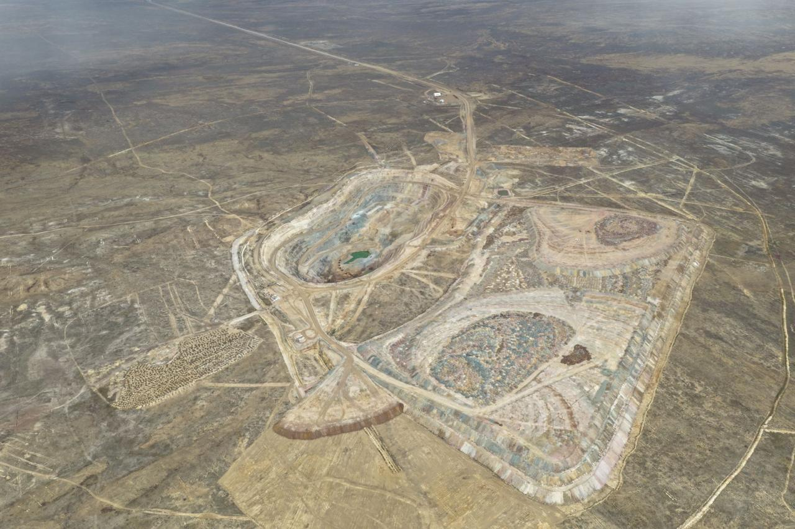

Figure 1 – Aerial view of the Ashiktas deposit (Source: Ulytau Gold Processing LLP)

1.2 Mineralogical Determinants of Reactivity in Mining Waste Systems
The successful transformation of mining waste into functional sorbent materials is fundamentally contingent upon a profound understanding of its mineralogical architecture. Unlike synthetic precursors engineered for chemical purity and uniformity, mining wastes are inherently complex, multi-phase systems. Their behavior during chemical and thermal activation is not merely the sum of individual component reactions but is governed by a complex interplay of mineral associations, textural relationships, and structural defects [16, 17]. This chapter establishes a conceptual framework for deconstructing this complexity, identifying the key mineral phases that dictate reactivity, and understanding the mechanisms through which they can be harnessed for phosphate functionalization.
Mining Waste as a Polymineralic System: Beyond Bulk Chemistry. A common pitfall in waste valorization studies is an over-reliance on bulk chemical composition (e.g., % SiO₂, % Al₂O₃, % Fe₂O₃). While useful for preliminary screening, such data obscures the critical information of mineral speciation. A high silica content may originate either from highly reactive amorphous phases or from essentially inert crystalline quartz. Similarly, iron can be present in the form of acid-soluble oxides (e.g., hematite, goethite) or as part of refractory silicate structures [33, 34]. Therefore, a mineralogical approach is essential for an adequate assessment of the reactivity and functional potential of mining waste.
Mining tailings, particularly those derived from base metal and gold operations, represent complex polymineralic systems composed predominantly of gangue minerals inherited from the host rock. These typically include tectosilicates such as quartz (SiO₂) and feldspars ((K,Na,Ca)AlSi₃O₈), as well as phyllosilicates, including micas (muscovite, biotite), chlorite, and clay minerals such as kaolinite, illite, and montmorillonite [35–38]. In addition, iron-bearing oxides and oxyhydroxides, such as hematite (Fe₂O₃), goethite (FeOOH), magnetite (Fe₃O₄), and aluminum hydroxides like gibbsite (Al(OH)₃), are commonly present [33]. Carbonate minerals, including calcite (CaCO₃) and dolomite (CaMg(CO₃)₂), may also occur [39], along with sulphide phases such as pyrite (FeS₂) and pyrrhotite (Fe₁₋ₓS), which are often responsible for acid mine drainage generation [7, 34].
Each of these mineral classes is characterized by distinct crystal structures, bond strengths, and surface chemistries, which collectively determine their contribution to the overall reactivity of the waste matrix and its suitability for further functionalization.
Reactivity of Silicate and Aluminosilicate Phases. Silicate minerals form the backbone of most mining wastes and represent the primary source of silicon required for the formation of a silicophosphate network. Among them, quartz and other tectosilicates play a dominant role. Quartz (SiO₂), the most abundant mineral in the Earth's crust, is characterized by a three-dimensional framework of fully polymerized silica tetrahedra interconnected by strong Si–O–Si bonds. This highly ordered structure provides exceptional chemical inertness under ambient conditions due to the high bond dissociation energy (~452 kJ·mol⁻¹) [40]. However, this inertness is not absolute. Under acidic conditions and elevated temperatures, partial hydrolysis of siloxane bonds can occur, leading to the formation of surface silanol groups (Eq. 1):

${\text{Si-O-Si}}_{\left(s\right)}+{\text{H}}_{2}\text{O}⇌{\text{Si-OH}}_{\left(s\right)}+{\text{Si-OH}}_{\left(s\right)}$ (1)

The reactivity of quartz can be significantly enhanced through mechanical activation. Processes such as ball milling induce structural disorder, reduce particle size, and generate fresh reactive surfaces with unsatisfied (dangling) bonds [41]. As a result, the density of surface silanol groups (≡Si–OH) increases, and a partially amorphous surface layer is formed, making the material more susceptible to subsequent chemical interactions [42]. In contrast to quartz, feldspars contain aluminum within the silicate framework, which introduces charge imbalance and increases their susceptibility to hydrothermal and acid exposure compared to pure SiO₂ [17].
Clay minerals and other phyllosilicates, including micas and chlorite, exhibit significantly higher reactivity than framework silicates due to their layered structure and relatively high specific surface area [35, 37]. Their reactivity is largely governed by the presence of surface hydroxyl groups and interlayer cations. Hydroxyl groups (≡Al–OH, ≡Si–OH), particularly at the edges of clay platelets, participate in acid–base reactions and act as active sites for chemical modification [36]. In addition, expandable clays such as montmorillonite contain exchangeable interlayer cations (e.g., Na⁺, Ca²⁺), which can be readily replaced, providing an additional pathway for chemical activation and functionalization [38].
Upon thermal treatment, clay minerals undergo dehydroxylation, resulting in significant structural transformations. For example, kaolinite loses structural hydroxyl groups in the temperature range of 450–700 °C, forming a metastable amorphous phase known as metakaolinite (Eq. 2):

${\text{Al}}_{2}{\text{Si}}_{2}{\text{O}}_{5}(\text{OH})_{4(s)}\overset{Δ}{→}{\text{Al}}_{2}{\text{Si}}_{2}{\text{O}}_{7(s)}+2{\text{H}}_{2}{\text{O}}_{\left(g\right)}$ (2)

This transformation leads to the destruction of the ordered crystalline structure and the formation of a highly disordered aluminosilicate with increased Lewis acidity and enhanced susceptibility to acid dissolution [43, 44]. As a result, thermally activated clays become highly reactive precursors for processes such as geopolymerization and reactions with phosphoric acid, facilitating the formation of amorphous silicophosphate networks. Furthermore, acid activation of clays, even in the absence of thermal pre-treatment, can partially leach interlayer cations and structural aluminum, increasing surface area and generating additional silanol groups, thereby further enhancing reactivity [43, 45].
The Dual Role of Iron and Aluminum (Oxyhydr)Oxides. Iron- and aluminum-bearing phases are among the most critical components in the functionalization of mining waste with phosphates, as they play a dual role in both acid consumption and the formation of new sorption-active sites. Under strongly acidic conditions (pH < 2), typical of phosphoric acid treatment, iron and aluminum (oxyhydr)oxides undergo proton-promoted dissolution [33, 46]. For example, goethite and aluminum hydroxides can dissolve according to the following reactions (Eq. 3-4):

${\text{FeOOH}}_{\left(s\right)}+3{\text{H}}^{+}→{\text{Fe}}_{\left(aq\right)}^{3+}+2{\text{H}}_{2}\text{O}$ (3)${\text{Al(}\text{OH)}}_{3(s)}+3{\text{H}}^{+}→{\text{Al}}_{\left(aq\right)}^{3+}+3{\text{H}}_{2}\text{O}$ (4)

The released trivalent cations exhibit high reactivity toward phosphate anions present in solution and readily form highly insoluble secondary phosphate phases. In particular, iron and aluminum phosphates such as strengite (FePO₄·2H₂O) and variscite (AlPO₄·2H₂O) can precipitate according to (Eq. 5-6):

${\text{Fe}}^{3+}+{\text{PO}}_{4}^{3-}+2{\text{H}}_{2}\text{O}→{\text{FePO}}_{4}⋅2{\text{H}}_{2}{\text{O}}_{\left(s\right)} (\text{strengite})$ (5)${\text{Al}}^{3+}+{\text{PO}}_{4}^{3-}+2{\text{H}}_{2}\text{O}→{\text{AlPO}}_{4}⋅2{\text{H}}_{2}{\text{O}}_{\left(s\right)} (\text{variscite})$ (6)

The extremely low solubility products of these phases (K_{sp} ≈ 10⁻²²–10⁻²⁶) make their formation thermodynamically favorable [47]. This in situ precipitation mechanism is of fundamental importance for waste functionalization, as it leads to the formation of new chemically distinct domains (FePO₄ and AlPO₄) that are intimately integrated into the original silicate matrix. These newly formed phases act as highly effective sorption centers for heavy metal ions such as Cu²⁺, providing binding environments that differ from those associated with surface-grafted phosphate groups [48, 49].
In addition to dissolution and reprecipitation processes, the surfaces of undissolved iron and aluminum oxides also contribute significantly to reactivity. These surfaces are covered with amphoteric hydroxyl groups (≡Fe–OH, ≡Al–OH), which can undergo protonation or deprotonation depending on pH [46, 50]. Under acidic conditions, the surface becomes positively charged and promotes the adsorption of phosphate anions via ligand exchange mechanisms, resulting in the formation of inner-sphere surface complexes. A representative reaction can be expressed as (Eq. 7):

$≡\text{Fe-OH}+{\text{H}}_{2}{\text{PO}}_{4}^{-}⇌≡{\text{Fe-O-PO}}_{3}{\text{H}}_{2}+{\text{OH}}^{-}$ (7)

Thus, both bulk phase transformations and surface reactions contribute to the incorporation of phosphate groups into the waste matrix, enhancing its functionality and sorption capacity.
Carbonate Phases: Porosity Generators and Phosphate Scavengers. Carbonate phases, commonly present in many ore systems, introduce a distinct set of reactive behaviors that significantly influence the phosphoric acid functionalization process. Due to their high reactivity toward acids, carbonates readily undergo dissolution under acidic conditions, as illustrated by the reaction (Eq. 8):

${\text{CaCO}}_{3(s)}+2{\text{H}}^{+}→{\text{Ca}}_{\left(aq\right)}^{2+}+{\text{CO}}_{2(g)}↑+{\text{H}}_{2}\text{O}$ (8)

This process has several important consequences. First, carbonate dissolution leads to substantial acid consumption, increasing reagent demand and potentially buffering the system to higher pH values, which may reduce the efficiency of silicate dissolution. Second, the release of CO₂ gas during the reaction can generate localized porosity within the waste matrix, enhancing the accessibility of internal reactive phases [39]. This in situ pore formation represents a distinctive feature of carbonate-containing wastes and may be advantageous for improving permeability and fluid flow in fixed-bed sorption systems [51].
The dissolved calcium ions (Ca²⁺) can further interact with phosphate species in solution, leading to the precipitation of various calcium phosphate phases depending on pH and saturation conditions. For example, under mildly acidic conditions, brushite (CaHPO₄·2H₂O) may form according to the reaction (Eq. 9):

${\text{Ca}}^{2+}+{\text{HPO}}_{4}^{2-}+2{\text{H}}_{2}\text{O}→{\text{CaHPO}}_{4}⋅2{\text{H}}_{2}{\text{O}}_{\left(s\right)} (\text{brushite})$ (9)

At higher pH values, more stable and less soluble phases such as hydroxyapatite (Ca₅(PO₄)₃OH) can be generated [52–54]. These calcium phosphate compounds are known for their strong affinity toward heavy metal ions and can contribute to contaminant removal through multiple mechanisms, including surface complexation, ion exchange (substitution of Ca²⁺ by divalent metal ions), and dissolution–precipitation processes [47, 55].
However, the role of carbonates is not exclusively beneficial. The uncontrolled formation of calcium phosphate phases may lead to excessive consumption of phosphate species that would otherwise be available for the functionalization of silicate surfaces. In addition, the precipitation of secondary phases within pore spaces may result in pore blockage, negatively affecting mass transfer and sorption efficiency. Therefore, the carbonate content of the raw material must be carefully considered as a key design parameter in the synthesis of silicophosphate sorbents.
Sulphide Minerals: A Source of Acidity and Secondary Phases. Sulphide minerals, particularly pyrite, are a characteristic component of many mining tailings and represent the primary source of long-term environmental risks associated with acid mine drainage (AMD). However, within the context of controlled functionalization, these phases can be reconsidered as reactive precursors rather than solely as liabilities.
Prior to chemical modification, sulphide-containing materials can undergo controlled thermal pre-treatment (roasting), which promotes the oxidation of sulphide phases. For example, pyrite is oxidized according to the reaction (Eq. 10):

$4{\text{FeS}}_{2(s)}+11{\text{O}}_{2(g)}\overset{Δ}{→}2{\text{Fe}}_{2}{\text{O}}_{3(s)}+8{\text{SO}}_{2(g)}↑$ (10)

This transformation converts pyrite into hematite (Fe₂O₃), an iron oxide phase that is significantly more suitable for subsequent interaction with phosphate species. As discussed previously, iron oxides exhibit high affinity toward phosphate anions and can actively participate in the formation of new sorption-active sites. Therefore, thermal pre-treatment serves a dual function: it eliminates the primary source of acid generation responsible for AMD and simultaneously produces a chemically compatible precursor for further functionalization [34].
In addition, the sulfur dioxide (SO₂) released during roasting can be captured and converted into sulfuric acid within an integrated processing scheme, potentially improving the overall process sustainability and partially offsetting reagent costs. Thus, sulphide oxidation represents not only a detoxification step but also an opportunity for process integration and resource recovery.
Textural and Surface Chemical Considerations. Beyond bulk mineralogical composition, the physical properties and surface chemistry of mining waste play a crucial role in determining its reactivity and suitability for functionalization. In their native state, most mining wastes are characterized by relatively low specific surface areas, typically below 10 m²/g [56], which is often considered a limitation for their application as sorbents. However, this limitation is not fundamental and can be overcome through appropriate activation strategies. As discussed above, processes such as mechanical activation, thermal treatment, and chemical modification can significantly alter the texture and surface characteristics of the material. Mechanical activation induces particle size reduction and the formation of structural defects, while thermal treatment promotes dehydroxylation and structural rearrangement [41]. Acid treatment, in turn, can etch mineral surfaces, partially dissolve reactive phases, and, in the case of carbonate-containing materials, generate porosity in situ. These combined effects lead to an increase in the accessibility of reactive sites and the development of a more favorable porous structure.
Importantly, for chemically functionalized materials, sorption performance is not solely governed by total surface area, but rather by the density and accessibility of specific active sites, such as phosphate functional groups (≡P–O⁻). This is particularly relevant in systems where sorption proceeds via inner-sphere complexation mechanisms, in which strong chemical bonding dominates over purely physical adsorption processes [46].
Equally important is the surface charge of mineral phases, which is commonly described by the point of zero charge (PZC). The PZC determines the net surface charge as a function of pH and, consequently, governs the interaction of the material with ionic species in solution [50, 57]. For instance, silica exhibits a low PZC (approximately pH 2–3), resulting in a negatively charged surface at higher pH values and thus favoring the adsorption of cationic species. In contrast, iron oxides possess significantly higher PZC values (typically pH 7–9), which leads to positively charged surfaces under acidic conditions and promotes the adsorption of anions such as phosphate. This contrast in surface charge behavior underlies the complementary roles of silicate and iron-containing phases: the latter facilitate phosphate immobilization, while the former, once functionalized, contribute to the subsequent binding of metal cations such as Cu²⁺.
Analytical Methodology for Mineralogical Assessment. A robust mineralogical characterization constitutes the indispensable first step of this research and is carried out using a complementary suite of analytical techniques. X-ray diffraction (XRD) is employed for the qualitative and quantitative identification of crystalline phases present in both raw and treated materials, with Rietveld refinement applied where appropriate to obtain quantitative phase composition [58]. Fourier transform infrared spectroscopy (FTIR) is used to identify functional groups, including hydroxyl (O–H), silicate (Si–O–Si), and phosphate (P–O) vibrations, thereby providing insight into changes in the chemical bonding environment resulting from modification processes [59].
The morphological and microstructural characteristics of the materials are examined using scanning electron microscopy (SEM), which allows for the evaluation of particle texture, surface features, and structural transformations induced by thermal and chemical treatments [16]. In addition, electron probe microanalysis (EPMA) is utilized to determine the local elemental composition and spatial distribution of key elements such as Si, Al, Fe, P, and Ca, enabling the identification of compositional heterogeneity and the formation of secondary phosphate phases within the modified matrix.
Textural properties are assessed using nitrogen physisorption techniques (BET and BJH methods), which provide information on specific surface area and pore size distribution, thereby quantifying structural changes induced by activation processes [56]. Furthermore, zeta potential measurements are conducted to evaluate surface charge characteristics and determine the point of zero charge (PZC), offering insight into electrostatic interactions governing phosphate adsorption and subsequent binding of metal cations.

1.3 Chemical Foundations of Silicophosphate Materials
The transformation of mineral mining wastes into functional sorbents hinges on the deliberate and controlled creation of a chemically active surface. The previous chapter established that the mineralogical complexity of these wastes provides a diverse portfolio of potential reactive sites. This chapter delves into the core chemistry of how these sites can be harnessed through reaction with phosphorus-containing species to form silicophosphate materials. These are not simple physical mixtures but hybrid inorganic systems where silicate structural units are chemically integrated with phosphate functional groups, creating a new material with properties distinct from its precursors [60, 61]. Understanding the fundamental chemical reactions — surface grafting, condensation, dissolution-precipitation, and phase transformation — is essential for designing a rational and effective functionalization protocol.
The Chemistry of Phosphoric Acid: A Multifunctional Reagent. Orthophosphoric acid (H₃PO₄) was selected as the primary reagent in this study due to its unique physicochemical properties and versatile reactivity. As a triprotic acid, it contains three dissociable protons characterized by distinct pKa values (pKa₁ ≈ 2.1, pKa₂ ≈ 7.2, pKa₃ ≈ 12.3) [62, 63]. Under strongly acidic conditions (pH < 2), typical of the functionalization process, the undissociated H₃PO₄ molecule predominates. However, as the reaction progresses and local pH conditions evolve, successive deprotonation leads to the formation of H₂PO₄⁻, HPO₄²⁻, and PO₄³⁻ species. This dynamic speciation plays a crucial role in determining the chemical behavior of the system.
In particular, phosphoric acid simultaneously performs multiple functions during the modification process. It acts as a Brønsted acid, donating protons that promote the dissolution of reactive mineral phases. At the same time, phosphate species function as ligands capable of forming stable complexes with metal cations such as Fe³⁺, Al³⁺, and Ca²⁺, either in solution or at the mineral surface. In addition, phosphate groups participate in condensation reactions, leading to the formation of P–O–P linkages (e.g., pyrophosphates and polyphosphates) and, most importantly, Si–O–P bonds that are fundamental to the development of silicophosphate structures [60].
Furthermore, orthophosphoric acid possesses several practical advantages for material synthesis. It is non-volatile, thermally stable, and, at moderate concentrations, less aggressive and corrosive compared to strong mineral acids such as hydrochloric or sulfuric acid. These characteristics make it a suitable and controllable reagent for the functionalization of mineral-based materials [44].
Surface Grafting: The Formation of Si–O–P Linkages. Surface grafting represents the most direct pathway for the functionalization of silicate surfaces and involves a condensation reaction between surface silanol groups (≡Si–OH) and orthophosphoric acid molecules. This process, analogous to esterification, can be described by the following reaction (Eq. 11):

$≡\text{Si-OH}+{\text{H}}_{3}{\text{PO}}_{4}⇌≡{\text{Si-O-P(O)(OH)}}_{2}+{\text{H}}_{2}\text{O}$ (11)
As a result of this reaction, phosphate groups become covalently anchored to the silicate surface, forming Si–O–P linkages. The grafted phosphate species retain one or more terminal P–OH groups, which serve as the primary active sites for the subsequent sorption of metal ions [61, 64].
The efficiency of surface grafting is strongly dependent on the availability of reactive surface sites. A sufficient density of silanol groups is required to initiate the reaction; however, in many crystalline silicates such as quartz, the initial concentration of these groups is relatively low. This limitation can be overcome through activation methods. Mechanical activation generates fresh surfaces with broken bonds, increasing the density of reactive ≡Si–OH groups [41, 42], while thermal treatment of clay minerals leads to dehydroxylation and the formation of metastable phases such as metakaolinite, which exhibit enhanced chemical reactivity [43, 44].
Reaction conditions also play a crucial role in governing the extent of grafting. As the condensation reaction is reversible, its progression toward product formation requires the removal of water, which can be achieved through elevated temperatures or post-synthesis calcination. Thermal treatment not only shifts the equilibrium toward bond formation but also promotes further condensation, resulting in stronger and more stable Si–O–P linkages [44].
In addition, the concentration of phosphoric acid influences the dominant reaction pathway. At moderate concentrations (typically 10–30 wt.%), the interaction is primarily limited to surface functionalization, favoring grafting reactions. In contrast, higher acid concentrations increase the solvent power of the system, promoting the dissolution of mineral phases and the formation of secondary phosphate phases, as discussed previously [30, 65].
Dissolution and In-Situ Precipitation: Creating New Phases. In polymineralic and chemically complex systems such as mining waste, the functionalization process is not limited to simple surface grafting but is often governed by coupled dissolution and in situ precipitation mechanisms. Under strongly acidic conditions (pH < 2), characteristic of phosphoric acid treatment, acid-soluble mineral phases undergo partial or complete dissolution, as discussed in Chapter 1.2. Iron and aluminum (oxyhydr)oxides release Fe³⁺ and Al³⁺ ions into the solution, carbonates dissolve with the release of Ca²⁺, Mg²⁺, and CO₂ gas, while aluminosilicate phases, particularly those that are amorphous or structurally disordered, may partially dissolve, contributing additional Si, Al, and other cations to the system.
The liberated cations do not persist in solution for extended periods. Instead, they rapidly interact with phosphate species, leading to the precipitation of secondary phosphate phases. This dissolution–precipitation mechanism represents a fundamental pathway in the functionalization of complex mineral matrices. Representative reactions include the formation of iron, aluminum, and calcium phosphates, such as (Eq. 12-14):

${\text{Fe}}^{3+}+{\text{PO}}_{4}^{3-}+2{\text{H}}_{2}\text{O}→{\text{FePO}}_{4}⋅2{\text{H}}_{2}{\text{O}}_{\left(s\right)} (\text{strengite})$ (12)${\text{Al}}^{3+}+{\text{PO}}_{4}^{3-}+2{\text{H}}_{2}\text{O}→{\text{AlPO}}_{4}⋅2{\text{H}}_{2}{\text{O}}_{\left(s\right)} (\text{variscite})$ (13)${\text{Ca}}^{2+}+{\text{HPO}}_{4}^{2-}+2{\text{H}}_{2}\text{O}→{\text{CaHPO}}_{4}⋅2{\text{H}}_{2}{\text{O}}_{\left(s\right)} (\text{brushite})$ (14)

These in situ formed phases, including strengite (FePO₄·2H₂O), variscite (AlPO₄·2H₂O), and brushite (CaHPO₄·2H₂O), are not isolated precipitates but are generated within the pore space, on mineral surfaces, and as intergrowths with the residual silicate framework [48, 49]. This results in the formation of a heterogeneous composite material in which newly formed, highly reactive sorption domains are embedded within a mechanically stable silicate matrix.
The formation of these phases is thermodynamically favored due to their extremely low solubility products (K_{sp} ≈ 10⁻²²–10⁻²⁶) [47, 55]. Consequently, the dissolution–precipitation pathway not only contributes to the immobilization of phosphate species but also plays a key role in generating new functional sites that enhance the overall sorption performance of the material.
Condensation and Network Formation. Beyond simple monomeric grafting and discrete precipitation processes, more complex polymerization reactions can occur during phosphoric acid functionalization. Phosphate species are capable of undergoing condensation reactions to form dimers, such as pyrophosphates (P₂O₇⁴⁻), as well as longer-chain polyphosphates [60]. A simplified representation of this process is given by (Eq. 15):

$2{\text{H}}_{2}{\text{PO}}_{4}^{-}→(\text{HO})_{2}{\text{OP-O-PO(OH)}}_{2}+{\text{H}}_{2}\text{O}$ (15)

These condensed phosphate species can subsequently interact with surface silanol groups (≡Si–OH) or with dissolved silica species, leading to the formation of cross-linked structures. In particular, the formation of Si–O–P–O–P linkages contributes to the development of a three-dimensional silicophosphate network (Eq. 16):

$≡\text{Si-OH}+{\text{HO-P(O)(OH)-O-P(O)(OH)}}_{2}→≡{\text{Si-O-P(O)(OH)-O-P(O)(OH)}}_{2}+{\text{H}}_{2}\text{O}$ (16)

The resulting structures are typically amorphous or nanocrystalline and can act as a binding matrix that integrates different mineral components into a cohesive composite material[44]. This network formation significantly enhances the mechanical strength and chemical stability of the material, particularly after subsequent thermal treatment, which promotes further condensation, removes residual water, and strengthens bridging bonds [66].
However, the extent of condensation must be carefully controlled. Excessive polymerization can lead to a reduction in the number of terminal phosphate groups (P–OH), which serve as the primary active sites for metal ion sorption. Therefore, an optimal functionalization strategy must balance the formation of a structurally stable silicophosphate network with the preservation of accessible reactive sites, ensuring both mechanical integrity and high sorption efficiency.
The Influence of Thermal Treatment.Thermal treatment represents an integral stage of the synthesis process and is applied at different stages to achieve distinct structural and chemical transformations. Pre-functionalization calcination of the raw material plays a crucial role in enhancing its reactivity. During this stage, clay minerals undergo dehydroxylation, leading to the formation of metastable amorphous phases such as metakaolinite, which exhibit significantly higher chemical reactivity [35, 43]. Simultaneously, sulphide minerals, particularly pyrite, are oxidized to form iron oxides such as hematite, thereby eliminating the potential for acid mine drainage while generating reactive iron-bearing phases suitable for subsequent phosphate interaction [34]. In addition, partial decomposition of carbonate phases may occur, allowing better control over their reactivity and reducing excessive acid consumption during subsequent treatment [39].
Following chemical functionalization, post-treatment calcination induces further structural evolution of the material. Thermal dehydration leads to the removal of physically and chemically bound water from hydrous phosphate phases, for example, the transformation of brushite (CaHPO₄·2H₂O) into monetite (CaHPO₄). At the same time, elevated temperatures promote the strengthening of Si–O–P linkages through condensation reactions, thereby increasing the stability and durability of the grafted phosphate layer [44]. In some cases, thermal treatment can also induce partial crystallization of previously amorphous phosphate phases, which may influence their sorption behavior and stability [60].
The selection of calcination parameters, including temperature, heating rate, and atmospheric conditions, is therefore of critical importance. While moderate temperatures enhance reactivity and structural stability, excessive thermal treatment may lead to sintering, pore collapse, and a reduction in accessible surface area and active site density, ultimately diminishing sorption performance [56].
Waste-Specific Functionalization Pathways. The discussion presented above demonstrates that phosphate functionalization is not a single, universal reaction, but rather a set of interconnected chemical pathways, the dominance of which is governed by the mineralogical composition of the precursor material (Section 1.2). This leads to the concept of waste-specific functionalization, in which the reaction mechanism and resulting material properties are determined by the relative abundance and reactivity of constituent mineral phases.
In silicate-dominated wastes, the functionalization process is primarily governed by surface grafting reactions. In such systems, particularly after mechanical or thermal activation, which increases the density of surface silanol groups, phosphate species are predominantly anchored onto the silicate framework via the formation of Si–O–P linkages. As a result, the final material can be described as a silicate core functionalized by a surface layer of chemically bound phosphate groups.
In contrast, wastes enriched in iron and aluminum phases tend to favor dissolution–precipitation mechanisms. Under acidic conditions, these phases release Fe³⁺ and Al³⁺ ions, which subsequently react with phosphate species to form secondary metal phosphate phases such as FePO₄ and AlPO₄. The resulting material is therefore a composite system consisting of residual silicate minerals and newly formed phosphate domains, which act as highly active and chemically distinct sorption centers.
For carbonate-rich wastes, the functionalization process is strongly influenced by acid consumption and the formation of calcium phosphate phases, such as brushite. In addition to promoting precipitation reactions, carbonate dissolution generates significant in situ porosity due to the evolution of CO₂ gas. Consequently, the final structure typically consists of a silicate-based framework incorporating a substantial fraction of calcium phosphate phases, along with an enhanced pore network.
Understanding these pathway-dependent transformations is essential for transitioning from an empirical, trial-and-error approach toward a rational, design-oriented strategy for the synthesis of waste-derived sorbents. This conceptual framework provides a basis for interpreting the behavior of specific mining wastes and for optimizing functionalization conditions to achieve improved sorption performance. In the present work, this approach is applied to the study of Kazakhstani mining wastes, enabling the targeted development of silicophosphate materials with enhanced efficiency for Cu²⁺ removal [30, 31, 67–69].

1.3.1 Methods for the Synthesis of Silicophosphate Sorbents
Porous inorganic sorbents and membranes are traditionally synthesized by sintering powders with controlled particle sizes, such as quartz, glass, and metal oxides, using various binders including liquid glass, clay minerals (e.g., kaolinite, montmorillonite), aluminophosphate binders, or polymers [21, 22, 70, 65]. By adjusting powder dispersion, binder composition, additives, and thermal treatment parameters, ceramic materials with tailored porosity, permeability, and mechanical stability can be obtained [22, 70].
A significant group of porous sorbents is based on aluminosilicate and silicophosphate frameworks synthesized via hydrothermal or sol–gel routes. For example, Wilson et al. developed a microporous crystalline aluminosilicate zeolite (UZM-4) consisting of a three-dimensional AlO₂ and SiO₂ tetrahedral network. This material exhibits thermal stability up to 600 °C and is synthesized by heating aluminum and silicon precursors in the presence of organic structure-directing agents at temperatures ranging from 85 to 225 °C [71]. Similar hydrothermal approaches have been reported for the synthesis of low-silica zeolites and high-purity gmelinite with SiO₂/Al₂O₃ ratios below 10, involving staged crystallization and calcination processes [72].
Several patented methods focus on the formation of macroscopic aluminosilicate aggregates from fine-crystalline zeolites. These approaches typically involve alkaline synthesis conditions (pH ≥ 12), reaction of silicate sources with electrolyte salts (phosphates, carbonates, or sulfates), and the introduction of aluminum-containing compounds, resulting in zeolite aggregates suitable for water softening applications [73]. Other studies describe catalyst and sorbent systems based on silicoaluminophosphates with zeolite-type structures, synthesized from microemulsion systems containing surfactants, allowing precise control over chemical composition and textural properties [74].
Silicophosphate and metalloaluminosilicate sorbents are commonly obtained through precipitation or sol–gel methods followed by hydrothermal or thermal treatment. For instance, metalloaluminosilicate compositions can be synthesized by reacting silicon dioxide with acidic metal salt solutions, followed by gel formation with aluminum precursors and subsequent hydrothermal crystallization, resulting in metal incorporation into the aluminosilicate framework [75]. A silicophosphate adsorbent synthesized by co-precipitation of sodium silicate, aluminum sulfate, and calcium dihydrogen phosphate at near-neutral pH (6–7), followed by washing and calcination, has also been reported [76].
Another approach involves the synthesis of mixed phosphate–metal oxide sorbents via controlled precipitation using orthophosphoric acid and metal salts, followed by pH adjustment, aging, granulation, and calcination at 400–800 °C. Such materials exhibit high specific surface areas (78–130 m² g⁻¹), significant pore volumes, and improved thermal stability [77].
In parallel, natural and industrial mineral materials—including opoka, tripoli, diatomite, dolomite, quartzite, and carbonate rocks—have been explored as low-cost precursors for sorbents after thermal or chemical activation [78, 79]. Heat treatment and alkaline modification have been shown to significantly enhance their sorption performance toward metal ions and organic pollutants. Additionally, various industrial wastes, such as pulp and paper industry residues and mining-related by-products, have been proposed as alternative raw materials for sorbent production due to their availability and favorable physicochemical properties [80, 81].
Recent studies confirm the growing relevance of modified aluminosilicate and phosphate-based sorbents for industrial wastewater treatment. Enhanced removal of heavy metals has been achieved through chemical modification with aluminum and iron polyhydroxocations, polymer functionalization, and the development of automated sorption systems for mine wastewater treatment [82, 83, 24].
Despite the wide compositional diversity of inorganic porous sorbents, most synthesis routes rely on aluminum, silicon, and phosphorus oxides or salts and involve multistage processes such as precipitation or sol–gel formation followed by hydrothermal or thermal treatment [22, 70, 65, 75]. At the same time, systematic studies focusing on the synthesis and characterization of silicophosphate sorbents derived from ore enrichment waste—particularly in the Republic of Kazakhstan and neighboring regions—remain limited, highlighting the relevance of further research in this area.

1.4 Waste-Specific Phosphate Functionalization: Mechanistic and Structural Considerations
The preceding chapters have established two fundamental principles: first, that mining wastes are mineralogically complex and heterogeneous (Chapter 1.2); and second, that phosphate functionalization encompasses a suite of distinct chemical pathways, including surface grafting, dissolution-precipitation, and network condensation (Chapter 1.3). This chapter synthesizes these principles into a unified framework, arguing that there is no single, universal protocol for waste functionalization. Instead, the optimal synthesis route is intrinsically determined by the specific mineral assemblage of the precursor material. This waste-specific approach is the key to moving beyond empirical trial-and-error towards a rational, design-driven methodology for creating high-performance sorbents from technogenic resources [11, 30].
The Concept of Mineralogical Fingerprint and Reactivity Mapping. Every mining waste possesses a unique “mineralogical fingerprint,” defined by the relative proportions and textural relationships of its constituent phases. This fingerprint governs the response of the material to chemical and thermal impact and ultimately determines its reactivity during functionalization. The central premise of this chapter is that such mineralogical variability can be interpreted in terms of a reactivity spectrum, allowing prediction of the dominant transformation pathways under acid–thermal treatment conditions.
At one end of this spectrum are silicate-dominated systems, composed primarily of quartz, feldspars, and micaceous residues. These materials exhibit low intrinsic reactivity due to their highly polymerized crystal structures; however, their reactivity can be significantly enhanced through mechanical or thermal activation, which increases the density of surface silanol groups and promotes subsequent surface functionalization.
Aluminosilicate-rich systems, particularly those containing clay minerals such as kaolinite and illite or their thermally activated derivatives (e.g., metakaolinite), occupy an intermediate position in the spectrum. These materials combine the presence of surface hydroxyl groups with a partially reactive framework, making them susceptible to both surface reactions and partial acid dissolution.
In contrast, systems enriched in iron and aluminum oxides or hydroxides, including goethite, hematite, and gibbsite, as well as their precursor sulphides following oxidation, are characterized by higher chemical reactivity under acidic conditions. These phases readily dissolve and subsequently reprecipitate as secondary phosphate compounds, forming highly active sorption domains within the material.
At the other end of the spectrum are carbonate-rich systems, dominated by minerals such as calcite and dolomite. These materials are highly reactive toward acids, leading to rapid acid consumption, CO₂ evolution, and the formation of calcium phosphate phases. While this behavior can promote porosity development, it may also compete with surface functionalization processes.
In practice, most mining wastes are complex polymineralic systems that fall between these idealized end-members [16, 27, 28]. Therefore, the key challenge lies in understanding the interactions between coexisting phases during functionalization and in predicting how their combined behavior influences the formation of the final sorption-active material.
Functionalization of Silicate-Dominated Wastes. Functionalization of silicate-dominated wastes presents a particular challenge due to the inherently low reactivity of framework silicates such as quartz and feldspars. In such systems, the dominant mechanism of modification is surface grafting, and the effectiveness of the process largely depends on pre-activation aimed at generating reactive surface sites.
Mechanical activation is one of the most effective approaches for enhancing the reactivity of silicate-rich materials. High-energy milling processes, such as ball milling, induce particle size reduction, which increases the available surface area for reaction, and simultaneously generate structural disorder within the crystal lattice. This includes the formation of defects, dislocations, and partially amorphous surface layers. In addition, the breakage of Si–O and Si–Si bonds leads to the formation of highly reactive defect sites (dangling bonds), which readily transform into surface silanol groups (≡Si–OH) upon interaction with moisture or acidic media [41, 42]. As a result, mechanically activated silicates exhibit significantly enhanced reactivity toward acid attack and subsequent phosphate functionalization. The effectiveness of this approach, however, depends on the optimization of milling parameters, including duration, rotational speed, ball-to-powder ratio, and milling environment, as excessive treatment may promote particle agglomeration and reduce the accessibility of reactive sites [41].
Thermal activation, in contrast, has a more limited effect on highly crystalline silicates such as quartz, which remain largely inert at moderate temperatures. Nevertheless, thermally induced transformations in associated minerals, such as the dehydroxylation of mica or chlorite phases, can generate more disordered and reactive structures that contribute to the overall reactivity of the system [17]. For predominantly silicate systems, however, mechanical activation remains the more effective strategy for enhancing surface reactivity.
Following activation, the functionalization of silicate surfaces with orthophosphoric acid proceeds primarily through surface-controlled grafting reactions. Under these conditions, the concentration of acid plays a critical role in determining the balance between surface functionalization and bulk dissolution. Moderate acid concentrations (typically 10–20 wt.%) favor the formation of surface-bound phosphate groups while minimizing undesired dissolution processes [61, 64]. Reaction temperature also influences the efficiency of grafting, with moderate heating (approximately 60–100 °C) facilitating condensation reactions and the removal of water, thereby shifting the equilibrium toward the formation of stable Si–O–P linkages. In addition, reaction time must be carefully controlled, as excessive durations may lead to over-condensation or localized surface degradation, reducing the availability of active sites.
The resulting material is typically characterized by a core–shell-like structure, consisting of a relatively inert crystalline silicate core surrounded by a thin, amorphous layer of grafted phosphate species. This configuration provides a combination of structural stability and surface functionality, making such materials suitable for subsequent sorption applications.
Functionalization of Aluminosilicate-Rich (Clay-Bearing) Wastes. Aluminosilicate-rich, clay-bearing wastes provide a more complex and versatile reactive platform compared to silicate-dominated systems. Their functionalization can proceed through both surface grafting and dissolution–precipitation mechanisms, depending on the mineralogical composition and the applied pre-treatment conditions.
Thermal activation plays a particularly important role in the case of kaolinite-rich materials. Upon heating in the temperature range of 450–700 °C, kaolinite undergoes dehydroxylation, resulting in the formation of metakaolinite—a metastable, amorphous aluminosilicate phase with a highly disordered structure and enhanced Lewis acidity [35, 37, 43]. This transformation significantly increases the susceptibility of the material to chemical attack compared to its crystalline precursor. When reacted with orthophosphoric acid, metakaolinite exhibits dual reactivity. On one hand, it can participate in surface grafting reactions through its abundant hydroxyl groups (≡Si–OH and ≡Al–OH), forming surface-bound phosphate species. On the other hand, partial dissolution of the amorphous structure may occur, releasing Al³⁺ and Si species into the solution. These species can subsequently react with phosphate anions to form amorphous aluminophosphate phases or reprecipitate as a binding gel within the material matrix [15, 44].
This combination of surface functionalization and bulk transformation makes thermally activated clays highly effective precursors for the formation of a continuous silicophosphate network. The resulting structure exhibits similarities to geopolymer-like systems, where a disordered aluminosilicate framework is chemically integrated with phosphate species [15, 30].
In addition to thermal treatment, acid activation represents another pathway for modifying clay minerals. Treatment with strong acids such as H₂SO₄ or HCl can increase surface area and reactivity by leaching interlayer cations and partially removing structural aluminum [43, 45]. This process results in the formation of a porous, silica-enriched material with a high density of silanol groups, which can serve as reactive sites for subsequent functionalization. However, from a practical standpoint, the use of orthophosphoric acid alone may offer a more efficient approach, as it allows simultaneous activation and functionalization within a single step, reducing process complexity while directly introducing phosphate functionality into the material.
Functionalization of Iron/Aluminum Oxide-Rich Wastes. In mining wastes where iron and aluminum (oxyhydr)oxides constitute a significant fraction of the mineral composition, functionalization is primarily governed by dissolution–precipitation mechanisms rather than simple surface grafting. This results in the formation of a fundamentally different type of material, characterized as a composite system consisting of residual, acid-resistant phases such as quartz and newly formed metal phosphate domains generated in situ.
Under acidic conditions provided by orthophosphoric acid, iron and aluminum oxide phases undergo proton-promoted dissolution, releasing Fe³⁺ and Al³⁺ ions into solution, as described in Section 1.2. The presence of a phosphate-rich environment leads to rapid supersaturation with respect to metal phosphate phases such as strengite (FePO₄·2H₂O) and variscite (AlPO₄·2H₂O) [47]. As a result, these phases nucleate and grow either directly on the surfaces of dissolving mineral grains or within pore spaces as finely dispersed crystallites [33, 48]. This process creates a heterogeneous structure in which newly formed phosphate phases are intimately integrated with the remaining mineral matrix.
The characteristics of the precipitated phases, including their size, morphology, and spatial distribution, are strongly influenced by reaction conditions. Higher acid concentrations promote more extensive dissolution of oxide phases, thereby increasing the extent of secondary phosphate formation. However, excessively aggressive conditions may lead to over-dissolution and structural degradation of the material. Temperature plays a dual role by affecting both dissolution kinetics and crystallization behavior; lower temperatures tend to favor the formation of numerous small nuclei, whereas higher temperatures promote crystal growth and phase ordering [33]. In addition, aging of the reaction system after initial mixing can induce the transformation of metastable or amorphous phases into more stable crystalline forms, which may alter both structural properties and sorption performance [48, 49].
The resulting material can be described as a true composite, in which sorption properties arise from the combined contribution of the residual mineral framework and the newly formed metal phosphate domains. These phosphate phases, particularly iron phosphates, exhibit a high affinity for divalent metal ions such as Cu²⁺, providing strong and specific binding sites. Consequently, iron- and aluminum-rich wastes represent highly promising precursors for the development of efficient sorption materials through controlled phosphate functionalization.
Functionalization of Carbonate-Rich Wastes. Carbonate minerals represent the most reactive components in many mining wastes, and their presence significantly alters the chemistry of the functionalization process. Under acidic conditions, carbonates such as calcite and dolomite react rapidly with orthophosphoric acid, consuming protons and releasing CO₂ gas [39]. This high reactivity has several important implications for process control and material formation.
One of the primary challenges associated with carbonate-rich systems is the substantial consumption of acid, which can increase reagent demand and require higher concentrations or volumes of H₃PO₄ to achieve effective functionalization of less reactive phases such as silicates. In addition, proton consumption during carbonate dissolution may lead to localized increases in pH, which can suppress the dissolution of iron and aluminum oxides and alter the pathway of phosphate precipitation [51]. As a result, careful control of reaction conditions is required. Strategies such as preliminary leaching with a weaker acid or the stepwise addition of phosphoric acid can be employed to regulate the reaction environment and improve process efficiency.
A key outcome of carbonate dissolution is the release of Ca²⁺ ions, which readily react with phosphate species to form calcium phosphate phases. Under acidic conditions, brushite (CaHPO₄·2H₂O) is typically the dominant phase formed [52, 53]. These calcium phosphates possess well-established sorption properties and can remove heavy metal ions through mechanisms such as surface complexation and ion exchange, including the substitution of Ca²⁺ by Cu²⁺ ions [47, 54, 55]. Therefore, while carbonate dissolution may compete with silicate functionalization, it also introduces an additional pathway for sorption.
Another important consequence of carbonate reactivity is the generation of porosity through the evolution of CO₂ gas. The effervescence associated with carbonate dissolution can create significant macroporosity within the material matrix, improving fluid transport and enhancing access to internal reactive sites [39, 51]. This feature is particularly advantageous for applications in fixed-bed systems, where permeability and mass transfer are critical. However, excessive gas evolution may compromise the mechanical integrity of the material, and thus the process must be carefully controlled to balance porosity development with structural stability.
Functionalization of Sulphide-Bearing Wastes: The Necessity of Pre-Oxidation. The presence of sulphide minerals, particularly pyrite, represents a significant environmental challenge in mining wastes due to their role in the generation of acid mine drainage (AMD), as discussed in Section 1.2. In their native form, sulphides are not suitable for direct functionalization with phosphoric acid. Under ambient conditions, they are prone to oxidation, leading to the generation of acidity and the release of dissolved metal species, which can compromise both environmental stability and material performance [7, 8]. Moreover, sulphide phases do not directly contribute to phosphate binding, limiting their usefulness in sorption applications.
For these reasons, a controlled thermal pre-oxidation (roasting) step is not only advantageous but essential for the effective processing of sulphide-bearing wastes [34]. During this treatment, pyrite is oxidized to form hematite according to the following reaction (Eq. 17):
$4{\text{FeS}}_{2}+11{\text{O}}_{2}→2{\text{Fe}}_{2}{\text{O}}_{3}+8{\text{SO}}_{2}↑$ (17)

This transformation converts an environmentally problematic phase into a chemically stable and functionally useful iron oxide. Hematite can subsequently participate in dissolution–precipitation processes during phosphoric acid treatment, contributing to the formation of iron phosphate phases that serve as active sorption sites.
In addition, the sulfur dioxide (SO₂) generated during roasting can be captured and converted into sulfuric acid in an integrated processing scheme. This offers the potential to improve process sustainability by reducing emissions and providing a secondary reagent source, thereby enhancing both the economic and environmental performance of the overall system.
A Decision Framework for Waste-Specific Synthesis. The insights developed throughout this chapter can be integrated into a conceptual framework for designing functionalization strategies tailored to specific types of mining waste. This framework is based on the premise that the mineralogical composition of the precursor material governs both its reactivity and the dominant transformation pathways during acid–thermal treatment.
The first and essential step in this approach is comprehensive mineralogical characterization, as outlined in Section 1.2, which enables the identification of the key reactive phases present in the waste, including silicates, clay minerals, iron and aluminum oxides, carbonates, and sulphides, along with their relative abundances. This information provides the basis for predicting the material’s response to chemical and thermal stimuli.
Based on this characterization, the necessity and type of pre-treatment can be assessed. In sulphide-rich systems, thermal pre-oxidation is required to eliminate the potential for acid generation and to convert sulphides into reactive oxide phases. In carbonate-rich materials, strategies such as preliminary leaching or controlled, stepwise acid addition may be necessary to manage acid consumption and maintain appropriate reaction conditions. For wastes dominated by crystalline silicates, mechanical activation is often essential to increase surface reactivity through defect formation and silanol generation. In contrast, materials with high clay content benefit significantly from thermal activation, which produces reactive amorphous phases such as metakaolinite.
Following pre-treatment, the dominant functionalization pathway can be anticipated. In silicate-rich systems, surface grafting reactions are typically predominant, particularly after activation has increased the density of reactive surface groups. In iron- and aluminum-rich systems, dissolution–precipitation mechanisms tend to dominate, leading to the formation of secondary phosphate phases that contribute significantly to sorption performance. In most real-world cases, however, mining wastes are complex and polymineralic, resulting in a combination of these pathways. Therefore, the functionalization process must be designed to balance surface modification and phase transformation in order to achieve optimal material properties.
The final stage of the framework involves empirical optimization of key synthesis parameters. Variables such as phosphoric acid concentration, reaction temperature, treatment duration, and post-functionalization calcination conditions must be systematically adjusted to maximize target performance metrics, such as Cu²⁺ sorption capacity. Statistical optimization approaches, including response surface methodology, provide a powerful tool for identifying optimal conditions within a multidimensional parameter space [84].
This decision framework establishes the scientific foundation for the experimental design employed in this thesis. By applying it to specific mining wastes from Kazakhstan, including gold and manganese tailings [30, 31, 67–69], the present study moves beyond generalized approaches and develops tailored synthesis protocols that fully exploit the unique mineralogical characteristics of each material.

1.5 Sorption Mechanisms of Cu²⁺ on Phosphate-Modified Mineral Matrices
The ultimate functional performance of the waste-derived silicophosphate materials developed in this research is defined by their ability to remove target contaminants from aqueous solution. This chapter provides a comprehensive theoretical framework for understanding the interaction between copper (II) ions (Cu²⁺) and the chemically modified mineral surfaces described in the preceding sections. Copper is selected as the model contaminant due to its prevalence in mining-affected waters [8, 23], its well-characterized aqueous chemistry [62, 63], and its high environmental toxicity [85]. A profound understanding of the sorption mechanisms — ranging from aqueous speciation to surface complexation and precipitation — is essential for interpreting experimental data, predicting material performance under realistic conditions, and rationally designing next-generation sorbents.
Aqueous Speciation and Coordination Chemistry of Cu²⁺. Before a copper ion can be sorbed onto a solid surface, it exists in a dynamic equilibrium of dissolved species, the distribution of which is governed by solution chemistry. This speciation determines the ion’s charge, effective size, and chemical reactivity, and therefore its affinity toward different surface functional groups.
In aqueous solution, copper (II) ions are typically present as hydrated complexes, commonly represented as [Cu(H₂O)₆]²⁺. These species undergo stepwise hydrolysis through proton release from coordinated water molecules [62, 63]. The primary hydrolysis reactions can be expressed as (Eq. 18-19):

${\text{Cu}}^{2+}+{\text{H}}_{2}\text{O}⇌{\text{CuOH}}^{+}+{\text{H}}^{+}$ (18)${\text{Cu}}^{2+}+3{\text{H}}_{2}\text{O}⇌{\text{Cu(}\text{OH)}}_{3}^{-}+3{\text{H}}^{+}$ (19)

The equilibrium constants of these reactions indicate a strong dependence of copper speciation on pH. In acidic to near-neutral conditions (pH 3–6), which are typical for many mine waters and treated effluents, the dominant species are the free Cu²⁺ ion and the monohydroxy complex CuOH⁺. As the pH increases above approximately 6, neutral and anionic hydroxo complexes become more significant, and under sufficiently alkaline conditions, precipitation of solid copper hydroxide, Cu(OH)₂(s), may occur [86, 87].
From the perspective of coordination chemistry, Cu²⁺ is a classic Jahn–Teller ion due to its d⁹ electronic configuration. This leads to distortion of the octahedral coordination environment, resulting in four short and strong equatorial bonds and two elongated axial bonds [88]. This structural feature has important implications for sorption behavior. Copper (II) exhibits a strong preference for ligands that can occupy equatorial positions, particularly oxygen-donor ligands such as water molecules, hydroxyl groups, and phosphate groups. At the same time, the axial positions are relatively weakly bound and readily exchangeable, rendering Cu²⁺ a labile ion capable of rapidly forming and breaking coordination bonds with surface functional groups.
This intrinsic affinity for oxygen-donor ligands underlies the effectiveness of phosphate-functionalized materials for Cu²⁺ removal. In contrast to alkaline earth metals such as Ca²⁺ and Mg²⁺, which interact primarily through electrostatic mechanisms, copper forms inner-sphere complexes with significant covalent character, resulting in stronger and more selective binding [57, 89].
In addition to hydrolysis, copper ions in natural and industrial aqueous systems may form complexes with common inorganic ligands such as sulfate (SO₄²⁻), carbonate (CO₃²⁻), and chloride (Cl⁻) [62]. For example, complexation with sulfate can be described by the equilibrium (Eq. 20):
Cu²⁺ + SO₄²⁻ ⇌ CuSO₄ (20)

The formation of such complexes can modify the effective charge and speciation of copper in solution, thereby influencing its interaction with sorbent surfaces. While these effects are important in real wastewater systems, fundamental studies are often conducted in simplified electrolyte media to isolate the primary sorption mechanisms and better understand the underlying interactions [90, 91].
Surface Protonation-Deprotonation and Site Availability. The phosphate-functionalized mineral surface is a dynamic system in which surface functional groups exhibit amphoteric behavior, meaning they can undergo protonation or deprotonation depending on the solution pH. This surface charging behavior governs the availability of negatively charged sites capable of binding cationic species such as Cu²⁺ [50, 57].
The dominant functional groups on the modified surface include terminal phosphate groups (≡P–OH), silanol groups (≡Si–OH), and metal hydroxyl groups associated with iron and aluminum phases (≡Fe–OH, ≡Al–OH). Among these, phosphate groups represent the primary active sites for metal ion binding. These groups undergo stepwise deprotonation reactions, which can be described as (Eq. 21-22):
$≡{\text{P-OH}}_{2}^{+}⇌≡\text{P-OH}+{\text{H}}^{+}(\text{p}K_{a1})$ (21)$≡\text{P-OH}⇌≡{\text{P-O}}^{-}+{\text{H}}^{+}(\text{p}K_{a2})$ (22)

The pKₐ values of surface-bound phosphate groups differ from those of free phosphoric acid due to the influence of the local surface environment and typically fall within the ranges of pKₐ₁ ≈ 2–4 and pKₐ₂ ≈ 6–8 [57, 90]. Silanol groups (≡Si–OH) are comparatively weaker acids, with pKₐ values generally around 6–8, and therefore become deprotonated primarily under near-neutral conditions [40]. Metal hydroxyl groups (≡Fe–OH and ≡Al–OH) also exhibit amphoteric behavior, with their protonation state governed by the point of zero charge (PZC), which varies depending on the specific oxide phase and coordination environment [46, 50].
Within the environmentally relevant pH range for copper removal (pH 4–6), a significant fraction of surface phosphate groups exists in their deprotonated form (≡P–O⁻), resulting in a high density of negatively charged sites available for interaction with Cu²⁺ ions. The density and accessibility of these active sites represent a critical factor controlling sorption performance and are often more important than the total specific surface area of the material [89].
Inner-Sphere Complexation: The Dominant Mechanism. The primary mechanism governing the retention of Cu²⁺ on phosphate-functionalized surfaces is inner-sphere complexation. This process represents a form of chemical adsorption in which the metal ion partially loses its hydration shell and forms a direct coordination bond with surface oxygen atoms [57, 90]. In contrast to outer-sphere complexation, where the hydrated ion is retained through relatively weak electrostatic interactions, inner-sphere complexation involves stronger, partially covalent bonding between the metal center and surface functional groups.
For a deprotonated phosphate site, the interaction can be represented by the following reaction (Eq. 23):
$≡{\text{P-O}}^{-}+[\text{Cu}({\text{H}}_{2}\text{O})_{6}]^{2+}⇌≡\text{P-O-Cu}({\text{H}}_{2}\text{O})_{5}^{+}+{\text{H}}_{2}\text{O}$ (23)

During this process, one coordinated water molecule is displaced, allowing the copper ion to bind directly to the surface oxygen. Depending on the spatial arrangement and density of available surface sites, Cu²⁺ may adopt different coordination geometries [53]. It can form a monodentate complex involving a single surface oxygen atom, or more stable bidentate configurations in which the ion is coordinated to two oxygen atoms either from the same functional group (bidentate mononuclear complex) or from adjacent sites (bidentate binuclear or bridging complex) [91]. These multi-dentate interactions generally result in enhanced stability due to chelation effects and stronger overall bonding.
The formation of inner-sphere complexes is associated with several characteristic kinetic and thermodynamic features. The process typically exhibits relatively slow kinetics compared to electrostatic adsorption, as partial dehydration of the Cu²⁺ ion requires overcoming an energy barrier. This behavior is often well described by pseudo-second-order kinetic models, reflecting the chemical nature of the interaction [92, 93]. Thermodynamically, inner-sphere complexation is frequently endothermic (ΔH° > 0), as the energy required to remove hydration water molecules can exceed the energy released upon bond formation [87, 94]. At the same time, the process is associated with a positive entropy change (ΔS° > 0), arising from the release of structured water molecules from both the hydration shell of Cu²⁺ and the surface, leading to an overall increase in system disorder [95].
Furthermore, inner-sphere complexes tend to exhibit low reversibility, as the strong metal–oxygen bonds formed at the surface require more aggressive conditions for desorption compared to outer-sphere interactions [96]. This characteristic contributes to the high stability of immobilized metal ions but may also influence regeneration strategies for the sorbent material.
Heterogeneous Nucleation and Precipitation. In phosphate-rich systems, particularly at elevated Cu²⁺ concentrations or higher pH values, sorption may be further enhanced by the formation of solid copper phosphate phases. In this case, the process does not correspond to homogeneous precipitation in the bulk solution but rather to heterogeneous nucleation occurring on the surface of the sorbent, which acts as a template for phase formation [47, 55].
The formation of copper phosphate phases, such as Cu₃(PO₄)₂, can be represented by the reaction (Eq. 24):
$3{\text{Cu}}^{2+}+2{\text{PO}}_{4}^{3-}⇌{\text{Cu}}_{3}({\text{PO}}_{4})_{2}(s)$ (24)

The extremely low solubility product of copper phosphate (K_{sp} ≈ 10⁻³⁷) makes this process thermodynamically highly favorable. Once local supersaturation is achieved near the sorbent surface, nucleation occurs, followed by the growth of crystalline or amorphous precipitates. Unlike surface complexation, which is limited to the formation of a monolayer of adsorbed species, this mechanism results in the development of a three-dimensional phase. As a consequence, the precipitated copper phosphate itself can act as an additional sorption medium, further increasing the overall capacity of the system.
In practice, the distinction between surface complexation and precipitation is not always clear, as both processes may occur simultaneously. At low copper concentrations, corresponding to polishing conditions, sorption is predominantly controlled by inner-sphere complexation at surface functional groups. As the metal loading increases, precipitation processes become increasingly significant due to the attainment of local supersaturation.
This transition has important implications for the performance and application of the sorbent material. The formation of precipitated phases may reduce reversibility, as such phases are generally more difficult to dissolve during regeneration compared to surface-bound complexes. At the same time, precipitation can substantially increase the maximum sorption capacity beyond that achievable through surface complexation alone. In dynamic systems such as fixed-bed columns, the onset of precipitation may also influence breakthrough behavior, potentially leading to sharp breakthrough profiles once available nucleation sites become saturated.
The Role of the Mineral Matrix and Secondary Phases. In the waste-derived materials developed in this study, the sorption mechanism is further complicated by the presence of in situ formed metal phosphate phases, such as FePO₄, AlPO₄, and CaHPO₄, as discussed in Section 1.4 [48, 49]. These secondary phases introduce additional and chemically distinct pathways for metal uptake, resulting in a multifunctional sorption system.
Iron phosphate phases, such as strengite, provide highly reactive surfaces where Cu²⁺ ions can form inner-sphere complexes either with ≡Fe–O–P–O⁻ groups or with hydroxyl groups (≡Fe–OH) present on the crystal surface. These interactions are typically strong due to the combined influence of phosphate coordination and the affinity of iron-based surfaces for heavy metals [47, 48]. Similarly, aluminum phosphate phases, such as variscite, offer analogous binding environments in which ≡Al–O–P–O⁻ groups serve as effective coordination sites for Cu²⁺ ions.
Calcium phosphate phases, including brushite and hydroxyapatite, contribute to sorption through a broader range of mechanisms. These include ion exchange processes, in which Cu²⁺ ions substitute for Ca²⁺ within the crystal lattice, as well as surface complexation involving ≡P–O⁻ and ≡Ca–OH functional groups. In addition, partial dissolution of calcium phosphate phases may release phosphate ions into solution, which can subsequently reprecipitate as copper phosphate phases on the material surface. This dissolution–reprecipitation pathway further enhances metal immobilization [52–54].
As a result, the final sorbent material can be described as a heterogeneous composite in which multiple sorption mechanisms operate simultaneously. The overall sorption performance reflects the combined contributions of surface-grafted phosphate groups on silicate phases and the various in situ formed metal phosphate domains. This synergistic interaction between the mineral matrix and secondary phases is a key factor underlying the high efficiency and stability of the developed materials.
Influence of Competing Ions and Ionic Strength. Natural and industrial mine waters are complex electrolyte systems containing a variety of dissolved species, including high concentrations of competing cations such as Ca²⁺, Mg²⁺, and Na⁺, as well as anions such as SO₄²⁻ and Cl⁻ [8, 23]. The presence of these species plays a critical role in determining the practical sorption performance of functionalized materials under realistic conditions.
Among competing cations, alkaline earth metals such as Ca²⁺ and Mg²⁺ represent the primary competitors for negatively charged surface sites. However, the interaction of these ions with phosphate-functionalized surfaces is predominantly electrostatic in nature. In contrast, Cu²⁺ forms stronger, partially covalent bonds with oxygen-donor ligands, particularly phosphate groups, through inner-sphere complexation. As a result, Cu²⁺ typically exhibits a significantly higher affinity for these sites compared to hard-sphere cations [89, 90]. This intrinsic selectivity allows phosphate-functionalized materials to retain a substantial portion of their sorption capacity even in solutions with high background electrolyte concentrations. The selectivity sequence is often related to hydrolysis behavior or the stability constants of metal–ligand complexes, reflecting the stronger coordination tendencies of transition metal ions such as Cu²⁺.
The ionic strength of the solution also influences sorption behavior, although its effect depends on the dominant sorption mechanism. An increase in ionic strength compresses the electrical double layer surrounding charged surfaces, thereby reducing the range and effectiveness of electrostatic interactions. Consequently, outer-sphere adsorption processes are typically suppressed under high ionic strength conditions. In contrast, inner-sphere complexation involves direct coordination between the metal ion and surface functional groups and is therefore much less sensitive to changes in ionic strength [57, 90]. As a result, a weak dependence of Cu²⁺ uptake on ionic strength is generally considered strong evidence for an inner-sphere sorption mechanism, whereas a pronounced decrease in sorption with increasing ionic strength suggests a greater contribution from electrostatic interactions.
Anions present in solution can also influence sorption through multiple pathways. They may form soluble complexes with Cu²⁺, such as CuSO₄⁰ or CuCl⁺, thereby altering the effective concentration and charge of the free copper ion available for sorption. In addition, certain anions, particularly sulfate, can adsorb onto mineral surfaces and compete with phosphate groups for available surface sites, potentially hindering access to active binding locations [62]. These combined effects highlight the importance of considering solution chemistry when evaluating sorption performance under realistic environmental conditions.
Kinetic Modeling and Rate-Limiting Steps. The rate at which Cu²⁺ ions are removed from solution is a critical parameter for practical applications, particularly in dynamic systems such as fixed-bed columns. Sorption kinetics are commonly analyzed using empirical models that provide insight into the mechanisms controlling the rate of uptake [92, 93, 97]. Among these, the pseudo-second-order model is most frequently applied and often provides an excellent description of metal ion sorption on chemically active surfaces (Eq. 25):
$\frac{dq_{t}}{dt}=k_{2}(q_{e}-q_{t})^{2}$ (25)
where q_{t} and q_{e} are the amounts sorbed at time t and at equilibrium, respectively, and k₂ is the rate constant. A good fit to this model implies that the rate-limiting step is a chemical sorption process involving valence forces through the sharing or exchange of electrons between the sorbent and the sorbate—i.e., chemisorption.
Intra-Particle Diffusion Model: The Weber-Morris model is used to probe whether diffusion within the pores of the sorbent particle is the rate-limiting step (Eq. 26):
$q_{t}=k_{id}t^{1/2}+C$ (26)

where $k_{id}$ is the intra-particle diffusion rate constant. If a plot of $q_{t}$ vs. $t^{1/2}$ is linear and passes through the origin, intra-particle diffusion is the sole rate-controlling step. However, in most practical systems, multi-linear behavior is observed, indicating that sorption proceeds through multiple sequential stages. These typically include rapid initial adsorption on the external surface, followed by a slower diffusion-controlled stage within the pores, and finally a plateau region corresponding to equilibrium conditions where the driving force becomes minimal.
For the composite, waste-derived materials investigated in this work, which possess heterogeneous structures and complex pore networks, intra-particle diffusion is expected to play a significant role, particularly under continuous-flow conditions. Therefore, both surface reaction kinetics and mass transfer limitations must be considered in the interpretation of experimental data and in the design of practical systems.
Implications for Sorbent Design and Application. The mechanistic understanding developed throughout this chapter provides a foundation for the rational design and application of phosphate-functionalized sorbents derived from mining waste. A key objective in material design is to maximize the density of accessible, deprotonated phosphate groups (≡P–O⁻) as well as the abundance of reactive secondary phases such as iron phosphates, which contribute significantly to sorption performance. Rather than focusing solely on increasing specific surface area, emphasis should be placed on the availability and accessibility of chemically active sites.
Equally important is the alignment of material properties with the pH conditions of the target system. For many mine waters, which typically fall within the pH range of 4–6, the sorbent should exhibit a high density of deprotonated functional groups within this interval to ensure efficient metal uptake. The inherent selectivity of phosphate-functionalized surfaces for Cu²⁺ over competing ions such as Ca²⁺ and Mg²⁺ represents a significant advantage and should be considered in the evaluation of material performance under realistic conditions.
Given the complexity of the sorption process, which may involve simultaneous contributions from surface complexation, ion exchange, and precipitation, it is essential to adopt modeling approaches that account for multi-mechanism behavior. Oversimplified models may fail to accurately describe system performance, particularly at higher loadings where precipitation processes become significant.
Finally, the design of sorbent materials must consider their application in continuous-flow systems. Kinetic parameters, diffusion characteristics, and mass transfer limitations are critical factors in the design of fixed-bed columns and in predicting breakthrough behavior under operational conditions [24, 98]. By integrating these considerations with the mechanistic insights developed in previous sections, this research aims to advance the development of sorbent materials that are not only effective but also predictable and optimizable based on fundamental physicochemical principles.

1.6 Critical Comparison of Waste-Derived Silicophosphate Sorbents with Conventional and Emerging Technologies
The preceding chapters have established the scientific foundation for transforming mining waste into phosphate-functionalized sorbents for Cu²⁺ removal. However, the ultimate value and practical relevance of these materials can only be assessed through a critical and objective comparison with the existing technological landscape for heavy metal remediation. This chapter positions waste-derived silicophosphates within the spectrum of available treatment options, ranging from established conventional methods to advanced emerging technologies. The goal is not to claim superiority in all aspects, but to identify the specific niche where these materials offer a compelling combination of technical performance, economic viability, and environmental benefits.
The Landscape of Copper Removal Technologies: A Spectrum of Solutions. The removal of copper from aqueous systems can be achieved using a wide range of treatment technologies, each characterized by distinct mechanisms, advantages, and limitations [99–102]. These technologies span a broad spectrum of approaches and are typically selected based on factors such as initial metal concentration, required effluent quality, operational scale, cost considerations, and regeneration requirements.
Among conventional methods, chemical precipitation remains the most widely applied primary treatment technique. This approach involves the addition of alkaline reagents, such as lime or sodium hydroxide, or sulfide-based agents to convert dissolved copper into insoluble compounds that can be separated from solution [8, 101]. While effective for high-concentration streams, this method often generates large volumes of sludge and may not achieve sufficiently low residual concentrations without additional treatment steps.
Ion exchange represents a more selective approach, utilizing synthetic resin materials functionalized with specific binding groups capable of exchanging copper ions from solution [23, 103–105]. These systems offer high selectivity and can achieve low residual concentrations; however, their performance may be limited by fouling, competition from other ions, and the cost associated with resin regeneration.
Adsorption-based technologies employ solid materials with high affinity for copper ions, including activated carbon [106–108], mineral-based sorbents [109–111], biochars [108, 112], and biosorbents [113]. These materials vary widely in cost, capacity, and selectivity, and have been extensively studied as both primary and polishing treatment options. Their effectiveness depends strongly on surface chemistry and the availability of active binding sites.
Membrane filtration techniques, such as nanofiltration and reverse osmosis, rely on pressure-driven separation mechanisms to remove dissolved ions based on size exclusion and charge interactions [114, 115]. These processes are capable of producing high-quality effluents but are associated with high energy consumption, membrane fouling, and concentrate management challenges.
Electrochemical methods, including electrocoagulation and capacitive deionization, utilize electrical potential to induce ion removal through coagulation or electrostatic adsorption processes [116, 117]. These approaches offer flexibility and reduced chemical usage but may require careful control of operational parameters and energy input.
In recent years, advanced synthetic sorbents have been developed through materials engineering approaches, including metal–organic frameworks (MOFs) [118, 119], functionalized mesoporous silica [89, 120], and various nanostructured materials [121–123]. These materials often exhibit exceptionally high sorption capacities and tunable surface properties; however, their practical application is frequently constrained by high production costs and limited long-term stability under real environmental conditions.
Overall, each of these technologies occupies a specific operational niche, and no single method can be considered universally optimal. Instead, effective copper removal strategies often rely on the integration of multiple processes, where different technologies are applied sequentially to achieve the desired treatment performance.
Comparison with Chemical Precipitation. Chemical precipitation, particularly lime-based precipitation, remains the dominant technology for heavy metal removal in the mining industry due to its simplicity, low cost, and scalability [8, 101]. The process involves increasing the pH of the solution to induce the formation of insoluble metal hydroxides. For copper, this can be represented by the reaction (Eq. 27):

${\text{Cu}}^{2+}+2{\text{OH}}^{-}→{\text{Cu(OH)}}_{2}(s)$ (27)

This approach is highly effective for treating solutions with high metal concentrations, often reducing copper levels from hundreds of milligrams per liter to the low milligram per liter range. Its widespread adoption is largely due to the low cost and availability of reagents such as lime, as well as the relative simplicity of operation and its ability to handle large volumetric flow rates.
Despite these advantages, chemical precipitation exhibits several important limitations. One of the most significant is its reduced effectiveness at low copper concentrations. The solubility product of copper hydroxide (K_{sp} ≈ 10⁻¹⁹) imposes a thermodynamic limit, typically resulting in residual copper concentrations in the range of 1–2 mg/L. This often exceeds increasingly stringent discharge standards, which may require concentrations below 0.5 mg/L or even lower [101, 102]. In addition, the process generates substantial quantities of sludge, which is often gelatinous in nature and requires further treatment, dewatering, and disposal, contributing to operational costs. The efficiency of precipitation is also highly sensitive to pH control, necessitating careful adjustment and, in many cases, subsequent neutralization. Furthermore, the process lacks selectivity, as multiple metals are co-precipitated, producing mixed sludges that are difficult to valorize or recycle.
Within this technological landscape, waste-derived silicophosphate sorbents are not intended to replace chemical precipitation as a primary treatment method. Instead, they occupy a complementary role as a post-precipitation polishing technology. Following lime treatment, treated effluents often contain residual copper concentrations in the range of 1–5 mg/L. At this stage, a secondary treatment step based on fixed-bed adsorption using functionalized waste-derived materials can further reduce copper concentrations to sub-milligram levels, enabling compliance with stringent environmental regulations. In this context, even moderate sorption capacities, on the order of 5–20 mg/g, are both technically effective and economically justified, as they are applied to relatively low residual concentrations rather than bulk removal [98, 124].
Comparison with Granular Activated Carbon (GAC). Granular activated carbon (GAC) is one of the most widely used adsorbents due to its high specific surface area and well-established effectiveness in the removal of organic contaminants [106, 107]. Its porous structure and surface chemistry also allow for the adsorption of certain heavy metal ions, although its performance in this regard is more limited compared to specialized sorbents.
In its unmodified form, GAC exhibits a relatively low and variable affinity for metal cations such as Cu²⁺. This behavior is primarily governed by the presence of oxygen-containing surface functional groups, including carboxyl, lactone, and phenolic moieties, which can participate in weak complexation or electrostatic interactions [107]. As a result, reported sorption capacities for copper on raw GAC are typically modest, generally in the range of 2–10 mg/g under near-neutral pH conditions [125]. Chemical modification of GAC, such as surface oxidation or impregnation with functional groups, can enhance its sorption performance, in some cases increasing capacities to approximately 20–40 mg/g [108]. However, such improvements require additional processing steps and associated costs.
From a production standpoint, GAC is an energy-intensive material. Its synthesis involves high-temperature pyrolysis of carbonaceous precursors such as coal, wood, or coconut shells, typically in the range of 600–900 °C, followed by physical or chemical activation to develop porosity. These processes contribute to relatively high production costs, commonly estimated at approximately 1,500–2,500 USD per tonne [126].
In comparison, waste-derived silicophosphate sorbents offer a distinct set of advantages and trade-offs. In terms of sorption capacity, GAC may achieve comparable or slightly higher values under optimized and modified conditions; however, its performance is highly dependent on surface treatment and solution chemistry. In contrast, silicophosphate materials derive their functionality from chemically specific phosphate groups, which provide strong and selective binding sites for Cu²⁺ ions through inner-sphere complexation. This results in greater selectivity and stability, particularly in the presence of competing ions and under varying ionic strength conditions.
A key advantage of waste-derived sorbents lies in their feedstock origin. While GAC relies on processed carbonaceous materials with inherent economic value, silicophosphate sorbents are produced from mining waste, which is typically considered an environmental liability. This fundamental difference provides a strong economic incentive, as the raw material cost is significantly reduced or even negative. Furthermore, although the thermal treatment steps involved in waste activation (typically 400–800 °C) are comparable to those used in activated carbon production, the overall process can be less resource-intensive due to the absence of high-temperature activation stages required to generate extensive microporosity.
Overall, while GAC remains a versatile and widely used adsorbent, particularly for organic pollutants, waste-derived silicophosphate materials offer a more selective and potentially cost-effective alternative for copper removal, especially in applications requiring targeted removal of trace concentrations under complex solution conditions.
Comparison with Chelating Ion-Exchange Resins. Chelating ion-exchange resins are widely regarded as the benchmark technology for selective heavy metal removal and recovery due to their highly engineered surface chemistry and predictable performance [23, 103–105]. These synthetic polymeric materials are functionalized with specific ligands, such as iminodiacetate, aminophosphonic, or thiol groups, which are designed to form strong coordination bonds with target metal ions.
The key advantage of chelating resins lies in their exceptional selectivity and high sorption capacity. Depending on the type of functional group and operating conditions, capacities in the range of 30–100 mg/g or higher can be achieved [23]. In addition, their porous polymer structure enables relatively fast mass transfer and rapid binding kinetics. Another important benefit is their regenerability; these materials are typically designed to withstand multiple cycles of adsorption and desorption, allowing for metal recovery and repeated reuse of the resin [96]. Furthermore, their performance is well characterized, and they often exhibit sharp and predictable breakthrough behavior, which facilitates process design and scale-up.
Despite these advantages, several limitations restrict their widespread application, particularly in large-scale environmental treatment scenarios. The production of chelating resins is costly, with prices commonly ranging from approximately 5,000 to 9,000 USD per tonne or higher [126]. In addition, these materials are derived from petrochemical feedstocks, raising concerns regarding sustainability. Their performance is also sensitive to fouling by organic matter, oils, and suspended solids, which often necessitates extensive pre-treatment of the influent. Moreover, repeated regeneration cycles can subject the polymer matrix to osmotic stress, potentially leading to structural degradation over time.
In comparison, waste-derived silicophosphate sorbents offer a fundamentally different value proposition. While they do not match the selectivity or regenerability of advanced chelating resins, they provide sufficient sorption capacity for the removal of copper at low concentrations, particularly in polishing applications. Their primary advantage lies in their significantly lower cost, as they are produced from mining waste materials that are otherwise considered environmental liabilities. This makes them especially attractive for large-volume treatment systems where the use of high-cost resins would be economically impractical.
Accordingly, chelating resins remain the preferred option for applications requiring high-value metal recovery or ultra-trace removal under tightly controlled conditions. In contrast, waste-derived silicophosphate materials are better suited for large-scale polishing of mine waters, where influent copper concentrations are typically in the low milligram per liter range and the primary objective is compliance with environmental discharge standards rather than metal recovery. In such contexts, their cost-effectiveness, scalability, and compatibility with circular economy principles represent significant advantages.
Comparison with Synthetic Nanomaterials and Metal-Organic Frameworks (MOFs). Over the past two decades, significant research efforts have been directed toward the development of advanced nanostructured materials for adsorption applications, including metal–organic frameworks (MOFs) [118, 119], functionalized mesoporous silica [89, 120], graphene oxide [121], and layered double hydroxides [122]. These materials are characterized by exceptional physicochemical properties that make them highly attractive from a fundamental perspective.
Among their most notable features are extremely high specific surface areas, with MOFs often exceeding 3000 m²/g, as well as the ability to precisely tailor pore size and surface functionality at the molecular level [118, 119]. Such structural control enables the design of highly specialized adsorption sites, resulting in exceptionally high reported sorption capacities. In some cases, capacities for Cu²⁺ removal exceeding 200–500 mg/g have been reported, significantly surpassing those of conventional sorbents [119, 121].
Despite these impressive properties, several critical limitations hinder the practical implementation of these materials in large-scale industrial wastewater treatment. Their synthesis typically requires expensive precursors, organic solvents, and complex multi-step procedures, leading to high production costs and limited economic feasibility. In addition, many synthesis routes are difficult to scale beyond laboratory conditions, posing challenges for industrial deployment. Stability is another major concern, particularly for MOFs, which may degrade in aqueous environments or under extreme pH conditions over extended periods [118]. Furthermore, most nanomaterials are produced as fine powders, which are not directly suitable for fixed-bed column operation without additional immobilization or granulation steps, thereby increasing processing complexity and cost. The long-term stability of these materials under regeneration conditions also remains insufficiently established.
In contrast, the design philosophy of waste-derived silicophosphate sorbents is fundamentally different. Rather than maximizing surface area or achieving record sorption capacities, the focus is placed on chemical robustness, structural integrity, cost efficiency, and scalability. The inherent stability of the mineral matrix ensures resistance to chemical and mechanical degradation, while sufficient mechanical strength enables direct application in fixed-bed systems. The use of mining waste as a feedstock provides a significant economic advantage, transforming a material traditionally considered a liability into a valuable resource. Moreover, the synthesis approach relies on unit operations such as milling, thermal treatment, and mixing, which are well established in the minerals processing industry and readily scalable.
This comparison highlights that sorption capacity alone is not the sole criterion for evaluating material performance. In practical applications, a material with a moderate capacity, for example on the order of 20 mg/g, but with low production cost, high stability, and suitability for large-scale operation, may be more economically and technically viable than a high-capacity nanomaterial that is expensive, unstable, and difficult to implement in real systems.
Mechanical and Hydraulic Performance in Fixed-Bed Systems. For practical implementation, sorbent materials must demonstrate reliable performance under continuous-flow conditions in packed-bed systems. In such configurations, both mechanical strength and hydraulic behavior are critical parameters that directly influence operational stability, longevity, and treatment efficiency.
Sorbent particles are subjected to a range of mechanical stresses during operation. These include compressive forces arising from the weight of the overlying bed, as well as abrasion resulting from particle–particle interactions during flow fluctuations or backwashing. In addition, materials may experience thermal and osmotic stresses during regeneration cycles, particularly when variations in temperature or solution composition occur. Therefore, sufficient mechanical integrity is essential to prevent particle degradation, attrition, and the generation of fines, which can negatively affect hydraulic performance.
Polymeric ion-exchange resins typically exhibit high mechanical strength, with crush strengths exceeding 50 N per bead [105]. In comparison, granulated mineral-based sorbents generally display lower but still adequate strength, commonly in the range of approximately 20–25 N per pellet, depending on synthesis conditions such as binder composition and calcination temperature [114, 127]. Although these values are lower than those of polymeric materials, they are generally sufficient for applications involving gravity-driven flow, low-pressure filtration systems, and on-site mine water treatment units [24, 98].
In addition to acceptable mechanical strength, mineral-based matrices offer several important advantages in terms of operational robustness. Their inorganic nature provides excellent thermal stability, allowing them to withstand elevated temperatures without degradation and enabling the potential use of thermal regeneration strategies. Furthermore, they exhibit strong resistance to oxidative environments, unlike polymeric materials, which can be susceptible to degradation in the presence of oxidants commonly found in industrial wastewater streams. Another key advantage is their structural rigidity, which prevents swelling and shrinking in response to changes in solution chemistry. This dimensional stability reduces the risk of hydraulic issues such as channeling, which can occur in polymer-based systems and compromise treatment efficiency.
Cost Analysis and Techno-Economic Assessment. A meaningful comparison of sorbent performance must consider not only the production cost per unit mass of material, but also the cost per unit of contaminant removed over the operational lifetime of the sorbent. This can be expressed in a simplified form as (Eq. 28):

$C_{metal}=\frac{C_{s}}{\left(q_{m} × N\right)}$ (28)

where C_{metal} is the treatment cost (USD per kg of Cu removed), $C_{s}$is the sorbent production cost (USD per tonne of sorbent), $q_{m}$is the effective sorption capacity (kg of Cu per tonne of sorbent), and $N$is the number of effective regeneration cycles.
For waste-derived silicophosphate materials, several reasonable assumptions can be made based on processing conditions and experimental observations. The production cost $C_{s}$is estimated to be in the range of 200–400 USD per tonne, reflecting relatively simple processing steps such as crushing, milling, calcination, and mixing with orthophosphoric acid. In this case, the dominant cost contributions arise from energy consumption and reagent usage, as the raw material itself is derived from mining waste and is effectively cost-free [30, 126]. The effective sorption capacity $q_{m}$, based on typical values of 5–20 mg/g, corresponds to approximately 5–20 kg of copper per tonne of sorbent. The number of regeneration cycles $N$is assumed to be in the range of 3–5, depending on operational conditions and material stability [96].
Using representative mid-range values ($C_{s}=300$ USD/tonne, $q_{m}=10$kg/tonne, and $N=4$), the estimated treatment cost can be calculated as (Eq. 29):

$C_{metal}=\frac{300}{10×4}=\$7.50\text{ per kg Cu removed}$ (29)

This value indicates a highly competitive cost profile, particularly for polishing applications where treatment volumes are large and residual metal concentrations are relatively low. For comparison, treatment costs associated with chelating ion-exchange resins can exceed 20–50 USD per kg of metal removed when factors such as resin replacement and regeneration are taken into account [104, 105]. Although this estimation is simplified and does not include all operational variables, it clearly demonstrates the economic potential of waste-derived silicophosphate sorbents in large-scale water treatment systems.
Environmental and Circular Economy Benefits. Beyond direct economic considerations, the use of waste-derived sorbents offers substantial environmental advantages that are closely aligned with the principles of the circular economy [9, 32]. A key benefit lies in waste valorization, whereby mining residues such as tailings are transformed from long-term environmental liabilities into value-added functional materials. This approach contributes to reducing the volume of waste requiring storage and mitigates the associated environmental risks [10, 11].
In addition, the utilization of secondary raw materials reduces the demand for virgin resources, thereby decreasing the environmental burden associated with mining, extraction, and processing of conventional sorbent materials. This is particularly significant when compared to the production of activated carbon or synthetic ion-exchange resins, which often rely on resource-intensive processes and non-renewable feedstocks.
From an energy perspective, the processing steps required for the production of silicophosphate sorbents - such as milling, moderate-temperature calcination, and chemical treatment - are generally less energy-intensive than those involved in the synthesis of advanced sorbents or carbon-based materials. As a result, the overall carbon footprint of the process can be reduced.
Furthermore, the functionalization process itself can contribute to environmental stabilization. The conversion of potentially mobile or hazardous components within the waste matrix into stable, insoluble phosphate phases reduces the risk of contaminant release and enhances the long-term environmental safety of the material [55, 128]. This dual function of waste treatment and material production represents an important advantage over conventional approaches.
Finally, the use of locally available mining waste as a feedstock enables the development of decentralized and regionally adapted water treatment solutions. This supports local production, reduces dependence on imported materials, and contributes to regional economic resilience, particularly in mining-intensive areas.
Synthesis: The Rational Niche for Waste-Derived Silicophosphates. Based on the comprehensive comparative analysis presented above, the rational application niche for phosphate-functionalized, waste-derived sorbents can be clearly defined. These materials are not intended to serve as universal replacements for existing technologies; rather, they occupy a specific and valuable position within integrated water treatment systems.

Table 1 - Technology Selection Matrix for Copper Removal

Technology | Optimal Application Niche | Key Advantages | Key Limitations
Chemical Precipitation | Primary treatment, high [Cu] | Low cost, simple operation, high throughput | High sludge production, limited polishing efficiency
Waste-Derived Silicophosphates | Secondary polishing, moderate [Cu] | Low cost, circular economy benefits, robust, selective for Cu²⁺ | Moderate capacity, limited regenerability
Chelating Ion Exchange | Metal recovery, ultra-trace polishing | High capacity, high selectivity, regenerable | High cost, fouling sensitivity
Activated Carbon | Organic removal, partial metal removal | High surface area, well-established technology | High cost, limited intrinsic affinity for metals
Advanced Nanomaterials (MOFs, etc.) | High-value, specialized applications | Extremely high capacity, tunable properties | Very high cost, stability issues, limited scalability

In summary (Table 1), the waste-derived silicophosphate sorbents developed in this research are most appropriately positioned as low-cost, regionally producible polishing materials for the removal of residual copper from pre-treated mining and industrial wastewaters. Their role is to bridge the gap between primary treatment processes, such as chemical precipitation, and final discharge requirements, where stringent regulatory limits must be met.
This positioning avoids unrealistic comparisons with high-performance but costly or impractical materials and instead emphasizes the practical engineering, economic, and environmental value of the proposed approach. By aligning material properties with real-world treatment needs, this work provides a clear justification for the research and development efforts presented in the subsequent experimental chapters.

1.7 End-of-Life Management of Silicophosphate Sorbents: Regeneration and Disposal
Regeneration of Phosphate-Based Sorbents: The regeneration of sorbents is an important factor determining their economic feasibility and environmental sustainability. For phosphate-modified mineral sorbents, regeneration is typically achieved through chemical desorption using acidic solutions such as hydrochloric acid (HCl) or nitric acid (HNO₃) [129, 130], which promote the release of adsorbed metal ions back into solution. Several studies have demonstrated that partial regeneration of phosphate-based sorbents is possible; however, repeated sorption–desorption cycles often result in a gradual decrease in sorption capacity [131, 130]. This decline is associated with structural changes, including the partial dissolution of phosphate functional groups and alteration of the Si–O–P network. In addition, strong acid treatment may lead to the leaching of active components and modification of surface properties. Therefore, while regeneration can be applied for short-term reuse, its long-term efficiency for silicophosphate sorbents remains limited and highly dependent on the material composition and treatment conditions.
Disposal and Environmental Safety of Spent Sorbents: After saturation with heavy metals such as Cu²⁺, sorbents must be considered as hazardous materials due to the risk of secondary contamination. Improper disposal may result in the release of toxic ions into the environment, particularly under changing pH or redox conditions. One of the most promising approaches for the safe management of spent sorbents is immobilization [132, 133]. This includes incorporation into cement matrices, geopolymer materials, or glass-ceramic systems, where heavy metals are physically and chemically stabilized within a solid structure. Such methods significantly reduce metal mobility and prevent leaching. Encapsulation and controlled landfill disposal are also considered, although they require strict environmental regulation and monitoring. The selection of disposal strategy depends on the chemical stability of the sorbent and the binding strength of the adsorbed metal ions.
Relevance to Waste-Derived Sorbents and Circular Economy Considerations: The use of mining waste as a precursor for sorbent synthesis provides an additional advantage in terms of resource efficiency and waste minimization. However, this also necessitates careful consideration of the full lifecycle of the material. In many cases, regeneration may not be the most sustainable option, particularly if it leads to structural degradation and secondary waste generation [134, 9]. Instead, the stabilization and reuse of spent sorbents as secondary raw materials may represent a more viable approach. This aligns with the principles of the circular economy, where materials are continuously reused and repurposed rather than discarded. For waste-derived silicophosphate sorbents, integration into construction materials or other inert matrices offers a practical pathway to minimize environmental impact while maintaining resource efficiency.

1.8 Research Gaps, Hypothesis, and Objectives
The preceding chapters have established a comprehensive framework for understanding the potential of phosphate-functionalized mining waste as sorbent materials. The analysis of mining waste as a reactive resource (1.1), the mineralogical determinants of its reactivity (1.2), the chemical principles of silicophosphate formation (1.3), the waste-specific functionalization mechanisms (1.4), and the detailed sorption mechanisms for Cu²⁺ (1.5) collectively point towards a promising yet underexplored avenue for waste valorization. A critical comparison with existing technologies (1.6) further refines the potential niche for these materials. Synthesizing this information allows for the precise identification of the research gap that this study aims to address.
Identification of the Research Gap. While the scientific literature provides a robust foundation on the chemistry of silicophosphate materials and the individual behaviors of pure mineral phases [60, 61, 89, 95], a significant gap exists in the systematic application of this knowledge to complex, real-world mining waste matrices.
- Lack of Waste-Specific Mechanistic Understanding: Most studies on phosphate-based sorbents utilize either synthetic precursors [52–54, 64] or relatively simple, single-mineral systems [45, 109]. The behavior of polymineralic waste materials - containing interacting silicates, carbonates, iron oxides, and residual sulphides - during phosphate functionalization is not merely the sum of its parts. The in-situ competition for phosphate, the synergistic or antagonistic effects between dissolving phases, and the resultant heterogeneous nature of the functionalized product are poorly understood and lack predictive models. For instance, while the reaction of calcite with phosphoric acid is well-known [39], its impact on the concurrent formation of iron and aluminum phosphate phases within a complex waste matrix remains unclear [30, 48].
- Undefined Reactivity-Controlling Parameters for Waste-Derived Materials: The existing literature emphasizes the importance of textural properties (specific surface area, porosity) for sorbent performance [56, 122]. However, as argued in Sections 1.2 and 1.5, the sorption capacity of chemically functionalized waste may be dominated by the density and chemical nature of active sites (e.g., ≡P–O⁻, in-situ precipitated metal phosphates) rather than classical textural parameters. The critical synthesis variables — such as acid concentration, P:Si ratio, thermal pre-treatment and post-treatment regimes — have not been systematically optimized for specific waste types to maximize this chemical functionality. The trade-off between forming strongly binding Si–O–P linkages [44, 60] and preserving accessible terminal ≡P–OH groups for metal sorption is a key unknown.
- Insufficient Validation with Real Mine Waters and Dynamic Conditions: The majority of sorption studies are conducted in ideal batch systems using single-metal solutions [86, 87]. The performance of waste-derived sorbents under realistic conditions — specifically in continuous fixed-bed columns [24, 98] with multi-component mine water containing competing ions (Ca²⁺, Mg²⁺) and variable pH [62, 63]—is critically lacking. Furthermore, the long-term stability, regenerability, and potential for secondary pollution (e.g., phosphate leaching) from these materials remain largely unexplored [96].
- Geographically Specific Valorization Potential: While the principles of waste valorization are global, their application is inherently local. Kazakhstan's mining sector generates vast, mineralogically diverse tailings [25–28], yet there is a paucity of systematic research dedicated to transforming these specific resources into functional materials for addressing the nation's water pollution challenges [8, 30, 31, 67–69]. The mineralogical specifics of Kazakhstani wastes, such as those from gold or manganese ore beneficiation [29, 31, 69], dictate a need for tailored processing protocols that are not currently available.
Therefore, the central research gap is the lack of a systematic, mechanism-based framework for transforming the specific, complex, and polymineralic mining wastes of Kazakhstan into effective and stable phosphate-functionalized sorbents for the dynamic removal of Cu²⁺ from realistic mine waters. This study is designed to address this gap by moving beyond empirical testing towards a fundamental understanding of the reactivity-controlling parameters for two distinct waste types.
Hypothesis. Based on the theoretical and empirical foundations established in the literature, this research is guided by the following central hypothesis:
It is hypothesized that the controlled phosphate functionalization of mineralogically distinct mining wastes from Kazakhstan can yield effective sorbents for Cu²⁺ removal, and that their performance is governed primarily by the density and chemical nature of phosphate-containing functional groups generated during synthesis, rather than by their specific surface area alone. Furthermore, the optimal functionalization pathway — whether dominated by surface grafting or dissolution-precipitation — is inherently determined by the specific mineral assemblage of the precursor waste.
This overarching hypothesis can be deconstructed into several testable sub-hypotheses:
- Sub-hypothesis 1 (Mineralogical Control): The mineralogical composition of the waste (e.g., abundance of reactive aluminosilicates vs. carbonates vs. iron oxides) will dictate its response to thermal and acidic activation, leading to distinct functionalization mechanisms and, consequently, different Cu²⁺ sorption behaviors.
- Sub-hypothesis 2 (Chemical vs. Textural Control): For phosphate-functionalized wastes, the equilibrium sorption capacity for Cu²⁺ will show a stronger correlation with the density of accessible phosphate groups than with classical parameters like BET surface area [56].
- Sub-hypothesis 3 (Dynamic Performance): The strong inner-sphere complexation of Cu²⁺ with phosphate sites [57, 90] will result in favorable dynamic performance in fixed-bed columns, characterized by delayed breakthrough and resilience in the presence of competing alkaline-earth cations.
- Sub-hypothesis 4 (Site-Specific Mechanism): Cu²⁺ sorption on these complex matrices will occur via a combination of mechanisms, primarily inner-sphere complexation with grafted phosphate groups and, under certain conditions, heterogeneous nucleation onto in-situ precipitated Fe/Al/Ca phosphate phases [47, 55].
Aim and Objectives. The primary aim of this doctoral research is to develop a scientific and technological basis for the valorization of specific Kazakhstani mining wastes into functional phosphate-modified sorbent materials for the efficient removal of Cu²⁺ from aqueous solutions, with a focus on understanding the underlying mechanisms governing their synthesis and sorption performance.
To achieve this aim and test the stated hypotheses, the following specific objectives are proposed:
- To characterize the mineralogical composition and physicochemical properties of domestic ore beneficiation wastes from Kazakhstan and evaluate their suitability as precursors for silicophosphate sorbents.
- To synthesize silicophosphate-based sorption–filtering materials by chemical modification with orthophosphoric acid followed by thermal treatment, and to determine the influence of synthesis parameters on the structural evolution of the materials.
- To investigate the phase composition, surface chemistry, textural characteristics, zeta potential, and mechanical properties of the synthesized materials using instrumental analytical techniques.
- To study the equilibrium and kinetic behavior of Cu²⁺ sorption, determine removal efficiency and equilibrium sorption capacity, and elucidate the sorption mechanism.
- To evaluate the dynamic sorption performance in fixed-bed column systems, including breakthrough behavior and operational stability under filtration conditions.
- To establish relationships between precursor composition, synthesis conditions, structural characteristics, and Cu²⁺ sorption performance, with emphasis on applicability in polishing water treatment.
- To develop a technological scheme and calculate the material balance for the production of silicophosphate sorption–filtering materials.
By systematically addressing these objectives, this research aims to transform the empirical observation of waste as a potential resource into a predictive, mechanism-based framework for the design of functional environmental materials, specifically tailored to the industrial and ecological context of Kazakhstan.

2 EXPERIMENTAL PART AND METHODOLOGY

2.1 Raw Materials and Sampling Procedure
The objects of this study were ore processing wastes and ores from several deposits in Kazakhstan (Figure 2):
- gold-bearing ore beneficiation waste from the Ashiktas deposit [67];
- gold-bearing ore beneficiation waste from the Akbakay deposit [68];
- manganese ore beneficiation tailings collected from the Borly deposit [31];
- tailings from the enrichment of manganese ores from the Zhairem deposit [69];
- copper–nickel–zinc ore from the Maikain deposit [67].

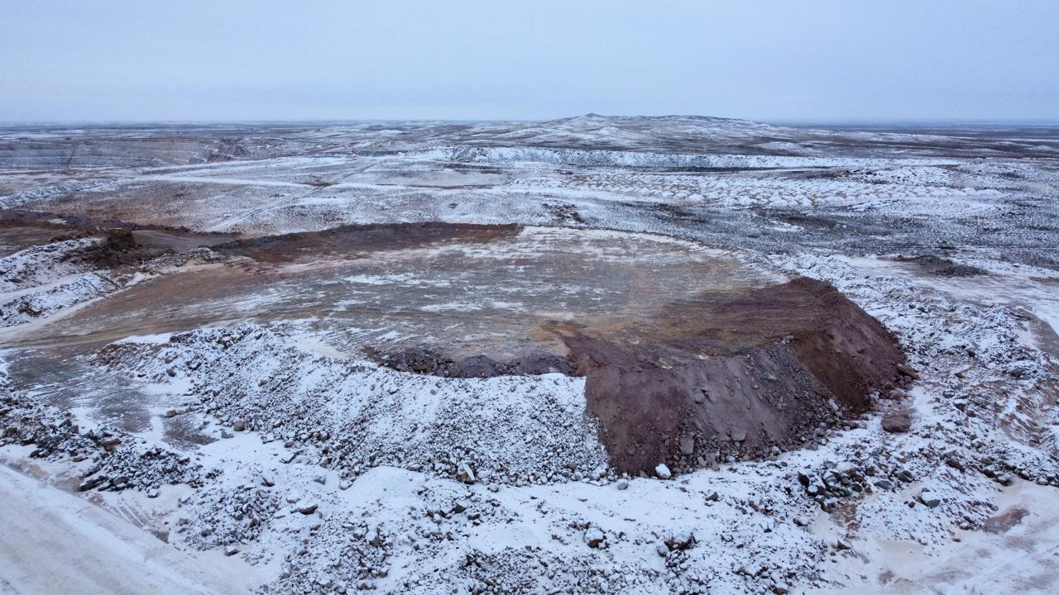

Figure 2 – General view of the Ashiktas mining site (Kazakhstan), from which the precursor material was collected for this study (Source: Ulytau Gold Processing LLP)

The raw materials used in this study included technogenic mineral wastes obtained from various mining deposits in the Republic of Kazakhstan. The selection of these materials was based on their mineralogical composition, particularly the presence of silica-rich and aluminosilicate phases, which are favorable for the synthesis of silicophosphate sorbents.
Sampling was carried out using a composite sampling approach to ensure statistical representativeness and to account for the inherent heterogeneity of technogenic materials. Point samples were collected from multiple locations uniformly distributed across the surface of tailings storage facilities and waste accumulation sites. The sampling depth was maintained within the range of 0–20 cm, corresponding to the most reactive surface layer.
Each point sample, with an approximate mass of 1–2 kg, was collected using manual sampling tools. During sampling, visible impurities such as plant residues, organic matter, and coarse foreign inclusions were removed. The collected point samples were subsequently combined to form a representative bulk sample.
Sample preparation included air-drying under ambient laboratory conditions to constant mass, followed by crushing and grinding. The material was then sieved to obtain the required particle size fraction (0–10 µm), ensuring uniformity for further modification and characterization. To achieve homogeneity and reduce the sample size for analytical purposes, the quartering method was applied. Prepared samples were stored in sealed polyethylene containers under controlled conditions to prevent contamination and moisture uptake prior to analysis.
Sampling and sample preparation procedures were carried out in accordance with the principles described in ISO 3082:2017 and GOST 14180–80 for mineral raw materials and beneficiation wastes. Homogenization and representative sample reduction were performed using the quartering method according to ISO 14488:2007.

2.2 Synthesis of Silicophosphate Sorbents
Silicophosphate materials were synthesized by an acid–thermal method using ore processing wastes as raw materials. Based on the content of acid-reactive mineral phases (primarily silicate, aluminosilicate, and carbonate components), the most suitable waste samples were selected. The required amount of phosphoric acid (20 wt.% and 35 wt.%) was calculated considering the neutralization capacity and chemical reactivity of each raw material.
Each sample was subjected to wet grinding to obtain a particle size of +0–10 µm. The resulting suspensions were dried at 105 °C for 1 h and subsequently calcined in a muffle furnace at 400, 600, and 800 °C. The obtained materials were cooled to room temperature and stored in airtight containers prior to characterization and sorption experiments. In addition, a technological scheme of the optimized synthesis route and a preliminary material balance analysis were developed using Aspen HYSYS V12 software for visualization of the technological stages of silicophosphate sorbent production. Figure 3 shows the process of turning tailings into phosphate-activated sorbents for copper removal.

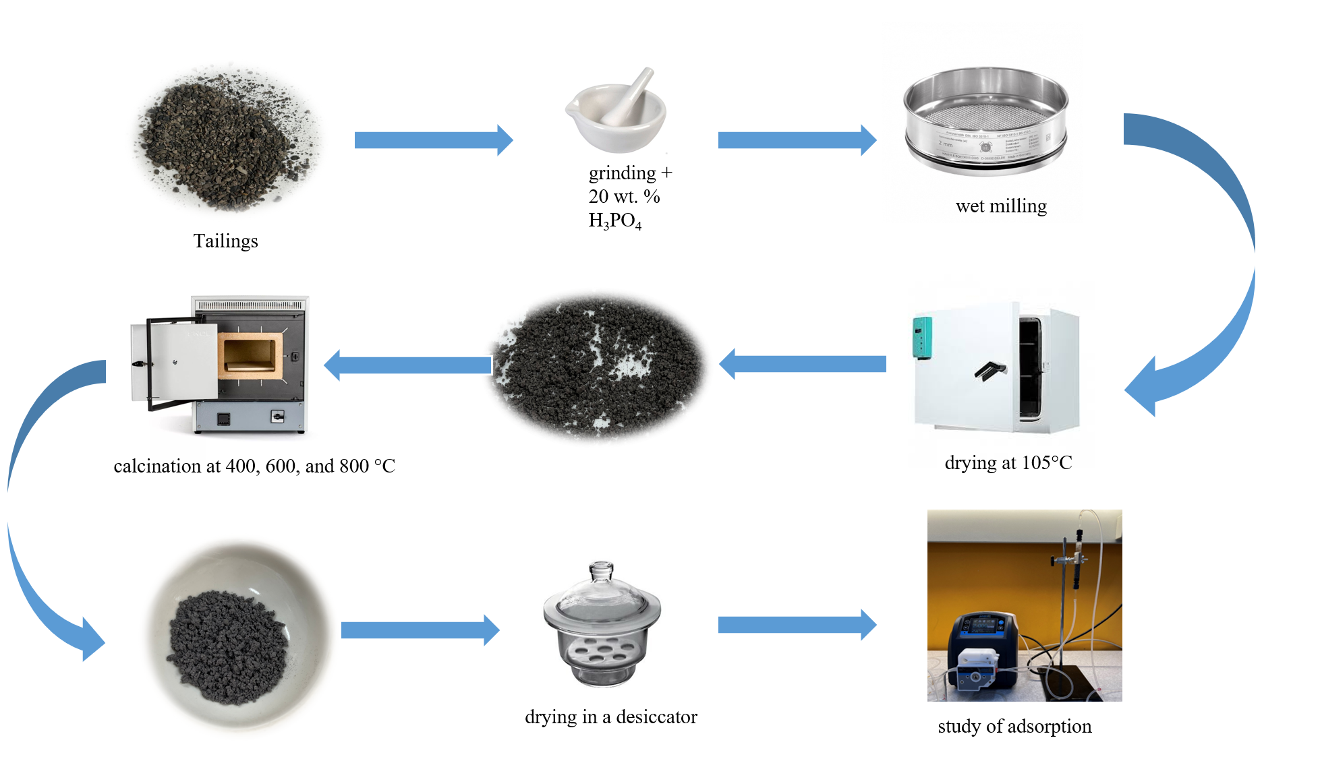
Figure 3 – The process of turning tailings into phosphate-activated sorbents for copper removal

2.3 Solubility and Mechanical Strength Testing
The solubility of the synthesized materials in water was evaluated by measuring mass loss after dissolution. A 1.0000 g sample was placed in 100 mL of distilled water and stirred for 30 min. The suspension was then filtered, and the insoluble residue was dried and weighed.
Solubility (S, rel. %) was calculated using Eq. (30):

$$S=\frac{\left(m_{0}-m_{1}\right)100}{m_{0}}$$ | (30)

where m₀ is the initial mass of the sample (g) and m₁ is the mass after dissolution (g).
Mechanical strength of the sorbents was evaluated using an abrasion resistance method, based on determining the extent of material wear caused by friction between sorbent particles themselves and against the walls of the apparatus. The tests were carried out using a laboratory vibrating sieve.
Mechanical strength (MS) was quantified in terms of abrasion losses, represented by the formation of a fine (dust-like) fraction, which was separated by sieving through a mesh with an aperture size of 0.5–0.7 mm. The abrasion loss, expressed as the mechanical strength index, was calculated according to Eq. (31):

$MS=\frac{m_{1}×100}{m_{0}}, \%$ (31)
where m₁ is the mass of the sorbent retained on the sieve after abrasion (g), and m₀ is the initial mass of the sorbent before abrasion (g).

2.4 Phase and Chemical Composition Analysis
The phase composition of the raw materials and synthesized sorbents was determined by X-ray diffraction using an automated DRON-3 diffractometer with CuKα radiation and a β-filter. The measurements were performed at an accelerating voltage of 35 kV and a current of 20 mA in θ–2θ scanning mode with a scanning rate of 2°/min.
Phase identification was carried out using the ICDD PDF2 database. Semi-quantitative phase analysis of powder samples was performed using the equal-hinge-plate method and artificial mixtures to estimate the relative contents of crystalline phases.
The elemental and material composition of the samples (EPMA) was investigated by electron probe microanalysis using a JEOL-733 electron microscope equipped with an X-ray microanalyzer.

2.5 Surface and Structural Characterization
Surface morphology and microstructure of the initial materials and synthesized sorbents were examined using scanning electron microscopy (SEM) on a JEOL JSM-6490LA instrument.
Specific surface area and pore characteristics were determined by nitrogen adsorption–desorption isotherms using a Beishide BSD-660 analyzer. The Brunauer–Emmett–Teller (BET) method was applied to calculate the specific surface area.
The surface charge properties were evaluated by measuring the zeta potential using a Zetasizer Nano ZS90 (Malvern Instruments).
Fourier transform infrared (FTIR) spectroscopy was performed on a Bruker Alpha-II ATR-FTIR spectrometer to identify functional groups and confirm phosphate incorporation into the structure of the synthesized materials.

2.6 Static Sorption Experiments
Batch sorption experiments were conducted to evaluate equilibrium sorption capacity and removal efficiency toward Cu²⁺ ions. For each experiment, 3.0 g of sorbent was mixed with 100 mL of copper ion solutions with initial concentrations of 1, 10, 20, 30, and 40 mg/L. The suspensions were agitated at 200 rpm for 24 h at room temperature under natural pH conditions without external pH adjustment.
After equilibration, the suspensions were filtered through 0.45 µm membrane filters, and the residual Cu²⁺ concentration was measured using a double-beam atomic absorption spectrometer AA-7000 (Shimadzu).
The removal efficiency (RE, %) was calculated using Eq. (32):

$$RE= \frac{\left(C_{0}-C_{e}\right)100}{C_{0}}$$ | (32)

The equilibrium sorption capacity (qₑ, mg/g) was calculated using Eq. (33):

$${\text{q}}_{\text{e}}\text{ = }\frac{\left(C_{o} {- C}_{e}\right)\text{V}}{m}$$ | (33)

where C₀ and Cₑ are the initial and equilibrium Cu²⁺ concentrations (mg/L), V is the solution volume (L), and m is the mass of the sorbent (g).

2.6.1 Equilibrium Modeling
Experimental equilibrium data were analyzed using Freundlich, Langmuir, Sips, and Dubinin–Radushkevich (D–R) models to describe the interaction mechanisms between Cu²⁺ ions and the synthesized sorbents.

2.7 Sorption Kinetics
Kinetic studies were carried out using a Cu²⁺ solution with an initial concentration of 10 mg/L. A 3.0 g portion of sorbent was added to 250 mL of solution and agitated at 200 rpm. Samples were withdrawn at predetermined time intervals (2, 5, 10, 30, 60, and 120 min), filtered through 0.45 µm membranes, and analyzed for residual Cu²⁺ concentration by AAS.
The kinetic data were interpreted using the pseudo-second-order model, mixed-order model, and intraparticle diffusion model.

2.8 Dynamic Sorption Experiments
Dynamic sorption performance was evaluated in a fixed-bed glass column (10 cm height × 1 cm internal diameter) packed with 3.0 g of sorbent. Prior to the experiment, the column was conditioned with 50 mL of distilled water at a flow rate of 2 mL/min using a peristaltic pump.
A Cu²⁺ solution with a concentration of 10 mg/L was continuously passed through the column at the same flow rate. The effluent was collected in six consecutive 50 mL fractions (total volume 300 mL), and Cu²⁺ concentrations in each fraction were determined by AAS to evaluate breakthrough behavior and dynamic capacity.
All experiments were performed in triplicate, and the reported values represent average results.

3 RESULTS AND DISCUSSION

3.1 Selection and Justification of Raw Materials for Silicophosphate Sorbent Synthesis
Based on the mineralogical and chemical composition of the initial ore beneficiation wastes obtained from XRD and EPMA analyses, further detailed investigation of the synthesized sorbents was focused on the material derived from flotation tailings of the gold-bearing ore from the Akbakay deposit. The primary objective at this stage was to identify the most suitable precursor for the synthesis of silicophosphate sorbents intended for the removal of heavy metal ions from aqueous solutions.
The results of the semi-quantitative X-ray phase analysis of tailings from different deposits are summarized in Table 2. The waste from the Ashiktas deposit is composed predominantly of quartz (96.4%), indicating a highly siliceous but mineralogically simple material with limited structural diversity. In contrast, the Akbakay gold-bearing ore tailings exhibit a more complex mineral composition, consisting mainly of quartz (67%), albite (12%), mica (muscovite) (3%), dolomite (11%), and a minor amount of iron phosphate phase identified as lipscombite (7%). Such a combination provides not only a sufficient silica content but also the presence of aluminosilicate and carbonate phases, as well as iron-containing compounds, which are favorable for acid–thermal modification and the formation of structurally stable and chemically active silicophosphate materials.
The polymetallic ore tailings from the Maikain deposit are characterized by a high barite content (39.5%), which is chemically inert under phosphoric acid treatment and may hinder the formation of active sorption sites. Therefore, despite the moderate silica content (52.3%), this material was considered less suitable for the synthesis of efficient silicophosphate sorbents.
Manganese ores from the Borly and Zhairem deposits demonstrate either an excessive contribution of non-siliceous phases or an imbalance in silica content. The Borly deposit waste contains significant amounts of manganese oxides (pyrolusite and hematite), while the Zhairem deposit is dominated by calcite (76.4%), which results in high acid consumption and limits the formation of stable silicophosphate frameworks.
The EPMA results presented in Table 3 further confirm these observations. The Akbakay waste shows an optimal SiO₂ content (66.99 wt.%) combined with appreciable amounts of Al₂O₃ (12.92 wt.%), CaO (3.35 wt.%), and alkali oxides, which collectively contribute to enhanced reactivity during phosphoric acid modification. Such a chemical composition is advantageous for the formation of structurally stable sorbents with ion-exchange and surface complexation capabilities.
In contrast, the Maikain sample exhibits a high BaO content (28.43 wt.%), consistent with the presence of barite, while the Borly and Zhairem manganese ores show either elevated MnO levels or excessive CaO content, making them less favorable for targeted silicophosphate sorbent synthesis.
Table 2 – Results of semiquantitative X-ray phase analysis of tailings of different ore enrichment

Waste | Phase name | Chemical composition | Concentration, %
Gold ore of the Ashiktas deposit | Quartz | SiO₂ | 96.4
Gold ore of the Ashiktas deposit | Muscovite | KAl₂(AlSi₃O₁₀)(OH)₂ | 3.6
Au-containing ore from the Akbakay deposit | Quartz | SiO₂ | 67
Au-containing ore from the Akbakay deposit | Albite | (Na_{0.84}Ca_{0.16})Al_{1.16}Si_{2.84}O₈ | 12
Au-containing ore from the Akbakay deposit | Lipscombite | Fe_{2.95}(PO₄)₂(OH)₂ | 7
Au-containing ore from the Akbakay deposit | Mica (muscovite) | K_{0.932}Al₂(Al_{0.932}Si_{3.068}O₁₀)(OH)_{1.744}F_{0.256}) | 3
Au-containing ore from the Akbakay deposit | Dolomite | CaMg(CO₃)₂ | 11
Polymetallic ore of the Maikain deposit | Quartz | SiO₂ | 52.3
Polymetallic ore of the Maikain deposit | Barite | BaSO₄ | 39.5
Polymetallic ore of the Maikain deposit | Muscovite | KAl₂(AlSi₃O₁₀)  (OH)₂ | 8.2
Manganese ore of the Borly deposit | Quartz | SiO₂ | 76.7
Manganese ore of the Borly deposit | Kaolinite | Al₂(Si₂O₅)(OH)₄ | 11.8
Manganese ore of the Borly deposit | Pyrolusite | MnO₂ | 6.8
Manganese ore of the Borly deposit | Hematite | Fe₂O₃ | 4.7
Manganese ore of the Zhairem deposit | Calcite | CaCO₃ | 76.4
Manganese ore of the Zhairem deposit | Quartz | SiO₂ | 16.4
Manganese ore of the Zhairem deposit | Albite | Na(AlSi₃O₈) | 4.9
Manganese ore of the Zhairem deposit | Braunite | (Mn₂O₃)₃MnSiO₃ | 2.4

Table 3 – EPMA of the initial waste samples

Gold ore of the Ashiktas deposit
Spectrum | MgO | Al₂O₃ | SiO₂ | K₂O | FeO | BaO | Total
Average | 0.70 | 10.14 | 81.52 | 3.45 | 3.85 | 0.14 | 100.00
Au-containing ore from the Akbakay deposit
Spectrum | Na₂O | MgO | Al₂O₃ | SiO₂ | P₂O₅ | SO₃ | K₂O | CaO | TiO₂ | MnO |  | FeO | Total
Average | 4.72 | 1.93 | 12.92 | 66.99 | 0.75 | 0.76 | 2.65 | 3.35 | 0.58 | 0.18 |  | 5.12 | 100.00
Polymetallic ore of the Maikain deposit
Spectrum | Na₂O | MgO | Al₂O₃ | SiO₂ | SO₃ | K₂O | FeO | BaO | Total
Average | 1.81 | 0.58 | 6.56 | 43.36 | 16.74 | 1.03 | 3.68 | 28.43 | 100.00
Manganese ore of the Borly deposit
Spectrum | Al₂O₃ | SiO₂ | K₂O | MnO | FeO | Total
Average | 4.86 | 79.04 | 0.36 | 10.51 | 5.23 | 100.00
Manganese ore of the Zhairem deposit
Spectrum | Na₂O | MgO | Al₂O₃ | SiO₂ | P₂O₅ | K₂O | CaO | MnO | FeO |  | Total
Average | 0.96 | 1.56 | 3.50 | 24.34 | 0.00 | 0.77 | 54.42 | 10.12 | 2.67 |  | 100.00

Thus, the flotation tailings of the gold-bearing ore from the Akbakay deposit were selected as the most promising raw material for further synthesis and detailed investigation of silicophosphate sorbents, owing to their optimal silica content, favorable mineralogical composition, and chemical suitability for acid–thermal treatment.
The favorable mineralogical and chemical composition of the Akbakay flotation tailings, characterized by an optimal SiO₂/Al₂O₃ ratio and the presence of aluminosilicate phases, suggests a high potential for the formation of active silicophosphate sorption sites during acid–thermal treatment. These structural features are expected to promote strong interactions with Cu²⁺ ions through ion exchange and surface complexation mechanisms. Therefore, the sorption behavior of Cu²⁺ ions on the synthesized Akbakay-based silicophosphate sorbents was investigated in detail under equilibrium, kinetic, and dynamic conditions. The results of these studies are discussed in the following sections.

3.2 Water Solubility and Mechanical Strength
Since the acid–thermal synthesis was carried out at different calcination temperatures and phosphoric acid concentrations, six silicophosphate sorbents were obtained. The samples were designated according to synthesis conditions as follows: Sample 1 (400 °C, 20 wt.% H₃PO₄), Sample 2 (400 °C, 35 wt.% H₃PO₄), Sample 3 (600 °C, 20 wt.% H₃PO₄), Sample 4 (600 °C, 35 wt.% H₃PO₄), Sample 5 (800 °C, 20 wt.% H₃PO₄), and Sample 6 (800 °C, 35 wt.% H₃PO₄).
Water solubility and mechanical strength are critical parameters determining the applicability of sorbents in water treatment processes, particularly under dynamic filtration conditions. The experimental results summarized in Table 4 demonstrate a clear dependence of both properties on synthesis temperature and phosphoric acid concentration.

Table 4 - Solubility in water and mechanical strength of synthesized silicophosphate sorbents

Sample | Solubility in water, % | Mechanical Strength, %
Sample 1 | 1.018 | 88.4
Sample 2 | 2.60 | 78.3
Sample 3 | 1.022 | 91
Sample 4 | 3.92 | 76.5
Sample 5 | 1.019 | 81.9
Sample 6 | 4.8 | 75.5

Sorbents synthesized using 20 wt.% H₃PO₄ (Samples 1, 3, and 5) exhibited low water solubility, not exceeding 1.02%, indicating the formation of chemically stable silicophosphate frameworks. In contrast, increasing the acid concentration to 35 wt.% led to a significant increase in solubility, reaching 2.60–4.80% for Samples 2, 4, and 6. This behavior may be attributed to partial formation of excess phosphate phases and less condensed structures prone to dissolution.
Mechanical strength followed a similar trend. Samples synthesized with 20 wt.% H₃PO₄ demonstrated higher abrasion resistance, with mechanical strength values ranging from 81.9 to 91.0%. The highest mechanical strength (91.0%) was observed for Sample 3 (600 °C, 20 wt.% H₃PO₄), indicating optimal consolidation of the structure at this temperature. Conversely, sorbents prepared with 35 wt.% H₃PO₄ showed reduced mechanical strength (75.5–78.3%), which can be explained by increased brittleness and structural heterogeneity caused by excess acid treatment.
The combined analysis of solubility and mechanical strength indicates that moderate calcination temperature (600 °C) and lower phosphoric acid concentration (20 wt.%) provide the most favorable balance between chemical stability and mechanical durability. These properties are essential for maintaining sorbent integrity during prolonged contact with aqueous solutions and under dynamic flow conditions.
Based on these results, Sample 3 was identified as the most promising candidate for further investigation of Cu²⁺ sorption behavior, including equilibrium, kinetic, and dynamic studies discussed in the subsequent sections.

3.3 Analysis of Composition and Structure of Materials
The structural evolution of phosphate-modified sorbents synthesized from Akbakay gold ore flotation waste was systematically investigated using X-ray diffraction (XRD). The results of the semi-quantitative phase analysis are summarized in Table 5, while representative diffraction patterns are shown in Figure 4.
The initial waste material exhibited a mineralogically heterogeneous composition, consisting mainly of quartz (67 wt.%), albite (12 wt.%), dolomite (11 wt.%), lipscombite (7 wt.%), and muscovite mica (3 wt.%). This assemblage reflects a complex mixture of silicate, carbonate, and phosphate-containing phases, providing a favorable precursor for acid–thermal modification.
Following phosphoric acid treatment and calcination, pronounced changes in phase composition were observed. Quartz remained the dominant crystalline phase in all synthesized samples and exhibited a clear increasing trend with calcination temperature. The highest quartz content (80 wt.%) was detected in Sample 5 (800 °C, 20 wt.% H₃PO₄), indicating progressive enrichment in thermally stable silica as less stable phases decomposed or transformed at elevated temperatures. This behavior is consistent with the high thermal and chemical stability of quartz.
Albite persisted in all synthesized materials within a relatively narrow range (8–12 wt.%), demonstrating its resistance to both acidic treatment and high-temperature calcination. The stability of albite suggests that aluminosilicate frameworks remain largely intact during synthesis and may contribute to structural rigidity and long-term sorbent stability.
In contrast, dolomite showed strong sensitivity to synthesis conditions. Its content increased markedly in Sample 3 (20 wt.%), synthesized at 600 °C with 20 wt.% H₃PO₄, suggesting partial stabilization or recrystallization at intermediate temperatures. However, dolomite content decreased significantly in Sample 4 (7 wt.%) and was not detected in Sample 5, indicating progressive thermal decomposition of carbonate phases at higher temperatures. This observation is consistent with the known decarbonation behavior of dolomitic minerals.

Table 5 - Results of semi-quantitative analysis of crystalline phases by XRD

Name | Formula | Mineral | Concentration, wt.%
Initial waste | SiO₂ | Quartz | 67
Initial waste | (Na_{0.84}Ca_{0.16})Al_{1.16}Si_{2.84}O₈ | Albite | 12
Initial waste | Fe_{2.95}(PO₄)₂(OH)₂ | Lipscombite | 7
Initial waste | K_{0.932}Al₂(Al_{0.932}Si_{3.068}O₁₀)(OH)_{1.744}F_{0.256}) | Mica (muscovite) | 3
Initial waste | CaMg(CO₃)₂ | Dolomite | 11
Sample 1 | SiO₂ | Quartz | 70
Sample 1 | (Na_{0.98}Ca_{0.02})(Al_{1.02}Si_{2.98}O₈) | Albite | 12
Sample 1 | CaMg(CO₃)₂ | Dolomite | 12
Sample 1 | Fe_{2.95}(PO₄)₂(OH)₂ | Lipscombite | 6
Sample 2 | (Na_{0.98}Ca_{0.02})(Al_{1.02}Si_{2.98}O₈) | Albite | 10
Sample 2 | SiO₂ | Quartz | 63
Sample 2 | (K_{0.94}Na_{0.03})(Al_{1.67}Mg_{0.04}Fe_{0.34})(Si_{3.26}Al_{0.74})O₁₀ (OH)_{0.94}F_{0.06})₂ | Mica | 5
Sample 2 | CaMg(CO₃)₂ | Dolomite | 11
Sample 2 | Fe_{2.95}(PO₄)₂(OH)₂ | Lipscombite | 10
Sample 3 | SiO₂ | Quartz | 68
Sample 3 | Na(AlSi₃O₈) | Albite | 11
Sample 3 | Ca(Mg,Fe)(CO₃)₂ | Dolomite | 20
Sample 3 | (K_{0.92}Na_{0.08})(Al_{1.86}Fe_{0.07}Mg_{0.07}Ti_{0.02})(Si_{3.03}Al_{0.97})O₁₀(OH)₂ | Mica | 1
Sample 4 | SiO₂ | Quartz | 76
Sample 4 | (Na_{0.98}Ca_{0.02})(Al_{1.02}Si_{2.98}O₈) | Albite | 8
Sample 4 | Ca(Mg,Fe)(CO₃)₂ | Dolomite | 7
Sample 4 | (K_{0.92}Na_{0.08})(Al_{1.86}Fe_{0.07}Mg_{0.07}Ti_{0.02})(Si_{3.03}Al_{0.97})O₁₀(OH)₂ | Mica | 4
Sample 4 | Fe_{2.95}(PO₄)₂(OH)₂ | Lipscombite | 5
Sample 5 | SiO₂ | Quartz | 80
Sample 5 | Na(AlSi₃O₈) | Albite | 12
Sample 5 | (K_{0.92}Na_{0.08})(Al_{1.86}Fe_{0.07}Mg_{0.07}Ti_{0.02})(Si_{3.03}Al_{0.97})O₁₀(OH)₂ | Mica | 5
Sample 5 | Fe_{2.95}(PO₄)₂(OH)₂ | Lipscombite | 3
Sample 6 | SiO₂ | Quartz | 72
Sample 6 | Na(AlSi₃O₈) | Albite | 12
Sample 6 | Fe_{2.95}(PO₄)₂(OH)₂ | Lipscombite | 5
Sample 6 | (K_{0.92}Na_{0.08})(Al_{1.86}Fe_{0.07}Mg_{0.07}Ti_{0.02})(Si_{3.03}Al_{0.97})O₁₀(OH)₂ | Mica | 11

(a) | (b)
(c) | (d)
(e) | (f)
(g)

Figure 4 – Diffraction patterns of samples: (a) Initial waste; (b) sample 1; (c) sample 2; (d) sample 3; (e) sample 4; (f) sample 5; (g) sample 6

Mica phases exhibited pronounced sample-dependent variability. While present only in minor amounts in most samples, mica content increased sharply to 11 wt.% in Sample 6 (800°C, 35 wt.% H₃PO₄). This increase is likely associated with recrystallization or the formation of secondary mica-like phases under conditions of excessive phosphate loading and elevated temperature, potentially stabilized by interactions with residual silicate and aluminate components.
A key observation concerns the behavior of lipscombite (Fe₂.₉₅(PO₄)₂(OH)₂), which represents an important iron phosphate phase. Its highest content (10 wt.%) was observed in Sample 2 (400°C, 35 wt.% H₃PO₄), indicating that moderate thermal treatment combined with high phosphate availability favors the stabilization of this phase. This finding is consistent with literature data reporting lipscombite formation under phosphate-rich conditions at low-to-intermediate temperatures. With increasing calcination temperature, the lipscombite content decreased, suggesting dehydroxylation and transformation into more thermally stable, likely amorphous Fe/Al-phosphate or silicophosphate phases at 600–800°C.
Importantly, the presence of lipscombite did not directly correlate with Cu²⁺ sorption performance. For example, Sample 3 (600 °C, 20 wt.% H₃PO₄) exhibited the highest Cu²⁺ adsorption capacity despite containing only ~1 wt.% mica and no notable enrichment in lipscombite.
In contrast, although Sample 4 was synthesized under the same thermal conditions with a higher phosphoric acid concentration, sorption experiments were not conducted for this sample. Nevertheless, based on its physicochemical characteristics, including SEM observations and BET data, it can be predicted that excessive phosphatization may lead to partial pore blockage and reduced accessibility of active Fe/Al surface sites. This structural effect is consistent with the general trend observed for highly acid-treated samples and may negatively influence sorption performance.
Overall, the XRD results clearly demonstrate that both phosphoric acid concentration and calcination temperature play a decisive role in controlling the phase composition and structural evolution of the synthesized sorbents (Figure 4). Quartz enrichment, carbonate decomposition, mica phase evolution, and phosphate phase transformations collectively define the structural framework of the materials, which ultimately governs their surface functionality and Cu²⁺ sorption efficiency.

3.3.1 EPMA
Electron Probe Microanalysis (EPMA) was employed to evaluate changes in the chemical composition of the materials as a function of synthesis conditions. The oxide compositions of the initial waste and the modified samples are summarized in Table 6. The raw material is characterized by a high content of silicon dioxide (SiO₂ ≈ 67 wt.%), alumina (Al₂O₃ ≈ 13 wt.%), and alkali oxides, including Na₂O (4.72 wt.%) and K₂O (2.65 wt.%). Minor amounts of P₂O₅, SO₃, CaO, TiO₂, and FeO are also present, reflecting the mineralogical heterogeneity of the original waste.
Phosphoric acid modification followed by thermal treatment results in pronounced compositional changes. Most notably, an increase in P₂O₅ content is observed in all treated samples, confirming the effective incorporation of phosphate species into the material structure. The highest P₂O₅ content (7.79 wt.%) was recorded for Sample 2, synthesized at 400 °C using 35 wt.% H₃PO₄, indicating more efficient phosphate incorporation under moderate thermal conditions. With increasing calcination temperature (600–800 °C), a general decrease in SiO₂ and Al₂O₃ contents is evident, particularly for Sample 6, which simultaneously exhibits elevated FeO (6.45 wt.%) and P₂O₅ (7.51 wt.%). This trend suggests partial restructuring of aluminosilicate phases and the enhanced contribution of iron phosphate species, such as lipscombite, at higher temperatures.
Variations in CaO, MgO, and K₂O contents among the samples further indicate component redistribution induced by acid treatment and thermal activation. Overall, the EPMA results demonstrate that both phosphoric acid concentration and calcination temperature play a decisive role in controlling the chemical composition and elemental distribution of the synthesized sorbents, which is directly related to their surface functionality and subsequent Cu²⁺ sorption behavior.

Table 6 - Oxide composition of the initial Akbakay waste and phosphate-modified sorbents determined by EPMA (wt.%)

Spectrum | Na₂O | MgO | Al₂O₃ | SiO₂ | P₂O₅ | SO₃ | K₂O | CaO | TiO₂ | MnO | FeO | BaO | Total
Initial waste | 4.72 | 1.93 | 12.92 | 66.99 | 0.75 | 0.76 | 2.65 | 3.35 | 0.58 | 0.18 | 5.12 | 0.05 | 100.00
Sample 1 | 4.61 | 1.75 | 12.89 | 65.94 | 4.36 | 0.71 | 2.44 | 2.81 | 0.60 | nf¹ | 3.75 | 0.13 | 100.00
Sample 2 | 4.62 | 1.68 | 12.18 | 62.07 | 7.79 | 0.85 | 2.28 | 3.60 | 0.53 | nf | 4.17 | 0.22 | 100.00
Sample 3 | 4.70 | 1.97 | 13.06 | 64.47 | 4.78 | nf | 2.52 | 3.48 | 0.71 | 0.16 | 4.09 | 0.07 | 100.00
Sample 4 | 2.06 | 1.90 | 13.90 | 64.15 | 5.91 | nf | 4.69 | 2.94 | 0.61 | 0.16 | 3.67 | nf | 100.00
Sample 5 | 4.30 | 2.50 | 12.08 | 59.98 | 5.82 | 0.77 | 2.55 | 5.09 | 0.54 | 0.30 | 6.03 | 0.04 | 100.00
Sample 6 | 4.24 | 2.78 | 11.90 | 58.06 | 7.51 | 0.70 | 2.77 | 4.68 | 0.40 | 0.30 | 6.45 | 0.21 | 100.00

¹ nf=not found.

3.3.2 FTIR Spectroscopy
The FTIR spectra of the initial material and the synthesized samples are shown in Figure 5 and provide insight into the functional groups and structural transformations induced by phosphoric acid modification and thermal treatment. The spectrum of the initial waste material (Figure 5a) exhibits characteristic features of silicate-based minerals. A broad absorption band centered at approximately 3400 cm⁻¹ corresponds to O–H stretching vibrations of surface hydroxyl groups and physically adsorbed water, while the band near 1630 cm⁻¹ is assigned to H–O–H bending vibrations of molecular water. The intense absorption band in the 1000–1100 cm⁻¹ region is attributed to asymmetric Si–O–Si stretching vibrations, typical of quartz and aluminosilicate frameworks. Additional bands observed at around 790 and 470 cm⁻¹ are associated with symmetric Si–O stretching and Si–O bending modes, respectively.

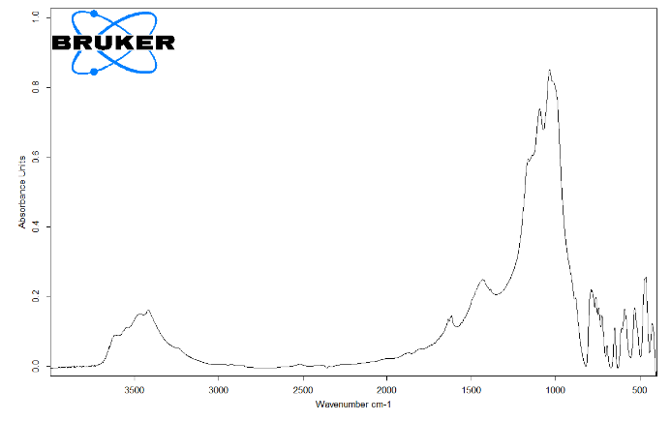 | 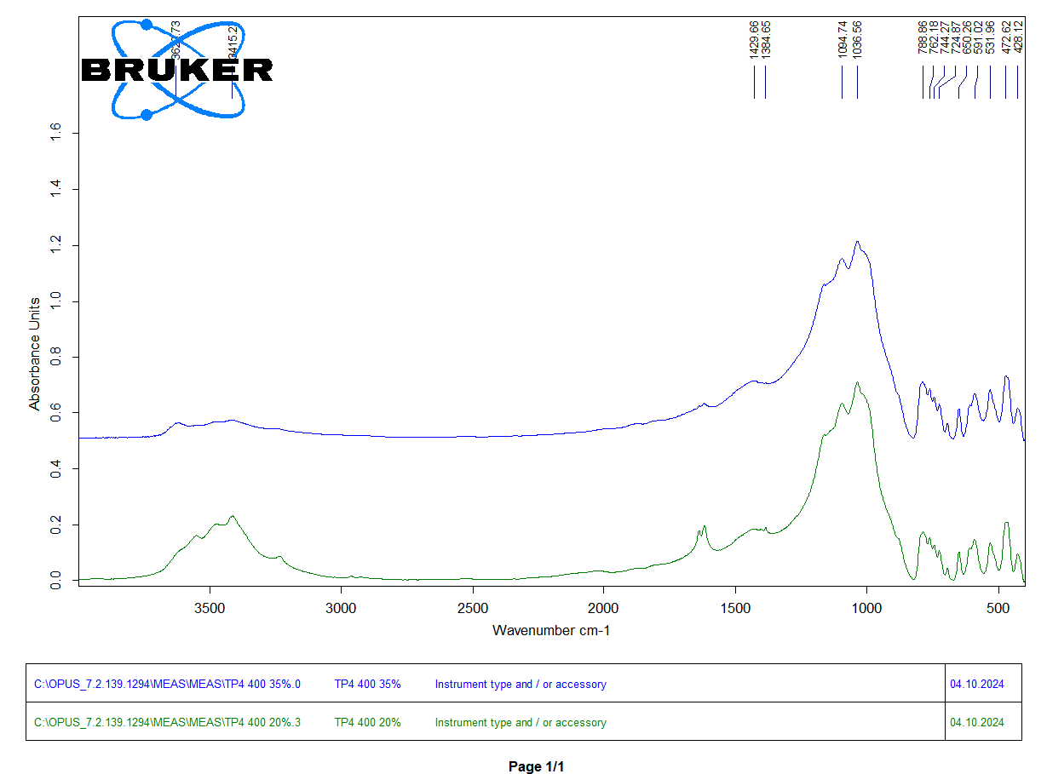
(a) | (b)
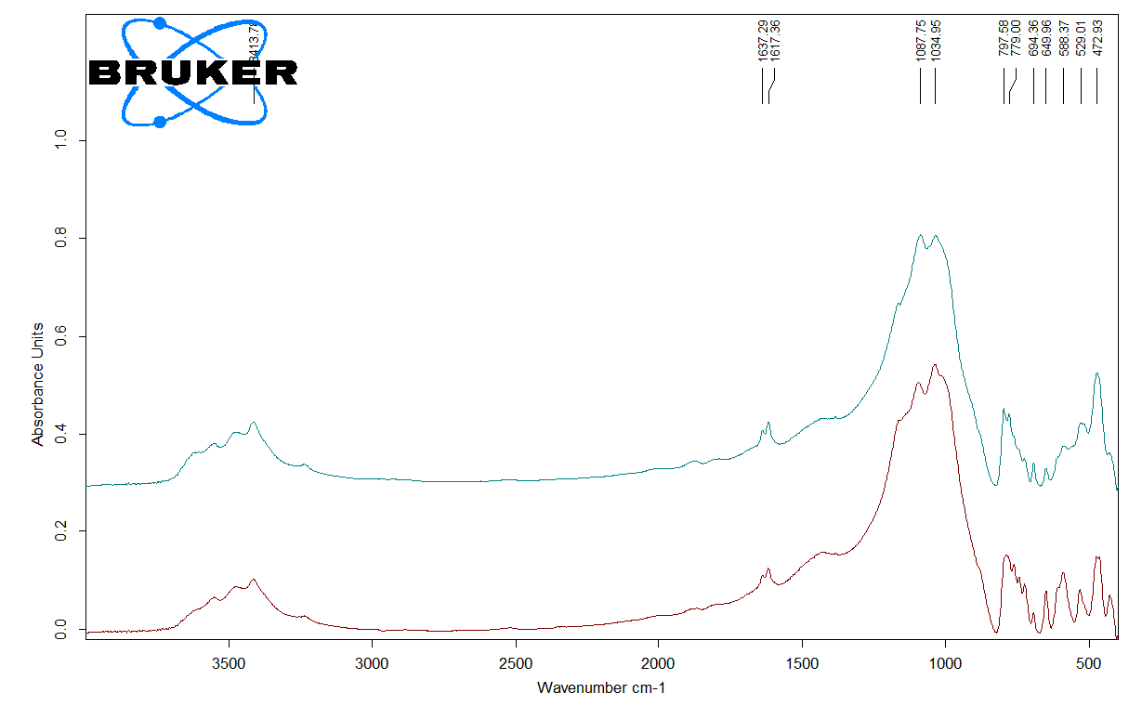 | 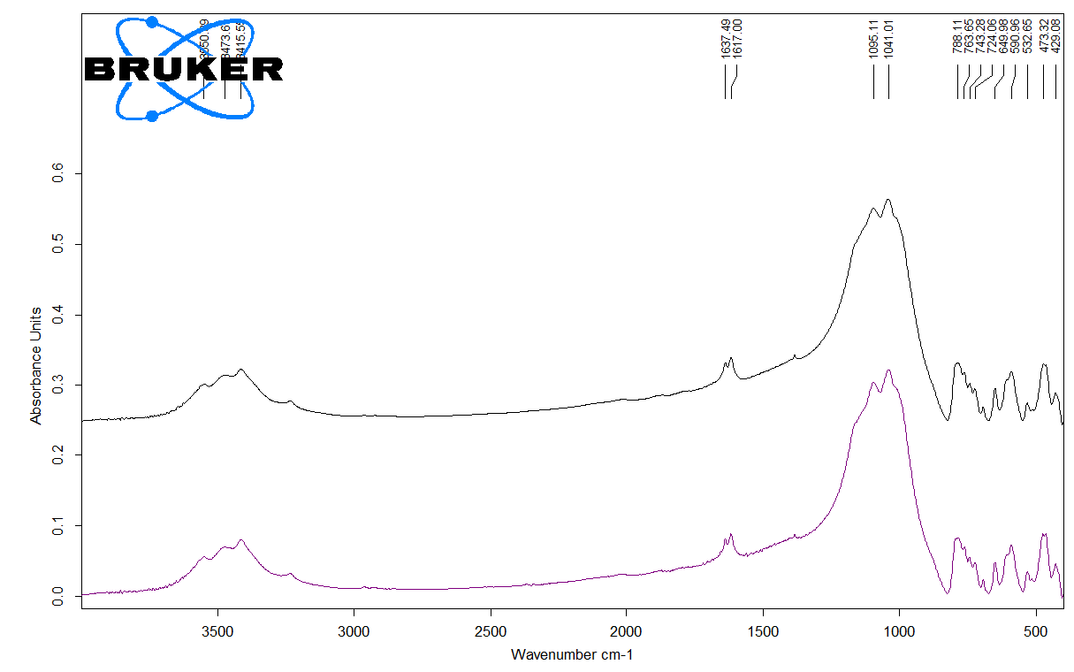
(c) | (d)
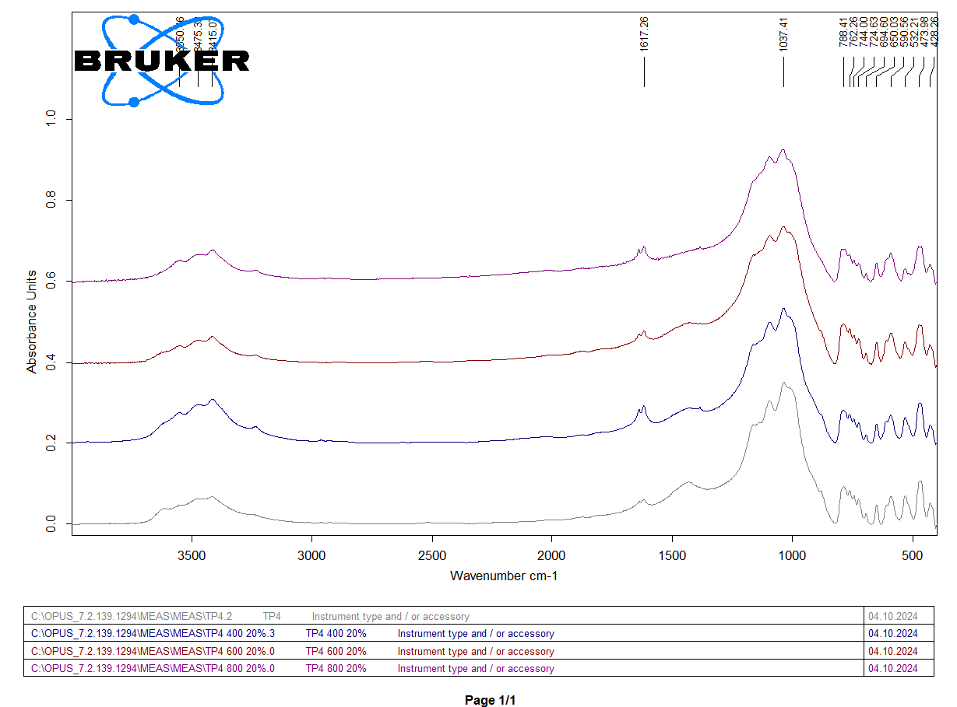 | 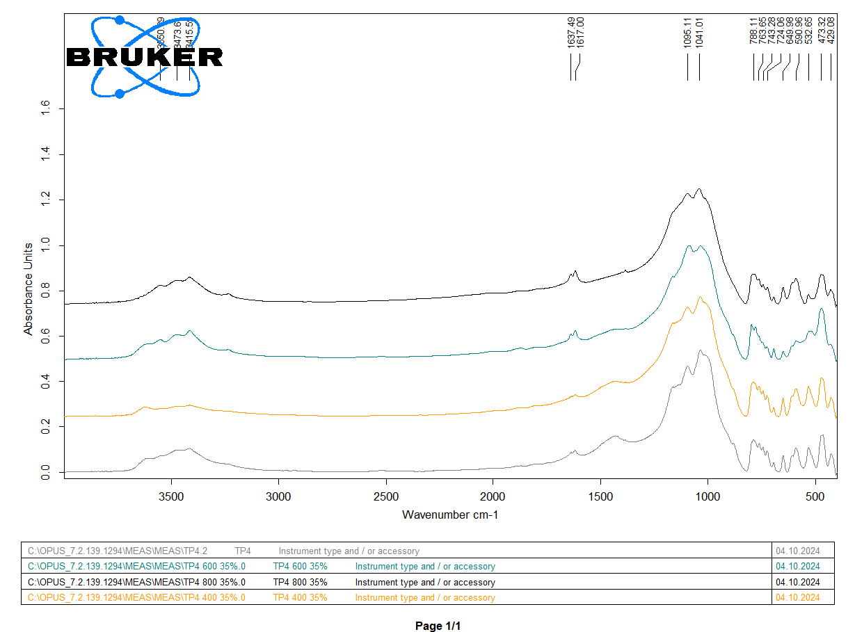
(e) | (f)

Figure 5 – FTIR spectroscopy of samples: (a) Initial waste; (b) comparison of sample 1 (green) and sample 2 (blue); (c) comparison of sample 3 (red) and sample 4 (light green); (d) comparison of sample 5 (purple) and sample 6 (black); (e) comparison of initial waste (gray), sample 1 (blue), sample 3 (red) and sample 5 (purple); (f) comparison of initial waste (gray), sample 2 (yellow), sample 4 (light green) and sample 6 (black)
A comparison of Samples 1 and 2 (Figure 5b), synthesized at 400 °C with 20 wt.% and 35 wt.% H₃PO₄, respectively, reveals noticeable differences in band intensity and spectral shape. In Sample 2, the absorption band near 1050 cm⁻¹, assigned to P–O stretching vibrations, becomes more pronounced, indicating the successful incorporation of phosphate groups into the structure. This observation is consistent with the formation of iron phosphate phases, such as lipscombite, identified by XRD and EPMA analyses.
The spectra of Samples 3 and 4 (Figure 5c), synthesized at 600 °C, show a reduction in hydroxyl-related absorption bands accompanied by slight shifts in the Si–O–Si stretching region. These changes suggest progressive dehydration and increased condensation of the silicate network. Phosphate-related bands remain clearly distinguishable, particularly in Sample 4 (35 wt.% H₃PO₄), highlighting the dominant role of acid concentration in promoting phosphate phase development.
For the high-temperature samples (Samples 5 and 6, Figure 5d), further attenuation of O–H stretching bands is observed, reflecting advanced dehydroxylation and thermal stabilization of the framework at 800 °C. Notably, the persistence of P–O stretching vibrations in Sample 6 indicates that phosphate species remain structurally stable even under severe thermal conditions.
Figures 3e and 3f summarize the spectral evolution of samples synthesized with different acid concentrations over the investigated temperature range. In both series, increasing calcination temperature leads to sharpening and slight shifts of Si–O–Si bands, suggesting enhanced structural ordering and crystallinity. Simultaneously, the emergence and intensification of phosphate-related bands in acid-treated samples - especially those modified with 35 wt.% H₃PO₄ - confirm the effective incorporation of phosphate units into the solid matrix.
Overall, the FTIR results corroborate the XRD and EPMA findings, demonstrating that phosphoric acid treatment induces the formation of phosphate-containing functional groups, while thermal activation governs dehydration and structural reorganization of the silicate framework. The coexistence of phosphate (P–O) and residual hydroxyl groups is particularly relevant for Cu²⁺ sorption, as these functionalities can act as active binding sites, thereby influencing the adsorption capacity and kinetics discussed in the subsequent sections.

3.4 Surface Properties of Materials
Scanning Electron Microscopy (SEM) was employed to investigate the surface morphology and microstructural evolution of the raw Akbakay gold ore waste and the phosphate-modified sorbents synthesized under different acid concentrations and calcination temperatures. Representative SEM images recorded at a magnification of 1000× are presented in Figure 6a–g.
The untreated waste material (Figure 6a) exhibits a dense and compact morphology composed of angular particles with irregular boundaries and a lack of discernible pore structures. The absence of developed textural features indicates limited surface accessibility, which is consistent with the low sorption activity of the raw material.

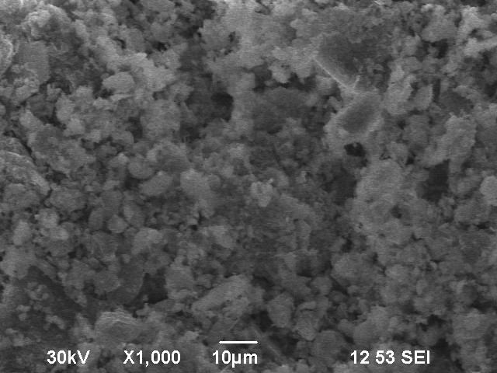 | 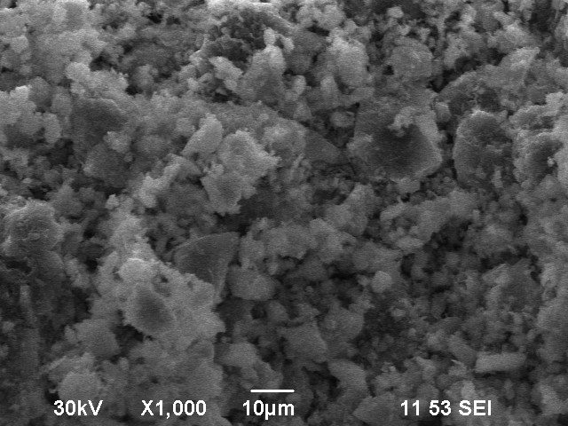
(a) | (b)
 | 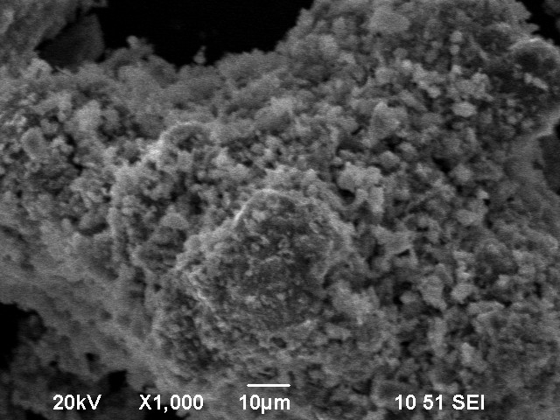
(c) | (d)
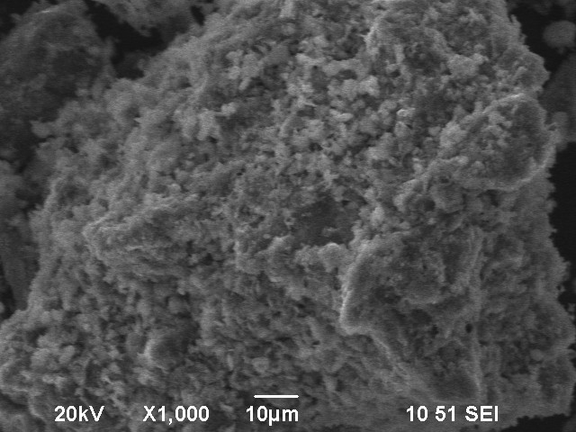 | 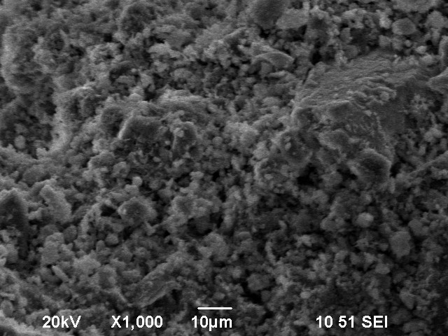
(e) | (f)
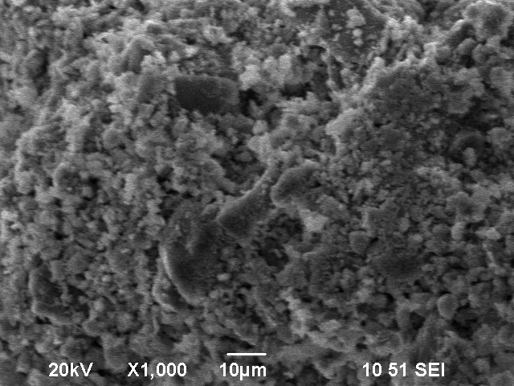
(g)

Figure 6 – SEM images of samples at 1000 magnification: (a) Initial waste; (b) sample 1; (c) sample 2; (d) sample 3; (e) sample 4; (f) sample 5; (g) sample 6
Following phosphoric acid modification and thermal treatment, pronounced morphological changes are observed. Samples 1 and 2 (Figure 6b and 6c), synthesized at 400 °C with 20 wt.% and 35 wt.% H₃PO₄, respectively, show the initial stages of surface etching manifested by fissures, microcracks, and increased surface roughness. However, a more detailed analysis of Figure 6c reveals that the sample treated with 35 wt.% H₃PO₄ exhibits a more pronounced degree of surface disruption compared to Sample 1. In particular, the morphology is characterized by the formation of finer fragmented particles and a higher density of microdefects, indicating a more intensive acid–mineral interaction.
This enhanced etching effect can be attributed to the higher acid concentration, which promotes partial dissolution of aluminosilicate and carbonate phases, leading to increased structural heterogeneity and the formation of loosely packed aggregates. At the same time, despite the more developed surface features observed in Figure 6c, the structure appears less mechanically coherent, suggesting that excessive acid treatment at this stage may induce over-fragmentation rather than controlled pore development.
More significant structural rearrangements occur at a calcination temperature of 600 °C. Sample 3 (Figure 6d, 20 wt.% H₃PO₄) displays fragmented granular particles with emerging pore channels and microcavities, indicative of acid-assisted mineral decomposition combined with thermal dehydration. In contrast, Sample 4 (Figure 6e, 35 wt.% H₃PO₄) reveals a highly disrupted and heterogeneous morphology characterized by extensive fragmentation and porous agglomerates. This pronounced textural development reflects the synergistic effect of elevated acid concentration and moderate thermal treatment, which promotes matrix disintegration and pore formation.
At the highest calcination temperature (800 °C), Samples 5 and 6 (Figure 6f and 6g) exhibit features associated with advanced thermal restructuring. Sample 5 (20 wt.% H₃PO₄) shows evidence of particle sintering and partial fusion, leading to smoother surfaces and diminished textural contrast. Sample 6 (35 wt.% H₃PO₄) undergoes even more extensive modification, with the formation of irregular porous clusters and locally melted surfaces. These morphological characteristics suggest the onset of vitrification and the formation of amorphous phosphate–silicate phases, which are commonly reported for acid-treated materials subjected to high-temperature calcination.
Overall, the SEM observations demonstrate that both phosphoric acid concentration and calcination temperature play a decisive role in controlling the surface morphology of the synthesized sorbents. Acid treatment at low and intermediate temperatures promotes surface etching, particle disaggregation, and pore development, whereas excessive thermal input at 800 °C leads to sintering and partial melting, potentially reducing the accessibility of active sites. These morphological trends are in good agreement with BET surface area measurements and Cu²⁺ sorption results, underscoring the importance of optimizing synthesis conditions to achieve favorable surface properties and enhanced adsorption performance.

3.4.1 Zeta Potential Analysis
The zeta potential values of the raw and phosphate-modified samples are summarized in Figure 7, illustrating the influence of phosphoric acid concentration and thermal treatment on surface charge characteristics. The initial gold ore waste exhibited a zeta potential of –10.4 mV, indicating limited surface activation and a relatively low capacity for electrostatic repulsion.
After modification, all synthesized sorbents demonstrated markedly more negative zeta potential values, ranging from –14.1 mV to –20.1 mV. This pronounced shift toward negative surface charge reflects the successful incorporation of phosphate groups and structural reorganization induced by acid treatment and subsequent calcination. Such changes are typically associated with the formation of negatively charged surface functional groups, including P–O⁻ and deprotonated hydroxyl species on Fe- and Al-containing sites.
Among the modified samples, Sample 3 (600 °C, 20 wt.% H₃PO₄) exhibited the most negative zeta potential (–20.1 mV) (Figure 7b), suggesting the highest degree of surface functionalization and enhanced colloidal stability. This observation is consistent with the presence of a high density of anionic surface sites, likely arising from phosphate coordination on Fe/Al-rich domains, and correlates well with its superior Cu²⁺ adsorption performance. Samples 1 and 2, synthesized at 400 °C with 20 wt.% and 35 wt.% H₃PO₄, respectively, also showed substantially enhanced surface charge (–18.0 mV and –16.3 mV; Figure 7a), indicating effective acid-induced surface modification at lower calcination temperatures.
In contrast, Samples 5 and 6, calcined at 800 °C, exhibited comparatively less negative zeta potential values (–14.1 mV and –14.8 mV, respectively; Figure 7c). This reduction is likely associated with partial sintering, surface densification, or the formation of amorphous phosphate–silicate phases at elevated temperatures, which may limit the accessibility of charged functional groups. Sample 4 (600 °C, 35 wt.% H₃PO₄) showed an intermediate zeta potential value (–16.1 mV; Figure 7b), suggesting that excessive acid loading can partially block or neutralize active surface sites, thereby reducing the effective surface charge.
The comparative analysis presented in Figure 7d–f further confirms that appropriately balanced acid–thermal treatment leads to a systematic increase in negative surface charge relative to the raw material. This enhancement is particularly advantageous for aqueous-phase sorption processes, as more negative zeta potentials promote stronger electrostatic attraction toward positively charged metal ions, such as Cu²⁺. The observed trends are in good agreement with literature reports on phosphate-functionalized mineral-based sorbents, which similarly demonstrate improved adsorption performance associated with increasingly negative surface charge values [86].
Overall, the zeta potential results confirm that phosphoric acid modification combined with controlled thermal activation effectively tailors the surface charge properties of Akbakay-derived sorbents. Optimization of acid concentration and calcination temperature is therefore crucial to maximize electrostatic interactions and achieve enhanced Cu²⁺ sorption efficiency.

(a) | (b)
(c) | (d)
(e)

Figure 7 – Zeta potential distribution of samples: (a) comparison of sample 1 (green) and sample 2 (red); (b) comparison of sample 3 (red) and sample 4 (green); (c) comparison of sample 5 (green) and sample 6 (red); (d) comparison of initial waste (red), sample 1 (blue), sample 3 (green) and sample 5 (black); (e) comparison of initial waste (red), sample 2 (blue), sample 4 (green) and sample 6 (black)

3.4.2 Surface area and porosity analysis
The surface textural properties of the initial waste material and the synthesized phosphate-modified sorbents were evaluated using nitrogen adsorption–desorption isotherms. The resulting parameters, including the Brunauer–Emmett–Teller (BET) specific surface area, Langmuir surface area, micropore area calculated using the Dubinin–Radushkevich (D–R) model, total pore volume, average pore diameter, and BJH pore size distribution, are summarized in Table 7.

Table 7 - Textural Properties of Initial waste and Phosphate-Modified Sorbents

Parameter | Initial waste | Sample 1 | Sample 2 | Sample 3 | Sample 4 | Sample 5 | Sample 6
BET Surface Area (m²/g) | 6.02 | 3.86 | 2.19 | 4.02 | 2.79 | 3.09 | 2.71
Langmuir Surface Area (m²/g) | 9.58 | 6.46 | 3.52 | 6.48 | 4.46 | 5.01 | 4.37
D-R Micropore Area (m²/g) | 6.46 | 3.56 | 3.48 | 3.20 | 3.05 | 3.23 | 2.82
Total Pore Volume (cm³/g) | 0.0191 | 0.0141 | 0.0103 | 0.0145 | 0.0106 | 0.0163 | 0.0172
Average Pore Diameter (nm) | 12.69 | 14.61 | 18.83 | 14.38 | 15.18 | 21.08 | 25.38
BJH Desorption Area (m²/g) | 6.70 | 4.51 | 2.23 | 4.57 | 3.10 | 3.78 | 3.11
BJH Pore Volume (cm³/g) | 0.0186 | 0.0136 | 0.0101 | 0.0143 | 0.0104 | 0.0160 | 0.0171

The unmodified initial waste exhibited the highest BET surface area (6.02 m²/g), which decreased in all modified samples regardless of calcination temperature or phosphoric acid concentration. This reduction is attributed to partial pore collapse, surface densification, and structural rearrangement during acid treatment and subsequent thermal processing. Among the modified sorbents, Sample 3 (600 °C, 20 wt.% H₃PO₄) retained a relatively moderate BET surface area (4.02 m²/g), whereas the lowest value was observed for Sample 2 (400 °C, 35 wt.% H₃PO₄), at 2.19 m²/g. A comparable trend was observed for Langmuir surface areas, which decreased from 9.58 m²/g for the raw material to 3.52 m²/g for Sample 2.
In contrast, the D–R micropore area showed less pronounced variation among the modified samples, remaining within the range of 2.8–3.6 m²/g. This indicates that a fraction of the microporous structure is preserved despite acid modification and calcination. The total pore volume was highest for the initial waste (0.0191 cm³/g) and slightly decreased after modification; however, Sample 6 (800 °C, 35 wt.% H₃PO₄) exhibited a relatively high pore volume (0.0172 cm³/g), suggesting the formation of additional mesopores at elevated temperatures.
Notably, the observed trends differ from those typically reported for acid-activated clay minerals, where phosphoric acid treatment often leads to significant surface area enhancement [59]. In the present case, the silica-rich nature of the Akbakay waste resulted in a decrease in BET surface area following modification (from 6.02 to 2.19–4.02 m²/g), likely due to pore collapse and thermal densification. Nevertheless, the average pore diameter increased in most modified samples, particularly those subjected to higher calcination temperatures, indicating the development of mesoporosity. Sample 6 displayed the largest average pore diameter (25.38 nm), with BJH desorption data further confirming its mesoporous character.
These structural transformations are expected to improve the accessibility of surface functional groups and internal active sites, thereby compensating for the reduction in overall surface area. Such behavior has been previously reported for waste-derived and phosphate-modified adsorbents, where mesopore development plays a dominant role in governing sorption efficiency [86]. Overall, the surface textural analysis demonstrates that phosphoric acid modification combined with thermal treatment reduces specific surface area but promotes mesopore formation, particularly at higher acid concentrations and calcination temperatures. This balance between surface area and pore architecture is crucial for optimizing Cu²⁺ sorption performance in the synthesized materials.
The synthesized silicophosphate sorbents are characterized by relatively low specific surface area values (2–4 m²/g). However, despite this, high sorption efficiency toward Cu²⁺ ions was observed. This indicates that the adsorption process is not governed primarily by physical adsorption mechanisms, which typically depend on surface area and pore structure.
Instead, the dominant mechanism can be attributed to chemical interactions, including ion exchange and surface complexation involving phosphate functional groups formed during phosphoric acid modification. These groups provide active sites for binding divalent metal cations, compensating for the limited surface area.
Thus, the sorption performance of the developed materials is controlled mainly by their surface chemistry rather than textural characteristics, which is consistent with the observed high removal efficiency at relatively low BET surface area. This behavior is typical for chemically functionalized mineral sorbents, where the density and nature of active sites play a more significant role than the total surface area.

3.5 Equilibrium and Kinetics of the Sorption Process of Copper Cations
The sorbent synthesized at 600 °C using 20 wt.% phosphoric acid (Sample 3) exhibited optimal physicochemical characteristics, including enhanced surface accessibility, a favorable pore structure, and the most negative surface charge among the studied samples. These features are critical for effective metal ion uptake and were therefore expected to result in superior sorption performance. Based on this, Sample 3 was selected for detailed investigation of Cu²⁺ sorption behavior under both static (batch) and dynamic (fixed-bed column) conditions.

3.5.1 Equilibrium Sorption Studies
Batch adsorption experiments were carried out using Sample 3 to evaluate its equilibrium adsorption capacity (qₑ) and Cu²⁺ removal efficiency (RE). The initial Cu²⁺ concentrations (C₀) ranged from 1 to 40 mg/L. In each experiment, 3.0 g of the sorbent was contacted with 100 mL of the metal ion solution. The initial pH of the solutions was maintained within the range of 4.5–6.0, corresponding to typical conditions for aqueous CuSO₄·5H₂O solutions without external pH adjustment.
After reaching equilibrium, the residual Cu²⁺ concentration (Cₑ) was determined, and the adsorption parameters were calculated. The experimental results are summarized in Table 8. Under equilibrium conditions, Sample 3 demonstrated consistently high Cu²⁺ removal efficiency across the entire investigated concentration range (1–40 mg/L), with RE values exceeding 97%. The equilibrium adsorption capacity (qₑ) increased steadily with increasing initial Cu²⁺ concentration, reaching a maximum experimental value of 1.33 mg/g at C₀ = 40 mg/L. This trend reflects an increased driving force for mass transfer at higher metal ion concentrations and a high affinity of the sorbent surface toward Cu²⁺ ions.

Table 8 - Experimental and modeled equilibrium adsorption parameters of Cu²⁺ on Sample 3

Experimental values |  |  |  |  | Predicted values
C₀  (mg/L) | C_{e}  (mg/L) | SD  (Cₑ) | RE  (%) | q_{e}  (mg/g) | q_{e}(Freundlich)  (mg/g) | q_{e}(Sips)  (mg/g) | q_{e}(D-R)  (mg/g) | q_{e}(Langmuir)  (mg/g)
1.00 | 0.030 | ± 0.004 | 97.010 | 0.032 | 0.245 | 0.307 | 0.258 | 0.311494
10.00 | 0.036 | ± 0.003 | 99.643 | 0.332 | 0.292 | 0.357 | 0.323 | 0.366845
20.00 | 0.061 | ± 0.006 | 99.697 | 0.665 | 0.496 | 0.560 | 0.584 | 0.588265
30.00 | 0.093 | ± 0.004 | 99.690 | 0.997 | 0.762 | 0.805 | 0.869 | 0.842164
40.00 | 0.180 | ± 0.01 | 99.550 | 1.327 | 1.476 | 1.412 | 1.401 | 1.382051

To further elucidate the adsorption mechanism, the experimental equilibrium data were fitted using four adsorption isotherm models: Freundlich, Langmuir, Sips, and Dubinin–Radushkevich (D–R) (Figure 8). The comparison between experimental and predicted qₑ values shows that the Langmuir and D–R models provide the closest agreement with the experimental data over the entire concentration range. The Sips model also yielded a reasonable fit, whereas the Freundlich model underestimated adsorption capacity, particularly at higher Cu²⁺ concentrations.
The fitted isotherm parameters and statistical indicators are summarized in Table 9. Among the evaluated models, the Dubinin–Radushkevich (D–R) model provided the best overall fit, as indicated by the highest coefficient of determination (R² = 0.930) and the lowest error values (SSE = 0.079, RMSE = 0.163). This suggests that the adsorption process is strongly influenced by pore-filling effects, which is consistent with the mesoporous structure observed in SEM and BET analyses.
The Langmuir model also showed a strong correlation with the experimental data (R² = 0.909), supporting the assumption of predominantly monolayer adsorption on energetically similar surface sites. The maximum monolayer adsorption capacity predicted by this model (qₘ = 4.37 mg/g) is in good agreement with the experimental adsorption trend.

Figure 8 – Fitting of equilibrium adsorption data to Freundlich, Langmuir, Sips, and Dubinin–Radushkevich (D–R) models

Table 9 - Isotherm model parameters and error function values for Cu²⁺adsorption onto Sample 3

Equilibrium model | Model parameters |  | Error functions
Freundlich | K_{F} | -1185.119 | R² | 0.860
Freundlich | n_{F} | -0.007 | SSE | 0.153
Freundlich |  |  | MSE | 0.051
Freundlich |  |  | RMSE | 0.226
Sips | q_{mS} | 6.076 | R² | 0.882
Sips | K_{S} | 0.855 | SSE | 0.131
Sips | n_{S} | 0.849 | MSE | 0.066
Sips |  |  | RMSE | 0.256
Dubinin-Radushkevich | q_{mD-R} | 2.720 | R² | 0.930
Dubinin-Radushkevich | B | 0.031 | SSE | 0.079
Dubinin-Radushkevich |  |  | MSE | 0.026
Dubinin-Radushkevich |  |  | RMSE | 0.163
Langmuir | q_{m} | 4.370 | R² | 0.909
Langmuir | K_{L} | 2.567 | SSE | 0.112
Langmuir |  |  | MSE | 0.037
Langmuir |  |  | RMSE | 0.193

The Sips model, which combines features of both Langmuir and Freundlich isotherms, exhibited moderate agreement (R² = 0.882), suggesting a limited degree of surface heterogeneity. In contrast, the Freundlich model showed the weakest fit (R² = 0.860) and yielded a non-physical negative value of the Freundlich constant (K_{F}), indicating that this model is not suitable for describing Cu²⁺ adsorption on Sample 3 under the studied conditions.
Overall, the equilibrium analysis indicates that Cu²⁺ adsorption onto Sample 3 is best described by the Langmuir and D–R models. While the Langmuir model reflects saturation of surface adsorption sites, the superior fit of the D–R model highlights the important role of pore-filling and physical adsorption mechanisms. This conclusion is consistent with the structural and surface characteristics of the sorbent, including mesoporosity, moderate surface area, and the presence of phosphate-functionalized Fe/Al-containing domains.

3.5.2 Practical Assessment of Sorbent Consumption
For the preliminary evaluation of practical applicability, the required sorbent dosage for Cu²⁺ removal from aqueous solutions was estimated based on experimentally determined equilibrium sorption capacities.
The required mass of sorbent was calculated using the following equation (Eq. 34):

$m=\frac{C_{0}×V}{q_{e}}$ (34)
where $m$ is the required sorbent mass (g), $C_{0}$is the initial concentration of Cu²⁺ (mg/L), $V$is the solution volume (L), and $q_{e}$is the equilibrium sorption capacity (mg/g).
For calculation purposes, a model system with a solution volume of 1 L was considered. The estimated sorbent consumption values based on experimental equilibrium data are presented in Table 10.

Table 10 - Estimated sorbent consumption based on experimental equilibrium data

Initial Cu²⁺ concentration,  mg/L | Equilibrium sorption capacity,  mg/g | Required sorbent mass,  g/L
1 | 0.032 | 31.25
10 | 0.332 | 30.12
20 | 0.665 | 30.08
30 | 0.997 | 30.09
40 | 1.327 | 30.14

The obtained results indicate that the required sorbent dosage remains nearly constant at approximately 30 g/L across the investigated concentration range. This behavior suggests a proportional relationship between the equilibrium sorption capacity and the initial Cu²⁺ concentration, indicating that the adsorption process follows a near-linear trend within the studied range without reaching saturation of active sites.
Despite the very high removal efficiency (>99%), the relatively moderate sorption capacity leads to a significant sorbent dosage requirement, which should be taken into account when considering large-scale water treatment applications.
It should be noted that these estimations are based on batch equilibrium data and may differ under dynamic flow conditions, where additional factors such as flow rate, mass transfer limitations, and the presence of competing ions may influence the overall sorption performance. The nearly constant sorbent consumption (~30 g/L) reflects stable adsorption behavior and confirms the reproducibility of the material performance across different concentration levels.

3.5.3 Sorption Kinetics
Kinetic experiments were performed to evaluate the rate and mechanism of Cu²⁺ ion sorption onto Sample 3 at an initial copper concentration (C₀) of 10 mg/L. Batch experiments were conducted using 3.0 g of sorbent in 250 mL of Cu²⁺ solution under continuous agitation at 200 rpm. At predetermined time intervals (2, 5, 10, 30, 60, and 120 min), aliquots were withdrawn, filtered through 0.45 μm membranes, and analyzed by atomic absorption spectroscopy (AAS) to determine the residual Cu²⁺ concentrations (Cₜ). The experimental kinetic data are summarized in Table 11.
A rapid uptake of Cu²⁺ ions was observed during the initial stage of the process, indicating a strong affinity of the sorbent surface toward copper ions. More than 98% removal was achieved within the first 2 minutes, followed by a gradual approach to equilibrium. After 120 minutes, the removal efficiency exceeded 99%, with an equilibrium adsorption capacity (qₑ) of 0.828 mg/g. This behavior suggests the presence of readily accessible active sites on the sorbent surface, followed by slower diffusion-controlled processes.

Table 11 - Kinetic experimental data for Cu²⁺ sorption

t (min) | C_{t} (mg/L) | SD (mg/L) | RE (%) | qₜ (mg/g)
0 | 10 | ±0.010 | 0.00 | 0.000
2 | 0.1349 | ±0.006 | 98.65 | 0.822
5 | 0.2401 | ±0.008 | 97.60 | 0.813
10 | 0.2473 | ±0.007 | 97.53 | 0.813
30 | 0.1161 | ±0.005 | 98.84 | 0.824
60 | 0.1086 | ±0.005 | 98.91 | 0.824
120 | 0.0660 | ±0.004 | 99.34 | 0.828

The experimental kinetic data were analyzed using pseudo-first-order (PFO), pseudo-second-order (PSO), intraparticle diffusion, and mixed-order kinetic models (Figure 9). The calculated kinetic parameters and associated error functions are presented in Table 12. The pseudo-first-order model showed poor agreement with the experimental data, as evidenced by the low correlation coefficient (R² = 0.511) and higher error values, indicating that this model does not adequately describe the sorption kinetics of Cu²⁺ ions on Sample 3.

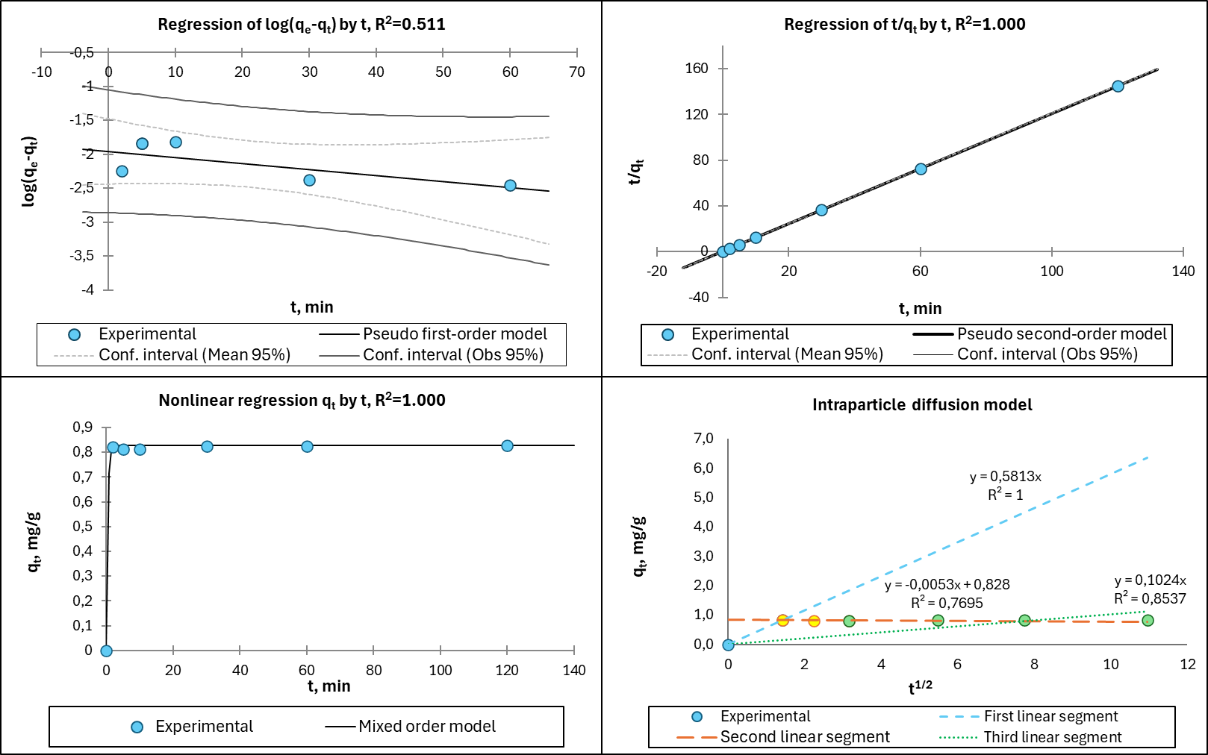
(d)
(c)
(b)
(a)

Figure 9 – Fitting of kinetic models for Cu²⁺ sorption: (a) Pseudo first-order; (b) Pseudo second-order; (c) Mixed order; (d) Intraparticle diffusion

Table 12 – Values of the kinetic model parameters and error functions for the system Copper ions – Sample 3

Model type | Model parameter |  |  | Error function
Pseudo-first-order  Linear expression  $$\log\left(q_{e}-q_{t}\right)=logq_{e}-\frac{k_{1}}{2.303}t$$ | k₁ | q_{e1} |  | R₁² |  | MSE | RMSE
 | -8.825x10⁻³ | 0.141 |  | 0.511 |  | 0.058 | 0.241
Pseudo second-order  Linear expression  $$\frac{t}{q_{t}}=\frac{1}{k_{2}q_{e}^{2}}+\frac{1}{q_{e}}t$$ | k₂ | q_{e2} |  | R₂² |  | MSE | RMSE
 | 1.199x10⁻¹ | 0.828 |  | 1.000 |  | 0.018 | 0.135
Intraparticle diffusion  Non-linear form  $$q_{t}=k_{i}t^{0.5}+I$$ | k_{i1} | k_{i2} |  | R_{i1}² |  | R_{i2}²
 | -0.005 | 0.1024 |  | 0.769 |  | 0.102
Mixed order  Non-linear form  $$q=q_{e}\left(\frac{1-exp⁡(-k_{1}t)}{1-f_{2}exp⁡(-k_{1}t)}\right)$$ | k₁ | k₂ | f₂ |  | R² | MSE | RMSE
 | 2.054 | 2.182 | 0.438 |  | 1.000 | 0.000 | 0.010

In contrast, the pseudo-second-order model provided an excellent fit to the experimental data, with an R² value of 1.000 and a calculated equilibrium adsorption capacity (qₑ = 0.828 mg/g) in close agreement with the experimental value. This result suggests that chemisorption, involving valence forces through electron sharing or exchange between Cu²⁺ ions and surface functional groups, plays a dominant role in the sorption process.
The intraparticle diffusion model was applied to further investigate the diffusion mechanism. The plot of qₜ versus t¹ᐟ² exhibited a multilinear behavior, indicating that intraparticle diffusion is not the sole rate-controlling step. The first linear region corresponds to rapid external surface adsorption or boundary layer diffusion, while the subsequent regions reflect slower diffusion within the internal pores of the sorbent and the final equilibrium stage. The poor linearity observed in the later stages suggests that intraparticle diffusion alone cannot fully describe the entire sorption process.
Among the tested models, the mixed-order kinetic model showed the best overall agreement with the experimental data, yielding an R² value of 1.000 and a minimal RMSE of 0.010. The estimated rate constants (k₁ = 2.054 min⁻¹ and k₂ = 2.182 g·mg⁻¹·min⁻¹) and the second-order contribution fraction (f₂ = 0.438) indicate that Cu²⁺ sorption onto Sample 3 proceeds through a combination of physisorption and chemisorption mechanisms. This mixed kinetic behavior reflects the complexity of the process and confirms the involvement of multiple simultaneous rate-limiting steps, including surface adsorption and diffusion-controlled transport.

3.6 Dynamic Sorption (Fixed-Bed Column)
Dynamic sorption experiments were performed using a fixed-bed column system to assess the performance of the synthesized sorbent under continuous-flow conditions. A glass column (10 cm height × 10 mm inner diameter) was packed with 3.0 g of Sample 3 and preconditioned by passing 50 mL of distilled water through the bed at a flow rate of 2 mL/min using a peristaltic pump. Subsequently, a Cu²⁺ solution with an initial concentration of 10 mg/L was continuously introduced into the column at the same flow rate.
The effluent was collected as six successive fractions of 50 mL each, corresponding to a total treated volume of 300 mL. The residual Cu²⁺ concentrations in each fraction were determined by atomic absorption spectroscopy (AAS). The experimental results are summarized in Table 13 and illustrated in Figure 10.
The column experiments confirmed the effective performance of Sample 3 under dynamic conditions. The total amount of copper adsorbed during the experiment was approximately 2.540 mg, corresponding to a dynamic sorption capacity of 0.847 mg/g. Although this value is lower than the equilibrium capacity obtained in batch experiments, it reflects the inherent limitations of fixed-bed systems, such as reduced contact time and mass transfer constraints. Nevertheless, the observed dynamic capacity demonstrates efficient copper removal under realistic operating conditions. Comparable equilibrium and dynamic sorption capacities for Cu²⁺ have been reported for a range of conventional and nanostructured sorbents [87].

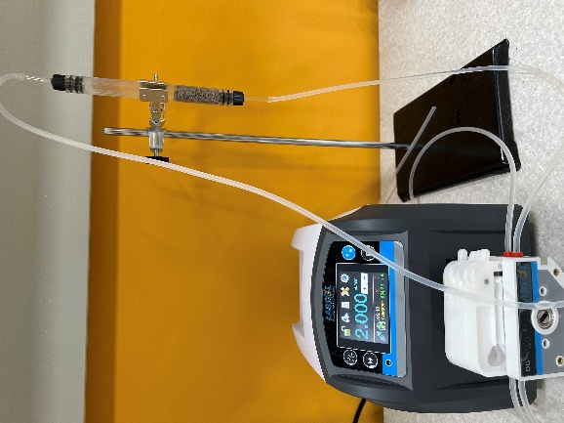

Figure 10 – Dynamic Cu²⁺ sorption profile of Sample 3 under fixed-bed conditions

Table 13 – Dynamic Cu²⁺ sorption performance
Fraction | Cumulative Volume  (mL) | Residual Cu²⁺  (mg/L) | SD (mg/L) | RE  (%) | Adsorbed Cu (mg) | Cumulative Adsorbed Cu (mg)
0 | 0 | 0.000 | ±0.000 | 100 | - | -
1 | 50 | 1.339 | ±0.020 | 86.608 | 0.280 | 0.433
2 | 100 | 1.478 | ±0.022 | 85.217 | 0.273 | 0.859
3 | 150 | 1.633 | ±0.025 | 83.668 | 0.265 | 1.278
4 | 200 | 1.599 | ±0.024 | 84.007 | 0.267 | 1.698
5 | 250 | 1.637 | ±0.025 | 83.626 | 0.269 | 2.116
6 | 300 | 1.519 | ±0.023 | 84.807 | 0.271 | 2.540

The breakthrough behavior of the column is presented in Figure 11. A 5% breakthrough was observed at a cumulative effluent volume of approximately 25 mL, while 95% breakthrough was not reached even after processing 300 mL of solution, indicating prolonged column operation and strong Cu²⁺ retention. Within the investigated filtration volume (up to 300 mL), the $C_{t}/C_{0}$ratio increased only to approximately 0.15, indicating that complete saturation of the sorbent bed was not achieved. Assuming a simplified near-linear increase of the $C_{t}/C_{0}$ratio with treated volume, the exhaustion point $\left(C_{t}/C_{0} ≈ 1\right)$can be tentatively estimated at a treated volume of approximately 2 L. Considering the relatively slow increase of $C_{t}/C_{0}$, the actual exhaustion volume may extend further, likely in the range of 2–3 L under the given experimental conditions. However, this estimation should be regarded as approximate, since breakthrough curves are typically non-linear and require further experimental validation at higher filtration volumes.
Throughout the tested volume, the removal efficiency remained consistently above 83%, and the column utilization efficiency was calculated to be 84.7%. These results highlight the stability and effectiveness of the sorbent during continuous operation.
Overall, the dynamic sorption performance demonstrates the practical applicability of the synthesized sorbent for continuous water treatment systems. Further improvements in column efficiency may be achieved by optimizing operational parameters such as flow rate, influent concentration, and bed height.
Compared to conventional sorbents, the synthesized materials offer several important advantages: they are derived from readily available mining byproducts, require no expensive reagents or complex synthesis procedures, and exhibit sufficiently fast sorption kinetics to enable compact treatment units. Although their sorption capacity is lower than that of advanced materials such as nano-hydroxyapatite [135], the use of waste-derived precursors combined with simple processing routes provides a sustainable and economically viable alternative. Moreover, further enhancements—such as hybrid modification strategies or targeted surface functionalization—may lead to improved performance for specific environmental applications.

Figure 11 – Breakthrough curve for dynamic sorption of Cu²⁺ ions

3.7 Chemical Mechanism of Sorbent Formation and Copper Sorption

3.7.1 Chemical transformations during sorbent synthesis
The formation of silicophosphate sorbents under acid–thermal conditions involve a series of physicochemical and chemical transformations, including partial dissolution of mineral phases, surface activation, and the formation of phosphate-containing functional groups.
During acid treatment with orthophosphoric acid, carbonate phases present in the raw material undergo dissolution (Eq. 35):

${\text{CaCO}}_{3}+2H_{3}PO_{4}→Ca^{2+}+2H_{2}PO_{4}^{-}+CO_{2}↑+H_{2}O$ (35)
Simultaneously, partial protonation and activation of aluminosilicate structures occur, leading to the formation of reactive surface hydroxyl groups (Eq. 36):

$≡Si\text{–}O\text{–}Si + H^{+}→≡Si\text{–}OH + ≡Si^{+}$ (36)
Interaction of activated surface sites with phosphate species results in the formation of phosphate functional groups (Eq. 37):

$≡Si\text{–}OH+H_{2}PO_{4}^{-}→≡Si\text{–}O\text{–}PO_{3}H^{-}+H_{2}O$(37)
For aluminum-containing sites (Eq. 38):

$≡Al\text{–}OH+H_{2}PO_{4}^{-}→≡Al\text{–}O\text{–}PO_{3}H^{-}+H_{2}O$ (38)
During subsequent thermal treatment (600 °C), condensation and stabilization of phosphate structures occur (Eq. 39):

$≡M\text{–}OH+HO\text{–}PO_{3}H^{-}→≡M\text{–}O\text{–}PO_{3}^{-}+H_{2}O(M=Si,Al)$ (39)
As a result, a stable silicophosphate framework with negatively charged functional groups (≡Si–O–PO₃⁻, ≡Al–O–PO₃⁻) is formed, which plays a key role in metal ion adsorption.

3.7.2 Mechanism of Cu²⁺ sorption
The removal of Cu²⁺ ions by the synthesized sorbent is governed by a combination of surface complexation and ion-exchange mechanisms, which is consistent with the kinetic analysis (pseudo-second-order model) indicating chemisorption.
1. Surface complexation
Copper ions interact with phosphate functional groups to form inner-sphere surface complexes (Eq. 40-41):

$≡Si\text{–}O\text{–}PO_{3}^{-}+Cu^{2+}→≡Si\text{–}O\text{–}PO_{3}\text{–}Cu^{+}$ (40)$≡Al\text{–}O\text{–}PO_{3}^{-}+Cu^{2+}→≡Al\text{–}O\text{–}PO_{3}\text{–}Cu^{+}$ (41)
This mechanism is the dominant pathway due to the high affinity of Cu²⁺ for oxygen donor ligands.
2. Ion exchange mechanism
Copper ions can replace exchangeable cations (e.g., H⁺, Na⁺, Ca²⁺) associated with surface functional groups (Eq. 42-43):

$≡Si\text{–}O^{-}H^{+}+Cu^{2+}→≡Si\text{–}O\text{–}Cu^{+}+H^{+}$ (42)$≡Si\text{–}O^{-}Na^{+}+Cu^{2+}→≡Si\text{–}O\text{–}Cu^{+}+Na^{+}$ (43)
3. Electrostatic interaction
At near-neutral pH, the negatively charged surface of the sorbent (confirmed by zeta potential measurements) promotes electrostatic attraction of Cu²⁺ ions (Eq. 44):

$≡SO^{-}+Cu^{2+}→≡SO^{-}⋅Cu^{2+}$ (44)

3.7.3 Summary of the sorption mechanism
The sorption of Cu²⁺ ions onto the synthesized silicophosphate sorbent is governed by a combination of surface complexation, ion exchange, and electrostatic interactions. The formation of inner-sphere surface complexes occurs through the interaction of copper ions with phosphate functional groups (≡Si–O–PO₃⁻ and ≡Al–O–PO₃⁻), which act as primary active sites. In addition, ion exchange processes take place, where Cu²⁺ ions replace exchangeable cations such as H⁺, Na⁺, or Ca²⁺ associated with the sorbent surface.
Furthermore, the negatively charged surface of the material, as indicated by zeta potential measurements, promotes electrostatic attraction of positively charged copper ions, enhancing their accumulation near the surface and facilitating subsequent chemical interaction.
These mechanisms are in good agreement with the experimental data. The FTIR spectra confirm the formation of phosphate functional groups, the zeta potential results indicate an increase in negative surface charge after modification, and the kinetic analysis, best described by the pseudo-second-order model, suggests that chemisorption is the dominant mechanism governing the sorption process.

3.7.4 Justification of Optimal Synthesis Conditions
The superior sorption performance of Sample 3, obtained at 600 °C using 20 wt.% H₃PO₄, can be explained by the combined effect of structural transformations and surface functionalization occurring during acid–thermal treatment.
At a phosphoric acid concentration of 20 wt.%, sufficient surface activation occurs, leading to the formation of phosphate functional groups (≡Si–O–PO₃⁻ and ≡Al–O–PO₃⁻), which act as active sites for Cu²⁺ binding. This concentration is optimal for functionalization without excessive dissolution of the mineral matrix. At higher acid concentrations (e.g., 35 wt.%), partial destruction of the aluminosilicate framework may occur, resulting in a decrease in structural stability and effective sorption sites.
Thermal treatment at 600 °C plays a critical role in stabilizing the formed phosphate structures. At this temperature, condensation reactions lead to the formation of chemically stable bonds between phosphate groups and the silicate matrix (Eq. 45):

$≡M\text{–}OH+HO\text{–}PO_{3}H^{-}→≡M\text{–}O\text{–}PO_{3}^{-}+H_{2}O(M=Si,Al)$ (45)
This results in a well-developed surface with a high density of negatively charged functional groups, as confirmed by zeta potential measurements (–20.1 mV), which enhances electrostatic attraction and surface complexation with Cu²⁺ ions.
At lower temperatures (e.g., 400 °C), the degree of condensation and structural stabilization is insufficient, leading to a lower density of active sites. In contrast, at higher temperatures (e.g., 800 °C), partial sintering and structural densification may occur, reducing surface accessibility and active site availability.
Thus, the combination of 20 wt.% H₃PO₄ and a calcination temperature of 600 °C ensures an optimal degree of surface functionalization while preserving the integrity of the silicate matrix. Under these conditions, stable phosphate functional groups are formed and firmly anchored to the surface, resulting in a high density of negatively charged active sites. This, in turn, leads to an increased negative surface charge, enhancing the interaction between the sorbent and Cu²⁺ ions.
These factors collectively account for the highest sorption capacity and removal efficiency of Cu²⁺ ions observed for Sample 3.

3.8 Development of the Technological Scheme and Material Balance for Silicophosphate Sorbent Production
Based on the comprehensive experimental results obtained in this study, including structural (XRD, FTIR), surface (BET, zeta potential), and sorption analyses, an optimized synthesis route for silicophosphate sorbents was developed. The proposed technological sequence reflects the most effective conditions of acid–thermal modification and ensures the formation of a structurally stable and sorption-active material. The optimized synthesis procedure is illustrated in Figure 12.
To evaluate the efficiency of the proposed synthesis method, a material balance analysis was performed based on 100 g of raw technogenic waste under optimized conditions.
During synthesis, 25 mL of 20 wt.% H₃PO₄ solution was used, corresponding to approximately 27.75 g of acid solution (assuming a density of 1.11 g/mL). Thus, the total initial mass of the system was 127.75 g. After synthesis and drying, 118.75 g of silicophosphate sorbent was obtained. The calculated material balance is summarized in Table 14.
The results demonstrate that the overall product yield reaches approximately 93%, indicating that the primary mineral matrix is largely preserved during the synthesis process. The observed mass loss is attributed to the removal of physically bound water, decomposition of carbonate phases, and partial dissolution of unstable mineral components during acid treatment.

Figure 12 – Block diagram of the technological scheme for the acid–thermal synthesis of silicophosphate sorbent

To further visualize the technological sequence and process configuration, a process flowsheet was developed using Aspen HYSYS V12 software (Figure 13).
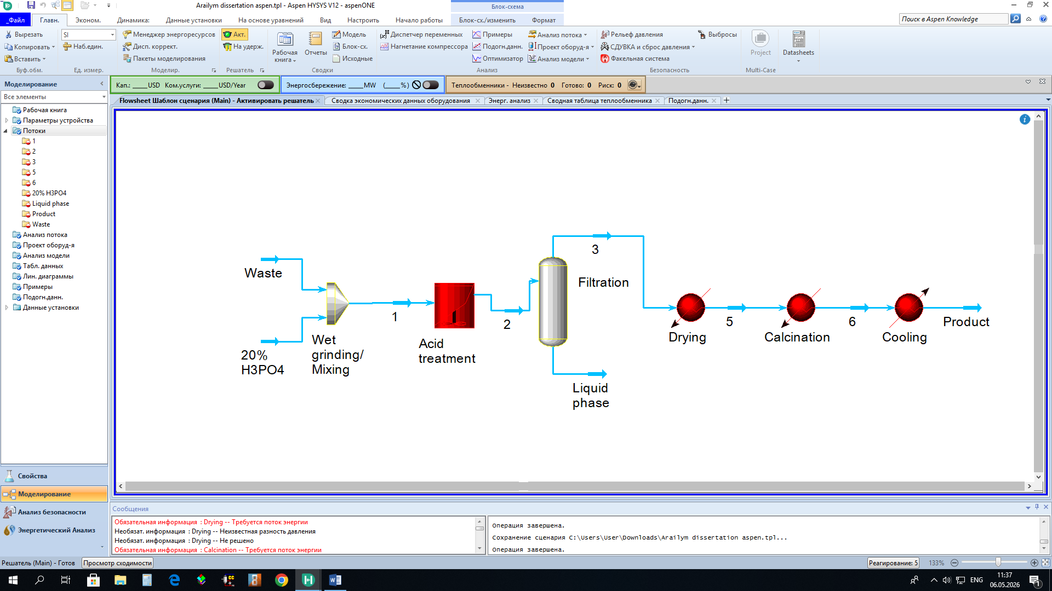
Figure 13 – Technological scheme of silicophosphate sorbent synthesis developed in Aspen HYSYS V12 using 20 wt.% H₃PO₄ and calcination at 600°C

The technological scheme developed in Aspen HYSYS V12 represents the proposed sequence of technological stages for the synthesis of silicophosphate sorbent from ore processing waste under optimized acid–thermal modification conditions. The scheme includes wet grinding and mixing of the raw material with 20 wt.% H₃PO₄ solution, acid treatment to promote interaction between phosphate species and reactive mineral phases, solid–liquid separation of the resulting suspension, drying at 105°C, thermal treatment at 600°C, and subsequent cooling of the synthesized material.
The developed technological scheme was used to visualize the process configuration, material flow sequence, and principal stages of sorbent production. Particular attention was given to the integration of acid treatment and thermal activation stages, which are essential for the formation of structurally stable phosphate-containing surface groups and preservation of the silicate framework. The scheme also served as the basis for the preliminary material balance analysis of the optimized synthesis route.

Table 14 – Material balance of the optimized synthesis process (per 100 g of raw material)

Parameter | Value
Raw technogenic waste | 100.00 g
20 wt.% H₃PO₄ solution | 25 mL / 27.75 g
Pure H₃PO₄ | 5.55 g
Water in solution | 22.20 g
Total initial mass | 127.75 g
Final sorbent (after drying) | 118.75 g
Mass loss | 9.00 g
Product yield | 92.95%

To further assess compositional transformations, an oxide-based material balance was performed for the main structural components of the sorbent, including SiO₂, Al₂O₃, and CaO. The calculations were based on the composition of Sample 3 obtained under optimized conditions (Table 15).

Table 15 – Oxide-based material balance of the final sorbent

Oxide | Content (wt.%) | Mass in final sorbent (g)
SiO₂ | 64.47 | 76.56
Al₂O₃ | 13.06 | 15.51
CaO | 4.78 | 5.67

The oxide-based analysis confirms that SiO₂ remains the dominant component in the final material, indicating preservation of the silicate framework. Al₂O₃ is retained in significant amounts, contributing to the formation of aluminosilicate and silicophosphate structural units. The presence of CaO suggests partial transformation of calcium-containing phases, including possible formation of calcium phosphate compounds during interaction with orthophosphoric acid.
It should be noted that the observed increase in the relative content of these oxides is primarily due to a concentration effect associated with the removal of soluble and volatile components during synthesis. These findings are consistent with XRD results indicating partial decomposition of carbonate phases and FTIR spectra confirming the formation of phosphate functional groups.
Overall, the combination of a high product yield (~93%), preservation of the silicate matrix, and formation of phosphate-containing structures demonstrates the effectiveness of the proposed acid–thermal modification method for the synthesis of stable and efficient silicophosphate sorbents from technogenic raw materials.
In addition to the material balance, a preliminary economic consideration of the proposed synthesis method was carried out. The main consumable reagent in the process is phosphoric acid, with a consumption of 25 mL of 20 wt.% H₃PO₄ solution (equivalent to approximately 5.55 g of pure H₃PO₄) per 100 g of raw material, corresponding to about 55 g per 1 kg of waste. Since the raw material consists of technogenic mineral waste, its cost can be considered negligible, and the overall process cost is primarily determined by reagent consumption and energy input during thermal treatment.
The relatively high product yield (~93%) significantly enhances process efficiency by minimizing material losses and reducing secondary waste generation. In addition, the use of moderate synthesis conditions (600 °C and 20 wt.% H₃PO₄) allows for optimization of energy consumption compared to higher-temperature treatments.
Thus, the proposed synthesis approach can be considered economically promising at a preliminary level due to the use of low-cost raw materials, moderate reagent consumption, and a simple technological scheme. Furthermore, the utilization of technogenic waste contributes to resource efficiency and environmental sustainability.

4 COMPARATIVE CU(II) SORPTION ON AKBAKAY-BASED SILICOPHOSPHATE AND BENTONITE

Industrial wastewater streams frequently contain toxic heavy metal ions, such as copper, which pose significant environmental and health risks and necessitate efficient remediation strategies [101, 85, 102]. Natural aluminosilicate minerals, particularly bentonite clays, have been extensively employed as adsorbents for this purpose, leveraging their abundance, low cost, and inherent cation exchange capacity [136, 110]. However, their application, especially in dynamic filtration systems, is severely hampered by intrinsic drawbacks, including high dispersibility, a propensity for emulsion formation, and partial solubility in aqueous media [109, 137].
The development of chemically stabilized sorbents from mineral and technogenic raw materials represents a promising avenue. Silicophosphate materials, in particular, offer enhanced chemical durability, resulting in low solubility and high stability in water [68] . This study presents a direct comparative assessment of a novel silicophosphate sorbent against conventional bentonite. The comparison is fundamentally justified by the compositional similarity of the matrices; both materials are predominantly silicate-based, with silica (SiO₂) constituting 50–60% of their mass. The novelty of this research lies in a comprehensive evaluation of a sorbent modified from Akbakay gold mining waste (using 20% H₃PO₄ and calcination at 600 °C) versus natural and calcined bentonite, focusing on critical physicochemical and sorptive properties relevant to practical application.

4.1 Materials and methods
The following materials were investigated [138]:
- A silicophosphate sorbent synthesized from Akbakay deposit processing waste, modified with 20% orthophosphoric acid and calcined at 600 °C.
- Natural granular bentonite (conforming to Technical Specifications TU 2164-004-00204493-2009).
- Bentonite calcined at 600 °C.
Analysis Methods:
- Solubility and mechanical strength were determined using standard methods[139].
- Material Characterization: The detailed mineralogical and elemental composition of the initial Akbakay processing waste and the derived silicophosphate sorbent, confirming the structural transformation upon phosphoric acid treatment and calcination, was established in our prior study using X-ray diffraction (XRD), scanning electron microscopy (SEM), and other analytical techniques [68].
- Sorption Experiments: Batch sorption experiments were conducted to evaluate Cu²⁺ uptake. A 3.0 g sample of each sorbent was mixed with 100 mL of Cu²⁺ solution at varying initial concentrations (1, 10, 20, 30, and 40 mg/L). The suspensions were stirred at 200 rpm for 24 h at room temperature. After filtration (0.45 μm membrane filter), the residual Cu²⁺ concentration was measured using an AA-7000 atomic absorption spectrometer (Shimadzu, Japan). The equilibrium sorption capacity (qₑ, mg/g) was calculated using the mass balance equation [140].

4.2 Research results
Solubility and Mechanical Strength:
According to the results presented in Table 16 natural bentonite undergoes rapid dispersion in water, forming a persistent turbid emulsion. Thermal treatment at 600 °C reduces its solubility by approximately 50%, yet fails to resolve the fundamental issue of colloidal stability, consistent with reported behavior of thermally modified clays [141].

Table 16 – Physicochemical Properties of the Sorbents

Sample | Solubility, % | Mechanical Strength, %
Silicophosphate sorbent (Akbakay, 600 °C, 20% H₃PO₄) | 1.22 | 91.0
Natural bentonite | 80.0 | 83.5
Bentonite calcined at 600 °C | 42.4 | 90.0

Equilibrium Sorption of Copper Ions (Cu²⁺):
The silicophosphate sorbent exhibited consistently high removal efficiency, markedly surpassing both bentonite variants across the tested concentration spectrum (Table 17). Its performance advantage is particularly pronounced at medium to high initial Cu²⁺ concentrations (10–40 mg/L), where the bentonite samples demonstrate unstable and limited sorption capacity [109, 141].

Table 17 – Residual Cu²⁺ concentrations and calculated sorption capacities after 24 h equilibrium

 | Akbakay Silicophosphate Sorbent |  |  |  | Natural Bentonite |  |  |  | Bentonite (600 °C)
C₀ (mg/L) | Cₑ  (mg/L) | SD (Cₑ) | qₑ  (mg/g) | SD (qₑ) | Cₑ  (mg/L) | SD (Cₑ) | qₑ (mg/g) | SD (qₑ) | Cₑ (mg/L) | SD (Cₑ) | qₑ (mg/g) | SD (qₑ)
1 | 0.0357 | ± 0.004 | 0.032 | ± 0.002 | 0.0099 | ± 0.0012 | 0.033 | ± 0.002 | 0.0141 | ± 0.0012 | 0.033 | ± 0.002
10 | 0.0299 | ± 0.003 | 0.332 | ± 0.015 | 0.6461 | ± 0.03 | 0.312 | ± 0.015 | 0.5739 | ± 0.025 | 0.314 | ± 0.015
20 | 0.0930 | ± 0.006 | 0.664 | ± 0.03 | 2.2238 | ± 0.08 | 0.593 | ± 0.025 | 1.1543 | ± 0.05 | 0.628 | ± 0.03
30 | 0.0606 | ± 0.004 | 0.998 | ± 0.04 | 2.0226 | ± 0.09 | 0.933 | ± 0.04 | 1.3982 | ± 0.06 | 0.953 | ± 0.04
40 | 0.1802 | ± 0.01 | 1.327 | ± 0.06 | 2.4845 | ± 0.1 | 1.250 | ± 0.05 | 1.9594 | ± 0.08 | 1.268 | ± 0.05

The comparative efficiency of the investigated sorbents for Cu²⁺ ion removal is visualized in Figure 14. The plot reveals a fundamental difference in material behavior: the silicophosphate sorbent maintains exceptionally low equilibrium concentration values (Cₑ) across the entire studied range of initial concentrations (C₀ = 1–40 mg/L), whereas for both natural and calcined bentonite, a sharp increase in Cₑ is observed even at moderate loadings (C₀ > 10 mg/L). This dependence of Cₑ on C₀ provides clear evidence of the higher and more stable sorption capacity of the modified silicophosphate material.

Figure 14 – Equilibrium Cu²⁺ concentration (Cₑ) as a function of initial concentration for different sorbents. The lines are shown for visual guidance only and do not represent a continuous dependence.

4.3 Discussion
The experimental results clearly demonstrate the superior operational performance of the modified silicophosphate sorbent derived from Akbakay mining waste. Its low solubility (1.22%) and high mechanical strength (91%) indicate the formation of a stable, cross-linked silicate–phosphate framework during acid activation and thermal treatment. Such structural consolidation enhances the material’s resistance to degradation and prevents particle disintegration during aqueous operation, which is consistent with previously reported findings for phosphate-functionalized mineral systems[68]. In contrast, natural bentonite, even after calcination, retains a pronounced hydrophilic character. This results in swelling, partial dispersion in water, and loss of material through solubilization, which may increase the risk of clogging and reduce filtration efficiency in practical systems [109, 142]. Although thermal treatment improves mechanical stability by dehydroxylation, it does not significantly enhance the density of active sorption sites and may partially disrupt the layered montmorillonite structure [141].
The high and stable affinity of the silicophosphate sorbent toward Cu²⁺ ions is evidenced by consistently low equilibrium concentrations (Cₑ < 0.2 mg/L) across the entire investigated concentration range. This behavior can be attributed to the presence of accessible and high-affinity functional groups, primarily protonated phosphate (≡P–OH) and silanol (≡Si–OH) groups, which actively participate in ion exchange and inner-sphere complexation mechanisms.
In contrast, the sorption performance of both bentonite samples is less stable and exhibits non-linear behavior. Natural bentonite shows a decrease in removal efficiency at moderate concentrations (10–20 mg/L), indicating rapid saturation of a limited number of exchangeable sites. The calcined bentonite demonstrates slightly improved performance; however, its adsorption capacity remains significantly lower than that of the silicophosphate sorbent.
The experimental adsorption data (qₑ vs Cₑ), presented in Figure 15, provide a qualitative assessment of sorption behavior. It should be noted that the obtained dependencies do not represent classical equilibrium isotherms, as the investigated concentration range is relatively low and full saturation of the sorbents was not achieved.
The silicophosphate sorbent exhibits a steep increase in adsorption capacity even at low equilibrium concentrations, indicating a high density of active sites and strong affinity toward Cu²⁺ ions. In contrast, the bentonite samples display more gradual and irregular trends, reflecting their heterogeneous structure and limited availability of sorption sites.
Overall, the higher position and stability of the silicophosphate adsorption curve confirm its superior sorption performance compared to conventional clay-based materials.
Therefore, the presented data should be interpreted as experimental adsorption behavior rather than fully developed equilibrium isotherms.

Figure 15 – Experimental adsorption data (qₑ vs Cₑ) for Cu²⁺ removal

4.4 Conclusion
A novel silicophosphate sorbent was successfully synthesized from Akbakay processing waste via phosphoric acid modification (20% H₃PO₄) followed by calcination at 600 °C. The developed material exhibits outstanding operational properties, including ultra-low aqueous solubility (1.22%), high mechanical strength (91%), and excellent stability of granule morphology in aqueous media.
In contrast, both natural and thermally treated bentonites demonstrate significant dispersibility and solubility in water (42–80%), which represent critical limitations for their application in continuous-flow water treatment systems.
The modified silicophosphate sorbent shows markedly superior performance in Cu²⁺ removal over the investigated concentration range (1–40 mg/L). It maintains consistently low residual concentrations (Cₑ < 0.2 mg/L), whereas both bentonite samples exhibit a pronounced increase in equilibrium concentration, exceeding 1–2 mg/L at moderate initial loadings.
The enhanced sorption performance of the silicophosphate material can be attributed to the formation of a stable silicate–phosphate framework containing accessible high-affinity functional groups, which facilitate efficient ion exchange and complexation with Cu²⁺ ions.
Overall, the combination of low solubility, mechanical robustness, structural stability, and high sorption efficiency confirms the practical potential of the developed waste-derived silicophosphate sorbent for the treatment of heavy metal-contaminated wastewater.

CONCLUSION

Brief conclusions on the results of dissertation research:
- Comparative analysis of beneficiation wastes from the Ashiktas, Akbakay, Borly, Zhairem, and Maikain deposits demonstrated that flotation tailings of the Akbakay gold deposit are the most suitable precursor for silicophosphate sorbent synthesis due to their favorable mineralogical composition, including quartz (67 wt.%), albite (12 wt.%), dolomite (11 wt.%), mica (3 wt.%), and lipscombite (7 wt.%). The identified mineral phases provide a silica-rich matrix and reactive components favorable for the formation of silicophosphate structures.
- A synthesis method for structurally stable silicophosphate sorption–filtering materials based on phosphoric acid modification (20–35 wt.% H₃PO₄) and thermal treatment at 400–800 °C was developed. The optimal sample synthesized at 600 °C using 20 wt.% H₃PO₄ demonstrated low water solubility (1.02%), high mechanical strength (91%), BET surface area of 4.02 m²/g, and enhanced negative surface charge (ζ = –20.1 mV).
- The developed materials exhibited high efficiency in Cu²⁺ removal under static and dynamic conditions. In batch sorption experiments within the concentration range of 1–40 mg/L, the removal efficiency exceeded 97% with an equilibrium sorption capacity of 1.33 mg/g. Under dynamic fixed-bed column conditions, the removal efficiency remained above 83% up to 300 mL of treated solution, with a dynamic sorption capacity of 0.847 mg/g and residual copper concentrations below 0.2 mg/L.
- The sorption mechanism was found to involve a combination of ion exchange and surface complexation associated with phosphate-containing functional groups. FTIR analysis confirmed the formation of P–O and Si–O–P bonds, EPMA analysis revealed phosphate incorporation into the structure, and zeta potential measurements demonstrated a shift of surface charge from –10.4 mV for the raw material to –20.1 mV for the modified sorbent.
- Compared with conventional bentonite sorbents, the developed silicophosphate materials demonstrated superior operational properties, including significantly lower solubility, improved structural stability, and higher mechanical strength under filtration conditions. These characteristics make the developed materials promising polishing sorbents for tertiary industrial wastewater treatment systems.
Evaluation of the Completeness of the Accomplished Objectives.
The dissertation research demonstrated that all objectives formulated in the work were fully accomplished. The tasks related to the development of structurally stable silicophosphate sorption–filtering materials based on domestic ore beneficiation waste were successfully solved. A technology for the synthesis of silicophosphate sorbents via phosphoric acid modification and thermal treatment was developed, and the relationships between synthesis conditions, structure, physicochemical characteristics, and sorption properties were established. The fundamental principles for obtaining mechanically stable and low-solubility sorption materials suitable for dynamic wastewater treatment systems were formulated.
Recommendations for Practical Application.
- The developed silicophosphate sorbents are recommended for application as polishing sorbents in tertiary industrial wastewater treatment systems for the removal of residual heavy metal ions.
- The proposed synthesis approach can be adapted for the utilization of other silica-containing technogenic wastes generated by the mining and metallurgical industries of the Republic of Kazakhstan.
- The obtained experimental data and technological parameters may serve as a basis for pilot-scale studies and further development of industrial sorption–filtration systems.
- Further studies are recommended to investigate the regeneration and reuse potential of the developed sorbents in repeated sorption–desorption cycles in order to evaluate their long-term operational stability and economic efficiency.
- The developed silicophosphate materials may also be promising for the removal of other toxic heavy metal cations, including Co²⁺ and Cd²⁺, from aqueous systems.
Evaluation of Techno-Economic Efficiency.
The proposed technology combines the utilization of technogenic mining waste with the production of value-added sorption materials for wastewater treatment. The use of ore beneficiation waste as the primary raw material reduces the consumption of expensive synthetic precursors and contributes to waste minimization. Compared to conventional synthetic adsorbents, the developed materials require relatively low reagent consumption and moderate thermal treatment temperatures, which may decrease overall energy demand during synthesis. In addition, the high mechanical strength (91%) and low solubility (~1%) of the developed materials improve operational stability and reduce sorbent losses during filtration processes, thereby enhancing the practical and economic efficiency of wastewater treatment systems.
Evaluation of the Scientific Level of the Work in Comparison with the Best Achievements in the Field.
Based on the analysis of the selected literature sources and the theoretical and experimental results obtained in this dissertation, it can be concluded that the present work corresponds to modern scientific and technological trends in the field of inorganic sorbent materials and wastewater treatment technologies. The obtained results are consistent with contemporary studies on phosphate-modified aluminosilicate sorbents and substantially expand current knowledge regarding the synthesis of structurally stable silicophosphate materials derived from ore beneficiation waste and the influence of acid–thermal treatment parameters on their physicochemical and sorption properties. The presented results are reliable, scientifically substantiated, and possess practical significance for the development of resource-efficient technologies for heavy metal removal from aqueous systems.
The main results of the dissertation research are reflected in 7 scientific publications, including 4 articles published in Scopus-indexed peer-reviewed scientific journals, 1 article published in a journal recommended by the Committee for Quality Assurance in Science and Higher Education of the Ministry of Science and Higher Education of the Republic of Kazakhstan, and 2 publications in conference proceedings. The obtained results were also presented and discussed at international scientific conferences.
Future investigations should focus on regeneration and reuse of the developed sorbents, evaluation of sorption performance toward other heavy metal ions, and validation under real industrial wastewater conditions containing competing ions and complex multicomponent matrices.

REFERENCES

1 Lottermoser B. Mine Wastes. – Berlin, Heidelberg: Springer Berlin Heidelberg, 2010.
2 Dassanayake C., Mashaan N. S., Oguntayo D. Mining Waste as a Resource in Construction: Applications, Benefits, and Challenges. 2025.
3 Mudd G. M. The Environmental sustainability of mining in Australia: key mega-trends and looming constraints // Resources Policy – 2010 – Vol. 35, No. 2 – P. 98–115 – DOI: https://doi.org/10.1016/j.resourpol.2009.12.001.
4 Adiansyah J. S., Rosano M., Vink S., Keir G. A framework for a sustainable approach to mine tailings management: disposal strategies // Journal of Cleaner Production – 2015 – Vol. 108 – P. 1050–1062 – DOI: https://doi.org/10.1016/j.jclepro.2015.07.139.
5 Cortés S., González P., Leiva C., Vargas Y., Vega A., Pastén P. Environmental and Public Health Impacts of Mining Tailings in Chañaral, Chile: A Narrative Case-Based Review // Sustainability – 2025 – Vol. 17, No. 17 – P. 7732 – DOI: https://doi.org/10.3390/su17177732.
6 Silva Rotta L. H., Alcântara E., Park E., Negri R. G., Lin Y. N., Bernardo N., Mendes T. S. G., Souza Filho C. R. The 2019 Brumadinho tailings dam collapse: Possible cause and impacts of the worst human and environmental disaster in Brazil // International Journal of Applied Earth Observation and Geoinformation – 2020 – Vol. 90 – P. 102119 – DOI: https://doi.org/10.1016/j.jag.2020.102119.
7 Nordstrom D. K., Blowes D. W., Ptacek C. J. Hydrogeochemistry and microbiology of mine drainage: An update // Applied Geochemistry – 2015 – Vol. 57 – P. 3–16 – DOI: https://doi.org/10.1016/j.apgeochem.2015.02.008.
8 Akcil A., Koldas S. Acid Mine Drainage (AMD): causes, treatment and case studies // Journal of Cleaner Production – 2006 – Vol. 14, No. 12–13 – P. 1139–1145 – DOI: https://doi.org/10.1016/j.jclepro.2004.09.006.
9 Geissdoerfer M., Savaget P., Bocken N. M. P., Hultink E. J. The Circular Economy – A new sustainability paradigm? // Journal of Cleaner Production – 2017 – Vol. 143 – P. 757–768 – DOI: https://doi.org/10.1016/j.jclepro.2016.12.048.
10 Salgado L., Aparicio L., Afif E., Fernández-López E., Gallego J. R., Forján R. A second life for mining waste as an amendment for soil remediation // Journal of Material Cycles and Waste Management – 2024 – Vol. 26, No. 5 – P. 2971–2979 – DOI: https://doi.org/10.1007/s10163-024-02013-6.
11 European Commission. Joint Research Centre. Recovery of critical and other raw materials from mining waste and landfills: state of play on existing practices. – LU: Publications Office , 2019.
12 Zhang L. Production of bricks from waste materials – A review // Construction and Building Materials – 2013 – Vol. 47 – P. 643–655 – DOI: https://doi.org/10.1016/j.conbuildmat.2013.05.043.
13 Zhou C., Liu G., Wu S., Lam P. K. S. The environmental characteristics of usage of coal gangue in bricking-making: A case study at Huainan, China // Chemosphere – 2014 – Vol. 95 – P. 274–280 – DOI: https://doi.org/10.1016/j.chemosphere.2013.09.004.
14 Hamza R. A., El-Haggar S., Khedr S. Marble and Granite Waste: Characterization and Utilization in Concrete Bricks // International Journal of Bioscience, Biochemistry and Bioinformatics – 2011 – – P. 286–291 – DOI: https://doi.org/10.7763/IJBBB.2011.V1.54.
15 Provis J. L., Bernal S. A. Geopolymers and Related Alkali-Activated Materials // Annual Review of Materials Research – 2014 – Vol. 44, No. 1 – P. 299–327 – DOI: https://doi.org/10.1146/annurev-matsci-070813-113515.
16 Klein C., Dutrow B. Manual of Mineral Science. 2007.
17 Deer W. A., Howie R. A., Zussman J. An Introduction to the Rock-Forming Minerals. – Mineralogical Society of Great Britain and Ireland, 2013.
18 Lu C., Yang H., Wang J., Tan Q., Fu L. Utilization of iron tailings to prepare high-surface area mesoporous silica materials // Science of The Total Environment – 2020 – Vol. 736 – P. 139483 – DOI: https://doi.org/10.1016/j.scitotenv.2020.139483.
19 Visa M. Synthesis and characterization of new zeolite materials obtained from fly ash for heavy metals removal in advanced wastewater treatment // Powder Technology – 2016 – Vol. 294 – P. 338–347 – DOI: https://doi.org/10.1016/j.powtec.2016.02.019.
20 Wang L., Hu G., Lyu F., Yue T., Tang H., Han H., Yang Y., Liu R., Sun W. Application of Red Mud in Wastewater Treatment // Minerals – 2019 – Vol. 9, No. 5 – P. 281 – DOI: https://doi.org/10.3390/min9050281.
21 Gladun V. D., Andreeva N. N., Akatyeva L. V., Dragina O. G. Inorganic adsorbents from technogenic waste for wastewater treatment of industrial enterprises // Ecology and Industry of Russia – 2000 – Vol. 5 – P. 17–20.
22 Gelfman M. I., Tarasova Yu. V., Shevchenko T. V., Mandziy M. R. Study of sorption characteristics of natural and modified sorbents based on aluminosilicate raw materials // Chemical Industry – 2002 – Vol. 8.
23 Ibebunjo K., El Ouardi Y., Bediako J. K., Iurchenkova A., Repo E. Selective recovery of copper from copper tailings and wastewater using chelating resins with bis-picolylamine functional groups // Heliyon – 2024 – Vol. 10, No. 6 – P. e27766 – DOI: https://doi.org/10.1016/j.heliyon.2024.e27766.
24 Pachkin S. G., Ivanov P. P., Ivanova L. A., Semenov A. G., Mikhailova E. S. Automated Control of Sorptional Treatment of Mine Wastewater // Coke and Chemistry – 2023 – Vol. 66, No. 10 – P. 522–525 – DOI: https://doi.org/10.3103/S1068364X23701168.
25 Atakhanova Z., Azhibay S. Assessing economic sustainability of mining in Kazakhstan // Mineral Economics – 2023 – Vol. 36, No. 4 – P. 719–731 – DOI: https://doi.org/10.1007/s13563-023-00387-x.
26 Kenzhaliyev B. K. Innovative technologies providing enhancement of non-ferrous, precious, rare and rare earth metals extraction // Kompleksnoe Ispolʹzovanie Mineralʹnogo syrʹâ/Complex Use of Mineral Resources/Mineraldik Shikisattardy Keshendi Paidalanu – 2019 – Vol. 310, No. 3 – P. 64–75 – DOI: https://doi.org/10.31643/2019/6445.30.
27 Baibatsha A., Bekbotayeva A., Kembayev M., Mamanov Y., Baibatchayeva Z. MINERALOGY AND PROCESSING OF ACCUMULATED TAILINGS OF KAZAKHSTAN BENEFICIATION FACTORIES AS TECHNOGENIC ORES – Albena, Bulgaria, 2023 – P. 77–84.
28 D’yachkov B. A., Bissatova A. Y., Mizernaya M. A., Khromykh S. V., Oitseva T. A., Kuzmina O. N., Zimanovskaya N. A., Aitbayeva S. S. Mineralogical Tracers of Gold and Rare-Metal Mineralization in Eastern Kazakhstan // Minerals – 2021 – Vol. 11, No. 3 – P. 253 – DOI: https://doi.org/10.3390/min11030253.
29 Kokkuzova M., Bekenova G., Dyussembayeva K., Dolgopolova A., Seltmann R. Gold-barite-polymetallic VMS deposit of Maikain, NE Kazakhstan // Applied Earth Science – 2017 – Vol. 126, No. 2 – P. 71–72 – DOI: https://doi.org/10.1080/03717453.2017.1306266.
30 Kubekova S. N., Kapralova V. I., Telkov S. A. Silicophosphate Sorbents, Based on Ore-Processing Plants’ Waste in Kazakhstan. // International Journal of Environmental and Science Education – 2016 – Vol. 11, No. 12 – P. 4985–4996.
31 Kalymbet A., Kubekova S., Kapralova V., Rysbekov K., Lavrova S. Valorization of Manganese Ore Tailings from the Borly Deposit into Functional Sorbents // Engineered Science – 2025 – – DOI: https://doi.org/10.30919/es1775.
32 Zhidebekkyzy A., Temerbulatova Zh., Amangeldiyeva B. A., Sakhariyeva A. Towards a Circular Economy: an Analysis of Kazakhstani case // Journal of Economic Research & Business Administration – 2023 – Vol. 143, No. 1 – P. 16–32 – DOI: https://doi.org/10.26577/be.2023.v143.i1.02.
33 Cornell R. M., Schwertmann U. The Iron Oxides: Structure, Properties, Reactions, Occurences and Uses. – Wiley, 2003.
34 Bigham J. M., Nordstrom D. K. Iron and Aluminum Hydroxysulfates from Acid Sulfate Waters // Reviews in Mineralogy and Geochemistry – 2000 – Vol. 40, No. 1 – P. 351–403 – DOI: https://doi.org/10.2138/rmg.2000.40.7.
35 Bergaya F., Lagaly G. Handbook of clay science. – Amsterdam Boston Heidelberg: Elsevier , 2013.
36 Meunier A. Clays. – Berlin/Heidelberg: Springer-Verlag, 2005.
37 Murray H. H. Applied Clay Mineralogy: Occurrences, Processing and Application of Kaolins, Bentonites, Palygorskite-Sepiolite, and Common Clays. – Amsterdam: Elsevier, 2006.
38 Velde B., Meunier A. The Origin of Clay Minerals in Soils and Weathered Rocks. – Berlin, Heidelberg: Springer Berlin Heidelberg, 2008.
39 Morse J. W., Arvidson R. S., Lüttge A. Calcium Carbonate Formation and Dissolution // Chemical Reviews – 2007 – Vol. 107, No. 2 – P. 342–381 – DOI: https://doi.org/10.1021/cr050358j.
40 Iler R. K. The chemistry of silica: solubility, polymerization, colloid and surface properties, and biochemistry. – New York, NY: Wiley, 2004 – 866 p.
41 Baláž P. Mechanochemistry in Nanoscience and Minerals Engineering. – Berlin, Heidelberg: Springer Berlin Heidelberg, 2008.
42 Li R., Zeng S., Shen K., Wang G., Zhang J. Effects of mechanical grinding on the physicochemical properties of silica aerogels // Frontiers in Materials – 2023 – Vol. 10 – P. 1225481 – DOI: https://doi.org/10.3389/fmats.2023.1225481.
43 Komadel P. Acid activated clays: Materials in continuous demand // Applied Clay Science – 2016 – Vol. 131 – P. 84–99 – DOI: https://doi.org/10.1016/j.clay.2016.05.001.
44 Brinker, C. Jeffrey, Scherer, George W. Sol-Gel Science: The Physics and Chemistry of Sol-Gel Processing. – San Diego: Academic Press , 2013.
45 Dim P. E., Mustapha L. S., Termtanun M., Okafor J. O. Adsorption of chromium (VI) and iron (III) ions onto acid-modified kaolinite: Isotherm, kinetics and thermodynamics studies // Arabian Journal of Chemistry – 2021 – Vol. 14, No. 4 – P. 103064 – DOI: https://doi.org/10.1016/j.arabjc.2021.103064.
46 Dzombak D. A., Morel F. Surface complexation modeling: hydrous ferric oxide. – New York: Wiley, 1990 – 393 p.
47 Nzihou A., Sharrock P. Role of Phosphate in the Remediation and Reuse of Heavy Metal Polluted Wastes and Sites // Waste and Biomass Valorization – 2010 – Vol. 1, No. 1 – P. 163–174 – DOI: https://doi.org/10.1007/s12649-009-9006-x.
48 Jin W., Yang Y., Jin J., Xu M., Zhang Z., Dong F., Shao M., Wan Y. Characterization of phosphate modified red mud–based composite materials and study on heavy metal adsorption // Environmental Science and Pollution Research – 2024 – Vol. 31, No. 31 – P. 43687–43703 – DOI: https://doi.org/10.1007/s11356-024-33969-5.
49 Fu H., He H., Zhu R., Ling L., Zhang W., Chen Q. Phosphate modified magnetite@ferrihydrite as an magnetic adsorbent for Cd(II) removal from water, soil, and sediment // Science of The Total Environment – 2021 – Vol. 764 – P. 142846 – DOI: https://doi.org/10.1016/j.scitotenv.2020.142846.
50 Kosmulski M. pH-dependent surface charging and points of zero charge. IV. Update and new approach // Journal of Colloid and Interface Science – 2009 – Vol. 337, No. 2 – P. 439–448 – DOI: https://doi.org/10.1016/j.jcis.2009.04.072.
51 Sdiri A., Higashi T., Hatta T., Jamoussi F., Tase N. Removal of heavy metals from aqueous solution by limestone // International Journal of Global Environmental Issues – 2012 – Vol. 12, No. 2/3/4 – P. 171 – DOI: https://doi.org/10.1504/IJGENVI.2012.049380.
52 Rosskopfová O., Galamboš M., Pivarčiová L., Čaplovičová M., Rajec P. Adsorption of nickel on synthetic hydroxyapatite from aqueous solutions // Journal of Radioanalytical and Nuclear Chemistry – 2013 – Vol. 295, No. 1 – P. 459–465 – DOI: https://doi.org/10.1007/s10967-012-1799-6.
53 Zhao X., Wu W., Pan D., Wu H. Study on the Behaviors and Mechanism of Ni(II) Adsorption at the Hydroxyapatite-Water Interface: Effect of Particle Size // Adsorption Science & Technology – 2022 – Vol. 2022 – P. 3838766 – DOI: https://doi.org/10.1155/2022/3838766.
54 Mahroug H., Belkaid S., Medjahed K. Removal of Pb²⁺ from synthetic aqueous solution using hydroxyapatite and hydroxyapatite@AD37 composite materials // Main Group Chemistry – 2022 – Vol. 21, No. 3 – P. 805–820 – DOI: https://doi.org/10.3233/MGC-210167.
55 Bolan N., Kunhikrishnan A., Thangarajan R., Kumpiene J., Park J., Makino T., Kirkham M. B., Scheckel K. Remediation of heavy metal(loid)s contaminated soils – To mobilize or to immobilize? // Journal of Hazardous Materials – 2014 – Vol. 266 – P. 141–166 – DOI: https://doi.org/10.1016/j.jhazmat.2013.12.018.
56 Rouquerol, Jean, Rouquerol, Françoise, Sing, Kenneth S. W., Llewellyn, Philip, Maurin, Guillaume. Adsorption by Powders and Porous Solids: Principles, Methodology and Applications. – Oxford: Academic Press, 2013.
57 Davis, J. A., Kent, D. B. Surface complexation modeling in aqueous geochemistry. 1990.
58 Moore D. M., Reynolds R. C. X-ray diffraction and the identification and analysis of clay minerals. – Oxford: Oxford University Press, 1997 – 378 p.
59 Jozanikohan G., Abarghooei M. N. The Fourier transform infrared spectroscopy (FTIR) analysis for the clay mineralogy studies in a clastic reservoir // Journal of Petroleum Exploration and Production Technology – 2022 – Vol. 12, No. 8 – P. 2093–2106 – DOI: https://doi.org/10.1007/s13202-021-01449-y.
60 Brow R. K. Review: the structure of simple phosphate glasses // Journal of Non-Crystalline Solids – 2000 – Vol. 263–264 – P. 1–28 – DOI: https://doi.org/10.1016/S0022-3093(99)00620-1.
61 Taleb Md. A., Kumar R., Barakat M. A., Almeelbi T., Seliem M. K., Ahmad A. Recent advances in heavy metals uptake by tailored silica-based adsorbents // Science of The Total Environment – 2024 – Vol. 955 – P. 177093 – DOI: https://doi.org/10.1016/j.scitotenv.2024.177093.
62 Stumm W., Morgan J. J. Aquatic chemistry: chemical equilibria and rates in natural waters. – New York, NY: Wiley, 1996 – 1022 p.
63 Benjamin Mark M. Water Chemistry. – Long Grove, IL: Waveland Press, 2014.
64 Ishizaka Y., Matsumoto K., Sato K., Choi J. Phosphonate‐Type Pseudo‐Grafted Precursor: Efficient Surface Modification of Silica // Chemistry–Methods – 2022 – Vol. 2, No. 4 – P. e202100080 – DOI: https://doi.org/10.1002/cmtd.202100080.
65 Gubaidullina G. M., Kapralova V. I., Dzhusipbekov U. Zh. Porous silico-polyphosphate materials for fine purification of drinking water and industrial effluents – St. Petersburg, Russia, 2006 – P. 44–46.
66 Sawangboon N., Nizamutdinova A., Uesbeck T., Limbach R., Meechoowas E., Tapasa K., Möncke D., Wondraczek L., Kamitsos E. I., Van Wüllen L., et al. Modification of silicophosphate glass composition, structure, and properties via crucible material and melting conditions // International Journal of Applied Glass Science – 2020 – Vol. 11, No. 1 – P. 46–57 – DOI: https://doi.org/10.1111/ijag.13958.
67 Kalymbet A., Kubekova S., Lavrova S. ORE ENRICHMENT WASTE AS RAW MATERIAL FOR HEAVY METAL SORBENTS // Journal of Chemical Technology and Metallurgy – 2025 – Vol. 60, No. 4 – P. 653–662 – DOI: https://doi.org/10.59957/jctm.v60.i4.2025.14.
68 Kalymbet A., Kubekova S., Kapralova V., Lavrova S. From Gold Mining Waste to Functional Sorbents: Structural and Compositional Insights into Copper Adsorption Efficiency // ES Materials & Manufacturing – 2025 – – DOI: https://doi.org/10.30919/mm1777.
69 Kalymbet A., Kubekova S., Kapralova V., Lavrova S. FEASIBILITY STUDY INTO THE POSSIBILITY OF MANGANESE ORE ENRICHMENT WASTE USE FOR SORBENT MATERIAL DEVELOPMENT // Journal of Chemical Technology and Metallurgy – 2026 – Vol. 61, No. 1 – P. 183–190 – DOI: https://doi.org/10.59957/jctm.v61.i1.2026.21.
70 Low J. J., Lewis G. J. Synthetic Crystalline Aluminosilicate Zeolite Having the Tschortnerite Framework Topology and Uses Thereof.
71 Lewis G. J., Moscoso J. G., Miller M. A., Wilson B. A. Crystalline Aluminosilicate Zeolitic Composition: UZM-4.
72 Qisheng H. Synthesis of Aluminum Rich AFI Zeolite.
73 Curran J. S., Bell V. A., Kuznicki S. M., Langner T. W. Method of Forming Aluminosilicate Zeolites.
74 Rodriguez J. A., Pariente J. P., Lara A. C., Canos A. C., Chen T. J., Ruziska P. A., Henry B. E., Stuntz G. E., Davis S. M. Catalytic Silicoaluminophosphates Having an AEL Structure, and Their Use in Catalytic Cracking.
75 Gerardo V., Andres M. Q. P. Metalloaluminosilicate Composition, Preparation and Use. 2002.
76 Dzhusipbekov U. Zh., Kaiynbayeva R. A., Chernyakova R. M. Method for Producing a Silicophosphate Adsorbent.
77 Bilanchin V. M., Grigoryeva N. G., Kozhevnikov O. V., Krylov G. B. Method for Producing Binder-Free Granulated Zeolite of the Faujasite Type.
78 Lesch D. A. Molecular Sieve Synthesis.
79 Ilyin A. P., Godymchuk A. Yu. Study of water purification processes from heavy metals using natural minerals // 6th All-Russian Scientific and Technical Conference “Energy: Ecology, Reliability, Safety” – Tomsk, Russia, 2000 – P. 256–257.
80 Komarov V. S., Velichko N. I., Ratko A. I. Method for Producing Alumocadmium Phosphate Adsorbent.
81 Bettke W., Gerth H.-S., Hantzschel H., Heinke M., Hose W., Reichardt G., Seidel R. Method for Producing Phosphate-Bonded Filter Cores. 1992.
82 Kussainova B., Tazhkenova G., Kazarinov I., Burashnikova M., Ramazanova R., Ivashchenko Y., Saurbayeva B., Tantybayeva B., Seitkan A., Matniyazova G., et al. Physico-Chemical Properties of Granular Sorbents Based on Natural Bentonite Modified by Polyhydroxocations of Aluminum and Iron (III) by Co-Precipitation // Molecules – 2025 – Vol. 30, No. 1 – P. 195 – DOI: https://doi.org/10.3390/molecules30010195.
83 Savchenko I., Yanovska E., Sternik D., Kychkyruk O. Sorption properties of porous aluminosilicate minerals of Ukraine, in situ modified by poly[5-(p-nitrophenylazo)-8-methacryloxyquinoline] of toxic metal ions // Applied Nanoscience – 2023 – Vol. 13, No. 12 – P. 7555–7567 – DOI: https://doi.org/10.1007/s13204-023-02951-x.
84 Bezerra M. A., Santelli R. E., Oliveira E. P., Villar L. S., Escaleira L. A. Response surface methodology (RSM) as a tool for optimization in analytical chemistry // Talanta – 2008 – Vol. 76, No. 5 – P. 965–977 – DOI: https://doi.org/10.1016/j.talanta.2008.05.019.
85 Alloway B. J. Heavy Metals in Soils: Trace Metals and Metalloids in Soils and their Bioavailability. – Dordrecht: Springer Netherlands, 2013.
86 Chen X., Hossain M. F., Duan C., Lu J., Tsang Y. F., Islam M. S., Zhou Y. Isotherm models for adsorption of heavy metals from water - A review // Chemosphere – 2022 – Vol. 307 – P. 135545 – DOI: https://doi.org/10.1016/j.chemosphere.2022.135545.
87 Burakov A. E., Galunin E. V., Burakova I. V., Kucherova A. E., Agarwal S., Tkachev A. G., Gupta V. K. Adsorption of heavy metals on conventional and nanostructured materials for wastewater treatment purposes: A review // Ecotoxicology and Environmental Safety – 2018 – Vol. 148 – P. 702–712 – DOI: https://doi.org/10.1016/j.ecoenv.2017.11.034.
88 Housecroft C. E., Sharpe A. G. Inorganic Chemistry. – Pearson, 2018.
89 Da’na E. Adsorption of heavy metals on functionalized-mesoporous silica: A review // Microporous and Mesoporous Materials – 2017 – Vol. 247 – P. 145–157 – DOI: https://doi.org/10.1016/j.micromeso.2017.03.050.
90 Davis J. A., Coston J. A., Kent D. B., Fuller C. C. Application of the Surface Complexation Concept to Complex Mineral Assemblages // Environmental Science & Technology – 1998 – Vol. 32, No. 19 – P. 2820–2828 – DOI: https://doi.org/10.1021/es980312q.
91 Manceau A., Charlet L., Boisset M. C., Didier B., Spadini L. Sorption and speciation of heavy metals on hydrous Fe and Mn oxides. From microscopic to macroscopic // Applied Clay Science – 1992 – Vol. 7, No. 1–3 – P. 201–223 – DOI: https://doi.org/10.1016/0169-1317(92)90040-T.
92 Ho Y. S., McKay G. Pseudo-second order model for sorption processes // Process Biochemistry – 1999 – Vol. 34, No. 5 – P. 451–465 – DOI: https://doi.org/10.1016/S0032-9592(98)00112-5.
93 Boyd G. E., Adamson A. W., Myers L. S. The Exchange Adsorption of Ions from Aqueous Solutions by Organic Zeolites. II. Kinetics¹ // Journal of the American Chemical Society – 1947 – Vol. 69, No. 11 – P. 2836–2848 – DOI: https://doi.org/10.1021/ja01203a066.
94 Shirsath D. S., Shirivastava V. S. Adsorptive removal of heavy metals by magnetic nanoadsorbent: an equilibrium and thermodynamic study // Applied Nanoscience – 2015 – Vol. 5, No. 8 – P. 927–935 – DOI: https://doi.org/10.1007/s13204-014-0390-6.
95 Ciobanu R., Bucatariu F., Mihai M., Teodosiu C. Silica-Based Composite Sorbents for Heavy Metal Ions Removal from Aqueous Solutions // Polymers – 2024 – Vol. 16, No. 21 – P. 3048 – DOI: https://doi.org/10.3390/polym16213048.
96 Bagotia N. Regeneration strategies for exhausted adsorbents used in water treatment - A critical review // Journal of Water Process Engineering – 2025 – Vol. 69 – P. 106560 – DOI: https://doi.org/10.1016/j.jwpe.2024.106560.
97 Weber, W. J., Morris, J. C. Kinetics of adsorption on carbon from solution – 1963 – Vol. 89, No. 2 – P. 31–59.
98 Letina D., Letshwenyo W. M. Investigating waste rock, tailings, slag and coal ash clinker as adsorbents for heavy metals: Batch and column studies // Physics and Chemistry of the Earth, Parts A/B/C – 2018 – Vol. 105 – P. 184–190 – DOI: https://doi.org/10.1016/j.pce.2018.02.013.
99 Raji Z., Karim A., Karam A., Khalloufi S. Adsorption of Heavy Metals: Mechanisms, Kinetics, and Applications of Various Adsorbents in Wastewater Remediation—A Review // Waste – 2023 – Vol. 1, No. 3 – P. 775–805 – DOI: https://doi.org/10.3390/waste1030046.
100 Gupta A., Sharma V., Sharma K., Kumar V., Choudhary S., Mankotia P., Kumar B., Mishra H., Moulick A., Ekielski A., et al. A Review of Adsorbents for Heavy Metal Decontamination: Growing Approach to Wastewater Treatment // Materials – 2021 – Vol. 14, No. 16 – P. 4702 – DOI: https://doi.org/10.3390/ma14164702.
101 Carolin C. F., Kumar P. S., Saravanan A., Joshiba G. J., Naushad Mu. Efficient techniques for the removal of toxic heavy metals from aquatic environment: A review // Journal of Environmental Chemical Engineering – 2017 – Vol. 5, No. 3 – P. 2782–2799 – DOI: https://doi.org/10.1016/j.jece.2017.05.029.
102 Barakat M. A. New trends in removing heavy metals from industrial wastewater // Arabian Journal of Chemistry – 2011 – Vol. 4, No. 4 – P. 361–377 – DOI: https://doi.org/10.1016/j.arabjc.2010.07.019.
103 Singh S., German M., Chaudhari S., Sengupta A. K. Fluoride removal from groundwater using Zirconium Impregnated Anion Exchange Resin // Journal of Environmental Management – 2020 – Vol. 263 – P. 110415 – DOI: https://doi.org/10.1016/j.jenvman.2020.110415.
104 Da̧browski A., Hubicki Z., Podkościelny P., Robens E. Selective removal of the heavy metal ions from waters and industrial wastewaters by ion-exchange method // Chemosphere – 2004 – Vol. 56, No. 2 – P. 91–106 – DOI: https://doi.org/10.1016/j.chemosphere.2004.03.006.
105 Zagorodni A. A. Ion exchange materials: properties and applications. – Amsterdam London: Elsevier, 2007 – 477 p.
106 Mohan D., Pittman Jr. C. U. Activated carbons and low cost adsorbents for remediation of tri- and hexavalent chromium from water // Journal of Hazardous Materials – 2006 – Vol. 137, No. 2 – P. 762–811 – DOI: https://doi.org/10.1016/j.jhazmat.2006.06.060.
107 Bandosz T. J., Ania C. O. Chapter 4 Surface chemistry of activated carbons and its characterization. 2006.
108 Wang J., Wang S. Preparation, modification and environmental application of biochar: A review // Journal of Cleaner Production – 2019 – Vol. 227 – P. 1002–1022 – DOI: https://doi.org/10.1016/j.jclepro.2019.04.282.
109 Bhattacharyya K. G., Gupta S. S. Adsorption of a few heavy metals on natural and modified kaolinite and montmorillonite: A review // Advances in Colloid and Interface Science – 2008 – Vol. 140, No. 2 – P. 114–131 – DOI: https://doi.org/10.1016/j.cis.2007.12.008.
110 Wang S., Peng Y. Natural zeolites as effective adsorbents in water and wastewater treatment // Chemical Engineering Journal – 2010 – Vol. 156, No. 1 – P. 11–24 – DOI: https://doi.org/10.1016/j.cej.2009.10.029.
111 Erdem E., Karapinar N., Donat R. The removal of heavy metal cations by natural zeolites // Journal of Colloid and Interface Science – 2004 – Vol. 280, No. 2 – P. 309–314 – DOI: https://doi.org/10.1016/j.jcis.2004.08.028.
112 Ahmed M. B., Zhou J. L., Ngo H. H., Guo W., Chen M. Progress in the preparation and application of modified biochar for improved contaminant removal from water and wastewater // Bioresource Technology – 2016 – Vol. 214 – P. 836–851 – DOI: https://doi.org/10.1016/j.biortech.2016.05.057.
113 Davis T. A., Volesky B., Mucci A. A review of the biochemistry of heavy metal biosorption by brown algae // Water Research – 2003 – Vol. 37, No. 18 – P. 4311–4330 – DOI: https://doi.org/10.1016/S0043-1354(03)00293-8.
114 Oyekanmi A. A., Abdul Khalil H. P. S., Dele-Afolabi T. T., Rafatullah M., Mohammed R. M. S., Alfatah T., Mohammed D., Abdullah C. K. Fabrication and characterization of porous ceramic composite membrane for water and wastewater treatment // Desalination and Water Treatment – 2022 – Vol. 246 – P. 174–195 – DOI: https://doi.org/10.5004/dwt.2022.28031.
115 Pendergast M. M., Hoek E. M. V. A review of water treatment membrane nanotechnologies // Energy & Environmental Science – 2011 – Vol. 4, No. 6 – P. 1946 – DOI: https://doi.org/10.1039/c0ee00541j.
116 Suss M. E., Porada S., Sun X., Biesheuvel P. M., Yoon J., Presser V. Water desalination via capacitive deionization: what is it and what can we expect from it? // Energy & Environmental Science – 2015 – Vol. 8, No. 8 – P. 2296–2319 – DOI: https://doi.org/10.1039/C5EE00519A.
117 Fu F., Dionysiou D. D., Liu H. The use of zero-valent iron for groundwater remediation and wastewater treatment: A review // Journal of Hazardous Materials – 2014 – Vol. 267 – P. 194–205 – DOI: https://doi.org/10.1016/j.jhazmat.2013.12.062.
118 Alrawe H., Feng F., Zhao C., Shi S., Al Kobaisi M., Fan L., Liu J. Z., Hou J., Zhang H. pH-Responsive and Selective Adsorption of Divalent Metal Ions by Metal–Organic Frameworks with Subnanometer Pore Windows and Carboxylic Groups // Industrial & Engineering Chemistry Research – 2025 – Vol. 64, No. 33 – P. 15965–15973 – DOI: https://doi.org/10.1021/acs.iecr.5c01789.
119 Li J., Wang X., Zhao G., Chen C., Chai Z., Alsaedi A., Hayat T., Wang X. Metal–organic framework-based materials: superior adsorbents for the capture of toxic and radioactive metal ions // Chemical Society Reviews – 2018 – Vol. 47, No. 7 – P. 2322–2356 – DOI: https://doi.org/10.1039/C7CS00543A.
120 Wu Z., Zhao D. Ordered mesoporous materials as adsorbents // Chemical Communications – 2011 – Vol. 47, No. 12 – P. 3332 – DOI: https://doi.org/10.1039/c0cc04909c.
121 Sitko R., Turek E., Zawisza B., Malicka E., Talik E., Heimann J., Gagor A., Feist B., Wrzalik R. Adsorption of divalent metal ions from aqueous solutions using graphene oxide // Dalton Transactions – 2013 – Vol. 42, No. 16 – P. 5682 – DOI: https://doi.org/10.1039/c3dt33097d.
122 Jose A., Mathew T., Fernández-Navas N., Querebillo C. J. Porous Inorganic Nanomaterials: Their Evolution towards Hierarchical Porous Nanostructures // Micro – 2024 – Vol. 4, No. 2 – P. 229–280 – DOI: https://doi.org/10.3390/micro4020016.
123 Nicolosi V., Chhowalla M., Kanatzidis M. G., Strano M. S., Coleman J. N. Liquid Exfoliation of Layered Materials // Science – 2013 – Vol. 340, No. 6139 – P. 1226419 – DOI: https://doi.org/10.1126/science.1226419.
124 Li Y., Zhao B., Shang T. Adsorption of copper(II) in biochar-humic acid–water system // Scientific Reports – 2025 – Vol. 15, No. 1 – P. 24948 – DOI: https://doi.org/10.1038/s41598-025-09880-5.
125 Almohammadi S., Mirzaei M. Removal of copper (II) from aqueous solutions by adsorption onto granular activated carbon in the presence of competitor ions // Advances in Environmental Technology – 2016 – Vol. 2, No. 2 – DOI: https://doi.org/10.22104/aet.2016.392.
126 De Gisi S., Lofrano G., Grassi M., Notarnicola M. Characteristics and adsorption capacities of low-cost sorbents for wastewater treatment: A review // Sustainable Materials and Technologies – 2016 – Vol. 9 – P. 10–40 – DOI: https://doi.org/10.1016/j.susmat.2016.06.002.
127 Iglesias I., Jiménez M., Gallardo A. M., Ávila E. E., Morera V., Viloria A., Ricaurte M., Tafur J. P. Mechanical properties and X-ray diffraction analyses of clay/sand pellets for CO₂ adsorption: the effects of sand content and humidity // Oil & Gas Science and Technology – Revue d’IFP Energies nouvelles – 2021 – Vol. 76 – P. 49 – DOI: https://doi.org/10.2516/ogst/2021030.
128 Rossouw A. S., Annegarn H. J., Weiersbye I. M., Furniss D. G. Evaluating the functional status of a rehabilitated gold tailings storage facility—A case study in the Witwatersrand // South African Journal of Botany – 2010 – Vol. 76, No. 2 – P. 402 – DOI: https://doi.org/10.1016/j.sajb.2010.02.041.
129 Crini G., Lichtfouse E. Advantages and disadvantages of techniques used for wastewater treatment // Environmental Chemistry Letters – 2019 – Vol. 17, No. 1 – P. 145–155 – DOI: https://doi.org/10.1007/s10311-018-0785-9.
130 Fu F., Wang Q. Removal of heavy metal ions from wastewaters: A review // Journal of Environmental Management – 2011 – Vol. 92, No. 3 – P. 407–418 – DOI: https://doi.org/10.1016/j.jenvman.2010.11.011.
131 Babel S. Low-cost adsorbents for heavy metals uptake from contaminated water: a review // Journal of Hazardous Materials – 2003 – Vol. 97, No. 1–3 – P. 219–243 – DOI: https://doi.org/10.1016/S0304-3894(02)00263-7.
132 Shi C., Fernández-Jiménez A. Stabilization/solidification of hazardous and radioactive wastes with alkali-activated cements // Journal of Hazardous Materials – 2006 – Vol. 137, No. 3 – P. 1656–1663 – DOI: https://doi.org/10.1016/j.jhazmat.2006.05.008.
133 Dermatas D., Meng X. Utilization of fly ash for stabilization/solidification of heavy metal contaminated soils // Engineering Geology – 2003 – Vol. 70, No. 3–4 – P. 377–394 – DOI: https://doi.org/10.1016/S0013-7952(03)00105-4.
134 Kirchherr J., Reike D., Hekkert M. Conceptualizing the circular economy: An analysis of 114 definitions // Resources, Conservation and Recycling – 2017 – Vol. 127 – P. 221–232 – DOI: https://doi.org/10.1016/j.resconrec.2017.09.005.
135 Dima J. B., Sequeiros C., Zaritzky N. E. Hexavalent chromium removal in contaminated water using reticulated chitosan micro/nanoparticles from seafood processing wastes // Chemosphere – 2015 – Vol. 141 – P. 100–111 – DOI: https://doi.org/10.1016/j.chemosphere.2015.06.030.
136 Rockson-Itiveh D. E., Keke M., Fabian O., Tunde A. Bentonite Clay as an Alternative Adsorbent for Removal of Heavy Metals in wastewater // FUOYE Journal of Engineering and Technology – 2023 – Vol. 8, No. 3 – DOI: https://doi.org/10.46792/fuoyejet.v8i3.1033.
137 Wingenfelder U., Hansen C., Furrer G., Schulin R. Removal of Heavy Metals from Mine Waters by Natural Zeolites // Environmental Science & Technology – 2005 – Vol. 39, No. 12 – P. 4606–4613 – DOI: https://doi.org/10.1021/es048482s.
138 Kalymbet A., Kubekova S., Kapralova V. COMPARATIVE STUDY OF A SILICOPHOSPHATE SORBENT BASED ON ENRICHMENT WASTES FROM THE AKBAKAY DEPOSIT AND BENTONITE IN THE SORPTION OF COPPER IONS FROM AQUEOUS SOLUTIONS // Mechanics & Technologies – 2026 – Vol. 1, No. 91 – P. 440–445.
139 American Public Health Association (APHA), American Water Works Association (AWWA), Water Environment Federation (WEF). Standard Methods for the Examination of Water and Wastewater. – Washington, DC: American Public Health Association (APHA).
140 Foo K. Y., Hameed B. H. Insights into the modeling of adsorption isotherm systems // Chemical Engineering Journal – 2010 – Vol. 156, No. 1 – P. 2–10 – DOI: https://doi.org/10.1016/j.cej.2009.09.013.
141 Abdelhamid B. Copper (II) ions removal from aqueous solution using bentonite treated with ammonium chloride // American Journal of Physical Chemistry – 2012 – Vol. 1, No. 1 – P. 1 – DOI: https://doi.org/10.11648/j.ajpc.20120101.11.
142 Liu P., Zhang L. Adsorption of dyes from aqueous solutions or suspensions with clay nano-adsorbents // Separation and Purification Technology – 2007 – Vol. 58, No. 1 – P. 32–39 – DOI: https://doi.org/10.1016/j.seppur.2007.07.007.

