Al-Farabi Kazakh National University

UDC 336.5 (574+510) (043) | On manuscript right

Xuan Zhai

Current state and prospects for cooperation between Kazakhstan and China in the gas industry

«8D04101 – World economy»

Dissertation for the degree of Doctor of Philosophy (PhD)

Scientific consultants:
Doctor of Economic Sciences, Professor
J. Juman
PhD, Professor
X.C. Dong

Republic of Kazakhstan
Almaty, 2026

CONTENT

NORMATIVE REFERENCES | 3
NOTATIONS AND ABBREVIATIONS | 4
INTRODUCTION | 5
1 THEORETICAL FOUNDATIONS AND ECONOMIC PREREQUISITES FOR THE DEVELOPMENT OF COOPERATION BETWEEN KAZAKHSTAN AND CHINA IN THE NATURAL GAS SECTOR | 13
1.1 Theoretical foundations of international cooperation between Kazakhstan and China in the oil and gas sector | 13
1.2 The significance of natural gas cooperation between Kazakhstan and China based on economic theories | 21
1.3 The historical development of Kazakhstan-China natural gas cooperation and relevant policies | 41
2 TOPICAL ISSUES OF DEVELOPMENT OF INTERACTION BETWEEN KAZAKHSTAN AND CHINA IN THE SYSTEM OF MODERN GAS RELATIONS | 50
2.1 Kazakhstan-China natural gas cooperation project under the regional economic framework | 50
2.2 Market structure and pricing mechanism of natural gas cooperation between Kazakhstan and China | 58
2.3 Economic analysis and trade potential of Kazakhstan-China natural gas trade | 75
3 PROSPECTS AND PRACTICAL ASPECTS OF TRANSFORMATION OF ORGANIZATIONAL AND ECONOMIC MECHANISMS OF BILATERAL COOPERATION IN THE GAS SECTOR | 85
3.1 Profit structure and future natural gas production forecast for the joint natural gas projects between Kazakhstan and China | 85
3.2 External competitive factors and future cooperation strategies for Kazakhstan in China’s natural gas market | 96
3.3 Future prospects for cooperation between Kazakhstan and China in the natural gas sector | 108
CONCLUSION | 114
REFERENCES | 118
Appendix 1 – table | 128

NORMATIVE REFERENCES
This dissertation references the following documents:
- Code of the Republic of Kazakhstan, issued on December 27, 2017, No. 125-VI. “On Subsoil and Subsoil Use”.
- Code of the Republic of Kazakhstan, issued on December 25, 2017, No. 120-VI. “On Taxes and Other Mandatory Payments to the Budget (Tax Code)”.
- Presidential Order of the Republic of Kazakhstan, issued on February 2, 2023, No. 121. “Strategy for Achieving Carbon Neutrality in the Republic of Kazakhstan by 2060”.
- Government Order of the Republic of Kazakhstan, issued on June 18, 2004, No. 669. “Kazakhstan Gas Sector Development Plan for 2004-2010”.
- Government Order of the Republic of Kazakhstan, issued on July 18, 2022, No. 488. “Kazakhstan Gas Sector Development Plan for 2022-2026”.
- Government Order of the Republic of Kazakhstan, issued on June 21, 2025, No. 463. “Kazakhstan Gas Sector Development Plan for 2025-2029”.
- Order No. 311-NK from the Acting Minister of Trade and Integration of the Republic of Kazakhstan, issued on August 14, 2023. This document revises Order No. 81. That order was released by the Minister of National Economy of the Republic of Kazakhstan on February 17, 2016. “On Amending Decree No. 81 of the Minister of National Economy of the Republic of Kazakhstan dated February 17, 2016 “On the Approval of the List of Goods Subject to Export Customs Duties, the Rates and Duration of Such Duties, and the Rules for Calculating the Rates of Export Customs Duties on Crude Oil and Petroleum Products”.
- Law of the Republic of Kazakhstan No. 2 dated December 1, 2004, “On Amendments and Additions to Certain Legislative Acts of the Republic of Kazakhstan on Subsoil Use and Oil Operations in the Republic of Kazakhstan”.
- Law of the Republic of Kazakhstan No. 174-VII of December 29, 2022, “On Amendments and Additions to Certain Legislative Acts of the Republic of Kazakhstan on Transportation and Subsoil Use”.
- Law of the Republic of Kazakhstan dated 13 January 2012 № 541-IV. “On Energy Saving and increase of Energy Efficiency”.
- Notice on the Issuance of the Energy Production and Consumption Revolution Strategy (2016-2030). National Development and Reform Commission [2016] No. 2795.
- Joint Statement of the People’s Republic of China and the Republic of Kazakhstan dated 18 May 2023.

NOTATIONS AND ABBREVIATIONS
OPEC | - Organization of the Petroleum Exporting Countries
IEA | - International Energy Agency
SCO | - Shanghai Cooperation Organization
G7 | - Group of Seven
LNG | - Liquid natural gas
GDP | - Gross domestic product
Bcm | - Billion cubic meters
WTO | - World Trade Organization
UN | - United Nations
OBOR | - One Belt and One Road
FDI | - Foreign direct investment
IMC | - Improved Model Contract
VAR | - Vector autoregression
TPP | - Thermal power plants
KMG | - Joint-stock national company KazMunayGas
CNPC | - China National Petroleum Corporation
OGP | - Oil and gas province
TCO | - TengizChevron
CPC | - Caspian Pipeline Consortium
OMG | - Ozenmunaigas
AGP | - Asian Gas Pipeline
BSP | - Beineu-Shymkent Pipeline
GPP | - Gas processing plants
PK | - PetroKazakhstan
MMG | - Mangistaumunaigas
ADM | - AiDanMunai
IRR | - Internal rate of return
EAEU | - Eurasian Economic Union
boe | - barrels of oil equivalent

INTRODUCTION
Relevance of the research topic. The country’s economic growth is inextricably related to the oil sector. Looking back over the history of the global economy, the use of fossil fuels has been the primary driver of almost every nation’s explosive economic expansion. Energy production and consumption, energy transportation, pricing strategies, and industry trends are the main economic aspects of energy. Exploration, development, transportation, and distribution are all parts of contemporary energy cooperation. Energy security has been a top concern in state policy due to issues like the unequal distribution and use of energy throughout the world. This has also highlighted the crucial position that energy cooperation plays in both international and regional cooperation.
The natural gas sector has a big impact on regional economic cooperation, according to trends in regional collaboration. In particular, Kazakhstan and China’s natural gas cooperation has significantly boosted both nations’ economic growth and energy security. The need for collaboration is defined by the complementary nature of China's and Kazakhstan’s natural gas resources. On the one hand, Kazakhstan has a wealth of natural gas and oil resources; its natural gas reserves are the second largest in Central Asia, only surpassed by Turkmenistan. Conversely, China is presently in a new phase of industrialization, and the country’s economic expansion has created several problems with the supply and demand of energy. China, one of the biggest natural gas consumers in the world, has continuously relied more than 40% on natural gas imports [1].
In 1997, China and Kazakhstan initiated their collaboration on energy projects, wherein Chinese oil companies provided financial investments and technical support for the development of Kazakhstan’s oil and gas fields. Collaborative oil and gas initiatives between the two countries have gradually transitioned from exploration and development phases to the transportation of oil and gas resources. China has effectively come to an arrangement with Turkmenistan and Uzbekistan to jointly build the “Central Asia–China” natural gas pipeline, with support from Kazakhstan.
To improve the effectiveness of their partnership in the oil and gas industry, Kazakhstan and China have established multiple bilateral agreements, which are backed by the support of both nations’ governments. The initiation of natural gas commerce between Kazakhstan and China has been facilitated by the establishment of this pipeline infrastructure, marking a crucial milestone in the energy relations between the two countries.
The “Kazakhstan–China” natural gas pipeline is defined in the Kazakhstan Gas Sector Development Plan for 2022–2026 as having a crucial function in Kazakhstan’s economy and being responsible for encouraging the diversification of Kazakhstan’s natural gas exports [2]. Through the “Kazakhstan–China” pipeline, Kazakhstan started exporting significant amounts of natural gas to China in 2017. The two countries’ bilateral natural gas commerce peaked in 2019 at 7.43 billion cubic meters. The Kenkiyak and Zhanazhol fields, which were created through investments by Chinese businesses in Kazakhstan, were the main source of the natural gas exports.
In addition to propelling the growth of Kazakhstan’s natural gas sector, cooperation between China and Kazakhstan has produced significant profits for the oil and gas projects in Kazakhstan of Chinese oil corporations. The Kashagan project, Kazgermunai project, Kozhasai project, Pridorozhnoye project, and other significant natural gas projects are now being built in Kazakhstan by Chinese enterprises. It does not seem like these natural gas projects have boosted the amount of natural gas traded between the two nations. Furthermore, the collaboration in natural gas between Kazakhstan and China is limited by the market structure, the balance of bargaining power, the capacity for natural gas transportation, and external competitive influences. Despite the numerous issues that require resolution, there remains significant potential for partnership.
Purpose and objectives of the study. The purpose of this study is to explore the primary issues, current circumstances, and future prospects of trade and economic collaboration in the natural gas sector between Kazakhstan and China; is to create useful suggestions for enhancing Kazakhstan and China’s bilateral gas cooperation’s effectiveness.
The following research objectives were formulated:
1. To identify the conceptual methodologies employed in this field of study and to examine theoretical and methodological approaches to the establishment and growth of international energy cooperation.
2. To examine the complementarity between the gas resource advantages of Kazakhstan and the natural gas demand of China.
3. To examine the way Kazakhstan and China’s natural gas collaboration has evolved historically and assess how national energy laws and policies have influenced this cooperation.
4. To evaluate the investment approach used by China in Kazakhstan in relation to the broader regional economic landscape, along with examining the current status of gas initiatives financed by Chinese oil corporations in Kazakhstan.
5. To conduct an empirical investigation into the natural gas trade between China and Kazakhstan, focusing on the impacts of population growth, economic development, complementarity of gas resources, and gas production and consumption.
6. To create economic and mathematical models that simulate the optimal cooperation framework and transportation strategy for Kazakhstan, while also assessing the economic potential and future gas output of significant projects funded by Chinese firms in Kazakhstan based on changes in the cost-benefit structure.
7. To offer feasible recommendations for enhancing the effectiveness of Kazakhstan-China economic cooperation and to propose possible domains for collaborative efforts that would be advantageous for both parties in the gas sector.
The objects of research – the natural gas sector of Kazakhstan and the natural gas sector of China.
The subject of research – the foreign trade and economic policies of Kazakhstan and China, along with their economic and trade relations in the gas sector.
The degree of development of the problem.
Recent years have seen the publication of theoretical and empirical works on the relationship between economic development and energy consumption, and the economics literature has extensively covered the topic of energy cooperation, including the effects of energy cooperation models, energy consumption, energy security, and environmental protection issues.
These scholars’ workings focus on analyzing the significance of global collaboration in the energy sector: W. Kenneth, R. Keohane, J. Szyliowicz, O. Noreng, M. Conant, S.X. Ni. X.K. Han, Y.Q. Guan. International economic cooperation, geopolitics, and energy security were all covered in these publications, which also looked at how international relations affected energy cooperation.
Many academics research the issues and opportunities of competition and collaboration in the natural gas sector with China, Russia, and Central Asian nations: S. Blank, Z.M. Wang, J. He, J.Q. Chen, L. Yang, Z.H. Li, H.Y. Yan, X.J. Deng, L. Shi. These works primarily addressed the mechanisms of cooperation between China, Russia, and Central Asian countries (Kazakhstan, Turkmenistan), and they illustrated how Central Asian nations’ natural gas export patterns have changed from cooperation with Russia to coexistence of competition and cooperation with Russia. G.A. Movkebaeva analyzed the energy collaboration between Russia, China, and Kazakhstan within the framework of the SCO, arguing that the establishment of the SCO would facilitate a transition in energy cooperation from traditional bilateral agreements to multilateral arrangements [3]. E.M. Pron examined China’s energy policy from the standpoint of the SCO and determined that by broadening its energy import sources and implementing long-term strategies such as energy collaboration within multilateral frameworks to guarantee energy security, China is enhancing its competitiveness in international markets [4]. Dong, C. et al. suggested that China and Central Asian nations engage in extensive and varied collaboration in the oil and gas sectors. In the oil and gas industry, cooperation between the two parties makes use of their complementary capital and resource strengths to satisfy the demands of their respective economies [5].
Economists are concerned about Kazakhstan-China energy collaboration, and energy scientists also examine the need for cooperation, such as prominent economists: E. Thomson, N. Horii, D. Zhalgasuly, J. Juman, K.S. Mukhtarova, A.M. Myrzakhmetova, A.T. Yerimpasheva, A.V. Khamzayeva, A.T. Makulova, C.M. Álvarez, X.C. Dong, X.M. Wang, X. C. Dong, C.Y. Zhao, Y. Shao, S. W. Zheng, Y. Shi, L. Ma, X. Huang, X. Zeng, X. Liu, Y. Chen, X. Wang. Thomson and highlighted in their research that in order to address China’s increasing energy demands, it is essential to enhance collaboration and dialogue with Central Asian countries, particularly Kazakhstan [6]. In phased research of China-Kazakhstan energy relations from 1997 to 2012, C. M. Álvarez concluded that regarding energy issues in Central Asia, China and Russia are more inclined to collaborate than to engage in rivalry [7]. Zhalgasuly and Deng argued that, in terms of national energy security policy and political risk, China and Kazakhstan can engage in strategic energy cooperation based on their geographical advantages and economic interests [8].
Many researchers’ studies have shown that oil and gas commerce between Kazakhstan and China is extremely important to both countries’ economic development. M. Zhamanova argued that Kazakhstan’s energy supply is more reliable compared to that of other regions while addressing China’s role in energy collaboration and competition among Central Asian countries [9]. X. Huang conducted an analysis on the impact of energy trade on economic growth between China and Kazakhstan. The empirical findings indicate that energy collaboration between these two countries is indeed beneficial for both parties, and that energy commerce between them has a favorable influence on the improvement of their respective economic levels to some degree [10]. According to Du et al., China and Kazakhstan have great advantages in energy commerce, and their energy supply and demand are highly complementary, creating a firm platform for trade [11].
The influence of Chinese investment on Kazakhstan’s energy industry and the critical role of infrastructure investment in natural gas cooperation has been highlighted by several academics. O’Neill examined how the Chinese government has made KazMunayGas a shareholder in the long-term success of these ventures, guaranteeing investor security in a politically unstable environment, using CNPC’s investments in Kazakhstan as an example [12]. Wu et al. investigated the oil and gas investment environments in the five Central Asian countries and concluded that Kazakhstan has a relatively favorable investment environment in terms of resources, the economy, and institutional frameworks [13].
The publications pertaining to Kazakhstan-China gas industry collaboration are also noteworthy. We highlight the research by C. Xin. Although Kazakhstan has abundant natural gas resources, the author noted that these have not yet reached full development. Kazakhstan might extend its natural gas market in China to attract Chinese investment and technology. He also pointed out that the undeveloped natural gas infrastructure provides a vital direction for the future growth of Kazakhstan’s natural gas sector, as well as a big investment opportunity for China [14].
The economic profitability of Chinese-invested natural gas projects in Kazakhstan, as well as studies of market structures and pricing mechanisms of natural gas trade, have not yet been covered in the literature, despite the substantial debate of Kazakhstan-China gas cooperation and trade potential, respectively. There remain research gaps regarding the development of mathematical methods to analyze the optimal model for future natural gas cooperation between Kazakhstan and China.
Theoretical and methodological basis of the study. The methodological framework for this study encompasses both traditional scientific methodologies and specialized techniques. This research heavily relies on the literature review method, data analysis, empirical analysis, model-based analysis, and comparative analysis.
1. Literature review method: To identify theoretical knowledge and analytical approaches, as well as to establish the primary framework of this research, the works of both domestic and foreign scholars in the fields of international political economy, regional economic cooperation, energy cooperation, and energy policy, among others, are reviewed and analyzed. Furthermore, references are made to official papers, assessments, and forecasts from international organizations.
2. Data analysis method: By checking past natural gas trade volumes, production and consumption figures of China and Kazakhstan, we collected lots of data from government databases, United Nations databases and Statistical Review of World Energy. This analytical approach serves as the foundation for investigating the existing situation and carrying out future empirical investigations.
3. Empirical analysis method: By developing the trade gravity model to conduct an empirical analysis of the factors influencing natural gas trade between Kazakhstan and China and using the empirical results to estimate the economic potential for future gas cooperation.
Data analysis, comparative analysis, economic and mathematical models, data processing, and a range of statistical approaches were among the usual scientific and professional methods and instruments used in this study, such as STATA 18, EViews 13, QSB, Microsoft Power BI 2016, Microsoft Excel 2016, etc.
This comprehensive approach provides an integrated study of the success of Kazakhstan-China collaboration in the natural gas sector, as well as practical recommendations for increasing cooperation from an economic standpoint.
The information base of the research. The Republic of Kazakhstan’s legislative and regulatory documents, methodological materials pertinent to the dissertation topic, publications written by Kazakhstani, Chinese, and foreign scholars, abstracts from databases like Scopus and Web of Science, and the author’s own research serve as the foundation for the empirical study.
The information base of the dissertation research was the primary and secondary data. Sources of primary data: statistical data of the Bureau of National Statistic of Kazakhstan, National Bureau of Statistics of China, Ministry of Energy of Kazakhstan, General Administration of Customs of the PRC. Secondary data sources: China Natural Gas Development Report by the National Energy Administration of the PRC., analytical reports of international organizations (International Energy Agency, Energy Institute, S&P Global, Wood Mackenzie, etc.), the database of the United Nations Comtrade, annual reports of Kazakhstan and Chinese oil and gas companies, etc.
The scientific novelty of the study. The development, framework, and effective addressing of various real-world challenges related to the partnership between China and Kazakhstan in the natural gas sector highlight the scientific novelty of this dissertation.
The dissertation produced the following important scientific findings:
1. The theoretical content of the development of international cooperation in energy sector has been clarified with an emphasis on the role of geopolitical relations in the development of regional energy cooperation.
2. The complementarity between gas resource advantages of Kazakhstan and natural gas demand of China has been conducted based on the theories of comparative advantage and factor endowments.
3. The history of natural gas cooperation and the importance of bilateral agreements between China and Kazakhstan has been analyzed, along with the influential role of national energy policies and relevant legislation.
4. The evaluation has been carried out regarding the present condition of natural gas initiatives funded by Chinese oil corporations in Kazakhstan based on collected data, and the concept of “investment in exchange for natural gas supplies” has been formed as the foundation of an author’s natural gas cooperation approach. Gas import security indices have been used to examine Kazakhstan’s and China’s competitiveness and negotiating strength.
5. Regression analysis has been applied to empirically evaluate the oil and gas trade between China and Kazakhstan, and factors that might affect trade volume have been described.
6. Future revenue and output levels for Chinese firms engaged in natural gas initiatives in Kazakhstan have been estimated through an examination of elements influencing the cost-benefit framework of these projects. The competitive scenarios and the mathematical model have been developed to simulate transportation profits under different scenarios.
7. Proposals have been prepared to increase the effectiveness of Kazakhstan-China cooperation in the natural gas industry, including infrastructural upgrades and the establishment of a ‘Central Asian gas hub’, the fields of coalbed gas and the gas chemical industry were proposed as mutually beneficial cooperation.
The main statements for the thesis defense:
1. From the standpoint of global energy cooperation, Kazakhstan and China’s natural gas cooperation is motivated by both economic and geopolitical factors. Enhancing gas cooperation helps to improve regional economic integration and is in line with both nations’ development needs. Cooperation on natural gas helps Kazakhstan raise export revenues and diversify exports. It also improves China’s energy security. The two countries can build a steady and low-cost energy link via pipeline natural gas trade. The author uses this information to create a cooperation model. The model builds steady and safe natural gas transport routes and supply chains. It works for long-term natural gas cooperation.
2. Natural gas production costs, transportation safety, and pricing mechanisms are key factors affecting natural gas supply and demand. Kazakhstan and China make joint investments in pipeline infrastructure and gas extraction. The two sides lift production capacity and transportation efficiency. The study talks about China’s model, which uses investment to get natural gas supplies. It also includes joint ventures to build a community with a shared future. This new cooperation model moves beyond pure commercial investment. It follows policy guidance. Both sides share economic gains from gas cooperation. This way helps cut down related risks.
3. A key element influencing how prices are determined in the natural gas industry is the function of nations that provide natural gas within the context of the natural gas market. The greater the strategic significance of a country that supplies natural gas, the more substantial its geopolitical power becomes, and the more stable its supply, the greater its dominance in natural gas pricing negotiations. Based on this, the author’s original model of Kazakhstan–China natural gas pricing negotiations is presented in this study. This model simulates the bidding strategies and bargaining thinking of Kazakhstan and China during natural gas price negotiations, reflecting the equilibrium of interests between the two parties in the bargaining process.
4. The pricing mechanism simulation’s findings indicate that Kazakhstan and China’s natural gas trade is not a zero-sum game. Unlocking the potential for natural gas trade between Kazakhstan and China will also help further enhance regional economic cooperation. Drawing upon this concept, the author conducts an empirical analysis of natural gas trade between Kazakhstan and China using an extended trade gravity model. The research shows the significant opportunity exists for the two nations to exchange natural gas and examines the key factors influencing this trade to provide insights for further evaluating the economic benefits of natural gas cooperation between Kazakhstan and China.
5. To achieve long-term collaboration in the natural gas companies, theoretical and methodological models for assessing investment possibilities must be developed within the existing cost-benefit framework. This led to the creation of the model for assessing the development of natural gas projects under current tax laws and operational models, which was put out by the author. The model emphasizes the need to adjust tax policies and operational models in response to the development status of different natural gas projects to guarantee consistent project income and natural gas output and to determine future natural gas production as a possible sign of growing natural gas cooperation between China and Kazakhstan.
6. Despite the stability of natural gas collaboration between Kazakhstan and China, which has resulted in considerable economic advantages, external competitive factors within the market structure impose clear constraints and exert a notable influence on their natural gas cooperation, demanding an effective model of competition and cooperation. Based on the competitive model analysis, it was determined that Kazakhstan’s best course of action is to continue exporting natural gas from Chinese oil companies in order to maintain its market competitiveness while utilizing its geographic advantages to create a hub for natural gas exports from Russia and Central Asia to China, thereby maximizing its interests. The results of the author’s suggested transport profit optimization model corroborate this conclusion.
7. Infrastructure development, the use of cutting-edge technology, and the idea of a ‘Central Asian gas hub’ were among the practical suggestions put out to boost the effectiveness of Kazakhstan-China collaboration in the natural gas industry. The introduction of coalbed gas and the natural gas chemical sector were suggested as potential gas cooperation areas.
The theoretical and practical significance. The results obtained and the methodologies developed by the author have the possibility of advancing theoretical and practical research in the areas of energy economics, international energy cooperation, and natural gas supply chains.
The suggested methods enable us to create international frameworks for natural gas sector collaboration. This will help to increase investment, boost natural gas output, and enhance the natural gas supply chain – all of which are critical to raising Kazakhstan’s natural gas industry’s competitiveness.
The practical significance of the research is illustrated in the proposed recommendations for improving the diversification of cooperation mechanisms and creating effective supply chains of natural gas. The findings and solutions developed within the dissertation can be used by the government agencies in elaborating cooperation strategies with China in the natural gas sector, by national enterprises in developing programs in possible areas for further cooperation and supporting joint projects in the natural gas industry, and by investors in creating investment plans for the supply chains of natural gas in Kazakhstan.
Approbation and publication of the research results. The dissertation’s findings were published in peer-reviewed academic publications and presented at international conferences. The results of the scientific research have been published in 6 Scopus-indexed journals, including 5 in Q1 journals and 1 in Q2 journals. Among these, the author highlighted the scientific articles published in the Scopus-indexed journal “Economies” in 2024. In addition, the main findings of the study are presented in 4 scientific articles published in journals recommended by the Committee for Quality Assurance in Education and Science of the Ministry of Education and Science of the Republic of Kazakhstan.
The research findings were published in 8 reports at: International scientific and practical conferences and roundtables between 2022 and 2025. The main provisions and conclusion were discussed at the following international conferences: I International Scientific Conference (Vienna, 2022), X International Scientific-Practical Conference (Manchester, 2023), International Scientific-Practical Conference (Texas, 2023), International Scientific Conference of Students and Young Scientists “Farabi Alemi” (Almaty, 2024), International Scientific Conference of Students and Young Scientists “Farabi Alemi” (Almaty, 2025), X International Scientific-Practical Conference (Gaziantep, 2025).
The structure of the dissertation. The work consists of an introduction, three chapters, a conclusion, as well as a list of references and an Appendix. The volume of the dissertation is 128 pages of typewritten text, including 28 tables, 26 figures. The list of references contains 161 titles.

THEORETICAL FOUNDATIONS AND ECONOMIC PREREQUISITES FOR THE DEVELOPMENT OF COOPERATION BETWEEN KAZAKHSTAN AND CHINA IN THE NATURAL GAS SECTOR

Theoretical foundations of international cooperation between Kazakhstan and China in the oil and gas sector

International energy cooperation research is classified as applied research, and its theoretical ‘originality’ is weak. It fundamentally utilizes conceptual terminology, analytical methodologies, and theoretical reasoning derived from international political science, economics, and additional fields. Furthermore, it investigates the context, motivations, circumstances, decision-making processes, and effects of cooperation from multiple perspectives. In essence, international energy cooperation is a typical transnational economic behavior with political characteristics.
Some academics have proposed the following theoretical stances toward international cooperation:
First, international collaboration is impacted by the international system’s structure. The structure of the international situation affects international cooperation in three ways: by impeding, facilitating or dismantling. Even when states have common interests, they do not necessarily act cooperatively to achieve them. States may fear becoming dependent on other countries as a result of the development of cooperation and the exchange of goods and services [15, 16]. Second, national concerns about relative gains can discourage cooperation. Third, hegemonic cooperation, which means that cooperation under hegemony is possible if there is a hegemonic state in the international community that plays an absolutely dominant role.
The state is the primary member of the international community and is the single, rational object. It is for this reason that States cooperate on a reciprocal basis, considering their respective comparative advantages. The cooperative method is probably the most effective way to achieve national objectives, because rational nations prioritize resolving competing interests amongst states in a way that is most advantageous to them at the lowest cost.
International cooperation is a kind of capacity. International cooperation is seen as a manifestation of the capacity of the state, and the state’s capacity for international engagement and domestic governance affects or even determines international cooperation.
Global governance is built on international collaboration. Global governance is the goal of regional collaboration, international multilateral cooperation, and transnational and cross-governmental cooperation. The best approach to control is through cooperation, including multilateral cooperation at the world level to create international institutions to regulate globalization and regional cooperation to improve the efficacy of policies [17, 18]. International collaboration can take many different forms, such as symmetrical and equal cooperation, asymmetrical and unequal cooperation, cooperation based on complementary interests, and cooperation based on similar interests.
Generally speaking, six requirements must be fulfilled for international collaboration between nations: 1) the cooperating parties must have no fundamental conflict of interest and must not be in a state of hostility; 2) The participating parties’ perceptions must coincide; 3) the cooperating parties must be mutually beneficial; 4) the cooperating parties must be able to exercise independence and autonomy; 5) the channels for policy coordination must be open and guaranteed by a mechanism; 6) both parties to cooperation must be able to adopt a rational attitude and approach when differences and disputes arise in foreign cooperation.
International collaboration is presently encountering a novel landscape where numerous issues, including security, finance, trade, environmental conservation, energy, and others, are both interconnected and distinct from each other. Bilateral or multilateral cooperation around the aforementioned topics has taken on various forms as a result of the current acceleration of changes in the global landscape.
Energy security is now a worldwide concern that cannot be handled by a single nation due to the growing interconnectedness of the international economy. The vulnerability of energy security was revealed by the first oil crisis, which was brought on by the Fourth Middle East War (1973–1974). As a result, international energy cooperation had to be prioritized. After 2000s, international oil prices continued to rise. Although there was a short decline in global oil prices influenced by the international financial crisis of 2008, the matter of international energy security continues to be a significant concern. The energy crisis (2014) made all countries aware of the huge impact of energy shortages on national economies and peoples’ lives. Following the 2020s, the Russian-Ukrainian war (2022–present) and the world pandemics (2020–2021) once again highlighted the vulnerability of energy security, and the global oil and gas trade environment was undergoing reconfiguration.
Longer-term energy economic cooperation initiatives and the coordination of energy policy between various governments, national oil firms, and other entities are referred to as international oil and gas cooperation, international petroleum economic organizations and natural and legal persons beyond the boundaries of the State in the production of natural gas and oil for the benefit of shared interests, with the primary focus being the transportation and recombination of the distribution of the production variables [19, 20]. International oil and gas cooperation is a way for nations to work together in the oil and gas industry to support stable energy supplies, sustainable development, resource efficiency, and economic expansion.
The following components should be included in the definition of ‘international oil and gas cooperation’, which in this study refers to the modification of policies or coordination of activities by two or more nations in order to safeguard their respective energy interests.
1) Cooperation subjects. National oil companies, the government and its appropriate administration, and others should be the primary entities involved in energy cooperation.
2) The content of cooperation. Oil and gas exploration, oilfield development, transportation, technological collaboration, and trade are all included.
3) Cooperation modes. A range of cooperation modes, including risk service and interest sharing, may be used, depending on the contract mode needs of the oil and gas resource countries.
4) Realizing and allocating each party’s energy interests is the process of international oil and gas cooperation. Although commercial contracts are signed between parties, cooperation mechanism can be flexible and adjustable in order to maintain the sustainability of the cooperation due to the confidentiality of the contracts.
5) Beneficial orientation. Energy security, including the export security of oil and gas resources nations, the import security of consumer nations, the investment security and profitability of oil firms, and other factors.
From the perspective of energy security, international collaboration in the oil and gas sectors may help diversify energy sources and lessen reliance on a single source. This is extremely crucial for the global community, particularly for nations that import gas and oil and must guarantee the security of their energy supply. Countries involved can work together to create and extract oil and gas resources, exchange mineral ownership, and collaborate on technical matters through international oil and gas partnerships. To guarantee the uninterrupted transportation of oil and gas to its destination, cooperating nations could combine their resources to build pipelines, compressor stations, storage facilities, and other infrastructure.
Contracts and pricing are typically negotiated as part of international oil and gas cooperation. Cooperating countries can make agreements on supply, pricing and quality standards to ensure that the rights and interests of both parties are respected. International collaboration may decrease market volatility and price swings while ensuring the reliability of energy supply. Multiple supply chains, resource diversification, oil and gas storage facilities, and emergency supply systems can all help achieve this.
When it comes to bilateral energy cooperation in general, a full oil and gas collaboration should consist of three components: social, commercial, and political. The political component consists of international cooperation treaties, energy policies, political program papers, and aspirations for energy cooperation. The energy cooperation agreements that oil companies have signed are referred to as the commercial portion. Claims made by participants in energy cooperative, such as finishing infrastructure development, taking on social responsibility, and ensuring worker safety, make up the social component.
In conclusion, international oil and gas cooperation is the advancement of energy cooperation among nations in a variety of ways to accomplish sustainable development, resource efficiency, and energy security. Multilateral conversations, contract negotiations, and intergovernmental coordination involving several stakeholders – including exporting and importing nations, energy companies, and international organizations – are necessary for this kind of cooperation.
National energy policies are closely linked to energy cooperation, which is a key element of economic cooperation. Many scholars thought that most of international energy cooperation is the cooperation of national economic sectors, energy sectors and multinational enterprises, etc. in order to protect national interests in energy production, transportation, and consumption, under the direction of national energy policy. According to some experts, international energy cooperation is mostly state-led and uses diplomatic ties to guarantee national energy as well as the interests of other industries and companies.
Theoretical underpinnings from the domains of economics, political economy, international relations, and geopolitics may serve as the basis for international collaboration in the oil and gas industry:
- Win-win theory: it is a notion of collaboration and negotiation that stresses cooperation and mutual compromise to fulfill the shared goals of all parties. This theory has been widely applied in various fields including international relations and business.
- Geopolitical theory: the significance of geographical elements in international politics is emphasized by this method of analyzing international relations and political decision-making. According to the argument, geographical elements like location, geo-ecology, and resource distribution have a big influence on international relations and political decision-making.
- International political economy: it is an interdisciplinary topic that examines the connections and mutual influences between international relations and the global economy. This theory focuses on how states’ political and economic choices affect international cooperation, the global political environment, and the international economic system.
- Energy security theory: it is a method of examining and researching energy supply, demand, and policy at the national, regional, and worldwide levels with a focus on guaranteeing steady, dependable, and sustainable energy sources for both national and international security.
- Regional integration theory: it is a subfield of political economics that examines how nations or regions might become more integrated and cooperative by establishing shared political, social, and economic structures. By strengthening regional cooperation, this approach aims to advance economic growth, development, and security.
In the past, the oil industry has been the focus of international energy cooperation. As a globally traded commodity in bulk, oil had a global market-based system for its production, transportation and consumption. International oil prices are influenced by political, economic, and technological aspects of the oil system. The oil industry is a highly marketized, politicized, and globalized market. Oil production, demand, economic crises, weather anomalies, terrorist acts, wars or regional conflicts, etc. can all have an impact on oil prices. With expanding globalization, sometimes a combination of these factors can trigger a global oil crisis.
OPEC+ and the IEA are currently the major international energy organizations at the global level due to changes in international relations. Additionally, there are other channels for discussing energy-related topics, such as the G7 and SCO, a regular global dialogue between energy consuming and producing countries.
Natural gas trade is more restricted to the regional level because it is more challenging to transport and store than oil. The advantages of transporting natural gas by pipeline are high transport volume, unaffected by seasons and weather, and low transport losses. The disadvantages are that construction of pipelines is time-consuming, and the implementation of natural gas commerce typically necessitates the installation of cross-border pipelines due to the unequal distribution of natural gas resources worldwide.
Different from the international crude oil market, one of the primary elements of the global natural gas market is the regional variance in price. The price of natural gas is correlated with the price of crude oil or refined oil products (diesel oil, liquid petroleum gas), and pipeline natural gas contracts usually last 20 to 30 years. LNG trade mainly includes short- and medium-term contracts, spot trading, bartering and other forms of trade. Contract rates for long-term LNG trading agreements are fixed, usually lasting 20 to 30 years. For a long time, Asian nations have had to import LNG at higher prices than those in Europe and the US due to the Asian regional pricing benchmark created by Japan’s LNG imports [21].
There is not currently a single market regulation system in place for the natural gas industry. Cooperation and trade in natural gas are mostly dependent on bilateral ties between nations. The resource countries themselves control the production and supply of natural gas, and the trading parties typically negotiate the trade price. Therefore, in international gas cooperation, the bilateral game scenario gives an advantage to the gas resource countries over the consuming countries.
J. Szyliowiez and B. Neill in their study proposed three models of international cooperation in the energy sector: (1) horizontal cooperation, which is a kind of multilateralism, that is, the consumer countries from a group of countries to dialogue with and counteract producer countries; (2) vertical cooperation is a form of bilateralism in which the production and consuming nations enhance their connection, strengthening their collaboration and ensuring energy security; (3) integrated cooperation refers to the use of both. International gas cooperation is mainly based on vertical cooperation between countries [22].
According to O. Noreng, nations that buy and sell oil share common goals in overseeing the worldwide oil market, particularly in setting the price of oil and ensuring a steady supply of oil. He introduced that the framework of the international energy agreement should include the following four areas [23]:
(1) Price-supply (the importing nation consents to a fair price adjustment, while the exporting nation assures the supply);
(2) Energy participation (the exporting nation makes investments in and takes part in the importing nations’ downstream processing or midstream transportation businesses);
(3) Financial investment (to achieve balance of payments, the exporting nation invests oil and gas income in other financial sectors of the importing nation);
(4) Technical support (to increase output, the exporting nation might acquire cutting-edge technology from the importing nation).
Through cooperation in the above-mentioned areas, the interdependence between countries will be more balanced, the economy will be more prosperous, and there will be fewer and fewer political conflicts.
Similar to other fields of international cooperation, international energy cooperation has its own forces and obstacles that are mobilized and sparked by the identification and discovery of shared objectives. In fact, the current bilateral mechanism is the most important mechanism to enable interest energy cooperation.
Geopolitics is the core theory that was founded earlier and has a greater influence in western political geography. Broadly speaking, the research object of geopolitics is the interaction between countries in a unique geographical environment [24, 25]. According to this theory, the country’s foreign policy decisions are mostly influenced by geographic variables. Based on these geographic factors, it examines the global or regional strategic situation and predicts the political behavior of the countries concerned.
The term ‘geopolitics’ was first introduced in 1905 by Swedish geographer R. Kjellen. In 1938 the prominent geopolitical scientist N.J. Spykman proposed that the geopolitics of a country often played a decisive role in its security strategy and timely formulation of foreign economic and trade policies [26, 27]. Oil and natural gas resources are important strategic resources, and their frequent flow in the world has exceeded the scope of economy. The geopolitical features of oil and gas resources were dictated by their non-renewable, raw, and uneven distribution [28].
In 1978, the American scholar A. Conant introduced the concept of ‘energy geopolitics’ for the first time. Oil and gas resources have a unique place in the geopolitics of energy because of the unequal distribution of these resources worldwide, which causes an imbalance in their production and consumption on the global market [29]. According to some scholars, the benefits of energy geopolitics might provide those nations that export energy with the ability to influence world affairs, make decisions, and take the lead [30]. Owing to the growing significance of gas and oil in the world economy, the theory of energy geopolitics is gradually divided into oil geopolitics and gas geopolitics through continued development.
Crude oil external dependence is the ratio of a country’s net crude oil imports to its own oil consumption, reflecting the degree of dependence of a country’s oil consumption on foreign oil. China’s economy has been expanding quickly since the mid-1990s, which has increased reliance on imports of crude oil. China became the world’s second-largest energy user in 2004 after being a net importer of crude oil in 1993. In 2007, China’s reliance on oil imports first hit 50%. In 2023, China’s reliance on natural gas was 42.3% while its reliance on oil was 73.6%. China consumed over 760 million tons of oil in total in 2023, making up 18.8% of the country’s primary energy consumption [31]. Transportation, petrochemicals, industrial, building, and civil usage are the primary uses of oil. China’s reliance on foreign oil has increased during the past several years. Furthermore, China’s natural gas infrastructure building has been moving forward gradually, and the market-based reform of natural gas pricing is still under process. This pattern reflects not just China’s emphasis on sustainable development and energy security but also shifts in the global energy market and China’s growing share of the world’s energy consumption.
China is now Asia’s biggest importer of gas and oil. China relies more on foreign energy. It takes part in global energy cooperation. It works with the Middle East, Central Asia, Latin America and other areas. This effort safeguards China’s energy security through cooperation. China imports most of its oil from Kazakhstan, Russia, and Middle Eastern nations including Saudi Arabia, Iraq, and Iran. Australia, Qatar, and Central Asian nations like Kazakhstan and Turkmenistan provide the majority of the imported natural gas resources. Despite having less oil resources along the Caspian Sea, Iran and Russia remain crucial channel nations. The geoeconomic politics of Central Asia and the Caspian Sea area revolve around oil and gas resources.
Mutual penetration of various countries on the basis of consolidation and expansion are the basic descriptions of the geopolitical competition pattern of oil and gas in Central Asia. The main contradictions and competition factors are summarized: internal competition and external competition coexist. Whether or if nations can find a balance of interests in a challenging diplomatic game will determine how different contradictions and disagreements are resolved.
The primary source of investment and trade competition needed for the development of large-scale oil and gas reserves amongst Central Asian nations is internal rivalry. Under the trend of global energy transformation, oil and gas resource imports have also reduced, as has worldwide investment in their development. External competition mainly comes from oil and gas exporters such as Russia and the Middle East. After the Russia-Ukraine conflict, Central Asia’s market share in China was significantly impacted by Russia’s increased resource exports to China.
Natural gas trade relations are increasingly changing from economic to geopolitical, and natural gas is becoming more geopolitical than oil. A. Goldthau proposed that the international natural gas market possesses geopolitical traits, as pipeline transit serves as the main method of transporting natural gas for trade, and regional natural gas markets differ in terms of maturity, supply and demand, and pricing strategies [32].
The following traits describe how importing, exporting, and transit countries rely on natural gas geopolitics: (1) Compared to the oil industry, the gas market is more reliant on foreign policy; (2) Pipeline gas transportation is more dependent on foreign policy than LNG transportation; (3) Importing countries are more dependent on diplomatic relations with exporting countries than transit countries.
The planning of transit routes may directly affect the game position of exporting countries and importing countries in the natural gas trade market. Meanwhile, transit countries will become the targets of both exporting and importing countries due to their geopolitical status [33]. Fu thought that the regional monopoly of the natural gas trade market makes it difficult for importing countries to flexibly deal with the sudden interruption of natural gas supply [34]. Energy diplomacy between importers and exporters is complicated by the fact that natural gas transmission between exporting and importing nations typically passes via third transit nations [35, 36, 37].
The theory of national competitive advantage was proposed in 1990 by M. Porter, a professor at Harvard University, to analyze how a nation’s competitiveness is formed. Porter contends that two external variables and four internal determinants are the main elements affecting a nation’s competitive edge in a given sector. Production, demand, industry features, and company competitiveness are examples of internal variables; random events and governmental acts are examples of external factors. Among the factors mentioned above, the competitiveness of industries and enterprises is the primary factor influencing a nation’s competitiveness [38]. Turkmenistan, Russia, and Kazakhstan are now the research subjects of rivalry and collaboration in the Chinese pipeline gas market.
Concerning the natural gas dynamics involving China and Russia, certain academics have posited that Russia harbors concern regarding China’s increasing political and economic influence in Central Asia. Consequently, it appears improbable that a triangular energy cooperation framework among Russia, China, and Kazakhstan will be established [39, 40, 41]. China’s negative and Russia’s positive, China’s positive and Russia’s negative, and both China and Russia’s active collaboration are the three phases of the natural gas game [42].
From the point of view of China-Russian natural gas collaboration, it is thought that China’s advantages in the process of bilateral cooperation are growing. After more than 20 years of struggle, China and Russia negotiated a natural gas trade agreement that benefits both countries: China has enough steady natural gas supplies, and Russia now has a sizable market for natural gas consumption [43, 44, 45]. The process of bilateral energy cooperation between China and Russia is frequently delayed due to Russia’s quick changes in international energy policy, which forces China to continuously look for new energy import sources, such Central Asia.
In terms of research on the natural gas game between Turkmenistan and China, scholars from various countries have different views. With substantial natural gas resources, Turkmenistan is progressively expanding its ability to provide gas and oil to the world market. Compared to other oil and gas-rich regions like the Middle East and Africa, Turkmenistan offers a more favorable investment climate. Turkmenistan has a greater degree of social civilization and is more independent from foreign investment than other oil-rich international political regimes because it prefers to enforce stronger fiscal regulations in all areas [46].
A. Fakhrizadeh and Z. Hojatti claimed that oil and gas cooperation between China and Turkmenistan has particular geographical benefits, and that the two nations may complement one another in political-diplomatic and economic growth. The main goal is for Turkmenistan and China to work together on the development of oil and gas [47].
Through their research on Turkmenistan’s economic strategy and industry development, several scholars have noted that the country’s economy is mostly focused on the energy sector, with little attention paid to the growth of other businesses. From the point of view of energy security, China should formulate corresponding foreign police on energy cooperation to reduce the risk of energy price fluctuations in the case of Turkmenistan’s unitary economic structure [48, 49, 50].
Because of its unique geographic location, Kazakhstan’s economy is one of the fastest expanding in the Eurasian area, drawing interest from both European and Asian nations. Kazakhstan has progressively made the shift from a planned to a market economy since gaining its independence. The export of natural resources such raw minerals, ores, and crude oil was a major factor in the nation’s economic growth in the 1990s. In addition to causing Kazakhstan’s economy to grow quickly after the 2000s, rising global crude oil prices also brought in more foreign collaboration and investment for the nation’s oil and gas sector.
Kazakhstan is presently among the leading global exporters of gas and oil, possessing a wealth of natural resources. The nation has forged energy partnerships with numerous European and Asian countries, particularly within the conventional oil and gas sector. At present, China plays a significant role in Kazakhstan’s international energy collaborations [51, 52]. The energy cooperation concept between China and Kazakhstan has distinctive features because of Kazakhstan’s unique geographical features.
In the 1990s, Kazakhstan and China began working together on oil and gas projects, including pipeline building and long-term supply contracts. Over time, this collaboration has grown to include downstream and renewable energy sectors. Figure 1 demonstrates the main sectors of energy cooperation between Kazakhstan and China.

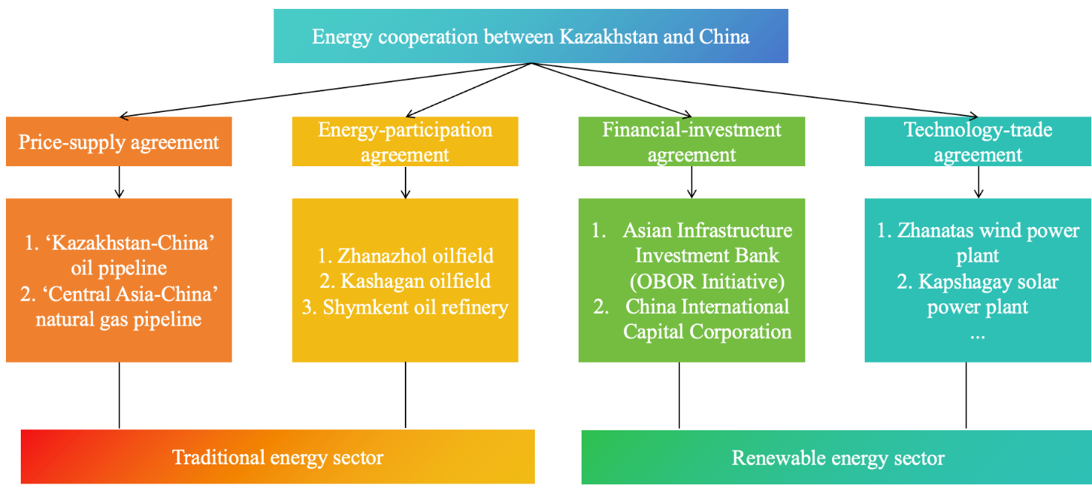

Figure 1 – The Scope of Energy Cooperation Between Kazakhstan and China
Note: Compiled by author based on the research of [5, 9, 10, 11]

In the chapter 1.1, the definition, motivations, and approaches of international energy cooperation are used as a theoretical starting point to propose a basic logical framework for establishing a Kazakhstan-China natural gas cooperation mechanism. It incorporates key theories such as the win-win theory, geopolitical theory, international political economy and the theory of national competitive advantage as the theoretical foundation for studying natural gas cooperation between Kazakhstan and China.
The cross-border pipeline is a commitment to long-term supply and long-term demand between the two nations, demonstrating that both will be able to restrain the other and that both are prepared to establish an interdependent cooperative partnership. This kind of cooperation will help promote the improvement of mutual trust, thus producing a spillover effect of cooperation between Kazakhstan and China.

The significance of natural gas cooperation between Kazakhstan and China based on economic theories

The term ‘international cooperation’ describes the type of cooperation that countries engage in on certain platforms and in particular settings with relation to issues like politics and economics. International cooperation involves at least two or more entities, with the core objective being the attainment of mutual benefits. Numerous elements, such as the differences in conditions between collaborating organizations, the techniques and policies of cooperation, the history of collaboration, and geopolitical concerns, affect the results of international cooperation.
Heterogeneity in international cooperation is necessary for economic cooperation. Economic heterogeneity includes resource heterogeneity, labor heterogeneity and capital heterogeneity [53]. The disparities in resources, labor, technology, and markets across different nations and areas are precisely what lead to trade and collaboration between regions.
The theory of absolute advantage, proposed by the British classical economist Adam Smith, applies the principle of division of labor and cooperation among various occupations within a nation to the division of labor among nations. The theory of international division of labor originated from the differing advantages among nations. From the perspective of international trade theory, Adam Smith’s theory of absolute advantage explains that a country's products with absolute advantages enable it to gain a profit advantage in international market competition, while products with absolute advantage can increase the country’s income.
The theory of absolute advantage illustrates the complementarity principle: a nation may increase production efficiency and quality when it has an absolute advantage in producing a certain kind of product. It makes profit by trading this commodity with countries that lack the same competitive advantage in other items, which increases its total competitiveness. Resources are distributed possibly, resulting in ongoing increases in production efficiency and preventing waste in the manufacturing process, if all countries take use of their absolute advantages in commerce and production through international division of labor and specialized production [54].
The British classical economist D. Ricardo developed the idea of comparative advantage, which built on the notion of absolute advantage and offered further rationale and explanation for problems in international trade. The fundamental tenet of this theory is that the international division of labor is determined by a nation’s comparative advantage rather than its absolute advantage [55]. In the theory of comparative advantage, as long as there is a difference in the production of these two items, international commerce can still take place even if one country’s production costs are greater than another’s for the same two goods.
Each nation makes the decision to export goods in which it has a comparative advantage and import goods in which its domestic manufacturing is at a comparative disadvantage during international trade. Nonetheless, the comparative advantage hypothesis is predicated on more rigorous theoretical ideas: (1) two nations manufacture two comparable goods; (2) two nations have different levels of development; (3) the comparative advantages of the two countries are static, and do not exist economics of scale; (4) factors such as technological progress are absent.
On this basis, the economist B. Balassa proposed the theory of dynamic comparative advantage, also known as the stages of comparative advantage. By analyzing changes in a country’s technology, industrial structure, and factor endowment structure, we can compare the comparative advantages of this country at different stages [56, 57, 58]. The concept developed into a significant theoretical underpinning for regional economic cooperation and international division of labor, applicable to both economic cooperation between countries and among micro-level enterprises.
The factor endowment theory was first proposed by economist Hans Heckscher and later systematized and refined by Gunnar Öhrlin, culminating in the Heckscher-Ohlin theory (H-O theory). Based on the relative abundance or scarcity of its production components, factor endowment theory measures and explains a nation’s foreign commerce as well as the kinds and forms of its imports and exports [59, 60].
The primary cause of international commerce stems from the fact that various nations have varying factor endowments, which lead to price discrepancies. A nation’s goods will be more affordable and have a comparative competitive edge in the global market if it makes use of its plentiful production factor resources.
On the other hand, commodities produced and exported by a nation utilizing its own limited production resources will be more expensive and have no comparative advantage in global markets. As a result, nations should make the most of their plentiful and inexpensive domestic production resources in order to produce items for trade in which they lack a comparative advantage.
As the trend toward global economic integration intensifies and economic development keeps growing, the disparities in factor prices arising from differences in natural endowments among countries will gradually narrow and tend toward equalization. Countries have to develop an industrial structure that is in line with their unique factor endowments and distribute resources sensibly based on their endowment of production factors. The cross-border flow of production factors can compensate for a country's factor endowment deficiencies and enhance its production efficiency.
Different economic resources and marketplaces within international cooperation provide the theoretical basis for regional cooperation, according to theories of absolute advantage, comparative advantage, and resource endowment. In this process, external factors dependent on interactions between countries are considered the driving force behind economic cooperation. Based on the source and persistence of externalities, technological externalities as well as capital externalities are examples of economic cooperation externalities.
Market-transmitted impacts are referred to as capital externalities (product markets, labor markets), also known as static externalities. Technological externalities refer to the transmission of technology or spread of knowledge, typically propagating across industries, and serve as a source of dynamic externalities [61]. The comparison of external costs and benefits resulting from cooperative economic processes determines positive and negative externalities in economics. Only positive externalities can sustain cooperative activities over time.
International regional economic cooperation includes the collaboration between China and Central Asian nations. The economic collaboration between China and Central Asian nations has been steadily strengthening due to economic globalization. While the trade structure has changed from a single-source raw material trade to a diversified energy trade, agricultural products trade, and manufacturing trade, collaboration has expanded from bilateral trade to technology cooperation and infrastructure development.
Trade integration and trade complementarity indices are used to analyze China’s trade with Central Asian nations, and the results show that the overall pattern of merchandise trade relations between China and the five Central Asian nations is characterized by complementarity outweighing competition, with complementarity continuously strengthening. Kazakhstan is one of China’s most significant neighbors in Central Asia. The two nations’ commercial and economic ties have grown significantly in recent years, and there is a great deal of opportunity for future collaboration. Kazakhstan and China have substantial trade potential and great trade complementarity in manufacturing, transportation, and mining [62, 63].
Among the various industrial partnerships, a primary focus of regional collaboration has consistently been the energy cooperation between China and the nations of Central Asia. Central Asian countries possess some of the largest reserves and production levels of natural gas and oil globally, thus they are rich in energy resources. The development of their energy industries receives significant attention and support from national governments.
Energy trade is an essential part of trade between China and Central Asian nations, who have long maintained tight economic cooperation and commercial ties. Numerous studies have shown that Central Asia possesses significantly greater competitive advantages in the energy sector compared to China, as evidenced by an analysis of the current trade dynamics between Central Asian countries and China. This indicates that there are appealing prospects for cooperation between China and Central Asian nations, rather than a focus on competitive energy trading [64, 65, 66].
From the perspective of regional trade, the primary reason lies in the comparative advantages Kazakhstan holds over China in manufactured goods and mineral raw materials within their bilateral trade relationship, creating a complementary dynamic with China's industrial demands [67]. J. Juman noted that in the oil and gas trade, Kazakhstan has a bigger export advantage than China. The two nations’ growing need for energy cooperation is reflected in the expansion of their oil and gas trade integration [68].
The growing risks of global political and economic uncertainty have highlighted the importance of energy security and trade complementarity. Energy security highlights the supply security of nations who export energy as well as the demand security of those that purchase it.
Kazakhstan’s energy trade with China has grown steadily and steadily over time as a member of the Silk Road Economic Belt. In terms of energy security, increasing energy commerce between China and Kazakhstan can protect China’s energy consumption security while lowering Kazakhstan’s energy use expenses. Advancing trade diversification creates favorable external conditions for optimizing the cooperative environment [69, 70].
In international cooperation, capacity cooperation involves the transnational allocation of production factors based on comparative advantage. By altering the local supply of production factors in the receiving country, it enhances the output levels of cooperating countries. Natural resources are the least mobile of the primary components of production, whereas capital is the most mobile. On the one hand, capacity cooperation can increase the supply of capital and technological factors in partner countries. However, it can also encourage productivity development and technical innovation in these nations.
From both resource endowment and geopolitical perspectives, Kazakhstan’s natural gas supply holds irreplaceable significance for China’s natural gas consumption market. Using the factor endowment theory and the concept of comparative advantage, we can further analyze the impact of Kazakhstan’s gas supply and China’s gas demand on natural gas cooperation between Kazakhstan and China.
Natural gas supply advantage of Kazakhstan
Kazakhstan has abundant oil and gas resources, and the country’s national plan is centered on the growth of the hydrocarbon sector. Since its independence, Kazakhstan has actively promoted and supported the growth of international cooperation projects in the hydrocarbon sector and actively sought out foreign investment in infrastructure development and hydrocarbon development in order to increase the role of energy in national development.
Kazakhstan has started to modify the balance of interests between international investors and domestic enterprises in the hydrocarbon industry due to the country’s notable rise in economic strength. The nationalization of strategic resources and the expansion of the state’s share of control over them have been achieved through the continuous revision of relevant laws, such as the law on subsoil resources, the law on environmental protection and the law on taxes.
As Kazakhstan’s hydrocarbon sector has grown, crude oil has been the main focus of investments and industrial priorities, with natural gas coming in second. In 2024, the hydrocarbon extraction sector accounted for 16.3% of Kazakhstan’s GDP, with the natural gas sector having the lowest percentage [71].
Despite Kazakhstan’s large natural gas reserves, the development of natural gas resources in the early stages requires significant financial support due to the difficulty of geological exploration. The majority of Kazakhstan’s natural gas deposits have a high sulfur concentration, which makes production and extraction extremely challenging and raises the cost of natural gas processing. Over the development of its history, Kazakhstan’s natural gas sector has improved its infrastructure and increased the amount of natural gas extracted, but the nation still struggles with a single export market.
Kazakhstan’s natural gas industry chain is divided into three parts: upstream, midstream and downstream. The natural gas industrial chain of Kazakhstan is depicted in Figure 2. As a producer of oil and gas, Kazakhstan’s gas industry is segmented into three distinct areas: upstream, which focuses on the extraction and integration of gas resources; midstream, which deals with the transportation of natural gas; and downstream, which pertains to the processing and distribution of natural gas.
From Figure 2 we can see that the overall structure of Kazakhstan’s natural gas industry chain. Kazakhstan has a comprehensive industrial chain for natural gas. The upstream section of this chain includes the exploration and production of natural gas resources, along with imported pipeline gas and contractual gas.
The midstream segment focuses on the transportation of natural gas. In Kazakhstan, state-owned enterprises predominantly oversee the management and distribution of these natural gas resources. Additionally, a state-owned entity is tasked with the construction, operation, and upkeep of the natural gas pipeline.

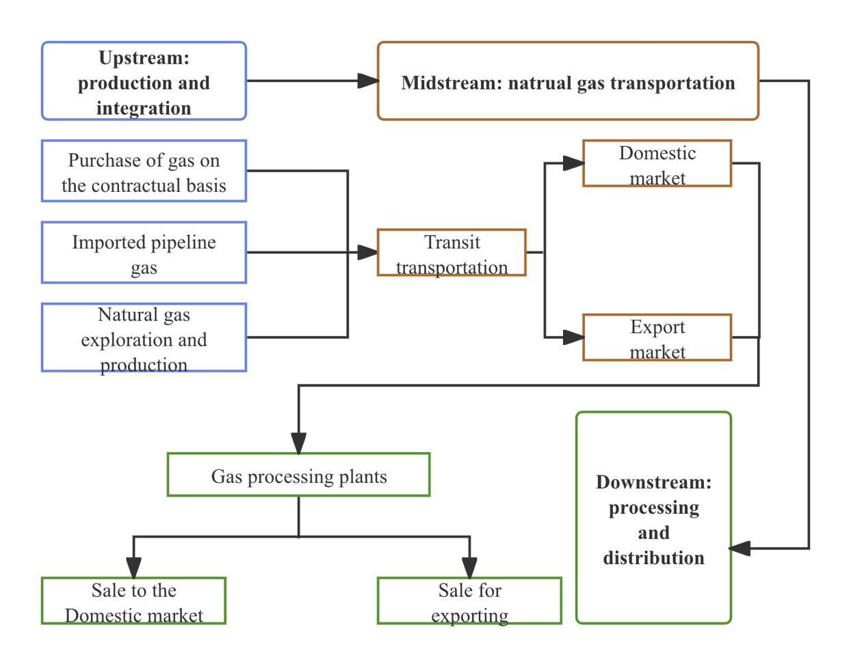
Figure 2 – The natural gas industry chain of Kazakhstan
Note: Compiled by author based on the research of [68]

Thus, gas imports, gas acquired through cooperation agreements, and gas extracted by Kazakhstan’s state-owned enterprises make up the upstream of the gas companies. State-owned companies KazMunayGas (KMG) and Qazaqgaz, as well as foreign oil and gas firms Shell plc, TotalEnergies SE, Eni S.p.A., Chevron Corporation, China National Petroleum Corporation (CNPC), Lukoil, and others, are the primary upstream players in the chain.
Kazakhstan has been successful in creating a cohesive domestic gas distribution and transportation infrastructure since gaining independence. Internal gas pipelines are connected to both Kazakhstan’s oil reserves and international pipelines, whereas international gas pipelines are mostly connected to China, Russia, and Central Asian countries.
The pipeline system divides the upstream natural gas into domestic market transportation and export transportation and then completes the processing and distribution through natural gas plants. QazaqGaz, a state-owned company, runs Kazakhstan’s gas pipeline network; downstream domestic gas use and exports must be bought and delivered via QazaqGaz. As a result, there is now no competitive market and the midstream and downstream of Kazakhstan’s natural gas sector is essentially a state-owned monopoly. Over 200 oil and gas fields have been found and produced in Kazakhstan’s five designated oil and gas regions (OGP). These five oil and gas provinces are:
1. Caspian OGP: the oil and gas fields of West Kazakhstan, Atyrau, and Aktobe administrative districts are included in this province, which is situated in the lowlands of the Caspian Sea and has two-thirds of its territory in Kazakhstan and the remaining portion in Russia. Yuzhno-Embinskaya, North-Embinskaya, Vostoknobortovaya, North-bord, West Caspian, and the Caspian area are the divisions of the Caspian OGP. Kashagan, Tengiz, Karachaganak, Zhanazhol, and other major oil and gas fields are among them.
2. The West Siberian OGP: includes Kazakhstan’s northern and northeastern regions, which are separated into two areas North Kazakhstan and Irtysh.
3. Turan OGP: the region that includes large parts of northwest and northern Kazakhstan, which may alternatively be identified as the Mangystau-Ustyurt OGP and the Central Kazakhstan OGP, as well as Turkmenistan, Kazakhstan, and Uzbekistan. South-Turgayskaya, North-Ustyurtskaya, North-Buzashinskaya, Syrdarya, North-Turgayskaya, East Aral, and Amudarya are the territories that make up the Turan OGP.
4. North Caucasian-Mangyshlak OGP: placed across the Black Sea and the Caucasus on the Mangistau Peninsula in southwest Kazakhstan. The South-Mangyshlak oil and gas region, where the Uzen and Zhetybay fields were found in 1961, is included in this OGP. Other oil and gas fields found there include Zhetybay Vostochny, Zhetybay Yuzhny, and Asar.
5. Tian-Shan-Pamir OGP: the hydrocarbon areas of Chu-Sarysuyskaya, Tenizksaya, Balkhashskaya, Iliyskaya, Alakolskaya, and Zaisanskaya are located between mountain ranges in eastern Kazakhstan.
Kazakhstan possesses significant natural gas reserves, especially in the western region of the Caspian Sea, which is known for its considerable yet untapped oil and gas resources. The country has verified natural gas reserves amounting to 1000 Bcm (billion cubic meters), representing 0.5% of the global total, according to the IEA’s Kazakhstan energy profile [72]. Kazakhstan’s estimated 2P gas reserves by basin are shown in Table 1.

Table 1 – Kazakhstan’s estimated 2P gas reserves by basin

Basin | Gas recoverable 2P reserves (MMscf) | Gas recoverable 2P reserves (MMcm)
Precaspian Basin | 122,819,594 | 3,587,021
Mangyshlak-Central Caspian | 7,977,885 | 232,999
North Ustyurt Basin | 3,543,254 | 103,483
Turgay Basin | 2,094,202 | 61,162
Volga-Urals Basin | 503,970 | 14,719
Chu-Sarysu Basin | 935,758 | 27,329
Zaysan Basin | 165,290 | 4,827
North Caucasus Platform | 25,000 | 730
Total | 138,064,953 | 4,032,271
Source: [73]

Kazakhstan possesses 2P (proven plus probable) gas reserves amounting to 138 trillion cubic feet (equivalent to 4.0 trillion cubic meters), which are spread over 287 fields, as reported by S&P Global in Table 1 [73]. The Precaspian Basin contains 89% of the global natural gas reserves, with over half classified as associated gas. These reserves are primarily located in deep-sea environments characterized by high sulfur content, notably in the Big 3-fields: Karachaganak, Tengiz, and Kashagan. The Mangyshlak-Central Caspian and North Ustyurt regions, two notable basins located in western Kazakhstan, present considerable exploration opportunities along with over 300 billion cubic meters of recoverable resources. Figure 3 depicts the main oil and gas fields in Kazakhstan that exhibit the highest levels of gas production.

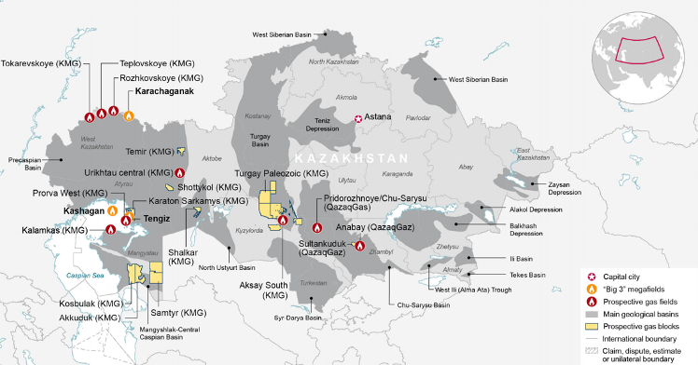

Figure 3 – The distribution of major oil and gas fields in Kazakhstan
Source: [73]

From Figure 3 we can see that, approximately 98% of Kazakhstan’s natural gas reserves are located in the west, with 85% concentrated in just a few large fields (Tengiz, Kashagan, Karachaganak, Zhanazhol and Imashevskoye). The following are the particulars of these big oil and gas fields:
1. Kashagan field: In terms of reserves, Kazakhstan’s largest oil and gas resource is the Kashagan field. One of the biggest oil fields found on the globe in the past 40 years, the Kashagan field is also one of the most complicated oil and gas business projects worldwide. With recoverable reserves of 1-2 billion tons, the field’s geological reserves are estimated to be 4.8 billion tons of oil and more than 1 trillion cubic meters of natural gas.
Because of the difficult maritime circumstances and issues with project development, logistics, and security, the Kashagan project is regarded as one of the most complicated oil and gas projects in the world. Five manmade islands – one major island and four smaller islands – are used for Kashagan oil and gas extraction.
The five fields that make up the North Caspian Project – Kashagan, Kalamkas Sea, Kairan, Aktoty, and South-west Kashagan – will be developed gradually. The current shareholders of the Kashagan field are KMG Kashagan (16.88%), Shell Kazakhstan (16.81%), Total EP Kazakhstan (16.81%), ExxonMobil Kazakhstan (16.81%), Eni S.p.A. (16.81%), CNPC (8.33%) and INPEX North Caspian Sea (7.56%).
According to the annual report for 2024 of KMG, the Kashagan field produced 17.4 million tons of oil and 11.2 Bcm of natural gas [74]. The amount of oil and gas produced in the Kashagan field during the last seven years is shown in Table 2.

Table 2 – The volume of oil and gas production in the Kashagan field (2018-2024)

Year | Crude oil (thousand tons) | Natural gas and associated gas (million m³)
2018 | 13,219 | 7,697
2019 | 14,127 | 8,453
2020 | 15,141 | 9,152
2021 | 16,236 | 9,878
2022 | 12,682 | 7,878
2023 | 18,774 | 11,857
2024 | 17,424 | 11,253
Note: Compiled by author based on data of [74]

2. Tengiz field: Known as “the pearl of Kazakhstan’s oil and gas industry”, it is the country’s second-largest oil and gas field. The field has 125 million tons of recoverable oil and 1.8 trillion cubic meters of related gas. KMG (20%), Chevron Overseas (50%), ExxonMobil (25%), and Lukoil (5%) are the stakeholders in the Tengiz field.
The inauguration of the Tengiz oil and gas refinery in 1991 signified the industrial development of the sector, which had been initiated in 1979. In 1993, Kazakhstan and Chevron Corporation formalized a contract for the TengizChevron (TCO) project. TCO was granted a 40-year hydrocarbon exploration and production license. The exploration, production, and sale of hydrocarbon resources in the Tengiz and Korolevskoye areas in the Atyrau region is the main business of TCO, the operator of the Tengiz field.
The first Kazakh crude grade, Tengiz, appeared in 2001 when oil from the Tengiz field was transported by the Caspian Pipeline Consortium (CPC) to the Russian port of Novorossiysk. In 2008, Kazakhstan began exporting Kazakh oil through the Baku-Tbilisi-Ceyhan pipeline for the first time. According to the annual report for 2024 of KMG, 27.8 million tons of oil and 15 Bcm of associated gas was produced from the Tengiz field in 2024. The amount of oil and gas produced in the Tengiz field during the last seven years is shown in Table 3.
3. Karachaganak field: Situated in the West Kazakhstan region, the Karachaganak field ranks among the largest gas condensate fields globally. Development of the field commenced in 1979, and it boasts geological reserves of 1.35 trillion cubic meters of natural gas along with 1.2 billion tons of condensate [75].

Table 3 – The volume of oil and gas production in the Tengiz field (2018-2024)

Year | Crude oil (thousand tons) | Associated gas (million m³)
2018 | 28,622 | 15,625
2019 | 29,791 | 16,290
2020 | 26,457 | 14,748
2021 | 26,553 | 14,767
2022 | 29,178 | 16,146
2023 | 28,893 | 16,009
2024 | 27,811 | 15,059
Note: Compiled by author based on data of [74]

The project is being developed and project managed by Karachaganak Petroleum Operating B.V. The operating companies for the Karachaganak project are KMG (10%), Eni S.p.A. (29.25%), Shell (29.25%) and Chevron (18%).

Table 4 – The volume of oil and gas production in the Karachaganak field (2018-2024)

Year | Liquid hydrocarbons (thousand tons) | Natural gas (million m³)
2018 | 10,953 | 18,913
2019 | 10,147 | 18,615
2020 | 10,941 | 20,214
2021 | 10,338 | 18,980
2022 | 10,135 | 19,442
2023 | 10,858 | 22,385
2024 | 10,968 | 23,942
Note: Compiled by author based on data of [74]

Table 4 illustrates the volume of oil and gas production in the Karachaganak field in the recent seven years. Notably, natural gas output from Kazakhstan’s three main fields has been steadily increasing over the past several years, as shown by Tables 2, 3, and 4.
4. Zhanazhol field: the Zhanazhol oil and gas field located in the Aktobe region of Kazakhstan, belonging to the Caspian OGP. The Zhanazhol field is developed and managed by CNPC's subsidiary CNPC-Aktobemunaigas. The field was developed in 1978 and has reserves of 133 Bcm of natural gas [76].
5. Uzen field: The Uzen oil and gas field is located in the Mangistau region of Kazakhstan and was developed in 1961. The field has a very high level of reserves development and initial geological reserves of more over one billion tons. The field is operated and developed by KMG's subsidiary Ozenmunaigas (OMG), with gas production of 613 million cubic meters in 2024 [74].
6. Zhetybay field: is a sizable oil and gas condensate field located in Kazakhstan’s Mangistau region. The field was discovered in 1961 and developed on a large scale in 1969 with initial geological reserves of 345 million tons. The Kazakh oil company JSC Mangistaumunaigas is currently developing the field, which produced 443 million cubic meters of gas by 2024 [74].
7. Kumkol field: which has initial oil reserves of 280 million tons and 15 billion cubic meters of natural gas, is situated in the South-Turgayskaya section of the Central Kazakhstan OGP [77]. Most of the unpurified natural gas is first reinjected to maintain formation pressure and expand oil recovery, the rest is transferred to gas processing facilities for processing, with power generation and other industrial requirements coming next. The enormous potential of Kazakhstan’s natural gas resources is demonstrated by the fact that the development of other oil and gas fields has successfully fueled the expansion of the natural gas sector.
Kazakhstan’s advantage in natural gas resources is reflected in the phased development of its oil and gas fields. Variations in Kazakhstan’s natural gas production over time show how oil and gas field development contributes to increased natural gas output and how natural gas has evolved from a ‘crude oil byproduct’ to a ‘commodity’. Figure 4 shows Kazakhstan’s natural gas production position between 2000 to 2024.

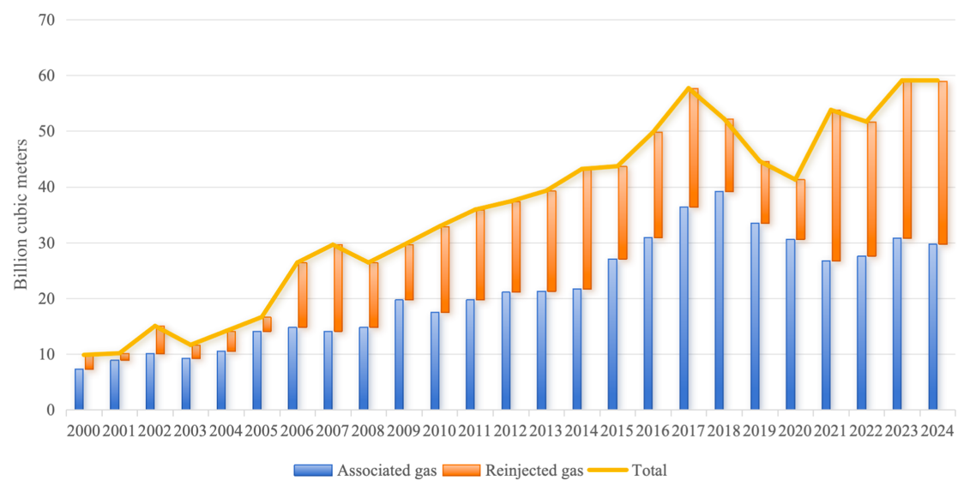

Figure 4 – The natural gas production of Kazakhstan (2000-2024)
Note: Compiled by author according to the data of [74]

The trends in Kazakhstan’s natural gas output are shown in Figure 4. First, Kazakhstan’s hydrocarbon resource development has accelerated, and the development of the giant Kashagan oil field in the Caspian Sea region in 2002 increased Kazakhstan’s oil and gas production. Simultaneously, between 2000 and 2010, several fields with newly confirmed reserves were added: the Krolevskoe, Akshabrak, South Aribek, and Kenrek fields in 2004; the Karamandbas and Karakuduk fields in 2005; the Tolken and Zinalevskoe fields in 2006; the Aribekmora, Kenrek, and Tengiz fields in 2007-2008; and the Khizil Kiya, S. Nurzanov and Areskum fields in 2009. During this period, Kazakhstan’s total gas production increased from 9.8 Bcm in 2000 to 32.9 Bcm in 2010. The development of the Kashagan and Tengiz fields has increased Kazakhstan’s natural gas reserves by 119.7 Bcm, boosting the country’s gas industry.
Second, Kazakhstan’s natural gas output increased steadily between 2011 and 2018, achieving the largest amount of natural gas extracted during that time, from 35.9 Bcm in 2011 to 52.2 Bcm in 2018. Increased gas production from the Karachaganak and Tengiz fields drove rapid growth in Kazakhstan’s gas production during the period. Kazakhstan's gas production did not grow in 2014 due to the suspension of production at the Karachaganak field in 2014 because of a gas leak into the Bolashk oil and gas processing facility from a surface pipeline.
Thirdly, owing to OPEC+ cutbacks, dropping output from the Tengiz and Kashagan oilfield, and worldwide diseases, Kazakhstan’s gas production fell in 2019 and 2020, reaching just 41.3 Bcm. As the world economy recovers and energy consumption rises in 2022–2023, Kazakhstan has taken aggressive measures to increase production. Kazakhstan's natural gas production grows to 59 Bcm in 2024, includes 29.7 Bcm of associated gas output, of which around one-third is re-injected to maintain oil production.
One of the directions of development of Kazakhstan’s gas industry is to increase gas production, not only in relation to already developed fields, but also in connection with the development of potential new fields. In 2023 the East Urikhtau gas field was put into industrial development with explored oil reserves of 4 million and gas reserves of 2.2 Bcm. Six production wells are currently in operation and there are plans to drill nine more production wells, which will raise annual oil output to 200,000 tons and related gas production to 100 million cubic meters [78].
The KAZENERGY National Energy Report 2023 states that throughout the next five to seven years, QazaqGaz and KMG want to activate many additional gas resources [73]. Table 5 demonstrates the details of these prospective gas fields.

Table 5 – Kazakhstan’s prospective gas fields and expected output by 2030

Perspective gas fields | Expected gas output (MMcm/y) | Production start | Company
Urikhtau Central | 900 | 2026 | KMG
Prorva West | 600 | 2027 | KMG
Pridorozhnoye | 142 | 2027 | QazaqGaz
Anabay | 16 | 2023 | QazaqGaz
Rozhkovskoye | 980 | 2023 | KMG
Ansagan | 462 | n/a | KMG
Barkhannaya | 48 | n/a | QazaqGaz
Aksay Yuzhny | 100 | 2023 | KMG
Kalamkas | 350 | 2027 | KMG
Turgay Paloezoic | 100 | 2028 | KMG
Karaton Subsalt | 930 | 2027 | KMG
Total | 4,628
Source: [73]

According to Table 5, Kazakhstan’s prospective gas fields include Urikhtau, Prorva West, Pridorozhnoye, Anabay, Barkhanna-Sultankuduk, Rozhkovskoye, Ansagan, and Teplovsko-Tokarevskoye. By 2030, these new upstream projects are anticipated to produce an additional 4.6 Bcm of gas annually.
High sulfur associated gas makes up most of Kazakhstan's natural gas reserves, which are buried at great depths and are difficult and costly to extract and process because of the need to remove sulphur and other impurities and to process the large amounts of sulphur extracted. The details of major natural gas processing plants in Kazakhstan are shown in Table 6.

Table 6 – Major gas processing plants in Kazakhstan

Gas processing plants | Capacity (Bcm/y) | Utilization (%)
Tengiz GPP | 13.0 | 100
Zhanazhol GPP | 8.4 | 62
Bolashak GPP (NCOC) | 6.3 | 84
Chinarevskaya GTU | 4.2 | 16
KazGPP | 1.5 | 60
Shagyrly GTU | 1.3 | 73
Kozhasay GPP | 0.43 | 100
Alibekmola GTI | 0.43 | 100
Source: [73]

From Table 6 we can see that the total capacity of Kazakhstan’s GPP is 38.8 billion cubic meters per year, with a load factor of 74%. Five large GPPs and several smaller facilities manage the majority of the gas. Only Tengiz GPP and Bolashak GPP are equipped with more modern high sulfur associated gas processing technology and are operating at high load factors of 100% and 84%, respectively. A portion of Karachaganak’s gas is transferred to the Orenburg gas processing facility for processing due to inadequate processing capacity. A part of the commercial gas produced by Orenburg GPP is exported through Gazprom companies, while the remainder is returned to Kazakhstan (to QazaqGaz via KazRosGas).
The infrastructure for gas transportation has been built with capability to accommodate the country’s prospective increase in gas output. KMG distributes gas to parts of the nation and expands the possibility for export destinations as a consequence of the investment in the gas transportation infrastructure. Kazakhstan’s government unified some of KMG’s gas extraction activities and all of its transportation systems and created JSC NC QazaqGaz to oversee them due to the country’s emphasis on the growth of the natural gas sector.
The Republic of Kazakhstan’s national operator for gas delivery and natural gas is JSC NC QazaqGaz. QazaqGaz manages a centralized infrastructure for the transportation of commercial gas through major gas pipelines and gas distribution networks, provides for the international transportation and sale of gas on domestic and foreign markets, develops, finances, builds and operates gas pipelines and gas storage facilities. Figure 5 illustrates the distribution of natural gas facilities in Kazakhstan.
As can be seen in Figures 3 and 5, from the oil and gas reserves in the west, Kazakhstan’s natural gas infrastructure progressively spreads to the north and south. Natural gas is transported to heavily populated cities via Kazakhstan’s pipeline system, which links to Russia’s pipeline network in the north and exports it to China in the south. According to pipeline routes and supply directions, the Kazakhstan pipeline system is managed and operated mainly by four subsidiaries of QazaqGaz:
- Intergas Central Asia (ICA) LLP: ICA’s main activities are transportation of natural gas through the main pipeline system, gas storage in subterranean storage facilities, as well as the upkeep and operation of major pipelines. The company manages 21,200 kilometers of mainline gas pipelines with a total capacity of 203.5 Bcm of gas [73]. ICA manages three underground gas storages in Kazakhstan: Bozoi, Poltoratskoye, and Akyrtobe.

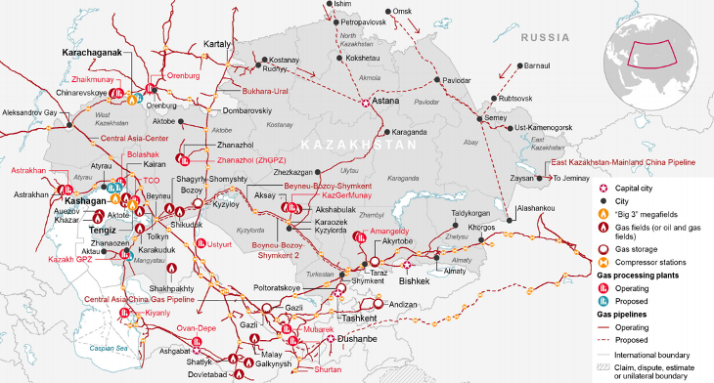
Figure 5 – The distribution of natural gas facilities in Kazakhstan
Source: [73]

- Asian Gas Pipeline (AGP) LLP: is a joint venture company operated by the participants QazaqGaz (50%) and Trans-Asia Gas Pipeline Company Limited (50%) of China, the operator of the “Central Asia–China” natural gas pipeline building and operating project inside Kazakhstan. The pipeline system’s goal includes both the export of natural gas to China and its consumption in the southern areas. The gas pipeline system has a capacity of 55 Bcm and a total length of 3,915 kilometers [73]. The pipeline system passes through four regions: Turkestan, Zhambyl, Almaty and Zhetysu.
- Beineu-Shymkent Pipeline (BSP) LLP: is a joint venture company run by the Chinese companies Trans-Asia Gas Pipeline Company Limited (50%) and QazaqGaz (50%). The pipeline system can carry 15 Bcm of gas and is 1,450 kilometers long overall [73]. In addition to the main gas pipelines ‘Bukhara Gas Region-Tashkent-Bishkek-Almaty’, ‘Gazli-Shymkent’, and the C line of the Central Asia-China natural gas pipeline, the pipeline system links the western portion of the oil and gas resources with the southern portion of Kazakhstan.
- JSC QazaqGaz Aimaq: The company is a wholly owned subsidiary of QazaqGaz and is engaged in the gasification of settlements in Kazakhstan. The main objectives of the company include organization of gas supply, transportation through the distribution network and management of gas distribution assets in the region. The pipeline network serves 11.6 million people in Kazakhstan and has a total length of 63,253 kilometers [73].
In addition to the development of its domestic gas infrastructure, Kazakhstan is increasing the international transit of Turkmen and Uzbek gas through Kazakhstan to China and Russia by making good use of its strategic location. Owing to Kazakhstan's lack of access to the sea, the diversification of its oil and gas export routes has been and remains one of the main directions of the country’s energy security policy.
Kazakhstan’s gas trade statistics are derived from several official sources but are contradicted by different methodologies. Kazakhstan’s Bureau of National Statistics reports that the nation exported 5.4 billion cubic meters of gas in 2024, a 9% drop from 2023 [79]. According to Statistical Review of World Energy 2025, Kazakhstan’s gas exports in 2024 amounted to 5.2 billion cubic meters, of which 4.5 billion cubic meters were exported to China and 0.7 billion cubic meters to Russia [80]. It is noteworthy that Kazakhstan is progressively limiting its natural gas exports and concentrating its resource exports on its strategic partner, China, despite the fact that different data sources indicate differing numbers for natural gas exports. This reflects the close nature of the two countries’ natural gas cooperation from an economic perspective. Table 7 illustrates Kazakhstan’s natural gas export from 2015 to 2024.

Table 7 – Kazakhstan’s natural gas export by countries (2015-2024)

Year | 2015 | 2016 | 2017 | 2018 | 2019 | 2020 | 2021 | 2022 | 2023 | 2024
Total exports (Bcm) | 13.2 | 12.9 | 16.8 | 25.6 | 27.5 | 14.0 | 10.6 | 7.8 | 5.3 | 5.2
Russia | 12.6 | 12.4 | 14.7 | 19.9 | 20.6 | 7.1 | 4.6 | 3.4 | 0.7 | 0.7
Uzbekistan | - | - | 1.5 | 0.3 | 0.4 | 0.1 | - | - | - | -
China | 0.6 | 0.5 | 0.6 | 5.4 | 6.5 | 6.8 | 5.9 | 4.4 | 4.6 | 4.5
Note: Compiled by author based on [80]

As Kazakhstan increasingly moves away from its reliance on a single market (Russia) for gas supplies and steadily expands its supply to the Chinese market, Table 7 shows the process of diversifying Kazakhstan’s natural gas export markets. This export trend aligns with Kazakhstan’s natural gas production dynamics, reflecting the strengthening of Kazakhstan's natural gas cooperation with China.
It is anticipated that Kazakhstan’s natural gas output will continue to rise in the future based on the country’s growth objectives and present natural gas production capacity. The development of newly discovered gas resources will be the primary engine in the gas output increasement about 2030. Kazakhstan’s natural gas export capacity is predicted by S&P Global to increase from the current 29% to 31% by 2035, indicating that there is still room for future growth and collaboration in the country’s natural gas sector [73].
Natural gas demand growth of China
The superstructure is determined by the economic basis, which is also intimately linked to the growth of national industry and is influenced by a wide range of circumstances. One of the requirements for human society’s existence and advancement is energy, which also serves as a crucial material foundation for the expansion of a country’s economy. China’s economic growth is marked by low production and high energy consumption, with coal usage making up the majority of China’s energy consumption, followed by natural gas and crude oil. China’s demand for energy is rising due to the country’s rapid industrialization and urbanization, which is spreading from the cities to the countryside. As a result, energy resources are crucial to China’s future economic growth.
Energy supply and economic growth are inextricably linked. China has some of the world’s largest deposits of coal and oil, and its hydroelectric energy savings are the greatest in the world, making it a country wealthy in energy resources. However, given the country’s circumstances, China’s unequal resource distribution, low per capita resource ownership, ineffective resource use, and significant waste have emerged as key obstacles to the country’s sustainable energy growth. Therefore, it is essential to examine the dynamic link between energy consumption and economic growth, research the effects of economic development on energy consumption, and suggest appropriate actions in order to achieve balanced development of energy and economy.
Following the initial energy crisis in 1970, worldwide economists started researching energy-related topics. Many nations experienced energy shortages as a result of the global oil crisis, which led to a progressive rise in awareness of energy-related concerns. The need for energy is growing quickly due to the growth of heavy industry, and awareness of the connection between economic development and energy shortages is becoming more pressing. At this point, energy plays a significant role in economic development.
J. Kraft and A. Kraft carried out a groundbreaking study to examine the causal link between two variables: economic development and energy use. They gathered data on GDP and energy consumption in the United States between 1947 and 1974. After examining the formation of a unidirectional causal relationship between the two variables, the researchers determined that while policies regarding energy consumption do not affect economic growth, economic growth, in contrast, leads to an increase in energy consumption [81].
However, a number of scholars, A. Akarca and T. Long, did not agree with this result. They discovered that, among other things, events like oil embargoes and world wars might affect or even alter the link between the two elements. A thorough discussion of the link between energy use and a nation’s economy at various points in time is warranted [82].
D. Stern claims that the United States’ economy, energy, capital, and labor-related data from 1947 to 1990 resumed the corresponding vector autoregression (VAR) model, expanding the study’s economic growth and energy consumption relationship. The VAR model analysis of the results derived from the Granger relationship between energy consumption and GDP is very significant. This implies that the shifts in the energy consumption structure have accelerated economic development [83].
U. Soytas investigated the empirical connection between economic growth and energy consumption in seven significant established and emerging economies, and the results showed that the economy and energy consumption of these countries passed the smoothness test and were first-order univariate series, and the two variables of the seven major developed countries proved to have a balanced correlation between the two variables of energy consumption and economic growth after cointegration test [84].
Numerous researchers have studied how energy use affects industrial structure, with the primary goal being to investigate how the two variables interact. B. Zhu et al. studied the relationship between energy consumption and the structure of three types of industries, i.e., heavy industry, light industry and knowledge-intensive industry. There is a strong correlation between energy consumption and industrial structure because it was discovered that these three categories of industries had varying degrees of impact over the nation’s energy consumption [85].
Energy exchanges have been more intertwined with the global energy market since China joined the World Trade Organization (WTO) in 2002. Energy policy and energy security may significantly affect the nation’s economic growth in the setting of a market economy and industrial rivalry [86]. The degree to which China’s economic development and energy consumption influence one another can also differ significantly between areas, and these shifts can be time-trended, particularly by global diseases and worldwide geopolitical events.
The ratio of the growth rate of energy consumption to the growth rate of the national economy is known as the energy consumption elasticity coefficient, reflecting the degree of dependence of economic growth on energy consumption, and is an internationally recognized technical and economic indicator for assessing the connection between the growth of the national economy and energy consumption, as well as a thorough indicator for assessing the caliber of economic development and the change in the mode of development [87]. The formula for its calculation is as follows:
$$e=\frac{{(E^{t}-E^{0})}/{E^{0}}}{{(G^{t}-G^{0})}/{G^{0}}}$$ | (1.1)
where, e is the energy consumption elasticity coefficient, E is total energy consumption, G is gross domestic product, t denotes the observation year, 0 represents the base year.
In order to analyze the correlation between the structure of energy consumption and changes in the elasticity coefficient of energy consumption, the elasticity coefficient method can be used to calculate the consumption coefficients of different energy varieties. In addition to being macroeconomically significant, energy consumption is also impacted by advancements in diverse energy sources. The contribution of the increase in different types of energy consumption to the elasticity coefficient of energy consumption is known as the share of the increase in the consumption of different types of energy in the total amount of energy consumed [88]. The formulas are as follows:
$${ec}_{i}=\frac{(E_{i}^{t}-E_{i}^{0})}{(E^{t}-E^{0})} e$$ | (1.2)
$$\sum{{ec}_{i}}= e$$ | (1.3)
where, ec_{i} is the contribution of the elasticity coefficient of each energy type, and i represents different energy types.
The contribution value of natural gas to the elasticity coefficient and the shift in China’s energy consumption structure from high energy intensity to high energy efficiency are shown in Figure 6.

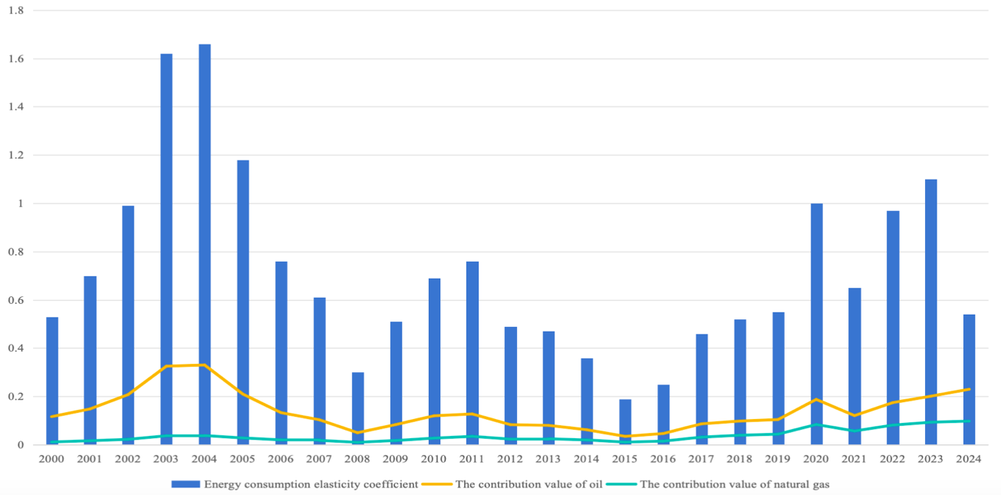

Figure 6 – The energy consumption elasticity coefficient and the contribution value of oil and gas
Note: Compiled by author based on the result of calculation

Figure 6 shows that China’s energy consumption elasticity index varied around 1.0 between 2000 and 2007, suggesting that high energy consumption was the main driver of China’s economic growth during this time. The elasticity index of energy consumption has fallen below 1.0 as China’s economy gradually transitions into a phase of stable development, indicating a transformation in the country’s energy consumption structure. It is noteworthy that during this process, natural gas average contribution rate rose from 0 to 0.4, while oil stayed at around 0.13. In China’s energy consumption structure, natural gas consumption has continued to expand at a comparatively rapid rate. Nevertheless, the consumption and contribution of the elasticity coefficient of natural gas is still much lower than that of oil.
Both the production and consumption of natural gas have continued to rise rapidly throughout the history of China’s natural gas sector, significantly contributing to the country’s high-quality economic and social development. China’s total natural gas consumption increased from 24.5 billion cubic meters in 2000 to 431.6 billion cubic meters in 2024, according to the Statistical Review of World Energy 2025 [80]. Geographically speaking, the heavily populated eastern and southern areas of China account for the majority of the country’s natural gas consumption. The transportation, residential, and power generating sectors account for the majority of China’s natural gas use. Natural gas, which proportion of primary energy consumption increased from 6.9% in 2017 to 8.8% in 2024, has been crucial to China’s urban gas supply, industrial fuel, gas-fired power production, and transportation sectors due to national regulations [80]. Figure 7 illustrates the dynamics of natural gas consumption in China.

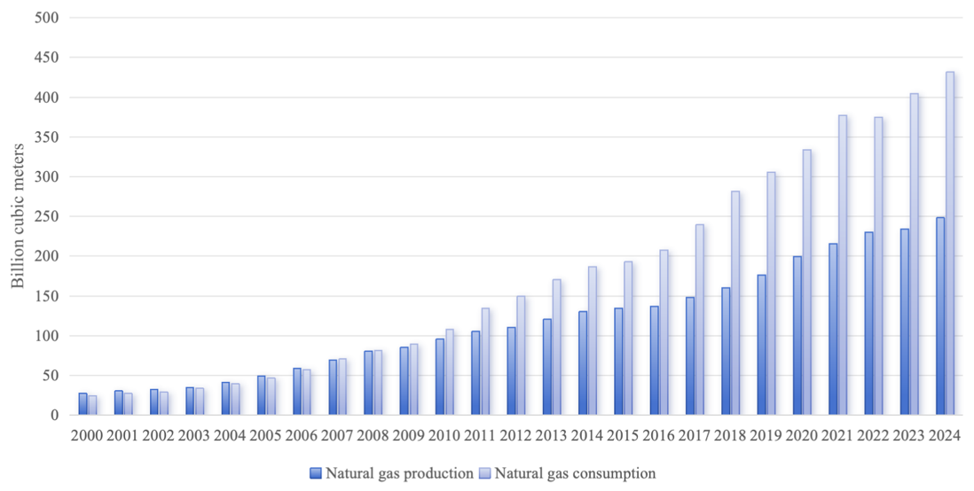

Figure 7 – The dynamics of natural gas production and consumption in China (2000-2024)
Note: Compiled by author based on [80]

From Figure 7 we can find that in last two decades, China’s natural gas sector grew quickly, and domestic gas output was considerably outpaced by the growth rate of natural gas demand. Despite possessing natural gas resources, China’s domestic production can only cover around 60% of its gas demand, resulting in a 40% (or 200 billion cubic meters) supply deficit across the whole gas market. The import and export of China’s natural gas sector essentially exhibits a pattern of “many imports and zero exports” due to the country’s enormous need for natural gas. Although China’s natural gas output has been rising annually, it is still far behind the level of demand, which underlines the country’s natural gas scarcity.
From the perspective of China’s natural gas consumption and the world natural gas supply and demand, China will continue to be the primary source of the world’s natural gas consumption, which is predicted to reach 430 – 450 billion cubic meters in 2025 and 550 – 600 billion cubic meters in 2030, according to the study of the China Natural Gas Development Report [1]. China’s consumption of natural gas is expected to stabilize following the attainment of ‘peak carbon’ in 2030, leading the natural gas industry into a period of consistent growth. Natural gas imports will continue to be a crucial tactic for guaranteeing China’s energy security in the context of economic expansion, according to the findings of China’s natural gas consumption prediction.
The demand for natural gas is rising in tandem with China’s economy’s fast growth. China’s natural gas import pattern is increasingly loosening up, particularly when domestic natural gas production can no longer fulfill domestic consumption demand. Subsequent to the official inauguration of the Central Asia–China gas pipeline in 2009, China commenced receiving a steady influx of natural gas from the countries of Central Asia. In 2010, China imported more than 10 billion cubic meters of natural gas, demonstrating an exponential development pattern. China’s external reliance on natural gas has increased in tandem with the rise in natural gas imports. Between 2006 and 2012, China’s reliance on natural gas imports increased from 2% to 28%, primarily from Turkmenistan and Australia [1].
Between 2013 and 2017, Qatar, Russia, Malaysia, the United States, and Myanmar accounted for the majority of China’s natural gas imports; the country’s reliance on outside sources increased from 31% to 40%. China’s reliance on natural gas reached 45% after 2018 due to the completion of the Kazakhstan-China natural gas trade and the functioning of the Russia–China East Gas Pipeline. China imported 71.3 billion cubic meters of pipeline gas in 2024, making about 40% of all gas imports [1], [80]. Figure 8 illustrates the dynamic of natural gas import and external dependence rate of China from 2000 to 2024 based on the above analysis.

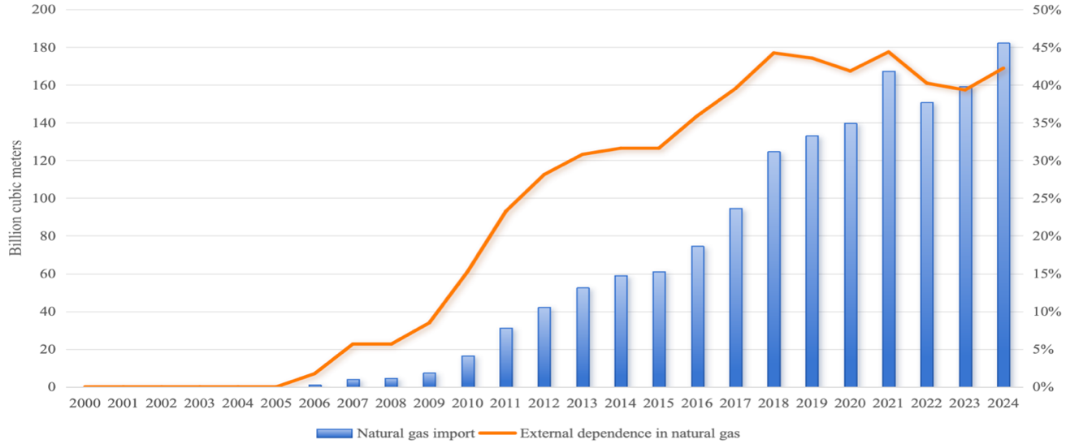

Figure 8 – Natural gas import in China and external dependence rate
Note: Compiled by author based on [1]

From Figure 8 can be seen, that although its growth has steadily stabilized, China’s natural gas consumption is still largely dependent on imports and is still susceptible to changes in energy prices and global geopolitical issues. With cross-border pipeline imports mostly dependent on Turkmenistan, Russia, Kazakhstan, and Myanmar, China’s natural gas import arrangement has essentially taken shape.
On the one hand, the Central Asia–China gas pipeline ran smoothly, and the supply volume increased quickly after that. On the other hand, the supply of natural gas from Russia to Europe has diminished due to the ongoing conflict between Russia and Ukraine; however, in accordance with the existing supply and marketing agreements, there has been a consistent increase in supply via the China–Russia East Gas Pipeline. In general, China’s need for natural gas imports has been fueled by the country’s need for constant expansion in its natural gas consumption. However, the unstable global natural gas market and complicated geopolitical environment affect China’s natural gas imports. The security of natural gas use is threatened by reliance on a single natural gas supply source. China’s natural gas cooperation with Central Asian nations continues to be the major focus of trade and economic cooperation in order to guarantee energy security.
The analysis of the chapter 1.2 examines the complementarity of natural gas resources between Kazakhstan and China from the perspective of supply and demand. Kazakhstan possesses a significant quantity of natural gas reserves; however, it lacks sufficient capacity for natural gas production. The competitiveness of Kazakhstan’s exports in the natural gas sector is influenced by its infrastructure and the availability of natural gas resources. Kazakhstan can successfully capitalize on its advantages in natural gas exports by building a pipeline infrastructure to connect its western natural gas deposits to export markets.
Considering natural gas production capacity and export capabilities, Kazakhstan holds comparative advantages over China in natural gas exports and there is no competitive relationship between two countries. Kazakhstan-China natural gas cooperation conforms to the theoretical prerequisites of regional cooperation and international trade and is crucial to ensuring energy security and using resource advantages.

The historical development of Kazakhstan-China natural gas cooperation and relevant policies

Energy policy is a key component of national energy management, determining a country’s future energy development trajectory. Numerous internal (such as the energy sector and economic development) and external (such as international relations and geopolitics) aspects are involved in the establishment of energy policy, which is distinguished by the importance of policy objectives and a continuous process of adjustment. The application of energy cooperation is guided by energy policy, while energy cooperation reflects the feasibility of energy policy. The two are tightly related and have an impact on one another. Energy cooperation involves policy implementation and interest exchange at the macro level, while energy policy provides strategic guidance at the micro level [89].
For resource-dependent nations like Kazakhstan, attracting international investment and fostering energy cooperation are crucial to the growth of their economy and energy sector. Economic growth and social stability are significantly influenced by the way its energy strategy is formulated. Kazakhstan gained independence from the former Soviet Union in the early 1990s, and its energy laws and policies have been continuously refined since then. Research by scholars from various countries on Kazakhstan's energy policy has primarily focused on energy security, energy transition, and energy cooperation with China and Russia.
In the study of Kazakhstan’s energy system, M. Karatayev and M. Clarke elaborated on the role of Kazakhstan’s energy policy drivers in shaping the energy transition [90]. They claimed Kazakhstan has an abundance of coal, natural gas, oil, and renewable energy resources. In light of Kazakhstan’s swift economic growth, the government passed the Law on Energy Saving and Increasing Energy Efficiency in 2012, which will support the energy transition and guarantee electricity supply [91]. J. MacGregor analyzed Kazakhstan's optimal energy investment policies for addressing power shortages, emphasizing that investments in electricity generation should limit coal usage while prioritizing natural gas and hydropower [92].
Several academics highlight the importance of Kazakhstan’s position as a connector in global partnerships, establishing a robust link between political collaboration and the energy security of Kazakhstan. D. Ismailova pointed out in her analysis of Kazakhstan’s energy policy that, against the backdrop of intense competition for resources, the formulation of Kazakhstan’s energy policy should ensure energy security [93]. A. Yalçınkaya and Y. Rashid analyzed the impact of Kazakhstan's diversified foreign policy on ensuring energy security, highlighting the importance of balancing Russian, Chinese, and European companies in oil and gas exploration projects and pipeline construction initiatives [94]. According to K. Baizakova’s study on Kazakhstan’s energy security and pipeline policy, Kazakhstan’s energy security and pipeline policy are crucial since it connects Europe and Asia [95].
Another important area of study is the connection between Kazakhstan’s energy policy and its energy cooperation with China [96, 97, 98, 99]. S. Giritlioglu elaborated the differing influences of China and Russia on Kazakhstan’s energy policy in her research. She emphasized Kazakhstan’s aggressive attitude to energy cooperation with China, which is mainly demonstrated by the signing of numerous advantageous agreements and investments in infrastructure projects [100]. L. Chai analyzed the cooperative strategies employed by China with Central Asian countries in areas such as trade and energy investment, emphasizing the approach of establishing an economic cooperation corridor between China and Central Asia via energy collaboration [101].
Energy Policy of Kazakhstan
The Law of the Republic of Kazakhstan “On Subsoil and Subsoil Use” (hereinafter referred to as the Subsoil Law), which came into force on January 27, 1996, No.2828, has undergone multiple amendments and supplements. This law aims to regulate subsoil use and activities related to the utilization of underground resources in Kazakhstan [102].
The amended and supplemented Subsoil Law of December 1, 2004 addresses the issue of state priority in Article 71: ‘In order to preserve and strengthen the resource and energy base of the country's economy, in newly concluded and previously concluded subsoil use contracts, with the exception of contracts for underground waters and commonly occurring minerals, the state, represented by the Government of the Republic of Kazakhstan or, by decision of the Government of the Republic of Kazakhstan, the national managing holding company or the national subsoil use company, shall take precedence over the other party to the contract or the members of the legal entity possessing the subsoil use right, as well as other individuals, in obtaining the transferable subsoil use right (its part) and (or) a share (block of shares) in a legal entity that has the right to subsoil use, as well as in a legal entity that has the ability to directly and (or) indirectly determine decisions and (or) influence the subsurface user’s decisions if this legal entity’s primary business is connected to subsoil usage in the Republic of Kazakhstan under conditions no worse than those provided by other purchasers.’ [103]. In comparison to contractual parties, other entities with subsurface resource usage rights, and other acquiring parties, this suggests that the state has higher priority rights over the exploration and production of oil and gas resources.
In 2005, The Kazakhstani government modified the Subsoil Law’s provisions pertaining to the purchase and transfer of resource assets, giving state regulatory agencies more power and limiting the mergers and purchases of resource assets within Kazakhstan by international corporations.
Kazakhstan implemented a new tax system in 2004 that included a “rent tax on exports,” with rates growing in line with rising oil prices, as part of its energy-related economic policy. Article 720 of Republic of Kazakhstan Code No. 120-VI, “On Taxes and Other Mandatory Payments to the Budget (Tax Code),” issued December 25, 2017 (with revisions and additions as of January 1, 2025) Table 8 lists special payments and taxes for subsurface users.:

Table 8 – Taxes applicable to subsoil users in Kazakhstan

Applicable tax | Rate / taxable base
Bonuses (signature) | Variable
Mineral Resources Extraction Tax | 5–18% for oil 10% for gas
Excess profit tax | 0–60%
Rent tax on exports | 0-32%（Zero tax rate if the global oil price is below $50/bbl.）
Payment for compensation of historical costs | Variable
Alternative subsurface use tax | 0–30%
Value-added tax | 1.2%
Property tax | 1.5%
Crude oil export duty | Variable; levied per ton based on rates tied to global oil prices
Source: Compiled by author based on [104]

Production sharing contracts and concession agreements are two of the contract forms utilized in Kazakhstan’s oil and gas cooperation projects:
1. Production sharing contract: Subsurface users pay for exploration, development, and production; they recover these costs and benefit from a portion of the output. Production is allocated between the government and the contractor according to an agreed ratio (typically, the government’s share increases as production rises). Through state-owned companies like KMG, the Kazakhstani government takes involved in projects, usually with a 50% or greater share. Large-scale or high-risk projects (such the Kashagan and Tengiz oil fields in the Caspian Sea region) are covered under this kind of contract. Mineral Resources Extraction Tax, Crude Oil Export Duty, Excess Profit Tax, Corporate Income Tax, and others are the main taxes imposed.
2. Concession agreement: The subsoil user (contractor) is responsible for paying for oil and gas exploration, development, and production under the terms of the concession agreement. Upon obtaining oil and gas production, the contractor pays the required taxes and fees stipulated by law and contract to the state, with the remaining production belonging to the contracting party. Although the state owns the oil and gas resources, contractors are allowed to sell the resources they create. Small to medium-sized projects or mature blocks are covered by this kind of contract. Mineral Resources Extraction Tax, Crude Oil Export Duty, Export Rent Tax, Property Tax, Excess Profit Tax, and others are the main taxes imposed.
3. Improved Model Contract (only for complex giant projects): The Republic of Kazakhstan introduced the IMC contract mechanism through the Law No. 174-VII of December 29, 2022, “On Amendments and Additions to Certain Legislative Acts of the Republic of Kazakhstan on Transportation and Subsoil Use.” [105]. The Tax Code, the Subsoil Law, and other Kazakhstani legislation were modified by this Act. For complicated oil and gas projects, the subsoil user (contractor) is responsible for covering the expenses of exploration, development, and production per the terms of the IMC contract. Nevertheless, the IMC contract eliminated the requirement to provide Kazakhstan with a minimum of 25% of total domestic crude oil production, allowing subsoil users to independently determine whether to supply the domestic market.
Regarding energy consumption policy, in February 2023, President Tokayev K.K. of the Republic of Kazakhstan formally signed the document titled “Strategy for Achieving Carbon Neutrality in the Republic of Kazakhstan by 2060” [106]. The plan is for increasing the percentage of renewable energy to 15% by 2030, mostly from solar and wind power, and to 50% by 2050 [107]. In Kazakhstan’s current energy consumption system, coal accounts for roughly 50% of total consumption and is trending downward annually; oil accounts for over 20% of total consumption; natural gas consumption is rising quickly from 14% to roughly 26%; and renewable energy sources account for roughly 4% of total consumption [80]. Coal-fired power plants utilize the majority of coal (71.2%), while thermal power plants (TPP) provide more than 85% of Kazakhstan's electricity [80]. The majority of these TPPs were constructed in the Soviet period, and their extended lifespan has led to decreased energy waste and equipment efficiency. Natural gas is gradually replacing coal in power generation and residential usage, which is the main reason for its growing percentage of Kazakhstan’s primary energy consumption.
The “Kazakhstan Gas Sector Development Plan for 2004-2010” was released by the Kazakhstani government in 2004 [108]. The strategy seeks to maximize the use of domestic natural gas resources, increase international transit volumes, and boost socioeconomic benefits by developing associated gas transportation and processing capacities. This will facilitate a more thorough satisfaction of the domestic natural gas market demand, achieve energy independence, and enhance the opportunities for the export of natural gas, liquefied natural gas, and their processed derivatives.
Developing natural gas fields, improving free gas extraction, efficiently using associated gas, increasing commercial gas production, creating natural gas transportation systems, and accomplishing regional gasification are the six specific implementation directions that the Kazakhstani government has identified in this plan. This policy plan proposed to implement a series of technical research and investment projects in the natural gas sector over two phases during the 2004-2010 period, including:
1) Enhancing exploration efforts to identify new gas fields, broaden existing natural gas reserves, and increase production capacity at current sites;
2) Establishing new gas processing plants and incorporating existing natural gas processing capabilities;
3) Realizing gas access for local residential areas and promoting the use of natural gas in power and transportation sectors;
4) Developing transit transportation capacity for gas trunk pipelines to utilize existing pipeline systems more effectively.
Given government energy policy, Kazakhstan’s natural gas sector has developed rapidly in recent years. In order to encourage the transformation of domestic energy use, the government has been constantly modifying its rules pertaining to the natural gas business. The “Kazakhstan Gas Sector Development Plan for 2022–2026” was approved by the Kazakhstani government in 2022 [2]. Within this plan, the government emphasized the special significance that natural gas plays in the global energy system and fuel balance during the shift to clean energy. The Republic of Kazakhstan’s economic and social prosperity are significantly influenced by the natural gas sector. However, a number of obstacles still stand in the way of this sector’s successful growth, such as the lack of investment appeal for projects involving the development of natural gas resources, the extremely antiquated infrastructure for natural gas transportation, and domestic natural gas supply prices that fall short of break-even.
The Plan determined the steps required for the natural gas business to grow successfully during this time (2022-2026):
1) Increasing commercial gas resources by fostering an environment that is conducive to investment in new initiatives related to gas production, processing, exploration, and infrastructure development for gas transportation;
2) Maintaining the domestic market while keeping in mind the state’s goal of limiting gas prices for certain consumer categories that require assistance, mainly for socially vulnerable populations;
3) Gas exports utilizing excess gas after prioritizing domestic market supply;
4) To promote gasification, particularly in northern Kazakhstan, it is essential to sustain and enhance gas transportation volumes, modernize and expand the gas transportation infrastructure, and eliminate major deficiencies and bottlenecks that threaten a reliable gas supply;
5) Encouraging the growth of the chemical industry related to oil and gas;
6) Changing the method, the natural gas sector is managed.
In June 2025, the Government of Kazakhstan once again formulated and promulgated the “Kazakhstan Gas Sector Development Plan for 2025-2029” [109]. Kazakhstan’s future aspirations to accomplish the objectives stated in the “Kazakhstan-2030” and “Kazakhstan-2050” plans are reflected in this plan. The government has elevated the natural gas industry’s development priority by designating it as “strategically important to the nation” in its most recent strategy. The report additionally indicated that Kazakhstan’s natural gas industry has formulated plans for future advancements in various sectors; however, it continues to face unresolved structural issues. Table 9 displays the development plan’s specifics (Appendix 1).
Table 9 shows that, in accordance with the Plan, the government-highlighted future development area of Kazakhstan’s natural gas industry is mainly focused on increasing the exploration and production of natural gas resources, improving infrastructure, streamlining pricing mechanisms, and encouraging the growth of the natural gas chemical industry. Compared to the previous phase of the Plan, the policy of the current period makes no comment of natural gas exports, indicating that the Kazakh government’s primary objectives at this stage are to prioritize meeting domestic supply needs and maintain Kazakhstan's current export capacity.
China’s Energy Cooperation Policy with Kazakhstan
Chinese President Xi Jinping’s proposal to jointly construct the Silk Road Economic Belt during his 2013 visit to Kazakhstan serves as the foundation for China’s energy cooperation policy with Kazakhstan. The purpose of jointly building the Silk Road Economic Belt is to strengthen economic ties and deepen cooperation among countries across Eurasia.
The policy content primarily emphasizes that energy cooperation should not only be pursued in the traditional fossil fuel sector but also broadened to include the creation of renewable energy sources like wind and electricity [110]. The Memorandum of Understanding on Jointly Advancing the Construction of the Silk Road Economic Belt was signed in December 2014 by Kazakhstan’s Ministry of National Economy and China's National Development and Reform Commission with the goal of cooperatively planning development projects between the two nations. China and Kazakhstan jointly released the Joint Statement of the People’s Republic of China and the Republic of Kazakhstan at the 2023 China-Central Asia Summit, which highlighted the two nations’ attitude to energy cooperation: ‘Both parties committed to taking steps to guarantee the long-term safe and stable functioning of the Kazakhstan-China crude oil pipeline and the Kazakhstan segment of the Central Asia-China natural gas pipeline, as well as their consistent delivery on time. While aggressively growing cooperation in clean energy sectors including wind power, photovoltaic, solar thermal, and nuclear power, they will continue to strengthen cooperation in oil, natural gas, natural uranium, and other areas [111].
Regarding energy transition policies, Chinese President Xi Jinping declared China’s objective to reach carbon neutrality by 2060 and peak carbon dioxide emissions by 2030 during the 75th session of the UN General Assembly in 2020. The goal was formally included into the government report in 2021, establishing it as a key energy strategy objective for China. Natural gas, as a transition fuel, will account for a greater portion of demand within the domestic energy consumption structure in order to meet the objectives of ‘carbon peak’ and ‘carbon neutrality.’
The above cooperation policies indicate that natural gas collaboration between China and Kazakhstan will primarily be guided by the joint development of the Silk Road Economic Belt strategy. By increasing expenditures in exploration and development, it seeks to strengthen collaboration and guarantee a steady supply of natural gas.
The historical development of Kazakhstan-China natural gas cooperation
Energy cooperation has been a significant subject in bilateral ties between China and Kazakhstan since the two countries’ formal diplomatic relations were established in 1992. The two nations’ energy collaboration began in 1997 when CNPC acquired stock in Kazakhstan's Aktobemunaigas.
A strong basis for future energy cooperation between the two nations has been established by the seamless development of oil cooperation. On the one hand, the need for imported oil resources has increased due to China’s fast economic expansion; on the other hand, Chinese companies have developed oil projects in Kazakhstan with notable success. The enormous potential for energy cooperation between the two nations was shown in 2006 with the construction of the Kazakhstan–China oil pipeline.
Following that, the Kazakhstan–China oil pipeline was extended by the Central Asia–China natural gas pipeline, was promptly placed on the cooperation agenda. In 2003, CNPC and KMG initiated feasibility studies on natural gas transportation and planned to consult with other Central Asian countries. The Central Asia–China natural gas pipeline project officially began in 2006 when China and Turkmenistan signed a framework agreement on the building of a gas pipeline and long-term natural gas supply.
The pipeline originates in Turkmenistan, traverses central Uzbekistan and southern Kazakhstan, and ultimately enters China at the Khorgos Port, extending approximately 10,000 kilometers in length. This pipeline system holds the distinction of being the longest natural gas pipeline globally and consists of four distinct pipelines: A, B, C, and D. The construction of natural gas pipelines by Turkmenistan, Uzbekistan, and Kazakhstan commenced between 2007 and 2009. The A/B lines of the Central Asia–China natural gas pipeline were officially completed, with natural gas transit beginning in December 2009.
Kazakhstan has enormous transit potential in natural gas cooperation because of its location between major gas suppliers (Turkmenistan and Uzbekistan) and consumers (Russia-Europe, China). Kazakhstan plays a vital balancing role as a gas transit nation.
Diversifying natural gas exports has been identified as a major objective in state strategy due to the fast growth of Kazakhstan’s natural gas sector. Kazakhstan has started preparing to exchange natural gas with China. By the end of 2013, the Central Asia–China gas pipeline known as the C Line was finished. This pipeline allows Kazakh natural gas to be exported to China by connecting to oil and gas reserves in western Kazakhstan (Kenkiyak and Zhanazhol fields).
A one-year contract to export five billion cubic meters of natural gas to China was struck in 2017 between CNPC and Kazakhstan’s state-owned enterprise, KazTransGas. The objective of export diversification was accomplished in October of that year when natural gas deliveries to China began via the Kazakhstan–China trunk gas pipeline.
The strategic importance of the Kazakhstan–China gas pipeline for Kazakhstan is highlighted as follows in the document “Kazakhstan’s Gas Sector Development Plan for 2022-2026.”:
1) It ensures the Republic of Kazakhstan’s energy security by transferring natural gas from the country’s western gas-producing areas to its southern regions, which were previously reliant on imports.
2) It helps gasify residential areas, particularly the republic’s center and northern districts by joining the Beineu–Bozoy–Shymkent gas pipeline with the Saryarka gas pipeline.
3) By linking the biggest gas pipelines, such as the Central Asia-Center, Bukhara-Ural, Saryarka, Gazli-Shymkent, and “Bukhara Gas Field – Tashkent – Bishkek – Almaty,” it establishes a single gas transportation system that enables efficient gas flow management.
4) It makes it possible to boost the transportation potential for gas supplies from Central Asia.
5) It enables the Kazakh gas supply to access a broader array of export markets.
According to this viewpoint, the Kazakhstan–China natural gas pipeline not only makes it easier for Kazakhstan to export natural gas, but it also improves domestic energy security and increases the natural gas transit capacity in Central Asia. For China and Kazakhstan, this natural gas pipeline project is extremely important.
The five-year natural gas purchase and sale agreement between CNPC and Kazakhstan’s state-owned firm KazTransGas was extended in 2018 with the goal of transporting 10 billion cubic meters of natural gas per year. Kazakhstan’s natural gas export program was extended in October 2023 when QazaqGaz and CNPC extended their three-year natural gas purchase and selling deal. The two companies signed a supplemental modification to the agreement during the 2025 Kazakhstan-China Business Forum with the goal of modifying the conditions for natural gas shipments to China in 2025 and opening the door for future supply expansion.
The Second China-Central Asia Summit was held in Astana, Kazakhstan in June 2025. China and Kazakhstan came to a cooperation agreement on the following two natural gas projects during the summit:
- Framework Agreement among the China National Petroleum Corporation, the Ministry of Energy of the Republic of Kazakhstan, KMG, and the Aktobe Region regarding the formation of a Joint Venture for the development of the Aktobe Natural Gas-to-Urea Project;
- Tripartite Agreement among the China National Petroleum Corporation, the Ministry of Energy of the Republic of Kazakhstan, and KMG regarding the Support of Collaboration in Block North-1 and the Enhancement of Cooperation within the Oil and Gas Sector.
From the standpoint of energy policy, the natural gas sector is strategically important for China’s and Kazakhstan’s social and economic advancement. To guarantee the growth of oil and gas projects, increase the ability to export natural gas, and accomplish carbon neutrality objectives, the Kazakhstani government has passed a number of laws and policies. China places a high priority on securing its natural gas supply as it aims to achieve carbon neutrality by 2060. In the framework of collaboratively advancing the Silk Road Economic Belt initiative, China and Kazakhstan have been enhancing their partnership in the natural gas industry.
The guiding role of Kazakhstan’s and China’s gas cooperation laws and regulations, as well as the history of cooperative development, are examined in chapter 1.3, which shows how far the two nations have come in this area. From the perspective of their historical growth, the exploration and development of oil and gas fields marked the beginning of the two nations’ natural gas cooperation. After it grew from the Kazakhstan-China oil pipeline to the Kazakhstan-China natural gas pipeline, a natural gas purchase and sale agreement was signed, resulting in the realization of natural gas commerce between the two nations. Although Kazakhstan and China’s natural gas cooperation has produced a number of successes, there is still more room for cooperation in the natural gas chemistry and exploration and development sectors.
Chapter 1 primarily examines the theoretical underpinnings and economic conditions necessary for fostering cooperation between Kazakhstan and China in the natural gas industry. From the perspective of energy cooperation theories, the natural gas cooperation between Kazakhstan and China is driven not only by geopolitical considerations but also economic interests. This chapter also outlined the complementary relationship between Kazakhstan’s gas supply advantages and China’s gas demand. The natural gas resources and infrastructure of Kazakhstan create the economic foundations necessary for collaboration between China and Kazakhstan in the natural gas industry.
The relevance of bilateral agreements between Kazakhstan and China was also discussed, along with a brief history of natural gas cooperation. National energy initiatives like the “Kazakhstan Gas Sector Development Plan for 2025-2029” were outlined. The conclusions drawn in this chapter provide a solid foundation for further discussion in subsequent chapters regarding investment policy, pricing mechanism, and trade structure of cooperation between Kazakhstan and China in the natural gas industry.

TOPICAL ISSUES OF DEVELOPMENT OF INTERACTION BETWEEN KAZAKHSTAN AND CHINA IN THE SYSTEM OF MODERN GAS RELATIONS

Kazakhstan-China natural gas cooperation project under the regional economic framework

The process and condition of regional economic integration are the main focus of regional economic cooperation. Eliminating some restrictions on investment, commerce in goods, and the movement of manufacturing inputs across nations is part of the integration process. The complete and unrestricted movement of different resources within the region, such as factor and commodity markets, is a sign of integration. Usually, countries that are physically close to one another engage in regional economic cooperation, where economic entities collaborate to facilitate the flow and reallocation of production factors across regions in pursuit of socioeconomic benefits [112, 113, 114].
Three types of regional economic collaboration exist: institutional cooperation, transitional cooperation, and functional cooperation. Collaboration between nations in an area to accomplish a certain goal is referred to as functional cooperation. It is usually driven by the market, mostly manifests as trade and investment, and eventually seeks to achieve financial gains. Shared regional agreements, often spearheaded by national governments, serve as the foundation for institutional collaboration. Economics, science and technology, education, and culture are just a few of the areas that are included in the scope of collaboration.
Six types of cooperation – multilateral reciprocity, free trade zones, customs unions, common markets, economic and monetary unions, and complete integration – can be identified based on the level of regional cooperative growth. The multilateral reciprocity represents the primary form of regional economic cooperation, whereby member states establish special tariffs on all or certain goods through mutual agreements. The free trade area refers to cooperative arrangements among member countries to eliminate tariff barriers and achieve trade liberalization within a specific region. In order to facilitate the free flow of products across the region, member states of the customs union remove trade barriers within the region and establish a single tariff policy for non-member nations outside the region. In addition to eliminating trade barriers within the region and implementing a unified external tariff policy, the common market also facilitates the free movement of production factors such as capital and labor. Building on a shared market to accomplish more coordination and alignment of fiscal, monetary, industrial, and other policies, the economic and monetary union is the pinnacle of regional cooperation.
The capacity collaboration between Kazakhstan and China has progressively shifted from mostly trade and investment-driven functional cooperation to government-led institutional cooperation given the current status of interaction between the two nations. Kazakhstan and China’s economic cooperation has advanced from multilateral reciprocity to the free trade zone in terms of regional cooperation growth, but it has not yet attained the level of the customs union.
China imports substantial amounts of energy raw resources, including coal, oil, natural gas, and uranium ore, each year, making it a significant energy user. With large supplies of coal, oil, gas, uranium ore, geothermal energy, solar energy, and wind energy, Kazakhstan is a nation rich in energy.
Based on the content of the previous chapter, the synergistic relationship between Kazakhstan and China’s oil and natural gas resources has fostered independent collaboration focused on trade and investment. Both countries have provided financial support (such as loans and investments) and regulatory assistance (including tax incentives and technological advancements) to facilitate energy cooperation (specifically in the oil and gas sectors) at the national level, as bilateral collaboration continues to expand.
Kazakhstan-China energy cooperation has a strong political and economic basis. The two nations’ energy cooperation has established an integrated upstream and downstream method of full industrial chain collaboration, which generates favorable conditions for satisfying market demand and ensuring the two nations’ energy security.
China will be able to exploit Kazakhstan’s abundant natural resources and open up the Kazakh market thanks to its direct investment in the country. Chinese enterprises entering the Kazakhstan market will reorganize their industries with Kazakhstani enterprises on the basis of their own comparative advantages, take the initiative to enhance their international competitiveness and engage in international competition, allowing the two nations to create transnational firms that correspond with their economic development.
In terms of economic and trade cooperation, foreign investment aids in enhancing the effectiveness of international collaboration, boosting trade exports and preventing excessive transportation costs, export trade barriers, and currency rate changes, among other things. Numerous academics who have researched direct investment’s complimentary impacts and trade in different countries have concluded that there is a long-run Granger causality between outward direct investment and exports [115, 116].
The investment-induced factor combination theory was proposed by Western economists in the 1980s. This theory proposes that the combined effect of direct and indirect inducing factors leads to the emergence of foreign direct investment. refers to a variety of production components that might come from either the investing or the host nation, such as labor, capital, resources, technology, management, and information expertise. Other than direct inducing factors, there are three types of indirect inducing variables: the government of the investing nation, the host country, and global forces.
This theory highlights how important indirect inducing variables are to foreign direct investment, including the macroeconomic environment, economic policies, laws, and investment climate. While indirect inducing variables play a major role in driving foreign direct investment from developing nations, direct inducing factors frequently drive foreign direct investment from industrialized countries according to this theory. This theory partially explains the emergence of energy cooperation. The disparities in labor, capital, resources, and technology between Kazakhstan and China serve as direct catalysts for such cooperation. In the meanwhile, regional collaboration is indirectly stimulated by the economic policies that both nations have chosen, such as the collaborative building of the Silk Road Economic Belt and other institutional and policy agreements made to strengthen cooperation.
China’s direct investment in developed countries has no discernible impact on import and export trade, whereas its direct investment in non-developed countries is consistent with Kojima’s theory that there is a positive correlation between investment and trade [117, 118, 119].
China started making direct investments in Kazakhstan after the two countries established diplomatic ties. With a total investment volume of just $0.05 billion, China’s direct investment in Kazakhstan between 1993 and 2000 was rather little; China’s investment in Kazakhstan has increased since 2000 as the country’s economy stabilized and the investment climate improved [69]. Figure 9 illustrates China’s foreign direct investment to Kazakhstan in the period of 2003-2024.

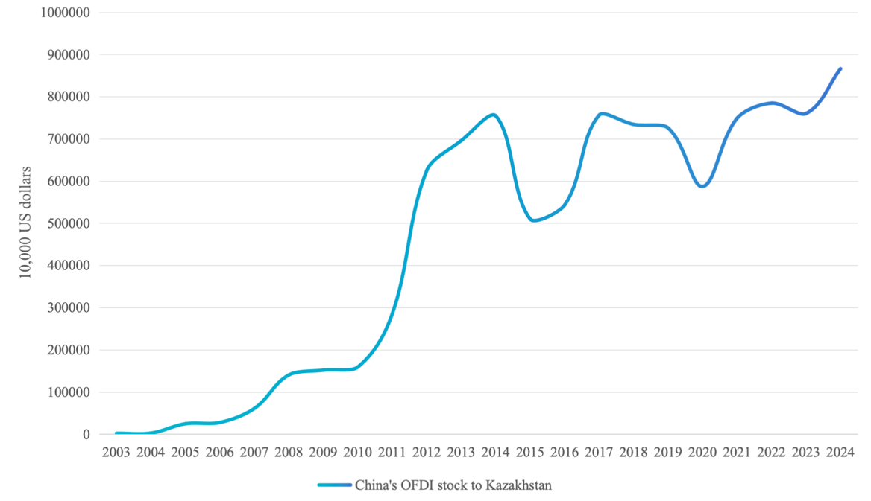
Figure 9 – China’s foreign direct investment to Kazakhstan in the period of 2003-2024
Source: Compiled by author based on [120]

From Figure 9 can be seen that China’s direct investment to Kazakhstan began to grow slowly in 2003–2006. Between 2005 and 2014, the amount of Chinese investment in Kazakhstan increased significantly, from $245.24 million to $754.107 million. The size of direct investment grew from US$36.06 million to US$299.59 million in 2010-2012, with direct investment flows growing rapidly to reach their peak. Only in 2014 did the impact of the energy crisis and in 2020 the world pandemic led to a slowdown in investment growth.
According to the Statistical Review of World Energy 2025, the Brent oil price decreased from $108.66 per baller in 2013 to $52.39 per baller in 2015. The global pandemic’s effects caused the price of Brent oil to drop to its lowest point in recent memory ($41.84 a barrel) [80]. Therefore, the macroeconomic climate and the global oil market have an impact on the amount of Chinese investment in Kazakhstan.
Chinese investment is crucial to Kazakhstan's growth in vital industries including mining, electricity, and logistics. Cooperation between the two countries is increasing, a trend evidenced by the growth of joint ventures and investment by Chinese companies. China and Kazakhstan have collaborated on projects in high-priority industries including infrastructure, mining, energy, and chemicals in recent years.
The collaboration in the energy sector between China and Kazakhstan has strengthened since the establishment of diplomatic relations between the two countries. In the initial years following Kazakhstan’s independence, the Kazakh government undertook the privatization of the country’s energy assets, which encompassed coal, uranium, as well as oil and gas. The purchase of Aktobemunaigas by CNPC in 1997 signified the commencement of energy collaboration between the two nations, facilitating the entry of Chinese oil and gas enterprises into the Kazakhstani market.
The production-oriented method of collaboration, which is complemented by the service-oriented mode of cooperation, dominates China’s cooperation with Kazakhstan on oil and gas resources. The joint venture mode is the primary method of service-oriented collaboration. The joint venture form is less dangerous than the production-oriented cooperation mode when it comes to investment risk, but the reward is also lower.
According to the aforementioned cooperation model, Chinese businesses primarily work with Kazakhstan on oil and gas resources through the following methods: directly importing gas and oil from Kazakhstan, directly contributing to the development of Kazakhstan’s oilfields, and purchasing or merging with the assets of Kazakhstan’s oil and gas fields.
Major oil and gas projects invested by CNPC in Kazakhstan
The cornerstone of Kazakhstan-China oil and gas cooperation is CNPC, one of the Chinese firms carrying out projects in Kazakhstan. CNPC is now involved in a number of cooperative oil and gas projects in Kazakhstan (for example, Kashagan project, AktobeMunaiGas project, Aktote project, North Buzachi Project, Kairan project, ADM (AiDanMunai), and Teresken 2 project etc.). Among these, the major oil and gas field projects with relatively large reserves include Kashagan project and AktobeMunaiGas project.
From the perspective of investment, CNPC acquired approximately 60% of AktobeMunaiGas for about $4 billion, marking its first major investment in Kazakhstan. The deal also covered the building of the Kazakhstan-China oil pipeline (about $3.5 billion) and oilfield development (around $1.1 billion), bringing the total strategic investment to almost $9 billion. In 2013, CNPC invested $5 billion to acquire an 8.33% stake in the Kashagan project in Kazakhstan, further expanding its investment in Kazakhstan’s oil and gas industry [121].
Among its major projects in Kazakhstan, CNPC has the largest oil reserves (485 boe, or barrels of oil equivalent) (65% of total reserves), followed by natural gas reserves (32%), as Table 10 illustrates. This suggests that natural gas still has a great deal of development potential for all of CNPC’s operations in Kazakhstan. Table 10 demonstrates the resource reserves by project invested by CNPC in Kazakhstan.

Table 10 – Resources reserve by project shares of CNPC in Kazakhstan 2024

Project | Estimated reserves (million boe) | Location
Kashagan | 393.2 | Caspian Sea (Offshore)
AktobeMunaiGas | 251.3 | Aktobe oblast (Onshore)
Aktote | 60.9 | Caspian Sea (Offshore)
North Buzachi | 19.2 | Mangistau oblast (Onshore)
Kairan | 15.2 | Caspian Sea (Offshore)
AiDanMunai | 9.7 | Kyzylorda oblast (Onshore)
Teresken 2 | 1.7 | Aktobe oblast (Onshore)
Total | 751.3
Including: |  | Proportion
Oil | 485.0 | 65%
Gas | 243.6 | 32%
Condensate | 20.7 | 3%
Source: Compiled by author based on [121]

The Zhanazhol field, the Kenkiyak-podsolevoy and North Truva fields, and the Teresken-1 and Teresken-2 exploration blocks in the Aktobe region were all licensed after CNPC purchased 60.3% of Aktobemunaigas’ interests in Kazakhstan in 1997. The Agreement in Principle on Cooperation on the Urikhtau Project in Kazakhstan was signed in 2011 by CNPC-Aktobemunaigas and KMG, under which the two parties will jointly explore and develop the Urikhtau Project to provide a guaranteed gas source for the second phase of the Kazakhstan-China gas pipeline.
Major oil and gas projects invested by PetroChina in Kazakhstan
It is worth noting that CNPC conducts some of its project investments and operations in Kazakhstan through its publicly listed company PetroChina. CNPC is the sole sponsor and controlling shareholder of PetroChina. According to China National Petroleum Corporation Yearbook 2025, PetroChina has involved in several oil and gas cooperation projects in Kazakhstan (for example, shareholder of Aktobemunaigas project, Mangistaumunaigaz Project, Petrokazakhstan Project, Kazgermunai Project etc.) PetroChina will have more than 520 million barrels of oil equivalent in total reserves by the end of 2023. The AktobeMunaiGas project and the Mangistaumunaigaz project are two of the biggest oil and gas field projects with comparatively substantial reserves. In 2009, PetroChina and KMG jointly acquired Mangistaumunaigaz in a deal valued at approximately $2.6 billion, with PetroChina contributing about 50% of the investment (approximately $1.3 billion) [121]. Table 11 demonstrates the resources reserves by project invested by PetroChina in Kazakhstan.
Table 11 illustrates the extensive natural gas reserves held by PetroChina in Kazakhstan. Although most fields are currently in advanced phases of development, there remain sufficient natural gas reserves to ensure a reliable supply in the future. PetroChina’s investment in mature oilfields such as PK and Kazgermunai exemplified the liberalized approach to energy cooperation between China and Kazakhstan in the early stages. At that time, Kazakhstan’s mature oilfields faced challenges including declining production and diminishing economic returns. Chinese companies made the decision to engage in these projects, which had more technical difficulties but carried less dangers. This decision laid the groundwork for future energy cooperation between the two nations.

Table 11 – Resources reserves by project shares of PetroChina in Kazakhstan 2024

Project | Estimated reserves (million boe) | Location
AktobeMunaiGas | 251.3 | Aktobe oblast (Onshore)
Mangistaumunaigaz | 190.3 | Mangistau oblast (Onshore)
Petrokazakhstan | 35.9 | Kyzylorda oblast (Onshore)
Kazgermunai | 21.6 | Kyzylorda oblast (Onshore)
North Buzachi | 19.2 | Mangistau oblast (Onshore)
Teresken 2 | 1.7 | Aktobe oblast (Onshore)
Makhambet | 0.1 | Caspian Sea (Offshore)
Bobek | 0.1 | Caspian Sea (Offshore)
Total | 751.3
Including: |  | Proportion
Oil | 388.1 | 74.6%
Gas | 120.7 | 23.2%
Condensate | 10.4 | 2.0%
Natural gas liquids | 0.8 | 0.2%
Source: Compiled by author based on [121]

Major oil and gas projects invested by Sinopec in Kazakhstan
Sinopec Corporation, China's largest state-owned petrochemical company, focuses its oil and gas projects in Kazakhstan on petrochemical projects and the development of a number of medium-sized oilfields. The most prospective natural gas project invested by Sinopec in Kazakhstan is Ural Oil and Gas Project. The Rozhkovskoye gas field is being developed by Ural Oil and Gas LLP, comprising KMG (50%), MOL Caspian Oil and Gas Plc (27.5%) and First International Oil Corporation (22.5%), a subsidiary of Sinopec. The project required a total expenditure of US$534 million [122]. According to KMG’s release, output will reach a maximum of over 1 billion m³ of gas and over 500 thousand tons of condensate year, with over 150 thousand tons of liquefied hydrocarbon gas produced annually. The Rozhkovskoye gas field represents a key project in response to the Kazakhstan Gas Sector Development Plan for 2022–2026 and also constitutes a major investment by Sinopec in Kazakhstan's natural gas industry.
Major oil and gas projects invested by Geo-Jade Petroleum in Kazakhstan
With oilfields in Kazakhstan, Albania, and Iraq, Geo-Jade Petroleum is an independent Chinese firm that explores and produces gas and oil. In 2014, Geo-Jade Petroleum made its first investment in Kazakhstan’s oil and gas sector when it paid US$526 million to acquire Maten Petroleum [123]. Maten Petroleum’s main assets are located in three oil field blocks in production in Kazakhstan, the Matin, Eastern Kokarna and Kara-Arna oil fields. In 2015, Geo-Jade Petroleum claimed that it has boosted its investment in Kazakhstan by paying US$400 million to acquire Kozhan JSC, a Kazakhstani oil producer with the rights to develop the Morskoye, Karatal, and Dauletaly fields in Atyrau Oblast [124]. Table 12 demonstrates the resources reserves by project Geo-Jade Petroleum in Kazakhstan.

Table 12 – Resources reserves by project shares of Geo-Jade Petroleum in Kazakhstan 2024

Project | Estimated reserves (million boe) | Life Cycle
Dauletaly | 18.85 | Producing
Pridorozhnoye | 5.1967 | Discovery
Karatal | 0.088 | Producing
Eastern Kokarna | 0.082 | Producing
Morskoye | 0.0446 | Undiscovered
Morskoye | 0.0038 | Producing
Matin | 0.0027 | Undiscovered
Dauletaly | 0.0024 | Undiscovered
Total | 24.3
Including: |  | Proportion
Oil | 19 | 78.48%
Gas | 5.1 | 21.21%
Condensate | 0.06 | 0.26%
Natural gas liquids | 0.02 | 0.04%
Source: Compiled by author based on [125]

Table 12 reflects that the majority of Geo-Jade Petroleum’s resource reserves in Kazakhstan are oil-based, while natural gas makes up 20% of the identified reserves. Among these, Geo-Jade Petroleum’s natural gas reserves mainly originate from Pridorozhnoye project, set for development in 2027. The Pridorozhnoye project is jointly developed by QazaqGaz Exploration and Geo-Jade Petroleum. At the Belt and Road Forum in 2023, the two companies inked a partnership agreement. In 2027, it is expected to be put into service. The construction and establishment of a comprehensive gas processing facility is projected to commence towards the conclusion of 2024. It is expected that the initial production will reach 107 million cubic meters, increasing to an annual total of 300 million cubic meters [126].
By analyzing the oil and gas projects invested in Kazakhstan by major Chinese companies, we may infer that “investment in exchange for natural gas supplies” is the primary investment strategy used by Chinese enterprises. Chinese oil corporations will specifically invest in large-scale gas field projects that will act as reserve resources for Kazakhstan’s gas exports to China.
China and Kazakhstan’s natural gas cooperation is in line with the changing trends of regional economic cooperation. This progression extends from functional cooperation and independent investment (such as CNPC’s acquisition of AktobeMunaiGas) to institutional cooperation (as exemplified by the signing of Pridorozhnoye project at the Belt and Road Forum). The governments of Kazakhstan and China have initiated a prominent role in their bilateral cooperation regarding natural gas. This includes the implementation of various fiscal and investment regulations aimed at enticing Chinese investments in oil and gas initiatives, alongside the collaboration agreement established between the two nations during the China-Central Asia Summit and the Belt and Road Forum.
Chinese companies and Kazakhstani state-owned firms (KMG and QazaqGaz) collaborate on natural gas cooperation projects between Kazakhstan and China as part of regional economic cooperation, rather than simple acquisitions and utilization. The “community with a shared future” in natural gas cooperation clearly indicates that, guided by policy, the cooperative model for natural gas between the two nations is steadily enhancing, while the risks associated with investment are persistently decreasing.
The phrases “community with a shared future” and “investment in exchange for natural gas supplies” were put out in chapter 2.1 to characterize the investment tactics used by Chinese oil corporations in Kazakhstan. Although Chinese businesses have significant natural gas reserves in their investment projects in Kazakhstan, it is important to note that the majority of these projects are either in the early phases of development or have not yet started commercial production. It is unclear if they will eventually increase trading in natural gas between China and Kazakhstan.
“Investment in exchange for natural gas supplies” refers to a model of foreign investment based on resource security in contemporary natural gas relations. In this model, capital, technology, and infrastructure are invested in exchange for long-term, stable energy supplies as well as the acquisition of rights and interests. From an economic standpoint, China and Kazakhstan both gain from this investment strategy. Large-scale investment operations, however, are vulnerable to things like shifts in national legislation and geopolitical events.
Recommendations for China:
1. Change from business investment to initiatives led by policy. Establish a memorandum of agreement with Kazakhstan for the development of natural gas resources at the government level, driven by national policy;
2. To increase the effectiveness of natural gas projects, Chinese companies could work with state-owned firms in Kazakhstan. The basis for their collaboration should be joint infrastructure development and technological investment.
The “investment in exchange for natural gas supplies” agreement has enabled Kazakhstan deploy cutting-edge technologies and enhance infrastructure while easing the financial burden of developing indigenous natural gas resources. China, one of the biggest natural gas users in the world, offers Kazakhstan’s natural gas exports a steady market. In the long run, the primary risks stem from the impact on resource sovereignty and economic security.
Recommendations for Kazakhstan:
1. Regulate the investment activities of Chinese enterprises in Kazakhstan’s natural gas sector in accordance with national policies and energy security considerations;
2. Realize the concept of a “community with a shared future” by distributing resources and advantages in a rational way, while highlighting the significance of localization in collaborative gas initiatives.

Market structure and pricing mechanism of natural gas cooperation between Kazakhstan and China

Natural gas is not only a fossil fuel but also one of the major commodities in international trade. Its supply and demand are influenced by both economic factors and non-economic factors that vary by country. As a result, the dynamics of supply and demand in the natural gas market are the outcome of several forces working together.
The primary factors affecting natural gas supply include the following:
1. Acquisition Cost: Energy prices are based on acquisition costs; lower costs result in more supply. Natural gas acquisition costs are mostly made up of extraction and transportation costs, much like those of other fossil fuels. More money and technology are needed to secure energy sources as extraction scales increase. Building transportation infrastructure, which requires significant investment and is a crucial component in the supply chain for natural gas. The majority of major natural gas infrastructure projects are created with money or involvement from the government.
2. Technological Advancements: The efficiency of natural gas supply may be greatly increased with improvements in extraction and transportation technology. For instance, the creation and application of LNG carrier technology have made natural gas a commodity that is traded internationally rather than just locally.
3. Energy Reserves: In order to increase natural gas reserves, nations have recently started building gas storage facilities and offshore floating storage units since natural gas is more difficult to store than coal and crude oil. Adequate natural gas reserves help ensure supply and stabilize prices. Conversely, insufficient reserves can easily trigger market panic and price hikes.
4. Geopolitical Conflicts: Natural gas supply may be disrupted by terrorist attacks, geopolitical conflicts, and other unanticipated occurrences. Natural gas supply problems were brought on by the conflict between Russia and Ukraine, and European natural gas prices skyrocketed due to the sabotage of the Nord Stream 2 pipeline. Crude oil prices are the primary determinant of international natural gas pricing, and fluctuations in the crude oil market can also affect the stability of the natural gas supply.
The factors affecting natural gas demand are as follows:
1. Economic Development: Nations across the globe progressively embraced the era of industrialization following the Industrial Revolution. This swift economic growth has paralleled a consistent increase in the need for fossil fuels. Urbanization has also accelerated due to economic growth, since the country’s need for natural gas has grown due to advancements in transportation and living standards.
2. Energy Prices: In the country’s energy consumption structure, natural gas is mostly utilized in the transportation, residential, and power generating sectors. The economic advantages of using natural gas will decrease in proportion as costs rise, leading customers to replace their need for natural gas with alternate energy sources. On the other hand, demand for natural gas will rise if costs are lower without sacrificing energy efficiency.
3. Environmental Protection: While the use of fossil fuels has brought immense benefits to humanity, it also poses a threat to our living environment. Demand for greener energy sources like natural gas and renewable energy (wind, solar) will progressively rise as nations across the world come to an agreement on preserving the environment and lowering carbon dioxide emissions.
4. Energy Security: Energy security is crucial for nations that use natural gas. The ratio of imports to domestic output keeps it in balance. If natural gas consumption relies heavily on imports, any risk of supply disruption could have a significant negative impact on demand.
Based on China’s natural gas imports, it can be inferred that the nation’s existing natural gas import corridor consists of one offshore liquid natural gas import corridor and three onshore pipelines.
1. Central Asia-China Gas Pipeline: In 2007, the Central Asia-China gas pipeline was formally inaugurated. The Central Asia-China gas pipeline’s A/B Line was formally finished in 2009. The pipeline begins in Turkmenistan on the right bank of the Amu Darya River, travels through Kazakhstan and Uzbekistan, and ends at the Khorgos Port in Xinjiang. 2013 marked the completion of Phase I of the Beineu-Bozoy-Shymkent gas pipeline, which was jointly sponsored by JSC KazTransGaz, China Development Bank Corporation, and the Bank of China. The pipeline spans 1,449 kilometers with a total investment of US$3.6 billion [121]. The Beineu-Bozoy-Shymkent gas pipeline joined the Central Asia-China gas pipeline’s C line in 2014, making each pipeline 1,833 kilometers long and capable of producing 60 Bcm annually. The Renaissance Gas Field in Turkmenistan serves as the gas source for the D Line of the Central Asia-China Gas Pipeline, which travels via Uzbekistan, Tajikistan, and Kyrgyzstan before arriving at Wuqia Station in Xinjiang. With a design capacity of 30 Bcm of gas annually and a total expenditure of around $6.7 billion, the D Line is 1,000 kilometers long [121]. Compared with A/B and C lines, D line, which is crucial for maintaining China’s energy security and advancing the southern border’s economy, arrives from the south of Xinjiang.
For the first time, the Central Asia-China gas pipeline system will pass through Tajikistan and Kyrgyzstan, joining the previously finished Lines A/B and C connecting Turkmenistan, Uzbekistan, and Kazakhstan to form a complete Central Asia-China gas pipeline system that connects the five Central Asian countries closely to China. This project benefits resource, transit, and consuming countries. The gas pipeline system connecting Central Asia and China is set to improve the structure of energy consumption in China, promote energy efficiency, lower emissions, and protect the environment. Additionally, it will create new avenues for energy trade for the countries in Central Asia.
2. Myanmar-China Oil and Gas Pipeline: This pipeline system includes crude oil pipelines and natural gas pipelines that will enable the transportation of oil and gas resources from the southwest to China without passing through the Strait of Malacca. In 2009, China and Myanmar signed “the Memorandum of Understanding between China National Petroleum Corporation and the Ministry of Energy of the Union of Myanmar on the Development, Operation, and Management of the Myanmar-China Crude Oil Pipeline Project”.
The natural gas pipeline begins in the offshore Shwe gas field in Myanmar, while the crude oil pipeline begins at Kyaukpyu Port. Myanmar’s economy, local infrastructure, job prospects, and urbanization along the pipeline route have all benefited from China-Myanmar gas collaboration. For China, energy cooperation between Myanmar and China has enabled it to reduce the risk of importing oil and gas resources through the sea [127].
3. Russia-China east gas pipeline (Power of Siberia): Beginning in East Siberia, Russia, the gas pipeline travels via Blagoveshchensk to Heihe, China. This pipeline travels through the Irkutsk Region, the Sakha Republic, and the Amur Region before arriving at the Russia-China border. The pipeline’s primary gas source is the Kovykkin and Chayankin gas fields in Russia. Completed in 2019, the gas pipeline can supply China with a steady supply of 38 billion cubic meters of natural gas annually [128].
In the past, Russia’s natural gas commerce was mostly focused on Europe, where European nations are the biggest exporters of Russian gas. Through the oil and gas trade, Europe also imposes restrictions on Russia's economy. Russia’s reliance on European commerce is lessened as a result of the Russia-China East Gas Pipeline, which indicates a change in the center of gravity of Russia’s energy trade from Europe to Asia. In addition to serving as a symbol of China and Russia’s energy cooperation, this gas pipeline serves as China’s foundation for balancing the entire development pattern of the natural gas sector. China can import large quantities of natural gas from Russia through the gas pipeline to meet the natural gas resources needed for China's energy transition.
4. Marine LNG corridor: With the maturity of LNG technology, trade in natural gas has transcended regional boundaries and is progressively evolving into a commodity that is traded internationally. China’s coastal regions are seeing increased energy consumption and quicker economic growth overall. Compared to the stability of pipeline supply, LNG supply is more flexible and convenient. Both the supply period and the receiving location can be adjusted according to the situation of both parties. However, given China’s possible geopolitical scenario, the Strait of Malacca is the primary route for China’s marine oil and gas transit, which poses a transportation danger.
As a rule, long-term gas supply contracts and solid international alliances are necessary for the building of transnational gas pipelines. As a result, pipeline natural gas supply contracts often last 20 to 30 years, and the price of natural gas can be changed in accordance with a formula that both parties agree upon depending on the price of gasoline and diesel or the price of oil globally. And long-term natural gas supply contracts have corresponding requirements on the supply capacity and receiving capacity of both resource and consumer countries, and other requirements on seasonal supply. Transit nations may also impose commensurate pipeline fees.
The whole process of buying natural gas from outside suppliers through trade to satisfy domestic demand and delivering the acquired natural gas to customers is included in the natural gas import supply chain. This process primarily consists of three stages: the external supply phase, the external procurement phase, and the external dependency phase.
The stability of natural gas supply from exporting nations to importing nations, including resource reserves, political hazards, and transportation stability, is reflected in the external supply phase. The external procurement phase primarily analyzes the impact of price fluctuations in natural gas trade on supply. The external dependency phase confirms the significance of obtaining natural gas from various sources by measuring the importing nation’s reliance on natural gas supply.
The geographical position, economic conditions, and distribution of natural resources are factors that influence the risks and characteristics associated with pipeline gas imports to China. Based on the data presented, it can be inferred that the supply chain for imported gas in China encompasses sourcing gas from global suppliers, participating in trade, and distributing it to local consumers [129].
The criteria outlined below may be employed to evaluate the security index of imported pipeline gas supply: the index measuring resource supply, the index assessing political risk, the stability index related to natural gas supply from gas-producing nations to China, the index that represents economic and transportation stability throughout the supply chain, and the index that shows variations in natural gas prices.
The supply chain associated with imported pipeline gas serves as the foundation for the mathematical and economic model that assesses gas import security indices. This model utilizes the weighting method to determine the weights of gas import indices, thereby enabling the analysis of security factors, critical risk elements, and components that may improve future gas collaboration [68]. Kazakhstan, Turkmenistan, Myanmar, and Russia were selected from the pipeline gas suppliers to analyze the differing factors among these nations.
1. Resource Supply Index (RS_{i}): For nations that supply gas, finite reserves coupled with rising consumption will result in a decrease or halt in supply. The formula is used to determine the resource supply index:
$${RS}_{i}=\frac{({NGP}_{i}-{NGC}_{i})}{{NGR}_{i}}$$ | (2.1)
where, RS_{i} is resource supply index of country i; NGP_{i} is volume of natural gas production in country i; NGC_{i} is volume of natural gas consumption in country i; NGR_{i} is volume of natural gas reserves in country i.
2. Supplier Country Risk Index (SC_{i}): These national factors include political stability, government effectiveness, investment climate and anti-corruption. ICRG (International Country Risk Guide) is a composite indicator of a country’s risk calculated by The PRS Group, considering political, economic and social variables. The higher the ICRG value, the more stable the indicators.
$${SC}_{i}=\frac{100}{{ICRG}_{i}}$$ | (2.2)
where, SC_{i} is the security index of supplier country i; ICRG_{i} is the ICRG indictor of supplier country i.
3. Natural Gas Price Change Index (PC_{i}): the disparity between the supply and demand for natural gas in the global gas market can lead to significant fluctuations in prices, particularly in the event of supply disruptions or a substantial increase in demand. The index used to measure price changes is determined based on the following formula:
$${PC}_{i}=\frac{1}{5}\sum_{t=1}^{5}{ln⁡{(\frac{P_{t+1}^{i}}{P_{t}^{i}})}^{2}}$$ | (2.3)
where, PC_{i} is pipeline gas price change index pf country i; Pt_{i} is natural gas import prices to China from country i in period t.
4. Transportation Security Index (TS_{i}): the elements influencing the security of transportation include the quantity of gas being transported, the length of the pipelines, and the military safety of the nations that the pipeline traverses.
$${TS}_{i}=\frac{{ING}_{i}}{TNG}×\frac{6}{{MP}_{i}}$$ | (2.4)
where, TS_{i} is the gas transportation security index; ING_{i} is the volume of imported gas by pipeline from country i; TNG is the total volumes of imported gas by pipeline; MP_{i} is the military security index in the ICRG indictor of country i.
5. Natural Gas Requirement Index (DR_{i}): This index reflects the share of imported gas via pipelines in China’s natural gas consumption. The index is calculated using the formula:
$${DR}_{i}=\frac{{ING}_{i}}{TNGC}$$ | (2.5)
where, DG_{i} is the natural gas demand index; ING_{i} is the volume of imported gas via pipeline from country i; TNGC is the total natural gas consumption in China.
To facilitate the comparison of indicators across various years, static results are examined by incorporating a temporal variable and employing a weighting technique. Consequently, it is essential to standardize the indicators:
$$eX_{tj}^{i}=\frac{X_{tj}^{i}}{X_{mid}}$$ | (2.6)
where, eX_{tj}^{i} is the result after standardization of index value; X_{tj}^{i} is value of index value of index j in supplier countries i in period t; X_{mid} is average value of index value.
The weight of the indicators is determined:
$$W_{tj}^{i}=\frac{eX_{tj}^{i}}{\sum_{t}{\sum_{j}{X_{tj}^{i}}}}$$ | (2.7)
where, W_{tj}^{i} is the result of weighting the indictor.
The raw data for calculating RS index, PC index, TS index and DR index is sourced from various statistical resources, including Statistical Review of World Energy [80], China Statistical Year Book [120], and Customs statistics database of General Administration of Customs of the People’s Republic of China [130]. The data for calculating SC index and TS index obtained from International Country Risk Guide. The results of gas supply indices are illustrated as below:
Figure 10 shows the resource supply index and supplier country risk index of four natural gas supplier countries (Turkmenistan, Kazakhstan, Russia and Myanmar). It is notable that: 1. While Russia and Turkmenistan both have substantial resource supply abilities, the level of country risk associated with Russia is notably greater than that of Turkmenistan and Kazakhstan; 2. The fairly low country risk ratings of Central Asian nations suggest that Turkmenistan and Kazakhstan have formed robust economic relationships with China; 3. Specifically, situated near Russia and Turkmenistan – nations known for their significant resource availability – Kazakhstan reaps advantages from improved resource potential.

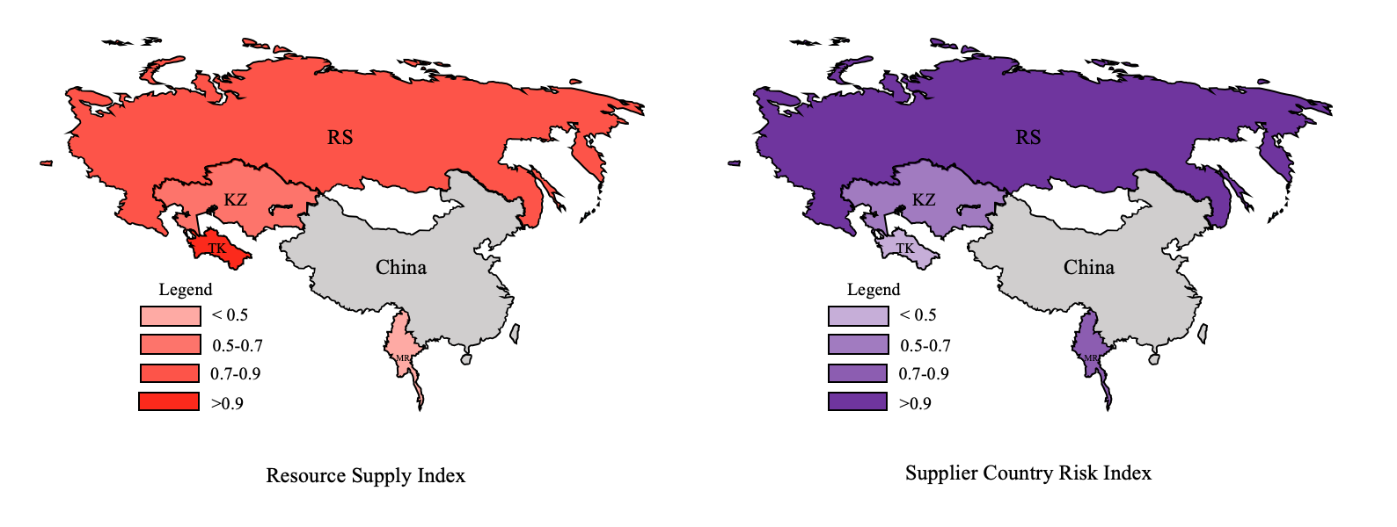
Figure 10 – The resource supply index and supplier country risk index of major natural gas supplier countries
Note: Compiled by author based on the results of calculation

Figure 11 illustrates the pipeline gas price change index, transportation security index and gas requirement index of each country.

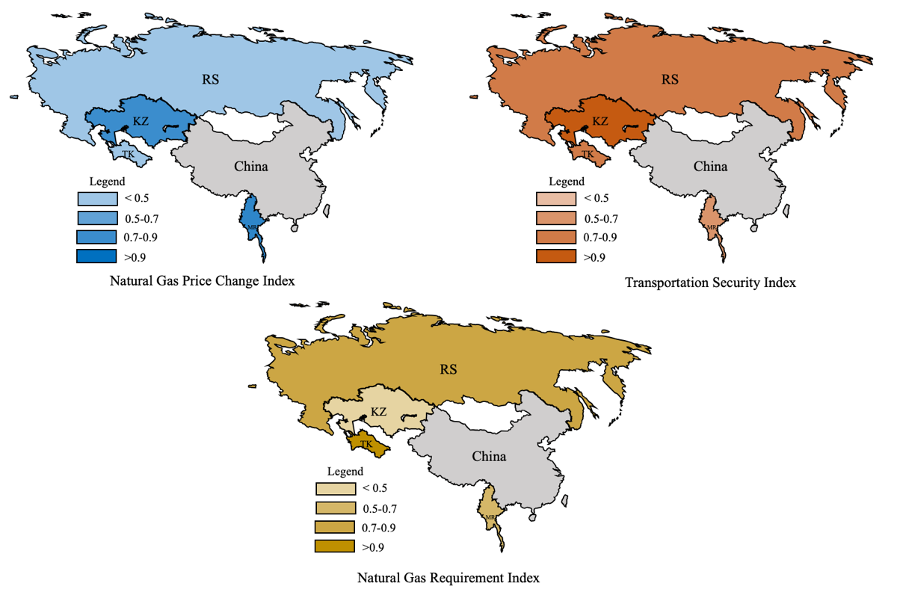
Figure 11 – The gas price change index, transportation security index and gas requirement index of major natural gas supplier countries
Note: Compiled by author based on the results of calculation

In Figure 11, we can see that: 1. Regarding the PC index, Turkmenistan and Russia have plentiful natural gas resources, along with prices for gas supply that are quite steady. The prices of natural gas originating from Kazakhstan and Myanmar have been steadily increasing as a result of diminished supply. The pipeline distance from Turkmenistan to China is longer than that from Kazakhstan, which results in higher natural gas prices for Turkmenistan compared to those of Kazakhstan. Nevertheless, Kazakhstan faces more significant price fluctuations due to its unreliable natural gas supply. Natural gas prices of Myanmar are higher than those of Central Asia, and its PC index is also linked to supply instability.
2. Concerning the TS index, three out of the four nations have land borders with China and have not faced any transportation interruptions in the past few years, leading to a high overall TS index across all four countries. Notably, three natural gas pipelines in Kazakhstan link to China’s pipeline infrastructure, leading to Kazakhstan possessing a greater TS index than the other three nations; 3. In a manner akin to the RS index, the market for natural gas consumption in China exhibits a significant reliance on the natural gas resources of Turkmenistan, which suggests that Turkmenistan possesses a relatively high DR index. Following the Russia-Ukraine conflict in 2022, Russia significantly increased its natural gas exports to China via the Russia-China east gas pipeline, resulting in a competitive scenario with Central Asian gas supplies in the DR index.
The results derived from the gas import security indices suggest that the main risks affecting the current natural gas partnership between Kazakhstan and China primarily arise from variations in supply and demand. As we have seen from the analysis of Kazakhstan’s natural gas reserves, production, and infrastructure in chapter 1.2, Kazakhstan possesses abundant natural gas reserves, with a considerable amount of these reserves not yet developed. Based on the analysis of Chinese companies’ investments in Kazakhstan’s natural gas projects presented in chapter 2.1, Kazakhstan and China have already established the necessary policy framework and economic environment for collaboration in the natural gas industry. The writer proposes that, at this moment, an efficient strategy to alleviate risks within the Kazakhstan-China natural gas partnership and improve its durability is to broaden the parameters of the “investment in exchange for natural gas supplies” policy while minimizing supply-and-demand uncertainties through the diversification of natural gas supply sources. At the same time, Kazakhstan needs to improve its natural gas transportation model to ensure transportation safety and further expand its influence in the Chinese natural gas import market.
In summary, the gas import security indices are used to compare the strengths and weaknesses of four pipeline gas supplier countries for Chinese gas market. In the market for pipeline gas in China, Kazakhstan holds significant advantages in terms of transportation and national security. However, it faces potential challenges concerning resource supply and the pricing of natural gas. The Chinese market relies significantly on natural gas resources sourced from Turkmenistan and Russia, which creates the potential for discrepancies between supply and demand. As a result, it is essential to conduct a more thorough examination of Kazakhstan’s pricing strategies and its negotiating influence regarding natural gas exports to China under conditions of both strengths and weaknesses through the aforementioned factors.
Global commerce can be likened to a risky venture, particularly in the sectors of oil and gas, which have significant impacts on a country’s economy and its energy stability. Bargaining model, as known as the Rubinstein model, built by Israeli economist Ariel Rubinstein in 1982 with the method of full information dynamic game, the basic and full information bargaining process simulation. Negotiation involves a crucial aspect known as bargaining, where the effective application of bargaining methods and techniques plays a significant role in achieving successful negotiations. This ensures that countries can fully leverage the bargaining framework during price negotiation endeavors [131].
The bargaining mechanism is widely used in international oil and gas trade, especially in the context of competitive globalized trade. The mechanism also allows energy companies in both countries to accept or reject each other’s proposals during the negotiation process. Because there is some negotiating power for both buyers and sellers. Resource-exporting nations must manage production costs while maximizing pricing advantages during the negotiating process. Simultaneously, resource-importing countries have an incentive to make some concessions in price negotiations in order to diversify potential security of supply risks and risks of market competition.
Current research used to analyze the bargaining power between countries in international natural gas cooperation. A. Lee and J. Kim discussed the effect on the bargaining power dynamics between the EU and Russia resulting from the decrease in gas imports from Russia by European nations [132]. O. Cobanli incorporated bargaining power into a cooperative game framework to examine the dynamics of the relationship between Europe and China concerning the natural gas trade in Central Asia and concluded that there is no conflict of interest between the two players [133]. Zhang et al. employed the bargaining model to replicate the pricing dynamics during the negotiations between China and Russia, thereby providing the optimal offer through the game, enhancing the transparency of the discussions between both parties, and leveraging additional factors to facilitate the negotiations [134].
The bargaining game is a matter of dividing the cake (distributing the surplus). There are three main categories of bargaining methods: Simultaneous-move Game, Axiomatic solution and Sequential bargaining. In this paper, we use a sequential bargaining model (Rubinstein bargaining), i.e., fixing a sequential negotiation protocol and solving subgame perfect equilibria.
The initial setup for sequential bargaining is as follows: two players share the cake, and the negotiation can take up to T rounds, with players taking turns proposing allocations. The order of bargaining agreements is: (an odd number of rounds) player 1 proposes, player 2 decides to pass or not pass; (an even number of rounds) player 2 proposes, player 1 decides to pass or not pass. If offer X is accepted, the game ends and cake is divided according to the offer, with player 1 getting x and player 2 getting (1-x). If offer x is rejected, negotiations move to the next stage. If no agreement is reached after round T, each player scores 0 points and nobody gets cake.
In order to examine the pricing behavior of participants involved in the natural gas trade between Kazakhstan and China, we formulate two hypotheses. In the first hypothesis, both parties involved in the negotiation are considered rational, indicating that they possess expectations and assessments regarding the final price. In hypothesis 2 both parties seek to maximize their own interests in the bargaining process.
Under the bilateral bargaining mechanism, the two sides of the gas trade game hold different objectives: gas-exporting countries want to raise the price of gas in order to ensure that hydrocarbon resources are fully exploited and to maximize government revenues, while countries that import gas strive to enhance trade efficiency. The determination of price is primarily influenced by the bargaining power of both parties. Resource-exporting countries usually have an advantage over importing countries and tend to increase their price space. However, imbalances in price control can affect the incentives for project development, especially when resource-importing countries are involved in the development of projects. In these instances, the costs associated with development could increase and potentially lead to supply risks. Consequently, it is essential to enhance the pricing dynamics of natural gas trading to ensure the stability of regional gas markets.
Reasonable and fair pricing behavior fully reflects the relative advantages of both trading parties and can improve the efficiency of trade. Nevertheless, the determination of the pricing space is challenging due to the confidentiality surrounding trade information. In this study, we employ the bid-by-bid theory to construct a model and examine the suitable trade pricing space.
Rubinstein’s sequential bargaining model considers the problem of how two parties can split a predicted amount of profits. This profit can be equitable for both parties, or it may favor one party over the other. The natural gas imported by China is mainly used to replace industrial fuel oil and liquefied petroleum gas (LPG). Consequently, during negotiations regarding natural gas trade, China tends to propose an offer that is associated with the pricing of alternative energy sources, thereby ensuring trade advantages.
Based on the above analysis of China and Kazakhstan, we make the following assumptions about the bargaining model:
1) It is assumed that rational behavior of China and Kazakhstan when they engage in a bilateral bargaining process. This assumption implies that both parties hope to reach an agreement within the expected price range and will actively seek the best strategy to achieve their goals;
2) In the bargaining process, information is an important factor that influences the decisions of both parties to the negotiation. There is no public pricing mechanism for international long-term natural gas contract transactions, as they are commercially confidential. In this assumption, both parties are allowed to use the information they already have to formulate their policies and adjust them in response to the other party's reaction.
In this process, the trading prices of natural gas between China and Russia, in addition to those between China and Turkmenistan, along with the spot prices of natural gas published by the International Energy Agency, can act as valuable informational references;
3) The importation of natural gas from Kazakhstan via gas pipelines is not constrained by technical limitations. In this scenario, elements such as technological advancements and geopolitical considerations do not play a significant role in the negotiations that affect the pricing of natural gas transactions;
4) Based on the above analysis, the market price of natural gas sales in China (P_{m}^{c}) is set to be:
$$P_{m}^{c}=a+ αP_{f}+βP_{l}$$ | (2.8)
where, P_{m}^{c} is Chinese market price of natural gas expressed as USD per thousand cubic meters; a is constant coefficient of basic price; P_{f} is market price of fuel oil; P_{l} is market price of LPG; α and β represents price weighting coefficients.
5) The length of the negotiations reflects the efficiency of the negotiations. Prolonged negotiations not only diminish the interest of the negotiating parties in reaching an agreement but also increase the cost of the negotiations. The agreed contract conditions will also be affected by more uncertainties due to the extension of time.
In this assumption, in order to save time, both parties establish a preferred price prior to the negotiation (expected price P_{e}^{c} and P_{e}^{k}) and keep it secret from the other party. Negotiations between the parties revolve around the determination of that P_{e} until both bids are infinitely close to that price and the negotiations are concluded. If the negotiation fails, both sides gain zero.
In conventional bargaining models, it is generally presumed that the party that acts first possesses a relative advantage. Nevertheless, in scenarios where both participants exhibit a high degree of patience during the bargaining process, both the initial player and the subsequent player may enjoy specific advantages. The first player advantage takes the initiative, while the second player can reject any offer from the beginning until all the benefits are obtained. Given that Kazakhstan possesses natural gas resources, it enjoys greater trade initiative. Assuming that Kazakhstan is the first to offer its price and China decides to accept or refuse. Each round happens with Kazakhstan proposing in odd rounds and China in even rounds until the negotiation ends. The bargaining process of negotiation is shown in Figure 12.

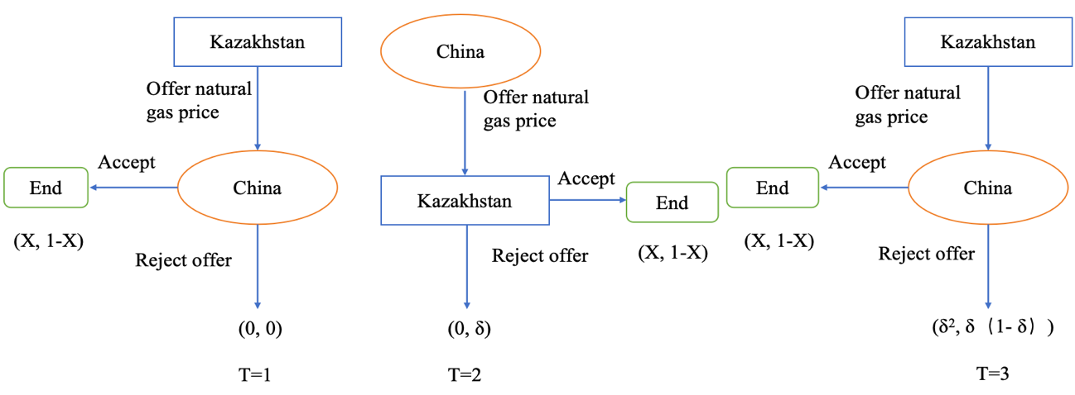
Figure 12 – The bargaining process of negotiation
Note: Compiled by author based on bargaining models

Assuming that in the first round of negotiation, Kazakhstan is the first to offer its expected gas price P_{k1}, and C_{g} denotes the expense associated with the production of natural gas in Kazakhstan, while Q signifies the trade volume of natural gas as stipulated in the agreement. In the first round of negotiation, if China could accept P_{k1} and end the bargaining process. But if P_{k1} is much higher than P_{e}^{c}, China may reject this offer and suggest next round bid.
The second round of negotiation will be started, this time due to the good intentions of the two parties, the coefficients for price discounting can be offered as δ_{k} and δ_{c}, respectively. In the second round of negotiations, after China makes an offer P_{c2}, Kazakhstan has the option to accept it and conclude the negotiation process; however, if Kazakhstan declines to present an offer and instead proposes a counteroffer, the negotiations will move to a second round, with additional negotiating costs for both sides. If the N round of negotiations is odd round, in which Kazakhstan proposes a final price P_{kn}, whether China accepts it or not, the negotiations end. If China finally refuses, then both parties benefit zero and negotiations fail. If the N round of negotiations is even round, then China proposes a final price P_{cn}, whether Kazakhstan accepts it or not, the negotiations end. If Kazakhstan finally refuses, then both parties benefit zero and negotiations fail.
The predicted profits of Kazakhstan and China in this scenario of each round shown in Table 13.

Table 13 – The predicted profits of Kazakhstan and China in the process of negotiation

Rounds | Kazakhstan | China
1 | K₁= (P_{k1} – C_{g}) * Q | C₁ = (P_{m}^{c} – P_{k1}) * Q
2 | K₂= (P_{c2} – C_{g}) * Q*δ_{k} | C₂ = (P_{m}^{c} – P_{c2}) * Q*δ_{c}
3 | K₃= (P_{k3} – C_{g}) * Q*δ_{k2} | C₃ = (P_{m}^{c} – P_{k3}) * Q*δ_{c2}
… | … | …
n (Odd) | K_{n}= (P_{kn} – C_{g}) * Q*δ_{k(n-1)} | C_{n} = (P_{m}^{c} – P_{kn}) * Q*δ_{c(n-1)}
N(even) | K_{n}= (P_{cn} – C_{g}) * Q*δ_{k(n-1)} | C_{n} = (P_{m}^{c} – P_{cn}) * Q*δ_{c(n-1)}
Note: Compiled by author

Table 13 illustrates that Kazakhstan and China subsequently alternate in presenting prices until the negotiation process reaches the N stage (the last round). In the third round of bargaining, Kazakhstan offers a counteroffer with an expected price ratio of Pk3, and then China must decide whether to accept the counteroffer. Similar to the conditions of the second round, Kazakhstan expects a discount price δ_{k} and China expects a discount price δ_{c}. If China accepts the P_{k3}, the negotiation will be finished. Otherwise, China will offer new price again and come to the next round negotiation.
Following the research of A. Rubinstein about bargaining model analysis indicates that a strategy specifies the offer that a player makes whenever it is his turn to make an offer, and his reaction to any offer made by his opponent [135]. The essence of negotiation is to predict the expected price of the other party through the pricing behavior in the bargaining process and adjust the offer in time, in aim to maximize the profit margin. Next section will analyze the two stages of the bargaining process as an example using the reverse categorization method and derive bargaining strategies for both sides.
In the research of this bilateral bargaining process, the key counterpoint is set in the second round, which both parties have made their offers. Assume that in the first round China rejected Kazakhstan’s offer P_{k1.} In the second-round if China offered price P_{c2} makes the expected profit of Kazakhstan K₂ ≥0, which means (P_{c2} – C_{g}) * Q*δ_{k} ≥ 0, then P_{c2} ≥ C_{g}, Kazakhstan may accept this offer and finish the negotiation.
For China how to adjust the second round of offer P_{c2} through the first round of Kazakhstan’s offer P_{k1}. In order to increase the chances of price offer P_{c2} accepted by Kazakhstan, it is necessary to determine the expected price P_{e}^{k} in the range of [C_{g}, P_{c2}]. φ is used in indicate the probability that Kazakhstan will accept the offer P_{c2}. The predicted profit of China can be expressed by:
$$C=φ\left(P_{m}^{c}-P_{c2}\right)Qδ_{c}+(1-φ)×0$$ | (2.9)
The probability φ defined by:
$$φ=\left(P_{c2}- C_{g}\right) / (P_{k1}-C_{g})$$ | (2.10)
Subsequently, according to China’s assessment of the production costs of natural gas in Kazakhstan, denoted as C_{g}, the anticipated profit maximization for China can be articulated in the following manner:
$$Max(C)=Max[\left(P_{c2}- C_{g}\right) × (P_{m}^{c}-P_{c2}) Qδ_{c}/(P_{k1}-C_{g})$$ | (2.11)
By solving the formula, the best price offer P_{c2} will be:
$$P_{c2}=\left(P_{m}^{c}+ C_{g}\right) /2$$ | (2.12)
Therefore, in the second round the predicted profit of Kazakhstan will be: K₂= (P_{m}^{c} – C_{g}) * Q*δ_{k} / 2. The predicted profit of China will be: C₂ = (P_{m}^{c} – C_{g}) * Q*δ_{c} / 2.
Then in the first round of bargaining, China will accept the offer P_{k1} when C₁ ≥ C₂, which means: (P_{m}^{c} – P_{k1}) * Q ≥ (P_{m}^{c} – C_{g}) * Q*δ_{c} / 2. From here we can get the first price offer of Kazakhstan P_{k1}.
$$P_{m}^{c}≥\left(2P_{k1}+ δ_{c}C_{g}\right) /(2-δ_{c})$$ | (2.13)
$$P_{k1}≤0.5 δ_{c}C_{g}+0.5P_{m}^{c}(2-δ_{c})$$ | (2.14)
Table 14 illustrates the expected profits for Kazakhstan and China in the first and second rounds of negotiations:

Table 14 – The predicted profits of Kazakhstan and China in the first and second round

Rounds | Kazakhstan | China
1 | K₁= Q*δ_{k} (P_{c2} – C_{g}) | C₁ = (P_{m}^{c} – P_{k1}) * Q
2 | K₂= Q*δ_{k} (P_{m}^{c} – C_{g}) /2 | C₂ = Q*δ_{c} (P_{m}^{c} –C_{g})/2
Note: Compiled by author

Equivalently, based on Kazakhstan’s approach to China’s decision-making in the first and second rounds. Assuming that the probability that China accepts the offer P_{k1} in the first round is ω, the expected profit maximum of Kazakhstan is stated as:
$$Max(K)=Max[ω\left(P_{k1}- C_{g}\right)Q × 0.5(1-ω) Qδ_{k}(P_{m}^{c}-C_{g})$$ | (2.15)
The probability ω defined by:
$$ω=2\left(P_{c2}- C_{g}\right) / (P_{m}^{c}-C_{g})$$ | (2.16)
From formulas 2.14, 2.15 and 2.16, the best offer of P_{k1} can be expressed by:
$$P_{k1}=\left[\left(2-δ_{c}\right)P_{m}^{c}+C_{g}δ_{c}+δ_{k}\left(P_{m}^{c}+C_{g}\right)\right]/4$$ | (2.17)
Finally, by analyzing the above formulas we can obtain an approximate price P_{k1} and P_{c2} and conditions that need to be met. In the first round of negotiation Kazakhstan will offer price P_{k1}=[(2–δ_{c}) P_{m}^{c} + δ_{c}C_{g} + δ_{k} (P_{m}^{c} + C_{g})] ⁄ 4. If the offer P_{k1} ≤ 0.5δ_{c} C_{g} +0.5 P_{m}^{c} (2–δ_{c}), then China will accept P_{k1} and negotiation finished. Otherwise, China will reject this offer and bargaining process turn into second round. In second round, China will offer P_{c2} = (P_{m}^{c} +C_{g}) ⁄ 2, if P_{c2} ≥ C_{g}, Kazakhstan would decide to accept or reject this offer.
The current natural gas pricing system in China is regional, meaning that the price of natural gas in each area is affected by the origin of the gas. Therefore, we selected the gas price in the Xinjiang Autonomous Region (on the border of Kazakhstan and China) as the market price P_{m}^{c}. According to data published by the China Development and Reform Commission, the price of natural gas in Xinjiang is 3 yuan per cubic meter (P_{m}^{c} = 11.73 $/MMBTU). Data on the price of natural gas production in Kazakhstan, published by S&P Global 2023, indicate that the average price of Kazakh natural gas production is 40 $/Mcm (C_{g} = 1.12$/MMBTU). Based on the analysis presented in the preceding section, it can be concluded that the gas price for the Kazakhstan-China transaction must fall within the range [C_{g}, P_{m}^{c}]. Failing to meet this condition will result in the failure of the bargaining process, leading to a situation where both parties receive nothing.
Based on the analysis of bargaining process, the Figure 13 illustrates the correlation between price discount (δ), price (P), and maximum predicted profit of Kazakhstan [Max(K)] and China [Max(C)] under current situation.

Figure 13 – The profit ratios in bargaining process between Kazakhstan and China
Note: Compiled by author based on bargaining models

The origin of natural gas being exported from Kazakhstan to China is the gas field located in Western Kazakhstan, along with underground natural gas storage and the Chinese receiving terminal is the Khorgos Port in Xinjiang. Natural gas trade details between Kazakhstan and China from 2015 to 2024 is shown in Table 15.

Table 15 – The natural gas trade between Kazakhstan and China from 2015 to 2024

Year | Gas export volume (million m³) | Value ($) | Average price ($/MMBTU)
2015 | 383.13 | 49,437,667.38 | 3.6816
2016 | 459.21 | 72,438,776.23 | 3.6701
2017 | 646.29 | 67,582,832.68 | 4.0101
2018 | 5,244.58 | 983,156,064.57 | 5.6023
2019 | 7,432.75 | 1,568,641,813.47 | 5.9659
2020 | 7,363.76 | 1,408,339,366.48 | 5.3726
2021 | 6,436.66 | 1,065,835,557.31 | 4.5916
2022 | 5,070.51 | 1,210,500,825.17 | 6.5308
2023 | 5,856.59 | 1,466,688,474.65 | 6.0149
2024 | 5,395.89 | 1,341,109,302.00 | 7.5574
Note: Compiled by author based on the data of [79]

From Table 15 we can draw the following conclusions:
1. Kazakhstan's enforcement of the contract was inadequate. The gas trade agreement stipulates that the involved parties will progressively raise the gas export volume to 10 billion m³ annually; however, Kazakhstan’s gas exports to China are diminishing each year.
2. The price trend in the current contract demonstrates that the natural gas price of Kazakhstan exported to China is within the range shown in Figure 14. This discovery demonstrates that during the negotiation of this agreement, the discount ratio between Kazakhstan and China δ_{k}: δ_{c} = [ 6:4, 7:3]. It is feasible to anticipate the extent to which Kazakhstan is prepared to concede to Chinese demands during discussions regarding gas pricing.
3. By comparing the price of natural gas trade between these countries and China, it can be seen that Russian gas is the cheapest and Turkmenistan is the most expensive due to the transportation distance. Kazakhstan and Uzbekistan exhibit comparable pricing structures. Kazakhstan lacks a notable edge over Turkmenistan or Russia regarding the quantity of gas traded; however, it plays a crucial role in ensuring China’s energy security. Consequently, there remains leverage for negotiation in the discussions.
By analyzing the above factors affecting the pricing behavior of the negotiating parties, we can hypothesize the bargaining process in two cases: 1. δ_{k}: δ_{c} = [7:3]; 2. δ_{k}: δ_{c} = [6:4].
Hypothesis 1: In the bargaining process the predicted profits of Kazakhstan and China are affected by pricing discount rate δ_{k} and δ_{c}. It is known that before the negotiation the expected price P_{e}^{c} and P_{e}^{k} in the range of [C_{g}, P_{m}^{c}]. To illustrate, we assume that δ_{k} =0.7, δ_{c}=0.3, C_{g} =1.12 $/MMBTU, P_{m}^{c} =11.73 $/MMBTU.
Based on our analysis of the bargaining process we can calculate the Kazakhstan’s offer in the first round (P_{k1}) and the China’s offer in the second round (P_{c2}) of bargaining will be: P_{k1}=[(2–δ_{c}) P_{m}^{c} + δ_{c}C_{g} + δ_{k} (P_{m}^{c} + C_{g})] ⁄ 4 = 7.3 ($/MMBTU); P_{c2} = (P_{m}^{c} +C_{g}) ⁄ 2 = 6.42 ($/MMBTU). The price offers P_{k1} and P_{c2} are in range of [1.12, 11.73], the Hypothesis 1 is valid.

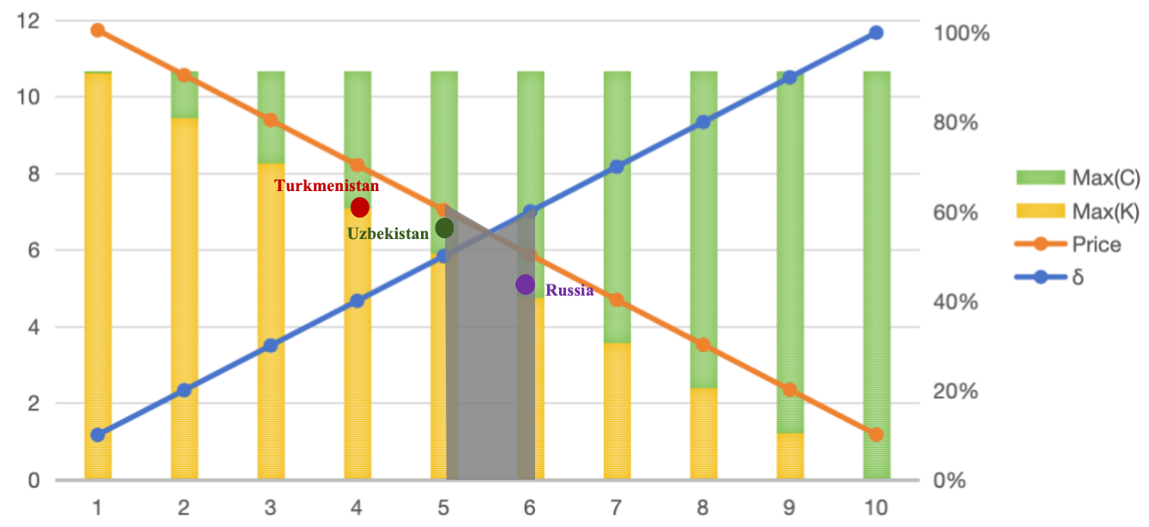
Figure 14 – Comparison of gas export prices between Turkmenistan, Russia, Uzbekistan and Kazakhstan
Note: Compiled by author

In light of the preceding analysis, we conducted a simulation of the natural gas price negotiation process between Kazakhstan and China, as outlined in Hypothesis 1. During this negotiation, we posited that Kazakhstan would initiate the first offer, followed by China making the second offer, with both parties participating in the initial round of discussions concerning the price of natural gas. In the second round of negotiations, China made the initial offer and Kazakhstan countered it, as the two sides explored whether they could reach an agreement on natural gas trade prices under various pricing scenarios. The first and second round of bargaining process between Kazakhstan and China demonstrated in Figure 15.

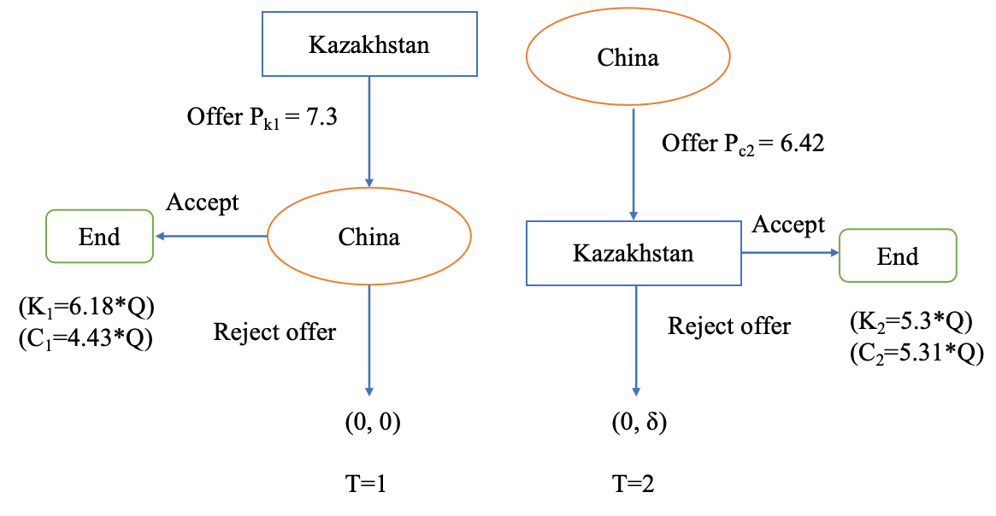
Figure 15 – The bargaining process of Hypothesis 1
Note: Compiled by author based on the analysis of Hypothesis 1

As illustrated in Figure 15, Hypothesis 1 indicates that both parties adopt a more conservative approach to their pricing proposals, given that Kazakhstan is more inclined to make concessions when both parties are positioned comparably within the negotiation process. The prices offered by the parties in the first and second rounds of negotiations and the predicted profits of the parties were at similar levels. This means that the parties are more likely to reach an agreement and conclude the negotiations in the first round of negotiations.
Hypothesis 2: In the bargaining process the predicted profits of Kazakhstan and China are affected by pricing discount rate δ_{k} and δ_{c}. It is known that before the negotiation the expected price P_{e}^{c} and P_{e}^{k} in the range of [C_{g}, P_{m}^{c}]. To illustrate, we assume that δ_{k}=0.6, δ_{c}=0.4, C_{g} =1.12 $/MMBTU, P_{m}^{c} =11.73 $/MMBTU.
Based on our analysis of the bargaining process we can calculate the Kazakhstan’s offer in the first round (P_{k1}) and the China’s offer in the second round (P_{c2}) of bargaining will be: P_{k1}=[(2–δ_{c}) P_{m}^{c} + δ_{c}C_{g} + δ_{k} (P_{m}^{c} + C_{g})] ⁄ 4 = 8.01 ($/MMBTU); P_{c2} = (P_{m}^{c} +C_{g}) ⁄ 2 = 6.42 ($/MMBTU). The price offers P_{k1} and P_{c2} are in range of [1.12, 11.73], the Hypothesis 2 is valid.
Based on the above analysis, we simulated the natural gas price negotiation process between Kazakhstan and China under Hypothesis 2. In the course of this negotiation, we posited that Kazakhstan would present the initial offer, followed by China making the subsequent offer, as both parties participate in the initial round of discussions concerning the pricing of natural gas. In the second round of negotiations, China made the initial offer and Kazakhstan countered it, as the two sides explored whether they could reach an agreement on natural gas trade prices under various pricing scenarios. The first and second round of bargaining process between Kazakhstan and China demonstrated in Figure 16.

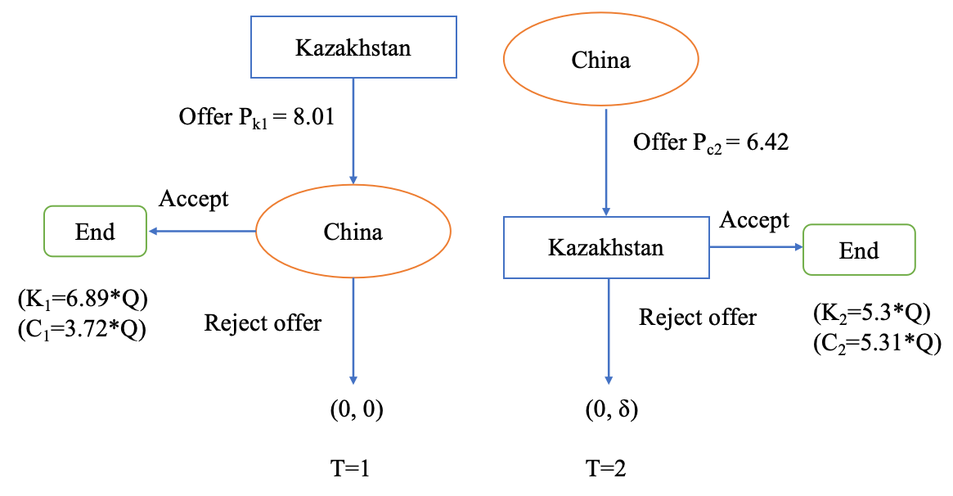
Figure 16 – The bargaining process of Hypothesis 2
Note: Compiled by author based on the analysis of Hypothesis 2

Figure 16 demonstrates that Kazakhstan, as the first bidder in Hypothesis 2, has the advantage of taking the initiative in the negotiations and wants to gain more in the bargaining process. Therefore, in the first round of negotiations, Kazakhstan makes small concessions on the price of gas trade transactions to gain more benefits. Under hypothesis 2, Kazakhstan’s pricing offer P_{k1} exceeded China’s expected pricing offer and was also elevated in comparison to the gas prices in Russia and Turkmenistan. It is therefore likely that China will reject P_{k1} and propose the start of the second round of negotiations. The continuation of such a bargaining process will cause China and Kazakhstan to waste a lot of time and labor costs, resulting in inefficient negotiations.
As a result, by comparing and analyzing Hypothesis 1 and Hypothesis 2, we can conclude that both hypotheses have the possibility of occurring in actual negotiations. In Hypothesis 1, both negotiating parties are rational groups, based on the understanding of each other’s situation each party is willing to balance the distribution of benefits and make the offer that is closest to the expected price of both parties. Despite the fact that neither party fully capitalized on their respective interests, this approach significantly enhanced the efficiency of the negotiations and laid the groundwork for effective collaboration moving forward. In Hypothesis 2, the two negotiating parties want to strive for more benefits during the bargaining process, so it is difficult to reach a quick agreement in the price negotiation. The whole negotiation process will be expensive and deteriorate the relationship between the two parties.
In general, there are two hypotheses are set to analyze the results of negotiation caused by different pricing behaviors. As Kazakhstan is the owner of natural gas resources, it is assumed that the first pricing offer of the bargaining process is initiated by Kazakhstan. In Hypothesis 1, Kazakhstan, being the initial party to extend an offer, presents a more substantial discount on its proposal. In Hypothesis 2, on the contrary, Kazakhstan offers prices first and wants more profit. Conclusions are drawn as follows:
1. In the negotiations concerning the natural gas trade between Kazakhstan and China, the initial offer made by Kazakhstan may significantly influence the overall trajectory of the discussions, owing to the first-mover advantage inherent in the bargaining process. If the price of first offer is too high, it will disrupt the entire negotiation process. If the initial offer’s price is excessively low, it will diminish Kazakhstan’s profits and weaken the pricing mechanism of the natural gas market. This requires Kazakhstan and China to make accurate assessments and risk forecasts regarding Kazakhstan’s natural gas production, cost prices, supply and demand volumes, and market prices when submitting their initial offers.
2. Bilateral negotiations are influenced by the accessibility of information regarding the natural gas production and sales market, the examination of the pricing behavior of the counterparty, and the anticipated discounts. Considering the significant impact that Turkmenistan and Russia have established a framework regarding natural gas market prices; therefore, Kazakhstan should emphasize its significance in maintaining market equilibrium within its negotiation proposal.
3. The trade of natural gas between Kazakhstan and China is presently characterized by a balance of interest, as both parties are prepared to provide comparable discount rates. However, the current pricing mechanism is based on market structural equilibrium. Combined with the analysis of the gas import security indices, supply and demand risks could have a negative impact on the natural gas market structure. Therefore, it is necessary to optimize the market structure and cooperation models.
4. The market price of natural gas in China exhibits a positive correlation with the import price. Due to the unique characteristics of the pipeline gas market, the price of natural gas in Kazakhstan is also affected and constrained by the prices of natural gas from Russia and Turkmenistan. Based on the results of gas import security indices, Kazakhstan’s transportation security and national security index are higher than those of Turkmenistan and Russia. Kazakhstan has the potential to utilize its geographical benefits to mitigate the impact of Turkmenistan and Russia on the pricing of natural gas in the market.
The chapter 2.2 evaluates the competitiveness and bargaining power of Kazakhstan in China’s pipeline gas market, considering supply and demand, transportation, energy security and economic factors. Based on the analysis presented, it can be inferred that Kazakhstan occupies a crucial role in the Chinese pipeline gas market, taking into account factors such as transportation security, supply security, and trade pricing. An equitable pricing mechanism relies on a well-balanced market structure. Considering the risks linked to supply and demand, Kazakhstan ought to capitalize on its transportation benefits to strengthen its position in stabilizing the Chinese natural gas market. In forthcoming natural gas collaborations, Kazakhstan and China can refine their natural gas transportation frameworks to alleviate supply and demand uncertainties and improve transportation security. The prospects for this aspect will be further analyzed in chapter 3.2. Consequently, the trade of natural gas between Kazakhstan and China does not represent a zero-sum game. Both nations are inclined to come to a consensus regarding the natural gas trade.

Economic analysis and trade potential of Kazakhstan-China natural gas trade

Economic and trade relations between Kazakhstan and China are founded on a solid basis for collaboration. China was among the initial nations to acknowledge Kazakhstan’s independence and to forge diplomatic ties with it, and the SCO and the OBOR Initiative have enabled Kazakhstan-China cooperation to take place within the framework of multifaceted cooperation.
The economies of Kazakhstan and China are highly complementary. When Kazakhstan first gained independence, Kazakhstan faced problems such as a shortage of daily necessities. A large number of light industrial supplies produced in China were exported to Kazakhstan, which alleviated such problems to a certain extent.
The functioning of the Kazakhstan – China oil pipeline and the Central Asia – China natural gas pipeline system has created new avenues for Kazakhstan’s energy exports. The investment and participation of CNPC and Sinopec in the project to modernize the Shymkent oil refinery has boosted the development of Kazakhstan’s chemical industry.
Kazakhstan and China were established as a permanent comprehensive strategic partnership in 2019, and the relationship between the two countries has become a model for regional economic cooperation. They have effectively leveraged their geographic advantages to enhance port construction and the transportation economy, thereby promoting the swift development of border trade zones, which has led to significant growth in economic relations.
Economic cooperation between Kazakhstan and China is realized in the following ways:
1. Enhancement of bilateral trade and investment. In recent years, the bilateral trade and investment between the two nations have experienced growth, and the degree of collaboration has intensified.
2. Strengthening infrastructure development and enhancing connectivity. The two countries have opened free trade zones at border crossings to promote the development of bilateral trade. Proactively advocate for the development of transportation hubs in both nations, while progressively enhancing the networks of highways, railways, and air routes within these countries. Strengthen the integration of oil and gas pipelines as well as power grids between the two nations.
3. Participating in the globalization of trade processes. China became a member of the WTO in 2001, while Kazakhstan joined in 2015. To foster the expansion of the global economy and advance trade globalization, the foreign ministers of Brazil, Russia, India, and China convened for the inaugural meeting of BRICS cooperation at the United Nations. Among the Central Asian countries, Kazakhstan and Uzbekistan officially became BRICS partner countries in 2025.
4. Providing financial support and loans. In order to promote the successful implementation of projects jointly undertaken by Kazakhstan and China, the China International Capital Corporation along with the Asian Infrastructure Investment Bank have invested financially in various sectors, including hydrocarbons, renewable energy, manufacturing, and construction.
As a result of changes in the international geopolitical situation, the global energy market is paying increasing attention to the issue of energy security. Given the trajectory of Kazakhstan’s economic growth and its investment environment, along with the rising energy demands stemming from China's expansion, it is anticipated that the focus of bilateral trade between Kazakhstan and China will continue to be predominantly on the energy sector, especially in relation to oil and gas.
The total energy exchange between Kazakhstan and China is increasing, and at the same time, the structure of energy trade between these two countries is experiencing considerable changes. To enhance the comprehension of the complementary nature of oil and gas trade within the economic and trade collaboration between Kazakhstan and China, the trade complementarity index (TCI) is employed to assess the extent of complementarity in oil and gas trade between the two nations.
The Trade Complementarity Index (TCI) was proposed by the Australian economist P. Drysdale in his study and its formula is as follows [136]:
$$TCI= \sum_{k}{{RCA}_{xa}^{k}{RCA}_{mb}^{k }×\frac{X_{w}^{k}}{X_{w}}}$$ | (2.18)
where: RCA^{k}_{xa} is the comparative advantage of country a by exports product k; RCA^{k}_{mb} is the comparative advantage of country b by imports product k.
When the TCI value exceeds 1, it signifies a robust complementarity in the trade of product k between the exporting and importing nations. The size of the TCI value is positively correlated with the complementarity of the two countries. When the TCI value falls below 1, it signifies a weak complementarity in the trade of product k between the two nations.
The TCI index can be used to further analyze the complementarity of oil and gas trade between Kazakhstan and China. The raw data for calculating TCI index is sourced from the United Nations Comtrade database. Table 16 shows the complementarity of energy trade cooperation between Kazakhstan and China.

Table 16 – The TCI index of oil and gas trade between Kazakhstan and China

Year | TCI^{oil} _{KC} | TCI^{gas} _{KC}
2000 | 10.42 | 0.00
2001 | 9.23 | 0.38
2002 | 9.11 | 0.94
2003 | 9.18 | 0.57
2004 | 10.89 | 0.71
2005 | 9.92 | 0.36
2006 | 8.98 | 0.27
2007 | 9.85 | 0.28
2008 | 9.13 | 0.16
2009 | 11.79 | 0.40
2010 | 10.65 | 0.35
2011 | 9.18 | 0.68
2012 | 9.75 | 0.82
2013 | 10.74 | 0.94
2014 | 13.90 | 1.25
2015 | 21.81 | 2.43
2016 | 23.76 | 4.15
2017 | 28.16 | 4.30
2018 | 25.39 | 4.47
2019 | 30.90 | 7.06
2020 | 37.62 | 5.08
2021 | 11.10 | 1.60
2022 | 9.30 | 1.10
2023 | 10.90 | 1.30
Note: Compiled by author based on the results of calculation

Table 16 shows that analyzing the degree of complementarity of bilateral energy trade from the perspective of Kazakhstan as an energy exporter, it is found that the TCI index is consistently greater than 1, indicating that Kazakhstan's exports and China's imports of energy have strong trade complementarity, and the degree of coincidence of the two countries’ commodities is increasing.
Elevated TCI values for crude oil suggest that Kazakhstan’s competitive edge in crude oil enhances export trade connections with China, illustrating significant trade complementarities. The TCI index for natural gas surpassed 1 in 2014, progressively exhibiting an upward trajectory, which signifies the increasing trade relationship between Kazakhstan and China in the natural gas sector.
Overall, the energy exchange between Kazakhstan and China demonstrates a consistent upward trajectory; nonetheless, the factors driving this trend are diverse. To analyze the components affecting the development of energy trade between Kazakhstan and China, regression models are employed to quantify the extent of impact that different variables have on the energy trade among these nations, thereby offering empirical evidence to evaluate the viability of energy trade between them.
To develop a trade gravity model aimed at investigating the factors influencing the evolution of trade between the two nations, the GDP of the region and the distance built by the region can be introduced into the regression model as the most explanatory variables. Inspired by Newton’s law of universal gravitation, J. Tinbergen extended this conceptual framework to economics, developing the trade gravity model [137]. The foundational principle asserts that the magnitude of bilateral trade correlates positively with economic scale while exhibiting an inverse relationship with distance. Its initial form is:
$$T_{ij}= α\frac{{GDP}_{i}×{GDP}_{j}}{D_{ij}}$$ | (2.19)
where, T_{ij} denotes the total trade volume between country i and country j, GDP_{i} and GDP_{j} represent the GDP of country i and country j respectively, D_{ij} indicates the geographic distance between country i and country j.
Logarithmic transformation of the gravity model can prevent the occurrence of heteroscedasticity, so this paper applies logarithmic transformation to the gravity model. The specific form is as follows:
$${LnT}_{ij}= α_{0}+α_{1}{LnGDP}_{i}+α_{2}{LnGDP}_{j}+α_{3}{LnD}_{ij}+μ_{ij}$$ | (2.20)
Among these, α₀ is the constant term, α₁, α₂ and α₃ are the regression coefficients for the corresponding variables, and μ_{ij} is the error term.
Lineman in 1966 and Berstrand in 1989 further found a correlation between population size and per capita income levels and the development of bilateral trade [138]. Economists have continued to refine the model by adding variables such as tariffs, borders, religion, and political systems to form the expanded equal trade gravity model to delve deeper into the factors that influence the development of trade between two countries.
Through an examination of the energy exchange between Kazakhstan and China, taking into account the accessibility of data and the reliability of the empirical findings, the data of the explanatory variables and each explanatory variable for the period of 2000-2023 were collected to form the time-series data, the empirical model of energy trade was established, and the regression analysis was carried out by using Stata18.
In order to improve the accuracy of the empirical analysis concerning energy trade between Kazakhstan and China, particular regression equations are formulated by integrating the GDP of both nations, the overall population, Kazakhstan's oil and gas output, along with the energy consumption rates of Kazakhstan and China:
$$Ln\left(T_{kc}\right)=β_{0}+β_{1}Ln\left({GDP}_{k}*{GDP}_{c}\right)+β_{3}Ln\left({OP}_{k}\right)+β_{4}Ln\left({GP}_{k}\right)+β_{5}Ln\left({POP}_{c}\right)+β_{6}Ln\left({POP}_{k}\right)+β_{7}Ln\left({EC}_{c}\right)+β_{8}Ln({EC}_{k})+ε_{kc}$$ | (2.21)
This study delineates the parameters of energy trade to encompass both oil and natural gas, utilizing the overall energy trade between the two nations as the explanatory variable. In this context, Kazakhstan is represented by the letter k, while China is represented by c. The trade gravity model serves as the foundation for incorporating additional factors such as economic size, population, industrial advancement, and energy usage, thereby illustrating the effects of energy trade between Kazakhstan and China.
where: GDP_{k} and GDP_{c} represent the economic size of Kazakhstan and China, respectively. As the GDP of these two nations increases, so does the level of economic development. This, in turn, leads to a greater volume of energy imports and exports, thereby facilitating the growth of bilateral energy trade;
OP_{k} and GP_{k} signify the quantity of oil and gas production in Kazakhstan, illustrating the extent of advancement within the nation's hydrocarbon sector;
POP_{c} and POP_{k} represent the population size of Kazakhstan and China, which are typically positively associated with energy consumption and, in turn, positively linked to energy imports;
EC_{c} and EC_{k} represent the domestic energy consumption of Kazakhstan and China, illustrating the internal demand for energy; ε_{kc} is a placeholder variable that takes on a value of 1 when a factor influences trade between the two nations, and 0 in the absence of such a factor.
Table 17 demonstrates the explanation of the meaning of the variables in the trade gravity model and data resources.

Table 17 – Explanation of the meaning of the variables in the trade gravity model and data resources

Variable | Meaning | Explanation | Data resources
T_{kc} | The volume of energy trade between Kazakhstan and China | Reflecting energy trade between Kazakhstan and China | Bureau of National Statistics of Kazakhstan [79];  UN Comtrade [139]
GDP_{k} | GDP of Kazakhstan | The larger the economy, the greater the export capacity | World Bank  [140]
GDP_{c} | GDP of China | The larger the economy, the stronger the import capacity | World Bank  [141]
OP_{k} | Crude oil production in Kazakhstan | The more oil is produced, the more export capacity | KAZENERGY National Energy Report 2023 [73];  Statistical Review of World Energy 2024 [142]
GP_{k} | Natural gas production in Kazakhstan | The more gas is produced, the more export capacity | KAZENERGY National Energy Report 2023 [73];  Statistical Review of World Energy 2024 [142]
POP_{c} | Population of China | Reflecting China’s energy demand capacity | National Bureau of Statistics of China [120]
POP_{k} | Population of Kazakhstan | Reflecting Kazakhstan’s energy demand capacity | Bureau of National Statistics of Kazakhstan [143]
EC_{c} | Energy consumption of China | Reflecting China’s energy consumption capacity | National Bureau of Statistics of China [120];
Appendix to Table 17
 |  |  | Statistical Review of World Energy 2024 [142];
EC_{k} | Energy consumption of Kazakhstan | Reflecting Kazakhstan’s energy consumption capacity | Statistical Review of World Energy 2024 [142]
ε_{kc} | The special case of energy trade between Kazakhstan and China | Reflecting the impact of international factors on energy trade | Global Risks Report 2024 [144]

The descriptive statistics for each variable according to Stata 18 are shown in Table 18:

Table 18 – The result of regression estimates for each variable

Variable | Sample size | Average | Max | Min | Standard deviation
T_{kc} | 24 | 1.54e+06 | 5.31e+06 | 2.87e+05 | 1.36e+06
GDP_{k}*GDP_{c} | 24 | 3.60e+06 | 9.52e+06 | 1.85e+05 | 3.04e+06
OP_{k} | 24 | 7.27e+07 | 9.04e+07 | 3.53e+07 | 1.58e+07
GP_{k} | 24 | 2.07e+06 | 3.92e+06 | 5.00e+05 | 9.49e+05
POP_{c} | 24 | 1.35e+05 | 1.41e+05 | 1.27e+05 | 4.80e+03
POP_{k} | 24 | 168.33 | 199.00 | 148.58 | 16.080
EC_{c} | 24 | 2.58e+06 | 4.00e+06 | 1.03e+06 | 8.69e+05
EC_{k} | 24 | 5.17e+04 | 7.73e+04 | 3.45e+04 | 1.27e+04
ε_{kc} | 24 | 0.1667 | 1 | 0 | 0.3726
Note: calculations by the author of the research in the Stata 18

(1) Correlation analysis
Correlation analysis of the regression variables revealed that ε_{kc} had low correlation with other variables, which was excluded to avoid inaccuracy of the regression results. The correlation coefficients of the tested variables were as shown in Table 19:

Table 19 – The result of variable correlation analysis

Variable | Ln(T_{kc}) | Ln(GDP_{k}*GDP_{c} | Ln(OP_{k}) | Ln(GP_{k}) | Ln(POP_{c}) | Ln(POP_{k}) | Ln(EC_{c}) | Ln(EC_{k})
Ln (T_{kc}) | 1.0000
Ln (GDP_{k}*GDP_{c}) | 0.9085 | 1.0000
Ln (OP_{k}) | 0.8363 | 0.9378 | 1.0000
Ln (GP_{k}) | 0.8191 | 0.9521 | 0.9588 | 1.0000
Ln (POP_{c}) | 0.8974 | 0.9873 | 0.9026 | 0.9526 | 1.0000
Ln (POP_{k}) | 0.9250 | 0.9510 | 0.8102 | 0.8650 | 0.9698 | 1.0000
Ln (EC_{c}) | 0.9000 | 0.9877 | 0.9693 | 0.9604 | 0.9649 | 0.9134 | 1.0000
Ln (EC_{k}) | 0.0193 | 0.0798 | 0.3200 | 0.0952 | -0.061 | -0.185 | 0.1788 | 1.0000
Note: calculations by the author of the research in the Stata 18

Due to the different units of each variable, in order to reduce heteroskedasticity, the variables were linearized by taking the logarithm of each variable, and the pwcorr correlation analysis of the variables to be regressed was carried out by applying Stat18. From the results of the correlation analysis of the variables, it can be seen that the degree of correlation between the explained variable Ln (T_{kc}) and the explanatory variables Ln (GDP_{k}*GDP_{c}), Ln (OP_{k}), Ln (GP_{k}), Ln (POP_{c}), Ln (POP_{k}) and Ln (EC_{c}) is high, and this research model has some significance.
Table 20 presents the outcomes of regression estimates corresponding to each variable.

Table 20 – The result of regression estimates for each variable

Ln (T_{kc}) | Coefficient | t | r² | Adj r² | F | P
Ln (GDP_{k}*GDP_{c}) | 4.913*** | (0.96) | 0.9281 | 0.8967 | 29.51 | 0
Ln (OP_{k}) | 2.6690* | 1.56
Ln (GP_{k}) | -2.4166** | (-0.35)
Ln (POP_{c}) | 0.0903*** | (0)
Ln (POP_{k}) | -1.739* | 2.73
Ln (EC_{c}) | 0.5768*** | (0.38)
Ln (EC_{k}) | -2.8056 | 0.83
_cons | -107.055 | -2.54
Note: compiled from regression results. Note-***,** and * denotes passing the test at 1%, 5% and 10% significant level.
Source: calculations by the author of the research in the Stata 18

Consequently, the findings of the regression analysis concerning the oil and gas trade collaboration between Kazakhstan and China are:
$$Ln\left(T_{kc}\right)=-107.055+0.4913Ln\left({GDP}_{k}*{GDP}_{c}\right)+2.6690Ln\left({OP}_{k}\right)-2.4166Ln\left({GP}_{k}\right)+0.0903Ln\left({POP}_{c}\right)-1.739Ln\left({POP}_{k}\right)+0.5768Ln\left({EC}_{c}\right)-2.8056Ln({EC}_{k})$$ | (2.22)
From the regression results, the value of R² is 0.9281, which means GDP figures for China and Kazakhstan, the volume of oil and gas production in Kazakhstan, the population of China, the population of Kazakhstan, and the energy consumption levels of both nations collectively account for 92.8% of the variation observed in oil and gas trade between Kazakhstan and China. The regression results passed the F-test at the 1 significance level, indicating that the model performs well overall. Below is a detailed analysis of each explanatory variable:
a) The regression coefficient between the GDP values of China and Kazakhstan and their oil and gas trade is 0.4913, passing the T-test at the 1% level. This suggests a favorable relationship between economic development and gas trade, as the economic growth in China and Kazakhstan has positively influenced their natural gas trade. On one side, the progress in economic development has prompted changes in the energy mix, leading to a substantial rise in the demand for clean energy sources like natural gas. At the same time, economic growth has improved foreign trade capabilities and enlarged market size, both of which will encourage natural gas trade. On the other side, countries have increased their focus on hydrocarbon extraction technologies, and increasingly sophisticated extraction and reserve technologies have been a key factor in the growth of oil and gas production, resulting in increased energy exports and a significant increase in the level of bilateral trade.
b) The correlation coefficient that measures the relationship between the rise in oil production in Kazakhstan and the trade value of oil and gas traded between Kazakhstan and China is 2.6690. This result is statistically significant, as it satisfies the T-test criteria at a 10% significance level, suggesting a positive correlation between the increase in oil production in Kazakhstan and the trade value of oil and gas with China. The partnership between these two countries in the oil industry is firmly established, with oil being the main export product of Kazakhstan. In comparison to natural gas, Kazakhstan’s oil exports to China exhibit greater stability and play a more significant role in the oil and gas trade between the two nations. The regression analysis reveals that the relationship between gas production growth in Kazakhstan and the oil and gas trade value with China is -1.739, which passes the T-test at the 10% significance level. This finding indicates a negative correlation between the growth of gas production in Kazakhstan and the oil and gas trade value with China. A possible reason for this outcome is that Kazakhstan’s natural gas supplies to China primarily originate from mature fields such as the Zhanazhol and Kenkiyak fields, which have limited production capacity The majority of gas field initiatives funded by Chinese firms in Kazakhstan are currently in the development stage, with infrastructure still lacking. Furthermore, the significant increase in domestic demand for natural gas in Kazakhstan has resulted in a reduction in the volume of natural gas trade between the two nations.
c) The growth of China’s population has played a significant role in fostering the development of oil and gas trade between the two nations. For every 1% increase in China's population, the volume of oil and gas trade between the two countries increases by 0.0903%. The expansion of China’s population contributes to an increase in energy demand, which subsequently enhances the labor force, thereby fostering economic growth and advancing the oil and gas sector. In contrast, the regression analysis reveals that the relationship between population growth in Kazakhstan and the oil and gas trade value with China is -2.416, which is statistically significant at the 5% level, suggesting a negative correlation between Kazakhstan’s population growth and its oil and gas trade value with China. As Kazakhstan’s population increases and its domestic consumption of natural gas rises, the limitations on its natural gas exports become more pronounced. Consequently, the size of Kazakhstan’s population has a constraining influence on its natural gas export capacity.
d) The correlation coefficient between the growth of energy consumption in China and the trade value of oil and gas between Kazakhstan and China is 0.5768. This value is statistically significant at the 1% level, indicating a positive association between energy consumption in China and the oil and gas trade value with Kazakhstan. The persistent growth of China’s economic scale, coupled with a consistent enhancement of its economic status, has propelled the continuous advancement and extensive utilization of renewable energy sources, including solar and wind power. Nevertheless, the extent to which renewable energy can replace oil and gas remains constrained. Given the present circumstances, China’s energy consumption continues to be significantly dependent on oil and gas resources, and this situation is improbable to alter. The increase in energy consumption in Kazakhstan has influenced the progression of oil and gas trade between the two nations. For every 1% increase in Kazakhstan’s energy consumption, the volume of oil and gas trade between the two countries decreases by 2.8056%. Although Kazakhstan’s population growth can increase its labor force, thereby accelerating energy extraction and boosting energy exports, the growth in Kazakhstan’s energy imports has lagged behind the increase in its domestic natural gas consumption. Ultimately, this demonstrates that the energy consumption Kazakhstan exerts a negative restraining effect on bilateral energy trade.
Overall, by examining the comparative resource advantages of Kazakhstan and China, we have determined that both nations exhibit complementary strengths in their energy resources. Additionally, alterations in their economic and trade frameworks reinforce this viewpoint. A thorough analysis of the TCI index indicates that the energy trade complementarity between Kazakhstan and China has experienced continuous fluctuations. From the perspective of energy trade complementarity between Kazakhstan and China from 2000 to 2023, it has been noted that both countries exhibit a complementary relationship in the areas of crude oil and natural gas. The trade complementarity value in natural gas between Kazakhstan and China has consistently increased since 2014, reaching a high of 7.06 in 2019. At present, the potential for natural gas trade between these two countries is approximately 1.2, suggesting that there remains significant potential for future growth in natural gas trade between China and Kazakhstan.
The application of a trade gravity model facilitated a regression analysis of the energy trade between Kazakhstan and China, leading to the identification of potential factors that influence this bilateral energy exchange. Kazakhstan’s rich reserves of oil and gas have supported continuous growth in its production of petroleum and natural gas. In the meantime, propelled by China’s consistent economic growth and its swiftly increasing population, the demand for oil and gas resources within China has escalated significantly.
Chapter 2 centers on the examination of the developmental issues concerning the interaction between Kazakhstan and China within the framework of contemporary gas relations. First, the research analyzed the natural gas projects invested by Chinese companies in Kazakhstan and introduced the concept of “investment in exchange for natural gas supplies”. Second, the analysis of natural gas market structure and gas pricing mechanism reveals risks associated with natural gas supply from Kazakhstan in the gas cooperation, and China’s dependence on natural gas from Kazakhstan hinges primarily on the transportation security. Third, the findings from the empirical analysis of oil and gas trade indicate that factors such as economic development, rising oil production, and the expansion of energy consumption in China positively influence trade between the two nations, whereas increases in gas production exert a negative effect.
Recommendations for Kazakhstan:
1. Encourage Chinese investment and enhance the involvement of Chinese enterprises in natural gas projects by implementing policy modifications. In particular, within the framework of large-scale natural gas initiatives that demonstrate promising development prospects, the government and national oil companies could focus on establishing joint ventures with Chinese businesses to boost collaboration efficiency and mitigate development risks.
2. The risks associated with the supply and demand of natural gas considerably adversely affect Kazakhstan’s standing in the natural gas market, as well as the oil and gas trade between Kazakhstan and China. To secure its interests, Kazakhstan must ensure a consistent supply of natural gas to China and identify suitable gas sources for its collaborative natural gas initiatives with China to enhance supply levels.
3. Enhance Kazakhstan's role as a mediator within the market structure by improving the interconnectivity of natural gas transportation networks and leverage its geographical advantages to balance the relationships among Turkmenistan, Russia, and Kazakhstan in the Chinese natural gas industry.
Recommendations for China:
1. Broaden the notion of “investment in exchange for natural gas supplies” to strengthen collaboration in natural gas with Kazakhstan and invest in promising natural gas projects in Kazakhstan to increase the proportion of natural gas resources within the country’s total resource reserves.
2. To improve the structure of the imported natural gas market through cooperation with Kazakhstan. The natural gas pipeline system is one of the essential prerequisites for such cooperation. Therefore, China needs to enhance the efficiency of cooperation with Kazakhstan in the area of natural gas transportation.
3. Ensure high-quality economic development and diversify investments by increasing the value added of natural gas products.

PROSPECTS AND PRACTICAL ASPECTS OF TRANSFORMATION OF ORGANIZATIONAL AND ECONOMIC MECHANISMS OF BILATERAL COOPERATION IN THE GAS SECTOR

Profit structure and future natural gas production forecast for the joint natural gas projects between Kazakhstan and China

A rational oil and gas royalty and tax regime is a critical issue concerning the proper development and utilization of oil and gas resources, the distribution of benefits, and the nation's economic development. Since achieving independence, Kazakhstan has developed a royalty and tax framework for oil and gas that is in accordance with its national priorities. Examining the framework of Kazakhstan’s oil and gas royalty and tax regime, along with its profit-sharing mechanisms, may yield valuable insights for enhancing the revenue structure of prospective Kazakhstan-China natural gas collaboration projects. This analysis could facilitate the efficient distribution of natural gas resources and aid in predicting future growth in natural gas production.
In the realm of international cooperation, the royalty and tax regime contract (concession agreement) represents a relatively traditional contractual model. Also known as a concession agreement or license agreement, it is termed a concession agreement from the perspective of fiscal and tax systems. Under the concession agreement, foreign oil companies obtain exclusive rights to explore, develop, and produce oil and gas in the block upon receiving a license. The government of the resource-abundant nation has relinquished its operational rights, employment rights, and authority over the oil and gas resources located within that block [145]. Figure 17 shows the flowchart of income distribution by the model of concession agreement.

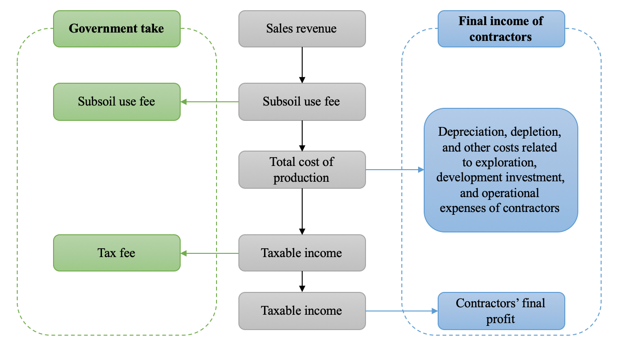
Figure 17 – The flowchart of income distribution by the concession agreement
Note: Compiled by author based on the review of [102], [103], [104]
Figure 17 illustrates that the level of post-tax profit distribution determines the contractor’s revenue. International oil corporations obtain net revenue from crude oil during each production cycle, which is allocated to offset the expenses associated with oil and gas extraction, as well as to fulfill tax obligations and fees, prior to realizing post-tax earnings. Under the royalty and tax regime contract, the contractor's income derives from product sales revenue. Therefore, the quality of mineral reserves and the level of development technology determine the contractor's primary income. Additionally, another key factor affecting the contractor's final income is the impact of taxation.
Consequently, within the framework of the royalty and tax regime model, it is essential to conduct a thorough analysis to ensure and improve the economic advantages for contractors. This analysis must consider the effects of different taxes and fees in resource-abundant nations on the economic efficiency of oilfield development. This analysis enables the control of tax burdens to achieve the maximization of oilfield development profits.
Through the analysis in the preceding two chapters, it is understood that the natural gas field development initiatives funded by Chinese firms in Kazakhstan encompass the Ural Oil and Gas, Kozhasai, Pridorozhnoy, Aktobemunaigas, Mangistaumunaigaz, Kazgermunai, and the Kashagan project. Given that the Kashagan project represents a significant oil and gas field in Kazakhstan, which is collaboratively managed by several international oil corporations, a Production Sharing Contract is utilized for this undertaking. The remaining projects are not classified as giant oil and gas projects or complex fields meeting IMC contract criteria and therefore are developed under concession agreement.
Within the framework of the royalty and tax regime, key elements influencing the profit margins of oil companies encompass not only investments in infrastructure and operational expenses dictated by technical factors, but also the returns after taxation. Consequently, the essential substance of development optimization strategies within the framework of the royalty and tax system mainly entails examining the effects of different taxes and fees on the economic benefits of oil and gas field development and studying the future returns of oil and gas field projects.
Under the concession agreement, the subsoil users (foreign oil companies) bear the costs of oil and gas exploration, development investment, and production. According to the Code of the Republic of Kazakhstan dated December 25, 2017, No. 120-VI “On Taxes and Other Mandatory Payments to the Budget (Tax Code)”, The main tax classifications relevant to the advancement of oil and gas fields presently encompass the following:
1. Mineral extraction tax: This tax is levied on the extraction of crude oil, gas condensate, and natural gas. The mineral extraction tax functions as an ad valorem tax, with the rate increasing in relation to a company’s annual production volume. For oil exported from Kazakhstan, the mineral extraction tax rate is twice that of oil sold in the domestic market. In specific cases, particularly for fields experiencing unfavorable economic conditions, the government possesses the power to reduce the mineral extraction tax rate.
2. Crude oil export duty: This duty varies each month based on global oil prices and is established by the Ministry of National Economy. Shipments to EAEU markets are exempt from this requirement. In 2023, changes were implemented in the methodology for calculating the duty, which included replacing the Russian Urals Blend oil price with the Kazakh KEBCO grade.
The following formula is used to determine the export customs duty rates on petroleum products and crude oil [146]:
When the average market price of crude oil is up to $25 US dollars per barrel, the export duty rate is 0;
When the average market price of crude oil is between $25 - $105 US dollars per barrel, the export duty is calculated using the following formula:
$$VTP=Avg*K$$
where, VTP – the rate of export duty on crude oil and petroleum products, in US dollars per ton; Avg – Average market price of crude oil for the previous period; K – correction coefficient 1.
When the mean market price of crude oil surpasses $105 US dollars per barrel, the rate of export duty on crude oil is established within the designated price range (115 – 235 $/ton).
3. Rent tax on exports: This tax is imposed on the value of exported crude oil and gas condensate. The rent tax rate increases as oil prices rise above US$50 per barrel, potentially reaching a maximum of 32%. Unlike the crude oil export duty, the rent tax also applies to exports intended for EAEU markets.
4. Corporate income tax: As stipulated in the Tax Code, every corporation is liable for a corporate income tax set at a rate of 20% of the taxable base.
5. Excess profit tax: a tax imposed on supplementary income that a subsoil user earns beyond the set standards. The taxable entity is the segment of net income that surpasses 25% of the deductions established for the computation of excess profit tax.
The subsequent development strategies can be formulated based on an examination of the existing tax rate regulations:
1. From the viewpoint of mineral extraction taxation, the tax rate applicable to the development of oil and gas fields is reduced during the initial stages and escalates proportionally in subsequent phases. Consequently, the most effective approach is to aim for elevated initial production rates, thereby guaranteeing a substantial net value added at a feasible extraction rate, which contributes to improving the economic efficiency of oil and gas ventures.
2. Export duty is primarily tied to fluctuations in international oil prices and the KEBCO crude oil price in Kazakhstan. When international oil prices fall below $25 per barrel, no export duties are levied. Conversely, export duties increase as international oil prices rise. Therefore, oil and gas project development should be expanded during periods of stable international oil prices, avoiding development when oil prices are excessively low or high.
3. Rent tax on exports imposed on exports is linked to global oil prices. If international oil prices drop below $50 per barrel, the rent tax on exports becomes null. Conversely, when prices rise above $50 per barrel, the tax escalates incrementally. Consequently, the development of oil and gas projects ought to be increased during times of stable international oil prices, while refraining from development when oil prices are either excessively low or high.
4. Income tax: The main elements influencing income tax include the tax rate and the taxable profit. Consequently, the initial focus for development strategies ought to be on managing income tax liabilities. While complying with Kazakhstan's laws and ensuring the company’s normal operations, efforts should be made to minimize taxable profit. The optimal strategy for global oil companies involves augmenting initial investments, reducing taxable income in the early stages, minimizing early income tax liabilities and cash outflows, thereby enhancing the effectiveness of capital deployment and the profitability of investments.
5. The main elements that affect the excess profit tax include the internal rate of return and net profit. When the internal rate of return for an oil and gas project exceeds 20%, the rate of return increases by 5%, and the excess profit tax rate increases by 10%. If the rate of return increases beyond 30%, the excess profit tax rate increases by an additional 10% incrementally.

Table 21 – The excess profit tax rate set by the government of Kazakhstan

Scale of net income distribution by levels for the purposes of calculating excess profit tax, percentage of deductions | Percentage for calculating the maximum amount of net income distribution for the purposes of calculating excess profit tax | Rate (%)
less than or equal to 25% | 25 | 0
25% - 30% inclusive | 5 | 10
30% - 40% inclusive | 10 | 20
40% - 50% inclusive | 10 | 30
50% - 60% inclusive | 10 | 40
60% - 70% inclusive | 10 | 50
Over 70% | In accordance with Article 761 of the Tax Code | 60
Source: The Tax Code of the Republic of Kazakhstan [104]

Therefore, effectively managing the internal rate of return is essential for reconciling the excess profit tax rate and minimizing excess profit tax. The main elements that affect the internal rate of return consist of sales revenue, investment, and expenses. In addition to the prices of crude oil sales, net crude oil production, investment, and expenses serve as the principal factors determining the internal rate of return. The optimal strategy for enhancing the economic viability of oil and gas projects involves adjusting the investment profile by calculating the contractor’s internal rate of return (IRR). Augmenting financial investment in the early stages of development may lead to a decrease in net cash flow during the initial phases, consequently diminishing the internal rate of return and further decreasing the excess profit tax.
Based on the previously mentioned analytical approach, an economic evaluation of oil and gas projects in Kazakhstan, which are funded by Chinese firms, is performed to predict development models and future natural gas output. It is assumed that the international oil price (Brent oil price) fluctuates between $60 and $80 per barrel, in alignment with the applicable tax categories and rates established in compliance with the prevailing laws and regulations of the Republic of Kazakhstan.
Aktobemunaigas project
The Aktobemunaigas initiative represents CNPC’s inaugural venture into the oil and gas sector in Kazakhstan, as well as being its most enduring project in this field. This undertaking predominantly encompasses oil and gas reserves, including the Kenkiyak, Zhanazhol, and North Truva fields. The funding for the current project is mainly directed towards the maintenance of assets, enhancements to infrastructure, and operational costs. The gas reserves in Kenkiyak and Zhanazhol are predominantly utilized to provide resources for the Kazakhstan–China gas pipeline. The Aktobemunaigas project operates under the general tax regime, with tax rates fluctuating based on production volume and international oil prices.
Based on the operational data for the Aktobemunaigas project published in the China National Petroleum Corporation Yearbook (2025), we summarized the project's costs and expenditures over the past decade in Table 22.

Table 22 – The costs and expenditures of the Aktobemunaigas project (2015-2024)

Year | CAPEX (million $) | OPEX (million $) | Tax (million $) | Oil production  (Mt) | Gas production  (Bcm) | Tax fee ($/t)
2015 | 298.1 | 644.3 | 783.0 | 4.7 | 9.6 | 104.8
2016 | 167.4 | 567.1 | 562.2 | 4.2 | 10.5 | 84.4
2017 | 162.1 | 577.3 | 711.8 | 4.0 | 10.4 | 110.8
2018 | 105.9 | 525.3 | 606.4 | 3.8 | 9.5 | 95.1
2019 | 99.1 | 526.5 | 512.0 | 3.0 | 9.2 | 84.3
2020 | 124.6 | 378.2 | 248.8 | 2.8 | 7.2 | 51.7
2021 | 128.7 | 348.7 | 408.0 | 2.7 | 6.4 | 91.8
2022 | 127.2 | 367.7 | 594.1 | 2.7 | 6.3 | 136.6
2023 | 167.0 | 281.2 | 467.9 | 2.6 | 5.8 | 106.8
2024 | 136.4 | 377.3 | 389.6 | 2.6 | 5.4 | 94.8
Source: Compiled by author based on [121]

As shown in Table 22, the oil and gas fields associated with the Aktobemunaigas project have reached a mature stage of development, characterized by relatively stable production levels that are gradually decreasing. The Aktobemunaigas project is now in the mid-to-late phase of oil and gas field development, having surpassed its peak production and currently confronting the potential for decline.
In Table 22, the CAPEX includes investment costs related to development of fields (infrastructure, wells, pipelines). The OPEX includes operational expenses directly related to project activities (production, transportation, administrative cost). To maintain output in the future, increased capital investment will be required for enhanced oil recovery. According to Kazakhstan's tax policy, the tax rate for the Aktobemunaigas project is also expected to be reduced accordingly. We have analyzed the projected revenue along with the anticipated oil and gas output for this initiative. The results are presented in Figure 18.

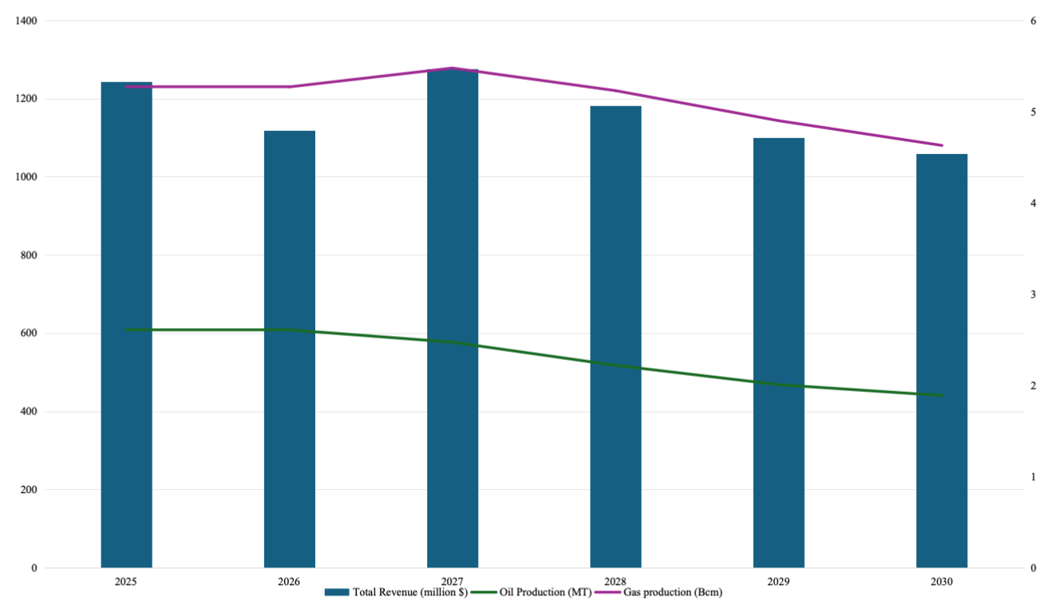
Figure 18 – The expected revenue and oil and gas production of the Aktobemunaigas project
Note: Compiled by author based on the results of calculation

Based on the above hypothetical conditions, we have forecasted the project revenue and production changes for the Aktobemunaigas project from 2025 to 2030. According to the forecast results in Figure 18, given the same levels of capital and operating expenditures, the project's returns are projected to exhibit a gradual decline by 2030, attributed to the national decrease in mineral extraction taxes. Based on the anticipated revenue figures, it is projected that the future oil output of the project will stabilize at around 2 million tons, whereas the production of natural gas is expected to be maintained at 5 billion cubic meters.
Mangistaumunaigaz project
The Mangistaumunaigaz project is a large-scale oil and gas development initiative jointly operated by KMG and PetroChina. The initiative includes significant oil and gas fields such as Zhetybay, Asar, Bekturly, and Burmash. These projects have successfully finished the preliminary drilling and well completion stages, as well as infrastructure development, and are now progressing into a phase of accelerated production expansion. In 2017, the Mangistaumunaigaz initiative commenced the expansion of natural gas production, raising output from 4.72 million cubic meters in 2016 to 709 million cubic meters. At present, production has stabilized at a high level, with oil output consistently around 6 million tons and natural gas production surpassing 1 billion cubic meters.
Based on the data published in the CNPC Yearbook 2025, we summarized the project's costs and expenditures of Mangistaumunaigaz project in Table 23.

Table 23 – The costs and expenditures of the Mangistaumunaigaz project (2015-2024)

Year | CAPEX (million $) | OPEX (million $) | Tax (million $) | Oil production  (Mt) | Gas production  (Bcm) | Tax fee ($/t)
2015 | 356.2 | 801.7 | 316.4 | 6.8 | 0.002 | 93.1
2016 | 373.5 | 673.6 | 251.4 | 6.8 | 0.004 | 73.7
2017 | 316.5 | 699.2 | 390.9 | 6.2 | 0.71 | 125.6
2018 | 312.2 | 680.6 | 558.7 | 6.2 | 0.74 | 89.3
2019 | 283.4 | 669.9 | 467.0 | 6.3 | 0.41 | 73.9
2020 | 297.1 | 576.7 | 157.1 | 5.9 | 0.58 | 52.7
2021 | 298.9 | 601.1 | 342.8 | 6.1 | 0.61 | 113.2
2022 | 375.5 | 717.4 | 399.5 | 6.2 | 0.55 | 130.3
2023 | 318.0 | 825.7 | 365.4 | 6.2 | 0.85 | 117.5
2024 | 314.6 | 946.8 | 336.8 | 6.2 | 1.21 | 107.9
Source: Compiled by author based on [121]

From Table 23, we can observe that as the Mangistaumunaigaz project’s oil and gas field development enters a rapid growth phase, capital investments will be directed toward boosting production and enhancing oil and gas infrastructure. As a result, it is anticipated that both capital expenditures and operating expenditures associated with the project will persist in their upward trend. Given the assumptions, we have projected the revenue and production variations for the project during the timeframe of 2025 to 2030.

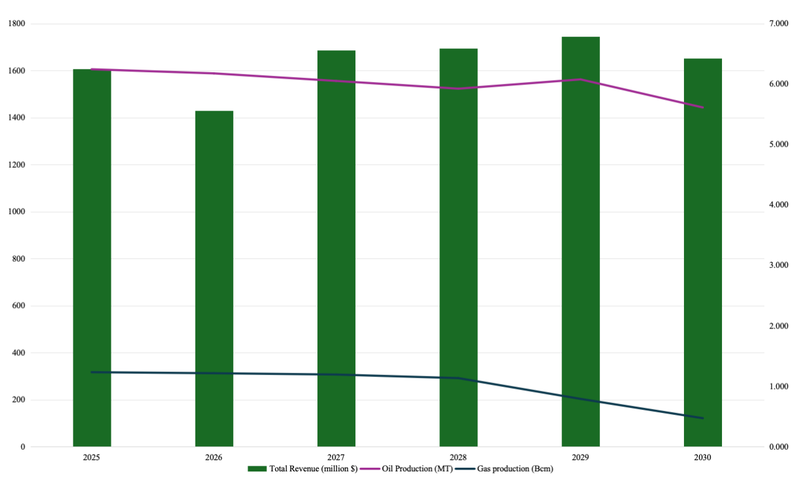
Figure 19 – The expected revenue and oil and gas production of the Mangistaumunaigaz project
Note: Compiled by author based on the results of calculation

Based on the forecast results in Figure 19, the Mangistaumunaigaz project will require additional capital investment to enhance natural gas infrastructure during 2025-2026 due to the projected continuous growth in natural gas production. Investment in infrastructure is crucial for ensuring production stability and improving the capacity for natural gas exports. Based on the forecasted revenue estimates, the future oil output of the project is anticipated to stabilize at approximately 6 million tons, while natural gas production is projected to be maintained at 1 billion cubic meters.
Kazgermunai project
The Kazgermunai initiative represents a collaborative oil and gas enterprise managed jointly by KMG and PetroKazakhstan. The project includes oil and gas fields such as Akshabulak, Aksay, and Nuraly. In a manner akin to the Aktobemunaigas project, the Kazgermunai project has reached its mid-development stage, during which oil and gas production has surpassed its peak and is now experiencing a steady decline. Future project development will require capital investment for field development and the operation and maintenance of infrastructure.
Based on the data published in the CNPC Yearbook 2025, we summarized the project's costs and expenditures of Kazgermunai project in Table 24.

Table 24 – The costs and expenditures of the Kazgermunai project (2015-2024)

Year | CAPEX (million $) | OPEX (million $) | Tax (million $) | Oil production  (Mt) | Gas production  (Bcm) | Tax fee ($/t)
2015 | 68 | 199 | 191 | 3.2 | 0.56 | 58.2
2016 | 30 | 141 | 150 | 3.1 | 0.69 | 47.3
2017 | 43 | 142 | 192 | 2.9 | 0.83 | 64.4
2018 | 50 | 146 | 256 | 2.8 | 0.73 | 89.1
2019 | 32 | 131 | 173 | 2.3 | 0.65 | 75.0
2020 | 23 | 99 | 65 | 1.7 | 0.53 | 39.4
2021 | 20 | 110 | 140 | 1.5 | 1.08 | 89.4
2022 | 21 | 97 | 181 | 1.3 | 0.65 | 134.3
2023 | 27 | 110 | 131 | 1.2 | 0.85 | 106.9
2024 | 16 | 118 | 111 | 1.1 | 0.86 | 105.1
Source: Compiled by author based on [121]

Table 24 presents the overall expenditure breakdown for the Kazgermunai project. Notably, the sustained reduction in both CAPEX and OPEX indicates the project has entered its mid-phase, with capital and operational expenditures now directed solely toward maintaining existing oilfield infrastructure and covering production costs necessary to sustain oil and gas output. Additionally, the project is expected to benefit from future national mining tax exemptions to reduce expenditures. In light of the previously mentioned hypothetical conditions, we have projected the revenue and production fluctuations of the Kazgermunai project for the years 2025 to 2030, as illustrated in Figure 20.

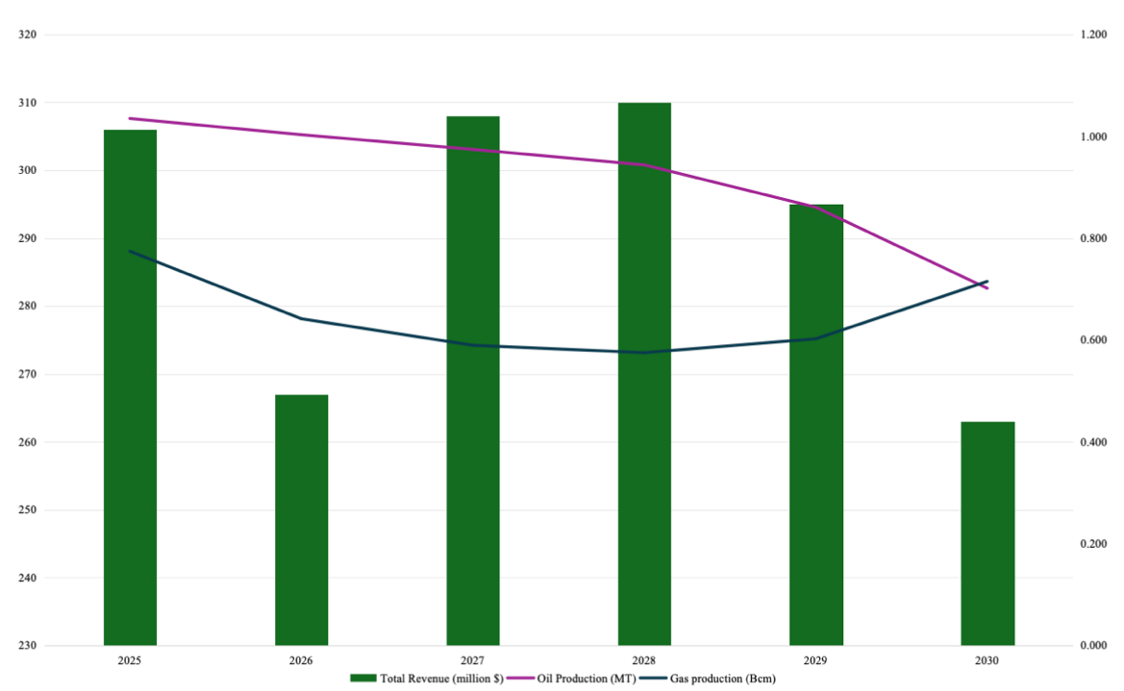
Figure 20 – The expected revenue and oil and gas production of the Kazgermunai project
Note: Compiled by author based on the results of calculation

Based on the forecast results in Figure 20, the Kazgermunai project is expected to achieve profitability by leveraging national tax reduction policies, all while sustaining existing expenditure levels. Given the anticipated revenue conditions, the future oil production of the project is estimated to be around 700,000 tons, with natural gas production expected to range between 600 and 700 million cubic meters.
Kozhasai Project
The Kozhasai Project represents a collaborative initiative in the oil and gas sector, developed in partnership by KMG and Sinopec. The Kozhasai field was developed in 1983 and is classified as a mature oil and gas field. According to data published in China Petrochemical Corporation Yearbook 2025, the Kozhasai project has entered its late development phase, with its oil and gas fields showing a noticeable decline in production. Crude oil production is currently at 300,000 tons, whereas the output of natural gas has decreased from 600 million m³ to 300 million m³. Based on the operational data published in Sinopec Yearbook 2025, we compiled a summary of the project’s costs and expenditures from the last ten years in Table 25.

Table 25 – The costs and expenditures of the Kozhasai project (2015-2024)

Year | CAPEX (million $) | OPEX (million $) | Tax (million $) | Oil production  (Mt) | Gas production  (Bcm) | Tax fee ($/t)
2015 | 7.6 | 60.0 | 83.2 | 0.45 | 0.64 | 91.7
2016 | 54.3 | 53.3 | 61.3 | 0.44 | 0.66 | 68.4
Appendix to Table 25
2017 | 39.1 | 39.1 | 56.1 | 0.37 | 0.38 | 76.0
2018 | 34.0 | 34.0 | 68.1 | 0.31 | 0.37 | 109.5
2019 | 37.1 | 37.1 | 67.4 | 0.35 | 0.33 | 94.0
2020 | 32.8 | 32.8 | 26.2 | 0.31 | 0.39 | 42.4
2021 | 38.1 | 38.1 | 65.9 | 0.29 | 0.81 | 105.2
2022 | 49.3 | 49.3 | 82.7 | 0.27 | 0.78 | 140.6
2023 | 54.1 | 54.1 | 62.1 | 0.25 | 0.71 | 111.73
2024 | 61.9 | 61.9 | 56.1 | 0.25 | 0.73 | 109.6
Source: Compiled by author based on [122]

As shown in Table 25, the Kozhasai project’s CAPEX, OPEX, and Tax expenditures are significantly lower than those of the other projects mentioned above. Neither capital expenditures nor operating expenditures exhibit any notable variations, which aligns with the project progressing into its later phases of development. Tax revenue being lower than other items indicates that the oil and gas production from this project is primarily used to meet domestic supply, with relatively small export volumes. Based on the above hypothetical conditions, we have projected the revenue and production changes for the Kozhasai project from 2025 to 2030 in Figure 21.

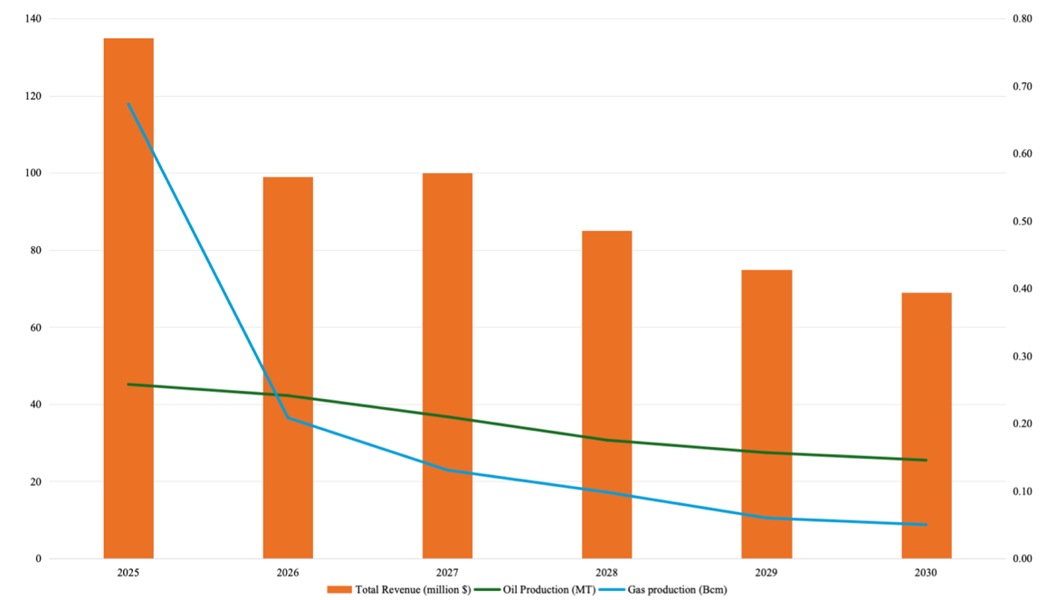
Figure 21 – The expected revenue and oil and gas production of the Kozhasai project
Note: Compiled by author based on the results of calculation

According to the forecast results in Figure 21, the revenue from the Kozhasai project is predicted to decline annually. Over the next 3 to 5 years, capital investment will be required for infrastructure maintenance in the later stages of the project to meet the demands of sustaining production. Forecasts indicate that, given the existing revenue conditions, the oil production of the project is anticipated to fall to around 150,000 tons, whereas the natural gas output is projected to diminish to 100 million cubic meters.
Ural Oil and Gas project
The Ural Oil and Gas project was jointly developed in 2023 by KMG, Sinopec, and MOL. As the project remains in its early development stages, detailed information regarding project expenditures and tax implications is currently unavailable. Furthermore, as per the official announcement from KMG, the anticipated natural gas output of the project is expected to attain 1 billion cubic meters each year.
Pridorozhnoy project
The Pridorozhnoy project is a collaborative effort between QazaqGaz Exploration and Geo-Jade Petroleum, currently in the exploration stage, with production anticipated to begin in 2027-2028. According to estimation of S&P Global (Table 5), the project is expected to produce 142 million cubic meters of natural gas annually after commencement. Overall, the oil and gas initiatives funded by Chinese firms in Kazakhstan have reached a balanced financial status and are functioning effectively. Through the examination of oil and gas production, capital investments, and tax contributions across various projects, we acquired a more profound insight into the distinct development phases of each project and their prospective trends. In light of the preceding analysis, Table 26 provides a summary of the projected natural gas output for these oil and gas initiatives in accordance with Kazakhstan's existing tax regulations.

Table 26 – The estimated natural gas production for these joint gas projects (2025-2030)

Project | 2025 | 2026 | 2027 | 2028 | 2029 | 2030
Aktobemunaigas | 5.27 | 5.27 | 5.48 | 5.23 | 4.90 | 4.63
Mangistaumunaigaz | 1.23 | 1.21 | 1.19 | 1.13 | 0.79 | 0.47
Kazgermunai | 0.77 | 0.64 | 0.59 | 0.57 | 0.60 | 0.71
Kozhasai | 0.67 | 0.21 | 0.13 | 0.10 | 0.05 | 0.04
Ural oil and gas | 1 | 1 | 1 | 1 | 1 | 1
Pridorozhnoye | 1.42 | 1.42 | 1.42 | 1.42 | 1.42 | 1.42
Total | 10.37 | 9.75 | 9.81 | 9.45 | 8.76 | 8.23
Note: Compiled by author based on the estimation

Table 26 indicates that the total natural gas production from oil and gas projects under all applicable concession agreements involving Chinese companies’ investments in Kazakhstan will amount to approximately 10 billion cubic meters during the period from 2025 to 2030.
The chapter 3.1 builds on the analysis in the chapter 2.1 to discuss and forecast the economic profitability and future natural gas production of Chinese oil companies’ natural gas projects in Kazakhstan. Overall, natural gas production holds greater growth potential than oil production in the major oil and gas projects invested by Chinese companies in Kazakhstan. A number of these initiatives have already exceeded an annual production of 1 billion cubic meters of natural gas, highlighting the significant potential for future collaboration in the natural gas sector between Kazakhstan and China. At the same time, given that expanding natural gas production and exports would increase project costs and tax fees, it is necessary to propose targeted recommendations for optimizing the projects’ cost-benefit structure.
Recommendations for Kazakhstan:
1. Apply tax incentives in accordance with the related laws of the Republic of Kazakhstan to oil and gas field projects in the intermediate to advanced phases of development aimed at enhancing their profitability.
2. Regarding prospective natural gas projects, the government could apply flexible tax policies to attract investment from Chinese companies.
3. Enhance the infrastructure for natural gas to improve the operational efficiency of natural gas initiatives and guarantee the effective use of natural gas resources.
Recommendations for China:
1. Enhance the investment framework and strategically organize project advancement. Augment technical investments in established oil and gas field initiatives to prolong their natural gas production durations.
2. Incorporate cutting-edge technology or embed renewable energy solutions into newly established natural gas initiatives to lower prospective operational expenses.
3. Enhance the information and advisory services pertaining to the natural gas investment sector, as well as the associated laws and policies of Kazakhstan. Strengthen the mechanism for information exchange between the government and enterprises, while also elevating the focus on updates concerning laws and policies that impact the natural gas industry.

External competitive factors and future cooperation strategies for Kazakhstan in China’s natural gas market

At present, natural gas continues to be regarded as one of the more eco-friendly energy options. Numerous countries around the world are promoting the development of the natural gas industry, acknowledging it as an essential ‘transitional’ energy resource in the movement from fossil fuels to renewable energy sources. As the economy grows, the demand for natural gas in China is increasing, and there is considerable potential for future expansion in the country's natural gas consumption. The main providers of pipeline gas to China are Central Asian countries, such as Turkmenistan and Kazakhstan. In the aftermath of the Russia-Ukraine conflict, Russia has augmented its pipeline gas supply to China.
Pipeline gas imports are predominantly unidirectional due to geographic constraints, primarily sourced from Central Asia and Russia. In 2024, China’s pipeline gas imports reached 76.6 Bcm. It is important to note that while the countries supplying these imports exhibit a varied distribution in terms of both transportation methods and directions, a significant portion of the imports relies heavily on a limited number of countries [147].
So far, a multitude of studies have explored the energy collaboration between China and the nations participating in the One Belt and One Road Initiative. These studies have assessed the critical importance of the natural gas pipelines ‘Central Asia-China’, ‘Russia-China’ (Power of Siberia), and ‘Myanmar-China’ in securing energy safety, as well as investigated the future prospects for cooperation between China and countries that export energy.
Among the gas-exporting nations, Russia and Turkmenistan stand out as the foremost producers of natural gas. The Russia-Turkmenistan relationship is both cooperative and competitive. Following the energy crisis of 2014, Russia ceased its imports of natural gas from Turkmenistan intended for export to Europe, resulting in a downturn in Turkmenistan’s economy. In the Chinese natural gas sector, the rivalry between the two nations is even more evident.
O. Lukin and M. Bi described the dynamic between Turkmenistan and Russia as a competitive partnership; it is anticipated that the entry of Turkmen gas into the Chinese market will reduce China’s reliance on Russian gas [148]. The development of the D line of natural gas pipelines known as ‘Central Asia-China’ is being expedited, resulting in an increase in its capacity from 55 billion cubic meters to 85 billion cubic meters annually, thereby establishing it as the most extensive gas transmission network from Central Asia to China. Concurrently, Russia is vigorously advancing the agreement concerning the ‘Russia-China east gas pipeline 2’ with China.
The economic benefits of natural gas compared to alternative energy sources are contingent upon pricing and usage patterns. Natural gas serves as a crucial transitional energy source in the pursuit of ‘carbon neutrality’ and in the long run, it could significantly influence the energy and economic equilibrium in numerous nations [149]. Given that Russia is linked to the Central Asian gas transportation network, there exists a duality of competition and collaboration between Russia and Central Asia. Therefore, it is essential to examine the diverse strategies of three key partners (Turkmenistan, Russia, Kazakhstan) in the context of varying dynamics within the Chinese natural gas market by developing a game-theoretic model.
Game theory consists of coalitional and strategic games that are used to predict the formation of cooperative alliances and the possibility of profit distribution. Game theory is applicable as a dynamic predictive method for understanding the behaviors of participants in various contexts, including natural gas market.
There are various situations of Turkmenistan, Russia and Kazakhstan exporting natural gas to China and the relative bargaining powers by using game theory model. Considering all potential choices made by the participants, this analysis presents the following plausible scenarios for the year 2030:
(1) In the Stackelberg game model, we posit that Turkmenistan serves as the ‘leader’, while Russia and Kazakhstan are regarded as the ‘followers’. In this context, Turkmenistan is expected to optimize the transportation capacity of the Central Asia-China gas pipeline system, thereby increasing its gas exports to China. Russia will manage the demand for natural gas from both China and Europe, ensuring that exports to China remain stable but at a controlled level. Kazakhstan is set to enhance its export profitability while increasing its natural gas exports to China.
(2) According to the Cournot competition model, we assume that Turkmenistan, and Russia as two oligarchs monopolize the pipeline gas market of China. In Scenario 2, Turkmenistan is expected to sustain its gas exports to China at a significant level. Concurrently, Russia will align its gas exports to China with those of Turkmenistan, owing to the postponement of the ‘Russia-China East Gas Pipeline 2’. In order to sustain market competitiveness and optimize investment returns, exclusively the natural gas resources obtained by Chinese firms in Kazakhstan will be exported to China.
(3) In scenario 3, it is presumed that the gas transportation capacity of both the Central Asia-China gas pipeline system and the Russia-China east gas pipeline system has been completely utilized, while the natural gas exports from Turkmenistan and Russia to China have also reached their peak levels. Kazakhstan will not increase its natural gas export capacity as outlined in the Kazakhstan Gas Sector Development Plan, limiting exports to China solely to the gas resources from the Kenkiyak and Zhanazhol fields, while the remaining volume will be allocated to the domestic gas market.
The theoretical model is based on the Stackelberg competition model and Cournot competition model. These two economic models present the differing strategic cooperation proposals for China from three gas suppliers within the Chinese natural gas market.
The Stackelberg competition established by German economist Stackelberg reflects the order of decision-making behaviors caused by asymmetry in market position. In scenario 1, Turkmenistan obtains ample gas resources and pipeline infrastructure to maintain a more significant share of the Chinese gas market. Russia and Kazakhstan will strategically modify their natural gas exports to China.
In the following, we describe the model as it is presented by Stackelberg and Cournot competition. First, the inverse curve of pipeline gas demand in Chinese market is defined as:
$$P_{c}=a-bQ_{c}=a-b(Q_{l}+Q_{f})$$ | (3.1)
where, P_{c} is the pipeline gas price of Chinese market; Q_{l} is the pipeline gas export volume of leader of the market; Q_{f} is the pipeline gas export volume of followers of the market.
The marginal cost of pipeline gas export is:
$$MC=(C_{p}+T_{i})Q_{c}$$ | (3.2)
where, C_{p} is the production cost per unit of gas in export country; T_{i} is the pipeline transportation cost per unit of gas from export country to China; Q_{c} is volume of pipeline gas export to China from export country.
The pipeline transportation cost per unit of gas is defined as [150]:
$$T_{i}=\frac{(m_{i}+β_{i}×C_{p})(e^{β_{i}×L_{p}})}{β_{i}}$$ | (3.3)
where, m_{i} is the maintenance cost of natural gas pipeline; β_{i} is gas consumption on the compressor stations along the pipeline; L_{p} is the length of gas pipeline.
According to the Stackelberg model, we assume that the gas export volume from Turkmenistan, acting as the leader, remains constant. The profit function of the followers is:
$$π_{f}=P_{c}Q_{f}-\int_{0}^{Q_{f}}{{MC}_{f}=\left[a-b\left(Q_{l}+Q_{f}\right)\right]Q_{f}-(C_{p}+T_{i})\frac{Q_{f}^{2}}{2}}$$ | (3.4)

When the follower’s profits are maximized:
$$\frac{{δπ}_{f}}{{δQ}_{f}}=a-b\left(Q_{l}+Q_{f}\right)-\left(C_{p}+T_{i}\right)\frac{Q_{f}}{2}=0$$ | (3.5)
The optimal pipeline gas export volume Q_{f}* for the followers is:
$$Q_{f}^{*}=\frac{2a-2bQ_{l}}{C_{p}+T_{i}+2b}$$ | (3.6)
Similarly, the leader’s profit maximization is expressed as:
$$π_{l}=P_{c}Q_{l}-\int_{0}^{Q_{l}}{{MC}_{l}=\left[a-b\left(Q_{l}+Q_{f}\right)\right]Q_{l}-(C_{p}^{l}+T_{i}^{l})\frac{Q_{l}^{2}}{2}}$$ | (3.7)
When the leader’s profits are maximized:
$$\frac{{δπ}_{l}}{{δQ}_{l}}=a-b\left(Q_{l}+Q_{f}\right)-\left(C_{p}^{l}+T_{i}^{l}\right)\frac{Q_{l}^{2}}{2}=0$$ | (3.8)
The optimal pipeline gas export volume Q_{l}* for the leader is:
$$Q_{l}^{*}=\frac{2a[2b+\left(C_{p}+T_{i}\right)]}{{(C}_{p}+T_{i}+2b)\left(C_{p}^{l}+T_{i}^{l}+2b\right)-4b^{2}}$$ | (3.9)
In Scenario 2, it is presumed that Russia exports an equivalent volume of natural gas as Turkmenistan. The natural gas trade with China becomes competitive in terms of pricing. The pipeline gas export volume Q_{T} of Turkmenistan is:
$$Q_{T}=\frac{2a-2bQ_{R}}{C_{p}^{T}+T_{i}^{T}+2b}$$ | (3.10)
where, C_{p}^{T} represents the cost of production for each unit of gas in Turkmenistan; T_{i}^{T} is the pipeline transportation cost per unit of gas from Turkmenistan to China; Q_{R} indicates the volume of gas exported through pipelines to China from Russia.
The optimal gas export volume Q_{R}* of Russia is:
$$Q_{R}^{*}=\frac{2a\left(C_{p}^{T}+T_{i}^{T}\right)}{{(C}_{p}^{R}+T_{i}^{R}+2b)\left(C_{p}^{T}+T_{i}^{T}+2b\right)-4b^{2}}$$ | (3.11)
where, C_{p}^{R} is the production cost per unit of gas in Russia; T_{i}^{R} is the pipeline transportation cost per unit of gas from Russia to China.
The optimal gas export volume Q_{T}* of Turkmenistan is:
$$Q_{T}^{*}=\frac{2a\left(C_{p}^{R}+T_{i}^{R}\right)}{{(C}_{p}^{R}+T_{i}^{R}+2b)\left(C_{p}^{T}+T_{i}^{T}+2b\right)-4b^{2}}$$ | (3.12)

As Kazakhstan produces a lower volume of natural gas in comparison to Russia and Turkmenistan, it is reasonable to conclude that Kazakhstan is unlikely to increase its gas exports in order to compete with its domestic consumption needs. Concurrently, Kazakhstan acts as a transit nation, receiving gas from Turkmenistan.
China receives natural gas from Turkmenistan at a price of:
$$P_{c}=P_{TC}+μ_{t}$$ | (3.13)
where, P_{TC} is the pipeline gas price sold from Turkmenistan to China; μ_{t} is the pipeline gas transit fee through Kazakhstan.
In this case the expected profit of Turkmenistan π_{t} is:
$$π_{T}=\left(P_{TC}+μ_{t}-C_{P}^{T}\right)Q_{TC}+(P_{TK}-C_{P}^{T})Q_{TK}$$ | (3.14)
where, Q_{TC} refers to the volume of pipeline gas that is sold from Turkmenistan to China; P_{TK} denotes the price of pipeline gas sold from Turkmenistan to Kazakhstan; Q_{TK} indicates the volume of transit pipeline gas that is received in Kazakhstan.
The expected profit of Kazakhstan as a transit country is expressed as:
$$π_{K}=Q_{TC}\left(P_{TC}+μ_{t}\right)(μ_{t}-T_{i}^{K})$$ | (3.15)
When marginal cost is 0, Kazakhstan maximizes its profit:
$$Q_{TC}\left(P_{TC}+μ_{t}\right)\left(μ_{t}-T_{i}^{K}\right)+\left(P_{TC}+μ_{t}\right)Q_{TC}=0$$ | (3.16)
The optimal gas export price P_{TC}* of Turkmenistan is:
$$P_{TC}^{*}=\frac{a}{2b}+\frac{1}{2}(C_{p}^{T}-T_{i}^{K})$$ | (3.17)
The optimal gas transit fee μ_{t}* through Kazakhstan is:
$$μ_{t}^{*}=\frac{1}{2}\left(\frac{a}{b}-P_{TC}+T_{i}^{K}\right)=\frac{1}{2}\left(\frac{a}{b}+3T_{i}^{K}-C_{p}^{T}\right)$$ | (3.18)
Turkmenistan holds about 20 trillion cubic meters of natural gas reserves, accounting for 9.8% of the world total natural gas reserves [151]. After reaching a peak of 85.08 billion cubic meters in 1989, annual gas production in Turkmenistan continued to fall, reaching its first trough value in 1998 at 12.01 billion cubic meters, gradually increasing over the subsequent decade, production then experienced a sharp decline to 33.32 billion cubic meters in 2009, following which it has exhibited a pattern of relatively consistent growth [72]. Turkmenistan’s natural gas production in 2024 accounted to 73.5 billion m³, the proportion of domestic gas consumption is about 40% (28.5 billion m³), which means that Turkmenistan possesses enormous potential for natural gas exports [80].
Until the 1990s, Turkmenistan’s natural gas exports were entirely reliant on the Central Asia-Central Pipeline to Russia, which imposed certain limitations. Consequently, Turkmenistan, confronted with the disparity between its plentiful natural gas reserves and restricted pipeline capacity, has actively pursued diversification of its export routes. Turkmenistan is diligently fostering collaborative ties with Iran, China, various European nations, and other countries. It has also established an initial pipeline configuration extending southward to northern Iran, traversing through Iran to Azerbaijan, and extending eastward to China.
In recent years, Turkmenistan has raised the percentage of its exports directed towards China, leading to a recovery in export volume. In 2021, the total export volume surpassed 40 billion cubic meters once more, with gas exports to China exceeding 30 billion cubic meters for the first time, achieving a total of 31.5 billion cubic meters [152]. According to the report of Wood Mackenzie, as a result of the incremental advancement of the Galkynysh field, it is anticipated that Turkmenistan’s natural gas output will attain 112.77 billion cubic meters by the year 2030 and 145 billion cubic meters by 2035 [153].
Russia ranks among the nations possessing the most substantial gas reserves globally, with approximately 38 trillion cubic meters of gas reserves [151]. In 2024, Russia’s natural gas output reached 629.9 billion cubic meters, with domestic consumption comprising approximately 75%. Both Russia and Turkmenistan possess considerable gas export capabilities, characterized by their gas reserves, production levels, and consumption ratios. The majority of Russia’s pipeline gas is exported to Europe, whereas its linkage with China began in 2020 to supply gas to northeastern China via the Russia-China east gas pipeline. According to the Statistical Review of World Energy 2025, Russia provides natural gas to Europe, China, and Central Asian nations through gas pipelines. In 2024, Russia exported 26.7 billion cubic meters of natural gas to China, which represented 24.6% of its overall pipeline gas exports [80].
In comparison to Turkmenistan and Russia, Kazakhstan does not rank as a significant gas producer. The gas reserves in Kazakhstan are approximately 2.7 trillion cubic meters, with gas production reaching 29.7 billion cubic meters in 2024. The domestic consumption of gas in Kazakhstan stands at 20.7 Bcm [80]. In recent years, Kazakhstan has gradually reduced its gas exports due to the rapidly growing domestic gas demand. In 2024 Kazakhstan exported around 5.4 Bcm natural gas to China through pipeline Central Asia – China [79]. As reported by S&P Global Commodity Insights, it is anticipated that Kazakhstan's natural gas production will attain 40.1 billion cubic meters by the year 2030 and will further increase to 41.9 billion cubic meters by 2035. S&P Global forecasts Kazakhstan’s net natural gas export volume to remain around 10 billion cubic meters during the 2030-2035 period [75]. Kazakhstan has made significant progress in its efforts to diversify its exports. The gas pipeline system referred to as ‘Central Asia – China’ constitutes a major initiative for Central Asian countries seeking to diversify their gas export markets [154]. Table 27 explains the details of natural gas pipelines and pipeline systems related to natural gas.

Table 27 – The details of selected gas pipeline and pipeline system

Route | Pipelines | Length, km | Capacity, Bcm/year | Compressor station | Pressure, Mpa
Turkmenistan-China | ‘Central Asia-China’ A/B, C lines | 3916 | 55 | 7 | 9.8
Turkmenistan-China | ‘Central Asia-China’ D line (under construction) | 966 | 10 | / | /
Russia-Kazakhstan | ‘Central Asia-Center’ | 1134 | 20 | 7 | 7.5
Russia-China | ‘Russia-China east gas Pipeline’ | 2159 | 38 | 9 | 9.8
Kazakhstan-China | ‘Beineu-Shymkent’ | 1450 | 15 | 4 | 9.8
Kazakhstan-China | ‘Central Asia – China’ C line | 1380 | 25 | 1 | 9.8
Note: Compiled by author based on [73], [80]

In order to analyze the competition and cooperation among the three partners on Chinese gas market under different stages, we designed three scenarios. In Scenario 1, it is posited that Turkmenistan will optimize its natural gas export capabilities to China, thereby establishing itself as the ‘leader’ in market competition. As ‘followers’, Russia will sustain its gas exports to China at a moderate level, determined by the export capacity of the current pipeline infrastructure. Kazakhstan, dedicated to improving its competitiveness, will augment its gas exports to China. Figure 22 demonstrates the natural gas flow directions of Scenario 1.

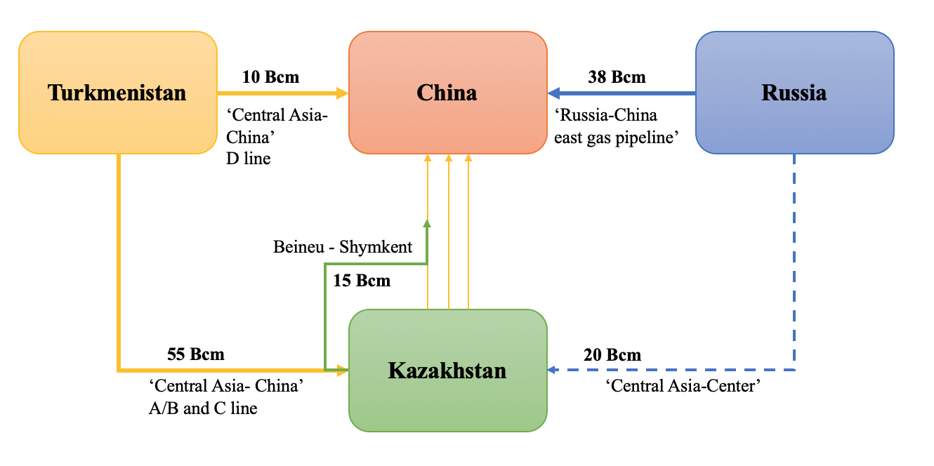
Figure 22 – The natural gas flow directions of Scenario 1
Note: Compiled by author based on the analysis of Scenario 1

The Scenario 1 defines the natural gas flow directions, where Turkmenistan and Kazakhstan deliver gas to China through the pipeline system ‘Central Asia – China’ and China receives gas directly from Russia via the gas pipeline ‘Russia-China east gas pipeline’. And the ‘Central Asia – China’ pipeline system has the largest gas transportation capacity in Chinese market.
Based on the results of Stackelberg model, the optimal gas export volumes of Turkmenistan are 58.6 Bcm, and the expected maximum profit for Turkmenistan is US$14,992,097,459.20 dollars. In this scenario, Turkmenistan will act as the dominant player to maximize utilization of the Central Asia-China gas pipelines’ transportation capacity. Given that Turkmenistan’s gas exports represent 90% of the pipeline’s overall capacity, this strategy seeks to enhance market share and achieve pricing benefits. As a ‘follower’, Russia's ideal natural gas export volume to China is 33.4 Bcm, constrained by pipeline capacity limitations and variations in European gas demand. The expected maximum profit for Russia is around US$8,750,800,000 dollars. For Kazakhstan, when its natural gas exports to China reach 13.7 billion cubic meters, it becomes more competitive in the Chinese market, with estimated profits of US$2,909,784,946.93 dollars. In light of the preceding analysis, we deem this scenario improbable. On one hand, as per the projections from S&P Global, Kazakhstan's net natural gas exports are anticipated to remain below 10 cubic meters. If export volumes become excessively high, it would affect the consumption of domestic natural gas and lead to shortages in supply. On the other hand, this forecast scenario has surpassed the maximum transport capacity of the ‘Central Asia – China’ pipeline system.
In Scenario 2, it is assumed that Russia will persist in exporting natural gas to China mainly through the ‘Russia-China east gas pipeline’. Moreover, Russia and Kazakhstan have reached a consensus to improve a portion of gas pipeline exports by transiting through Kazakhstan via the ‘Central Asia-Center’ pipeline. In accordance with the Cournot competition theory, Turkmenistan and Russia are expected to function as ‘oligarchs’ in order to equally divide the market share of Chinese natural gas. Kazakhstan has the potential to enhance its revenue by exporting a segment of its natural gas while also receiving transit gas. The distribution of natural gas transportation under this assumption is shown in Figure 23.

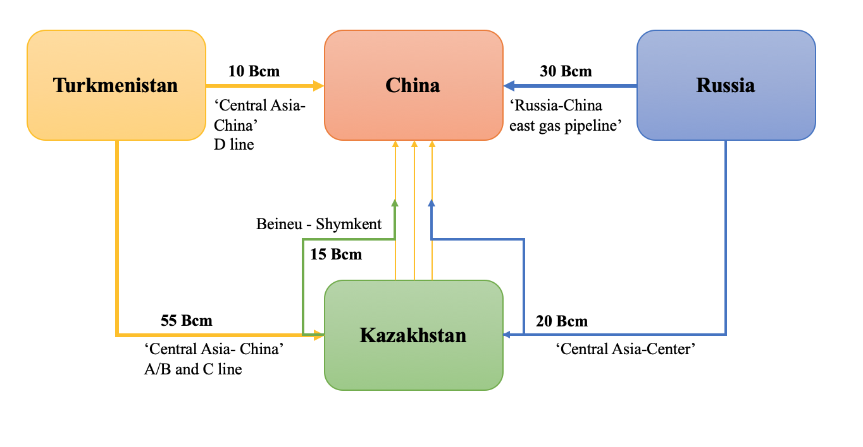
Figure 23 – The natural gas flow directions of Scenario 2
Note: Compiled by author based on the analysis of Scenario 2

In this scenario, Turkmenistan and Russia need to collaborate with Kazakhstan to increase their share of the natural gas market. Additionally, Russia is required to finalize an agreement with Kazakhstan concerning the transit volume of Russian natural gas exports to China through the ‘Central Asia-Center’ pipeline. The results show that the optimal gas export volumes of Turkmenistan are 46.7 Bcm, and the expected maximum profit for Turkmenistan is US$12,724,341,887.55 dollars. The ideal volume of natural gas exports from Russia to China is 42.8 billion cubic meters, with anticipated profits amounting to US$12,326,400,000. In contrast, Kazakhstan’s potential natural gas exports are estimated to be 8.9 billion cubic meters, yielding an expected profit of US$2,223,035,442.21. Scenario 2 represents the most viable hypothesis for international natural gas cooperation. This model ensures the logical framework of trade competition, while also guaranteeing that the quantities of natural gas transported remain within the limits of the pipeline system's capacity.
In Scenario 3, it is assumed that both the ‘Central Asia – China’ pipeline and the ‘Russia-China east gas pipeline’ are functioning at their full capacity. This implies that Turkmenistan and Russia are capable of exporting up to 65 Bcm and 58 Bcm of pipeline gas to China, respectively. Kazakhstan will not expand its natural gas export capacity to ensure domestic market supply, with exports to China contingent upon production from the Kenkiyak and Zhanazhol fields. Figure 24 presents the gas transportation flow in Scenario 3.

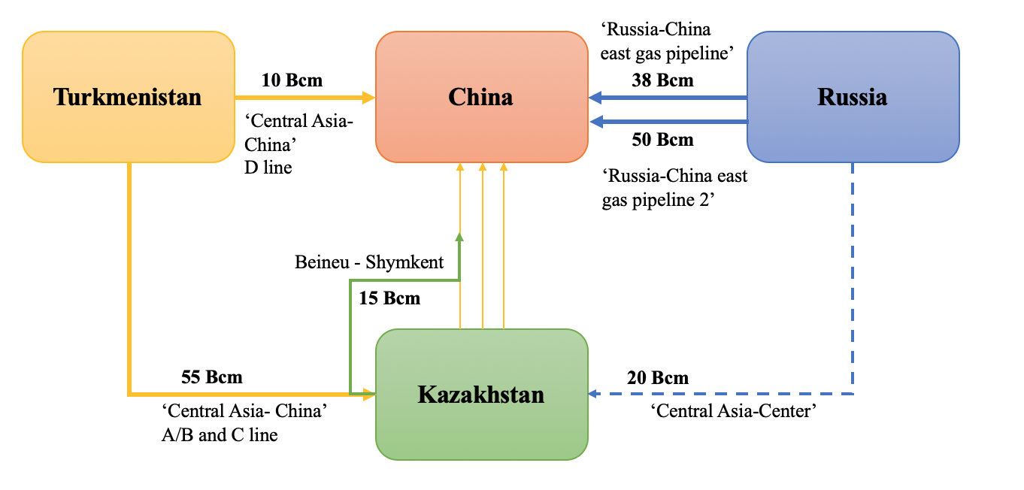
Figure 24 – The natural gas flow directions of Scenario 3
Note: Compiled by author based on the analysis of Scenario 3

In Scenario 3, it is assumed that Turkmenistan and Russia will supply 58 billion cubic meters of pipeline gas to China. According to projections regarding the future output of the Aktobemunaigas project, it is expected that Kazakhstan’s natural gas exports to China will amount to 4.6 billion cubic meters. Given that Russia and China have merely established a cooperative agreement concerning the development of the ‘Russia-China East Gas Pipeline 2’, and that construction has yet to begin, it is currently unfeasible to conduct a more in-depth analysis of the ideal export volumes for Turkmenistan and Russia within this context.
Based on the analysis of the three scenarios outlined above, we can evaluate the maximum potential revenue for Kazakhstan's natural gas transportation system by examining its differing natural gas export volumes and transit volumes under each scenario. As the infrastructure advances, the gas transportation system in Kazakhstan is concurrently evolving. The volume of gas transported within the system is primarily influenced by the quantity of domestic gas that is produced, processed, imported, and the system’s capacity to facilitate its transportation [155]. Consequently, the effectiveness of the gas transportation system is influenced by the quantity of gas that is exported and supplied to the domestic market, as well as the volume attributable to the volume of underground gas storage.
According to the above analysis in chapter 1.2, it is evident that only the Asian Gas Pipeline (AGP) and the Beineu-Shymkent Gas Pipeline (BSP) are presently tasked with delivering natural gas to the Chinese market within Kazakhstan’s gas pipeline infrastructure. The mathematical representation of the natural gas transportation issue within Kazakhstan's transport model is articulated as an economic-mathematical challenge involving linear modeling of significant complexity. To achieve equilibrium between domestic market needs and export demands while optimizing the transportation system's efficiency, a multi-tiered mathematical modeling strategy is employed in the examination of the gas transportation sub-model directed towards China.
- Model of ‘Oil and gas fields – Export’
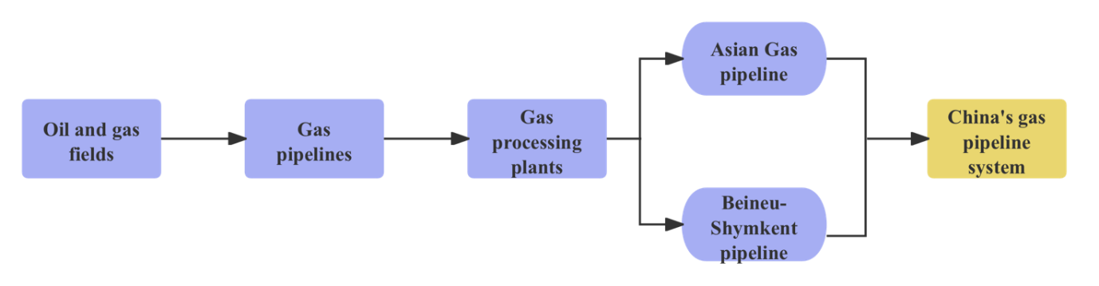
- Model of ‘Border-Transit-Export’
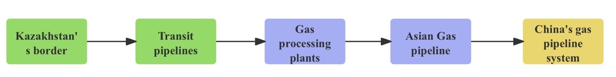
Figure 25 – The sub-models of natural gas transportation to China
Note: Compiled by author based on [73]

It is necessary to maximize [156]:
$$Max W=\sum_{t=1}^{n}{X_{t}^{kc}T_{t}^{kc}L^{kc}+\sum_{t=1}^{n}{X_{t}^{kc}M_{t}^{kc}+\sum_{t=1}^{n}{Y_{t}^{bc}T_{t}^{bc}L^{bc}-\sum_{t=1}^{n}{X_{t}^{kc}C_{t}}}}}$$ | (3.19)
with restrictions:
on the volume of gas exports to China
$$0≤\sum_{t=1}^{n}{X_{t}^{kc}≤\sum_{t=1}^{n}{\left(P_{t}-D_{t}\right)}}$$ | (3.20)
on the volume of gas transportation to China
$$0≤\sum_{t=1}^{n}{X_{t}^{kc}+\sum_{t=1}^{n}{Y_{t}^{bc}≤E^{pp}}}$$ | (3.21)
on the volume of gas transit to China
$$0≤\sum_{t=1}^{n}{Y_{t}^{bc}≤E^{pp}}$$ | (3.22)
nonnegativity of variables
$$X_{t}^{kc}≥0, Y_{t}^{bc}≥0$$ | (3.23)
where:
t- natural gas transportation period index,$t=\overline{1,n}$
P_{t} - volume of natural gas production in Kazakhstan in period t, m³;
D_{t}- volume of gas transportation to the domestic market in period t, m³;
C_{t}- natural gas production costs in Kazakhstan in period t, $/m³;
E_{pp}- gas pipeline system capacity, Bcm/year;
L_{kc}- the length of gas pipelines to China, km;
L_{bc}- the length of transit gas pipelines to China, km;
X^{kc}_{t}- volume of gas transportation from Kazakhstan to China in period t, m³;
T^{kc}_{t}- tariff for gas transportation from Kazakhstan to China in period t, $/103m³/km;
M^{kc}_{t}- trade prices for gas sales from Kazakhstan to China in period t, $/103m³;
Y^{bc}_{t}- volume of gas transportation to China transit of Kazakhstan in period t, m³;
T^{bc}_{t}- tariff for gas transportation to China transit Kazakhstan in period t, $/10³m³/km;
The task of natural gas transportation in the transport model of Kazakhstan belongs to the class of linear modeling problems of large dimensionality, which is the most developed section of economic and mathematical programming. The definition of the constraint system enables the application of the aggregation method: this method substitutes the resolution of the initial problem with the resolution of several sub-model problems, linking the derived solutions appropriately. After the mathematical model is established, aggregation methods can be employed to examine and consolidate variable factors, ultimately leading to the acquisition of the relevant optimal outcomes. The task is implemented on a computer using the QSB program designed to solve problems of economic and mathematical modeling. Figure 26 presents the profit from the export and transit of natural gas from Kazakhstan to China based on the analysis of three Scenarios.

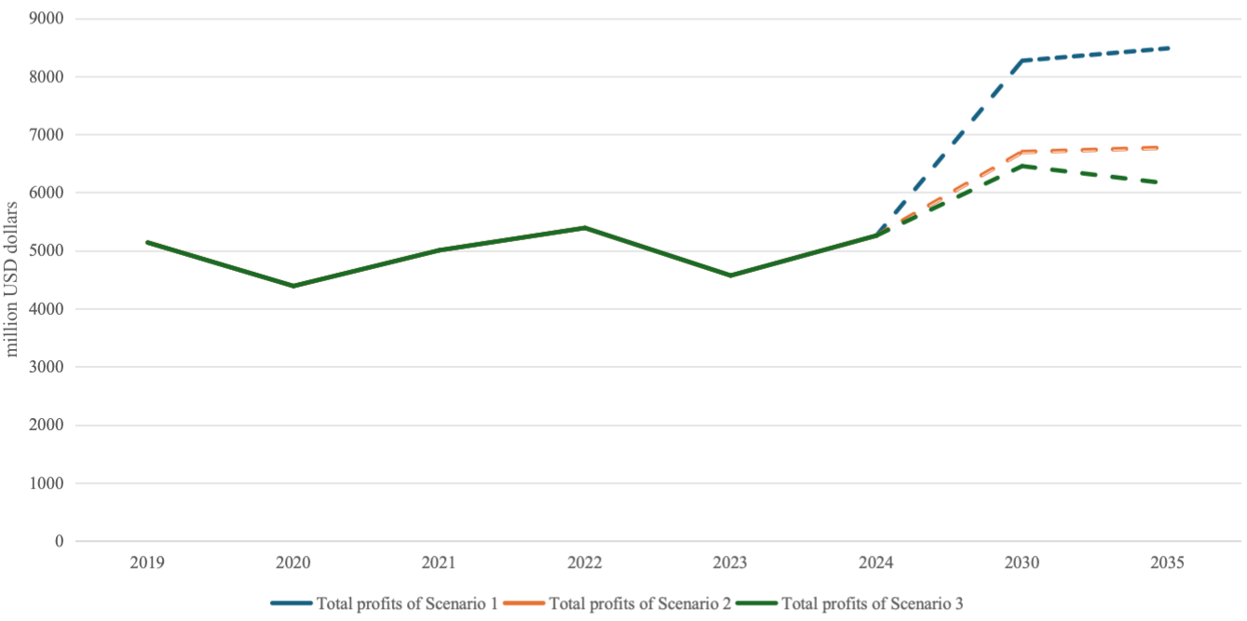
Figure 26 – The estimated profits of gas exports and transit from Kazakhstan to China
Note: Compiled by author based on the results of calculation
Figure 26 illustrates the variation in profits obtainable by Kazakhstan’s natural gas transportation system under different scenarios. The analysis results indicate that Scenario 2 represents the most favorable model for natural gas cooperation between Kazakhstan and China. Although Kazakhstan could generate higher revenues under Scenario 1, the export volumes of Turkmenistan and Kazakhstan in this scenario far exceed the maximum capacity of the transportation system. Therefore, this scenario is not applicable to the Kazakhstan-China natural gas cooperation model. In Scenario 2, Kazakhstan strategically boosts its export volume, guaranteeing a stable domestic supply of natural gas while simultaneously rendering the Kazakhstan-China natural gas cooperation project lucrative. Furthermore, the transit of natural gas from Russia and Turkmenistan via Kazakhstan has the potential to augment revenue and strengthen Kazakhstan’s geopolitical standing. In Scenario 3, as production declines at Kenkiyak and Zhanazhol fields, the revenue produced by Kazakhstan's gas transportation system will primarily depend on transit fees, which will eventually diminish Kazakhstan's competitive advantage in the market as time progresses.
Central Asian countries are located at a considerable distance from the primary markets for gas consumption, primarily relying on pipelines for export to the global market. With the advancement of export diversification, the development of pipelines exhibits characteristics of cross-border, multi-national, and long-distance transportation. The establishment and functioning of transnational pipelines necessitate a significant level of trust and strong collaboration among gas-producing, transit, and importing nations, which inevitably heightens the challenges associated with gas pipeline construction.
The varying positions and functions of individual nations in cross-border pipeline transportation, with some acting as energy consumers and others as energy suppliers, exhibit distinct attitudes and strategies regarding transit transportation. Furthermore, the roles and positions of specific transit countries evolve in response to fluctuations in the market and shifts in supply and demand, thereby heightening the uncertainty and risk associated with the cross-border transportation of natural gas.
Kazakhstan’s distinctive geographical location in Central Asia establishes it as a significant hub for the cross-border transportation of natural gas. With the change in its role from a gas resource country to a transit country, Kazakhstan’s initiatives to create a Central Asian gas hub have given greater prominence to and emphasized its status as a transit country. The enhancement of Kazakhstan’s gas transmission system will not only fortify the gas pipeline infrastructure but will also yield substantial revenues from gas transit.
In the chapter 3.2, the suggestion for a new collaborative framework, termed the ‘Central Asian gas hub’, has been put forward. The findings from both the scenario analysis and the transportation model analysis validate the economic feasibility of creating a ‘Central Asian natural gas hub’ in Kazakhstan, highlighting its importance in securing China's natural gas supply. In the future, Kazakhstan’s strategy for natural gas development may prioritize transit transportation, thereby strengthening its position as a central hub for gas transportation within Central Asia. This transition is expected to significantly influence the export of natural gas from Turkmenistan to China through the Central Asia-China gas pipeline, which will pass through Kazakhstan for Central Asia Pipeline Lines A, B, and C. Additionally, it will affect Russia’s gas export routes to China, making Kazakhstan's role in China’s natural gas transit transportation essential.

Future prospects for cooperation between Kazakhstan and China in the natural gas sector

Cooperation in the natural gas sector aligns with the energy strategies established by both governments and fosters economic collaboration at the regional level. On one side, the production of natural gas in Kazakhstan demonstrates a distinct upward trajectory, suggesting that the nation’s natural gas sector has considerable potential for growth. Conversely, with ongoing enhancements to natural gas infrastructure, Kazakhstan’s capacity for natural gas exports has also seen a substantial rise. The collaboration in natural gas between the two nations exemplifies the political trust and economic support that exists mutually between Kazakhstan and China [157].
Based on the preceding analysis, it can be inferred that the existing collaboration between Kazakhstan and China in the natural gas sector predominantly centers on the development of oil and gas fields, the transportation of natural gas, and the trade of natural gas. Chinese investment and technological advancements have significantly improved the efficiency of Kazakhstan’s oil and gas field development, thereby aiding the nation's strategic growth and energy commerce. China’s natural gas investments in Kazakhstan have primarily focused on exploration, with insufficient investment in downstream sectors such as natural gas processing plants and supply equipment. Therefore, future natural gas cooperation between Kazakhstan and China should focus on the integrated development of the natural gas industry.
In alignment with Kazakhstan’s natural gas development strategy, the nation is set to actively advance its gas chemical sector in the coming years. It can undergo chemical transformation to yield products like acetylene, carbon monoxide, carbon dioxide, and hydrogen, which subsequently lead to the production of additional derivatives. Investments by Chinese companies in the oil and gas sector in Kazakhstan are set to enhance not only the bilateral trade of natural gas but also to foster greater collaboration between the two countries in the field of natural gas chemicals.
The analysis presented above indicates that the collaboration between Kazakhstan and China in the gas sector can be broadened to encompass infrastructure, high technology, natural gas hubs, gas chemical production, and natural gas extraction, alongside the conventional trade partnerships. Engaging in these sectors will not only advance the growth of the natural gas industry in both nations but will also assist them in achieving a more sustainable transition in energy consumption.
Cooperation in the perspective natural gas projects
Given its substantial reserves of natural gas, production capabilities, and the development of its transportation infrastructure, the natural gas sector emerges as one of the most promising industries in Kazakhstan. Furthermore, collaboration in this field is a significant focus of the economic partnership between China and Kazakhstan. In the last twenty years, China and Kazakhstan have developed significant collaboration in the natural gas industry, establishing robust connections through joint efforts in resource exploration, and the development of natural gas pipeline infrastructure.
As certain oil and gas field projects, in which Chinese firms have invested in the Mangistau, Kyzylorda, and Aktobe regions, progress into the mid-to-late stages of development, a decline in natural gas production is anticipated in the future. Kazakhstan can offer tax incentives for these initiatives in compliance with legal regulations, thus enhancing their profitability and facilitating the export of natural gas.
Simultaneously, numerous new gas field development initiatives are being planned in Kazakhstan, including the Urikhtau project, the Anabay project, and the Kalamkas project, which offer fresh opportunities for Chinese enterprises in the domain of natural gas extraction. Chinese companies could partner with Kazakhstan in investing in natural gas extraction for prospective natural gas initiatives. The formation of a joint venture will not only safeguard the interests of both Kazakhstani and Chinese firms but will also improve the efficiency of the project’s development.
Prior to initiating collaboration, Chinese gas enterprises must conduct a thorough evaluation of Kazakhstan’s resource, investment climate, and market requirements, while also developing sustainable growth strategies that include increasing asset scale and establishing long-term independent operations. These are recommendations for joint venture:
1. Elevate the importance of natural gas in the oil and gas production industry, encourage the development of extensive natural gas processing facilities, proactively promote the natural gas sector, and foster the creation of products like compressed natural gas and condensate. Shift the production of associated gas towards a co-production framework for both oil and natural gas.
2. Enhance initiatives in autonomous exploration, augment new hydrocarbon reserves via independent exploration through the collaborative efforts of gas companies from Kazakhstan and China, and shift from oil and gas development to an integrated exploration and development model.
3. Enhance the scale of asset growth, Chinese gas firms must identify high-quality assets and pursue swift expansion in asset size via mergers and acquisitions, with a single operation of existing assets changing into new asset acquisitions.
4. Expand business areas, gas companies of Kazakhstan and China have the potential to incorporate engineering services, product sales, and various other enterprises related to natural gas field projects. This can range from a singular upstream oil and gas production operation to a fully integrated company that encompasses oil and gas production, transportation, and sales.
Cooperation in the field of infrastructure
The analysis indicates that the geographical benefits of Kazakhstan play a crucial role in promoting the continued growth of natural gas collaboration between Kazakhstan and China. The geographical advantage enhances the price competitiveness and transportation security of Kazakhstan-China natural gas trade, demonstrating the diversity of natural gas transportation routes. In light of a more liberalized natural gas market, Kazakhstan and China ought to enhance their natural gas pipeline transportation regulations and infrastructure development strategies to achieve reduced costs and increased efficiency in gas transportation between the two nations. For significant natural gas field projects funded by Chinese enterprises in Kazakhstan, the establishment of natural gas processing facilities and transportation pipelines post-project commissioning signifies the future trajectory of natural gas collaboration between the two countries.
As can be seen from the analysis in chapter 1.2, Kazakhstan’s natural gas processing facilities currently have a capacity of only 38.8 billion cubic meters, which is far from sufficient to meet the demand once new natural gas projects come online. According to the analysis in chapter 3.1, future natural gas initiatives anticipated to receive investment from Chinese firms are estimated to yield around 10 billion cubic meters of natural gas. Consequently, the advancement of natural gas infrastructure holds significant strategic value for the collaboration between Kazakhstan and China in the natural gas industry. The creation of additional natural gas processing facilities will enhance the growth prospects of Kazakhstan's natural gas sector and increase its capacity to export natural gas.
Cooperation in the field of advanced technology
In the discussion on optimizing the future cost-benefit structure of natural gas projects, the cooperation in the field of advanced technology is considered to be an effective way. Currently, the application of internet technology in oil and gas field development has become a trend. Applying ‘Internet +’ and 5G technologies to natural gas projects can improve the efficiency of oil and gas development and enhance the monitoring of pipeline transportation safety. Integrating information technology into the natural gas industry not only drives its intelligent transformation but also reduces potential safety risks. Regarding production technology, China possesses the manufacturing capabilities required for the essential equipment and has acquired advanced techniques for the deep processing of natural gas products. In the future, there is potential for collaboration between Kazakhstan and China on natural gas processing technologies.
In the field of renewable energy technology, Kazakhstan has been proactive in promoting the development of renewable energy in recent years, with intentions to build more solar and wind power facilities in the country in the future. Furthermore, international energy firms engaged in Kazakhstan’s oil and gas industry (including TotalEnergies) have made investments in the development of wind power facilities to provide electricity for their oil and gas operations, enhancing ongoing collaborative efforts. In the worldwide energy landscape, China stands out as one of the foremost nations in solar and wind energy production, boasting a well-established technology and equipment supply chain. Kazakhstan and China have the potential to merge their renewable energy collaboration with natural gas initiatives, utilizing electricity produced from renewable resources such as wind and solar energy to facilitate the advancement of natural gas projects. This integration will assist natural gas projects in securing tax advantages and lowering production expenses [158, 159, 160].
Cooperation in the construction of Central Asian natural gas hub
Kazakhstan stands out as the most rapidly expanding economy and the most engaged nation in foreign trade within Central Asia. Regarding the natural gas trade environment, Kazakhstan shares borders with significant natural gas producers (Turkmenistan and Russia) and a key natural gas consumer (China), positioning it strategically at the center of the trade network.
Within the context of regional economic collaboration, the natural gas cooperation frameworks established by China with Turkmenistan, Kazakhstan, and Russia exhibit unique features alongside commonalities, which can be attributed to the variations in their respective national economic progress and natural gas sectors. In the context of cooperation between Kazakhstan and China in the natural gas sector, the two countries should first and foremost base their efforts on national policies, use pipeline projects as a channel, and leverage government-to-government exchanges to drive investment. Establishing a Central Asian natural gas hub will not only enhance the efficiency of regional natural gas cooperation and expand Central Asia’s influence in the global natural gas market but also ensure natural gas security for Kazakhstan and China.
Therefore, Kazakhstan serves a pivotal function in harmonizing the supply and demand of natural gas within the natural gas market. By analyzing the natural gas pricing mechanisms, it can be concluded that Kazakhstan can expand its market influence by integrating natural gas resources from Central Asia and Russia and improve its competitive position in the market by minimizing information asymmetries related to pricing. China has the potential to work together with Central Asian nations and Russia on the initiative for a “natural gas hub” by utilizing platforms like the Silk Road Economic Belt, BRICS, and the SCO. In the future, the establishment of the natural gas hub will position Kazakhstan as a pivotal natural gas transit center in Central Asia, consequently strengthening the roles of both Kazakhstan and China in regional economic collaboration.
Cooperation in the field of coalbed methane
Empirical findings indicate that natural gas production is a key potential factor in boosting natural gas trade between Kazakhstan and China. Enhancing the production of natural gas is a significant focus within the framework of Kazakhstan-China natural gas collaboration, and it also affects Kazakhstan’s internal natural gas usage. Boosting natural gas output will not only secure the availability of natural gas for Kazakhstan’s domestic market but will also facilitate the growth of future natural gas commerce between the two nations.
In the “Kazakhstan Gas Sector Development Plan for 2025-2029”, the area 5 discusses the advancement of the coal chemical industry (Table 9). In addition to conventional natural gas resources, Kazakhstan holds abundant coalbed methane resources. According to S&P Global estimates Kazakhstan's coalbed gas resources are estimated at 8 trillion cubic meters. The extensive coal basins of Ekibastuz, Karaganda, and Turgay possess reserves of 10 billion tons, 6.9 billion tons, and 5.9 billion tons, respectively. Lignite constitutes approximately one-third of the overall coal reserves, creating a more favorable environment for coalbed gas extraction [73].
Given the present disparity in gasification across Kazakhstan, the gas infrastructure is predominantly located in the western and southern areas. The north-central area, with Astana as its capital, represents a significant potential market for coalbed gas. Additionally, the coalbed gas extracted from the coal basins in this region serves as a vital resource for the gas pipeline infrastructure, as the government of Kazakhstan actively supports the development of the gas pipeline network.
In 2017, Kazakhstan intends to establish a joint venture with China’s Xinjiang Oilfield Company for the purpose of developing coalbed gas. In 2018 Kazakhstan’s companies signed a letter of agreement on strategic cooperation with China Coal Science and Industry Group Company Limited to jointly promote the technological development of coal mining, coalbed gas extraction and utilization industry in Karaganda region. In the future, coalbed gas development is anticipated to emerge as the most promising initiative within Kazakhstan’s natural gas sector.
Cooperation in the field of gas chemical industry
The natural gas chemical industry is anticipated to play a crucial role in diversifying Kazakhstan’s oil and gas industry, shifting from mere resource extraction to a more multifaceted development approach through the advancement of natural gas chemicals. From the viewpoint of natural gas chemical advancement, the chemical utilization of natural gas not only yields greater economic benefits compared to direct combustion but also stimulates industrial growth and job creation. Furthermore, it can facilitate the attainment of low-carbon objectives through carbon enrichment and sequestration in the form of chemical products. Consequently, the advancement of the natural gas chemical sector holds substantial importance for both the economic and social progress of the nation.
Kazakhstan possesses significant natural gas resources, which serve as a crucial raw material for the chemical industry. In light of the existing shortage of commercial natural gas, the petrochemical sector reliant on natural gas (methane) – including the production of ammonia, nitrogen fertilizers, and methanol – has not seen considerable development in Kazakhstan. As an example, the Atyrau gas chemical complex project provides a large supply of low-cost natural gas products (propane, ethane, and butane) from the chemical plant.
The natural gas chemical sector in China is primarily focused on chemical bases located in regions rich in gas resources. Through advancements in technology within the chemical sector, the chemical industry in China has achieved the capability to produce a significant volume of natural gas products, mainly including natural gas to acetylene, carbonyl gas to acetic acid, natural gas to hydrogen, and direct conversion of methane and syngas.
Led by the governments, Kazakhstan and China have already begun initial cooperation in the gas chemical industry. Kazakhstan and China have established an initial cooperation plan in the field of gas chemical industry based on the joint oil and gas projects. In 2025, the Ministry of Energy of Kazakhstan, along with KMG, CNPC, and the state government of Aktobe State, entered into an investment agreement for the establishment of a urea manufacturing facility. This project is intended to be located at the Zhanazhol natural gas processing plant in Kazakhstan. The natural gas processing facility is intended to function as a supply base for raw materials, with plans to provide 600 million cubic meters of commercial natural gas annually [161].
The “Kazakhstan Gas Sector Development Plan for 2022-2026” identifies the advancement of the oil and gas chemical industry as a key objective for the growth of Kazakhstan's natural gas sector. According to the plan published by the Ministry of Energy of Kazakhstan, the volume of petrochemical products is expected to reach 1.128 million tons by 2025, and 1.2 million tons by 2026 (Table 28). The advancement of the gas chemical sector will contribute to the augmentation of value added to natural gas and improve the economic advantages of natural gas collaboration.

Table 28 – The planned gas chemical plants by the Ministry of Energy of Kazakhstan

Project type | Capacity (t/y) | Resources | Location | Estimated project cost
Ethylene/ Polyethylene | 1.25 MMt/y | Ethane from Atyrau refinery gas unit | Atyrau Oblast | $7.6 billion
Ammonia and urea | 660,000 ammonia; 577,500 urea. | Natural gas from Shagyrly-Shomyshty field | Mangystau Oblast | $1 billion
Methanol | 130,000 methanol | Natural gas and carbon dioxide | West Kazakhstan Oblast | $140 million
Ammonia and urea | 40,000 ammonia; 100,000 urea. | Natural gas | West Kazakhstan Oblast | $200 million
Olefins | 800,000 olefins | Natural gas | Atyrau Oblast | $1.8 billion
Terephthalic acid/ Polyethylene terephthalate | 600,000 terephthalic acid; 430,000 polyethylene terephthalate | Paraxylene from Atyrau refinery | Atyrau Oblast | $1 billion
Source: [73]

Table 28 illustrates the development prospects for the chemical industry within Kazakhstan’s future natural gas sector. Natural gas can be used as a feedstock to produce ammonia and urea, methanol, and olefins. These chemical products provide greater added value than their raw materials. Furthermore, as many of them are derived from natural gas, they exhibit a reduced environmental impact during their production when compared to petrochemical products.
The oil and gas projects funded by Chinese firms in Kazakhstan offer resources and technical assistance to enhance their collaboration in the gas chemical sector. Moving forward, the cooperation in the gas chemical sector will make an important contribution to the development of local economy, energy security and the improvement of export potential.
Chapter 3 mainly assesses the anticipated production volumes of upcoming joint natural gas initiatives and outlines potential collaboration scenarios between Kazakhstan and China in the natural gas sector under various export volumes and cooperation models. Anticipated collaborative natural gas initiatives between Kazakhstan and China are projected to generate significant natural gas output, and these initiatives may encourage Chinese investment in the natural gas infrastructure of Kazakhstan. The examination presented in section 3.2 reveals that Kazakhstan serves as the most beneficial hub for natural gas trade between Turkmenistan and Russia on one hand, and China on the other, considering both trade and transportation aspects.
In the chapter 3.3, recommendations are provided to enhance natural gas production, modernize infrastructure, and adopt advanced technologies to increase the efficiency of natural gas cooperation between Kazakhstan and China. The concept of a Central Asian gas hub has been proposed to enhance the collaboration in natural gas between Kazakhstan and China, as part of broader regional economic cooperation.

CONCLUSION
Based on the review and synthesis of existing research literature, this dissertation first defines and elaborates on the concept of international energy cooperation and the prerequisites of natural gas cooperation founded in the theories of comparative advantage and factor endowment and proposes a basic logical framework for establishing a natural gas cooperation mechanism between Kazakhstan and China. Subsequently, this study examines and assesses China’s investment approaches in natural gas collaboration, alongside Kazakhstan’s negotiation tactics concerning market configuration and pricing systems, while also performing empirical analyses of the critical elements affecting natural gas commerce between the two nations. Ultimately, a cost-benefit analysis has been conducted to evaluate the potential outcomes of natural gas projects funded by Chinese oil companies in Kazakhstan. The author performed a comprehensive investigation and model evaluation of Kazakhstan’s competitive-cooperative strategies across different scenarios and introduced a concept for the creation of a regional natural gas transportation hub.
The main conclusions of this dissertation are as follows:
1. Energy cooperation between Kazakhstan and China is progressing into a new developmental stage. The partnership in natural gas signifies a mutual dedication to broadening economic cooperation, fortifying energy alliances, and improving the effectiveness of regional natural gas collaboration.
The essence of global energy cooperation lies in the ongoing collaborative initiatives undertaken within the energy sector by the governments and energy companies of sovereign nations, in conjunction with international energy organizations, driven by shared interests and achieved through the transfer and reallocation of production resources. In this process, national governments and energy corporations employ diverse strategies to enhance resource distribution and increase profitability. Typically, the goals of energy collaboration are strategic; such partnerships are not solely focused on attaining financial benefits but are fundamentally centered on guaranteeing energy security and protecting national interests.
The partnership in energy between Kazakhstan and China aligns with the objectives of international energy collaboration, ensuring reciprocal benefits for both countries. Kazakhstan is endowed with significant natural gas reserves, whereas China is one of the foremost consumers of natural gas worldwide. Collaboration in natural gas between the two nations enhances resource allocation efficiency and fosters economic growth on both sides. The geopolitical landscape renders natural gas collaboration between China and Kazakhstan unavoidable, as Kazakhstan is not only a geographical neighbor to China but also a significant political ally. Collaboration within the natural gas industry will contribute to the diversification of the energy markets in both nations and reduce the threats to energy security that arise from geopolitical tensions.
The partnership in natural gas between Kazakhstan and China represents a facet of regional economic collaboration, and the effectiveness of this alliance is influenced by the participation of other countries in the regional economic framework. In this context, China has also engaged in natural gas partnerships with Turkmenistan and Russia. Concerning Turkmenistan and Russia, Kazakhstan acts not merely as a “competitor” in the Chinese gas market but also plays a crucial and distinctive role in ensuring the stability of regional natural gas transportation. A primary objective in examining the natural gas collaboration between Kazakhstan and China is to identify methods for utilizing geographical and resource advantages in order to develop a cooperation strategy that optimally enhances the economic benefits for both nations.
2. Kazakhstan’s oil and gas sector possesses a unique competitive edge in global trade, and its association with China is defined more by complementarity than rivalry. Collaboration in natural gas between Kazakhstan and China serves as a significant means of attaining an efficient distribution of production resources.
The oil and gas resources serve as a fundamental catalyst for the economic advancement of Kazakhstan. Being classified as a “resource-rich” nation, these resources provide Kazakhstan with a competitive edge in global trade. As a participant in OPEC+, Kazakhstan possesses a notable advantage regarding oil and gas production, export quantities, and its impact on the international market. China ranks among the largest consumers of natural gas globally, yet its domestic output falls short of satisfying the vast demand within the country. As a result, China predominantly acts as a “buyer” in the international energy market, significantly impacting global energy dynamics.
In this context, the natural gas sectors of the two nations are more synergistic than adversarial, and collaboration will assist both parties in securing energy stability and promoting economic growth. Natural gas cooperation is a method of rationally allocating relevant factors based on comparative advantage. The natural gas corporation facilitates the influx of Chinese capital and technology into Kazakhstan’s natural gas sector, while Kazakhstan’s natural gas resources can be conveyed to China through gas infrastructure.
3. Kazakhstan and China have made significant progress in natural gas cooperation, and the catalytic role of energy policy in this cooperation has begun to appear. However, the full potential of this cooperation is far from being realized.
National energy policies reflect the importance of the oil and gas industry to the country's economic development. In recent years, Kazakhstan has continuously enacted legislation to regulate foreign oil companies’ investments in oil and gas exploration and production activities in Kazakhstan. In terms of subsoil resource use and taxation, the law redistributes the oil and gas profits earned by foreign oil companies in Kazakhstan and grants the government priority rights in oil and gas cooperation. In terms of subsoil resource use and taxation, the relevant law redistributes the oil and gas profits earned by foreign oil companies in Kazakhstan and grants priority rights of the government in oil and gas cooperation.
4. The strategy for Kazakhstan-China natural gas cooperation continues to be optimized. Within the context of the collaborative advancement of the Silk Road Economic Belt, Kazakhstan and China have forged multiple agreements aimed at cooperation in the natural gas sector, indicating a progressive transition in energy partnership between the two nations from oil to natural gas.
Chinese oil firms invest in oil and gas projects in Kazakhstan. These firms gain rights to untapped natural gas resources in the country. These gas resources support profitable cooperation. Chinese oil firms earn more gains by processing or selling natural gas. Chinese oil companies no longer only use acquisitions for local energy projects. They set up joint ventures with Kazakh state-owned enterprises. Both sides share profits and risks together.
5. In the context of the Chinese gas market framework, Kazakhstan possesses a competitive edge compared to other gas-exporting nations regarding transportation security, supply reliability, and pricing of gas. Within the natural gas pricing system, both Kazakhstan and China exhibit equivalent capabilities in terms of price offerings.
Natural gas resources, transport, prices, market demand and supply security shape the positions of gas suppliers and buyers. Turkmenistan, Russia, Kazakhstan and Myanmar are major pipeline gas suppliers for China. Data on gas import security shows Kazakhstan leads in transport safety, stable supply and trade prices. Kazakhstan has a steady political environment and good geographic location. These strengths make it an important pipeline gas supplier. Kazakhstan and China have equal power to set gas prices in price talks.
6. China’s economic growth, higher oil output and energy use boost oil and gas trade with Kazakhstan. Kazakhstan’s rising natural gas production and energy use hold back this trade.
We build a trade gravity model to study factors affecting bilateral oil and gas trade. Results show economic growth strongly lifts trade volume. China’s growing economy uses more energy. It pushes up oil and gas trade between the two countries. More natural gas output in Kazakhstan does not raise bilateral trade. The country needs to expand natural gas exports further.
7. Current tax rules and cost-benefit standards show joint gas projects of Kazakhstan and China will produce 10 billion cubic meters of natural gas by 2030.
Foreign oil companies join Kazakhstan’s oil and gas projects mostly via concession agreements. These companies pay related taxes before getting their share of oil and gas resources. Kazakhstan charges mineral extraction tax, oil export duty and excess profits tax on oil and gas exports under these agreements. Many natural gas projects are now in middle or late development stages. Stable production needs more investment and better technology. Early-stage gas project funds will go to gas infrastructure such as pipelines and processing plants. Current cost and benefit standards predict joint gas projects will reach 10 billion cubic meters output by 2030. Both countries have large room for gas cooperation.
8. Raise natural gas exports to keep market competitiveness. Build a Central Asian gas hub to make full use of transport strengths.
Turkmenistan, Russia and Kazakhstan supply most pipeline gas to China. Connected regional pipeline networks require balanced competition and cooperation in the gas industry. This is a key direction for future gas cooperation between Kazakhstan and China. We use a game theory model to set three plans for Kazakhstan’s gas exports and a transport model to calculate transport income under each plan. Calculation results support the game theory model. Kazakhstan gains most by raising gas exports to stay competitive. It uses its geographic location to act as a gas transit hub for Turkmenistan and Russia sending gas to China.
9. Kazakhstan and China have broad cooperation space in infrastructure building, coalbed methane mining and gas chemical processing.
Gas project progress relies heavily on infrastructure development. Kazakhstan’s gas processing capacity cannot fully support new ongoing gas projects. Both countries need to upgrade infrastructure and apply new technology in gas projects. These are core tasks for future gas cooperation. The two sides already carry out commercial cooperation on coalbed methane. This brings new ideas for deeper gas partnership. The two countries can work together on gas chemical production for domestic gas supply. They raise added value of gas products and increase profits from oil and gas projects.
This paper fully studies and evaluates gas cooperation between Kazakhstan and China. It covers supply and demand, market structure, pricing rules, investment plans and transport safety. The paper puts forward practical cooperation models and potential cooperation fields. These plans fit the economic needs of both countries. In contrast to other investigations regarding the natural gas collaboration between Kazakhstan and China, this study employs empirical analysis alongside game theory models to perform a comprehensive examination of the economic viability of gas cooperation, framed within the realms of international politics and regional economics. From an economic theoretical standpoint, the importance and vast potential of collaboration between Kazakhstan and China in the natural gas sector have been highlighted for the economic advancement of both nations.

References
- National Energy Administration of the PRC. China Natural Gas Development Report (2025). – Beijing, 2025.
- Комплексный план развития газовой отрасли Республики Казахстан на 2022 – 2026 годы. Постановлен Правительством Республик Казахстан от 18 июля 2022 года № 488. (утратило силу постановлением Правительства Республики Казахстан от 21 июня 2025 года № 463.) https://adilet.zan.kz/rus/docs/P2200000488
- Movkebaeva G. A. Energy cooperation among Kazakhstan, Russia, and China within the Shanghai Cooperation Organization // Russian Politics and Law. –2013. – Vol.51. –№. 1. – P. 80–87.
- Pron E. M. China’s energy diplomacy via the Shanghai Cooperation Organisation // Palgrave Macmillan UK eBooks. – 2014. – P. 52–73.
- Dong C., Dong X. C., Zhao C. Y. Research on the prospects of oil and gas cooperation between China and Central Asia under the background of “One Belt, One Road” // Price Theory and Practice. –2020. – Vol.02. – P. 1–4.
- Thomson E., Horii N. China’s energy security: challenges and priorities // Eurasian Geography and Economics. –2009. – Vol.50. –№. 6. – P. 643–664.
- Álvarez C. M. China-Kazakhstan Energy Relations between 1997 and 2012 // Journal of International Affairs. –2015. – Vol.69. –№. 1. – P. 57–69.
- Zhalgasuly D., Deng F. Analysis of energy cooperation between Kazakhstan and China // Times Economics and Trade. –2020. – Vol.10. – P. 12–14.
- Zhamanova M. China’s Energy Policy in Central Asia and the Role of Kazakhstan: Thesis for the degree of PhD / M. Zhamanova. – Shanghai: East China Normal University, 2020. –164 p.
- Huang X. Research on the economic growth effect of energy cooperation between China and Kazakhstan: Master’s Thesis / X. Huang. – Guangzhou: Guangdong University of Foreign Studies and Foreign Trade, 2021. – 46 p.
- Du B., Juman J., Makulova A. T., Khamzayeva A. V., Zhai X. Analysis of the competitiveness, complementarity, and trade combination of Kazakhstan and China in the oil and gas trade // Economies. –2024. – Vol.12. –№. 7. – P. 182.
- O’Neill D. C. Risky Business: The political economy of Chinese investment in Kazakhstan // Journal of Eurasian Studies. –2014. – Vol.5. –№. 2. – P. 145–156.
- Wu X. L., Zhang S. Q., Zhao L., Luo D. K. Research on the oil and gas investment environment of five Central Asian countries // Energy of China. –2020. – Vol.42. –№. 10. – P. 32–38.
- Xin C. China-SCO member countries natural gas cooperation research: Thesis for the degree of PhD / C. Xin. – Jilin: Jilin University of Finance and Economics, 2018. – 155 p.
- Qin Y. Q. International regimes and international cooperation: Rethinking neo-liberal institutionalism // Journal of the Diplomatic Academy. – 1998. – Vol.01. – P. 1–8.
- Kenneth W. International political economy / W. Kenneth. – Shanghai people’s publishing house, 2004. –141 p.
- Ni S.X. Contemporary Western Theory of International Relations: Thesis for the degree of PhD / S.X. Ni. – Shanghai: Fudan University, 2004. –276 p.
- Keohane R. O. After hegemony / R. O. Keohane. – In Princeton University Press, 2005. –290 p.
- Han X. K., Tong J. Y. International Petroleum Cooperation // Petroleum Industry Press. – 1995. – P. 25–31.
- Guan Q. Y., He F. China’s energy security and international energy cooperation // World Economy and Politics. – 2007. – Vol.11. – P. 1–9.
- Geng J., Ji Q., & Fan Y. A dynamic analysis on global natural gas trade network // Applied Energy. – 2014. – Vol.132. – P. 23–33.
- Szyliowicz J. S., O’Neill, B. E. (Eds.). The Energy Crisis and US Foreign Policy / J. S. Szyliowicz, B. E. O’Neill. – Michigan: Greenwood, 1975. – 258 p.
- Noreng O. Oil politics in the 1980’s: patterns of international cooperation / O. Noreng. – Michigan: McGraw-Hill, 1978. – 171 p.
- Yuan S. Y., Kim Y. J. Geopolitics of Energy in Central Asia // Journal of Henan Normal University: Philosophy and Social Science Edition. – 2012. – Vol.39. –№. 5. – P. 81–85.
- Dong X. C., Pi G. L. Energy Geopolitics and China’s Energy Strategy // Economic Issues. – 2015. – Vol.2. – P. 6–8.
- Wang S. Energy Cooperation in Northeast Asia: Problems, Challenges and Prospects - A Geopolitical Economy Perspective: Thesis for the degree of PhD / S. Wang. – Shanghai: Shanghai Academy of Social Sciences, 2012. –112 p.
- Mao H. Y. Geopolitical and geo-economic patterns and countermeasures in China’s neighborhood // Progress in Geographical Sciences. – 2014. – Vol.33. –№. 3. – P. 289–302.
- Yang L. Z., Liu X. J., Yu W.C. Research on the complementarity of trade between China and Central Asian countries under the background of the “Belt and Road” // Shanghai Economic Research. – 2015. – Vol.11.– P. 1–10.
- Conant M. A., Gold F. R. The geopolitics of energy / M. A. Conant., F. R. Gold. – New York: Routledge, 1978. – 244 p.
- Yang Y., He Z. Research on energy geopolitics and energy power // Advances in Geosciences. – 2012. – Vol.40. –№. 3. – P. 1–17.
- Jiang S., Liu X. X., Cheng F. Y., Wang D. X., & Hou H. Challenges and countermeasures for China’s oil and gas import security under the new situation // International Petroleum Economics. – 2024. – Vol.32. –№. 4. – P. 12–17.
- Goldthau A. Rhetoric versus reality: Russian threats to European energy supply // Energy Policy. – 2007. – Vol.36. –№. 2. – P. 686–692.
- Coq C. L., Paltseva E. Assessing gas transit risks: Russia vs. the EU // Energy Policy. – 2012. – Vol.42. – P. 642–650.
- Fu J. Y. “Shale Gas Revolution”, “Ukraine Crisis” and Russia-EU Energy Relations - A Dynamic Analysis of Gas Market Structure and Power Structure // European Studies. – 2014. – Vol.16. – P. 82–98.
- He C. L., Zhou G. D., Jiang Z. A., Hu A. L., Chen L. Y. China’s natural gas supply security in a global environment // Natural Gas Industry. – 2010. – Vol.30. –№. 1. – P. 123–126.
- Du B., Juman J., Khamzayeva A., Xuan Z. Energy cooperation between Kazakhstan and China under “One Belt and One Road”: current state, challenges and perspectives // Bulletin of the Karaganda University economic series. – 2024. – Vol.11429. –№. 2. – P. 7–18.
- Huang W. H., Zhou S. H., Wang J. Changes in global natural gas supply and demand and thoughts on China’s natural gas security supply // Oil, Gas and New Energy. – 2023. – Vol.135. –№. 2. – P. 1–12.
- Porter M. E. Competitive Strategy: Techniques for Analyzing Industries and Competitors / M. E. Porter. – New York: Free Press, 1998. – 397 p.
- Blank S. China, Kazakh energy, and Russia: An unlikely ménage à trois // The China and Eurasia Forum. – 2005. – Vol.3. –№. 3. – P. 99–109.
- Wang Z. M. Analytical report on gas cooperation between Russia and Central Asian countries // Journal of Beijing Petroleum Management Cadre College. – 2010. – Vol.5. – P. 1–7.
- He J., Li P. C. Analysis of Russian factors in China’s gas cooperation with Central Asia // Knowledge Economy. – 2010. – Vol.9. – P. 1–10.
- Chen J. Q., Yun S. M. Research on the game and development trend of Sino-Russian natural gas cooperation // Russian East European Central Asian Studies. – 2011. – Vol.6. – P. 37–43.
- Yang L. History and Prospects of Sino-Russian Gas Cooperation // Eurasian Economy. – 2014. – Vol.5. – P. 86–97.
- Li Z. H., Li J. N, Yang Y., Kolosov A., Ren Y., & Bazarzhapov et al. Security pattern and trend of China-Russia natural gas trade // Resources Science. – 2018. – Vol.40. –№. 11. – P. 1–10.
- Li X. C., Yu L. Y. Research on the development of China-Russia natural gas trade in the context of “Belt and Road” // Small and Medium-sized Enterprises Management and Technology. – 2019. – Vol.20. – P. 1–2.
- Asian Development Bank. Asian development outlook 2015: financing Asia’s future growth. – URL: https://www.adb.org/sites/default/files/publication/154508/ado-2015.pdf (accessed: 03.2025)
- Fakhrizadeh A., Hojatti Z. Inflation Targeting and Effects of Oil Price Shocks in ECO, Case Study of Iran, Kazakhstan and Turkey // Biosciences Biotechnology Research Asia. – 2015. – Vol.112. –№. 2. – P. 207–215.
- Yan H. Y., Li S. Q. A brief analysis of Turkmenistan's natural gas export pattern and its impact // Russian Central Asian and Eastern European Market. – 2012. – Vol.8. – P. 1–6.
- Deng X. J. Analysis of natural gas cooperation between China and Turkmenistan // International Research Reference. – 2015. – Vol.8. – P. 1–6.
- Shi L., Li F. H., He W. Y., Yang Z., & Li Z. Central Asia pipeline gas supply security situation and response strategies // International Petroleum Economics. – 2023. – Vol.131. –№. 12. – P. 22–30.
- Korov A.G., Zhd L.V., Nie SL. The current situation and prospects of China-Kazakhstan cooperation in the field of oil and gas // Central Asia Information. – 2007. – Vol.11. – P. 1–6.
- Ming H. H., Zhang Q. H., Xin Q. Overview of Kazakhstan’s oil industry // International Petroleum Economics. – 2009. – Vol.2. – P. 1–8.
- Wachter K. W., Freedman D. A. Measuring Local Heterogeneity with 1990 U.S. Census Data // Demographic Research. – 2000. – P. 3.
- Osarosee E. O., Abaraodo C. U. ABSOLUTE ADVANTAGE THEORY // BW Academic Journal. – 2022. – Vol.1. –№. 1. – P. 5.
- Rahman M. A. David Ricardo’s Principle of Comparative Cost Advantage inspires International Trade // SSRN Electronic Journal. – 2023. – Vol.12. –№. 71. – P. 1–15.
- De Benedictis L., Tamberi M. A note on the Balassa index of revealed comparative advantage // SSRN Electronic Journal. – 2001. – P. 1–37.
- Yin D. S., Hu F. The source and evolution of dynamic comparative advantage // Seek. – 2006. – Vol.4. – P. 1–5.
- Siddique M., Anwar A., & Quddus M. A. The impact of real effective exchange rate on revealed comparative advantage and trade balance of Pakistan // Economic Journal of Emerging Markets. – 2020. – Vol.12. –№. 2. – P. 193–207.
- Fujiwara K., Shimomura K. A factor endowment theory of international trade under imperfect competition and increasing returns // Canadian Journal of Economics. – 2005. – Vol.38. –№. 1. – P. 273–289.
- Markusen J. R., Venables A. J. Interacting factor endowments and trade costs: A multi-country, multi-good approach to trade theory // Journal of International Economics. – 2007. – Vol.73. –№. 2. – P. 333–354.
- Wang T. H. Dynamic externality, industrial clusters and economic growth // Research on financial issues. – 2008. – Vol.2. – P. 41–45.
- Yang Y., Liu Y., Jin F. J. Patterns of international energy cooperation between China and Central Asia-Russia under the perspective of energy geopolitics // Geography Research. – 2015. – Vol.2. – P. 1–12.
- Liu X., Chen Y., Wang X. Research on China-Kazakhstan Trade under “The Belt and Road Initiative”—Based on the Perspective of Factor Endowment Theory // Proceedings of the 2019 International Conference on Management Science and Industrial Economy (MSIE 2019). – 2020. – Vol.01. – P. 270–274.
- Wu L., Sun R. Analysis of the competitiveness and complementarity of energy trade between China and countries along the “Belt and Road” // Productivity Research. – 2018. – Vol.11. – P. 77–81.
- Feng L., Xu H., Wu G., Zhao Y., Xu J. Exploring the structure and influence factors of trade competitive advantage network along the Belt and Road // Physica a Statistical Mechanics and Its Applications. – 2020. – Vol.559. – P. 125057.
- Zhu K. P., Kang J. L. Competitive Complementarity Analysis of Energy Trade between China and Central Asian Countries // Business & Economy. – 2021. – Vol.11. – P. 1–4.
- Yang X. M., Huang Q., Tang W. Y. Research on the current situation and competitiveness of trade between China and Kazakhstan - the background of the tenth anniversary of the “Belt and Road” initiative // Monthly Price. – 2024. – Vol.4. – P. 70–79.
- Жуман Ж., Чжай С., Макулова А.Т. Современное состояние и перспективы газового рынка Китая // Central Asian Economic Review. – 2024. – №.6. – С. 53–65.
- Shao Y. Research on the dynamic changes in the structure of energy trade networks and influencing factors of countries along the “Belt and Road”: Master’s Thesis / Y. Shao. – Wuhan: Central South University of Finance, 2022. –54 p.
- Zhou J., Han J. Q. The impact of energy trade cooperation between China and the “Belt and Road” countries on energy security // Resources and industries. – 2022. – Vol.24. –№. 6. – P. 31–43.
- Bureau of National Statistics of Republic of Kazakhstan. GDP calculated using the production method, with the oil and gas sector’s share of GDP (2024 year). – URL: https://stat.gov.kz/ru/industries/economy/national-accounts/publications/427384/ (accessed: 31.07.2025)
- International Energy Agency. Kazakhstan energy sector review 2022 – URL: https://iea.blob.core.windows.net/assets/fc84229e-6014-4400-a963-bccea29e0387/Kazakhstan2022.pdf (accessed: 06.2022)
- KAZENERGY. KAZENERGY National Energy Report 2023. – URL: https://kazenergy.com/upload/document/energy-report/NationalReport23_en.pdf (accessed: 10.2023)
- KazMunayGas. The annual report for 2024. – Astana, 2025.
- KAZENERGY. Karachaganak: from good to great. – URL: https://www.kazenergy.com/upload/document/center/250115_10_Karachaganak_RU.pdf?ysclid=mmqbjnohlk584147591 (accessed: 15. 01.2025)
- Нефтегаз. Техническая библиотека месторождения Жанажол. https://neftegaz.ru/tech-library/mestorozhdeniya/142285-zhanazhol/?ysclid=mmqbpgpnxx841356756 (дата доступна: 27.11.2015)
- Нефтегаз. Техническая библиотека Кумкольского нефтегазового месторождения. https://neftegaz.ru/tech-library/mestorozhdeniya/142058-kumkolskoe-neftegazovoe-mestorozhdenie/?ysclid=mmqbwgji4b437260260 (дата доступна: 15.10.2013)
- КазМунайГаз. Скважинный фонд месторождения Восточный Урихтау. https://www.kmg.kz/ru/press-center/articles/skvazh-urikhtau/ (дата доступна: 04.12.2023)
- Комитет государственных доходов Министерства финансов Республики Казахстан. Показатели внешней торговли по месяцам за 2024 г. https://www.gov.kz/memleket/entities/kgd/documents/details/643037?lang=ru&ysclid=mmqchwswgi697220987 (дата доступна: 10.04.2024)
- Energy Institute. Statistical Review of World Energy 2025. – London, 2025.
- Kraft J., Kraft A. On the relationship between energy and GNP // The Journal of Energy and Development. – 1978. – Vol.3. – P. 401–403.
- Akarca A. T., Long T. V. On the Relationship Between Energy and GNP: A Reexamination // The Journal of Energy and Development. – 1980. – Vol.5. –№. 2. – P. 326–331.
- Stern D. I. Energy and economic growth in the USA // Energy Economics. – 1993. – Vol.15. –№. 2. – P. 137–150.
- Soytas U., Sari R. Energy consumption and GDP: causality relationship in G-7 countries and emerging markets // Energy Economics. – 2002. – Vol.25. –№. 1. – P. 33–37.
- Zhu B., Shan H. Y. Impacts of industrial structures reconstructing on carbon emission and energy consumption: A case of Beijing // Journal of Cleaner Production. – 2020. – P. 231–245.
- Liu S. China’s energy restructuring and energy security // International Technology and Economic Research. – 2002. – Vol.5. –№. 2. – P.1–17.
- Liu W. D., Zhong W. Z., Qing S. Forecast of China’s total energy consumption in 2020 based on method of fixed base energy consumption elasticity coefficient // Resources Science. – 2016. – Vol.38. – P. 658–664.
- Wang S. C., Dong X. C. Causal relationship between energy consumption and GDP in China – An analysis based on structural changes and technology progress // Reform & Strategy. – 2009. – Vol.11. –№. 25. – P. 46–49.
- Zhao C. Y., Zhai X., Tao M. M., Che S. Enlarged scars: The effects of economic policy uncertainty on electricity accessibility and urban-rural disparity // Utilities Policy. – 2024. – Vol.91. – P. 101852.
- Karatayev M., Clarke M. L. A review of current energy systems and green energy potential in Kazakhstan // Renewable and Sustainable Energy Reviews. – 2015. – Vol.55. – P. 491–504.
- Закон Республики Казахстан об энергосбережении и повышении энергоэффективности от 13 января 2012 года № 541-IV. https://adilet.zan.kz/eng/docs/Z1200000541
- MacGregor J. Determining an optimal strategy for energy investment in Kazakhstan // Energy Policy. – 2017. – Vol.107. – P. 210–224.
- Ismailova D. Some trends in energy policy of Kazakhstan // European Journal of Business and Economics. – 2011. – P.1–3.
- Yalçınkaya A., Rashid Y. RELATIONSHIPS BETWEEN FOREIGN POLICY AND ENERGY SECURITY IN CENTRAL ASIA: a CASE STUDY OF KAZAKHSTAN // Karadeniz Araştırmaları. – 2021. – Vol.18. –№. 71. – P. 491–514.
- Baizakova K. I. Energy security issues in the foreign policy of the Republic of Kazakhstan // American Foreign Policy Interests. – 2010. – Vol.32. –№. 2. – P. 103–109.
- İpek P. The role of oil and gas in Kazakhstan’s foreign policy: Looking east or west? // Europe Asia Studies. – 2007. – Vol.59. –№. 7. – P. 1179–1199.
- Li P. Energy cooperation between China and Central Asian countries - Analysis based on the evolutionary game model // Journal of Beijing University of Technology (Social Science Edition). – 2015. – Vol.17. –№. 6. – P. 30–37.
- Wang X. M. Central Asian Petroleum Cooperation and China’s Energy Security Strategy // International economic cooperation. – 2008. – Vol.6. – P. 41–46.
- Zheng S.W., Shi Y. The current situation, risks and prevention mechanisms of investment and cooperation in oil and gas resources between China and Kazakhstan under the background of the “Belt and Road” // Journal of Inner Mongolia Nationalities University (Social Science Edition). – 2022. – Vol.48. –№. 1. – P. 99–107.
- Giritlioglu S. A comparative analysis of the energy policies of China and Russia in Kazakhstan // Bilig Journal of Social Sciences in Turkish World. – 2025. – Vol.112. – P. 33–61.
- Chai L. Strategic steps and policy system construction of energy cooperation between China and Central Asian countries // Xinjiang Social Science. – 2016. – Vol.2. – P. 73–79.
- Кодекс Республики Казахстан о недрах и недропользовании от 27 декабря 2017 года № 125-VI ЗРК. https://adilet.zan.kz/rus/docs/K1700000125
- Закон Республики Казахстан от 27 января 1996 года № 2828 «О недрах и недропользовании» (с изменениями, внесенными Законами РК от 11.05.99 г. № 381-1; от 11.08.99 г. № 467-1; от 16.05.03 г. № 416-II; от 01.12.04 г. № 2-III) Данная редакция действовала до внесения изменени. (редакция от 20.12.2004 г.) (редакция от 20.12.2004 г.) https://prg.kz/document/?doc_id=3404071&pos=27;17
- Налоговой Кодекс Республики Казахстан от 18 июля 2025 года № 214-VIII ЗРК. https://adilet.zan.kz/rus/docs/K2500000214
- Закон Республики Казахстан о внесении изменений и дополнений в некоторые законодательные акты Республики Казахстан по вопросам транспорта и недропользования от 29 декабря 2022 года № 174-VII ЗРК. https://adilet.zan.kz/rus/docs/Z2200000174
- Указ Президента Республики Казахстан об утверждении Стратегии достижения углеродной нейтральности Республики Казахстан до 2060 года от 2 февраля 2023 года № 121. https://adilet.zan.kz/rus/docs/U2300000121
- Zhai X., Juman J., Makulova A. T., Khamzayeva A. V., Du B. Research on Relationship between Energy Consumption and GDP in Kazakhstan // Economies. – 2024. – Vol.12. –№. 8. – P. 212.
- Комплексный план развития газовой отрасли Республики Казахстан на 2004 – 2010 годы. Постановлен Правительством Республик Казахстан 18 июня 2004 года № 669. https://adilet.zan.kz/rus/docs/P040000669
- Комплексный план развития газовой отрасли Республики Казахстан на 2025 – 2029 годы. Постановлен Правительством Республик Казахстан 21 июня 2025 года № 463. https://adilet.zan.kz/rus/docs/P2500000463
- National Development and Reform Commission. Notice on the Issuance of the Energy Production and Consumption Revolution Strategy (2016-2030). – URL: https://zfxxgk.ndrc.gov.cn/web/iteminfo.jsp?id=2767(accessed: 29.12.2016)
- Xinhua News Agency. Joint Statement of the People's Republic of China and the Republic of Kazakhstan dated 18 May 2023. – URL: https://www.yidaiyilu.gov.cn/p/0N9RG661.html(accessed: 18.05.2023)
- Liu G. X., Yu S. X. New developments in Asian regional economic cooperation and China’s response strategy // International Business Research. – 2003. – Vol.2. – P. 1–10.
- Wu Y. K., Zhou J. P. A Comparative Study of Regional International Economic Integration. – Beijing: Economic Science Press, 1994. – 332 p.
- Qin F. M., Ji X. G. Research on Docking and Cooperation between the Silk Road Economic Belt Construction and the Eurasian Economic Union // Research on Eastern Europe and Central Asia in Russia. – 2015. – Vol.4. – P. 1–7.
- Hejazi W., Safarian A. E. The complementarity between U.S. foreign direct investment stock and trade // Atlantic Economic Journal. – 2001. – Vol.29. –№. 4. – P. 420–437.
- Bajo-Rubio, O., Montero-Muñoz, M. Foreign Direct Investment and Trade: A Causality analysis // Open Economies Review. – 2001. – Vol.12. –№. 3. – P. 305–323.
- Zhou, X., Niu R. Outward direct investment of Chinese enterprises and its trade effects - an empirical study of the gravitational model of the underlying loss panel // International Economic and Trade Exploration. – 2012. – Vol.28. –№. 5. – P. 69–81.
- Wang S., Tian T., Xie R. D. Research on the trade effect of China’s outward direct investment // World Economic Research. – 2014. – Vol.10. – P. 80–86.
- Chen T.T. The dynamic relationship between foreign direct investment trade and economic growth based on the VAR model // Information System Engineer. – 2020. – Vol.02. – P. 150–153.
- National Bureau of Statistics of the People’s Republic of China. China Statistical Yearbook. – URL: https://www.stats.gov.cn/sj/ndsj/
- Shao B. H., Meng C. C., Zhu S. Y., Ai J., & Zhu K. H. et al. (Eds.). China National Petroleum Corporation Yearbook (2025). – Petroleum industry press, 2025. – 838 p.
- Sinopec. (Eds.). China Petrochemical Corporation Yearbook 2025. – Sinopec Press, 2025. – 800 p.
- Xinhua Net. China’s private enterprise Geo-Jade Petroleum successfully acquired Maten Petroleum Company of Kazakhstan. – URL: http://www.xinhuanet.com//world/2014-08/09/c_126851220.htm (accessed: 09.08.2014)
- Huanqiu Net. Insider Look at Geo-Jade Petroleum’s Acquisition in Kozhan JSC: 70% of Funds Used to Acquire 1.6 Times the Size of Maten. – URL: https://m.huanqiu.com/article/9CaKrnJJAl5(accessed: 04.04.2015)
- Official website of Geo-Jade Petroleum. – URL: https://www.geojade.com/CentralAsia/index.aspx
- Мамышев Ж. Китайская Geo-Jade Petroleum приступит к освоению казахстанского газового месторождения Придорожное в 2024 году. Курсив. https://kz.kursiv.media/2023-10-18/zhnb-qazaqgazgeojade/?ysclid=mmr6tn7ehy332672515 (Дата доступна: 18.10.2023)
- Yang B., Swe T., Chen Y., Zeng C., Shu H., Li X., Yu T., Zhang X., Sun L. Energy cooperation between Myanmar and China under One Belt One Road: Current state, challenges and perspectives // Energy. – 2020. – Vol.215. – P. 119130.
- Juman J., Khamzayeva A., Xuan Z. Cooperation between China, Russia and Central Asian countries in the natural gas sector // Bulletin of the National Academy of Sciences of the Republic of Kazakhstan (The Bulletin). – 2025. – Vol.415. –№. 3. – P. 509–524.
- Dong X. C., Kong Z. Y. Risk analysis of natural gas imports in China from the perspective of supply chain // Natural gas industry. – 2017. – Vol.5. –№. 37. – P. 113–118.
- General Administration of Customs of the People’s Republic of China. Customs statistics database. – URL: http://stats.customs.gov.cn
- Rubinstein A. Perfect equilibrium in a bargaining model // Econometrica. – 1982. – Vol.50. –№. 1. – P. 97.
- Lee A., Kim J. Analysis of Bargaining Power between the EU and Russia by Altering Gas Supply Network Structure // Sustainability. – 2023. – Vol.15. –№. 5. – P. 4655.
- Cobanli O. Central Asian gas in Eurasian power game // Energy Policy. – 2014. – Vol.68. – P. 348–370.
- Zhang S., Qi Z. Y., Tan X. Y. Analysis of the Sino-Russian natural gas trade price game // Prices in China. – 2018. – Vol.1. – P. 76–80.
- Rubinstein A. A Bargaining Model with Incomplete Information About Time Preferences // Econometrica. – 1985. – Vol.53. –№. 5. – P. 1151.
- Drysdale P. Japan, Australia, New Zealand: the prospect for western pacific economic integration // Economic Record. – 1969. – Vol.45. –№. 3. – P. 321–342.
- Tinbergen J. Shaping the world Economy; Suggestions for an international economic policy. – Rotterdam: Rotterdam University Press, 1965. – 335 p.
- Karemera D., Smith W. I., Ojah K., & Cole J. A. A gravity model analysis of the benefits of economic integration in the Pacific Rim // Journal of Economic Integration. – 1999. – P. 347–367.
- United Nations. United Nations Commodity Trade Statistics Database. – URL: https://comtradeplus.un.org/
- World Bank. GDP (current US$) – Kazakhstan. – URL: https://data.worldbank.org/indicator/NY.GDP.MKTP.CD?locations=KZ
- World Bank. GDP (current US$) – China. – URL: https://data.worldbank.org/indicator/NY.GDP.MKTP.CD?locations=CN
- Energy Institute. Statistical Review of World Energy 2024. – London, 2024.
- Bureau of National Statistics of Republic of Kazakhstan. Population of the Republic of Kazakhstan by gender and type of locality. – URL: https://stat.gov.kz/en/industries/social-statistics/demography/(accessed: 15.07.2024)
- World Economic Forum. Global Risks Report 2024. – URL: https://www.weforum.org/publications/global-risks-report-2024/ (accessed: 10.01.2024)
- Hu J., Ma X.T., Zhang F.Y. Oil – Gas Mineral Property Right Systems and Proceeds in China and other countries: A Comparative analysis and implications // Bulletin of Xi’an Shiyou University. – 2003. – Vol.13. –№. 4. – P. 5–10.
- Приказ Министра торговли и интеграции Республики Казахстан от 14.08.2023 № 311-НК “О внесении изменений в приказ Министра национальной экономики Республики Казахстан от 17 февраля 2016 года N 81 “Об утверждении Перечня товаров, в отношении которых применяются вывозные таможенные пошлины, размера ставок и срока их действия и Правил расчета размера ставок вывозных таможенных пошлин на сырую нефть и товары, выработанные из нефти”. https://www.alta.ru/tamdoc/23kz0311/?ysclid=m9k3oi75cu266184243
- Li J., She Y., Gao Y., Li M., Yang G., Shi Y. Natural gas industry in China: development situation and prospect // Natural Gas Industry B. – 2020. – Vol.7. –№. 6. – P. 604–613.
- Lukin O., Bi M. Turkmenistan and Russia: partners or rivals? // International Petroleum Economy. – 2010. – Vol.6. – P. 57–60.
- Kondratov D. I. The Future of Global Natural Gas Market // Russian Foreign Economic Journal. – 2022. – Vol.11. – P. 66–82.
- Hubert F., Ikonnikova S. Investment options and bargaining power: the Eurasian supply chain for natural gas // The Journal of Industrial Economics. – 2011. – Vol.59. –№. 1. – P. 85–116.
- British Petroleum. Statistical Review of World Energy 2020. – London, 2020.
- Energy Institute. Statistical Review of World Energy 2023. – London, 2023.
- Wood Mackenzie. The Report of Turkmenistan-China Gas Pipeline. – Beijing, 2024.
- Liang M., Zhang Y., Peng Y., Sun L., & Ren Z. Turkmenistan’s natural gas industry and diversification of exports // Forward-looking & Overview. – 2020. – Vol.39. –№. 2. – P. 140–147.
- Parkhomchik L. A. Kazakhstan pipeline policy in the Caspian region // Oil and Gas Pipelines in the Black-Caspian Seas Region / ed. by Zhiltsov S., Zonn I., Kostianoy A. – Switzerland: Springer, 2015. – P. 139–151.
- Чжай С., Жуман Ж., Хамзаева А. В. Состояние и перспективы транспортировки газа из Казахстана в Китай // Вестник «Национальной Академии Наук Республики Казахстан». – 2024. – Vol.3. –№. 409. – С. 490–506.
- Zeng X., Zhao L., Xu A. Suggestions on China-Kazakhstan Energy Cooperation under the New Situation of Kazakhstan’s Natural gas market // Special Zone Economy. – 2023. – Vol.5. – P. 15–18.
- Mukhtarova K., Makasheva K., Kenzhebaeva Z., Sadyrova M. Prospects for economic cooperation in Central Asia // Central Asia and the Caucasus. – 2021. – Vol.22. –№. 3. – P. 94–108.
- Смагулова А.С., Кенжегулова Г.К., Сатпаева З.Т., Мырзахметова А.М., Еримпашева А.Т. Влияние международного сотрудничества на развитие возобновляемых источников энергии в Казахстане // Экономика: стратегия и практика. – 2024. – Vol.19. –№. 3. – С. 44–59.
- Чжай С., Жуман Ж., Ду Б.Х. Сотрудничество Китая и Центральной Азии в области возобновляемой энергетики // Мировая экономика и Международные отношения. – 2025. – Vol.69. –№. 2. – С. 76–84.
- Министерство энергетики Республики Казахстан. Казахстан и КНР запускают совместный проект по строительству завода карбамида. https://www.gov.kz/memleket/entities/energo/press/news/details/1034845?lang=ru&ysclid=mmr57bff7p144679383(дата доступа: 15.07.2025)

Appendix 1 – table

Table 9 – Future gas sector development plan for 2025-2029
Area | Content
Area 1. Expansion of the commercial gas resource base | Increase in the commercial gas resource base by 17% (to 34.4 billion m³) compared to 2024.
Area 2. Increasing gas processing capacity | Expansion of gas processing capacity by 5 billion cubic meters by 2029.
Area 3. Gasification of the country and ensuring uninterrupted gas transportation | 1. Updating the General Gasification Plan, considering the instructions of the President of the Republic of Kazakhstan, Tokayev K.K., on the gasification of the northern and eastern regions of the Republic of Kazakhstan.  2. Enhancing the capacity of primary gas pipelines to accommodate future gas requirements and encourage additional gasification.  3. Uninterrupted gas supply and peak consumption balancing through increased capacity of existing underground gas storage facilities and construction of new ones.  4. Digitization of regional transportation and natural gas sales processes.
Area 4. Development of the gas engine fuel market | 1. Increase use of methane as motor fuel and alternative gasification via LNG.  2. Increase in the number of buses on the KPG by 90% compared to 2024 (up to 5,143 units).  3. Expansion of the CNG station network by 71% compared to 2024.  4. Construction of the first LNG plants with the aim of forming a domestic LNG market.
Area 5. Development of the coal chemical industry | Development of a Roadmap for the Development of the coal chemical Industry in the Republic of Kazakhstan.
Area 6. Development of gas generation | Increase in the share of gas generation to 27% in the overall energy balance (up to 40 billion kWh).
Area 7. Reforming the gas pricing system | Improvement of the gas pricing model, including:  - development and implementation of measures to regulate commercial gas prices;  - regulation of commercial gas prices for subsoil users operating in gas and gas condensate fields;  - long-term planning of tariffs and prices to ensure the financial stability of the National Operator.
Area 8. Improving the regulatory framework | 1. Amendments to legislation:  creating conditions for the development of the CNG filling station network.  2. Creation of regulatory documents (standards) concerning the following matters:  - design, construction, and operation of main gas pipelines/gas transportation facilities and gas distribution networks;  - evaluation of the extent of wear and damage in gas trunk pipelines and gas distribution systems;  - design, construction, reconstruction, and operation of newly commissioned medium- and large-scale LNG production facilities;  - identification of projects for gasification using budgetary resources.  3. Introduction of efficient consumption of commercial gas.
Source. [109]

