«L.N.Gumilyov Eurasian National University» NJSC

UDC 541.44:546.3:620.3:621.311.23 Manuscript

SULEIMENOVA DIANA ADILKHANOVNA

Synthesis of cathode materials based on transition metal chalcogenides and their application for dye-sensitized solar cells

8D05306 – Chemistry

The dissertation submitted as a series of articles for the degree of
Doctor of Philosophy (PhD)

Scientific supervisor
Doctor of Philosophy (PhD),
acting associate professor
Ye.О. Tashenov

External scientific consultant
Doctor of Philosophy (PhD),
medical doctor (MD), lecturer
Robert J. O'Reilly

Republic of Kazakhstan
Astana, 2026
ContentS

1 | Acknowledgments | 3
2 | Article: “Efficient One-Step Synthesis of a Pt-Free Zn_{0.76}Co_{0.24}S Counter Electrode for Dye-Sensitized Solar Cells and Its Versatile Application in Photoelectrochromic Devices” | 4-23
3 | Article: “Enhanced Efficiency and Stability of Dye-Sensitized Solar Cells Utilizing FeCo₂S₄ nanowires as Pt-free Counter Electrodes” | 24-38
4 | Article: “Tailored manganese oxide and nickel sulfide composites with MWCNTs as platinum-free electrodes for solar energy conversion” | 39-59
5 | Article: “Unveiling the Potential of Mn_{x}Co_{3-x}S₄ Electrocatalyst in Triiodide Reduction for Dye-sensitized Solar Cells” | 60-68
6 | Conference: “Pt-free and efficient counter electrode with nanostructured MnCo₂S₄ for dye-sensitized solar cells” | 69
7 | Conference: “Pt-free and efficient counter electrode with FeCo₂S₄ nanowires for dye-sensitized solar cells” | 70
8 | Patent: “Method of production of electrocatalyst for dye-sensitized solar cells” | 71

ACKNOWLEDGMENTS

I gratefully acknowledge the invaluable guidance, continuous support, and mentorship of my supervisor, Dr. Yerbolat Tashenov, throughout the course of my doctoral research. I also thank him for providing the opportunity to conduct this work in the Functional Materials and Computational Chemistry Laboratory at Nazarbayev University.

I would also like to express my sincere gratitude to Professor Mannix P. Balanay, PhD (Associate Professor in Chemistry at Nazarbayev University and Head of Laboratory) and Dr. Bakhytzhan Baptayev (Leading Researcher, National Laboratory of Astana) for their valuable scientific guidance and mentorship. I am also thankful to all members of the Functional Materials and Computational Chemistry Laboratory, the Department of Chemistry, and the National Laboratory Astana at Nazarbayev University for their support and collaboration throughout this research.

I am deeply grateful to my family for their constant encouragement, care, and motivation during my doctoral studies.

Finally, I would like to thank the members of my dissertation council for their constructive feedback and valuable suggestions.

Article

Efficient One-Step Synthesis of a Pt-Free Zn_{0.76}Co_{0.24}S Counter Electrode for Dye-Sensitized Solar Cells and Its Versatile Application in Photoelectrochromic Devices

Yerbolat Tashenov^{1,2}, Diana Suleimenova^{1,2}, Bakhytzhan Baptayev¹, Salimgerey Adilov^{1,3, *} and Mannix P. Balanay^{1,3, *}

¹ National Laboratory Astana, Nazarbayev University, 53 Kabanbay Batyr Ave., Astana 010000, Kazakhstan;
² Department of Chemistry, L.N. Gumilyov Eurasian National University, 2 Satpayev St., Astana 010008, Kazakhstan
³ Department of Chemistry, Nazarbayev University, 53 Kabanbay Batyr Ave., Astana 010000, Kazakhstan
* Correspondence: sadilov@nu.edu.kz (S.A.); mannix.balanay@nu.edu.kz (M.P.B.); Tel.: +7-717-270-6368 (S.A.); +7-717-269-4657 (M.P.B.)

Abstract: In this study, we synthesized a ternary transition metal sulfide, Zn_{0.76}Co_{0.24}S (ZCS-CE), using a one-step solvothermal method and explored its potential as a Pt-free counter electrode for dye-sensitized solar cells (DSSCs). Comprehensive investigations were conducted to characterize the structural, morphological, compositional, and electronic properties of the ZCS-CE electrode. These analyses utilized a range of techniques, including X-ray diffraction, scanning electron microscopy, energy dispersive X-ray spectroscopy, and X-ray photoelectron spectroscopy. The electrocatalytic performance of ZCS-CE for the reduction of I₃⁻ species in a symmetrical cell configuration was evaluated through electrochemical impedance spectroscopy and cyclic voltammetry. Our findings reveal that ZCS-CE displayed superior electrocatalytic activity and stability when compared to platinum in I⁻/I₃⁻ electrolyte systems. Furthermore, ZCS-CE-based DSSCs achieved power conversion efficiencies on par with their Pt-based counterparts. Additionally, we expanded the applicability of this material by successfully powering an electrochromic cell with ZCS-CE-based DSSCs. This work underscores the versatility of ZCS-CE and establishes it as an economically viable and environmentally friendly alternative to Pt-based counter electrodes in DSSCs and other applications requiring outstanding electrocatalytic performance.
Keywords: ternary sulfide; dye-sensitized solar cell; Pt-free counter electrode; photoelectrochromic device; Prussian Blue.

- Introduction
Dye-sensitized solar cells (DSSCs), referred to as the third generation of photovoltaic technology, have seen a surge in research efforts in recent decades. These innovative solar cells, first reported in 1991 and with a modest 7% efficiency, have since emerged as a promising alternative to expensive silicon-based photovoltaics. Their appeal lies in their ease of fabrication under ambient conditions, flexibility, and cost-effectiveness [1-3]. Recent advances in DSSCs have produced astonishing results. They achieve a remarkable energy conversion efficiency of 15.2% under standard 1.5 AM light conditions and an unprecedented PCE of 34% under ambient light conditions [4,5]. This outstanding performance positions DSSCs as viable options for outdoor and indoor applications [6,7]. Nevertheless, the commercialization of DSSCs has suffered setbacks primarily due to economic factors, including the cost of the technology and its moderate life expectancy. As a result, the focus of DSSC research has shifted to optimizing performance and reducing costs. Despite these challenges, the use of DSSCs represents an extremely novel and promising method for harnessing solar energy. The major components of these photovoltaic devices include the photoanode, sensitizers, electrolyte, and counter electrode, all of which are critical for effective operation. Figure 1 shows a schematic diagram illustrating the operation of DSSCs. The photoanode plays a central role in the absorption and conversion of solar energy. It is usually made of nanocrystalline titanium dioxide (TiO₂), which is the preferred material due to its numerous advantageous properties, such as its excellent electron mobility, stability, and cost-effectiveness. Its compatibility with dye molecules due to its porosity and ease of fabrication make it a preferred choice for the efficient conversion of solar energy [8]. The sensitizers or dyes in DSSCs are responsible for capturing solar energy and converting it into electricity by absorbing light, generating electron-hole pairs, injecting electrons into the semiconductor, and facilitating regeneration of the sensitizer molecule to sustain the photovoltaic process. This mechanism enables DSSCs to efficiently harness sunlight and convert it into usable electrical energy. Among commercial dyes, N719 is still widely accepted as a reference dye, mainly because of its well-documented optical and electrochemical properties. In addition, it is preferred because of its relatively high conversion efficiency and standardized test protocols that allow researchers to evaluate the performance of DSSCs using established methods [9]. To enable the continuous conversion of absorbed sunlight into electricity in a DSSC, an essential component is the electrolyte solution located between the photoanode and the counter electrode. Among the most widely used and established electrolyte systems employed in DSSCs is the iodide/triiodide redox couple. This choice is mainly due to its exceptional efficiency in facilitating electron transfer and the regeneration of dye molecules [10]. In addition to traditional liquid electrolytes, the DSSC research community has recently shown increased interest in quasi-solid and solid-state electrolytes. These emerging alternatives have distinct advantages over their liquid counterparts, such as higher stability and lower potential for leakage. They are typically made from polymer or gel matrices, highlighting their potential for future advances in DSSC technology [11].

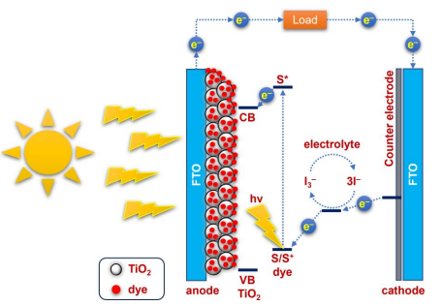
Figure 1. A schematic diagram of the operational principles of DSSC. CB and VB denote the conduction and valence band of the TiO₂, respectively. S/S⁺ signifies the ground and cationic state of the dye, and S* represents the excited state of the dye. FTO stands for fluorine-doped SnO₂.

Due to its excellent catalytic activity, platinum is the conventional and widely accepted choice for counter electrodes (CEs) in DSSCs [12]. Pt enables efficient electron transport at the counter electrode and supports the regeneration of oxidized dye molecules. Moreover, platinum effectively drives the reduction of oxidized species in the electrolyte due to its low overpotential for the reduction reaction. However, one of the drawbacks of using Pt as a counter electrode is its high cost, which limits the scalability and affordability of DSSCs. In addition, Pt can be degraded and oxidized by the liquid electrolyte, especially when the redox pair I⁻/I₃⁻ is used, leading to stability problems [13]. Recently, extensive efforts have been made to develop platinum-free counter electrodes. The ideal material should not only be inexpensive but also have excellent electrocatalytic activity in the reduction of triiodide and high stability in corrosive environments. Among the various materials studied, transition metal chalcogenides stand out due to their impressive electrocatalytic activity, chemical stability, and abundant availability [14-21]. However, compared to Pt-based solar cells, DSSCs with transition metal chalcogenides still lag behind in terms of power conversion efficiency (PCE). In this context, ternary transition metal chalcogenides prove to be a more promising route. They are characterized by the presence of two cations that cause charge delocalization through d-d overlap within the crystal lattice. This phenomenon enhances the electrocatalytic activity of the material [22,23]. Recent studies have investigated counter electrodes based on ternary transition metal chalcogenides for DSSCs and obtained remarkable results, such as CoSbS (5.38%, Pt: 5.54%) [24], NiCo₂S₄ (8.29%, Pt: 7.35%) [25], CuCo₂S₄ (7.56%, Pt: 7.42%) [17], Ni_{0.95}Mo_{0.05}S (7.15%, Pt: 7.20%) [26], and NiAl₂S₄ (5.02%, Pt: 5.38%) [27]. In 2019, Li and Jin et al. presented a ternary sulfide counter electrode based on Zn_{0.76}Co_{0.24}S for DSSCs, which achieved a PCE of 7.42% using a two-step preparation method [28].
In this study, we introduce a Zn_{0.76}Co_{0.24}S-based DSSC counter electrode, designated as ZCS-CE, synthesized via a cost-effective one-step solvothermal process. ZCS-CE exhibits comparable photovoltaic performance to Pt-based DSSCs. Unlike prior research [28], which employed a more complex and expensive two-step synthesis method, we propose an innovative approach to enhance the catalytic activity of Zn_{0.76}Co_{0.24}S through a streamlined one-step process, reducing production costs. We comprehensively investigate its electrochemical behavior and conduct a comparative evaluation of composite DSSCs utilizing platinum and ZCS-CE as counter electrodes. This analysis reveals the superior durability of solar cells equipped with ZCS-CE, while also highlighting the cost-saving benefits of the one-step synthesis. The outcomes of this study hold the potential to advance DSSC technology by offering a more sustainable, eco-friendly, and economically viable approach to harness solar energy. In the following sections, we will discuss the synthesis procedure, structural and morphological characterization, and electrochemical behavior of the Zn_{0.76}Co_{0.24}S electrocatalyst and present a performance evaluation of the ZCS-CE in DSSCs. These results open new opportunities for the development of low-cost, environmentally friendly, and high-performance solar cells and contribute to the global efforts to harness solar energy for a clean and sustainable future. In addition to our primary focus on developing efficient and cost-effective DSSCs, we are expanding our research to explore potential applications of DSSCs in photoelectrochromic devices (PECDs). PECDs are devices that can dynamically change their optical properties in response to external stimuli such as light or applied voltage. The integration of DSSCs into PECDs holds promise for the development of smart and energy-efficient solutions in a variety of areas, including smart windows, eyeglasses, and various applications where adjustable transparency or coloration is desired.

2. Materials and Methods
2.1. Materials
All chemical reagents and materials are from commercial sources and have been used without further modification unless otherwise noted.

2.2. Synthesis of ZCS-CE
A solution-based method was used to deposit a Zn_{0.76}Co_{0.24}S layer on a glass substrate coated with fluorine-doped tin oxide (FTO). Before depositing the ZCS-CE layer, the FTO substrates were thoroughly cleaned by washing with soapy water, deionized water, and acetone under ultrasonic conditions. To prepare the zinc-cobalt sulfide material by solvothermal synthesis, the following steps were performed: thiourea (0.5 mmol), Zn(NO₃)₂ × 6H₂O (0.125 mmol), and Co(NO₃)₂ × 6H₂O (0.250 mmol) were dissolved in 35 mL ethanol at room temperature for 30 min. This solution was then placed in a 50 mL stainless steel reactor with a Teflon liner, where the FTO glass substrate was attached to the wall with the conducting side down. The mixture was gradually heated at a rate of 5ºC per minute until it reached 200ºC, and this temperature was maintained for 4 h. After natural cooling to room temperature, the electrodes were repeatedly rinsed with deionized water and ethanol to remove unreacted compounds. They were then dried in a vacuum oven at 80ºC for 12 h. For comparison with the fabricated ZCS-CE, a control CE was also prepared by applying Pt paste (consisting of terpineol and hexachloroplatinic acid, Sigma-Aldrich, St. Louis, MO, USA) to a clean and dry FTO glass substrate and then annealing at 500ºC for 30 min.

2.3. Fabrication of Dye-Sensitized Solar Cells
Preparation of the photoanode began with cutting FTO glass (2.2 mm, surface resistivity 7 Ω/sq, Sigma-Aldrich) into pieces of 1.5 × 2.0 cm, washing in ethanol and acetone for 30 min each with ultrasound, and then drying under reduced pressure. A compact TiO₂ film was deposited by immersing the clean and dry FTO slides in a 50 mM titanium (IV) isopropoxide solution in 1 M aqueous HCl for 30 min and then sintering at 500ºC for the same time. The compact film was then coated with a transparent TiO₂ paste (DN-EP03, Dyenamo (Stockholm, Sweden), particle size: 18-20 nm) using a doctor blade technique. The film was air-dried for one hour before being sintered stepwise at 125ºC, 325ºC, 425ºC, and 500ºC. The transparent TiO₂ film was coated with a scattering TiO₂ film (Greatcell Solar WER2-O, Sigma-Aldrich, particle size: 150-250 nm) by doctor blading after cooling to 70ºC. The film was then air-dried for one hour before being sintered in the same manner as the transparent TiO₂ layer. The electrodes were then immersed in a solution of 0.25 mM dye N719 (Sigma-Aldrich) in a mixture of acetonitrile: tert-butanol (1:1) with 0.75 mM chenodeoxycholic acid (CDCA, Sigma-Aldrich) for 24 h. The dye-loaded electrodes were then carefully washed with ethanol before drying. Finally, the counter electrode was securely attached to the TiO₂ photoanode with double-sided tapes acting as spacers after dropping the iodide/triiodide redox electrolyte (DN-OD03 S104, Dyenamo) over it.

2.4. Deposition of Prussian Blue and Fabrication of Photoelectrochromic Device
After ultrasonic cleaning in a mixture of ethanol and acetone for 15 min, a glass substrate coated with FTO with a size of 0.5 × 1.5 cm² was used as a conductive substrate for the Prussian Blue (PB) electrochromic layer. This electrochromic layer was deposited on the FTO surface using the electrodeposition method according to a procedure adopted from the literature [29] with minor modifications. Specifically, the PB film was created using the chronoamperometry method with a deposition time of 5 s and a voltage of 0.4 V. A standard three-electrode configuration was used for this deposition process, with the FTO-coated glass, Ag/Ag⁺, and Pt wires serving as working, reference, and counter electrodes, respectively. The electrolyte solution consisted of 20 mM each of HNO₃, NaNO₃, Fe(NO₃)₃ × 9H₂O, and K₃[Fe(CN)₆] in a 30 mL electrodeposition bath. In the fabrication of the photoelectrochromic device, two prefabricated dye-sensitized solar cells were connected in series with a Pt wire. In addition, a PB-coated FTO substrate was immersed in an electrolyte solution. The anode (-) of the DSSCs was connected to the PB-coated FTO, while the ZCS-CE-based counter electrode (+) was connected to the Pt wire via an outer conductor. The electrolyte solution contained 0.1 M NaNO₃ and 0.1 M HNO₃. The performance of the photoelectrochromic device was investigated under sunlight irradiation (AM 1.5).

2.5. Characterization
An X-ray diffractometer (XRD, Rigaku SmartLab X-ray, Cedar Park, TX, USA) was used to determine the structural features of the synthesized materials. Energy dispersive X-ray spectroscopy and NEXSA Thermo Scientific (Waltham, MA, USA) X-ray photoelectron spectroscopy (XPS) were used to determine the material composition, while a Zeiss (Jena, Germany) Crossbeam 540 scanning electron microscope (SEM) was used to study the morphological properties. The photovoltaic evaluation was performed using the Dyenamo toolbox (DN-AE01). A Palmsens4 potentiostat was used for electrochemical experiments. The electrochemical impedance spectroscopy (EIS) of the DSSCs was performed in complete darkness with a bias voltage of -0.72 V, an amplitude of 10 mV, and a frequency range of 0.1-100,000 Hz. EIS was performed on the symmetrical dummy cells under the same conditions but with a bias voltage of 0 V. Cyclic voltammetry (CV) to evaluate the catalytic activity of the electrocatalysts was performed at a scan rate of 0.1 V/s using Ag/Ag⁺, a Pt wire, and the prepared materials (Pt and/or ZCS-CE films on FTO glass) with the working area of 2.25 cm² as the reference electrode, CE, and working electrode, respectively. LiI (10 mM), LiClO₄ (0.1 M), and I₂ (1 mM) solution in acetonitrile (50 mL) were the components of the electrolyte used for the CV test. A Thermo Scientific Evolution 300 UV-Vis spectrophotometer was used to study the optical performance of the electrochromic device (ECD). The experiment to evaluate the ECD was performed in a three-electrode system using Prussian Blue film on FTO glass as the working electrode, platinum wire as the counter electrode, and Ag/Ag⁺ as the reference electrode. Cycles were performed with an aqueous electrolyte of 0.1 M NaNO₃ and 0.1 M HNO₃ (30 mL) and within a potential range of -0.5 V to +1.0 V. The working area of the PB film was 0.5 cm² and the voltage scan rate was 20 mV/s.

3. Results and Discussion
3.1. Characterization of ZCS-CE
Ternary zinc-cobalt sulfide was synthesized using a solvothermal one-pot method, as shown in Figure 2. The precursors of the elements Zn, Co, and S were taken in suitable molar ratios and thoroughly dissolved by stirring and sonication. Heating the prepared solution at 200ºC for 4 h together with a glass FTO substrate in a Teflon-lined autoclave reactor resulted in the formation of a ZCS-CE film on the FTO.

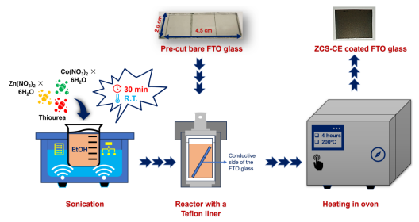
Figure 2. Schematic illustration of the one-pot synthesis of a Zn_{0.76}Co_{0.24}S
counter electrode on an FTO substrate.

The morphological characteristics of the ZCS-CE sample prepared on the FTO substrate were analyzed using scanning electron microscopy (see Figure 3). As shown in Figure 3a, the ZCS-CE has a predominantly spherical shape with diameters between 100 and 150 nm. The SEM image shows the presence of microspheres, each of which has a distinct nanoflock-like structure and forms a recognizable cluster on the surface. Figure 3b provides an insight into the thickness of the ZCS-CE layer on the FTO glass, which measures approximately 465 nm. This image shows a smooth, flat, and uniform growth of the ZCS-CE layer that is consistent along its entire length.

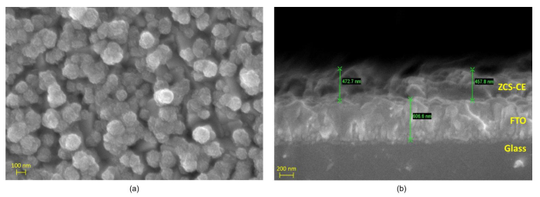
Figure 3. Scanning electron microscope images of the ZCS-CE: (a) top view and
(b) cross-sectional perspective.

The as-prepared ZCS-CE sample underwent thorough investigation by powder X-ray diffraction analysis to confirm its purity and crystal structure. In Figure 4a, the X-ray diffraction pattern of ZCS-CE shows characteristic peaks at 2θ-diffraction angles of 28.6º, 47.6º, and 56.4º corresponding to the (111)-, (220)-, and (311)-planes of the cubic phase of Zn_{0.76}Co_{0.24}S (JCPDS #47-1656) [30]. The pronounced sharpness of these peaks and the conspicuous absence of extraneous signals in the diffraction pattern are compelling evidence of the high crystallinity and impeccable purity of the ZCS-CE material. In particular, these results confirm the successful synthesis of ZCS-CE by a simple one-step solvothermal process. To validate the presence and uniform distribution of the constituent elements (Zn, Co, and S) on the FTO glass substrate, we employed energy dispersive spectroscopy (EDS), as depicted in Figure 4b. EDS is a powerful technique that not only identifies the elemental composition of materials but also provides spatial information about their distribution. The EDS analysis reaffirms the presence of all expected elements throughout the examined area, and equally crucially, it demonstrates their uniform dispersion. This uniformity is of paramount importance in various applications, notably in the development of semiconductor materials and photovoltaic devices. In these contexts, the consistency of element distribution significantly influences material performance and efficiency.
X-ray photoelectron spectroscopy was employed to investigate the chemical composition and oxidation states of the elements. In Figure 5a, the XPS spectrum reveals characteristic peaks corresponding to the elements Zn, Co, and S, all possessing a 2p electron configuration. These findings align with the results of energy dispersion X-ray spectroscopy. Notably, the presence of carbon and oxygen peaks can be attributed to the adsorption of CO₂ and moisture from ambient air on the sample’s surface. For a more in-depth examination of the chemical states, we turn to the high-resolution spectrum of Zn 2p (Figure 5b), in which two prominent peaks at 1022.3 eV and 1045.4 eV correspond to Zn 2p3/2 and Zn 2p1/2, respectively. These peaks confirm the 2+ oxidation state of zinc [31]. Similarly, the Co 2p emission spectrum in Figure 5c displays the coexistence of 2+ and 3+ oxidation states at the surface of the ZCS-CE sample. Here, two primary peaks at 781.2 eV (Co 2p3/2) and 797.3 eV (Co 2p1/2) are associated with Co²⁺, while two additional sharp peaks at 778.5 eV and 793.6 eV represent Co³⁺, confirming their distinct oxidation states. The presence of Co 2p satellite peaks at 785.6 eV and 803.9 eV supports these results [32]. The high-resolution S 2p spectrum, shown in Figure 5d, exhibits an asymmetric peak that can be divided into two distinct peaks at 161.6 eV and 162.8 eV, corresponding to S 2p3/2 and S 2p1/2, respectively. These peaks align with metal-sulfur bonds as described in the literature [33]. Additionally, a broad satellite peak at 169.6 eV suggests various forms of oxidized sulfur. Overall, the XPS analysis conclusively establishes the chemical composition of the ZCS-CE sample, including the Zn²⁺, Co²⁺, Co³⁺, and S²⁻ states, which agrees seamlessly with the XRD results.

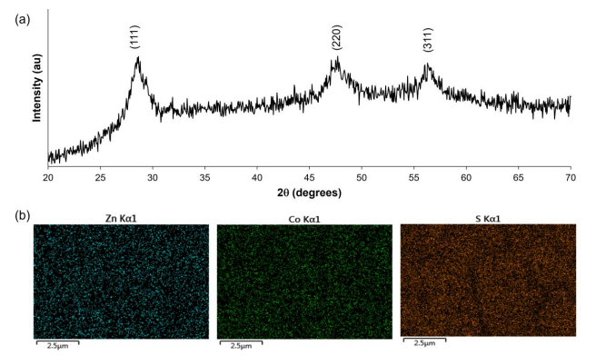
Figure 4. (a) XRD spectrum revealing crystallographic information and
(b) elemental mapping of Zn, Co, and S distribution of the of as-prepared ZCS.

3.2. Electrochemical Analysis of ZCS-CE
To evaluate the electrocatalytic performance of our fabricated ZCS-CE, cyclic voltammetry experiments were performed using a standard three-electrode configuration and a scan rate of 100 mV/s. As shown in Figure 6a, both the Pt and ZCS CEs show distinct anodic and cathodic peaks associated with two electron transfer processes involving iodide/triiodide redox reactions. These reactions can be described by Equations (1)-(4), which represent the oxidation and reduction of I₃⁻/I₂ and I⁻/I₃⁻ species at the electrode surface
Ox₁: 3I⁻ → I₃⁻ + 2ē (1)
Ox₂: 2I₃⁻ → 3I₂ + 2ē (2)
Red₁: I₃⁻ + 2ē → 3I⁻ (3)
Red₂: 3I₂ + 2ē → 2I₃⁻ (4)

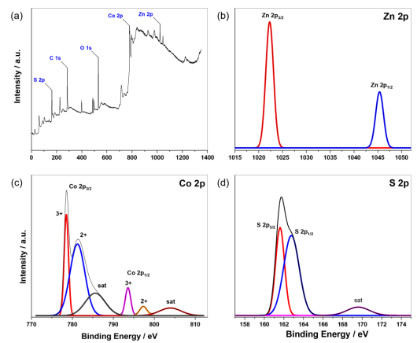
Figure 5. (a) XPS survey spectrum of the as-synthesized ZCS-CE. High-resolution XPS spectra of (b) Zn 2p, (c) Co 2p, and (d) S 2p.

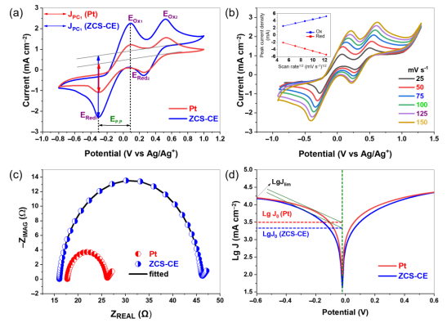
Figure 6. (a) Cyclic voltammograms of the counter electrodes; (b) cyclic voltammetry at various scan rates of ZCS-CE; (c) Nyquist plot of symmetrical dummy cells; and (d) Tafel plots of counter electrodes.

Usually, the electrocatalytic performance of CE materials is evaluated in terms of I₃⁻ reduction using two key parameters derived from the left pair of oxidation-reduction peaks (Ox₁/Red₁): the peak cathodic current density (J_{PC1}) and the peak-to-peak distance (Ep.p) between the Ox₁ and Red₁ peaks. Higher J_{PC} values and lower Ep.p values for the counter electrodes indicate lower overpotentials for the initiation of the I⁻/I₃⁻ redox reaction and higher reaction rates, respectively. In our study, the ZCS-CE outperforms its Pt counterpart by exhibiting higher peak cathodic current density. This result indicates that triiodide is reduced faster on the ZCS-CE surface, suggesting better overall electrocatalytic activity. Moreover, both the Pt and ZCS CEs exhibit the same Ep.p value (0.38 V), indicating their comparable abilities to initiate the I⁻/I₃⁻ redox reaction. Figure 6b shows the CV of ZCS-CE at different scan rates, with the redox peak signals becoming more intense at higher scan rates. The linear relationship between the current density of the redox peaks and the square root of the scan rate (Figure S1, Supporting Information) shows that the electrocatalyst and the redox electrolyte do not interact chemically. Instead, ion diffusion in particular facilitates the reduction of triiodide.
Electrochemical impedance spectroscopy was used to evaluate the electrocatalytic activity of the ZCS-CE in symmetrical dummy cells with a CE/electrolyte/CE configuration. The Nyquist plots for both the ZCS-CE and Pt were fitted using the electrical equivalent circuit based on the Randles model (see Figure S2 in the Supporting Information), resulting in well-defined semicircles, as presented in Figure 6c. The series resistance (Rs) of the electrodes, measured at 16.05 Ω for ZCS-CE and 17.72 Ω for Pt, marks the starting point of these semicircles in the Nyquist diagram. These results indicate excellent adhesion and contact behavior between the FTO substrate and the ZCS-CE electrocatalyst, with lower ohmic resistance compared to Pt. The semicircular region provides information about the charge transfer resistance (R_{CT}) at the interface between the electrocatalyst and the electrolyte. In general, a smaller R_{CT} value indicates higher catalytic activity in the reduction of I₃⁻/I⁻ during charge transfer. From the EIS-Nyquist plots, the R_{CT} values for the ZCS-CE and Pt catalysts are 14.97 Ω cm² and 4.18 Ω cm², respectively. These results highlight the increased internal resistance at the electrode-electrolyte interface and the reduced electrocatalytic reduction of triiodide ions by the ZCS-CE electrocatalyst compared to the reference electrode, which ultimately affects the performance of the DSSCs.
Tafel polarization curves were employed to evaluate the catalytic performance of the CE materials, as shown in Figure 6d. The Tafel polarization curve describes three distinct regions-the polarization region, the Tafel region, and the diffusion region-based on different voltage levels, from low to high. The polarization region is located in the lower potential region, the Tafel region is in the middle and plays a central role in controlling the electrocatalytic activity, while the diffusion region covers the rest of the curve and determines the diffusion behavior of the cathode ions. Two critical parameters, namely the limiting diffusion current (J_{lim}) and the exchange current density (J₀), can be derived from the Tafel profiles. These parameters are critical for evaluating the electrocatalytic performance of the CE. As shown in Figure 6d, the exchange current density within the Tafel region can be determined by identifying the intersection of the slope with the zero voltage. In addition, Equation (5) provides an alternative method for calculating J₀, as follows:
J₀ = RT/nFR_{CT} (5)
In this equation, R represents the universal gas constant, T represents the absolute temperature, n represents the number of electrons transferred during the redox process, F represents the Faraday constant, and R_{CT} is derived from the EIS experiment. In EIS measurements, high catalytic activity was observed at low R_{CT} values, which should translate into high J₀ values according to Equation (5). When we compared the ZCS-CE with the Pt, we found that both have a slope in the range of log J₀ = 3.30–3.50 mA/cm², which indicates comparable catalytic activity and is consistent with the results of EIS measurements. At the same time, the high value of J_{lim} indicates a fast ion diffusion rate within the electrocatalyst. Remarkably, both ZCS-CE and Pt have almost identical J_{lim} values on the panel curves, indicating that the I⁻ and I₃⁻ ions on the surfaces of both electrodes have similar diffusion rates, which affects the power conversion efficiency values of the dye-sensitized solar cells.

3.3. Photovoltaic Performance of ZCS-CE
The current-voltage (J-V) characteristics of the newly fabricated dye-sensitized solar cells with ZCS-CE and standard Pt counter electrodes were measured in order to evaluate and compare their photovoltaic performance (see Figure 7a). In Table 1, the resulting photovoltaic parameters are summarized, providing values for the open-circuit voltage (V_{OC}), short-circuit photocurrent density (J_{SC}), fill factor (FF), and power conversion efficiency.

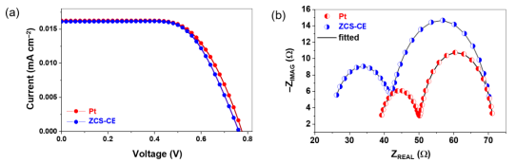
Figure 7. (a) Current-voltage curves and (b) Nyquist plot of DSSCs with Pt and ZCS CEs counter electrodes.

Table 1. Photovoltaic parameters and electrochemical impedance spectroscopy results of Pt- and ZCS-CE-based CEs.
CE | PCE (%) | V_{OC} (V) | J_{SC} (mA/cm²) | FF | R_{CT}  (Ω cm²) | R_{S}* (Ω) | R_{CT}*  (Ω) | RTiO₂ (Ω)
ZCS-CE | 7.94±0.02 | 0.760±0.00 | 16.12±0.07 | 0.65±0.00 | 14.97±0.38 | 24.32±0.77 | 17.63±0.31 | 29.23±0.29
Pt | 8.12±0.09 | 0.780±0.00 | 16.24±0.20 | 0.64±0.02 | 4.18±0.69 | 38.41±0.64 | 11.83±0.41 | 21.35±0.31

The DSSC with a Pt counter electrode showed remarkable photovoltaic performance with V_{OC}, J_{SC}, and FF values of 0.780 V, 16.24 mA/cm², and 0.64, respectively, resulting in a PCE of 8.12%. By contrast, the DSSC with the ZCS-CE counter electrode achieved slightly lower performance with V_{OC} = 0.760 V, J_{SC} = 16.12 mA/cm², and FF = 0.65, corresponding to an efficiency of 7.94%. Although the photovoltaic properties of the ternary sulfide-based counter electrode lag behind those of the Pt counter electrode, they remain remarkably comparable, with only 2.2% difference from the reference electrode but with a much lower production cost.
The superior catalytic activity of the Pt layer contributed significantly to the higher J_{SC} value observed for the prepared DSSC, which is consistent with our results from Tafel measurements. The lower open circuit voltage values measured for the DSSCs with the ZCS-CE counter electrode corresponded to a higher charge transfer resistance at the interface between the electrocatalyst and the electrolyte, which is consistent with our electrochemical impedance spectroscopy results from the symmetrical dummy cells. To properly account for the impact of ZCS-CE on the electrochemical performance of DSSCs, we performed EIS on a complete cell and fitted the plots shown in Figure 7b with the equivalent electrical circuit presented in Figure S3 (Supporting Information). The EIS analysis yielded critical electrochemical insights, including the charge transfer resistance (R_{CT}*) at the counter electrode-electrolyte interface (represented by a small semicircle on the EIS plot), the resistance at the TiO₂-dye-electrolyte interface (RTiO₂, a large semicircle), and the series resistance (R_{S}*, where the curve crosses the abscissa axis). These parameters are detailed in Table 1. The electrocatalytic activity is directly reflected by the size of the small semicircle, correlating with R_{CT}* at the counter electrode-electrolyte interface. Generally, a lower R_{CT}* value signifies heightened electrocatalytic activity in counter electrode materials for redox reactions within the electrolyte. When comparing the two counter electrodes, the Pt-based DSSC exhibited a lower R_{CT}* value at 11.83 Ω, while the solar cell employing the ZCS-CE counter electrode demonstrated a higher charge transfer resistance of 17.63 Ω, which is consistent with our previous results with the symmetrical dummy cells.
Additionally, we assessed the stability of DSSC devices fabricated with both ZCS-CE and Pt counter electrodes at room temperature. Photovoltaic parameters were periodically monitored for up to 200 h (Figure 8). The observed J_{SC}, V_{OC}, FF, and PCE values were recorded by averaging data from three devices. Notably, the stability of the Pt-based DSSC exhibited fluctuations within the first 100 h, peaking at a PCE value of 8.35% at the 75 h mark while maintaining a consistent efficiency of 8.11%. However, the power conversion efficiency for the Pt counter electrode began to decline after 100 h, eventually reaching 7.33% by the end of the stability test. This decline may be attributed to the deactivation of Pt’s catalytic properties upon extended exposure to the corrosive I₃⁻/I⁻ electrolyte. Conversely, DSSCs utilizing the ternary sulfide counter electrode displayed superior stability. Their PCE steadily increased during the initial 25 h, achieving its highest efficiency peak of 8.28% at both the 25 h and 75 h marks. At the conclusion of the experiment, the solar cell equipped with the ZCS-CE maintained an efficiency of 8.14%, surpassing the standard platinum analog’s performance by 10% over the same timeframe. Notably, this difference was primarily driven by the J_{SC} value, as the V_{OC} values for both Pt and ZCS CEs remained constant after 100 h, reaching a voltage plateau at 0.8 V. These stability test results underscore ZCS-CE as an ideal counter electrode material for dye-sensitive solar cells.

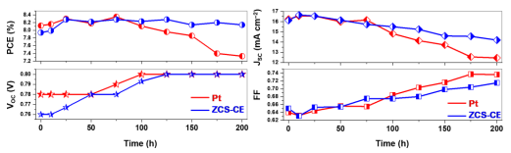
Figure 8. Photovoltaic stability of the different CEs used in DSSCs.

In a recent study by the research team of Li and Jin [28], Zn_{0.76}Co_{0.24}S was synthesized in a two-step process. This process first involved the hydrothermal synthesis of a transition metal oxide, ZnCo₂O₄, followed by its conversion to sulfide using thioacetamide as a sulfur source. By contrast, our one-step technique provides a leaner and more efficient route to the production of Zn_{0.76}Co_{0.24}S, which serves as a promising counter electrode material. Our approach has several notable advantages, especially in terms of photovoltaic conversion efficiency and open circuit voltage. Our solar cells based on Zn_{0.76}Co_{0.24}S achieved an efficiency of 7.94%, exceeding the 7.42% reported in the reference study. In addition, our cells exhibited a higher V_{OC} of 0.76 V compared to the 0.65 V, indicating the potential for improved efficiency and higher output voltage. However, it is worth noting that the reference showed better current generation, with a higher short-circuit current of 17.5 mA/cm² compared to our 16.12 mA/cm². This discrepancy can be attributed to differences in the size of the nanoparticles. Their particles had a diameter of about 500 nm, while our synthesis resulted in particles with a diameter of 100 to 150 nm. Unfortunately, their studies did not provide information on the thickness of their counter electrode or the concentration of the N719 dye used, which could also affect photovoltaic performance. Overall, our one-step approach not only improves the efficiency of Zn_{0.76}Co_{0.24}S synthesis but also provides a more cost-effective and easily scalable process for the fabrication of high-performance solar cells.

3.4. Fabrication and Characterization of Photoelectrochromic Device
To comprehensively evaluate the electrochemical properties of thin Prussian Blue films, cyclic voltammetry measurements were performed at a scan rate of 20 mV/s. A three-electrode system was used with a solution containing 0.1 M NaNO₃ and 0.1 M HNO₃. The potential range investigated was from -0.5 V to 1.0 V. Figure 9 illustrates the resulting cyclic voltammogram.
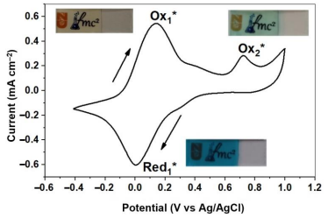
Figure 9. Electrochemical behavior of the Prussian Blue layer within the voltage range of -0.5 V to 1.0 V. The insets illustrate the visual color changes observed at various electrochemical states.

The voltammogram shows two detectable oxidation peaks and one reduction peak, indicating the presence of two relatively stable redox couples within the system as well as an additional oxidation process. Consistent with the chemical reactions described below, the observed redox peak in the -0.4-0.4 V range corresponds to the conversion of Prussian Blue to Prussian White (PW) [34]. This transformation is driven by the reduction of Fe³⁺ ions, accompanied by the intercalation of sodium ions:
Red₁∗: KFe^{III}[Fe^{II}(CN)₆] + Na⁺ + ē − → KNaFe^{II}[Fe^{II}(CN)₆] (6)

Conversely, the reverse oxidation process together with the deintercalation of sodium ions leads to coloration:
Ox₁∗: KNaFe^{II}[Fe^{II}(CN)₆] → KFe^{III}[Fe^{II}(CN)₆] + Na⁺ + ē (7)

The second oxidation peak at 0.72 V (145.24 μA) can be attributed to the partial oxidation of Fe²⁺ ions in PB:
Ox₂∗: KFe^{III}[Fe^{II}(CN)₆] → Fe^{III}[Fe^{III}(CN)₆] + K⁺ + ē (8)

The optical properties of the PB films were thoroughly investigated using transmittance spectroscopy, which covers a wide wavelength range from 300 to 800 nm. Figure 10 shows the transmittance spectra of PB in its original, bleached, and dyed states. From these spectra, we extracted critical data points, highlighting the maximum transmittance at 488 nm and the minimum at 726 nm. To comprehensively evaluate the performance of these coatings, we used key parameters such as electrochromic contrast (∆T), contrast ratio (CR), and optical density (∆OD), which were calculated according to Equations (9)-(11). These crucial parameters are briefly summarized in Table 2. This rigorous analysis provides a comprehensive understanding of the optical properties and performance of PB films.
∆T = T_{bleached} − T_{colored} (9)
CR = T_{bleached} / T_{colored} (10)
∆OD = log (CR) (11)

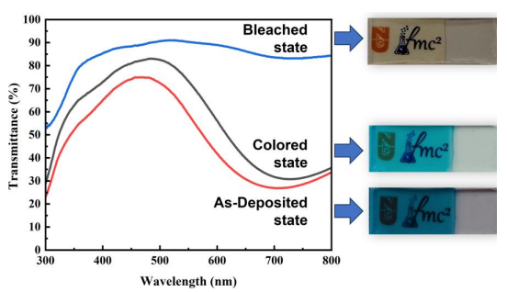
Figure 10. Transmittance spectra of Prussian Blue in its bleached, colored, and as-deposited states, accompanied by visual images corresponding to each state.

Table 2. Transmittance (T), electrochromic contrast (ΔT), contrast ratio (CR), and optical density (ΔOD) of Prussian Blue in three different states.

λ (nm) | T_{as-deposited} (%) | T_{colored} (%) | T_{bleached} (%) | ΔT (%) | CR | ΔOD
488 | 74.11 | 83.03 | 90.15 | 7.12 | 1.08 | 0.03
726 | 27.18 | 30.74 | 83.23 | 52.49 | 2.71 | 0.43

The parameters given vividly show the possibilities of optical modulation in the dye bleaching process. From Figure 10 and Table 2, it can be seen that the most significant transmittance shift of 52.49% and the highest ∆OD value of 0.43, which distinguish between the transparent and blue states, occur at a wavelength of 726 nm. Conversely, the lowest transmission shift of 7.12% and the lowest ∆OD value of 0.03, which distinguish between the bleached and colored states, are mainly observed at 488 nm.
Recently, there has been increased interest in the development of smart windows that can be optically controlled, especially as part of green building initiatives [35-37]. Smart windows have attracted attention because of several advantages they offer over conventional window systems. These include potential savings in air conditioning, heating, lighting, and curtain requirements. Among the various technologies being explored for smart windows, photoelectrochromic devices have emerged as a promising solution. PECD can combine the principles of a dye-sensitized solar cell and an electrochromic device, resulting in a robust and reliable approach. These devices feature the remarkable ability to reversibly change their coloration or transparency in response to external stimuli. At the same time, the DSSCs integrated into the PECD efficiently convert incident light into electrical energy. This combination of technologies holds significant potential for achieving dynamic control over various aspects of window functionality. These integrated systems can seamlessly regulate light transmission, tinting, and energy generation to help promote sustainable and energy-efficient building practices.
By using dye-sensitized solar cells as an energy source, we seamlessly integrated an electrochromic PB film into the design of a state-of-the-art photoelectrochromic device. The schematic diagram of our experimental electrochromic device is shown in Figure 11. In this configuration, we had two solar cells connected in series. The negative terminal of the DSSCs was connected to a PB-coated fluorine-doped tin oxide substrate, while the positive electrode was connected to another platinum (Pt)-coated FTO substrate via an outer conductor. The electrolyte solution used in this setup consisted of a 0.1 M NaNO₃ + 0.1 M HNO₃ mixture. Upon exposure to light, the electrochromic PB film transitioned from its initial state to a pale white state. This transition was reversible, and a short-circuit mechanism was used to return the electrochromic film to its original state, thereby restoring its coloration.
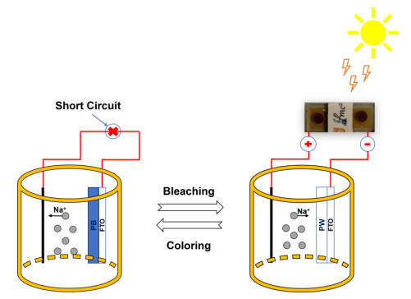
Figure 11. Schematic illustration of the photoelectrochromic device powered by dye-sensitized solar cells.

4. Conclusions
In summary, this study represents significant progress in the field of renewable energy and smart window technologies by synthesizing and characterizing Zn_{0.76}Co_{0.24}S, a ternary transition metal sulfide electrode prepared by a one-step solvothermal technique. When used as a counter electrode in dye-sensitized solar cells, ZCS-CE exhibits exceptional electrocatalytic activity with a competitive power conversion efficiency of 7.94%, making it a promising alternative to conventional platinum-based CEs. Comprehensive material analyses, including energy dispersive X-ray spectroscopy, X-ray photoelectron spectroscopy, X-ray diffraction, and scanning electron microscopy, confirmed the high crystallinity and purity of ZCS-CE and highlight its suitability for DSSC applications. In particular, ZCS-CE showed superior stability in electrolyte media and maintained its efficiency over 200 h of testing. Moreover, the integration of ZCS-CE into a photoelectrochromic device represents a novel, self-powered system that combines DSSC and electrochromic PB film technologies. This advancement holds great promise for smart window applications, enabling dynamic control of tint and transparency for sustainable and energy-efficient building design, shaping the future of renewable energy and architectural innovation.

Supplementary Materials: The following supporting information can be downloaded at: https://www.mdpi.com/article/10.3390/nano13202812/s1, Figure S1: Correlation between peak current density and scan rate for Zn_{0.76}Co_{0.24}S; Figure S2: Equivalent electrical circuit used for fitting Nyquist plots of symmetrical dummy cells; Figure S3: Equivalent electrical circuit used for fitting Nyquist plots of DSSCs; Figure S4: Scanning electron microscopy images of PB film deposited on FTO glass at different resolutions.
Author Contributions: Conceptualization, S.A., B.B. and M.P.B.; methodology, investigation, writing-original draft preparation, Y.T., D.S. and B.B.; software, Y.T. and M.P.B.; validation, B.B. and M.P.B.; resources, writing-review and editing, supervision, funding acquisition, S.A. and M.P.B.; project administration, S.A. All authors have read and agreed to the published version of the manuscript.
Funding: This research was funded by the Science Committee of the Ministry of Science and Higher Education of the Republic of Kazakhstan (Grant No. AP09259604, project PI-S.A.) and the Nazarbayev University under the Faculty Development Competitive Research Grants Program (Grant No. 20122022FD4122, M.P.B.).
Data Availability Statement: Data sharing not applicable.
Conflicts of Interest: The authors declare no conflict of interest.

References
1. O’Regan, B.; Grätzel, M. A low-cost, high-efficiency solar cell based on dye-sensitized colloidal TiO₂ films. Nature 1991, 353, 737-740. [CrossRef]
2. Noorasid, N.S.; Arith, F.; Mustafa, A.N.; Azam, M.A.; Mahalingam, S.; Chelvanathan, P.; Amin, N. Current advancement of flexible dye sensitized solar cell: A review. Optik 2022, 254, 168089. [CrossRef]
3. Błaszczyk, A.; Joachimiak-Lechman, K.; Sady, S.; Ta ´nski, T.; Szindler, M.; Drygała, A. Environmental performance of dye-sensitized solar cells based on natural dyes. Sol. Energy 2021, 215, 346-355. [CrossRef]
4. Ren, Y.; Zhang, D.; Suo, J.; Cao, Y.; Eickemeyer, F.T.; Vlachopoulos, N.; Zakeeruddin, S.M.; Hagfeldt, A.; Gratzel, M. Hydroxamic acid pre-adsorption raises the efficiency of cosensitized solar cells. Nature 2023, 613, 60-65. [CrossRef]
5. Michaels, H.; Rinderle, M.; Freitag, R.; Benesperi, I.; Edvinsson, T.; Socher, R.; Gagliardi, A.; Freitag, M. Dye-sensitized solar cells under ambient light powering machine learning: Towards autonomous smart sensors for the internet of things. Chem. Sci. 2020, 11, 2895-2906. [CrossRef]
6. Aslam, A.; Mehmood, U.; Arshad, M.H.; Ishfaq, A.; Zaheer, J.; Ul Haq Khan, A.; Sufyan, M. Dye-sensitized solar cells (DSSCs) as a potential photovoltaic technology for the self-powered internet of things (IoTs) applications. Sol. Energy 2020, 207, 874-892. [CrossRef]
7. Li, G.; Sheng, L.; Li, T.; Hu, J.; Li, P.; Wang, K. Engineering flexible dye-sensitized solar cells for portable electronics. Sol. Energy 2019, 177, 80-98. [CrossRef]
8. Shakeel Ahmad, M.; Pandey, A.K.; Abd Rahim, N. Advancements in the development of TiO₂ photoanodes and its fabrication methods for dye sensitized solar cell (DSSC) applications. A review. Renew. Sust. Energ. Rev. 2017, 77, 89-108. [CrossRef]
9. Najm, A.S.; Alwash, S.A.; Sulaiman, N.H.; Chowdhury, M.S.; Techato, K. N719 dye as a sensitizer for dye-sensitized solar cells (DSSCs): A review of its functions and certain rudimentary principles. Environ. Prog. Sustain. Energy 2022, 42, e13955. [CrossRef]
10. Boschloo, G.; Hagfeldt, A. Characteristics of the iodide/triiodide redox mediator in dye-sensitized solar cells. Acc. Chem. Res. 2009, 42, 1819-1826. [CrossRef] [PubMed]
11. Iftikhar, H.; Sonai, G.G.; Hashmi, S.G.; Nogueira, A.F.; Lund, P.D. Progress on electrolytes development in dye-sensitized solar cells. Materials 2019, 12, 1998. [CrossRef]
12. Ding, S.; Yang, C.; Yuan, J.; Li, H.; Yuan, X.; Li, M. An overview of the preparation and application of counter electrodes for DSSCs. RSC Adv. 2023, 13, 12309-12319. [CrossRef]
13. Olsen, E.; Hagen, G.; Eric Lindquist, S. Dissolution of platinum in methoxy propionitrile containing LiI/I₂. Sol. Energy Mater. Sol. Cells 2000, 63, 267-273. [CrossRef]
14. Huo, J.; Wu, J.; Zheng, M.; Tu, Y.; Lan, Z. Effect of ammonia on electrodeposition of cobalt sulfide and nickel sulfide counter electrodes for dye-sensitized solar cells. Electrochim. Acta 2015, 180, 574-580. [CrossRef]
15. Vikraman, D.; Patil, S.A.; Hussain, S.; Mengal, N.; Kim, H.-S.; Jeong, S.H.; Jung, J.; Kim, H.-S.; Park, H.J. Facile and cost-effective methodology to fabricate MoS₂ counter electrode for efficient dye-sensitized solar cells. Dyes Pigm. 2018, 151, 7-14. [CrossRef]
16. Liu, X.; Yue, G.; Zheng, H. A promising vanadium sulfide counter electrode for efficient dye-sensitized solar cells. RSC Adv. 2017, 7, 12474-12478. [CrossRef]
17. Baptayev, B.; Mustazheb, D.; Abilova, Z.; Balanay, M.P. Nanostructured flower-shaped CuCo₂S₄ as a Pt-free counter-electrode for dye-sensitized solar cells. Chem. Commun. 2020, 56, 12190-12193. [CrossRef] [PubMed]
18. Baptayev, B.; Tashenov, Y.; Adilov, S.; Balanay, M.P. Facile fabrication of ZnCo₂S₄@MWCNT as Pt-free counter electrode for high performance dye-sensitized solar cells. Surf. Interfaces 2023, 37, 102699. [CrossRef]
19. Baptayev, B.; Tashenov, Y.; Aliakbarova, A.; Adilov, S.; Balanay, M. Ternary NiCuS electrocatalyst for iodide/triiodide reduction in dye-sensitized solar cells. Mater. Today Proc. 2022, 71, 94-99. [CrossRef]
20. Baptayev, B.; Mustazheb, D.; Balanay, M.P. Binary transition metal sulfides as an economical Pt-free counter electrodes for dye-sensitized solar cells. Mater. Today Proc. 2020, 25, 24-27. [CrossRef]
21. Kharboot, L.H.; Fadil, N.A.; Bakar, T.A.A.; Najib, A.S.M.; Nordin, N.H.; Ghazali, H. A review of transition metal sulfides as counter electrodes for dye-sensitized and quantum dot-sensitized solar cells. Materials 2023, 16, 2881. [CrossRef]
22. Amin, B.G.; Swesi, A.T.; Masud, J.; Nath, M. CoNi₂Se₄ as an efficient bifunctional electrocatalyst for overall water splitting. Chem. Commun. 2017, 53, 5412-5415. [CrossRef] [PubMed]
23. Du, J.; Yu, A.; Zou, Z.; Xu, C. One-pot synthesis of iron-nickel-selenide nanorods for efficient and durable electrochemical oxygen evolution. Inorg. Chem. Front. 2018, 5, 814-818. [CrossRef]
24. John Peter, I.; Rajamanickam, N.; Ragavendran, V.; Mayandi, J.; Nithiananthi, P. M_{1−x}Sb_{1−y}S_{δ} (M = Ni, Cu, Co) ternary metal sulfides: Emerging candidates for I₃⁻ reduction in bifacial dye-sensitized solar cells. Mater. Sci. Eng. B 2023, 287, 116142. [CrossRef]
25. Li, L.; Zhang, X.; Fu, Y.; Han, X.; Wang, Y.; Zhang, Y.; Zhang, W.; Li, L. NiCo₂S₄ nanotube arrays grown in situ on Ni foam as a low-cost counter electrode for dye-sensitized solar cells. Sol. Energy 2021, 225, 297-304. [CrossRef]
26. Theerthagiri, J.; Senthil, R.A.; Buraidah, M.H.; Madhavan, J.; Arof, A.K.; Ashokkumar, M. One-step electrochemical deposition of Ni_{1−x}Mo_{x}S ternary sulfides as an efficient counter electrode for dye-sensitized solar cells. J. Mater. Chem. A 2016, 4, 16119-16127. [CrossRef]
27. Tamilarasan, S.; Sundararaj, S.B.; Bhojanaa, K.B.; Pandikumar, A.; Basha, S.J.S.; Thangavelu, S. Unraveling the enhanced electrochemical performances of nickel aluminum sulfide lattices for overall water splitting and as counter electrode materials for dye-sensitized solar cells. J. Phys. Chem. C 2023, 127, 11921-11931. [CrossRef]
28. Cui, Q.; Yang, Q.; Wang, W.; Yao, J.; Liu, Z.; Zuo, X.; Zhu, K.; Li, G.; Jin, S. Controllable synthesize core-shelled Zn_{0.76}Co_{0.24}S nanospheres as the counter-electrode in dye-sensitized solar cells and its enhanced electrocatalytic performance. J. Mater. Sci Mater. Electron. 2019, 31, 1797-1807. [CrossRef]
29. Isfahani, V.B.; Memarian, N.; Dizaji, H.R.; Arab, A.; Silva, M.M. The physical and electrochromic properties of Prussian Blue thin films electrodeposited on ITO electrodes. Electrochim. Acta 2019, 304, 282-291. [CrossRef]
30. Lin, Y.; Huang, J.; Shi, L.; Cong, G.; Zhu, C.; Xu, J. Combining Zn_{0.76}Co_{0.24}S with S-doped graphene as high-performance anode materials for lithium- and sodium-ion batteries. Nanotechnol. Rev. 2020, 9, 1227-1236. [CrossRef]
31. Yang, Y.; Huang, W.; Li, S.; Ci, L.; Si, P. Surfactant-dependent flower- and grass-like Zn_{0.76}Co_{0.24}S/Co₃S₄ for high-performance all-solid-state asymmetric supercapacitors. J. Mater. Chem. A 2018, 6, 22830-22839. [CrossRef]
32. Gao, X.; Chang, Q.; Hong, J.; Long, D.; Jin, G.; Xiao, X. Zinc Cobalt Sulfide Microspheres as a High-Performance Electrode Material for Supercapacitors. ChemistrySelect 2018, 3, 13751-13758. [CrossRef]
33. Mohamed, S.G.; Hussain, I.; Shim, J.J. One-step synthesis of hollow C-NiCo₂S₄ nanostructures for high-performance supercapacitor electrodes. Nanoscale 2018, 10, 6620-6628. [CrossRef]
34. Mortimer, R.J.; Reynolds, J.R. In situ colorimetric and composite coloration efficiency measurements for electrochromic Prussian blue. J. Mater. Chem. 2005, 15, 2226-2233. [CrossRef]
35. Liu, Z.; Yang, J.; Leftheriotis, G.; Huang, H.; Xia, Y.; Gan, Y.; Zhang, W.; Zhang, J. A solar-powered multifunctional and multimode electrochromic smart window based on WO3/Prussian blue complementary structure. Sustain. Mater. Technol. 2022, 31, e00372. [CrossRef]
36. Chang, C.-M.; Chiang, Y.-C.; Cheng, M.-H.; Lin, S.-H.; Jian, W.-B.; Chen, J.-T.; Cheng, Y.-J.; Ma, Y.-R.; Tsukagoshi, K. Fabrication of WO₃ electrochromic devices using electro-exploding wire techniques and spray coating. Sol. Energy Mater. Sol. Cells 2021, 223, 110960. [CrossRef]
37. Guo, X.; Xu, Z.; Huang, J.; Zhang, Y.; Liu, X.; Guo, W. Photoelectrochromic smart windows powered by flexible dye-sensitized solar cell using CuS mesh as counter electrode. Mater. Lett. 2019, 244, 92-95. [CrossRef]

Supplementary Information
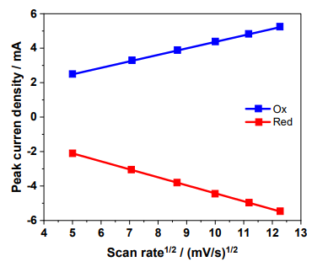
Figure S1. Correlation between Peak Current Density and Scan Rate for Zn_{0.76}Co_{0.24}S.
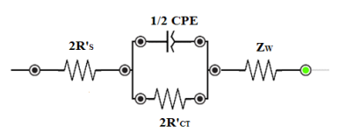
Figure S2. Equivalent electrical circuit used for fitting Nyquist plots of symmetrical dummy cells.
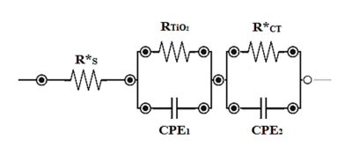
Figure S3. Equivalent electrical circuit used for fitting Nyquist plots of DSSCs.
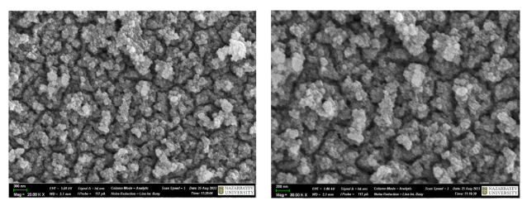
Figure S4. Scanning electron microscopy images of PB film deposited on FTO glass at different resolutions.

Article

Enhanced efficiency and stability of dye-sensitized solar cells utilizing FeCo₂S₄ nanowires as Pt-free counter electrodes

Diana Suleimenova^{a,b}, Yerbolat Tashenov^{b}, Bakhytzhan Baptayev^{a,c,*}, Mannix P. Balanay^{c,*}

ªNational Laboratory Astana, Nazarbayev University, 53 Kabanbay Batyr Ave., Astana 010000, Kazakhstan
^{b}Department of Chemistry, L.N. Gumilyov Eurasian National University, 2 Satpayev St., Astana 010008, Kazakhstan
^{c}Chemistry Department, Nazarbayev University, 53 Kabanbay Batyr Ave., Astana 010000, Kazakhstan

ABSTRACT
Replacing traditional Pt-based counter electrodes with low-cost and highly stable materials is crucial for the development of commercially viable dye-sensitized solar cells (DSSCs). In this study, we synthesized a ternary Pt-free FeCo₂S₄ nanowire (NW)-based sulfide electrocatalyst by a three-step solvothermal method. This material was then used as a counter electrode in DSSCs to facilitate the reduction of triiodide species. The formation of FeCo₂S₄ NW was confirmed by various characterization techniques such as X-ray diffraction, energy dispersive X-ray spectroscopy and X-ray photoelectron spectroscopy. Scanning electron microscopy analysis revealed the structure of the nanowires. Electrochemical studies, which included cyclic voltammetry, electrochemical impedance spectroscopy and Tafel polarization methods, revealed the excellent stability, superior electrocatalytic activity and remarkable kinetics of FeCo₂S₄ NW in the reduction of triiodide to iodide. Photovoltaic measurements of the fabricated DSSCs yielded a power conversion efficiency (PCE) of 7.88 % for the FeCo₂S₄- based devices, outperforming the control device made of Pt (PCE=7.45 %). This improvement was primarily due to the increase in short-circuit current density (J_{SC}), thanks to the lower charge transfer resistance (R_{CT}) of FeCo₂S₄ NW (J_{SC}=15.23 mA/cm²; R_{CT}=5.54 Ω cm²) compared to Pt (J_{SC}=14.12 mA/cm²; R_{CT}=7.07 Ω cm²). In addition, the FeCo₂S₄ NW-based solar cells exhibited excellent stability and maintained their high PCE value even after 10 days of aging under ambient conditions, while Pt-based DSSCs showed a 3 % decrease from their initial PCE value. This FeCo₂S₄ NW counter electrode proves to be an excellent alternative to Pt, and the presented results provide valuable insights for the development of cost-effective and highly stable DSSCs.

- Introduction
To tackle the climate crisis and feed a growing population, the world needs abundant, clean and cost-effective energy sources. Among these alternatives, solar energy is particularly promising. Photovoltaics offers a way to convert solar energy into electricity, with silicon-based solar cells being the most commonly used despite their high cost. Dye-sensitized solar cells (DSSCs) have proven to be a viable alternative. They attracted attention when they reached an efficiency of about 7 % in 1991 [1], and showing potential to generate electricity from solar energy at a much lower cost and with less toxicity than silicon- and perovskite-based photovoltaics. Recent advancements have pushed the efficiency of state-of-the-art DSSCs beyond 15 % under standard air mass 1.5 conditions [2] and up to 36 % at 1000 lx indoor light conditions [3]. However, despite these advancements, DSSCs have not yet been fully commercialized. To compete with silicon-based solar cells, further improvements in DSSC efficiency are necessary, along with ensuring economic feasibility and longevity. These improvements involve optimizing the DSSC photoanode [4-10], enhancing light-harvesting materials through dye design and co-sensitization [3,11-15], and utilizing other multielectron redox electrolytes [3,16,17]. Additionally, an alternative approach involves exploring novel counter electrodes (CEs) to replace conventional Pt-based CEs [18]. The use of platinum increases the cost of solar cells and its scarcity and high production cost hinder widespread adoption. Furthermore, Pt-based CEs are susceptible to degradation caused by iodine-based electrolytes, which undermines the stability of DSSCs [19]. To address these challenges, various materials with good electrocatalytic activity have been proposed as alternatives for CEs in DSSCs [20-27]. Multinary transition metal sulfides have garnered attention due to their abundance, excellent performance, and low cost. The presence of multiple metals can customize the electronic structure of the surface, facilitating charge transfer and improving electrical conductivity and electrocatalytic performance [28,29]. Consequently, multinary transition metal sulfides have been studied as potential CE materials for DSSCs and have shown outstanding electrocatalytic activity [30-35].
Motivated by these considerations, we have synthesized a ternary sulfide, FeCo₂S₄, as a CE for DSSCs using a simple solvothermal method in three stages. To our knowledge, only one study has utilized FeCo₂S₄ as Pt-free electrode, employing spherical particles with an average size of 300 nm, resulting in a power conversion efficiency (PCE) of 7.36 % [36]. In our approach, we synthesized FeCo₂S₄ nanowires (NW), offering distinct advantages over spherical particles for catalytic activity due to their high aspect ratio and large surface area-to-volume ratio. These characteristics provide more active sites for catalysis, facilitating faster and more efficient reduction reactions. Consequently, this can lead to improved charge transfer kinetics and overall cell performance. Electrochemical measurements demonstrate that FeCo₂S₄ NW exhibits better electrocatalytic activity for the I⁻/I₃⁻ redox reaction compared to platinum. Remarkably, DSSCs equipped with FeCo₂S₄ NW CEs achieved a higher PCE of 7.88 % compared to devices with conventional platinum CEs (PCE of 7.45 %). These results indicate that FeCo₂S₄ NW holds promise as a cost-effective and efficient alternative to platinum for DSSCs.

2. Experimental
2.1. Materials
Chemicals and materials were acquired from commercial sources and used as received, unless otherwise stated.

2.2. Synthesis of FeCo₂S₄ nanowires
FeCo₂S₄ NW were synthesized by a solvothermal method as presented in Fig. 1. First, a FeCo precursor was obtained: CoCl₂ • 6H₂O (0.12 mmol), FeCl₃ • 6H₂O (0.24 mmol), CO(NH₂)₂ (1.44 mmol) and NH₄F (0.72 mmol) were dissolved in 63 mL of DI water. After a clear solution was formed, ethylene glycol (34 mL) was added to the above mixture, which was then stirred continuously for 30 min. The solution was transferred to a Teflon-lined 100 mL reactor with a vertically positioned fluorine-doped SnO₂ (FTO) glass (2.2 mm thickness, surface resistivity 7 Ω/sq, Sigma-Aldrich). The reactor was sealed and the reaction was carried out at 120ºC for 12 h. Afterwards, the obtained thin film on FTO was washed with DI water and ethanol and then dried at 60ºC for 12 h in a vacuum oven. In the second step, FeCo₂O₄ was obtained by sintering FTO glasses coated with the FeCo precursor at 600ºC for 3 h. In the final step, FeCo₂O₄ was sulfurized to obtain FeCo₂S₄ by dissolving 33.3 mg of the sulfur powder in 35 mL of DI water in the presence of 1.67 mL of hydrazine monohydrate. The solution was then transferred to a Teflon-lined reactor together with FeCo₂O₄ on FTO and heated at 180ºC for 6 h. The sample was then washed with DI water and ethanol and dried in a vacuum oven at 70ºC for 12 h.

2.3. Fabrication of dye-sensitized solar cells
To prepare the working electrode (WE), FTO glass slides were initially cleaned with ethanol using sonication and then dried. A compact TiO₂ layer was subsequently grown on the cleaned FTO by immersing it in a 50 mM titanium (IV) isopropoxide solution in 2 M HCl at 70ºC for 30 min, followed by sintering at 500ºC for another 30 min. Next, a transparent TiO₂ paste (DN-EP03, Dyenamo, particle size: 18-20 nm) was applied onto the compact layer using a doctor blade technique, air dried for 30 min, and then subjected to stepwise sintering: 125ºC for 5 min, 325ºC for 10 min, 425ºC for 15 min, and finally 500ºC for 30 min. After cooling to 70ºC, a scattering TiO₂ layer (Greatcell Solar WER2-O, Sigma-Aldrich, particle size: 150-250 nm) was applied using the same doctor blading method. The film was air dried for 1 h, and the sintering process was repeated. The average film thickness of the 2 layers of the TiO₂ photoanode film is 24.7 µm (Figure S1, supporting information). Once the electrodes cooled to 70ºC, they were immersed in a solution containing 0.25 mM N719 (Sigma-Aldrich) and 0.75 mM chenodeoxycholic acid (CDCA, Sigma-Aldrich) dissolved in an acetonitrile:tert-butanol (1:1) mixture for 24 h. Subsequently, the dye-loaded electrodes were gently rinsed with ethanol and dried at 70ºC for 15 min. For the preparation of the Pt counter electrode (CE), Pt paste (terpineol and hexachloroplatinic acid, Sigma-Aldrich) was doctor bladed onto clean and dry FTO glass and then sintered at 500ºC for 30 min. The average film thickness of the Pt film is 200 nm, whereas for the FeCo₂S₄ NWs varies between 3.1 to 4.8 µm (Figures S2 and S3, respectively, supporting information). An MPN-based iodine/iodide redox electrolyte (DN-OD03 S104, Dyenamo) was then applied onto the dye-loaded TiO₂ WE electrode, and the CE was placed over it, using a double-sided tape separator to prevent short-circuiting.

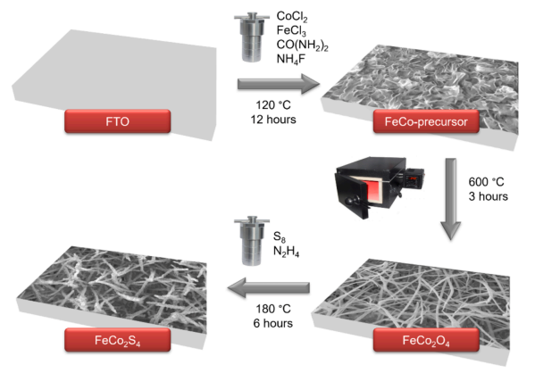
Fig. 1. Schematic illustration of the preparation of FeCo₂S₄ NW counter electrode.

2.4. Characterization
The product obtained was characterized using the Rigaku SmartLab system to generate X-ray diffraction (XRD) patterns. Electron microscopic images were acquired using a Zeiss Crossbeam 540 scanning electron microscope. Energy dispersive X-ray spectroscopy (EDX) and NEXSA Thermoscientific X-ray photoelectron spectroscopy (XPS) were used to determine the material composition. The photovoltaic measurements were carried out with the Dyenamo Toolbox (DN-AE01). For the analysis of the electrochemical impedance spectroscopy (EIS) of the solar cells, the measurements were performed in the dark with a bias voltage of - 0.72 V, an amplitude of 10 mV and a frequency range of 0.1 - 100000 Hz. In contrast, the EIS of symmetrical dummy cells was carried out under the same conditions, but with a bias voltage of 0 V. The cyclic voltammetry analysis was performed with Ag/Ag⁺ (non-aqueous) as reference electrode, Pt wire as counter electrode and FeCo₂S₄ on FTO as working electrode. The electrolyte consisted of a 0.1 M LiClO₄, 10 mM LiI, and 1 mM I₂ acetonitrile solution, with sampling at a rate of 0.05 V/ sec.

3. Results and discussion
3.1. Characterization of FeCo₂S₄ nanowire
The X-ray diffraction method was employed to characterize the synthesized material, with the results depicted in Fig. 2a. As there is no standard powder diffraction file available for FeCo₂S₄, we compared its pattern to that of Co₃S₄, assuming a substitution of one Co atom with a single Fe atom in the FeCo₂S₄ structure. In the XRD pattern, peaks at 30.9º, 35.7º, 47.2º, and 55.0º were attributed to the (311), (400), (511), and (440) lattice planes of spinel Co₃S₄ (JCPDS no. 42-1448). Notably, the XRD pattern of FeCo₂S₄ closely resembles that of Co₃S₄, with only slight shifts in peak positions. These shifts can be attributed to the change in chemical composition, as substituting one Co atom with one Fe atom alters the lattice parameters of Co₃S₄. To demonstrate the complete conversion from oxide to sulfide, we also presented the XRD pattern of FeCo₂O₄, with peaks at 18.9º, 31.2º, 36.7º, 44.7º, 55.6º, 59.2º and 65.0 corresponding to the planes of (111), (220), (311), (400), (422), (511), and (440), respectively, which can be indexed to the cubic spinel of FeCo₂O₄ (JCPDS no. 98–001-6669). The observed peak positions also align well with previously reported data on FeCo₂O₄ [37,38] and FeCo₂S₄ [39,40] structures, indicating a complete conversion without detectable impurities.
The X-ray photoelectron spectroscopy was used to analyze the elemental composition and valence states. The survey spectra of the FeCo₂O₄ and FeCo₂S₄ NWs is shown in Figure S4, which further supports the successful synthesis of the desired material. The high-resolution spectra for the Fe 2p, Co 2p, and S 2p of FeCo₂S₄ NW are presented in Fig. 2b to d. For peak deconvolution, the Tougaard background correction algorithm was used together with a Gaussian fitting method. Fig. 2b shows the characteristic Fe 2p spectra. The Fe 2p3/2 and Fe 2p1/2 peaks were fitted with a combination of Fe⁰, Fe²⁺, Fe³⁺ and satellite effects. The standard binding energies for the Fe²⁺ 2p1/2 and Fe³⁺ 2p1/2 contributions were determined to be 722.9 and 733.3 eV, respectively. Similarly, the Fe²⁺ 2p3/2 and Fe³⁺ 2p3/2 were positioned at 710.9 and 714.7 eV, respectively. Moreover, the Fe 2p3/2 peak at 707.1 eV corresponds to the Fe⁰ peak, which is consistent with the results of other researchers [41]. One plausible reason for the presence of Fe⁰ could be the existence of crystal defects, vacancies, or imperfections in the lattice structure which can create localized regions with reduced oxidation states. Since the percentage fitted peak area contained in fitting range for metallic iron (1.7 %) is much smaller than that of oxidised irons (50.9 % Fe²⁺ and 45.8 % Fe³⁺), it is apparent that only a small percentage of ionic Fe atoms are converted to metallic species. In Fig. 2c, the emission spectrum of Co 2p confirms the coexistence of the oxidized forms of Co²⁺ and Co³⁺ with a spin-orbital splitting of 15.0 eV between the Co 2p3/2 and Co 2p1/2 peaks. The peaks at 780.0 eV and 795.0 eV are attributed to Co²⁺, while the binding energies found at 778.4 eV and 793.5 eV correspond to Co³⁺. In addition, there are two broad spin-orbit doublings at 783.9 and 801.8 eV, which belong to satellite peaks [31,33,42]. In Fig. 2d, two distinct peaks are observed for sulfur at binding energies of 161.6 eV and 162.8 eV, which are assigned to S 2p3/2 and S 2p1/2, respectively. This indicates the presence of S²⁻ species in the prepared materials. The peak observed at 163.6 eV can be attributed to the bonding between the metal and sulfur atoms in the bimetallic sulfides [43]. Moreover, a satellite peak is observed at 168.3 eV.

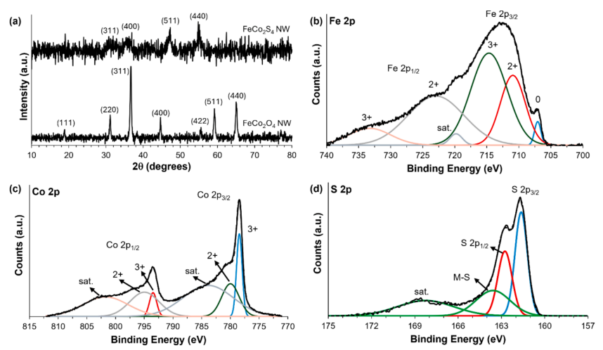
Fig. 2. (a) Comparative XRD pattern of FeCo₂O₄ and FeCo₂S₄ NWs. High-resolution XPS spectra of FeCo₂S₄ NW for (b) Fe 2p, (c) Co 2p, and (d) S 2p.

To obtain a comprehensive understanding of the morphology and structure of the deposited FeCo₂S₄ NW, we performed an analysis using scanning electron microscopy. In addition, SEM images of the FeCo₂O₄ NW were provided for comparison (Fig. 3a). The FeCo₂O₄ NWs show a dense network of smooth, interwoven fibers covering the surface of the FTO substrate with an average diameter of 92 ± 17 nm. The tips have a tapered shape. The conversion of FeCo₂O₄ to FeCo₂S₄ using hydrazine as a reducing agent and sulfur powder resulted in significant transformations. The smooth, interwoven fibers transformed into rough, nodule-like nanowires with an average diameter of 199 ± 26 nm (Fig. 3b). The observed increase in diameter could be due to the widening of the lattice parameter by the substitution of S²⁻ ions, which have larger ionic radii (184 pm) compared to O²⁻ ions (140 pm). Elemental analysis by energy dispersive X-ray spectroscopy confirms the homogeneous distribution of the elements Fe, Co, and S in the sample (Fig. 3c), confirming the formation of FeCo₂S₄ without impurities. 3.2. Electrochemical analysis of FeCo₂S₄ The electrochemical performance of the FeCo₂S₄ NW electrode was investigated by cyclic voltammetry, Tafel polarization, and electrochemical impedance spectroscopy. Cyclic voltammetry is a valuable method for evaluating the electrocatalytic activity of a catalyst in redox reactions and the kinetics of interfacial charge transfer processes. As shown in Fig. 4a, both the FeCo₂S₄ NW and Pt electrode voltammograms exhibit two reduction and two oxidation peaks corresponding to the iodide/triiodide redox process, which involves a two-electron transfer process, as shown in Equations (1) and (2):
I₃⁻ + 2ē ⟶3I⁻ (1)
3I⁻ ⟶I₃⁻ + 2ē (2)
Ep-p = |Ep anodic - Ep cathodic| (3)

The presence of these peaks on both the high and low potential sides indicate successful catalysis of the iodide/triiodide redox reactions by the FeCo₂S₄ NW electrocatalyst. Moreover, FeCo₂S₄ NW exhibits a higher peak cathodic current density (J_{red}) than the Pt electrocatalyst, indicating its superior electrocatalytic activity. Furthermore, the comparison of peak-to-peak separation (Ep-p, Equation (3) between FeCo₂S₄ NW and Pt counter electrodes shows that FeCo₂S₄ NW has a slightly higher Ep-p despite its better electrocatalytic activity (Ep-p of Pt is 389.8 mV, whereas for FeCo₂S₄ it is 449.8 mV), result in slower diffusion of I₃⁻ species which can affect the overall electron transfer kinetics. One possible reason is due to the presence of defects, edges, or specific crystal facets on the FeCo₂S₄ NW surface could contribute to the observed higher Ep-p while still maintaining superior electrocatalytic activity due to increased active sites. To evaluate the stability of the FeCo₂S₄ NW electrocatalyst in I⁻/I₃⁻ media, cyclic voltammetry analysis was performed at different scan rates (Fig. 4b). The increase of redox peak signals with scan rate indicates the chemical inertness of FeCo₂S₄ NW in I⁻/I₃⁻ media and implies the dependence of triiodide reduction on ion diffusion.

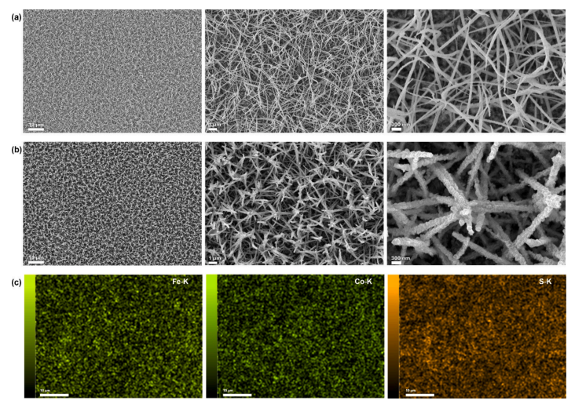
Fig. 3. SEM micrographs at three different magnifications of (a) FeCo₂O₄ NW and (b) FeCo₂S₄ NW. (c) EDX elemental mapping images of FeCo₂S₄ NW.

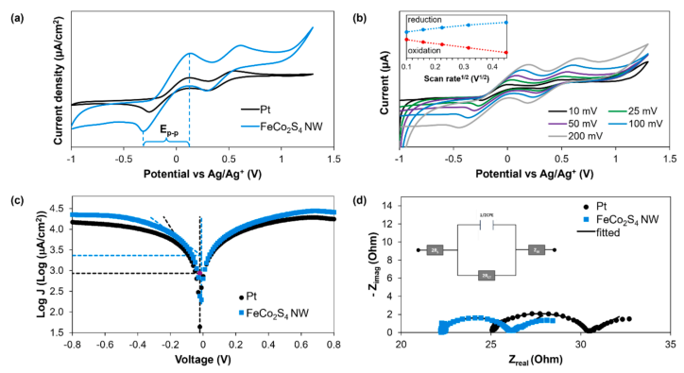
Fig. 4. (a) cyclic voltammograms of the counter electrodes, the scan rate is 50 mV/s; (b) scan rate dependence of cyclic voltammogram of FeCo₂S₄; and (c) Tafel polarization curves of Pt and FeCo₂S₄ CEs; (d) Nyquist plot of symmetrical dummy cells (inset is the equivalent electrical circuit used for fitting of Nyquist plots.

The electrocatalytic activity of the counter electrodes was further examined using the Tafel polarization method in symmetrical dummy cells. Two identical electrodes, each with a 1 cm² active surface area, were positioned facing each other and separated by double-sided Scotch tape. The Tafel polarization curves obtained from these cells (Fig. 4c) facilitated the determination of the exchange current density (J₀), which is identified at the intersection of the linear cathodic branch (βc) and the equilibrium potential lines (E₀) of the polarization curves [44]. Our results show that FeCo₂S₄ has a larger cathodic Tafel slope (338 mV/ decade) compared to Pt, which has a slope of 161 mV/decade. This difference results in a higher J₀ value in FeCo₂S₄ NW in contrast to the reference (J₀ (Pt) = 0.86 mA/cm²; J₀ (FeCo₂S₄ NW) = 2.31 mA/cm²). This difference indicates that the associated CE works better electrocatalytically because more electrons pass through the interface between the CE and the electrolyte [45].
J₀ is inversely proportional to the charge transfer resistance (R_{CT}), as described in Equation (4):
J₀ = RT/nFR_{CT} (4)

where R is universal gas constant, T is absolute temperature, n is number of electrons, and F is Faraday constant. Therefore, the higher J₀ of FeCo₂S₄ implies a lower R_{CT}, expressing the superior electrocatalytic activity of the ternary sulfide counter electrode over the Pt-CE. This trend continues in the further electrochemical analysis of the dummy cells (Fig. 4d). Nyquist diagrams of the dummy cells show the electron transfer process at the interface between the counter electrode and the electrolyte. The diagram shows a semicircle whose intersection with the x-axis indicates the series resistance R_{S} between the FTO substrate and the electrocatalyst. The semicircle represents the charge transfer resistance at the interface between the electrocatalyst and the electrolyte. A smaller semicircle at a lower frequency indicates the diffusion resistance Z_{W} of the electrolyte. The R_{CT} is significantly lower for FeCo₂S₄ compared to Pt: 1.89 Ohm cm² compared to 2.66 Ohm cm². Therefore, the electrochemical analysis further confirms the superior electrocatalytic activity of FeCo₂S₄ compared to Pt.

3.3. Photovoltaic performance FeCo₂S₄
Dye-sensitized solar cells were constructed using FeCo₂S₄ nanowires grown on an FTO substrate as a counter electrode. In addition, DSSCs were fabricated using a Pt-based CE as a control. The performance of these solar cells was investigated under light conditions of about 100 mW/cm² to determine their photovoltaic properties. The electrochemical parameters were derived from the results of electrochemical impedance spectroscopy and are shown in Table 1 and Fig. 5. It is noteworthy that the DSSC with FeCo₂S₄ NW exhibits a remarkable power conversion efficiency of 7.88 %, slightly exceeding the efficiency of the Pt-based control device at 7.45 % (Fig. 5a). A comparison shows that the Pt-based DSSC had higher values for V_{OC} and FF than the FeCo₂S₄ NW counterpart. This discrepancy suggests that the higher PCE of FeCo₂S₄ is mainly due to an increase in J_{SC}. Analysis of the cyclic voltammetry data indicates a higher rate of triiodide reduction on the FeCo₂S₄ NW-CE compared to the Pt-CE. This accelerated reduction facilitates the formation of iodide species and accelerates the dye regeneration process. The Tafel curve analysis confirms this phenomenon, with the exchange current density for FeCo₂S₄ being greater than that of Pt. Therefore, the superior electrocatalytic activity of ternary sulfide over Pt explains the enhanced J_{SC} observed in FeCo₂S₄-based solar cells. Furthermore, the parameters derived from the Nyquist plot analysis support this conclusion (Fig. 5b). The plot consists of two semicircles, with the smaller one representing the charge transfer resistance at the CE/electrolyte interface (Rʹ_{CT}) and the larger semicircle representing the charge transfer resistance at the TiO₂/dye/electrolyte interface (RTiO₂). The intersection with the x-axis corresponds to the series resistance (R_{S}), which includes the internal resistances such as those of the TCO substrate and the electrocatalyst/TCO layer. It is noteworthy that the Rʹ_{CT} values indicate a significantly higher electron flow at the FeCo₂S₄ CE/ electrolyte interface compared to the Pt CE/electrolyte interface. This finding supports the superior electrocatalytic activity of FeCo₂S₄ nanowires over Pt and thus explains the improved performance of DSSCs utilizing FeCo₂S₄.

Table 1. Photovoltaic parameters of the DSSCs with FeCo₂S₄ and Pt counter electrodes.
DSSCs | PCE (%) | V_{OC} (V) | J_{SC} (mA/cm²) | FF | R_{CT} (Ω˟cm²) | R_{S} (Ω) | Rʹ_{CT} (Ω) | RTiO₂ (Ω)
FeCo₂S₄ | 7.88±0.23 | 0.75±0.01 | 15.23±0.24 | 0.69±0.03 | 1.89 | 26.9 | 12.9 | 85.5
Pt | 7.45±0.24 | 0.77±0.01 | 14.12±1.17 | 0.69±0.04 | 2.66 | 28.1 | 13.4 | 103.8

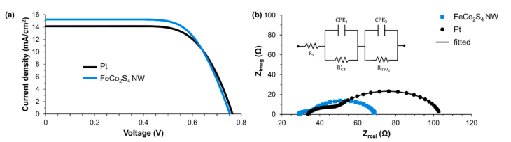
Fig. 5. (a) J-V curves and (b) Nyquist plot (inset is the equivalent electrical circuit used for fitting of Nyquist plots of the Pt- and FeCo₂S₄ NW-based DSSCs.

The low charge transfer resistance at the FeCo₂S₄/electrolyte interface improves electrolyte reduction at the counter electrode surface, facilitating fast electron transport from the FeCo₂S₄ surface to the electrolyte. This process increases the concentration of iodide species, thereby accelerating the dye regeneration process and generating a higher J_{SC} [46]. This phenomenon explains the improved J_{SC} in FeCo₂S₄- based DSSCs. Conversely, a high concentration of injected electrons on TiO₂ increases the rate of the recombination process. The lower charge transfer resistance at the TiO₂/dye/electrolyte interface (RTiO₂) of the FeCo₂S₄ device clearly indicates this effect.
The photovoltaic performance of dye-sensitized solar cells based on Pt and FeCo₂S₄ nanowires was monitored for over ten days to evaluate their stability (Fig. 6). DSSCs using FeCo₂S₄ NW demonstrated remarkable stability in power conversion efficiency, short-circuit current density, and fill factor even after ten days. In contrast, Pt-based solar cells showed a significant decline in PCE and J_{SC} over the same period. The stable J_{SC} of FeCo₂S₄ NW indicates its excellent performance in catalyzing triiodide-iodide reduction, unlike Pt, which showed a notable decrease in J_{SC} during testing. Interestingly, Pt-based DSSCs exhibited stable or slightly improved V_{OC}, whereas FeCo₂S₄ NW-based devices showed a slight decrease in V_{OC} after ten days, possibly due to increased recombination processes. The low charge transfer resistance of FeCo₂S₄ NW at the TiO₂/dye/electrolyte interface suggests increased electron backflow, which could contribute to the V_{OC} decrease in FeCo₂S₄ NW devices after ten days. Considering all the photovoltaic parameters, the FeCo₂S₄ nanowires emerge as a promising alternative to platinum, offering a more stable and cost-effective counter electrode material for DSSCs.

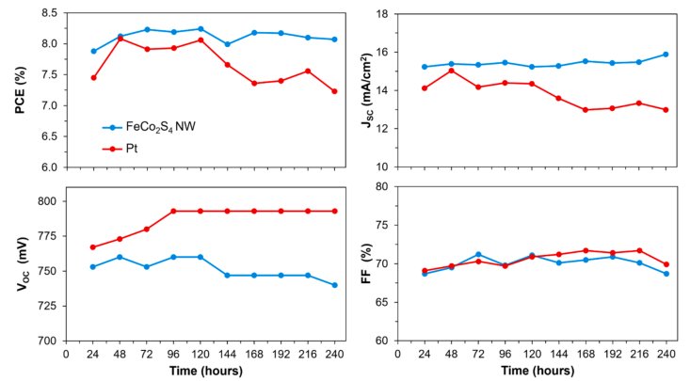
Fig. 6. Stability curves of the photovoltaic parameters of Pt- and FeCo₂S₄ NW-based DSSCs.

4. Conclusions
In conclusion, FeCo₂S₄ nanowires were successfully synthesized by a three-step solvothermal method, and their excellent electrocatalytic activity, fast redox kinetics, and high stability were demonstrated. The nanowires were used as a counter electrode in dye-sensitized solar cells, resulting in a power conversion efficiency (PCE) of 7.88 %, outperforming a control device made of Pt (PCE=7.45 %). The improvement was primarily due to the increase in short-circuit current density, thanks to the lower charge transfer resistance of FeCo₂S₄ NW. The FeCo₂S₄ NW-based solar cells exhibited excellent stability and maintained their high PCE value even after 10 days of aging under ambient conditions, while Pt-based DSSCs showed a 3 % decrease from their initial PCE value. This FeCo₂S₄ NW counter electrode is a promising alternative to Pt, providing valuable insights for the development of cost-effective and highly stable DSSCs.

CRediT authorship contribution statement
Diana Suleimenova: Software, Resources, Methodology, Formal analysis, Data curation, Conceptualization. Yerbolat Tashenov: Methodology, Formal analysis, Data curation. Bakhytzhan Baptayev: Writing - original draft, Supervision, Resources, Project administration, Methodology, Funding acquisition, Formal analysis, Conceptualization. Mannix P. Balanay: Writing – review & editing, Validation, Supervision, Resources, Project administration, Methodology, Investigation, Funding acquisition, Formal analysis, Conceptualization.

Appendix A. Supplementary material
Supplementary data to this article can be found online at https://doi. org/10.1016/j.jphotochem.2024.115908

References
[1] B. O’Regan, M. Gratzel, ¨A low-cost, high-efficiency solar cell based on dye-sensitized colloidal TiO₂ films, Nature 353 (1991) 737-740, https://doi.org/ 10.1038/353737a0.
[2] Y. Ren, D. Zhang, J. Suo, Y. Cao, F.T. Eickemeyer, N. Vlachopoulos, S. M. Zakeeruddin, A. Hagfeldt, M. Gratzel, Hydroxamic acid pre-adsorption raises the efficiency of cosensitized solar cells, Nature 613 (2023) 60-65, https://doi.org/ 10.1038/s41586-022-05460-z.
[3] S.M. Meethal, S.C. Pradhan, J. Velore, S. Varughese, R.S. Pillai, F. Sauvage, A. Hagfeldt, S. Soman, Asymmetric dual species copper(II/I) electrolyte dye-sensitized solar cells with 35.6% efficiency under indoor light, J. Mater. Chem. A 12 (2024) 1081-1093, https://doi.org/10.1039/D3TA06046B.
[4] H. Asgari Moghaddam, S. Jafari, M.R. Mohammadi, Enhanced efficiency of over 10% in dye-sensitized solar cells through C and N single- and co-doped TiO₂ single layer electrodes, New J. Chem. 41 (2017) 9453-9460, https://doi.org/10.1039/ C7NJ01535F.
[5] S. Zhang, F. Huang, X. Guo, Y. Xiong, Y. Huang, H. Ågren, L. Wang, J. Zhang, Boosting the efficiency of dye-sensitized solar cells by a multifunctional composite photoanode to 14.13 %, Angew. Chem. Int. Ed. 62 (2023) e202302753, https:// doi.org/10.1002/anie.202302753.
[6] S.E. Kervee, M.R. Mohammadi, Dye-sensitized solar cells based on TiO₂ particulate gels: Impact of gel formation mechanism on photovoltaic performance, J. Photochem. Photobiol. A 338 (2017) 104-114, https://doi.org/10.1016/j. jphotochem.2017.02.006.
[7] H.M. Ghartavol, M.R. Mohammadi, A. Afshar, Y. Li, On the assessment of incorporation of CNT-TiO₂ core-shell structures into nanoparticle TiO₂ photoanodes in dye-sensitized solar cells, Photochem. Photobiol. Sci. 18 (2019) 1840-1850, https://doi.org/10.1039/c9 pp00100j.
[8] B. Baptayev, S. Adilov, M.P. Balanay, Surface modification of TiO₂ photoanodes with In³⁺ using a simple soaking technique for enhancing the efficiency of dye-sensitized solar cells, J. Photochem. Photobiol. A 394 (2020) 112468, https://doi. org/10.1016/j.jphotochem.2020.112468.
[9] B. Aljafari, S. James, A. Sorrentino, S. Anandan, Nanostructured g-C₃N₄-decorated TiO₂ for superior photoanode performance in dye-sensitized solar cells, Inorg. Chem. Commun. 159 (2024) 111737, https://doi.org/10.1016/j. inoche.2023.111737.
[10] E. Nouri, M.R. Mohammadi, P. Lianos, Impact of preparation method of TiO₂-RGO nanocomposite photoanodes on the performance of dye-sensitized solar cells, Electrochim. Acta 219 (2016) 38-48, https://doi.org/10.1016/j. electacta.2016.09.150.
[11] B. Baptayev, S.-M. Kim, B. Bolatbek, S.H. Lee, M.P. Balanay, The effect of coupling and di-anchoring group in the performance of triphenylamine-based dyes for dye-sensitized solar cells, Dyes Pigm. 198 (2022) 110020, https://doi.org/10.1016/j. dyepig.2021.110020.
[12] X. Xie, Y. Zhang, Y. Ren, L. He, Y. Yuan, J. Zhang, P. Wang, Semitransparent dye-sensitized solar cell with 11% efficiency and photothermal stability, J. Phys. Chem. C 126 (2022) 11007-11015, https://doi.org/10.1021/acs.jpcc.2c03162.
[13] T. Kheshti, F. Shojaei, A. Mohajeri, BODIPY-based macrostructures: A design strategy toward enhancing the efficiency of dye-sensitized solar cells, J. Phys. Chem. A 128 (2024) 3751-3763, https://doi.org/10.1021/acs.jpca.3c06743.
[14] G.Z. Wubie, M.-N. Lu, M.A. Desta, H.D. Weldekirstos, M.M. Lee, W.-T. Wu, S.-R. Li, T.-C. Wei, S.-S. Sun, Metal-free organic dyes with double auxiliary acceptors for high-performance dye-sensitized solar cells, Solar RRL 8 (2024) 2300913, https:// doi.org/10.1002/solr.202300913.
[15] B. Baptayev, S.-M. Kim, B. Bolatbek, S.H. Lee, M.P. Balanay, Effect of π-spacer length in novel xanthene-linked L-(D-π-A)2-type dianchoring dyes for dye-sensitized solar cells, ACS Appl. Energy Mater. 5 (2022) 6764-6771, https://doi. org/10.1021/acsaem.2c00384.
[16] R. Kaur, N. Dalpati, J.H. Delcamp, B.H. Farnum, Nickel-based two-electron redox shuttle for dye-sensitized solar cells in low light applications, ACS Appl. Energy Mater. 7 (2024) 3645-3655, https://doi.org/10.1021/acsaem.3c03198.
[17] Masud, Y.S. Kim, H.K. Kim, Quasi-solid-state dye-sensitized solar cells by mechanically stable semi-interpenetrating network polymer gel electrolytes for indoor applications, ACS Appl. Energy Mater., 7 (2024) 5226-5234. 10.1021/ acsaem.4c00717.
[18] M.S. Bezabih, Nanocomposite counter-electrode materials for dye-sensitized solar cells: A review, Energy Technol. 12 (2024) 2300709, https://doi.org/10.1002/ ente.202300709.
[19] E. Olsen, G. Hagen, S. Eric Lindquist, Dissolution of platinum in methoxy propionitrile containing LiI/I₂, Sol. Energy Mater. Sol. Cells 63 (2000) 267-273, https://doi.org/10.1016/S0927-0248(00)00033-7.
[20] N. Shahzad, T. Lutfullah, D. Perveen, S. Pugliese, N. Haq, S.M. Fatima, A. Salman, M.I.S. Tagliaferro, Counter electrode materials based on carbon nanotubes for dye-sensitized solar cells, Renew. Sust. Energ. Rev. 159 (2022) 109087, https://doi. org/10.1016/j.rser.2022.112196.
[21] A.R. Tapa, W. Xiang, X. Zhao, Metal Chalcogenides (MxEy; E = S, Se, and Te) as counter electrodes for dye-sensitized solar cells: An overview and guidelines, Adv. Energy Sustainability Res. 2 (2021) 2100056, https://doi.org/10.1002/ aesr.202100056.
[22] G. Dwivedi, G. Munjal, A.N. Bhaskarwar, A. Chaudhary, Dye-sensitized solar cells with polyaniline: A review, Inorg. Chem. Commun. 135 (2022) 109087, https:// doi.org/10.1016/j.inoche.2021.109087.
[23] A. Yildiz, T. Chouki, A. Atli, M. Harb, S.W. Verbruggen, R. Ninakanti, S. Emin, Efficient iron phosphide catalyst as a counter electrode in dye-sensitized solar cells, ACS Appl. Energy Mater. 4 (2021) 10618-10626, https://doi.org/10.1021/ acsaem.1c01628.
[24] S. Gnanasekar, P. Kollu, S.K. Jeong, A.N. Grace, Pt-free, low-cost and efficient counter electrode with carbon wrapped VO₂(M) nanofiber for dye-sensitized solar cells, Sci. Rep. 9 (2019) 5177, https://doi.org/10.1038/s41598-019-41693-1.
[25] S. Mohammadnejad, M.R. Mohammadi, H.M. Ghartavol, M. Askari, Lithium-functionalized graphene oxide with a low load of Pt as an efficient counter electrode for dye-sensitized solar cells, J. Appl. Electrochem. 54 (2024) 275-287, https://doi.org/10.1007/s10800-023-01967-z.
[26] J. Wu, Z. Lan, J. Lin, M. Huang, Y. Huang, L. Fan, G. Luo, Y. Lin, Y. Xie, Y. Wei, Counter electrodes in dye-sensitized solar cells, Chem. Soc. Rev. 46 (2017) 5975-6023, https://doi.org/10.1039/C6CS00752J.
[27] P.A. Mithari, A.C. Mendhe, S.R. Patrikar, C.D. Lokhande, B.R. Sankapal, Bi₂S₃ nanoparticles anchored MWCNTs towards core-shell architecture: Counter electrode for dye-sensitized solar cell, Appl. Surf. Sci. Adv. 18 (2023) 100485, https://doi.org/10.1016/j.apsadv.2023.100485.
[28] Y. Du, G. Cheng, W. Luo, Colloidal synthesis of urchin-like Fe doped NiSe₂ for efficient oxygen evolution, Nanoscale 9 (2017) 6821-6825, https://doi.org/ 10.1039/C7NR01413A.
[29] J. Du, A. Yu, Z. Zou, C. Xu, One-pot synthesis of iron-nickel-selenide nanorods for efficient and durable electrochemical oxygen evolution, Inorg. Chem. Front. 5 (2018) 814-818, https://doi.org/10.1039/C7QI00792B.
[30] I. John Peter, N. Rajamanickam, V. Ragavendran, J. Mayandi, P. Nithiananthi, M_{1-x}Sb_{1-y}S_{δ} (M = Ni, Cu, Co) ternary metal sulfides: Emerging candidates for I₃⁻ reduction in bifacial dye-sensitized solar cells, Mater. Sci. Eng., B 287 (2023) 116142, https://doi.org/10.1016/j.mseb.2022.116142.
[31] B. Baptayev, D. Mustazheb, Z. Abilova, M.P. Balanay, Nanostructured flower-shaped CuCo₂S₄ as a Pt-free counter-electrode for dye-sensitized solar cells, Chem. Commun. 56 (2020) 12190-12193, https://doi.org/10.1039/D0CC04211K.
[32] M.H. Samat, M.F.M. Taib, O.H. Hassan, M.Z.A. Yahya, A.M.M. Ali, First-principles study on XV₂S₄ (X = Ni, Cr, and Mo) counter electrode for dye-sensitized solar cells, Emerg. Mater. 3 (2020) 125-131, https://doi.org/10.1007/s42247-020- 00089-y.
[33] B. Baptayev, Y. Tashenov, S. Adilov, M.P. Balanay, Facile fabrication of ZnCo₂S₄@MWCNT as Pt-free counter electrode for high performance dye-sensitized solar cells, Surf. Interfaces 37 (2023) 102699, https://doi.org/10.1016/j. surfin.2023.102699.
[34] E. Meyer, A. Bede, N. Zingwe, R. Taziwa, Metal sulphides and their carbon supported composites as platinum-free counter electrodes in dye-sensitized solar cells: A review, Materials 12 (2019) 1980, https://doi.org/10.3390/ma12121980.
[35] Y. Tashenov, D. Suleimenova, B. Baptayev, S. Adilov, M.P. Balanay, Efficient one-step synthesis of a Pt-free Zn_{0.76}Co_{0.24}S counter electrode for dye-sensitized solar cells and its versatile application in photoelectrochromic devices, Nanomaterials 13 (2023) 2812.
[36] X. Zhang, P. Chen, F. Yang, L. Wang, J. Yin, J. Ding, F. Huang, Y. Wang, Effect of FeCo₂S₄ on electrocatalytic I₃⁻ reduction: Theoretical and experimental aspects, Chem. Eng. J. 424 (2021) 130419, https://doi.org/10.1016/j.cej.2021.130419.
[37] A. Pendashteh, J. Palma, M. Anderson, R. Marcilla, Nanostructured porous wires of iron cobaltite: novel positive electrode for high-performance hybrid energy storage devices, J. Mater. Chem. A 3 (2015) 16849-16859, https://doi.org/10.1039/ C5TA02701B.
[38] T. Huang, Z. Qiu, Z. Hu, Z. Zhang, Porous chopsticks-like FeCo₂O₄ by the hydrothermal method for high-performance asymmetric supercapacitors, J. Energy Storage 46 (2022) 103898, https://doi.org/10.1016/j.est.2021.103898.
[39] D. Zhao, M. Dai, Y. Zhao, H. Liu, Y. Liu, X. Wu, Improving electrocatalytic activities of FeCo₂O₄@FeCo₂S₄@PPy electrodes by surface/interface regulation, Nano Energy 72 (2020) 104715, https://doi.org/10.1016/j.nanoen.2020.104715.
[40] M.A.M. Elsaid, A.A. Hassan, S.G. Mohamed, A.Z. Sayed, A.M. Ashmawy, A. F. Waheed, Synthesis and electrochemical performance of porous FeCo₂S₄ nanorods as an electrode material for supercapacitor, J. Energy Storage 44 (2021) 103330, https://doi.org/10.1016/j.est.2021.103330.
[41] X. Zheng, J. Jiang, T. Bi, F. Jin, M. Li, FeCo₂S₄@Ni@graphene nanocomposites with rich defects induced by heterointerface engineering for high-performance supercapacitors, ACS Appl. Energy Mater. 4 (2021) 3288-3296, https://doi.org/ 10.1021/acsaem.0c03062.
[42] B. Liu, D. Kong, J. Zhang, Y. Wang, T. Chen, C. Cheng, H.Y. Yang, 3D hierarchical Co₃O₄@Co₃S₄ nanoarrays as cathode materials for asymmetric pseudocapacitors, J. Mater. Chem. A 4 (2016) 3287-3296, https://doi.org/10.1039/C5TA09344A.
[43] S.-X. Yan, S.-H. Luo, J. Feng, P.-W. Li, R. Guo, Q. Wang, Y.-H. Zhang, Y.-G. Liu, S. Bao, Rational design of flower-like FeCo₂S₄/reduced graphene oxide films: Novel binder-free electrodes with ultra-high conductivity flexible substrate for high-performance all-solid-state pseudocapacitor, Chem. Eng. J. 381 (2020) 122695, https://doi.org/10.1016/j.cej.2019.122695.
[44] C.T.T. Thuy, J.H. Jung, S. Thogiti, W.-S. Jung, K.-S. Ahn, J.H. Kim, Graphene coated alumina-modified polypyrrole composite films as an efficient Pt-free counter electrode for dye-sensitized solar cells, Electrochim. Acta 205 (2016) 170-177, https://doi.org/10.1016/j.electacta.2016.04.099.
[45] Y.-J. Huang, M.-S. Fan, C.-T. Li, C.-P. Lee, T.-Y. Chen, R. Vittal, K.-C. Ho, MoSe₂ nanosheet/poly(3,4-ethylenedioxythiophene): poly(styrenesulfonate) composite film as a Pt-free counter electrode for dye-sensitized solar cells, Electrochim. Acta 211 (2016) 794-803, https://doi.org/10.1016/j.electacta.2016.06.086.
[46] M.P.A. Muthalif, Y. Choe, Control of the interfacial charge transfer resistance to improve the performance of quantum dot sensitized solar cells with highly electrocatalytic Cu-doped SnS counter electrodes, Appl. Surf. Sci. 508 (2020) 145297, https://doi.org/10.1016/j.apsusc.2020.145297.

SUPPORTING INFORMATION

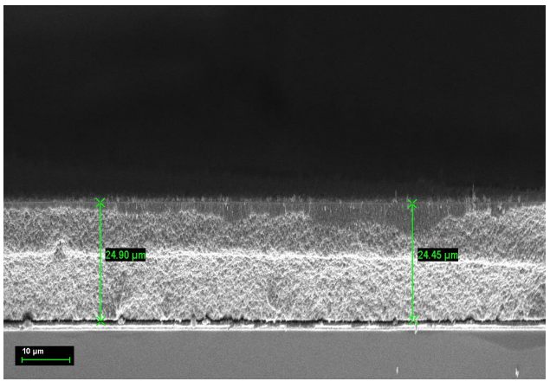
Figure S1. The cross-sectional image of TiO₂ photoanode used for dye-sensitized solar cells

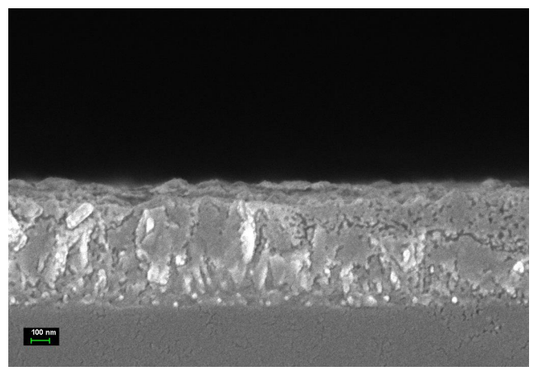
Figure S2. The cross-sectional image of Pt film on FTO glass.

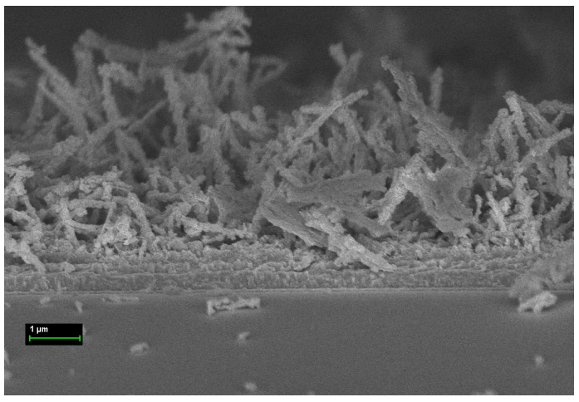
Figure S3. The cross-sectional image of FeCo₂S₄ nanowires film on FTO glass.

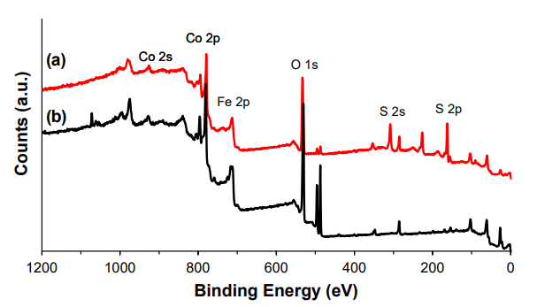
Figure S4. Comparative XPS survey spectra of (a) FeCo₂S₄ NW and
(b) FeCo₂O₄ NW

Article

Tailored manganese oxide and nickel sulfide composites with MWCNTs as platinum-free electrodes for solar energy conversion

Diana Suleimenova^{1,2}, YerbolatTashenov², Ayagoz Ibrayeva^{1,2}, Robert J. O’Reilly³, Bakhytzhan Baptayev^{1∗} & Mannix P. Balanay⁴

¹National Laboratory Astana, Nazarbayev University, Astana, Kazakhstan. ²Department of Chemistry, L.N. Gumilyov Eurasian National University, Astana, Kazakhstan.
³School of Science and Technology, University of New England, Armidale, NSW 2351, Australia.
⁴Chemistry Department, Nazarbayev University, Astana, Kazakhstan.
∗email: bbaptayev@nu.edu.kz; mannix.balanay@nu.edu.kz

This study investigates the electrocatalytic performance of binary MnO/NiS and ternary MWCNT@MnO/NiS composites as platinum (Pt) free counter electrodes (CEs) for triiodide reduction in dye sensitized solar cells (DSSCs). The MnO and NiS components form mixed phase structures, MnO/Mn₃O₄ and NiS/Ni₃S₄, respectively, while multiwalled carbon nanotubes (MWCNTs) function as a conductive scaffold to enhance charge transport. The composites were synthesized via a solvothermal method and thoroughly characterized using a combination of structural and electrochemical techniques. Both MnO/NiS and MWCNT@MnO/NiS electrodes demonstrated significantly lower charge transfer resistance than the conventional Pt CE, indicating superior catalytic activity. When integrated into DSSCs, the MnO/NiS and MWCNT@MnO/NiS electrodes achieved power conversion efficiencies (PCEs) of 8.66% and 9.29%, respectively, surpassing that of the Pt based device (8.54%) under identical testing conditions. The enhanced performance is attributed to the synergistic effects between the redox active mixed metal phases and the high conductivity and surface area of MWCNTs. Additionally, the devices exhibited excellent long term operational stability, underscoring the potential of these composite materials as cost effective and durable alternatives to noble metal CEs in next generation solar energy systems.
Keywords Binary composite, Ternary composite, Multi-walled carbon nanotubes, Electrocatalyst, Dye sensitized solar cell.

Dye-sensitized solar cells (DSSCs) have emerged as promising alternatives to conventional silicon-based photovoltaic technologies, primarily due to their low production costs, ease of fabrication, and relatively high energy conversion efficiencies under low-light conditions. Since the pioneering work of O’Regan and Grätzel¹, research on DSSCs has significantly expanded, exploring various materials and configurations to enhance their performance and reduce costs²⁻⁶. A typical DSSC consists of three essential components: a photoanode, an electrolyte, and a CE. The photoanode, usually composed of a dye-sensitized nanostructured semiconductor (commonly TiO₂), absorbs incident photons. Upon light absorption, the dye molecules become photoexcited, promoting electrons from the highest occupied molecular orbital (HOMO) to the lowest unoccupied molecular orbital (LUMO). These excited electrons are subsequently injected into the conduction band of the semiconductor and then travel through an external circuit toward the CE, generating an electric current. The oxidized dye molecules are regenerated by electrons from the redox couple, typically iodide-triiodide (I⁻/I₃⁻), within the liquid electrolyte. The CE plays a crucial role in catalyzing the reduction of I₃⁻ back to I⁻, thus completing the circuit by allowing the flow of electrons from the external circuit into the electrolyte. For this function, the CE must exhibit high electrocatalytic activity, low charge-transfer resistance, and excellent electrical conductivity. Pt is traditionally employed as the CE material due to its superior catalytic and electrical properties. However, the high cost and scarcity of Pt, along with its susceptibility to corrosion in I⁻/I₃⁻ electrolytes leading to the formation of undesirable complexes such as PtI₄ and H₂PtI₆, limit its long-term application in DSSCs^{7,8}.
To address these limitations, significant research has been directed toward the development of alternative CE materials that are cost-effective, stable, and highly efficient. Among the most promising candidates are carbon-based materials, conductive polymers, and transition metal compounds. In particular, carbon nanomaterials such as MWCNTs have gained attention due to their high surface area, excellent electrical conductivity, and structural versatility^{9,10}. MWCNTs can be chemically functionalized to introduce active nucleation sites on their surface, enabling the anchoring and growth of catalytically active species. This functionalization strategy not only ensures the uniform dispersion of catalytic components but also enhances interfacial bonding and facilitates efficient charge transfer, thereby improving the overall electrocatalytic performance of the resulting hybrid composites¹¹⁻¹⁴. Several studies have demonstrated the versatility of MWCNT-based composites in diverse applications. For example, MoS₂/MWCNT thin films have been synthesized and employed as CEs in DSSCs, achieving a power conversion efficiency (PCE) of 0.56%¹¹. In another study, CuO/Cu₂O nanoparticles were grown on MWCNTs and utilized as a gas sensing platform, highlighting their multifunctionality¹². Furthermore, Au-MWCNT composites have been fabricated using green chemistry methods for use in photocatalytic and biosensing applications, demonstrating their environmental compatibility and broad utility¹³. Notably, a ZnCo₂S₄@MWCNT composite used as a CE in DSSCs achieved a significantly higher PCE of 8.55%, underscoring the promising performance of such hybrid structures¹⁴.
Transition metal compounds, such as oxides and sulfides, are particularly attractive due to their ease of synthesis, low cost, good electrocatalytic activity, and chemical stability in the presence of the I⁻/I₃⁻ redox couple¹⁵⁻¹⁷. These properties make them suitable alternatives to Pt for long-term DSSC operation. These attributes position them as viable and sustainable alternatives to Pt for long-term DSSC applications. In this study, manganese oxide and nickel sulfide were selected as the primary active materials due to their complementary electrochemical properties. MnO is an earth-abundant, environmentally benign material with a high theoretical capacitance, making it a promising candidate for pseudocapacitive and redox-related applications. Its potential is further supported by its low cost and relatively straightforward synthesis. However, its practical application is hindered by intrinsic limitations, including low electrical conductivity and structural instability during cycling, which restrict its standalone use in electrochemical systems¹⁸. In contrast, NiS exhibits high electrical conductivity and robust electrocatalytic activity, particularly toward redox reactions such as the I⁻/I₃⁻ couple¹⁹. This makes it an effective catalyst in DSSCs, although it may still face challenges related to nanoparticle aggregation and mechanical integrity. To address the individual limitations of MnO and NiS while leveraging their synergistic benefits, MWCNTs were introduced as a conductive scaffold. MWCNTs serve multiple roles: they provide a high-surface-area support that enhances the dispersion of the active components, facilitate rapid charge transport due to their excellent electrical conductivity, and contribute to the mechanical stability of the composite. Moreover, the incorporation of MWCNTs mitigates particle aggregation and promotes a more uniform distribution of MnO and NiS nanoparticles²⁰. The resulting MWCNT@MnO/NiS hybrid composite harnesses the advantageous properties of each constituent: MnO’s high redox capacity, NiS’s superior conductivity and catalytic activity, and MWCNTs’ structural and electronic support. This integrated approach offers a stable, efficient, and cost-effective alternative to traditional Pt-based CE in DSSCs, addressing both performance and scalability challenges in next-generation solar cell technologies. In this study, we explore a novel composite CE material comprising MWCNTs, MnO, and NiS for application in DSSC utilizing the conventional I⁻/I₃⁻ liquid electrolyte. This tri-component system is engineered to exploit the synergy among its constituents, with MWCNTs contributing high electrical conductivity and surface area, MnO offering structural stability and electrochemical activity, and NiS serving as an efficient catalytic material. The synergistic interaction among these materials is anticipated to enhance electron transport, lower charge transfer resistance, and significantly improve catalytic performance. Collectively, these attributes aim to deliver a cost effective, durable, and scalable alternative to traditional Pt-based CEs.

Materials and methods
Materials
All the chemicals used in this study were of high purity from commercial sources and used without further purification unless otherwise specified. Fluorine-doped SnO₂ (FTO) coated glass (7 Ω/sq, 2.2 mm, Sigma Aldrich); light scattering titania paste (Greatcell Solar WER2-O TiO₂ Paste, Sigma Aldrich); transparent TiO₂ electrode paste (DN-EP03, Dyenamo); screen printable Platinum paste (Greatcell Solar PT1 Pt paste, Sigma Aldrich); Di-tetrabutylammonium cis-bis(isothiocyanato)bis(2,2′-bipyridyl-4,4′-dicarboxylato)ruthenium (II), 95% (N719, Sigma Aldrich); chenodeoxycholic acid (CDCA, Sigma Aldrich); terephthalic acid, 98% (Sigma Aldrich); titanium (IV) isopropoxide, 97% (TTIP) Sigma Aldrich); manganese (II) nitrate tetrahydrate, ≥97% (Mn(NO₃)₂·4H₂O, KT, Sigma Aldrich); nickel (II) nitrate hexahydrate ≥97% (Ni(NO₃)₂·6H₂O, KT, Sigma Aldrich); thiourea, ACS reagent, ≥99.0% (NH₂CSNH₂, Sigma Aldrich); multi-walled carbon nanotubes, >95% (MWCNTs, OD: 10–20 nm, US Research Nanomaterials, Inc.); iodine ≥99,8% (Sigma Aldrich); lithium iodide, 99.9% (LiI, Sigma Aldrich); guanidine thiocyanate, 99% (GuSCN, Alfa Aesar, Thermo Scientific); 1-butyl-3- methylimidazolium iodide (BMII, DN-OD05, Dyenamo); 3-methoxypropionitrile (MPN, Sigma Aldrich); 4-tert-butylpyridine, 98% (tBP, Sigma Aldrich); acetonitrile (ACN, Acros Organic); tert-butanol, ≥99.0% (Sigma Aldrich); nitric acid ≥65% (HNO₃, Honeywell Fluka); and hydrochloric acid >37% (HCl, HDL, Sigma Aldrich).

Synthesis and preparation of counter electrodes
The ternary composite CE composed of MWCNTs, MnO, and NiS, hereafter referred to as MWCNT@MnO/NiS, was synthesized through a two-step process involving spray-coating and solvothermal deposition. First, a dispersion of MWCNTs was prepared at a concentration of 1 mg/mL in a 1 weight percent aqueous Triton X-100 solution. This dispersion was uniformly spray-coated onto pre-cleaned fluorine-doped tin oxide (FTO) glass substrates placed on a hotplate maintained at 160°C. After deposition, the coated substrates were sintered in air at 350°C for 30 min to improve adhesion and enhance conductivity, resulting in MWCNT-coated FTO substrates, referred to as MWCNT@FTO.
For the subsequent deposition of MnO and NiS, the MWCNT@FTO substrates were placed in a 50 mL Teflon-lined stainless-steel autoclave containing 40 mL of an ethanol-based precursor solution. This solution was prepared by dissolving 0.0625 mmol of manganese nitrate tetrahydrate (Mn(NO₃)₂·4H₂O), 0.125 mmol of nickel nitrate hexahydrate (Ni(NO₃)₂·6H₂O), and 1.00 mmol of thiourea (NH₂CSNH₂). The sealed autoclave was heated at 180°C for 8 h under static conditions. Following the reaction, the substrates were allowed to cool naturally to room temperature, rinsed thoroughly with ethanol and deionized water to remove residual precursors, and then dried overnight at 60°C.
Control electrodes were prepared to isolate the contribution of each material. MWCNT-only electrodes were fabricated using the same spray-coating and sintering method, but without the solvothermal step. Similarly, MnO and NiS composite electrodes were synthesized by applying the solvothermal procedure directly to bare FTO substrates under identical conditions. For reference, a Pt-based CE was prepared by doctor blading a commercial Pt paste, composed of terpineol and hexachloroplatinic acid, onto FTO glass. This electrode was then sintered at 500°C for 30 min in air to form the final Pt layer.

Assembly of dye-sensitized solar cells
FTO glass substrates (2.2 mm thickness, surface resistivity 7 Ω/sq) were cleaned by sonication in ethanol. A compact TiO₂ blocking layer was applied by immersing the substrates in a 50 mM solution of titanium (IV) isopropoxide in 2 M HCl at 70°C for 30 min, followed by sintering at 500°C for 30 min. Subsequently, a transparent TiO₂ layer (particle size: 18-20 nm) and a scattering TiO₂ layer (particle size: 150-250 nm) were sequentially applied using the doctor blade technique. After each layer, the films were air-dried for 1 h and sintered in stages: 125°C for 5 min, 325°C for 10 min, 425°C for 15 min, and 500°C for 30 min. After cooling to 70-80°C, the TiO₂ films were immersed in a 0.5 mM N719 dye solution in tert-butanol:acetonitrile (1:1 v/v) containing 0.75 mM chenodeoxycholic acid for 24 h. The dye-sensitized electrodes were then rinsed with ethanol to remove unbound dye. To assemble the solar cells, the CE and working electrode (WE) were sandwiched using a double-sided Scotch tape spacer. The space between the electrodes was filled with a redox electrolyte consisting of 0.03 M I₂, 0.05 M LiI, 0.10 M guanidinium thiocyanate (GuSCN), 0.6 M 1-butyl-3-methylimidazolium iodide (BMII), and 0.5 M 4-tert-butylpyridine (TBP) in an acetonitrile:MPN (1:1) mixture.

Characterization
The structural and morphological characteristics of the electrodes were examined using a Zeiss Crossbeam 540 scanning electron microscope (SEM) and a JEOL JEM-1400 Plus transmission electron microscope (TEM). Elemental composition and chemical states were analyzed using energy-dispersive X-ray spectroscopy (EDS) and X-ray photoelectron spectroscopy (XPS, Thermo Scientific NEXSA).
X-ray diffraction (XRD) patterns were collected using a Rigaku SmartLab diffractometer. Electrochemical impedance spectroscopy (EIS) of the DSSCs was performed in the dark at a bias voltage of -0.70 V with a 10 mV amplitude over a frequency range of 0.1 Hz to 100 kHz. EIS measurements of symmetric dummy cells were carried out under identical conditions, except with 0 V bias. Cyclic voltammetry (CV) was conducted using a non-aqueous Ag/Ag⁺ reference electrode, a Pt wire CE, and the DSSC CE as the working electrode. Photovoltaic performance was evaluated under standard illumination conditions (100 mW/cm²) using the Dyenamo photovoltaic testing system (DN-AE01).

Results and discussion
Material characterization
The crystalline phases of the synthesized materials, namely MWCNT, MnO/NiS, and MWCNT@MnO/NiS, were characterized using X-ray diffraction, as presented in Fig. 1. For simplicity, the mixed manganese oxide and nickel sulfide phases are referred to as MnO and NiS throughout this work. A characteristic diffraction peak at 2θ=25.69°, corresponding to the (002) reflection of the graphitic structure of MWCNTs, was observed in the MWCNT@MnO/NiS sample, but was absent in the pure MnO/NiS counterpart. The mixed NiS phase exhibited distinct diffraction peaks at 2θ values of 15.8°, 26.6°, 31.5°, 37.9°, 46.6°, 49.7°, and 54.9°, corresponding to the (111), (220), (311), (222), (400), (422), (511), and (440) crystal planes of Ni₃S₄, as identified in JCPDS Nos. 47-1739 and 43-1469²¹⁻²³. Additional weaker peaks at 2θ=29.8°, 44.7°, and 53.2° were attributed to NiS based on JCPDS No. 012-0041^{21,22}. The MnO phase showed peaks at 2θ=34.4° and 41.0°, corresponding to the (111) and (200) planes, respectively, as referenced in JCPDS No. 07-0230²⁴⁻²⁶. Furthermore, peaks at 2θ=23.9°, 35.0°, and 51.3° were assigned to the (112), (211), and (105) planes of Mn₃O₄, according to JCPDS Nos. 04-007-1841 and 07-0230^{24,25,27}.

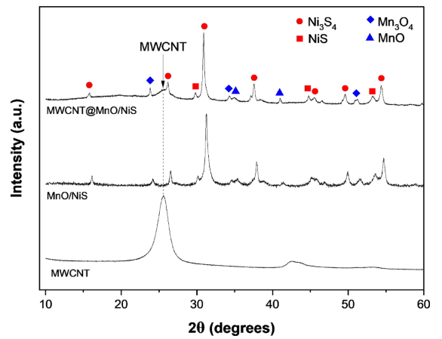
Fig. 1. X-ray diffraction patterns of the synthesized electrocatalysts: MWCNT@MnO/NiS, MnO/NiS, and pristine MWCNTs.

The elemental composition and oxidation states of the MWCNT@MnO/NiS composite were investigated using X-ray photoelectron spectroscopy. The wide-scan XPS spectrum (Fig. 2a) confirmed the presence of manganese, nickel, carbon, sulfur, and oxygen, verifying the successful synthesis and integration of all intended components within the composite. A detailed analysis of the high-resolution Ni 2p spectrum (Fig. 2b) revealed peaks at 853.5 eV and 855.8 eV in the Ni 2p₃/₂ region, and at 870.6 eV and 872.9 eV in the Ni 2p₁/₂ region. The peaks at 853.5 eV and 870.6 eV were assigned to Ni²⁺, while those at 855.8 eV and 872.9 eV corresponded to Ni³⁺, confirming the presence of mixed-valence nickel species within the NiS phase. Satellite peaks observed at 859.8 eV and 875.8 eV further support this assignment, consistent with values reported in the literature^{22,28-30}. The S 2p XPS spectrum (Fig. 2c) reveals the presence of multiple sulfur species, consistent with the mixed NiS and Ni₃S₄ phases identified from the Ni 2p analysis. Binding energy peaks at 161.35 eV and 162.52 eV correspond to the S 2p₃/₂ and S 2p₁/₂ spin-orbit components of monosulfide (S²⁻) in NiS, showing a splitting of ~1.2 eV, which is characteristic of metal-sulfide bonding³¹. A slightly higher BE at 163.65 eV is attributed to disulfide (S₂²⁻) species in Ni₃S₄, typically exhibiting a small positive shift relative to monosulfides due to increased electron withdrawal in the S-S bonded structure. Additionally, a prominent peak at 168.60 eV is assigned to sulfate (SO₄²⁻) species, likely formed through surface oxidation of sulfide phases upon air exposure. The simultaneous presence of sulfide and sulfate signals indicates partial surface oxidation of the nickel sulfide phases, a common occurrence in air-exposed sulfides³². The Mn 2p XPS spectrum (Fig. 2d) displays prominent peaks at 641.3 eV and 653.4 eV, corresponding to the Mn 2p₃/₂ and Mn 2p₁/₂ states of Mn²⁺, respectively. The presence of a satellite peak at 646.6 eV further confirms the existence of Mn in the +2 oxidation state. These spectral features indicate that the manganese oxide component in the composite consists of a mixed phase of MnO and Mn₃O₄, both of which contain Mn²⁺ species³³. Detailed peak deconvolution reveals four distinct contributions: a dominant Mn²⁺ 2p₃/₂ peak at 641.3 eV, a minor Mn³⁺ 2p₃/₂ peak at 643.5 eV, a Mn²⁺ shake-up satellite at 646.6 eV, and the Mn²⁺ 2p₁/₂ peak at 653.4 eV. The area ratio of Mn³⁺ to Mn²⁺ based on the 2p₃/₂ peaks is approximately 1:4, indicating that Mn²⁺ is the predominant oxidation state with a minor contribution from Mn³⁺. This confirms the coexistence of MnO (Mn²⁺) and Mn₃O₄ (Mn²⁺/Mn³⁺), with MnO as the dominant phase. The absence of features associated with higher oxidation states, such as Mn⁴⁺, or strong Mn³⁺ satellites suggests that phases like Mn₂O₃ or MnO₂ are not significantly present. Overall, these findings support the presence of a binary mixed-phase MnO system featuring redox-active Mn centers, which may contribute to the material’s electrochemical performance. While the Mn 2p XPS spectrum clearly indicates that Mn²⁺ is the predominant oxidation state, with a strong Mn 2p₃/₂ peak at 641.3 eV and a satellite at 646.6 eV characteristic of MnO, the O 1s spectrum (Fig. 2e) presents a more complex distribution of oxygen species. Deconvolution of the O 1s region reveals a relatively small peak at 529.5eV, which is typically assigned to lattice oxygen (O²⁻) in MnO. In contrast, a more intense peak appears at 531.0 eV and is attributed to lattice oxygen in Mn₃O₄, which contains both Mn²⁺ and Mn³⁺. This suggests that although MnO is the dominant manganese species based on the cationic Mn 2p analysis, its corresponding oxygen signal is less prominent, possibly due to factors such as surface oxidation, differences in surface concentration, or variations in photoemission sensitivity. The peaks observed at 532.2 eV and 533.5 eV are assigned to surface hydroxyl groups or oxygenated carbon species, and sulfate species, respectively, consistent with the presence of functionalized MWCNTs and sulfur detected in the S 2p region. Together, the Mn 2p and O 1s spectra confirm the formation of a MnO and Mn₃O₄ mixed-phase system, where MnO is more prevalent in the bulk while Mn₃O₄ and surface-bound species are enriched at the surface.
The high-resolution C 1s XPS spectrum of the MWCNT@MnO/NiS mixed-phase composite (Fig. 2f) displays several characteristic peaks that elucidate the carbon bonding environments within the hybrid material. The dominant peak at 284.5 eV corresponds to sp² -hybridized carbon (C=C) from the graphitic framework of the MWCNTs, indicating the preservation of their intrinsic conductive structure. Peaks at 286.2 eV, 288.1 eV, and 289.3 eV are attributed to C–O, C=O, and O–C=O functionalities, respectively, reflecting the partial oxidation of the MWCNT surface. The presence of these functional groups can enhance charge transfer and mechanical adhesion within the composite, thereby contributing to its overall electrochemical performance and stability¹⁴. To further elucidate the influence of MWCNTs on the MnO/NiS composite, XPS analysis was conducted on the pristine MnO/NiS sample, as shown in Fig. S1. A comparative assessment of the core-level spectra reveals that the binding energies of Mn 2p, Ni 2p, S 2p, and O 1s in MnO/NiS are consistently shifted to higher values relative to those observed in the MWCNT@MnO/NiS composite. This systematic shift toward lower binding energies in the presence of MWCNTs suggests a net electron transfer from the carbon nanotubes to the metal oxide/sulfide matrix. Such electron donation is indicative of strong interfacial electronic interactions between the MWCNTs and the MnO/NiS components. The observed binding energy modulation reinforces the hypothesis that MWCNTs do not merely serve as a conductive scaffold but actively participate in tuning the electronic structure of the hybrid material, potentially enhancing its charge transport properties and overall electrochemical performance.

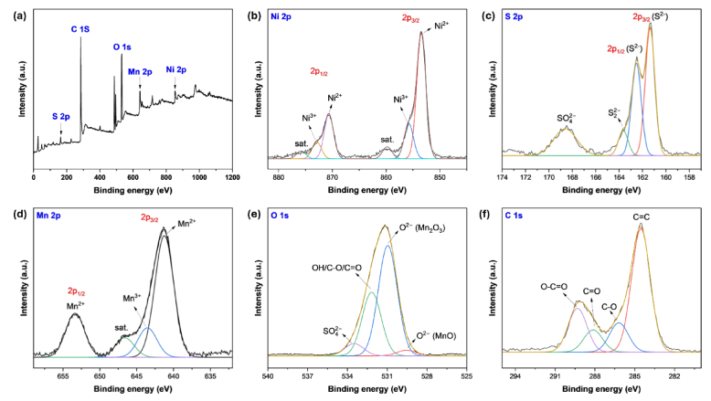
Fig. 2. XPS spectra of the MWCNT@MnO/NiS composite: (a) wide-scan survey spectrum; high-resolution spectra of (b) Ni 2p, (c) S 2p, (d) Mn 2p, (e) O 1s, and (f) C 1s.

The morphology and structure of the synthesized materials are illustrated in Fig. 3. Figure 3a shows a uniform MWCNT film deposited onto FTO glass using spray coating. The MWCNTs form an interconnected, porous network of entangled nanotubes that uniformly covers the FTO substrate. This network not only provides a high surface area but also ensures good electrical conductivity and mechanical adhesion, serving as an effective scaffold for subsequent deposition of active materials. The MnO/NiS binary composite, synthesized separately via a solvothermal process, is shown in Fig. 3b. In Fig. 3c, the ternary MWCNT@MnO/NiS composite is displayed, where NiS particles exhibit both cubic and flower-like morphologies, while MnO appears as spherical structures. Notably, the MnO particles in the ternary composite appear significantly larger than those in the MnO/NiS binary system depicted in Fig. 3b. This apparent increase in particle size is likely a result of heterogeneous nucleation occurring on the surface-functionalized MWCNTs. During the thermal treatment and dispersion processes, oxygen-containing functional groups such as carboxyl, hydroxyl, and carbonyl are likely introduced onto the surface of the MWCNTs. These functional groups act as chemically active sites that enhance the binding affinity between the carbon nanotube surface and metal precursors. Previous studies have demonstrated that such surface functionalization improves the interaction between carbon nanotubes and metal species, facilitating more efficient nucleation and subsequent particle growth^{34,35}. In this context, the functionalized MWCNTs provide localized sites for MnO deposition, which promotes particle aggregation and growth. This mechanism plausibly accounts for the larger MnO particle size observed in the ternary MWCNT@MnO/NiS composite relative to the binary MnO/NiS system.
As confirmed by the XRD and XPS analyses discussed earlier, both the NiS and MnO components exist as mixed phases. Specifically, the nickel sulfide comprises a combination of NiS and Ni₃S₄, while the manganese oxide consists of MnO and Mn₃O₄. This multiphase composition contributes to the observed morphological diversity and may enhance the electrochemical performance of the composite by introducing varied redox-active sites and improving charge transport.
The cross-sectional SEM image (Fig. 3d) reveals that the MWCNT@MnO/NiS film exhibits a relatively uniform thickness, ranging from approximately 596 to 648 nm (average ~ 622 nm). The minor variation (~8%) indicates good deposition consistency. Furthermore, the SEM image confirms continuous and smooth growth across the substrate, suggesting uniform coverage and strong film integrity. High-resolution TEM images (Fig. 3e), obtained by scraping material from the film, distinctly show the tubular MWCNTs embedded with submicron-sized particles of NiS (cubic) and MnO (spherical), supporting the coexistence of the mixed nickel sulfide (NiS/Ni₃S₄) and manganese oxide (MnO/Mn₃O₄) phases within the composite structure. EDS mapping (Fig. 3f) confirmed the elemental distribution of Mn, Ni, S, O, and C across the FTO substrate, further supporting the successful integration of MWCNTs with the MnO and NiS components. These results validate the presence of both NiS and MnO phases, uniformly dispersed within the MWCNT matrix, forming a well-integrated and synergistic ternary composite.

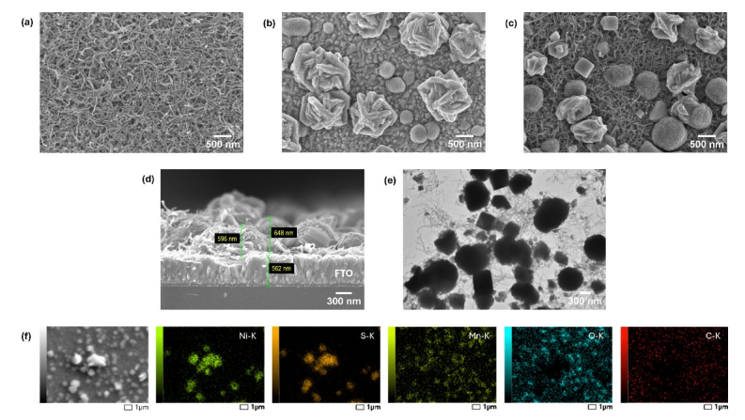
Fig. 3. SEM images of (a) MWCNT; (b) MnO/NiS; (c) MWCNT@MnO/NiS composite; (d) cross-sectional view of the MWCNT@MnO/NiS composite;
(e) TEM image of MWCNT@MnO/NiS; (f) EDS elemental
mapping of MWCNT@MnO/NiS.

Electrochemical and photovoltaic characterization of counter electrodes
Cyclic voltammetry (CV) analysis was conducted to evaluate the electrocatalytic performance of MWCNT, MnO/NiS, and MWCNT@MnO/NiS CEs. As shown in Fig. 4a, both MnO/NiS and MWCNT@MnO/NiS composites exhibit two distinct redox peaks corresponding to the I⁻/I₃⁻ redox couple:
I₃⁻ + 2ē → 3I⁻ (1)
3I⁻ → I₃⁻ + 2ē (2)

This redox couple is central to DSSC operation. The appearance of both anodic and cathodic peaks in the CVs of MnO/NiS and MWCNT@MnO/NiS indicates effective catalysis of this two-electron transfer process. Notably, both composites show higher cathodic peak current densities (J_{red}) than the Pt electrode, implying enhanced kinetics for triiodide reduction. In contrast, MWCNT alone shows two distinct oxidation peaks but only one broad and weak reduction peak, suggesting that the redox process is slow and not fully reversible. Furthermore, CV measurements at various scan rates (Fig. 4b) and the resulting linear relationship between peak current and square root of scan rate (Fig. S2) suggest a diffusion-controlled process for MnO/NiS and MWCNT@MnO/NiS, in contrast to MWCNT which likely undergoes side reactions with the electrolyte. Additional CV analysis at multiple scan rates (Fig. 4 c, d) further confirms that the redox currents in MnO/NiS and MWCNT@MnO/NiS scale linearly with the square root of the scan rate (Figs. S3 and S4), consistent with diffusion-limited electron transfer processes and the absence of undesirable chemical interactions with the I⁻/I₃⁻ electrolyte.

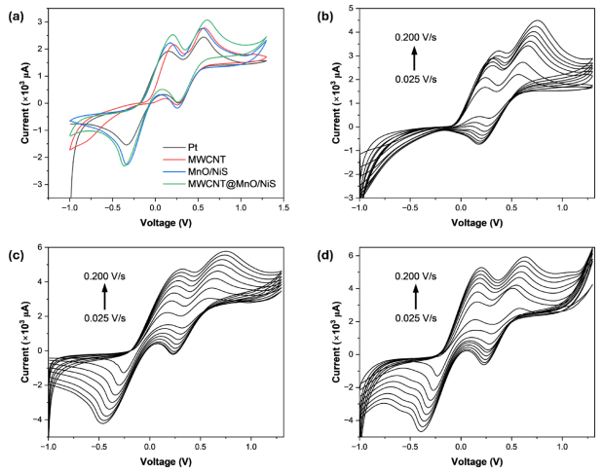
Fig. 4. Cyclic voltammograms of the CEs: (a) overall comparison of the electrodes, (b) MWCNT, (c) MnO/NiS, and (d) MWCNT@MnO/NiS at different scan rates.

The enhanced catalytic behavior of the MnO/NiS and MWCNT@MnO/NiS composites is attributed to their mixed-phase composition. The MnO/NiS composite contains both MnO and Mn₃O₄ phases, while the nickel sulfide exists as a mixture of NiS and Ni₃S₄. These phase mixtures can create heterojunction interfaces, increasing the number of active sites and improving charge transfer efficiency. The incorporation of MWCNTs into MWCNT@MnO/NiS further enhances electrical conductivity and provides a high-surface-area scaffold for dispersion of the metal oxide-sulfide nanoparticles, thereby increasing the effective catalytic surface. To gain further insight into their electrocatalytic properties, symmetrical dummy cells were assembled for impedance spectroscopy and Tafel analysis (Fig. 5). Electrochemical impedance spectroscopy Nyquist plots (Fig. 5a) reveal that MWCNT@MnO/NiS exhibits the lowest charge transfer resistance (R_{CT}) of 0.53 Ω cm², slightly lower than MnO/NiS at 0.55 Ω cm². Both are significantly lower than that of Pt (2.23 Ω cm²), indicating superior charge transfer kinetics. The low-frequency semicircle corresponding to Warburg diffusion resistance (Z_{W}) is small for these composites, suggesting efficient mass transport of redox species. In contrast, MWCNT exhibits an extremely high R_{CT} of 2293 Ω cm² (Fig. 5a, inset), confirming its poor catalytic activity and aligning with the earlier CV results.
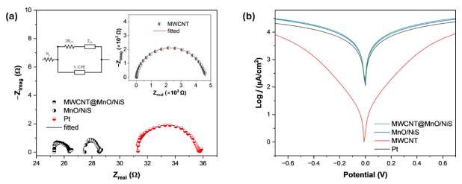
Fig. 5. (a) Nyquist plot and (b) Tafel polarization curve of symmetrical dummy cells. The equivalent electrical circuit model used to fit the EIS spectra is also included.

Tafel polarization analysis (Fig. 5b) provides valuable electrochemical insights into the catalytic and mass transport properties of CEs in DSSCs. Two key parameters extracted from the Tafel curves are the exchange current density (j₀) and the limiting diffusion current density (J_{lim}), which serve as indicators of electron transfer kinetics and ionic diffusion behavior, respectively. The exchange current density was determined from the linear portion of the Tafel slope using the relation
j_{o} = RT/nFR_{CT} (3)

Both MnO/NiS and MWCNT@MnO/NiS composites exhibit high exchange current densities of 2.13 and 2.23 mA cm⁻², respectively, which slightly exceed that of the Pt electrode (2.06 mA cm⁻²). These values indicate that the composites possess strong catalytic activity and efficient electron transfer capabilities at the electrode-electrolyte interface. The slight increase in current density for MWCNT@MnO/NiS suggests a modest improvement in electrocatalytic performance compared to MnO/NiS and Pt, as the addition of MWCNTs enhances electrical conductivity and increases the available surface area for redox reactions, but the improvement is incremental because MnO/NiS alone already exhibits high activity³⁶. Additionally, the low charge transfer resistance values observed for both composites further affirms their effective interfacial charge transport.
The limiting diffusion current density, which reflects the maximum current supported by ion transport in the electrolyte, shows similarly high values for MnO/NiS, MWCNT@MnO/NiS, and Pt. In the context of the Tafel curve, J_{lim} can be estimated from the intersection of the cathodic branch with the Y-axis (log j), which corresponds to the current density where concentration polarization dominates, and the reaction becomes diffusion limited. This suggests that the diffusion of I⁻ and I₃⁻ ions is not hindered by the substitution of Pt with composite electrodes. The comparable J_{lim} values indicate that both MnO/NiS-based electrodes maintain excellent ionic permeability, which is essential for minimizing concentration polarization and sustaining high photocurrent output. These findings demonstrate that the MnO/NiS and MWCNT@MnO/NiS composites combine efficient catalytic activity with effective ion transport properties. The presence of MnO and Mn₃O₄ along with NiS and Ni₃S₄ creates a synergistic structure that offers abundant active sites and robust electrical pathways. When reinforced with MWCNTs, the electrode structure becomes even more favorable for rapid charge and mass transport, which supports the high photovoltaic performance observed in devices utilizing these materials. Photovoltaic performance testing of DSSCs equipped with the prepared CEs (Table 1, Fig. 6a) further supports the electrochemical findings. The device employing the MWCNT@MnO/NiS CE achieved the highest PCE of 9.29%, surpassing that of the reference cell with a Pt electrode (8.54%). The MnO/NiS-based device also demonstrated strong performance, yielding a PCE of 8.66%. In contrast, the device using the MWCNT-only CE exhibited a significantly lower efficiency of 4.17%, consistent with its high charge transfer resistance and poor catalytic activity observed in Tafel and impedance measurements.

Table 1. Photovoltaic performance parameters and charge transfer resistance of DSSCs using different CEs.

DSSCs | PCE (%) | V_{OC} (mV) | J_{SC} (mA/cm²) | FF | R_{CT} (Ω˟cm²)
MWCNT@MnO/NiS | 9.29±0.40 | 0.69±0.01 | 18.07±0.78 | 0.74±0.00 | 0.53
MnO/NiS | 8.66±0.18 | 0.69±0.01 | 17.18±0.21 | 0.73±0.01 | 0.55
MWCNT | 4.17±0.67 | 0.66±0.00 | 15.72±1.11 | 0.40±0.07 | 2293
Pt | 8.54±0.53 | 0.70±0.00 | 16.73±1.14 | 0.73±0.01 | 2.23

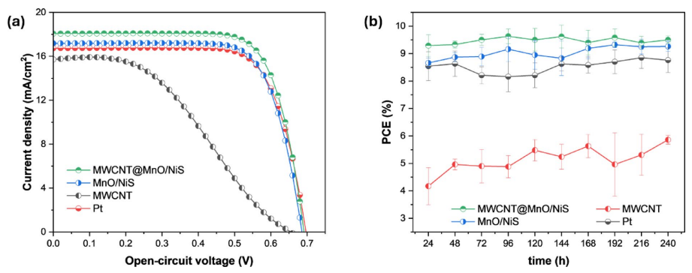
Fig. 6. (a) Current density-voltage characteristics and (b) PCE stability over 240 h of DSSCs with different CEs

To comprehensively assess the relative performance of the MWCNT@MnO/NiS composite, its photovoltaic efficiency was compared with those of recently reported MWCNT-based binary and ternary metal oxide/ sulfide CEs, as summarized in Table 2. The comparative data clearly demonstrate that the MWCNT@MnO/ NiS composite achieves one of the highest PCEs among the listed systems, with a notable PCE of 9.29%. This result underscores the material’s significant potential as a viable Pt-free alternative in DSSCs. Particularly noteworthy is that the performance of MWCNT@MnO/NiS not only rivals but in some cases surpasses that of more structurally intricate systems, including MoWO₄-ZnO@MWCNT³⁷ and MoS₂/Ni₃S₂/MWCNT³⁶. These findings affirm the effectiveness of the MWCNT@MnO/NiS composite design, both in terms of energy conversion efficiency and in the practical simplification of electrode fabrication, which is crucial for scalable and cost-effective solar energy technologies.

Table 2. Photovoltaic performance comparison of binary and ternary composites used as CEs in DSSCs employing the I⁻/I₃⁻ redox couple and N719 dye.

Counter electrodes | J_{SC} (mA cm⁻²) | V_{OC} (mV) | FF | PCE (η, %) | References
MnO₂-NiO | 0.3 | 0.83 | 0.84 | 0.21 | ³⁸
CuCo₂S₄@MWCNTs | 8.46 | 0.76 | 0.49 | 3.09 | ³⁹
Ba₆Co₂₅S₂₇/MWCNT | 8.41 | 0.81 | 0.47 | 3.20 | ⁴⁰
Ni₃S₂/MWCNTs | 6.72 | 0.77 | 0.72 | 3.74 | ⁴¹
NiO/MWCNTs | 7.53 | 0.71 | 0.70 | 3.80 | ⁴¹
NiCo₂S₄/MWCNT | 9.02 | 0.71 | 0.55 | 4.14 | ⁴²
ZnO/MWCNTs | 10.20 | 0.71 | 0.62 | 4.57 | ⁴³
CuS/ZrS₃/MWCNT | 12.26 | 0.72 | 0.58 | 5.15 | ⁴⁴
Cu₄SnS₆/MWCNT | 11.20 | 0.74 | 0.73 | 6.05 | ⁴⁵
NiCoO₂@CNTs fiber | 14.67 | 0.64 | 0.68 | 6.38 | ⁴⁶
Fe₂O₃@MWCNT | 13.01 | 0.75 | 0.73 | 7.09 | ⁴⁷
SH-MWCNTs@NiMoO₄ | 19.66 | 0.72 | 0.52 | 7.29 | ⁴⁸
Ni₃S₂@MWCNTs | 17.25 | 0.75 | 0.56 | 7.48 | ⁴⁹
MoS₂-MoO₂/MWCNTs | 15.62 | 0.79 | 0.62 | 7.79 | ⁵⁰
MoS₂/Ni₃S₂/MWCNTs | 17.92 | 0.70 | 0.66 | 8.27 | ³⁶
ZnCo₂S₄@MWCNT | 17.99 | 0.74 | 0.65 | 8.55 | ¹⁴
CoS₂/MWCNTs | 18.01 | 0.72 | 0.71 | 8.85 | ⁵¹
ZnCo₂O₄@NiMoO₄/CP | 20.51 | 0.76 | 0.60 | 9.38 | ⁵²
MoWO₄-ZnO@MWCNTs | 19.16 | 0.78 | 0.66 | 9.96 | ³⁷
MnO/NiS | 17.18 | 0.69 | 0.73 | 8.66 | This work
MWCNT@MnO/NiS | 18.07 | 0.69 | 0.74 | 9.29 | This work

The enhanced photovoltaic performance of the MWCNT@MnO/NiS composite is attributed to a synergistic combination of high electrocatalytic activity and improved charge transport. The mixed-phase structure, comprising MnO and Mn₃O₄ along with NiS and Ni₃S₄, provides a rich distribution of catalytically active sites, facilitating rapid triiodide reduction at the electrode-electrolyte interface. Simultaneously, the incorporation of MWCNTs enhances electrical conductivity and increases the effective surface area, which promotes efficient charge collection and minimizes resistive losses within the cell.
Stability testing over a 10-day period (240 h, Fig. 6b) revealed no significant degradation in device performance for any of the fabricated cells. The PCE values remained stable throughout the test duration, indicating excellent operational durability of both the MnO/NiS and MWCNT@MnO/NiS CEs. To assess the structural integrity of the CEs after prolonged use, DSSCs were dismantled following 15,840 h of continuous operation. The electrodes were extracted and thoroughly cleaned using acetonitrile and ethanol to remove residual electrolyte and contaminants, followed by drying in a vacuum oven at 60°C overnight to ensure complete solvent removal. SEM analysis showed that the surface morphology of both MnO/NiS and MWCNT@MnO/NiS electrodes remained largely unchanged after long-term operation. No signs of particle agglomeration, delamination, or morphological degradation were observed, confirming excellent structural stability of the composite layers under extended working conditions (Fig. S5). XPS analysis further supported the long-term stability of the CEs by revealing only minor changes in surface chemistry. While a general shift toward higher binding energies was observed for all detected elements, indicating subtle changes in the local chemical environment, possibly due to charge redistribution or interfacial electronic interactions, no major chemical degradation or compositional breakdown was evident (Fig. S6). These shifts suggest limited surface reorganization rather than fundamental material instability. Additionally, a modest decrease in the intensity of the C 1s peak associated with the O–C=O functional group was observed, indicating partial desorption or decomposition of oxygenated carbon species from the MWCNT surface. Conversely, the O 1s peak, attributed to surface hydroxyl groups, oxygenated carbon species, and sulfate groups, showed an increase in intensity. This likely reflects surface oxidation or accumulation of reaction by-products due to prolonged exposure to illumination and ambient conditions during operation. Despite these subtle spectral changes, the core chemical composition and functionality of the composite electrodes were preserved.
Together, the SEM and XPS results provide consistent and complementary evidence that the MnO/NiS and MWCNT@MnO/NiS composite electrodes maintain their structural and chemical integrity after more than 15,000 h of continuous photovoltaic operation. This long-term durability, coupled with high photovoltaic performance, underscores the promise of these materials as stable, cost-effective, and scalable alternatives to conventional Pt-based CE in DSSC applications.

Conclusion
A solvothermal synthesis strategy was successfully employed to fabricate binary MnO/NiS and ternary MWCNT@MnO/NiS composite counter electrodes, consisting of mixed phases of MnO, Mn₃O₄, NiS, and Ni₃S₄. Comprehensive electrochemical and photovoltaic evaluations demonstrated that both composites exhibit efficient iodide and triiodide redox kinetics, strong electrocatalytic activity, and low charge transfer resistance. Dye-sensitized solar cells incorporating MnO/NiS and MWCNT@MnO/NiS counter electrodes achieved power conversion efficiencies of 8.66% and 9.29%, respectively, both exceeding the performance of the reference Pt electrode at 8.54%. The superior performance of the MWCNT-containing composite is attributed to the synergistic interaction between the catalytically active mixed-phase nanostructure and the high conductivity and surface area provided by multiwalled carbon nanotubes. These results demonstrate that MnO/NiS-based materials are not only efficient and stable but also present a cost-effective alternative to Pt for use in dye-sensitized solar cells. This work provides a practical and scalable approach to developing high-performance, noble-metal-free counter electrodes for next-generation solar energy technologies.

Data availability
The original contributions presented in the study are included in the article/supplementary material, further inquiries can be directed to the corresponding authors.

References
1. O’Regan, B. & Grätzel, M. A low-cost, high-efficiency solar cell based on dye-sensitized colloidal TiO₂ films. Nature 353, 737-740. https://doi.org/10.1038/353737a0 (1991).
2. Ito, S. et al. Fabrication of thin film dye sensitized solar cells with solar to electric power conversion efficiency over 10%. Thin Solid Films 516, 4613-4619. https://doi.org/10.1016/j.tsf.2007.05.090 (2008).
3. Hagfeldt, A., Boschloo, G., Sun, L., Kloo, L. & Pettersson, H. Dye-sensitized solar cells. Chem. Rev. 110, 6595-6663. https://doi.or g/10.1021/cr900356p (2010).
4. Ibrayeva, A. et al. Advancements in carbazole-based sensitizers and hole-transport materials for enhanced photovoltaic performance. Molecules 29, 5035. https://doi.org/10.3390/molecules29215035 (2024).
5. Yelshibay, A., Bukari, S. D., Baptayev, B. & Balanay, M. P. Conducting polymers in solar cells: Insights, innovations, and challenges. Organics 5, 640-669. https://doi.org/10.3390/org5040034 (2024).
6. Nur Iman, R., Younas, M., Harrabi, K. & Mekki, A. A comprehensive review on advancements and optimization strategies in dye-sensitized solar cells: Components, characterization, stability and efficiency enhancement. Inorg. Chem. Commun. 165, 112488. https://doi.org/10.1016/j.inoche.2024.112488 (2024).
7. Olsen, E., Hagen, G. & Eric Lindquist, S. Dissolution of platinum in methoxy propionitrile containing LiI/I₂. Sol. Energy Mater. Sol. Cells 63, 267-273. https://doi.org/10.1016/S0927-0248(00)00033-7 (2000).
8. Papageorgiou, N., Maier, W. F. & Grätzel, M. An iodine/triiodide reduction electrocatalyst for aqueous and organic media. J. Electrochem. Soc. 144, 876. https://doi.org/10.1149/1.1837502 (1997).
9. Wu, J. et al. Counter electrodes in dye-sensitized solar cells. Chem. Soc. Rev. 46, 5975-6023. https://doi.org/10.1039/C6CS00752J (2017).
10. Prajapat, K. et al. Next-generation counter electrodes for dye-sensitized solar cells: A comprehensive overview. Sustain. Mater. Technol. 42, e01178. https://doi.org/10.1016/j.susmat.2024.e01178 (2024).
11. Karade, S. S., Dubal, D. P. & Sankapal, B. R. Decoration of ultrathin MoS₂ nanoflakes over MWCNTs: Enhanced super capacitive performance through electrode to symmetric all-solid-state device. Chemistry Select 2, 10405-10412. https://doi.org/10.1002/slct.2 01701788 (2017).
12. Bang, J. H. et al. Decoration of multi-walled carbon nanotubes with CuO/Cu₂O nanoparticles for selective sensing of H₂S gas. Sens. Actuators B 344, 130176. https://doi.org/10.1016/j.snb.2021.130176 (2021).
13. Duc Chinh, V. et al. Synthesis of gold nanoparticles decorated with multiwalled carbon nanotubes (Au-MWCNTs) via cysteaminium chloride functionalization. Sci. Rep. 9, 5667. https://doi.org/10.1038/s41598-019-42055-7 (2019).
14. Baptayev, B., Tashenov, Y., Adilov, S. & Balanay, M. P. Facile fabrication of ZnCo₂S₄@MWCNT as Pt-free counter electrode for high performance dye-sensitized solar cells. Surf. Interfaces 37, 102699. https://doi.org/10.1016/j.surfin.2023.102699 (2023).
15. Subalakshmi, K. et al. Platinum-free metal sulfide counter electrodes for DSSC applications: Structural, electrochemical and power conversion efficiency analyses. Sol. Energy 193, 507-518. https://doi.org/10.1016/j.solener.2019.09.075 (2019).
16. Korir, B. K., Kibet, J. K. & Ngari, S. M. A review on the current status of dye-sensitized solar cells: Toward sustainable energy. Energy Sci. Eng. 12, 3188-3226. https://doi.org/10.1002/ese3.1815 (2024).
17. Zheng, D. et al. Revolutionizing dye-sensitized solar cells with nanomaterials for enhanced photoelectric performance. J. Clean. Prod. 464, 142717. https://doi.org/10.1016/j.jclepro.2024.142717 (2024).
18. Yuan, S., Jiang, L., Yin, C., Wu, H. & Zhang, X. A transfer function type of simplified electrochemical model with modified boundary conditions and Padé approximation for Li-ion battery: Part 1. Lithium concentration estimation. J. Power Sources 352, 245-257. https://doi.org/10.1016/j.jpowsour.2017.03.060 (2017).
19. Singh, E., Kim, K. S., Yeom, G. Y. & Nalwa, H. S. Two-dimensional transition metal dichalcogenide-based counter electrodes for dye-sensitized solar cells. RSC Adv. 7, 28234–28290. https://doi.org/10.1039/C7RA03599C (2017).
20. Wysocka, I., Kowalska, E., Ryl, J., Nowaczyk, G. & Zielińska-Jurek, A. Morphology, photocatalytic and antimicrobial properties of TiO₂ modified with mono- and bimetallic copper, platinum and silver nanoparticles. Nanomaterials 9, 1129. https://doi.org/10.33 90/nano9081129 (2019).
21. Hu, Q. et al. Graphene oxide-drove transformation of NiS/Ni₃S₄ microbars towards Ni₃S₄ polyhedrons for supercapacitor. J. Colloid Interface Sci. 559, 115-123. https://doi.org/10.1016/j.jcis.2019.10.010 (2020).
22. Cheng, L. et al. One-step controlled synthesis of hierarchical hollow Ni₃S₂/NiS@Ni₃S₄ core/shell submicrospheres for high-performance supercapacitors. Electrochim. Acta 283, 664-675. https://doi.org/10.1016/j.electacta.2018.07.013 (2018).
23. Zhang, Y. et al. One-pot synthesis of tunable crystalline Ni₃S₄@amorphous MoS₂ core/shell nanospheres for high-performance supercapacitors. Small 11, 3694-3702. https://doi.org/10.1002/smll.201403772 (2015).
24. Wu, X. et al. Mn₂O₃ doping induced the improvement of catalytic performance for oxygen reduction of MnO. Int. J. Hydrog. Energy 41, 16087-16093. https://doi.org/10.1016/j.ijhydene.2016.04.216 (2016).
25. Yang, J., Yang, X., Zhong, Y. L. & Ying, J. Y. Porous MnO/Mn₃O₄ nanocomposites for electrochemical energy storage. Nano Energy 13, 702-708. https://doi.org/10.1016/j.nanoen.2015.03.026 (2015).
26. Jankovský, O. et al. Synthesis of MnO, Mn₂O₃ and Mn₃O₄ nanocrystal clusters by thermal decomposition of manganese glycerolate. Ceram. Int. 41, 595-601. https://doi.org/10.1016/j.ceramint.2014.08.108 (2015).
27. Yang, W., Eraky, H., Zhang, C., Hitchcock, A. P. & Zhitomirsky, I. Electrochemical and scanning transmission X-ray microscopy studies of MnO₂ and Mn₃O₄ for supercapacitor cathodes: Influence of fabrication method and electrochemical activation on charge storage. Chem. Eng. J. 483, 149391. https://doi.org/10.1016/j.cej.2024.149391 (2024).
28. Wang, M. et al. Solid-state synthesis of single-phase nickel monophosphosulfide for the oxygen evolution reaction. Dalton Trans. 50, 12870-12878. https://doi.org/10.1039/D1DT02343H (2021).
29. Nagajyothi, P. C., Pavani, K., Ramaraghavulu, R. & Shim, J. Microwave synthesis of NiMn₂O₄ /Ni-foam: Efficient bifunctional electrocatalysts for overall water splitting. Int. J. Hydrog. Energy 54, 691-699. https://doi.org/10.1016/j.ijhydene.2023.09.046 (2024).
30. Wang, J. et al. MoS₂ nanosheets decorated Ni₃S₂@MoS₂ coaxial nanofibers: Constructing an ideal heterostructure for enhanced Na-ion storage. Nano Energy 20, 1-10. https://doi.org/10.1016/j.nanoen.2015.12.010 (2016).
31. Fantauzzi, M., Elsener, B., Atzei, D., Rigoldi, A. & Rossi, A. Exploiting XPS for the identification of sulfides and polysulfides. RSC Adv. 5, 75953-75963. https://doi.org/10.1039/C5RA14915K (2015).
32. Lv, J. et al. Achieving better impedance matching by a sulfurization method through converting Ni into NiS/Ni₃S₄ composites. J. Mater. Chem. C 6, 1822-1828. https://doi.org/10.1039/C7TC05503J (2018).
33. Lv, X., Feng, L., Lin, X. & Ni, Y. A novel 3D MnNi₂O₄@MnNi₂S₄ core-shell nano array for ultra-high capacity electrode material for supercapacitors. J. Energy Storage 47, 103579. https://doi.org/10.1016/j.est.2021.103579 (2022).
34. Vanyorek, L. et al. Ultrasonic cavitation assisted deposition of catalytically active metals on nitrogen-doped and non-doped carbon nanotubes-A comparative study. J. Mater. Res. Technol. 9, 4283-4291. https://doi.org/10.1016/j.jmrt.2020.02.054 (2020).
35. Egbosiuba, T. C. & Abdulkareem, A. S. Highly efficient as-synthesized and oxidized multi-walled carbon nanotubes for copper(II) and zinc(II) ion adsorption in a batch and fixed-bed process. J. Mater. Res. Technol. 15, 2848-2872. https://doi.org/10.1016/j.jmrt. 2021.09.094 (2021).
36. Norouzibazaz, M., Gholivand, M. B. & Taherpour, A. A. Design and construction of MoS₂/Ni₃S₂ nanosheets decorated on multi-walled carbon nanotubes as a sustainable counter electrode for dye-sensitized solar cells: an experimental and computational investigation. J. Phys. Chem. Solids 193, 112168. https://doi.org/10.1016/j.jpcs.2024.112168 (2024).
37. Areerob, Y. et al. Synthesis of novel MoWO₄ with ZnO nanoflowers on multi-walled carbon nanotubes for counter electrode application in dye-sensitized solar cells. Sci. Rep. 12, 12490. https://doi.org/10.1038/s41598-022-16791-2 (2022).
38. Kakroo, S., Surana, K. & Bhattacharya, B. Electrodeposited MnO₂-NiO composites as a Pt-free counter electrode for dye-sensitized solar cells. J. Electron. Mater. 49, 2197-2202. https://doi.org/10.1007/s11664-019-07925-w (2020).
39. Gayathri, V., Praveen, E., Jayakumar, K., Karazhanov, S. & Mohan, C. R. Graphene quantum dots assisted CuCo₂S₄/MWCNT nanoflakes as superior bifunctional electrocatalysts for dye-sensitized solar cell and supercapacitor applications. Colloids Surf. A. 662, 130948. https://doi.org/10.1016/j.colsurfa.2023.130948 (2023).
40. Gayathri, V., Muthukumar, A. & Mohan, C. R. GQDs-assisted Ba₆Co₂₅S₂₇/MWCNT composite as a promising candidate for supercapacitor and a perspective Pt-free counter electrode in DSSC for enhancing the short circuit current. Colloids Surf. A. 683, 132973. https://doi.org/10.1016/j.colsurfa.2023.132973 (2024).
41. Singh, R., Kaur, N., Navjyoti, & Mahajan, A. Ni²⁺ enriched carbon nanotubes nanohybrids based non-platinum counter electrodes for dye sensitized solar cells. Sol. Energy 226, 31-39. https://doi.org/10.1016/j.solener.2021.08.028 (2021).
42. Gayathri, V., John Peter, I., Ramachandran, K., Karazhanov, S. & Raja Mohan, C. Graphene quantum dots embedded in NiCo₂S₄/MWCNT nanocomposite as a promising candidate for supercapacitors and I₃– reduction in dye-sensitized solar cells. Energy Fuels 35, 13360-13369. https://doi.org/10.1021/acs.energyfuels.1c01471 (2021).
43. Eswaramoorthy, N. et al. Influence of ZnO/MWCNTs based hybrid electrodes for boosting the performance of photovoltaic and supercapacitor devices. Mater. Chem. Phys. 316, 129049. https://doi.org/10.1016/j.matchemphys.2024.129049 (2024).
44. Rathika, A., Peter, J., Ragavendran, V., Mayandi, J. & Nithiananthi, P. MWCNT supported CuS/ZrS₃ composite: A versatile multifunctional catalyst for dye-sensitized solar cells, water splitting, and supercapacitors. Electrochim. Acta 477, 143746. https:// doi.org/10.1016/j.electacta.2023.143746 (2024).
45. Peter, J., Vignesh, G., Muthu Kumar, A. & Nithiananthi, P. Hierarchical Cu₄SnS₆ nanoflowers supported by MWCNT can accomplish everything: Supercapacitors, dye-sensitized solar cells and water splitting. Electrochim. Acta 457, 142416. https://doi.org/10.1016/j.electacta.2023.142416 (2023).
46. Aldosari, H., Ali, A., Muqaddas, S., Shoukat, R. & Awad, M. A. Electrodeposited NiCoO₂@CNTs fiber as efficient counter electrode in wire-shaped dye-sensitized solar cells. J. Mater. Sci. Mater. Electron. 34, 1916. https://doi.org/10.1007/s10854-023-11379-6 (2023).
47. Wu, K. et al. Morphology-dependent catalysis on nanostructures Fe₂O₃@MWCNT as Pt-free counter electrode for dye-sensitized solar cells. Int. J. Hydrog. Energy 48, 33571-33579. https://doi.org/10.1016/j.ijhydene.2023.05.133 (2023).
48. Amisama, A., Gholivand, M. B. & Mirzaei, M. Construction of SH-MWCNTs@NiMoO₄ as a Pt-free counter electrode for efficient dye-sensitized solar cells. Inorg. Chem. Commun. 178, 114541. https://doi.org/10.1016/j.inoche.2025.114541 (2025).
49. Maiaugree, W., Tansoonton, T., Amornkitbamrung, V. & Swatsitang, E. Ni₃S₂@MWCNTs films for effective counter electrodes of dye-sensitized solar cells. Curr. Appl. Phys. 19, 1355-1361. https://doi.org/10.1016/j.cap.2019.08.020 (2019).
50. Tansoonton, T., Maiaugree, W., Karaphun, A., Kotutha, I. & Swatsitang, E. Synthesis of MoS₂-MoO₂/MWCNTs counter electrode for high-efficient dye-sensitized solar cells. J. Mater. Sci. Mater. Electron. 30, 20778-20788. https://doi.org/10.1007/s10854-019-02 445-z (2019).
51. Ibrahim, A. S. et al. Facile synthesis of cobalt sulfide/carbon nanotube composites as a low-cost Pt-free counter electrode for dye-sensitized solar cells (DSSCs). Diamond Relat. Mater. 130, 109440. https://doi.org/10.1016/j.diamond.2022.109440 (2022).
52. Zhang, X. et al. Facile synthesis of ZnCo₂O₄@NiMoO₄ with porous coated structures on carbon paper as stable and efficient Pt-free counter electrode materials for advanced dye-sensitized solar cells. Appl. Surf. Sci. 616, 156461. https://doi.org/10.1016/j.apsusc.2023.156461 (2023).

Author contributions
D.S. and A.I. performed the main experiments and data analysis. Y.T. assisted with data analysis D.S. and A.I. wrote the draft manuscript text. R.J.O., B.B. and M.P.B. reviewed and edited the manuscript. B.B. and M.P.B. supervised the project, provided critical resources, and acquired funding and contributed to project design.

Funding
This research was funded by the Science Committee of the Ministry of Science and Higher Education of the Republic of Kazakhstan (Grant No. AP23490505 (B.B.)) and Nazarbayev University, through the Collaborative Research Program No. 111024CRP2006 (M.P.B) and the Faculty-Development Competitive Research Grants Program No. 20122022FD4122 (M.P.B.).

Declarations
Competing interests
The authors declare the following financial interests which may be considered as potential competing interests. B.B. reports financial support was provided by Ministry of Science and Higher Education of the Republic of Kazakhstan. If there are other authors, they declare that they have no known competing financial interests or personal relationships that could have appeared to influence the work reported in this paper.

Additional information
Supplementary Information The online version contains supplementary material available at https://doi.org/1 0.1038/s41598-025-14954-5.

SUPPORTING INFORMATION

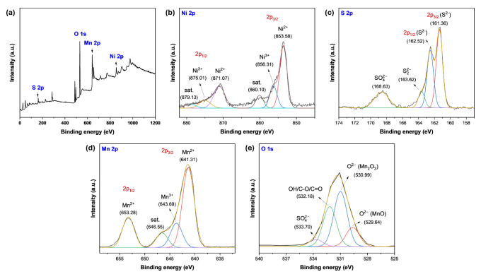
Figure S1. XPS spectra of the MnO/NiS composite: (a) wide-scan survey spectrum; high-resolution spectra of (b) Ni 2p, (c) S 2p, (d) Mn 2p, and (e) O 1s.

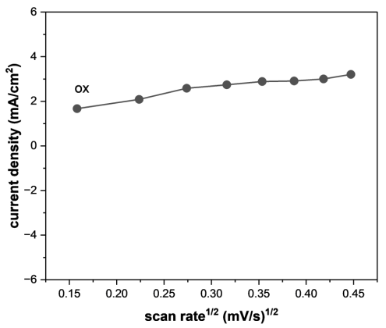
Figure S2. Plot of peak current density vs. scan rate dependence of MWCNT.

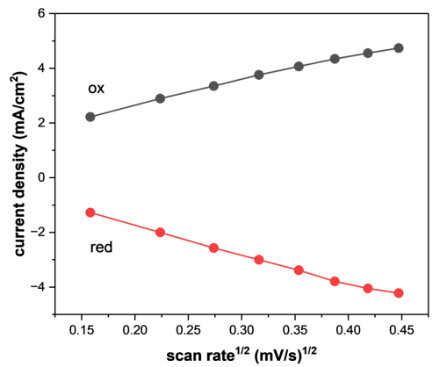
Figure S3. Plot of peak current density vs. scan rate dependence of MnO/NiS.

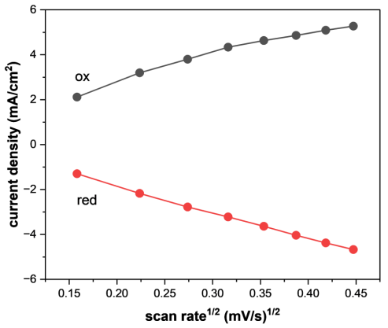
Figure S4. Plot of peak current density vs. scan rate dependence of MWCNT@MnO/NiS

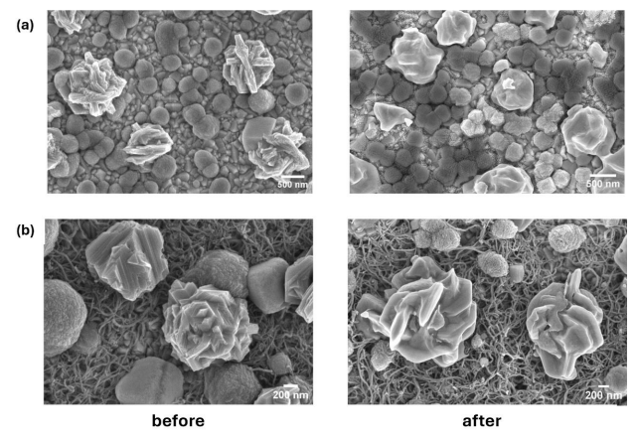
Figure S5. SEM images of (a) MnO@NiS and (b) MWCNT@MnO/NiS electrodes before and after long-term operation (15,840 hours) showing morphological stability.

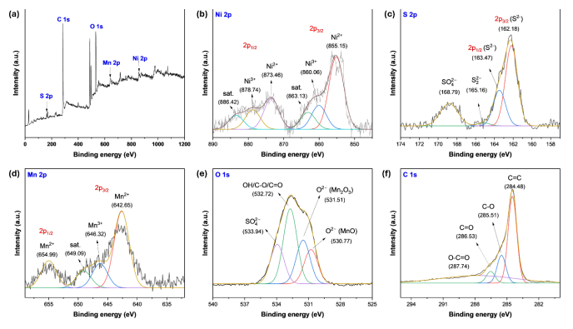
Figure S6. XPS spectra of the MWCNT@MnO/NiS composite after long-term operation (15,840 hours): (a) wide-scan survey spectrum; high-resolution spectra of (b) Ni 2p, (c) S 2p, (d) Mn 2p, (e) O 1s, and (f) C 1s.

Article

Unveiling the Potential of Mn_{x}Co_{3-x}S₄ Electrocatalyst in Triiodide Reduction for Dye-sensitized Solar Cells

D. Suleimenova^{1,2}, Ye. Tashenov^{1,2}, Mannix P. Balanay³, B. Baptayev^{1*}

¹National Laboratory Astana, Nazarbayev University, 53 Kabanbay Batyr Ave., Astana, 010000 Kazakhstan;
²Department of Chemistry, L.N. Gumilyov Eurasian National University, 2 Satpayev St., Astana, 010008 Kazakhstan;
³Chemistry Department, Nazarbayev University, 53 Kabanbay Batyr Ave., Astana, 010000 Kazakhstan (*Email: bbaptayev@nu.edu.kz)

The development of a low-cost and high-efficiency Pt-free counter electrode is an important goal to improve the performance of dye-sensitized solar cells. In this study, we successfully synthesized a Mn_{x}Co_{3-x}S₄-based counter electrode by a facile solvothermal synthesis technique. The electrocatalyst was directly deposited on a fluorine doped titanium oxide (FTO) coated glass substrate. Various characterization techniques such as X-ray diffraction, scanning electron microscopy, energy dispersive X-ray spectroscopy and X-ray photoelectron spectroscopy were employed to analyze the obtained Mn_{x}Co_{3-x}S₄ counter electrode material. The photovoltaic measurements performed on the dye-sensitized solar cells showed a remarkable improvement in energy conversion efficiency with the Mn_{x}Co_{3-x}S₄ counter electrode (8.60 %) compared to the conventional Pt (8.11 %). Moreover, the Mn_{x}Co_{3-x}S₄ counter electrode exhibited excellent stability, further highlighting its potential as an efficient and durable alternative to Pt in dye-sensitized solar cells. Overall, our results contribute to the further development of Pt-free counter electrode materials for sustainable solar energy applications.
Keywords: MnCo₂S₄; ternary sulfide; solvothermal synthesis; Pt-free counter electrodes, dye-sensitized solar cells.

Introduction
The demand for photovoltaic technology continues to increase as the world's population grows and environmental concerns increase. Among the various types of photovoltaic technologies, dye-sensitized solar cells (DSSCs) have emerged as a promising third-generation solution due to their low cost, high efficiency, and ease of fabrication. These characteristics make DSSCs a potential replacement for expensive silicon-based solar cells [1]. However, the commercialization of DSSCs faces challenges such as relatively low efficiency, poor stability, and non-competitive prices. Another hurdle is the use of platinum (Pt) as a counter electrode in DSSCs, which is problematic due to high cost, limited availability, and stability-related issues [2-4]. Consequently, there is an urgent need to develop low-cost and high-efficiency Pt-free counter electrodes to improve the overall affordability of solar cells [5].
Transition metal compounds, especially ternary compounds such as oxides, sulfides, and selenides, have emerged as promising alternatives to Pt due to their excellent electrocatalytic activity, long-term stability, and abundance [6-8]. In this study, we focused on the development of a MnCo₃S₄ electrocatalyst as a Pt-free counter electrode for DSSC applications. MnCo₂S₄ is a ternary compound derived from Co₃S₄ with one Co atom replaced by Mn. To achieve this, we synthesized a Mn_{x}Co_{3-x}S₄ counter electrode directly on a fluorine-doped titanium oxide (FTO) coated glass substrate using a simple one-step solvothermal method. The resulting Mn_{x}Co_{3-x}S₄/FTO counter electrode was extensively characterized by various spectroscopic and microscopic techniques and then integrated into a DSSC device to evaluate its performance.
Remarkably, the DSSC with the Mn_{x}Co_{3-x}S₄ composite counter electrode achieved a higher efficiency (PCE) of 8.60 % compared to the device with a conventional Pt counter electrode (PCE of 8.11 %). These results demonstrate the potential of Mn_{x}Co_{3-x}S₄ counter electrodes as a promising alternative to Pt in DSSCs, offering advantages such as lower cost and higher efficiency. With this research, we contribute to the further development of Pt-free counter electrode materials and pave the way for more affordable and sustainable photovoltaic technologies.

2. Experimental
2.1. Materials
Chemicals and materials were obtained from commercial sources and utilized as received, unless specifically stated otherwise.

2.2. Synthesis of Mn_{x}Co_{3-x}S₄ counter electrode
A composite material, Mn_{x}Co_{3-x}S₄, was synthesized by the solvothermal method. In this method, the precursors Mn(NO₃)₂, Co(NO₃)₂, and thiourea were dissolved in ethanol in an ultrasonic bath. The resulting solution, together with the FTO glass, was then transferred to a 50-mL stainless steel autoclave lined with Teflon and kept at a temperature of 180°C for 14 hours. The stoichiometric ratio of manganese and cobalt nitrates to thiourea was 1:2:10, respectively. Subsequently, the electrocatalyst-coated FTO substrates were washed with water and ethanol and dried at 70°C for 12 hours in a vacuum oven.

2.3. Fabrication of dye-sensitized solar cells
Preparation of the working electrode (WE) included the following steps: First, the FTO glass slides (2.2 mm thick, surface resistivity 7 Ω/sq, Sigma-Aldrich) were cleaned with ethanol and ultrasound and then air dried. A compact TiO₂ layer was formed by soaking the FTO in a 50 mM titanium (IV) isopropoxide solution in 2M HCl at 70ºC for 30 minutes and sintering at 500ºC for 30 minutes. A transparent TiO₂ paste (particle size: 18-20 nm, DN -EP03, Dyenamo) was doctor bladed the compact TiO₂ layer. After the transparent TiO₂ layer was air dried for 30 minutes, the electrodes were sintered in an oven at different temperatures: 125ºC for 5 minutes, 325ºC for 10 minutes, 425ºC for 15 minutes, and 500ºC for 30 minutes. Once the electrodes were cooled to 70ºC, a light-scattering TiO₂ layer (particle size: 150-250 nm, Greatcell Solar WER2-O, Sigma-Aldrich) was doctor bladed over the transparent TiO₂ film and air dried for 1 hour before sintering as described above. After cooling, the electrodes were immersed in a dye solution containing 0.25 mM of ruthenium-based standard dye N719 (Sigma-Aldrich) and 0.75 mM chenodeoxycholic acid (CDCA, Sigma-Aldrich) in an acetonitrile: tert-butanol mixture (1:1) for 24 hours. After loading the dye, the electrodes were rinsed with ethanol to remove unbound dye molecules from the surface of the TiO₂ film and then dried. The counter electrode (CE) was prepared using a Pt-based approach. A commercial Pt paste (containing terpineol and hexachloroplatinic acid, Sigma-Aldrich) was doctor bladed onto a clean and dry FTO glass substrate and then sintered at 500ºC for 30 minutes. To construct the dye-sensitized solar cell, an MPN-based iodine/iodide redox electrolyte (DN-OD03 S104, Dyenamo) was applied to the dye-loaded TiO₂ photoanode and the CE (either Pt or Mn_{x}Co_{3-x}S₄) was placed on top. The two electrodes were separated with double-sided adhesive tape.

2.4. Characterization
The electrocatalyst was subjected to various characterization techniques to evaluate its properties. X-ray diffraction (XRD) patterns were obtained using a Rigaku SmartLab system. The structure and morphology were analyzed using a Zeiss Crossbeam 540 scanning electron microscope (SEM). Energy dispersive X-ray spectroscopy (EDS) and NEXSA Thermoscientific X-ray photoelectron spectroscopy (XPS) were used to determine material composition. The photovoltaic analysis of the solar cells was performed using Dyenamo Toolbox (DN -AE01). Electrochemical analysis, on the other hand, was performed in the dark using the IM6 electrochemical station from Zahner Elektrik. The measurements were performed with a bias voltage of -0.72 V, an amplitude of 10 mV and a frequency range of 0.1 - 100000 Hz. The obtained data were further processed and fitted using the EIS Spectrum Analyzer.

3. Results and Discussion
3.1. Characterization of Mn_{x}Co_{3-x}S₄ electrocatalyst
Figure 1 shows the XRD patterns of Mn_{x}Co_{3-x}S₄. In addition to the prominent peaks originating from the FTO substrate, specific diffraction peaks can be observed at 32.09°, 36.73°, 48.36°, and 55.83° corresponding to the (311), (400), (511), and (440) crystal planes of Co₃S₄, respectively (PDF42-1448) [9]. It is noteworthy that the XRD diffraction peaks of Mn_{x}Co_{3-x}S₄ are very similar to those of Co₃S₄, indicating the substitution of a single Co atom by Mn and the similarity of crystal structure between the two [10]. Therefore, we can conclude that the doping process led to the formation of MnCo₂S₄.
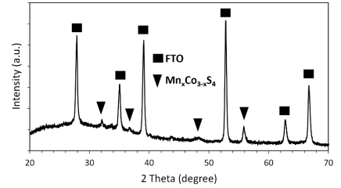
Figure 1: X-ray diffraction pattern of a thin film of Mn_{x}Co_{3-x}S₄ on an FTO substrate

The elemental composition and valence states were analyzed by X-ray photoelectron spectroscopy, and the corresponding spectra are shown in Figure 2. The full XPS spectrum of the Mn_{x}Co_{3-x}S₄ composites shows distinct peaks attributable to Mn, Co, and S, confirming the presence of these elements and their corresponding valence states in the sample. It is worth noting that the elements C, N and O are normally present in air.
The Co 2p spectrum shows two spin-orbit doublet peaks. The dominant peaks at 781.8 and 797.0 eV correspond to the 2p3/2 and 2p1/2 spin-orbit states of Co²⁺, respectively, while the weaker peaks at 777.6 and 792.8 eV are associated with Co³⁺ [10]. The presence of Co³⁺ peaks in the spectrum indicates possible oxidation of the surface when exposed to air. As can be seen in Figure 2, the Mn 2p orbitals show spin splitting leading to two singlet pairs: Mn 2p3/2 (642.8 eV) and Mn 2p1/2 (654.6 eV), which can be attributed to the Mn²⁺ binding energy [11]. In the S 2p XPS spectra, a satellite peak at 168.7 eV and three peaks representing different sulfur species are observed. The peaks at 162.3 and 163.5 eV correspond to S 2p3/2 and S 2p1/2, respectively. In addition, the peak at 164.6 eV indicates metal-bonded sulfur (S-M) [12].

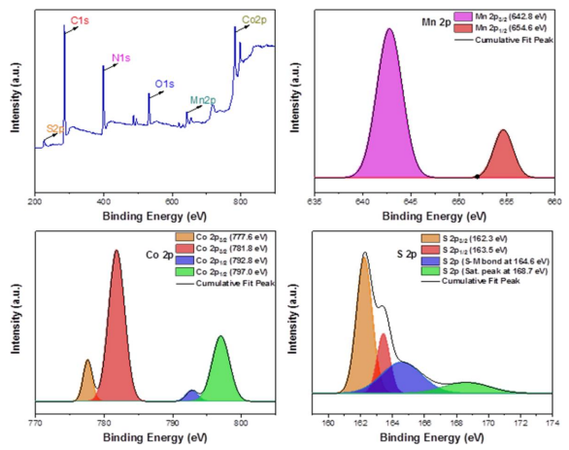
Figure 2. XPS spectra of the Mn_{x}Co_{3-x}S₄ electrocatalyst.

Uniformly grown Mn_{x}Co_{3-x}S₄ nanoflakes were prepared on the surface of FTO glass by a solvothermal reaction. The resulting electrocatalyst had nanoflakes with an average diameter of about 260 nm and a plate thickness of 36.5 nm, as shown in the upper part of Figure 3. The lower part of Figure 3 shows the spectrum of energy dispersive X-ray spectroscopy of the synthesized Mn_{x}Co_{3-x}S₄ composite, which confirms the presence of elements Mn, Co and S in the prepared material.

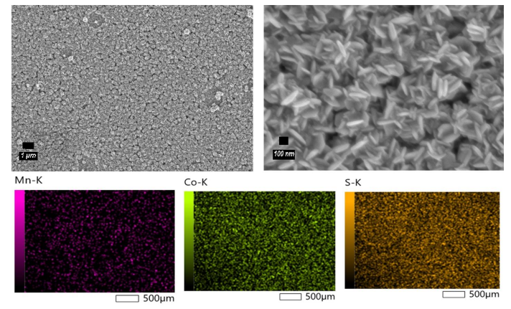
Figure 3. Top: FE-SEM images of the Mn_{x}Co_{3-x}S₄ coated FTO electrode showing magnifications of 5000 (left) and 40000 (right). Bottom: EDS mapping of the electrocatalyst.

3.2. Photovoltaic and electrochemical performance of Mn_{x}Co_{3-x}S₄ electrocatalyst
To investigate the photovoltaic and electrochemical performances of an electrocatalyst, dye-sensitized solar cells were constructed using Mn_{x}Co_{3-x}S₄ and Pt as counter electrodes. The photovoltaic measurements were performed under the standard solar conditions AM 1.5 and an illuminance of 1000 W/cm². The obtained results are summarized in Table. Figure 4a shows the current-voltage (J-V) curve of the solar cells, while Figure 4b presents the Nyquist diagrams. It is worth noting that the Mn_{x}Co_{3-x}S₄ composite cell has an excellent performance with a power conversion efficiency (PCE) of 8.60 %, slightly exceeding the Pt cell efficiency of 8.11 %. The main factor contributing to the increase in PCE efficiency is the short circuit current (J_{SC}), which was 16.60 mA/cm² for the Mn_{x}Co_{3-x}S₄ cell and 15.87 mA/cm² for the Pt control device. This higher J_{SC} indicates better electrocatalytic activity of the Mn_{x}Co_{3-x}S₄ electrocatalyst compared to Pt. The electrochemical impedance spectroscopy measurements confirm this result (Fig. 4b). The Nyquist diagrams of the solar cells consist of two semicircles: The smaller arc represents the charge transfer resistance at the interface between the counter electrode and the electrolyte (R_{CT}), while the larger arc corresponds to the charge transfer resistance at the interface between the semiconductor and the electrolyte (.). The intersection of the graph with the x-axis indicates the series resistance of the device (R_{S}). It is worth noting that the Mn_{x}Co_{3-x}S₄ cell has a lower series resistance (19.2 Ω) compared to Pt (22.6 Ω), indicating better contact between Mn_{x}Co_{3-x}S₄ and FTO. In addition, the R_{CT} of the Mn_{x}Co_{3-x}S₄ cell was also lower than that of the Pt solar cell, indicating improved electrocatalytic activity of the novel Pt-free counter electrode and improved electron flow at the counter electrode-electrolyte interface. This electron flow, referred to as the exchange current (J₀), is indirectly proportional to the charge transfer resistance R_{CT} and can be expressed as
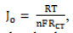
where R is the universal gas constant, T is the absolute temperature, n is the number of electrons involved in the triiodide reduction process, and F is Faraday's constant. The superior electrocatalytic activity of Mn_{x}Co_{3-x}S₄ provides an explanation for the improved J_{SC} in the DSSCs compared to Pt.

Table. Photovoltaic parameters comparison between DSSCs with Mn_{x}Co_{3-x}S₄ composites and Pt counter electrodes.

DSSCs | PCE (%) | V_{OC} (V) | J_{SC} (mA/cm²) | FF | R_{S} (Ω) | R_{CT} (Ω) | RTiO₂ (Ω)
Mn_{x}Co_{3-x}S₄ | 8.60 | 0.73 | 16.60 | 0.71 | 19.2 | 12.9 | 47.9
Pt | 8.11 | 0.73 | 15.87 | 0.70 | 22.6 | 13.1 | 54.6

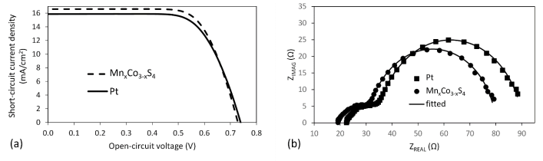
Figure 4. (a) Current-voltage curves and (b) Nyquist plots depicting the performance of dye-sensitized solar cells.

4. Conclusions
In this study, Pt-free counter electrodes based on Mn_{x}Co_{3-x}S₄ were successfully synthesized by a one-pot solvothermal method. The electrocatalytic activity of Mn_{x}Co_{3-x}S₄ proved to be excellent and exceeded that of Pt, as further measurements showed. In particular, the dye-sensitized solar cell with Mn_{x}Co_{3-x}S₄ composites as the counter electrode achieved an efficiency of 8.60 %, slightly outperforming the DSSC with Pt counter electrode (PCE: 8.11 %). These results highlight the potential of Mn_{x}Co_{3-x}S₄ composites as a promising alternative to Pt for DSSC counter electrodes due to their improved electrocatalytic performance and cost efficiency. Moreover, this research introduces a novel idea and strategy for fabricating efficient base metal counter electrode materials for DSSCs. The convenient solvothermal method used in this study provides a practical and scalable approach to fabricate Mn_{x}Co_{3-x}S₄ composites. This technique can potentially be extended to other metal sulfide materials, allowing the development of a broader range of base metal counter electrodes. The successful implementation of Mn_{x}Co_{3-x}S₄ composites as Pt-free counter electrodes not only solves the problem of scarcity and high cost of Pt but also provides a sustainable and environmentally friendly solution for DSSC technology. Future studies can address the optimization of the composition and morphology of Mn_{x}Co_{3-x}S₄ composites to further improve their performance in DSSCs and ultimately advance the field of renewable energy.

5. Author contributions
Diana Suleimenova was responsible for the conception and design of the analysis and for performing the synthesis, characterization, and electrochemical and photovoltaic measurements. She was also involved in writing the first draft of the manuscript. Yerbolat Tashenov played a key role in the analysis of the data. Bakhytzhan Baptayev contributed to the conception and design of the analysis, performed an overall analysis of the data, and provided the necessary funding. Mannix P. Balanay contributed to the conception and design of the analysis and provided critical revisions to the overall manuscript.

6. Conflicts of interest
There are no conflicts to declare.

7. Acknowledgements
This research was funded by the Science Committee of the Ministry of Education and Science of the Republic of Kazakhstan (Grant No. АР13068358 “Low-cost solid-state dye-sensitized solar cells - a new strategy of the development of the field”, project PI - B.B.).

References
1. O'Regan, B. & Grätzel, M. (1991). A low-cost, high-efficiency solar cell based on dye-sensitized colloidal TiO₂ films. Nature, 353(6346), 737-740.
2. Olsen, E., Hagen, G. & Eric Lindquist, S. (2000). Dissolution of platinum in methoxy propionitrile containing LiI/I₂. Sol. Energy Mater. Sol. Cells, 63(3), 267-273.
3. Shu, Z. X. & Bruckenstein, S. (1991). Iodine adsorption studies at platinum. J. Electroanal. Chem. Interfacial Electrochem, 317(1-2), 263-277.
4. Kay, A. & Grätzel, M. (1996). Low cost photovoltaic modules based on dye sensitized nanocrystalline titanium dioxide and carbon powder. Sol. Energy Mater. Sol. Cells, 44(1), 99-117.
5. Ahmed, U., Alizadeh, M., Rahim, N.A., Shahabuddin, S., Ahmed, M.S. & Pandey, A.K. (2018). A comprehensive review on counter electrodes for dye sensitized solar cells: A special focus on Pt-TCO free counter electrodes. Sol. Energy, 174, 1097-1125.
6. Liu, K., Wei, A., Liu, J., Liu, Z., Xiao, Z. & Zhao, Y. (2018). NiCo₂S₄ nanosheet thin film counter electrodes prepared by a two-step approach for dye-sensitized solar cells. Mater. Lett. 217, 185-188.
7. Theerthagiri, J., Senthil, R.A., Buraidah, M.H., Madhavan, J., Arof, A.K. & Ashokkumar, M. (2016). One-step electrochemical deposition of Ni_{1−x}Mo_{x}S ternary sulfides as an efficient counter electrode for dye-sensitized solar cells. J. Mater. Chem. A, 4(41), 16119-16127.
8. Hou, W., Xiao, Y. & Han, G. (2017). An interconnected ternary MIn₂S₄ (M=Fe, Co, Ni) thiospinel nanosheet array: A type of efficient platinum-free counter electrode for dye-sensitized solar cells. Angew. Chem., 129(31), 9274-9278.
9. Li, Y., Wang, N., Xu, J., Liu, Z. & Yu, H. (2019). Significant effect of advanced catalysts Co₃S₄ modified CuWO₄·2H₂O under visible light condition photocatalytic hydrogen production. J. Nanopart. Res., 21(4), 80.
10. Dai, Z., Feng, X., Li, Q., Su, P., Shen, X., Zheng, Y., Jiao, Q., Zhao, Y., Li, H. & Feng, C. (2021). Construction of porous core-shell MnCo₂S₄ microrugby balls for efficient oxygen evolution reaction. J. Alloys Compd., 872.
11. Raghavendra, K.V.G., Gopi, C.V. V. M., Vinodh, R., Rao, S.S., Obaidat, I.M. & Kim, H.-J. (2020). Facile synthesis of nanoparticles anchored on honeycomb-like MnCo₂S₄ nanostructures as a binder-free electroactive material for supercapacitors. J. Energy Storage, 27.
12. Wang, H., Zhang, K., Song, Y., Qiu, J., Wu, J. & Yan, L. (2019). MnCo₂S₄ nanoparticles anchored to N- and S-codoped 3D graphene as a prominent electrode for asymmetric supercapacitors. Carbon, 146, 420-429.

Д. Сүлейменова, Е. Ташенов, Маникс П. Баланэй, Б. Баптаев

Бояғышқа сезімтал күн батареялары үшін триодидтерді тотықсыздану кезінде Mn_{x}Co_{3-x}S₄ электрокатализаторының әлеуетін ашу

Қымбат емес және жоғары тиімді, құрамында платинасы жоқ қарсыэлектродты жасау бояғышқа сезімтал күн батареяларының өнімділігін жақсартудың маңызды міндеті болып табылады. Бұл зерттеуде біз қарапайым солвотермиялық синтез әдісін қолдана отырып, Mn_{x}Co_{3-x}S₄ қарсы электродты сәтті синтездедік. Электрокатализатор тікелей фтор легирленген титан оксидімен (FTO) қапталған шыны төсенішке қолданылды. Алынған Mn_{x}Co_{3-x}S₄ қарсыэлектрод материалын талдау үшін рентгендік дифракциялық спектроскопия, сканерлеуші электрондық микроскопия, энергиялық дисперсиялық рентгендік спектроскопия және рентгендік фотоэлектрондық спектроскопия сияқты әртүрлі сипаттама әдістері пайдаланылды. Бояғышқа сезімтал күн батареяларында жүргізілген фотоэлектрлік өлшеулер әдеттегі Pt (8,11 %) салыстырғанда Mn_{x}Co_{3-x}S₄ есептегіш электродпен (8,60 %) қуатты түрлендіру тиімділігінің айтарлықтай жақсарғанын көрсетті. Сонымен қатар, Mn_{x}Co_{3-x}S₄ қарсыэлектроды тамаша тұрақтылықты көрсетті, бұл оның әлеуетін одан әрі бояғышқа сезімтал күн батареяларында Pt-ге тиімді және берік балама ретінде әлеуетін одан әрі көрсетеді. Тұтастай алғанда, біздің нәтижелеріміз күн энергиясын тұрақты пайдалану үшін Pt-сіз контрэлектродтық материалдарды одан әрі дамытуға ықпал етеді.
Кілт сөздер: MnCo₂S₄, үштік сульфид, солвотермиялық синтез, Pt жоқ қарсы электродтар, бояғышқа сезімтал күн батареялары.

Д. Сулейменова, Е. Ташенов, Маникс П. Баланэй, Б. Баптаев

Раскрытие потенциала электрокатализатора Mn_{x}Co_{3-x}S₄ в восстановлении трийодидов для солнечных элементов, сенсибилизированных красителем

Разработка недорогого и высокоэффективного противоэлектрода, не содержащего платины, является важной задачей для улучшения характеристик солнечных элементов, сенсибилизированных красителем. В этом исследовании мы успешно синтезировали противоэлектрод на основе Mn_{x}Co_{3-x}S₄ с помощью простого метода сольвотермического синтеза. Электрокатализатор наносили непосредственно на стеклянную подложку с покрытием из легированного фтором оксида титана (FTO). Для анализа полученного материала противоэлектрода Mn_{x}Co_{3-x}S₄ использовались различные методы характеризации, такие как рентгеновская дифракционная спектроскопия, сканирующая электронная микроскопия, энергодисперсионная рентгеновская спектроскопия и рентгеновская фотоэлектронная спектроскопия. Фотогальванические измерения, выполненные на солнечных элементах, сенсибилизированных красителем, показали заметное улучшение эффективности преобразования энергии с противоэлектродом Mn_{x}Co_{3-x}S₄ (8,60 %) по сравнению с обычным Pt (8,11 %). Кроме того, противоэлектрод Mn_{x}Co_{3-x}S₄ продемонстрировал превосходную стабильность, что еще больше подчеркивает его потенциал в качестве эффективной и долговечной альтернативы Pt в солнечных элементах, сенсибилизированных красителем. В целом, наши результаты способствуют дальнейшему развитию материалов противоэлектродов, не содержащих Pt, для устойчивого использования солнечной энергии.
Ключевые слова: MnCo₂S₄, тройной сульфид, сольвотермальный синтез, бесплатиновые противоэлектроды, солнечный элемент, сенсибилизированный краситель.

Conference

Pt-free and efficient counter electrode with nanostructured MnCo₂S₄ for dye-sensitized solar cells

Diana Suleimenova^{1*}, Ayagoz Ibrayeva¹, Bakhytzhan Baptayev², Yerbolat Tashenov^{1,3}, Mannix P. Balanay^{3**}

¹L.N. Gumilyov Eurasian National University, Nur-Sultan, 010000 Kazakhstan
²National Laboratory Astana, 53 Kabanbay Batyr Ave., Nur-Sultan, 010000 Kazakhstan
³Department of Chemistry, School of Sciences and Humanities, Nazarbayev University, 53 Kabanbay Batyr Ave., Nur-Sultan, 010000 Kazakhstan
*E-mail: www.lady.di@mail.ru , **E-mail: mannix.balanay@nu.edu.kz

In the past few years, the development of alternative and renewable energy sources has been one of the urgent and most important tasks due to the growing demand of the population for energy. Dye-sensitized solar cells (DSSC) firstly introduced by Grätzel and O'Regan are third generation photovoltaic devices that have distinctive advantages over silicon solar cells, such as low cost of materials used, ease of fabrication and eco-friendliness.
The development of an alternative counter electrode for dye-sensitized element (DSSC) using a simple and single method is an ad hoc research direction for problem solving used with an expensive Pt-based counter electrode. In this work, a MnCo₂S₄ counter electrode was developed directly on a fluorine-doped titanium oxide (FTO) coated glass substrate using a one-step and simple hydrothermal method. The MnCo₂S₄@FTO counter electrode has been characterized by several spectroscopic and microscopic methods and has also been assembled in a DSSC device to evaluate electrode performance.
The DSSC with MnCo₂S₄ counter electrode produced 97 % comparable efficiency with Pt-based electrode which shows its applicability as an alternative counter electrode owing to its reduced production cost and almost similar photovoltaic efficiency with the reference electrode.

Conference

Pt-free and efficient counter electrode with FeCo₂S₄ nanowires for dye-sensitized solar cells

Diana Suleimenova^{1,2}, Yerbolat Tashenov¹, Bakhytzhan Baptayev², Mannix P. Balanay³*

¹L.N. Gumilyov Eurasian National University, Astana, 010000 Kazakhstan
²National Laboratory Astana, 53 Kabanbay Batyr Ave., Astana, 010000 Kazakhstan
³Department of Chemistry, School of Sciences and Humanities, Nazarbayev University, 53 Kabanbay Batyr Ave., Astana, 010000 Kazakhstan
*Corresponding authors emails: bbaptayev@nu.edu.kz (BB); mannix.balanay@nu.edu.kz (MPB)

The population's growing demand for energy has made the development of alternative and renewable energy sources one of the most urgent and important problems of recent years. Dye-sensitized solar cells (DSSCs), originally introduced by Grätzel and O'Regan, represent a third generation of photovoltaic devices that offer unique advantages over silicon solar cells, including low material cost, ease of fabrication, and environmental friendliness. The development of an alternative counter electrode for dye-sensitized solar cells with a simple and straightforward method is an ad hoc research direction for solving problems used with an expensive Pt-based counter electrode. In this work, a FeCo₂S₄ counter electrode was developed directly on a fluorine-doped titania (FTO) coated glass substrate using a three-step solvothermal method: Preparation of precursor, preparation of cobalt iron oxide and sulfurization process. The FeCo₂S₄@FTO counter electrode was characterized by various spectroscopic and microscopic methods and incorporated into a DSSC device to evaluate the performance of the electrode. The DSSC with the FeCo₂S₄ counter electrode achieved an efficiency of 95 %, which is comparable to the Pt-based electrode. This shows that the FeCo₂S₄ counter electrode is suitable as an alternative counter electrode as it can be produced at a lower cost and has an almost similar photovoltaic efficiency to the reference electrode.

Patent
