International Educational Corporation

UDC: 728.3(574) Manuscript rights

SAKENOVA SAYA MEIRKHANOVNA

Specific Features of the Development of Bioclimatic Architecture for Low-Rise Urban Housing in Southeastern Kazakhstan

8D07311 - Architecture

Dissertation for the degree Doctor of Philosophy (PhD)

Domestic Scientific Advisor:
Amandykova D. A., Candidate of Architecture, Research Professor, School of Design, IEC
International Scientific Advisor:
Konbr U., Professor of Architecture and Urban Development, Department of Architecture, Faculty of Engineering, Tanta University

Republic of Kazakhstan
Almaty, 2026
CONTENTS

NORMATIVE REFERENCES 3
DEFINITIONS 4
ABBREVIATIONS AND SYMBOLS 7
INTRODUCTION 9
1. Theoretical foundations of bioclimatic architecture in low-rise housing 19
1.1 History of the Formation of Bioclimatic Architecture 19
1.2 International Experience in the Design of Low-Rise Residential Buildings with Due Regard for Bioclimatic Conditions 30
1.3 Influence of Natural and Climatic Factors on the Architecture of Low-Rise Residential Buildings in Kazakhstan 39
Conclusions to Section One 49
2. Analysis of contemporary factors influencing the formation of the bioclimatic architecture of low-rise urban housing in the Southeastern Kazakhstan 51
2.1 International and National Certification Systems for Sustainable Construction 51
2.2 Modern Concepts of Sustainable Development in Low-Rise Construction 60
2.3 Socio-Economic and Demographic Features of Urban Development in the Region 69
2.4 Natural, Climatic, and Urban-Planning Factors Affecting the Formation of the Residential Environment within the Urban Structure 78
Conclusions to Section Two 86
3. Bioclimatic architecture of low-rise urban housing in Southeastern Kazakhstan 88
3.1 Architectural and Planning Solutions for Low-Rise Urban Housing in Southeastern Kazakhstan 88
3.2 Specific Features of the Spatial and Volumetric Design of Low-Rise Residential Buildings 98
3.3 Placement of Low-Rise Residential Buildings within the Urban System 113
3.4 Recommendations for the Formation of the Bioclimatic Architecture of Urban Housing in Southeastern Kazakhstan 120
Conclusions to Section Three 128
CONCLUSION 130
LIST OF REFERENCES 133
Appendix A 145
Appendix B 153
Appendix C 171

NORMATIVE REFERENCES

This dissertation uses references to the following standards, regulatory documents, and official methodological documents:
- UN 2030 Strategy on Urban Environmental Sustainability
- Concept for the Development of Energy Saving and Energy Efficiency in the Republic of Kazakhstan for 2023-2029
- OMIR Certification
- Law of the Republic of Kazakhstan dated July 16, 2001, No. 242 'On Architectural, Urban Planning and Construction Activities in the Republic of Kazakhstan'
- UN-Habitat Profile Program
- Environmental Standard for Building Materials - BREEAM
- Energy Efficiency Standard - LEED
- Green Building Council
- SNiP RK 2.04.01-2001 (Building Codes and Regulations of the Republic of Kazakhstan). Construction Climatology. - Astana: Committee for Construction and Housing and Communal Services
- SNiP RK 3.02.43-2007 (Building Codes and Regulations of the Republic of Kazakhstan). Residential Buildings. - Astana: Committee for Construction and Housing and Communal Services
- Environmental Code of the Republic of Kazakhstan: adopted on January 2, 2021, No. 4007
- Human Development Report
- Manifesto of the XXIII World Congress of the International Union of Architects (2009, UIA World Congress, Turin)
- Recommendations for the Design of Residential Buildings in the Kazakh SSR in the Territory of the IV Climatic Region with Dust Storms
- Decrees of the Government of the Republic of Kazakhstan dated March 15, 2023, No. 211 'On the Establishment of the Special Economic Zone "G4 City"' and dated December 6, 2023, No. 1087 'On the Approval of the Comprehensive Plan for the Socio-Economic Development of the City of Konaev, Almaty Region for 2023-2027'
- Action Plan for the Implementation of the Instructions of the President of the Republic of Kazakhstan on the Socio-Economic Development of the City of Almaty

DEFINITIONS

Arid Climate | A dry climate with low atmospheric moisture and high temperatures, limiting but not entirely preventing vegetation growth; typical of deserts and semi-deserts.
Atriums | Open inner courtyards surrounded by columns and connected with surrounding residential spaces.
Bioclimatic Architecture | Design that responds to the regional climate to provide comfort with minimal energy consumption, using environmentally clean sources (sun, wind, water, soil), and reduces the need for heating, cooling, and lighting.
Bioclimatic Assessment | An assessment that identifies the medical and climatic potential of a territory to use landscape and climatic features for healthcare and recreation efficiently.
Bioclimatics | A branch of architecture that takes into account ecological and sustainable development requirements and aims to improve environmental and energy efficiency indicators of existing and new urban residential buildings.
Biophilic Design | The integration of natural elements into artificial environments to improve quality of life, based on the concept of biophilia introduced by E.O. Wilson in 1984.
BREEAM | Building Research Establishment Environmental Assessment Method, a UK-developed environmental certification standard focused on building materials.
Domus | A Roman 1-2 story townhouse, originally intended for a single family.
Ecological Architecture | A design approach focused on preserving and integrating natural elements into the urban environment.
Equivalent-Effective Temperature | Temperature, which considers the combined influence of air temperature, humidity, and wind speed on a person.
Facies | The smallest landscape unit visible only at a large scale, such as a birch grove, a hill, or a small depression in the steppe.
Fusuma | A subcategory of shōji: opaque or painted sliding panels used to divide interior spaces in traditional Japanese homes.
Global Campaign for Secure Tenure | A campaign to ensure legal security of tenure as a key factor in housing strategy, supporting the rights of the urban poor, and emphasizing the role of women in housing policy.
Global Campaign for Urban Governance | A campaign aimed at strengthening local capacity for effective, accountable, and inclusive urban governance, particularly addressing the needs of marginalized groups, and promoting women's participation.
Indoor climate control | A set of measures and devices that ensure the creation of an artificial indoor climate. Its effect is determined by air temperature, humidity, mobility, and the temperature of surrounding surfaces.
Insula | A Roman multi-story apartment building (2-4 floors) intended for rent.
Landscape | A natural-territorial complex defined by natural boundaries and characterized by a specific visual appearance.
LEED | Leadership in Energy and Environmental Design, a US-developed certification standard emphasizing energy efficiency.
Morphogenesis in Architecture | The gradual development and organization of spatial structures in architecture.
Passive House | A building characterized by extremely low energy consumption achieved through passive energy-saving strategies.
Shōji | A general term for translucent sliding or fixed screen doors or walls made of wood lattice and paper in traditional Japanese architecture.
Smart Materials | Materials capable of responding to external stimuli by changing their properties. They may exhibit shape-shifting, self-healing, magnetic behavior, and other smart functions.
Solar Architecture | An architectural approach to building that utilizes clean and renewable solar energy, incorporating optics, thermodynamics, electronics, photovoltaics, materials science, and energy efficiency.
Sustainable Architecture | Environmentally oriented high-tech that minimizes environmental impact through efficient use of materials, energy, space, and ecosystems.
Territorial Bioclimate | An important natural resource that directly influences human comfort and well-being.
Thermal Building | A modern wellness and recreation center based on natural thermal springs, typically including pools, saunas, spas, and related services.
UN-Habitat | The United Nations Human Settlements Program promotes sustainable urban development through advocacy, policy guidance, capacity-building, knowledge sharing, and partnerships.
Urban Heat Island | The temperature difference between a city's urban center and its outskirts.
Urban Landscape | A complex multi-component system consisting of both natural and artificial elements.
Urbanism | A 20th-century urban planning movement advocating for the creation and expansion of large cities, often seen as a symbol of modern urbanism.
Urbanization | A socio-economic process characterized by the growing importance of cities, the rise of urban lifestyles, and their cultural and civilizational influence.
Yurt (Kiyiz Yui / Ger) | A traditional portable dwelling made from wood, felt, reeds, and decorated with ornaments, used by nomadic peoples.
Сlub-type residential building | An elite low-rise apartment building built or restored to an exclusive design in a prestigious urban area, intended for residents of a similar social class.

ABBREVIATIONS AND SYMBOLS

BAT | Biologically Active Temperature
BREEAM | Building Research Establishment Environmental Assessment Method
С | Clothing Insulation (Clo); Climate Discomfort Coefficient by Rusanov
CIAM | Congrès Internationaux d’Architecture Moderne
CRISED (ЦНИИЭП) | Central Research Institute for Standard and Experimental Design
DI | Discomfort Index (USA)
DY | Discomfort Index (Japan)
EET | Equivalent-Effective Temperature
ESHT | Equivalent Still Air Temperature
G | Thermoregulation Stress Index (by Eisenstat)
H | Wind Chill Index (Hill)
I | Pathogenic Meteorological Situation Index (Boksha)
K | WPC Variability Index (by Rusanov); BISM Index (by Belkin)
Kazgorstroyproject | Design Organization
Kg | Climate Continentality Index (by Gorchinsky)
Khr (Кхр) | Climate Continentality Index (by Khromov)
MHI (МИЗ) | Meteorological Health Index (by Bogatkin)
N | Thermal Load Index (by Kondratyev)
NEET | Normal Equivalent-Effective Temperature (thermal sensitivity indicator for clothed individuals considering wind)
Qs | Body Heat Balance (by Rusanov)
RC | Residential Complex
REET | Radiation Equivalent-Effective Temperature (considered the most informative index)
RES | Renewable Energy Sources
S | Severity Score (Bodman)
So | Weather Rigidity Coefficient (Osokin)
T | Weather Rigidity Coefficient (Arnoldi)
TPR (ТПР) | Adjusted Temperature Index (Adamenko and Khairulin)
UHI | Urban Heat Island
UN | United Nations
W (К) | Wind-Chill Index (Seiple)
WC | Refined Wind-Chill Index (Canada)
WPC (КПМ) | Weather Pattern Class (by Rusanov)
ρO₂ | Partial Oxygen Density (Ovcharova)
ЕТ | Equivalent-Effective Temperature (indicator of thermal sensitivity, including wind effect)

INTRODUCTION

Relevance of the research topic. Under conditions of global climate change, accelerated urbanization, and the increasing burden on energy systems, environmental sustainability in the built environment is acquiring particular significance. Contemporary architecture and urban planning are increasingly oriented toward the principles of rational use of natural resources, energy efficiency, and the adaptation of architectural solutions to the natural and climatic conditions of specific territories. In this context, bioclimatic architecture, as one of the directions of environmentally sustainable construction, is an effective approach to shaping the architectural environment, reducing building energy consumption, and creating comfortable conditions for human life and activity.
Over recent decades, bioclimatic architecture has become widely disseminated in international practice as an important direction in the sustainable development of cities and the rational use of natural resources. At the international level, this issue is reflected in the United Nations Sustainable Development Goals for 2030, which give particular attention to ensuring that cities and human settlements are inclusive, safe, resilient, and environmentally sustainable [1-3].
In the Republic of Kazakhstan, issues of environmental and energy efficiency of construction are also gradually acquiring institutional significance. At the initiative of the Green Building Council, the national environmental building certification system, “OMIR,” has been developed and adapted to the economic, climatic, and technological characteristics of the country’s construction sector [4]. The regulatory foundation for ensuring a favorable living environment and conditions for the life activity of the population is constituted by the provisions of the Law of the Republic of Kazakhstan No. 242 of July 16, 2001, “On Architectural, Urban Planning, and Construction Activity in the Republic of Kazakhstan,” in particular the provisions concerning citizens’ right to a favorable environment in populated areas [5].
For Kazakhstan, the issue under consideration has not only environmental, but also strategic socio-economic significance. Considerable resources are expended on the production, extraction, and transportation of energy resources, while issues of energy conservation and improving the energy efficiency of buildings remain highly relevant. Under these conditions, the development of green, energy-efficient construction is an important direction for increasing the sustainability of the construction sector, reducing operating costs, and mitigating negative environmental impacts.
The principles of green building presuppose the efficient use of natural resources, the reduction of environmental burdens, and, simultaneously, the provision of comfortable conditions for residence and work. The implementation of these principles involves the use of environmentally safe building materials, energy-efficient engineering systems, rational water-use technologies, natural ventilation systems, and intelligent management of building energy consumption. In general, certified green buildings are characterized by lower operating costs, reduced energy and water consumption, and a higher-quality indoor environment, which positively affects user health and comfort.
At the same time, the introduction of ecological and bioclimatic design principles into construction practice is accompanied by several constraints. Among the principal ones are higher initial capital costs, limited availability of certain environmentally safe building materials, and insufficient professional training among construction sector specialists in sustainable architectural design. Nevertheless, the development of green buildings remains one of the key directions of long-term environmental and economic sustainability. It requires coordination among the state, the scientific community, the professional architectural community, and the education system.
Particular relevance to the issue under consideration is imparted by the projected deficit of water resources in Kazakhstan. According to assessments by international experts, the water deficit may reach 50% of current demand by 2040. Under these conditions, technologies for rational water use and the reuse of water resources acquire particular significance; they likewise form part of the system of principles for environmentally oriented construction.
In the context of the aforementioned trends, bioclimatic architecture, which adapts architectural solutions to a territory's natural and climatic conditions, is particularly important in the Southeastern region of Kazakhstan. This region is characterized by a pronounced continental climate, significant seasonal temperature fluctuations, and a diversity of natural landscapes, all of which necessitate careful consideration of climatic factors in shaping the architectural environment.
Southeastern Kazakhstan is characterized by cold winters and a hot summer, placing increased demands on energy efficiency and microclimatic comfort in residential development. Under these conditions, the design of low-rise residential buildings must be based on the principles of bioclimatic design, including optimizing heat loss, rational use of solar energy, effective natural ventilation, and the creation of a favorable microclimate within the residential environment.
Of particular importance in bioclimatic design are architectural and spatial solutions, including buffer zones, atrium spaces, and the rational orientation of buildings relative to the cardinal directions. Such solutions enable regulating the thermal balance of buildings, improving natural lighting and ventilation conditions, and reducing energy consumption for space heating and cooling.
An equally important aspect is the use of environmentally safe and climate-adapted building materials. The use of local materials and technologies that align with the region's natural conditions increases the sustainability of the residential environment and reduces environmental burdens on the surrounding environment.
Additional relevance is imparted to the study by the contemporary urban planning transformations taking place in the largest cities of Kazakhstan, particularly in the city of Almaty, where new development regulations are being introduced that are aimed at regulating functional zoning, limiting building height, and taking natural and environmental factors into account in the formation of the urban environment. Despite the progressive character of these changes, existing regulatory approaches largely preserve an aggregated principle of territorial regulation, treating large urban areas as homogeneous. At the same time, within such zones there is substantial variability in microclimatic conditions, determined by relief, the density and morphology of development, landscaping, and air-flow characteristics. This necessitates a transition to a more detailed, microclimatically oriented approach in architectural and planning design, which determines the scientific and practical significance of the present study.
Thus, the relevance of the present study is determined by the need for a scientific substantiation of the principles for the formation of the bioclimatic architecture of low-rise urban housing under the conditions of Southeastern Kazakhstan, aimed at increasing energy efficiency, environmental sustainability, and the comfort of the residential environment, as well as at developing architectural design methods adapted to regional natural and climatic conditions.
Degree of elaboration of the research topic. The issues of bioclimatic architecture and climatically adapted design of the residential environment have been widely developed in both domestic and international scholarly literature. Contemporary research in this field encompasses a broad range of questions related to the interaction between architecture and natural and climatic factors, the formation of an energy-efficient residential environment, and the development of principles of sustainable architectural design.
The theoretical foundations of bioclimatic architecture were established by foreign researchers, who examined the principles of interaction between architecture and the natural environment, as well as the possibilities of using climatic factors in architectural design. A significant contribution to the development of the concept of climatically adaptive architecture was made by the studies of V. Olgyay [6], in which the foundations of climate-oriented building design were developed, and the bioclimatic chart was proposed as a tool for analyzing comfortable climatic conditions.
The works of Luis de Garrido [7] address issues of environmentally sustainable architecture and the use of renewable natural resources in construction. Of substantial importance for the development of the bioclimatic approach are the studies by Willi Weber and Simos Yannas [8], which analyze passive strategies for the climatic adaptation of buildings and the formation of an energy-efficient architectural environment.
An important contribution to the development of the theory of sustainable architecture was made by Norbert Lechner's [9] studies, which systematized methods of climate-oriented architectural design, including the use of natural factors to improve the energy efficiency of buildings.
A special place in the development of bioclimatic architecture is occupied by the studies of Ken Yeang [10-14], in which the principles of integrating the natural environment into the structure of buildings, as well as the interrelationship between architectural form, ecological technologies, and natural processes, are examined. Issues of architectural environmental efficiency and the sustainable development of the urban environment were further developed by Richard Saxon [15] and Richard Hyde [16].
The influence of natural and climatic conditions on the architecture of residential buildings has a long scholarly tradition and has been examined by both classical and contemporary researchers. The foundations of climatically conditioned architectural design were laid as early as the ancient period by M. Vitruvius [16], who emphasized the need to account for natural conditions in the design of buildings.
During the Renaissance, these ideas were further developed in the works of L. B. Alberti [20] and A. Palladio [21], in which architecture was considered a system closely connected to the natural environment and the climatic characteristics of a territory. In subsequent periods, questions concerning the interaction between architecture and natural conditions were reflected in studies of architectural history and theory, including the works of Auguste Choisy [19].
In the twentieth century, the problems of climatic adaptation in architecture continued to develop in the works of outstanding architects and theorists. A significant contribution to the development of architecture that takes natural and climatic factors into account was made by Le Corbusier [22-25] and F. L. Wright [26-29], in whose projects and theoretical works the issues of the interrelationship between architectural form, landscape, and the natural environment were examined.
In domestic architectural scholarship, issues concerning the influence of natural and climatic factors on architectural design were developed in the studies of B. G. Barkhin [30], D. A. Kemenov [31], Z. Giedion [32], J. E. Aronin [33], V. K. Litskevich [34-35], T. B. Rapoport [36-38], T. K. Basenov [39], M. M. Mendikulov [40], B. A. Glaudinov [41], B. U. Kuspangaliev [42], A. T. Akhmedova [43], A. Zh. Abilov [44], E. K. Dyusebay [45], K. Samoilov [46], N. Zh. Kozbagarova [47], G. S. Abdrasilova [48], G. K. Sadvokasova [49], A. A. Kornilova [50], S. E. Mamedov [51], M. V. Reva [52], and L. E. Mamedova and A. Zh. Abilov [53]. The key domestic theorists and their contributions to climate-oriented residential architecture are summarized in Figure A.2.
The cited studies examine various aspects of the formation of the architectural environment with due regard for natural and climatic conditions, including issues of the urban-planning development of territories, the typology of residential buildings, and architectural and planning solutions.
Despite the substantial body of scholarly research on sustainable architecture and the climatic adaptation of buildings, the development of bioclimatic architecture for low-rise urban housing in Southeastern Kazakhstan remains insufficiently studied.
Existing studies focus primarily on either general issues of sustainable architectural design or on individual aspects of the climatic adaptation of buildings, whereas a comprehensive study of the architectural principles governing the formation of bioclimatic low-rise housing, taking into account regional natural and climatic factors as well as urban planning factors, remains underrepresented.
In this regard, there is a need for a comprehensive scholarly study to identify the principles of bioclimatic architecture for low-rise urban housing in the Southeastern region of Kazakhstan.
The scientific hypothesis of the study is that the bioclimatic architecture of low-rise urban housing can serve as an effective model for creating a sustainable residential environment, ensuring comfortable living conditions by integrating natural and climatic factors, architectural and planning solutions, and environmentally oriented design principles.
It is also assumed that taking into account the microclimatic heterogeneity of the urban territory and the differentiation of architectural and planning solutions by site type increases the effectiveness of bioclimatic design and ensures a more precise adaptation of low-rise residential development to local environmental conditions.
Thus, bioclimatic architecture is regarded not only as a technological approach but also as an architectural-environmental approach to shaping the residential environment, oriented toward sustainable urban development.
The study aims to identify the specific features and principles of the development of bioclimatic architecture for low-rise urban housing in Southeastern Kazakhstan, taking into account regional natural, climatic, and urban-planning conditions.
Research objectives:
- To conduct a theoretical analysis of the history of the emergence and development of bioclimatic architecture.
- To examine international and domestic experience in the application of the principles of bioclimatic architecture in the design of low-rise residential buildings.
- To determine the factors influencing the formation of the bioclimatic architecture of low-rise urban housing in Southeastern Kazakhstan.
- To identify the specific features of the architectural solution of low-rise urban housing in Southeastern Kazakhstan at the present stage.
- To develop recommendations for the formation of the bioclimatic architecture of urban housing in Southeastern Kazakhstan.
The object of the study is the bioclimatic architecture of low-rise urban housing (as exemplified by the cities of Almaty, Taldykorgan, and Konaev).
The subject of the study is the regularities governing the formation of architectural and planning, spatial and volumetric, and environmental solutions for low-rise urban housing, taking into account the natural and climatic factors of Southeastern Kazakhstan.
Research methods. The methodological foundation of the study was a set of interrelated scientific methods aimed at identifying the principles governing the formation of the bioclimatic architecture of low-rise urban housing.
The following research methods were used in the study:
- Theoretical analysis of scholarly literature, within the framework of which domestic and international scholarly studies devoted to issues of bioclimatic architecture, sustainable architectural design, and the climatic adaptation of buildings were analyzed.
- Comparative-typological analysis of architectural solutions: a comparative analysis was conducted of low-rise housing projects under various climatic conditions, drawing on international experience and the practice of architectural design in Kazakhstan.
- Analysis of the region’s natural and climatic factors: a study of the climatic characteristics of the Southeastern region of Kazakhstan, including temperature regimes, solar radiation, wind conditions, and humidity indicators, influencing the formation of architectural solutions for low-rise housing.
- Bioclimatic analysis and comparative climatic interpretation: to assess climatic comfort and substantiate preliminary architectural design strategies, the study used a combined interpretation of climatic indicators. Within this framework, the Olgyay bioclimatic chart was considered as a theoretical and methodological reference for climate-oriented design, while the Mahoney climate tables were used as a simplified comparative tool for deriving preliminary architectural recommendations. The analysis was carried out for three cities in Southeastern Kazakhstan: Almaty, Konaev, and Taldykorgan, which enabled the identification of regional specificities in the climatic influence on the formation of the residential environment.
- Graphic-analytical method: used to analyze the architectural and spatial solutions of low-rise housing and identify the regularities in the formation of bioclimatic architecture.
- Method of architectural synthesis: based on the results of theoretical and climatic analysis, recommendations were formulated for the bioclimatic architecture of low-rise urban housing in Southeastern Kazakhstan.
The boundaries of the study are defined by the examination of the problems involved in the formation of the architectural and planning structure of bioclimatic low-rise urban housing in the Southeastern region of Kazakhstan.
The study's territorial boundaries encompass the cities of Almaty, Konaev, and Taldykorgan, which share similar natural and climatic conditions and specific urban-planning features.
The architectural boundaries of the study include an analysis of the functional, spatial, and volumetric, and architectural-compositional principles governing the formation of low-rise urban housing, taking into account bioclimatic factors and the specific features of the region’s natural environment.
The reliability of the study's scientific results is ensured through a set of complementary methods, including the analysis of scholarly literature, comparative-typological analysis of architectural solutions, and bioclimatic analysis of the region’s natural and climatic conditions.
The study is based on an extensive empirical foundation, including climatic data for the territories under investigation, an analysis of architectural practice in low-rise housing construction, and a bioclimatic analysis of climatic conditions.
The interpretation of regional climatic data, supported by the theoretical reference to the Olgyay bioclimatic chart and the simplified comparative use of Mahoney climate tables, enabled the identification of regularities in the formation of architectural solutions adapted to the natural and climatic conditions of Southeastern Kazakhstan. The comprehensive character of the study ensures the scientific substantiation of the results obtained and confirms the reliability of the formulated conclusions and recommendations.
The scientific novelty of the dissertation research lies in the development of architectural principles for the formation of bioclimatic architecture for low-rise urban housing, applied to the natural and climatic conditions of Southeastern Kazakhstan.
In the dissertation:
- For the first time, a comprehensive study has been carried out of the architectural principles governing the formation of bioclimatic architecture in low-rise urban housing in the Southeastern region of Kazakhstan, taking into account multilevel climatic analysis (macro-, meso-, and microclimate).
- Natural, climatic, and urban planning factors influencing the formation of architectural and planning solutions for low-rise housing have been identified and systematized, including relief parameters, the morphology of development, and the territory’s aeration regime.
- The need to differentiate architectural and planning solutions for low-rise development based on local microclimatic conditions has been substantiated theoretically.
- Based on a comprehensive analysis of the natural and climatic, morphological, and urban-planning characteristics of the current state of the cities of Almaty, Taldykorgan, and Konaev, the regularities governing the formation of the microclimatic heterogeneity of the urban environment have been identified, and their theoretical-cartographic generalization has been carried out at the microclimatic level.
- A theoretical classification of territory types (microclimatic zones) has been developed for the cities of Almaty, Taldykorgan, and Konaev based on a comprehensive analysis of climatic, morphological, and urban-planning factors.
- An original model for the formation of the bioclimatic architecture of low-rise housing has been developed, reflecting the interrelationships among natural and climatic factors, urban-planning factors, and architectural and planning factors, and ensuring differentiation of design solutions by microclimatic zone.
Main provisions submitted for defense:
- Bioclimatic architecture is an effective approach to the design of low-rise urban housing, increasing building energy efficiency and improving microclimatic comfort in the residential environment under the continental climate of Southeastern Kazakhstan.
- The formation of architectural and planning solutions for low-rise housing is determined by the totality of natural and climatic, and urban planning factors, including temperature regime, solar radiation, wind conditions, humidity characteristics, as well as the morphology of development and the relief of the territory, including the microclimatic heterogeneity of the urban environment.
- Urban territory is characterized by microclimatic heterogeneity, which necessitates the differentiation of architectural and planning solutions according to local site conditions, in contrast to the existing aggregated urban-planning zoning.
- The microclimatic heterogeneity of the urban environment is a key factor in shaping the bioclimatic architecture of low-rise housing and requires a transition from aggregated urban-planning zoning to differentiated design.
- The classification of territories by microclimatic characteristics serves as the basis for differentiated design solutions for low-rise residential development in the cities of Almaty, Taldykorgan, and Konaev.
- The combined interpretation of climatic data, with reference to the Olgyay bioclimatic chart and the simplified comparative use of Mahoney climate tables, together with the analysis of morphological development and the generalization of microclimatic conditions, enables substantiating the choice of architectural and planning solutions for different types of territories.
- The author’s theoretical model for the formation of bioclimatic architecture provides a systemic representation of the interrelationships among natural and climatic factors, urban-planning factors, and architectural factors, and serves as a basis for differentiating design solutions.
The scientific significance of the study lies in the development of the theoretical and methodological foundations of bioclimatic architecture as applied to the conditions of the Southeastern region of Kazakhstan. The results obtained enable an expanded scholarly understanding of the interaction between architectural solutions and natural and climatic factors in the formation of a low-rise residential environment.
The study contributes to the development of architectural approaches to the design of energy-efficient, environmentally sustainable residential development. It may be used to advance further scholarly research in the fields of bioclimatic architecture and sustainable urban planning.
The practical significance of the study lies in developing architectural recommendations for the design of low-rise urban housing that account for the bioclimatic conditions of the Southeastern region of Kazakhstan.
The results of the study may be used:
  - in architectural design practice in the development of projects for low-rise housing construction;
  - in the development of regional building codes and recommendations in the field of sustainable and energy-efficient construction;
  - in the educational process in the training of specialists in architecture, urban planning, and environmentally oriented design.
The theoretical significance of the study lies in expanding scholarly knowledge of the regularities of the interaction between architectural solutions and natural and climatic factors in the context of the formation of a low-rise residential environment.
The results of the study supplement the existing scholarly understanding of bioclimatic architecture and provide a theoretical foundation for further research on sustainable architectural design and environmentally oriented urban development.
The author's personal contribution consists of conducting a comprehensive study of the specific features of the formation of the bioclimatic architecture of low-rise urban housing in the Southeastern region of Kazakhstan.
The author analyzed architectural and planning solutions for low-rise housing and courtyard spaces, within the framework of which the influence of building orientation, the organization of courtyard territories, and architectural and spatial solutions on the formation of a favorable microclimate in the residential environment was identified.
Based on the results of the conducted study, recommendations were formulated for the design of low-rise urban housing, taking into account the key factors of the natural environment:
- Considering the region's minimum and maximum temperatures, architectural solutions were proposed to prevent overheating and overcooling, based on the principles of effective thermal insulation and rational structural design.
- Considering the region's wind regime, the need to develop architectural solutions that ensure effective natural ventilation and a favorable air-exchange regime was substantiated.
- Considering the orientation of buildings relative to the cardinal directions, recommendations were proposed for the spatial organization of residential development to increase building energy efficiency and improve microclimatic conditions.
- Particular attention was given to creating an environmentally safe residential environment, including the selection of building materials, architectural and planning solutions, and engineering systems.
Approbation of the research results
The main findings of the dissertation research have been published in high-ranking international scientific journals and in journals recommended by the Committee for Quality Assurance in Science and Higher Education of the Republic of Kazakhstan.
The following scholarly works have been published on the topic of the research:
- Conformation Factors of Building Bioclimatic Microclimate, Civil Engineering and Architecture, 12(1): 350-360, 2024.
DOI: 10.13189/cea.2024.120126 (CiteScore - 1.4, percentile - 66);
- Strategies for the Development of the Architecture of Residential Buildings in Kazakhstan, Project Baikal, Visual Arts and Performing Arts, No. 87: 38-43, 2026,
ISSN: 2307-4485, E-ISSN: 2309-3072 (CiteScore - 0.4, percentile - 32);
- Bioclimatic architectural and compositional approaches to residential design in the urban environment, XIX International Scientific and Practical Internet Conference “Problems and Prospects for the Development of Modern Science in the Countries of Europe and Asia.” Pereiaslav, Ukraine: 44-47, 2025;
- The potential of smart technologies in the development of sustainable bioclimatic housing, XIX International Scientific and Practical Internet Conference “Problems and Prospects for the Development of Modern Science in the Countries of Europe and Asia.” Pereiaslav, Ukraine: 47-50, 2025;
- Evolution of the Spatial Structure of the City of Almaty under the Influence of Block and Spot Development, XIX International Scientific and Practical Internet Conference “Problems and Prospects for the Development of Modern Science in the Countries of Europe and Asia.” Pereiaslav, Ukraine: 50-53, 2025.
- Microclimatic Differentiation of Low-Rise Housing in Southeastern Kazakhstan, Bulletin of the Kazakh Head Architectural and Construction Academy, Architecture, No. 2: 8-19, 2026, DOI: 10.51488/1680-080X/2026.2-01.
Scope and structure of the dissertation
The dissertation consists of an introduction, three sections, a conclusion, a list of references, and appendices.
The first section examines the theoretical foundations of bioclimatic architecture and the principles of climate-oriented design, and analyzes international and domestic experience shaping the residential environment.
The second section analyzes the natural and climatic conditions of the Southeastern region of Kazakhstan and the factors influencing the formation of architectural solutions for low-rise housing. A bioclimatic analysis of the cities of Almaty, Konaev, and Taldykorgan was conducted, the microclimatic heterogeneity of the urban territory was identified, and the need to differentiate design solutions was substantiated.
The third section presents a classification of territory types (microclimatic zones) and develops the author’s model for the formation of bioclimatic architecture, ensuring differentiation in architectural and planning solutions based on microclimatic conditions.
The internal logic of the dissertation is based on a gradual transition from theoretical and historical analysis to the identification of regional factors, and then to the development of differentiated architectural recommendations. Particular attention is given to the relationship between natural and climatic conditions, urban morphology, spatial and volumetric characteristics of low-rise housing, and the formation of a comfortable residential microclimate. The appendices supplement the main text by presenting analytical diagrams, comparative schemes, microclimatic zoning materials, and the author’s conceptual model.
The dissertation comprises 144 numbered pages before the appendices.
The list of references includes 197 titles.
The appendices comprise 42 pages

1. Theoretical foundations of bioclimatic architecture in low-rise housing

1.1 History of the Formation of Bioclimatic Architecture
G. H. Olgyay, an American architect of Turkish origin, is rightfully regarded as the founder of bioclimatic architecture as a scientific field. His work Design with Climate: A Bioclimatic Approach to Architectural Regionalism (1963) established the theoretical foundation for the design of buildings with due regard for the climatic and environmental conditions of particular regions. The principal aim of this research was to develop a methodology for integrating climatic parameters into architectural design, thereby enabling reductions in heating, cooling, and lighting expenditures while improving the comfort of the living environment.
Olgyay’s key contribution was the formulation of the concept of bioclimatic architecture, within which the building is regarded as a system interacting with the natural environment. Within this approach, climatic data are used to determine optimal design solutions, including building orientation, form generation, window parameters, shading levels, and natural ventilation organization. This enables reducing energy consumption and ensuring the sustainability of buildings. The bioclimatic charts he developed serve as a tool for analyzing comfort conditions based on temperature, humidity, wind, and solar radiation, thereby enabling the selection of substantiated design strategies, particularly under extreme climatic conditions.
Olgyay gives particular attention to the principle of regionalism, emphasizing the need to adapt architecture to local climatic, cultural, and environmental conditions. The author criticizes universal design solutions that ignore regional specificity and substantiates the significance of traditional construction methods and materials as effective climate-adaptive solutions. In this context, architecture is regarded as part of a unified ecological system. The theoretical foundation of bioclimatic architecture and its key conceptual components are summarized in Figure A.1.
The work also substantiates the use of passive methods for microclimatic regulation, including natural ventilation, high-thermal-mass materials, shading elements, and solar energy. The author emphasizes the need to integrate architectural and engineering solutions, implying an interdisciplinary approach to design [6].
The further development of these propositions is presented in the works of Luis de Garrido, particularly in the book Arquitectura Bioclimática Extrema, where the emphasis shifts toward the practical implementation of bioclimatic principles. The author considers combinations of architectural elements, such as walls, windows, glazed structures, overhangs, ventilation ducts, floors, and underground spaces, as a system that ensures the formation of an energy-efficient and sustainable environment.
Massive walls made of materials with high thermal mass can retain heat, reducing winter heat loss and summer overheating, while multilayer structures improve thermal and acoustic insulation. Windows are designed with due regard for solar orientation and wind flows, ensuring the optimal use of natural lighting and thermal energy. The use of modern glazed structures with low-emissivity coatings enables regulation of the building's thermal balance.
Overhangs, canopies, and shading elements protect against solar overheating, while natural ventilation systems, including ventilation shafts, courtyards, and galleries, help cool interior spaces. Massive floors and underground spaces provide thermal inertia, stabilizing temperatures, while air tunnels are used for directed cooling.
Internal courtyards and semi-open spaces play an important role as buffer zones, regulating the microclimate. In combination with landscaping, vertical gardens, and green roofs, they intensify natural ventilation and cooling, thereby creating a comfortable and sustainable architectural environment.
Luis de Garrido emphasizes that the combination of architectural elements should be formed with due regard for climatic conditions, relief, and cultural context, thereby ensuring the harmonious interaction of the building with the natural environment. Within his approach, architecture is regarded as an environmentally sustainable system capable of reducing energy consumption and minimizing environmental impact.
A significant contribution of the author is the development of a design methodology for automatic thermal regulation and effective natural lighting without complex engineering systems. As a result, such buildings exhibit low energy consumption and economic efficiency at both the construction stage and during operation.
Garrido’s bioclimatic approach is implemented through three stages: the collection of climatic data, the formation of design solutions, and the selection of the most effective strategies. The author identifies approximately 50 eco-sustainable architectural strategies based on combinations of basic elements: walls, windows, glazed structures, overhangs, ventilation systems, and other components. These strategies are grouped into four categories: heat generation, cold generation, accumulation, and thermal energy transfer.
Thus, an architecture capable of self-regulating its thermal regime is formed, ensuring comfort without complex technical systems [7].
The further development of the bioclimatic approach is associated with a turn toward traditional architecture, as reflected in the book Lessons from Vernacular Architecture by W. Weber and S. Yannas [8]. The authors examine traditional construction methods as a source of sustainable solutions, demonstrating the interrelationship among architectural form, climate, materials, and cultural characteristics.
The first part of the book analyzes examples of architectural adaptation to natural conditions. The architecture of Santorini is characterized by compact development, narrow streets, and light-colored facades, which provide shading and protection from the wind. In the Dakhla Oasis, design is associated with the rational use of water and the reduction of thermal load. In Lebanon, the evolution of window forms reflects a combination of climatic and cultural factors. In traditional Chinese architecture, courtyards and transitional spaces provide natural ventilation. These examples show that architecture is shaped by both climatic and social factors.
The second part examines the influence of traditional architecture on modern concepts. Examples of the Indian bungalow, Japanese architecture, and the works of Luis Barragán and Severiano Porto demonstrate that traditional principles can be adapted to contemporary conditions while preserving their functional and environmental effectiveness.
The book also emphasizes the educational significance of traditional architecture, showing that its study contributes to the formation of an understanding of sustainability and of the integrated interaction of architectural elements. An important conclusion is that traditional architecture reflects not only climate but also the cultural and social structure of society, and that its principles enable reduced dependence on engineering systems and adaptation to climatic change [8].
The authors emphasize the need to integrate traditional principles with modern technologies to develop innovative and sustainable architectural solutions.
Norbert Lechner’s book Heating, Cooling, Lighting: Sustainable Design Methods for Architects is devoted to developing sustainable architectural solutions that reduce energy consumption by optimizing heating, cooling, and lighting systems. The author substantiates the need to integrate environmentally oriented approaches into architectural design to counter climate change and improve resource efficiency [9].
Lechner emphasizes that up to 80% of a building’s energy consumption is determined at the conceptual design stage, underscoring the importance of architectural and planning solutions in energy efficiency. In this regard, he proposes a three-level model: basic design aimed at reducing energy expenditure; the use of passive energy sources, including solar heating and natural ventilation; and the application of highly efficient engineering systems to compensate for residual energy demands.
Considerable attention is given to the adaptation of buildings to climatic conditions. Massive structures and limited glazing are characteristic of hot, dry regions, whereas in tropical climates, lightweight structures, open layouts, and well-developed natural ventilation are more effective. Solar energy, passive cooling, and daylighting are considered key strategies for creating a comfortable environment.
The author analyzes a wide range of sustainable strategies, including passive solar heating, Trombe wall systems, thermal barriers, and the use of transparent structures. Alongside these, active technologies are also examined: photovoltaic panels and solar water heaters are evaluated from the standpoint of their economic efficiency. Additional consideration is given to shading systems, passive cooling, and the integration of natural elements, such as green roofs and vertical greening, which help reduce thermal loads and improve environmental quality. Particular attention is devoted to biophilic design as an instrument for enhancing user comfort and quality of life.
An important component is lighting design. Lechner examines methods for organizing daylight tubes, toplighting, and reflective surfaces, as well as energy-efficient artificial lighting systems, including LED sources and intelligent control, which enable adaptation of illuminance levels and reduced energy consumption [9].
Ken Yeang’s book Bioclimatic Skyscrapers is devoted to the concept of bioclimatic skyscrapers that combine economic efficiency, environmental sustainability, and improved environmental quality. The author substantiates that high-rise buildings can be energy-efficient when climatic conditions are considered, and passive architectural strategies are applied [10].
The work examines key aspects of skyscraper design from a bioclimatic perspective, including vertical circulation, the integration of engineering systems, the use of natural ventilation, and landscaping. Particular attention is given to building orientation, the use of shading devices, and the selection of materials that reduce energy consumption and form a favorable microclimate.
An illustrative example is the Menara Mesiniaga (IBM Tower) building in Kuala Lumpur (1992), which implemented a combination of mechanical systems, natural ventilation, operable windows, and shaded semi-open spaces. This enabled reducing energy expenditures and ensuring comfortable operating conditions.
Thus, this study serves as a practical guide to integrating environmental principles into high-rise construction, emphasizing the role of climatic adaptation and passive strategies in developing sustainable solutions.
The further development of these propositions is presented in the book The Skyscraper Bioclimatically Considered, in which Yeang formulates a comprehensive approach to the design of high-rise buildings with due regard for climate, environmental parameters, and energy consumption at all stages of design [10].
The principal emphasis is placed on passive strategies, such as natural ventilation, the formation of thermal layers, the use of shading devices, and vertical greening. The author emphasizes the need to consider building orientation, solar path, and airflow to create an energy-efficient and comfortable environment.
The theoretical propositions are supported by examples of implemented projects in tropical climates, where natural elements, such as gardens, water features, and green facades, are used to improve the microclimate. The significance of multifunctionality of space as a condition for the adaptability of buildings to users’ changing needs is also noted [10].
Overall, Yeang demonstrates that the bioclimatic approach is not a stylistic choice, but a necessary direction in the development of contemporary architecture, ensuring a balance between technological and environmental solutions.
The work The Skyscraper Bioclimatically Considered constitutes a significant scholarly resource aimed at rethinking the principles of high-rise building design and at shaping an environmentally responsible architectural environment oriented toward sustainable development.
The further development of the bioclimatic approach is presented in Ken Yeang’s book Eco Skyscrapers, in which the theoretical propositions and practical experience of creating environmentally sustainable skyscrapers are generalized [10]. Primary attention is given to integrating natural elements into building structures and to applying passive methods of microclimatic regulation.
The author examines the use of natural ventilation, solar lighting, thermal mass, and shading devices as key factors in reducing energy consumption. The significance of building orientation, material selection, and the implementation of environmental technologies, including vertical greening, accessible roofs, and rainwater harvesting systems, is emphasized.
The effectiveness of these solutions is demonstrated through examples of projects implemented in various climatic conditions, including tropical climates, where open spaces, natural cooling, and organized air circulation are employed. The author shows that traditional architectural principles can be adapted to contemporary high-rise buildings.
Particular attention is given to the interdisciplinary approach: the design of sustainable skyscrapers requires collaboration among architects, engineers, ecologists, and urban planners. At the same time, buildings are regarded as elements of the urban ecosystem rather than as isolated objects.
Overall, Yeang emphasizes that sustainable design is a necessary direction for architectural development, aimed at reducing environmental burdens and improving the quality of life.
In the article "Designing the Ecoskyscraper: Premises for Tall Building Design," Yeang further develops these ideas, emphasizing the integration of architecture with natural ecosystems [10]. He notes that skyscrapers are among the most resource-intensive building types; however, their abandonment is not feasible, necessitating the development of principles for their environmental transformation.
Within the concept of biointegration, buildings are regarded as elements of the ecosystem, capable of processing resources, reducing emissions, and participating in natural processes. The author identifies five modes of building operation: passive, mixed, full, productive, and combined, while particular significance is attributed to passive strategies, including natural ventilation, solar radiation, shading, and greening.
As examples, the projects of EDITT Tower in Singapore, Chongqing Tower in China, and BIDV Tower in Vietnam are examined, which have implemented vertical greening, water reuse systems, and the integration of natural elements, thereby contributing to increased environmental sustainability.
The author emphasizes that the design of sustainable skyscrapers requires reconsideration of approaches to energy and material use, as well as to interaction with the natural environment, thereby achieving a balance between the artificial and natural components of architecture.
An illustrative example is the Eco-Bay Complex project in Abu Dhabi, which aims to create a “green oasis” in an extreme climate. The concept includes a greening system encompassing all levels of the complex: vertical gardens, green roofs, and semi-open spaces that provide shading and natural cooling.
An important element is the presence of horizontal and vertical ecological corridors, which enhance biodiversity and connect green areas. The project implements passive strategies, such as natural ventilation, shading systems, and evaporative cooling, as well as technologies for collecting and reusing rainwater.
The architectural solutions are adapted to the region's climatic conditions, with due regard for winds, solar radiation, and temperature fluctuations, enabling the efficient use of natural resources. The complex's structure includes public spaces, such as atriums and protected pedestrian zones, which create a comfortable environment.
Thus, the Eco-Bay Complex project demonstrates the potential of integrating bioclimatic principles and modern technologies to reduce environmental burdens, increase comfort, and foster a sustainable architectural environment, particularly relevant for regions with extreme climates [10].
In the book Atrium Buildings, R. Saxon examines atriums as an important element of bioclimatic architecture, emphasizing their functional role in shaping the indoor microclimate. Atrium spaces enable effective management of airflow, natural lighting, and thermal conditions, thereby serving as an instrument for the design of energy-efficient and sustainable buildings [11].
The author notes that atria reduce the need for artificial lighting by maximizing daylight use and provide conditions for natural ventilation and passive cooling. These properties are particularly significant for buildings in hot and temperate climates, where microclimatic control is a key factor in environmental comfort.
In addition, atriums influence the quality of the indoor environment by creating comfortable conditions of occupancy, enhancing the expressiveness of architectural space, and promoting social interaction among users. In this context, they are regarded as an integrating element that unites the architectural, engineering, and environmental aspects of design.
Thus, atrium buildings occupy a significant place in bioclimatic architecture, combining functional and aesthetic characteristics oriented toward sustainable development and energy conservation.
The book Bioclimatic Housing constitutes a comprehensive study of the principles of bioclimatic housing design, primarily oriented toward warm climates. The work brings together the theoretical and practical aspects of sustainable housing construction and is structured into three main parts [12].
The first part examines the reconceptualization of bioclimatic housing in the context of sustainable development. It analyzes the interrelationship among climate, architecture, and human life activity, and formulates the key principles of passive use of solar energy, natural ventilation, adaptive structural solutions, and the rational use of materials. It emphasizes the need to reduce the environmental impact of buildings by optimizing resource consumption.
The second part analyzes climatic zones and the corresponding housing typologies. It examines examples from the Mediterranean, Australia, Iran, Japan, and other regions, where architectural solutions are adapted to local climates, ranging from massive structures in arid areas to lightweight, ventilated structures in the tropics. It demonstrates how traditional methods are transformed under contemporary conditions.
The third part is devoted to the practical aspects of design, including an integrated approach, material selection, and the application of innovative technologies. It examines strategies to reduce energy consumption, including solar panels, water collection systems, and passive cooling methods. Particular attention is given to the concept of “green homes,” which aim to reduce environmental burdens and improve residential comfort.
The book contains numerous examples of implemented projects and emphasizes the need for a comprehensive approach that accounts for urban planning, climatic, and energy factors. In conclusion, the importance of further developing bioclimatic research and implementing it in mass housing construction is emphasized.
Thus, Bioclimatic Housing forms a holistic understanding of contemporary sustainable housing design, combining theory and practice and emphasizing the need to adapt architecture to climate change [12].
J. E. Aronin’s book Climate and Architecture (1959) is devoted to the study of the interrelationship between climatic conditions and architectural design, proposing scientifically substantiated approaches to the adaptation of buildings in different climatic zones. The author systematically analyzes the principal climatic factors: temperature, humidity, solar radiation, wind regimes, precipitation, and seasonal changes, and their influence on the formation of architectural solutions [13].
Particular attention is given to the thermal regulation of buildings. Methods for heat retention in cold climates and for preventing overheating in hot conditions are examined, including thermal insulation of enclosing structures, structural solutions that reduce heat loss, and natural ventilation and facade shading. Examples of adapting architecture to climate include the use of massive walls for high insulation, the organization of internal courtyards for cooling, and the consideration of the specific characteristics of foundations under permafrost conditions.
A significant place is occupied by the analysis of solar radiation and methods for regulating illuminance and thermal loads. The principles of building orientation and the use of canopies, awnings, louvers, and light-reflective materials are examined. It is emphasized that competent building placement, facade organization, and glazing optimization substantially enhance indoor comfort.
The influence of humidity and precipitation is also analyzed. Under conditions of increased humidity, protective methods are examined, including waterproof coatings, drainage, and ventilation, whereas in arid climates, the emphasis is placed on moisture retention through the use of hygroscopic materials, water elements, and greening.
Separate attention is given to wind impacts. The author examines the aerodynamics of development, the design of wind-resistant building forms, the use of protective green plantings, and the organization of street spaces with due regard for prevailing winds.
The book presents numerous examples of architectural solutions for different climatic zones, including an analysis of traditional architecture and its adaptation under contemporary conditions. In conclusion, it is emphasized that consideration of climatic factors at the design stage is a necessary condition for creating a comfortable, energy-efficient, and durable architectural environment, underscoring the practical significance of the study [13].
V. K. Litskevich’s book Housing and Climate (1984) is devoted to the study of the interrelationship between the architectural design of residential buildings and climatic conditions. The author analyzes the influence of natural and climatic factors (temperature, humidity, solar radiation, wind, and precipitation) on the formation of the housing environment and substantiates the principles for designing comfortable and energy-efficient housing [14].
Particular attention is given to the formation of the thermal regime of buildings. Methods for regulating thermal balance are examined, as are differences in heat loss between cold and hot climates, the influence of materials on the thermal conductivity of structures, and methods for insulating facades and roofs. In addition, passive methods of microclimatic regulation are analyzed, for example, building orientation, shading, and natural ventilation.
Under cold-climate conditions, the principles of minimizing heat loss are examined, including the use of multilayer structures, rational planning, and the organization of entrance zones (vestibules) and insulated passageways to reduce heat loss.
For hot, arid climates, solutions to reduce overheating are analyzed, including natural cooling, shading devices (canopies, galleries, balconies), light-colored facade finishes, and optimal building orientation to reduce thermal loads.
Under conditions of increased humidity, methods of protection against condensation and mold are examined, including proper ventilation, the use of moisture-resistant materials, and the construction of roofs with greater overhangs. The role of natural ventilation in creating a comfortable microclimate is emphasized.
Separate attention is given to wind loads. The author analyzes the aerodynamic shaping of buildings, the use of protective plantings, and the selection of spatial and planning solutions to reduce wind impacts.
The conclusion examines the prospects for the development of climate-adaptive housing, including the use of energy-saving materials, the introduction of intelligent climatic systems, and the formation of environmentally sustainable residential complexes [14].
The book by V. K. Litskevich and L. K. Konova, Recommendations for Taking Local Climatic Conditions into Account in the Selection of Architectural and Planning Solutions for Housing (1978), is devoted to developing methodological approaches for the design of residential buildings that account for local climate. The authors examine the key climatic factors: temperature, humidity, insulation, wind loads, and precipitation, and analyze their influence on the selection of architectural and planning solutions that ensure building comfort, energy efficiency, and stability of buildings.
Particular attention is given to building orientation, the organization of interior space with due regard for natural lighting and ventilation, and the selection of materials that provide thermal insulation in winter and protection from overheating in summer. The specific features of housing design in different climatic conditions, cold, hot, humid, and windy regions, are examined [15].
Methods for protecting buildings from adverse climatic impacts are analyzed in detail. In cold climates, solutions to increase thermal protection are considered, such as multilayer structures, thermal insulation materials, and rational planning. In hot, arid regions, the emphasis is on preventing overheating through shading devices, light-colored facades, and natural ventilation. Under conditions of increased humidity, measures to ensure air circulation and protect against condensation and mold are examined.
Separate attention is given to wind loads. The analysis addresses building forms and placement, the use of protective plantings and aerodynamically stable solutions, and the organization of development that creates protected courtyards and public spaces.
In conclusion, practical recommendations are formulated for selecting climate-adapted architectural and planning solutions. It is emphasized that accounting for climatic factors improves residential comfort and reduces operating costs, underscoring the work's high practical significance for architects and designers [15].
T. B. Rapoport’s book, Specific Features of Southern Housing Design (1974), is devoted to the principles of the architectural design of residential buildings in hot-climate conditions. The author analyzes the key climatic characteristics of southern regions, high temperatures, intense solar radiation, and low humidity, and substantiates the need to take them into account in the formation of architectural solutions that ensure comfort and reduce energy consumption [16].
Primary attention is given to spatial, planning, and structural solutions to protect buildings from overheating. Building orientation, functional zoning, natural ventilation, and the use of shading elements are examined. Examples of traditional architecture include internal courtyards, shaded galleries, massive walls, and narrow window openings that limit solar exposure.
Building materials and structural solutions characteristic of southern housing are analyzed. The advantages of local materials with high thermal mass and thermal insulation are emphasized, as are those of contemporary technologies, for example, light-colored facades, reflective glazing, and energy-efficient roofing systems.
Particular attention is given to landscape organization as a microclimatic factor. Greening, water elements, and shading structures that create a comfortable environment and help cool are examined.
Urban-planning aspects are also analyzed, including development density, street-space parameters, and the mutual arrangement of buildings. The need to adapt traditional techniques to contemporary conditions and to develop climate-adaptive architecture is emphasized.
In conclusion, the effective design of southern housing requires careful consideration of climatic factors, architectural solutions, and energy-saving technologies, thereby determining the practical significance of the work [16].
T. B. Rapoport’s article "On the Typological Aspects of Zoning on the Example of Territories with a Hot Climate" (1975) is devoted to the principles of urban-planning zoning in hot-climate conditions. The author examines the influence of climatic factors such as temperature, solar radiation, humidity, and winds on the formation of the structure of residential development and the microclimate of the urban environment [17].
The parameters of development are analyzed, including density, building orientation, street width, and the roles of greening and water elements. Typological solutions include compact block development with internal courtyards, narrow streets with shaded galleries, terraced houses, and buildings with ventilated facades.
The principles of adapting traditional architecture to contemporary conditions are examined, including measures to mitigate overheating, such as shading devices, massive walls, light-colored facades, and natural ventilation. The significance of the planning structure of buildings and of transitional spaces for the formation of a comfortable microclimate is noted.
Separate attention is given to functional zoning, the placement of public facilities, and the organization of pedestrian and transport flows. The role of transitional spaces (boulevards, squares, and galleries) in shaping a comfortable urban environment is emphasized.
In conclusion, the author notes the need for a comprehensive zoning approach that accounts for the climatic and typological characteristics of development, as well as for environmental sustainability principles, which are particularly relevant under conditions of global warming and urbanization [17].
The book City, Architecture, Human Beings, and Climate, edited by M. S. Myagkov, Yu. D. Gubernsky, L. I. Konova, and V. K. Litskevich (2007), is devoted to the study of the interrelationship among the urban environment, architectural solutions, and climatic factors that determine the formation of comfortable living conditions. The work examines contemporary approaches to urban planning and design, the adaptation of architecture to various climatic conditions, and the influence of global climatic changes on the development of the urban environment [18].
The authors analyze the impact of natural and climatic factors on urban planning, including thermal regimes, insulation, wind loads, humidity, and precipitation. The influence of development density, building orientation, street-network parameters, and greening on the formation of the urban microclimate is examined. Particular attention is given to protection against extreme climatic impacts and to increasing the energy efficiency of architectural solutions.
The work investigates architectural and planning techniques to optimize climatic conditions, including the organization of natural airflow, protection against overheating, regulation of solar lighting, and the use of energy-efficient materials. Examples of adapting buildings to different climatic zones are provided through a comparison of traditional and contemporary approaches.
Considerable attention is given to issues of sustainable development and ecological architecture. Strategies are examined for adapting urban development to changing climatic conditions, implementing the principles of “green” architecture, and ensuring the rational use of natural resources. The role of energy-efficient residential districts in creating a comfortable urban environment is emphasized.
The socio-economic aspects of climatic influence are also analyzed, including urbanization processes, demographic changes, and the need to develop adaptive housing. The authors emphasize the role of architects and urban planners in shaping sustainable cities and improving the quality of life for the population.
In conclusion, the need for a comprehensive approach to urban environment design, with due regard for climatic, environmental, and social factors, is emphasized, underscoring the study's practical significance [18].
V. Gutnov made a substantial contribution to the development of climate-adaptive architecture, underscoring the need for harmonious interaction between architecture and the natural environment. The author emphasizes the importance of taking local climatic, environmental, and cultural conditions into account, as well as of using local materials and rationally employing natural resources, such as solar radiation, wind, and water. Such an approach aims to reduce anthropogenic burdens and increase the energy efficiency of the architectural environment [19].
Thus, V. Gutnov’s studies develop the ideas of bioclimatic architecture, emphasizing the importance of integrating architecture with the natural environment as a basis for sustainable, adaptive architectural solutions to contemporary climatic challenges [19]. The relationship between thermal comfort mechanisms and bioclimatic analysis tools is presented in Figure A.3.
As a result of the analysis, it has been established that the formation of bioclimatic architecture involves a transition from the intuitive consideration of natural conditions in traditional architecture to scientifically substantiated methods of climate-oriented design. The contemporary stage in this field involves integrating natural and climatic factors, architectural and planning solutions, and energy-efficient technologies into a unified system to create a sustainable architectural environment.
The analysis of scholarly research has shown that the key principle of bioclimatic architecture is the adaptation of architectural solutions to local climatic conditions through the use of both passive and active strategies of microclimatic regulation. At the same time, the transition from universal design solutions to a regionally and locally differentiated approach becomes particularly significant.
It has been established that the development of bioclimatic architecture has established a methodological foundation, including tools for climatic analysis and the substantiation of design solutions, thereby creating prerequisites for their further application in architectural practice.
Thus, the formation of bioclimatic architecture reflects the transition from empirically developed methods of climatic adaptation to scientifically substantiated approaches to architectural design.
At the present stage, this transition is associated not only with the development of theoretical conceptions of the interaction between architecture and the natural environment, but also with the formation of an applied set of tools for climatic analysis that makes it possible to substantiate architectural and planning solutions with due regard for the specific conditions of a given territory. This creates the theoretical prerequisites for further consideration of international and domestic experience in bioclimatic design.
At the same time, the historical development of bioclimatic architecture demonstrates that climate-responsive design should not be understood as a set of isolated technical measures. Its evolution shows a gradual transition from empirical adaptation to natural conditions toward a more systematic architectural methodology, in which climatic parameters become part of the logic of form generation, spatial organization, and material selection. This is particularly important for low-rise housing, since this type of development is more directly connected with the ground surface, the landscape, courtyard spaces, and the everyday use of open and semi-open territories.
The historical analysis also shows that the effectiveness of bioclimatic architecture depends not only on the application of individual passive techniques, such as shading, natural ventilation, thermal mass, or orientation, but also on their integration into a coherent architectural system. In traditional housing, this integration was achieved through accumulated experience and adaptation to local ways of life. In contemporary architecture, the same task requires theoretical interpretation, comparative analysis, climatic assessment, and the development of principles that can be applied in design practice.
For the present dissertation, this conclusion has methodological significance. The historical foundations of bioclimatic architecture make it possible to consider low-rise urban housing not only as a building type, but also as a spatial system that mediates the relationship between climate, urban morphology, landscape, and human comfort. Therefore, the subsequent analysis of international and domestic experience is aimed not merely at describing individual examples, but at identifying those architectural and planning principles that may be adapted to the specific natural and climatic conditions of Southeastern Kazakhstan. In this sense, the historical review forms the theoretical basis for the transition from general concepts of bioclimatic architecture to the comparative analysis of design practice.

1.2 International Experience in the Design of Low-Rise Residential Buildings with Due Regard for Bioclimatic Conditions
As established, bioclimatic architecture is a concept based on the careful consideration of natural, social, economic, and technological factors. Bioclimatic buildings not only reduce anthropogenic burdens on the environment but also create a comfortable, energy-efficient environment for human activity. Landscape-climatic, socio-economic, environmental, energy-related, and urban-planning factors exert a substantial influence on the form generation of bioclimatic architecture.
One of the most illustrative examples of the formation of an architectural environment with due regard for landscape-climatic conditions is provided by the dwellings of nomadic peoples. It should be emphasized that these dwellings do not constitute temporary shelters, but rather represent a formed architectural type closely connected with the landscape in which the ethnos was formed. Over the course of several millennia, nomadic civilizations developed modes of existence in various natural conditions without disturbing ecological equilibrium. Traditional nomadic dwellings are distinguished by their high degree of environmental adaptation, ensuring comfort and organic integration with the natural landscape. In this connection, they are of considerable interest for contemporary environmentally oriented architecture, including recreation facilities, ethnographic complexes, and ecological settlements in steppe, desert, and tundra landscapes [17; 87].
A distinctive feature of nomadic cultures is their functioning in extreme, ecologically vulnerable natural systems. At the same time, the accumulated millennial experience with nature use enabled these communities to minimize their negative environmental impact. The nomadic worldview presupposes the perception of the human being as part of the natural system, subordinating life activity to natural rhythms and fostering sustainable interaction with the environment. Under contemporary conditions, marked by the growing environmental challenges, this experience acquires particular relevance.
One of the key achievements of nomadic civilization was the formation of mobile, lightweight, and functionally efficient collapsible dwellings: yurts, yarangas, chum dwellings, and tents. These structures, adapted to the conditions of the steppe, desert, and tundra, have retained their relevance for more than five thousand years. There is a stable interrelationship between the traditional dwellings of nomadic peoples and the natural landscape that shapes their structural and spatial characteristics.
Within the framework of the present study, the traditional dwellings of Kazakhs and Mongols, yurts (among the Kazakhs, kiiz üi; among the Mongols, esgiin ger), are examined. Despite their shared typology, their structural and form-generating features differ substantially, which is conditioned by differences in natural and climatic conditions. In particular, the steppe and semi-desert territories of Kazakhstan and Mongolia differ in their moisture regimes, temperature characteristics, and wind loads.
In the regions where Mongolian ethnoses formed (the interfluve of the Onon and Kerulen rivers), a summer moisture regime predominates (up to 90% of annual precipitation), accompanied by strong winds. In contrast, the winter period is characterized by cold and low snowfall. These conditions led to the construction of a low, gently sloping yurt, resistant to wind loads but not designed to withstand significant snow pressure. By contrast, in Central and Eastern Kazakhstan, a winter-type moisture regime predominates, accompanied by substantial snow cover. This led to the construction of yurts with steeper, pointed roofs, ensuring effective vertical load capacity.
Structural differences are also evident in the frame elements. In the Mongolian yurt, straight uni poles are used, ensuring a predominantly horizontal distribution of loads, whereas in the Kazakh yurt, curved uuk poles are employed, allowing vertical load redistribution and withstanding the weight of the snow cover. An additional element of the Kazakh yurt is the reed mat chiy, which performs both protective and ventilating functions. It prevents the penetration of venomous animals while simultaneously ensuring air circulation.
Landscape conditions also influenced the choice of building materials. In Mongolia, which is rich in forest resources, larch was widely used to manufacture frames, leading to the emergence of more massive structural elements, including solid door openings. In Kazakhstan, where timber resources are limited, willow rods were used, resulting in lighter, more collapsible structures. This, in turn, influenced the thermal-engineering characteristics of the dwelling: the Kazakh yurt has lower thermal mass; however, this is compensated for by the region's milder climatic conditions.
Thus, the analysis demonstrates that a complex of natural and climatic, environmental, and cultural factors shaped the traditional dwellings of nomadic peoples. Their structural and spatial solutions exemplify a high degree of architectural adaptation to local environmental conditions, confirming the significance of traditional experience for the development of contemporary bioclimatic approaches in architectural design.
A vivid example of the organic interrelationship of living space with the natural environment is provided by the traditional Japanese dwelling represented by the Katsura Villa in Kyoto (1620-1663). The complex is organized around a garden with a large pond, where natural landscapes are recreated: mountains, water expanses, fields, streams, and rice plantations. In this case, architecture is subordinated to the natural component, with the garden serving as the key element and the building as its continuation.
The garden directly adjoins the living quarters, providing natural shading and protection against overheating. Owing to the system of sliding partitions, a high degree of spatial transformation is achieved, with the boundaries between the interior and exterior environments virtually eliminated. As a result, a unified spatial structure emerges, in which architecture and nature are mutually integrated.
The structural basis of the building is a frame system, while the planning structure is formed by dividing space into cells through lightweight partitions. This allows the configuration of rooms to be modified flexibly. The architecture of the villa is oriented toward contemplative functions, in particular toward observing nature and moonlight. When the partitions are fully opened, the interior space becomes an open veranda, strengthening its connection to the surrounding landscape.
The material and structural solutions are also subordinated to natural logic: the building is constructed of wood, and natural materials such as bamboo, rice paper, and timber are used in the interior. The spatial organization is based on the tatami modular system, which determines the dimensions of the rooms and shapes the house's proportional structure. Terraces and verandas, based on this system, ensure a visual and functional connection between the interior and the natural surroundings.
A characteristic feature is the use of raised floors, borrowed from traditional хозяйственные постройки, which provides protection against moisture and forms a hierarchy of spaces. The sliding partitions, shōji, and fusuma play a substantial role, allowing the interior space to be flexibly transformed by combining or separating rooms as needed. Thus, the architecture of the Katsura Villa demonstrates a high degree of adaptability and integration with the natural environment.
No less illustrative is the example of Roman housing, in which the interrelationship between architecture and natural factors can likewise be traced. The Roman housing structure included various building types, ranging from compact houses with workshops (tabernae) to large domus occupying substantial plots within the urban fabric.
The classical type was the atrium house, whose central element was the atrium, a space with an opening in the roof (compluvium) that admitted light and collected rainwater into the impluvium. The water was directed into underground reservoirs, which testifies to the rational use of natural resources. They’re existed various types of atria: Tuscan, tetrastyle, Corinthian, displuviate, and covered, differing in their structural characteristics.
Living quarters (cubicula and tablinum) were organized around the atrium, forming an axial composition. Subsequently, under the influence of Hellenistic architecture, the peristyle was introduced into the house's structure, a colonnaded internal courtyard opening toward the garden and serving as a recreational space.
The evolution of Roman housing can be traced through the examples of Pompeii. Early houses, such as the House of the Surgeon, had a simple planning structure. In later buildings, for example, in the House of Sallust, porticoes appear, opening the space toward the garden. In houses of the second and first centuries BCE, such as the House of Pansa, the House of the Faun, and the House of the Silver Wedding, the composition becomes more complex, the connection with external space is strengthened, and perspective and spatial effects are employed.
Hellenistic influence manifested itself in the complication of the house's functional structure, including the allocation of separate zones: the women’s quarters (gynaeceum), guest rooms, and differentiated triclinia. Business functions were concentrated in the front part of the house, in the atrium and tabernae. A ceremonial hall, the oecus, framed by a colonnade, was also introduced.
From the end of the second century BCE, a new housing type, the terrace house, emerged, in which the connection to the landscape became stronger. The atrium and peristyle were arranged on different levels, and the rooms were oriented toward the natural surroundings. Examples include the House of Championnet and the House of the Mosaic of the Doves, where the architecture actively interacts with relief and the local panorama.
Thus, the development of Roman housing reflects a transition from closed spatial structures to more open and integrated solutions. The principles of axial composition, the use of internal courtyards, connection with nature, and functional differentiation exerted a significant influence on the formation of the European architectural tradition. Overall, Roman housing demonstrates a synthesis of functionality, representativeness, and ecological adaptation, underscoring the importance of accounting for natural factors in architectural design.
During the Roman Empire, residential architecture underwent significant changes driven by socio-economic transformations. The rapid population growth and influx of inhabitants from the provinces led to increased demand for affordable urban housing, which in turn gave rise to a new type of multi-apartment building: the insula. The development of construction technologies, including the use of Roman concrete, brick facing, and vaulted structures, enabled the construction of multi-story buildings and partially resolved the problem of overcrowding. As early as the first century BCE, such buildings became widespread, and legislation limited their height (to 20.79 m under Augustus and to 17.83 m under Trajan). At the beginning of the fourth century CE, more than 46,000 insulae were counted in Rome, alongside a significantly smaller number of private houses, which testifies to their dominant position in the structure of urban development.
Insulae were multi-story buildings of predominantly rectangular plan, placed on plots of varying configuration. Their average area was approximately 216 m² in Rome and 239 m² in Ostia. Unlike the traditional domus, residential premises were located mainly on the upper floors, whereas the ground floor was occupied by tabernae shops and workshops facing the street. Above them were mezzanines for the owners, while separate entrances and staircases were provided for tenants. Insulae were divided into vertical blocks belonging to different owners, reflecting early forms of multifunctional, multi-owner development.
The planning structure of insulae differed from that of the traditional Roman house: the atrium disappeared, and the facade became the principal source of light and air. This led to the formation of a prototype of the modern apartment building, with regular rows of windows. However, issues of lighting and ventilation remained problematic. Because of the high cost of glass, mica was used, which admitted only a limited amount of light, while in the cold season, wooden shutters were employed. Heating systems were ineffective: braziers provided insufficient warmth and produced smoke pollution.
The architectural appearance of insulae was restrained; facades were rarely decorated, although decorative elements such as pilasters, arches, and patterned brickwork were occasionally used. Balconies and loggias became new elements. Despite state regulation, the quality of construction often remained low. Ancient authors noted frequent collapses and fires, associated with the cheapening of structures, the reduction of wall thickness, the shallowing of foundations, and the use of non-durable materials. Vitruvius, for example, criticized partitions made of woven branches coated with plaster as fire-hazardous structures. The interpretation of fire-related risks in dense residential structures is also consistent with general studies on fire dynamics in buildings [188].
The origin of insulae is associated with the development of tabernae equipped with mezzanines, which gradually led to an increase in the number of stories and to the formation of the multi-apartment house. In Pompeii, early examples of such buildings have been identified, combining the functions of housing, trade, and production.
The structure of insulae has been studied most fully in Ostia. In Rome, a second-century insula discovered at the foot of the Capitoline Hill has been well preserved, standing approximately 21.9 m high. Its lower level contained tabernae with mezzanines, while the upper stories were intended for tenants. The facade was supplemented by a portico that served as a balcony. The planning of the upper levels included a corridor system connecting apartments, each consisting of a principal room and additional premises, with secondary lighting.
Legislation provided for measures to reduce fire hazard, including limitations on building height, the provision of porticoes, and the creation of gaps between buildings. However, most insulae lacked engineering infrastructure: there was no water supply or sewerage, and residents used street water sources. Only the more prestigious buildings provided improved living conditions, including internal courtyards that contributed to lighting and ventilation. An example is the House of Diana in Ostia, which features an internal courtyard and a more thoughtfully organized plan.
Thus, the insula emerged as the principal type of urban housing in the Roman Empire, facilitating the mass settlement of the population. At the same time, it demonstrates the contradiction between functional efficiency and environmental quality, reflecting the early stages of multi-story residential development and the associated problems of microclimate, comfort, and safety.
One of the earliest fundamental works devoted to the interrelationship between architecture and natural and climatic factors is Vitruvius’s treatise The Ten Books on Architecture [14]. In this work, the author systematizes the influence of climate, building orientation, and building materials on durability, energy efficiency, and indoor environmental comfort. Vitruvius substantiates the need to take local climatic conditions into account, such as wind direction, solar radiation, and humidity, as key factors in the formation of a favorable microclimate.
Leon Battista Alberti and Andrea Palladio further developed these ideas. In The Ten Books on Architecture, Alberti examines architecture as a harmonious system interacting with the natural environment, emphasizing the need to consider relief, orientation, and climatic conditions in building design [15]. In The Four Books on Architecture, Palladio adapts these principles to design practice, demonstrating them through the example of villas integrated into the landscape and ensuring comfort through proportions, symmetry, and natural ventilation [16].
Vitruvius was the first to formulate the principles of climate-adaptive design systematically, linking building orientation to climatic conditions. In cold regions, facades are recommended to be oriented to the south to maximize solar heat gain, whereas in hot regions, direct insolation should be avoided. Particular attention is given to protection from winds, the organization of natural ventilation, and the use of local building materials adapted to the climate. He assigns an important role to massive enclosing structures with high thermal mass, as well as to the use of porticoes and canopies for protection against overheating [14].
Alberti develops these propositions by emphasizing the synthesis of functionality and aesthetics. He regards architecture as a system of proportions that reflects the harmony of human beings and nature and emphasizes the importance of natural lighting and ventilation. In his approach, particular importance is placed on the orientation of buildings relative to the sun and the wind, as well as on the use of local materials that ensure both structural efficiency and visual expressiveness [15].
Palladio, in turn, transforms theoretical principles into a practical design methodology. He develops solutions to optimize the microclimate through spatial organization: the use of high central halls, porticoes, and colonnades enhances natural ventilation and protects them from solar radiation. In his projects, particular attention is given to the zone of rooms and to the integration of architecture with the landscape through terraces, gardens, and consideration of relief. The use of local materials, such as brick and limestone, ensures the durability and thermal-engineering efficiency of buildings [16].
Thus, in the works of Vitruvius, Alberti, and Palladio, a holistic system of views on architecture as a climate-adaptive and nature-oriented environment takes shape. Vitruvius lays the foundations for the analysis of climatic factors, Alberti develops the idea of harmony and proportion, and Palladio formulates practical approaches to integrating architecture and landscape. The totality of these principles remains relevant in contemporary sustainable design and serves as the theoretical foundation of bioclimatic architecture.
In the mid-twentieth century, Le Corbusier developed a concept of the architectural environment in which nature does not determine the form of development but is transformed by architecture [17-20]. He regarded the building as an active element that formed a new environment, integrating landscaped spaces into it without subordinating architecture to the existing landscape. One of the key devices was the use of accessible flat green roofs, forming the so-called “courtyard under the sky,” which transfers the traditional courtyard space to roof level.
This approach was implemented, in particular, in the Maisons Jaoul project (1952), where the green roof serves as a natural cooling system, reducing thermal loads and improving the microclimate. Similar principles can be traced in the use of green loggias and recreational spaces in residential complexes, which form a multi-level system of interaction between architecture and nature.
Working in hot-climate regions, Le Corbusier formulated the so-called “Law of the Sun,” which establishes the dependence of architectural solutions on insolation and thermal conditions. Within this principle, particular importance is attached to building orientation, the choice of materials, and structural solutions that protect against overheating, ensure effective ventilation, and drainage. These propositions found expression in the projects of the High Court of Justice and Villa Shodhan, where parasol roofs were employed to reduce thermal loads. Monolithic reinforced concrete was used as the principal material, possessing high thermal inertia and contributing to the stabilization of the indoor microclimate.
In his urban-planning concepts, Le Corbusier proposed a fundamentally new model for organizing the urban environment, implemented in the Plan Voisin project (Paris, 1925) and in the planning of Algiers (1952). He proposed replacing traditional dense development with a system of high-rise buildings arranged around green spaces, ensuring solar access, ventilation, and an open urban structure. This approach, despite its disregard for historical context, served as the basis for modernist urbanism.
A significant contribution to the development of architectural theory was also made by Le Corbusier’s formulated concept of the “Five Points of a New Architecture.” Its key propositions include: placing buildings on columns (pilotis), which frees the ground level and preserves the natural environment; the free plan, which ensures flexibility in spatial organization; ribbon glazing, which contributes to uniform natural lighting; and the accessible green roof, which compensates for the loss of natural territories. These principles found practical embodiment, among other places, in the residential development of Tel Aviv in the 1930s, where the lower levels of buildings were used for public functions.
Thus, Le Corbusier’s concept reflects the transition from the adaptation of architecture to the natural environment toward its active transformation. Architecture is regarded as an instrument for the formation of a new urban ecosystem, in which building and city are interrelated according to the principle of “the city as a house, the house as a city.” This approach exerted a substantial influence on the development of contemporary conceptions of environmental and climate-adaptive architecture, including the integration of green spaces and the formation of a sustainable urban environment.
Frank Lloyd Wright’s book The Future of Architecture presents a systematic exposition of his theoretical views on the development of architecture in the context of technological, social, and natural factors [21]. The architect views architecture as a dynamic system evolving under the influence of new materials, engineering solutions, and changing societal needs. At the core of his concept lies the idea of organic architecture, according to which buildings must be inseparably connected with the natural landscape, adapted to the environment, and proportionate to the human being.
Wright criticizes the standardized and dogmatic approaches of academic architecture, opposing them to the principles of individuality, functionality, and the natural conditioning of form. He emphasizes that architecture is formed through the harmonious interaction of space, structure, materials, and human beings. In this connection, particular attention is given to the free plan, horizontal zoning, the integration of interior and exterior space, and the use of natural lighting and ventilation. New materials also play a substantial role: glass, steel, and concrete, which enable the formation of flexible, transformable spatial structures.
Wright associates the future of architecture with the synthesis of technology and nature, in which the building continues the surrounding environment. He considers the prospects for the development of low-rise and individual development, formulating the concept of the “Broadacre City,” within which a dispersed residential environment reduces the burden on megacities and ensures a more harmonious interaction with the landscape.
Thus, The Future of Architecture serves as a manifesto of organic architecture oriented toward environmental sustainability, flexibility, and human-centeredness. Wright’s ideas exerted a significant influence on the development of bioclimatic and sustainable design, and they remain relevant in contemporary architectural practice.
The practical implementation of these principles can be traced in Wright’s architectural projects, particularly in the series of “Prairie Houses,” in which he sought to form a holistic spatial environment integrated into the natural context. These buildings are characterized by a free plan, the horizontal orientation of volumes, elongated proportions, and a developed system of terraces and overhangs that provide sun protection. The planning structure often has a cruciform composition, with a central fireplace serving as the interior's compositional core. The use of local materials, such as wood and stone, emphasizes the environmental orientation and sustainability of the architectural solutions [22-24].
The further development of the principles of organic architecture can be traced in the works of Alvar Aalto, one of the key representatives of twentieth-century organic modernism. In his projects, architecture is regarded as a means of forming an emotionally and environmentally comfortable environment that fosters interaction between the human being and nature. Aalto sought to unite functionality and natural harmony, regarding the building as part of the landscape.
An illustrative example is Villa Mairea (1938-1939), where the architectural composition is organically integrated into the natural surroundings. The use of local materials, such as wood and stone, and the engagement with the traditions of Finnish architecture reinterpreted in modernist form, create a unique spatial environment. The flowing lines of the building and its interaction with the forest landscape create the effect of continuity between architecture and nature. Thus, in Aalto’s works, nature appears not as an external factor but as an integral part of the architectural conception, underscoring the significance of the environmental approach long before its widespread dissemination. The selected international precedents and their bioclimatic relevance are systematized in Figure A.4.
The analysis of international experience demonstrates that bioclimatic design in world practice is developing as a systemic approach that integrates architectural and planning, structural, engineering, and environmental solutions. At the same time, the high effectiveness of these solutions is determined not by individual techniques, but by their comprehensive application with due regard for climate, landscape, and the character of development. This conclusion is of fundamental significance for subsequent comparison with domestic practice, where bioclimatic principles are more often implemented in a fragmented manner.
The comparative interpretation of international experience was also supported by studies and project analyses related to twentieth-century modernism, organic architecture, atrium buildings, solar design, energy-conscious residential design, and examples of climate-responsive architectural practice [62; 65-77; 122-130; 171].
The analysis of international experience makes it possible to distinguish several stable directions in the development of bioclimatic low-rise housing. The first direction is associated with the use of passive climatic strategies, including the rational orientation of buildings, the regulation of solar access, the organization of natural ventilation, and the use of thermal mass. The second direction concerns the integration of landscape elements into the structure of residential development, where vegetation, water, relief, and open spaces are not auxiliary components, but active instruments for regulating the microclimate. The third direction is related to the increasing role of technological systems, including energy-efficient envelopes, renewable energy sources, smart control systems, and digital tools for environmental analysis.
However, the direct transfer of international approaches to the conditions of Kazakhstan would be methodologically incorrect. Bioclimatic design is always dependent on the specific climatic regime, the character of urban morphology, construction traditions, economic conditions, and the lifestyle of the population. Therefore, international experience should be interpreted not as a ready-made design model, but as a system of adaptable principles. For Southeastern Kazakhstan, the most relevant of these principles include protection against overheating during the warm period, heat retention during the cold period, the controlled use of solar radiation, the organization of effective natural ventilation, and the creation of transitional spaces that moderate the interaction between indoor and outdoor environments.
This comparative interpretation is important because it enables a transition from the description of individual international examples to the identification of design logic. International practice demonstrates that the bioclimatic quality of low-rise housing is achieved when architectural form, site planning, facade solutions, open spaces, and engineering systems are coordinated with one another. This conclusion provides the basis for examining the domestic context, where similar principles are present, but are often applied fragmentarily and require adaptation to local climatic, urban-planning, and socio-economic conditions.
The analysis of international experience shows that the effectiveness of bioclimatic design depends on the correspondence between architectural techniques and local environmental conditions. In different climatic regions, similar principles may acquire different spatial and constructive forms: compactness may serve as protection against heat loss, openness may support natural ventilation, shading may reduce overheating, and transitional spaces may regulate the boundary between indoor and outdoor environments. Consequently, international examples should not be interpreted as ready-made models for direct transfer, but rather as a system of adaptable principles that require regional interpretation.

1.3 Influence of Natural and Climatic Factors on the Architecture of Low-Rise Residential Buildings in Kazakhstan
The climatic conditions of Kazakhstan exert a determining influence on the development of housing architecture, requiring the adoption of adaptive design solutions to ensure a comfortable microclimate. The country's territory lies within a sharply continental climate zone, characterized by significant diurnal and seasonal temperature fluctuations, high wind activity, an uneven distribution of precipitation, and seismic hazard in the southern regions [52].
In the northern and central regions (Nur-Sultan, Karaganda, Pavlodar, Kostanay), winter temperatures reach -35 to -40 °C, while in summer they exceed +35 °C. This has led to the development of structural solutions to reduce heat loss during the cold season and protect against overheating in the warm season. One characteristic technique is the arrangement of entrance groups with vestibules that serve as thermal buffers.
In the southern regions (Almaty, Taraz, Shymkent), the key task is protecting buildings from overheating. In this connection, architectural means of solar protection are employed, such as enlarged balcony canopies, shading elements, and light-colored facade materials (plaster, facing tiles, and silicate brick) that reflect solar radiation.
The steppe and desert territories (Aktobe, Kyzylorda, Mangystau) are characterized by strong winds (up to 20-30 m/s) and dust storms, which have shaped the principles of the aerodynamic organization of development. Residential quarters are formed with due regard for the creation of wind-protection zones by means of U-shaped and enclosed courtyard configurations. In addition, airtight window structures with reinforced frames are used, along with greening that helps retain wind and stabilize the microclimate [52].
In the seismically hazardous areas of southern Kazakhstan (Almaty, Taraz, Zhambyl Region), where earthquakes of up to 9 on the seismic scale are possible, special structural solutions are used: reinforced concrete frames, monolithic belts, panel reinforcement, and flexible connections between elements, ensuring the accommodation of dynamic loads. In Almaty, height restrictions remained in place for a long time (up to 9 stories), reflecting the adaptation of architecture to seismic conditions [52].
Historical events also exerted a substantial influence on the development of architecture. The 1887 earthquake in the city of Verny (now Almaty) led to a transition toward low-rise development (1-2 stories) with increased distances between buildings. At the same time, a tradition of active greening took shape, which subsequently contributed to the formation of the image of the garden city [43]. In general, the development of low-rise housing in Southeastern Kazakhstan may be divided into three stages.
Characteristic examples of residential buildings of this period include the houses of E. Baum, T. Golovizin, Gabdulvaliev, Seidalin, and Gavrilov, as well as the A. Baitursynov House-Museum. They are characterized by one-story volumes with a high gable roof, a rectangular composition, and accentuated entrance groups. High ceilings (up to 3.5 m) ensured improved air exchange. Carved window surrounds and cornices complemented the architectural appearance, while the facades were painted in pastel tones with contrasting accents. Wood was used as the principal building material, owing to its favorable thermal insulation properties. Household functions (the kitchen and storage rooms) were often placed in separate buildings, forming an estate-like structure [43].
Beginning in the 1920s, amid administrative and economic transformations (including the renaming of Verny as Alma-Ata and the development of the Turkestan-Siberian Railway), an era of rapid urbanization commenced. The population increased from 71,000 in 1929 to almost 200,000 in 1937, underscoring the need for accelerated housing construction. In the absence of a comprehensive master plan, development was concentrated along the main thoroughfares, where administrative and public buildings were located.
Mass housing of this period is represented predominantly by one- and two-story frame-and-reed houses without engineering amenities. From the mid-1930s onward, a transition toward permanent construction began, and three- and four-story “housing combines” were erected with elements of Constructivism, Art Deco, and Neoclassicism. Examples include the housing combine (1936) designed by N. A. Borisenko, as well as the residential buildings of Ya. Stankevich, distinguished by high architectural quality and urban-planning expressiveness [2].
In the twentieth century, the spatial and planning solutions of urban housing in Kazakhstan underwent substantial changes, reflecting the transition from individual low-rise construction to mass multi-story development based on industrial technologies. At the beginning of the century, low-rise estate-type development predominated in cities, based on the use of local materials: unfired brick (saman), wood, and stone. Such houses, as a rule, had a central courtyard surrounded by residential and utility buildings, reflecting the traditional way of life and the family-based organization of space. At the same time, these housing types were characterized by low energy efficiency, the absence of centralized engineering systems, and low development density, which limited the potential for urban development [20].
From the mid-twentieth century onward, a transition to low-rise industrial construction began. In the 1950s-1960s, the first multi-apartment houses constructed using industrial methods appeared in Kazakhstan. These were predominantly two- to four-story brick buildings with compact apartments, including rooms of 12-15 m² and kitchens of 5-6 m², generally without balconies. Alongside brick masonry, prefabricated reinforced concrete structures began to be used. However, insufficient thermal insulation and an irrational planning structure necessitated further improvement of these solutions [20].
In the 1960s-1980s, under conditions of industrialization and urbanization, mass housing construction developed on a large scale, based predominantly on panel housing construction. In major cities such as Almaty, Karaganda, Shymkent, and Pavlodar, large numbers of standard five- and nine-story residential buildings were built, increasing the housing stock. In comparison with previous stages, planning characteristics improved: balconies and loggias appeared, kitchen areas increased to 7-8 m², and separate sanitary units were introduced. At the same time, panel housing construction was accompanied by several shortcomings, including poor thermal and acoustic insulation and limited planning flexibility, which subsequently required modernization [20].
In parallel, large-block construction technology was employed, representing an intermediate variant between panel and brick buildings. The use of large reinforced concrete blocks ensured higher thermal insulation and strength, as well as increased seismic resistance, which was especially relevant in southern regions such as Almaty and Taraz. However, the high cost of producing and transporting the elements limited the widespread dissemination of this technology [20].
Brick housing construction retained its significance, especially in southern and seismically hazardous areas. Brick buildings were distinguished by high strength, good thermal and acoustic insulation, and greater flexibility in planning. This enabled the creation of more spacious apartments that meet the needs of large families. At the same time, the high labor intensity and construction costs limited the scale of their application [20].
From the 1990s to the present, a gradual transition has occurred from standard industrial solutions to more flexible, technologically advanced approaches. Contemporary residential complexes are erected using monolithic reinforced concrete, aerated concrete blocks, and improved panel systems. Planning solutions have become more varied, kitchen areas have increased to 8-12 m², balcony and loggia spaces have developed further, and the region's climatic and cultural specificities are taken into account. At the same time, the role of site improvement has intensified: courtyard spaces, children’s and sports grounds, recreation zones, and parking areas are being formed [20].
Thus, the evolution of spatial and planning solutions for housing in Kazakhstan is characterized by a successive transition from traditional estate-type housing to industrial mass development and, subsequently, to contemporary adaptive models of the residential environment. This process reflects the aspiration to improve housing quality, energy efficiency, and its correspondence to climatic and social conditions [20].
B. U. Kuspangaliyev’s scholarly study analyzes the evolution of urban residential architecture in twentieth-century Kazakhstan. The work examines the key stages of its formation, as well as the architectural and urban-planning processes that shaped its residential development, taking into account social, economic, and cultural factors [20].
In the first part of the study, the author analyzes the prerequisites for the formation of urban residential architecture, beginning from the early twentieth century. Particular attention is given to the traditional Kazakh dwelling and its influence on the subsequent development of the urban environment. During the period of the Russian Empire, the first urban settlements emerged, predominantly in low-rise development influenced by Russian, Eastern, and European architectural traditions, thereby shaping the specific appearance of the cities of Kazakhstan [20].
The next stage spans the 1930s to the 1950s, a period marked by industrialization and rapid urbanization in Kazakhstan. During this period, mass construction of standard housing unfolded, conditioned by the need to provide rapidly growing industrial centers with a labor force. At the same time, features of Stalinist Empire style were preserved in architecture, expressed in monumentality, the decorative richness of facades, and the use of classical compositional devices. However, by the end of the 1950s, a transition had already taken place toward functional, economical construction oriented toward industrialization and mass production [20].
The period from the 1960s to the 1980s is characterized by the large-scale introduction of panel housing construction within the framework of housing reform. The priority became reducing construction time and cost, which led to the typification of projects and the standardization of planning solutions. During this period, the mikrorayon system of development took shape, determining the contemporary structure of most cities in Kazakhstan. At the same time, the standard housing of this period is characterized by several shortcomings: uniformity of architectural solutions, low construction quality, weak climatic adaptation, and limited comfort [20].
From the beginning of the 1990s, during the transition to a market economy, housing construction underwent substantial transformations. After an initial decline in construction volumes, the active development of multifunctional residential complexes and higher-comfort housing began. The introduction of new construction technologies, materials, and architectural solutions led to growth in typological and planning diversity. At the same time, new tasks emerged, driven by the need to balance economic efficiency with the quality of the residential environment [20].
B. U. Kuspangaliyev’s study emphasizes the significance of historical-typological analysis for the development of contemporary architecture in Kazakhstan. The author emphasizes the need to preserve national traditions in the design of residential buildings, as well as to adapt international experience with due regard for the region's climatic and cultural specificities [20].
A substantial contribution to the study of regional housing specificities was made by A. T. Akhmedova’s dissertation, devoted to the architectural and planning organization of rural estate housing in the southern regions of Kazakhstan. The work examines the evolution of rural housing, its traditional and contemporary forms, as well as the structure of estate development, in particular the interrelationship between residential and utility buildings, the organization of courtyard space, the use of building materials, and the influence of climatic factors on architectural solutions [21].
Particular attention is given to the climatic conditioning of architecture. Under the hot-climate conditions of southern Kazakhstan, solutions are formed that are aimed at protection against overheating and the provision of natural ventilation: the use of canopies, galleries, and verandas; the orientation of buildings to the cardinal directions; the use of massive walls made of saman and other natural materials with high thermal mass; as well as the formation of layouts conducive to cross-ventilation [21].
The author identifies the principal types of rural estate houses:
- traditional houses with a central courtyard, including residential and utility buildings, a garden or kitchen garden, as well as a summer kitchen.
- Soviet standard houses of the 1960s-1980s with simplified planning and a weakened connection with traditional techniques.
- modernized estates combining traditional and contemporary elements, including new materials and individual planning solutions [21].
The work also analyzes the development of engineering infrastructure: water supply, sewerage, electrification, and heat supply, as well as the influence of engineering infrastructure on the spatial organization of housing. It examines the transformation of the estate structure in response to family composition and utility functions, including the transition from multi-generational living to more differentiated planning solutions. The influence of Soviet norms and standardization, which conditioned the transition from traditional materials to industrial constructions, is noted separately [21].
An important aspect is adapting traditional elements to contemporary conditions. Thus, summer kitchens gradually lose their significance as engineering systems develop, whereas canopies, galleries, and courtyard spaces are preserved, transformed into new architectural forms, and continue to perform climate-protective functions [21].
In conclusion, the author emphasizes that a combination of traditional architectural principles and contemporary comfort requirements shapes rural housing in southern Kazakhstan. The necessity of using regional materials and technologies, increasing energy efficiency, taking into account the needs of large families, and preserving the courtyard space structure as an important element of a sustainable residential environment [21].
A. R. Sabitov’s dissertation, The Architecture of Housing in Small Railway Settlements in Western Kazakhstan (1986), is devoted to the study of the architectural and planning solutions of residential buildings under the specific conditions governing the formation of small railway settlements. The author analyzes the features of residential development conditioned by the development of transport infrastructure and the socio-economic specificity of these territories [22].
The work examines the key factors in the formation of housing architecture: climatic conditions, development typology, and economic and technological constraints. Particular attention is given to spatial, planning, and structural solutions that ensure residential comfort in remote areas far from major urban centers. The author identifies the principal housing types and the regularities of their development, emphasizing the importance of adapting architecture to the region's extreme climatic conditions, such as strong winds, sharp temperature fluctuations, and a shortage of building materials [22].
In conclusion, recommendations are formulated to improve the design of residential buildings in small settlements, with due regard for their transport-logistical function and climatic specificity [22].
G. K. Sadvokasova’s dissertation, Ecological and Urban-Planning Specific Features of the Formation of Systems in the Industrial Regions of Kazakhstan (2007), examines the principles of sustainable urban planning under conditions of industrial urbanization. The author analyzes the influence of industrial development on the formation of the urban environment, emphasizing environmental aspects [23].
The key environmental problems considered include air, water, and soil pollution, the irrational use of natural resources, and the negative impact of industrial facilities on public health. In this connection, the role of urban-planning solutions in reducing environmental burdens and improving environmental quality is examined. The principles of ecological and urban-planning design are identified, including greening, landscape rehabilitation, rational zoning, the introduction of waste-treatment and disposal technologies, and the formation of sanitary-protective zones [23].
Based on an analysis of domestic and international experience, the author identifies trends in the formation of sustainable urban systems and substantiates the need to integrate environmental strategies into urban planning, thereby ensuring a balance between economic development and environmental protection [23].
S. E. Mamedov’s dissertation, Principles of the Architectural and Planning Formation of Residential Complexes within the Changing Social Structure of the City (2020), is devoted to contemporary approaches to the design of residential complexes, with due regard for the transformation of cities' social structures [24].
The author analyzes the influence of demographic, economic, and cultural factors on the formation of the residential environment, identifying the key trends of integrating multifunctional spaces, developing public zones, and ensuring the flexibility and adaptability of planning solutions. Particular attention is given to the influence of urbanization, migration processes, and changes in household structure on housing requirements [24].
The work examines examples of residential complexes that demonstrate contemporary approaches to creating a comfortable and sustainable environment and analyzes international experience adapted to Kazakhstan's conditions. On this basis, design principles are formulated to create functionally diverse residential districts, ensure a balance between private and public spaces, increase development density, and introduce innovative technologies [24].
Thus, the study emphasizes the need to form an adaptive residential environment capable of responding to changes in the social structure and ensuring the sustainable development of cities [24].
M. V. Reva’s dissertation, Regional Specific Features of the Design and Construction of Residential Buildings in Kazakhstan (2013), examines the regional character of architectural and construction solutions across the country, with due regard for climatic, economic, and social factors. The work substantiates the principles of housing design under sharply continental climatic conditions, as well as the specific features of their adaptation to regional conditions, including the use of local materials and technologies [25].
The author examines the influence of climatic factors on architectural and planning solutions, identifying key aspects such as thermal insulation, protection against wind loads, the organization of natural ventilation, and the prevention of overheating in the southern regions. Particular attention is given to seismic resistance in Almaty and Taraz, where special structural measures are employed to enhance the reliability of buildings [25].
The study analyzes differences in urban-planning approaches across the northern, central, western, and southern regions, as well as the specific features of the formation of residential complexes, with due regard for urbanization and population density. Both traditional and contemporary construction technologies are examined, including energy-efficient solutions and innovative materials [25].
Based on an analysis of implemented projects, the author concludes that there is a need to develop regionally oriented standards and design solutions that ensure comfortable living across different climatic conditions. In conclusion, recommendations are proposed to increase energy efficiency and environmental sustainability, and to improve urban-planning policy to foster a sustainable residential environment [25].
A substantial contribution to the study of the contemporary residential environment of Southeastern Kazakhstan is made by A. T. Akhmedova’s dissertation, devoted to the spatial organization of the region’s urban housing. The work examines planning solutions under conditions of urbanization, demographic changes, and the influence of climatic factors [26].
The author analyzes the principles governing the formation of the residential environment in cities of Southeastern Kazakhstan (Almaty, Taldykorgan, and others), identifying the key factors of population growth, migration processes, social structure transformation, and the region's climatic specificities. On this basis, principles for the spatial organization of residential complexes are formulated: flexibility and adaptability of layouts, functional zoning, interrelationships with urban infrastructure, and environmental orientation of solutions, including greening and natural ventilation [26].
Given the region's sharply continental climate, the author substantiates the need to use thermal-insulating and energy-efficient materials, as well as passive methods of microclimatic regulation, such as building orientation, shading, and cross-ventilation. Considerable attention is given to the design of comfortable courtyards and public spaces that help reduce overheating during the summer [26].
The work also analyzes the influence of changes in the population's social structure on housing architecture. Growth is noted in the demand for increased living area, flexible planning solutions, and multifunctional spaces combining residential, work, and public functions. At the same time, the influence of the traditional way of life is preserved, as reflected in the organization of spaces, for example, spacious kitchens and zones for receiving guests and for family interaction [26].
An analysis of contemporary trends shows a transition from standard apartments to transformable spaces, the formation of “housing of a new type” with the integration of greening, public zones, and recreational infrastructure, as well as the active introduction of energy-saving technologies, “smart” systems, and new building materials [26].
In conclusion, the author emphasizes the need to integrate traditional and contemporary design principles, to account for climatic and social factors, and to create a flexible, environmentally sustainable, and comfortable residential environment adapted to regional conditions [26].
In the scholarly study by L. E. Mamedova and A. Zh. Abilov's The Application of Bioclimatic Design for the Purpose of Increasing the Energy Efficiency of Residential Buildings in the City of Almaty examines bioclimatic design as an effective tool for improving the energy efficiency of residential development in Almaty. The work analyzes contemporary architectural approaches and technological solutions to reduce energy consumption and improve the microclimate of interior spaces [27].
The authors emphasize the necessity of using traditional bioclimatic principles verified by many years of practice. Bioclimatic design presupposes accounting for seasonal climatic changes, including building orientation that maximizes solar radiation during the cold season and reduces heat loss. Traditional architecture, adapted to specific natural conditions, forms sustainable models possessing both practical and scholarly value. Their integration into contemporary design enables increased energy efficiency in residential and public buildings through natural ventilation, passive solar technologies, and local building materials, thereby contributing to the formation of a regional architectural identity [27].
The complex environmental situation conditions the relevance of applying bioclimatic approaches in Almaty. The city, with a population of about 2 million people, is characterized by a high transport burden: more than 250 thousand automobiles enter it daily, while the total number of vehicles is about 600 thousand units. Annual pollutant emissions exceed 200 thousand tons (about 300 kg per inhabitant), including nitrogen oxides, carbon monoxide, formaldehyde, chlorine, and benzo[a]pyrene. Under these conditions, the introduction of energy-efficient, environmentally oriented solutions in housing construction becomes a priority [27].
The authors identify the principal problems hindering the increase of energy efficiency:
- an insufficient level of investment in energy-efficient design and construction;
- low awareness of the advantages of energy-efficient technologies;
- irrational use of energy resources [27].
A significant part of Almaty’s housing stock is severely deteriorated: about 44% of buildings were constructed before 1970 (3,566 out of 8,175), and more than 54% require major repairs. In 2016-2017, 3.2 billion tenge were allocated from the local budget for the repair of 188 buildings and the replacement of 246 elevators, which exceeds the funding volumes of previous years. Overall, the housing stock accounts for about 60% of the city’s heat consumption. Conducted energy audits show that heat losses in residential buildings reach 30%, while the specific energy consumption of 4-story buildings (197 kWh/m² per year) exceeds the standard (90 kWh/m²) by more than two times [27].
According to expert assessments, about 60% of buildings are characterized by a high level of heat loss, of which up to 50% is caused by insufficient thermal insulation of enclosing structures: windows, doors, walls, and roofs. In this connection, improving the thermal insulation characteristics of buildings is a priority for increasing energy efficiency [27].
The analysis shows that the implementation of energy-efficient measures makes it possible to reduce energy consumption substantially:
- installation of double-glazed windows, savings of 12-25%;
- improvement of airtightness and replacement of doors 4-12%;
- thermal insulation of facades and external walls 25-35%;
- installation of roof thermal insulation with a thickness of no less than 6 cm (for example, high-density expanded polystyrene) 17-22% [27].
Thus, the study's results confirm that integrating bioclimatic principles and contemporary energy-efficient technologies is a key direction for increasing the sustainability of residential development in Almaty, reducing energy consumption, and improving the quality of the urban environment [27].
In the scholarly study by L. E. Mamedova, A. T. Yeshpanov, K. I. Samoilov, and A. Zh. Abilov: A comprehensive analysis of the processes of designing and constructing energy-efficient housing in the southern regions of Kazakhstan was carried out. The authors examine both historical and contemporary approaches to the formation of energy-efficient buildings, identify their architectural and construction features, and substantiate the need to introduce innovative solutions into construction practice [28].
In the historical context, it is emphasized that the traditional architecture of Southern Kazakhstan initially incorporated elements of energy efficiency, particularly the use of adobe houses with high thermal mass and resistance to temperature fluctuations. Under contemporary conditions, characterized by increasing energy consumption, urbanization, and environmental deterioration, energy-efficient construction is of key significance for the region's sustainable development [28].
It is noted that more than 70% of Kazakhstan’s housing stock, predominantly buildings from the 1950s-1980s, does not meet contemporary thermal-engineering standards, resulting in heat losses of 30% or more. The principal causes are the low quality of thermal insulation and the presence of “thermal bridges” in building structures [28].
The authors identify the basic principles of energy-efficient housing design:
- optimal orientation of buildings in relation to the sun for the maximum use of solar energy;
- increasing the thermal resistance of enclosing structures (walls, roof coverings, and floor structures);
- application of passive solar heating and lighting systems;
- minimization of thermal bridges;
- use of contemporary thermal-insulating materials;
- Introduction of mechanical ventilation with heat recovery;
- application of “smart home” systems for energy-resource management [28].
Such approaches are being successfully implemented in European countries (Germany and Denmark), where building energy consumption has been reduced to 15 kWh/m² per year, substantially lower than indicators of traditional development [28].
Separate attention is given to environmental and social aspects. Reducing energy consumption helps lower CO₂ emissions, especially in large cities such as Almaty, which has high levels of air pollution. In addition, energy-efficient solutions enable increased autonomy for rural territories, reduced dependence on centralized engineering systems, and partial relief of pressure on the urban environment [28]. Domestic examples of low-rise residential development in Almaty are summarized in Figure A.5. Domestic examples of low-rise residential design in Konaev and Taldykorgan are presented in Figure A.6.
As priority directions for the development of energy-efficient construction in the southern regions of Kazakhstan, the following are proposed:
- development of state standards and certification systems for energy-efficient buildings;
- improvement of the qualifications of architects and designers in the field of sustainable and “green” construction [28].
Thus, the analysis of domestic experience shows that Kazakhstan’s architectural practice has accumulated substantial material reflecting the influence of natural and climatic conditions on the formation of the residential environment. At the same time, the application of bioclimatic principles remains, in most cases, local and fragmentary, predominantly at the level of individual architectural, planning, and structural solutions. In contrast to international practice, where bioclimatic design is developing as a holistic system, in the domestic context, comprehensive approaches that combine climatic analysis, urban-planning parameters, and architectural solutions remain underdeveloped. This substantiates the need to formulate an adapted bioclimatic design model for low-rise urban housing, with due regard for Kazakhstan's climatic, socio-economic, and technological conditions.
In this connection, methods of bioclimatic analysis acquire particular significance, enabling a transition from a general description of natural and climatic conditions to the substantiation of specific design solutions. Climatic assessment tools, including the Olgyay bioclimatic chart and Mahoney climate tables, provide a theoretical and methodological basis for differentiating architectural and planning solutions according to the local conditions of the territory. The comparative interpretation of international and domestic experience is presented in Figure A.7.
The analysis of domestic practice indicates that the climatic adaptation of low-rise housing in Kazakhstan has developed unevenly. On the one hand, traditional and regional architectural experience demonstrates a clear connection between housing form, material selection, orientation, and natural conditions. On the other hand, contemporary residential practice often treats climatic factors as technical constraints rather than as active form-generating parameters. As a result, individual solutions such as thermal insulation, orientation, the use of local materials, or landscaping may be present, but they are not always integrated into a comprehensive bioclimatic design system.
This circumstance is particularly significant for Southeastern Kazakhstan, where the natural and climatic situation is not homogeneous. The cities of Almaty, Konaev, and Taldykorgan are located within one broad regional context, but they differ in relief, wind regime, degree of urbanization, landscape structure, and the character of residential development. Therefore, the architectural response cannot be reduced to a single universal set of recommendations. The same design technique may produce different results depending on local conditions: compact development may reduce heat loss in one situation, but may worsen aeration in another; open courtyard spaces may improve ventilation, but may also increase wind discomfort; increased insolation may be beneficial in winter, but may intensify overheating in summer.
This variability also shows that the architectural assessment of low-rise housing should be linked not only to typology, but also to the environmental behavior of each site. In this regard, the climatic potential of the territory becomes a design resource that determines the selection of planning, volumetric, and landscape solutions. Such an interpretation makes it possible to connect the analysis of domestic experience with the subsequent factor-based examination of the region.
Thus, the domestic context confirms the need to move from general climatic adaptation toward microclimatic differentiation. For the present research, this means that Kazakhstan’s existing experience should be considered not only as a set of implemented examples, but also as evidence of the need for a more precise methodological framework. Such a framework should combine climatic analysis, urban-planning parameters, architectural and planning solutions, and the characteristics of local residential practice. This provides the logical transition from the theoretical and historical analysis of Section One to the examination of contemporary factors influencing the formation of bioclimatic low-rise urban housing in Section Two.

Conclusions to Section One
- The theoretical analysis conducted has shown that bioclimatic architecture emerged from the evolution of architectural and construction practices aimed at adapting buildings to natural and climatic conditions. It has been established that its origins lie in traditional vernacular housing, where passive methods of microclimatic regulation were employed (orientation to the cardinal directions, the use of material thermal inertia, and natural ventilation).
- It has been established that, in the twentieth and twenty-first centuries, bioclimatic architecture received scientific substantiation and further development through the introduction of engineering calculations, energy modeling, and the principles of sustainable development. The contemporary stage is characterized by the integration of digital technologies (BIM and climate modeling), which enhances the energy efficiency and environmental sustainability of buildings.
- The analysis of international experience has shown that in countries with diverse climatic conditions (Europe, the Middle East, and Asia), the principles of bioclimatic design are widely applied, including the use of solar energy, adaptive facades, green roofs, and natural cooling systems. These solutions demonstrate high effectiveness in reducing energy consumption and improving residential comfort.
- The study of domestic experience has revealed that, in Kazakhstan, elements of bioclimatic architecture are applied fragmentarily, most often at the level of individual design solutions (building orientation, thermal insulation, and the use of local materials); however, a comprehensive approach to bioclimatic design remains at the stage of development.
- It has been established that the principal limiting factors in the introduction of bioclimatic principles into domestic practice are an insufficient regulatory and methodological foundation, limited use of digital tools for climatic analysis, and insufficient integration of interdisciplinary approaches into design.
- Overall, the results of the first section confirm the need to develop an adapted bioclimatic design model for low-rise residential buildings, with due regard for the Republic of Kazakhstan's climatic, socio-economic, and technological conditions.
The analysis of domestic practice was additionally informed by studies and publications on low-rise housing in Almaty, the transformation of urban development, contemporary residential construction, recent dissertation research in Kazakhstan, and regional design practice under climatic conditions of Kazakhstan [78-86; 106-116].
The synthesized conclusions of Section One are graphically summarized in Figure A.8.

2. Analysis of contemporary factors influencing the formation of the bioclimatic architecture of low-rise urban housing in the Southeastern Kazakhstan

2.1 International and National Certification Systems for Sustainable Construction
G. H. Olgyay’s Design with Climate: A Bioclimatic Approach to Architectural Regionalism exerted a substantial influence on the development of contemporary bioclimatic architecture. The principles developed by the author served as the foundation for the concepts of passive design, “green” architecture, and energy-efficient technologies. Contemporary software tools such as Ecotect and EnergyPlus rely heavily on the methodological propositions outlined in this work.
The study devoted to contemporary trends in the design of energy-efficient and environmentally oriented buildings examines the transformation of architectural practice under conditions of global climate change and the depletion of natural resources. Under these conditions, reconsidering traditional design approaches becomes particularly relevant, with an emphasis on reducing energy consumption and minimizing environmental impacts. The work systematizes the key principles of sustainable architecture, including the rational use of natural resources, the introduction of energy-saving technologies, and the adaptation of buildings to local climatic conditions [29].
A central place in the study is occupied by the analysis of passive and active methods of increasing energy efficiency. Passive methods are implemented at the architectural and planning levels and aim to reduce energy consumption without the use of engineering systems. These include optimizing building orientation relative to the cardinal directions, considering the wind rose, accounting for materials' thermal inertia, and maximizing natural lighting and ventilation. Active methods, by contrast, involve the use of engineering technologies, such as solar panels, heat pumps, heat recovery systems, and intelligent building management systems [29].
In contemporary design practice, the importance of environmentally safe building materials is increasing, as they largely determine a building’s carbon footprint throughout its life cycle. Among the promising solutions considered are energy-efficient double-glazed units, wood composites, recycled materials, and thermal-insulation panels based on natural components, such as hemp and flax fiber. In addition, the potential of “smart” materials capable of adapting to environmental changes is analyzed, including glass with variable light transmittance and self-cleaning facade coatings.
Substantially important in sustainable design is the integration of natural factors into architectural solutions, enabling simultaneous improvements in environmental comfort and reductions in operating costs. In this connection, methods of bioclimatic design are considered, including installing green roofs and facades, using rainwater, applying solar-protection screens and louvers, and implementing landscape solutions to reduce thermal loads. International projects are presented as illustrations, including passive houses, energy-autonomous buildings, and net-zero-energy buildings.
Separate attention is given to the role of digital technologies in the development of sustainable architecture. The use of BIM technologies enables modeling energy consumption, optimizing resource flows, and predicting a building's environmental impact at the design stage. In addition, the development of artificial intelligence and the Internet of Things (IoT) enables the creation of “smart” buildings that adapt to changing operating conditions and achieve high energy efficiency.
An important area of inquiry is the analysis of international certification systems for sustainable construction, such as LEED, BREEAM, DGNB, and WELL. These systems provide a comprehensive assessment of buildings against a range of criteria, including energy efficiency, emissions levels, indoor environmental quality, the use of renewable resources, and water consumption management.
At this stage, these certification approaches serve as the basis for state and corporate policy in sustainable construction. At the same time, it is emphasized that architectural solutions must consider not only technical energy-efficiency parameters but also social, environmental, and economic factors. The implementation of the principles of “green” construction contributes to reducing infrastructure burdens, decreasing operating costs, and improving the quality of the urban environment. In the face of global climatic challenges, energy-efficient and environmentally oriented solutions represent not so much a trend as a necessary condition for creating sustainable, comfortable cities.
Contemporary trends in the design of energy-efficient and environmentally sustainable buildings are based on a comprehensive approach that aims to minimize environmental impact, reduce operating costs, and increase user comfort [29].
Studies on contemporary energy-efficient buildings, green construction in Kazakhstan, ecohouse design, sustainable construction, atrium spaces, atrium climatization, and architectural physics additionally substantiate the relevance of integrated passive and active strategies in sustainable architectural design [60-61; 117-121].
Scholarly studies examine the key methodological principles, technological solutions, and practical approaches that shape the current directions of twenty-first-century architecture. At the same time, integrative design, based on interdisciplinary interaction, acquires particular significance, within which the principles of bioclimatic architecture, adaptive design, and digital modeling are combined into a unified system.
Energy efficiency is addressed through the implementation of passive and active engineering solutions. Passive solutions include the following architectural and planning techniques: natural ventilation, thermal inertia, optimized building orientation, and regulation of solar gains. Active methods include the application of engineering systems, such as heat recovery, intelligent microclimate control, and high-performing facade solutions. The integration of renewable energy sources, including photovoltaic panels, geothermal heat pumps, and solar collectors, is becoming an integral part of sustainable design [29].
The bioclimatic approach is regarded as the basis for adapting buildings to specific climatic conditions. In this context, strategies for optimal building orientation, green roofs and vertical greening, and dynamic facade systems that reduce summer overheating and increase winter heat gain are analyzed. An important element is considering the building life cycle, which enables assessment of environmental impact at all stages, from design to operation and disposal [29].
As a result, it is emphasized that contemporary architecture must strive to integrate the principles of energy efficiency and environmental sustainability comprehensively. This requires the introduction of adaptive design solutions, the broad application of digital modeling, the use of renewable energy sources, and the adoption of innovative engineering systems. Only a systemic approach enables the creation of an architectural environment that addresses the challenges of climate change and sustainable development [29].
International and national certification systems for sustainable construction play a key role in developing energy-efficient buildings by setting standards for design, construction, and operation. Among the most widespread systems are LEED, BREEAM, DGNB, and WELL, each with its own assessment criteria and field of application. The contextual position of international and national sustainability assessment systems in relation to bioclimatic low-rise housing is presented in Figure B.1. A comparative assessment of sustainability assessment systems according to environmental, energy, comfort, climatic, and regional criteria is presented in Figure B.2.
The LEED system (USA) is oriented toward the comprehensive assessment of buildings in the following areas: energy efficiency, reduction of energy consumption through passive and active solutions; water resources, reduction of consumption and the reuse of water; materials, the use of environmentally safe and recycled components; indoor environmental quality, improvement of ventilation and reduction of the toxicity of materials; innovationsthe introduction of new technologies. Depending on the number of points scored, the levels Certified, Silver, Gold, and Platinum are assigned.
The BREEAM system (United Kingdom) assesses buildings according to criteria of energy efficiency, water use, environmental safety of materials, environmental impact, and user comfort. It provides certification levels ranging from Pass to Outstanding and is applied to a wide spectrum of facilities, from residential buildings to infrastructure projects.
DGNB (Germany) implements a comprehensive approach that considers ecological, economic, and sociocultural aspects. The key criteria include environmental sustainability, economic efficiency throughout the life cycle, indoor environmental quality, and technological innovativeness. The system uses a scale from Bronze to Platinum and is widely used across the countries of the European Union.
The WELL Building Standard is primarily focused on the health and well-being of users. The assessment includes air and water quality, nutritional conditions, physical activity levels, lighting, and psychological comfort. This system is particularly in demand in the design of office and public buildings, where the priority is creating a favorable indoor environment.
In addition to international systems, many countries have developed national environmental certification standards tailored to local climatic conditions, regulatory frameworks, and the specific features of the construction sector. Among the best known are Green Star (Australia and New Zealand), oriented toward energy efficiency and the reduction of carbon footprint; HQE (France), which implements a comprehensive approach with due regard for user health; CASBEE (Japan), which emphasizes energy efficiency, indoor environmental quality, and resistance to natural impacts; as well as GOST R 54964-2012 (Russia), based on the principles of environmental safety and energy saving [30].
Overall, international and national certification systems for sustainable construction play a key role in shaping next-generation architectural standards. They contribute to increasing building energy efficiency, reducing environmental burdens, and improving users' quality of life. Under conditions of global climate change and increasing urbanization, these instruments acquire strategic significance for the sustainable development of the urban environment [31].
In recent years, Kazakhstan has likewise witnessed the active implementation of environmentally oriented construction principles. Among the most widespread certification systems are the international standards LEED and BREEAM, as well as the national OMIR system. The LEED system (Leadership in Energy and Environmental Design), developed by the U.S. Green Building Council (USGBC), assesses the environmental performance of design and operational solutions and enables the implementation of energy-efficient technologies at all stages of a building’s life cycle [4]. In turn, BREEAM (Building Research Establishment Environmental Assessment Method), developed by BRE Global, focuses on a comprehensive assessment of energy efficiency, materials use, and the environmental impact of buildings. The presence of certified facilities in Kazakhstan that meet these standards testifies to growing interest in sustainable construction and to the gradual integration of international practices [4].
In addition, the country's national certification system, OMIR, has been developed by the Kazakhstan Green Building Council (KazGBC) with support from international experts and the United Nations Development Program. This system is tailored to the specific climatic and regulatory conditions of the Republic of Kazakhstan and is designed to comprehensively assess the environmental efficiency of office, commercial, and residential buildings. It includes 10 categories and 56 assessment criteria, allowing for the consideration of regional-specific design and operational factors [3].
Thus, a multi-level system of environmental certification is taking shape in Kazakhstan, including both international and national standards. Their application contributes to the development of energy-efficient and bioclimatically oriented architecture, as well as to improving the quality of the urban environment and the standard of living of the population [4].
The strategic document “OMIR - Multi-Apartment Residential Buildings” constitutes a comprehensive standard for the environmental certification of multi-apartment residential buildings, developed by the Kazakhstan Green Building Council (KazGBC). This standard is oriented toward the development of sustainable approaches in urban planning and architectural design, as well as toward the systemic integration of environmentally responsible construction principles into national practice [3; 4].
The principal objective of the standard is to minimize the environmental impact of buildings, increase energy efficiency, and ensure a high level of residential comfort and safety. The document regulates the certification procedure, including the following stages: application submission, preliminary assessment, final certification upon completion of construction, and subsequent verification during operation. At the same time, the standard draws on international experience in environmental construction and is adapted to the Republic of Kazakhstan's climatic, economic, and social conditions [4].
The assessment system comprises several categories and criteria that ensure a comprehensive evaluation of the environmental and operational efficiency of buildings. The key categories include:
- management and the construction process planning and minimization of environmental impact at the project implementation stage;
- health and comfort microclimatic parameters, illuminance, acoustics, ventilation, and indoor environmental quality;
- energy efficiency, the use of renewable energy sources, the reduction of energy consumption, and the introduction of intelligent energy-management systems;
- transport accessibility provision with public transport and pedestrian infrastructure;
- water efficiency, the rational use of water resources, and the introduction of water reuse systems;
- materials and resources, the use of environmentally safe and certified building materials;
- waste management, the organization of separate collection, and the reduction of waste volumes;
- ecology and biodiversity preservation of the natural environment and adaptation to climate change;
- leadership and innovation, including the introduction of innovative solutions such as digital technologies and “smart building” concepts [4].
Depending on the level of compliance with the established criteria, a building is assigned one of four certification levels: Bronze, Silver, Gold, or Platinum, which reflect its environmental sustainability and compliance with the principles of “green” construction.
The document also includes a methodology for confirming compliance with the standard, including conducting an independent expert evaluation, monitoring energy and water consumption indicators, assessing carbon emissions, and analyzing building operational characteristics. Considerable attention is given to issues of adaptation to changing climatic conditions, the introduction of “green” technologies, and the principles of the circular economy.
Thus, the application of the “OMIR” standard aims to achieve comprehensive outcomes: increasing the energy efficiency of buildings, reducing the burden on engineering infrastructure, lowering greenhouse gas emissions, and improving the quality of the urban environment. In this context, this standard serves as an important instrument for the formation of an environmentally sustainable and comfortable architectural and urban-planning environment in Kazakhstan [3; 4].
The document, Specific Features of the Development of Green Construction in Kazakhstan, provides a comprehensive analysis of the current state, prospects, and constraints of implementing the principles of environmentally oriented construction in the country. In the context of the global transition to sustainable development, Kazakhstan is laying the foundations of a “green” economy, in which the construction sector is regarded as a key sphere of transformation, as it is one of the largest consumers of resources and a source of greenhouse gas emissions [4].
In this connection, the implementation of the principles of energy efficiency, resource conservation, and the reduction of environmental burdens in construction acquires strategic significance, being aimed at increasing environmental safety and the quality of life of the population. One key direction is optimizing building energy consumption. Traditional approaches, focused on non-renewable energy sources and insufficiently considering heat losses, result in excessive operating costs and inefficient resource use.
The document emphasizes that modernizing construction standards should be oriented toward integrating innovative solutions, including passive buildings, solar and wind energy, intelligent engineering systems, and environmentally safe materials [3; 4].
An important aspect is adapting international environmental certification standards, such as LEED, BREEAM, and DGNB, to Kazakhstan's conditions. These systems are oriented toward comprehensive assessment of energy efficiency, environmental safety of materials, comfort, and user safety, enabling the creation of a sustainable architectural environment [4].
At the same time, the document notes that Kazakhstan is at the initial stage of implementing these approaches, despite the existence of individual projects already implemented. The development of “green” construction is accompanied by many systemic constraints, including:
- The high energy intensity of the economy, conditioned by climatic conditions, and the low energy efficiency of the existing stock.
- The limited implementation of contemporary technologies (such as heat recovery, intelligent management systems, and renewable energy sources).
- Insufficient motivation among developers oriented toward short-term economic efficiency.
- The absence of a unified national environmental certification system adapted to regional conditions [3; 4].
- To overcoming these constraints, a phased strategy for the development of “green” construction is proposed, including:
- Institutional development, including the creation and strengthening of national organizations in the field of sustainable construction;
- The popularization of energy-efficient solutions through educational programs, subsidies, and tax incentives.
- The development and implementation of a national environmental certification system for buildings with due regard for climatic and socio-economic factors;
- The implementation of pilot projects demonstrates the effectiveness of energy-efficient and bioclimatic solutions in the long term.
Thus, the document records the transition from the fragmentary implementation of individual technologies to the formation of a systemic approach to sustainable construction. This establishes the prerequisites for integrating bioclimatic principles, digital tools, and the regulatory framework into a unified design model that addresses contemporary environmental and social challenges [4].
Particular attention in the document is given to the concept of the “passive house,” which presupposes achieving high energy efficiency through a combination of architectural and structural solutions, the use of thermal inertia of materials, the maximum utilization of solar energy, effective thermal insulation, and heat recovery systems. The application of these principles enables substantial reductions in energy consumption and operating costs, underscoring their promise for implementation in Kazakhstan [3; 4].
A major focus of the study is the analysis of state initiatives to support sustainable construction. In particular, the document examines the Energy Saving-2020 program, aimed at reducing energy consumption in the construction sector, as well as the strategic initiative Green Bridge, which aims to integrate Kazakhstan into global processes of sustainable development and to attract international investment into the environmental construction sector [3].
The work also presents examples of international experience that are potentially adaptable to Kazakhstan's conditions. These include Zero-Energy Buildings, which maintain a balance between energy consumption and generation, and Positive Energy Buildings, which generate more energy than they consume. Among the effective architectural and technological solutions considered are green roofs, solar panels, bioclimatic facades, rainwater collection and reuse systems, and construction-waste recycling technologies [4].
In conclusion, it is emphasized that the development of “green” construction in Kazakhstan should be regarded not as a local trend but as an objective necessity driven by a combination of environmental, economic, and social factors. The introduction of contemporary construction standards, the development of a national certification system, and state support for sustainable solutions create the conditions for the formation of an energy-efficient urban environment, the reduction of environmental burdens, and the improvement of the quality of life of the population.
Thus, the sustainable development of the construction sector becomes a critically important element of the transition to a “green” economy, requiring a comprehensive approach that includes regulatory, technological, and organizational-economic transformations [3; 4].
Green construction in Kazakhstan is one of the key directions of sustainable development, ensuring the rational use of natural resources and reducing environmental burdens. Under contemporary conditions, the transition to energy-efficient, environmentally safe technologies is becoming not only a priority but also a strategic necessity for the construction sector [4].
The principal characteristic of a “green” building is the comprehensive optimization of energy, water, and material use while simultaneously reducing operating costs and improving the quality of life. This approach is implemented through the integration of energy-efficient solutions, renewable energy sources, resource-recycling technologies, and environmentally safe materials.
The rational management of water resources is of substantial importance. Contemporary buildings employ systems for collecting and reusing rainwater, wastewater treatment, and water-saving equipment, which enable reductions in the burden on engineering infrastructure and in resource consumption [3].
Heating and ventilation systems are designed to minimize heat loss and increase energy efficiency through improved thermal insulation, heat-recovery ventilation, and automated microclimate control systems. This ensures a comfortable indoor environment while reducing energy costs.
The energy supply for “green” buildings is based on integrating renewable energy sources, such as solar panels, geothermal installations, and wind generators. The use of intelligent energy-consumption management systems enables the optimization of engineering system operations and increases their efficiency [4].
An important component is the choice of building materials. Preference is given to environmentally certified materials with a low carbon footprint, including recycled components, responsibly sourced timber, and natural thermal-insulation solutions. This helps reduce negative environmental impacts throughout the building's life cycle.
The status of a “green” building is assigned through certification, during which energy efficiency, environmental safety of materials, emissions levels, indoor environmental quality, and the use of renewable resources are assessed. Certified buildings are characterized by reduced operating expenses, an improved microclimate, and increased residential comfort.
At the international level, the key certification systems are BREEAM, LEED, and DGNB, which provide comprehensive assessments of building sustainability based on environmental, economic, and social criteria. In Kazakhstan, the national system “OMIR” is additionally being developed; it is adapted to the country’s climatic and economic conditions and is aimed at the formation of sustainable design principles [3; 4].
Despite the obvious advantages, the development of environmentally oriented construction in Kazakhstan faces many constraints, among which the key one remains the high level of initial capital investment, which restrains the widespread implementation of “green” technologies.
The development of “green” construction in Kazakhstan is constrained by several objective factors, among which the most significant is high initial capital costs. These are обусловлены by the need to introduce energy-efficient engineering solutions, use contemporary materials, and integrate innovative technologies. At the same time, in the long term, these investments are offset by reductions in operating costs and increased energy efficiency of buildings [3; 4].
A substantial factor remains the limited availability of environmentally certified building materials on the domestic market, which increases their cost and complicates logistics. However, as demand grows and local production develops, the availability of these solutions is expected to increase gradually, while their costs are expected to decrease.
An equally significant problem is the insufficient professional training of specialists in sustainable design. Architects, engineers, and developers often lack the competencies to implement “green” technologies, underscoring the need for educational programs and advanced training in this field.
An additional constraint is the insufficient dissemination of innovative technologies, including “smart” building systems, autonomous energy solutions, and digital resource management. Their implementation requires modernizing the regulatory framework and developing engineering infrastructure.
State support and regulatory control play an important role. Despite the existence of individual programs, the further development of “green” construction requires the strengthening of legislative mechanisms, including the introduction of tax incentives, subsidies, grant programs, and mandatory energy-efficiency requirements [3].
At the same time, steady growth in demand for environmentally oriented construction is forecast. One of the determining factors is the intensification of water scarcity: according to assessments by international experts, by 2040, Kazakhstan may face a shortage of up to 50% of water relative to current consumption levels. In this context, the introduction of water-saving technologies and water reuse in residential and public buildings is particularly relevant [4].
The development of energy-efficient construction also contributes to reducing dependence on traditional energy resources, lowering greenhouse gas emissions, and increasing the resilience of the urban environment to climate change. An additional effect is the reduction of utility costs and the improvement of the population’s quality of life.
Therefore, despite the existing constraints, “green” construction possesses significant potential for development in Kazakhstan. Its further dissemination is associated with the introduction of innovative technologies, the development of the regulatory framework, and the adaptation of international experience, which, taken together, create the prerequisites for the formation of a sustainable and energy-efficient architectural and urban-planning environment [3; 4].
Thus, the analysis of international and national certification systems for sustainable construction shows that contemporary standards form universal criteria of energy efficiency, environmental safety, and the comfort of the architectural environment. At the same time, in the conditions of Southeastern Kazakhstan, their application cannot be mechanical, as it requires taking regional natural and climatic, urban-planning, and socio-economic specificities into account. In the context of the present study, this makes it possible to regard environmental certification systems not as ends in themselves, but as a regulatory and methodological foundation for formulating adapted principles of bioclimatic design for low-rise urban housing.
The analysis of certification systems demonstrates that their methodological value lies not only in the assessment of completed buildings, but also in the formation of design priorities at the early stages of architectural decision-making. Categories such as energy efficiency, material sustainability, water use, indoor environmental quality, site ecology, transport accessibility, and user comfort create a comprehensive framework for understanding the environmental performance of buildings. However, these categories remain universal and require interpretation when applied to specific regional contexts.
For low-rise urban housing in Southeastern Kazakhstan, this interpretation should consider several specific conditions. First, the region is characterized by a combination of cold winters and hot summers, which requires a balance between heat retention and overheating protection. Second, the role of the site is particularly important, since relief, wind exposure, landscape structure, and development density directly influence the formation of the local microclimate. Third, the economic feasibility of sustainable construction remains significant, as low-rise housing must remain accessible while meeting higher requirements for environmental comfort and energy efficiency.
In this regard, certification systems may be considered not as direct design instructions, but as a methodological basis for structuring design criteria. Their relevance for the present dissertation consists in the possibility of translating general sustainability indicators into architectural and planning parameters: orientation, building compactness, courtyard configuration, envelope efficiency, shading, greening, ventilation, and the organization of buffer spaces. This makes it possible to connect the regulatory and assessment dimension of sustainable construction with the architectural logic of bioclimatic design. Therefore, the analysis of certification systems creates a necessary transition to the consideration of contemporary concepts of sustainable low-rise construction, where these criteria are transformed into concrete principles of spatial and volumetric organization.

2.2 Modern Concepts of Sustainable Development in Low-Rise Construction
Boris Grigoryevich Barkhin, an outstanding Soviet architect and architectural theorist, made a significant contribution to the development of architectural design methodology, devoting particular attention to the functional, social, and environmental sustainability of the architectural environment. His fundamental work Methodology of Architectural Design (1982), became one of the key studies in the formation of a scholarly approach to the design of architectural objects [29].
In B. G. Barkhin's work, the necessity of a comprehensive design approach that considers a set of climatic, economic, social, and cultural factors is consistently substantiated. The author emphasizes that architectural design must be based not only on artistic principles but also on a systemic understanding of the natural environment, technological possibilities, and societal needs. In this context, his approach may be regarded as one of the methodological predecessors of bioclimatic design.
Particular attention in Barkhin’s research is devoted to issues of the formation of the residential environment, including low-rise housing construction. It has been established that low-rise development improves the quality of life, creates a more favorable microclimate, and reduces the anthropogenic burden on the territory. This approach correlates with contemporary conceptions of bioclimatic architecture as a system oriented toward adaptation to natural conditions and the provision of a comfortable living environment.
Barkhin’s design methodology emphasizes the need to account for natural and climatic factors, including the orientation of buildings relative to the cardinal directions, consideration of the wind regime, and the use of greening as an instrument for creating a favorable microclimate [29; 32-33]. In this way, the foundations are laid for integrating architectural and natural components into a unified system for the residential environment.
No less significant is the author’s approach to the functional organization of housing. Barkhin substantiates the need for flexible planning solutions that can adapt to changing conditions in the population's life activities. Such variability ensures the durability of architectural solutions and their correspondence to the dynamics of social processes.
The environmental aspect occupies a system-forming place in Barkhin’s works. The author emphasizes the expediency of using local building materials, brick, timber, and stone as the most adapted to climatic conditions and the most economically efficient [29]. In addition, the significance of energy savings through the use of natural energy sources, solar radiation, and natural ventilation is emphasized, which aligns with contemporary principles of passive design.
In the urban planning context, Barkhin substantiates the need for a balanced development structure in which residential buildings, public spaces, and green zones exist in functional and environmental equilibrium. The integration of low-rise development into the natural landscape is regarded as a key condition for improving the quality of the urban environment and reducing environmental burdens.
Thus, the theoretical propositions of B. G. Barkhin provide an important methodological foundation for the development of the bioclimatic approach in architecture, as they are oriented toward the careful consideration of natural, climatic, urban-planning, and social factors, which align with the objectives of the present study.
D. A. Kemenov’s scholarly study, Definitions and Concepts of Sustainable Development in the Sphere of Low-Rise Construction, analyzes the principles of sustainable development in architecture and urban planning, with an emphasis on low-rise development as an alternative to high-rise construction [34]. Under conditions of contemporary urbanization, particular relevance is acquired by problems associated with high development density, including environmental, social, and economic challenges, which require a reconsideration of traditional urban-planning approaches.
The author substantiates that some negative consequences, including increased burden on engineering infrastructure, rising energy expenditures, complicated transport logistics, and a decline in the quality of the urban environment, accompany high-rise construction. In addition, a deterioration of insolation and natural ventilation, as well as an intensification of the “urban heat island” effect, is noted, which, taken together, negatively affects the microclimate and residential comfort [34; 35].
Low-rise development, with numerous sustainable advantages, is examined as an alternative direction. It has been established that such developments are characterized by lower resource consumption during construction and operation and also contribute to a more favorable social environment. In particular, low-rise residential districts foster a closer connection between people and nature, stimulate residents’ participation in site improvement, and enhance subjective residential comfort.
The concept of sustainable development in this study is structured around four interrelated aspects: social, economic, environmental, and technical. The social aspect is aimed at the formation of a comfortable environment and the development of local communities; the economic aspect, at the optimization of costs and the increase of resource-use efficiency; the environmental aspect, at the reduction of anthropogenic burdens, energy saving, and the use of renewable energy sources; and the technical aspect, at the introduction of innovative technologies and the increase of the adaptability of architectural solutions [34].
The methodological foundation of the study includes an analysis of international experience, a comparative study of urban-planning concepts, and a review of scholarly publications. As examples, low-rise development projects in European countries are cited, particularly in the Netherlands, where the principle of integrating architecture with the natural landscape is implemented, ensuring high environmental quality and the sustainable development of territories [35].
As a result of the study, it has been established that low-rise construction may be regarded as one of the basic models of the sustainable development of the urban environment. It contributes to reducing infrastructure burden, increasing energy efficiency, improving microclimatic conditions, and creating a more comfortable living environment.
Thus, the propositions presented confirm the expediency of a transition to low-rise development as one of the directions of sustainable urban planning. In the context of the present study, this makes it possible to regard low-rise housing as an effective model that integrates bioclimatic principles, the rational use of resources, and the creation of a balanced architectural environment.
In the context of increasing urbanization and intensifying problems associated with multi-story development; the development of low-rise residential areas becomes particularly relevant. In contemporary practice, low-rise construction is regarded as an important instrument of state housing policy aimed at increasing housing affordability, resettling the emergency housing stock, and optimizing urban development density [34-36].
As shown earlier, low-rise housing offers several significant advantages. First, it is characterized by more economical construction technologies, which increase its affordability for the population. Second, such developments form more favorable environmental conditions through lower development density, improved insolation, natural ventilation, and reduced noise burden. Third, the engineering infrastructure of low-rise districts requires lower construction and operational costs than that of multi-story complexes [34; 35].
In addition, low-rise development more closely aligns with the natural landscape of territories, enabling the horizontal expansion of settlements. This contributes to the formation of a more sustainable and comfortable living environment that is less dependent on complex engineering systems, which is especially important in the context of bioclimatic design.
A substantial advantage of low-rise construction is its flexibility and adaptability. The implementation of such projects can be phased, reducing investment risks and broadening participation in the construction process, including private developers. At the same time, the development of this direction requires a comprehensive approach, including the provision of engineering and transport infrastructure, job creation, and consideration of environmental factors [36].
In the opinion of several researchers, the effective development of low-rise construction is associated with the introduction of industrial construction methods, which enable shorter construction time and lower project costs. Unlike multi-story buildings, low-rise buildings can be erected within shorter periods, from several weeks to several months, which is especially relevant within affordable housing programs [34].
An important condition is ensuring the availability of land resources and their comprehensive development. State policy in the sphere of housing construction presupposes the formation of territories with ready engineering and transport infrastructure, as well as the development of a regulatory framework that accounts for the specific features of low-rise development. In this context, state support through mechanisms of financing, lending, and infrastructure provision is a key factor in the sustainable development of this housing type [35-36].
Thus, low-rise construction is regarded as a strategically significant direction in the development of the residential environment, ensuring a balance among economic efficiency, environmental sustainability, and residential comfort. Within the framework of the present study, this approach serves as the basis for the further substantiation of the bioclimatic principles governing the formation of low-rise residential development.
Scholarly studies devoted to the development of low-rise housing construction and its influence on the population’s quality of life examine various typological forms of housing: individual residential houses, row houses, and low-rise multi-apartment buildings. In accordance with regulatory requirements, this category includes buildings up to three stories in height intended for the residence of one or several families [34; 36].
One key aspect is the economic efficiency of low-rise construction. It has been established that the cost of such developments is lower than that of multi-story developments, especially when industrial technologies are used. The use of prefabricated panels, frame systems, and other innovative solutions enables substantial reductions in both construction costs and operating expenses [34].
An analysis of international experience shows that, in developed countries, low-rise housing accounts for a significant share of the housing stock. Thus, in the United States, Canada, Germany, and the Netherlands, the share of individual housing ranges from 70-90%, which contributes to a comfortable urban environment and increases public satisfaction with living conditions [35].
The social aspects of low-rise development are of substantial importance. Ownership of individual housing strengthens social ties, increases residents’ involvement in site improvement, and promotes the formation of sustainable local communities. A reduction in crime levels is also observed, associated with greater openness and visibility in the residential environment.
At the same time, the development of low-rise construction is constrained by several factors. Among the principal ones is the insufficient provision of social and transport infrastructure. New residential areas are often built on the periphery, leading to remoteness from educational, healthcare, and business facilities and increasing the time and financial costs of travel [36].
An additional constraint is the population's limited awareness of the advantages of low-rise housing. A preference for multi-story development persists, conditioned by concerns related to the operation of individual housing and access to infrastructure. In this connection, an urgent task is the popularization of contemporary low-rise construction technologies and the demonstration of successfully implemented projects.
The authors emphasize that the effective development of this direction is possible through the implementation of public-private partnership mechanisms that support comprehensive territory development, the development of engineering and social infrastructure, and affordable lending. Such an approach enables the creation of a comfortable, functionally balanced residential environment.
Overall, low-rise construction has significant potential to improve the population’s quality of life and address housing problems, serving as an important element of contemporary urban-planning policy.
At the same time, it should be noted that the formation of a sustainable residential environment directly depends on taking natural and climatic conditions and landscape features into account. As studies show, bioclimatic factors exert a substantial influence on architectural and planning solutions, necessitating the adaptation of buildings to specific climatic zones and natural conditions [37].
Historically, architecture developed in close interrelationship with the natural environment; however, with the development of engineering technologies, this dependence was partially lost. Contemporary buildings are, to a large extent, oriented toward the artificial manipulation of the microclimate, leading to increased energy consumption and intensified environmental burdens.
In the context of global climate change and intensifying urbanization, the need to return to the principles of adaptive design becomes evident. In this context, bioclimatic architecture emerges as a key direction that integrates natural factors into the architectural environment and fosters energy-efficient, environmentally sustainable housing.
The study The Terrain Factor in the Architecture of a Bioclimatic Low-Rise Residential Building introduces the concept of the “bioclimatic low-rise residential building” (BLRB), which is defined as an object designed with due regard for the climatic, topographic, and geological conditions and the biological resources of a specific territory [37]. The formation of such buildings is grounded in the principle of minimizing environmental impact and reducing energy consumption through the rational use of natural factors.
Within the framework of the study, four groups of factors determining the architecture of BLRBs are identified: climatic factors (temperature, humidity, solar radiation, wind, and precipitation), topographic factors (relief and elevation above sea level), geological factors (soil type and seismic activity), and biological factors (vegetation and water resources) [37-38]. This classification forms a methodological foundation for the adaptive design of the residential environment.
Based on an analysis of climatic conditions, a typology of six climatic zones is proposed: hot-arid, hot-humid, warm, cold without stable snow cover, cold with snow cover, and severe climate. For each zone, the corresponding architectural solutions that ensure optimal interaction between the building and the surrounding environment are substantiated.
Thus, under hot-arid climatic conditions, the formation of compact, partially earth-sheltered volumes with high thermal mass in the enclosing structures is recommended, enabling the accumulation of coolness and reducing overheating. Natural ventilation systems, solar-protection elements, and rainwater harvesting play a substantial role.
In hot-humid climates, priority is given to open, well-ventilated structures. Buildings are executed in lightweight constructions, raised above ground level, and actively employ translucent elements, greening, and natural cooling systems.
Warm climates are characterized by the use of combined solutions, including buffer zones, regulated insolation, and passive microclimatic adaptation systems. Green roofs, water-collection systems, and alternative energy sources are widely used.
Under cold-climate conditions, the key considerations are compact form, high thermal insulation, and minimizing heat loss. Multilayer enclosing structures, thermal zoning, heat recovery, and the use of solar energy are applied.
For regions with stable snow covers, snow loads and wind impact are additionally taken into account. Pitched roofs, buffer spaces, and passive heating systems are used.
In extremely severe climates, effective solutions include partial earth-sheltering of buildings, minimizing glazing area, and using highly efficient thermal-insulation materials. Energy supply is ensured through renewable sources, including geothermal and solar energy.
In addition to climatic factors, relief features exert a significant influence. On slopes, terraced solutions are used; in mountainous areas, frame constructions on supports are used; and in flood-prone zones, pile or raised systems are used. Such approaches enable minimizing intervention in the natural environment and increasing the sustainability of development [38].
An important component is the use of the territory's biological resources: vegetation, water bodies, and soil cover. This presupposes the application of local materials, the integration of green plantings, the introduction of water-circulation systems, and the formation of green building surfaces.
Thus, bioclimatic low-rise housing is regarded as the result of careful consideration of natural, climatic, and territorial factors. The propositions presented provide a theoretical foundation for developing adaptive architectural solutions to increase energy efficiency, environmental sustainability, and the quality of the residential environment, which align with the objectives of the present study.
The study, Bioclimatics in the Architectural and Planning Solutions of Medium-Rise Residential Buildings, is devoted to adapting residential buildings to climatic conditions to increase energy efficiency and comfort [39]. The work examines architectural and urban-planning factors, as well as environmental, social, and economic factors, which determine the formation of bioclimatic solutions. It is shown that even under temperate continental conditions, applying bioclimatic approaches can substantially optimize energy consumption and improve the quality of the residential environment.
The key task of design is to create a sustainable microclimate that adapts to changing external conditions with minimal resource expenditure. This effect can be achieved through a comprehensive analysis of environmental factors: relief, orientation relative to the cardinal directions, wind regime, and insolation.
Landscape-climatic parameters exert a determining influence on spatial and volumetric design solutions. Thus, the relief of the site predetermines structural approaches, such as earth-sheltered volumes and green roofs, which provide additional thermal insulation. Consideration of solar radiation enables optimization of building orientation and window placement, reducing winter heat loss and preventing summer overheating. Wind flows are used as a natural ventilation resource through the application of atria, through-spaces, and wind corridors [39].
Water-related and green elements of the environment are of substantial importance. Rainwater collection systems, the use of water surfaces for air cooling, and the integration of green plantings into the structure of facades and roofs contribute to the formation of a favorable microclimate and the reduction of energy expenditures.
Socio-economic factors also significantly influence design solutions. Bioclimatic architecture fosters a responsible attitude toward resources and enhances user comfort and health. The inclusion of natural elements in the architectural environment positively affects residents' psycho-emotional state, especially in dense urban areas.
The environmental aspects of design focus on reducing the negative impact of buildings throughout their life cycles. This includes the use of environmentally safe, recyclable materials, the reuse of construction resources, and the introduction of principles of closed natural cycles.
Energy efficiency is achieved through the active use of renewable energy sources: solar, wind, geothermal, and hydrothermal. The use of photovoltaic systems, heat-accumulating structures, and energy-storage technologies enables a substantial reduction in dependence on centralized energy-supply systems. At the same time, particular attention is given to reducing heat loss, including by limiting glazing on northern facades and by rationalizing the organization of interior space.
The urban-planning level of design presupposes taking development density, transport accessibility, and visual comfort into account. The rational placement of buildings helps reduce the impact of noise and pollution and creates a favorable residential environment. The greening of territories, the introduction of compensatory environmental solutions, and the use of autonomous engineering systems help reduce the burden on urban infrastructure [39].
As a result of the study, some key principles of bioclimatic design were formulated:
- The principle of adaptation corresponds to the spatial and volumetric structure of the building to the site's natural conditions.
- The principle of preservation and replenishment compensates for lost natural elements through greening.
- The principle of interrelationships is the integration of the building into the urban environment and the formation of transitional spaces.
- The principle of environmental safety is to minimize environmental impact by using environmentally safe materials and technologies.
- The principle of energy independence is the introduction of autonomous energy sources.
- The principle of autonomy is the provision of comfortable conditions independently of external factors.
- The principle of organicity is the consideration of natural rhythms and processes in architectural solutions.
Based on the study, specific architectural and planning solutions for the design of bioclimatic residential buildings were formulated [39]. In a temperate continental climate (as in central Russia), the key task is to reduce heat loss and increase building energy efficiency.
To this end, the use of buildings with greater depth is proposed to reduce heat losses during the cold period. The introduction of green atriums and winter gardens are regarded as an effective technique that provides additional thermal insulation and increases natural lighting. The form generation of facades, subordinated to the relief and climatic specificities of the site, allows for reducing wind loads and improving the building's aerodynamic characteristics. An additional protective function is provided by adaptive facade elements, wind catchers, suspended structures, and screening surfaces, all designed with due regard for local conditions [39].
The rational orientation of the building in relation to the cardinal directions is regarded as one of the key bioclimatic techniques: on the northern side, the glazing area is minimized, and auxiliary rooms are placed, whereas the southern orientation is used to organize open spaces and increase insolation.
As a result of the study, a concept of residential development for the coastal district of Yekaterinburg was developed, based on the principles of bioclimatic architecture. The project provides for the integration of autonomous energy supply systems and the creation of an environmentally sustainable residential environment. It is noted that the proposed solutions possess adaptive potential and can be applied in other regions with similar climatic conditions, thereby reducing energy consumption and increasing residential comfort.
Thus, the analysis confirms that applying bioclimatic principles in the design of medium-rise residential buildings increases energy efficiency, environmental sustainability, and the quality of the residential environment. The comprehensive use of natural factors, innovative technologies, and adaptive architectural solutions forms the foundation for sustainable urban development.
In the future, further research may focus on improving autonomous energy systems, developing intelligent resource management technologies, and introducing bioadaptive building materials to deepen the integration of architecture and the natural environment.
The analysis shows that contemporary concepts of sustainable development in low-rise construction provide a theoretical foundation for transitioning from general principles of environmental and energy-efficient design to the development of specific architectural, planning, spatial, and volumetric solutions. For the present study, this is particularly important, since low-rise urban housing is regarded not only as a type of development but also as the most flexible form of adaptation of the residential environment to the territory's natural, climatic, and microclimatic conditions. Consequently, sustainable low-rise construction in Southeastern Kazakhstan must be based on careful consideration of climate, relief, local microclimate, and social scenarios of habitation.
Additional studies on the site factor, bioclimatic principles in residential design, social factors in architectural space, atrium development, the history of bioclimatic energy-efficient architecture, and passive-house design confirm the need to consider architectural form, site conditions, social structure, and energy performance as interrelated components of sustainable low-rise housing design [55-57; 88-90].
Contemporary concepts of sustainable development in low-rise construction demonstrate that environmental efficiency cannot be achieved only through the application of advanced materials or engineering equipment. The sustainability of low-rise housing depends on the coordinated interaction of architectural form, planning structure, construction technology, energy strategy, and the everyday patterns of residential use. This is especially important in the context of urban housing, where the building is not an isolated object but part of a wider system of streets, courtyards, green spaces, transport connections, and social infrastructure.
In the context of Southeastern Kazakhstan, sustainable low-rise housing should therefore be understood as a flexible typological model capable of responding to different climatic and urban-planning conditions. Its advantages are associated with the possibility of organizing direct contact with the ground, forming semi-private courtyard spaces, using natural ventilation, integrating vegetation, and applying passive solar strategies. At the same time, these advantages may be lost if development is carried out without regard to wind regime, relief, insolation, density, and the character of surrounding buildings.
Thus, the concept of sustainable low-rise construction must be connected with the principle of territorial differentiation. A sustainable solution in one part of the city may be ineffective or even problematic in another if local microclimatic conditions are ignored. For example, the same courtyard configuration may create a protected and comfortable environment in a wind-exposed zone, but may contribute to stagnant air in a poorly ventilated area. This means that contemporary sustainable construction requires not only general environmental principles, but also a method for linking these principles to site-specific conditions. This conclusion provides the basis for the subsequent analysis of socio-economic and demographic features, since the architectural effectiveness of low-rise housing depends not only on climate and technology, but also on the needs, mobility, settlement patterns, and everyday practices of the population.

2.3 Socio-Economic and Demographic Features of Urban Development in the Region
The Action Plan for implementing the instructions of the President of the Republic of Kazakhstan on the socio-economic development of the city of Almaty constitutes a comprehensive program aimed at modernizing the urban environment, developing infrastructure, and improving the quality of life for the population [40]. The document covers key areas: seismic safety, water supply, ecology, the transport system, healthcare, education, as well as support for entrepreneurship and the development of tourism potential.
Within the framework of ensuring seismic safety, the introduction of an integrated monitoring and early warning system is envisaged, including synchronization with the systems of the Kyrgyz Republic and China by 2026. For these purposes, 3.2 billion tenge have been allocated. In addition, the introduction of ground-based monitoring of natural disasters is planned (3.6 billion tenge), along with conducting regular drills and improving the population’s preparedness for emergencies. The modernization of the fire service will enable raising the level of equipment provision to 80% in 2024-2025, with financing from the republican and local budgets (in total, more than 7 billion tenge) [40].
In the sphere of water supply and protection against mudflow threats, the reconstruction and construction of stabilizing channels on key rivers (the Bolshaya Almatinka, Kaskelen, Talgar, and Esik) are planned for 2024-2026 with financing of 29.5 billion tenge, as well as the completion of the construction of the mudflow-protection dam on the Aksai River. Strengthening of water supply will be ensured through the construction of new water intakes (Kargaly, Aksai, Yermensai, Barlyk) with a total investment volume exceeding 47 billion tenge. The reconstruction of the Talgar water pipelines and the introduction of a differentiated tariff policy are also envisaged [40].
The modernization of engineering and transport infrastructure includes the construction of the western collector, a 34 km-long road, the reconstruction of sewerage systems, and the modernization of the Sorbulak treatment facilities. In the energy sector, the conversion of CHP-2 to gas is envisaged (investment of 330 billion tenge), as well as the gasification of adjacent populated areas with the involvement of state and corporate funds [40].
In the environmental sphere, measures are being implemented to reduce anthropogenic burdens: stricter requirements for the technical condition of transport, control over fuel quality, the creation of low-emission zones, the elimination of unauthorized dumps, and the regulation of Category III-IV facilities. A substantial role is assigned to public-private partnerships in the modernization of urban infrastructure [40].
The development of social infrastructure includes the construction and modernization of healthcare and educational facilities. The construction of multidisciplinary hospitals, including perinatal and oncology centers, as well as the development of the polyclinic network, is planned. In the educational sphere, the construction of student dormitories and the expansion of educational infrastructure are envisaged [40].
The city’s transport system is being developed through the construction and reconstruction of major thoroughfares (Saina Street and Abai Avenue), the creation of transport interchanges, and the expansion of the metro network. Important projects include above-ground metro between the Almaty-2 and Almaty-1 stations, the construction of a 26-km light rail transit line, and an increase in financing for metro development up to USD 1 billion [40].
Separate attention is given to social policy and youth support. Programs are being implemented to reduce the unemployment rate among the NEET category (to 5.2% by 2025 and 4% by 2030); the Almaty Zhastary preferential lending program is being expanded; and the volume of construction of rental housing and student dormitories is being increased [40].
Thus, the presented plan demonstrates a comprehensive approach to the development of the urban environment, based on the integration of infrastructural, environmental, and social solutions, which forms the foundation for the sustainable development of Almaty.
Support for small and medium-sized businesses in Almaty has led to a significant expansion of financial instruments, with financing totaling 40 billion tenge in 2024 and 45 billion tenge in 2025 [40]. At the same time, measures are being implemented to modernize the urban economy's structure, including the renovation of major markets, the elimination of inefficient intermediary links (in particular at the Altyn Orda market), and the introduction of a unified design code for the urban environment. Within the framework of developing the tourism cluster, provision is made for preparing a master plan, modernizing street lighting, and expanding the powers of district akimats, aimed at improving the manageability and quality of the urban environment [40].
The implementation of the indicated measures creates the prerequisites for comprehensive improvement of the socio-economic situation, enhanced infrastructure quality, environmental sustainability, and the comfort of the urban environment, as well as for ensuring sustainable economic growth in Almaty.
An important element of territorial development is the Alatau Special Economic Zone, covering 96,560 hectares north of Almaty along the Almaty-Konaev highway [58]. The creation of the SEZ is aimed at stimulating investment activity, developing key sectors of the economy, and forming contemporary multifunctional infrastructure, tourism, medical, educational, and cultural-leisure infrastructure. In this way, the transition to a comprehensive model of the region's spatial and economic development is ensured.
The functioning of the SEZ is regulated by the Constitution of the Republic of Kazakhstan, the Law “On Special Economic and Industrial Zones,” and other regulatory legal acts. At the same time, in the event of discrepancies between national legislation and international agreements, the norms of ratified international treaties take precedence [41].
A special legal regime applies within the SEZ, providing tax and customs preferences. In particular, a free customs zone regime is applied, allowing goods to be placed, processed, and exported without payment of customs duties until they is imported into the rest of the country’s territory. To ensure control, the SEZ territory is subject to mandatory engineering provisions, including fencing and video surveillance systems. The regime governing the entry and stay of foreign citizens is regulated by national legislation and international agreements, which help attract foreign specialists and investors [41].
The conditions for terminating the operation of the SEZ are also normatively regulated. Upon completion of its term of operation, advance public notification, re-registration of goods under other customs regimes, and preparation of reporting documentation for state bodies are envisaged. In the event of early abolition, the relevant procedures must be completed within six months, with the settlement of resident activities and the further use of infrastructure. The possibility of adjusting the conditions of the functioning of the SEZ is закреплена at the level of the Government of the Republic of Kazakhstan, which ensures flexibility of governance [41].
Thus, the creation of the Alatau SEZ is regarded as a strategic instrument for the spatial and economic development of Almaty agglomeration. The implementation of this project contributes to attracting investment, diversifying the economy, creating jobs, and developing competitive infrastructure oriented towards the long-term sustainable development of the region.
The Zhetysu Region, established on June 8, 2022, is located in the southeast of the Republic of Kazakhstan, with its administrative center in Taldykorgan. The region covers 118 thousand km² and has a population of 698.8 thousand people, with more than half (388.3 thousand) residing in rural areas, which determines the territory's agrarian-oriented structure [42].
An analysis of the region’s socio-economic development shows positive dynamics across the key indicators. In 2022, the short-term economic indicator amounted to 104.1%. The volume of industrial production reached 281.3 billion tenge (+1.3%), agriculture 509.7 billion tenge (+2.4%), trade 362.5 billion tenge (+30.4%), and construction 136.4 billion tenge (+4.3%). The volume of investment amounted to 270 billion tenge (+16.3%), while housing commissioning reached 295.3 thousand m² (+8.8%) [42].
In 2023, further growth of gross regional product by 2.1% is forecast. The volume of industrial production is planned to increase to 330 billion tenge (+2.5%) through the modernization and launch of backbone enterprises, including the Aksu Sugar Factory and the Tekeli Mining and Processing Plant. Gross agricultural output is forecast at 544 billion tenge (+2.8%), supported by the expansion of sown areas, increases in livestock numbers, and growth in livestock-product output. The volume of investment is planned to reach 328 billion tenge (+8.6%), while housing commissioning is expected to reach 322 thousand m² (+9%) [42].
The agro-industrial complex remains the key sector of the region’s economy. In 2022, 25.8 billion tenge were allocated to its development, of which 24.1 billion tenge were in the form of subsidies covering about 7.5 thousand entities. In 2023, financing volume increased to 29.8 billion tenge, including 23.3 billion tenge in subsidies. For January-April 2023, gross agricultural output amounted to 55.9 billion tenge (+1.7%) [42].
The expansion of sown areas characterizes the development of crop production: from 517.2 thousand ha in 2022 to 519.1 thousand ha in 2023. At the same time, areas under sugar beet (+2.2 thousand ha), vegetable and forage crops (+0.3 thousand ha), as well as maize (+0.2 thousand ha), were increased. The forecast production volume includes: 861.5 thousand tons of grain crops, 301.2 thousand tons of maize, 207.4 thousand tons of oilseed crops, 246.7 thousand tons of potatoes, 235.3 thousand tons of vegetables, and 365 thousand tons of sugar beet, which is almost 1.9 times the indicators of the previous year [42].
Separate attention is given to the development of the sugar industry as a strategically significant direction. In 2022, the Koksu Sugar Factory produced 70 thousand tons of sugar. In 2023, output of up to 77 thousand tons is planned, including processing of cane and beet raw materials, with the Aksu Sugar Factory processing up to 19 thousand tons. These measures are aimed at ensuring the region's food independence and developing export potential [42].
Thus, the Zhetysu Region demonstrates steady positive dynamics of socio-economic development based on the combination of agrarian potential, industrial modernization, and investment activity. These processes lay the groundwork for the territory's spatial development and the creation of a contemporary residential environment adapted to regional conditions.
Animal husbandry in the Zhetysu Region demonstrates steady positive dynamics. According to the results of 2022, the numbers of large and small cattle, as well as horses, increased on average by 3.7%, while meat and milk production volumes grew by 5.2%. For January-April 2023, livestock growth ranged from 3.2% to 19.9%, meat production increased by 0.5%, milk by 1.1%, and eggs by 6.1% [42].
The expansion of production infrastructure accompanies the sector's development. In 2022, 7 feedlots with a capacity of 3.4 thousand head and 3 dairy farms with a capacity of 190 head were established. Overall, 76 feedlots (33 thousand head) and 37 dairy farms (8.7 thousand head) are in operation in the region. In 2023, further development is planned, including the establishment of 10 feedlots (4.2 thousand head) and 3 dairy farms (1.1 thousand head) [42].
The region’s industrial sector comprises 530 enterprises, including 14 large and 16 medium-sized enterprises. In 2022, industrial output totaled 281.3 billion tenge (+1.3%), and in January-April 2023, it reached 100.5 billion tenge (+12.7%). Growth was ensured by increased production in manufacturing (+14.7%), the mining sector (+17.3%), energy supply (+3.4%), and water supply and waste processing (+38.9%). The forecast production volume is 330 billion tenge (+2.5%), which is associated with the modernization and launch of enterprises (Alacem, Kainar AKB, Aksukant, and the Tekeli Mining and Processing Plant) [42].
The region’s investment activity is characterized by the formation of a project portfolio through 2026, including 146 projects totaling 1.6 trillion tenge and creating 7.1 thousand jobs. At the same time, growth in small and medium-sized businesses is observed: the number of operating entities increased from 53.6 thousand in 2022 to a projected 60 thousand in 2023, while the share of SMEs in gross regional product reached 39.3%. For support of entrepreneurship, 6.8 billion tenge were allocated, of which 70 projects totaling 2 billion tenge were financed [42].
Housing construction and infrastructure development also demonstrate positive dynamics. In 2022, 295.3 thousand m² of housing were commissioned (+8.8%), and in 2023, an increase to 322 thousand m² is planned. In parallel, projects are being implemented to develop transport and engineering infrastructure, gasify populated areas, expand water-supply systems and the road network, and construct social infrastructure facilities, including schools and medical, sports, and cultural institutions [42].
Thus, the region demonstrates comprehensive development based on the combination of agrarian, industrial, and investment potential, which creates the prerequisites for the sustainable spatial and socio-economic development of the territory.
Within the study, the demographic processes and migration dynamics of Kazakhstan's population, reflecting quantitative and structural changes in migration flows, were also analyzed [59]. An analysis of international migration for the period from January 2023 to March 2024 reveals pronounced seasonal dynamics. At the beginning of 2023 (January-May), a stable positive migration balance was observed, with arrivals totaling 1,600-1,800 and departures totaling 900-1,100.
During the summer period (June-August 2023), a negative migration balance was recorded (-322, -444, -315), due to a surplus of departures over arrivals. However, beginning in autumn (September-November), the situation stabilizes, the number of arrivals increases to 1,000-1,100 people, and the migration balance again becomes positive.
In December 2023, a decline in migration activity was noted; however, at the beginning of 2024, a significant increase in population inflow was recorded. In January 2024, the balance stood at 203 people, and in February and March, a sharp increase in arrivals was observed (up to 1,883 and 2,006 people, respectively), indicating the resumption of positive migration dynamics [43].
Overall, it has been established that, despite seasonal fluctuations, migration processes tend to increase population inflow, which influences the formation of the demographic structure and the development of territories.
A structural analysis of external migration by ethnic composition for January-March 2023 and 2024 shows a stable differentiation of migration flows across the key ethnic groups [43]. Among those arriving in the Republic of Kazakhstan, Kazakhs predominate, and their share in 2024 shows a tendency to increase compared with the previous year. Russians remain the second-largest group, with their share remaining relatively stable. Uzbeks rank third, and their migration flow increased in 2024. Ukrainians are also among those arriving, though their numbers are lower than those of the Uzbek group. Tatars, Germans, and representatives of other ethnic groups constitute a smaller share of migrants, while the “others” group maintains stable indicators.
Thus, Kazakhs and Russians dominate the structure of Kazakhstan’s external immigration, while the share of migration from Central Asian countries is simultaneously increasing, indicating a transformation of regional migration ties [43].
An analysis of emigration by ethnic composition over the same period reveals distinct patterns. Among the departing population, Russians constitute the largest share, and in 2024, their emigration activity increased. The share of Kazakhs among those departing is significantly lower, indicating differing migration strategies among ethnic groups. Ukrainians occupy a noticeable place among emigrants, demonstrating moderate growth, whereas Germans maintain a stable level of emigration. Tatars and Uzbeks are represented to a lesser extent, while the “others” category remains virtually unchanged.
Overall, it has been established that the principal emigration flow continues to consist of the Russian-speaking population, followed by Kazakhs, Ukrainians, and Germans, which reflects the influence of economic, social, and demographic factors on the formation of the migration structure [43].
An analysis of interregional population migration in Kazakhstan reveals a stable tendency toward spatial population concentration in the largest urban agglomerations [44]. The largest increase in migration is observed in Astana (+15,390 people), which testifies to the capital's high investment, economic, and social attractiveness. The city of Almaty also demonstrates a significant increase (+9,187 people), confirming its status as one of the key centers of population attraction. Shymkent ranks third (+3,536 people), forming an additional growth pole.
At the same time, some regions are characterized by a pronounced outflow of migrants. The greatest population decline was recorded in the Turkestan Region (-7,725 people), which is associated with the migration of the working-age population to more developed economic centers. A substantial decrease in population is also noted in the Zhambyl (-3,928), West Kazakhstan (-2,960), Karaganda (-1,491), and Kostanay (-1,462) regions. Population outflow is also observed in the North Kazakhstan (-1,052) and Abai (-1,832) regions. At the same time, the Almaty Region demonstrates a slightly positive balance (+168 people).
Thus, internal migration processes are characterized by a directed redistribution of the population from peripheral regions to the largest cities: Astana, Almaty, and Shymkent. The concentration of economic opportunities, developed infrastructure, and higher-quality urban environments conditions this trend. Overall, the identified patterns confirm the stability of urbanization processes in Kazakhstan and the formation of a polycentric settlement system, with large urban agglomerations playing a dominant role [44].
Socio-economic factors exert a substantial influence on the formation of architectural and urban-planning solutions, shaping the spatial organization of the residential environment [45]. The study under consideration analyzes approaches to the design of architectural space with due regard for the needs of the population, social dynamics, and the transformation of urban processes. Also, it proposes methods for parametrically subdividing territory into functional cell modules.
The key idea of the study is that architectural space reflects social processes and the needs of the population. Historically, the development of architecture took place in close interrelationship with political, economic, and cultural changes, which found expression in the typology of buildings, the structure of development, and the principles of settlement organization. In this context, the urban environment may be understood as a system of interconnected spatial cells, each reflecting specific social functions and forms of interaction. Accordingly, the sociology of architecture examines the mechanisms through which social processes are translated into spatial forms [45].
The methodology of parametric design enables the identification of the architectural-spatial structure's variability and adaptability. Within this approach, the urban environment is viewed as a dynamic system comprising numerous interrelated elements that can change in response to social, economic, and environmental factors. The principal instrument is the division of territory into modules-cells, each of which is formed as a combination of different parameters and scenarios of space use.
In accordance with their functional purpose, spatial cells are classified into several types: private, public, semi-public, and transit. Private cells are oriented toward ensuring personal space and are formed within residential zones. Public cells are intended for social activity and interaction, including squares, parks, and cultural spaces. Semi-public cells, such as courtyard territories, combine features of privacy and publicity, ensuring transitional forms of interaction. Transit cells serve a connective function and facilitate pedestrian and transport movement.
The concept of morphogenesis in architecture interprets the development of the urban environment by analogy with the biological processes of the formation of living systems. Within this approach, the city's spatial structure is viewed as the result of the interaction among numerous factors, including demographic changes, economic conditions, and social processes [45]. The evolution of urban fabric is manifested in changes in development density, the transformation of transport infrastructure, and the redistribution of functional zones.
The analysis shows that, in many cases, urban development is spontaneous and predominantly driven by market mechanisms, leading to an imbalance between residential development and the provision of social and transport infrastructure. Intensive housing construction without the accompanying development of public spaces and infrastructure results in a decline in the quality of the urban environment.
In this connection, integrating socio-economic research into the architectural and urban-planning design process is particularly significant. This enables balancing development density, infrastructure accessibility, and residential comfort, thereby forming a sustainable and adaptive urban environment [45].
Social factors play a key role in shaping and designing the residential environment, determining its structure, functional content, and spatial organization at different levels of urban planning [45]. A significant aspect is the consideration of demographic changes and the evolving needs of the population.
The socio-economic value of urban territory and the role of social infrastructure in shaping residential environments are additionally supported by studies on urban-planning activity and social infrastructure development [162-164].
The theoretical interpretation of social, communicative, semiotic, and morphogenetic aspects of architectural space, as well as the organization of public, residential, and multifunctional urban environments, is supported by studies on communicative space, social modeling of housing, perception of the architectural environment, urban landscape, residential blocks, public-service systems, and multifunctional complexes [91-105; 132-146].
In the design of residential cells, the individual needs of a family or a single person is taken into account, including functional zoning, layout flexibility, and residential comfort. At the level of residential complexes and mikrorayons, social processes determine the placement of public spaces, service facilities, and leisure zones. In turn, at the regional level, the design of the residential environment involves analyzing migration flows, the socio-economic structure of the population, and territorial development strategies.
The study examines the concept of the self-organization of space, according to which the urban environment is formed under the influence of numerous local factors without rigid centralized control. Self-organizing structures may serve as an effective instrument for spatial development; however, they require coordinated management to prevent chaotic development. An example of this process is the evolution of urban quarters, where the density and structure of development change in response to demographic and economic conditions [45].
Forecasting spatial development requires a comprehensive approach that includes analyzing historical trends, social transformations, and urban-planning factors. The substantiation of architectural solutions must be based on the results of socio-urban studies, which enable the identification of the real needs of the population. In particular, analyzing development density, transport flows, and demographic dynamics enables determining the most effective directions for developing the architectural environment.
In world practice, the social program of housing design is implemented at several levels. The first level presupposes the design of a residential cell that ensures the basic needs of the human being. The second level is associated with the formation of residential complexes and mikrorayons, where collective needs are taken into account, including access to educational, medical, and recreational infrastructure. The third level covers the planning of housing construction at the city and regional levels, including the development of standards and settlement strategies.
The study shows that social factors directly influence the geometry and structure of space. Differences in income levels, lifestyles, and cultural traditions shape the development of diverse housing, public spaces, and transportation networks. Consideration of these differences is a necessary condition for the formation of a comfortable and sustainable urban environment [45].
Overall, it has been established that social processes constitute an integral component of architectural and urban-planning design. The urban environment is shaped by the interaction of historical, economic, and social factors, which require careful consideration. Among the key recommendations proposed are the application of parametric design methods, the conduct of preliminary socio-urban studies, and the use of the concept of morphogenesis in the formation of new residential territories.
Thus, the socio-economic and demographic processes of Southeastern Kazakhstan should be regarded as one of the basic factors in the formation of the bioclimatic architecture of low-rise urban housing. The growth of the urban population, the concentration of migration in the largest centers, changes in household structure, and increasing demands for the quality of the residential environment condition the need for a transition to more differentiated architectural solutions. In this context, bioclimatic design must take into account not only the site's natural parameters, but also the territory's social profile, residential environment use scenarios, the level of infrastructural provision, and the character of the city’s spatial development.
The socio-economic and demographic analysis shows that the development of low-rise urban housing cannot be considered separately from the broader transformation of the regional settlement system. The growth of urban population, the expansion of suburban territories, changes in household structure, the demand for more comfortable residential environments, and the increasing importance of everyday accessibility all influence the requirements imposed on contemporary housing. In this context, low-rise development becomes not only a typological alternative to high-rise construction, but also a spatial instrument for creating a more differentiated and human-scaled urban environment.
At the same time, socio-economic factors do not act independently from natural and climatic conditions. The choice of residential development type, its density, location, transport accessibility, and infrastructure provision directly affect the environmental quality of urban territories. Areas with insufficient transport connectivity may increase dependence on private cars and intensify environmental burdens. Territories with weak social infrastructure may reduce the quality of residential life even when architectural solutions are formally adequate. Conversely, a well-organized low-rise environment can contribute to social stability, everyday comfort, and the formation of a more sustainable pattern of urban development.
For the present research, this means that the bioclimatic architecture of low-rise urban housing should be considered as an interdisciplinary problem. It combines climatic adaptation, urban-planning organization, economic feasibility, social comfort, and the long-term sustainability of residential territories. The socio-economic analysis therefore performs a linking function: it explains why bioclimatic design is not limited to the physical parameters of buildings, but must also respond to the changing needs of the population and the development priorities of the region. This conclusion creates the basis for the next stage of the study, which examines the natural, climatic, and urban-planning factors that directly determine the microclimatic characteristics of residential environments in Almaty, Konaev, and Taldykorgan.

2.4 Natural, Climatic, and Urban-Planning Factors Affecting the Formation of the Residential Environment within the Urban Structure
If the preceding subsections examined the regulatory-methodological, typological, and socio-economic prerequisites for the formation of bioclimatic architecture, then the present subsection focuses primarily on the natural, climatic, and urban-planning factors that determine the parameters of the residential environment within the urban structure. Their analysis enables moving from the general conditions of sustainable development to the identification of specific regularities in the formation of the microclimate and the architectural-spatial organization of low-rise urban housing. The system of formation factors influencing bioclimatic low-rise urban housing in Southeastern Kazakhstan is shown in Figure B.3.
Bioclimatic parameters are the cumulative effects of meteorological characteristics of the air environment on the human organism, including temperature, wind speed, humidity, and atmospheric pressure. Climate formation is determined by the action of the main climate-forming factors: solar radiation, atmospheric circulation, and the properties of the underlying surface [168; 177]. The comparative regional climatic conditions of Almaty, Konaev, and Taldykorgan are summarized in Figure B.4. The regional climatic context of the three selected cities is presented in Figure B.5.
The scholarly study devoted to the bioclimatic characterization of territories for medical-geographical purposes examines a comprehensive assessment of climatic conditions and their influence on public health [177]. The authors identify medico-climatic factors, including parameters of cosmic, atmospheric, and terrestrial origin that affect the physiological state of the human being. It has been established that climatic conditions can both trigger adaptive responses in organisms and contribute to the development of pathological conditions. Particular attention is given to the phenomena of meteorological sensitivity and meteorological dependence: according to research data, about 69% of people with chronic diseases and 30-40% of the conditionally healthy population respond to changes in weather conditions [167; 170; 172; 180-183].
To assess bioclimatic comfort in territories, integrated meteorological indices are used that reflect human perception of the climatic environment. Among the key indicators are equivalent-effective temperature (EET), normal equivalent-effective temperature (NEET), biologically active temperature (BAT), Bodman’s winter weather severity index, and Siple’s wind-chill index [168; 170; 172; 180-183]. The application of these indices enables identification of zones of climatic comfort and discomfort, as well as quantitative assessment of the level of climatic burden on the human organism.
The assessment of human thermal comfort and hygienic aspects of the residential microclimate is additionally supported by studies on human heat exchange, urban improvement, housing microclimate standardization, microclimate conditioning, and thermoregulation [167; 170; 172; 180-183].
The analysis shows that during the winter period, territories with reduced EET values and high wind loads experience unfavorable conditions, increasing the risk of hypothermia and respiratory diseases. In the warm period, by contrast, the combination of high temperatures, increased humidity, and intense solar radiation forms conditions of heat stress [167; 168; 170; 172; 180-183]. The use of bioclimatic indices enables not only the recording of these conditions but also the forecasting of climatic risks, thereby laying the foundation for the development of adaptation measures.
Thus, the comprehensive bioclimatic characterization of a territory serves as an important instrument in the system of architectural and urban-planning design. The results obtained have interdisciplinary significance and may be used to plan residential areas, organize recreational spaces, and develop strategies to adapt the population to climatic change, which aligns with the objectives of creating a sustainable and comfortable urban environment [168; 177]. The sequential methodology of microclimatic differentiation is presented in Figure B.6.
In world practice, bioclimatic indicators (indices) are widely used to assess the impact of climatic conditions on the physiological state of the human being, serving as indirect indicators of the thermal state of the environment and the level of comfort of staying within it [168; 170; 172; 180-183]. Bioclimatic indices enable quantitative assessment of heat and cold stress and identification of climatic comfort or discomfort.
At present, about 30 biometeorological indicators are used, which are conventionally divided into seven main groups [168; 170; 172; 180-183]:
The first group consists of temperature-humidity indicators, including the effective temperature of still air (ET), the discomfort index (DI), and its Japanese analogue (DY).
The second group consists of temperature-wind indices of cold stress: Siple’s wind-chill index, Hill’s wind-cooling index, Arnoldi’s weather severity coefficient, as well as the refined Canadian index (WC).
The third group consists of temperature-humidity-wind indices for shaded conditions, including equivalent-effective temperature (EET) and normalized equivalent-effective temperature (NEET), which account for wind's influence on thermal perception.
The fourth group consists of indicators that account for solar radiation: radiation equivalent-effective temperature (REET), biologically active temperature (BAT), the equivalent temperature index, and the climate discomfort coefficient.
The fifth group consists of indices of pathogenicity and climate variability: the meteorological situation pathogenicity index (I), the partial density of oxygen (ρO₂), the meteorological health index (MHI), and the indicator of the tension of thermoregulation mechanisms (G).
The sixth group consists of indices of climatic continentality, including the indicators of Gorczynski (Kg) and Khromov (Kkhr).
The seventh group consists of indices of atmospheric conditions: the total atmospheric pollution index (Ii) and the climatic potential of atmospheric self-purification (KM), which reflect the environment's capacity to disperse pollutants [168; 172; 177].
The application of these indices enables the assessment of the influence of climatic factors on public health, the identification of thermal-stress levels, and the formulation of scientifically substantiated criteria for environmental comfort. In this connection, bioclimatic indices are widely used in climatology, medicine, ecology, and particularly importantly, in architectural and urban-planning design, ensuring the adaptation of spatial solutions to the natural and climatic conditions of a territory [168; 177]. The logical transition from factor analysis to microclimatic zones and differentiated architectural responses is presented in Figure B.7.
In the context of environmental assessment of climatic processes, regional bioclimatic and microclimatic studies are important for understanding the role of temperature, solar radiation, wind regime, relief, and the underlying surface in shaping the conditions of human life activity and urban environmental quality [168; 177].
Regional bioclimatic studies and climatic atlases demonstrate pronounced spatial differentiation in climatic comfort across Central Asia and Kazakhstan. In the cold period, discomfort is associated primarily with low temperatures and wind load, whereas in the warm period it is intensified by high solar radiation, overheating, and arid climatic conditions. Foothill and mountain-adjacent territories, including Almaty and Taldykorgan, are characterized by more complex but relatively differentiated microclimatic conditions due to the influence of relief, air movement, and local landscape structure [168; 177].
These studies substantiate that bioclimatic characteristics directly influence well-being, work capacity, and the population’s quality of life. The analysis revealed pronounced spatial differentiation in the region’s climatic conditions. According to EET calculations, the most favorable conditions throughout the year are found in the Southeastern part of Kazakhstan, particularly Almaty and Taldykorgan, where temperature fluctuations are more moderate.
At the same time, the most unfavorable bioclimatic conditions were recorded in Kazalinsk, Tasty, and Kyzylorda, where significant seasonal extremes are observed: reduced winter temperatures and pronounced summer overheating. During the summer, the cities of Turkestan, Kyzylorda, Shymkent, Tasty, and Kazalinsk experience increased thermal burden, resulting in uncomfortable living conditions.
Analysis of the winter period showed that the most severe climatic conditions are observed in Kordai, Kyzylorda, Taraz, Shokpar, and Kazalinsk, where, according to Bodman’s index, winter is classified as “moderately severe” or “severe.” By contrast, in Shymkent, Turkestan, Almaty, and Taldykorgan, winter conditions are milder, enhancing climatic comfort during the cold season. Effective temperature calculations confirm the seasonal dynamics: the minimum values occur in January, whereas the most comfortable conditions are recorded during the transitional periods, in May and September [168; 177].
The authors emphasize the need for a comprehensive approach to analyzing bioclimatic characteristics, since climatic parameters directly affect not only public health but also energy consumption and the potential for creating a recreational environment. Taking these factors into account enables well-grounded architectural and planning decisions, including the organization of residential development, the selection of heating and ventilation systems, and the development of adaptation measures for extreme climatic conditions [168; 177].
Based on the study's results, a table of average monthly equivalent-effective temperature (EET) values for the south and south-east of Kazakhstan was compiled, reflecting the annual dynamics of thermal comfort. This indicator accounts for the cumulative effects of air temperature, humidity, and wind speed, enabling more accurate assessment of the human subjective perception of climatic conditions and the use of these data in architectural-climatic design [168; 177].
According to the table, during the winter period (December-February), the highest levels of cold discomfort are recorded in Kyzylorda, Kazalinsk, Tasty, and Kordai, where the equivalent effective temperature (EET) is at its minimum. In these areas, the combination of low temperatures and wind loads forms conditions close to “very cold” and “extremely cold.” At the same time, in Shymkent, Almaty, and Taldykorgan, EET values remain higher, which indicates a milder winter climate [168; 177].
During the transitional periods (March-May, September-November), the most favorable bioclimatic conditions are observed. In the cities of Almaty, Shymkent, Turkestan, and Taldykorgan, EET values fall within the climatic comfort zone, characterized by moderate temperatures, reduced extreme weather events, and favorable conditions for the daily activities of the population [168; 177].
The summer period (June-August) is characterized by a significant increase in EET, especially in Kyzylorda, Kazalinsk, and Turkestan, where maximum values are recorded, reflecting a high level of thermal stress. In these regions, the combination of high temperatures and low humidity lead to overheating, reducing residential comfort and increasing the need for cooling systems. In mountainous and foothill areas (Almaty, Taldykorgan), EET values remain relatively lower, ensuring more favorable conditions even during the summer period [168; 177].
Thus, the analysis of the seasonal dynamics of EET reveals pronounced spatial differentiation in climatic comfort across the territory of the south and south-east of Kazakhstan. In winter, the most unfavorable conditions are characteristic of regions with low temperatures and strong winds, whereas in summer, discomfort is most pronounced in regions with high solar radiation and an arid climate. The most comfortable conditions are observed during interseasonal periods, especially in areas with moderate relief and balanced climatic conditions. The data obtained are of fundamental significance for architectural design, including the selection of structural solutions and materials, as well as the creation of an energy-efficient residential environment [168; 177].
In this context, the study by N. Sarzhanov, devoted to the design of residential buildings in Climatic Region IV of Kazakhstan, is of particular scholarly value [76]. The specified region covers desert and semi-desert territories and is characterized by extreme climatic conditions: summer temperatures exceed 40 °C, winter temperatures may fall to -35°C, and the region is marked by high dust levels, low humidity, strong winds, and sandstorms.
The author emphasizes that these climatic factors directly determine architectural and planning solutions. In Climatic Region IV, buildings are subject to summer overheating and significant winter heat loss, increasing the load on engineering systems. The key problems include intense solar radiation, wind impacts, air dustiness, and a water deficit that limits the potential for greening and the natural regulation of the microclimate. In addition, significant diurnal and seasonal temperature fluctuations are considered, requiring the use of materials with high thermal mass [76].
The study also analyzes traditional construction experience in arid regions, shaped by long-term adaptation to extreme conditions. The principal approaches include the use of massive walls made of clay, stone, and unfired brick, which provide thermal inertia; the use of enclosed courtyards, galleries, and canopies for protection against overheating; the organization of natural ventilation through cross-ventilation and ventilation shafts; the limitation of glazing on southern and western facades; and the use of vestibules and earth-sheltered spaces for protection against winds and sandstorms [76].
The Soviet period of urban planning in Kazakhstan took the region's climatic specificities into account to some extent. In industrial centers such as Karaganda, Balkhash, and Temirtau, compact development was employed to protect residential areas from wind impacts, reduce winter heat loss, and decrease environmental dust. The use of light facade tones helped reduce building overheating in summer, while the creation of green corridors and shelterbelts improved air quality and regulated the microclimate [76]. At the same time, under contemporary conditions, these principles require reconsideration with due regard for new technological possibilities and energy-efficiency requirements.
Contemporary housing construction in the arid zones of Kazakhstan faces several systemic problems, including insufficient integration of traditional climate-adaptive solutions, reduced green spaces, irrational use of water resources, and an outdated regulatory framework. In this connection, researchers propose a set of directions to increase the sustainability of the residential environment. The key directions include the introduction of energy-efficient technologies (high-performance thermal-insulation materials, solar panels, and natural cooling systems), the development of green infrastructure (buffer zones, vertical greening, and green roofs), the optimization of urban-planning solutions (building orientation, calculation of development density, and organization of aeration), the use of local building materials, and the introduction of water-saving technologies, including rainwater collection systems and drip irrigation [76].
The authors conclude that adapting architectural and urban-planning solutions to the conditions of Climatic Region IV is a key factor in creating a comfortable, sustainable environment. The application of the principles of bioclimatic design, energy conservation, and environmentally oriented construction enables not only reducing the negative impact of extreme climate but also improving the population’s quality of life, reducing operating costs, and ensuring the sustainability of residential development [76].
Particular significance is attached to the analysis of the bioclimate of the urban environment, which is largely determined by anthropogenic factors. These include thermal emissions from industry and transport, changes in the thermal balance resulting from reduced evaporation and the high thermal mass of urban surfaces, and the influence of dense development and the relief of the territory. An important phenomenon is the “heat island,” that is, a local increase in temperature in urban environments compared with suburban areas, caused by the accumulation of heat from buildings, road surfaces, and insufficient greening [168]. The morphological structure of the three selected cities is presented in Figures B.8-B.10.
Solar radiation exerts a substantial influence on the urban climate. In industrial centers, its level may decrease due to atmospheric pollution, altering the radiation balance and reducing ultraviolet radiation levels. This has an ambiguous effect on public health, ranging from vitamin D deficiency to an increased risk of certain diseases. At the same time, the parameters of humidity and air circulation are transformed in the urban environment: wind flows slow down under conditions of dense development, forming stagnant zones, although local intensification is possible in narrow street spaces. Air humidity is generally lower than in suburban areas, which is associated with reduced evaporation and the high thermal conductivity of artificial surfaces [168].
To improve the microclimate of the urban environment, a set of measures is proposed to regulate key parameters: wind speed, air humidity, temperature, and pollution levels. The principal measures include: planning development with due regard for the wind rose; the formation of green zones and water bodies; the use of energy-efficient building materials; the optimal orientation of buildings relative to the cardinal directions; and the introduction of natural cooling and ventilation solutions. The implementation of these approaches contributes to creating a comfortable, environmentally sustainable, and safe urban environment, which is especially relevant amid climate change and increasing population density [168].
Within the study, particular attention is given to the “heat island” phenomenon, a local increase in temperature in urban environments compared with surrounding areas. This effect is characteristic of dense development with the predominance of impermeable surfaces (asphalt, concrete, metal, glass) and an insufficient level of greening [169].
The city of Almaty, as Kazakhstan's largest metropolis, demonstrates a pronounced “heat island” effect. The formation of this phenomenon is conditioned by a combination of factors, among which the key ones are anthropogenic thermal emissions, high development density, changes in the underlying surface, and a decrease in the intensity of natural air exchange [169].
The principal causes of the formation of the “heat island” in Almaty include:
- high urbanization density and land-use transformation, under which urban surfaces accumulate solar radiation and release heat slowly, increasing average daily temperatures;
- thermal emissions from transport, thermal power plants, and industrial facilities, which intensify the thermal burden, especially during the heating period;
- specific features of air circulation conditioned by the geographical location of the city at the foot of the mountains, which contribute to the emergence of temperature inversions and reduce the efficiency of natural ventilation;
- reduction in the area of green plantings and water bodies, which decreases the effect of evaporative cooling and worsens the microclimate [169].
The formation of a “heat island” increases average daily temperatures, especially at night, leading to greater demand for air conditioning and higher energy consumption. In addition, as thermal comfort conditions deteriorate, the burden on engineering infrastructure intensifies, and the impact on public health increases [168].
Thus, the analysis of bioclimatic parameters and the processes that shape the urban microclimate confirms the need to integrate climate-adaptive solutions into architectural and urban-planning design. Effective management of the parameters of the urban environment requires the application of scientifically substantiated methods of assessment and forecasting, including the use of digital modeling tools, which constitutes an important stage in the transition to bioclimatically oriented design of residential development. The analysis maps of microclimatic patterns and environmental structure are presented in Figures B.11-B.13.
Among the key consequences of the formation of the “heat island” is an increase in air pollution, as high temperatures contribute to the formation of photochemical smog, which poses a threat to public health. In addition, living conditions deteriorate, especially for meteorologically sensitive population groups, the elderly, children, and persons with chronic diseases, who are more susceptible to thermal stress. Changes in the microclimate are also reflected in changes in the humidity regime, air circulation, and the territory's water balance [168].
To mitigate the “heat island” effect in Almaty, a comprehensive approach is required that combines urban planning, architectural, and environmental measures. The principal directions include:
  - expansion of green plantings through the creation of parks and squares, the greening of streets and courtyards, as well as the restoration of riparian zones;
  - introduction of green roofs and vertical greening, which contribute to reducing the thermal load on buildings;
  - optimization of street surfaces through the use of light-colored and reflective materials;
  - improvement of urban planning with due regard for the wind rose and the formation of conditions for natural ventilation;
  - greening of the transport system, including the development of public transport, bicycle infrastructure, and the reduction of motor-vehicle emissions [169].
Thus, the “heat island” effect constitutes a significant climatic problem; however, its negative impact can be substantially reduced through comprehensive design solutions. The introduction of principles of environmentally sustainable and bioclimatic design enables improvements in the quality of the urban environment, reduced energy consumption, and more comfortable living conditions.
In this context, the study by N. Zh. Sarzhanov and A. Zh. Abilov, devoted to the practice of housing design in Climatic Region IV of Kazakhstan, is of particular interest [76]. The authors examine the influence of extreme climatic factors, such as sharp temperature fluctuations, strong winds, and low humidity, on the formation of architectural solutions. The work substantiates the need to carefully consider climatic parameters in the design of residential buildings, including the selection of building materials, improvements in thermal insulation, optimization of building orientation, and the application of energy-efficient technologies.
The examples of implemented projects and the practical recommendations presented in the study confirm that adapting architectural and planning solutions to a region's specific climatic conditions is a key prerequisite for creating a comfortable, sustainable residential environment [76].
Overall, the analysis of bioclimatic parameters, the specific features of the formation of the urban microclimate, and the practice of design under different climatic conditions confirms the need for a transition to scientifically substantiated methods of architectural design. This presupposes the use of climatic analysis tools, calculation models, and digital modeling, which enable the cumulative impact of natural factors to be accounted for and the development of energy-efficient, adaptive architectural solutions.
As a result of the analysis, it has been established that natural, climatic, and urban-planning factors affect the residential environment unevenly, forming within the urban territory areas that differ in their bioclimatic characteristics. This confirms the fundamental importance of accounting for the microclimatic heterogeneity of the urban structure in the design of low-rise housing. Consequently, the formation of the bioclimatic architecture of Southeastern Kazakhstan requires not unified but differentiated architectural and planning solutions, developed based on the site's local conditions, the character of development, relief, insolation, wind regime, and the environment's thermal balance.
The criteria used for microclimatic zone identification are systematized in Figure B.14. The final microclimatic zoning maps for Almaty, Konaev, and Taldykorgan are presented in Figures B.15-B.17.
The analysis of natural, climatic, and urban-planning factors confirms that the urban microclimate is formed through the interaction of several layers of influence. Regional climatic parameters determine the general background conditions, including temperature regime, solar radiation, humidity, and wind activity. At the same time, the urban structure modifies these parameters through development density, street orientation, building height, surface materials, greening, relief, and the configuration of open spaces. As a result, the actual conditions experienced within residential territories may differ substantially from generalized climatic data.
This distinction is essential for architectural design. Average climatic indicators provide a necessary basis for understanding the regional context, but they are insufficient for determining site-specific architectural solutions. Within the same city, different territories may require different design responses: protection from excessive wind, improvement of air exchange, reduction of overheating, reinforcement of shading, preservation of solar access, or the use of relief as a spatial and climatic resource. Therefore, the formation of bioclimatic low-rise housing requires a transition from general climatic characterization to the identification of microclimatic patterns within the urban environment.
In this dissertation, such a transition is interpreted as the methodological basis for microclimatic differentiation. The purpose of this approach is not to replace existing urban-planning zoning, but to supplement it with a more precise layer of architectural-climatic interpretation. This makes it possible to classify territories according to their dominant microclimatic characteristics and to connect each type of territory with a corresponding set of architectural and planning solutions. Thus, the results of Section Two provide the analytical foundation for Section Three, in which low-rise urban housing is examined through the relationship between microclimatic zones, architectural form, spatial organization, and differentiated design recommendations.

Conclusions to Section Two
- It has been established that the formation of the bioclimatic architecture of low-rise urban housing in Southeastern Kazakhstan is determined by a set of interrelated factors: natural and climatic factors, urban-planning factors, socio-economic factors, and technological factors. Their careful consideration is a necessary condition for ensuring the energy efficiency, environmental sustainability, and comfort of the residential environment.
- The analysis of the region’s natural and climatic conditions (sharply continental climate, significant diurnal and seasonal temperature fluctuations, high solar insolation, and wind loads) has shown that the key bioclimatic parameters of design are building orientation, protection against overheating in the summer period, heat retention in winter, as well as the use of natural ventilation and insolation.
- It has been revealed that urban-planning factors (development density, block orientation, the configuration of the street and road network, and the presence of greened spaces) exert a substantial influence on the formation of the local microclimate and the energy balance of residential territories. The rational organization of the urban structure helps reduce heat losses and improve environmental quality.
- It has been established that contemporary international and national certification systems for sustainable construction (LEED, BREEAM, DGNB, and others) set universal criteria for assessing the energy efficiency, environmental safety, and comfort of buildings; however, their direct application in Kazakhstan requires adaptation to the country's specific climatic and socio-economic conditions.
- The analysis of contemporary concepts of sustainable development in low-rise construction has shown that the priority directions are energy efficiency, the use of renewable energy sources, the application of environmentally safe materials, and the introduction of the principles of closed-cycle and low-carbon development.
- The study of the region's socio-economic and demographic specificities has revealed steady growth in the urban population, increased demand for affordable, comfortable housing, and the need to optimize construction and operational costs. These conditions demand bioclimatic solutions that are economically efficient and sustainable in the long term.
- It has been established that the contemporary development of digital technologies (climatic modeling, BIM, and digital twins) opens new possibilities for comprehensive analysis of factors and the optimization of design solutions in bioclimatic architecture, thereby increasing forecasting accuracy and design efficiency.
- As a result of the analysis, a system of key factors influencing the formation of the bioclimatic architecture of low-rise urban housing in Southeastern Kazakhstan has been identified, providing a scholarly foundation for the development of an adapted design model that takes regional specificities and contemporary requirements for sustainable development into account.
The analysis conducted in the section has shown that the formation of the bioclimatic architecture of low-rise urban housing in Southeastern Kazakhstan is determined not by one isolated condition, but by a system of interrelated factors. These include the regulatory-methodological requirements of sustainable construction, contemporary concepts of low-rise development, the socio-economic and demographic processes of the region, as well as the natural, climatic, and urban-planning characteristics of the territory. Their combined action manifests itself through microclimatic differences in the urban environment, which condition the need to move toward differentiated design of residential development, with due regard for local site conditions and the use of climatic analysis and modeling tools. This proposition serves as the methodological foundation for the development of the adapted bioclimatic design model presented in the following section. The analytical findings of Section Two are graphically synthesized in Figure B.18.

3. Bioclimatic architecture of low-rise urban housing in Southeastern Kazakhstan

3.1 Architectural and Planning Solutions for Low-Rise Urban Housing in Southeastern Kazakhstan
The collapse of the USSR and the transition to a market economy brought about a substantial transformation of Almaty’s construction sector, both in the volume of housing construction and in changes to the number of stories and the structural solutions employed. Under the new socio-economic conditions, the sector underwent reorientation, accompanied by the search for more efficient and adaptive models of housing construction [42-43].
At the same time, the high seismic activity in the Almaty region brought the problem of residential-environmental safety to the forefront, thereby underscoring the need to modernize the city’s construction base. In particular, a tendency emerged toward the transition to monolithic housing construction, as well as toward the formation of an industrial base for low-rise construction using various technologies and cost levels, oriented toward mass implementation in both urban and rural environments [32-33].
An analysis of the Master Plans of Almaty, beginning in 1951, shows a steady decline in the share of low-rise developmentfrom 95.1% (one to two-story buildings) to 45.5% by 1984, with a forecast reduction to 15.3% by 2010. A similar dynamic was also observed in other cities in CIS countries, reflecting a general trend toward enlargement and increased density in residential development [41].
At the same time, as early as the beginning of the 1990s, a reconsideration of this approach became evident. According to the Almatygenplan Institute (1992), the share of estate-type and cottage development for the period 1996-2000 was approximately 45% of the total volume of housing commissioned. Earlier, during the revision of the Master Plan (1989), territories were designated for individual housing construction in the suburban zone, with the formation of independent residential districts provided with the necessary infrastructure [45-46].
Thus, the population of the first planned district on the lands of the Prigorodny state farm amounted to approximately 40 thousand people. The area allocated for the first stage of development was 820 ha, with a housing stock volume of 780 thousand m² (at 19.5 m² per person) and plot sizes ranging from 600 to 1200 m². For the prospective period (2001-2010), an additional approximately 1,000 ha was envisaged for the settlement of 40-50 thousand people, with the construction of up to 1,125 thousand m² of housing, including through the withdrawal of agricultural land in the Ili District [45].
The key urban-planning requirements for the siting of low-rise development districts included:
- ensuring transport accessibility within 40 minutes from the city center;
- placement on free territories adjacent to existing settlements;
- orientation toward connection with the main transport arteries;
- coordination of settlement with the placement of places of employment [32-33].
However, insufficient consideration of a number of the above factors led to a reduction in the effectiveness of territorial development, particularly on the lands of the Prigorodny state farm. This was expressed in the insufficient social and economic effectiveness of the projects, caused by complex relief, weak transport connectivity, unfavorable environmental conditions, and the mismatch of the selected sites with the strategic directions of the city’s development [41; 43].
A retrospective analysis of global urban-planning practice shows that attitudes toward low-rise individual housing emerged as an alternative to industrialized mass development. In particular, the works of F. L. Wright emphasize a critique of the standardized urban environment and substantiate the need to form an individualized residential space integrated with the natural environment [25-28].
The concept of Broadacre City (1939), developed by Wright, presupposed decentralized settlement with the predominance of individual houses on substantial land plots, a developed transport network, and the accessibility of places of employment within everyday reach. This approach reflects the aspiration to create a sustainable, spatially differentiated residential environment.
Historical data for the USSR show that in 1927, the share of individual housing construction was approximately 50%, and 99.5% of this stock consisted of one-story houses. However, with the end of the NEP period, individual housing was displaced by collective forms of settlement, which led to the formation of standard mikrorayon development [29-30].
In the post-Soviet period, a sharp decline in the volume of housing construction, including large-panel construction, is observed: in Almaty, from 418 thousand m² in 1988 to 55 thousand m² in 1994. Similar processes also occurred in other cities of the region, for example, in Tashkent, where construction volumes declined to 250 thousand m². This testifies to a systemic crisis of the industrial model of housing construction and to the need for its transformation.
Against this background, in European countries beginning in the 1970s, mikrorayon development was rejected, whereas in the United States, low-rise construction accounts for up to 92% of total housing, and about 70% of the housing stock consists of individual houses. At the same time, less than 5% of the population lives in high-rise buildings in the largest cities [9].
The experience of Japan is also illustrative, where, despite the high cost of land, a significant part of the population lives in individual houses. Each year, approximately 1.5 million housing units are constructed in the country, predominantly using structures adapted to seismic conditions [54; 69].
In developed Western countries, housing is regarded not only as a construction object but also as a system of rights, including the inviolability of the home, freedom of choice of development type, long-term ownership, and the free disposal of real estate.
Thus, the retrospective analysis shows that low-rise individual housing in world practice serves as a sustainable alternative to industrial models of mass construction, ensuring a higher degree of adaptation to the natural, climatic, social, and spatial conditions shaping the residential environment [6; 9; 54].
Contemporary housing development policy is oriented toward expanding public participation in shaping the residential environment. In this context, the construction of single-family detached houses is regarded as an effective instrument for solving a complex of social, economic, environmental, and spatial tasks. Even in European countries with high population density, the predominant form remains individual settlement [9; 15-16].
In many post-Soviet countries, efforts are underway to provide institutional support for this direction. Thus, in Russia, the federal program Svoy Dom (“Your Home”) is being implemented to stimulate individual housing construction. Economic calculations indicate the possibility of reducing the cost of 1 m² of housing to no more than 2 months’ per capita income, making individual housing more affordable for broad segments of the population.
The key conditions for the development of low-rise construction are two interrelated factors. The first is the application of economically efficient design solutions and construction technologies. In particular, in the United States, mass housing construction is based on the use of standard industrial structures, while the quality of buildings is ensured not so much by increasing the thickness of the enclosing structures as by the use of contemporary thermal-insulation materials [9].
The second factor concerns the nature of the interaction between developers and local authorities. Practice shows that allocating territories without engineering and transport infrastructure substantially reduces the effectiveness of individual construction projects. An example is the development of the Prigorodny state farm in Almaty, where insufficient infrastructure limited its socio-economic impact [41; 43].
Also of substantial importance is the development of mechanisms for long-term financing of construction. In practice worldwide, a mortgage-credit system with repayment periods of 10-20 years or more is widely used, enabling a more even distribution of the financial burden across the population. In some countries, additional state support measures are also applied, including tax benefits during the loan repayment period.
The development of new territories for individual construction requires preliminary preparation, including a complex of measures for land reclamation and engineering preparation. These include: the relocation or reconfiguration of high-voltage power transmission lines and trunk gas pipelines; the drainage of waterlogged sites; the reclamation of quarries; the regulation of watercourse channels; and the liquidation or relocation of existing agricultural facilities.
An integral part of the formation of residential districts is the development of engineering and transport infrastructure: the construction of principal engineering facilities (aeration, water supply, heat supply, and power supply stations), the introduction of autonomous life-support systems, the creation of a street and road network, and the development of public transport, including railway directions and high-speed urban transport.
An analysis of international experience shows that the effective development of low-rise construction is ensured when it is integrated into the existing transport structure. Thus, in Minsk, individual development is placed in suburban zones adjacent to railway arteries. In Bishkek, given the shortage of flat territories, one of the directions of development is the development of hill slopes, despite difficult engineering-geological conditions.
The experience of Dushanbe is also illustrative, where experimental residential development projects have been implemented on adyr territories. Under conditions of complex relief and collapsible soils (more than 60 m), monolithic structural systems using movable formwork are employed, which ensures the adaptation of architectural solutions to natural conditions.
Similar problems are also characteristic of Almaty, which is surrounded by agricultural lands, industrial zones, and foothill territories. The development of the latter requires the elaboration of specialized architectural and structural solutions, including lightweight structures, reinforced foundations, and consideration of the relief and microclimatic specificities of the territory.
One of the key advantages of low-rise construction is its lower capital intensity compared to industrial multi-story systems. The need for metal and cement is reduced, while the use of local building materials, such as clay, brick, lime, and concrete, as well as secondary resources (slag and ash), increases, which aligns with the principles of resource conservation [54].
At the same time, critics of low-rise development point to increased expenditures on engineering and transport infrastructure as a consequence of dispersed development. However, practice shows that an orientation toward large, centralized engineering systems leads to higher capital costs, reduced reliability, and slower construction. In this connection, the development of local, autonomous engineering support systems appears more effective.
In particular, the orientation toward the construction of large energy facilities and extensive engineering networks in Almaty led to a slowdown in the implementation of certain projects (including CHP-3) and, as a consequence, to a limitation of housing construction opportunities in the affected territories.
Overall, the observed crisis of the design and construction complex of Almaty and the Republic of Kazakhstan is transitional in character. The reorientation of state policy toward support for the construction sector as one of the key sectors of the economy is regarded as a necessary condition for the activation of housing construction and the formation of a sustainable residential environment [3; 4].
Housing construction in Kazakhstan is characterized by steady growth, with state support playing a significant role. The implementation of a set of programs, including the national project Strong Regions as Drivers of National Development, as well as the initiatives Nurly Zher, Nurly Zhol, Regional Development, and Auyl - El Besigi, is aimed at the systemic development of housing construction and increasing the provision of housing for the population [3-4].
Within the Nurly Zher program, large-scale projects to develop engineering and utility infrastructure are envisaged. Thus, in one period alone, the implementation of 375 projects totaling 119 billion tenge was planned, including the provision of utilities to more than 50 thousand land plots for individual housing construction. Overall, by 2025, it is planned to provide infrastructure for approximately 235 thousand plots, which testifies to the state’s strategic orientation toward expanding housing construction and increasing its affordability.
In parallel, growth in the volume of housing commissioning and investment in the construction sector is being recorded. In particular, according to the results of 2021, more than 17 million m² of housing were commissioned in Kazakhstan, exceeding the indicators of the previous period by 11.4%, while investment totaled 2.4 trillion tenge. These trends reflect the activation of the construction market and the increasing role of housing construction as one of the key sectors of the economy [3].
At the same time, despite the existence of developed state support and the positive dynamics of the sector, low-rise construction has not assumed a dominant position in the structure of housing construction. In the professional community, it is regarded as a promising direction that can increase housing affordability, improve the population’s quality of life, and address demographic objectives [41; 54].
In this regard, the expert community has advanced proposals to improve the institutional mechanisms of sectoral governance. In particular, the National Association of Designers of Kazakhstan (NAPRK) recommends the creation of a permanent expert council capable of providing professional evaluation and support for decisions in the fields of architecture, urban planning, and housing construction, including issues related to the development of low-rise development.
The need for a clear distinction between individual housing construction and low-rise multi-apartment housing is also becoming increasingly relevant. According to the current legislation of the Republic of Kazakhstan, low-rise development includes residential buildings up to three stories in height (excluding the attic), including row houses with individual plots (Law of the Republic of Kazakhstan of April 7, 2016, No. 486-V). At the same time, the classification of individual housing as low-rise requires additional regulatory elaboration, with due regard for environmental sustainability and the comfort of the residential environment.
State policy also provides for measures to supply citizens with land plots for individual housing construction. In particular, in accordance with Article 50 of the Land Code of the Republic of Kazakhstan, citizens are entitled to receive a land plot measuring 0.10 ha free of charge. The introduction of digital services (eGov.kz) has enabled substantial simplification of the application process and increased its transparency.
However, the key problem remains the insufficient engineering preparation of the territories being allocated. Despite significant financing (including approximately 54 billion tenge for utilities to plots intended for individual housing construction), the level of infrastructure provision substantially lags behind the rate at which land is allocated.
The situation in the Almaty Region is particularly illustrative: despite more than 160 thousand applications in the queue, the annual volume of plot allocation remains limited (approximately 2.5 thousand in 2021, with a planned increase to 4.9 thousand in 2022). If current rates are maintained, the waiting period to obtain a land plot may reach several decades, substantially reducing the policy's effectiveness.
Overall, the analysis shows that, despite significant potential for housing construction and active state support, some systemic constraints remain, including infrastructure provision, regulatory oversight, and the development structure. This underscores the need for more targeted development of low-rise construction as an important element in creating a sustainable, comfortable residential environment in Kazakhstan.
One significant advantage of low-rise housing construction is the reduction in project implementation time. According to expert assessments, constructing three-story residential buildings takes substantially less time than building high-rises, thereby increasing the investment attractiveness of this segment and reducing risks for developers and buyers. An additional factor is the lower cost of housing at the early stages of construction, as well as the variability of architectural solutions, which ensures diversity of the residential environment.
Lower foundation requirements and reduced preparatory work volume condition the comparatively low cost of low-rise houses. At the same time, the development of low-rise territories, as a rule, is accompanied by the creation of a favorable environmental setting and spatial proximity to natural surroundings, which improves the quality of life and the socio-psychological comfort of the population [54].
An important condition for expanding low-rise construction is the introduction of contemporary technologies. Among the most widespread are: structures based on a metal frame that do not require deep foundations; prefabricated frame-panel systems; energy-efficient modular solutions based on 3D panels; and rapid-erection and transformable housing technologies. The use of these approaches enables substantial reductions in construction time and cost, making low-rise housing more affordable for broad segments of the population [54; 147].
In some cases, contemporary construction technologies are already being applied in Kazakhstan, as evidenced by the ability to erect low-rise residential houses within extremely short timeframes. However, despite technological potential, the development of this segment is limited by several institutional and organizational factors.
According to specialists’ assessments, about 50% of the housing commissioned annually in Kazakhstan falls on individual houses. At the same time, the structure of this segment remains heterogeneous and includes, on the one hand, high-price cottage settlements and, on the other, mass self-built development with heterogeneous quality of architectural and structural solutions [41].
The key constraining factor is the insufficient provision of land plots with engineering infrastructure. At the same time, this problem is compounded by the lack of accessible financial instruments and a shortage of qualified specialists, which limit the population’s ability to implement high-quality individual construction. As a result, fragmented development arises, with varying levels of architectural elaboration and the risk of unfinished construction objects.
As a promising direction, the development of multi-format residential settlements is being considered, combining different types of development to ensure comprehensive development of the residential environment. Such projects are now being implemented in Kazakhstan as well, which testifies to the gradual adaptation of international experience to national conditions.
The development of low-rise construction requires the formation of effective mechanisms of interaction among the state, developers, and financial institutions. In particular, within the framework of public-private partnership models, it is assumed that the state provides engineering infrastructure, developers implement projects, and financial institutions provide accessible lending instruments for both developers and the population.
In this connection, professional associations, including NAPRK, emphasize the need for institutional support for the sector, including through the creation of expert councils and the development of strategic decisions to advance low-rise housing construction. Particular importance is attached to granting this direction priority status within state housing policy, both in urban and in rural territories.
It should be noted that the development of low-rise construction contributes not only to increasing housing affordability but also to employment generation, the creation of a comfortable living environment, and the implementation of the principle of “walking-distance accessibility” for social and everyday service infrastructure facilities.
An analysis of global experience shows that an exclusive orientation toward industrial methods of large-panel housing construction does not ensure the sustainable development of the residential environment. Such systems are characterized by high capital intensity, limited flexibility of architectural and planning solutions, and low adaptability to changing operating conditions [9; 54].
In Western countries, which began the active development of large-panel construction in the mid-twentieth century, a subsequent transition occurred toward more flexible technologies based on lightweight structures and small-unit materials. This made it possible to form a diversified construction market oriented toward the needs of small and medium-sized businesses and ensuring a more sustainable development of housing construction [9].
The National Association of Designers of the Republic of Kazakhstan, taking into account the results of large-panel housing construction during the Soviet period, has consistently opposed reproducing this model under contemporary conditions. In the view of the professional community, the underutilization of existing house-building combines cannot serve as a sufficient basis for preserving or expanding the practice of large-panel construction. Moreover, the development, at the expense of state resources, of projects for one- and two-story residential houses in large-panel form appears methodologically and economically unjustified, as they do not meet contemporary requirements for flexibility, adaptability, and architectural diversity in the residential environment [9; 54].
Instead, the contemporary stage of housing construction development requires reorienting the production base toward more variable, technologically advanced, and resource-efficient solutions suited to the tasks of low-rise housing construction. In this respect, international professional experience is particularly valuable. Thus, on December 1-2, 2020, the forum Low-Rise Russia - 2020 was held at the Chamber of Commerce and Industry of the Russian Federation, within the framework of which contemporary approaches to the development of low-rise and individual housing construction were considered, and the most innovative design and technological solutions were presented. Alongside representatives of the Russian Federation, specialists from Kazakhstan, Kyrgyzstan, Uzbekistan, Belarus, and Hungary took part in the forum.
Particular attention was given to developing new organizational and technological models for the residential environment. In particular, in the Kyrgyz Republic, a project is being considered to integrate high-rise and low-rise construction in the city of Bishkek into a single ecosystem, including digital platforms that span real estate sales to the management of smart home systems and associated services. This testifies to the fact that contemporary low-rise construction is increasingly associated not only with housing typology but also with the implementation of digital, operational, and service solutions.
The coronavirus pandemic and the restrictive measures of 2020 exerted a substantial influence on reconsidering the advantages of low-rise and individual housing. The practice of forced insolation showed that, for residents of multi-story buildings, the shortage of personal space and the limited opportunities for remote work, privacy, and everyday activities within the dwelling became particularly acute. At the same time, living in townhouses and individual houses proved to be more resilient in terms of spatial autonomy and everyday adaptation.
Under these conditions, additional requirements were effectively imposed on low-rise and individual housing.
First, autonomy in public space acquired particular significance. The design of residential settlements, quarters, and mikrorayons must provide spaces for family time while minimizing excessive contact with neighbors.
Second, the significance of autonomy within the dwelling itself increased. Planning solutions must ensure privacy, flexible movement through the house, and variable organization of interior space, including installing additional partitions and adapting rooms to changing everyday scenarios.
Third, attention to the natural lighting of the residential environment intensified. The increase of insolation and the accessibility of daylight are regarded as important factors of psychological comfort and residential quality [32-33; 85; 121].
Fourth, the energy efficiency of internal engineering systems became fundamental, as the increase in the time a person spends at home naturally leads to greater consumption of water, gas, and electricity. Accordingly, reducing operating costs is an important criterion for housing quality [3; 9].
Fifth, a special place is occupied by the thermal efficiency of the building, which is directly connected with saving resources for heating and hot-water supply, as well as with ensuring a comfortable microclimate in the interior environment [6; 9; 117; 121].
On professional platforms, including within the above-mentioned forum, technologies for further developing low-rise individual construction were actively discussed. These include energy-efficient modular house-building systems based on 3D panels, enabling production even in small workshops and ensuring high assembly speeds. Such solutions combine technological sophistication, energy-saving properties, and the potential to increase the operational efficiency of buildings further, leading to the formation of houses with minimal or zero energy consumption for heating [9; 64].
The experience of Hungary is also illustrative, where measures to increase housing affordability for young families are being implemented at the state level, including a reduction in the VAT rate to 5%. The presented technologies of rapidly erected suburban individual housing are based on a combination of panel and monolithic construction principles: factory quality of components is complemented by the reliability of monolithic joints, which increases strength, reduces the risk of freezing and leaks, and shortens project implementation time. At the same time, such housing may not only be more affordable, but also more efficient in terms of construction time.
Particular attention should be given to the concept of mobile, flexible, automated production of building structures and components for low-rise construction. This approach is oriented toward the decentralization of construction production, the reduction of logistics costs, and the expansion of the possibilities for adapting building systems to local conditions.
The architectural and planning structure of low-rise urban housing should also be considered in relation to the daily scenarios of residential use. In bioclimatic design, planning decisions influence not only the functional convenience of dwellings, but also the environmental quality of adjacent spaces, including courtyards, entrances, pedestrian routes, and semi-private outdoor areas. The location of residential rooms, service zones, staircases, galleries, terraces, and buffer spaces determines the degree of exposure to sunlight, wind, overheating, and heat loss. Therefore, the planning structure becomes an important instrument for regulating the relationship between the dwelling, the courtyard, and the surrounding urban environment.
For Southeastern Kazakhstan, this issue is particularly relevant because the residential environment must respond to strong seasonal contrasts. In winter, planning solutions should support compactness, protection from cold winds, and rational use of solar gains. In summer, the same structure should provide shading, natural ventilation, and access to outdoor spaces protected from overheating. This dual seasonal requirement means that the architectural and planning organization of low-rise housing cannot be based only on standard typological schemes. It should be developed as a flexible system in which the internal layout, courtyard configuration, orientation, and landscape elements are coordinated with local climatic and microclimatic conditions.
Overall, design in contemporary megacities is a multifaceted task that requires consideration of interrelated factors and the search for comprehensive architectural and planning solutions. Alongside this, the significance of environmental aspects aimed at ensuring a comfortable and sustainable environment for human life activity is increasing [3; 9]. A substantial condition for the formation of a high-quality urban environment is the accessibility of public transport, commercial facilities, and social infrastructure, which ensures the territory's functional connectivity. At the same time, it is necessary to take the city's cultural and historical specificities into account, which form
Contemporary international and professional experience confirms that the prospects for the development of low-rise housing construction are associated not with the reproduction of outdated industrial models, but with the introduction of flexible, energy-efficient, technologically advanced, and adaptable solutions capable of ensuring a higher quality of the residential environment and greater sustainability of architectural and planning solutions under changing conditions [6; 9; 54].
Thus, low-rise urban housing should be regarded not only as a promising type of development from the socio-economic and urban-planning point of view, but also as a form of the residential environment whose effectiveness is determined to a significant extent by taking the local natural and climatic, and morphological conditions of the territory into account. In the conditions of Southeastern Kazakhstan, this requires a transition from the general recognition of the advantages of low-rise development to a more detailed analysis of its architectural, planning, and spatial and volumetric solutions, with due regard for the microclimatic specificities of a particular site.
The analysis of architectural and planning solutions demonstrates that low-rise urban housing possesses significant potential for bioclimatic adaptation because its spatial structure is more flexible than that of high-rise residential development. The relatively small scale of buildings allows for a more direct response to site orientation, relief, wind direction, solar exposure, and the organization of open spaces. At the same time, this potential is realized only when planning decisions are coordinated with the environmental characteristics of the territory.
In the context of Southeastern Kazakhstan, the architectural and planning organization of low-rise housing should therefore be understood as a system of interrelated decisions. The placement of buildings on the plot, the configuration of courtyards, the orientation of residential rooms, the location of entrances, the distribution of public and private zones, and the integration of green spaces all influence the formation of the local microclimate. Planning solutions also determine the degree of exposure or protection of residential areas: they can either enhance natural ventilation and solar access or, conversely, create overheating, excessive wind pressure, or stagnant air.
This is why low-rise housing cannot be evaluated only from the standpoint of density, number of storeys, or typology. Its bioclimatic effectiveness depends on the correspondence between planning structure and specific environmental conditions. Compact layouts, semi-enclosed courtyards, linear blocks, terraced configurations, and detached houses may each be effective under different circumstances. The task is not to identify one universal model, but to determine the conditions under which each planning type becomes appropriate. This conclusion leads directly to the analysis of spatial and volumetric characteristics, since the environmental performance of low-rise housing is determined not only by its plan, but also by the proportions of built volumes, the degree of enclosure, the height-to-width ratio of open spaces, the articulation of facades, and the use of transitional architectural elements.
In the context of bioclimatic design, architectural and planning solutions should be interpreted as a mediator between the characteristics of the territory and the functional organization of the dwelling. The planning structure of low-rise housing determines not only the distribution of residential, public, and auxiliary spaces, but also the degree of openness of the building to solar radiation, wind movement, landscape elements, and courtyard areas. Therefore, the architectural and planning organization becomes one of the first levels at which climatic adaptation is transformed into a concrete design decision. For the cities of Almaty, Konaev, and Taldykorgan, this is particularly important because differences in relief, wind exposure, insolation, and urban density require not a universal housing scheme, but a flexible planning approach adapted to the specific conditions of the site.

3.2 Specific Features of the Spatial and Volumetric Design of Low-Rise Residential Buildings
At present, the architectural design of low-rise housing faces several interrelated challenges. The key one is the search for a balance between clients' individual preferences and the need to create an integral architectural and urban-planning environment. The creation of harmonious residential development presupposes consideration of the interests not only of individual homeowners but also of the local community, in line with contemporary principles of sustainable development. At the same time, a substantial factor remains the need to ensure the economic expediency of design solutions while complying with environmental and energy-efficiency requirements.
In this context, the architectural design of low-rise housing is a complex, multicomponent process that reflects transformations in socio-economic and environmental conditions. It integrates principles of environmental sustainability, functional rationality, architectural expressiveness, and technological sophistication, thereby ensuring a comfortable, high-quality residential environment. At the same time, amid sustained demand for low-rise housing, the importance of forecasting future needs increases, requiring architects to develop adaptive, long-term, effective solutions.
Contemporary low-rise residential properties in the city of Almaty are predominantly located in the upper-comfort and premium-class segments, characterized by high-quality architectural, planning, and structural solutions, the application of contemporary technologies, and placement in prestigious areas. The geographical, climatic, and socio-economic specificities of particular territories exert a substantial influence on consumer preferences and on the formation of the architectural concept of the residential environment, thereby confirming the need to take the microclimatic and urban-planning differentiation of the territory into account.
Taking the above factors into account, low-rise urban housing in the south-east of Kazakhstan may be classified according to the following types.
Individual housing consists of detached residential houses intended for the residence of one family, offering a high level of autonomy and architectural and planning flexibility. The main varieties include:
- cottages: individual residential houses of increased floor area with a household plot, as a rule, located in suburban or prestigious urban zones;
- townhouses: attached residential houses with a height of two to four stories, united by common walls, while each unit has a separate entrance and a small adjacent territory. This type of development ensures a combination of privacy and compactness and also contributes to the formation of local neighborhood communities through the presence of common spaces.
- club houses: low-rise multi-apartment residential buildings (usually 3-5 stories), designed for a limited number of apartments and oriented toward an elevated level of comfort. Enclosed territories characterize them, as do additional service functions (recreation areas, fitness, swimming pools), as well as the use of high-quality, exclusive finishing materials that emphasize the status character of the housing.
The classification and interpretation of low-rise housing types were additionally supported by studies on adaptable housing, apartment individualization, high-rise and multi-apartment residential complexes, rental housing, high-comfort apartments, housing for socially vulnerable groups, and facade color-compositional solutions [147-156].
President’s Park (developer: BI Group; location: Miras microdistrict, plot No. 115, Sadykova Street, above Al-Farabi Avenue; apartment area: 62.8-182.93 sq. m; price: from 1.6 million KZT/sq. m) is an example of a contemporary low-rise residential complex in the premium segment, oriented toward the formation of a comfortable and socially oriented residential environment.
The project concept is based on an interpretation of the image of a contemporary estate with elements of a country mansion, reflected in the architectural-spatial organization and the character of the site improvement. Particular attention is devoted to the courtyard space, oriented toward different age groups and the development of social activity. The landscape structure includes alleyways, recreation zones, and water elements that create a favorable microclimate.
The architectural solution of the complex is characterized by integration with the natural landscape and an expressive composition achieved through the combination of horizontal and vertical facades. The use of panoramic glazing increases natural insolation and reduces dependence on artificial lighting. The use of vertical decorative elements creates a rhythmic facade, while the natural color palette enhances visual integration with the surrounding environment.
It should be noted that the project implements certain principles of bioclimatic design, including optimized building orientation relative to the cardinal directions, the use of projecting elements, and deep window openings to regulate solar radiation and protect against summer overheating. The entrance group, in the form of an accentuated arch with integrated lighting, serves as a compositional center and emphasizes the complex's status character.
Thus, the facility under consideration demonstrates a combination of contemporary architectural trends, energy-efficient design elements, and an improved environment designed to enhance quality of life.
DOSTYQ 300 Club House (developer: Sensata Group; location: 300 Dostyk Avenue; apartment area: 96.39-221.37 sq. m; price: from 1.55 million KZT/sq. m) is an ensemble of low-rise residential development in the elite segment, located on a landscaped site with an area of 2.3 ha.
The architectural concept of the project is based on the principles of elegance and compositional integrity, expressed through classical proportions, symmetry, and a light-colored facade palette. The use of environmentally safe materials and water-repellent coatings aligns with contemporary requirements for sustainable construction. The functional organization includes developed infrastructure, including concierge service, underground parking with bicycle parking, and the placement of service facilities on the ground floors.
The spatial and volumetric design of the complex is conceived as a unified architectural-landscape system, in which particular significance is attached to integrating natural components into the structure of the residential environment. Panoramic glazing increases insolation and improves the energy efficiency of buildings.
A substantial element of the design concept is the active use of greening, both horizontal and vertical. Accessible roofs with green terraces and recreational zones help reduce the thermal load on buildings, improve microclimatic conditions, and create a comfortable living environment.
The complex's planning structure provides for the functional separation of private and public spaces. The internal courtyard territories are organized as recreational zones featuring landscape design elements, small architectural forms, and water features, thereby creating a favorable social environment.
Thus, this facility illustrates the application of bioclimatic and sustainable architectural principles in urban development, thereby improving the environmental, energy, and social characteristics of the residential environment.
BENELUX Club Houses (developer: Bazis-A; location: Miras microdistrict, near the First President’s Park; apartment area: up to 169 sq. m; price: from 1.5 million KZT/sq. m) represent an example of low-rise development integrated into the natural-landscape structure of the territory.
The complex includes three-story residential buildings organically embedded in a park environment, with a relict grove featuring more than 500 ginkgo trees. Private courtyard spaces are provided for each residential block, as well as two-level play areas for children. Favorable transport accessibility and the proximity of social infrastructure facilities enhance the functional attractiveness of the complex.
The architectural solution is based on the principles of sustainable and bioclimatic design, aiming to ensure a harmonious interaction between the development and the natural surroundings. The spatial and volumetric composition is formed through a system of terraces, balconies, and panoramic glazing, which ensures a high level of natural lighting and a visual connection with the landscape.
The facade solutions are characterized by the use of natural materials, wood, stone, and glass, possessing thermo-inertial properties, which contribute to increasing energy efficiency. The use of ventilated facades, canopies, and horizontal sun-shading elements reduces thermal loads and improves the thermal regulation of the premises.
The landscape organization of the territory is implemented with due regard for the “garden city” concept, ensuring functional zoning and smooth transitions between development and recreational spaces. Multilevel greening performs the functions of biofiltration, noise reduction, and the creation of a favorable microclimate, which aligns with the objectives of improving the environmental quality of the residential environment.
BELLE VIEW (developer: Mangosteen Development; location: 122/1 Al-Farabi Avenue; apartment area: 70.11-180.23 sq. m; price: from 1.5 million KZT/sq. m) is a business-class residential complex oriented toward the creation of a safe and comfortable urban environment.
The functional structure of the complex includes improved courtyard spaces free of vehicular traffic, a developed system of public zones, underground parking, and elements of “smart” infrastructure. A significant role is played by the presence of a private park with recreational functions.
The architectural solution is based on the principles of bioclimatic design and the integration of natural components into the urbanized environment. Compositionally, the development is organized around an internal courtyard, which creates favorable conditions for natural insolation and ventilation and provides a private recreational space.
The facade solutions use natural materials and contemporary cladding systems, ensuring both aesthetic expressiveness and improved thermal-engineering performance. Panoramic glazing increases natural lighting, while horizontal sun-shading elements prevent overheating in the summer.
The landscape concept is implemented as a cascade garden with diverse vegetation, reducing air temperature, increasing humidity, and improving environmental quality through bioclimatic effects. In addition, a system of pedestrian routes and terraced spaces is provided, forming conditions for active and passive recreation.
Accessible green roofs serve a dual function: environmental and recreational, reducing the thermal load on buildings and expanding the complex's public spaces. Thus, the project demonstrates the comprehensive implementation of the principles of sustainable and bioclimatic design.
order, with an emphasis on the vertical articulation of the facades. The use of natural and contemporary materials, such as stone, glass, and metal, ensures durability and architectural expressiveness.
Panoramic glazing and French balconies enhance natural lighting and create a visual connection with the natural surroundings. The spatial organization of the territory provides for clear zoning, including the formation of buffer spaces, in particular an elevated entrance terrace that ensures the transition from the public to the private zone.
The integration of transport infrastructure into the landscape solution reduces visual load and improves environmental comfort. Greening is implemented at both the territorial and building terrace levels, including vertical and container greening, which improves microclimatic conditions, reduce noise levels, and increases environmental sustainability.
Thus, the facility under consideration demonstrates a combination of architectural expressiveness, functional organization, and bioclimatic elements, ensuring a comfortable, sustainable residential environment.
Green Center (developer: Nef Qazaqstan; location: the intersection of Askarov and Sadykov Streets; apartment area: 42-210 sq. m; price: from 1.3 million KZT/sq. m) is an example of a low-rise residential complex that integrates an urban lifestyle with the natural surroundings.
The project's functional concept combines residential, recreational, and public spaces, including Fold Home-format infrastructure (guest rooms, fitness zones, and leisure spaces), reflecting contemporary requirements for the flexibility and multifunctionality of the residential environment. The placement of the complex near public and natural facilities strengthens its urban-planning significance.
The architectural solution is based on the principles of sustainable and bioclimatic design, ensuring a harmonious interaction between the development and the landscape. The compositional structure is formed through a cascading organization of volumes, which reduces the visual impact on the surrounding environment and improves insolation characteristics.
The facade solutions include the use of natural materials, wood, and stone, which ensure visual integration with the natural context and improve thermal-engineering characteristics. Panoramic glazing and open terraces increase natural lighting and create a comfortable residential environment.
The spatial organization of the territory is based on a system of multilevel pedestrian connections, terraced recreational zones, and public spaces. The landscape design includes elements of vertical and horizontal greening that improve microclimatic conditions, reduce noise levels, and create an environmentally favorable environment.
Thus, this facility demonstrates a comprehensive implementation of the principles of sustainable and bioclimatic design oriented toward improving the quality of the urban environment and residential comfort.
In the spatial and volumetric organization of low-rise residential development in the south-east of Kazakhstan, stable typological solutions are identified, represented by L-, U-, and enclosed (block) configurations, each with specific functional and climatic advantages.
The L-shaped configuration forms a semi-enclosed courtyard, ensuring the zoning of the territory and creating an environment protected from noise and wind. This contributes to rational insulation of residential premises, the organization of convenient pedestrian connections, and the integration of greening into internal spaces, thereby increasing residential comfort.
The U-shaped configuration provides a more pronounced enclosure of the courtyard, creating a favorable microclimate by shielding it from wind and external noise. Such a structure contributes to effective functional zoning, the formation of recreational spaces, and the improvement of the aeration regime. In addition, its positive influence on the organization of insolation and the creation of a visually ordered urban environment is noted.
The enclosed (block) configuration with an internal courtyard-atrium is characteristic of denser urban development and ensures a high level of privacy. The perimeter arrangement of residential sections contributes to uniform insolation, while the internal space performs recreational functions, including the placement of greenery and children’s and sports grounds. The presence of through-passages ensures connection with the urban structure while preserving the insolation of the internal environment.
It should be noted that the typological solutions indicated ensure not only functional efficiency but also favorable microclimatic conditions, aligning with the principles of bioclimatic design and underscoring the need to account for the spatial configuration of development to create a comfortable residential environment.
From the bioclimatic perspective, the key parameters in the formation of low-rise development are density, total floor area, and the configuration of the spatial and volumetric design. These parameters determine the thermal-engineering characteristics of the enclosing structures, the conditions of insolation and shading, the organization of buffer spaces, and the parameters of light openings.
Excessive development density worsens the aeration of courtyard spaces, whereas low density increases vulnerability to climatic impacts. Perimeter development may result in insufficient insolation and ventilation in individual apartments. The increased complexity of the volumetric structure reduces the compactness of buildings and increases energy expenditures for heating and cooling.
In this connection, the application of alternative planning solutions appears expedient, including the diagonal orientation of buildings and the staggered blocking of sections, which help ensure a balance between compactness and rational orientation. A substantial factor is also the influence of the development configuration on the character of courtyard shading.
In spatial and planning solutions, bioclimatic adaptation elements include terraces, balconies, canopies, and semi-enclosed spaces such as galleries, colonnades, and arcades. During the cold period, glazed loggias, verandas, and balconies are used to provide additional protection and year-round use.
Enclosed summer spaces may be incorporated into the building's thermal envelope or located outside it. Their incorporation into the facade plane is more effective, as it allows for preserving compactness and increasing energy efficiency.
The choice of thermal-insulation materials plays an important role. From an economic point of view, the most effective are mineral wool and expanded polystyrene, which ensure the required level of thermal insulation with minimal thickness. Within the bioclimatic framework, air buffers are particularly important: owing to air's low thermal conductivity, they provide effective thermal insulation. Glazed galleries and verandas serve as transition zones between the exterior and the interior. A contemporary development of this approach is vacuum insulation, which ensures high efficiency with minimal thickness.
The use of open galleries is characteristic of southern facades, allowing solar radiation to enter during winter. As a result, the facade structure is transformed into a system of terraces and balconies, forming an enlarged cellular composition.
Facade solutions play a key role in regulating the thermal regime. In practice, various approaches are used, including sun-shading screens and suspended systems, smooth surfaces, horizontal articulation of facades, and brick masonry providing thermal inertia.
Sun-shading devices include horizontal, vertical, and cellular elements: canopies, awnings, louvers, and screens. In addition, shading is provided by roof overhangs, greening, and facade plasticity. The design of these elements is carried out with due regard for the sun's path, climatic conditions, and architectural requirements. An important factor is the choice of material for sun-shading devices [13].
An analysis of the correspondence between courtyard spaces and bioclimatic parameters identified regularities that determine the quality of the residential environment.
The quality of human life depends directly on the characteristics of the surrounding space, which serve as a resource for creating a comfortable environment under natural conditions. Consideration of local ecosystems, the principles of sustainable development, and the rational use of climatic resources, along with measures to restore greening and reduce environmental burdens, form the foundation of bioclimatic architecture.
One of the key tasks of architectural design is analyzing climatic factors and developing corresponding urban and spatial planning solutions. Considering the temperature regime, wind conditions, and solar radiation requires the development of adaptive architectural solutions.
The formation of bioclimatic architecture is influenced not only by natural and climatic factors, but also by social, economic, environmental, energy-related, and urban-planning factors, which determine the comprehensive character of the task.
The criteria for the optimality of design solutions include:
- ensuring comfortable conditions in the urban and residential environment;
- maximizing the use of favorable climatic factors while minimizing negative impacts;
- reducing the costs of maintaining buildings' thermal regimes.
Of substantial importance is the aeration regime of development, which influences environmental quality at all levels of the planning structure, from the district to the individual plot. Greening, in this context, acts as a system-forming element that regulates the microclimate and enhances environmental sustainability.
Historical experience shows that bioclimatic principles have been applied in the vernacular architecture of various regions and remain relevant in contemporary practice, while accounting for new technologies.
Within the framework of the study, the principal principles of bioclimatic-building design were systematized:
- Sustainability: rational use of resources and reduction of dependence on non-renewable energy sources.
- Adaptation: consideration of relief, climate, orientation, and wind regime.
- preservation and replenishment: compensation for lost greening through the integration of green elements.
- Interrelationship: integration of the building into the urban environment.
- energy efficiency and energy independence: reduction of energy consumption through the use of natural resources.
- Autonomy: reduction of dependence on centralized systems.
- Organicity: functioning by analogy with natural cycles.
Studies of twentieth- and twenty-first-century architecture demonstrate a consistent tendency to integrate natural factors into building design, confirming the relevance of the bioclimatic approach.
The application of bioclimatic principles in urban architecture increases thermal comfort through greening, rational building orientation, and the use of adaptive materials.
Bioclimatic design requires an interdisciplinary approach that draws on knowledge of climatology, building physics, and human physiology. This enables improving the quality of the interior environment, reducing operating costs, and increasing building efficiency.
Within the framework of the study, the following parameters were analyzed:
- annual dynamics of climatic indicators;
- the wind regime of the territory;
- orientation of buildings in relation to the cardinal directions.
Architectural and technical means of microclimate regulation include a set of environmental parameters and local microclimatic characteristics of urban development. Their integration enhances air movement, reduces temperatures, regulates humidity and solar radiation levels, and creates comfortable conditions in the urban environment.
A comfortable microclimate in open spaces directly influences building energy consumption. In an arid climate, increasing the inflow of fresh air through greening, both within the development and in adjacent areas, is particularly significant.
The study's results show that the application of passive solar technologies ensures a stable temperature regime within buildings regardless of external conditions. The thermal inertia of the enclosing structures plays a substantial role in smoothing temperature fluctuations, and the organization of courtyard spaces helps reduce outdoor air temperature.
An important direction is the use of accessible roofs, whose areas should compensate for the loss of green areas. At the same time, it is necessary to minimize the negative environmental impact by implementing rational waste management and introducing sorting and recycling principles.
In southern regions, minimizing the use of non-renewable energy sources and maximizing solar energy use is particularly relevant. This is implemented through autonomous engineering systems based on alternative energy sources.
Of substantial importance is the use of recyclable, locally sourced building materials. The structural solutions of buildings must provide for the possibility of dismantling and reusing materials, as well as for an effective system for the removal of household waste.
It should be noted that a building actively influences its surrounding environment, altering the area's aerodynamics, insolation, and shading. Based on an analysis of bioclimatic buildings in different regions, typological models are identified:
- The northern type is characterized by an enclosed structure with internal green spaces (atriums, winter gardens) that protect against unfavorable climatic conditions.
- The southern type is distinguished by an open system, with active facade greening as a sun-shading and cooling element.
- The temperate type combines elements of open and enclosed structures, ensuring protection against both overheating and overcooling.
An additional factor is the “urban heat island” effect, influenced by the technogenic burden, which leads to deterioration of the urban environment's aeration regime.
Within the study, it is proposed to consider a bioclimatic indicator: the environmental thermal load index (THC), determined using a black-globe thermometer, to provide a more accurate assessment of comfort conditions.
To increase humidity and reduce air temperature, the use of water elements in the development structure is recommended. Placing water bodies and fountains in the direction of air flows can increase humidity by 6-12% and reduce temperature by 3-5°C, while water curtains can reduce temperature by up to 8°C and substantially increase humidity.
The organization of ventilation plays a key role. Natural ventilation ensures air circulation inside buildings, increasing comfort and contributing to night cooling in hot climates while preserving safety requirements.
The results of radiation balance studies show that the principal source of the resulting radiant temperature is the ground surface, with its contribution ranging from 42-46%, regardless of the surrounding development parameters.
Water surfaces significantly influence the microclimate by increasing air humidity. Their use is especially effective in hot, dry climates; however, they should be applied with caution in regions with high humidity. Under such conditions, the directed use of cooled air with its supply to zones of human occupancy becomes important.
In addition to landscape architecture, water elements (fountains, pools, cascades, and ponds) play an important role in shaping the microclimate of the urban environment. The interaction of water and vegetation contributes to moisture evaporation, air humidification, and the reduction of temperatures in open spaces and adjacent development.
To assess the planning structure and its influence on site improvement, a system of parameters is used, including:
- administrative-territorial levels;
- types of developed territories (individual development, groups of buildings, blocks);
- indicators of the aeration regime: the areas of stagnant, comfortable, and uncomfortable zones, as well as the weighted average wind speed.
When developing urban-planning solutions, data on the wind regime (speed and directions by season at a height of 10 m, taking relief into account) are considered, as well as the geometric parameters of development: number of stories, street widths, boundaries, and areas of residential territories.
Wind-impact analysis enables identification of zones with different aeration conditions. In places where stagnant and uncomfortable zones intersect, compensatory measures are required, including greening, recreational spaces, sports and children’s grounds, and small architectural forms.
In the long term, the development of the urban environment should be based on sustainability principles aimed at reducing the burden on natural resources and improving the environment.
Elements of development affect the microrelief (up to 3 m) and form local aeration regimes while simultaneously being influenced by wind flows. Dense development increases turbulence and reduces wind speed by 5-25% on average, worsening microclimatic conditions.
Components of site improvement are differentiated according to the duration of human stay. Zones of short-term stay include pedestrian connections and driveways, whereas zones of long-term stay require consideration of aeration and microclimatic parameters.
The principal elements include recreation zones, children’s and sports grounds, dog-walking areas, utility zones, greened areas, parking areas, pedestrian and transport connections, and public transport stops. At the same time, the duration of stay, the level of activity, and the age groups of users are taken into account.
Contemporary standards of environmental and energy design aim to comprehensively reduce negative environmental impact and require consideration of baseline parameters from the earliest stages of design.
The urban environment is regarded as a socio-natural system requiring a comprehensive approach. In this context, the LEED certification system is applied, focused on reducing cumulative environmental impact and on accounting for environmental and economic aspects of sustainable development.
The application of such standards enables the optimization of design solutions, cost reduction, and improved coordination between engineering and architectural systems.
At the same time, the development of bioclimatic design requires expanding the climatic database, including the creation of local weather stations and monitoring weather conditions at different points in the urban environment and at different heights (not less than 3 m, 6 m, and 10 m).
Thus, consideration of climatic, urban-planning, and environmental factors, along with the introduction of contemporary analytical methods and standards, ensures the creation of a sustainable and comfortable urban environment.
Bioclimatic architecture remains relevant amid the global energy crisis, driving the adoption of solutions that promote the rational use of natural resources and reduce dependence on traditional energy sources. At the same time, this approach has deep historical roots and is based on an understanding of the functioning of natural systems and the principles of their integration into the architectural environment.
The regulation of the microclimate, ensuring comfortable conditions of human thermal well-being, is possible only through the careful consideration of seasonal factors, including development density, the characteristics of enclosing structures, and the types of surface coverings and greening. The influence of site-improvement elements on the microclimate and sanitary-hygienic conditions is heterogeneous.
Two key groups of factors are distinguished:
- Elements with increased thermal radiation (driveway покрытия, pedestrian surfaces, and small architectural forms), which contribute to overheating of the environment and deterioration of comfort.
- Elements that improve the microclimate through changes in the radiation regime, namely greening and water components, which provide evaporative cooling and reduce air temperature (by 3-4 °C) and surface temperatures (by 8-12 °C).
The purpose of analyzing the aeration regime of residential territories is to create a comfortable living environment as a component of the socially guaranteed quality of development. This presupposes the creation of information monitoring systems to acquires and process data on the state of aeration for both existing and planned territories.
The monitoring system for the aeration regime serves as an instrument for substantiating urban-planning decisions at various planning levels, ensuring the necessary level of detail in baseline data. In this connection, the development of a national system for assessing bioclimatic buildings, adapted to Kazakhstan's conditions (by analogy with existing international approaches), appears promising.
The methodological foundation of the study includes statistical, analytical, and calculation-graphic methods based on normative climatic data from a long period of observations.
Low-rise bioclimatic residential formations in a metropolis are predominantly located in green zones and residential districts, which aligns with the principles of integrating development into the city's natural framework.
The city of Almaty's climate is sharply continental, with pronounced seasonal contrast: a cold winter and a hot, dry summer. Mountain-valley air circulation exerts a substantial influence. The average annual temperature is about +10 °C, with about -10 °C in January and up to +30 °C in July.
The period of stable frost lasts approximately 70 days, while the number of days with temperatures above 30 °C averages 36 per year. In urban development, the “urban heat island” effect is further manifested as elevated temperatures in the central districts compared with the periphery.
The indicated climatic conditions determine the expediency of applying the “temperate type” of bioclimatic buildings, characterized by a mixed bioenvironmental structure and the need to ensure equal protection against overheating and overcooling.
The results of the analysis of climatic parameters (temperature, humidity, solar radiation, wind regime, and orientation relative to the cardinal directions) are presented in tables and graphical materials and demonstrate pronounced seasonal variability.
Maximum solar radiation occurs during the summer, accompanied by high temperatures and low humidity, which create conditions for greater thermal discomfort. During the winter, extreme combinations of low temperatures and high humidity also negatively affect human well-being.
It should be taken into account that the use of average climatic data does not reflect extreme conditions, under which significant deviations of parameters are possible (up to +38 °C in summer and -38 °C in winter). This underscores the need for comprehensive architectural, engineering, and planning solutions to ensure the sustainability and comfort of the residential environment.
The interpretation of regional climatic and environmental conditions was also based on studies of urban climate, standard housing design under climatic conditions, snow and blizzard impacts, geological and groundwater data, desert-city development, and social infrastructure in Kazakhstan [157-162].
A comfortable aeration regime ensures effective ventilation of the urban environment and contributes to the removal of pollutants from space. The ventilation of development requires consideration of the wind regime, including an analysis of wind speed, frequency, and direction. For the territory under consideration, the predominance of the Southeastern direction at a speed of less than 3 m/s is characteristic.
The analysis of aeration, thermal-wind processes, relief influence, overheating, and local air circulation was also informed by studies on wind-tunnel modeling, high-rise development effects, enclosing structures under hot calm climate, overheating mitigation, complex relief, and local circulations in mountain regions [165-166; 173-176; 178-179; 189].
At low wind speeds, the optimal arrangement is to orient buildings at 45° to the prevailing wind, reducing wind shadow zones. When buildings are oriented with the wind flow, the wind speed is preserved; however, zones of increased speed form at the windward ends. In dense urban development, this is accompanied by reduced wind speed and requires specialized architectural and planning solutions to regulate aeration.
In areas with low-rise development and no screening objects, natural aeration is preserved, confirming the microclimatic advantages of this type of development.
Thus, consideration of environmental factors in urban-planning design is carried out in two principal directions:
- ensuring comfortable living conditions;
- regulating environmental conditions and ensuring environmental safety.
The analysis of dense, high-rise development reveals the formation of zones with reduced wind speeds, where pollutant accumulation is possible. Assessment of aerodynamic comfort enables the rational placement of greening and the application of wind-protective elements to adjust design solutions.
A substantial criterion is the climatic assessment of horizon directions, which considers the wind regime and solar radiation. The results indicate the absence of critical unfavorable directions; however, from an architectural point of view, it is necessary to consider the increased solar load on western and south-western facades, as well as the limited insolation of northern orientations.
The general assessment of weather conditions makes it possible to substantiate the choice of building operating regimes, including open, semi-open, and closed regimes, depending on seasonal changes in climatic parameters.
The architectural and planning concept for the facilities is formulated with due regard for climatic conditions and is aimed at mitigating negative impacts and implementing compensatory measures. At the same time, design, engineering, and technological requirements corresponding to different building operating regimes are taken into account.
The results of the climatic analysis are universal and can be applied not only to the southern regions of Kazakhstan but also to other parts of the country with different climatic conditions.
A comprehensive assessment of horizon directions enables the identification of favorable and unfavorable orientations and the formulation of corresponding architectural solutions for microclimate regulation. At the same time, existing limitations associated with the insufficient detail of meteorological data for different sections of the urban territory should be taken into account.
The assessment of insolation conditions and solar exposure was additionally supported by studies on the hygienic significance of insolation and methods for calculating insolation in building design [184-185].
In particular, a deficit of climatic information is noted in certain zones of the metropolis (central and peripheral districts) and in small settlements, where the application of bioclimatic approaches may be especially effective. This circumstance limits the accuracy and universality of the proposed methodologies and underscores the need to develop the climatic monitoring system further.
In the conditions of Southeastern Kazakhstan, the most expedient solution appears to be the application of bioclimatic buildings with a mixed bioenvironment, which is conditioned by the sharply continental climate and pronounced seasonal contrast. Based on the results of the study conducted, the following recommendations were formulated with due regard for environmental factors:
- with due regard for extreme temperatures, to provide measures of protection against overcooling and overheating;
- with due regard for the wind regime, to ensure effective aeration of the development;
- to take the climatic assessment of horizon directions into account in building orientation;
- to provide solutions to regulate the microclimate and ensure environmental safety.
Optimal microclimatic conditions are achieved through a comprehensive approach that includes the rational organization of courtyard spaces and the orientation of facades. Promising is the application of adaptive architectural solutions, including kinetic elements (transformable modules), the use of energy-efficient and environmentally safe materials, and the introduction of autonomous energy-supply systems based on active and passive energy sources.
The building envelope may be regarded as an “adaptive system” capable of responding to changes in the external environment and regulating the interior microclimate. The principles of modularity and structural transformability enable greater architectural flexibility and better alignment with changing operating conditions.
Engineering and technological solutions, in combination with architectural-spatial devices (green roofs and facades, courtyard spaces, atriums, balconies and winter gardens, sun-shading devices), ensure ventilation, air humidification, the diffusion of solar radiation, and the creation of bioclimatic comfort.
Thus, the architectural organization of low-rise urban housing in Southeastern Kazakhstan largely corresponds to the principles of bioclimatic design, ensuring a balance between environmental sustainability and residential comfort.
An important direction is the application of the passive-house concept, based on increasing the energy efficiency of enclosing structures and minimizing heat loss. The principal mechanisms of heat loss are associated with the thermal conductivity of structures and air exchange, both of which require comprehensive reduction.
The key methods of increasing energy efficiency include:
- improving the thermal-insulation characteristics of enclosing structures;
- minimizing “thermal bridges”;
- increasing the airtightness of the building envelope;
- using energy-efficient window systems;
- applying exhaust-air heat-recovery systems.
Of substantial importance is the principle of social orientation, which presupposes a transition from perceiving the building as an isolated object to understanding it as part of a collective living environment, in which all users participate in its formation and maintenance.
An additional direction of sustainable development is reducing the volume of new construction by renovating and repurposing the existing housing stock. In the context of the city of Almaty, this direction acquires particular significance, as reflected in development programs through 2025, which provide for the modernization of residential blocks from the 1950s to 1970s to increase their energy efficiency and environmental quality.
Research in this field confirms that renovation serves as an effective instrument of sustainable development, renewing the residential environment, increasing development density, and improving the environmental and social characteristics of the urban territory.
The analysis shows that the effectiveness of architectural, planning, spatial, and volumetric solutions for low-rise housing is determined not only by the object's typology but also by the degree to which they correspond to specific natural, climatic, and urban-planning conditions. The same techniques, building orientation, the configuration of courtyard spaces, the application of buffer zones, greening, and sun-shading devices, demonstrate different levels of effectiveness depending on the relief, aeration regime, development density, and insolation characteristics of the territory. This makes it possible to conclude that a differentiated approach to the design of low-rise residential development is necessary, based on taking the local microclimatic heterogeneity of the urban environment into account.
The spatial and volumetric design of low-rise housing is one of the principal instruments through which bioclimatic principles acquire architectural form. Unlike purely technical measures, spatial and volumetric solutions influence the environmental behavior of the building at the level of its geometry, massing, proportions, and relationship with open spaces. Building depth, height, roof configuration, facade articulation, the presence of buffer zones, and the degree of compactness determine how the building receives solar radiation, resists heat loss, organizes air movement, and creates protected or ventilated outdoor areas.
The spatial and volumetric characteristics of low-rise housing are especially significant because they directly influence the environmental performance of both indoor and outdoor spaces. The proportions of the building, the configuration of roof forms, the depth of residential blocks, the articulation of facades, and the ratio between built and open areas determine the ability of the architectural form to accumulate heat, provide shade, reduce wind pressure, and organize natural air movement. In this respect, spatial and volumetric design performs not only a compositional function, but also a climatic one. It allows the building to respond to seasonal contrasts, balancing the need for solar access and heat retention in winter with the need for shading, ventilation, and protection from overheating in summer.
Particular importance should be given to the balance between compactness and openness. Compact spatial forms can reduce heat loss and create protection from strong winds, which is important for the cold period and for wind-exposed territories. However, excessive compactness may limit natural ventilation and intensify stagnant-air conditions in dense urban fragments. Conversely, more open volumetric configurations may improve air exchange and visual permeability, but they may also increase wind discomfort and solar overheating if shading and landscape regulation are not properly organized. Therefore, the spatial and volumetric design of low-rise housing should be differentiated according to the dominant microclimatic characteristics of the site.
In the climatic conditions of Southeastern Kazakhstan, this aspect is particularly important because residential buildings must respond simultaneously to opposite seasonal requirements. In the cold period, architectural form should contribute to heat retention, reduction of wind exposure, and rational use of solar gains. In the warm period, the same building must prevent overheating, provide shading, and support natural air exchange. Therefore, the spatial and volumetric solution should not be understood as a purely compositional category. It is a functional and environmental mechanism that mediates between climate and residential comfort.
This also determines the importance of transitional elements in low-rise housing. Loggias, verandas, galleries, terraces, vestibules, shaded entrances, and semi-open courtyards form an intermediate layer between indoor and outdoor environments. These elements reduce the abruptness of climatic impact, regulate solar exposure, improve ventilation possibilities, and increase the adaptability of residential space to seasonal changes. The effectiveness of such elements depends on their orientation, depth, openness, and connection with the surrounding territory.
Thus, the spatial and volumetric features of low-rise housing must be considered in connection with its placement within the urban system. Even a well-designed building may lose its bioclimatic effectiveness if it is placed in a territory with unsuitable wind exposure, poor insolation, excessive density, or insufficient landscape regulation. This provides the transition to the next subsection, where the placement of low-rise residential buildings is analyzed as part of the broader urban structure.

3.3 Placement of Low-Rise Residential Buildings within the Urban System
City of Almaty:
At this stage, the architectural design of low-rise housing is gaining significant importance in shaping a comfortable and sustainable residential environment. This process reflects transformations in social, environmental, and economic conditions, thereby shaping new orientations for architectural practice. In contrast to multi-apartment high-rise development, low-rise housing provides broader opportunities for individualization and ensures a closer interrelationship among architecture, the natural environment, and human beings.
One of the leading tendencies of contemporary design is the strengthening of requirements for the environmental sustainability and energy efficiency of buildings. Under conditions of global climate change and rising energy costs, architectural practice is increasingly oriented toward reducing buildings' carbon footprints. This is reflected in the application of energy-saving technologies, such as passive heating systems, solar panels, and rainwater collection and reuse systems. At the same time, building materials are selected with due regard for environmental safety, durability, and recyclability [9; 63; 131].
A defining characteristic of contemporary low-rise housing is its aspiration to integrate with the natural landscape. Architectural solutions are oriented toward forming a harmonious interaction with the surrounding environment while preserving its environmental and aesthetic value. This approach acquires particular significance in areas with pronounced natural features, particularly in the foothill zone of the Zailiysky Alatau, where design must account for relief, microclimatic conditions, and environmental constraints.
Koktobe is one of the most sought-after locations for the construction of elite residential real estate. Its elevated terrain provides unique panoramic views of the city and the mountain massifs. The district is characterized by lower noise and pollution levels, which positively affect environmental conditions and residential quality. Contemporary styles, with active use of glazing and integration with the natural landscape, characterize architectural solutions. Enclosed, guarded territories increase the district's attractiveness for family living.
Nurlytau (Remizovka) is a territory with high environmental potential, shaped by its proximity to mountain massifs and its distance from industrial zones. The architectural development is executed predominantly in the contemporary styles of minimalism and high-tech, which align with requirements for energy efficiency and functional rationality. Spacious plots contribute to landscape design, the creation of recreational zones, and the enhancement of the quality of the residential environment. Despite its distance from the center, transport accessibility remains competitive.
Almarasan is located near recreational areas in the mountains, making it highly attractive for living in a natural environment. Climatic and landscape conditions are prerequisites for the deep integration of architecture with its natural surroundings. Residential development is generally implemented in the chalet or neoclassical style, using natural materials such as wood and stone. A high level of privacy and environmental comfort characterizes the district.
Baganashyl is distinguished by its advantageous location near the city's central districts, which ensures high transport accessibility and well-developed infrastructure. Classical-style cottages with contemporary architectural elements predominantly represent development. Significant plot areas allow diverse landscape compositions and zones of rest and recreation. The combination of urban infrastructure and a calm residential environment make the district востребованным among family households and the professionally active population.
Esentai is strategically located near Almaty's business and financial center, making it attractive to representatives of the business community. Architectural solutions are designed to create a high-class residential environment by applying contemporary technologies, including smart-home systems. In the development structure, residences with an expanded set of functions predominate swimming pools, SPA zones, and guarded territories. The enclosed character of development ensures a high level of safety and privacy.
Thus, the districts of the city of Almaty oriented toward the development of elite residential real estate are characterized by a differentiated combination of geographical, environmental, and socio-functional factors. These specificities form the structure of demand and determine the directions of architectural and planning solutions oriented toward the premium segment and the principles of bioclimatic adaptation of the residential environment.
The typology of low-rise urban housing in prestigious districts of Almaty, such as Koktobe, Nurlytau, Almarasan, Baganashyl, and Esentai, is characterized by a diversity of architectural forms conditioned by a combination of socio-economic and natural-environmental factors. The development structure is dominated by individual residential houses (cottages), which constitute the most sought-after format of elite housing. As a rule, such buildings have 1-3 stories and are distinguished by spacious planning and the use of contemporary architectural styles such as Art Nouveau, high-tech, minimalism, and neoclassicism. Their structure widely incorporates panoramic glazing, terraces, swimming pools, and winter gardens, while the adjoining plots allow the creation of developed recreational spaces, gazebos, play zones, recreation areas, and barbecue areas [52; 63; 131].
Another widespread type is townhouses, that is, attached residential houses with individual entrances and compact adjoining plots. As a rule, they have 2-3 stories and represent a compromise between the privacy of individual housing and economy achieved through shared infrastructure. This type is in demand among young families and the professionally active population, who are oriented toward a combination of comfort, safety, and a rational use of space. Shared infrastructure elements include access roads, parking zones, and public spaces.
Low-rise residential complexes occupy a separate niche in the structure of elite development. Complexes with 2-4 stories are oriented toward the premium segment and feature contemporary architectural solutions, including panoramic glazing and environmentally friendly materials. As a rule, they are located on enclosed territories with developed internal infrastructure, including sports and recreational zones, swimming pools, children’s playgrounds, and guarded spaces. This format is oriented toward users for whom a high level of comfort, safety, and service provision is a priority.
The typological structure also includes duplexes (two-family residential houses), consisting of two independent sections with separate entrances. As a rule, these are two-story buildings that enable cost optimization while preserving a high level of privacy and comfort. Despite their relatively lower prevalence, this type is in demand among users oriented toward the rational organization of the residential environment.
Additional functional elements, such as guest houses, sports and recreational facilities, and home offices, are characteristic components of low-rise residential development in the districts under consideration. They expand the plot's functional possibilities and contribute to the formation of a comprehensive residential environment. Private bathhouses, swimming pools, gyms, and tennis courts complement the principal development, emphasizing its premium character.
The common characteristics of low-rise housing in the prestigious districts of Almaty are a high degree of integration with the natural landscape and the use of contemporary engineering and digital technologies, including smart-home systems, solar panels, and autonomous water and energy supply. Taken together, this forms a private, environmentally oriented, and safe residential environment that meets contemporary requirements for quality of life and the principles of bioclimatic architecture [6; 9; 134].
Examples of implementing the principles for forming a low-rise residential environment in the city of Almaty can be found in contemporary premium-segment residential complexes, where tendencies toward integrating architecture, the natural environment, and engineering technologies are evident [9; 63; 131].
The Esentai City residential district is a large-scale project implemented according to the “city within a city” concept. The complex, designed by Almaty Vilnius Architects, occupies 46 ha and forms a multifunctional development. Its location near the river and the foothills creates favorable environmental conditions and a high level of environmental comfort. The district is characterized by developed infrastructure, including educational, commercial, and sports facilities. The architectural and planning structure of the complex includes more than 40 three-story townhouses and about 1,500 apartments. The territory is functionally differentiated into business and residential zones, which correspond to contemporary principles of urban-planning zoning [52; 63]. Particular attention is devoted to environmental aspects and energy efficiency, including green spaces, electric-vehicle charging stations, and solar panels for street lighting. The residential premises are offered in a shell-and-core finish, allowing for individualized interior design.
The Esentai River Townhouse residence, located in the same district along the Esentai River, is a complex of attached low-rise development. The project includes 43 townhouses with a three-story structure and a mansard level. Each residential unit has an individual parking space and an adjoining plot. The internal environment of the complex is organized with due regard for recreational needs, including children’s playgrounds, sports zones (workout areas), and everyday infrastructure facilities. The use of shell-and-core finishes and the possibility of developing individual design projects reflect a tendency to personalize the residential environment [131].
The Remizovka Private Residences residential complex is an example of premium-class low-rise development with reduced density. The project, implemented by the BAZIS-A Corporation, includes seven residential buildings up to 6 stories tall and only 126 apartments, ensuring a high level of privacy. The architectural concept is oriented toward the synthesis of urban and natural environments, in which low-rise development and green plantings contribute to the formation of a favorable microclimate [6; 8]. The complex includes social infrastructure and a community center that offers additional leisure and interaction. The planning solutions feature larger apartment areas and are oriented toward comfortable living.
The Orchard Residences residential complex is being implemented in the Medeu District and is oriented toward environmentally adaptive architecture. The complex includes five residential buildings up to six stories in height, with mansard roofs. The spatial organization of development is directed toward preserving aeration flows, thereby improving the microclimatic conditions of the territory [9]. The complex's infrastructure includes a swimming pool, sports and public spaces, and underground parking with charging stations for electric vehicles. The variability of apartment finishes ensures flexibility in creating individualized residential spaces.
The Alatau Hills residential complex is an example of low-rise development that considers microclimatic factors. The complex includes six three-story buildings arranged along a central axis, which contributes to the free circulation of air flows and the formation of a favorable aeration regime [52; 80-81]. Its location in an environmentally favorable zone enhances the territory's recreational potential. The complex's internal environment includes a well-developed system of site improvements: bicycle paths, sports and children’s playgrounds, and recreation zones. Underground parking and additional parking spaces are provided. The planning solutions are oriented toward flexibility of use, while the presence of storage rooms and terraces increases the functional adaptability of the residential environment.
Thus, the examples considered demonstrate that contemporary low-rise development in Almaty is an integrated system combining architectural and planning solutions, engineering, and environmental solutions. Its characteristic features are the functional differentiation of the territory, the use of energy-efficient technologies, the development of recreational infrastructure, and consideration of microclimatic conditions. These specificities confirm the tendency toward a transition to bioclimatically oriented design, in line with contemporary requirements for the sustainable development of the urban environment [6; 9; 131].
City of Konaev:
Low-rise housing in the city of Konaev comprises several principal types: individual residential houses, duplexes, townhouses, and low-rise multi-apartment buildings. This typological structure reflects contemporary tendencies in the formation of the residential environment, conditioned by the region's socio-economic and natural-climatic conditions [52; 63; 131].
The most widespread form is the individual residential house, which offers flexible spatial organization tailored to users' needs. Contemporary cottages with panoramic glazing, integrated garages, and green plots are also increasingly present in construction practice. Duplexes and townhouses are becoming increasingly popular due to their efficient use of space and reduced operating costs. Their architectural and planning solutions are oriented toward the formation of a comfortable residential environment with elements of open space: terraces, internal courtyards, and large window openings ensuring a visual and functional connection with nature.
At the same time, the application of energy-efficient and bioclimatic technologies (solar heating systems, rainwater collection systems, and green roofs) in the low-rise development of Konaev at the present stage remains limited, indicating insufficient integration of sustainable design principles into mass practice [9; 134].
The bioclimatic features of low-rise housing in the city of Konaev are manifested in the partial consideration of climatic factors in the formation of architectural solutions. First and foremost, this is expressed in the building orientation aimed at optimizing solar radiation: increased glazing on the southern side increases heat gains during the winter, while projecting elements (cornices and canopies) protect against overheating in summer [6; 9]. The use of ventilated facades and natural ventilation systems helps create a favorable microclimate by organizing air exchange. The use of local building materials (brick and timber) improves the thermal engineering characteristics of enclosing structures, while green elements help reduce overheating in the urban environment. Thus, low-rise development in Konaev is, to a certain extent, adapted to natural and climatic conditions; however, the potential of bioclimatic design has not been fully realized.
An example of a premium-segment low-rise residential development is the Riviera Pool & Spa complex, which comprises 16 townhouses in the coastal zone of Lake Kapchagay. The project is oriented toward creating a comfortable, recreational living environment. Architectural solutions include three-story residential blocks with terraces, panoramic glazing, and a functionally organized interior space. The complex's infrastructure includes a swimming pool, a spa zone, a bathhouse complex, children’s playgrounds, and recreation areas, creating a multifunctional living environment. The spatial organization is oriented toward the maximum use of the territory's natural potential.
The Garden City residential complex is an example of economy-class low-rise development comprising eleven four-story buildings. The project is characterized by a rational architectural and planning structure oriented toward affordability and functionality. The placement of the complex near transport infrastructure ensures its integration into the urban structure. The apartment planning solutions provide for variability and the possibility of adapting residential space. Site improvements includes pedestrian zones, children’s playgrounds, greening, and the organization of a car-free courtyard, which meet contemporary requirements for the safety and comfort of the urban environment [52].
The Balsu Lux residential complex, located near the Kapchagay Reservoir, is a low-rise development that employs contemporary construction technologies. The complex includes five three-story buildings constructed with light steel thin-walled structures (LSTS), which ensure energy efficiency and seismic resistance. The architectural solutions combine classical stylistics and contemporary materials, including facade panels and insulated structures. The complex's territory is improved and includes recreational and public spaces. The functional organization of the apartments is oriented toward comfort and flexibility of use, while the engineering equipment ensures a contemporary level of residential quality.
Thus, the city of Konaev's low-rise residential development is typologically diverse, encompassing both individual and collective forms of living. At the same time, the integration of bioclimatic principles and energy-efficient solutions remains limited, underscoring the need to develop further architectural and planning approaches that take due account of microclimatic factors and sustainable design principles [6; 9; 131].
City of Taldykorgan:
Low-rise housing in the city of Taldykorgan, located within the Almaty agglomeration's zone of influence, comprises various types of development: individual residential houses, duplexes, townhouses, and low-rise multi-apartment buildings. The established typology is generally comparable to analogous solutions in Almaty and Konaev, which is conditioned by common tendencies in the development of a comfortable and environmentally oriented residential environment [52; 63; 131].
The most widespread form remains individual residential houses, which provide a high degree of spatial adaptation to users’ needs. Duplexes and townhouses demonstrate growing demand owing to the more rational use of land resources and their relative affordability. Low-rise multi-apartment houses, as a rule, are oriented toward middle-income families and combine the advantages of urban infrastructure with elements of suburban living.
The architectural features of low-rise housing in Taldykorgan, similarly to other cities of the region, reflect an aspiration toward functional rationality, aesthetic expressiveness, and integration with the natural environment. Environmentally adapted materials, such as brick, timber, and natural stone, are widely used in construction, thereby increasing durability and reducing environmental burden [9; 134]. The architectural appearance of the buildings is characterized by laconic forms incorporating elements of traditional Kazakh architecture (ornamental motifs and natural textures). The use of panoramic glazing and terraces ensures sufficient natural lighting and strengthens the connection between the interior space and the external environment.
At the same time, the implementation of bioclimatic design principles in mass practice remains limited and fragmented, underscoring the need for a systemic introduction of climate-adaptive solutions [6; 9].
An illustrative example of the problems of implementing low-rise housing construction is the Bereke cottage settlement. The project aimed to provide affordable housing for large families and envisaged the construction of 577 houses totaling 18.6 thousand m². However, during implementation, substantial shortcomings were identified: of the 373 houses built, 204 proved unfit for habitation. The principal defects included insufficient thermal insulation, fungal damage to structures, and non-compliance with wall thickness requirements, rendering the buildings' operation impossible.
These problems indicate shortcomings in architectural and construction practice, including insufficient consideration of regional climatic conditions and requirements for enclosing structures [6; 9; 52; 76].
At this stage, the project is being phased, reconstructed, and completed. A recalculation of work volumes has been conducted, defect lists prepared, and procedures for selecting a new contractor initiated. Completion of construction is planned for 2025. The implementation of the updated project aims to provide the population with high-quality, affordable housing and to restore confidence in the housing construction system.
Thus, the low-rise residential development in Taldykorgan is typologically comparable to that of other cities in the region and reflects common tendencies in the development of the residential environment. At the same time, the identified problems in the implementation of particular projects demonstrate the need to improve the quality of architectural and planning solutions, strengthen control over construction processes, and more deeply introduce the principles of bioclimatic design with due regard for regional conditions [6; 9; 131]. The city-specific problems identified from the review and case analysis are summarized in Figure C.2. The main deficits of existing domestic residential practice are presented in Figure C.3.
The analysis of the low-rise residential developments in Almaty, Taldykorgan, and Konaev shows that the relationship between architecture and the natural environment is not general but differentiated. Within each city, areas are formed with different combinations of relief, insolation, wind regime, density, and development morphology, which condition the microclimatic heterogeneity of the urban territory. This circumstance underscores the need to shift from broad urban-planning zoning to a more detailed, microclimatically oriented approach, in which local conditions determine architectural and planning solutions. In this way, a theoretical foundation is formed for the subsequent classification of microclimatic zones and the development of differentiated recommendations for the design of low-rise housing. The analysis of domestic residential case studies according to the identified microclimatic zones is presented in Figure C.1. The transition from the identified city-specific problems to differentiated bioclimatic recommendations is presented in Figures C.2-C.5.
The placement of low-rise residential buildings within the urban system should therefore be understood as a strategic stage of bioclimatic design. At this level, the architect determines how the future residential development will interact with the existing urban fabric, relief, wind corridors, green infrastructure, transport connections, and surrounding buildings. The same architectural type may produce different environmental effects depending on its location: in open territories it may require wind protection and compactness, while in dense areas it may require greater permeability and the organization of ventilation corridors. This confirms the need to connect urban placement strategies with the classification of microclimatic zones and to use this classification as a basis for differentiated architectural recommendations.
For Almaty, Konaev, and Taldykorgan, this conclusion is particularly significant because each city combines several contrasting spatial and climatic conditions. In some areas, relief and wind movement intensify air exchange and require protection from excessive exposure. In other areas, development density and insufficient permeability may contribute to stagnant air and overheating. Green and recreational territories may improve thermal comfort and air quality, while poorly organized open spaces may intensify solar load or wind discomfort. Therefore, the placement of low-rise housing must be coordinated with the specific microclimatic role of the site within the urban structure.
The analysis also demonstrates that differentiated placement strategies are necessary for the transition from descriptive zoning to design-oriented classification. Microclimatic zones become meaningful for architecture only when they are connected with specific planning and volumetric responses: compactness, openness, courtyard configuration, wind protection, shading, greening, orientation, and the organization of pedestrian and recreational spaces. In this sense, microclimatic zoning is not an end in itself, but an analytical stage that makes it possible to formulate design recommendations.
Thus, the results of the placement analysis create the basis for the final part of the dissertation, where recommendations are developed for the formation of bioclimatic architecture of low-rise urban housing in Southeastern Kazakhstan. These recommendations synthesize theoretical principles, factor analysis, microclimatic differentiation, and the identified deficits of existing residential practice.

3.4 Recommendations for the Formation of the Bioclimatic Architecture of Urban Housing in Southeastern Kazakhstan
In the contemporary context of sustainable urban planning and architectural design, the application of three-dimensional modeling technologies acts as a key instrument in the formation of bioclimatic urban housing. The use of BIM technologies ensures the integration of all stages of an object's life cycle, from conceptual design to operation and technical maintenance, which is especially important for increasing energy efficiency and adapting buildings to local climatic conditions [9].
The application of three-dimensional modeling within the BIM framework enables the creation of parametric models in which structural elements, engineering systems, and architectural components are endowed with characteristics reflecting their physical, thermal-engineering, and climatic parameters. Such integration enables comprehensive climatic analysis, including the study of solar-radiation dynamics and the distribution of heat flows, both of which are important components of bioclimatic design. Modeling the sun's movement throughout the year enables assessing insolation across different zones of the building, optimizing the orientation of openings, and making a well-grounded selection of materials with due regard for their thermophysical properties [6].
In addition, the analysis of the shading regime, carried out through three-dimensional modeling, enables consideration of the influence of surrounding development, relief, and greening on the distribution of solar radiation. This, in turn, reduces the risk of overheating in the summer and decreases heat loss in the winter, directly affecting energy efficiency and microclimatic comfort. It is important to note that integrating heterogeneous data into a unified BIM model provides a holistic understanding of the building's interaction with its surrounding environment.
Within this approach, three-dimensional modeling enables consideration of not only insolation and shading parameters but also the characteristics of the wind regime, the features of the urban microclimate, and local geography. Such an interdisciplinary approach ensures the identification of potential problems at the early stages of design, allows adjustments to spatial, planning, and structural solutions, and optimizes engineering systems to achieve the required indicators of energy efficiency and environmental sustainability. In dense urban environments, where the built environment's morphology substantially influences the microclimate, modeling the impact of each development element is fundamental [84; 85; 121].
An additional advantage of BIM technologies is the improvement of the quality of design documentation and the effectiveness of interaction among participants in the design process. The use of a unified information model ensures coordination among architects, engineers, and specialists from related fields, thereby contributing to the development of integrated design solutions that enhance environmental safety and comfort.
Contemporary software tools also offer broad capabilities for analyzing solar radiation and shading at scales ranging from building to urban development. They enable modeling lighting dynamics at any point in the year, accounting for geographic coordinates, site orientation, relief, and material characteristics. Such tools ensure not only the visualization of light-and-shadow processes but also their quantitative assessment, including the determination of insolation and shading zones and the levels of natural lighting in interior spaces.
At the same time, despite their high analytical value, computer modeling methods have several limitations. First, most software solutions record lighting states at discrete time intervals, which requires processing large amounts of data to obtain a holistic picture of the annual solar regime. Second, the complication of the analytical process when working with a large volume of visual information increases the probability of underestimating individual factors in the absence of systematic analysis. Third, calculation errors are possible, conditioned by the simplification of material characteristics (albedo, reflection coefficients, etc.) and by the limitations of the modeling algorithms used [85; 121].
Despite the limitations noted, computer models for calculating shading and analyzing solar radiation play a significant role in contemporary architectural and urban-planning design. Their application makes it possible to assess more accurately the interaction of buildings with sunlight under real operating conditions, to identify on time the risks of facade overheating and insufficient natural lighting, and to optimize on a well-grounded basis the placement of buildings, the parameters of openings, the configuration of street spaces, and the choice of building materials [6].
In addition, computer modeling contributes to the development of measures to increase the energy efficiency of buildings, including the selection of optimal roof-slope angles for solar panel placement and the design of sun-shading devices with due regard for the actual trajectories of solar movement. Overall, shading modeling becomes an integral element in the development of sustainable, environmentally oriented architectural solutions, ensuring a balance among energy conservation, residential comfort, and adaptation to natural conditions.
At the same time, it is fundamentally important to recognize that digital modeling is a tool whose effectiveness depends on its integration into a comprehensive design approach that combines engineering calculations, climatic analysis, and architectural design. In this context, the use of digital three-dimensional models of the urban environment, which underpin the implementation of the “smart city” concept, is advancing.
Digital models, including the so-called “digital twins” of cities, are designed to improve the quality of the urban environment, safety, and the efficiency of territorial management. Their application enables testing design solutions, modeling transformations of urban infrastructure, and assessing the impact of new architectural objects before implementation. A substantial advantage is the possibility of involving a wide range of specialists, architects, engineers, ecologists, and other experts, which ensures the interdisciplinary character of the decisions adopted [84].
An illustrative example of the application of three-dimensional modeling in architecture is the Coral Reef project, developed by Vincent Callebaut Architectures in 2011 as a concept for the restoration of territories in Haiti after the devastating earthquake. The project constitutes a model of a self-sufficient modular structure intended to accommodate the affected population and based on the principles of bioclimatic architecture.
The architectural solution includes two wave-like multi-apartment volumes, executed on a metal frame with timber materials. The natural morphology of coral reefs inspires the spatial organization of the complex and forms a “living” structure with the integration of greening and agricultural elements. Between the residential modules, an internal space is formed, with terraces and cascading gardens, providing not only recreational functions but also partial food autonomy.
The structural solution provides for the placement of the complex on a pile platform in the water area, ensuring adaptation to coastal environmental conditions and increased seismic resistance. The engineering systems include renewable energy sources, hydro and wind installations, and photovoltaic panels, which together form a closed ecological life-support system.
Thus, the application of three-dimensional modeling, including that based on BIM technologies, is the most important instrument for the formation of bioclimatic urban housing. The possibility of a comprehensive analysis of insolation, shading regime, and the microclimatic conditions of the urban environment ensures the well-grounded adoption of design decisions aimed at increasing energy efficiency, environmental sustainability, and the comfort of the residential environment. In the context of contemporary climatic and resource challenges, these technologies are becoming an integral part of architectural practice, ensuring the long-term effectiveness and sustainability of urban-environmental development [9].
Among the innovative directions of bioclimatic design are adaptive facade systems and kinetic structures that regulate heat gain and solar radiation input in response to external conditions. An illustrative example is the Al Bahr office center building in Abu Dhabi, where automated sun-shading screens enable reducing interior overheating by up to 50% compared with traditional solutions. The additional integration of adaptive ventilation and lighting systems helps optimize the building's energy balance.
An important direction is the use of “smart” materials, including low-emissivity glass and glass with adjustable transparency. The application of these technologies reduces heat loss and increases visual and thermal comfort, especially under intense solar radiation. At the same time, in low-rise construction, the principle of building aggregation, which aims to reduce the area of external enclosing structures, is becoming increasingly relevant. It has been established that linear aggregation of residential houses can reduce heating costs by 35-40%, confirming its effectiveness under cold-climate conditions [9; 90; 117; 121].
An additional technique for increasing energy efficiency is the partial embedding of building stories into the ground. The use of the soil's heat-exchange properties allow stabilizing the temperature regime and, on average, reducing heat losses from enclosing structures by 2.7 times. In combination with heat exchangers and heat pumps, this approach reduces heating costs by up to 37% in certain functional zones.
A substantial role in ensuring energy efficiency belongs to the materials of enclosing structures. The most effective are multilayer systems that include outer layers of brick, expanded clay concrete, or composite materials, and inner thermal-insulation layers of expanded polystyrene or mineral wool. Such solutions ensure the required level of thermal protection, structural strength, and durability. In addition, the use of gypsum and foamed gypsum materials reduces thermal conductivity, increases vapor permeability, and shortens construction time.
Glazed structures, which constitute a significant source of heat loss, require particular attention. Contemporary solutions include multilayer insulating-glass units with inert gases, metalized coatings, and the integration of heliosystems into window elements. These technologies enable reducing energy expenditures for heating and cooling by 40-60%. In turn, integrating solar collectors into facades and roofs enables the use of renewable energy and can reduce a building's overall energy consumption by up to 80%, provided that comprehensive thermal insulation is in place [9].
Within the framework of the present study, the use of atrium spaces is proposed for adapting low-rise housing to the climatic conditions of Southeastern Kazakhstan. The inclusion of atriums in the spatial and volumetric structure of buildings contributes to a favorable microclimate by improving natural ventilation and lighting, especially during periods of significant seasonal temperature fluctuations. Atriums, which are open or semi-open internal spaces, allow solar heat to accumulate in winter and help reduce overheating in summer.
An additional advantage is the possibility of integrating greening into the building's internal structure. Plant elements perform natural air filtration, increase humidity, and create a comfortable visual environment. Thus, atrium spaces act not only as architectural and planning instruments but also as ecological instruments in the formation of a sustainable residential environment [14].
The role of greening, watering, and natural convection in regulating the microclimate of residential territories is supported by studies on urban greening, watering in the planning structure of the city, and natural convection processes [186-187].
Thus, the totality of the innovative solutions considered, from adaptive facades and energy-efficient materials to spatial techniques, including atrium structures, forms a comprehensive approach to the design of bioclimatic low-rise housing. Their application ensures increased energy efficiency, improved microclimatic characteristics, and compliance with contemporary requirements of sustainable architectural development.
The formation of atrium spaces involves architectural and construction tasks that require consideration of winter heat losses and the risk of summer overheating. The design of such facilities presupposes a comprehensive solution to spatial and planning, structural, and engineering issues, including the organization of natural lighting and climate-control systems. When implemented in a coordinated manner, atriums can serve as buffer zones, enhancing energy efficiency and improving microclimatic comfort in the building.
From the point of view of spatial and planning structure, the typology of atriums is characterized by considerable diversity. The most widespread is the principle of double enclosure, which forms the building's external envelope while accounting for urban-planning factors and insolation conditions. The geometry and volume of the atrium are determined by the ratio of its dimensions to the building's usable floor area, enabling optimization of functionality and energy efficiency.
The combination of simple geometric forms yields more complex spatial solutions adapted to conditions of dense development. On constrained sites, the choice of atrium building forms is substantially narrowed, whereas on more open sites, extended horizontal compositions can be used to ensure natural lighting at every level. At the same time, rooms without natural lighting should preferably be used for the placement of engineering and communication systems.
In atrium buildings, the design of transparent enclosing structures and the selection of glazing materials acquire key significance. The orientation of the atrium space and the placement of transparent elements depend directly on climatic conditions and the building’s thermal requirements. The most rational solution is to installs an overhead skylight, since most solar radiation enters from above. Its design requires balancing minimizing heat loss, protecting against excessive insolation, and effectively using diffuse light [14].
In cold climates, it is expedient to orient glazed surfaces toward the south to increase solar heat gain and improve natural lighting. At the same time, the latitudinal orientation of transparent structures does not ensure an effective thermal regime and may be justified predominantly under hot-climate conditions. Eastward and westward orientations are permissible only in limited cases, as such surfaces are exposed to low-angle sunlight, which complicates effective summer shading and leads to additional heat gain in winter.
Thus, the choice of the form and orientation of atrium spaces should be based on climatically determined principles. In cold regions, the priority is maximizing solar heat gains and reducing heating and artificial lighting costs. Under hot-climate conditions, by contrast, the key task becomes limiting direct solar radiation and preventing overheating, thereby reducing the load on cooling systems. Such a differentiated approach aligns with the principles of bioclimatic design and creates an energy-efficient, comfortable architectural environment [14; 119-121].
Within the framework of the present study, it is proposed to rely on international experience in the formation of bioclimatic architecture, based on a system of interrelated principles.
The first principle is the law of conservation of energy. The design and construction of buildings should be oriented toward minimizing the expenditure of thermal and electrical energy for heating, cooling, and air conditioning. The implementation of this principle encompasses the entire life cycle of the building, from the design stage to operation and modernization [9].
The second principle is the principle of interaction with the sun. Among all energy sources, solar radiation possesses the greatest potential. Solar energy reaches the Earth in the form of visible, ultraviolet, and infrared radiation, shaping the thermal balance and climatic processes. The rational use of solar energy in architecture enables effective management of insolation, heat gain, and natural lighting, a key element of bioclimatic design [6].
The third principle is to reduce the volume of new construction. This principle presupposes the use of existing building stock and the reuse of materials and structures. Renovation practices and the secondary use of resources enable reducing environmental burdens and consumption of natural resources, in line with contemporary requirements for sustainable development.
The fourth principle is the principle of the building’s social orientation. It presupposes a rethinking of architecture's role as an environment for collective use. The building is regarded not only as a functional object but also as a social space, the formation and maintenance of which depend on user participation. Such an approach ensures greater adaptability of architectural solutions to residents' needs.
The fifth principle is ecological orientation (respect for place). The architectural solution should be formed with due regard for the natural conditions of the territory, including landscape, climate, and environmental characteristics. In contrast to the traditional utilitarian approach, contemporary practice is oriented toward harmonizing the interaction of architecture and the natural environment. This principle finds its fullest expression in the concept of eco-settlements, where natural harmony is manifested in both architecture and lifestyle.
An eco-settlement is a model of a sustainable environment in which the natural landscape is preserved, renewable energy sources (solar, wind, hydro, and geothermal) are used, environmentally safe materials are employed, and biological methods of waste disposal are implemented. An important component is residents' social responsibility to maintain and restore the surrounding environment. Thus, eco-settlement acts as a space for the formation of an environmentally oriented way of life and new models of interaction between human beings and nature [3-4; 54; 117-118].
The sixth principle is integrity. This principle reflects the integrative character of bioclimatic architecture. Although the simultaneous implementation of all principles is not always possible, it is precisely their comprehensive application that ensures the greatest effectiveness. The design of energy-efficient, environmentally oriented buildings is a multiparametric task that involves selecting optimal structural solutions, engineering systems, and energy sources. In contemporary practice, such integrated approaches are implemented at both the individual building level and within comprehensive urban planning. The final analytical scheme of the research is presented in Figure C.13.
A generalization of the results of Section 3 makes it possible to formulate the author’s theoretical model of the bioclimatic architecture of low-rise urban housing in Southeastern Kazakhstan. In this model, low-rise housing is regarded as a system formed at the intersection of three interrelated blocks of factors: natural and climatic (temperature regime, solar radiation, wind conditions, and relief features), urban-planning (development morphology, density, the character of greening, and the aeration regime of the territory), and architectural and planning (building typology, orientation, volume configuration, buffer spaces, materials, and engineering solutions). The methodological foundation of the model consists of a sequential transition from the bioclimatic analysis of climatic conditions to the identification of the microclimatic features of the territory, followed by classification of site types and selection of differentiated design solutions. Such an approach makes it possible to substantiate the design of low-rise residential development not based on average normative parameters, but with due regard for the specific type of microclimatic zone. The author’s model for the formation of bioclimatic low-rise urban housing is presented in Figure C.14.
The recommendations formulated in this subsection demonstrate that the formation of bioclimatic architecture for low-rise urban housing should be understood as a multi-level design process. At the first level, the architect identifies the regional climatic background and the main environmental constraints of the territory. At the second level, the site is interpreted according to its microclimatic characteristics, including wind exposure, insolation, relief, greening, development density, and the possibility of natural ventilation. At the third level, these conditions are translated into architectural and planning decisions, including building orientation, compactness, courtyard configuration, buffer spaces, facade solutions, shading, envelope performance, and landscape organization.
This sequence is important because it prevents the mechanical application of universal sustainable design techniques. In bioclimatic low-rise housing, the same technique may have different effects depending on the site type. For example, increased openness may improve ventilation in stagnant-air zones but may intensify heat loss and wind discomfort in exposed zones. Compact development may reduce energy demand and protect from wind, but in poorly ventilated territories it may worsen aeration. Greening may reduce overheating and improve air quality, but its effectiveness depends on species selection, density, irrigation, and spatial placement. Therefore, the proposed recommendations should be applied as a differentiated system rather than as a fixed catalogue of measures.
The proposed recommendations are based on the principle that bioclimatic design should be differentiated according to the dominant environmental problem of the territory. In wind-exposed areas, the priority is protection from excessive air movement through compact planning, semi-enclosed courtyard spaces, landscape barriers, and controlled orientation of buildings. In zones with limited air exchange, the main task is to prevent stagnant air through increased permeability, ventilation corridors, and the careful organization of open spaces. In territories with excessive solar exposure, shading, facade protection, vegetation, and the regulation of surface heating become particularly important. In terrain-influenced areas, the architectural solution should respond to slope, drainage, wind direction, and the visual-spatial structure of the landscape.
This differentiated logic makes it possible to avoid the mechanical application of standard sustainable design techniques. A solution that is effective in one microclimatic zone may be insufficient or even problematic in another. For example, compactness can improve thermal protection and reduce wind discomfort, but in a poorly ventilated urban fragment it may intensify stagnant-air conditions. Similarly, openness can support natural ventilation, but in wind-exposed territories it may increase discomfort in courtyard and pedestrian spaces. Therefore, the effectiveness of architectural recommendations depends on their correspondence to the specific microclimatic type of the territory.
In practical terms, this means that the proposed recommendations should be applied at the early stages of site analysis and conceptual design, when the main parameters of orientation, density, courtyard configuration, and landscape structure are determined. Their value lies in establishing a clear connection between the identified microclimatic problem and the corresponding architectural response. This strengthens the role of the author’s model as an analytical-design framework rather than as a purely descriptive scheme.
Recent studies by the author’s scientific advisors and their co-authors additionally confirm the relevance of integrating organic architecture and city-planning principles, sustainability assessment frameworks, smart building systems, sustainable construction materials, softscaping strategies, green energy technologies, indoor air quality control, and natural ventilation into the design and evaluation of sustainable residential and urban environments [190–197].
As a result, the recommended approach connects microclimatic analysis with architectural synthesis. It enables the development of low-rise housing that is not only energy-efficient, but also adapted to the everyday use of residential territories, the comfort of open and semi-open spaces, and the long-term sustainability of the urban environment. In this sense, the proposed recommendations serve as a practical continuation of the author’s theoretical model and provide a basis for further refinement through project testing, field measurements, digital modeling, and the development of regional methodological guidelines.

Conclusions to Section Three
- The research conducted in Section Three enabled the consistent examination of low-rise urban housing in Southeastern Kazakhstan as an object of bioclimatic design: from identifying its urban-planning potential and analyzing its architectural and planning solutions to establishing its interrelationship with the natural environment and generalizing the contemporary principles and instruments of bioclimatic architecture. The results obtained form the basis for the conclusions, reflecting both the theoretical and the practical provisions of the study.
- It has been established that the bioclimatic architecture of low-rise urban housing in Southeastern Kazakhstan is formed as a comprehensive system based on the integration of natural and climatic, urban-planning, and architectural and planning factors, which ensures the creation of an energy-efficient, environmentally sustainable, and comfortable residential environment.
- The analysis of architectural and planning solutions showed that the most effective are compact, adaptive planning structures oriented towards the cardinal directions, with functional zoning that maximizes solar energy use in winter and protects against overheating in summer.
- It was revealed that the specific features of the spatial and volumetric solutions of low-rise housing consist of the formation of optimal building proportions, the use of buffer spaces (vestibules, terraces, galleries), as well as the application of passive architectural elements (shading devices, green plantings, accessible roofs), which contribute to improving the microclimate.
- It was established that the placement of low-rise housing within the urban system should take into account bioclimatic zoning, wind roses, insolation, and relief features. The rational integration of residential development into the urban structure contributes to the formation of a favorable microclimate and to improving the quality of the urban environment.
- It has been demonstrated that low-rise urban housing is a promising direction in the development of the contemporary urban environment, ensuring a balance among development density, residential comfort, and environmental sustainability, especially in Southeastern Kazakhstan.
- The key interrelationship between low-rise residential buildings and the natural environment was established, expressed through the integration of green plantings, the use of natural landscape features, and the formation of ecologically balanced residential territories.
- Recommendations were developed for the formation of the bioclimatic architecture of low-rise urban housing in Southeastern Kazakhstan, including:
- the orientation of buildings with due regard for insolation and wind regime;
- the application of energy-efficient structural, spatial, and planning solutions;
- the use of local and environmentally friendly building materials;
- the integration of green infrastructure (courtyards, gardens, green roofs);
- consideration of microclimatic zones in the design of residential development;
- the introduction of the principles of sustainable development and low-carbon construction.
The proposed groups of architectural solutions are systematized in Figures C.6-C.12.
Scientific evidence substantiates that the proposed recommendations increase energy efficiency, reduce operating costs, and improve environmental conditions in residential settings, thereby confirming their practical significance.
The key result of the study is the development of the author’s model for the formation of the bioclimatic architecture of low-rise housing, reflecting the interrelationship of natural and climatic, urban-planning, and architectural and planning factors, and ensuring the differentiation of design solutions depending on the type of microclimatic zone, which makes it possible to adapt architectural solutions to the regional conditions of Southeastern Kazakhstan. The synthesis of Section Three is graphically presented in Figure C.15.
Overall, the results of Section Three provide the scientific and practical foundation for introducing bioclimatic principles into the design of low-rise urban housing and may be used to develop normative documents, architectural projects, and strategies for the sustainable development of the region's cities.

CONCLUSION

The research hypothesis has been confirmed. The work carried out substantiates that the bioclimatic architecture of low-rise urban housing can serve as an effective model for creating a sustainable residential environment, ensuring comfortable living conditions through the comprehensive integration of natural and climatic factors, architectural and planning solutions, and environmentally oriented design principles.
It has been established that accounting for the microclimatic heterogeneity of urban territory and differentiating design solutions according to site characteristics can substantially increase the effectiveness of the bioclimatic approach and ensure a more precise adaptation of residential development to local environmental conditions.
Accordingly, bioclimatic architecture is substantiated not only as a technological approach, but also as a comprehensive architectural-environmental approach oriented toward the sustainable development of the urban environment.
During the research, the scientific task of establishing the theoretical-methodological and practical foundations of bioclimatic design for low-rise urban housing in Southeastern Kazakhstan has been accomplished. The theoretical analysis carried out has shown that bioclimatic architecture emerged from the evolution of architectural practice from traditional housing forms to contemporary, sustainable, and technologically advanced solutions. It has been established that the current stage of its development is characterized by the active integration of digital technologies, including BIM modeling, climate modeling, and energy-efficiency analysis tools, which enables substantial increases in the validity and precision of design solutions.
Based on an analysis of international and domestic experience, it has been revealed that, in practice worldwide, bioclimatic architecture is implemented through a systemic approach that includes the use of renewable energy sources, adaptive facade systems, green infrastructure, and passive methods of microclimate regulation. It has been demonstrated that these solutions ensure a significant reduction in building energy consumption and an improvement in the quality of the residential environment. At the same time, it has been established that in Kazakhstan, the implementation of bioclimatic principles remains fragmentary, limited to individual architectural and engineering solutions, and is conditioned by an insufficient regulatory framework, limited application of digital tools, and weak integration of interdisciplinary approaches.
It has been determined that the bioclimatic architecture of low-rise urban housing in Southeastern Kazakhstan depends on a combination of interrelated factors, including natural and climatic conditions, urban planning, socio-economic, and technological conditions. It has been established that the region is characterized by a sharply continental climate, significant insolation, pronounced temperature fluctuations, and strong wind effects, all of which require the application of adaptive architectural solutions. It has been demonstrated that optimizing the thermal regime of buildings, using solar energy, organizing natural ventilation, and protecting against overheating are the key tasks of bioclimatic design under these conditions.
Within the study, the identified microclimatic heterogeneity of the urban environment is particularly significant. It has been established that, within the cities under investigation, territories are formed by different combinations of insolation, wind, temperature, and morphological characteristics, which require differentiated architectural and planning solutions. This enabled moving from an enlarged design approach to a more detailed model based on microclimatic zone classification.
It was revealed that urban-planning factors, such as development density and structure, street and block orientation, and the presence of greened areas and water elements, significantly influence the formation of the local microclimate and the energy balance of the residential environment. It has been established that a rational organization of urban structure helps reduce heat loss, improve ventilation, and create comfortable living conditions. In turn, socio-economic and demographic processes, including urbanization and the increasing demand for affordable, high-quality housing, make the development of low-rise housing construction one of the most promising directions in shaping the urban environment.
It has been demonstrated that low-rise urban housing has significant potential for sustainable development, offering an optimal balance of development density, environmental sustainability, and residential comfort. It has been established that the most important principle of its formation is a close interrelationship with the natural environment, expressed through the integration of green infrastructure, the use of natural landscape features, and the creation of a favorable microclimate within the residential territory.
In the course of the research, architectural and planning, spatial and volumetric, and urban-planning solutions were developed that ensure the effective adaptation of low-rise housing to the natural and climatic conditions of Southeastern Kazakhstan. It was substantiated that compact, adaptive planning structures oriented to the cardinal directions and ensuring rational functional zoning are the most effective. It was revealed that the use of buffer spaces (vestibules, terraces, galleries), as well as elements of passive architecture (shading devices, green plantings, accessible roofs), contributes to improving the microclimate and reducing energy expenditure.
Scientifically substantiated recommendations have been formulated for the formation of the bioclimatic architecture of low-rise urban housing, including the orientation of buildings with due regard for insolation and wind regime, the application of energy-efficient structural solutions, the use of environmentally safe and local materials, the integration of green infrastructure, and the consideration of microclimatic zones in design. It has been demonstrated that implementing these recommendations increases building energy efficiency, reduces operating costs, and improves the environmental characteristics of the residential environment.
The key scientific result of the dissertation is the development of the author’s model for the formation of the bioclimatic architecture of low-rise housing, based on the systemic integration of natural and climatic factors, urban-planning factors, and architectural and planning factors.
The proposed model is based on the following sequence: bioclimatic analysis - identification of microclimatic features - classification of territories - selection of differentiated solutions, and ensures the transition from universal to adaptive design approaches.
The theoretical significance of the study lies in developing scientific conceptions of bioclimatic architecture as a comprehensive system integrating the principles of sustainable development, climatic adaptation, and the architectural-spatial organization of the residential environment. The results obtained supplement existing scientific approaches and provide a foundation for further research in sustainable architecture and urban planning.
The practical significance of the work is determined by the possibility of applying the developed recommendations and the proposed model in the design of low-rise housing, the development of normative-methodological documents, and the formulation of strategies for the sustainable development of cities in Kazakhstan. The results of the study may be used in professional architectural practice, educational programs, and scientific research.
From the standpoint of potential technical and economic effectiveness, the proposed recommendations may contribute to reducing excessive energy demand for heating, cooling, and artificial lighting through the use of passive climatic adaptation, rational orientation, shading, natural ventilation, compact spatial organization, and climate-responsive envelope solutions. Although the dissertation does not include direct economic calculations, the proposed principles create a methodological basis for further technical and economic assessment at the project-design stage.
The scientific level of the work is determined by the synthesis of international and domestic approaches to bioclimatic architecture, sustainable housing design, and climate-responsive urban planning, with their adaptation to the specific natural, climatic, morphological, and urban-planning conditions of Southeastern Kazakhstan. In comparison with existing studies, the dissertation develops a regionally differentiated approach based on microclimatic heterogeneity and zone-specific architectural recommendations for low-rise urban housing.
Thus, the study's aims and objectives have been achieved, and the results obtained confirm the scientific validity of the proposed hypothesis. The research carried out enabled the identification of the regularities governing the formation of the bioclimatic architecture of low-rise urban housing and the proposal of well-grounded design approaches for it under the conditions of Southeastern Kazakhstan.
The results obtained possess both theoretical and practical significance and may serve as a foundation for further research aimed at developing bioclimatic architecture, introducing digital design methods, and fostering a sustainable urban environment. The final synthesis of the main research results, differentiated design recommendations, and scientific contribution is presented in Figure C.16.

LIST OF REFERENCES

- United Nations. Ensure access to open, safe, resilient and sustainable cities and human settlements. Available at: https://www.un.org/sustainabledevelopment/ru/cities/ (accessed: 20.11.2025).
- United Nations. UN-Habitat. Available at: https://www.un.org/ru/ga/habitat/ (accessed: 20.11.2023).
- Republic of Kazakhstan. On approval of the Concept for the development of the sphere of energy conservation and energy efficiency improvement of the Republic of Kazakhstan for 2023-2029: Resolution of the Government of the Republic of Kazakhstan dated 28 March 2023, No. 264 [electronic resource]. - URL: https://adilet.zan.kz/rus/docs/P2300000264 (accessed: 24.01.2026).
- Okusheva, A. Development of green construction in Kazakhstan: challenges and prospects. Available at: https://eri.kz/ru/Mnenija/id=640 (accessed: 03.05.2024).
- Republic of Kazakhstan. On architectural, urban planning and construction activity in the Republic of Kazakhstan: Law of the Republic of Kazakhstan dated 16 July 2001, No. 242 [electronic resource]. - URL: https://adilet.zan.kz/rus/docs/Z010000242_(accessed: 20.01.2026).
- Olgyay, V., Olgyay, A. Design with Climate: Bioclimatic Approach to Architectural Regionalism. Princeton, NJ: Princeton University Press, 1963. 208 p.
- Garrido, L. de. Arquitectura Bioclimática Extrema. Barcelona: Instituto Monsa de Ediciones, 2014. 192 p.
- Weber, W., Yannas, S. Lessons from Vernacular Architecture. London: Routledge, 2013. 256 p.
- Lechner, N. Heating, Cooling, Lighting: Sustainable Design Methods for Architects. Hoboken, NJ: John Wiley & Sons, 2015. 736 p.
- Yeang, K. Bioclimatic Skyscrapers. Mulgrave: Images Publishing Group, 2002. 224 p.
- Yeang, K. The Skyscraper Bioclimatically Considered. Chichester: Wiley, 1996. 269 p.
- Yeang, K., Richards, I. Eco Skyscrapers I. Mulgrave, VIC: Images Publishing, 2007. 160 p.
- Yeang, K. The structural design of tall and special buildings // The Structural Design of Tall and Special Buildings. 2007. Vol. 16. Pp. 411-427. DOI: 10.1002/tal.414.
- Saxon, R. Atrium Buildings and Climate. Harlow: Longman Group UK Ltd, 1987. 127 p.
- Hyde, R., ed. Bioclimatic Housing: Innovative Designs for Warm Climates. London: Earthscan, 2008. 440 p.
- Vitruvius. Ten Books on Architecture / transl. from Latin by F. A. Petrovskii. 2nd ed., rev. Moscow: Editorial URSS, 2003. 320 p.
- Kuksin, K. V., Gordeeva, Z. I. Traditional dwellings of nomadic peoples and their adaptation to landscape conditions (on the example of Mongolian and Kazakh yurts) // Socio-Ecological Research. - 2015. - No. 1-2 [electronic resource]. - URL: https://cyberleninka.ru/article/n/traditsionnye-zhilischa-kochevyh-narodov-i-ih-adaptatsiya-k-landshaftnym-usloviyam-na-primere-yurt-mongolov-i-kazahov (accessed: 24.01.2026).
- Mikhailov, B. P., ed. General History of Architecture. Vol. II. Architecture of the Ancient World (Greece and Rome). Moscow: Stroiizdat, 1973.
- Choisy, A. Histoire de l'Architecture [electronic resource]. - URL: https://arx.novosibdom.ru/node/1489 (accessed: 14.03.2026).
- Alberti, L. B. Ten Books on Architecture / transl. by V. P. Zubov. Moscow: Publishing House of the All-Union Academy of Architecture, 1935. Vol. I. 800 p.
- Palladio, A. The Four Books on Architecture / transl. by I. V. Zholtovsky. Moscow: Akademiya, 1938. 308 p.
- Le Corbusier. Urbanisme. Paris, 1924. 240 p.
- Le Corbusier. L’Unité d’habitation de Marseille. Paris: Le Point, 1950. 200 p.
- Le Corbusier. Vers une architecture. Paris, 1923.
- Le Corbusier. On housing // Masters of Architecture on Architecture / ed. by A. V. Ikonnikov, I. L. Mats, G. M. Orlov. Moscow: Iskusstvo, 1971.
- Wright, F. L. The Future of Architecture. Moscow: Gosstroiizdat, 1960.
- Wright, F. L. Organic Architecture: The Architecture of Democracy. 1939.
- Wright, F. L. In the Cause of Architecture: Essays by Frank Lloyd Wright for Architectural Record 1908-1952. 1987.
- Wright’s Visions: Farrela Grehan Photography; introduction by Terence Riley. 1997. ISBN 0-8212-2470-0.
- Barkhin, B. G. Methodology of Architectural Design. Moscow: Stroiizdat, 1982. 224 p.
- Kemenov, D. A. Definitions and concepts of sustainable development in low-rise construction // Arkhitektura i dizain. - 2018. - No. 4. - DOI: 10.7256/2585-7789.2018.4.30093 [electronic resource]. - URL: https://nbpublish.com/library_read_article.php?id=30093 (accessed: 21.03.2026).
- Giedion, S. Space, Time and Architecture. Moscow: Stroiizdat, 1975. 567 p.
- Aronin, J. E. Climate and Architecture / transl. from English by V. B. Sokolov; ed. by V. E. Korenkov. Moscow: State Publishing House of Literature on Construction, Architecture and Building Materials, 1959.
- Litskevich, V. K. Housing and Climate. Moscow: Stroiizdat, 1984. 228 p.
- Litskevich, V. K., Konova, L. K. Recommendations for accounting for local climatic conditions in selecting architectural and planning solutions for housing. Moscow: TsNIIEP Housing, 1978. 51 p.
- Rapoport, T. B. Specific features of housing architecture in territories with hot climate in the south of the USSR: Extended abstract of Dr. Arch. diss. Moscow, 1978. 37 p.
- Rapoport, T. B. Specific features of southern housing design: Review. Moscow: TsNTI for Civil Construction and Architecture, 1974. 79 p.
- Rapoport, T. B. On typological aspects of regionalization on the example of territories with hot climate // Housing Construction. 1975.
- Basenov, T. K. Architecture of Kazakhstan in the 17th-19th centuries // Margulan, A. Kh., Basenov, T. K., Mendikulov, M. M. Architecture of Kazakhstan. Alma-Ata: Kazgosizdat, 1959. Pp. 85-102.
- Mendikulov, M. M. Toward a characterization of the architecture of Kazakhstan in the 19th and early 20th centuries // Margulan, A. Kh., Basenov, T. K., Mendikulov, M. M. Architecture of Kazakhstan. Alma-Ata: Kazgosizdat, 1959. Pp. 116-147.
- Glaudinov, B. A. History of the Architecture of Kazakhstan. Almaty: KazGASA, 1999. 295 p.
- Kuspangaliev, B. U. Development of the architecture of urban housing in Kazakhstan in the 20th century: Extended abstract of Dr. Arch. diss. Bishkek, 2000. 52 p.
- Akhmedova, A. T. Architectural and planning features of rural estate housing in the southern districts of the Kazakh SSR (on the example of Almaty and TaldyKurgan regions): Cand. Arch. diss. Moscow, 1988.
- Abilov, A. Zh. Genesis and conceptual foundations of the development of urban planning in Kazakhstan in the 20th century: Extended abstract of Dr. Arch. diss. Almaty, 2003. 44 p.
- Dyusebai, E. K. Architecture of residential and public buildings flexibly adaptable to the dynamics of social change: Extended abstract of Dr. Arch. diss. Almaty: KazGASA, 2004. 46 p.
- Samoilov, K. I. Architecture of Kazakhstan in the 20th century (development of architectural-artistic forms). Almaty: M-Ari Design, 2004. 940 p.
- Kozbagarova, N. Zh. Development of landscape architecture in Kazakhstan in the 20th century: Extended abstract of Dr. Arch. diss. Almaty: KazGASA, 2010. 43 p.
- Abdrasilova, G. S. Trends in the development of regional architecture and urban planning in Kazakhstan: Extended abstract of Dr. Arch. diss. Almaty, 2010. 48 p.
- Sadvokasova, G. K. Ecological and urban-planning features of system formation in industrial regions of Kazakhstan: Extended abstract of Cand. Arch. diss. Almaty, 2007. 27 p.
- Kornilova, A. A. Formation of a system of cultural and public services in rural residential-production complexes of Northern Kazakhstan: Cand. Arch. diss. Moscow, 1979. 172 p.
- Mamedov, S. E. Principles of architectural and planning formation of residential complexes in the changing social structure of the city: PhD diss. Nur-Sultan, 2020.
- Reva, M. V. Regional features of the design and construction of residential buildings in Kazakhstan. Karaganda: Karaganda State Technical University, 2013.
- Mamedova, L. E., Abilov, A. Zh. Application of bioclimatic design for increasing the energy efficiency of residential buildings in the city of Almaty [electronic resource]. - 2023. - URL: https://cyberleninka.ru/article/n/primenenie-bioklimaticheskogo-proektirovaniya-v-tselyah-povysheniya-energoeffektivnosti-zhilyh-zdaniy-v-g-almaty (accessed: 24.03.2026).
- Shneiderman, I. M. Development of low-rise housing and its role in improving the quality of life of the population // Narodonaselenie. 2013. No. 3.
- Pipunyrov, P. V. The site factor in the architecture of a bioclimatic low-rise residential building // Vestnik OGU. 2011. No. 9 (128).
- Byzov, M. M., Kaganovich, N. Bioclimatics in architectural and planning solutions of mid-rise residential buildings // SAFETY2018. Yekaterinburg, 4-5 October 2018.
- Anufriev, A. A. Social factors as a method of organizing the structure of architectural space // Vestnik IrGTU. 2015. No. 5 (100).
- Republic of Kazakhstan. On amendments to the resolutions of the Government of the Republic of Kazakhstan dated 15 March 2023 No. 211 'On the establishment of the special economic zone G4 City' and dated 6 December 2023 No. 1087 'On approval of the Comprehensive plan for the socio-economic development of the city of Konaev, Almaty Region, for 2023-2027': Resolution of the Government of the Republic of Kazakhstan dated 26 December 2023 No. 1187 [electronic resource]. - URL: https://adilet.zan.kz/rus/docs/P2300001187 (accessed: 20.03.2026).
- Bureau of National Statistics of the Republic of Kazakhstan. Migration of the population of the Republic of Kazakhstan (January-March 2024) [electronic resource]. - URL: https://stat.gov.kz/ru/industries/social-statistics/demography/publications/158501/ (accessed: 20.03.2026).
- Stamenkovich, M. Z. Contemporary trends in the design of energy-efficient and environmentally friendly buildings // AMIT (Architectural and Modern Information Technologies). 2011. No. 3(16).
- Baizhumanova, S. E. Features of the development of green construction in Kazakhstan // Bulletin of Science and Education. - 2018. - No. 5 (41) [electronic resource]. - URL: https://cyberleninka.ru/article/n/osobennosti-razvitiya-zelenogo-stroitelstva-v-kazahstane (accessed: 20.03.2026).
- Niemeyer, O. My Experience of Building Brasília. Moscow: Foreign Literature Publishing House, 1963.
- Aalto, A. Architecture and Humanism / ed. transl. by Andrei Gozak. Moscow: Progress, 1978. 224 p.
- Fathy, H. Natural Energy and Vernacular Architecture: Principles and Examples with Reference to Hot Arid Climates. London: The University of Chicago Press, 1986.
- Ando, T. The Pritzker Architecture Prize. Los Angeles: The Hyatt Foundation, 1995.
- John Nash // Structurae. Ratingen, 1998.
- Bakharev, D. V. Methods of calculation and standardization of solar radiation in urban planning: Cand. Tech. Sci. diss. Moscow: NIISF, 1968. 218 p.
- Milne, M., Givoni, B. Architectural design based on climate // Watson, D., ed. Energy Conservation through Building Design. New York: McGraw-Hill, 1979. Pp. 96-113.
- Maksai, J., Holland, E., Nachman, H., Yaker, J. Residential Building Design. Moscow: Stroiizdat, 1979.
- Samin, D. K. 100 Great Architects. Moscow: Veche, 2001.
- Saxon, R. Atrium Buildings / transl. from English by A. G. Rappaport. Moscow: Stroiizdat, 1987.
- Tzonis, A. Santiago Calatrava: The Poetics of Movement. Universe, 1999.
- Tzonis, A. Santiago Calatrava: The Complete Works. New York: Rizzoli, 2004.
- Ginzburg, M. Ya. Architecture of the NKTP Sanatorium in Kislovodsk. Moscow: Publishing House of the Academy of Architecture of the USSR, 1940. 86 p.
- Usov, Ya. Yu. Bioclimatic building: past and future // Housing Construction. 2008. No. 7. Pp. 32-34.
- Sarzhanov, N. Zh., Abilov, A. Zh. Practice of housing design in the IV climatic region of Kazakhstan // Higher School of Kazakhstan. - Almaty, 2017. - No. 1 (1). - Pp. 55-60.
- Usov, Ya. Yu. Bioclimatic principles in the buildings of Oscar Niemeyer // Science, Education and Experimental Design in MARCHI: Scientific-Practical Conference of Faculty and Young Scientists, 28-30 April 2008: Abstracts. - Moscow: Arkhitektura-S, 2008. - P. 66.
- Auzhanov, N. Prospects for the development of low-rise housing in Almaty // Tauar. 1997. No. 1 (January/March). Pp. 35-39. Available at: https://www.ecopolis.kz/perspektivy-razvitiya-maloetazhnogo-zhilya-v-almaty/ (accessed: 15.04.2025).
- Tursynbaev, A. A chance to save the megapolis. Available at: https://kazpravda.kz/n/shans-dlya-spaseniya-megapolisa/ (accessed: 15.04.2024).
- Kachalova, N. Almaty new buildings at a price of 1.2 million tenge per square meter [electronic resource]. - URL: https://kz.kursiv.media/2020-09-05/almatinskie-novostroyki-po-cene-12-mln-tenge-za-kvadratnyy-metr/ (accessed: 24.03.2026).
- Biryukova, T. To create a new cult low-rise development. Available at: https://dknews.kz/ru/chitayte-v-nomere-dk/246274-sozdat-novyy-kult-maloetazhnost (accessed: 29.07.2022).
- Antonov, S. Should old quarters of Almaty be demolished because of deterioration? Experts comment [electronic resource]. - URL: https://tengrinews.kz/kazakhstan_news/nujno-snosit-staryie-kvartalyi-almatyi-iz-za-vethosti-455537/ (accessed: 24.03.2026).
- Sarsembaeva, D. E. Architecture of social infrastructure in the cities of Northern Kazakhstan: PhD diss. Almaty, 2023. 276 p.
- Tolegen, Zh. Zh. Architectural and urban-planning principles of forming a safe environment in the smart city system: PhD diss. Almaty, 2023. 163 p.
- Turekulova, A. I. Theoretical and technological aspects of light-dynamic transformations in architecture: PhD diss. Almaty, 2021. 213 p.
- Danibekova, E. T. Problems of the formation of regional identity in contemporary architecture of Kazakhstan: PhD diss. Almaty, 2022. 241 p.
- Malibekuly, Z., Semenyuk, O., Dyisebayev, U., Kuc, S. Architecture of the yurt and its impact on teaching young architects // World Transactions on Engineering and Technology Education. - 2020. - Vol. 18, No. 2. - Pp. 225-230 [electronic resource]. - URL: https://www.wiete.com.au/journals/WTE%26TE/Pages/Vol.18%2C%20No.2%20%282020%29/24-Kuc-S.pdf (accessed: 20.03.2026).
- Kupriyanov, V. N., Smetanin, D. V. History of the development and classification of atriums // Izvestiya KazGASU. 2010. No. 2 (14).
- Markov, D. I. History, principles and prospects for the development of bioclimatic energy-efficient architecture // Architecture and Modern Information Technologies. - 2012. - No. 1 (18). - Pp. 123-135 [electronic resource]. - URL: https://marhi.ru/AMIT/2012/1kvart12/markov/abstract.php (accessed: 14.03.2026).
- Holloway, D. Passive House: A Simple Design Method. Methodology for the design of passive solar houses based on the principles of direct and indirect heating / transl. from English by O. P. Menshinin. USA, 2006.
- Gulenko, V. V. Communicative space [electronic resource]. - URL: http://www.socioniko.net/ru/articles/comspace.html (accessed: 14.03.2026).
- Kiyanenko, K. V. Architecture and social modeling of housing: Extended abstract of Dr. Arch. diss. Moscow, 2005.
- Lobanov, A. V. Communicative spaces as an instrument for understanding contemporary architecture [electronic resource]. - URL: https://archi.ru/elpub/91210/kommunikativnye-prostranstva-kak-instrument-poznaniya-sovremennoi-arkhitektury (accessed: 13.02.2025).
- Serdyuk, I. I. Perception of the architectural environment. Lviv: Vyshcha Shkola, 1979.
- Shimko, V. M. Architectural-design planning of the urban environment. Moscow: Arkhitektura-S, 2006.
- Bolshakov, A. G. Assessment of the interrelationship of social and spatial factors in the planning of the city of Belgorod // Vestnik IrGTU. 2015. No. 1 (96). Pp. 88-102.
- Bolshakov, A. G. Urban-planning form of the urban landscape as a condition and result of planning and regulation of urban-planning activity in Irkutsk // Vestnik IrGTU. 2010. No. 7 (47). Pp. 70-80.
- Ikonnikov, A. V. Space and form in architecture and urban planning. Moscow: KomKniga, 2006. 352 p.
- Krasheninnikov, A. V. Residential blocks: Study guide. Moscow: Vysshaya Shkola, 1988. 87 p.
- Molchanov, V. M. Fundamentals of architectural design: socio-functional aspects. Rostov-on-Don: Feniks, 2004. 160 p.
- Morphogenesis [electronic resource] // Wikipedia. - URL: https://en.wikipedia.org/wiki/Morphogenesis (accessed: 15.01.2025).
- Isaeva, V. V., Karetin, Yu. A., Chernyshev, A. V., Shkuratov, D. Yu. Fractals and chaos in biological morphogenesis. Vladivostok: Institute of Marine Biology FEB RAS, 2004. 128 p.
- Haken, H. Information and self-organization. Moscow: Mir, 1991. 240 p.
- Eco, U. The Absent Structure: Introduction to Semiotics / transl. from Italian by V. G. Reznik, A. G. Pogonyailo. Saint Petersburg: Simpozium, 2006. 544 p.
- Yargina, Z. N., Khachatryants, K. K. Social foundations of architectural design. Moscow: Stroiizdat, 1990. 343 p.
- Sarzhanov, N., Abdrakhman, A. Renovation and modernization issues of residential development in Kazakhstan // Bulletin of the L. N. Gumilyov Eurasian National University. Technical Science and Technology Series. - 2023. - No. 1 (142). - Pp. 44-55 [electronic resource]. - URL: https://bultech.enu.kz/index.php/main/article/download/260/271 (accessed: 25.03.2026).
- Voronin, B. P. On the practice of design and construction in the IV climatic region of the Kazakh SSR // Housing Construction. 1979.
- Gorokhov, V. A. Urban Green Construction. - Moscow: Stroiizdat, 1991. - 416 p.
- Sabitov, A. R. Architecture of housing in small railway settlements of Western Kazakhstan: Extended abstract of Cand. Arch. diss. Moscow, 1986.
- Vasilkovsky, S. V., Arefyev, A. Guryev residential settlement. Moscow: Academy of Architecture of the USSR, 1948.
- Darbinyan, S. D. Architectural and planning features of housing in semi-desert regions (on the example of Central Kazakhstan) // Housing Construction. 1979. No. 9. Pp. 8-10.
- TsNIIEP Housing. Recommendations for improving the sanitary-hygienic qualities of mass housing with consideration of regional natural-climatic conditions. - Moscow: TsNIIEP Housing, 1983. - 24 p.
- Kydykov, A. D., Glaudinov, B. A. Formation of a residential district in the conditions of the arid zones of Kazakhstan // Vestnik KazGASA. Almaty, 2012.
- Auzhanov, N. G. Prospects for the development of the settlement system in the territory of Kazakhstan // Zodchiy. 21 vek. 2013. No. 4 (49).
- Sarzhanov, N., Schurch, T. Rethinking Soviet Era Mass Housing in Kazakhstan // Spatium. - 2023. - No. 49. - Pp. 42-50. DOI: 10.2298/SPAT221002001S [electronic resource]. - URL: https://repository.satbayev.university/uploads/xnf8g9xu2oxk8jdbjgqdhfz1p.pdf (accessed: 25.02.2026).
- Kazgorstroyproject Design Institute [electronic resource]. - URL: https://tipdoc.ru/proevtsorg/1608235/ (accessed: 24.03.2026).
- Roaf, S., Fuentes, M., Thomas, S. Ecohouse: A Design Guide. 3rd ed. Oxford: Architectural Press; Elsevier, 2007. 480 p. ISBN 978-0-7506-6903-0.
- Kibert, C. J. Sustainable Construction: Green Building Design and Delivery. 5th ed. Hoboken, NJ: John Wiley & Sons, 2022. 656 p. ISBN 978-1-119-70645-8.
- Tsatsura, E. I., Golovanova, L. A. Atrium spaces as a direction of energy saving in buildings // New Ideas of the New Century. 2015.
- Stefanutti, L. Atrium climatization // ABOK. - 2001. - No. 4 [electronic resource]. - URL: https://www.abok.ru/for_spec/articles.php?nid=38 (accessed: 24.03.2026).
- Obolensky, N. V. Architectural Physics. Moscow: Arkhitektura-S, 2007. 448 p.
- Lind, C. Frank Lloyd Wright’s Usonian Houses. San Francisco: Pomegranate Artbooks, 1994. ISBN 1-56640-998-5.
- Toker, F. Fallingwater Rising: Frank Lloyd Wright, E. J. Kaufmann, and the Most Extraordinary House in America. New York: Alfred A. Knopf, 2003. ISBN 1-4000-4026-4.
- Whiting, H., II. On the Edge of Nature: Frank Lloyd Wright’s Artist Studio. Salt Lake City: University of Utah Press, 2007. ISBN 978-0-87480-877-3.
- Frank Lloyd Wright [electronic resource]. - URL: https://www.livelib.ru/author/437832/top-frenk-llojd-rajt (accessed: 14.03.2026).
- Wines, J. Green Architecture. Berlin: Taschen, 2000.
- Usov, Ya. Yu. Brasilia as an example of bioclimatic design at the urban scale // Science, Education and Experimental Design in MARCHI: Scientific-Practical Conference of Faculty and Young Scientists, 28-30 April 2008: Abstracts. - Moscow: Arkhitektura-S, 2008. - Pp. 67-68.
- Myagkov, M. S., Gubernskiy, Yu. D., Konova, L. I., Litskevich, V. K., eds. City, architecture, human being and climate. Moscow: Arkhitektura-S, 2007. 342 p.
- Poluy, B. M. Architecture and urban planning in severe climate (environmental aspects). Leningrad: Stroiizdat, 1989. 300 p.
- Rimsha, A. N. City and hot climate. Moscow: Stroiizdat, 1975. 280 p.
- Rimsha, A. N. Urban planning under hot climate conditions. Moscow: Stroiizdat, 1979. 312 p.
- Kukina, I. V. Improvement of the natural-anthropogenic complex of residential development of the 1960s construction period (issues of modeling): Extended abstract of Cand. Arch. diss. Moscow, 1992. 26 p.
- Abilova, A. Zh. Socio-economic assessment as a method of design forecasting // Architecture of the USSR. 1991. May-June. Pp. 44-46.
- Shamychkova, M. A. Socio-ecological interpretation of urban society: Cand. Sociol. Sci. diss. Moscow, 2004.
- Filanova, T. V. Formation of local socio-territorial entities in a large established city: on the example of Samara: Cand. Arch. diss. Saint Petersburg, 2008. 137 p.
- Zhilina, Yu. N. Influence of human needs on the organization of the architectural environment: Cand. Arch. diss. Yekaterinburg, 2003. 207 p.
- Kiyanenko, K. V. Architecture and social modeling of housing: Dr. Arch. diss. Vologda, 2005. 470 p.
- Smirnov, O. V., Khromov, V. Ya. Service institutions and public centers of cities. Moscow: Stroiizdat, 1973. Pp. 18-34.
- Orlova, M. A., Arkhangelskiy, Z. E., et al. Public service enterprises for the population. Moscow: Stroiizdat, 1980. Pp. 20-26.
- Sokolov, L. I. City center function, structure, image. Moscow: Stroiizdat, 1992. Pp. 40-84.
- Khromov, V. Ya. Institutions of intercity service for a medium-sized city in the system of group settlement: Extended abstract of Cand. Arch. diss. Moscow, 1972. 28 p.
- Kolgashkina, V. A. Public-residential complexes with an integrated business component: Cand. Arch. diss. Moscow, 2015. 238 p.
- Vartapetova, A. E. Architectural and planning principles of the organization of office facilities: Cand. Arch. diss. Moscow, 2010. 182 p.
- Gelfond, A. L. Business center as a new type of public building: Dr. Arch. diss. Moscow, 2002. 297 p.
- Lazareva, M. V. Multifunctional spaces of large public complexes: Cand. Arch. diss. Moscow, 2007. 285 p.
- Kaidalova, E. V. Architectural formation of commercial residential buildings in the historic city center: on the example of Nizhny Novgorod: Cand. Arch. diss. - Nizhny Novgorod, 2005. - 224 p.
- Anisimov, L. Yu. Principles of forming the architecture of adaptable housing: Cand. Arch. diss. Moscow, 2009. 210 p.
- Asafova, T. G. Models of architectural and planning individualization of apartments in the mass segment of the housing market: Cand. Arch. diss. Moscow, 2010. 196 p.
- Skoblitskaya, Yu. A. Architectural and planning organization of services in high-rise residential complexes in the largest cities: Cand. Arch. diss. Moscow, 2013. 287 p.
- Petrova, L. V. Architectural and planning techniques for improving the residential environment in high-rise houses: Extended abstract of Cand. Arch. diss. Moscow, 1994. 23 p.
- Volov, V. G. Formation of types of urban apartments based on family life activity: Extended abstract of Cand. Arch. diss. Moscow, 1994. 20 p.
- Grebenshchikov, K. N. Functional and planning organization of multi-apartment housing for families with different income levels: Cand. Arch. diss. Yekaterinburg, 2012. 347 p.
- Rodimov, A. O. Formation of architectural and planning solutions for rental housing for a young family: on the example of Moscow: Cand. Arch. diss. Moscow, 2013. 176 p.
- Shamaeva, T. V. Functional and planning solutions for high-comfort apartments in commercial multi-apartment residential buildings: on the example of Moscow: Cand. Arch. diss. Moscow, 2007. 235 p.
- Potienko, N. D. Architectural and typological features of designing residential buildings for socially vulnerable categories of the urban population: on the example of Samara: Cand. Arch. diss. Samara, 2002. 317 p.
- Volkova, N. Yu. Formation of color-compositional solutions for facades of residential buildings and complexes: Cand. Arch. diss. Moscow, 2009. 214 p.
- Oke, T. R., Mills, G., Christen, A., Voogt, J. A. Urban Climates. Cambridge: Cambridge University Press, 2017. - 546 p. DOI: 10.1017/9781139016476. ISBN 978-1-107-42953-6.
- Gerburt-Geibovich, A. A. Climate assessment for standard housing design. Leningrad: Gidrometeoizdat, 1971. 205 p.
- Mikhel, V. M., Rudneva, A. V., Lipovskaya, V. I. Snow drifts during blizzards and snowfalls in the territory of the USSR. Saint Petersburg: Gidrometeoizdat, 1969. 204 p.
- Committee of Geology and Subsoil Use of the Republic of Kazakhstan. Directory of Deposits of Kazakhstan: Underground Waters of the Republic of Kazakhstan [electronic resource]. - URL: http://info.geology.gov.kz/ru/informatsiya/spravochnik-mestorozhdenij-kazakhstana/podzemnye-vody/category/groundwater (accessed: 11.04.2024).
- Karamyshev, V. A. A city is being built in the desert. Alma-Ata: Kazakhstan, 1975. 128 p.
- Kornilova, A. A., Sarsembaeva, D. E. Existing state of the social infrastructure of the city of Nur-Sultan (Astana): according to field research data // Global Science and Innovation 2019: Central Asia: Proceedings of the International Conference. Astana, 2019. Pp. 45-49.
- Kornilova, A. A., Sarsembaeva, D. E. Recreation in the architecture of social infrastructure: on the example of the city of Nur-Sultan // Global Science and Innovation 2020: Central Asia: Proceedings of the International Conference. Nur-Sultan, 2020. Pp. 37-41.
- Ponomarev, I. V. Architectural and urban-planning activity and the socio-economic value of urban territory: Extended abstract of Cand. Arch. diss. Yekaterinburg, 2000. 22 p.
- Abdulloev, M. Aerodynamic characteristics of residential buildings in conditions of complex relief: Extended abstract of Cand. Tech. Sci. diss. Moscow, 1984. 24 p.
- Abramovich, G. N. Theory of turbulent jets. Moscow: Fizmatgiz, 1960. 375 p.
- Adolf, E. Human physiology in the desert: Collection of articles / transl. from English. Moscow: Foreign Literature Publishing House, 1952. 360 p.
- Aizenstatt, B. A. Bioclimatic atlas of Central Asia. Leningrad: Gidrometeoizdat, 1973. 156 p.
- Vetoshkin, S. I., Goromosov, M. S., et al. Hygienic foundations of housing design and construction in the hot and dry climate of Central Asia // Questions of Communal Hygiene in the Conditions of the Hot Climate of Central Asia. Moscow: Medgiz, 1954.
- Witte, N. K. Human heat exchange and its hygienic significance. Kyiv: Gosmedizdat, 1956. 148 p.
- Voronina, V. L. Experience of building design in tropical climate countries. Moscow, 1966. 118 p.
- Hygienic aspects of urban improvement: Reports of the conference “Climate-City-Human Being”. Moscow: Gidrometeoizdat, 1973. 37 p.
- Giyasov, A. Study of thermal-wind processes on a model of residential development of cities with hot dust-calm climatic conditions // Izvestiya VUZov. Construction and Architecture. Novosibirsk, 1989. No. 6. Pp. 43-47.
- Giyasov, A. Role of high-rise development in regulating the thermal-wind regime of cities with a hot calm climate profile (on the example of Dushanbe): Extended abstract of Cand. Tech. Sci. diss. Moscow, 1983. 24 p.
- Giyasov, B. I. Influence of hot calm climate on enclosing structures and the microclimate of residential buildings: Extended abstract of Cand. Tech. Sci. diss. Moscow, 2000. 24 p.
- Goldshtein, G. K. Methods of accounting for the thermal regime of the external environment and means of reducing overheating of the residential zone (on the example of Tashkent): Extended abstract of Cand. Tech. Sci. diss. Tashkent, 1967. 24 p.
- Goltsberg, I. A. Microclimate of the USSR. Leningrad: Gidrometeoizdat, 1967. 282 p.
- Gorlin, S. M. Study of flow around a model of relief and urban development in a wind tunnel // Proceedings of the Main Geophysical Observatory. 1968. Issue 234. Pp. 36-45.
- Gorniak, L. Use of territory with complex relief for residential development. Moscow: Stroiizdat, 1982. 73 p.
- Goromosov, M. S. Microclimate of housing and its hygienic standardization. Moscow: Medgiz, 1963. 134 p.
- Gubernskiy, Yu. D., Litskevich, V. K. Housing for the human being. Moscow: Stroiizdat, 1991. 227 p.
- Gubernskiy, Yu. D., Korenevskaya, E. I. Hygienic foundations of microclimate conditioning in residential and public buildings. Moscow: Meditsina, 1978. 192 p.
- Gumener, P. I. Study of thermoregulation in hygiene and labor physiology. Moscow: Medgiz, 1962. 231 p.
- Dantsig, N. M. Insolation of buildings and urban development territories as a hygienic problem // Ultraviolet Radiation. Moscow-Leningrad, 1939. 83 p.
- Dashkevich, L. L. Methods of calculating insolation in the design of industrial buildings. Moscow: Gostroiizdat, 1963. 526 p.
- Demedkova, A. P., Goldshtein, G. K. Greening and watering in the planning structure of the city. Review information No. 16. Urban Planning. Moscow, 1977. 25 p.
- Jaluria, Y. Natural convection /transl. from English. Moscow: Mir, 1983. 400 p.
- Drysdale, D. Introduction to fire dynamics / transl. from English. Moscow: Stroiizdat,1990. 424 p.
- Drozdov, O. A. On certain features of local circulations in mountain regions // Vestnik LGU. Series: Geology and Geography. 1960. Vol. 24. Issue 4. Pp. 25-31.
- Amangeldikyzy, R., Amandykova, D., Tokayuk, A. Architectural Renovation of Industrial Buildings on the Example of Large Cities of Kazakhstan // Future Cities and Environment. - 2023. - Vol. 9, No. 1. - Article 6. - Pp. 1-15. DOI: 10.5334/fce.172.
- Tolegen, Z., Issabayev, G., Yussupova, A., Murzalina, G., Amandykova, D. Architectural and Compositional Concepts of Environmentally Safe Urban Arrangement // Civil Engineering and Architecture. - 2022. - Vol. 10, No. 3. - Pp. 1036-1046. DOI: 10.13189/cea.2022.100320.
- Oliynyk, O., Amandykova, D., Konbr, U., Eldardiry, D. H., Iskhojanova, G., Tolegen, Z. Converging Directions of Organic Architecture and City Planning: A Theoretical Exploration // ISVS e-journal. - 2023. - Vol. 10, No. 8. - Pp. 223-235. DOI: 10.61275/ISVSej-2023-10-08-16.
- Tolegen, Z., Konbr, U., Karzhaubayeva, S., Sadvokasova, G., Nauryzbayeva, A., Amandykova, D. Assessment of Safe Access to Pedestrian Infrastructure Facilities in the City of Almaty, Kazakhstan // Civil Engineering and Architecture. - 2023. - Vol. 11, No. 1. - Pp. 351-371. DOI: 10.13189/cea.2023.110128.
- Konbr, U., Elsayed, M., Elboshy, B. A Framework for Assessing the Sustainability of Egyptian University Campuses // Civil Engineering and Architecture. - 2023. - Vol. 11, No. 4. - Pp. 1909-1939. DOI: 10.13189/cea.2023.110419.
- Konbr, U., Mamdouh, H. A Proposed Strategy to Evaluate Nanomaterials in Construction to Boost Sustainable Architecture // Civil Engineering and Architecture. - 2022. - Vol. 10, No. 7. - Pp. 3206-3226. DOI: 10.13189/cea.2022.100732.
- Konbr, U., Abdelaal, M. Utilizing Smart Systems to Enhance the Sustainability of Egyptian Administrative Buildings // Civil Engineering and Architecture. - 2022. - Vol. 10, No. 7. - Pp. 2779-2808. DOI: 10.13189/cea.2022.100701.
- Konbr, U. Smart Sustainable Cities - Vision and Reality // Resourceedings. - 2019. - Vol. 2, No. 1. - Pp. 101-127. DOI: 10.21625/resourceedings.v2i1.455.

Appendix A
Supplementary graphical materials for Section One

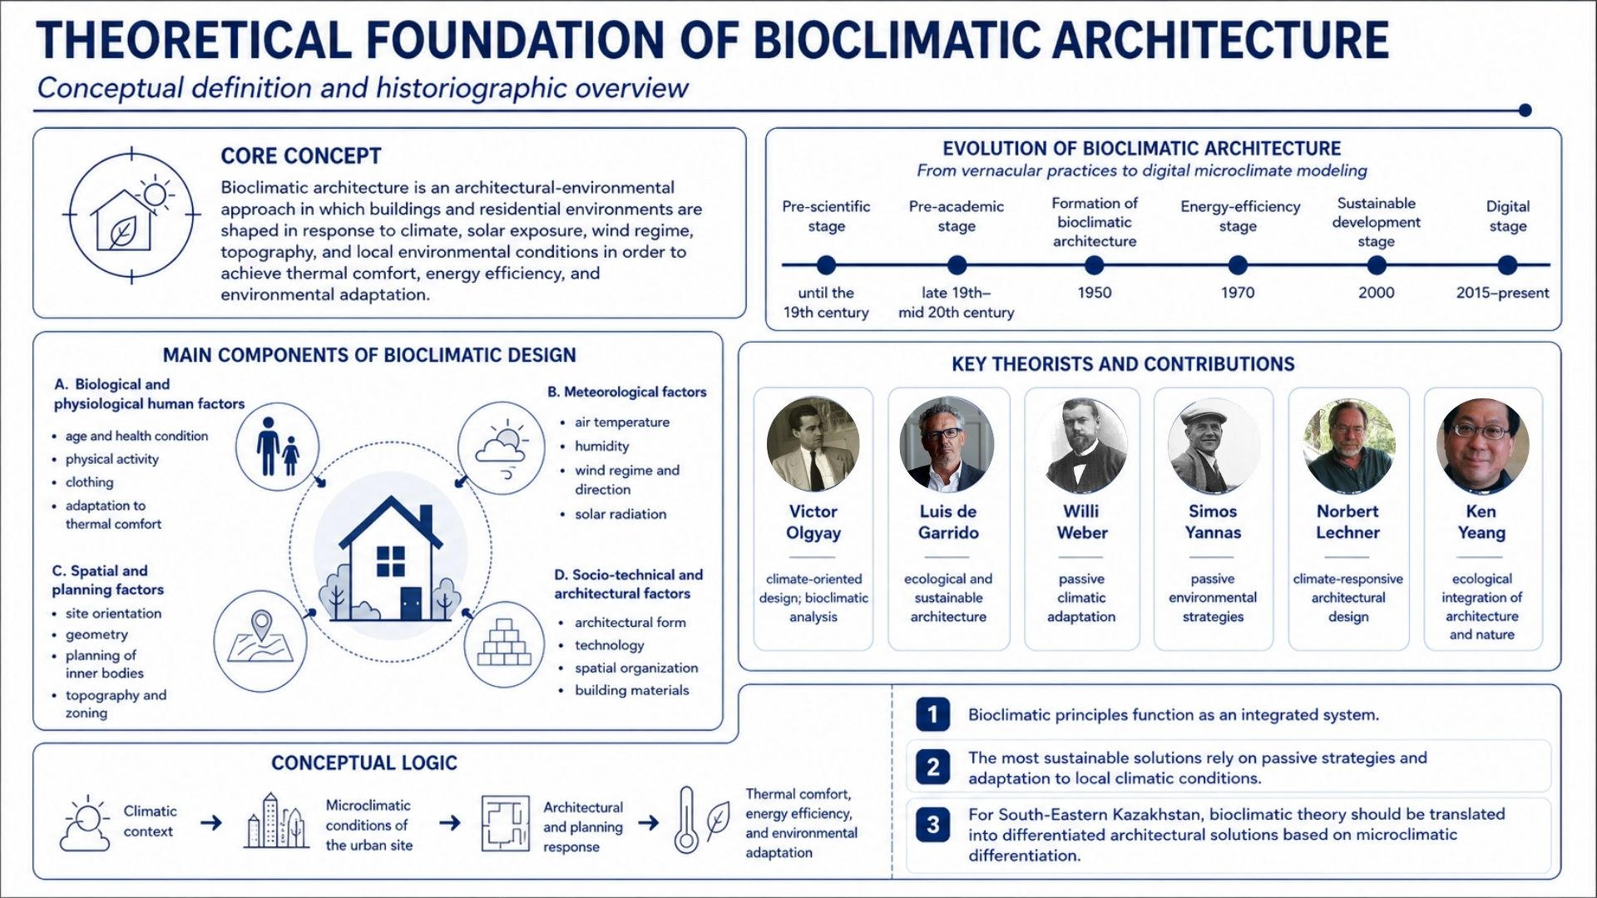

Figure A.1 - Theoretical foundation of bioclimatic architecture

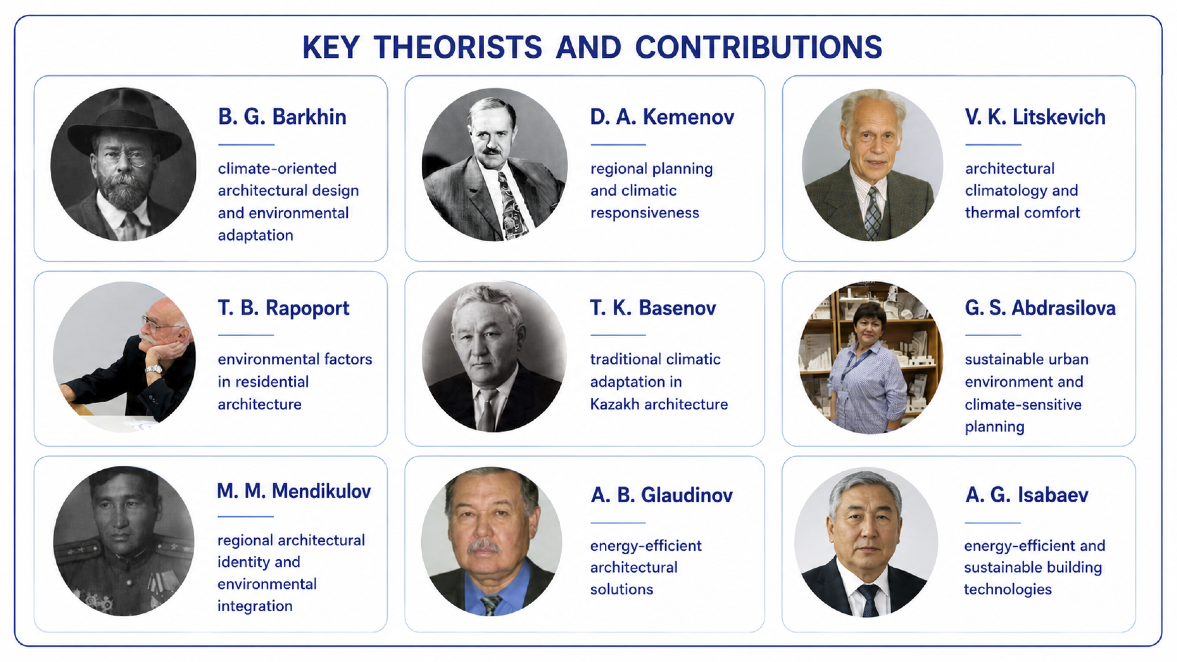
KEY DOMESTIC THEORISTS AND CONTRIBUTIONS

Figure A.2 - Key domestic theorists and contributions to climate-oriented residential architecture

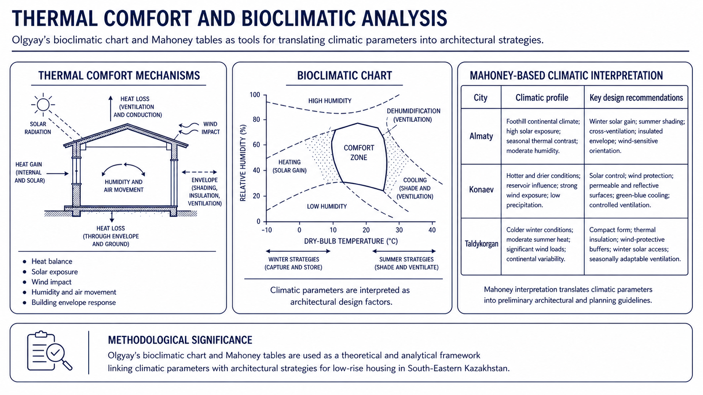

Figure A.3 - Thermal comfort and bioclimatic analysis

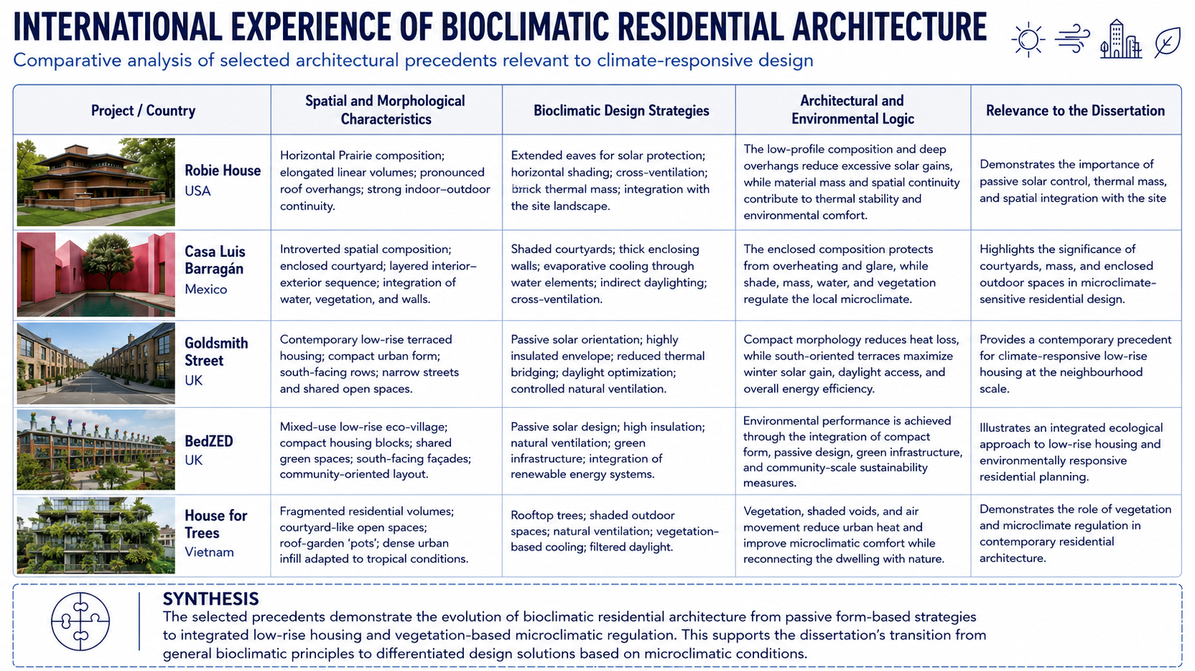

Figure A.4 - International experience of bioclimatic residential architecture

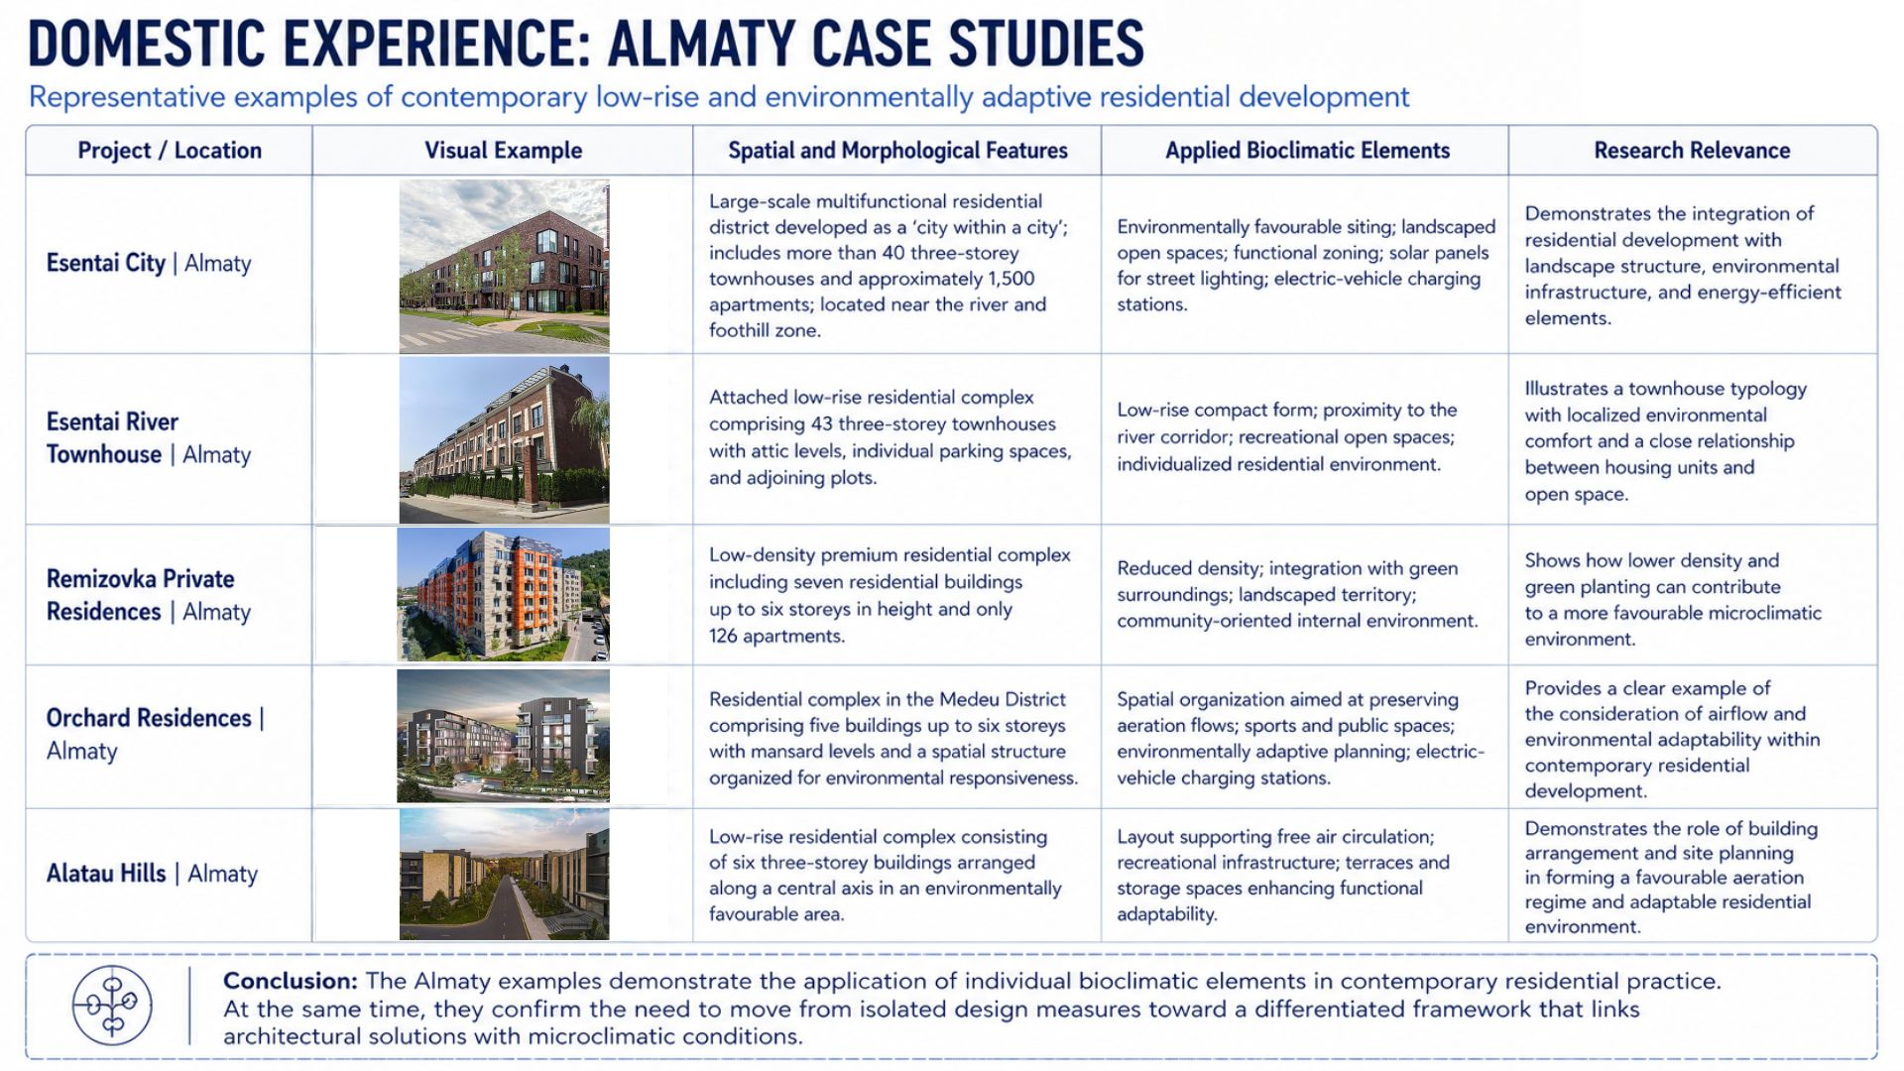

Figure A.5 - Domestic experience: Almaty case studies

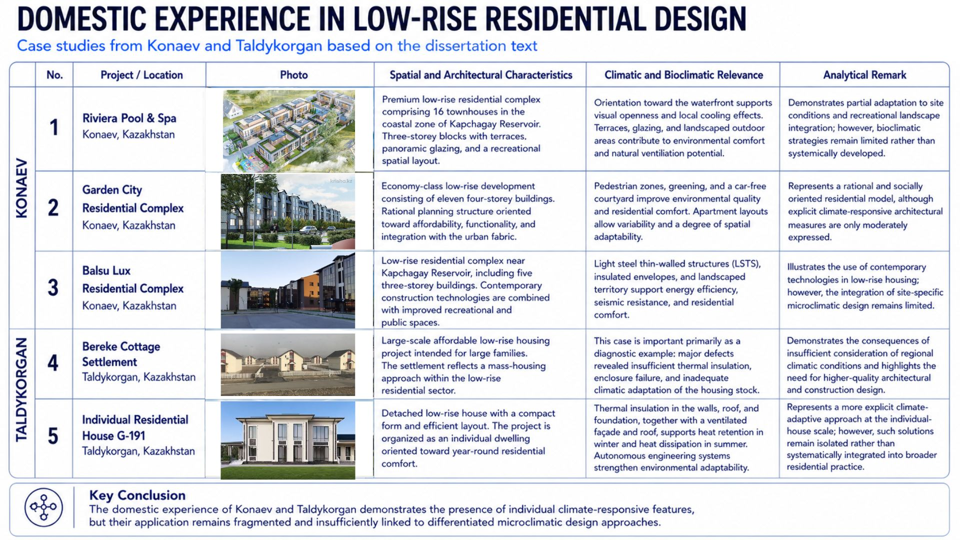

Figure A.6 - Domestic experience in low-rise residential design: Konaev and Taldykorgan case studies

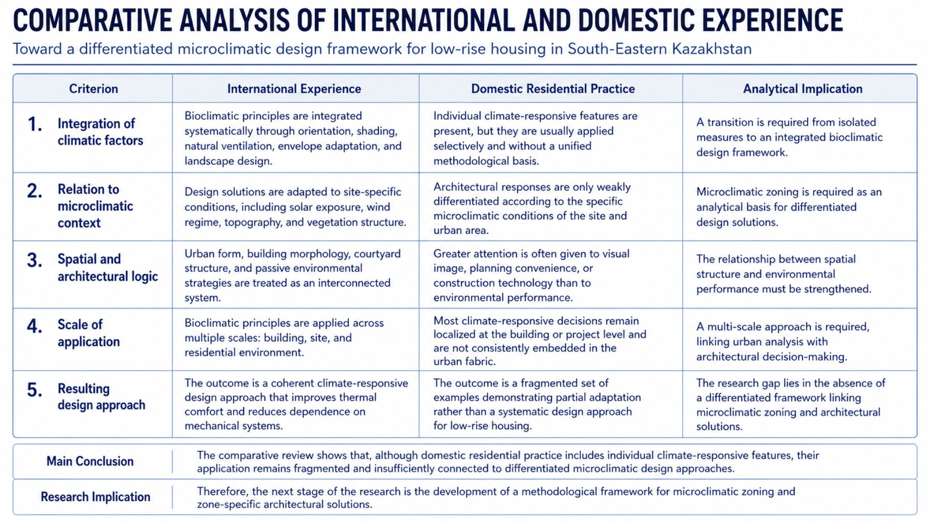

Figure A.7 - Comparative analysis of international and domestic experience

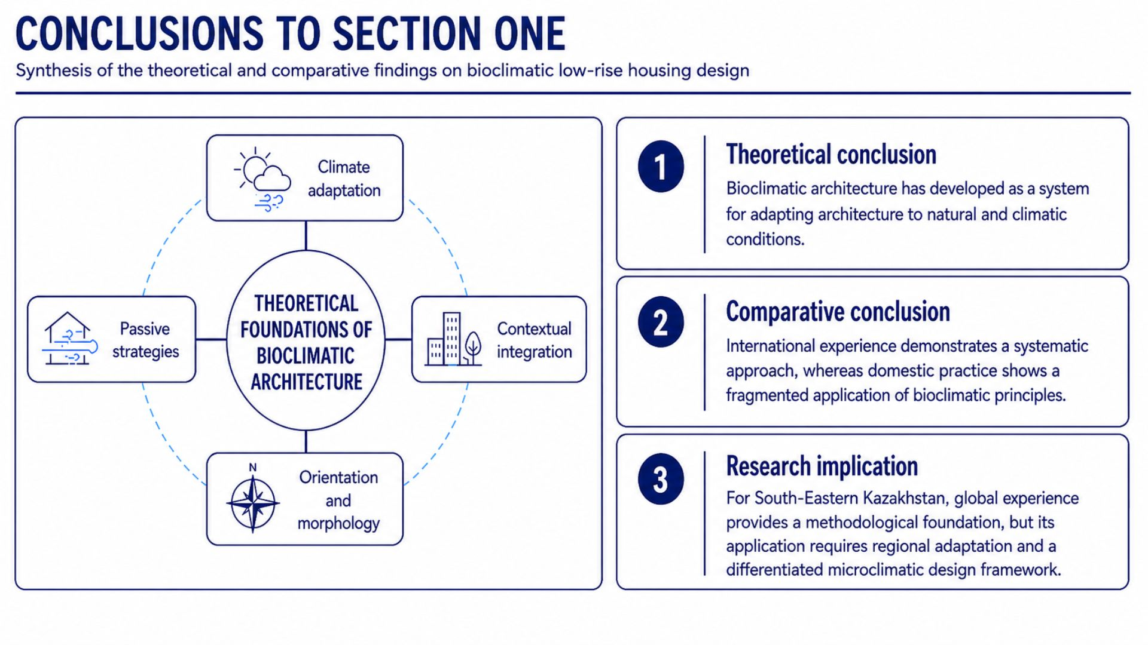

Figure A.8 - Conclusions to Section One

Appendix B
Supplementary graphical materials for Section Two

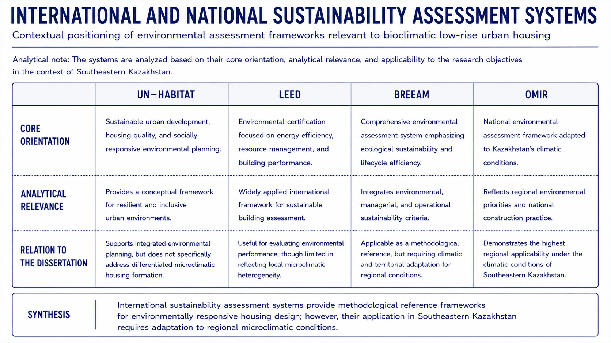

Figure B.1 - International and national sustainability assessment systems

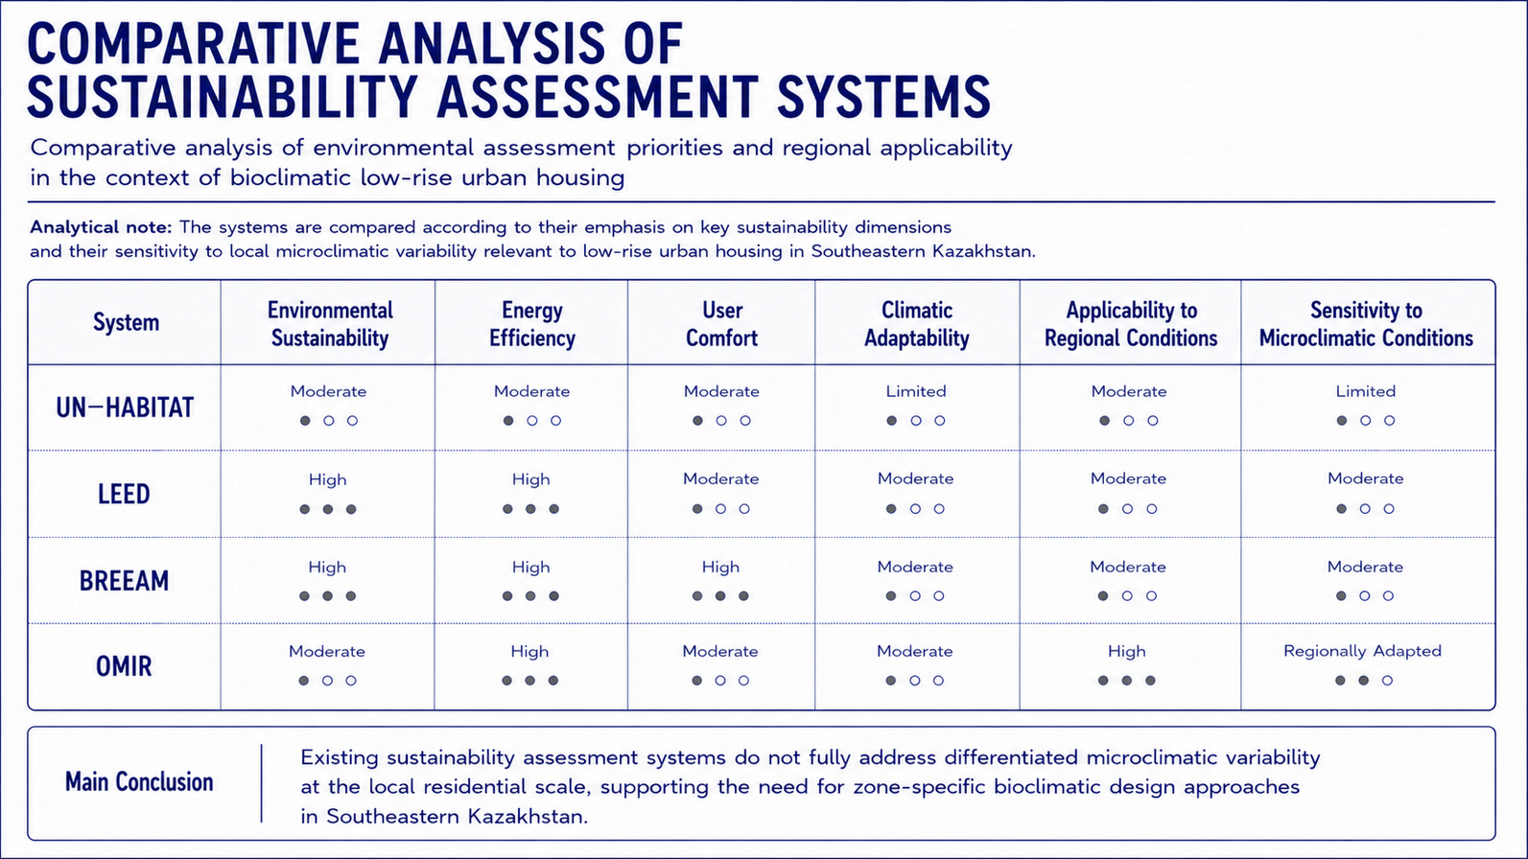

Figure B.2 - Comparative analysis of sustainability assessment systems

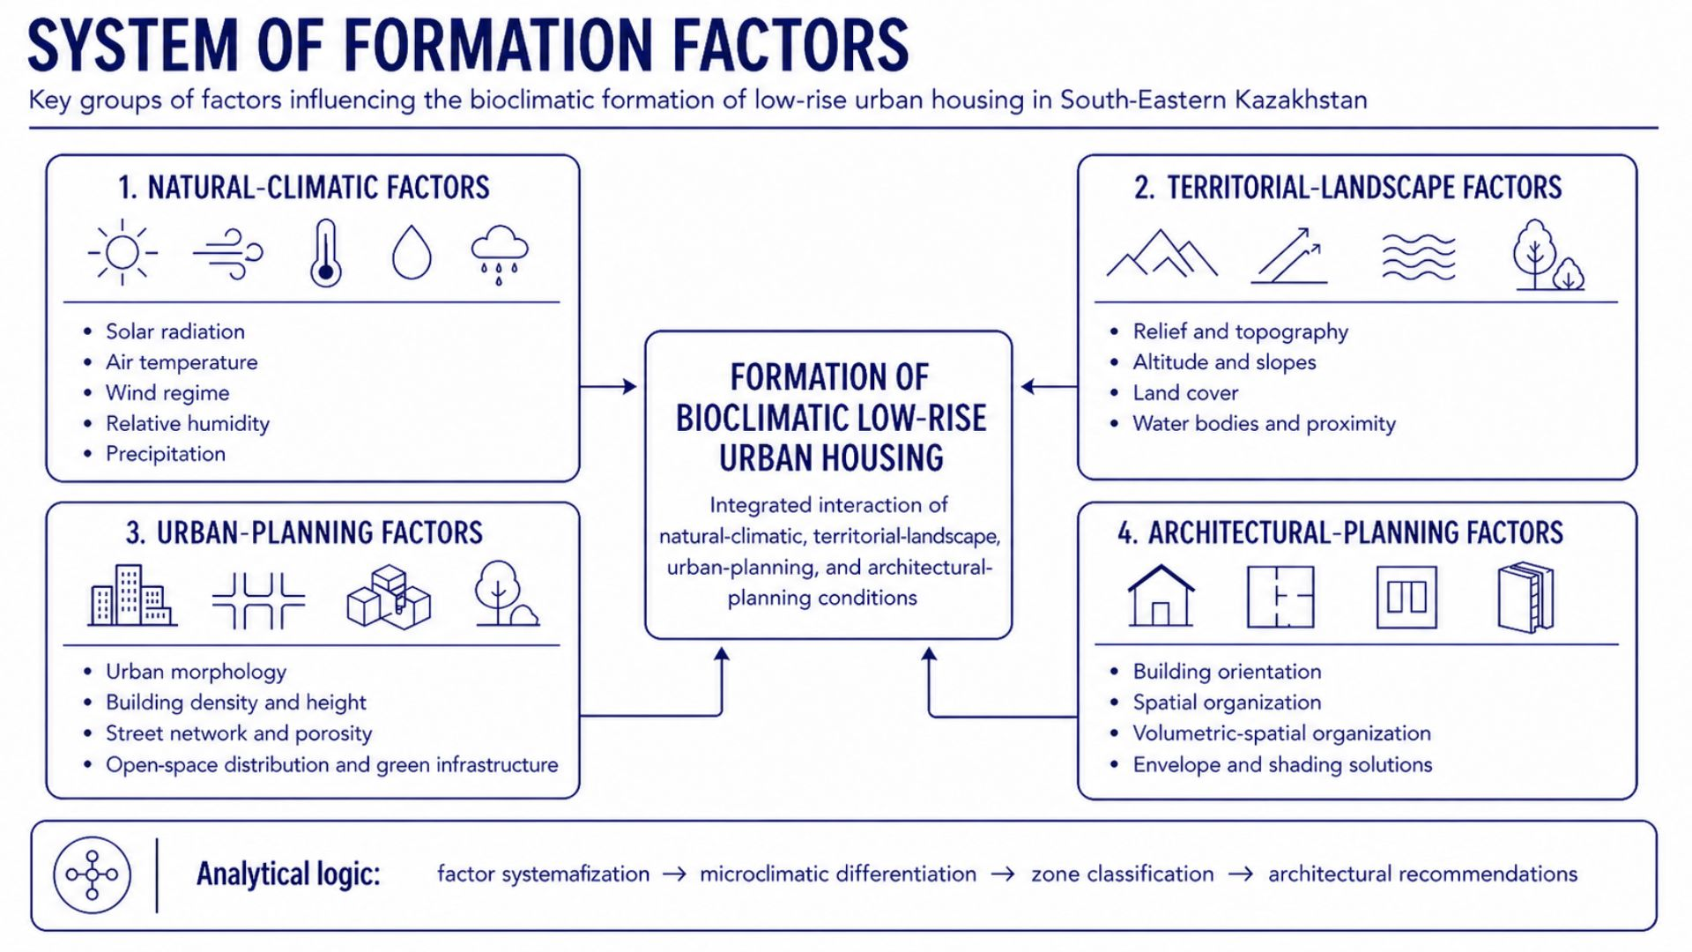

Figure B.3 - System of formation factors

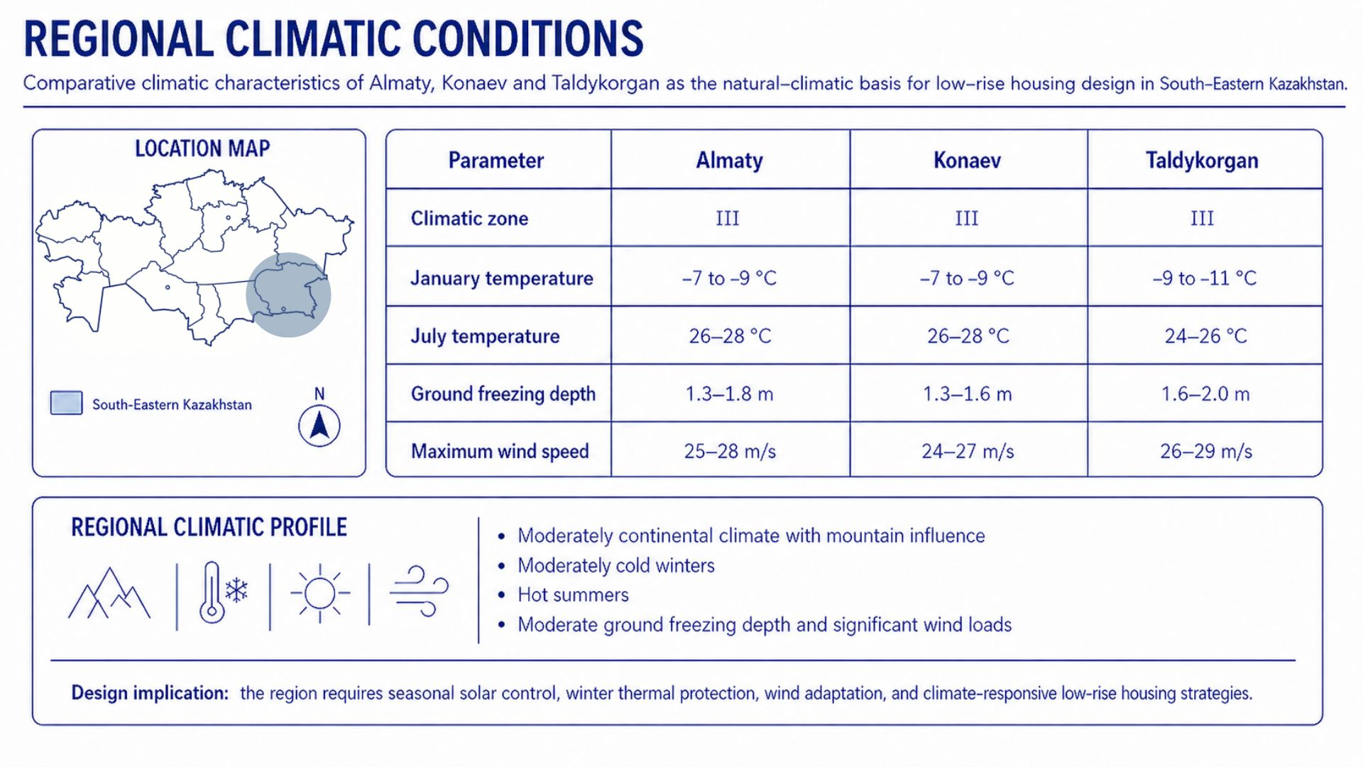

Figure B.4 - Regional climatic conditions

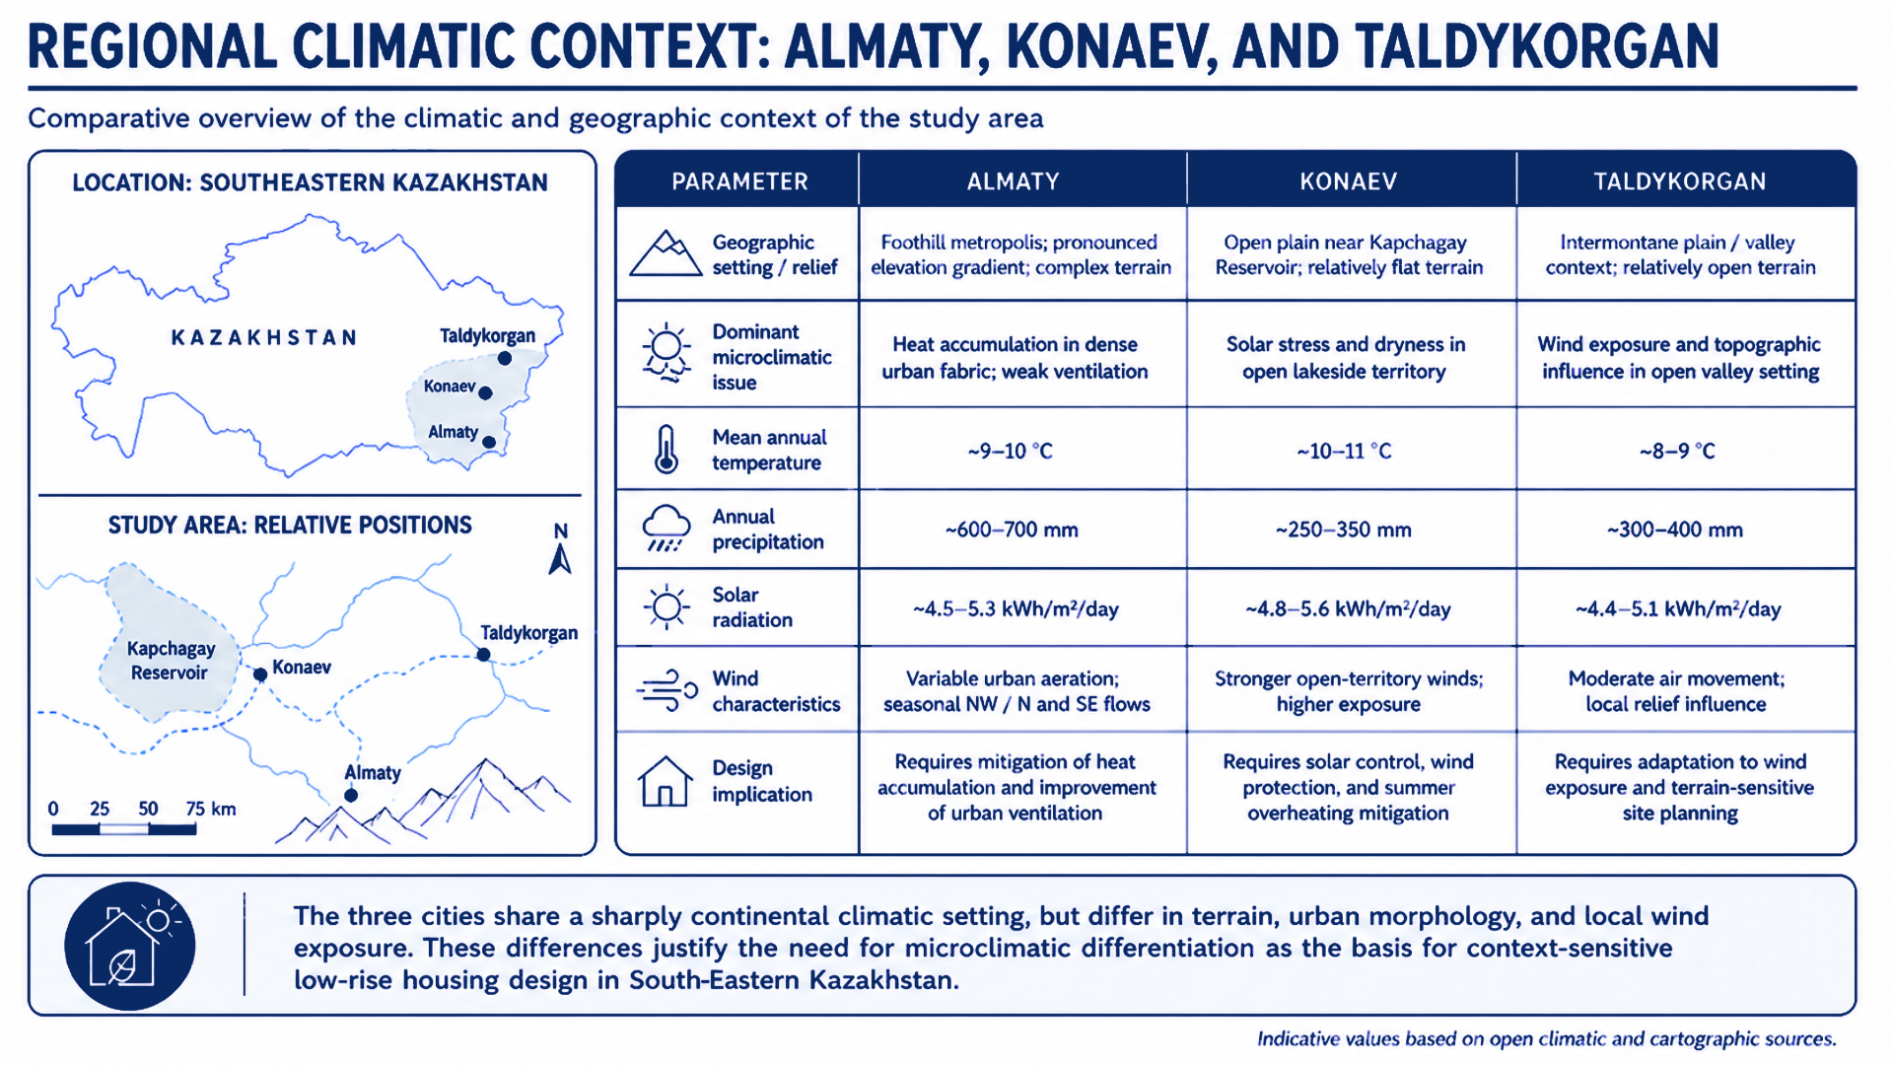

Figure B.5 - Regional climatic context of Almaty, Konaev, and Taldykorgan

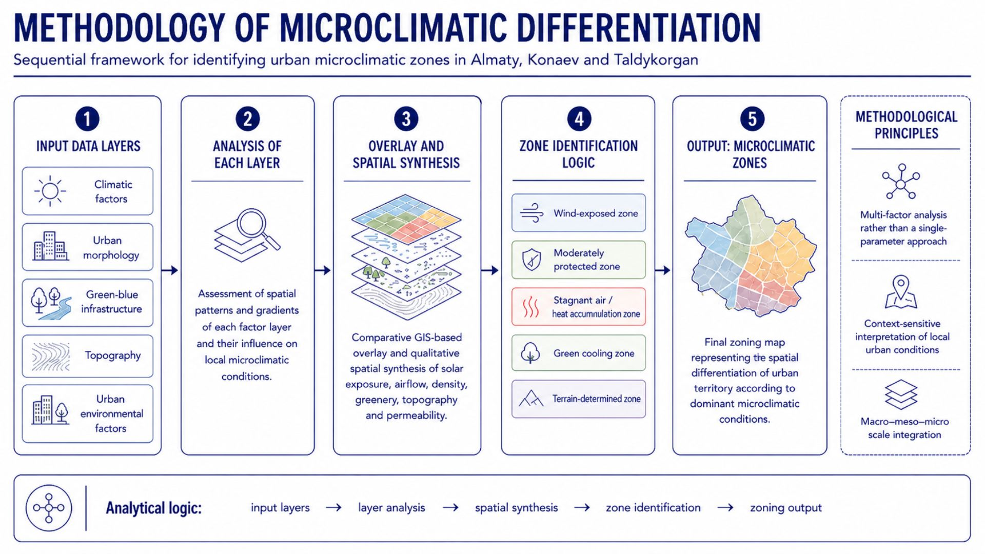

Figure B.6 - Methodology of microclimatic differentiation

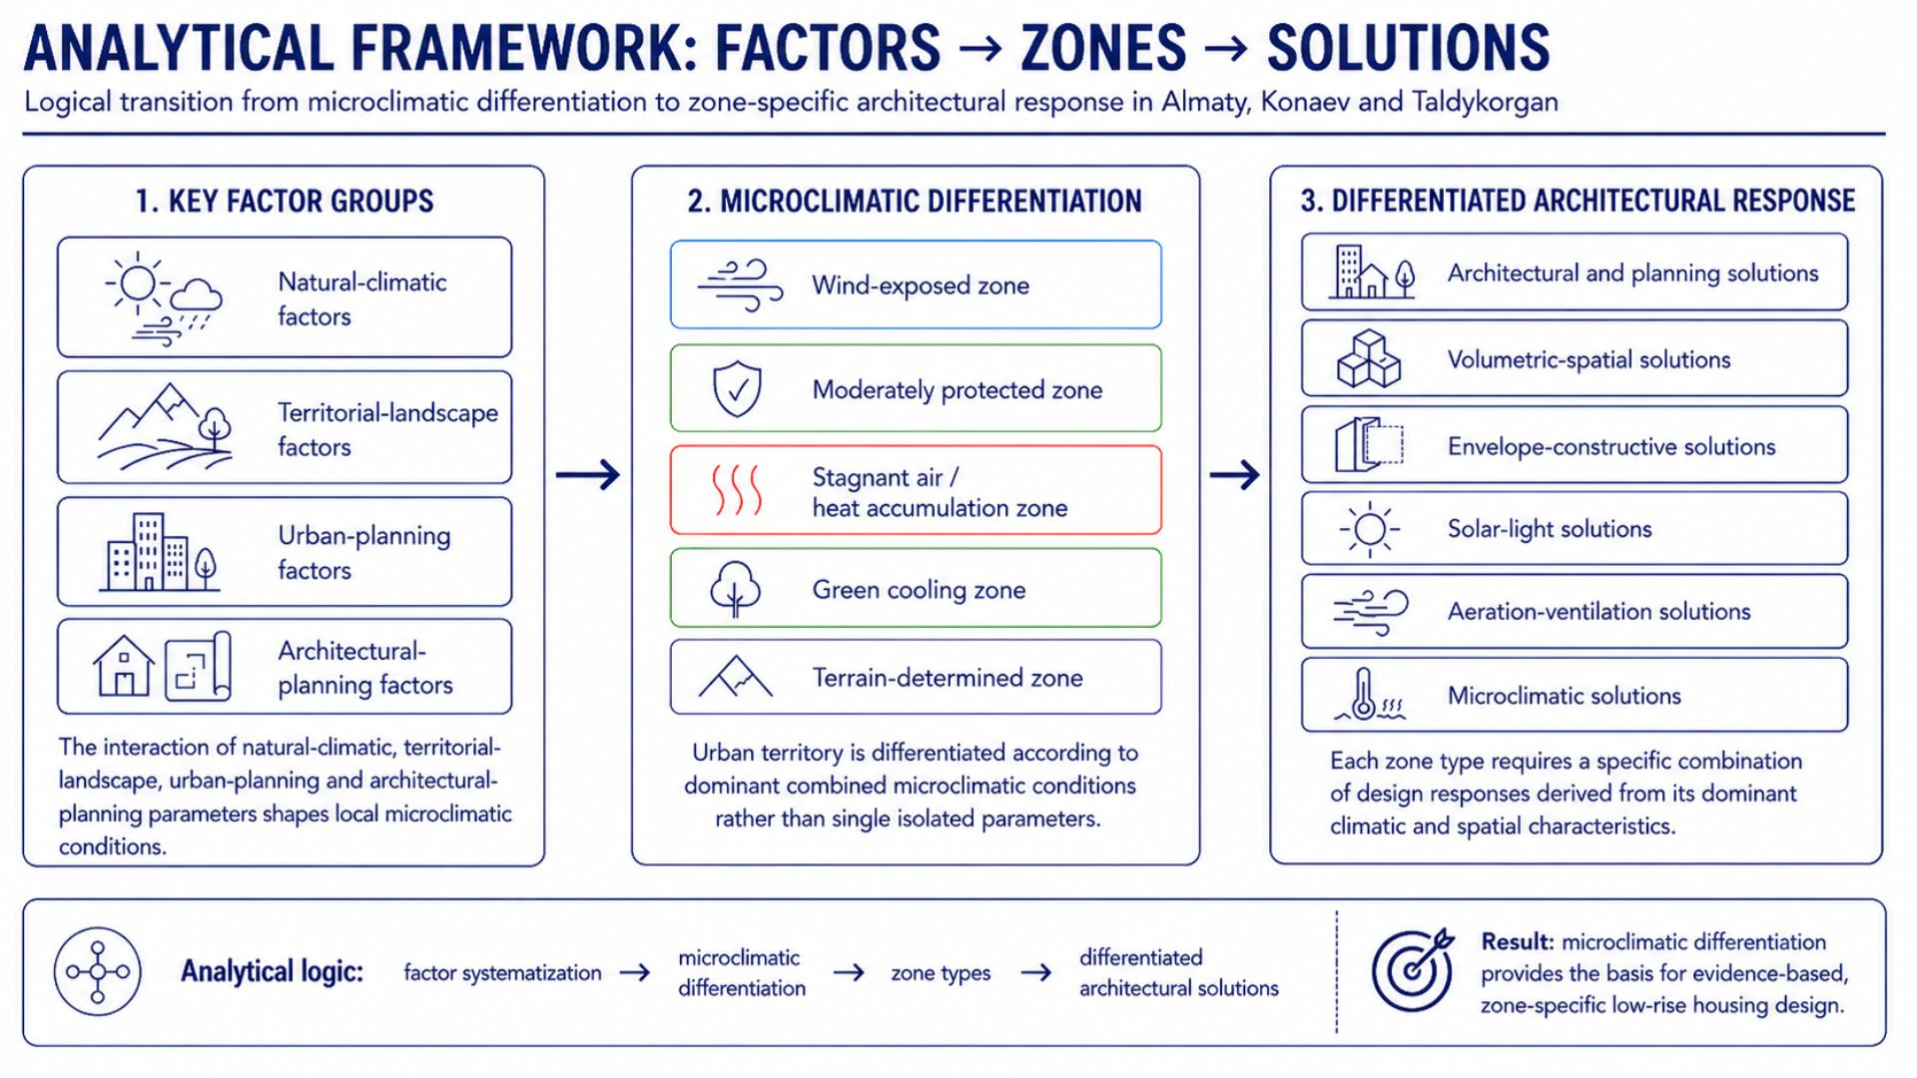

Figure B.7 - Analytical framework: factors, zones, and solutions

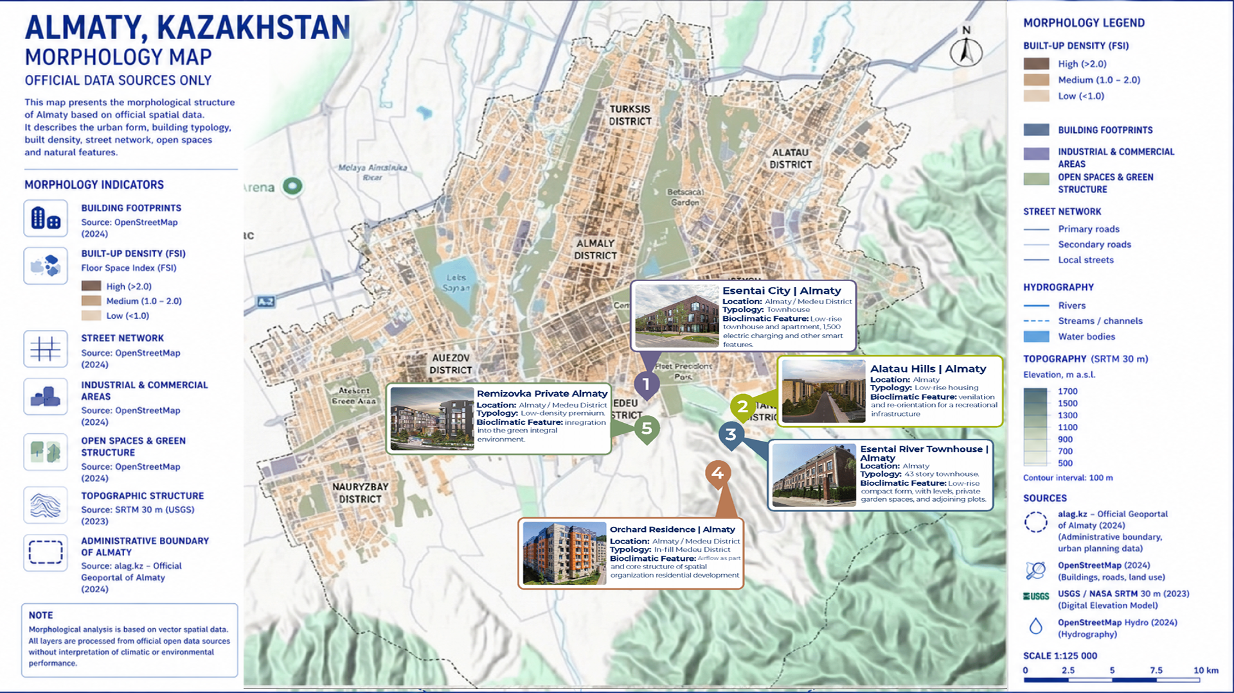

Figure B.8 - Almaty, Kazakhstan: morphology map

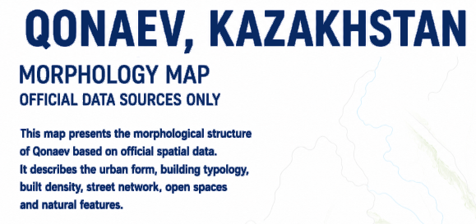
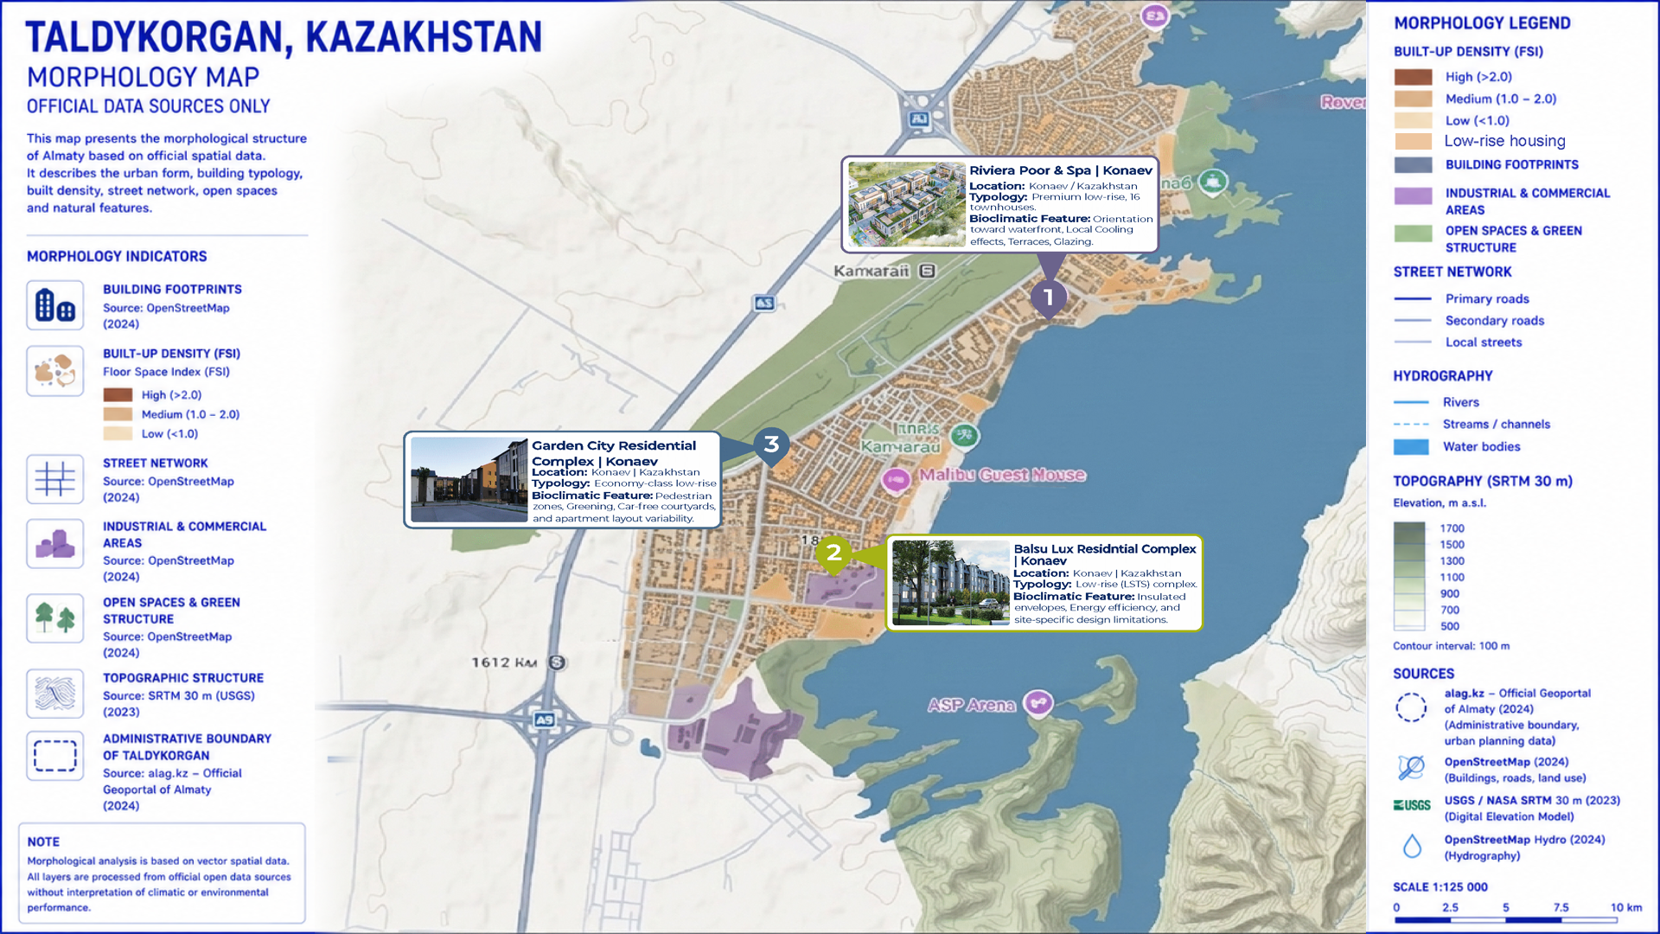

Figure B.9 - Konaev, Kazakhstan: morphology map

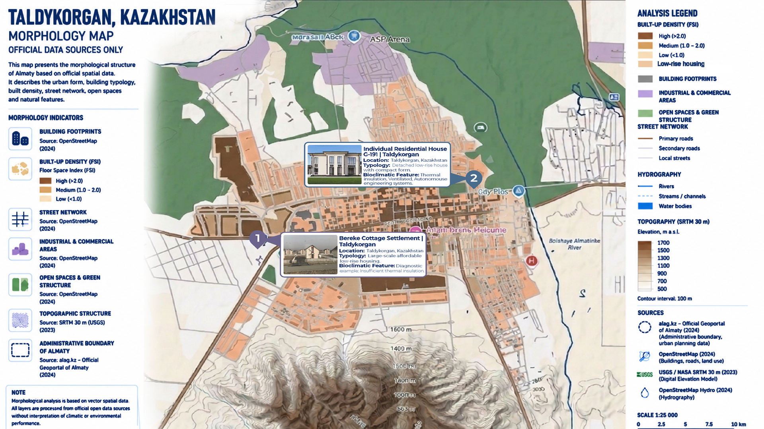

Figure B.10 - Taldykorgan, Kazakhstan: morphology map

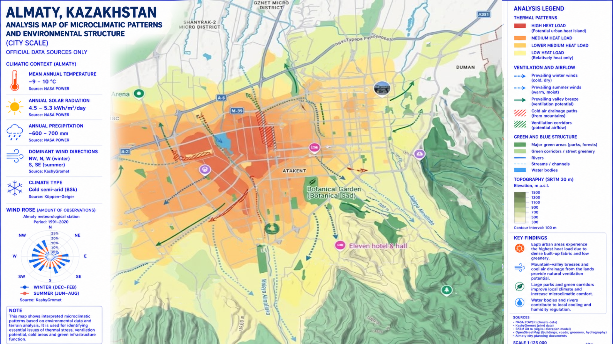

Figure B.11 - Analysis map of microclimatic patterns and environmental structure of Almaty

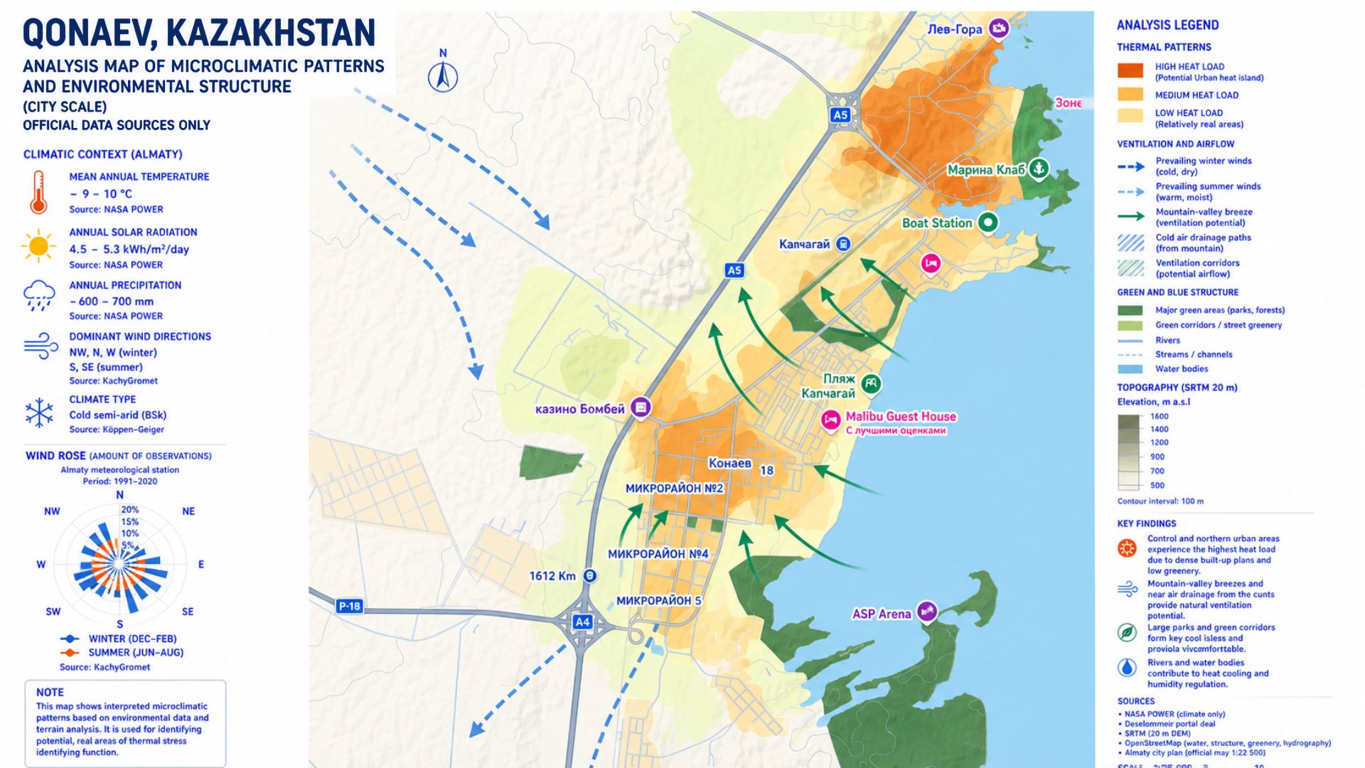

Figure B.12 - Analysis map of microclimatic patterns and environmental structure of Konaev

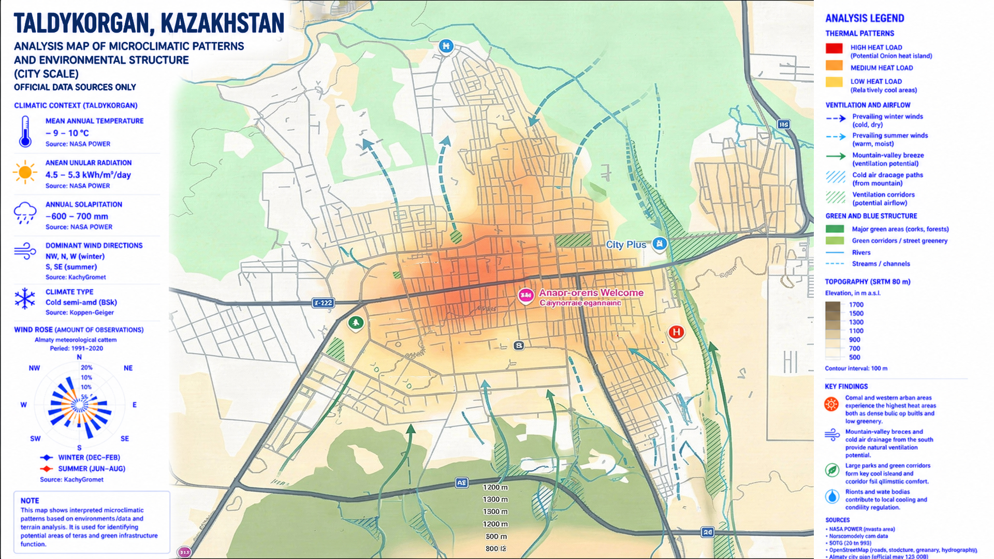

Figure B.13 - Analysis map of microclimatic patterns and environmental structure of Taldykorgan

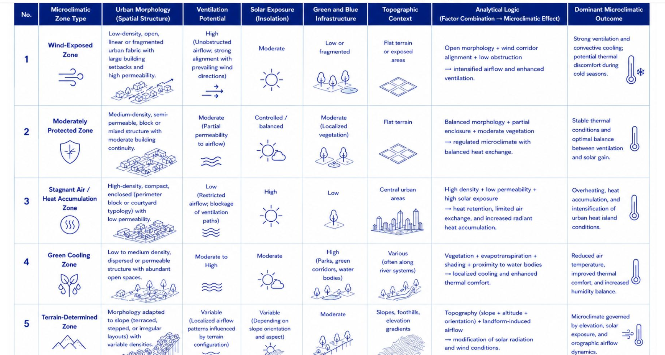

Figure B.14 - Criteria for microclimatic zone identification

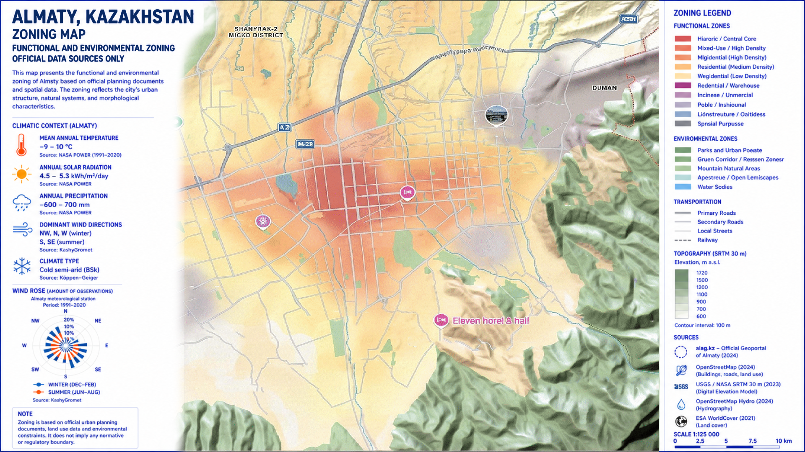

Figure B.15 - Zoning map of Almaty

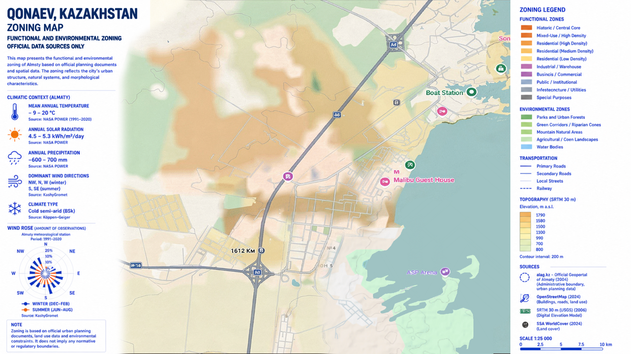

Figure B.16 - Zoning map of Konaev

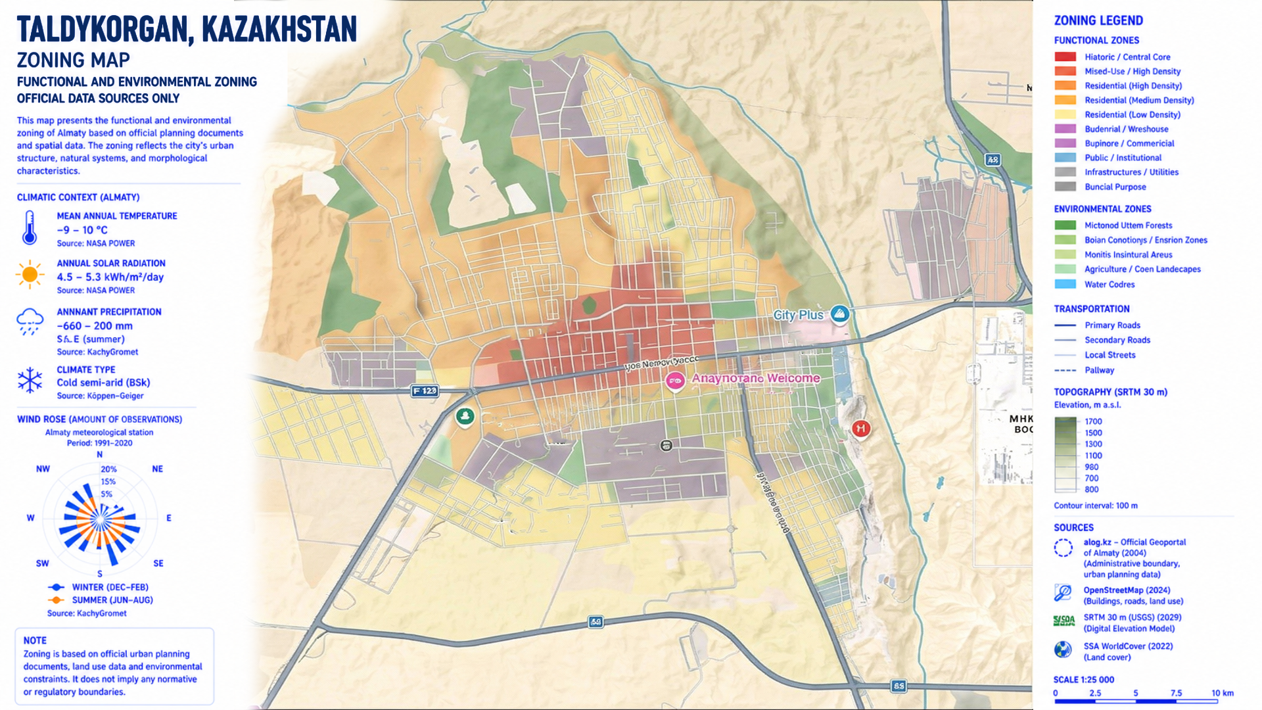

Figure B.17 - Zoning map of Taldykorgan

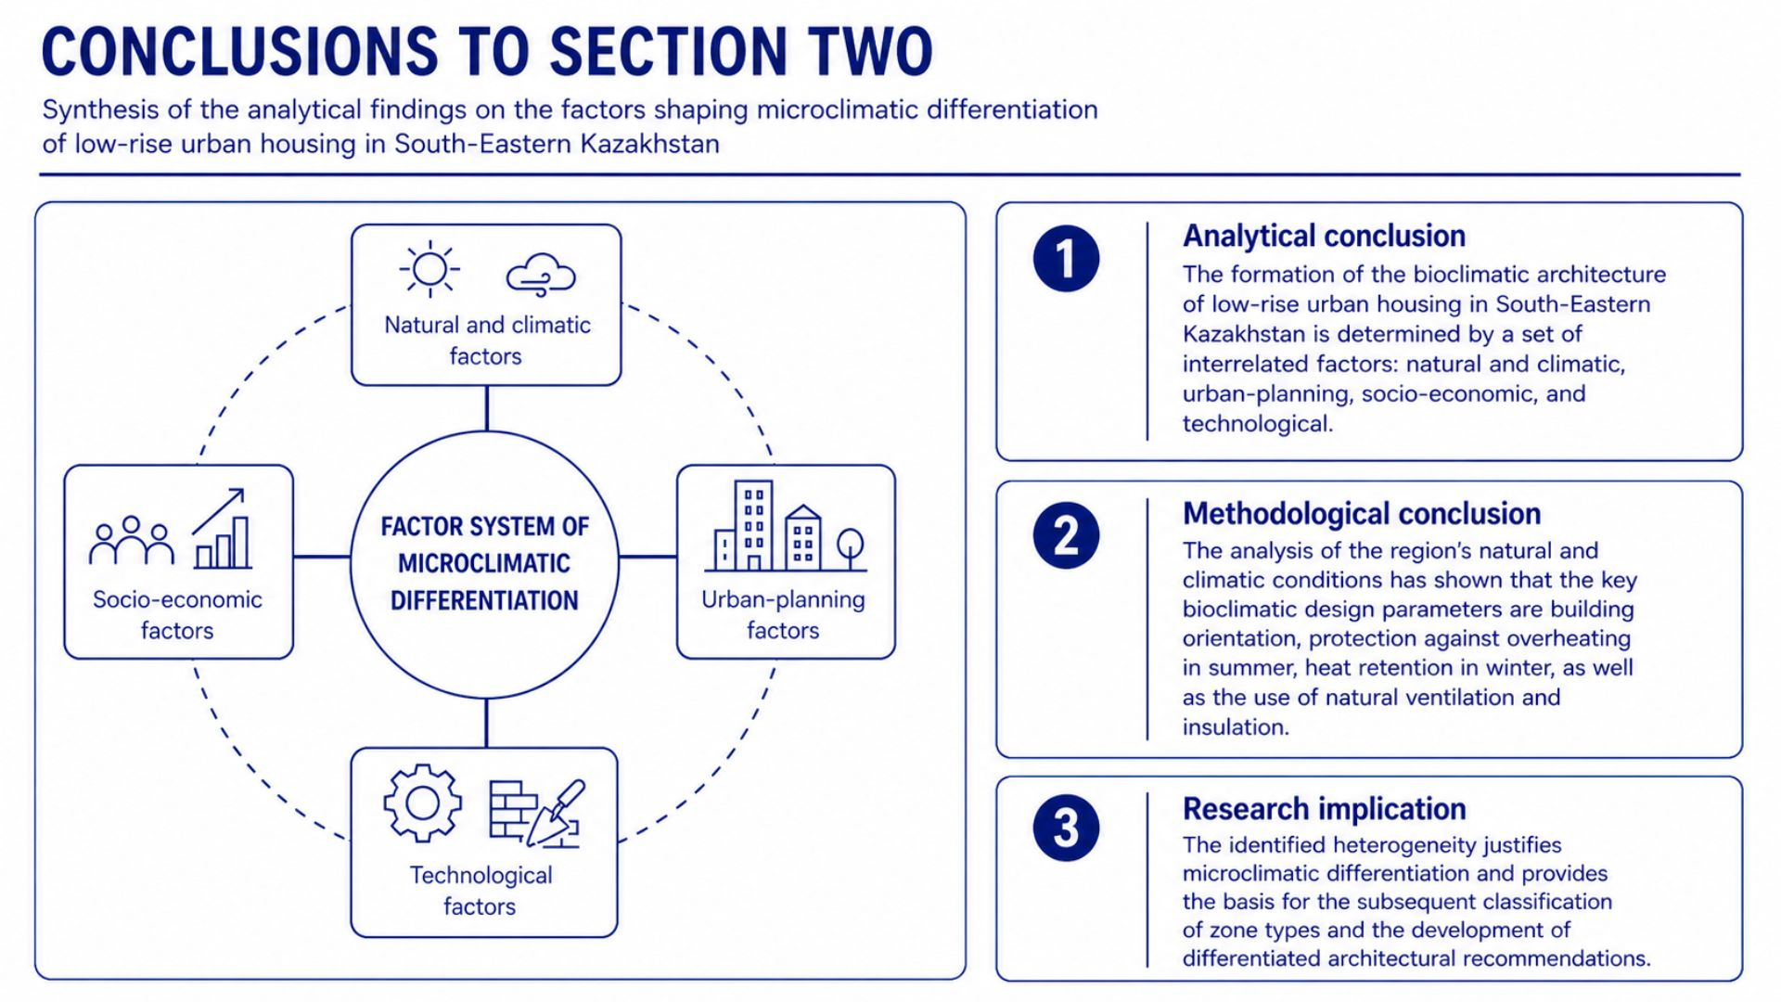

Figure B.18 - Conclusions to Section Two

Appendix C
Supplementary graphical materials for Section Three

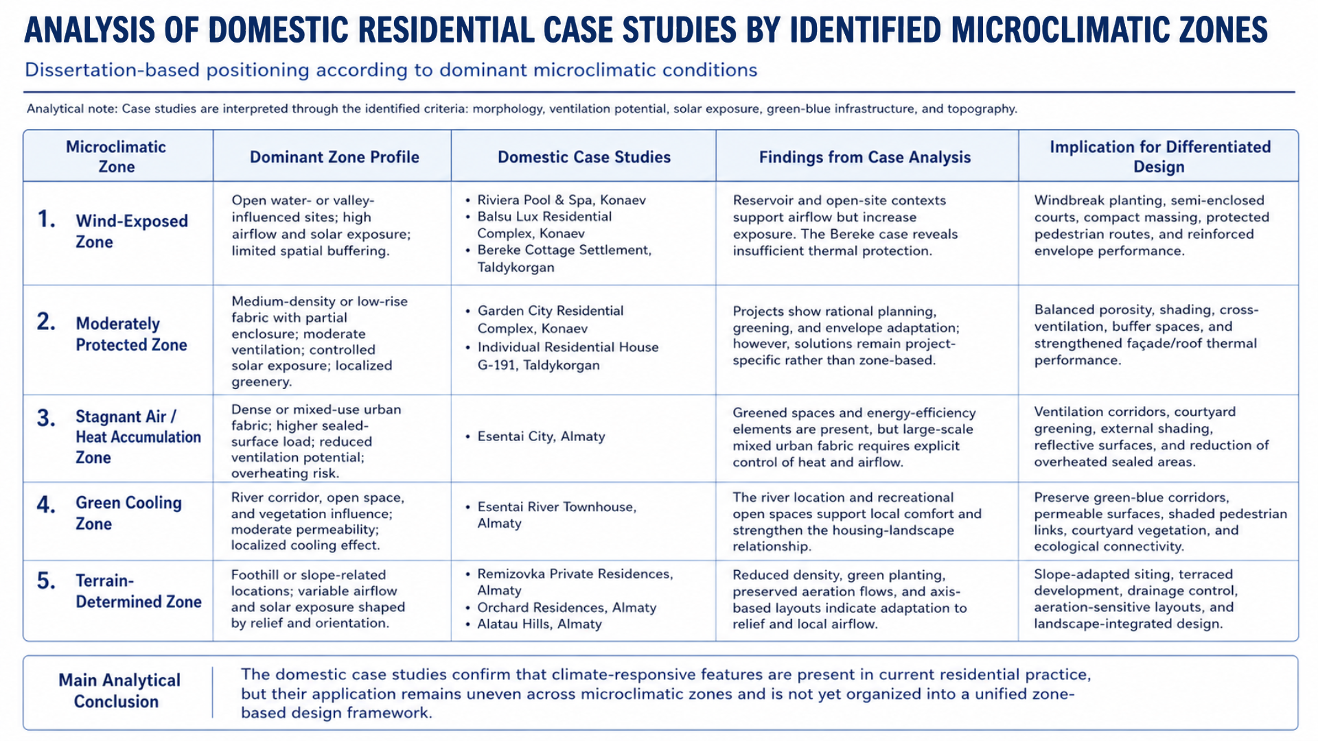

Figure C.1 - Analysis of domestic residential case studies by identified microclimatic zones

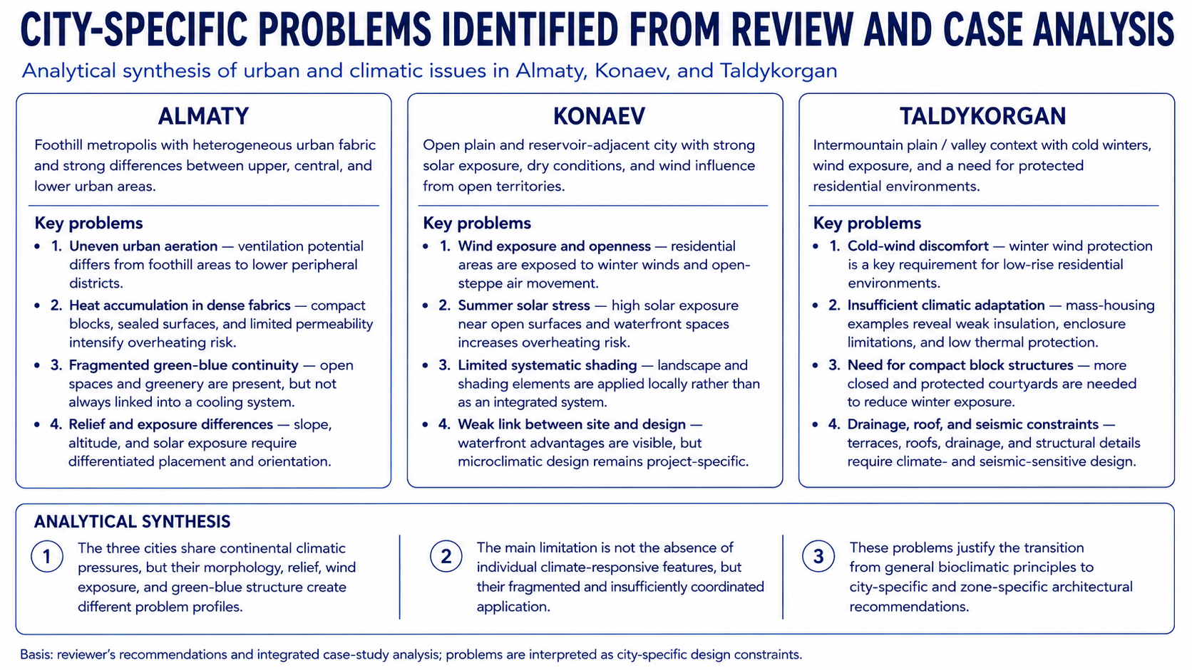

Figure C.2 - City-specific problems identified from review and case analysis

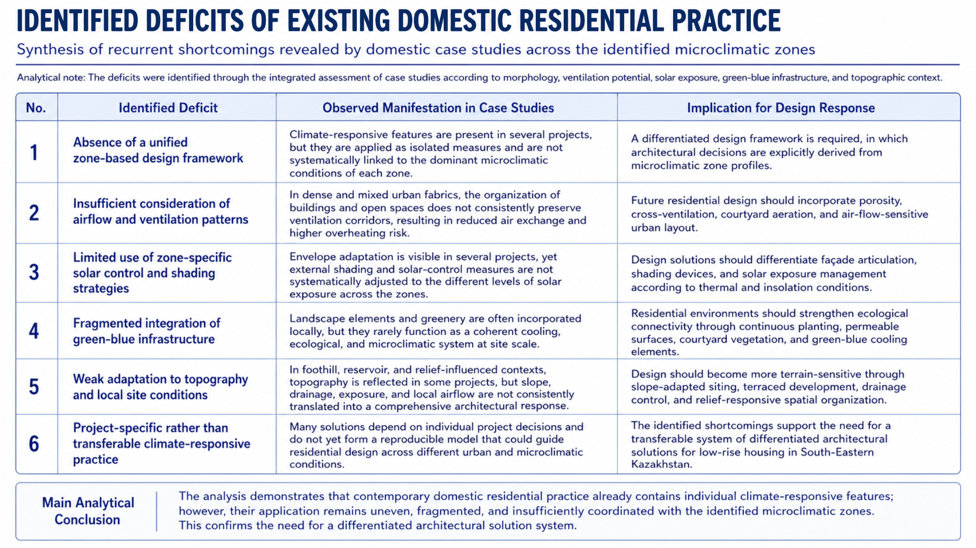

Figure C.3 - Identified deficits of existing domestic residential practice

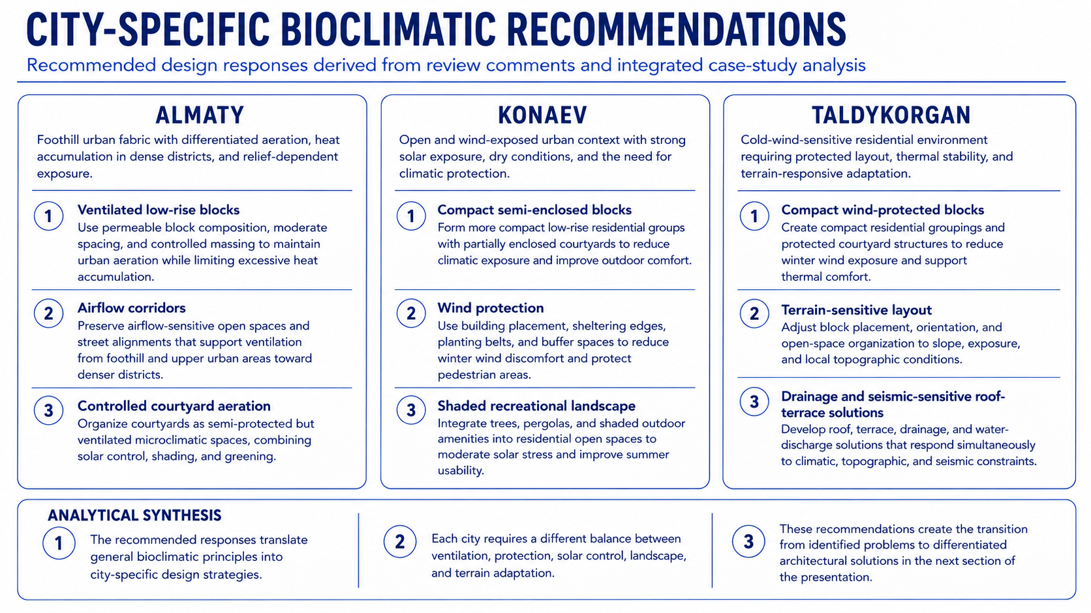

Figure C.4 - City-specific bioclimatic recommendations

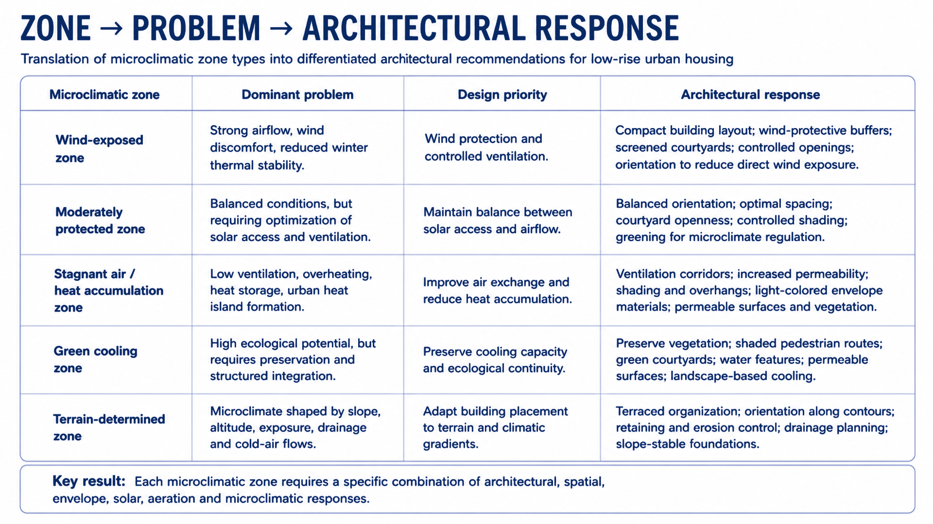

Figure C.5 - Zone-problem-architectural response framework

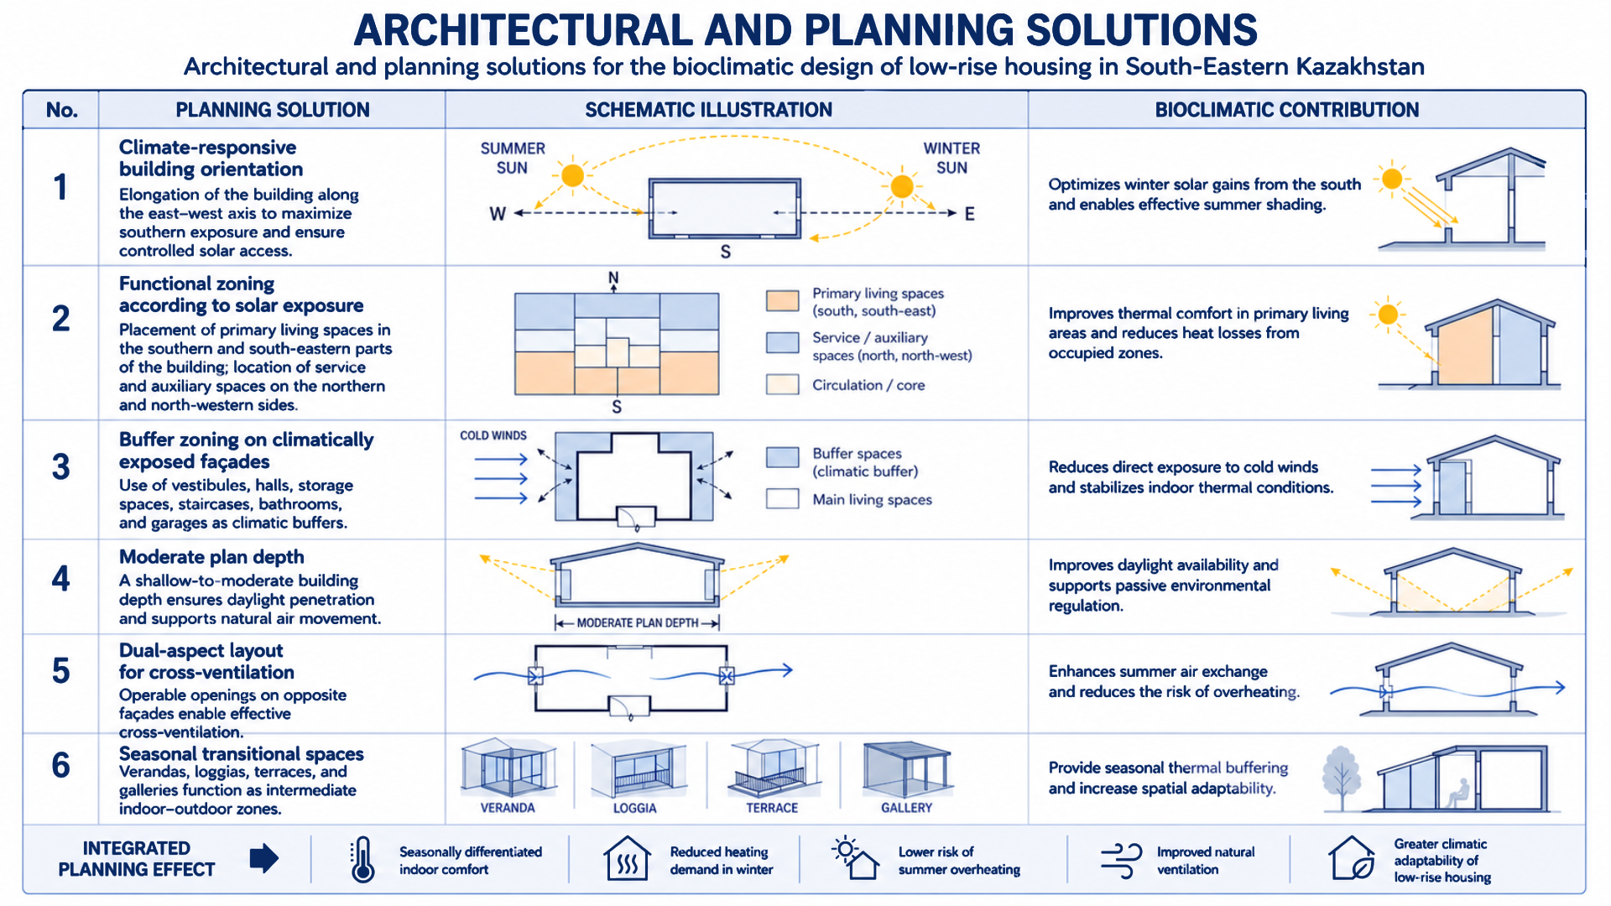

Figure C.6 - Architectural and planning solutions

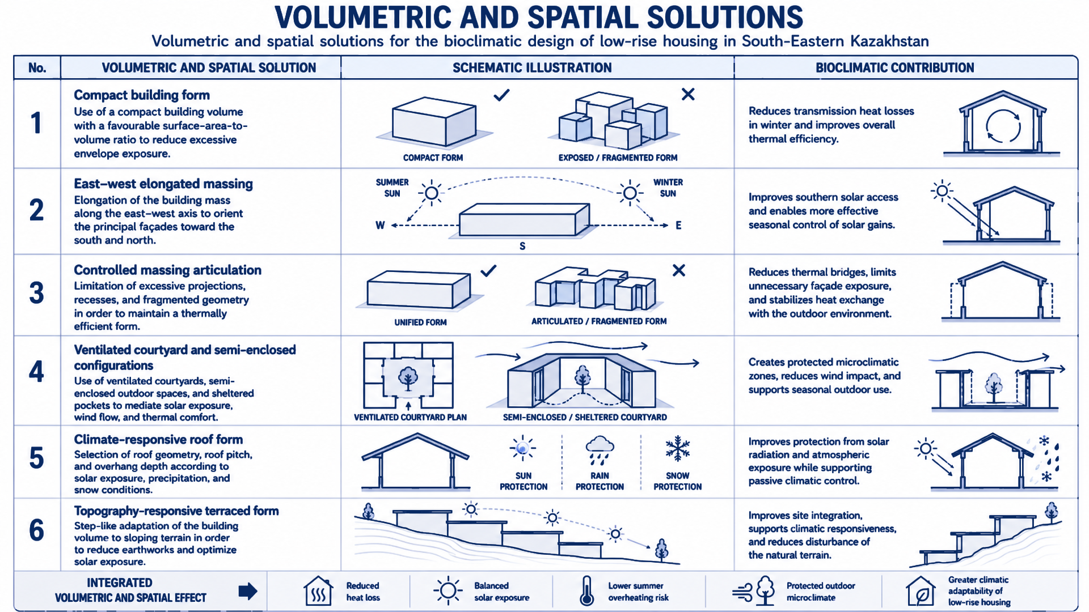

Figure C.7 - Volumetric and spatial solutions

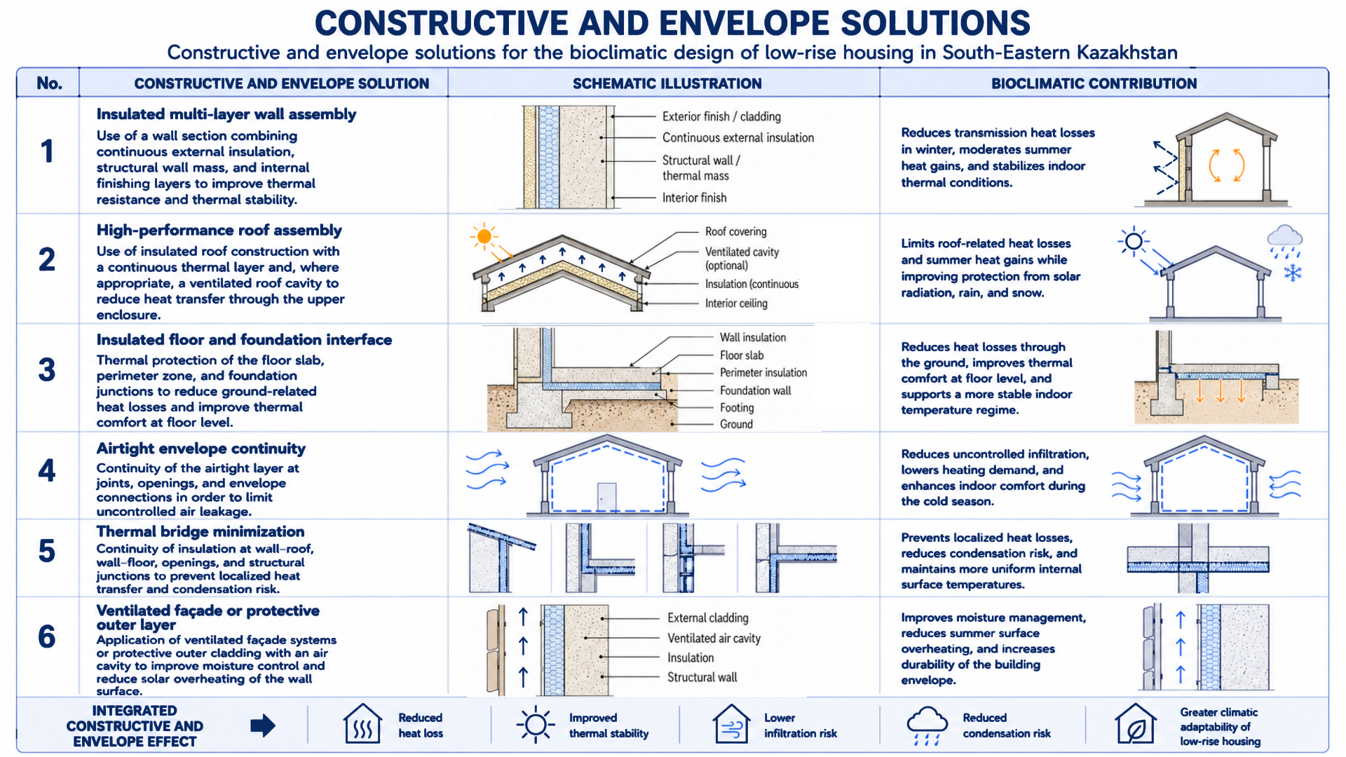

Figure C.8 - Constructive and envelope solutions

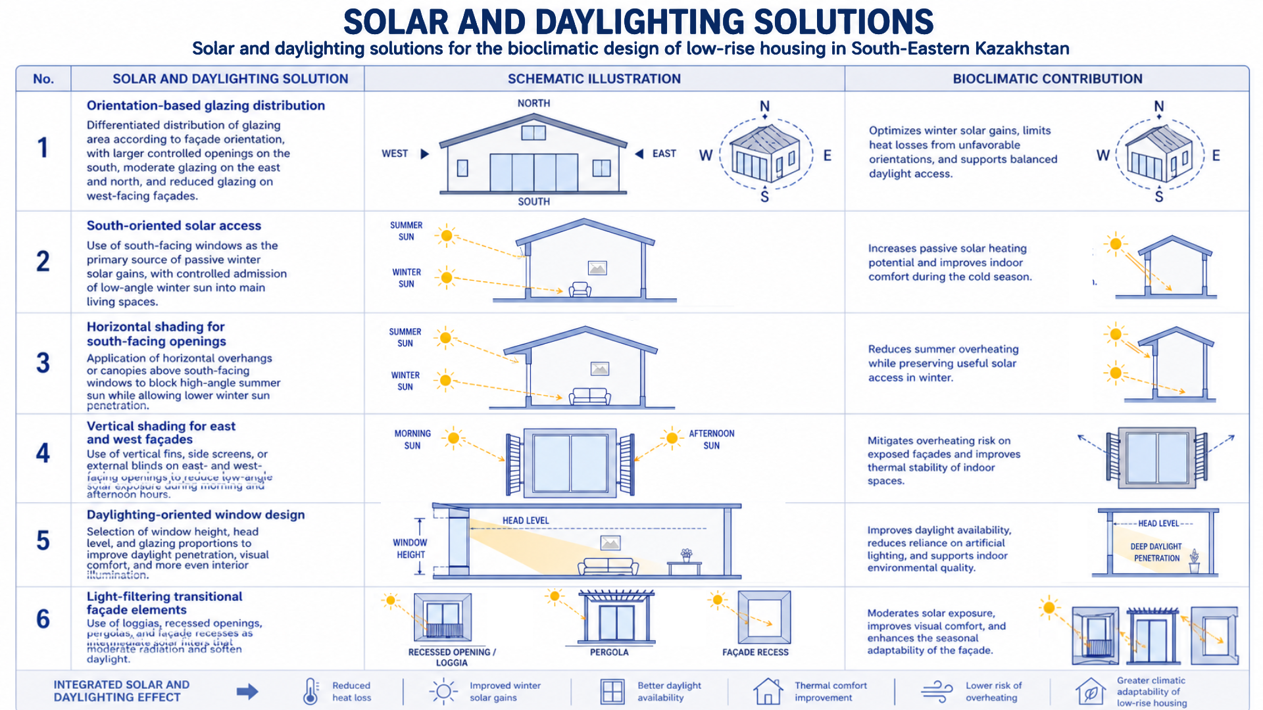

Figure C.9 - Solar and daylighting solutions

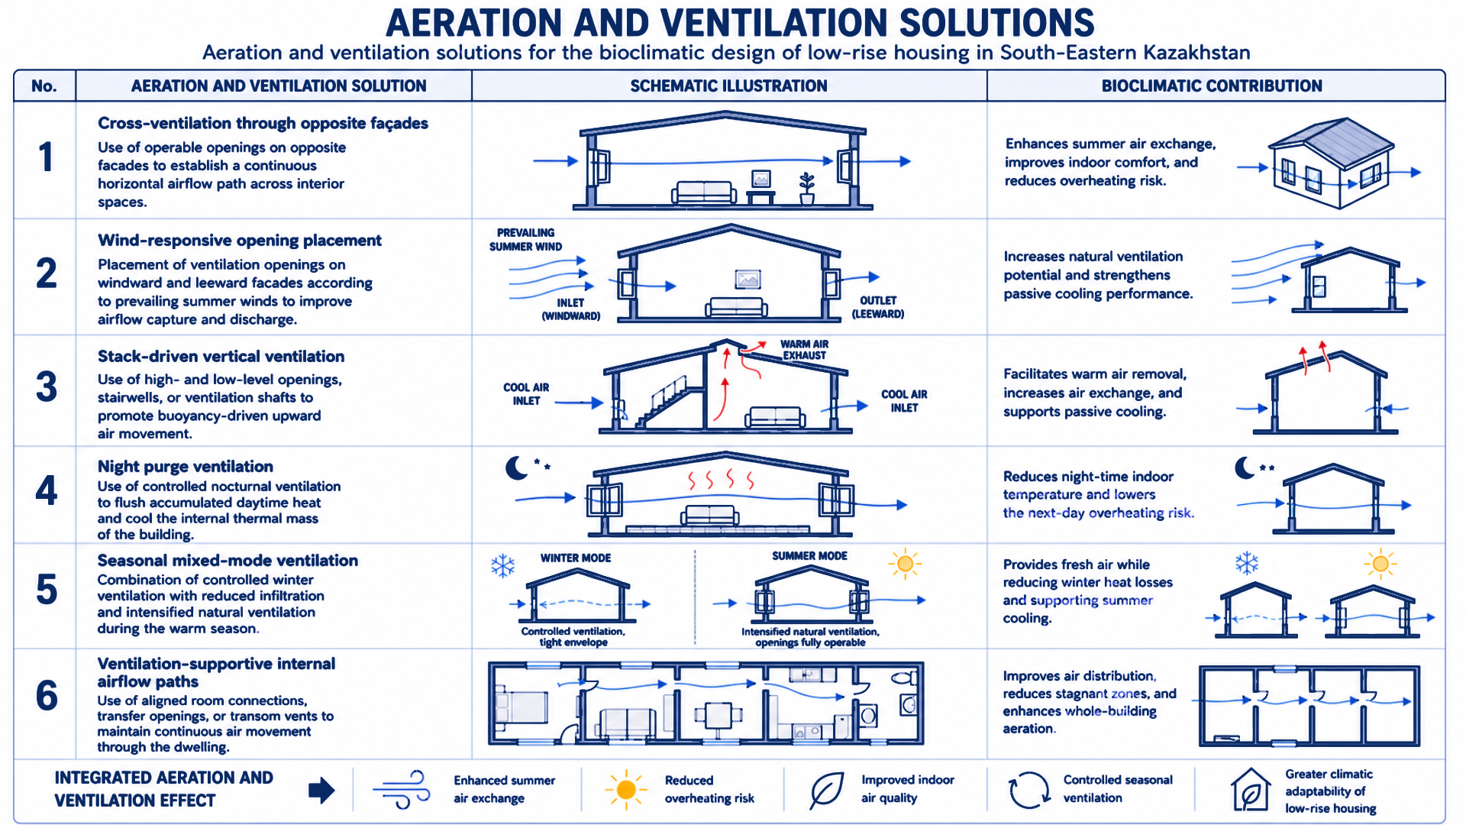

Figure C.10 - Aeration and ventilation solutions

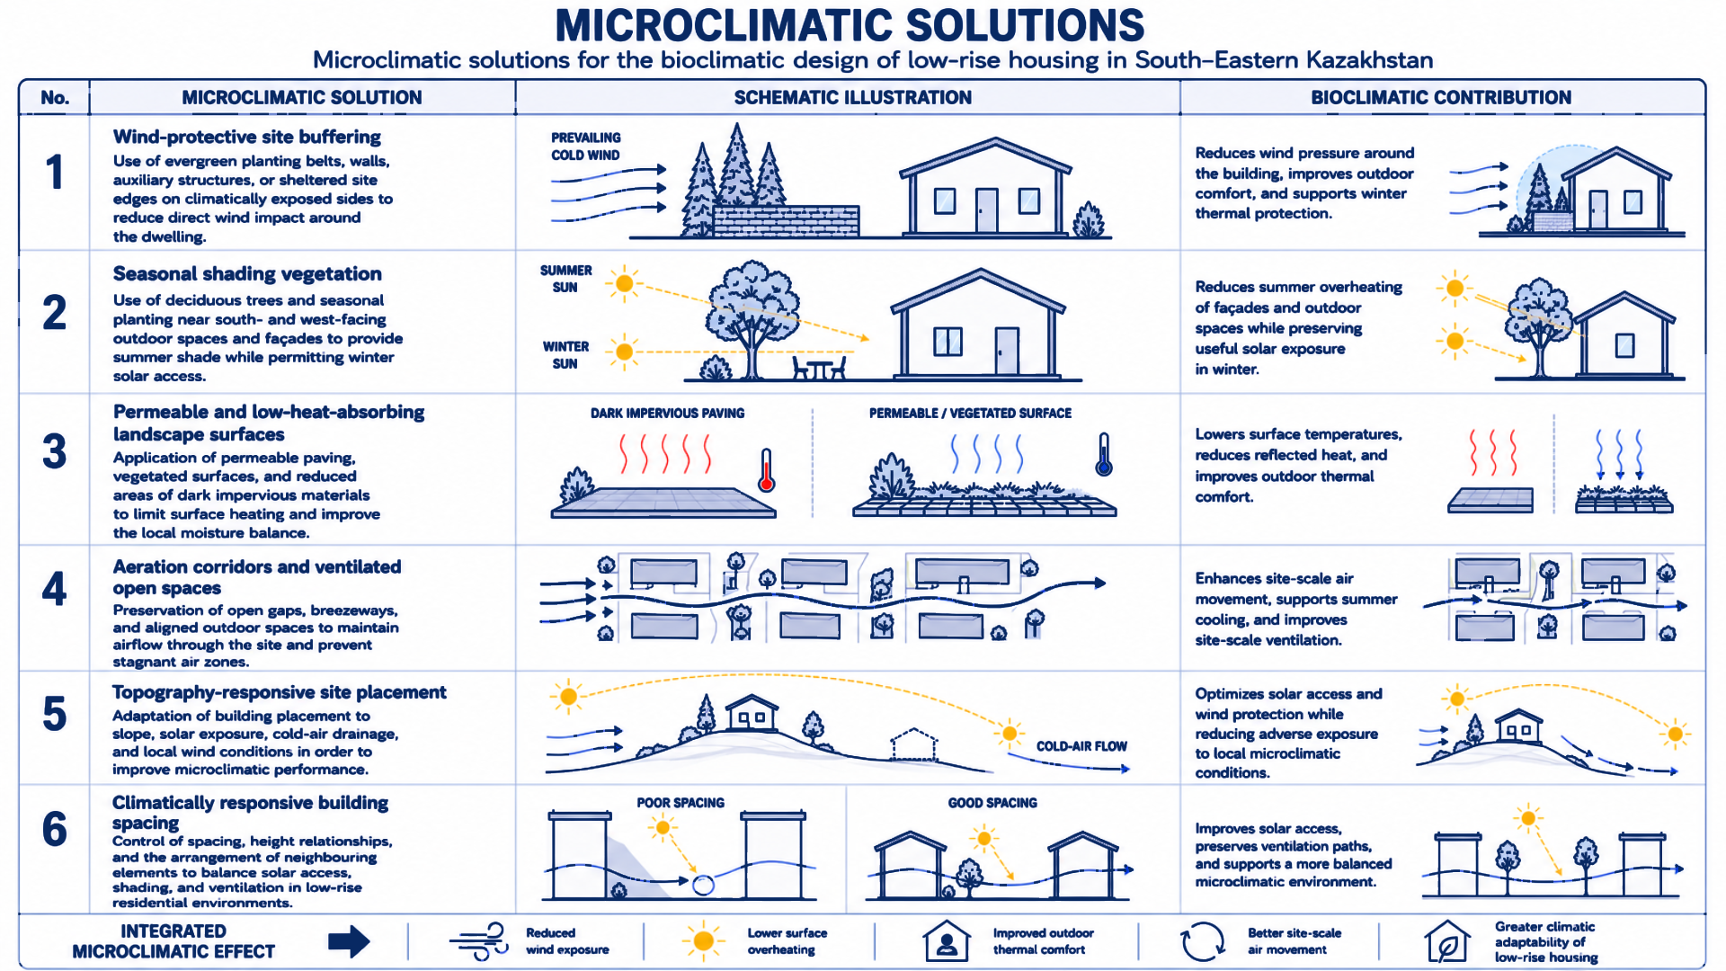

Figure C.11 - Microclimatic solutions

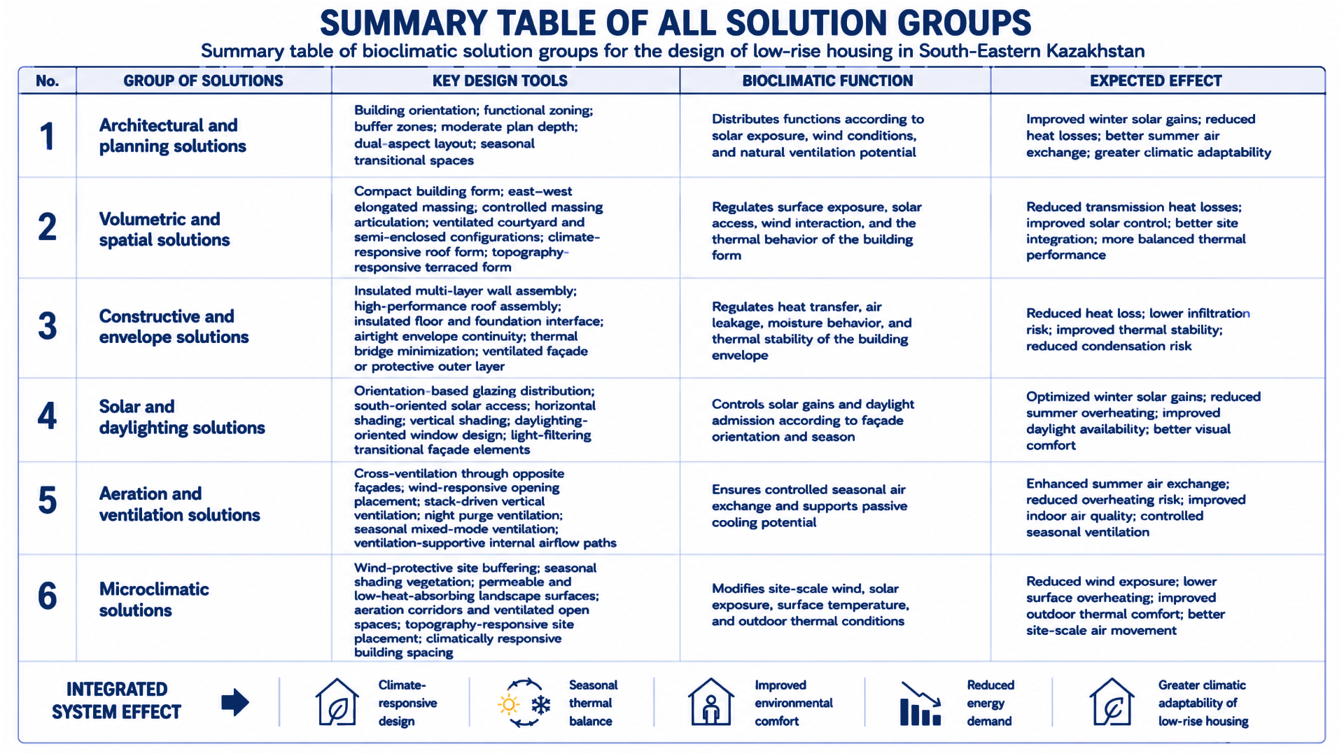

Figure C.12 - Summary table of all solution groups

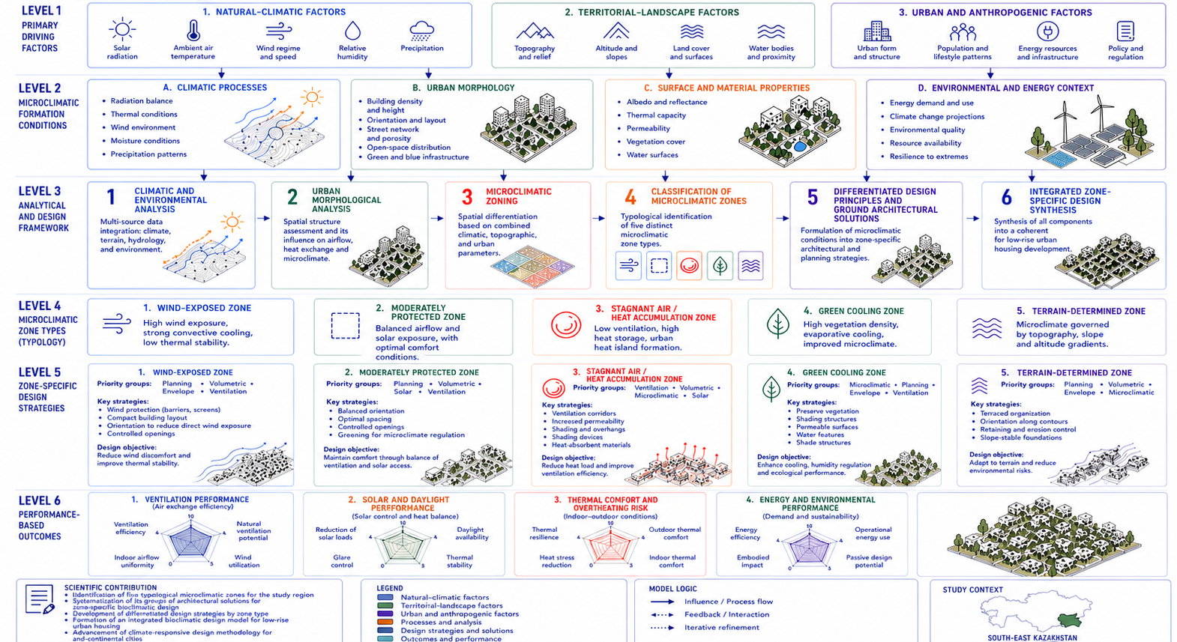

Figure C.13 - Final analytical scheme of the research

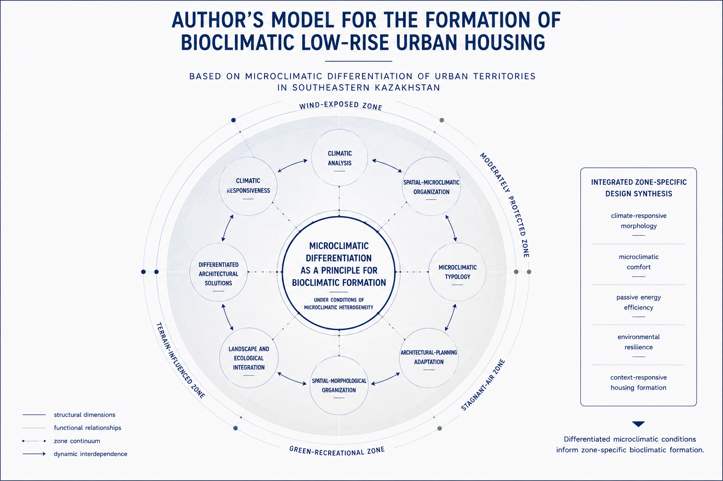

Figure C.14 - Author’s model for the formation of bioclimatic low-rise urban housing

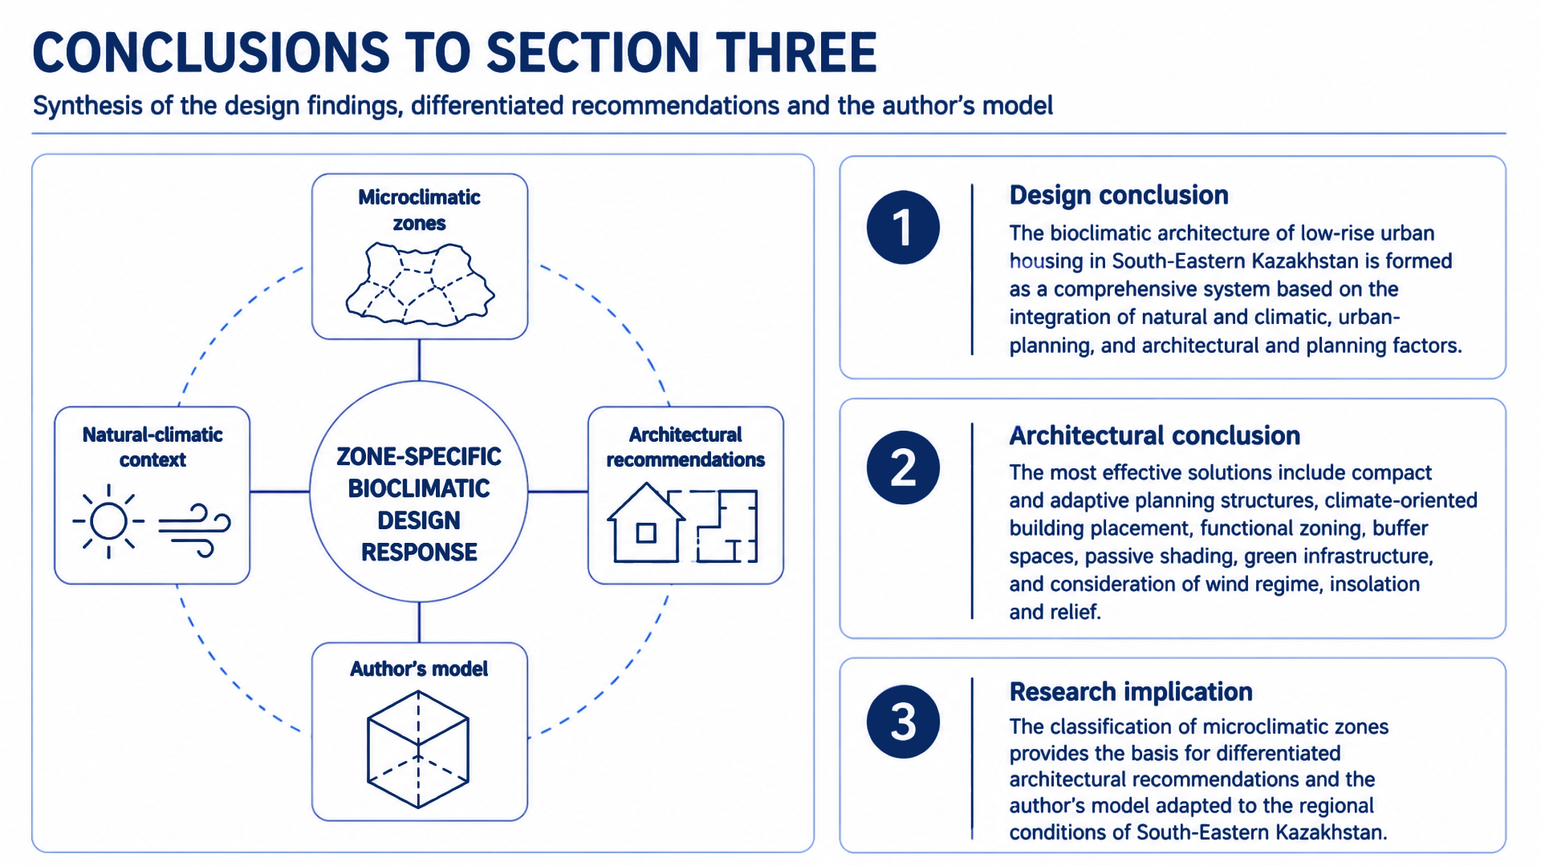

Figure C.15 - Conclusions to Section Three

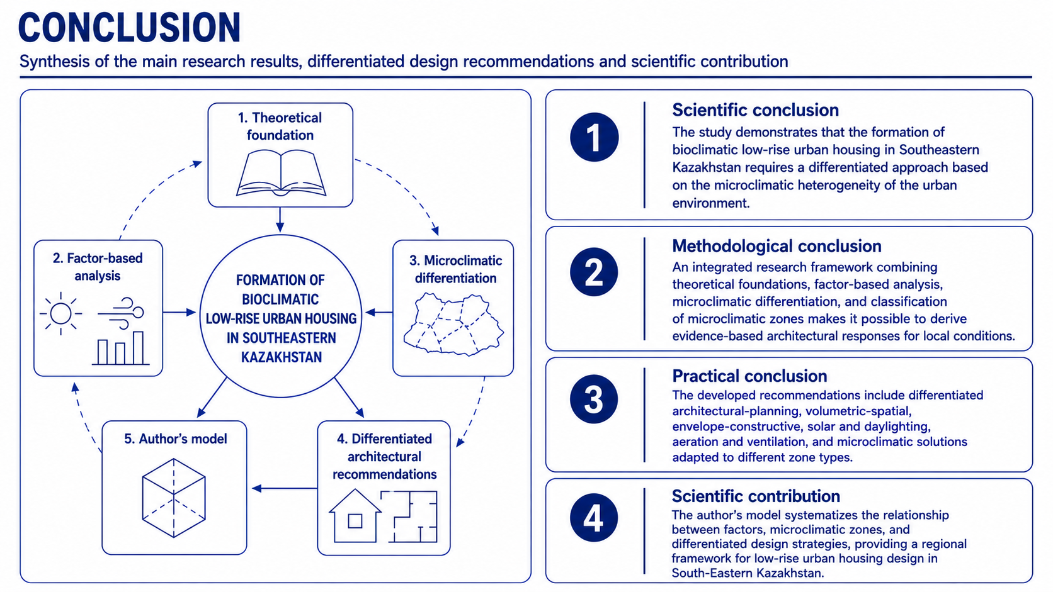

Figure C.16 - Final synthesis of the main research results, differentiated design recommendations, and scientific contribution

