University of International Business named after Kenzhegali Sagadiyev

UDC On manuscript rights Copyright

SABDENALIYEV BAKHTIYAR

Modernisation of the Quality Management System in Higher Education Institutions in Kazakhstan through digitalisation of processes

8D04102 Management

Dissertation for an academic degree
Doctor of Philosophy (Ph.D.)

Domestic scientific consultant
M.U. Spanov
Doctor of Economics, Professor

Foreign scientific consultant
Laszlo Vasa
Ph.D., Professor

The Republic of Kazakhstan
Almaty, 2026

CONTENT

 | REGULATORY REFERENCES ................................................................... | 3
 | DESIGNATIONS AND ABBREVIATIONS …………………………….... | 4
 | Introduction ......................................................................................... | 5
1 | THEORETICAL AND METHODOLOGICAL FOUNDATIONS OF QUALITY MANAGEMENT IN HIGHER EDUCATION INSTITUTIONS............................................................................................. | 12
1.1 | Theoretical foundations of quality management in higher education institutions....................................................................................................... | 12
1.2 | International experience in improving the quality of higher education and its adaptation to the conditions of Kazakhstan..................................................... | 24
1.3 | Methodological foundations of education quality management in the context of digitalization …………………………………………………….............. | 37
2 | ANALYSIS OF THE CURRENT STATE OF DIGITAL MODERNISATION OF THE QUALITY MANAGEMENT SYSTEM IN UNIVERSITIES OF KAZAKHSTAN .......................................................... | 51
2.1 | Current situation of the level of development of higher education in Kazakhstan …………………………………………………………………. | 51
2.2 | Analysis of digital technologies and platforms used to ensure quality in Kazakhstani universities ……………………................................................. | 72
2.3 | The purpose of the iPortal platform in the digital transformation of education quality management in higher education institutions ……………. | 84
3 | DEVELOPMENT OF A STRATEGY FOR THE DIGITAL MODERNISATION OF QUALITY MANAGEMENT IN HIGHER EDUCATION INSTITUTIONS IN KAZAKHSTAN ................................... | 105
3.1 | Mechanisms for the digitalisation of quality management in higher education institutions in Kazakhstan .............................................................. | 105
3.2 | Recommendations and roadmap for modernising the quality management system in Kazakhstani universities ................................................................. | 119
3.3 | Model for the digital transformation of higher education using the iPortal platform ……………………………………………………………………. | 133
 | CONCLUSION .............................................................................................. | 142
 | References …………………………...................................................... | 146
 | Appendices ............................................................................................... | 159

REGULATORY REFERENCES

Decree of the President of the Republic of Kazakhstan dated February 15, 2018 No. 636 “On the approval of the National Development Plan of the Republic of Kazakhstan until 2025 and invalidation of certain decrees of the President of the Republic of Kazakhstan.”
Law of the Republic of Kazakhstan dated May 3, 2022 No. 118-VII ZRK “On amendments and additions to certain legislative acts of the Republic of Kazakhstan on the issues of protection of the rights of the child, education, information and informatization.”
Law of the Republic of Kazakhstan dated July 4, 2018 No. 171-VI ZRK “On amendments and additions to certain legislative acts of the Republic of Kazakhstan on the issues of expanding academic and managerial independence of higher education institutions.”
Law of the Republic of Kazakhstan dated November 24, 2015 No. 418-V ZRK “On Informatization.”
Resolution of the Government of the Republic of Kazakhstan dated December 27, 2019 No. 988 “On the State Program for the Development of Education and Science of the Republic of Kazakhstan for 2020–2025.”
Resolution of the Government of the Republic of Kazakhstan dated March 28, 2023 No. 248 “On the approval of the Concept for the Development of Higher Education and Science in the Republic of Kazakhstan for 2023–2029.”
Resolution of the Government of the Republic of Kazakhstan dated October 27, 2021 No. 726 “On the approval of the national project ‘Quality Education’ (‘Educated Nation’).”
Resolution of the Government of the Republic of Kazakhstan dated December 12, 2017 No. 827 “On the State Program ‘Digital Kazakhstan.’”
Order of the Minister of Education and Science of the Republic of Kazakhstan dated June 23, 2022 No. 292 “On the approval of the Rules for ensuring quality at the levels of education.”
Order of the Minister of Education and Science of the Republic of Kazakhstan dated June 17, 2015 No. 391 “On the approval of qualification requirements for educational activities of organizations providing higher and (or) postgraduate education, and the list of documents confirming their compliance.”
Order of the Minister of Education and Science of the Republic of Kazakhstan dated February 13, 2003 No. 79 “On the approval of the Instruction on conducting state attestation of educational organizations.”
Order of the Minister of Science and Higher Education of the Republic of Kazakhstan dated April 20, 2023 No. 112 “On amendments and additions to the Order of the Minister of Science and Higher Education of the Republic of Kazakhstan dated April 20, 2022 No. 112 ‘On the approval of the Action Plan for the implementation of the National Project ‘Educated Nation.’”

DESIGNATIONS AND ABBREVIATIONS

ICT | Information and Communication Technology
LMS | Learning Management System
UTAUT | The Unified Theory of Acceptance and Use of Technology
MATLAB | Matrix Laboratory
TQM | Total Quality Management
UHEP | Unified Higher Education Platform
EDS | Electronic Digital Signature
OECD | Organisation for Economic Co-operation and Development
UNESCO | United Nations Educational, Scientific and Cultural Organization

INTRODUCTION
Relevance of the research topic. In the context of intensive societal transformations, ensuring the quality of education is a crucial issue among both general and professional educational challenges, as the success of addressing this issue directly impacts the economic and political stability of the state. At the same time, any state policy in the field of education is primarily aimed at increasing the competitiveness of domestic education, ensuring its compliance with international standards, and preparing personnel with a high level of digital literacy. Under these conditions, the task of improving the quality of higher education becomes particularly relevant, requiring the enhancement of the quality management system of educational activities in universities. Traditional approaches to ensuring the quality of education, which are primarily based on paper documentation and inspection control, are becoming increasingly ineffective in the face of rapid technological development. Thus, in leading countries such as the United Kingdom, Germany, Finland, South Korea, and Singapore, automated education quality management systems, platforms for monitoring educational processes, and digital tools to support managerial decision-making are already being actively implemented. The digitalization of quality management processes opens up new opportunities for more transparent and prompt evaluation of educational outcomes, as well as for the active participation of all stakeholders in quality management processes.
In recent years, Kazakhstan has witnessed active efforts to modernize the quality management systems in universities. At the state level, strategic documents and targeted programs aimed at developing the quality of higher education have been adopted and are being implemented. Among the most significant initiatives are the Concept for the Development of Higher Education and Science of the Republic of Kazakhstan for 2023–2029, the State Program for the Development of Education and Science of the Republic of Kazakhstan for 2020–2025, the Concept for the Development of the Creative Economy until 2025, the Concept for Digital Transformation and the Development of the Information and Communication Technologies and Cybersecurity Sector of the Republic of Kazakhstan for 2023–2029, the Law of the Republic of Kazakhstan “On Science and Technology Policy” (as amended and supplemented on 19.05.2025), and the Law of the Republic of Kazakhstan “On Education” (as amended on 16.06.2025). Moreover, the significance of the present study increases substantially in light of the priorities for comprehensive support of youth outlined in the Address of the President of the Republic of Kazakhstan, Kassym-Jomart Tokayev, to the people of the country entitled “Kazakhstan in the Era of Artificial Intelligence: Current Challenges and Solutions through Digital Transformation” dated September 8, 2025, where the issues of education and human resources development were identified as the cornerstones. the stones of the country's steady and progressive progress.
Given the above, the need to modernize the quality management system of higher education in Kazakhstani universities through the digitalization of processes becomes particularly urgent. However, despite government efforts and the significant interest of researchers, the problem of education quality management remains largely unresolved. Firstly, modern society is characterized by intensive and dynamic processes that require the education system to be flexible, innovative, and capable of responding promptly to changing conditions. Secondly, there is insufficient synchronization between the strategic goals of state programs and the actual practice of quality management in universities, which is manifested in the fragmented implementation of digital tools. Thirdly, the methodological toolkit that would enable universities to effectively utilize digital technologies to enhance the quality of educational activities, particularly in terms of analytical assessment and the monitoring of academic data for informed managerial decision-making, remains underdeveloped.
In this regard, the importance and relevance of the issue under consideration served as the basis for selecting the topic of this dissertation.
Moreover, the relevance of the present study is also determined by the need to develop a human resource potential equipped with digital literacy and capable of effectively managing the quality of education in the context of the digital economy. The implementation of this objective is directly related to the state policy on enhancing the competitiveness of the national education system, as outlined in the strategic documents of the Republic of Kazakhstan. Thus, the present research aims to develop scientifically grounded recommendations that support the modernization of higher education quality management systems in Kazakhstani universities through the digitalization of processes, aligning with the priority directions of state educational policy and global trends.
The degree of problem development. The theoretical foundations of quality management in higher education institutions have been formed at the intersection of approaches from general management, pedagogy, and systems theory. The most important principles were developed in the works of W.E. Deming, J.M. Juran, P.B. Crosby, K. Ishikawa, A.V. Feigenbaum, and G. Taguchi. Their concepts laid the groundwork for integrating quality management into educational processes and for the subsequent adaptation of Total Quality Management (TQM) principles to the academic environment. The research of L. Harvey, D. Green, J. Biggs, J. Brennan, and P. Scott contributed significantly to the development of the conceptual framework and the identification of specific features of quality assurance in universities. The primary focus is placed on the relationship between quality management, academic autonomy, and a culture of increased responsibility. Particular importance is assigned to the role of the instructor as a bearer of the institutional culture of quality and as an active participant in management processes.
International experience in quality assurance demonstrates institutional diversity in approaches, shaped by regional contexts and the transformation of global educational priorities. A significant contribution to the analysis of comparative models was made by H. Harms, U. Teichler, D.F. Westerheijden, M. Kofler, M. Benson, and D. Houston. Their works reveal the mechanisms of operation of quality assurance agencies, accreditation processes, and the impact of the Bologna Process on institutional governance. The studies of J. Tilly, J. Brennan, S. Stauffer, O. Kivinen, and R. Schroeder examine the transformation of the role of universities under globalization and digitalization, as well as the adaptation of external control tools to internal strategic objectives. The analysis highlights the differences between a regulatory model based on compliance with standards and the development of a quality culture aimed at internal institutional improvement.
The theoretical and methodological foundations of applying TQM, and the process-based approach in university management have been studied, both in the context of adapting industrial standards and with consideration of the specific features of education. A significant contribution was made by H. Kanya, C. Lauri, B. Bergman, L. Klebeck, W. Mussel, and A. Schartel. Their works explore the possibility of translating the PDCA (Plan–Do–Check–Act) cycle into educational contexts, identify barriers to the standardization of academic activities, and propose models for monitoring and continuous improvement. The development of process-based management in education is also analyzed in the studies of J. Evans, K. Lindsey, J. Bennington, A. Josef, and M. Reinhardt, where attention is focused on the necessity of comprehensively covering all levels of academic management. Particular emphasis is placed on performance metrics, cross-functional linkages, and feedback mechanisms within the framework of improving educational services.
Digital tools and platforms in education quality management have become the focus of intensive research aimed at understanding their role in institutional transformations. The analysis of information systems used in universities is presented in the works of A. Sangrà, P. Meessen, A. Alcantara, M. Moro, S. Gao, and Y. Fan. These studies demonstrate how the implementation of BI systems, LMS platforms, visualization systems, and digital identification transforms decision-making mechanisms, performance assessment, and student interaction. The works of G. Rodríguez, A. Pérez, E. Herrero, I. Sepúlveda, and K. Larson examine cases of integrating adaptive platforms and digital portfolios into the monitoring of educational achievements. Special attention is given to the potential of artificial intelligence and digital footprints in predictive analytics and the individualization of educational trajectories.
The paradigm of digital transformation and digital maturity in higher education institutions has been formed based on interdisciplinary approaches. Foundational models of digital maturity are presented in the works of EDUCAUSE, JISC, and Gartner. These models are elaborated upon in the studies of G. Salmon, S. Becker, N. Mikhailovich, E. Schindler, and B. Gregory. The focus is on levels of institutional readiness, digital culture, structural adaptation, and the strategic integration of digital solutions. The transition from fragmented automation to a unified digital ecosystem is analyzed in the context of resilience, flexibility, and self-renewal capacity. Contributions to the development of the theory of digital transformation were also made by S. Downie, M. Nussbaum, A. Kuhn, and E. Esteban, who emphasize the importance of digital maturity as a factor in institutional competitiveness and managerial effectiveness.
Methodological approaches to quality assessment and monitoring in the context of digitalization are evolving, integrating standards, metrics, and digital mechanisms. Conceptual developments are presented in the works of M. Van Assche, M. López, O. Tilly, A. Bourgeault, and E. Wright, which address methods for collecting, interpreting, and applying educational data. The development of indicators and visual analytical models is explored in the research of J. Sutcliffe, H. Sung, E. Navas, L. Chen, and D. Campbell. Emphasis is placed on the need to transition from retrospective to predictive management, the inclusion of intelligent systems, and the formation of standards for data-informed governance. In the context of digital transformation, monitoring becomes not only a technical tool but also a foundation for institutional self-development and strategic management.
Thus, despite the existence of a broad theoretical foundation, a clear scientific gap remains in the systematic analysis of digital quality management mechanisms in higher education. Contemporary research predominantly focuses on individual tools–from LMS and BI platforms to digital maturity indicators and PDCA models–yet lacks a conceptually coherent architecture that integrates these elements into a reproducible model. There is an insufficient development of approaches that reflect the institutional characteristics of universities, the specificity of internal governance, and the integration of digital solutions into the strategic frameworks of quality assurance. The ambiguity of boundaries between technological, methodological, and managerial components of digitalization necessitates further theoretical and methodological refinement of this issue, as well as the development of comprehensive models tailored to the transformation conditions of Kazakhstani universities.
Research aim and objectives. This dissertation aims to develop organizational and methodological foundations and recommendations for modernizing the quality management system in Kazakhstani universities under the conditions of digitalization of processes.
In accordance with this aim, the following key research objectives are set:
- to examine the theoretical foundations of quality management in higher education institutions;
- to synthesize international experience in modernizing quality assurance mechanisms and to identify possibilities for its adaptation to the Kazakhstani context;
- to substantiate the methodological foundations of education quality management under digitalization conditions;
- to analyze the current state of higher education in Kazakhstan, taking into account regional specificities and the dynamics of workload on academic staff and universities;
- to assess the level of development of digital technologies and platforms used for quality assurance in Kazakhstani universities;
- to justify mechanisms for the digitalization of quality management in Kazakhstani higher education institutions;
- to develop scientifically grounded practical recommendations and a roadmap for the phased modernization of the quality management system;
- to design a conceptual model of iPortal as a digital solution ensuring institutional resilience, transparency, and manageability of quality assurance processes in the university environment.
The subject of the research is the organizational and methodological aspects of quality management in higher education under the conditions of process digitalization.
The object of the research is the processes of quality management of educational activities in Kazakhstani universities.
Research methods. The methodological basis of the dissertation combines quantitative and conceptual approaches to analyze the mechanisms of digitalization in the quality management of education in Kazakhstani universities. The empirical part is based on a dataset concerning the activity of academic staff, covering classified types of work, their time tracking, distribution by weeks, and forms of digital engagement.
The following methods were used for data processing and analysis:
- Python 3.11 software, including the libraries pandas, numpy, matplotlib, seaborn, scipy.stats, and scikit-learn for constructing correlation matrices, cluster dendrograms, normalization, and visualization of digital patterns of faculty activity;
- JASP 0.18.2.0 software for performing correlation analysis (Pearson, Spearman) and confirming the statistical significance of relationships among academic, digital, and managerial indicators;
- Z-score standardization for standardizing data across each activity type and enhancing their comparability;
- Factor analysis using the Principal Axis Factoring method, implemented in JASP and Python (FactorAnalyzer), to identify the latent structure of digital practices and extract key components of engagement;
- Cluster analysis (hierarchical clustering using Ward’s method) for grouping faculty members based on their digital activity profiles;
- Construction of transition and linkage matrices (Markov transition-like logic) between weeks and activity types to identify stable behavioral trajectories;
- Visualization of the architectural structure of digital mechanisms using plotly, graphviz, and networkx in Python.
The theoretical and analytical part of the study included:
– structuring of digital tools according to the three-tiered architecture of quality management: (1) data collection, (2) analytical processing, (3) decision-making;
- modeling the logic of the PDCA cycle (Plan–Do–Check–Act) in the context of the university digital environment;
- conceptualization of the data-informed governance approach, based on the interpretation and deliberate use of analytical data in managerial decision-making;
- comparative content analysis of international digital maturity models: EDUCAUSE, Gartner Digital Maturity Model, JISC Digital Capability Framework.
The informational and empirical basis of the study includes classified logs of faculty digital activity, aggregated indicators by type of activity, workload time-tracking reports, internal university documents (excluding specific institutional references), as well as strategic documents in the fields of digitalization and education quality.
Scientific novelty. This study contributes to the development of the theory and practice of quality management in higher education under conditions of digital transformation by proposing an innovative model for integrating emotional intelligence (EI) as a key element of sustainable digital governance. It introduces an approach to transforming existing models of education quality assessment through the lens of meta-competencies and the digital adaptability of the educational environment. The main results of the study are as follows:
– the inclusion of emotional intelligence (EI) is substantiated as a functional component of the higher education quality assurance system, reflecting a shift from an academically oriented to a human-centered assessment model;
- a three-level architecture for integrating EI into quality management is developed, encompassing the individual, institutional, and state levels, with defined coordination mechanisms and operationalization of indicators;
- a roadmap for EI implementation through 2030 is proposed, structured by phases and levels, taking into account digital, organizational, and regulatory implementation conditions;
- a scenario graph for EI implementation is constructed, indicating logical dependencies between stages, key control points, and institutional risks hindering systemic change;
- a methodology for assessing EI in the digital educational environment is substantiated through the integration of ePortfolio elements, LMS analytics, and digital indicators of meta-competencies for faculty and students;
- proposals are formulated for the institutionalization of EI at the level of state policy, including the need to develop a standard, incorporate EI into accreditation procedures, and ensure its systematic integration into universities' strategic documents.
The main provisions submitted for defense:
- the applicability of international quality management models in the Kazakhstani context, substantiated through comparative analysis of global practices (United Kingdom, Germany, United States, Japan, OECD countries, and Islamic states), identification of the elements most relevant to Kazakhstan, and assessment of the risks of uncritical adoption;
- a methodological toolkit for analyzing the digital transformation of quality management in educational activities, incorporating the Knowledge Economy Index (KEI) to evaluate the extent of university engagement in regional economies;
- the main directions of digital transformation in university quality assurance systems, including the formation of a unified data architecture, the development of staff digital competencies, and the standardization of analytical tools at the level of academic programs;
- a “roadmap” for the modernization of quality management in Kazakhstani universities, including stages of digital transformation, strategic goals, monitoring indicators, and potential institutional risks;
- a new model of the digital platform iPortal, aimed at enhancing institutional resilience, transparency, and controllability of quality assurance processes in higher education.
The theoretical significance of the study. The theoretical significance of the study lies in substantiating a new paradigm of digital quality management in higher education based on the synthesis of systems, process-based, and institutional approaches. An original methodological framework for assessing universities’ digital maturity is proposed, incorporating infrastructural, competency-based, regulatory, and cultural dimensions. A structured approach to modernizing the quality assurance system is developed, aligned with strategic transformation priorities and international best practices. The study identifies the relationship between digital quality management mechanisms and institutional resilience, interpreting educational quality as the outcome of integrated digital, organizational, and behavioral factors. The resulting theoretical propositions provide a foundation for further research in educational analytics, digital management, and the transformation of academic governance.
The practical significance of the study. The practical significance of the study lies in the potential for direct application of the developed recommendations and the digitalization roadmap in the strategic and operational management of Kazakhstani universities. The study proposes a multi-level model for implementing digital solutions, including the stages of diagnostics, piloting, and institutionalization of quality mechanisms. The developed provisions provide a foundation for creating digital quality management platforms, including iPortal, which aims to automate monitoring, visualize educational data, and establish adaptive feedback mechanisms. The study's results can be applied within the framework of the national Digital Kazakhstan program, as well as in the development of internal university regulations aimed at enhancing the transparency, efficiency, and resilience of educational management under conditions of digital transformation.
Аpprobation of the research results. The main findings of the study have been validated through their practical implementation within the activities of the International Educational Corporation (IEC). The results were applied in the development and deployment of the digital information system iPortal, aimed at enhancing transparency, analytical support, and managerial control over quality management processes in higher education.
Dissemination of research results. The principal propositions and conclusions submitted for defense are presented in 5 scholarly publications: 2 articles in a Scopus-indexed journal with a non-zero impact factor, and 2 articles in journals recommended by the Committee for Quality Assurance in Science and Higher Education of the Republic of Kazakhstan and 1 article in the proceedings of international scientific and practical conferences.
Structure and scope of the dissertation. The dissertation consists of three chapters comprising the theoretical, analytical, and recommendation sections. The work is 179 pages in length and includes 34 tables, 24 figures, and 4 appendices. The study draws on 152 sources.
1 Theoretical and methodological foundations of quality management in higher education institutions

  - Theoretical foundations of quality management in higher education institutions

The formation of management models in the university system dates back to the developments in the field of scientific management proposed at the beginning of the 20th century. Frederick W. Taylor [1] formulated the foundations of rationalizing labor activity to increase efficiency through standardization of operations, precise regulation, and redistribution of functions between performers and managers. The concept assumed the optimization of processes by their dissection and scientific substantiation of procedures, subsequently influencing the development of administrative practices, including higher education. Nadworny [2] demonstrated that the competition between Taylorism and alternative approaches, particularly Gilbreth's methods, was not limited to technical differences but was due to the struggle for institutional recognition within the emerging management science. A comparison of the Taylor and Gilbreth approaches revealed key differences. Taylorism to maximize productivity is focused on standardizing operations and precise time management. In contrast, Gilbreth’s approach was based on analyzing micro-movements to reduce workers’ physical effort and improve working conditions. The competition between these approaches reflected broader differences in understanding the nature of productivity: Taylor’s mechanistic view versus Gilbreth’s emphasis on humanizing labor. Grachev and Rakitsky [3] expanded the geographical and chronological scope of Taylorism’s analysis, showing that its principles underwent transformations depending on economic and institutional conditions, including implementation in centralized planning practices in various countries. It was found that in the late stage of the industrial economy, Taylorism lost its flexibility and turned into a normative model, the effectiveness of which was limited in the conditions of the post-industrial economy, which requires greater adaptability and network forms of labor organization. Modern interpretations proposed by Uddin and Hossain [4] combined Taylorism with behavioral theories, emphasizing the need to consider the human factor in management. The difference in the approach was that instead of mechanical standardization of processes, it proposed to adapt formalized procedures to the needs of personnel focused on development, creativity, and self-realization. Thus, Taylorism was not viewed as a complete system but as a basis that requires integrating elements of organizational flexibility and a motivational approach. Hamid, Isa, Chew, and Altun [5] clarified that the development of quality management in universities went through several stages - from mechanistic standardization to the integration of digital technologies and institutional reorganization. It was noted that the implementation of ISO standards, benchmarking, and lean practices was accompanied by serious barriers, among which the dominant ones were insufficient strategic flexibility, weak technological infrastructure, and lack of internal readiness for systemic transformations, which increased the dependence of universities on formal compliance with requirements in the absence of real changes in processes.
The application of management concepts in the educational environment was associated with the works of Hill and Taylor [6], who substantiated the need to implement total quality management (TQM) principles in universities. The basis for the transition was the awareness of the fundamental differences between educational organizations and manufacturing enterprises: students do not act as passive consumers of educational services but are active participants in the process of creating knowledge, which requires a new understanding of quality as a multidimensional process that includes academic results, the development of research skills and the formation of socially responsible behavior–in the context of increasing demands on educational systems, Hill and Taylor [7] specified the conditions for integrating TQM into university practice, focusing on building effective internal communication, developing teamwork and forming sustainable feedback mechanisms between all participants in the educational process. It was emphasized that the transfer of industrial models without adaptation to the substantive characteristics of education leads to the formation of routine procedures that hinder the development of innovation, personal growth of students, and their ability to self-organize. As part of developing views on quality management, Bogue [8] studied the evolution of quality assurance mechanisms in higher education in the context of institutional reforms. It is shown that the sustainability of quality management is achieved through its inclusion in the university mission, the integration of ethical standards into educational processes, and the formation of an atmosphere of public accountability. This approach was based on the recognition that only internally motivated, value-oriented structures can ensure the long-term effectiveness of educational activities. Manatos, Sarrico, and Rosa [9] deepened the study of institutional barriers to implementing TQM, showing that resistance to change, weak support from management, and the lack of an established culture of self-assessment and ongoing quality monitoring are key obstacles. A model of factors for the successful integration of TQM in universities is proposed based on the active involvement of all levels of management, continuous professional training of personnel, the development of horizontal feedback mechanisms, and maintaining a value orientation toward quality as a strategic goal of educational development.
Hamid, Isa, Chew, and Altun [5] identified stages in the development of quality management from Taylorism to modern models focused on digital and institutional transformations. The stages included the initial stage of mechanistic management with an emphasis on standardization of operations and labor regulation, the transition to total quality management concepts with employee involvement, the introduction of ISO standards and benchmarking practices, the development of lean strategies to eliminate losses and improve efficiency, as well as the integration of digital quality management tools taking into account institutional changes. It was found that implementing modern approaches in educational organizations is associated with persistent barriers: a lack of strategic flexibility, a weak technological base, and a lack of readiness for internal transformations. Tsutsui [10] found that Deming's ideas were perceived in Japan as the basis of management philosophy, providing a combination of production efficiency with employee involvement and social responsibility, strengthening organizations' position in the context of global competition. Petersen [11] interpreted Deming's philosophy as a system of organizational thinking that includes systems analysis of process relationships, control of variations to stabilize quality, cognitive understanding of the mechanisms of the organization's work, and the use of management psychology to develop a supportive environment; the separation of these components is recognized as necessary for the construction of adaptive management systems. Hughey [12] showed that the application of TQM principles in universities requires a rethinking of the role of the student, suggesting a transition from an administrative hierarchy to a cooperative model of educational management, the development of mentoring, the formation of partnerships, and the stimulation of institutional learning at all levels of the educational process.
The theoretical and applied foundations for total quality management in higher education have been developed by integrating ideas from various authors and adapting industrial models to the educational environment. Kanji, Malek, and Tambi [13] developed an empirical quality assessment model for UK universities based on customer satisfaction, evidence-based management, staff involvement, and continuous process improvement. It has been established that successful implementation of TQM in universities depends on the ability not only to measure quantitative indicators but also to implement changes in the organizational culture and management systems: integration involves not a formal combination of methods but their conjugation through systematic work with values, internal communications, and decision-making structure. The proposed model of critical success factors was subsequently adapted within the framework of business-oriented strategies for the development of the academic sector, aimed at increasing the competitiveness of universities in the global educational environment. Best and Neuhauser [14] reconstructed W. Edwards Deming's contribution to the development of quality philosophy, revealing that eliminating fear, employee involvement, and replacing control with training and leadership serve as the basis for the formation of self-developing organizations. It is shown that the ideas of variations and a systematic understanding of processes are applicable not only in the manufacturing sector: in education, minimizing deviations in training and increasing the sustainability of educational results through systematic work with processes leads to an increase in the quality of education without mechanical standardization, and in healthcare, similar principles ensure patient safety and the sustainability of procedural control, which confirms the universality of the Deming model at the level of the logic of system management. Aydemir and Türkel [15] compared the principles of TQM with Islamic values, finding that components such as leadership, customer focus, and planning correspond to the norms of collective responsibility, justice, and the desire for continuous improvement, which made it possible to formulate the possibility of adapting TQM in Islamic educational institutions as a universal ethical model. Ndagire, Is’haq, and Lubaale [16] systematized the barriers to TQM implementation in private universities, determining that the key problems remain the lack of managerial competencies, resistance to change, limited resources and the absence of systemic mechanisms for quality assessment at the same time, successful integration of TQM requires institutional maturity, that is, the presence of an internally built system of goals, values ​​and responsibilities that ensure the ability to perceive and support change, as well as strategic leadership and comprehensive organizational support. Hamid et al. [5] recorded that the concept of quality has evolved from product and system management to process, knowledge, and network management, integrating digitalization, social responsibility, and risk management, which made it possible to demonstrate the preservation of the role of TQM as a transitional model between industrial standards and the requirements of a post-industrial society. The formulated approaches reflected that TQM has transformed from a technical control system to a management philosophy focused on values, processes, and human needs. The ideas of Deming, Juran, Crosby, Feigenbaum, Ishikawa, and Taguchi have been adapted to the educational environment through the introduction of systemic quality management models, an emphasis on the development of leadership competencies, a reorientation towards the student as a key stakeholder in the educational process and continuous improvement of procedures and methods. The interaction of the Islamic perspective and the challenges of the digital age has confirmed the universality of TQM as an institutional development strategy that combines the measurability of educational results, an ethical focus on organizational development, and a strategic vision in a changing global environment.
The systems approach to quality management in education considers educational institutions as open, self-organizing systems interacting with the external environment and changing in response to internal and external stimuli. This became the basis for conceptualizing organizations as complex, dynamically developing units. Russell L. Ackoff [17] developed these ideas, defining organizations as integral systems with new qualities that cannot be reduced to a simple sum of their parts, and proposed the concept of "goal systems" in which the interaction of elements is aimed at achieving common goals that ensure the consistency of actions. According to Ackoff [18] sustainable quality is achieved not through local improvements but through redefining the structure of interactions within the system, which implies a transition from optimizing individual processes to synchronizing the organization's strategic objectives. The transition from operational analysis to humanistic synthesis in the management of organizations was recorded by Detrick [19], who emphasized that it is precisely systems thinking that allows one to take into account value aspects, the human factor, and complex relationships within the educational environment, going beyond linear optimization models. Peter Senge [20] formulated the concept of a learning organization, in which systems thinking integrates the development of personal mastery, work with mental models, the formation of a shared vision, and the development of team learning, which in the context of higher education means the creation of universities capable of constant adaptation, collective knowledge, and the development of sustainable development strategies based on the participation of all actors in the educational process. Ramage and Shipp [21] systematized the elements of the Senge model, highlighting the involvement of all participants, orientation to long-term goals, and the development of a culture of continuous learning as key factors in the sustainability and effectiveness of the management of educational organizations while emphasizing that it is the culture of collective development, and not only mechanical procedures, that ensures the viability of universities in the face of change. Spain [22] adapted the ideas of the systems approach to curriculum design, considering the educational process as an open system that constantly interacts with the educational, social, and economic environment, which made it possible to form more flexible, adaptive, and student-oriented educational trajectories; the adaptation was explained by the need to take into account the multiplicity of influencing factors and the changing demands of society. Jung [23] applied systems analysis to the management of educational institutions in the field of arts and humanities, finding that identifying the discrepancies between mission, organizational practice, and external environmental requirements allows for the construction of adaptive quality management mechanisms, ensuring the integrity of strategic development and the sustainability of educational results. Hofkirchner and Schafranek [24] proposed a philosophical reconstruction of general systems theory as a metatheory of complex systems, emphasizing the non-linearity of organizational development processes, the need for analysis at multiple levels, and the recognition of communicative interdependence as a condition for the effective functioning of educational structures; emphasis was placed on the importance of moving from reductionist models to integrative and interdisciplinary approaches. In an empirical study, Kocatürk and Karadağ [25] applied a systems approach to analyze the organizational functioning of universities through the prism of the Birnbaum model, where the typology of management structures made it possible to establish that the degree of autonomy, adaptability, and sustainability is directly related to the effectiveness of quality management; The use of the Birnbaum model is justified by its ability to take into account the internal mechanisms of decision-making and the response of universities to changes in the external environment. Systems thinking in higher education has transformed into a fundamental paradigm for the analysis and design of university organizations, focused on recognizing internal complexity, dynamic interaction with the external environment, and the development of strategies for sustainable institutional development.
At the national level, research interest in modernizing quality management systems in education is actively developing. Special attention is paid to studying the possibilities of adapting international standards and TQM methodologies in the Kazakhstani educational space. Within the framework of these studies, mechanisms for integrating a systemic approach into the practice of universities, problems of institutionalization of quality assurance processes, and the impact of accreditation requirements on the transformation of management models are analyzed.
In recent years, the integration of total quality management (TQM) methods and a systems approach in higher education in Kazakhstan has become a subject of active scientific interest. Kazakh researchers focus on the need to adapt international quality management practices to the educational system's national characteristics and strategic guidelines for sustainable development. The study by Istileulova and Peljhan [26] identified the specifics of the transformation of business schools in the CIS countries, including Kazakhstan, under the influence of international accreditation processes. The authors showed that the desire to comply with international standards stimulated internal changes: revision of university missions, development of metrics for assessing educational outcomes, introduction of strategic planning tools, and increased requirements for academic programs. An essential contribution of the study is to substantiate the relationship between accreditation processes and the development of a systems approach to quality management in educational organizations in Kazakhstan. Salimova and Makolov, studying the effectiveness of ISO 9000 standards in Russian companies, identified several systemic problems that directly parallel the Kazakhstani context [27]. Among the key barriers, they noted insufficient involvement of top management in quality management processes, the formal nature of the process approach implementation, weak focus on continuous improvement, and limited use of the capabilities of standards to improve performance. These findings highlight the need to move from the declarative implementation of standards to the conscious integration of TQM principles into the management practices of higher education institutions. The analysis conducted by Manarbek and Kondybayeva focuses on the study of the use of business quality management tools in higher education in Kazakhstan. Their work notes that such components as process management, focus on the effectiveness of educational services, involvement of all stakeholders, and the development of a quality culture are gradually being introduced into the activities of Kazakhstani universities [28]. Therefore, comprehensive systems of internal control and quality assessment based on system analysis and modern management technologies are crucial. Mukanova, Abildina, and Mukhatayev study proposed a conceptual model for developing internal quality assurance systems (SIQA) as an integral part of the National Quality Assurance System for Higher Education in Kazakhstan [29]. The authors reviewed the practices of building SIQA in the context of the European Standards and Guidelines (ESG) requirements, emphasizing the importance of creating proprietary regulatory, organizational, and personnel conditions. Particular attention is paid to the need for universities to move from formal compliance with requirements to building a systemic process of continuous improvement of the quality of education in the context of academic autonomy and growing competition in the global educational services market. The results of Kazakhstani studies indicate the transition of the higher education quality management system from the initial development of international standards to the conscious adaptation of TQM elements and a systems approach. An understanding of the importance of strategic integration of quality into management processes, development of an internal quality culture, involvement of all levels of academic and administrative staff, and strengthening the focus on meeting the needs of students and external stakeholders is being formed. At the same time, the identified problems of insufficient institutionalization of new quality management models emphasize the need for further efforts to build sustainable and effective quality assurance systems in Kazakhstan's higher education.
The transformation of governance in higher education is based on the intersection of two trends: the value-oriented approach and the New Public Management (NPM) model. Within the framework of the first trend, Freeman and Reed [30] formulated the Stakeholder Theory, which asserts the need to consider the interests of all groups involved in the university's activities, including students, teachers, employers, and the state. This theory marked a departure from shareholder logic in favor of social inclusiveness and ethical responsibility, thereby changing the basic criteria for the effectiveness of public organizations. The development of the approach was continued by Parmar et al. [31], who integrated normative, instrumental, and descriptive components into the analysis of the sustainability and legitimacy of universities, emphasizing the importance of an active response to the requests of all stakeholder groups as a condition for maintaining public trust. Further, Moore [32] developed the concept of public value accounting. The author defined the creation of public value as the primary criterion for assessing the activities of public organizations, distinguishing them from corporate structures focused on shareholder efficiency. It was emphasized that universities should be evaluated through their contribution to achieving democratically determined public priorities, not only through economic performance indicators.
The second direction relates to the development of NPM, theoretically substantiated by Hood [33], who described the transition of the public sector to decentralization, management by objectives, standardization of procedures, and introduction of market mechanisms. In his subsequent works, Hood [34] recorded the paradoxical effects of reforms: the introduction of market practices was accompanied not by the strengthening of the autonomy of organizations but by the growth of administrative control and the complication of procedures, which contradicted the initial goals of liberalization of management. Lynn [35] specified that attempts to integrate universalist managerial principles into public management encounter contradictions between the requirements of efficiency, democracy, and compliance with legal norms manifested in the university environment through the constant tension between market mechanisms and the principles of academic freedom. Thomas and Davies [36] applied a feminist analysis to the study of NPM implementation in British universities, finding that reforms lead to a transformation of academic identity: disciplinary control mechanisms are strengthened, the system of subordination is formalized, and structural manifestations of gender asymmetry are preserved. Broucker and De Wit [37] showed that the degree of commercialization and the success of NPM implementation vary depending on the cultural and institutional environment: Anglo-Saxon countries are dominated by commercialization, while continental Europe retains elements of collegiality and state regulation, providing a more balanced model of interaction between academic autonomy and managerial control.
A summary of theoretical positions indicates the existence of a fundamental contradiction between the value basis of university activity and the management forms borrowed from the private sector. Stakeholder theory and the concept of public value offer models focused on long-term public interests, considering the needs of a wide range of stakeholders, developing social responsibility, and maintaining democratic principles in the educational process. In contrast, the New Public Management (NPM) model focuses on standardized performance indicators, results-based management, and market mechanisms for assessing performance. Therefore, universities are forced to integrate stakeholder management and performance measurement systems, to align value guidelines with administrative requirements and maintaining a balance between the public mission and internal control mechanisms.
Theoretical approaches demonstrate not only a variety of conceptual foundations but also differences in the interpretation of key concepts that determine universities' structure, goals, and mission in the context of institutional and managerial changes. Each paradigm – from Stakeholder Theory to New Public Management – forms its interpretations of the categories of quality, value, responsibility, and the role of stakeholders, defining different priorities in building strategies for the development of educational organizations. These differences are reflected in the philosophical foundations of the approaches, in the placement of managerial emphasis on social responsibility or measurable performance, and in the socio-cultural contexts that influence the perception of universities of their mission in society. To systematize the terminological field, a table has been compiled summarizing the key definitions proposed by leading authors whose approaches formed the basis for the analysis of transformations in higher education (Table 1).

Table 1 – Key concepts and their interpretations in higher education management research
Term / Concept and authors | Definition
Stakeholder Theory  Freeman & Reed | An organization is viewed as a network of relationships between stakeholders whose interests must be taken into account in the management process
Stakeholder Responsibility  Parmar et al. | Ethical, strategic and management decisions must be based on the integration of the needs and expectations of all groups of stakeholders
Public Value  Moore | Assessment of the activities of organizations through the prism of their contribution to achieving the collective public good, and not just economic results
New Public Management (NPM)  Hood | A public management model focused on improving efficiency, using market mechanisms and decentralizing decision-making
Public Service Bargains (PSB)  Hood | A system of formalized or informal agreements between government agencies and employees on rights, responsibilities and control mechanisms
Managerial Subjectivity Thomas & Davies | Formation of the professional identity of employees through management regimes, control mechanisms and changes in organizational culture
Note – compiled by the author
The approach of Freeman and Reed’s [30] became the fundamental for the reorientation of the value foundations of governance from shareholder interests to multiple stakeholder groups, broadening the understanding of corporate social responsibility. This broadened understanding of responsibility formed the basis for subsequent research, including the interpretation by Parmar et al. [31], which emphasizes the ethical, strategic, and analytical dimensions of stakeholder engagement and their impact on long-term organizational sustainability. Moore [32] proposed a shift in focus from financial performance to the creation of social value. The author identified the success of public institutions through their contribution to the collective good rather than through economic performance. Defining social value is particularly important in universities, which have both an educational and civic mission, where social contribution indicators become a criterion for sustainability. In the context of New Public Management, defined by Hood [33], the concept of quality and effectiveness was rethought through the prism of instrumental criteria: efficiency, market mechanisms, and decentralization of powers. Subsequent analysis by Hood [34] recorded the paradoxical consequences of reforms manifested in the strengthening of bureaucratic control instead of the expected organizational freedom. Thomas and Davies defined management in the context of NPM as a process of forming new models of professional identity, paying special attention to gender and symbolic aspects related to the internal transformation of the academic space [35]. NPM reforms transformed the educational environment, redefining ideas about the professional "I" and strengthening disciplinary mechanisms for regulating university behavior.
The developed definitions included the features of the conceptual framework and the value bases of management models, which necessitates their comparison and critical analysis in subsequent classifications and assessment systems. Various interpretations of quality and management are accompanied by the development of classification schemes aimed at structuring types of stakeholders, forms of institutional isomorphism, models of organizational functioning, and concepts of public value. Each direction has formed its analytical constructs that allow for a comparative analysis of institutional practices and the identification of development patterns, internal contradictions, and conditions for the sustainability of educational organizations. The following section presents Table 2 with key classifications proposed by the authors whose theoretical approaches formed the basis of the conceptual analysis.

Table 2 – Classifications of management and institutional models in higher education
Approach and authors | Type / Category
1 | 2
Institutional Isomorphism DiMaggio & Powell (1983) | Mechanisms of organizational convergence: coercive (regulatory pressure), mimetic (imitation of successful models), normative (professional standards)
Continuation of the table 2
1 | 2
Stakeholder Typology  Freeman; Parmar et al. | Division of stakeholders into internal (participants of the educational process) and external (governmental and community actors); primary (directly influencing) and secondary (indirectly influencing) groups
Public Value Creation  Moore | Three-level model of public value: expected value (societal expectations), actual value (realized outcomes), perceived value (public evaluation of activities)
Paradoxes of NPM Hood | Internal contradictions of reforms: limitation of autonomy through globalization, successful failure in achieving goals, partial implementation of managerialism principles
Public Management Cultures  Douglas (1970); Hood | Typology of management cultures: hierarchical (emphasis on rules and subordination), individualistic (competition-driven), egalitarian (based on equality and collective decision-making)
Note – compiled by the author

Classifications proposed in theoretical developments reflect the desire to systematize complex managerial and institutional processes occurring in the university environment. The institutional isomorphism model developed by DiMaggio and Powell [37] describes the mechanisms through which organizations begin to take similar forms under the influence of regulatory pressure, imitation of successful practices, or the influence of professional norms. Stakeholder typologies formulated by Freeman and refined by Parmar et al. allow us to distinguish between categories of stakeholders – from students and teachers to government agencies, accreditation agencies, and local communities – and take their interests into account when making managerial decisions, which enhances the complexity of processes within universities. The concept of public value developed by Moore introduces a differentiation between society's expectations, actual results, and their perception, which becomes especially significant for assessing the effectiveness of universities in the context of their social mission. Hood classifications show that public sector management depends on the prevailing management culture – hierarchical, market or egalitarian – and is associated with internal contradictions of the organizational environment, influencing the choice of strategies and methods for implementing quality policies [38]. The construction of assessment tools is becoming a necessary condition for the implementation of conceptual models of quality and management. In the context of increasing requirements for accountability, transparency and global competitiveness of universities, metrics and indicators that allow operationalizing such abstract categories as social value, stakeholder satisfaction, the level of implementation of NPM principles and the transformation of professional identity in the academic environment are of particular importance. Theoretical schools have proposed various approache which allow measuring university characteristics, reflecting the specific emphases, logics and priorities of each direction, which necessitates a critical comparison of the indicators used. The summary table systematizes key indicators used for empirical assessment of management processes in higher education, which allows for comparability of results and improvement of the quality of analytical conclusions in university management studies.

Table 3 – Key indicators used for empirical assessment of university management quality
Metric / Instrument | Description | Source
Public Value Score | Measurement of a university’s contribution to creating socially significant value in line with societal expectations | Moore - Founder of Public Value Theory
Stakeholder Satisfaction Index | Assessment of the satisfaction levels among various stakeholder groups regarding university performance | Parmar et al. - Development of Stakeholder Theory
Accreditation Legitimacy Perception | Measurement of perceived legitimacy of accreditation processes among academic community members | Baumann & Krücken - Institutional Approach
NPM Implementation Score | Assessment of the degree of implementation of results-based management and market mechanisms in universities | Broucker & De Wit - Comparative Analysis
Academic Identity Disruption Index | Qualitative analysis of transformations in academic staff identity under the influence of New Public Management reforms | Thomas & Davies - Feminist Perspective
Note – compiled by the author

The Public Value Score developed by Moore marks a shift from formal performance assessment to measuring the real contribution of universities to achieving the public good. The assessment criteria include citizen perceptions of performance, the alignment of the educational institution’s mission with societal expectations, and the sustainability of strategic results, which is particularly important for public universities, where performance is not limited to profitability or the number of graduates. The Stakeholder Satisfaction Index proposed by Parmar et al. as an extension of Stakeholder Theory focuses on the perception of quality and value by various stakeholder groups, including students, faculty, employers, and partners, with an emphasis on the need for a comprehensive assessment of the multiplicity of interests [39]. This approach differs from traditional one-sided KPI models and is particularly relevant for university management in highly complex institutional environments.
Accreditation Legitimacy Perception, developed by Baumann and Krücken [40], focuses on the perception of accreditation procedures by various participants in the academic community, capturing the transition from a normative understanding of legitimacy to its assessment through the prism of public opinion and internal recognition. The NPM Implementation Score metric, proposed by Broucker and De Wit, is designed to assess the degree of implementation of market and performance management principles in universities. The main parameters include the level of autonomy, the structure of the indicator system, administrative reporting, and the specifics of the distribution of management functions, which are especially important for the analysis of combined models of higher education organizations. The Academic Identity Disruption Index, developed by Thomas and Davies, is used to analyze changes in the professional identity of academic staff under the influence of managerial reforms. Particular attention is paid to gender aspects, changes in status positions, and forms of resistance to organizational practices. The index allows us to identify the hidden consequences of transformations that affect academic culture, internal norms of interaction, and the sustainability of universities’ value orientations.
Thus, the theoretical analysis indicates the formation of two interrelated but conceptually different directions in developing quality management models in higher education. On the one hand, the value-oriented approaches of Stakeholder Theory and the concept of public value focus on the social mission of universities, the polyphony of stakeholders, and the need for a comprehensive assessment of public contribution. On the other hand, the NPM model offers management mechanisms based on market principles, standardized performance indicators, and procedural accountability. Due to such contradictions universities must integrate value and market benchmarks into management practices. The developed classifications and metrics - from Public Value Score to Academic Identity Disruption Index - reflect the desire to operationalize various aspects of the academic environment's quality, effectiveness, and transformation. Systematization of theoretical approaches and assessment tools creates a basis for a critical analysis of management processes in higher education. It allows us to identify key areas for further research in the institutional development of universities.
Based on the theoretical analysis, a structure of approaches to quality management in higher education has been formed, combining value-oriented and instrumental-market models (Figure 1).

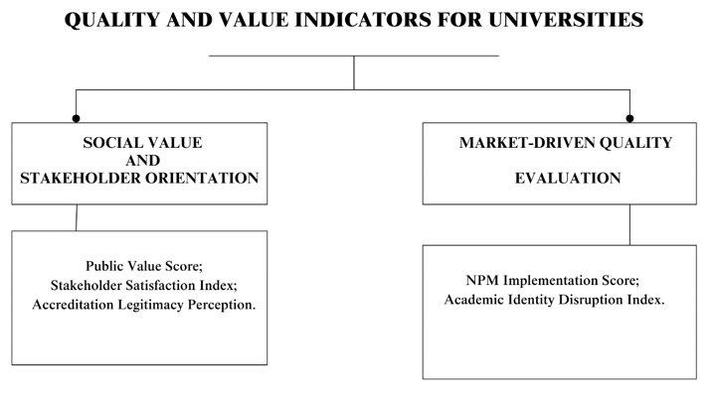
Figure 1 – Quality and value indicators for universities

Note – compiled by the author

The value-oriented direction is represented by Stakeholder Theory (Freeman, Parmar, et al.), which focuses on protecting the interests of a wide range of stakeholders, as well as the concept of public value (Moore), which defines the mission of universities through their contribution to achieving the collective good and social development. These concepts focus on recognizing the university as an active participant in social processes that generate long-term positive changes. To operationalize value guidelines, specialized metrics have been developed: Public Value Score (Moore), which measures the perception of the public contribution of universities in the context of the expectations of civil society, and Stakeholder Satisfaction Index (Parmar et al.), which records the level of satisfaction of various stakeholder groups with the quality of educational, scientific and social functions of universities. Using these tools allows for integrating a comprehensive assessment of the compliance of the university's activities with its social mission into management processes.
The instrumental-market direction, formed within the framework of the New Public Management model (Hood, Broucker, and De Wit), is focused on standardized performance management, increased efficiency, and the introduction of market mechanisms in the public sector, including higher education. The metrics NPM Implementation Score (Broucker and De Wit), reflecting the level of autonomy of universities, the structure of the indicator system, administrative reporting and the features of the centralization of management processes, and the Academic Identity Disruption Index (Thomas and Davies), aimed at diagnosing changes in the professional identity of academic staff under the influence of reforms related to the introduction of managerial practices, are used as an empirical basis for assessing the degree of implementation of these principles. These metrics allow us to identify not only formal transformations of management structures but also hidden processes affecting the educational environment's academic culture and value orientations. The presented structure of theoretical directions and corresponding assessment tools captures the key contradiction between the social mission of universities and the requirements of market efficiency, as well as between academic autonomy and strengthening of bureaucratic control, which determines the complexity of institutional development of higher education in the context of modernization of management models.

1.2. International experience in improving the quality of higher education and its adaptation to the conditions of Kazakhstan

In the context of globalization and the transformation of educational systems, the need to form effective models of quality management in education is becoming one of the key guidelines for developing national strategies. For Kazakhstan, which is at the stage of active modernization of higher education, the study of international experience is critical, as various approaches to quality assurance have been accumulated depending on historical, economic, and cultural conditions. Foreign models demonstrate how quality management systems can act as a tool for the strategic development of universities, increasing their competitiveness and adapting to the challenges of the global educational space. In this regard, the analysis of foreign practices formed in the United States and European countries allows the identification of the principles of building sustainable quality assurance systems and the determination of potential areas for their adaptation to national conditions. Examples of the application of systemic, process, and stakeholder-oriented approaches characteristic of foreign models can become the basis for developing practical solutions in the context of reforming Kazakhstan's education. This section is devoted to considering key concepts and practices of quality management in education that have developed in the international environment, emphasizing their institutional features and the possibilities of application in national practice.
The quality management model in higher education in the United States was built on institutional accreditation, combining a high degree of autonomy of universities with the need to ensure external accountability to society and government agencies. The development of independent accreditation agencies, operating on a voluntary and professional basis, formed a stable system of multi-level control capable of adapting to changes in educational policy without the need for direct government intervention. The introduction of quality management elements was accompanied by borrowing practices from the corporate sector, which contributed to a stronger emphasis on measurable results, an increased role in the social mission of universities, and a focus on the strategic effectiveness of their activities. Thus, accreditation has become a tool for ensuring minimum quality standards. Based on the conclusion of Boland and Silberghs [41] implementing quality management programs initiated a transformation of the administrative structures of universities. Thus, it has become a premise for the transition from centralized models to more flexible systems of internal coordination focused on achieving strategic goals and increasing institutional sustainability. In the context of developing studies of management changes, Lewis and Hartley [42] drew attention to the transformation of performance criteria caused by the introduction of the Best Value concept, where the emphasis shifted from exclusively quantitative indicators to the social significance of the services provided, which led to a rethinking of the internal quality assessment system in universities. In the context of further specifying the conditions for successful reform, Stringham [43] showed that the integration of TQM concepts into public organizations requires not only procedural changes but also a transformation of the organizational culture, the development of self-assessment mechanisms, and the involvement of employees in continuous improvement processes, which predetermined the growth of requirements for professional reflection, increased importance of internal quality monitoring and an expansion of the area of ​​personnel responsibility for the results of educational activities. The study of the consequences of managerial transformations in the academic environment was continued by Deem and Brehony [44], who found that the spread of new managerialism practices contributed to a change in the role of academic staff: an emphasis on quantitative performance indicators, increased external reporting, and standardization of quality control procedures was accompanied by an increase in administrative pressure and a limitation of the space for academic freedom. An analysis of the directions of institutional evolution by Amaral, Rosa, and Tavares [45] recorded that accreditation procedures, initially aimed at stimulating the internal development of universities, were transformed into mechanisms of formal control over compliance with established standards, which reduced institutional flexibility and created risks of losing the innovative potential of educational organizations. Issues of objectivity of assessment procedures were further highlighted in the study by Klasik and Hutt [46], which found that excessive dependence on accreditation processes on quantitative indicators leads to systemic distortions in the assessment of the quality of universities’ activities: educational experience, scientific work and the implementation of the social mission remain outside the framework of formalized measurements, which hinders the achievement of the goals of sustainable development of higher education.
The introduction of total quality control (TQC) concepts in Japanese organizations was accompanied by a transition from traditional process control to the development of internal operational training, which contributed not only to improving product quality but also to the formation of competent teams capable of self-development and continuous improvement (Chiarini's study [47]). Hosono's study [48] provided a clarification of the specifics of the Japanese quality management model, focusing on the involvement of employees at all levels in decision-making and quality improvement processes, which created the preconditions for the development of educational institutions with the capacity for internal reflection and adaptation to changes in the external environment. In his analysis of organizational learning processes, Kim [49] demonstrated that the spread of systems thinking was a factor in the transition from local quality improvement initiatives to comprehensive development programs aimed at strengthening strategic thinking and the ability to take into account the long-term consequences of current decisions. Ravichandran and Rai's study [50] confirmed that the learning organization concept in Japan was perceived not as a theoretical framework but as a practical necessity for ensuring flexibility and resilience in the face of high market uncertainty and in addition to developing approaches to organizational learning, Murray and Chapman [51] emphasized that effective adoption of learning models requires the development of systemic competencies at all levels of the educational structure, including both basic teaching practices and management processes. The practical application of theoretical principles of quality management allows for the consolidation of improvements in the work of educational organizations. Senge [52] pointed out that for sustainable development, it is important to follow established recommendations and understand how actions in one part of the system affect results in another. Understanding cause-and-effect relationships and developing systems thinking become key conditions for quality management not to be reduced to the formal execution of procedures but to contribute to fundamental changes in the structure and dynamics of the organization. The comprehensive integration of systems thinking principles has made the Japanese model one of the most influential examples of applying systems approaches to quality development in higher education and corporate management globally.
The processes of quality management transformation in UK higher education were developed in the context of a large-scale reform of the public sector based on introducing the principles of standardization, transparency, and effectiveness. The spread of New Public Management (NPM) ideas in the 1980-1990s was accompanied by increased international competition, growing public demand for accountability of public institutions, and the need to improve the efficiency of universities in the context of limited resources. Institutional modernization of higher education was expressed in the creation of independent quality control bodies, such as the Quality Assurance Agency (QAA), whose activities implied compliance with formalized standards while maintaining the mission of universities as public institutions. The British experience was characterized by a combination of strict external regulation measures with attempts to preserve academic self-regulation elements, forming a contradictory but dynamic model of quality management. Therefore, the transformation of management practices reflected the transition from the traditional model of academic freedom to the concept of managed autonomy through preserving academic values ​​​​and meeting university performance requirements.
Berdahl's [53] analysis showed that the introduction of external accountability mechanisms and standardized quality assessment procedures was accompanied by a weakening of the academic autonomy of universities and an increase in their dependence on the political and economic priorities of the state. Buchbinder's [54] study complemented the development of the problem by demonstrating that the orientation toward market principles transformed the mission of universities from the free production of knowledge to the adaptation of educational activities to the requirements of the academic market. The change in management models was recorded by Braun [55], who emphasized that the spread of the new managerialism contributed to the centralization of power, the unification of decision-making procedures, and an increased emphasis on achieving measurable goals in universities. Reflection on internal structural changes was offered in the study by Reed [56], which found that the weakening of the professional power of the teaching corps was accompanied by an increase in administrative control, leading to a transformation of the mechanisms of collegial self-government and a decrease in the opportunities for collective decision-making. The impact of globalization processes on quality management practices is analyzed by Rhoades and Sporn [57], who showed that the standardization of requirements simultaneously increased competition between universities and undermined the uniqueness of educational programs due to the unification of assessment criteria. The problem of the discrepancy between market mechanisms and academic values ​​was developed in the study by Dobbins [58], where it was noted that the introduction of NPM tools did not always lead to increased efficiency and often conflicted with the traditional missions of universities. Jarvis [59] deepened the analysis, demonstrating that the spread of quality control regimes occurred under institutional isomorphism processes shaped by the pressure of global governance models and transnational standards. A comprehensive generalization of the identified trends is presented in Zapp, Marques, and Powell's work [60], which recorded that universities are increasingly perceived as global actors subordinated to external standards and involved in transnational quality coordination processes. The British experience of modernizing quality management in higher education demonstrates that standardization and dissemination of the principles of New Public Management have led not only to institutional changes in the administrative structures of universities but also to a profound transformation of the conceptual foundations of academic activity, shifting emphasis from autonomy and internal development to external accountability and strategic management.
The system of accreditation and quality assurance in higher education in Germany was formed under the influence of the processes of European integration, the requirements of globalization, and the internal need to modernize the mechanisms of university regulation. In contrast to the Anglo-Saxon models focused on market competition and full institutional autonomy, the German approach combines elements of state regulation with the principles of professional self-government, which reflects the peculiarities of the historical evolution of the higher education system in Germany. The national accreditation system led to the adaptation of the Bologna process, which required universities to comply with uniform educational standards and demonstrate the ability to develop internally, strategically adapt, and preserve academic traditions. One of the central challenges was the need to balance between the independence of quality assurance agencies and subordination to the requirements established by state bodies. A special feature of the German accreditation model was the emphasis on the collective nature of decision-making, the teaching staff's active participation in external quality assessment procedures, and the preservation of the high role of academic self-regulation mechanisms. The demand for transparency, performance, and social accountability in higher educational institutions. Nevertheless, there were concerns
about the legitimacy of the new accreditation procedures as they affected the autonomy of universities and created possible risks of reducing the innovative potential of academic institutions.
Kohler [61] found that the initiation of accreditation procedures was a response to the need to harmonize qualifications within the European Higher Education Area while maintaining the emphasis on protecting the professional specificity of national universities. Schwarz and Westerheijden [62] analyzed the integration of accreditation into the framework of external quality assessment, emphasizing the partnership nature of the interaction between accreditation agencies and universities, where consultation and joint definition of assessment criteria have become essential elements of the process. Serrano-Velarde [63] found that accreditation agencies sought to enhance their professional legitimacy by institutionalizing their independence from the state, but political pressures and administrative constraints complicated this. Doyle et al. [64] drew attention to the dual nature of professionalization processes: the desire to improve efficiency is combined with increased formalized control that limits academic autonomy. Baumann and Krücken [40] documented the existing debate about the contradiction between external accountability and internal freedom of universities, demonstrating that the accreditation process simultaneously strengthens institutional accountability and increases regulatory pressure. Ohly and Schneijderberg [65] showed that the active participation of faculty in evaluation procedures is key to maintaining trust in quality assurance systems and preserving the principles of academic democracy. The comparative analysis of Juanatey et al. [66] confirmed that the combination of institutional independence of agencies and the presence of precise mechanisms of social responsibility to society determines the success of the German model. Duarte and Vardasca [67] complemented the systematization of the development of accreditation models, recording the transition from the dominance of formal compliance requirements to multi-level strategies for assessing institutional effectiveness, social mission and the contribution of universities to societal development.
The globalization of education in OECD countries led to crucial changes in educational quality management systems. The rapid expansion of international students mobility, the growth of transnational educational programs, and the increasing influence of global agencies have created new requirements for quality comparability based on external criteria and metrics. Universities have begun to restructure their internal management systems, seeking to preserve their educational identity while meeting transparency, efficiency, and global competitiveness standards. The formation of global rankings, the development of international accreditation systems, and the strengthening of the role of external agencies have defined a new vector of institutional dynamics in which quality has come to be perceived as a strategic resource for strengthening international standing - the transition to external quality assessment systems required balancing global standards and domestic educational strategies. As a result, the local development goals and the requirements for international comparability increased. Marginson and Van der Wende [68] found that global rankings have transformed higher education into a globalized competitive space where institutional reputation is determined based on standardized indicators of academic activity and research productivity. According to Van der Wende [69], the desire to universalize standards conflicts with the need to preserve educational trajectories' cultural and professional specificity. Further, Green [70] revealed that the transfer of quality concepts between different educational systems leads to the loss of essential differences in the interpretation of academic qualifications, which complicates the processes of accreditation, recognition, and comparability.
Paradeise and Thoenig [71] analyzed the difficulties of adapting global models. They showed that local professional orders and organizational traditions continue to play a key role in implementing quality policies despite strengthening global regulation. Blanco-Ramírez and Berger [72] drew attention to the dual nature of accreditation and ranking processes, providing transparency to external actors and stimulating the commercialization of educational practices. Hazelkorn [73,74] systematized the impact of global rankings on the institutional strategies of universities, finding that focusing on external metrics distorts educational priorities and weakens the internal mission focus. Texeira-Quiros et al. [75] demonstrated that successful universities can integrate innovation, total quality management (TQM) methods, and internationalization into a single organizational strategy, ensuring resilience to external challenges. The study by Aburizaizah [76] confirmed that even with the active implementation of international quality standards, there remains a need to develop mechanisms to consider local educational priorities and cultural characteristics, which is especially important for achieving institutional resilience in the context of global competition. The body of research indicates the formation of a multi-level quality management model, where global requirements are combined with local development trajectories, and quality becomes a tool for the strategic adaptation of universities in the global educational space.
Developing quality management systems in higher education in Islamic countries is based on integrating ethical and spiritual principles enshrined in the Islamic tradition. Unlike Western models that focus on quantitative performance indicators, the Islamic approach is focused on social justice, moral leadership, and collective responsibility of educational institutions. The formation of accreditation procedures, internal assessment systems, and institutional development strategies is determined by the desire to combine international quality standards with the religious and cultural characteristics of the educational environment. These characteristics suggest that quality assurance processes aim to achieve academic goals, fulfill the mission of serving society, and strengthen social cohesion. Moral guidelines built into management processes contribute to forming educational systems resistant to external pressure and focused on long-term development. The Islamic quality assurance model demonstrates an alternative path to institutional modernization, in which effectiveness is assessed in terms of productivity and compliance with moral and ethical standards. The formation of the conceptual basis of Islamic quality management is reflected in several studies, each of which supplemented and clarified the previous findings. Atari [77] developed a theoretical framework for an Islamic educational management model, identifying personal development and service to society as key goals of universities, contrasting the Islamic system with approaches focused on market performance. Building on these provisions, Grine, Bensaid, Nor, and Ladjal [78] found that a religious basis for social responsibility enhances the sustainability of educational organizations in multicultural societies because collective values ​​support high levels of internal trust and institutional loyalty. Shah, Ghazi, Shahzad, and Ullah [79] proposed that educational quality should be viewed as a multidimensional category that includes the compliance of educational processes with scientific requirements, spiritual norms, and societal expectations, which requires a comprehensive adaptation of assessment and management methods. Maidl, Seemann, Frick, Gündel, and Paal [80] demonstrated that the introduction of religious values ​​into corporate governance enhances the involvement of all participants in educational processes, increasing efficiency not through external control but through intrinsic motivation. The study by Mustafayeva, Paltore, Pernekulova, and Meirim [81] confirmed that Islamic higher education contributes to professional training and the strengthening of cultural identity, making universities hubs of social cohesion. The analysis by Aljendan [82] revealed that the successful implementation of accreditation reforms in Saudi Arabia was due not only to the borrowing of international quality standards but also to their adaptation to religious and cultural specifics, which allowed maintaining public legitimacy and avoiding conflicts between global requirements and local values. According to Houssaini [83] religious norms directly influence the processes of management regulation, setting specific decision-making mechanisms based on the principles of collective responsibility and justice. Further Setiawan [84] in the development of the concept of ethical leadership in educational organizations, strengthened the emphasis on moral responsibility, justice, and the collective good, defining these principles as mandatory guidelines for the development of quality systems in Islamic higher education.
The development of quality management models in universities in Islamic countries is characterized by systematically integrating moral principles into organizational development processes. Management structures are built on a combination of the desire for academic efficiency with ensuring social justice, ethical responsibility, and spiritual growth of all participants in educational processes. The development of an internal quality culture is based on the principles of shura (collective discussion of decisions), ijtihad (constant intellectual search for new ways of improvement), and amanat (responsible attitude to trusted resources), which requires a departure from rigid administrative models in favor of flexible, ethically oriented management strategies. Leadership in Islamic educational organizations is interpreted not as a control tool but as a responsibility to ensure the community's prosperity, which is reflected in the practices of involving employees, students, and external stakeholders in the processes of internal quality development. The institutional sustainability of universities is directly related to the ability to combine the implementation of global quality requirements with a commitment to fundamental religious and moral values, which requires the creation of multi-level internal assessment systems capable of taking into account not only quantitative but also moral and ethical parameters of educational activities. The Islamic approach forms a unique model of quality assurance in which academic achievements, social responsibility, and moral guidelines are considered interrelated elements of institutional effectiveness. A comparative analysis of foreign models of quality management in higher education demonstrates the presence of two main trends: gradual institutional adaptation of global standards in countries with stable academic traditions (Great Britain, Germany, USA, Japan) and value transformation of quality models in countries with a strong religious and cultural context (Islamic countries). Differences are manifested not only in accreditation procedures or assessment systems but also in understanding the mission of higher education itself, which requires taking these differences into account when interpreting international experience (Table 4).

Table 4 – Comparative characteristics of quality management models in higher education in different countries
Countries / Groups | Nature of Quality Systems Development | Main Mechanisms | Key Features | Assessment of University Mission
United Kingdom | Evolutionary institutional reform | Accreditation (QAA), NPM implementation, quality standardization | Combination of market mechanisms with elements of academic autonomy | Combination of external accountability and internal mission
Germany | Evolutionary adaptation to the Bologna Process | Accreditation agencies, external quality evaluation (Evaluation and Accreditation Councils) | Striving for a balance between university autonomy and state regulation | Protection of academic autonomy as the basis of institutional identity
United States | Historical institutionalization of independent accreditation | Voluntary institutional accreditation, quality standards, ranking systems | Sustainable combination of academic freedom and external evaluation through professional organizations | High value placed on autonomy with public accountability
Japan | Adaptation of Western models through local systemic thinking | TQC, organizational learning, internal self-assessment systems | Strong reliance on collective practices and systemic interconnection of processes | Integration of organizational development and educational mission
OECD Countries (General Trend) | Strengthening internationalization of quality standards | Global rankings, international accreditation, degree comparability | Competition among universities, growth of standardization, tension between globalization and local specificity | Pressure of global standards on internal missions
Islamic Countries | Selective integration of global standards through the lens of ethics | National accreditation systems oriented towards cultural norms | Dominance of ethical, spiritual, and social values in quality assessment | Quality as compliance with the moral mission of education
Note – compiled by the author

A comparison of foreign models of quality management in higher education demonstrates the presence of stable differences caused by historical trajectories of the development of academic systems and political and cultural characteristics. In Great Britain, Germany, and the United States, reforms of quality systems took place through institutional adaptation of accreditation, standardization of educational programs, and external performance assessment. Universities retained basic elements of academic autonomy and professional self-government despite the growing demands for transparency and performance. Management changes were accompanied by developing mechanisms for comparability of educational results while striving to preserve local educational identity and mission. In Japan, the integration of quality models took place through the adaptation of Western management concepts with their processing within the framework of the local corporate culture. The spread of ideas of total quality control (TQC) and organizational learning was accompanied by an emphasis on collective participation, internal reflection, and strategic sustainability of educational organizations. Systems thinking and focus on long-term results have become the main characteristics of the Japanese quality model, where the development of human potential is considered a key indicator of the effectiveness of universities. In OECD countries, globalization processes have increased the internationalization of quality assurance systems. International rankings, standardized accreditation procedures, and degree comparability have created new mechanisms for universities' global competitiveness. Increased external pressure was accompanied by internal institutional changes aimed at meeting global quality metrics without completely abandoning national academic traditions. Internal quality management systems were forced to balance the requirements of international comparability and preserving cultural specificity.
In Islamic countries, the development of quality management systems is based on integrating ethical, religious, and social principles into the accreditation, assessment, and strategic development of educational institutions. Quality is interpreted through the compliance of educational programs with academic standards and spiritual and social norms. Management practices in the Islamic educational context are built on social responsibility, justice, and service to society. Accreditation procedures aim to combine global requirements with local cultural characteristics. The differences between the models lie in the degree of institutional autonomy, the nature of quality assurance mechanisms, and the axiological foundations of educational strategies. In the UK, Germany, the USA, and Japan, the processes of standardization and accreditation took place while maintaining the mission of universities as autonomous academic institutions. In Islamic countries, quality development is associated with education as an element of spiritual and social service, which determines the specifics of strategic guidelines and mechanisms of institutional legitimation. Studying foreign models of quality management in higher education allowed us to identify three main areas of institutional development: evolutionary adaptation of global standards while maintaining academic autonomy, local processing of borrowed practices through national cultural characteristics, and integrating ethical and spiritual principles into educational strategies. The identified differences in the goals, mechanisms, and axiological foundations of the models determine the conditions of their applicability in various contexts. Considering the peculiarities of the Kazakhstani higher education system, including the desire to strengthen institutional autonomy and the need to increase international competitiveness and preserve cultural identity, it becomes advisable to make a reasonable choice of elements of global practices that best meet national priorities.
The comparative analysis of international quality management models in higher education allowed identifying key trends and institutional features of different countries. It is shown that the effective development of quality systems requires a balanced combination of external accountability, internal autonomy, and value-mission guidelines. For Kazakhstan, which is at the stage of active reforms, it is essential to consider these patterns to build a sustainable quality management model that combines international standards and national specifics. As part of the generalization, an adaptation structure has been developed, which systematizes the directions, elements, and justifications for their applicability to Kazakhstan's higher education conditions. The proposed model provides a basis for further institutional development of universities to strengthen academic freedom, enhance the public mission, and form sustainable internal quality assurance mechanisms (Table 5).

Table 5 – Adaptation of international higher education quality management models for Kazakhstan
Model | Model Elements | Applicability in Kazakhstan | Explanation
United Kingdom | Accreditation, external accountability, Best Value,  market mechanisms | Partial | Strengthening external accountability is important, but full adoption of NPM should be approached cautiously to avoid risks to academic freedom
Germany | Balance between autonomy and state regulation | High | The model closely aligns with Kazakhstan’s current reforms aimed at institutional autonomy combined with state standards
United States | Voluntary accreditation, institutional independence | Limited | Partial independence of accreditation is possible, but requires strengthening internal quality systems and institutional maturity
Japan | Systemic thinking, organizational learning | High | The model is suitable for developing internal quality and strategic self-development of universities
OECD (general trends) | Internationalization of standards, global rankings | Partial | Internationalization is important, but blindly replicating ranking strategies should be avoided to preserve national specificity
Islamic Countries | Ethical leadership, integration of spiritual values | Limited | Cultural differences exist, but elements of ethical leadership and social responsibility are applicable
Note – compiled by the author

Comparison of international quality management models in higher education allows for a well-founded approach to forming a system of recommendations for Kazakhstan. The development of quality assurance mechanisms in various countries demonstrates that the success of reforms is determined by the improvement of accreditation or standardization procedures and by considering the axiological foundations of educational systems, the level of institutional maturity, and the cultural and historical context. Adaptation of international experience without critical assessment leads to the risk of losing local educational identity, formalizing quality procedures, and weakening the strategic potential of universities.
The UK and German models are focused on maintaining academic autonomy while institutionalizing accreditation procedures and developing quality standards. This experience is highly applicable in Kazakhstan since it combines the requirements of external accountability with an internal strategy for sustainable university development. The German model of balance between academic freedom and state regulation is of particular value, which corresponds to Kazakhstan's desire to strengthen the autonomy of universities while maintaining national educational guidelines.
The US experience, based on voluntary accreditation and high university independence, requires careful adaptation. Independent accreditation procedures can be effective only with a mature internal quality system capable of providing objective self-assessment and internal control. At the current stage of reforms in Kazakhstan, it is advisable to consider this experience as a long-term perspective after strengthening the basic institutional mechanisms.
The Japanese model, based on systems thinking, organizational learning, and internal quality development, is the most relevant for forming sustainable development strategies for Kazakhstani universities. Adapting methods of collective knowledge management, continuous improvement cycles, and corporate participation in quality processes corresponds to increasing universities' innovative potential.
International OECD practices, including global rankings and standardized metrics, can be partially integrated. Internationalization of quality systems contributes to increasing the competitiveness of universities in Kazakhstan. Still, complete copying of ranking strategies carries the risk of losing educational specificity and the priority of the social mission. Adapting ranking procedures to consider the higher education system's national characteristics and strategic goals is necessary. Models of Islamic countries, focused on integrating spiritual, moral, and social values ​​into educational processes, are applicable in terms of developing ethical leadership, social responsibility of universities, and forming a mission of serving society. Complete adaptation of religiously oriented systems is impossible in the Kazakhstani context, but elements of a moral mission can enhance the social focus of educational strategies. Forming an effective model of quality management of higher education in Kazakhstan requires a balance between the internationalization of standards, the development of internal autonomy of universities, the integration of systems thinking into organizational learning processes, and the preservation of national educational identity. The development of such a model should be based on a strategic combination of external accountability, internal growth, and the social mission of education, which will ensure sustainability, competitiveness, and relevance of the higher education system in the global educational environment.
Two leading vectors of development of quality management systems in higher education at the global level have been identified: - value-ethical, based on the priority of social mission, moral responsibility, and internal self-organization of universities; - instrumental-market, focused on standardization of processes, external accountability and increasing international competitiveness. Comparison of the models of Great Britain, Germany, the USA, Japan, OECD countries, and Islamic countries made it possible to substantiate the need for a flexible combination of these vectors in forming strategies for developing higher education (Figure 2).
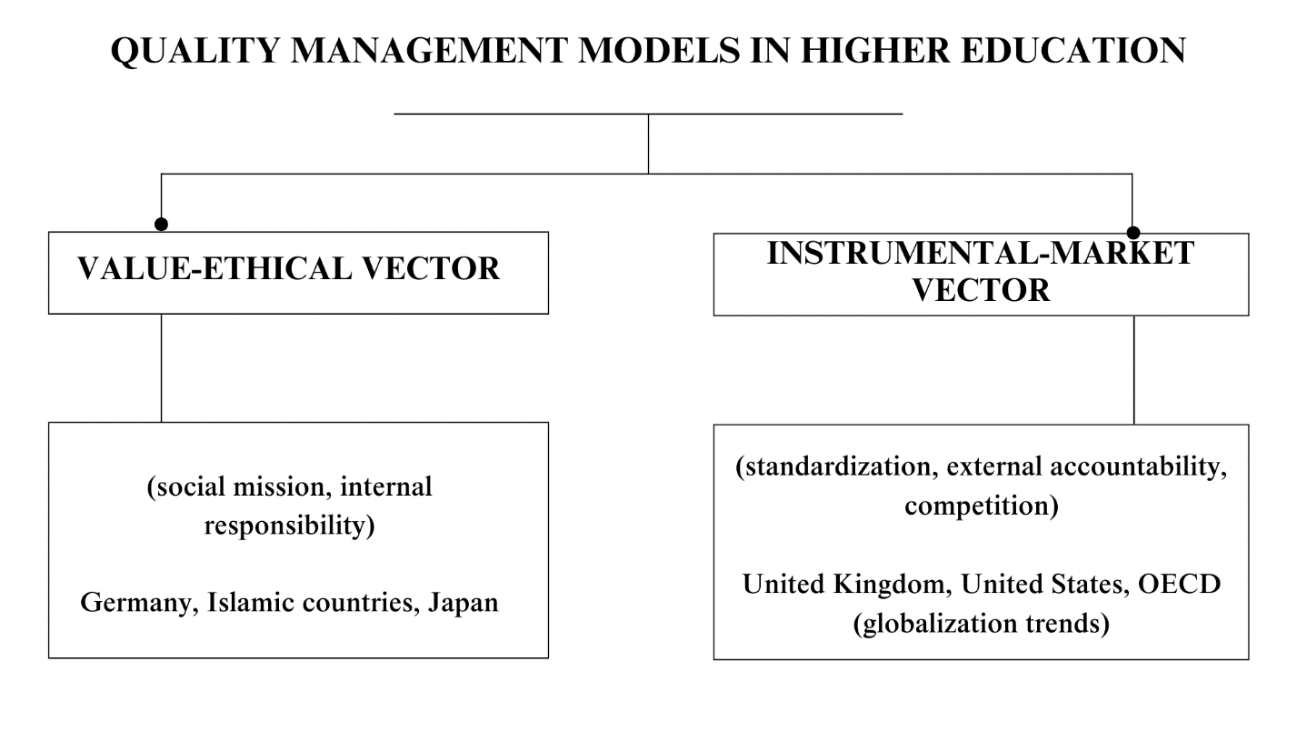Figure 2 – Key development vectors of quality management models in higher education
Note – compiled by the author

Analyzing international quality management models in higher education allows us to identify two stable vectors of institutional development. The value-ethical vector reflects the priority of the social mission, internal responsibility, and orientation of educational organizations towards moral standards. Countries with a predominance of this trajectory, including Germany, Islamic states, and Japan, consider the quality of education as comprehensive compliance with scientific, social, and ethical requirements, attaching special importance to preserving the identity of the educational environment.
The instrumental market vector is characterized by the dominance of external accountability, standardization of processes, and orientation toward global competitiveness. This model's application, recorded in the practice of Great Britain, the USA, and OECD countries, is accompanied by an increased role of quantitative indicators, global rankings, and unified quality assessment procedures.
A comparative analysis shows that none of the trajectories provides a universal solution to the problems of sustainable development of higher education. In modern conditions, the most effective models combine value-ethical guidelines with instrumental market mechanisms, which allows universities to simultaneously maintain a social mission and meet the requirements of the global educational environment.

  - Methodological foundations of education quality management in the context of digitalization

The evolution of the quality management methodology in higher education in Kazakhstan reflects a complex process of moving away from centralized administrative practices of the Soviet type to the formation of our models of internal quality development. In the early stages of modernization, priority was given to the formal adoption of external standards, such as the principles of the Bologna Process, the three-tier structure of education, the credit system, and academic mobility. However, the introduction of international mechanisms took place in the context of the continuing features of the Soviet management culture, where centralized regulation and focus on meeting regulatory requirements prevailed without emphasizing the effectiveness of educational processes [85]. The ISO 9001:2001 model was used as a fundamental quality management tool focused on regulating procedures and eliminating non-conformities through internal and external audits. However, the experience of applying ISO in Kazakhstani universities demonstrated the limitations of an approach that reduces quality management to recording the facts of compliance with requirements without developing institutional mechanisms for self-assessment and strategic planning. In response to the identified limitations, the EFQM model began to spread. It differs from ISO 9001:2001 in its focus on integrated development through the interaction of leadership, strategy, partnership, and resource management. The EFQM model considers both capabilities and achieved results, allowing educational institutions to assess their functioning and focus on sustainable improvement systematically [86]. The transition to EFQM in Kazakhstan was due to the need to go beyond formal compliance with procedures and the desire to build quality systems that stimulate internal innovation processes and competitiveness.
The influence of global trends, primarily the development of international ranking systems such as the QS World University Rankings, has strengthened the normative and coercive mechanisms of isomorphism, directing Kazakhstani universities to borrow the Anglo-American model of research universities based on scientific productivity, academic reputation, and internationalization [87]. At the same time, the emphasis on quantitative indicators weakened attention to the internal development of quality systems, limiting universities' motivation for profound institutional changes. In response to these challenges, an active reform of the principles of university autonomy began, providing for the transfer of powers for strategic management, academic policy, and internal quality control to the educational organizations themselves [88]. However, the implementation of autonomy encountered serious obstacles: continued dependence on government regulation, insufficient maturity of management structures, and limited resources for the effective functioning of internal quality systems. The development of autonomy made the issues of modernizing quality assessment tools and motivation systems for teaching staff particularly urgent.
A comparative analysis of the ISO 9001:2001 and EFQM models allows us to more clearly identify the methodological differences that have necessitated the transition to new approaches in quality management of higher education in Kazakhstan (Table 6).

Table 6 - Comparative characteristics models in the context of higher education quality management modernization in Kazakhstan
Parameter | ISO 9001:2001 Model | EFQM Model | Reasons for Transition
Main Objective | Standardization of processes and elimination of nonconformities | Strategic development and continuous improvement | Need to move beyond formal compliance
Quality Assessment Approach | Compliance audits | Evaluation of capabilities and results | Focus on internal development
Model Structure | Strict procedures and control of inconsistencies | Integration of leadership, strategy, personnel, partnerships, and processes | Broader framework for organizational growth
Orientation towards Development | Limited (elimination of deficiencies) | High (promotion of institutional potential) | Stimulating sustainable advancement
Approach to Innovation | Weak integration | Innovation as a core component | Demand for institutional flexibility
Application in Kazakhstan | Widespread during the early reform stage | Increasing adoption with strategic emphasis | Rising requirements for competitiveness
Note – compiled by the author

One of the most important achievements in improving the methodology of quality management has been the introduction of digital solutions, which was especially clearly demonstrated in the research on the modernization of motivation systems in higher education in Kazakhstan [89]. The problems of insufficient financial incentives, excessive bureaucratization of assessment procedures, and limited career opportunities at universities were identified as key barriers to improving the quality of educational services. The solution was the development of the E-portal digital platform, designed to systematically collect data on publication activity, participation in research projects, results of pedagogical work, and activities within the framework of educational programs. The integration of ePORTAL made it possible to form a more transparent, objective, and development-oriented system for assessing teachers' professional activity. The difference between this approach is that the incentive system is linked to real work results rather than formal indicators. This ensured the transition from the administrative subordination model to the intrinsic motivation model through recognition of achievements and stimulation of professional growth. The work of authors [89] also emphasizes the need for an integrated approach to the digitalization of quality systems, including the creation of a corporate development culture, the introduction of strategic planning and continuous monitoring of educational results. These changes are supported by general trends in the formation of internal quality assessment models based on the design of goals, performance criteria, and update mechanisms [90], as well as the development of national institutions for accreditation and certification of education quality [91]. Thus, the modern methodology of quality management in higher education in Kazakhstan is evolving towards building complex, digitalized, and sustainable development-oriented systems capable of integrating international standards with national specifics.
The issues of quality management methodology in higher education face several serious problems, including excessive formalization of procedures, weak focus on development, and limited involvement of stakeholders. Hackman and Wageman [92] note that the original idea of ​​total quality management (TQM) was based on the desire to eliminate process variability and improve the internal systems of organizations. However, in educational institutions, the transfer of industrial models was accompanied by difficulties: the emphasis on processes often led to the alienation of teachers and limited flexibility, which prevented the complete adaptation of the methodology to the goals of learning and student development. While the basic principles of TQM, such as employee involvement, focus on processes, and empirical management, could theoretically contribute to improving educational quality, they often turned into bureaucratic procedures that do little to improve learning outcomes.
An analysis conducted by Horsburgh [93] demonstrated that existing quality control mechanisms in higher education have a limited impact on improving student learning. The primary focus of control procedures was on the external attributes of quality - standards, reporting, structural coherence of programs - while internal processes of training and development of competencies remained on the periphery. Horsburgh emphasizes that the real quality of education should be determined by the ability to transform the learner through critical thinking, independence, and the ability to adapt to learning. At the same time, mechanical compliance with regulations does not provide sufficient grounds for assessing these aspects. The result is a paradox: the desire for measurability of quality has diverted attention from the actual goals of the educational process.
Similar problems were noted by Kezar and Dee [94], who explored a multi-paradigm approach to studying higher education organizations. The authors argued that traditional quality assessment methodologies based on uniform standards and universal metrics do not consider the complexity and multidimensionality of educational institutions, where different organizational cultures, interests, and values ​​intersect. The desire to unify assessment methods prevents taking into account the specifics of individual organizations, which reduces the effectiveness of quality improvement interventions. In parallel, there is a lack of integration of research findings on organizational change and educational reforms into quality assurance practice.
The works of Asif et al. [95] and Ah-Teck and Starr [96] raise the need to revise traditional TQM models in higher education. Asif et al. [95] emphasize the importance of a systems approach, where the central element is monitoring compliance with standards and building a culture of continuous improvement at all levels - from administration to faculty and students. In turn, Ah-Teck and Starr [96] showed, using the example of Mauritius, that the effective implementation of TQM principles in educational organizations is possible only by developing trusting relationships, transparency, and ethics of management decisions. Instead of formal data collection for reporting, it is proposed to build a “data culture” where feedback is perceived as a development tool, not a control tool. At the same time, the authors note that without attention to leadership's moral and cultural aspects, efforts to implement TQM risk turning into superficial reforms.
Krause [97] made a conceptual contribution to understanding the quality problems in higher education, suggesting considering them through the prism of "wicked problems" - complex, multidimensional, and poorly structured tasks that do not have a single solution. From this position, implementing universal quality models is ineffective since each educational organization operates in a unique context and faces its own set of contradictions between state requirements, student expectations, academic mission, and internal constraints. Krause [97] emphasizes the need for theoretically informed, flexible, and multi-level approaches to quality assurance that would combine an element of standardization with opportunities for local adaptation and development of the educational environment.
Yurkofsky et al. [98] reinforced the emphasis on the need to move from the paradigm of searching for universal recipes ("What Works") to the concept of "continuous improvement" - continuous improvement based on local problems, cyclical data analysis and active participation of practitioners. They emphasize that educational changes must consider not only the structural but also the political, social, and value complexity of educational systems. Attempts to mechanically implement improvement models without considering these aspects are doomed to limited success. The authors conclude that there is a need for deeper attention to politics, power relations, and equity issues in developing quality assurance methods.
Hartono [99], in turn, in a systematic review of quality development in Indonesian universities, showed that successful quality management practices are built on the transition from formal compliance with accreditation requirements to a strategic approach aimed at creating an internal quality culture. Challenges in implementing quality models include limited resources, resistance to change, and the need to align international standards with local realities. Examples of successful initiatives emphasize that integrating international practices is possible only through their adaptation to the specifics of the national educational system.
Thus, the problematic aspects of the quality management methodology in higher education are associated with the dominance of the formalistic approach, insufficient attention to the transformation of educational practices, limited participation of stakeholders, and the lack of explicit consideration of the multidimensionality of educational systems. Existing studies emphasize the need to move from control to development, from standardized models to flexible, adaptive strategies that consider local and global contexts.
A systematic analysis of the problems of the quality management methodology in higher education allows us to identify several persistent limitations that reduce the effectiveness of the reforms. The identified problems reflect the contradictions of traditional approaches and the need to move to models focused on development and adaptation to the educational environment. The main problematic aspects are presented in Table 7.

Table 7 - Main Problems of Traditional Quality Management Methodology in Higher Education
Problem | Essence of the Problem
Excessive Formalization | Focus on compliance with procedures rather than the development of the educational environment
Lack of Focus on Student Development | Emphasis on process control without supporting transformative learning and competency development
Limited Engagement of Academic Staff and Students | Insufficient involvement of key stakeholders in quality assurance processes
Mechanical Transfer of Industrial Models | Adoption of management models without considering the specific nature of educational institutions
Inadequate Adaptation to Local Contexts | Standardization of procedures without accounting for institutional diversity and specific conditions
Neglect of Political and Social Dimensions | Insufficient attention to power relations, cultural dynamics, and social factors affecting education quality
Dominance of External Accountability over Internal Development | Quality systems prioritize external reporting rather than the continuous internal improvement of teaching and learning processes
Note – compiled by the author

The analysis of the identified problems shows that traditional approaches to quality management are often limited to formal verification of compliance with requirements. This approach hinders the development of educational programs and reduces the participation of teachers and students in the process of quality improvement. The evaluation focuses on compliance with regulations rather than fundamental changes in training content and the results of graduates' training. Formalization of procedures weakens attention to the organization of the educational process and the use of effective teaching methods. Control mechanisms are focused mainly on external audit, which reduces initiative within educational institutions and limits opportunities for the professional growth of participants in the educational process. As a result, the quality of training is perceived as fulfilling prescribed requirements rather than developing academic and practical competencies.
Transition of approaches to quality management in higher education occurred through the evolution of models focused on a deeper understanding of educational processes. Initial attempts were based on Total Quality Management (TQM), where the emphasis was on systematic improvement of processes through the involvement of employees at all levels and monitoring compliance with standards [92]. The transfer of TQM to the field of education has led to problems associated with the difficulties of assessing learning outcomes and the impossibility of standardizing educational effects. Houston [100] noted that direct borrowing of quality control methods from industry does not consider the peculiarities of the development of knowledge and critical thinking of students. These limitations determined the need to move to a systems approach proposed by Mizikaci [101], where universities are viewed as open systems with interconnected social, technical, and managerial components. Quality assessment has shifted from individual procedures to a comprehensive analysis of interaction processes, use of resources, and achievement of educational results. Within the systems approach framework, quality is determined by the ability of an educational organization to adapt to changes and ensure student development. A continuation of the development was institutional analysis, in which Filippakou [102] showed that quality is formed not only through the organization of processes but also through the consolidation of specific value systems in educational policy. Quality began to be perceived as an external image through participation in ratings, compliance with accreditation requirements, and quantitative indicators. This shift reduces attention to the content of educational programs and leads to the dominance of procedural reporting over the development of the educational process. These findings determined the need to move from assessing compliance with standards to assessing the ability of universities to ensure academic and social goals in a changing environment.
In parallel with the criticism of formalism in quality management, new approaches have emerged that emphasize the role of social interactions and education's public mission. The stakeholder theory proposed by Kember [103] is based on recognizing the importance of the opinions of students, teachers, administrators, and employers in the formation and evaluation of educational programs and due to the shift from administrative control to the development of feedback systems. Consideration of the real needs of the educational environment conditioned the inclusion of various groups. Stakeholder participation enhances educational goals' relevance and promotes educational organizations' development as dynamic and responsible actors. The concept of public value developed by Houston [100] has expanded the concept of quality beyond academic achievements. Thus, higher education assessment should consider the contribution of universities to society's development. Usually,the role of higher education participation in public policies is measured through expanding access to knowledge, supporting social mobility, and strengthening civic potential. With this approach, quality is defined through universities' social role, not only through academic results. The examples of reforms in Kazakhstan reviewed by Yergebekov and Temirbekova [104] showed that the formal implementation of the Bologna Process principles, such as the three-tier education system, the credit system, and academic mobility, was accompanied by limited real change. The main requirements of the Bologna Process - the development of institutional autonomy, increased student participation in governance, and a focus on the social mission of education - were not fully implemented. Kerimkulova and Kuzhabekova [105] noted that state quality policy was focused primarily on compliance with external standards without a deep revision of educational practices. The analysis of Azimbayeva [106] showed that maintaining administrative control hinders the formation of strategic quality management, where stakeholders and a focus on public values ​​play a key role. The development of the concepts of systems thinking, institutional theory, stakeholder theory, and public value creates the basis for the transition from formalized assessment systems to quality models that integrate educational, organizational, and social aspects of university development.
The continued development of conceptual foundations for quality assurance in higher education is associated with the deepening of the previously discussed areas and the expansion of the emphasis on the systemic participation of stakeholders. In addition to the Total Quality Management and systems thinking approaches, the study by Shams [107] proposed a model for ensuring the quality of transnational education focused on the active cooperation of students, teachers, employers, partners, and regulators. Within the framework of this model, quality is determined not only by internal procedures but also by the level of alignment of the interests of all participants in the educational process. The analysis by Dhukaram et al. [108] showed that applying a systems approach in educational institutions requires synchronizing technical solutions, organizational structures, and human resources to achieve sustainable results. Further development of the concept of stakeholder participation in quality assurance is reflected in the study by Artykbayeva and Greiman [109], which demonstrated that the effectiveness of dual educational models is directly related to the active involvement of employers in the design and implementation of curricula. Insufficient participation leads to a decrease in the relevance of the content and a weakening of the connection between education and the labor market. In the context of Kazakhstan, the study by Anafinova [110] showed that the localization of the Bologna Process was accompanied by the formalization of academic mobility standards and university autonomy without a fundamental change in the content of educational practice, which hindered the achievement of the stated goals of the reforms. The work of Mazza and Azzali [111] emphasizes that the real involvement of students and employers in the procedures of internal and external quality assessment of educational programs creates conditions for the transition from formal compliance with accreditation requirements to a real increase in the level of graduate training. A summary of the results of the studies reviewed shows that sustainable development of quality systems requires the combination of several areas: the integration of the principles of Total Quality Management with an emphasis on the ongoing participation of stakeholders, the use of system analysis to coordinate all components of the educational ecosystem, strengthening interaction with external partners and adapting international standards to national conditions.
The problem of methods and criteria for assessing quality in higher education has been developed through empirical research, theoretical reviews, and applied developments. The study by Tsinidou, Gerogiannis, and Fitsilis [112] conducted an empirical analysis of the factors determining the quality of higher education, where key groups of criteria were identified: quality of teaching, quality of administrative support, quality of infrastructure, research activities, and the influence of the university image. The study relied on a questionnaire of students and used factor analysis methods to identify the main determinants of quality. Unlike many traditional models, the emphasis was placed on academic indicators and the perception of quality through the prism of administrative and social services. The work by Harvey and Williams [113] presented a generalization of fifteen years of development of quality theory in higher education, recording the transition from monitoring compliance with standards to an emphasis on the internal development of institutions. An important contribution of the study was the identification of a trend towards a shift in methods from external accreditation assessment to self-assessment and internal audit systems, where the key criteria are the ability for self-development, adaptability of educational programs, and the involvement of teachers and students in quality assessment processes. The approach of Zineldin, Akdag, and Vasicheva [114] proposed new criteria for quality assessment focusing on student satisfaction, including such parameters as trust in teachers, quality of interaction with academic staff, organizational support, and academic infrastructure. The authors developed a model based on five dimensions of quality, integrating the principles of servicoscopy into the analysis of educational services. The work of Lodge and Bonsanquet [115] critically rethought existing methods for assessing the quality of education, drawing attention to the weak correlation between mechanistic metrics of effectiveness and the actual quality of students' educational experience. The study's contribution is to justify the need to move towards complex, context-sensitive methodologies, where the criterion for success is the support of deep learning and the formation of sustainable competencies, and not just the achievement of specified quantitative indicators.
Further development of quality assessment methods is associated with the transition to the integration of digital competencies and multicriteria analysis. The review by Alyahyan and Düştegör [116] systematized the best practices for predicting academic performance, emphasizing that the integration of quantitative and qualitative indicators, including behavioral data and digital activity of students, allows for the construction of more accurate models for assessing the quality of educational processes. The work of Zhao, Llorente, and Gómez [117] showed that the development of digital competencies is becoming an indispensable element of quality assessment, especially in the context of the digital transformation of higher education. The authors substantiated the inclusion of digital literacy as an independent criterion in assessing educational programs and the performance of universities. The study by Miranda et al. [118], within the framework of the Education 4.0 concept, identified the key components of new-generation educational practices, proposing to take into account such criteria when assessing quality as the adaptability of programs to rapidly changing market requirements, the use of personalized learning technologies, and the active involvement of students in the joint creation of educational content. The contribution of the work was to develop practical quality assessment models that consider the transition to a digital and project-oriented educational environment. The model proposed by Makki, Alqahtani, Abdulaal, and Madbouly [119] used multicriteria decision-making methods to assess quality standards in university colleges, demonstrating the feasibility of integrating quantitative expert assessment models such as AHP and TOPSIS into strategic quality planning processes. Using these models made it possible to take into account the complexity of the interaction of various quality criteria and improve the validity of decisions in the strategic management of educational organizations.
A comparative analysis of approaches and applied metrics for quality assessment in higher education allows us to summarize the key areas of development of assessment methods. Table 8 reflects the main approaches, groups of metrics used, as well as aspects that were excluded or critically rethought within the framework of the studies reviewed.

Table 8 – Approaches and metrics for evaluating quality in higher education
Approach | Applied Metrics | Excluded or Reconsidered Metrics
Evaluation based on students' perception of institutional quality. | Teaching quality, administrative support, infrastructure, research activities, institutional reputation. | Financial indicators, reputation indices unrelated to educational services.
Systematic review of quality development methods. | Internal self-assessments, institutional adaptability, staff engagement. | Formal external audits without evaluation of internal processes.
Student satisfaction model (SERVQUAL approach). | Trust in faculty, student support services, quality of interaction, infrastructure quality. | Standardized academic performance indicators without satisfaction analysis.
Critical analysis of learning quality assessments. | Deep learning outcomes, development of critical thinking, overall learning experience. | Quantitative efficiency metrics detached from educational quality.
Predictive analytics of academic success. | Behavioral data, digital activity metrics, academic performance. | Single-sided academic metrics without digital footprint consideration.
Assessment of digital competence. | Digital literacy, integration of technology in education. | Quality evaluations excluding digital readiness components.
Education 4.0 components analysis. | Program adaptability, personalized learning, student co-creation of educational content. | Static academic requirements not accounting for technological change.
Multi-criteria decision-making (MCDM) for quality standards. | Integrated quality criteria using AHP and TOPSIS, strategic standard assessment. | Single-layer accreditation systems without comprehensive evaluation.
Note – compiled by the author

The analysis of the presented approaches to quality assessment in higher education shows two main strategies. The first strategy is based on classical assessment methods, including internal self-assessments, student satisfaction surveys, academic performance measurement, and organizational infrastructure assessment. The first strategy methods aim to maintain minimum standards of quality of educational services, ensure compliance with the requirements of external accreditation bodies, and meet students' basic expectations regarding teaching, learning conditions, and administrative support. Using such metrics as the quality of teaching, administrative services, and research activities ensures the transparency of assessment procedures but limits the ability of educational institutions to take into account the complexity of the educational process and quickly respond to changes in the academic and professional environment. The second strategy focuses on integrating digital indicators, behavioral data, and multi-criteria analysis methods for assessing the quality of educational programs. The emphasis is on measuring the digital literacy of students, the ability of educational programs to adapt to the new requirements of the knowledge economy, the use of personalized learning technologies, and the development of mechanisms for the joint creation of educational content. Assessment methods based on systematic analysis of digital activity and multi-criteria expert assessment using AHP and TOPSIS demonstrate the ability to consider academic, behavioral, and technological indicators simultaneously. The integration of such metrics allows for the construction of more comprehensive assessment models aimed at identifying the strengths and weaknesses of educational programs, taking into account individual student trajectories and labor market requirements.
Comparative analysis shows that classical methods ensure standard compliance of educational institutions with formal requirements but poorly consider changes in the structure of students' educational requests and the labor market. Moreover, integrating digital competencies, adaptive learning technologies, and multi-criteria assessment systems is productove in many aspects. In particular it will affect increasing accuracy in diagnosing the quality of educational programs and strengthening the connection between educational outcomes and professional requirements. Using new approaches requires educational institutions to move from static quality control systems to dynamic management systems based on systematically collecting and analyzing heterogeneous data. Combining classical internal self-assessment procedures with complex digital and multi-criteria methods allows us to create more sustainable and adaptive quality assessment models considering academic, social, and professional expectations.
A comparative analysis of approaches to assessing quality in higher education allows us to identify a group of metrics that retain their significance regardless of changes in the educational environment and methodological shifts. Stable metrics include the quality of teaching, student satisfaction with learning conditions, organizational support effectiveness, and academic infrastructure availability. Regardless of the specifics of research approaches, these indicators remain basic for determining the minimum level of quality of educational services and serve as the basis for internal and external assessment of the activities of educational organizations. Recognition of the role of teaching and the educational environment as central quality factors is confirmed in all the studies reviewed, indicating the high stability of these criteria in academic practice.
The variability in the use of other metrics is due to several factors. One of the key factors is the change in the technological context, which leads to the inclusion of such criteria as students' digital literacy, ability to use educational technologies, and adaptability of programs to the requirements of the digital economy. The development of behavioral analysis methods stimulates metrics expansion by including indicators of students' digital activity, involvement in educational processes, and personalized learning. The second factor is the change in ideas about the mission of higher education, which results in increased attention to the social and professional effects of educational programs, such as graduate employment, compliance of educational results with labor market requirements, and development of entrepreneurial competencies. The third factor is the transition from monitoring compliance with standards to building continuous quality improvement systems. This leads to the exclusion of formalized reporting procedures without analyzing real educational processes and replacing them with complex self-assessment tools, stakeholder feedback, and multi-criteria assessment models.
Thus, a new understanding of quality assessment is being formed. While maintaining basic metrics, flexible, dynamic indicators that reflect the transformation of the educational environment and changing social expectations need to be integrated (Figure 3).

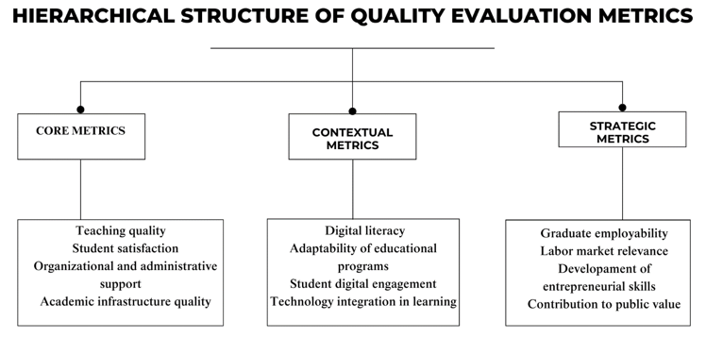
Figure 3 – Hierarchical structure of quality evaluation metrics

Note – compiled by the author

The construction of a hierarchical structure of quality assessment metrics in higher education reflects the need for an integrated approach to systematizing the criteria used in modern models of monitoring and development of educational institutions. Thus, despite the variability of assessment methods, a stable group of basic indicators remains, providing a fundamental basis for diagnosing the state of educational processes. These invariant metrics include the quality of teaching, student satisfaction with learning conditions, organizational and administrative support effectiveness, and the availability of the necessary academic infrastructure. Regardless of the specifics of the methodologies used, these indicators form the core of quality assessment systems and serve as the basis for ensuring minimum standards of educational services.
Expanding the range of metrics used through contextual indicators is conditioned due to the development of educational technologies, changes in labor market requirements, and the evolution of the academic environment. At the second level, such criteria as students' digital literacy, active use of information and communication technologies in educational programs, and adaptability of training content to changing professional standards and conditions of the knowledge economy are distinguished. The emergence of these metrics reflects the response of quality systems to global trends in digitalization, internationalization of education, and the need to prepare graduates for the conditions of a dynamic labor market. Contextual indicators allow educational institutions to assess the ability to quickly adapt, implement innovative practices, and technologically transform the educational environment.
The formation of the third level is associated with the development of ideas about the social mission of higher education and the need to assess the long-term contribution of universities to social development. Strategic metrics include graduate employment indicators, compliance of educational results with market requirements, development of entrepreneurial competencies, and participation in creating public value through educational, scientific, and social projects. Integrating strategic metrics into quality assessment systems allows for considering the internal results of the educational process and the broader socio-economic effects of educational organizations' activities. At the same time, the emphasis on strategic indicators requires monitoring systems to move from assessing the current state of the educational environment to predicting its impact on the development of society and the economy.
The hierarchical structuring of metrics allows us to explain the stability of individual criteria over time and the logic behind the emergence of new indicators in response to changes in the external environment. Basic metrics ensure institutional stability when comparing educational programs and universities at the national and international levels. Contextual metrics are characterized as to have impact on technological, academic, and social changes, ensuring the relevance of educational processes in a dynamic environment. Strategic metrics guide the development of higher education toward achieving long-term goals related to expanding student opportunities and strengthening the contribution of universities to the sustainable development of society.
Systematization of metrics by levels of stability and purpose of application allows for the first time to combine both stable and changeable criteria for quality assessment in a single model, demonstrating the substantive side of assessment procedures and their evolution in response to internal and external challenges. Unlike traditional models that record a static list of quality criteria, the constructed structure shows how different levels of metrics interact with each other and how external challenges and internal development goals of educational organizations determine their changes. Such systematization opens up the possibility of designing more flexible, adaptive, and strategically oriented quality assessment systems in higher education.
The development of quality assessment methods in higher education provided the foundation for evolution of measurement tools and changes in ideas about the essence of quality. The transition from assessing procedures and satisfaction to assessing educational organizations' institutional development and social contribution requires a new typology of methods. The table below classifies quality assessment methods depending on the level of understanding of the educational mission, highlighting operational, developmental, and transformational approaches. This structure shows how assessment methods reflect the depth of knowledge of educational processes and higher education goals (Table 9).

Table 9 – Advanced typology of quality evaluation methods in higher education
Evaluation Focus | Methodological Approach | Level of Quality Concept Addressed | Characteristics
Operational Level | Surveys, performance indicators, service satisfaction questionnaires | Compliance with service standards, operational efficiency | Focused on immediate outputs; limited reflection on transformative educational outcomes
Developmental Level | Institutional self-assessment, continuous improvement models | Institutional learning capacity, adaptability, internal innovation | Reflects internal capacity to self-correct and evolve without external enforcement
Transformational Level | Mixed-methods evaluation, stakeholder-driven assessments, digital behavior analysis | Development of competencies, employability, public value contribution | Addresses the capacity of higher education to produce sustainable societal and economic impact
Note – compiled by the author

The quality assessment methods in higher education has undergone transition from traditional classification based on data collection techniques to structuring based on the depth of understanding of educational processes. Building a structure based on quality levels identifies operational, developmental, and transformational methods as key groups that differ in application purposes and impact educational organizations' development. Operational methods aim to monitor compliance with educational service standards and assess the basic effectiveness of teaching, administrative support, and infrastructure. Using these methods ensures transparency of processes but is limited to a short-term perspective without considering the potential for institutional growth. Developmental methods focus on the internal capacity of educational institutions for self-analysis, adaptation, and continuous improvement, which allows for forming feedback mechanisms, stimulating academic community participation, and strengthening a quality culture. Transformational methods reorient assessment to identify the strategic contribution of higher education to the development of human capital, support for social mobility, and expansion of the public influence of universities. Forming a model based on the “operationalism-development-transformation” axis provides a description of assessment tools and a reflection of the logic of their integration into educational strategies. The novelty of the proposed structure lies in the unification of stable, variable, and strategic criteria into a single system, where quality assessment is considered, a dynamic process aimed at ensuring academic development, adaptability, and social contribution of educational institutions. Classification of methods based on the functional role, and not only technical characteristics, opens up new possibilities for designing assessment systems oriented towards sustainable institutional development in the context of global changes.

- Analysis of the current state of digital modernisation of the quality management system in universities of Kazakhstan

2.1 Current situation of the level of development of higher education in Kazakhstan
Over the last two decades, Kazakhstan's higher education system has undergone significant transformations aimed at enhancing the quality of educational programs and aligning them with international standards. Many reforms have affected key aspects of the educational process, including licensing, accreditation, human resources policy and international integration. This is particularly evident in the Concept for the Development of Higher Education and Science in the Republic of Kazakhstan 2023-2029 [120]. This concept aims to ensure high-quality education programs, develop the scientific component of universities and strengthen their contribution to innovative development. Along with this, an essential place in strategic management of higher education is occupied by the concept of digital transformation, the development of information and communication technologies and the cybersecurity industry for 2023-2029 [121]. This highlights the importance of digitising educational processes, developing modern online platforms, and enhancing cybersecurity systems within the educational environment. The document focuses on development of intellectual and communication technologies in universities that correspond to the tasks of forming knowledge economy and digital state.
In addition, the legislative framework for the reform of higher education and science is based on key regulatory legal acts – the Law of the Republic of Kazakhstan “On Science and Technology Policy” (as amended and supplemented on 19.05.2025) [122] and the Law of the Republic of Kazakhstan “On Education” (as amended on 16.06.2025) [123]. These laws establish a legal basis for interaction between educational and scientific organizations, define the status and functions of universities, and regulate issues related to accreditation, licensing, and financing of educational programmes. In particular, the provisions of the “On Science and Technology Policy” law aim to stimulate scientific activity at universities, develop human resources, and create conditions for commercializing scientific research. Meanwhile, the “On Education” law regulates the quality of education programmes, introduces a national qualification system, and ensures academic integrity.
Generally, these strategic documents form the regulatory and conceptual framework for implementing reforms in Kazakhstan's higher education system. These areas include restructuring the university network, developing human resources, strengthening the scientific component, implementing digital transformation, and enhancing international integration. During the period from 2003 to 2023, the number of universities decreased from more than 180 to 112 as part of a policy aimed at enlarging universities and improving the quality of education. This was accompanied by a reduction in the number of teachers, from 40,972 in 2003 to 37,391 in 2019, resulting from staff optimisation and increased competition for highly qualified personnel. Particular attention has been paid to internationalizing the higher education system as part of these reforms. Kazakhstan has stepped up its participation in international academic mobility programs and strengthened scientific cooperation with foreign partners. As a result, the number of Kazakhstani universities represented in world rankings has significantly increased. For example, according to the QS World University Rankings, in 2010, only two Kazakh universities were included, but by 2024, their number had grown to 16. This demonstrates an increase in the international competitiveness of Kazakhstan's higher education system.
The modernisation of Kazakhstan's higher education system encompasses not only a reduction in the number of universities but also reforms of educational programs, the introduction of international quality standards, the development of academic mobility, and measures to increase funding. These measures aim to create a flexible, competitive, and innovative higher education system that can train specialists highly sought after in both national and global job markets. Therefore, it is necessary to examine the current state of development of the higher education sector in more detail, along with its key indicators, over the period from 2013 to 2023.
The evaluation of the current state of higher education in Kazakhstan was conducted through a multi-tiered quantitative assessment designed to identify the institutional contribution of universities to socio-economic development. Although the regional dimension is not explicitly stated in the section title, territorial differentiation was incorporated as an essential analytical axis to capture spatial disparities. The period under review covers 2013–2023 and relies on official data from the Bureau of National Statistics of the Republic of Kazakhstan. The methodological framework consisted of three stages.
1) Calculation of sectoral shares in the structure of gross regional product (GRP):
For each region and year, the relative contributions of education and scientific activities to the regional economy were measured using the following formulas:
Share of the education sector in GRP by formula (1):

${Share}_{Education}=\frac{{GRP}_{Education}}{{GRP}_{Total}}$ (1)

Share of the scientific and technical sector in GRP by formula (2):

${Share}_{Science}=\frac{{GRP}_{Science}}{{GRP}_{Total}}$ (2)

The derived indicators reflect the degree to which universities are institutionally embedded in regional economic structures.
2) Construction of the Knowledge Economy Index (KEI):
An integrated index was developed to capture the density of knowledge-sector participation within the regional economy. The KEI was computed as the arithmetic sum of the previously calculated sectoral shares by formula (3):

${KEI}_{i}={Share}_{Education, i}+{Share}_{Science, i}$ (3)
where:
$i$ - denotes the region.

This index serves as a synthetic indicator of the knowledge-based orientation of regional development.
3) Structural profiling of regional higher education systems:
The final stage involved analyzing the educational structure across regions. Key indicators included: the number of students per university; the proportion of master's and doctoral students in total enrollment; growth rates in higher education participation; average academic staff workload. A correlational analysis was conducted to examine the association between the number of doctoral students and R&D intensity, as well as between KEI values and the regional economic share of higher education.
The vector of structural transformations in Kazakhstan's higher education system over the past decade is manifested not only in substantive and regulatory changes but also in quantitative shifts reflecting the redistribution of academic workload and institutional density. To identify the scale of these changes, this section presents two generalized indicators: the average number of students per teacher and the average number of students per university. The first allows tracking the evolution of staffing in the educational process, while the second reflects the aggregated workload of the university sector as a whole. The dynamics of these indicators for 2013–2023 serve as the basis for a deeper understanding of the processes of concentration, centralization, and staff exhaustion, highlighting the issue of the sustainability limits of the existing institutional configuration (Figure 4).

Figure 4 – Faculty and university load indicators in Kazakhstan's higher education for 2013–2023

Note – compiled by the author

The dynamics of two key indicators, the number of students per teacher and the number of students per university, suggest the emergence of a stable trend toward institutional concentration and an increase in the staffing load in the higher education system. During the period under review, the number of students per teacher increased from 12.7 to 15.9, indicating a gradual decline in human resources without a corresponding increase in the teaching contingent. The most intensive growth of the indicator was observed after 2017, which may be associated with several institutional reforms that led to an increase in admissions, accompanied by limited expansion of the full-time teaching staff. This process records not only an increase in the number of students but also a shift in the balance between infrastructural capabilities and human resources, indicating growing tension within the academic system.
At the same time, the infrastructural load is also increasing: the number of students per university has grown from 4.1 to 5.3 thousand over ten years, or by more than 28%. In the context of the closure or consolidation of some universities, especially regional and private ones, this reflects not so much the expansion of higher education coverage as the redistribution of demand in favor of large and metropolitan institutions that can ensure minimum quality standards with increased student flows. This trajectory indicates a shift toward the large-scale unification of university space, with a decrease in the density of the regional network leading to an increase in the dominance of large educational centers with a high intensity of exploiting existing capacities.
A comparison of the two indicators reveals an increase in the systemic burden on both personnel and the material and technical base of universities, which may, in the future, exacerbate the contradictions between expanding access to higher education and ensuring its quality. Strategic guidelines for modernization in this context should take into account regional differences in personnel and infrastructure provision, as well as provide mechanisms for equalizing the load, including digitalization tools, hybrid forms of education, and personnel incentives in border and small university centers.
The first block of indicators enables the characterization of institutional capacity and staffing at universities. The following analytical perspective then shifts to the structure of the student body, reflecting the internal configuration of the educational system. The share of master's and doctoral students in the total number of students serves as an integral indicator of the maturity of higher education as a segment capable of ensuring not only the mass training of bachelors but also the reproduction of scientific research potential. It is through the change in proportions between the levels of educational training that we can trace the movement toward a post-industrial university model, one aimed at generating knowledge rather than just training personnel to reproduce the current employment structure. The trends reflected in the graph allow us to assess the sustainability and pace of the transition to a more complex educational architecture in the context of institutional reforms and changes in the financing system (Figure 5).

Figure 5 – Dynamics of graduate and doctoral enrollment in Kazakhstan's higher education for 2013–2023

Note – compiled by the author

The indicators of the share of master's and doctoral students in the total number of students demonstrate a two-circuit development of the higher education system: on the one hand, moderate but upward dynamics of the master's degree have been recorded over the decade, on the other hand, stagnation and structural instability at the doctoral level. In 2013, the share of master's students was 6.5%, and by 2023, it reached 11.4%, thereby doubling over the decade. The growth accelerated, especially after 2019, which is probably due to the institutionalization of academic master's programs as a format for training not only specialists but also future researchers. This confirms the transition from the traditional continental model of universities, which focused exclusively on bachelor's degrees, to a vertically integrated educational cycle, where the master's program serves as an intermediate scientific filter.
In contrast, the share of doctoral students throughout the period under review remained at an extremely low level, not exceeding 0.7%, with individual deviations that do not form a stable trend. This disproportion between master's and doctoral studies indicates a structural gap between the second and third levels of higher education, indicating a weak institutional link between the educational and research segments. Such a configuration hinders the development of comprehensive university research platforms and diminishes the prospects for recruiting and retaining scientific personnel within the system.
Thus, despite the quantitative growth of master's programs, the lack of a comparable increase in doctoral studies demonstrates the limited ability of higher education to ensure the continuity of the academic trajectory and, therefore, to perform the functions of reproducing scientific knowledge in the long term. Overcoming this asymmetry requires not only an expansion of the contingent but also a qualitative transformation of the institutional environment, including the reform of postgraduate studies, incentives for academic mentoring, and funding of research projects at universities.
Aggregated indicators at the country level enable tracking current state of higher education transformation. Still, they do not reveal the spatial differences that underline the system's absolute heterogeneity. The Kazakhstani university space was formed in conditions of high territorial differentiation, both in terms of student density and institutional maturity of regional universities. In this regard, turning to regional sections becomes not just an extension of the analysis but a necessary condition for identifying tension points, structural imbalances, and local stability zones. Four indicators served as the basis for the spatial typology: the average workload per teacher, the proportion of master's and doctoral students in the total student body, and the number of students per university. These indicators enable the reconstruction of regional differences in terms of staffing, institutional maturity, and infrastructural concentration (APPENDIX А). Below are the results of a comparison of regions by each of these parameters to identify stable spatial patterns and form an initial matrix for typology, from overloaded university systems to underutilized and reserve circuits (Table 10).

Table 10 – Regional dynamics of students per faculty member in higher education for 2013–2023
Region | 2013 | 2015 | 2017 | 2019 | 2021 | 2023
1 | 2 | 3 | 4 | 5 | 6 | 7
Akmola | 11,4 | 10,4 | 12,3 | 14,0 | 16,1 | 15,1
Aktobe | 13,6 | 11,5 | 13,1 | 17,9 | 15,3 | 17,0
Almaty | 18,2 | 14,9 | 15,9 | 18,5 | 21,4 | 18,7
Atyrau | 15,5 | 13,7 | 15,5 | 18,6 | 19,2 | 21,2
West Kazakhstan | 22,0 | 22,6 | 28,3 | 28,0 | 23,1 | 21,2
Zhambyl | 19,3 | 14,5 | 17,6 | 21,2 | 20,3 | 16,2
Karaganda | 14,1 | 11,6 | 13,0 | 13,8 | 14,0 | 13,7
Kostanay | 16,5 | 16,1 | 16,6 | 17,5 | 16,9 | 16,5
Kyzylorda | 13,7 | 12,1 | 13,3 | 17,0 | 17,2 | 20,0
Mangystau | 14,4 | 9,2 | 14,6 | 20,2 | 19,2 | 19,6
Pavlodar | 13,3 | 11,9 | 12,3 | 15,5 | 16,7 | 16,2
North Kazakhstan | 9,4 | 9,2 | 12,3 | 13,5 | 13,9 | 12,1
Turkestan | 8,2 | 7,5 | 7,3 | 9,0 | 11,5 | 12,2
East Kazakhstan | 10,9 | 11,7 | 13,0 | 15,3 | 16,7 | 18,1
Astana c. | 11,7 | 10,8 | 10,5 | 11,9 | 12,8 | 14,5
Almanty c. | 10,2 | 10,1 | 10,4 | 12,6 | 13,5 | 13,6
Shymkent c. | 16,4 | 17,8 | 18,4 | 26,8 | 26,0 | 24,3
Note – compiled based on calculations

The Students per Faculty Member indicator captures the academic density configuration, reflecting the distribution structure of higher education human resources across the territory. A stable spatial gap is formed between regions with maximum operational load and zones of personnel sparseness, which are not involved in the intensive growth of the student contingent.
The pole of the highest density is represented by the West Kazakhstan Region and Shymkent city, where the load consistently exceeds the threshold of 20 students per teacher, reaching 28.3 and 26.8 students per teacher at peak times. These territories form a zone of personnel overstrain, characterised by the maximum utilisation of staff resources with a weak reproduction of teaching potential. The Atyrau region is approaching this group, demonstrating a progressive increase in the load, with an expected exit abroad of 21 students by 2023.
On the opposite axis are the Turkestan region, North Kazakhstan region, and Almaty city, forming the contour of institutional sparseness. The workload level in these regions varies between 8 and 13 students, which can be attributed to either weak demographic pressure or a limited influx of students. Geographically, this zone is situated near the southern border and the northern peripheral belt, where the institutional capacity of education has remained unchanged over the period.
Karaganda, Kostanay, and Astana city demonstrate a stabilized workload regime, fluctuating in the range of 13-17 students, which allows us to classify them as structurally balanced academic systems. The behaviour of the Zhambyl region and Mangystau region does not fit into a linear model, reflecting institutional volatility and possible shifts in the regional strategy of educational planning.
The distribution of values ​​by subjects indicates the absence of a universal norm of academic density, recording the transition from extensive models to polarized systems with sharply expressed personnel contrasts. The spatial architecture of the teaching load suggests the possibility of forming stable clusters – from zones of systemic overload to territories of institutional underutilization, with varying degrees of risk of reproducing staff exhaustion.
The students per university indicator helps reconstruct the territorial distribution of the academic load on the institutional units of the higher education system. Unlike personnel density, this parameter reflects the level of operational concentration of the student contingent within each organizational structure, recording the potential for infrastructural saturation, the degree of staffing, and the functional capacity of university sites. The spatial configuration of this indicator provides grounds for identifying zones of extreme compression, balanced throughput, and systemic underutilization (Table 11).

Table 11 – Regional dynamics of students per university in higher education for 2013–2023
Region | 2013 | 2015 | 2017 | 2019 | 2021 | 2023
Akmola | 2297,8 | 1544,5 | 2360,3 | 2998,5 | 3011,0 | 2880,8
Aktobe | 3970,2 | 3389,3 | 3638,2 | 4615,8 | 4151,5 | 4706,4
Almaty | 3567,0 | 3017,0 | 3114,0 | 3733,7 | 5786,0 | 8169,0
Atyrau | 3782,3 | 3338,0 | 4015,3 | 4392,3 | 3925,0 | 3529,3
West Kazakhstan | 8505,7 | 8952,0 | 7848,0 | 7926,3 | 6722,3 | 6231,8
Zhambyl | 5361,0 | 4737,5 | 6958,0 | 8367,7 | 11221,5 | 9329,0
Karaganda | 4644,9 | 4108,4 | 4736,6 | 4829,1 | 4573,7 | 4869,0
Kostanay | 3192,7 | 2716,3 | 2933,4 | 3077,4 | 3058,7 | 2931,3
Kyzylorda | 3443,0 | 2513,8 | 3324,3 | 3803,7 | 4174,7 | 5129,3
Continuation of the table 11
Region | 2013 | 2015 | 2017 | 2019 | 2021 | 2023
Mangystau | 2869,5 | 1988,0 | 2583,5 | 5018,0 | 3276,5 | 6852,0
Pavlodar | 3814,3 | 3175,8 | 3634,3 | 4172,3 | 4178,3 | 3626,0
North Kazakhstan | 2923,0 | 2280,0 | 3013,5 | 3899,5 | 3669,0 | 3117,0
Turkestan | 5064,5 | 4131,5 | 4301,5 | 5807,0 | 4391,0 | 5393,5
East Kazakhstan | 4174,3 | 3834,6 | 4190,6 | 4508,6 | 4601,6 | 4771,0
Astana c. | 3825,8 | 3659,6 | 4028,4 | 3953,1 | 4185,9 | 5357,4
Almanty c. | 3621,7 | 3064,5 | 3282,3 | 3967,8 | 4100,6 | 5044,1
Shymkent c. | 7159,4 | 6951,6 | 7082,0 | 10738,0 | 10355,0 | 10425,8
Note – compiled based on calculations

The maximum values were recorded in the Zhambyl and West Kazakhstan regions, as well as in Shymkent, a city where, in some years, the indicator exceeded the threshold of 8-11 thousand students per university. Such concentration signals the formation of infrastructure limit zones, where the operational capacity of universities is used in an extensive mode. A growth trend was accompanied by high density until 2021, after which, in some cases, a slight decrease was recorded, which may be due to the exhaustion of physical facility capacity or partial unloading due to digital formats. Almaty region and Shymkent city demonstrate double dynamics: in the first - exponential growth (from 3.6 thousand in 2013 to 8.2 thousand in 2023), and the second - stabilization at the level of 10-10.5 thousand. These regions form an urbanized belt with an increased aggregate load, gravitating towards a model of megalopolis centralization. Such a trajectory suggests a shift in student demand toward large hubs with established logistics and educational infrastructure.
The opposite pole is represented by the Akmola, Kostanay, and North Kazakhstan regions, where the indicator values do not exceed 3,000-3,200 students. These regions are included in the zone of institutional dispersion, reflecting limited coverage, weak aggregation, and fragmented organization of the regional university sector. This group is characterized by structural inertia and a low degree of infrastructure load, with a relatively stable number of universities. A smoothed trajectory is observed in Astana, Karaganda, and East Kazakhstan regions, where the value ranges from 4.5 to 5.5 thousand, indicating a balanced institutional density regime. There is neither a sharp increase nor a decline, which means a relative balance between the scale of admission, material base, and management capacity.
The current configuration reflects a multi-level institutional architecture in which hyper-concentrated nodes, balanced cores, and dispersed educational contours coexist. Differentiation by the infrastructural load parameter allows us to identify not only potential overload zones but also territories with reserves for spatial redistribution of the academic load.
The indicator of the share of master's students in the student body structure reflects the level of institutional maturity and the depth of the educational vertical in the higher education system. In the context of transitioning to a two-tier model of personnel training, this parameter serves as a marker of academic complexity. Spatial differentiation of values ​​records both the heterogeneity of access to second-level programs and differences in the organizational and methodological capacity of regional universities (Table 12).

Table 12 – Regional variation in the share of master’s students in higher education for 2013–2023
Region | 2013 | 2015 | 2017 | 2019 | 2021 | 2023
Akmola | 0,06 | 0,05 | 0,06 | 0,05 | 0,05 | 0,06
Aktobe | 0,03 | 0,02 | 0,02 | 0,03 | 0,04 | 0,03
Almaty | 0,05 | 0,06 | 0,07 | 0,06 | 0,08 | 0,05
Atyrau | 0,02 | 0,02 | 0,04 | 0,04 | 0,03 | 0,04
West Kazakhstan | 0,03 | 0,03 | 0,03 | 0,02 | 0,03 | 0,04
Zhambyl | 0,04 | 0,04 | 0,04 | 0,03 | 0,05 | 0,06
Karaganda | 0,05 | 0,05 | 0,06 | 0,06 | 0,04 | 0,04
Kostanay | 0,03 | 0,03 | 0,04 | 0,03 | 0,03 | 0,02
Kyzylorda | 0,03 | 0,03 | 0,03 | 0,03 | 0,06 | 0,05
Mangystau | 0,04 | 0,06 | 0,05 | 0,04 | 0,05 | 0,08
Pavlodar | 0,04 | 0,06 | 0,10 | 0,09 | 0,09 | 0,06
North Kazakhstan | 0,02 | 0,02 | 0,04 | 0,04 | 0,04 | 0,05
Turkestan | 0,04 | 0,04 | 0,04 | 0,05 | 0,04 | 0,03
East Kazakhstan | 0,06 | 0,06 | 0,08 | 0,06 | 0,08 | 0,10
Astana c. | 0,10 | 0,11 | 0,13 | 0,12 | 0,10 | 0,10
Almanty c. | 0,09 | 0,10 | 0,09 | 0,08 | 0,07 | 0,07
Shymkent c. | 0,03 | 0,04 | 0,06 | 0,04 | 0,06 | 0,06
Note – compiled based on calculations

The highest values of the share of master's students are consistently recorded in Astana and Almaty cities, where the indicator varies from 9% to 13% throughout the analyzed period. Thus, the core of the master's concentration is built within these cities, reflecting not only the aggregation of high-level academic programs but also the influx of applicants from other regions due to educational migration. The spatial localization of such values ​​coincides with the nodes of the most developed scientific and academic infrastructure and the presence of research schools capable of supporting a sustainable master's program. East Kazakhstan and Pavlodar regions form the eastern growth zone, demonstrating a progressive increase in the share of master's students to 10% in 2023. An increase in the value in these regions may indicate a transition to more complex forms of academic reproduction and an attempt by regional universities to integrate into vertical educational chains. The opposite contour is set by the Aktobe, Atyrau, and West Kazakhstan regions, where the indicator remains within 2-4%, indicating weak institutional development at the second level of education. These regions are included in the zone of structural reduction of the academic vertical, associated with low demand, limited professorial resources, and a deficit of master's programs.
Certain territories, including Mangystau, Zhambyl, and Kyzylorda regions, exhibit spasmodic dynamics, reflecting institutional instability or an adaptive response to external management incentives (for example, changes in grant policy or centralized expansion of educational quotas).
The general configuration of values ​​indicates the existence of territorial asymmetry in the distribution of master's programs, where the capital and eastern zones dominate over the western and peripheral regions. Structural inequality in this indicator conveys institutional stratification that extends beyond a simple demographic explanation and reveals profound differences in the academic potential and personnel reproducibility of regional higher education systems.
The share of doctoral students in the overall student body structure represents the degree of scientific saturation and research focus of the university system at the regional level. This indicator enables recording the presence or absence of the third stage of higher education, serving as an indicator of institutional maturity, academic autonomy, and the ability to generate new scientific personnel. The spatial representation of values ​​provides grounds for identifying zones of a complete reproduction cycle, fragmented educational systems, and territories with an extinct research function (Table 13).

Table 13 – Regional Variation in the Share of Doctoral Students in Higher Education, 2013–2023
Region | 2013 | 2015 | 2017 | 2019 | 2021 | 2023
1 | 2 | 3 | 4 | 5 | 6 | 7
Akmola | 0,001 | 0,000 | 0,003 | 0,004 | 0,003 | 0,002
Aktobe | 0,001 | 0,001 | 0,001 | 0,003 | 0,003 | 0,004
Almaty | 0,001 | 0,001 | 0,006 | 0,011 | 0,010 | 0,009
Atyrau | 0,000 | 0,000 | 0,000 | 0,000 | 0,000 | 0,001
West Kazakhstan | 0,000 | 0,000 | 0,000 | 0,001 | 0,000 | 0,000
Zhambyl | 0,000 | 0,001 | 0,001 | 0,002 | 0,002 | 0,002
Karaganda | 0,002 | 0,004 | 0,007 | 0,011 | 0,010 | 0,010
Kostanay | 0,000 | 0,000 | 0,001 | 0,003 | 0,003 | 0,003
Kyzylorda | 0,001 | 0,002 | 0,003 | 0,004 | 0,003 | 0,003
Mangystau | 0,000 | 0,001 | 0,003 | 0,003 | 0,004 | 0,004
Pavlodar | 0,001 | 0,002 | 0,006 | 0,007 | 0,006 | 0,006
North Kazakhstan | 0,000 | 0,001 | 0,004 | 0,006 | 0,004 | 0,002
Turkestan | 0,008 | 0,011 | 0,010 | 0,007 | 0,004 | 0,005
East Kazakhstan | 0,003 | 0,004 | 0,007 | 0,010 | 0,008 | 0,009
Astana c. | 0,006 | 0,008 | 0,015 | 0,025 | 0,027 | 0,024
Almanty c. | 0,008 | 0,010 | 0,014 | 0,020 | 0,016 | 0,015
Shymkent c. | 0,000 | 0,000 | 0,001 | 0,002 | 0,002 | 0,003
Note – compiled based on calculations

The highest values are consistently observed in Astana and Almaty cities, where the indicator ranges from 2.4 to 2.7%, forming the core of academic recursion. Within this core, the country's leading research universities are concentrated, having the authority to award PhD degrees and a developed infrastructure for third-level training. The growth of the indicator in these agglomerations records the tendency to consolidate scientific training in nodes of national importance.
The regions with a pronounced but more moderate intensity include Karaganda, East Kazakhstan, and Pavlodar regions, demonstrating values ​​at the level of 0.6-1.0%, forming a belt of stable research periphery, where doctoral studies are developing in conjunction with industrial and technical clusters. The dynamics in this group are characterized by smooth growth without sharp fluctuations, which may indicate an internal institutional balance.
The Turkestan region exhibits an anomalous trajectory, characterised by high values at the beginning of the period, followed by a subsequent decrease. This profile is interpreted as a consequence of a short-term concentration of target programs or the presence of single institutions with doctoral programs that lost the status of reproduction centers by the end of the period. Statistical volatility in this zone indicates an unstable institutional architecture. Kostanay, Mangystau, Kyzylorda, and North Kazakhstan regions remain within a 0.2-0.4% range, forming a contour of limited academic development. Here, doctoral programs are implemented in a limited volume and cover a relatively small number of students, indicating weak integration into research networks and a shortage of human resources.
The Atyrau and West Kazakhstan regions, as well as Shymkent city, record minimal values close to statistical zero, forming a zone without full-fledged scientific and educational trajectories, where higher education is limited to bachelor's and master's degrees. The third level is either institutionally absent or not implemented in a stable form. The overall spatial configuration of the indicator emphasizes the strong asymmetry of the scientific load, concentrated in two capital centers and individual industrial regions. In most areas, doctoral studies are not implemented in a systematic manner, which leads to institutional limitations in the educational vertical, reduces the possibilities of training scientific personnel, and contributes to the concentration of research activity in universities located in Astana and Almaty.
Regional differentiation in terms of the workload of the teaching staff and the structure of the student body reveals two fundamentally different scenarios for management responses. In regions with a high student-teacher ratio and excess institutional capacity, such as the West Kazakhstan region, Shymkent city, and Zhambyl region, the priority is the digitalization of the educational process, optimization of staff workload, and gradual strengthening of the teaching staff. The introduction of hybrid formats, distribution of the management and methodological workload, as well as targeted personnel policies, can mitigate operational pressure and stabilize the quality of training. Regional entities with low student density and underdeveloped master's and doctoral programs, including the Akmola, North Kazakhstan, and Kostanay regions, are characterized by institutional sparseness and fragmentation of the academic space. In the context of a limited influx of students and a personnel shortage, it becomes advisable to concentrate resources, eliminate parallel functions between universities, and create nodal educational platforms with a full-format vertical of training. Restructuring the network through the integration and consolidation of structures opens up the possibility of freeing up funds, enhancing the quality of teaching, and restoring sustainable trajectories for personnel training.
A fixed configuration prevents the uniform distribution of the effects of higher education modernization. In heavily loaded regions, transformation is constrained by infrastructural overload and extreme exploitation of human resources. In weakly involved areas, there is no institutional critical mass to launch transformations. As a result, a spatial gap is formed, in which management initiatives do not achieve full implementation, and educational asymmetry is reproduced at the interregional level.
The economic consequences are reflected in the uneven distribution of human capital, a decline in the scale of research personnel reproduction, and a limitation on the contribution of universities to regional development. Investments in modernization without considering territorial specifics do not lead to systemic restructuring but rather consolidate institutional inequality, reducing the return on public investment and limiting the role of higher education as a driver of socio-economic growth.
The modernization of higher education is closely tied to the university sector's involvement in economic processes and its degree of institutional influence on regional development. The potential of universities as drivers of economic dynamics is manifested not only through personnel training but also through direct participation in the creation of added value, knowledge transfer, and the generation of science-intensive products. A formalized assessment of the contribution of higher education to regional economies requires an analysis of the sectoral structure of the gross regional product, with a focus on the allocation of components related to education and scientific and technical activities. Comparison of the shares of education and science in the structure of GRP enables us to assess the current scale of economic integration among universities and differentiate regions based on the level of institutional inclusion of higher education in the economy. This approach establishes a basis for identifying territories in which universities serve a strategic function as systemically essential organizations and, conversely, regions with an underdeveloped or latent role in the academic sector. Structural analysis based on the national account of education and science opens up the possibility of constructing an index of the economic significance of universities as an element of the regional modernization model (Figure 6).

Figure 6 – Dynamics of Kazakhstan’s gross regional product for 2013–2023 (mln. KZT)

Note – compiled by the author
Between 2013 and 2023, Kazakhstan’s gross regional product (GRP) increased from 35.9 trillion to 119.4 trillion tenge, marking a cumulative growth of over 230%. The period 2020–2023 accounted for more than 48% of this increase, driven by post-crisis capital inflows, budgetary expansion, and investment activity. The years 2015–2017 indicate a slowdown in response to external price volatility and fiscal adjustments. Moderate recovery followed in 2018–2019 without structural acceleration. The upward shift in GRP observed from 2021 reflects intensified state intervention and sectoral support, particularly in export-oriented and infrastructure domains.
The GRP dynamics over the decade indicate structural reinforcement of the national economic base. However, the extent to which the higher education system contributes to this growth remains uneven and largely unquantified. Comparative measurement of GRP structure-specifically, the relative weight of education and scientific-technical sectors serves as a basis for assessing the economic embeddedness of universities, which is addressed in the next section.
Measuring the contribution of the education sector to the gross regional product enables us to identify not only the intensity of its institutional development but also the degree of its economic integration into the regional production patterns. The indicator reflects the extent to which higher education performs not only a social but also a financial function, becoming a condition for neoclassical accumulation and modernization maneuvers. The distribution of this indicator by region allows us to identify zones of stable institutionalization of education and, conversely, territories with latent or limited involvement of the educational sector in regional development (Figure 7).

Figure 7 – Share of Education in Regional GRP, 2013–2023 (% of total GRP)

Note – compiled by the author

The distribution of the education sector's share in the regional gross product structure reveals a pronounced territorial asymmetry. The highest concentration of educational potential is recorded in the southern and central regions, specifically in Turkestan, Zhambyl, and Kyzylorda, whereby in 2023, the values reached 13.9%, 10.6%, and 8.7%, respectively. In these regions, the education sector begins to perform the function of one of the systemic drivers of regional accumulation. This structure is due to both the institutional density of universities and the limited diversification of the economic base, resulting in a relative hypertrophy of the educational component in the GRP. In contrast, industrially oriented regions such as Atyrau and Mangystau exhibit minimal values (ranging from 1.5% to 3.5%), indicating the institutional marginalization of universities within the local economy. These territories are characterized by weak involvement of the education sector in production chains and the absence of sustainable positive dynamics.
The urban agglomerations of Astana and Almaty, despite the concentration of leading universities and research centers, are expected to record moderate growth rates - approximately 2.5% by 2023. This structure is due to the high level of industry diversification and capital density, resulting in a relatively small share of the education sector in the GRP structure. In all regions from 2021 to 2023, an increase in the share of education in GRP is observed, which may be due to the post-crisis effect of expanded government funding and the institutional rehabilitation of higher education in the budget priorities.
The institutional significance of universities extends beyond their educational function. The scientific activity is necessary to consider in terms of research potential and the degree of involvement in innovation activities. The share of professional, scientific, and technical activities in the structure of regional GRP acts as a marker of the extent to which the local economy is capable of not only consuming but also generating knowledge as a production resource. Comparison of the obtained values with indicators for the education sector allows us to identify the presence of either a gap or synchronization between the two key functions of universities: education and research (Figure 8).

Figure 8 – Share of Science and Professional, Technical Activities in Regional GRP, 2013–2023 (% of total GRP)
Note – compiled by the author

The scientific component in Kazakhstan's regional economies is characterised by a high degree of spatial concentration and dynamic volatility. A significant excess of the national average values was recorded in Atyrau up to 2016 (up to 12.2%). However, such anomalies are explained by the peculiarities of statistical accounting within the oil and gas sector and do not reflect the actual level of scientific reproduction.
The agglomeration centers of Astana city and Almaty city consistently demonstrate high values (ranging from 6% to 10%), reflecting the institutional concentration of leading scientific centres, research institutes, and universities with active grant support. These cities serve as the core of the national research infrastructure, acting as connecting points between academic science, education, and innovation. In the overwhelming majority of regions, including Pavlodar, North Kazakhstan, Kostanay, and East Kazakhstan, the values of the indicator remain below 2.5% throughout the period, indicating a lack of sustainable growth. This indicates a weak integration of universities into scientific and technical development, as well as a fragmented institutional infrastructure.
The low weight of the scientific component in the regional economy limits the transformation potential of higher education, reduces the return on investment in the academic sector, and necessitates the development of mechanisms for spatially rebalancing intellectual capital. In the context of budgetary restructuring and digitalization of the economy, this area involves priority institutional intervention.
A comparison of specific values in the education and science sectors within the regional structure of GRP enables us to identify institutional differences. Still, it does not reflect their cumulative effect on the formation of the knowledge economy. For a comprehensive assessment of the level of cognitive development in territories, an aggregated indicator is used: the Knowledge Economy Index, which synthesizes the share of the education sector and professional and scientific activity in the gross regional product. This index measures the institutional quality of the environment that can reproduce and capitalize on knowledge as an economic asset (Figure 9).
The results of the KEI calculation by regions of Kazakhstan for the period 2013-2023 reveal a stable regional differentiation in the institutional capacity of the cognitive sector. The leading positions throughout the period are held by Astana city and Almaty city, reaching their maximum values in 2017 (14.7% and 9.0%, respectively). These values record the presence of a synchronized educational and scientific infrastructure capable of reproducing personnel and generating knowledge in a manner akin to a technological economy. The Turkestan region demonstrates a stable expansion of KEI, with growth increasing from 9.4% in 2013 to 15.3% in 2023. This reflects the dominant role of the education sector, which is relatively underdeveloped in other industries, making universities a functional anchor of socio-economic development. In the Zhambyl and Kyzylorda regions, the index is also expected to exceed 10% by 2023, confirming the hypertrophied importance of the educational and scientific sectors in the context of limited industry diversification.

Figure 9 – Knowledge economy index (KEI) by region for 2013–2023

Note – compiled by the author
Against this background, the Atyrau and Mangystau regions stand out, where, in 2013-2016, the KEI demonstrated abnormal peaks (up to 13.2% in Atyrau), but in subsequent years, there was a sharp decline. This is regarded as a consequence of the revaluation of the scientific component in the oil and gas cluster and subsequent statistical adjustment.
Most of the northern and eastern regions, including Pavlodar, Karaganda, East Kazakhstan, and North Kazakhstan, maintain a KEI in the range of 4-6%, indicating a low level of institutional integration of the knowledge sector into the economy. Despite the presence of individual universities, no systemic effect from their activities has been recorded.
Thus, the KEI index enables the tracking of both territorial gaps and institutional imbalances in the development of the knowledge economy. The index values not only reflect the current institutional capacity but also indicate the strategic potential of regions in transitioning to an innovation-oriented development model (Table 14).
A comprehensive analysis of regional differences in the development of higher education in Kazakhstan, covering the share of education and science in the gross regional product (GRP), the structure of the student body, the development of master's and doctoral programs, the workload of the faculty, and the knowledge economy index, allows us to identify four consistently different groups of regions.
Table 14 – Differentiated needs for the modernization of higher education by region of Kazakhstan
Region | Personnel modernization | Research modernization | Structural transformation
Turkestan | high | medium | current
Zhambyl | high | limited | required
Kyzylorda | high | moderate | required
East Kazakhstan | medium | weak | necessary
Karaganda | medium | medium | partially implemented
Atyrau | low | unstable | priority
Pavlodar | medium | weak | necessary
Mangystau | high | unstable | requires redistribution
West Kazakhstan | medium | weak | necessary
North Kazakhstan | high | weak | requires consolidation
Aktobe | high | medium | partially implemented
Akmola | high | weak | requires external resource
Kostanay | medium | weak | requires consolidation
Shymkent c. | high | medium | is being strengthened
Astana c. | moderate | high | completed
Almaty c. | moderate | high | completed
Note – compiled by the author

These differences reflect not only the heterogeneity of the participation of universities in the economy but also the asymmetry of institutional conditions, human resources, and strategic priorities of regional development:
Integrated academic and economic hubs, the cities of Almaty and Astana, as well as the Turkestan and Zhambyl regions. They are characterized by a high share of education and science in the GDP, stable growth of the knowledge economy index, developed master's and doctoral programs, a significant contingent of students, and a moderate workload for faculty. These regions serve as concentration points for academic and research resources, being systematically essential elements of the national educational architecture. Their universities have a high potential for a multiplier effect on the economy and social transformations.
Regions with potential for research transformation include Karaganda, East Kazakhstan, Kyzylorda, and the city of Shymkent. They have a developing scientific infrastructure and an expanding student body but a limited contribution to the regional economy. There is an increase in master's degree indicators and a partial strengthening of doctoral studies, while the risks of overloading the teaching staff remain. Support is needed in institutional development and increased interaction between universities and priority industries for the regions.
Personnel-oriented regions with a limited research focus are the Kostanay, Pavlodar, and North Kazakhstan regions. Here, universities are primarily focused on teaching, with a stable but moderate share of education in the GDP and low scientific productivity. Regional universities provide basic training but are poorly integrated into the innovative economy. The primary challenge is to establish research areas and foster a culture of university research.
Economically active regions with low academic presence are Atyrau, Mangistau, and West Kazakhstan regions. Despite high economic productivity, universities' participation in the socio-economic structure remains fragmented. Low values ​​are typical for all key indicators: the share of education and science in GRP, the knowledge economy index, the number of students, and the number of teachers. This indicates a structural gap between universities and the economy, which requires systemic intervention, both institutional and programmatic.
The generalization of the results highlights that a single model for modernizing higher education does not accurately reflect the spatial reality of Kazakhstan. The emerging picture of regional differentiation indicates the need for region-specific reform scenarios that take into account: personnel limitations and overloads; institutional weakness of research contours; misalignment between educational tasks and the economic needs of the region.
Thus, higher education should be considered as an adaptive system that requires coordination with local development strategies, including industrialization, digitalization, and the formation of new industries. The structural modernization of universities should be based on regional typology and aimed at eliminating institutional gaps, strengthening human resources, and aligning with the regional economy's priorities.
For a more in-depth assessment of the internal relationships between the educational and scientific components of regional economies, as well as their contributions to the formation of the knowledge economy, a correlation analysis was conducted on aggregated data for the period 2013–2023. It enables us to identify the strength and direction of statistical relationships between three key variables: the share of the higher education sector in GDP, the share of scientific and technical activity, and the consolidated knowledge economy index (KEI), which reflects the institutional integration of these components into the structure of regional development. The inclusion of knowledge economy parameters enables a multidimensional perspective that captures both the functional impact of universities and the unevenness of their regional embeddedness. The constructed typology serves as an operational tool for identifying modernization priorities and for designing targeted strategies that reflect institutional asymmetries and structural disparities across regions (Table 15).

Table 15 – Correlation matrix between education, science and the Knowledge Economy Index (KEI) for 2013–2023
Variable | Test | Share_Education | Share_Science | KEI
1. Share_Education | Pearson's r | –
1. Share_Education | p-value | –
2. Share_Science | Pearson's r | -0.372*** | –
2. Share_Science | p-value | < .001 | –
3. KEI | Pearson's r | 0.481*** | 0.635*** | –
3. KEI | p-value | < .001 | < .001 | –
* p < .05, ** p < .01, *** p < .001

The correlation matrix reveals three key relationships. First, a moderately strong positive correlation between the share of the education sector and the Knowledge Economy Index (KEI) (r = 0.481, p < .001). Thus, regions with a higher share of education in the GDP structure exhibit a higher level of institutional integration into the knowledge economy. Second, a stronger positive correlation is between the share of science in GRP and the KEI (r = 0.635, p < .001), indicating a significant contribution of the scientific and technical sphere to the development of the region's innovative and cognitive potential. Third, the negative correlation between the share of education and the share of science (r = –0.372, p < .001) records an institutional bias: in several regions, the dominance of one sector usually occurs at the expense of the weakening of the other, which highlights the problem of an unbalanced distribution of resources and priorities.
To analyze the degree of involvement of higher education and scientific and technical activities in the regional economy, three indicators were compared: the average share of education in the GRP structure (Share_Education), the share of the scientific sector (Share_Science), and the consolidated knowledge economy index (KEI), reflecting the institutional and structural integration of knowledge into regional processes (APPENDIX В). Based on correlation logic and descriptive statistics, three stable typological groups of regions were identified, reflecting different trajectories and potentials for modernization.
Integrated regions: a balanced model of "education - science - knowledge economy."
The regions of this group are characterized by a balanced ratio of three key parameters: a high share of education (above 0.05), a significant contribution of the scientific sector (more than 0.02), and consistently high values ​​of the knowledge economy index (KEI ≥ 0.08). Thus, the institutional infrastructure ensures internal consistency between universities, research organizations, and economic entities. Universities are not isolated from regional development practices but, on the contrary, are integrated into the processes of reproduction and innovation, forming a closed loop of knowledge and technology transfer.
The economic model of these regions is not limited to basic personnel training but instead advances to the stage of forming intellectual resources and knowledge-intensive specialization. The presence of developed links between the sectors of education, science, and the economy facilitates the formation of high-value-added clusters, the creation of technology parks, and the development of applied laboratories and academic business incubators. Universities become participants in the processes of export growth, technological development, and regional positioning. Examples of included regions:
Turkestan region – the maximum value of the share of education (0.098), the presence of a scientific base (0.017), KEI = 0.116. A closed regional chain is formed: universities, research, and applied demand.
Zhambyl region – pronounced institutional balance (0.075, 0.014, KEI = 0.089), with a focus on applied agricultural science.
Astana, city – high scientific component (0.098), KEI = 0.127, the capital as a center of concentration of innovative and regulatory and design expertise.
Almaty, a city – the most prominent university and academic hub of the country, with a KEI of 0.090, demonstrates integration into the regional and global scientific economy.
This institutional structure sets optimal conditions for implementing policies that promote technological modernization, digitalization, and sustainable growth, in which higher education serves not only a servicing but also a formative function.
Education-dominated regions: predominance of the educational function with limited scientific participation
The second group is dominated by regions with a consistently high share of the higher education sector (≥ 0.045), but the contribution of scientific and technical activity does not exceed 0.015. The values ​​of the knowledge economy index remain in the range of 0.05 to 0.07, indicating an average level of institutional integration. This structure suggests that the role of universities is limited mainly to the educational function, while participation in R&D, knowledge commercialization, or technological entrepreneurship remains fragmented.
In these regions, higher education plays a crucial reproductive and social role, providing human resources for the local economy and partially compensating for the outflow of young people. However, the institutional potential of universities remains unexploited mainly, particularly in both the scientific and applied spheres. The lack of connections with research institutes, industrial enterprises, and regional projects leads to a limited transformational return on investment in education. Examples of included regions:
Kyzylorda region – relatively high share of education (0.057), but weak scientific sector (0.030), KEI = 0.087.
Shymkent, city – stable university base (0.052), but weak indicators of scientific activity (0.017), KEI = 0.068.
North Kazakhstan region – high share of education (0.047), minimal scientific contribution (0.009), KEI = 0.056.
Kostanay and Akmola regions – similar parameters, lack of a holistic academic environment.
The predominance of the educational function creates the preconditions for the transition to more complex forms of institutional interaction. Suppose regional universities have a solid foundation in personnel and resources. In that case, it is possible to develop research laboratories, enhance faculty qualifications, and introduce project-based learning and partnerships with local enterprises.
Institutionally unbalanced regions: concentration of scientific potential with weak educational participation
The last category includes regions with a minimal share of education (≤ 0.03) but also a pronounced presence of scientific structures (share of science ≥ 0.03). The KEI values ​​​​in these regions often fluctuate over a wide range and do not exceed 0.07, which indicates an unformed institutional ecosystem. There is a spatial and functional gap between the scientific infrastructure and the higher education system.
This imbalance limits the reproduction of human capital, reduces the efficiency of using scientific resources, and complicates the implementation of long-term regional programs. The presence of research institutes or research departments in the absence of a university environment reduces the scalability of research, hinders the training of postgraduates, and disrupts the “education-science-practice” link.
Examples of included regions:
1. Atyrau region - high share of science (0.063) with low educational presence (0.011), KEI = 0.073. Fragmented scientific activity outside the context of the university environment.
2. Aktobe region – similar structure: 0.018 (science), 0.035 (education), KEI = 0.053.
3. Mangistau region – institutionally disparate elements, KEI = 0.048, education - 0.021, science - 0.028.
For such regions, the priority task is institutional convergence between universities and research institutes, the creation of postgraduate schools, the development of research programs within the framework of industrial partnership, and strengthening technology transfer and academic mobility.
The final analysis confirmed the pronounced territorial differentiation in the degree of involvement of higher education in the regional economies of Kazakhstan. The high share of the education and research sector in the gross regional product, supported by the values ​​of the knowledge economy index, indicates the presence of a formed institutional core with the potential for generating and transferring knowledge. In such regions, universities perform not only an educational but also a strategic function, creating support for export-oriented academic clusters, technology parks, and sustainable research ecosystems. In the context of accelerating digitalization and globalization, these territories can act as catalysts for the modernization impulse for related sectors and neighboring regions. Reduced values ​​of the share of education and science, as well as unstable knowledge economy indices in certain areas, indicate institutional fragmentation and limited participation of higher education in shaping economic dynamics. The revealed structure requires a revision of the functional role of universities, integration with regional needs, and prioritization of tasks for the development of human resources, research, and structural potential. The lack of synergy between academic structures and the socio-economic goals of the region hinders the implementation of sustainable growth and innovative development mechanisms. The conducted typology of areas allowed us to identify three stable models of institutional configuration: integrated (high consistency between universities, science, and economics), education-dominated (predominance of the social function of education with a weak scientific component), and imbalanced (predominance of scientific structures with low educational activity). For each of these models, strategic transformation vectors were defined, including scaling up innovative solutions, developing research infrastructure, bridging the academic and scientific sectors, and connecting to knowledge-intensive industries. The analysis of institutional parameters confirmed that personnel, research, and structural deficits vary in depth and distribution across different regions. These results justify the need to abandon the universal model of higher education modernization in favor of designing region-specific strategies that take into account local characteristics, functional gaps, and the potential for institutional growth.

2.2 Analysis of digital technologies and platforms used to ensure quality in Kazakhstani universities

Modern LMS platforms, including Moodle and Platonus, serve as the fundamental digital infrastructure of universities, facilitating the organization of the educational process, automating communication with students, and documenting regulated pedagogical activities. The architectural structure of these systems is primarily focused on the classroom load and formalised components of teaching activities. Significant segments of actual employment, in particular administrative functions, student support, and participation in strategic and extracurricular initiatives, are not covered by digital control tools and are not included in institutional reporting. Existing platforms do not account for the high variability and expanded range of functions performed by teachers, including individual support of students, participation in commission work, development of an academic image, organization of student research, and other non-standard formats [124].
The insufficient integration of such activities into the digital environment reduces the manageability of human resources, distorts the accurate picture of employment, and hinders the formation of informed management decisions. Research emphasizes that, in the context of high workload and the expansion of the teacher's functional role, current systems are insufficient to account for all aspects of academic activity. The lack of appropriate modules, templates, and systematization of extracurricular activities results in their invisibility in institutional plans and reporting, which increases the risk of overload and undermines the principles of transparency in university management [125,126].
Against this background, the need to develop approaches to identify, record, and analytically understand the whole structure of academic employment is becoming more urgent. This analysis is based on data collected on the actual activity of teachers and aims to identify unaccounted segments of the workload, assess the architectural limitations of existing digital platforms, and formulate proposals for improving the electronic management environment. This approach enables us to move beyond formal planning and adopt a multi-loop model that considers both standard and flexible formats of involvement in the academic and organizational life of the university.
Therefore, it is crucial to identify discrepancies between the actual workload of teachers and the capabilities of existing Learning Management System (LMS) platforms. To achieve this goal, a multi-level methodology was developed, including the following stages:
Survey and analytical assessment of the forms of employment of the teaching staff. The first stage of the study was a targeted questionnaire survey among the teaching staff aimed at identifying the structure of actual jobs within the framework of the digital transformation of university management. The survey involved 132 respondents from various faculties, representing a diverse range of academic profiles and functional roles. The questionnaire included a list of standard and non-standard types of activities, categorized by areas: academic workload, research work, organizational and methodological functions, administrative tasks, student support, participation in campus initiatives, advanced training, and other forms of educational involvement. The data obtained formed the basis for subsequent classification of employment, statistical analysis, and the development of proposals to improve the architecture of digital platforms.
Systematization of functional categories of teaching activity. Based on internal documentation and expert interviews, a list of all types of teacher activity was compiled, including both regulated and unregulated tasks.
Cluster analysis of workload. Using machine learning methods, typical profiles of teacher workload were identified, which enabled the determination of the main areas of their activity and the revelation of hidden patterns in workload distribution.
An assessment of the architecture of existing Learning Management System (LMS) platforms. An analysis of the functionality of popular platforms, including Platonus and Moodle, was conducted to determine the degree of their compliance with the identified categories of teaching activity.
Comparison of results. The results of the cluster analysis were compared with the capabilities of the LMS platforms, enabling the identification of areas not covered by existing systems and determining areas for revision or the development of new solutions.
Formation of recommendations. Based on the data obtained, recommendations were developed to expand the functionality of LMS platforms to more fully reflect the actual workload of teachers, including proposals for the introduction of new modules and accounting tools.
The methodology was developed for a comprehensive assessment of the current situation and the development of well-founded proposals for enhancing the digital infrastructure for managing teaching activities in universities.
To assess the internal connections between the types of teachers' activities in the context of analyzing the quality of digital management, a correlation analysis was conducted for all recorded workload categories. The purpose of this step is to identify those areas in which there is no institutional delineation of functions and the workload is distributed manually or duplicated, as well as to determine which types of activity form stable, interconnected blocks. Particular attention is paid to the combination of administrative, scientific, methodological, and educational functions since it is through the nature of their conjugacy that conclusions can be drawn about the completeness of the coverage of these processes by digital platforms. The correlation matrix presented below reflects the nature of the connections between activities based on the indicator of time spent (in minutes) recorded in the teachers' reports. Analysis of the obtained connections allows not only to identify systemic overloads but also to localize areas of lack of digital support in academic management (Figure 10).

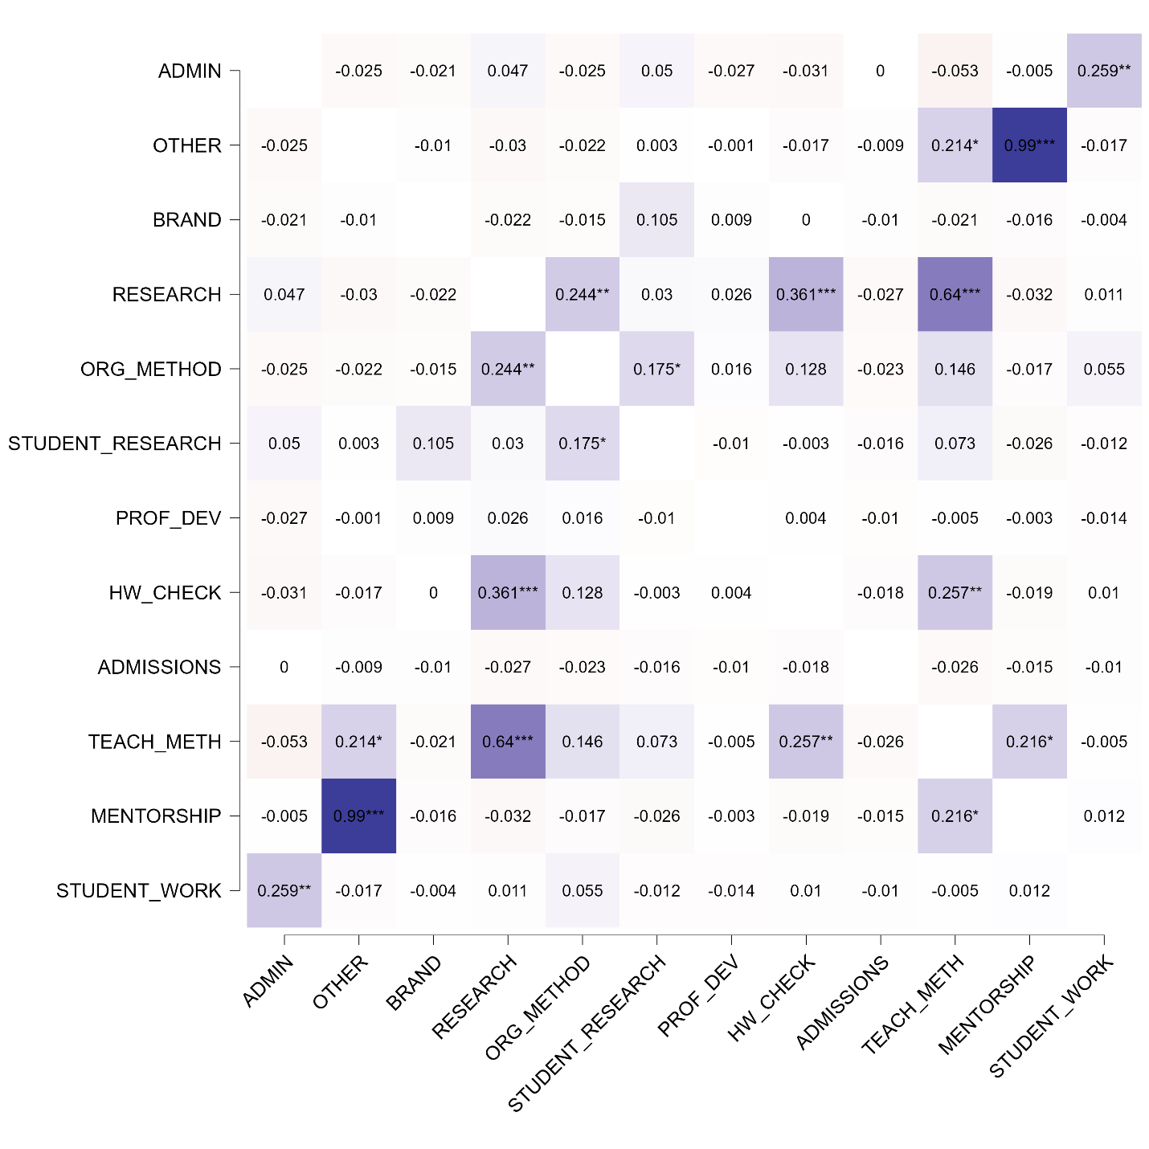
Figure 10 – Correlation matrix of academic staff activities by category of workload (in minutes)

Note – compiled based on calculations

The correlation matrix constructed for academic staff activities reveals several structurally significant associations that offer insights into the institutional organization of workload distribution and the implicit digital architecture of educational management. One of the most striking results is the near-perfect correlation between the categories "Mentorship Activities" (MENTORSHIP) and "Other Activities" (OTHER), with a coefficient of r = 0.99 (p < 0.001). This powerful relationship suggests that a substantial volume of informal mentoring and social engagement remains unclassified within the digital framework and is thus recorded under general-purpose categories. The data indirectly suggest a taxonomic deficiency in the design of activity logging interfaces or digital planning systems, which fail to capture nuanced yet labor-intensive tasks performed by faculty.
Another cluster of significant associations concerns Organizational and Methodological Work (ORG_METHOD), Teaching and Methodological Support (TEACH_METH), and Homework Checking (HW_CHECK). The pairwise correlation between ORG_METHOD and TEACH_METH reaches r = 0.64 (p < 0.001), while ORG_METHOD and HW_CHECK are positively associated at r = 0.361 (p < 0.001). This triad of linkages reflects a structural overlap between routine pedagogical duties and the absence of automation or digital assistance in document processing, task scheduling, or grading workflows. The institutional inability to streamline or integrate these processes via digital platforms likely results in a redundancy of manual effort and an inefficient allocation of faculty time.
The moderate correlation between Scientific Research (RESEARCH) and Student Research Organization (STUDENT_RESEARCH) (r = 0.175, p < 0.05), as well as the statistically significant association between Organizational and Methodological Work (ORG_METHOD) and Scientific Research (RESEARCH) (r = 0.244, p < 0.01), reveals a layered configuration of responsibilities within academic institutions. Specifically, faculty members engaged in formal research activities are simultaneously involved in organizing and supervising student-led research programs, such as NIRS, NIRM, or NIRD. This dual engagement is not limited to content development but also extends to administrative oversight, scheduling coordination, and mentoring responsibilities – functions that, ideally, should be distributed across support units or supported by integrated institutional systems.
The presence of such statistically meaningful overlaps suggests a lack of formal delegation mechanisms within the organizational structure. Instead of having dedicated coordinators or digital tools that streamline research supervision tasks (e.g., project management modules, workflow tracking systems, centralized mentoring platforms), the burden falls directly on academic staff. As a result, the institutional architecture relies heavily on manual coordination and individual initiative rather than on systematized digital support. Therefore, the cognitive and administrative load on researchers increases, revealing a gap in the functional design of digital platforms.
In contrast, several categories demonstrated near-zero correlation with the core academic and managerial activities. Specifically, Branding Activities (BRAND), Professional Development (PROF_DEV), and Admissions Committee Work (ADMISSIONS) appear largely uncorrelated with the main pedagogical and organizational workload. This statistical isolation suggests that these forms of activity are either conducted independently of the core academic calendar or are poorly integrated into the broader digital ecosystem of faculty performance management. Their operational detachment may reflect structural asymmetries in how institutional priorities are represented in reporting systems.
To sum up, these patterns of correlation revealed both structural dependency clusters and areas of disconnection within academic workload management. There is limited functional integration of digital platforms across teaching, research, and development domains. Thus, institutional inconsistencies present the processes of different types of academic activity, supported and coordinated. As such, they justify further analytical decomposition via factor analysis or cluster modeling to uncover latent dimensions of labor allocation and to develop digital modernization strategies tailored to these institutional asymmetries.
Correlations between the categories of teaching activity revealed both stable, functional links and areas of the institutional gap caused by fragmented digital support for individual activities. Cluster analysis was performed to identify structural heterogeneity within the academic corps further and determine typological differences in workload distribution. The use of hierarchical clustering enabled us to transition from analyzing the relationships between categories to identifying stable behavioral patterns that reflect differences in the practices of performing the functional duties of teachers. Thus, clustering is not only a statistical grouping tool but also an analytical basis for understanding the current model of institutional coordination, identifying role profiles, and assessing the degree of integration of digital solutions into everyday academic life. The structural parameters of the model and the distribution of teachers among the identified clusters are presented in Table 16.

Table 16 – Model Summary: Hierarchical Clustering
Clusters | N | R² | AIC | BIC | Silhouette
10 | 126 | 0.819 | 512.200 | 852.550 | 0.740
Note – The model is optimized with respect to the BIC value

The hierarchical clustering model constructed from the full sample (N = 126) showed a high degree of variation explained (R² = 0.819) and demonstrated the stability of the internal structure of the groups, which is confirmed by the value of the silhouette coefficient at 0.740. The optimal number of clusters was determined within the upper limit of the studied range, which indicates a significant degree of substantive differentiation between the groups. Therefore, several functionally separate models of academic workload distribution coexist within a single organizational environment, differing both in the ratio of research, teaching, and administrative activities and in the level of involvement in informal or poorly digitized forms of employment. Each of the formed clusters reflects a specific type of institutional role that dominates the structure of individual activity. In some groups, the workload associated with research activities and organizing student science projects predominates. In others, a clear shift towards the pedagogical and methodological components is evident. Some clusters are characterized by a high share of administrative and coordination functions, which can be interpreted as a sign of a deficit of digital delegation and management tools. In addition, groups were recorded in which a significant part of the activity is represented by categories outside the main normative field ("OTHER", "BRAND"), allowing us to discuss potential institutional gaps in the regulation and classification of labor. The identified types of teaching profiles form an empirical basis for the subsequent analysis of the compliance of the current digital management model with the actual distribution of functions at the university.
The obtained results form the basis for developing substantive recommendations for modernizing the digital architecture of academic management. Firstly, by identifying stable intersections between functional blocks, it becomes possible to eliminate excessive cross-loads, in which the same teacher simultaneously performs methodological, organizational, and research work without a clear delineation of roles in the digital circuit. Such intersections, being systematized, can be redistributed either between employees or digitized through automated modules. Secondly, the recorded structure of clusters suggests the need to revise the role of supporting administrative units, such as departments, academic departments, research centers, and deans' offices, in the processes of support, accounting, and employment planning. As a result,lt, the process of independent task coordination will improve, and operational connectivity between academic and administrative processes will strengthen. Third, the high degree of heterogeneity in the distribution of functions underscores the importance of increasing the transparency of educational planning. The transition from static reporting to digital platforms, which enable the real-time visual tracking and analysis of employment, will provide the conditions for more flexible and balanced human resource management.
The summary characteristics of each of the ten identified clusters, including size, level of within-group homogeneity, and proportion of explained variation, are presented in Table 17.

Table 17 – Cluster information
Cluster | 1 | 2 | 3 | 4 | 5 | 6 | 7 | 8 | 9 | 10
Size | 1 | 116 | 2 | 1 | 1 | 1 | 1 | 1 | 1 | 1
Explained proportion within-cluster heterogeneity | 0.000 | 0.971 | 0.029 | 0.000 | 0.000 | 0.000 | 0.000 | 0.000 | 0.000 | 0.000
Within sum of squares | 0.000 | 264.365 | 7.833 | 0.000 | 0.000 | 0.000 | 0.000 | 0.000 | 0.000 | 0.000
Note – The total sum of squares of the 10 cluster model is 1500

The distribution of teachers across the formed clusters revealed a pronounced asymmetry in the volume of observations. Cluster 2 turned out to be the most representative, including 116 out of 126 teachers in the sample, which is over 92% of the total population. Thus, there is a dominance of one typological profile of academic activity, characterized by a high degree of internal consistency, which is confirmed by the value of explained intra-cluster heterogeneity at the level of 0.971. The value of the intra-cluster sum of squares for this segment is 264.365 with a total variation level of 1500, which confirms its statistical capacity and content homogeneity.
The remaining clusters (1 and 3–10) include only single observations, each of which recorded only one teacher or, in the case of cluster 3, two people. The explained variation for these clusters is either zero (0.000) or extremely low (0.029 for cluster 3), indicating the absence of stable, recurring behavioral patterns within the remaining profiles. Such values ​​can be interpreted as the presence of extreme, non-standard, or institutionally unstructured employment trajectories that have not been confirmed in mass behavior.
From an institutional management perspective, such a structure of results indicates the concentration of the academic model around a single, formalized or regulated format of workload distribution, while alternative scenarios are either not fixed or marginalized. Consequently, there is a lack of flexibility in role management, limited career trajectories, or weak integration of digital solutions that allow adapting academic activities to individual or cross-functional formats.
The summary metrics for the quality of the hierarchical clustering model, calculated using the Euclidean distance metric, are presented in Table 18.

Table 18 – Model performance metrics
Metric | Value
Maximum diameter | 6.778
Minimum separation | 4.779
Pearson's γ | 0.904
Dunn index | 0.705
Entropy | 0.449
Calinski-Harabasz index | 58.138
Note – All metrics are based on the euclidean distance

The assessment of the model consistency based on standard metric indicators indicates an acceptable quality of the clustering and confirms the stability of the identified groups. The value of the maximum cluster diameter (6.778) in comparison with the minimum intercluster distance (4.779) indicates a partial intersection of the boundaries between the most distant observations within the cluster and the closest elements from other groups. Still, the excess of the diameter over the separation remains insignificant and does not violate the general structural isolation of the clusters.
The Pearson γ coefficient (0.904) demonstrates a high degree of correlation between the distances within the original Euclidean space and the clustering results, which confirms the consistency of the model with the original data. The Dunn index value (0.705) indicates a satisfactory level of clarity in the boundaries between the groups while maintaining density within the clusters. The entropy indicator (0.449) indicates a weakly expressed uneven distribution of objects by groups, which is due to the predominant enlargement of one cluster and the presence of insignificant extreme units.
The Calinski provides the most convincing confirmation of the internal consistency of the model–Harabasz index, which reached a value of 58.138, which is a high indicator of intra-cluster density under the condition of noticeable inter-cluster separation. Taken together, the obtained metric values ​​confirm the statistical consistency of the model and allow the use of clustering results in the future for interpreting typological differences and institutional diagnostics.
The substantive characteristics of the identified clusters according to the main categories of teachers’ activity are presented in Table 19, which provides standardized average values ​​for each area of ​​workload.

Table 19 – Cluster Means
Cluster | Admin | Other | Brand | Research | Org_  method | Student_  research | Prof_dev | Hw_check | Admissions | Teach_meth | Mentorship | Student_work
1 | 0.777 | 0.144 | 0.097 | -0.089 | 0.217 | 9.199 | -0.342 | -0.114 | 0.286 | 0.982 | -0.157 | -0.154
2 | -0.093 | -0.092 | -0.091 | -0.114 | -0.082 | -0.082 | -0.106 | -0.094 | -0.127 | -0.131 | -0.088 | -0.101
3 | -0.043 | 0.069 | -0.076 | -0.067 | -0.211 | -0.144 | 1.231 | -0.158 | 7.742 | 0.244 | -0.089 | 0.268
4 | 8.632 | -0.123 | -0.107 | 0.038 | -0.192 | -0.235 | -0.413 | -0.154 | -0.145 | -0.339 | -0.089 | 0.167
5 | -0.259 | -0.123 | -0.107 | 8.481 | -0.221 | -0.235 | 3.379 | -0.167 | -0.145 | 8.050 | -0.157 | -0.154
6 | 2.722 | -0.123 | -0.107 | -0.120 | -0.241 | -0.235 | -0.439 | 0.097 | -0.145 | -0.339 | 0.201 | 10.903
7 | -0.259 | -0.111 | 11.110 | -0.294 | -0.205 | 0.861 | 1.496 | -0.180 | -0.145 | -0.339 | -0.157 | -0.034
8 | -0.259 | -0.123 | -0.107 | 2.617 | 10.655 | 0.861 | 0.979 | 1.082 | -0.145 | 1.448 | -0.157 | 0.811
9 | -0.259 | 11.104 | -0.107 | -0.294 | -0.241 | -0.235 | 1.744 | -0.180 | -0.145 | 2.380 | 11.035 | -0.154
10 | -0.259 | -0.115 | 0.077 | 3.049 | 0.153 | -0.235 | 3.379 | 10.825 | -0.145 | 2.846 | -0.157 | -0.154
Note – All metrics are based on the euclidean distance
The analysis of average values by clusters demonstrates a pronounced differentiation of teaching activity profiles, confirming the presence of alternative role models within the academic environment. Cluster 2, covering 92% of the sample, is characterized by moderately negative deviations from the average level in all activity categories. Such a uniformly reduced workload may indicate a standardized, balanced, and typical distribution of responsibilities in the context of unified digital reporting and functional uniformity.
At the opposite pole, there are small clusters with a pronounced specialization. Thus, cluster 5 demonstrates abnormally high values ​​for the categories Scientific Research (RESEARCH = 8.481), Professional Development (PROF_DEV = 3.379), and Teaching and Methodological Support (TEACH_METH = 8.050), indicating an intensive individual research trajectory with active participation in educational and methodological initiatives. Such a workload exceeds the institutional norm and may reflect both high qualifications and the lack of mechanisms for task redistribution.
Cluster 4, on the contrary, demonstrates excessive values ​​in the direction of Administrative Work (ADMIN = 8.632), which indicates a shift toward coordination and management functions. A probable explanation is the teacher's involvement in managing the structural unit or the lack of digital task delegation within the department.
Other clusters with unique profiles are also distinguished:
Cluster 6 - intensive involvement in Student Engagement (STUDENT_WORK = 10.903), which indicates the predominance of educational and extracurricular forms of support;
Cluster 7 - the maximum value for Branding Activities (BRAND = 11.110), which may reflect involvement in public and reputational projects of the university;
Cluster 10 has the highest Admissions Committee load (ADMISSIONS = 10.825), which corresponds to the period of targeted recruitment of applicants and may be due to the lack of automation in the admissions campaign.
Finally, cluster 9 demonstrates anomalous values ​​simultaneously for Other (OTHER = 11.104), Mentorship (MENTORSHIP = 11.035), and Teaching and Methodological Support (TEACH_METH = 2.380). This combination indicates a shift towards weakly structured and poorly regulated forms of activity, which reflects institutional gaps in classification and also shows a high share of informal obligations not covered by the digital platform.
The presented differences suggest the presence of both standard and highly specialized role models that are disproportionately represented in the structure of academic employment. This requires subsequent analysis not only in the context of digital management but also in terms of fair resource allocation, support, and assessment of work.
To justify the choice of the optimal number of clusters, a graph of the change in the values ​​of the information criteria (AIC and BIC), as well as the intra-group sum of squares (WSS) depending on the number of clusters, was constructed (Figure 11).
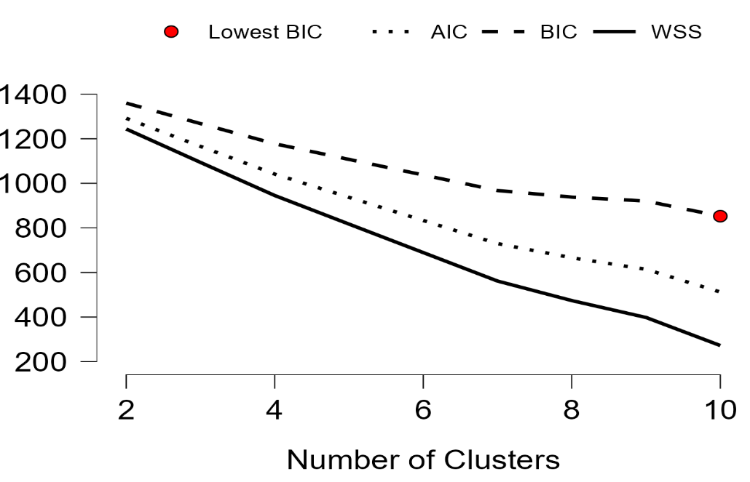
Figure 11 – Dynamics of information criteria and intra-group dispersion with varying number of clusters

Note – compiled based on calculations

The graph illustrates the dynamics of three key metrics - AIC, BIC, and WSS - as the number of clusters varies. The visualized decrease in the WSS (within the sum of squares) values ​​with an increase in the number of clusters reflects the growth of intra-group homogeneity, which indicates a better description of the data due to the rise in the number of segments. However, upon reaching a specific limit, a further increase in clusters leads to a decrease in the model's stability and an increase in overfitting.
In terms of information criteria, the lowest BIC (Bayesian Information Criterion) value, which means the best balance between the accuracy of the model and its complexity, is achieved with 10 clusters, which are marked on the graph with a red dot. The parallel behavior of AIC and WSS further confirms the validity of this choice, as it maintains a smooth decrease in intra-group variance without sharp jumps.
Thus, the visualized dynamics confirm the previously chosen number of clusters and indicate the presence of a complex and multi-level structure in the sample, requiring a multi-factor description. This provides grounds for using the obtained clusters as substantively substantiated types of academic employment in the further interpretation and development of management decisions.
To record the differences in the parametric distribution of academic activity, a visualization of the spatial structure of teacher clusters was used based on standardized values ​​for all workload categories. This presentation format provides analytical reinforcement of the typology identified through cluster analysis, allowing one to interpret not only the numerical structure but also the configuration of the mutual arrangement of employment profiles.
The cluster with the most significant number includes teachers whose workload is distributed evenly among the main areas of activity: teaching, methodological work, and research activity. For all categories, the values ​​deviate minimally, remaining within the average levels, which indicates that the performance meets the standard set of duties as approved. The workload structure corresponds to a typical full-time position without pronounced specialization and bias towards administrative or unaccounted forms of employment. Such a profile is formed under conditions of full accountability to the digital planning system and reflects the current institutional model of function distribution.
Additionally, the visualization reveals the presence of small but distinct clusters that do not structurally intersect with the primary type. Spatial isolation reflects the presence of stable role configurations in which pronounced specialization in one or more areas is observed. In some cases, the workload was concentrated within the framework of administrative coordination, research activities, organizing educational work, as well as participating in campaigns for the admission of applicants and events to promote the academic brand. A deviation distinguishes these profiles from the normative model of the distribution of functions, characterized by a high degree of individualization.
The OTHER category, visually recorded as the zone of most significant deviation from the main configuration, marks the areas of activity that have not received digital consolidation or are outside the established classification system. In cases where the activity recorded in the OTHER category predominates, the teacher's workload extends beyond the formalized areas and is not accounted for in standard digital reporting tools. Such forms of employment are not regulated in the current classification system and, as a result, are not subject to planning, control, and adjustment at the management level. Such a situation indicates institutional gaps in the labor accounting system and creates risks of systematic underestimation of the actual workload, especially in segments related to non-staff functions, external initiatives, or cross-functional activities.
The isolation of small clusters and the absence of transitional forms between them and the dominant type indicate structural disunity within the teaching staff. In such conditions, not only the internal asymmetry of the labor distribution system is recorded, but also the imperfection of the existing digital control tools. The recorded structure of deviations from the standard workload indicates the need to move from a single digital model to a multi-loop management system. For teachers whose activities comply with established standards and are covered by digital regulations, it is necessary to maintain the stability of planning procedures, transparency of control, and unification of accounting. At the same time, for profiles with a pronounced specialization - such as scientific, administrative, project, or educational - a different logic is needed: flexibility in planning, the ability to individually regulate the workload, and the adaptation of digital tools to non-standard activity formats.
Thus, the visualization in Appendix С confirms the results of cluster modeling and reveals hidden aspects of institutional functioning that are not reflected in the aggregated indicators. The spatial distribution of activity types reveals systemic discrepancies between the actual employment structure and the digital management mechanisms used. The differences identified confirm the need to introduce individualized accounting modes capable of adequately recording non-standard combinations of activities. Recognizing the variability of academic profiles requires increasing the functional flexibility of digital platforms. Without including mechanisms that reflect deviations from the standard employment model, it is impossible to ensure completeness, accuracy, and operational controllability in the processes of planning, distributing, and monitoring the workload of teachers. Substantive differences between employment profiles form an analytical basis for designing digital solutions that can ensure functional fairness, increased transparency, and institutional sustainability of academic labor management.
To evaluate the degree of alignment between formal institutional planning and actual academic workloads, a structured comparison was conducted between observed categories of staff activity and those covered by internal regulations. Table 20 presents this comparison, highlighting the functional domain of each activity, whether it is formally regulated, and the extent to which it is institutionally exposed or underrecognized.

Table 20 – Comparative overview of academic activity categories: regulation status and institutional exposure
Academic Activity Domain | Regulated by Institutional Norms | Institutional Exposure / Risk
1 | 2 | 3
Teaching (in-class instruction) | Yes | Low – standardized and digitally tracked
Departmental responsibilities (planning, meetings, etc.) | Yes | Low – part of routine planning workload
Continuation of the table 20
1 | 2 | 3
Administrative duties (coordination, management tasks) | Yes | Low – included in digital workload systems
Research (academic R&D projects) | Yes | Low – formally integrated into reporting
Curriculum and methodological development | Yes | Low – accounted in planning templates
Professional development (trainings, certifications) | Yes | Low – documented in HR systems
Student mentoring and guidance | No | High – loosely structured, underreported
Student research supervision (SRS, SRP, SRD) | No | High – functionally important, not regulated
Participation in admissions-related activities | No | Moderate – seasonal, but often excluded from planning
Brand-building and public engagement | No | High – reputation-sensitive, institutionally invisible
Homework grading and evaluation | No | Moderate – routine but often overlooked in load plans
Other (non-classified, informal or ad hoc activities) | No | Critical – lacks classification, untraceable in systems
Note – compiled by the author

The analysis of Table 20 revealed a discrepancy between the official structure of the teachers' workload and the actual functional employment. Formal regulation covers six categories: classroom teaching, participation in department activities, administrative functions, research, methodological duties, and advanced training programs. The listed categories are recorded in local acts of universities, integrated into electronic accounting systems, and included in the calculated standards when planning individual workloads.
Cluster analysis recorded systemic activity in areas not provided for by the normative model. These include individual work with students, checking homework, organizing student research activities, participating in admissions campaigns, developing an academic and public image, and non-structural forms of employment that cannot be classified. Each area is associated with contingent management, maintaining a reputational resource, expanding the scientific environment, and supporting the educational process; however, it is absent from digital reporting systems and planning mechanisms.
Electronic accounting templates do not accompany forms of employment outside the regulated part, are not included in the workload distribution reports, and are not included in the calculations when drawing up an individual teacher plan. The lack of digital recording makes these categories statistically invisible, complicates the redistribution of resources, and reduces the accuracy of the university's analytical tools. The most vulnerable areas are those related to scientific mentoring of students, activities within the admissions committee, public positioning, and unregulated employment.
The modern model of digital management necessitates an expansion of the list of recorded forms of employment and the introduction of a platform that can accommodate not only traditional but also flexible, situational, and integrative formats of teaching activity. An electronic portal for recording full employment should include parameters for non-standardized work, automated reporting forms, and the ability to analyze data based on actual involvement.
Categories not covered by the regulatory system cover a significant volume of actual employment and include individual work with students not related to classroom studies; checking and commenting on homework; support for student research projects (NIRS, NIRM, NIRD); participation in admissions campaigns; development and implementation of events to strengthen the academic brand; as well as actions that cannot be classified, recorded in the open category “other”. Each of these areas requires regular involvement, organizational participation, and responsibility but is not reflected in the calculations of individual workload, is not recorded in electronic plans, and is not taken into account in institutional performance assessment.
A comparison of volumes reveals that the total labor intensity of unregulated activities is comparable to that of the regulated workload. However, the lack of digital recording and regulatory support means that the employment of teachers in these areas cannot be effectively managed: there are no mechanisms for time tracking, performance assessment, and resource redistribution. This situation creates institutional distortions, overload of individual teachers, uneven distribution of responsibilities, distortion of analytical data on employment, as well as unfairness in calculating motivational and incentive payments.
The integration of full employment into the digital management architecture is a key condition for transitioning to a balanced, manageable, and objective planning system at the university. The electronic platform should take into account both formalized types of activity and flexible, proactive, reputationally significant functions. Only in the case of digital registration of the entire structure of the actual workload is it possible to build up-to-date individual plans, objective analytics of personnel workload, and effective strategic management of the academic resource.

2.3. The purpose of the iPortal platform in the digital transformation of education quality management in higher education institutions

In today's educational landscape, the digital transformation of educational processes is becoming one of the key factors in improving the competitiveness of higher education. Digital platforms integrated into the education quality management system are becoming a tool not only for optimising administrative functions, but also for increasing transparency, accessibility of educational resources, and the effectiveness of monitoring and analytics of the educational process. In the context of modern challenges and prospects for the development of higher education, the digitalisation of education quality management processes is not just a trend, but an imperative that determines the competitiveness and sustainability of universities in the global educational space.
The relevance of digital transformation is driven by the need to improve the efficiency of educational processes, ensure transparency and accessibility of information, and adapt to the needs of the digital generation of students [127]. The integration of advanced digital platforms and technologies provides an opportunity not only to automate standard administrative and academic procedures, but also to significantly optimise strategic and operational decision-making processes at all levels of education management. In addition, it opens up new horizons for personalising learning and increasing student engagement in the educational process. The previous sections showed the general trends in the development of universities and the processes of digitalisation in the higher education system of Kazakhstan, highlighted the key tasks and challenges associated with the introduction of information and communication technologies into management processes, and considered the purposes of digital solutions in increasing the transparency and efficiency of the educational environment. Building on these points, this section will focus on the author's model, the iPortal digital platform, as a tool for integrating digital solutions into the practice of quality management in higher education in Kazakhstan.
In this context, the iPortal platform is one of the most illustrative examples of digital transformation in Kazakhstani universities. It was developed and implemented in a number of Kazakhstani higher education institutions with the aim of optimising and improving the efficiency of education quality management [89]. iPortal is an integrated system designed to provide comprehensive support for the educational process, covering curriculum management, the development and distribution of educational content, monitoring student performance, and organising communication between all participants in the educational process. An analysis of the functionality and practical application of iPortal allows us to assess the potential of digital platforms in the context of the Kazakhstani higher education system, taking into account the specifics of the regulatory framework, the characteristics of the organisational structure of universities, and the level of digital literacy of teachers and students.
Within this chapter – after reviewing the overall state of higher education in Kazakhstan and analysing the digital platforms and technologies used in the country’s universities – this subsection focuses on a concrete case of digital transformation in quality management: the iPortal platform. This focus enables a detailed examination of its architecture, functional capabilities, and impact on various dimensions of the educational process, as well as an assessment of its contribution to improving educational quality and optimising university management.
This section used a quantitative methodology, which is in line with modern scientific approaches used in related fields. For example, Susilo et al. [128] used a quantitative method to assess the effectiveness of strategies aimed at developing students' communication skills, emphasising the importance of structured approaches in the educational environment. Similarly, Seifloo et al. [129] developed a model based on a sieve approach to quantitatively assess changes in land use in urban development, emphasising the need for categorisation and measurement in spatial analysis. In the study by Zheng et al. [130], data were collected using online surveys and analysed using partial least squares structural equation modelling (PLS-SEM), which made it possible to identify behavioural factors in the service sector. Olson [131] conducted a systematic review of language proficiency assessment methods in bilingualism research, emphasising the importance of methodological rigour and the systematisation of quantitative tools. In turn, Bouteraa [132] used a mixed methodology to study the barriers to fintech adoption, combining qualitative data with quantitative data within the UTAUT model. Derksen et al. [133] investigated ethical aspects and user preferences first through focus groups and then using quantitative questionnaires, which allowed for the validation of the results.
As part of the study, a structured survey was developed, comprising 38 questions aimed at identifying students' perceptions of digital educational platforms. The questions covered various aspects related to the use of digital solutions in the learning process: from assessing the level of digital literacy and confidence in working with online tools to analysing the user-friendliness of the interface, the accessibility of platform functions, and the availability of technical support. Particular attention was paid to how students interact with teachers and classmates through digital channels, how effectively independent work is organised, and how digital technologies affect the transparency and quality of the educational process. The study also examined whether students' opinions are taken into account when improving the digital environment at universities.
As part of this study, a questionnaire survey was conducted to identify the characteristics of how students at Kazakhstani universities perceive the digital educational environment. The questionnaire was developed considering modern methodological approaches to researching user experience in the context of the digitalisation of higher education. The content of the survey covered a wide range of topics, including the socio-demographic characteristics of respondents, their digital literacy, experience of interacting with educational platforms, and assessment of the functionality and accessibility of infrastructure. At the initial stage, respondents provided information that allowed us to form their socio-demographic profile, which made it possible to conduct a more accurate comparative analysis between different groups of students. Participants were then asked to assess the frequency and nature of their use of digital educational platforms, including the most common learning management systems in domestic practice, as well as their level of proficiency with basic digital tools such as Microsoft 365, Microsoft Teams, and Zoom. Access to information support, the availability of instructions, and experience in independently solving technical problems when working with platforms were also taken into account.
A separate set of questions was devoted to the perception of the platforms' interface, their navigation structure, as well as the convenience of performing educational operations, access to academic information and tools for independent work. An important aspect was the integration of digital solutions within the university system, the availability of regular feedback from teachers and the effectiveness of communication in the educational process. The accessibility and reliability of the digital infrastructure was also considered, including technical conditions, access to equipped classrooms, internet connection, and the availability of students' own devices. The assessment of academic and technical support from the university, as well as the stability of the platforms' functioning during the semester, played a significant purpose. The final part of the questionnaire allowed respondents to express their overall opinion about the digital educational environment, their level of satisfaction with the technologies used, the extent of their impact on the quality and transparency of the educational process, and the involvement of students in the process of improving digital solutions.
The survey was conducted online using the Google Forms platform. To measure respondents' attitudes towards various aspects of the digital environment, a five-point Likert scale was used (from 1 – «Strongly disagree» to 5 – «Strongly agree»). This format ensured that the collected data was structured and suitable for subsequent quantitative analysis, including correlation analysis, classification model building, and intergroup comparisons. The questionnaire was designed to identify students' perceptions of digital educational platforms, assess their level of digital competence, and evaluate their satisfaction with the use of electronic resources in educational and administrative activities. This tool provided representative data for quantitative analysis aimed at empirically testing the hypothesis that the effectiveness of higher education quality management is significantly improved when digital technologies are comprehensively integrated into the educational process and administrative activities of universities.
The results of the empirical study cover several key aspects. First, a detailed profile of the survey participants was presented, including distribution by age, gender, level of education, field of study, and course of study (Table 1).

Table 21 – Profile of respondents
№ | Characteristics | Students (number) | % ratio
1 | 2 | 3 | 4
1 | Age
 | 17-19 | 1996 | 63%
 | 20-22 | 1098 | 34,6%
 | 23-25 | 38 | 1,2%
 | 26-28 | 13 | 0,4%
 | 29 and older | 24 | 0,8%
 | TOTAL | 3169 | 100%
2 | Gender
 | female | 1475 | 46,54%
 | male | 1694 | 53,46%
 | TOTAL | 3169 | (100%)
3 | Year of study
Continuation of the table 21
1 | 2 | 3 | 4
 | 1st year | 1199 | 37,84%
 | 2nd year | 810 | 25,56%
 | 3rd year | 579 | 18,27%
 | 4th year | 554 | 17,48%
 | 5th year | 27 | 0,85%
 | TOTAL | 3169 | 100%
4 | Level of education
 | Bachelor's degree | 3087 | 97,41%
 | Master's degree | 63 | 1,99%
 | Doctoral programme (PhD) | 19 | 0,6%
 | TOTAL | 3169 | 100%
5 | Field of study
 | Business, management and law | 351 | 11,08%
 | Veterinary medicine | 1 | 0,03%
 | Natural sciences, mathematics and statistics | 109 | 3,44%
 | Healthcare | 3 | 0,09%
 | Engineering, manufacturing and construction industries | 976 | 30,8%
 | Information and communication technologies | 670 | 21,14%
 | Arts and humanities | 430 | 13,57%
 | Educational sciences | 257 | 8,11%
 | Agriculture and biological resources | 4 | 0,13%
 | Social sciences, journalism and information | 259 | 8,17%
 | Services | 109 | 3,44%
 | TOTAL | 3169 | 100%
6 | Digital platform
 | iPortal | 1699 | 53,61%
 | Moodle | 339 | 10,7%
 | Platonus | 290 | 9,15%
 | Univer | 713 | 22,5%
 | Platforms developed by the university itself | 128 | 4,04%
 | TOTAL | 3169 | 100%

Analysis of the data obtained from the survey allows us to draw a number of general conclusions regarding the socio-demographic profile of respondents and their academic specialisation, as well as their use of digital educational platforms. The gender distribution of the study participants shows a slight predominance of male respondents. According to the respondents' answers, 1,694 men (53.5%) and 1,475 women (46.5%) took part in the survey. Thus, the sample is characterised by a relative gender balance, which contributes to the representativeness of the data. The age profile of respondents indicates a predominance of students in the younger age groups. The largest share of survey participants falls into the 17–19 age category –1,996 people, which constitutes the core of the sample. The second largest group – 20–22 years old – comprises 1,098 respondents. The age categories 23–25 (38 people), 26–28 (13 people) and 29 and older (24 people) are significantly less represented. These results confirm that the main body of data was obtained from students in the early stages of their studies, which is important to consider when interpreting perceptions of the digital environment, as it is precisely junior students who are more often involved in digital forms of interaction. The distribution by year of study also confirms the predominance of undergraduate students. As the survey shows, most of the participants are first-year students (1,199 people), followed by second-year students (810 people), third-year students (579 people) and fourth-year students (554 people). The participation of fifth-year students was minimal, with only 27 respondents. This sample structure indicates the high activity of first-year students, who are most involved in digital formats of learning and interaction with platforms.
The academic distribution of respondents by field of study demonstrates a wide range of specialisations and allows us to assess the influence of the field of study on the perception of digital educational platforms. The largest number of respondents are enrolled in engineering, manufacturing, and construction programmes – 976 people. This is explained by the high level of digitalisation of the educational process in technical disciplines, which involves the active use of digital tools for modelling, design, and analysis. The second largest group is information and communication technologies (ICT), represented by 670 students. These data show that respondents who interact directly with digital technologies as part of their educational and future professional activities demonstrate a higher level of digital engagement. The group of students studying arts and humanities (430 people) has a slightly different attitude towards digital tools, due to the specific nature of disciplines that are less focused on technical means. The «Business, Management and Law» group includes 351 respondents and is characterised by fairly active use of digital solutions, especially in the context of data analysis and online communications. The category «Social Sciences, Journalism and Information» covers 259 participants, which highlights the interest in information management tools and the interactive capabilities of the digital environment.
The remaining 483 respondents are distributed among the areas of «Pedagogy», «Healthcare», «Agriculture and Bioresources», «Services» and others. Combined in the ‘Other’ category, they represent areas that are significant for the national economy, where digital platforms play an increasing purpose in the training of specialists. Thus, the data obtained indicates the diversity of educational tracks and the need for a differentiated approach to the development of digital infrastructure, taking into account the specifics of academic fields. The use of educational platforms also demonstrates varying degrees of integration of digital solutions into the learning process. Based on the respondents' answers, the most actively used platform is iPortal, which is used by 1,699 people. The universal Univer system is used by 713 participants. The Moodle and Platonus platforms are used by 339 and 290 students, respectively. In addition, 128 respondents reported using their own digital solutions developed by universities. This distribution shows the diversity of digital tools used and indicates the relevance of tasks related to their standardisation, integration, and improvement of the user experience. In particular, the high proportion of iPortal and Univer users indicates a preference for centralised, functionally rich platforms, while the availability of alternative solutions highlights the need for a flexible architecture for the digital educational environment.
The reliability and validity of the data collection tools used were confirmed during the questionnaire development and testing phase. The questionnaire structure was designed to ensure comprehensive coverage of key aspects of the digital educational environment, which contributes to high content validity. The data processing methods used ensured the analytical reliability and reproducibility of the results obtained. The empirical data was analysed using Microsoft Excel and MATLAB software, as well as Python programming language libraries. As part of the statistical processing, linear regression procedures were implemented to identify relationships between variables. The Kruskal-Wallis test, which acts as a non-parametric analogue of one-way analysis of variance (ANOVA), was used to test statistical hypotheses. The application of this test made it possible to adequately consider the distribution characteristics of the empirical data and ensure the correctness of the statistical conclusions.
After completing the empirical data collection phase through a survey of students at Kazakhstani universities, a comprehensive multi-stage quantitative analysis was conducted to identify factors influencing the perception and satisfaction with digital educational platforms. The aim of this stage was not only to establish statistically significant relationships between various components of students' digital experience, but also to build models that would allow practical recommendations to be formulated for optimising the digital educational environment in universities.
The application of a multi-component approach to analysis included methods of classification, correlation analysis, segmentation, and statistical hypothesis testing. This approach provided a multidimensional view of the students' experience and allowed us to identify key predictors of satisfaction, user behaviour profiles, as well as institutional and technical factors influencing the perception of the digital environment. The analysis of the collected data included five stages: classification of student satisfaction using a decision tree, correlation analysis of digital environment perception (Spearman's method), behavioural segmentation of respondents based on MATLAB modelling, testing of statistical hypotheses using the Kruskal-Wallis method, and formulation of comprehensive conclusions and practical recommendations for universities.
Next, we will examine these stages in more detail, describing the analytical methods used, key results, and their significance for assessing students' perceptions of digital educational platforms.
Stage 1. Analysis of students' perception of digital educational platforms using a decision tree algorithm
The use of decision tree-based classifiers to study students' perception of digital educational platforms has attracted considerable attention in recent studies. Karim et al. demonstrated the effectiveness of decision trees in classifying and predicting student academic performance in fully online environments using diverse datasets from university and corporate platforms such as Microsoft Teams. This approach highlights the ability of decision trees to work with different types of data to model student learning outcomes. Similarly, in higher education research, decision tree algorithms have been used to analyse student perceptions during the rapid transition to distance learning. For example, a study conducted in August 2021 examined students' perceptions of online learning during the COVID-19 pandemic, showing that decision trees served an important purpose in analysing survey data to understand the student experience [134, 135]. The ability of decision trees to process both categorical and numerical data makes them suitable for identifying complex perceptions and attitudes towards digital platforms.
In addition, the use of decision trees extends to the analysis of perceptions of specific digital tools. Students' perceptions of platforms such as Zoom, Moodle, and Google Classroom were studied using decision tree models, which provided insights into how students acquire knowledge through these tools [136]. These models help identify key factors influencing positive or negative evaluations, contributing to targeted improvements in the digital educational environment. In addition to analysing perceptions, decision trees are used to predict broader educational outcomes based on perceptions. For example, studies have used decision trees to predict student competence and engagement levels in online environments, often integrating sentiment analysis and log file data [137]. Such predictive modelling helps to understand how perceptions translate into academic performance and activity, highlighting the purpose of decision trees in developing personalised educational strategies.
In addition, recent advances include the integration of decision trees into adaptive learning systems. A November 2023 study highlights the use of decision trees to create personalised learning plans based on an analysis of students' perceptions and abilities, which contributes to improving the educational experience [138]. This demonstrates the potential of decision trees to adapt digital educational platforms to the individual needs of learners based on perception data. Decision tree-based classifiers are a universal tool for analysing students' perceptions of digital educational platforms, facilitating classification, prediction and personalisation. Their ability to work with diverse types of data and identify meaningful patterns makes them valuable for improving the effectiveness of online learning in various educational contexts.
To identify the key factors determining students' perception of digital educational platforms, an analysis was conducted using the Decision Tree Classifier algorithm. The target variable was the level of student satisfaction with the quality of digital platforms used at their universities. The features used were responses to 33 statements reflecting experience with various digital services (Platonus, Moodle, Microsoft Teams, Zoom, etc.), technical support, accessibility of information, and subjective perceptions of organisation and independence resulting from the use of digital technologies.
The constructed decision tree model made it possible to identify key predictors that have the greatest impact on students' positive perception of digital educational platforms. The application of this method not only made it possible to classify respondents according to their level of satisfaction, but also to assess the relative importance of each variable under study. The Gini importance coefficient was used as a measure of importance, reflecting the contribution of the corresponding feature to improving the quality of divisions within the decision tree structure (Appendix D).
Based on the constructed decision tree model, variables that have the greatest impact on student satisfaction with digital educational platforms were identified. The most significant predictor was the indicator related to the perception of the platforms' capabilities for organising independent learning activities and monitoring one's own progress (Gini coefficient = 0.330). This factor is interpreted as a key element determining the positive assessment of the digital educational environment. Students who highly rated the platforms' ability to support self-directed learning were more likely to demonstrate overall satisfaction. The second and third most significant variables reflect the institutional and individual aspects of digital transformation. Thus, the perception of the university's activity in developing and improving the digital environment (Gini = 0.117) was positively correlated with the level of satisfaction, which indicates the importance of the university's strategic approach to digitalisation. A similar significance was shown by the indicator reflecting students' perception of the improvement of their digital literacy and professional readiness as a result of using platforms (Gini = 0.115), which indicates the perception of digital solutions not only as a tool for current learning, but also as a means of professional development.
A number of other variables were also included in the model, although their contribution was less pronounced. These included the perception of transparency in the educational process (0.027), confidence in the use of digital tools (0.024), availability of technical support (0.022), and experience with Zoom and Microsoft 365 platforms (0.022 each). Despite their lower importance ratings, these factors reflect the complexity of students' digital experience and highlight the importance of operational and support infrastructure. The variables associated with the perception of uninterrupted access to platforms (0.019) and the assessment of the overall improvement in the quality of education through digital technologies (0.019) demonstrated the least significance in the model. These results suggest that the subjective functional usefulness of the platform and institutional involvement have a more pronounced effect on satisfaction than the assessment of individual technical aspects of the digital environment.
These results show that the perception of platform functionality (possibility for self-learning, integration into the educational process, development of digital competences) plays a much more important role than simply having access or using separate tools. The solution tree not only allowed for classifying the level of satisfaction but also identified the main directions for optimizing the digital educational environment, which is oriented towards students' needs. The data obtained can be used by university management in decision-making on the development of LMS and other digital platforms.

Table 22 – Questions based on the classification of the tree of solutions
№ | Questions | Gini-importance
1 | «LMS helps to organize independent work and monitoring progress» | 0.330
2 | «The University is actively developing and improving the digital environment» | 0.117
3 | «Platform experience increases my digital literacy and prepares for professional activity» | 0.115
4 | «Platforms make the learning process more transparent and understandable» | 0.027
5 | «I feel confident in all the digital tools of the university» | 0.024
6 | «I know where to go in case of technical difficulties» | 0.022
7 | «Confident using Zoom for lectures and seminars» | 0.022
8 | «Regularly use Microsoft 365 (Word, Excel, Teams, OneDrive) for tasks» | 0.022
9 | «Digital technologies really improve my learning quality» | 0.019
10 | «The University provides uninterrupted access to the LMS during the semester» | 0.019
Note – Compiled by the author from primary sources

According to the presented results, the main determinants of positive perception of digital educational environment by students are functional characteristics of platforms. The most significant value in the decision tree model was demonstrated by the indicator related to the affirmation «LMS helps to organize independent work and monitor progress» (coefficient of Gini = 0.330). This indicates that the platform’s ability to facilitate self-organization and learning management is perceived by learners as a key component of digital learning. The next most important are the statements concerning the strategic digital policy of the university and the subjective digital advantage: «The university actively develops and improves the digital environment» (0.117) and «Experience using platforms increases my digital literacy and prepares me for professional activities» (0.115). These variables indicate that students are more positive about the digital transformation of a university when tangible personal benefits accompany it. The less pronounced, but also significant, predictors are related to perceptions of process transparency, availability of support, and basic operational skills, such as using Zoom and Microsoft 365. They help reduce anxiety in distance learning by providing confidence in the process of interacting with digital infrastructure. The analysis of the decision tree allowed to highlight the most critical elements of the digital educational environment, forming a positive attitude of students. This includes three levels: functional utility, strategic support and technical reliability that form a holistic experience of interaction with the educational platform. The results obtained can be used to prioritise the digital development directions of universities.
The students' perception of digital educational platforms: from basic skills to strategic alignment (Figure 12) reflects the evolution of digital platform perceptions depending on the degree of user involvement in the digital education environment. The horizontal axis demonstrates the transition from basic operational skills to strategic digital integration, encompassing five key components, each of which has both instrumental and behavioral metrics.
1. Operational skills are a fundamental level of digital competence. It includes the ability to use synchronous (for example, videoconferencing) and asynchronous (forums, LMS) tools. This element serves as a starting point in the development of digital literacy.
2. Functional utility reflects the platform’s perceived convenience and efficiency from a self-organizing perspective. Platforms that promote student self-management (e.g., through planning, reminders, tracking progress) increase the engagement and autonomy of students.
3. Process transparency is related to the availability of information, support, and feedback. This component reduces anxiety, especially in the online format, where a lack of visual contact and operational support can cause stress.
4. Subjective quality reflects the overall user perception of the platform’s technical reliability. Even with functionality, low stability and failures significantly reduce students' satisfaction and confidence in digital solutions.
5. Strategic support - the most advanced level related to institutional policy and digital culture of the university. It involves not only providing digital tools but also creating an environment in which digital literacy is seen as a strategic competence. This factor influences the institutional loyalty and willingness of students to be ambassadors for digital change.
Thus, the proposed model illustrates the transition from minimum requirements to digital skills to an integrated strategic alignment where digital platforms become an integral part of academic and organizational experience. Using this approach, we can examine not only the technical aspects of LMS, but also their impact on the behavioral and institutional aspects of education quality.
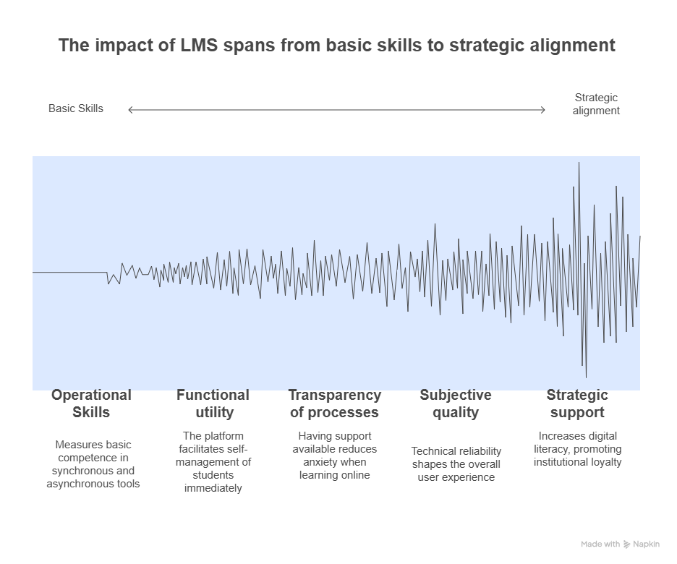
Figure 12 - Model of students' perception of digital educational platforms: from basic skills to strategic alignment

The analysis highlighted four stable student behavior profiles, differing in LMS satisfaction level, digital strategies and behavioral characteristics. Below are the typical paths (tree branches) and the interpretation of the corresponding profiles (Table 3).
1. «Digital-Pro» (Digital professional)
This profile unites students with high digital confidence and functional autonomy. Main characteristics:
1.1 High scores of self-organization through LMS (4 on the Likert scale),
1.2 a strong sense of confidence in using all key digital tools,
1.2 a clear understanding of how to obtain technical support.
These students show the highest probability of satisfaction using LMS - 87%, which allows them to be considered as «digital mature» category. They tend to actively use LMS not only for information but also for self-organization, tracking progress and interacting with the academic environment.
2. «Strategist-optimist»
Representatives of this segment assess the institutional efforts in digitalization positively and link digital transformation with the growth of their own digital literacy. However:
- their confidence in specific tools (e.g., Teams, Zoom, Microsoft 365) remains at an average level (around 3 ratings),
- There is a lack of depth of practical skills with the general support of the digital vector of the university.
The LMS satisfaction rate in this group is 73%, indicating a potentially positive but not yet fully realized digital inclusion. For them, strategic support and the appearance of institutional progress are important.
3. «Functional skeptic»
This profile shows contradictory behavioral characteristics:
- Slightly subjective assessment of the impact of LMS on
self-organization (3),
- Good video server skills (Zoom, Teams - 4),
- Lack of confidence in receiving support (grade 2).
Despite having technical skills, the overall satisfaction with LMS in this group is low - 38%. This points to the gap between functional tool ownership and trust in an educational ecosystem.
4. «Technically excluded»
Most vulnerable group characterized by:
- low confidence in digital instruments (2),
- Rarely used by Microsoft 365,
- Perception of the digital environment as opaque and non-informative.
This profile demonstrates a minimum LMS satisfaction level of 12%, which indicates the risk of digital isolation and the need for targeted support from the university. The decision tree allowed not only quantitative classification of respondents, but also qualitative interpretation of differences in their behavioral strategies.

Table 23 - Student profiles and LMS satisfaction
№ | Profile | Behavioral trajectory characteristics | LMS satisfaction
1 | Digital-Pro | High level of self-organization through LMS (grade 4); high confidence in all digital tools; awareness of support mechanisms. | 87 %
2 | Strategist-optimist | Positive assessment of the development of the digital environment at the university (rating 4); perception of the growth of their own digital literacy; average confidence in using tools. | 73 %
3 | Functional skeptic | Low subjective influence of LMS on self-organization (grade 3); high confidence in Zoom/Teams; insufficient awareness of technical support capabilities. | 38 %
4 | Technically excluded | Low confidence in digital tools (score 2); rare use of Microsoft 365; perception of the digital environment as opaque and difficult to access. | 12 %
Note – compiled by the author from primary sources

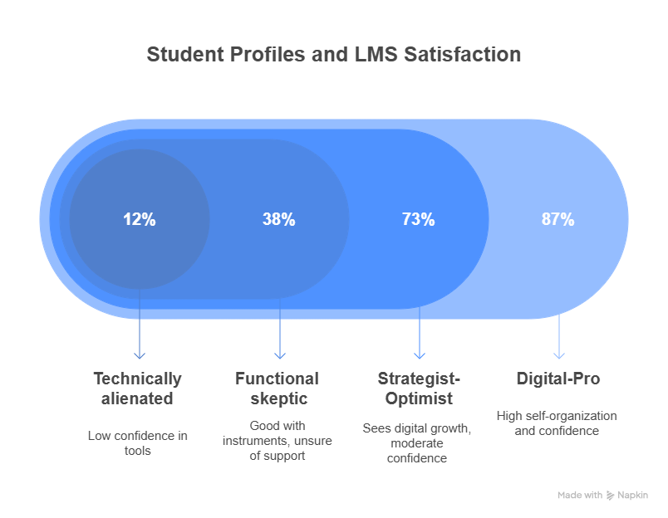
Figure 13 - Student profiles and LMS satisfaction

Note – compiled by the author

Figure 9 illustrates the gradation of these profiles on the LMS satisfaction scale and highlights the evolution from digital isolation to full digital integration. In addition, a strategic model for the transition from uninvolved to engaged users was developed to analyze ways of increasing students' involvement in the digital environment (Figure 13). This model focuses on the institutional conditions needed to enhance digital maturity:
1. Prioritization of LMS as an element of strategic development of the university. Clear institutional commitment contributes to the formation of trust and perception of platforms in students as an important component of the educational process.
2. Guaranteed support - the availability of accessible and understandable help mechanisms (technical, methodological, informational) plays a key role in the formation of digital confidence.
3. Building sustainable participation through skills enhancement, positive user experience and institutional recognition of digital activity.
Thus, Figure 14 conceptualizes the transition from a state of digital alienation to an informed, supported digital participation reflected both in students' academic activity and their overall satisfaction with the educational environment.
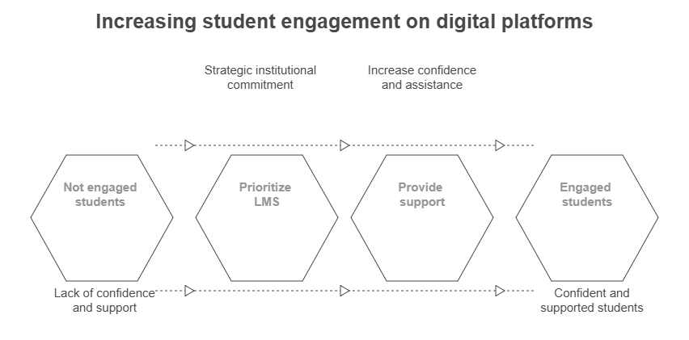
Figure 14 - Increasing student engagement on digital platforms

Note – compiled by the author

The study revealed an important feature of digital behavior of students: a key factor of satisfaction using educational platforms is not the level of technical training, but the subjective perception of the usefulness of LMS in the context of self-organization, transparency of the educational process and accessibility of institutional support. That is, the perception of a platform as a functional, supportive and predictable element of an educational environment has a more significant impact on users' commitment than the presence or absence of basic digital skills. It has also been found that the strategic positioning of digital platforms in institutional policy of the university significantly affects the level of trust and satisfaction of students. Respondents who showed a high degree of agreement with the statement about the priority of digital transformation at the university also showed higher ratings of LMS satisfaction and perceived the platform as an integral component of the academic environment. This highlights the need for proactive digital communication and leadership on the part of the administration, as well as the importance of forming a holistic digital culture within the university.
Along with positive user profiles, a group of students in the digital vulnerability zone was also identified. The so-called «technically excluded» profile covers about 12-15% of the sample and is characterized by a low level of confidence in the use of digital tools, poor perception of availability of support and general distance from the digital environment. Despite having formal access to platforms, the members of this group show signs of digital isolation, which is associated with an increased risk of academic fragmentation. This indicates the need to develop targeted digital inclusion strategies that focus on increasing confidence, improving accompaniment and reducing barriers in interaction with educational platforms. The results of the study suggest that the effectiveness of the digital environment is determined not so much by the technical parameters of the platforms, but rather by the quality of the user experience and the institutional environment in which digital learning takes place.
As part of the second phase of the study, a correlation analysis was carried out in order to identify stable relationships between different aspects of students' perception of digital educational platforms. The analysis used data obtained from 38 Lyckert scales (ranging from 1 to 5 points) covering key parameters of students' interaction with digital platforms.
The correlation coefficient of Stirman (ρ) was calculated for all possible pairs of variables (n = 703), which allowed to determine both positive and negative relationships between students' evaluation judgements. To improve the interpretation of the results, a Bonferroni correction was applied, with the significance threshold being:
|ρ| 0.30, p < 0.01. The results of the analysis allowed to highlight the most significant positive and negative correlations (see Table 24), reflecting key interdependencies in the structure of digital experience of students:

Table 24 - Top-5 positive and negative correlations

№ | Pair of variables | ρ | Interpretation
+1 | «LMS facilitates self-organization» х «LMS increases digital literacy» | +0,63 | The more a student feels organizational benefit, the more they value digital skills development.
+2 | «Platform makes process transparent» х «I trust the results of automatic evaluation» | +0,57 | Transparency enhances the credibility of algorithmic evaluation.
+3 | «Confident in Zoom/Teams» х «I use Microsoft 365 a lot» | +0,49 | The cluster of «operational» skills is formed: synchronous and office tools are mastered together.
Continuation of the table 24
№ | Pair of variables | ρ | Interpretation
+4 | «There is access to reference materials 24/7» х «The university is actively developing the digital environment» | +0,46 | Institutional support is directly related to the perception of resource availability.
+5 | «I know where to go for help» х «Support responds quickly» | +0,45 | Cognitive and actual support move in sync.
−1 | «Feel overwhelmed by the number of platforms» x «LMS facilitates self-organization» | –0,44 | The higher the platform «noise», the lower the feeling of use LMS.
−2 | «Platform often fails» x «I trust the results of automatic evaluation» | –0,41 | Technical instability undermines the credibility of any digital function.
−3 | «I would prefer paper tasks» x «Experience with LMS increases digital literacy» | –0,38 | Traditional approach hinders the development of digital competences.
−4 | «Experiencing difficulties with mobile version» x «Access 24/7» | –0,34 | Poor mobile optimization negates the effect «always available».
−5 | «No sense in the course forum» x «LMS increases engagement» | –0,32 | Negating interactive elements reduces engagement.
Note – compiled by the author

For a visual representation of the correlations, a heat map was built, where:
(1) The color scale varies from dark red (ρ > +0.6) to dark blue (ρ < 0.6),
(2) White color indicates absence of correlation (ρ 0).

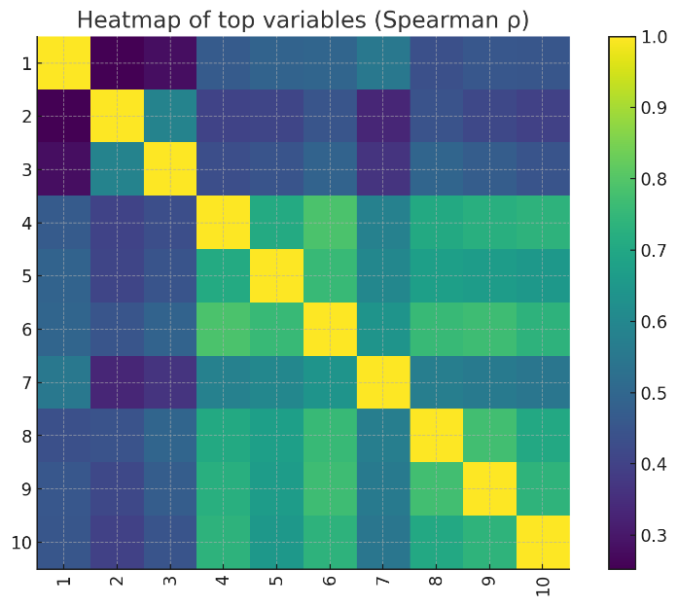
Figure 15 - Correlation heat map

Note – compiled by the author

Two dominant clusters were identified:
1. Value-cluster: includes the relationship between perceived platform utility, transparency process and trust in digital functions.
2. Ops-cluster: groups technical skills, access to materials, tool confidence and quality of support.
The «blue corridors» - areas of negative correlations, especially regarding platform overload and technical malfunctions, were also recorded. The analysis showed a high correlation between subjective perception of LMS use and digital maturity level of students. Improving one of the components of a cluster (for example, support quality) can positively affect related parameters such as system trust, engagement and satisfaction.
Particular attention should be paid to the following conclusions:
- The overload and fragmentation of digital systems significantly undermine the perception of LMS use and require unifying interfaces, consolidating functions.
- Mobile optimization is a critical barrier: negative experiences with smartphones and tablets drastically reduce the perception of accessibility.
- Technical stability and support are the most important mediators of digital confidence and inclusion.
- The formation of clusters of users by operational skills points to the possibility of personalized support and training.
Results of correlation analysis allowed to clarify the logical and behavioral interrelations in the experience of digital interaction of students, as well as to determine priority directions for further optimization of digital educational environment in universities of Kazakhstan.
At this stage of the study, a behavioral segmentation of respondents was carried out in order to identify stable groups of students, differing in their level of digital inclusion, satisfaction with platforms and academic-demographic characteristics. To realize this task, analysis tools were used in the MATLAB software environment, which made it possible to structure the sample by a set of key indicators, including mean values of satisfaction (Means), norms of deviation (Norms), integral digital footprint (Trace), as well as the cumulative indicators of behavioral evaluation (Means II).
The segmentation approach has ensured the construction of profiles of users of the digital educational environment, which in turn allows to move from generalized interpretation to personalized strategies of digital accompaniment and improvement of students' interaction with platforms.
- Trace and Means drop by 56% from segment A to E - the "digital divide" index.
- Norms confirm: the Digital-Pro has positive settings >4.4/5, and the Low-Touch - <2/5.
Key profiles:
- Digital-Pro (26% of the sample): female, younger to middle age, IT/int. program. Need flexible but advanced tools (API, Git integration).
- Tech-Sceptic (14%): senior undergraduates/ post-graduate students of social sciences; prefer traditional forms, do not tolerate «platform noise». Requires «soft migration» + individual consultations.

Table 25 - MATLAB-analysis (segmentation)
Segment | Gender | Age | Direction | Level | Trace | Means | Norms | Means II
A. Digital-Pro | ♀ | 20–24 | IT/Engineering | Bachelor | 491 | 4,57 | 4,42 | 29,8
B. Strategist-Optimist | ♀ | 25–34 | Management/Economics | Master’s degree | 438 | 4,12 | 3,96 | 27,1
C. Mixed-Adopter | ♂ | 18–19 | Humanities | Bachelor | 372 | 3,48 | 3,33 | 24,5
D. Tech-Sceptic | ♂ | 35+ | Social Science | Master’s degree/PhD | 267 | 2,51 | 2,36 | 18,7
E. Low-Touch | ♀ | 18–19 | Medicine | Bachelor | 214 | 2,06 | 1,88 | 17,3
Note – compiled by the author

At this stage, the study was conducted to test statistical hypotheses in order to identify significant differences in the level of satisfaction with digital educational platforms depending on the socio-demographic and academic characteristics of students. The analysis method used was the Kraskel-Wallis criterion (Kruskal-Wallis H-test), which is a non-parametric analog of single-factor dispersion analysis (ANOVA) and can be applied in the absence of normal data distribution. Using this criterion, it was possible to determine whether variables such as age, gender, field of training, level of education and experience of interaction with LMS have a statistically significant influence on the assessment of the digital educational environment. The obtained values of H-statistics and significance levels (p-value) allowed to formulate conclusions about the existence or absence of differences between the compared groups, which is important for further substantiation of target strategies of digital transformation in universities.

Table 26 - Testing the hypotheses (Kruskal-Wallis)
№ | Hypothesis | H-stat. | p-value | Conclusion
H1 | Age affects satisfaction with the LMS | 18.4 | 0.0001 | Confirmed
H2 | Gender affects satisfaction | 2.3 | 0.129 | Not confirmed
H3 | Field of study affects satisfaction | 25.7 | 0.0000 | Confirmed
H4 | Level of education (Bachelor’s/Master’s) affects satisfaction | 7.9 | 0.019 | Confirmed
H5 | ≥2 years of LMS experience is associated with higher satisfaction | 14.2 | 0.0002 | Confirmed
H6 | The main research hypothesis – comprehensive ICT implementation improves quality management efficacy | – | p < 0.001* | Confirmed
Note - The «before/after» model was built on 12 universities-early LMS-adoptists (n = 814 students). Median difference of «satisfied + fully agreed» = +18.6 p.p., H = 10.2.

The final stage of the study is aimed at systematizing the results, formulating key conclusions and developing practice-oriented recommendations for optimizing the digital educational environment in universities. Based on a comprehensive data analysis, including classification, segmentation, correlation and statistical testing methods, the strengths and weaknesses of current digital infrastructure were identified, as well as key determinants of student satisfaction.
The conclusions reached allowed to substantiate priority directions of digital transformation, and the proposed recommendations are oriented on managerial and technological improvement of quality of digital communication. Special attention is given to the strategic positioning of LMS in institutional policy, increasing digital inclusion and developing personalized forms of support for students in a digital vulnerability zone.
5.1 Strengths of the current digital system
1. High organizational value of LMS (ρ=+0.63) - students see it as a self-management tool.
2. Formed cluster of digital skills (Zoom + M365) - basis for further digital transformation.
3. Strategic support from the part of universities is already felt (Gini #2).
5.2 Weaknesses
1. Platform overload (ρ=-0.44) is a fragmented ecosystem.
2. Technical instability and mobile disruptions undermine confidence.
3. Digital gap: 15% of students remain «Low-Touch».

Table 27 - 5.3 Practical activities for universities of Kazakhstan
Direction | Specific measures | KPI/term
1. Systems approach to LMS | - Approve the single digital core (LMS + SSO). - Introduce the regulation «1 course - 1 LMS-space». | The proportion of disciplines in a single LMS > 90% (2026).
2. Integration into international e-learning | - Sign LTI gateway with Coursera/edX for co-branded MOOC.- Create English-language course templates. | 50 joint MOOCs, 5 foreign partners (2027).
3. Growth of ICT competence | - Compulsory micro-course «Digital Teaching/Studying Skills» (1 ECTS) for all freshmen and young teachers. - DigCompEdu B2+ Certificate for the instructor = basic KPI. | 70 % of the B2+ (2026) limit.
4. Digital motivation and analysis | - Implement KPI & Workload Analytics (Moodle + Power BI). - Transparent communication «activity bonus». | Reflection of KPI in the personal office, Prep. engagement index + 15% (2025).
5. Bridging the gap | - Create «Digital Buddy-center» (student-trainer). - Mobile version of LMS - priority sprint. | Low-touch ratio reduced to <5% (2026).

5.4 Control of performance
  - Quarterly Dashboard: satisfaction (Trace), % LMS availability, average speed of response of technical support, share of courses with LTI-content.
  - Annual Review: recalculation of the median of the final rating of disciplines «digital block» vs pre-digital analogues, analysis of correlation KPI of teachers with students' success.

Table 27 - Key result
Key result | Meaning
The main predictor of satisfaction is the feeling that «LMS allows to effectively self-organize and track progress» (Gini 0.59). | Students value above all functional use.
Cluster «value + transparency» gives correlation ρ 0.82. | The more understandable the process and functions, the higher the confidence.
Platform «noise» (too many different services) ↔ negative impact (ρ -0.44) to the benefit of LMS. | Ecosystem consolidation - priority 1.

Main interim conclusions
1. Leaders on Trace - men 20-28 years and women 29+ in engineering/ ICT programs (bachelor’s degree). Their average Likert scores 4.8-5.0.
2. The relevant factor is the field of training (H = 150, p < 10 3): engineering/ICT students’ rate LMS much higher than humanists.
3. Gender and age (in the current slice) do not give a statistically significant difference in satisfaction, and the level of «tank/mag/PhD» affects moderately (p 0.02).
The analysis of iPortal platform introduction and use in educational process, it is possible to state with confidence its significant influence on improvement of efficiency of management of quality of education in higher education institutions of Kazakhstan, This is reflected not only in the optimization of administrative procedures, but also in the significant improvement of communication between all participants in the educational process, as well as in the expansion of access to educational resources, which is an important factor for improving the quality of education. The iPortal platform contributes to the speed and transparency of educational management processes, providing timely access to relevant information and analytical data necessary for informed management decisions, This allows to react quickly to changes in the educational environment and adapt the learning process to the needs of students and labor market requirements.
Table 28 - Results
Block | Action | Key artifacts
Segmentation (MATLAB-logic) | Groups are formed by sex, age ranges, direction of training and level of education. | Segment metrics (top 12 by Trace) is an interactive table.
Kruskal-Wallis | For each group, the metrics Trace, Means, Norms, Means II and sample size (N) are calculated. | Horizontal bar-chart «Top demographic segments of Trace».

The results of the analysis confirm that the integrated implementation of digital educational technologies and information and communication platforms such as iPortal contributes to improving the effectiveness of quality management in higher education, this is fully consistent with the research hypothesis. Given the positive experience of using iPortal and other digital solutions in Kazakhstan’s universities, further research may be directed to develop and implement a conceptual model of digital transformation of education quality management system, taking into account the specifics of the Kazakh higher education system, as well as the integration of advanced international practices in the field of digitalization of education, which will create an integrated and adaptive system, able to ensure sustainable development and increase the competitiveness of Kazakh universities on the international scene.
In sum, the effectiveness of digital transformation in quality management depends less on platform availability than on their purposeful integration into academic and managerial workflows. Decision-tree and correlation results show that perceived support for self-regulation and progress tracking is the primary driver of student satisfaction, reinforced by institutional commitment and gains in digital literacy, whereas platform fragmentation and weak mobile performance erode trust. Segmentation reveals heterogeneous “digital maturities,” calling for targeted measures, consolidation around a single LMS+SSO core, mobile-first optimisation, micro-courses in digital skills, peer support, and transparent analytics. Non-parametric tests confirm the roles of program area, study level, and prior LMS experience (with no gender effect). These findings support the hypothesis that integrated platforms such as iPortal enhance manageability, transparency, and decision timeliness; the next subsection details iPortal’s architecture, data flows, and implementation metrics.

3 Development of a strategy for the digital modernisation of quality management in higher education institutions in Kazakhstan
3.1 Mechanisms for digitalization of quality management in universities of Kazakhstan

The transition from fragmentary implementation of digital solutions to the formation of a holistic system of digital quality management characterizes the current stage of higher education development in Kazakhstan. In the context of an increasingly complex external educational environment and growing demands for academic transparency, there is an increasing need for a systemic analysis of existing digital mechanisms that ensure the sustainability and reproducibility of quality assessment and improvement processes. Digitalization of quality management in Kazakhstan universities is due to internal requirements for academic effectiveness and external challenges associated with integrating into the global educational space. In this context, digital mechanisms act not only as tools for automating assessment and control procedures but also as elements of a systemic increase in the educational environment's transparency, accountability and adaptability.
An analysis of current practices shows that some leading universities in Kazakhstan have created the prerequisites for institutionalized digital transformation. For example, the L.N. Gumilyov Eurasian National University uses BI analytics to monitor academic performance, and the Platonus LMS is integrated into the internal quality control system. Al-Farabi Kazakh National University has implemented digital portfolios and analytical modules based on Moodle, which allows for the formation of individual educational trajectories. Nazarbayev University demonstrates the highest degree of maturity: learning analytics is actively used, and blockchain technologies are used to confirm educational achievements. These cases indicate the formation of a strategic logic of digitalization. At the same time, most regional universities operate at the level of local initiatives without a holistic quality management architecture and the integration of digital tools into the management ecosystem.
Despite the positive dynamics, digital transformation in most universities remains limited and unsystematic. The introduction of individual platforms is often not accompanied by their methodological linkage with management cycles and is not supported by human and regulatory resources. The lack of an end-to-end digital architecture limits the potential of analytical tools and reduces the reproducibility of management decisions. In this regard, the relevance of a comprehensive study of digital quality assurance mechanisms, their interrelations and conditions for effective implementation increases. Such an analysis allows us to formulate unified principles and approaches to designing a digital quality management ecosystem in universities in Kazakhstan.
This section focuses on the applied logic of digitalization of quality management, emphasizing specific institutional and technological mechanisms integrated into the management architecture of universities. Three complementary approaches are considered as a methodological basis: systemic - identifying the relationship between various digital components of the university environment; process - ensuring cyclicality and continuity of management (PDCA model); and mature - focused on self-assessment and strategic planning of digital transformation.
The analysis compares the national context with international approaches, with priority given to internal institutional mechanisms and real management practices. The key elements of the digital quality management architecture include information and analytical systems, LMS platforms, digital portfolios, monitoring and forecasting systems, as well as artificial intelligence tools and blockchain solutions. Particular attention is paid to the tools themselves and the logic of their integration and mutual reinforcement. This approach allows the inventory of digital resources and the building of an analytically sound model of the digital quality infrastructure capable of adaptation and sustainable reproduction.
The use of the EDUCAUSE model allows for the classification of key domains of digital transformation (infrastructure, leadership, analytics, culture) and conducting an audit of the maturity of the digital environment [139]. In the context of Kazakhstani universities, this model is relevant for identifying structural and functional deficiencies, particularly in the ​​strategic implementation of analytical platforms. The model provides an opportunity to assess the level of integration of digital analytics into the quality management process, the degree of digital maturity of management teams and the formation of a sustainable digital culture. The applied tools include maturity self-assessment questionnaires, digital resource maps, role matrices and digital competencies used for institutional planning and personnel diagnostics.
The Gartner Digital Maturity Model formalizes the stages of digital transformation, from local initiatives to full institutionalization of solutions [140]. In Kazakhstan, it is applicable to build step-by-step digitalization roadmaps that clearly define the phases from unconscious digitalization to systemic integration of digital solutions into the university development strategy. This model allows for a gap analysis of the current state of digitalization, identifying priority growth areas (e.g. automation of monitoring processes, implementation of predictive analytics) and selecting tools following the target maturity level.
The JISC Digital Capabilities model allows for assessing the level of readiness of teachers and students to work in the digital environment and serves as a basis for designing advanced training programs under international standards (e.g. DigCompEdu) [141]. This model is helpful for auditing the digital literacy of staff, designing individual trajectories for developing digital competencies, implementing modules on digital pedagogy, and systematically assessing progress in the transformation of teaching practices. In the context of the Kazakhstani education system, where staff stability and the level of digital inclusion are still associated with several institutional limitations, such an approach can serve as a regulatory mechanism that promotes the balanced implementation of innovative technologies through targeted improvement of the digital readiness of the teaching staff.
Thus, international maturity models serve as an analytical basis for internal institutional audit and strategic digitalization planning. Their application allows universities in Kazakhstan to conduct comprehensive diagnostics, identify “digital gaps”, form digital transformation benchmarks and integrate digital solutions into strategic documents and regulations. However, these models themselves do not provide an answer to the question of how specific mechanisms function within the management system. For this purpose, this study proposes an additional framework – a three-loop model of digitalization of quality management.
The three-loop model allows structuring digital mechanisms by management levels: from data collection and recording (loop 1) through analysis and interpretation (loop 2) to the use and verification of information (loop 3). The visualization of the model is shown in Figure 16, which emphasizes the systemic logic of the functioning of digital tools and reveals the functional load of each level.
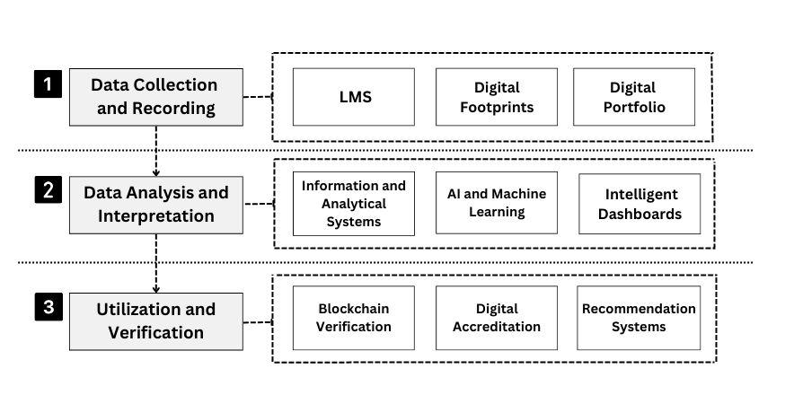
Figure 16 – Three-loop system of digitalization of education quality

Note – compiled by the author

The key mechanisms included in the three loops are discussed below, indicating their objectives, institutional significance and interrelations within the digital quality management ecosystem.
Contour 1: Collection and recording of educational data. The primary level of digitalization focuses on mechanisms that ensure regular and structured data collection on the educational process's progress. Their primary purpose is to generate a representative information base that serves as the basis for subsequent analysis and decision-making:
- Learning Management Systems (LMS) function as the leading digital platforms that record the entire spectrum of learning activity: registration, assignment completion, attendance, feedback, and interaction with learning content. These systems provide a standardized data format suitable for automated processing.
- Digital portfolios are a means of accumulating and verifying students' individual educational achievements, including academic results, research, projects and extracurricular activities, forming a complete digital trajectory of the student.
- Analysis of digital footprints is carried out by recording metadata related to user behavior in the digital educational environment - time of activity, interface transitions, duration of involvement and frequency of access to educational resources.
These mechanisms are the foundation for constructing subsequent analytical and management levels, forming a structured and reproducible array of digital data.
Circuit 2: Data Analysis and Interpretation. The second level implements technologies to transform raw data into meaningful management indicators. The purpose of this circuit is to identify patterns, risks and deviations based on which corrective actions can be developed; the following mechanisms are used here:
- Information and analytical systems (BI platforms) integrate data from LMS, digital portfolios, survey systems and other sources. They aggregate, visualize and build comprehensive KPI reports that serve as a tool for making strategic decisions.
- Artificial intelligence and machine learning systems enable predictive analytics, from predicting the risk of academic expulsion to automated classification of students by learning styles and engagement levels.
- Intelligent dashboards serve as a visual interface for quality management. They display data across organizational units (department, faculty, and university as a whole), allowing the identification of educational bottlenecks and initiating real-time management responses.
Thus, the second circuit provides analytical reporting and the institutional interpretation of digital data necessary for operational and strategic quality management.
Circuit 3: Use and verification of data. The final circuit is aimed at the practical application of analytical results and the implementation of procedures for external and internal quality verification. The mechanisms of this level ensure the formalization, recognition and adaptation of educational results, including:
- Blockchain solutions provide a technological opportunity for secure storage and verification of learning outcomes. Due to the properties of immutability and transparency, they are used to record diplomas, certificates, and micro-certification modules, increasing trust from external stakeholders.
- Digital accreditation platforms automate the processes of submitting self-assessment reports, conducting remote expert visits and processing the evidence base, which significantly increases the transparency and efficiency of external quality control procedures.
- Recommender systems based on machine learning algorithms create personalized learning paths, selecting disciplines, modules and electives, taking into account predictive models of student success, preferences and academic progress.
Contour 3 completes the management cycle by generating informed feedback and creating conditions for sustainable improvement in the quality of educational outcomes.
The coordinated functioning of the three contours allows us to consider the digital infrastructure of quality management as an integrated system, where each mechanism plays a specific role in ensuring the reliability, analytical nature and effectiveness of management decisions. As we move from collecting and recording data to interpreting and applying it, a closed logic of the digital cycle is formed, ensuring horizontal integration of processes and vertical alignment of management levels. In such a configuration, digital mechanisms acquire not just an instrumental but an institutional character, becoming the basis for the transformation of academic management in the context of a sustainable increase in requirements for the quality of education.
In addition to the three-loop model describing the digital infrastructure's architecture, this section applies the PDCA (Plan–Do–Check–Act) model, which allows for the dynamic logic of the functioning of digital mechanisms to be revealed. While the three-loop system records the structural placement of tools, the PDCA model demonstrates their process role in the quality management cycle. This combination provides a complete understanding of how digital technologies form a sustainable, adaptive and reproducible quality assurance system in universities.
In the context of the digital transformation of the higher education system, quality management acquires new methodological content, forming a flexible and adaptive architecture based on a continuous improvement cycle. One of the most universal and, at the same time, operationalized models that allow structuring digital quality management processes is the PDCA (Plan-Do-Check-Act) model, widely used in the international practice of management and regulation of educational activities (in particular, in ISO 21001 and ISO 9001 standards) [142,143]. Using this model in the context of digitalization allows not only the structure of quality assurance actions but also the institutionalization of the analytical logic of management, in which each management decision is based on current, full-format, and reproducible data.
In the digital context, the PDCA model demonstrates special properties, such as high sensitivity to changes in the internal and external environment parameters, scalability of solutions, the ability to configure operational feedback and integrate behavioral analytics. This makes it possible to move from an administratively regulated quality control model to a predictive and adaptive management format based on data-informed and evidence-based solutions.
In this logic, quality management is not a formalized assessment process but a continuous, self-renewing system capable of institutional learning and strategic self-adjustment.
The quality assurance cycle based on the PDCA model, shown in Figure 17, illustrates the logical sequence of management actions and corresponding digital mechanisms that ensure the closure and adaptability of the management system in the context of digital transformation.

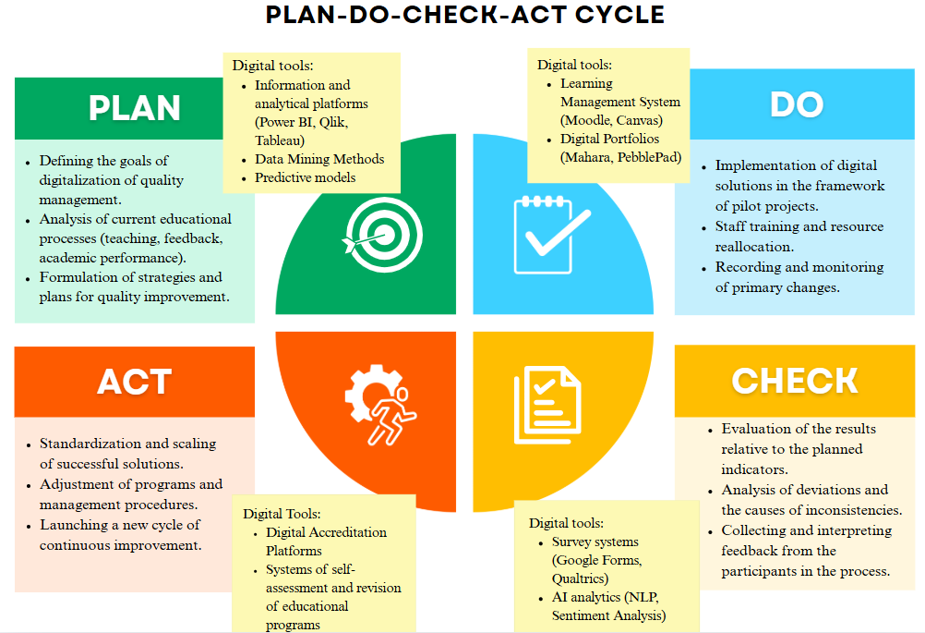

Figure 17 – Digital cycle of quality assurance in education based on the PDCA model
Note – compiled by the author

Each of the PDCA phases, implemented in a digital environment, is filled with specific digital mechanisms, each of which provides a critical function in the context of educational management:
- Planning (Plan)
At this stage, goals are set, strategic benchmarks are formed, and quality parameters are determined. In the digital paradigm, this is achieved through the integration of information and analytical systems (BI platforms: Power BI, Tableau), intelligent dashboards, predictive analytics, and machine learning models that allow early identification of potential risks, scenario forecasts, and the area of ​​possible deviations. Analysis of digital traces aggregated from LMS and portfolios enables modeling of learners’ behavioral patterns, which are used to build goals and priorities for educational programs. Thus, the planning stage in the digital context relies not on expert judgments but on multidimensional data, increasing the accuracy of strategic decisions.
- Implementation (Do)
This phase covers operational activities for the implementation of educational programs, in which Learning Management Systems (Moodle, Canvas, Blackboard), digital portfolios, adaptive educational platforms (Smart Sparrow, Knewton, ALEKS), as well as mobile applications that provide access to personalized educational services play a key role. These tools ensure the recording of students' activity, support for flexible learning formats, the construction of individual trajectories and timely communication with all subjects of the educational process. Digital recording at this stage not only provides a registration effect but also creates a basis for further monitoring and interpretation of the quality of implementation.
(3) Check (Check)
Operational data is transformed into management-relevant information at the monitoring and evaluation stage. The main digital tools are automated survey systems, sentiment and open text analysis tools (NLP, sentiment analysis), early warning systems and analytical dashboards that allow real-time identification of problem areas, tracking key performance indicators, satisfaction and engagement. These tools perform the critical verification function - not only of formal but also of hidden quality indicators, including decreased motivation, academic risks and changes in behavioral patterns. The Check stage becomes a zone for transforming arrays of digital traces into interpretable indicators that require management response.
- Adjustment (Act)
The final phase closes the cycle and initiates corrective actions to change programs, educational strategies, and personnel decisions. In the digital version, blockchain solutions (for verification and certification of educational achievements), virtual accreditation platforms, personnel quality management systems, recommendation algorithms, and micro-certification tools are linked to this phase. Here, quality management takes on the character of a dynamic and targeted intervention, implemented not based on scheduled inspections but in response to deviations recorded by analytics. Thus, Acting in the digital context is not so much the completion of a cycle as its renewal in a new iteration, with a higher degree of personalization and strategic precision.
The presented interpretation of the PDCA model in the digital environment allows us to consider quality management not as an administrative function, but as an end-to-end, analytically sound system in which each element of the infrastructure plays a functionally complete role. This approach creates an institutional culture of continuous improvement, increases the responsiveness and sustainability of the educational system, and ensures the reproducibility of quality standards oriented towards international criteria. Thus, the three-loop model structures digital mechanisms by data levels, and the PDCA model – by management cycle phases. Their integration ensures both process reproducibility and architectural synchronicity, creating conditions for forming a mature digital quality ecosystem.
The approach to education quality management based on the digital interpretation of the PDCA model requires not only cyclical organizational logic, but also clear functional content of each stage of management of the corresponding digital mechanisms. In this regard, the systemic classification of digitalization tools is of particular importance, which allows us to correlate the purpose, methodological grounds and limitations of the solutions used with the stages of the PDCA cycle. This typology provides an analytical link between the architecture of the digital environment and management actions, allowing us to implement the principles of data-informed governance.
Table 29 presents an expanded classification of key digitalization mechanisms, structured by functional purpose, type of processed data, methodological approaches and location within the PDCA cycle.

Table 29 – Classification of digital mechanisms by PDCA stages and methodological approaches in the context of higher education
Digitalization mechanism | Purpose | Examples of tools | Stage PDCA | Methodological binding | Data type | Potential limitations
BI platforms | Visualization, KPI monitoring, dashboards | Power BI, Tableau, Qlik Sense | Check | Systemic, mature | Quantitative, aggregated | Requires clean and consistent data
LMS | Accounting for educational activity and achievements | Moodle, Canvas, Blackboard | Do | Process | Behavioral, operational | Superficial use, limited student engagement
Digital portfolios | Formation of a multidimensional competency profile | Mahara, PebblePad | Do / Check | Process | Individual, project | Lack of comprehensiveness, student motivation
Artificial Intelligence / ML | Predictive analytics, behavior modeling | IBM Watson, Scikit-Learn | Check / Act | Systemic | Behavioral, predictive | Algorithmic bias, need for model validation
Automated Surveys | Analysis of satisfaction and feedback | Qualtrics, Google Forms | Check | Process | Qualitative, subjective | Low engagement, risk of data distortion
Blockchain and Digital Accreditation | Protection, authenticity of educational documents | Hyperledger, OpenCerts | Act | Mature | Metadata, legally significant | High cost, regulatory uncertainty
Early Warning Systems | Forecast of expulsions and academic risks | Custom algorithms in BI | Check | Systemic | Complex, cross-segment | Lack of trained models, human resources
Digital Footprint Analysis | Behavior diagnostics, personalization | xAPI, OpenLAP, Learning Locker | Plan / Check | Process | Navigational, behavioral | Ethical risks, difficulties in interpretation
Note – compiled by the author

The proposed scheme allows the inventory of existing tools and their critical assessment from the standpoint of applicability, institutional maturity, and potential limitations in the context of the Kazakhstani higher education system. The classification presented in the table demonstrates the diversity of digital mechanisms integrated into various stages of the PDCA cycle. It emphasizes their functional differentiation within the institutional quality management architecture. For example, BI platforms and intelligent analytical systems play a key role at the Check stage, providing visualization of key performance indicators, data aggregation, and the formation of strategic reporting. At the same time, tools such as LMS and digital portfolios are mainly used at the Do stage, providing operational control over the implementation of the educational process and the accumulation of individual student data. The methodological linkage of each mechanism allows it to be clearly correlated with a particular management approach (systemic, process, maturity), which is essential for choosing strategies for the digital transformation of a university.
In addition, the table allows identifying typical limitations of the implementation of each mechanism, both technical and institutional. Thus, the use of AI and predictive analytics is associated with the risks of algorithmic bias and requires high-level validation of models. At the same time, the level of respondent engagement and possible distortions in the interpretation of qualitative data limit the use of digital surveys. In turn, blockchain and digital accreditation technologies have a high potential for ensuring trust and transparency but face regulatory uncertainty and the need for significant financial resources. Thus, the presented analytical tools not only form the basis for digital quality management but also require adaptation, considering the maturity of the organizational environment, personnel readiness and the specifics of the national regulatory framework.
Given the above limitations and the need for contextual adaptation of digital solutions, it seems appropriate to structure the existing mechanisms in the form of functionally interconnected subsystems. Such structuring allows for a more precise definition of the area of ​​responsibility of each tool, the increased coherence of the digital quality management architecture, and the construction of a holistic institutional model that meets the principles of a systems approach. In this regard, digital quality management mechanisms in universities can be classified as in Figure 18.

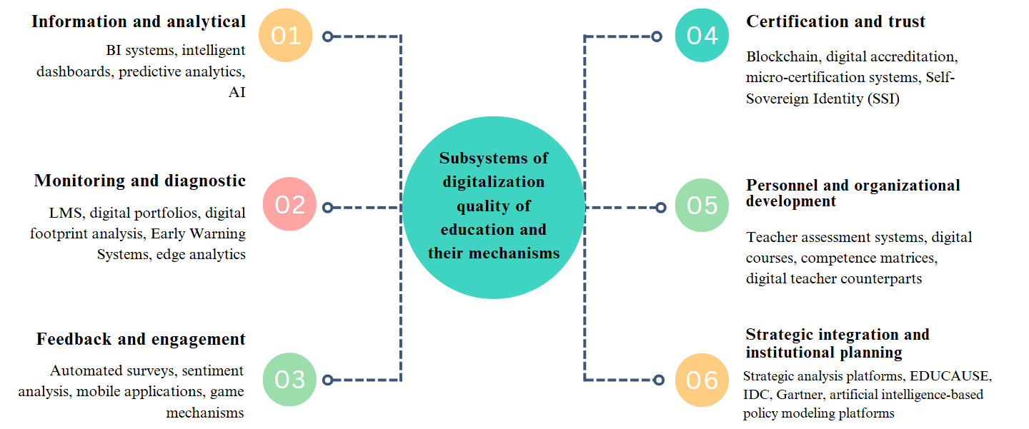

Figure 18 – Architecture of digitalization subsystems of education quality and their tools
Note – compiled by the author
In the context of the digital transformation of the education quality management system, forming a functionally coordinated architecture requires a clear distinction and, at the same time, coordination of the roles of various subsystems. Using a systems approach allows for structuring digital mechanisms by functional affiliation and degree of involvement in the management cycle. As a result, a holistic model is formed, where each subsystem performs a specialized role but is simultaneously integrated into the end-to-end logic of digital management.
The information and analytical subsystem is the core of the digital architecture, transforming heterogeneous primary data into meaningful management indicators. BI platforms, intelligent monitoring panels, AI-based cognitive services, as well as predictive algorithms that perform the functions of analytical modules and provide visualization of key performance indicators, construction of scenario forecasts and early risk detection are used as support mechanisms. Integration of solutions capable of processing unstructured data (video, speech, text) significantly expands the range of interpretation of behavioral patterns of students, which is of particular importance in the context of the development of personalized management of the educational process [144,145].
The monitoring and diagnostic subsystem, which forms the primary information base of digital management, operates closely with the information and analytical circuit. Data collection and aggregation is carried out through LMS, digital portfolios and digital trace analysis systems, including edge analytics, which ensures information processing directly on user devices. Such architecture increases the speed of feedback, reduces the load on computing power and ensures representativeness in displaying the educational activity and behavioral trajectories of students. Data passed through analytical filters becomes the basis for management interpretation, which ensures the transition from simple recording of information to the assessment and forecasting of academic processes [146].
The feedback and engagement subsystem strengthens the feedback loop, ensuring constant communication between students and administrative structures. Based on sentiment analysis tools, automated surveys, gamified environments and mobile platforms, it identifies areas of satisfaction and dissatisfaction, allowing us to record not only quantitative but also qualitative indicators. The involvement of game mechanics, ratings and personalized feedback forms a motivational architecture of interaction that promotes increased academic engagement and constructive participation of students in quality management.
Digital verification of educational achievements is implemented through the certification and trust subsystem, where blockchain technologies, digital accreditation platforms and Self-Sovereign Identity (SSI)-based solutions are of particular importance. The latter allow building autonomous and secure mechanisms for identification and confirmation of achievements without the participation of centralized registries, which actualizes the issues of digital sovereignty of the individual in the educational environment. The integration of such solutions increases trust on the part of external stakeholders and institutionalizes digital transparency.
The development of human capital is supported by the functioning of the personnel and organizational development subsystem, within the framework of which a digital assessment of teaching activities is carried out, digital competency profiles are built, digital twins of teachers are formed, and adaptive advanced training courses are organized. The use of digital avatars of professional development allows not only to track the dynamics of academic results, but also to form individual improvement trajectories in accordance with institutional priorities.
The digital quality management architecture is completed by a strategic integration and institutional planning subsystem designed to link current actions with the long-term development goals of the university. It is based on strategic analysis platforms, digital roadmaps, mature models (EDUCAUSE Dx, JISC, Gartner), as well as educational policy modeling tools that use artificial intelligence algorithms to test management scenarios before their practical implementation. The use of such solutions ensures the development of well-founded and flexible strategies capable of adaptation in the context of a rapidly changing educational and socio-technological environment.
Consequently, each of the subsystems not only performs autonomous tasks, but is also integrated into a logically closed digital ecosystem, where data, going through successive stages of collection, analysis, interpretation and use, create conditions for reproducible and adaptive quality management. Structural coherence, functional specialization and technological synchronicity allow for a high level of institutional maturity and orientation towards sustainable development in a dynamically changing educational environment.
However, institutional maturity and technological synchronicity do not guarantee automatic improvement of the quality of education. For digital mechanisms to truly work as drivers of sustainable development, not only their functional integration is required, but also a systemic assessment of their effectiveness. In the context of expanding digital transformation, the functional implementation of mechanisms alone is not enough to achieve a sustainable effect. For quality management based on the principles of evidence-based practice, a quantitative and qualitative assessment of the effectiveness of each digital solution is necessary. This involves the development of a system of digital KPIs that reflect both operational and strategic parameters of the functioning of the mechanisms.
Thus, within the information and analytical subsystem, the key metrics are the accuracy of learning model forecasts, the completeness of aggregated data, and the relevance of scenario modeling. In the monitoring and diagnostic circuit, the indicators of digital footprint coverage, the response speed of early warning platforms, and the completeness of digital portfolio data are of particular importance. For feedback and engagement mechanisms, engagement rates, response rates, satisfaction indices, and emotional reactions extracted using NLP are assessed.
The digital certification subsystem is analyzed through the level of international recognition of certificates, the speed of data verification, and the degree of trust in the system (for example, the share of requests confirmed by verified data). The personnel development block evaluates the indices of growth of digital competencies of teachers, the degree of personalization of courses, and the rate of involvement in advanced training programs. The strategic subsystem, in turn, should demonstrate the dynamics of achieving institutional goals, the level of maturity according to EDUCAUSE models, and the number of completed points of digital roadmaps.
The integration of these metrics allows us to create an end-to-end monitoring model, in which each mechanism is assessed not in isolation, but in conjunction with other digital elements and management levels. This approach not only enhances the transparency of the quality management system, but also serves as a basis for making adaptive and informed decisions in a rapidly changing educational environment.
The peculiarity of this model is its multifunctionality and multi-level nature: it includes elements of technical control (platform performance, data collection accuracy), behavioral analysis (student and teacher engagement), academic tracking (performance, progress, risks) and institutional analytics (scenario planning, evaluation of program changes). End-to-end monitoring is based on automated BI tools, intelligent dashboards, predictive analytics systems and behavioral indicators generated by learning analytics and digital trace analysis.
Of particular importance in the implementation of end-to-end monitoring is the operational feedback mechanism, which ensures not only the recording of deviations, but also the immediate launch of corrective actions. Thanks to this, monitoring is transformed from a static observation function into an active element of adaptive management. In the context of digital transformation, such architecture promotes institutional readiness for rapid changes, minimizes management risks and strengthens trust in the educational system on the part of external and internal stakeholders. Thus, the end-to-end monitoring model links digital mechanisms and the university's strategic goals, providing data-based quality management at all levels - from operational to institutional.
Along with forming an end-to-end monitoring model, institutionalized verification of digital mechanisms is particularly important. The effectiveness of digital solutions in quality management cannot be assessed solely by the fact of their implementation or frequency of use. A systematic procedure for checking the relevance, reliability, and adaptability of the tools used in terms of their compliance with the strategic goals of the university and the expectations of key stakeholders is needed. Thus, effective quality management in the digital educational environment requires the development of a multi-level verification mechanism that covers not only technical but also institutional, pedagogical, and ethical aspects. Table 30 presents a systematic overview of approaches to verifying digital solutions, indicating their goals, methods used, and expected effects.

Table 30 – Levels, methods and objectives of verification of digital mechanisms in education quality management
Verification level | Method | Purpose and expected effect
1 | 2 | 3
Technical | Log files, load testing, data integrity audit | Ensuring stability, security and correct functioning of digital solutions
Continuation of the table 30
1 | 2 | 3
Functional | Usability tests, A/B testing, digital footprint analysis | Assessment of convenience, accessibility and effectiveness of using tools in the educational process
Analytical and methodological | Accuracy of AI model predictions, KPI validity, and comparison with benchmarks | Confirmation of the reliability of analytical conclusions and the validity of decisions based on them
Pedagogical | Focus groups, expert assessments, interviews with teachers and students | Establishing compliance of digital solutions with educational goals and academic expectations
Institutional | Assessment of embedding in PDCA processes, maturity questionnaires (EDUCAUSE, JISC), ecosystem audit | Diagnostics of the consistency of digital mechanisms with the goals and development strategy of the university
Ethical and legal | Analysis of GDPR compliance, ethics standards, and the openness of algorithms | Guarantee of compliance with user rights, prevention of discrimination and abuse in the digital environment

The constructed multi-level verification system of digital mechanisms reflects the complex nature of the digitalization of quality management in universities. It serves as a methodological framework for institutional assessment of the solutions used. Each level covers individual aspects of functioning, from technological viability and ergonomics of user interaction to compliance with pedagogical tasks, regulatory requirements, and university strategic priorities.
Thus, the technical and functional levels provide the basic operationalization of digital solutions, reliability, accessibility, scalability, and compatibility. The methodological and pedagogical levels focus on the substantive value of the tools: their contribution to achieving educational goals, developing digital didactics, and adaptability to the disciplinary profile. The analytical and management level evaluates the mechanisms' ability to generate management-significant information and support the implementation of the PDCA model, ensuring cyclicality and feedback in the digital management loop.
The institutional and legal levels go beyond individual instruments and cover parameters of digital maturity, architectural sustainability, ethical compliance, and regulatory transparency. This typology provides a basis for conducting a structured audit and building sound trajectories for developing digital infrastructure.
Verification covers both quantitative and qualitative methods. On the one hand, indicative approaches are used: the accuracy of predictive models, engagement rates in survey instruments, behavioral analytics, and the speed of management response to deviations. On the other hand, expert methods are used – focus groups, case analysis, and interviews with digital solution coordinators, allowing the identification of non-functional failures, algorithmic bias, and imbalance between functionality and institutional applicability.
Particular attention should be paid to new generations of digital solutions – cognitive services based on AI, edge analytics systems, and digital identification platforms. Their verification requires not only technical verification but also an assessment of the ethical admissibility, transparency of algorithms and the legality of personal data processing. Consequently, the digital transformation of education quality management involves not just the introduction of new technologies but also institutional training, rethinking architectural solutions, and preparing them for adaptive correction in conditions of high uncertainty.
Despite the growing role of digital mechanisms in education quality management, the implementation process is accompanied by many persistent limitations. At the technological level, the key obstacles remain the fragmentation of the digital infrastructure, the incompatibility of individual platforms and the limited scalability of solutions. Such problems are especially pronounced in universities with a low level of digital maturity, where there is no strategic integration of local digital initiatives.
From a methodological perspective, the difficulties are due to the weak institutionalization of digital mechanisms, insufficient connection with management cycles, and limited systems development for assessing their effectiveness. In many cases, digital tools operate autonomously without sufficient connection to the PDCA phases or to the strategic development tasks of the university. In addition, the shortage of personnel with both technical and analytical competencies hinders the full-scale operation of digital systems and the interpretation of the data obtained in a management context.
Institutional barriers manifest themselves in the slow implementation of digital solutions in regulatory documents, weak links with national information platforms and regulatory uncertainty regarding innovative mechanisms – including blockchain technologies, SSI and cognitive services. Such risks hinder the transition from fragmented automation to a strategically built digital quality management architecture.
These barriers can only be overcome through institutional training, regulatory adaptation, comprehensive technological synchronization, and building up the digital potential of personnel. Under such conditions, a mature digital management ecosystem is formed, in which mechanisms not only automate processes but also become a source of management-relevant information capable of supporting evidence-based quality policy. The division of functional roles, the interconnectedness of subsystems, and architectural reproducibility create the prerequisites for the sustainable development of universities in the context of the digital transformation of education.
The set of identified patterns, the system structure of subsystems, as well as the mechanisms for verification and institutionalization of digital solutions indicate the formation of a new quality management paradigm in Kazakhstan's universities - digital-modular, adaptive and strategically oriented. The transition from fragmented implementation to an architecturally reproducible model requires a sustainable technological base and conceptual integrity, which is expressed in integrating the PDCA management cycle, mature models, and multi-level assessment systems. On this basis, it seems possible to formulate the main conclusions reflecting both the achieved level of digitalization and the vectors of its further development in the context of the transformation of higher education:
(1) The digital transformation of the quality management system in universities in Kazakhstan is becoming increasingly institutionalized, implying a transition from fragmented initiatives to a holistic, functionally coordinated architecture. The typology of digital subsystems presented in the study - from information and analytical to strategic and personnel - reflects not only the operational specifics of the mechanisms used but also the logic of their institutional integration into the educational ecosystem of the university. Each of them is integrated into the management cycle, supports the implementation of the PDCA model and meets certain levels of the three-loop digitalization system.
(2) In the context of the growing complexity of the educational environment, digital mechanisms are becoming integral components of sustainable management: they allow recording deviations, predicting risks, building personalized development trajectories, and making decisions based on evidence. However, to ensure the effectiveness of digital transformation, it is not enough to simply implement mechanisms - their institutional verification is required, built on a multi-level logic and considering both technological regulatory and ethical parameters. Particular attention should be paid to new generations of solutions based on AI and edge analytics, which require a high degree of trust, transparency of algorithms, and the legitimacy of data processing.
(3) Forming an end-to-end monitoring and quality assessment model based on digital indicators and strategic KPIs supported by cognitive mechanisms is becoming a necessary condition for sustainability. Such management ensures flexibility and adaptability, institutional learning, critical reflection on the practices applied, and strategic sustainability of universities in the context of global transformations. In this context, digital transformation is not limited to the technical adaptation of tools but transforms the very content of quality management, giving it a systemic and strategic focus.
In conclusion, the approach presented in the study demonstrates that the digitalization of quality management in the universities of Kazakhstan goes beyond technological renewal and forms a conceptually sound ecosystem based on the functional specialization of subsystems, architectural synchronicity and institutional verification of digital mechanisms. Such a model facilitates the integration of digital solutions into the management cycle and provides conditions for reproducible, evidence-based and strategically sustainable development of the educational environment. The sustainability of digital transformation is achieved through the harmonization of technological and regulatory foundations, the development of human resources and a critical rethinking of the mechanisms used in the logic of institutional learning and digital maturity.

3.2 Recommendations and roadmap for the modernization of the quality management system in universities in Kazakhstan

Emotional intelligence (EI) is a critical component of the modern higher education system, as it integrates cognitive and emotional-behavioral characteristics necessary for forming sustainable learning behavior, the ability to self-regulate, constructive interaction, and accept responsibility for individual educational results. In the context of the transformation of traditional models of education quality assessment, the importance of personality-oriented indicators that reflect not only academic performance but also behavioral adaptability, emotional stability, and metacognitive awareness of students is increasing. Modern challenges in the field of education - including digitalization, autonomization of the educational process, and rising uncertainty - require students to independently manage their learning, critically evaluate what is happening, and function sustainably in changing conditions. The parameters that have acquired strategic importance include emotional awareness, expressed in the understanding and regulation of one's emotional states; empathy as the ability to understand the emotional manifestations of other participants in the educational process; intrinsic motivation, ensuring a sustainable desire to master knowledge; self-reflection, necessary for the analysis of educational and behavioral strategies; strategic thinking, allowing to build an individual educational trajectory; as well as readiness for continuous development in the context of constant institutional and technological changes. Depending on the context, metacognitive characteristics acquire special significance in hybrid and digital formats. Therefore, there is a high share of independent work, fragmented communications, and the need to manage the information load, which makes metacognition a key resource for sustainability and effectiveness in learning. Thus, emotional-personal and metacognitive parameters form a new substantive core of the education quality system, complementing and expanding traditional academic criteria. Affective parameters are expressed in achieving emotional stability, stress management, and a positive perception of educational requirements. Emotional intelligence is a key factor determining the depth of cognitive and affective engagement, the level of intrinsic academic motivation, and the subjective sense of well-being in the educational environment.
Along with EI, such factors include psychological stability, academic self-efficacy, social support, engagement in the learning community, and digital competence [147,148]. The development of stable emotional skills is associated with a decrease in the severity of anxiety, a reduced risk of social maladjustment, an increase in self-control, and the ability to adapt to the unstable academic workload typical of the modern educational environment [149]. Increased indicators of emotional intelligence are associated with resistance to academic burnout and the development of the ability to transfer formed emotional strategies to academic and professional interactions. Emotional intelligence is interpreted as a composed and controlled characteristic subject to development within the educational trajectory. In the institutional context of education quality management, emotional intelligence is integrated into strategic mechanisms through formalized educational modules to develop emotional awareness, behavioral flexibility, empathy, and the ability to interact constructively in blended and distance learning [150]. Educational outcomes associated with a high level of EI include academic productivity, the ability to acquire knowledge independently, digital engagement, and the development of self-study skills, critical thinking, and reflection [151]. These indicators are included in the list of education quality indicators updated in international practice, such as the ability to self-regulate, flexibility in the context of digital transformation, readiness for continuous learning, and the ability to manage one's development in a rapidly changing educational environment. Emotional intelligence promotes resilience to external destabilizing factors, including information overload, fragmentation of academic interaction, and uncertainty of requirements typical of hybrid formats. Formed emotional and social competence ensures an active learning position, expressed in the ability of the student to independently initiate and structure educational activity, adapt to a changing environment, and maintain conscious involvement in the development process.
Similar relationships have been recorded in Kazakhstani higher education. The level of EI among students correlates with motivation for learning, leadership potential, stress resistance, and positive academic attitudes [152]. A dependence of emotional competence on age and stage of study has been established, which confirms the need for adaptive support for students throughout the entire educational cycle. The absence of gender differences emphasizes the universality of EI as a parameter that can be developed and integrated into educational policy. Including EI in the quality management system allows us to move from assessing formal results to supporting sustainable personal and professional competencies, forming a holistic model of university development.
Emotional intelligence cannot be considered an optional or secondary area in the educational policy of universities. Its role goes beyond psychological support or individual support for students. EI is a system-forming component that ensures the internal stability of the educational environment, the consistency of academic and personal results, and the institutional ability to adapt to the socio-economic and technological transformation. The inclusion of EI in the higher education quality management framework corresponds to the logic of the transition from formal assessment to strategic support for the development of human capital focused on graduates' sustainability, adaptability, and professional competence.
The main areas of modernization of the education quality management system, taking into account emotional intelligence, involve a multi-level approach covering both individual student development trajectories and institutional and state regulatory mechanisms. At the personal level, formalized training modules to develop emotional intelligence into the structure of bachelor's and master's degree programs are preferable. Such modules should cover basic competencies in emotional awareness, self-regulation, empathy, and interaction skills. As an additional tool, it is recommended to form an "emotional portfolio" of a student, recording the dynamics of the development of emotional and behavioral strategies in the learning process.
At the institutional level, the need to include interdisciplinary courses combining the content of sociology, psychology, and management in the mandatory part of educational programs is substantiated. Such courses ensure the formation of sustainable emotional and social skills that underlie adaptive behavior and effective interaction in the academic environment. Assessing emotional and social characteristics requires transitioning from episodic observations to a standardized measurement system. Thus, analysis and identification of the level of development of key behavioral and affective competencies could be conducted and monitored through an integrated indicator. Such an indicator should record emotional awareness, self-regulation abilities, the severity of empathic reactions, resistance to stress factors, communicative variability, and metacognitive strategies in educational activities. The indicator structure is formed based on quantitative and qualitative data obtained through observations, self-assessments, and digital monitoring. The design of the index can be based on the results of diagnostic methods, self-assessment tools, and observed behavioral manifestations integrated into the digital educational environment. The content of the index is comparable in importance with academic performance but reflects not the accumulation of knowledge but the formation of sustainable strategies for interaction and self-organization. The introduction of such an indicator allows us to expand the system of internal quality assessment, record individual dynamics, and take emotional and social maturity into account when forming personalized trajectories. University psychological and career centers should be transformed into support structures focused on supporting students' emotional and personal development, including in digital format. At the same time, systematic training of the teaching staff is needed, aimed at developing competencies in emotional intelligence and digital mentoring, including the use of IT solutions for diagnosing and developing EI.
At the state level, it is necessary to develop a regulatory framework that includes emotional intelligence assessment in the education quality assurance system. Forming a national standard that fixes the EI parameters as a mandatory element of the educational result is necessary. In the external evaluation framework of universities, EI should be included in the system of performance indicators for accreditation and monitoring. In addition, it is advisable to provide state support to university initiatives to create digital solutions for assessing and developing EI, including mobile applications, online platforms, personalized emotional development trackers, and other technological tools. Such measures will ensure consistency between the digitalization strategy, the objectives of sustainable education, and the goals of forming full-fledged human capital.
Integrating emotional intelligence into the education quality management system requires a comprehensive approach that covers all levels of the educational system - from the individual trajectory of a student to the institutional mechanisms of a university and public policy. The provisions and results formulated within the framework of the dissertation research, reflected in the article by Kireyeva et al. [148], make it possible to build a consistent architecture for the implementation of EI as one of the key parameters of sustainable quality of higher education in Kazakhstan. Below is a structured table demonstrating the goals and mechanisms of modernization for each level (Table 31).

Table 31 – Integration of emotional intelligence into the quality management system of education in universities of Kazakhstan
Level | Objective | Main mechanisms
Individual level (student) | Development of EI as a component of academic achievement and personal resilience | – Introduction of EI training modules in undergraduate and graduate programs– Formation of an emotional portfolio and self-regulation trackers– Diagnostics at the entrance and exit (Big Five, EQ-I, Lüscher)
Institutional level (university) | Integration of EI into academic and managerial architecture | – Mandatory interdisciplinary courses (sociology, psychology, management)– Introduction of the emotional-social competence index (ESCI Index)– Psychological and career centers focused on EI development– Advanced training of teaching staff on EI and digital mentoring
National level (state) | Standardization and institutionalization of EI in the higher education system | – Development of a national standard for assessing EI as part of educational quality– Inclusion of EI in accreditation indicators and monitoring of the effectiveness of universities– State support for digital tools for EI development (applications, platforms, online assessment)
Note – compiled by the author

The structure of implementing emotional intelligence in the quality management system of higher education is represented by three interconnected levels: individual, institutional, and state. Each level performs an independent function within the overall model and is characterized by its goals and implementation tools. The relationship between the levels is based on consistent complication and scaling: the tools used at the individual level become implementable in the presence of institutional mechanisms, which, in turn, require regulatory and strategic consolidation at the state level.
The individual level is focused on the development of the emotional and social strategies of the student as a formalized result of education. In this context, emotional intelligence is considered a developing and measurable competence that requires inclusion in curricula, modular assessments, and a support system. The formation of sustainable skills of self-regulation, empathy, and adaptation is impossible without institutional support, which is expressed in organizational and methodological decisions within the university. The institutional level determines the managerial and substantive framework for EI support. The university is responsible for the implementation of interdisciplinary courses, the creation of a psychological and career support infrastructure, the organization of EI assessment, and advanced training for the teaching staff. Support tools, including emotional and social competence indices and digital modules, require regulatory legitimation for large-scale dissemination and sustainability. The state level ensures EI's regulatory, financial, and strategic consolidation in the national quality assurance system. Integrating EI into accreditation procedures, educational program standards, and university performance indicators forms a single framework within which centralized support for university initiatives is possible. State measures are also aimed at digitalizing the assessment and development of EI, considering regional differences and institutional differentiation.
The relationship between the levels is based on the principle of consistent expansion of organizational responsibility: from an individual educational trajectory to institutional support and then to regulatory and strategic support at the state policy level. The common goal is maintained at all levels and is expressed in the recognition of emotional intelligence as an element of sustainable quality of higher education. The distinction between levels is based on the difference in the scale of management decisions, the instruments used, and the degree of formalization of implementation mechanisms.
A visual representation of the relationship between the levels of integration of emotional intelligence allows us to clearly reflect the principle of nesting of functions and responsibilities (Figure 19).

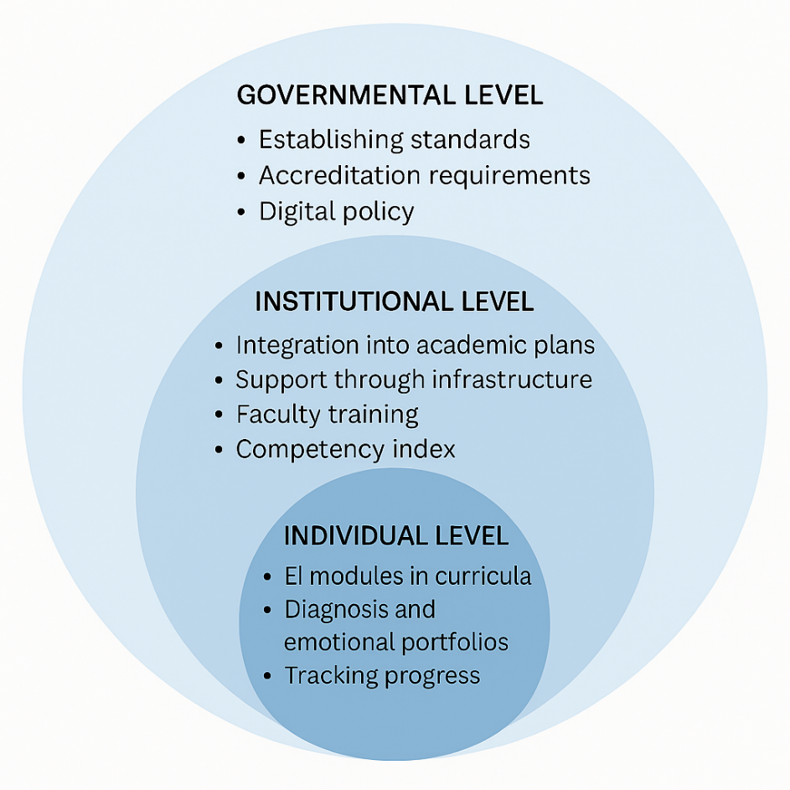
Figure 19 – Nested model of integrating emotional intelligence into quality management in higher education

Note – compiled by the author

In this context, the “nested model” refers to a hierarchical structure in which each level of emotional intelligence implementation (individual, institutional, state) does not exist in isolation but is integrated into a broader level as an element of a larger system. The following features characterize such a model:
Functional expansion: mechanisms implemented at the individual level (for example, developing self-regulation or empathy in a student) become complete only in an institutional infrastructure (educational modules, digital platforms, support centers).
Organizational dependence: institutional initiatives (competency indices, teacher training, interdisciplinary courses) require regulatory and resource support from the state. Thus, the university level is integrated into a broader contour of state regulation.
The principle of scaling states that actions at one level are strengthened or made possible by decisions at the next level. For example, a digital module for assessing EI on the LMS platform requires institutional customization, but this customization is only possible with national standards and financial support.
Inseparable interconnection: nesting reflects not just subordination but functional integrity, in which the entire system's stability depends on the consistency of all three levels.
Thus, the nested model reflects the logic of a consistent and interconnected expansion of responsibility, from individual student practices to the institutional mechanisms of the university and further to regulatory support at the level of state policy.
The figure shows a structure in which the individual, institutional, and state levels do not duplicate but consistently expand on each other. The inner circle covers mechanisms aimed at developing EI in students. The middle level represents institutional conditions that ensure the implementation of individual trajectories. The outer contour forms the normative and strategic framework necessary for the systemic sustainability and scalability of the approach. The figure shows a structure in which the individual, institutional, and state levels do not duplicate but consistently expand on each other. The inner circle covers mechanisms aimed at developing EI in students. The institutional level provides the organizational and methodological basis for implementing individual educational trajectories to build emotional intelligence. At this level, conditions are created that make it possible to include emotional and social competencies in curricula, provide support for students, and implement assessment mechanisms. The external level of the model reflects government regulation that forms the normative and strategic foundations for the functioning and dissemination of institutional solutions. The creation of national standards, the integration of emotional intelligence into accreditation procedures, and support for digital infrastructure ensure the sustainability and reproducibility of the approach across the entire higher education system.
The development of emotional intelligence in the higher education system requires an inextricable link between individual practices, institutional mechanisms, and state regulation. The presented model reflects not a formal delineation of areas of responsibility but the functional interdependence of the three levels. The individual level includes specific pedagogical and diagnostic tools aimed at developing sustainable emotional and social competencies of the student. However, implementing these mechanisms is impossible without organizational support at the university level.
The institutional level ensures the integration of EI into educational plans, support infrastructure, and the intra-university assessment system. It forms the operational basis within which personalized EI development trajectories become possible. Training of teaching staff, the introduction of the emotional and social competence index, and the activities of career and psychological support centers make it possible to link individual results with managed processes.
The state-level sets the normative and strategic conditions within which universities receive the authority and resources to scale up practices. Including EI in standards, accreditation criteria, and state digital initiatives makes building a holistic and comparable education quality system possible. The format of nested circles emphasizes that each level does not exist in isolation: institutional actions are determined by the framework of state policy, and student development is determined by the opportunities formed at the university. The unifying element is the recognition of EI as a key resource for the sustainability and quality of the educational system.
The transition from a structural model to step-by-step implementation planning allows us to present the introduction of emotional intelligence as a process with clearly defined time frames and levels of responsibility (Figure 20).

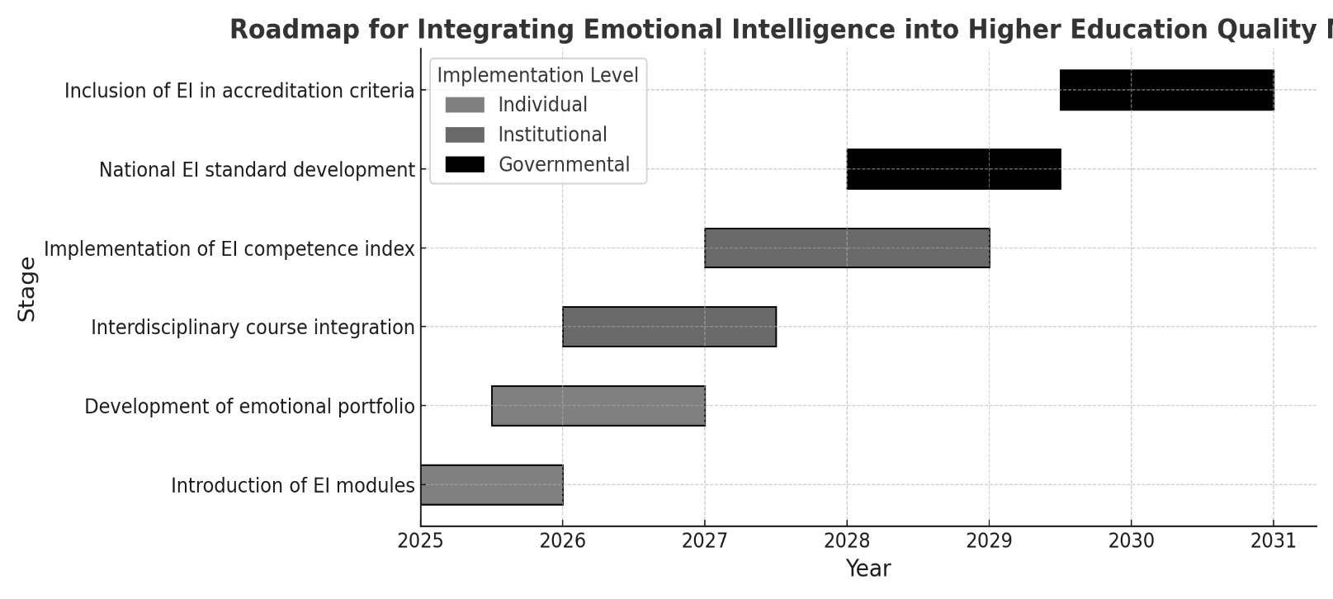

Figure 20 – Roadmap for the implementation of emotional intelligence in quality management of higher education for 2025–2030

Note – compiled by the author

The graphical diagram reflects the sequence of key events aimed at integrating emotional intelligence into education quality management at the individual, institutional, and state levels in 2025–2030. The structure is presented in three phases: initial (2025–2026), transitional (2027–2028), and final (2029–2030), which corresponds to the logic of gradual expansion of responsibility and increase in functional complexity. The period 2025–2026 is allocated for the formation of basic conditions at the student level since it is at this stage that it is possible to lay the foundation for emotional and social competencies through the development of training modules built into the LMS and the launch of digital self-reflection tools, including ePortfolio, emotional state trackers and questionnaires on self-regulation scales. The sequence is not arbitrary: implementation at the institutional level (2027–2028) requires pre-prepared digital solutions, pedagogical materials, and testing of support mechanisms. At this stage, interdisciplinary courses are introduced, an internal assessment of EI is carried out using competency indices, and career and psychological centers are developed to support students in forming sustainable emotional strategies. The final phase (2029–2030) is focused on consolidating the achieved solutions in the regulatory field through standardization of EI requirements, including relevant indicators in accreditation procedures, and forming a single national digital platform for monitoring. The functional dependence between the stages determines the sequence of phases: implementation without a prepared institutional framework or regulatory support leads to fragmentation, imitation practices, and a decrease in the model's sustainability. The stage-by-stage approach to implementing the emotional intelligence model plays a functional rather than formal role since each subsequent step requires achieving certain conditions at the previous level. The development of individual tools, such as digital modules, self-regulation indicators, and ePortfolio elements, is only possible with agreed methods and resources prepared by the university. Institutional measures, in turn, are effective only with regulatory and strategic support, ensuring solutions' scalability and reproducibility. An attempt to implement stages in parallel or reverse violates the development logic. It leads to formalization without content, for example, when EI assessment is implemented before training modules or a regulatory framework appears. Unlike production processes, where simultaneous deployment of components is possible, in the case of emotional and social competencies, a disrupted sequence leads to decreased sustainability and an imitative implementation. The stage-by-stage architecture allows us to link goals, means, and time horizons into a single reproducible model.
A summary table (Table 32) records inter-level relationships and structuring of digital, institutional, and political measures by implementation phases.
The structure of the integral matrix reflects the mechanism for implementing emotional intelligence through the distribution of activities across management levels – individual, institutional, and state – and across implementation stages within the period 2025–2030. The horizontal axis records each level's responsibility area, while the vertical axis sets the chronological sequence of actions, structured into three interconnected phases. The initial phase covers 2025–2026 and is focused on launching training modules, forming digital self-regulation tools, and recording the first diagnostic data at the student level. The medium-term stage (2027–2028) includes the institutionalization of solutions: the introduction of interdisciplinary courses, internal assessment indices, personnel training, and the creation of support structures. The final period (2029–2030) aims to consolidate the model in regulatory documents, accreditation procedures, and state digital solutions. The sequence of these phases is not arbitrary. Each stage is based on the functionally completed actions of the previous one, which excludes the possibility of rearrangement or parallel execution without losing the substantive integrity. The mechanism used in the formation of the structure can be designated as matrix operationalization, in which actions are related not only to time frames but also to institutional functions, scales of implementation, and assessment tools.

Table 32 – Integrated implementation matrix: digital, institutional, and policy layers across phases for 2025–2030
Level | Phase 1 (2025–2026) | Phase 2 (2027–2028) | Phase 3 (2029–2030)
Digital | EI modules embedded in LMSePortfolio initiated | Competence index integrated into institutional platforms | National EI tracking and analytics system
Individual | Participation in EI learning modulesInitial portfolio entries | Structured self-assessment via platform tools | Longitudinal tracking of individual EI growth
Institutional | Interdisciplinary EI course delivery  Advisor and staff training | Internal EI evaluation using competence index | Full integration into institutional QA processes
Governmental | Guidelines and orientation documents published | National standard pilotedTargeted funding allocated | Inclusion in accreditation and quality metrics
Note–compiled by the author

Introducing digital platforms into the matrix does not perform an auxiliary function but a supporting function. We are talking about logically integrated technological solutions, such as educational LMS systems, electronic portfolios, modules for emotional self-analysis, digital self-regulation trackers, monitoring panels, and adapted feedback forms. Each of these solutions provides three system functions: technical compatibility of actions at different levels, collection, and accumulation of data in the implementation process, and the ability to scale in the context of differences between universities. Without the integration of digital platforms, it is impossible to ensure the reproducibility of solutions, control over the dynamics of emotional and behavioral characteristics, and the correct support of the student. The development of digital logic of interaction between participants in the educational process allows for the avoidance of manual control, increased diagnostic accuracy, and the building of a personalized support mechanism. Digital infrastructure, built into institutional and state levels, ensures horizontal synchronization of all model functions and forms the basis for vertical scaling.
The matrix format allows the presentation of the implementation of EI as a system of coordinated, controlled, and logically structured actions delimited by the level of responsibility and the phase of execution. Such design provides the ability to coordinate initiatives formed at a student or university level with regulatory and strategic decisions made at the state level. However, the table does not reflect the internal functional dependencies between actions. The transition from one element to another requires the fulfillment of several preconditions; for example, launching a training module without a digital recording tool makes subsequent diagnostics impossible; introducing an assessment index in the absence of trained teachers devalues ​​the measurement result. Identifying these logical connections, which are inaccessible to direct reflection in tabular form, is implemented through a graph scenario. This tool allows you to record cause-and-effect relationships between actions, track critical entry points, identify institutional risk nodes, and form a sequence of actions that do not allow imitation.
The scenario graph is based on the logic of progressive accumulation of conditions, where the implementation of one event depends on the completion of the previous one. Such a structure is especially critical for emotional intelligence since developing competencies based on affective and behavioral characteristics requires the utmost consistency between the content, environment, and support system. Unlike processes related to material and technical equipment, in the educational model of emotional intelligence, it is impossible to implement a sustainable result through fragmented or parallel actions. The scenario dependency graph allows you to structure the internal logic of implementation, show where institutional vulnerability begins, and record which decisions block or, conversely, open access to the next stage.
Using a matrix and a graph in conjunction forms a dual management architecture. The matrix structure ensures the fixation of deadlines, roles, and formal procedures. The scenario graph is a mechanism for logically protecting the model from inconsistent decisions, allowing you to interpret and manage a complex system of interdependent actions. The integrated digital platform is not an auxiliary element but a carrier of the entire execution logic, through which control, accumulation of information, and adaptive support are implemented. The combination of these components forms not just an implementation plan but a controlled, structurally verified, and technically stable model for modernizing the quality of education based on emotional intelligence.
This addition enhances the manageability of the process and allows for the construction of realistic implementation sequences taking into account the internal limitations of the system (Figure 21).
The roadmap and scenario model for implementing emotional intelligence in quality management of higher education have been developed, considering the previously identified limitations of the academic, institutional, and regulatory environment. Both tools perform a planning and compensatory function, allowing for forming a sustainable trajectory of transformations in the context of methodological and organizational heterogeneity.
At the level of academic practice, the key difficulty is the lack of a holistic implementation logic. Emotional intelligence remains institutionally unanchored, often positioned outside core educational planning, lacking codified mechanisms for curricular integration, procedural development, and measurable evaluation. Positioning implementation stages in a fixed temporal sequence ensure internal consistency of the process, exposes functional dependencies between procedural elements, and defines the scope of institutional responsibility at each level. A formalized sequence of events eliminates fragmentation and reduces the likelihood of an imitative approach in which EI is included in the educational agenda without operational content.
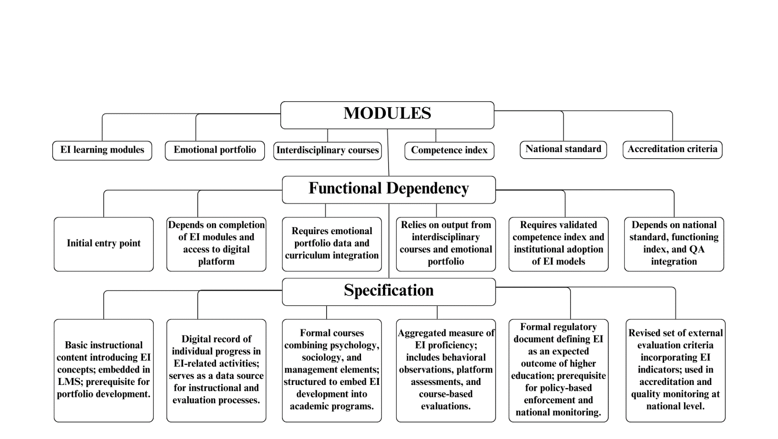
Figure 21 – Graph-scenario of implementation of emotional intelligence in quality management of higher education

The institutional level is characterized by pronounced instability. Universities demonstrate varying degrees of organizational, personnel, and digital readiness for the implementation of EI. At the same time, there is no unified infrastructure for support and methodological support. The scenario model allows structuring the transition between levels, indicating what conditions must be met before moving on to the next stage. Such a sequence blocks attempt to expand practices prematurely without institutional readiness and prevent a shift in emphasis from substantive transformation to administrative reporting. Despite its strategic relevance, the digital aspect of implementing emotional intelligence remains on the periphery of institutional attention. Most Kazakhstani universities focus on administrative and information platforms that provide accounting, control, and reporting but do not include modules to develop and support emotional and social competencies in the digital infrastructure. The lack of platform solutions adapted to supporting EI limits the possibility of operational monitoring, personalized feedback, and the introduction of self-assessment tools.
The roadmap does not involve ready-made external digital solutions but is based on the need for institutional adaptation. EI integration into already functioning university platforms, LMS, electronic portfolios, and digital student and teacher offices, is required at the institutional level. Elements such as the emotional and social competence index should be technically feasible through existing digital environments, with the ability to accumulate individual dynamics, visualize, and aggregate them into an internal quality assessment system.
The state level of digital support involves developing modules on national platforms with open access to methodological materials, diagnostic tools, and digital EI development trackers. These solutions can be integrated into a single system of digital quality assurance of higher education, ensuring comparability of results between universities. Centralized digital support increases the uniformity of EI implementation conditions in regional universities, where their platform resources are limited.
Integrating digital solutions into the scenario model increases the sustainability of all levels and reduces the workload on the teaching staff. Including the platform layer allows for the flexibility of roadmap implementation, accelerated feedback, and expanded support tools without expanding staffing levels or increasing contact hours. Thus, digital technologies become not an external resource but a necessary condition for implementing the logic of step-by-step implementation enshrined in the roadmap and the graph scenario.
At the macro level, normative fragmentation was identified. Elements related to emotional intelligence are not enshrined in standards, performance indicators, and accreditation procedures. The sequence recorded in the graph scenario and the roadmap allows for the development of a normative justification for implementation–from the intra-university index of emotional and social competence to the development of a national standard and the inclusion of relevant parameters in accreditation procedures. Such a structure eliminates the discrepancy between the substantive significance of EI and its absence in the quality assessment system.
The roadmap and the scenario graph function as interconnected tools to ensure the consistency of institutional actions and maintain a logical sequence when implementing emotional intelligence in the education quality management system. The scenario graph, built on the principles of functional dependence, reflects the conditions for the admissibility of each management step. The order of actions is determined not by the calendar binding but by fulfilling substantive prerequisites, without which subsequent activities do not acquire operational meaning. The structure of the scenario model allows you to set transition restrictions, designate logical fixation points, and identify potential zones of institutional risk. Such a model is close in design to network planning systems, where priority is determined not by time but by the logic of processes. The roadmap represents a management planning system based on chronological ordering and institutional consolidation of areas of responsibility. Each stage is associated with a specific time interval agreed upon with the implementation capabilities within the organization, regulatory, and human resources. Timely allocation of responsibilities, coordination across governance levels, and verification of outcome completion are structured through a phased planning framework. The applied format formalizes administrative sequencing and regulates the operational pacing of implementation across defined stages.
Combining the logical model and the phase implementation map eliminates fragmentation, ensures the sustainability of substantive decisions, and prevents premature transitions between levels. Time constraints without substantive readiness become formal, while logical conditions without administrative fixation lose their feasibility. The coordination of two dimensions creates a controlled system where each component can be implemented only if the institutional, substantive, and technological conditions are met. The reliability of the entire structure is determined not by the volume of activities but by the degree of compliance with the logic of transitions and the distribution of responsibility between participants at all levels. The sustainability of the trajectory of change is achieved not through individual initiatives but through the conjugation of the logic of development with institutional responsibility at each level.
Sequential structuring of implementation phases, functional mapping of dependencies, and differentiation of governance levels form an integrated model for embedding emotional intelligence within quality assurance systems in higher education. The following table presents targeted recommendations structured by institutional tier to formalize operational responsibilities and outline prerequisite conditions. Each recommendation is positioned within a specific administrative domain and aligned with the foundational requirements for viable execution (Table 33).

Table 33 – Institutional recommendations and implementation conditions for integrating emotional intelligence in higher education quality management
Level | Key Recommendations | Implementation Phase | Operational Purpose | Dependencies | Responsible Actor | Conditions for Implementation
Individual | Integrate EI modules into LMS platforms; develop digital portfolios and self-assessment tools | Phase 1 (2025–2026) | Establish foundation for personalized EI development | Requires functioning LMS; supports institutional content and evaluation models | Students; academic developers | Methodological content; digital tools; validated diagnostics
Institutional | Introduce EI competence index; embed EI in curricula; conduct faculty training | Phase 2 (2027–2028) | Enable formal assessment and internal QA integration | Requires data from digital portfolios and learning modules | Faculty; QA units | Staff readiness; administrative approval; institutional funding
Governmental | Standardize EI indicators; include EI in accreditation frameworks; fund national digital tools | Phase 3 (2029–2030) | Ensure national comparability and policy alignment | Requires institutional practice and validated index structure | Ministry; accreditation bodies | Legal framework; strategic policy adoption; centralized infrastructure

The recommendations matrix captures the horizontal distribution of responsibility and the vertical sequence of prerequisites necessary for scalable and measurable outcomes. Institutional action without foundational readiness risks fragmentation, while national standardization without local adoption limits system responsiveness. The proposed model affirms that sustainable integration of emotional intelligence requires conceptual validity, functional cohesion, operational infrastructure, and shared accountability across all levels of educational governance. The consolidation of strategic, procedural, and technological elements within a unified implementation architecture positions emotional intelligence not as an ancillary theme but as a central pillar of quality assurance in higher education.

3.3 Model of digital transformation of higher education using the iPortal platform
Both unique opportunities and serious challenges accompany current trends in digital transformation in higher education. Many universities are faced with the need not only to modernize the educational environment but also to build a flexible and sustainable quality management system capable of adapting to the rapidly changing demands of the labour market. In addition, the process of integrating new technologies into the educational process is complicated by insufficient preparation for innovation and limited digital literacy among staff, which often becomes a serious barrier to digital transformation.
In these conditions, it becomes relevant to develop and implement a new platform model based on modern digital technologies for integration into the higher education quality management system, which considers both technical and organizational aspects. It is necessary to form a capable model not only of combining educational, scientific and administrative processes but also of ensuring flexibility in management, transparency of procedures and adaptation to the individual needs of users. Such a model should become a tool for solving complex problems, including optimising business processes, supporting personalised learning, fostering digital culture, and ensuring the sustainable development of the university. The purpose of such a model is to serve as a link between the various components of the educational ecosystem. The new system should provide centralised access to data, automate key processes, integrate with external systems, and comply with modern security standards.
The iPortal platform, as an integrated digital solution, can serve as the basis for a comprehensive quality management system covering all levels and areas of university activity. It provides not only centralized data storage and processing but also intelligent analysis, which is critical when making decisions based on evidence. With the help of iPortal's functional modules, key processes can be automated, including planning and monitoring educational programs, evaluating the professional growth of teachers, and gathering feedback from students.
The introduction of digital technologies into the educational process presents opportunities to enhance the quality of education, expand access to education, and streamline management processes. In this regard, a comprehensive study of integrating modern digital platforms, particularly the iPortal platform, into the existing higher education quality management system is of particular importance. iPortal, as an integrated digital campus platform, is a comprehensive solution that combines educational, scientific and administrative services aimed at ensuring the effective digital transformation of the university. The implementation of such digital platforms extends beyond the standard automation of repetitive operations, creating a qualitatively new educational environment that focuses on personalised learning, the development of research skills, and the formation of a digital culture. The implementation of the iPortal platform in the higher education quality management system will not only optimize the educational process but also create conditions for the development of scientific and innovative activities, increase the digital literacy of students and teachers, and ensure the transparency and efficiency of university management.
The effectiveness of an LMS is primarily determined by its ability to integrate with the university's existing infrastructure, including student information management systems, electronic libraries, financial systems, and human resource management platforms, thereby creating a unified information space and automating business processes. The implementation of a digital campus and iPortal, in particular, is a systematic approach to ensuring the quality of education, requiring continuous development of functionality for personalized analytics, increased interactivity and the implementation of advanced solutions based on artificial intelligence, which will allow the educational process to be adapted to the individual needs of each student through the provision of adaptive content, intelligent recommendations and automated feedback, as well as the introduction of automation tools for routine tasks such as checking assignments, generating reports and organizing schedules, which will allow teachers to focus on more critical aspects of their work, such as developing new teaching materials, conducting consultations and organizing research activities.
The iPortal platform is the core of the digital campus, providing a single point of access to all of the university's information resources and services, which significantly simplifies the work of students, teachers and administrative staff. The functionality of iPortal covers a wide range of tasks, including registration for courses, creation of individual class schedules, providing access to up-to-date educational materials and resources, organising effective communication between participants in the educational process, supporting collaborative work on projects, conducting online testing and assessing student performance, as well as providing access to administrative services and information, creating a convenient and effective environment for learning and working.
The development and implementation of a digital campus integrating the iPortal platform is a multifaceted task that requires a systematic approach and careful analysis of a wide range of factors, from the selection of the optimal architecture to the development of effective mechanisms to protect against cyber threats and unauthorised access to confidential information, This is due to the need to ensure the continuity of the educational process and protect the university's intellectual property.
The iPortal platform architecture is based on service-oriented architecture, providing a high level of flexibility, scalability, and integration with other university information systems, which allows for the development of customised digital solutions that specifically meet the needs of target user groups, including students who need convenient access to educational materials and means of communication with teachers.
For teachers, the platform offers an extended set of tools that allow them to effectively organise the learning process, develop interactive teaching materials, automate the process of checking assignments and assessing student performance, and provide real-time feedback and support. In addition, iPortal supports the uploading of text documents and media files, including video lessons, allowing the creation of interactive learning materials. The digital portal offers extensive opportunities for university administrative staff, enabling the automation of document flow, resource management, key performance indicator monitoring, and the generation of analytical reports to support informed management decisions.
The iPortal software architecture is based on a three-tier model, comprising the presentation layer, business logic layer, and data storage layer (Figure 22).

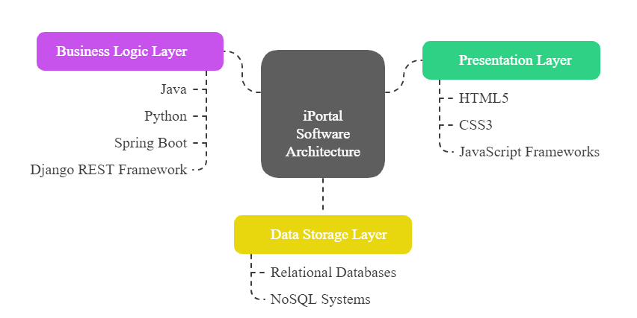

Figure 22 – iPortal software architecture

Note – compiled by the author

This separation ensures modularity, protocol unification, and the ability to develop components independently, accelerating the implementation of changes. The architecture includes three functional layers: the presentation layer, the business logic layer, and the data storage layer, each of which plays a key role in ensuring flexibility, scalability, and integration of the digital educational platform. The presentation layer (indicated in green) is implemented using HTML5, CSS3, and JavaScript frameworks, allowing you to create an interactive user interface adapted to students, teachers, and administrative staff. This layer ensures high-quality interaction with the system and supports modern responsive design requirements. The business logic layer (purple) is responsible for implementing key platform functions and integrating with external systems, using programming technologies such as Java and Python, as well as Spring Boot and the Django REST Framework, which provide scalability, security, and flexibility for development.
The data storage layer (indicated in yellow) is designed to manage structured and unstructured data, which uses relational databases and non-relational solutions. The central element of this architecture is the iPortal software module, which integrates between layers and supports a unified information environment for the platform. This architecture contributes to the creation of a robust and scalable educational ecosystem that can adapt to changing user needs and modern challenges in higher education.
Table 34 shows the key technologies and objectives of the three-tier iPortal architecture.

Table 34 – The three-tier architecture of iPortal
Architecture Layer | Technology | Description / Purpose
Presentation Layer | HTML5, CSS3, JavaScript (React, Angular) | Provides an interactive and user-friendly interface for students, faculty, and staff. Ensures responsive design and seamless user experience.
Business Logic Layer | Java (Spring Boot), Python (Django REST Framework) | Implement core application logic, APIs, and services. Ensures scalability, security, and adherence to modern development standards.
Data Storage Layer | Structured: PostgreSQL, MySQLUnstructured: MongoDB, Cassandra, Neo4j | Manage reliable and efficient storage. RDBMS handles structured data, while NoSQL databases support unstructured, large-scale, real-time data processing.
DBMS Selection Criteria | Scalability, reliability, performance, security | DBMS solutions are chosen based on the specific technical and analytical needs of the platform.
Relevance of NoSQL | MongoDB, Cassandra, Neo4j | With the rapid growth of data and real-time analytics demand, NoSQL systems provide horizontal scalability and fast performance for digital education systems.

According to the above, the three-level architecture of the iPortal software platform includes the levels of presentation, business logic and data storage, as well as the main technologies and goals of each of the levels. The choice of a database management system (DBMS) is made considering requirements for scalability, reliability, performance, and security. In the context of rapid data growth and the need for operational analytics, NoSQL solutions are becoming particularly relevant, enabling the efficient processing of large amounts of information in real time, which is critical for the digital transformation of modern higher education.
The iPortal platform is integrated with several external systems, including the Unified Higher Education Platform (UHEP) and state databases, ensuring the completeness and relevance of the data. In particular, integration with the information systems of the Ministry of Science and Higher Education has been implemented for the automated exchange of data on students, teachers, educational programmes and scientific projects, ensuring compliance with legal requirements, increasing the transparency of processes, automating reporting processes, eliminating duplication of information and, as a result, significantly reducing the administrative burden on university staff, freeing up resources for more important tasks related to improving the quality of education and developing scientific research.
The iPortal platform implements a comprehensive model of integration with external systems, supporting REST, SOAP, XML, and JSON protocols, which ensures compatibility with various technological solutions. Adapters and gateways are used to work with legacy systems, minimizing implementation costs and risks. iPortal is integrated with a certification center and supports electronic digital signatures, ensuring legally valid document flow.
It supports connections to educational platforms (e.g., Coursera), electronic libraries, email systems, and messengers, as well as EDMS, CRM, ERP, and banking gateways. This allows for the automation of admission, document flow, payment, project management, order control, and student service processes. A key feature is compatibility with the university's existing IT infrastructure, ensuring flexibility and resilience to change. All this contributes to the formation of a unified digital ecosystem for the university (Figure 23).
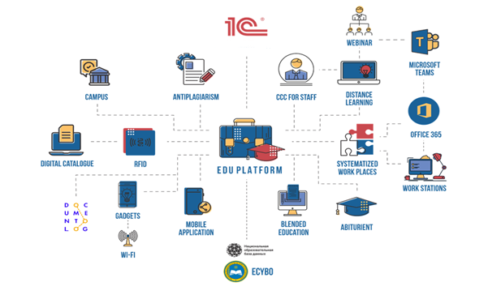
Figure 23 – Conceptual model of the iPortal platform

Note – compiled by the author
The conceptual model of the iPortal platform encompasses a wide range of aspects, including network and server infrastructure, software architecture, integration with external systems, modules, and functional components, as well as information security. This enables the creation of a reliable, scalable, and secure platform that meets the modern requirements for digital educational environments. The iPortal platform is a central element of the digital campus architecture, playing a decisive role in implementing the university's sustainable development strategy and achieving high academic performance (Figure 24).
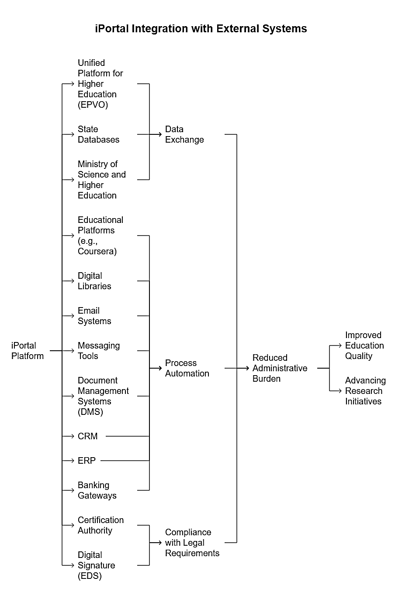
Figure 24 – iPortal integration with external systems

Note – compiled by the author
When considering the modules and functional components of the iPortal platform, it is worth noting that it encompasses a wide range of tools and services that support all core university activities, from organising the educational process and managing research activities to interacting with applicants and graduates.
One of the key modules is the learning process management module, which automates lesson planning, timetable creation, attendance tracking, performance monitoring, and exam administration, thereby increasing the efficiency of classroom use, optimising teacher workloads, reducing the labour intensity of routine operations, and ensure transparency in the assessment of student knowledge.
The content management module enables the creation, storage, organization and provision of access to various educational resources, including curricula, teaching materials, lectures, presentations, video recordings, interactive simulations, sets of practical tasks and tools for organising student collaboration, which together form a comprehensive digital educational environment that helps boost student motivation and learning effectiveness. Plus, academic mobility, application acceptance, student transfer, enrolment, and ranking processes are automated, which cuts down on data processing time and makes educational services more accurate and accessible.
The platform also provides functionality for creating and adjusting curricula and individual educational trajectories, ensuring not only that educational programmes meet the needs of the labour market, but also personalising the learning process, allowing students to choose courses and modules that correspond to their individual interests, academic goals and professional plans, which contributes to increasing student motivation, engagement and academic performance, as well as developing the independent learning and self-development skills necessary for a successful career in a rapidly changing world. In addition, the platform automates reporting and provides the ability to generate course logs, summary reports, and individual study plans, allowing for analysis of the educational process and its results, identification of problem areas, and informed management decisions aimed at improving the quality of education and the university's management system. iPortal, as a system for recording students, teachers, and administrative and management personnel, provides full access to the system's functionality through mobile applications, as well as notifications about assignments and grades.х.
One of the key features of the iPortal platform is the automation of processes related to final qualification works, including the stages of forming and editing topics, assigning scientific supervisors and reviewers, planning and conducting preliminary defences and defences, as well as checking for plagiarism and forming electronic archives of final qualification works, This significantly reduces the time required to prepare and conduct final qualification works, improves the quality and objectivity of assessment, and ensures compliance with the requirements of academic integrity and transparency. iPortal automates support for academic mobility and application acceptance, featuring an electronic public reception room and a digital blog for the rector, which provides feedback and facilitates public participation. The implementation and use of the information and analytical system contribute to improving the efficiency of educational organisation management.
The scientific activity management module provides a set of tools for comprehensive support of scientific research activities, ranging from planning and organising scientific events (conferences, seminars, round tables) to the publication of scientific results and the preparation of grant applications, contributing to the intensification of scientific work, increasing publication activity and strengthening the university's position in the scientific community. A critical component is the human resources management module, which automates the processes of recruitment, adaptation, training, assessment and development of personnel, as well as recording working hours, calculating salaries and processing leave, allowing you to optimise personnel administration, increase the efficiency of the HR department, reduce personnel management costs, and ensure compliance with labour legislation requirements. For communication and collaboration between students and teachers, there is a collaboration module that provides a set of tools for communication and information exchange, including email, forums, chats, video conferencing, and project management systems, ensuring the formation of an integrated information space that promotes the development of communication skills, stimulates a culture of cooperation, and facilitates the organisation of distance learning and online consultations, which is particularly relevant in the context of the expanding use of distance learning technologies and the increasing number of international students.
The implementation of electronic document management and customer relationship management systems, such as Documentolog and Bitrix24, has enabled the university to digitise key management processes, improve the speed and quality of service for students, staff and partners, and create a unified information environment for effective communication and coordination of activities across all university departments. In addition, integration with external information systems such as eGov.kz and the National Education Database, automated data exchange and compliance with education legislation requirements are ensured, reducing the administrative burden on university staff, increasing the reliability and relevance of information, and ensuring the transparency and accountability of the university's activities to society and the state.
iPortal is a digital environment focused on the sustainable development of the university and ensuring academic excellence, where each module is designed to meet the specific needs of the relevant target user groups, such as students, faculty, administrative staff, applicants, and alumni, and provides access to the necessary functions and information in a convenient and intuitive interface. The iPortal platform is thus designed to become the core of the digital campus, uniting all of the university's information systems and ensuring effective management of all aspects of its activities.
The information security of the iPortal platform is ensured through a comprehensive architecture covering all levels of the system. To prevent unauthorised access, multi-factor authentication, a role-based access model and a strict password policy have been implemented. External threats are countered by next-generation firewalls, IDS/IPS, antivirus solutions, network traffic analysis, as well as regular penetration tests and security audits. Data transmission and storage are protected using HTTPS, TLS, and cryptographic methods. The built-in logging and auditing system records user actions and event activity, allowing incidents to be identified and investigated in a timely manner. Particular attention is paid to the protection of personal data in accordance with legal requirements, including regular employee training. The information security policy formalises the principles and responsibilities of users. The separation of environments (development, testing, operation) reduces risks. Regular backups, geographically distributed storage, and data recovery tests ensure readiness for failures. High-performance server and network infrastructure supports fault tolerance and scalability. To increase availability, mechanisms for automatic switching to backup resources have been implemented. The use of SIEM systems, behavioural analysis and event correlation improve response times. External access is provided via VPN with multi-factor authentication. The university has two Internet channels (each with a capacity of 500 Mbit/s) and a dual-band 802.11n Wi-Fi network. Plans are in place to transition to the Wi-Fi 6 standard, aiming to increase bandwidth and enhance connection stability. iPortal's information security is based on modern technologies, regulatory procedures, and organisational practices, ensuring reliable data protection and the smooth operation of the university's entire digital infrastructure.
Assessing the comprehensive impact of the iPortal platform on key aspects of university activities, including the educational process, research activities, digital openness, and management efficiency, allows us to identify specific improvements and areas requiring further development, necessitating the application of a multifaceted methodology that combines quantitative and qualitative approaches to data analysis. The implementation of the iPortal platform has a significant and multifaceted impact on the university's educational ecosystem, profoundly transforming existing approaches to learning, expanding the horizons of educational resource accessibility, and optimising learning management processes, which is reflected in improved education quality and more effective preparation of students for the challenges of the modern economy.
In summary, it should be emphasised that the integration of the iPortal digital platform into the university's activities is not just a technical innovation but a strategic step towards improving the quality of education and strengthening institutional sustainability. The comprehensive impact of the platform encompasses all key aspects of academic and administrative activities, forming the basis for a transition to a ‘smart university’ model focused on results, personalisation of learning, and continuous improvement of educational practices. It is essential not only to record the results achieved but also to establish a system for regular monitoring and analysis of the effectiveness of the implemented digital solutions, which will enable adaptation to the changing requirements of the educational environment and maintain high-quality standards at all levels of the university's functioning. In this regard, it is proposed to utilise the conceptual model of the iPortal platform as the core of a digital quality management model in higher education among universities in Kazakhstan.

CONCLUSION

Based on the conducted dissertation research, the following conclusions were obtained.
- The evolution of quality management in higher education institutions has gone from Taylorism and mechanistic standardization to TQM and a systematic approach, where the focus has shifted to values, processes and the human factor. The sustainability of quality systems is ensured not by the formal implementation of ISO, benchmarking and lean, but by the institutionalization of a culture of continuous improvement, leadership and involvement of all participants in the educational process. Operationalization requires comprehensive metrics (Public Value Score, Stakeholder Satisfaction Index, NPM Implementation Score, etc.) that measure both social contributions and managerial transformations, including the impact on academic identity. In Kazakhstan, there is a transition from declarative compliance with international standards to conscious adaptation of TQM and systems thinking, but barriers remain, insufficient strategic flexibility, technological base and readiness for internal changes. Optimal trajectory is a hybrid model that combines value-based management with the balanced use of NPM tools, the priority of internal motivation, horizontal connections and digital quality monitoring tools.
- International experience shows that no model of quality assurance in higher education is universal: hybrid solutions that combine value-based and ethical guidelines (social mission, academic autonomy, and stakeholder participation) with instrumental market mechanisms (external accountability, standards, comparability, and metrics) provide the best results. The optimal balance for Kazakhstan is the German logic of “autonomy under the state standard” and the Japanese line of systems thinking and organizational learning, complemented by a careful integration of the international requirements of the OECD without mechanically copying rating strategies. It is advisable to consider the American model of independent, mostly voluntary accreditation as a long-term goal after strengthening internal quality systems, a culture of self-assessment and institutional maturity. Elements of Islamic approaches – ethical leadership, social responsibility, and missionarism, can strengthen the social orientation of reforms if they are embedded in a secular normative framework and support academic freedom. Taken together, this shows a direction where external transparency and international comparability are underpinned by an internal culture of continuous improvement, digital monitoring tools, and sustained engagement of all participants, which enhances competitiveness while preserving national educational identity.
- It was concluded that the effectiveness of quality management in universities in Kazakhstan requires a transition from formal regulatory models to an integrated EFQM architecture based on digitalization, self-assessment and continuous improvement. The priority is not fixing compliance with procedures, but developing the institutional capacity for change: system leadership, strategy, partnerships, resource and data management (e-portal, end-to-end monitoring of teaching, research and service results). Classical metrics should be supplemented with contextual ones (digital literacy, behavioral/log data, adaptability of programs) and strategic indicators (employment, market fit, public value) using multi-criteria methods (e.g., AHP/TOPSIS) and predictive analytics. Overcoming persistent problems, excessive formalism, weak stakeholder engagement, mechanical transfer of industrial practices and underestimation of the local context, is possible through a shift from “compliance control” to “development management”. Methodologically, this means the introduction of a three-level assessment framework with the co-design of indicators together with students, teachers, employers and regulators. As a result, the autonomy of universities is filled with content: external comparability and transparency are supported by an internal culture of quality, real-world usage data and cycles of rapid improvement, which increases competitiveness without blurring the national educational identity.
- The analysis showed that in 2013-2023, Kazakhstan's higher education was modernized on the basis of an updated regulatory framework and digital agenda, but at the same time, concentration increased: the burden on teachers and universities increased, which signals the risk of depletion of human and infrastructural resources. The structure of training has become asymmetric, with a noticeable increase in the proportion of master's degrees, while doctoral studies remain stagnant. This is due to a noticeable increase in the proportion of master's degrees, while doctoral studies remain stagnant. As a result, the “education-research” link is being severed, with a noticeable increase in the proportion of master's degrees, doctoral studies remain stagnant, which is why the “education-research” link is being severed and the reproduction of scientific personnel is weakened. The spatial picture is polarized: metropolitan agglomerations and part of the southern regions demonstrate high KEI values and institutional maturity, while the industrial west and a number of northeastern territories are characterized by low scientific saturation and weak integration of universities into the economy. Correlation analysis confirms that the scientific component is more strongly associated with the development of the “knowledge economy” than the educational one, while there is a negative relationship between the shares of education and science, indicating an imbalance in the distribution of resources. In such conditions, a universal modernization model is unproductive: differentiated scenarios are required that combine the unloading and digitalization of overloaded clusters, consolidation and strengthening of research circuits in pedagogically dominant regions, and institutional “linking” of universities with R&D in economically active but academically “thin” areas.
- The digital infrastructure of universities in Kazakhstan (Moodle, Platonus) covers mainly classroom and formally regulated activities, but systematically "loses" significant segments of the actual employment of teachers. Correlation analysis revealed "hidden links" between organizational and methodological work, methodological support and work verification, as well as an almost complete substitution of mentoring activities, which indicates taxonomic flaws in accounting interfaces and a lack of automation. Clustering has shown the dominance of a single standardized employment profile in the presence of small but sharply specialized roles (administration, research, student work, reception, branding), which are poorly reflected in the digital system and therefore lead to point overloads and uneven distribution of tasks. To bridge the gaps, it is necessary to move from a single loop to a multi-cycle digital management model with personalized planning: the introduction of mentoring accounting modules, student research, extracurricular support and recruitment campaigns, as well as end-to-end time tracking, automated reporting and real-time load analysis. The inclusion of “invisible” forms of employment in the LMS/full-time employment portal increases transparency and equity of motivation, allows for the reallocation of resources based on data, and makes strategic learning quality management measurable and reproducible.
- The analysis confirms that students' satisfaction with the digital environment is decisively influenced not by the “availability of platforms”, but by their functional usefulness for self-regulation and tracking progress, and this relationship is reinforced by universities' institutional commitment to digital transformation and the growth of digital literacy. Classification, correlation, and segmentation results showed a heterogeneous “digital maturity” of the audiences. So, with the high potential of iPortal, consolidation around a single LMS+SSO core, mobile-first optimization and available support are critical for trust and engagement, while fragmentation of services and technical instability undermine the effect. Nonparametric tests confirmed that differences in perception are most strongly determined by the direction of training, level of education, and experience with LMS. At the same time. At the same time, gender does not play a statistically significant role. In general, iPortal, being an integrated platform, increases the manageability, transparency and efficiency of decisions, which directly enhances the quality of educational management. The practical implication is a shift in focus from building a “zoo” of tools to their holistic integration and personalized support for digital risk groups.
- The analysis shows that the digitalization of quality management in Kazakhstani universities goes beyond disparate initiatives and forms into an integrated architecture, where data collection and accounting, their analytical interpretation and subsequent verification are closed in a three-circuit system and operationalized through the PDCA cycle. International maturity models (EDUCAUSE, Gartner, JISC) are becoming not an end in themselves, but an internal audit and planning tool, allowing building roadmaps from local automation to institutionally integrated analytics and personalization of learning. The effectiveness of this transformation is determined not by the presence of separate platforms, but by their integration into end-to-end monitoring with KPIs and multi-level verification of the technical, methodological, pedagogical, and ethical-legal viability of solutions. The key limitations are related to the fragmentation of infrastructure, the lack of analytical competencies and the regulatory uncertainty of new technologies, which requires the synchronization of systems, the increase of human capital and the formalization of digital processes in management regulations. As a result, a digitally modular, adaptive, and strategically oriented quality management paradigm is being formed, increasing transparency, predictability, and reproducibility of management decisions in an increasingly complex educational environment.
- The integration of emotional intelligence into the quality management system sets a shift from narrow academic metrics to the support of sustainable personal and professional competencies that affect motivation, self-regulation and student engagement. The proposed “nested” model links individual practices (EI modules, ePortfolio and self-regulation trackers) with institutional mechanisms (emotional and social competence index, teacher training, integration into the curriculum) and their regulatory consolidation at the state level. The 2025-2030 roadmap assumes a phased deployment from pilot digital tools in the LMS to intra-university assessment and further to standardization and inclusion of EI in accreditation indicators, which ensures scalability and comparability of results. Digital reliance is crucial: data collection and analysis in a single platform environment, transparent KPIs and feedback, without which the risk of fragmentation and imitation increases. The sustainability of the model is achieved by coordinating methodological content, personnel readiness and legal support, so that EI becomes a system-forming element of the modernization of quality management in Kazakhstan's higher education.
- The integration of iPortal as the core of the “digital campus” forms an integrated quality management system, combining educational, scientific and administrative processes on a single three-layer architecture with advanced analytics and integrations with external registries. The platform provides personalized training, automation of routine operations, and transparency of decisions through end-to-end data, planning and monitoring modules, and feedback tools. Comprehensive cybersecurity, fault tolerance, and scalability create the technological backbone for sustainable development and a smart university. The key success factor remains human and organizational readiness: without the growth of digital literacy and managerial coordination, the risk of fragmentation and imitation of implementation is high. Regular monitoring of the effects and data-based architecture adjustments make it possible to maintain compliance with changing labor market requirements and quality standards.

REFERENCES

- Taylor F. W. Principles and methods of scientific management // Journal of Accountancy. – 1911. – Vol. 12, № 3. – P. 3.
- Nadworny M. J. Frederick Taylor and Frank Gilbreth: competition in scientific management // Business History Review. – 1957. – Vol. 31, № 1. – P. 23–34. – DOI: https://doi.org/10.2307/3111727
- Grachev M., Rakitsky B. Historic horizons of Frederick Taylor's scientific management // Journal of Management History. – 2013. – Vol. 19, № 4. – P. 512–527. – DOI: https://doi.org/10.1108/JMH-05-2012-0043
- Uddin N., Hossain F. Evolution of modern management through Taylorism: An adjustment of Scientific Management comprising behavioral science // Procedia Computer Science. – 2015. – Vol. 62. – P. 578–584. – DOI: https://doi.org/10.1016/j.procs.2015.08.537
- Hamid S. R., Isa S., Chew B. C., Altun A. Quality management evolution from the past to present: Challenges for tomorrow // Organizacija. – 2019. – Vol. 52, № 3. – P. 157–186. – DOI: https://doi.org/10.2478/orga-2019-0011
- Hill F. M., Taylor W. A. Total quality management in higher education // International Journal of Educational Management. – 1991. – Vol. 5, № 5. – DOI: https://doi.org/10.1108/09513549110144724
- Taylor A., Hill F. Quality management in education // Quality Assurance in Education. – 1993. – Vol. 1, № 1. – P. 21–28. – DOI: https://doi.org/10.1108/09684889310040712
- Bogue E. G. Quality assurance in higher education: The evolution of systems and design ideals // New Directions for Institutional Research. – 1998. – № 99. – P. 7–18.
- Manatos M. J., Sarrico C. S., Rosa M. J. The integration of quality management in higher education institutions: a systematic literature review // Total Quality Management & Business Excellence. – 2017. – Vol. 28, № 1–2. – P. 159–175. – DOI: https://doi.org/10.1080/14783363.2015.1050180
- Tsutsui W. M. W. Edwards Deming and the origins of quality control in Japan // The Journal of Japanese Studies. – 1996. – Vol. 22, № 2. – P. 295–325. – DOI: https://doi.org/10.2307/132975
- Petersen P. B. Total quality management and the Deming approach to quality management // Journal of Management History. – 1999. – Vol. 5, № 8. – P. 468–488. – DOI: https://doi.org/10.1108/13552529910290520
- Hughey A. W. Application of the Deming philosophy to higher education // Industry and Higher Education. – 2000. – Vol. 14, № 1. – P. 40–44. – DOI: https://doi.org/10.5367/000000000101294841
- Kanji G. K., Malek A., Tambi B. A. Total quality management in UK higher education institutions // Total Quality Management. – 1999. – Vol. 10, № 1. – P. 129–153. – DOI: https://doi.org/10.1080/0954412998126
- Best M., Neuhauser D. W. Edwards Deming: father of quality management, patient and composer // BMJ Quality & Safety. – 2005. – Vol. 14, № 4. – P. 310–312. – DOI: https://doi.org/10.1136/qshc.2005.015289
- Aydemir H., Türkel R. Evaluation of Quality Principles from the Islamic Perspective // Hitit İlahiyat Dergisi. – 2022. – Vol. 21, № 2. – P. 1193–1238. – DOI: https://doi.org/10.14395/hid.1072356
- Ndagire S., Is’haq A. Y., Lubaale R. A Systematic Review for the Challenges of Total Quality Management Implementation in Service Quality of Private Universities // TWIST. – 2024. – Vol. 19, № 4. – P. 388–394. – URL: https://orcid.org/0009-0004-5286-5636.
- Ackoff R. L. A theory of practice in the social systems sciences // Systems Research. – 1988. – Vol. 5, № 3. – P. 241–246. – DOI: https://doi.org/10.1002/sres.3850050306
- Ackoff R. L. Systems thinking and thinking systems // System Dynamics Review. – 1994. – Vol. 10, № 2–3. – P. 175–188. – DOI: https://doi.org/10.1002/sdr.4260100206
- Detrick G. Russell L. Ackoff // Academy of Management Learning & Education. – 2002. – Vol. 1, № 1. – P. 56–63. – DOI: https://doi.org/10.5465/amle.2002.7373640
- Senge P. Peter Senge and the learning organization // Dimension. – 1990. – Vol. 14. https://doi.org/10.1007/978-1-84882-525-3_13
- Ramage M., Shipp K. Peter Senge // Systems Thinkers. – 2009. – P. 119–128. – DOI: https://doi.org/10.1007/978-1-84882-525-3_13
- Spain S. Systems thinking applied to curriculum and pedagogy: A review of the literature // Curriculum Perspectives. – 2019. – Vol. 39. – P. 135–145. – DOI: https://doi.org/10.1007/s41297-019-00085-1
- Jung Y. Systems thinking in organizations: Applying it to study arts and educational settings // Journal of Art for Life. – 2017. – Vol. 9.
- Hofkirchner W., Schafranek M. General System Theory // Philosophy of Complex Systems. – 2011. – P. 177–194. – DOI: https://doi.org/10.1016/B978-0-444-52076-0.50006-7
- Kocatürk H. E., Karadağ E. Organizational functioning in Turkish higher education system: Birnbaum’s five models of institutional governance // Journal of Pedagogical Research. – 2021. – Vol. 5, № 4. – P. 230–250. – DOI: https://doi.org/10.33902/JPR.2021474637
26 Istileulova Y., Peljhan D. External Challenges vs. Internal Changes: Business Schools’ Dilemma // Organizational Changes for Dynamic Stability: Conference Papers / eds. R. Rozman, A. Stare. – Ljubljana: The Slovenian Academy of Management, 2012. – P. 206–221.
27 Salimova T. A., Makolov V. I. Unused Potential of Quality Management Systems of the Russian Companies: an Empirical Study // European Research Studies Journal. – 2016. – Vol. 19, № 3A. – P. 150–166. – DOI: https://doi.org/10.35808/ersj/554
28 Manarbek G., Kondybayeva S. Quality assurance practices in higher education: Lessons from the U.S. and implications for Kazakhstan // Journal of Higher Education Policy and Leadership Studies. – 2024. – Vol. 5, № 3. – P. 66–86. – DOI: https://dx.doi.org/10.61186/johepal.5.3.66
29 Mukanova S., Abildina S., Mukhatayev A. Organization of internal quality assurance systems as a construct of the national quality assurance system: practice of Kazakhstani universities // Higher Education in Kazakhstan. – 2024. – № 2 (46). – P. 77–87. – DOI: https://doi.org/ 10.59787/2413-5488-2024-46-2-107-117
30 Freeman R. E., Reed D. L. Stockholders and stakeholders: A new perspective on corporate governance // California Management Review. – 1983. – Vol. 25, № 3. – P. 88–106. – URL: https://doi.org/10.2307/41165018.
    - Parmar B. L., Freeman R. E., Harrison J. S., Wicks A. C., Purnell L., De Colle S. Stakeholder theory: The state of the art // The Academy of Management Annals. – 2010. – Vol. 4, № 1. – P. 403–445. – URL: https://doi.org/10.1080/19416520.2010.495581.
    - Moore M. H. Public value accounting: Establishing the philosophical basis // Public Administration Review. – 2014. – Vol. 74, № 4. – P. 465–477. – URL: https://doi.org/10.1111/puar.12198.
    - Hood C. Contemporary public management: a new global paradigm? // Public Policy and Administration. – 1995. – Vol. 10, № 2. – P. 104–117. – URL: https://doi.org/10.1177/095207679501000208.
    - Hood C. Paradoxes of public-sector managerialism, old public management and public service bargains // International Public Management Journal. – 2000. – Vol. 3, № 1. – P. 1–22. – URL: https://doi.org/10.1016/S1096-7494(00)00032-5.
    - Lynn L. E. Jr. A critical analysis of the new public management // International Public Management Journal. – 1998. – Vol. 1, № 1. – P. 107–123. – URL: https://doi.org/10.1016/S1096-7494(99)80087-7.
    - Thomas R., Davies A. Gender and new public management: Reconstituting academic subjectivities // Gender, Work & Organization. – 2002. – Vol. 9, № 4. – P. 372–397. – URL: https://doi.org/10.1111/1468-0432.00165.
    - Broucker B., De Wit K. New public management in higher education // The Palgrave International Handbook of Higher Education Policy and Governance. – London: Palgrave Macmillan UK, 2015. – P. 57–75. – URL: https://doi.org/10.1007/978-1-137-45617-5_4.
    - DiMaggio P., Powell W. The iron cage revisited: Institutional isomorphism and collective rationality in organizational fields // American Sociological Review. – 1983. – Vol. 48, № 2. – P. 147–160.
    - Douglas M. Natural Symbols: Explorations in Cosmology. – London: Barrie & Rockliff, 1970.
    - Baumann J., Krücken G. Debated legitimacy: Accreditation in German higher education // Higher Education Policy. – 2019. – Vol. 32. – P. 29–48. – URL: https://doi.org/10.1057/s41307-018-0120-x.
    - Boland T., Silbergh D. Managing for quality: the impact of quality management initiatives on administrative structure and resource management processes in public-sector organizations // International Review of Administrative Sciences. – 1996. – Vol. 62, № 3. – P. 351–367. – URL: https://doi.org/10.1177/002085239606200305.
    - Lewis M., Hartley J. Evolving forms of quality management in local government: lessons from the Best Value pilot programme // Policy & Politics. – 2001. – Vol. 29, № 4. – P. 477–496. – URL: https://doi.org/10.1332/0305573012501486.
    - Stringham S. H. Does quality management work in the public sector // Public Administration and Management: An Interactive Journal. – 2004. – Vol. 9, № 3. – P. 182–211.
    - Deem R., Brehony K. J. Management as ideology: The case of ‘new managerialism’ in higher education // Oxford Review of Education. – 2005. – Vol. 31, № 2. – P. 217–235. – URL: https://doi.org/10.1080/03054980500117827.
    - Amaral A., Rosa M. J., Tavares D. Assessment as a tool for different kinds of action: from quality management to compliance and control // Quality Assessment for Higher Education in Europe. – 2007. – P. 43–53.
    - Klasik D., Hutt E. L. Bobbing for bad apples: Accreditation, quantitative performance measures, and the identification of low-performing colleges // The Journal of Higher Education. – 2019. – Vol. 90, № 3. – P. 427–461. – URL: https://doi.org/10.1080/00221546.2018.1512804.
    - Chiarini A. Japanese total quality control, TQM, Deming's system of profound knowledge, BPR, Lean and Six Sigma: Comparison and discussion // International Journal of Lean Six Sigma. – 2011. – Vol. 2, № 4. – P. 332–355. – URL: https://doi.org/10.1108/20401461111189425.
    - Hosono A. Industrial Strategies: Toward a Learning Society for Quality Growth // Efficiency, Finance, and Varieties of Industrial Policy. – New York: Columbia University Press, 2016. – P. 306–352. – URL: https://doi.org/10.7312/noma18050-010.
    - Kim D. Toward learning organizations. – Cambridge (Mass.): Pegasus, 1992.
    - Ravichandran T., Rai A. Quality management in systems development: an organizational system perspective // MIS Quarterly. – 2000. – P. 381–415. – URL: https://doi.org/10.2307/3250967.
- Murray P., Chapman R. From continuous improvement to organisational learning: developmental theory // The Learning Organization. – 2003. – Vol. 10, № 5. – P. 272–282. – URL: https://doi.org/10.1108/09696470310486629.
- Senge P. M., Sterman J. D. Systems thinking and organizational learning: Acting locally and thinking globally in the organization of the future // European Journal of Operational Research. – 1992. – Vol. 59, № 1. – P. 137–150. – URL: https://doi.org/10.1016/0377-2217(92)90011-W.
- Berdahl R. Academic freedom, autonomy and accountability in British universities // Studies in Higher Education. – 1990. – Vol. 15, № 2. – P. 169–180. – URL: https://doi.org/10.1080/03075079012331377491.
- Buchbinder H. The market oriented university and the changing role of knowledge // Higher Education. – 1993. – Vol. 26, № 3. – P. 331–347.
- Braun D. Changing governance models in higher education: The case of the new managerialism // Swiss Political Science Review. – 1999. – Vol. 5, № 3. – P. 1–24. – URL: https://doi.org/10.1002/j.1662-6370.1999.tb00276.x.
- Reed M. New managerialism, professional power and organisational governance in UK universities: A review and assessment // Governing Higher Education: National Perspectives on Institutional Governance. – 2002. – Vol. 2. – P. 163–185. – URL: https://doi.org/10.1007/978-94-015-9946-7_9.
- Rhoades G., Sporn B. Quality assurance in Europe and the US: Professional and political economic framing of higher education policy // Higher Education. – 2002. – Vol. 43. – P. 355–390. – URL: https://doi.org/10.1023/A:1014659908601.
- Dobbins M. How market-oriented is French higher education? // French Politics. – 2012. – Vol. 10. – P. 134–159. – URL: https://doi.org/10.1057/fp.2012.5.
- Jarvis D. S. Policy transfer, neo-liberalism or coercive institutional isomorphism? Explaining the emergence of a regulatory regime for quality assurance in the Hong Kong higher education sector // Policy and Society. – 2014. – Vol. 33, № 3. – P. 237–252. – URL: https://doi.org/10.1016/j.polsoc.2014.09.003.
- Zapp M., Marques M., Powell J. J. Blurring the boundaries. University actorhood and institutional change in global higher education // Comparative Education. – 2021. – Vol. 57, № 4. – P. 538–559. – URL: https://doi.org/10.1080/03050068.2021.1967591.
- Kohler J. R. Quality assurance, accreditation, and recognition of qualifications as regulatory mechanisms in the European higher education area // Higher Education in Europe. – 2003. – Vol. 28, № 3. – P. 317–330. – URL: https://doi.org/10.1080/0379772032000119973.
- Schwarz S., Westerheijden D. F. Accreditation in the framework of evaluation activities: A comparative study in the European higher education area // Accreditation and Evaluation in the European Higher Education Area. – 2004. – P. 1–41. – URL: https://doi.org/10.1007/978-1-4020-2797-0_1.
- Serrano-Velarde K. Rising above institutional constraints? The quest of German accreditation agencies for autonomy and professional legitimacy // Minerva. – 2014. – Vol. 52, № 1. – P. 97–118. – URL: https://doi.org/10.1007/s11024-014-9245-2.
- Doyle L., Egetenmeyer R., Singai C., Devi U. Professionalisation as development and as regulation: Adult education in Germany, the United Kingdom and India // International Review of Education. – 2016. – Vol. 62. – P. 317–341. – URL: https://doi.org/10.1007/s11159-016-9560-y.
- Ohly S., Schneijderberg C. German professors’ motivation to act as peer reviewers in accreditation and evaluation procedures // Minerva. – 2021. – Vol. 59, № 2. – P. 217–236. – URL: https://doi.org/10.1007/s11024-020-09430-5.
- Juanatey A. G., Jordana J., Durán I. P., Royo D. S. Independence, accountability and responsibilities of quality assurance agencies in higher education: European and Latin American countries compared // European Journal of Higher Education. – 2021. – Vol. 11, № 2. – P. 175–196. – URL: https://doi.org/10.1080/21568235.2020.1850309.
- Duarte N., Vardasca R. Literature review of accreditation systems in higher education // Education Sciences. – 2023. – Vol. 13, № 6. – P. 582. – URL: https://doi.org/10.3390/educsci13060582.
- Marginson S., Van der Wende M. To rank or to be ranked: The impact of global rankings in higher education // Journal of Studies in International Education. – 2007. – Vol. 11, № 3–4. – P. 306–329. – URL: https://doi.org/10.1177/1028315307303544.
- Van der Wende M. Internationalization of higher education in the OECD countries: Challenges and opportunities for the coming decade // Journal of Studies in International Education. – 2007. – Vol. 11, № 3–4. – P. 274–289. – URL: https://doi.org/10.1177/1028315307303543.
- Green M. F. Lost in translation: Degree definition and quality in a globalized world // Change: The Magazine of Higher Learning. – 2011. – Vol. 43, № 5. – P. 18–27. – URL: https://doi.org/10.1080/00091383.2011.599288.
    - Paradeise C., Thoenig J. C. Academic institutions in search of quality: Local orders and global standards // Organization Studies. – 2013. – Vol. 34, № 2. – P. 189–218. – URL: https://doi.org/10.1177/0170840612473550.
    - Blanco-Ramírez G., Berger J. B. Rankings, accreditation, and the international quest for quality: Organizing an approach to value in higher education // Quality Assurance in Education. – 2014. – Vol. 22, № 1. – P. 88–104. – URL: https://doi.org/10.1108/QAE-07-2013-0031.
    - Hazelkorn E., Gibson A. Global science, national research, and the question of university rankings // Palgrave Communications. – 2017. – Vol. 3, № 1. – P. 1–11. – URL: https://doi.org/10.1057/s41599-017-0011-6.
    - Hazelkorn E. Reshaping the world order of higher education: the role and impact of rankings on national and global systems // Policy Reviews in Higher Education. – 2018. – Vol. 2, № 1. – P. 4–31. – URL: https://doi.org/10.1080/23322969.2018.1424562.
    - Texeira-Quiros J., Justino M. D. R., Antunes M. G., Mucharreira P. R., Nunes A. D. T. Effects of innovation, total quality management, and internationalization on organizational performance of higher education institutions // Frontiers in Psychology. – 2022. – Vol. 13. – P. 869638. – URL: https://doi.org/10.3389/fpsyg.2022.869638.
    - Aburizaizah S. J. The role of quality assurance in Saudi higher education institutions // International Journal of Educational Research Open. – 2022. – Vol. 3. – P. 100127. – URL: https://doi.org/10.1016/j.ijedro.2022.100127.
    - Atari A. T. Prolegomena for an Islamic perspective of educational management // American Journal of Islam and Society. – 1999. – Vol. 16, № 1. – P. 41–72. – URL: https://doi.org/10.35632/ajis.v16i1.2140.
    - Grine F., Bensaid B., Nor M. R. M., Ladjal T. Sustainability in multi-religious societies: An Islamic perspective // Journal of Beliefs & Values. – 2013. – Vol. 34, № 1. – P. 72–86. – URL: https://doi.org/10.1080/13617672.2013.759363.
    - Shah S. F., Ghazi S. R., Shahzad S., Ullah I. Quality and features of education in the Muslim World // Universal Journal of Educational Research. – 2015. – Vol. 3, № 4. – P. 243–257.
    - Maidl L., Seemann A. K., Frick E., Gündel H., Paal P. Leveraging spirituality and religion in European for-profit-organizations: A systematic review // Humanistic Management Journal. – 2022. – Vol. 7, № 1. – P. 23–53. – URL: https://doi.org/10.1007/s41463-021-00110-4.
    - Mustafayeva A., Paltore Y., Pernekulova M., Meirim I. Islamic higher education as a part of Kazakhs’ cultural revival // Journal of Ethnic and Cultural Studies. – 2023. – Vol. 10, № 3. – P. 103–127. – URL: https://www.jstor.org/stable/10.2307/48736796.
    - Aljendan A. Y. Saudi Higher Education Accreditation: From Policy to Practice: Cultural Inquiry into Saudi Academics' Practices during the Implementation of Accreditation Standards // Journal of Ecohumanism. – 2024. – Vol. 3, № 3. – P. 700–711. – URL: https://doi.org/10.62754/joe.v3i3.3407.
    - Houssaini O. S. Integrating Spirituality and Politics: Insights from Islam and Christianity on Religiosity and Governance in Contemporary Society // International Journal of Euro-Mediterranean Studies. – 2024. – Vol. 17, № 2. – P. 235–258. – URL: https://doi.org/10.70908/2232-6022/17.235-258.
    - Setiawan A. Ethical Decision-Making in Educational Leadership: Insights from Islamic Scholars // Edu Spectrum: Journal of Multidimensional Education. – 2024. – Vol. 1, № 1. – P. 15–27. – URL: https://doi.org/10.70063/eduspectrum.v1i1.29.
    - Monobayeva A., Howard C. Are post-Soviet republics ready for the new public management? The case of educational modernization in Kazakhstan // International Journal of Public Sector Management. – 2015. – Vol. 28, № 2. – P. 150–164. – URL: https://doi.org/10.1108/IJPSM-08-2014-0102.
    - Nabi Y., Shaprova G., Buganova S., Suleimenova K., Toktarkozha G., Kobenkulova Z., Zheksembinova A., Sekenova A. The validity of a design technology for a higher education quality assurance system based on the EFQM model // Eurasia Journal of Mathematics, Science and Technology Education. – 2017. – Vol. 14, № 3. – P. 831–847. – URL: https://doi.org/10.12973/ejmste/81039.
    - Anafinova S. The role of rankings in higher education policy: Coercive and normative isomorphism in Kazakhstani higher education // International Journal of Educational Development. – 2020. – Vol. 78. – P. 102246. – URL: https://doi.org/10.1016/j.ijedudev.2020.102246.
    - Suleimenova S. K., Omirbayev S. M. Tools for monitoring and quality assurance of education in the conditions of autonomy of Kazakhstan’s universities // Central Asian Economic Review. – 2023. – № 6. – P. 114–128. – URL: https://doi.org/10.52821/2789-4401-2022-6-114-128.
    - Urdabayev M., Ainakul N., Sabdenaliyev B. Modernization of the Motivation Systems in Higher Education: Challenges and Digital Solutions // Eurasian Journal of Economic and Business Studies. – 2024. – Vol. 68, № 3. – P. 111–126. – URL: https://doi.org/10.47703/ejebs.v68i3.431.
    - Mukhatayev A., Omirbayev S., Biloshchytskyi A., Kassenov K., Toxanov S., Idiyatova Y. Modeling the university's internal quality assurance system: the case of Kazakhstan // Научно-аналитический журнал «Высшая школа Казахстана». – 2024. – Vol. 48, № 4. – P. 81–95. – URL: https://doi.org/10.59787/2413-5488-2024-48-4-81-95.
    - Abilmazhinova I. State Regulation of Quality Assurance of Higher Education in the Republic of Kazakhstan // Научно-аналитический журнал «Высшая школа Казахстана». – 2024. – Vol. 45, № 1. – P. 23–31. – URL: https://doi.org/10.59787/2413-5488-2024-45-1-23-31.
    - Hackman J. R., Wageman R. Total quality management: Empirical, conceptual, and practical issues // Administrative Science Quarterly. – 1995. – P. 309–342. – URL: https://doi.org/10.2307/2393640.
    - Horsburgh M. Quality monitoring in higher education: the impact on student learning // Quality in Higher Education. – 1999. – Vol. 5, № 1. – P. 9–25. – URL: https://doi.org/10.1080/1353832990050102.
    - Kezar A., Dee J. R. Conducting multi-paradigm inquiry in the study of higher education organization and governance: Transforming research perspectives on colleges and universities // Higher Education: Handbook of Theory and Research. – 2011. – Vol. 26. – P. 265–315. – URL: https://doi.org/10.1007/978-94-007-0702-3_7.
    - Asif M., Awan M. U., Khan M. K., Ahmad N. A model for total quality management in higher education // Quality & Quantity. – 2011. – Vol. 47. – P. 1883–1904. – URL: https://doi.org/10.1007/s11135-011-9632-9.
    - Ah-Teck J. C., Starr K. E. Total Quality Management in Mauritian education and principals' decision-making for school improvement // Journal of Educational Administration. – 2014. – Vol. 52, № 6. – P. 833–849. – URL: https://doi.org/10.1108/JEA-06-2012-0075
    - Krause K. L. Addressing the wicked problem of quality in higher education: Theoretical approaches and implications // Higher Education Research & Development. – 2012. – Vol. 31, № 3. – P. 285–297. – URL: https://doi.org/10.1080/07294360.2011.634381.
    - Yurkofsky M. M., Peterson A. J., Mehta J. D., Horwitz-Willis R., Frumin K. M. Research on continuous improvement: Exploring the complexities of managing educational change // Review of Research in Education. – 2020. – Vol. 44, № 1. – P. 403–433. – URL: https://doi.org/10.3102/0091732X20907363.
    - Hartono H. Research Developments in Quality Management at Universities in Indonesia: A Systematic Literature Review // AL-ISHLAH: Jurnal Pendidikan. – 2024. – Vol. 16, № 2. – P. 661–669. – URL: https://doi.org/10.35445/alishlah.v16i2.4737.
    - Houston D. Rethinking quality and improvement in higher education // Quality Assurance in Education. – 2008. – Vol. 16, № 1. – P. 61–79. – URL: https://doi.org/10.1108/09684880810848413.
    - Mizikaci F. A systems approach to program evaluation model for quality in higher education // Quality Assurance in Education. – 2006. – Vol. 14, № 1. – P. 37–53. – URL: https://doi.org/10.1108/09684880610643601.
    - Filippakou O. The idea of quality in higher education: a conceptual approach // Discourse: Studies in the Cultural Politics of Education. – 2011. – Vol. 32, № 1. – P. 15–28. – URL: https://doi.org/10.1080/01596306.2011.537068.
    - Kember D. A reconceptualisation of the research into university academics' conceptions of teaching // Learning and Instruction. – 1997. – Vol. 7, № 3. – P. 255–275. – URL: https://doi.org/10.1016/S0959-4752(96)00028-X.
    - Yergebekov M., Temirbekova Z. The Bologna process and problems in higher education system of Kazakhstan // Procedia – Social and Behavioral Sciences. – 2012. – Vol. 47. – P. 1473–1478. – URL: https://doi.org/10.1016/j.sbspro.2012.06.845.
    - Kerimkulova S., Kuzhabekova A. Quality assurance in higher education of Kazakhstan: a review of the system and issues // The Rise of Quality Assurance in Asian Higher Education. – 2017. – P. 87–108. – URL: https://doi.org/10.1016/B978-0-08-100553-8.00006-9.
    - Azimbayeva G. Comparing post-Soviet changes in higher education governance in Kazakhstan, Russia, and Uzbekistan // Cogent Education. – 2017. – Vol. 4, № 1. – P. 1399968. – URL: https://doi.org/10.1080/2331186X.2017.1399968.
    - Shams S. R. Transnational education and total quality management: A stakeholder-centred model // Journal of Management Development. – 2017. – Vol. 36, № 3. – P. 376–389. – URL: https://doi.org/10.1108/JMD-10-2015-0147.
    - Dhukaram A. V., Sgouropoulou C., Feldman G., Amini A. Higher education provision using systems thinking approach – case studies // European Journal of Engineering Education. – 2018. – Vol. 43, № 1. – P. 3–25. – URL: https://doi.org/10.1080/03043797.2016.1210569.
    - Artykbayeva A., Greiman V. A. A Comparative Study of Stakeholder Engagement in the Dual Education System: A Case of Germany, the United States and Kazakhstan // Journal of Technical Education and Training. – 2023. – Vol. 15, № 3. – P. 154–168. – URL: https://doi.org/10.30880/jtet.2023.15.03.014.
    - Anafinova S. Localization of the Bologna process in the post-Soviet context: the case of Kazakhstan // Journal of Comparative & International Higher Education. – 2024. – Vol. 16, № 3. – P. 219–235. – URL: https://doi.org/10.32674/jcihe.v13i5S.4673.
    - Mazza T., Azzali S. Stakeholders’ involvement in economics and management programs quality assurance // Quality Assurance in Education. – 2025. – Vol. 33, № 1. – P. 47–61.
    - Tsinidou M., Gerogiannis V., Fitsilis P. Evaluation of the factors that determine quality in higher education: an empirical study // Quality Assurance in Education. – 2010. – Vol. 18, № 3. – P. 227–244. – URL: https://doi.org/10.1108/09684881011058669.
    - Harvey L., Williams J. Fifteen years of quality in higher education // Quality in Higher Education. – 2010. – Vol. 16. – P. 3–36. – URL: https://doi.org/10.1080/13538321003679457.
    - Zineldin M., Akdag H. C., Vasicheva V. Assessing quality in higher education: New criteria for evaluating students’ satisfaction // Quality in Higher Education. – 2011. – Vol. 17, № 2. – P. 231–243. – URL: https://doi.org/10.1080/13538322.2011.582796.
    - Lodge J. M., Bonsanquet A. Evaluating quality learning in higher education: Re-examining the evidence // Quality in Higher Education. – 2014. – Vol. 20, № 1. – P. 3–23. – URL: https://doi.org/10.1080/13538322.2013.849787.
    - Alyahyan E., Düştegör D. Predicting academic success in higher education: literature review and best practices // International Journal of Educational Technology in Higher Education. – 2020. – Vol. 17, № 1. – P. 3. – URL: https://doi.org/10.1186/s41239-020-0177-7.
    - Zhao Y., Llorente A. M. P., Gómez M. C. S. Digital competence in higher education research: A systematic literature review // Computers & Education. – 2021. – Vol. 168. – P. 104212. – URL: https://doi.org/10.1016/j.compedu.2021.104212.
    - Miranda J., Navarrete C., Noguez J., Molina-Espinosa J. M., Ramírez-Montoya M. S., Navarro-Tuch S. A., Bustamante-Bello M. R., Rosas-Fernández J. B., Molina A. The core components of Education 4.0 in higher education: Three case studies in engineering education // Computers & Electrical Engineering. – 2021. – Vol. 93. – P. 107278. – URL: https://doi.org/10.1016/j.compeleceng.2021.107278.
    - Makki A. A., Alqahtani A. Y., Abdulaal R. M., Madbouly A. I. A novel strategic approach to evaluating higher education quality standards in university colleges using multi-criteria decision-making // Education Sciences. – 2023. – Vol. 13, № 6. – P. 577. – URL: https://doi.org/10.3390/educsci13060577.
    - Government of the Republic of Kazakhstan. On the approval of the Concept for the Development of Higher Education and Science in the Republic of Kazakhstan for 2023–2029 (Resolution No. 248 dated March 28, 2023). – IPS «Adilet». – URL: https://adilet.zan.kz/rus/docs/P2300000248.
    - Government of the Republic of Kazakhstan. On the approval of the Concept of Digital Transformation, Development of the Information and Communication Technologies Sector and Cybersecurity for 2023–2029 (Resolution No. 269 dated March 28, 2023). – IPS «Adilet». – URL: https://adilet.zan.kz/rus/docs/P2300000269.
    - Republic of Kazakhstan Law. Law on Science and Technological Policy (as amended and supplemented as of May 19, 2025). – IPS «Adilet». – URL: https://adilet.zan.kz/rus/docs/Z2400000103.
    - Republic of Kazakhstan Law. Law on Education (as amended and supplemented as of June 16, 2025). – URL: https://online.zakon.kz/Document/?doc_id=30118747.
    - Abdula A. I., Baluta H. A., Kozachenko N. P., Kassim D. A., Zhuravlev F. M. The use of Moodle in the teaching of philosophy and distance learning // Proceedings of the 1st Symposium on Advances in Educational Technology. – 2022. – Vol. 1. – P. 616–630.
    - Mihai D., Mihailescu M. E., Carabas M., Tapus N. Integrated high-workload services for e-learning // IEEE Access. – 2023. – Vol. 11. – P. 8441–8454. – URL: https://doi.org/10.1109/ACCESS.2023.3238967.
    - Olugbade D., Ojo O. A., Tolorunleke A. E. Challenges and limitations of Moodle LMS in handling large-scale projects: West-African Universities lecturers’ perspective // Journal of Educational Technology and Instruction. – 2023. – Vol. 2, № 2. – P. 47–66. – URL: https://doi.org/10.70290/jeti.v2i2.71.
    - Alenezi M. Digital learning and digital institution in higher education // Education Sciences. – 2023. – Vol. 13, № 1. – Art. 88. – URL: https://doi.org/10.3390/educsci13010088
    - Susilo H., Sudrajat A. K. Improving Student’s Communication Skills Through Remad Cocoper Strategies Based on Lesson Study and Appreciative Inquiry in Quantitative Research Methodology Course // International Conference on Learning Innovation 2019 (ICLI 2019). – Paris: Atlantis Press, 2020. – P. 32–36.
    - Seifloo T. B., Yuzer M. A. A methodology for estimation of land use changes in an urban area with the emergence of a new impact factor // MethodsX. – 2020. – Vol. 7. – P. 101013.
    - Zheng K., Kumar J., Kunasekaran P., Valeri M. Role of smart technology use behaviour in enhancing tourist revisit intention: the theory of planned behaviour perspective // European Journal of Innovation Management. – 2022. – Vol. 27, № 3. – P. 872–893.
    - Olson D. J. A systematic review of proficiency assessment methods in bilingualism research // International Journal of Bilingualism. – 2024. – Vol. 28, № 2. – P. 163–187.
    - Bouteraa M. Mixed-methods approach to investigating the diffusion of FinTech services: enriching the applicability of TOE and UTAUT models // Journal of Islamic Marketing. – 2024. – Vol. 15, № 8. – P. 2036–2068.
    - Derksen M. E., van Beek M., de Bruijn T., Stuit F., Blankers M., Goudriaan A. E. Ethical aspects and user preferences in applying machine learning to adjust eHealth addressing substance use: A mixed-methods study // International Journal of Medical Informatics. – 2025. – Vol. 199. – P. 105897.
134. Karim M., Rahman R. M. Decision Tree and Naïve Bayes Algorithm for Classification and Generation of Actionable Knowledge for Direct Marketing // Journal of Software Engineering and Applications. – 2013. – Vol. 6. – P. 196–206. – URL: http://dx.doi.org/10.4236/jsea.2013.64025
135. Cranfield D. J., Tick A., Venter I. M., Blignaut R. J., Renaud K. Higher education students’ perceptions of online learning during COVID-19 – a comparative study // Education Sciences. – 2021. – Vol. 11, № 8. – Art. 403. – URL: https://doi.org/10.3390/educsci11080403
136. Salas-Rueda R.-A., Castañeda R., Ramírez Ortega J., Martínez-Ramírez S.-M. Use of the deep learning and decision tree techniques to analyze the incorporation of technology in the educational field // Digital Education Review. – 2025. – № 46. – P. 26–39. – URL: https://doi.org/10.1344/der.2025.46.26-39
137. Remali N. A. S., Shamsuddin M. R., Abdul-Rahman S. Sentiment analysis on online learning for higher education during COVID-19 // 2022 3rd International Conference on Artificial Intelligence and Data Sciences (AiDAS). – Ipoh (Malaysia), 2022. – P. 142–147. – URL: https://doi.org/10.1109/AiDAS56890.2022.9918788
138. Ibarra-Vazquez G., Ramírez-Montoya M. S., Buenestado-Fernández M., Olague G. Predicting open education competency level: A machine learning approach // Heliyon. – 2023. – Vol. 9, № 11. – Art. e20597. – URL: https://doi.org/10.1016/j.heliyon.2023.e20597
- EDUCAUSE. The EDUCAUSE Guide to Technology, Leadership and Culture [Electronic resource]. – URL: https://www.educause.edu/about/the-educause-guide-to-technology-leadership-and-culture (accessed: 01.05.2025).
- Palma J. P. B., Avila L. S., Mag-iba M. A. J., Buman-eg L. D., Nacpil E. E. Jr., Dayrit D. J. A., Rodelas N. C. e-Governance: A Critical Review of e-Government Systems Features and Frameworks for Success // International Journal of Computing Sciences Research. – 2023. – Vol. 7. – P. 2004–2017. – URL: https://doi.org/10.25147/ijcsr.2017.001.1.138.
- JISC. Building digital capability [Electronic resource]. – URL: https://www.jisc.ac.uk/rd/projects/building-digital-capability (accessed: 01.05.2025).
- International Organization for Standardization (ISO). ISO 9001:2015. Quality management systems – Requirements. – Geneva: ISO, 2015. – 29 p.
- Deming W. Out of the Crisis: A new paradigm for managing people, systems and processes / trans. from English. – Moscow: Alpina Publisher, 2016. – 344 p.
- OECD. Digital Education Outlook: Pushing the Frontiers with Artificial Intelligence, Blockchain and Robots. – Paris: OECD Publishing, 2021. – 250 p. – URL: https://doi.org/10.1787/589b283f-en.
- Zawacki-Richter O., Marín V. I., Bond M., Gouverneur F. Systematic review of research on artificial intelligence applications in higher education – where are the educators? // International Journal of Educational Technology in Higher Education. – 2019. – Vol. 16, № 1. – P. 1–27. – URL: https://doi.org/10.1186/s41239-019-0171-0.
- UNESCO IITE. Artificial Intelligence and Education: Guidance for Policy-makers [Electronic resource]. – Paris: UNESCO, 2021. – URL: https://unesdoc.unesco.org/ark:/48223/pf0000376709 (accessed: 16.05.2025).
- Sánchez-Álvarez N., Extremera N., Fernández-Berrocal P. The relation between emotional intelligence and subjective well-being: A meta-analytic investigation // The Journal of Positive Psychology. – 2016. – Vol. 11, № 3. – P. 276–285. – URL: https://doi.org/10.1080/17439760.2015.1058968.
- Maguire R., Egan A., Hyland P., Maguire P. Engaging students emotionally: The role of emotional intelligence in predicting cognitive and affective engagement in higher education // Higher Education Research & Development. – 2017. – Vol. 36, № 2. – P. 343–357. – URL: https://doi.org/10.1080/07294360.2016.1185396.
- Cejudo J., Rodrigo-Ruiz D., López-Delgado M. L., Losada L. Emotional intelligence and its relationship with levels of social anxiety and stress in adolescents // International Journal of Environmental Research and Public Health. – 2018. – Vol. 15, № 6. – P. 1073. – URL: https://doi.org/10.3390/ijerph15061073.
- Kotsou I., Mikolajczak M., Heeren A., Grégoire J., Leys C. Improving emotional intelligence: A systematic review of existing work and future challenges // Emotion Review. – 2019. – Vol. 11, № 2. – P. 151–165. – URL: https://doi.org/10.1177/1754073917735902.
- Zhoc K. C., King R. B., Chung T. S., Chen J. Emotionally intelligent students are more engaged and successful: examining the role of emotional intelligence in higher education // European Journal of Psychology of Education. – 2020. – Vol. 35, № 4. – P. 839–863. – URL: https://doi.org/10.1007/s10212-019-00458-0.
- Kireyeva A., Kenzhegulova G., Kozhirova S., Vasa L., Sabdenaliyev B. Assessing emotional intelligence in higher education: policy recommendations for Kazakhstan’s education system // Public Policy and Administration. – 2024. – Vol. 23, № 4. – P. 490–507. – URL: https://doi.org/10.13165/VPA-24-23-4-05

APPENDIX А

Regional dynamics of students per faculty member in higher education for 2013–2023

Region | 2013 | 2014 | 2015 | 2016 | 2017 | 2018 | 2019 | 2020 | 2021 | 2022 | 2023
1 | 2 | 3 | 4 | 5 | 6 | 7 | 8 | 9 | 10 | 11 | 12
Students per Faculty Member
Akmola | 11,38 | 10,81 | 10,39 | 11,50 | 12,28 | 11,70 | 14,01 | 14,50 | 16,06 | 14,45 | 15,12
Aktobe | 13,60 | 12,04 | 11,54 | 12,57 | 13,13 | 14,82 | 17,87 | 17,79 | 15,31 | 13,48 | 16,95
Almaty | 18,23 | 15,22 | 14,86 | 16,24 | 15,94 | 15,99 | 18,54 | 17,10 | 21,39 | 27,98 | 18,69
Atyrau | 15,54 | 13,96 | 13,70 | 15,36 | 15,48 | 17,65 | 18,61 | 19,06 | 19,24 | 20,44 | 21,22
West Kazakhstan | 22,04 | 23,37 | 22,63 | 25,68 | 28,33 | 27,62 | 27,96 | 23,18 | 23,12 | 21,98 | 21,16
Zhambyl | 19,26 | 14,00 | 14,47 | 16,49 | 17,64 | 18,89 | 21,17 | 22,36 | 20,27 | 17,47 | 16,18
Karaganda | 14,12 | 13,20 | 11,62 | 12,88 | 13,01 | 13,98 | 13,76 | 14,00 | 13,99 | 13,37 | 13,72
Kostanay | 16,52 | 15,27 | 16,11 | 16,33 | 16,57 | 17,38 | 17,49 | 16,16 | 16,85 | 15,63 | 16,50
Kyzylorda | 13,70 | 10,71 | 12,09 | 12,57 | 13,32 | 15,36 | 16,96 | 14,77 | 17,20 | 18,61 | 19,98
Mangystau | 14,42 | 10,09 | 9,20 | 13,62 | 14,60 | 15,16 | 20,19 | 236,69 | 19,16 | 19,72 | 19,63
Pavlodar | 13,31 | 12,97 | 11,93 | 12,74 | 12,27 | 14,41 | 15,47 | 16,39 | 16,73 | 14,82 | 16,24
North Kazakhstan | 9,37 | 9,03 | 9,25 | 11,02 | 12,33 | 14,97 | 13,54 | 15,15 | 13,90 | 12,67 | 12,06
Turkestan | 8,22 | 7,95 | 7,48 | 6,92 | 7,34 | 8,58 | 8,99 | 10,54 | 11,48 | 10,22 | 12,23
East Kazakhstan | 10,93 | 10,81 | 11,71 | 12,26 | 13,03 | 13,40 | 15,27 | 15,81 | 16,72 | 18,65 | 18,07
Astana,c. | 11,74 | 11,14 | 10,80 | 10,63 | 10,51 | 11,11 | 11,95 | 12,27 | 12,79 | 13,17 | 14,45
Almanty,c. | 10,17 | 9,69 | 10,09 | 10,11 | 10,44 | 11,30 | 12,62 | 13,41 | 13,48 | 14,06 | 13,61
Shymkent,c. | 16,43 | 15,14 | 17,82 | 16,92 | 18,40 | 22,44 | 26,83 | 24,77 | 25,98 | 26,91 | 24,28
Students per University
Akmola | 2297,83 | 1714,83 | 1544,50 | 1691,00 | 2360,25 | 2541,50 | 2998,50 | 3027,75 | 3011,00 | 2727,00 | 2880,75
Aktobe | 3970,17 | 3470,83 | 3389,33 | 3500,67 | 3638,17 | 4076,50 | 4615,83 | 4515,00 | 4151,50 | 3795,67 | 4706,40
Almaty | 3567,00 | 3241,33 | 3017,00 | 3140,67 | 3114,00 | 3470,00 | 3733,67 | 3584,33 | 5786,00 | 7303,00 | 8169,00
1 | 2 | 3 | 4 | 5 | 6 | 7 | 8 | 9 | 10 | 11 | 12
Atyrau | 3782,33 | 3517,33 | 3338,00 | 3670,67 | 4015,33 | 4395,33 | 4392,33 | 4135,67 | 3925,00 | 3372,33 | 3529,33
West Kazakhstan | 8505,67 | 9456,33 | 8952,00 | 5983,80 | 7848,00 | 7665,75 | 7926,25 | 6780,25 | 6722,25 | 6356,75 | 6231,75
Zhambyl | 5361,00 | 3916,00 | 4737,50 | 6554,00 | 6958,00 | 7555,00 | 8367,67 | 12476,50 | 11221,50 | 9816,00 | 9329,00
Karaganda | 4644,90 | 4569,22 | 4108,44 | 4637,56 | 4736,56 | 4949,89 | 4829,11 | 4627,78 | 4573,67 | 4759,88 | 4869,00
Kostanay | 3192,71 | 2834,29 | 2716,29 | 2865,29 | 2933,43 | 3024,14 | 3077,43 | 3262,33 | 3058,67 | 2857,17 | 2931,33
Kyzylorda | 3443,00 | 2827,00 | 2513,75 | 3356,67 | 3324,33 | 3553,33 | 3803,67 | 2792,25 | 4174,67 | 4758,67 | 5129,33
Mangystau | 2869,50 | 1907,50 | 1988,00 | 2540,50 | 2583,50 | 3107,50 | 5018,00 | 3787,00 | 3276,50 | 6744,00 | 6852,00
Pavlodar | 3814,25 | 3437,50 | 3175,75 | 3391,50 | 3634,25 | 3973,00 | 4172,25 | 4286,00 | 4178,25 | 3646,50 | 3626,00
North Kazakhstan | 2923,00 | 2425,50 | 2280,00 | 2617,50 | 3013,50 | 3765,00 | 3899,50 | 4008,00 | 3669,00 | 3274,50 | 3117,00
Turkestan | 5064,50 | 4544,50 | 4131,50 | 4096,00 | 4301,50 | 4836,50 | 5807,00 | 4014,33 | 4391,00 | 3347,33 | 5393,50
East Kazakhstan | 4174,29 | 3794,14 | 3834,57 | 3995,57 | 4190,57 | 4589,86 | 4508,57 | 4586,29 | 4601,57 | 5017,00 | 4771,00
Astana,c. | 3825,79 | 3781,79 | 3659,64 | 3700,00 | 4028,38 | 3887,07 | 3953,13 | 3961,67 | 4185,87 | 4800,79 | 5357,36
Almanty,c. | 3621,73 | 3343,40 | 3064,45 | 3269,03 | 3282,30 | 3508,78 | 3967,80 | 3984,32 | 4100,57 | 4553,03 | 5044,14
Shymkent,c. | 7159,44 | 6781,33 | 6951,56 | 6313,10 | 7082,00 | 8481,30 | 10738,00 | 9006,60 | 10355,00 | 11350,13 | 10425,75
Share of Master's Students (%)
Akmola | 0,056 | 0,062 | 0,045 | 0,056 | 0,056 | 0,056 | 0,047 | 0,047 | 0,045 | 0,057 | 0,060
Aktobe | 0,026 | 0,035 | 0,024 | 0,024 | 0,023 | 0,026 | 0,026 | 0,029 | 0,039 | 0,041 | 0,033
Almaty | 0,049 | 0,049 | 0,056 | 0,064 | 0,074 | 0,075 | 0,060 | 0,065 | 0,080 | 0,074 | 0,054
Atyrau | 0,021 | 0,020 | 0,018 | 0,021 | 0,035 | 0,040 | 0,040 | 0,028 | 0,030 | 0,041 | 0,040
West Kazakhstan | 0,032 | 0,030 | 0,027 | 0,023 | 0,029 | 0,029 | 0,024 | 0,028 | 0,029 | 0,027 | 0,040
Zhambyl | 0,041 | 0,045 | 0,038 | 0,040 | 0,038 | 0,035 | 0,026 | 0,038 | 0,047 | 0,057 | 0,056
Karaganda | 0,049 | 0,055 | 0,051 | 0,053 | 0,060 | 0,065 | 0,057 | 0,046 | 0,043 | 0,039 | 0,040
Kostanay | 0,033 | 0,036 | 0,032 | 0,035 | 0,036 | 0,040 | 0,031 | 0,026 | 0,029 | 0,025 | 0,023
Kyzylorda | 0,026 | 0,030 | 0,029 | 0,032 | 0,031 | 0,040 | 0,030 | 0,039 | 0,063 | 0,054 | 0,046
Mangystau | 0,038 | 0,057 | 0,057 | 0,047 | 0,049 | 0,050 | 0,038 | 0,045 | 0,048 | 0,064 | 0,078

1 | 2 | 3 | 4 | 5 | 6 | 7 | 8 | 9 | 10 | 11 | 12
Pavlodar | 0,038 | 0,042 | 0,061 | 0,095 | 0,104 | 0,115 | 0,090 | 0,086 | 0,094 | 0,073 | 0,064
North Kazakhstan | 0,020 | 0,023 | 0,020 | 0,028 | 0,039 | 0,048 | 0,042 | 0,041 | 0,044 | 0,034 | 0,048
Turkestan | 0,038 | 0,037 | 0,036 | 0,036 | 0,035 | 0,057 | 0,053 | 0,049 | 0,040 | 0,037 | 0,031
East Kazakhstan | 0,063 | 0,072 | 0,062 | 0,071 | 0,080 | 0,080 | 0,057 | 0,055 | 0,079 | 0,085 | 0,104
Astana,c. | 0,100 | 0,111 | 0,115 | 0,130 | 0,132 | 0,136 | 0,120 | 0,109 | 0,099 | 0,096 | 0,100
Almanty,c. | 0,093 | 0,104 | 0,098 | 0,096 | 0,089 | 0,090 | 0,078 | 0,074 | 0,072 | 0,067 | 0,065
Shymkent,c. | 0,034 | 0,041 | 0,040 | 0,049 | 0,056 | 0,050 | 0,036 | 0,051 | 0,058 | 0,054 | 0,056
Share of Doctoral Students (%)
Akmola | 0,001 | 0,001 | 0,000 | 0,001 | 0,003 | 0,004 | 0,004 | 0,003 | 0,003 | 0,003 | 0,002
Aktobe | 0,001 | 0,001 | 0,001 | 0,001 | 0,001 | 0,003 | 0,003 | 0,003 | 0,003 | 0,004 | 0,004
Almaty | 0,001 | 0,001 | 0,001 | 0,003 | 0,006 | 0,011 | 0,011 | 0,013 | 0,010 | 0,009 | 0,009
Atyrau | 0,000 | 0,000 | 0,000 | 0,000 | 0,000 | 0,000 | 0,000 | 0,000 | 0,000 | 0,001 | 0,001
West Kazakhstan | 0,000 | 0,000 | 0,000 | 0,000 | 0,000 | 0,001 | 0,001 | 0,001 | 0,000 | 0,000 | 0,000
Zhambyl | 0,000 | 0,001 | 0,001 | 0,001 | 0,001 | 0,002 | 0,002 | 0,002 | 0,002 | 0,002 | 0,002
Karaganda | 0,002 | 0,003 | 0,004 | 0,004 | 0,007 | 0,010 | 0,011 | 0,011 | 0,010 | 0,010 | 0,010
Kostanay | 0,000 | 0,000 | 0,000 | 0,001 | 0,001 | 0,003 | 0,003 | 0,004 | 0,003 | 0,004 | 0,003
Kyzylorda | 0,001 | 0,002 | 0,002 | 0,003 | 0,003 | 0,004 | 0,004 | 0,004 | 0,003 | 0,003 | 0,003
Mangystau | 0,000 | 0,001 | 0,001 | 0,001 | 0,003 | 0,005 | 0,003 | 0,005 | 0,004 | 0,003 | 0,004
Pavlodar | 0,001 | 0,002 | 0,002 | 0,003 | 0,006 | 0,007 | 0,007 | 0,007 | 0,006 | 0,007 | 0,006
North Kazakhstan | 0,000 | 0,000 | 0,001 | 0,002 | 0,004 | 0,007 | 0,006 | 0,005 | 0,004 | 0,003 | 0,002
Turkestan | 0,008 | 0,009 | 0,011 | 0,010 | 0,010 | 0,009 | 0,007 | 0,007 | 0,004 | 0,006 | 0,005
East Kazakhstan | 0,003 | 0,004 | 0,004 | 0,005 | 0,007 | 0,009 | 0,010 | 0,009 | 0,008 | 0,008 | 0,009
Astana,c. | 0,006 | 0,008 | 0,008 | 0,012 | 0,015 | 0,021 | 0,025 | 0,029 | 0,027 | 0,027 | 0,024
Almanty,c. | 0,008 | 0,009 | 0,010 | 0,011 | 0,014 | 0,020 | 0,020 | 0,021 | 0,016 | 0,016 | 0,015
Shymkent,c. | 0,000 | 0,000 | 0,000 | 0,001 | 0,001 | 0,002 | 0,002 | 0,002 | 0,002 | 0,003 | 0,003

APPENDIX В

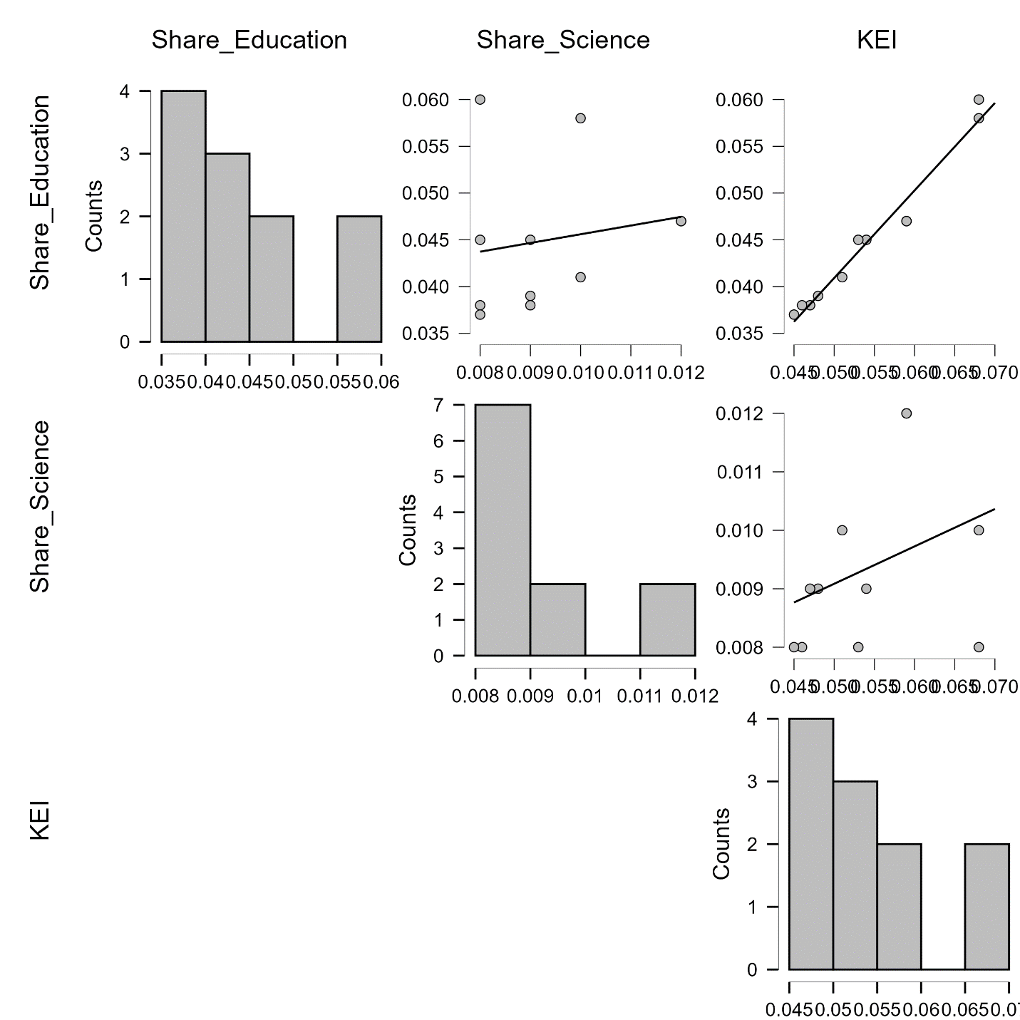

Figure B.1 – Correlation plots for Akmola

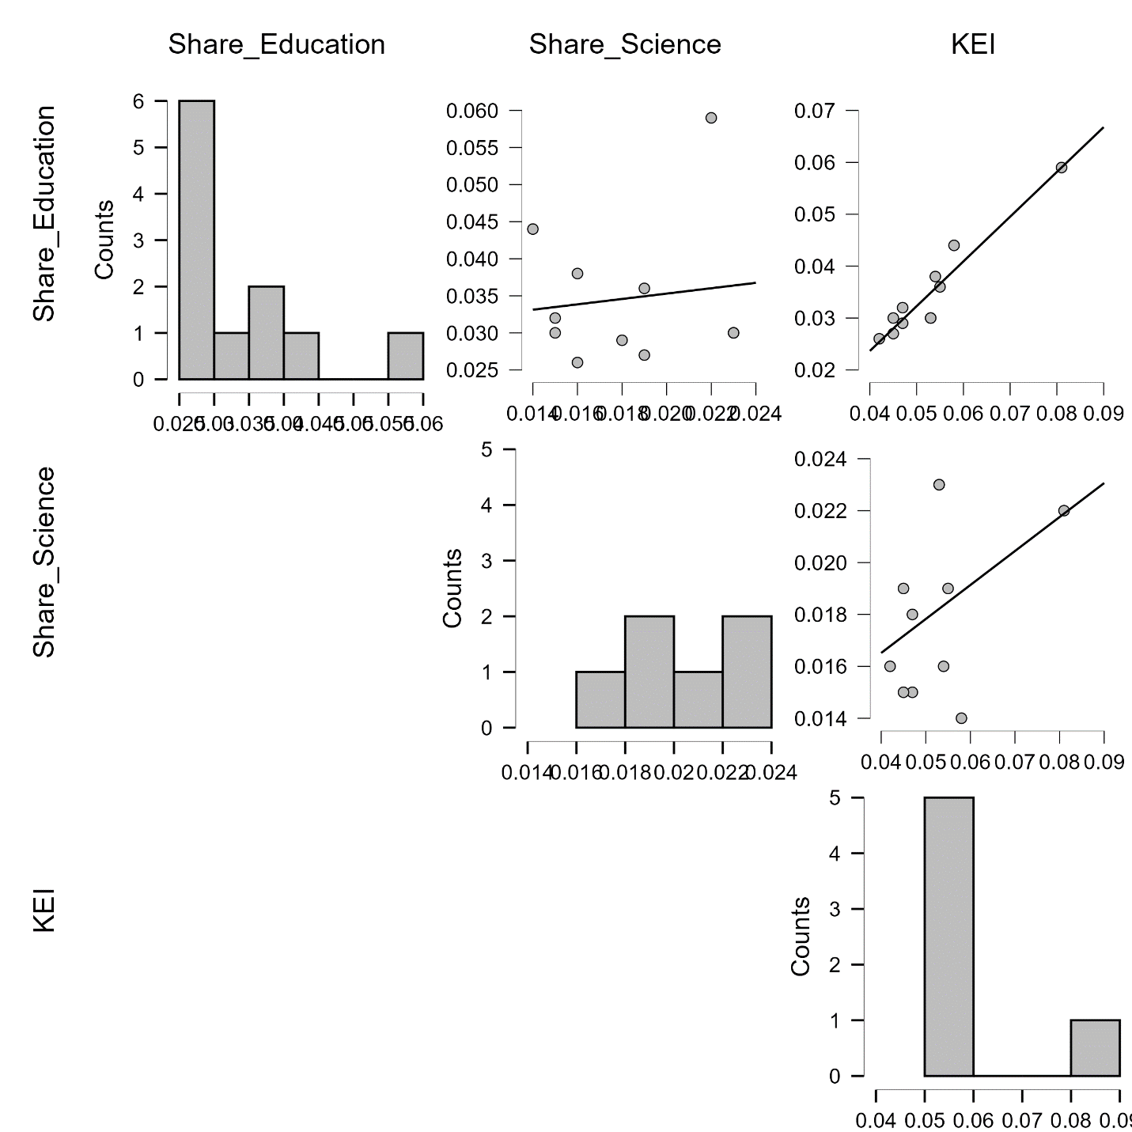

Figure B.2 – Correlation plots for Almaty
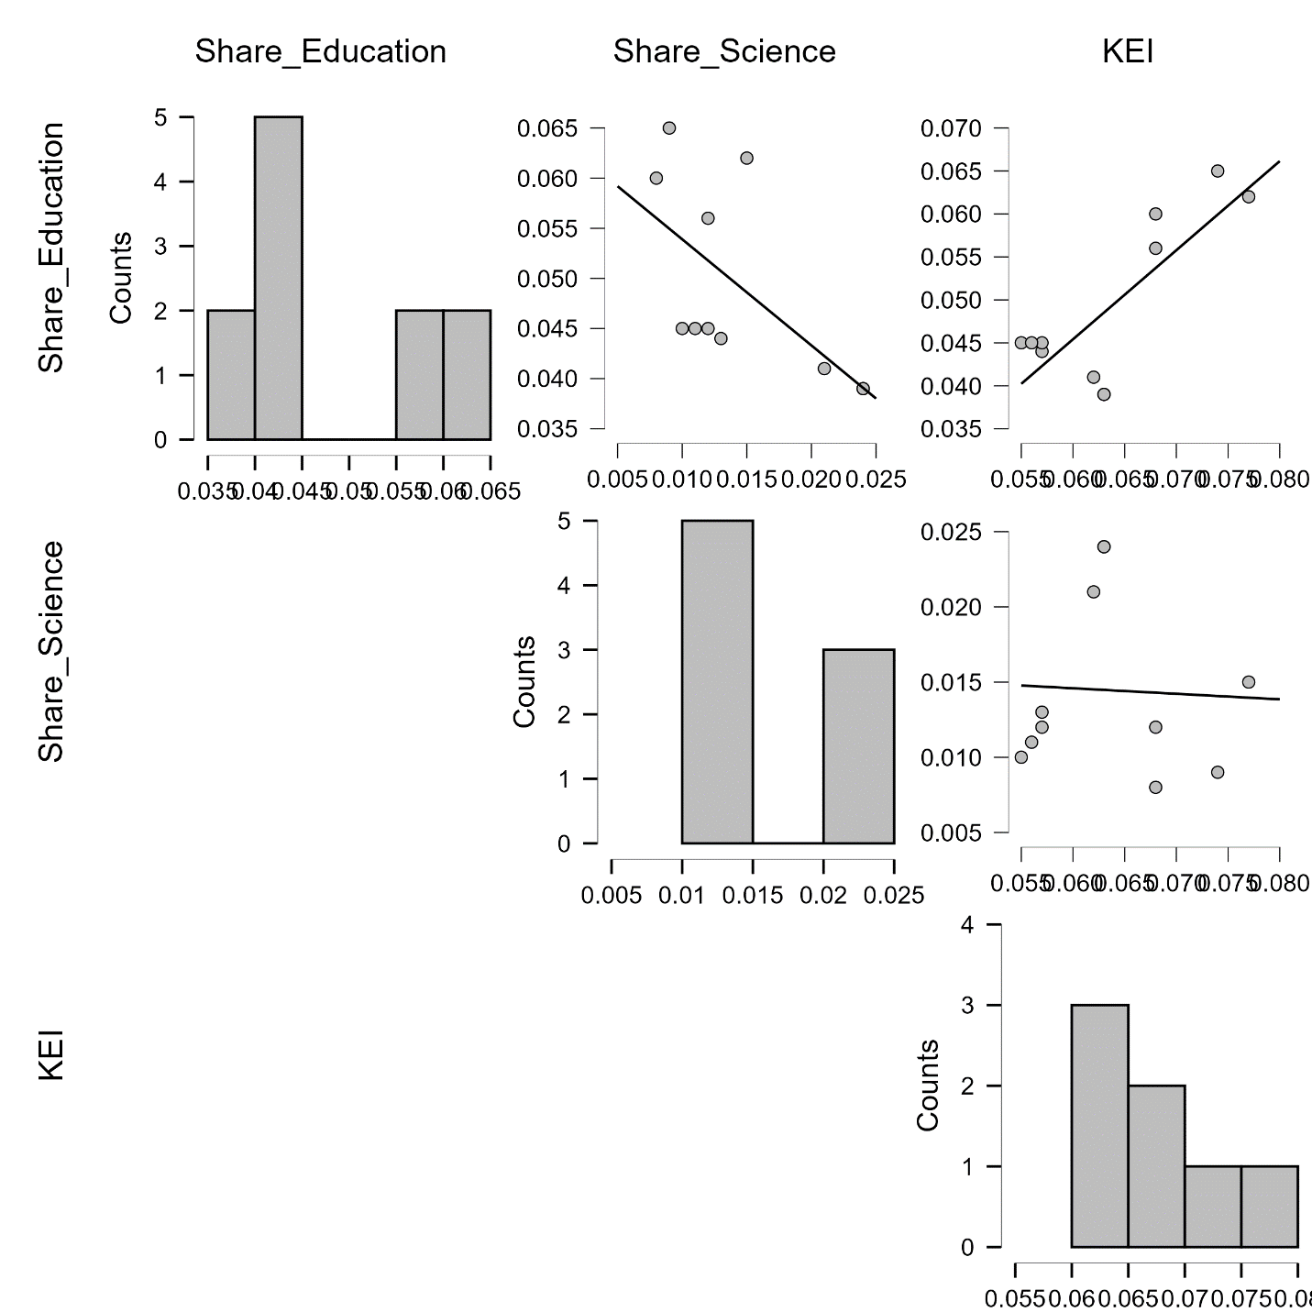

Figure B.3 – Correlation plots for Atyrau
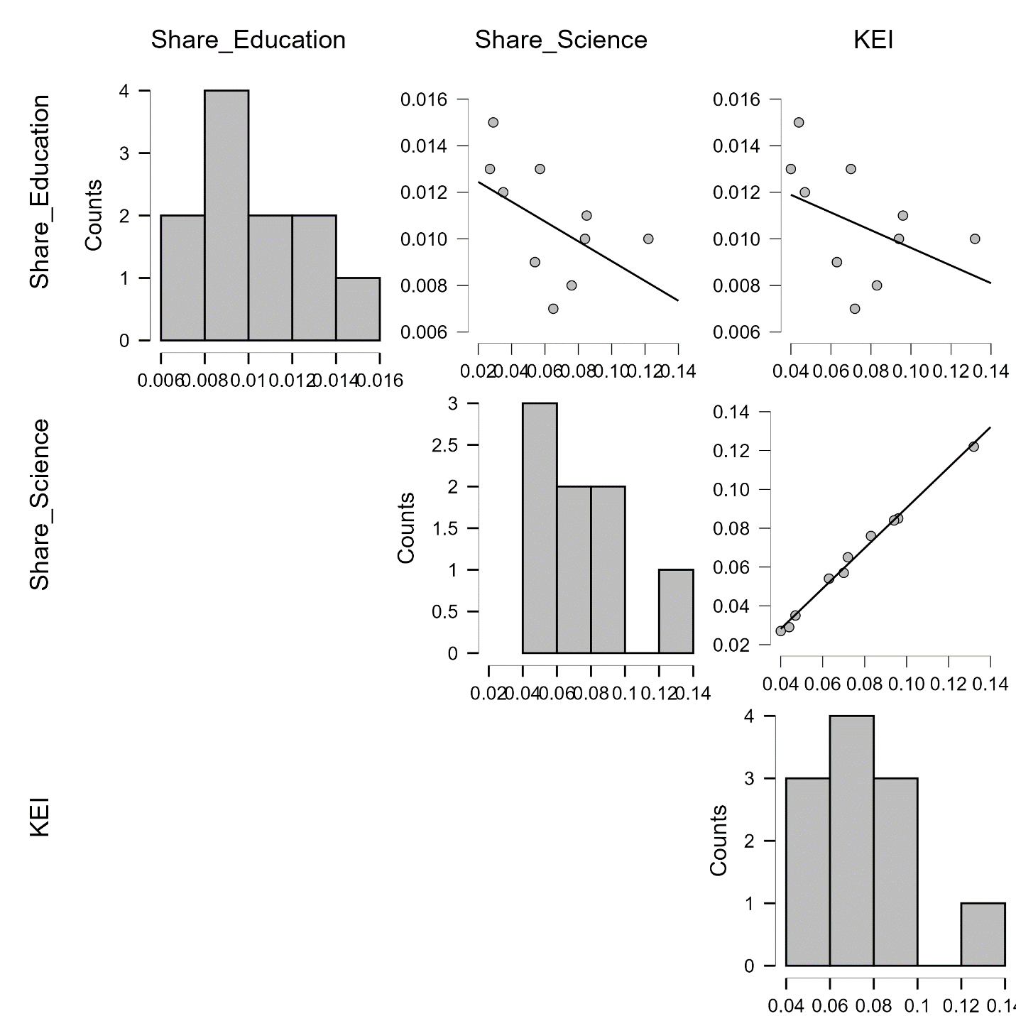

Figure B.4 – Correlation plots for West Kazakhstan
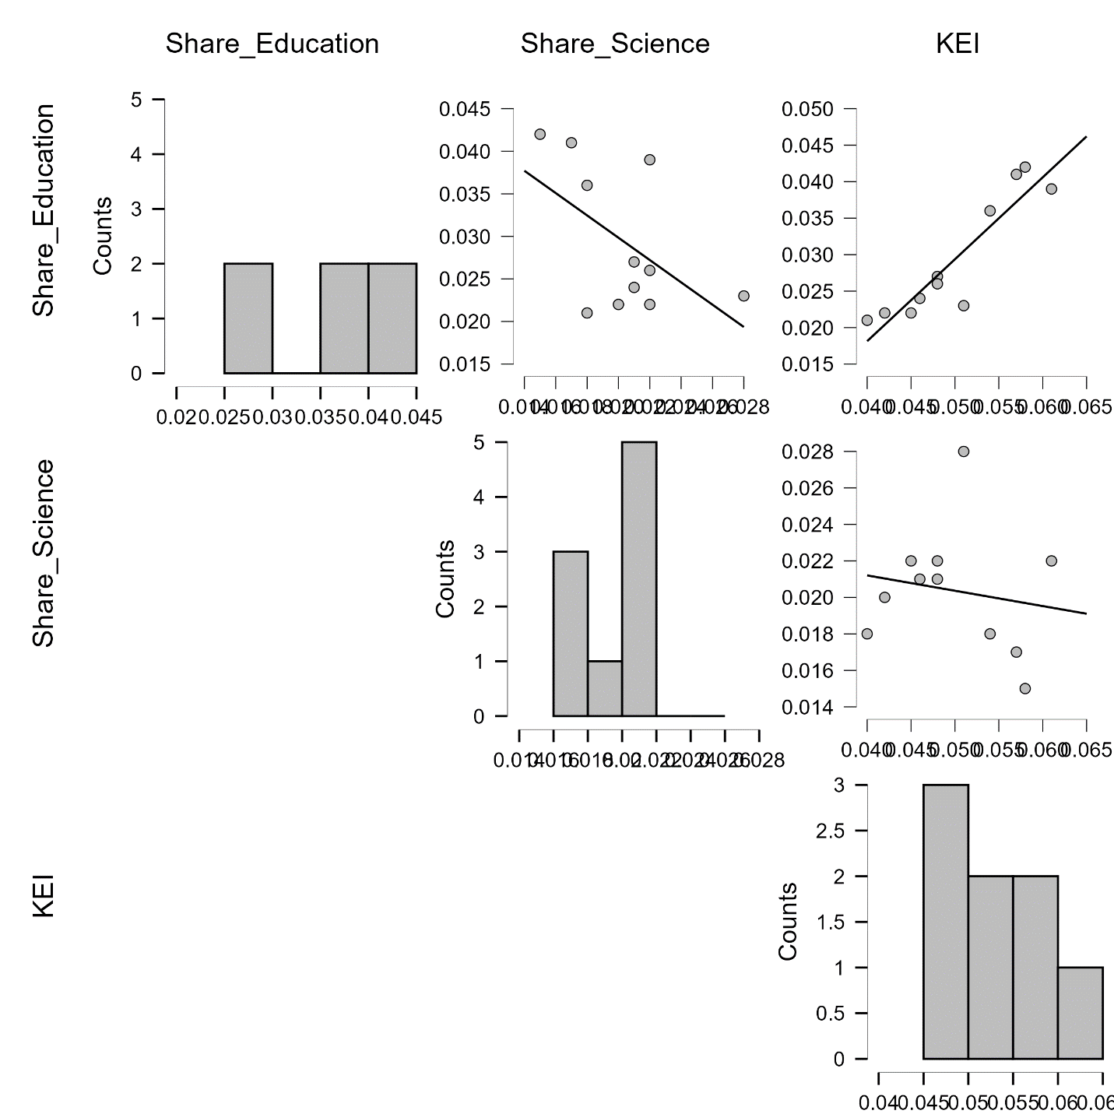

Figure B.5 – Correlation plots for Zhambyl
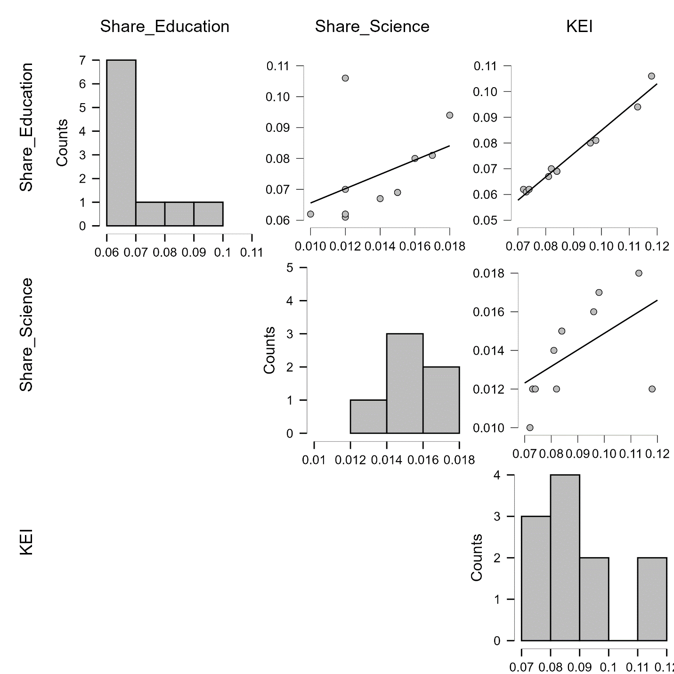

Figure B.6 – Correlation plots for Karaganda
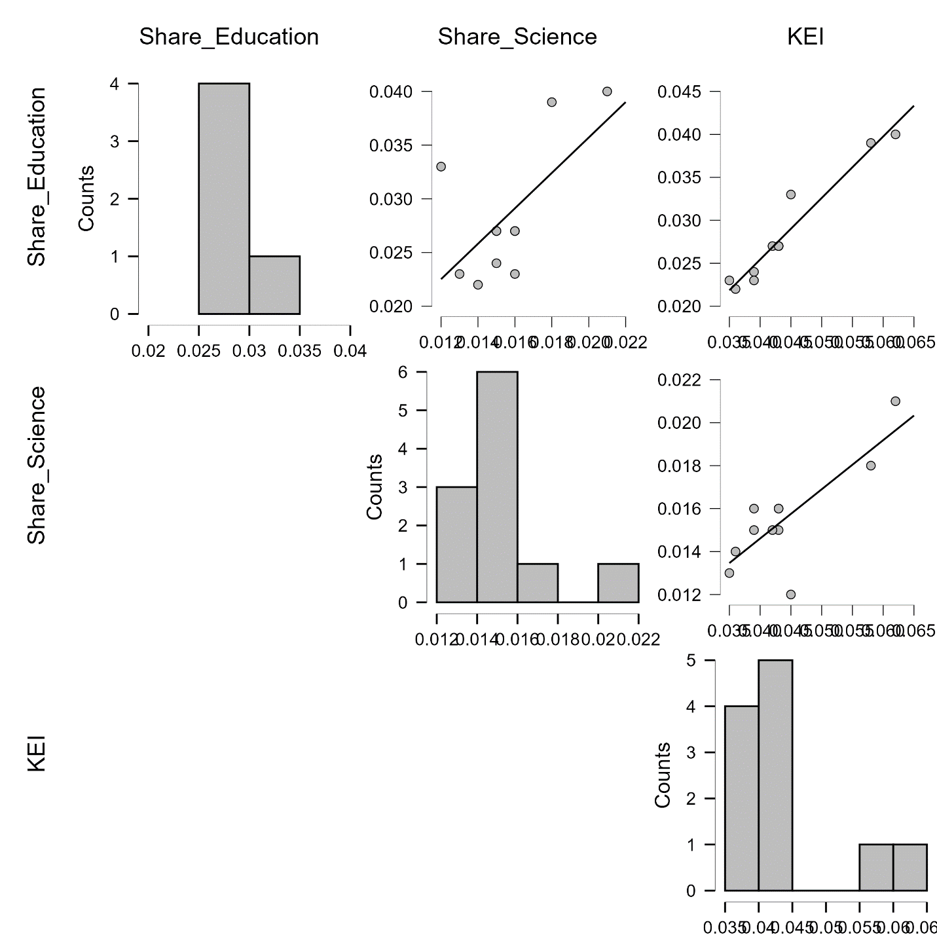

Figure B.7 – Correlation plots for Kostanay
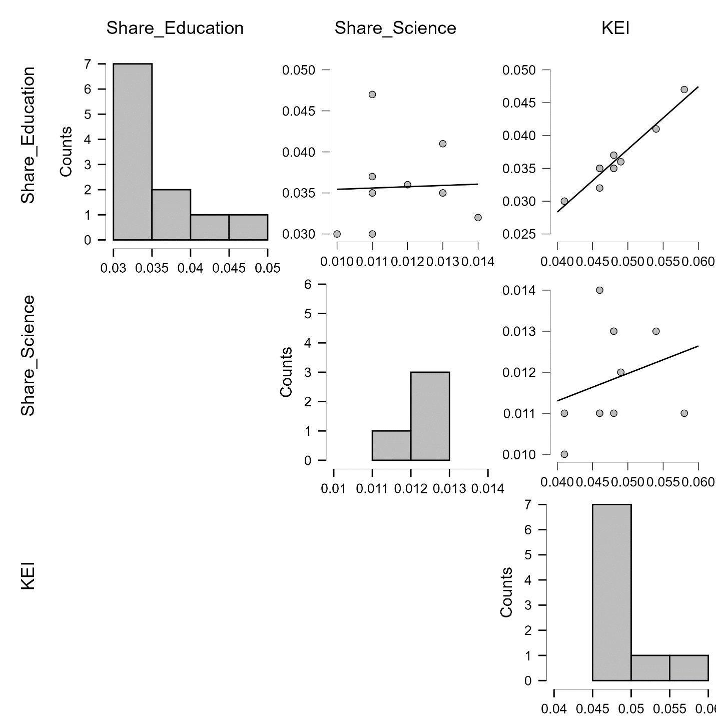

Figure B.8 – Correlation plots for Kyzylorda
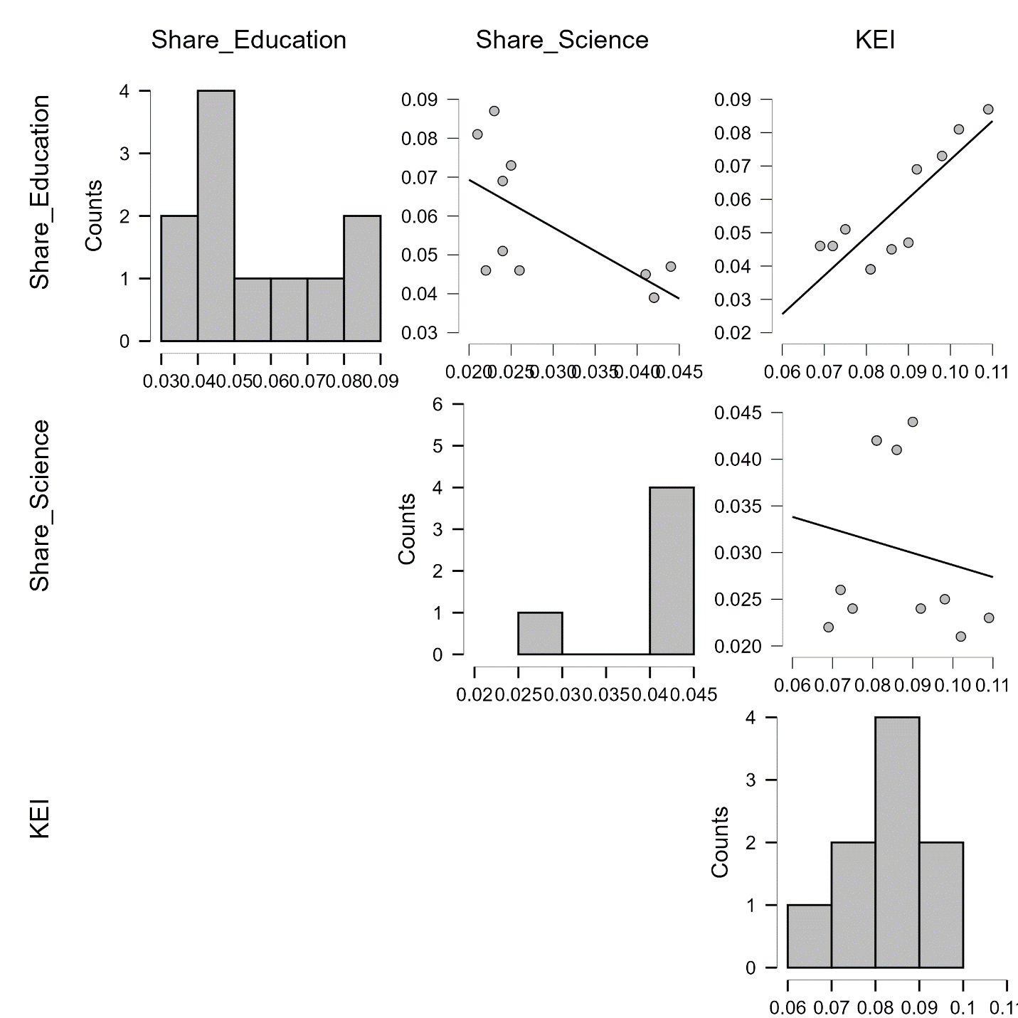

Figure B.9 – Correlation plots for Mangystau
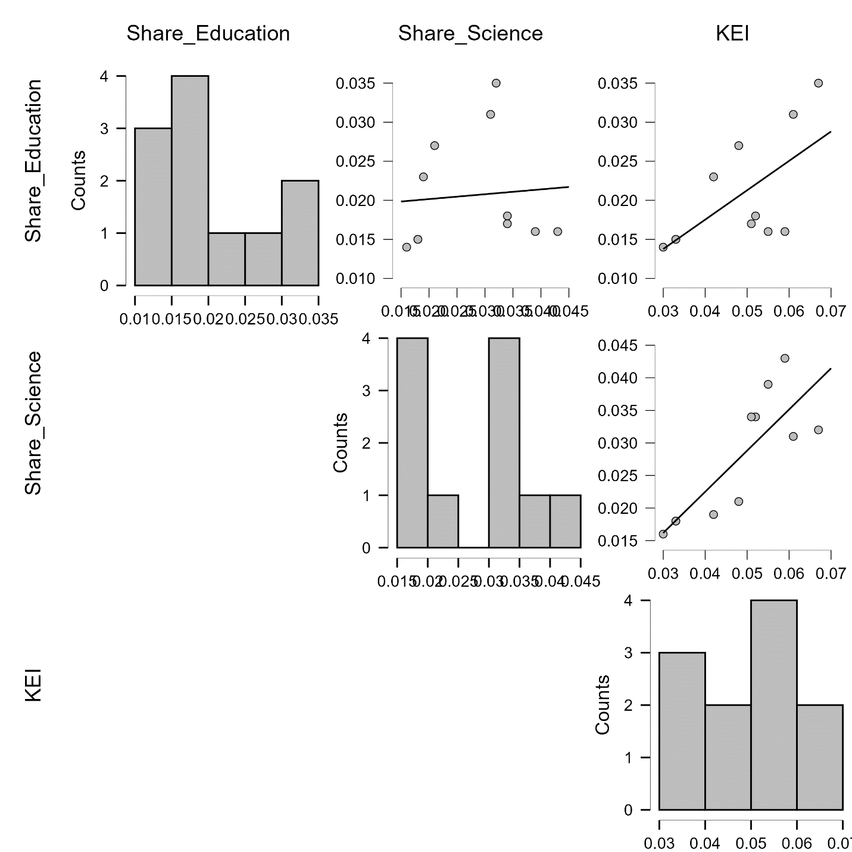

Figure B.10 – Correlation plots for Pavlodar
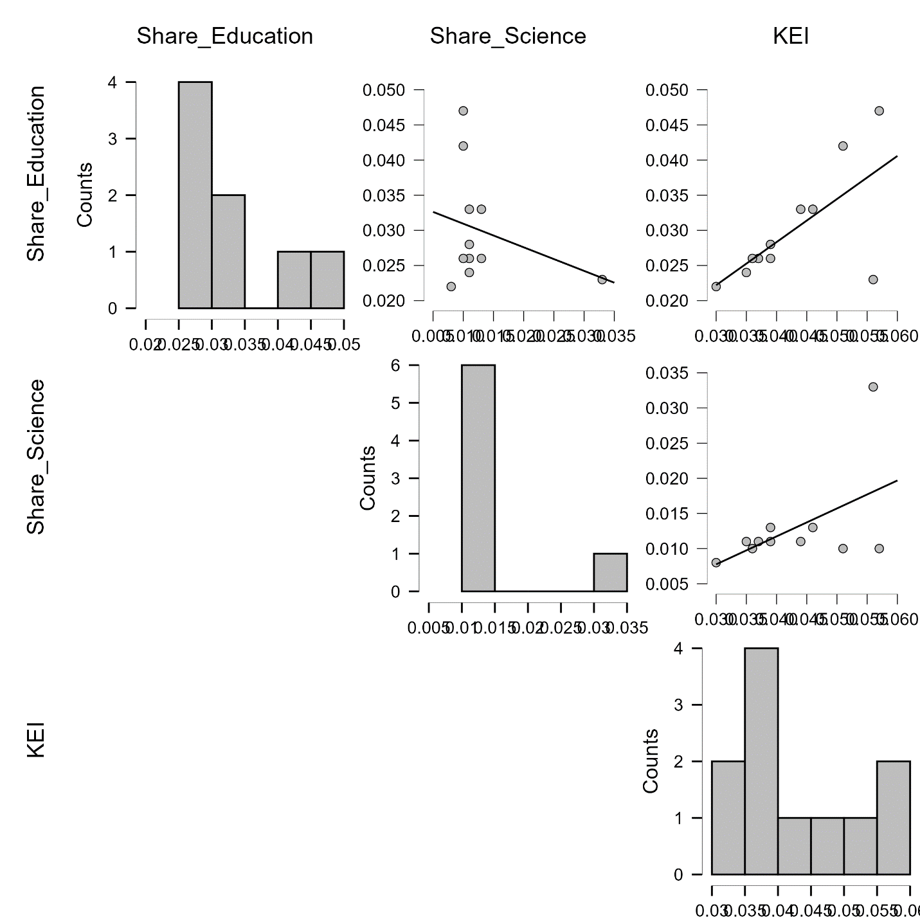

Figure B.11 – Correlation plots for North Kazakhstan
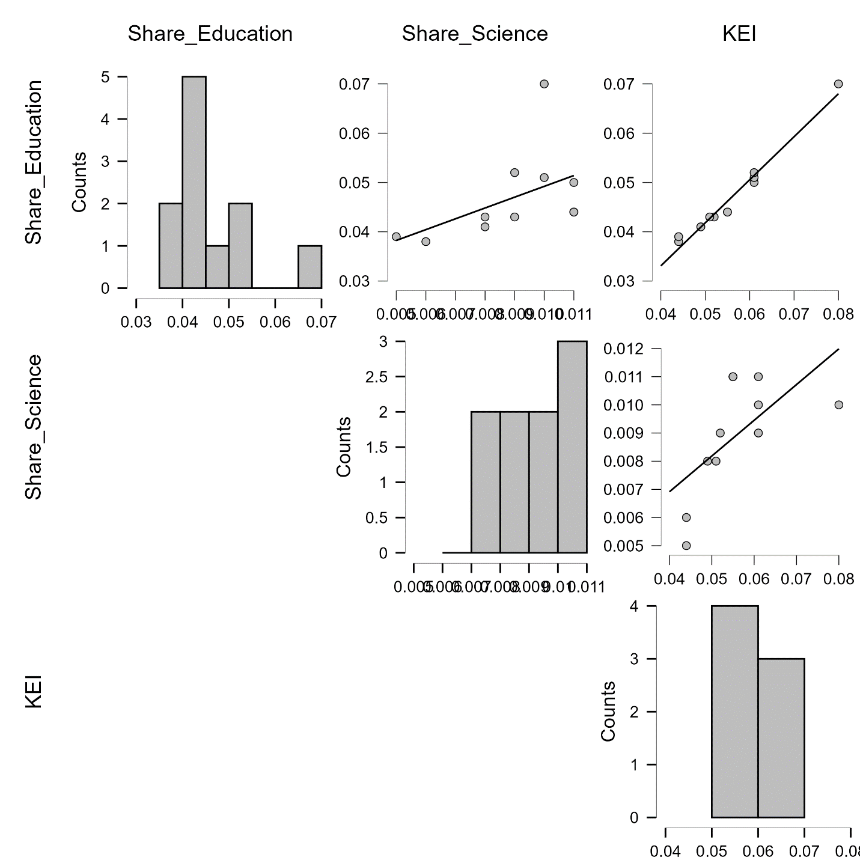

Figure B.12 – Correlation plots for Turkestan

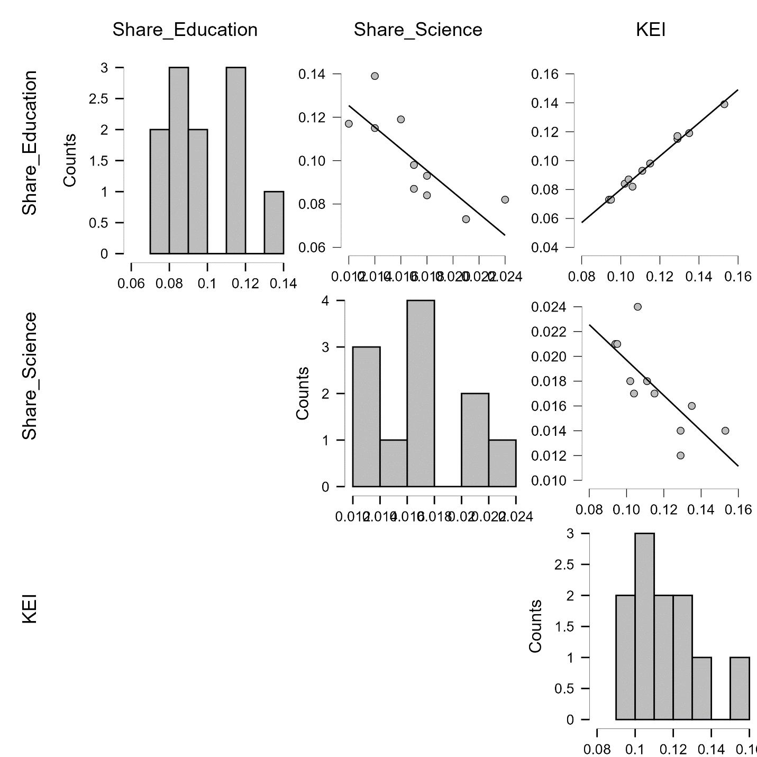

Figure B.13 – Correlation plots for East Kazakhstan
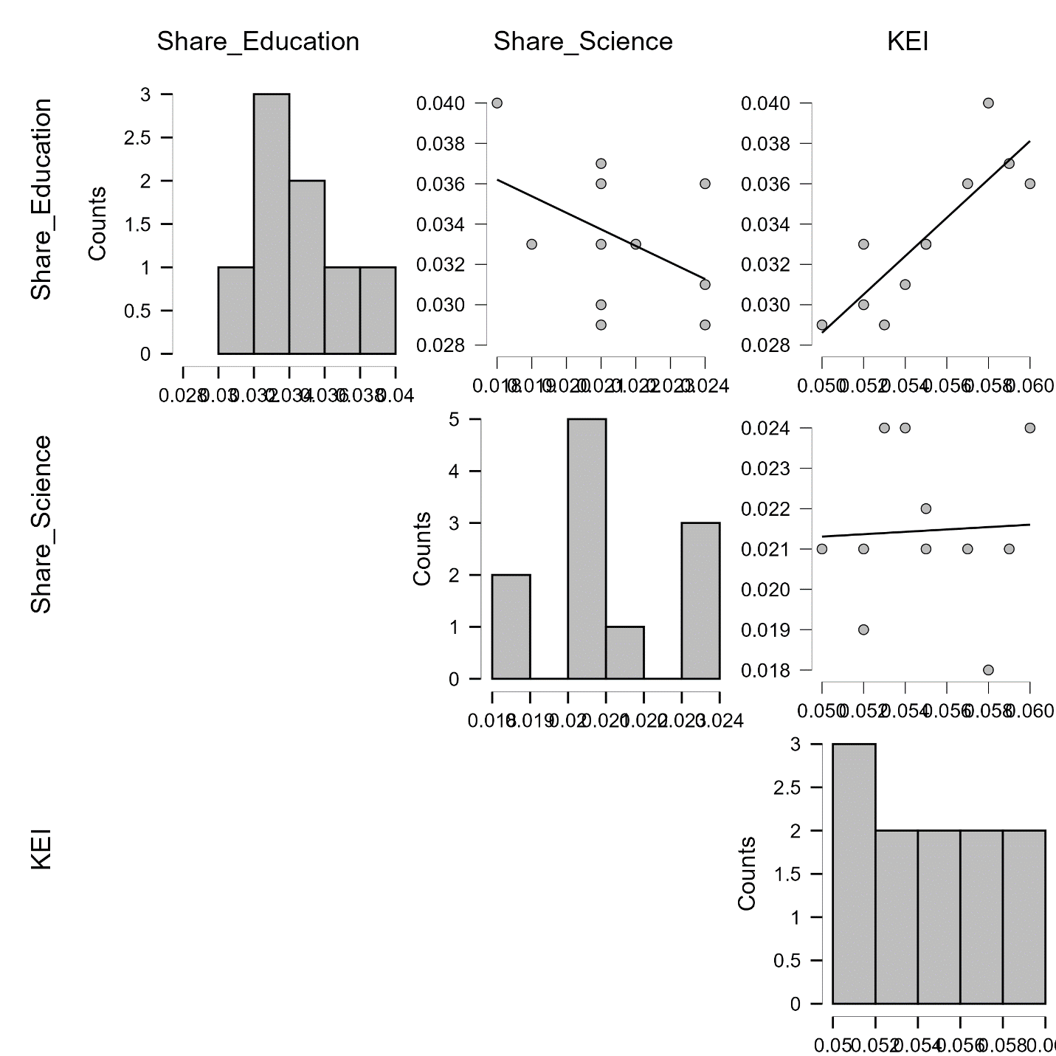

Figure B.14 – Correlation plots for Astana,c.
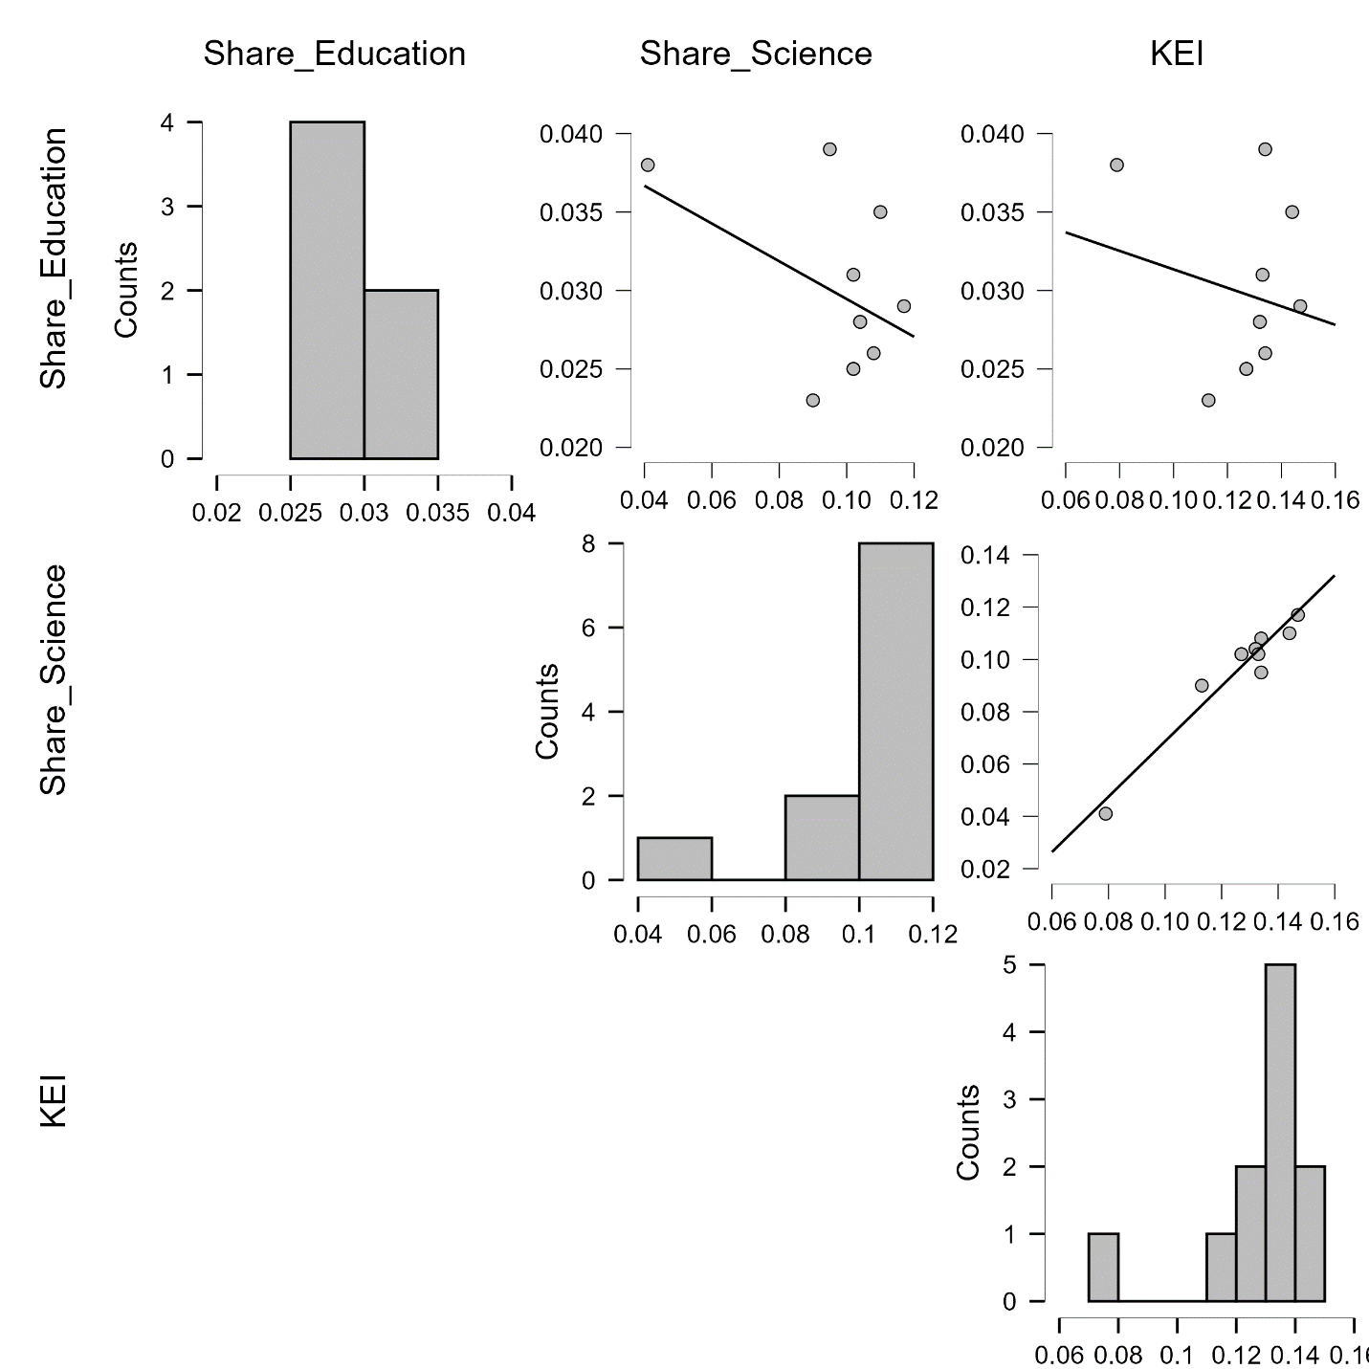

Figure B.15 – Correlation plots for Almanty,c.
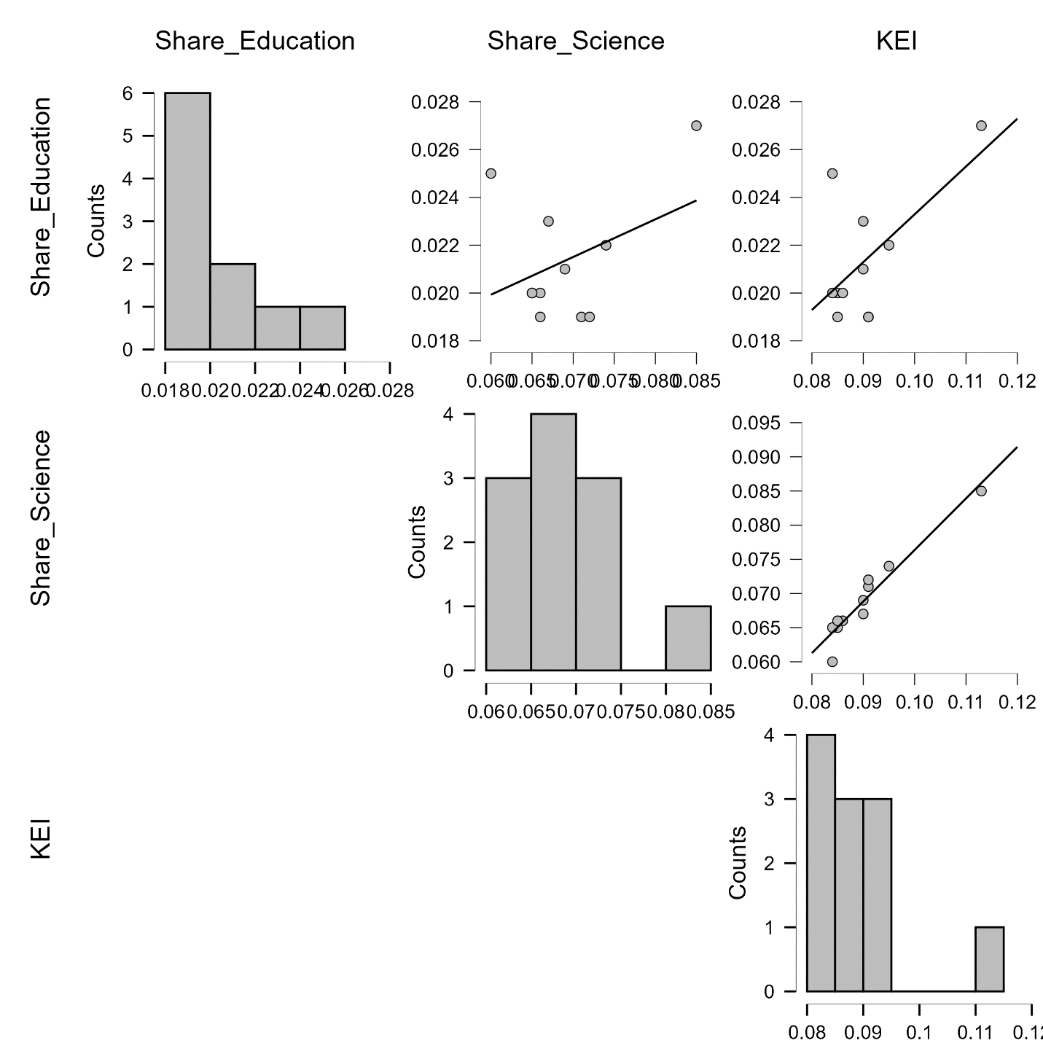

Figure B.16 – Correlation plots for Shymkent,c.

APPENDIX С

Cluster Matrix Plot
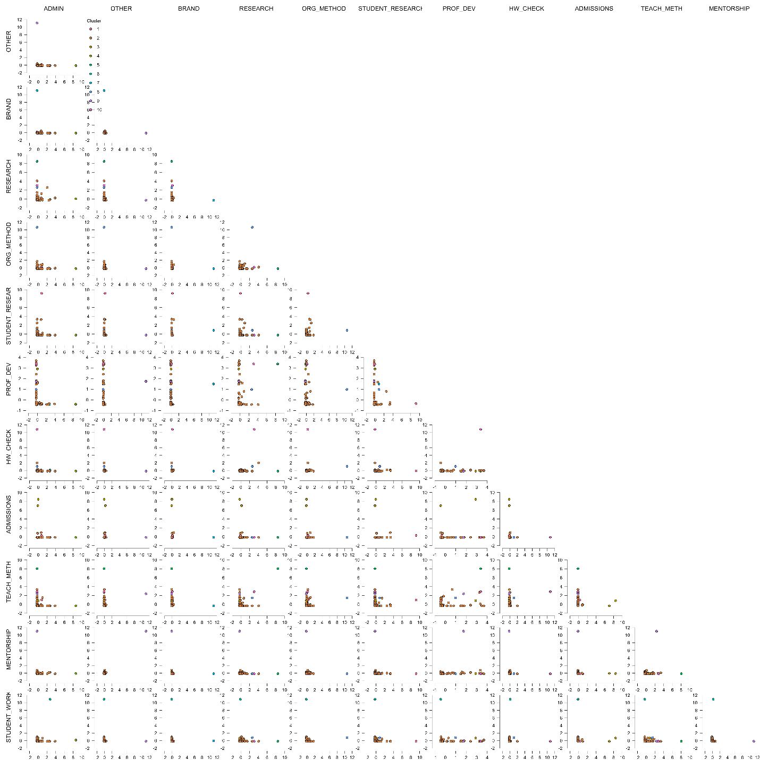

Figure C.1 – Distribution of teachers into clusters in the parametric space of activity categories

APPENDIX D

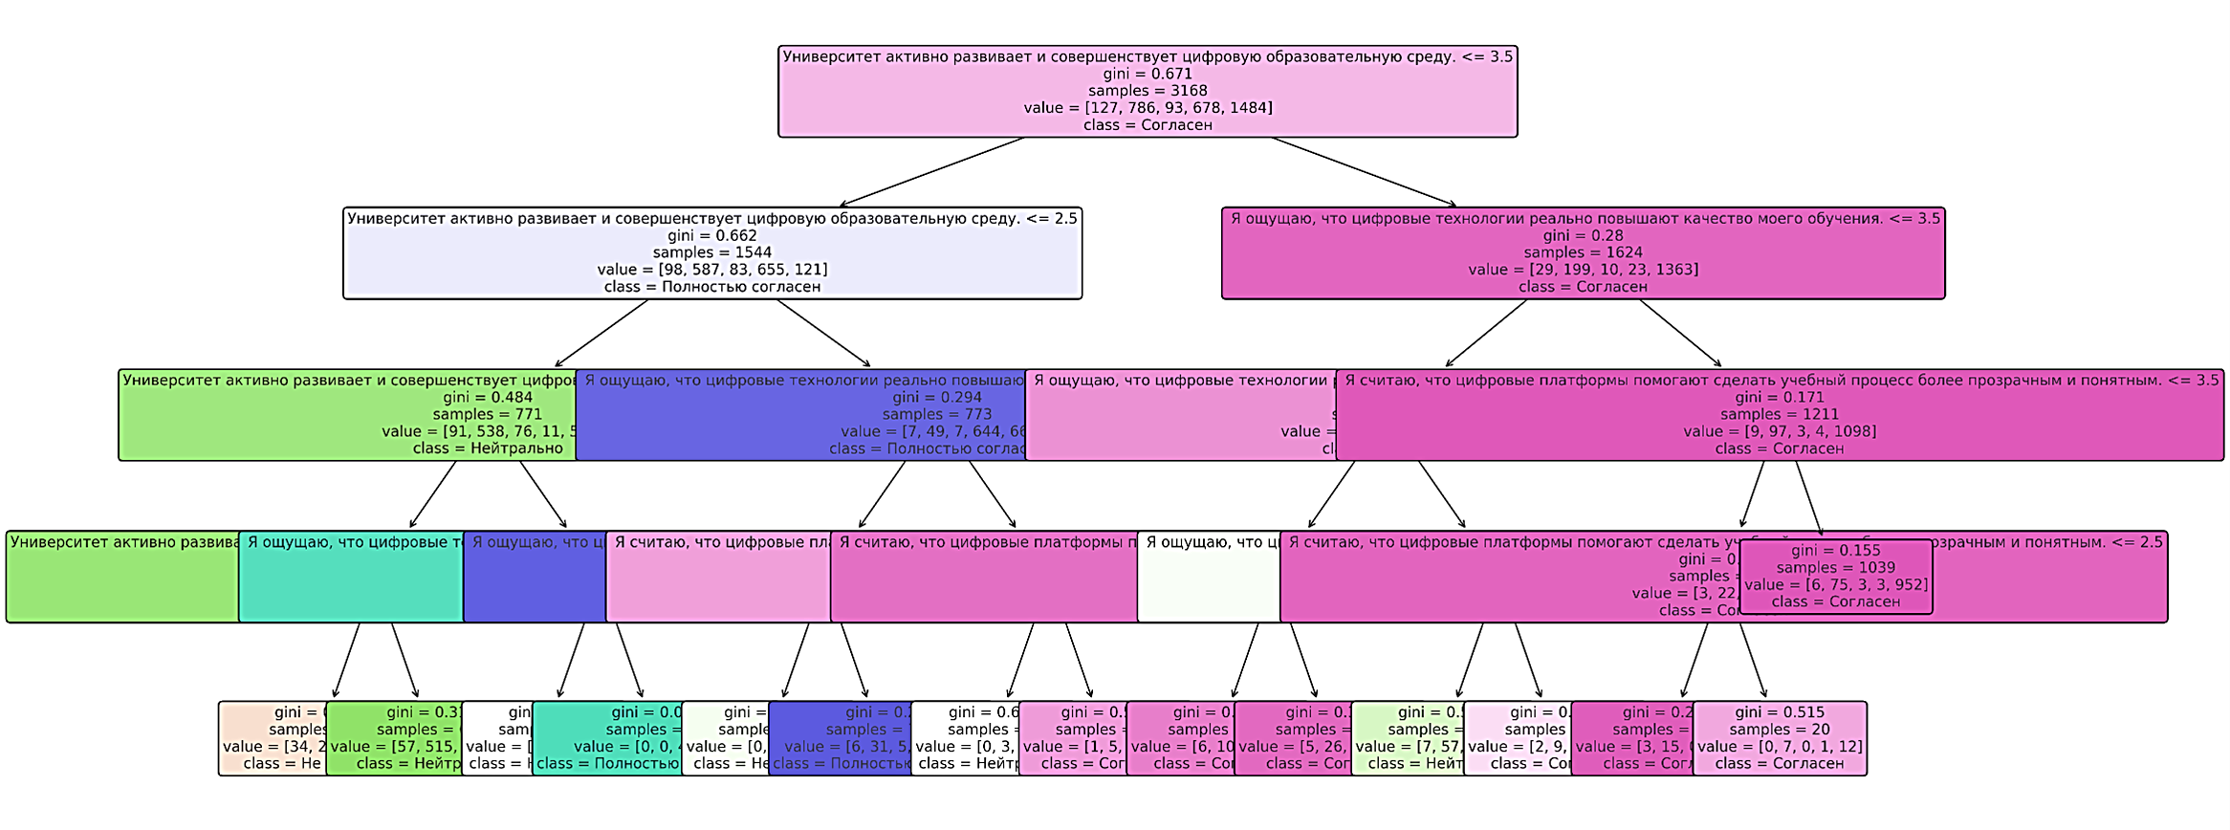

Figure D.1 - The decision tree structure

