SDU University
UDC 373.016:811.111(043) Manuscript

RAIKHANOVA DANARA KURMANOVNA

ESP Curriculum Development for Science (Chemistry-Biology) Students in Kazakhstani Higher Education

8D01703 - "Foreign Language: Two Foreign Languages"

A dissertation submitted for the degree of Doctor of Philosophy (PhD)

Internal Scientific Supervisor Gulnar KASSYMOVA, SDU professor,
Doctor of Pedagogical science

External Supervisor Nataša BAKIĆ-MIRIĆ, Priština University, Serbia
Associate Professor

Total word count (excluding the list of references and appendices): 68020

Almaty, 2026
Declaration Form

This doctoral dissertation was completed after my registration for the Doctor of Philosophy (PhD) degree at “Kazakh National Women’s Teacher Training University” (hereinafter - the University) and represents the results of my own research work, which has not been included in or submitted as part of any dissertation previously presented at this University or any other institutions.
I confirm that I have familiarized myself with the University’s research ethics guidelines and have made every effort to identify all potential risks related to the conduct of this study, as well as to obtain the necessary ethical and/or safety approvals.
In addition, I acknowledge that generative artificial intelligence (AI) tools were used in this scholarly work solely for searching academic sources, managing references, and creating visuals to interpret the research data. All data and personal information were processed in accordance with the University’s regulations. As the author of this dissertation, I take full responsibility for its content, statements, and references.

AI Function | Use  (Yes / No) | Used Tools | Degree of Use / Comments
Brainstorming ideas, topics, planning | Yes | ChatGpt | Brainstorming ideas, interpreting statistics and thematic analysis
Finding and / or selecting sources | Yes | SDU Library, Google Scholar, Scopus | These tools are used for searching for various relevant academic articles, books and relevant materials.
Editing or revising my own text | Yes | QuillBot | Editing or revising my own text
References / citations | Yes | Zotero, Mendeley | Reference management tools that help to collect, organize, annotate, and cite research materials.
Data Analysis | Yes | SPSS Statistics 25  Jamovi 2.6.23  Napkin Ai  Graphy Ai | - Used to reliability testing (e.g., Cronbach’s Alpha), descriptive statistics and correlation;  - Used to conduct a Paired Sample t-test and calculate Cohen’s d;  - Used to transform your interpretation, analysis by turning text into engaging, clear visuals;  - Used to create Matrix Maps.
By completing this form, I confirm that I have provided complete and accurate information regarding my use of AI tools during the dissertation writing process, and acknowledge that failure to comply with my ACADEMIC SUPERVISOR’S instructions regarding the use of AI tools may result in disciplinary consequences.

Signature:

Date:

Abstract

Purpose of the Study: This study aimed to develop and validate a theoretical and methodological framework for a competency-based English for Specific Purposes (ESP) curriculum tailored to the needs of future chemistry-biology teachers in higher education in Kazakhstan. It sought to bridge the gap between existing ESP programmes and the actual linguistic, academic, and professional requirements of students in teacher education.
Research Design and Methods: Guided by a pragmatic paradigm, a multi-phase mixed-methods design was implemented. The research unfolded in three interconnected phases: a pre-intervention needs analysis using a convergent design, an intervention phase featuring design and development research (DDR) integrated with a quasi-experimental validation, and a post-intervention evaluation using an explanatory sequential design. Data were collected from students (N=85 across phases), language and content instructors (N=13), program coordinators (N=7), and alumni (N=26) through questionnaires, tests, semi-structured interviews, and document analysis. Quantitative data were analyzed using descriptive statistics, paired samples t-tests, Cronbach's alpha, and Cohen’s d effect sizes. Qualitative data underwent inductive thematic analysis.
Findings: The needs analysis revealed specific gaps in the existing curriculum. The newly developed, competency-based ESP curriculum led to statistically significant improvements in students' subject-specific language proficiency and academic confidence. Qualitative findings from instructors and alumni confirmed the curriculum's strong alignment with professional requirements and its effectiveness in preparing graduates for disciplinary communication.
Conclusion: The study results in a validated, theoretically grounded ESP curriculum model that demonstrates the efficacy of a systematic, needs-driven, and constructively aligned approach. This model provides a replicable framework for designing discipline-specific language courses in higher education, contributing to the advancement of competency-based and multilingual education in Kazakhstan and similar contexts.
Keywords: English Specific Purposes, Needs Analysis, Curriculum Design, Constructive Alignment, Competency-Based Education, Chemistry-Biology Teacher Education.

Table of Contents
Table of contents 5
List of figures and tables 9
Definitions 12
Abbreviations and acronyms 14

Chapter 1. Introduction 16
1.1 Rationale and importance of the study 17
1.2 Study aims and objectives 18
1.3 Approbation and implementation of research results 19
1.4 Thesis overview 20
Chapter 2. Educational Context 22
2.1 Global perspectives on English-medium instruction in higher education institutions 22
2.2 Language policies and initial teacher education reforms in Kazakhstan 25
2.2.1 Gaps in the national curriculum for chemistry-biology majors in Kazakhstan 27
2.3 Chapter summary 28
Chapter 3. Literature Review 29
3.1 Defining English for Specific Purpose 29
3.2 Language proficiency and academic success 32
3.3 Competency-based education and ESP 35
3.3.1 Science student-teachers’ learning needs in the ESP context 38
3.4 Developing curricula tailored for science majors in the ESP context 40
3.4.1 Constructive alignment as a framework for ESP curriculum development 44
3.5 Conceptual framework and curriculum model 48
3.6 Chapter summary 55
Chapter 4. Research design 56
4.1 Research paradigm 56
4.2 Research methodology 57
4.3 Research participants 59
4.4 Stages of research 60
4.5 The intervention programme 61
4.5.1 Needs analysis 61
4.5.2 Intended learning outcomes 63
4.5.3 Material development 65
4.5.4 Integrating experiential learning activities 67
4.5.4.1 Project based, task-based, and team-based learning activities 67
4.5.4.2 Game-based learning activities 68
4.5.4.3 Research-based learning activities 69
4.5.4.4 Case-study learning activities 69
4.5.4.5 Establishing assessment criteria 70
4.6 Data collection 72
4.6.1 Questionnaires 73
4.6.2 Pre and post tests 74
4.6.3 Interviews 75
4.6.4 Document analysis 76
4.7 Data analysis 78
4.7.1 Quantitative data analysis 78
4.7.2 Qualitative data analysis 79
4.8 Ethical issues 80
4.9 Validity and reliability 81
4.10 Study limitations 82
4.11 Chapter summary 83
Chapter 5. Findings 85
5.1 Needs analysis results 85
5.2 Intended learning outcomes’ results 103
5.3 Results of ESP course materials and activities development 123
5.3.1 Designing off-the-shelf (commercial) ESP materials 124
5.3.2 Designing in-house (institutionally developed) ESP materials 130
5.4 Intervention stage 154
5.4.1 Pre- and post-test results 160
5.4.2 One-group pre- and post-test results 163
5.5 Post - intervention stage 165
5.5.1 A semi-structured interview results 165
5.5.2 Alumni questionnaire results 167
5.6 Chapter summary 176
Chapter 6. Discussion 177
6.1 Science student-teachers’ ESP learning needs 179
6.1.1 Lexical, epistemic, and affective dimensions 182
6.1.2 Pedagogical and linguistic challenges in ESP for science 185
6.2 The journey from theory to classroom practice 187
6.2.1 Aligning materials with the programmatic "why" 189
6.2.2 Implementing an ESP course to address science student-teachers’ learning needs 191
6.3 Holistic effectiveness of the ESP model's impact and sustainability 194
6.3.1 Synergistic design principles, constraints, and future trajectories 200
6.4 Chapter summary 203
Chapter 7. Conclusions 207
7.1 Study implications 207
7.1.1 Contribution to knowledge and practice 209
7.2 Recommendation to policy and practice 210
7.3 Final reflections 211

List of references 213
List of appendices 231
Appendix A Cover page of the compiled materials “English for Specific Purposes (for chemistry and biology students)” 231
Appendix B Certificate of entry into the state register of rights to objects protected by copyright, for compiled materials 232
Appendix C Act of implementation 233
Appendix D Assessment rubric for written work 234
Appendix E Rubric of presentation assessment 236
Appendix F Grading rubric of project work 237
Appendix G Questionnaire for language practitioners 238
Appendix H Questionnaire for content teachers and chemistry - biology students 239
Appendix I Online survey questions for department coordinators 241
Appendix J Learners’ evaluation of unit 1: “Chemistry in Our Lives” 243
Appendix K Semi-structured interview on course evaluation 244
Appendix L Survey for chemistry-biology alumni 246
Appendix M Syllabus for Academic English course 248
Appendix N Syllabus for English for Special Purposes course 251
Appendix O Pre-test questions 255
Appendix P Post-test questions 258
Appendix Q Magazine #1: “Human Body System” 262
Appendix R Magazine # 2: “Beauty of Beast” 263
Appendix S Collection of certificates in nomination of the best speaker and the best report 264
Appendix T Title page of the conference collection 265
Appendix U Appreciation certificate for scientific advisor 266
Appendix V Poster presentation and certificate of participation 267
Appendix W Sample of abstract book created by students 268
Appendix X Sample of invitation to conference / mini seminar session 269
Appendix Y Sample of poster presentation by students 270

List of Figures
Figure 1. Intersection of ESP and curriculum development 48
Figure 2. Intersection of constructive alignment and backward design 49
Figure 3. Theories underpinning the study 51
Figure 4. The model of ESP curriculum development 95
Figure 5. Question #3 ‘ESP course is helpful in understanding your major subjects in English’ 96
Figure 6. Questions #5 & 6 ‘Materials should be more focused on chemistry-biology or academic English’ 96
Figure 7. Needs analysis of the programme 102
Figure 8. Key academic skills needed in educational settings 105
Figure 9. The expected outputs that students are required to produce throughout their courses 106
Figure 10. Writing skills that are expected from educators 107
Figure 11. Reading skills that are expected from educators 107
Figure 12. Speaking skills that are expected from educators 108
Figure 13. Listening Skills that are expected from educators 108
Figure 14. Branches and sub-branches of ESP curriculum for chemistry-biology specialty at higher institution 112
Figure 15. Required level of English proficiency in the 2020-2021 academic year 114
Figure 16. Required level of English proficiency in the 2021-2022 academic year 115
Figure 17. Course design parameters 116
Figure 18. Action verbs of three domains 126
Figure 19. Bingo game on disease topic of ESP classes for chemists and biologists 133
Figure 20. A set of taboo cards on states of matter 133
Figure 21. An article ‘Laundry Detergent from Jessica Alba’s Honest Co. Contains Ingredient It Pledged Avoid’ 137
Figure 22. Chemistry in Our Lives 139
Figure 23. Case Study rules and regulations for laboratory safety 140
Figure 24. Case Study rules and regulations for Life on Earth 142
Figure 25. Assessment of project work of chemistry and biology students 145
Figure 26. Content pages of unit Life on Earth & Bonding 148
Figure 27. Cover pages of units of ESP compiled materials 154
Figure 28. Correlation between programme learning outcomes and lesson learning outcomes 157
Figure 29. Difference in results between control and experimental groups 162
Figure 30. Pre-test and post-test mean results 164
Figure 31. Demographic results of alumni 168
Figure 32. Gender background of alumni 168
Figure 33. Occupation information of alumni 169
Figure 34. Usage of skills in the workplace by alumni 171
Figure 35. Satisfaction of the ESP course 172
Figure 36. Recommendation of the ESP course by alumni 173

List of Tables
Table 1. Characteristics of curriculum designs 46
Table 2. Research phases’ alignment with the research design 58
Table 3. Chronological and methodological sequencing of research stages 61
Table 4. Comparative analysis of foreign (English) language curricula of non - linguistic specialty students in Kazakhstan 88
Table 5. Inductive thematic analysis from general English, ESP, and content instructors 92
Table 6. Questionnaire results from chemistry-biology students in 2018-2019 academic year 93
Table 7. Cronbach’s alpha 97
Table 8. Item-total statistics 97
Table 9. Reliability statistics taken from 2019-2020 academic year 99
Table 10. Scale statistics taken from 2019-2020 academic year 99
Table 11. Questionnaire results from chemistry-biology students in 2019-2020 academic year 100
Table 12. Most common types of homework assignments set on educators’ (major) course 109
Table 13. The list of participants in the student conference 127
Table 14. An example of the ‘Stop the Bus’ game on chemical elements 135
Table 15. Feedback for the first unit given by chemistry-biology students 151
Table 16. Alignment of the learning outcomes with learning activities and assessment tasks of the compiled materials English for specific Purposes for chemistry-biology students 158
Table 17. Pre-post-test results of control and experimental groups 161
Table 18. Paired sample T-test and cohen's d statistical analysis 162
Table 19. Descriptive statistics of a one-group pretest-posttest experiment 163
Table 20. Paired sample T-test and cohen's d statistical analysis of a one-group pretest-posttest experiment 164
Table 21. An inductive thematic analysis results of semi-structured interview 166
Table 22. Evaluation of ESP course by alumni 169
Table 23. The statistical summary 170
Table 24. Summarizing suggested changes for improving the ESP course based on alumni feedback 173

Definitions

In this dissertation, the following terms are used with their corresponding definitions:

Approach | in education refers to a broad theoretical framework or philosophy that guides teaching strategies, curriculum design, and assessment practices, reflecting foundational beliefs about how students learn.
Competency - Based Learning | is an educational approach that focuses on the development and assessment of specific competencies or skills, rather than the amount of time spent on learning activities. It allows students to progress upon demonstrating mastery of the knowledge and skills required for a given subject or profession, aligning educational objectives with real-world competencies (Spady, 1994; Bill & Melinda Gates Foundation, 2013).
Constructive Alignment | is an instructional design concept, where the teaching activities and assessment tasks are aligned with the intended learning outcomes. This alignment ensures that students engage in learning activities that support the desired knowledge and skills, and that assessments accurately measure whether students have achieved those outcomes. (Biggs, 1996).
Course | is a unit within an educational programme that focuses on a particular subject or topic. It is organized as a series of lessons, assignments, and assessments aimed at helping students achieve specific learning outcomes. The course can be compulsory or elective.
Course Design | is creation of an individual course which involves lesson planning, selecting of materials, defining learning outcomes, and structuring activities for a single subject or discipline.
Curriculum | is an educational programme or structured framework that encompasses a set of courses and experiences designed to achieve specific learning outcomes. It is oriented towards developing knowledge, skills, and competencies in a particular field or discipline, structured to ensure that students’ progress through defined stages toward a qualification.
Curriculum Development | encompasses the broader process of planning and organizing an educational programme or framework which ensures coherence among multiple courses and their alignment with institutional or educational goals.
English for Specific Purposes | refers to the teaching and learning of English tailored to the specific needs and professional contexts of learners. Unlike general English, ESP focuses on language skills relevant to particular fields such as business, law, medicine, or science, often incorporating subject-specific vocabulary, communication strategies, and cultural norms.
Framework | in educational contexts refers to a structured approach or system that outlines the key components of a curriculum or teaching strategy, providing a coherent and organized structure for implementing and assessing educational practices. It is used to guide the development and evaluation of teaching and learning experiences.
Intended Learning Outcomes | are specific, measurable statements that define what students are expected to know, understand, or be able to do by the end of an educational experience. ILOs guide the design of curricula, teaching strategies, and assessments to ensure clear expectations for both teachers and students (Anderson & Krathwohl, 2001).
Methodological Principle | refers to a fundamental guideline or approach that underpins the process of teaching and learning. These principles shape the pedagogical strategies employed in curriculum design, emphasizing the systematic application of teaching methods to achieve educational objectives (Schwab, 1978).

List of Abbreviations and Acronyms

BIL - Bilim-Innovation Lyceum
CA - Constructive Alignment
CBE - Competency-based Education
CBL - Case-based Learning
CEC - Continuous Education Centre
CEFR - Common European Framework of Reference for Languages
CGS - Control Group Students
CLIL - Content and Language Integrated Learning
CLT - Communicative Language Teaching
CNP - Communication Needs Processor
DDR - Design and Development Research
EAP - English for Academic Purposes
EBP - English for Business Purposes
EFL - English as a Foreign Language
EGAP - English for General Academic Purposes
EGS - Experimental Group Students
ELP - English for Legal Purposes
ELT - English Language Teaching
EMI - English-Medium Instruction
EMP - English for Medical Purposes
EOP - English for Occupational Purposes
EPP - English for Professional Purposes
ERPP - English for Research Publication Purposes
ESAP - English for Specific Academic Purposes
ESL - English as a Second Language
ESP - English for Specific Purposes
EST - English for science and Technology
EVP - English for Vocational Purposes
GBL - Game-based Learning
GE - General English
GPA - Grade Point Average
HE - Higher Education
HEI - Higher Education Institutions
ICT - Information and Communication Technology
ILO - Intended Learning Outcomes
IREC - Institutional Research Ethics Committee
ITE - Initial Teacher Education
KASA - Knowledge, Awareness, Skills, Attitude
KERA - Kazakhstan Educational Research Association
LO - Learning Outcomes
LSA - Learner Situation Analysis
NA - Needs Analysis
NIS - Nazarbayev Intellectual School
NS - National Standard
OBL - Outcome-based Learning
OECD - Organisation for Economic Co-operation and Development
PBL - Project-based Learning
PLO - Programme Learning Outcome
PSA - Present Situation Analysis
Q&A - Questions and Answers
QED - Quasi-experimental Design
RBL - Research-based Learning
RQ - Research Question
STEM - Science, Technology, Engineering, and Mathematics
TBL - Task-based Learning
TBLT - Task-based Language Teaching
TSA - Target Situation Analysis
UNESCO - United Nations Educational, Scientific and Cultural Organization
UNT - Unified National Testing

Chapter 1
Introduction
As Magzhan Zhumabayev, one of Kazakhstan’s most prominent poets, educators, and public intellectuals of the early twentieth century, insightfully observed: “the fate of the Kazakh people, and their future as a nation, ultimately depends on how their schools are founded; if we can build our education system on pure, strong, and aligned foundations, then we can confidently pledge ourselves to a bright future”. Magzhan Zhumabayev’s enduring insight mentioned above remains deeply relevant today, reminding us that the quality of teacher education is central to shaping the nation’s long-term development. In recent years teacher education has become the top priority of education policy in Kazakhstan (Government of the Republic of Kazakhstan, 2023). Examples are the increase in the passing score in the Unified National Testing (UNT) for those students who are entering pedagogical specialties, and the scholarship for future teachers has increased significantly. Along with all of the above, the desire to achieve world standards of quality in teacher education encourages leading pedagogical universities of the country to expand academic mobility opportunities and join international initiatives (Ministry of Education of the Republic of Kazakhstan, 2022).
The 21st century is marked by rapid advancements and unprecedented discoveries across all fields, making the role of educators more crucial than ever (UNESCO, 2025). As one of the key drivers of national educational development, teachers, especially highly qualified and professionally trained teachers play a decisive role in shaping student growth. When it comes to student development, it is widely recognized that teachers can serve as gateways to brighter futures, wherein they may also become obstacles that hinder progress if they lack the necessary competencies. Therefore, it is fair to assert that teachers are the central figures whose effectiveness determines success not only within the educational sphere but also in the implementation of bilingual education policies and the development of students’ academic and linguistic competencies (Imanova et al., 2025).
Nowadays, countries across the globe are adopting bilingual and multilingual education systems to equip students with skills needed in a rapidly changing world, with this trend becoming increasingly prominent globally (UNESCO, 2023; OECD, 2020). National language policies are also evolving to respond to linguistic diversity and promote early language learning (European Commission, 2018; Hornberger, 2009). Overall, multilingualism continues to expand in response to globalization, technological advancement, and shifts in educational paradigms (García & Wei, 2014; Cenoz & Gorter, 2015).
The education quality and language policy changes are aligned to produce a workforce equipped to meet Kazakhstan's multilingual and professional demands (Karimsakova et al., 2022). That is why the quality of education in higher institutions becomes not only a criterion for the personal success of a specialist, but also a factor in influencing the welfare of the entire state education as a whole (Krupchenko, 2018). The widespread use of the English language is growing rapidly in higher education institutions (hereinafter, HEIs) of Kazakhstan (Karimsakova et al., 2022). Efforts to promote English in HEIs in Kazakhstan are generally viewed in a positive light, with promising outcomes (Akynova et al., 2021) such as improved global communication and enhanced opportunities for students and institutions.

1.1 Rationale and Significance of the Study

I have been teaching English in HEIs of Kazakhstan for almost 15 years. During this time, I have taught General English, as well as Practical and Academic English. However, in 2017 I was assigned to teach a course titled English for Special Purposes (hereinafter, ESP) for a combined chemistry-biology major at one of the higher education institutions in Kazakhstan. From that moment, I began searching for appropriate curricula, materials, and instructional activities for this specific context. It soon became evident that there were no clear guidelines or suitable materials available for teaching ESP to students of a combined chemistry-biology program. This gap motivated me to explore the topic in depth and ultimately provided a strong rationale for focusing on it in my PhD dissertation.
My starting point was to conduct a comprehensive analysis of ESP theory. ESP has been the subject of research and practice for over 50 years, and it is now considered one of the leading approaches in the academic environment (Charles, 2013). While the field of ESP has gained significant traction worldwide, there is a critical research gap in specialized language instruction for students pursuing interdisciplinary majors in Kazakhstan, such as chemistry and biology. This lack of research also leads to a gap in instructional practice, as educators have limited evidence-based guidance to design effective ESP courses for these students. This gap is particularly evident in the context of Kazakhstani higher education. This lack of developed curricula that support language poses the importance of the research for chemistry-biology students who require a unique set of linguistic competencies to navigate the diverse demands of their combined field of study (Raikhanova et al., 2025).
In this regard the field of ESP has gained significant attention in the realm of English as a Foreign Language (hereinafter, EFL) education, as it aims to equip learners with the linguistic skills and knowledge required for their chosen academic or/and professional domains (Hutchinson & Waters, 1987; Tan et al., 2023; Inal & Karabulut, 2024). This is particularly crucial for students pursuing interdisciplinary programmes, such as the combined major of chemistry-biology, where the language needs may vary from those in a general English curriculum.

1.2 The Study Aims and Objectives

Studies indicate that the key challenges in implementing ESP in chemistry-biology classes include the absence of suitable instructional materials, a wide range of language proficiency levels among learners, and teachers’ limited prior exposure to subject-specific English instruction (Sintia et al., 2025). Whilst a wide range of materials may exist both in the field of Chemistry and Biology separately, there are scarcity of resources specifically designed for English for Chemistry or Biology courses, especially in the developing contexts such as Kazakhstan. Furthermore, in my day-to-day teaching practice I noticed that there is no established curriculum model to guide the development of such discipline-specific ESP courses in HEIs in Kazakhstan. In addition, there is frequent confusion and misapplication regarding the branches of ESP. Misunderstandings often arise when courses intended for academic purposes are applied in professional contexts, or vice versa, leading to gaps in learner preparedness and the effectiveness of instruction (Karabassova, 2020). Such challenges underscore the need for further investigation.
Therefore, the aim of this research is to (1) develop a theoretical and methodological framework, (2) design an ESP curriculum model and didactic material collection based on the findings of the needs analysis (hereinafter, NA), and (3) experimentally evaluate the effectiveness of the developed ESP curriculum model within a Kazakhstani higher education institution.
Based on the identified rationale and significance, the research sets out to accomplish several key objectives to: (1) study and analyse the theoretical and methodological foundations of teaching English for Specific Purposes (ESP) and curriculum development within the context of contemporary foreign language education (see Chapter 3); (2) conduct a needs analysis (see Chapter 4 and Chapter 5) and, based on the findings of the needs analysis, (3) define a methodological framework for ESP curriculum development for future chemistry-biology students, the outcome of which is the generation of an ESP curriculum development model (see Chapters 3 and 4); (4) implement the developed curriculum model within an ESP course for chemistry-biology students, grounded in advanced theoretical approaches and a clearly defined methodological framework and supported by instructional resources, including the compiled materials English for Specific Purposes (compiled materials for chemistry - biology major students) (see Chapter 4 and Chapter 5); and (5) experimentally test and evaluate the effectiveness of the ESP curriculum model within the ESP course for chemistry-biology students in real-world educational settings, ensuring its practical applicability and alignment with educational modernization goals (see Chapters 5 and 6). In line with these aims and objectives, the study is guided by the following research questions (hereinafter, RQ):

RQ 1. What discipline-specific linguistic, academic, and professional needs do chemistry-biology students demonstrate in relation to ESP learning in a Kazakhstani higher education context?
RQ 2. How can a discipline-specific ESP didactic material collection be designed to address the identified needs and support chemistry-biology students’ learning outcomes?
RQ 3. How can an ESP curriculum model for chemistry-biology students be developed as a replicable methodological guideline for ESP and EMI practitioners?
RQ 4. To what extent is the developed ESP curriculum model effective in terms of students’ learning outcomes within the selected higher education institution?

The research outcome may influence several aspects of ESP development in one HEI in Kazakhstan. They include a discipline-specific didactic material collection, an ESP curriculum model for chemistry-biology students that can serve as replicable methodological guidelines for language and EMI practitioners. Together, these outputs can support classroom practice, teacher training, and curriculum and policy development.

1.3 Approbation and Implementation of Research Results

The findings of this research were disseminated through ten publications, including two Scopus-indexed Q3 articles, which contributed to refining the needs analysis and curriculum design principles (Raikhanova et al., 2025; Raikhanova & Bakić-Mirić, 2023). Additionally, six articles were published in journals recommended by the Committee for Quality Assurance of the Ministry of Science and Higher Education of the Republic of Kazakhstan, addressing ESP pedagogy, curriculum development, and discipline-specific language learning (Raikhanova, 2020; Raikhanova, 2020a; Raikhanova, 2020b; Raikhanova et al., 2024; Raikhanova & Kassymova, 2024; Raikhanova et al., 2025).
The results were presented at two academic conferences: the Eurasian Conference on Language and Social Sciences 6 (Uzbekistan, 2019) and the 1st International Scientific Conference “Current Issues in Foreign Language Education” (Turkistan, 2023), with both papers published in the respective conference proceedings, supporting scholarly dialogue on ESP and science education (Raikhanova & Kassymova, 2019; Raikhanova et al., 2023). The study also produced an educational-methodological collection, English for Specific Purposes (for chemistry-biology students) (Raikhanova, 2024), registered in the State Copyright Register.
Furthermore, participation in professional development programmes and engagement as a junior researcher in a Ministry-funded EMI grant (IRN: AP19676131, 2023-2025) contributed to validating the research design and strengthening the practical relevance of the developed ESP curriculum model.

1.4 Thesis Overview
The thesis consists of seven chapters, a list of references, and appendices, which include documents and instructional materials related to the research. Chapter 1, Introduction, outlines the relevance of the study, its aims and objectives, research questions, and the approbation and implementation of the research results within the context of English for Specific Purposes education in Kazakhstan. Chapter 2, Educational Context, examines global perspectives on English-medium instruction in higher education and analyses language policy developments and initial teacher education reforms in Kazakhstan, with particular attention paid to existing gaps in the national curriculum for chemistry-biology majors. Chapter 3, Literature Review, analyses the theoretical and methodological foundations of English for Specific Purposes and ESP curriculum development. This chapter integrates key concepts such as constructive alignment, learner-centred and competency-based education, and experiential learning, and culminates in the development of a conceptual framework and a practical ESP curriculum model. Chapter 4, Research Design, presents the research paradigm and the methodological framework guiding the study and details the stages of the research, participant selection, the intervention programme, data collection instruments, data analysis procedures, ethical considerations, and issues of validity and reliability. Chapter 5, Findings, reports the results of the experimental and pedagogical research by presenting findings from the needs analysis, formulation of intended learning outcomes, ESP materials development, and evaluation of the intervention through pre- and post-tests, interviews, and alumni questionnaire data. Chapter 6, Discussion, interprets the findings in relation to the theoretical foundations and previous research, addressing science student-teachers’ ESP learning needs, the implementation of the curriculum model, and its overall effectiveness, sustainability, and pedagogical implications. Chapter 7, Conclusions, summarizes the key outcomes of the study, outlines its theoretical and practical contributions, provides recommendations for policy and educational practice, and suggests directions for future ESP curriculum development.

Chapter 2

Educational Context
In Chapter 2 I present the educational context that underpins the development of the English for Specific Purposes (ESP) curriculum for chemistry-biology students in Kazakhstan. I outline the key global and national policy frameworks that shape foreign language education, with particular attention to multilingualism, English-medium instruction (EMI), and competency-based approaches. The chapter then examines Kazakhstan’s language policies and ongoing reforms in initial teacher education (ITE), emphasizing the shift toward competency-based training, English integration in STEM disciplines, and updated teacher preparation frameworks.
Building on these reforms, gaps are identified in the existing national curriculum for chemistry-biology majors particularly the limited ESP coverage, insufficient subject-specific language training, and the absence of structured materials for bilingual (EMI) instruction. These contextual factors collectively justify the need for a tailored ESP curriculum aligned with national reform priorities, global trends, and discipline-specific requirements. I then conclude the chapter with a synthesis of key implications for curriculum development.
I now explain each of these sections in detail.

2.1 Global Perspectives on EMI in Higher Education Institutions

English has increasingly become the preferred language of instruction across global higher education systems. As noted by Wächter and Maiworm (2014), universities worldwide are expanding the number of English-medium instruction (EMI) programmes across various academic disciplines. Researchers such as Alessandra Molino, Branka Drljača Margić, and Irena Vodopija-Krstanović (2020) argue that EMI adoption is often linked to internationalisation goals, institutional competitiveness, and improved global rankings. Consequently, EMI has become strongly associated with English dominance in universities, reflecting widespread beliefs about the benefits of English exposure for second language development. Nevertheless, emerging evidence highlights the potential value of translanguaging approaches in EMI contexts (Curle et al., 2020). Although the effectiveness of EMI in supporting English language acquisition remains contested, many scholars maintain that EMI enables students to develop subject knowledge and language skills simultaneously (Rose et al., 2019).
Unlike Content and Language Integrated Learning (CLIL), which evolved from language-integrated teaching principles in European school systems, EMI has usually been implemented as an educational policy without strong linguistic planning or guidance from language specialists. As a result, EMI programmes often operate separately from language education, leading to persistent language-related challenges. The rapid growth of EMI in contexts where students and lecturers are non-native English speakers has drawn attention to the specific linguistic, instructional, and communication challenges this approach creates. For example, learners must comprehend complex academic content in English, while lecturers must adapt their teaching strategies to ensure understanding despite varying levels of language proficiency (Airey & Linder, 2006; Albakri, 2017; Chang, 2010; Ali, 2020; Zacharias, 2013; 2015).
As a result, EMI has become a defining feature of higher education worldwide, particularly in non-English speaking regions seeking to enhance academic competitiveness and global visibility. European countries such as the Netherlands, Sweden, Germany, and Finland have significantly expanded EMI programmes to attract international students and increase research collaboration (Dearden, 2014; Wächter & Maiworm, 2014). Similar trends are observed in Asia, where China, Japan, and South Korea have rapidly internationalised their universities by offering degree programmes fully or partially delivered in English (Macaro et al., 2018). In the Middle East, EMI is central to higher education policies in the UAE, Qatar, and Saudi Arabia, reflecting broader national strategies for economic diversification and global integration. Across these regions, EMI is perceived not only as a medium for content delivery but also as a tool for developing multilingual graduates capable of participating in global academic and professional networks. It is within this global movement that Kazakhstan has begun to expand EMI programmes in higher education, aligning national policy with international trends.
These programmes collectively reflect Kazakhstan’s commitment to linguistic diversity and global integration, balanced by the preservation of national identity (Godman et al., 2025). Although Kazakhstan’s Trilingual Education programme was partially paused between 2019 and 2022 due to concerns regarding teachers’ preparedness and the practical challenges of teaching three languages simultaneously (Kambatyrova et al., 2022), the policy has nevertheless produced measurable outcomes. In particular, English as a Medium of Instruction (EMI) has continued to be implemented in selected schools and universities, especially in higher education, supporting students’ preparation for international academic and professional opportunities. For instance, bachelor’s programmes taught exclusively in English are expanding, with 35,552 students enrolled in the 2022-2023 academic year, representing 89% of all English-medium programme participants (Committee on Statistics of the Ministry of National Economy of the Republic of Kazakhstan, 2023). Leading HEIs in Kazakhstan offering EMI programmes include: SDU University, the International University of Information Technology, KBTU, Kimep and Astana IT University, NU, which may reflect a growing emphasis on preparing globally competitive graduates fluent in English. Subsequently, training programmes for teachers delivering content in English have further encouraged this effort, ensuring qualified instruction. These initiatives may reflect Kazakhstan's dedication to embedding trilingualism as a cornerstone of its educational and cultural identity, fostering a globally competitive workforce while preserving its linguistic heritage. According to Amanbayeva and Meirbekova (2017) the strategy aims to fulfill a cultural imperative of time and approved a priority of three languages in the country and has led to more universities designing and implementing programmes with a language other than native, mainly English.
The number of universities in Kazakhstan, which are providing EMI, have begun to increase in recent years from 2 universities in 2008 to 42 in 2016 and, there is an active training programme for instructors teaching core subjects in English respectively (Gaipov et al., 2024). For instance, bachelor’s programmes enrolled 4,315 students within the framework of trilingual education in the 2022 academic year, with 146 holding international English proficiency certificates at Upper Intermediate (B2) level and 33 at Advanced (C1) level. These programmes are focused on four natural science specialties, Physics (5В011000), Informatics (5В011100), Chemistry (5В011200), and Biology (5В011300) - primarily offered by pedagogical institutions such as Abai Kazakh National Pedagogical University, Pavlodar Pedagogical University, and South Kazakhstan State Pedagogical University, which collectively account for 30,7% of total enrollment (National Center for Higher Education Development, 2022).
Although the global role of the English language continues to expand, and its promotion within higher education is widely regarded as a positive and promising initiative in Kazakhstan, empirical data reveals a contrasting reality in specific contexts. For instance, according to the “Education First” report (2024), Kazakhstan represents an extremely low ranking in English proficiency with 103rd place out of 116 countries. This happens despite all efforts on prioritization of language education at a policy level, so it seems that significant challenges persist in its practical implementation. Moreover, Mekezhanova (2023) argues that contemporary requirements for the EFL preparation of prospective biology teachers necessitate a systematic revision of curricular content. The question of the effectiveness of courses such as "Professionally-Oriented Foreign Language" and "English for Specific Purposes" remains unresolved. Overall, the discussion highlights inconsistencies between the expansion of English-related initiatives and their practical outcomes in higher education. To better understand the roots of these inconsistencies, it is necessary to consider the role of national language policies and reforms in initial teacher education. The next subsection therefore focuses on language policy development in Kazakhstan and its influence on teacher education programmes.

2.2 Language Policies and Initial Teacher Education Reforms in Kazakhstan

Kazakhstan has been transforming its HEI educational sector for several decades, following
the recent globalization trends. The country’s ambitions in education are reflected in policy initiatives that aim to position Kazakhstan as a globally competitive nation (Ministry of Education and Science of the Republic of Kazakhstan, 2020). A prominent example is the Trinity of Languages state programme, which seeks to develop fluency in Kazakh, Russian, and English. This programme underscores Kazakhstan’s commitment to multilingual proficiency and its alignment with international educational trends (Government of the Republic of Kazakhstan, 2010). This commitment is further evident in a series of strategic governmental policies, including the State Programme for Education Development, which promotes trilingualism by increasing English proficiency among the population and integrating English into STEM curricula in schools (Government of the Republic of Kazakhstan, 2011). In line with this strategy, the 2019-2020 Road Map introduced the teaching of Natural Science disciplines in English, aiming to foster both interdisciplinary knowledge and English language skills (Government of the Republic of Kazakhstan, 2015). The State Programme for the Development of Education and Science (2018) continues this trajectory by emphasizing curriculum modernization and innovative teaching methods to enhance global competitiveness. It highlights English language proficiency, encourages English-medium instruction in higher education, and prioritizes teacher training for subject-specific content delivery. Collectively, these initiatives reflect Kazakhstan’s dedication to multilingual education and its effort to prepare graduates for both domestic and international challenges (Aubakirova et al., 2019; Zharkynbekova, 2017; Delovarova & Gaipov, 2019; Zhumay et al., 2021).
Kazakhstan’s Trilingual Education Policy underwent several systemic obstacles that undermined the implementation of it. Although the Roadmap for 2015-2020 was introduced as an operational framework, it lacked clear indicators, milestones and measurable outcomes, leaving schools without concrete implementation guidance (Karabassova, 2020). Teacher preparation also emerged as a major barrier, as STEM teachers completed only 3-9-month language-training courses, which were insufficient for developing full EMI teaching competence (Karabassova, 2020; Mehisto et al., 2008). The reform was piloted mainly in elite model schools such as NIS, BIL and Daryn institutions, producing strong results in isolated settings but creating disparities between experimental and mainstream schools (Mehisto et al., 2008; Karabassova, 2020). Collectively, these issues indicate a significant policy-practice gap and challenge the feasibility of large-scale trilingual implementation (Manan & Hajar, 2024).
Furthermore, Kazakhstan's language policy is an integral and ambitious component of its broader educational reforms, specifically impacting Initial Teacher Education (hereinafter, ITE) programs (OECD, 2020). The core objective is the promotion of functional trilingualism, where Kazakh is the state language, Russian serves as the language of interethnic communication, and English is the language for international engagement and integration into the global economy (Berikkhanova et al., 2024). This policy dictates a significant shift in ITE curricula, which must now prepare future educators not just for general pedagogy, but for a multilingual classroom reality, requiring them to teach certain content subjects in specific languages (e.g., history in Kazakh, some sciences in English).
The implementation of the trilingual model within ITE involves the integration of cross-cutting themes such as Content and Language Integrated Learning (CLIL) methodologies. This may mean that teacher training programs are designed to ensure graduates possess high proficiency in their respective languages of instruction and are adept at using student-centered, active learning strategies that facilitate both content and language acquisition. Universities have collaborated with international partners to develop these new programs and provide professional development to existing faculty, ensuring that future teachers can effectively navigate the demands of a diverse linguistic environment (OECD, 2021).
However, the rapid policy changes present significant challenges for ITE and teachers on the ground. A persistent issue has been ensuring that the teaching workforce has the necessary language proficiency, particularly in English, to deliver content effectively. Teachers and school administrators often report a lack of clear guidelines, sufficient teaching materials, and adequate systematic training programs to fully implement the policy's vision (Berikkhanova et al., 2024). As such, the success of the reforms relies heavily on teachers' capacity to translate policy into effective classroom practices, and ensuring alignment between top-down policy goals and the realities of diverse local contexts remains a key area of focus for the ongoing modernization of Kazakhstan's education system.

2.2.1 Gaps in the National Curriculum for Chemistry-Biology Majors in Kazakhstan

In this regard, a critical issue at the higher education level is the lack of a structured and effective framework for English language teaching and learning, particularly in ESP courses. The absence of a well-organized system and a robust theoretical and methodological foundation for ESP curriculum development has hindered progress in preparing future educators and professionals with the necessary English language skills. Addressing these shortcomings requires the development and implementation of a comprehensive ESP curriculum tailored to the specific needs of Kazakhstani higher education. Such a curriculum would not only enhance the language proficiency of graduates but also equip them with the specialized skills required to teach and work effectively in English, thereby aligning educational outcomes with national policy objectives.
Currently, ESP in Kazakhstan has been explored in several disciplinary contexts, including foreign language teaching for students of non-linguistic specialisations such as transport, tourism, construction, technical, economic and agroeconomic profiles (Moldakhmetova, 2000; Stamgaliyeva, 1999; Tynyshtykbayeva, 1999; Zhyltyrova, 2019; Niyazova, 2021; Meiramova, 2006), the scientific and methodological foundations of EFL in specialised natural science education (Akhmetova, 2020), the methodology of training future biologists (Izbassarova et al., 2020), and CLIL-based subject-language integration (Sataev, 2024), including programmes for future Natural Science teachers (Meiramova, 2006; Tazhigulova et al., 2018). However, combined subject specialisations such as chemistry-biology remain under-researched (see Chapter 2).
Notwithstanding the global emphasis on interdisciplinary education (Lattuca, 2001; Barnett, 2000), no ESP model has yet been specifically developed for the combined Chemistry-Biology major. In this regard, developing an ESP curriculum tailored for chemistry-biology students has become increasingly urgent in the context of Kazakhstani higher education. At the same time, there are several studies have underscored the need for interdisciplinary approaches that combine content knowledge with foreign language skills, particularly in the context of the country’s trilingual education policy (Mekezhanova, 2023; Meiramova, 2006; Stamgalieva, 1999; Tazhigulova et al., 2018; Zhyltyrova, 2019). Similarly, although Needs Analysis is widely recognized as a foundational component of effective ESP curriculum design (Hutchinson & Waters, 1987; Dudley-Evans & St John, 1998; Richards, 2001; Anthony, 2018), curriculum development has undoubtedly benefited from significant contributions by several scholars (Sagintaeyeva et al., 2021; Shamatov et al., 2022). However, higher education institutions in Kazakhstan still lack a structured framework that adequately addresses the specific linguistic, academic and professional needs of chemistry-biology students. This indicates a clear disconnect between the theoretical significance of Needs Analysis and its practical implementation in the local context.
Furthermore, the global academic community is increasingly moving toward learner-centered, competency-based, and experiential learning curricula (Biggs & Tang, 2011; Kolb, 2015; Kuh, 2008; Nunan, 2013), which aim to prepare students not only for academic success but also for active participation in a dynamic, interconnected world. These trends underscore the growing need for graduates who are well-rounded, adaptable, collaborative, innovative, and capable of critical thinking, a need that is not yet fully met by existing ESP provisions in Kazakhstani higher education. However, Kazakhstani higher education institutions are still in the early stages of integrating these methodologies. The mismatch between the global educational demands for competencies in science and the limited availability of ESP programs tailored to students’ needs highlights the challenge of preparing future chemistry-biology educators who possess both language and soft skills and competencies that enable them to succeed in diverse, globalized professional environments. This misalignment with state policies, students’ goals, and labor market demands highlights the need for a robust framework tailored to the needs of science students.

2.3 Chapter Summary

In conclusion, the analysis of both global and national educational trends demonstrates the increasing significance of multilingual education and English-medium instruction in preparing students for the demands of a rapidly changing world. Kazakhstan’s trilingual education policies, strategic state programmes, and initiatives to integrate English into science disciplines reflect a clear commitment to enhancing language proficiency and fostering international competitiveness. However, despite these efforts, significant challenges persist in the practical implementation of ESP courses, particularly for interdisciplinary fields such as chemistry-biology. The absence of a contextually relevant, structured, and competency-based ESP curriculum, coupled with limited pedagogical guidance and appropriate instructional materials, underscores the need for systematic intervention of developing and implementing a comprehensive ESP curriculum framework that is grounded in theory, tailored to students’ needs, and aligned with national and institutional goals. This chapter establishes the foundation for the present study which will be explored in detail in the subsequent chapters.

Chapter 3
Literature Review

In the previous chapter I provided the analysis of both global and national educational trends, which demonstrates the increasing significance of multilingual education and English-medium instruction in preparing students for the demands of a rapidly changing world. In Chapter 3, I explain theoretical and methodological foundations that inform such a curriculum. First, I define ESP in Section 3.1, outlining its key characteristics, classifications, and relevance to higher education contexts. This section establishes the conceptual framework that underpins the study. Second, in Section 3.2 I examine the relationship between language proficiency and academic success, with particular attention to the role of academic language competence in EMI and ESP settings. Third, in Section 3.3 I discuss competency-based education in relation to ESP, highlighting its importance for aligning language instruction with contemporary educational and professional demands.
Within this discussion, in Section 3.3.1 I focus specifically on the learning needs of science student-teachers in the ESP context, adopting a learner-centred perspective that informs curriculum design. Subsequently, in Section 3.4 I explore approaches to developing curricula tailored to science majors, emphasizing coherence between disciplinary content, language objectives, and professional competencies. To support this process, in Section 3.4.1 I introduce constructive alignment as a key framework for ESP curriculum development.
Finally, in Section 3.5 I present the conceptual framework and practical model derived from the theoretical discussion, synthesizing the key principles examined in the chapter. The chapter concludes with a summary in Section 3.6, where I highlight the main theoretical insights and outline their implications for the empirical phase of the study.

3.1 Defining English for Specific Purpose (ESP)

The given sub-chapter traces how the theoretical foundations of ESP intersect with outcome-based curriculum design, highlighting the relevance of constructive alignment and other theoretical perspectives that support coherent links between learning needs, instructional decisions, and assessment practices. According to Anthony (2018), ESP is:

ESP is an approach to language teaching that targets the current and/or future academic or occupational needs of learners, focuses on the necessary language, genres, and skills to address these needs through the use of general and/or discipline-specific teaching materials and methods (pp. 10-11).

The above definition indicates that academic needs relate to higher education contexts, such as developing listening or academic writing skills, while occupational needs refer to professional contexts like hospitals or factories. Anthony (2018) also emphasizes language components (lexis, morphology, syntax, semantics, pragmatics, phonology), genres (written or spoken forms, procedures, and contexts), and skills, including traditional competencies and metacognitive skills like planning, evaluating, and self-correction. ESP employs both general and discipline-specific resources: some tasks resemble General English methods, such as translation or pronunciation practice (Swales, 1990; Larsen-Freeman & Anderson, 2013), but ESP remains learner-centered, prioritizing approaches directly relevant to disciplinary content. For example, STEM-focused ESP students may conduct research on terminology or analyze word frequency data similarly to scientific experiments (Anthony, 2018).
ESP is a distinct approach within English Language Teaching (ELT), which was influenced by the post-World War II economic and technological boom, which created demand for English across industries (Crystal, 1997), and a linguistic shift emphasizing real communication over rules (Hutchinson & Waters, 1987; Widdowson, 1978). Early English for Science and Technology (EST) work by Ewer and Lattore (1969) and Swales (1971) laid the foundation for ESP’s principle: “Tell me what you need English for and I will tell you the English that you need” (Richards, 2001; Swales, 1985). In contemporary ESP discourse, English for Science and Technology (EST) is increasingly referred to as STEM English and is classified by Anthony (2018) as a sub-branch of English for Academic Purposes (EAP), whereas Dudley-Evans and St John (1998) continue to position EST as a primary branch of ESP. Alongside these disciplinary distinctions, psychological perspectives have played a significant role in shaping ESP, as researchers have emphasized the importance of learners’ motivation, professional aspirations, and personal values in the language learning process (Rodgers, 1969). From this viewpoint, effective ESP instruction must take into account not only linguistic content but also learners’ attitudes and goals. Consequently, learner-centered approaches ensure that instruction remains relevant to students’ academic and professional needs, enabling them to develop appropriate learning strategies, transferable skills, and sustained motivation (Richards, 2001; White, 1988).
Furthermore, Hutchinson and Waters (1987) outlined key ESP phases: register analysis, discourse analysis, target situation analysis (Needs Analysis), skills and strategies, and a learner-centered approach. Register analysis examines grammar and vocabulary in specific subjects (Strevens, 1988; West, 1994), while discourse analysis focuses on connected communication (Allen & Widdowson, 1974). Target situation analysis, introduced by Chambers (1980) and refined by Munby (1978), systematically identifies learners’ communicative needs. Later approaches emphasized strategies, cognitive processes, and learner autonomy, highlighting the importance of understanding how language is learned, not just used (Brindley, 1984; Hutchinson & Waters, 1987; Nation & Macalister, 2010). Hutchinson and Waters (1987) divided ESP into two main categories: English for Academic Purposes (EAP) and English for Occupational Purposes (EOP). Robinson (1991) further classified ESP by stages of experience: pre-study, in-study, and post-study for EAP, and pre-experience, in-service, and post-experience for EOP. Dudley-Evans and St. John (1998) also proposed classifications by discipline or professional area. Although EST was central to EAP, other areas such as English for Medical Purposes (EMP) and English for Legal Purposes (ELP) have also played significant roles. EOP, in contrast, encompasses professional purposes (medicine, law, business) and vocational purposes (work or pre-work situations). Thus, English for Academic Medical Purposes is aimed at students, while English for Occupational Medical Purposes targets practitioners. Vocational English and Pre-Vocational English prepare learners for trades or job-seeking skills (Dudley-Evans & St. John, 1998).
Anthony Laurence (2018) identifies EAP as the most influential ESP branch due to its central role in higher education, with EOP as the second key branch. A wide range of ESP coursebooks belong to EOP, such as English for the Hotel Industry (O’Hara), Cambridge English for Scientists (Armer), English for the Military (Mellor-Clark & Altamirano), and English for Logistics (Grussendorf). In practice, EAP and EOP are often subdivided further, for example, EAP into English for General Academic Purposes (EGAP) and English for Specific Academic Purposes (ESAP), or EOP into English for Professional Purposes (EPP) and English for Vocational Purposes (EVP). Sub-branches can be highly specific, such as English for Biochemistry, English for Research Publication Purposes (ERPP) (Flowerdew, 2013), English for Business (Bargiela-Chiappini & Zhang, 2013; Ferguson, 2013), or English for Nursing (Bosher, 2008). According to Anthony (2018), the ESP branches are not isolated. For instance, learners of atomic and nuclear physics require both general academic skills (e.g., lecture comprehension) and discipline-specific language (e.g., mathematics, chemistry, biology). Similarly, emergency room nursing overlaps with other healthcare and pre-vocational skills. Anthony (2018) describes this by showing Physics under EAP and physicists under EOP, highlighting that while studying physics and working as a physicist differ, their language needs often overlap.
In summary, students pursue English for Specific Purposes (ESP) for multiple reasons, including labor market demands and academic study requirements. Within ESP, scholars such as Jordan (1997), Dudley-Evans and St. John (1998), Flowerdew and Peacock (2001), and Hyland and Hamp-Lyons (2002) distinguish between English for Academic Purposes (EAP), which focuses on communicative needs in academic contexts, and English for Occupational Purposes (EOP), which addresses professional and vocational language use. However, this distinction is often blurred, as language skills developed in academic settings are frequently transferred to professional environments. Understanding these classifications and their overlap is essential, as they form the theoretical and historical foundation of ESP. This foundation, in turn, underpins effective curriculum and syllabus design, which must be informed not only by ESP typologies but also by contemporary theories of language learning to ensure relevance and coherence in instructional practice.

3.2 Language Proficiency and Academic Success

Research across educational contexts consistently demonstrates that English language proficiency is a significant predictor of academic success, particularly in EMI and ESP contexts where students must engage with complex disciplinary content in a second language; empirical studies in various higher education systems have shown that weaker English proficiency among non‑native speakers is associated with lower comprehension of academic texts, difficulties in lecture processing, and poorer performance on written and oral assessments, all of which cumulatively affect academic outcomes and progression (Azkiyah et al., 2023; Curle et al., 2024; Feng et al., 2023). For example, systematic reviews of EMI academic success determinants indicate that general English proficiency plays a pivotal role in predicting students’ achievement in EMI courses, with higher proficiency levels consistently linked to better grades, improved understanding of subject matter, and increased engagement with academic tasks, while additional factors such as academic self‑efficacy and vocabulary breadth further mediate this relationship (Feng et al., 2023; Yuksel et al., 2023). This international evidence aligns with research showing that, beyond basic communicative ability, academic success in content disciplines requires mastery of academic registers, discipline‑specific vocabulary, and genre conventions such as scientific argumentation and research reporting, skills that are developed through both formal language instruction and sustained engagement with academic discourse (Azkiyah et al., 2023; Rose et al., 2019). Moreover, quantitative studies conducted in non‑Anglophone environments such as Turkey consistently find that students’ performance in EMI programmes is significantly predicted by English proficiency scores, highlighting that students with stronger English skills tend to achieve higher content course scores and are better equipped to manage the linguistic demands of coursework, assessments, and academic discourse (Kamasak & Sahan 2023; Yuksel et al., 2023). In contexts where English is not the dominant language of everyday life, this proficiency achievement link is further underscored by the combined effects of language learning anxiety, self‑regulation skills, and proficiency, which together influence students’ ability to access, process, and produce academic content in English (Yuksel et al., 2023). Within the Kazakhstani context, where EMI and trilingual education policies have been implemented to enhance global competitiveness and academic mobility, evidence also points to a robust connection between English language competence and academic performance: mixed‑methods research conducted at Kazakhstani EMI universities identifies English proficiency as a statistically significant predictor of higher Grade Point Average (GPA), while students without strong secondary English background often require additional language support to achieve academic success, suggesting that initial proficiency gaps translate into performance differences in higher education settings (Berdygozhina, 2024). Complementary doctoral and master’s level studies in Kazakhstan reveal that students transitioning from high school into EMI university programmes face linguistic challenges such as inadequate academic vocabulary and limited exposure to English academic genres, which negatively affect their academic performance in introductory university courses, particularly in science and technical majors where comprehension of complex lecture material and academic texts is essential to success (Dilzhanova, 2024; Sadykova, 2022). These findings resonate with broader analyses of English‑medium education in Kazakhstan, which report that despite widespread policy support for increasing EMI offerings, students often lack sufficient academic English preparation for the linguistic demands of disciplinary curricula, including reading comprehension, writing extended academic texts, and synthesizing scientific information, thereby constraining their capacity to perform at expected academic levels (Goodman et al., 2023; Tajik et al., 2022). Such local evidence illustrates that while English proficiency is viewed by students and alumni as beneficial for academic performance and future career prospects, limitations in students’ language preparation and proficiencies can impede their ability to capitalize fully on the opportunities afforded by EMI, highlighting the need for targeted language support and curriculum alignment that integrate academic English development with content learning (Goodman et al., 2023).
Importantly, the literature also underscores that proficiency alone is not the sole determinant of academic success; it interacts with other variables such as academic self‑efficacy, motivation, and socio‑educational background. For instance, studies have shown that students with higher levels of self‑regulation and lower language learning anxiety demonstrate better academic success outcomes even when controlling for English proficiency, emphasizing that affective and metacognitive skills help students navigate the cognitive challenges of studying through English (Yuksel et al., 2023). Similarly, international research indicates that academic vocabulary knowledge and familiarity with academic tasks are strong predictors of success, such that students who possess deeper lexical repertoires and explicit genre awareness tend to achieve higher academic outcomes, reinforcing that proficiency must be understood comprehensively to include both general communicative ability and specialized academic language skills (Feng et al., 2023; Azkiyah et al., 2023). These broader insights align with the observed challenges in Kazakhstan, where gender, socioeconomic status, and secondary schooling quality also contribute to differences in English proficiency and thereby influence academic performance in EMI programmes, suggesting that proficiency is shaped by a constellation of educational and social factors (Dilzhanova, 2024).
Furthermore, longitudinal and cross‑national research emphasizes that English proficiency contributes to students’ ability to engage with disciplinary knowledge beyond the classroom: strong proficiency is associated with greater participation in academic discussions, deeper engagement with research literature, and increased confidence in presenting and writing about complex subject matter all critical components of academic success in science and professional disciplines (Feng et al., 2023; Rose et al., 2019). In Kazakhstan, analogous patterns emerge, as students who perform well on English proficiency measures are more likely to navigate scientific reading tasks, engage with international academic texts, and participate actively in seminars, thereby reinforcing the conceptual link between language competence and academic integration (Goodman et al., 2023; Sadykova, 2022). This convergence of international and local evidence shows that English proficiency functions both as a gatekeeper and facilitator for academic success: it enables access to curriculum content, underpins mastery of essential academic literacies, and interacts with psychosocial and institutional factors that together determine students’ performance outcomes.
Finally, practical implications from this literature suggest that enhancing students’ English proficiency, particularly in academic English, should be a strategic priority for higher education institutions aiming to improve academic success rates, especially in science and STEM‑oriented programmes where linguistic demands are high. Research advocates for integrated language support programs embedded within discipline curricula, focused genre instruction, academic vocabulary development, and proactive scaffolding of academic tasks to mitigate the linguistic barriers students face, with evidence showing that such interventions positively influence academic outcomes and student confidence (Feng et al., 2023; Kamasak & Sahan, 2023). In the Kazakhstani context, this necessity is heightened by policy goals around internationalization and enhanced graduate employability, as stakeholders recognize that proficiency in English not only affects learners’ academic success but also shapes their preparedness for global academic and professional engagement; institutional documentation and policy studies likewise emphasize the need for coordinated language development and curricular reform to ensure that students develop the proficiency required to succeed academically and professionally (Dilzhanova, 2024; Goodman et al., 2023). Taken together, the literature robustly supports the claim that English language proficiency is a multidimensional predictor of academic success in EMI and ESP settings, mediated by cognitive, affective, and contextual factors, with clear implications for curriculum design, instructional strategies, and language support policies.
Overall, it is concluded that English language proficiency is a critical determinant of academic success, particularly in ESP and EMI contexts, as it enables students to access, process, and produce disciplinary knowledge effectively. In Kazakhstan, gaps in academic English skills among science students have been shown to affect comprehension, participation, and performance, underscoring the importance of targeted language support. These findings point to the need for structured curriculum design that integrates language development with clearly defined learning outcomes, which forms the foundation of competency-based education in ESP contexts.

3.3 Competency-Based Education and ESP

A curriculum serves as a structured framework linking learning objectives, content, methods, assessments, instructional materials, and teacher training. In contrast, a competency‑based curriculum is grounded in clearly defined outcomes and is supported by content, methodology, and qualified teaching staff (Mosha, 2012; UNESCO, 1998; UNESCO, 2023). In language education, competence refers to the ability to apply knowledge, while proficiency reflects actual performance in real‑world tasks (Chomsky, 1965; Richards, 2013). The shift toward competency‑based education (hereinafter, CBE) represents a fundamental move from measuring content coverage to assessing the learner's ability to apply knowledge (Mkonongwa, 2018). CBE ensures graduates possess the specific, measurable competencies required by the target academic or professional context (Pluff & Weiss, 2022). Moreover, CBE requires the curriculum developer to treat assessment not merely as a final grade, but as a system for reliably measuring complex, integrated skills (Mani, 2025). Competency‑based frameworks in language teaching prioritize clearly articulated outcomes, enabling alignment of instruction, tasks, and assessment, and emphasizing performance in context rather than rote memorization of discrete items (Wang & Maa, 2021).
CBE’s focus on clear, applied outcomes necessitates the use of integrated, modern pedagogical methods to effectively monitor student progress toward competency achievement (Ponomariovienė et al., 2025). In the ESP context, such methods involve authentic tasks, rubric‑based assessment, and performance evaluations aligned with professional or academic requirements, rather than traditional discrete assessments; these strategies reflect a shift toward formative and summative evaluation practices tailored to real‑world outcomes (Andrews et al., 2018; Hannigan et al., 2022; Evans at al., 2020). Professionally‑oriented ESP curricula are fundamentally driven by the initial needs analysis of the target professional or academic field, identifying the specific language, discourse, and communicative tasks students must master (Anthony, 2018). Needs analysis remains foundational for CBE in ESP because it defines the competencies necessary for successful performance in academic or workplace environments, ensuring that curriculum content and methods are directly relevant to learners’ future roles (Long, 2005).
The curricula adopt these principles, aiming to equip learners with practical language skills for academic or professional fields. This approach aligns with learner‑centered and experiential education favoring active engagement, practical tasks, and real‑world applicability (Kolb, 1984; Nunan, 2013). Learner‑centered curricula emphasize joint planning between teachers and students, including needs analysis, goal setting, methodology, and evaluation, thus integrating content‑ and process‑oriented approaches in a unified, flexible design (Meilyani et al., 2025) that directly fosters workforce readiness (Martinez & Poon, 2015; Zhang & West, 2020). These principles echo international research suggesting that competency‑based language teaching must interweave communicative tasks with profession‑specific functions, such as interpreting technical texts, delivering presentations, or composing reports, thereby cultivating applied competence rather than isolated skills.
The learner‑centered paradigm, championed by Nunan (2013), remains critical, prioritizing learner autonomy and active engagement in the educational process. This approach is intrinsically linked to experiential learning - the process by which language skills are developed through direct experiences and focused reflection (Zhuang, 2023). In ESP contexts, experiential learning involves tasks such as project work, role‑plays, professional discussions, and other real‑life simulations (Ochoa et al., 2025). These methods help students acquire discipline‑specific vocabulary, communicative competence, and soft skills (Cao, 2024; Kolb, 1984; Legutke & Thomas, 1991). For example, integrative task‑based and content‑based methodologies that merge subject content with language use have been shown to support the holistic development of applied competences, especially in discipline‑specific reading and writing tasks (Brinton et al., 2003; Hyland, 2006).
Furthermore, contemporary research highlights that competency‑based ESP instruction benefits from blending technology‑enhanced learning and interactive platforms, which help scaffold student engagement with authentic materials and provide immediate feedback loops critical for competency refinement (Chang et al., 2024). These digital environments can simulate professional scenarios and offer multimodal input, including audio‑visual resources and collaborative online tasks, thus enriching the learning environment and reinforcing competency acquisition (Pegrum et al., 2022). Such methods align with broader ESP pedagogy which emphasizes the integration of authentic materials and interactive technology to bring learners closer to professional discourse practices (Chang, 2024).
In the Kazakhstani higher education context, the adoption of competency‑based approaches in ESP and foreign language curricula reflects broader curriculum reforms aimed at aligning academic qualifications with labor market needs and international standards. Research on foreign language teaching in Kazakh universities highlights that a competency‑based approach is seen as essential for forming communicative and professional competences that enable graduates to participate effectively in global academic and professional environments (Kanayeva et al., 2021). Such frameworks emphasize learning outcomes that include critical thinking, autonomous learning strategies, and discipline‑specific communication skills, resonating with national goals for internationalization and workforce competitiveness.
Empirical studies in Kazakhstan further demonstrate the value of competency‑based ESP instruction. For instance, research on pragma‑professional communicative competence among IT speciality students in Kazakhstani ESP classes reveals that structured, competency‑oriented instruction contributes to clearer pathways for developing profession‑specific communicative skills and enhances students’ perceptions of ESP teachers’ performance and curriculum relevance (Zhaiykbay et al., 2025). This underscores how well‑designed competency frameworks can support both teaching efficacy and learner achievement in ESP courses tailored to technical disciplines. Additionally, studies focused on the formation of professional and pedagogical competences in ESP students suggest that modern educational technologies and interactive teaching strategies play important roles in facilitating learners’ mastery of targeted competencies, further illustrating how CBE principles translate into practice in Central Asia‑adjacent contexts (Boqiyeva, 2024).
Despite its advantages, implementing CBE in ESP contexts also poses challenges. Institutional constraints such as limited teacher training in competency‑aligned curriculum development, insufficient resources for authentic assessment, and varying levels of stakeholder understanding of competency frameworks can hinder effective adoption. Research suggests that professional development programs focused on competency‑based teaching practices, assessment literacy, and curriculum design are critical for equipping educators to implement CBE successfully in ESP settings. Faculty development initiatives that build assessment rubric design skills, task design proficiency, and strategies for integrating real‑world competencies are especially valuable in complex higher education environments.
Overall, the convergence of international and local evidence supports the argument that competency‑based education constitutes a robust guiding framework for ESP curriculum design by prioritizing measurable outcomes, integrating authentic tasks and assessment, and fostering professional communicative competence. Competency‑based ESP curricula offer learners clear goals, practical tasks, and performance‑oriented assessments that together prepare them not only for academic success but also for effective participation in their future professions. As higher education systems continue to evolve, the alignment of CBE principles with ESP instruction provides a coherent pathway to ensure that graduates possess both the linguistic and professional competencies required in an increasingly globalized and specialized world.

3.3.1 Science Student-Teachers’ Learning Needs in the ESP Context

Identifying learners’ needs through a systematic needs analysis is a pivotal stage in the design of ESP courses, as highlighted by Chen (2015), who emphasizes that understanding students’ requirements is essential before developing curriculum content and instructional materials. In ESP literature, identifying the learning needs of specific learner groups is a foundational step in developing effective curricula, particularly for science student‑teachers whose future professional roles require a blend of academic language proficiency and discipline‑specific communicative competence (Dudley‑Evans & St John, 1998; Paltridge & Starfield, 2019). Moreover, conducting a thorough needs analysis can profoundly shape course planning, enabling instructors to design materials that are better suited to learners’ objectives and to integrate academic tasks that reflect real-world disciplinary practices (Čapková & Kroupová, 2017; Muhammad & Abdul Halim Raof, 2019).
The process of needs analysis encompassing present situation analysis, target situation analysis, and learner situation analysis has been widely adopted to determine both learners’ current language abilities and their future language and communication requirements in academic and professional settings (Chambers, 1980; Long, 2005). International studies on ESP needs analysis for science majors highlight that students commonly struggle with specialized vocabulary, scientific discourse structures, academic reading, and writing conventions, and that effective ESP programs must be tailored to support these areas through authentic, discipline‑relevant tasks such as scientific report writing, oral explanations of experimental procedures, and interpretation of data in English (Dmitrieva & Poskrebysheva, 2022; Oštarić & Perinčić Tičić, 2022). In addition, scholars such as Bula and Diaz-Ducca (2017) argue that ESP courses should focus on fostering communication and collaborative skills, employing authentic and meaningful tasks, group and pair activities, and exercises aligned with learners’ personal and professional interests. The scope of needs analysis typically encompasses the investigation of students’ goals, expectations, motivations, prior knowledge, challenges, learning gaps, and reasons for enrolling in a course, allowing educators to identify both strengths and areas requiring additional support (Beatty, 1981; Benesch, 2001; Brindley, 1984; Chambers, 1980; Hyland, 2006; Johnson & Newport, 1989; Richterich, 1984). Raikhanova and Bakić-Mirić (2023) note that needs analysis serves as the cornerstone of an effective ESP curriculum, as it provides insights into learners’ academic objectives and interests and helps determine appropriate instructional approaches, often beginning with informal consultations between teachers and students to establish preferences for content, methodology, and learning activities. In the context of Kazakhstan, this study specifically addresses the ESP needs of future chemistry and biology professionals, a group for which there is currently limited research. Many higher education institutions still deliver ESP courses as general English instruction, which often fails to address the discipline-specific language and professional communication competencies required by science majors. Therefore, this research aims to develop a needs-based ESP course that responds to the unique linguistic and academic requirements of chemistry and biology students, providing a more targeted and relevant educational experience.
Research focusing on chemistry and biology learners specifically demonstrates similar patterns: for example, a needs analysis conducted among chemistry‑biology students in Kazakhstan revealed that learners require a wide range of academic language skills, including listening comprehension of lectures, speaking with subject‑specific vocabulary, and reading and writing competencies for scientific literature and that differences in learners’ backgrounds (e.g., prior instruction in English vs. Kazakh/Russian) significantly influence their ESP needs and optimal course design (Raikhanova et al., 2025). This study underscores that for chemistry and biology majors, pluralistic needs profiles necessitate differentiated instruction that accounts for varying proficiency levels and learning goals, such as comprehension of complex scientific texts and production of written reports with discipline‑specific features. Additional international research on chemistry students’ English needs confirms that learners often identify reading and writing as particularly important for engaging with textbooks, academic articles, and technical documentation, while listening and speaking skills are crucial for following lectures and participating in seminars or lab discussions findings that point to the multidimensional nature of language needs in science disciplines beyond general English proficiency (Curle et al., 2020). In the Kazakhstani context, studies on ESP in science and technical fields align with these international insights, showing that science learners not only need to improve their command of scientific lexis and discourse conventions but also require support in analytical reading strategies and academic writing styles specific to chemistry and biology education, which are essential for academic tasks, research engagement, and future teaching responsibilities (Aimoldina & Smagulova, 2024; Raikhanova, 2020). Moreover, research indicates that student motivation and attitudes towards ESP are shaped by how well courses reflect learners’ academic goals and career aspirations, with students recognizing the value of ESP for professional communication but noting gaps in course design that could be remedied through more focused needs analysis and task‑based instruction (Basturkmen & Shackleford, 2015; Hyland, 2018; Raikhanova et al., 2025). Taken together, the literature suggests that science student‑teachers’ ESP learning needs encompass not only discipline‑specific linguistic competencies but also academic literacy skills and communicative strategies that enable them to successfully navigate scientific texts, engage in scholarly discussion, and produce complex written and oral work in their fields, thereby calling for ESP curricula that are grounded in systematic needs analysis and aligned with the real‑world communicative tasks of chemistry and biology education.

3.4 Developing Curricula Tailored for Science Majors in the ESP Context

Developing effective ESP curricula for science majors requires a systematic, research‑informed design process that aligns closely with learners’ linguistic needs, academic tasks, and future professional roles. Traditional ESP curriculum design has long emphasized needs analysis as the foundational step in designing programs that respond to target learners’ real objectives and contexts, distinguishing ESP programs from general English courses (Dudley‑Evans & St John, 1998; Paltridge & Starfield, 2019). A robust needs analysis informs all subsequent elements of curriculum development, including goals, content selection, teaching methodologies, and assessment mechanisms. For science majors, particularly those in chemistry and biology, needs analysis enables curriculum designers to identify both general language skills and discipline‑specific academic literacy demands that students must master in higher education and professional environments (Raikhanova, et al., 2025).
In practical terms, the outcomes of needs analysis determine the learning objectives and outcomes for an ESP curriculum. These objectives must encapsulate measurable linguistic and professional competencies, such as the ability to comprehend and produce scientific texts (e.g., research articles, laboratory reports), to participate in discipline‑specific discussions, and to use field‑relevant terminology accurately. The importance of aligning ESP curricula with clearly articulated learner goals is echoed in curriculum design literature, which suggests that effective ESP programs emerge from a fusion of needs analysis results and curriculum frameworks that integrate language and content learning (Richards, 2001). Constructing such curricula calls for thoughtful articulation of course aims that reflect learners’ present proficiency and their anticipated communicative tasks within scientific communities.
One influential approach to curriculum development that has gained prominence across language education is outcome‑based learning (OBL), which focuses on what learners are expected to demonstrate upon completion of a program. In the context of ESP for science majors, OBL means establishing competency outcomes that blend linguistic accuracy with disciplinary tasks, such as writing a coherent lab report in English or presenting scientific data to peers (Raikhanova & Bakić‑Mirić, 2023). In their research on ESP curriculum design for chemistry and biology majors, Raikhanova and Bakić‑Mirić (2023) argue that science ESP curricula should be outcome‑oriented, with explicit competencies guiding content selection, teaching methods, and assessment tasks. This perspective aligns with broader educational research emphasizing that curricula should be learner‑centered and competency‑driven, ensuring that instruction prepares students for the actual communicative and cognitive demands they will face in discipline‑specific settings.
A complementary theoretical framework that supports outcome‑focused curricula is constructive alignment, which posits that all aspects of teaching-learning outcomes, instructional activities, and assessment tasks must be coherently aligned to facilitate meaningful learning (Biggs & Tang, 2011). In the ESP context, constructive alignment means that the linguistic tasks students complete in class, such as analyzing scientific journal articles or drafting research summaries, should be directly connected to the desired learning outcomes, such as the ability to interpret scientific discourse or to communicate complex scientific concepts in English. This alignment ensures that learning activities and assessments are not isolated tasks but are purposefully designed to foster the competencies defined in the curriculum’s framework. A Kazakhstani case study describing ESP curriculum development for chemistry and biology students explicitly references constructive alignment, explaining how intended learning outcomes guide the integration of linguistic content, scientific discourse practices, and classroom instruction in a coherent curriculum structure that supports student achievement (Raikhanova, et al., 2024). Another key principle in ESP curriculum development is the integration of authentic and discipline‑relevant materials. Authentic materials such as current scientific articles, technical reports, lab manuals, and recorded lectures from STEM fields expose learners to the lexical, discourse, and genre features typical of academic and professional scientific contexts (Reinoso‑Espinosa et al., 2020). These materials serve dual functions: they provide meaningful input for students’ language development and help them become familiar with the register and rhetorical conventions of scientific English. For example, chemistry majors must navigate texts dense with nomenclature, formulas, and procedural descriptions, while biology students frequently engage with narrative explanations of processes, descriptions of experimental methodology, and evaluation of scientific evidence. Curricula that integrate such authentic content allow learners to build both linguistic competence and discipline‑specific literacy skills a goal at the heart of ESP design.
While authentic input is valuable, equally important are task‑based and project‑based instructional strategies that emulate real scientific communication. Tasks such as preparing a lab report, composing abstracts, presenting research findings, and participating in peer discussions mirror authentic professional activities and encourage learners to apply language in meaningful contexts. Research in ESP pedagogy underscores that learners benefit most when classroom tasks are linked to real‑world expectations, thus strengthening both language proficiency and critical thinking (Bula & Diaz‑Ducca, 2017). Implementing such tasks within a curriculum can also enhance learners’ motivation by clarifying the relevance of their language learning to their future academic and professional outcomes.
A further innovation in ESP curriculum design for science majors is the use of corpus‑informed instruction, wherein corpora of discipline‑specific texts are analyzed to identify high‑frequency vocabulary, keyword combinations, and syntactic patterns prevalent in scientific discourse. Such insights can then inform syllabus content and materials development, promoting a corpus‑based approach to teaching specialized language features (Jumanazarovich et al., 2024). This technique ensures that curriculum designers do not rely solely on intuition but rather on empirically grounded data about how language is used in authentic scientific texts, thus increasing the pedagogical accuracy and relevance of ESP instruction.
Assessment within ESP curricula for science majors must also be thoughtfully aligned with learning outcomes and instructional strategies. Formative assessments, such as peer feedback on drafts, scaffolded writing tasks, and reflective journals, help monitor learner progress and support ongoing development of academic English skills. Summative assessments, such as final lab reports, oral defenses, or research poster presentations, evaluate students’ ability
to synthesize content knowledge and linguistic competence in integrated tasks. These forms of assessment align with outcome‑based and constructive alignment frameworks wherein assessment tasks are directly linked to the competencies learners are expected to demonstrate. For example, an assessment that requires students to analyze and present the results of an experiment assesses not only linguistic accuracy but also discipline‑specific reasoning and communication skills. Such assessment designs are consistent with principles advocated in the ESP literature that call for task‑based evaluation aligned with real scientific communication practices (Dudley‑Evans & St John, 1998; Raikhanova & Bakić‑Mirić, 2023).
Implementing these curriculum principles requires that educators possess competencies not only in English teaching but also in understanding the academic and professional contexts of their learners. Teacher preparation for ESP instruction should thus involve professional development in both content areas and language pedagogy, helping instructors design materials and facilitate activities that integrate discipline‑specific content with language instruction. The Cambridge English Teaching Framework illustrates that effective language teaching involves knowledge of learners, language teaching methods, assessment literacy, and professional development strategies, all of which are relevant for ESP curriculum designers seeking to enhance instructional quality (Cambridge English Teaching Framework).
In addition to these pedagogical considerations, local educational policies and strategic priorities influence ESP curriculum development. In Kazakhstan, national policy documents such as the Roadmap of Trilingual Education Development and language program strategies emphasize the importance of English proficiency within multilingual higher education environments, further highlighting the need for ESP curricula that support students’ academic and professional aspirations (State Program for the Development and Functioning of Languages in the Republic of Kazakhstan). By aligning curriculum design with both international pedagogical principles and national educational goals, ESP programs can better prepare science majors for success in global academic communities and future professional settings.
Overall, the literature demonstrates that tailored ESP curricula for science majors particularly those in chemistry and biology must integrate systematic needs analysis, competency‑based objectives, constructive alignment, authentic materials, task‑based instruction, corpus‑informed design, and aligned assessments. These components work together to ensure that learners develop not just general language proficiency but the discipline‑specific communicative competencies essential for academic success and professional engagement in science fields. Such comprehensive curriculum design affirms the role of ESP as not simply a language program but as a strategically aligned educational framework that bridges language learning and scientific literacy.

3.4.1 Constructive Alignment as a Framework for ESP Curriculum Development

Having outlined the general concept of ESP and its development of curricula in previous sections, this section turns to constructive alignment (hereinafter, CA) as a guiding framework for ESP curriculum development. Curriculum development is an essential process in educational systems, aiming to structure learning experiences that help to achieve specific educational goals. Over time, various theoretical frameworks have emerged to guide the development of curricula, each emphasizing different aspects of the teaching and learning process. These theories offer valuable insights into how curricula can be designed, implemented, and evaluated to meet the diverse needs of learners.
Dramatic changes in curricula occurred as education shifted from a centralized model to a school-oriented approach, later influencing learner-centered methods (Taba, 1962). In the 1950s-1960s, most programs were centrally designed and implemented uniformly, with teachers mainly executing the curriculum and differentiating only by language proficiency. Limitations of this model led to school-oriented curricula, allowing flexibility to address students’ needs and preferences. This approach became a precursor to learner-centered teaching, emphasizing skill and competency development alongside knowledge acquisition. Subject-centered and learner-centered perspectives often coexist in practice (Nunan, 2013).
Brindley (1984, p. 13) highlights that in learner-oriented pedagogy, students are the main actors in the educational process. Both content and methods, as well as instructor-student interactions, are shaped by student individuality. Instructors create optimal conditions for self-development, while students take responsibility for setting learning goals, choosing methods, and mastering skills and knowledge for future use.
ESP is intrinsically grounded in this learner-centered framework, tailoring curricula to learners’ needs, goals, and contexts. This aligns with broader trends in curriculum development, which increasingly prioritize learner-centered approaches. Figure 1 visually represents the intersection of ESP and curriculum development, with learner-centeredness at the core, highlighting its central role in shaping effective and relevant learning experiences.

Figure 1. Intersection of ESP and curriculum development

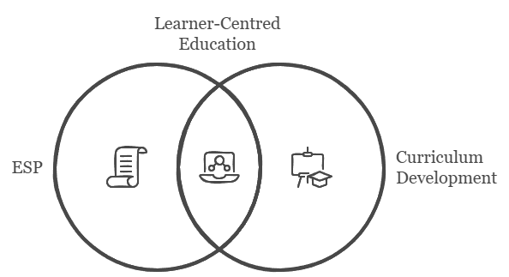

It is essential to develop a curriculum framework that effectively manages the interrelationship between goals, content, methodology, and assessment known as constructive alignment (Biggs, 1999). “Constructive” emphasizes that students bear responsibility for acquiring knowledge and skills through practice, while “alignment” ensures that teaching and learning activities and assessments are designed to help students achieve the intended learning outcomes. The system consists of three elements: intended learning outcomes, teaching and learning activities, and assessment, which must be coherently aligned.
The principles of constructive alignment trace back to Tyler’s (1949) foundational work, which framed four key questions for curriculum design: defining purposes, identifying and organizing experiences to achieve them, and evaluating effectiveness. Tyler highlighted that learning occurs through active student engagement, asserting that it is the learner’s actions, not the teacher’s, that drive meaningful learning (Biggs, 2014). John Biggs (2014, p.65) proposed viewing teaching as a multi-layered ecosystem, where innovation like Constructive Alignment is influenced and often constrained by institutional, departmental, and national regulations. For CA to be successfully implemented, it must be supported at all levels. The educational goals and graduate competencies must be agreed at the university and faculty levels. In addition, the proposed programme (curriculum) outcomes are consistent with faculty aims. The intended learning outcomes in the course should correspond to the outcomes of the programme (curriculum). After all, the intended learning outcomes must also match the intended learning outcomes of the course and lessons.
Curriculum model development integrates theory, context, and learners’ needs to guide course design. Nation and Macalister (2010) describe it as an inner circle of syllabus, goals, content, methods, and assessment, guided by outer circles of environment, needs, and principles. This alignment ensures learning outcomes are met and supports continuous improvement. Meanwhile, the curriculum design model, based on Graves’ Language Course Design (2000, p.3) and instructors’ experiences, views curriculum as an interconnected system of context, needs analysis, goals, content, materials, and assessment. This flexible framework guided the development of a tailored ESP curriculum for the study. At the same time Richards (2013, p.8) provided a useful overview of ESP curriculum design, expanding some different acknowledged curriculum philosophies in order to define 3 curriculum designs: Forward, Central, and Backward Curriculum Development Processes.
Forward design is linear and content-oriented, beginning with content selection and proceeding to syllabus development, methodology, learning outcomes, and assessment, often relying on pre-made materials (Neagley, 1967). Central design emphasizes teaching processes and classroom methodology over pre-determined content, fostering active learning, student autonomy, and contextualized instruction. Backward design is outcome-based, starting with intended learning outcomes that guide content, methods, and assessment, aligning instruction with skills and competencies required in the labor market (Kelly & Price, 2009; McKernan, 2007). Richards (2013) highlights that the choice of model depends on course duration, teacher expertise, material availability, and institutional context. Detailed components of forward, central and backward design is shown in the following table (see Table 1).

Table 1. Characteristics of curriculum designs (Richards, 2013, p. 30)

 | Forward Design | Central Design | Backward Design
Syllabus | Language-centred; Content divided into its key elements; Sequenced from simple to complex; Pre-determined prior to a course; Linear progression | Activity-based; Content negotiated with learners; Evolves during the course; Reflects the process of learning; Sequence may be determined by learners | Needs based; Ends-means approach; Objectives or competency-based; Sequenced from part skills to whole; Pre-determined prior to course; Linear progression
Methodology | Transmissive and teacher-directed; Practice and control of elements; Imitation of models; Explicit presentation of rules | Learner-centred; Experiential learning; Active engagement in interaction and communication; Meaning prioritized over accuracy; Activities that involve negotiation of meaning | Practice of part skills; Practice of real-life situations; Accuracy emphasized; Learning and practice of expressions and formulaic language
Role of teacher | Teacher as instructor, model, and explainer; Transmitter of knowledge; Reinforcer of correct language use | Teacher as facilitator; Negotiator of content and process; Encourager of learner self-expression and autonomy | Organizer of learning experiences; Model of target language performance; Planner of learning experiences
Role of learner | Accurate mastery of language forms; Application of learned material to new contexts; Understanding of language rules | Negotiator of learning content and modes of learning; Development of learning strategies; Accept responsibility for learning and learner autonomy | Learning through practice and habit formulation; Mastery of situationally appropriate language; Awareness of correct usage; Development of fluency
Assessment | Norm-referenced, summative end-of-semester or end-of-course test; Assessment of learning; Cumulative mastery of taught form | Negotiated assessment; Assessment for learning; Formative assessment; Self-assessment; Develop capacity for self-reflection and self-evaluation | Criterion-reference;Performance-based;Summative assessment;  Improvement oriented;Assessment of learning; Cumulative mastery of taught patterns and uses

Language curricula comprise input (linguistic content), process (teaching and learning methods), and output (learning outcomes) (Richards, 2013). Curriculum approaches are chosen based on the interplay of these elements, considering factors such as teaching materials, students, and instructors. Forward, central, and backward design models help explore these aspects and guide the selection of an appropriate curriculum approach.
In conclusion, both constructive alignment and the backward curriculum model share a fundamental emphasis on defining clear, outcome-oriented goals as the starting point for curriculum development. Constructive alignment ensures that learning activities and assessments are systematically aligned with intended learning outcomes, thus fostering a coherent educational experience that promotes deep learning.

Figure 2. Intersection of constructive alignment and backward design

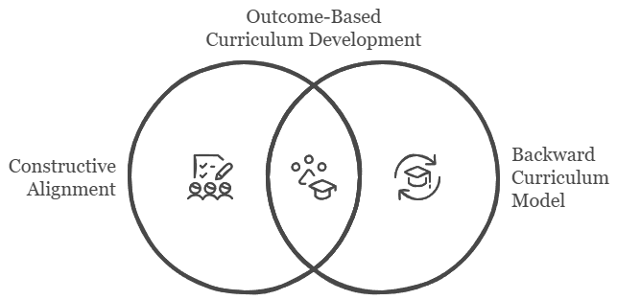
Their intersection lies in the shared principle that learning outcomes drive the design of curricula, instructional materials, and assessment procedures, ensuring that students achieve the competencies required for academic success and professional readiness. Therefore, integrating constructive alignment within a backward design framework provides a powerful strategy for developing ESP curricula that are responsive to learners' needs, labour market demands, and the overarching goals of higher education.

3.5 Conceptual Framework and Curriculum Model

This sub-chapter outlines theoretical and methodological principles that integrate several interrelated educational theories and curriculum design principles to establish a coherent foundation (Figure 3) to the theoretical justification. At its core, ESP approach emphasizes Needs Analysis as the starting point for identifying the specific linguistic and professional requirements of learners, ensuring that the curriculum remains learner-centred and contextually relevant (Dudley Evans & St. Johns, 1998; Hutchinson & Waters, 1987;). The framework draws on principles of Curriculum Development, highlighting a learner-centred model (Graves, 2000; Nation and Macalister, 2010; Nunan, 2013) that prioritizes students’ needs, interests, and future professional applications of language. It also incorporates insights from Language Curriculum Development, guided by the principles of Backward Design, where needs, outcomes, teaching and assessment are aligned accordingly (Richards, 2013; Richards, 2017; Taba, 1962; Tyler, 1949). In addition, the framework is grounded in Competency-Based Education (CBE), which combines constructivist principles emphasizing learning through experience and active engagement with outcome-based design, ensuring that learning goals are clearly defined and measurable (Piaget, 1950; Spady, 1994; Vygotsky, 1978). The principle of Constructive Alignment further connects all curriculum components by ensuring coherence between intended learning outcomes, teaching and learning activities, and assessment practices (Biggs, 1996; Biggs & Tang, 2011). Altogether, these elements form a cyclical model in which Needs Analysis, Learner-Centredness, Competency-Based, Outcome-Based Learning, and Backward Design are positioned at the core. This cycle reflects the dynamic and interconnected nature of ESP curriculum development, ensuring that each stage reinforces the others to produce a coherent, competency-oriented learning experience.

Figure 3. Theories underpinning the study
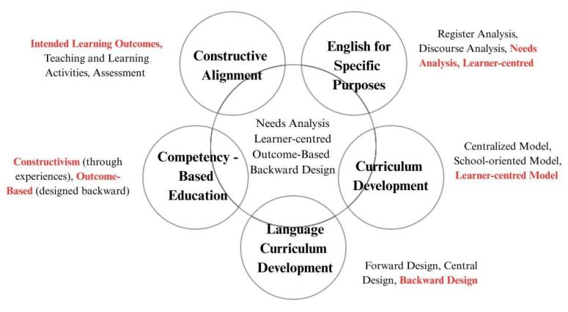
Grounded in these theoretical principles (Figure 3), the ESP Curriculum Development Model (Figure 4) was designed as a practical representation of the proposed methodological framework. The model illustrates the sequential and interrelated processes of needs analysis, formulation of intended learning outcomes (ILOs), establishment of assessment criteria, development of learning materials, and evaluation of the course effectiveness, all aligned to ensure coherence between curriculum components and student competencies.

Figure 4. The model of ESP curriculum development
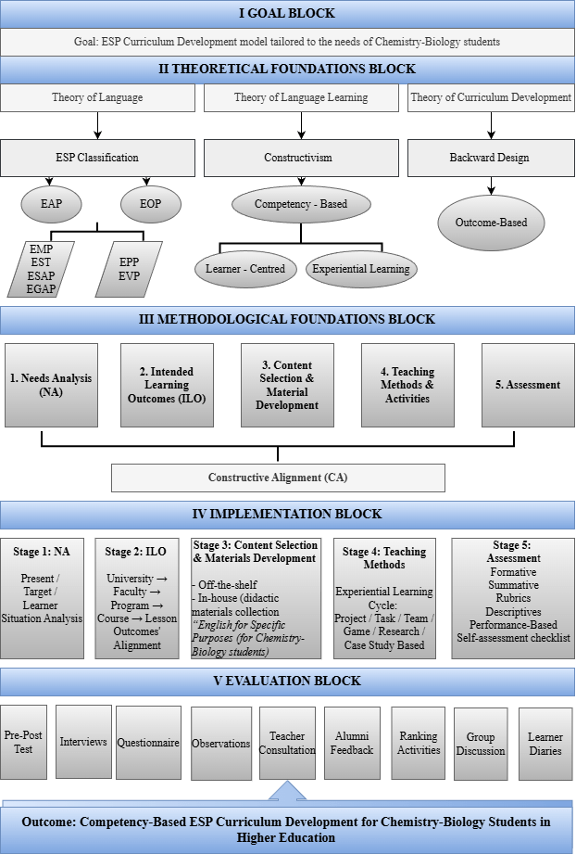
The ESP curriculum development model in Figure 4 proposed in this study is designed as a comprehensive, systematic framework that integrates theoretical principles, methodological rigor, and practical implementation to address the specific academic and professional language needs of chemistry-biology students in higher education (Hutchinson & Waters, 1987; Dudley-Evans & St John, 1998).
The model in Figure 4 responds to the growing demand for discipline-specific English instruction that equips future specialists with the linguistic competencies required for academic study, professional communication, and lifelong learning (Basturkmen, 2010; Hyland, 2006). By combining insights from ESP theory, constructivist learning principles, competency-based education, and outcome-oriented curriculum design, the model offers a coherent approach to ESP curriculum development that is both context-sensitive and transferable to similar educational settings (Richards, 2017; Biggs & Tang, 2011). The model begins with the Goal Block, which explicitly articulates the primary aim of developing a competency-based ESP curriculum tailored to the needs of chemistry-biology students. This goal reflects a central tenet of ESP: that language instruction must be grounded in learners’ disciplinary contexts, communicative purposes, and future professional roles (Hutchinson & Waters, 1987; Dudley-Evans & St John, 1998). Rather than emphasizing general language proficiency, the model prioritizes the development of academic and professional competencies that enable students to function effectively in scientific, educational, and workplace environments (Hyland, 2006). The clarity of the goal ensures that all subsequent decisions related to curriculum design, material development, instructional strategies, and assessment remain aligned with the intended outcomes of the program (Biggs & Tang, 2011).
The Theoretical Foundations Block which is provided in Figure 4 is the conceptual underpinning for the model and integrates three complementary theoretical perspectives: the theory of language, the theory of language learning, and the theory of curriculum development (Richards, 2017). From the perspective of the theory of language, the model adopts an ESP-based classification that distinguishes between English for Academic Purposes (EAP) and English for Occupational Purposes (EOP) (Dudley-Evans & St John, 1998). Within EAP, the model acknowledges subdomains such as English for Science and Technology (EST) and English for Academic Purposes in specific disciplines (ESAP), which are particularly relevant for chemistry-biology students engaged in academic reading, writing, and research (Hyland, 2006; Basturkmen, 2010). Within EOP, the inclusion of English for Professional Purposes (EPP) reflects the communicative demands graduates may face in professional and educational contexts (Dudley-Evans & St John, 1998). This classification ensures that the curriculum addresses both academic and professional language needs in a balanced and integrated manner.
The theory of language learning underpinning the model is grounded in constructivism (see Figure 4), which views learning as an active process of meaning construction rather than passive knowledge acquisition (Piaget, 1972; Vygotsky, 1978). Constructivist principles inform the adoption of a competency-based approach, emphasizing learners’ ability to apply language skills in authentic contexts (Richards & Rodgers, 2014). This perspective supports learner-centred instruction, where students actively engage with content, collaborate with peers, and reflect on their learning experiences (Nunan, 2013). Experiential learning is positioned as a core pedagogical principle, enabling students to develop language competence through tasks that mirror real-world disciplinary practices (Kolb, 1984). The theory of curriculum development is informed by backward design and outcome-based education, both of which emphasize the importance of starting with clearly defined learning outcomes and aligning content, instruction, and assessment accordingly (Wiggins & McTighe, 2005; Biggs & Tang, 2011). Backward design ensures that curriculum planning is purposeful and coherent, while outcome-based education reinforces accountability and transparency in teaching and learning. These principles collectively provide a strong theoretical foundation for the methodological structure of the model (Richards, 2013; Richards, 2017).
Building on the theoretical framework, the Methodological Foundations Block (see Figure 4) translates abstract principles into a structured sequence of curriculum development processes. This block comprises five interrelated components: needs analysis (NA), intended learning outcomes (ILO), content selection and material development, teaching methods and activities, and assessment (Richards, 2017; Nation & Macalister, 2010). These components are unified through the principle of constructive alignment (CA), which ensures consistency and coherence across all elements of the curriculum (Biggs & Tang, 2011).
As illustrated in Figure 4, the proposed methodological framework follows a staged and systematic process of curriculum development. Within this sequence, the identification of learners’ needs constitutes the initial and foundational stage, as it informs all subsequent decisions regarding objectives, content, and instructional design. Needs analysis serves as the starting point of the methodological process, systematically identifying learners’ present situation, target situation, learning needs, and contextual constraints (Hutchinson & Waters, 1987; Dudley-Evans & St John, 1998). The findings of the needs analysis inform the formulation of intended learning outcomes, which are articulated at multiple levels, including institutional, program, course, and lesson levels (Biggs & Tang, 2011). This multi-level alignment ensures that the ESP curriculum is consistent with broader educational goals while remaining responsive to specific learner needs (Richards, 2017).
Content selection and material development are guided by the defined learning outcomes, ensuring relevance, authenticity, and disciplinary alignment of chemistry- biology-related texts, tasks, and activities (Tomlinson, 2014). The model supports the use of both off-the-shelf materials and in-house developed resources, allowing for flexibility and contextual adaptation (Basturkmen, 2010). Teaching methods and activities are selected to facilitate experiential and competency-based learning, emphasizing active engagement, collaboration, and problem-solving (Kolb, 1984; Nunan, 2013). Assessment, as the final component, is designed to validly measure the achievement of intended outcomes, incorporating a range of formative and summative approaches (Brown & Abeywickrama, 2019).
The Implementation Block (see Figure 4) operationalizes the methodological framework by translating curriculum plans into classroom practice. This block is organized into five stages that mirror the methodological components of the model. The first stage involves conducting a comprehensive needs analysis, followed by the second stage - alignment of intended learning outcomes across institutional and instructional levels. The third stage focuses on the development and adaptation of ESP materials, including the creation of a dedicated collection titled English for Specific Purposes (for Chemistry-Biology students). The fourth stage emphasizes the application of experiential learning cycles, incorporating instructional strategies such as projects, tasks, research activities, and case studies (Kolb, 1984; Richards & Rodgers, 2014). The final stage addresses assessment, integrating formative, summative, and performance-based evaluation methods, supported by rubrics, descriptive feedback, and self-assessment tools (Brown & Abeywickrama, 2019).
The Evaluation Block (see Figure 4) ensures systematic validation and continuous improvement of the ESP curriculum. Evaluation is conducted through multiple data sources, including pre- and post-tests, interviews, questionnaires, classroom observations, teacher consultations, learner reflections, ranking activities, group discussions, and alumni feedback (Creswell, 2018; Patton, 2015). This multi-method approach enables triangulation and provides insights into both immediate learning outcomes and long-term curriculum impact that prove the effectiveness of the developed ESP curriculum model. The inclusion of alumni perspectives is particularly significant, as it allows the evaluation of the curriculum’s relevance and effectiveness beyond the academic setting.
Taken together, the five blocks of the model form an integrated framework that moves from goal formulation and theoretical grounding to methodological planning, implementation, and evaluation (see Figure 4). Viewed holistically, the model reflects the core logic of Design and Development Research (DDR) by progressing systematically from analysis and design to implementation and evaluation, resulting in a theoretically informed and empirically validated ESP curriculum for chemistry-biology students in higher education (Richards, 2017; Davis et al., 2007).

3.6 Chapter Summary

Chapter 3 presented the conceptual and methodological foundations of the study, outlining the theoretical principles and practical processes that informed the design of a needs-based, student-centered, and context-responsive ESP curriculum. The chapter outlined how the study integrates established perspectives on ESP, competency development, experiential learning, and curriculum alignment into a coherent framework guiding curriculum design and implementation.
The chapter first clarified the core pedagogical assumptions underpinning the study, emphasizing the importance of aligning language instruction with professional and disciplinary demands. These assumptions informed the selection of a competency-oriented approach, in which learning outcomes, instructional activities, and assessment practices are systematically aligned to support meaningful learning and professional skill development.
Building on this theoretical grounding, the chapter then detailed the methodological processes through which the curriculum was operationalized. Central to this process was a systematic needs analysis, which served as the foundation for defining learning outcomes and shaping instructional content. Based on these outcomes, learning materials and activities were designed to reflect authentic disciplinary practices and to promote active student engagement through experiential learning approaches. Assessment was conceptualized as an integral component of the curriculum, combining formative and summative elements to support continuous learning and evaluate the attainment of professional competencies.
Together, the theoretical and methodological components of the chapter culminated in the development of an integrated conceptual framework and practical curriculum model. This model provides a structured representation of how theoretical principles are translated into concrete curriculum design decisions and serves as a methodological roadmap for the empirical stages of the study. The subsequent chapters build upon this framework by presenting the research design, course implementation, and empirical evaluation of the ESP curriculum developed for future chemistry-biology teachers.

Chapter 4

Research Design

Chapter 4 outlines the methodological design and procedures used to examine the creation and efficacy of the competency-based ESP curriculum for chemistry-biology students in one HEI in Kazakhstan. This study adopts a Design and Development Research (DDR) design combined with quasi-experimental and multi-phase mixed-methods approaches, enabling the systematic integration of quantitative and qualitative data across different phases of the research process. Importantly, the approach is divided into three consecutive stages: pre-intervention, intervention, and post-intervention, systematically addressing the research questions concerning (1) the discipline-specific linguistic, academic, and professional needs of chemistry-biology students (RQ1), (2) the design of a discipline-specific ESP didactic material collection to address these needs and support learning outcomes (RQ2), (3) the development of an ESP curriculum model as a replicable methodological guideline (RQ3), and (4) the pedagogical effectiveness of the developed ESP curriculum model in terms of students’ learning outcomes within the selected higher education institution (RQ4). The final sections detail the instruments utilized for data collection and the rigorous quantitative and qualitative procedures used to analyze the collected data. This systematic approach ensures the rigor, validity, and reliability of the findings presented in the subsequent chapters, which are explained in the sub-sections below.

4.1. Research Paradigm

This study adopts the pragmatic research paradigm to address, as it best to answer our questions to the what and how to research based on the intended consequences where we want to go with it (Creswell & Plano Clark, 2018). Gillespie et al. (2024) define it as a consistent methodology aimed at creating useful, actionable knowledge, which provides a philosophical basis for this research. As pragmatists do not see the world as an absolute unity, this paradigm provides the essential philosophical basis for the mixed methods research design, endorsing the use of both: quantitative and qualitative approaches to addresses the research problem at hand (Fealy et al., 2023; Sharma et al., 2023).

4.2 Research Methodology

Guided by a pragmatic research paradigm, I adopted an overall research design grounded in Design and Development Research (DDR). This design was selected because the primary aim of the study is not only to investigate an educational phenomenon, but also to design, implement, and evaluate an ESP curriculum model for chemistry-biology student-teachers. DDR is particularly appropriate for educational research that seeks to produce practical solutions informed by theory, as it integrates systematic design, iterative development, and empirical evaluation. In this study, DDR provided the overarching framework within which the curriculum was conceptualized, developed, tested, and refined across multiple phases. Within this design, I employed several research approaches to support data collection and evaluation.
Within this framework, I adopted a mixed-methods approach to gain a comprehensive understanding of both the process and outcomes of curriculum implementation. The integration of quantitative and qualitative data enabled triangulation and enhanced the validity of the findings. Quantitative data (e.g., test results and survey responses) were used to measure changes in language proficiency and learning outcomes, while qualitative data (e.g., interviews, observations, and reflective feedback) provided insights into students’ experiences, perceptions, and learning needs within the ESP and EMI context. Mixed-methods research approach involves integration of qualitative and quantitative research and data in a research study (Creswell, 2018). Moreover, application of a mixed-methods research approach allowed me to triangulate data sources as a means for seeking convergence across qualitative and quantitative methods (Jick, 1979).
Furthermore, a quasi-experimental approach was embedded within the DDR framework to examine the effectiveness of the developed ESP curriculum. Random assignment was not feasible in the institutional context; therefore, intact groups were used to compare pre- and post-intervention outcomes, allowing for assessment of changes attributable to the curriculum.
Mixed-methods research encompasses several designs, including convergent (concurrent) and explanatory sequential approaches (Creswell, 2018; Tashakkori et al., 2020). Convergent approaches involve the simultaneous collection of quantitative and qualitative data, which are then integrated to provide a comprehensive understanding of a phenomenon. Explanatory sequential approaches collect and analyze quantitative data first, followed by qualitative data that help explain or elaborate on the quantitative results (Creswell, 2018; Ivankova & Stick, 2007). In contrast, exploratory sequential designs begin with qualitative data collection to inform subsequent quantitative measurement (Creswell, 2018).
Aligned with the pragmatic paradigm and mixed-methods orientation, the study was conducted in three interconnected phases, targeting a set of research questions. The first phase, pre-intervention, involved a comprehensive Needs Analysis; the second phase, intervention, focused on the development and implementation of the ESP curriculum; and the third phase, post-intervention, evaluated the effectiveness of the developed materials.
As the research unfolded across multiple interconnected phases, it is framed as a multi-phase mixed-methods design. I will now present each phase in detail, explaining its specific design, methods, and procedures.
Phase 1 of the study employed a convergent mixed-methods design to conduct a comprehensive needs analysis. In this design, qualitative and quantitative data are collected concurrently and integrated during interpretation to provide a holistic understanding of learners’ and instructors’ needs, wants and lacks (Creswell, 2018; Tashakkori et al., 2020). This approach allowed the study to triangulate multiple sources of information and obtain a robust, evidence-based foundation for the subsequent phase 2.
Phase 2 of the study is fundamentally framed as a Design and Development Research (DDR) integrated with a Quasi-Experimental Design (QED). DDR provides the overarching structure necessary for the creation and rigorous evaluation of the ESP curriculum model (Richards, 2017; Davis et al., 2007), guiding the entire investigation through a structured two-stage process: (1) development and (2) implementation. Thus, the study uses the DDR framework to guide the development of the curriculum model, while QED serves as the quantitative mechanism (Kim & Clasing-Manquian, 2023) to evaluate the developed model during implementation.
Phase 3 adopted a sequential explanatory mixed-methods approach to evaluate the long-term effectiveness and validate the ESP curriculum. Quantitative data were first collected one year after the initial intervention. This was followed by qualitative and quantitative data, allowing for assessment of the curriculum’s sustained impact and practical applicability in real-world contexts (Creswell, 2018; Ivankova & Stick, 2007). This combined methodology is executed through three distinct and sequenced phases, aligning with the sequential explanatory mixed-methods approach (see Table 2 ):

Table 2. Research phases’ alignment with the research design
Phases | Alignment of Research Design
Pre-intervention (analysis of needs) | This phase is fundamentally convergent design mixed - methods, relying on both qualitative (interviews, document analysis) and quantitative (student questionnaires) data to define needs, wants and lacks.
Intervention (development and implementation) | This phase is design and developmental (DDR) and quasi-experimental design (QED) research. The curriculum is developed and then the effectiveness of the developed curriculum is tested using the QED. The QED is necessary due to the non-random assignment of the control and experimental groups based on pre-existing class structures. It involves the administration of pre-tests and post-tests to measure the impact of the curriculum "treatment" on student achievement.
Post-intervention (evaluation and validation) | This final phase is a sequential explanatory mixed method design, integrating both quantitative (one-group pre-test and post-test, alumni questionnaire) and qualitative data (student interviews) to fully address the long-term effectiveness and practicality of the curriculum. The qualitative data often helps explain the statistical results from the QED, completing the sequential logic of the design.

Table 2 illustrates the overall methodological structure of the study. At the highest level, the research is grounded in a pragmatic paradigm, which allows the integration of multiple methods to address the research problem comprehensively. The study is framed within a Design and Development Research (DDR) design, which provides the structural framework for the systematic development, implementation, and evaluation of the ESP curriculum. Within this design, a quasi-experimental approach is employed to quantitatively examine the effectiveness of the curriculum intervention using pre-test and post-test comparisons with intact groups. In parallel, a mixed-methods approach is applied across three interconnected phases, integrating qualitative and quantitative data through convergent and sequential designs. This hierarchical structure ensures methodological coherence while enabling both rigorous evaluation and contextual understanding of the curriculum development process.

4.3 Research Participants

This study was conducted in one Kazakhstani higher institution where I work as an instructor of English. My decision to focus on this research was based on my desire to gain an in-depth understanding of the investigated issue.
The choice of participants is explained by the intention to receive answers to our research questions from both parties; teachers’ as well as students’ views (Dudley Evans and St. John, 1998). Thus, I have been attracted to this study by the EFL, ESP, subject practitioners, program coordinators, chemistry-biology students from various years of study, and alumni. Participation was entirely voluntary, and all participants were provided with an information sheet outlining the purpose, procedures, and ethical considerations of the study. They were informed that they could withdraw at any time without any consequences.
In accordance with the research aims and questions, I have used non-probability sampling, specifically convenience and purposive sampling (Cohen et al., 2007; Creswell, 2018; Zhu Hua, 2016). A nonprobability sampling (or convenience sample) involves the researcher choosing participants simply for reasons of ease of access, in terms of physical proximity, accessibility, the timing of the administration of the survey, or the willingness of people to participate (Zhu Hua, 2016, p.169).
The convenience sampling was used to access currently enrolled chemistry-biology students, instructors, and program coordinators in one higher institution where I worked as an English language teacher. While the purposive sampling was applied when selecting interviewees and alumni based on two criteria:
- They are graduates of the Chemistry-Biology programme;
- They have completed the ESP course under the developed curriculum model. This
technique ensured that participants selected for the post-intervention interviews and the alumni questionnaire could provide feedback specifically on the long-term impact and practical utility of the intervention tested in the study.

4.4 Stages of Research

As I have already noted, the research design, framed by the principles of Design and Development Research (Richards, 2017; Barthmann et al., 2025) was executed through a systematic sequence of three distinct phases. This sequential structure (Creswell, 2017; Gempes & Obenza, 2025) ensures that the findings from each phase provide the necessary foundation and validation for the next, moving logically from problem diagnosis to solution implementation and final evaluation. The three phases (1) Pre-Intervention, (2) Intervention, and (3) Post-Intervention align with the essential steps of a curriculum design model and serve to comprehensively address the research questions in a progressive manner.

Table 3. Chronological and methodological sequencing of research stages
Stage # | DDR Function | RQ Addressed | Timeline
Phase 1: Pre - Intervention | Needs Analysis | RQ 1 | 2018-2020
Phase 2: Intervention | Development & Implementation | RQ 2 & RQ 3 | 2019-2023
Phase 3: Post - Intervention | Evaluation of Curriculum Effectiveness | RQ 4 | 2023-2025

The table above provides an overview of the chronological sequencing of the study, mapping each stage to its core objective, research questions, and general timeline.

4.5 The intervention programme
The preceding theoretical discussion established the necessity of moving from input-focused models to a competency-based, outcome-driven framework for ESP in higher education. This sub-chapter transitions to the practical, methodological steps required to construct a curriculum that achieves constructive alignment and ensures professional relevance. The foundational methodological components discussed herein are Needs Analysis (NA), the formulation of Intended Learning Outcomes (ILOs), the selection and development of Materials, and the design of appropriate Assessment Criteria (Wiggins & McTighe, 2005).
4.5.1 Needs Analysis

A comprehensive needs analysis is the foundation of effective ESP curriculum development, as it ensures that each subsequent stage from defining learning outcomes to selecting teaching strategies is firmly rooted in the specific requirements of learners. The following section delves into the process of needs analysis, highlighting its pivotal role in shaping a curriculum that aligns with both learner objectives and the demands of the discipline.
A detailed examination of ESP, its purposes, and its characteristics indicates the importance of needs analysis as the starting point in designing an ESP course. I strongly agree with Hutchinson and Waters (1987), Dudley-Evans and St John (1998), and Basturkmen (2010), who point out that, first, students and their needs should be clearly defined, and second, based on this analysis, the ESP curriculum should be designed, after which materials production can follow. Research in ESP has demonstrated that needs analysis significantly influences course design. For example, it has encouraged instructors to create more suitable and relevant teaching materials (Čapková & Kroupová, 2017) and to identify the academic tasks undergraduates frequently perform in English, which can then be incorporated into the ESP syllabus (Muhammad & Abdul Halim Raof, 2019). Also, according to Hutchinson & Waters (1987) needs analysis should be conducted depending on the following classification: 1) Target needs (what the learner needs to do in the target situation) and learning needs (what the learner needs to do in order to learn) 2) Necessities (what is necessary in the learners’ use of language?) 3) Lacks (what the learners lack) and 4) Wants (what the learners want) (Nation & Macalister, 2010).
Bula and Diaz-Ducca (2016) emphasize that ESP courses should focus on communication and cooperation skills that help students achieve a comparable proficiency level. Their research also highlighted learners’ preference for authentic, effective, and purposeful tasks, as well as for pair and group work. We firmly believe that needs analysis assists teachers in identifying content and selecting materials in line with ESP typology (Hutchinson & Waters, 1987, p.17; Brindley, 1984, p.53).
For many years, needs analysis has been considered a complex process, described differently by various scholars. Generally, within the ESP framework, it encompasses learners’ goals, preferences, interests, necessities, wants, expectations, motivations, reasons for course choice, lacks, teaching and learning constraints, and knowledge gaps (Chambers, 1980; Beatty, 1981; Risterich, 1984; Johnson & Newport, 1989; Benesch, 2001; Hyland, 2009).
Thus, needs analysis in ESP course design often involves three dimensions, addressing the following questions:
- Present Situation Analysis (PSA): Identifies learners’ existing competencies,
knowledge, and abilities in relation to current requirements. In our study, PSA was carried out through document analysis. What are the English language proficiency requirements for chemistry and biology students in their future academic and professional contexts?
- Target Situation Analysis (TSA): Investigates the levels, skills, tasks, and
activities learners will use English for, and the learning environment of the ESP course. TSA in this study was conducted through online open-ended questionnaires with English and content instructors. What are the specific learning needs, preferences, and expectations of chemistry and biology students in the ESP course?)
- Learner Situation Analysis (LSA): Examines learners’ motivation, expectations,
and preferences. In this study, LSA was carried out through a Likert-scale questionnaire. What are the specific learning needs, preferences, and expectations of chemistry and biology students in the ESP course?
The purpose of these analyses was to establish students’ needs, determine the course context, and identify goals and expectations. We strongly believe that when ESP teachers are informed about students’ needs, they are better equipped to design effective ESP courses and deliver instruction successfully.
In conclusion, needs analysis provides the foundation for a targeted ESP curriculum by identifying the specific needs and expectations of learners. Once these needs are understood, the next crucial step is to define Intended Learning Outcomes, which serve as a framework for structuring the curriculum and measuring student progress. The next sub-section explores the process of formulating clear and measurable learning outcomes that align constructively with teaching and assessment.

4.5.2 Intended Learning Outcomes

Following the empirical data yielded by the Needs Analysis (NA), the second essential step in constructing an effective curriculum within the Backward Design framework is the formulation of Intended Learning Outcomes (ILOs) (Wiggins & McTighe, 2005). ILOs represent a fundamental pedagogical shift from traditional, input-focused objectives which describe what the instructor will teach to outcome-based statements that clearly define what the learner must know, understand, and be able to demonstrate at the end of the course (Spady, 1994). Biggs and Tang (2011) explain that the verb within an ILO is particularly significant because it determines the level and nature of learning expected from students. This verb acts as a bridge between learning outcomes, instructional strategies, and assessment tasks, ensuring coherence across all components of the curriculum. When ILOs emphasise higher-order cognitive processes such as analysing, synthesising, or evaluating they naturally encourage the design of learning activities that promote deeper learning (Anderson & Krathwohl, 2001). Conversely, outcomes that target foundational knowledge or basic skills lead to more structured and skill-specific instructional approaches.
Understanding constructive alignment is essential for developing an effective ESP curriculum. Constructive alignment involves aligning three core elements: the intended learning outcomes, the teaching and learning activities, and the assessment tasks (Biggs, 1996; Biggs & Tang, 2011). Within this framework, the curriculum must be designed so that students engage in learning activities that directly help them achieve the intended outcomes, and assessments must accurately measure the extent to which these outcomes have been achieved. As Ramsden (2003) noted, assessment drives learning, and students learn only what they know they will be assessed on. Therefore, assessment must reflect the intended learning outcomes so that students can achieve the expectations set for them. Assessments should be constructed to evaluate the specific features stated in the learning outcomes, and students should be provided with clear criteria to understand what is required and how they will be evaluated. The purpose of assessment, therefore, is not to describe the personal qualities of students, but to determine the extent to which they have achieved the desired learning outcomes. Within the concept of constructive alignment, the focus of teaching shifts from what we teach to what students will do and be able to achieve. This makes it a highly useful framework for curriculum and instructional design.
In the context of language education and ESP, clearly formulated ILOs contribute to more targeted instruction by articulating the linguistic, academic, and professional competencies students are expected to master. Scholars highlight that well-designed outcomes support alignment between institutional goals, programme-level aims, and the specific requirements of ESP courses (Richards, 2017; Graves, 2008). This alignment ensures that ESP instruction fosters both general academic literacy and discipline-specific communication skills. Moreover, ILOs serve as a foundation for determining whether instruction should focus on common-core academic skills or more specialised, profession-oriented competencies (Dudley-Evans & St John, 1998).
A substantial body of research shows that the formulation of ILOs helps guide curriculum planners in selecting appropriate instructional strategies. For instance, explicit outcomes enable the integration of active learning, problem-based learning, and other experiential methods that encourage meaningful application of language skills in authentic contexts (Harding, 2007; Hyland, 2016). These instructional approaches are particularly relevant in ESP settings, where learners must transfer knowledge from the language classroom to their disciplinary or professional environments.
ILOs also play a critical role in assessment design. According to Boud and Falchikov (2006), assessments should not simply measure students’ knowledge but should evaluate the specific behaviours and performances articulated in the learning outcomes. The use of rubrics, performance-based assessment, and task-based evaluation is therefore recommended, as these approaches closely mirror real-world language use and align with the principles of constructive alignment (Norris, 2016).
In summary, intended learning outcomes serve as the foundational framework that guides the educational process and defines student achievement. However, to fully support these outcomes and facilitate deeper learning, it is essential to consider how instructional materials can be strategically developed to align with learners’ needs and course goals. Well-designed materials play a critical role in translating curriculum objectives into engaging and meaningful learning experiences, enabling students to apply their knowledge in authentic contexts.

4.5.3 Material Development

The development of materials is a fundamental element in the teaching and learning process, and has been extensively discussed by many scholars (Cunningsworth & Tomlinson, 1984; McDonough & Shaw, 1993; McGrath, 2002; Tomlinson, 2014) in various academic settings such as conferences, round tables, seminars, and workshops, as well as in publications including articles, manuscripts, and books across a wide range of academic journals and publishers worldwide. This highlights the necessity for ESP practitioners to critically analyze, adapt, and often develop their own materials incorporating meaningful texts and interactive activities that foster the acquisition of both language competencies and subject-specific knowledge.
The coursebook The Structure of Technical English by Herbert (1976) represented a watershed moment in the development of ESP materials. It was groundbreaking as the first textbook centered specifically on ESP. However, in practice, many ESP instructors face significant challenges in developing materials due to limited time, insufficient training, and demanding teaching schedules. These challenges are particularly acute when working with heterogeneous groups of learners with varying proficiency levels (Basturkmen, 2010).
Instructional materials play a central role in ESP course design. Dudley-Evans and St. John (1998) identify four primary purposes for using materials in ESP contexts: (1) to provide the main vehicle for language input particularly important in EFL settings where classroom instruction may be the learner’s only exposure to English (Richards, 2017); (2) to support the learning process through clear, functional, and engaging tasks (Nunan, 2013; Ellis, 2024); (3) to stimulate and motivate learners by offering challenging but achievable activities connected to their prior knowledge and real-world needs (Ur, 2018); and (4) to facilitate self-study by providing well-organized explanations, models, and instructions (Little, 2022).
Given these functions, the development and selection of materials place significant demands on ESP practitioners. Preparing high-quality instructional materials requires substantial time and expertise, especially when selecting authentic texts, aligning them with course outcomes, and designing tasks that integrate language and disciplinary content (Tomlinson, 2014; Graves, 2000; McGrath, 2016). Although not all instructors are expected to create full in-house materials, Dudley-Evans and St. John (1998) emphasize that ESP teachers must act as competent suppliers of materials. This includes the ability to select resources based on learner needs and course aims (Graves, 2000; McGrath, 2016), creatively adapt existing materials to different proficiency levels (Howard & Major, 2004), and supplement coursebooks with additional tasks that enhance authenticity, variety, and relevance (Tomlinson, 2014). Such competencies enable teachers to tailor instruction effectively, even in contexts where resources are limited or student groups are heterogeneous (Richards, 2013).
There are two main approaches to developing new materials. The first begins with high-quality specialised content; the task is to determine how and where it fits within the course. The second starts with a gap in existing materials: the course goals are clear, but no suitable resources are available, so appropriate specialised content must be identified and developed. Below are examples of two processes for getting new course materials:
1. Starting point A - to have specialised content - to find out its real content - to correspond the real content and specialised content within the proposed course structure;
2. Starting point B - demand of material for the specific purpose - seeking to find appropriate specialised content (Hutchinson & Waters, 1987, pp. 21-22).
Once suitable content is identified, the next step is to design tasks. Activity selection should consider available resources, class size, study methods, and intended learning outcomes. ESP students do not study language for its own sake; rather, they use language to access disciplinary knowledge and develop professional competencies. Materials should therefore support applied learning (Dudley-Evans & St. John, 1998; Robinson, 1991). Variety is particularly important in ESP classes. Tasks focusing on micro-skills (e.g., learning vocabulary, collocations, or extracting main ideas) are essential to complement macro-skills such as reading or writing (Richards, 2013; Nunan, 2013). A mix of task types sustains motivation and prevents monotony. Visual elements such as charts, graphs, diagrams, and infographics are especially effective in diversifying activities and stimulating analysis and critical thinking (McGrath, 2002; Tomlinson, 2014). Because ESP courses are learner-centered, interaction patterns must also vary. A balance of teacher input, pair or group work, and class discussion ensures quality interaction. The effectiveness of these dynamics depends on both class size and the teacher’s ability to manage them constructively (Richards & Rodgers, 2014; Dudley-Evans & St. John, 1998).
Therefore, professional self-reflection is critical across all fields, including education (Farrel, 2022). Teachers must continuously evaluate their competencies and readiness to perform effectively. While teaching errors may not have immediate life-or-death consequences as in medicine, their long-term impact on learners can be profound. Poor practices, lack of classroom support, and weak student-teacher relationships can damage motivation and hinder achievement (Molero Jurado et al., 2025; Fauth et al., 2019).
Consequently, professional competencies are essential in shaping sound pedagogical decision-making. In this regard, experiential learning approaches within ESP methodology offer valuable opportunities to enhance instruction (Dudley-Evans & St. John, 1998; Alkandari & Alfaraj, 2025). Such approaches enable dynamic, learner-centered environments where students actively engage, apply knowledge, and develop the professional skills required for their future careers (Kuijpers, 2025).
In summary, enhancing material development in ESP requires practitioners to critically evaluate, adapt, and supplement resources to meet learners’ academic and professional needs. Ultimately, the quality of materials directly influences the effectiveness of ESP instruction. Building on this, the following section will address the establishment of assessment criteria, which are essential for evaluating both the efficiency of instructional materials and the achievement of learning outcomes.

4.5.4 Integrating Experiential Learning Activities

Given the importance of experiential learning in ESP, it is crucial to investigate how well exercises facilitate language acquisition among chemistry and biology students. Students of chemistry and biology have been taught ESP through a variety of experiential learning strategies listed below.

4.5.4.1 Project-Based, Task-Based, and Team-Based Learning Activities

Project-based learning (PBL) engages students in meaningful, profession-related projects, supporting learner-centred education and competency development (Dewey, 1938; Kilpatrick, 1996; Piaget, 1950; Smakova, 2021; Orr, 2002; Vygotsky, 1978). In ESP contexts, PBL has been applied to academic disciplines to enhance students’ readiness, motivation, and integration, shifting the teacher’s role from knowledge provider to facilitator, adviser, and feedback provider (Anderson & Fernandez‑Branson, 2024; McCabe & O’Connor, 2013). Effective PBL involves cycles of inquiry, research, critical and creative thinking, and collaborative engagement with peers and instructors.
Task-based learning (TBL) complements PBL by focusing on communicative activities that develop language through meaningful tasks rather than abstract study (Gonzalez-Lloret, 2017; Ellis, 2003; Larsen-Freeman & Anderson, 2013). Both approaches support interactive, experiential learning, reinforcing the principles of content-based and learner-centred education in ESP. Tasks may include reading scientific texts, lab reports, research presentations, or other discipline-specific activities.
Team-based learning further promotes collaboration, problem-solving, and peer-supported knowledge construction. In chemistry-biology ESP courses, such approaches allow students to apply language and subject knowledge to authentic professional contexts, enhancing both academic and professional competencies (Raikhanova & Kassymova, 2019).
Overall, teaching ESP to chemistry and biology students may be accomplished through the use of project-based, task-based, and team-based learning activities. These methods give students the chance to acquire the skills and information required for success in their field of study as well as to improve their language and subject matter understanding in a meaningful and applicable environment. Teachers can assist students in overcoming the particular difficulties they have when learning English for Specific Purposes in the setting of chemistry and biology by including these strategies into ESP curriculum.

4.5.4.2 Game-Based Learning Activities

Game-based learning is an effective method for teaching ESP to chemistry and biology students, enhancing language proficiency, subject knowledge, and engagement. Games provide enjoyable, interactive, and contextualised learning environments, promoting teamwork, critical thinking, problem-solving, and retention of complex scientific concepts (Qian & Clark, 2016; Dehghanzadeh & Sahragard, 2018; Reinders & Wattana, 2015). They allow students to apply language skills in real-world contexts, receive immediate feedback, and develop specialised communication abilities for scientific fields. Challenges include technological issues, time, and curriculum constraints, but with proper planning, game-based learning effectively motivates students and supports meaningful language acquisition. The format, digital or paper-based, is secondary to its educational value.
For students studying chemistry and biology in ESP classes, using game-based learning activities can significantly improve language learning and topic information acquisition. Teachers may promote motivation and retention by involving students in enjoyable, interactive, and contextualised activities. This will ultimately position them for success in their chosen scientific disciplines. Overall, the research reviewed indicates that teaching ESP to chemistry and biology students may be successfully accomplished through game-based learning methods. These studies show that game-based learning techniques, which can be more engaging and pleasant than conventional lecture-based methods, can help students grasp and retain ESP concepts (Raikhanova, 2020).

4.5.4.3 Research-Based Learning Activities

Research-based learning (RBL) is an effective strategy for teaching ESP to chemistry and biology students in higher education, linking language acquisition with scientific inquiry and critical thinking (Healey & Jenkins, 2009; Kuh, 2008). Needs analysis showed that higher-level students benefit most from RBL, which includes activities such as analyzing journal articles, writing lab reports, conducting experiments, creating presentations or posters, and group research projects. These activities develop research skills, critical thinking, collaboration, and real-world problem-solving, enhancing both English proficiency and subject knowledge (Paul & Elder, 2008; Hidi & Renninger, 2006).
For effective RBL, educators should align tasks with learning outcomes, select profession- and interest-driven lessons, guide students in research methods and academic writing, foster collaboration, provide continuous support, and recognize student achievements through presentations or publications. Overall, incorporating RBL in ESP courses promotes meaningful learning, bridges theory and practice, and better prepares students for academic and professional success.

4.5.4.4 Case-Study Learning Activities

Case-based learning (CBL) has increasingly been adopted in higher education as an approach that aligns well with outcome-based and competency-focused curricula. CBL engages students in analysing real or simulated scenarios to apply knowledge, solve problems, and justify decisions (Davis, 2004; Herreid & Schiller, 2013). Empirical research demonstrates that CBL enhances critical thinking, problem-solving, and metacognitive skills (Kulak & Newton, 2017; McFee et al., 2017), while also fostering intrinsic motivation, reflection, and self-evaluation (Facione et al., 2000; Ennis et al., 2005). Recent studies in STEM and health-science programmes further show that CBL improves knowledge retention and supports the development of transferable competencies required in professional settings (Thistlethwaite et al., 2012).
As a collaborative learning method, CBL also contributes to communication skills and teamwork, particularly when implemented in group-based formats (Fernandez-Santander, 2008; Savery, 2006). Because CBL is grounded in learner-centred principles, it encourages students to take responsibility for their learning and supports lifelong learning dispositions (Hartfield, 2010; Biggs & Tang, 2011). Overall, the literature indicates that CBL is an evidence-based instructional approach that supports outcome-based education by integrating knowledge application, critical thinking, and communication within authentic learning tasks (Raikhanova & Bakic-Miric, 2023).

4.5.4.5 Establishing Assessment Criteria

The development and deployment of an ESP curriculum are heavily influenced by a strategic approach to assessment, where assessment techniques are carefully designed to align with clearly defined learning outcomes and instructional goals, as exemplified in the Backward Design model (Richards, 2013). Since ESP intends to provide the student with the appropriate language skills for a particular academic profession or a workplace, it is imperative to correctly determine the extent of students' progress and the degree of the effectiveness of the given curriculum. Constructing an assessment helps one ensure that the ESP curriculum meets the target learners’ requirements, tracks the learners’ development and assesses the effectiveness and relevance of the teaching and learning programme.
So determining the needs of target learners and subsequently reconstructing the language teaching curriculum in ESP courses is one of the paradigm shifts in the realm of English teaching. This, however, calls for a comprehensive needs analysis to ascertain the exact linguistic needs in the particular field and the language proficiency skills (Mostafavi et al, 2021). The contemporary society including international business has increasingly required people with excellent communicative competencies within different domains and professions (Godina et al, 2018). The purpose of creating and employing an ESP course is to give the most suitable training, the one which suits the academic, social and professional status of the user (Pinem, 2021). Therefore, it should be such that the decisions made in relation to the English materials should also consider the students’ academic areas of interest and the places they work (Dewi & Indriani, 2021; Umar, 2021). Besides the interviews and questionnaires, the learners’ needs assessment should also focus primarily on data collection from multiple settings (Dudley-Evans & St. John, 1998; Hutchinson & Waters, 1987). Once these needs have been established, it is then possible to combine the syllabus and the programme for delivery to those needs and create the appropriate means of evaluation to assess the ability of the learners in relation to what has been expected out of them (Biggs, 1996; Richards, 2017). This congruence of the curriculum, instruction and assessment (Biggs & Tang, 2011) is very important for the relevance and effectiveness of the ESP programme as it makes it easy for the teachers to ensure that the relevant content is delivered to the learners and their learning is evaluated.
Course Assessment is an organizational route that collects and thoroughly evaluates information concerning the students’ learning activities in order to evaluate the extent to which the given goals have been achieved (Gronlund, 2006; Waugh & Gronlund, 2013). It includes several activities such as testing, quizzes, projects, and observations to assess what the students understand as well as what skills they have (Brown & Abeywickrama, 2019).
Cumulative assessment looks at the “trout measure” capture of “how well is the student learning what is to be taught” (Iseni, 2011). In an ESP curriculum, assessment plays a crucial role in evaluating students' mastery of the specific knowledge, skills, and competencies they are expected to develop.
This assessment process is guided by clearly defined learning outcomes, as outlined in the backward design framework (Wiggins & McTighe, 2005; Richards, 2017). By starting with the desired outcomes in mind, assessment techniques including regular quizzes, real-life activities, and projects are strategically designed to measure students' ability to apply concepts in practical contexts (Biggs & Tang, 2011). Regular quizzes and tests evaluate retention, while real-life activities assess practical application of the learned concepts. Projects and assignments offer a means of evaluating comprehensive understanding and synthesis of the material.
This study adopts a multifaceted assessment framework to measure student proficiency in academic communication and research skills across two courses: English for Academic Purposes (EAP) and English for Specific Purposes (ESP). While EAP is a well-established branch within the broader field of ESP, each course in this study addresses different communicative needs, academic and professional, respectively (Hutchinson & Waters, 1987; Dudley-Evans & St. John, 1998).
Formative assessment and summative assessment are distinct yet complementary components, both essential for a robust learning cycle (Allali & El Ghouati, 2025). Formative assessment provides ongoing, diagnostic feedback designed to identify gaps in understanding and guide instructional adjustments for both the student and the teacher, directly promoting self-regulation and conceptual mastery (Atwa et al., 2024; Ditingki et al., 2025). In contrast, summative assessment (like final projects or exams) serves a comprehensive, evaluative function, measuring the extent to which students have achieved the defined end-of-course learning outcomes and competencies, thus providing a final judgment on proficiency (OECD, 2023). A strategic assessment framework, therefore, deliberately integrates these two types, ensuring that assessment supports both continuous improvement and final accountability.
In summary, the integration of assessment into the learning process is crucial for effective educational programs, particularly within specialized fields like ESP, necessitating a balance between evaluative and developmental functions.

4.6 Data Collection

Data collection in this study was planned as a systematic, multi-stage process designed to align with the research questions and the overarching aims of developing and validating an ESP curriculum. Guided by the pragmatic paradigm, the process integrated both qualitative and quantitative methods to ensure a comprehensive understanding of learners’ and instructors’ needs, the implementation of the curriculum, and its short- and long-term effectiveness. This approach provided both depth, through contextual and experiential insights, and breadth, through statistically generalizable evidence. Instruments were carefully selected and administered to diverse stakeholder groups, including chemistry-biology students, language and content practitioners, program coordinators, and alumni.
The data collection process was organized into three interconnected phases. The pre-intervention phase focused on conducting a comprehensive needs analysis to identify learners’ and instructors’ requirements, expectations, and challenges through document analysis, interviews with language and content instructors, and questionnaires administered to chemistry-biology students. The intervention phase involved the development and implementation of the ESP curriculum using a constructive alignment approach. Data collection included qualitative document analysis, quantitative surveys administered to program coordinators, and pre-test/post-test assessments of student performance to evaluate the effectiveness of the curriculum implementation. Finally, the post-intervention phase assessed the long-term outcomes and validity of the curriculum through a combination of replicated tests, student interviews, and alumni surveys.
The following sections present the data collection phases in detail.

4.6.1 Questionnaires

Questionnaire with Students (2018/2019)
A Likert-scale questionnaire was administered to chemistry and biology students (N = 44) at the end of the 2018–2019 academic year (see Appendix H). The questionnaire served as a quantitative method for identifying students’ perceptions of the ESP course, its relevance to their academic needs, and the usefulness of course materials and teaching methods.
The questionnaire consisted of 12 closed-ended items, each measured on a five-point Likert scale ranging from Strongly Agree to Strongly Disagree. The items focused on the perceived importance of English for academic studies, relevance of ESP content, alignment with students’ subject-specific needs, usefulness of teaching methodologies, and expectations regarding future professional requirements. The questionnaire was distributed online during regular class hours, and participation was voluntary. Students were informed about the purpose of the study, and anonymity was ensured.
Additionally, at the end of the 2019-2020 academic year, a Likert-scale questionnaire was administered to first-year chemistry and biology students (N=30) to collect quantitative data on their perceptions of the ESP course and its relevance to their academic studies (see Appendix H).
The questionnaire was a revised version of the original 12-item instrument used in the previous academic year, now consisting of 6 items. Each item was rated on a five-point Likert scale ranging from Strongly Agree to Strongly Disagree.
The questionnaire was distributed online during regular class hours, and participation was voluntary. Students were informed about the purpose of the study, and anonymity was ensured.

Questionnaire with Program Coordinators
To validate and operationalize ESP curriculum priorities, a survey was administered among faculty members (N=7) to identify the key competencies, essential academic skills, and expected learning outcomes for students by the end of their degree programs (see Appendix I).
The questionnaire included a combination of closed-ended and open-ended questions. Faculty members were asked to provide their demographic information, identify key learning outcomes and competencies expected of students upon completion of their degree, indicate important academic skills to be acquired, describe typical assignments and learning tasks, and provide any additional comments or suggestions.
The questionnaire was administered online, and participation was voluntary. Respondents were informed about the purpose of the study, and their anonymity and confidentiality were strictly maintained throughout the process.

Questionnaire with Alumni
Furthermore, the insights were gathered from former ESP course participants (N=26) to understand the contribution of the courses to career advancement, language proficiency, and confidence in professional communication. The survey focused on evaluating the long-term effectiveness and impact of ESP courses on alumni academic and professional development (see Appendix L).
Participants were recruited via social networks such as Telegram and WhatsApp. Recruitment messages were shared in relevant groups, briefly explaining the study's purpose, the importance of their input, and how they could participate.
The questionnaire contained closed and open-ended questions, divided into key components including demographic data, ESP course impact, skills gained in the ESP course and applied in the workplace, overall satisfaction, and suggestions for improvement. Participation was voluntary, and anonymity was ensured.

4.6.2 Pre and Post Tests

Pre and Post Test of Control and Experimental Groups
To evaluate the effectiveness of the ESP course for chemistry-biology students, a quasi-experimental pretest-posttest design was employed during the 2019-2020 academic year. Participants were selected using convenience sampling, as they were drawn from existing class groups enrolled in the chemistry and biology courses. A total of 41 first-year students participated, divided into a Control Group (CGS, N=19) and an Experimental Group (EGS, N=22) based on class availability rather than random assignment. All participants were non-native English speakers, with proficiency levels ranging from pre-intermediate to intermediate.
The pre-test was administered at the beginning of the semester to assess students’ initial knowledge and skills in chemistry and biology in English (see Appendix O). The assessment included a variety of tasks: matching terms with definitions, completing sentences with appropriate terminology, multiple-choice questions, and gap-filling exercises focused on biological and chemical concepts. The post-test, administered at the end of the intervention period, measured students’ improvements in these areas and included similar tasks as the pre-test, along with reading comprehension passages designed to assess the application of knowledge in English (see Appendix P).
The intervention period lasted 15 weeks, during which the Experimental Group engaged in the course materials that were specifically compiled for chemistry-biology students, while the Control Group followed the course books from core Chemistry and Biology separately.
All participants were informed about the purpose of the study, and their participation was voluntary. Anonymity and confidentiality of test results were strictly maintained throughout the research process. This structured approach allowed for a rigorous assessment of the ESP course’s effectiveness in improving students’ subject-specific knowledge and language skills.

One-Group Pre and Post Test
A one-group pretest-posttest experiment was conducted to replicate and validate the findings of a previous controlled experiment and evaluate the effectiveness of the published 6-unit ESP Collection for chemistry-biology students during the 2023-2024 academic year (N=11).
The pre-test was administered at the beginning of the semester to assess students’ initial knowledge and skills in chemistry and biology in English. The assessment included a variety of tasks: matching terms with definitions, completing sentences with appropriate terminology, multiple-choice questions, and gap-filling exercises focused on biological and chemical concepts. The post-test, administered at the end of the intervention period, measured students’ improvements in these areas and included similar tasks as the pre-test, along with reading comprehension passages designed to assess the application of knowledge in English.
The intervention period lasted 15 weeks, during which the students engaged in the course materials that were specifically compiled for chemistry-biology students.

4.6.3 Interviews

Interview with Practitioners
A semi-structured online qualitative data collection method was employed to address the second research question. Semi-structured interviews were conducted with language and ESP teachers (N=9) using the SurveyMonkey platform (see Appendix G). This method enabled the researcher to gather in-depth insights into teachers’ perceptions of needs analysis in English language and ESP instruction. Two separate interview guides were developed: one for General English instructors and one for ESP instructors. The General English interview guide consisted of 8 questions, and the ESP instructor guide also included 8 questions. Both sets focused on teaching experience, instructional materials, learners’ needs, and teachers’ attitudes towards needs analysis.
To complement these data and broaden the understanding of learners’ professional needs, an additional semi-structured online survey was administered to content specialists (N=4) using the SurveyMonkey platform (see Appendix H). Their responses helped determine the importance of subject-specific goals in ESP classes and clarify the alignment between language instruction and disciplinary requirements.
All participants were informed about the purpose of the study, and participation was voluntary. Anonymity and confidentiality were ensured throughout the process.

Interview with Students
A semi-structured interview approach was employed to gather students’ perceptions and experiences of the ESP course for chemistry and biology students, providing qualitative insights into its implementation and practical impact (Appendix K). The interviews aimed to examine how well the course aligned with students’ academic and professional needs, identify strengths and areas for improvement, and explore its influence on students’ confidence in using English within discipline-specific contexts. The instrument comprised eight open-ended questions, one closed-ended question, and one recommendation-based item, allowing for structured responses while also enabling participants to elaborate on their experiences in detail. Participants were asked to evaluate the relevance of course goals, usefulness of materials, clarity of structure, opportunities for interaction, and impact on their English performance in content subjects.
The data were collected asynchronously via Google Forms, where participants provided written responses to open-ended questions at their convenience. On average, completing the form took approximately 20 minutes. Participation was voluntary, and informed consent was obtained from all interviewees. Responses were recorded and transcribed, while anonymity and confidentiality were strictly maintained.

4.6.4 Document Analysis

A content analysis approach was applied to the selected curriculum documents for the purpose of answering the first research question and disseminated to students (Bowen, 2009). This method allowed the researcher to examine existing educational documents that regulate the content and structure of foreign language instruction in non-linguistic specialties. For the analysis, the following documents were selected:
- A working curriculum programme in the discipline "Foreign Language" for universities of non-linguistic specialties, which is intended to provide training in the discipline "Foreign Language" as one of the compulsory disciplines of the general education cycle. This model programme is the result of adapting the international model of foreign language education, developed in accordance with the Model curriculum for undergraduate specialties approved by the Ministry of Education and Science of the Republic of Kazakhstan dated 05.07.2016 (Working curriculum approved by minutes No. 11 of the meeting of the RUMS Ministry of Education and Science of the Republic of Kazakhstan dated 30.06.2016).
- Working curriculum POIYa 3207 Professionally-oriented foreign language for 6B01502 - Chemistry-Biology specialty, developed in accordance with the state compulsory education standard of the Republic of Kazakhstan in 2016 (Working curriculum approved by minutes No. 2 of the meeting of the RUMS Ministry of Education and Science of the Republic of Kazakhstan dated dated 30.06.2016), approved and introduced enacted by order of the Ministry of Education and Science of the Republic of Kazakhstan.
Furthermore, the development of the intended learning outcomes was guided by multiple data sources and analytical methods to ensure vertical alignment across institutional, program, course, and lesson levels.
Initially, document analysis was conducted to examine the University’s Strategic Goals and Vision and the Faculty and Departmental Objectives, which reflect the institution’s broader educational mission, and development plans. This step ensured that the ESP curriculum aligned with the university’s strategic direction and departmental educational philosophy.
Moreover, the results of the document analysis and faculty survey were integrated through curriculum mapping, which established coherence between:
- Programme-Level Learning Outcomes, describing the competencies expected of graduates;
- Course Outcomes, specifying the knowledge, skills, and attitudes students should
gain in each ESP course; and
- Lesson Aims, which define concrete, short-term objectives for classroom sessions.

4.7 Data Analysis
This chapter outlines the procedures used to analyse the quantitative and qualitative data collected through questionnaires, pre- and post-intervention tests, interviews, and document analysis. The analysis was conducted in alignment with the study’s research questions and methodological design.
4.7.1 Quantitative Data Analysis
Quantitative data in this study were collected through multiple instruments, including needs analysis likert-scale surveys, pre- and posttests administered across several cohorts, questionnaires conducted with programme coordinators and alumni.
The analysis began with conducting a reliability assessment of the needs analysis questionnaire. Cronbach’s alpha was calculated to examine the internal consistency of the questionnaire items and to verify the dependability of the scale used to measure students’ perceived language needs (Tavakol & Dennick, 2011; Field, 2018).
For the quasi-experimental study conducted during the 2019-2020 academic year, quantitative analysis involved comparing pre-test and post-test scores of the control and experimental groups. Descriptive statistics were first used to summarize students’ performance, followed by inferential analysis using paired samples t-tests to determine whether statistically significant differences existed between pre- and post-intervention scores within each group. To evaluate the practical significance of the observed differences, Cohen’s d effect sizes were calculated (Cohen, 1988; Field, 2018). This procedure enabled the assessment of whether the intervention programme had a meaningful impact on students’ ESP performance beyond statistical significance.
Quantitative data from programme coordinators were also analyzed descriptively to determine the extent to which institutional stakeholders perceived the proposed ESP curriculum as relevant and aligned with disciplinary learning outcomes.
A similar quantitative procedure was applied during the one-group pretest-posttest experiment conducted between 2021 and 2025. Descriptive statistics, paired samples t-tests, and effect sizes were computed to evaluate the effectiveness of the newly published six-unit ESP Collection. Although this stage used only one group, the statistical approach provided insight into the progression of students’ language competence following the implementation of the intervention programme.
Additionally, alumni feedback collected during the fifth stage included Likert-scale questionnaire items that were summarized through descriptive statistics (Norman, 2010; Allen & Seaman, 2007). These results helped evaluate the perceived long-term usefulness and applicability of the ESP curriculum among former chemistry-biology students. Across all quantitative datasets, statistical analyses were conducted to ensure systematically derived conclusions supporting the evaluation and validation of the revised ESP curriculum model.
4.7.2 Qualitative Data Analysis
Qualitative data were collected primarily through semi-structured interviews with multiple stakeholder groups, including General English teachers, ESP instructors, content specialists, current students, and alumni. The analysis followed an inductive thematic analysis approach (Creswell & Poth, 2018). During this research, semi-structured interviews with GE and ESP instructors (N=9) were conducted online. These interviews explored teachers’ perceptions of needs analysis, teaching experience, instructional materials, and learner needs. An additional qualitative survey with content specialists (N=4) supported the identification of subject-specific learning demands and helped clarify how linguistic objectives intersect with disciplinary expectations.
Additionally, qualitative interviews with chemistry-biology students (N=11) were conducted asynchronously through Google Forms. These interviews explored students’ perspectives on the effectiveness of the ESP course, including alignment with academic and professional needs, clarity of course structure, and impact on confidence in using English in discipline-specific contexts. Responses were written, allowing participants to reflect thoughtfully at their own pace.
Alumni also contributed qualitative feedback through open-ended items describing their experiences with the ESP curriculum and suggestions for further improvement.
All qualitative data underwent a multi-step inductive thematic analysis (Braun & Clarke, 2006; Nowell et al., 2017). Initial codes were generated from repeated reading of the interview transcripts and open-ended responses. These codes were then grouped into categories representing recurring patterns in participants’ perceptions. Preliminary coding and theme organization were supported by ChatGPT to ensure systematic grouping of responses, after which all themes were manually reviewed, refined, and verified by the researcher for accuracy. Representative quotations were identified to illustrate each theme, and tables were prepared to document thematic categories for transparency.
Although quantitative and qualitative analyses were conducted separately, their integration allowed for triangulation of results to strengthen the overall validation of the ESP curriculum model (Creswell & Plano Clark, 2018). Quantitative test scores provided empirical evidence of language development following the intervention programme, while qualitative interview data contextualized these findings by offering insight into students’ experiences, motivations, and perceived benefits. The convergence of these datasets supported a comprehensive evaluation of the ESP curriculum’s effectiveness in meeting chemistry-biology students’ academic and professional needs.

4.8 Ethical Issues

Formal ethical approval for this study was granted by the Institutional Research Ethics Committee (IREC) of the host private university where the research was conducted. The committee reviewed the research design, participant recruitment procedures, and data management protocols to ensure compliance with institutional and national ethical standards. Moreover, ethical principles from the Kazakhstan Ethical Code for Education Researchers (KERA, 2020) were strictly followed throughout the research process.
Participants were provided with a clear Participant Consent Form prior to engaging in surveys or interviews. The form outlined the purpose of the study, the procedures involved, potential benefits and risks, and emphasized that participation was voluntary. Participants were informed that they could withdraw at any time without penalty, and that their decision to participate or to provide critical feedback would in no way affect their academic standing, grades, or relationship with the instructor. This approach aligns with KERA’s requirements for participant awareness of their rights (KERA, 2020, p. 22).
Recognizing the researcher-participant power dynamic, particularly where the researcher also acted as an instructor for some participants, all measures were taken to minimize any undue influence. Participation was entirely voluntary, and the informed consent process clearly decoupled involvement in the study from course assessment or evaluation.
All collected data were treated with strict confidentiality. Identifying information was not shared with third parties, and results were reported only in aggregate form. Online survey data (SurveyMonkey, Google Forms) and other instruments, including pre- and post-tests and interviews, were securely stored, password-protected, and accessible only to the research team. Data were anonymized prior to analysis. These procedures comply with KERA principles regarding privacy (KERA, 2020, p. 23).
The study posed no foreseeable physical or psychological risks. Questions were designed to be non-intrusive, and participants could skip any questions they were uncomfortable answering. This practice aligns with KERA’s requirement to protect participants from potential negative consequences (KERA, 2020, p. 21).
Participants, including students, faculty, and alumni, were recruited through institutional channels and social networks. Clear communication about the study’s purpose, importance, and voluntary nature ensured informed engagement, reflecting KERA’s emphasis on ethical recruitment. All data collected were used solely for research purposes and stored securely in accordance with institutional guidelines, ensuring responsible handling and compliance with KERA (2020, p. 25).

4.9 Validity and Reliability

To ensure the validity and reliability of this study, multiple strategies were employed at different stages of the research process.
The ESP course materials, including all six units, were reviewed by two experienced professors after their compilation. Their feedback focused on the alignment of content with the intended learning outcomes, the relevance of tasks to chemistry-biology concepts, and the suitability of language level for students. This expert validation helped establish the content validity of both the intervention materials and the assessment instruments, ensuring that the curriculum addressed the students’ academic and professional needs (Creswell & Creswell, 2018).
The instruments used for data collection, including pre- and post-tests, questionnaires, and interviews, were designed to measure specific constructs relevant to the ESP curriculum. For example, the pre- and post-tests targeted students’ subject-specific knowledge in chemistry and biology in English, while the questionnaires and interviews assessed perceptions of course relevance, effectiveness, and impact on academic and professional skills. The careful alignment of instruments with research objectives supports construct validity (Creswell & Creswell, 2018).
Reliability was addressed through multiple procedures. For the questionnaires, Cronbach’s alpha was calculated to confirm internal consistency, ensuring that items within each scale reliably measured the intended constructs (Tavakol & Dennick, 2011). For pre- and post-tests were ensured by conducting descriptive statistics, paired-sample t-tests, and Cohen’s d statistical analyses to compare the pre-test and post-test scores within both the Experimental Group (EGS) and the Control Group (CGS). These analyses provided a robust measure of learning outcomes, effect sizes, and the intervention’s impact, reinforcing the reliability of the quantitative findings (Field, 2018). Moreover, the effectiveness of the intervention programme of one group pre-and-post test was assessed using a statistical approach involving a descriptive statistic, paired samples t-test to evaluate the mean difference, effect size, and Cohen's d. Furthermore, students received feedback after completing each unit, which maintained consistency in understanding and engagement with the materials, contributing to procedural reliability.
Reliability and validity were further enhanced through the use of multiple data sources and methods. Quantitative data (tests and questionnaires) were complemented by qualitative data from semi-structured interviews and document analysis. This triangulation allowed cross-verification of findings and strengthened the credibility of the results (Patton, 2015).

4.10 Study Limitations

While this study was designed and implemented with methodological rigor and employed a multi-phase mixed-methods approach, several limitations must be acknowledged. Recognizing these limitations is essential, as they contextualize the findings, clarify the scope of interpretation, and indicate directions for future research.
First, the contextual and sample specificity of the research constitutes an important limitation. The study was conducted within a single higher education institution in Kazakhstan, and participants were primarily recruited through convenience sampling due to the researcher’s professional involvement in the institution. As a result, the samples of students, instructors, and alumni may not be fully representative of the broader population of chemistry-biology students or ESP practitioners across different institutional, regional, national, or international contexts (Creswell & Creswell, 2018). Consequently, the findings are most directly transferable to educational settings with similar institutional structures, disciplinary profiles, and linguistic environments, rather than being universally generalizable.
Second, limitations arise from the quasi-experimental design constraints of the intervention phase. The study employed a quasi-experimental design (QED) because random assignment of participants to control and experimental groups was not feasible within existing academic class structures. Although pre-test measures were used to establish baseline equivalence between groups, the absence of randomization means that unmeasured confounding variables such as differences in learner motivation, prior educational experiences, learning strategies, or group dynamics may have influenced the outcomes alongside the curriculum intervention itself (Creswell & Creswell, 2018; Patton, 2015). This limitation is inherent in educational research conducted in authentic classroom settings and should be considered when interpreting causal relationships.
The study acknowledges the potential impact of researcher positionality and bias, as the researcher’s dual role as curriculum developer, course instructor, and primary investigator could have influenced the design, data collection, and interpretation of findings. Despite ethical safeguards to separate participation from academic assessment, subjective influence may have unconsciously affected qualitative data, including interviews and open-ended survey responses, as well as the design of evaluation instruments used to assess curriculum effectiveness. To address these risks, the study employed reflexive practices, including methodological triangulation, peer review, and expert validation, aimed at mitigating potential bias (Berger, 2015; Finlay, 2002; Patton, 2015). Reflexivity enabled the researcher to critically examine how personal assumptions and professional roles might affect interpretation of qualitative data, enhancing the transparency, credibility, and trustworthiness of the results in this design-based, practice-oriented educational research.
Acknowledging these limitations does not diminish the value or validity of the present study. Rather, it clarifies the boundaries within which the findings should be interpreted and underscores the iterative nature of ESP curriculum development. These limitations highlight the need for future research that replicates and extends the proposed model across different disciplines, institutions, and educational systems, ideally employing larger samples and randomized designs where feasible.

4.11 Chapter Summary

This chapter has presented a comprehensive and systematic exposition of the methodological framework guiding the development, implementation, and evaluation of a competency-based ESP curriculum for chemistry-biology students. Grounded in the pragmatic research paradigm, the study adopted a multi-phase mixed-methods research design to address the four research questions related to needs identification, ESP material development, and curriculum effectiveness.
The research design was operationalized through three sequential and interconnected phases, each employing a distinct mixed-methods strategy aligned with the study’s objectives. Phase 1 (Pre-Intervention) employed a convergent mixed-methods design to conduct a comprehensive needs analysis incorporating target situation analysis (TSA), present situation analysis (PSA), and learning situation analysis (LSA). Data were collected through document analysis, semi-structured instructor interviews, and student questionnaires to ensure a multifaceted understanding of learners’ linguistic, academic, and professional needs.
Phase 2 (Intervention) was structured within a Design and Development Research (DDR) framework, into which a quasi-experimental design (QED) was embedded. This phase involved the systematic development of the ESP curriculum based on Backward Design principles, followed by its implementation in authentic classroom settings. Curriculum effectiveness was evaluated through pre-test and post-test comparisons between control and experimental groups, allowing for an empirical examination of learning gains attributable to the intervention.
Phase 3 (Post-Intervention) adopted an explanatory sequential mixed-methods design to assess the long-term impact of the ESP curriculum. This phase began with the collection of quantitative data through alumni surveys and was subsequently enriched by qualitative student interviews designed to explain, elaborate, and contextualize the quantitative findings. This sequential approach enabled a deeper understanding of the sustainability and practical relevance of the curriculum outcomes.
The chapter further detailed the participant sampling strategies, including convenience and purposive sampling, as well as the data collection instruments, which comprised questionnaires, language tests, interviews, and document analysis. The data analysis procedures were clearly outlined for both quantitative data, using descriptive and inferential statistics, including effect size calculations and qualitative data, analyzed through inductive thematic analysis.
Rigorous measures to ensure validity and reliability were implemented throughout the research process. Validity was strengthened through expert review and methodological triangulation, while reliability was ensured through consistent data collection procedures and statistical reliability testing, including the calculation of Cronbach’s alpha. In addition, the chapter affirmed the study’s adherence to both international and national ethical standards, including the guidelines of KERA, with detailed protocols for informed consent, confidentiality, secure data handling, and the mitigation of researcher-participant power dynamics.
Finally, the chapter acknowledged the study’s limitations, primarily related to contextual specificity and researcher positionality, which frame the interpretation of the results presented in subsequent chapters. Overall, this robust methodological foundation ensures that the findings discussed in the following chapters are derived from a systematic, credible, and ethically sound investigative process.

Chapter 5

Findings

This chapter presents the results of the experimental and pedagogical validation of the proposed methodological framework for ESP curriculum development designed for chemistry-biology students. The chapter demonstrates how the theoretical and methodological principles outlined in the preceding chapters were implemented, tested, and evaluated in practice. The experimental component aimed to examine the effectiveness of the developed ESP curriculum.

5.1 Needs Analysis Results

The findings of this study are presented in a systematic order to facilitate a comprehensive understanding of the collected data. Initially, a comparative analysis of foreign language curricula for non-linguistic specialty students in Kazakhstan is provided, offering a broad context for the current state of language instruction. Following this, survey results from both language instructors and content instructors are presented, highlighting the perspectives of those directly involved in teaching ESP courses. Finally, the results of questionnaires administered to chemistry and biology students during the 2018/19 and 2019/20 academic years are discussed, providing valuable insights into learners' needs, experiences, and expectations. These sections collectively offer a detailed overview of the curricular and instructional needs that informed the development of the new ESP framework.

Document Analysis Results
As an initial step in the needs analysis process, a comprehensive document analysis was conducted to establish a foundational understanding of the existing curricular structure and its alignment with the linguistic and academic needs of chemistry and biology students. This phase involved a critical review of institutional documents, including the POIYa 3207 programme for professionally-oriented foreign languages, which outlines subject-specific la
language instruction, as well as the working curriculum for the "Foreign Language" course designed for students in non-linguistic specialties. By examining these official curricular frameworks, the analysis aimed to identify existing goals, content scope, and instructional expectations. This served as a baseline for identifying gaps, misalignments, and opportunities for enhancement within the ESP curriculum.
While comparing the goals and objectives of the programmes listed above, it is evident how the teaching approaches of these disciplines differ. For instance, the objectives of the "Professionally-oriented Foreign Language" course for chemistry and biology students are to ensure graduates actively use the foreign language as a means of "forming and formulating thoughts" in socially determined and professionally oriented areas of communication, and to teach students to acquire, expand, and deepen knowledge within their specialty, while also fostering self-improvement of their professional qualifications.
Several target aspects are highlighted in the “Foreign Language” curriculum, the most significant of which is “building students' ability and readiness for intercultural communication,” reflecting the communicative orientation of the foreign language course for universities of non-linguistic specialties. Achieving this goal involves reaching a level of competence understood as the ability to correlate language means with specific goals, situations, conditions, and tasks of verbal communication. Accordingly, linguistic material is considered a tool for implementing verbal communication, and when selected, a functional - communicative approach is applied.
As stated in the working curricula of “Foreign Language” for non-linguistic specialties, “the specificity of the communicative orientation of a foreign language course in non-linguistic universities consists in a combination of socio-cultural, linguistic, communicative, cognitive, and professional components of intercultural communication for non-philologist specialists.” This implies that teaching a foreign (English) language achieves broader goals than in a professionally-oriented course. For example, a student specializing in chemistry or biology cannot only formulate thoughts in English in a professional communication environment and master systemic knowledge in the specialty, but also achieve a level of linguistic competence where a foreign language becomes “a means of intercultural communication and an instrument for understanding the culture of a particular national community, including linguaculture.”
This represents a significant difference between the two curricula: while a professionally-oriented curriculum narrows the focus of foreign language teaching to specialized knowledge and professional communication skills, a general English curriculum has a broader pedagogical purpose, fostering holistic education that includes understanding culture, traditions, and
pedagogical other socio-cultural aspects of the target language country.
However, this difference does not imply that one curriculum has priority over the other, as they are designed to achieve different objectives at different levels. Additionally, a professionally-oriented curriculum clearly distinguishes between educational and pedagogical goals, enabling teachers to develop more precise curricula and instructional materials. The professionally-oriented curriculum in Kazakhstan lays the foundation for targeted foreign language instruction, oriented toward students’ professional needs, guiding material selection, and aiming to teach communication strategies with business partners to achieve planned communicative effects and professionally significant outcomes.
The process of achieving the goals in the professionally-oriented curriculum is described as follows: to master the discipline “Professionally-oriented Foreign Language,” students apply knowledge, skills, and activities developed in core disciplines such as English language, Inorganic Chemistry, Analytical Chemistry, Physical Chemistry, Organic Chemistry, etc. Mastering this discipline provides a necessary basis for subsequent study of main disciplines. As a result, students can apply gained knowledge: in studying disciplines taught in a foreign language; when consulting additional literature in a foreign language; when performing and writing a thesis; when writing articles or reports for participation in professional contexts.
In contrast, the general English programme emphasizes repetition and systematization of language knowledge, skills, and speech abilities, alongside consolidation of regional and cultural knowledge acquired in high school. The main direction is to achieve practical, developmental, and educational goals as specified in the curriculum concept. Throughout the course, students develop linguistic knowledge (phonetic, lexical, grammatical, and orthographic), language skills, speech abilities, and deepen cultural understanding.
Analysis of the professionally-oriented curriculum shows that its primary purpose is
not to overhaul traditional teaching approaches but to adapt best practices from international experience to develop new methods based on the latest achievements in psychological and pedagogical sciences. Regarding general requirements for mastery of the content, students should: Understand the system of the studied foreign language (phonetic, lexical, and grammatical) compared with their mother tongue; Comprehend socio-cultural norms of everyday and business communication, including speech etiquette; Gain knowledge of language history and culture; Acquire socio-cultural and professional communication skills as outlined in the curriculum; Read and translate literature in their specialty; Express their communicative intentions in written form within professional and specialty-specific contexts.
The professionally-oriented programme explicitly defines requirements for mastering the discipline and aims to develop professional competencies such as: Expressing and understanding concepts, thoughts, feelings, facts, and opinions in written and oral forms in a foreign language, including professional contexts; Interacting linguistically appropriately and creatively across diverse social and cultural contexts; Reading, listening, pronunciation, and utilizing information sources in chemistry and biology in a foreign language; Organizing educational processes, including online blended learning; Teaching chemistry and biology in English at school.
It also focuses on developing subject competencies, including: Understanding theoretical foundations and technologies of teaching chemistry and biology; Knowledge of the conceptual and theoretical foundations of chemistry and biology and their place in the general system of sciences; Knowledge of fundamental chemical and biological laws, theories, and processes in nature and technology; Applying theoretical and experimental knowledge in practical teaching contexts; Organizing and conducting chemical experiments and biological research.
The compulsory foreign language curriculum aligns with the national scale of levels, where Level I corresponds to CEFR A1-A2, Level II to B1, and Level III to B2. Each level is organized into cognitive-linguocultural complexes, with oral communication developed through social, every day, educational, and professional contexts using standard situations and role-playing. Written communication develops via personal emails, notes, postcards, messages, and, at higher levels, formal letters, essays, theses, and reports.

Table 4. Comparative analysis of foreign (English) language curricula of non - linguistic specialty students in Kazakhstan
Foreign Language Curriculum | Professionally-Oriented Foreign Language Curriculum
Building general ability and readiness for intercultural communication. | Obtaining, expanding, and deepening knowledge in professionally oriented areas.
A combination of socio-lingual, cultural, communicative, and cognitive competences. | Self-improvement in specific professional competences.
Achieving broader goals in general linguistic competences. | Narrowly targeted in learning language.
Expanding knowledge about culture, history, traditions, and socio-cultural aspects. | Obtaining specialized knowledge and specific speech skills related to a field.
Repetition and systematization of knowledge previously acquired in schools. | Necessary basis for the subsequent study of main professional subjects.
Carried out in accordance with national scale levels (NS): 1) A1-A2, 2) B1, 3) B2. | No need to take into account general language levels as the primary metric.
Focuses on comprehensive language immersion and fluency. | No need to overload non-linguistic students with general language learning.

Thus, the professionally-oriented programme is more narrowly targeted, making it practically achievable and allowing flexibility in students’ initial language proficiency. It offers advantages by not overloading non-linguistic specialty students with language learning while integrating seamlessly into their general training. In the future, the professionally-oriented model should incorporate cultural awareness and personal development through foreign language study, reflecting the modern educational emphasis on plurilingualism and intercultural dialogue. A foreign language is considered not only a tool for communication but also a means of forming a student as a subject of national and world culture. It is essential to create a programme that alternates between compulsory English tasks and professionally-oriented tasks to achieve these broader educational aims.

Interview Results with Practitioners
Building on the insights from the document analysis, the next step in the study focused on understanding the perspectives of instructors.
Determining whether general English (GE) instructors believe it is necessary to conduct needs analysis (NA) during undergraduate studies and their attitudes toward selecting course materials according to students' professional fields were the main objectives of the online open - ended interview questions distributed for this study (see Appendix G). General English language teachers (N=5) were asked these questions to gain insights into their perspectives regarding needs analysis. According to the findings, the majority of respondents to Question #2 indicated that it is crucial to take students’ requirements into consideration. Some even discussed their own perspectives on the needs of students they should address. In contrast, GE respondent #4 emphasized the significance of meeting students' needs by selecting appropriate methods and approaches tailored to their strengths and weaknesses. For instance, GE respondent #3 stated that she did not ignore students' requests to practice speaking skills more.
Although teachers had access to the New English File coursebook, they expressed a favorable outlook on conducting needs analyses for their classes. The results of the survey demonstrate that teachers deliver a wide variety of English courses, highlighting the necessity for specialized methods to accommodate students' differing abilities across subject areas. Attending to students' needs is widely acknowledged, particularly in terms of
efficient communication and individualized instruction based on each student’s unique background and interests. Despite teachers’ general satisfaction with widely-used materials
such as New English File, they also recognize the need for additional resources relevant to particular professions, suggesting a gap in general language education. Diverse views exist on material elevance; some instructors stress the importance of core language skills, while
others advocate alignment with students' future professions. Expected student outcomes include independence, fluency, and a solid foundation in English, aligning with competency-based education. While most respondents agreed that surveys are essential for assessing student satisfaction, there was disagreement about their effectiveness compared to needs analyses. Overall, these results underscore a commitment to improving chemistry and biology students’ ESP curriculum through the use of authentic materials and active student feedback, resulting in a flexible learning environment that meets professional and
academic standards.
The initial goal of the interview among ESP language teachers (N=4) was to understand their perceptions and challenges regarding the teaching and learning process, as well as their views on how best to meet students' needs. Respondents provided general information about the advantages and disadvantages of studying and teaching ESP (see Appendix G). ESP education is a relatively new field at this university, as reflected in the responses of ESP respondents #2 and #3. When asked whether it is vital to fulfill students' needs, all respondents answered positively, emphasizing the importance of flexibility in adapting teaching strategies lesson by lesson. Responses to the fifth question, which asked about the benefits of taking an ESP course, highlighted academic freedom, diversity in teaching methods and instructional materials, and increased motivation for students to study and practice subject-specific content over general English. However, responses to the sixth question noted challenges, such as a lack of materials, limited networking with science teachers, gaps in the curriculum, and students’ limited English proficiency.
The results of the ESP teachers’ interview indicate a range of experience in science English instruction, with teaching experience spanning from five months to two years, suggesting a possible need for additional professional development. Instructors emphasized the importance of meeting students’ requirements, particularly in professional communication and scientific terminology, and expressed a strong desire for students to acquire both written and oral professional language skills. The variety of course materials, ranging from established textbooks to online resources, indicates discrepancies in relevance and quality, especially for students at lower proficiency levels. Although educators value the programme’s relevance and academic flexibility, they voiced concerns regarding curricular gaps, students’ limited English ability, and insufficient collaboration with
scientific teachers. All respondents highlighted the importance of developing the four language skills such as speaking, writing, listening, and reading while emphasizing that speaking and writing are particularly critical for effective scientific communication.
Suggestions for improvement included better communication between ESP and science teachers, the introduction of professional English for pre-intermediate students, and the use of video materials for class analysis. Overall, the results demonstrate a commitment to enhancing the ESP curriculum while addressing resource and collaboration challenges to better prepare students for academic and professional contexts.
The answers given by content teachers (N=4) also identified the English language needs of science students and provided valuable insight into appropriate themes for creating an ESP syllabus. Content instructors reported varying levels of satisfaction with students’ English competence, but several teachers expressed concern that some students’ limited proficiency could hinder full participation in English Medium Instruction courses. According to subject teachers, science students should be able to comprehend spoken English, ask and respond to questions appropriately, analyze, discuss, and explain solutions to problems, and infer the meaning of scientific terminology. While content teachers primarily emphasized speaking and writing skills, ESP language teachers considered all four skills, productive and receptive, as critical.
Question four contained particularly important information for ESP language instructors (see Appendix H). Responses suggested that ESP courses should cover general topics such as matter, properties of matter, states of matter, atoms, atomic structure, molecules, elements, compounds, mixtures, living organisms, animals and plants, and body systems such as digestive, nervous, circulatory, and endocrine systems. Reading, writing, and listening skills are essential for understanding laboratory instructions and scientific texts. In addition to recommending that English teachers expand their subject knowledge to better support language learning in context, content teachers also endorsed ESP instructors’ efforts to improve students’ scientific vocabulary and comprehension. Overall, the observations made by Science Teacher #3 reinforce the perspectives of ESP language instructors regarding collaboration between language and science teachers to enhance students’ English proficiency and their ability to use it effectively in professional settings.
This inductive thematic analysis organizes survey findings from General English
(GE) teachers, ESP instructors, and content teachers (CT) into clearly defined themes, each supported by representative quotes and summarized in tables for clarity.

Table 5. Inductive thematic analysis from general English, ESP, and content instructors
Theme | Description | Responses
Need for Adaptability | Importance of tailoring teaching methods to accommodate diverse students’ needs. | GE [4]: "Finding out their weaknesses and strengths, and try to choose more suitable methods."  GE [3]: "I organized some speaking activities based on students’ requests."  ESP [3]: "It is a high necessity to meet students' needs."  GE [5]: "Ignoring students' suggestions for materials is unproductive."
Integration of Language and Content | Necessity of combining language instruction with discipline - specific content. | CT [3]: "English teachers should develop their science content knowledge."  GE [1]: "We prepare professionals capable of using L2 in their fields."  ESP [3]: "This field of study is crucial due to a lack of research."
Resource Gaps | Identification of inadequate teaching materials and resources necessary for effective instruction. | ESP [4]: "There is a lack of ready programmes and materials."  ESP [5]: "We are lacking course materials."  GE [1]: "I don't fully follow the syllabus of the book."
Emphasis on Skills | Focus on developing essential speaking and writing skills for academic and professional contexts. | GE [3]: "I want them to be fluent speakers of English."  ESP [3]: "Students should express their opinions effectively."  CT [1]: "Understand the basic terminology of subject-specific topics in English."  CT [2]: "Discuss, analyze, and solve problems of the content in English."  CT [4]: "Vocabulary, Speaking, Reading, and Writing."
Collaboration between disciplines | Need for better coordination and communication between language and content teachers. | ESP [2]: "ESP teachers should communicate more with science teachers."  ESP [1]: "Programs should be coordinated with mathematics teachers."

The thematic analysis clearly reveals critical insights into the challenges and expectations of English language educators across various contexts. The findings suggest a pressing need for a more integrated approach to English language instruction addressing the identified resource gaps is essential for improving the effectiveness of English language programmes and meeting the diverse needs of teachers and students.

Questionnaire Results with Students
Furthermore, Table 6 shows students’ attitude towards the statement that ESP course meets their needs, which is also evident in their answers to the second question where 52% of respondents strongly agree, and 32% answered agree while 57% of respondents understood the relevance of ESP classes to their needs.

Table 6. Questionnaire results from chemistry-biology students in 2018-2019 academic year
# | Respondents | Number of respondents | Strongly Agree (%) | Agree (%) | Neutral (%) | Disagree (%) | Strongly Disagree | Total (%)
1 | English is significant for my academic studies | 44 | 64% | 32% | 5% | 0% | 0% | 100%
2 | ESP course meets my study expectations | 44 | 52% | 32% | 9% | 7% | 0% | 100%
3 | ESP course is helpful in understanding my major subjects (chem-bio) in English | 44 | 61% | 20% | 14% | 0% | 5% | 100%
4 | ESP classes are relevant to my needs | 44 | 57% | 32% | 9% | 0% | 2% | 100%
5 | Materials should be more focused on Chemistry – Biology | 44 | 30% | 39% | 23% | 7% | 2% | 100%
6 | Materials should be more focused on Academic English | 44 | 23% | 32% | 25% | 14% | 7% | 100%
7 | Teaching methods used by teacher are useful | 44 | 75% | 18% | 5% | 2% | 0% | 100%
8 | The teaching methodologies used by teacher are appropriate | 44 | 75% | 16% | 9% | 0% | 0% | 100%
9 | During ESP classes I have opportunities to work in groups and pairs | 44 | 68% | 27% | 5% | 0% | 0% | 100%
10 | Do you enjoy your ESP classes? | 44 | 66% | 32% | 2% | 0% | 0% | 100%
11 | The evaluation procedures in the course are carried out appropriately | 44 | 44% | 37% | 12% | 5% | 2% | 100%
12 | English is necessary in my future career | 44 | 93% | 7% | 0% | 0% | 0% | 100%

The bar graph below demonstrates how students feel about how well the ESP course prepares them for the various English disciplines. Only 5% of individuals responded "definitely disagree," compared to an overall response rate of 61% who "strongly agree." The students who answered ‘strongly disagree’ or ‘neutral’ are those who graduated from NIS and BIL schools (N=24), and had already experienced learning chemistry and biology in English. However, the majority of positive responses were given by students from public schools (N=20), where chemistry or biology subjects were taught in Kazakh or Russian respectively.

Figure 5. Question #3 ‘ESP course is helpful in understanding your major subjects in English’
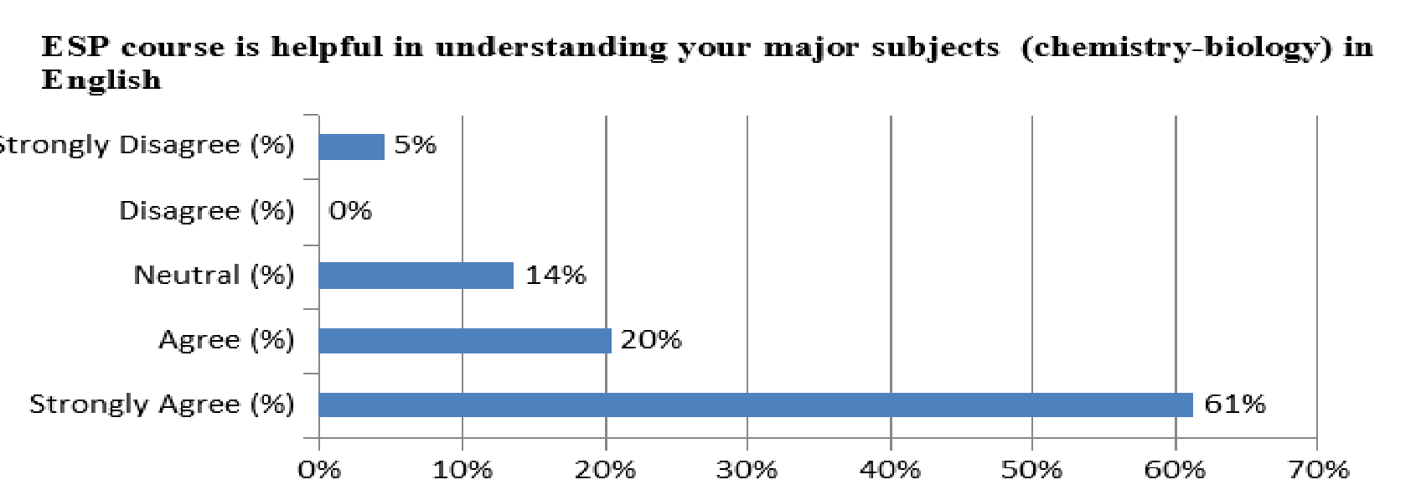

The results show that students are aware of the significance of the English language in their respective professional fields since 93% of students stated that English is necessary for their future career. The knowledge of chemistry-biology students’ English at higher education institution in the 2018-2019 academic year ranges from A1/A2, B1/B2 to C1 levels according to the CEFR. When compared to the 2017-2018 academic year results approximately a quarter of learners experienced insufficient, or almost no change in their English language improvement in ESP classes. The data about students’ goals show that 25% of participants said that their primary goal is to enhance their knowledge of academic English while 75% said that their primary goal is to use English outside the academia.
Both fifth and sixth questions in Figure 6 show almost the same significance with 69 percent of participants strongly agreeing and agreeing with the fifth question's mean value of 2.1364 and a standard deviation of 1.00211, and 55 percent strongly agreeing and agreeing with the sixth question's mean value of 3.0000 and SD of 1.29399, respectively. Therefore, after consulting with the head of the chemistry and biology department, it was decided to divide the elective English course into ESP and EAP where ESP course was intended for those who graduated from public schools with either Kazakh or Russian as the medium of instruction and EAP was for graduates who came from schools with English as the medium of instruction. This way some students have the opportunity to improve language competencies relevant to their respective area of studies while some have the opportunity to work more on EAP since their knowledge of ESP is already high.

Figure 6. Questions #5 & 6 ‘Materials should be more focused on chemistry-biology or academic English’
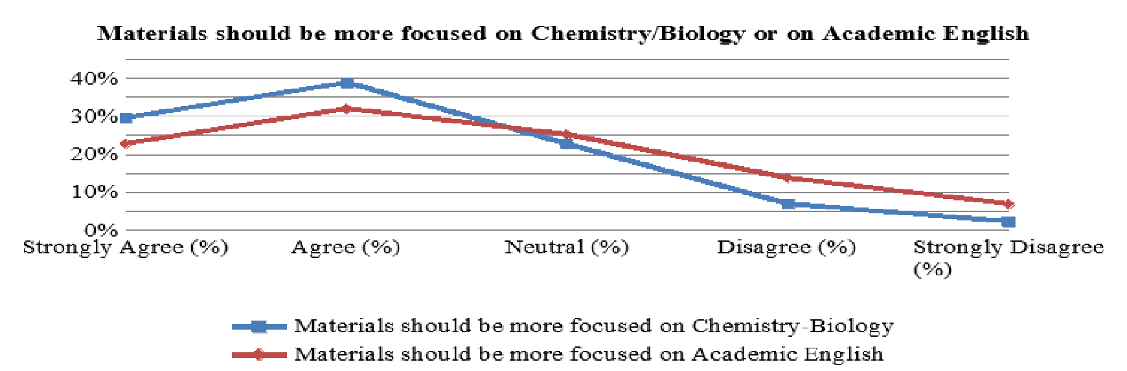

Tables 7 and 8 below show the actual value for Cronbach’s alpha.

Table 7. Cronbach’s alpha
Case Processing Summary
 |  | N |  | %
Cases | Valid | 44 | 100,0
Cases | Excludedª | 0 | ,0
Cases | Total | 44 | 100,0

Reliability Statistics
Cronbach's Alpha | Cronbach's Alpha Based on Standardized Items | N of Items
,728 | ,728 | 12

A total of 44 chemistry-biology students completed the questionnaire, which measured their perceptions of the ESP course and its relevance to their studies. The internal consistency of the questionnaire was acceptable, with a Cronbach’s alpha of 0.728, indicating reliable measurement across the 12 items (Tables 7 and 8).

Table 8. Item-total statistics
Item-Total Statistics
 | Scale Mean if Item Deleted | Scale Variance if Item Deleted | Corrected Item-Total Correlation | Squared Multiple Correlation | Cronbach's Alpha if Item Deleted
1. English is important in my academic studies | 18,4091 | 25,038 | -,130 | ,342 | ,755
2. ESP course meets my study expectations | 18,1136 | 18,801 | ,637 | ,658 | ,669
3. ESP course is helpful in understanding my major subjects (chem-bio) in English | 18,1591 | 17,858 | ,652 | ,731 | ,661
4. ESP classes are relevant to my needs | 18,2273 | 18,552 | ,736 | ,812 | ,657
5. Materials should be more focused on Chemistry – Biology | 17,6818 | 19,710 | ,439 | ,424 | ,699
6. Materials should be more focused on Academic English | 16,8182 | 22,850 | ,008 | ,179 | ,786
7. The teaching methodologies used by teacher are useful | 18,4773 | 20,534 | ,587 | ,676 | ,686
8. The teaching methodologies used by teacher are appropriate | 18,4773 | 22,813 | ,225 | ,470 | ,725
9. During ESP classes I have opportunities to work in groups and pairs | 18,4545 | 23,370 | ,165 | ,291 | ,730
10 I enjoy my ESP classes | 18,4091 | 20,294 | ,656 | ,670 | ,680
11. The evaluation procedures in the course are carried out appropriately | 18,0227 | 20,162 | ,430 | ,420 | ,700
12. English is necessary in my future career | 18,7500 | 24,378 | ,069 | ,139 | ,734

Students were highly satisfied with the teaching methodologies. Items 7 and 8 show that 75% strongly agreed that teaching methods were both useful and appropriate. Moreover, opportunities for collaborative work were valued: 68% strongly agreed and 27% agreed that ESP classes provided group and pair activities (Item 9). Most students also reported enjoying the ESP classes (Item 10), with 66% strongly agreeing.
The descriptive statistics further indicate that students’ goals were divided: 25% aimed to enhance academic English, while 75% intended to use English outside academia. In terms of English proficiency, chemistry-biology students ranged from A1/A2 to C1 according to the CEFR, with longitudinal comparison showing that approximately a quarter of students experienced little improvement in ESP classes compared to the previous academic year.
Overall, the descriptive analysis demonstrates that students perceive ESP as relevant and beneficial, though the need to differentiate instruction according to prior exposure is evident. The results highlight the importance of tailoring course content and instructional strategies to diverse student backgrounds, supporting the implementation of a stage-based ESP curriculum model.
Further in the 2019/20 academic a reliability analysis was carried out on the perceived task values scale comprising 12 items as shown in the table above from the first year chemistry-biology students (N=30) who entered the university in 2019/20 academic year. Cronbach’s alpha showed that the questionnaire reached acceptable reliability, α = 0. 728. The majority of items appeared to be worthy of retention in Cronbach's alpha if item deleted column. Four items out of 12 were exceptions: 1, 6, 9 and 12, which could increase the alpha to α = 0.755, α = 0.786, α = 0.730 or α = 0.734 and removal of these items should be considered. Thus, the questionnaire of the following academic year from students (N=30) was conducted without problem questions and the results of reliability statistics are as follows (see table 9) So, table 9 gives as Cronbach’s alpha coefficient α = 0.840 that is greater in comparison to the first one α = 0.728 which was taken the previous academic year. In this case, α = .840, which shows the questionnaire is even more reliable now.
Table 9. Reliability statistics taken from 2019-2020 academic year
Reliability Statistics
Cronbach's Alpha | Cronbach's Alpha Based on Standardized Items | N of Items
,840 | ,866 | 6

After all, table 10 is the final result in the output which represents the whole picture of the descriptive statistics.

Table 10. Scale Statistics taken from 2019-2020 academic year
Scale Statistics
Mean | Variance | Std. Deviation | N of Items
26,2000 | 12,579 | 3,54673 | 6

Table 11. Questionnaire results from chemistry-biology students in 2019-2020 academic year
# | Respondents | Number of respondents | Strongly Agree (%) | Agree (%) | Neutral (%) | Disagree (%) | Strongly Disagree
1 | English is significant in my academic studies | 30 | 70% | 20% | 10% | 0% | 0%
2 | English will be necessary for my future career | 30 | 86.7% | 6.67% | 6.67% | 0% | 0%
3 | General English met my academic expectations | 30 | 50% | 30% | 16.67% | 3.33% | 0%
4 | ESP met my academic expectations | 30 | 40% | 43.33% | 16.67% | 0% | 0%
5 | ESP was helpful in understanding your main subjects (chemistry - biology) in English | 30 | 60% | 30% | 10% | 0% | 0%
6 | General English should be replaced by ESP | 30 | 30% | 23.33% | 23.33% | 20% | 3.33%

It was already noted, the alpha coefficient increased from α = 0.728 to α = 0.840, which shows that needs analysis was more reliable in the 2019-2020 academic year. All the conducted studies during the two academic years of 2018-2019 and 2019-2020 helped a lot in choosing tasks and in compiling materials. So, it was revealed that students entering the university from ordinary or rural schools are not ready to immediately switch to the ESP course, so General English is an integral part and should also be present in the process of choosing and compiling the right material.
As previously mentioned, needs analysis should be designed to demonstrate students’ language needs and obstacles in language learning, problems that teachers face in teaching ESP and teaching outcomes. Thus, Figure 7 below is a good illustration of the needs, lacks, wants and targets of instruction in ESP for the chemistry/biology students and the needs of the labour market in Kazakhstan as a result of accepting all the answers and wishes of the students (Raikhanova, Kassymova, & Bakić-Mirić, 2025).
The study confirms that English for Specific Purposes curriculum design starts with gathering information on present language needs of students and target language usage. Course components should demonstrate the interests of students in the target subject(s) and present language by using authentic materials. The current study is aimed to build a needs analysis (NA) to investigate the language needs of science (chemistry/biology) students. According to the research results it is suggested to divide ESP course into two: one for students with a low level of English who graduated from public schools and second for those with a high level of English who graduated from schools where science subjects were taught in English. This part dealt with assessing ‘Chemistry and Biology’ combined major programme students’ academic and professional needs, wants, and lacks in the ESP course offered at the post-secondary level.

Figure 7. Needs analysis of the programme

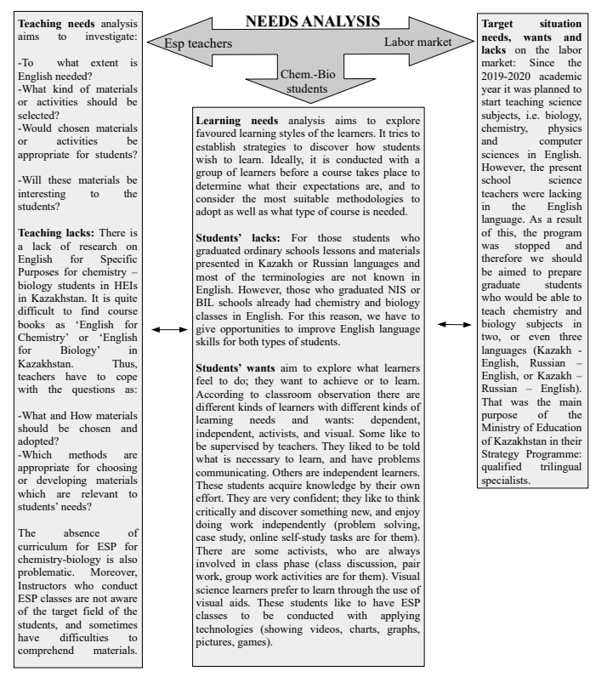

Based on the results provided by the present situation analysis (PSA), target situation analysis (TSA) and learning situation analysis (LSA) it is noted that university students are homogeneous in terms of learning background. Moreover, it is quite obvious that chemistry/biology students require general academic listening comprehension skills as well as speaking skills with generic and specific range of vocabulary to explain, discuss, ask and answer questions during tutorials, reading and writing skills necessary to understand academic and scientific literature and produce quality pieces of writings respectively. However, learners with higher levels of English experienced insufficient, or almost no progress in their English language improvement in ESP classes since most of them are graduates from specialised schools where science subjects were taught in English. At the same time, according to the results emerging from the instructors’ questionnaire it is clear that ESP course has advantages such as academic freedom, variation of teaching techniques and materials, and more motivation for students to learn and practice materials related to their specialty in comparison to General English. Additionally, drawbacks like lack of materials and networking with science teachers, insufficiency of English knowledge, and gaps in curriculum were mentioned as well. Thus, we strongly believe that if ESP teachers are informed and aware of the students’ needs, that this would greatly assist them in successfully designing the ESP courses that would be designed in such a way so that both groups of students have equal opportunities to learn and/or improve their English language skills at the post-secondary level.

5.2 Intended Learning Outcomes’ Results

The internal materials must be in line with the general outcomes of the curriculum and the desired learning results. They ought to be used in conjunction with other curricular elements including exercises, assessments, and course syllabi.
As it was already mentioned before, constructive alignment (CA) is a learning pattern the goal of which is to explicitly describe what learners are expected to know and how they are expected to demonstrate that knowledge before any instruction begins. Assessment tasks are then constructed to permit accurate assessments as to how well those outcomes have been accomplished, and teaching is subsequently intended to engage students in learning activities that maximise their chances of obtaining those results.
Taking all of the above into account, it is safe to say that this approach can certainly be considered as learner-centred, since it aims to give students a thorough grasp of the standards and goals being met as well as the best way to reach them. On the other hand, until recently, most universities followed, and perhaps still adhere to traditional teaching, when learning is teacher-oriented, in other words, when the teacher himself chooses the content that should be covered and puts standard-oriented marks without referring to the assessment criterion. However, in student-centred learning, assessment is necessarily criterion-oriented, making it simple to comprehend what grade was given for each completed assignment (Biggs, 2014).
According to the hierarchy of intended learning outcomes the initial educational goals and graduate competencies must be agreed at the university and faculty levels. This study was carried out at one higher education institution and therefore we decided to start by looking at the aims of the university and faculty. This institution is a private university in Almaty, Kazakhstan. University offers full-time undergraduate and postgraduate degree programmes. University vision at this institution is to be the leading internationally-oriented university in Central Asia, recognized for our teaching and learning; innovation, inquiry and discovery; and the excellence of our graduates. University is committed to developing, through outstanding knowledge creation and delivery, graduates who are global citizens and whose values are formed through holistic education. These skilled professionals and disseminators of knowledge and innovation will enhance the lives of fellow citizens, the economy, and the nation. The university values and missions are: 1. Encouraging creativity and new ideas; 2. Cultivating moral and ethical principles; 3. Developing autonomy and transferable skills; 4. Striving for outstanding achievements; 5. Creating global citizens; 6. and Inspiring leaders of the future.
To identify the vision of the different faculties the teachers (N=7) were surveyed to create an alignment with the general ESP curriculum outcomes and desired learning results that better prepare students for their future careers and academic challenges (see Appendix I - The survey questions for different department teachers). The purpose of this survey was to align the ESP curriculum with the overall educational objectives and desired learning outcomes of faculty (Vision of the Faculty - Survey from Teachers - Alignment with ESP Curriculum). The survey aims to identify the key competencies and essential academic skills that students should acquire by the end of their degree programme to foster these competencies, various tasks and assignments that can be implemented in the ESP curriculum targeting the development of these skills and ensuring that students are well-prepared for both academic challenges and future professional endeavors.
The open-ended Question (Q) 1 reveals expected learning outcomes for students by the time they complete their degree programmes. The responses from educators highlight key competencies and skills that students are expected to acquire by the end of their degree programmes, emphasizing a comprehensive learning framework. Key outcomes include a solid understanding of subject-specific environments, the ability to implement quantitative skills, and the integration of applied knowledge through practical experiences. Critical thinking and analytical skills are essential, with a focus on academic reading, writing, and problem-solving methodologies. Communication skills, both written and oral, are prioritized, alongside insights into translation and linguistic research. Additionally, the importance of emotional intelligence and creativity is recognized, reflecting a holistic approach to preparing students for the complexities of the modern workforce. These findings can guide curriculum development and instructional practices to enhance student learning experiences.
The Q2 highlights the key academic skills needed to acquire in the educational settings within different disciplines reflecting a holistic approach to student development. The skills include analytical reading, building communication, critical thinking, delivering presentation, digital literacy, essay writing, group projects, listening, note-taking, problem-solving, public speaking and report writing.

Figure 8. Key academic skills needed in educational settings
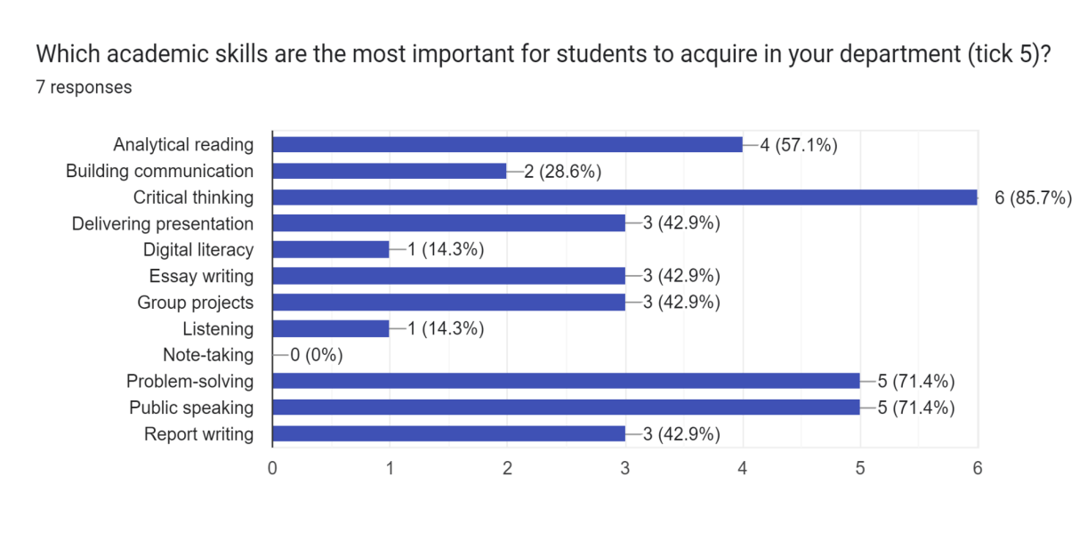
The analysis of academic skills represents that critical thinking (16.67%), problem-solving (13.89%), and public speaking (13.89%) are the most valued competencies among educators, highlighting their significance for student success in both academic and professional contexts. In contrast, digital literacy and listening skills are deemed less important, each receiving only 2.78%, while note-taking is not prioritized at all (0%). This suggests that educators may view basic digital skills and listening as fundamental abilities not requiring explicit emphasis in the curriculum. Overall, the findings indicate a clear focus on analytical and communicative skills, while also pointing to potential gaps in addressing the evolving demands of today’s academic and professional environments.
The Q3 illustrates the expected outputs that students are required to produce throughout their courses. This data highlights the emphasis placed on different types of assessments and learning activities, reflecting the pedagogical priorities within the curriculum. By analyzing the percentages of each output type, we can gain insight into the skills and competencies that educators deem essential for student development.

Figure 9. The expected outputs that students are required to produce throughout their courses

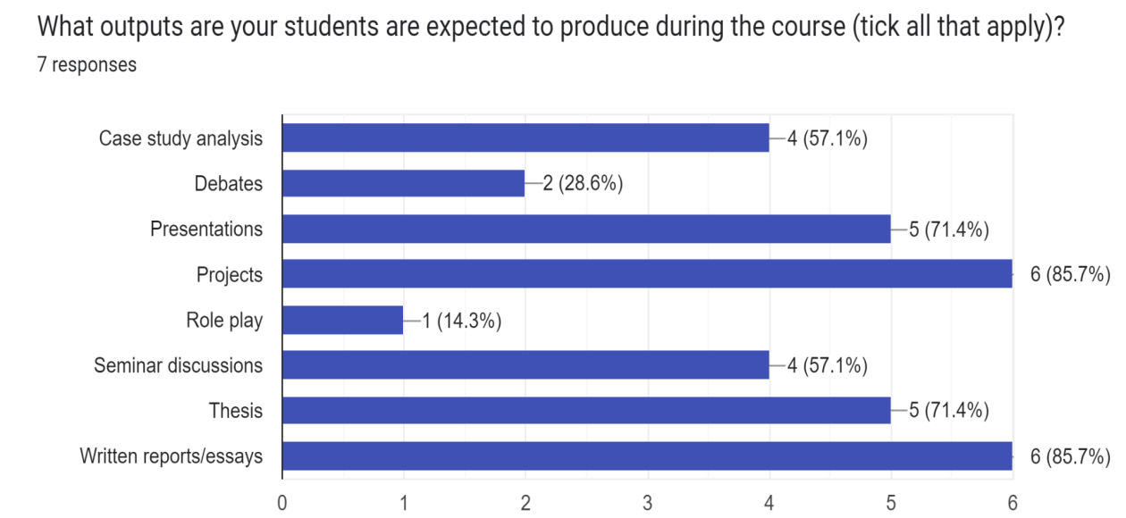

The survey results regarding the expected outputs that students are required to produce during their courses reveal significant trends in pedagogical practices. As illustrated in the data, projects (85.7%) and written reports/essays (85.7%) are the most commonly expected outputs, indicating a strong emphasis on practical application and comprehensive analysis within the curriculum. Presentations (71.4%) and thesis work (71.4%) also hold considerable importance, reflecting the value placed on effective communication skills and in-depth research capabilities. Additionally, case study analysis and seminar discussions are each expected from 57.1% of respondents, highlighting the integration of real-world scenarios and collaborative learning in the academic framework. In contrast, outputs such as debates (28.6%) and role play (14.3%) are less frequently emphasized, suggesting that while interactive and experiential learning methods are recognized, they may not be central to the educational objectives. Overall, the findings underscore a curriculum focused on developing analytical, communicative, and practical skills, preparing students for both academic rigor and professional challenges.
Questions from 4 to 7 present an analysis of educators' expectations regarding various aspects of language skills within their courses, specifically focusing on writing, reading, speaking, and listening. The questions explore the genres of writing students are expected to produce, the tasks assigned to develop reading skills, the types of authentic texts utilized in major subjects, the spoken skills students should demonstrate, and the listening materials employed in the curriculum. By examining these areas, we can gain valuable insights into the pedagogical approaches adopted by educators, as well as the competencies they prioritize for student development. This comprehensive assessment will highlight key trends and expectations, ultimately informing curriculum design and instructional strategies aimed at enhancing students' language proficiency across multiple contexts.

Figure 10. Writing skills that are expected from educators

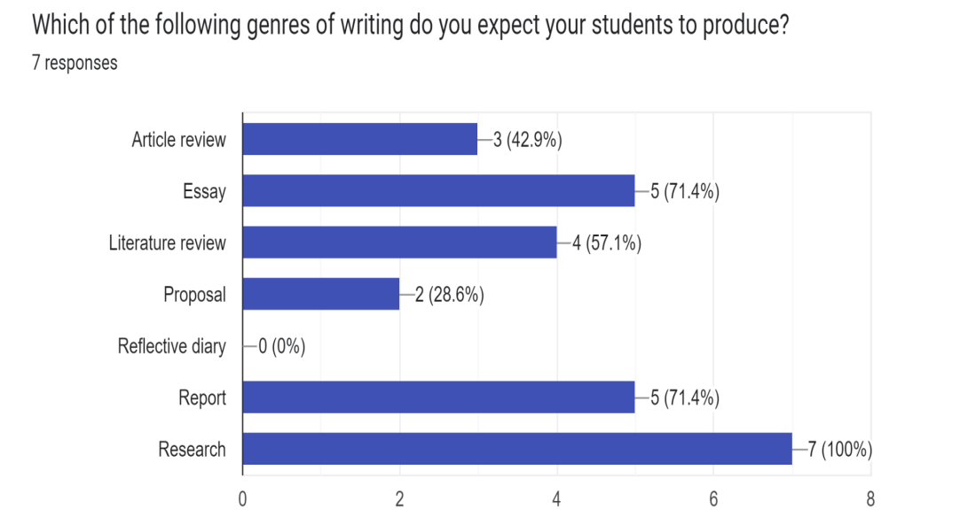

Figure 11. Reading skills that are expected from educators

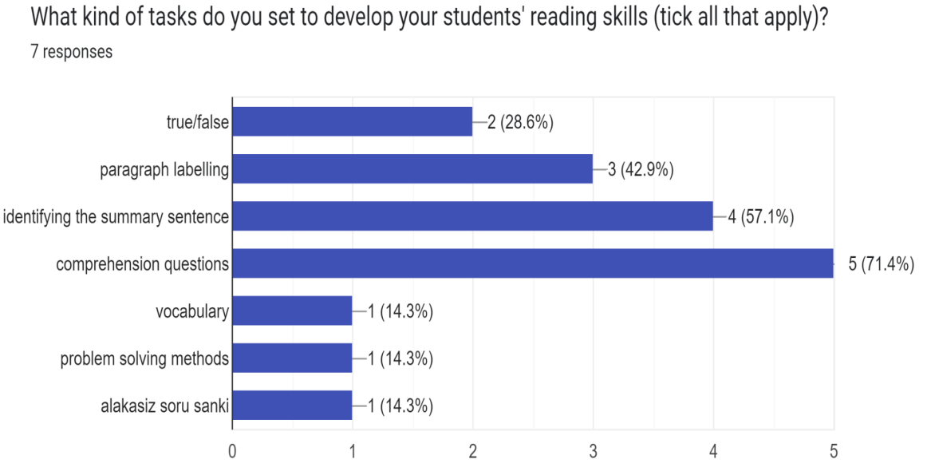

Figure 12. Speaking skills that are expected from educators

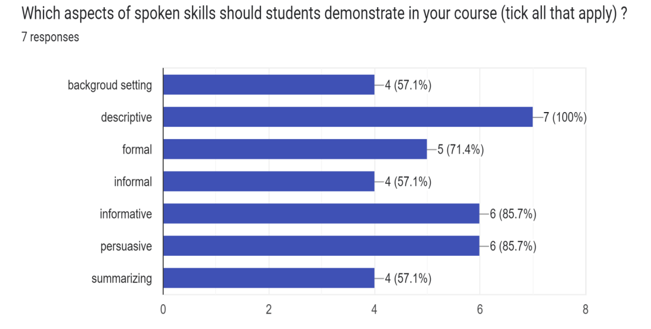
Figure 13. Listening skills that are expected from educators
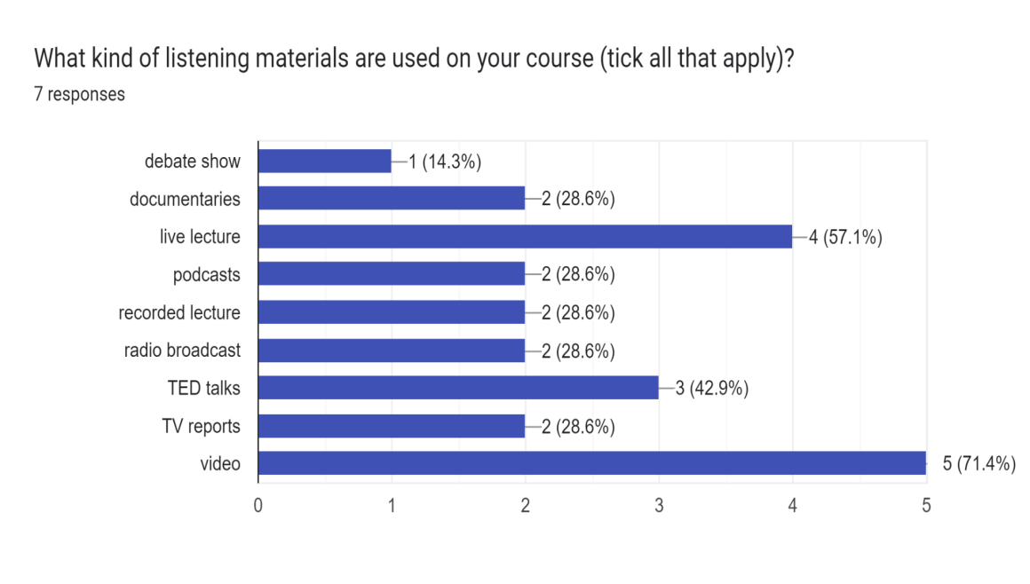

The survey responses regarding language skills reveal significant trends in educators' expectations for student competencies. In writing, research (100%) is the most emphasized genre, followed by essays (71.4%) and reports (71.4%), highlighting a strong focus on structured academic outputs. For reading skills development, comprehension questions (71.4%) are the most common tasks, indicating a necessity for understanding texts, while identifying summary sentences (57.1%) and paragraph labeling (42.9%) also play important roles. In spoken skills, descriptive communication is prioritized (100%), alongside informative (85.7%) and persuasive speaking (85.7%), reflecting the need for adaptability in various contexts. Listening materials predominantly feature video (71.4%) and live lectures (57.1%), suggesting a preference for engaging formats, though less emphasis is placed on materials like debate shows (14.3%) and podcasts (28.6%). Overall, the findings underscore a commitment to developing critical academic skills while revealing potential areas for enhancing vocabulary acquisition and diversifying listening resources. The last question Q8 analyzed the responses regarding the most common homework assignments. The respondents are labeled as R and the number indicates the order in the table 12 given below.

Table 12. Most common types of homework assignments set on educators’ (major) course
Name | Response
R1 | Case study analysis, project work, problem solving
R2 | Problem Solving, Projects
R3 | presentations, analytical essays, comparative analysis
R4 | workshop, project and finding new methods to solve problems
R5 | Group projects, presentations, essays
R6 | Projects, case-studies, essays
R7 | Problem solving, small project, review of an article

The analysis of homework assignments within the research settings reveals a strong emphasis on practical and collaborative tasks designed to enhance student learning across various disciplines. Key assignments such as projects and case study analyses underscore the importance of applying theoretical knowledge to real-world scenarios, fostering critical thinking and problem-solving skills. Additionally, the consistent inclusion of presentations and group projects highlights the need for effective communication and teamwork, essential competencies in professional environments. The diversity of assignments, which includes analytical essays, comparative analyses, and workshops, reflects a well-rounded approach to assessment that caters to different learning styles and reinforces understanding through multiple formats. Overall, these findings indicate a curriculum that prioritizes the development of practical skills and prepares students for the complexities of their future careers.
As shown in the Hierarchy of Intended Learning Outcomes, the next step after examining university and faculty aims represented as aims of teachers from different faculties is to examine curriculum (programme) aims, i.e. whether the aims of the curriculum (programme) are in line with the aims of the faculty.
The combined major programme “Chemistry and Biology” at higher education institution has been implemented since the 2017-2018 academic year. It provides an opportunity to study two fundamental scientific disciplines concurrently, while preparing students for instruction in English. The programme is designed to educate qualified chemistry and biology teachers, to enable them to create effective learning environments through the integration of instructional technologies and specialized teaching methods, and to ensure their ability to respond to emerging developments and innovations in the field. In parallel, the programme equips students with the professional skills necessary for future career success.
The Chemistry-Biology programme integrates disciplinary knowledge in chemistry and biology with practical laboratory experience, pedagogical training, technological competence, and subject-specific teaching approaches. It supports both professional and personal development through inclusive, interdisciplinary, and STEM-oriented courses, supplemented by practical components such as school practice and internships.
To maintain responsiveness to evolving educational demands, annual curriculum adjustments (10-20% revisions) are introduced. These include the expansion of laboratory hours, the integration of STEM and teaching methodologies, and the incorporation of professional guidance for pre-service teachers. Such innovations enhance student motivation, accommodate diverse learning styles, and strengthen applied competencies. School internships in leading national and international institutions provide authentic teaching experience, mentorship, and structured evaluation, thereby bridging theory and practice. This combination of academic preparation and practical immersion fosters confidence, supports career exploration, and ensures professional readiness. Programme learning outcomes (PLO) are as follow:
PLO 1: Use in practice the methods of teaching chemistry and biology with using modern technologies;
PLO 2: Acquire the communicative competence and professional skills of the teacher by learning language and general educational subjects in an interdisciplinary approach;
PLO 3: Develop the scientific skills by working with physical-chemical installations and by carrying out scientific observation of chemical processes;
PLO 4: Apply the theoretical foundations and experimental knowledge of chemistry and biology knowledge in everyday life;
PLO 5: Analyze the results of lab activities in chemistry and biology laboratory classes through practical applications;
PLO 6: Systematize and summarize the laws of natural sciences, sectoral, regional and international problems, and analyze various options for improving the state of the environment;
PLO 7: Master new educational technologies, multimedia tools, software methods in profession, and also criteria-based assessment methods through practical experience;
PLO 8: Gain professional competence in the performance of scientific work related to applied research.

During the four-year study period chemistry/biology students take a 6-credit compulsory General English course in the first term and a 3-credit elective ESP course during the second term. Furthermore, there is also a 2-credit ESP course in the sixth term. It is also necessary to take into account that all other core subjects are taught in English which gives these students a great advantage over those who are educated in either Kazakh or Russian languages. Since the programme at university provides English as the medium of instruction, this equips students to teach chemistry and biology in English once they complete their degree.
Taking into account the detailed classification of STEM in EAP done by Anthony Laurence (2018) in Figure 3, we tried to create our own ESP sub-sub-branch model for chemistry-biology specialty. To do this, we studied the Educational Programme of 6B015002 - Chemistry-Biology bachelor students who entered university in the 2019-2020 academic year and for the upcoming 4 years. Within 4-year studying process chemistry-biology students are taking such major disciplines as General Chemistry, Inorganic Chemistry, Organic Chemistry, Physical and Colloid Chemistry, Environmental Chemistry, Biochemistry and Chemical Industry in Chemistry field, as well as General Biology (Botany, Zoology), Cytology and Histology, Physiology of animals and plants, Human Anatomy and Physiology, Molecular Biology, Genetics, Microbiology and Biotechnology in Biology field.
As you can see in Figure 14 the ESP branches for chemistry-biology specialty at higher education institutions are interconnected depending on the learners’ needs. Since most core and multidisciplinary lectures are conducted in English. Hence, chemistry-biology students require general academic listening comprehension skills as well as speaking skills with generic and specific range of vocabulary to explain, discuss, ask and answer questions during tutorials, and of course reading skills in conjunction with writing skills to perceive and understand academic and scientific literature and produce qualified pieces of writings respectively.

Figure 14. Branches and sub-branches of ESP curriculum for chemistry-biology specialty at higher institution

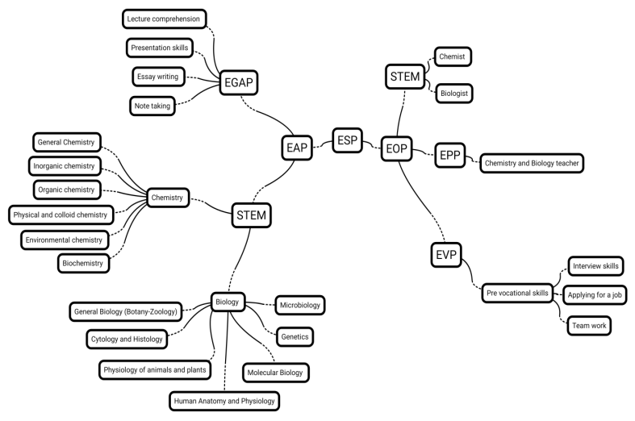

What does this classification give us? What is it for? It is obvious that an understanding of what type of ESP should be used at what stage of teaching and learning comes. For instance, classification of EAP can be used at the beginning of the course, including EGAP, where elements of the GE can be included in accordance with the requirements and needs of students, as well as skills such as lecture comprehension, presentation skills, essay writing, note taking, and etc., that is the basis of academic knowledge that every student should know and master in order to successfully accomplish the disciplines presented in the initial years of study at higher education institutions. In addition, EAP can be focused on STEM, where the emphasis is on the main major topics, in our case, it is chemistry and biology. That is, students can be presented with topics, skills, vocabulary which will later be used as scaffolding in lectures and classes of the main subjects in order not to hang up on new terms, but to delve more into the meaning of the context. In the third and fourth year of study, the classification of EOP is more appropriate since students embark on a new stage of becoming specialists, in our case a teacher of chemistry and biology. This is a period when practicum begins in schools and other various educational centres where the study of terminology and general English is not already applicable because it is the time when students need such content to show the skills of a future teacher, not a current student, as it was mentioned in EAP. Students require more occupational and professional skills and competencies that will allow them to use with real students. For example, designing curricula or lesson plans, or daily phrases used in the classroom, skills that allow students to painlessly and professionally conduct a lesson at a high level.
When the programme of chemistry - biology was just launched, the coordinators and heads of departments faced the task of improving the level of the English language among students, since the specialty was new and the flow of applicants was relatively small, and the level of students was diverse. In one group, there were graduates of specialised schools like NIS or BIL where subjects were taught in English, and graduates from remote villages where the level of English leaves much to be desired. And the teachers of the ESP had a difficult task to interest all students, and not just the weak ones. In that very first pilot year, it was decided to increase English hours to 9 hours a week, where 6 hours were elective granted by the university itself and only 3 hours were compulsory. Thus, it turned out to be 18 hours overall in one academic year. It certainly was an incredible workload and challenge for both teachers and students. Finding the right materials and exercises took an incredible amount of time and was undeniably a huge amount of work. After all, it is not easy to replenish all those school knowledge and skills that should have been mastered gradually from year to year over at least the last 5-6 years. In particular, I felt sorry for those students who conscientiously worked and mastered that elementary programme and expected great knowledge and skills from the university, however, unfortunately, had to study it on an equal footing with everyone else. Twenty-four students entered the specialty of chemistry and biology in the first academic year. Studying in one group there were 3 beginners, 6 elementary, 2 low pre-intermediate, 6 pre-intermediate and 7 intermediate and above level students. Teachers had to come up with such tasks and exercises, and look for suitable materials that would be of interest to everyone, especially those students with an advanced level of English. However, in subsequent years, the specialty gradually gained popularity and more and more people wished to enter it. Thus, leading to a decline in the load of English, for example, in the 2018-2019 academic year, the first semester remained unchanged with 6 elective and 3 compulsory hours, but in the second semester there was a reduction of 3 elective hours, thus amounting to 3 elective and 3 compulsory. In the 2017-2018 academic year the total number of hours was 18 hours, then in 2018-2019 it was 15 hours per year. Also, in the second semester of the 2018-2019 academic year, after the Needs Analysis, it was revealed that students with a good level of English would like to diversify their skills and knowledge in the academic field, thus, after consulting with the head of the department, it was proposed to divide the ESP into two, that is, for weaker students were asked to introduce ESP, but with elements of General English, where there is grammar along with specific terminologies, and the second elective course was with elements of academic English, that is, English for Academic Purposes. The separation was possible only due to the fact that there were about 70 students entering and one group for Academic English was recruited. In addition, with the growth of applicants it was the fall in the number of hours, the same decision of the university and the faculty, negotiating with the coordinators, there was an offer for pre-requisites for the main disciplines of English. The introduction of pre-requisites took place in stages, so in the 2020-2021 academic year, students who had less level than pre-intermediate (A2) had to first take courses at the Continues Education Centre (CEC) to raise the language until the required level, and only after that they have had access to the main discipline of the English language in the curriculum (Figure 15).

Figure 15. Required level of English proficiency in the 2020-2021 academic year
Pedagogical Science (Physics-Informatics, Mathematics, Chemistry-Biology)
CURRENT LEVEL | PLACED TO | I | II | III | IV
A0 → | A1 | A1 (CEC 101) | A2 (MDE 109);  PED (128, 108) | A2+  (MDE 110)
A1 → | A2 | A2 (MDE 109);  A2+ (MDE 110) | PED (128, 108)
A2 → | B1 | B1 (MDE 103);  B1+ (MDE 188) | PED (128, 108)
B1 → | B2 | B2 (MDE 104);  B2+ (MDE 106) | PED (128, 108)

And already in the 2021-2022 academic year, the threshold for the level of English proficiency increased from pre-intermediate (A2) to intermediate (B1), which meant that students who have fully mastered the level of intermediate can take English according to the curriculum (Figure 16).

Figure 16. Required level of English proficiency in the 2021-2022 academic year

CURRENT LEVEL | PLACED TO | I | II | III | IV | V
A0 → | A1 | A1  (CEC 101) | A2  (CEC 102); | B1  (CEC 103) | ESP 1 (MDE 103) | ESP 1+  (MDE 188)
A1 → | A2 | A2  (CEC 102) | B1  (CEC 103) | ESP 1 (MDE 103) | ESP 1+  (MDE 188)
A2 → | B1 | B1 (CEC 103); | ESP 1 (MDE 103) | ESP 1+  (MDE 188)
B1 → | B1 | ESP 1  (MDE 103) | ESP 1+  (MDE 188)
B2 → | B2 | ESP 2  (MDE 104) | ESP 2+  (MDE 106)

Thus, during the five years, the university has been developing the ESP programme, making it a suitable discipline at the higher education level. Nowadays, the compulsory English language 1 and 2 programme in university is no longer General English, with banal textbooks that are used in various English courses. Now the English language programme at university, taking into account the specifics and involving the interests of the university, faculty, specialty, is being developed based on the interests of students. Of course, there is still work to be done, but nevertheless, it is encouraging that the level of English in university is taking on a new look, more academic, not the school one that was years earlier.
One of the next stages, after identifying programme aims, is to define course aims based on all the objectives listed above. A class that lasts for a term or an academic year is referred to as a "course." Typically, a course is taught by one or two professors and is regarded as a separate subject. Students receive grades when the course has been completed at the same time. Programme, on the other hand, is a different title for degrees. For instance, Bachelor of Science in Biology would be recognized as a programme, whereas Introduction to Biology would be a course. However, other nations use words a little bit in a different way. The completion of a university degree is referred to as a "course," while an academic course would be described as a "unit" or "module." Most educational institutions around the world provide courses that are only a few weeks to several terms long. They can be offered as "compulsory" or "elective" components. A compulsory course (sometimes known as a "core course" or a "general education course") is one that students are compelled to take, whereas an elective course is one that students choose from among other courses in a curriculum. Core courses are thought to be essential for earning a degree, while elective courses tend to be more specialised (Merriam-Webster online dictionary).
Investigating the factors that should be taken into consideration when creating an ESP course is important. Many ESP teachers are unsure of whether the course should be intensive or extensive, assessed or not, common-core or specific, homogeneous or heterogeneous, fixed or flexible, or address immediate or delayed needs.
Dudley-Evans and St John (1998) distinguished between fixed and variable aspects in ESP courses. Absolute ESP qualities include creating a course that meets the needs of the learners, using core methodologies and activities that are perfectly suited to the particular discipline, and putting a strong emphasis on the language, skills, and methodologies that relate to these activities. ESP is designed more for adult learners; it is typically generated for students with intermediate level and above; and most ESP courses are supposed to possess fundamental knowledge of the language system. Despite the variable course features that ESP might be structured to the special disciplines, ESP may apply different generic methodology taken from General English course in practising special teaching situations, and ESP may use different generic methodology taken from ESP in general English course, there is no doubt that this course could be used with low level students either.
One of the most crucial responsibilities in teaching English for specific purposes is creating an adequate course that covers all necessary study abilities. The technique and methodology behind creating an effective learning environment for students is known as course design. The goal of course design is to integrate learning opportunities for students into a focused environment that fosters intellectual development. For teachers and students, there are numerous designed and authentic sources and materials available. The 21st century's digitalization offers opportunities to access all materials online, yet the majority of people struggle to find the right resources. Even professors struggle to choose the best materials. Low English proficiency and competency levels of learners may be resulted from inappropriate material selection. According to Dudley-Evans and Maggie St John (1998, pp. 148-149), there are various parameters we need to take into account when designing or building courses. These criteria are shown in Figure 17 below.

Figure 17. Course design parameters (Dudley-Evans and Maggie St John, 1998)

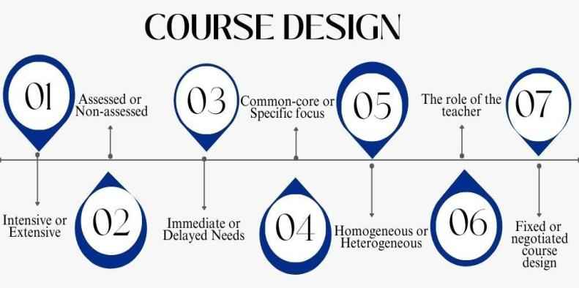

Finding out whether the training should be intensive or extended is the first step. The primary goal of the intensive course is to meet critical language needs in a short amount of time. On the other hand, extensive classes are offered at least once a week and are held every week. Extensive courses' primary goal is to support ongoing, long-term language learning. In contrast to an intensive course, which only occupies a small portion of students' schedules, an extensive ESP course requires learners to devote all of their time to the ESP course. The majority of ESP courses are run intensively so they can equip students with the language and language skills they need for particular academic fields or to train company workers for particular labour responsibilities. However, ESP courses are provided simultaneously with other subject courses at universities. The advantages of taking intensive ESP classes are clear. Students are intensely focused on learning English. They have plenty of time to do a variety of jobs, assignments, and activities. For instance, students may spend a significant amount of time and effort studying a new language, creating presentations, or producing reports.In terms of time availability for studying English and practising various language skills like reading, writing, listening, and speaking as well as 21st century skills like communication, presentation, collaboration, creativity, and critical thinking, intensive courses may be more efficient due to the absence of other distractions. Intensive courses, however, also have some drawbacks. The lack of a correlation with core courses may cause students' motivation and enthusiasm to drop. The learning process appears artificial since students do not apply what they have learned in the workplace. When the learning process is more closely tied to the students' fields of study and experienced firsthand in the primary course area, enthusiasm and passion advance. In our situation, we have an extensive ESP course, which has advantages and disadvantages of its own. The benefits of ESP course, for instance, can be implemented in conjunction with the subject course, relevant to its issues, and tailored to learners' needs and experiences. The rank of ESP as a subject is enhanced once it is included in the programme and included in the timetable where students are evaluated, which motivates students to learn the material thoroughly. The potential lack of continuity between sessions, especially if the classes are infrequent, is the extended course's biggest drawback, albeit (Robinson, 1991). How can students become proficient if there are only three credits (classes) per week? Additionally, they are not fully focused on ESP classes because of distractions from other disciplines. The institution's policies determine whether to offer intensive or extensive courses. It might be easy to fit certain intensive components within a lengthy course, though.
The second issue is determining whether the course should be assessed or not. This course is more effective and convenient for mutual learners or staff who are responsible for their learning process and progress because the intensive ESP focuses on rapid language learning. These courses are rarely assessed because they are not usually concerned with testing or evaluating learners' proficiency. At the same time, extensive ESP courses are mostly offered at universities for students who may not understand the importance of the learning process. As a result, ESP should be a mandatory or at least elective course for these students, with their performance evaluated alongside other subjects at the end of each term and academic year. It is crucial that ESP courses are seriously considered by both students and other departments in order to considerably raise their status. On the other hand, it also adds accountability, responsibilities, and duties to the process of teaching English.
Choosing whether the ESP course should address immediate or later requirements is the third step. Immediate needs are those that students have throughout the course, whereas delayed needs are those that will be more advantageous in the future. English for Occupational Purposes (EOP) and English for Academic Purposes (EAP) are the two main categories of ESP (Hutchinson & Waters,, pp. 6-8; Biggs, 1993; Graves,2000). Business English, professional English (e.g., English for engineers, lawyers, and doctors), and vocational English are other sub-divisions of EOP that are occasionally created (e.g. English for tourism, nursing, and aviation). According to Dudley-Evans (1998), ESP has the following absolute characteristics:
- ESP is designed to meet the specific needs of the learners.
- ESP makes use of the underlying methodology and activities of the specialism it serves.
- It is centred not only on the language (grammar, lexis, register), but also the skills, discourse and genres appropriate to those activities (Renshaw & Cohen, 2014).

The majority of ESP or EAP courses are designed to address delayed needs such as presentation skills, writing academic papers, or oral communication in their future professional fields, which cannot be fully used in accordance with their profession, and are typically set in the first or second years of the learning curriculum. When students get real-world experience later in the course or perhaps when they have to write and defend dissertations in their final year, the actual needs of EOP become more urgent. Do such elements of EAP or EOP courses make sense to incorporate beforehand? In our opinion, it would be more important to include EOP components in the last years when students are aware of how important the course is as opposed to the first or second years, or at the very least, to ensure that the course is offered through the final year. There is definitely a case to be made for offering a brief, intensive course on academic language and including presenting and writing abilities in the last year, especially given how pertinent these skills are. A training that meets their professional needs while preparing them for oral and written communication always seems to pique their interest. Additionally, there is a logical order for handling such a course in the last academic year, especially when there is a chance to integrate the course that also better prepares students for the working world.
The second query is whether common-core or study-specific resources and courses should be used. The main problem with ESP programme design is how specific course materials are put together with a focus group of students in mind. There is a distinction between "broad angled" courses, which are designed for a more diverse group of students, and "restrict angled" courses, which are produced for a very narrowly targeted group of students. For instance, courses called English for Science can be considered as ‘broad angled’ since they are for classes focused on wide academic skills which cover many sub-fields including Formal Sciences, Social Sciences, Life Sciences, Physical Sciences, or Natural Sciences. Meanwhile, the course titled English for Chemistry or English for Biology is considered as ‘restricted angled’ as they refer to courses that are more special purpose. Furthermore, the courses can be even more specific. For example, chemistry often distinguishes between two areas, scientific chemistry or pedagogical chemistry, and courses could be developed for just one of these sub-areas: English for Scientific Chemistry or English for Pedagogical Chemistry. Some ESP courses are created for broad-focused subjects or professions, while others are for specialisations within them. A wide range of target events, such as professional skills, or a variety of genres may be the topic of broad focused courses. It does not, however, imply that knowledge is imparted in an informal or careless manner. Quite precise content may be included, and skills will be very thorough. Wide concentration has the advantage of enabling us to manage a number of talents even when there is just one need at hand. To reduce the stress of the learning process, the broadly focused course offers opportunities to switch from specially targeted English to usual, generic focused English. In contrast, not enough time for a variety of activities can cause some distractions and make it harder to understand the information. A narrowly focused course focuses solely on a small number of target genres, such as listening skills or just reading and writing skills. The decision between a wide- or narrow-angled course design might be based on grouping the students. For example, if there are 60 students entering the university, divide them according to their language levels and choose between wide or narrow angled English for future chemistry-biology learners according to their needs and preferences after determination of Needs Analysis.
The fifth point is to learn whether the group taking the course is homogeneous or heterogeneous. Students from the same learning background, such as a single career or specialty, make up a homogeneous group. A heterogeneous group of learners, however, comes from various specialities, occupations, or educational levels. Since General English is broad, teaching it to a diverse group of students is not a difficulty, but teaching professionally focused classes is challenging. With homogenous groups, however, it is possible to provide more focused work. Because they are created to be immediately applicable and appropriate for the needs of the learners, we anticipate that students will find highly targeted courses to be particularly inspiring. When an ESP course aids in comprehending lectures on important subjects and students are able to learn and use all acquired language skills in their writing assignments, reports, presentations, and seminars, the majority of students’ report feeling enthused about their studies. It would be incorrect to believe that just particular materials need to be chosen for homogeneous groupings. There are moments when it can be changed between common-core and certain materials. The initial problem is to homogeneously group the students so that they are all interested in learning ESP. The language's sophistication is a further problem. It is possible for students to come from similar specialisations or occupations, but it may be quite challenging to guarantee that levels are equal among groups. The division of students into groups based on their language proficiency is a relatively typical practice in general English classes. However, the specific aims of the learners are prioritised more in ESP courses in terms of homogeneity.
Understanding the function of the teacher is the next stage. The function of ESP teachers is a highly important and contentious issue. Considering that teachers direct the class, impart language skills, and split students into groups or pairs (Hutchinson & Waters, 1987; Swales, 1985; Dudley - Evans and St. John, 1998). Dudley - Evans and St. John (1998) describes a teacher as a provider of input and activities. However, some ESP instructors serve as consultants or facilitators who manage input but not control. They continually discuss with students what materials, topics, skills, and activities they want to be included in their curriculum before making any decisions about the course design on their own. In certain cases, teacher facilitators will even ask students to assist in gathering supplies for the lesson. All of this is a result of the lack of material understanding in particular fields. However, the teacher-facilitator aids in practising the deeper linguistic understanding.
An "integrated set of teaching-learning experiences, with the ultimate goal of leading the learners to a particular state of knowledge" (Hutchinson & Waters, 1987) is what is referred to as a course. The process of developing an ESP curriculum involves gathering information to create useful tasks and assignments, as well as suitable environments for ESP students to succeed (Richards & Rodgers, 2001). As a result, needs, wants, preferences, and expectations of learners play a crucial role in course design, making ESP a learner-centred approach rather than one that is teacher-centred. Additionally, the two teacher roles mentioned above are on opposite ends, with one acting as a complete dictator or controller and the other as a complete facilitator or consultant. However, there is no harm in including some teacher-centred activities into conventional teaching techniques when teaching ESP. Without a doubt, a skilled ESP instructor will instinctively know which position to play. The following are the main responsibilities of ESP practitioners: teacher, course designer, materials provider, collaborator, researcher, and evaluator. As a result, ESP teachers' jobs require a lot more than just instruction.
The final question is whether the course design must be prepared by the language teacher following counselling with affiliation or if it can be decided upon by the learners themselves throughout the course. In other words, the goal is to determine if the course design should be rigidly negotiated or flexible. A fixed course design is one that has been established in advance and is typically constant. A flexible and negotiated course design enables course modifications in response to student feedback (Hutauruk, 2015). The majority of the textbooks for the curricular programme's scheduled and evaluated ESP and EAP courses should be the same. As a result, fixed course design will become compulsory. The flexible negotiated syllabus is significant, nevertheless, if the professors or institutions consider the students' opinions, include them in decisions about their learning process, and have them evaluate their own development. These two different kinds of courses are on the other side of the continuum. Two courses can be combined into one at the same time. For instance, a course may have a set structure with some flexible, negotiated course components, including themes and exercises that students actively suggest.
After studying all parameters of course design listed above we decided to put everything in
nutshell as a result of the case study of ESP course on chemistry-biology specialty at university that is shown below (Raikhanova & Kassymova, 2020).
Course Duration and Credit Allocation. Between 2017 and 2020, the ESP course structure shifted considerably. In 2017-2018, the programme included six credits of elective ESP courses distributed across both semesters. In 2018-2019, the allocation was reduced to three credits, still spread over two semesters. By 2019-2020, the elective ESP course was further diminished to only three credits in the second semester. This reduction indicates a gradual narrowing of ESP’s role within the overall curriculum.
Assessment Practices. ESP courses at universityare assessed together with other academic subjects at the end of the semester. This practice encourages students to take the course seriously and to regard it as equally important as their major subjects, ensuring greater student commitment.
Timing of Needs Fulfillment. ESP courses are primarily designed to address students’ immediate academic needs: understanding lectures in English, following subject-specific content, making presentations, and answering seminar questions. However, professionally oriented English for Occupational Purposes (EOP) is more appropriate in the later years of study, when students are preparing for dissertations, presentations, and future professional communication. In this sense, ESP at university combines both short-term and delayed goals, moving from academic survival skills toward professional competence.
Target Groups. The design of ESP courses reflects the heterogeneity of students’ backgrounds and prior educational experiences. For students from high-performing schools such as NIS or BIL, a combined English for Academic Purposes (EAP) and English for Specific Academic Purposes (ESAP) approach is recommended, integrating both academic and professional English. By contrast, students from mainstream schools often lack English terminology in science, requiring a more terminology-focused and subject-specific ESP course. Homogeneity within university’s student cohorts is nonetheless appreciated: students share the same chemistry-biology background and are further divided according to their language proficiency levels, allowing instructors to maintain a balanced course structure.
Curriculum Design. Given that the chemistry-biology major was introduced only three years ago, the ESP curriculum is based on a flexible design. Learners’ needs, preferences, and expectations are considered through ongoing needs analysis, and students are actively involved in shaping learning topics, processes, and activities. This learner-centered flexibility ensures that the course remains relevant and adaptable as the programme develops.
Role of ESP Teachers. At univerity, ESP teachers play a crucial role not only as instructors but also as course designers, material providers, collaborators, researchers, and evaluators. Their aim is to motivate students to become independent, confident, and qualified learners who can succeed academically and professionally. This multi-dimensional role highlights the learner-centered nature of ESP, which goes beyond traditional teaching to include curriculum development, collaboration with content teachers, and continuous evaluation.
Practitioners of ESP should be aware of the expectations of the institution and the learners as well as their strengths, weaknesses, and limitations while designing courses. The course design may occasionally be implemented in advance and changed either during or after the course has been taught. However, there is a course design that is created throughout the course and agreed upon with students. This design may be changed based on the needs and feedback of the learners. In conclusion, an ESP instructor needs to have expertise teaching as well as providing the appropriate selection of available materials.

5.3 Results of ESP Course Materials and Activities Development

The development of effective teaching materials is a critical component of any ESP curriculum, particularly in fields such as chemistry and biology where language is closely tied to subject-specific content. In this section, the focus is placed on the process of designing, selecting, and adapting instructional resources that align with the identified learning outcomes and the needs of students. Material development in ESP requires careful consideration of both language and content demands, ensuring that learners not only acquire the necessary English proficiency but also become familiar with the terminology and discourse conventions of their academic disciplines. This section outlines the principles and processes followed in the development of ESP materials for chemistry-biology students, including both the adaptation of off-the-shelf resources and the creation of in-house materials tailored to varying levels of English proficiency. Emphasis is placed on the integration of experiential learning principles to enhance engagement, contextual learning, and long-term knowledge retention.
Further, this section provides a detailed description of two key types of resources used in the course: adapted off-the-shelf materials and custom-designed in-house materials developed specifically for chemistry-biology students with differing levels of English proficiency.

5.3.1 Designing Off-the-Shelf (Commercial) ESP Materials

Taking into account all the findings from the teachers, it becomes evident that including real, authentic resources from the learners' discipline such as workplace reports, recordings of presentations, and laboratory reports is vitally important. Using authentic materials helps students acquire core subject knowledge more effectively, motivates them, and exposes them to language in use. Content selection is one of the main processes in materials development. Based on the needs analysis, 55% of the students expressed a desire to replace or modify the ESP course by incorporating elements of academic English. As already noted above, in response to students’ preferences, it was decided to divide the elective English course into two parts: ESP and EAP. The EAP course was intended for students who had graduated from specialised schools with English-medium instruction or those with a high level of proficiency. Consequently, the elective course PED-105 was divided into PED-108: Academic English and PED-128: English for Specific Purposes.
In the first year of study, elective courses carried 3 credits each semester; later, however, they were reduced to 3 credits for only one semester. This reduction does not imply a decline in language learning. On the contrary, this change was necessitated by modifications in university’s language policy. Language prerequisites were introduced, and students who did not meet the required level were obliged to take a preparatory course at the Continuous Education Centre (CEC) first. Therefore, the decrease in elective course hours did not indicate a general decrease in language instruction.
As a teacher, full autonomy was granted in the selection of materials. An off-the-shelf EAP textbook, Extended Writing and Research Skills by J. McComack and J. Slaght (University of Reading), was chosen because it was designed to help non-English speakers acquire the learning methods necessary to succeed in academic courses. The underlying premise of the textbook is that, in order to successfully conduct research and complete projects such as extended written assignments or oral presentations, students must develop the confidence and ability to become self-directed and autonomous learners.
The goal of the PED-108 course is to equip students with the knowledge and competencies needed to conduct research and produce written projects in their subject-specific areas. An integrated approach is employed throughout, with a strong focus on writing and research skills. The ultimate aim is to provide students with the tools necessary to undertake research and produce extended writing in their chosen fields. In higher education, students are expected to be self-directed learners; therefore, they must not only practise study techniques (e.g., note-taking, creating bibliographies) but also develop study competencies such as critical thinking.
During the term, students are expected to complete two projects. The first project is a mini-research paper of approximately 2,000 words, completed individually or in pairs, on a topic within their discipline. Students are responsible for choosing the title and focus, locating relevant sources, and writing the paper. The project is assessed according to four criteria: content, use of sources, organisation, and language (Raikhanova & Kassymova, 2020, pp. 125-131).
The second project requires students to organise and deliver a mini-seminar session on their chosen topic. This includes compiling an abstract book, preparing invitation leaflets, and managing the organisational aspects of the oral presentations. Presentations are evaluated on five criteria: delivery, language, organisation, content, and preparation.
The next stage involves identifying and formulating clear, applicable learning outcomes. Writing learning outcomes involves three fundamental phases. First, make a list of the approaches, skills, or competencies that are crucial to the course. While cognitive-domain outcomes often dominate, equal attention should also be paid to the affective and psychomotor domains. Second, select appropriate action verbs that indicate the expected level of student achievement. For example, learning outcomes should be learner-centred, beginning with phrasing such as: “By the end of the course, learners will be able to …” rather than descriptions of teaching content. Third, ensure that learning outcomes are specific and measurable. Don't you think they are too general and not specific enough to measure. Pay attention to the given learning outcome: ‘By the end of the course, students will be able to know how to produce extended writing projects’? (LO1) Don't you think that many aspects and understandings are hidden under the verb ‘Know’? (Pole & Lampard, 2001). For instance:

LO2: ‘By the end of the course, students will be able to establish a specific focus and develop own ideas’;
LO3: ‘By the end of the course, students will be able to find sources of information from books, journals and the Internet’;
LO4: By the end of the course, students will be able to select information appropriate to students’ specific needs;
LO5: By the end of the course, students will be able to incorporate ideas and information into own text through paraphrasing/summarising, while avoiding plagiarism;
LO6: By the end of the course, students will be able to follow appropriate styles for referencing;
LO7: By the end of the course, students will be able to compare different scholars’ opinion, discuss what the different literature argues, and link to own purpose of review;
LO8: By the end of the course, students will be able to give presentations and illustrate poster presentations on completed work;
LO9: By the end of the course, students will be able to organise mini seminar sessions

The interpretation of know in LO1 is not sufficiently specific and therefore is unhelpful for assessment purposes. Students also lack clarity about what is required of them. More precise, measurable verbs, as demonstrated in LO2-LO9, are preferable (Pole & Lampard, 2001). Scholars provide numerous examples of action verbs across the cognitive, affective, and psychomotor domains (Bloom et al., 1956; Dave, 1970; Bloom, 1973) (see Figure 18).
Figure 18. Action verbs of three domains
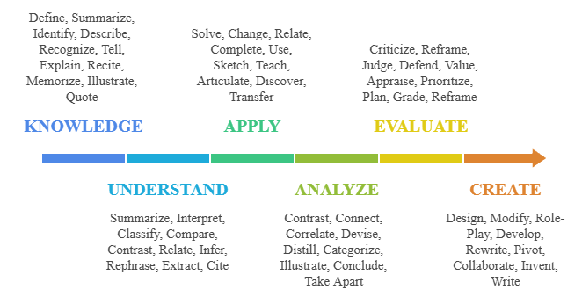
After defining learning outcomes, the next step is to develop the course syllabus. The syllabus should include a course description, scheduling details, lecturer contact information, learning outcomes, expected competencies, a weekly plan, learning and teaching activities, a reading list, assessment methods with grading criteria, course policies, and institutional values (see Appendix M).
To determine which instructional approaches are most effective in higher education ESP contexts, it is essential to explore how Research-Based Learning (RBL) aligns with the objectives of English for Academic Purposes (EAP). With its emphasis on inquiry, independent research, and critical thinking, RBL is particularly suitable for EAP courses, where developing academic literacy and research skills is crucial.
The weekly plan for the EAP course (see Appendix M) was divided into several stages. First, students selected a research topic, gathered resources, reviewed publications, and compiled a literature review. Second, they developed methodological components using interviews, surveys, and observations, which were then integrated into the main body and conclusion. Finally, they submitted their completed paper to Turnitin.com, an online plagiarism detection service, with an acceptable similarity index set at a maximum of 30%.
In addition to the written submission, students were required to plan and lead a mini-seminar or round table session. Each student prepared a 15-minute presentation followed by a 5-minute Q&A. Three teams were randomly assigned: one edited abstracts into a book of abstracts (see Appendix W), another created and distributed invitations (see Appendix X), and the third compiled presentations and posters, introduced speakers, provided technical support, and managed timing (see Appendix Y).
Despite the challenges, these activities were carried out with enthusiasm. Students participated in the conference “Development and Prospects of Science in Kazakhstan through the Eyes of Youth” at University on April 19, 2019, presenting research papers in Session #6, “Relevant Issues of Science Education Theory and Methodology in School and University” (see Table 13).
To protect confidentiality, student names are not disclosed. Instead, anonymised labels such as EAP Student 1, EAP Student 2, etc., are used, ensuring anonymity while accurately representing their contributions.
Table 13. The list of participants in the student conference
 | Баяндамашының аты-жөні | Баяндама тақырыбы
1 | EAP Student 1 | The main factors influencing career choice of high school students in Kazakhstan
2 | EAP Student 2 | Benefits and drawbacks of implementing English science classes in schools of Kazakhstan
3 | EAP Student 3 | Designing a trilingual magic vocabulary book for the future chemistry and biology teachers.
4 | EAP Student 4 | No perfume industry in Kazakhstan
5 | EAP Student 5 | Preparation necessities of future teachers in the condition of dual education system
6 | EAP Student 6 | Choosing the ideal parenting style in bringing up a well-rounded child.
7 | EAP Student 7 | Solving problems with the help of cognitive behavioral therapy
8 | EAP Student 8 | Effectiveness of assessment of students in Nazarbayev Intellectual schools in comparison with ordinary
9 | EAP Student 9 | Effects of available skin creams on our health by its composition
10 | EAP Student 10 | Inspiring the young generation to be interested in teaching profession
11 | EAP Student 11 | The importance of physical exercises for teenagers
12 | EAP Student 12 | Euthanasia: Right to Die
13 | EAP Student 13 | Solving problems with the help of cognitive behavioral therapy
14 | EAP Student 14 | The impact of modern technology trends on development of education system in Kazakhstan.
15 | EAP Student 15 | The current problems and future perspectives of teaching professions in Kazakhstan
16 | EAP Student 16 | How to become the youngest director of school?
17 | EAP Student 17 | Feeling the heat: biological impacts of climate change and causes of global warming
18 | EAP Student 18 | The authority of the school teachers and its role in the educational process

All the topics presented were chosen by the students based on their personal interests. Despite being freshmen, they completed the assignments successfully, demonstrating great enthusiasm both in planning their own mini-conference and in participating in the event itself.
EAP Student 6 received second place, while the Best Speaker nomination went to EAP Students 16, 4, 2, and 1. The Best Report nomination was awarded to EAP Students 12, 10, 8, and 3, while others received certificates of participation (see Appendix S – Collection of certificates for the Best Speaker and Best Report nominations). In addition, a letter of appreciation was given to the scientific supervisor of EAP Student 6 for their student’s outstanding achievement and second-place award.
Furthermore, several students’ articles were selected and published in the university conference proceedings. The works of EAP Students 2, 6, 3, and 7 were included, reflecting excellent outcomes achieved in a short period of time (see Appendix T - Title page of the conference collection). The scientific advisor of EAP Student 6, whose work was highly recognized, was also awarded a diploma (see Appendix U - Appreciation Certificate).
In subsequent years, students continued to engage in Research-Based Learning (RBL) with minor adjustments. Initially, students worked individually; later, they were given the opportunity to collaborate in pairs. This change encouraged students from different specialisations to develop skills such as cooperation and compromise, particularly when selecting a mutually interesting topic. Whereas in earlier years’ students presented their findings using PowerPoint slides, this was later replaced by poster presentations in line with contemporary research practices.
A PowerPoint presentation usually consists of a sequence of slides presented on a computer screen or projector, containing text, images, videos, charts, and other media. It is often used for lectures or talks and can be interactive, with the presenter navigating the slides while engaging with the audience. By contrast, a poster presentation is a physical display of information, typically printed on a large sheet or mounted on a board. It usually contains a title, abstract, introduction, methodology, findings, conclusion, and references, along with visual aids such as charts, tables, and graphs. Poster presentations have a more scientific character, making them particularly well-suited for RBL activities.
Assigning such tasks also allows instructors to monitor students’ academic interests and remain up to date with current trends. Even teachers with extensive experience and traditional approaches can benefit from these projects, as they integrate modern technological and methodological innovations introduced by students. For example, research topics chosen in the 2022 academic year included: “The use of social media in the modern education system for training Zoomers,” “The myth of the fourth dimension,” “The extent to which blended learning affects students of the current generation,” and “The effectiveness of online teaching and its impact on students.” Well-structured projects of this kind are often considered for publication in academic journals.
As an illustration, science department students presented a poster titled “Game-Based Learning as One of the Methods of Teaching Science Students” at the International Scientific Conference Current Issues in Foreign Language Teaching - 2023, organised by the Faculty of Philology at Khoja Akhmet Yassawi International Kazakh-Turkish University on March 30-31, 2023. Students were awarded certificates of participation (see Appendix V).
Students in the modern world require support in developing both subject knowledge and competencies. It should be emphasised that certain educational changes are necessary because today’s learners are children of the 21st century, an era of globalisation, integration, media, technology, and rapid advances in information and communication technologies. Therefore, all Kazakhstani teachers must reflect on how the national educational system responds to these shifts and whether it effectively equips students with the 21st-century skills needed for university, professional life, and the workplace.
For these reasons, the EAP course has been designed according to a professionally oriented, competency-based approach that aligns with contemporary educational standards. Students acquire and apply essential competencies such as critical thinking, problem solving, creativity and innovation, communication, collaboration, personal growth, and well-being. These competencies strengthen their career expertise and ensure applicability in future professional contexts. Thus, designing the learning process in accordance with students’ professional needs is a breakthrough method that enables them to formulate critical ideas and produce creative outcomes, with the ultimate learning outcome being readiness for professional proficiency.

5.3.2 Designing In-House (Institutionally Developed) ESP Materials

The goal of ESP is to help students acquire the language abilities necessary to succeed in a certain academic or professional field. When you are lacking resources it is crucial to create in-house materials that are specifically catered to the needs of the target students in order to establish an effective ESP programme. Moreover, numerous studies highlight the value of using exclusive or unique resources when designing ESP curricula. Customised in-house materials are educational resources created by the educational setting to meet the demands of the students (Basturkmen, 2010). In order to augment published materials, Dudley-Evans and St. John (1998) contend that ESP practitioners should work to develop a "materials bank" of internal resources. This is so that learners' unique linguistic demands may be met, which may not be the case with published resources. The activities and content of in-house resources may be altered to meet the requirements and preferences of the learners, as noted by Gong (2010) and Anthony (1997). In-house resources might also represent the specialised fields of study or employment of the learners. As a result, internal resources boost students' engagement and drive. In-house resources can take into account the instructional setting, equipment and facilities available, and appropriateness for learners' language, according to Basturkmen (2010).
Thus, in-house materials are crucial in ESP programme design for the reasons as follows: Compiled to meet learners’ needs: Internal resources can focus on particular linguistic needs and abilities of learners. They can correspond to the language, abilities, and skills needed in the discipline or professional field; Alignment with the teaching and learning settings: In-house materials may be appropriate for the curriculum, resources, faculty specialisation, and competency levels of the educational setting. Implementation and accomplishing learning outcomes are made easier by this match; Adaptability: Internal resources provide you the freedom to change the activities and content to fit the learners' development and changing needs. To maximise learning, they may be tried out, assessed, and improved. This adaptability is lacking in published sources. Overall, creating ESP materials internally is an iterative process. Conducting requirements assessments, working with subject matter experts, offering interactive activities, allowing for flexibility, analysing and assessing materials, and updating them on a regular basis are all necessary for creating customised and high-quality contents. These techniques may be used to constantly enhance internal materials to increase their value. Further, we provide the content analysis of compiled ESP materials for chemistry and biology students that we have adjusted while taking into account all of the strategies and methods we stated so far.
If everything was more or less clear with materials for PED 108 - Academic English, then PED 128 - English for Specific Purposes presented some challenges, particularly due to the lack of textbooks designed for the combined Chemistry-Biology major. The first year was the most difficult in terms of selecting materials and exercises that would be useful to students both academically and professionally.
Needs analysis played a critical role, making the selection of relevant topics and activities easier. While the survey of subject teachers helped identify appropriate content and themes, the student questionnaire facilitated the selection of effective teaching and learning methods.
For the purposes of the PED 128 course, students are required to read and comprehend chemical equations, symbols, properties and uses of elements, body systems, organs, diseases, and tool instructions all typically presented in English. Understanding subject-specific terminology is essential. The course aims to equip students with the foundational tools necessary to communicate confidently in English within the fields of chemistry and biology.
PED 128 combines classroom instruction with opportunities for self-study. Each lesson has been carefully compiled to provide students with practical, usable language that can be applied in real-world professional and academic contexts. The primary goals of the course are to build students’ communicative and professional competencies and to support the development of their academic English skills.
As a practical, skills-based course, English for Specific Purposes is an essential component of the training of future chemistry and biology teachers. It includes vocabulary development and reading practice based on scientific themes, enabling students to perform tasks and communicate effectively in English in both academic and teaching environments. Its relevance to other science courses is direct and intentional.
Over the course of four years, the ESP materials for the Chemistry-Biology programme at university have been gradually refined based on student feedback, needs assessments, and informal discussions with subject specialists. The final result is a set of compiled ESP materials tailored to this dual-major programme. These materials aim to equip students with the English skills necessary for their future teaching careers, particularly in English-medium instruction settings.
The course encourages students to become motivated, independent, and skilled learners. The learning environment is designed to support students in achieving high academic and career outcomes. Each lesson is structured to ensure that students acquire language that is immediately applicable in their future professions.
The compiled ESP course is organized into six units, with three focused on chemistry and the remaining three on biology (see Appendix A - Course Cover Page). The PED 128 course employs a variety of teaching and learning strategies, including project work, discussions, group work, problem-solving and critical thinking tasks, individual assignments, case studies, crosswords, matching, and gap-filling exercises. Examples of these approaches are provided below.
The benefits of game-based learning in ESP, provides examples of game genres and mechanics, and offers suggestions for creating learning games that are relevant to the interests of students studying chemistry and biology at university (Raikhanova, 2020).
Vocabulary acquisition is often tested with the help of various games, and examples some of the games that were used during the ESP lessons are listed below:
- The letter guessing game is called hangman. In order to uncover the secret word(s),
students are given a set of blank letters (f. ex.: __ __ __ __ __ __ __ __ __ __ __ __ __ __) that correspond to a word or phrase used in chemical or biology terminology. In contrast, if students choose a letter that is not in the word, a stickman is drawn slowly, part by part, and a sound is produced as the letter is exposed from the blank letter (f. ex.: _P_ __ __ __ __ _s_ __ __ __ __ __ _s_ __ _s_); but, with each incorrect letter guess the man is drawn more and more and when he is done, he is hanged, and the game is over (f. Ex.:  ). On the other hand, if you discover the word before the man is entirely hanged, you have succeeded in finishing the game (for example: Photosynthesis). Students may also be asked to describe the term that has been disclosed, for example: "Photosynthesis is the intricate process by which green plants, algae, and specific bacteria use energy from the sun and chlorophyll to convert carbon dioxide, water, and inorganic salts into carbohydrates."
To play in class, bingo is a ton of fun. There are several bingo variations, and you
may make your own unique Chemistry/Biology Bingo. Create a 2x3, 3x3, or 4x4 grid and fill the boxes with particular vocabulary phrases. Out loud, read the word definitions. Students tick off the terms that correspond to the definition they are given. The word "Bingo" should be yelled by the student who has crossed every word. Following that, they all check the terms against their meanings, and if everything is accurate, the winner is awarded a reward. For instance, the first meaning for the term "cholesterol" fits in the tables provided.

Figure 19. Bingo game on disease topic of ESP classes for chemistry-biology students
Arthritis | Cholesterol | Cancer
Cardio  vascular | Infections | Sedentary
1.To eat much of it is deposited on the walls of the arteries and can block them.
2.The painful inflammation of a joint may require surgery
3.They can easily be spread from one person to another
4.Disease which affects the circulation of blood is particularly common with people who are overweight
5.Too much exposure to the sun can cause skin ___________
6.The type of lifestyle when you don't get enough exercise.

- Taboo is a linguistic game in which players are divided into teams called Team A,
Team B, or Team C. For any number in a group, teachers may make the precise number of cards needed. Each team chooses a member to serve as a clue-giver in turn. The top of the clue cards features the clue word, followed by a list of prohibited terms. Without using any prohibited words in their clues, clue-givers have one minute to describe the clue word. The team is not awarded a point if a prohibited word is spoken or the time limit has passed; the other team receives the point instead. The team with the most points declares themselves the winner.

Figure 20. A set of taboo cards on states of matter
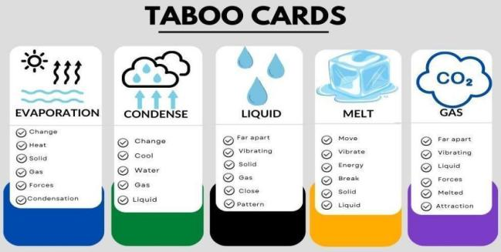

- Chinese whispers is a game that is quite popular and may be used in classrooms.
Students are required to stand in a queue or sit in a circle. A person seated or standing on the right side is speaking special words, phrases, or information into their ear. The last participant declares the word or phrase aloud for everyone to hear and to determine whether
it is the same as the original one. This game's main goal is to introduce a new language in a fun way. Additionally, it promotes the growth of active listening abilities.
- Students can identify as many smaller terms in pairs or smaller groups by breaking
sentences into smaller words using this strategy. For instance, several smaller words may be created from the term "Carbon Dioxide" in the sentence below.

CARBON DIOXIDE
CAR CAN
BONE CAD
ROB CARE
OXEN ON
DOOR NICE
DIODE ODD
BOND ODOR

- By altering the category titles, the fantastic game Stop the Bus may be utilised with
learners of any ability and age while helping them review vocabulary. Students focus intently to identify a suitable precise phrase that starts with the predetermined letter. 'Stop the Bus!' is yelled by the first person, couple, or team to complete. For instance, the table can be completed with the following information to test your understanding of chemical elements based on the letter "M" (Table 14).

Table 14. An example of the‘Stop the Bus’ game on chemical elements
ELEMENT | USAGE | PROPERTIES | DISCOVERY INFO | COMPOUNDS | # OF ELECTRONS | ATOMIC MASS
Mg -magnesium | Medicine  Chlorophyll molecules;  Camera flash bulbs; | Purified is very light, silvery metal; | Chemist named Davy isolated and purified in 1808 | MgO –  Magnesium Oxide;  MgCl2 Magnesium Chloride; | 12 | 24.31 AMU (atomic mass units)

The digital era of the twenty-first century has created new opportunities for educators to design and promote game-based learning activities for ESP instruction across a range of digital platforms. These platforms now give users access to a variety of tools and resources that may be used to create and implement gaming activities. Just a few years ago the majority of games were made in paper format, but following the Covid-19 epidemic, opportunities have multiplied and are now closer and more readily available than before. Teachers can use games and quizzes that have already been created on digital platforms like Kahoot, Quizlet, Quizizz, Wordwall, Duolingo, and others to teach and practise language abilities. Let’s look at the digital platforms:
- Using the free Kahoot platform, you can design and participate in interactive tests,
polls, and games. Your quizzes may be enhanced with pictures, videos, and music to make them more interesting, and students can take them individually or in groups.
- Quizlet: Quizlet is a free online tool that lets you make study sets, quizzes, and
flashcards. Multiple choice, matching, and fill-in-the-blank quiz types are available, and you can share your quizzes with students or embed them on your website.
- Google Forms is a free online tool that lets you design polls, tests, and feedback
forms. You may add several question kinds to your quiz, such as checkboxes, dropdown menus, and multiple choice questions, and you can examine and evaluate student replies in real time.
- Socrative: Socrative is a free online tool that lets you make and distribute exit ticket,
polls, and quizzes. Numerous quiz types, such as multiple choice, true or false, and short answer, are available, and you can monitor student development and performance.
- With the use of the Wordwall web tool, teachers may develop a variety of dynamic
and interesting in-person or virtual classroom activities for their learners. Below illustrated are the types of activities that can be completed using the wordwall.net platform.
These platforms also let teachers design unique activities and tests that are catered to the individual requirements of the learners. Collaborative learning is made possible by digital platforms, which is one of its key benefits. Along with improving their language abilities, students may develop their teamwork and communication skills by cooperating to accomplish tasks and solve difficulties. Students may receive quick feedback from digital platforms, which enables them to recognise their strengths and shortcomings and modify their learning appropriately. Teachers can utilize this input to evaluate student performance and modify their pedagogical approaches. Additionally, engaging and immersive learning environments are offered through digital platforms, which keep students interested and improve their learning. Students are inspired to study and take part in game-based learning activities because they are fun and exciting. Activities may be created to imitate real-world scenarios, making them applicable to everyday life and potential future employment.
Further, some case-study scenarios were introduced that were implemented in my ESP classes for chemistry and biology students.
Chemistry and biology students are given a Wall Street Journal article published on March, 10, 2016 by Serena Ng (see Figure 22). The article is about actress Jessica Alba who created The Honest Co., which promotes itself as offering items that are safer and more ecologically friendly than those from well-known companies. A variety of home, personal care, and infant goods are among the company's offerings. Recent lab tests, however, have cast doubt on the validity of the company's assertions. The aim of this case study is to evaluate the Honest Co.'s claims from a chemistry and biology perspective such as:
1. Whether there is scientific evidence to support the claims made by the Honest Co. about the safety and environmental friendliness of their products?
2. Are the components used in the goods of Honest Co. both environmentally and human health safe?
3. Are the Honest Company's goods as effective as or more effective than those of well-known brands?
4. Is the Honest Co. transparent about the ingredients used in their products and the testing methods used to evaluate their safety and efficacy?
5. Is the alternative cleanser called sodium coco sulfate (SCS) really less irritating than sodium lauryl sulfate (SLS)?

Figure 21. An article ‘Laundry Detergent from Jessica Alba’s Honest Co. Contains Ingredient It Pledged Avoid’

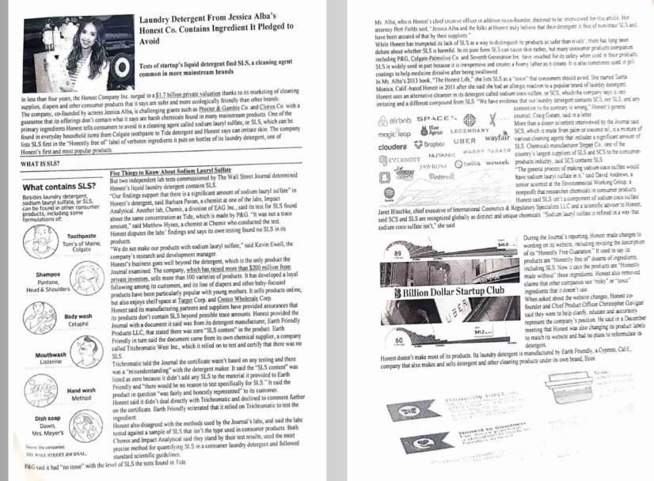

Since the given assignment is a case-study there are no any correct answers. However, possible answers might be as follows: according to The Honest Co., its goods are safer and greener than those of well-known companies. The business has drawn criticism for its claims' lack of scientific backing, though. The business agreed to pay $1.55 million to resolve a lawsuit alleging deceptive advertising and mislabeling in 2016, and it also changed the labels on its products. According to the lawsuit, the company's goods were not as chemical-free or all-natural as claimed. Furthermore, the company's sunscreen has come under fire for not offering sufficient UV protection. In its products, The Honest Co. combines natural and artificial components. Despite the company's assurances that its goods are both environmentally and humanly safe, some of the substances have caused considerable controversy. For instance, the business incorporates sodium lauryl sulfate (SLS), a recognised skin irritant, in several of its products. The business also makes use of synthetic perfumes, which in some people might trigger allergic responses. Additionally, it was discovered that a number of the company's infant products included high concentrations of sodium benzoate, which when combined with vitamin C to produce benzene can be carcinogenic. The Honest Co. asserts that its products outperform well-known brands by an equal or greater margin. The company's goods, according to some customers, do not perform as well as promised. For instance, some customers claim that the brand of laundry detergent provided by the firm does not clean garments as effectively as competing brands. The company's sunscreen has also drawn criticism for not offering sufficient sun protection. According to The Honest Co., its products perform better than well-known brands by an equal or higher proportion. Some customers claim that the company's products do not live up to its promises. For instance, some consumers complain that the company's brand of laundry detergent does not clean clothes as well as other products. While there is some indication that sodium coco sulfate (SCS) may be less irritating than sodium lauryl sulfate (SLS), further studies are required to assess the safety and effectiveness of this substitute cleaner. Any new product should be used with caution by those with sensitive skin or pre-existing skin issues, and they should visit a dermatologist if they have any concerns about potential skin irritation. The procedure of the case-study may take place in pairs or groups. After reading the article students cooperate with each other in order to find out more about the topic and try to find answers to the given questions. As a conclusion, students should give an oral presentation about their findings. However, it all depends on the imagination of teachers. Educators can assign to prepare a poster presentation by the end of the lesson or organise a debate. Students can also be divided into groups to play different roles, for example, one of the students acts as a delegate of the Honest Co., the next student may be a representative of another famous company that does not agree with the statement of the Honest Co. The third student might be a representative of the court. All participants can make an incredible success in problem-solving, critical thinking and public speaking skills.
Despite the fact that learners study science, that is chemistry and biology, they are still future teachers and therefore case-study activities can be selected focusing on their teaching area interests. For instance, in the compiled ESP materials designed for the major programme ‘Chemistry and Biology’ in the unit Chemistry in Our Lives in the introduction section (Figure 23) there is a task about safety laboratory signs so you can assign students a case-study so that students can take these topics more seriously since it is crucial to prioritise laboratory safety signs of learners as future chemistry educators and be aware of any risks that may arise from lab work. In this case study, we would like to examine a chemical experiment that led to a lab mishap and provide suggestions on how to create a safer version of the experiment that still accomplishes its learning outcomes.

Figure 22. Chemistry in Our Lives, pp. 5-6
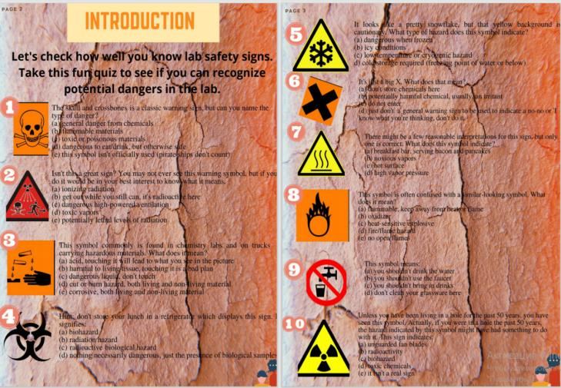

Case Study: In the experiment at hand, magnesium ribbon and hydrochloric acid react to generate hydrogen gas. One of the students unintentionally spilled hydrochloric acid on their skin during the experiment, causing a chemical burn.
Task: Your assignment as aspiring educators is to evaluate the experiment and suggest ideas for creating a safer version of it that still meets its instructional goals. Take into account the following elements in your analysis:
Safety of Chemicals: What safety rules and procedures were in place when the experiment was being conducted? What other safety measures could be put in place to avoid accidents?
Dangers: What risks may the experiment pose? What actions may be made to lessen the possibility of accidents?
Experimental Design: How can the experiment be improved to meet its educational goals and reduce the possibility of errors?
Pedagogy: What instructional strategies may be used to present the experiment to students in a way that emphasises the value of chemical safety and promotes ethical laboratory conduct?
The possible assessment criteria of students’ analysis are might be as follows:
1. Chemical Safety awareness: Exhibits a thorough awareness of chemical safety guidelines and practices.
2. Identification of Hazards: Highlights potential risks in the experiment and suggests measures to reduce the likelihood of mishaps.
3. Experimental Design: Offer a less risky variation of the experiment that nonetheless fulfils its intended educational outcomes.
4. Pedagogy: Exhibits knowledge of effective teaching techniques that emphasise the significance of chemical safety and promote ethical laboratory conduct.
5. Communication: Effective and clear verbal or written (if you assign a written experimental report) communication of ideas (Figure 23).
Learning Outcomes of the Case-Study: Students will be able to
1. Understand and implement chemical safety signs and procedures in laboratory settings after completing this case study.
2. Identify possible risks in laboratory research and suggest measures to reduce the likelihood of mishaps.
3. Create experiments that are safer while still achieving educational goals.
4. Use powerful instructional techniques that emphasise the significance of chemical safety and promote appropriate laboratory conduct.
5. Effectively and clearly express ideas in both written (if you assign a written experimental report) and spoken parts.

Figure 23. Case study rules and regulations for laboratory safety

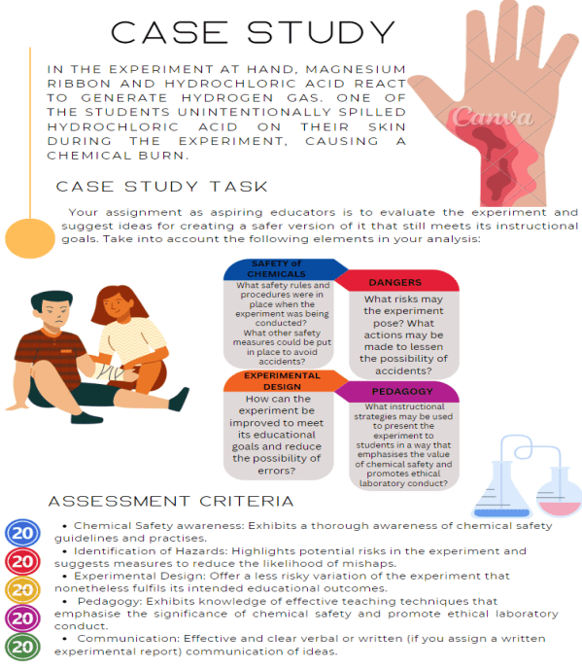

To conclude, future chemistry instructors have the chance to advance their understanding of pedagogy, experimental design, and chemical safety through this case study. Students will get a greater knowledge of the significance of chemical safety in laboratory settings and build skills in developing safer experiments that still fulfil educational outcomes by analysing a laboratory accident and suggesting solutions for designing a safer experiment. Students will also learn how to emphasise the significance of chemical safety and promote responsible laboratory behaviour among their own students through the discussion of successful teaching tactics.
Let me share one more possible case study based on the next unit titled Life on Earth which is focused on the biology section according to compiled ESP materials which was specially designed for the combined major ‘Chemistry and Biology’.
It is crucial for biology majors to build problem-solving abilities that they can use in the classroom in the future. In this hypothetical case study, we will look at a topic involving biodiversity preservation and the effects of human activity on the variety of life on Earth.
Case Study: A neighborhood conservation group has engaged you to assist in addressing the issue of dwindling biodiversity in a close-by habitat. The group has observed a decline in the number of species in the environment and is worried about how human activities may affect the variety of wildlife in the region. It is your responsibility to assess the situation and suggest tactics for preserving ecological biodiversity.
Task: The following concerns must be addressed in the strategy you create:
1. Identify the key elements that the ecosystem's declining biodiversity may be attributed to.
2. Make recommendations for efforts to protect the ecosystem's biodiversity, including steps to lessen the effects of human activity on the environment.
3. Establish a strategy for tracking the success of conservation activities over time.
The possible assessment criteria of students’ strategy might include:
1. Identification of Factors: Display a thorough comprehension of the elements influencing the ecosystem's loss of biodiversity.
2. Conservation Strategies: Offer practical solutions for preserving ecological biodiversity, such as steps to lessen the harm caused by human activity.
3. Monitoring Plan: Create a strategy for tracking the success of conservation initiatives over time, using the right measurements and indicators.
4. Creativity: Display innovation in the development and application of conservation initiatives, including the utilisation of cutting-edge methods or collaborations with regional stakeholders.
5. Communication: Effective and clear verbal communication of ideas.

Figure 24. Case Study rules and regulations for life on Earth

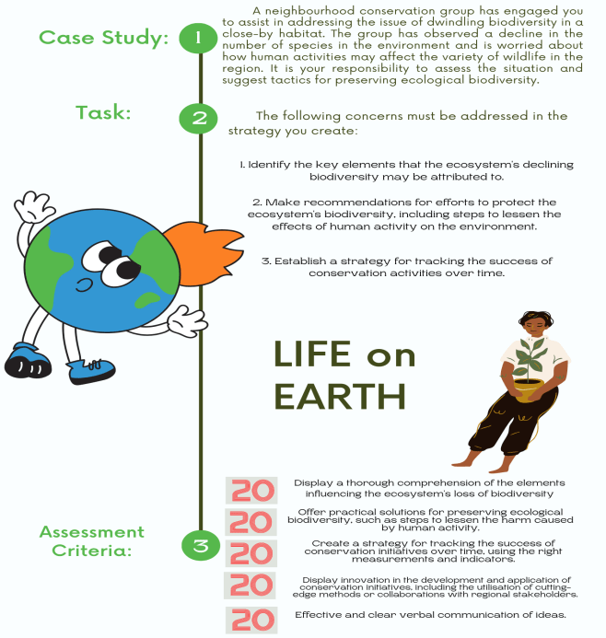

Learning Outcomes of the Case-Study: Students will be able to:
- List the elements that a particular ecosystem's declining biodiversity may be attributed to.
- Create plans to protect ecosystem biodiversity, taking steps to lessen the harm done to the
environment by human activity.
- Develop critical thinking and problem-solving abilities in relation to conservation biology.
- Gain knowledge of the value of biodiversity and how human actions affect ecosystems.
- Gain experience in creating and delivering conservation plans.
Future biology instructors will get the chance to hone their problem-solving and critical thinking abilities in relation to conservation biology through this case study. Students will get expertise in formulating and presenting conservation plans that address the complex issues affecting ecosystems and biodiversity by analysing a real-world scenario and suggesting effective conservation measures. Additionally, while they work on their plans, students will improve their communication abilities and show that they can persuade other stakeholders of their scientific ideas and methods in an effective manner.
Below is an example of how PBL can be applied and implemented for chemistry and biology students in ESP classes. Over the years, assignments for project work have changed to meet the interests and needs of students, and sometimes even because of force majeure situations, such as the Covid pandemic. Initially, when I did not have any ESP teaching experience, project work activities were more task-oriented, such as discussions, presentations on certain topics done in pairs or in groups. Then, after interviews and conversations with students, the design of project work has shifted from simple tasks to those which are focused on experiential learning, that is learning by doing, becoming longer in time, more complex, more creative, and more technology-oriented. Thus, during the ESP course, students performed such project work as the design of paper and electronic magazines, Instagram pages (Raikhanova & Kassymova, 2024) educational channels in the telegram, and filmed mini-video clips focusing exclusively on topics related to the profession.
There is no doubt that students need to know how to use the information and vocabulary they have learned in real-world settings since fundamental knowledge and vocabulary are not always sufficient. So, one of the term tasks is designing a magazine. For students, making a magazine as a project is a lot of fun. Students are given the chance to come up with original ideas, create text columns and magazine-style layouts, use a variety of fronts, master new software, and discover how to include pertinent photographs and graphics. By the creation and design of their own magazines, students can experiment with expanding their knowledge of chemistry and biology through this project. All topics that students learned during the term and feel are important to finish the project may be used in magazines. There is hope that this project effort will be advantageous and engaging for both readers and designers. At the conclusion of their project work, students share the scientific resources, information, and techniques they have learned to create magazines with their peers, friends, professors, and other interested parties. Students leave the session with background knowledge in the fields of biology and chemistry after completing the project. Although it will always be necessary to receive and refresh this scientific and personal knowledge, having well-thought-out strategies and concepts that can help you feel more in control and even proud of your finished job. Also, the fact that all students are future school teachers should not be forgotten, which means that the acquired skills will be useful both during the internship and already directly during work. One of the criteria of project work was to choose the age category of the material, since the material for adults will be difficult for children, and illustrations that are too childish may seem strange to high school students. Thus, during the presentation, the students explained whom their magazines were designed for and how they selected materials and how they adapted the texts. In a word, a kind of research was carried out. Many students earn extra money in children's centres and I hope they will be able to put all the skills into practice. Participating actively and submitting assignments on time are requirements for creating and producing magazines. The subjects covered in project work should be intended to get students interested in biology and chemistry, and they should include activities that inspire and pique other students' interests in finding out more about their field of study. Students will gain knowledge of their own interests and 21st century abilities during the process. Information and communication technology (ICT), communication and presentation, administration and organisation, research and enquiry, self-evaluation and reflection, as well as group involvement and leadership skills, are some of these abilities. The procedure for conducting project work in the specialty "Chemistry and Biology" is as follows: Depending on the overall number of students, one group is divided into 4-6 subgroups by approximately 5 students each. In total, there were 7 groups obtained, that is, in the end, 7 magazines were defended, such as Road to the Dream, C&B journal, Zhas Galym, Beauty of Beast, Human Body System, Jasus’a and Organ Systems. Students were divided into groups randomly and members of one group acted according to the principle “one for all and all for one”. Team and individual work of students was also evaluated in accordance with the rules and regulations of the projects, which are indicated in the evaluation criteria. Evaluation criteria can be completely different, you can even agree with your students together, giving them the opportunity to be a part of writing syllabi. In our case, the project work was rated at 20 points out of 100, which was added to the final grade (Raikhanova, 2020). The following ASSESSMENT CRITERIA were used (Figure 25):

Figure 25. Assessment of project work of chemistry and biology students

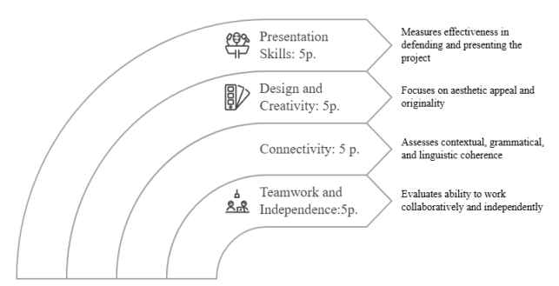

Students complete tasks in stages over several weeks and the teacher tracks the progress every week, trying to keep students in good shape and, in case of any problems or questions, to provide assistance. The initial stages of the project are to study the interests of each other, which will determine the topic and division of responsibilities for the implementation of the project, then comes the collection, adapting, sorting and filtering the materials. The next step is the creation of the magazine and, finally, the presentation of the long-awaited project work. The title, layout, and content of the magazine are completely up to the students themselves so they can add any activities they like when creating their magazines. Some examples of magazines produced by first-year chemistry-biology students are shown in the photographs below. The first issue of the "Human Body Systems" magazine (#1) features articles geared towards elementary school students. The goal of this magazine is to get readers interested in understanding and learning more about the parts of their bodies that do what they do. Moreover, because no human can exist without a body, it is designed to understand the connections between the many components of organisms. Along with review questions and activities, the digestive, respiratory, circulatory, neurological, and urinary systems are discussed. Endocrine, immunological, and reproductive systems are not included, as it was noted by my students, the function of listed systems can be quite challenging to explain for kids. As you have already noticed, QR (Quick Response) codes are attached on some pages of the magazine No. 1 "Human Body Systems" (see Appendix Q) and if you focus your mobile phone camera on the QR code, you can easily watch interesting and informative videos, cartoons on different body systems. QR codes are complementary tools used to engage digital natives in the learning process and are perfectly in line with digitalization these days.
Magazine No. 2 is called "Beauty of the Beast" (see Appendix R) and the theme is also focused on children of primary school age. This is a very colourful and interesting magazine for kids to find out which animals are the best of the best. As noted by the students, the purpose of choosing superlative adjectives when describing animals is that children of the 21st century are very competitive and are only interested in excellence. Therefore, the first-year students have developed such a beautiful magazine listing the cutest, most courageous, tallest, most numerous insects, the most intelligent and the most nature-influencing animals to attract children's attention and make them more involved in reading.
The role of a teacher was to organise an interesting atmosphere through the introduction of PBL in the ESP classes to consolidate topics that meet students’ majors, that is chemistry and biology.
In conclusion, teaching English for Specific Purposes (ESP) to students studying chemistry and biology may be successfully accomplished through the use of project-based, task-based, and team-based learning activities. These methods give students practical, hands-on learning opportunities that advance both their language abilities and their subject understanding. In project-based learning, students work on lengthy assignments that call on them to apply their linguistic and subject-matter expertise to resolve practical issues. This strategy promotes student ownership of their education and the growth of their analytical and problem-solving abilities. Project-based learning can include research projects or even students planning and completing their own projects in the context of ESP for chemical and biology students.
The ultimate goal is to help students use thematic patterns in science to communicate effectively both in speaking and writing about scientific issues. As such, the compiled ESP materials foster a student-centered and dynamic classroom environment, grounded in active learning through real-world, subject-specific challenges.
As it was mentioned above, backward curriculum design which is based on the determination of learning outcomes and uses the generated outcomes as the basis for developing a learning process and content is the most appropriate for higher education among the three ways suggested by Richards (2001). Meaningful content and activities are designed and chosen based on expected learning outcomes in backward design, which starts with clearly defined desired outcomes. This methodology is completely in line with the realities of developing curricula for the teaching of foreign languages in higher education institutions nowadays. Thus, defining precise learning outcomes is crucial so they can be measured easily in the future. Learning outcomes for Ped 128 - English for Specific purposes for chemistry - biology students as follows:
LO1: By the end of course, students will be able to define subject specific vocabulary words /
terms;
LO2: By the end of course, students will be able to understand and use useful phrases and words related to chemistry and biology;
LO3: By the end of course, students will be able to discuss a wide range of subject specific topics;
LO4: By the end of course, students will be able to describe subject specific principles,
methods;
LO5: By the end of course, students will be able to improve their reading and writing fluency on subject specific topics with academic elements;
LO6: By the end of course, students will be able to give effective presentations including organisation, preparation, and delivery techniques;
LO7: By the end of course, students will be able to identify roots, prefixes, suffixes; appropriately apply synonyms and number skills; interpret and incorporate visual aids;
LO8: By the end of course, students will be able to follow essential grammar rules needed for scientists;
LO9: By the end of course, students will be able to create project works by providing personal information collected in 10-12-week time.

After the learning outcomes have been determined, the next stage is to fill out the course syllabus. The syllabus outline includes such aspects as the course description, specific information about the time and venue of lessons and office hours, the lecturer's contact information, the course learning outcomes and the skills and competencies that students are expected to acquire, a weekly course schedule, learning and teaching activities, a reading list and resources, assessment procedures and grading criteria, including a description of grades, the course policy, and course values. Additionally, a syllabus for the first year undergraduate students of chemistry-biology specialty is provided below (see Appendix N).
In the weekly plan shown in the syllabus and in the content of compiled materials for chemistry and biology students there are overall six units presented. Each unit consists of Introduction, Basic concepts of chemistry or biology subjects, Language skills, Grammar and Unit review sections (see Figure 26).

Figure 26. Content pages of unit Life on Earth & Bonding

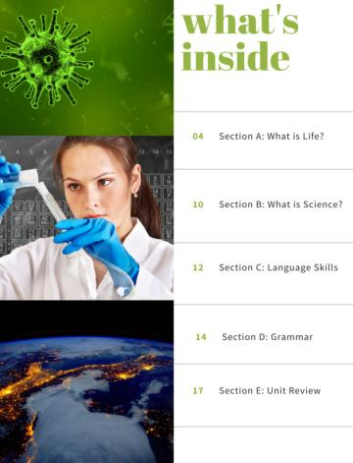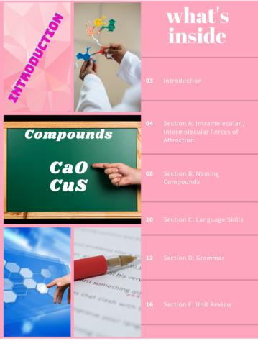

Having carefully studied the content of the material, a quite appropriate question arises why elements of academic and general English are included in the ESP course. A very simple answer follows, as we already know needs analysis plays a huge role in content selection and collection of materials. So one of the questions of the questionnaire sounded like ‘Which English do you prefer GE or ESP? Write a few sentences why?’ The answers were as follow:
- I think we didn’t have enough time for general English in the first semester. So, I prefer General English.
- Both of them was really interesting for me
- General English. Because I learned many new words and grammar.
- Both of them, because with general English we improved our grammar and by ESP we understood more about chemistry and biology.
- I believe that General English is just as important as profiled English. Because first of all you need a simple speech to talk to others, and then a specialised one to explain everything in the future. So I'm in favour of keeping the two English ones equally.
- I prefer ESP because we study English and our main subjects together. It helps us understand our subjects carefully
- General English helps to tighten speaking and writing
- ESP, because ESP is helpful in understanding main subjects.
- I prefer GE, because it helps to focus most of my English by learning grammar or others. Also it was interesting and can help to understand not only your main subjects also to communicate with native speakers and to be versatile
- I prefer ESP. Because in General English I didn't learn so much.There were those things that I already knew about. But ESP was really helpful in understanding my main subjects in English.
- I prefer General english more. Because it is interesting and diverse subject. We can discuss different topics, and learn grammar.Also Teacher can focus on writing and speaking skills
- You need both. Both help students with low levels of English like me.
- ESP. Because it is useful for our profession
- ESP, despite the fact that General English was interesting and useful, from ESP I received a lot of useful things for studying my specialty
- Both, 50% GE and 50% ESP. General English is good for our speaking and writing, while ESP is good for our terminology. I think these class should be always together in term.
- For me General English was so useful, ESP so hard for me
- I prefer ESP, because it provides more opportunities for understanding special subjects.
- ESP. Because it is close to our main subjects. It helped to understand clearly.
- Both of them was really interesting for me

The answers were given by students who studied General English with elements of Academic English on various topics, and also studied ESP. According to the responses, it is noticeable that the students are divided into two opinions, those who prefer GE to ESP and vice versa, but there are those who like both disciplines as well. At that time, the ESP course included texts, terms only in chemistry and biology. However, based on the answers given by the students, it was decided to add components of language skills and grammar, which are necessary for future teachers of chemistry and biology. Since many who chose General English argued their choice by studying grammar, the solution was to add elements of basic grammar with a sufficient number of exercises.
The main reason for the development of the compiled materials, of course, was the lack of off-the-shelf textbooks or materials for chemistry-biology students. We identified learning outcomes on which we need to proceed, that is, to find suitable specialised course content. In the process of designing and delivering an ESP course, we always keep in mind that students are not primarily studying the language itself but rather language for main disciplines, that is for chemistry and biology. In other words, they are learning knowledge and skills that should not only help them with their language but also with their careers. Thus, we do not forget the fact that the ESP class has different interactional characteristics since it is learner-centred where the shift from instructor input to solo work, pair / group work, and class discussion can provide great engagement if they find a specific balance. Accordingly, the ESP course should require work both separately and in groups or pairs. Students should also be provided a variety of interactions according to their preferences.Therefore, while developing units, surveys were conducted on educational materials and methods, and the students' wishes and comments were considered when creating subsequent units (Table 15). Gathering this feedback was crucial because it allowed educators to understand students' needs, preferences, and learning challenges, ensuring that the instructional materials were relevant, engaging, and effective. By incorporating their input, the learning experience can be tailored to better support their comprehension and motivation, leading to improved educational outcomes.

Table 15. Feedback for the first unit
Q1: How do you think which tasks are not appropriate for you? Explain why?
- I think all tasks are appropriate for me, because we need to learn more
- It’s too boring to read long texts that we never understand. And Google translator does it for us. Seems inefficient.
- Tasks aren't difficult according to our subjects
- All the tasks that we performed quite suit me and I am ready for any tasks
- For me all tasks appropriate
- all tasks are necessary for knowledge.and that's why i can't say something about this.
- Long texts / They are so boring
- I think that all tasks are suitable to remember biological words well and understand them, especially crossword
- All tasks appropriate for us
- I like all the tasks.
- I think that everything is fine
- I think that all of the tasks are appropriate, but if you add more pictures with text, it will be very good.
Q2: According to Unit 1, do you like the process of learning? If not, please write any ideas to make it better.
- I like the way you try for us. We love your teacher.
- I like the learning process
- I really like every processes of learning
- Everything is normal.
- typical exercises for doing ourselves (writing exercises) are boring sometimes. we can discuss more and by dividing into groups we can work together there and it's not bad idea that every lesson divide to groups
- Yes i like/ But i like group challenges, so in homework it would be cool if you asked to voice some movie and draw something
- I like all the tasks. They are so interesting and amazing
- I think it will be better if some lessons will like competitions in group or may be individually too
- I like everything, but I think that it would be better if there were group projects
- I like how you prepare texts and tasks for our class, but please add pictures, really for me it is very easy to memorise with pictures.
Q3: Write your suggestions about tasks, activities you want to do in the class, and out of the class
- Grammar? Speaking Listening Kahoot Tasks out of the class
- I love creativity and want to connect English with interesting projects. For example, make magazines that you showed us. Group projects. Competition
- I would like to add a little grammar and that's it
- We can watch video, for example, ted talks and prepare questions about this and answer and discuss dividing into groups for improve speaking
- I really like the crosswords + definitions we make. I would like to develop our speaking skills
- In class speaking out of the class reading
- FE: interview or collective work
- I want to have team works on project Secondly also i want you to give new word in the form of card (only important for our profession(chem-bio) For instance *ore* but without so not including definitions it is separate tasks
- watch a short video in English related to our topic
- Play the games
- I didn’t like the task where we must write terms in 3 languages because we can just copy-paste. I think it will better if you will ask orally)
- I like group or pair projects to get to know each other better
- In the class I like everything, maybe we can do some home tasks like a presentation
Q4: Do you agree to have similar tasks in Unit 2?
- Yes,of course!:)
- No , more varieties time so another time differently
- I agree but I would like to talk about chemistry too
- Yes, words and definitions which you prepare, very help me, and very useful
- Most of the answers sound just like ‘Yes’.

All of the aforementioned evidence suggests that the ESP course is based on a competency-based approach that is professionally focused and adapts the modern educational system. The student-oriented approach, where students are given the freedom to choose, is given very high significance in the selection of materials, topics, and teaching techniques and methods. As a result, the ESP course for chemistry-biology students is constructed taking into consideration the preferences and needs of students themselves. Thus, designing the learning process in accordance with the professional needs of students is such a breakthrough method that allows students to create their own critical ideas and create creative products where professional readiness is the main learning outcome.

5.4 Intervention Stage

The main goal of this experimental part is to test the effectiveness of the ESP curriculum specifically designed for the combined major programme in Chemistry and Biology. This curriculum seeks to provide students with the English language skills and knowledge necessary for their future careers as science teachers, enabling them to conduct their lessons in English with confidence. The importance of English as a key component of learning is highlighted in this context, and university instructors are committed to creating a learning atmosphere that encourages and supports students in their journey toward becoming competent, autonomous, and proficient learners (Raikhanova et al., 2024)
This comprehensive approach to developing ESP materials ensures a well-structured, targeted, and effective course that addresses the specific needs of students enrolled in the combined major programme. Each unit of the ESP course designed for this study includes an introduction, fundamental principles of the subject matter, language skills, grammar, and a unit review. It covers a variety of themes related to both chemistry and biology, including Chemistry in Our Lives, Life on Earth, Bonding, Plants, Acids & Bases, and Homeostasis & Animal Anatomy (Figure 27).

Figure 27. Cover pages of units of ESP compiled materials

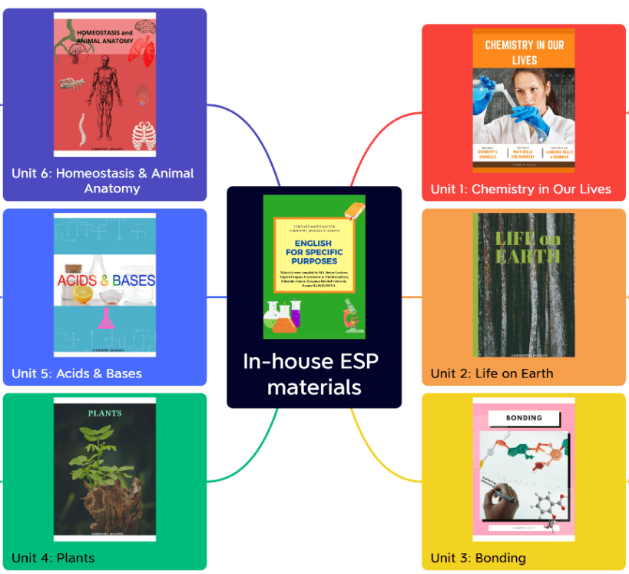
Throughout the units, a range of teaching and learning techniques are employed, such as:
- case studies;
- discussions;
- group work activities;
- problem-solving tasks;
- critical thinking exercises;
- individual work;
- project work;
- matching and gap-filling exercises.
Additionally, the course incorporates core language skills such as reading, speaking, writing, and listening. The primary objective is to teach students how to communicate effectively in English both orally and in writing when addressing topics within their specific fields of study. To achieve this, the compiled ESP materials emphasize student engagement and active participation. They also make use of dynamic classroom strategies that encourage deeper learning through the exploration of real-world, subject-specific problems and challenges (Raikhanova & Bakić-Mirić, 2023).
Developing a successful ESP curriculum for chemistry and biology students at higher education institutions within the framework of Kazakhstani education requires careful planning and implementation. Before developing an ESP programme, it is essential to conduct a needs analysis to determine students’ specific language requirements. The study supports the idea that obtaining data on students’ current language abilities and target language use is the first step in designing an ESP programme. Using authentic resources, course components should reflect students’ interest in the subject matter and their current level of language proficiency.
The findings of the study suggested dividing the ESP course into two groups: one for students who graduated from public schools and had limited English proficiency, and another for students with advanced proficiency who had attended institutions where science was taught in English. Furthermore, it was established that chemistry and biology students require essential academic skills to read, write, and comprehend academic and scientific literature, as well as a specialized vocabulary to explain, discuss, ask, and answer questions in tutorials. Unlike General English, the ESP course offers advantages such as academic freedom, diverse teaching methods and materials, and increased student motivation to learn and practice subject-specific content. This was confirmed by the results of the instructors’ questionnaire.
We made an effort to identify the desired learning outcomes (LOs) based on the needs analysis. The findings indicated that competency-based learning where students are provided with opportunities to apply their knowledge and skills in real-world scenarios should be the focus of ESP curriculum development. Through this approach, students acquire the knowledge and competencies necessary to succeed in their chosen fields.
It is important to note that educational change is essential in the 21st century, which is characterized by significant advancements in media, technology, and communication. Consequently, Kazakhstani educators must consider how the nation’s educational system responds to these changes and evaluate its effectiveness in equipping learners with the 21st-century skills required to thrive at university, in life, and in the workplace. In this environment, students need support to acquire both content knowledge and relevant skills.
For this reason, the ESP course is designed around a competency-based professional approach that integrates the leading-edge trends of modern education. Students develop and apply competencies such as critical thinking, problem-solving, creativity, innovation, communication, collaboration, personal growth, and well-being skills that can be effectively transferred to their future professional settings. Thus, tailoring the educational process to students’ professional needs is a forward-looking approach that empowers learners to develop original, critical, and creative outputs, with proficiency as the primary learning outcome.
To ensure exposure to professional language and terminology, authentic materials must be incorporated into the curriculum, providing learners with opportunities to practice language skills in real-world contexts. Nevertheless, certain challenges were identified, including limited resources, insufficient networking with subject-matter instructors, lack of English proficiency, and gaps in the curriculum.
In response, we developed 6-unit ESP materials for chemistry and biology students, based on the results of the needs analysis and the instructors’ questionnaire. We are confident that this set of ESP materials will be highly beneficial for teachers in conducting their lessons. In addition to this, the results of the alignment of Programme Learning Outcomes (PLOs) with unit-specific Learning Outcomes (LOs) demonstrated a strong coherence between the overall goals of the teacher training programme and the specific objectives of the ESP curriculum. The LOs of each unit were carefully mapped to the PLOs, ensuring that language development was integrated with subject-specific competencies in chemistry and biology. Moreover, the alignment of LOs with classroom activities highlighted the practical implementation of outcomes in the teaching process. For instance, problem-solving tasks and project work were directly linked to the development of critical thinking and collaboration skills, while case studies and discussions supported communication and subject-specific vocabulary acquisition. This double alignment (PLO ↔ LO and LO ↔ classroom activities) confirmed that the ESP curriculum was not only theoretically grounded but also pedagogically consistentand effective in achieving its intended learning objectives.

Figure 28. Correlation between programme learning outcomes and lesson learning outcomes

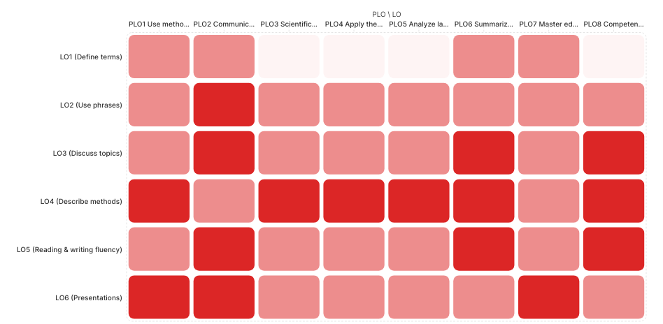

The correlation analysis for PED 128 English for Specific Purposes highlights a stronger emphasis on subject-specific language acquisition and professional communication within the domains of chemistry and biology. Lesson Learning Outcomes addressing terminology, discipline-related phrases, principles, and project-based work (LO1-LO5, LO9) show high correspondence with PLOs focusing on scientific observation, experimental knowledge, and applied research (PLO3, PLO4, PLO5, PLO8). At the same time, communicative and technological competences (PLO1, PLO2, PLO7) are reinforced through outcomes on presentations, grammar, and academic writing (LO6-LO8). Thus, the course ensures that students not only acquire linguistic and communicative proficiency in their discipline but also integrate this knowledge into professional teaching and research contexts.
Furthermore, we aligned the learning outcomes of each unit with corresponding learning activities and compiled them in a single table (see Table 16). The table makes it simpler for teachers and students to comprehend the link between learning objectives and activities by helping to organise the lesson plan and ensuring that each activity is matched with a particular learning result. Educators may assess the efficacy of the plan and pinpoint areas for improvement by performing a content analysis of the unit and commenting on the learning outcomes and activities. Students may also use this table to understand how each activity contributes to meeting the unit's overall learning outcomes. Additionally, this process involves developing assessment and critical thinking abilities, which may be helpful for both teachers and students.

Table 16. Alignment of the learning outcomes with learning activities and assessment tasks of the compiled materials English for specific Purposes for chemistry-biology students
LO | Teaching–Learning Activities | Assessment Tasks
LO1: Define subject - specific vocabulary words / terms | Crosswords, bingo, gap-fills (Units 1,2, 3,4,6); | Vocabulary quizzes; crossword completion; short written definitions
LO2: Understand and use useful phrases and words related to chemistry and biology | Reading scientific texts, infographics (Units 2,4,5,6); comprehension exercises (Unit 3); discussion tasks (Unit 2) | Reading comprehension tasks; short-answer vocabulary-in-context questions
LO3: Discuss subject - specific topics | Group discussions (Units 1, 2); debates on environmental issues (Unit 2); case studies (Unit 6) | Oral discussion evaluation; group presentation rubrics; case study rubrics;
LO4: Describe subject - specific principles and methods | Research projects on daily chemicals (Unit 1); Redi’s experiment report (Unit 2); Venn diagram on dicots/monocots (Unit 4); case studies on homeostasis (Unit 6) | Written reports; visual diagrams; graded group projects
LO5: Improve reading / writing fluency with academic elements | Graph description (Units 1,3,6); writing reports/summaries (Units 2, 6); infographic-to-text transformation (Unit 4) | Written assignments; summary reports; graph description exercises
LO6: Give effective presentations | Research-based projects and oral presentations (Units 1–6) | Presentation rubric (content, organisation, delivery)
LO7. Apply synonyms, number skills, and interpret visual aids | Maths exercises: place values, percentages, rates (Unit 1); statistics & fractions (Unit 1); creating graphs and visuals (Unit 3); interpreting infographics (Units 2,6) | Problem-solving exercises; graph/visual interpretation tasks
LO8. Follow essential grammar rules for scientists | Grammar tasks: Present Simple (Unit 1), Present Continuous (Unit 2), Past Simple (Unit 3), Future Tense (Unit 4), Passive Voice (Unit 5), Conditionals (Unit 6) | Grammar quizzes; sentence completion exercises; grammar use in reports
LO9. Create project works over 10-12 weeks | Long-term projects: environmental issues (Unit 2); career research in chemistry (Unit 5); organ systems project (Unit 6) | Project submission (written report + oral presentation)

In this study, special attention is given to alignment, which lies at the centre of course design. Although the concept of alignment is straightforward, its implementation can be challenging. Alignment requires the teacher to consider what students need to learn to achieve the intended learning outcomes, and to provide a curriculum with sufficient learning experiences that increase the likelihood of success. The teaching and learning system rests on three interconnected components: targeted learning outcomes, appropriate teaching and learning activities, and assessment tasks.
In the previous subsection, the alignment of learning objectives and activities was presented. The next stage involves evaluating whether the ESP materials are effective, appropriate, and well-aligned with the intended learning outcomes. For this purpose, pre- and post-tests were employed to measure students’ progress. The pre-test served as a baseline, identifying students’ initial strengths and weaknesses in chemistry and biology language skills. After completing the ESP materials, post-test results were compared to assess improvement.
ESP instruction in this context focuses on enhancing students’ ability to understand and use subject-specific vocabulary and concepts. The analysis of pre- and posttest results allows for measuring the effectiveness of the materials and highlighting areas for further refinement. Ultimately, this process provides insights into best practices for designing and applying ESP resources that improve students’ academic performance and support their success in chemistry and biology studies.

5.4.1 PrePosttest Results

For this research, two groups (CGS & EGS) were formed, one of which is comprising a total of 41 first-year students who were enrolled in chemistry and biology courses in 2019 - 2020 academic year.The students of CGS group were determined as controlled group (N=19) while the EGS one is experiential (N=22). All participants were non-native English speakers with different levels of proficiency in the language, ranging from pre-intermediate to intermediate. The study is classified as a quasi-experimental study because the groups were not randomly assigned, instead they were chosen on the availability, existing class structures and voluntary base. The study utilised in-house ESP materials that were especially compiled for chemistry and biology students by the researcher for an experimental group that were specifically tailored for chemistry and biology students, including three units for chemistry and three units for biology subjects. These materials consisted of subject-specific texts, different types of exercises and activities, language skills development tasks and unit review sections, which all aimed to equip the students with a comprehensive understanding of the scientific concepts and vocabulary that were essential for success in their respective fields. The controlled group used off-the-shelf textbooks ‘Core Chemistry (John Mills and Peter Evans)’ and separately ‘Core Biology (Jean Martin)’ by Cambridge University Press including science topics for pupils (students). At the start of the academic year, a pre-test was administered to the students to gauge their baseline competencies in chemistry and biology. The pre-test comprised 32 questions (Appendix O), including fill-in-the-gaps, matching, multiple-choice, and reading comprehension questions, which were equally divided between the two subjects. The test items were developed by the researcher, based on the compiled ESP materials prepared before the course. The questions covered a range of topics, including fundamental scientific principles and terminology. The students were given an academic hour, which is equivalent to 50 minutes, to complete the pre-test, and their oral responses were recorded. The researchers analysed the test scores to identify any notable patterns or trends in the students' understanding of the subjects. Controlled group students classified as CGS (controlled group student) while EGS categorized as experimental group students.
The intervention period for the study lasted one term (15 weeks), during which both the Control Group and the Experimental Group engaged in their respective learning activities. Each week, both groups participated in scheduled classes that included lectures, discussions, and assessments relevant to their subjects. During this time, the Control Group continued to follow off-the-shelf textbooks for students on chemistry and biology using conventional methods of instructions, while the Experimental Group used in-house ESP materials specifically compiled for integrated major: chemistry and biology students. The Experimental Group's curriculum incorporated activities such as project-based, task-based, game-based, problem-based, research-based learning and case studies to enhance engagement and practical application of competencies.
At the end of the term, the pre-test was followed by a post-test (Appendix P) to measure improvements in knowledge, allowing for a comparison of the mean scores and standard deviations between both groups. The pre-test and post-test results are as follows:

Table 17. Pre-post-test results of control and experimental groups
 | N | Mean | Median | SD | SE
CGS_pre | 19 | 80.2 | 80 | 12.60 | 2.89
CGS_post | 19 | 82.2 | 85 | 12.11 | 2.78
EGS_pre | 22 | 78.2 | 84.0 | 12.45 | 2.66
EGS_post | 22 | 89.7 | 90.0 | 8.97 | 1.91

The results indicate that the experimental group (EGS) experienced a significant improvement in post-test scores compared to their pre-test performance, while the control group (CGS) showed only a minimal increase. The mean score for EGS increased from 78.2 to 89.7, with a corresponding decrease in standard deviation from 12.45 to 8.97, suggesting not only improved performance but also more consistent learning outcomes. In contrast, CGS showed only a slight increase from 80.2 to 82.2, with little change in variability (Figure 29).
Figure 29. Difference in results between control and experimental groups

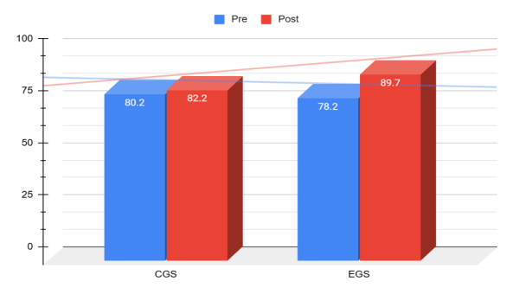

Further Paired Sample T-Test and Cohen's d statistical analysis was conducted to compare the pre-test and post-test scores within both the Experimental Group (EGS) and the Control Group (CGS). Additionally, a pre-test comparison between the two groups was performed to assess their initial equivalence. The statistical results provide insight into whether the intervention led to meaningful changes in performance and whether the groups were comparable before the intervention.

Table 18. Paired sample T-test and cohen's d statistical analysis
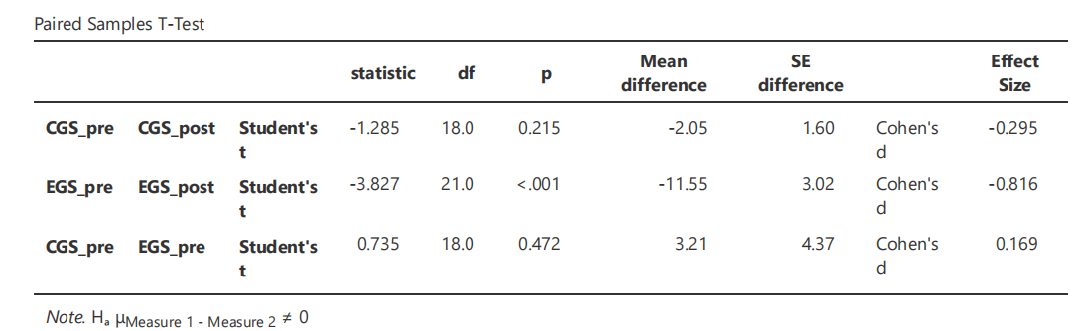

There was no significant difference between the control and experimental groups before the intervention, indicating that the groups were comparable at the start of the study. In the control group, the p-value was greater than 0.05, meaning we fail to reject the null hypothesis. This indicates that the difference between pre-test and post-test scores was not statistically significant. Additionally, the small effect size (Cohen’s d = -0.295) suggests that any observed change was minor. In contrast, in the experimental group, the p-value was less than 0.05 (specifically, < 0.001), leading us to reject the null hypothesis and conclude that a statistically significant difference exists between pre-test and post-test scores. The post-test scores were significantly lower than the pre-test scores, suggesting that the intervention had a measurable impact. Moreover, Cohen’s d = -0.816 indicates a large effect size, meaning the intervention had a substantial influence on performance. These findings suggest that the instructional approach based on the developed ESP curriculum model had a strong positive effect on student learning, leading to both statistically and practically significant gains.

5.4.2 One-Group Pre-Post-Test Results

Educational interventions must demonstrate consistent effectiveness across different
learner populations to be considered reliable. A previous study using a pretest-posttest design with control and experimental groups showed a moderate yet significant improvement in post-test scores. However, to ensure the generalizability and reliability of these findings, it is essential to replicate the study with a new cohort. This research aims to verify whether the previously observed learning gains persist under the same conditions but with different participants, thereby strengthening the evidence for the intervention’s effectiveness. Thus, a one-group pretest-posttest experiment was conducted to replicate and validate the findings of a previous controlled experiment and evaluate the effectiveness of the published 6-unit English for Specific Purposes (ESP) Collection for chemistry-biology students during the 2023-2024 academic year (N=11). The effectiveness of the intervention programme was assessed using a statistical approach involving a descriptive statistic (see table 19), paired samples t-test to evaluate the mean difference, effect size, and Cohen's d (see Table 20).

Table 19. Descriptive statistics of a one-group pretest-posttest experiment
 | N | Mean | Median | SD | SE
Pre Test | 11 | 79.9 | 83 | 12.31 | 3.71
Post Test | 11 | 87.3 | 88 | 8.22 | 2.48

The Pre-Test scores (N = 11) had a mean of 79.9, with a median of 83, suggesting that the central tendency of scores was slightly shifted. The standard deviation (SD = 12.31) indicates a moderate level of variability among students' initial performance, while the standard error (SE = 3.71) reflects the estimated variability of the sample mean. After the intervention, the Post-Test scores (N = 11) showed a notable increase, with a mean of 87.3 and a median of 88, indicating an overall improvement. The standard deviation (SD = 8.22) is lower than in the pre-test, suggesting that students’ performance became more consistent. The standard error (SE = 2.48) also decreased, indicating greater confidence in the estimated mean.
Figure 30. Pre-test and post-test mean results
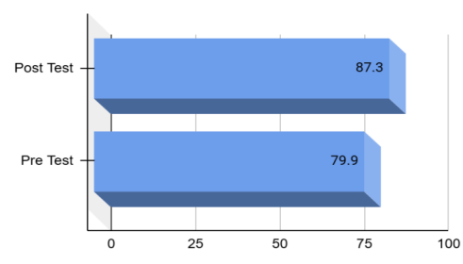
The increase in the mean score from 79.9 to 87.3 suggests that the intervention had a positive effect on students' performance, leading to higher overall scores with less variation in outcomes. This aligns with the previous statistical findings, reinforcing the effectiveness of the intervention in improving student competencies.
Table 20. Paired sample T-test and cohen's d statistical analysis of a one-group pretest-post test experiment
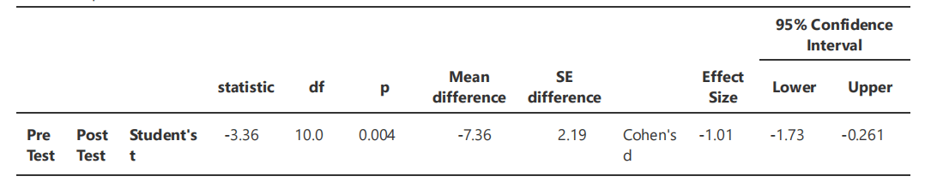

Cohen’s d = -1.01, which represents a large effect size, indicating that the intervention had a substantial impact on student performance. A large effect size (d > 0.8) suggests that the observed improvement is not only statistically significant but also practically meaningful in an educational context. These findings confirm that the intervention led to a significant and meaningful improvement in student performance, reinforcing the reliability and effectiveness of the previously tested instructional approach, materials and activities as components of the developed ESP curriculum model. The results align with the original study, supporting the intervention’s consistency and potential for broader application in similar educational settings.

5.5 Post - Intervention Stage

The post-intervention stage constitutes the final phase of the study and is aimed at examining the long-term effectiveness and validity of the implemented ESP curriculum model. Unlike earlier stages that focused on immediate instructional outcomes, this phase extends the evaluation to capture delayed and reflective evidence of impact after students had completed the course and applied their learning in academic or professional contexts. This stage therefore provides a deeper understanding of the sustainability and practical relevance of the developed curriculum.
To achieve this objective, data were collected from former ESP course participants through qualitative and quantitative instruments designed to elicit reflective evaluations of the curriculum. Students’ perspectives on language development, skill transfer, and curriculum relevance were complemented by alumni reflections, allowing the study to assess how well the ESP curriculum addressed real-world communicative demands over time. The integration of these data sources enabled triangulation and strengthened the longitudinal validation of the curriculum model. To begin the post-intervention analysis, the following sub-chapters present the findings from semi-structured interviews conducted with students who completed the ESP course and reflections from alumni.

5.5.1 A Semi-Structured Interview Results

A semi-structured interview method was employed to understand students' perception of the effectiveness of the ESP course for chemistry and biology students. The data were collected asynchronously via Google Forms, where participants provided written responses to open-ended questions at their convenience. On average, completing the form took approximately 20 minutes. The primary aim of this study was to assess how well the course aligned with students' academic and professional needs, identify strengths and areas for improvement, and explore its impact on students' confidence in using English in their field. A purposive sampling technique was used to select eleven students, who participated voluntarily. All selected students had completed the ESP course under the new curriculum model, ensuring that they could provide relevant feedback on its effectiveness. Data collection was conducted through voluntary participation and confidentiality was strictly maintained, with all personal information encrypted and responses anonymized. The interview consisted of eight open-ended, one closed-ended and one recommendation-based questions at the end, allowing for structured responses while also enabling participants to elaborate on their experiences. A total of 11 students participated, providing written responses related to course content, instructional methods, assessment strategies, and perceived learning outcomes. An inductive thematic analysis was applied to qualitative data to identify common trends, while quantitative responses were summarized using descriptive statistics. The interview format was chosen for its ability to capture detailed individual reflections, allowing deeper insight into how students experienced the curriculum in practice.
Participants consistently emphasized that the curriculum supported their development as future science educators by integrating discipline-specific content with teaching strategies in English. They highlighted improvements in academic English, particularly in speaking, scientific writing, and vocabulary acquisition, and reported increased confidence in using English for both academic and instructional purposes. Students also praised the quality of the course materials, noting their relevance to chemistry and biology and the balance between content knowledge and language development. Interactive tasks such as group projects, discussions, and case studies were valued for making lessons dynamic and collaborative.
While overall feedback was highly positive, some respondents suggested placing greater emphasis on speaking practice and incorporating more real-life teaching simulations. On a 5-point scale, all participants (N=11) rated the course as 5 (excellent), and 100% indicated they would recommend it to peers, confirming a high level of satisfaction and the perceived effectiveness of the ESP curriculum in supporting both academic and professional growth.

Table 21. An inductive thematic analysis results of semi-structured interview
Theme | Findings | Evidence
Relevance to Professional and Academic Goals | Participants felt the curriculum supported their future careers as science educators, especially in explaining topics in English. | “It helped me to learn how to explain biology topics in English, which is necessary for teaching.” S1
Improvement in Language Proficiency | Significant improvement in speaking, scientific writing, and vocabulary acquisition. Students became more confident in using English in academic and instructional contexts. | “My speaking barrier was decreased, and I became more confident in expressing scientific terms in English.”
Positive Perception of Course Materials | Course materials were well-selected, engaging, and relevant to the students' fields, enhancing both content and language knowledge. | “The materials were interesting and exactly what we need as biology and chemistry students.”
Opportunities for Active Engagement | Interactive activities such as group projects, discussions, and case studies were valued for promoting language development and peer collaboration. | “We were always engaged in practical tasks that made the lessons more dynamic and fun.”
Suggestions for Enhancement | Some students suggested more speaking activities and real-life teaching simulations to further improve their professional preparedness. | “It would be better to include more speaking practices and mini-research tasks related to our field.”

5.5.2 Alumni Questionnaire Results

Furthermore, this research focuses on gathering insights from former ESP course participants to understand how these courses have contributed to their career advancement, language proficiency, and confidence in professional communication and by analyzing alumni experiences and the applicability of the skills learned, this study seeks to provide valuable recommendations for improving ESP curriculum design. Thus, this survey was collected from alumni students (N=26) who took ESP course in different academic years (2018/19 and 2019/20), which focus on evaluating the long-term effectiveness and impact of ESP courses on their academic and professional development. To recruit participants for this study, social networks such as Telegram and WhatsApp were utilized as primary communication channels. Since many former students remained connected through academic or professional group chats, these platforms provided an efficient and direct way to reach them. Recruitment messages were shared in relevant groups, briefly explaining the study's purpose, the importance of their input, and how they could participate. The questionnaire contained closed and open-ended questions and was divided into key components such as demographic data, ESP course impact, skills that gained in ESP course and being applied in the workplace, overall satisfaction, and some suggestions for improvement. Description of demographic data as follows:

Figure 31. Demographic results of alumni

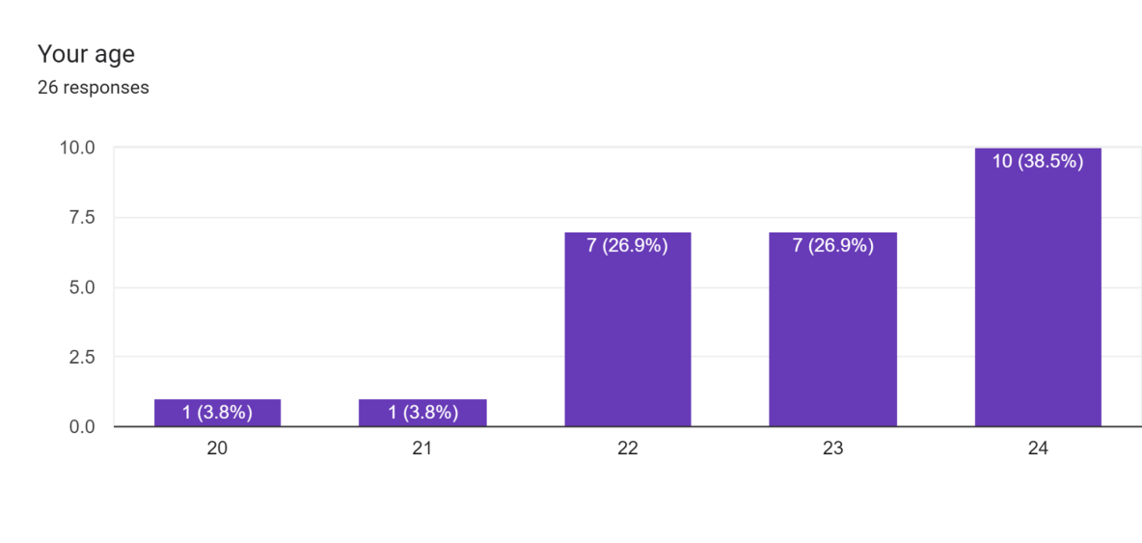

The majority of participants were between the ages of 22 and 24, with almost 40% (10 students) being 24 years old, making this the most common age group. This suggests that most of the participants are in their mid-20s, having graduated from their studies or having recently entered the workforce.
The gender breakdown of the participants shows a significant imbalance, with the vast majority being female:

Figure 32. Gender background of alumni

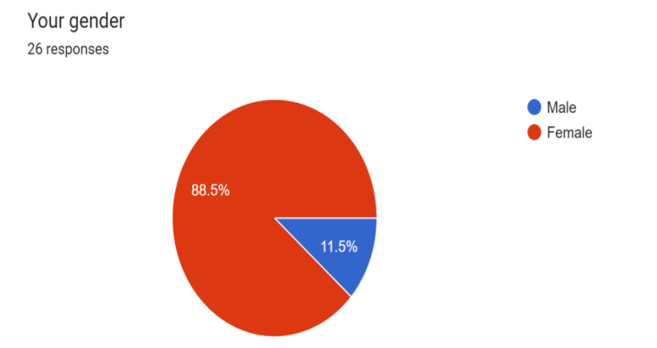
The Figure 32 indicates that the female respondents were overwhelmingly dominant in the sample, representing 88,5% of the total participants.
Regarding the job placements of alumni students’ responses were categorized as follows:

Figure 33. Occupation information of alumni

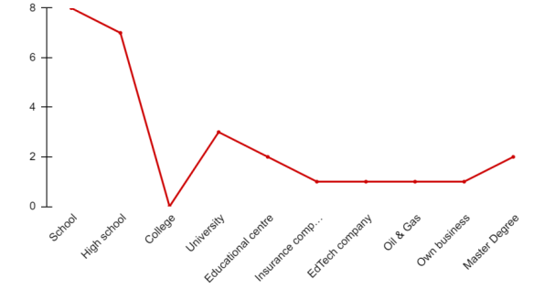

A high number of participants are employed in the education sector (almost 70% between schools (30,77%), high schools (26,92%), and universities (11,54%), reflecting the relevance of ESP courses for those pursuing careers in teaching or academia. The small but significant number of participants in diverse fields such as EdTech, Oil & Gas, and business (20%) illustrates that ESP courses are applicable in non-academic settings as well.
The next key components evaluate ESP course impact on students' academic and professional development. This section includes seven questions ranging from 1 to 5, where 1 is Strongly Disagree and 5 equals to Strongly Agree. Questions are as follow:

Table 22. Evaluation of ESP course by alumni
# | Respondents | Number of respondents | Strongly Agree (%) | Agree (%) | Neutral (%) | Disagree (%) | Strongly Disagree
1 | The ESP course was beneficial for my career | 26 | 69,2% | 26,9% | 3,9% | 0% | 0%
2 | I use English skills learned in the ESP course in my current job | 26 | 57,7% | 23% | 15,4% | 3,9% | 0%
3 | The ESP course improved my confidence in using English in professional settings | 26 | 65,4% | 26,9% | 7,7% | 0% | 0%
4 | The course content was relevant to my field of study and career | 26 | 65,4% | 23% | 7,7% | 3,9% | 0%
5 | The ESP course provided practical skills that I apply in my job | 26 | 61,5% | 26,9% | 7,7% | 3,9% | 0%
6 | The ESP classes were relevant to my needs | 26 | 76,9% | 15,3% | 3,9% | 3,9% | 0%
7 | The teaching methods used by the instructor were useful | 26 | 76,9% | 15,3% | 3,9% | 3,9% | 0%

The analysis of the data collected from the alumni highlights the overwhelmingly positive impact of the ESP course on their academic and professional development. A significant majority (84%) agreed or strongly agreed that the course was beneficial for their career, and 76% reported regularly using the English skills learned in their current job. Furthermore, 92% of participants felt the course improved their confidence in using English in professional settings, while 88% found the course content relevant to their field of study. The course was also praised for its practical application, with 92% agreeing that they could apply the skills learned in their job. Additionally, 96% of respondents found the teaching methods used by the instructor to be useful, with 76% strongly agreeing. However, a small minority of participants (ranging from 4% to 16% across questions) expressed neutral or slightly negative responses, indicating potential areas for improvement, such as better alignment of the course content with specific job-related needs.

Table 23. The statistical summary

 | Strongly Agree (%) | Agree (%) | Neutral (%) | Disagree (%) | Strongly Disagree (%)
Count | 7.00 | 7.00 | 7.00 | 7.00 | 7.00
Mean | 67.57 | 22.47 | 7.17 | 2.79 | 0.00
Standard Deviation | 7.31 | 5.20 | 4.10 | 1.90 | 0.00
Min | 57.70 | 15.30 | 3.90 | 0.00 | 0.00
Max | 76.90 | 26.90 | 15.40 | 3.90 | 0.00

The statistical summary confirms these trends. The mean percentage of “Strongly Agree” responses was 67.6%, while “Agree” responses averaged 22.5%. Neutral and disagree responses were comparatively rare (7.2% and 2.8%, respectively), and no respondents strongly disagreed. These findings suggest that the ESP course was highly effective in meeting alumni expectations and supporting their academic and career trajectories.
Moreover, the practical significance of English for Specific Purposes (ESP) courses in professional contexts requires understanding using the skills learnt in these courses. In order to determine whether specific abilities acquired through the ESP course are being actively utilised by participants in their present jobs, the question "Which skills from the elective course do you use most frequently in your job?" was asked. Critical thinking, problem-solving, communication, subject-specific vocabulary, teamwork, and research were among the talents listed in the poll. A review of the respondents and a focus on significant trends are presented in the interpretation that follows.

Figure 34. Usage of skills in the workplace by alumni

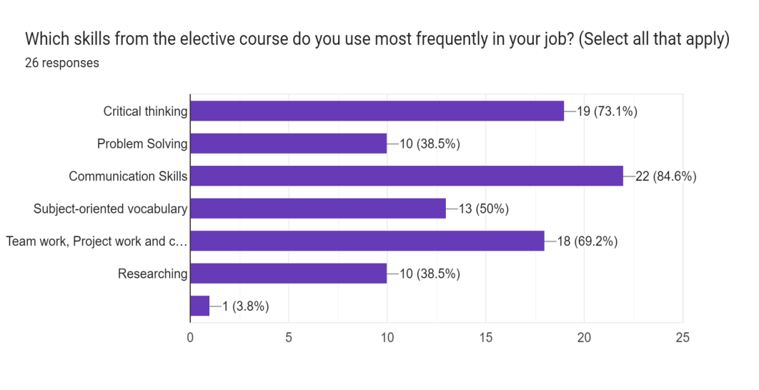

According to the data, almost 85% of participants reported using communication as the most frequently applied skill they had learnt in the ESP course in professional settings. This indicates that the course was successful in helping participants develop the critical competencies needed for interactions, presentations, and relations. Critical thinking skills were also extensively employed, with 73% of respondents employing them in decision-making and problem-solving, proving the course's usefulness in cultivating analytical capacities across many industries. According to almost 70% of participants, the course's emphasis on equipping students for practical, cooperative activities is emphasised by teamwork and cooperation, underscoring its applicability in real-world work environments. 50% of participants employed terminology that was subject-oriented, indicating that although this talent is vital for more than half of the students, its importance differs depending on industries and employment responsibilities. Researching and problem-solving techniques were used by 38,5% of respondents, suggesting that although these abilities are important, they could be less essential to all work activities and more context-dependent. Remarkably, none of the participants chose "Other," indicating that the pre-established skill categories accurately represented the whole spectrum of applied abilities from the ESP course and were in good alignment with the professional demands of the students.
The next criterion is overall satisfaction where data shows how well participants felt the ESP course prepared them for their jobs and how good they thought it was. Satisfaction levels were consistently high. Sixty-five percent rated their job preparedness from ESP as excellent, 31% as good, and 4% as neutral. Similarly, 84% rated the overall course quality as excellent and 16% as good. Only 4% provided neutral feedback. These results demonstrate that alumni considered ESP highly effective both in preparing them for professional roles and in overall instructional quality.

Figure 35. Satisfaction of the ESP course
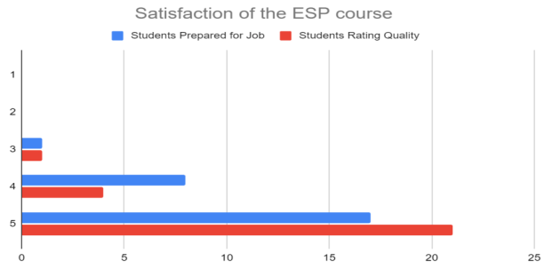

Student feedback is an invaluable resource for assessing the efficacy of the English for Specific Purposes (ESP) course, as well as identifying areas that may require improvement. Students were asked to submit their suggestions for the course and suggest any modifications that could improve the learning experience based on information gathered from the survey. In order to provide a better understanding of the most beneficial elements of the ESP course and to discover trends that may guide future changes, this section analyses the major conclusions drawn from the replies provided by the students. To the question whether they would recommend the ESP course to future students and all participants expressed great pleasure with the ESP course's ability to help their academic and linguistic growth, with a clear recommendation to prospective students. It also highlights how valuable and appealing the course is to a wide range of students.

Figure 36. Recommendation of the ESP course by alumni

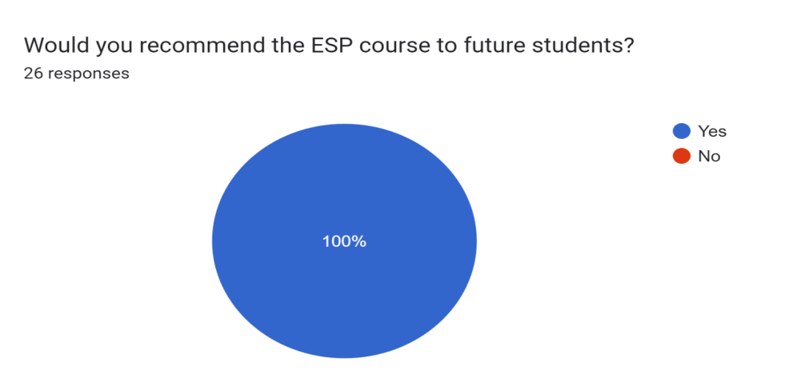
Several insightful trends that point to opportunities for improvement were identified from the open-ended questions in the survey presented in the table below:

Table 24. Summarizing the suggested changes for improving the ESP course based on alumni feedback
Suggestion | Details / Explanation
R [2] | - l learned more school biology in ESP course than in biology lesson  itself. Like l still remember some articles we red and l use it when l teach my students extra things or fun facts. ESP course wasn’t bad of course, but that years l hated my majors (now ofc l love it) and it was like extra headache to go to one more chem-bio lesson. So yeah l think its better to have more like classroom phrases thing in class. Maybe the content changed after 2020. But l remember our teacher said that “this is a new course , so we will see what we can learn from this course together”;
R [4] | - ESP helped to improve my language skills for further biology and  chemistry classes;  - My ESP teacher was Danara Raikhanova in 2018-2019 yy, and I truly  enjoyed the lessons. There’s nothing I can suggest to improve the course. The course syllabus was very well developed, every lesson was planned till its end, there was no free minute;
R [6] | - No recommendations, but I want to add that hearing students’ voices  and meeting their needs are crucial in teaching process. So, teacher/instructor should be flexible and open to new ideas;  - The ESP course is very important for students who live in the country  where English is not L1. The course itself prepares students before delving into complex concepts of major courses. Therefore, students can easily adapt due to the ESP course. That’s why this course should be in the curriculum;
R [10] | - It was the one that really helped to improve my vocabulary in my field  of study;
R [13] | - Everything great; Great subject;
R [14] | - I liked all activities; ESP was very interesting. You can improve your  skills and have big outlook;
R [15] | - More practical works, tedtalks, ppt skills;
R [19] | - No changes, no need to change anything, everything is perfect. The  main thing is not to change the teacher;
R [23] | - I took this course as a bachelor's degree at the university. At the moment  I'm studying for a master's degree also at higher institution. Although I know that the master's degree is a completely different level of education, there were students in my group who studied Kazakh in their specialty (other state universities). And everyone had a different level of English. I would like us to take this course in the master's degree as well;  - I'm so glad that I completed this course in a bachelor's degree. Because  thanks to English and the experience I learned at the university, I was lucky to enrol in a grant in the master's program with 50/50 points in English without any preparation for the exam. I want to note that when I entered the bachelor's degree, my level of English was beginner. I didn't attend additional English courses. I only studied from ESP course;
R [24] | - The most important thing Im using from ESP courses, it about a good  mood and making a friendly relationship with students. I think that moment really helps me in my job as a teacher;

The results demonstrate that the developed ESP curriculum effectively addressed the linguistic and professional needs of chemistry and biology students. Quantitative data confirmed improvements in career readiness, confidence, and applicability of skills, while qualitative feedback emphasised the value of practical activities, subject integration, and responsive teaching.
Pre- and post-test results (discussed earlier) support these findings, showing significant gains in both English proficiency and understanding of scientific concepts. The competency-based and learner-centred design of the curriculum, integrating language and content objectives, ensured its relevance and applicability.
The findings position the ESP curriculum as an effective model for science students in Kazakhstani higher education. Its flexible structure, variety of teaching activities (project-based, task-based, research-based, and case-study approaches), and adaptability to student needs highlight its potential for wider application across disciplines and educational contexts.

5.6 Chapter Summary

Chapter 5 presented the empirical findings of the study, systematically reporting results from the needs analysis, curriculum design and development, intervention, and post-intervention evaluation stages, providing a comprehensive account of how the ESP curriculum was informed, implemented, and validated.
The chapter began with the findings of the needs analysis, which identified the linguistic, academic, and professional requirements of chemistry-biology students and informed the formulation of intended learning outcomes. These results established a clear evidence-based foundation for curriculum development and ensured alignment with institutional, programmatic, and learner-level expectations.
Subsequently, the results related to ESP course materials and activity development were presented, distinguishing between the adaptation of off-the-shelf materials and the design of in-house resources. This section demonstrated how needs analysis findings and intended learning outcomes were translated into context-specific instructional materials and learning activities guided by constructive alignment principles.
The intervention stage reported quantitative findings from pre- and post-testing, including both experimental and control group comparisons and one-group pre- and post-test results. These findings provided empirical evidence of the curriculum’s effectiveness in enhancing students’ ESP competencies following implementation.
Finally, the post-intervention stage presented qualitative and quantitative findings from semi-structured student interviews and alumni questionnaires. These results offered reflective and longitudinal insights into the perceived relevance, applicability, and sustained impact of the ESP curriculum beyond the immediate instructional context.
Overall, the findings presented in this chapter collectively demonstrate the effectiveness, relevance, and validity of the developed ESP curriculum model, thereby addressing the research questions and preparing the ground for the discussion in Chapter 6.
Chapter 6

Discussion

In this chapter, I discuss the findings of my study in light of previous research on ESP, EMI, and multilingual education, informed by my understanding of Kazakhstan's social and educational context, including its trilingual reforms and interdisciplinary challenges in higher education. Relating them to the research questions and the broader aim of developing a competency-based ESP curriculum for chemistry-biology students, I situate these findings within global scholarship, allowing them to enter into dialogue with both international studies and Kazakhstan's specific reform trajectory.
From the outset, my findings reaffirm a foundational principle of ESP: unlike General English, which emphasizes broad communicative competence, ESP must be grounded in clearly defined academic and professional contexts (Hutchinson & Waters, 1987; Dudley-Evans & St John, 1998; Anthony, 2018; Jordan, 1997). What became evident in my needs analysis is that chemistry-biology students are not seeking generalized fluency, but rather the ability to engage with disciplinary genres, interpret scientific texts, conduct laboratory discussions, and eventually teach subject content in English. This aligns closely with genre-based and disciplinary literacy perspectives, which conceptualize academic language as embedded in specific epistemological and communicative practices (Hyland, 2018; Swales, 1990; Anthony, 2018).
However, I also found that these needs cannot be understood purely in disciplinary terms. They are deeply shaped by Kazakhstan’s Trilingual Education Policy and the expansion of EMI in STEM disciplines (Government of the Republic of Kazakhstan, 2010; Goodman et al., 2023; Tajik et al., 2022). While EMI expansion is part of a global movement toward internationalisation (Wächter & Maiworm, 2014; Macaro et al., 2018), in Kazakhstan it carries additional political and identity dimensions. My participants’ responses reflected this complexity: they are preparing not only to function as scientists, but as future educators expected to operate within multilingual and partially anglicised educational environments.
At the same time, my data reveal a clear tension between policy ambition and linguistic readiness. Although national reforms emphasize English integration, many students reported insufficient preparation for studying or teaching their disciplines in English. This finding resonates strongly with international EMI research, which has long highlighted the gap between policy implementation and classroom realities (Rose et al., 2019; Azkiyah et al., 2023; Feng et al., 2023). In the Kazakhstani context, scholars such as (Goodman et al., 2023; Berdygozhina, 2024; Dilzhanova, 2024) similarly identify structural barriers, including limited teacher training and insufficient materials. My findings therefore confirm that EMI expansion, without structured language support, risks placing unrealistic expectations on both students and teachers.
Another important insight from my study concerns the pedagogical dimension of students’ needs. Participants consistently expressed the need not only for linguistic development, but also for strategies to teach content bilingually. This aligns with CLIL scholarship, which emphasizes the integration of content and language objectives (Brinton et al., 2003; Hyland, 2006). However, unlike European CLIL contexts, where methodological frameworks were carefully developed over time, EMI in Kazakhstan has often been introduced through top-down policy reform (Dearden, 2014). I interpret my findings as evidence that a carefully designed ESP curriculum can serve as a bridge between macro-level language policy and micro-level classroom practice (Long, 2005; Nation & Macalister, 2010).
Importantly, my analysis also led me to question purely instrumental interpretations of ESP. While institutional discourse frequently frames English proficiency in terms of employability, competitiveness, and global rankings, trends associated with market-oriented reforms in higher education (Block et al., 2012), students articulated more complex motivations. They spoke about confidence, professional identity, and the desire to feel competent in multilingual classrooms. These perspectives resonate with critical applied linguistics scholarship, which views language learning as socially mediated and identity-forming rather than simply technical skill acquisition (Rodgers, 1969; Richards, 2001; White, 1988).
For this reason, I conceptualize “specific needs” not as a fixed checklist aligned with policy mandates, but as a negotiated and context-sensitive construct. Contemporary ESP scholarship supports this view, emphasizing that needs analysis must be dynamic, situated, and responsive to evolving professional practices (Anthony, 2018; Richards, 2001; Chambers, 1980). My mixed-methods findings demonstrate that students’ needs simultaneously support national reform goals, particularly English integration in STEM, while also exposing significant gaps in implementation, especially the absence of structured subject-specific language training (Kanayeva et al., 2021; Goodman et al., 2023).
Finally, the competency-based orientation of the proposed curriculum reflects global shifts toward learner-centered and outcomes-based education (Biggs & Tang, 2011; Nunan, 2013; Mosha, 2012; UNESCO, 1998; Wang & Maa, 2021). However, through my analysis, it became clear that competency development in the Kazakhstani ITE context must go beyond linguistic outcomes. It must integrate disciplinary literacy, bilingual pedagogical competence, and reflective professional practice. In this sense, the ESP model I propose is not merely an adaptation of global trends, but a contextually grounded response to the specific linguistic, institutional, and policy realities of Kazakhstan’s higher education system (Nation & Macalister, 2010; Graves, 2000).
This chapter discusses the findings of the current study in relation to its four research questions and situates them within existing scholarship on ESP curriculum design. Section 6.1 addresses Research Question 1 by examining the multidimensional ESP learning needs of science student-teachers. Section 6.2 responds to Research Question 2 by analysing how these needs informed the design and implementation of discipline-specific didactic materials. Section 6.3 discusses Research Questions 3 and 4 by evaluating the effectiveness, impact, and sustainability of the developed ESP curriculum model. Together, these sections move from diagnosis to design to evaluation, reflecting the developmental logic of the research.

6.1 Science Student-Teachers’ ESP Learning Needs

This section addresses Research Question 1: What discipline-specific linguistic, academic, and professional needs do chemistry-biology students demonstrate in relation to ESP learning in a Kazakhstani higher education context? The findings reveal that these needs are not homogeneous. Rather, they are multidimensional, developmentally staged, and deeply influenced by prior schooling, policy reforms, and emerging professional identities. In comparison with prior ESP studies in similar contexts (Anthony, 2018; Mekezhanova, 2023), this multidimensionality highlights previously underexplored influences developmental staging in ESP curriculum development for Kazakhstani interdisciplinary programs such as chemistry-biology.
What struck me most profoundly when I began analysing the data was not simply that students had different needs, as I had expected that, but the stark, almost binary nature of their perceptions based on their educational trajectories (Robinson, 1991). The quantitative data painted a clear picture of what I have come to conceptualise as a “schooling gap.” For the majority of students from public Kazakh- or Russian-medium schools, the ESP course was viewed as an essential lifeline: a crucial tool for decoding their English-taught major subjects (Azkiyah et al., 2023; Feng et al., 2023; Curle et al., 2024; Kamasak & Sahan, 2023). Conversely, a significant proportion of graduates from specialised schools such as Nazarbayev Intellectual Schools (NIS) or Bilim Innovation Lyceums (BIL) perceived the same course with indifference or dissatisfaction, regarding it as a redundant review of language they already possessed (Rose et al., 2019; Curle et al., 2020). This was not merely a difference in opinion; it reflected a fundamental disagreement in lived educational experience.
As I reflected on these findings, I realised that the “schooling gap” represented far more than inequality in test scores. Drawing on Maton’s (2013) concept of epistemic access, I began to interpret it as a structural stratification of capital. Students from English-medium backgrounds entered university already socialised into the particular ways of thinking, writing, and arguing that characterise scientific disciplines in English (Dmitrieva & Poskrebysheva, 2022; Oštarić & Perinčić Tičić, 2022). They possessed an intuitive command of disciplinary discourse, whereas their peers from other educational backgrounds were required to acquire this knowledge consciously and with effort, often while simultaneously grappling with complex disciplinary content. This finding resonated strongly with research conducted in comparable Kazakhstani contexts, such as Kuzembayeva and Zhakanova’s (2021) study of medical students, and echoed broader global critiques suggesting that English-Medium Instruction (EMI) can paradoxically embed, rather than mitigate, educational inequality (Macaro et al., 2018; Galloway & Rose, 2021; McKinley & Rose, 2022; Goodman et al., 2023; Tajik et al., 2022).
From my position in the classroom, this divergence compelled me to confront a central reality: the “specific need” of chemistry-biology students was not a singular construct. Instead, it existed along a spectrum of pedagogical imperatives (Hutchinson & Waters, 1987; Raikhanova & Bakić-Mirić, 2023). For students from public schools, the imperative centred on foundational scaffolding developing essential lexico-grammatical competence and basic genre awareness necessary to cross the threshold into disciplinary understanding. For their peers from specialised schools, however, the need shifted decisively toward discursive sophistication: mastering nuanced rhetorical moves within research articles, engaging in scholarly critique, and cultivating a confident, authoritative academic voice. In this regard, the findings provided practical validation of a core ESP principle: as proficiency increases, tolerance for general English diminishes, and the demand for specificity intensifies (Dudley-Evans & St John, 1998; Anthony, 2018).
However, framing this issue solely as a technical challenge of classroom differentiation felt, to me, like a failure to uphold a deeper responsibility. I came to understand the “schooling gap” not merely as a pedagogical problem, but as a manifestation of curricular injustice, embedded within the broader architecture of national education policy (Goodman et al., 2023; Tajik et al., 2022). The specialised schools such as NIS and BIL that produced the more advanced cohort are themselves outcomes of Kazakhstan’s selective and experimental trilingual education policy, a system that has deliberately concentrated educational resources. Within this context, a standardised university ESP syllabus did not operate on an equitable foundation; instead, it unintentionally functioned as a mechanism for reproducing pre-existing inequities, disengaging more advanced students while simultaneously failing to provide sufficient support for underprepared learners. This insight was transformative for my understanding of needs analysis: it must extend beyond identifying linguistic gaps to examining their socio-political origins.
Consequently, I became convinced that an equitable ESP response must actively resist this inertia. Such a response necessitates a shift away from the one-size-fits-all model toward a flexible, multi-track curriculum (Robinson, 1991). This would involve parallel pathways: one designed to offer sheltered content instruction and essential academic literacies, and another focused on fostering advanced disciplinary discourse and knowledge production (Dudley-Evans & St John, 1998; Raikhanova et al., 2025). This approach aligns with what has been described as critical pragmatism in ESP, whereby instruction provides practical tools for immediate academic survival while simultaneously rendering visible the structures of power and privilege embedded in academic communication. Without this justice-oriented differentiation, I feared that my classroom would simply become another site where societal inequalities were rehearsed and reaffirmed.
This theoretical realisation led directly to a pivotal practical outcome: the administrative restructuring of the language programme. Following consultations with programme coordinators, the decision was made to divide the ESP course into two sub-branches (Anthony, 2018): EAP for students from EMI backgrounds, and ESP for those who had graduated from Kazakh- or Russian-medium institutions. In addition, my analysis of curriculum documents revealed a critical flaw within the POIYa 3207 programme curriculum namely, a profound misalignment in the sequencing of ESP provision. Discipline-specific terminology was not formally introduced until the third year, at which point students were no longer merely academic learners but emerging professionals, immersed in teaching methodology and major-specific coursework. By this stage, their linguistic needs had shifted decisively from general academic comprehension (EGAP) to the performance of professional-pedagogical tasks (Hutchinson & Waters, 1987; Robinson, 1991). The appropriate provision at this point was not ESAP for studying science, but unambiguously EOP for teaching science. This delayed introduction of linguistically relevant professional tools constituted a fundamental failure to address students’ developmental needs (Dudley-Evans & St John, 1998; Anthony, 2018).
This insight prompted me to examine the taxonomy of ESP itself carefully. I came to the conclusion that ESP should not be viewed as a category parallel to EAP or EOP, but rather as an overarching framework that encompasses them. Within this framework, EAP (for academic study) and EOP or EPP (English for Professional Purposes) represent context-specific manifestations along a learner’s developmental trajectory. This conceptualisation both clarified and reinforced the integrated models proposed by Dudley-Evans and St. John (1998) and Anthony (2018), positioning ESP as a responsive and evolving field.
In practical terms, this necessitated a precise re-articulation of instructional objectives. As Belcher (2023) and Anthony (2018) argue, the effectiveness of ESP depends fundamentally on the accurate identification of the target situation. The data were unambiguous: for third-year student-teachers, the target situation is the multilingual science classroom, not the academic discourse of scientific research. Accordingly, instructional materials and assessments needed to be redesigned around core occupational genres, including lesson planning, explaining complex scientific processes in accessible language, managing classroom interaction, and evaluating student work in English. This shift from knowledge consumption to knowledge mediation became non-negotiable for the development of genuine professional readiness.
Ultimately, this process reinforced for me that a rigorous needs analysis cannot be conceptualized as a one-time event. Rather, it must function as a continuous diagnostic mechanism for dynamic and longitudinal assessment. The administrative division into EAP and ESP tracks represented only an initial step. It must be followed by a carefully sequenced, theory-informed redesign of each track to ensure that early EAP instruction systematically scaffolds toward the occupation-specific demands of the EOP phase. Without such alignment, there is a risk of delivering the appropriate type of instruction at an inappropriate stage and, in doing so, failing to fulfil the fundamental purpose of ESP and meet students’ needs (Biggs & Tang, 2011; Raikhanova et al., 2025).
6.1.1 Lexical, Epistemic, and Affective Dimensions

Across all data sources as surveys, interviews, and classroom observations one theme emerged with undeniable force: the overwhelming challenge of academic literacy in scientific English (Al-Murtadha, 2025; Rose et al., 2019). For my students, this was not an abstract competence but a daily and often frustrating struggle. Scientific discourse, characterised by high lexical density, extensive nominalisation, and complex grammatical structures constituted a formidable barrier (Vu Thi Mau et al., 2025; Dmitrieva & Poskrebysheva, 2022). My findings indicated that students struggled not merely to recognise “difficult words,” but to interpret meaning embedded within dense disciplinary conventions, a process frequently accompanied by a palpable sense of intellectual exclusion and heightened anxiety (Al-Murtadha, 2025; Yuksel et al., 2023; Azkiyah et al., 2023).
I interpreted this struggle through the lens of genre analysis scholarship, which conceptualises academic literacy as the capacity to navigate and produce specialised textual forms such as laboratory reports, research articles, and literature reviews (Swales, 1990; Hyland, 2006; Cheng, 2008). Students’ difficulties in decoding complex conceptual content, particularly where familiar lexical items acquired precise technical meanings, revealed a critical deficiency in disciplinary literacy. This challenge was further exacerbated by what I identified in curriculum documents as a systemic resource gap: the near-total absence of authentic, discipline-specific materials for chemistry-biology majors within the existing ESP provision (Brinton et al., 2003; Reinoso-Espinosa, 2020; Saraa & Bourzeg, 2025; Popescu, 2021). For future educator-scientists, this gap is doubly damaging. It constrains their own epistemic access while simultaneously depriving them of authentic textual models to analyse and emulate in their future pedagogical practice (Maton, 2013).
From my position at the front of the classroom, I came to conceptualise this challenge as a “lexical-epistemic burden.” This burden is not simply linguistic in nature, but reflects a broader structural and pedagogical mismatch that amplifies cognitive load and undermines learner motivation (Bocianu, 2025; Sweller et al., 2011; Biggs, 2014). Reliance on general English textbooks, as was the case in the former curriculum, failed to provide the scaffolding required for meaningful engagement with authentic scientific texts, thereby reinforcing a self-sustaining cycle of anxiety and avoidance (Al-Murtadha, 2025; Yuksel et al., 2023). My classroom experience aligns with broader ESP materials research demonstrating that tailored, discipline-specific resources reduce misaligned cognitive load and foster the self-efficacy essential for success in specialised academic fields (Bocianu, 2025; Popescu, 2021). I became increasingly convinced that only through carefully designed, discipline-specific reading tasks could learners develop both the literacy practices and the confidence demanded by chemistry and biology (Dudley-Evans & St. John, 1998).
This burden manifested most acutely in the domain of scientific writing, where mastery of disciplinary conventions functions as a direct marker of academic and professional legitimacy (Oetomo et al., 2025). Participants reported significant difficulties in structuring explanations, describing experimental procedures, synthesising data, and employing appropriate rhetorical conventions. Writing apprehension was a tangible presence in the classroom, reinforcing existing research that academic writing in the sciences requires a form of rhetorical awareness rarely cultivated through general English
instruction (Hyland, 2018). Effective scientific writing demands logical organisation, evidential clarity, and a disciplined authorial stance competencies that extend well beyond vocabulary acquisition.
For my chemistry-biology student-teachers, however, writing carries a distinctive dual epistemic-pedagogical burden. First, they must master scientific writing to participate successfully in their own academic studies. Second, and more critically, they must develop the metadiscursive awareness necessary to unpack and explain these conventions to their future students (Cheng, 2008). This requirement necessitates an ESP approach that moves beyond genre acquisition for assessment purposes toward genre analysis for pedagogical mediation (Hiegelsberger, 2018; Anthony, 2018). Consequently, my instruction needed to equip students not only to produce a laboratory report, but also to understand and articulate how such texts function their rhetorical moves, organisational logic, and persuasive strategies so that they could later model and teach scientific writing within their own classrooms (Cheng, 2008).
Similarly, the need for oral proficiency revealed a pronounced tension between professional aspiration and affective reality. Although 93% of students acknowledged the importance of English for their future careers, the majority reported low confidence in speaking, particularly in formal contexts such as presentations (Yuksel et al., 2023; Nunan, 2013). This discrepancy illuminated the constraining effect of a high affective filter, fuelled by fear of error within a high-stakes disciplinary environment, which inhibits the very communicative practice required for fluency development (Krashen, 1982; Lemana et al., 2023). In response, I found that competency-based activities such as tasks and projects-based learning and teaching, micro-lectures, and structured peer feedback served a dual pedagogical function. These tasks provided meaningful, low-anxiety speaking opportunities grounded in students’ hybrid identities as both science learners and trainee teachers, while simultaneously fostering the professional self-efficacy needed to manage future multilingual classrooms (Kolb, 1984; Nunan, 2013).
Synthesising these observations, I came to view students’ communicative needs as tightly interwoven strands of a single knot. Lexical-epistemic barriers in reading intensified rhetorical and structural challenges in writing, while both were further constrained by affective factors that peaked during spoken performance (Yuksel et al., 2023; Azkiyah et al., 2023). For chemistry-biology student-teachers, this triad is additionally shaped by a pedagogical imperative: their academic communication skills must ultimately function as tools of instruction. Consequently, an effective ESP curriculum cannot address these dimensions in isolation. It must adopt an integrated genre-pedagogy approach, drawing on authentic scientific and science-education texts to simultaneously develop disciplinary literacy, rhetorical competence, professional confidence, and foundational pedagogical language awareness (Brinton et al., 2003; Saraa & Bourzeg, 2025; Dudley-Evans & St. John, 1998). For me, this integrated orientation represents the central contribution of the needs analysis, advancing ESP for teacher education beyond linguistic competence toward the cultivation of the teacher-scientist’s full communicative agency (Biggs, 2013; Nunan, 2013).
The necessity for such a sophisticated and differentiated curriculum is strongly reinforced by the expectations of the programme coordinators (N = 7). Their survey responses revealed a consistent prioritisation of higher-order academic literacies, including critical thinking (16.67%), problem-solving (13.89%), and public speaking (13.89%), as essential for student success. These expectations align closely with the advanced needs of students from specialised schools with EMI backgrounds. At the same time, the coordinators’ overwhelming emphasis on tangible outputs such as research projects and written reports (85.7% each) clearly delineates the non-negotiable target genre repertoire. The near-universal expectation for research writing (100%) and persuasive speaking (85.7%) establishes a clear benchmark for professional readiness.
However, a critical tension emerges one that I confronted daily in my teaching practice. These faculty expectations presuppose a level of linguistic and rhetorical competence that, as the documented “schooling gap” demonstrates, many students do not possess upon entry (Azkiyah et al., 2023; Feng et al., 2023). The curriculum, therefore, must be not only differentiated but also deliberately and compassionately sequenced. It must scaffold graduates of public schools from foundational academic literacy toward complex genre production, while simultaneously challenging specialised school graduates to refine and extend their competencies within discipline-specific tasks. The comparatively lower emphasis placed on skills such as note-taking does not diminish their importance for novice learners; rather, it exposes a hidden curriculum of assumed competencies that an equitable ESP programme must explicitly surface and systematically develop (Biggs & Tang, 2011). This alignment process confirmed for me that the target situation is both rigorous and genre-specific, and that the central, learner-centred, competency-based challenge of ESP lies in designing multiple, transparent pathways that render this target genuinely accessible to all learners (Nation & Macalister, 2010).

6.1.2 Pedagogical and Linguistic Challenges in ESP for Science

Building on my understanding of integrated needs, my analysis inevitably confronts the most distinctive and defining feature of my teaching context: the dual and at times even triple professional identity of my learners. They are not solely chemistry or biology students who need English, nor are they generic trainee teachers. Rather, they embody all three roles, generating a constellation of needs that transcends conventional ESP categories, sitting at the intersection of disciplinary knowledge transmission and pedagogical mediation (Raikhanova & Bakić-Mirić, 2023; Raikhanova et al., 2025).
The interviews with science content teachers powerfully framed this triple requirement. Their expectation that students must be able to “discuss, analyse, and solve problems” in English signified more than academic participation; it implied the future capacity to orchestrate such discourse within a classroom (Aimoldina & Smagulova, 2024; Raikhanova, 2020). This aligns with research on classroom discourse, which maps the complex repertoire of teacher talk-explanation, concept checking, elicitation, feedback necessary for effective pedagogical communication (Kanayeva et al., 2021). For my chemistry-biology student-teachers, therefore, ESP must prepare them to deconstruct scientific concepts for novice consumption, a task demanding a meta-awareness of language entirely absent from standard ESAP frameworks focused solely on knowledge consumption.
A critical and, for me, frustrating gap existed between this identified need and our existing provision. Our ESP instruction, as I inherited it, rarely touched upon instructional discourse explicitly. Preparing learners to teach science in English requires moving beyond technical vocabulary to encompass classroom interaction patterns, questioning strategies, and the discursive skills of scaffolding understanding (Boqiyeva, 2024; Zhaiykbay et al., 2025). This gap is substantiated by research on language teacher identity, which insists that professional preparation must integrate language proficiency with pedagogical communication practices (Mahendra, 2020; Lewis, 2011). Without this focus, I observed student-teachers develop what I term a pedagogical language deficit: they possessed the content knowledge but lacked the specialised discursive toolkit to teach it effectively in English.
This deficit was further compounded by a significant institutional collaboration gap, which I experienced firsthand. Interviews with fellow ESP instructors revealed a regrettable lack of structured dialogue with science faculty practitioners, resulting in syllabi that were often disconnected from the immediate linguistic demands of students’ concurrent major courses (Graves, 2000; Nation & Macalister, 2010). This constraint is a well-documented barrier in ESP implementation. Without such collaboration, needs analysis becomes a static, retrospective exercise, incapable of dynamically aligning ESP instruction with the evolving curriculum of the major.
In the Kazakhstani context, I interpret this institutional gap as a symptom of a broader policy-practice disconnect within the trilingual education ecosystem. While national policy mandates English proficiency for modernization, its translation into coordinated curriculum design and interdisciplinary practice remains inconsistent and fraught (Goodman et al., 2023; Tajik et al., 2022). Recent research on EMI in Kazakhstan notes that macro-level policy often falters at the meso-institutional level, where logistical constraints and departmental silos dilute implementation (Gaipov et al., 2024). This divide led me to a critical conclusion: an effective ESP response must be doubly aligned. It must align horizontally with the dual disciplinary-pedagogical demands of the learner’s identity, and vertically with institutional structures capable of fostering the interdisciplinary collaboration required to support it (Paltridge & Starfield, 2019).
Thus, in my practice, the dual identity of the chemistry-biology student-teacher was no longer merely an added complexity. It became the defining parameter, the central problem-space that exposed the limitations of curricula designed for single-purpose learners. It highlighted the systemic institutional reforms needed to move from rhetorically recognising this duality to genuinely resourcing it in practice. My task became not just teaching English for science, but fostering the emergence of the teacher-scientist, a professional uniquely equipped to bridge worlds (Raikhanova, 2023; Lewis, 2011).
6.2 The Journey from Theory to Classroom Practice
When I embarked on this research, after conducting a systematic needs analysis, the second research question: how a discipline-specific ESP didactic materials collection could be designed to address the identified needs and support chemistry-biology students’ learning outcomes (RQ2) appeared deceptively simple yet operationally profound. This inquiry extended far beyond a straightforward evaluation of textbook efficacy; instead, it evolved into an examination of my role as a curriculum architect operating within a highly specialised educational ecosystem. Such a shift in perspective aligns with views of ESP practitioners as materials developers and course designers rather than mere implementers of externally produced resources (Dudley-Evans & St. John, 1998; Graves, 2000; Nation & Macalister, 2010; Tomlinson, 2014). In practice, this question came to define the central and complex challenge of my professional development, compelling me to move from being a passive deliverer of pre-packaged content toward becoming an active designer of integrated learning experiences. As Basturkmen (2023) argues, the fundamental validity of ESP lies in its demonstrable responsiveness to specific learner needs, rendering such alignment a non-negotiable cornerstone of pedagogical legitimacy.
My journey therefore constitutes a situated case study in operationalising this principle within the unique constraints and affordances of a Kazakhstani EMI context for chemistry-biology student-teachers, where language education intersects with disciplinary instruction and teacher preparation (Gaipov et al., 2024; Goodman et al., 2023; Kanayeva et al., 2021). In this sense, the systematic alignment of needs analysis, materials design, pedagogy, and assessment gradually extended beyond the level of individual resources and resulted in the development of a coherent and transferable ESP curriculum model how such a model can function as a replicable methodological guideline for ESP and EMI practitioners (RQ3).
This discussion represents a reflective synthesis of that developmental process. I argue that achieving genuine correspondence between materials, learner needs, and target outcomes is neither unsystematic nor purely intuitive; rather, it is the product of a deliberate, systematic, and recursive process of multilevel alignment, as consistently emphasised in ESP curriculum design literature (Graves, 2000; Nation & Macalister, 2010; McGrath, 2013). This process requires linking the macro-level, aspirational goals articulated by institutional and national policy to the meso-level objectives of the degree programme, and ultimately to the micro-level interactions, practices, and competencies cultivated in the classroom, reflecting a vertically coherent model of curriculum alignment (Biggs, 1996; Richards, 2013; Ellis, 2018). My narrative traces an evolution from an initial phase of reactive uncertainty, where my primary strategy involved a quantitative increase in instructional hours, to the development of a coherent, evidence-informed model in which every textual resource, pedagogical activity, and assessment task fulfils a clearly validated function within a broader developmental framework (Nunan, 2013; Brown, 2019). This progression echoes research suggesting that effective ESP practice emerges through iterative cycles of reflection, evaluation, and redesign rather than one-off course planning decisions (Tomlinson, 2014; West, 1994). Ultimately, this account is one of professional metamorphosis: a shift from a teacher who transmits linguistic content to a curriculum designer who intentionally engineers the conditions for disciplinary participation and professional identity formation, a role increasingly recognised as central in ESP and EMI contexts (Dudley-Evans & St John, 1998; Raikhanova & Bakić-Mirić, 2023). In this sense, the chapter that follows serves as a direct continuation and elaboration of my response to the second and third research questions, grounding theoretical alignment in lived classroom practice.

6.2.1Aligning Materials with the Programmatic "Why"

My initial and most significant conceptual breakthrough stemmed from a fundamental reconceptualization of my course’s purpose. I was not teaching a discrete, generic "English" module, I was facilitating a critical, enabling component of a chemistry-biology teacher education programme operating within Kazakhstan’s broader trilingual policy framework. This realization meant my materials could no longer be an isolated linguistic island; they had to be an integral part of the academic archipelago, deliberately engineered to help realize national educational objectives at the classroom level (Richards, 2017). To navigate this, I adopted the principle of constructive alignment as my core design philosophy (Biggs, 2014; Biggs & Tang, 2011). This outcome-based approach insists that the curriculum must be engineered backwards from clear statements of what learners should be able to know, do, and value upon completion. As Biggs (2014) posits, this creates a coherent system where learning activities and assessment tasks are explicitly designed to elicit the performance articulated in the intended learning outcomes. In the ESP context, this translates to a backward design process, where materials are not selected based on convenience or availability but are meticulously crafted or adapted to scaffold the achievement of pre-specified, needs-derived competencies (Nation & Macalister, 2010; Tomlinson, 2014; Wiggins & McTighe, 2005; Graves, 2000).
To begin this backward design (Richards, 2013; Richards, 2017), I first looked upwards to understand the ultimate "why." The university’s strategic vision to cultivate "global citizens" and "skilled professionals" who act as "disseminators of knowledge" was more than aspirational rhetoric; it was the institutional interpretation of a national mandate. This vision provided the ethical and institutional imperative for my work, directly echoing the national ITE reform goal of preparing educators for the "multilingual classroom reality" mandated by Kazakhstan’s trilingual policy (Goodman et al., 2023; Kanayeva et al., 2021). The policy’s call for teachers capable of delivering content in specific languages created a direct, macro-level need for advanced, discipline-specific English proficiency (Dudley-Evans & St. John, 1998). My task was to operationalize this policy aspiration into a functional curriculum (Graves, 2000).
However, these lofty, cascading goals needed practical translation into disciplinary practice. This led me to consult the faculty teachers, the experts who understood the day-to-day demands of the discipline within this policy context. Their survey data proved illuminating. Their priorities revealed that they valued not merely lexical knowledge but the application of language for higher-order intellectual functions essential for modern teaching. The pronounced emphasis on critical thinking (16.67%), problem-solving (13.89%), and public speaking (13.89%), coupled with the overwhelming expectation for project-based outputs and written reports (85.7% each), painted a clear picture. They needed future teachers who could use English to analyze, synthesize, argue, and explain complex scientific concepts-precisely the competencies required to enact CLIL methodology (Coyle et al., 2010) and fulfil the professional role envisioned by national reforms (Kanayeva et al., 2021). These faculty priorities directly informed and were reflected in the Programme Learning Outcomes (PLOs) of future chemistry-biology student-teachers, such as PLO2 (communicative competence) and PLO4 (application of theoretical and experimental knowledge).
My task, therefore, became one of pedagogical engineering: constructing a linguistic and metacognitive bridge between these layered goals and student capability. This involved enacting a deliberate vertical cascade of alignment: from national policy (functional trilingualism, EMI-ready teachers), to institutional strategy (producing "disseminators of knowledge"), to programme goals (PLOs for communicative and applied competence), to faculty expectations (higher-order academic literacies), and finally to my specific classroom objectives (Nation & Macalister, 2010; Richards, 2017). For instance, when I formulated a course-level Learning Outcome like "LO6: give effective presentations including organisation, preparation, and delivery techniques," it was consciously designed as a direct stepping stone in this cascade. It addressed the faculty’s desire for public speaking, supported the programme’s communicative competence PLO, served the university’s vision of creating confident disseminators, and ultimately contributed to the national goal of preparing a teacher who can confidently instruct in English. This ensured my ESP materials functioned as a supportive, integrated pillar of the degree and a pragmatic mechanism for policy implementation, not as a peripheral or decorative add-on. This practice resonates deeply with the assertion that effective EAP/ESP must be "contextually embedded," actively engaging with and supporting the specific literacy practices and epistemological values of the target discipline (Hyland, 2006; Johns, 2011). In my context, that discipline was uniquely dual-natured: the formation of a bilingual science educator capable of thriving within Kazakhstan’s prescribed multilingual classroom reality.
Yet, in this process, I am critically aware of a significant institutional pitfall: the potential for "alignment fatigue" or performative compliance (Biesta, 2010). It is administratively easy to create elegant curriculum mapping matrices that satisfy audit requirements but have minimal impact on actual teaching and learning. For me, alignment was never a bureaucratic checkbox exercise; it was the foundational rationale for transforming policy into practice. It was the design philosophy that dictated why I chose a demanding, research-skills textbook for one student cohort and invested hundreds of hours in creating custom, scaffolded units for another. It consistently prevented me from defaulting to the seductive ease of generic, one-size-fits-all commercial textbooks, which Basturkmen (2010) warns often lack the specificity required for genuine ESP and which would have failed to address the nuanced demands of the national trilingual agenda. This principled stance, while labor-intensive, ensured that the alignment from national policy to classroom activity was lived and enacted, not merely documented. In this way, my syllabus became a case study in the micro-level operationalization of macro-level educational reform (Nation & Macalister, 2010).
6.2.2 Implementing an ESP Course to Address Science Student-Teachers’ Learning Needs

As a researcher with a scientific background, I approached my pedagogical innovations with measured skepticism. Anecdotal impressions of student engagement or perceived improvement were insufficient for establishing the validity of my design. To rigorously evaluate whether my carefully aligned and differentiated ESP materials would yield measurable improvements over conventional approaches, I implemented the classroom as both a controlled environment and an experimental laboratory (Creswell, 2018). The empirical evidence gathered through this process forms the foundation of the present discussion.
The quantitative outcomes from the experimental implementation provided compelling support for the efficacy of the model. Students in the Experimental Group (EGS), who engaged with the tailored, in-house ESP materials, demonstrated a statistically significant increase in subject-specific language and content knowledge, with mean scores rising from 78.2 to 89.7. However, beyond the mean improvement, the reduction in standard deviation from 12.45 to 8.97 was particularly pedagogically significant. This contraction of variability indicates that the materials did not solely enhance the performance of already-proficient learners, thereby widening disparities; instead, the intervention effectively elevated the competence of the entire cohort, narrowing the performance gap and demonstrating that a differentiated, needs-responsive design can address heterogeneous starting points effectively (Hyland, 2006). In contrast, the control group, which relied on off-the-shelf science textbooks, showed minimal gains that were statistically insignificant (p > 0.05), with a negligible effect size (Cohen’s d = -0.295). For the experimental group, the improvement was highly significant (p < 0.001), with a large effect size (Cohen’s d = -0.816), underscoring both the reliability and substantial educational impact of the intervention (Cohen, 1988; Plonsky & Oswald, 2014). These findings highlight the inadequacy of generic materials in meeting the complex linguistic and cognitive demands of science teacher-education students in an EMI context (Patton, 2015).
To ensure that these findings were not isolated to a particular cohort or semester, a replication study was conducted with a subsequent student group. The replication produced another significant pre/post gain (p = 0.003) with a similarly large effect size (d = -1.01), confirming the reliability and generalizability of the ESP model (Marsden et al., 2018; Porte & McManus, 2019). As Marsden, Morgan-Short, Trofimovich, and Ellis (2018) observe, replication is fundamental to scientific practice, yet remains rare in educational research. The consistent replication of results further validates the robustness of the model and supports its potential transferability to comparable contexts. Nevertheless, quantitative metrics, while indispensable, capture only a portion of the model’s intended outcomes. The university’s educational vision emphasizes holistic development, which necessitates evaluating broader indicators of professional identity formation. Evidence from qualitative observation and portfolio assessment revealed that students transformed from passive recipients of instruction into active organizers and presenters at university conferences, embodying the role of the “disseminator of knowledge” (Wingate, 2015; Boud & Falchikov, 2006). Tangible outputs, such as published conference abstracts and professionally designed teaching magazines, provided further demonstration of students’ integrated competencies, including digital literacy, collaborative creativity, and scholarly effort. These manifestations of skill development are aligned with Wingate’s (2015) assertion that higher education assessment must evolve to capture complex, multidimensional outcomes beyond simple knowledge recall.
Through iterative cycles of design, implementation, and evaluation, these findings informed the crystallization of my ESP Curriculum Model for Science Teacher Education, which I conceptualized as a dynamic and coherent system rather than a static syllabus or set of materials (Graves, 2000; McGrath, 2013). The model is characterized by four interlocking features that operate synergistically to address both learner needs and professional preparation goals. Firstly, systemic and dynamic alignment ensures that all course components are interconnected vertically and horizontally. Vertical alignment connects institutional vision to individual lesson objectives, while horizontal alignment ensures coherence between course learning outcomes, teaching-learning activities, and assessment tasks (Biggs & Tang, 2011). Importantly, the model is dynamic: it evolved responsively based on empirical data, leading to adjustments in credit load, introduction of language prerequisites, and formal splitting of ESP and EAP tracks according to diagnostic needs analysis, rendering the system both adaptable and context-sensitive (Nation & Macalister, 2010).
Secondly, the model embodies dual-track flexibility, explicitly integrating learner diversity into its design. Rather than assuming a hypothetical “average” student, the model structures parallel pathways that acknowledge the continuum of language proficiency and professional preparation needs. These tracks range from English for Specific Academic Purposes (ESAP), supporting students’ academic socialization and participation in scholarly discourse, to English for Occupational Purposes (EOP), oriented toward classroom-specific language for future teaching practice (Hutchinson & Waters, 1987; Anthony, 2018; Belcher, 2023). This flexible, principled pragmatism, as emphasized by Belcher (2023), ensures that the pedagogical approach is contextually effective rather than ideologically constrained.
Thirdly, the content architecture integrates dual professional identities. Thematic units such as “Acids & Bases” or “Homeostasis” establish the knowledge base of the student-as-scientist, while pedagogical framing, case studies on lab safety, project tasks requiring differentiation for child audiences, and grammar integrated for clear communication, simultaneously nurtures the student-as-future-teacher. This dual-focus approach ensures that students are not merely learning disciplinary knowledge but are developing the linguistic and pedagogical skills required to teach chemistry and biology effectively through English.
Fourthly, the model enforces a non-negotiable pedagogy of engagement, privileging active, constructivist learning strategies over passive instruction. All outcomes are explicitly linked to interactive activities such as discussions, games, case studies, and project-based tasks (Richards & Rodgers, 2014; Nunan, 2013; Kolb, 1984). These pedagogical choices reflect the necessity of embedding critical thinking, problem-solving, collaboration, and multimodal communication within authentic practice rather than assuming that such skills can be absorbed passively. In this way, the classroom becomes a workshop in which students enact the full spectrum of their emergent professional roles (Tomlinson, 2014; Raikhanova & Bakić-Mirić, 2023).
Despite its demonstrated effectiveness, several limitations and areas for future development must be considered. The initial needs analysis, while multifaceted, was constrained by the small samples of instructors’ interview (N=13) and faculty survey (N=7), and future iterations could benefit from different higher institutions to capture the sustained literacy demands of the profession (Dörnyei, 2007). In addition, the model’s intensive, specialist-driven design introduces potential “designer dependency,” where the system’s sustainability relies on continuous expert involvement (Nation & Macalister, 2010). Institutionalization via shared repositories, teacher guides, and professional learning communities is essential to mitigate this risk.
Further, the analysis highlighted skill gaps between faculty perceptions and contemporary professional realities. For instance, low prioritization of digital literacy (2.78%) and listening skills (2.78%) conflicts with the modern demands of scientific communication and pedagogy, emphasizing the need to incorporate discipline-specific listening comprehension and digital academic literacies, such as navigating databases and evaluating online sources. Finally, while the model was informed by faculty input, the development of materials was primarily led by the ESP specialist. True integration, as advocated by Content and Language Integrated Learning (CLIL) principles, requires co-design with chemistry and biology lecturers to blur the traditional boundary between language and content learning and to produce more authentic, challenging learning experiences (Dalton-Puffer, 2011).
In conclusion, the ESP model demonstrates substantial effectiveness in preparing chemistry-biology student-teachers for EMI classrooms. Its systemic coherence, dual-track flexibility, and active pedagogical orientation enable learners to acquire the linguistic, disciplinary, and professional competencies essential for teaching chemistry and biology in English. The model’s design addresses heterogeneity, supports holistic identity formation, and provides a replicable and empirically validated framework for ESP in teacher education, while also highlighting critical areas for future refinement and institutional adoption (Basturkmen, 2010).

6.3 Holistic Effectiveness of the ESP Model's Impact and Sustainability
Having detailed the design principles and immediate experimental outcomes of the ESP model, the critical question remains: to what extent does this model achieve sustained, holistic effectiveness in preparing chemistry-biology student-teachers for the realities of Kazakhstan's multilingual classrooms? Therefore, the fourth research question of this study: To what extent is the developed ESP curriculum model effective in terms of students’ learning outcomes within the selected higher education institution? demanding a response that transcends simplistic metrics of success (Creswell, 2018). Answering this requires moving beyond the controlled experiment to examine longitudinal impact and professional transformation, particularly in light of the national mandate to prepare teachers for English-medium instruction within the constraints of existing ITE programs (National Center for Higher Education Development).
In specialized teacher education, where the goal is the formation of competent, confident professionals, effectiveness cannot be reduced to a single test score or satisfaction rating. Rather, it must be assessed through a multi-dimensional lens that examines immediate learning gains, the sustainability of those gains over time, the translation of classroom learning into professional practice, and the model's capacity to address the diverse needs of all learners (Wingate, 2015; Belcher, 2006; Nation & Macalister, 2010). As Wingate (2015) compellingly argues, higher education assessment must evolve to capture these complex, multidimensional outcomes that truly reflect professional preparedness.
This chapter synthesizes evidence from across the research timeline to construct a comprehensive answer to RQ 4. It integrates the controlled experimental data presented earlier with longitudinal perspectives from alumni and reflective feedback from recent participants. This triangulated approach allows for a robust evaluation that moves beyond the question of if the model worked in a specific instance, to understand how it worked, for whom, and with what enduring consequences (Dörnyei, 2007; Patton, 2015). The discussion will unfold across four interlocking dimensions of effectiveness: quantifiable proficiency gains, professional identity and skill transfer, equity in addressing learner heterogeneity, and perceived relevance and motivational value. Through this synthesis, the chapter will demonstrate that the ESP model's effectiveness lies precisely in its integrated, systemic response to the complex challenge of preparing science teachers for EMI contexts within Kazakhstan's specific policy landscape.
The effectiveness of an ESP curriculum model designed for science student-teachers must be evaluated through a multidimensional lens that extends beyond short-term language gains. Given the dual mandate of this programme to develop both disciplinary English proficiency and professional pedagogical readiness, effectiveness can only be meaningfully established by triangulating quantitative achievement data, qualitative learner experiences, longitudinal alumni outcomes, and indicators of equity and relevance. In addressing the third research question, this section synthesises evidence from classroom experimentation, replication studies, student and alumni voices, and institutional data to demonstrate that the proposed ESP model constitutes a robust, reliable, and professionally transformative intervention in science teacher education.
At the most fundamental level, the effectiveness of the model is evidenced by its demonstrable impact on targeted learning outcomes. As it was already mentioned above a quasi-experimental design comparing an Experimental Group (EGS) using the tailored ESP materials with a Control Group (CGS) relying on conventional science textbooks revealed unequivocal results (Creswell & Creswell, 2018; Creswell, 2018). Students in the EGS exhibited a statistically significant increase in combined language and content knowledge, as measured by pre- and post-tests specifically aligned with course learning outcomes. The strength of this improvement was confirmed by a highly significant p-value and a large effect size, which, according to conventions in applied linguistics research, represents a substantial and educationally meaningful impact (Plonsky & Oswald, 2014; Cohen, 1988). Crucially, this controlled comparison suggests that the observed gains were attributable not to maturation or increased exposure alone, but to the specific design features of the ESP model, namely, its alignment of language, content, pedagogy, and assessment (Biggs & Tang, 2011; Nation & Macalister, 2010).
To address a common critique in educational research that innovative interventions may yield context-bound or one-off successes is a formal replication study was conducted with a subsequent cohort using a one-group pre-test/post-test design (Patton, 2015; Marsden et al., 2018; Porte & McManus, 2019). The replication yielded another statistically significant gain (p = 0.003) with an even larger effect size (d = −1.01). The consistency of these findings across cohorts strengthens claims of reliability and generalisability. Replication constitutes a cornerstone of scientific inquiry, yet remains regrettably underutilised in educational design research. In this respect, the replicated outcomes elevate the model from a promising local innovation to a demonstrably reliable instructional approach capable of producing stable learning gains across different student populations.
Importantly, these objective performance metrics are strongly supported by learners’ subjective experiences. Post-course interviews (N=11) revealed unanimous perceptions of tangible improvement in English proficiency, particularly in speaking, scientific vocabulary, and academic writing areas explicitly targeted by the model (Patton, 2015). One participant reflected that their “speaking barrier had decreased” and that they had become “more confident in expressing scientific terms in English,” while another highlighted noticeable progress in scientific writing. The convergence of quantitative achievement data with learners’ self-reported growth strengthens the construct validity of the findings (Norris & Ortega, 2023), suggesting that the statistical gains represent meaningful, lived improvements in communicative competence rather than abstract test performance. This alignment between measured outcomes and learner perception is widely recognised as a marker of robust educational impact.
However, effectiveness in teacher education cannot be fully captured through immediate proficiency gains alone. A more consequential measure lies in the extent to which learning transfers into professional practice and contributes to the formation of a sustainable teacher identity (Darling-Hammond & Bransford, 2005). From this broader professional viewpoint, the ESP model demonstrates particularly strong outcomes. During the course itself, a visible transformation occurred as students moved from passive recipients of knowledge to active producers and disseminators of disciplinary content. Their participation as organisers and presenters at university-level academic conferences, alongside the production of tangible scholarly artefacts such as published abstracts and professionally designed teaching magazines, signalled an early internalisation of the teacher-scholar role. These activities were not peripheral enhancements but core assessment tasks embedded within the curriculum, reflecting a constructivist understanding of learning as active, situated, and socially mediated.
The most persuasive evidence of long-term professional effectiveness and a direct response to the persistent challenge within Kazakhstani ITE of preparing teachers with high-level English proficiency within constrained degree timelines emerges from the alumni survey (N=26). This data offers a retrospective evaluation of the model’s relevance from the perspective of graduates who are now navigating the very professional realities the national trilingual policy anticipates (Yin, 2018; Goodman et al., 2023). The findings are striking. An overwhelming 96.1% of respondents agreed or strongly agreed that the ESP course had been beneficial for their professional development, while 92.3% reported increased confidence in using English in workplace contexts. Perhaps most significantly, 88.4% indicated that they actively apply skills acquired during the ESP course in their current jobs. These figures move beyond measures of satisfaction to constitute a validation of professional transferability, one of the most challenging outcomes to achieve in language education, and a critical indicator that the model helps bridge the identified policy-practice gap.
Further analysis of the specific skills transferred into professional contexts reveals the depth of this impact. Alumni most frequently reported applying communication skills (85%), followed by critical thinking (73%) and teamwork (69%). These competencies correspond directly to the model’s pedagogy of engagement, which privileges discussion, collaborative problem-solving, case-based learning, and project work over passive reception. The high rate of reported skill use suggests that the classroom functioned as a simulated professional environment, enabling learners to rehearse and internalise practices directly transferable to real-world teaching and interdisciplinary workplaces. This finding is particularly significant for the national ITE agenda, which mandates the preparation of educators capable of teaching content subjects in English. The model demonstrates a viable pathway to bridge the policy-practice gap, transforming the policy aspiration of ‘functional trilingualism’ into a tangible, transferable skill set for science teachers. This finding aligns with broader research emphasising the importance of authentic, task-based learning environments in fostering durable professional competencies (Kolb, 1984).
Qualitative alumni narratives provide the most compelling proof-of-concept for the model’s role in addressing the ITE proficiency challenge. These stories illustrate how the curriculum operationalizes national policy at the individual level. One graduate reflected that the most important transferable outcome of the ESP course was learning how to build a “friendly relationship with students,” identifying interpersonal rapport as a crucial pedagogical skill supporting classroom effectiveness. This comment reveals an internalisation of relational and affective dimensions of teaching that are rarely foregrounded in traditional language curricula. Another alumnus described a trajectory from beginner-level English upon university entry to successful admission into a competitive English-medium master’s programme, explicitly attributing this achievement to the ESP course. This trajectory embodies the core promise of the national trilingual education policy for ITE: that strategic, needs-specific language support within the degree programme can equip future teachers with the proficiency required for academic and professional advancement, thereby directly contributing to the policy's goal of a globally competitive teaching workforce. Particularly noteworthy is the account of a practising teacher who stated, “I learned more school biology in the ESP course than in biology lessons themselves… I use it when I teach my students.” This unexpected yet revealing outcome underscores the power of integrated language-content pedagogy, where disciplinary understanding is deepened precisely because it is recontextualised for explanation, simplification, and teaching. Such narratives exemplify the model’s success in fostering the bilingual, and in some cases trilingual, teacher-scholar envisioned in national and institutional policy documents.
Another critical dimension of effectiveness concerns equity and the model’s capacity to address learner heterogeneity. Educational interventions that raise average performance while exacerbating disparities ultimately fail to meet ethical and pedagogical standards. From its inception, the ESP model was explicitly designed to accommodate diverse proficiency levels and professional trajectories through a dual-track structure and differentiated materials. Quantitative evidence for this equitable impact is provided by the reduction in the standard deviation of the Experimental Group’s scores following the intervention (Hattie, 2009; Tomlinson, 2014). This statistical contraction indicates a narrowing of the achievement gap within the cohort, suggesting that the model successfully elevated lower-performing students without disproportionately benefiting those already advantaged. In contrast to critiques of differentiation that warn of widening disparities, these findings indicate that structured, data-informed flexibility can promote inclusivity when carefully designed.
Equity is further reflected in the diverse career pathways pursued by graduates. Alumni data indicate employment across secondary schools, high schools, universities, EdTech companies, the Oil and Gas sector, and business contexts. Despite this professional heterogeneity, perceptions of course relevance remained consistently high, with 88.4% of respondents affirming the applicability of course content to their current roles. This consistency suggests that the model’s integrated design provided a foundational yet adaptable skill set capable of supporting multiple, unpredictable career trajectories. As Belcher (2023) argues, principled pragmatism, rather than rigid specialisation, is essential for ESP curricula operating within complex and evolving professional landscapes. The present model embodies this principle by balancing disciplinary specificity with transferable communicative and cognitive competencies.
Finally, the model’s effectiveness is strongly reinforced by evidence of perceived relevance and motivational appeal (Dörnyei & Ushioda, 2011). Student acceptance and engagement are not superficial concerns but central determinants of sustained learning and institutional viability. In post-course interviews, all eleven participants rated the course as “excellent” and stated unequivocally that they would recommend it to peers. Such unanimous endorsement is rare in educational evaluations and points to a high degree of alignment between learner expectations and curricular delivery. Students consistently highlighted the relevance of materials to their disciplinary needs and praised the active, task-based nature of classroom interaction. These perceptions directly reflect the model’s dual focus on professional identity and experiential learning (Raikhanova & Bakić-Mirić, 2023).
Alumni responses confirm that this positive perception endures well beyond course completion. Across seven evaluative criteria, the mean percentage of “Strongly Agree” responses reached 67.6%, with a further 22.5% selecting “Agree.” When asked to evaluate the overall quality of the ESP course, 84.6% rated it as excellent, and notably, 100% indicated that they would recommend the course to future students. This sustained advocacy constitutes one of the strongest indicators of long-term perceived value, suggesting that graduates continue to recognise the course’s relevance as their professional identities mature. Educational psychology research consistently demonstrates that perceived relevance enhances intrinsic motivation, deep cognitive engagement, and long-term retention. From this perspective, learner satisfaction operates not as a superficial metric but as an indirect indicator of deep curricular alignment.
Taken together, the evidence presented in this chapter demonstrates that the ESP model is effective across multiple, interconnected dimensions: it produces statistically robust and replicable proficiency gains; catalyses professional identity formation and skill transfer; addresses learner heterogeneity with equity; and achieves exceptionally high levels of perceived relevance and motivation (Oancea et al., 2021; Nation & Macalister, 2010). Most importantly, these dimensions do not operate in isolation but reinforce one another within a coherent pedagogical system. By grounding design decisions in diagnostic needs analysis and responding iteratively to empirical feedback, the model achieves a correspondence between institutional goals, learner needs, and professional realities. In doing so, it fulfils the central aim articulated earlier in this thesis: to prepare science student-teachers who are not only linguistically competent but professionally confident, critically literate, and capable of teaching their disciplines effectively through English in diverse educational contexts.

6.3.1 Synergistic Design Principles, Constraints, and Future Trajectories

An integrative examination of the preceding dimensions reveals that the effectiveness of the ESP model cannot be attributed to any single instructional feature or isolated pedagogical decision. Rather, its impact emerges from the synergistic interaction of several interlocking design principles that together form a coherent, adaptive system (Biggs & Tang, 2011; McGrath, 2016). This holistic effectiveness is best understood not as the sum of discrete outcomes, but as an emergent property of systemic alignment, flexibility, identity integration, and engaged pedagogy operating in concert within a specific institutional and sociolinguistic context (Nation & Macalister, 2010).
At the foundation of this system lies systemic and dynamic alignment, which functions as the principal structural driver of effectiveness. Vertical alignment ensures that institutional aims such as the preparation of multilingual, professionally competent science teachers are translated coherently into programme-level outcomes, course objectives, and daily classroom practices (Richards, 2017). Horizontal alignment, in turn, secures consistency between intended learning outcomes, teaching and learning activities, and assessment tasks (Biggs, 2014). This clarity of purpose directly underpins students’ strong perceptions of relevance and value, as they are able to discern the rationale behind instructional choices (Hyland, 2016) and understand how individual tasks contribute to their broader academic and professional development. Crucially, alignment within this model is not static but iterative and data-responsive (Tomlinson, 2014). Adjustments to credit load, course sequencing, entry-level prerequisites, and track differentiation were informed by ongoing empirical evidence rather than abstract curricular ideals (Graves, 2000). This capacity for informed adaptation explains the model’s sustained effectiveness across cohorts and contexts, reinforcing its resilience as an educational intervention.
Complementing this alignment is dual-track flexibility, which serves as the model’s primary mechanism for addressing learner heterogeneity and promoting equity. By explicitly rejecting the notion of a homogeneous or “average” ESP learner, the model institutionalizes responsiveness through parallel pathways aligned with students’ proficiency levels, academic preparedness, and professional trajectories (Belcher, 2006). The formal distinction between English for Specific Academic Purposes (ESAP) and English for Occupational Purposes (EOP) allows learners to engage with content that is developmentally appropriate while remaining professionally relevant (Hutchinson & Waters, 1987; Anthony, 2018). This flexibility is directly responsible for the model’s capacity to narrow intra-cohort performance disparities (Tomlinson, 2017), as evidenced by the contraction of score distributions in the experimental groups. Importantly, it also accounts for the model’s sustained relevance across diverse post-graduation pathways, enabling graduates to transfer acquired competencies into teaching, higher education, industry, and technology-enhanced learning environments alike.
A third, equally critical driver is the integration of dual professional identities, which functions as the model’s conceptual and content engine. Rather than treating language as an auxiliary skill detached from disciplinary and pedagogical practice, the model deliberately weaves together the identities of student-as-scientist and student-as-future-teacher within each thematic unit (Coyle et al., 2010). Scientific concepts are not merely learned but reframed through pedagogical lenses, requiring students to explain, adapt, and mediate disciplinary knowledge for imagined school audiences (Dalton-Puffer, 2011). This integration ensures that language development is always anchored in meaningful professional activity, transforming linguistic practice into an act of identity formation. The effectiveness of this approach is most clearly reflected in alumni narratives, where former students report not only increased linguistic confidence but also deeper conceptual understanding of school-level science and enhanced pedagogical awareness. In this sense, the model transcends traditional ESP categorizations by positioning language as both a cognitive and professionalizing tool.
Activating these structural and conceptual elements is the pedagogy of engagement, which operates as the model’s catalytic process. By privileging constructivist, interactional learning modes such as discussions, case studies, project-based tasks, and public-facing academic performances the classroom is reimagined as a workshop for professional practice rather than a site of passive knowledge transmission (Richards & Rodgers, 2014). This pedagogical stance is directly linked to the development of transferable competencies that alumni report using most frequently in their professional lives, including communication, collaboration, and critical thinking. Simultaneously, it generates the dynamic, participatory learning environment that underpins exceptionally high levels of student satisfaction and endorsement. Engagement, in this model, is not an effective add-on but a structural necessity for the development of higher-order academic and professional skills (Ellis, 2003).
Taken together, these principles form a virtuous cycle: aligned goals provide clarity and direction; flexible pathways ensure inclusivity and relevance; integrated identities supply professional meaning; and engaged pedagogy transforms participation into competence (Fullan, 2007). The resulting outcomes of measurable proficiency gains, equitable performance distribution, professional identity development, and strong stakeholder buy-in are not isolated achievements but interconnected expressions of a system functioning coherently (Hattie, 2009). The model’s holistic effectiveness, therefore, resides precisely in this integration, where each design choice reinforces and amplifies the others.
Nevertheless, a rigorous evaluation of effectiveness must also acknowledge the limitations and boundary conditions within which this success has been realized. One of the most salient constraints concerns the model’s specialist-driven origin. While faculty consultation informed its development, the design and sustained refinement of materials were largely undertaken by the ESP specialist. This introduces a degree of designer dependency, raising legitimate questions about scalability, sustainability, and institutional transferability (Norris, 2016). The very features that make the model effective are its contextual sensitivity and tailored materials-also demand significant expertise, time, and pedagogical autonomy, which may not be uniformly available across institutions.
Relatedly, the initial needs analysis, though methodologically robust and multi-layered, relied on relatively small faculty samples. While subsequent student and alumni data strongly corroborate the model’s relevance and impact, broader stakeholder engagement, including school mentors, programme alumni at later career stages, and institutional policymakers could enrich future iterations (Dörnyei, 2007) by providing longitudinal perspectives on evolving professional literacy demands.
Post-implementation data also highlight areas for further refinement. Alumni feedback points to the value of expanding opportunities for high-stakes spoken interaction and authentic teaching simulations, such as micro-teaching sessions (Basturkmen, 2010) or simulated parent-teacher and student-teacher conferences. These suggestions reflect a broader challenge in ESP pedagogy: reproducing the communicative pressures of real professional contexts within classroom settings. Addressing this gap represents a logical next step in strengthening the model’s occupational authenticity.
Another important insight concerns emerging skill gaps. Faculty perceptions initially underestimated the importance of digital academic literacy and discipline-specific listening comprehension skills that are now indispensable in contemporary scientific and educational practice (Hyland, 2016). Future iterations of the model must therefore more deliberately integrate competencies related to navigating scientific databases, evaluating digital sources, and processing spoken academic discourse (Wingate, 2015) in lectures, webinars, and professional development contexts.
Looking forward, the most significant developmental trajectory lies in transitioning from specialist-led innovation to collaborative co-design and co-teaching. In line with CLIL principles, deeper integration between language and content departments would enable even more authentic task design (Dalton-Puffer, 2011), higher cognitive challenge, and seamless fusion of disciplinary reasoning and linguistic expression. Institutionalizing the model through shared digital repositories, detailed instructor guides, and professional learning communities for ESP practitioners will be essential in mitigating designer dependency (Fullan, 2007) and ensuring adaptability across contexts.
In sum, the ESP model’s effectiveness is best understood as the outcome of an intentionally engineered, responsive system that balances empirical rigor with contextual sensitivity (Nation & Macalister, 2010). Its strengths lie not only in what it achieves, but in how those achievements are produced through alignment, flexibility, integration, and engagement working in dynamic interplay (Biggs & Tang, 2011). Acknowledging its limitations does not diminish its value; rather, it delineates the conditions under which such a model can be sustained, scaled, and further refined to meet the evolving demands of science teacher education in multilingual settings.

6.4 Chapter Summary
This chapter has traced a coherent trajectory from the systematic identification of chemistry-biology student-teachers’ learning needs (RQ1) to the design of discipline-specific ESP materials (RQ2), the development of a replicable ESP curriculum model (RQ3), and the empirical evaluation of its effectiveness (RQ4). Rather than treating needs analysis, materials design, curriculum modelling, and effectiveness evaluation as discrete stages, the chapter has demonstrated how they function as interdependent components of a single, iterative curriculum-development process.
The chapter began by addressing RQ1, establishing that the ESP learning needs of chemistry-biology student-teachers in Kazakhstan are neither simple nor uniform. The needs analysis revealed a multilayered constellation of challenges that extend well beyond general language proficiency. Students face substantial discipline-specific lexical and genre demands, difficulties with academic reading and writing, and pronounced barriers to spoken scientific communication. These linguistic challenges are compounded by pedagogical requirements unique to future science teachers, including the ability to explain complex concepts clearly, manage classroom discourse, and adapt scientific language for school-level audiences. Affective factors, most notably anxiety, low confidence, and fear of speaking, further exacerbate these difficulties, while institutional constraints such as limited instructional hours and misaligned assessment practices restrict opportunities for meaningful development. Collectively, these findings demonstrate that a uniform ESP provision is pedagogically inadequate in a context where graduates are expected to teach science through English.
Crucially, the findings generated in response to RQ1 did not remain at the level of diagnosis. They became the primary epistemic and pedagogical foundation for the design decisions undertaken in RQ2. The ESP curriculum and its materials were therefore reconstructed through the principles of constructive alignment and competency-based education. Learning outcomes were articulated to reflect concrete academic and professional competencies, instructional activities were designed to simulate authentic disciplinary and pedagogical tasks, and assessments were aligned with real-world performance rather than decontextualized language testing. In line with foundational ESP scholarship, communicative requirements identified through needs analysis became the primary driver of curricular decisions.
The correspondence between ESP materials and student needs, examined in response to RQ2, thus emerged not as a static alignment to be achieved once, but as a dynamic principle of coherence enacted through continuous design, reflection, and revision. The effectiveness observed in students’ development was meticulously constructed: through diagnostic listening to institutional priorities, disciplinary expectations, and learner voices; through responsive design that integrated scientific content, academic language, pedagogical practice, and active methodologies; and through rigorous validation using both quantitative and qualitative evidence. This process fundamentally reshaped the researcher’s professional understanding of ESP practice, reframing it as the careful engineering of a coherent subsystem within a larger teacher education programme rather than as a supplementary language service.
A defining feature of this redesign, and the central outcome of RQ3, was the deliberate staging of the curriculum into a developmentally sequenced model. The model differentiated between English for Academic Purposes (EAP) in the early stages of study, focusing on academic literacy, genre awareness, and receptive and productive skills, and English for Occupational Purposes (EOP) in later stages, where the emphasis shifted toward professional communication and the discourse practices of science teaching. This staged progression constituted a pragmatic response to the stratified needs revealed in the data and reflected established best practices in dynamic curriculum design (Richards, 2001; Nation & Macalister, 2010). Importantly, the model rejected monolithic solutions in favour of a dual-track structure that accommodated heterogeneous proficiency levels and divergent professional trajectories. In this way, RQ3 was answered through the construction of a scalable, context-responsive, and theoretically grounded ESP curriculum model.
The extent to which this model was effective in preparing future chemistry-biology teachers, posed in RQ4, was examined through the integration of quantitative and qualitative evidence across multiple dimensions. First, the model proved to be empirically validated and reliable. Statistically significant and replicated pre/post-test gains with large effect sizes provide strong evidence of a causal impact on integrated language and content knowledge, moving beyond anecdotal success and establishing the intervention as a robust instructional approach. Second, the model is professionally transformative. Alumni data and qualitative narratives indicate that skills developed through the ESP course, particularly communication, critical thinking, and collaborative competence, are actively transferred into graduates’ professional lives. The emergence of a teacher-scholar identity is evident in graduates’ confidence, career advancement, and sustained use of English in diverse professional contexts. Language learning, within this model, functions not as an isolated goal but as a catalyst for broader professional formation. Third, the model promotes equity. Quantitative evidence of reduced performance dispersion demonstrates that the intervention benefits learners across the proficiency spectrum rather than privileging already-advanced students. The model’s relevance across varied career pathways from secondary and higher education to industry and educational technology further attests to its flexibility and inclusivity. This capacity to serve heterogeneous learners reflects the principled pragmatism advocated in contemporary ESP scholarship (Belcher, 2023). Finally, the model is perceived as highly relevant and valuable by its key stakeholders. Exceptionally high satisfaction, endorsement, and recommendation rates from both current students and alumni indicate strong motivational appeal and cultural fit. Such perceptions are not merely affective outcomes; they are closely linked to sustained engagement and deep learning (Biggs & Tang, 2011), reinforcing the model’s overall effectiveness.
Taken together, the findings presented in this chapter demonstrate that the ESP curriculum model developed for chemistry-biology student-teachers achieves a high degree of holistic effectiveness. This effectiveness is not incidental but systematically engineered through interlocking principles of alignment, differentiation, integration, and engagement. The model moves decisively beyond the paradigm of language service provision. It does not simply add English to science education; it reconfigures the learning experience to support the integrated development of bilingual or trilingual, critically literate, and professionally confident teacher-scholars.
The chapter has shown that addressing the complex learning needs of science student-teachers requires more than increased instructional hours or generic materials. It demands a responsive, evidence-based ESP model that aligns institutional vision with learner realities and professional futures. The correspondence ultimately achieved is not merely between materials and needs, but between pedagogical intent and the learners’ emerging professional selves, an alignment that stands as the central contribution of this research.
In conclusion, this study directly addresses the identified gap in Kazakhstani educational research by developing the first empirically validated ESP curriculum model specifically for the combined chemistry-biology major. While previous work has focused on discrete sciences or general CLIL, this model accounts for the unique dual-disciplinary and pedagogical identity of this cohort, offering a framework absent from the current literature.

Chapter 7

Conclusion

This dissertation addressed the pressing need for a competency-based English for Specific Purposes (ESP) curriculum tailored to future chemistry-biology student-teachers in Kazakhstani higher education. Responding to both national educational priorities and global trends in ESP and EMI instruction, the study aimed to develop, implement, and evaluate a theoretically grounded and practically applicable ESP curriculum model aligned with the academic and professional needs of students in the combined major of chemistry and biology.
The research integrated theoretical, methodological, and empirical dimensions of ESP curriculum development. The theoretical component clarified key concepts of ESP, its phases and classifications, and contemporary approaches to curriculum design. The methodological component focused on needs analysis, constructive alignment, backward design, and materials development. The empirical component validated the proposed framework through experimental implementation and multi-stage evaluation. Together, these components formed a coherent ESP curriculum development model comprising Foundation, Development, and Evaluation stages, ensuring a holistic and outcome-driven approach to language education (Figure 4).
The findings confirm that effective ESP curriculum development requires systematic needs analysis, alignment with institutional and programmatic goals, and the integration of competency-based and experiential learning approaches. The study demonstrates that backward curriculum design, driven by clearly articulated learning outcomes, is central to developing ESP courses that meaningfully prepare students for academic study and future professional practice. By addressing both linguistic and pedagogical competencies, the proposed model supports the preparation of chemistry-biology student-teachers capable of functioning effectively within Kazakhstan’s trilingual education framework and the broader international academic community.

7.1 Study Implications

The results of this research generate significant implications for ESP curriculum development in higher education, particularly for non-linguistic and pedagogical majors. These implications can be interpreted through the three interrelated stages of the proposed ESP curriculum development model: Foundation, Development, and Evaluation.
Implications for the Foundation Stage: The study underscores the central role of comprehensive needs analysis as the foundation of effective ESP curriculum design. By integrating present situation analysis (PSA), target situation analysis (TSA), and learning situation analysis (LSA), the research demonstrates that ESP curricula must be responsive to students’ diverse linguistic backgrounds, academic preparedness, and professional aspirations.
The identification of heterogeneous student profiles, particularly differences between graduates of English-medium and non-English-medium schools, has important implications for curriculum differentiation. The findings suggest that a uniform ESP course may not adequately address students’ varied needs. Instead, the implementation of differentiated pathways, such as ESP and EAP tracks, allows for more equitable and effective language development. This approach ensures that students receive instruction aligned with their proficiency levels while maintaining relevance to their disciplinary and pedagogical contexts.
Implications for the Development Stage: The study also provides important implications for the Development stage of ESP curriculum design. The findings confirm that constructive alignment and backward curriculum design are not merely theoretical constructs but essential practical mechanisms for ensuring coherence between learning outcomes, teaching activities, materials, and assessment.
One key implication is the need to reconceptualize ESP classification in higher education. The research demonstrates that English for Academic Purposes (EAP) and English for Occupational Purposes (EOP) should not be treated as separate or competing domains but as complementary and sequential components of a unified ESP framework. When aligned with students’ academic progression, ESP instruction can facilitate a gradual transition from academic language development to professional and pedagogical competence.
Furthermore, the study highlights the importance of context-sensitive materials development, particularly for interdisciplinary majors such as chemistry and biology, where commercially available textbooks are limited or inadequate. Collaboration between ESP instructors and subject teachers emerges as a critical factor in creating authentic, discipline-relevant materials. The integration of experiential learning approaches such as project-based, task-based, case-study-based, and research-based activities supports the development of both linguistic proficiency and transferable professional skills.
Implications for the Evaluation Stage: With regard to the Evaluation stage, the study demonstrates that ESP curriculum effectiveness should be assessed through a multi-dimensional and longitudinal perspective. The combination of quantitative and qualitative evaluation methods provides a more comprehensive understanding of learning outcomes than single-point assessments.
The findings imply that curriculum evaluation should extend beyond immediate post-course results to include student perceptions, instructor feedback, and alumni reflections. Such an approach allows institutions to assess the sustainability and long-term relevance of ESP curricula in relation to academic success and professional practice. This reinforces the view of ESP curriculum development as a cyclical and continuously evolving process rather than a static instructional intervention.

7.1.1 Contribution to Knowledge and Practice

From a theoretical standpoint, this research contributes to ESP scholarship by advancing a systematic, stage-based model for ESP curriculum development designed for future teachers enrolled in a combined chemistry-biology major. The study operationalizes key ESP concepts, including needs analysis, constructive alignment, and competency-based education, within the context of pedagogical teacher training. In doing so, it addresses a critical gap by focusing on the linguistic and academic needs of students in interdisciplinary science programs in the Kazakhstani higher education context. Although ESP has been widely examined internationally, limited research has explored the design of ESP curricula tailored to interdisciplinary teacher-training programs in Kazakhstan. By developing an integrated theoretical and methodological framework that adapts established ESP principles to local educational conditions, this study provides a structured model for ESP curriculum design that can inform both future research and practical curriculum development in comparable higher education settings.
A significant contribution lies in the dynamic interpretation of ESP classification, demonstrating how EGAP, ESAP, EAP-STEM, CLIL-oriented ESP, and EOP can be strategically integrated across different stages of undergraduate education. This staged perspective extends existing ESP theory by linking curriculum design directly to students’ academic development and professional identity formation, particularly in the preparation of subject teachers working in EMI and trilingual settings.
Practically, the study offers a replicable and adaptable ESP curriculum model grounded in empirical evidence. The proposed framework provides clear methodological guidance for ESP practitioners, curriculum designers, and instructional coordinators involved in teacher education programmes. Key practical outputs include:
- an outcome-based ESP curriculum model for future chemistry-biology student-
teachers;
- a compiled six-unit ESP teaching resource, English for Specific Purposes (for
Chemistry and Biology Students);
- methodological guidelines applicable to ESP, EAP, CLIL, and EMI contexts.
These contributions support institutions in designing ESP programmes that are aligned with disciplinary content, pedagogical objectives, and national educational standards. The model’s flexibility allows it to be adapted to other non-linguistic majors facing similar challenges in ESP provision.
7.2 Recommendations to Policy and Practice

Based on the findings of this study, several context-sensitive recommendations can be made for educational policy and institutional practice in Kazakhstan, particularly in relation to the growing implementation of English-medium instruction (EMI) and the role of ESP in supporting disciplinary learning. At the institutional level, higher education institutions in Kazakhstan should institutionalize needs analysis as a mandatory and cyclical stage of ESP curriculum development, rather than treating it as an unsystematic manner or preliminary activity. Given the substantial heterogeneity observed among students entering EMI programmes, including differences in English proficiency, prior educational background, and academic literacy, ESP curricula should be systematically differentiated. This may involve the development of modular or streamed ESP courses that address foundational academic English, discipline-specific language use, and EMI preparedness at different entry points, rather than implementing standardized ESP courses across faculties and cohorts.
In the context of Kazakhstan’s multilingual higher education environment, where students transition from Kazakh- and Russian-medium schooling into EMI programmes, ESP courses should explicitly address academic socialization and language mediation challenges. Institutions may therefore consider integrating ESP more closely with first-year disciplinary courses, positioning ESP as a bridge between secondary education and EMI-based academic study rather than as an isolated language requirement. Such integration would enhance coherence between language support and disciplinary expectations.
At the policy level, the findings suggest the need for greater flexibility in national curriculum and quality assurance frameworks governing ESP and EMI provision. While national standards play an important role in ensuring consistency and accountability, overly prescriptive requirements may limit institutions’ ability to respond to local disciplinary, regional, and student-specific needs. Policy frameworks could therefore articulate broad learning outcomes and graduate competencies for ESP within EMI contexts, while granting universities autonomy in curriculum design, sequencing, and assessment. This would enable institutions to align ESP provision more effectively with disciplinary demands and institutional profiles.
Furthermore, national and institutional policies should formally recognize and support interdisciplinary collaboration between language instructors and subject specialists. In the Kazakhstani EMI context, where content lecturers may themselves be operating in a second or third language, structured collaboration is essential to ensure that ESP instruction reflects authentic disciplinary practices and assessment expectations. This could be supported through workload recognition, joint curriculum planning sessions, and incentives for collaborative materials development.
At the level of teaching practice and professional development, ESP teacher training in Kazakhstan should extend beyond methodological competence to include curriculum design literacy. Professional development initiatives should emphasize needs-based curriculum development, constructive alignment, backward design, and experiential learning approaches that mirror disciplinary practices within EMI settings. Given the dual pedagogical and disciplinary mediation role of ESP teachers in EMI programmes, targeted training should also address strategies for supporting students’ academic literacy development and transition into English-medium disciplinary study.
Finally, institutions may consider embedding continuous evaluation mechanisms within ESP programmes, using student feedback, performance data, and EMI course outcomes to refine curricula over time. Such evidence-informed programme development would contribute to more sustainable and context-responsive ESP provision, strengthening the role of ESP as a strategic component of EMI implementation in Kazakhstan’s higher education system.

7.3 Final Reflections
This doctoral research has significantly shaped my understanding of ESP curriculum design and its role in preparing future subject teachers for multilingual educational contexts. At the beginning of the PhD journey, my perspective on ESP was primarily focused on language instruction as a supplementary component of disciplinary training. Through engagement with ESP scholarship and empirical research, my understanding evolved toward viewing ESP as an integrated pedagogical approach that connects language, disciplinary knowledge, and professional competencies. This shift influenced both the conceptualization of the study and my own teaching practice, encouraging a more systematic and needs-based approach to curriculum design.
Conducting this research also strengthened my appreciation of the importance of needs analysis, constructive alignment, and collaboration between language specialists and subject teachers in designing effective ESP programs. During my doctoral studies, I had the opportunity to participate as a junior researcher in a government-funded research project examining EMI in higher education. Within this project, I collaborated with subject teachers and contributed to organizing and aligning their lessons with pedagogical principles and practices informed by ESP research. The knowledge and skills gained through my PhD study helped to support the integration of language-aware teaching practices into disciplinary instruction, further reinforcing the practical relevance of ESP-informed curriculum design.
Looking forward, I intend to expand this line of research by applying and refining the proposed ESP curriculum development model in other disciplinary contexts and institutional settings. Future work may explore interdisciplinary ESP program design, the integration of digital learning technologies, and collaborative curriculum development involving language educators and subject specialists. Additionally, longitudinal research examining how ESP-informed training influences the professional development of future science teachers would provide valuable insights into the long-term impact of such curricula.
Overall, this doctoral study marks the beginning of a sustained research agenda aimed at strengthening ESP curriculum design within higher education and teacher training contexts. By continuing to refine and extend the proposed framework, I hope to contribute to the development of innovative, context-responsive ESP practices that support the preparation of future educators within Kazakhstan’s multilingual education system.

List of References
- Aimoldina, А., & Smagulova, A. (2024). Exploring needs analysis among higher education students in teaching languages for specific purposes. Higher Education in Kazakhstan, 46(2), 88-100. https://doi.org/10.59787/2413-5488-2024-46-2-88-100
- Airey, J., & Linder, C. (2006). Language and the experience of learning university physics in Sweden. European Journal of Physics, 27(3), 553–560. https://doi.org/10.1088/0143-0807/27/3/009
- Akhmetova, M. K. (2020). Nauchno-metodicheskie osnovy inoyazychnogo estestvennonauchnogo obrazovatel'nogo protsessa v profil'nykh shkolakh [Scientific and methodological foundations of the foreign-language natural science educational process in specialized schools] (Doctoral dissertation, Almaty).
- Akynova, D., Agmanova, A., & Beisembayeva, Zh. (2021). Promotion of English in tertiary education in Kazakhstan. In Proceedings of the 8th International Conference on Education and Education of Social Sciences, 34-41. https://doi.org/10.46529/socioint.202104
- AlBakri, S. (2017). Effects of English medium instruction on students’ learning experiences and quality of education in content courses in a public college in Oman (Doctoral dissertation, University of Exeter).
- Ali, H. I. H. (2020). Lecture comprehension difficulties experienced by Omani students in an English-medium engineering programme. Cogent Arts &amp; Humanities, 7(1). https://doi.org/10.1080/23311983.2020.1741986
- Alkandari, H., & Alfaraj, A. (2025). Exploring the relationship between ESP teachers’ reflective practices and their impact on their course-related instructional decisions. Educational Process: International Journal, 18, e2025511. https://oi.org/10.22521/edupij.2025.18.511
- Allali, S., & El Ghouati, A. (2025). Formative assessment in Moroccan EFL classrooms: Teachers’ perceptions and practices. Journal of English Language Teaching and Applied Linguistics, 7(4), 1-7. https://doi.org/10.32996/jeltal.2025.7.4.1
- Allen, I., & Seaman, C. (2007). Likert scales and data analyses. Quality Progress, 40(7), 64-65.
- Allen, J. P., & Widdowson, H. G. (1974). Teaching the communicative use of English. IRAL: International Review of Applied Linguistics in Language Teaching, 12(1), 1-21. https://doi.org/10.1515/iral.1974.12.1-4.1
- Al-Murtadha, M. (2025). Motivating second language learners with a possible selves intervention program. Journal of Language, Identity & Education, 24(1), 43-56. Routledge. https://doi.org/10.1080/15348458.2022.2075874
- Amanbayeva, G., & Meirbekova, M. K. (2017). Realization of trilingual politics in the education system of the Republic of Kazakhstan. Problems of Multilingual Education, 6, 50-55. http://rep.ksu.kz/handle/data/1653
- Anderson, L. C., & Fernandez-Branson, C. (2024). Alignment of learning objectives, assessments, and active learning to promote critical thinking in a first-year medical physiology course: Lessons learned. Advances in Physiology Education, 48, 385–394. https://doi.org/10.1152/advan.00096.2023
- Anderson, L. W., & Krathwohl, D. R. (Eds.). (2001). A taxonomy for learning, teaching, and assessing: A revision of Bloom’s taxonomy of educational objectives. Longman.
- Andrews, M., Brown, R., & Mesher, L. (2018). Engaging students with assessment and feedback: Improving assessment for learning with students as partners. Practitioner Research in Higher Education, 11(1), 32-46. http://ojs.cumbria.ac.uk/index.php/prhe/article/view/460
- Anthony, L. (1997). Defining English for specific purposes and the role of the ESP practitioners. Center for Language Research: Annual Review, 115-120.
- Anthony, L. (2018). Introducing English for specific purposes. Routledge.
- Atwa, H. S., Potu, B. K., Fadel, R. A., Deifalla, A. S., Fatima, A., Othman, M. A., & Nasr El-Din, W. A. (2024). Implementing formative assessment in human anatomy practical sessions: Medical students’ perception and effect on final exam performance. Advances in Medical Education and Practice, 551-563. https://doi.org/10.2147/AMEP.S465384
- Aubakirova, B., Mandel, M., & Benkei-Kovacs, B. (2019). European experience of multilingualism and the development of multilingual education in Kazakhstan. HERJ Hungarian Educational Research Journal, 9(4), 689-707. https://doi.org/10.1556/063.9.2019.4.54
- Azkiyah, S. N., Rahmawati, Y., Shohibussirri, M., Nisa, Y. F., Sunengsih, N., & Mukminin, A. (2023). English proficiency as a predictor of academic performance in the context of non-English as a medium of instruction. PASAA: Journal of Language Teaching and Learning in Thailand, 65, 32-56. https://doi.org/10.58837/CHULA.PASAA.65.1.2
- Bargiela-Chiappini, F., & Zhang, Z. (2013). Business English. In B. Paltridge & S. Starfield (Eds.), The handbook of English for specific purposes (pp. 193–211). Wiley-Blackwell. DOI:10.1002/9781118339855.ch10
- Barnett, R. (2000). Supercomplexity and the curriculum. Studies in Higher Education, 25, 255-265. https://doi.org/10.1080/713696156
- Barthmann, K., Schrüfer, G., & Eckstein, V. (2025). Design‑based research - a research format for educational research. Vietnam Journal of Education, 9 (Special Issue), 137-145. https://doi.org/10.52296/vje.2025.438
- Basturkmen, H. (2010). Developing courses in English for specific purposes. Palgrave Macmillan.
- Basturkmen, H., & Shackleford, N. (2015). How content lecturers and language specialists collaborate in ESP courses. English for Specific Purposes, 37, 1-11. https://doi.org/10.1016/j.esp.2014.08.001
- Beatty, P. T. (1981). The concept of need: Proposal for a working definition. Community Development, 12(2), 39-46.
- Belcher, D. D. (2023). Digital genres: What they are, what they do, and why we need to better understand them. English for Specific Purposes, 70, 33-43. https://doi.org/10.1016/j.esp.2022.11.003
- Benesch, S. (2001). Critical English for academic purposes: Theory, politics, and practice. Lawrence Erlbaum.
- Berdygozhina, Z. (2024). Factors of academic achievement at EMI university. SDU Bulletin: Pedagogy and Teaching Methods, 67(2), 91-96. https://doi.org/10.47344/sdu20bulletin.v67i2.147
- Berger, R. (2015). Now I see it, now I don’t: Researcher’s position and reflexivity in qualitative research. Qualitative Research, 15(2), 219-234. https://doi.org/10.1177/1468794112468475
- Berikkhanova, A., Azimbayeva, G., & Mukhamedkhanova, A. (2024). Teacher education in Kazakhstan: Past, present and future. In The reform of teacher education in the post-Soviet space (pp. 118-131). Routledge.
- Biesta, G. J. J. (2010). Good education in an age of measurement: Ethics, politics, democracy. Routledge. https://doi.org/10.4324/9781315634319
- Biggs, J. B. (1993). From theory to practice: A cognitive systems approach. Higher Education Research and Development, 12, 73-86.
- Biggs, J. (1996). Enhancing Teaching through Constructive Alignment. Higher Education, 32, 347-364. http://dx.doi.org/10.1007/bf00138871
- Biggs, J. B. (1999). What the student does: Teaching for enhanced learning. Higher Education Research & Development, 18(1), 57-75. https://doi.org/10.1080/0729436990180105
- Biggs, J. B. (2014). Constructive alignment in university teaching. HERDSA Review of Higher Education, 1, 5-22. www.herdsa.org.au/herdsa-review-higher-education-vol-1/
- Biggs, J., & Tang, C. (2011). Teaching for quality learning at university. McGraw-Hill Education.
- Block, D., Gray, J., & Holborow, M. (2012). Neoliberalism and applied linguistics. Routledge.
- Bloom, B., Engelhart, M., Edward, J., Walker, H., & David, R. (1956). Taxonomy of educational objectives: The classification of educational goals. David McKay.
- Bloom, B., Krathwohl, D., & Masia, B. (1973). Taxonomy of educational objectives: The classification of educational goals. Handbook II. David McKay Company.
- Bocianu, I. I. (2025). How cognitive load theory impacts learning ESP [Undergraduate thesis, University of Bucharest]. University of Bucharest Repository.
- Boqiyeva, M. (2024). Formation of professional and pedagogical competence of ESP students. The Lingua Spectrum, 1(1), 80-81. Retrieved from https://lingvospektr.uz/index.php/lngsp/article/view/25
- Bosher, S. (2008). English for nursing: Academic skills. University of Michigan Press.
- Boud, D., & Falchikov, N. (2006). Aligning assessment with long‐term learning. Assessment & Evaluation in Higher Education, 31(4), 399-413. https://doi.org/10.1080/02602930600679050
- Bowen, G. A. (2009). Document analysis as a qualitative research method. Qualitative Research Journal, 9(2), 27–40. https://doi.org/10.3316/QRJ0902027
- Braun, V., & Clarke, V. (2006). Using thematic analysis in psychology. Qualitative Research in Psychology, 3(2), 77-101. https://doi.org/10.1191/1478088706qp063oa
- Brindley, G. (1984). Needs analysis and objective setting in the adult migrant education programme. NSW Adult Migrant Education Service.
- Brinton, D. M, Snow, M. A., & Wesche, M. (2003). Content-based second language instruction (2nd ed.). University of Michigan Press. https://doi.org/10.3998/mpub.8754
- Brown, H. D., & Abeywickrama, P. (2019). Language assessment: Principles and classroom practices (3rd ed.). Pearson Education.
- Bula, O., & Díaz-Ducca, J. (2016). ChemCourse: Design of an ESP course for chemists and chemistry students. Revista de Lenguas Modernas, 25, 153-180. https://doi.org/10.15517/rlm.v0i25.27693
- Cambridge English. (n.d.). Cambridge English teaching framework. https://www.cambridgeenglish.org/teaching-english/professional-development/cambridge-english-teaching-framework
- Čapková, H., & Kroupová, J. (2017). Language needs analysis of students of economics. Journal on Efficiency and Responsibility in Education and Science, 10(1), 1-6. https://doi.org/10.7160/eriesj.2017.100101
- Cao, L. (2024). A study of project‑based learning to intermediate EFL learners in reading class: Enhancing self‑regulated learning of post‑secondary students in Macao. Asian‑Pacific Journal of Second and Foreign Language Education, 9, Article 71. https://doi.org/10.1186/s40862-024-00298-6
- Cenoz, J., & Gorter, D. (2015). Teaching English through pedagogical translanguaging. World Englishes, 39(2), 300-311. https://doi.org/10.1111/weng.12462
- Chambers, F. (1980). A re-evaluation of needs analysis in ESP. The ESP Journal, 1(1), 25-33. https://doi.org/10.1016/0272-2380(80)90007-4
- Chang, H. J. (2024). ESP instruction design based on digital literacy for tourism English learners. Journal of English Teaching through Movies and Media, 25(3), 60-71. https://doi.org/10.16875/stem.2024.25.3.60
- Chang, H. J., Park, S. M., Lee, M. K., Hwang, Y., Jeon, M. K., Lee, H. J., Kim, J. E., Yun, T. J., Lim, J. H., & Kim, J. A. (2024). When digital literacy meets English education. Hankookmunhwasa.
- Chang, Y. (2010). English-medium instruction for subject course in tertiary education: Reactions from Taiwanese undergraduate students. Taiwan International ESP Journal, 2, 55-84.
- Charles, M. (2013). English for academic purposes. In B. Paltridge & S. Starfield (Eds.), The handbook of English for specific purposes (pp. 137-153). Wiley-Blackwell.
- Chen, J. (2015). Effective teaching strategies for facilitating the language acquisition of English language learners. Idiom, 45(2), 14-16.
- Cheng, A. (2008). Analyzing genre exemplars in preparation for writing: The case of an L2 graduate student in the ESP genre-based instructional framework of academic literacy. English for Specific Purposes, 29(1), 50-71. https://doi.org/10.1093/applin/amm021
- Chomsky, N. (1965). Aspects of the theory of syntax. MIT Press.
- Cohen, J. (1988). Statistical power analysis for the behavioral sciences (2nd ed.). Lawrence Erlbaum Associates.
- Cohen, L., Manion, L., & Morrison, K. (2007). Research methods in education (6th ed.). Routledge.
- Committee on Statistics of the Ministry of National Economy of the Republic of Kazakhstan. (2023). [Statistical Data]. https://stat.gov.kz/en/
- Coyle, D., Hood, P., & Marsh, D. (2010). CLIL: Content and language integrated learning. Cambridge University Press.
- Creswell, J. W. (2017). Research design: Qualitative, quantitative, and mixed methods approaches (4th ed.). Sage.
- Creswell, J. W. (2018). Research design: Qualitative, quantitative, and mixed methods approaches (5th ed.). Sage.
- Creswell, J. W., & Creswell, J. D. (2018). Research design: Qualitative, quantitative, and mixed methods approaches (5th ed.). Sage.
- Creswell, J. W., & Plano Clark, V. L. (2018). Designing and conducting mixed methods research (3rd ed.). SAGE.
- Creswell, J. W., & Poth, C. N. (2018). Qualitative inquiry and research design (4th ed.). SAGE.
- Crystal, D. (1997). English as a global language. Cambridge University Press.
- Cunningsworth, A., & Tomlinson, B. (1984). Evaluating and selecting EFL teaching materials. Heinemann Educational Books.
- Curle, S., Jablonkai, R. R., Mittelmeier, J., Sahan, K., & Veitch, A. (2020). English in higher education: English medium instruction - Part 1: Literature review. British Council. https://www.teachingenglish.org.uk/sites/teacheng/files/L020_English_HE_lit_review_FINAL.pdf
- Curle, S., Rose, H., & Yuksel, D. (2024). English medium instruction in emerging contexts: An editorial introduction to the special issue. System, 122, 103262. https://doi.org/10.1016/j.system.2024.103262
- Dalton-Puffer, C. (2011). Discourse in content and language integrated learning (CLIL) classrooms. John Benjamins Publishing Company. https://doi.org/10.1075/lllt.20
- Darling-Hammond, L., & Bransford, J. (2005). Preparing teachers for a changing world: What teachers should learn and be able to do. Jossey-Bass.
- Dave, R. H. (1970). Psychomotor levels in developing and writing behavioral objectives (pp. 20-21). Educational Innovators Press.
- Davis, G. A. (2004). Creativity is forever (5th ed.). Kendall Hunt Publishing.
- Davis, J. P., Eisenhardt, K. M., & Bingham, C. B. (2007). Developing theory through simulation methods. Academy of Management Review, 32(2), 480-499. https://doi.org/10.5465/amr.2007.24351453
- Dearden, J. (2014). English as a medium of instruction: A growing global phenomenon. British Council. https://www.britishcouncil.es/sites/default/files/british_council_english_as_a_medium_of_instruction.pdf
- Dehghanzadeh, S., & Jafaraghaie, F. (2018). Comparing the effects of traditional and flipped classroom on nursing students’ critical thinking disposition: A quasi-experimental study. Nurse Education Today, 71, 151-156. https://doi.org/10.1016/j.nedt.2018.09.027
- Delovarova, Kh., & Gaipov, D. (2019). The ways of implementation of the trilingual policy of Kazakhstan in the process of education. Bulletin of Kazakh National Women's Pedagogical University, 4(80), 147-152.
- Dewey, J. (1938). Experience and education. Free Press.
- Dewi, M. C., & Indriani, L. (2021). Addressing English language needs of economic development students in the Indonesian context. Englisia: Journal of Language, Education, and Humanities, 9(1), 80-93. https://doi.org/10.22373/ej.v9i1.9746
- Dilzhanova, A. (2024). Factors influencing the effectiveness of English as a medium of instruction (EMI) practice for undergraduate students in Kazakhstan (Master’s thesis). Nazarbayev University Graduate School of Education.
- Ditingki, A. M., Cimene, F. T. A., & Cimene, D. R. A. (2025). Inquiry‑based learning strategies and critical thinking skills of college students. Cognizance Journal of Multidisciplinary Studies, 5(8), 637-650. https://doi.org/10.47760/cognizance.2025.v05i08.028
- Dmitrieva, E. N., & Poskrebysheva, T. A. (2022). Teaching English for specific purposes in modern technical education conditions. In I. Savchenko (Ed.), Freedom and responsibility in pivotal times (pp. 387-394). European Proceedings of Social and Behavioural Sciences. https://doi.org/10.15405/epsbs.2022.03.47
- Dörnyei, Z. (2007). Research methods in applied linguistics. Oxford University Press.
- Dörnyei, Z., & Ushioda, E. (2011). Teaching and researching motivation (2nd ed.). Pearson.
- Dudley-Evans, T., & St John, M. J. (1998). Developments in English for specific purposes: A multidisciplinary approach. Cambridge University Press.
- Education First. (2024). English Proficiency Index 2024. Retrieved from https://www.ef.com/wwen/epi/regions/asia/kazakhstan/
- Ellis, R. (2003). Task-based language learning and teaching. Oxford University Press.
- Ellis, R. (2024). Task-based and task-supported language teaching. International Journal of TESOL Studies, 6(4), 1–13. https://doi.org/10.58304/ijts.20240401
- ENIC-Kazakhstan. (n.d.). National Center for Higher Education Development. https://enic-kazakhstan.kz
- Ennis, R. H., & Millman, J. (2005). Cornell critical thinking test, Level X (5th ed.). The Critical Thinking Company.
- European Commission. (2018). The European higher education area in 2018: Bologna process implementation report. Publications Office of the European Union.
- Evans, C. M., Landl, E., & Thompson, J. (2020). Making sense of K-12 competency-based education: A systematic literature review of implementation and outcomes research from 2000 to 2019. The Journal of Competency-Based Education, 5(4), e01228. https://doi.org/10.1002/cbe2.1228
- Ewer, J. R., & Latorre, G. (1969). A course in basic scientific English. Longman.
- Facione, P. A., Facione, N. C., & Giancarlo, C. A. (2000). The disposition toward critical thinking: Its character, measurements, and relationship to critical thinking skill. Informal Logic, 20, 61-84. https://doi.org/10.22329/il.v20i1.2254
- Farrell, T. S. C. (2022). Reflective practice in education and professional development (2nd ed.). Bloomsbury Academic.
- Fauth, B., Decristan, J., Decker, A.-T., Büttner, G., Hardy, I., Klieme, E., & Kunter, M. (2019). The effects of teacher competence on student outcomes in elementary science education: The mediating role of teaching quality. Teaching and Teacher Education, 86, 102882. https://doi.org/10.1016/j.tate.2019.102882
- Fealy, S., Irwin, P., Tacgin, Z., See, Z. S., & Jones, D. (2023). Enhancing nursing simulation education: A case for extended reality innovation. Virtual Worlds, 2(3), 218-230. https://doi.org/10.3390/virtualworlds2030013
- Feng, L., He, L., & Yiganmu, A. (2023). Determinants of students’ academic success in English as a medium of instruction (EMI) classes: A systematic review. Heliyon, 9(10), e20421. https://doi.org/10.1016/j.heliyon.2023.e20421
- Ferguson, G. (2013). English for specific purposes. In B. Paltridge & S. Starfield (Eds.), The handbook of English for specific purposes (pp. 15-33). Wiley-Blackwell.
- Fernandez-Santander, A. (2008). Cooperative learning combined with short lectures: An effective teaching strategy in higher education. International Journal of Educational Technology in Higher Education, 5(1), 1-14. https://doi.org/10.1002/bmb.20141
- Field, A. (2018). Discovering statistics using IBM SPSS statistics (5th ed.). Sage.
- Finlay, L. (2002). Negotiating the swamp: The opportunity and challenge of reflexivity in research practice. Qualitative Research, 2(2), 209-230. https://doi.org/10.1177/146879410200200205
- Flowerdew, J., & Peacock, M. (Eds.). (2001). Development in ESP: A multidisciplinary approach. Cambridge University Press.
- Flowerdew, L. (2013). Corpus-based discourse analysis. Routledge.
- Gaipov, D. E., Tulepova, S. B., Bekturova, M. B., & Zhampeiis, K. M. (2024). English as a medium of instruction in higher education: Overview of academic policies in Kazakhstani universities. Bulletin of Ablai Khan KazUIRandWL Series: Pedagogical Sciences, 1(72), 182-198. https://doi.org/10.48371/PEDS.2024.72.1.013
- Gaipov, D., Raikhanova, D., & Korzhinbayeva, A. (2025). A handbook for lecturers on English-medium instruction: Educational and methodological manual. Lantar Books.
- Galloway, N., & Rose, H. (2021). English medium instruction and the English language practitioner. ELT Journal, 75(1), 33-41. https://doi.org/10.1093/elt/ccaa063
- Garcia, O., & Wei, L. (2014). Translanguaging: Language, bilingualism, and education. Palgrave MacMillan. https://doi.org/10.1057/9781137385765
- Gempes, G. P., & Obenza, B. N. (2025). Integrating conceptual frameworks in mixed methods research: A guide to design and application. International Journal of Multidisciplinary Studies in Higher Education, 2(3), 1-12. https://doi.org/10.70847/619380
- Gillespie, A., Cornish, F., Zittoun, T., & Aveling, E.-L. (2024). Pragmatism and methodology: Doing research that matters. Cambridge University Press. https://doi.org/10.1017/9781009031066
- Godina, D., Oblovatskaya, I., Ulitko, E., Danko, O., & Yaroslavskaya, I. (2018). Institutionally produced ESP course implications for professional competence development. SHS Web of Conferences, 50. https://doi.org/10.1051/shsconf/20185001012
- Gong, B. (2010). Using balanced assessment systems to improve student learning and school capacity: An introduction. Council of Chief State School Officers.
- Gonzalez-Lloret, M. (2017). Language and technology. Springer.
- Goodman, B., Assylbekova, A., & Yembergenova, A. (2025). EMI and CLIL in Kazakhstani higher education: Current policies and future possibilities. Chinese Journal of Applied Linguistics, 48(1), 12-29. https://doi.org/10.1515/CJAL-2025-0102
- Goodman, B., Kambatyrova, A., Aitzhanova, K., Kerimkulova, S., & Chsherbakov, A. (2023). Transfer of genre knowledge among three languages: Insights from English‑medium postgraduate programs in Kazakhstan. System, 119, 103114. https://doi.org/10.1016/j.system.2023.103114
- Government of the Republic of Kazakhstan. (2023). Government strengthens oversight of teacher training. Prime Minister of the Republic of Kazakhstan.
https://primeminister.kz/en/news/government-of-kazakhstan-strengthens-oversight-of-teacher-training-30840
- Graves, K. (2000). Designing language courses: A guide for teachers. Heinle & Heinle.
- Graves, K. (2008). The language curriculum: A social contextual perspective. Language Teaching, 41(2), 147-181. https://doi.org/10.1017/S0261444807004867
- Gronlund, N. (2006). Assessment of student achievement (8th ed.). Pearson.
- Hamp-Lyons, L. (2001). English for academic purposes. In R. Cater & D. Nunan (Eds.), The Cambridge guide to teaching English to speakers of other languages (pp. 126-130). Cambridge University Press.
- Hannigan, C., Alonzo, D., & Oo, C. Z. (2022). Student assessment literacy: Indicators and domains from the literature. Assessment in Education: Principles, Policy & Practice, 29(4), 482-504. https://doi.org/10.1080/0969594X.2022.2121911
- Harding, K. (2007). English for specific purposes: Resource books for teachers. Oxford University Press.
- Hartfield, P. J. (2010). Reinforcing constructivist teaching in advanced level biochemistry through the introduction of case-based learning activities. Journal of Learning Design, 3(3), 20-31. http://dx.doi.org/10.5204/jld.v3i3.59
- Hattie, J. (2009). Visible learning: A synthesis of over 800 meta-analyses relating to achievement. Routledge.
- Healey, M., & Jenkins, A. (2009). Developing undergraduate research and inquiry. Higher Education Academy.
- Herbert, A. J. (1976). The Structure of Technical English. Longman.
- Herreid, C. F., & Schiller, N. A. (2013). Case studies and the flipped classroom. Journal of College Science Teaching, 42(5), 62-66. https://www.researchgate.net/publication/264860703_Case_Studies_and_the_Flipped_Classroom
- Hidi, S., & Renninger, K. A. (2006). The four-phase model of interest development. Educational Psychologist, 41(2), 111-127. https://doi.org/10.1207/s15326985ep4102_4
- Hiegelsberger, M. (2018). The perks of genre analysis in ESP: An investigation of bachelor theses in technical studies. CELT Matters.
- Higher Education Development National Center: ENIC - Kazakhstan. (2022). Analytical report. https://enic-kazakhstan.edu.kz/ru
- Hornberger, N. H. (2009). Multilingual education policy and practice: Ten certainties (grounded in Indigenous experience). Language Teaching, 42(2), 197-211. https://doi.org/10.1017/S0261444808005491
- Howard, J., & Major, J. (2004). Guidelines for designing effective English language teaching materials. The TESOLANZ Journal, 12, 50-58. http://file.snnu.net/res/20126/18/7ab67ab7-44d6-462e-85f9-a0740095b0c2.pdf
- Hutauruk, B. S. (2015). Children’s first language acquisition at age 1-3 years old in Baatla. IOSR Journal of Humanities and Social Sciences, 20(8), 51-57.
- Hutchinson, T., & Waters, A. (1987). English for specific purposes: A learner-centered approach. Cambridge University Press.
- Hyland, K. (2006). English for academic purposes: An advanced resource book. Routledge. https://doi.org/10.4324/9780203006603
- Hyland, K. (2009). Specific purpose programs. In M. H. Long & C. J. Doughty (Eds.), The handbook of language teaching (pp. 201-217). Blackwell Publishing Ltd.
- Hyland, K. (2016). Teaching and researching writing (3rd ed.). Routledge. https://doi.org/10.4324/9781315717203
- Hyland, K. (2018). English for academic purposes: An advanced resource book. Routledge.
- Hyland, K., & Hamp-Lyons, L. (2002). EAP: Issues and directions. Journal of English for Academic Purposes, 1, 1-12. https://doi.org/10.1016/S1475-1585(02)00002-4
- Imanova, D., Akzhigitova, A., & Zabrodskaja, A. (2025). Language-in-Education Policy for English Language Teaching in Public Schools of Kazakhstan: Top-Down vs. Bottom-Up Approaches. Education Sciences, 15(1), 66. https://doi.org/10.3390/educsci15010066
- Inal, S., & Karabulut, R. (2024). Exploring EFL learners’ experiences and perspectives: Insights into ESP learning. i-manager’s Journal on English Language Teaching, 14(3). https://doi.org/10.26634/jelt.14.3.21017
- Iseni, A. (2011). Assessment, testing, and correcting students’ errors and mistakes. Language Testing in Asia, 1(3), 60. https://link.springer.com/content/pdf/10.1186/2229-0443-1-3-60.pdf
- Ivankova, N. V., & Stick, S. L. (2007). Students’ persistence in a distributed doctoral program in educational leadership in higher education: A mixed methods study. Research in Higher Education, 48(1), 93-135. https://doi.org/10.1007/s11162-006-9025-4
- Izbassarova, R., Sarimbayeva, B., Semenikhina, S., Semenikhin, V., & Keubassova, G. (2020). The development of reflection among future biology teachers in the process of methodological training. Cypriot Journal of Educational Sciences, 17(10), 3701-3711. https://doi.org/10.18844/cjes.v17i10.8241
- Jick, T. D. (1979). Mixing qualitative and quantitative methods: Triangulation in action. Administrative Science Quarterly, 24(4), 602-611. https://doi.org/10.2307/2392366
- Johns, A. M. (2011). The future of genre in L2 writing: Fundamental, but contested, instructional decisions. Journal of Second Language Writing, 20(1), 56-68.
- Johnson, J. S., & Newport, E. L. (1989). Critical period effects in second language learning: The influence of maturational state on the acquisition of English as a second language. Cognitive Psychology, 21(1), 60–99. https://doi.org/10.1016/0010-0285(89)90003-0
- Jordan, R. R. (1997). English for academic purposes: A guide and resource book for teachers. Cambridge University Press.
- Jumanazarovich, P. D., Matrasulovna, J. M., & Abdusharipovna, R. S. (2024). Implementation of content-based and task-based language teaching in ESL classes. Journal of Advanced Scientific Research, 5(1).
- Kamasak, R., & Sahan, K. (2023). Academic success in English medium courses: Exploring student challenges, opinions, language proficiency and L2 use. RELC Journal, 55(3), 705-720. https://doi.org/10.1177/00336882231167611
- Kanayeva, A., Umekova, N., Token, M., & Tokkulinova, G. (2021). The role of a competency-based approach in teaching a foreign language in Kazakh universities. Pedagogika I Psihologiâ, 48(3), 179-187. https://doi.org/10.51889/2021-3.2077-6861.20
- Kambatyrova, A., Assylbekova, B., & Goodman, B. (2022). Primary school English language education in Kazakhstan: Policy, preparation, and practice. In English for Young Learners in Asia (pp. 48-64). Routledge.
- Karabassova, L. (2020). Understanding trilingual education reform in Kazakhstan: Why is it stalled? In Education in Central Asia: A kaleidoscope of challenges and opportunities (pp. 37-51). Springer.
- Karimsakova, A., Kupenova, A., & Kuzembayeva, G. (2022). The state policy of languages in the Republic of Kazakhstan. International Journal of Multilingual Education, (21), 80–85. https://multilingualeducation.openjournals.ge/index.php/ijml/article/view/6549
- Kelly, S., & Price, H. (2009). Vocational education: A clean slate for disengaged students? Social Sciences Research, 30, 810-825. https://doi.org/10.1016/j.ssresearch.2009.05.002
- Kim, H., & Clasing-Manquian, P. (2023). Quasi-Experimental Methods: Principles and Application in Higher Education Research. Emerald Publishing. https://doi.org/10.1108/S2056-375220230000009003
- Kirkpatrick, D. (1996). Revisiting Kirkpatrick’s four-level model. Training and Development, 1, 54-57.
- Kolb, D. A. (1984). Experiential learning: Experience as the source of learning and development. Prentice Hall.
- Kolb, D. A. (2015). Experiential learning: Experience as the source of learning and development (2nd ed.). Pearson Education, Inc.
- Kazakhstan Ethical Code for Education Researchers (KERA, 2020). Ethical guidelines for educational research.
- Krashen, S. D. (1982). Principles and practice in second language acquisition. Pergamon Press.
- Krupchenko, A. K. (2018). Theory and methodology of vocational education: Professional linguodidactics. Academy of the Ministry of Education of Russia.
- Kuh, G. D. (2008). High-impact educational practices: What they are, who has access to them, and why they matter. Association of American Colleges and Universities.
- Kuijpers, M. A. C. T. (2025). Career competencies, preparing students for the future. Social Sciences, 14(5), 291. https://doi.org/10.3390/socsci14050291
- Kulak, V., & Newton, G. (2017). Does the use of case-based learning impact the retention of key concepts in undergraduate biochemistry? International Journal of Higher Education, 6(2), 110-120. https://doi.org/10.5430/ijhe.v6n2p110
- Kuzembayeva, G., & Zhakanova, B. (2021). Needs analysis in English language teaching of medical students in Kazakhstan. International Journal of Multilingual Education, 10, 45–55. https://doi.org/10.22333/ijme.2021.19005
- Larsen-Freeman, D., & Anderson, M. (2013). Techniques and principles in language teaching (3rd ed.). Oxford University Press.
- Lattuca, L. R. (2001). Creating interdisciplinarity: Interdisciplinary research and teaching among college and university faculty. Vanderbilt University Press.
- Legutke, M., & Thomas, H. (1991). Process and experience in the language classroom. Longman.
- Lemana II, H. E., Casamorin, D. B., Aguilar, A. D., Paladin, L. G., Laureano, J. V., & Frediles, J. A. (2023). Affective filters’ extent of influence on oral communication: L2 learners’ perceptions. International Journal of Educational Management and Development Studies, 4(1). https://doi.org/10.53378/352969
- Lewis, E. B. (2011). Secondary science teachers’ translation of professional development through affinity- and institution-identity. University of Nebraska-Lincoln. https://digitalcommons.unl.edu/teachlearntalks/2
- Little, D. (2022). Language learner autonomy: Rethinking language teaching. Language Teaching, 55(1), 64-73. https://doi.org/10.1017/S0261444820000488
- Long, M. (2005). Methodological issues in learner needs analysis. In M. H. Long (Ed.), Second language needs analysis (pp. 19-76). Cambridge University Press. https://doi.org/10.1017/CBO9780511667299.002
- Macaro, E., Curle, S., Pun, J., An, J., & Dearden, J. (2018). A systematic review of English medium instruction in higher education. Language Teaching, 51(1), 36-76. doi:10.1017/S0261444817000350
- Mahendra, A. W. (2020). Constructing identity: Experiences of Indonesian ESP teachers in a language institute. English Language Teaching Educational Journal, 3(3), 229-240.
- Manan, S. A., & Hajar, A. (2024). Understanding English medium instruction (EMI) policy from the perspectives of STEM content teachers in Kazakhstan. TESOL Journal, 15(4), e847. https://doi.org/10.1002/tesj.847
- Mani, Z. (2025). Transitioning to competency-based education in nursing: A scoping review of curriculum review and revision strategies. BMC Nursing, 24, 1111. https://doi.org/10.1186/s12912-025-03319-y
- Marsden, E., Morgan‑Short, K., Trofimovich, P., & Ellis, N. C. (2018). Introducing Registered Reports at Language Learning: Promoting transparency, replication, and a synthetic ethic in the language sciences. Language Learning, 68(2), 309-320. https://doi.org/10.1111/lang.12284
- Maton, K. (2013). Knowledge and knowers: Towards a realist sociology of education. Routledge. https://doi.org/10.4324/9780203885734
- Martinez, K., & Poon, J. (2015). Competency‑based education and college and career readiness. ERIC.
- McCabe, A., & O’Connor, U. (2013). Student-centred learning: The role and responsibility of the lecturer. Teaching in Higher Education, 18(5), 579-591. https://doi.org/10.1080/13562517.2013.860111
- McDonough, J., & Shaw, C. (1993). Materials and methods in ELT. Wiley.
- McFee, R. M., Cupp, A. S., & Wood, J. R. (2017). Use of case‑based or hands‑on laboratory exercises with physiology lectures improves knowledge retention, but veterinary medicine students prefer case‑based activities. Advances in Physiology Education, 42(2), 245-250. https://doi.org/10.1152/advan.00084.2017
- McGrath, I. (2002). Materials evaluation and design for language teaching (2nd ed.). Edinburgh University Press.
- McGrath, I. (2016). Materials evaluation and design for language teaching (2nd ed.). Edinburgh University Press. https://doi.org/10.1515/9780748694822
- McKernan, J. (2007). Curriculum and imagination (1st ed.). Routledge.
- McKinley, J., & Rose, H. (2022). English language teaching and English-medium instruction. Journal of English-Medium Instruction, 1(1), 85-104. https://doi.org/10.1075/jemi.21026.mck
- Mehisto, P., Frigols, M. J., & Marsh, D. (2008). Uncovering CLIL. Palgrave MacMillan.
- Meilyani, A., Rinalgi, D., Shermia, M., & Qamariah, Z. (2025). The role of needs analysis in designing relevant learning outcomes for EFL curriculum: Literature review. Datokarama English Education Journal. https://doi.org/10.24239/dee.v6i1.113
- Meiramova, S. A. (2006). Metodika obucheniya spetsial'noi inoyazychnoi leksike studentov inzhenerno-tekhnicheskikh vuzov (angliiskii yazyk) [Methodology of teaching special foreign vocabulary to students of engineering universities (English language)] (Candidate dissertation, Almaty).
- Mekezhanova, A. B. (2023). Nauchno-metodicheskie osnovy inoyazychnoi podgotovki budushchikh uchitelei biologii [Scientific and methodological foundations of foreign language training of future biology teachers] (Doctoral dissertation, Karaganda University).
- Ministry of Education and Science of the Republic of Kazakhstan. (2020). State Programme for the Development of Education and Science of the Republic of Kazakhstan for 2020–2025. Government of the Republic of Kazakhstan.
- Ministry of Education of the Republic of Kazakhstan. (2022). Concept for the development of education in the Republic of Kazakhstan for 2022-2026 (Approved by Government Resolution). Government of the Republic of Kazakhstan.
- Mkonongwa, D. L. (2018). Competency-based teaching and learning approach towards quality education.
- Moldakhmetova, G. Z. (2000). Metodika obucheniya informativnomu obshcheniyu na osnove ekonomicheskikh tekstov (angliiskii yazyk, tekhnicheskii vuz) [Methodology of teaching informative communication based on economic texts (English, technical university)] (Candidate dissertation, Almaty).
- Molero Jurado, M. D. M., Martos Martínez, Á., Pérez-Fuentes, M. D. C., del Pino Salvador, R. M., & Gázquez Linares, J. J. (2025). Cybervictimization and emotional symptoms in adolescents: Mediating role of psychological flexibility versus inflexibility. Frontiers in Psychology, 15. https://doi.org/10.3389/fpsyg.2024.1505422
- Molino, A., Drljača Margić, B., & Vodopija-Krstanović, I. (2020). Uncovering English-medium instruction: Glocal issues in higher education. Applied Linguistics, 41(6), 1014-1017. https://doi.org/10.1093/applin/amy042
- Mosha, H. J. (2012). A case study of learning materials used to deliver knowledge and skills for competency-based curricula (in Tanzania). ADEA.
- Mostafavi, S., Mosheni, A., & Abbasian, G. (2021). The pedagogical efficacy of ESP courses for Iranian students of engineering from students’ and instructors’ perspectives. Asian-Pacific Journal of Second and Foreign Language Education, 6, 1-20. https://doi.org/10.1186/s40862-021-00109-2
- Muhammad, A., & Abdul Halim Raof. (2019). Assessing the ESP needs of Saudi engineering undergraduates: A diagnostic view. Arab World English Journal, 10, 204-222. https://dx.doi.org/10.24093/awej/vol10no4.16
- Munby, J. (1978). Communicative syllabus design. Cambridge University Press.
- Mwakyobwe, V. E., & Shawa, M. C. K. (2023). Pedagogical and assessment practices towards competency-based education in Tanzania teacher colleges. Asian Journal of Education and Social Studies, 40(2), 1-12. https://doi.org/10.9734/ajess/2023/v40i2867
- Nation, I. S. P., & Macalister, J. (2010). Language curriculum design. Routledge.
- National Center for Higher Education Development. (2022). Higher Education Development National Center: ENIC - Kazakhstan Analytical report. https://enic-kazakhstan.edu.kz/ru
- Neagley, R. L., & Evans, N. D. (1967). Handbook for effective curriculum development. Prentice-Hall.
- Niyazova, A. (2021). Approach to determining the foreign language proficiency of graduates of Kazakhstani universities in a professional environment. Vestnik KazNU. Seriya Pedagogicheskaya, 1, 28-34.
- Norman, G. (2010). Likert scales, levels of measurement and the “laws” of statistics. Advances in Health Sciences Education, 15(5), 625-632. https://doi.org/10.1007/s10459-010-9222-y
- Norris, J. M. (2016). Current uses for task-based language assessment. Annual Review of Applied Linguistics, 36, 230-244. https://doi.org/10.1017/S0267190516000027
- Norris, J. M. (2016). Language program evaluation. The Modern Language Journal, 100(1), 169-189. https://doi.org/10.1111/modl.12307
- Norris, J. M., & Ortega, L. (2023). Research methods in language teaching. Modern Language Journal, 107(1), 1-20. https://doi.org/10.1111/modl.12853
- Nowell, L. S., Norris, J. M., White, D. E., & Moules, N. J. (2017). Thematic analysis: Striving to meet the trustworthiness criteria. International Journal of Qualitative Methods, 16(1). https://doi.org/10.1177/1609406917733847
- Nunan, D. (2013). Learner-centered English language education: The selected works of David Nunan. Routledge.
- Oancea, A., Fancourt, N., Robson, J., Thompson, I., Childs, A., & Nuseibeh, N. (2021). Research capacity-building in teacher education. Oxford Review of Education, 47(1), 98-119. https://doi.org/10.1080/03054985.2020.1842184
- Ochoa, C., Palacios Solís, E. A., Farias Guerrero, M. M. Y., & Ortega Brocell, I. C. (2025). The efficacy of experiential learning in ESP: A mixed-methods study on speaking skills. Polo del Conocimiento. https://polodelconocimiento.com/ojs/index.php/es/article/view/10475
- Oetomo, D., Widoretno, S., Ramli, M., Prayitno, B. A., Sugiarto, B., & Prabowo, C. A. (2025). Analysis of students' scientific writing skills in the biology education study program at Sebelas Maret University. JPBI (Jurnal Pendidikan Biologi Indonesia, 11(1), 253-261.
- Organisation for Economic Co-operation and Development (OECD). (2020). Raising the quality of initial teacher education and support for early career teachers in Kazakhstan. OECD Publishing.
- Organisation for Economic Co-operation and Development (OECD). (2021). A regional analysis of pedagogical practices in Eastern Europe and Central Asia. OECD Publishing.
- Orr, T. (2002). English for specific purposes. TESOL.
- Oštarić, M., & Perinčić Tičić, N. (2022). Developing communicative competence through language skills in an ESP course: A case of technical English. Zbornik radova Veleučilišta u Šibeniku, 16(3-4), 235-246. https://doi.org/10.51650/ezrvs.16.3-4.13
- Paltridge, B., & Starfield, S. (2019). Thesis and dissertation writing in a second language: A handbook for students and their supervisors (2nd ed.). Routledge. https://doi.org/10.4324/9781315170022
- Patton, M. Q. (2015). Qualitative research & evaluation methods: Integrating theory and practice (4th ed.). SAGE Publications, Inc.
- Paul, R., & Elder, L. (2008). The miniature guide to critical thinking concepts and tools. Foundation for Critical Thinking Press.
- Pegrum, M., Hockly, N., & Dudeney, G. (2022). Digital literacies. Routledge.
- Piaget, J. (1950). The psychology of intelligence. Routledge.
- Piaget, J. (1972). Intellectual evolution from adolescence to adulthood. Human Development, 15, 1-12. https://doi.org/10.1159/000271225
- Pinem, Y. A. (2021). Extrinsic motivation influencing vocational students’ English achievement on hunting bule before and during pandemic. Journal of Physics: Conference Series, 1823, 1-10. DOI 10.1088/1742-6596/1823/1/012015
- Plonsky, L., & Oswald, F. L. (2014). How big is “big”? Interpreting effect sizes in L2 research. Language Learning, 64(4), 878-912. https://doi.org/10.1111/lang.12079
- Popescu, C. (2021). The needs of students in teaching English for specific purposes. Annals of the Romanian Society for Business Law, 1(1), 1-10.
- Porte, G. K., & McManus, K. (2019). Doing replication research in applied linguistics. Routledge.
- Pluff, M. C., & Weiss, V. (2022). Competency‑based education: The future of higher education. In New models of higher education: Unbundled, rebundled, customized, and DIY (pp. 200-218). IGI Global. https://doi.org/10.4018/978-1-6684-3809-1.ch010
- Pole, J., & Lampard, R. (2001). Practical social investigation: Qualitative and quantitative methods in social research. Taylor & Francis.
- Ponomariovienė, J., Jakavonytė-Staškuvienė, D., & Torterat, F. (2025). Implementing competency-based education through the personalized monitoring of primary students’ progress and assessment. Education Sciences, 15(2), 252. https://doi.org/10.3390/educsci15020252
- Qian, M., & Clark, K. R. (2016). Game-based learning and 21st century skills: A review of recent research. Computers in Human Behavior, 63, 50-58. https://doi.org/10.1016/j.chb.2016.05.023
- Raikhanova, D. (2020). Peculiarities and challenges of an ESP course for chemistry/biology students in Kazakhstani universities. Bulletin of Kazakh National Women’s Teacher Training University, 81(1), 126-132.
- Raikhanova, D. (2024). English for specific purposes for chemistry and biology students. SDU University.
- Raikhanova, D., & Bakić-Mirić, N. (2023). Developing an outcome-based learning curriculum in ESP. The Journal of Teaching English for Specific and Academic Purposes, 11(2), 567-579. https://doi.org/10.22190/JTESAP230728041R
- Raikhanova, D., & Kassymova, G. (2019). Implementing project-based learning in English for specific purposes for science students. In Proceedings of the Eurasian Conference on Language and Social Sciences 6 (pp. 65-75). Uzbekistan.
- Raikhanova, D., & Kassymova, G. (2020a). English for specific purposes course design parameters for chemistry-biology students. Bulletin of Toraighyrov University, 3, 428-439.
- Raikhanova, D., & Kassymova, G. (2020b). Formation of professionally oriented competence in teaching English for academic purposes for chemistry-biology students. Bulletin of KazNPU, 65(1), 125-131.
- Raikhanova, D., & Kassymova, G. (2024). Analysing Instagram’s pedagogical dimensions as an educational tool for ESP: Insights from higher education science students. Pedagogy and Psychology, 61(4), 145-158.
- Raikhanova, D., Kassymova, G., & Bakić-Mirić, N. (2025). Developing needs analysis-based ESP curriculum for chemistry-biology students in higher education. The Journal of Teaching English for Specific and Academic Purposes, 13(2), 351-360. https://doi.org/10.22190/JTESAP250310027R
- Raikhanova, D., Seidaliyeva, G., & Ismailova, D. (2024). Developing outcome-based English for specific purposes curriculum for chemistry-biology students. Bulletin of Toraighyrov University, 4, 158-172.
- Ramsden, P. (2003). Learning to teach in higher education (2nd ed.). Psychology Press.
- Reinders, H., & Wattana, S. (2015). Affect and willingness to communicate in digital game-based learning. ReCALL, 27, 38-57. https://doi.org/10.1017/S0958344014000226
- Reinoso-Espinosa, A. G., Macías-Silva, E. C., Armas-Pesántez, P. R., & Heredia-Arboleda, E. E. (2020). English for specific purposes: Teaching English for science. Polo del Conocimiento, 5(12), 395-405. https://doi.org/10.23857/pc.v5i12.2062
- Renshaw, T. L., & Cohen, A. S. (2014). Life satisfaction as a distinguishing indicator of college student functioning: Further validation of the two-continua model of mental health. Social Indicators Research, 117(1), 319-334. https://doi.org/10.1007/s11205-013-0342-7
- Richards, J. C. (2001). Curriculum development in language teaching. Cambridge University Press.
- Richards, J. C. (2013). Curriculum approaches in language teaching: Forward, central, and backward design. RELC Journal, 44(1), 5–33.
- Richards, J. C. (2017). Jack C Richards' 50 Tips for Teacher Development Google EBook: Cambridge Handbooks for Language Teachers. Cambridge University Press.
- Richards, J., & Rodgers, T. (2001). Approaches and methods in language teaching. Cambridge University Press.
- Richards, J. C., & Rodgers, T. S. (2014). Approaches and methods in language teaching (3rd ed.). Cambridge University Press.
- Risterich, R. (1984). A European unit: Credit system for modern language learning by adults. In J. A. Van Ek & J. L. Trim (Eds.), Across the threshold level. Pergamon.
- Roadmap of Trilingual Education Development in the Republic of Kazakhstan for 2015-2020. (2015). Retrieved from https://online.zakon.kz/document/?doc_id=35182262
- Robinson, P. (1991). ESP today: A practitioner’s guide. Prentice Hall.
- Rodgers, C. (1969). Freedom to learn. Merrill.
- Rose, H., Curle, S., Aizawa, I., & Thompson, G. (2019). What drives success in English medium taught courses? The interplay between language proficiency, academic skills, and motivation. Studies in Higher Education, 45(10), 2149-2161. https://doi.org/10.1080/03075079.2019.1590690
- Sadykova, A. (2022). Linguistic challenges and academic performance of students transitioning from school to an English medium university in Kazakhstan (Master’s thesis). Nazarbayev University Graduate School of Education.
- Sagintayeva, A., Mussina, A., Suleimenova, A., Karatabanov, R., Kurakbayev, K., & Priestley, D. (2021). Curriculum design: Local responses to global challenges of higher education. Graduate School of Education, Nazarbayev University.
- Saraa, N., & Bourzeg, M. (2025). Assessing ESP needs of chemistry students: A case study from Algeria. المعيار, 16(2),-1090–1106. https://asjp.cerist.dz/en/article/278868
- Sataev, M. T. (2024). Podgotovka budushchikh uchitelei biologii na osnove CLIL-tekhnologii [Training future biology teachers based on CLIL technology] (Doctoral dissertation, Almaty).
- Savery, J. R. (2006). Overview of problem-based learning: Definitions and distinctions. Interdisciplinary Journal of Problem-Based Learning, 1(1), 9-20. https://doi.org/10.7771/1541-5015.1002
- Shamatov, D., Kataeva, Z., Sparks, J., & Sagintayeva, A. (2022). Syllabus design: From syllabus quality to teaching quality. Nazarbayev University.
- Sharma, E., Sharma, S., Al-Qudah, M. A. H., Yildiz, C., Adom, D., Ferdinand, D., Afhami, R. (2023). Measurement invariance, validity, reliability, and factor structure examination of the creativity nurturing behaviour scale for teachers: Comparisons across gender in thirteen countries. Creativity Studies, 16(1), 274-296. https://doi.org/10.3846/cs.2023.16085
- Sintia, D., Perdana, I., & Karani, E. (2025). ESP in practice: A literature review of challenges faced by teachers and learners. English Journal of Indragiri, 9(2). https://doi.org/10.61672/eji.v9i2.3003
- Smakova, K. M. (2021). Developing intercultural communicative competence through project-based learning in English language teaching (Doctoral dissertation, Karaganda Buketov University).
- Stamgaliyeva, N. K. (1999). Metodika kontekstno-tsentrirovannogo obucheniya inostrannomu yazyku v neyazykovom vuze [Context-centered methodology of teaching a foreign language in a non-linguistic university] (Candidate dissertation, Almaty).
- Strevens, P. (1988). ESP after twenty years. In M. Tickoo (Ed.), A re-appraisal; ESP: State of the art (pp. 1-19). SEAMEO Regional Language Centre.
- Swales, J. (Ed.). (1985). Episodes in ESP. Pergamon.
- Swales, J. M. (1971). Writing scientific English. Thomas Nelson & Cengage.
- Swales, J. M. (1990). Genre analysis: English in academic and research settings. Cambridge University Press.
- Sweller, J., Ayres, P., & Kalyuga, S. (2011). Cognitive load theory. Springer.
- Taba, H. (1962). Curriculum development: Theory and practice. Harcourt Brace and World.
- Tajik, M. A., Manan, S. A., Arvatu, A.-C., & Shegebayev, M. (2022). Growing pains: Graduate students grappling with English medium instruction in Kazakhstan. Asian Englishes, 24(2), 249-267. https://doi.org/10.1080/13488678.2022.2119970
- Tan, S., Harji, M. B., & Hu, X. (2023). A bibliometric analysis of English for Specific Purposes from 2011 to 2023: Status, themes, evolution, and emerging trends. Journal of Language and Education. https://doi.org/10.17323/jle.2023.17632
- Tashakkori, A., Johnson, R. B., & Teddlie, C. (2020). Foundations of mixed methods research: Integrating quantitative and qualitative approaches in the social and behavioral sciences (2nd ed.). Sage.
- Tavakol, M., & Dennick, R. (2011). Making sense of Cronbach’s alpha. International Journal of Medical Education, 2, 53-55. https://doi.org/10.5116/ijme.4dfb.8dfd
- Tazhigulova, G. O., Asanova, D. N., & Uteubayeva, E. A. (2018). Conditions of English language teaching to prospective biology teachers in Kazakhstan. Vestnik Novosibirskogo Gosudarstvennogo Pedagogicheskogo Universiteta, 8(6), 23-40.
- The State Programme for the Development and Functioning of Languages in the Republic of Kazakhstan (2011–2020), adopted by Decree of the President of the Republic of Kazakhstan on June 29, 2011 No. 110. (2011). Retrieved from http://www.akorda.kz/en/official_documents/strategies_and_programmes
- The State Programme of Education Development in the Republic of Kazakhstan (2011-2020), approved by the Decree of the President of the Republic of Kazakhstan dated December 7, 2010 No. 1118. (2010).
- The Strategic Development Plan of the Republic of Kazakhstan until 2025 (2020-2025), approved by the Decree of the President of the Republic of Kazakhstan dated February 15, 2018 No. 636. (2018).
- Thistlethwaite, J. E., Davies, D., Ekeocha, S., Kidd, J. M., MacDougall, C., Matthews, P., & Clay, D. (2012). The effectiveness of case-based learning in health professional education. Medical Teacher, 34(6), e421–e444. https://doi.org/10.3109/0142159X.2012.680939
- Tomlinson, C. A. (2014). The differentiated school: Making revolutionary changes in teaching and learning. ASCD.
- Tomlinson, C. A. (2017). How to differentiate instruction in academically diverse classrooms. ASCD.
- Tyler, R. W. (1949). Basic principles of curriculum and instruction. University of Chicago Press.
- Tynyshtykbayeva, A. B. (1999). Metodika formirovaniya umenii professional'nogo obshcheniya na inostrannom yazyke u studentov tekhnicheskogo vuza [Methodology for forming professional communication skills in a foreign language among students of a technical university] (Candidate dissertation, Almaty).
- Umar, U. (2021). Implementation of e-learning on the teaching English as global language in the pandemic era. Jurnal Innovasi Penelitian, 1(10), 2095-2098. doi:10.47492/jip.v1i10.410.
- UNESCO. (1998). World Conference on Higher Education: Higher education in the twenty-first century, vision and action. UNESCO.
- UNESCO. (2022). Reimagining our futures together: A new social contract for education. UNESCO.
- UNESCO. (2023). Global education monitoring report 2023: Technology in education - A tool on whose terms? UNESCO. https://doi.org/10.54676/UZQV8501
- UNESCO. (2025, May 15). UNESCO strengthens futures literacy and foresight capacities in Kazakhstan’s higher education sector. UNESCO. https://www.unesco.org/en/articles/unesco-strengthens-futures-literacy-and-foresight-capacities-kazakhstans-higher-education-sector
- Ur, P. (2018). PPP: Presentation-practice-production. The TESOL Encyclopedia of English Language Teaching, 1-6.
- Vu Thi Mau, V., Nguyen Thi Quy, N., Nguyen Thi Thanh Tung, N., & Hoang Tra My, H. (2025). Nominalisation in English scientific discourse: A systemic functional description. Ngôn Ngữ, 58(4). https://doi.org/10.57001/huih5804.2025.036
- Vygotsky, L. S. (1978). Mind in society: The development of higher mental processes. Harvard University Press.
- Wächter, B., & Maiworm, F. (Eds.). (2014). English-taught programmes in European higher education: The state of play in 2014. Lemmens Medien.
- Wang, A. Y., & Maa, T.‑Y. (2021). Competency‑based education: A literature review and its practical considerations for EFL teacher education. In A. Y. Wang (Ed.), Competency-based teacher education for English as a foreign language (1st ed., pp. 17–33). Routledge.
- Waugh, C. K., & Gronlund, N. E. (2013). Assessment of student achievement (10th ed.). Pearson.
- West, R. (1994). Needs analysis in language teaching. Language Teaching Journal, 27(1), 1-19.
- White, R. V. (1988). The ELT curriculum: Design, innovation and management. Blackwell.
- Widdowson, H. G. (1978). Teaching language as communication. Oxford University Press.
- Wiggins, G., & McTighe, J. (2005). Understanding by design: A framework for effecting curricular development and assessment (2nd ed.). ASCD.
- Wingate, U. (2015). Academic literacy and student diversity: The case for inclusive practice. Multilingual Matters.
- Yin, R. K. (2018). Case study research and applications: Design and methods (6th ed.). SAGE Publications.
- Yuksel, D., Soruç, A., Altay, M. & Curle, S. (2023). A longitudinal study at an English medium instruction university in Turkey: The interplay between English language improvement and academic success. Applied Linguistics Review, 14(3), 533-552. https://doi.org/10.1515/applirev-2020-0097
- Zacharias, N. T. (Ed.). (2013). Contextualizing the pedagogy of English as an international language: Issues and tensions. Cambridge Scholars Publishing.
- Zacharias, N. T. (2015). Navigating through the English-medium-of-instruction policy: Voices from the field. In Language Planning for Medium of Instruction in Asia (pp. 93-108). Routledge.
- Zharkynbekova, Sh. K. (2017). Language reforms and intercultural transformations in the multilingual space of the Republic of Kazakhstan. Vestnik RUDN. Voprosy obrazovaniya: yazyki i spetsial'nost', 14(2), 246-252. https://doi.org/10.22363/2312-8011-2017-14-2-246-252
- Zhaiykbay, K. T., Gaipov, D., Kulgildinova, T. A., & Ushurova, S. M. (2025). IT specialty students’ pragma‑professional communicative competence in Kazakhstani ESP classes. Journal of Teaching English for Specific and Academic Purposes. https://doi.org/10.22190/JTESAP241014056Z
- Zhang, J., & West, R. (2020). Designing microlearning instruction for professional development through a competency-based approach. TechTrends, 64, 310-318. https://doi.org/10.1007/s11528-019-00449-4
- Zhu Hua. (2016). Research methods in intercultural communication: A practical guide. Wiley-Blackwell.
- Zhumay, N., Tazhibayeva, S., Shaldarbekova, A., Jabasheva, B., Naimanbay, A., & Sandybayeva, A. (2021). Multilingual education in the Republic of Kazakhstan: Problems and prospects. Social Inclusion, 9(1), 56-62. https://doi.org/10.17645/si.v9i1.3561
- Zhuang, Q. (2023). Application of experiential learning in college foreign language teaching. Journal of Education, Humanities and Social Sciences, 22, 485–491. https://doi.org/10.54097/ehss.v22i.12509
- Zhyltyrova, Zh. T. (2019). Teoretiko-prikladnye osnovy modelirovaniya sistemy professional'no-inoyazychnoi podgotovki spetsialistov agroekonomicheskogo profilya [Theoretical and applied foundations of modeling the system of professional foreign language training of agro-economic specialists] (Doctoral dissertation, Almaty).

List of Appendices
APPENDIX A
Compiled Materials “English for Specific Purposes (for chemistry-biology students)”

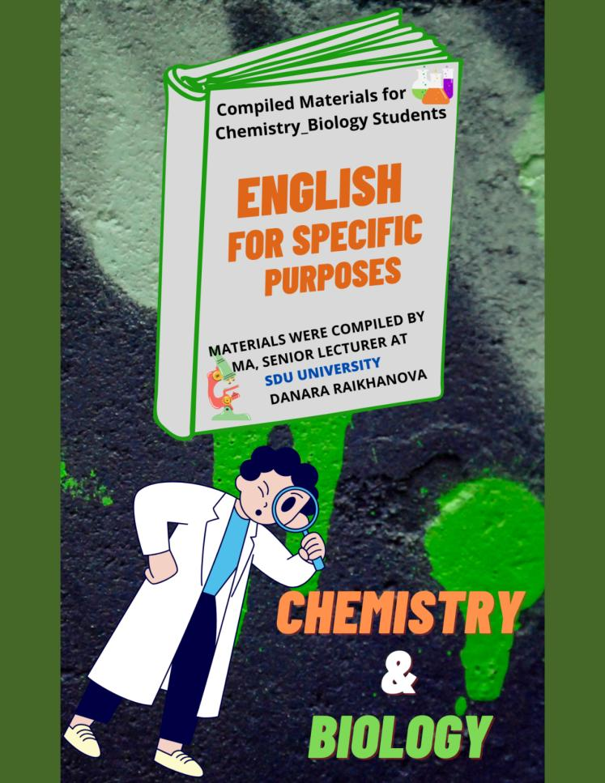
APPENDIX B
Certificate of entry into the State register of rights to objects protected by copyright, for compiled materials “English for Specific Purposes (for chemistry-biology students)”
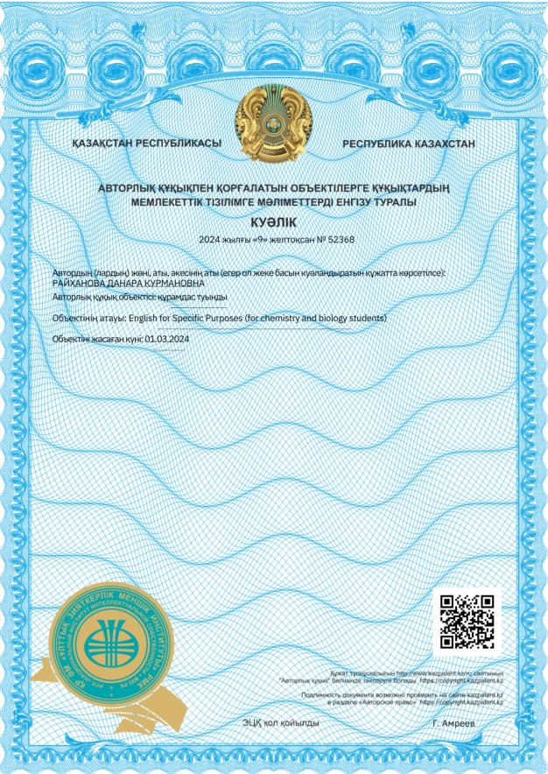

APPENDIX C
Act of implementation
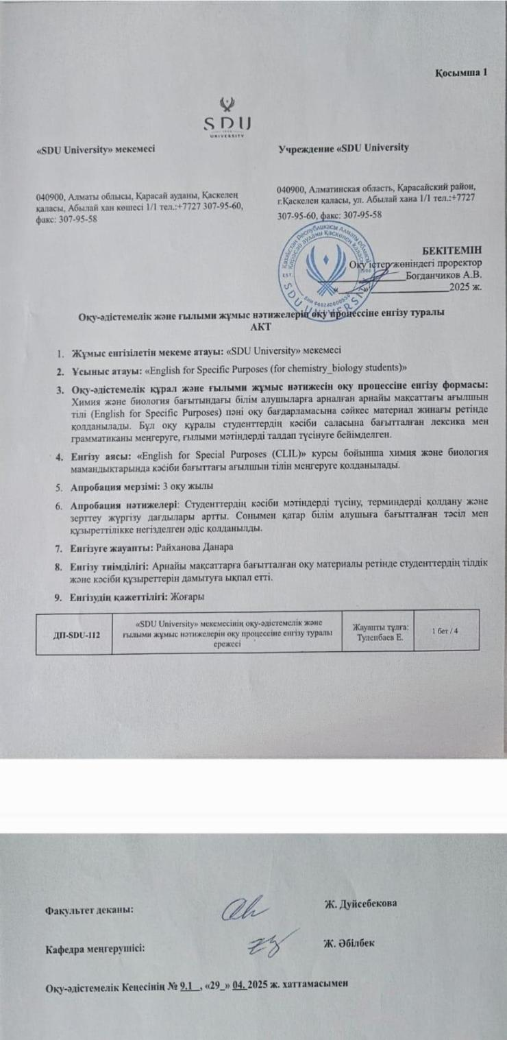

APPENDIX D
Assessment rubric for written work

 | Exceeds expectations (A) | Meets Expectations (B) | Needs Improvements (C) | Below Expectations (D)
Content | Clearly focused content, relevant to title, scope and level of detail are appropriate/ relevant. Arguments are well presented and developed, with supporting evidence from a variety of sources. Shows awareness of complexities of the topic. | Generally well- focused content May be lacking level of detail or development of ideas and/or limited in scope (which may affect length). Much of the content may be descriptive, when a critical approach is required. Some understanding of complexities of topic evident. Arguments may be inconsistent or insufficiently developed. | Focus at times waivers; some content may be irrelevant. Clearly limited in level of detail, superficial treatment of subject, with no development of ideas. Shows lack of awareness of complexities of topic. May be very short. Little or no evidence of evaluation of ideas, staying mostly at the descriptive level. No clear line of argument. | No obvious focus, clearly content inadequately researched; unable to deal with topic (probably very short) or wholesale plagiarism has made it impossible to assess the true level. Too much personal material.
Use of source materials | Effective use of range of sources, appropriate incorporation through paraphrase / quotations / summary. Shows ability to synthesise well from several sources to support ideas. Bibliography and referencing follow academic convention, and a range of sources are used. No obvious / conscious plagiarism. | Effective use of sources, mostly when summarising / paraphrasing ideas clearly. Shows some evidence of synthesis of information. Bibliography and use of sources show an understanding of the concept of referencing, though this is not always followed, e.g., bibliography missing publisher / not in alphabetical order, references in text include first name/title. No obvious / conscious plagiarism. | Limited sources used, and summary / paraphrase of ideas not always clear. Some attempts at synthesis of ideas. Clearly has problems compiling bibliography and incorporating sources in an appropriate way, although there is some attempt to do this. Poor language control may be a factor. Suspicion of plagiarism in some sections. | Inadequate attempt to use source material, e.g., may only use one source or none. Content based mainly on the student's view with no evidence to support it. Shows little misunderstanding of the importance of referencing and academic conventions. No bibliography or, where this exists, does not follow appropriate academic convention. No reflection of course content.
Organisation | Overall structure and main ideas are clearly organised and easy to follow. Introduction outlines the structure of the project and has a clear thesis. Conclusion is clear, with evidence of evaluation of the work. Ideas are effectively linked together and ‘flow’ coherently and cohesively, making it easy for the reader to follow. Appropriate headings in text make it easy for reader to follow. | Overall structure and main ideas are generally obvious. Introduction and/or conclusion may not be appropriately linked to main body. Lack of headings in some sections hinders reader. At times a tendency to move from one idea to another with no attempt to link them. | Difficult for reader to establish overall structure / identifying main ideas. May be due to poor language control, which also affects cohesion. Introduction / conclusion may be inadequate. Frequent move from one idea to another, with no attempt to link them. | Ineffective attempt to organise the work. Very difficult for reader to follow the text. The introduction fails to give the reader an overview / clear idea of what will follow or wholesale plagiarism has made it impossible to assess true level.
Language | Complex ideas clearly expressed, with wide, accurate usage of vocabulary and grammar; any errors do not impede communication. Appropriate academic style, with good grasp of hedging, etc. Use of a wide range of connectors to link ideas at paragraph and sentence level. | Ideas on the whole clearly expressed. Linking of ideas within paragraphs generally appropriate, but at times lacking between sections. Some vocabulary and/or grammar problems, but generally do not impede communication. Spelling and/or punctuation may lack control, although this generally does not interfere with comprehension. | Some ideas are simply expressed, but other ideas are not clearly expressed. No evidence of ability to express complex ideas. Linking between and within sentences may be inconsistent. Fairly serious vocabulary and/or grammar problems; can impede communication. Spelling and/or punctuation may be fairly seriously flawed. May be too much use of lists rather than continuous prose. | The level of vocabulary and grammar is so consistently weak and the spelling / punctuation so poor that the end product fails to achieve its purpose due to ineffective communication (or wholesale plagiarism has made impossible to assess true level).
Adapted from J. McCormack & J. Slaght. English for Academic Study: Extended Writing & Research Skills. University of Reading.

APPENDIX E
Rubric of Presentation Assessment
 | Profile A | Profile B | Profile C | Profile D
Delivery | Pronunciation hardly interferes with comprehension. Volume and speed are appropriate. Rhythm and intonation are varied and appropriate. Good eye contact. | Pronunciation of individual words occasionally interferes with comprehension. Volume and speed are adequate. Rhythm and intonation generally appropriate. Eye contact may be limited. | Pronunciation of chunks of language at times makes comprehension impossible. Volume / speed may be inadequate, and there is little or no eye contact. May be inappropriate use of gesture. | Pronunciation and intonation frequently impede comprehension, making it difficult to evaluate the presentation. May be inaudible.
Language | Clear evidence of ability to express complex ideas, using a wide range of appropriate vocabulary. Cohesive devices, where used, contribute to fluency. High degree of grammatical accuracy. | Some ability to express complex ideas, although not consistently. Reasonable use of range of vocabulary and structures. Cohesive devices, where used, contribute to fluency, but are sometimes misapplied. | Range of vocabulary and structures are adequate to express simple ideas. Errors sometimes impede communication. | Very limited range of vocabulary and grammar means ideas are expressed with difficulty. Presentation is often repetitive, due to insufficient control of language.
Organisation | Strong introduction, with clear outline. Logical ordering of main points. Effective conclusion. | Generally, there is a logical ordering of main ideas. Introduction/ conclusion are linked with main points. | Presentation lacks clear organisation of ideas, making it difficult to follow. | Lack of any apparent organisation makes it difficult to follow presentation.
Content | Content is appropriate and relevant. Topic is explored in sufficient depth. | Content is mostly appropriate and relevant. | Content is at times irrelevant, and development of ideas is superficial. | Content is always related to the topic and there is little development of ideas.
Evidence of preparation | Evidence of thorough familiarity with topic. Fluent delivery, with skilful use of notes. Deals well with questions. Use of PowerPoint / Poster enhances presentation. | Familiar with topic. Use of notes sometimes interferes with delivery of presentation. Use of PowerPoint / Poster at times distracts from presentation content, due to unclear script / inappropriate pictures / posters / poor timing. | Reasonable preparation. Organisation mostly clear and logical. Acceptable use of visual aids. Some difficulty in dealing with questions. | Inadequate preparation, with little evidence of familiarity with subject. Visual aids unhelpful, unclear or ineffective. Too much focus on PowerPoint / Poster rather than basic content. Inability to deal with questions.
Comments:Adapted from J. McCormack & J. Slaght. English for Academic Study: Extended Writing & Research Skills. University of Reading.

APPENDIX F
Grading rubric of project work
 | Exceeds expectations (A) | Meets Expectations (B) | Needs Improvements (C) | Below Expectations (D)
Content | All information is clear and comes from reputable sources. Extensive details & relevant examples are used to support the content. | Use relevant information. Include many details and strong examples that come from reputable sources. | Information relates to the topic, but the project needs more details and examples to fully support ideas. | Information does not include details or examples that relate to the topic. Information does not come from a reliable source.
Design | Design is unique & interesting. Uses five and more original media items. | Design is original. Use three to five original media items. | Make a few changes to background or layout. Use one or more original media items. | Use only design templates. Media and ideas are not original.
Organisation | Every assignment is complete, accurate, and on time. Use time well. Create a list or calendar to track progress. Modify work habits to finish project on time. | Finish assignment on time. Most of the work is done on time. Monitor the progress frequently. Complete all required tasks on schedule. | Most assignments finish on time. Some work is not done on time. | Rarely finish assignments on time. Did not use time well. Little or no work is done on time.
Teamwork | Identify and make a complete list of tasks that need to be done. Use the list of divided work fairly. Evaluate tasks and assign them to appropriate team members. | Identify and make a list of tasks that need to be done. Assigned work that was too easy or too hard for one or more team members. | Did not identify some of the tasks that need to be done. Did not assign work fairly between team members. | Did not identify many tasks that need to be done. Did not assign work fairly between team members.
Oral Presentation | Demonstrate a thorough knowledge of the subject matter. Able to use audience questions to further demonstrate understanding of the topic. Appear to be an expert on the subject being presented. | Demonstrate a working knowledge of the subject matter. Able to satisfactorily answer audience questions and provide additional information upon request. | Demonstrate a basic knowledge of the subject matter. Able to address audience questions by repeating parts of the presentation - do not provide any additional information. | Demonstrate little or no knowledge of the subject. Unable to answer audience questions or comment further on any part of the presentation.

APPENDIX G
Questionnaire from language practitioners

General English Instructors:
1. What type of English language subjects have you taught?
2. Is it important to respond to your students’ needs? If yes, what?
3. What course materials (books) do you use?
4. Are you satisfied with course materials you use? Why?
5. Do you agree that English language materials (books) should be selected to meet students’ professional needs? Why?
6. What are your future expectations from your learners?
7. Do you think it is necessary to conduct needs analysis from your learners to find out if your subject satisfies their wants? Why?
8. Comments and suggestions _____________________________________________

ESP Instructors:
1. Have you ever had an experience in teaching science English? If yes, how long?
2. What is your future expectation from your learners?
3. Is it important to respond to your students’ needs? If yes, what?
4. What (course) material do you use?
5. What are your likes about the current ESP course?
6. What are your dislikes about the current ESP course?
7. How do you think to what extent the four main skills (writing, reading, listening and speaking) are significant for your students?
8.Comments and suggestions to improve ESP course ___________________________________

Thank you for your time!

APPENDIX H

Questionnaire from content teachers and chemistry - biology students

Content Instructors:
1. Are you satisfied with English level of your students?
2. What abilities do you want your learners to be able to do with English in your subject?
3. What do you suppose which main skills (writing, reading, listening and speaking) are important for your learners?
4. What main topics should be selected in the content of the ESP programme to help understanding your subject?
5. What should ESP teachers do to prepare learners better so they can meet all their needs in their future career?
6. Comments and suggestions to improve ESP course __________________________________

Chemistry - Biology students who enrolled in 2018-2019 academic year:

# | Respondents | Strongly Agree (%) | Agree  (%) | Neutral  (%) | Disagree  (%) | Strongly Disagree (%)
1 | English is significant for your academic studies
2 | ESP course meets your study expectations
3 | ESP course is helpful in understanding your major subjects (chem-bio) in English
4 | ESP classes are relevant to your needs
5 | Materials should be more focused on Chemistry – Biology
6 | Materials should be more focused on Academic English
7 | Teaching methods used by teacher are useful
8 | The teaching methodologies used by teacher are appropriate
9 | During ESP classes you have opportunities to work in groups and pairs
10 | Do you enjoy your ESP classes?
11 | The evaluation procedures in the course are carried out appropriately
12 | English is necessary in your future career

Chemistry - Biology students who enrolled in 2019-2020 academic year:

# | Respondents | Strongly Agree (%) | Agree (%) | Neutral (%) | Disagree (%) | Strongly Disagree (%)
1 | English is significant in my academic studies
2 | English will be necessary for my future career
3 | General English met my academic expectations
4 | ESP met my academic expectations
5 | ESP was helpful in understanding your main subjects (chemistry - biology) in English
6 | General English should be replaced by ESP

Thank you for your time!

APPENDIX I
Online survey questions for different department coordinators to identify the key competencies and essential academic skills in higher education.

Dear Faculty Coordinators,
Over the next academic year, the ESP programme is going to undergo tremendous changes. Now, we are in the process of collecting authentic materials from each department, in order to link the content of ESP to each department's major courses. This will help to prepare our students for better academic performance in their fields.

Please take 10-15 minutes to complete this form.

1. First Name and Surname ___________________________________________
2. What is your Department? __________________________________________
3. What are the main 5 things that students are expected to learn by the time they complete their degree? _________________________________________________
4. Which academic skills are the most important for students to acquire in your department (tick several)?
- Analytical reading
- Building communication
- Critical thinking
- Delivering presentations
- Digital literacy
- Essay writing
- Group projects
- Listening
- Note-taking
- Problem solving
- Public speaking
- Report writing
- Add option ___________

5. What outputs are your students are expected to produce during the course (tick all that apply)?
- Case study analysis
- Debates
- Presentations
- Projects
- Role play
- Seminar discussions
- Thesis
- Written reports / essays
- Other _____________________
6. Which of the following genres of writing do you expect your students to produce?
- Article review
- Essay
- Literature review
- Proposal
- Reflective diary
- Report
- Research
- Other _______________
7. What kind of tasks do you set to develop your students' reading skills (tick all that apply)?
- True /False
- Paragrapg labelling
- Identifying the summary sentence
- Comprehension questions
- Vocabulary
- Add option _______________
8. Which aspects of spoken skills should students demonstrate in your course (tick all that apply)?
- Background settings
- Descriptive
- Formal
- Informal
- Persuasive
- Summarising
- Other _________________
9. What kind of listening materials are used on your course (tick all that apply)?
- Debate show
- Documentaries
- Live lectures
- Podcasts
- Recorded lectures
- Radio broadcast
- TED talks
- TV reports
- Video
- Add option __________________
10. Please indicate the 3 most common types of homework assignments set on your (major) course. __________________________________________________

Thank you for your time! Please, click submit.

APPENDIX J

Learner Evaluation of Unit 1: “Chemistry in Our Lives”

Dear Students,
Thank you for taking the time to provide feedback on the English for Specific Purposes (ESP) materials compiled by me. Your input is invaluable in evaluating and improving the materials to better meet your language and professional needs. Your responses will help us assess the relevance, effectiveness, and suitability of the materials in relation to your field of study and profession. Your honest feedback is greatly appreciated.

1. Does the first unit (Chemistry in our Lives) align with your specific English language needs related to your field of study or future profession?
- Yes
- No
- Other
2. Are the tasks covered in the first unit relevant and applicable to your field of study or future profession?
- Yes
- No
- Other
3. Are there any specific topics or areas that you feel are missing from the first unit? If yes, what are they? __________________________________________________
4. Are the language skills (reading, writing, listening, speaking) adequately addressed in the materials?
- Strongly disagree
- Disagree
- Neutral
- Agree
- Strongly agree
5. Are there any specific language areas that you would like to see more focus on? If yes, what are they? _____________________________________________________________
6. Do you find the language level of the first unit appropriate for your proficiency level?
- Yes
- No
- Other ___________
7. Are the materials challenging enough to help you progress in your English language skills?
- Yes
- No
- Other ___________
8. How do you think which tasks are not appropriate for you? Explain why? ______________________________________________________________________
9. According to Unit 1, do you like the process of learning? If not, please write any ideas to make it better. _________________________________________________
10. Write your suggestions about tasks, activities you want to do in the class, and out of the class. ___________________________________________________________________
11. Do you agree to have similar tasks in Unit 2? _________________________________________________________________________
12. Do you have any additional feedback, suggestions, or recommendations for improving the materials?
If yes, what are they? _________________________________________________________________
Thank you for your time. Your feedback will contribute to the ongoing enhancement of the ESP materials and ensure that they effectively address your specific English language and professional needs

APPENDIX K
Semi-structured interview on course evaluation from chemistry-biology students (N=11) during the 2022-2024 academic years, selected using purposive sampling technique.

SDU University
Faculty of Education and Humanities
Email: danara.raikhanova@sdu.edu.kz
Office E402
Participant Consent Form
PhD Thesis Title: ESP Curriculum Development for Chemistry-Biology Students in Kazakhstani Education

Dear Participant,
You are invited to take part in a research study conducted by Danara Raikhanova, MA, senior lecturer of the Faculty of Education and Humanities, SDU University. The purpose of this study is to explore the effectiveness of an ESP curriculum for chemistry-biology students. Your responses will contribute to improving the design and delivery of English courses tailored to the needs of students in scientific disciplines.

What Participation Involves:
Your participation will include providing answers for the survey.

Your Rights as a Participant:
Your participation in this survey is voluntary, and you may choose to withdraw at any time without any consequences. You have the right to skip any question that you are not comfortable answering. Your responses will remain confidential, and all data will be used solely for research purposes. No identifying information will be shared with third parties, and results will be reported in aggregate form.

Potential Benefits:
Your input will help improve curriculum development and enhance educational practices in the field of English for Specific Purposes (ESP). Your feedback will contribute to creating more effective learning materials and instructional strategies, ultimately benefiting future students in similar academic programmes.

Risks:
There are no foreseeable risks associated with this study.

Contact Information:
If you have any questions or concerns about this survey, please feel free to contact danara.raikhanova@sdu.edu.kz or in the office E402.

Background Information: Year and major of study _____________________________
About the ESP Course:
1. Were the ESP course goals relevant to your academic and professional needs? If Yes, why or why not?
2. How useful and relevant were the materials and activities used in ESP? (example: challenging, useful, interesting, outdated, not relevant)
3. Were the materials well-adapted to your field (chemistry/biology)?
4. Was the course well-structured and engaging? What could be improved?
5. Did you have enough opportunities for interaction (discussions, group work, project work, case study)? Which one did you like more?
6. Were you satisfied with assessment and evaluation methods used in ESP course? Would you suggest any changes in how students are evaluated?
7. Did the ESP course improve your confidence in using English in another content disciplines? If yes, in what way? Or maybe ESP course was useful for another major (content) subjects?7. Did the ESP course improve your confidence in using English in another content disciplines? If yes, in what way? Or maybe ESP course was useful for another major (content) subjects?
8. How would you rate the overall course quality (1 (poor)-5 (excellent))?
9. Would you recommend this ESP course to future students?
Thank you very much for your contribution. Your responses are very valuable. The last question is optional (just as recommendation).
10. What changes would you suggest to improve the course?

APPENDIX L

Survey questionnaires for chemistry-biology alumni who took ESP course.

Dear Participants,
Thank you for taking the time to participate in this survey. As part of my PhD research, I am investigating the effectiveness and impact of English for Specific Purposes (ESP) courses on students’ academic and professional development. Your insights and experiences are invaluable in understanding how these courses have influenced your education and career.
Your participation is crucial in helping us improve the ESP curriculum and better align it with the needs of students in specific fields. Thank you for your contribution to this important research!
Sincerely,
Danara Raikhanova, Senior Lecturer, MA at SDU University

1. Your Age ________________ 2. Gender __________________
3. Current Job Place:
- School
- High School
- College
- University
- Educational Centre
- Other ____________
4. Please indicate your level of agreement with the following statements (1 = Strongly Disagree, 2= Disagree, 3= Neutral, 4 = Agree, 5 = Strongly Agree):
 | 1 | 2 | 3 | 4 | 5
1.The ESP course was beneficial for my career
2. I use English skills learned in the ESP course in my current job.
3. The ESP course improved my confidence in using English in professional settings.
4. The course content was relevant to my field of study and career
5. The ESP course provided practical skills that I apply in my job.
6. The ESP classes were relevant to my needs
7. The teaching methods used by the instructor were useful
5. Which skills from the elective course do you use most frequently in your job? (Select all that apply):
- Critical thinking
- Problem solving
- Communication skills
- Subject-oriented vocabulary
- Team work, Project work, and collaboration
- Researching
- Other _______________
6. How well did the ESP course prepare you for your job?
- 1 Not at all
- 2
- 3
- 4
- 5 Significantly
7. How would you rate the overall quality of the ESP course?
- 1 Poor
- 2
- 3
- 4
- 5 Excellent
8. Would you recommend the ESP course to future students?
- Yes
- No
9. What changes would you suggest to improve the ESP course? _______________________________________________________________________

10. Is there anything else you would like to share about your experience with the ESP course?
_______________________________________________________________________

APPENDIX M
Syllabus for Academic English course

Course Code: PED 108
Department: Department of Pedagogical Mathematics and Natural Science
Course Title: Academic English 1
Credits/ECTS: 5 ECTS
Degree Cycle (Level): Bachelor degree
Course Type: Full-time study
Language of Instruction: English
Course Description
The purpose of the PED -108 course is to equip students with the skills necessary
for conducting research and for producing projects in their own subject-specific area. An integrated approach is used throughout the teaching and learning process where writing and research skills are given special attention. The goal of this course is to give students the tools they need to undertake research and create an extended piece of writing in their chosen fields.
Instructor (s)
Name Surname: Danara RAIKHANOVA
Degree: MA, senior lecturer
Contact information: danara.raikhanova@sdu.edu.kz
Skills and competences
Academic Skills:
1. Able to produce an extended piece of writings;
2. Develop discursive skills - to communicate effectively both orally and in writing;
3. Understand conventions of the academic community;
4. Boost reading and research skills;
5. Identify and apply academic techniques as paraphrasing /summarising, quoting and avoiding plagiarism;
Subject-Specific Skills:
1. Improve speaking skills to participate in academic seminars and discussions
related to subject-related topics;
- Design effective (poster) presentation skills on subject-specific sphere;
- Develop critical thinking and learner autonomy;
- Advance research skills on subject-specific topics;
Weekly course plan
# | Topics | Activity
1 | Introduction to the skills of extended writing and research | Critical thinking in academic study; Types of writing; Introduction and explanation of own project;
2 | Using evidence to support your ideas (1) | Selective reading: reading for research purpose; Referencing;
3 | Using evidence to support your ideas (2) | Features of a summary; Stages in writing a summary or paraphrase; Practising;
4 | Structuring your project and finding information (1) | The structure of projects; Descriptive and evaluative writing; Finding information’
5 | Structuring your project and finding information (2) | Analysing websites; Online sources; Writing a bibliography;
6 | Developing your project (1) | Discussing feedback on draft text; Quotations, paraphrases and plagiarism;
7 | Developing your project (2) | Avoiding plagiarism; Working with abstracts; MIDTERM EXAM #1
8 | Introductions, conclusions and definitions (1) | Features of introductions; Analysing your introduction; Identifying the thesis statement;
9 | Introductions, conclusions and definitions (2) | Features of conclusion and definitions;
10 | Incorporating data and illustrations (1) | The purpose of data; The language used for incorporating data;
11 | Incorporating data and illustrations (2) | Data commentary; Practising data commentary;
12 | Preparing for conference presentations and editing your work (1) | Features of abstracts; Conference abstracts;
13 | Preparing for conference presentations and editing your work (2) | Preparing an oral presentation; Preparing a poster presentation; MIDTERM #2
14 | Project Work (1) | Leading seminar (half group)
15 | Project Work (2) | Leading seminar (second half of the group)
Course Learning Outcomes
- Brainstorm and plan the assigned work individually and in groups
- Incorporate ideas and information into text through paraphrasing / summarising and
synthesising
- Present (poster, ppt) presentations individually or in teams
- Produce lead seminars by practising in participating in discussions and seminars
- Develop presentation skills on subject-specific sphere through completing exercises
and assignments
Planned Learning Activities and Teaching Method
● Lecture
● Questions & Answer
● Discussion
● Problem Solving
- Critical Thinking
- Project Based
- Research Based
Reading List
If the number of Required / Recommended / Other reading list is more than one, you can add a line below
Type: Recommended/ Author: Joan McCormack and John Slaght
Title: Extended Writing & Research Skills/ Publishing year: 2009/ Publisher/Web site: Garnet
Academic Integrity
Students must ensure that all work completed for this course is their own work. Any evidence of plagiarism, data falsification, fabrication, collusion, self-plagiarism and/or other forms of academic misconduct will be penalised. Further, information can be found in the Code of Practice on Academic Integrity.

APPENDIX N
Syllabus for English for Special Purposes course
Course Code: PED 128
Department: Department of Pedagogical Mathematics and Natural Science
Course Title: English for Special Purposes 1
Credits/ECTS: 5 ECTS
Degree Cycle (Level): Bachelor degree
Course Type: Full-time study
Language of Instruction: English
Course Description
The course deals with the study of basic tools students need to speak English with confidence in chemistry and biology subjects. The course offers a blend of classroom teaching and self-studying. Each lesson has been carefully combined to ensure that students will be equipped with genuinely useful language that they can take out of the classroom and use in their sphere. The aim of the course is to form students’ communicative and professional competencies as well as develop their reading and writing skills for academic purposes. The course consists of mainly practical lessons. The course English for Specific Purposes is an important component of general knowledge for future Chemistry and Biology teachers, which includes vocabulary and reading based on themes from Science, and will enable students to perform everything in English. The relevance with the other courses is direct, especially with all Practical English Courses.
Instructor (s)
Name Surname: Danara RAIKHANOVA
Degree: MA, senior lecturer
Contact information: danara.raikhanova@sdu.edu.kz
Skills and competences
Academic Skills:
1. Language skills to effectively use in speaking and writing;
2. Presentation skills, including organisation, preparation and delivery techniques;
3. Communication skills are taught and practised;
4. Boost reading and research skills;
Subject-Specific Skills:
- Reading and writing skills of specific content in a subject-specific genre and format;
- Effective (poster) presentation skills on subject-specific sphere;
- Speaking on subject related topics by using a wide range of terms;
- Critical thinking and learner autonomy;
- Research skills on subject-specific topics;
Weekly course plan
№ | Topics | Activity
1 | Introduction | Introduction to the course, explanation of rules and regulations, discussion instructor and learner expectations of the course;
2 | Chemistry in Our Lives (1) | Section A: Chemistry & Chemicals;  Section B: Maths Skills for Chemistry;
3 | Chemistry in Our Lives (2) | Section C: Language Skills;  Section D: Grammar; Section E: Unit Review
4 | Life on Earth (1) | Section A: What is Life?  Section B: What is Science?
5 | Life on Earth (2) | Section C: Language Skills; Section D: Grammar; Section E: Unit Review; UNIT QUIZ #1;
6 | Bonding (1) | Section A: Intramolecular / Intermolecular Forces of Attraction; Section B: Naming Compounds;
7 | Bonding (2) | Section C: Language Skills; Section  D: Grammar; Section E: Unit Review; MIDTERM EXAM;
8 | Plants (1) | Section A: How are plant bodies organised?; Section B: Language Skills;
9 | Plants (2) | Section C: Grammar; Section D: Task-Based Project; Section E: Unit Review; Presenting Group Projects; UNIT QUIZ #2;
10 | Acids & Bases (1) | Section A: Naming Acids and Bases; Section B: Strong and weak acids and bases;
11 | Acids & Bases (2) | Section C: Language Skills; Section D: Grammar; Section E: Unit Review;
12 | Homeostasis & Animal Anatomy (1) | Section A: homeostasis; Section B: How the animal body is organised? Section D: Grammar explanation;
13 | Homeostasis & Animal Anatomy (2) | C: Individual Project Work; Section D: Grammar; Section E: Unit Review; UNIT QUIZ #3;
14 | Project Work Defence (1) | Each group is required to submit a project work. Rules and regulations are introduced at the very beginning;
15 | Project Work Defence (2) & Consolidation | Each group is required to submit a project work. Rules and regulations are introduced at the very beginning; Preparing for the finals.
Course Learning Outcomes
- Define subject specific vocabulary words / terms;
- Understand and use useful phrases and words related to chemistry and biology;
- Discuss a wide range of subject specific topics;
- Describe subject specific principles, methods;
- Improve reading and writing fluency on subject specific topics with academic elements;
- Give effective presentations including organisation, preparation, and delivery techniques;
- Identify roots, prefixes, suffixes; appropriately apply synonyms and number skills; interpret and incorporate visual aids;
- Follow essential grammar rules needed for scientists;
- Create project works by providing personal information collected in (10) 12-week time.
Planned Learning Activities and Teaching Method
- Lecture
- Questions & Answer
- Discussion
- Problem Solving
- Critical Thinking
- Language and Vocabulary skills
- Case Study
- Project Based Learning
Reading List
If the number of Required / Recommended / Other reading list is more than one, you can add a line below
Type | Author | Title | Publishing year | Publisher
Required | Stephen Bailey | Academic Writing | 2015 | Routledge
Required | Karen Timberlake &  William Timberlake | Basic Chemistry | 2017 | Pearson
Required | Gerald Audesirk, Teresa Audesirk, & Bruce E. Byers | Biology: Life on Earth | 2017 | Pearson
Required | Simon Clarke | English Grammar in Context | 2008 | Macmillan
Required | Michael Vince | English Grammar in Context | 2008 | Macmillan
Assessment Methods and Criteria
The University’s normative rules regarding assessment apply. See the Code of Practice on Assessments. These norms set the boundary conditions for all instructors of University. If the pre-final grade is more than one, you can insert a row below in the table.
Assessment | Description | Quantity | %
Assignment | Pre-final | 6 | 24
Quiz | Pre-final | 3 | 15
Attendance | Pre-final | 45 | 9
Midterm Exam | Pre-final | 1 | 12
Project Work + Written Exam | Final | 1 + 1 | 10 + 30
Total |  |  | 100

Academic Integrity
Students must ensure that all work completed for this course is their own work. Any evidence of plagiarism, data falsification, fabrication, collusion, self-plagiarism and/or other forms of academic misconduct will be penalised. Further, information can be found in the Code of Practice on Academic Integrity.

APPENDIX O
Pre - Test Questions to assess students' initial knowledge in chemistry and biology in English language.

Student’s Full Name ______________________________ / Pre-Test for ESP course
A Match the terms in Column A with their definitions in Column B and write the correct letter to Column C.
Column A | Column B | Column C
1. Antioxidants | a. A biological molecule that carries genetic information.
2. Photosynthesis | b. The process by which plants convert light energy into chemical energy.
3. Ionic bond | c. A type of bond formed by the transfer of electrons between atoms.
4. Prokaryotic cell | d. A cell without a nucleus.
5. Buffer | e. A substance that minimizes changes in pH.
Answers: 1-e, 2-b, 3-c, 4-d, 5-a

B Complete the sentences with appropriate words from the box.
Antioxidants Photosynthesis Organelles Hydrogen bond Taproot

- The process of __________ provides energy for most life forms on Earth.
- A __________ is a strong root that grows vertically downward.
- DNA is held together by a type of weak attraction known as a __________.
- __________ help prevent damage to cells by neutralizing free radicals.
- The nucleus and mitochondria are examples of __________ within a cell.
Answers: 1-photosynthesis, 2-taproot, 3-hydrogen bond, 4-antioxidants, 5-organelles
C Choose the correct answer.
1. Which of the following is NOT part of an organ system?
a. Epithelial tissue b. Skeletal system c. Digestive system d. Endocrine system
2. What is the main function of chlorophyll in plants?
a. Absorbing nutrients b. Storing water c. Absorbing sunlight d. Breaking down food
3. Which bond involves the sharing of electron pairs between atoms?
a. Ionic bond b. Polar covalent bond c. Metallic bond d. London dispersion forces
4.The pH scale measures:
a. Concentration of hydrogen ions in a solution b. Concentration of oxygen in a solution
c. Temperature of a solution d. Density of a solution
5. Which organ system is responsible for transporting nutrients and oxygen throughout the body?
a. Nervous system b. Respiratory system c. Circulatory system d. Digestive system
Answers: 1-a, 2- c, 3- b, 4- a, 5-c
D Fill in the gaps with appropriate organ system.
1. The _______________ (1) helps pump blood throughout your body.
2. The _______________ (2) breaks down food so your body can use it for energy.
3. The _______________ (3) is responsible for sending messages between your brain and body.
4. The _______________ (4) gives your body shape and support with bones.
5. The _______________ (5) allows humans to have babies.
6. The _______________ (6) helps you move by working with your muscles.
7. The _______________ (7) sends hormones into the bloodstream to regulate your body.
8. The _______________ (8) removes waste from your body through urine.
9. The _______________ (9) protects you from getting sick by fighting off germs.
10. The ______________ (10) helps you breathe in oxygen and breathe out carbon dioxide.
11. The _______________ (11) includes your skin, which protects your body from outside harm.
Answers: 1. circulatory system; 2. digestive system; 3. nervous system; 4. skeletal system; 5. reproductive system; 6. muscular system; 7. endocrine system; 8. urinary system; 9. immune system; 10. respiratory system; 11. integumentary system
E Read the passage and answer the questions below.
Plants are important for our world. They have different parts that help them grow and survive. The first part is the root system. Roots grow underground and help the plant stay in place. They also take water and nutrients from the soil.
Above the ground, there is the shoot system, which includes the stem, leaf, and flower. The stem is like a bridge. It connects the roots and the leaves. It supports the plant and helps transport water and nutrients.
The leaf is usually green and helps the plant make food through a process called photosynthesis. Leaves take in sunlight and air to create energy.
Finally, many plants have a flower. The flower is very colorful. It helps the plant reproduce by making seeds. Different parts of the plant have special jobs, and they all work together to keep the plant healthy and strong.
1. What is the primary function of the plant's root system?
a. To absorb sunlight b. To provide support and stability
c. To produce flowers and seeds d. To transport water and nutrients
2. Which part of the plant is responsible for photosynthesis?
a. The stem b. The flower c. The root d. The leaf
3. How do the different parts of the plant work together?
a. They compete for resources b. They function independently
c. They rely on each other to survive and thrive d. They have no connection to one another
4. What is the role of the stem in the plant's structure?
a. To store food b. To attract pollinators
c. To connect the roots and leaves d. To produce oxygen
5. Why is the flower an important part of the plant?
a. It helps the plant absorb water b. It provides shade for the plant
c. It enables the plant to reproduce d. It contributes to the plant's photosynthesis
6. How do the roots help the plant survive?
a. They produce energy for the plant b. They make the plant more colorful
c. They anchor the plant in the soil d. They convert sunlight into food
7. What is the primary function of the plant's leaves?
a. To support the stem b. To store water c. To create seeds d. To manufacture food
Answers: 1 - b, 2 - d, 3 - c, 4 - c, 5 - c, 6 - c, 7 - d

APPENDIX P
Post-Test Questions to measure improvements in knowledge and skills of chemistry - biology students after ESP course.
Student’s Full Name ______________________________ / Post-Test for ESP course

A Read the text and choose the correct answer.
Forensic Scientists Discover Natural Antioxidant’s Ability to Break Down Synthetic Substances
In a breakthrough development in the field of forensic science, researchers have uncovered the remarkable potential of a natural antioxidant to break down synthetic substances. This discovery, resulting from a comprehensive study conducted
by a team of forensic scientists, could revolutionize chemical processes in various industries.
Chemistry lies at the heart of this groundbreaking research. The composition of matter and the intricate chemical reactions that occur during various processes have long fascinated scientists. In recent years, the focus has been on finding ways to convert synthetic substances into more digestible and environmentally friendly forms.
Enter antioxidants, natural substances known for their ability to combat the harmful effects of free radicals. Traditionally, antioxidants have been associated with promoting health and preventing disease. However, this new research has unveiled an additional dimension to their potential.
By meticulously examining the chemical properties of diverse antioxidants, the team of forensic scientists identified a particular compound with an uncanny ability to break down synthetic substances. This chemical process occurs through a series of reactions that effectively dismantle the synthetic matter, rendering it more manageable for decomposition and removal.
The implications of this discovery are far-reaching. Industries that produce synthetic materials, such as plastics and polymers, struggle with their environmental impact and the challenges posed by their disposal. The newfound ability to break down these substances using natural antioxidants provides a promising solution to this predicament.
Moreover, the forensic scientists behind this breakthrough emphasize the significance of using natural substances over synthetic alternatives. Synthetic chemicals often have unknown long-term effects on the environment and human health, making their utilization a matter of concern. By harnessing the power of natural antioxidants, scientists can now address these concerns while promoting sustainability and eco-friendliness.
Dr. Emily Watson, the lead researcher on the project, highlights the potential forensic applications of this discovery. "Not only can natural antioxidants aid in the decomposition of synthetic substances, but they can also serve as valuable tools in forensic investigations," she explains. "Their ability to break down and alter synthetic materials opens up new avenues for gathering evidence and analyzing crime scenes."
As the scientific community celebrates this groundbreaking achievement, further research is already underway to explore the full potential of natural antioxidants. The hope is to develop efficient and scalable methods for utilizing these substances in a wide range of applications, from waste management to the remediation of polluted environments.
In conclusion, the recent discovery by forensic scientists regarding the antioxidant's ability to break down synthetic substances marks a significant milestone in the fields of chemistry and forensic science. With its potential to revolutionize chemical processes and promote sustainability, this breakthrough paves the way for a greener and more environmentally conscious future.
- What is the main focus of the recent breakthrough in forensic science?
A. Analyzing crime scenes B. Identifying natural antioxidants
C. Breaking down synthetic substances D. Promoting health and preventing disease
- How do antioxidants break down synthetic substances?
A. Through chemical reactions B. Through physical force
C. Through digestion D. Through natural decomposition
3. What is one potential benefit of using natural antioxidants?
A. Unknown long-term effects B. Environmental impact
C. Health promotion D. Sustainable and eco-friendly solutions
4. Which industry could benefit from the ability to break down synthetic materials?
A. Agriculture B. Fashion C. Forensic science D. Plastics and polymers
5. What potential applications do forensic scientists see for natural antioxidants?
A. Gathering evidence and analyzing crime scenes
B. Promoting sustainability in industries
C. Developing efficient waste management methods
D. Remediation of polluted environments
Answers: 1- C, 2 - A; 3 - D; 4 - D; 5 - A
B Write the correct name of each biological organization.
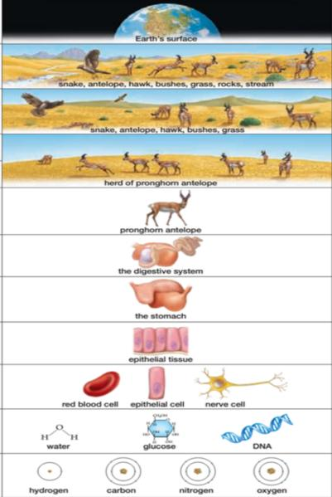
12. ___________________________

11. ___________________________________

10. ___________________________________

9. _________________________________

8. _________________________________

7. _________________________________

6. _________________________________

5. _________________________________

4. _________________________________

3. _________________________________

2. _________________________________

1._________________________________

Answers: 1- Atom, 2 - Molecule, 3 - Cell, 4 - Tissue, 5 - Organ, 6 - Organ system, 7 - Mollecular organism, 8 - Population, 9 - Species, 10 - Community, 11- Ecosystem, 12 - Biosphere
C Match the following definitions with appropriate words from the box below.
a. abscisic acid b. apical meristem c. blade d. cork cambium e. cortex f. cuticle g. lateral h. legume i. mitotic cell division j. mycorrhiza k. osmosis l. phloem m. pith n. primary
1. _______________: a meristem tissue that forms cylinders’ parallel to the long axis of roots and stems; normally located between the primary xylem and primary phloem (vascular cambium) and just outside the phloem (cork cambium); also called cambium.
2. _______________: growth in length and development of the initial structures of plant roots and shoots; results from cell division of apical meristems and differentiation of the daughter cells
3. ________________: the cluster of meristem cells at the tip of a shoot or root (or one of their branches)
4. ________________: a symbiotic association between a fungus and the roots of a land plant that facilitates mineral extraction and absorption.
5. ________________: the flat part of a leaf
6. ____________: a lateral meristem in woody roots and stems that gives rise to cork cells.
7. _______________: the part of a primary root or stem located between the epidermis and the vascular cylinder.
8. _______________: a waxy or fatty coating on the surfaces of the aboveground epidermal cells of many land plants; aids in the retention of water.
9. _______________: the diffusion of water across a differentially permeable membrane, normally down a concentration gradient of free water molecules. Water moves into the solution that has a lower concentration of free water from a solution that has a higher concentration of free water.
10. _______________: a plant hormone that generally inhibits the action of other hormones, enforcing dormancy in seeds and buds and causing the closing of stomata.
11. ________________: mitosis followed by cytokinesis
12. ________________: cells forming the center of a root or stem.
13. ____________: a member of a family of plants characterized by root swellings in which nitrogen-fixing bacteria are housed; includes peas, soybeans, lupines, alfalfa, and clover.
14. _______________: a conducting tissue of vascular plants that transports a concentrated solution of sugars (primarily sucrose) and other organic molecules up and down the plant
Answers: 1. Lateral; 2. Primary; 3. apical meristem; 4. Mycorrhiza; 5. Blade; 6. Cork cambium;
7. Cortex; 8 cuticles; 9. Osmosis; 10. Abscisic acid; 11. Mitotic cell division; 12. Pith; 13. Legume; 14. Phloem
APPENDIX Q
Magazine #1: “Human Body System” created by chemistry - biology students.

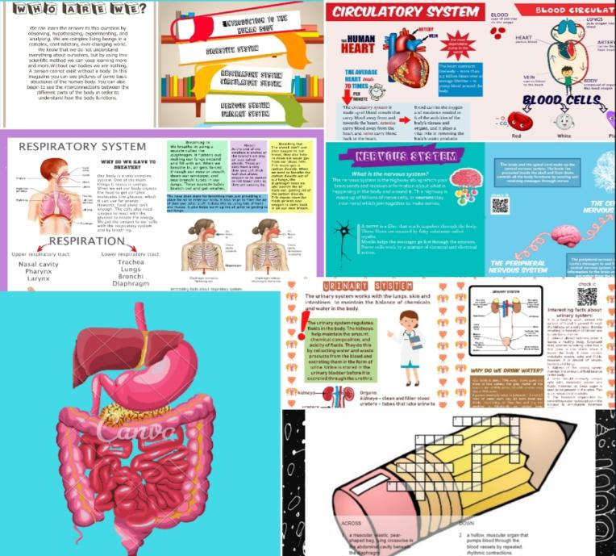

APPENDIX R
Magazine # 2: “Beauty of Beast” created by chemistry-biology students.

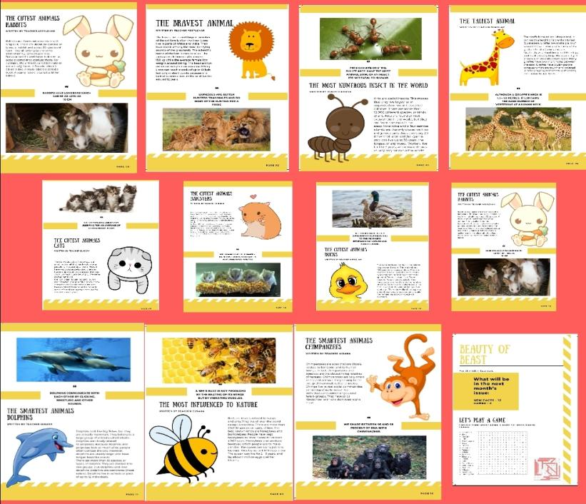

APPENDIX S

Collection of certificates in nomination of the best speaker and the best report

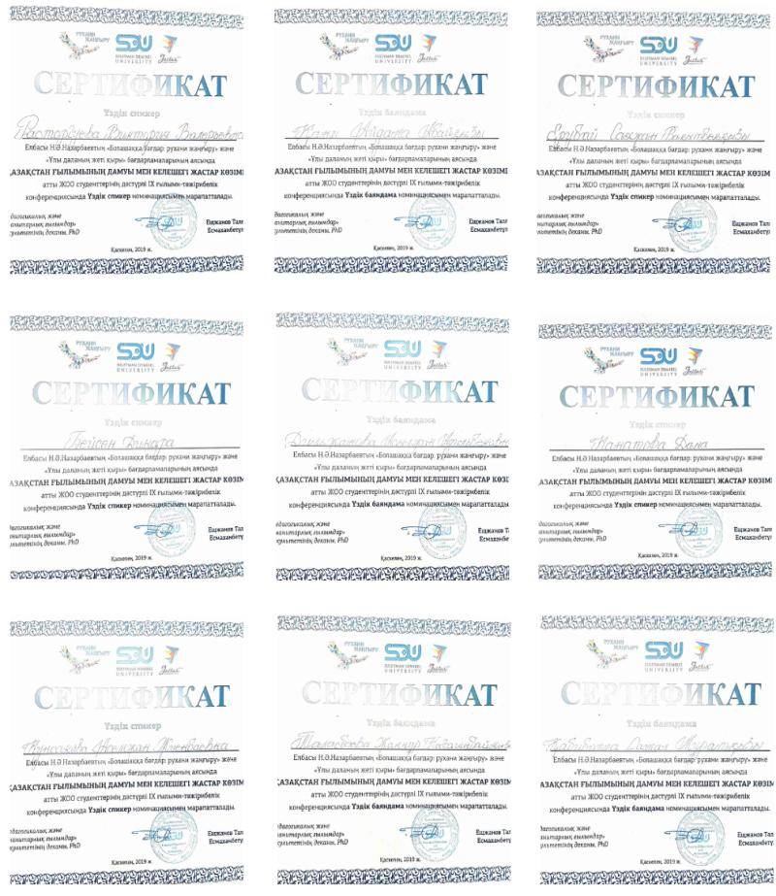

APPENDIX T
Title Page of the Conference Collection

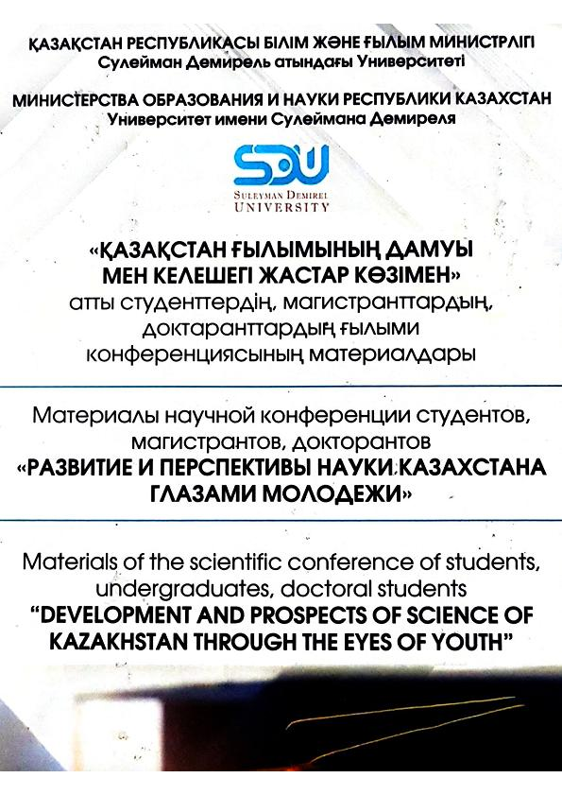

APPENDIX U
Appreciation Certificate for scientific advisor

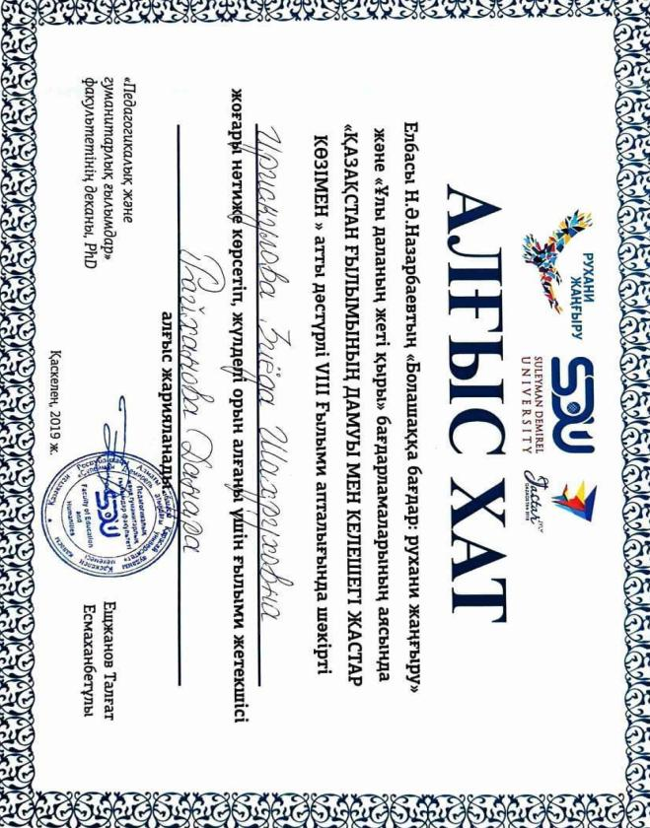

APPENDIX V
Poster presentation and certificate of participation

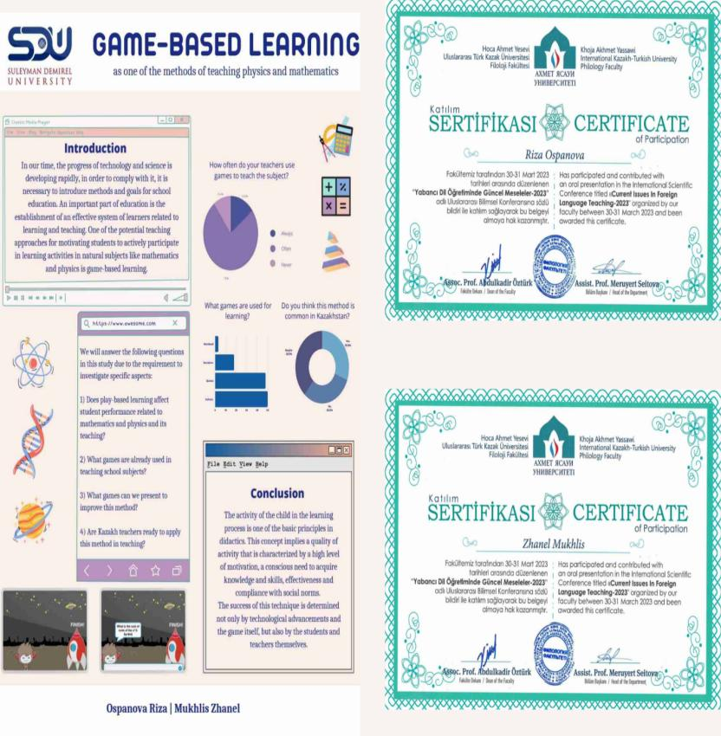

APPENDIX W
Sample of Abstract Book created by chemistry - biology students in EAP course
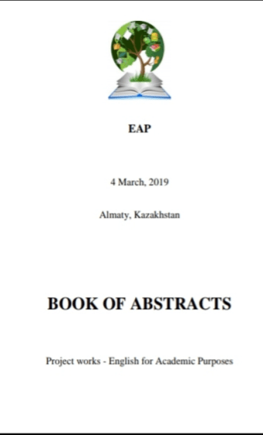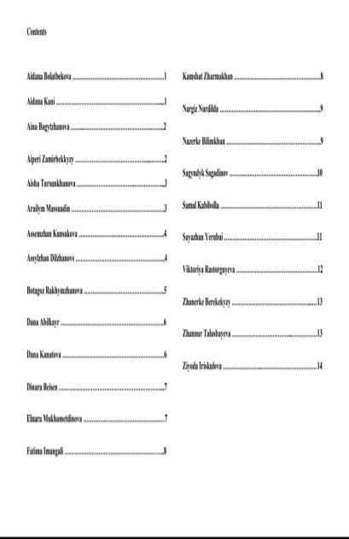

APPENDIX X
Sample of Invitation to Conference / Mini Seminar Session organised by chemistry - biology students in EAP course.

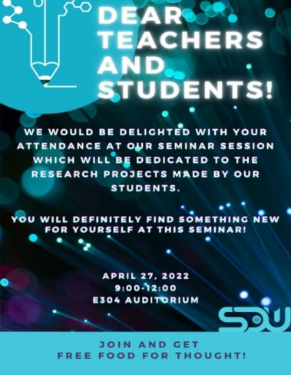

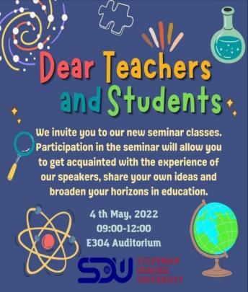

APPENDIX Y
Sample of poster presentation by students in EAP course.

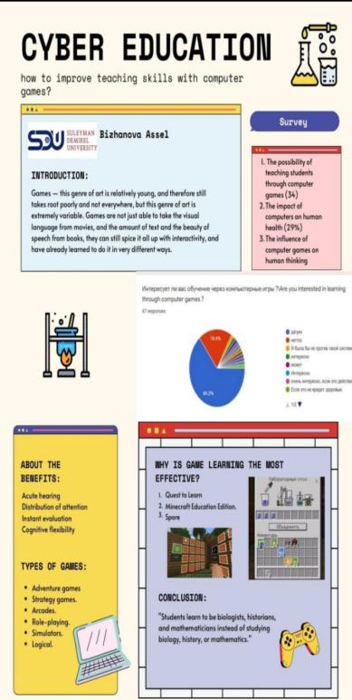

Cronbach's alpha is a measure of internal consistency, that is, how closely related a set of items are as a group. Cronbach’s alpha is 0.728, which indicates a good level of internal consistency for our study, since a score 0.7 ≤ α < 0.9 is considered good and α ≥ 0.9 is an excellent result.

