Ministry of Science and Higher Education of the Republic of Kazakhstan
Kazakh-British Technical University

UDC 004.9(043) | As a manuscript

NAM DIANA

The usage of computer methods for diagnostics of medical data

8D06101 — Computer Science, Computer Engineering
and Management

Dissertation for a degree of
Doctor of Philosophy (PhD)

Scientific advisor
Pak. A.A., PhD
Professor KBTU
(Almaty, Kazakhstan)
External scientific advisor
Hassanov J., PhD
Associate Professor
ADA University
(Baku, Azerbaijan)

Republic Kazakhstan
Almaty, 2025

CONTENTS

NORMATIVE REFERENCES 4
DEFINITIONS 5
NOTATIONS AND ABBREVIATIONS 7
INTRODUCTION 8
1 LITERATURE REVIEW 14
1.1 Review of existing dataset used for lung cancer diagnostics with machine learning algorithms 14
1.1.1 The Lung Image Database Consortium and Image Database Resource Initiative (LIDC-IDRI) 15
1.1.2 Data Science Bowl 2017: Advancing Lung Cancer Detection through Data 16
1.1.3 SEER (Surveillance, Epidemiology, and End Results Program): A Comprehensive Resource for Cancer Research 17
1.2 Review of data augmentation methods 17
1.2.1 Review of Generative Adversarial Networks (GANs) 18
1.2.2 Review of Variational Autoencoders (VAEs) 19
1.2.3 Review of Affine transformation for medical data augmentation 20
1.2.4 Review of existing comparative analyses of data augmentation methods 20
1.3 Review of existing deep learning models applicable for lung cancer segmentation 21
1.3.1 Method for image processing U-Net 21
1.3.2 Method for image processing DeepLab V3 22
1.3.3 Method for image processing Mask RCNN 22
1.3.4 Method for image processing U-Net ++ 23
1.3.5 Method for image processing Trans UNet 24
1.3.6 Method for image processing SwinUNet 26
1.4 Overview of lung cancer 30
1.4.1 Overview of Lung cancer worldwide statistics 31
1.4.2 Overview of Lung cancer and other cancer statistics in Kazakhstan 33
1.4.3 Overview of Lung-RADS System 36
1.5 Review of Existing CAD systems for lung cancer detection 36
1.5.1 Google AI for Lung Cancer Detection 37
1.5.2 Philips Lung Cancer Orchestrator 38
2 MATERIALS AND METHODS 39
2.1 Materials for lung cancer segmentation 39
2.2 Methods for image processing 41
2.3 Methods for image preprocessing 41
2.3.1 Method for Linear scaling of attenuation coefficients to Hounsfield Unit 41
2.3.2 Thresholding-based method for lung area segmentation 43
2.3.3 CLAHE: Enhancing Image Contrast through Adaptive Histogram Equalization method for medical image preprocessing 45
2.4 Deep Learning-based Methods for Lung Cancer Segmentation 46
2.4.1 Architecture for lung cancer segmentation U-Net 46
2.4.2 Architecture for lung cancer segmentation DeepLab V3 48
2.4.3 Architecture for lung cancer segmentation Mask RCNN 50
2.5 Methods for Data Augmentation 51
2.6 Data augmentation method for lung cancer augmentation DeepLungSynth 52
2.6.1 Vector Quantized Variational Autoencoder model for synthetic cancer area generation 54
2.6.2 Deep Convolutional Generative Adversarial Network model for synthetic cancer area generation 55
2.7 Method for lung cancer augmentation MetaLung 56
2.8 Metrics 60
3 RESULTS OF LUNG CANCER SEGMENTATION 61
3.1 Results of data collection 61
3.2 Result of application multiparameter models 63
3.3 Results of the impact of MetaLung to the size and variability of the train set 64
3.4Results of the Impact of application of MetaLung for lung cancer segmentation 65
4 DISCUSSION 67
5 PRACTICAL APPLICATION 69
5.1 An application of the dataset collected for the current research 70
5.2 Application of result in medicine 70
5.3 Application of the Results in the Education 71
6 FUTURE WORK 73
CONCLUSION 75
LIST OF REFERENCES 77
APPENDIX A - Code listing for MetaLung model 84
APPENDIX B - Code listing for generation of synthetic image with VQVAE model ……………………………………………………………………………………... 94
APPENDIX C - Code listing for generation of synthetic image with DCGAN model 109
APPENDIX D - Certificate on the Entry 115
APPENDIX E - List of publications 116
APPENDIX F - Recommendation letters 118
APPENDIX G - Review 119
APPENDIX H - Review 120
APPENDIX I - Review 121
APPENDIX J - Act of implementation to education process 122

NORMATIVE REFERENCES

This dissertation uses references to the following standards:
- Law of the Republic of Kazakhstan “About science” dated 02/18/2011 N2 407-IV LRK.
- Acting Order Minister of Health and Social Development of the Republic of Kazakhstan dated July 31, 2015 No. 647 approval of state mandatory standards and standard professional educational programs in medical and pharmaceutical specialties" as amended by the Order of the Minister of Health of the Republic of Kazakhstan dated February 21, 2020 N9 RK DSM-12/ 2020. Registered with the Ministry of Justice of the Republic of Kazakhstan on February 27, 2020 No. 20071.
- Rules for awarding academic degrees approved by order of the Minister of Education and Science of the Republic of Kazakhstan dated March 31, 2011 127 (registered in the Register of State Registration of Normative Legal Acts under No. 6951).
- GOST 7.32-2017 Interstate Standard. System of standards on information, librarianship and publishing. Research report. Structure and design rules.

DEFINITIONS

Deep Learning - A subset of machine learning involving neural networks with multiple layers that learn representations of data.
Generative Adversarial Networks (GANs) - A framework with two neural networks, a generator and a discriminator, competing against each other to generate synthetic data.
Variational Autoencoders (VAEs) - A type of autoencoder that learns to encode data into a latent space and can generate new data samples.
Data Augmentation - Techniques used to increase the diversity of training data, such as rotation, flipping, and scaling of images.
Affine Transformation - A linear mapping method that preserves points and lines, used in image processing for transformations like rotation and scaling.
Convolutional Neural Networks (CNNs) - Deep neural networks designed for analyzing visual data, with layers that automatically and adaptively learn spatial hierarchies.
Mask RCNN - An extension of Faster R-CNN that predicts segmentation masks along with object detection.
U-Net - A CNN architecture for image segmentation with an encoder-decoder structure and skip connections.
DeepLab V3 - A CNN architecture for image segmentation with an encoder-decoder structure and skip connections.
Hounsfield Units (HU) - A scale for describing radiodensity in medical CT imaging, useful for distinguishing different tissues.
Lung-RADS - A classification system for lung nodules in CT scans, used for reporting and following up on findings.
MetaLung - A data augmentation method using affine transformations for generating new CT images, preserving clinical features.
Elastic Transform - A data augmentation method involving random distortions to make models robust to elastic variations.
Neural Network - A computing system inspired by the biological neural networks, consisting of layers of nodes that process information.
Metric - A standard of measurement used to evaluate models, such as accuracy, precision, recall, DICE, and IoU.
Precision - A metric that measures the proportion of true positives among the positive predictions.
Recall - A metric that measures the proportion of true positives among the actual positives.
DICE Score - A statistical tool to gauge the similarity between two samples, used in image segmentation evaluation.
Intersection over Union (IoU) - A metric used to evaluate the accuracy of an object detector on a particular dataset, based on the overlap between predicted and ground truth.
False Positive - An incorrect identification of the presence of a condition when it is not actually present.
False Negative - An incorrect identification of the absence of a condition when it is actually present.
Segmentation - The process of partitioning a digital image into multiple segments to simplify the representation of an image.
Classification - The task of assigning a label to an input, such as identifying whether an image contains a specific object.
Overfitting - A modeling error where a function corresponds too closely to a particular set of data, potentially failing to generalize to new data.
Underfitting - A situation where a model is too simple to capture the underlying trend of the data, resulting in poor predictive performance.
Neural Network Layers - Different stages of a neural network where specific types of processing are done, such as convolutional layers for feature extraction.
Backpropagation - A method used to train neural networks, involving the propagation of errors backward through the network to update weights.

NOTATIONS AND ABBREVIATIONS

CAD | Computer-Aided Diagnosis
GAN | Generative Adversarial Network
CNN | Convolutional Neural Network
RCNN | Region-based Convolutional Neural Network
IoU | Intersection over Union
DICE | Dice Coefficient
HU | Hounsfield Units
Lung-RADS | Lung Reporting and Data System
CT | Computed Tomography
DeepLab V3 | A variant of DeepLab for semantic segmentation
U-Net | A U-shaped convolutional neural network architecture for image segmentation
MetaLung | Meticulous affine-transformation-based lung cancer augmentation method

INTRODUCTION

Lung cancer's high mortality rate is partly due to its typically late diagnosis, as early-stage lung cancer often presents with nonspecific symptoms. The application of computer-aided diagnostic methods for lung cancer can help address this issue, especially in developing countries where there is a significant shortage of qualified medical personnel. A major limitation in the use of computer-aided diagnostic (CAD) systems in medical tasks is the scarcity of medical data, caused by the following reasons:
- Privacy of medical data
- High cost of data annotation
- The necessity to collect data within a specific region due to the unique socio-economic characteristics of that region
Deep learning models used in medical diagnostics require large datasets. In computer vision practice, data augmentation is widely used to increase the size of the training dataset. There are many different methods of image augmentation, which can generally be divided into two main categories: multi-parameter deep learning models that generate new clinical cases and affine image transformations that allow direct manipulation of image morphology.
The use of multi-parameter deep learning models in the generation of medical images enables the creation of entirely new clinical cases, which can be utilized for the further training of deep neural networks. This approach significantly increases the size and variability of the training dataset, leading to substantial improvements in the diagnosis of medical images. A classical example of such neural networks is the application of generative adversarial networks (GANs) [1]. GANs have been used for lung image augmentation in [2–4], for liver images in [5,6], for brain tumors in [7,8].
Another example of deep learning algorithms for generating synthetic medical images is variational autoencoders (VAEs) [9], which exemplify encoder-decoder architecture. In [10], the authors introduced a beta-VAE for generating 3-D lung lesions. In [11], VAEs were utilized to create synthetic patient records, including details such as age, gender, symptoms, and treatment months for illnesses like gastroenteritis, pneumonia, and malaria. The authors [12] explored the use of VAEs combined with transfer learning for detecting brain lesions. Furthermore, VAEs have been applied in brain-related fields, as shown in [13], where they generated synthetic Brain positron emission tomography (PET) images to predict brain metabolic topography age.
An application of multi-parameter deep learning model allows significantly increase the size and the variability of the training set, which lead to increase the quality of the next medical image diagnostics. However, this approach has several limitation, which are crucial for medical image processing.
Firstly, training deep neural networks requires significant computational power, often involving the use of high-performance GPUs or specialized hardware. This demand for computational resources increases with the complexity and depth of the model, as deeper models typically consist of numerous layers and parameters that need to be optimized. Furthermore, the performance and accuracy of these models are heavily dependent on the quantity and quality of the training data. Large and diverse datasets are essential to capture the variability in medical images, which in turn improves the model's ability to generalize and make accurate predictions. Consequently, acquiring and processing such vast amounts of data can be both time-consuming and costly, presenting a substantial barrier to the widespread adoption of these technologies in medical diagnostics.
The second, more critical factor is the necessity of validation by an experienced clinical physician. It is challenging to control the output of generated images. While hallucinations in non-medical image generation tasks are easily identifiable by the human eye, this problem becomes much more significant in medical tasks. Several diseases share similar visual features, locations, and shapes, which cannot be distinguished by a machine learning engineer without medical expertise. For example, lung cancer, known for its high mortality rate and severity, can appear visually similar to benign calcifications, differing only in density.
Another method for increasing the training dataset is the use of affine transformations. Affine transformations are linear mappings that preserve points, straight lines, and planes. They allow for direct manipulation of the morphological features of images, providing a level of control over the output images. However, this approach also has some drawbacks. While affine transformations can enhance the diversity of the training data by applying operations such as rotation, scaling, translation, and shearing, they do not create new information. This means that the augmented data is still limited to variations of the original images, potentially missing out on more complex variations seen in real-world medical cases. Additionally, if not applied carefully, these transformations can introduce artifacts or distortions that may negatively impact the performance of the model.
In collaboration with a radiologist, the authors explored the application of various medical data augmentation methods and proposed a new method called MetaLung, which offers the following advantages:
1. It increases the size of the training dataset by incorporating radiological features of lung cancer.
2. It is based solely on affine transformations, which reduces computational power requirements.
3. It improves the quality of segmentation by an average of 20%.
This approach affects the expertise of radiologists to ensure that the augmented data accurately reflects the radiological characteristics of lung cancer. This improves the reliability and performance of deep learning models in medical image analysis.
Relevance
Lung cancer remains one of the leading causes of mortality from oncological diseases, which is related to the difficulty of early diagnosis due to nonspecific symptoms, especially in developing countries with limited resources and a lack of qualified medical personnel. CAD systems can enhance the effectiveness of early detection and reduce the burden on healthcare systems, but their development is constrained by the lack of medical data required for training and validation.
Several key factors cause the shortage of medical data:
1. Privacy issues.
2. High costs of data annotation.
3. Regional specificity of data to ensure the accuracy and reliability of CAD systems in various conditions.
This study aims to address data scarcity by generating synthetic data to develop effective and adaptable tools for lung cancer diagnosis.
Research goals, objectives, and study subject
In this study, the authors posed the question: how can the quality of lung cancer segmentation on Computed Tomography (CT) scans be improved, given limited data and modest computational resources? Is it possible to create a CT scan augmentation method for lung cancer that preserves the natural distribution?
Research goal
To develop a CT scan augmentation method that improves the quality of lung cancer segmentation while remaining computationally efficient and preserving the natural distribution of CT scans.
Requirements for the method
To ensure the efficacy and practical applicability of the proposed method, several key requirements must be met. These requirements are critical for maintaining the integrity of the data and ensuring that the method can be seamlessly integrated into existing workflows. The following criteria outline the essential features and goals of the method:
- Saving the distribution between different instances on CT images: The method must preserve the distinct patterns and distributions present in the original data, ensuring that the synthetic images accurately reflect the variations found in real-world medical data.
- Small computational complexity: The approach should be efficient, requiring minimal computational resources, to facilitate its use in diverse environments, including those with limited computational capabilities.
- Reducing False Positive results: A key objective is to minimize the occurrence of false positives, thereby enhancing the accuracy and reliability of diagnostic tools.
- Increasing average image segmentation quality: The method should consistently improve the quality of image segmentation, providing clearer and more precise delineations of anatomical structures, which is crucial for accurate diagnosis and treatment planning.
Research Tasks
1. Data collection and annotation, including the creation of a dataset for segmentation tasks based on Kazakhstani data, followed by annotation performed by a radiologist.
2. Development of a baseline model for lung cancer segmentation based on collected data
3. Development of an augmentation method capable of preserving the correct depth distribution among lung structures.
4. Application of the method for data augmentation across various neural networks with different depths and architectural features.
5. Conducting a comparative analysis of the proposed method with existing data augmentation approaches and baseline models.
Research Object
Methods of augmentation of Computed Tomography (CT) images of the lung cancer.
Scientific Novelty
1. The MetaLung method is an accurate augmentation method based on affine transformations that preserves the density distribution among various anatomical structures (vessels, bones, fatty tissues) on CT slices. This approach, for the first time, ensures high segmentation accuracy with minimal computational costs.
2. The DeepLungSynth method is an augmentation method for the integration of cancer areas generated by multiparameter deep-learning models, such as Deep Convolutional Generative Adversarial Network (DCGAN) and Vector Quantized Variational Autoencoder (VQVAE) to healthy lung CT image s for the generation of synthetic images.
3. First, consider radiological features to evaluate the quality of synthetic data.
4. First applies the Lung RADS System for evaluation of image segmentation quality.
Practical Significance
1. MetaLung data augmentation method improves CT lung image segmentation across various deep neural network architectures, reducing false positives and enhancing diagnostic accuracy.
2. DeepLungSynth method integrates VQVAE, DCGAN enabling the creation of synthetic datasets for segmentation and classification tasks.
3. A unique Kazakhstani lung cancer dataset [14] was created and annotated by a radiologist, including specific annotations for 2D and 3D segmentation, detection, and classification, serving as a foundation for further medical data research.
Main defence
1. Development of the MetaLung augmentation method for processing lung cancer CT images, demonstrating significant improvement in lung cancer segmentation results. The proposed method improves segmentation quality without losing spatial information among lung structures. It was tested on three convolutional neural networks: MASK RCNN (DICE: from 0.51 to 0.6), U-Net (DICE: from 0.37 to 0.4), and DeepLabV3 (DICE: from 0.33 to 0.41). The method also reduces the number of false positives, as confirmed by an increase in Precision: MASK RCNN (from 0.53 to 0.68), U-Net (from 0.81 to 0.86), and DeepLabV3 (Precision: from 0.79 to 0.86).
2. Development of the DeepLungSynch method for generating synthetic CT lung cancer images using Vector Quantized Variational Autoencoder (VQVAE) and Deep Convolutional Generative Adversarial Network (DCGAN). The application of the method increases in segmentation performance: VQVAE improved DICE from 0.37 to 0.41 and IoU from 0.31 to 0.35; DCGAN improved results to DICE 0.4 and IoU 0.33; and by combining DCGAN, VQVAE, and affine transformations, the best results were achieved: DICE 0.42 and IoU 0.37.
3. Creation of a dataset including lung cancer patient images from Kazakhstan, featuring CT scans, corresponding binary masks outlining tumor regions, and disease severity assessment based on the Lung-RADS system.
The main provision of current research is a provision of two novel data augmentation methods applicable to synthetic medical data generation. The methods covered two main fields for data augmentation: multiparameter models (based on DCGAN and VQVAE) and affine transformation. Table 1 provides a summarization analysis of multiparameter deep learning and affine transformation for medical image processing based on the practical experiments received during current research.

Table 1- Main provision of the research

Approach of data augmentation | Advantages | Disadvantages
Morphological based (affine transformation) | 1)Low computational complexity  2) Ability to control generated image  3) Image segmentation quality significantly increase compared with baseline model for some transformations | 1) Some affine transformations have negative impact to image segmentation quality compared with baseline  2) Smaller DICE and IoU than with application of VQ-VAE and DCGAN  3) The image will save main patterns of the original image; it is not possible to generate absolutely new image working with morphological features of the original image only
Multi-parameter deep learning models (DCGAN, VQ-VAE) | 1) Better image segmentation quality for VQ-VAE and DCGAN than for all observed affine transformations and baseline model  2) Ability to generate different synthetic image | 1) High computation complexity  2) Required additional verification by the clinicians because of the use of trainable parameters, which mostly is the black box for human

Approbation of obtained results. PhD thesis results are published the following international journals:
1. MetaLung: Meticulous affine-transformation-based lung cancer augmentation method // Indonesian Journal of Electrical Engineering and Computer Science. – 2024. – Vol. 36, № 1. – Pp. 401–413. (Scopus Q3)
2. Comparative analysis of U-Net, U-Net++, TransUNet and Swin-UNet for lung X-ray segmentation // Herald of the Kazakh-British Technical University. – 2024. – Vol. 21(2). – Pp. 42–53. (SHEQAC-MSHE RK)
3. Overview of transformer-based models for medical image segmentation // Scientific Journal of Astana IT University. – 2023. – № 13. – Pp. 64–75. (SHEQAC-MSHE RK)
4. Lung cancer segmentation dataset with Lung-RADS class [Electronic resource] // Mendeley Data. – 2024. – V. 1. – DOI: 10.17632/5rr22hgzwr.1.
5. Overview Analysis of Computer Vision Algorithms // Internauka. – 2022. – № 21-8 (244). – Pp. 49–53.
6. An Application of Classical Machine Learning Algorithms for Lung Cancer Classification Based on Clinical Features // Baitursynov Readings International Scientific and Research Conference, Kostanay. – 2024. – Pp. 319–324.
7. Systematic Review of Data Augmentation Methods Applied for Medical Image Processing // Proceedings of the XXI International Scientific and Practical Conference on News of Scientific Progress. – 2024. – Pp. 55–67.
8. An Application of Deep Learning Methods for Brain Tumor Classification // Proceedings of the XXI International Scientific and Practical Conference on Leading Scientific Innovations. – 2024. – Pp. 7–19.
9. Classification of lung calcifications and cancer in Lungs-RADS System based on radiological features // Herald of the Kazakh-British Technical University. – 2024. – № 4. – Pp. 32–44. (SHEQAC-MSHE RK)
10. Method of Augmenting Lung Computed Tomography Images "MetaLung" // Patent Certificate. – No. 49239 dated August 26, 2024.
11. Application of Generative Adversarial Neural Networks for Lung cancer CT image segmentation // Kostanay State Pedagogical Institute. – 2025. – Pp. 105–112.

LITERATURE REVIEW

The use of methods for the computer-aided diagnosis of lung cancer is directly related to the problem of the scarcity of medical data, the resolution of which is the primary focus of the current study. Data augmentation methods can partially address the issue of limited medical data; however, the application of these methods cannot be considered independently from the specific task they are intended to solve. Therefore, in the literature review, the authors examined all the steps involved in the task of medical data diagnosis.
The authors structured the literature review in the same order as the pipeline that will be used later to validate the newly proposed method. First, the authors reviewed the existing datasets that can be utilized in the task of medical diagnosis of lung cancer. This paragraph is also important because, within the framework of the current study, the authors proposed a dataset of Kazakhstani medical data for open use. Next, the authors reviewed existing data augmentation methods. The main point to be defended in this study is the augmentation method based on affine transformations. However, because of popularity and spread use of generative adversarial networks (GANs), the authors also could not ignore them in the literature analysis. Overall, the authors propose to consider all augmentation methods by conditionally dividing them into two main subgroups. The first subgroup includes deep learning models that can be applied to the task of generating new images. The second subgroup includes methods that work directly with the morphology and topology of images.
Evaluating the quality of data augmentation is impossible without assessing their impact on the quality of model training. Therefore, the next step was to review the deep learning models that are directly used for the task of medical data segmentation. Given the large number of modern models, the authors included only those used in the articles published within the framework of the current study.
Furthermore, the authors also examined lung cancer statistics, particularly focusing on the prevalence and mortality rates in Kazakhstan and worldwide. This analysis provided a comprehensive understanding of the global and regional impact of lung cancer, highlighting the significance of developing effective diagnostic tools.
The final point of the literature analysis is the existing software and hardware systems, and CAD systems used for diagnosing lung cancer. It should be noted that the use of these systems is expensive and is applied in Kazakhstan in only a few cases. Although the current study focuses only on the task of augmenting medical data, this point is also covered in the literature review.

Review of existing dataset used for lung cancer diagnostics with machine learning algorithms
The advancement of deep learning and machine learning algorithms has brought about significant improvements in medical imaging, particularly in the early detection and diagnosis of lung cancer. This chapter focuses on the datasets utilized for lung cancer diagnostics, which are crucial for training and validating machine learning models. Given the complexity and variability of medical data, these datasets serve as the foundation for developing robust and accurate diagnostic tools. The chapter will explore key datasets such as the Lung Image Database Consortium and Image Database Resource Initiative (LIDC-IDRI)[14], the Data Science Bowl 2017 dataset [15], and the SEER (Surveillance, Epidemiology, and End Results) Program dataset [16]. These resources have been instrumental in pushing the boundaries of medical research and enhancing clinical practices. The following sections provide detailed insights into each dataset, their composition, and their impact on lung cancer diagnostics.

The Lung Image Database Consortium and Image Database Resource Initiative (LIDC-IDRI)
The Lung Image Database Consortium and Image Database Resource Initiative (LIDC-IDRI) dataset is as an indispensable resource in the field of lung cancer research, particularly in the development of CAD systems. This dataset was created through a collaboration between the National Cancer Institute (NCI), the Food and Drug Administration (FDA), and other academic and industry partners, aiming to enhance the early detection and diagnosis of lung cancer through advanced imaging techniques.
The LIDC-IDRI dataset comprises a vast collection of thoracic CT scans, annotated by experienced thoracic radiologists. The dataset includes diagnostic and screening thoracic CT scans from a diverse patient cohort, offering a comprehensive overview of lung imaging data. Each scan is meticulously annotated, with radiologists marking the boundaries of lung nodules and providing detailed descriptions of their characteristics. This results in a rich dataset that includes various nodule sizes, shapes, and densities, reflecting the complexity and variability of lung cancer presentations.
One of the key strengths of the LIDC-IDRI dataset is its detailed nodule classification. Nodules are categorized into three groups based on their size: nodules greater than 3 mm, nodules 3 mm or smaller, and non-nodules 3 mm or larger. This classification, along with extensive metadata such as patient demographics and clinical follow-up information, enhances the utility of the dataset for a wide range of research applications.
Researchers utilizing the LIDC-IDRI dataset face several challenges, including the high variability in nodule appearance and the computational demands of processing large volumes of high-resolution, three-dimensional CT scans. Despite these challenges, the dataset has significantly advanced the field of lung cancer detection. It has been instrumental in developing and validating CAD algorithms, improving the accuracy of lung nodule detection and characterization, and supporting the growth of radiomics, which involves extracting and analyzing quantitative features from medical images to create predictive models for disease outcomes.
The impact of the LIDC-IDRI dataset extends beyond algorithm development. It has been widely used in radiologist training, helping medical professionals improve their skills in identifying and classifying lung nodules. Moreover, the dataset has fostered a spirit of collaboration and open research, with many researchers sharing their methodologies and findings to advance the field of medical imaging and artificial intelligence.
The LIDC-IDRI dataset is publicly accessible through The Cancer Imaging Archive (TCIA), providing researchers and data scientists with a valuable resource for ongoing research and development. The dataset's comprehensive collection of annotated CT scans and accompanying metadata. It drives innovations in lung cancer detection and treatment, highlighting the importance of early diagnosis in improving patient outcomes. The availability and fullness of the LIDC-IDRI dataset make it useful for future advancements in the fight against lung cancer.

Data Science Bowl 2017: Advancing Lung Cancer Detection through Data
The Data Science Bowl 2017, hosted by Kaggle and sponsored by the National Institutes of Health (NIH) and Booz Allen Hamilton, has emerged as a pivotal event in the realm of medical data science. The competition focused on harnessing the power of machine learning to enhance the early detection of lung cancer, a leading cause of cancer-related deaths globally. The primary objective was to develop algorithms capable of identifying malignant lung nodules from high-resolution, three-dimensional CT scans provided by the National Lung Screening Trial (NLST).
The dataset provided to participants included thousands of low-dose CT scans, each annotated with detailed information regarding the presence and characteristics of lung nodules. These scans encompassed a broad spectrum of nodule sizes, shapes, and densities, reflecting the real-world variability encountered in clinical practice. Accompanying metadata included patient demographics, scan acquisition parameters, and clinical follow-up information, which added a layer of depth to the data, enabling more comprehensive analyses.
Participants were tasked with two main challenges: the accurate detection of lung nodules and the classification of their malignancy. This required the development of sophisticated algorithms capable of processing high-resolution, three-dimensional images and extracting relevant features for nodule identification and characterization. The competition highlighted several key issues in medical imaging, including the high variability in nodule appearance, the need for balanced datasets, and the computational complexity of analyzing large volumes of imaging data.
The outcomes of the Data Science Bowl 2017 have had a lasting impact on the field of lung cancer detection. The competition spurred the creation of highly accurate and efficient detection algorithms, many of which have been integrated into clinical workflows. These advancements have significantly improved the diagnostic accuracy and early detection rates of lung cancer, ultimately contributing to better patient outcomes. Moreover, the collaborative nature of the competition fostered a spirit of open research and innovation. The databowl has many participants with various methodologies and findings. Thereby advancing the field of medical imaging and artificial intelligence.
The Data Science Bowl 2017 dataset continues to serve as a valuable resource for ongoing research and development. It is accessible through Kaggle, providing researchers and data scientists with a rich repository of annotated CT scans for training and evaluating new algorithms. The competition demonstrated the transformative potential of collaborative data science in addressing complex healthcare challenges and underscored the importance of early detection in the fight against lung cancer.

SEER (Surveillance, Epidemiology, and End Results Program): A Comprehensive Resource for Cancer Research
The Surveillance, Epidemiology, and End Results (SEER) Program, managed by the National Cancer Institute (NCI), is a cornerstone resource for cancer research and public health. Established in 1973, SEER collects and publishes detailed cancer incidence and survival data from population-based cancer registries, covering approximately 34.6% of the U.S. population. This extensive dataset provides valuable insights into cancer trends, outcomes, and disparities, supporting evidence-based decision-making in research and policy. SEER's comprehensive database includes information on cancer incidence, prevalence, mortality, survival, and patient demographics. The data is collected from 21 geographically diverse registries across the United States, ensuring a broad and representative sample of the population. Key features of SEER include detailed statistics on cancer incidence and mortality rates, survival data, comprehensive patient demographics, tumor characteristics, and initial treatment modalities. SEER data is instrumental in epidemiological research, clinical outcomes studies, health disparities analysis, and policy development. Researchers and policymakers utilize SEER data to study cancer trends, identify risk factors, evaluate screening and prevention programs, understand treatment outcomes, and develop targeted interventions. SEER data is publicly accessible through the SEER website, which offers tools and resources such as the SEER Stat software for data analysis, the SEER Cancer Statistics Review (CSR), and various datasets and reports.

Review of data augmentation methods
The scarcity of medical data poses a significant obstacle to the application of deep learning models. This scarcity is primarily due to ethical concerns, as medical data is private and its use requires patient consent, and the complexity and cost of annotation, necessitates hiring specialized clinicians. Additionally, in medical tasks, there is a preference for using region-specific data because geo-economic factors influence disease statistics and the presence of comorbidities. These factors can also affect the prevalence of diseases with similar courses or diagnostic features.
Data augmentation can partially address this problem. Data augmentation is a technique used to increase the size of training datasets by applying various transformations to the existing data. In this chapter, the authors examine two main approaches to medical data augmentation: the use of multiparametric models to generate synthetic clinical cases and methods that work with image morphology, which increase the dataset by altering the existing images. The authors explore the application of Generative Adversarial Networks (GANs), Variational Autoencoders (VAEs), and affine transformations in medical data processing tasks.
GANs create realistic synthetic images by training two neural networks in opposition, improving the diversity and size of training datasets. VAEs, on the other hand, learn the underlying data distribution and generate new data samples, enhancing the robustness of diagnostic models. Affine transformations, such as rotation, scaling, and translation, modify existing images to create new training examples, thereby improving model generalization. This chapter provides a detailed review of these augmentation techniques and their implementation in medical imaging to overcome the limitations imposed by data scarcity.

Review of Generative Adversarial Networks (GANs)
The advent of Generative Adversarial Networks (GANs) has revolutionized various fields of artificial intelligence, offering unprecedented capabilities in generating realistic synthetic data. In the domain of medical imaging, GANs have emerged as a powerful tool with the potential to address numerous challenges and enhance the quality of healthcare delivery. This chapter delves into the application of GANs for medical image generation, exploring their theoretical underpinnings, practical implementations, and transformative impact on medical research and clinical practice.
Medical imaging is a cornerstone of modern diagnostics, playing a critical role in the detection, characterization, and monitoring of diseases. However, the acquisition of high-quality medical images is often constrained by factors such as limited data availability, high costs, and the need for extensive expert annotation. These challenges have spurred interest in developing methods that can generate synthetic medical images, augmenting existing datasets and facilitating advancements in machine learning models used for diagnostic purposes.
The application of GANs in medical imaging extends beyond mere data augmentation. They have been employed in various innovative ways, including anomaly detection [17,18], image-to-image translation [19,20], and the synthesis of medical data [21,22].
Despite their potential, the use of GANs in medical image generation is not without challenges. Issues such as model stability, mode collapse, and the need for large computational resources pose significant hurdles. Moreover, the ethical implications of generating synthetic medical data, particularly in terms of patient privacy and the potential for misuse, warrant careful consideration. This chapter aims to provide a comprehensive overview of GANs in the context of medical imaging, addressing both their capabilities and limitations.
In the following sections, the authors will explore the foundational concepts of GANs, review state-of-the-art applications in medical imaging, and discuss the future directions of this rapidly evolving field. Through a combination of theoretical insights and practical examples, this chapter seeks to elucidate the transformative potential of GANs in enhancing medical imaging and, ultimately, improving patient care.
The authors [23] of proposed the GAN-LSTM-3D method for the reconstruction of lung tumors in three-dimensional space from 2D CT images. In this method, the 2D CT images are initially fed into a VGG Net [24] for feature extraction. The extracted features are then processed by an LSTM network [25], which is capable of handling sequential data and capturing temporal dependencies. The output of the LSTM is subsequently used as input for a GAN, which is responsible for reconstructing the lung tumor in a 3D space. This approach leverages the strengths of both LSTM in processing continuous data and GAN in generating realistic 3D reconstructions from sequential 2D data. The combination of GAN and LSTM for lung tumor reconstruction also was described in [26]. GAN also could be used for domain adaptation from CT images to MRI images, as in [27].
In contrast to the previously discussed methods aimed at reconstructing existing lung cancer images, the authors [28] utilized Generative Adversarial Networks (GANs) to generate synthetic lung cancer images. They used Deep Convolutional GAN (DC-GAN) to generate the lung cancer region, focusing solely on the area affected by cancer rather than generating the entire lung image. The generated images were then shown to clinical doctors, who were tasked with distinguishing between the generated and real images. In most cases, the doctors were unable to visually differentiate the generated cancer images from the real ones, demonstrating the high realism of the GAN-generated images.
The authors of [29] also proposed using GANs for synthetic cancer generation. They focused solely on the region near the lung cancer, defined as a 64x64x64 volume of interest (VOI), which was subsequently used to generate synthetic lung cancer areas. The authors introduced a two-step framework for lung segmentation. The first part consists of a Style-based GAN [30], while the second part employs the U-Net [31] architecture, widely used in medical data segmentation tasks. This approach enhances the accuracy and realism of the generated synthetic cancer images, thereby improving the training and validation of diagnostic models.
The process of lung tumor generation using GAN-based models is also described in [32]. The authors applied StyleGAN [33] and pix2pix GAN [34] for synthesizing lung cancer images. The same as in the previous observed article focused on the Volume of Interest (VoI) for generating detailed and realistic cancer regions. To evaluate the quality of the generated images, the authors employed both subjective assessments by doctors, who sketched the synthesized images to compare realism and objective image quality metrics.
GAN-based models also could be used for preprocessing and improving the quality of medical data. For example, Cycle GAN [35] has been used for denoising lung CT images in [36], GAN-based models also could be applied for data anonymization, as in [37], and other tasks.

Review of Variational Autoencoders (VAEs)
Variational Autoencoders (VAEs) are a type of generative model that combines principles from neural networks and probabilistic graphical models to learn and generate complex data distributions. Introduced by Kingma and Welling in 2013, VAEs consist of an encoder that maps input data to a probabilistic latent space and a decoder that reconstructs the data from this latent representation. The training process involves optimizing the Evidence Lower Bound (ELBO) to balance reconstruction accuracy and regularization of the latent space. VAEs are particularly useful for applications requiring the generation of high-quality synthetic data, such as image augmentation and anomaly detection. They have proven effective in various fields, including medical imaging, where they help address data scarcity and enhance diagnostic models.
Variational autoencoders have been used for unsupervised anomaly detection [38], synthetic medical data generation [39].
The same as GAN, Variational autoencoders have been used for several tasks for the lung. The authors of the first observed article provide an application of VAE for lung lesion reconstruction [40]. The authors of the referenced article [41] conduct a comprehensive analysis of Variational Autoencoders (VAEs) concerning their applicability to lung cancer classification and clustering tasks. They examine the capacity of the VAE's embedding space to generalize by using these embeddings as inputs for a multi-layer perceptron in subsequent lung nodule classification tasks. The study demonstrates that VAEs achieve state-of-the-art performance in clustering malignant and benign lesions. Furthermore, the authors compare the performance of standard Gaussian VAEs with Dirichlet VAEs [42].
Although VAEs are used for related tasks, in the domain of image generation they are less frequently employed compared to GANs. However, these models also offer several advantages. This is because the latent space of VAEs is obtained through the training of an encoder, allowing the interpretation of the latent space and the preservation of significant features of real images in a compressed form.

Review of Affine transformation for medical data augmentation
Affine transformation is a fundamental technique used in medical data augmentation to diversify training datasets for machine learning models. These transformations include linear operations such as translation, rotation, scaling, and shearing, all of which preserve the geometric properties of the images. These transformations allows significantly enhance the robustness and generalizability of models, making them more effective in real-world medical applications where variations in image acquisition are common.
Affine transformations offer a way to modify the morphological features of an image without the need for multi-parameter deep learning models. This approach requires significantly less computational power compared to using Generative Adversarial Networks (GANs) or Variational Autoencoders (VAEs). Another advantage of affine transformations is the ability to control parameters precisely. However, unlike the generative approach in augmentation tasks, affine transformations do not create entirely new images, which limits their ability to expand the variability of the training dataset.
An application of affine transformation on the image, such as horizontal flip, rotation, translation, mirroring, stretching, and zooming has been described in [43–45]. The article [46] provides a comparison between augmentation techniques applied for general image processing such as rotation, flipping, translation, and others for the classification of brain MRI, lung CT, and mammography images for image classification tasks.

Review of existing comparative analyses of data augmentation methods
The article [47] presents a comparative analysis of eleven data augmentation techniques, including two novel methods based on wavelet transform and constant-Q Gabor transform. The authors evaluated these augmentation techniques using four distinct datasets [48–51] and employed the ResNet50 [52] model for image classification. This analysis provides a comprehensive examination of various augmentation strategies, such as contrast adjustment, saturation, and deformation, among others. It is noteworthy that only one of the datasets utilized in this study is medical in nature.
In contrast, the subsequent article [53] offers a detailed comparative analysis of data augmentation methods specifically for the classification of diverse medical images. This study employed lung CT scans [14, p. 1], MR brain images [54], eye fundus photographs [55], and breast mammography images [56]. The author used eleven affine transformations for data augmentation for the next image classification. ResNet101 model was applied for all experiments.
The next observed article [57] provides comparative analyses of affine transformations for tuberculosis detection on X-ray images on two datasets [58,59]. The authors applied nine data augmentation techniques.
The first three observed articles provided comparative analyses of data augmentation techniques that work with the morphology of the image. The next observer article provides a comprehensive review of multiparameter deep learning models for medical data augmentation [60]. The authors provide deep analyses of an application of VAE, GAN, diffusion models, and hybrid models with different computation complexity for medical image processing on various datasets. The analyses include the model, hybrid status, dataset, the type of medical image collected in the dataset, and the metrics used for the evaluation of the model.

Review of existing deep learning models applicable for lung cancer segmentation
In this work, the authors used several deep-learning models applicable to the task of medical data segmentation. Segmentation is a practical task that allows for the analysis of not only the class to which a particular object belongs but also the location, size, and exact shape of the area affected by the disease. The authors focused on segmentation tasks because, unlike classification tasks, segmentation provides more detailed and practical insights into the medical images.

Method for image processing U-Net
Biomedical image segmentation is a critical task in medical image analysis, facilitating the identification and delineation of anatomical structures and pathological regions. The U-Net architecture, introduced by Olaf Ronneberger, Philipp Fischer, and Thomas Brox in 2015, has emerged as a cornerstone in this field due to its effectiveness and flexibility. This convolutional neural network (CNN) is designed specifically for the segmentation of biomedical images, addressing the unique challenges posed by such tasks.
Key elements of U-Net could be described as elements provided below.
Skip Connections: One of the key innovations of the U-Net architecture is the use of skip connections. These connections concatenate feature maps from the encoder to the decoder, allowing the network to use high-resolution features from the encoder for better localization. This helps in preserving spatial information that is often lost during the downsampling process.
Mirror Architecture: The symmetric structure of U-Net ensures that the information captured during downsampling is effectively utilized during upsampling, leading to improved segmentation accuracy.
Flexible Input Size: U-Net can handle images of varying sizes due to its fully convolutional nature, making it adaptable to different biomedical imaging tasks.
U-Net architecture has been used in many medical image tasks [61–63]. The efficiency of U-Net architecture also shown in medical image segmentation tasks was a motivation to improve the architecture by adding residual [64], recurrent [65], or dense [66] layers, application for 3D image segmentation [67,68], or extention by application U-form with skip connections for transformer-based architectures, such as TransUNet [69] and Swin U-Net [70].

Method for image processing DeepLab V3
DeepLab V3 [71] is an updated version of the DeepLab V1 [72] model presented by Google for image segmentation. The main part connecting all three models is Atrous Convolution [71, p. 3] which allows an increase in the size of the receptive field of convolution without an increase in the number of parameters. It is achieved by adding a rate parameter.
Key elements of DeepLab V3 could be described as elements provided below.
Multi-Scale Contextual Information: ASPP allows DeepLabV3 to capture multi-scale contextual information, improving the network's ability to recognize and segment objects of varying sizes.
Enhanced Receptive Field: Atrous convolution increases the receptive field without additional computation, enabling the network to gather more contextual information.
Adaptability to Various Image Sizes: As a fully convolutional network, DeepLabV3 can handle input images of different sizes, making it versatile for various biomedical imaging tasks.

Method for image processing Mask RCNN
The architecture of MASK RCNN [73] is a logical continuation of the development of two-stage image detection methods [74–76]. Initially, convolutional neural networks (backbone networks) are used to extract image features from the input image, on which further computations are performed. Detection with MASK RCNN is carried out in two steps: region proposal and parallel classification, segmentation, and object detection.
Key elements of Mask RCNN could be described as elements provided below.
Two-Stage Detection Approach: Mask R-CNN follows a two-stage process: first, it generates region proposals using a Region Proposal Network (RPN), and then it performs object classification, bounding box regression, and segmentation in parallel.
Instance Segmentation: Unlike standard object detection models, Mask R-CNN extends Faster R-CNN by adding a branch that generates pixel-level segmentation masks for each detected object, making it effective for instance segmentation tasks.
Feature Pyramid Networks (FPN) and ResNet Backbone: Mask R-CNN uses deep feature extractors such as ResNet combined with FPN to enhance the model’s ability to detect objects at different scales with improved accuracy.
RoIAlign for Precise Localization: Instead of using RoIPool, Mask R-CNN employs RoIAlign, which avoids misalignments caused by quantization in pooling operations, ensuring more precise mask generation and object localization.
Versatility in Applications: Due to its ability to detect and segment objects simultaneously, Mask R-CNN is widely used in various applications, including medical imaging, autonomous driving, and video analysis.

Method for image processing U-Net ++
U-Net++ [77] is an advanced version of the U-Net architecture designed for improved performance in medical image segmentation. It introduces several modifications and enhancements over the original U-Net to address issues like coarse predictions and lack of flexibility in the network architecture.
The original U-Net gained prominence for its symmetric encoder-decoder structure with skip connections, enabling precise segmentation of complex medical images. U-Net++ enhances this framework by introducing nested and dense skip connections, which facilitate better feature propagation and reuse across the network. These connections help mitigate the vanishing gradient problem and ensure a more comprehensive utilization of features extracted at different levels of the encoder. Figure 1 shows updated skip connections of U-Net++.

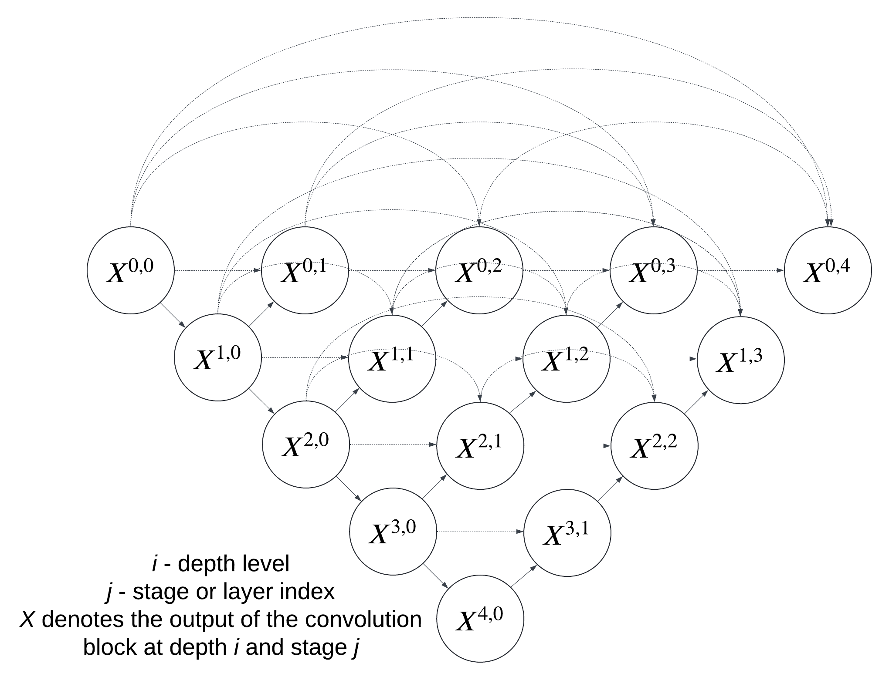

Figure 1 — Skip connections of U-Net++ [77, p. 3]

Each node $X^{ij}$ denotes the output of the convolution block at depth i and stage j, illustrating dense skip pathways across the network.
Additionally, U-Net++ incorporates deep supervision, applying supervisory signals to multiple intermediate layers rather than just the final output. This approach ensures a strong gradient flow throughout the network, leading to more effective training and robust feature learning. Another significant innovation in U-Net++ is the redesign of skip pathways to include dense convolutional blocks, which refine feature maps before they are merged in the decoder. This refinement enhances the model's ability to capture fine details and complex structures in medical images.
Overall, U-Net++ achieves superior segmentation performance by simplifying the optimization process and ensuring semantic similarity between encoder and decoder features. Its ability to handle intricate anatomical structures and provide high precision makes U-Net++ a powerful tool in medical image analysis, proving particularly effective in tasks such as lung nodule and brain tumor segmentation.

Method for image processing Trans UNet
Trans UNet architecture is one of the first successful implementations of architecture that inherited U-form architecture from the original U-Net with Transformer-based models. U-Net was received by a combination of Vision Transformers (ViT) [78] originally applied for image classification tasks and U-Net architecture. Motivated by other original U-Net it used the same number of blocks within the encoder and the decoder parts, however, the encoder applied Transformer blocks from ViT instead of convolutional layers.
Vision Transformer ViT has been proposed as the first adoption of transformer-based models for image analyses originally proposed for natural language processing tasks. Transformer-based algorithms are the first architecture that uses an attention mechanism only. The same as transformers in text processing, ViT operates with a multi-head attention mechanism. However, the image processing experienced some important differences. The minimum meaningful value of the text or “token” is the word. However, it is not possible to split the image into some meaningful parts with fixed values, because it is not clear about the size of relevant objects or the possible overlapping. So ViT operated with the patches. The patch is the part of the image within it that is cropped with the size 16*16. The whole process of classification by the next steps:
- Dividing the image into patches: The original image is divided into small patches of the same size.
- Converting patches to vectors: Each patch is converted to a fixed-length vector using a linear layer.
- Adding Positional Information: Positional information is added to each patch vector to maintain the order of the patches in the image.
- Transmission through a transformer: The resulting vectors pass through several layers of a transformer, where self-attention mechanisms are applied, allowing the model to take into account the relationships between all image patches.
- Classification: After processing by the transformer, the resulting vector is used for classification or other image analysis tasks.
The overview of ViT transformers has been provided in Figure 2.

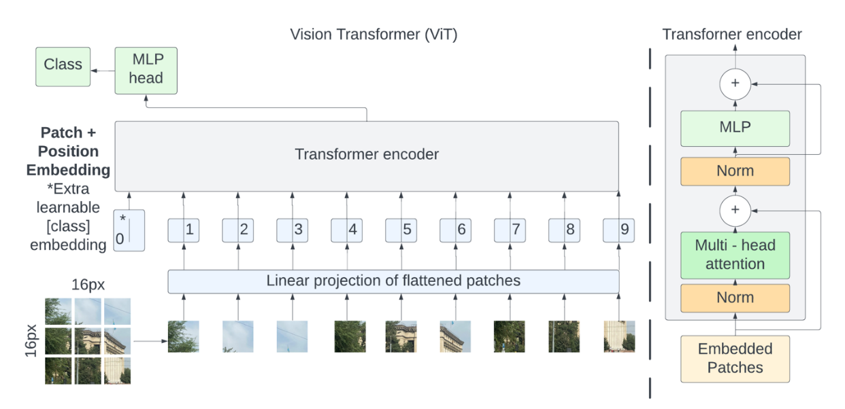
Figure 2 — Overview of Vision Transformer (ViT) [78, p. 3]

Trans UNet inherits mirror architecture from the original U-Net with an equal number of blocks in the encoder and the decoder. The encoder of Trans UNet works by the same pronciple as ViT architecture. Certaintly, it does not apply the last classification layer. As it is shown in Figure 3 with an overview of TransUNet model, firstly the relevan features of the image are extracted via feature extraction convolution layer. Then the linear projection is received and fed into several attention normalisation and attention blocks.

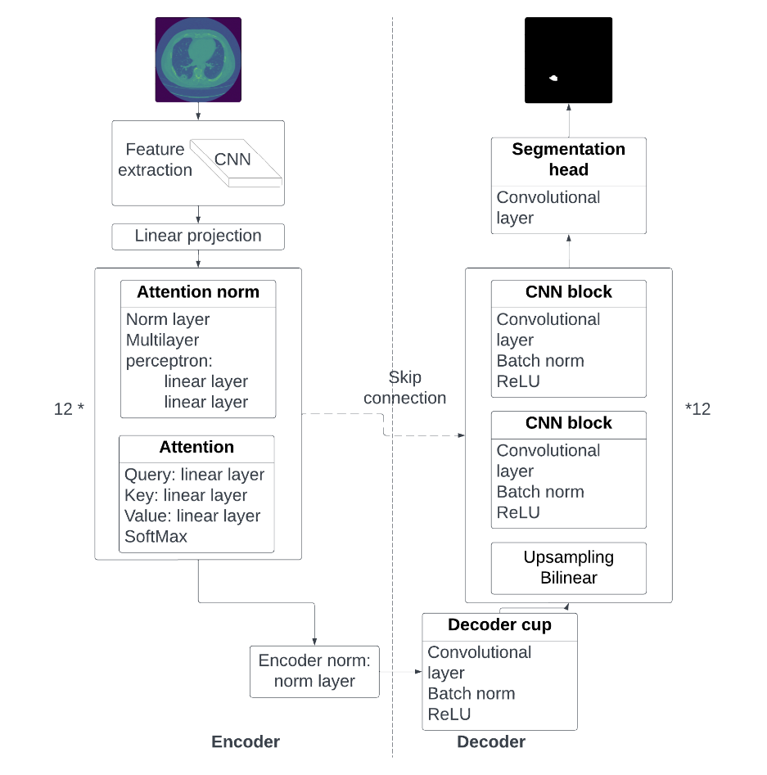

Figure 3 — Trans UNet model architecture [69, p 3]
The decoder of Trans UNet is usually a convolutional neural network with double convolutional and up-sampling layers with the same total number of blocks as in the encoder.

Method for image processing SwinUNet
Like Trans UNet and U-Net, SwinUNet architecture was constructed for medical image segmentation tasks. Swin U-Net also used a mirror U-structure of the original U-Net but with an application of Transformers in the encoder and the decoder. The replacement of a convolutional decoder with a transformer-based is not only one difference between Trans UNet and SwinUNet, SwinUNet architecture applied Swin Transformers block [79] for better segmentation quality. The overview of model architecture have been provided in Figure 4.

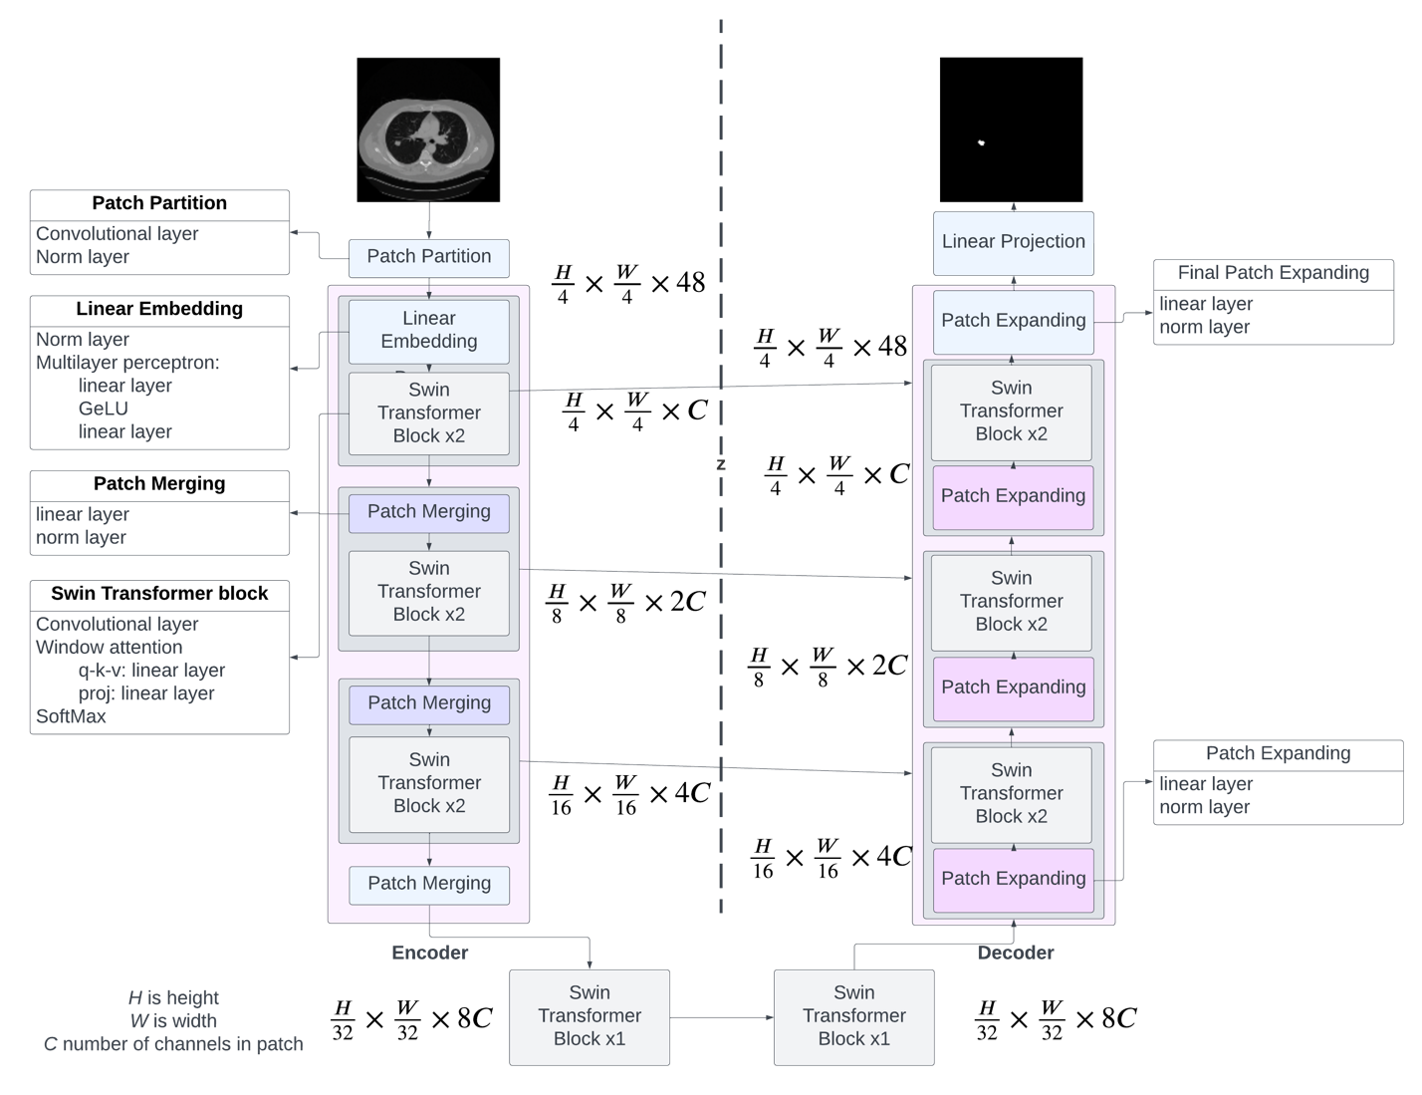

Figure 4 — Swin-Unet model architecture [70, p. 5]

H is height, W is weight, and C is the number of channels for image patch in Figure 4. The encoder block functions as a transformer with a sequence embedding input. Hence, the input image is divided into non-overlapping patches sized 4x4. This results in each patch having a feature dimension of 4x4x3=48 (with 3 representing the number of channels). Swin Transformer blocks and patch merging layers create hierarchical feature representations. Down-sampling and dimension increase are achieved through the patch merging layer, and feature representation learning is accomplished using the Swin Transformer block. The Swin Transformer block is described as a versatile backbone for Transformer-based models and has been tested for both classification and object detection tasks, making it a critical component of the Swin U-net architecture.
In computer vision, convolutional neural networks (CNNs) are the dominant architecture. However, Transformer-based algorithms excel in natural language tasks due to their ability to handle sequence data with long-range dependencies. The authors of the Swin Transformer identify two primary challenges in adapting Transformers for computer vision: defining a basic element and managing computational complexity. Unlike language processing where word tokens serve as basic elements, it's challenging to determine a fixed size for the minimal element in images. Additionally, the computational complexity is higher in images due to more pixels compared to words in a paragraph. The Swin U-net architecture addresses these challenges using hierarchical feature maps and a shifted window approach, as depicted in Figure 5.
Figure 4 illustrates the splitting of an input image with three channels into non-overlapping patches. The original article specifies each patch's size as 4x4x3, resulting in (H x W) patches. Previous articles mention splitting images into fixed-scale patches, whereas the Swin Transformer creates hierarchical feature maps (Figure 3), mimicking CNN feature map resolutions. The number of patches reduces in deeper layers by merging with neighboring patches in a 2x2 fashion, with a down-sampling resolution of 2x2 and an output dimension of 2.
Hierarchical feature maps in Swin Transformers start with small grey-colored patches (Figure 4) that merge with neighboring patches in deeper layers. This approach allows the use of dense prediction algorithms.
Another issue with ViT Transformers is their quadratic computational complexity due to the global self-attention mechanism that processes all patch vectors, increasing token numbers with image size. Swin Transformers address this by calculating self-attention within non-overlapping windows (shifted windows), replacing standard multi-head self-attention (MSA) with shifted windows (Figure 6), thereby achieving linear complexity instead of quadratic in Swin Transformers. Global self-attention is formalized as shown in Eq. 1:

$$\begin{aligned}Ω\left(MSA\right)=4hwC^{2}+2{\left(hw\right)}^{2}C\#\left(1\right)\end{aligned}$$

Where MSA is standard multi-head attention
[h, w] is image dimension
computation complexity of MSA is quadratic to the image size
C is the length of patch vector

While window-self attention with linear complexity is described in Eq. 2:

$$\begin{aligned}Ω\left(W-MSA\right)=4hwC^{2}+2M^{2}\left(hw\right)C\#\left(2\right)\end{aligned}$$
Where $W-MSA$ is shifted window-based MSA,
$M$ is the fixed window size, default $M = 7$,
the computation complexity is linear to the image size.

The shifted window approach is illustrated in Figure 6. It employs a regular window partitioning strategy, as shown in the left part of Figure 5, beginning from the top-left pixel. The feature size of 8x8 is divided into windows of size 4x4. Subsequently, the window shifts from the previous layer by moving $\left(\left[\frac{M}{2}\right],\left[\frac{M}{2}\right]\right)$pixels from the regular partitioning. The total number of patches must be retained, with the blocks being transposed accordingly.
The following way allows for solving the main problem of transformer-based models. Transformer-based models, which use an attention-based approach, work correctly with global context. However, in medical image processing, where relevant parts are extremely smaller than others, like in cancer segmentation, local context also should be taken into account. Swin Transformer solves this problem via the hierarchical feature representation and a shifted window approach.

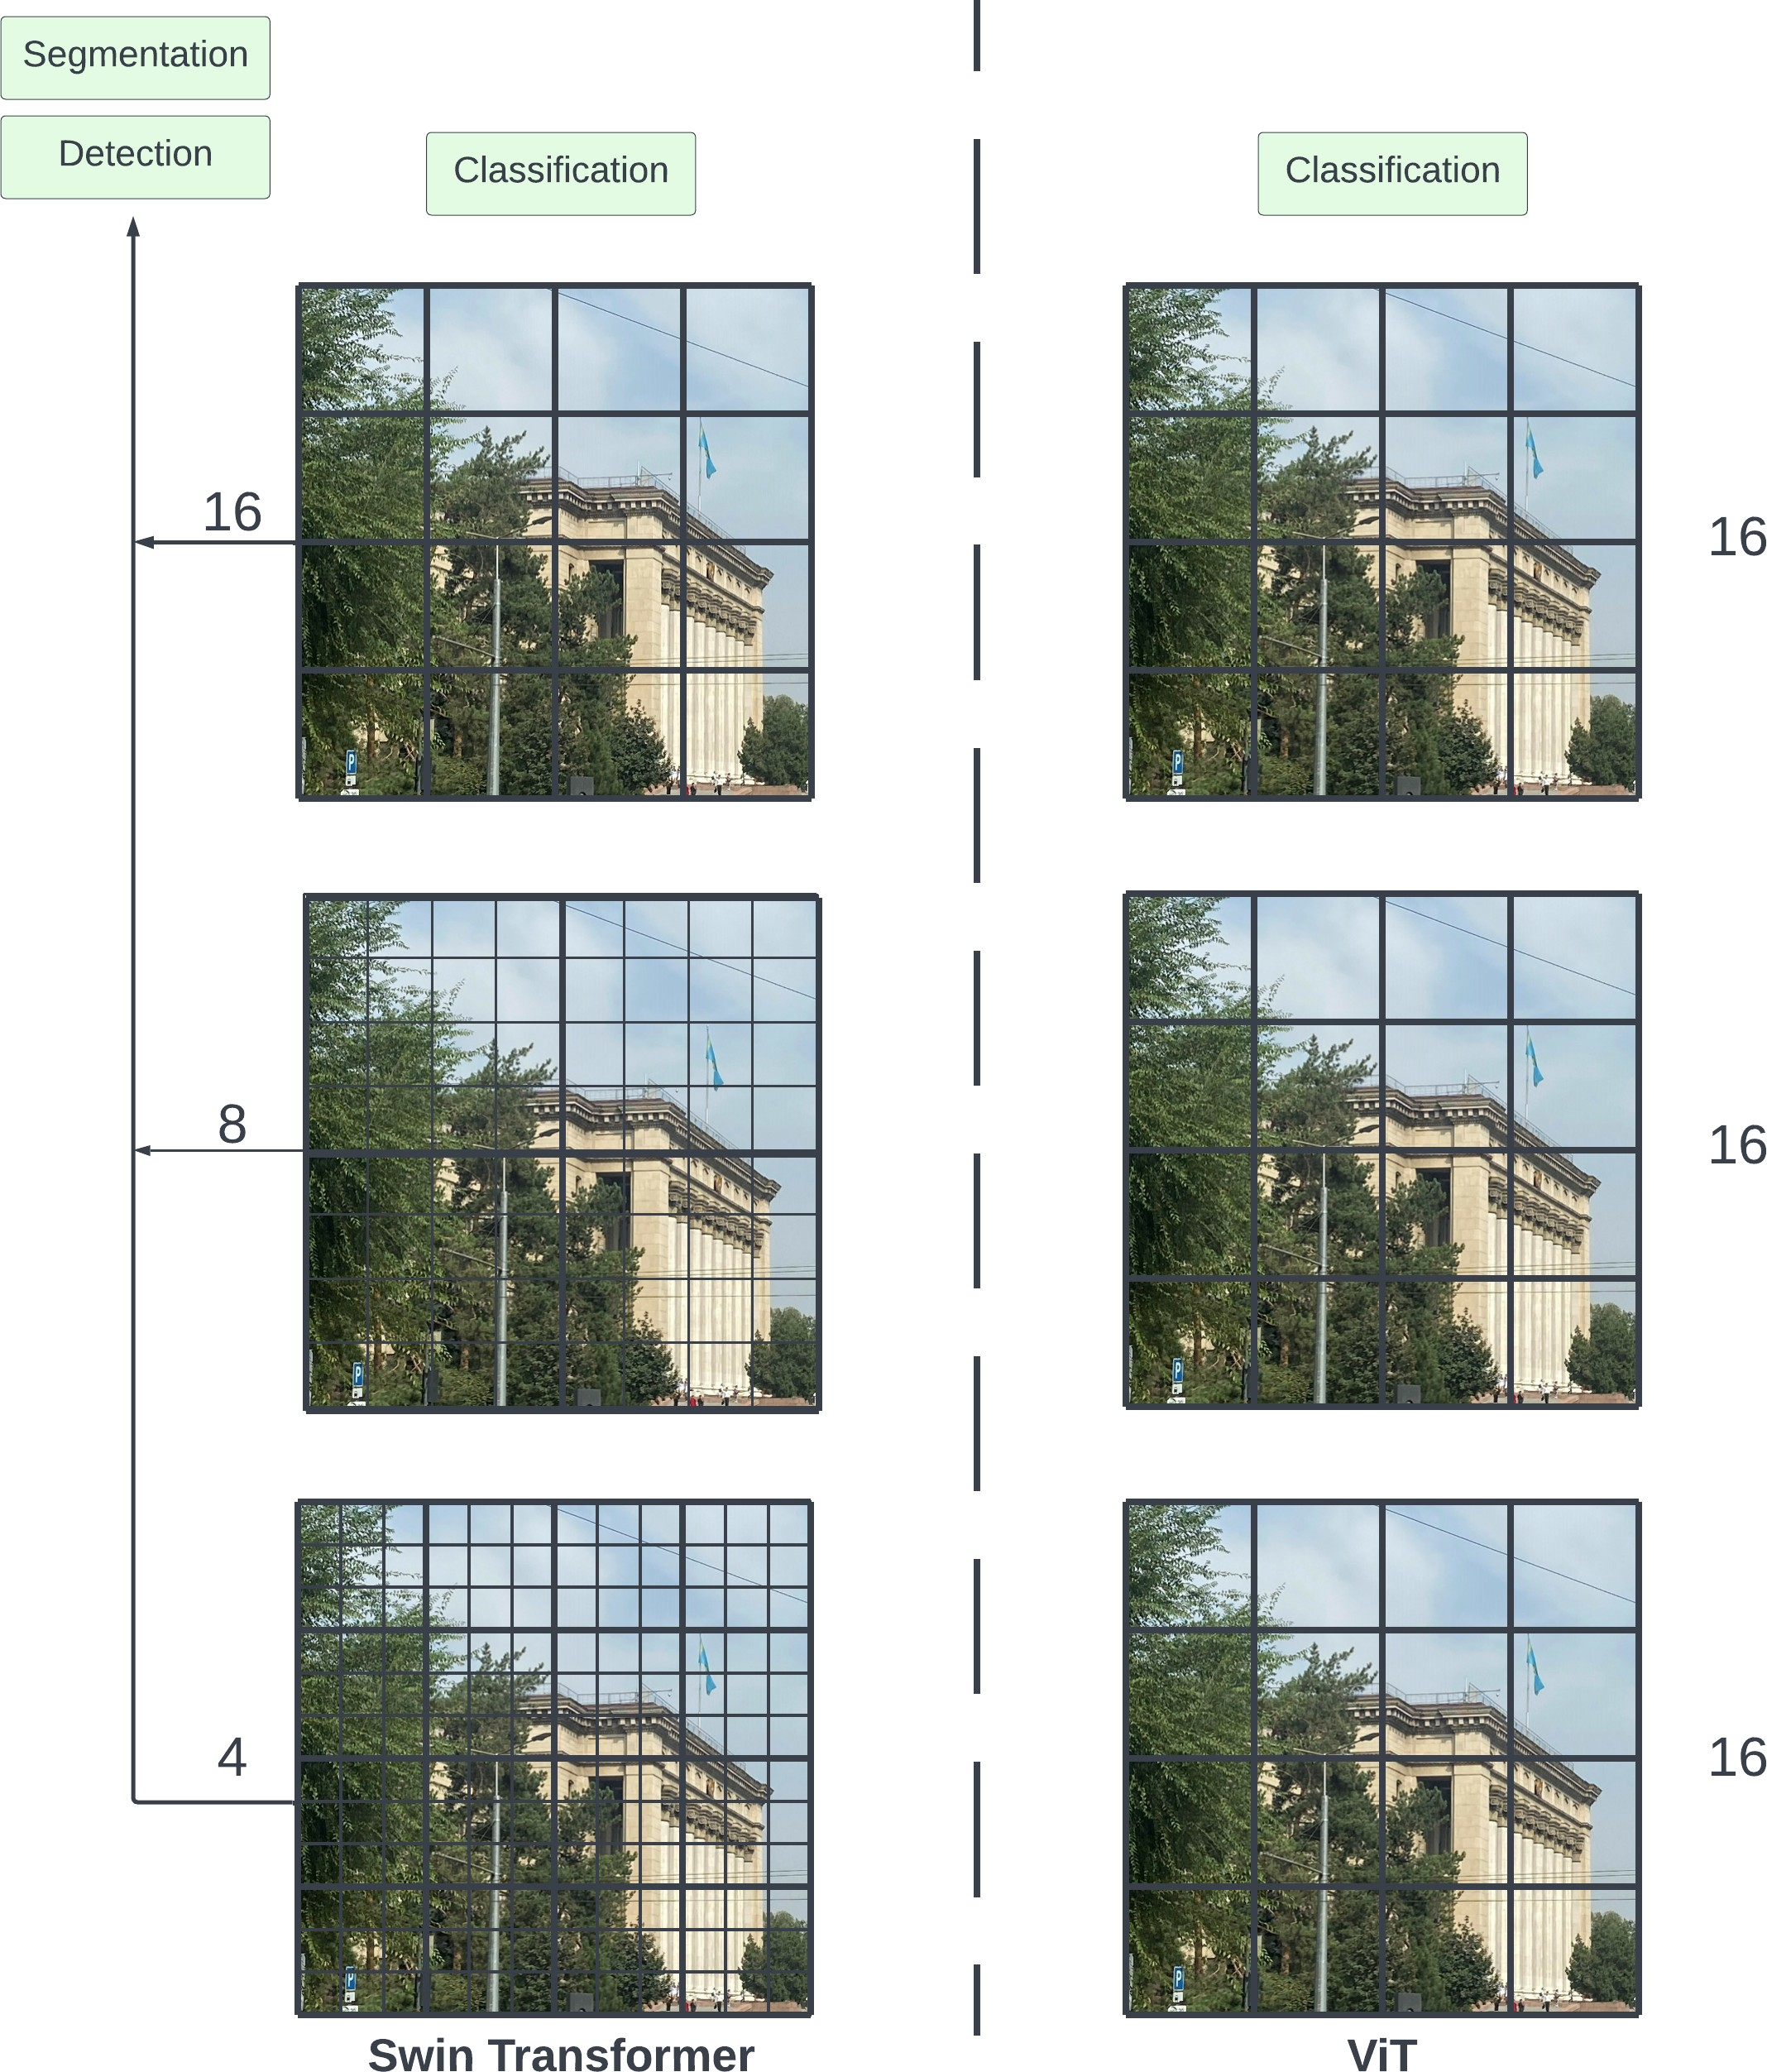

Figure 5 — Hierarchical feature maps in Swin Transformer (a) and fixed size in Vision Transformers ViT (b) [70, p. 1]

Hierarchical feature maps in Swin Transformer allows to see images from different perspective.

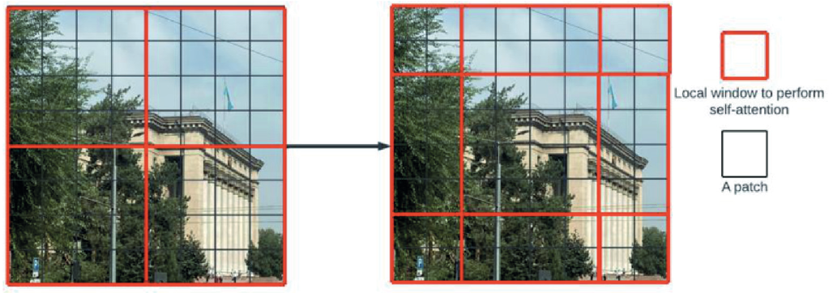

Figure 6 — Shifted window approach [70, p. 2]

Swin Transformer block is formalized via Equations 3-6 with an application of Shifted window-based multi-head self-attention mechanism.

$$\begin{aligned}\hat{z^{l}}=W-MSA\left(LN\left(z^{l-1}\right)\right)+z^{l-1}\#\left(3\right)\end{aligned}$$
$$\begin{aligned}\hat{z^{l}}=MLP\left(LN\left(\hat{z^{l}}\right)\right)+\hat{z^{l}}\#\left(4\right)\end{aligned}$$
$$\begin{aligned}\hat{z^{l+1}}=SW-MSA\left(LN\left(z^{l}\right)\right)+z^{l}\#\left(5\right)\end{aligned}$$
$$\begin{aligned}\hat{z^{l+1}}=MLP\left(LN\left(\hat{z^{l+1}}\right)\right)+\hat{z^{l+1}}\#\left(6\right)\end{aligned}$$
Where $W-MSA$ is multi-head self-attention,
$SW-MSA$ is Shifted Multi-head self attention,
$MLP$ is multi-layer perception,
$\hat{z^{l}}$ is an output the $\left(S\right)W-MSA$,
$z^{l-1}$ is an output of MLP,
$LN$ is the natural logarithm.

Relative position bias is employed to calculate the distance between patches. It relies on the relative position representations detailed in the article [80]. The self-attention mechanism is executed as described in Equation 7.

$$\begin{aligned}Attention\left(Q,K,V\right)=SoftMax\left(\frac{QK}{\sqrt{d}}+B\right)V\#\left(7\right)\end{aligned}$$
Where $B∈R^{M^{2}*M^{2}}$ is Bias
$Q∈$ is query,
$K∈$ is key,
$V∈$ is value,
$d$ is the dimension of query and key,
$M^{2}$ is the number of patches in a window.

Swin transformers have been applies for various computer vision tasks, such as image classification, segmentation, and object detection. The model showed high performance on all of them. The comparative analyses of Trans UNet, U-Net, U-Net ++ and Swin UNet models have been published in Nam D., Pak A. COMPARATIVE ANALYSIS OF U-NET, U-NET++, TRANSUNET AND SWIN-UNET FOR LUNG X-RAY SEGMENTATION. Herald of the Kazakh-British technical university. 2024;21(2):42-53 [81].

Overview of lung cancer
In this chapter, the authors will explore the key aspects related to lung cancer, starting with its definition and causes, and concluding with statistical data and the Lung-RADS classification system. The chapter will begin with a description of lung cancer, including its main types and causes. Next, the authors will analyze global and Kazakhstani statistics on the prevalence and mortality of lung cancer, which will help to assess the scale of the problem and identify key trends. Finally, the authors will take a detailed look at the Lung-RADS system, which is an important tool for standardizing the diagnosis and management of lung cancer. Special attention will be given to the application of this system in the context of Kazakhstani data, allowing for an assessment of its effectiveness and potential benefits for local patients.
Lung cancer is a type of cancer that originates in the tissues of the lungs, usually in the cells lining the air passages. It is one of the most common and deadliest forms of cancer worldwide. The disease is characterized by uncontrolled cell growth in the lung tissues, which can spread (metastasize) to other parts of the body, including the brain, bones, liver, and other organs. There are two main types of lung cancer: non-small cell lung cancer (NSCLC), which is the most prevalent, and small cell lung cancer (SCLC), which is less common but tends to grow and spread more quickly. The information about lung cancer types is extremely important because it has a big influence on the next treatment. Also, Lung cancer types have an impact to the statistics of appearance and correlation with region. SCLC is not so common as NSCLC, however, it is a more mortal type of lung cancer. Additionally, these types of cancers have different view on Computed tomography images and different radiological features. This fact is important for the computer vision. The description of types is provided in Table 2.

Table 2 — Lung Cancer Types

Type | Description
Non-Small Cell Lung Cancer (NSCLC) | Accounts for approximately 85% of all lung cancer cases. It includes subtypes such as adenocarcinoma, squamous cell carcinoma, and large cell carcinoma. NSCLC is generally less aggressive than SCLC and may be treated with surgery, radiation, chemotherapy, targeted therapy, or a combination of these.
Small Cell Lung Cancer (SCLC) | Small Cell Lung Cancer (SCLC): Comprises about 15% of lung cancers and is known for its rapid growth and early spread to distant body parts. It is typically treated with chemotherapy and radiation therapy, as surgery is rarely an option due to the advanced stage of the disease at diagnosis.

Lung cancer is a multifaceted disease with a variety of contributing factors. Understanding these causes is crucial for prevention, early detection, and treatment. While some risk factors are well-established, others are still being researched.

Overview of Lung cancer worldwide statistics
Lung cancer is a leading cause of cancer-related mortality worldwide. It presents a significant public health challenge due to its high incidence and poor prognosis. In 2024, lung cancer remains the most common cause of cancer death globally, accounting for 1.8 million deaths, which represents 18.7% of all cancer-related deaths​ [82]. This high mortality rate is largely due to the late stage at which lung cancer is often diagnosed, as well as its aggressive nature and the presence of other risk factors such as smoking.
Since the 1980s, lung cancer has consistently held a leading position as the most common cause of cancer-related deaths worldwide. This trend underscores the global burden of the disease, which surpasses other types of cancer in terms of mortality rates. The prevalence and lethality of lung cancer highlight the urgent need for effective prevention and treatment strategies on a global scale. The distribution of death rate of lung cancer is shown in Figure 7.

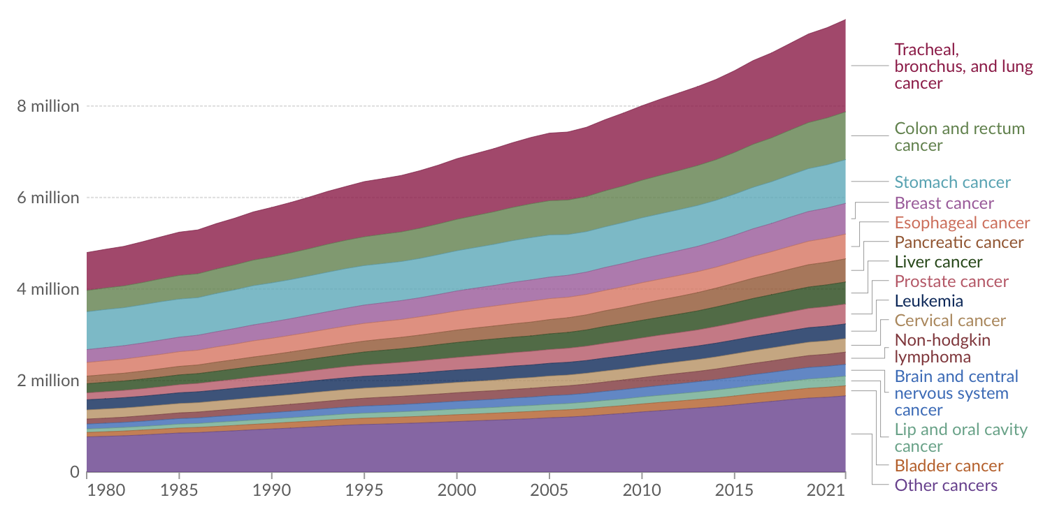

Figure 7 — The distribution of death rate between cancer types from 1980 to 2021 over the world. The graph from [83] The statistics from [84]

The Figure 8 illustrates the global incidence rates of lung cancer per 100,000 people, age-standardized for both sexes in 2022. It uses a color gradient to represent varying rates, with dark blue indicating the highest incidence (above 40 per 100,000) and lighter shades representing lower rates. Notably, countries like Canada, China, and parts of Eastern Europe exhibit the highest rates, while regions such as the United States, Western Europe, and parts of South America show moderate incidence rates. In contrast, much of Africa, South Asia, and Central America display the lowest rates, marked in yellow to light green. This visual representation highlights significant geographic disparities in lung cancer incidence, underscoring the influence of factors such as smoking prevalence, environmental exposures, and healthcare access across different regions.

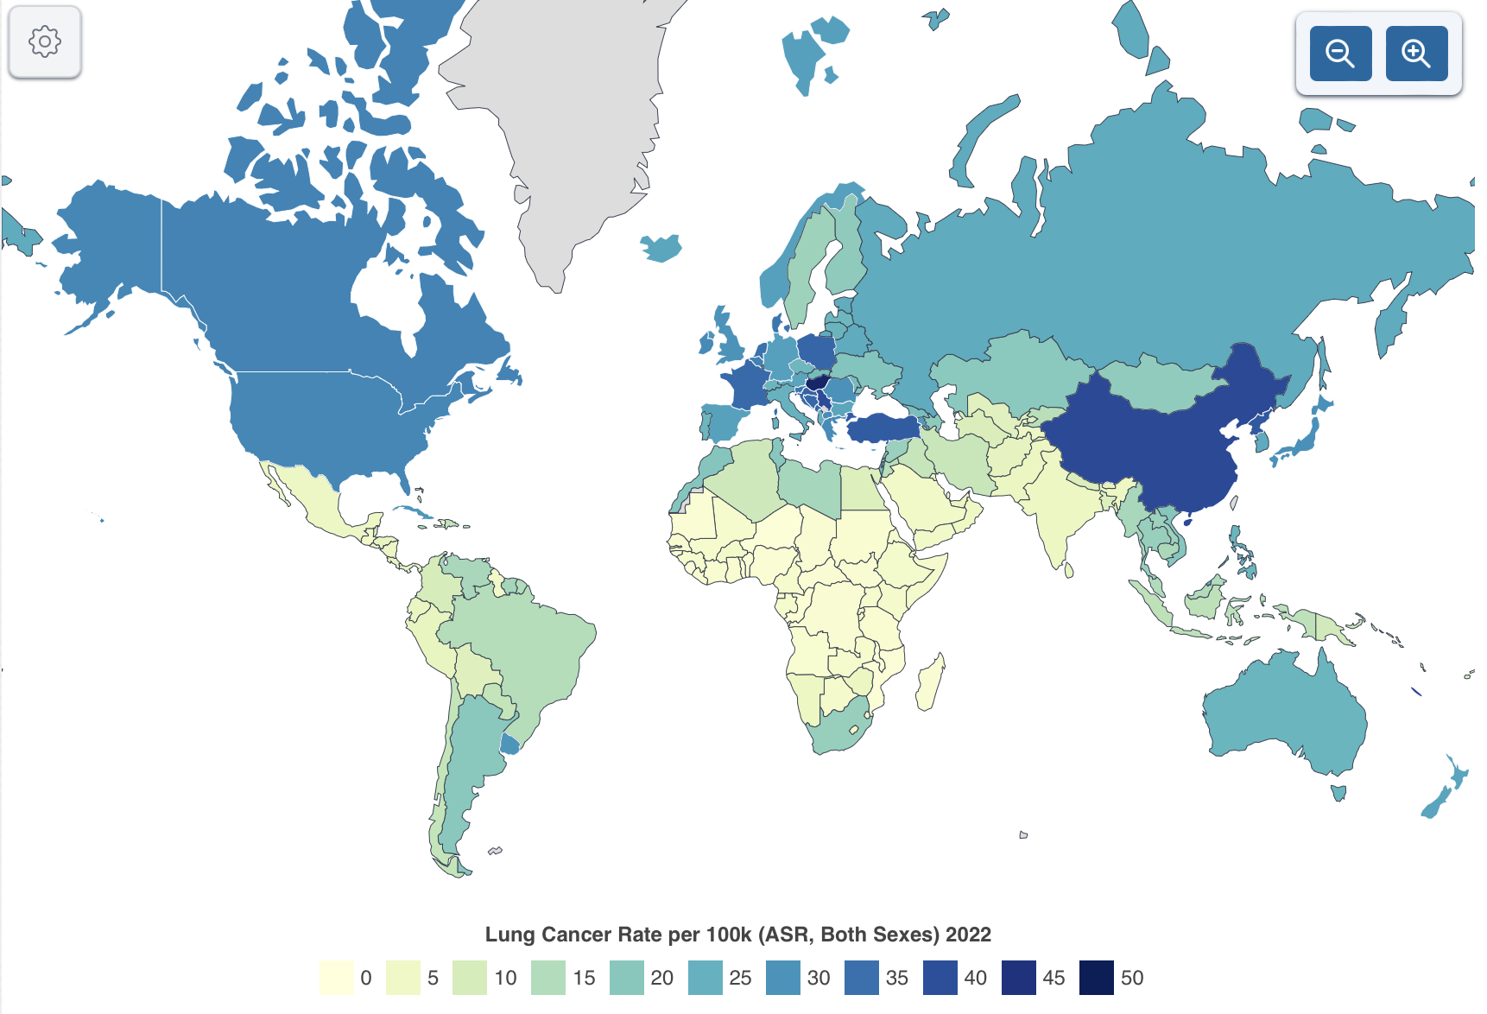

Figure 8 — Lung cancer rate per 100k for both sexes in 2022 over the world [85]

Figure 9 shows lung cancer mortality rate. Continuing from the previous discussion on lung cancer's prevalence and mortality, the global distribution of lung cancer mortality rates in 2022 illustrates significant geographic disparities. The highest mortality rates are concentrated in countries like Turkey, Hungary, and China, where rates exceed 30 deaths per 100,000 people. These regions, shaded in dark blue on the map, face substantial challenges in addressing lung cancer due to high smoking prevalence, environmental factors, and possibly limited access to early detection and treatment. In contrast, countries with lower mortality rates, particularly in Africa and South America, exhibit a range of factors, including potentially lower smoking rates and different environmental exposures. However, lower mortality rates in these regions may also reflect underreporting or limited diagnostic capabilities. This disparity underscores the critical need for targeted public health interventions and equitable access to healthcare resources to reduce lung cancer mortality worldwide. It is imperative to enhance early detection, improve treatment options, and implement comprehensive tobacco control measures to mitigate the burden of lung cancer.

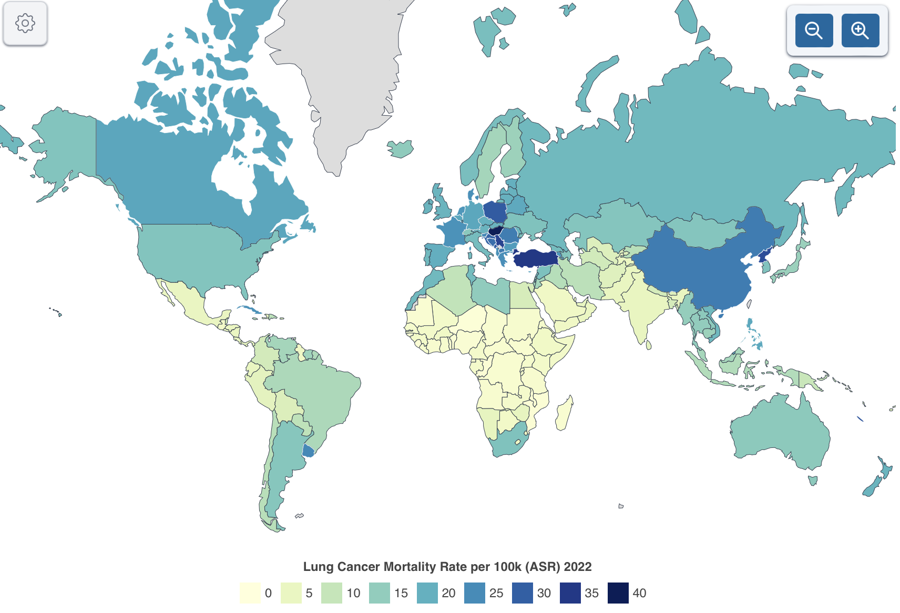

Figure 9 — Lung cancer mortality rate per 100k for both sexes in 2022 over the world [85, p. 1]

In Kazakhstan, the prevalence and mortality of lung cancer are at a moderate level compared to other countries, as can be seen from the provided graphs. In 2022, lung cancer mortality rates in Kazakhstan are in the range of 10 to 20 per 100,000 population, which is significantly lower than in countries with high mortality rates, such as Turkey and Hungary. However, the situation requires constant monitoring and improvement of preventive measures. Potential risks associated with environmental factors and changing lifestyles of the population must be taken into account. Even with a relatively low incidence rate, timely diagnosis and access to quality health care remain important to reduce mortality and improve the quality of life of patients.

Overview of Lung cancer and other cancer statistics in Kazakhstan
However, lung cancer in Kazakhstan, while not as prevalent as in some other countries, remains the leading cause of cancer-related deaths, mirroring global trends. In this chapter, the authors examine the statistics and trends of lung cancer in Kazakhstan over the past several years, based on publicly available sources. The distribution of lung cancer cases in Kazakhstan aligns with global patterns, where, despite not being the most common cancer, it remains the most lethal. This analysis underscores the significant impact of lung cancer on public health in Kazakhstan, highlighting the critical need for continued efforts in prevention, early detection, and treatment.
Figure 10 shows the number of new cases in Kazakhstan in 2022, segmented by gender and overall population. The information has been provided by an open-source Global Cancer Observatory (IARC). In males, lung cancer emerges as the most prevalent type, accounting for 22.6% of the cases (3,822 cases), followed by stomach cancer at 11.0% and colorectal cancer at 10.5%. The incidence of prostate and liver cancers is also notable, comprising 8.0% and 4.2% of cases, respectively. The "Others" category, which includes various other cancers, makes up a significant portion, at 43.7%.
In contrast, among females, breast cancer is the leading cancer type, with a substantial 23.7% of the total cases (4,570 cases). Cervical cancer follows, accounting for 9.5%, and colorectal cancer stands at 9.0%. Other prominent cancers include corpus uteri (6.7%) and stomach cancer (6.4%). Notably, the "Others" category is also significant among women, representing 44.8% of the cases, indicating a diverse range of less common cancers affecting the female population.

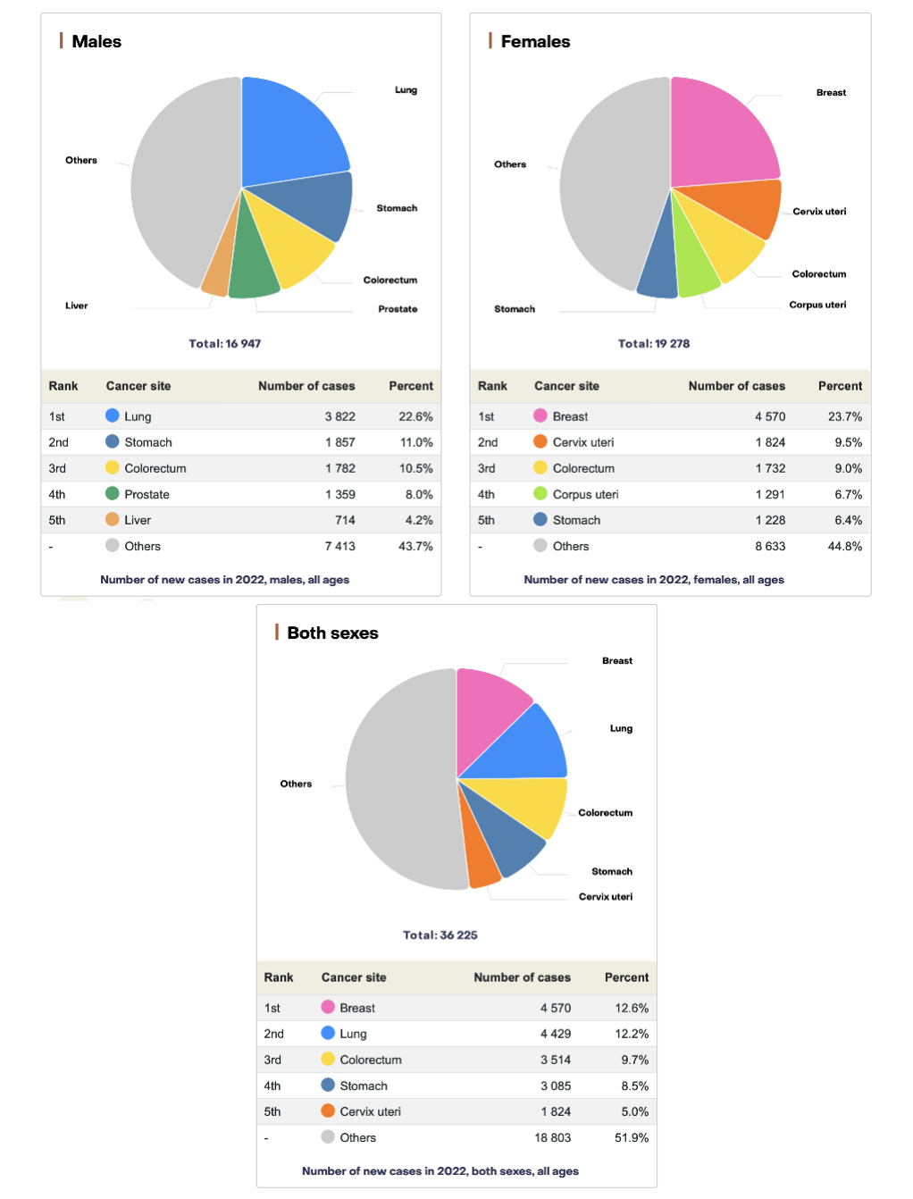

Figure 10 — Number of new cases in Kazakhstan [86]
When considering both sexes, the total number of new cancer cases in Kazakhstan for 2022 is 36,225. Breast cancer and lung cancer are the two most common cancers, with 12.6% and 12.2% of the cases, respectively. Colorectal and stomach cancers follow, with 9.7% and 8.5% of the cases. Cervical cancer also features prominently among the top cancers, at 5.0%. The "Others" category, which encompasses various other cancers, constitutes the majority of cases at 51.9%, highlighting the wide range of cancer types present in the population. This data underscores the diverse cancer landscape in Kazakhstan, necessitating targeted public health strategies and interventions.
As observed in the information provided by source [87], the study examined new cases of lung cancer (LC) in Kazakhstan from 2010 to 2019. Data from the Ministry of Health and the Bureau of National Statistics were utilized to calculate incidence rates. The mean age of patients was 64.2 years, with the highest incidence observed in the 55-74 age groups. The majority of cases were among men (80.5%). Statistical analyses included the calculation of average annual change rates and trend analysis using the Joinpoint program. The findings highlighted the significant proportion of new LC cases among older adults. Incidence Rate of LC in Kazakhstan based on number and age in 2010-2019 have been provided in Figure 11.
Based on the calculated average annual Crude Rate (CR) and Age-Standardized Rate (ASR) indicators for lung cancer (LC), the study compiled cartograms to categorize regions by incidence rates per 100,000 population. For CR, regions were classified as low (up to 18.4), average (18.4 to 28.4), and high (above 28.4), as illustrated in Figure 11A. The lowest indicators were found in South Kazakhstan and Mangystau. The ASR criteria divided regions into low (up to 20.6), average (20.6 to 25.6), and high (above 25.6), shown in Figure 11 B. Regions like Astana city and East Kazakhstan had higher ASR levels. This analysis provides a detailed regional breakdown of lung cancer incidence in Kazakhstan. The cartogram has been drawn for 2010 – 2019 years.

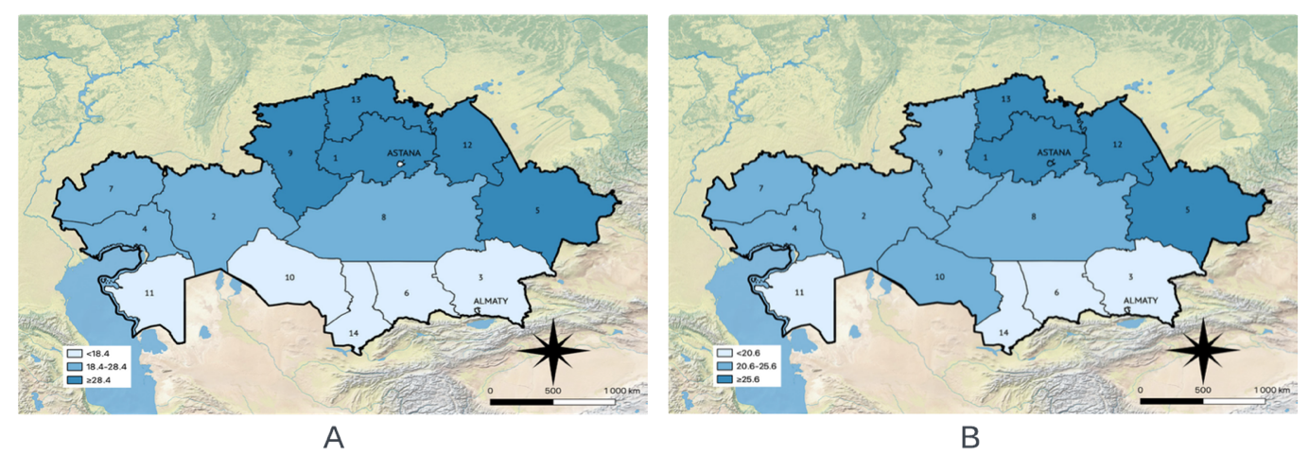
Figure 11 — The cartogram of lung cancer in Kazakhstan based on (a) CR (b) ASR [87, p. 1]

The list of regions for Figure 11 could be described as following 1. Akmola, 2. Aktobe, 3. Almaty, 4. Atyrau, 5. East-Kazakhstan, 6. Zhambyl, 7. West-Kazakhstan, 8. Karaganda, 9. Kostanay, 10. Kyzylorda, 11. Mangystau, 12. Pavlodar, 13. North-Kazakhstan, 14. South-Kazakhstan.

Overview of Lung-RADS System
The authors collected and labeled the dataset with the combination of Kazakhstan local data and open open-source dataset LIDC-IDRI. The dataset was labeled for cancer segmentation and classification based on the Lung-RADS System [88]. The labeling of the dataset is unique, however, there is a lot of existing research that applied the Lung-RADS system. The Lung-RADS System was utilized due to its significant enhancement in the quality of patient management.
Lung-RADS (Lung Imaging Reporting and Data System) is a quality assurance tool designed for the standardization and management of lung cancer screening with low-dose computed tomography proposed by the American College of Radiology. The description of classes based on the Lung-RADS System is shown in Table 3.

Table 3 — The description the classes based on the Lung-RADS System

Class (Lung-RADS) | Size | Recommendations | Description
LR1 | n/a | n/a | No nodules or nodules with a very low likelihood of becoming cancerous. Considered a healthy scan.
LR2 | 4-6 mm | 1 year control | Nodules with characteristics highly unlikely to become cancerous. Low-risk features are present.
LR3 | 6-8 mm | 6 month control | Nodules with a low likelihood of malignancy, requiring closer monitoring but still generally low risk.
LR4A | Less than 1.5 cm | 3 month control | Nodules more suspicious for malignancy, requiring short-term follow-up. Intermediate risk.
LR4B | Greater than 1.5 cm | Biopsy is recommended | Nodules highly suspicious for malignancy, likely requiring biopsy for further evaluation. High risk.

Lung-RADS System is responsible for the next nodule classification and the next treatment. Currently, it is the main system used for the evaluation of cancer stage over the world.

Review of Existing CAD systems for lung cancer detection
In this paragraph, the authors observed existing CAD systems which could be applied for lung cancer segmentation. However, it should be mentioned that their application is associated with high costs. The expense of using such software is influenced by several factors, including the scale of deployment, integration requirements, and ongoing support and maintenance. Additionally, the costs can be further exacerbated by the need for specialized hardware, training for medical staff, and the customization required to adapt the software to specific clinical settings. The initial investment often includes licensing fees, installation charges, and potential upgrades, which can add up quickly. Furthermore, there are hidden costs such as the potential need for data security measures and compliance with medical regulations, which are crucial for protecting patient information. These financial considerations can pose significant barriers for many healthcare institutions, particularly smaller clinics or those in resource-limited settings, making it challenging to adopt these advanced technologies despite their potential benefits.

Google AI for Lung Cancer Detection
Google AI for Lung Cancer Detection [89] represents a significant advancement in the application of artificial intelligence in healthcare, specifically in the early detection and diagnosis of lung cancer. Google AI uses deep learning models to analyze CT scans of the lungs with a high degree of accuracy. The technology is designed to improve the early detection of lung cancer by identifying malignant nodules that might be missed by human radiologists.
Instead of the usual approach, when the doctor examines the CT image as a 2D image, Google AI applies 3D volumetrics for early-stage lung cancer detection. The model processes the entire CT scan, examining each layer in detail, which allows it to detect small nodules that may be indicative of early-stage cancer. By leveraging vast amounts of data and sophisticated neural networks, Google AI can provide faster and more reliable diagnoses, potentially leading to earlier treatment and better patient outcomes. This approach not only enhances diagnostic accuracy but also aims to alleviate the workload on radiologists, allowing them to focus on more complex cases.
Google's AI model for lung cancer detection is an example of how cutting-edge technology can be harnessed to address critical challenges in medical diagnostics, ultimately contributing to improved healthcare delivery. The authors applied the dataset with more than 45 thousand clinical cases including healthy and non-healthy cases and compared the results with six doctor clinicians. The CAD systems showed average better performance than humans. For a patient without symptoms and no previous cancer history, the AI system analyzed the case and identified potential lung cancer that had previously been assessed as normal, like it is shown in Figure 12. The results had been published [90].

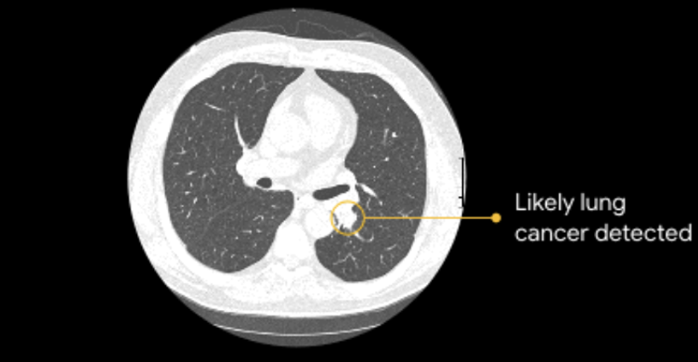

Figure 12 — An example of the usage of Google for asymptomatic patient. The photo from the site [89]
Google's AI systems do not include specific pricing information for medical products, ensuring that users seek such details through appropriate commercial channels. This limitation aligns with the platform's broader policy of prioritizing general information over transactional or cost-specific data. Consequently, users are encouraged to consult specialized vendors or manufacturers for precise pricing inquiries.

Philips Lung Cancer Orchestrator
Philips Lung Cancer Orchestrator [91] is an integrated patient management system designed to streamline the lung cancer screening process and manage incidental pulmonary findings. It supports healthcare providers by tracking patients through various stages of screening, diagnosis, and treatment, ensuring a fully documented and traceable patient journey. The system provides automated tools for patient management, including notifications, reminders, and status updates, and integrates clinical data from multiple sources such as EMRs, lab systems, pathology, radiology, and genomics into one dashboard​.
Key features of the Lung Cancer Orchestrator could be described as following.
Lung Cancer Screening Manager: Utilizes a defined set of steps to ensure timely follow-up of screening exams and diagnostic tests. Results can be communicated to participants and their primary care physicians and documented in the EMR​.
Collaborative Tumor Board: Provides a rich dashboard for multidisciplinary teams to review and manage patient cases, facilitating collaborative clinical decision-making. This includes the integration of clinical data for comprehensive patient profiles​.
Incidental Nodule Manager: Uses Natural Language Processing to identify and track incidental pulmonary findings, ensuring that suspicious findings are appropriately followed up and managed​.
Seamless Integration: Captures required and optional data elements and integrates them into the EMR and the American College of Radiology Lung Cancer Screening Registry, reducing administrative tasks and improving patient care efficiency.
This chapter shows the literature review of methods and datasets used for medical image processing.

MATERIALS AND METHODS

In this chapter, the authors provide a detailed overview of the materials and methods used in the current study. A specially collected dataset, including medical images and relevant information, was utilized for the research. This chapter discusses two main approaches to addressing the tasks at hand: deep learning methods and data augmentation methods.
The first approach involves the use of variational autoencoders and generative adversarial networks, which enable the creation of synthetic images based on existing data, thereby increasing the diversity of the training dataset. These deep learning methods play a crucial role in improving the quality of segmentation and classification of medical images, which is the main goal of this study.
The second approach focuses on the development and application of the MetaLung method [92], a data augmentation technique based on affine transformations. MetaLung was specifically designed to increase the volume and variability of data used for training models while preserving critical patterns and characteristics of medical images. This method allows for the generation of new lung cancer images while maintaining the distribution between different image components, such as lung tissue, bones, and vessels. MetaLung has also demonstrated high efficiency in reducing the number of false-positive results and improving segmentation accuracy, making it a valuable tool for clinical applications.
Furthermore, this chapter details the data preprocessing methods used to prepare the original images and data before their use in the models. Data preprocessing includes steps to enhance image quality, normalization, and artifact removal, which improve the accuracy and reliability of subsequent analysis stages.
Thus, this chapter provides a comprehensive overview of the methodologies used, as well as their implementation and benefits in the context of medical image processing and lung cancer diagnosis.

Materials for lung cancer segmentation
For this study, we, together with the Almaty Institute of Radiology and Oncology, collected and labeled a data set that can be used for further use for tasks of medical classification and segmentation of lung images. When diagnosing medical data, the specifics of the region in which the data were collected are taken into account. Firstly, this affects the statistics of the disease, and secondly, the presence of other diseases that may have similar radiological signs and symptoms. All collected data was completely anonymized.
The dataset consists of a combination of Kazakhstani local patients and Open source LIDC-IDRI data. The authors combined the datasets because of the lack of local data, which is a common problem in medical image processing. The dataset was labeled by the doctor-radiologist from the Almaty Institute of Radiology and Oncology. A specialized labeling tool, depicted in Figure 13, was employed for this study.

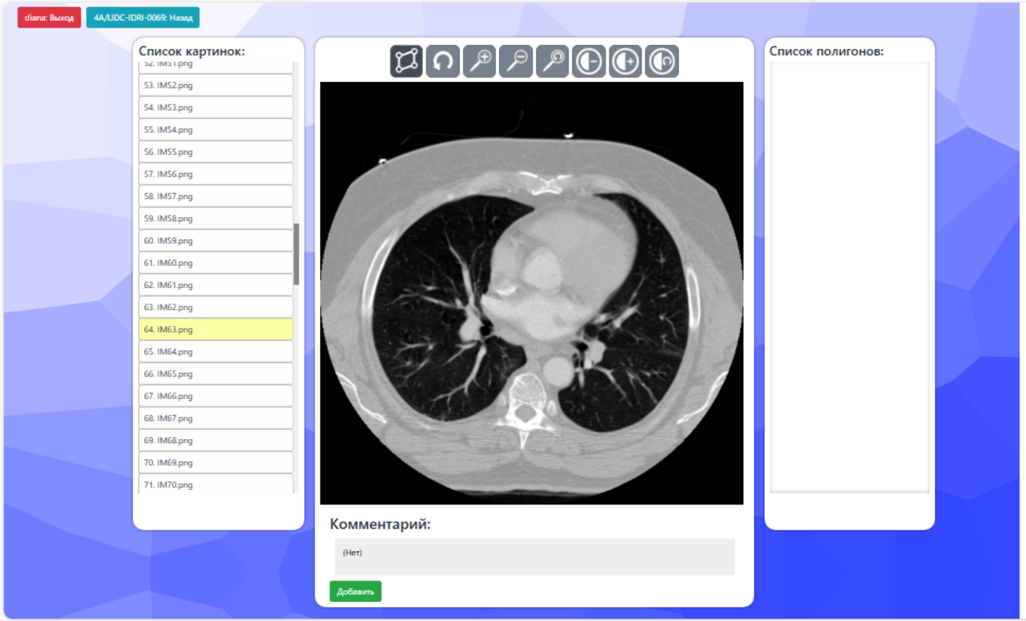

Figure 13 — Data labeling tool

The authors collected and labeled the data from 71 patients in total including private and open-source data. The data from the LIDC-IDRI dataset has been relabeled by the same principle as Kazakhstani local data. Each patient has 100 – 500 low-dose computed tomography images, and only a few of them contain lung cancer. The authors used only slices with exciting lung cancer and did not apply healthy patients with Lung-RADS class less than 2. The dataset finally contains 972 CT images with lung cancer. The distribution between Kazakhstan and open-source data was approximately 2:1 for Kazakhstani and LIDC-IRDI data correspondingly provided in Figure 14.

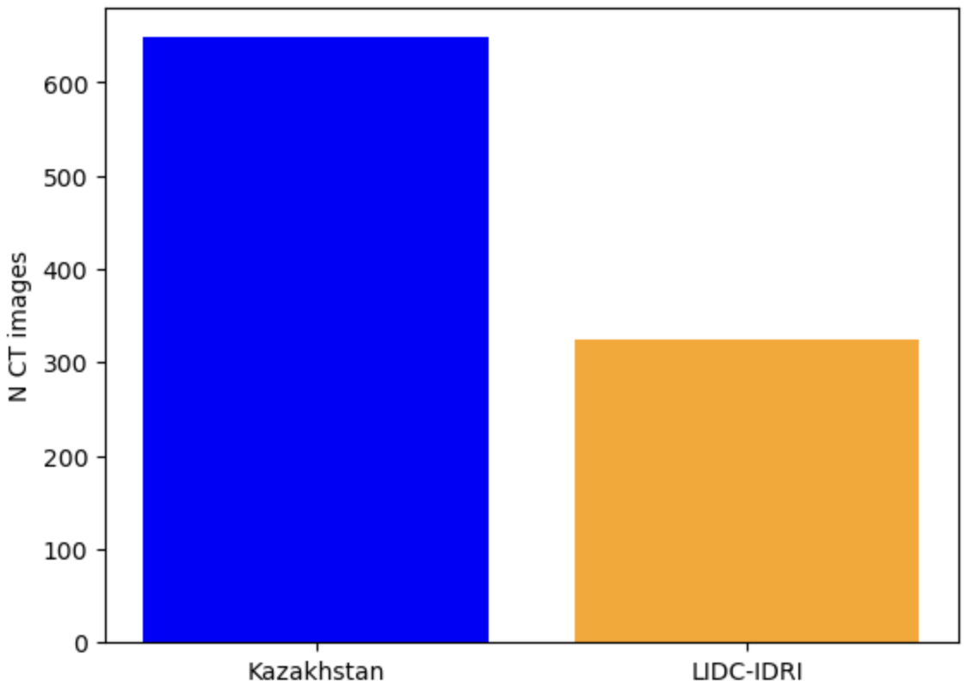
Figure 14 — The distribution between Kazakhstan and LIDC-IDRI data
The distribution between Kazakhstani and open-source data is 2:1. The main part of the data was local Kazakhstani data.

Methods for image processing
One of the main provisions of the current research is the newly proposed method MetaLung. However, it is not possible to evaluate the quality of data augmentation method without the next model training. The authors focused on the image segmentation task because it enables the assessment of the size, location, and morphology of lung cancer, rendering it more applicable to real-world scenarios compared to image classification. The authors used the pipeline shown in Figure 15 for all of the experiments. The proposed pipeline was applied for all experiments, including affine transformation, multiparameter models and MetaLung.

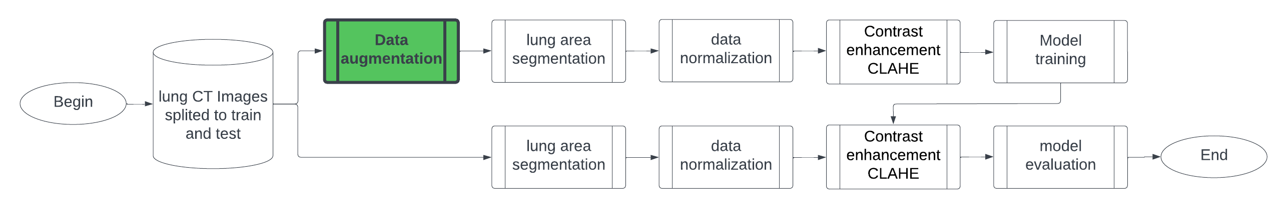

Figure 15 — Pipeline for lung cancer segmentation

The authors used the data, which was split into train and test sets. Then, the authors standardized it to Hounsfield Units. Data augmentation was not used for calculation baseline models.
The next Paragraph describes the main methods, including the newly proposed MetaLung method. The authors used the U-Net model for the evaluation the quality of segmentation with VQ-VAE and DCGAN models, and U-Net, Mask RCNN, and DeepLab V3 for the evaluation of Affine transformation and newly proposed MetaLung method.

Methods for image preprocessing
Although data augmentation also is part of image preprocessing, in this paragraph the authors observed only applied on already exciting images. The authors applied Contrast Limited Adaptive Histogram Equalization (CLAHE) to increase the contrast of CT image because this method is widely used and shows high performance on medical data. Also, the authors applied lung area segmentation with a thresholding–based algorithm. The authors did not apply neural networks for this operation because the density distribution of the lung area and adjacent areas such as fat and bones have big differences in Hounsfield units.

Method for Linear scaling of attenuation coefficients to Hounsfield Unit
The image has been provided in DICOM format. DICOM is the standard format for CT images. However, it was done with the several types of equipment: SIEMENS, GE MEDICAL SYSTEMS, TOSHIBA, UIH. So preliminary it should be standardized based on Hounsfield Unit. Hounsfield Unit is standard measure of density in CT image. It could be done via Eq. 8.

$$\begin{aligned}HU=\frac{μ_{X}-μ_{water }}{μ_{water}-μ_{air }}*1000\#\left(8\right)\end{aligned}$$

Where $μ_{water }$and $μ_{air }$ are linear attenuation coefficients for water and air under standard conditions

Figure 16 shows the changes in density after standardization according to Hounsfield Units.

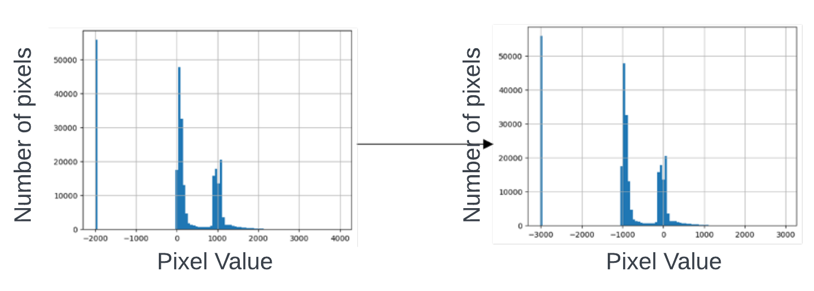
Figure 16 — Histogram of DICOM image (a) before converting to HU (b) after converting to HU

All instances on CT images have some specific density, which is quantified in Hounsfield Units (HU). This density measurement is crucial for differentiating between various tissue types and abnormalities. For example, lung calcifications, which often indicate areas of old infections or inflammatory responses, typically exhibit high HU values similar to those of bones, reflecting their dense, calcified nature. On the other hand, lung cancer regions tend to have much lower HU values, often approaching zero, which corresponds to the density of soft tissues and fluid-filled spaces.
The precise measurement of these HU values allows radiologists and automated systems to distinguish between normal anatomical structures and pathological changes. In the case of lung CT imaging, the ability to identify and classify these densities accurately is vital for diagnosing conditions such as lung cancer, pulmonary nodules, and other pulmonary diseases. The distribution of HU values within a lung CT image provides a detailed map of the varying densities, highlighting areas of concern that may require further investigation.
In addition to lung cancer and calcifications, other instances, such as fat, muscle, and air-filled spaces, each have characteristic HU ranges that aid in their identification. For instance, fat typically appears with HU values ranging from -100 to -50, while muscle tissue has values around 40 to 50 HU. The presence of air, as in the lung's alveoli, is represented by HU values near -1000. This wide range of HU values in a CT image forms a distinctive pattern that can be analyzed to detect abnormalities, track disease progression, or monitor treatment efficacy.
The distribution of density in HU in a lung CT image, as illustrated in Figure 17, offers a comprehensive view of these variations. It helps in understanding the tissue composition and potential abnormalities within the lung. By analyzing this distribution, healthcare professionals can make informed decisions regarding diagnosis and treatment, enhancing patient care and outcomes.

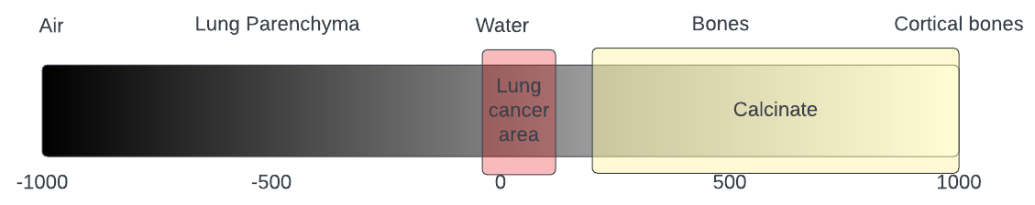

Figure 17 — The density distribution of different instances on Lung CT image

The authors deliberately annotated the cancer and calcification values with specific colors in Figure 17 to demonstrate the difference in density. Cancers and calcifications have similar shapes and locations on lung CT scans but differ significantly in density. Cancer could be a mortal illness, whereas calcified formations in the lung do not independently carry severe consequences. An example of the difference between cancers and calcified formations is shown in Figure 18.

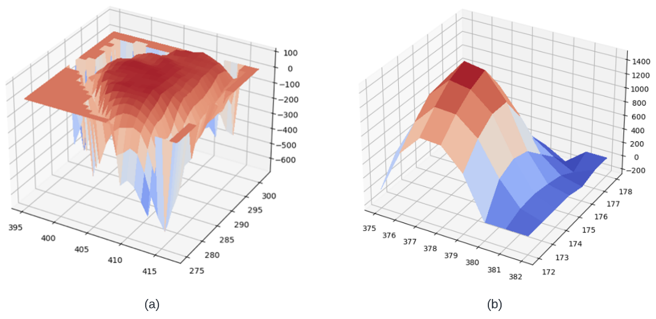
Figure 18 — The density distribution in Hounsfield Units between (a) cancer (b) calcifications

As it is shown in Figure 18 the density for calcification is much more than for cancer.

Thresholding-based method for lung area segmentation
To enhance the effectiveness of model training, thresholding-based segmentation was applied to both the training and test sets to eliminate all non-lung regions from the images. This preprocessing step aims to focus the analysis on the lung area, thereby removing irrelevant parts and potentially reducing the complexity of the data. It is important to note that this step is optional and can be omitted if deemed unnecessary. Additionally, the authors did not assess the quality of lung segmentation in this study.
Despite the potential influence of external factors on CT images, which can introduce noise, the significant difference in HU values between the lung tissue and the bone area allows for effective lung segmentation using the thresholding method. This method can accurately isolate the lung region without the need for more complex neural network-based segmentation approaches, thereby reducing computational complexity and processing time. The block diagram of the lung segmentation process is illustrated in Figure 19. By using a binary mask of the same size as the input image, the authors can effectively extract only the lung area by multiplying the mask with the CT image. This process ensures that the focus remains solely on the lung tissue, facilitating a more accurate analysis and interpretation of the CT data.

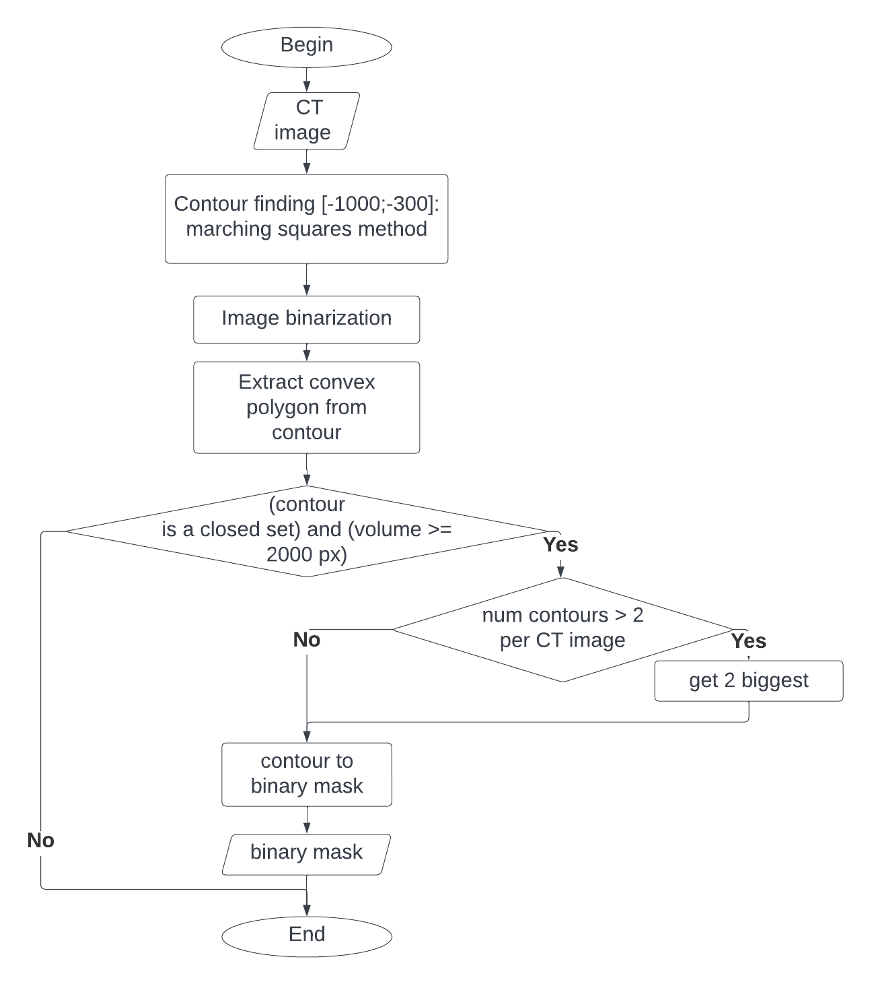
Figure 19 — Block scheme of the lung segmentation method

Furthermore, this approach not only simplifies the data preprocessing pipeline but also enhances the efficiency of the subsequent analysis. By excluding non-lung regions, the authors minimize the likelihood of false positives and ensure that the models are trained on the most relevant features. This step is particularly useful in clinical settings, where quick and accurate diagnostics are crucial. The use of thresholding for lung segmentation is a practical choice, leveraging the inherent contrast in HU values to streamline the analysis process without sacrificing accuracy.
Figure 20 demonstrates the results of lung segmentation using the thresholding method. The result of the lung segmentation algorithm from the original CT image shown in Figure 20(a) is provided in Figure 20(b).

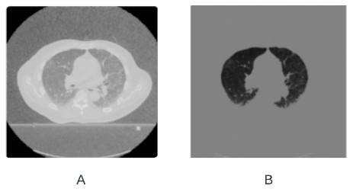
Figure 20 — CT images (a) original (b) after lung segmentation

Additionally. It should be noted that the results of the application of a thresholding-based algorithm for lung segmentation were not additionally checked by the clinician. So, it could contain mistakes that were not couched during labeling. However, its application allows for an increase in image segmentation quality.

CLAHE: Enhancing Image Contrast through Adaptive Histogram Equalization method for medical image preprocessing
Contrast Limited Adaptive Histogram Equalization (CLAHE) is an advanced technique in image processing aimed at improving the local contrast of an image, thereby enhancing its overall visual quality. Unlike traditional histogram equalization, which applies a uniform transformation across the entire image, CLAHE works by dividing the image into smaller, non-overlapping regions known as tiles. Each tile undergoes histogram equalization independently, which allows for localized contrast enhancement.
One of the key features of CLAHE is its ability to limit contrast enhancement, thereby preventing the amplification of noise. This is achieved through a process known as contrast limiting, where the histogram is clipped at a predefined value before computing the cumulative distribution function (CDF). The excess pixels are then redistributed uniformly, ensuring that the contrast enhancement does not lead to noise amplification. The clip limit is a crucial parameter that determines the extent to which the histogram bins can grow, effectively controlling the degree of enhancement applied to the image.
After the histogram equalization of each tile, CLAHE employs bilinear interpolation to merge the tiles seamlessly. This step ensures that the borders of the tiles do not create visible boundaries, resulting in a smooth transition across the entire image. This localized approach to contrast enhancement is particularly useful for images with varying lighting conditions, where different regions may require different levels of enhancement.
CLAHE finds extensive applications across various fields. In medical imaging, it enhances the visibility of structures in images such as CT scans, MRIs, and X-rays, making it easier for medical professionals to detect and analyze abnormalities. In satellite imaging, CLAHE improves the contrast of images, aiding in better interpretation and analysis of geographic and environmental data. Additionally, it is widely used in photography to enhance the details and dynamic range of photos, resulting in visually appealing images with improved clarity.
By providing localized contrast enhancement while preventing over-amplification of noise, CLAHE ensures that important details in an image are more visible, significantly improving the overall image quality. This method's ability to adaptively enhance contrast in different regions of an image makes it a powerful tool in various image processing applications.

Deep Learning-based Methods for Lung Cancer Segmentation
The authors applied three convolutional neural networks for the evaluation of a new proposed method for medical data augmentation. The authors chose U-Net, DeepLab V3, and Mask RCNN because of their differences in the architecture and the number of trainable parameters.

Architecture for lung cancer segmentation U-Net
U-Net architecture has few important features which makes it especially appropriate for medical image tasks:
1. It could be effectively trained on the small size of data, which is crucial in medical image processing because of data privacy and the costs of labeling.
2. Medical images usually are imbalanced within one image. It means that the size of the relevant area, such as lung cancer on lung CT image or borders between cells on biopy, is smaller than all other areas. So the U-shape architecture and the use of pixel wise Cross entropy (Eq 9) which is sensitive to data imbalance, makes it appropriate for toset cases. An example is shown in Figure 21.

$$\begin{aligned}L=-\frac{1}{N}\sum_{i=1}^{N}{\left[y_{i}\log\left(p_{i}\right)+\left(1-y_{i}\right)\log\left(1-p_{i}\right)\right]}\#\left(9\right)\end{aligned}$$

Where $N$ is the number of pixels.
$p_{i}$ is the binary ground truth label for pixel $i$.
$p_{i}$ is the predicted probability of pixel $i$ being foreground.

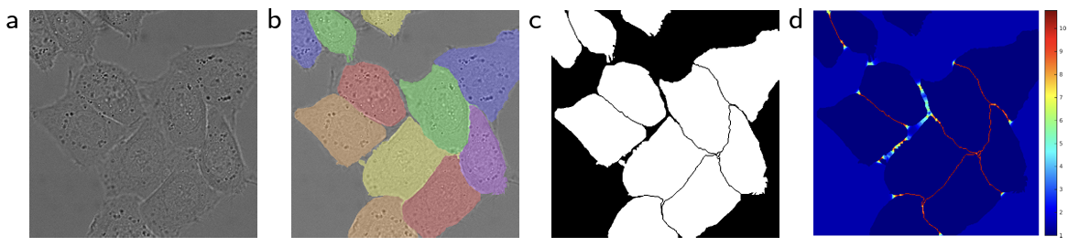

Figure 21 — An example of an image with small borders between cells (a) original biopsy image (b) instance segmentation between cells (c) semantic segmentation between cells (d) heatmap of boundaries

Figure 21 (s) shows a heatmap of small boundaries between cells on biopsy image. Generally, for the model, it is cheaper to classify all pixels as the biggest class. However, it is crucial for medical image processing.
U-Net is an example of an encoder-decoder architecture, with a mirror U-form structure. This design enables the model to capture both the contextual and spatial information necessary for precise segmentation. It consists of the main parts: convolutional encoder and decoder, bottleneck, and skip-connection layers.
The encoder path is responsible for capturing the context of the input image. It consists of repeated two convolutional blocks with the size 3x3 without padding, with the ReLU activation function applied for all of them and a 2x2 max pooling operation with stride 2 for downsampling. At each downsampling step, the number of feature channels is doubled.
The bottleneck forms the bridge between the encoder and decoder paths, which connect them in the middle of architecture. It consists of two 3x3 convolutions followed by ReLU activations, without downsampling. This stage serves to process the compressed representation obtained from the encoder.
The decoder path reconstructs the segmentation map from the compressed feature map, received at the end of the encoder. It is the mirror to the decoder and absolutely repeats it with the difference of the use of upsampling convolutional layers, which allows receiving the original size of the image at the end. It consists of upsampling the feature map followed by a 2x2 convolution (“up-convolution”) that halves the number of feature channels, a concatenation with the correspondingly cropped feature map from the encoder path, and two 3x3 convolutions followed by ReLU activations.
The encoder and the decoder also are connected via skip-connection layers between the corresponding convolutional layers of the encoder and the decoder. It allows the saving of the information that possibly could be used because of compressing the image and also partly solves the problem of vanishing gradient.
The final layer of the decoder is a 1x1 convolution that maps each 64-component feature vector to the desired number of classes. For binary segmentation, a sigmoid activation function is used, while a softmax activation function is employed for multi-class segmentation. The architecture of the U-Net model is shown in Figure 22.

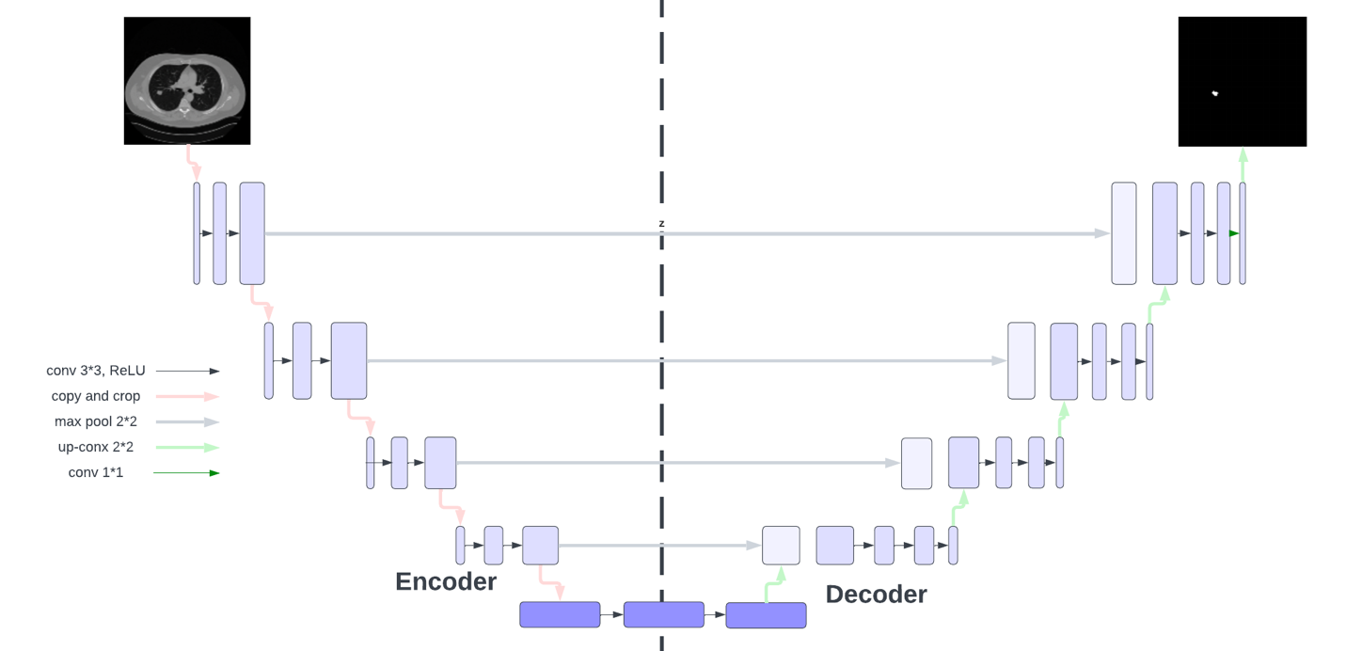

Figure 22 — U-Net model architecture [31]

U-Net was used for evaluation MetaLung and multipatameter models for data augmentation.

Architecture for lung cancer segmentation DeepLab V3
The rate parameter is one for standard convolutional operation. The receptive field could be increased if the rate is more than one (Eq 10).

$$\begin{aligned}y\left[i\right]=\sum_{k=1}^{K}{x\left[i+r*k\right]w\left[k\right]}\#\left(10\right)\end{aligned}$$

Where x[i] is the input signal,
w[k] is the filter,
r is the rate parameter
y[i] is the output for the 1D input signal

DeepLab V3 applies atrous convolution, also known as dilated convolution, is used to expand the receptive field of the filters without increasing the number of parameters or the amount of computation. This allows the network to capture more contextual information from the input image. In DeepLabV3, it has been implemented by inserting holes (dilations) into the convolution kernels. Atrous convolution enables the extraction of fine-grained features while maintaining a large receptive field. The difference between standard convolutional and the Atrous Convolution is provided in Figure 23.

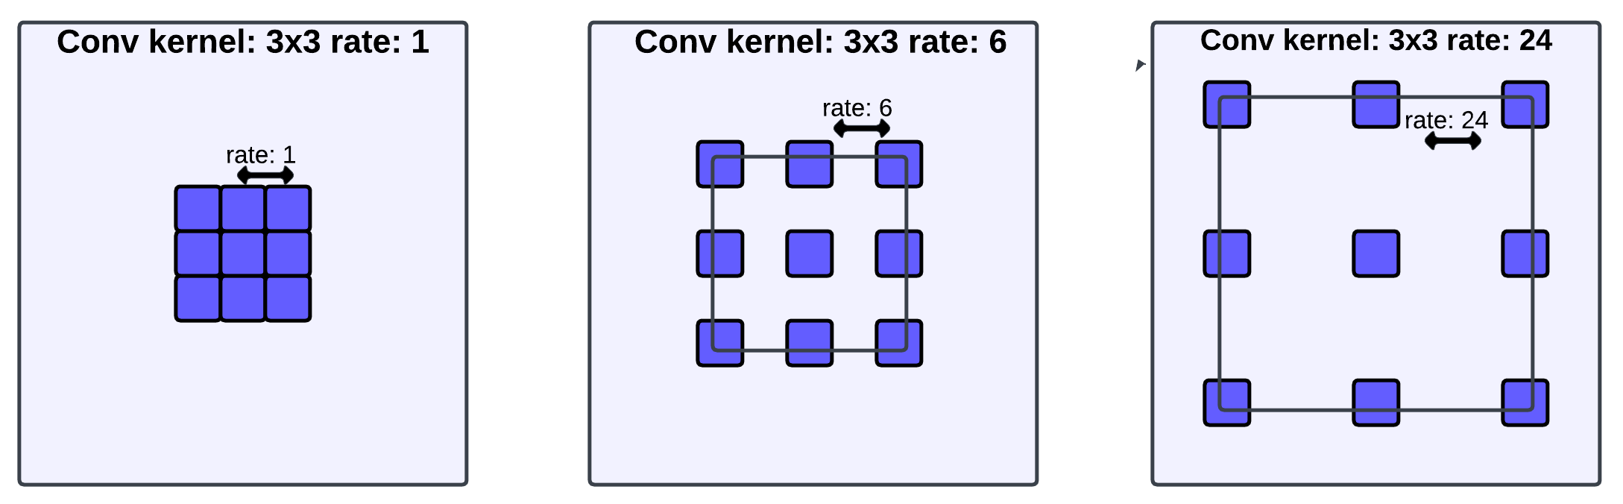

Figure 23 — The difference between Atrous Convolution with 1, 6, 24 rate [71, p. 1]

Deeplab V3 inherits Atrous Spatial Pyramid Pooling (ASPP) [93] from DeepLab V2. Atrous Spatial Pyramid Pooling (ASPP) is a critical component of DeepLabV3, designed to capture multi-scale information by applying atrous convolutions with different rates in parallel. This technique effectively gathers contextual information at multiple scales. ASPP includes multiple parallel atrous convolutions with different dilation rates, followed by concatenation and a 1x1 convolution to fuse the multi-scale features. The difference between Deeplab V2 and Deeplab V3 is adding batch normalization to ASPP. The combination of standard and Astrous convolution layers for feature extraction is provided in Figure 24.

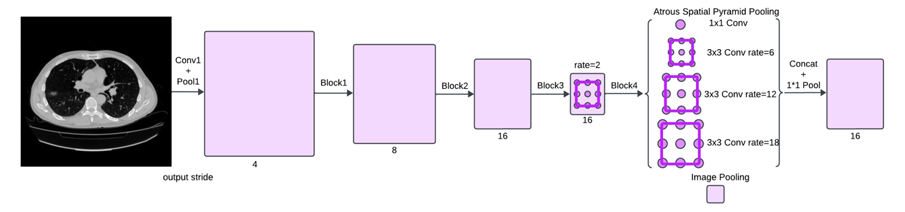

Figure 24 — Dilatated convolutional approach [71, p. 5]

Parallel modules with Atrous convolution (ASPP), augmented with image-level features [71]. Skip connections help in preserving spatial information that might be lost during the downsampling process. They connect feature maps from earlier layers to later layers, aiding in the precise localization of objects.
The structure of DeepLabV3 consists of three main components: the encoder path, the ASPP module, and the decoder path. The encoder path employs a backbone network, such as ResNet, to extract features from the input image. Atrous convolutions are integrated within the backbone to enhance the feature extraction process by capturing detailed contextual information while maintaining a large receptive field.
At the end of the encoder, the ASPP module is designed to capture multi-scale contextual information. This is achieved through parallel atrous convolutions with varying dilation rates, which effectively gather information at multiple scales. The concatenated outputs from these convolutions are then processed by a 1x1 convolution to fuse the multi-scale features.
Unlike traditional decoder paths, DeepLabV3 often employs a simplified upsampling approach. The output of the ASPP module is upsampled to match the original image resolution. Skip connections are used to combine features from the encoder with the upsampled output, thereby enhancing segmentation accuracy by retaining high-resolution information and ensuring precise localization of objects

Architecture for lung cancer segmentation Mask RCNN
The first step in the detection algorithm is the Region Proposal Network [76, p. 1], inherited from the Faster RCNN algorithm. Its task is to generate rectangular bounding boxes around candidate regions and their corresponding probabilities of containing a relevant object inside. It achieves this by sliding a small network over the backbone's feature map and generating region proposals and objectness scores through a series of convolutions.
An important improvement in the MASK RCNN algorithm is the use of RoIAlign (Region of Interest Align) instead of RoIPooling (Region of Interest Pooling). RoIAlign allows for more accurate object boundaries by using bilinear interpolation. The obtained candidate regions are used as input for the second step of detection. In addition to object detection, MASK RCNN produces a binary mask for each candidate region. Therefore, the neural network learns to simultaneously solve the tasks of segmentation and detection, which also improves its performance.
The segmentation branch predicts a binary mask for each RoI, identifying the pixel-level outline of the object. This branch is a small Fully Convolutional Network (FCN) that outputs a mask for each class, with the mask typically produced at a lower resolution and then upsampled to the original RoI size using bilinear interpolation. Additionally, Mask R-CNN includes branches for classification and bounding box regression. An overview of Mask R-CNN architecture is shown in Figure 25.

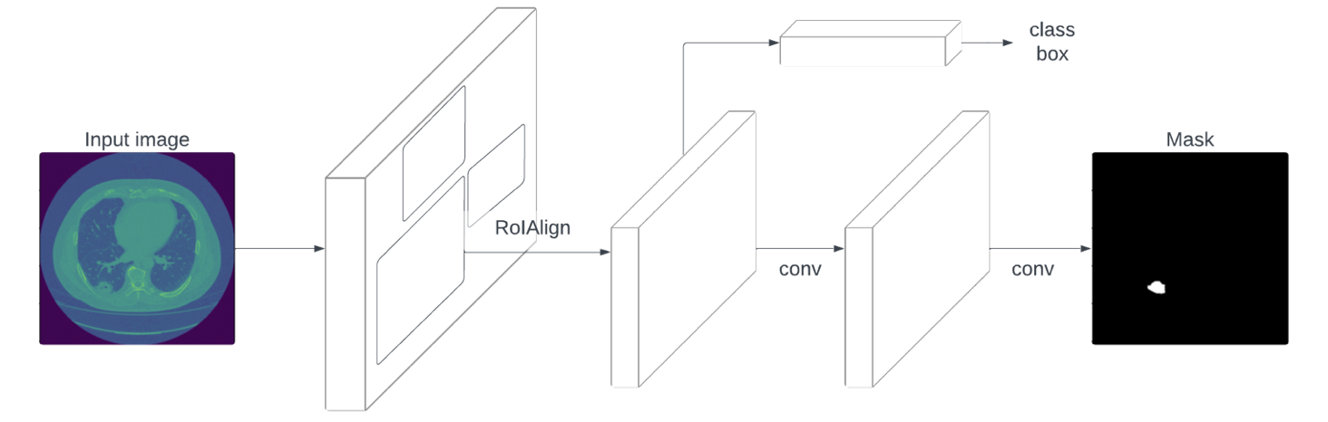

Figure 25 — Mask RCNN model architecture [73, p. 1]

Multi-task loss (Eq. 11) is used as the error function during training, which is the sum of all errors obtained during training for each region of interest.
$$\begin{aligned}L=L_{cls}+L_{box}+L_{mask}\#\left(11\right)\end{aligned}$$

Where $L_{cls}$ is loss of classifier,
$L_{box}$ is loss of bounded box
$L_{mask}$ is loss of mask

Multi-task loss allows to take into account classification, object detection, and segmentation losses at the same time. This approach makes Mask RCNN applicable for real-life object detection.

Methods for Data Augmentation
Basically, the authors could separate all methods applicable for image augmentation into two main groups: multiparameter models, which allow to generation of new images, but require a lot of computational resources and methods that work with the morphological features of the image, which have limited abilities for new instances generation, but required less computational resources and allows to control the output images. The overview of methods applicable to data augmentation has been provided in Figure 26.

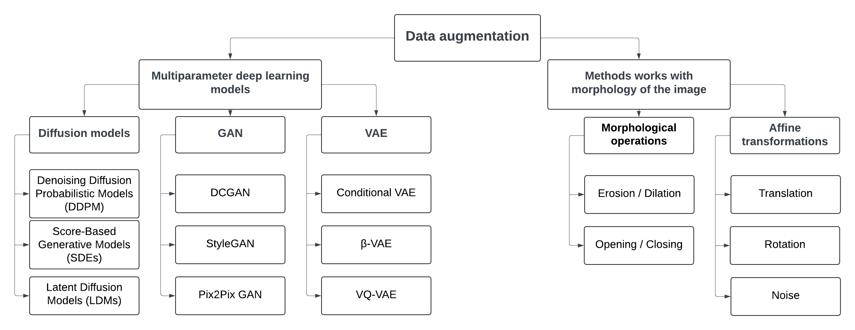

Figure 26 — Data augmentation methods with examples

Multiparameter deep learning models, such as Variational Autoencoders and Generative adversarial neural networks, are the type of models with big number of trainable parameters. The main principles of GAN and VAE architectures have been provided in Paragraph 2.2. For the current research, the authors observed two models: VQ-VAE and DCGAN for cancer area generation. The authors experimented with lung cancer segmentation on 2-dimensional CT slice, so additionally the authors developed a framework for adding lung cancer to a healthy CT slice without lung cancer for the next segmentation. The authors applied the U-Net model for lung cancer segmentation with a small number of trainable parameters to check the impact of generated images on the segmentation quality. Although the quality of image segmentation is important, the authors also compared models based on their applicability to the likelihood of lung cancer generation and the computational complexity of deep learning models.
Morphological image features refer to the characteristics and properties of objects in an image, which are determined by their shape, structure, and spatial relationships between pixels. These features are extremely important for medical image processing because all instances on the CT image have different values from each other. Even though the generative approach to the task of lung cancer augmentation provides a significant increase in further image diagnostics, the results of the generated images are difficult to control, which is especially critical in medical tasks. Therefore, in the current study, the authors paid more attention to methods that work directly with the morphological features of the image. The authors provided comparative analyses of affine transformation separately and developed a new method MetaLung (Meticulous affine-transformation-based lung cancer augmentation method).

Data augmentation method for lung cancer augmentation DeepLungSynth
In this chapter, the authors explored the applicability of multiparametric deep learning models for the generation of lung cancer images. Lung cancer images are typically large-scale, which increases computational complexity. Additionally, these images contain specific patterns related to the pixel depth of certain entities in lung CT scans. It is crucial to maintain these existing patterns during image generation, as they cannot be accurately controlled in generated images without additional verification by a clinical physician. Therefore, the authors developed a framework that allows for the insertion of generated lung cancer regions into healthy images. For this purpose, the authors used lung cancer images classified as Lung-RADS 1.
The authors applied deep parametric models solely for generating the lung cancer regions, which allowed us to work with images of smaller dimensions. This approach helps in managing computational resources while ensuring the generation of high-quality synthetic data for further analysis and model training. The authors used two deep learning models, VQ-VAE and DCGAN, to generate regions of cancerous tumors.
These generated images were then added to CT scans of actual patients. The differences in pixel depth between the various entities present in the lung CT scan also aided in this process. Additionally, the authors generated corresponding binary masks for further model training. Throughout the study, the authors focused on evaluating the quality of lung cancer segmentation. The authors used the U-Net model for lung cancer segmentation and evaluated the quality of segmentation with IoU and DICE metrics. The authors compared deep multiparameter models with general affine transformation and baseline models. Based on our experiments the authors found that despite the significant improvements in the quality of lung cancer segmentation provided by deep multiparametric models, their use is complicated by several factors:
1. Need for Clinical Verification: It is not possible to generate a complete CT scan and the corresponding binary mask without involving a clinical doctor for additional verification and data annotation. Our approach also requires additional data.
2. Computational Complexity: The use of deep learning models is further complicated by the need for powerful servers due to the increasing computational demands.
3. Verification and Refinement: Generated regions also require further verification and refinement. For example, in our case, the authors observed fractional pixel values in the generated regions. Preserving important patterns in pixel depth is critical in medical tasks, as radiological features directly impact clinical diagnosis. Such inaccuracies could lead to a situation where, in real-world scenarios, the model might confuse another disease with lung cancer. This is especially problematic in CAD systems, as reducing false positives is crucial in practice due to the invasive and traumatic nature of biopsy procedures.
The limitations suggest that the use of traditional data augmentation methods based on affine transformations remains relevant. These traditional methods offer a simpler and more computationally efficient approach compared to deep learning-based models, making them valuable in scenarios where resources are limited or where the complexity of the generated data does not require advanced techniques.
The authors utilized a consistent method for generating a new synthetic dataset with CT images using GAN and VAE models:
1. Cropping and Resizing: The cancerous regions were cropped and resized to 64x64 pixels.
2. Model Training: The DCGAN and VQ-VAE models were trained with these resized cancerous images.
3. Generating New Images: New cancer images were generated with dimensions of 64x64 pixels.
4. Integration into Healthy CT Slices: These generated cancer images were randomly resized and integrated into the middle slices of CT scans from healthy patients without cancer, ensuring there was sufficient space free from vessels on the CT slice.
The authors utilized 800 real CT slices from healthy patients and added the generated cancer images to these slices. The cancer images were placed in free spaces after resizing with random scaling factors between 1 and 4. However, some of them do not have enough free space for adding cancer without vessels or other ling anatomic structures (such as calcinates), so the total number of generated synthetic image is different from 800. The synthetic dataset created from these modified CT slices was then combined with the original training set. The subsequent steps followed the same process as training models with affine transformations. Figure 27 illustrates the method for synthetic dataset generation.

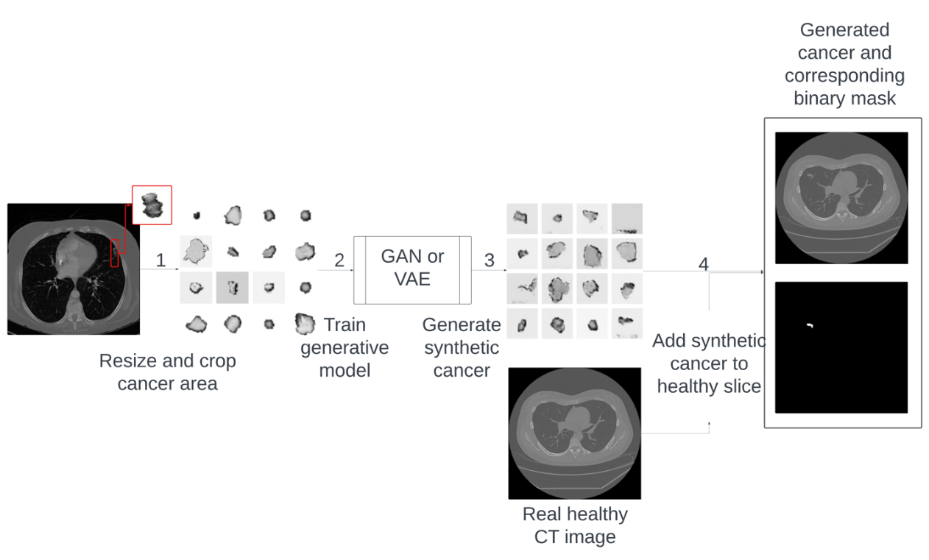
Figure 27 — The DeepLungSynth method of synthetic image generation

The proposed method was used for all multiparameter models for lung cancer image generation mentioned in current research. It allows the generation cancer area only with the use of much fewer computational resources than generation of the whole CT image. Additionally, it will not be possible to find a cancer on the generated image without certificated clinical and requires much more training data.

Vector Quantized Variational Autoencoder model for synthetic cancer area generation
Vector Quantized Variational Autoencoder (VQ-VAE) is an extension of the traditional variational autoencoder (VAE) architecture that incorporates a vector quantization mechanism [94]. For generating new images, the authors employed the same PixelCNN [95] model as prior, as used in the original VQ-VAE article. The authors followed the identical training method for both the VQ-VAE and PixelCNN models as described in the original work. Similar to the standard VAE, the VQ-VAE operates on an encoder-decoder framework. An overview of the VQ-VAE architecture is illustrated in Figure 28.

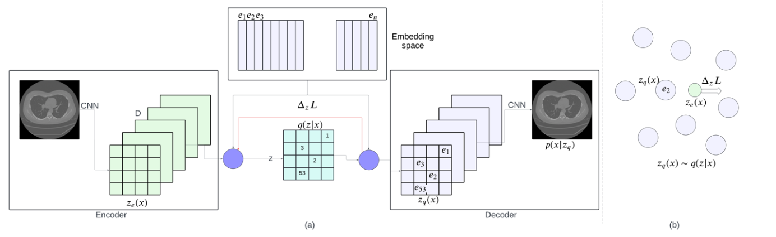

Figure 28 — VQ-VAE architecture (a) Embedding space visualization (b)
The primary distinction of the VQ-VAE is the use of a vector quantization mechanism for discrete latent variables, as opposed to general continuous ones. The [94]encoder transforms the original image $x$ into $z_{e}\left(x\right)$ with the use of CNN. The discrete value of $z$ is calculated with the nearest neighbor look-up of $z$ with $e$ (the shared embedding space), as in Eq. 12.

$$\begin{aligned}q\left(z = k | x\right)=\frac{1 for k={argmin}_{j}{\left\|z_{e}\left(x\right)-e_{j}\right\|}_{2}}{0 otherwise}\#(12)\end{aligned}$$

Where $q\left(z | x\right)$ is the posterior categorical distribution,
$x$ is an input image,
$e$ is the embedding space,
$z_{e}\left(x\right)$ is an output of the encoder

To simplify subsequent calculations, the authors utilized $e_{k}$, which is a vector representation of $z_{e}\left(x\right)$ as the nearest embedding vector from the embedding space. This vector is calculated through the bottleneck between the encoder and decoder, as described in Eq. 13. It is used as the input for the decoder, which is trained to reconstruct the original image. The decoder itself is also a Convolutional Neural Network.

$$\begin{aligned}z_{q}\left(x\right)= e_{k}\#\left(13\right)\end{aligned}$$

Where $k= {argmin}_{j}{\left\|z_{e}\left(x\right)-e_{j}\right\|}_{2}$

Since VQ-VAE comprises three components: the encoder, the decoder, and the bottleneck, its loss function is a combination of three parts of the architecture, as described in Eq. 14. The first component is the reconstruction loss, which optimizes the reconstruction of the original image using the encoder and decoder. The second component is vector quantization, which is applied to the embedding space. The final component is the commitment loss, which regulates the growth of the encoder's output.

$$\begin{aligned}L=\log{p\left(x | z_{q}\left(x\right)\right)+{\left\|sg\left[z_{e}\left(x\right)\right]-e\right\|}_{2}^{2}+β}{\left\|z_{e}\left(x\right)-sg\left[e\right]\right\|}_{2}^{2}\#\left(14\right)\end{aligned}$$

Where $sg$ is stop gradient,
$β$is a hyperparameter, weighting the contribution of vector quantization loss
Application of VQ VAE allows to generate realistic and control synthetic images.

Deep Convolutional Generative Adversarial Network model for synthetic cancer area generation
A Deep Convolutional Generative Adversarial Network (DCGAN) [1] is a type of deep learning neural network used for generating images. The architecture includes two primary components: the generator and the discriminator. These components are distinct deep learning models trained for different purposes within the GAN framework.
The generator's role is to create new images. It takes a latent vector, which is a set of random values, as input. The generator itself has never seen the original images and aims to produce realistic images based on the input latent vector.
The discriminator, another neural network within the GAN architecture, serves the purpose of distinguishing between real images from the dataset and fake images produced by the generator. While the generator's goal is to create realistic images, the discriminator's objective is to accurately classify whether an input image is real or fake. The architecture of DCGAN is depicted in Figure 29.

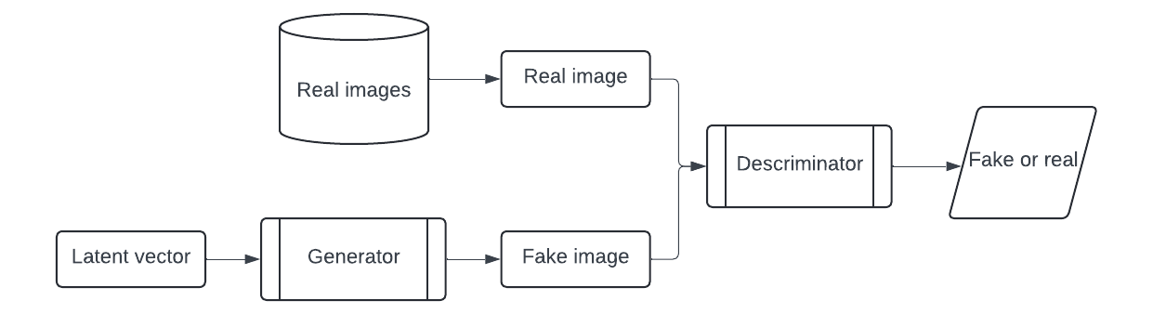

Figure 29 — DCGAN architecture

Following the methodology of the original authors, the authors removed all pooling layers from both the generator and the discriminator. The discriminator is composed of convolutional layers with LeakyReLU activation functions for all layers except the last, which uses a Sigmoid activation function. The generator, similarly, consists of convolutional layers with ReLU activation functions for all layers except the final one, where a hyperbolic tangent function is applied. The loss function of DCGAN combines the losses from both the generator and the discriminator, as detailed in Eq. 15.

$$\begin{aligned}L_{GAN}=L_{D}+L_{G}\#\left(15\right)\end{aligned}$$

Where $L_{D}$ is discriminator loss,
$L_{G}$ is generator loss

Method for lung cancer augmentation MetaLung
In the previous chapter, the authors discussed the challenges associated with using deep learning models for lung cancer image generation, such as the need for powerful servers and additional data validation. These methods, while effective, come with significant computational and resource complexities. In light of these challenges, the authors decided to develop a new method based on affine transformations, which offers a simpler according to computational complexity and allows to control of the process of generation.
MetaLung is a novel approach designed to enhance the analysis and diagnosis of lung conditions using CT imaging. This method leverages the advantages of maintaining the distribution between different instances in CT images, including distinct structures like lung tissue, bones, and fat. By distinguishing between entities that may appear similar but differ in density, MetaLung minimizes the risk of misdiagnosis. Additionally, the method's low computational complexity makes it accessible for use in developing countries, where healthcare resources are often limited. MetaLung also focuses on reducing false-positive results, thereby preventing unnecessary biopsies and enhancing patient safety. Furthermore, the method increases the size and variability of training datasets, improving model accuracy as evidenced by stable increases in DICE and IoU metrics across various models. Overall, MetaLung represents a significant advancement in medical imaging, balancing diagnostic precision with practical constraints.
Various methods exist for augmenting training datasets, including Generative Adversarial Networks (GANs) and affine transformations. However, the authors opted not to use GANs due to several significant challenges. First, GANs require a diverse and extensive training dataset to function effectively. Second, they demand substantial computational resources, which may not be feasible in all scenarios. Third, the generated images from GANs must be verified by medical professionals to ensure accuracy and reliability.
CT images comprise multiple components, such as lung tissue, bones, fats, and also air and water. The standard format for these images is DICOM, where each pixel's density is measured in Hounsfield Units (HU). For instance, the HU value for air is approximately -1000, while for lung tissue, it is around -500. Lung cancer and calcifications may appear similar in form; however, they exhibit significant differences in HU values, which are critical for accurate diagnosis.
Maintaining the correct distribution of HU values among different instances in CT images is essential when generating new images. This is because mixing these values could lead to incorrect interpretation of different instances. To address this, the authors utilized six affine transformation methods in the MetaLung approach. These methods include mirroring the image, replacing cancerous regions with free space, rotating the image, rotating cancer regions, adding noise to the image, and introducing noise to cancerous areas. These transformations are applied with random parameters that preserve the density distribution of lung instances in the CT image. The details of these affine transformation methods employed in MetaLung are outlined in Table 4.

Table 4 — Affine transformation used within MetaLung

N | Method name | Description | Random parameters
1 | 2 | 3 | 4
1 | Mirroring the image | All CT images, formatted in [512,512], are flipped along the vertical central axis at x=128. | n/a

Continuation of table 4

1 | 2 | 3 | 4
2 | Replacing cancer for free space | Lung and vessel regions in CT images are initially segmented using a thresholding algorithm to identify free spaces. Cancerous regions are then rotated 180 degrees and repositioned into these free areas on the opposite side of the lung, if available. If there is no space on the opposite side, the cancer is placed on the same side. This method is inapplicable if there isn't enough free space due to other structures like vessels or calcifications. | n/a
3 | Rotating the image | The entire image is rotated to a random angle ranging from 0 to 90 degrees. | $$angle∈\left[0,90\right]$$
4 | Rotating cancer | Only the cancerous area is rotated to a random angle between 0 and 90 degrees, leaving the rest of the image unchanged. | $$angle∈\left[0,90\right]$$
5 | Adding noise to the image | Noise with a random intensity from 0 to 20 is added to the entire image. The noise level is kept low to preserve the fixed HU values of different structures (lung, bone, cancer, vessels) on the CT image. | $$noise∈\left[0,20\right]$$
6 | Adding noise to cancer | Similar to the previous method, noise with a random intensity from 0 to 20 is applied exclusively to the cancerous area. This method uses the same noise levels as Method 5. | $$noise∈\left[0,20\right]$$

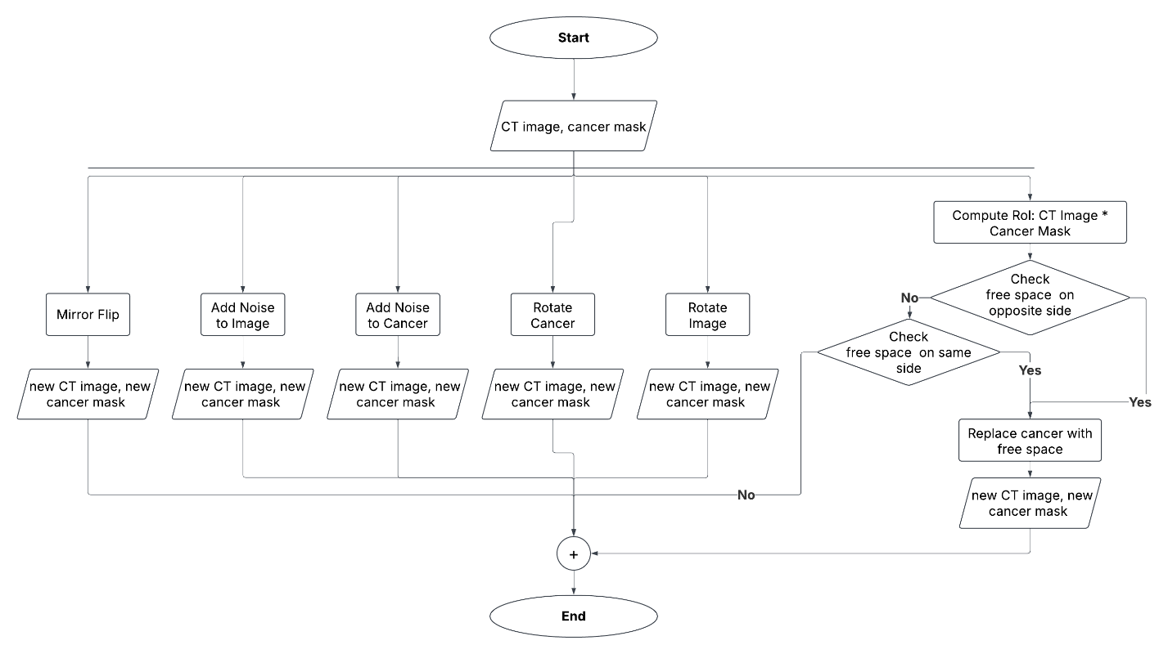

Figure 30 — Bloch-scheme of MetaLung model

The MetaLung augmentation method enables the generation of at least five new images from a single original image. This method takes a CT image in Hounsfield Units (HU) along with a corresponding binary mask indicating lung cancer as input. It operates on 2D CT slices of a standard size. The output of MetaLung consists of a set of new CT images accompanied by new masks. The techniques of adding noise to the entire image or specifically to the cancerous area do not necessitate the creation of a new mask since the cancer location remains unchanged. The Figure 30 shows the block-scheme of MetaLung.
A novel approach in MetaLung, termed "replace cancer to free space," allows the generation of new CT images by repositioning the cancerous area to different locations within the lung, provided there is free space available without vessels. This method is not universally applicable, as it may not be possible to find such free space in all cases. The pseudocode for the algorithm is provided above, and an application example and visualization of the MetaLung Method for a CT scan can be accessed via the provided link [92, p. 1].

ALGORITHM MetaLung (CT image, cancer mask):
FUNCTION Mirroring the image (CT image, cancer mask)
new CT image = mirror flip (CT image)
new cancer Mask = mirror flip (cancer mask)
RETURN new CT image, new cancer mask
FUNCTION Replacing cancer for free space (CT image, cancer mask)
RoI = CT image * cancer mask
IF (check vessels on the opposite side == True)
new CT image = replace RoI with free part
generate new cancer mask
RETURN new CT image, new cancer mask
ELSE IF (check vessels on the same side == True)
new CT image = replace RoI with free part
generate new cancer mask
RETURN new CT image, new cancer mask
FUNCTION Rotating the image (CT image, cancer mask)
angle = random (min = 1, max = 90)
new CT image = rotate (CT image, angle)
new cancer mask = rotate (cancer mask, angle)
RETURN new CT image, new cancer mask
FUNCTION Rotating the cancer (CT image, cancer mask)
angle = random (min = 1, max = 90)
new cancer mask = rotate(cancer mask, angle)
old RoI = CT image * cancer mask
new RoI = flip (CT image, angle) * new mask
new Ct image = replace(old Roi, new Roi)
RETURN new CT image, new cancer mask
FUNCTION Adding noise to the image (CT image, cancer mask)
noise = random array (min = 0, max = 20, size = [512,512])
new CT image = noise + CT image
RETURN new CT image, cancer mask
FUNCTION Adding noise to cancer (CT image, cancer mask)
noise = random array (min = 0, max = 20, size = [512,512])
new CT image = noise * cancer mask + CT image RETURN new CT image, cancer mask
The following method allows to increase the size and the variability of trainset without an application of deep learning methods.

Metrics
The authors utilized four metrics to evaluate the quality of image segmentation: DICE, as referenced in Eq. 16, and IoU, as referenced in Eq. 17, to assess the similarity between ground truth and predicted masks. Image segmentation can be described as a pixel-wise segmentation problem. This approach enables the calculation of Precision, as mentioned in Eq. 18, and Recall, as in Eq. 19, to analyze the distribution of false positive and false negative predictions within a predicted mask. Precision aims to reduce false positives by measuring the accuracy of positive predictions among those identified as positive. Conversely, Recall focuses on minimizing false negatives, evaluating the model's capacity to identify all actual positive instances by reducing instances incorrectly predicted as negative. In the context of CT image diagnostics for lung cancer detection, Precision is crucial as it helps to minimize false positive predictions. Reducing false positives is particularly important as erroneous predictions can lead to unnecessary and invasive procedures, such as biopsies, which can be traumatic and highly invasive.

$$\begin{aligned}DICE=\frac{2*\left|X∩Y\right|}{\left|X\right|+\left|Y\right|}\#\left(16\right)\end{aligned}$$
$$\begin{aligned}IoU=\frac{\left|X∩Y\right|}{\left|X∪Y\right|}\#\left(17\right)\end{aligned}$$
Where X is a ground true mask,
Y is the predicted mask
$$\begin{aligned}\text{Precision}=\frac{\text{True Positives}}{\text{True Positives}+\text{False Positives}}\#\left(18\right)\end{aligned}$$
$$\begin{aligned}\text{Recall}=\frac{\text{True Positives}}{\text{True Positives}+\text{False Negatives}}\#\left(19\right)\end{aligned}$$
The use of the following metrics allows the evaluation of methods among their applicability for the medical image segmentation task.
This chapter provides information about materials and methods used for lung cancer detection on CT images.

RESULTS OF LUNG CANCER SEGMENTATION

Results of data collection
As a result of data collection was collected and labeled the dataset combined with Kazakhstani and open-source data. The same way as local relabeled open-source data.
The labeling process for our dataset includes the following detailed information:
- CT image: The authors utilized the entire CT image, focusing specifically on the pixel array data. These pixel values were converted into Hounsfield Units (HU), a standardized quantitative scale for describing radiodensity. This conversion allows for accurate differentiation of various tissue types within the body, providing a clearer representation of internal structures, including potential cancerous regions.
- Binary mask with lung cancer: For each CT image, a corresponding binary mask was created, highlighting the areas identified as lung cancer. The mask matches the dimensions of the CT image, ensuring pixel-to-pixel correspondence. The binary nature of the mask simplifies the identification process, with one value (e.g., 1) representing the presence of cancer and another value (e.g., 0) indicating its absence. This clear demarcation is crucial for training machine learning models, especially in segmentation tasks where precise boundary delineation is essential.
- Class according to the Lung-RADS System: Each case was classified based on the Lung-RADS System. This classification provides a standardized method for assessing and categorizing findings according to the level of suspicion for lung cancer. The Lung-RADS classification helps stratify risk and guide subsequent management decisions, such as follow-up recommendations or the need for further diagnostic procedures.
The authors removed all additional information from CT image which was written into DICOM format because of data privacy issues and saved the value of the image only before the dataset publication in HU. The data was serialized and saved to PICKLE format. The PICKLE format is a binary serialization format used in Python for object serialization and deserialization. Figure 31 shows the rows from the published dataset.

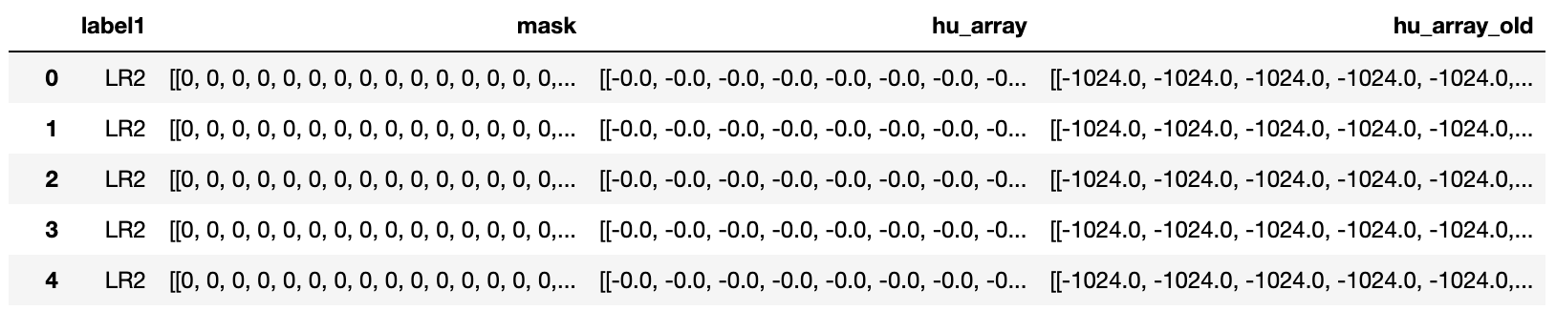

Figure 31 — The published dataset

The dataset could be used for classification and segmentation purposes. Additionally, the authors shared the segmentated area of the lung, but it should be mentioned that it was not confirmed by the clinicians. The classification could be done according to the size of the nodule based on the Lung-RADS System. The distribution of Lung-RADS classes in the dataset has been provided in Figure 32.

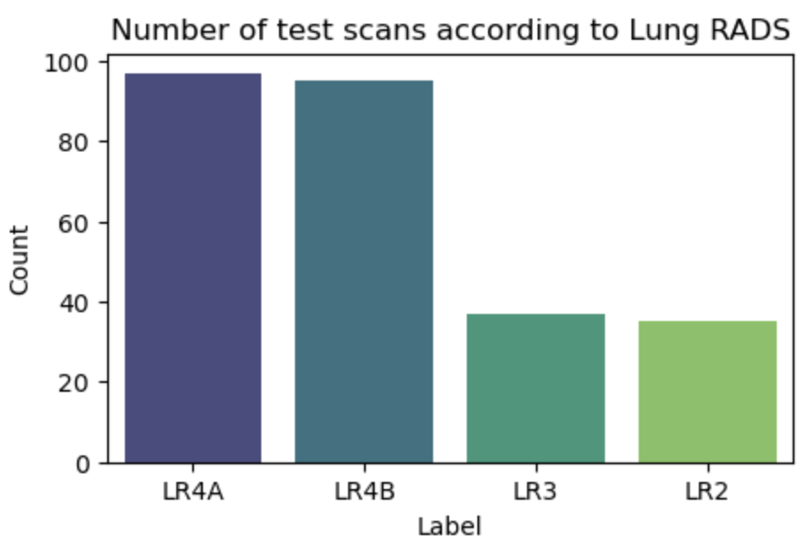
Figure 32 — The distribution between classes in the dataset according to Lung-RADS System

Image segmentation involves the process of partitioning an image into multiple sub-classes. The dataset the authors have compiled can be utilized for the segmentation of lung cancer regions. An illustration of lung cancer, accompanied by the corresponding binary masks of the cancerous areas, is presented in Figure 33. Figure 33 (a) shows original CT image, Figure 33 (b) lung cancer mask, Figure 33 (c) labeled area.

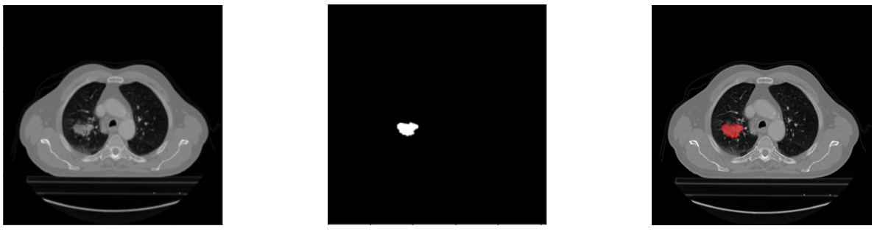

Figure 33 — Example of labeled images from the dataset (a) original CT image (b) lung cancer mask (c) labeled area

The data was spited for train and test sets before the training by the way, when images from one patient could be in the train set or in the test set total. The authors used four patients from each Lung-RADS category for the test set and the remaining in the train set. So totally the train set consists of 708 CT images and the test set consists of 264 CT images. The dataset was published and could be found via Nam, Diana; Panina, Alexandra; Pak, Alexandr (2024), “Lung cancer segmentation dataset with Lung-RADS class”, Mendeley Data, V1 [96].

Result of application multiparameter models
Figure 34 illustrates the comparison between real cancer (Figure 34 a) and synthetic cancer generated by VQ-VAE (Figure 34 b) and DCGAN (Figure 34 c). As depicted in Figure 26, the cancerous region exhibits a significant contrast with the surrounding areas of the image. This distinct contrast allows for the application of thresholding-based algorithms for cancer segmentation. This segmentation step is crucial before integrating the generated cancerous regions into CT scans of healthy patients. This approach ensures that the synthetic lesions are accurately segmented and positioned within the healthy tissue context.

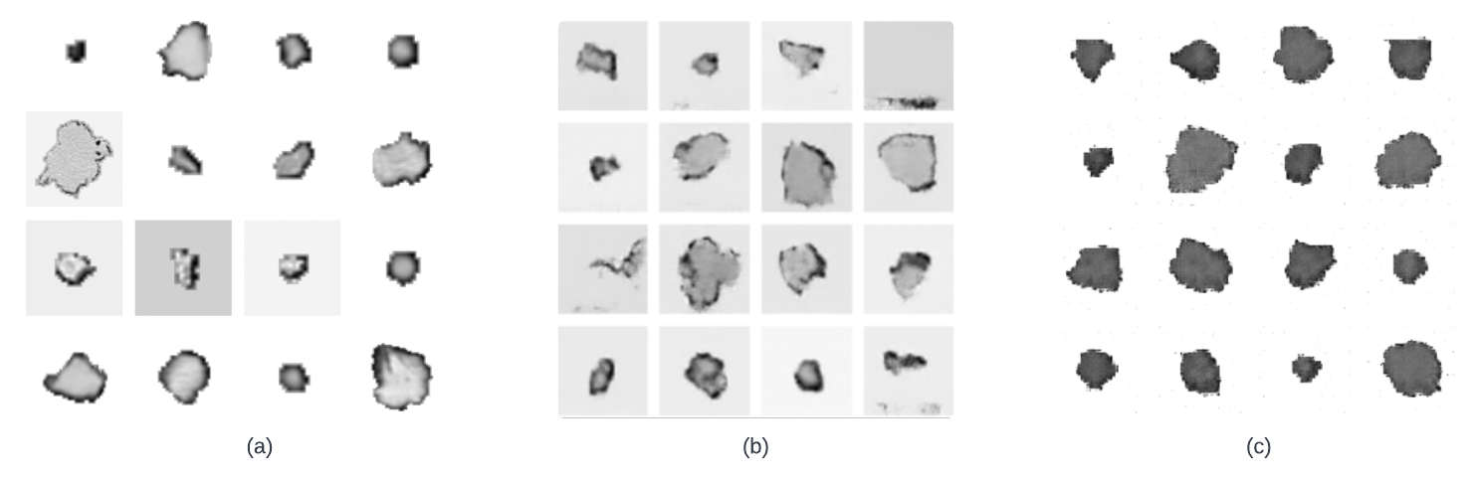

Figure 34 — Example (a) real lung cancer and synthetic cancer generated by (b) VQ-VAE (c) DCGAN

The authors integrated cancer into the CT slices of healthy patients, using only slices from the middle. Out of 800 CT images, the authors resized the cancer (from 1 to 4) and added it to the available space on the images. If no free space was available, the slice and cancer were skipped. This process generated 708 CT images with synthetic cancer for DCGAN and 705 CT images for VQ-GAN. An example of a synthetic cancer CT image is demonstrated in the Figure 35, showing the original healthy slice, the generated binary mask, and the synthetic cancer. Figure 35 (a) shows Real CT slice of a healthy person, Figure 35 (b) generated cancer mask, Figure 35 (c) CT slice with generated cancer

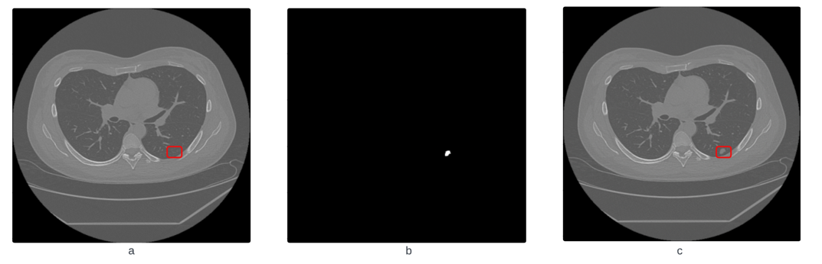
Figure 35 — (a) Real CT slice of a healthy person (b) generated cancer mask (c) CT slice with generated cancer
The authors evaluated and compared the lung cancer segmentation results under similar conditions for each method and against the baseline model. The experimental findings are presented in Table 5.

Table 5 — Results of application data augmentation methods

Methos | N generated samples | DICE | IoU
Baseline (without data augmentation) | n/a | 0.3708 | 0.312
Vertical Mirror Flipping | 708 | 0.3913 | 0.3244
Image Rotation | 708 | 0.3658 | 0.3075
Cancer Rotation | 708 | 0.2721 | 0.2191
Adding Noise to Image | 708 | 0.3168 | 0.2596
Adding Noise to Cancer | 708 | 0.3434 | 0.2832
Gaussian Blurring | 708 | 0.217 | 0.16
VQ-VAE | 705 | 0.4191 | 0.3541
DCGAN | 708 | 0.4001 | 0.3347
Mixed dataset | 12726 | 0.4283 | 0.3799

The numbers of trainable parameters are shown in Table 6 for each model applied in the experiment.

Table 6 — The number of trainable parameters

Approach | Part of the model | Trainable parameters
DCGAN | Generator | $$3,8×{10}^{6}$$
DCGAN | Discriminator | $$2,7×{10}^{6}$$
VQ-VAE | VQ-VAE | $$2×{10}^{6}$$
VQ-VAE | Pixel CNN | $$1,7×{10}^{7}$$

An application of deep learning models for data generation required additional computational resources.

Results of the impact of MetaLung to the size and variability of the train set
The application of the MetaLung method has enabled an expansion of the training dataset from 708 to 4865 images, a 6.87-fold increase over the original set. This increase can potentially be further amplified by combining and permuting various affine transformations. Figure 36 illustrates the distribution of cancer locations and the extent of changes due to the augmented number of images and corresponding masks.
To visualize this, the authors aggregated all masks from the original images and constructed a heatmap based on these results, as shown in Figure 36 a. Subsequently, the same process was applied to the dataset augmented by MetaLung, with the resulting distribution depicted in Figure 36 b. This approach demonstrates how the MetaLung method significantly enriches the training dataset, thus improving the robustness and variability of the training process.

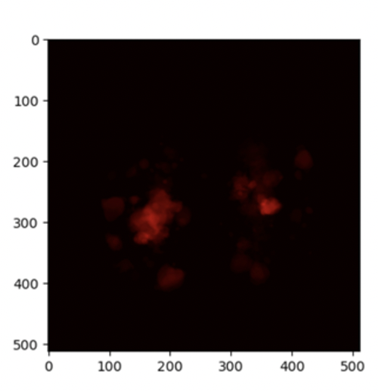 | 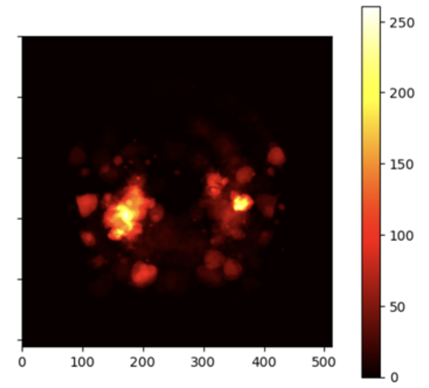
(a) | (b)
Figure 36 — Heatmap of cancer distribution (a) original train set (b) extended train set by MetaLung application

As shown in Figure 54 b MetaLung's application helps balance the distribution of cancers between the left and right lungs in the training dataset. This balancing increases both the diversity and the size of the training set, enhancing the quality of medical image processing. By providing a more balanced dataset, MetaLung contributes to improved accuracy and effectiveness in medical imaging tasks.

Results of Impact of application of MetaLung for lung cancer segmentation
Initially, the authors trained three convolutional models (Mask RCNN, U-Net, and Deeplab V3) without data augmentation to establish a baseline. Next, the authors implemented seven augmentation techniques, including MetaLung, to expand the training dataset. The authors evaluated segmentation results using four metrics: DICE, IoU, Precision, and Recall. DICE and IoU measured the similarity between ground truth and predicted masks, while Precision and Recall assessed the distribution of False Positives and False Negatives. Table 7 presents the baseline and augmented model results.

Table 7 — Average results if metrics for lung cancer segmentation

Model | DICE |  | IoU |  | Precision |  | Recall
 | baseline | MetaLung | baseline | MetaLung | baseline | MetaLung | baseline | MetaLung
U-Net | 0.3708 | 0.4004 | 0.312 | 0.3418 | 0.8175 | 0.8676 | 0.359 | 0.3684
DeepLab V3 | 0.3308 | 0.4136 | 0.269 | 0.3498 | 0.7906 | 0.8634 | 0.3177 | 0.3817
Mask RCNN | 0.5117 | 0.6004 | 0.4609 | 0.5361 | 0.5372 | 0.6864 | 0.5093 | 0.5896

MetaLung shows stable increase inall used metrics for all observed models. Additionally, DICE scores for each Lung-RADS class, highlighting the diagnostic difficulty, are shown in Table 8.

Table 8 — DICE metrics for lung cancer segmentation among Lung RADS classes

Model | LR2 |  | LR3 |  | LR4A |  | LR4B
 | baseline | MetaLung | baseline | MetaLung | baseline | MetaLung | baseline | MetaLung
U-Net | 0.1997 | 0.1346 | 0.365 | 0.36 | 0.1979 | 0.3655 | 0.6127 | 0.5497
DeepLab V3 | 0.0645 | 0.0458 | 0.3417 | 0.3889 | 0.1773 | 0.3971 | 0.5813 | 0.5755
Mask RCNN | 0.0 | 0.2665 | 0.2259 | 0.4032 | 0.7226 | 0.7501 | 0.5961 | 0.6475

All experiments proved that MetaLung method shows stable increase for medical image segmentation quality.

DISCUSSION

Based on our experiments, VQ-VAE achieved the highest score for data augmentation in the context of lung cancer segmentation. However, the method has certain limitations, particularly regarding the number of trainable parameters and the associated computational complexity. Generating the entire CT image poses a challenge, primarily due to the substantial computational resources required, especially for images sized 512x512 pixels. Additionally, generating accurate masks without further medical verification is challenging.
Our findings reveal that while the generated images visually resemble the real ones, they do not entirely replicate the radiological characteristics of actual cancers. For example, fractional pixel values were present in the generated images, which are not consistent with real cancer imagery. This discrepancy underscores the necessity for clinical verification by a physician to ensure the accuracy and reliability of the generated images.
The proposed method effectively generates realistic images, significantly enhancing the quality of lung cancer segmentation. However, it necessitates the use of additional healthy images and involves computationally intensive processes for incorporating cancerous regions. Therefore, while the method shows promise, these practical considerations must be addressed to optimize its application in clinical settings.
While CAD systems have the potential to significantly improve the speed and accuracy of lung cancer detection, a major challenge remains: the scarcity of data. Traditional data augmentation techniques, such as GANs and affine transformations, can expand the dataset's size and variability. However, these methods often overlook critical radiological features, like the density in Hounsfield Units, which are essential for accurately replicating medical conditions and guiding neural network decision-making.
To address this limitation, the authors proposed MetaLung, a novel data augmentation method that considers the density distribution of various structures in lung CT images, including lung areas, fat, cancer, and calcifications. This approach not only increases the dataset's size and variability but also enhances the quality of lung cancer segmentation. The authors tested MetaLung across three convolutional neural networks - U-Net, Mask RCNN, and DeepLab V3 - each with distinct architectures and trainable parameters. Our evaluation, based on DICE, IoU, Precision, and Recall metrics, demonstrated that models augmented with MetaLung outperformed baseline models that lacked data augmentation.
Despite these improvements, our findings indicate that segmentation quality can still vary across different Lung-RADS classes. Moreover, while MetaLung is effective for lung cancer segmentation, it could also be applied to lung cancer classification on CT images. It's important to note that MetaLung is compatible only with DICOM-format images, as this format preserves vital density information, unlike standard formats like PNG or JPG, which do not.
Our study highlights the importance of controlled augmentation in medical data processing, especially since inaccurate data can negatively impact diagnosis. Typically, data collection focuses on a few disease types, but in reality, a wide array of conditions exist. MetaLung helps to bridge this gap by maintaining the radiological integrity of lung cancer features, thereby potentially enhancing both image segmentation quality and diagnostic accuracy.
This chapter provides a results of application of proposed data augmentation models and the description of published dataset.

PRACTICAL APPLICATION

Lung cancer is recognized as the deadliest form of cancer, posing a significant challenge to healthcare systems worldwide. The complexity of diagnosing and treating this disease necessitates the use of advanced technologies, such as Computer-Aided Detection (CAD) systems, which have the potential to improve diagnostic accuracy and efficiency. However, the implementation of these systems is often hindered by the scarcity of high-quality medical data, essential for training robust models. This research addresses this issue by leveraging data augmentation techniques, specifically through the development of the MetaLung method, highlighting its practical applications in medical imaging and healthcare.
The MetaLung method was developed to enhance the size and variability of CT image datasets, with a particular focus on lung cancer. It combines novel and previously unused affine transformations, including a groundbreaking technique that replaces cancerous regions with free space. As a result, the MetaLung method significantly contributes to the development and validation of CAD systems, improving their performance and reliability in clinical settings.
The dataset collected for this research is unique, containing meticulously annotated data from Kazakhstani patients. This dataset is valuable not only for its regional specificity, reflecting geo-economic characteristics but also for its detailed annotations, including segmented lung cancer regions and classifications according to the Lung-RADS system. Such a dataset is instrumental in developing medical algorithms sensitive to regional factors, thereby enhancing the accuracy of segmentation and classification tasks in medical imaging. The dataset's practical utility extends to the automatic recognition and classification of lung cancer types, facilitating timely and accurate diagnostics.
Moreover, the practical applications of the MetaLung method extend beyond data augmentation. It serves as a versatile tool in various stages of medical data processing, from pre-processing to the development of decision-support systems in clinical settings. The method's ability to generate high-quality synthetic data aids in balancing datasets, which is crucial for training machine learning models that generalize well across different cases. This capability is particularly important in lung cancer detection, where maintaining the integrity of radiological features is essential for accurate diagnosis and effective treatment planning. By enhancing the dataset size and diversity, MetaLung helps mitigate the risk of overfitting, thus ensuring more reliable model performance.
The integration of the findings from this research into educational frameworks is another significant outcome. This inclusion not only enhances the academic curriculum but also provides students with practical insights into the complexities of applying computer vision techniques in medical data processing. By equipping future data scientists and AI researchers with the necessary knowledge and skills, this integration fosters the development of a new generation of experts capable of navigating the challenges of medical imaging and AI-driven healthcare solutions.
In summary, this study not only addresses the critical issue of data scarcity in medical imaging but also underscores the importance of developing in-house CAD systems tailored to specific regional needs. The cost of purchasing existing CAD systems can be prohibitive, making the creation of custom systems a more accessible and practical solution. By providing a comprehensive and cost-effective method, the MetaLung method stands as a valuable contribution to the field of medical data processing and computer vision, with far-reaching implications for both research and clinical practice. This chapter delves into the practical applications of MetaLung, exploring its potential to revolutionize lung cancer detection and treatment, as well as its integration into educational and clinical workflows.

An application of the dataset collected for the current research
In this study, a unique medical dataset was collected and meticulously annotated, serving as a valuable resource for further segmentation and classification of medical images. This dataset is particularly noteworthy as it includes data from Kazakhstani patients, maintaining the region's geo-economic characteristics. Such specificity is essential for developing and testing medical algorithms and models that are sensitive to regional factors.
The dataset's unique value lies in its detailed annotations, which include both segmented lung cancer regions and classifications according to the Lung-RADS system. The annotations are performed by experienced radiologists, ensuring high quality and accuracy, which is crucial for segmentation tasks where precise tumor boundary identification is vital for diagnosis and treatment.
Beyond segmentation, this dataset can be utilized for classification and detection tasks in medical imaging. For instance, it can aid in the automatic recognition and classification of lung cancer types, thereby enhancing the quality of medical care and speeding up diagnostic processes. The dataset's application is also relevant for developing decision-support systems in medical institutions, where accuracy and timeliness are critical.
Moreover, this dataset can improve existing methods for managing lung cancer patients. It can be used to develop predictive models that help doctors choose the best treatment strategies based on accurate and comprehensive patient information. Thus, this dataset is not only an essential resource for academic and research purposes but also has the potential to significantly enhance clinical practice and improve patient outcomes.

Application of result in medicine
Lung cancer remains the deadliest type of cancer, claiming numerous lives worldwide. The complexity of diagnosing and treating lung cancer places a substantial burden on healthcare systems. To alleviate this strain, Computer-Aided Detection (CAD) systems have emerged as invaluable tools, offering the potential to significantly enhance diagnostic accuracy and efficiency. However, one of the major challenges in the implementation of CAD systems is the scarcity of medical data, which hampers the development and training of robust models.
Data augmentation techniques offer a partial solution to the problem of data scarcity by artificially increasing the size and diversity of the training dataset. Among these techniques, the MetaLung method stands out due to its ability to preserve critical patterns and features within medical images. This preservation is crucial, as it ensures that the augmented data remains representative of real-world scenarios, thereby maintaining the reliability of diagnostic processes.
The practical applications of the MetaLung method are vast and varied, making it a versatile tool that can be utilized at any stage of medical data processing. By leveraging affine transformations and other augmentation techniques, MetaLung can generate synthetic images that mirror the distribution and characteristics of real CT scans. This capability is particularly useful in lung cancer detection, where maintaining the integrity of radiological features is essential for accurate diagnosis.
MetaLung's ability to generate high-quality synthetic data makes it an excellent resource for training and validating CAD systems. These systems can benefit from the increased dataset size and variability, which enhances their ability to generalize across different cases and reduces the likelihood of overfitting. Additionally, MetaLung can be employed in the pre-processing phase to balance datasets, ensuring an equitable distribution of cancerous and non-cancerous cases, as well as the equal representation of left and right lung cancers.
In summary, the MetaLung method addresses the critical issue of data scarcity in medical imaging, offering a practical solution that enhances the performance and reliability of CAD systems. Its capacity to generate representative and diverse synthetic data makes it a valuable asset in the ongoing battle against lung cancer, supporting healthcare professionals in delivering accurate and timely diagnoses. Furthermore, developing in-house CAD systems is crucial due to the high costs associated with purchasing existing solutions. By creating customized systems, healthcare institutions can tailor the technology to their specific needs and budget, ultimately providing more accessible and efficient patient care.

Application of the Results in the Education
Computer science, and more specifically computer vision, serves as an applied science that significantly contributes to the development and automation of processes across various existing fields. This domain leverages the power of algorithms and data processing techniques to interpret and analyze visual information, leading to advancements in numerous industries, including healthcare, automotive, and manufacturing. The present research focuses on the application of computer vision in the medical field, particularly in the processing and analysis of medical data. This specific focus introduces a set of challenges unique to medical imaging that are not typically encountered in general computer vision tasks.
One of the primary challenges in the medical application of computer vision is the necessity for additional verification of generated images. Unlike traditional computer vision tasks where the generated or augmented data can often be directly used for model training, medical data requires rigorous validation to ensure that the synthetic images accurately represent real-world medical conditions. This step is crucial because any inaccuracies in the generated data could lead to incorrect diagnoses and treatment plans, potentially compromising patient safety. Therefore, collaboration with medical professionals is essential to verify that the generated images maintain clinical relevance and accuracy.
Another unique challenge in medical image processing is the need to preserve patterns and relationships between different entities within an image. For instance, in lung CT scans, it is critical to maintain the relative positions and characteristics of various anatomical structures such as lung tissues, blood vessels, and potential pathological findings like tumors. This requirement ensures that the augmented data remains faithful to the physiological realities it represents. The maintenance of these patterns is vital for the effective training of machine learning models, which rely on consistent and accurate data to learn the subtle nuances necessary for precise medical image interpretation.
The findings from this research have not only been pivotal in advancing medical data processing techniques but also hold significant educational value. The methodologies and results developed in this study are proposed for integration into academic curricula, particularly within courses on computer vision, machine learning, and deep learning. By incorporating these findings into educational programs, students can gain practical insights into the complexities and ethical considerations involved in applying computer vision techniques to medical data. This exposure will equip future data scientists and AI researchers with the knowledge and skills required to tackle the unique challenges posed by medical applications of computer vision.
In conclusion, while computer vision as an applied science has broad applications, its use in medical data processing brings forth specific challenges that require careful consideration and specialized approaches. The additional layers of validation and pattern preservation are crucial in ensuring the reliability and safety of medical AI systems. The integration of these advanced techniques into educational frameworks will help cultivate a new generation of experts capable of navigating the intricate landscape of medical data processing, thereby driving innovation and enhancing patient care.
The results of the current study have been integrated into the educational process at ADA University as part of the "Introduction to Computer Vision" course. An implementation act, No. 19/5577-24, was obtained to document this integration.
This chapter provides information about the practical application of the results of the current research.

FUTURE WORK

In this study, the authors examined the application of data augmentation in the task of medical image segmentation. The method the authors proposed is specialized and specifically designed for lung cancer, based on the depth of images characteristic of this type of cancer. Consequently, the authors propose to develop the method in the following directions:
1. Evaluating the method's effectiveness for lung cancer classification and detection tasks
2. Developing a framework for the complete cycle of lung cancer diagnosis
3. Conducting experiments using data that includes other lung diseases
Next, the authors consider further development of the method in the following directions. The authors focused on the task of segmentation to evaluate the method's performance, as it allows precise determination of the size and location of lung cancer. However, segmentation is challenging to assess because the metric overlays a pre-annotated area by a human, and even minor errors in small tumors can be critical, complicating the accurate evaluation of the method's effectiveness. Conducting additional experiments in classification and detection will help assess not only the accuracy but also the stability of the method under various conditions. This will also identify potential areas for improvement and adapt the method for different datasets, which is crucial for its clinical application.
The authors also only considered images that already contain lung cancer, working solely with positive examples. At this stage, it is also useful to add preliminary classification of CT images. Developing a framework for the complete cycle of lung cancer diagnosis requires considering all stages of the process, starting with the classification of images for the presence or absence of pathology. This will help not only in the early detection of the disease but also in reducing the number of false-positive and false-negative results. Such an approach will ensure more accurate diagnosis and improve the quality of subsequent treatment, which is vital for improving patient prognosis.
Experiments using data that includes other lung diseases can significantly expand the applicability and versatility of the proposed method. Including cases of diseases such as chronic obstructive pulmonary disease (COPD), pneumonia, or tuberculosis in the analysis will allow us to assess how well the method copes with the task of differential diagnosis. This is particularly important in real clinical practice, where it is necessary not only to detect lung cancer but also to accurately distinguish it from other pathologies. Thus, the method can offer more precise and reliable diagnostic tools, positively impacting treatment outcomes and patient prognosis.
In this study, the authors also explored the use of multiparametric models for generating medical images. Although the primary focus is on methods that work directly with the morphology of medical data, the authors recognize the potential benefits of developing multiparametric models. Firstly, deep computer vision models significantly enhance the variability of the dataset. Secondly, our experiments with U-Net showed that these models improved segmentation quality more than traditional methods.
Despite encountering fractional values in the generated lung cancer areas, which is problematic for CT imaging, this issue highlights potential growth areas for generating cancer regions. The authors propose the following directions for developing the framework using deep multiparametric models:
1. Standardizing output images with clinical input to closely resemble real tumors
2. Changes in the approach to training multiparametric models
3. Utilizing diffusion models in lung cancer generation
As discussed earlier, both VQ-VAE and DCGAN yielded fractional pixel values that do not appear in real CT scans, disrupting the necessary patterns for accurate lung imaging. Although this approach enhances dataset variability, it poses challenges for real-world applications since the authors cannot predict the diagnostic impact when other conditions are present. To address this issue, the authors propose a solution that doesn't alter the deep network architecture. By analyzing the distribution of real tumors in HU (Hounsfield Units), the authors can create a formula to standardize these values, aligning them with realistic scenarios. The similarity between generated and real lung cancer images can be assessed through distance metrics between feature maps or manually by presenting the data to clinical experts.
Another approach is to intervene during the neural network training phase to manage the output values effectively. This could involve the use of specialized loss functions or additional regularizes that consider the nuances of medical data. For instance, the authors can introduce losses that penalize deviations from real HU values, ensuring the generated images' realism. Furthermore, additional regularizes can enforce constraints on texture and contextual features within the image, helping to maintain the anatomical structure of the lungs. Implementing such strategies will not only refine model accuracy but also make the outputs more applicable in clinical settings, providing high-quality synthetic data for training and testing medical systems.
Additionally, the use of diffusion models in generating lung cancer images represents a promising research avenue. Diffusion models can enhance synthetic image quality by using a gradual process to add details, unlike generative adversarial networks, which may not always offer the same level of control. This feature is particularly beneficial for generating complex structures like tumors. By incorporating fine details and textures, diffusion models can provide a more accurate representation of medical data, crucial for diagnostic precision. Integrating these models with existing methods can further improve image quality and realism, offering a valuable tool for future research and developing advanced diagnostic techniques.
This chapter provides about feature work of current research.

CONCLUSION

The computational processing of medical data has the potential to significantly reduce the burden on the healthcare sector by providing faster and more accurate diagnostics. Deep learning methods play a crucial role in automating the analysis of medical images, leading to more effective disease detection. A major challenge in this field is the shortage of medical data, which hampers model training and limits generalization on real-world data. This underscores the need for methods that can effectively leverage existing data and enhance diagnostic quality.
The result of current research could be formalized as:
1. The developed MetaLung augmentation method, based on affine transformations with controlled input parameters, ensures the preservation of spatial distribution between lung structures in CT images, maintains low computational complexity, and reduces false positives. When applied to DeepLabV3, U-Net, and Mask RCNN models, this innovative approach increases segmentation quality, as evidenced by DICE score improvements from 0.33 to 0.41 (DeepLabV3), 0.37 to 0.40 (U-Net), and 0.51 to 0.60 (Mask RCNN), while raising Precision to 0.86 (DeepLabV3, U-Net) and 0.68 (Mask RCNN).
2. The developed DeepLungSynch augmentation method for generating synthetic lung cancer CT images using VQVAE and DCGAN. This approach enhances segmentation accuracy by increasing training datasets with high-quality synthetic samples. The method allows an increase the DICE from 0.3708 to 0.4283 and IoU from 0.312 to 0.3799.
3. Creation of a lung cancer dataset from patients in Kazakhstan, including CT scans, corresponding binary masks outlining tumor regions, and disease severity assessment based on the Lung-RADS system.
The proposed MetaLung method, based entirely on affine transformations, allows for controlled input parameters and achieves the following objectives:
- Preserving the distribution between different instances in CT images.
- Low computational complexity.
- Reducing false positive results.
- Increasing overall image segmentation quality.
The scientific novelty of current research is in proposing two new data augmentation methods. The first one MetaLung based on affine transformation, which means a classical computer vision approach without the application of complicated neural networks. The second one DeepLungSynch based on generative neural networks. However, its application also allows for decreasing the computational complexity by generating the cancer area only. Additionally, the dataset, which was specifically labeled for segmentation and classification of cancer nodules, was published in open source, which allows the next experiments with it.

Limitation
Even though the presented augmentation methods in the work show a significant increase in the quality of segmentation, they have two serious limitations that can affect the quality of the generalization of the results.
First, a limited-size data set was used, which cannot guarantee the preservation of the quantitative increase in the metric values ​​when training on a large volume of data.
Second, the lack of a comparative analysis of approaches using generative neural networks and morphological transformations of images between themselves and other existing approaches.

LIST OF REFERENCES

1 Radford A., Metz L., Chintala S. Unsupervised Representation Learning with Deep Convolutional Generative Adversarial Networks // 4th International Conference on Learning Representations, ICLR 2016 – Conference Track Proceedings. – ICLR, 2015.
2 Wang Y., Zhang Y., Wang Q., et al. Combination of generative adversarial network and convolutional neural network for automatic subcentimeter pulmonary adenocarcinoma classification // Quant. Imaging Med. Surg. – 2020. – Vol. 10, № 6. – P. 1249–1264.
3 Lin C.-H., Chen S.-C., Huang Y.-C., Lee P.-Y. Using Generative Adversarial Networks and Parameter Optimization of Convolutional Neural Networks for Lung Tumor Classification // Applied Sciences. – 2021. – Vol. 11, № 2. – Article 480.
4 Jin D., Xu Z., Tang Y., Harrison A.P., Mollura D.J. CT-realistic lung nodule simulation from 3D conditional generative adversarial networks for robust lung segmentation // Lecture Notes in Computer Science. – 2018. – Vol. 11071. – P. 732–740.
5 Enokiya Y., Ishikawa M., Tanaka Y., et al. Automatic Liver Segmentation Using U-Net with Wasserstein GANs // Journal of Image and Graphics. – 2019. – Vol. 7, № 3. – P. 94–101.
6 Wei X., Li Y., Hu W., et al. Automatic Liver Segmentation in CT Images with Enhanced GAN and Mask Region-Based CNN Architectures // BioMed Research International. – 2021. – Vol. 2021. – Article ID 6631238.
7 Nema S., Bhanodiya A., Sharma A., et al. RescueNet: An unpaired GAN for brain tumor segmentation // Biomedical Signal Processing and Control. – 2020. – Vol. 55. –101641 p.
8 Mukherjee D., Lahiri A., Sinha A., et al. Brain tumor image generation using an aggregation of GAN models with style transfer // Scientific Reports. – 2022. – Vol. 12, № 1. – P. 1–16.
9 Kingma D.P., Welling M. Auto-Encoding Variational Bayes // 2nd International Conference on Learning Representations, ICLR 2014 – Conference Track Proceedings. – ICLR, 2013.
10 Li Y., Chen P.H.C., Yu J. A 3D lung lesion variational autoencoder // Cell Reports Methods. – 2024. – Vol. 4, № 2.
11 Salim Jr A. Synthetic Patient Generation: A Deep Learning Approach Using Variational Autoencoders. – 2018.
12 Akrami H., Zunair H., Ravi D., et al. Brain lesion detection using a robust variational autoencoder and transfer learning // Proceedings of the IEEE International Symposium on Biomedical Imaging (ISBI). – 2020. – P. 786–790.
13 Choi H., Kang H., Lee D.S. Predicting aging of brain metabolic topography using variational autoencoder // Frontiers in Aging Neuroscience. – 2018. – Vol. 10. – Article 212.
14 Armato S.G., McLennan G., Bidaut L., et al. The Lung Image Database Consortium (LIDC) and Image Database Resource Initiative (IDRI): A completed reference database of lung nodules on CT scans // Medical Physics. – 2011. – Vol. 38, № 2. – P. 915–931.
15 Data Science Bowl 2017 | Kaggle [Electronic resource]. – URL: https://www.kaggle.com/c/data-science-bowl-2017 (accessed: 22.01.2025).
16 Duggan M.A., Anderson W.F., Altekruse S., et al. The Surveillance, Epidemiology, and End Results (SEER) Program and Pathology: Toward strengthening the critical relationship // American Journal of Surgical Pathology. – 2016. – Vol. 40, № 12. – P. e94–e102.
17 Nakao T., Hanaoka S., Nomura Y., et al. Unsupervised deep anomaly detection in chest radiographs // Journal of Digital Imaging. – 2021. – Vol. 34, № 2. – P. 418–427.
18 Han C., Rundo L., Araki R., et al. MADGAN: Unsupervised medical anomaly detection GAN using multiple adjacent brain MRI slice reconstruction // BMC Bioinformatics. – 2021. – Vol. 22, № 2. – P. 1–20.
19 Armanious K., Jiang C., Fischer M., et al. MedGAN: Medical image translation using GANs // Computerized Medical Imaging and Graphics. – 2020. – Vol. 79. – Article 101684.
20 Lin S., Zhang Y., Song Z., et al. LC-GAN: Image-to-image translation based on generative adversarial network for endoscopic images // Proceedings of the IEEE International Conference on Intelligent Robots and Systems (IROS). – 2020. – P. 2914–2920.
21 Liu Y., Zhou Y., Liu X., Dong F., Wang C., Wang Z. Wasserstein GAN-Based Small-Sample Augmentation for New-Generation Artificial Intelligence: A Case Study of Cancer-Staging Data in Biology // Engineering. – 2019. – Vol. 5, № 1. – P. 156–163. – DOI: 10.1016/j.eng.2018.11.018.​ResearchGate
22 Sedigh P., Sadeghian R., Masouleh M.T. Generating Synthetic Medical Images by Using GAN to Improve CNN Performance in Skin Cancer Classification // Proceedings of the 7th International Conference on Robotics and Mechatronics (ICRoM 2019). – 2019. – P. 497–502. – DOI: 10.1109/ICRoM48714.2019.9071779.​
23 Hong L., Modirrousta M.H., Nasirpour M.H., Nahavandi S. GAN-LSTM-3D: An Efficient Method for Lung Tumour 3D Reconstruction Enhanced by Attention-Based LSTM // CAAI Transactions on Intelligence Technology. – 2023. – DOI: 10.1049/cit2.12223.​IET Research +1Harvard Scholar+1
24 Simonyan K., Zisserman A. Very Deep Convolutional Networks for Large-Scale Image Recognition // 3rd International Conference on Learning Representations (ICLR 2015) – Conference Track Proceedings. – 2014. – DOI: 10.48550/arXiv.1409.1556.​
25 Hochreiter S., Schmidhuber J. Long Short-Term Memory // Neural Computation. – 1997. – Vol. 9, № 8. – P. 1735–1780. – DOI: 10.1162/neco.1997.9.8.1735.​
26 Gu C., Gao H. Combining GAN and LSTM Models for 3D Reconstruction of Lung Tumors from CT Scans // International Journal of Advanced Computer Science and Applications. – 2023. – Vol. 14, № 5. – P. 378–388.​
27 Jiang J., Hu Y.-C., Tyagi N., Zhang P., Rimner A., Mageras G.S., Deasy J.O., Veeraraghavan H. Tumor-Aware, Adversarial Domain Adaptation from CT to MRI for Lung Cancer Segmentation // Medical Image Computing and Computer-Assisted Intervention – MICCAI 2018. – 2018. – Vol. 11071. – P. 777–785.​
28 Chuquicusma M.J.M., Hussein S., Burt J., Bagci U. How to Fool Radiologists with Generative Adversarial Networks? A Visual Turing Test for Lung Cancer Diagnosis // Proceedings of the 2018 IEEE 15th International Symposium on Biomedical Imaging (ISBI 2018). – 2018. – P. 240–244. – DOI: 10.1109/ISBI.2018.8363574.​Northwestern Scholars+1it4sec.org+1
29 Shi H., Lu J., Zhou Q. A Novel Data Augmentation Method Using Style-Based GAN for Robust Pulmonary Nodule Segmentation // Proceedings of the 32nd Chinese Control and Decision Conference (CCDC 2020). – 2020. – P. 2486–2491. – DOI: 10.1109/CCDC49329.2020.9164303.​SpringerLink
30 Zhu P., Abdal R., Zhang Y., Wonka P. SEAN: Image Synthesis with Semantic Region-Adaptive Normalization // Proceedings of the IEEE/CVF Conference on Computer Vision and Pattern Recognition (CVPR 2020). – 2020. – P. 5103–5112. – DOI: 10.1109/CVPR42600.2020.00515.
31 Ronneberger O., Fischer P., Brox T. U-Net: Convolutional Networks for Biomedical Image Segmentation // Lecture Notes in Computer Science. – Springer, 2015. – Vol. 9351. – P. 234–241.
32 Toda R., Teramoto A., Imaizumi K., et al. Lung cancer CT image generation from a free-form sketch using style-based pix2pix for data augmentation // Scientific Reports. – 2022. – Vol. 12, № 1. – P. 1–10.
33 Karras T., Laine S., Aila T. A style-based generator architecture for generative adversarial networks // Proceedings of the IEEE Conf. on Computer Vision and Pattern Recognition. – IEEE, 2019. – P. 4396–4405.
34 Isola P., Zhu J.Y., Zhou T., Efros A.A. Image-to-image translation with conditional adversarial networks // Proceedings of the IEEE Conf. on Computer Vision and Pattern Recognition. – IEEE, 2017. – P. 5967–5976.
35 Zhu J.Y., Park T., Isola P., Efros A.A. Unpaired image-to-image translation using cycle-consistent adversarial networks // Proceedings of the IEEE Int. Conf. on Computer Vision. – IEEE, 2017. – P. 2242–2251.
36 Liu C.X., Ullah F., Wang H. The medical image denoising method based on the CycleGAN and the complex shearlet transform // Int. J. Adv. Comput. Sci. Appl. – 2023. – Vol. 14, № 8. – P. 118–125.
37 Gonzalez-Abril L., et al. Generative adversarial networks for anonymized healthcare of lung cancer patients // Electronics. – 2021. – Vol. 10, № 18. – P. 2220.
38 Uzunova H., Schultz S., Handels H., Ehrhardt J. Unsupervised pathology detection in medical images using conditional variational autoencoders // Int. J. Comput. Assist. Radiol. Surg. – 2019. – Vol. 14, № 3. – P. 451–461.
39 Papadopoulos D., Karalis V.D. Variational autoencoders for data augmentation in clinical studies // Applied Sciences. – 2023. – Vol. 13, № 15. – P. 8793.
40 Li Y., Chen P.H.C., Yu J. A 3D lung lesion variational autoencoder // Cell Reports Methods. – 2024. – Vol. 4, № 2. – P. 100695.
41 Keel B., Ahmad M., Hofmanninger J., et al. Variational autoencoders for feature exploration and malignancy prediction of lung lesions. – 2023.
42 Joo W., Lee J., Kim N., et al. Dirichlet variational autoencoder // Pattern Recognit. – 2019. – Vol. 107. –107514 p.
43 Paul J., Jerusalin Carol J., Sivarani T.S. Enhancing brain tumor classification with VGG-19 in deep learning paradigms // SSRG Int. J. Electron. Commun. Eng. – 2024. – Vol. 11, № 4. – P. 41–50.
44 Nemoto T., Ohno Y., Nishio M., et al. Effects of sample size and data augmentation on U-Net-based automatic segmentation of various organs // Radiol. Phys. Technol. – 2021. – Vol. 14, № 3. – P. 318–327.
45 Kurup A., Vincent P.M.D.R., Sundararajan V., et al. Automated detection of malarial retinopathy using transfer learning // Proceedings of the IEEE Southwest Symposium on Image Analysis and Interpretation (SSIAI). – 2020. – P. 18–21.
46 Goceri E. Medical image data augmentation: techniques, comparisons and interpretations // Artif. Intell. Rev. – 2023. – Vol. 56, № 11. – P. 12561–12605.
47 Nanni L., Ghidoni S., Brahnam S. Comparison of different image data augmentation approaches // J. Imaging. – 2021. – Vol. 7, № 12. – P. 254.
48 Kylberg G., Uppström M., Sintorn I.M. Virus texture analysis using local binary patterns and radial density profiles // Lecture Notes in Computer Science. – 2011. – Vol. 7042. – P. 573–580.
49 Liu S., Wu W., Zhang J., et al. Novel features for art movement classification of portrait paintings // Image Vis. Comput. – 2021. – Vol. 108. – Article 104116.
50 Carpentier M., Giguere P., Gaudreault J. Tree species identification from bark images using convolutional neural networks // Proceedings of the IEEE Int. Conf. on Intelligent Robots and Systems (IROS). – 2018. – P. 1075–1081.
51 Bahaadini S., Noroozi V., Rohani N., et al. Machine learning for Gravity Spy: Glitch classification and dataset // Inf. Sci. – 2018. – Vol. 444. – P. 172–186.
52 He K., Zhang X., Ren S., Sun J. Deep residual learning for image recognition // Proc. IEEE Conf. on Computer Vision and Pattern Recognition. – IEEE, 2016. – P. 770–778.
53 Goceri E. Medical image data augmentation: techniques, comparisons and interpretations // Artif. Intell. Rev. – 2023. – Vol. 56, № 11. – P. 12561–12605.
54 Bakas S., Akbari H., Sotiras A., et al. Identifying the best machine learning algorithms for brain tumor segmentation, progression assessment, and overall survival prediction in the BRATS challenge // Lect. Notes Comput. Sci. – 2018. – Vol. 11045. – P. 123–133.
55 Decencière E., Zhang X., Cazuguel G., et al. Feedback on a publicly distributed image database: The Messidor database // Image Anal. Stereol. – 2014. – Vol. 33, № 3. – P. 231–234.
56 Moreira I.C., Amaral I., Domingues I., et al. INbreast: Toward a full-field digital mammographic database // Acad. Radiol. – 2012. – Vol. 19, № 2. – P. 236–248.
57 Stirenko S., Kononenko I., Holovenkin B., et al. Chest X-ray analysis of tuberculosis by deep learning with segmentation and augmentation // Proc. IEEE Int. Conf. on Electronics and Nanotechnology (ELNANO). – IEEE, 2018. – P. 422–428.
58 Shiraishi J., Katsuragawa S., Ikezoe J., et al. Development of a digital image database for chest radiographs with and without a lung nodule: Receiver operating characteristic analysis of radiologists’ detection of pulmonary nodules // AJR Am. J. Roentgenol. – 2000. – Vol. 174, № 1. – P. 71–74.
59 Jaeger S., Candemir S., Antani S., et al. Two public chest X-ray datasets for computer-aided screening of pulmonary diseases // Quant. Imaging Med. Surg. – 2014. – Vol. 4, № 6. – P. 475–477.
60 Di Ruberto C., Della Ventura M., Tommasi S., et al. Deep learning approaches for data augmentation in medical imaging: A review // J. Imaging. – 2023. – Vol. 9, № 4. – P. 81.
61 Shaziya H., Shyamala K., Zaheer R. Automatic lung segmentation on thoracic CT scans using U-Net convolutional network // Proc. IEEE Int. Conf. on Communication and Signal Processing (ICCSP). – 2018. – P. 643–647.
62 Robin M., John J., Ravikumar A. Breast tumor segmentation using U-Net // Int. Conf. on Computing Methodologies and Communication. – IEEE, 2021. – P. 1164–1167.
63 Frid-Adar M., Diamant I., Klang E., et al. Improving the segmentation of anatomical structures in chest radiographs using U-Net with an ImageNet pre-trained encoder // Lecture Notes in Computer Science. – Springer, 2018. – Vol. 11040. – P. 159–168.
64 He K., Zhang X., Ren S., Sun J. Deep residual learning for image recognition // Proc. IEEE Conf. on Computer Vision and Pattern Recognition. – IEEE, 2016. – P. 770–778.
65 Liang M., Hu X. Recurrent convolutional neural network for object recognition // Proc. IEEE Conf. on Computer Vision and Pattern Recognition. – IEEE, 2015. – P. 3367–3375.
66 Huang G., Liu Z., van der Maaten L., Weinberger K.Q. Densely connected convolutional networks // Proc. IEEE Conf. on Computer Vision and Pattern Recognition (CVPR). – IEEE, 2017. – P. 2261–2269.
67 Chen W., Chen Z., Liu Y., et al. S3D-UNet: Separable 3D U-Net for brain tumor segmentation // Lecture Notes in Computer Science. – Springer, 2019. – Vol. 11384. – P. 358–368.
68 Çiçek Ö., Abdulkadir A., Lienkamp S.S., et al. 3D U-Net: Learning dense volumetric segmentation from sparse annotation // Lecture Notes in Computer Science. – Springer, 2016. – Vol. 9901. – P. 424–432.
69 Chen J., Lu Y., Yu Q., et al. TransUNet: Transformers make strong encoders for medical image segmentation. – 2021.
70 Cao H., Wang Y., Chen J., et al. Swin-Unet: Unet-like pure transformer for medical image segmentation // Lecture Notes in Computer Science. – Springer, 2021. – Vol. 13803. – P. 205–218.
71 Chen L.-C., Papandreou G., Schroff F., Adam H. Rethinking atrous convolution for semantic image segmentation. – 2017. – arXiv:1706.05587.
72 Chen L.-C., Papandreou G., Kokkinos I., et al. Semantic image segmentation with deep convolutional nets and fully connected CRFs. – 2014. – P. 1–12.
73 He K., Gkioxari G., Dollár P., Girshick R. Mask R-CNN // Proc. IEEE Int. Conf. on Computer Vision. – IEEE, 2017. – P. 2980–2988.
74 Ren S., He K., Girshick R., Sun J. Faster R-CNN: Towards real-time object detection with region proposal networks // IEEE Trans. Pattern Anal. Mach. Intell. – 2017. – Vol. 39, № 6. – P. 1137–1149.
75 Girshick R. Fast R-CNN. – 2015.
76 He K., Zhang X., Ren S., Sun J. Deep residual learning for image recognition // Proc. IEEE Conf. on Computer Vision and Pattern Recognition. – IEEE, 2016. – P. 770–778.
77 Zhou Z., Siddiquee M.M.R., Tajbakhsh N., Liang J. UNet++: A nested U-Net architecture for medical image segmentation // Deep Learning in Medical Image Analysis and Multimodal Learning for Clinical Decision Support. – Springer, 2018. – Vol. 11045. – P. 3–11.
78 Dosovitskiy A., Beyer L., Kolesnikov A., et al. An image is worth 16×16 words: Transformers for image recognition at scale // Proc. Int. Conf. on Learning Representations (ICLR). – 2020.
79 Liu Z., Lin Y., Cao Y., et al. Swin Transformer: Hierarchical vision transformer using shifted windows // Proc. IEEE Int. Conf. on Computer Vision. – IEEE, 2021. – P. 9992–10002.
80 Shaw P., Uszkoreit J., Vaswani A. Self-attention with relative position representations // Proc. Conf. of the North American Chapter of the Association for Computational Linguistics: Human Language Technologies (NAACL HLT). – ACL, 2018. – Vol. 2. – P. 464–468.
81 Nam D., Pak A. Comparative analysis of U-Net, U-Net++, TransUNet and Swin-Unet for lung X-ray segmentation // Herald of the Kazakh-British Technical University. – 2024. – Vol. 21, № 2. – P. 42–53.
82 Geneva, Lyon. Global cancer burden growing, amidst mounting need for services. – 2024.
83 Cancer deaths by type, World. https://ourworldindata.org/grapher/cancer-deaths-by-type-grouped 25.01.2025.
84 Global Burden of Disease (GBD). https://www.healthdata.org/research-analysis/gbd 25.01.2025.
85 Lung cancer rates by country 2024. https://world populationreview.com/country-rankings/lung-cancer-rates-by-country 25.01.2025.
86 Statistics at a glance, 2022: Top 5 most frequent cancers. Number of new cases: 36 225. Number of deaths: 20 686. Number of prevalent cases (5-year): 102 845.
87 Yessenbayev D., Aubakirov M., Zhakupov S., et al. Epidemiology of lung cancer in Kazakhstan: Trends and geographic distribution // Asian Pac. J. Cancer Prev. – 2023. – Vol. 24, № 5. – P. 1521–1532.
88 Lung-RADS | American College of Radiology https://www.acr.org/Clinical-Resources/Reporting-and-Data-Systems/Lung-Rads 23.01.2025.
89 A promising step forward for predicting lung cancer https://blog.google/technology/health/lung-cancer-prediction/ 23.01.2025.
90 Ardila D., Kiraly A.P., Bharadwaj S., et al. End-to-end lung cancer screening with three-dimensional deep learning on low-dose chest computed tomography // Nat. Med. – 2019. – Vol. 25, № 6. – P. 954–961.
91 Lung Cancer Orchestrator Philips https://www.usa.philips.com/healthcare /product/ HC841017/lung-cancer-orchestrator 23.01.2025.
92 Namdiana. MetaLung—data augmentation method for lung cancer segmentation: A novel method has been introduced for lung cancer segmentation, is applicable for lung cancer classification as well. The method has been implemented in Python 3.7. https://github.com/namdiana/MetaLung--data-augmentation-method-for-lung-cancer-segmentation/ 23.01.2025.
93 Chen L.-C., Papandreou G., Kokkinos I., et al. DeepLab: Semantic image segmentation with deep convolutional nets, atrous convolution, and fully connected CRFs // IEEE Trans. Pattern Anal. Mach. Intell. – 2016. – Vol. 40, № 4. – P. 834–848.
94 Van Den Oord A., Vinyals O., Kavukcuoglu K. Neural discrete representation learning // Adv. Neural Inf. Process. Syst. – 2017. – Vol. 30. – P. 6307–6316.
95 Van Den Oord A., Kalchbrenner N., Kavukcuoglu K. Conditional image generation with PixelCNN decoders // Adv. Neural Inf. Process. Syst. – 2016. – P. 4797–4805.
96 Nam D., Panina A., Pak A. Lung cancer segmentation dataset with Lung-RADS class // Mendeley Data. – 2024. – Vol. 1. DOI: 10.17632/5rr22hgzwr.1.

APPENDIX A

Code listing for MetaLung model
import cv2, ast
import torchvision
import matplotlib.pyplot as plt
import torch.nn.init as init
import torch
import torch.nn as nn
import numpy as np
import pandas as pd
from torchvision import transforms
from torch.autograd import Variable
import torch.functional as F
import pickle
import torch.nn.functional as F
import segmentation_models_pytorch as smp
from PIL import Image, ImageFilter
import pydicom
from skimage import measure
from scipy.spatial import ConvexHull
from PIL import Image, ImageDraw
import copy
from scipy.ndimage import rotate
import random
import seaborn as sns
from skimage import exposure
from torchvision.models.detection.faster_rcnn import FastRCNNPredictor
from torchvision.models.detection.mask_rcnn import MaskRCNNPredictor
path = "LIDC-IDRI-Example/1-141.dcm"
orig_dicom = pydicom.dcmread(path)
orig_dicom
def visualise_dicom_and_hist(image):
fig, (ax1, ax2) = plt.subplots(1, 2, figsize=(12, 4))
# Display the original image on the left
ax1.imshow(image, cmap='gray')
ax1.set_title('Original Image')
# Calculate the histogram
histogram, bins = np.histogram(image.flatten(), int(np.max(image)), [int(np.min(image)), int(np.max(image))])
# Plot the histogram on the right
ax2.plot(bins[:-1], histogram, color='black')
ax2.set_xlabel('Pixel Value')
ax2.set_ylabel('Frequency')
ax2.set_title('Image Histogram')
# Display the plot
plt.show()
image = orig_dicom.pixel_array
visualise_dicom_and_hist(image)
def converToHU(path):
dicom = pydicom.dcmread(path)
pixel_array = dicom.pixel_array.astype(float)
rescale_slope = dicom.RescaleSlope
rescale_intercept = dicom.RescaleIntercept
hu_array = pixel_array * rescale_slope + rescale_intercept
return hu_array
dicom_image = converToHU(path)
visualise_dicom_and_hist(dicom_image)
mask_path = "LIDC-IDRI-Example/IM140.png"
mask = (cv2.imread(mask_path, cv2.IMREAD_GRAYSCALE) == 255)**2
img_norm = (lungs-np.min(lungs))/(np.max(lungs)-np.min(lungs))
resulted_image = np.stack((img_norm+mask,img_norm,img_norm),axis=2)
plt.figure(figsize=(60, 60))
plt.subplot(1, 3, 1)
plt.imshow(lungs, cmap='gray')
plt.title('CT image of lung only', fontsize=100)
plt.axis('off')
plt.subplot(1, 3, 2)
plt.imshow(mask, cmap='gray')
plt.title('Ground true mask', fontsize=100)
plt.axis('off')
plt.subplot(1, 3, 3)
plt.imshow(resulted_image)
plt.title('Colored cancer', fontsize=100)
plt.axis('off')
plt.show()
mask_path = "LIDC-IDRI-Example/IM140.png"
mask = (cv2.imread(mask_path, cv2.IMREAD_GRAYSCALE) == 255)**2
img_norm = (lungs-np.min(lungs))/(np.max(lungs)-np.min(lungs))
resulted_image = np.stack((img_norm+mask,img_norm,img_norm),axis=2)
plt.figure(figsize=(60, 60))
plt.subplot(1, 3, 1)
plt.imshow(lungs, cmap='gray')
plt.title('CT image of lung only', fontsize=100)
plt.axis('off')
plt.subplot(1, 3, 2)
plt.imshow(mask, cmap='gray')
plt.title('Ground true mask', fontsize=100)
plt.axis('off')
plt.subplot(1, 3, 3)
plt.imshow(resulted_image)
plt.title('Colored cancer', fontsize=100)
plt.axis('off')
plt.show()
def MirroringTheImage(ct_numpy,cancerMask):
ct_numpyNew = np.flip(ct_numpy, 1)
zero = np.flip(cancerMask, 1)
return ct_numpyNew, zero
new_ct, new_mask = MirroringTheImage(lungs, mask)
visualize_generation(lungs, mask, new_ct, new_mask)
def MirroringTheImage(ct_numpy,cancerMask):
ct_numpyNew = np.flip(ct_numpy, 1)
zero = np.flip(cancerMask, 1)
return ct_numpyNew, zero
new_ct, new_mask = MirroringTheImage(lungs, mask)
visualize_generation(lungs, mask, new_ct, new_mask)
def RotatingTheImage(ct_numpy, cancerMask):
angle_degrees = random.randint(1, 90)
rotated_mask = rotate(cancerMask, angle_degrees, reshape=False, order=0)
img = rotate(ct_numpy, angle_degrees, reshape=False, order=0)
return img, rotated_mask
In [16]:
new_ct, new_mask = RotatingTheImage(lungs, mask)
visualize_generation(lungs, mask, new_ct, new_mask)
def RotatingTheImage(ct_numpy, cancerMask):
angle_degrees = random.randint(1, 90)
rotated_mask = rotate(cancerMask, angle_degrees, reshape=False, order=0)
img = rotate(ct_numpy, angle_degrees, reshape=False, order=0)
return img, rotated_mask
new_ct, new_mask = RotatingTheImage(lungs, mask)
visualize_generation(lungs, mask, new_ct, new_mask)
def RotatingCancer(ct_numpy, cancerMask):
pos = np.where(cancerMask)
xmin = np.min(pos[0])
xmax = np.max(pos[0])
ymin = np.min(pos[1])
ymax = np.max(pos[1])
kernel = [xmin, ymin, xmax, ymax]
angle_degrees = random.randint(1, 90)
rotated_mask = rotate(cancerMask, angle_degrees, reshape=False, order=0)
pos = np.where(rotated_mask)
rxmin = np.min(pos[0])
rxmax = np.max(pos[0])
rymin = np.min(pos[1])
rymax = np.max(pos[1])
zero = np.zeros([512,512])
a = rotated_mask[rxmin:rxmax+1, rymin:rymax+1]
zero[xmin:xmin + a.shape[0],ymin:ymin + a.shape[1]] = a
img = rotate(ct_numpy, angle_degrees, reshape=False, order=0)
ct_New = copy.deepcopy(ct_numpy)
a = img[rxmin:rxmax+1, rymin:rymax+1]
ct_New[xmin:xmin + a.shape[0],ymin:ymin + a.shape[1]] = a
return ct_New, zero
new_ct, new_mask = RotatingCancer(lungs, mask)
visualize_generation(lungs, mask, new_ct, new_mask)
def visualize_cancer_histogram(lung, mask, generated_lung, generated_mask):
cancer_area_original = lung[mask == 1]
cancer_area_generated = generated_lung[generated_mask == 1]
fig, axes = plt.subplots(2, 3, figsize=(24, 12))
axes[0, 0].imshow(lung, cmap='gray')
axes[0, 0].set_title('Original CT', fontsize=25)
axes[0, 0].axis('off')
axes[0, 1].imshow(mask, cmap='gray')
axes[0, 1].set_title('Original Mask', fontsize=25)
axes[0, 1].axis('off')
axes[0, 2].hist(cancer_area_original, bins='auto', color='blue', alpha=0.7)
axes[0, 2].set_title('Original Cancer Area Histogram', fontsize=25)
axes[0, 2].set_xlabel('Pixel Value')
axes[0, 2].set_ylabel('Frequency')
axes[1, 0].imshow(generated_lung, cmap='gray')
axes[1, 0].set_title('Generated CT', fontsize=25)
axes[1, 0].axis('off')
axes[1, 1].imshow(generated_mask, cmap='gray')
axes[1, 1].set_title('Generated Mask', fontsize=25)
axes[1, 1].axis('off')
axes[1, 2].hist(cancer_area_generated, bins='auto', color='blue', alpha=0.7)
axes[1, 2].set_title('Generated Cancer Area Histogram', fontsize=25)
axes[1, 2].set_xlabel('Pixel Value')
axes[1, 2].set_ylabel('Frequency')
plt.tight_layout()
plt.show()
def AddingNoiseToCancer(ct_numpy,cancerMask):
array = np.random.randint(low=0, high=20, size=(512,512))
img = ct_numpy + array * cancerMask
return img, cancerMask
new_ct, new_mask = AddingNoiseToCancer(lungs, mask)
visualize_cancer_histogram(lungs, mask, new_ct, new_mask)
def visualize_cancer_histogram(lung, mask, generated_lung, generated_mask):
cancer_area_original = lung[mask == 1]
cancer_area_generated = generated_lung[generated_mask == 1]
fig, axes = plt.subplots(2, 3, figsize=(24, 12))
axes[0, 0].imshow(lung, cmap='gray')
axes[0, 0].set_title('Original CT', fontsize=25)
axes[0, 0].axis('off')
axes[0, 1].imshow(mask, cmap='gray')
axes[0, 1].set_title('Original Mask', fontsize=25)
axes[0, 1].axis('off')
axes[0, 2].hist(cancer_area_original, bins='auto', color='blue', alpha=0.7)
axes[0, 2].set_title('Original Cancer Area Histogram', fontsize=25)
axes[0, 2].set_xlabel('Pixel Value')
axes[0, 2].set_ylabel('Frequency')
axes[1, 0].imshow(generated_lung, cmap='gray')
axes[1, 0].set_title('Generated CT', fontsize=25)
axes[1, 0].axis('off')
axes[1, 1].imshow(generated_mask, cmap='gray')
axes[1, 1].set_title('Generated Mask', fontsize=25)
axes[1, 1].axis('off')
axes[1, 2].hist(cancer_area_generated, bins='auto', color='blue', alpha=0.7)
axes[1, 2].set_title('Generated Cancer Area Histogram', fontsize=25)
axes[1, 2].set_xlabel('Pixel Value')
axes[1, 2].set_ylabel('Frequency')
plt.tight_layout()
plt.show()
In [23]:
def AddingNoiseToCancer(ct_numpy,cancerMask):
array = np.random.randint(low=0, high=20, size=(512,512))
img = ct_numpy + array * cancerMask
return img, cancerMask
In [24]:
new_ct, new_mask = AddingNoiseToCancer(lungs, mask)
visualize_cancer_histogram(lungs, mask, new_ct, new_mask)
val_df = pd.read_pickle('lung_cancer_test.pkl')
val_df.head()
val_df.info()
print("Unique types according to Lung RADS: " + str(val_df["label1"].unique()))
visualise_index = [val_df[val_df["label1"] == lr].index[0] for lr in val_df["label1"].unique()]
print("Indices to visualize: " + str(visualise_index))
fig, axes = plt.subplots(len(visualise_index), 3, figsize=(15, 15))
for i in range(len(visualise_index)):
row_label = val_df['label1'][visualise_index[i]]
axes[i, 0].imshow(val_df['hu_array_old'].values[visualise_index[i]], cmap='gray')
axes[i, 0].set_title('hu_array_old', fontsize=20)
axes[i, 0].axis('off')
axes[i, 1].imshow(val_df['hu_array'].values[visualise_index[i]], cmap='gray')
axes[i, 1].set_title(f'{row_label}\nhu_array', fontsize=20)
axes[i, 1].axis('off')
axes[i, 2].imshow(val_df['mask'].values[visualise_index[i]], cmap='gray')
axes[i, 2].set_title('mask', fontsize=20)
axes[i, 2].axis('off')
plt.tight_layout()
plt.show()
label1_counts = val_df['label1'].value_counts()
plt.figure(figsize=(5, 3))
sns.barplot(x=label1_counts.index, y=label1_counts.values, palette='viridis')
plt.title('Number of test scans according to Lung RADS')
plt.xlabel('Label')
plt.ylabel('Count')
plt.show()
def calculate_dice_coefficient(mask_true, mask_pred):
intersection = np.sum(mask_true * mask_pred)
union = np.sum(mask_true) + np.sum(mask_pred)
dice_coefficient = (2.0 * intersection) / (union + 1e-8)
return dice_coefficient
def calculate_iou(mask_true, mask_pred):
intersection = np.sum(mask_true * mask_pred)
union = np.sum(mask_true) + np.sum(mask_pred) - intersection
iou = (intersection + 1e-8) / (union + 1e-8)
return iou
def precision_score(groundtruth_mask, pred_mask):
true_positives = np.sum(pred_mask * groundtruth_mask)
total_pixel_pred = np.sum(pred_mask)
precision = (true_positives + 1e-8) / (total_pixel_pred + 1e-8)
return precision
def recall_score(groundtruth_mask, pred_mask):
true_positives = np.sum(pred_mask * groundtruth_mask)
total_pixel_truth = np.sum(groundtruth_mask)
recall = (true_positives + 1e-8) / (total_pixel_truth + 1e-8)
return recall
model = smp.DeepLabV3(
encoder_name="resnet50",
encoder_weights="imagenet",
in_channels=1,
classes=1,
).cuda()
model_evaluation('weights/deeplabv3 baseline.pth','baseline DeepLabV3 metrics')
model_evaluation('weights/deeplabv3_all metalung.pth','DeepLabV3 + MetaLUNG')
model = smp.Unet(
encoder_name="vgg11",
encoder_weights="imagenet",
in_channels=1,
classes=1,
).cuda()
print(sum(p.numel() for p in model.parameters()))
model_evaluation('weights/u-net baseline.pth','Baseline U-Net')
model_evaluation('weights/u-net_all metalung.pth','U-Net + MetaLUNG')
torch.set_num_threads(32)
device = torch.device('cuda') if torch.cuda.is_available() else torch.device('cpu')
num_classes = 2
def seed_everything(seed):
random.seed(seed)
os.environ['PYTHONHASHSEED'] = str(seed)
np.random.seed(seed)
torch.manual_seed(seed)
torch.cuda.manual_seed(seed)
torch.backends.cudnn.deterministic = True
def get_model_instance_segmentation(num_classes):
model = torchvision.models.detection.maskrcnn_resnet50_fpn(pretrained=True)
in_features = model.roi_heads.box_predictor.cls_score.in_features
model.roi_heads.box_predictor = FastRCNNPredictor(in_features, num_classes)
in_features_mask = model.roi_heads.mask_predictor.conv5_mask.in_channels
hidden_layer = 256
model.roi_heads.mask_predictor = MaskRCNNPredictor(in_features_mask,hidden_layer num_classes)
return model
model = get_model_instance_segmentation(2).cuda()
print(sum(p.numel() for p in model.parameters()))
model_evaluation('weights/maskrcnn baseline.pth', 'Baseline MASK RCNN')
model_evaluation('weights/maskrcnn baseline.pth', 'Baseline MASK RCNN')
model_evaluation('weights/maskrcnn_all metalung.pth', 'MASK RCNN + MetaLung')

APPENDIX B

Code listing for generation of synthetic image with VQVAE model
import cv2, ast
import torchvision
import matplotlib.pyplot as plt
import torch.nn.init as init
import torch
import torch.nn as nn
import numpy as np
import pandas as pd
from torchvision import transforms
from torch.autograd import Variable
import torch.functional as F
import pickle
import torch.nn.functional as F
import segmentation_models_pytorch as smp
from PIL import Image, ImageFilter

df = pd.read_pickle('lung_cancer_train.pkl')

from skimage.transform import resize
def crop_roi(mask, hu_array):
roi = mask * hu_array
if np.any(roi):
nonzero_indices = np.nonzero(roi)
min_row, max_row = np.min(nonzero_indices[0]), np.max(nonzero_indices[0])
min_col, max_col = np.min(nonzero_indices[1]), np.max(nonzero_indices[1])
roi_cropped = roi[min_row-10:max_row+10, min_col-10:max_col+10]
roi_resized = resize(roi_cropped, (64, 64), anti_aliasing=True)
else:
roi_resized = np.zeros((64, 64))
return roi_resized

df['roi'] = df.apply(lambda row: crop_roi(row['mask'], row['hu_array_old']), axis=1)

def replace_zeros(arr):
return np.where(arr == 0, 255, arr)

df['roi'] = df['roi'].apply(replace_zeros)

import albumentations as A
from albumentations.pytorch.transforms import ToTensorV2
from torch.utils.data import Dataset, DataLoader
from tqdm import tqdm

class ResidualLayer(nn.Module):
def __init__(self, in_dim, hidden_dim, res_hidden_dim):
super().__init__()
self.res_block = nn.Sequential(
nn.ReLU(),
nn.Conv2d(in_dim, res_hidden_dim, kernel_size=3, stride=1, padding=1, bias=False),
nn.ReLU(),
nn.Conv2d(res_hidden_dim, hidden_dim, kernel_size=1, stride=1, bias=False)
)

def forward(self, x):
x = x + self.res_block(x)
return x

class ResidualStack(nn.Module):
def __init__(self, in_dim, hidden_dim, res_hidden_dim, n_res_layers):
super().__init__()
self.n_res_layers = n_res_layers
self.stack = nn.ModuleList(
[ResidualLayer(in_dim, hidden_dim, res_hidden_dim)] * n_res_layers
)
self.act = nn.ReLU()

def forward(self, x):
for layer in self.stack:
x = layer(x)
x = self.act(x)
return x

class Encoder(nn.Module):
def __init__(self, in_channels, hidden_dim, res_hidden_dim, n_res_layers):
super().__init__()
self.conv1 = nn.Conv2d(in_channels, hidden_dim // 2, kernel_size=4, stride=2, padding=1)
self.conv2 = nn.Conv2d(hidden_dim // 2, hidden_dim, kernel_size=4, stride=2, padding=1)
self.conv3 = nn.Conv2d(hidden_dim, hidden_dim, kernel_size=3, stride=1, padding=1)
self.residual_stack = ResidualStack(hidden_dim, hidden_dim, res_hidden_dim, n_res_layers)
self.act = nn.ReLU()

def forward(self, x):
x = self.conv1(x)
x = self.act(x)
x = self.conv2(x)
x = self.act(x)
x = self.conv3(x)
return self.residual_stack(x)

class VectorQuantizer(nn.Module):
def __init__(self, num_embeddings, embedding_dim, commitment_cost):
super().__init__()
self.embedding_dim = embedding_dim
self.num_embeddings = num_embeddings
self.commitment_cost = commitment_cost
self.embedding = nn.Embedding(self.num_embeddings, self.embedding_dim)
self.embedding.weight.data.uniform_(-1.0 / self.num_embeddings, 1.0 / self.num_embeddings)

def forward(self, x):
x = x.permute(0, 2, 3, 1).contiguous()
x_shape = x.shape
flat_x = x.view(-1, self.embedding_dim)
distances = (torch.sum(flat_x**2, dim=1, keepdim=True)
+ torch.sum(self.embedding.weight**2, dim=1)
- 2 * torch.matmul(flat_x, self.embedding.weight.T))
encoding_indices = torch.argmin(distances, dim=1).unsqueeze(1)
encodings = torch.zeros(encoding_indices.shape[0], self.num_embeddings, device=x.device)
encodings.scatter_(1, encoding_indices, 1)
quantized = torch.matmul(encodings, self.embedding.weight).view(x_shape)
e_latent_loss = F.mse_loss(quantized.detach(), x)
q_latent_loss = F.mse_loss(quantized, x.detach())
loss = q_latent_loss + self.commitment_cost * e_latent_loss
quantized = x + (quantized - x).detach()
avg_probs = torch.mean(encodings, dim=0)
perplexity = torch.exp(-torch.sum(avg_probs * torch.log(avg_probs + 1e-10)))
return loss, quantized.permute(0, 3, 1, 2).contiguous(), perplexity, encodings, encoding_indices

class Decoder(nn.Module):
def __init__(self, in_channels, hidden_dim, res_hidden_dim, n_res_layers):
super().__init__()
self.conv_transpose1 = nn.ConvTranspose2d(in_channels, hidden_dim, kernel_size=3, stride=1, padding=1)
self.residual_stack = ResidualStack(hidden_dim, hidden_dim, res_hidden_dim, n_res_layers)
self.conv_transpose2 = nn.ConvTranspose2d(hidden_dim, hidden_dim//2, kernel_size=4, stride=2, padding=1)
self.conv_transpose3 = nn.ConvTranspose2d(hidden_dim//2, 1, kernel_size=4, stride=2, padding=1)
self.act = nn.ReLU()

def forward(self, x):
x = self.conv_transpose1(x)
x = self.residual_stack(x)
x = self.conv_transpose2(x)
x = self.act(x)
return self.conv_transpose3(x)

class Model(nn.Module):
def __init__(self, hidden_dim, res_hidden_dim, n_res_layers, num_embeddings, embedding_dim, commitment_cost):
super().__init__()
self.encoder = Encoder(1, hidden_dim, res_hidden_dim, n_res_layers)
self.pre_vq_conv = nn.Conv2d(hidden_dim, embedding_dim, kernel_size=1, stride=1)
self.vq_vae = VectorQuantizer(num_embeddings, embedding_dim, commitment_cost)
self.decoder = Decoder(embedding_dim, hidden_dim, res_hidden_dim, n_res_layers)

def forward(self, x):
z = self.encoder(x)
z = self.pre_vq_conv(z)
loss, quantized, perplexity, _, _ = self.vq_vae(z)
x_reconstructed = self.decoder(quantized)
return loss, x_reconstructed, perplexity

class CancerDataset(Dataset):
def __init__(self, df, transform=None):
super().__init__()
self.data = df['roi']
self.transform = transform

def __len__(self):
return len(self.data)

def __getitem__(self, index):
roi = self.data[index]
if self.transform:
augmented = self.transform(image=roi)
roi = augmented['image']
return roi

from sklearn.model_selection import train_test_split
train_df, test_df = train_test_split(df, test_size=0.2, random_state=42)
train_df = train_df.reset_index(drop=True)
test_df = test_df.reset_index(drop=True)
transform = A.Compose([
A.Normalize(mean=0.5, std=1.0, max_pixel_value=255.0),
ToTensorV2()
])
df_train = CancerDataset(train_df, transform)
df_test = CancerDataset(test_df, transform)
train_loader = DataLoader(df_train, batch_size=16, shuffle=True, num_workers=2)
test_loader = DataLoader(df_test, batch_size=16, shuffle=False, num_workers=2)
num_training_updates = 15000
hidden_dim = 256
res_hidden_dim = 32
n_res_layers = 2
embedding_dim = 64
num_embeddings = 512
commitment_cost = 0.05
learning_rate = 2e-4
device = torch.device('cuda' if torch.cuda.is_available() else 'cpu')
model = Model(hidden_dim, res_hidden_dim, n_res_layers, num_embeddings, embedding_dim, commitment_cost).to(device)
optimizer = torch.optim.Adam(model.parameters(), lr=learning_rate, amsgrad=False)
train_res_recon_error = []
train_res_perplexity = []
for i in tqdm(range(num_training_updates)):
data = next(iter(train_loader))
data = data.to(device)
optimizer.zero_grad()
vq_loss, data_recon, perplexity = model(data)
recon_error = F.mse_loss(data_recon, data)
loss = recon_error + vq_loss
loss.backward()
optimizer.step()
train_res_recon_error.append(recon_error.item())
train_res_perplexity.append(perplexity.item())
if (i+1) % 100 == 0:
print('%d iterations' % (i+1))
print('recon_error: %.3f' % np.mean(train_res_recon_error[-100:]))
print('perplexity: %.3f' % np.mean(train_res_perplexity[-100:]))
torch.save(model, 'vqvae2.pt')
import cv2, ast
import torchvision
import matplotlib.pyplot as plt
import torch.nn.init as init
import torch
import torch.nn as nn
import numpy as np
import pandas as pd
from torchvision import transforms
from torch.autograd import Variable
import torch.functional as F
import pickle
import torch.nn.functional as F
import segmentation_models_pytorch as smp
from PIL import Image, ImageFilter
from skimage.transform import resize
from albumentations import Compose, Normalize
from albumentations.pytorch.transforms import ToTensorV2
from sklearn.model_selection import train_test_split
from torch.utils.data import Dataset, DataLoader
from torchvision.utils import make_grid
from tqdm import tqdm
import torchvision.transforms as T
from scipy.signal import savgol_filter

# Function to crop ROI
def crop_roi(mask, hu_array):
roi = mask * hu_array
if np.any(roi):
nonzero_indices = np.nonzero(roi)
min_row, max_row = np.min(nonzero_indices[0]), np.max(nonzero_indices[0])
min_col, max_col = np.min(nonzero_indices[1]), np.max(nonzero_indices[1])
roi_cropped = roi[min_row-10:max_row+10, min_col-10:max_col+10]
roi_resized = resize(roi_cropped, (64, 64), anti_aliasing=True)
else:
roi_resized = np.zeros((64, 64))
return roi_resized

def replace_zeros(arr):
return np.where(arr == 0, 255, arr)

class ResidualLayer(nn.Module):
def __init__(self, in_dim, hidden_dim, res_hidden_dim):
super().__init__()
self.res_block = nn.Sequential(
nn.ReLU(),
nn.Conv2d(in_dim, res_hidden_dim, kernel_size=3, stride=1, padding=1, bias=False),
nn.ReLU(),
nn.Conv2d(res_hidden_dim, hidden_dim, kernel_size=1, stride=1, bias=False)
)

def forward(self, x):
return x + self.res_block(x)

class ResidualStack(nn.Module):
def __init__(self, in_dim, hidden_dim, res_hidden_dim, n_res_layers):
super().__init__()
self.stack = nn.ModuleList([
ResidualLayer(in_dim, hidden_dim, res_hidden_dim) for _ in range(n_res_layers)
])
self.act = nn.ReLU()

def forward(self, x):
for layer in self.stack:
x = layer(x)
return self.act(x)

class Encoder(nn.Module):
def __init__(self, in_channels, hidden_dim, res_hidden_dim, n_res_layers):
super().__init__()
self.conv1 = nn.Conv2d(in_channels, hidden_dim // 2, kernel_size=4, stride=2, padding=1)
self.conv2 = nn.Conv2d(hidden_dim // 2, hidden_dim, kernel_size=4, stride=2, padding=1)
self.conv3 = nn.Conv2d(hidden_dim, hidden_dim, kernel_size=3, stride=1, padding=1)
self.residual_stack = ResidualStack(hidden_dim, hidden_dim, res_hidden_dim, n_res_layers)
self.act = nn.ReLU()

def forward(self, x):
x = self.act(self.conv1(x))
x = self.act(self.conv2(x))
x = self.conv3(x)
return self.residual_stack(x)

class VectorQuantizer(nn.Module):
def __init__(self, num_embeddings, embedding_dim, commitment_cost):
super().__init__()
self.embedding_dim = embedding_dim
self.num_embeddings = num_embeddings
self.commitment_cost = commitment_cost
self.embedding = nn.Embedding(self.num_embeddings, self.embedding_dim)
self.embedding.weight.data.uniform_(-1.0 / self.num_embeddings, 1.0 / self.num_embeddings)

def forward(self, x):
x = x.permute(0, 2, 3, 1).contiguous()
x_shape = x.shape
flat_x = x.view(-1, self.embedding_dim)
distances = (
torch.sum(flat_x**2, dim=1, keepdim=True)
+ torch.sum(self.embedding.weight**2, dim=1)
- 2 * torch.matmul(flat_x, self.embedding.weight.T)
)
encoding_indices = torch.argmin(distances, dim=1).unsqueeze(1)
encodings = torch.zeros(encoding_indices.shape[0], self.num_embeddings, device=x.device)
encodings.scatter_(1, encoding_indices, 1)
quantized = torch.matmul(encodings, self.embedding.weight).view(x_shape)
e_latent_loss = F.mse_loss(quantized.detach(), x)
q_latent_loss = F.mse_loss(quantized, x.detach())
loss = q_latent_loss + self.commitment_cost * e_latent_loss
quantized = x + (quantized - x).detach()
avg_probs = torch.mean(encodings, dim=0)
perplexity = torch.exp(-torch.sum(avg_probs * torch.log(avg_probs + 1e-10)))
return loss, quantized.permute(0, 3, 1, 2).contiguous(), perplexity, encodings, encoding_indices

class Decoder(nn.Module):
def __init__(self, in_channels, hidden_dim, res_hidden_dim, n_res_layers):
super().__init__()
self.conv_transpose1 = nn.ConvTranspose2d(in_channels, hidden_dim, kernel_size=3, stride=1, padding=1)
self.residual_stack = ResidualStack(hidden_dim, hidden_dim, res_hidden_dim, n_res_layers)
self.conv_transpose2 = nn.ConvTranspose2d(hidden_dim, hidden_dim // 2, kernel_size=4, stride=2, padding=1)
self.conv_transpose3 = nn.ConvTranspose2d(hidden_dim // 2, 1, kernel_size=4, stride=2, padding=1)
self.act = nn.ReLU()

def forward(self, x):
x = self.conv_transpose1(x)
x = self.residual_stack(x)
x = self.act(self.conv_transpose2(x))
return self.conv_transpose3(x)

class Model(nn.Module):
def __init__(self, hidden_dim, res_hidden_dim, n_res_layers, num_embeddings, embedding_dim, commitment_cost):
super().__init__()
self.encoder = Encoder(1, hidden_dim, res_hidden_dim, n_res_layers)
self.pre_vq_conv = nn.Conv2d(hidden_dim, embedding_dim, kernel_size=1, stride=1)
self.vq_vae = VectorQuantizer(num_embeddings, embedding_dim, commitment_cost)
self.decoder = Decoder(embedding_dim, hidden_dim, res_hidden_dim, n_res_layers)

def forward(self, x):
z = self.encoder(x)
z = self.pre_vq_conv(z)
loss, quantized, perplexity = self.vq_vae(z)[:3]
x_reconstructed = self.decoder(quantized)
return loss, x_reconstructed, perplexity

class CancerDataset(Dataset):
def __init__(self, df, transform=None):
super().__init__()
self.data = df['roi']
self.transform = transform

def __len__(self):
return len(self.data)

def __getitem__(self, index):
roi = self.data[index]
if self.transform:
augmented = self.transform(image=roi)
roi = augmented['image']
return roi

class LatentBlockDataset(Dataset):
def __init__(self, data: torch.Tensor):
super().__init__()
self.data = data

def __len__(self):
return self.data.shape[0]

def __getitem__(self, index):
label = 0
return self.data[index], label

# PixelCNN Implementation
class GatedActivation(nn.Module):
def forward(self, x):
x, y = x.chunk(2, dim=1)
return torch.tanh(x) * torch.sigmoid(y)

class GatedMaskedConv2d(nn.Module):
def __init__(self, mask_type, dim, kernel, residual=True, n_classes=10):
super().__init__()
assert kernel % 2 == 1, "Kernel size must be odd"
self.mask_type = mask_type
self.residual = residual
self.class_cond_embedding = nn.Embedding(n_classes, 2 * dim)
kernel_shp = (kernel // 2 + 1, kernel)
padding_shp = (kernel // 2, kernel // 2)
self.vert_stack = nn.Conv2d(dim, dim * 2, kernel_shp, 1, padding_shp)
self.vert_to_horiz = nn.Conv2d(2 * dim, 2 * dim, 1)
kernel_shp = (1, kernel // 2 + 1)
padding_shp = (0, kernel // 2)
self.horiz_stack = nn.Conv2d(dim, dim * 2, kernel_shp, 1, padding_shp)
self.horiz_resid = nn.Conv2d(dim, dim, 1)
self.gate = GatedActivation()

def make_causal(self):
self.vert_stack.weight.data[:, :, -1].zero_()
self.horiz_stack.weight.data[:, :, :, -1].zero_()

def forward(self, x_v, x_h, h):
if self.mask_type == 'A':
self.make_causal()
h = self.class_cond_embedding(h)
h_vert = self.vert_stack(x_v)
h_vert = h_vert[:, :, :x_v.size(-1), :]
out_v = self.gate(h_vert + h[:, :, None, None])
h_horiz = self.horiz_stack(x_h)
h_horiz = h_horiz[:, :, :, :x_h.size(-2)]
v2h = self.vert_to_horiz(h_vert)
out = self.gate(v2h + h_horiz + h[:, :, None, None])
out_h = self.horiz_resid(out) + x_h if self.residual else self.horiz_resid(out)
return out_v, out_h

class GatedPixelCNN(nn.Module):
def __init__(self, input_dim=256, dim=64, n_layers=15, n_classes=1):
super().__init__()
self.embedding = nn.Embedding(input_dim, dim)
self.layers = nn.ModuleList()
for i in range(n_layers):
mask_type = 'A' if i == 0 else 'B'
kernel = 7 if i == 0 else 3
residual = False if i == 0 else True
self.layers.append(GatedMaskedConv2d(mask_type, dim, kernel, residual, n_classes))
self.output_conv = nn.Sequential(
nn.Conv2d(dim, 512, 1),
nn.ReLU(True),
nn.Conv2d(512, input_dim, 1)
)

def forward(self, x, label):
shp = x.size() + (-1, )
x = self.embedding(x.view(-1)).view(shp).permute(0, 3, 1, 2)
x_v, x_h = x, x
for layer in self.layers:
x_v, x_h = layer(x_v, x_h, label)
return self.output_conv(x_h)

def generate(self, label, shape=(16, 16), batch_size=64):
param = next(self.parameters())
x = torch.zeros((batch_size, *shape), dtype=torch.int64, device=param.device)
for i in range(shape[0]):
for j in range(shape[1]):
logits = self.forward(x, label)
probs = F.softmax(logits[:, :, i, j], -1)
x.data[:, i, j].copy_(probs.multinomial(1).squeeze().data)
return x

APPENDIX C

Code listing for generation of synthetic image with DCGAN model

import cv2, ast
import torchvision
import matplotlib.pyplot as plt
import torch.nn.init as init
import torch
import torch.nn as nn
import numpy as np
import pandas as pd
from torchvision import transforms
from torch.autograd import Variable
import torch.functional as F
import pickle
import torch.nn.functional as F
import segmentation_models_pytorch as smp
from PIL import Image, ImageFilter
from torch.utils.data import Dataset, DataLoader
import albumentations as A
from albumentations.pytorch.transforms import ToTensorV2
import os
from torch.utils.data import DataLoader
from torchvision.datasets import ImageFolder
import torchvision.transforms as tt
import torch
import torch.nn as nn
import cv2
from tqdm.notebook import tqdm
from torchvision.utils import save_image
from torchvision.utils import make_grid
import seaborn as sns

sns.set(style='darkgrid', font_scale=1.2)
df = pd.read_pickle('lung_cancer_train.pkl')

from skimage.transform import resize

def crop_roi(mask, hu_array):
roi = mask * hu_array
if np.any(roi):
nonzero_indices = np.nonzero(roi)
min_row, max_row = np.min(nonzero_indices[0]), np.max(nonzero_indices[0])
min_col, max_col = np.min(nonzero_indices[1]), np.max(nonzero_indices[1])
roi_cropped = roi[min_row-10:max_row+10, min_col-10:max_col+10]
roi_resized = resize(roi_cropped, (64, 64), anti_aliasing=True)
else:
roi_resized = np.zeros((64, 64))
return roi_resized

df['roi'] = df.apply(lambda row: crop_roi(row['mask'], row['hu_array_old']), axis=1)

def replace_zeros(arr):
return np.where(arr == 0, 2000, arr)

df['roi'] = df['roi'].apply(replace_zeros)

plt.imshow(df['roi'][600], cmap="gray")

def to_device(data, device):
if isinstance(data, (list, tuple)):
return [to_device(x, device) for x in data]
return data.to(device, non_blocking=True)

class DeviceDataLoader():
def __init__(self, dl, device):
self.dl = dl
self.device = device

def __iter__(self):
for b in self.dl:
yield to_device(b, self.device)

def __len__(self):
return len(self.dl)

device = torch.device('cuda') if torch.cuda.is_available() else torch.device('cpu')

discriminator = nn.Sequential(
nn.Conv2d(1, 64, kernel_size=4, stride=2, padding=1, bias=False),
nn.BatchNorm2d(64),
nn.LeakyReLU(0.2, inplace=True),
nn.Conv2d(64, 128, kernel_size=4, stride=2, padding=1, bias=False),
nn.BatchNorm2d(128),
nn.LeakyReLU(0.2, inplace=True),
nn.Conv2d(128, 256, kernel_size=4, stride=2, padding=1, bias=False),
nn.BatchNorm2d(256),
nn.LeakyReLU(0.2, inplace=True),
nn.Conv2d(256, 512, kernel_size=4, stride=2, padding=1, bias=False),
nn.BatchNorm2d(512),
nn.LeakyReLU(0.2, inplace=True),
nn.Conv2d(512, 1, kernel_size=4, stride=1, padding=0, bias=False),
nn.Flatten(),
nn.Sigmoid()
)

latent_size = 128

generator = nn.Sequential(
nn.ConvTranspose2d(latent_size, 512, kernel_size=4, stride=1, padding=0, bias=False),
nn.BatchNorm2d(512),
nn.ReLU(True),
nn.ConvTranspose2d(512, 256, kernel_size=4, stride=2, padding=1, bias=False),
nn.BatchNorm2d(256),
nn.ReLU(True),
nn.ConvTranspose2d(256, 128, kernel_size=4, stride=2, padding=1, bias=False),
nn.BatchNorm2d(128),
nn.ReLU(True),
nn.ConvTranspose2d(128, 64, kernel_size=4, stride=2, padding=1, bias=False),
nn.BatchNorm2d(64),
nn.ReLU(True),
nn.ConvTranspose2d(64, 1, kernel_size=4, stride=2, padding=1, bias=False),
nn.Tanh()
)

generator = to_device(generator, device)
discriminator = to_device(discriminator, device)

image_size = 64
batch_size = 128
stats = (0.5, 0.5, 0.5), (0.5, 0.5, 0.5)

class CatsDataset(Dataset):
def __init__(self, df, transform=None):
super().__init__()
self.data = df['roi']
self.transform = transform

def __len__(self):
return len(self.data)

def __getitem__(self, index):
roi = self.data[index]
if self.transform:
augmented = self.transform(image=roi)
roi = augmented['image']
return roi

transform = A.Compose([
A.Normalize(mean=0.5, std=1.0, max_pixel_value=255.0),
ToTensorV2()
])

df_train = CatsDataset(df, transform)
train_dl = DataLoader(df_train, batch_size, shuffle=True, num_workers=2, pin_memory=True)

def fit(model, criterion, epochs, lr):
model["discriminator"].train()
model["generator"].train()
torch.cuda.empty_cache()
losses_g, losses_d, real_scores, fake_scores = [], [], [], []
optimizer = {
"discriminator": torch.optim.Adam(model["discriminator"].parameters(), lr=lr, betas=(0.5, 0.999)),
"generator": torch.optim.Adam(model["generator"].parameters(), lr=lr, betas=(0.5, 0.999))
}

for epoch in range(epochs):
for real_images in train_dl:
real_images = to_device(real_images, device)
optimizer["discriminator"].zero_grad()
real_preds = model["discriminator"](real_images)
real_targets = torch.ones(real_images.size(0), 1, device=device)
real_loss = criterion["discriminator"](real_preds, real_targets)
latent = torch.randn(batch_size, latent_size, 1, 1, device=device)
fake_images = model["generator"](latent)
fake_targets = torch.zeros(fake_images.size(0), 1, device=device)
fake_preds = model["discriminator"](fake_images)
fake_loss = criterion["discriminator"](fake_preds, fake_targets)
loss_d = real_loss + fake_loss
loss_d.backward()
optimizer["discriminator"].step()
optimizer["generator"].zero_grad()
latent = torch.randn(batch_size, latent_size, 1, 1, device=device)
fake_images = model["generator"](latent)
preds = model["discriminator"](fake_images)
targets = torch.ones(batch_size, 1, device=device)
loss_g = criterion["generator"](preds, targets)
loss_g.backward()
optimizer["generator"].step()

model = {"discriminator": discriminator, "generator": generator}
criterion = {"discriminator": nn.BCELoss(), "generator": nn.BCELoss()}
lr = 0.0002
epochs = 300
fit(model, criterion, epochs, lr)

torch.save(model, 'GAN.pt')

APPENDIX D

Certificate on the Entry

Of Data into the State Register of Rights to Copyright Protected Objects No. 49239 dated “26” August 2024



APPENDIX E

List of publications

№ п/п | name | Print or handwriting | Name of publisher | Number of pages | Coathors
1. | MetaLung: Meticulous affine-transformation-based lung cancer augmentation method | article | Indonesian Journal of Electrical Engineering and Computer Science, Vol 36, №1, 2024 | 13 | Alexandra Panina, Alexandr Pak, Fuad Hajiyev
2. | Comparative analysis of U-Net, U-Net++, TransUNet and Swin-UNet for lung X-ray segmentation | article | Herald of the Kazakh-British Technical University, Vol 21, № 2, 2024 | 12 | A. Pak
3. | Overview of transformer-based models for medical image segmentation | article | Scientific Journal of Astana IT University, №13, 2023 | 12 | Alexandr Pak
4. | Lung cancer segmentation dataset with Lung-RADS class | dataset | Mendeley Data, V1, 2024 | н/а | Alexandra Panina, Alexandr Pak
5. | Overview Analysis of Computer Vision Algorithms | article | Internauka, № 21-8 (244), 2022 | 5 | T. Shynarbekova
6. | An Application of Classical Machine Learning Algorithms for Lung Cancer Classification Based on Clinical Features | conference paper | Baitursynov Readings International Scientific and Research Conference, Kostanay, 2024 | 6 | -
7. | Systematic Review of Data Augmentation Methods Applied for Medical Image Processing | conference paper | Proceedings of the XXI International Scientific and Practical Conference on News of Scientific Progress, 2024 | 12 | -
8. | An Application of Deep Learning Methods for Brain Tumor Classification | conference paper | Proceedings of the XXI International Scientific and Practical Conference on Leading Scientific Innovations, 2024 | 12 | Brevnov, T. R.
9. | Classification of lung calcifications and cancer in Lungs-RADS System based on radiological features | article | Herald of the Kazakh-British Technical University, № 4, 2024 |  | -
10. | Метод аугментации снимков компьютерной томографии легкого «MetaLung» | Copyright Registration | No 49239 от «26» августа 2024 года |  | Панина Александра Сергеевна, Пак Александр Александрович
11. | Application of Generative Adversarial Neural Networks for Lung cancer CT image segmentation. | article | Herald of Kostanay State Pedagogical Institute -№1, 2025. | 8 | -

APPENDIX F
Review
Of the dissertation submitted for the degree of Doctor of Philosophy (Ph.D) on the topic:" The usage of computer methods for diagnostics of medical data", specialty "8D06101 — Computer Science, Computer Engineering and Management " from REPUBLICAN STATE ENTERPRISE ON THE RIGHT OF ECONOMIC USE «INSTITUTE OF INFORMATION AND COMPUTATIONAL TECHNOLOGIES».
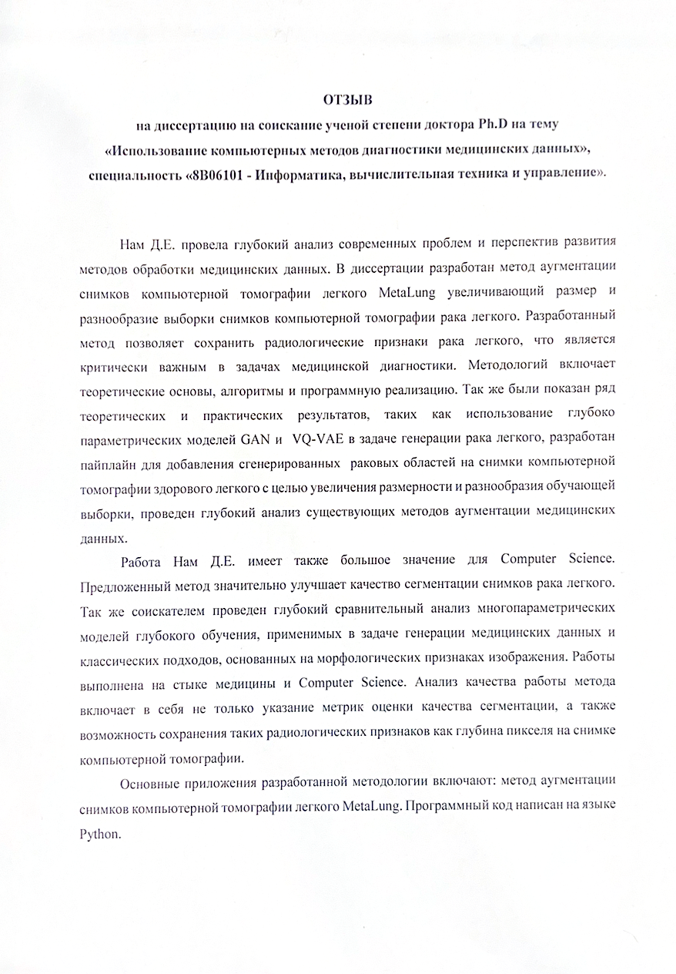


APPENDIX G
Review
Of the dissertation submitted for the degree of Doctor of Philosophy (Ph.D) on the topic:" The usage of computer methods for diagnostics of medical data", specialty "8D06101 — Computer Science, Computer Engineering and Management " from Kazakh Institute of Oncology and Radiology (KazIOR).

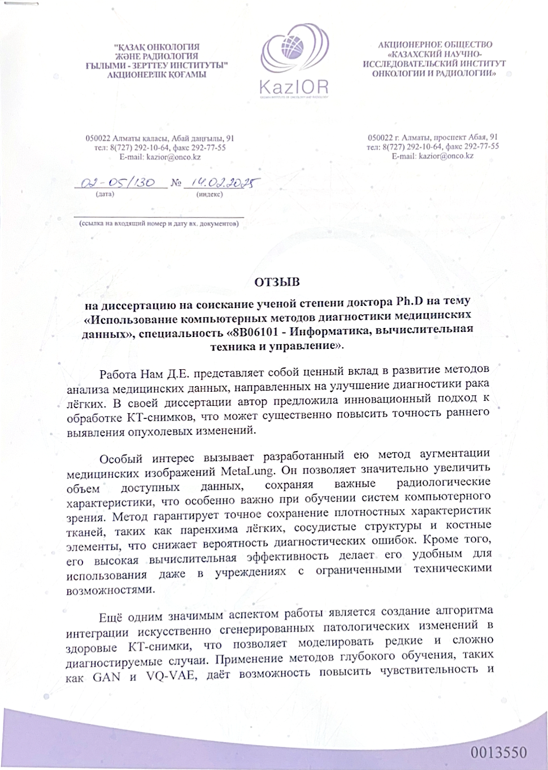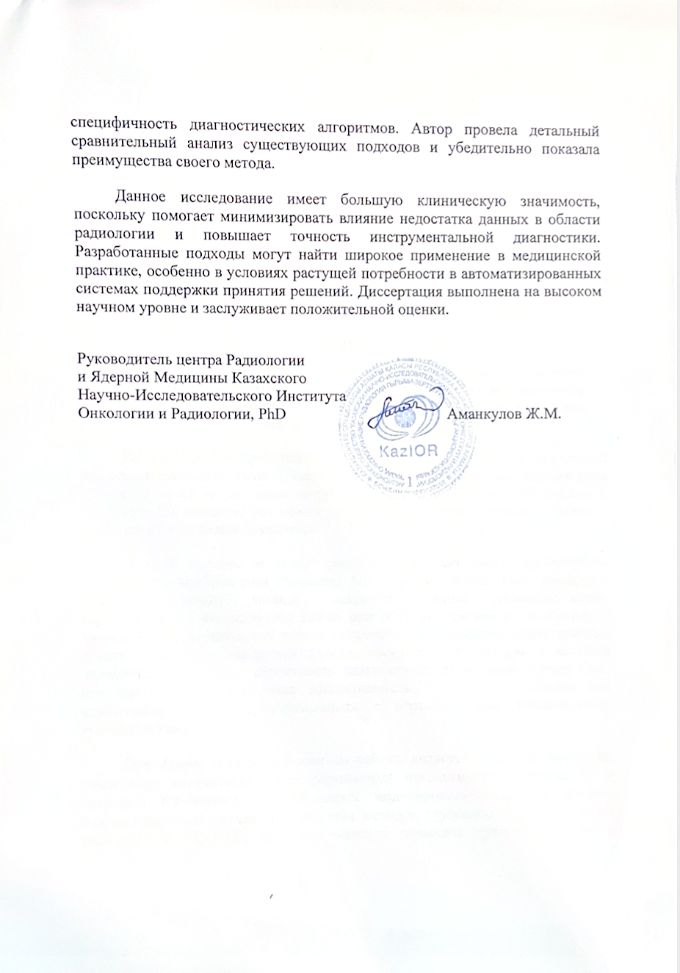

APPENDIX H
Review
Of the dissertation submitted for the degree of Doctor of Philosophy (Ph.D) on the topic:" The usage of computer methods for diagnostics of medical data", specialty "8D06101 — Computer Science, Computer Engineering and Management " from Kazakh Institute of Oncology and Radiology (KazIOR).

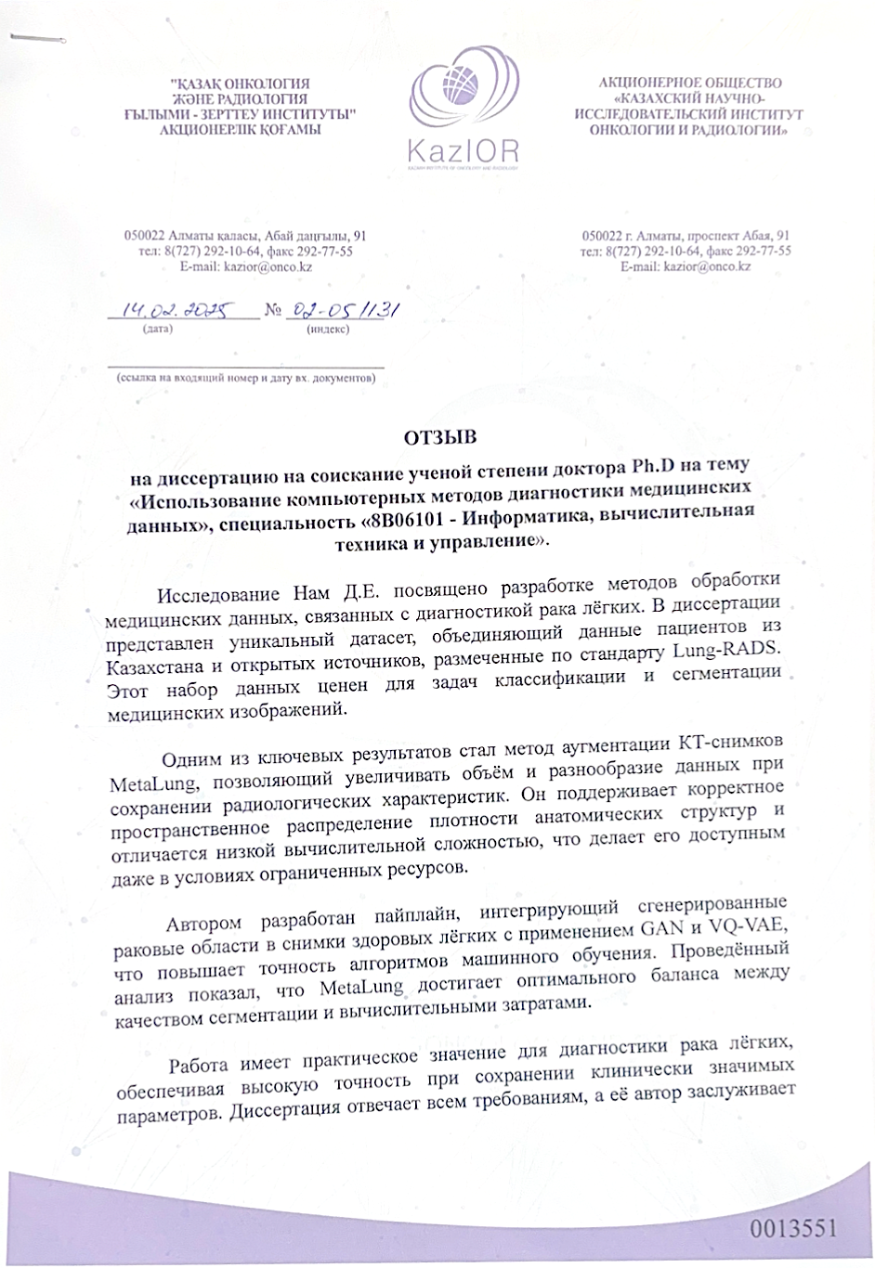


APPENDIX I
Review
Of the dissertation submitted for the degree of Doctor of Philosophy (Ph.D) on the topic:" The usage of computer methods for diagnostics of medical data", specialty "8D06101 — Computer Science, Computer Engineering and Management " from Kazakh Institute of Oncology and Radiology (KazIOR).

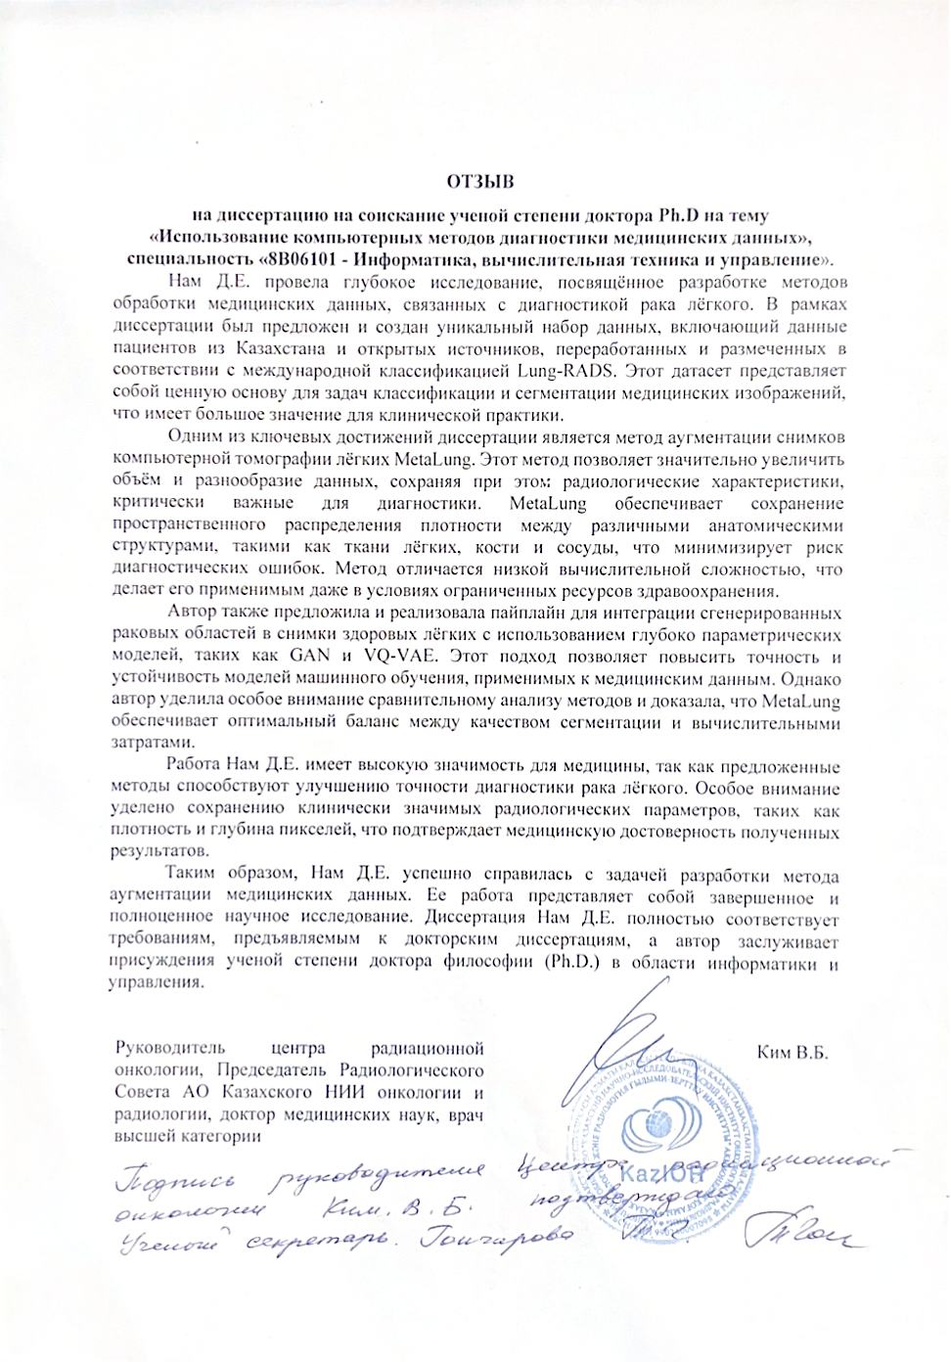

APPENDIX J

Act of implementation to education process of ADA University, Baku, Azerbaijan

