Karaganda National Research University named after
academician Ye.A. Buketov

UDC 37:81’243 On the manuscript rights

NABIYEVA AIZHAN BOLATOVNA

Formation of foreign language pragmatic competence of future English teachers through the use of Web 2,0 technologies

8D01702 – Foreign language: two foreign languages

Dissertation submitted
for the degree of Doctor of Philosophy (PhD)

Scientific supervisors:
Shelestova T.Yu.
Ph.D., Associate Professor

Prof. dr hab. Janusz Taborek
Adam Mickiewicz University of Poznań

The Republic of Kazakhstan
Karaganda, 2026
TABLE OF CONTENTS

NORMATIVE REFERENCES 3
TERMS AND DEFINITIONS 4
LIST OF ABBREVIATIONS AND ACRONYMS 6
INTRODUCTION 7
- THEORETICAL FOUNDATIONS FOR FORMING FOREIGN-LANGUAGE PRAGMATIC COMPETENCE OF FUTURE ENGLISH TEACHERS THROUGH THE USE OF WEB 2.0 TECHNOLOGIES 17
  - Foreign-language pragmatic competence as a structural component of communicative competence 17
  - The linguodidactic potential of Web 2.0 technologies for forming future English teachers’ foreign-language pragmatic competence 42
  - The model for forming foreign-language pragmatic competence in future English teachers based on Web 2.0 technologies 57
- PRACTICAL IMPLEMENTATION OF FOREIGN-LANGUAGE PRAGMATIC COMPETENCE FORMATION IN FUTURE ENGLISH TEACHERS THROUGH THE USE OF WEB 2.0 TECHNOLOGIES 84
  - The content of the experimental work on foreign-language pragmatic competence formation in future English teachers through the use of Web 2.0 technologies 84
  - The results of the experimental work on foreign-language pragmatic competence formation in future English teachers through the use of Web 2.0 technologies 118
CONCLUSION 147
REFERENCES 153
APPENDICES 180

NORMATIVE REFERENCES

This dissertation references the following normative documents:

Strategy “Kazakhstan – 2050: New Political Course of the Established State.” – Approved by the Decree of the President of the Republic of Kazakhstan, dated December 14, 2012.
Law of the Republic of Kazakhstan “On Education.” – No. 319-III, dated July 27, 2007.
Professional Standard “Teacher” (Education 4.0). – Approved by the Order of the Acting Minister of Education of the Republic of Kazakhstan, dated December 15, 2022, No. 500.
Address by the President of the Republic of Kazakhstan, Kassym-Jomart Tokayev, to the People of Kazakhstan “The Economic Course of a Just Kazakhstan.” – Dated September 1, 2023.
Address by the President of the Republic of Kazakhstan, Kassym-Jomart Tokayev, to the People of Kazakhstan “Kazakhstan in the Era of Artificial Intelligence: Current Challenges and Their Solutions through Comprehensive Digital Transformation.” – Astana, September 8, 2025.
Concept for the Development of Higher Education and Science in the Republic of Kazakhstan for 2023-2029. – Approved by the Resolution of the Government of the Republic of Kazakhstan, dated March 28, 2023, No. 248.
National Project “Digital Transformation of Education” (within the National Project “Quality Education – Educated Nation”). – Approved by the Resolution of the Government of the Republic of Kazakhstan, dated October 12, 2021, No. 726.
Law of the Republic of Kazakhstan “On Informatization.” – No. 418-V ZРК, dated November 24, 2015 (as amended and supplemented).

TERMS AND DEFINITIONS
Pragmatic competence – competence specifically responsible for achieving successful communication by employing the language in a manner that is appropriate for the given situation.
Foreign-language pragmatic competence – “knowledge and a range of abilities to use and interpret a foreign language in various real-life scenarios in the context of intercultural communication. This range includes the ability of speakers to employ language for various purposes, such as making a request, providing instructions, or complaining; the ability of listeners to comprehend the speaker’s true intentions, particularly when those objectives are expressed indirectly – sarcasm, irony, and indirect requests are a few examples of how this might happen; the ability to command of the rules that govern how statements are connected to form a coherent discourse”.
Communicative competence – a language learner’s ability to use language to communicate successfully.
Interlanguage pragmatics (ILP) – “a subfield of Second Language Acquisition (SLA) that studies non-native speakers’ knowledge, use, and development in performing L2 speech acts (sociocultural functions)” [1].
Pragmatic production – the learner’s ability to produce linguistically and socially appropriate utterances in the target language, taking into account context, interlocutor relationships, communicative intent, and cultural norms.
Pragmatic comprehension – the learner’s ability to understand and interpret implied meanings, intentions, pragmatic cues, politeness strategies, sociocultural norms, and contextual information in spoken or written communication.
Sociopragmatics – a branch of pragmatics that examines how social variables (such as power, distance, status, age, cultural norms, and politeness conventions) influence the appropriate use and interpretation of language in communicative situations. It focuses on the social rules that govern interactions.
Pragmalinguistics – the linguistic resources used to perform pragmatic functions, including sentence forms, lexical choices, politeness markers, discourse particles, and grammatical structures. It concerns how linguistic forms encode the communicative intentions.
Speech act – an utterance that serves a communicative function.
Pragmatic markers – pragmalinguistic resources used to perform a variety of SAs.
Implicatures – the implicit meaning conveyed beyond the literal meaning of the speaker’s words.
Pragmatic instruction – the teaching of appropriate language use in social contexts, emphasizing the ability to use language successfully across various scenarios by comprehending social and cultural norms.
Pragmatic awareness – conscious and explicit knowledge about pragmatics.
Web 2.0 technology – the second generation of technologies and websites that promote user-generated content.
Connectivism – a modern educational theory that emphasizes the value of creating connections between ideas, experiences, and social networks through technology.
Authentic input – materials that provide information about the target culture and were not originally created for a language learning context.
Digital learning environment – an organized educational ecosystem that integrates digital tools, platforms, resources, communication channels, and technological infrastructure to support teaching, learning, collaboration, and assessment. These include LMS platforms, Web 2.0 tools, virtual classrooms, and online interaction spaces.
Explicit instruction – a teaching approach in which pragmatic norms, speech act strategies, sociocultural rules, and linguistic forms are explained directly and consciously to learners. It involves metapragmatic explanations, modeling, and guided practice.
Discourse Completion Test – an elicitation instrument in interlanguage pragmatics used to assess learners’ pragmatic competence. It presents learners with short descriptions of communicative situations that they must complete with an appropriate utterance, allowing researchers to evaluate pragmatic production and comprehension.

LIST OF ABBREVIATIONS AND ACRONYMS

CEFR – Common European Framework of Reference
EFL – English as a Foreign Language
ESL – English as a Second Language
ELT – English Language Teaching
SLA – Second Language Acquisition
ICT – Information and Communication Technologies
ILP – Interlanguage Pragmatics
IPrA – International Pragmatics Association
ICC – Intercultural communicative competence
CC – Communicative Competence
L1 – First language
L2 – Second Language
FL – Foreign language
TL – Target language
Web 2.0 – Second generation of web-based technologies emphasizing user interaction and collaboration
SAMR – Substitution, Augmentation, Modification, and Redefinition (model of technology integration in education)
TESOL – Teaching English to Speakers of Other Languages
RK – Republic of Kazakhstan
NS – Native Speaker
NNSs – non-native speakers
NNESTCs – non-native English-speaking teacher candidates
SAs – Speech Acts
CMC – Computer-mediated communication
CALL – Computer-assisted language learning
MALL – Mobile-assisted language learning
CMCL – Computer-Mediated Classroom Learning
TBLT – Task-Based Language Teaching
DCT – Discourse Completion Test
ODCT – Oral Discourse Completion Test
WDCT – Written Discourse Completion Test
MDCT – Multiple-choice Discourse Completion Test

INTRODUCTION
The Relevance of the Research. The relevance of the study is determined by the need to prepare pedagogical professionals capable of ensuring effective and contextually appropriate foreign language communication in the context of globalization and the digital transformation of education. In today’s highly interconnected world, successful foreign-language proficiency among future teachers is not limited to linguistic knowledge alone but presupposes the development of pragmatic competence [2, p. 28], which enables the appropriate use of linguistic resources across diverse sociocultural and professionally significant pedagogical contexts.
The significance of the research is shaped by several factors. First, in the context of preparing future foreign language teachers, particular importance is attached to the shift in the teaching paradigm from a grammar-oriented model to communicative language teaching aimed at performing real-life communicative tasks. This shift has led to growing scholarly interest in interlanguage pragmatics (ILP) as an independent field within Second Language Acquisition (SLA) theory [3, p. 153]. Interlanguage pragmatics examines the processes by which non-native speakers (NNSs) acquire and use speech acts (SAs) in a foreign language and the degree of their sociocultural appropriateness [4]. Findings from numerous studies, including Thomas [5], Kasper and Rose [6], Bardovi-Harlig K. [7], Kasper and Schmidt [8], Ishihara and Cohen [9], and others, indicate that even grammatically accurate utterances may result in communicative breakdowns due to the neglect of sociocultural context, a phenomenon commonly referred to as pragmatic failure [5]. Accordingly, the successful realization of SAs requires not only mastery of linguistic forms but also the development of skills for the contextually appropriate use of language in accordance with specific communicative situations, goals, and norms of politeness [10]. This, in turn, constitutes a fundamentally important component of the professional training of future English teachers.
Second, international educational standards and professional regulatory documents identify pragmatic competence as a key component of foreign language proficiency and foreign language teacher education. According to the Common European Framework of Reference for Languages (CEFR), “pragmatic competence constitutes an independent subcomponent of communicative competence” [11] and is specifically responsible for “achieving successful communication by using the language appropriately for the given situation” [12]. The TESOL standards define the ability of future teachers to engage in appropriate and effective communication across diverse sociocultural contexts as one of the core professional requirements [13]. Moreover, the European Profile for Language Teacher Education emphasizes “the capacity of future teachers to foster learners’ ability to use the target language (TL) appropriately across different contexts and cultures” [14, p. 15]. According to the Program Standards for the Preparation of Foreign Language Teachers [15], developed by the American Council on the Teaching of Foreign Languages (ACTFL) and the Council for the Accreditation of Educator Preparation (CAEP) in the United States, “a qualified language teacher should be pragmatically competent” [16]. All these documents recognize pragmatic competence as an integral component of training professional foreign language teachers.
Third, within the Kazakhstani EFL context, issues of ILP, particularly in the field of English language teaching methodology, are still underrepresented and not fully integrated into educational practice compared to other aspects of language learning, such as grammar or vocabulary. Although certain components of pragmatic competence are reflected in state reforms and strategic educational documents, its systematic and purposeful development in the process of preparing future English language teachers remains limited due to challenges such as inadequate teacher training and curriculum inflexibility [17].
In this regard, the regulatory documents of the Republic of Kazakhstan clearly emphasize the need to train teachers capable of effective communication in international and intercultural contexts. In the “Kazakhstan-2050” Strategy, the development of human capital, the improvement of education quality, and the training of globally competitive specialists are identified as priority directions of national development [18]. These priorities are further specified in the Professional Standard “Teacher” (Education 4.0), which defines effective communication, the development of learners’ language competencies, respect for global cultural and linguistic diversity, and the formation of foundations of multicultural education as essential professional requirements for teachers [19]. The Standard also highlights the teacher’s role in organizing subject-subject interaction and regulating communication in accordance with professional, ethical and sociocultural norms [19].
Taken together, these provisions directly relate to the development of foreign-language pragmatic competence, as this competence ensures the ability to interpret communicative intentions appropriately, take into account sociocultural and situational parameters of interaction, and select contextually appropriate linguistic means in diverse communicative settings. Within this framework, the teacher is viewed not merely as a transmitter of linguistic knowledge but as a mediator of appropriate communication in a multilingual and multicultural educational environment [19], which points out the particular importance of the purposeful formation of foreign-language pragmatic competence in future English teachers.
The relevance of the study is further reinforced by the processes of digitalization in education. Regulatory documents and state strategies emphasize the need to integrate technologies into the educational process and to train specialists capable of functioning effectively in a digital environment. “The Economic Course of Kazakhstan”, the message of the President of the RK Kassym-Jomart Tokayev to the people of Kazakhstan on September 1, 2023, reflects the social imperative for “the training of a new generation of specialists with modern digital technologies, capable of effective communication, and internationally competitive” in the context of globalization and internationalization of education [20]. This priority is further developed in the 2025 Address “Kazakhstan in the Era of Artificial Intelligence”, which positions digital transformation and AI integration as key drivers of educational modernization [21]. The Concept of the Development of Higher Education and Science in the Republic of Kazakhstan for 2023-2029 clearly states that “Kazakhstani universities should switch to the “smart-university” model” [21]. The conventional classroom settings do not always offer an environment conducive to students practicing language appropriately in authentic communicative contexts, since “formal education may not keep pace with technological changes” [22]. In the contemporary digitally interconnected world, incorporating Web 2.0 technologies into EFL instruction as a transforming opportunity for learners to develop their pragmatic competence addresses both international best practices and national priorities. Since the ability to use didactic potential of technologies effectively in a learning environment refers to “the digital competencies, which are a mandatory professional competence of a competitive foreign language teacher” [19].
S.S. Kunanbayeva, who made a major contribution to the development of competence-based model of foreign language teacher training and scientifically supported the integration of intercultural communicative competence (ICC) into professional foreign language education in Kazakhstan, “underscored the fundamental importance of pragmatic subcompetence and defined as mastery of all aspects of communicative behaviors as a collection of communication norms and traditions inherent to a TL socio-cultural community” in the development of professional and communicative competence [23]. That is, the formation of TL pragmatic competence provides the ability for meaningful authentic intercultural communication, which is one of the responsibilities of a teacher.
Despite the global interest in ILP issues over the past few decades, and the fact that many EU countries (CEFR), the United States, Korea, Japan and others have increasingly incorporated pragmatic elements into language instruction (Taguchi; Cohen; Rose and Kasper; Halenko; Sanchez-Hernandez and Baron; Derakhshan and Shakki) [2, 24-29], in the Kazakhstani EFL context, the concept of “foreign-language pragmatic competence” remains insufficiently acknowledged within the broader frameworks of communicative competence and intercultural communicative competence. A significant research gap persists due to the limited number of Kazakhstani studies addressing pragmatic competence in foreign language (Shalshykbayeva et. al; Aimoldina et. al; Karabayeva; Zhussubalina and Tleuberdiyev; Seitkhan and Kassymbekova; Zhanysbekova and Syrlybayeva) [30-35]. Although existing literature confirms that teachers can empower learners to communicate strategically and effectively in English by integrating pragmatics into the teaching process, significant deficiencies remain in the integration of pragmatics instruction into foreign language teacher training, assessment methods for pragmatic competence, and the potential of technologies, particularly Web 2.0, for its formation.
Hence, the relevance of this research is determined by the social order in training teachers of a new formation who are multilingual, mobile, communicative, and competent, and prepared to swiftly adjust to the evolving conditions of the innovative professional educational environment. It is obvious that the development of communication skills, including tactful speech of the “alpha” generations, is a contemporary issue. Moreover, the analysis of domestic and foreign studies has shown that the problems of communicative inappropriateness are primarily caused by insufficient formation of pragmatic competence [35]. These findings led to the need for the formation of a future teacher’s foreign-language pragmatic competence, which holds significant value for strengthening the informatization of domestic education and aligning it with worldwide standards.
Accordingly, the relevance of the research topic is determined by the following contradictions between:
- the social demand in training teachers of a “new formation” who are capable of and ready for successful communication in a multilingual and multicultural environment, and the insufficient attention paid within higher pedagogical education to the pragmatic component of communicative competence that ensures the appropriate use of linguistic resources in diverse sociocultural situations;
- the growing interest of teachers in learning and teaching pragmatics and the insufficient development of corresponding methodological approaches and instructional-didactic materials;
- the high potential of Web 2.0 technologies aimed at enhancing the effectiveness of developing foreign-language pragmatic competence and the lack of a systematic approach to their integration into the educational process of professional foreign language teacher training.
The identified contradictions necessitate addressing the scientific and practical research problem, which lies in the absence of a theoretically grounded and empirically validated model for the formation of foreign-language pragmatic competence of future English language teachers based on the systematic integration of Web 2.0 technologies into the educational process. The resolution of this problem determined the choice of the dissertation research topic: “Formation of foreign-language pragmatic competence of future English language teachers through the use of Web 2.0 technologies” [36].
The aim of the research is to scientifically substantiate, develop, and experimentally verify the model for the formation of future English teachers’ foreign-language pragmatic competence through the use of Web 2.0 technologies [36].
The object of the research is the pedagogical process of forming the foreign-language pragmatic competence of future English teachers [36].
The subject of the research is the model for the formation of future English teachers’ foreign-language pragmatic competence through the use of Web 2.0 technologies [36].
Research hypothesis:
If the didactic decisions in the process of professional training of future foreign language teachers are oriented toward the development of foreign-language pragmatic competence with due consideration of its essence, structure, and component composition, as well as toward the use of the potential of Web 2.0 technologies, then the design and implementation of a model for forming future foreign language teachers’ foreign-language pragmatic competence will contribute to an increased level of its formation, since Web 2.0 technologies ensure the authenticity, interactivity, and reflexivity of learning and create pedagogical conditions for the meaningful acquisition of pragmatically appropriate foreign-language communication across diverse sociocultural contexts [36].
To achieve the aim and confirm the formulated hypothesis, it is necessary to solve the following tasks:

1) To provide a theoretical justification for and formulate an author’s definition of the concept of foreign-language pragmatic competence in the context of the professional training of future foreign language teachers, as well as to identify its essence, structure, and component composition;
2) To determine the linguistic and didactic potential of Web 2.0 technologies in the process of forming foreign-language pragmatic competence using them;
3) To design and theoretically substantiate a model for forming the foreign-language pragmatic competence of future English language teachers through the use of the proposed Web 2.0 technologies [36];
4) To conduct a pedagogical experiment aimed at testing and confirming the effectiveness of the developed model for forming foreign-language pragmatic competence through the use of Web 2.0 technologies within the system of professional training of future English language teachers.
The central premise of the research is that the purposeful integration of Web 2.0 technologies into the educational process ensures the effective formation of foreign-language pragmatic competence in future English language teachers by enhancing the development of pragmalinguistic and sociopragmatic skills within an authentic digital communicative environment adapted to the Kazakhstani educational context.

The theoretical-methodological basis of the research is founded on the integration of concepts from ILP, foreign language education, digital pedagogy, and teacher professional training.
The theoretical basis of the research is provided by:
- Studies in the field of pragmatics and Interlanguage Pragmatics (ILP) (Ch. Morris, Ch. S. Peirce, J. Katz, Levinson, Crystal, Kasper, Leech, Blum-Kulka, Mey, Thomas, Kasper, Dahl, Schmidt, Taguchi, and others; Speech act theory: Austin, Searle, Liefer, Bierwisch, Stalnaker; Politeness theory (Brown, Levinson, Thomas, Martinez-Flor); Noticing Hypothesis (Schmidt); Cooperative Maxims (Grice);
- Studies on pragmatic competence and its role in the communicative competence models in foreign language education process (S. Kunanbayeva, D. Kulibayeva, A. Chaklikova, Shalshykbayeva et. al, Aimoldina et. al, Karabayeva, Zhussubalina and Tleuberdiyev, Seitkhan and Kassymbekova, Zhanysbekova and Syrlybayeva, D. Hymes, M. Canale, M. Swain, L.F. Bachman, Yule, Taron, A.S. Palmer, and others)
- Studies addressing the important role of pragmatic competence in the context of professional training of English teachers (teachers as pragmatic models): Verschueren, Hergüner, Çakır, Glasgow, Liu, Bardovi-Harlig, Hartford, Rose, Cohen, Denny, Baştürkmen, Ishihara, Sachtleben, Ekin, Damar, etc.; teachability of pragmatics and role of pragmatic instruction: Taguchi, Plonsky, Ishihara, Glaser, Eslami, Eslami Rasekh, Vàsquez, Tajeddin, Khodaparast, Korkmaz, Karatepe, etc.
- Studies on the linguodidactic potential and application of Web 2.0 tools for foreign language teaching and pragmatic development (F.K. Atabayeva, A.K. Mynbayeva, B.A. Zhetpisbayeva, G.B. Sarzhanova, G.S. Akybayeva, A.M. Tulegenova, S.G. Kurymbayev, V.A. Burmistrova, A.V. Filatova, P.V. Sysoev, O.О. Zakharova, A.V. Titova, S. Geddes, S. Kumar, W. Mark, P. McGee, J. Bloch, R. Poth, B. Dodge, N. Peachey, A. Antonio, D. Tuffley, A. Hill, L. Johnson, O. Reilly, Pop, Wang, Vásquez, Lee, Dettinger, Mai, Hashim, Rosen, Girgin, Cabaroglu, Light, Polin, Cunningham, Furniss, Zhang, Gonzalez-Lloret, Derakhshan, Garcia-Gomez and others).
To implement the tasks and provide evidence for the research hypothesis, a mixed-methods research design (quantitative and qualitative analysis) was employed, along with a set of research methods:
- Theoretical methods: review and analysis of scientific and scientific-methodological literature and normative documents; methods of comparison and modelling;
- Empirical methods: pedagogical observation, survey, and pedagogical experiment;
- Statistical methods: Student’s T-test, Wilcoxon Signed-Rank test, McNemar criterion, and Likert scale.
Experimental research base. Karaganda National Research University named after academician Ye.A. Buketov, Faculty of Foreign Languages.
The main stages of the research.
The first stage (2021-2022) involved studying the literature on the research problem, determining the level of progress, and developing the scientific research apparatus. Methodological foundations and research methods were identified. The international English-language works regarding the theory and methodology of pragmatic competence, teaching and assessing pragmatics, and a review of domestic research on pragmatic competence were conducted, along with scientific studies in the field of integrating Web 2.0 technologies into the educational training of future foreign language teachers.
The second stage (2022-2023) involved the development of an experimental research program, the testing and generalization of the study’s overarching hypothesis, and the design of a model aimed at forming foreign-language pragmatic competence in future English teachers [36], a set of exercises was developed to test the effectiveness of the model, and the development of “English in Context: Communicating with Pragmatic Awareness” course based on the Nearpod platform using digital educational content.
The third stage (2023-2024) comprised the implementation of experimental research, including testing and data analysis; the completion of the diagnostic, formative, and evaluative phases of the experiment; the processing and interpretation of the collected data; the writing of the dissertation; and the practical implementation of the research findings.
The scientific and theoretical significance of the research consists of:

refining and introducing into the scholarly discourse the author’s concept of “foreign-language pragmatic competence,” as well as specification of its essence, structure, and constituent components [36];
- determination and theoretical substantiation of the linguistic and didactic potential of Web 2.0 technologies in the process of forming the foreign-language pragmatic competence of future English language teachers [36];
- the design and conceptual substantiation of a model for forming foreign-language pragmatic competence through the use of Web 2.0 technologies [36];
- the development of a scientifically grounded system for assessing pragmatic competence that ensures objective and reliable diagnosis of the level of its formation [34].
The practical significance of the research consists of:
- the practical course “English in Context: Communicating with Pragmatic Awareness” on the Nearpod platform based on the developed model for the formation of foreign-language pragmatic competence, which can be used as a ready-made instructional module in university teacher training programs, as a supplementary component in methodology and intercultural communication courses, and directly in regular EFL lessons to integrate pragmatic instruction into communicative classroom practice;
- the Electronic Study-guide “Interlanguage Pragmatics: Raising Pragmatic Awareness in the EFL Classroom” [36], which can be used as a ready-made instructional module in university teacher-preparation programs, as a supplementary component in methodology and intercultural communication courses, and directly in regular EFL language lessons to integrate pragmatic instruction into communicative classroom practice. The study-guide provides structured, technology-enhanced activities for the phased development of pragmatic competence across key SAs and implicatures;
- the Methodological Recommendations for forming foreign-language pragmatic competence provide specific algorithms, task types, digital tool integration strategies, and assessment guidelines for current and future teachers. These recommendations can be used in teacher training programs, advanced professional development programs, methodological units within schools and higher education institutions, individual professional self-development, as well as the professional practice of future teachers.
- the developed set of assessment tools, including instruments for diagnosing the level of foreign-language pragmatic competence and analytic rubrics for assessing pragmatic comprehension and pragmatic production, can be directly applied in teaching basic English, in courses on foreign language teaching methodology and intercultural communication, as well as within the professional pedagogical practice of future English language teachers. Its implementation (including on platforms such as Nearpod and Flip/Padlet, as well as in role-play tasks) ensures objective measurement of competence development, provides systematic and transparent feedback, and enhances the effectiveness of monitoring and assessing learning outcomes.
The main scientific provisions submitted for the dissertation defense are:
1. The theoretical and methodological foundations for the formation of foreign-language pragmatic competence in future English teachers:
- The definition of foreign-language pragmatic competence developed in this study reveals its essence as a set of knowledge, skills, and abilities that ensure the effective and appropriate use of a foreign language, as well as its accurate interpretation in a variety of real-life communicative situations within the context of intercultural communication;
- Foreign-language pragmatic competence is considered an integral component of teachers’ professional competence and includes pragmalinguistic and sociopragmatic sub-competences, realized through the aspects of pragmatic comprehension and pragmatic production. Its content encompasses speech acts, pragmatic markers, and conversational implicatures, which enable future English language teachers to use and interpret language appropriately in diverse communicative situations.
2. The linguistic and didactic potential of Web 2.0 technologies in forming foreign-language pragmatic competence in future English teachers is identified as a structured set of interrelated components. The linguistic potential includes authentic input, synchronous and asynchronous interaction, cross-cultural communication, awareness of politeness strategies, speech act practice, and productive output. The didactic potential comprises flexible modes of delivery, learner-centered learning, a variety of tasks, collaborative learning, monitoring of the learning process, as well as feedback and assessment. The integration of Web 2.0 technologies into a unified digital learning environment ensures the effective formation of foreign-language pragmatic competence in future English language teachers.
3. The developed model for forming foreign-language pragmatic competence in future English teachers through Web 2.0 technologies includes the following components:
- Target block, which defines the strategic guidelines for the training of future foreign language teachers based on international and national standards;
- Conceptual block, which incorporates the theoretical foundations of interlanguage pragmatics (ILP) and digital pedagogy, as well as a set of scientific approaches (competence-based, communicative-cognitive, task-based language teaching (TBLT), sociolinguocultural, and connectivist) and instructional principles (general didactic and methodological-technological);
- Content block, which represents the didactic and methodological content, including its component structure (pragmalinguistic and sociopragmatic components), pragmatically oriented learning elements (speech acts, pragmatic markers, and conversational implicatures), as well as content presented through the developed instructional materials (Nearpod course, textbook, and methodological guidelines) aimed at developing foreign-language pragmatic competence;
- Procedural block, which ensures the implementation of the model through a set of pedagogical conditions (motivational and value-based readiness, a minimum level of A2 in foreign-language communicative competence, basic ICT competence, an authentic digital learning environment, and methodological coherence), the staged organization of instruction (diagnostic, formative, and reflective-evaluative stages), as well as the implementation of blended learning through the integration of Web 2.0 technologies using appropriate teaching methods and tools (Nearpod, Padlet, Interactive YouTube, Collaborate Board, etc.);
- Evaluation and outcome block, which includes the author-developed system for assessing foreign-language pragmatic competence based on the Discourse Completion Task (DCT), aimed at diagnosing pragmatic comprehension and pragmatic production, as well as determining the achieved level of competence (A2-C1).
4. The findings of the experimental study confirm the effectiveness of the proposed model for developing foreign-language pragmatic competence in future English language teachers through the use of Web 2.0 technologies, as evidenced by increased levels of pragmatic comprehension and pragmatic production, as well as the development of the ability to communicate appropriately across diverse sociocultural contexts.
Approbation and implementation of the research results. The results of the present dissertation are presented in 8 scientific publications: in scientific publications included in the Scopus database – 1, in publications recommended by the Quality Assurance in the field of Science and Higher Education in the Ministry of Science and Higher Education of the Republic of Kazakhstan – 3, and in the proceedings of international scientific conferences – 4. In addition, an electronic student’s guide “Interlanguage Pragmatics: Raising Pragmatic Awareness in the EFL Classroom” was developed and certified (Certificate of entry of information into the state register of copyrighted objects No. 42812 dated January 8, 2024) and implemented in the context of experimental pedagogical work on the basis of Karaganda National Research University named after Ye.A. Buketov. “Methodological recommendations for technology-enhanced teaching of foreign-language pragmatic competence” [36] for foreign language teachers were developed and certified (Certificate of entry of information into the state register of copyrighted objects No. 37257 dated July 16, 2023). A practical course “English in Context: Communicating with Pragmatic Awareness” based on the Nearpod platform was developed and implemented in the educational process as an effective educational material for the formation and development of foreign-language pragmatic competence (Act of implementation).
The structure and scope of the dissertation. The dissertation consists of an introduction, two chapters, a conclusion, a list of references, and appendices.
In the introduction, the relevance of the research topic is determined and the methodological apparatus is presented.
In Chapter One “Theoretical foundations for forming foreign-language pragmatic competence of future English teachers through the use of Web 2.0 technologies”, the essence of pragmatic competence, its componential structure is revealed, a term “foreign-language pragmatic competence” is defined and introduced, a thorough comparative analysis of international and domestic research in the field of communicative competence, pragmatics and ILP; the main linguistic and didactic potential of Web 2.0 technologies for forming foreign-language pragmatic competence is identified; and a model for forming foreign-language pragmatic competence of future English teachers using Web 2.0 tools is developed.
Chapter Two “Practical implementation of foreign-language pragmatic competence formation in future English teachers through the use of Web 2.0 technologies” provides the data on the content, process and results of the experimental work.
The conclusion presents the main findings and summary of the research.
The dissertation includes 20 tables, 42 figures, 366 references, and 8 appendices.

- THEORETICAL FOUNDATIONS FOR FORMING FOREIGN-LANGUAGE PRAGMATIC COMPETENCE OF FUTURE ENGLISH TEACHERS THROUGH THE USE OF WEB 2.0 TECHNOLOGIES

  - Foreign-language pragmatic competence as a structural component of communicative competence

In the context of educational globalization and informatization, accompanied by the expansion of international boundaries, the integration of Kazakhstan into the global educational space, has intensified international academic and professional cooperation; this process has created a need for the ability to use English appropriately in intercultural communication, which is explicitly reflected in national normative documents regulating teacher education in the Republic of Kazakhstan, emphasizing “the training of future specialists of a “new formation” oriented toward professional self-realization and global integration” [19]. This objective is implemented through a competence-based approach to learning, with communicative competence identified as a core outcome of foreign-language education [19].
Accordingly, the relevance of pragmatic competence within teacher education has increased, as effective communication depends not only on linguistic accuracy but also on the ability to use language appropriately in real communicative contexts.
Communicative difficulties between a speaker and a listener remain relevant across linguistic and cultural contexts. Empirical research indicates that even highly proficient learners may experience difficulties in understanding intended meanings and politeness norms. Kazakhstani students, despite demonstrating strong grammatical skills [38]; frequently struggle to communicate effectively in English in real-life situations.
As noted in previous studies, non-native speakers (NNSs) are more likely to experience pragmatic failure due to insufficient awareness of TL norms rather than grammatical inaccuracy. In modern linguistics, the subcompetence responsible for addressing such issues is pragmatic competence, which therefore requires systematic theoretical understanding both in the context of its contribution to national linguistic and didactic sciences and in scientific literature to integrate it into the educational process of training future English teachers in Kazakhstan.
Contemporary views on teacher education further reinforce the importance of pragmatic competence. E. G. Tareva emphasizes the need for future teachers who can effectively foster long-term changes and swiftly address challenges in uncertain environments. Graduates who can rethink how they learn and what they have learned are better able to gain skills that go beyond merely studying for a goal [39]. According to Tareva, digital-era pedagogical universities represent a new generation of students who value the functional and pragmatic significance of acquired competencies for their personal and professional development. The goal of this change in educational philosophy is to help people acquire the competence that will assist them throughout their lives [39].
Within a competence-based paradigm, the internal structure of competence becomes a central methodological issue. According to S.S. Kunanbayeva, the implementation of an effective competence-based approach may require the decomposition of the competence: competence-subcompetence structure [23]. From this perspective, the development of a scientifically substantiated model for forming foreign-language pragmatic competence contributes to minimizing recurring communication challenges in real-world contexts while simultaneously supporting the coherent formation of foreign-language communicative competence as a structured system of interconnected components.
The section therefore examines pragmatic competence within major communicative competence models, introduces the concept of “foreign-language pragmatic competence”, and substantiates the role of pragmatic instruction in the professional preparation of future English teachers.
The growing scholarly interest in pragmatics is confirmed by bibliometric evidence. Figure 1 demonstrates a steady increase in Scopus-indexed publications on “L2 pragmatic competence” and “interlanguage pragmatics” from the early 2000s to 2025, indicating the evolution of pragmatics into a prominent and potentially independent field of linguistic inquiry.
This trend reflects the expanding scope of pragmatic research and its increasing relevance for foreign-language education.

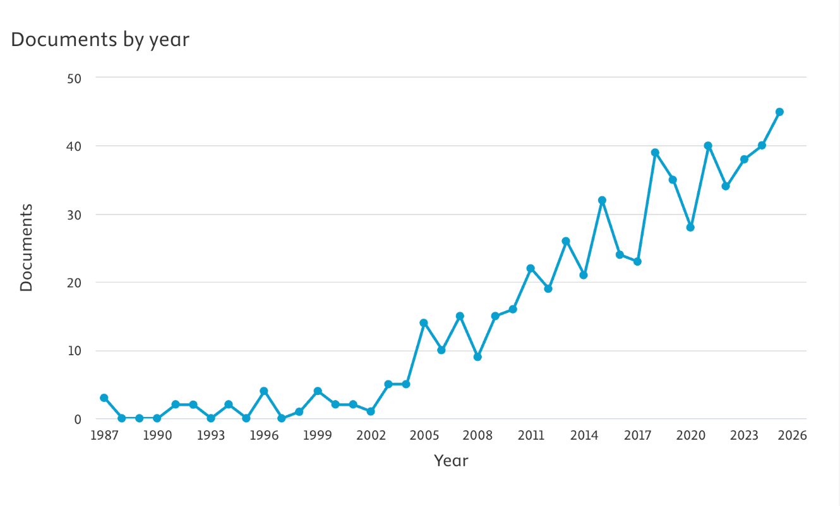

Figure 1 – The evolution of publications on L2 pragmatic competence and related topics (1987–2025)

Before delving into the importance and construct of pragmatic competence, it is necessary to clarify the concept of pragmatics itself. As a linguistic subfield, pragmatics emerged relatively recently, in the early 1970s [40, p. 495], although its theoretical foundations are rooted in the philosophy of language. The development of pragmatics was significantly influenced by the functional views of language proposed by Wittgenstein [41], Austin [42], Searle [43], and Grice [44], who conceptualized language as a form of social action rather than a purely formal system. More and more linguists have come to recognize the importance of pragmatics as a language study. To represent it from its functional perspective in language and communication, the International Pragmatics Association (IPrA) was founded in 1986 [45]. Within the framework of IPrA, the first conferences devoted to pragmatic issues took place (Viareggio 1985, Antwerp 1987, Barcelona 1990, and Kobe, Japan 1993) and pragmatics journals began to be published in steadily growing volumes and pages (Journal of pragmatics, Intercultural Pragmatics, International Review of Pragmatics, Pragmatics and Society) [40, p. 495]. Since that period pragmatics has not lost its interest among scholars and ceased to be considered as a small subbranch of linguistics (see fig. 1).
Although pragmatics was formally established as a field in the 1970s, the term itself was introduced earlier by Charles Morris in 1938. Morris’s work was influenced by Charles Sanders Peirce’s “pragmatism”, a widespread philosophy in the USA from 1870s until the mid-20th century [46]. Peirce’s pragmatism promoted intellectual activity by highlighting the relationship between signs and users. He emphasized that pragmatism deals with how mental activities are linked to language use in human communication [47, p. 218]. Pragmatism, or pragmaticism, with its broader principles, serves as a philosophical foundation of pragmatics, laying the groundwork for contemporary pragmatics in particular. Thus, pragmatics primarily emphasizes the relationship between language usage and the underlying elements, such as interpersonal or social dynamics, that may influence the way language is used. Morris’s (1938) early definition of pragmatics states that it is the study of how one person perceives the sign that another person presents. He considers language “a communication and action tool, with a particular focus on context and pragmatic aspects in the process of interpreting messages” [47].
Eventually, various academics, including pragmatists, linguists, and applied linguists, have attempted to provide definitions of pragmatics from their viewpoints.
One of the first linguists to elucidate the ambiguity concerning the notion of pragmatics Levinson stated that determining the distinction between grammar and pragmatics may constitute an initial step toward defining the notion of pragmatics [48, p. 9-10]. Katz similarly distinguished pragmatic theories from grammatical ones, emphasizing that pragmatics explicates the reasoning processes through which speakers and hearers relate utterances to contextualized meanings [49, p. 19]. The observed distinction illustrates that pragmatics should be regarded as equally important as grammar, underscoring its relevance within the field of linguistics. These distinctions underline the status of pragmatics as a domain that complements grammar by explaining how linguistic forms are interpreted and used in context.
Pragmatics has also been defined as the study of language use in context. Crystal states that “pragmatics is the study of language from the point of view of users, especially of the choices they make, the constraints they encounter in using language in social interaction and the effects their use of language has on other participants in the act of communication” [50].
In relation to semantics, pragmatics highlights the context-dependent nature of meaning. While semantics concerns relatively stable meanings of linguistic signs, pragmatics examines how these signs are interpreted in specific communicative situations [40, p. 498].
According to Leech, pragmatics investigates how utterances acquire meaning within certain settings [51]. Kasper and Blum-Kulka highlight the centrality of context in pragmatic interpretation and language use [52], while Mey further defines pragmatics as the study of language use in communication shaped by social factors [53, p. 6].
The growing emphasis on intercultural communication led to the emergence of ILP, which examines pragmatic behavior in L2 and FL use. Researchers including Thomas [5], Kasper and Dahl [54], Kasper and Schmidt [8], Bardovi-Harlig [55, p. 185] and Taguchi [56] emphasized the need for further studies in ILP. Kasper and Dahl specified the scope and focus on “NNSs’ comprehension and production of SAs, and how pragmatic instruction is provided in FL environment” [54].
In the Kazakhstani EFL context, pragmatic competence has been conceptualized within broader frameworks of ICC. Academician S. S. Kunanbayeva emphasizes the paramount importance of the pragmatic component of the communicative subcompetence within the structure of ICC. According to S.S. Kunanbayeva, the adoption of the communicative approach “presupposes mastery of the entire complex of communicative behavior as a set of communication norms and traditions of a TL socio-cultural community, which, in turn, indicates that the lack of an adequate pragmatic component of intercultural communication and TL communicative behavior is the source of intercultural communication breakdowns, since this component builds the relationship between the speaker, utterance and the communicative context” [23, p. 272]. This position highlights pragmatic competence as a regulating mechanism that links linguistic knowledge with situationally appropriate language use in intercultural interaction.
In this context, it is worth emphasizing that ICC and pragmatic competence are closely related constructs but are not synonymous and should be analytically distinguished. ICC represents a broader concept that includes attitudes, cultural awareness, and interpretive skill that provides effective interaction across cultural boundaries as stated in Byram’s model [57] and further elaborated in Kunanbayeva’s research [58]. Pragmatic competence, on the other hand, is a separate dimension of communication that focuses on the selection and interpretation of linguistic forms appropriate to various social situations, including intercultural ones. Schauer argues that pragmatics refers to context-sensitive language use rather than cultural knowledge per se, whereas intercultural pragmatics emphasizes how pragmatic norms are applied among individuals from different cultural backgrounds [59]. As a result, intercultural communicative competence covers broader cognitive, attitudinal, and cultural aspects of communication, while pragmatic competence provides the linguistic and interactional basis required for appropriate language use in cross-cultural situations. Thus, pragmatic competence should be regarded as a crucial component that contributes to, but does not subsume, intercultural communicative competence.
In applied linguistics, pragmatic competence has been defined from multiple perspectives. A simplified definition of pragmatics adapted for EFL learners was put forward by the Center of Advanced Research in Language Acquisition (CARLA) at the University of Minnesota: “pragmatics denotes the way meaning is conveyed through communicative acts varied by situational contexts, interpersonal communication, and sociocultural variables” [60]. This idea highlights that sociocultural norms and context impact how meaning should be communicated and transmitted.
Reviewing existing definitions shows that pragmatics has been interpreted in a variety of ways thus far; however, it is fundamental to choose a definition that outlines the general scope of the present study. Pragmatics can be defined as a linguistic subfield that examines appropriate language use depending on different social variables.
Appropriate language use refers to the application of pragmatic knowledge to succeed in communicative purposes [61].
Pragmatic knowledge is defined as “cognitive representations of discourse structures that are associated with pragmatics. This concept relates to cognitive schemata that are developed through personal experiences and subsequently stored in long-term memory” [62, p. 85]. In other words, pragmatic knowledge includes knowledge of socio-cultural norms, context-dependent pragmatic markers, politeness norms, and mitigating SA strategies.
In ILP research, pragmatic knowledge is commonly recognized as “pragmatic awareness”, a “conscious and explicit knowledge about pragmatics” [62, p. 194]. Raising pragmatic awareness is therefore viewed as a prerequisite for the development of pragmatic competence.
According to Thomas and Leech, pragmatic competence involves two interrelated aspects: pragmalinguistic knowledge, which is the ability to choose suitable linguistic resources for language functions, and sociopragmatic knowledge, which is the ability to assess contextual factors appropriately. (see Fig. 2) [51, 4]. Effective pragmatic performance requires the integration of these components in accordance with the speaker’s illocutionary intentions and communicative goals.

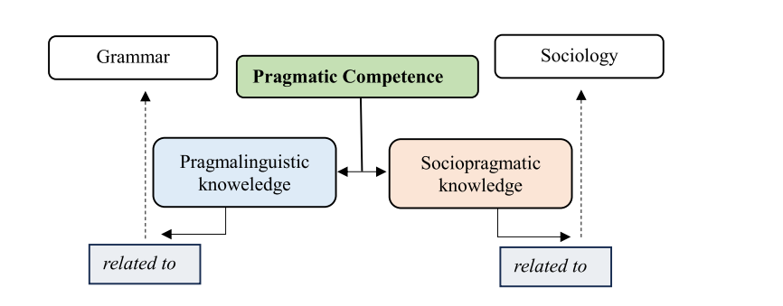

Figure 2 – A communicative approach to pragmatic competence (adapted from Leech [51, p. 11]
Consequently, “pragmatic competence may be understood as a dynamic, adaptive process shaped by an individual’s linguistic resources, as well as by the communicative modalities, contextual constraints, and sociocultural conventions governing language use in specific contexts” [63]. Kasper defines pragmatic competence as “individuals’ comprehension and production of language use in context” [63], while Koike emphasizes knowledge and performance of appropriateness and politeness conventions regulating SAs [64, p. 279].
From the perspective of applied linguistics, pragmatic competence is associated with soft skills. Unlike linguistic competence, which includes phonology, morphology, syntax, and vocabulary, pragmatic competence is socially co-constructed and involves understanding of linguistic forms and their functional meanings, sociocultural awareness, and the ability to use this knowledge to formulate a communicative act during interaction.
Ziashahabi et al. define pragmatic competence as the manner in which individuals employ language to communicate in a diverse array of social and cultural contexts [65]. Nordquist similarly characterizes pragmatic competence as “the ability to use language effectively in a contextually appropriate way” [66]. Ultimately, after the presentation of the above definitions, it is accurate to say that pragmatic competence refers to the practical use of language rather than its “correct usage” (Council of Europe) [11].
The phrase “using it appropriately” is the fundamental component of pragmatic competence. This appropriate use, often described “as natural, conventional, culturally determined, or socially acceptable, takes into account such contextual variables as the speaker and interlocutor, as well as the temporal and situational conditions of communication” [67].
In foreign-language learning, pragmatic competence is often described as how leaners come to know “how-to-say-what-to-whom-when” [7, p. 66]. By contrast, “failure to integrate accurate linguistic use with contextually appropriate application is regarded as a failure in foreign-language interaction” [67]. Empirical research consistently demonstrates that EFL learners exhibit insufficient levels of pragmatic competence.
Therefore, the present study attempts to consider pragmatic competence in the context of existing prominent models of communicative competence to substantiate its importance as one of the key subcompetencies. This significance is evidenced by the ability of appropriate language use being referred to as a critical component in the Communicative Competence models. The contemporary communicative approach in language learning and teaching draws upon Canale and Swain’s model [68], Bachman’s [69], and is corroborated by CEFR component descriptions [11-12].
The notion of communicative competence was first introduced by Dell Hymes, who challenged Chomsky’s concept of linguistic competence by emphasizing the social and contextual appropriateness of language use [70]. Hymes argued that communicative competence encompasses not only grammatical knowledge but also the ability to use language effectively across diverse communicative situations [71]. This reconceptualization marked a decisive transition from formal accuracy toward communicative effectiveness. Following this shift, linguistic ability began to be evaluated in terms of achieving communicative goals rather than mere grammatical correctness.
The concept of Hymes’ communicative competence was adopted in practical context of Canale and Swain’s model. A theoretical model of communicative competence, first introduced by Canale and Swain, and further developed by Canale [72], included the following key competencies (Figure 3):

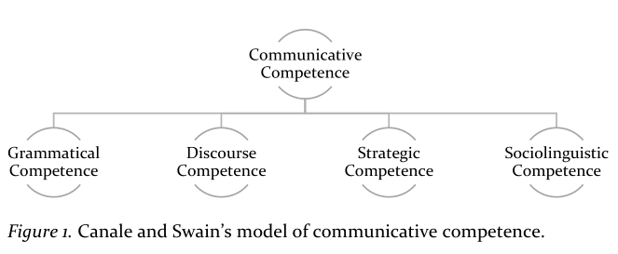

Figure 3 – Canale and Swain’s model of CC

Although pragmatic competence is not explicitly labeled as a separate component in Canale and Swain’s model, its features are largely embedded within sociolinguistic competence. As noted by Canale, sociolinguistic competence includes sensitivity to appropriateness, politeness, and contextual variation in language use [72, p. 7]. This implicit positioning of pragmatic competence reflects an early recognition of its importance, albeit without formal differentiation as independent subcompetence.
A more explicit treatment of pragmatic competence was proposed in Bachman’s model of communicative language ability, which was the first to identify pragmatic competence as a fundamental subcomponent. Bachman conceptualized language competence as comprising organizational competence and pragmatic competence (Figure 4).
Organizational competence includes grammatical competence and textual competence; the latter relates to the coherence and cohesion of discourse [70]. Pragmatic competence, by contrast, reflects the ability to use language appropriately to achieve communicative goals in social contexts.
Within Bachman’s model, pragmatic competence consists of illocutionary competence and sociolinguistic competence [69]. Illocutionary competence relates to the ability to perform language functions and realize SAs, whereas sociolinguistic competence concerns the appropriate selection of linguistic forms based on social context.
Illocutionary competence is structured around four functional categories associated with expressing ideas and emotions, performing tasks, problem-solving, and creative language use, while sociolinguistic competence includes sensitivities to dialect, register, naturalness, and cultural references [69].

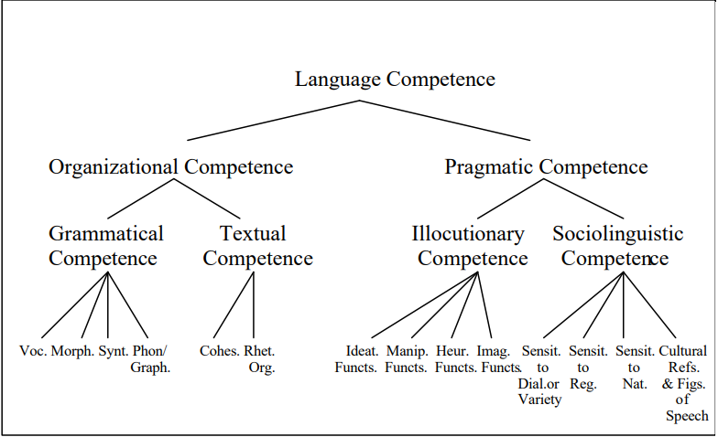

Figure 4 – Bachman’s Language Competence

Pragmatic knowledge is related to discourse in Bachman and Palmer’s model [73]. This knowledge includes understanding pragmatic conventions to create suitable structures and sociocultural conventions to interpret statements in a given setting. Bachman and Palmer contend that many attributes of the speaker/hearer influence communicative language proficiency. They list, among others, awareness of the context, the expression of their emotions, and their linguistic skills. This final element of their enumeration is crucial because it incorporates two important fields: strategic competence and language knowledge. Language knowledge includes both organizational and pragmatic knowledge, which work together to achieve effective communication. Organizational knowledge encompasses skills pertaining to grammatical and textual understanding, enabling the arrangement of the formal components of language. Grammatical knowledge encompasses vocabulary, morphology, syntax, phonology, and graphology, allowing speakers and listeners to generate or recognize grammatically correct structures [74]. In contrast, textual knowledge comprises the rules governing the integration of utterances into coherent text or speech [73].
Pragmatic knowledge relates to the ability to produce and interpret speech. It is divided into two categories: familiarity with pragmatic principles, which is crucial to successfully communicate the intended language functions and comprehend the illocutionary force of utterances, and knowledge of sociolinguistic principles for producing and decoding utterances in accordance with their appropriateness in a particular communicative context [74].
Strategic knowledge aligns with the speaker’s communication goals; it involves the establishment of the communicative objective, the negotiation of the available resources, and the planning of the communicative act [74].
Bachman and Palmer’s approach to communicative competence outlines essential components and their interrelations, offering a more comprehensive understanding of communicative language ability compared to Canale and Swain’s model.
The third communicative language competence model outlined in the CEFR, serves a dual purpose: it is utilized for both evaluation and the processes of language acquisition and instruction. This model emphasizes the importance of effective communication in language learning and teaching methodologies [12]. The CEFR serves as a tool for standardizing foreign language teaching and learning methodologies across Europe, grounding its framework for the competencies to be achieved, along with its teaching and assessment procedures, in a detailed conceptualization of competence [12, p. 299].
The CEFR is centered on an action-based approach, prioritizing “act of speech within language activities” which “form part of wider social context” [12, p. 9]. On this basis, CEFR highlights pragmatic competence as one of the three key components of the communicative competence model along with linguistic competence and sociolinguistic competence (Figure 5) [11].

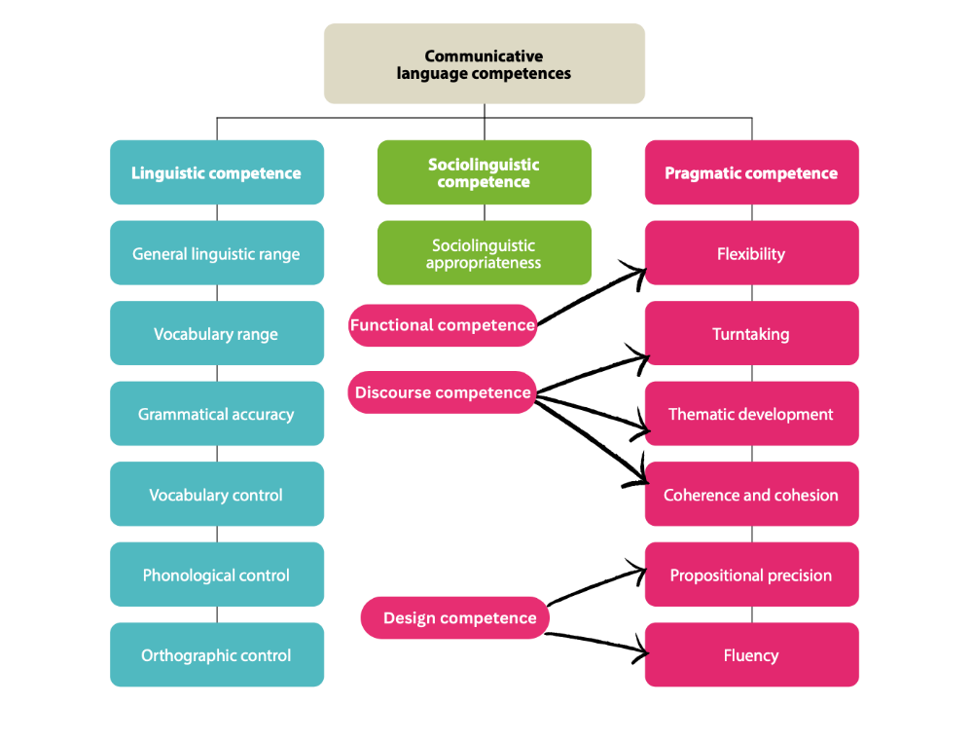

Figure 5 – CEFRL learner’s competences in Cambridge
This shift in perspective on what concerns the learner necessitates that the independent speaker be linguistically competent rather than merely grammatically and lexically skilled. This perspective highlights the central role of pragmatic and situational dimensions, as well as the communicative context, in shaping language use, given that individuals draw on their competences strategically to realize intended communicative goals. The interlocutor engages in a communicative process to perform an act. It is also worth noting that sociolinguistic skills are receiving more attention [70].
Providing a thorough description of every subcompetence, linguistic competence is defined as the knowledge and capacity to utilize verbal resources to construct well-structured communication. The components of the linguistic competence include lexical, grammatical, semantic, phonological, orthographic, and orthoepic competencies. Sociolinguistic competence is the ability to utilize language effectively in social settings. The following components of this competency are emphasized: language elements that denote social relationships, norms of appropriate behavior, expressions of peoples’ wisdom, differences in register and dialects, and stress [11].
Furthermore, the CEFR refers to pragmatic competence as “the functional use of linguistic resources” [12, p. 13] for producing SAs based on interactional exchange scenarios. It is subdivided into discourse, functional, and design competencies. Discourse competence implies a coherent arrangement of sentences during the interaction based on Grice’s Cooperative principles: quantity, quality, relevance and manner. Thematic development, turn-taking and coherence and cohesion refer to the main aspects of discourse competence [11].
Functional competence denotes “flexibility” in the use of one’s repertoire and the selection of appropriate sociolinguistic choices” [11, p. 138]. It refers to determining which microfunctions or macrofunctions are conveyed by what language forms. Here, microfunctions may include correcting, suggesting, toasting, asking for help, and many other categories, while macrofunctions encompass description, persuasion, argumentation, explanation, and so forth.
Finally, design competence is “knowledge of interactional and transactional schemata” [11, p. 138], which are patterns of social interaction. This competence correlates with sociolinguistic competence.
In the framework of the CEFR, pragmatic characteristics are integrated into sociolinguistic competence. This integration includes an understanding of social customs, which encompasses politeness regulations, as well as awareness of intergenerational, gender, and class relations, and the linguistic designation of fundamental routines within a community's functioning [11].
The analysis of communicative competence models shows that although CEFR identifies pragmatic competence as a separate component, pragmatic aspects such as sociolinguistic appropriateness and politeness conventions are assigned to sociolinguistic competence. However, Bachman’s model represents pragmatic competence as a distinct component of language ability, not as including sociolinguistic competence [75]. Similarly, sociolinguistic competence in Canale and Swain’s model has the features of pragmatic competence.
Thus, although sociolinguistic competence is interrelated with some pragmatic aspects, it is pragmatic competence that covers all aspects of communicative performance – from choosing appropriate linguistic units to constructing a coherent speech act in accordance with the context and intent. From this perspective, pragmatic competence deserves a distinct and prioritized position within the structure of communicative competence, particularly in the preparation of future foreign language teachers. Within the CEFR framework, pragmatic competence may be conceptualized as the capacity to select appropriate linguistic resources and employ them effectively in accordance with situational demands to accomplish communicative objectives.
The adoption of communicative competence models has led to substantial changes in the theory and practice of foreign language teaching, shifting the focus from memorizing rules and vocabulary to functional and social usage [76]. As these models increasingly recognize pragmatics, pragmatic teaching has gained popularity. The growing body of scholarly literature, including monographs and empirical studies, devoted to the teaching of pragmatic competence reflects this tendency [75]. Bachman and Palmer emphasize the significance of pragmatic competence, asserting that it is the principal factor influencing an individual’s total language proficiency [74].
Pragmatic competence has received little attention from Kazakhstani scholars. Otegen et al. relate the pragmatic aspect to a significant effect on the dynamics of discourse. Pragmatics is the study of how language is used by speakers and listeners and how it is influenced by factors such as the relationship between speakers and listeners and the context in which it is used [77]. In her work, Oshakbayeva analyzes contemporary challenges with second language learning theory. This study examines the pragmatic approach to bilingualism in the context of second language acquisition and explores its typology of knowledge. The classification of pragmatic knowledge is intricately linked to text, speech, and communication [78]. Kenzhekanova defines pragmatics as the process of selecting language forms for the speaker to perform their SAs [79, p. 15]. Zhanysbekova’s study focuses on the theoretical foundations underlying the formation of pragmatic competence within the broader framework of communicative competence. The aim of the study was to cultivate a courteous speech culture among students [80]. Kemelbekova and Serikova state that the main goal of teaching a foreign language is forming pragmatic competence in language learners, and “pragmatic competence is defined as the set of knowledge that includes the rules for constructing words, integrating them into text, utilizing statements for various communicative functions, and forming sentences in a foreign language while adhering to specific interactional norms” [81]. Nabiyeva has presented a thorough and broad comprehension of foreign-language pragmatic competence, including a two-part structure – coding and utilizing – based on the study and comparison of communicative competence models [82]. The visualization confirms the underrepresentation in domestic studies, necessitating a systematic national framework for research and teacher training in pragmatic competence (Figure 6).

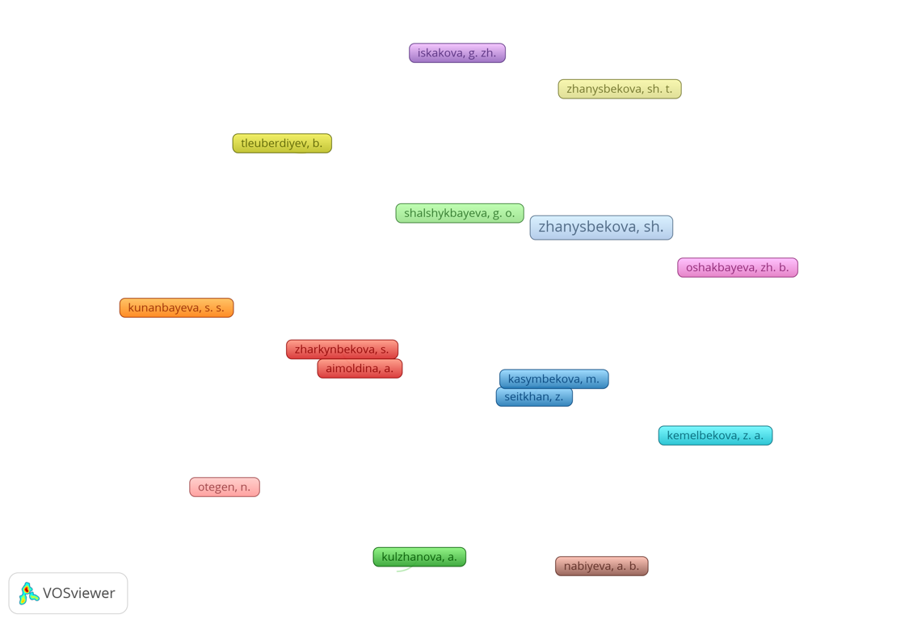

Figure 6 – The early developmental stage of pragmatic competence research in Kazakhstan

The analysis of domestic and international literature on the definitions under review and the role of pragmatic competence within communicative competence models provides a basis for concluding that the term “pragmatic competence” refers to an individual’s ability to comprehend the speaker’s intended meaning and use language appropriately in different communicative situations. The present study considers pragmatic competence in the context of intercultural communication as a key to successful interaction. As the literature review shows that the notion “second language pragmatic competence” is widely used for this purpose in SLA research (Tsutagawa, Bagherkazemi, Roever, Rafiq and Yavuz, etc.), it appears essential to purpose the term “foreign-language pragmatic competence” for application in the EFL, particularly Kazakhstani, context:
“Foreign-language pragmatic competence is a range of abilities to use and interpret a foreign language in various real-life scenarios within the context of intercultural communication. This range includes speakers’ ability to employ language for various purposes, such as making a request, providing instructions, or complaining; listeners’ ability to comprehend the speaker’s true intentions, particularly when those objectives are expressed indirectly – sarcasm, irony, and indirect requests are a few examples; commands of the rules that govern how statements are connected to form a coherent discourse”.
The definition provided takes into account the various facets of pragmatics. In general, it encompasses the understanding of various SAs (the ability to employ language for various purposes), implicature (the ability to recognize the true intentions of the speaker), and pragmatic markers (linguistic units used to form discourse). Foreign-language pragmatic competence refers to speakers’ ability to choose the proper action for a given situation in an intercultural communication context.
Foreign-language pragmatic competence is a prerequisite for EFL learners to effectively communicate the intended message and employ not only grammatically correct but also appropriate language for the social setting [6-7]. For instance, individuals may employ excessively formal language in casual environments or utilize slang or colloquial expressions in official contexts. Such usage may lead to misunderstandings or give the impression that the speaker is uneasy or impolite [84].
Possessing foreign-language pragmatic competence for future English teachers in Kazakhstan is of utmost importance, as it demonstrates their professional competence and enables them to model the appropriate language use [85]. As it is stated in the Professional Standard for Teachers (Education 4.0) of the RK, one of the abilities of a foreign language teacher is “promoting effective communication, developing learners’ linguistic competences” [19]. This underscores the teacher’s role as a facilitator of successful communication who can guide language learners on how, when, and why language is used in certain ways.
Hergüner and Çakır argue that “the majority of the responsibility still lies with future education”, which is the crucial initial phase in a teacher’s professional journey, during which a teacher acquires the majority of their beliefs, techniques, dispositions, and abilities related to teaching a foreign language [86]. This emphasizes teachers as key figures in the formation of learners’ ability to use language appropriately.
Glasgow adds that an EFL teacher who possesses pragmatic awareness should have the ability to cultivate students’ understanding of successful strategies for engaging in conversation, accurately perform SAs using appropriate pragmalinguistic forms, expand students’ awareness of the range of contextually acceptable expressions offer opportunities for informed decision-making and enable them to identify the most appropriate linguistic choices [87, pp. 6-7].
In light of all these factors, forming pragmatic awareness is undoubtedly a challenging endeavor. Therefore, understanding “what, how, and in what ways” pragmatic knowledge might be improved is essential. The implementation of pragmatically appropriate language in the classroom is of paramount importance, in addition to awareness and competence [88].
Pragmatic competence cannot be an automatic outcome of grammar instruction in a classroom setting without intentional pedagogical intervention. It can be developed simultaneously with other aspects of grammatical knowledge in the context of native speakers, whereas in the EFL setting, even proficient language users frequently make pragmatic mistakes and lack comprehension of intended meaning. Liu emphasizes the importance of pragmatic instruction for EFL students, as language acquisition often occurs in the classroom [89]. The argument is that intentional pragmatic instruction is necessary to teach the essential pragmatic competence. The implication is that language learners rely on the current generation of teachers, who are also affected by the same pragmatic lack, to provide the necessary pragmatic knowledge [90].
This implies that the training of foreign language teachers must be tailored to the attainment of these objectives. Therefore, it is essential to incorporate pragmatic instruction into foreign language teacher training first from the very beginning.
There is a significant amount of research that considers the theoretical level of EFL learners’ awareness or the availability and appropriateness of teaching materials for pragmatic instruction. However, there is limited research on the pragmatic awareness of teachers and trainees in classroom settings (Bardovi-Harlig and Hartford; Rose; Ishihara; Aksoyalp; Sert; Pojprasat and Watcharapunyawong [91-95, 67]. Ekin and Damar highlight a concern that the study of this field has historically focused on the student perspective, leaving the teacher's perspective underrepresented [96]
Research over the past few decades (Ishihara and Cohen, Huang, Ghadiri et al.) has shown that pragmatic teaching is feasible, effective, and has a significant impact [9, 97-98]. Such evidence has encouraged teachers to incorporate it into their curricula and researchers to focus on specific aspects of practical teaching methods. Recent studies across diverse L1 backgrounds (Arabic, German, Japanese, Persian, Spanish, Turkish, and Vietnamese) (e.g. Alsuhaibani; Barón et al.; Civelek and Karatepe; Çetinavcı; Derakhshan and Arabmofrad; Gazioğlu and Çiftçi; Glaser; Nguyen et al.; Takimoto) have examined the impact of various instructional methods on the acquisition of pragmatic aspects of SAs, implicatures, and politeness [99-107]. All of this research comes to the same conclusion, though, despite the wide range of topics, approaches, L1 backgrounds, and contexts: instruction is effective in experimental settings.
The majority of this research found that explicit instruction outperformed implicit instruction. Put simply, the results indicated that individuals learning a foreign language are likely to gain advantages from receiving clear explanations about the underlying rules of language usage, followed by targeted opportunities for practical application.
Teaching and learning foreign-language pragmatics for non-native English-speaking teacher candidates (NNESTCs) is possible in EFL settings by providing pragmatic instruction, communicative activities, and cross-cultural pragmatics research. At the same time, NNESTCs do not automatically acquire knowledge about pragmatics and its teaching. For example, Ivanova’s study on Bulgarian secondary school English teachers to evaluate pragmatic awareness shows that, although most of the teachers acknowledge the need for teaching and evaluating pragmatic awareness and demonstrated some degree of pragmatic awareness, 43% of teachers were unable to name any SAs [108]. Tajeddin and Khodaparast’s investigation of metapragmatic awareness and pragmatic instruction among EFL instructors indicated that they did not consistently teach pragmatic elements [109]. Future teachers struggle to integrate their pragmatic awareness into teaching practice, underscoring the need for explicit pragmatic instruction in teacher training programs [110]. In the Kazakhstani context, Zhaiykbay et al. emphasize teacher support in pragmatic instruction for individual student needs, especially in English language classrooms [111]. Providing pragmatic instruction and using various tasks can help students understand the pragmatic features of the English language. Teachers serve as models for appropriate pragmatic behavior.
It is important for language teachers to be aware of specific areas of pragmatics to assist learners to understand others’ intentions and express themselves appropriately in a sociocultural setting [9, p. 23]. Pragmatic competence necessitates explicit instruction, as non-native English speakers might memorize verb inflections without understanding the pragmatic purpose behind them. For example, native speakers frequently use the imperfect progressive to soften high-imposition requests, whereas learners often encounter difficulties in recognizing and appropriately using features such as past tense forms, politeness markers, and word order, which points to the importance of explicit pedagogical attention to these. Explicit teaching is crucial for learners to understand how grammar interacts with context. Table 1 shows what teachers should know to teach foreign-language pragmatics [9, pp. 23-24].

Table 1 – Core components of foreign-language pragmatics instruction [110]

Selected aspects of teacher expertise for teaching foreign language in general | Teacher knowledge components necessary for teaching foreign-language pragmatics
Subject-matter knowledge | Understanding of pragmatic variability.  Understanding pragmatic norms in the TL.  Understanding meta-pragmatic knowledge
Pedagogical-content knowledge | Understanding of how to teach foreign-language pragmatics.  Understanding of evaluating foreign-language pragmatic skills.
Knowledge of the learners and local, curricular, and educational contexts | Understanding learners’ identities, cultures, proficiencies, and other qualities.  Understanding of the pragmatics-focused curriculum.  Understanding the role of foreign-language pragmatics in educational settings.

The table above summarizes the essential knowledge base required for teachers to effectively teach foreign-language pragmatics. Each form of knowledge is crucial in this context. These knowledge forms are categorized based on subject matter, pedagogical content, learners, and local curricular and educational environments. It is argued that instructors’ perceptions of their knowledge influence how they utilize it in teaching, assessment, and curriculum design. Put differently, teachers need to be cognizant of foreign-language pragmatics and how it is taught and assessed.
As key sources of foreign-language input in EFL settings, teachers’ classroom interactions provide students with linguistic and lexical knowledge and abilities to communicate successfully in the TL across different contexts. Thus, as Wyner and Cohen suggest, teachers’ lack of pragmatic education may contribute to students’ low sociopragmatic awareness [112].
However, in theory, teacher development courses appear to be an ideal setting for addressing matters like pragmatics instruction, the advantages that students can gain from it, and pedagogical approaches to help students become competent in pragmatics [113].
The EFL teacher can use many frameworks to instruct foreign-language pragmatics. Speech act theory, Politeness theory, and the Noticing hypothesis can be listed as key theories to provide deeper insights into the research topic.
Speech act theory was initially proposed due to its status as the foundation of pragmatics. Austin, a philosopher of language, proposed speech act theory, which posits that language serves to do actions, namely, accomplishing tasks through verbal communication [42]. Searle, Kiefer, and Bierwisch assert that “Speech act theory, in conjunction with the examination of indexical expressions, constitutes the majority, if not the entirety, of the domain of pragmatics” [114]. The aforementioned authors arrived at this conclusion in response to Stalnaker’s assertion that pragmatics and SAs are closely connected: “Pragmatics is the study of SAs and the contexts in which they are performed” [115]. Researchers widely agree that SAs are the best way to test the functional ability of language learners.
Secondly, this study adopted politeness theory, which was devised by Brown and Levinson [116], due to the logical link between politeness and SAs. The idea of politeness is another crucial element in speech act performance. Most foreign language learners struggle to learn how to speak properly as it requires not just language competence but also an understanding of the social and cultural values of the country in question [116]. The challenge lies in defining precisely what constitutes appropriate language use in various contexts and what those contextual variables are. According to Brown and Levinson's theory, three aspects of interpersonal interactions are associated with politeness: 1) social distance between interlocutors; 2) degree of imposition of the act; and 3) power dynamics between interlocutors. Thomas categorizes these situations as pragmatic parameters [117, p. 171].
Social distance can be interpreted as the varying degrees of familiarity between interlocutors [116]. In other words, it refers to the distinctions between interlocutors, including intimate and distant relationships. We can conceptualize it as a continuum, where the closest individuals, such as parents and relatives, represent one end and strangers represent the other.
The social status of both the speaker and the listener is referred to as relative power. In parallel, the degree of imposition reflects the status of the addresser and their ability to impose their thoughts and wishes upon others.
The degree of imposition indicates the level of threat associated with a face-threatening act in the target culture, such as discussing taboo topics. In the same vein, Martinez-Flor relates it “to the extent that the speaker can impose their intention on the listener” [118, p. 6]. Therefore, it is essential to examine these social aspects when formulating any speech act effectively in accordance with the social environment, since they govern the preferred language patterns employed.
The following situation provides an appropriate illustration: “You are preparing to conduct an English lesson and realize that you have forgotten the printed handouts. What would you say if you needed to ask a fellow teacher to share their copies with you?”. The social dynamics in this scenario involve power equality, professional but familiar social distance, mild imposition, and the purpose of requesting a favor.
In SLA research, the Noticing Hypothesis (Schmidt) emphasizes the importance of conscious attention in language learning [119]. Schmidt claims that the process of “noticing” in language learning is critical for converting input into intake, which is required for effective communication [120, p. 20]. Noticing is the conscious recognition of language elements, as opposed to mere understanding (i.e. grasping broader linguistic principles). The Noticing Hypothesis emphasizes that, to promote deep learning and eventual mastery of communication skills, learners must actively notice TL features within that input, including appropriate language forms, their pragmatic uses, and sociocultural norms. Thus, the hypothesis suggests that to achieve pragmatic growth, noticing and input are essential.
These three prominent SLA frameworks form the foundation of foreign-language pragmatic instruction.
Since pragmatic competence is about learners’ perceptions of the social setting and appropriate language use, it is important to consider both of its components: pragma-comprehension and pragma-production.
Developing pragma-comprehensive competence refers to recognizing the contextual setting and understanding the intended message, whereas pragma-productive competence denotes the speaker’s performance by using relevant linguistic expressions appropriate for the communicative situation.
On this point, drawing on the above-mentioned frameworks, the following elements of pragmatic competence can be considered within pragmatic instruction: 1) SAs as communicative situations; 2) conversational implicatures as intended meaning of the message; and 3) pragmatic markers as linguistic expressions relevant to the context.
Traditionally, the primary area of pragmatic attention in language instruction has been SAs. As a result, most foreign-language pragmatics instruction and research into foreign-language pragmatics acquisition have focused on SAs. Other areas of interest in pragmatics in language instruction include politeness (with and without reference to specific SAs), implicature, and pragmatic routines [121].
SAs are a key element of foreign-language pragmatic competence, as they represent the primary components of verbal and nonverbal expression that must be effectively communicated within a sociocultural context. Consequently, they may serve as a potential source of pragmatic failure. A lack of accurate input causes foreign language learners to struggle with comprehending SAs, particularly in misinterpreting how to react to sociocultural norm differences. NNSs tend to transfer pragmatic norms in the same way they transfer linguistic norms from their language to the TL. Bardovi-Harlig found that even advanced-level NNSs frequently lack native-like pragmatic competence in various SAs [122].
According to J.L. Austin, a prominent figure in SAs research, the term “speech act” pertains to the act of speaking that serves a purpose in communication and has an impact on the actual world [123].
Austin’s theory categorizes SAs into three components: the locutionary act, the illocutionary act, and the perlocutionary act. The locutionary act pertains to the literal semantic content of an utterance, which must conform to the grammatical and lexical standards of the language. For example, the utterance “I cannot hear the students at the back” serves as a complaint at the locutionary level about the speaker's difficulty in hearing. In contrast, the illocutionary act relates to the speaker's communicative intention. In a classroom context, a future English teacher’s statement like “I can’t hear the students at the back” may carry an indirect intention, such as requesting students to lower their voices. Lastly, the perlocutionary act refers to the effect an utterance has on the listener, which may involve actions like convincing or modifying behavior. For instance, if students respond to the teacher's statement by lowering their volume, this exemplifies the perlocutionary outcome of the speech act [123].
Within his speech act theory, J. L. Austin identified five major categories of SAs, which are verdictives, exercitives, commissives, behabitives, and expositives, based on their functional roles in communication [124]. Further, Searle, a philosopher of language, altered Austin’s framework and classified SAs into representatives, commissives, directives, expressives, and declarations [124]. SAs basically group together different types of language functions including expressing gratitude, making requests and denying them, apologizing, complaining, offering advice, complimenting, and more [125].
While knowledge of SAs is universal, applying them in real-life TL situations is culturally specific. Some Kazakhstani EFL classroom observations indicate that students frequently translate SAs from Kazakh/Russian (L1) to English (TL). Meiramova and Kulzhanova contended that EFL speakers typically encounter challenges in responding to favors, which may be attributed to a lack of intercultural communication [126]. Communicating pragmatically with native English speakers may pose difficulties when employing such phrases. Comprehending the performance of SAs in English will substantially improve communicative competence in the TL [127].
Language learners must restructure their knowledge of sociopragmatic competence to reflect the unique rules of interaction defined by the TL community's norms. Consequently, different studies have reported that the appropriate use of SAs in TL communication with native speakers is a matter of major concern to foreign language learners [128-130].
For effective instruction, EFL teachers should know how learners from diverse linguistic backgrounds perform a range of SAs in English. They should also understand how to effectively instruct NNSs in selecting and utilizing appropriate pragmalinguistic structures to respond effectively to different communicative situations. Ishihara’s findings show that teaching compliments explicitly and using web resources can improve pragmatic awareness among EFL students [93]. Thus, foreign language learners may enhance their comprehension and production of SAs through effective pragmatic instruction.
Fraser called the linguistic signals used to perform a certain speech act pragmatic markers [131]. These signals correspond to the various types of potential direct messages that a sentence may carry. These pragmatic markers serve as linguistically encoded indicators of the speaker’s intended communicative goals.

According to Furko, “pragmatic markers are a group of linguistically varied elements that have distinctive qualities like indexicality, context-dependence, and multifunctionality and serve a variety of attitudinal and meta-communicative functions despite lacking conceptual meaning. Despite the fact that pragmatic markers do not typically modify the propositional meaning of an utterance, they are essential for indicating the speaker's attitudes and for facilitating the process of pragmatic inference” [132].
Pragmatic markers are derived from all components of grammar.
Verbs, nouns, adverbs, and idiomatic expressions function as pragmatic markers. However, the expression’s meaning is essentially the same whether it is employed as a pragmatic marker and varies mainly in its function when it is used as a propositional formative [133]. They are small additions that aid the reader in understanding the meaning or tone of a sentence.
Grammatical structure alone does not determine the function of an utterance or phrase. A single grammatical structure may realize different pragmatic functions depending on the context of use. This is particularly evident in pedagogical discourse, where the imperative form is widely employed for multiple instructional purposes. For instance: “Leave the room!” (order), “Please, open your coursebooks!” (Request), “Try to rephrase the sentence using passive voice” (suggestion), “Complete the task individually” (instruction), “Have a look at this example” (invitation). Conversely, a function can be expressed by a variety of grammatical constructions. For example, to invite students to participate in a classroom activity, a teacher can use the following phrases: “Would you like to take part in this discussion?”, “Can you work in pairs for this task?”, “How about analyzing this example together?”, or “Let’s move on to a group activity.” Contextual factors clearly influence the choice of grammatical structures, ensuring their appropriateness within the communicative context.
Some ILP studies refer to pragmatic markers as “pragmatic formulas,” or “routine formulas,” or “pragmatic routines.” “Pragmatic formulas,” or “routine formulas,” are defined as “crucial pragmalinguistic resources that are used to perform a variety of SAs.” For instance, the phrase “I am sorry to hear about + [X]” is commonly employed to convey regret [134-135].
“Pragmatic routines” are characterized as “specific sequences of words or semi-fixed expressions that are recurrently employed in specific social contexts to serve specific social purposes and have conventionalized meanings” [136]. These routines are culturally specific and are considered “tacit agreements” that are shared among members of a specific speech community [137, p. 4]. Moreover, cultures vary in the accessibility and suitability of specific pragmatic routines [138].
Learning and memorizing many pragmatic markers may aid in the process of developing foreign-language pragmatic competence. Moreover, the acquisition of pragmatic markers significantly enhances learners’ spoken performance in a foreign language, supports the development of more native-like competence, strengthens interactional abilities, and promotes successful integration into the TL community.
Pragmatic markers play a crucial role in social interaction, helping EFL learners identify the intended meaning of SAs [38, p. 76]. For example, the pragmatic formula “Can I leave a message, please?” allows the hearer to identify the speaker's courteous request and understand their intention appropriately [139].
Altogether, these elements outline the scope of pragmatic markers, which are of considerable importance in pragmatics due to their function in speech [70]. Language users within the same community frequently employ recurrent communicative expressions that are identical or similar to reduce the potential misunderstandings and maintain alignment. According to Narkprom and Phoocharoensil, academic English writers use pragmatic markers to engage with readers and avoid misconceptions [140]. Similar to academic English writing, pragmatic markers employed in spoken language have their own pragmatic value [141].
Pragmatic competence relies not only on SAs; conversational implicatures are also essential pragmatic elements for effective communication in the TL. Grice was the first to introduce the term implicature as a concept in discourse, defining it as “what a speaker intends and conveys indirectly” [44]. It is the implicit meaning that is conveyed beyond the literal meaning of the speaker’s words.
Bialystok regards pragmatic competence “as a three-step process: the utterer's capacity to employ language in a variety of contexts; the listener's capacity to comprehend the utterer's true intentions, such as indirect SAs, irony, and sarcasm; and the fundamental principles that combine to produce discourse” [142, p.6]. Conversational implicatures refer to the second step, denoting “the meanings that are not explicitly articulated in the speech” [143, p.45].
Interpreting implicatures is a significant challenge for EFL learners. This issue is because learners’ understanding is influenced by several aspects, including implicature type, cultural background, foreign language exposure, and overall competency [144, p. 46]. However, the research conducted by Taguchi discovered “that comprehending implicatures can be effectively enhanced with explicit instruction” [56].
Grice introduced the Cooperative Principle hypothesis founded on four conversational maxims: Quality, Quantity, Relation, and Manner, which are core principles for understanding how language functions when meanings are implied (see fig. 7) [145].

Grice’s Cooperative Maxims

Quality Quantity Relation Manner
(say what you consider to be true (say enough, (be relevant) (be clear,
or that are supported by evidence) but not too much) follow cultural norms)

Figure 7 – Grice’s Conversational Maxims

Grice contends that cooperation is an essential component of interaction. When individuals communicate with specific intentions, they use principles to form logical conclusions and accurate interpretations. Throughout this process, individuals focus on various contextual cues and utilize their own prior experiences and skills [146]. Therefore, violations of these maxims give rise to conversational implicatures in diverse forms of indirect communication, such as irony or sarcasm (Table 2).

Table 2 – Examples of Grice’s Conversational Maxims and Their Flouting

Maxim | Example | Implicature (flouted)
Quality | A: Did you prepare the lesson plan for tomorrow?  B: Yes, it’s ready and uploaded to the course platform. | A: Did you prepare the lesson plan for tomorrow?  B: Of course, I had plenty of time between grading and meetings. (said ironically, implying the lesson is not properly prepared)
Quantity | A: Have you checked all the students’ assignments?  B: Yes, I have reviewed and graded all of them. | A: Have you checked all the students’ assignments?  B: I’ve looked at the first few submissions. (implying that the task is not finished)
Relation | A: Will you be able to attend the staff meeting this afternoon?  B: Yes, I’ll be there at 3 p.m. | A: Will you be able to attend the staff meeting this afternoon?  B: I have two classes back-to-back this afternoon. (implying possible non-attendance)
Manner | A: How was the student’s oral presentation?  B: It was clear, well-structured, and easy to follow. | A: How was the student’s oral presentation?  B: Well… it was certainly memorable. (vague response implying a negative evaluation)

For EFL learners, especially those training to become English teachers, being aware of Grice’s Cooperative principle and conversational maxims is vital. When addressing conversational maxims, it is crucial to understand that there is no requirement for speakers and listeners to consistently adhere to these maxims. According to Grice, interlocutors are expected to follow a “cooperative principle” when communicating. When a maxim is not followed, it conveys implied meaning. Everyday native conversations encompass indirectness, implied meanings, and understatement. Interlocutors have to negotiate and maintain a conversational balance to understand the implicature by adhering to the cooperative principle [147]. With this pragmatic awareness, learners increase pragma-comprehensive competence, enabling them to notice nuances and avoid misinterpretation.
Despite pragmatics being the primary focus of numerous investigations, many studies have either concentrated on the comprehension of implicatures or the production of SAs separately. Accordingly, the present study concentrates on learners’ production of key SAs and their comprehension of conversational implicatures, which together serve as indicators for evaluating the overall pragmatic competence of EFL learners [124].
Consequently, key aspects of pragmatic competence included in the current study are the following: 1. Implicature refers to the meaning that is indirectly conveyed or implied by a speaker, beyond the literal interpretation of their words; 2. SAs, which are actions performed during the act of speaking; 3. Situational routines are, more accurately, pragmatic markers, expressions that are utilized in certain contexts [147, p. 231].
The study of international theoretical models of pragmatic competence, as well as the works of Kazakhstani scholars, revealed that, despite its importance, the component structure of pragmatic competence is insufficiently systematized and lacks clear pedagogical operationalization. Bachman conceptualizes pragmatic competence through illocutionary and sociolinguistic components, Thomas and Leech differentiate between pragmalinguistic and sociopragmatic knowledge, and the CEFR distributes pragmatic aspects across discourse, functional, and sociolinguistic domains. However, these approaches tend to describe pragmatic competence at a theoretical level without establishing a direct link to instructional practice and assessment.
At the same time, a study of Kazakhstani research shows that pragmatic competence is under-represented, notably in its internal structure, instructional components, and assessment methodologies within teacher education programs. This creates a gap between academic knowledge and practical application in EFL situations. The study introduces a proposed component structure for foreign-language pragmatic competence to resolve this gap. This structure is composed of core elements, including pragmalinguistic and sociopragmatic subcompetences. It outlines functional aspects, covering pragmatic comprehension and production, as well as fundamental instructional elements such as speech acts, conversational implicatures, and pragmatic markers.
The proposed structure effectively combines several dimensions into a unified system that connects theoretical concepts with practical teaching application and assessment. This approach fosters both conceptual clarity and practical implementation in teacher training. The lack of systematic frameworks for teaching pragmatics in Kazakhstan underscores the necessity for a well-structured, pedagogically sound model in the context of EFL. This structure seeks to prepare future English language teachers to appropriately use, interpret, and teach pragmatically relevant language in different contexts of communication.
Integrating pragmatic components of foreign languages into EFL programs is crucial for preparing students with the competencies required to interact effectively with speakers from diverse cultural backgrounds. McNamara and Roever emphasize that individuals without pragmatic competence may inadvertently cause offense, appear too opinionated, or be difficult to comprehend [148]. Kasper also emphasizes how important it is to teach pragmatics in order to help students become more pragmatically competent [149].
However, the communicative approach fails to achieve its goals in the actual classroom setting. Pragmatics is frequently underrepresented in the language classroom for a variety of reasons. The first is that teachers’ training is deficient in addressing pragmatic aspects of the language, which are more variable and thus present challenges in terms of assessment and evaluation. Additionally, this method necessitates the teacher’s familiarity with the target culture and the availability of a diverse selection of instructional materials that contain pragmatic variation samples tailored to the communication context. Pragmatic instruction is often implicit and only present at beginning of instruction (if present at all). Pragmatic elements are often limited to cultural references and lack practice activities that promote awareness and development of these structures.
Moreover, the textbooks frequently fail to provide any instruction on how to conduct related activities. Although there is an attempt to include communicative approaches into the textbooks, the process lacks cohesion.
Therefore, it may be challenging for future teachers in an EFL environment to function in pragmatically appropriate ways, as they are unlikely to have sufficient experience communicating with pragmatically competent speakers, despite the opportunities the Internet offers for intercultural communication. Contextual experience is essential for effective communication, as contextual factors are dynamic rather than static, unlike the syntactic or morphological features of a language, which remain relatively unchanged [75]. It becomes difficult for foreign language learners to build pragmatic competence because “contexts of use tend to be rather different from culture to culture, and consequently from language to language” [54, p. 263].
The teachability of pragmatic competence has been noted as another challenge in the foreign language classroom context. Kasper suggests that both linguistic and pragmatic competence are types of knowledge that learners can acquire, develop, use, or lose. Thus, the effective incorporation of activities aimed at cultivating this competence in the TL remains a demanding task within language pedagogy.
Early research from the 1980s and 1990s, including investigations by Kasper and Rose [6], has reached a consensus affirming the teachability of pragmatics. Instructed groups frequently outperform non-instructed groups in this domain. In an EFL environment such as Kazakhstan, where learners have little exposure to authentic English situations, enhancing their pragmatic awareness is essential, and this awareness can be increased primarily in the classroom, where teachers are essential in setting up the right environment for instruction. Ellis argues that giving input is crucial for improving language acquisition and increasing output opportunities [150]. As a result, it is important to take into account how instruction may significantly reduce misconceptions. Instructed foreign language acquisition, based on the noticing hypothesis, aims to improve learners’ communicative skills and sociopragmatic and pragmalinguistic use of the language. Its objective is to assist learners in enhancing their ability to communicate effectively in the target language.
Adequate pragmatic input and instruction can enhance learners’ pragmatic comprehension and production. Pragmatics has become increasingly important, particularly in relation to its role in teaching a foreign language.
Multiple studies indicate that language textbooks provide limited coverage of pragmatic features and insufficient support for the development of learners’ metapragmatic awareness [151-152]. Furthermore, they present the majority of speaking activities out of context.
Regrettably, the textbooks used in Kazakhstani universities were discovered to be indistinguishable in this aspect.
The review of coursebooks frequently used in Kazakhstani universities, such as New English File, Cutting Edge, Speakout, Solutions, Headway, Total English, and Outcomes, reveals a notable lack of systematic attention to pragmatic competence. For example, it is found that the pragmatic content is reduced in Cutting Edge, an intermediate-level textbook with a focus on vocabulary and grammar learning [70]. The language employed is predominantly decontextualized, consisting of literary descriptions and lacking conversations; the selection of the material is based on grammatical or vocabulary objectives. There are several exercises that could be considered pragmatic awareness-focused; however, their treatment is either insufficient or inadequate. For instance, the treatment of making requests can be examined (Figure 8). There is a list of expressions without context, distinctions based on register, usage instances, or information on levels of politeness. The activities require that the students produce dialogues; however, there are no scenarios that establish the context of the dialogue, the age, or the social class of the speakers. Regarding the information on the context and meta-pragmatics included in the textbook Cutting Edge, there is a lack of sufficient data on the context and meta-pragmatics of SAs and language functions.
The intermediate textbook included examples of agreement, disagreement, and request SAs in the speaking section, as seen below (Figure 8).

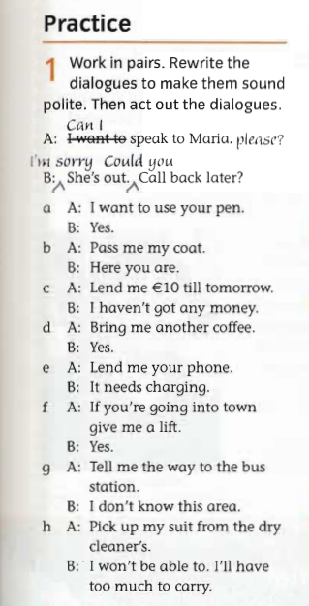

Figure 8 – Extract from Cutting Edge Intermediate course book

The examples above demonstrate that SAs are delivered without contextual explanations. Simply put, there is a lack of explicit information on the many forms of each speech act, the level of formality or informality associated with each technique or semantic formula, the social relationship and power between the speaker and listener or between participants in the conversation, and the degree of burden involved. Consequently, it seemed that none of the textbooks made much of an attempt to inform students about contextual or situational aspects, either explicitly or implicitly. Recent studies that critically examine global EFL textbooks corroborate this observation. Derakhshan and Arabmofrad discovered that SA instruction is frequently implicit, if at all, does not integrate tools that may help to comprehend context-sensitive language usage [103]. Al-Ghamdi indicates that although some coursebooks contain dialogues, they lack authentic pragmatic variations or cultural explanations [153]. Since most EFL teachers rely on these resources, it underscores the need for other pedagogical interventions such as supplementary courses based on Web 2.0 tools to develop their pragmatic awareness and instructional resources.
Additionally, none of the textbooks under study provide any information on the meta-pragmatics component. Meta-pragmatic information refers to the ability to complete a speech act at the appropriate time and place, and with the right person. Furthermore, it encompasses the suitability of a statement within a culture-specific and situation-specific context. It is important to note that, as the example above illustrates, meta-information becomes insignificant when there is a small list of speech act strategies or semantic formulations for a handful of SAs. There are no further instructions for how to use the strategies in certain places, times, or with particular people.
Intermediate textbooks considered are not pragmatically abundant and effective in terms of the variety and frequency of SAs and language functions. As a result, learners will undoubtedly encounter a multitude of challenges due to the issues presented by these textbooks. This research has demonstrated that books do not provide a real and substantial basis of foreign-language pragmatic material and hence cannot be regarded as authentic or reliable sources of input from a pragmatic perspective [154].
Textbooks play a crucial role in providing knowledge and language practice in EFL settings, so the lack of instruction on pragmatics poses a significant challenge for both educators and students.
Thus, it is possible to draw the conclusion that current EFL teacher training programs provide insufficient preparation for future teachers to competently address pragmatic instruction. They also underestimate the importance of pragmatics.
Some of these problems can be solved; however. Technology provides valuable resources for delivering genuine pragmatic language input and facilitating practice for foreign language learners in and outside the EFL classroom. This, in turn, enhances the development of pragmatic skills among foreign language learners [124].

  - The linguodidactic potential of Web 2.0 technologies for forming future teachers’ foreign-language pragmatic competence

In the previous Section we revealed that foreign-language pragmatic instruction is possible and favorably influences future English teachers’ pragmatic development. However, for a variety of reasons, including the traditional linguistic focus areas, a lack of curriculum and training materials for teachers and students, and time and resource constraints in the classroom, pragmatics has rarely been explicitly or fully incorporated into the foreign language curriculum [124].
Researchers in the field of computer-assisted language learning (CALL) have recognized that the technology can mitigate the limitations often present in conventional classrooms, which provides alternative environments that expose language learners to a broader spectrum of sociopragmatic contexts [124].
The term “technology” is commonly used in language learning, especially for computer-aided studies. This study addresses a wide range of meanings, including technologies employed in computer-aided learning, as well as a detailed analysis of specific technology types such as multimedia, mobile devices, synchronous and asynchronous computer-mediated communication (CMC), and technology-enhanced learning materials [155]. Given the significance of computer-aided studies, it is imperative to investigate their historical evolution further. CALL, a term developed in the 1970s for software specifically created or modified for language acquisition, is extensively utilized in digital TL pragmatic learning. Computer-mediated communication for language learning (CMCL), an extension of CALL, denotes the use of computers and the internet as educational contexts. Language pedagogy is shifting towards mobile-assisted language learning (MALL) to overcome time and location constraints [156]. Benson links the “future of CALL” to “intelligent applications” [157].
This technological evolution in language teaching and learning did not occur independently but was influenced by the global Internet’s changes. The primary cultural shift that can define technological advancement from around 2000 to the present is particularly the World Wide Web’s introduction by Tim Berners-Lee in 1991.
World Wide Web tools have undergone a correspondingly radical transformation from Web 1.0 to Web 3.0 [73]:
- Web 1.0: users could only browse basic HTML and JavaScript web pages on sites like MySpace, LiveJournal, and Geocities [73].
- Web 2.0: they are platform-based rather than media-based; they encourage participation, are social and open by nature, and are read-write webs rather than read-only webs, shifting the emphasis from linking information to linking people, and from accessing information to participating [158].
- Web 3.0: using artificial intelligence to deliver tailored solutions, generate data, and perform analysis [73]. Examples of these are ChatGPT, Google Bard, Apple Siri, and Amazon's Alexa.
- Web 4.0 (The Symbiotic Web): By combining machine and human intelligence, this stage marks yet another advancement in the development of the internet. It is distinguished by deep intelligence, semantics, and hyper-personalization, wherein technologies such as machine learning, artificial intelligence (AI), and the Internet of Things (IoT) establish a context-aware and user-centric environment [159].
- Education 5.0: This more recent paradigm shifts toward one that is innovation-focused and human-centered. In order to educate students for the challenges of the twenty-first century, it prioritizes human abilities like creativity, critical thinking, and social-emotional intelligence, even while it maintains the technology innovations of earlier times. At this point, AI is used as a tool to create individualized, passion-based learning experiences that stimulate students' natural drive and encourage holistic growth for lifetime learning [160].
According to the sources and technological evolution indicated, Web 2.0 has been selected as the most appropriate technology environment for developing the pragmatic ability of future English instructors. Web 2.0 technologies prioritize human interaction, while Web 3.0 and subsequent models emphasize artificial intelligence, personalization, and data-driven approaches, with a primary concentration on content creation and automated assistance. These technologies promote authentic user-generated communication and collaboration, which are essential for the development of pragmatic competence. Moreover, although Web 2.0 platforms have started incorporating AI functionalities such as automated feedback, they emphasize active student engagement, in contrast to AI-driven technologies that foster passive involvement and reliance on generated language
Web 2.0 technologies offer significant advantages in educational contexts due to their pedagogical transparency and safety features, which enable teachers to manage interactions, moderate content, and create structured learning environments. This is especially crucial in teacher education, where guided practice and reflective feedback play key roles. Despite advancements in artificial intelligence, Web 2.0 remains the most effective approach for fostering pragmatic competence, as it promotes authentic interaction, active participation, and is manageable from an educational perspective. Future research may delve into combining Web 2.0 environments with AI-enhanced tools to merge the benefits of human interaction with intelligent support for developing pragmatic competence.
A trendy technology known as Web 2.0 was introduced in 2005 and referred to as a new generation of the World Wide Web as a result of its use in education [161]. During 1.5 decades of the Web 1.0 generation, several features emerged, including private and public messaging, chat groups, discussion forums, news channels, blogs, peer-to-peer file sharing, and user-generated encyclopedias [162]. According to Kali et al., the key aspect of these websites was “user participation,” also known as “networking people” [163].
They are defined as the transition from static to highly dynamic web pages or user-generated content, which enables users to collaborate, share, create, and engage [163]. McLeod and Vasinda and Kapp and O’Driscoll adopted the word “web-volution” to represent the transition from Web 1.0 to Web 2.0 due to these benefits [164].
O’Reilly was the first to officially conceptualize these features during an international workshop and offered his definition: “Web 1.0 was about connecting computers and making technology more efficient for computers. Web 2.0 is about connecting people and making technology more efficient for people” [161]
Similarly, Grosseck states that Web 2.0 means “the social utilization of the web that enables individuals to collaborate, actively participate in content creation, generate knowledge, and share information online” [165, p. 478].
According to Cormode and Krishnamurthy, Web 2.0 refers to both “a platform where innovative technologies have been built and a space where users are first-class objects” [166, p. 2].
Consequently, the term “Web 2.0” denotes the new generation of technologies and websites that promote user-generated content.
Such hassle-free and open-source tools developed on the Internet are now available to the public at minimal or no cost. According to Barak and Miri, the development of these Web 2.0 tools is facilitated by the ability to meet, create, share, and broadcast information [167].
These features have resulted in the development and evolution of web-based communities and hosted services, including social networking sites (e.g., Facebook, MySpace), video sharing sites (e.g., YouTube), wikis, and blogs). These tools allow individuals to communicate texts, images, videos, comments, and audio clips, facilitating the formation of interest-based communities.
Having analyzed the above-discussed definitions and features of Web 2.0 technologies, we can infer that the following characteristics best describe these tools (see Fig. 9):
WEB 2.0 SERVICES
Networking people
Content sharing
User participation
Collective intelligence
Interactivity
Creativity
User-generated content
Collaboration and crowdsourcing
Multimodal and dynamic

Figure 9 – Main characteristics of Web 2.0 technologies
The features of Web 2.0 tools closely align with the ideas of connectivism, a modern educational theory that emphasizes the value of creating connections between ideas, experiences, and social networks through technology. Considering the extensive use of smartphones and other gadgets today, educational technologies ought to be developed with connectivist principles in mind [168].
Accordingly, researchers have sought to develop innovative digitally mediated approaches that assist instructors in teaching the pragmatic element of language and enable learners to enhance their pragmatic competence through the affordances of these technologies.
One approach is to “implement web-based strategy instruction: to improve the development and utilization of language learner strategies, to offer guidance in the acquisition of complex pragmatic language that is challenging to comprehend, and to facilitate learning through web-based materials” [169].
Many Web 2.0 technologies have become a part of our personal and professional lives. Although they were not originally developed for educational or scholarly use, educators and researchers have identified the pedagogical potential of their core features, such as openness, accessibility, user participation, communication, information exchange, and collaboration.
Web 2.0 applications have been greatly used in both teaching and learning, bringing life to conventional classrooms. The educational potential of technology can be applied to enhance in-person instruction and extend learning beyond the conventional classroom setting. Pop observed that English language teachers were among the early adopters who recognized the advantages of utilizing Web 2.0 technology in the acquisition of foreign languages [170]. According to Wang and Vásquez, Web 2.0 technologies have shifted foreign language research from a cognitive to a social orientation, from classroom to naturalistic settings, from acquisition to participation, and from foreign language learning to foreign language usage [171]. Furthermore, it sparked conversations about the discrepancy between the current traditional learning theories and the requirements of the younger generation, who have been raised in the digital era and exhibit distinct learning preferences compared to previous generations [172].
Learning, language literacy, collaboration, and product demonstration are the four global areas of influence that Web 2.0 technologies have established. These areas correspond to both cognitive (learning, language literacy) and social (collaboration, product demonstration) aspects of foreign language acquisition, regarded as processes (learning and collaboration) and outcomes (language literacy and product) of higher education.
Consequently, the four aforementioned factors establish various opportunities for the integration of Web 2.0 technologies into the educational process. Web 2.0 offers numerous functionalities that enable educators to not only use existing websites but also tailor assignments for specific student groups, such as for collaboration or research projects, by using web-based platforms like blogs, Flickr, wikis, and podcasts.
Blogs, for instance, often referred to as online diaries or journals, demonstrate the popularity of Web 2.0 services due to their user-friendly nature, effective information organization, interactivity, multimedia capabilities, and reliable security features [31]. Edublogs, specifically designed for educational purposes, effectively foster critical thinking, reflection, and writing. According to connectivism theory (J. Siemens, S. Downes), learning happens when people build knowledge networks, and blogs are a place where people may engage and create collaborative content. A.V. Filatova identifies key didactic properties of blogs, including their contextual relevance to the author, interactive engagement, effective information organization, high multimedia integration, user-friendliness, and security [173].
As an asynchronous audio format, podcasts allow students to access content whenever it is convenient for them and improve their listening and speaking skills. They promote enhanced engagement and interaction among learners as components of the Web 2.0 multimodal tools. Podcasts, as a Web 2.0 tool, play an important role in enhancing the modern educational process, according to Zhetpisbayeva et al., by increasing students’ motivation and autonomy, encouraging a shift from reproductive to productive language learning, and providing authentic, accessible, and up-to-date content for developing foreign-language communicative competence [174].
Wiki platforms allow for collaborative creation and editing, incorporating the principle of computer-assisted collaborative learning in foreign language education. They promote students working together, editing together, and exchanging feedback. The WikiBilim Foundation in Kazakhstan is a good example of such an organization because it promotes educational content in Kazakh and gets students involved in wiki projects, which helps preserve the language and improve digital literacy [175]. P.V. Sysoev also underlines some of the educational features of wiki technology, such as its openness, non-linearity, ability to see the history of a document, ability to use multimedia, and hypertext structure [176, p. 141].
This section characterizes the linguistic and didactic potential of Web 2.0 tools in foreign language education. Linguistic possibilities they offer include the following:
- Interactive communication. Web 2.0 technologies provide genuine interactions with information and other learners, allowing for creative responses to assignments. Web 2.0 is a platform for meeting new people, exchanging ideas, and displaying creativity in front of an audience [177, pp. 25-40]. As an example, Flip (formerly, Flipgrid) (https://info.flip.com/en-us.html) gained popularity in the language education community. This application allowed educators to seamlessly merge traditional classrooms with digital environments, facilitating immediate student engagement in recorded video and audio discussions, as well as peer-to-peer connection through written comments. It can also function as an instrument for oral communication assignments designated by instructors (e.g., storytelling).
- Access to the authentic language usage. Web 2.0 technologies enable students to enroll in previously inaccessible courses and the assignments are consistently innovative and, crucially, facilitate the development of intercultural communication skills in real-time, authentic language contexts. A vast collection of YouTube videos, audio, and video podcasts enables students to examine actual situations of intercultural communication and the language and behavior of participants in intercultural communication and to compare and analyze cultural differences in the norms of a foreign language. Researchers have proven that integrating YouTube into classes significantly enhances the educational experiences of learners [178]. Using Web 2.0 technology in English-language teaching fosters discourse, reflexivity, multiculturalism, emotional sensitivity, and personal growth for students [179].
- Practice of language skills. The literature research on Web 2.0 technology's impact on students’ writing showed positive outcomes. Publicly accessible blogs, for instance, improved students’ perceptions of themselves as writers and sharpened their awareness of their audience [180-181]. The feedback received from both peers and the instructor served to enhance students’ self-awareness as writers, encourage reflective thinking, and highlight areas of knowledge that required further development. Facebook can also be considered a suitable tool for writing practice and learning [182]. Research suggests that Facebook chats are effective for pre-writing activities including brainstorming and planning [183-184]. According to Yunus et al., photos, multimedia, and links supplied by students served as stimuli for developing new ideas and facilitated the writing process [185]. Practicing a three-phase model of learning to listen to foreign language texts: before listening, during listening, and after listening through the use of podcasts effectively influences learners’ listening skills. With the development of auditory skills, the podcast service will be an additional unlimited source of audio and video materials of various topics and durations. Balula et al. studied the educational advantages of IHMC Camp, an idea mapping tool [186]. It was utilized to teach reading and speaking skills in a Business English course. Flip and VoiceThread appear to facilitate enhancement in several domains, including pronunciation and listening abilities, due to increased exposure to other accents. It also helps students practice speaking on various topics and, most importantly, reduces speaking anxiety [187]. Thus, Web 2.0 is posited as a valuable service, providing greater opportunities to practice language skills for EFL learners.
Simultaneously, these technologies have the didactic potential to change the roles of both students and teachers in the classroom. These are didactic functions of Web 2.0 tools in foreign language teaching:
- Learner-centered instruction. Integrating Web 2.0 into the curriculum establishes a student-focused classroom and decreases dependence on the conventional teacher-led education. Students are given more autonomy over their education, selecting materials and tasks that suit their unique requirements and learning preferences. This change lessens the need for direct instruction and empowers students to be accountable for their development. In addition, these tools support differentiated instruction by enabling teachers to adjust content and support to learners’ individual needs, thereby increasing engagement and fostering inclusivity [188].
- Collaborative learning. Web 2.0 tools offer teachers and students more opportunities to collaborate with each other. ERSC Society defines Web 2.0 as a platform for online collaboration and information sharing. Web 2.0 encompasses websites and online applications that allow users to participate and share their material via social networking, wikis, podcasts, mash-ups, blogs, microblogging sites, and social media [189-191]. Discussion boards such as those on Moodle, Nearpod, or Edmodo, and wikis facilitate collaborative work or group projects. Collaboration also takes place outside of the classroom, giving students the opportunity to interact with peers from around the world and enhancing their language and cultural experiences.
- Lesson delivery tool. Web 2.0 tools provide essential means for the delivery of the language content and assignments when integrated into blended or online learning. Moreover, they facilitate learner engagement with the materials [192]. Moodle, Nearpod, Google Classroom, Edmodo, Canva, Padlet, and others are resources that can serve effectively to deliver or even construct the lesson. These resources facilitate a range of learning styles, increasing the interactivity and accessibility of the lessons. Additionally, they support flipped classroom models, in which students use class time for practice and interactive activities while interacting with the material outside class.
- Encouragement. Due to the availability of choices, learners may choose the tools and activities that align with their preferences, resulting in increased motivation. Web 2.0 technology allows for more engaging and stimulating learning experiences than ever before [193]. Interactive and multimedia-rich features of these tools make learning more engaging and dynamic, which can boost motivation and encourage longer-term participation. Multimedia content, gamified platforms, and creative assignments (such as video blogs and digital storytelling) provide students fresh opportunities to express themselves and practice language use in real-world settings.
- Teacher-enhanced monitoring and assessment. Many Web 2.0 platforms allow teachers to monitor learners’ participation and assess their work. Kahoot and Quizzes may be used to assess students’ comprehension, provide feedback, and help them improve. Test or task creating tools provide automatic feedback on students’ responses and facilitate the assessment process. The assessment process is streamlined by automated grading and analytics, which frees up teachers’ time for more focused intervention and support.
- Enhancement of digital and intercultural competence. The use of Web 2.0 tools improves learners’ digital literacy, intercultural awareness, and language skills. Creating digital content, working with peers from around the world, and navigating online platforms are all components of critical 21st-century skills. Teachers involve students in meaningful, task-based language learning that reflects real-world practices when they purposefully use Web 2.0 tools to teach both language and how to use those tools (e.g., writing a blog post, working together in a wiki, or participating in online forums). The development of intercultural competence, which is becoming more and more crucial in our globalized world, is further supported by exposure to genuine language use.
Therefore, Web 2.0 technologies can be regarded as a type of instrument that effectively assists educators in ensuring publicity, nonlinearity, material delivery, the ability to modify published content, the creation of a personal area, and the ability to moderate and provide feedback.
In Kazakhstani research, the integration of digital technologies and Web 2.0 tools into foreign language instruction is being investigated as part of a larger digital transition in teacher education. In the context of English language teacher training, Shelestova and Nabiyeva emphasize the didactic potential of Web 2.0 technologies for interactive and learner-centered instruction in higher education EFL contexts [194]. Sarzhanova et al. address the instructional design of smart and digital technologies in instructors’ digital educational settings [195]. Furthermore, Talapova and Seitkazy examine how digital learning resources affect English language instruction in Kazakhstan, highlighting both the theoretical advantages and practical difficulties of implementation [196].
However, domestic studies point out that although digital and Web 2.0 technologies are acknowledged to have educational value, their use is frequently dispersed and inadequately systematized, especially when it involves developing pragmatic competence [197, 31]. This gap substantiates the necessity of a structured, pragmatics-oriented model that incorporates Web 2.0 technologies into the professional preparation of future English teachers.
In line with this conclusion, Web 2.0 technologies used both within and outside of the classroom have been shown to positively affect English learners’ proficiency. The influence of Web 2.0 technologies on students’ language communication skills and knowledge was underscored, suggesting that students prefer and find it more effective to study through these tools compared to conventional methods. They allow students to create learning environments that are flexible, dynamic, and innovative [198].
We agree with Light and Polin, who noted that if Web 2.0 technologies are utilized effectively and in accordance with the goals of a lesson or module, they have the potential to revolutionize education [199]. Employing these tools can be the best way to improve what are now referred to as 21st-century skills, such as critical thinking, creativity, communication, and teamwork.
Closely aligning with the objectives of modern language teaching, Web 2.0 presents a multitude of possibilities for instructing pragmatics as well. This is because it enables students to participate in purposeful and authentic discussions in the foreign language while also exposing them to a wider array of language functions and significant interactions that can enhance their learning experience.
Several studies have examined how technology affects the development of pragmatic competence in EFL students [200-203]. In the Kazakhstani context, no research has been conducted in this area, and it is crucial to thoroughly consider web-enhanced pragmatics instruction.
Gonzalez-Lloret emphasizes the capability of technology-driven tools and resources in enhancing the acquisition of pragmatic skills [10]. Zhang found the telecollaborative video-based practice to be an effective method to enhance learners’ ability to react correctly to compliments [204]. Liu and Zhang reported that “computer-assisted speech act training contributed to Chinese EFL learners’ improved ability to produce requests in English in a contextually appropriate manner” [205]. In the same vein, Ahn and Lee discovered that Korean EFL learners’ pragmatic competence was enhanced by a mobile application that offered explicit instruction and feedback on SAs [206].
Let us highlight the key linguodidactic value of Web 2.0 that facilitates the process of forming foreign-language pragmatic competence in future English teachers (Table 3).

Table 3 – Linguistic and didactic potential of Web 2.0 tools in the development of foreign-language pragmatic competence

Component | Pragmatic value | Examples of Web 2.0 tools
1 | 2 | 3
- Linguistic potential
Authentic input | Authentic audiovisual materials reflecting real-life language enable learners to visualize the setting and notice pragmatic markers | YouTube, podcasts, TikTok, Instagram, vlogs
Synchronous/asynchronous interaction | Facilitates the use of appropriate SAs in authentic communicative situations through immediate and reflective interaction | Zoom, Speaky, Hellotalk, VRchat, MS teams, blogs, forums, wikis, Padlet
Cross-cultural communication | Enables communication with native speakers, increasing awareness of how cultural norms can change how people act | Social networks, language exchange apps
Awareness of politeness strategies | Helps learners notice indirectness, hedging and to follow culturally accepted norms of politeness | Forums, chatbots, podcasts, YouTube, blogs
Speech act practice | Allows learners to practice appropriate refusals, apologies, requests etc. | Nearpod
Productive output | Encourages appropriate oral and written functional language use | Flip, Padlet, blogs, collaborate boards
- Didactic potential
Flexible integration/ delivery tool | It can be effectively used as part of classroom instruction as well as for delivering a lesson online | Moodle, Edmodo, Google Classroom
Student-centered learning | Allows learners to research, participate independently, and create content | Blogs, Canva
Variety of tasks | A toolbox encompassing many task designs helps teachers create various pragmatic tasks including role-play, peer interaction, and discussion boards, which increases learners’ motivation, involvement, and leads to effective outcomes | Nearpod, Quizlet, WardWall
Continuation of Table 3
1 | 2 | 3
Collaborative learning | Promotes peer learning and negotiating pragmatic meaning | Collaborative boards, Forums
Monitoring the learning process | Allows teachers to track learners’ pragmatic development progress | Nearpod, digital portfolios
Feedback and assessment | Enables reflection, providing corrective feedback, and assessment or self-assessment | Google forms, Nearpod

As illustrated in the table, one of the most significant linguistic possibilities that these products offer is contextualized input (i.e., speech-act content) that closely resembles naturally occurring language and offers analysis to learners in EFL contexts. Several studies including Derakhsan and Eslami, Alcon and others revealed that authentic audiovisual input improves foreign-language pragmatic development [207-208]. Additionally, learners are likely to notice when the focused pragmatic aspects such as pragmalinguistic characteristics (linguistic forms, techniques, and semantic formulae) as well as sociopragmatic aspects (power, social distance, and imposition rank) are presented along with visual indicators. These insights provide learners with contextually appropriate clues to use the new language [209, p. 206].
Moreover, synchronous and asynchronous interaction enhances appropriate pragmatic comprehension and production within real-time or delayed communication depending on the selected Web 2.0 tool.
Web 2.0 tools, particularly social networks foster cross-cultural communication within an authentic environment of the TL. Social networks offer numerous benefits for learning English, including the ability to communicate, connect with native speakers, and participate in English groups, thereby making learning more engaging and comfortable [210]. Various investigations (Wang; Özdemir) indicated the efficacy of Facebook (group talks) in enhancing cross-cultural cooperation among EFL university students, which further enabled their pragmatic competence development [211-212]. Students also expressed favorable attitudes toward this form of instruction [213].
Similarly, Web 2.0 can assist in raising pragmatic awareness and applying politeness strategies that are appropriate within the culture. Future professionals who are proficient in a foreign language face considerable challenges in understanding the nuances of contextual foreign-language communication due to the lack of understanding of the norms and values characteristic of TL culture, and an unformed foreign-language pragmatic competence for effective communication within an intercultural context. As Strambi and Tudini stated, “negotiation of L2 politeness in an authentic but relatively safe environment through CMC results in developing intercultural pragmatic knowledge” [214, p. 94]. Research that explored pragmatic-focused training employing blogs for mediation discovered how blogging might promote learners’ pragmatic cultural awareness in their comprehension of specific topics, such as the target culture’s habit of gift-giving humility [215]. Many Web 2.0 tools, such as chatbots, blogs, and forums, enable users to understand and follow the social conventions of the language used. Consequently, learners can benefit from enhancing their sociopragmatic ability.
A diverse collection of instruments that help to design a variety of task types promotes engaging SAs practice. A study project conducted by the University of Maryland Center for Advanced Study of Language (CASL) highlighted positive outcomes in task-based language teaching of pragmatic features including a) navigating through streets, b) placing meal orders, c) giving street instructions, d) bargaining for food and services, and e) organizing travel arrangements through computer-mediated role-plays and engaging in real-time online conversations with feedback [216].
As a result, to produce pragmatic output, Web 2.0 suggests platforms for recording audio/video or providing written responses. Such possibilities facilitate oral/written expression, minimizing barriers and encouraging confidence. Taking on many roles when speaking or writing supports gaining experience with a variety of functional languages, including those used to express agreement or disagreement, make suggestions, pose questions, and demonstrate empathy [217].
The didactic potential of Web 2.0 tools provides considerable assistance for teachers to develop learners’ foreign-language pragmatic competence. They offer opportunities and platforms for language teachers and learners to organize and deliver lesson sessions, ensure a learner-centered education, keep students interested with a variety of tasks, encourage collaborative learning, track the progress on their activities, evaluate their work, and solicit feedback [218].
For future English teachers, using diverse Web 2.0 tools in the context of pragmatics is beneficial in two ways: developing their own pragmatic competence and empowering them to deliver technology-enhanced pragmatic instruction.
Primarily, Web 2.0-based interactions, including authentic situations, role-plays, discussion forums, and several other activities, contribute to the internalization of pragmatic norms across diverse contexts, fostering the development of future teachers’ foreign-language pragmatic competence [73]. Technology-enhanced learning experiences allow them to exemplify appropriate pragmatic behaviors.
Moreover, pragmatic competence training using Web 2.0 tools enhances both technical and pedagogical abilities, which ensures embedding a suitable tool into language instruction.
Consequently, gaining pragmatic knowledge through explicit instruction and Web 2.0 tools equips future teachers to teach foreign-language pragmatics explicitly in their classes.
In the previous Section, we examined a growing body of evidence supporting the need for explicit instruction in foreign-language pragmatics. This is because when left to their own devices, learners may not develop pragmatic behavior that is appropriate for them in the variety of communicative scenarios they encounter.

Li’s study confirms the positive effect of explicit awareness-raising instruction on foreign-language pragmatics for graduate teaching assistants who taught different TL at a US public institution, using web-based materials that utilize the latest technological advancements [219]. The pragmatics-focused course enhanced the pragmatic knowledge of graduate teaching assistants, fostered their cross-cultural pragmatic awareness, and simplified their teaching and research of pragmatics [16].
At the same time, the analysis of the linguodidactic potential of Web 2.0 tools reveals pedagogical limitations and risks that require careful consideration. One of these is that technological affordances differ based on learning objectives and topic areas. Given the numerous Web 2.0 technologies available, it is important to determine which ones are relevant to a specific area of education, such as ILP. Employing ineffective technology may not ensure a productive outcome. Furthermore, a tool that works well in one ILP course may not be applicable in another. Using technology without proper design and training may be wasteful and damaging to students’ pragmatic development [220]. Thus, the effectiveness of technology-enhanced language instruction largely depends on teachers’ ability to plan, adapt, and carry out meaningful learning activities.
However, the use and selection of Web 2.0 technologies should be based on objective criteria. Today, we have access to thousands of dynamic Web 2.0 technologies that may evolve, improve, or even disappear. Some resources may initially be free but eventually require a membership, posing a challenge for learners and institutions with limited financial resources. After successfully completing the reliability test, additional selection criteria must be taken into account [221]. When selecting a Web 2.0 tool, teachers should consider how it might help students to enhance their foreign-language pragmatic competence.
Along with connectivism, which emphasizes the importance of learning through connections, wherein learners are encouraged to access, exchange, and co-create knowledge using digital resources, we have chosen Ruben Puentedura’s SAMR model as a practical framework for incorporating technology meaningfully in education [222]. Connectivism serves as the theoretical basis for employing Web 2.0 tools to enable authentic communication and collaborative learning, whereas the SAMR model guides teachers in systematically and purposefully integrating these tools at four progressive levels: S – Substitution, A – Augmentation, M – Modification, R – Redefinition. The integration of these approaches will ensure proficient utilization of Web 2.0 tools in the foreign language classroom (Figure 10) [222].
The approach closely matches Bloom’s taxonomy. The lower level of Bloom’s taxonomy corresponds to SAMR’s enhancement component, which comprises substitution and augmentation. Substitution refers to the act of substituting a conventional tool with a technological tool. Augmentation involves using technology to increase functionality. Consequently, the transformation level of SAMR, which similarly comprises two phases: modification and redefinition, is analogous to the upper level of Bloom's taxonomy. During the modification phase, technology enables significant change. One example of modification is using Edpuzzle to add interactive elements and activities to a YouTube video to help learners understand a report or story. Redefinition is the final stage in the model. In this phase, technology helps produce new content, such as webinars and video conferencing to connect educational institutions globally. The transition from enhancement to transformation may require some time as educators engage in practice, reflection, and learning [223].

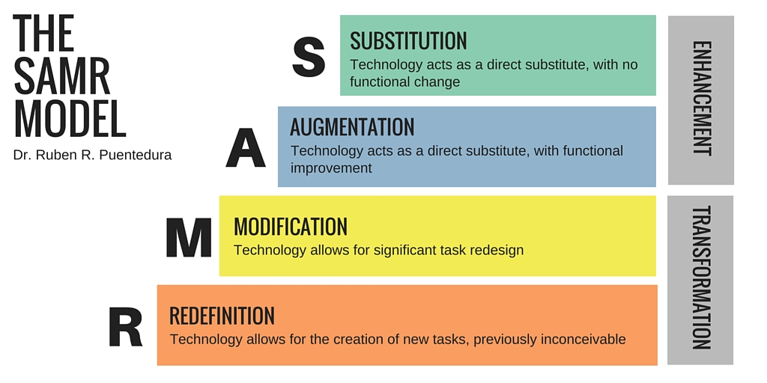

Figure 10 – The SAMR model

The SAMR model helps instructors evaluate their progress and explore effective methods to employ educational technology. The primary consideration is to ensure that the tool is appropriate for the particular activity and learning objective. The objective is to design lessons that facilitate activities involving redefinition [70]. Simultaneously, it is important to note that all the phases facilitate technological interaction and enhance student participation [223].
Effective integration of Web 2.0 tools in education requires professional practice and systematic planning. While these technologies hold significant potential to enhance learning, their use may lead to negative outcomes without clear implementation strategies and monitoring mechanisms [224-225]. In addition, practical constraints such as limited internet access, inadequate infrastructure, insufficient teacher training, and time pressures within content-heavy curricula may hinder their effective use [226]. Educational institutions must therefore ensure reliable technological infrastructure to maximize instructional benefits. On the other hand, inadequate implementation of Web 2.0 applications without evaluating their linguodidactic potential cannot bring productive results. Given the concerns mentioned, it is clear that implementing proactive steps can boost the effectiveness of user-friendly, convenient, professional, and innovative Web 2.0 tools in educational settings.
Various digital tools, such as WhatsApp, email, Moodle, movies, video clips and many others, have been integrated for teaching one of the key SAs – requesting. The predominant instructional approach, CMCL, favors mobile-based resources such as Skype and email. Research suggests that email, a kind of asynchronous CMCL [192], is critical to building pragmatic competence, particularly SAs. This diagram (Figure 11) illustrates a comprehensive overview of technology-based resources implemented in the English pragmatic competence development of NNSs by analyzing 20 articles published between 2015 and 2023 [158].

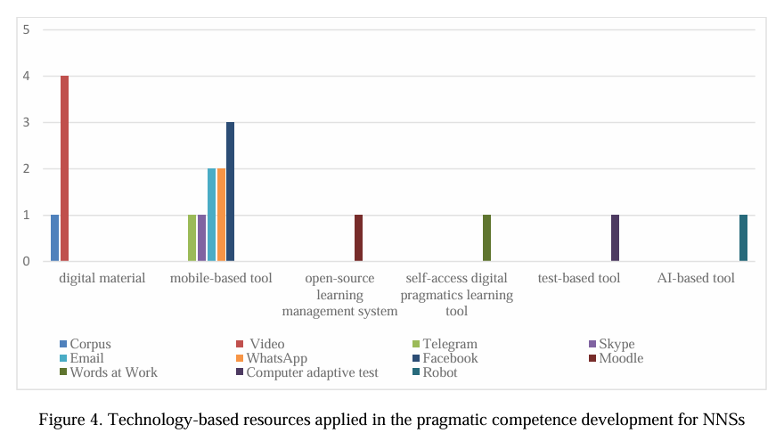

Figure 11 – Technology-enhanced resources applied in the pragmatic competence development for NNSs [158]

The research indicates that Web 2.0 tools are frequently employed as technology-related resources, including Facebook, WhatsApp, and Telegram. It is noteworthy that these services, not explicitly intended for language acquisition, are so effective in enhancing English pragmatic competence for NNSs. Comparatively, it is important to note that social communication platforms and other tools share some features, such as group chat, voice and video calling, instant messaging, multimedia sharing, status updates, and privacy settings, all of which help NNSs develop their pragmatic English skills. Web 2.0 technologies are crucial for presenting TL pragmatic content and facilitating learner interaction with the materials [191]. This category encompasses features such as virtual reality, immersive game environments, and multimedia capabilities. Consequently, it is recommended to investigate additional engagement strategies that are similar to those of Twitter, Kakao, WeChat, Nearpod, Flip, and Weibo to establish a more interactive learning environment.
Furthermore, from a pedagogical perspective, learning management systems such as Canvas, Sakai, and Moodle create interactive and flexible instructional environments that enable teachers to design, deliver, and scaffold pragmatics-focused activities, thereby supporting non-native speakers in the gradual development of pragmatic competence [158].
Recent technological advancements provide significant opportunities for the enhanced integration of pragmatic elements into the foreign-language curriculum, as demonstrated by the growing body of technology-mediated research in foreign-language pragmatics and its documented effectiveness in using digital technologies to support learners’ formation of pragmatic competence.
The purpose of this chapter is to show that the deliberate and integrated use of technology in EFL classrooms can play a significant role in supporting the development of learners’ foreign-language pragmatic competence. The objective of this study is to determine the efficacy of using the Web 2.0 technology intervention teaching method for teaching pragmatics, with a specific focus on SAs and conversational implicature, to Kazakhstani EFL undergraduates.
The discipline, still in its early stages, is expanding to encompass an extensive range of strategies and ideas. The articles in this special issue reflect these various perspectives, each providing new insights to inspire further research.
The role of technological development in the assessment of pragmatic abilities and classroom instruction has been and remains a significant contributor. It encompasses novel instructional and assessment materials, as well as the evaluation of their efficacy in the acquisition of foreign-language pragmatics. Although there are currently available materials in a variety of languages, including Arabic, Chinese, Japanese, Russian, and Spanish, they are still limited and have not been more extensively integrated than they have been into foreign language curricula or classrooms. The application of digital technology for the creation and assessment of materials in foreign-language pragmatics instruction will remain crucial for its further development. Digital technologies provide essential means for the delivery of foreign-language pragmatic content and facilitate learner engagement with the materials [192].
The results indicate that effective formation of English pragmatic competence requires explicit instruction in selected pragmatic elements, implemented within a technology-mediated and immersive instructional context. English pragmatic competence is proposed to develop in several aspects. Simultaneously, technology-driven pragmatic training via Web 2.0 represents the most promising approach for enhancing English pragmatic competence. Moreover, the development of English pragmatic competence should be significantly influenced by the implementation of Web 2.0 technology-based resources that are capable of facilitating adequate interaction in an authentic interacting environment, particularly mobile applications [158].
It is evident that teachers of today should make use of Web 2.0 technology to differentiate their instruction. These technologies empower educators to tailor students’ learning experiences based on their individual interests, degrees of preparedness, and preferred learning methods. They provide students with access to a wide range of learning opportunities and resources that are not available through standard textbooks and media centers. Teachers may assist their students in conducting research, interacting with software, creating products, and communicating with one another both within and outside of the classroom by using digital tools that can be obtained online.
1.3 The model for forming foreign-language pragmatic competence in future English teachers based on Web 2.0 technologies [36]

Considering the requirements of the state and the labor market regarding training specialists competent in a foreign language at a professional level for international cooperation and interaction, it is necessary to develop and evaluate an appropriate model for integrating a pragmatics component into the EFL curriculum of the teacher training. This section elaborates the theoretical and conceptual foundations, as well as the technological basis, of the “Model for forming foreign-language pragmatic competence in future English teachers through the use of Web 2.0 technologies.”
It is widely agreed that pragmatic elements can be effectively taught and that their instruction is pedagogically practical when appropriate methodological approaches are implemented [9, 169]. To construct a model, we will consider the theoretical analysis of existing didactic models with a focus on what determines their properties and how they affect the choice of teaching methods [227].
Currently, pedagogical research extensively employs the modeling approach, which entails constructing a systematic sequence of all stages of the learning process to increase the educational process as a whole [228].
According to P. Elubayeva, the competence model is important to enhance the educational process, enabling the systematization of the requirements for future professionals and providing standards of behavior [229].
I.V. Neprokina asserts that the model necessitates the use of such learning technologies that will help students acquire the skills that are in high demand in the labor market [230].
The modeling approach enables teachers to shift the structural components of learning models depending on the individual characteristics of each student, as well as to integrate new learning tools, methods, and technology. Such adaptability makes teaching foreign languages more effective [230].
The learning model is characterized by its dynamism, openness, adequacy, finiteness, completeness, informativeness, and predictability. It allows for the integration of new components and modifications to suit the education system’s development and societal requirements. Each model reflects a specific set of relationships with reality due to its finite resources. It must encompass all fundamental characteristics of the topic, provide sufficient information through hypotheses, and be predictable but distinct from other learning models.
With the objective of developing the foreign-language pragmatic competence of future English teachers through Web 2.0 technologies, a structural-functional model was designed to serve as a pedagogical tool for educators to manage and structure the educational process.
The structural-functional model stands out among numerous pedagogical models for the fact that, as a structural model, it transfers the internal structure of the studied object, while its functional component provides a technology – an algorithm that displays a sequence of operations leading to the realization of a certain goal [231].
Thus, the structural-functional model serves as a foundation for comprehending a recently developed model aimed at improving the educational process. This model consists of a set of organizational and pedagogical rules designed for all individuals involved in the learning environment [36]. The third task of the research is to develop an effective model for forming foreign-language pragmatic competence in future English language teachers through the utilization of Web 2.0 technologies [36]. The methodological foundations, prerequisites, and primary goal of this model are included in the target block. Figure 12 of the model shows how its blocks work together in the structured learning process [36].
Based on the analysis of scholarly literature, the structural-functional model includes the following blocks: target, conceptual, content, procedural, evaluation, and outcome blocks [231]. Structuring into such blocks contributes to a clearer understanding of the model’s mechanisms and demonstrates that it is goal-oriented and systematically organized to achieve the targeted outcome. Each block was constructed on the basis of synthesized empirical findings and comparative reasoning, while the model as a whole is justified through theoretical argumentation.
The first block is the target block, which is generated from the idea and prerequisites and determines the content, technology and expected result of the process under consideration. This block focuses on “the purpose of this model, which is to form the pragmatic competence of future English teachers through the use of Web 2.0 technologies” [36].
In conceptualizing the model, particular attention must be given to the relevance of the research topic, which is shaped by “societal demands and labor market expectations for a new generation of teachers capable of effective communication within the conditions of globalization and digital transformation” [231]. The Education 4.0 framework defines contemporary requirements for teacher professionalism, emphasizing “the ability to work effectively in multilingual and digitally mediated environments, to support learners in applying linguistic and cultural knowledge in real-life contexts, and to integrate digital technologies into teaching practice” [19]. These priorities are consistent with the objectives of developing foreign-language pragmatic competence through the use of Web 2.0 technologies. President Tokayev emphasized that professional education should be aligned with the real demands of the labor market [20]. “The model of a future English teacher within the educational program 6B01705 – Foreign language: two foreign languages emphasizes hard skills, particularly proficiency in foreign languages to meet international standards, alongside various communicative competencies” [232]. Foreign-language pragmatic competence is associated with a speaker’s capacity to produce contextually appropriate utterances and to infer interlocutors’ communicative intentions [36]. However, the systematic incorporation of pragmatics into foreign language teacher education in Kazakhstan presupposes the availability of clearly defined pragmatic content, instructional procedures, methodological guidelines, and specialized teaching materials. At present, this area remains insufficiently explored, which constitutes a significant research gap. In response to this challenge, the proposed model is designed to facilitate the formation of foreign-language pragmatic competence in future English teachers by taking into account the specific features of professional training, the pedagogical affordances of digital technologies for raising pragmatic awareness, and the use of instructional situations that support the development of appropriate pragmatic comprehension and production.
Given the overarching objective of the model, aimed at fostering foreign-language pragmatic competence in prospective English teachers through the pedagogically grounded integration of Web 2.0 technologies into professional training, it became essential to formulate a system of interrelated tasks. These tasks are intended to operationalize the purpose of the model and ensure its consistent and step-by-step realization within the educational process. They also represent the target outcomes expected at each stage of the model and contribute to the consistent development of the components of foreign-language pragmatic competence within the professional preparation of future English teachers. In accordance with this purpose, three integrated objectives were formulated:
- to provide future English teachers with a scientifically grounded conceptual understanding of the nature, components, and mechanisms of foreign-language pragmatic competence.
- to ensure the systematic development of pragma-comprehension and pragma-production skills through the meaningful integration of Web 2.0 tools, enabling learners to model, practice, and evaluate contextually appropriate SAs.
- to cultivate reflective, intercultural, and digital competencies that form the basis for effective implementation of technology-supported pragmatics instruction in future EFL teaching practice.
The second – conceptual block is represented by the conceptual basis, approaches and principles that further determine the organization of the formation process. The conceptual basis integrates the theory of the communicative competence (Chomsky; Hymes; Canale and Swain; Canale; Bachman), ILP and pragmalinguistic theory (Austin; Searle; Grice; Leech; Thomas; Bardovi-Harlig; Kasper; Purpura; Cohen; Roever; Taguchi), digital learning paradigms including CALL, CMC, MALL, Web 2.0, Connectivism, SAMR model ( Sykes; Eslami; Taguchi; Takamiya and Ishihara; Garcia-Gomez; Cunningham; Liu; Mejias; Franklin and van Harmelen; Crook et al.; Grosseck; Light and Polin; Orehovački, Bubaš, and Kovačić; Bower).
The model is based on the following approaches: a) competence-based, b) communicative-cognitive, c) task-based approach (TBLT), d) sociolinguocultural, and e) connectivist approach. Approaches serve as the linguodidactic foundation for learning and address the selected learning strategy.
The competence-based approach improves labor market competitiveness by emphasizing practical activities, promoting student autonomy, and fostering research skills [31]. Zimnyaya I.A. asserts that this approach aims to develop students’ ability to apply knowledge and skills in real-life situations [233]. Formation of foreign-language pragmatic competence in future English teachers can be implemented within the framework of the competence-based approach, which is aimed at students’ practical use of communicative skills in socioculturally varied situations. The competence-based approach enhances students’ understanding of linguistic rules and their application in context, facilitating real-world communication tasks and enabling future teachers to develop foreign-language pragmatic competence through progress tracking and reflection.
Within a cognitive-communicative approach, the formation of foreign-language pragmatic competence is supported through the development of learners’ analytical reasoning, awareness of implicit meanings, and strategic selection of context-appropriate linguistic resources [188]. This approach conceptualizes pragmatic competence formation as a process that emerges from the interaction between cognitive processing and communicative activity, thereby ensuring a coherent integration of communicative skill development and cognitive growth [36]. Kulgildinova et al. claim that this approach helps to construct and understand utterances from the point of view of the speaker and the listener through the psychological processes accompanying the speech situation [234]. They outlined the areas where the use of the communicative and cognitive approach has already proven effective: cognitive-linguocultural methodology (Kunanbayeva) [235], cognitive and communicative approach in teaching spelling as a text-formulating activity (Skriabina) [236], cognitive-communicative approach in terminology (Golovanova; Temmerman) [237, 238], the cognitive-communicative approach in text activity (Kulgidinova, van Dijk) [234, 239], integrated technology (Kondubayeva) [240]. In this context, learners are trained to adapt language based on their social status, relationship with the interlocutor, politeness norms, and situational factors – key elements of pragmatic competence. Such analysis of the communicative process leads to developing interlocutors’ metapragmatic awareness, which is the understanding of the mechanism of how and why an utterance is used appropriately or not. Metapragmatic awareness comprehensively enhances learners’ foreign-language pragmatic competence.
The task-based language teaching approach (TBLT) with its communicative nature enhances learners’ language learning through communicative tasks with real outcomes. Prior research shows (Ellis; Van den Branden, Bygate and Norris; Long) that integrating TBLT positively influences the teaching of pragmatics [241-243]. Martinez determined the importance of incorporating TBLT and technology in English language learning in EFL contexts [244]. Tasks and technologies offer learners the chance to engage with contexts that they would not be able to experience unless they engaged with the target community.
A sociolinguocultural approach is characterized by its focus on the correlation between linguistic forms and social, communicative and cultural contexts. Since this approach considers language as a social phenomenon that reflects the social structure, relationships and culture [234]. Consequently, it facilitates the ability to adequately interpret and use linguistic expressions regarding pragmatic and sociocultural factors. This leads to the effective SAs’ performance in multilingual and multicultural settings.
Connectivism has not been widely adopted in Kazakhstani educational courses, and contemporary EFL practices lack pragmatic strategies based on this theory. However, incorporating the connectivist approach into pedagogical practices and staying current with developing digital technology leads to benefits. The connectivist approach can considerably promote the development of foreign-language pragmatic
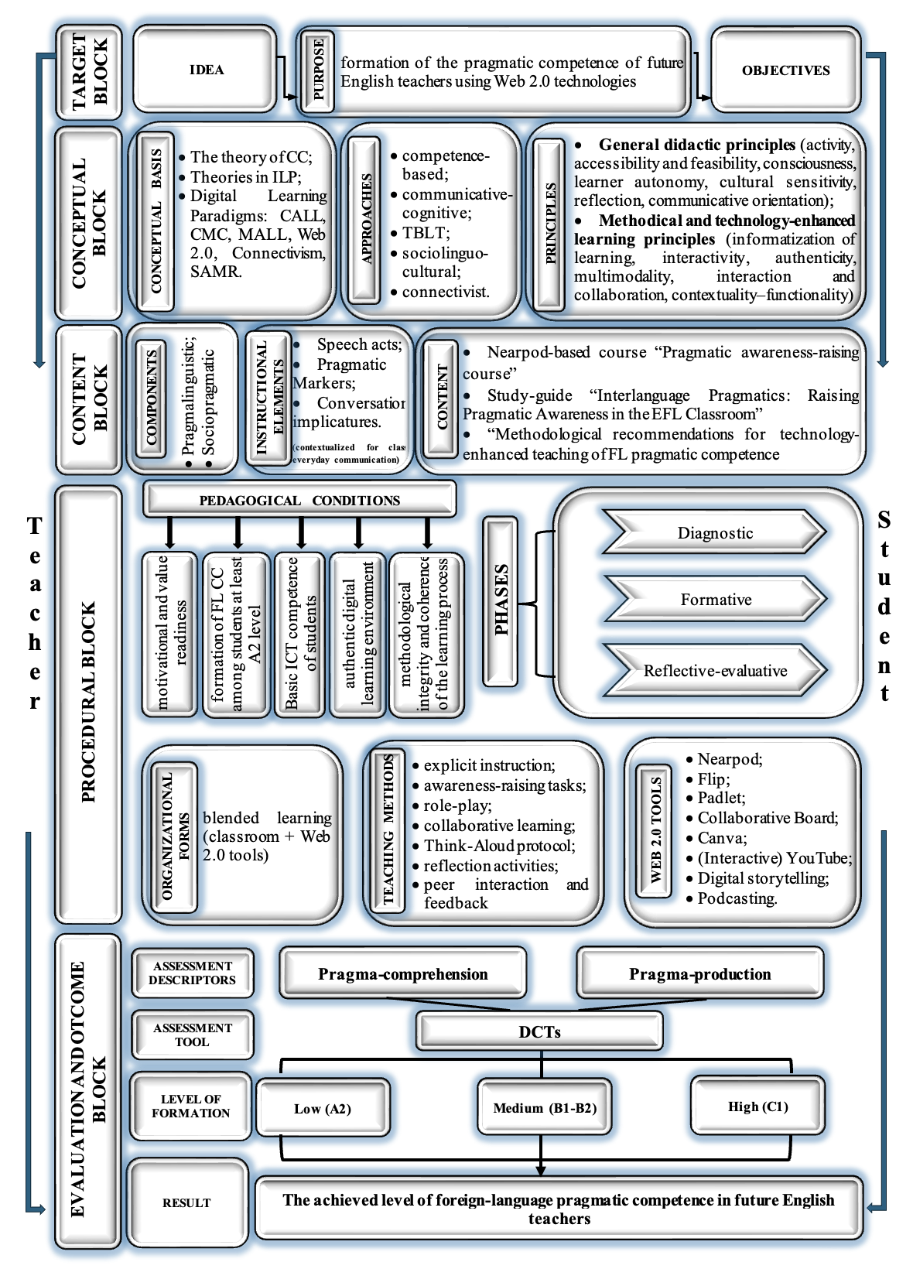

Figure 12 – The model for forming foreign-language pragmatic competence in future English teachers based on Web 2.0 technologies [36]
competence by incorporating collaborative learning and authentic interaction [169]. Many Web 2.0 tools that provide authentic input, peer interaction, collaborative learning, and personalized learning paths encourage context-appropriate language use.
The model is based on two interconnected groups of principles reflecting the pedagogical and digital dimensions of foreign-language pragmatic competence formation. These include general pedagogical and linguodidactic principles that shape pragmatic learning content and outcomes, and methodical and information-technological principles that regulate the organization of Web 2.0-mediated instruction [36].
The first group includes general pedagogical and linguodidactic principles that regulate the linguistic, pragmatic, and intercultural aspects of the educational process:
The principle of contextuality and functionality presupposes that language should be learned in specific social, cultural, linguistic, and digital contexts, all of which are essential for the formation of adequate communicative behavior. Kasper and Rose, Taguchi and Cohen emphasized the supporting role of the social context in pragmatic learning and development. Iskakova et al. claim that the use of linguistic units and the identification of their functional roles represent a key aspect of linguistics [245]. That is, the principle of functionality assumes that “the forms of languages created, regulated, governed, acquired, and used in accordance with their communicative functions” [246]. The incorporation of Web 2.0 technologies creates a digital learning environment that simulates real-life communicative situations, providing students with context to recognize the functions of pragmatic markers and use them appropriately. Accordingly, the contextual-functional principle is a key factor in advancing the pragmatic dimension of communicative competence in prospective English teachers within Web 2.0-mediated instructional environments.
The development of foreign-language pragmatic competence depends critically on the principle of authenticity. S.S. Kunanbayeva underlines authenticity as a fundamental requirement for modern foreign language education content [22, 31]. It is important to note that many language learners may not recognize the socio-cultural characteristics of a foreign language in the context of communication. Thus, learners need to be provided with materials that support the development of foreign-language pragmatic knowledge. To effectively communicate the intended meanings of speech act strategies or semantic formulations, these materials should provide learners with authentic and real-world examples. Furthermore, Web 2.0 platforms serve as effective means of delivering authentic materials for developing sociopragmatic and pragmalinguistic competence through observing, analyzing, and reproducing SAs in different contexts.
The model emphasizes the principle of communicative orientation, promoting the use of language by students to address real-world or simulated communicative tasks that mimic real-life scenarios. This approach is integral to developing foreign-language pragmatic competence, as it allows for the incorporation of communicative tasks reflective of real-world contexts. Furthermore, the integration of Web 2.0 tools enhances the ability to organize interactive and authentic communication practices. These practices contribute to fostering sociopragmatic understanding and pragmalinguistic skills, allowing learners to navigate complex communication situations effectively. According to Kunanbayeva, “this principle aims to cultivate communicative behavior, which is a set of norms and traditions of a particular linguocultural community. The lack of the development of pragmatic component in communicative behavior is a major cause of communication breakdowns” [31].
Additionally, integrating the principle of cultural sensitivity can increase awareness of cultural differences and prevent miscommunication [247]. Timpe-Laughlin et al. suggest that increasing cultural sensitivity and orientation toward pragmatic components can lead to more effective intercultural communication, taking into account the diverse language use contexts [61, p. 20]. Incorporating cultural sensitivity enhances learners’ pragmatic competence by using culturally relevant input and interactive activities [248].
The second group comprises methodical and information-technological principles. These principles represent the specific characteristics of Web 2.0-mediated pragmatic instruction and facilitate the integration of digital tools into the pedagogical process:
The principle of informatization of education requires the systematic and pedagogically grounded incorporation of digital technologies into foreign language teaching. In this study, informatization is achieved through the intentional application of Web 2.0 platforms as a medium for pragmatic instruction, pragmatic input, interaction, feedback, and reflection. The principle ensures that foreign language teaching and the digital classroom work together, thereby transforming Web 2.0 tools from supplementary into core instructional tools.
The principle of interactivity represents the technological and pedagogical potential of Web 2.0 platforms, which facilitate active learner participation, instant feedback, and multimodal modes of communication. Interactivity fosters meaningful pedagogical interaction and collaboration. These are two strongly related qualities of Web 2.0-based learning environments rather than two independent instructional principles. Interaction and collaboration facilitate learner-learner and learner-teacher communication, joint task completion, and the co-construction of pragmatic meaning. The relevance of this principle is determined by the fact that pragmatic competence is not an isolated process; it is a part of communicative competence and intercultural communication. The principles of interaction and collaboration, by building a collaborative learning environment, empower future teachers to engage in different SAs.
The principle of learning autonomy is intended to reduce the need for teacher intervention in the student’s educational process. Students should be able to show that they can be independent by making their own decisions and following their interests. However, too much independence may result in fragmentation and isolation, so teachers should be cautious [70]. This principle aligns with the characteristics of Web 2.0 technologies that facilitate the organization of student-centered interaction to promote their pragmatic comprehension and production. Anna Turula states that the didactic potential of Web 2.0 tools fosters autonomous learning [249]. Taguchi suggests that cultivating learner autonomy through self-regulated learning strategies can help students manage the challenges of learning foreign-language pragmatics by instructing them to pay attention to pragmatic elements [70]
According to Day, the principle of reflection is a vital part of learning, and it is also important for teacher preparation [250]. The principle of reflection involves regular analysis and rethinking by students of their progress in pragmatic competence. Such reflection allows students to understand more deeply how they can improve their skills. The integration of this principle raises pragmatic awareness which is a key objective in foreign-language pragmatics training (Ishihara and Cohen; O'Keeffe, Clancy, and Adolphs; Timpe-Laughlin, Wain, and Schmidgall). Students, future English teachers, should not only interpret and reproduce the SAs successfully but also reflect on them and identify the ways to manage different situations. “Learner self-reflection, supported by systematic teacher facilitation, enables the diagnosis of learning challenges and contributes to the ongoing refinement” of pragmatic instructional methods and materials [169].
The principle of visuality and multimodality is vital in Web 2.0-mediated pragmatic instruction, as visual and audiovisual methods enhance learners’ interpretation of pragmatic meaning. Visual elements act as supportive aids, conveying implicit meanings, discourse conventions, and nonverbal cues essential for developing pragmatic competence. The use of multimodal resources through Web 2.0 technologies allows the integration of various modes within a learning environment, thereby increasing learners’ pragmatic awareness and fostering the sociopragmatic and pragmalinguistic competence of future English teachers.
The included learning principles are interconnected and form a cohesive system within a specific methodology, with each principle contributing uniquely [36].
The third content block encompasses componential structure and linguistically and socioculturally rich input that ensure the formation of the level of foreign-language pragmatic competence of future English teachers. The content is grounded on the prominent theoretical models: Canale and Swain’s, Bachman’s, and the CEFR’s. Canale and Swain’s model served as the starting point; although pragmatic competence was not identified, its characteristics, however, can be found in discourse and sociolinguistic competences. Subsequently, in his 1990 model, Bachman conceptualized “pragmatic competence as an independent component comprising illocutionary and sociolinguistic competences, thereby establishing a theoretical basis for subsequent model development” [69]. “A comparative examination of existing pragmatic competence models, together with the CEFR framework [11-12], which distinguishes discourse, functional, and design competences, makes it possible to delineate two core pragmatic skills” [70]. These are pragma-comprehension, understood as the ability to interpret speakers’ communicative intentions, and pragma-production, defined as the ability to select and employ linguistically appropriate forms in context. These skills are supported by the fundamental components – pragmalinguistic and sociopragmatic – proposed by prominent researchers in the field of pragmatics (Leech, Thomas, Kasper, Taguchi). Foreign-language pragmatic competence is formed through the appropriate comprehension and production of pragmalinguistic resources (pragmalinguistics) taking into account the sociopragmatic norms (sociopragmatics) of the TL. Pragma-comprehension and pragma-production together indicate the student’s ability to capture the “implied” meaning of the statement and use appropriate linguistic units in a specific socio-cultural setting (Figure 13).

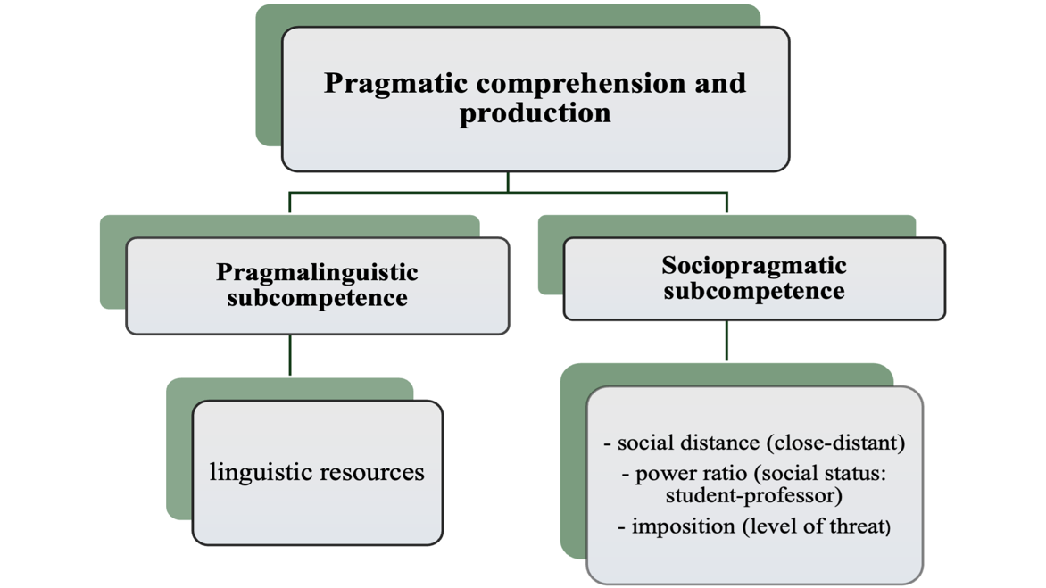

Figure 13 – Structure of pragmatic competence

These two criteria evaluate the following key pragmatic elements: SAs, pragmatic markers and conversational implicatures:
1. Implicature is the meaning that is indirectly conveyed or implied by a speaker, beyond the literal interpretation of their words.
2. SAs are considered goal-oriented actions performed with words in interpersonal communication, largely characterized by the speaker's intentions and their impact on the listener(s).
3. Pragmatic markers can be understood as function-oriented linguistic resources operating at the lexical, grammatical, and syntactic levels, which guide the interpretation of meaning, regulate the organization of interaction, and express the speaker’s attitude toward the propositional content of an utterance.
The comprehension or selection of these elements depends on social variables, which include the physical or digital context of the discourse, the relationship among the participants (such as relative power, degree of imposition, social distance), the participants’ shared knowledge about the topic, and the relevant social rules and norms [251].
Table 4 illustrates the descriptors of the levels of foreign-language pragmatic competence that future English teachers should have. They were adapted from the CEFR, taking into consideration pragmalinguistic and sociopragmatic components [11].

Table 4. Descriptors of the levels of foreign-language pragmatic competence for future English teachers.

Criteria | Level  Pragmatic elements | Low | Medium |  | High
Criteria | Level  Pragmatic elements | A2 | B1 | B2 | C1
Pragma-comprehension | SAs | Can understand short, routine expressions and basic SAs in everyday situations. | Can understand the main point of straightforward SAs in familiar contexts. | Can follow extended discourse and infer the speaker’s communicative intentions. | Can comprehend nuanced, layered SAs in a range of formal and informal contexts.
Pragma-comprehension | Implicatures | Can understand basic literal meaning only. | Can recognize simple implied meanings in routine exchanges. | Can infer implicit intentions and socially shared knowledge. | Can interpret subtle pragmatic implicatures and sociocultural references.
Pragma-comprehension | Pragmatic markers | Can recognize familiar markers such as “please” or “sorry” and their basic functions. | Can understand common discourse markers and their organizing functions. | Can interpret the function of markers for emphasis, hedging, or contrast. | Can follow complex discourse guided by pragmatic markers and identify speaker’s attitude or stance.
Pragma-comprehension | Summary of comprehension | Demonstrates emerging awareness of speaker intent in simple exchanges. | Shows developing ability to recognize indirectness and discourse structure. | Understands pragmatic intentions across varied contexts. | Fully understands and interprets communicative meaning beyond the surface level.
Continuation of Table 4
Criteria | Level  Pragmatic elements | Low | Medium |  | High
Criteria | Level  Pragmatic elements | A2 | B1 | B2 | C1
Pragma-production | SAs | Can produce basic SAs (e.g., greetings, requests) with limited accuracy. | Can use a range of common expressions to perform SAs appropriately in most situations. | Can adapt speech act strategies to interlocutor, context, and purpose. | Can flexibly use a wide range of SAs with high sensitivity to social and cultural norms.
Pragma-production | Implicatures | Rarely expresses indirect or implied meanings. | Can sometimes express implied meaning in simple ways. | Can express intentions indirectly with control of tone and appropriateness. | Can produce complex implicatures, metaphors, and references suited to social setting.
Pragma-production | Pragmatic markers | Can use basic discourse markers to signal politeness or manage turn-taking. | Can use a variety of markers to connect ideas and express stance. | Can effectively use markers for precision, mitigation, and engagement. | Can skillfully manage interaction using a rich variety of pragmatic markers in extended discourse.
Pragma-production | Summary of production | Uses formulaic language with limited awareness of communicative norms. | Communicates appropriately in familiar situations, with some flexibility. | Demonstrates pragmatic fluency in various interaction types. | Produces contextually and culturally appropriate language with high pragmatic control.

The proposed level system, serving as a self-assessment tool, allows learners to determine and evaluate their pragmatic competence progress.
Furthermore, the content block is implemented through a set of instructional resources, including 1) a Nearpod-based “Pragmatic awareness-raising course”, 2) an electronic study guide entitled “Interlanguage Pragmatics: Raising Pragmatic Awareness in the EFL Classroom”, 3) author-developed methodological guidelines designed to support technology-enhanced instruction in foreign-language pragmatic competence [36].
The procedural block (Block 4) presents the stages, organizational forms, instructional methods, and learning tools. The process of foreign-language pragmatic competence formation involves three stages: the diagnostic, the formative and the reflective-evaluative stages. At the diagnostic stage, the levels of future teachers’ pragmatic competence are identified through surveys and pre-tests. The vital role of pragmatic competence for future teachers is presented. During the formative stage, future English teachers’ pragmatic competence is systematically developed through pedagogical interventions such as communicative tasks, pragmatic instruction, and productive practice. Post-test, assessment of the formation level, analysis of the changes, and reflection occur at the final reflective-evaluative stage [36].
To ensure the successful implementation of each stage of developing pragmatic competence, a set of pedagogical tools is chosen based on the principles of contextuality, functionality, interaction, collaboration, communicative orientation, and learner autonomy, as well as the potential of Web 2.0 technologies. Effective teaching methods identified to foster the development of pragma-comprehension and pragma-production in technology-enhanced learning environments are the following: explicit instruction, awareness-raising tasks, role-play, collaborative learning, Think-Aloud protocol, reflection activities, peer interaction and feedback.
The explicit instruction, based on competence-based and cognitive-communicative approaches, is designed to enhance pragmatic awareness and accurate application of SAs, pragmatic markers, and implicatures. The decision to adopt an explicit or implicit instructional approach in intervention studies is significant (Figure 14), as it influences the incorporation of metapragmatic information within instructional input. Teachers use explicit instruction to teach pragmalinguistic and sociopragmatic components in a foreign language. A meta-analysis of 50 papers by Plonsky and Zhuang found that explicit instruction, feedback, and practice opportunities significantly impact foreign-language pragmatics instruction [36]. This data indicates that language teachers must have adequate knowledge and awareness of pragmatic issues to integrate them into their teaching effectively. They should also help students become aware of pragmatic elements and enable them to recognize and interpret them beyond the classroom [36]. Web 2.0 tools providing videos, interactive presentations, and visualizations make it easier to explain and learn pragmatic strategies that ensure appropriate language use.
Unlike implicit instruction, which is based on learners' incidental exposure to material, explicit education involves the deliberate presentation of metapragmatic information and guided practice. This contrast emphasizes the educational benefit of explicit approaches in improving learners’ pragmatic awareness and allows for systematic comparison, as shown in Figure 14. Furthermore, it enables students to intentionally observe, analyze, and use pragmatic aspects in context, allowing for deeper and more regulated language use. It also provides more explicit instructional scaffolding, allowing students to better internalize pragmatic principles and apply them to new communicative scenarios.
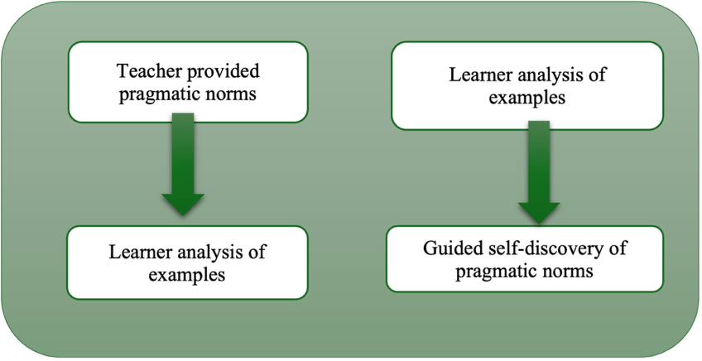

Figure 14 – Teaching foreign-language pragmatics using deductive and inductive methods [252]

The Awareness-Raising method is an important way for improving foreign-language pragmatic ability because it encourages students to observe, analyze, and interpret authentic communicative scenarios. Unlike explicit instruction, this method does not provide fixed rules; instead, it encourages students to autonomously discern pragmatic elements. Schmidt’s Noticing Hypothesis emphasized that being aware of language input is essential for learning, especially in pragmatics [119]. Bardovi-Harlig and Dörnyei argue that pragmatic growth is frequently slowed without intentional attention and reflection [253]. Students raise an awareness of contextual propriety and sociocultural norms by analyzing SAs, implicatures, and pragmatic markers in real-world discourse. The research findings have demonstrated that the use of information technology can improve pragmatic awareness significantly [253].
The Role-play is a means of simulating social interactions in which participants take on certain roles in a specific situation [254]. It is a frequently employed method to develop pragmatic competence in TL, as it enables learners to mirror authentic communicative scenarios and engage in contextually appropriate language use. This method provides a secure environment for students to experiment with SAs, pragmatic markers, and politeness norms that are appropriate for their social roles, status, and communicative goals. Kasper and Rose state that pragmatic development needs both input and opportunities for output, especially when people are interacting. Playing roles in different situations provides those chances for output, consequently improving pragma-productive skills [6]. Role-play is consistent with TBLT and communicative language teaching approaches, which prioritize purposeful communication and interaction. Additionally, Web 2.0 tools like video blogs, online role-playing games, and digital storytelling let students role-play in real time or at their own pace, obtain feedback and reflect on their pragmatic choices, which helps them improve their performance and become more conscious of their pragmatic choices.
Collaborative Learning is an effective method to set up a discussion board where students may post questions, share their experiences, and have in-depth conversations about certain subjects. This aligns with Vygotsky’s sociocultural theory, which posits that knowledge is built through social interaction and scaffolding, especially when it comes to using language in context. Web 2.0 tools like shared blogs, forums, and co-authored documents create authentic situations for pragmatic engagement. These tools encourage students to use language in context, receive feedback from their peers, and reflect on how to be polite and appropriate. This combination of collaborative learning digital tools helps future English teachers become more conscious of how to use language and communicate effectively.
The Think-Aloud Protocol is a metacognitive approach that improves pragmatic competence by encouraging learners to articulate their thoughts during language interpretation. It fosters greater awareness of the impact of their language on others and encourages them to contemplate how acceptable, intentional, and culturally sensitive their communication choices are. When implemented on Web 2.0 platforms, think-aloud assignments emphasize the link between comprehension and responsible language use. As Ericsson and Simon [255] and Kasper and Schmidt [8] point out, this strategy strengthens learners’ interlanguage pragmatic systems.
In teacher training, reflective activities are considered an effective way to improve pragmatic competence in TL. By allowing students to reflect on how they use language, these activities help them manage their SAs, politeness techniques, and implicatures, thereby enabling them to make correct pragmatic choices. Dewey [256] and Schön [257] developed the concept of reflective thinking, which is important for both professional and personal growth. Kasper and Schmidt also stress the importance of self-awareness and reflection concerning one’s learning and application of pragmatic standards in different sociocultural settings [8]. Using reflective diaries, peer interaction, critical event analysis, and self-evaluation in language learning helps future teachers learn how to use theoretical knowledge in real life.
To improve pragmatic competence in a foreign language, it is important to engage with and acquire feedback from other people, which implies the use of the peer interaction and feedback method. Through the use of Web 2.0 platforms, students have the possibility of receiving comments, corrections, and constructive evaluations from both teacher and peers. This method fosters reciprocal monitoring, improving pragmalinguistic skills and making appropriate socio-pragmatic choices. Lynch [258] and Saito and Fujita [259] emphasize “the significance of peer input in EFL learning, noting that interaction with peers and engagement in peer feedback contribute substantially to learners’ development of appropriate language use”.
Furthermore, the procedural block presents the organizational forms of learning. There have been suggestions for several forms of training, such as virtual and traditional classroom training, to help raise pragmatic awareness [260]. In the process of developing future English teachers’ foreign-language pragmatic competence using Web 2.0 technologies, research shows that blended learning is the major form of learning organization, integrating in-class instruction with independent online work [261-263]. In the classroom, students work together, role-play, and interact in person under the guidance of their teacher. At home, students keep learning by using Web 2.0 tools asynchronously, doing interactive activities, and making digital content. Consequently, this instructional format enables learners to apply their practical knowledge in authentic contexts, both through real-time interaction and within digitally mediated collaborative environments [169].
While numerous studies have highlighted the benefits of Web 2.0-enhanced learning, few have cautioned educators about potential roadblocks and solutions. Empirical studies conducted in diverse educational contexts have identified a range of factors influencing the effectiveness of Web 2.0 implementation in teacher education. Research carried out in Nigeria by Khan et al. highlights socioeconomic inequalities, delayed technology uptake, and the absence of qualified mentors for ICT literacy development as major obstacles to successful integration [264]. In a U.S.-based investigation, Zakrzewski and BriAnne Newton report that favorable attitudes toward Web 2.0 tools, structured orientation sessions, expert mentoring, and access to reliable technological infrastructure significantly enhance future teachers’ satisfaction with web-supported learning environments [265]. At the European level, a large-scale study by Schmitz et al. across 30 countries indicates that outdated hardware, insufficient ICT competence, inflexible curricula, limited institutional support, and low teacher motivation to develop digital skills may impede successful technology adoption [266]. “Taken together, these findings suggest that although such challenges are not widespread, they require systematic analysis and collaborative solutions, as their impact may extend beyond individual institutions and influence broader educational practices. Taking proactive steps to address this issue can promote beneficial usage of Web 2.0 tools” [221].
In relation to the abovementioned issues, formulating and defining pedagogical conditions is an integral stage in pedagogical research. Within the scope of this dissertation, key pedagogical conditions are outlined as prerequisites for the effective development of pragmatic competence through Web 2.0 technologies [36]. These conditions include:
- students’ motivational and value-based readiness for learning;
- foreign-language communicative competence at a minimum A2 proficiency level;
- students’ basic ICT competence;
- the establishment of an authentic digital learning environment;
- methodological consistency and coherence throughout the instructional process [36].
Priority within the proposed framework is given to learners’ motivational and axiological orientation toward the learning process. The extent to which future English teachers develop foreign-language pragmatic competence largely depends on sustained learning motivation and value awareness, particularly in technology-mediated instructional environments supported by Web 2.0 tools. The theory of activity identifies motives as objects or phenomena that fulfill a person's needs and drive them toward specific activities. In the context of education, Web 2.0 technologies that promote interactivity and collaboration, facilitate access to authentic materials and reinforce students’ value orientations through productive practice already serve as a significant motivating factor. In addition, the instructional methodology plays a decisive role in shaping learners’ motivation, thereby positioning motivation as a central pedagogical condition for the successful implementation of the proposed model [36]. High internal motivation, recognition of the professional significance of appropriate speech behavior, and a positive attitude towards digital tools foster active engagement in acquiring pragmatic skills. Furthermore, values such as intercultural sensitivity, speech etiquette, and professional responsibility enhance the practical application of acquired strategies across diverse contexts. This condition aligns with competence-based and sociolinguocultural frameworks, as well as contemporary research in digital pedagogy.
The formation of pragmatic competence in digitally mediated instructional contexts relies, among other factors, on learners’ possession of a foundational level (at least A2) of foreign-language communicative competence, which supports effective engagement with pragmatic tasks [36]. This level provides a sufficient bank of lexical and grammatical structures, as well as the capacity to interact in familiar circumstances, allowing learners to focus on statement relevance rather than grammatical accuracy. The CEFR Companion Volume claims: “Can communicate in simple and routine tasks requiring a simple and direct exchange of information on familiar topics and activities” [11, p. 36]. Thus, the A2 level provides a basic foundation for perceiving and reproducing pragmatic aspects (SAs, implicatures, and pragmatic markers) in real-world communication scenarios. This position is supported by “empirical evidence reported by Bardovi-Harlig and Kasper and Rose, who demonstrate that the development of pragmatic competence is closely linked to learners’ level of language proficiency” [36].
The effective development of foreign-language pragmatic competence requires the third pedagogical condition – creating an integrated authentic digital learning environment. Such an environment should include authentic input, activities, and interaction forms that closely reflect real-life social, academic, and professional situations in which students can use the language in accordance with politeness and sociocultural norms. Thomas [267] and Pegrum [268] found that such realistic tasks promote pragmatic transfer and awareness, thereby improving both pragmalinguistic and sociopragmatic skills. According to a sociolinguocultural approach (Hymes; Canale and Swain), an authentic digital environment promotes the meaningful use of linguistic forms in varied social situations, which is critical for recognizing implicatures and selecting suitable SAs in online communication. The CEFR publications (Companion Volume) state that building pragmatic competence necessitates participation in “real-life tasks and situations,” which provide contextual relevance and promote communicative adaptation [11]. In the context of Web 2.0, these tasks can be presented in interactive and collaborative ways, increasing student involvement and knowledge of pragmatic strategies.
The establishment of an authentic digital educational environment necessitates adequate ICT competence among both teachers and students. In Kazakhstan, this requirement is reflected in the state Professional Standard for Teachers, which identifies the integration of digital technologies into education as a key professional indicator. Scholars assert that ICT literacy, including fundamental skills in using digital tools and online platforms, is essential [269], and particularly vital for effective Web 2.0-based pragmatic training.
The fourth pedagogical condition is called the methodological integrity and coherence of the learning process. The State-mandatory standards of higher and postgraduate education of the RK identify the requirements for the training level of future professionals, learning content, and amount of course load, and reflect learning outcomes of the educational programs [19]. This feature signifies that the learning process should follow a clear structure and algorithm. Algorithmization in foreign language education entails following specified phases and techniques to achieve desired results. The competence approach (Weinert; Khutorskoy; Zimnaya) focuses on the end result [270, 271, 233], while the cognitive-communicative and sociolinguocultural approaches (Canale and Swain; Hymes; Safonova) balance knowing the rules with being able to use them in real-life interactions between cultures [68, 71, 272]. The task-based method breaks up content into meaningful communicative activities, while the connectivist approach (Web 2.0) adds network resources and tools to the learning process. This strategy can benefit students by allowing them to control the educational process and build autonomy. Failure to adhere to a clear learning algorithm can result in problems such as diminished motivation, cultural stereotyping, and difficulties understanding the topic. Poor organization in cross-cultural contacts can lead to preconceptions and a negative attitude toward the other culture. These issues can lead to culture shock and a failure to meet the goal of fostering tolerant relationships between representatives from various cultures. The fundamental issue in these circumstances is the teacher’s weak organizational skills, as students frequently obtain knowledge from sources they do not trust and lack a step-by-step study plan to attain this goal [36]. Kasper asserts that evidence supports the systematic development of pragmatic abilities, with learners benefiting from rich input that enhances their awareness of socio-cultural norms [149]. Therefore, methodological integrity ensures that pragmatic competence is built up in a methodical way, with the Web 2.0 digital world becoming a planned part of the teaching paradigm [36].
However, there is limited information available on how to include pragmatics in a teacher education program. Curiously, the majority of the literature on pragmatics training only covers the theoretical aspects. Instead, the emphasis is placed on the impact of instructing learners in pragmatics. According to Pérez, the goal of teaching pragmatics is to help students identify language that is acceptable for social situations [273].
When it comes to practical teaching methods in an EFL setting, the complexity rises. According to LoCastro, native speakers acquire social language skills through interactions at home, school, and in society [274]. Nevertheless, the limited opportunities for interaction with native speakers in conventional classroom settings make the acquisition of pragmatic norms of appropriateness particularly challenging for EFL learners.
“Pragmatic competence plays a vital role in effective communication but is frequently neglected in foreign language education” [275], particularly in EFL settings [276]. This gap is evident in the pedagogical practices and cognitive frameworks of Kazakhstani EFL teachers. Nevertheless, there have been noteworthy initiatives over the last decades at the international level aimed at fostering students’ pragmatic competence through diverse instructional strategies, as evidenced by researchers such as Bardovi-Harlig, McConachy, and others. These efforts emphasize the urgent need to identify the most effective teaching methods for developing students’ pragmatic competence.
To be trained to teach pragmatics is crucial for EFL teachers. Bardovi-Harlig and Mahan-Taylor, suggested three instructional methods: employing real-life language examples, ensuring input is followed by production or interpretation, and starting pragmatics training early. That is, effective foreign-language pragmatics training should have specified objectives, provide authentic input, encourage observant and reflective skills, facilitate learner-centered interaction, and include feedback and assessment. Research shows that opportunities for observation and reflection, along with explicit metapragmatic knowledge education, improve pragmatic acquisition (Schmidt; Taguchi). Learners who participate in the TL and culture have more frequent instances of noticing, which leads to stronger pragmatic development. Timpe-Laughlin underlines the need for learners to develop observational abilities to identify pragmatic aspects in varied circumstances [277]. Allowing learners to determine their rate of interaction with information can also increase learning outcomes, since self-paced study has been associated with better recall and comprehension [278-279].
According to research, while input and observational skills improve receptive foreign-language pragmatic abilities (Taguchi) [280], learner-centered interactions and practice are critical for building productive skills (Bardovi-Harlig) [138]. Bardovi-Harlig and Bastos discovered that how much people interact with each other has a big impact on their ability to produce and recognize conventionalized routines [281]. To enhance the learning experience of adult foreign language learners, it is crucial to promote reflection on new pragmatic knowledge and to provide clear feedback through formative assessment (Holden and Sykes; Kasper and Rose) [282, 5]. Adults often possess substantial practical knowledge in their L1, complicating the integration of new social language use and context-specific language skills. Thus, relevant feedback and assessment are critical for recognizing pragmatic elements. Despite the absence of specific laws on how people act in speech communities, certain patterns tend to be followed. Sykes and Cohen state that feedback shouldn't be a “prescriptive ideal or native-speaker model” [283, p. 89]. Instead, it should show examples of how people in the target community use language in real life so that learners can compare their choices to community norms and conventions.
Teaching pragmatics in the EFL classroom is a complex endeavor due to the variability of pragmatic behavior across different social and cultural contexts. Effective pragmatic instruction should concentrate on three essential functions: providing learners with appropriate TL input, enhancing learners’ pragmatic and metapragmatic awareness, and creating authentic opportunities for practicing pragmatic knowledge. Additionally, teachers must possess a comprehensive knowledge base that includes subject-matter knowledge (understanding pragmatic norms and metapragmatic information), pedagogical-content knowledge (strategies for teaching and assessing pragmatics), general pedagogical knowledge (overall teaching and assessment skills), and knowledge of learners and their contexts (awareness of cultural identities and the relevance of pragmatics in education) [9].
Web-based materials can enhance foreign-language pragmatic instruction through independent self-study or blended learning, leveraging Web 2.0 technologies for meaningful interaction, authentic materials, and diverse pragmatic features. This approach aligns with learning stages identified in numerous studies on foreign language teaching. Our dissertation incorporates a structured algorithm for teaching pragmatics using Web 2.0 technologies as a key pedagogical condition.
We identify a sequence of interrelated processes for explicit pragmatics instruction, which includes 1) a warm-up stage, 2) pragmatic instruction, 3) a pragmatic awareness-raising stage, 4) practice in output production and comprehension, and 5) self-evaluation with immediate feedback. Based on this framework, we propose the algorithm for teaching pragmatics, structured into five stages with nine specific steps.

Table 5 – Algorithm of pragmatic instruction using Web 2.0 tools [36]

Teacher’s actions | Students’ actions | Work form
1 | 2 | 3
Stage No. 1: A warm-up stage
Step 1. Discussion of pragmatic phenomena in L1 and TL
- engaging the learners’ prior knowledge by prompting them to provide information on their existing understanding of pragmatics and the distinctions between their native language (L1) and target language (TL).  - posing some leading questions | - being involved in the discussion | classroom  integrated with Web 2.0 tools
Stage No. 2: Explicit Pragmatic instruction
Step 2. Explanation of the essence of pragmatic element
- explicit instruction of pragmatic element (SA or an implicature), highlighting the significance of modification devices, including their types and tools, what SA strategies, corresponding softening devices and pragmatic markers (situational routines) exist | - clarifications and questions during the explanation | classroom  integrated with Web 2.0 tools
Stage No. 3. Pragmatic awareness-raising stage
Step 3. Authentic audio/video sample interaction based on Web 2.0 technologies
Continuation of Table 5
1 | 2 | 3
- exposing students to appropriate input, NSs’ SAs via audio/videos excerpts using Web 2.0 services;  - posing some preparatory questions regarding the input | - listening/watching the authentic material and get ready to answer some preparatory questions as presented on the Nearpod board in accordance with the instructions of the teacher | classroom  integrated with Web 2.0 tools
Step 4. Discussion of identified examples of pragmatic element
- monitoring the discussion of identified examples of pragmatic phenomena | - discussion of identified examples of pragmatic phenomena in groups/pairs | classroom
Stage No. 4. Practice
Step 5. Producing pragmatic output
- monitoring of students’ work | - students perform written and oral tasks using the studied pragmatic phenomena in accordance with different SAs;  - practice comprehension;  - practice in producing output | classroom/extracurricular
Step 6. Collaborative discussion of learners’ outputs
- monitoring of mutual discussion of students’ works | - mutual discussion of written and oral works by students in order to determine the correctness of the use of pragmatic markers in speech | classroom/extracurricular
Step 7. Making necessary changes to students’ work
- monitoring of students’ learning activities | - making necessary changes by students to written and oral works after discussion and recommendations of other students | classroom/extracurricular
Stage No. 5. Evaluation
Step 8. Teacher's assessment of completed student assignments
- comments and remarks of the teacher as the final conclusion of the activity;  - evaluation of the completed work by students in accordance with the criteria | - discussion of the teacher's assessment of the students’ educational and cognitive activity | classroom
Step 9. Students’ reflection
- monitoring of students’ reflection | - self-assessment and reflection of students on their educational and cognitive activities;  - suggestions for improving the content and implementation of projects | classroom
Web 2.0 technologies enable the design of instructional tasks of varying levels of complexity, ranging from basic practice-oriented exercises (e.g., gap-filling, multiple-choice tasks, and matching) to advanced learning activities, including simulations, collaborative tasks, multimedia-based instruction, and audio-based production activities.
Within the proposed framework, “learning tools function as a key mechanism for operationalizing the development of foreign-language pragmatic competence in future English teachers in digitally mediated contexts” [36]. The purposeful use of Web 2.0 technologies transforms EFL instruction by diversifying pedagogical formats and creating more dynamic learning environments that sustain learner involvement. Contemporary research increasingly demonstrates that such technology-mediated approaches provide favorable conditions for the instruction of foreign-language pragmatics, particularly when Web 2.0 tools are employed to support interaction, practice, and reflection. The proposed model includes a variety of learning technologies, such as Nearpod, Flip/Padlet, Collaborative Board, Canva, YouTube, and podcasts presented in Table 6 [36].

Table 6 – Web 2.0 tools in pragmatic instruction

Tool | Linguo-didactic and pedagogical potential | SAMR level | Connectivist alignment
1 | 2 | 3 | 4
Nearpod (main platform) | Interactive content delivery, structure pragmatics practice, real-time feedback | Substitution, augmentation, modification, redefinition | - Combines multiple knowledge sources;  - Enables learner-driven exploration and feedback
Nearpod Collaborate Board | Peer discussion, reflection on pragmatic norms, appropriateness judgment | Augmentation | - Promotes shared meaning-making;  - Facilitates real-time and asynchronous knowledge exchange
Interactive YouTube (Nearpod) | Authentic video input with embedded prompts and reflection tasks | Modification | - Connects learners to real-world examples;  - Encourages critical viewing and contextual analysis
Padlet | Scenario-based output, peer feedback, cultural comparison | Modification | - Supports social learning;  - Encourages content creation and decentralized knowledge sharing
Flip | Oral performance of SAs, peer interaction, metapragmatic explanation | Redefinition | - Learners create content for peers;  - Builds distributed knowledge through shared practice
Continuation of Table 6
1 | 2 | 3 | 4
Canva | Visual design of pragmatic content (e.g., politeness strategies, apology maps) | Modification | - Develops digital expression;  - Encourages individualized representation of complex concepts
Podcasts | Extended authentic input (intonation, discourse markers), used for self-study or reflection | Augmentation | - Exposes learners to diverse real-world voices;  - Encourages learner choice in pacing and focus

The table above describes the linguistic and pedagogical possibilities of chosen Web 2.0 tools and shows how they align with the components of the SAMR model and principles of connectivism. These tools were used not only to facilitate pragmatic instruction but also to transform conventional instruction by collaborative, multi-modal and learner-driven activities. Such an educational environment including social interaction and independent engagement with real-world language input, can help learners form their pragmatic competence which would not be that effective with traditional methods alone.
The main trunk Web 2.0 product employed in the scope of our research project was Nearpod, which allowed us to not only practice with the many task types it provided but also build whole lessons.
Nearpod is a prominent interactive presenting technology that transforms classroom participation. Teachers can design engaging classes by using multimedia elements, interactive polls, quizzes, and virtual reality simulations. Nearpod already includes integrated interactive YouTube videos to assess student comprehension and encourage active engagement, as well as a collaborative board for real-time and distant collaboration to enhance cooperation and interaction. Students actively participate using smart gadgets, which promotes meaningful interactions with the course material.
Dr. Ruben Puentedura’s SAMR model provides a prism through which to examine the incorporation of technology in the classroom. As we aim to integrate Web 2.0 technologies into the EFL classroom, we examine how Nearpod may be aligned with the SAMR paradigm (Table 7) [284].
Educators may maximize the use of technology in the classroom by combining the SAMR model with tools such as Nearpod. Nearpod improves student learning, fosters cooperation, and creates transforming educational experiences by moving through the stages of substitution, augmentation, modification, and redefinition [284]. (https://nearpod.com/blog/samr/)

Table 7 – Implementation of Nearpod features according to the SAMR model

SAMR model | Nearpod
1 | 2
Continuation of Table 7
1 | 2
Substitution | Nearpod substitutes traditional handouts and printed worksheets with digital counterparts. Teachers submit PDFs or materials to Nearpod, which students may view using their smartphones. This substitute optimizes efficiency, minimizes paper use, and offers a user-friendly method for students to get educational resources.
Augmentation | It provides interactive games and assessments such as polls, quizzes, time to climb, and more. Teachers construct dynamic presentations that include embedded questions and multimedia features, making lesson plans more interesting and interactive.
Modification | It allows for collaborative activities and vibrant debates among students. Collaborate Board, Time to Climb, Draw It, and other interactive elements and activities encourage group collaboration, constructive feedback, and cooperative problem solving. Students actively communicate with their peers in real time, which improves their communication and critical thinking abilities.
Redefinition | In their current projects, its collaborative features – Collaborate Board, Immersive Reader, and others – create dynamic and captivating learning experiences. Nearpod's Virtual Reality (VR) Field excursions and 3D models take students on virtual field excursions and simulations, offering immersive and hands-on learning experiences based on real-world instances. By incorporating these elements, teachers may redefine standard classroom procedures, stimulate collaboration, and allow students to explore subject in new ways.

To illustrate, Civelek and Karatepe studied the effects of Nearpod-based pragmatics education on EFL learners’ request modification, involving 11 voluntary participants. The lectures provided clear pragmatic instruction for using requests in various socio-cultural contexts. Results from t-tests indicated significant learner improvement, as qualitative analysis revealed increased use of internal and external modifiers. Additionally, Nearpod training helped participants overcome pragmatic failures resulting from the L1 transfer [101].
While preparing Interlanguage pragmatics lessons, we needed to first provide the outline of each lesson and pragmatic instruction. And with the help of Canva we could draw students’ attention and present lessons with great visuals (https://www.canva.com/en/). Canva's user-friendly interface and pre-made templates make it simple to produce eye-catching graphics. Users may create and share designs with others using an online graphic design tool Canva. It highlights the importance of working together and material created by users, which makes it an excellent illustration of a Web 2.0 application. Canva offers a vast collection of free and premium stock visuals and illustrations, facilitating the creation of designs.
The next important Web 2.0 tool that helps promote student’s pragma-productive skills, especially speaking, is Flip. For almost ten years, educational institutions all around the globe have been using Flip (previously Flipgrid), a free online and mobile software from Microsoft, to record, edit, and share video assignments.
However, Flip has discontinued working recently. Due to the quick turnover of hardware and software components, the majority of current technological research runs the risk of having a limited shelf life [285]. Digital technologies change so quickly that tools often become outdated in a short timeframe. Consequently, “their impact on education is continuous, leading to constant changes in teaching and learning practices” [286].
Even though Flip stopped working after the experimental phase, to verify the aforementioned statement about technologies, we replaced Flip with Padlet, which appeared as effective as Flip.
The use of “role-play” technology in conjunction with the Flip tool has significant educational potential. After analyzing the relevance and efficacy of the Flip application in learning English pragma-productive skills, we proposed using Flip as a connectivist tool and role-play as a teaching technology to improve future English teachers’ foreign-language pragmatic competence. Moreover, this type of research was initially conducted in Kazakhstan.
In addition, Canva, YouTube and Flip are integrated into the Nearpod platform, which completely facilitates the teaching process.
Video/audio podcasting has emerged as a valuable technique for introducing real-life scenarios. Podcasts discussing pragmatics and pragmatic aspects relevant to the current study have been found in well-proven BBC learning English, 360 Skill, H3 podcasts, Denny Sumargo's podcast and others.
The fifth element presents the evaluation and results block. This block outlines the outcomes in developing foreign-language pragmatic competence, characterized by specific levels and assessment criteria. The research evaluates pragmatic competence through two main criteria: Pragmatic Comprehension, which involves recognizing and interpreting pragmatic meanings and SAs, and Pragmatic Production, which focuses on producing contextually appropriate utterances with linguistic and sociopragmatic accuracy. Using CEFR descriptors, three levels of formation are identified: low (A2), indicating basic comprehension and production of simple pragmatic patterns; medium (B1–B2) [11], reflecting an ability to handle a broader range of pragmatic features with some cultural sensitivity; and high (C1), demonstrating proficiency in understanding and producing complex, culturally nuanced language across various contexts. This classification facilitates diagnostic clarity and aligns with international proficiency standards, allowing for consistent assessment of learners’ progress in pragmatic competence.
As a result of implementing the current model and algorithm, the study predicts that future English teachers will enhance their foreign-language pragmatic competence through Web 2.0 technologies after its intervention. This model for fostering pragmatic competence in future English teachers appears as an interconnected and interactive system, wherein the synergy of its components leads to achieving efficient outcomes. The section addresses “the development of this model oriented toward enhancing pragmatic competence in future English teachers within technology-supported learning environments” [36].
The study approaches this issue by rethinking the role of Web 2.0 technologies as pedagogical instruments that, when combined with appropriate teaching methodologies, create meaningful conditions for pragmatic development in foreign language education [36]. It introduces an innovative approach for incorporating these technologies into EFL courses, focusing on the interactive nature of pragmatics, which enhances learner engagement and communication [36].
The model’s interconnected blocks suggest that achieving the purpose of forming a pragmatic competence level of future English teachers requires a comprehensive integration of all elements. The integration of this model promises to improve the professional training of educators and develop their foreign-language pragmatic competence. It emphasizes the importance of integrating online interactive activities, such as using various websites and Web 2.0 tools, with traditional classroom instruction to optimize learning outcomes in the field of pragmatics [36].
Generally, future English language teachers may struggle to determine what and how to teach pragmatics without an explicit definition. This model was designed to educate undergraduate teachers on pragmatics and fundamental ideas within the field. Firstly, it helps to prepare educators to consider pragmatics for effective communication in the TL. Secondly, it pertains to the activation of teachers’ pragmatic awareness. Teachers need to intentionally expose their pragmatic competence in English to cultivate learners’ pragmatic competence. This involves assisting teachers in identifying pragmatic inputs. Thirdly, it focuses on equipping educators with practical examples for activating pragmatic skills in the classroom. This aspect enables educators to examine pragmatics from a learner’s viewpoint. Instructors observe how they can increase the importance of pragmatic signals (markers), thereby focusing learners’ attention on them. These goals can be accomplished by posing targeted inquiries, employing visual aids, illustrating communicative failures and successes, implementing repetition, using exaggerated demonstrations, role-playing, and contrasting their L1 with the TL [287].

Summary of Chapter One

The theoretical analysis conducted in Chapter One has demonstrated that pragmatic competence is a critical structural component of communicative competence and is essential for the professional development of prospective English language teachers. It has been shown that pragmatic competence ensures the ability to use and interpret language effectively in a variety of sociocultural contexts, and it is founded on the integration of pragmalinguistic and sociopragmatic knowledge.
The review of theoretical approaches to communicative competence has revealed that pragmatic competence is a fundamental structural subcomponent responsible for the appropriate use of language in a variety of social and cultural contexts. The evolution of linguistic thought, from the philosophical foundations of language use (Austin, Searle, Grice, Wittgenstein) to communicative competence models proposed by Hymes, Canale and Swain, Bachman, Bachman and Palmer, and the CEFR, has shown an increasing recognition of context-sensitive language use as a critical dimension of communication. It has been demonstrated that pragmatic competence is founded on the integration of pragmalinguistic and sociopragmatic knowledge and has a significant impact on all aspects of communication, justifying its consideration as an independent component of communicative competence in the professional training of future English language teachers.
The study found that pragmatic competence plays an important role in the professional development of EFL teachers because it allows them to act as models of proper language usage as well as facilitators of learners' communication growth. According to the Kazakhstani professional standard, future English teachers are expected to demonstrate adequate language ability for effective communication in multilingual contexts, hence emphasizing the need of pragmatic competence in teacher education. The review of international and domestic research has demonstrated that pragmatic instruction is essential, effective, and teachable; however, it is not adequately represented in the Kazakhstani EFL curriculum. The analysis of textbooks that are frequently used (Cutting Edge, Speakout, Solutions, Headway) has revealed a deficiency in authentic pragmatic input, contextualized explanations, and metapragmatic instruction. Consequently, it is determined that the development of pragmatic awareness demands the explicit and systematic integration into teacher education programs.
The analysis of key theoretical frameworks supporting pragmatic instruction, such as Speech Act Theory, Politeness Theory, and the Noticing Hypothesis, has revealed their importance in establishing the conceptual foundation for teaching speech acts, conversational implicatures, and pragmatic markers as core elements of pragmatic competence. It has also been established that the development of pragmatic competence is dependent on the interdependence of pragmatic comprehension (the ability to interpret intended meaning and contextual cues) and pragmatic production (the ability to use appropriate linguistic forms), which serve as the foundation for assessing learners' pragmatic development.
The analysis of the linguodidactic potential of Web 2.0 technologies has revealed their substantial influence on the enhancement of pragmatic competence in digitally mediated learning contexts. The transition from Web 1.0 to Web 3.0 demonstrates that Web 2.0 signifies an interactive and user-centric phase of Internet advancement, marked by participation, collaboration, and user-generated content. In the context of connectivism, it has been demonstrated that Web 2.0 tools (blogs, wikis, podcasts, video-sharing platforms, and social networks) offer authentic, dynamic, and multimodal environments that enhance collaboration and learning. Their inherent characteristics, such as networking, user interaction, creativity, and collective intelligence, enable learners to develop not just cognitive but also social and communicative abilities required for pragmatic competence.
The study has further revealed the pedagogical effectiveness of Web 2.0 technologies in EFL teacher education, especially in facilitating access to actual linguistic input, promoting intercultural contact, improving productive skills, and establishing collaborative learning settings. The use of Web 2.0 resources (including Flip, YouTube, social networks, podcasts, and edublogs) has been shown to enhance pragmatic awareness by promoting involvement in authentic communicative contexts, reflective interaction, and peer feedback. As a result, Web 2.0 technologies serve as effective intermediaries between digital learning environments and conventional pedagogy, fostering learners’ social engagement, creativity, autonomy, and comprehensive pragmatic development.
Consequently, the analysis conducted in Chapter One has provided a strong theoretical foundation for the study by defining the concept and structure of foreign-language pragmatic competence, substantiating its importance for the professional development of future English language teachers, and illustrating the linguodidactic potential of Web 2.0 technologies in its development. The findings of the theoretical analysis have substantiated the necessity for developing a scientifically grounded model intended for the efficient formation of pragmatic competence in digitally enhanced learning settings.

II. PRACTICAL IMPLEMENTATION OF FOREIGN-LANGUAGE PRAGMATIC COMPETENCE FORMATION IN FUTURE ENGLISH TEACHERS THROUGH THE USE OF WEB 2.0 TECHNOLOGIES

2.1 The content of the experimental work on foreign-language pragmatic competence formation in future English teachers through the use of Web 2.0 technologies

This section outlines the design, content, and structure of the experimental part of the research aimed at enhancing future English teachers’ foreign-language pragmatic competence, showing how theoretical foundations have been applied in the teaching context. An interactive course based on the Nearpod platform integrated with a variety of Web 2.0 tools, including Flip, Canva, Collaborate Board, and Padlet, a Study guide for both teachers and learners; and Methodological recommendations for teachers and future English teachers were designed to provide teaching and self-study sources at the formative phase.
The formative phase of the study, which constituted the experimental stage, focused on developing the foreign-language pragmatic competence of future English teachers and was preceded by a needs analysis aimed at identifying existing institutional and pedagogical gaps in EFL instruction. To ascertain the necessity and relevance of the investigation, two diagnostic surveys were administered during the pre-experimental phase.
The first survey was developed to investigate the degree to which EFL instructors and teacher educators prioritize pragmatic competence in their teaching practices and whether future teacher education programs adequately address pragmatic aspects of language. It examined primary concerns such as teachers’ awareness and understanding of pragmatics, its prevalence in curriculum and lesson plans, confidence in teaching pragmatics effectively, and the availability of educational materials and resources for pragmatic instruction.
EFL teachers, including Kazakhstan EFL teachers, face challenges in developing students’, especially future English teachers’ [288] pragmatic competence essential for global communication. Teachers must enhance students’ awareness of diverse socio-cultural backgrounds to mitigate miscommunications stemming from differing interpretations of shared knowledge [289]. The importance of pragmatic competence is highlighted, as a lack of awareness can negatively affect on social relationships [290]. Thus, English teachers must demonstrate pragmatic competence themselves, and it is crucial to integrate this into the English curriculum [291], which has been insufficiently emphasized in the Kazakhstani educational system.
As a result, educators may not believe that they are adequately prepared to instruct pragmatics. Non-native educators may encounter additional challenges due to their lack of experience in the TL communities. For instance, Savvidou and Economidou-Kogetsidis note that non-native English teachers (NNTs) have challenges when determining which pragmatic element is appropriate for a foreign language at various language levels and ages. Consequently, it is argued that teacher education programs should include instruction in pragmatics. Examination limitations may interfere with the instruction of pragmatics. Teachers may prioritize grammar and vocabulary in EFL classes due to test constraints, leading to a lack of pragmatic competence [292].
Many studies have been conducted in the literature to examine the pragmatic awareness and perspectives of future EFL teachers in the context of teaching English in the Italian, Croatian, Pakistani, Algerian, and Turkish contexts [293-297]. However, no studies have been conducted to investigate EFL teachers’ perspectives on the role of pragmatics in language instruction, as well as the theoretical knowledge they receive throughout courses in their teacher education programs in Kazakhstan. This is the reason for the current small-scale survey at the pre-experimental stage, which was conducted to determine whether EFL instructors prioritize pragmatics and whether they are exposed to the pragmatic aspect of language in their teacher education programs.
The participants were 56 EFL teachers from Karaganda National Research University named after Ye.A. Buketov in Kazakhstan, Adam Mickiewicz University in Poland, and Kazakhstani schools, whose L1 was Kazakh/Russian/Polish respectively, and who had no prior experience living abroad for more than four months. They did not complete a separate course in pragmatics throughout their undergraduate studies. The majority of the participants have over ten years of professional experience; however, educators with less than ten years of experience also shared their views (see fig. 15).

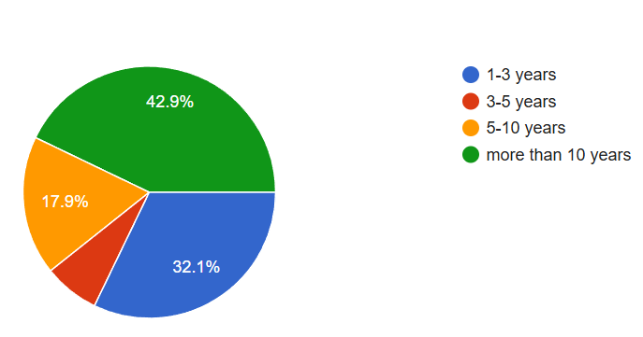

Figure 15 – Teaching experience of survey participants

The questionnaire included several questions about the professional background of the teachers, as mentioned above, as well as 12 Likert-type items about the role of teaching foreign-language pragmatics in the EFL classroom. Each item had five points, from “strongly agree” to “strongly disagree.”
The results of this preliminary study reveal a considerable gap between the what is considered the importance of pragmatic competence and actual teacher preparation programs in Kazakhstan's EFL context. This substantiates previous assumptions in the literature about the insufficient development of pragmatics in foreign language instruction (Kasper and Rose; Taguchi).
The analysis of the participants’ responses revealed that a significant majority of instructors (87.5%) have an understanding of the notion of pragmatics. This significant agreement illustrates the conceptual understanding of pragmatics in general; yet, this theoretical awareness is not applied in teaching instruction in the EFL classroom practically showing the theory-practice divide.
All participants agree that pragmatic competence is crucial for language learners and that instructors should teach and evaluate pragmatic skills in a classroom setting (100%). This supports the concept of Canale and Swain’s communicative model, which suggests the appropriate usage of language regarding the context as a core component of CC.
The following item addresses the teachability of pragmatics like grammar and other linguistic components. The majority of participants (92.8%) agreed that pragmatics can be effectively taught through a well-structured methodology, while a minority of participants (3.6%) opposed this idea. Although some scholars questioned the teachability of pragmatics in research literature (Kasper), the interventionist approach for the pragmatic instruction demonstrated otherwise: learners’ pragmatic comprehension and production can be enhanced by providing adequate pragmatic input and explicit instruction [298-300]. Consequently, the positive responses from the participants indicate their openness to such instructional changes if relative resources and teacher-training programs are provided.
The EFL teachers state that they received no instruction on separate SAs or pragmatic markers (85.7%), which shows the deficiency in foreign language teacher education lacking Speech Act theory, Politeness theory and ILP. This gap in teacher preparation demonstrates future foreign language teachers’ unpreparedness to raise learners’ pragmatic awareness and performance.
Additionally, they contended that assignments designed to enhance students’ pragmatic abilities were not implemented (84%). This demonstrates a gap in task-based learning. As Taguchi claims, tasks that simulate authentic contexts – such as role plays or discourse completion tasks (DCTs) – are effective to develop pragmatic ability [301]. The absence of such activities indicates that the curriculum is primarily focused on grammatical and lexical competence, which is likely influenced by traditional structuralist approaches that are still present in many EFL textbooks and practices.
Therefore, the majority of participants (87.5%) noted that classroom coursebooks lack the essential pragmatic knowledge for acceptable language usage and that the university library only had a few supplementary materials. Several research studies conducted by Nu and Murray, Ren and Han, Vellenga have already revealed this underrepresentation of pragmatic-oriented input and awareness-raising activities in library books and textbooks. The pedagogical input problem is a critical barrier to pragmatic instruction, since many teachers rely mostly on coursebooks and textbooks [91].
Nonetheless, EFL teachers try to provide students corrective feedback on their pragmatic mistakes based on their instinctive pragmatic awareness. Nipaspong asserts that providing corrective feedback in pragmatics facilitates foreign language learners’ adoption of native-like politeness and socio-cultural norms. [302].
Almost all participants are confident in the abilities of non-native instructors to teach pragmatics which undermines the notion that only native English-speaking teachers can instruct pragmatics [303]. However, later scholars (e.g., Ishihara and Cohen; McConachy; Taguchi) have demonstrated that pragmatic instruction depends on pedagogical competence and intercultural awareness rather than linguistic nativeness.
Moreover, all the respondents underline the value of workshops in enhancing their pragmatic awareness. As Ishihara has suggested, teacher training that integrates pragmatic theory and practice can substantially improve both learner outcomes and teacher confidence [93].
The findings demonstrate that while many teachers recognize the importance of pragmatics for communicative competence, they had little exposure to theoretical frameworks or practical strategies for teaching pragmatics throughout their training. Consequently, pragmatic elements including SAs, politeness strategies, and sociocultural norms are frequently inadequately addressed in classroom education. This aligns with global trends observed in developing EFL contexts but also underlines a particular opportunity for reform in Kazakhstani teacher education. The disparity between awareness and action in pragmatic competence development can be effectively addressed by incorporating explicit instruction, pragmatic theory, and task-based pedagogy, as well as providing in-service training.
In addition to the underrepresentation of pragmatics, as previously stated, EFL learners face significant challenges in accessing authentic pragmatic language input. As a result, it is not unexpected that even competent Kazakhstani English speakers lack adequate pragmatic ability. Fortunately, technology provides a range of tools that can extend pragmatics instruction beyond the boundaries of traditional classrooms and enhance the amount of high-quality input.
Integrating Web 2.0 technologies into teaching and learning is crucial for teachers to keep pace with students ("digital natives" (Thorpe) [304], “Net generation” Jones et al., who view technology as an integral part of their everyday activities [305].
Educational technology may enhance and transform students’ learning. There are several varieties and branches of educational technology used worldwide. As an illustration, distance learning encompasses e-learning, web-based learning, digital learning, and other similar approaches. Classroom technology has become crucial for regular learning activities. Additionally, the integration of high-tech tools into classroom activities, such as facilitating group learning and content review, has been made possible by technological advancements. Multidimensional education, an emerging paradigm, allows students to learn in both classroom and home contexts [306]. In class, students focus on practice or one-on-one learning. At home, they can utilize online resources like Quizlet, Quizizz, or Google Forms for self-diagnosis and study [307].
Despite the potential of Web 2.0 technologies, which may be utilized in both traditional and online or blended learning settings, there remain barriers to their effective and optimum application. Therefore, it is necessary to conduct a comprehensive analysis of this issue to provide systematic suggestions that will enhance the effective incorporation of Web 2.0 technologies into traditional educational settings.
In addition to identifying students’ use of Web 2.0 technologies, a diagnostic survey was conducted to examine patterns of Web 2.0 integration among both future English teachers (students) and practicing English language teachers. The survey aimed to determine the frequency of Web 2.0 use in instruction, participants’ attitudes toward these tools, their awareness of pedagogical advantages, and their readiness to adapt Web 2.0 technologies for instructional purposes [308].
The survey was administered to 202 undergraduate students (1st-4th year) of the Faculty of Foreign Languages at Karaganda National Research University named after academician Ye.A. Buketov and 158 English language teachers using the Google Forms online platform. The questionnaire included both open-ended (questions that required a thorough response) and closed-ended questions, designed to ascertain the specific educational platforms and Web 2.0 tools that students utilize in their learning, assess their comprehension of the potential of Web 2.0 tools, and evaluate the level of knowledge and experience language teachers possess in utilizing these tools in a systematic manner when teaching foreign languages [308].
Figure 16 shows that both students and English language teachers have mostly positive attitudes toward Web 2.0 technologies (85% and 76%, respectively. However, their actual frequency of pedagogical application remains limited (30% among students and 34% among teachers). Moreover, while students display a high level of readiness and adaptability to digital tools (90%), teachers report substantially lower readiness indicators (41%), suggesting existing constraints related to methodological training and practical experience with technology-enhanced instruction.
Despite the widespread use of accessible technologies such as Zoom, YouTube, and institutional platforms, their implementation is largely superficial and oriented toward information delivery rather than interactive and pragmatically focused instruction. These results correspond with the findings of Shelestova and Maryshkina [309], who report that Kazakhstani students tend to favor passive forms of digital input due to insufficient methodological support.
Students’ preferences for podcasts and blogs reflect a learner-driven inclination toward asynchronous and individualized learning formats, which aligns with Lai’s emphasis on learner autonomy in digital EFL environments [310]. At the same time, the limited selection of wikis and student-generated content reveals gaps in digital literacy and collaborative task design. This tendency is consistent with the conclusions of Gacs, Goertler, and Spasova, as well as recent reviews of online language teaching by Tao et al., which highlight “the importance of continuous teacher involvement for the successful implementation of task-based Web 2.0 activities” [311].
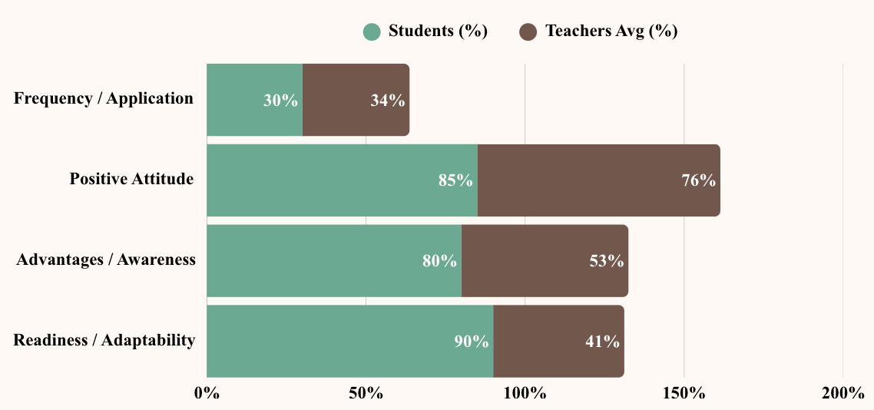

Figure 16 – Diagnostic survey on Web 2.0 use among future teachers (n=202) and English language teachers (n=158)

Participants also identified several advantages of Web 2.0 technologies in the learning process, including the development of professional competencies (42.1%), access to up-to-date instructional content (42.1%), expansion of general knowledge (38.6%), diversity of task formats (32.2%), opportunities for interaction with course participants (30.2%), and the development of communicative competence (16.8%) [308]. Alongside these benefits, respondents noted challenges such as limited Internet access and insufficient skills in using Web 2.0 technologies effectively.
Overall, the survey results reveal a lack of systematic and pedagogically grounded integration of Web 2.0 technologies for communication practice, particularly in the domain of pragmatics. While both students and teachers demonstrate positive attitudes toward digital tools, the gap between awareness and consistent instructional use underscores the need for targeted methodological support.
Taken together, the findings of the diagnostic surveys established a solid empirical basis for the experimental design and revealed two key gaps: (1) insufficient attention to pragmatic instruction in the professional preparation of future English teachers and (2) the limited and unsystematic use of Web 2.0 technologies for pragmatic competence development. These findings provided justification for the development of a focused experimental model integrating Web 2.0 tools into pragmatic instruction.
Consequently, we attempted to design and deliver targeted instructional lectures aimed at promoting the integration of open educational resources, including Web 2.0 technologies, into EFL classrooms to future language instructors to illustrate their potential use in a two-month doctoral pedagogical practice. To accomplish our objective, we engaged the future teachers of foreign languages from master students’ group at the Faculty of Foreign Languages of Karaganda National Reasearch University. The lectures on the subject of “Digitalization of foreign language education” included introduction to several Web 2.0 technologies (e.g. Google sites, Nearpod, Quizlet, Padlet, Wheel of names etc.) and illustrated step-by-step directions for their use in EFL classrooms. The selection of either tool is determined exclusively by the teacher's preferences and the objectives of the course [308].
The above-mentioned Web 2.0 tools, which are only a tiny portion of what we were able to introduce in the short duration of our experimental practice, may be incorporated by foreign language teachers into traditional instruction in a variety of ways:
- integration of Web 2.0 into the classroom to facilitate group work on interactive whiteboards;
- utilization of ICT in computer laboratories to organize lessons;
- providing adequate authentic input;
- development of online homework assignments;
- integration of social networks and Internet platforms to facilitate communication and transmission of educational materials, assignment feedback, and other pertinent information;
- transitioning individual formative assessments to an electronic format.
These experiences motivated prospective EFL teachers to consider themselves curators of digital learning environments who promote pragmatic awareness through contextualized, technology-enhanced activities, validating the significance of connectivist frameworks.
Thus, using Web 2.0 technology, a language learning environment is built in which students participate in the educational process by extracting and generating information. These technologies have a tremendous potential for helping students build and develop the required language abilities. It is also a learning format for staying current in the modern world. The majority of university students express a desire for the incorporation of various ICT formats in foreign language classes [308].
“Web 2.0- supported instruction fosters a dynamic learning environment by broadening access to learning resources, improving instructional effectiveness, and encouraging continuous skill development. Research by Salehi and Salehi further indicates that web-based technologies promote a shift toward learner-centered instruction, enabling students to more fully realize their learning potential” [312]. The authors argue that ICT technologies and current teaching methods have similarities in promoting communication and engagement in classrooms, hence improving education globally.
Recent studies demonstrate that the integration of Web 2.0 technologies in higher education positively affects learning outcomes. Research by Nasr and Kara shows that “Web 2.0-supported instruction enhances students’ academic performance and English language proficiency, highlighting its pedagogical value for teacher education and professional development” [313-314].
Technology has provided new possibilities for teaching and practicing pragmatics as well. For example, videotapes of naturalistic interactions can be a useful tool for the explicit instruction of pragmatics. Recently, computer-assisted language learning has expanded the opportunities for teaching and learning pragmatics. Taguchi suggests that social networking and virtual platforms might facilitate pragmatic practice [37]. In the same vein, the World Wide Web and the Internet have facilitated the teaching and learning of pragmatics.
Web-based tools might potentially serve as a method for delivering foreign-language pragmatic instruction. The utilization of web-based learning materials offers several benefits, including the opportunity for meaningful interaction and the use of authentic materials. Digital learning environments supported by Web 2.0 technologies enable sustained engagement with authentic pragmatic input and varied discourse practices, while also allowing instructors to observe and evaluate learners’ pragmatic growth and the outcomes of instructional intervention [209]. From this perspective, interactive platforms such as Nearpod, Moodle, and Flip offer favorable conditions for both the instruction and development of pragmatic competence in foreign language education [315].
Currently, pragmatic aspects of English language teaching remain underemphasized in Kazakhstani higher education system. Disregarding the pragmatic aspect of communicating in a foreign language, results in learners lacking the necessary skills to effectively use them in real-life communication situations. This involves recognizing speakers’ intentions, participants’ social roles, and relevant social, pragmatic, and linguistic cues.
The study’s content is formed of ideas derived from aforementioned two pre-experimental surveys on the role of pragmatics in the EFL teacher preparation program and the possibilities of Web 2.0 technology. Web 2.0 tools facilitate providing adequate pragmatic awareness-raising input and the delivery of pragmatic instruction.
Pragmatics teaching materials should cover three major elements: social context, language usage, and interaction. To effectively teach pragmatics, teachers should use creative methods such as awareness-raising tasks, audio-visual materials, and interviews to increase students’ knowledge of cultural differences. Similarly, in his work, Taguchi has suggested three categories of activities that should be incorporated into pragmatics materials: tasks that raise awareness, tasks that focus on receptive skills, and tasks that focus on productive skills [37]. Ishihara and Cohen proposed that pragmatic learners must focus on the language forms and the pertinent factors that influence the forms in the given context [9]. This approach exposes learners to contextualized input, which subsequently facilitates the acquisition of pragmatics. Additionally, they emphasized the positive impact of audio-visual materials such as movies with realistic settings on activating learners’ stimuli, attention and emotional reaction. According to Song and Liu [316] and Rustambekovna [317], video excerpts from movies may teach students about discourse and cultural variations in conversations.
The current study strategically incorporates various Web 2.0 tools into the instructional design to support the development of future English teachers’ pragmatic competence. Throughout the study period, these tools performed a range of functions, including platforms for delivery instruction and content, sources of authentic input, and tools for evaluation and feedback (see fig.17)

Web 2.0 Tools in Use
Delivery platform

- Nearpod (lesson flow)
- Flip (tasks)
- Padlet (tasks/posts)
- Collaborate Board (posts)
Authentic input

- Youtube (video SAs)
- Flip (video analysis)

Assessment and feedback

- Nearpod reports

Figure 17 – Multifunctional use of Web 2.0 tools in FL pragmatic instruction

During the preliminary phase of the project, an original course was created employing the Nearpod platform with a specific focus on the professional training of future English teachers, aimed at enhancing the understanding and production of key English SAs and conversational implicatures within pedagogically relevant and everyday communicative contexts. The course was named: “English in Context: Communicating with Pragmatic Awareness”.
Each of the 25 interactive classes in the course addressed a distinct pragmatic aspect. Every lesson had video content, explicit instruction, guided activities, self-assessment tests, and reflection questions. The lessons aimed to develop students’ abilities as language users and future teachers, emphasizing the need for both pragmatic application and analytical reflection on teaching pragmatic norms in classroom interactions.
The Nearpod-based course was designed and implemented with several Web 2.0 tools systematically integrated to augment learner engagement and foster the development of pragmatic competence. Canva was employed to design visually organized and pedagogically sound teaching slides, which were integrated into Nearpod courses to enhance understanding of speech act theory and associated pragmatic elements. Authentic input was provided by including interactive YouTube videos, which allowed students to view and analyze real-life examples of SAs in context. Students were able to engage in peer interaction through comments and feedback and share their responses to discourse scenarios through Nearpod's Collaborate Board feature, thereby promoting collaborative meaning-making. The Flip platform was employed to enable students to practice and present pragmatic SAs in a personalized, low-pressure setting through asynchronous video responses. Additionally, the Nearpod Toolbox, which incorporates quizzes, polls, audio recordings, matching tasks, and many others, was implemented to facilitate formative assessment and ensure ongoing engagement with the course content. The purposeful incorporation of these Web 2.0 tools enhanced the course’s multimodal and interactive design, coinciding with the educational objectives of developing pragmatic awareness and pedagogical reflection in future English teachers, enabling them to transfer pragmatic knowledge to their prospective teaching practice.
The teaching materials comprise a comprehensive Nearpod-based course designed for intermediate A2-B2 university-level EFL learners enrolled in teacher training programs, with a specific emphasis on forming pragmatic competence relevant to future English language teaching. It consists of 8 units that address the main pragmatic aspects. These units have been adapted from the teaching SAs procedure developed by Bardovi-Harlig, Eslami and Liu, Uso-Juan, Vasquez, Ishihara, Taguchi, and Gonzalez Lloret [91, 318-321]. This platform provided speech act situations based on YouTube video clips and an explanation of the speech act taxonomy. Additionally, it was used in conjunction with video clips from YouTube chosen by the researcher, which included clips on how to perform polite SAs (BBC Learning English), clips on situational conversations, and movie fragments on contextual scenarios.
According to the literature review, SAs, particularly SAs of request, dominate technology-based instructions for pragmatic competence development. But the speech act is much more than this. Due to cultural diversity, it is difficult for NNSs to employ appropriate verbal utterances to perform various SAs in accordance with the varying cultural norms [322-323]. Ed-deraouy and Sana [324] further support this by observing that the delicate relationship between language and culture indicates that every phrase, word, and pause reflects the wider sociocultural context we live in. Consequently, this study should have broaden the scope of investigation to encompass other pragmatic aspects of SAs, including requesting, refusing, apologizing, complaining, complimenting, asking for and giving directions, thanking, and suggesting. These SAs were used in context-specific settings relevant to both professional and everyday communication, including teacher-student interactions, classroom management, feedback provision, instructional requests, pragmatic meaning clarification, and common interpersonal situations encountered in daily life.
When compiling a pragmatic awareness-raising course on the platform Nearpod, all the task types recommended by Taguchi, Ishihara and Cohen were included. It is based on learners’ need to learn pragmatics and how that learning would improve their ability to communicate, their pragmatics skills, and how they feel about digital learning:
- Tasks were scaffolded to facilitate comprehension prior to production.
- Sociopragmatic sensitivity was prioritized (when to say what and how).
- Form-focused noticing activities (e.g., polite structures) were incorporated into lessons.
- Subsequent production tasks were executed with Nearpod and Flip;
- Reflective tasks that encourage students to analyze pragmatic phenomena from a teacher’s perspective and consider strategies for teaching pragmatics explicitly in the EFL classroom.
The goal of the course was to use web-based strategy instruction to enhance students’ pragmatic competence and prepare future English teachers for explicit teaching of pragmatics, guiding them in complex pragmatic language usage that is hard to acquire naturally and promoting learning through the use of Web 2.0 tools.
General objectives of the course
The course aimed at developing students’:
- pragma-receptive skills;
- pragma-productive skills;
- attitudes towards digital learning.
A key rationale for developing the online course was to facilitate the integration of pragmatics into future teachers’ instructional practice by providing empirically grounded pragmatic materials, structured pedagogical guidance, and technology-enhanced instructional strategies. Unlike general EFL courses, the present course is oriented toward teacher education, aiming to reduce anxiety related to pragmatic competence and to equip future English teachers with practical tools for teaching pragmatics explicitly.
Methodological recommendations for language instructors on teaching pragmatics were developed alongside the course [325], and a study guide [326] was created to support teachers in implementing pragmatics-focused instruction. These materials were not designed as student manuals but as professional pedagogical resources, reinforcing the applied and teacher-oriented nature of the course. The course material was pilot-tested at Karaganda National Research University named after Ye.A. Buketov throughout the 2023-2024 academic year, ensuring adequate field testing for all assignments.
The course was based on digital learning and included explicit instruction, pragmatic input, pragmatic awareness-raising activities and pragmatic output. The following teaching methods were used throughout the course: communicative, role-play, forums, and technology-based language teaching.
The course contains 27 lessons: 2 of them – pre- and post-tests, 13 of them – interactive lessons with an instructor and 12 homework lessons (Figure 18).

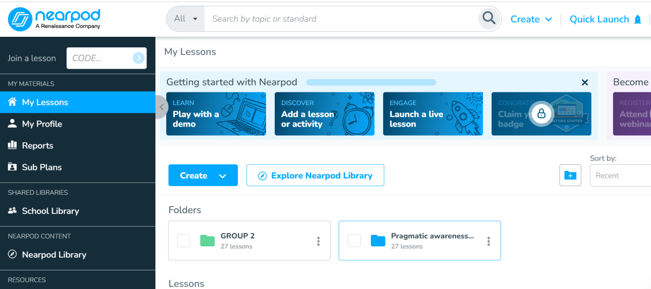

Figure 18 – Course interface

Content of the course:

1. Pre-test
2. Lesson 1: Overview
3. Lesson 2: Requests (https://app.nearpod.com/?pin=C3DC18A095ED0CE5F20B3DA203688612-1andandutm_source=link)
4. Lesson 2: Hometask
5. Lesson 3: Requests Part 2 (https://app.nearpod.com/?pin=5B227A84948F4B21A876879E3C9D4A73-1andandutm_source=link)
6. Lesson 3: Hometask
7. Lesson 4. Refusals
8. Lesson 4: Hometask
9. Lesson 5. Refusals Part 2
10. Lesson 5: Hometask
11. Lesson 6: Apology
12. Lesson 6: Hometask
13. Lesson 7: Apology Part 2
14. Lesson 7: Hometask
15. Lesson 8: Complaints
16. Lesson 8: Hometask
17. Lesson 9: Compliments
18. Lesson 9: Hometask
19. Lesson 10: Asking for and giving directions
20. Lesson 10: Hometask
21. Lesson 11: Speech act of gratitude
22. Lesson 11: Hometask
23. Lesson 12: Suggestions
24. Lesson 12: Hometask
25. Lesson 13: Implicatures
26. Lesson 13: Hometask
27. Post-test

This course is designed for one academic year. The program was aimed at improving the pragmatic competence of future English teachers by including both universal (general) and professionally oriented (teacher-specific) pragmatic elements. The SAs were chosen based on their relevance to teaching, classroom communication, and the many situations future teachers may encounter in both everyday and professional settings.
The program contains eight key SAs that have long been recognized in ILP research: requests, refusals, apologies, complaints, compliments, asking for and giving directions, expressions of gratitude, and recommendations, as well as conversational implicatures. Each speech act is accompanied by various pragmalinguistic markers (hedges, softeners, discourse markers, mitigation devices, boosters, and supportive moves), which represent the universal layer of pragmatic competence required for effective interpersonal communication. These elements are essential for future English teachers who must demonstrate appropriate sociopragmatic and pragmalinguistic awareness in multilingual and multicultural contexts.
Unlike other professional fields (law, diplomacy, medicine, business), where pragmatics primarily concerns negotiation, persuasion, conflict resolution or professional consultations, teacher pragmatics is situated within the pedagogical discourse and is central to sustaining classroom interaction, providing instructions, managing student behavior, supporting motivation, giving feedback, and ensuring a positive learning environment.
Therefore, all components of the course were structured around both universal (everyday) speech-act scenarios and classroom-specific teacher-student interactions, ensuring that the chosen content aligns with the authentic communicative needs of future English teachers.
The initial session of the experimental course (“Lesson 1: Overview”) (https://app.nearpod.com/?pin=68566D4D9D4398048BAE04AC65B77A60-1andandutm_source=link) lays the conceptual foundation essential for forming the pragmatic competence of future English teachers (Figure 19). The course, while addressing universal pragmatic concepts like SAs, implicatures, and pragmatic markers, also frames them within the specific communication contexts often found in foreign language education. This dual perspective enables students to understand how general pragmatic knowledge functions within the professional discourse of the classroom.

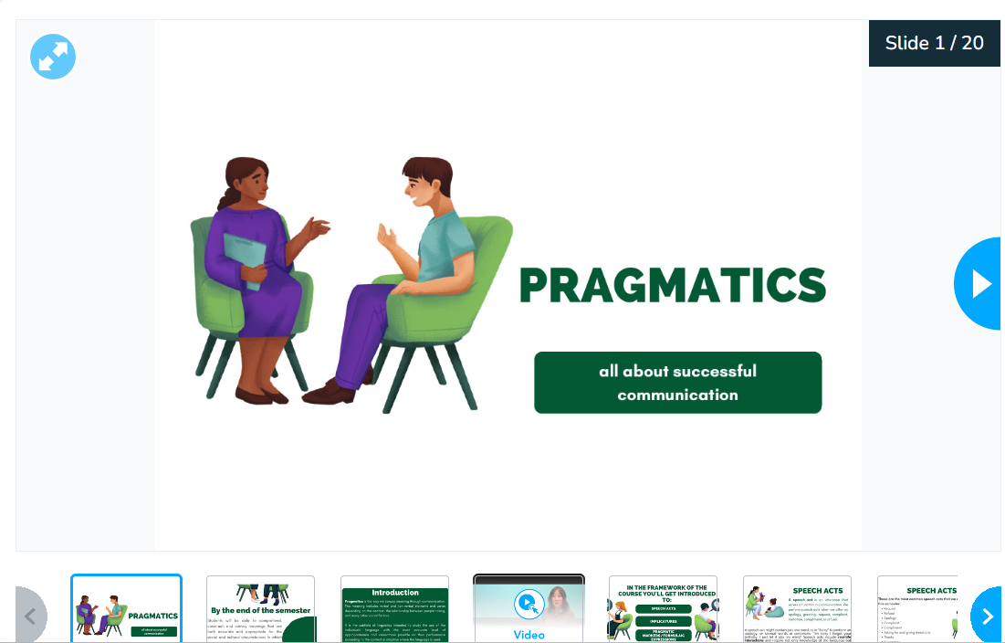

Figure 19 – Overview lesson (a)

To provide a theoretical grounding for these concepts, learners may observe a video extract of Dr. Dale Koike’s lecture “Introduction to the Pragmatics Module”, who is a professor of Spanish and Portuguese linguistics at the University of Texas at Austin, and specializes in pragmatics and discourse analysis, and second language acquisition (Figure 20).

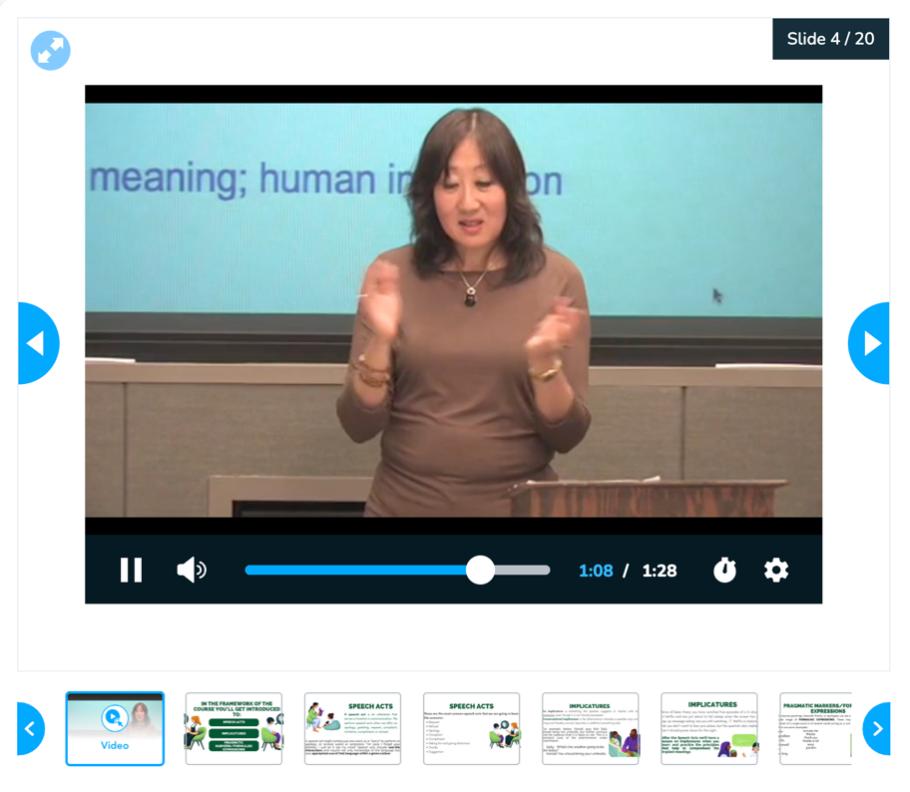

Figure 20 – Overview lesson (b)
The lesson establishes expected outcomes, focusing on future teachers’ ability to interpret and express meaning appropriately in English across contexts.
Following the theoretical overview, the lesson outlines the course structure and its key pragmatic focus areas to be developed through Web 2.0-supported activities.
The Overview Lesson also introduces learners to the course structure, the digital platforms utilized throughout the semester, and the multimodal evaluation and homework formats that help them develop pragmatic competence.
Nearpod is the main platform where all lessons were generated; the rest of the tools used throughout the study such as Canva, YouTube, podcasting, collaborate board, Flip are already integrated into Nearpod (Figure 21).

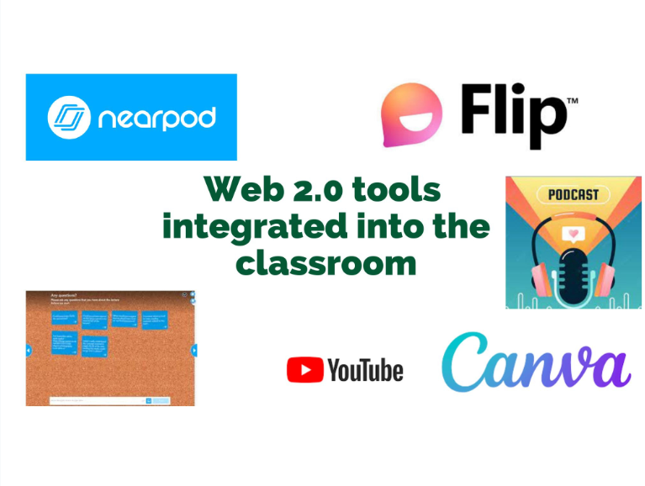

Figure 21 – Web 2.0 tools embedded into classroom

This lesson also offers concise technical guidance on using the Web 2.0 tools integrated into the curriculum, accompanied by video instructions. The Lesson Overview ends with the assessment rubrics, which explain the criteria that will be used to evaluate student success in the practical modules.
The rest of the lessons are dedicated to the most investigated SAs: requests, refusals, apologies, complaints, compliments, asking for and giving directions, gratitude, suggestions, and conversational implicatures.
Pragmatic scholars argue that “language instructors in EFL classrooms should fulfill three functions or conditions for teaching foreign-language pragmatics. These involve a) the provision of targeted pragmatic input to foster learners’ awareness, b) the creation of authentic contexts for the application of pragmatic knowledge, and c) the systematic delivery of feedback on learners’ pragmatic language production” [327]. In simpler terms, it is considered essential for foreign-language pragmatic teaching and learning to have sufficient and contextually appropriate input, opportunities for practice, and corrective feedback [327].
The following essential components should be included in foreign-language pragmatics instruction to assure the effective formation of pragmatic competence in future English teachers:
1. Pragmatic awareness-raising input
- Authentic, context-rich language use (e.g., video dialogues, interactions with native speakers)
- Analysis of SAs, politeness tactics, and sociocultural factors
2. Meta-pragmatic knowledge:
- Explicit instruction in pragmalinguistics (linguistic means to conduct SAs)
- Sociopragmatics (the social conventions and norms that dictate appropriateness)
3. Practice and production
- role-play activities and discourse completion tasks;
- practice of SAs in different communicative contexts (e.g., formal vs. informal situations and varying power relations).
4. Reflection and Evaluation:
- Use pragmatic-focused rubrics for peer and instructor feedback.
- Provided guidance on propriety, tone, and sociocultural fit.
These elements correspond with the findings of Kasper and Rose [6], Taguchi [56], and Roever [328], who emphasize the necessity of integrating explicit instruction with interactive, contextualized practice to enhance the development of pragmatic competence.
These lessons are structured according to the proposed algorithm (Table 8):
1. A warm-up stage;
2. Pragmatic instruction;
3. A pragmatic consciousness-raising stage;
4. Practice in producing output as well as comprehension;
5. Self-evaluation and immediate feedback.

Table 8 – The suggested algorithm of pragmatic instruction

Lesson stage | Purpose | Web 2.0 tool integrated | Learning outcome(s) supported
1 | 2 | 3 | 4
Warm-up stage | Activating background knowledge; introducing SAs through everyday triggers and selected classroom-oriented examples | Canva (in Nearpod) + YouTube | Raised sociopragmatic awareness; noticing L1–FL differences
Pragmatic instruction | Explicit explanation of pragmatic forms, polite and natural-sounding strategies (mitigation, softening), and core pragmatic markers; establishing functional purposes of the target speech act or implicatures | Nearpod slides (Canva-based), YouTube videos | Acquisition of explicit pragmalinguistic and sociopragmatic knowledge
Continuation of Table 8
1 | 2 | 3 | 4
Pragmatic awareness-raising input | Comparative analysis of appropriate/inappropriate pragmatic forms in everyday communication and classroom-embedded exchanges; recognition of implicature | YouTube videos, Nearpod Matching, Fill-in-the-Blank, Collaborate Board | Improved ability to identify appropriate vs. inappropriate pragmatic choices
Practice and production | Guided production tasks requiring performance of the target speech act across everyday and classroom situations (DCTs, role-plays, micro-simulations) | Flip (video responses), Nearpod Open-Ended, Voice Recording, Collaborate Board for peer feedback | Accurate production of SAs; appropriate tone/register adjustment
Reflection and evaluation/feedback | Reflection on pragmatic choices; identification of successful and problematic instances of pragmatic behavior in both general and classroom contexts; peer and instructor feedback | Nearpod Quizzes, Collaborate Board comments/likes, Flip (reflective video), Instructor classroom feedback | Development of metapragmatic awareness and professional self-monitoring skills

The warm-up stage is the first part of the intervention and is designed to activate learners’ prior understanding of SAs, especially variations between their L1 and FL pragmatic patterns. The goal was to encourage interest in the specific speech act and to provide an accessible gateway to the following teaching activities. Visual prompts designed in Canva were integrated into Nearpod to facilitate discussion, while polls and open-ended questions were employed to draw out initial intuitions regarding appropriateness and strategies in specific L1 and FL contexts. In several classes, short YouTube videos were utilized to demonstrate culturally diverse cases, pushing students to reflect on various pragmatic norms. Although the warm-up activities were based on general communication scenarios, many of the prompts naturally reflected interaction patterns commonly found in language learning. This helped students develop first connections to the teaching methods used. This stage encouraged emotive engagement and provided a meaningful context for the instruction (see Figure 22).
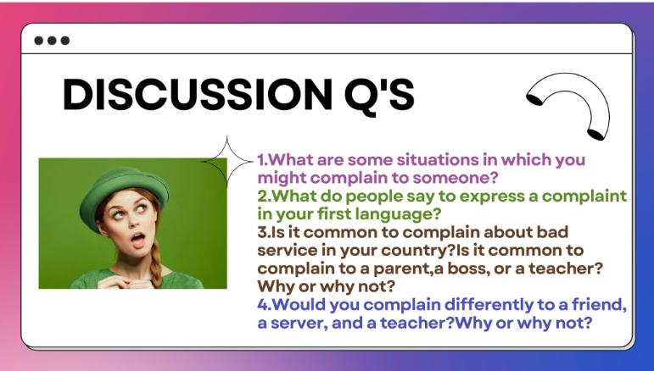

Figure 22 – A warm-up stage

The pragmatic instruction stage (Figures 23, 24) provided explicit guidance on the structure, communicative function, and multicultural diversity of target SAs and implicatures. At this stage, students were given detailed explanations of when and why a specific speech act is performed, as well as the linguistic resources – such as mitigation, softening, and pragmatic markers – that shape polite and natural-sounding English production. In addition to the schematic explanations, short video instructions were included to show real-world examples of application in different cultural and communication settings.



Figure 23 – Pragmatic instruction stage (a)

The instructional material was delivered through Nearpod presentations that integrated Canva-based visuals, model dialogues, and authentic interaction samples. These examples allowed students to see how pragmatic forms work in both general communicative settings and scenarios relevant to language learning environments, preparing them for the upcoming analysis and production tasks. During this stage, learners acquired explicit pragmalinguistic and sociopragmatic knowledge, establishing a strong basis for awareness-raising and practice activities in the subsequent phases.

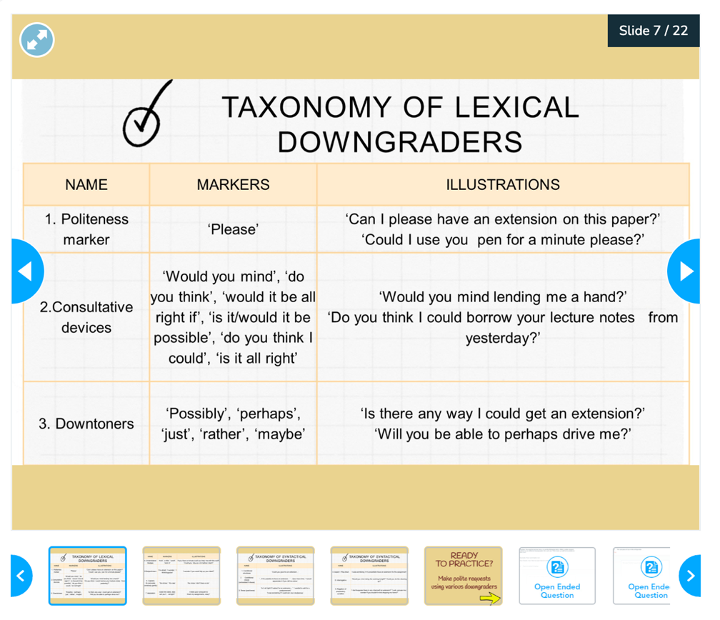

Figure 24 – Pragmatic instruction stage (b)

During the third stage, the learners were exposed to authentic language scenarios illustrating the target SAs to raise their pragmatic awareness (Figure 25). At this stage, participants were instructed to work individually, in pairs or in small groups to identify the pragmalinguistic forms, sociopragmatic variables (such as imposition size, social distance, and power), and types of strategies that impact the appropriateness of speech act realization. The input examples included both everyday conversational exchanges and sample interactions relevant to language learning environments, enabling students to observe how pragmatic strategies shift depending on context.
“The awareness-raising stage was based on the recognized assumption that contextually rich and sufficient input is a key condition for developing foreign-language pragmatic competence” [327, 329]. Drawing on insights from speech act theory, the materials demonstrated how language functions as a sequence of communicative actions shaped by social and cultural expectations. Through engagement with model dialogues, authentic video segments, and naturally occurring interactions, learners were guided to observe strategies employed, levels of directness, mitigation patterns, and cultural variations.
The awareness-raising activities also matched existing recommendations in ILP research (Rose; Taguchi), which emphasized the importance of explicitly focusing on pragmatic aspects [330] and using relevant, context-based examples [37]. In accordance with these principles, students compared appropriate and inappropriate realizations of SAs, explored potential misconceptions, and assessed the communicative impact of various linguistic choices. These activities set the groundwork for informed and context-sensitive production in the following practice stage.
At this stage, attention was given to cultural aspects of language use, as pragmatic competence involves awareness of culturally grounded norms. Following Kasper and Rose [6], cross-cultural comparisons and brief reflective tasks were included to illustrate variation in speech-act realization across communities.

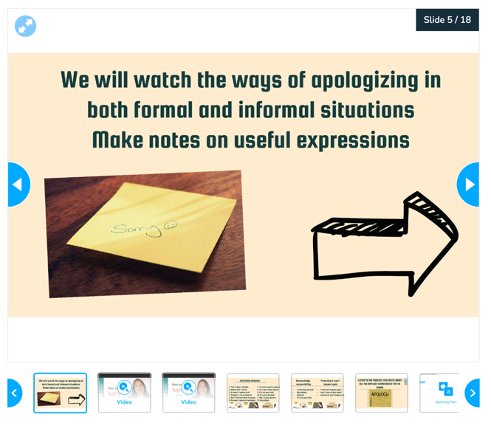

Figure 25 – Authentic input stage

After the explicit instruction and awareness-raising stages, the next stage involves practicing both producing pragmatic output and pragmatic comprehension by various communicative activities (Figure 23). At this stage students were expected to perform tasks for both pragmatic comprehension and production applying previously analyzed pragmatic input through the use of Web 2.0 tools. The activities aimed at the accurate performance of SAs across various situations, assisting students in consolidating their understanding of form, function, and appropriateness.
The practice and production stage was the most important part of the intervention, during which learners utilized previously acquired pragmatic knowledge within controlled yet progressively authentic communicative contexts. Building upon the explicit instructions and awareness-raising activities of preceding stages, this stage required learners to demonstrate both pragma-comprehensive and pragma-productive skills through a variety of task formats completely integrated within the Nearpod platform. These tasks were intended to support learners in understanding and using context-appropriate SAs, mitigation forms, and pragmatic markers (Table 9).

Table 9. Course tasks types and their delivery Web 2.0 tool

Task type | Description | Delivery Web 2.0 tool | Pragmatic competence
1 | 2 | 3 | 4
Oral discourse completion tasks (ODCT) | Open-ended questions that require oral response for the given SA situation (response may be given face to face or through the audio recording). | Nearpod | Pragma-productive skill
Written discourse completion tasks (WDCT) | Open-ended questions that require responses in written form for the given situation. | Nearpod | Pragma-productive skill
Interactive video | Interactive video enables instructors to incorporate formative assessments at pre-established intersections within a video. Teachers have the ability to incorporate a Multiple-Choice Question or an Open-Ended Question into any video they include in their lesson. This may be done by either adding a video from YouTube, uploading their own video, or selecting a video from the Nearpod collection. | Nearpod+YouTube | Pragma-comprehensive/pragma-productive skills
Quiz | With a Quiz, teachers may incorporate multiple-choice questions into their Nearpod lessons. Quizzes are auto-graded, so the instructor will know right away what learners understand and may discuss the results with them in real time. | Nearpod | Pragma-comprehensive skill
Poll | Poll activities enable teachers to assess comprehension, conduct a class vote, emphasize student viewpoints, and more by asking multiple choice questions with no correct answer. According to the course objective, this activity was used to assess the appropriateness of pragmatic language in the given situation. | Nearpod | Pragma-comprehensive skill
Draw it | The Draw It allows students to reply to a prompt on a virtual canvas with drawings, text, photos, and video. Teachers can ask students to draw on a blank background or use the options provided in the Draw It toolbar to modify the background. | Nearpod | Pragma-productive skill
Continuation of Table 9
1 | 2 | 3 | 4
Drag and drop | Drag and Drop is an interactive activity in which students may sort or organize images and text consecutively or in theme groupings. Teachers can apply a custom backdrop to draggable objects or upload their own diagram or graphic organizer for students to annotate. | Nearpod | Pragma-comprehensive skill
Matching pairs | When reaching to a Matching Pairs in a lesson, students click the cards they think correspond to the given pair. | Nearpod | Pragma-comprehensive skill
Video analysis | Recognition of a speech act or implicature on the video provided. Students are expected to pay attention to the pragmatic markers used and then discuss their appropriateness. | Nearpod+YouTube | Pragma-comprehensive skill
Podcast analysis | Recognition of a speech act or implicature on the podcast provided. Students are expected to pay attention to the pragmatic markers used and then discuss their appropriateness. | Nearpod+Podcasting | Pragma-comprehensive skill
Role-play | Role-plays are designed for two or a group of students. Students choose the roles from the given situation and perform as they are in that situation exactly practicing SAs. | Nearpod+Flip | Pragma-comprehensive skill
Collaborate board | Students may upload text and photos to a shared class board using Collaborate Board, an interactive discussion board. Students will be able to comment on each other's posts and "Like" posts of other students. | Nearpod+Collaborate board | Pragma-comprehensive/pragma-productive skills
Time to climb | Time to Climb is an innovative “game-like” activity from Nearpod that aims to increase student engagement and competition in the classroom while also evaluating their comprehension. Students will compete to reach the summit of the mountain within a specified time limit, all while completing multiple choice questions. | Nearpod | Pragma-comprehensive skill

As it is demonstrated in Table 9, a wide range of task types was implemented to ensure the formation of both receptive and productive pragmatic skills within the context of teacher training. Oral and written Discourse Completion Tasks (ODCTs/WDCTs) required learners as future English teachers to interpret and respond appropriately to situational cues, facilitating the analysis of sociopragmatic variables (power, distance, imposition) relevant to both classroom and everyday interaction and the selection of suitable linguistic strategies (Figures 26, 27). In addition, interactive video exercises, facilitated through Nearpod’s integrated YouTube feature, required learners to recognize pragmatic markers at key points of communication [331]. Such kind of task facilitated the active processing of authentic audiovisual input and corresponded with Lonergan’s argument concerning the pedagogical efficacy of active video viewing for conveying appropriateness [331, p. 45].

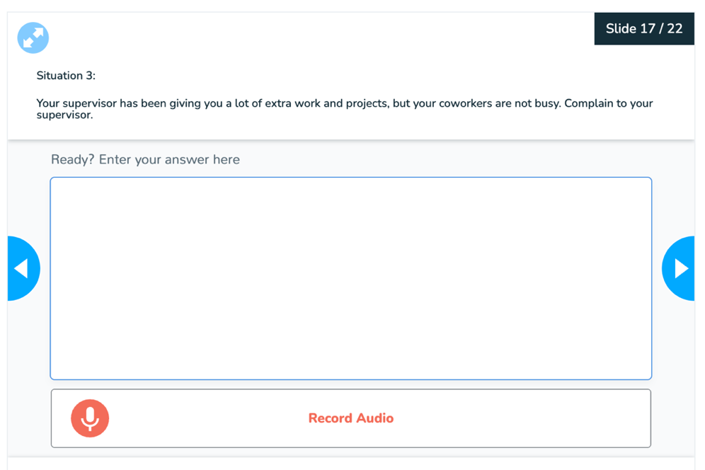

Figure 26 – Lesson: Complaint. ODCT

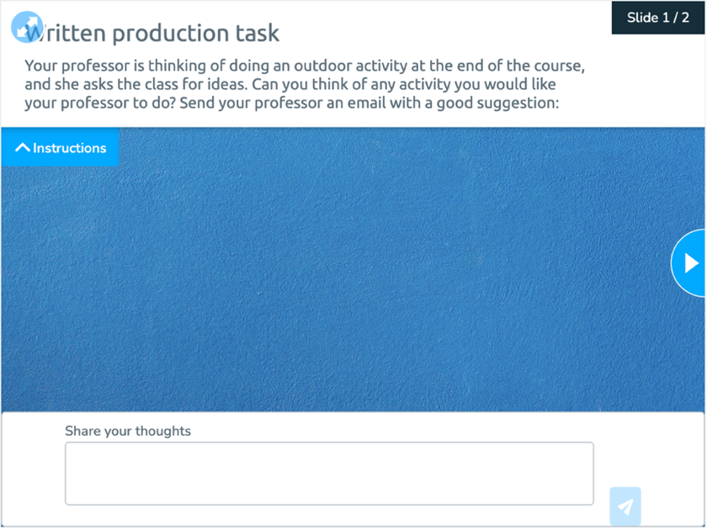

Figure 27 – Lesson: Suggestions. WDCT

Quiz, poll, matching pairs, drag-and-drop, and “Time to Climb” activities were designed to test pragma-comprehensive skills by encouraging learners to evaluate the appropriateness of pragmatic choices, distinguish between levels of directness, or identify implicit meanings (Figures 28, 29). These activities are based on the principle that significant repetition across diverse formats enhances pragmatic awareness [37]. “Draw It” tasks allowed students to visualize their interpretations of pragmatic scenarios, a method that facilitated more profound processing of position, tone, and communicative intent. Video and podcast analysis activities promoted a deeper understanding of pragmatic behavior by guiding students to assess speakers’ strategies, recognize softeners, and identify implicatures.

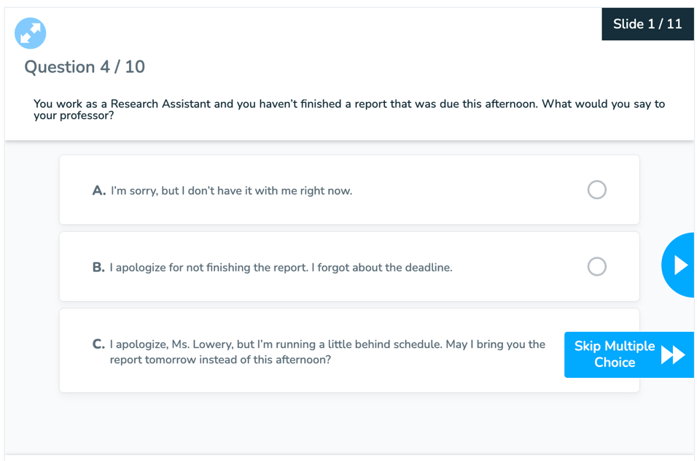

Figure 28 – Lesson: Apology. MDCT



Figure 29 – Lesson: Refusal. “Time to Climb” activity

Role-play activities, aligned with Bardovi-Harlig’s perspective on the effectiveness of simulated interaction, facilitated the contextualized production of SAs. In Nearpod-integrated Flip videos, Padlet videos or real-time classroom interactions, students acted out situations where they had to politely say no, complain about service, or give positive feedback, requesting a student for clarification, politely refusing an inappropriate request, apologizing for a misunderstanding, praising a student's work, or giving them suggestions during group work or collaborative learning tasks. These activities allowed students to practice the target pragmatic skills in both everyday and classroom situations.
This stage also included Think-Aloud (TA) Protocols, which were customized for Nearpod using the Open-Ended and Audio Recording tools (Figure 30). TA Protocols encouraged learners to verbalize their reasoning during critical decision-making moments, such as evaluating appropriateness, selecting mitigating strategies, or analyzing implicatures. Cognitive and ILP research (Timpe-Laughlin et al.; Bowles) emphasizes that concurrent verbal reports enhance the cultivation of metapragmatic awareness by rendering learners’ implicit reasoning explicit. Furthermore, this method offered teachers diagnostically significant insights into learners’ conceptualizations of pragmatic norms and the underlying cognitive strategies [332, 333].

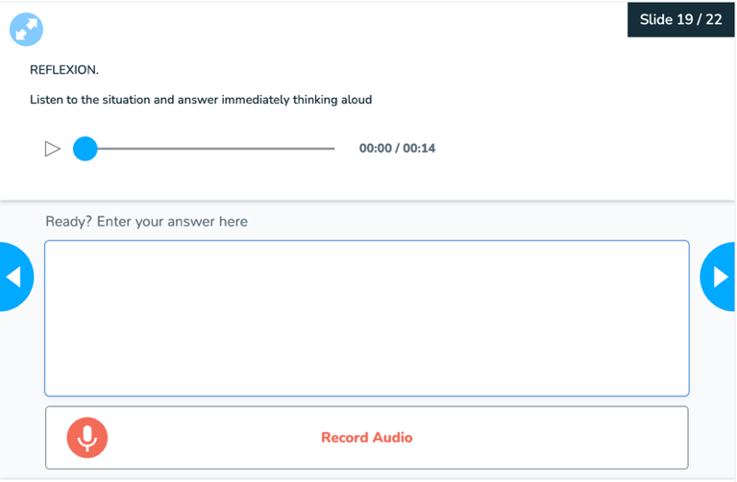

Figure 30 – Lesson: Refusals. TA protocol

Peer interaction, facilitated via the Nearpod Collaborate Board, further enhances effective pragmatic development. Students made responses, exchanged comments, and engaged in evaluative reflection, which is consistent with Vygotskian concepts of socially mediated learning and Bachman and Palmer’s emphasis on continuous, formative evaluation [334]. This peer-supported environment was crucial for building up pragmatic performance because it gave learners a chance to improve their tactics, compare their choices with those of their peers, and learn how to act more naturally in a pragmatic way.
Overall, the practice and production stages ensured that students completed repeated, varied, and context-rich pragmatic activities that reflected both everyday communication and academic-instructional exchanges. This integrative approach is in line with modern ILP frameworks that stress the need to combine explicit instruction, authentic input, guided practice, and formative feedback so that learners, especially future English teachers, can develop strong, transferable pragmatic skills that are needed in multilingual classrooms.
The final phase of Nearpod lessons is reflection, which provides learners with a chance to pause and evaluate their understanding of the material covered in a lesson or set of courses. At this stage, students identified aspects of the targeted SA or other pragmatic elements they found confusing or challenging and could request further assistance, instruction, practice, or support before progressing further.
Reflection activities encompassed a variety of formats, such as reflective writing, group discussions, learning portfolios, and presentations [335]. In the present course, such formats were implemented through quizzes, interactive video activities, video-based analysis, drag-and-drop tasks, polls, and form-comparison exercises, which allowed learners to assess pragmatic appropriateness and get immediate, targeted feedback on their choices. Aligned with the recommendations of Bachman and Palmer, the applied formative approaches enabled the systematic tracking of learners’ pragmatic progress and generated informative evidence regarding the development of their pragmatic understanding. Reflective tasks are presented at the end of each lesson to give the opportunity for students to reflect on studied material and evaluate their comprehension level of the target pragmatic element (Figure 31).
Through this integration of metacognitive reflection, peer-assisted assessment, and instructor-led feedback, the final phase enhanced learners’ metapragmatic awareness and further developed their capacity to make contextually appropriate pragmatic choices. This competence is especially important for future English teachers because reflective analysis serves as the foundation for modeling, explaining, and scaffolding pragmatic behavior in future classroom practice.

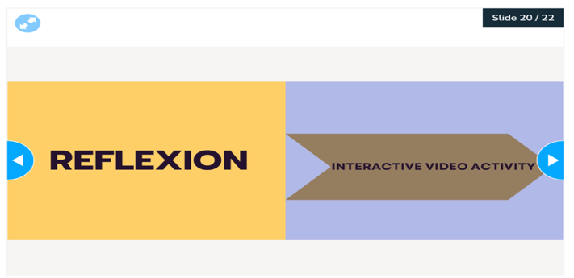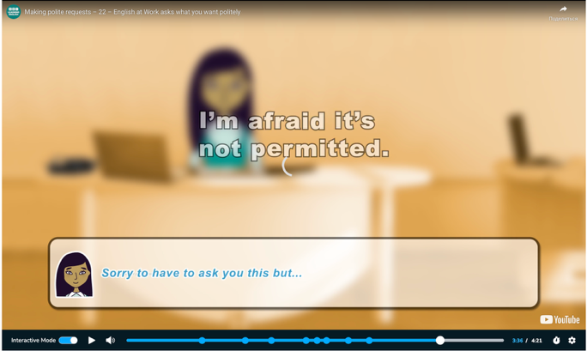
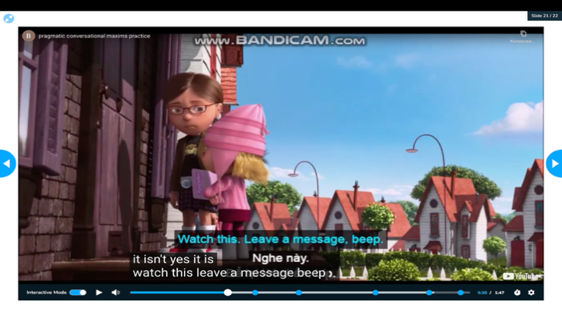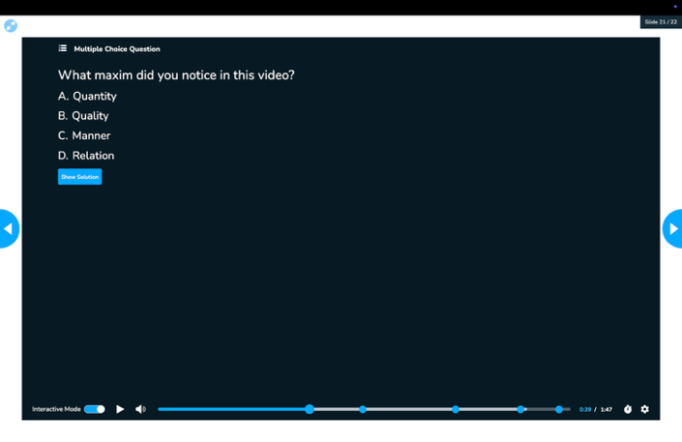

Figure 31 – Reflection stage

Each instructional cycle concluded with post-lesson homework, which was delivered via Web 2.0 applications such as Flip, Padlet, and Nearpod Collaborate Board, all embedded within the Nearpod ecosystem. These tasks were meant to make practical input stronger and stimulate independent thinking and production in real or almost real communication situations.
Flip task. Flip was employed to assign autonomous, video-recorded tasks in which learners demonstrated a specific speech act (e.g., making a request, issuing an apology, or declining an offer). These tasks required students to:
- act out a situation requiring a SA (request, refusal, apology etc.);
- demonstrate the use of appropriate language and strategies;
Even though Flip stopped working in 2024 because of problems with the platform, the tool worked very well during the experimental course to let people express themselves and contemplate themselves in other ways. Because it was asynchronous, it encouraged people to perform in their own way and adapt their pragmatic knowledge to different situations (Figure 32).

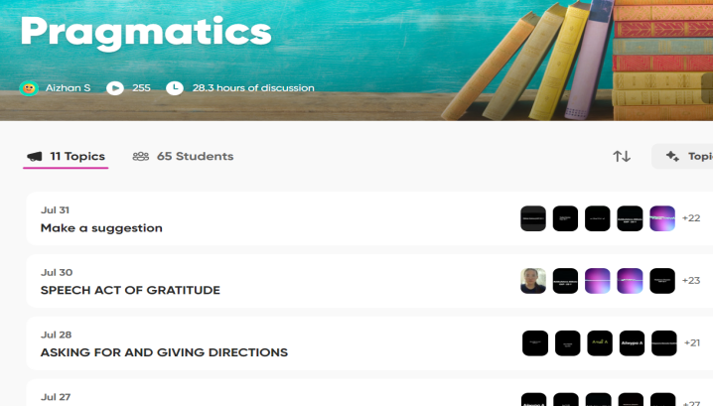

Figure 32 – Flip tasks

Padlet task. Padlet, an alternative to Flip, was tested with a subgroup of students to see if it could enable similar video-recording and peer-sharing features. Learners were requested to upload recordings that simulated interactions from various contexts, such as classroom-related compliments, student-teacher apologies, or cross-cultural refusals. Padlet’s easy-to-use and collaborative interface made it possible for students to keep working on real-world tasks outside of class, and the asynchronous format let students work at their own pace and think about what they learned. Although the experimental procedure concluded a year before, students demonstrated exceptional performance (Figure 33). The use of Padlet also promoted learner autonomy and responsibility for task completion. Moreover, peer contact via commentary and feedback facilitated a more profound engagement with the pragmatic aspects of language use. The platform also facilitated the development of reflective skills by enabling students to evaluate their own and their classmates' performances. In general, the results indicate that Padlet can be a valuable resource for expanding pragmatic practice beyond the walls of the classroom.
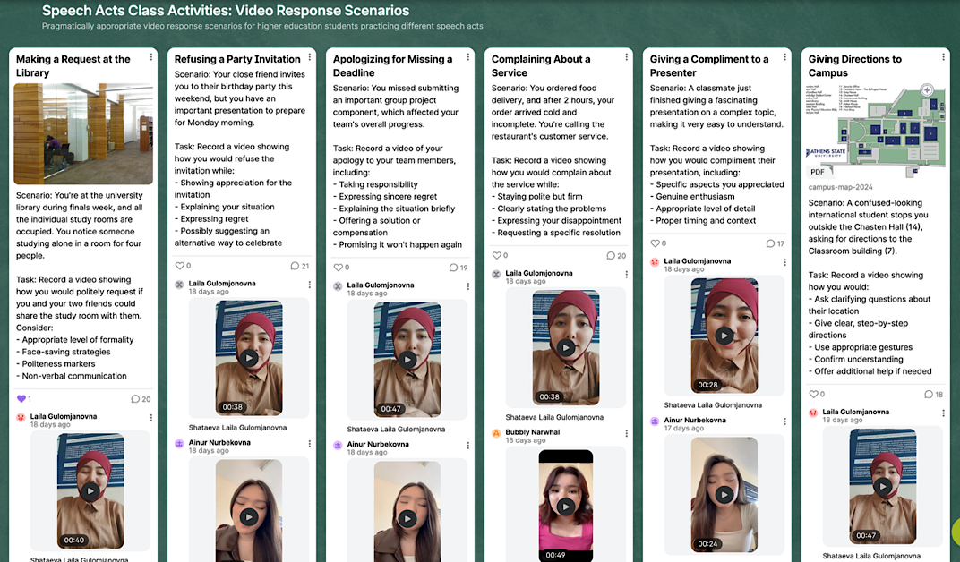

Figure 33 – Padlet task

Nearpod Collaborate Board. These activities featured short video situations that were incorporated into Nearpod, such as clips that showed appropriate or inappropriate examples of requests, refusals, or apologies. Participants were directed to evaluate the pragmatic appropriateness of the interaction and to post their reflections, evaluations, and recommendations on the Collaborate Board (Figure 34). Peer input was encouraged through comments and “likes,” which helped people improve their ability to make pragmatic judgments and think critically.

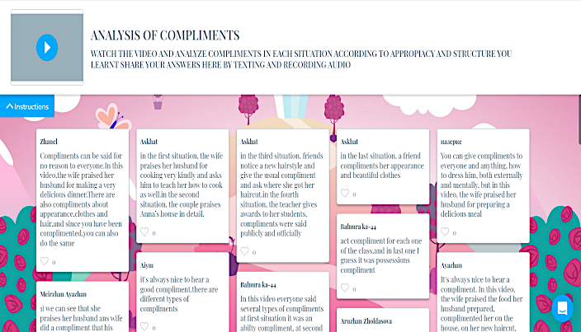

Figure 34 – Nearpod Collaborate Board task

Collectively, these asynchronous assignments aided the transfer of in-class input to real-world or simulated settings, improving both pragmatic production and pedagogical reasoning. Engaging realistic interaction and role-plays promote students’ ability to recognize a SA, detect pragmatic errors and make an appropriate choice of pragmatic markers, as well as reflect on how they would guide learners in addressing such issues in their own future classrooms.
Formative and summative assessments were used throughout the course to examine students’ growth of pragmatic awareness. Nearpod tools, including appropriateness rating tasks, collaborative discussions, and verbal responses via Flip and Padlet were employed to incorporate formative assessments into individual lessons. This approach enabled learners to assess and refine their pragmatic choices in context.
A pre-test and post-test design was employed for summative assessment to evaluate improvements in pragmatic competence. The assessments comprised multiple-choice questions and open-ended Discourse Completion Tasks (DCTs), which assessed learners’ ability to recognize and produce contextually appropriate SAs.
The first and the last Nearpod lessons are pre-test and post-test relatively. Both tests are the same; that is, they compare the results and effectiveness of the constructed course.
One of the most essential features of the Nearpod platform is its automatic generation of reports after each session, which facilitated considerably monitoring learners’ engagement, assessing lesson’s effectiveness and tracking learning outcomes (Figure 35).

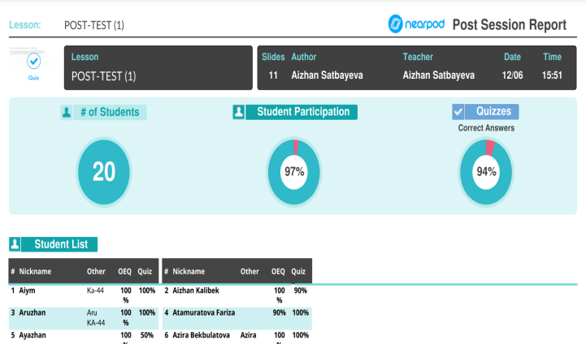

Figure 35 – Nearpod report

Nearpod generates comprehensive reports including participants’ responses to implemented task types (quiz, poll, MCQ, matching pairs, open-ended questions etc.), as well as individual participation data of each student contribution. This facilitates ongoing formative assessment, enabling teachers to identify mistakes and provide corrective feedback. These reports can also be used for a summative assessment of pre-/post-test results to evaluate participants’ pragma-comprehensive and pragma-productive abilities. Exporting and reviewing test results in such a well-structured format provides clear evidence of learners’ progress and challenges. Overall, the research design was enhanced by the features of Nearpod reports by correlating instructional input with measurable student outcomes, which advocates for the use of Web 2.0 tools not only for content delivery and authentic input but also for ongoing, data-driven support.
The Nearpod-based course “English in Context: Communicating with Pragmatic Awareness” provides EFL students with organized, interactive learning environment to enhance their pragmatic competence in a range of social contexts. By incorporating Web 2.0 tools such as Flip (or its alternatives), Collaborate Board, YouTube, and Canva, the course promotes engagement, reflection, and real-world application of conversational implicatures and SAs. Learners can actively recognize and produce contextually appropriate language in addition to comprehending pragmatic norms as a result of the multimodal tasks, formative assessments, and reflective activities.
To support the interactive Nearpod-based course and assure learning continuity beyond classroom sessions, two major supplemental materials were created and integrated into the experimental work: an Electronic Student’s Guide and a set of Methodological Recommendations for Teachers.
The study guide “Interlanguage Pragmatics: Raising Pragmatic Awareness in the EFL Classroom” is designed for bachelor's and master’s program “Foreign language: two foreign languages” preparing future foreign language teachers. At the same time, the guide is also suitable for the educational programs “Translation studies,” and “Foreign Philology,” as well as anyone who assists individuals or groups of learners in either formal or informal lifelong learning through lessons, workshops, or massive open online courses (MOOCs).
The Electronic Student’s Guide serves as an expanded variation of the interactive Nearpod course. It is intended to:
- reinforce key concepts and SAs covered during classroom activities, ensuring continuity between in-class and out-of-class learning;
- offer supplementary theoretical insights into pragmatics, including speech act theory, politeness strategies, and sociocultural variation relevant to real-world and instructional communication;
- provide additional practice materials, including expanded DCTs, reflection questions, cultural case studies, and model dialogues, to promote deeper engagement with pragmalinguistic and sociopragmatic features;
- incorporate self-assessment criteria to assist learners in monitoring their progress in both comprehension and production.
The study guide aims to enhance future English teachers’ foreign-language pragmatic competence using a combination of direct instruction, realistic audiovisual materials, and practice focused on output. It uses explicit explanations of important pragmatic aspects, real-life video and audio assets to show how language is used in context, and Web 2.0 tools to let students make replies that are appropriate for the situation. This method not only helps future English teachers improve their personal pragmatic skills, but it also shows them how to use pragmatics effectively in their future classrooms.
It comprises ten units:
Unit 1. Interlanguage pragmatics and its aspects
Unit 2. Speech act of requesting
Unit 3. Speech act of refusing
Unit 4. Speech act of apology
Unit 5. Speech act of complaint
Unit 6. Speech act of complimenting
Unit 7. Asking for and giving directions
Unit 8. Speech act of gratitude/thanking
Unit 9. Speech act of suggestions
Unit 10. Conversational implicatures
Each section includes a warm-up stage, authentic audiovisual input, explicit instruction, and reflective techniques to improve teaching and learning.
By the end of the course students are expected to comprehend, construct, and convey meanings that are both accurate and appropriate to the social and cultural contexts of communication, with particular attention to their application in both everyday interaction and future classroom discourse as future English teachers.
Unit 1 introduces students to the following pragmatic elements: SAs, pragmatic markers/formulaic expressions and implicatures.
A speech act is an utterance that serves a communicational function. SAs occur when we express an apology, salutation, request, complaint, invitation, compliment, or rejection [7].
A speech act may range from a brief utterance such as “Sorry!” used to apologize, to more elaborated forms, for example, “I’m sorry for the confusion. I forgot to upload the assignment on time.” SAs involve real-life communicative situations, including classroom contexts, and they need not just linguistic proficiency but also the ability to select and model contextually appropriate language in accordance with sociocultural norms [7].
The key SAs that are included in the study guide:
- Request
- Refusal
- Apology
- Complaint
- Compliment
- Asking for and giving directions
- Thanks
- Suggestion
A single word or longer phrases that convey SAs are called pragmatic markers/formulaic expressions. Each speech act unit in the course provides learners with the appropriate pragmatic markers/formulaic expressions to sound like a native speaker.
An implicature is the assumed meaning that a speaker transmits or reveals via their words without directly saying it. Conversational implicature is the phenomenon in which a speaker says one thing while concurrently transmitting (often) something else [336].
For instance, in the exchange below, a teacher explicitly comments on a student’s preparation while implicitly encouraging greater effort:
Student: Did I do well on today’s presentation?
Teacher: You explained the main idea clearly, but you might want to review the examples once more.
In this case, the teacher’s response implicitly signals that improvement is needed, without directly stating dissatisfaction.
Another common illustration involves digital communication. When, after several episodes of a Netflix series, a pop-up notification appears, “Are you still watching...?” Netflix suggests that you may not want to lose your progress, but the inquiry also suggests that it should shut down for the night [336].
These examples show how speakers frequently convey meanings beyond the literal level and how successful communication is dependent on the listener’s skill to infer such implied meanings.
Unit 1 also comprises technical instructions and evaluation rubrics.
All other units include various SAs and implicatures, and they all share the following stages: a warm-up stage, an audio-visual input, pragmatic instruction, producing output and reflection.
A warm-up stage usually includes general questions about a certain speech act comparing it with how it is performed in students’ own culture. Question like “How do you refuse in your culture in formal and informal situations?”, “Is it common to complain to a parent, a boss, a teacher in your culture? Why or why not?” etc. In addition to highlighting potential cross-cultural variations in pragmatic behavior, this step activates learners' prior knowledge and cultural schemas. It establishes a basis for further study by prompting learners to express their intuitions and contemplate culturally appropriate language usage.
An audio-visual input provides a QR code to an appropriate authentic podcast extract or video resource presenting a speech act as depicted in the figure below. Learners are able to observe pragmatic features in naturally occurring discourse, such as intonation, non-verbal signals, and contextual factors, through the use of authentic multimodal input. It also increases engagement and promotes the development of listening and interpretative abilities, which are required for pragmatic comprehension. After watching the video or listening to the podcast related socio-pragmatic questionnaire is followed.

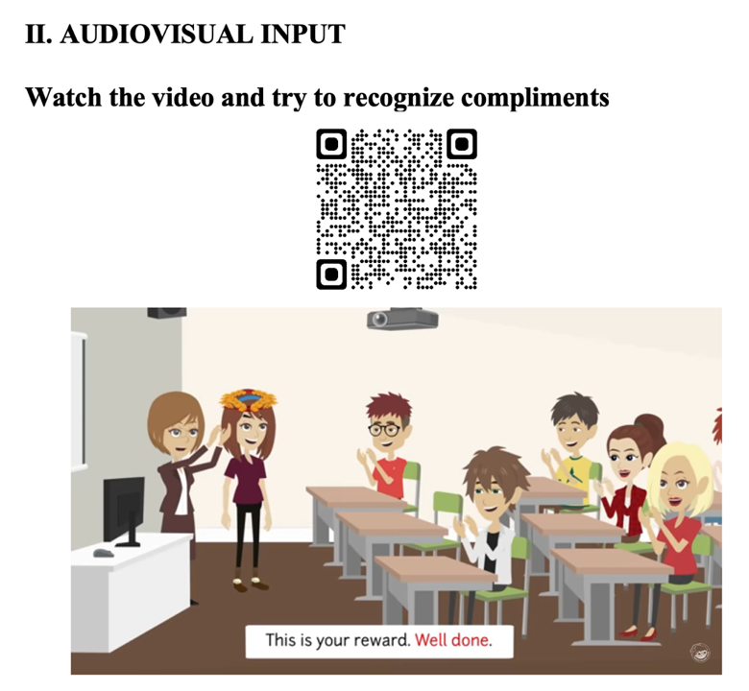

Figure 36 – Authentic audio-visual input (from Study-Guide)

The explicit pragmatic instruction stage contains explicit information about a speech act, speech act classification, modification types, special softeners/downgraders, and appropriate pragmatic markers.
The next stage is practice in producing output. This stage presents a wide range of activities for both pragmatic comprehension and production. Students will have a great opportunity to practice pragmatic receptive skills as well as productive skills.
The task types to practice receptive skills for pragmatic comprehension are as follows:
- Form comparison. This type of activity is aimed at understanding the differences or difficulties between L1 SA and TL SA. Students are basically asked to translate some SA expressions into TL and observe the differences or difficulties they encounter in such a process. Such comparison tasks provide comprehension of pragmatic significance in foreign language communication.
- Form analysis. The task type provides students with real-life situations and examples of a relative SA. Students need to identify the type/classification of SA (direct/indirect). This leads students to differentiate SA types and their appropriateness regarding the situation.
- MDCT. Discourse completion tasks that require choosing appropriate one or more answers (depending on the instruction) among several options for the given situation. This type is a valid and available assessment of individual’s pragmatic comprehension.
- Think-aloud (TA) tasks. Initially used in cognitive psychology, think-aloud activities, or concurrent verbal reports, subsequently are now widely employed in ILP studies. TA protocols are aimed at revealing the cognitive processes that occur during the execution of certain tasks that cannot be elicited from production data [124]. In TA tasks, students are required to do activities and think aloud simultaneously. Learners were tasked with identifying SAs in dialogues and evaluating their appropriateness in context by answering questions.
- Listening task. Podcast materials were employed to present authentic communicative contexts, allowing learners to observe the use of target SAs and related expressions in natural discourse.
- Video activity. Students are provided with a QR code, when scanned, redirects them to a video extract (YouTube/video podcast/movie) featuring an authentic situation. Based on the Noticing hypothesis, students were provided with pre-viewing questions that directed their attention to the recognition of SAs, the identification of pragmatic markers, levels of appropriateness, and implied meanings before watching the video.

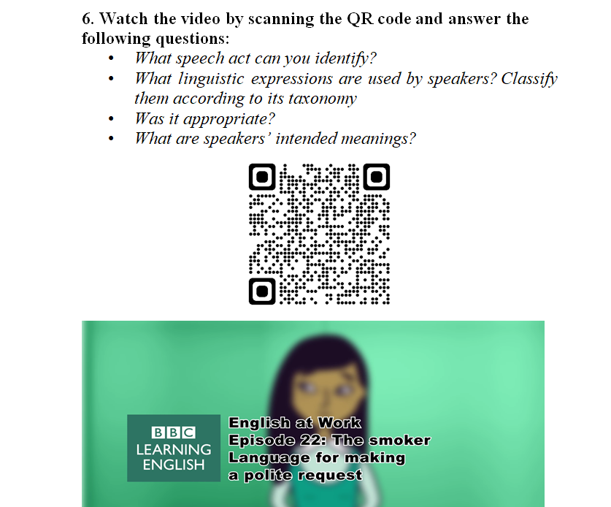

Figure 37 – Video activity (from Study-Guide)

Comprehension activities were then paired with production tasks to support learners’ application of pragmatic language in context. Pragma-productive tasks used in the study-guide are following:
- ODCT. Discourse completion tasks that require oral response for the given SA situation.
- WDCT. Discourse completion tasks that require responses in written form for the given situation.
- Dialogue completion. In this task, students are presented with real-life dialogues containing some blank spaces, which require appropriate pragmatic markers to be completed.
- Role-play. Role-plays are designed for two or a group of students. Students select roles based on the provided situation and perform as they are in that situation exactly practicing SAs.
- Flip task. This task requires students to be registered in flip.com so that they can be redirected to the Flip task by scanning a QR code. In Flip, students are presented with a situation and need to record a video response using appropriate pragmatic markers studied before in instruction.
In the final reflection stage, students are given some time to consider their progress and evaluate themselves. At this stage, questions related to misunderstandings or errors may emerge, providing opportunities for clarification within the learning process.
The electronic study guide, which includes QR codes, allows access to materials via various digital devices.
The methodological guidelines are intended for both future and in-service English teachers and may be used in teacher education programs as well as in continuing professional development. The recommendations aim to improve the quality, usefulness, and long-term viability of pragmatic instruction by meeting the demands of teachers at different points in their careers. Since teaching foreign-language pragmatic competence is underrepresented in Kazakhstani educational institutions, it was found relevant to construct methodological recommendations for EFL teachers.
These recommendations were designed to support instructors through:
- strategies for planning and delivering speech act instruction using Web 2.0 tools;
- options for designing digitally mediated tasks targeting various SAs;
- sample rubrics for assessing learners’ pragmatic comprehension (e.g., Nearpod quizzes) and production (e.g., Flip or Padlet video responses);
- guidance on implementing learner-centered, task-based approaches that align with contemporary communicative language teaching principles.
The overall aim of the methodological recommendations is to offer methodological support to foreign language teachers in enhancing a student's foreign-language pragmatic competence. This is achieved by providing algorithms, active teaching methods, various types of work, and teaching features in a mixed format. Furthermore, the recommendations concentrate on developing language exercises and communicative tasks that can be used in the foreign language classroom. The ultimate goal is to elevate the level of foreign-language pragmatic awareness by utilizing Web 2.0 technologies.
The recommendations are based on linguodidactic principles, emphasizing contextualized pragmatic input, explicit instruction, technology-supported authentic communication, and cultural awareness. They also address challenges noted in the preliminary surveys, including teachers’ lack of confidence in teaching pragmatics and the insufficient use of digital resources for communication practice.
The work offers a comprehensive overview of the analysis and findings from research on methodology, techniques, and education in the field of foreign-language pragmatic instruction. The scientific foundation is built upon many methodologies such as connectivism, technology-based language education, active learning, and cooperative learning. These techniques enhance students’ independence and motivation, which are essential to form foreign-language pragmatic competence. The methodological guidelines take into consideration the Professional Standard for Teachers “Education 4.0” of the Republic of Kazakhstan, the CEFRL and the TESOL Technological Standards for learning EFL.
The Nearpod course, the Electronic Student’s Guide, and the Methodological recommendations together formed an integrated instructional framework aimed at forming future teachers’ pragmatic competence and supporting their ability to teach pragmatics through technology-enhanced approaches.

2.2 The results of the experimental work on foreign-language pragmatic competence formation in future English teachers through the use of Web 2.0 technologies

This section presents the outcomes of the formative phase (intervention) aimed at forming foreign-language pragmatic competence of future English teachers using Web 2.0 tools. To evaluate changes in learners’ comprehension and production of basic SAs, data were gathered via Nearpod session reports, pre-/post-test results, and participants’ reflections.
Research design
The objective of the present study is to examine the effectiveness of pragmatics instruction conducted by teachers using Web 2.0 technology on the pragmatic awareness and performance of future EFL teachers. Furthermore, this study intends to explore EFL learners’ perspectives of using self-access resources to enhance pragmatic abilities.
This study used both quantitative and qualitative research methods – a mixed-methods research approach in achieving its objectives. According to Tashakkori and Creswell, mixed methods research is characterized as “combining qualitative and quantitative methods in one research study” [337, p. 4]. The use of a mixed-methods approach enables a comprehensive examination of a research problem by combining qualitative and quantitative evidence within a single investigative framework. This approach involves not only the systematic gathering and analysis of different types of data but also their purposeful synthesis to inform interpretation and conclusions. Accordingly, mixed-methods research necessitates methodological integration across multiple stages of the study, including the design, data collection procedures, analytical processes, and the interpretation of results. Additionally, “by integrating qualitative and quantitative methodologies, it enables a more thorough knowledge of the social phenomena” [338, p. 151].
According to Riazi and Candlin, “an analysis conducted by Greene, Caracelli, and Graham identified five key purposes underlying the use of mixed methods research” [339]. “In its early conceptualization, triangulation was regarded as a primary objective of combining qualitative and quantitative approaches” [339]. Triangulation is the utilization of many data gathering methods to enhance the comprehension of the examined concept and improve the research's validity. Furthermore, it has been stated that complementarity is a significant objective of mixed methods research. In this study, many forms of data allow the researcher to examine diverse facets of a certain concept, such as pragmatic comprehension and pragmatic production. According to Riazi and Candlin, “complementarity is based on the complexity of social phenomena” [340, p. 144]. Finally, the mixed-method technique may be used for development purposes. The second phase of research builds upon the previous phase's data. The fourth purpose is the act of initiating or beginning something. Initiation involves collecting and analyzing several forms of data to uncover previously undiscovered features of contradicting results. In conclusion, the mixed approach aims to achieve expansion by broadening the scope of the study (Figure 31) [124].

Experimental group
Intervention
Perception survey
Pre-test
Post-test
Quantitative data collection, analysis and results
Qualitative data collection, analysis and results
Determination of results for comparison
Describe and interpret similarities and differences

Figure 38 – Visual representation of the research design and data collection procedures

Given that pragmatic competence is considered a complex social phenomenon, many methods of data collection and analysis were used to provide detailed information that effectively addresses the research questions. Quantitative data was collected via online DCTs, while qualitative data was elicited and analyzed through a student perception survey. The former was employed to examine the influence of using Web 2.0 tools on pragmatic performance and awareness, whereas the latter was utilized to determine the views of future teachers on pragmatic competence and the potential of Web 2.0 technology. The evaluation of both aspects of pragmatic competence – pragma-comprehension and pragma-production – allowed us to achieve the complementary purpose and triangulation of the datasets. The selected mixed-method approach appeared the most suitable for accomplishing the research objectives [124].
Participants
52 Kazakhstani future English teachers in their second and fourth years from the foreign language faculty at Karaganda National Research University named after academician Ye.A. Buketov, one of the well-known universities in Karaganda, Kazakhstan, participated in this study.
The participants belonged to four distinct groups and were enrolled in the courses “Practical course of the basic foreign language (level C)”. Due to institutional limitations, it was unable to allocate students randomly, resulting in four pre-existing groups. All groups were experimental to examine the efficacy of the formation process of future English teachers’ foreign-language pragmatic competence through the use of Web 2.0 technology. Before any data collection all participants signed the consent form designed to conduct this experimental work (Appendix 1).
The course ran for one term. Each week, the learners were introduced to a different speech act (e.g. requests, refusals, suggestions, complaints, compliments etc.) and implicatures.
All participants share basic demographics, including field of study and first language (native speakers of Kazakh). The demographic information received from participants shows that females outnumbered males (Table 3). The individuals studied in the same department. The participants’ ages span from 19 to 22. The groups consisted of individuals at A2, B1, and B2 levels, determined by their scores on the British Council EnglishScore test [341]. Nevertheless, the vast majority of the participants were learners at the B1 proficiency level. While the most appropriate level for pragmatics education was considered intermediate (Kasper), the cohorts also included a few learners at the A2 and B2 levels. This was a favorable occasion to assess the effectiveness of incorporating pragmatics training using Web 2.0 technologies, given the prevalence of teaching common mixed-level classes in EFL settings [124].

Table 10 – General information about the participants

Gender
Female |  |  | Male |  |  |  |  |  | Total
f(n) | p(%) |  | f(n) |  |  |  | p(%) |  | f(n) |  |  |  | p(%)
47 |  | 90.4 | 5 |  |  | 9.6 |  |  | 52 | 100
Age
19-20 |  |  | 21-22 |  |  |  |  |  | Total
f(n) | p(%) |  | f(n) |  |  | p(%) |  |  | f(n) |  | p(%)
22 | 42.3 |  | 30 |  |  | 57.6 |  |  | 52 |  | 100
Proficiency
A2 |  |  | B1 |  | B2 |  |  |  | Total
f(n) |  | p(%) | f(n) | p(%) | f(n) |  |  | p(%) | f(n) |  |  | p(%)
8 |  | 15.4 | 38 | 73.1 | 6 |  |  | 11.5 | 52 |  |  | 100

The participants in this research were chosen for various reasons. First and foremost, all of them were future English instructors. According to the educational program 6B01705 – Foreign language: two foreign languages, “the profile of a future English teacher includes competencies, such as proficiency in foreign languages in accordance with international standards, comprehension of both verbal and non-verbal forms of academic discourse, fluency in a foreign language for intercultural communication and the ability to demonstrate diverse communicative skills” [232]. Given the instructional nature of foreign-language pragmatics, effective teaching in this area presupposes deliberate pedagogical preparation. As a result, prospective teachers need systematic training that enables them to guide learners in managing intercultural interaction and in producing contextually appropriate SAs across diverse social environments. Furthermore, their level of proficiency is more suitable for instruction in pragmatics. Finally, regarding participants’ age range they have a certain level of pragmatic competence in their L1 (Kazakh) and may realize the importance of pragmatics during the communication process.
Data collection tools
Within the mixed-method design of the current study, several instruments were used to acquire data. At first, the participants’ language proficiency level was verified using the British Council EnglishScore test. This test comprises 72 questions designed to assess students’ proficiency in grammar, vocabulary, reading, and listening. Second, an online DCT pragmatic test was developed on Nearpod serving as the pre-test and post-test in groups to assess future teachers’ pragmatic competence. Third, a perception survey was administered to the students at the conclusion of the experimental study to inquire about their impressions of acquiring pragmatic skills using Web 2.0 tools.
Language Proficiency Test. EnglishScore is an online test that is proctored and administered via a mobile device. The test is accessible for free, and the results are immediately provided upon completion. Additionally, a certificate may be purchased once the test has been completed. EnglishScore, developed by the Centre for Research in English Language Learning and Assessment (CRELLA) at the University of Bedfordshire, UK (www.beds.ac.uk/crella), is partially based on the British Council's International Language Assessment [342].
It was given 40 minutes overall to complete the test comprising three sections: grammar and vocabulary, reading, and listening. The questions that users will encounter in the Reading and Listening parts are determined by their performance in the Grammar and Vocabulary part. All the parts have strong correlations with the overall score, with coefficients around 0.94. Users who succeed in one part tend to succeed well in others. The reliability of English Score is assessed by utilizing Rasch conditional standard errors of measurement (CSEM). Approximately, adding and subtracting 2 x CSEM from a scale score reflects a user's genuine level of skill on the examined content with 95% certainty [342].
A programmed answer key is used to autonomously score all sections of EnglishScore. English language proficiency is measured on the numeric, granular scale, which ranges from 0 to 599. The test enhances the CEFR by displaying finer gradations within a learner’s CEFR level, allowing for gradual advances in English proficiency across several abilities. Additionally, it offers teachers and other decision-makers a better understanding of the strengths and weaknesses of test-takers, in addition to providing them with useful and motivating feedback [342].
Pragmatics tests. Many scholars working in the subject of pragmatics, such as Kasper and Roever [343], Alcón-Soler and Martínez-Flor [344], Nurani [345], Félix-Brasdefer [346], and especially Martínez-Flor and Usó-Juan [347], have faced a considerable challenge in determining the appropriate methodologies to use for data collection. Kasper and Dahl identified two primary challenges: firstly, the reliability of the data; and secondly, their capability to accurately represent the authentic performance of linguistic action [54, p. 215]. The DCTs were first used by Blum-Kulka [348] to analyze pragmatic SAs. Since then, they have become an increasingly common instrument in pragmatic studies.
DCT was chosen as the data collecting method for the current study for a variety of reasons. This being the case, various pragmatic assessment approaches have been presented. However, DCT is commonly used to collect data in cross-cultural and interlanguage pragmatics. It offers learners a variety of settings with unique environmental and social elements. Furthermore, in contrast to naturalistic data, it allows the researcher to maintain control over contextual factors in settings [349]. Additionally, it is useful as it makes it possible to gather a lot of data quickly [124].
The assessment instrument was developed to examine learners’ pragmatic awareness by identifying instances of inappropriate language use and by evaluating their ability to understand and produce meaning in context. This included the interpretation and realization of a range of communicative functions such as making requests, issuing refusals, expressing apologies, complaints, compliments, and gratitude, providing and requesting directions, and offering suggestions, as well as the comprehension of implied meanings [124].
The pragmatic test was divided into two parts: MDCT and a blend of ODCT and WDCT, totaling 20 items (Appendix 2). These items were grouped from several materials addressing the speech act assessment issue in ILP research (Bardovi-Harlig and Griffin; Martínez-Flor and Soler; Taguchi; Vellenga; Cetinavci and Ozturk; Samaie and Arianmanesh; Limberg; Matsugu; Halenko) [350-355]. The items in this research study were adapted from their original forms, which included circumstances focused on students and situations that were likely to occur beyond the university for research study participants. Two experts: non-native (Letyaykina Tatyana, Head of KazTEA) and native (Linda Russel, EFL teacher) English teachers contributed to the item development and modification, as well as the writing of the answer key. The items were different regarding the sociopragmatic component – the interlocutors’ degree of acquaintance, status and imposition. The questions and tasks included conversations between professors and students, advisers and students, classmates/groupmates, colleagues, friends, strangers – interactions likely to be encountered in future English teachers’ professional as well as everyday life settings (e.g., job interviews, coworker conversations, coffee shop order, giving directions etc.). Some items required students to comprehend conversational implicatures [124].
The first MDCT part comprises multiple-choice questions, while the second, which is a DCT, requires participants to either type in or record their responses to scenarios that are presented to them in audio format.

Table 11 – Table of specifications – Pragmatic test

Pragmatic elements | Sections |  | # of items | % of items
Pragmatic elements | Part 1: MDCT | Part 2: ODCT+WDCT | # of items | % of items
1 | 2 | 3 | 4 | 5
Requests | 1 | 14 | 2 | 10%
Refusals | - | 15 | 1 | 5%
Apologies | 2, 4 | 16 | 3 | 15%
Complaints | - | 11, 18 | 2 | 10%
Compliments | 5, 10 | - | 2 | 10%
Gratitude |  | 13, 20 | 2 | 10%
Continuation of Table 11
1 | 2 | 3 | 4 | 5
Asking for /giving directions | - | 12, 19 | 2 | 10%
Suggestions | 3 | 17 | 2 | 10%
Implicatures | 6, 7, 8, 9 | - | 4 | 20%
# of items | 10 | 10 | 20
% of items | 50% | 50% |  | 100%

The MDCT (Figure 32) is presented in a closed format and consists of 10 items, each presenting a hypothetical scenario in which selected SAs are utilized. The learners were instructed to choose the most suitable response from a set of three or four alternatives that were provided as potential responses to the given scenario. Indeed, an answer that is pragmalinguistically and sociopragmatically appropriate stands out as the most suitable. Conversely, there are additional diversions that may be either inappropriate or incorrect. These distractors provide negative evidence about what is unsuitable in the TL. The presence of this negative evidence is anticipated to have a beneficial effect on the learners’ acquisition of foreign language when learners are provided with the opportunity to focus on linguistic structures. Kang supports Sheen’s theory that negative evidence, or “language information about what is not possible in the TL,” facilitates foreign language learning [356, p. 582]. The students were instructed to assess the appropriateness of SAs utilized in these particular scenarios. The scenarios were developed according to the three social parameters: P, SD, and SI. The parameters were restricted to dichotomous variables (+/- P, =/- SD, +/- SI). Each situation is given equal weight and difficulty to prevent respondents from being confronted with the most difficult situations in the beginning, which may discourage them from continuing. In addition, the sequence of situations was assigned at random to prevent any potential influence on the responses of the participants [357].
This approach guarantees the instrument's validity and reliability by methodically regulating contextual elements and response alternatives. The MDCT's closed format enables the consistent assessment of learners' pragmatic comprehension across participants, while the inclusion of both appropriate and inappropriate options fosters the development of discrimination skills.. Furthermore, using precisely specified social characteristics improves the authenticity of the scenarios and simulates real-life conversational situations. The use of controlled input, contextual variation, and role-based framing allows for a more accurate assessment of learners' abilities to perceive and evaluate pragmatic meaning in the target language.
Students role-played every scenario so that they could respond more authentically (“You work as a Research Assistant” or “You should request the teacher to clarify this issue”). The role (status) of the interlocutors is clearly stated (teacher-student, teacher-teacher, student-student). Figure 39 illustrates one of the items of the pragmatics test (DCT) presenting a situation where the students had to choose the option with the best request. This role-based conceptualization improves the contextual realism of the task and facilitates a more precise assessment of learners' pragmatic decision-making.

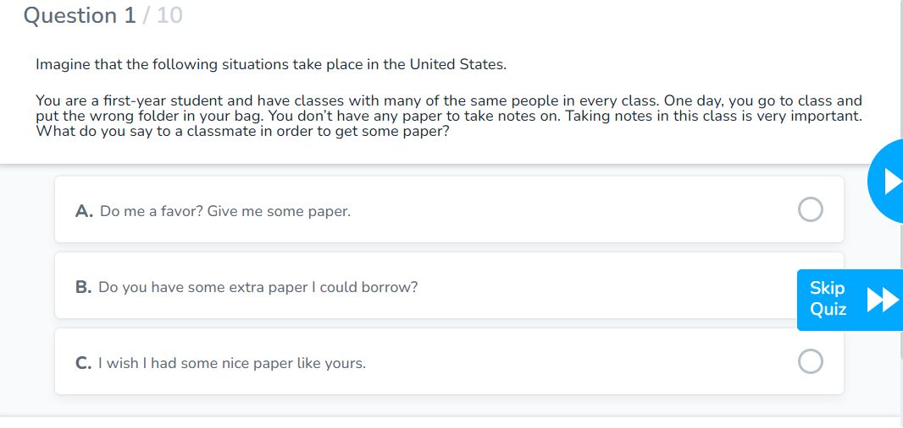

Figure 39 – MDCT via Nearpod

The most significant field of research in interlanguage pragmatics is pragmatic production, which is often assessed using a written questionnaire (Written Discourse Completion Task). This research defines pragmatic production as learners’ oral and written performance in expressing requests, refusals, apologies, complaints, thanking, asking for and giving directions, and suggestions in various settings [358].
Open-ended DCT: The open-ended DCT comprises a written and an oral discourse completion task and is used to evaluate the speech act performance of learners. This study used an open-ended DCT with 10 speech act instances and participants answered in English. The DCT pretest and posttest utilized to assess participants’ pragmatic ability in this study were identical.
WDCT and ODCT (Figure 33) are instruments that offer learners an elaborate representation of a situation to which they have to respond. More precisely, it is a simulation of a communicative encounter “in which two interlocutors assume roles under predetermined experimental conditions in order to elicit spoken data” [359]. The questionnaire consists of ten written prompts, which are brief descriptions of real-life situations. After each prompt, there is an empty space where respondents are expected to provide an appropriate SA expression. The aim is to fulfill their objective without offending the person they are communicating with, based on the given situations. The provided area is anticipated to have no limitations on the length of the informants’ answers. The WDCT and ODCT, similar to the MDCT, carefully analyze the complexity, weight, and sequence of circumstances to ensure respondents’ participation and contributions are not impacted by any anomalies. The purpose of these scenarios was to elicit a specific pragmatic aspect that is being examined. The 10 real-life circumstances encompass sociopragmatic factors such as social power, level of imposition, and social distance, which are intricately connected [328]. The example from the pragmatic test below depicts a discourse completion task where the student is instructed to record an audio response of complaint.

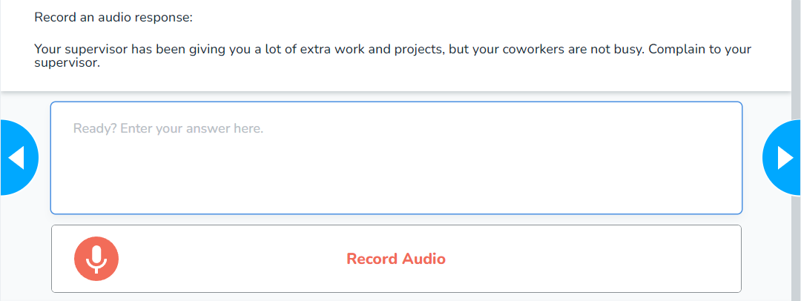

Figure 40 – WDCT/ODCT via Nearpod

The quality of diagnostic materials is one of the key aspects of knowledge assessment. To avoid inadequate assessment of knowledge, it is necessary to use only statistically sound test materials with a sufficient level of reliability and validity [360]. As part of our study, we conducted a thorough assessment of the reliability and validity of the tests developed to assess pragmatic competence. Although previous research has confirmed the reliability of tests for assessing pragmatic competence, we conducted an additional study of the reliability of the sections a written and an oral discourse task to evaluate the speech act performance of learners, which was the main focus of our study. We used parallel tests to assess their reliability and found that the test has a reliability coefficient of 0.86, which indicates the reliability of the tests for our current study [359].
The students were given a total of 50 minutes to complete the test. The Nearpod tool automatically scored all of the multiple-choice items. The answer key was retained when an item was taken in its original form. The answer key for the items that were created or altered was reviewed by native and non-native experts. Missing responses were marked as wrong. The multiple-choice items were evaluated as either correct or incorrect. Test takers were awarded 10 percent for each correct response and received 0 percent for any incorrect response. The overall score for section 1 was 100 percent.
The appropriateness scale, used to evaluate pragmatic production, was adapted from Taguchi’s rubrics [37] and Halenko’s modified version [26]. To identify the level of pragmatic production of the selected key SAs in classroom and everyday scenarios, the rating scale should have descriptors including both pragmalinguistic and sociopragmatic components. Table 12 presents traditional ratings and 100-point-based scoring adapted to the Kazakhstani assessment scale and descriptors of the appropriacy scale. Native and non-native raters reviewed the (O/W)DCT responses provided by the participants and evaluated them according to the given assessment scale. Responses with above one-point differences on the scale were examined and collectively modified, resulting in a substantial interrater reliability of 0.85 [358].
Table 12 – Rating scale

Ratings | 100 point-based scoring | Descriptors
Excellent | 95-100 | - Target communicative function fully realized.  - Levels of directness, politeness and formality of the response are almost entirely appropriate and effective for the situation.  - Pragmalinguistic forms and mitigation strategies demonstrate highly accurate sociopragmatic control.
Good | 90-94 | - Target communicative function mostly realized.  - Levels of directness, politeness and formality of the response are appropriate and effective for the situation.  - Non-target-like features are minor and unlikely to affect a positive outcome.
Fair | 70-89 | - Target communicative function somewhat realized.  - Levels of directness, politeness and formality of the response are generally appropriate and effective.  - The expressions may contain several non-target-like features; however, they would be considered to have achieved minimal levels of appropriateness for a positive outcome.
Poor | 50-69 | - Target communicative function somewhat realized.  - Levels of directness, politeness and formality of the response are not sufficiently appropriate or effective for the situation.  - Features are predominantly inappropriate and lack satisfactory levels of indirectness, or the expressions do not provide adequate mitigation for a positive outcome.
Very poor | 25-49 | - Target communicative function minimally or not realized.  - Levels of directness, politeness and formality of the response are completely inappropriate or ineffective for the situation.  - Expression is too limited for making judgment.
No attempt | 0-24 | No response (opt out) or response is irrelevant / unintelligible and cannot be evaluated for pragmatic appropriateness.

The raters were given explicit instructions to thoroughly evaluate each scenario and assess the appropriateness of the students’ responses. They were asked to consider factors such as the effective delivery of the main speech act, how polite and appropriate the response was, how long it was, and how easy it was for a fluent English speaker to understand the answer [127]. The total score for this segment was 100.
Students’ perception survey. The survey on learners’ perceptions was administered to examine students’ responses to and evaluations of their initial experience of learning pragmatics through the use of Web 2.0 technologies, providing insight into their attitudes toward this instructional approach. This was the approach of gathering feedback from students on the insights they obtained from using web-based resources and pragmatic instruction. Students may share the benefits and weaknesses of the materials, with a particular emphasis on the usability of the speech act, any challenges participants had encountered, and recommendations for future improvements. The researcher made the assumption that self-report would provide an accurate description or measurement of the characteristics and beliefs of the learners. The purpose of creating this survey was to find out how students perceived the process of learning. It appears that there has been no investigation into their understanding of learning pragmatics. Therefore, this survey aimed to comprehend the perspectives of participants in this study on the learning process and classroom activities. The survey included nine closed-ended and one open-ended question meant to extract the participants’ views on learning pragmatics, learning and teaching foreign-language pragmatics using Web 2.0 technologies, and their experiences in the project (see Appendix 3) [82].
Data collection procedure
Data collection was carried out during the 2023-2024 academic year. Before the start of the study, participants were provided with information concerning the experimental intervention and the assessment instruments used for research purposes. Participants provided written consent and received an information leaflet before participating in the study.
During the first week, participants received the DCT via the Nearpod website or application enter code. To assess the participant’ initial pragmatic receptive and productive skills in different scenarios based on their current knowledge the author-compiled DCTs were used as a pre-test. The participants were instructed to omit scenarios for which they were unlikely to provide a response.
The Experimental Treatment:
- An introductory lesson was provided to familiarize participants with the program.
- Both Nearpod and Flip were utilized to administer the classes.
- Each participant needs to own a Google email account (Gmail).
- Students should go to nearpod.com/student or activate the Android or iOS app and input the five-character code provided by the teacher.
- Students can use the student’s name validation or click “Join as a Guest” on the page that appears after entering the code.
- If a teacher activates the live participation mode, students can engage in class activities on their devices while the teacher maintains control over the pace of the Nearpod instruction, video, or activities. Instructors can monitor and assess students’ progress and outcomes in real time during their instruction.
- If a teacher activates the student-paced mode, students can join the session whenever and wherever it is convenient for them and work at their own pace. Teachers use this function to provide Nearpod lessons as homework.
- They participated in a variety of online activities that were developed using the flexible options that Nearpod provides.
- They engaged in lively discussions through the Collaborate Board (integrated with Nearpod).
- They recorded audio and video responses for role-play assignments using Flip (integrated with Nearpod).
- The teachers provided feedback after every lesson.
- Participants were requested to provide reflections about their learning.
Roles of a teacher as an instructor of the course:
- giving students a 5-letter code to join each lesson;
- launching a lesson mode: a student-paced or live participation mode;
- monitoring students during the lesson;
- having a comprehensive report on the involvement of all participants;
- delivering explicit instruction in a classroom setting through the use of Nearpod presentations.
- checking students’ assignments.
- providing feedback and evaluating.
Roles of the participants:
- entering a code and a username in Nearpod platform;
- getting access to a lesson;
- being engaged during a lesson;
- sending homework assignments.
The whole term was dedicated to classes powered by explicit instruction. Nearpod served as the primary platform for delivering interactive lesson materials and homework sessions. Its instructional content was enriched through the integration of additional Web 2.0 tools, including Canva-based infographics, interactive YouTube resources, collaborative boards, and podcasting activities, allowing us to expand the range of means for delivering lessons and providing real-life authentic input. Nearpod allows users to join the lesson and do activities through the use of computers, tablets, and cellphones. From a conceptual perspective, Nearpod may be positioned at the intersection of CALL and MALL frameworks, providing a relevant theoretical basis for its application in the present study. In this regard, Jeon and Kaya note that sustained instructional exposure to pragmatics for at least five hours can lead to measurable improvement in learners’ pragmatic ability [361]. Consequently, the instruction was decided to be delivered at the beginning of each class [124].

Table 13 – Overview of Nearpod-Based Lessons and Activities for Pragmatic Competence Development

Nearpod lesson | Activities involved
1 | 2
1st lesson: Overview | a video lecture by a professor of the university of Texas, explanation of pragmatics, SAs, implicatures and pragmatic markers, video instructions for integrated Web 2.0 tools use, assessment rubrics
2nd lesson: Requests | video activities (recognition of requests in the videos), metapragmatic explanation, infographics (presentation of types of requests), awareness raising activities (analyzing the context in animated videos), multiple-choice questions for request production and quiz for request comprehension
3rd lesson: Requests | video analysis (revision of previous lesson), instruction (presentation of downgraders’ taxonomy), open-ended questions for request production, poll (rating the appropriateness level of request in the videos), audio activities through open-ended questions (listening to the scenario given and giving audio/written response)
Continuation of Table 13
1 | 2
4th lesson: Refusals | video activities (recognition of refusals in the videos), brainstorming questions (about refusing in L1 culture), video instruction (how to refuse politely), metapragmatic explanation, infographics (presentation of refusals’ taxonomy), poll activity (rating the politest refusal strategy), awareness raising activities (analyzing the refusals in animated video)
5th lesson: Refusals | audio activities through open-ended questions (listening to the scenario given and giving audio/written response), poll activity, podcasting (making notes on how to say no politely strategies), “Time to climb” activity
6th lesson: Apology | Metapragmatic explanation (presentation on when to apologize), Drag and Drop activity (categorizing different situations to the appropriate columns of “Apology” and “No apology”), quiz (rating the seriousness level of situations), instruction (infographics presenting apologizing strategies), awareness raising activities (analyzing the apology in animated video), quiz for MDCT
7th lesson: Apology | Instruction (presentation of pragmatic markers), video instruction (ways of apologizing in formal and informal situations), podcasting (making notes on apology markers), matching pairs activity (matching apology markers with the appropriate functions), awareness raising activities (analyzing the apology strategies in British Council video), audio activities through open-ended questions (listening to the scenario given and giving audio/written response)
8th lesson: Complaints | Brainstorming questions (about complaining in L1 culture), metapragmatic explanation (presentation of complaint strategies, steps and markers), video activities (recognition of complaint in the videos), audio activities through open-ended questions (listening to the scenario given and giving audio/written response), poll activity (rating for the most appropriate complaint), Draw it activity (writing pieces of advice for effective complaining from video)
9th lesson: Compliments | video instruction (how to give and receive compliments), metapragmatic explanation (presentation of complimenting strategies and markers), awareness raising activities (analyzing the compliments in video), audio activities through open-ended questions (listening to the scenario given and giving audio/written response)
10th lesson: Asking for and giving directions | Metapragmatic explanation (presentation of the importance of asking for and giving directions, and pragmatic markers), video instruction (on useful expressions and structures), making up dialogues using road-maps, quiz for MDCT
11th lesson: Gratitude (thanking) | Metapragmatic explanation (presentation of thanking ways and expressions, responding to being thanked), video instructions (how to say “thank you” to sound like a native), audio activities through open-ended questions (listening to the scenario given and giving audio/written response), Draw it activity (highlighting thanking strategies)
12th lesson: Suggestions | Metapragmatic explanation (presentation of suggesting ways, downgraders and markers), awareness raising activities (analyzing the suggestion strategies in video), Role-play activity, video activity (comparing two suggestions and responses in video)
13th lesson: Implicatures | Metapragmatic explanation (presentation of implicatures and cooperative principles), audio activities through open-ended questions (listening to the scenario given and giving audio/written response), Interactive YouTube activity (pragmatic conversational maxims practice)

Thirteen interactive lessons were held in a live mode with teacher instruction, while twelve home task lessons were delivered in a student-paced mode, which allowed students to do assignments at their own pace, any time, from anywhere (Table 13).
The activities were delivered to the learners through Nearpod sessions as twenty-five distinct lesson materials. The task arrangement was determined using Robinson's theory [362]. Moving from simple to more complex exercises help learners recognize specific pragmatic elements, resulting in increased accuracy and fluency in spoken and written output. In other words, the activities were organized according to increasing levels of complexity. Additionally, the assignments were developed based on suggestions from the literature. Warm-up discussions, pragmatic awareness input, metapragmatic instructions, pragmatic output, and feedback were the algorithm of the learning experience. Furthermore, the intervention incorporated authentic audiovisual samples from television programs, films, YouTube, BBC, and podcasts [124].
As a post-test, all of the participants passed the DCT again in the last week. The post-test took around 50 minutes. All the responses were automatically stored in the reports section for later analysis.
At the end of the project, students’ perceptions survey was delivered to all participants to analyze their attitude towards learning pragmatics through the use of a Web 2.0 tool.
Data analysis
Analysis of the English proficiency level test:
A Wilcoxon Signed-Rank Test was conducted to analyze and compare the indicators (the pretest and posttest scores) of improvement in students’ language proficiency. This method is universal because it can be applied to qualitative characteristics measured on an ordinal scale. The number of gradations (levels) of the characteristic in our study is at least three, which corresponds to all the parameters for the application of this test. We used the following levels and gradations of English language proficiency according to the CEFR: A1-1, A2-2, B1-3; B2-4, C1-5. The data collection process began with a diagnostic phase, during which participants’ English language proficiency was determined through standardized testing (British English Score), focusing on grammar, vocabulary, and reading comprehension. Then, during the term, the students focused on practical, step-by-step guidance to improve language knowledge and enhance SAs’ performance using Web 2.0 technologies A pretest was administered before the experiment, and a posttest after that. Next, we calculated the differences between the values after the experiment and the values before the experiment for each student. The differences obtained were ranked by absolute value. Then, the ranks of all positive differences and, separately, all negative differences were summed. The sums of the ranks obtained were compared with the critical value of the criterion.
The descriptive statistics reveal that the mean posttest score (M = 4.3) was higher than the mean pretest score (M = 3.1), indicating an improvement in language proficiency after the experiment. The results of the Wilcoxon Signed-Rank Test presented in Table 14 below confirmed a statistically significant difference between the pretest and posttest scores (Z =-3.77, p < .05).

Table 14 – Result of the Wilcoxon-Singed Rank Test for the language proficiency Scores

Strategic_Post - Strategic_Pre
Z  Asymp. Sig. (2-tailed) | -3.771 ^{b}  .000

Thus, statistical significance was achieved, and the first null hypothesis was rejected, confirming that the suggested model of pragmatic competence had a significant positive impact on learners’ language skills.
Analysis of the DCTs:
The results were collected at both the beginning and end of the experiment within the same group. We employed the Student’s t-test to evaluate the validity of the differences observed on an interval scale. To achieve this, 52 students were tested at the beginning and end of the semester. The results are clearly displayed in Table 1, which includes the names of the students who participated in the experiment (the first column), the results of the first test to identify the level of pragmatic competence at the beginning of the semester (the second column), and the results of the second test to identify the level of pragmatic competence at the end of the semester (the third column).
The further calculation procedure is as follows:
It was essential to calculate the differences (y_{i} - х_{i}) for each participant and include them in the fourth column (d_{i}). For the first participant, the difference is 15 (65-50 = 15), which is obtained by deducting the result of the first test (at the beginning of the semester) from the result of the second test (at the end of the semester). In certain cases, the values of the differences may be negative, particularly as the outcomes decline. Subsequently, the sum of the discrepancies in the fourth column of Σd_{i} was computed. Then, the average difference was calculated by dividing the sum of the differences (Σd_{i}) by the number of participants (n) (Table 15).

Table 15 – Calculation table for determining t_{gr}

Students (n) | Pretest (х_{i}) | Posttest (y_{i}) | (y_{i} - х_{i} ) = d_{i} | d_{i} ²
1 | 2 | 3 | 4 | 5
 | Point-based grading
1 | 50 | 65 | 15 | 225
2 | 35 | 82.5 | 47.5 | 2256.25
3 | 65 | 95 | 30 | 900
4 | 50 | 90 | 40 | 1600
5 | 65 | 95 | 30 | 900
6 | 65 | 95 | 30 | 900
7 | 60 | 35 | -25 | -625
8 | 50 | 72.5 | 22.5 | 506.25
9 | 40 | 55 | 15 | 225
Continuation of Table 15
1 | 2 | 3 | 4 | 5
10 | 50 | 60 | 10 | 100
…
…
…
52 | 25 | 85 | 60 | 3600
 | M = 49,127 | M = 80,196 | Σd_{i} = 31,06863

The mean value of the variable before the experiment is (M= 49.127). The mean value of the variable post-experiment is (M = 80.196) (Figure 41). The standard deviation of the differences (S_{td} = 3.054) was computed using the formula, and the Student's Paired t-test was determined, t_{р} = 10.270.

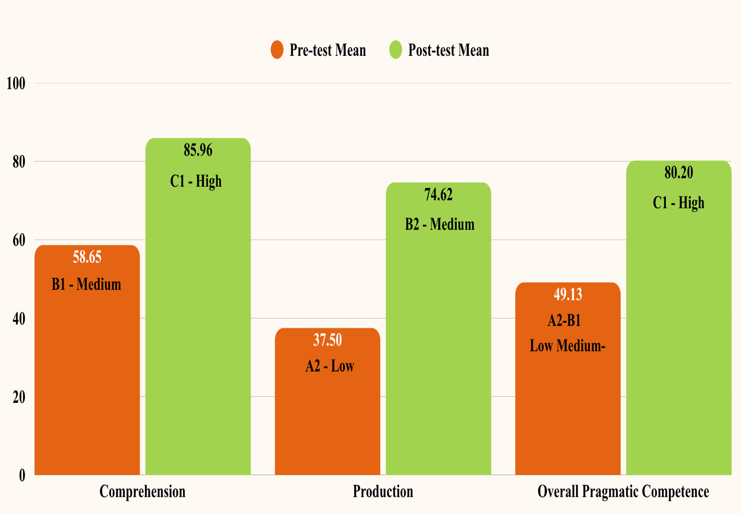

Figure 41 – Pre-test and post-test results of learners’ pragmatic competence (DCT)

Table 16 indicates that the boundary value ((t_{gr}) was obtained with the degrees of freedom f=n-1 (52-1=51). The critical value of the Student’s t-distribution for a specified number of degrees of freedom is t_{gr} = 2.009, i.e., ((t_{р} ≥ t_{gr}). As a consequence, the observed differences are statistically significant (t_{р} = 10.171). The variable alterations are statistically significant (p-value=0.05).
Table 16 – Group Statistics (Pretest and Posttest Results of the Group)

 | n | Mean | Std. Deviation | Std. Error Mean | t_{р} | critical value | 95% Confidence Interval of the Difference p<0.05 | p=0.05
Pretest | 52 | 49,127 | 21,813 | 3,054 | 10.171 | 2.009 | t_{р} > critical value | there is sig. diff.
Posttest | 52 | 80,196

To validate the effectiveness of the used approach, an additional criterion, the Wilcoxon T-test was employed to evaluate the differences between two series of measurements conducted on the same participants under different conditions or at various periods.
This test can ascertain the direction and severity of changes – that is, whether the indicators are more shifted in one direction than in the other.
For each item in a sample of n items, we calculated a difference score (d_{i}) by subtracting one measurement from another.
We neglected the positive or negative signs and obtained a set of (n=52) absolute differences (d_{i}).
Then, assigned ranks (R_{i}) from 1 to n to each of the (d_{i}) such that the smallest absolute difference score attains rank 1 and the largest gets rank n. If two or more (d_{i}) were equal, they were each assigned the average rank of the ranks they would have been assigned individually had ties in the data not occurred.
The Wilcoxon test statistic t_{exp} is subsequently obtained as the sum of the positive ranks. We used Microsoft Excel to find t_{exp.} (Table 17).

Table 17 – Results of Wilcoxon Signed Ranks (R_{i}) Test

Students (n) | Pretest (х_{i}) | Posttest (y_{i}) | d_{i =} (y_{i} - х_{i} ) | R_{i} Shift rank number
Students (n) | Point-based grading
1 | 2 | 3 | 4 | 5
1 | 50 | 65 | 15 | 8
2 | 35 | 82.5 | 47.5 | 41.5
3 | 65 | 95 | 30 | 24
4 | 50 | 90 | 40 | 35.5
5 | 65 | 95 | 30 | 24
6 | 65 | 95 | 30 | 24
7 | 60 | 35 | -25 | 17
8 | 50 | 72.5 | 22.5 | 14
9 | 40 | 55 | 15 | 8
10 | 50 | 60 | 10 | 4.5
…
…
…
Continuation of Table 17
1 | 2 | 3 | 4 | 5
52 | 25 | 85 | 60 | 11.5
The sum of the ranks of atypical shifts: |  |  |  | T_{emp. =} 43.5
p=0.05 (Т_{cr.} =466); p=0.01 (Т_{cr.} =397)

The graphical results of the Significance Axis for calculating the reliability of differences between two dependent results derived on an ordinal scale using the Wilcoxon T-test are illustrated in Figure 34.

T_{0,01} T_{0,05}

significant ? non-significant
397 466

Figure 34 – Significance Axis

We compare Т_{emp.} to Т_{cr.}, which is significant at p=0.05 (Т_{cr.} =466) and p=0.01 (Т_{emp.} = 397). It can be contended that the differences between the results obtained are statistically reliable (Т=43.5 at p<0.05) and that the variations in the indicator are statistically significant at p<0.05, as Т_{emp}.=43.5<T_{cr.}=466.
Additionally, we applied the McNemar criterion to calculate the reliability of differences between two dependent results. This was done by analyzing the totality of positive scores (ranging from 70-100) and negative scores (ranging from 0-67) obtained during the pretest and posttest. The methodology for calculating the reliability of differences between the results obtained by this criterion is based on the construction of a four-field table called the “2x2 table” (Table 18).

Table 18 – McNemar test on paired proportions

Pretest result | Posttest results |  | Total | Diff. | 95%  Confidence Interval | Exact probability
Pretest result | Pos. | Neg.
Pos. | a=48 | b=14 | 62 | 36.54% | 28.31% to 44.77% | p<0.0001
Neg. | c=90 | d=56 | 146 | 36.54% | 28.31% to 44.77% | p<0.0001
Total | 138 | 70 | 208

The results presented in the table shows the difference between the proportions (expressed as a percentage) with a 95% confidence interval. The (two-sided) P-value is less than the conventional 0.05, thus the conclusion is that there is a significant difference between the two proportions. The difference between the pretest results and posttest results is 36.54% with a 95% CI from 28.31% to 44.77%, and is highly significant (P<0.0001).
Analysis of the students’ perception survey:
A survey was also administered using the Likert Scale, which was composed of a series of statements that were designed to ascertain students’ positive or negative attitudes toward the use of Web 2.0 technologies with an emphasis on pragmatic elements. The Likert Scale analysis encompassed several critical stages that resulted in a dependable conclusion regarding the objective of the study, which was the integration of pragmatic elements with Web 2.0 technologies. The data was evaluated by calculating the average score for each statement on the Likert Scale. The overall Likert Scale scores were first computed by multiplying the frequency of each response option by its corresponding Likert Scale score. Total Score = Σ(F× i) where:
F = (number of respondents)
i = Likert Scale scores, namely SD (1), D (2), Neutral (3), A (4), SA (5)
The average score is calculated by dividing the total score by the total number of respondents. Mean Score = Σ(F× i)÷ number of respondents.
The range of interpretation of the average score on the Likert Scale was given as follows: 1.0-2.4 (negative ratio), 2.5-3.4 (neutral ratio) and 3.5-5.0 (positive ratio). The results are shown in Table 19.

Table 19 – Students’ attitude towards teaching through Web 2.0 technologies with the pragmatic elements

Statement | Strongly agree |  |  | Agree |  |  | Neutral |  |  | Disagree |  |  | Strongly disagree |  |  | Total Score | Mean score | Attitude
Statement | (F) | (%) |  | (F) | (%) |  | (F) | (%) |  | (F) |  | (%) | (F) |  | (%)
1 | 2 | 3 |  | 4 | 5 |  | 6 | 7 |  | 8 |  | 9 | 10 |  | 11 | 12 | 13 | 14
I liked studying using Nearpod | 39 | 75% |  | 12 | 23.1% |  | 1 | 1.9% |  |  |  |  |  |  |  | 246 | 4.73 | Positive
Flip is a comfortable space to share video/audio responses without any hesitation | 35 |  | 67.3% | 13 | 25% |  | 2 | 3.8% |  | 1 | 1.9% |  | 1 |  | 1.9% | 236 | 4.5 | Positive
Web 2.0 technologies (Nearpod, Flip etc.) could help to create an authentic environment to learn SAs | 38 |  | 73.1% | 11 | 21.2% |  | 3 | 5.8% |  |  |  |  |  |  |  | 243 | 4.67 | Positive
Collaborate Board tasks were effective for interactive discussions by posting texts, recordings and images to a shared class board | 37 |  | 71.2% | 13 | 25% |  | 2 | 3.8% |  |  |  |  |  |  |  | 243 | 4.67 | Positive
All speech act classes have clear instructions with pragmatic expressions (markers) | 40 |  | 76.9% | 9 | 17.3% |  | 3 | 5.8% |  |  |  |  |  |  |  | 245 | 4.71 | Positive
Continuation of Table 19
1 | 2 |  | 3 | 4 | 5 |  | 6 | 7 |  | 8 | 9 |  | 10 |  | 11 | 12 | 13 | 14
All lessons present audio/video input to raise our pragmatic awareness | 36 |  | 69.2% | 14 |  | 26.9% | 2 |  | 3.8% |  |  |  |  |  |  | 242 | 4.65 | Positive
It is important to teach students pragmatic knowledge (knowledge about how to use English appropriately) | 37 |  | 71.2% | 12 |  | 23.1% | 3 |  | 5.8% |  |  |  |  |  |  | 242 | 4.65 | Positive
Overall Mean Score |  |  |  |  |  |  |  |  |  |  |  |  |  |  |  |  | Mean = 4.6 | Positive
1.0-2.4 – (Negative attitude); 2.5-3.4 – (Neutral attitude); 3.5 -5.0 – (Positive attitude)
Rating from 1 (low level) to 5 (high level)
 | 5 |  |  | 4 |  |  | 3 |  |  | 2 |  |  | 1
How successful would you say you learn pragmatics through the use of Web 2.0 tools? Rate from 1 (low level) to 5 (high level) | 44 |  | 84.6% | 8 |  | 15.4% |  |  |  |  |  |  |  |  |  | 60 | 1.15 | Positive
How do you feel about classroom activities on Nearpod platform? | 47 |  | 90.4% | 3 |  | 5.8% | 2 |  | 3.8% |  |  |  |  |  |  | 59 | 1.13 | Positive
Overall Mean Score |  |  |  |  |  |  |  |  |  |  |  |  |  |  |  |  | Mean = 3.8 | Positive
1.0-2.4 – (Negative attitude); 2.5-3.4 – (Neutral attitude); 3.5 -5.0 – (Positive attitude)

The data in the table suggests that the majority of the statements were met with a positive response from the students. Consequently, we determined that students possess a favorable perspective (Mean = 4.6) toward the utilization of Web 2.0 technologies in the classroom, which incorporate pragmatic components.
The data obtained from the perception survey were employed to investigate the perceptions of the experimental group participants (n=52) regarding the use of Web 2.0 technologies to learn about pragmatics.
Thematic analysis of the student perception survey, which was administered following the instructional intervention utilizing Web 2.0 technologies, identified three overarching themes with matching categories. These themes are indicative of the attitudes and experiences of students regarding the efficacy of the learning process, the instruments employed, and the pedagogical strategies that were implemented during the experiment (see fig. 42)
Outcome of the Intervention
Pragmatic gains
Learned about pragmatic aspects
Increased pragmatic awareness
Perceptions about Web 2.0 tools
Comfortable to use, no hesitation
Authentic environment to learn
Clear visual instructions
Pragmatic awareness-raising audio/video input
Perceptions about the activities
Realistic situations
A good range of activities
Feedback
Increased pragmatic production

Figure 42 – Themes and categories emerged from the students’ perception survey

The study of the student perspective survey indicated three major themes: pragmatic gains, positive impressions of Web 2.0 tools, and effective learning activities. Students reported a significant increase in their awareness and production of pragmatic features, which suggests that their communicative competence has been significantly enhanced. They discovered the Web 2.0 tools (Nearpod, Flip, YouTube) to be both engaging and comfortable, emphasizing their authentic, interactive, and visually clear learning environment. Moreover, learners appreciated the incorporation of realistic scenarios, diverse activities, and audio/video materials that enhanced pragmatic awareness, in conjunction with the constructive comments provided. These findings confirm that the use of digital technologies and well-designed instructional assignments effectively contributed to the development of foreign-language pragmatic ability.
Results
The researcher analyzed learners’ foreign-language pragmatic competence by evaluating the production of eight speech act. The objective was to assess the knowledge of learners in the production of precise and appropriate speech act strategies or linguistic forms, as well as their situational comprehension of the three factors of social power, distance, and imposition. In this process, they were presented with a series of scenarios for each speech act, and they were required to either provide written responses or record audio responses to each scenario (Table 20).

Table 20 – Analysis of learners’ pragmatic competence in SA production

Participants | SA type | Open-ended question | Pre-test response | Identified issues | Post-test response | Improvement observed
1 | 2 | 3 | 4 | 5 | 6 | 7
Continuation of Table 20
1 | 2 | 3 | 4 | 5 | 6 | 7
P12 | Request | Q14: Request the following action and record an audio response: You want your teacher to explain a grammar problem to you. | “Excuse me, can you help me with grammar rule because I actually don’t understand this.” | - Lacks politeness markers (e.g., “please”)  - Does not consider social distance and power dynamics  - Direct, lacks mitigation  - No acknowledgment of instructor’s authority | “Hello, Teacher, I hope you're doing great. I'm facing a bit of a challenge with a grammar problem and I was wondering if you could assist me in understanding it better. Your guidance on this matter would be immensely appreciated. Thank you so much for your help in advance!” |  | - Improved politeness  - Awareness of social dynamics
P24 | Refusal | Q15: Text your response: Your co-worker (= colleague) asked you to cover for him because he is sick. But you are not close to the person and you don’t want to cover for him. What would you tell your co-worker? | “I’m sorry. I can’t cover you. But I try to help you.” | - Too direct  - Lacks softening strategies  - Impolite  -Lacks coherence | “I’m sorry to hear you’re not feeling well. I hope you recover soon. Unfortunately, I have some prior commitments and won’t be able to cover for you this time. I hope you understand. Let me know if there’s anything else I can do to help.” |  | - More polite and structured  - Uses appropriate refusal strategies
P1 | Complaint | Q11: Text your response for the following situation: Your classmate always comes late to group meetings and is not helping at all with your group’s presentation. Complain to that classmate and answer his question: | “Please help with the task, this is our common cause.” | - Misidentifies speech act  - Makes a request instead of a complaint  - Perceives complaints as impolite  - Lacks clear expression of dissatisfaction | “Hey, I've noticed that you've been consistently late to our group meetings, and it's making it challenging for us to work together effectively on our presentation. We could really use your input and help. Can we count on you to be more punctual and contribute to the group effort? It would make a big difference. Thanks for understanding.” |  | - Directly addresses the issue  - Uses polite yet firm complaint strategy
Continuation of Table 20
1 | 2 | 3 | 4 | 5 | 6 |  | 7
P4 | Giving directions | Q2: Record an audio response: A middle-aged woman asks your help as she wants to go to the nearby bus station. How will you direct her? Look at the attached map. | “First go straight, then left.” | Minimal instructions - Lacks politeness markers  - Too direct and vague  - No greeting or confirmation  - No alternative routes | ‘Hello, of course I will tell you the way. You can get there in two ways. First way: you need to go straight along Bond Street. When you reach the underground station, you need to turn right onto King Road. Along the road you need to go to the end until you see a stop. Second way: You need to go straight and turn right when you reach the museum. You will be taken to Green Street. Before reaching the Factory, you need to turn left. And go straight to the cafe. Then you need to cross the road and there will be a stop on the right.’ |  | - Provides two alternative routes  - Uses clear sequencing and landmarks  - More detailed and structured - Politeness markers added  - Improved clarity and coherence
P6 | Apology | Q16: Record an audio response for the following apology situation: Your friend has been on holiday and you have been looking after their cat. One day, the cat escaped from your kitchen and  you haven’t seen it since! Your friend has returned from holiday and comes to your house to collect her cat. She says, “Thank you SO much for looking after Timmy. I hope he hasn’t been  any trouble. Where is he?” You say? | “I’m sorry. I was careless and lost your cat.” | - Direct but lacks mitigation  - No explanation or emotional appeal  - Too abrupt and harsh  - No attempt to soften the apology  - Lacks acknowledgment of responsibility and concern | “I need to tell you the truth. I’m sorry, but Timmy managed to sneak out of the kitchen one day, and I haven’t been able to find him since. I searched the area, but to no avail. I feel terrible about this.” |  | - Provides context and explanation  - Uses mitigating language  - Expresses guilt and concern  - More detailed and emotionally considerate  - Better politeness and mitigation strategies  - Stronger pragmatic awareness
Continuation of Table 20
1 | 2 | 3 | 4 | 5 | 6 |  | 7
P26 | Suggestion | Q17: Text your suggestion: Your friend is thinking of looking for a job this summer. She does not know whether to  send the CV to different companies or go personally to each one. Send her an email suggesting the best option. | ‘I think you’re a good fit for our job. Can you come for an interview?’ | - Response is inappropriate for the task  - Instead of a suggestion, it mimics a job offer  - Lacks explanation and guidance | ‘I wanted to share a suggestion regarding your approach. In today’s digital age, sending your CV to different companies online can be an efficient first step. It allows you to reach a broader audience and increases the chances of getting noticed. After applying online, you can always follow up with a visit to companies that particularly interest you. Best of luck with your job search, and let me know if there’s any way I can assist you in the process.’ |  | - Clearly structured suggestion  - Provides reasoning and benefits  - Uses polite and encouraging tone  - Correct understanding of speech act
P7 | Gratitude | Q20: Record an audio response to thank: You and a friend travel to Rio de Janeiro and stay with your friend’s uncle. He is a  retired man who hosts you, feeds you, and shows you around during your entire stay. As you leave, what would you say? | ‘Thank you for the provision, for the delicious food, for the excursion.’ | - Lists individual aspects of hospitality but lacks fluency and warmth  - Robotic and unnatural phrasing  - No cohesive structure | ‘Thank you so much for your hospitality during our stay in Rio de Janeiro. We truly appreciate your kindness and the wonderful time we’ve had. Until we meet again!’ |  | - Expresses gratitude warmly and naturally  - Uses polite and appreciative tone  - Includes a farewell  - More natural and contextually appropriate  - Expresses deeper appreciation  - Demonstrates improved fluency and structure
Continuation of Table 20
1 | 2 | 3 | 4 | 5 | 6 |  | 7
P45 | Compliments | Q18: Read the following situation, decide how you would respond, and record your response. Situation: You just hired a new salesperson and they just sold the biggest shipment of your product that’s been sold all year. | “Ouuu. Nice. Good job.” | - Too brief and informal  - Lacks enthusiasm and specificity  - Not contextually rich  - No explicit recognition of achievement | “This is amazing, this achievement is truly worthy of praise. My respect, your contribution to the work this year is very huge, I appreciate such workers! Keep it up!” |  | - More detailed and contextually appropriate  - Uses expressive and motivational language  - Demonstrates improved pragmatic awareness and politeness

The analysis of pre- and post-test data revealed a marked pragmatic progress related to key SAs (e.g., requesting, refusing, apologizing, complaining, suggesting), illustrating learners’ transition from formulaic or L1-influenced responses to more contextually appropriate and socially attuned communication. Thomas distinguishes between sociopragmatic and pragmalinguistic failure [5], which can be used to explain the initial deficiencies. Pragmalinguistic deficits, a deficiency of linguistic resources (e.g., hedges, politeness markers, modal verbs) to accurately encode intent, were evident in numerous pre-test responses, including excessively direct refusals (“I can’t help you”) and vague gratitude (“Thank you for the provision”). In parallel, sociopragmatic mistakes, such as misinterpreting formality or social distance (e.g., using casual language with a teacher), revealed a lack of comprehension of culturally bound social standards.
This underdevelopment is consistent with interlanguage pragmatics research, which indicates that FL learners frequently rely on L1 transfer or limited grammatical competence when producing SAs (Kasper and Rose) [6]. For example, learners frequently resorted to direct strategies or misidentified the speech act completely (e.g., issuing a request instead of a complaint), which suggests an inadequate pragmatic schema.
Kazakhstani authors Abdraimova, Kucherbayeva, and Sarmurzin et al. [363-365] emphasize the impact of cultural identity and multilingual contexts on language acquisition. Understanding these variables helps to understand the initial pragmatic challenges that learners encounter, such as issues with directness or politeness strategies, which are frequently associated with L1 transfer or cultural norms.
Nevertheless, the post-test responses indicate that explicit instruction and reflection facilitated learners’ engagement with the sociocultural aspects of interaction. Based on Schmidt’s noticing hypothesis [119], it is probable that tasks that prompted learners to evaluate the appropriateness of their output, ponder on its usage, and compare it to native-like models contributed to the development of their metapragmatic awareness. For instance, participants starting use mitigated expressions (“I was wondering if you could…”) and intricate reasoning in apologies or suggestions – indicative of both pragmalinguistic and sociopragmatic improvement.
Furthermore, the observed progression aligns with the developmental stages delineated by Bardovi-Harlig [7], wherein learners progressively advance from pre-basic or formulaic stages to contextually competent production. This transition was likely facilitated by instructional scaffolding through Nearpod tools, such as interactive tasks, Collaborate Boards, and audio/video responses, which provided the necessary input, output, and feedback cycles for pragmatic acquisition [194].
In sum, the observed pragmatic failures in the pre-test align theoretically with the established constraints of interlanguage pragmatics. Improvements in fluency, contextual appropriateness, and strategic language use indicate that pragmatic instruction, when supported by awareness-raising, reflection, and real-life contextualization, effectively facilitates the comprehension and production of foreign-language pragmatics.
Discussion
The findings of this study show a considerable improvement in students’ pragmatic ability over the course of the semester. The statistical studies, which include the McNemar test, Wilcoxon T-test, and paired Student’s t-test, offer strong proof of the efficacy of the instructional approach that integrates Web 2.0 technologies in improving pragmatic awareness and production.
With mean scores increasing from M=49.127 in the pretest to M=80.196 in the posttest, the paired t-test results show a significant increase in pragmatic competence. The observed differences were statistically significant at p < 0.05, as evidenced by the fact that the computed t-value (t_{р} = 10.270) exceeded the critical value (t_{gr} = 2.009). In the same vein, the Wilcoxon T-test confirmed the significance of the empirical test statistic (T_{emp}. = 43.5) by demonstrating that it was significantly lower than the critical value (T_{cr}. = 466). Consequently, the reliability of the observed differences between pretest and posttest scores was confirmed.
Furthermore, a 36.54% increase in scores on the McNemar test demonstrated a significant change in students’ capacity to provide pragmatically acceptable responses. The intervention's efficacy in developing pragmatic competence was further supported by the two-sided P-value, which was less than 0.0001.
Student responses to various speech act scenarios were qualitatively analyzed, revealing significant enhancements in pragmatic appropriateness, politeness strategies, and awareness of social distance, power dynamics, and contextual factors. For example, students demonstrated improved mitigation strategies, more structured responses in requests, refusals, and complaints, and enhanced politeness markers.
These results are consistent with prior research that has noted the significance of explicit instruction and digital instruments in the learning of pragmatic competence. The reported improvements were facilitated by the use of Web 2.0 tools, which enabled multimodal engagement, peer interaction, and repeated practice.
The incorporation of Web 2.0 tools into pragmatics teaching was predominantly regarded positively, according to the Likert Scale study. Students expressed gratitude for Nearpod and Flip, which enabled interactive and real-world learning experiences, with an overall mean score of 4.6. This favorable opinion implies that the incorporation of technology not only improved pragmatic awareness but also raised motivation and engagement levels among students.
Nevertheless, it is important to acknowledge that the majority of students responded favorably; however, a very small number of students expressed a neutral or a negative attitude regarding specific aspects, such as the efficacy of instructional activities on the Nearpod platform. This implies that in order to guarantee the best possible engagement for every student, instructional design needs to be further improved.
Furthermore, the results showed that there were only slight differences in the frequency, shift, and type of speech act strategies or semantic formulations used by EFL learners when addressing individuals of higher, equal, and lower status. In other words, the strategies employed by EFL learners were consistent, and their use of semantic formulations was nearly identical in the majority of the scenarios. They did not take into account the contextual or sociopragmatic factors of social power, social distance, and imposition in various contexts. This conclusion may be interpreted in terms of Politeness theory and Schmidt's Noticing Hypothesis.
The pre-test results contradict politeness theory, since Brown and Levinson [116] posited that the speaker has to consider the three contextual elements of distance, power, and imposition while executing face-threatening acts. In reality, these three variables are directly correlated with language use. The results of this study demonstrated that the learners predominantly selected similar strategies or semantic constructions in speech act production towards individuals of higher, equal, and lower status, with slight changes. It indicates that they neglected to account for the three situational/contextual elements of social distance, power, and imposition.
Furthermore, two degrees of pragmatic feature noticing and understanding are distinguished based on Schmidt’s noticing hypothesis. Noticing is defined as conscious registration of the occurrence of some event, whereas understanding is distinguished as recognition of some general principle, rule, or pattern. Understanding refers to a deeper level of abstraction associated with (semantic, syntactic, or communicative) meaning and system learning, whereas noticing is concerned with surface-level events and item learning [120, p. 30]. Consequently, it might be argued that the learners may have just attained the noticing stage, enabling them to recognize a semantic formula and generate speech actions without contemplating or comprehending the contextual aspects that inform the selection of suitable strategies or linguistic forms. In other words, they have not achieved deeper degrees of abstraction or rule learning.
Further, students’ DCT responses are considered to be more effective and situation-appropriate over time in terms of directness, politeness, and formality (Table 5).
Research task 4 examined whether integrating Web 2.0 technologies for pragmatics instruction into EFL classes resulted in a statistically significant difference in SA production and comprehension. A few studies comparing the effectiveness of various forms of completely online education on the pragmatic performance of EFL learners have been carried out in the field. The present research narrows its focus to explicitly designed instruction in pragmatics delivered through Web 2.0 technologies. This emphasis distinguishes it from earlier investigations that either compared implicit, explicit, and combined instructional approaches using similar digital tools or concentrated on the role of synchronous and asynchronous computer-mediated communication in pragmatics teaching.

Summary of Chapter Two

Chapter Two puts the research aims into practice by combining methodological design and empirical validation. It consists of two interconnected components: (1) the design and development of methodological guidelines and teaching resources for pragmatic instruction, and (2) the experimental conduct and evaluation of their effectiveness. These sections together show how the suggested model turns theoretical ideas into practical applications. The primary purpose of the study is to form foreign-language pragmatic competence among future English teachers by means of the intentional integration of Web 2.0 technologies.
Preliminary diagnostic surveys revealed two primary concerns: the absence of explicit pragmatics instruction within teacher education curricula and the inconsistent use of Web 2.0 tools for the enhancement of communicative and pragmatic skills. The surveys included EFL teachers and students from Karaganda National Research University and other schools that worked with it. They showed that teachers knew how important pragmatics was, but they didn't have the teaching methods and materials they needed to teach it well. Similarly, students expressed interest in digital learning but engaged with Web 2.0 technologies in an inconsistent and superficial manner, mostly for information access rather than participatory collaboration.
To address the lack of pragmatic instruction in Kazakhstani higher education, Section 2.1 proposes a three-part instructional ecosystem: the Nearpod course “English in Context: Communicating with Pragmatic Awareness,” the Electronic Student’s Guide, and Methodological Recommendations for Teachers.
The results of preliminary surveys led to the development of an experimental course entitled “English in Context: Communicating with Pragmatic Awareness,” delivered on the Nearpod platform and integrated with Web 2.0 resources including Flip, Padlet, Canva, Collaborate Board, and YouTube. The course was designed to help students develop pragma-receptive and pragma-productive skills, raise their metapragmatic awareness, and cultivate positive attitudes toward technology-enhanced learning. It comprised 27 lessons, including a pre-test and post-test, 13 instructor-led sessions, and 12 self-study assignment lessons. Each session focused on a single speech act – requests, refusals, apologies, complaints, compliments, offering and asking for directions, expressions of gratitude, suggestions, and conversational implicatures – and was accompanied by explicit instruction, authentic video input, and interactive practice.
The use of Web 2.0 technology served many educational purposes:
- Delivery systems (Nearpod, Canva) improved lesson flow and multimodal presentation.
- Use of authentic input tools (e.g., YouTube and Flip) provided students with real-world communication experiences.
- Interactive tools (Padlet, Collaborate Board) facilitated discussion, feedback, and reflection.
- Assessment tools like Nearpod analytics and Flip video replies made it possible to do both formative and summative evaluation.
The instructional design used a five-stage algorithm: (1) warm-up, (2) pragmatic instruction, (3) pragmatic awareness-raising, (4) practice and production, and (5) reflection and feedback. Each stage had corresponding learning outcomes and was proceeded with specific Web 2.0 tools. Prior sociopragmatic knowledge was activated during the warm-up phase; theoretical and cultural explanations of SAs were given during the instruction phase; pragmatic forms and implicatures were observed during the awareness-raising phase; production was emphasized through role-plays, simulations, and discourse completion tasks during the practice phase; and self-evaluation and peer evaluation using pragmatic rubrics were encouraged during the reflection phase.
The experimental course included explicit instruction of pragmalinguistics and sociopragmatics, real-world examples, and scaffolded tasks based on Taguchi, Ishihara and Cohen, and Bardovi-Harlig. Video-based activities and contextualized dialogues improved learners’ comprehension of SAs and implicatures in both formal and informal contexts, highlighting the sociocultural norms that dictate communicative appropriateness. Teacher and student guides were made to go along with it, ensuring its methodological consistency.
The Electronic Student’s Guide “Interlanguage Pragmatics: Raising Pragmatic Awareness in the EFL Classroom” supplements the course material with theoretical information, DCT assignments, reflective questions, cultural case studies, and QR-linked multimedia input. It operates as a self-access resource for Bachelor’s and Master’s students in foreign philology, translation studies, linguistics, and foreign language teaching, fostering the lifelong development of pragmatic competence and autonomous learning.
The Methodological Recommendations for Technology-Enhanced Teaching of Foreign-Language Pragmatic Competence were created to assist EFL teachers in their pragmatic instruction through the use of Web 2.0. They consist of digital task templates, lesson-planning techniques, and rubrics for evaluating pragma-comprehension and pragma-production. The suggestions focus on principles that are learner-centered, communicative, and connectivist, and they are in line with the Professional Standard for Teachers of the Republic of Kazakhstan, the CEFR, and the TESOL Technology Standards. They also help teachers with typical problems, like not having enough experience teaching pragmatics and not using digital resources enough. They provide specific algorithms for usage in the classroom and in blended learning settings.
The Nearpod course, the Electronic Guide, and the Methodological Recommendations work together to make a single instructional ecosystem that turns the model’s conceptual, material, and procedural blocks into useful teaching resources.
The experimental part of the research attempted to prove the effectiveness of the proposed model for forming future English teachers’ pragmatic competence through Web 2.0 technologies. This study was conducted at Karaganda National Research University named after academician Ye.A. Buketov with 52 students enrolled in the faculty of foreign languages.
The study employed a mixed-methods design, incorporating both quantitative (pre- and post-tests, Nearpod reports) and qualitative (learner reflections, perception surveys) methods.
The intervention adopted the Nearpod-based course “English in Context: Communicating with Pragmatic Awareness,” which included 27 interactive modules and integrated Web 2.0 tools such as Nearpod, Flip, Padlet, Canva, YouTube, and Collaborate Board. The teaching algorithm had four steps: 1) motivational-cognitive, which aims to raise awareness through authentic input; 2) instructional-awareness, which involves teaching SAs and pragmatic norms; 3) communicative-practice, which focuses on production through interactive and collaborative tasks; and 4) reflective-evaluative, which emphasizes peer and self-assessment with digital rubrics.
Quantitative results indicated a statistically significant enhancement in learners’ pragma-comprehension and pragma-production. Students’ discourse completion tasks demonstrated enhanced accuracy, contextual relevance, and increased understanding of politeness tactics and social characteristics. Qualitative research demonstrated enhanced motivation, engagement, and autonomy referring to the interactive and authentic characteristics of Web 2.0 tools.
The results confirm the research hypothesis and show that the purposeful incorporation of Web 2.0 technologies into the instruction of pragmatics fosters a favorable learning environment for the development of foreign-language pragmatic competence. The experimental results demonstrate that technology-enhanced, task-based, and reflective learning efficiently integrates theory and practice, facilitating the modernization of English teacher education in Kazakhstan.

Conclusion

The modernization of teacher education has become one of the important priorities of the national development strategy of the RK in the context of the worldwide digital transformation of society and education. The quick development of digital technology and the rise of an information society demand for a new kind of teacher: a creative, thoughtful, and tech-savvy professional who can ensure educational quality and student competitiveness in the global world.
According to the President of the RK, Kassym-Jomart Tokayev, “Teachers are the intellectual vanguard of the country, establishing the foundation for the long-term prosperity of the nation” [366].
In this context, the current dissertation research was conducted to provide a scientific and practical contribution to the development of a pedagogical system aimed at enhancing the foreign-language pragmatic competence of future English teachers through the integration of Web 2.0 technologies. The focus of the study reflects both national educational priorities and contemporary global directions in digital pedagogy, aligning with the Concept for the Development of Education and Science of the Republic of Kazakhstan for 2023-2029, as well as with the principles articulated in the Education 4.0 professional standard for teachers.
The purpose of this work – “to scientifically substantiate, develop, and experimentally verify the model for the formation of future English teachers’ foreign-language pragmatic competence through the use of Web 2.0 technologies” [36] – was entirely accomplished. The established objectives were consistently met, and the research hypothesis was empirically validated.
Chapter One of the dissertation provided the theoretical and methodological foundation of the study. A comprehensive review of the literature showed that pragmatic competence has been interpreted variably across linguistic, educational, and cultural contexts. The chapter clarified the essence, structure, and the role of foreign-language pragmatic competence as an integral component of the communicative competence in future English language teachers. The study explained its significance in future teacher preparation by contextualizing it within communicative competence models and relating it to the demands of the Kazakhstani educational system. Drawing from the research of both Kazakhstani and international scholars (Canale and Swain, Bachman and Palmer, Taguchi, Roever, Bardovi-Harlig, Kunanbayeva, Zhussubalina, etc.), pragmatic competence is characterized as a multidimensional construct that includes pragmalinguistic and sociopragmatic components, realized through pragmatic comprehension and pragmatic production. Its content was specified through key instructional elements, including speech acts, pragmatic markers, and conversational implicatures, which ensure the appropriate use and interpretation of language use in context. The investigation further indicated that the formation of this competence requires not merely linguistic proficiency but also an understanding of sociocultural norms and the ability to employ language appropriately within context.
It also identified a set of key challenges and contradictions in the development of pragmatic competence within foreign language education. Some of these are that pragmatics is underrepresented in foreign language curricula, there is a lack of localized teaching resources that reflect cultural and communication norms, and the level of both students’ and teachers’ digital literacy. These challenges emphasize the necessity for enhanced methodological support, faculty training, and the creation of flexible instructional resources that integrate global best practices with local requirements.
Furthermore, the linguodidactic potential of Web 2.0 technologies was substantiated as a significant factor in the formation of future English teachers’ pragmatic competence. The linguistic potential includes authentic input, synchronous and asynchronous interaction, cross-cultural communication, awareness of politeness strategies, speech act practice, and productive output, while the didactic potential involves flexible organization of instruction, learner-centered approaches, task variability, collaborative learning, monitoring, as well as feedback and assessment. This distinction provides a structured framework for understanding how Web 2.0 technologies contribute to the formation of pragmatic competence.
Based on these theoretical premises, a structural-functional model was developed, incorporating five interconnected components: target, conceptual, content, procedural and evaluation and outcome blocks. The model’s novelty is derived from the systematic integration of Web 2.0 technologies into the pragmatic instruction process, the alignment of pragmalinguistic and sociopragmatic components with instructional stages, and the combination of explicit pragmatic instruction with technology-enhanced learning environments. Furthermore, a structured instructional algorithm was suggested to guarantee a consistent progression from awareness-raising to practice and reflection. This algorithm offers a distinct methodological framework for the development of pragmatic competence and the instruction of pragmatics. The study provides a comprehensive and clear explanation of the effective development of pragmatic competence in future English language educators. The model delineates the stages, concepts, and instruments of education, highlighting the significance of digital technologies in fostering authentic communication environments for development of professionally relevant competencies. It provided the conceptual foundation for the later experimental application of technology-enhanced pragmatic instruction.
Chapter Two presents practical implementation and experimental verification of the proposed model. The theoretical analysis led to the creation of a complete instructional ecosystem, which includes: 1) the interactive Nearpod course “English in Context: Communicating with Pragmatic Awareness’; 2) the electronic student guide “Interlanguage Pragmatics: Raising Pragmatic Awareness in the EFL Classroom”; and 3) the methodological recommendations for technology-enhanced pragmatic instruction.
Together, these resources make up a single technology for developing pragmatic competence through real-world, task-based, and reflective learning. Each part helps both teachers and students become digitally and practically literate in line with the professional Standard for Teachers of the Republic of Kazakhstan, the CEFR descriptors and the TESOL Technology Standards.
The pedagogical experiment at Karaganda National Research University named after academician Ye.A. Buketov with 52 future English teachers evaluated the efficacy of this technology. The study adopted a mixed-methods design that combined numerical data such as pre- and post-intervention testing, Nearpod-generated analytics, and statistical analysis using t-tests with qualitative data drawn from learner reflections, survey responses, and classroom observations.
The experimental study was conducted in three stages: diagnostic, formative, and reflective-evaluative. The diagnostic stage assessed learners' initial level of pragmatic competence; the formative stage involved implementing the proposed instructional model; and the reflective-evaluative stage measured learning outcomes and evaluated the intervention's effectiveness. During the formative stage, the instructional process was arranged using the developed five-step lesson algorithm that included a warm-up stage, explicit teaching, authentic input, communicative practice and output production, and reflection. This structure guaranteed a systematic progression from awareness-raising to controlled practice and the reflective consolidation of pragmatic knowledge. Each stage was systematically aligned with the development of pragmalinguistic and sociopragmatic competencies and supported by Web 2.0 technologies (Nearpod, Padlet, Flip, Canva, and YouTube), enabling interactive and contextually grounded learning.
The effectiveness of the suggested model was assessed using a mixed-methods research design that combined qualitative and quantitative methods to ensure a thorough analysis of learning outcomes. Three complementary instruments were employed to evaluate distinct aspects of development. The Wilcoxon Signed-Rank Test examined general English competency and found a substantial improvement between pre- and post-test scores (Z = -3.77, p < 0.05), showing language progress. The evaluation of pragmatic competence was conducted using Discourse Completion Tasks (DCTs), revealing a significant enhancement in learners' performance (M = 80.196 vs. M = 49.127). The statistical significance of these differences was established by Student’s t-test (t = 10.171 > tₐ = 2.009, p < 0.05), with further validation from the Wilcoxon test and McNemar’s test (p < 0.0001) confirming the reliability and consistency of the data. A Likert-scale survey was used to assess learners' impressions of Web 2.0 technologies, revealing a consistently positive attitude (overall mean score M = 4.6). Furthermore, qualitative interpretation of survey responses using theme analysis highlighted critical patterns linked to learner engagement, perceived effectiveness, and the importance of realistic, technology-enhanced tasks in fostering pragmatic competence.
Qualitative analysis of DCT responses highlighted a significant progression in learners’ language use, transitioning from L1-influenced and pragmatically inappropriate utterances in the pre-test to more contextually appropriate and socially sensitive language in the post-test. This evolution signifies an increased awareness of social dynamics, power relations, and the nuances of imposition, alongside enhanced application of politeness strategies and pragmatic markers. The integration of quantitative and qualitative findings provides robust empirical evidence for the proposed model’s effectiveness, demonstrating its positive influence on learners’ language proficiency, pragmatic competence, and attitudes towards technology-enhanced learning.
The developed assessment tool was used to evaluate learners’ pragmatic competence, which was supplemented with analytic rubrics meant to determine the level of pragmatic comprehension, pragmatic production, and overall competence formation. This approach ensured a systematic and objective evaluation of learners' performance, allowing for measurable progress in the development of foreign-language pragmatic ability. In general, the diagnostic, formative, and evaluative stages of the experiment showed that targeted use of Web 2.0 tools significantly enhanced the participants’ pragmatic awareness and ability to apply appropriate SAs in context.
The key scientific and practical results of the dissertation can be outlined as follows:
- The concept and structure of foreign-language pragmatic competence were clarified and specified for teacher education, incorporating pragmalinguistic and sociopragmatic components realized through pragmatic comprehension and pragmatic production.
- The linguodidactic potential of Web 2.0 technologies was theoretically substantiated and empirically validated as a means of developing pragmatic competence in future English language teachers.
- A structural-functional model for the formation of foreign-language pragmatic competence based on the integration of Web 2.0 technologies was developed and validated.
- A comprehensive set of methodological and instructional tools (including a Nearpod-based course, an electronic student guide, and methodological recommendations) was developed, providing a coherent framework for technology-enhanced pragmatic instruction.
- The experimental implementation confirmed the effectiveness of the proposed model, demonstrating significant improvements in learners’ pragmatic comprehension, pragmatic production, and overall ability to use language appropriately in diverse communicative contexts.
The findings can be used in future English teacher education and in-service professional development, providing a framework for incorporating pragmatic instruction into EFL courses via Web 2.0 technology. The Nearpod-based course provides instructors and trainers with course structure, task typology, and assessment tools to help future English teachers enhance their pragmatic awareness and production skills.
The research hypothesis was thoroughly validated: the systematic incorporation of Web 2.0 technologies into the instruction of English pragmatics fosters advantageous pedagogical conditions for the enhancement of foreign-language pragmatic competence among future teachers.
The theoretical significance of the research lies in enhancing the scientific understanding of pragmatic competence as a fundamental element of communicative competence in English teacher training. The practical significance is established by the creation and validation of instructional tools suitable for implementation in bachelor's and master's degree programs in foreign language education, as well as professional development courses for practicing instructors. The methodological recommendations are adaptable to various institutional contexts and can help educators construct pragmatics-focused lessons that are consistent with CEFR descriptors and national professional standards for teachers. The results have been successfully implemented and approved at Karaganda National Research University named after E. A. Buketov and have been presented at local and international scientific journals.
The conducted study and its results are in complete accordance with the strategic educational vision of the Republic of Kazakhstan. The dissertation substantiates that the integration of Web 2.0 technologies with pragmatic instruction facilitates a transition from conventional knowledge dissemination to interactive, reflective, and contextually relevant learning, thereby aiding in the cultivation of a new generation of educators – digitally proficient, pragmatically informed, and globally oriented professionals.
As defined in the Professional Standard for Teachers (Education 4.0), the modernization of Kazakhstan’s education system requires teachers to develop their professional competencies and integrate modern technologies into educational practice [19]. The current research contributes to this objective by providing a scientifically validated and empirically tested framework for the incorporation of technology and pragmatics into teacher education.
The findings also provide avenues for further investigation. Subsequent studies could investigate the sustainability of pragmatic gains achieved through digitally mediated instruction, explore the role of artificial intelligence and adaptive learning systems in pragmatics pedagogy, and compare the effectiveness of different Web 2.0 tools or Web 3.0 among learners at varying levels of language proficiency. Furthermore, the model will be validated and adapted for a broader range of applications by extending the research to other regions and contexts.
In conclusion, the research provides a holistic framework, comprising theoretical, methodological, and technological components, for cultivating the pragmatic competence of future English teachers in the digital age. Pragmatic competence, an essential aspect of communicative competence, enables future teachers to cultivate meaningful and culturally relevant communication in the educational setting. Meanwhile, the use of Web 2.0 technology ensures that this competence is developed in ways that are consistent with modern educational standards and globalized world expectations. The results confirm the pedagogical effectiveness of the proposed model and underscore the pivotal role of teachers in shaping the quality and sustainability of educational development in Kazakhstan within the contemporary educational landscape.
Consequently, the study affirms that pragmatic competence should no longer be regarded as an auxiliary or elective aspect of teacher education but must be systematically integrated into training programs. By doing so, higher education institutions in Kazakhstan will not only meet the social demand for teachers of a “new formation” but also contribute to raising a generation of learners capable of navigating intercultural communication with confidence, appropriateness, and professional skill. In this regard, the research outcomes may serve as a practical resource for curriculum designers, methodologists, and institutions of further professional education involved in foreign language teacher training. The proposed model offers a scalable and practice-oriented methodology for integrating pragmatic competence into digitally enhanced instruction, thereby strengthening the professional preparedness of future English teachers to function effectively in multilingual and intercultural educational environments.

References

- Ли Ц. Как развивать и улучшать прагматическую способность студентов-филологов иностранного языка в Китае // Образование и право. – 2020. – № 3. – С. 308-313. – DOI: 10.24411/2076-1503-2020-10351.
- Zhang Y., Li Y. The impact of cross-cultural pragmatic competence on second language acquisition: a study on pedagogical strategies from an applied linguistics perspective // Advances in Humanities Research. – 2024. – Vol. 10. – P. 28-32.
- Taguchi N. Interlanguage pragmatics / N. Taguchi // The Routledge handbook of pragmatics / ed. by A. Barron, P. Grundy, G. Yueguo. – Oxford; New York: Routledge, 2017. – P. 153-167.
- Золотов П. Ю. Рассмотрение прагматической компетенции как структурного компонента иноязычной коммуникативной компетенции // Вестник Тамбовского университета. Серия: Гуманитарные науки. – 2020. – № 25. – С. 57-64.
- Thomas J. Cross-cultural pragmatic failure // Applied Linguistics. – 1983. – Vol. 4, no. 2. – P. 91-112.
- Kasper G., Rose K. R. Pragmatic development in a second language. – Oxford: Blackwell, 2002. – 307 p.
- Bardovi-Harlig K. Developing L2 pragmatics. – Language Learning. – 2013. – Vol. 63, suppl. 1. – P. 68-86.
- Kasper G., Schmidt R. Developmental issues in interlanguage pragmatics // Studies in Second Language Acquisition. – 1996. – Vol. 18, no. 2. – P. 149-169.
- Ishihara N., Cohen A. D. Teaching and learning pragmatics: where language and culture meet. – Harlow: Pearson Education, 2010. – 357 p.
- González-Lloret M. Technology and L2 pragmatics learning // Annual Review of Applied Linguistics. – 2019. – Vol. 39. – P. 113-127.
- Council of Europe. Common European Framework of Reference for Languages: Learning, Teaching, Assessment. Companion Volume. – Strasbourg: Council of Europe Publishing, 2020. – 236 p.
- Council of Europe. Common European Framework of Reference for Languages: Learning, Teaching, Assessment. – Cambridge: Cambridge University Press, 2001. – 273 p.
- TESOL International Association. TESOL/CAEP Standards for P–12 Teacher Preparation in ESL. – Revised Edition. – Alexandria, VA: TESOL International Association, 2018. – 92 p.
- Kelly M., Grenfell M., Allan R., Kriza Ch., McEvoy W. European Profile for Language Teacher Education – A Frame of Reference. Final report to the European Commission. – Southampton: University of Southampton, 2004. – 115 p.
- ACTFL; CAEP. ACTFL/CAEP Program Standards for the Preparation of Foreign Language Teachers. – Alexandria, VA: ACTFL International, 2015. – 24 p.
- Yang L. Affording pragmatics-focused training for language teachers: The case of L2 Mandarin Chinese // System. – 2024. – Vol. 125. – Article 103447. – DOI: 10.1016/j.system.2024.103447.
- Berkinbayeva G., Dauletbekova Z., Yelubayeva P., Bugybayeva Z. 4C-based learning model as an effective tool in language classrooms: the case of Kazakh schools // International Journal of Innovation and Learning. – 2023. – Vol. 34, No. 1. – P. 81-95. – DOI: 10.1504/IJIL.2023.10050832.
- Қазақстан Республикасының 2050 жылға дейінгі даму стратегиясы «Қазақстан-2050»: қалыптасқан мемлекеттің жаңа саяси бағыты: Қазақстан Республикасы Президентінің 2012 жылғы 14 желтоқсандағы Жарлығы. – Астана, 2012.
- «Педагог» кәсіби стандарты (Білім беру 4.0): Қазақстан Республикасы Білім және ғылым министрінің міндетін атқарушының 2022 жылғы 15 желтоқсандағы № 500 бұйрығы. – Астана, 2022.
- Тоқаев Қ.-Ж.К. Қазақстан Республикасының Президенті Қ.-Ж. Тоқаевтың Қазақстан халқына 2023 жылғы 1 қыркүйектегі Жолдауы: Әділетті Қазақстанның экономикалық бағдары // Ақорда: ресми сайт. – 2023. – URL: https://www.akorda.kz/kz/memleket-basshysy-kasym-zhomart-tokaevtyn-adiletti-kazakstannyn-ekonomikalyk-bagdary-atty-kazakstan-halkyna-zholdauy-1833
- Тоқаев Қ.-Ж. К. Жасанды интеллект дәуіріндегі Қазақстан: өзекті мәселелер және оны түбегейлі цифрлық өзгерістер арқылы шешу: Қазақстан халқына Жолдау, 2025 жылғы 8 қыркүйек // Ақорда: ресми сайт. – 2025. – URL: https://www.akorda.kz/kz/memleket-basshysy-kasym-zhomart-tokaevtyn-kazakstan-halkyna-zholdauy-zhasandy-intellekt-dauirindegi-kazakstan-ozekti-maseleler-zhane-ony-tubegeyli-cifrlyk-ozgerister-arkyly-sheshu-881957
- Қазақстан Республикасында жоғары білім мен ғылымды дамытудың 2023–2029 жылдарға арналған тұжырымдамасы, Қазақстан Республикасы Үкіметінің 2023 жылғы 28 наурыздағы № 248 қаулысымен бекітілген // https://adilet.zan.kz/kaz/docs/P2300000248
- Кунанбаева С.С. Теория и практика современного иноязычного образования. – Алматы, 2010. – 344 с.
- Cohen A. D. Strategies in learning and using a second language. – Harlow: Longman, 2004. – 270 p.
- Rose K. R., Kasper G. (eds.) Pragmatics in language teaching. – Cambridge: Cambridge University Press, 2001. – 312 p.
- Halenko N. Teaching pragmatics and instructed second language learning. – London: Bloomsbury Academic, 2022. – 232 p.
- Sánchez-Hernández A., Barón J. Investigating the effects of explicit instruction on L2 learners’ pragmatic development: A meta-analysis // Language Teaching Research. – 2022. – Vol. 26, no. 5. – P. 829-852.
- Derakhshan A., Shakki F. Investigating L2 pragmatic instruction in the era of globalization: A review // Frontiers in Psychology. – 2023. – Vol. 14. – Article 1123456. – DOI: 10.3389/fpsyg.2023.1123456.
- Шалшыкбаева Г. О., Бахтиярова Р. М., Мауленова Е. М. Шетел тілін оқытуда прағматикалық кәсіби бағдарлы міндеттерді шешу аркылы кәсіби құзыреттілікті қалыптастыру // ҚР ҰҒА хабарлары. Қоғамдық және гуманитарлық ғылымдар сериясы. – 2016. – № 3(307). – С. 316-320.
- Aimoldina A., Zharkynbekova S., Akynova D. Investigating Pragmatic Failures in Business Letters of Kazakhstani Professionals // Procedia Economics and Finance. – 2016. – Vol. 39. – P. 65-70. – DOI: 10.1016/S2212-5671(16)30241-6
- Карабаева К. Ж. Научно-теоретические основы формирования профессионально-коммуникативной компетенции будущих учителей иностранных языков в условиях информатизации иноязычного образования (языковой вуз, педагогические специальности): дис. ... доктора философии (PhD): 6D011900 – «Иностранный язык: два иностранных языка». – Алматы: КазУМОиМЯ им. Абылай хана, 2019. – 197 с.
- Zhussubalina Zh., Tleuberdiyev B. Cognitive and pragmatic features of Anglicisms in Kazakh media text // Lebende Sprachen. – 2023. – Vol. 68. – DOI: 10.1515/les-2023-0009.
- Seitkhan Z., Kasymbekova M. The importance of communicative-pragmatic competence at basic secondary school // Universum: психология и образование: электрон. научн. журн. – 2024. – № 6(120). – URL: https://7universum.com/ru/psy/archive/item/17700. – DOI: 10.32743/UniPsy.2024.120.6.17700.
- Zhanysbekova Sh., Syrlybayeva G. Developing pragmatic competencies in Kazakh language teaching: exploring effective methodologies for student formation // Bulletin of the National Academy of Sciences of the Republic of Kazakhstan. – 2024. – Vol. 1, № 407. – P. 162–177. – DOI: 10.32014/2024.2518-1467.665.
- Жанысбекова Ш., Нургали С., Клычниязова Г. Прагматикалық құзыреттілікті оқыту: тілдерді оқытудың әдістемелік ерекшеліктері // Педагогикалық ғылымдар сериясы. – 2025. – № 1(82). – С. 177-184. – DOI: 10.26577/JES202582115.
- Shelestova, T. Yu., Taborek, J., Nabiyeva, A. B. The methodological model for the formation of future English teachers’ pragmatic competence based on Web 2.0 technologies // Bulletin of the Karaganda University. Pedagogy Series. – 2024. – Vol. 29, No. 2 (114). – P. 138-151. – DOI: https://doi.org/10.31489/2024Ped2/138-151.
- Taguchi N. Teaching pragmatics: trends and issues // Annual Review of Applied Linguistics. – 2011. – Vol. 31. – P. 289-310.
- Batyrova A. Understanding Kazakhstani students’ challenges in speaking English and their strategy use: a phenomenographic study: Master’s thesis / A. Batyrova. – Nur-Sultan: Nazarbayev University Graduate School of Education, 2021. – 124 p. – URL: http://nur.nu.edu.kz/handle/123456789/5624 (accessed: 28.08.2025).
- Тарева Е. Г. Дидактические основания обучения иностранным языкам в условиях компетентностного подхода // Вестник МГЛУ. Серия: Педагогические науки. – 2016. – № 23 (759). – С. 112-121.
- Jucker A. H. Pragmatics in the history of linguistic thought / A. H. Jucker // The Cambridge handbook of pragmatics / ed. by K. Allan, K. M. Jaszczolt. – Cambridge: Cambridge University Press, 2012. – P. 495-512. – DOI: 10.5167/uzh-57900.
- Wittgenstein L. Philosophical investigations. – Oxford: Blackwell, 1953. – 232 p.
- Austin J. L. How to do things with words. – Oxford: Oxford University Press, 1962. – 167 p.
- Searle J. R. Speech acts: an essay in the philosophy of language. – Cambridge: Cambridge University Press, 1969. – 203 p.
- Grice H. P. Utterer’s meaning and intentions // The Philosophical Review. – 1969. – Vol. 78, № 2. – P. 147-177.
- International Pragmatics Association (IPrA) [Electronic resource] // University of Antwerp. – Mode of access: https://www.uantwerpen.be/en/research-groups/grammar-and-pragmatics/resources/international-pragma (accessed: 28.08.2025).
- Семиотические истоки прагматики [Электронный ресурс] // Тверской государственный университет. – Режим доступа: http://homepages.tversu.ru/~ips/Pragmb.html (дата обращения: 28.08.2025).
- Niu M., Dechsubha T. The development of pragmatics in Morris’s behavioral semiotics: semiotic perspective // Education Quarterly Reviews. – 2022. – Vol. 5, no. 2. – P. 216-225. – DOI: 10.31014/aior.1993.05.02.482.
- Levinson S. C. Pragmatics. – Cambridge: Cambridge University Press, 1983. – 420 p.
- Katz J. J. Propositional structure and illocutionary force. – New York: Thomas Y. Crowell, 1977. – 208 p.
- Crystal D. The Cambridge encyclopedia of language. – 2nd ed. – Cambridge: Cambridge University Press, 1997. – 489 p.
- Leech G. N. Principles of pragmatics. – New York: Longman, 1983. – 250 p.
- Kasper G., Blum-Kulka S. (eds.). Interlanguage pragmatics. – Oxford: Oxford University Press, 1993. – 345 p.
- Mey J. L. Pragmatics: an introduction. – 2nd ed. – Oxford: Blackwell, 2001. – 358 p.
- Kasper G., Dahl M. Research methods in interlanguage pragmatics // University of Hawai'i Working Papers in ESL. – 1991. – Vol. 9, № 1. – P. 215-263.
- Bardovi-Harlig K. Pragmatics and language teaching: bringing pragmatics and pedagogy together // Pragmatics in language teaching / ed. by K. R. Rose, G. Kasper. – Cambridge: Cambridge University Press, 2002. – P. 13-32.
- Taguchi N. An application of relevance theory to the analysis of L2 interpretation processes: the comprehension of indirect replies: PhD dissertation. – Flagstaff, AZ: Northern Arizona University, 2002. – 245 p.
- Byram M. Teaching and Assessing Intercultural Communicative Competence. – Clevedon: Multilingual Matters, 1997. – 124 p.
- Kunanbayeva S. S., Kulgildinova T. A., Karibayeva B. E. Functional-pragmatic and intercultural communicative parameters in the typology of business communications // Journal of Pedagogical Sciences. — 2023. — Vol. 71, No. 4. — P. XX–XX. — DOI: 10.48371/PEDS.2023.71.4.014.
- Schauer G. A. Intercultural competence and pragmatics. – Cham: Palgrave Macmillan, 2024. – 168 p. – DOI: 10.1007/978-3-031-44472-2
- Sykes J. M., Cohen A. D. Introduction to pragmatics. What does pragmatics mean? [Electronic resource]. – Center for Advanced Research on Language Acquisition, University of Minnesota, 2006. – Mode of access: http://www.carla.umn.edu/speechacts/sp_pragmatics/Introduction_to_pragmatics/introduction_to_pragmatics.html (accessed: 28.08.2025).
- Timpe-Laughlin V., Wain J., Schmidgall J. Defining and operationalizing the construct of pragmatic competence: review and recommendations // ETS Research Report Series. – Princeton, NJ: Educational Testing Service, 2015. – № RR-15-06. – 43 p.
- Alcón Soler E., Safont Jordà M. P. (eds.). Intercultural language use and language learning. – Dordrecht: Springer, 2008. – 289 p.
- Kasper G. Variation in interlanguage speech act realization // Cross-cultural pragmatics: requests and apologies / ed. by S. Blum-Kulka, J. House, G. Kasper. – Norwood, NJ: Ablex, 1989. – P. 37-58.
- Koike D. A. Pragmatic competence and adult L2 acquisition: speech acts in interlanguage // The Modern Language Journal. – 1989. – Vol. 73, № 3. – P. 279–289.
- Ziashahabi S., Jabbari A. A., Razmi M. H. The effect of interventionist instructions of English conversational implicatures on Iranian EFL intermediate-level learners' pragmatic competence development // Cogent Education. – 2020. – Vol. 7, no. 1. – Article 1840008. – DOI: 10.1080/2331186X.2020.1840008.
- Nordquist R. Pragmatics gives context to language [Electronic resource] // ThoughtCo. – 2020. – Mode of access: https://www.thoughtco.com/pragmatics-language-1691654 (accessed: 28.08.2025).
- Pojprasat S., Watcharapunyawong S. Factors Affecting Teachers’ Pragmatic Knowledge Incorporation into Thai EFL Classrooms // International Journal of Learning, Teaching and Educational Research. – 2022. – Vol. 21, no. 9. – P. 197-216. – DOI: 10.26803/ijlter.21.9.11.
- Canale M., Swain M. Theoretical bases of communicative approaches to second language teaching and testing // Applied Linguistics. – 1980. – Vol. 1, no. 1. – P. 1-47.
- Bachman L. F. Fundamental considerations in language testing. – Oxford: Oxford University Press, 1990. – 408 p.
- Золотов П. Ю. Методика формирования прагматической компетенции студентов на основе корпусных технологий: дис. … канд. пед. наук: 13.00.02 – теория и методика обучения и воспитания (иностранные языки). – Тамбов, 2020. – 227 с.
- Hymes D. On communicative competence // Sociolinguistics: selected readings / ed. by J. B. Pride, J. Holmes. – Harmondsworth: Penguin, 1972. – P. 269-293.
- Canale M. From communicative competence to communicative language pedagogy // Language and communication / ed. by J. C. Richards, R. W. Schmidt. – London: Longman, 1983. – P. 2-27.
- Sivachenko O. Requesting in Ukrainian: Native Speakers’ Pragmatic Behavior and Acquisition by Language Learners: doctoral dissertation (PhD) in Applied Linguistics / Department of Modern Languages and Cultural Studies, University of Alberta. – Edmonton, 2020. – 283 p.
- Bachman L. F., Palmer A. S. Language testing in practice: designing and developing useful language tests. – Oxford: Oxford University Press, 1996. – 377 p.
- Золотов П. Ю. Методика формирования прагматической компетенции студентов на основе корпусных технологий: автореф. дис. … канд. пед. наук: 13.00.02 – теория и методика обучения и воспитания (иностранные языки). – Тамбов, 2020. – 25 с.
- Omar F. R., Razı Ö. Impact of instruction based on movie and TV series clips on EFL learners’ pragmatic competence: Speech acts in focus // Frontiers in Psychology. – 2022. – Vol. 13. – Article 974757. – DOI: 10.3389/fpsyg.2022.974757.
- Otegen N., Abduljanova Z., Rgizbaeva I. Communicative structure of the word // Procedia – Social and Behavioral Sciences. – 2014. – Vol. 114. – P. 551-558. – DOI: 10.1016/j.sbspro.2013.12.745.
- Ошакбаева Ж. Б. Классификация прагматического знания в процессе усвоения второго языка // Вестник КазНУ. Серия филологическая. – 2015. – № 5 (157). – С. 213-217.
- Кенжеханова К. К. Саяси дискурстың прагмалингвистикалық және когнитивтік компоненттері (қазақ тіліндегі мерзімді басылымдар материалдары бойынша): дис. ... филол. ғыл. канд. – Алматы, 2015. – 186 б.
- Жанысбекова Ш. Т. Жоғары сынып оқушыларының прагматикалық құзыреттілігін қалыптастыру туралы // Абай атындағы ҚазҰПУ-дың Хабаршысы. «Педагогика ғылымдары» сериясы. – 2021. – № 4 (72). – Б. 207-213. – DOI: https://doi.org/10.51889/2021-4.1728-5496.24.
- Кемелбекова З. А., Серикова А. Б. Ағылшын тілі сабағында студенттердің прагматикалық құзыретін қалыптастырудың тиімді әдістері // Абай атындағы ҚазҰПУ-нің Хабаршысы. «Көптілді білім беру және шетел тілдері филологиясы» сериясы. – 2022. – № 3 (39). – Б. 150-156.
- Nabiyeva A. B. Pragmatic competence as a subcomponent of foreign language communicative competence // Актуальные научные исследования в современном мире. – 2021. – № 11(79), ч. 7. – P. 103-109.
- Rahman F., Yuzar E., Zhou W. Developing an online test battery for testing EFL pragmatic competence: what can it tell us? // SCOPE: Journal of English Language Teaching. – 2023. – Vol. 8, no. 1. – P. 72-83. – DOI: 10.30998/scope.v8i1.17418.
- Szczepaniak-Kozak A., Wąsikiewicz-Firlej E. Pragmatic competence of teachers: a contrastive case study of native and non-native teachers of English // Applied Linguistics Papers. – 2018. – Vol. 25, No. 1. – P. 127-142.
- Turlybekov B., Seidaliyeva G., Abiev B., Kazyhankyzy L. Development of professional-pedagogical competence in future English language teachers // International Journal of Innovative Research and Scientific Studies. – 2024. – Vol. 7, No. 3. – P. 1009-1016. – DOI: 10.53894/ijirss.v7i3.3009.
- Korkmaz S., Karatepe Ç. Exploring the pragmatic awareness and competence of EFL instructors at tertiary level // Anadolu Journal of Educational Sciences International. – 2023. – Vol. 13, no. 1. – P. 34-55. – DOI: 10.18039/ajesi.1086084.
- Glasgow G. Language awareness, metapragmatics and the L2 teacher [Electronic resource] // Accents Asia. – 2008. – Vol. 2, no. 2. – P. 1-16. – Mode of access: https://accentsasia.org/2-2/glasgow.pdf (accessed: 28.09.2025).
- Yıldız Ekin M. T., Atak Damar E. Pragmatic awareness of EFL teacher trainees and their reflections on pragmatic practices // ELT Research Journal. – 2013. – Vol. 2, no. 4. – P. 176-190.
- Liu C. N. Pragmatics in Foreign Language Instruction: The Effects of Pedagogical Intervention and Technology on the Development of EFL Learners’ Realization of “Request”: Dissertation for the Degree of Doctor of Philosophy in Curriculum and Instruction. – Texas A&M University, 2007. – 169 p.
- Emama E. E., Maledo R. O. Pragmatics and communicative competence: English in a second language environment and the pedagogical challenges // Scholarship and Commitment: Essays in Honour of G. G. Darah / ed. by G. S. Okolocha, O. S. Egbo. – Lagos: Malthouse Press, 2018. – P. 413-420.
- Bardovi-Harlig K., Hartford B. S. The place of second language acquisition theory in language teacher education // Beyond methods: Components of language teacher education / ed. by K. Bardovi-Harlig, B. S. Hartford. – New York: McGraw Hill, 1997. – P. 113-136.
- Rose K. R. Pragmatics in the classroom: theoretical concerns and practical possibilities // Pragmatics and Language Learning / ed. by L. F. Bouton. – Urbana-Champaign: Division of English as an International Language, 1997. – Vol. 8. – P. 267-295.
- Ishihara N. Co-constructing pragmatic awareness: instructional pragmatics in EFL teacher development in Japan // TESL-EJ. – 2011. – Vol. 15, no. 2. – P. 1-17. – [Electronic resource]. – Mode of access: http://www.tesl-ej.org/wordpress/issues/volume15/ej58/ej58a2/ (accessed: 28.09.2025).
- Aksoyalp Y. Pre-service EFL teachers’ awareness of pragmatics // Journal of Language and Linguistic Studies. – 2016. – Vol. 12, no. 2. – P. 42-59.
- Sert O. Turkish EFL instructors’ perceptions of pragmatics instruction: a mixed-methods study // Journal of Language Teaching and Research. – 2021. – Vol. 12, no. 5. – P. 789-800.
- Ekin M. T. Y., Damar E. A. Pragmatic awareness of EFL teacher trainees and their reflections on pragmatic practices // ELT Research Journal. – 2013. – Vol. 2, no. 4. – P. 176-190.
- Huang N. Revisiting L2 pragmatic competence through implicit vs. explicit instructional framework // Frontiers in Psychology. – 2022. – Vol. 13. – Article 987729. – DOI: 10.3389/fpsyg.2022.987729.
- Ghadiri S., Tajeddin Z., Alemi M. Teachers’ means of scaffolding L2 learners’ pragmatic production in online instruction // Iranian Journal of Language Teaching Research. – 2024. – Vol. 12, no. 2. – P. 19-38. – DOI: 10.30466/ijltr.2024.54755.2550.
- Alsuhaibani Z. Developing EFL students’ pragmatic competence: the case of compliment responses // Language Teaching Research. – 2022. – Vol. 26, no. 5. – P. 847-866. – DOI: 10.1177/1362168820913539.
- Barón J., Celaya M. L., Levkina M. Learning pragmatics through tasks: when interaction plays a role // Applied Pragmatics. – 2020. – Vol. 2, no. 1. – P. 1-25. – DOI: 10.1075/ap.18010.bar.
- Civelek M., Karatepe Ç. The impact of student-paced pragmatics instruction through Nearpod on EFL learners’ request performance // Advances in Language and Literary Studies. – 2021. – Vol. 12, no. 6. – P. 67-78. – DOI: 10.7575/aiac.alls.v.12n.6.p.67.
- Çetinavcı U. R. The effects of explicit film-based instruction on EFL teacher trainees’ interpretation of implied meanings // European Journal of Educational Research. – 2019. – Vol. 8, no. 2. – P. 581-605. – DOI: 10.12973/eu-jer.8.2.581.
- Derakhshan A., Arabmofrad A. The impact of instruction on the pragmatic comprehension of speech acts of apology, request, and refusal among Iranian intermediate EFL learners // English Teaching & Learning. – 2018. – Vol. 42, no. 1. – P. 75-94. – DOI: 10.1007/s42321-018-0004-6.
- Gazioğlu T., Çiftçi H. Developing pragmatic competence through teaching requests in English classrooms // Journal of Uludağ University Faculty of Education. – 2017. – Vol. 30, no. 1. – P. 139-165.
- Glaser K. News from the pragmatics classroom: contrasting the inductive and the deductive approach in the teaching of pragmatic competence // Intercultural Pragmatics. – 2016. – Vol. 13, no. 4. – P. 529-561. – DOI: 10.1515/ip-2016-0023.
- Nguyen M. T. T., Pham T. T. T., Nguyen A. T. The effects of corrective feedback with and without revision on enhancing L2 pragmatic performance // Applied Pragmatics. – 2019. – Vol. 1, no. 1. – P. 1-25. – DOI: 10.1075/ap.00001.min.
- Takimoto M. Investigating the effects of cognitive linguistic approach in developing EFL learners’ pragmatic proficiency // System. – 2020. – Vol. 89. – Article 102213. – DOI: 10.1016/j.system.2020.102213.
- Ivanova I. N. Teachers’ perceptions of the role of pragmatics in the EFL classroom // Studies in Linguistics, Culture, and FLT. – 2018. – Vol. 3, no. 1. – P. 27-44. – DOI: 10.46687/SILC.2018.v03.003.
- Tajeddin Z., Khodaparast M. Unpacking the nexus between teachers’ awareness of pragmatics instruction and their classroom practices // Teaching English Language. – 2020. – Vol. 14, no. 2. – P. 29-57.
- Khabcheche H., Hamitouche F. Exploring pragmatic awareness of prospective teachers of English as a foreign language and their reflections on pragmatic knowledge and practices // Revue des Recherches Éducatives et Didactique. – 2022. – Vol. 11, no. 2. – P. 787-812.
- Zhaiykbay K., Gaipov D., Kulgildinova T., Ushurova S. IT specialty students’ pragma-professional communicative competence in Kazakhstani ESP classes // Journal of Teaching English for Specific and Academic Purposes. – 2025. – Vol. 13, no. 4. – P. 755-768. – DOI: 10.22190/JTESAP241014056Z.
- Wyner L., Cohen A. D. Second language pragmatic ability: individual differences according to environment // Studies in Second Language Learning and Teaching. – 2015. – Vol. 5, no. 4. – P. 519–556. – DOI: 10.14746/ssllt.2015.5.4.2.
- Cohen A. D., Knight S. W. P., Sykes J. M. Teachers gaining awareness of L2 pragmatics by means of an asynchronous professional development module // L2 Pragmatics in Action. – Amsterdam: John Benjamins, 2023. – P. 31-61. – DOI: 10.1075/lllt.58.02coh.
- Searle J., Kiefer F., Bierwisch M. Speech act theory and pragmatics. – Dordrecht: Springer, 1980. – 336 p. – ISBN 9789027710451.
- Stalnaker R. Pragmatics // Semantics of Natural Language / ed. by D. Davidson, G. Harman. – Dordrecht: Reidel, 1972. – P. 389-408. – DOI: 10.1007/978-94-010-2557-7_11.
- Brown P., Levinson S. Politeness: some universals in language usage. – Cambridge: Cambridge University Press, 1987. – 345 p.
- Blejdea E. D. (Popovici). The pragmatic competence in the process of learning English as a foreign language: PhD thesis. – Cluj-Napoca, 2016. – 220 p. – Scientific supervisor: Prof. Mihai Zdrengea.
- Martínez-Flor A. Analysing request modification devices in films: implications for pragmatic learning in instructed foreign language contexts // Intercultural language use and language learning / ed. by E. Alcón Soler, M. P. Safont Jordà. – Dordrecht: Springer, 2007. – P. 245-280.
- Schmidt R. The role of consciousness in second language learning // Applied Linguistics. – 1990. – Vol. 11, no. 2. – P. 129-158.
- Schmidt R. Consciousness and foreign language learning: a tutorial on the role of attention and awareness in learning // Attention and awareness in foreign language learning / ed. by R. Schmidt. – Honolulu: University of Hawaii, Second Language Teaching & Curriculum Center, 1995. – P. 1-63.
- Basturkmen H., Nguyen T. T. M. Teaching pragmatics // The Routledge handbook of pragmatics / ed. by A. Barron, P. Grundy, Y. Guo. – London: Routledge, 2017. – P. 563-574.
- Emama E., Oliseyenum M. R. Pragmatics and communicative competence: English in a second language environment and the pedagogical challenges // Journal of Language Education and Research. – 2023. – Vol. 9, no. 1. – P. 77-91. – DOI: 10.31464/jlere.1221689.
- Taguchi N., Roever C. Second language pragmatics. – Oxford: Oxford University Press, 2017. – 324 p. – (Oxford Applied Linguistics).
- Civelek M. An experimental study on enhancing EFL learners’ pragmatic awareness and performance through Web 2.0 tools online: is teacher presence necessary?: Master’s thesis. – Bursa: Uludağ University, 2023. – 145 p.
- Bucher Barbosa da Silva T. Bringing pragmatics into the ESL classroom: Master’s thesis. – Morgantown: West Virginia University, Department of World Languages, Literatures, and Linguistics, 2012. – 145 p.
- Meiramova S., Kulzhanova A. The peculiarities of gratitude expression use in the foreign language (on the example of English) // Open Journal of Social Sciences. – 2015. – Vol. 3. – P. 15-20. – DOI: 10.4236/jss.2015.36004.
- Rafiq R., Yavuz M. A. Advancing English as second language communication: the effectiveness of online pragmatic training on essential speech acts // Education and Information Technologies. – 2024. – Vol. 29, no. 2. – P. 1835-1855. – DOI: 10.1007/s10639-023-12345-6.
- Blum-Kulka S., Olshtain E. Requests and apologies: a cross-cultural study of speech act realization patterns (CCSARP) // Applied Linguistics. – 1984. – Vol. 5, no. 3. – P. 196-213.
- Timpe V. Assessing intercultural language learning: the dependence of pragmatic appropriateness and grammatical accuracy in spoken production. – Frankfurt am Main: Peter Lang, 2013. – 312 p.
- Heidari A., Heidari Tabrizi H., Chalak A. Using short stories vs. video clips to improve upper intermediate EFL students’ sociopragmatic knowledge: speech acts in focus // Cogent Arts & Humanities. – 2020. – Vol. 7, no. 1. – Article 1778977. – DOI: 10.1080/23311983.2020.1778977.
- Fraser B. An approach to discourse markers // Journal of Pragmatics. – 1990. – Vol. 14, no. 3. – P. 383-395. – DOI: 10.1016/0378-2166(90)90096-V.
- Furko P. Manipulative uses of pragmatic markers in political discourse // Palgrave Communications. – 2017. – Vol. 3. – Article 17054. – DOI: 10.1057/palcomms.2017.54.
- Fraser B. Pragmatic markers // Pragmatics Quarterly. – 1996. – Vol. 6, no. 2. – P. 167-190. – DOI: 10.1075/prag.6.2.03fra.
- Nattinger J. R., DeCarrico J. S. Lexical phrases and language teaching. – Oxford: Oxford University Press, 1992. – 272 p.
- Ranta L., Zavialova A. The challenges of conducting research in diverse classrooms: reflections on a pragmatics teaching experiment // Languages. – 2022. – Vol. 7, no. 3. – Article 223. – DOI: 10.3390/languages7030223.
- Wray A. What do we (think we) know about formulaic language? An evaluation of the current state of play // Annual Review of Applied Linguistics. – 2012. – Vol. 32. – P. 231-254. – DOI: 10.1017/S026719051200013X.
- Sanchez-Hernandez A., Alcon-Soler E. Pragmatic gains in the study abroad context: learners’ outcomes and perceptions // Language Teaching Research. – 2019. – Vol. 23, no. 5. – P. 579-600. – DOI: 10.1177/1362168817728950.
- Bardovi-Harlig K., Mossman S., Vellenga H. The effect of instruction on pragmatic routines in academic discussion // Language Teaching Research. – 2017. – Vol. 21, no. 4. – P. 416-437. – DOI: 10.1177/1362168816657313.
- Bouzekria H., Mashaqba B., Al Khalaf E., Huneety A. Production of pragmatic routines by Algerian EFL learners: the effect of corpus-based instruction // Language Teaching Research. – 2023. – Vol. 27, no. 5. – P. 1093-1116. – DOI: 10.1177/13621688211024347.
- Narkprom N., Phoocharoensil S. Lexical bundles in native English speakers’ and Thai writers’ dissertations // GEMA Online Journal of Language Studies. – 2022. – Vol. 22, no. 3. – P. 43-62.
- Pan Z. Formulaic language use by learners of English in interlanguage communication // World Journal of English Language. – 2023. – Vol. 13, no. 7. – P. 128-147. – DOI: 10.5430/wjel.v13n7p128.
- Kentmen H., Debreli E., Yavuz M. A. Assessing tertiary Turkish EFL learners’ pragmatic competence regarding speech acts and conversational implicatures // Languages. – 2023. – Vol. 8, no. 1. – Article 49. – DOI: 10.3390/languages8010049.
- Samaie M., Arianmanesh M. Comprehension of conversational implicature in an Iranian EFL context: a validation study // Journal of Language and Linguistic Studies. – 2018. – Vol. 14, no. 4. – P. 44-62.
- Rabab’ah G., Cheikh M., Al-Deaibes M. Unraveling conversational implicatures: a study on Arabic EFL learners // Open Cultural Studies. – 2024. – Vol. 8, no. 1. – Article 20240006. – DOI: 10.1515/culture-2024-0006.
- Ziashahabi S., Jabbari A. A., Razmi M. H. The effect of interventionist instructions of English conversational implicatures on Iranian EFL intermediate level learners’ pragmatic competence development // Cogent Education. – 2020. – Vol. 7, no. 1. – Article 1840008. – DOI: 10.1080/2331186X.2020.1840008.
- Jernigan J. E. Instruction and developing second language pragmatic competence: An investigation into the efficacy of output: Dissertation ... Doctor of Philosophy. – Austin: University of Texas at Austin, 2007. – Spring Semester.
- Roever C. Validation of a web-based test of ESL pragmalinguistics // Language Testing. – 2006. – Vol. 23, No. 2. – P. 229-256. – DOI: 10.1191/0265532206lt330oa.
- McNamara T., Roever C. Language testing: The social dimension. – Malden, MA: Blackwell Publishing, 2006. – 228 p.
- Kasper G. Can pragmatic competence be taught? (NetWork #6). – Honolulu, HI: University of Hawaii, Second Language Teaching & Curriculum Center, 1997. – 36 p.
- Ellis R. Principles of instructed language learning // System. – 2005. – Vol. 33, № 2. – P. 209-224. – DOI: 10.1016/j.system.2004.12.006.
- Nu M., Murray N. Pragmatics in English language teaching: From theory to practice. – London: Routledge, 2020.
- Ren W., Han Z. The representation of pragmatics in recent ELT textbooks // ELT Journal. – 2016. – Vol. 70, № 4. – P. 424-434. – DOI: 10.1093/elt/ccw010.
- Al-Ghamdi R. Investigating the use of politeness strategies in expressing disagreements among Saudi EFL teachers on Twitter: PhD dissertation. – University of Mississippi, 2023. – Mode of access: https://egrove.olemiss.edu/etd/2473.
- Farashaiyan A., Tan K. H., Shahragard R. An evaluation of the pragmatics in the “Cutting Edge” intermediate textbooks // 3L: The Southeast Asian Journal of English Language Studies. – 2018. – Vol. 24, no. 4. – P. 158-170. – DOI: 10.17576/3L-2018-2404-12.
- Klimanova L. The evolution of identity research in CALL: From scripted chatrooms to engaged construction of the digital self // Language Learning & Technology. – 2021. – Vol. 25, № 3. – P. 186-204.
- Fithriani R., Dewi U., Daulay S. H., Salmiah M., Fransiska W. Using Facebook in EFL writing class: its effectiveness from students’ perspective // The 2nd Annual International Conference on Language and Literature (AICLL 2019). – Aug 2019. – P. 634-645. – DOI: 10.18502/kss.v3i19.4892.
- Benson P. Teaching and researching: Autonomy in language learning. – London: Routledge, 2013. – DOI: 10.4324/9781315833767.
- Hui X., Liu Z., Chi Y. A systematic review on technology-based instructions to develop English pragmatic competence for non-native speakers // International Journal of Evaluation and Research in Education. – 2024. – Vol. 13, no. 5. – P. 3587-3598. – DOI: 10.11591/ijere.v13i5.28385.
- Koh C. H., Shibghatullah A. S., Thong C. L., Sarsam S. M., Qazi S. A. Bridging Web 4.0 and Education 4.0 for Next Generation User Training in ERP Adoption // Journal of Theoretical and Applied Information Technology. – 2023. – Vol. 101, No. 22. – P. 7015-7028.
- George A. S., Baskar T., Siranchuk N. The Evolution of Education 5.0 in the Innovation Era: A Review of the Progression from Teacher-Centered Learning to Student-Driven Models // Partners Universal International Innovation Journal (PUIIJ). – 2025. – Vol. 3, Issue 1 (January–February). – P. 19-28. – DOI: 10.5281/zenodo.14944042.
- O'Reilly, T. (2005). What is web 2.0: Design patterns and business models for the next generation of software. Communications & Strategies, 65(1), 17-37.
- Shuen A. Web 2.0: A Strategy Guide: Business thinking and strategies behind successful Web 2.0 implementations. – Sebastopol, CA: O’Reilly Media, 2018. – 336 p.
- Kali Y., Sagy O., Benichou M., Atias O., Levin-Peled R. Teaching expertise reconsidered: The Technology, Pedagogy and Content and Space (TPeCS) knowledge framework // British Journal of Educational Technology. – 2019. – Vol. 50, no. 5. – P. 2162-2177.
- Kapp K. M., O'Driscoll T. Learning in 3D: adding a new dimension to enterprise learning and collaboration. – Hoboken, NJ: John Wiley & Sons, 2010. – 300 p.
- Grosseck G. To use or not to use Web 2.0 in higher education? // Procedia – Social and Behavioral Sciences. – 2009. – Vol. 1. – P. 478-482.
- Cormode G., Krishnamurthy B. Key differences between Web 1.0 and Web 2.0 // First Monday. – 2008. – Vol. 13, no. 6. – P. 1-23. – DOI: 10.5210/fm.v13i6.2125.
- Chancusig Chisag J. C., Gálvez Díaz N. C., Murillo Calderón F. M., Gamboa Cruzado J., Quinchimbla Pisuña F. E., Iza Carate M. D., Romero Baylón A., González Ortiz O. L. The technology acceptance model in the collaborative learning of Web 2.0, Web 3.0 and Web 4.0: Higher education case study // WSEAS Transactions on Environment and Development. – 2020. – Vol. 16, no. 70. – P. 680-688. – DOI: 10.37394/232015.2020.16.70.
- Utecht J., Keller D. Becoming relevant again: Applying connectivism learning theory to today’s classrooms // Critical Questions in Education. – 2019. – Vol. 10, № 2. – P. 107-119.
- Shelestova T., Nabiyeva A., Kalizhanova A., Chuishbekov D., Turkenova S. Flip for promoting English language learners’ productive skills: Connectivist practices in Kazakhstan // Journal of Educational Outcomes. – 2024. – Vol. 21, no. 4. – DOI: 10.9743/JEO.2024.21.4.5.
- Pop A. The impact of the new technologies in foreign language instruction: Our experience // Procedia – Social and Behavioral Sciences. – 2010. – Vol. 2, № 2. – P. 1185-1189. – DOI: 10.1016/j.sbspro.2010.03.170. – Mode of access: https://www.sciencedirect.com/science/article/pii/S1877042810002090 (accessed: 08.10.2025).
- Wang S., Vásquez C. Web 2.0 and second language learning: What does the research tell us // CALICO Journal. – 2012. – Vol. 29, № 3. – P. 412-430.
- Selevičienė E. Effectiveness and acceptance of Web 2.0 technologies in the studies of English for specific purposes in higher education: Dis. … Dr. of Education Sciences (S 007). – Vilnius: Mykolas Romeris University, 2020. – 305 p.
- Филатова А.В. Оптимизация преподавания иностранных языков посредством блог-технологий (для студентов языковых специальностей вузов): дис. … канд. пед. наук: 13.00.02. – М., 2009. – 197 с.
- Жетписбаева Б. А., Костина Е. А., Жанкина Б. Ж. Использование подкастов в обучении иностранному языку студентов языковых специальностей вузов // Вестник Карагандинского университета. Серия «Педагогика». – Караганда: КарГУ им. Е. А. Букетова, 2016. – № 4(84). – С. 79-85.
- Sapargaliyev D. WikiBilim (Wiki Knowledge): Salvation of the Kazakh language on the Internet // Interactive Collaborative Learning (ICL), 2013 International Conference on. – New York: IEEE, 2013. – P. 359-364. – DOI: 10.1109/ICL.2013.6644709.
- Сысоев П. В. Вики-технология в обучении иностранному языку // Язык и культура. – 2013. – № 3(23). – С. 140-152.
- Crane, B. E. Using Web 2.0 and Social Networking Tools in the K–12 Classroom. – Chicago: Neal-Schuman Publishers, 2012. – 176 p.
- Buzzetto-More N. Student attitudes towards the integration of YouTube in online, hybrid, and web-assisted courses: an examination of the impact of course modality on perception // Journal of Online Learning and Teaching (JOLT). – 2015. – Vol. 11. – P. 55-70.
- Balanaieva, O. V., Salashchenko, H. M., Shurupova, K. V., Devos, A. O., Romanchuk, A. I. Development of Skills of Intercultural Communication in the Process of Studying at Higher Educational Institutions // Journal of Curriculum and Teaching. – 2020. – Vol. 9, No. 4. – P. 1-9. – DOI: 10.5430/jct.v9n4p1.
- Amir Z., Ismail K., Hussin S. Blogs in language learning: maximizing students’ collaborative writing // Procedia – Social and Behavioral Sciences. – 2011. – Vol. 18. – P. 537-543. – DOI: 10.1016/j.sbspro.2011.05.079.
- Arslan R. Ş., Şahin-Kızıl A. How can the use of blog software facilitate the writing process of English language learners? // Computer Assisted Language Learning. – 2010. – Vol. 23, No. 3. – P. 183-197. – DOI: 10.1080/09588221.2010.486575.
- Lee L. Fostering reflective writing and interactive exchange through blogging in an advanced language course // ReCALL. – 2010. – Vol. 22, No. 2. – P. 212-227. – DOI: 10.1017/S095834401000008X.
- Ahmed M. A. Using Facebook to develop grammar discussion and writing skills in English as a foreign language for university students. – Sino-US English Teaching, 2016. – Vol. 13, No. 12. – P. 932-952.
- Al-Tamimi M. F., Al-Khawaldeh A. H., Mohammad H. I. The effect of using Facebook on improving English language writing skills and vocabulary enrichment among university students // Journal of Social Sciences (COES & RJ-JSS). – 2018. – Vol. 7. – P. 187-214.
- Yunus M. M., Nordin N., Salehi H., Embi M. A., Salehi Z. The use of information and communication technology (ICT) in teaching ESL writing skills // English Language Teaching. – 2012. – Vol. 5, No. 4. – P. 136-152. – DOI: 10.5539/elt.v5n4p136.
- Balula A., Moreira A. How’s and Why’s in online assessment // International Journal of Information and Operations Management Education. – 2014. – Vol. 3, No. 4. – P. 382-382. – DOI: 10.1504/IJIOME.2010.034639.
- Hashim H., Rafiq K. R. M., Yunus M. M. Improving ESL learners’ grammar with gamified-learning // Arab World English Journal (AWEJ), Special Issue on CALL. – 2019. – P. 41–50. – DOI: 10.24093/awej/call5.4.
- Пентина Е. О. Теоретико-прикладные основы формирования нарративной компетенции будущих учителей английского языка: дис. … докт. филос. (PhD): 6D011900 – Иностранный язык: два иностранных языка / Е. О. Пентина; Казахский университет международных отношений и мировых языков имени Абылай хана. – Алматы, 2025. – 167 с.
- Canning-Wilson C. Practical Aspects of Using Video in the Foreign Language Classroom [Electronic resource]. – Abu Dhabi: The TESL Journal, The Center of Excellence for Research and Training, Higher Colleges of Technology. – Available at: http://iteslj.org/Articles/Canning-Video.html.
- Rosen A. Technology Trends: e-learning 2.0 [Electronic resource] // The eLearning Guide. – 2006. – P. 1-7. – Available at: http://www.readygo.com/e-learning-2.0.pdf.
- Jarrah M. A., Alzubi A. A. F. Arab Postgraduates’ Readiness towards and Effectiveness of Utilizing Web 2.0 in Language Learning // International Journal of Instruction. – 2021. – Vol. 14, No. 1. – e-ISSN 1308-1470; p-ISSN 1694-609X. – Available at: https://www.e-iji.net.
- Sykes J. M., González-Lloret, M. Exploring the Interface of Interlanguage (L2) Pragmatics and Digital Spaces // Annual Review of Applied Linguistics. – 2024. – Vol. 44. – P. 55-77. – DOI: 10.1017/S0267190524000042.
- Mohammed T. A. S., Assam B. N., Saidi M. The Use of Web 2.0 Tools in the Foreign Language Classroom // Journal of Educational and Social Research. – 2020. – Vol. 10, No. 2. – DOI: 10.36941/jesr-2020-0037.
- Shelestova T. Yu., Nabiyeva A. B. Integration of Web 2.0 technologies into foreign language teaching in higher education // Bulletin of Ablai Khan Kazakh University of International Relations and World Languages. Pedagogical Sciences Series. – 2023. – Vol. 71, No. 4. – DOI: 10.48371/PEDS.2023.71.4.014.
- Sarzhanova G. B., Bobesh R. S., Smagulova G. Zh., Turkel A., Serikbayeva N. B. Instructional design of smart technology use in teacher digital educational environment // Education and Science. – 2023. – Vol. 25, No. 9. – P. 12-45. – DOI: 10.17853/1994-5639-2023-9-12-45.
- Talapova A. K., Seitkazy U. G. The impact of digital learning tools on English language teaching in Kazakhstan // European Research Materials. – 2025. – No. 11. – P. 45-52. – URL: https://ojs.publisher.agency/index.php/ERM/article/view/7053 (accessed: 25.05.2025).
- Girgin P., Cabaroğlu N. Web 2.0 Supported Flipped Learning Model: EFL Students’ Perceptions and Motivation // Çukurova University Faculty of Education Journal. – 2021. – Vol. 50, No. 2. – P. 858-876.
- Abusamra A. University EFL Students’ Perceptions of Using Second-Generation Web 2.0 Tools in Developing English Language Skills // Journal of Language and Education. – 2021. – Vol. 7, No. 3. – P. 112-128.
- Light D., Polin D. K. Integrating Web 2.0 tools into the classroom: Changing the culture of learning. – 2010. – 34 p.
- Cunningham K. J. Integrating Web 2.0 Tools into the EFL Classroom: A Case Study of Pre-Service Teachers // International Journal of Emerging Technologies in Learning (iJET). – 2016. – Vol. 11, No. 3. – P. 56-63. – DOI: 10.3991/ijet.v11i03.5328.
- Cunningham K. J. Building Learners’ Autonomy through Technology Integration: Reflections on EFL Teaching Practice // Teaching English with Technology. – 2017. – Vol. 17, No. 3. – P. 67-83.
- Furniss T. Web 2.0 in Education: Empowering Learners and Teachers through Collaboration [Electronic resource]. – 2016. – Available at: https://files.eric.ed.gov/fulltext/EDXXXXXX.pdf.
- Yang Y. F. Learner-Centered Technology Integration in EFL Writing: Blog-Mediated Peer Feedback // Computers and Composition. – 2016. – Vol. 41. – P. 47-63. – DOI: 10.1016/j.compcom.2016.02.001.
- Zhang Y. Telecollaborative Video-Based Practice for Developing EFL Learners’ Pragmatic Competence: Responding to Compliments // Asian EFL Journal. – 2020. – Vol. 27, No. 3. – P. 135-160.
- Liu C. N., Zhang, Y. The Effects of a Computer-Assisted Speech Act Training Program on Chinese EFL Learners’ Production of Requests // Language Learning & Technology. – 2022. – Vol. 26, No. 3. – P. 45-67. – DOI: 10.1017/llt.2022.004.
- Ahn T., Lee S. A mobile application providing explicit instruction and feedback on speech acts enhances Korean EFL learners’ pragmatic competence // Computer Assisted Language Learning. – 2022. – Vol. 35, No. 5–6. – P. 1175-1198. – DOI: 10.1080/09588221.2021.1908243.
- Alcón-Soler E., Guzmán-Pitarch, J. The Effectiveness of Computer-Mediated Communication in the Development of EFL Learners’ Pragmatic Competence // System. – 2010. – Vol. 38, No. 4. – P. 625-636. – DOI: 10.1016/j.system.2010.09.001.
- Derakhshan A., Eslami Z. R. The Effect of Teaching Speech Acts on EFL Learners’ Pragmatic Competence: Evidence from Iranian Classrooms // Language Teaching Research Quarterly. – 2020. – Vol. 15. – P. 23-41.
- Eslami-Rasekh, Z. Raising the Pragmatic Awareness of Language Learners // ELT Journal. – 2005. – Vol. 59, No. 3. – P. 199-208. – DOI: 10.1093/eltj/cci039.
- Ton Nu A. Pragmatic content in EFL textbooks: an investigation into Vietnamese national teaching materials // TESL-EJ. – 2020. – Vol. 24, no. 3. – P. 1-24.
- Wang C. Using Facebook for Cross-Cultural Collaboration: The Experience of Students from Taiwan // Educational Media International. – 2012. – Vol. 49, No. 1. – P. 63-76. – DOI: 10.1080/09523987.2012.662625.
- Özdemir E. Promoting EFL Learners’ Intercultural Communication Effectiveness: A Focus on Facebook // Computer Assisted Language Learning. – 2017. – Vol. 30, No. 6. – P. 510-528. – DOI: 10.1080/09588221.2017.1325907.
- Qassrawi R. M., Al Karasneh S. M. Benefits of Facebook Usage (as a Web 2.0 Application) in Foreign Language Instruction in Higher Education: A Meta-Analysis Study // Cogent Arts & Humanities. – 2023. – Vol. 10, No. 1. – Article 2185447. – DOI: 10.1080/23311983.2023.2185447.
- Strambi A., Tudini V. “I’ll say something about myself”: Questions and self-disclosures in Italian L1-L2 online initial interactions // Journal of Pragmatics. – 2020. – Vol. 170. – P. 82–95. – DOI: 10.1016/j.pragma.2020.08.006
- Takamiya Y., Ishihara N. Blogging: cross-cultural interaction for pragmatic development // Innovation in Language Learning and Teaching. – 2013. – Vol. 36. – P. 185-214. – DOI: 10.1075/lllt.36.10tak.
- Taguchi N., Boas I. V. Task-Based Instruction and Development of L2 Pragmatics: Computer-Mediated Role-Plays for Speech Act Practice // Center for Advanced Study of Language (CASL), University of Maryland. – College Park, MD, USA, 2013. – 52 p.
- Bykova L., Lanskaya J., Perova T., Remaeva J., Voinova A. Exploring the potential of Web 2.0 technologies for teaching second/foreign language writing in higher education // Journal for Educators, Teachers and Trainers. – 2022. – Vol. 13, no. 1. – P. 276-287. – DOI: 10.47750/jett.2022.13.01.029.
- Kim E. Y. A., Brown L. Negotiating pragmatic competence in computer mediated communication: The case of Korean address terms // CALICO Journal. – 2014. – Vol. 31. – P. 264–284.
- Li Sh. Pragmatics of Chinese as a Second Language. – Bristol: Multilingual Matters, 2024. – 230 p.
- González-Lloret M. L2 pragmatics and CALL // Language Learning & Technology. – 2021. – Vol. 25, № 3. – P. 90-105. – URL: http://hdl.handle.net/10125/73451
- Yucedal H. M. Integration of web 2.0 tools in EFL classes: Barriers and solutions // Amazonia Investiga. – 2023. – Vol. 12, № 63. – P. 109-122. – DOI: 10.34069/AI/2023.63.03.10.
- Puentedura R. R. SAMR: Moving from enhancement to transformation [Web log post]. – 2013. – May 29. – Mode of access: http://www.hippasus.com/rrpweblog/archives/000095.html.
- Abusamra A. N., Triwiyanto T. Using the second generation Web 2.0 tools in developing university EFL students’ English language skills [Text] // Jurnal Inovasi Teknologi Pendidikan. – 2023. – Vol. 10, No. 2. – P. 167-180. – DOI: 10.21831/jitp.v10i2.60710.
- Ziegler N. Digital tools and L2 pragmatics: Current trends and future directions // Language Learning & Technology. – 2022. – Vol. 26, No. 3. – P. 1-15. – DOI: 10.10125/73457.
- Soran H., Kara S. Developing EFL learners’ pragmatic competence through technology-enhanced tasks // Journal of Language and Linguistic Studies. – 2022. – Vol. 18, No. 2. – P. 543-560. – DOI: 10.17263/jlls.1038472.
- Winans M. D. Email requests: politeness evaluations by instructors from diverse language backgrounds [Text] // Language Learning & Technology. – 2020. – Vol. 24, No. 2. – P. 104-118.
- Ахметова М. К. Научно-методические основы иноязычного естественнонаучного образовательного процесса в профильных планах: дис. … доктора философии (PhD): 6D011900 – Иностранный язык: два иностранных языка. – Алматы: Казахский университет международных отношений и мировых языков им. Абылай хана, 2020. – 193 с.
- Клочихин В. В. Методическая модель обучения студентов коллокационной компетенции на основе корпусных технологий // Вопросы методики преподавания в вузе. – 2023. – Т. 12, № 2. – С. 24-36. – DOI: 10.57769/2227-8591.12.2.02.
- Елубаева П.К. Моделирование компетентностного образования в формировании межкультурно-коммуникационной компетенции регионоведа: Монография. – Алматы, 2016. – 144 c.
- Непрокина И. В. Метод моделирования как основа педагогического исследования // Вестник Тольяттинского государственного университета. Серия: Педагогические науки. – 2020. – № 3. – С. 45-52.
- Писаренко В. И. Педагогические модели: типология и особенности // Проблемы современного образования. – 2024. – № 1. – С. 58-76. – DOI 10.31862/2218-8711-2024-1-58-76.
- Академик Е. А. Бөкетов атындағы Қарағанды ұлттық зерттеу университеті. 6B01705 «Шетел тілі: екі шетел тілі (ағылшын)» білім беру бағдарламасы: бакалавриат бағдарламасы. – Білім беру бағдарламаларының мемлекеттік тізілімінде (EPVO) тіркелген, тіркеу № 6B0170059, 2019 жылғы 23 шілде (25.04.2025 ж. жаңартылған). – Қарағанды, Қазақстан Республикасы.
- Зимняя И.А. Ключевые компетенции – новая парадигма образования // Высшее образование сегодня. – 2003. – №5. – 39 с.
- Кульгильдинова Т. А. Научно-методические основы формирования когнитивно-коммуникативной компетенции на уроках русского языка в начальных классах (в школах с русским языком обучения): автореф. дис. … д-ра пед. наук / Т. А. Кульгильдинова. – Алматы, 2010. – 48 с.
- Кунанбаева С. С. Современное иноязычное образование: методология и теории / С. С. Кунанбаева. – Алматы: Эдельвейс, 2005. – 330 с.
- Скрябина Е. В. Когнитивно-коммуникативный подход в обучении правописанию как текстооформляющей деятельности (10–11 классы): дис. … канд. пед. наук: 13.00.02 – Теория и методика обучения и воспитания / Е. В. Скрябина. – Москва, 2011. – 189 с.
- Голованова Е. И. Введение в когнитивное терминоведение / Е. И. Голованова. – Москва: Флинта: Наука, 2004. – 224 с.
- Temmerman R. Towards New Ways of Terminology Description: The Sociocognitive Approach. — Amsterdam: John Benjamins, 2000. – 256 p.
- van Dijk T. A. Text and Context: Explorations in the Semantics and Pragmatics of Discourse. – London: Longman, 1980. – 272 с.
- Кондубаева М. Р., Балтабаева Ж. К., Шаханова Р. А. Особенности речевого поведения коммуникантов в социокультурных условиях Казахстана // Международный журнал экспериментального образования. – 2013. – С. 172-175.
- Ellis R. Task-based Language Learning and Teaching. – Oxford: Oxford University Press, 2003. – 387 с.
- Van den Branden K, Bygate M., Norris J. (Eds.) Task-based Language Teaching: A Reader. – Amsterdam: John Benjamins, 2009. – 361 с.
- Long M. H. Second Language Acquisition and Task-Based Language Teaching. – Malden, MA: Wiley-Blackwell, 2015. – 553 с.
- Herraiz-Martínez A. Technology and Task-Based Language Teaching (TBLT): Exploring Pragmatics. – Language Learning & Technology, 2018. – Vol. 22, No. 2. – P. 28-44.
- Искакова Г. Ж., Киякова Р. Ж., Букаева А. А., Исина А. О. Мәтіннің функционалды-прагматикалық концепциясы // Ш. Уәлиханов атындағы КУ хабаршысы. Филология сериясы. – 2024. – № 2. – С. 42-52. – DOI: 10.59102/kufil/2024/iss2pp42-52.
- Демьянков В.З. Функционализм в зарубежной лингвистике конца 20 века // Дискурс, речь, речевая деятельность: Функциональные и структурные аспекты. – М.: ИНИОН РАН, 2000. – С. 26-136.
- Shirzad M., Ghaemi H. Interlanguage Pragmatics: Iranian EFL Teachers’ Cognition // Alberta Journal of Educational Research. – 2019. – Vol. 65, No. 3. – P. 238–257. – DOI: 10.55016/ojs/ajer.v65i3.56662
- Paluanova K. Incorporating Cultural Sensitivity Into ESL Curricula to Foster Pragmalinguistic Competence // Journal of Language and Cultural Studies. – 2023. – Vol. 12, No. 4. – P. 45-59.
- Turula A. Intercultural Communicative Competence in English Language Teaching in Polish State Colleges. – Frankfurt am Main: Peter Lang, 2017. – 256 p. – ISBN 978-3-631-72633-5.
- Day C. Reflection: A necessary but not sufficient condition for professional development // British Educational Research Journal. – 1993. – Vol. 19, No. 1. – P. 83–93. – DOI: 10.1080/0141192930190107
- Delahaie J. Sociopragmatic Competence in FFL Language Teaching: Towards a Principled Approach to Teaching Discourse Markers in FFL // International Journal of Language and Linguistics. – 2016. – Vol. 3, No. 2. – P. 45-59.
- Al-Khasawneh F. M. The Importance of Pragmatic Competence in the EFL Curriculum: Application and Implications // Arab World English Journal. – January 2016. – DOI: 10.2139/ssrn.2895549.
- Bardovi-Harlig K., Dörnyei Z. Do language learners recognize pragmatic violations? Pragmatic vs. grammatical awareness in instructed L2 learning // TESOL Quarterly. – 1998. – Vol. 32, No. 2. – P. 233-259. – DOI: 10.2307/3587583.
- Tran G. Q. The Nature and Conditions of Pragmatic and Discourse Transfer Investigated through Naturalized Role Plays: PhD Thesis. – University of Melbourne, 2004. – 297 p.
- Ericsson K. A., Simon, H. A. Protocol Analysis: Verbal Reports as Data. – 2nd ed. – Cambridge, MA: MIT Press, 1993. – 443 p
- Dewey, J. How We Think: A Restatement of the Relation of Reflective Thinking to the Educative Process. – Boston: D.C. Heath, 1933. – 301 p.
- Schön D. A. The Reflective Practitioner: How Professionals Think in Action. – New York: Basic Books, 1983. – 374 p.
- Lynch T. Seeing What They Meant: Transcribing as a Route to Noticing. – ELT Journal, 2001, Vol. 55, No. 2, pp. 124–132. https://doi.org/10.1093/elt/55.2.124
- Saito H., Fujita T. Characteristics and User Acceptance of Peer Rating in EFL Writing Classrooms. – Language Teaching Research, 2004, Vol. 8, No. 1, pp. 31-54. https://doi.org/10.1191/1362168804lr133oa
- House J., Kasper G. Politeness Markers in English and German. – In F. Coulmas (Ed.), Conversational Routine: Explorations in Standardized Communication Situations and Prepatterned Speech (pp. 157-185). – The Hague: Mouton, 1981.
- Molderez I., Fonseca E. The efficacy of experiential learning in teaching sustainable development. Procedia - Social and Behavioral Sciences, 237, 1263-1268. – 2018. https://doi.org/10.1016/j.sbspro.2017.12.322
- Tajeddin Z., Alemi M., Pakzadian M. Pragmatic learning in EFL classrooms: The effects of instruction on speech act performance. The International Journal of Language Learning and Applied Linguistics World (IJLLALW), 5(1), 253-268. – 2014.
- AlSmari N. A. The effect of explicit pragmatic instruction on EFL learners’ production of requests and refusals // Arab World English Journal (AWEJ). – 2020. – Vol. 11, No. 4. – P. 26-43. – DOI: 10.24093/awej/vol11no4.3.
- Khan H. U., Aruya J. A., Gill A. Q. Web 2.0 technologies adoption barriers for external contacts and participation: a case study of federal establishment of Africa // International Journal of Business Information Systems. – 2022. – Т. 39, № 2. – С. 278-297.
- Zakrzewski J., Newton B. Technology in teacher education: student perceptions of instructional technology in the classroom // Journal on Empowering Teaching Excellence. – 2022. – Vol. 6, No. 1. – URL: https://digitalcommons.usu.edu/jete/vol6/iss1/4
- Schmitz M. L., Antonietti C., Cattaneo A., Gonon P., Petko D. When barriers are not an issue: Tracing the relationship between hindering factors and technology use in secondary schools across Europe // Computers & Education. – 2022. – Vol. 179. – Article No. 104411. – DOI: 10.1016/j.compedu.2021.104411.
- Thomas M. Interactive whiteboards in teaching and learning: Theoretical and practical issues. – 2009. – London: Routledge. – 256 p.
- Pegrum M. Mobile learning: Languages, literacies and cultures. – 2014. – London: Palgrave Macmillan. – 256 p. – DOI: 10.1057/9781137309815.
- Nurzhanova A., et al. Investigation of Future Teachers’ Digital Literacy and Technology Use Skills // International Journal of Education in Mathematics, Science and Technology. – 2023. – Vol. 12, No. 2. – P. 387-405. – DOI: 10.46328/ijemst.3826.
- Weinert F. E. Concept of Competence: A Conceptual Clarification. – In D. S. Rychen & L. H. Salganik (Eds.). Defining and Selecting Key Competencies. – Göttingen: Hogrefe & Huber Publishers, 2001. – P. 45-65.
- Хуторской А. В. Ключевые компетенции как компонент личностно-ориентированной парадигмы образования // Народное образование. – 2003. – № 2. – С. 58-64.
- Сафонова В. В. Коммуникативная и социокультурная компетенции в контексте современных требований к качеству иноязычного образования // Иностранные языки в школе. – 2014. – № 7. – С. 2-11.
- Pérez M. Technology-Mediated Pragmatics Instruction in EFL Contexts // Journal of Language Teaching and Research. – 2019. – Vol. 10, No. 4. – P. 780-789. – DOI: 10.xxxx/jltr.2019.10.4.
- LoCastro V. Pragmatics for Language Teaching. – London: Routledge, 2012. – 358 p.
- Tajeddin Z., Alemi, M., Pashmforoosh, R. Teachers’ Cognition and Classroom Practice of L2 Pragmatics: The Case of EFL Teachers in Iran // The Language Learning Journal. – 2018. – Vol. 46, No. 2. – P. 172-185. – DOI: 10.1080/09571736.2015.1127409.
- Amiri F., Birjandi P., Maftoon P. The Effect of Consciousness-Raising Tasks on Iranian EFL Learners’ Pragmatic Competence in Request and Refusal Speech Acts // Theory and Practice in Language Studies. – 2015. – Vol. 5, No. 5. – P. 1019-1028. – DOI: 10.17507/tpls.0505.04.
- Timpe-Laughlin V. Measuring L2 Pragmatic Competence: Developing a Speech Act Measure in a Computerized Context. – Frankfurt am Main: Peter Lang, 2016. – 286 p. – ISBN 978-3-631-67422-0.
- Kornell N., Metcalfe J. Study Efficacy and the Region of Proximal Learning Framework // Journal of Experimental Psychology: Learning, Memory, and Cognition. – 2006. – Vol. 32, No. 3. – P. 609-622. – DOI: 10.1037/0278-7393.32.3.609.
- Tullis J. G., Benjamin A. S. On the Effectiveness of Self-paced Learning // Journal of Memory and Language. – 2011. – Vol. 64, No. 2. – P. 109-118. – DOI: 10.1016/j.jml.2010.11.002.
- Taguchi N. Context, Individual Differences, and Pragmatic Competence. – Bristol: Multilingual Matters, 2012. – 256 p. – ISBN 978-1-84769-866-4. – DOI: 10.21832/9781847698664.
- Bardovi-Harlig K., Bastos M.-T. Proficiency, Length of Stay, and Intensity of Interaction, and the Acquisition of Conventional Expressions in L2 Pragmatics // Intercultural Pragmatics. – 2011. – Vol. 8, No. 3. – P. 347-384. – DOI: 10.1515/iprg.2011.017.
- Holden C. L., Sykes J. M. The Pragmatics of Virtual Environments: Learning to Do Things with Words in World of Warcraft // CALICO Journal. – 2013. – Vol. 30, No. 3. – P. 257-278. – DOI: 10.11139/cj.30.3.257-278.
- Sykes J. M., Cohen A. D. Learner Perceptions of Pragmatics in Computer-Mediated Communication: The Role of Chatrooms in Learning Speech Acts. – CALICO Journal, 2008. – Vol. 26, No. 3. – P. 530-546. – DOI: 10.11139/cj.26.3.530-546.
- Practical SAMR model examples to integrate education technology [Electronic resource] // Nearpod Blog. – August 12, 2025. – Mode of access: https://nearpod.com/blog/samr/ (accessed: 14.09.2025).
- Chun D. M., Kern R., Smith B. Technology in language use, language teaching, and language learning [Text] // The Modern Language Journal. – 2016. – Vol. 100, Suppl. 1. – P. 64-80.
- Tunaz M. Language teaching through Web 2.0 tools: The attitudes of pre-service language teachers [Text] // Nevşehir Hacı Bektaş Veli Üniversitesi SBE Dergisi. – 2023. – Vol. 13, No. 1. – P. 639-649.
- Marcet E. Teaching pragmatics to instructors of L2 Japanese: A relevance-theoretic approach [Text] // System. – 2024. – Vol. 126. – Article 103472. – DOI: 10.1016/j.system.2024.103472.
- Yuan R., Tangen D., Mills M., Lidstone J. (2015). Teacher identity and diversity: A study of Chinese preservice teachers’ understanding of their future roles. Asia-Pacific Journal of Teacher Education, 43(1), 72-85. https://doi.org/10.1080/1359866X.2014.932332
- Nguyen T. T. M., Canh L. V. Developing EFL learners’ intercultural communicative competence: Insights from intercultural pragmatics and language education [Text] // Intercultural Pragmatics. – 2019. – Vol. 16, No. 3. – P. 375-399. – DOI: 10.1515/ip-2019-0011.
- Nguyen M. T. T., Pham T. T. T., Pham M. H. The relative effects of explicit and implicit form‐focused instruction on pragmatic development in L2 English // The Journal of Asia TEFL. – 2012. – Vol. 9, No. 1. – P. 1-28.
- Ariani M., Basthomi Y., Prayogo A. J. The role of pragmatic socialization in building learners’ pragmatic competence from English teachers’ perspectives // Pegem Journal of Education and Instruction. – 2021. – Vol. 11, No. 4. – P. 197-208. – DOI: 10.14527/pegegog.2021.014.
- Savvidou C., Economidou-Kogetsidis M. Teaching pragmatics in English as a foreign language classrooms: Theoretical considerations and practical applications // TESOL Journal. – 2019. – Vol. 10, No. 3. – P. e00411. – DOI: 10.1002/tesj.411.
- Sciberras M. (2016). The teaching of pragmatics in the EFL classroom: The Malta context. Journal of Education and Research, 5(2). – P. 123-135.
- Borovina D., Semren M. (2022). Teaching pragmatics in foreign language classrooms: Challenges and opportunities. European Journal of English Language Studies, 4(1). – P. 44-58.
- Kausar G. (2016). Teaching pragmatics in ESL context: A critical review. International Journal of English Language Teaching, 4(3) – P. 71-84.
- Hergüner S., Çakır C. (2017). The role of pragmatic competence in foreign language education. International Journal of Language Academy, 5(7). – P. 203-216.
- Yılmaz C. (2014). Pragmatic competence and its place in foreign language teaching. Journal of Language and Linguistic Studies, 10(2). – P. 21-35.
- Cohen A. D. Considerations in assessing pragmatic appropriateness in spoken language // Language Teaching. – 2020. – Vol. 53, No. 2. – P. 183-202. – DOI: 10.1017/S0261444819000156.
- Culpeper J., Haugh, M., Kádár, D. Z. (2018). Pragmatics and the English Language. London: Palgrave Macmillan. – 286 p. – DOI: 10.1057/978-1-137-56917-5.
- Taguchi N., Kim Y. (2018). Task-Based Approaches to Teaching and Assessing Pragmatics: Developmental and Classroom Perspectives. Amsterdam / Philadelphia: John Benjamins Publishing Company. – 380 p. – DOI: 10.1075/lllt.50.
- Taguchi N. Corpus-informed assessment of L2 comprehension of conversational implicatures // TESOL Quarterly. – 2009. – Vol. 43, No. 4. – P. 738-749. – DOI: 10.1002/j.1545-7249.2009.tb00188.x.
- Nipaspong P., Chinokul S. The role of prompts and explicit feedback in raising EFL learners’ pragmatic awareness // Suranaree University of Technology Journal (Humanities and Social Sciences). – 2010. – Vol. 4, No. 2. – P. 91-107.
- Phillipson R. Linguistic Imperialism. – Oxford: Oxford University Press, 1992. – 352 p.
- Thorpe M. Rethinking learner support: The challenge of collaborative online learning. — Open Learning: The Journal of Open, Distance and e-Learning., 2001. — Vol. 16, No. 2. — P. 105-119. — DOI: 10.1080/02680510120050334.
- Jones C., Ramanau R., Cross S., Healing G. Net generation or Digital Natives: Is there a distinct new generation entering university? — Computers & Education., 2010. — Vol. 54, No. 3. — P. 722-732. — DOI: 10.1016/j.compedu.2009.09.022
- Clipa O. Teachers’ reflection on the educational process. — Procedia – Social and Behavioral Sciences., 2014. — Vol. 149. — P. 20-24. — DOI: 10.1016/j.sbspro.2014.08.172.
- Abusamra A. N., Triwiyanto T. Using the second-generation Web 2.0 tools in developing university EFL students’ English language skills. — Jurnal Inovasi Teknologi Pendidikan., 2023. — Vol. 10, No. 2. — P. 167-180. — DOI: 10.21831/jitp.v10i2.60710.
- Shelestova T. Yu., Nabiyeva A. B. Problems of using Web 2.0 technologies in teaching language disciplines at the university // Bulletin of the Karaganda University. Pedagogy Series. – 2021. – Vol. 101, No. 1. – P. 93-101.
- Шелестова Т. Ю., Марышкина Л. В. Применение цифровых образовательных технологий в обучении иностранным языкам студентов неязыковых специальностей // Вестник Карагандинского университета. Серия «Педагогика». — 2021. — № 3(103). — С. 112-120.
- Lai C. Technology and learner autonomy: An argument in favor of the nexus of formal and informal language learning // Annual Review of Applied Linguistics. – 2019. – Vol. 39. – P. 52-70. – DOI: 10.1017/S0267190518000055.
- Gacs A., Goertler S., Spasova S. Planned online language education versus crisis-prompted online language teaching: Lessons for the future // Foreign Language Annals. – 2020. – Vol. 53, No. 2. – P. 380-392. – DOI: 10.1111/flan.12460.
- Salehi H., Salehi, Z. Integration of ICT in language teaching: Challenges and barriers // Proceedings of the 3rd International Conference on e-Education, e-Business, e-Management and e-Learning (IPEDR 2012, Singapore). – Vol. 27. – IACSIT Press, 2012. – P. 215-219. – ISSN 2010-4626.
- Nasr M. A. A. N. The effectiveness of a Web 2.0-based reciprocal-teaching paradigm in developing Saudi-university students’ reading comprehension // Jordan Journal of Educational Sciences. – 2022. – Vol. 18, No. 2. – P. 385-400.
- Kara S. The effects of Web 2.0 tools on foundation English students’ success rates at a private university in Iraq // International Journal of Social Sciences & Educational Studies. – 2023. – Vol. 10, No. 1. – P. 22.
- Abdel Latif O. L. I. A digital EFL learning program in pragmatics for developing English majors’ communicative speaking, pragmatic competence and attitudes towards digital learning // Journal of Research in Education and Psychology. – 2022. – Vol. 37, No. 2. – P. 801-854.
- Song H., Liu Z. Language teaching with video-based technologies: Creativity and CALL teacher education // Frontiers in Psychology. – 2022. – Vol. 13. – Article 995652. – DOI: 10.3389/fpsyg.2022.995652.
- Rustambekovna Z. The Effectiveness of Applying Video Materials in Communicative Language Teaching // International Journal of Academic Research in Business and Social Sciences. – 2017. – Vol. 7, No. 9. – P. 222-230. – DOI: 10.6007/IJARBSS/v7-i9/3318.
- Eslami Z. R., Liu C. N. Learning pragmatics through computer-mediated communication in the absence of nonverbal cues // Intercultural Pragmatics. – 2013. – Vol. 10, No. 3. – P. 443-469. – DOI: 10.1515/ip-2013-0020.
- Usó-Juan E. The presentation and practice of the communicative act of requesting in textbooks: Focusing on modifiers // In: A. Martínez-Flor, & E. Usó-Juan (Eds.) Speech Act Performance: Theoretical, Empirical and Methodological Issues. – Amsterdam/Philadelphia: John Benjamins Publishing Company, 2010. – P. 223-244. – DOI: 10.1075/lllt.26.12uso.
- Vásquez C. Interlanguage pragmatics and speech communities: Recent developments in second language pragmatics research // In: N. Taguchi (Ed.) The Routledge Handbook of Second Language Acquisition and Pragmatics. – London; New York: Routledge, 2019. – P. 11-26. – ISBN 978-1-138-57665-8.
- González-Lloret M. Technology-mediated task-based language teaching and learning // Language Teaching. – 2023. – Vol. 56, No. 3. – P. 333-347. – DOI: 10.1017/S0261444823000032.
- Alemi M., Moakhar N. P., Rezanejad, A. A cross-cultural study of condolence strategies in a computer-mediated social network // Russian Journal of Linguistics. – 2021. – Vol. 25, No. 2. – P. 417-442. – DOI: 10.22363/2687-0088-2021-25-2-417-442.
- Benattabou D. Helping EFL students avoid socio-pragmatic failure: focus on nonverbal intercultural competence // TESOL and Technology Studies. – 2020. – Vol. 1, No. 1. – P. 23-41. – DOI: 10.48185/tts.v1i1.45.
- Ed-deraouy B., Sana, S. Examining pragmatic knowledge in speech acts of request, compliment response, and apology among Moroccan EFL students // International Journal of Linguistics, Literature and Translation. – 2024. – Vol. 7, No. 1. – P. 109-122. – DOI: 10.32996/ijllt.2024.7.1.11.
- Shelestova T. Yu., Nabiyeva A. B. Methodological Recommendations for Technology-Enhanced Teaching of Foreign Language Pragmatic Competence: әдеби туынды: авторлық құқық объектісіне куәлік № 37257, 2023 ж. 16 маусым / Қазақстан Республикасының Әділет министрлігі. – Алматы, 2023.
- Shelestova T. Yu., Nabiyeva A. B., Baizhakhanova Z. I. Interlanguage Pragmatics: Raising Pragmatic Awareness in the EFL Classroom: әдеби туынды: авторлық құқық объектісіне куәлік № 41812, 2024 ж. 8 қаңтар / Қазақстан Республикасының Әділет министрлігі. – Алматы, 2024.
- Farashaiyan A., Tan K. H., Muthusamy P., Sahragard R. The Praxis of Interlanguage Pragmatics Instruction in an EFL Context // The Southeast Asian Journal of English Language Studies. – 2017. – Vol. 23, No. 4. – P. 89-111. – DOI: 10.17576/3L-2017-2304-08.
- Roever C. Teaching and Assessing Pragmatics // The Routledge Handbook of Instructed Second Language Acquisition. – Ed. by S. Loewen and M. Sato. – 2nd ed. – London: Routledge, 2021. – P. 330-347.
- Kasper G. Speech acts in interaction: Towards discursive pragmatics // Pragmatics and Language Learning. – Vol. 11. – Honolulu: University of Hawai‘i, National Foreign Language Resource Center, 2006. – P. 281-314.
- Rose K. R. On the Effects of Instruction in Second Language Pragmatics // System. – 2005. – Vol. 33, No. 3. – P. 385-399. – DOI: 10.1016/j.system.2005.06.003.
- Lonergan, J. Video in Language Teaching. – Cambridge: Cambridge University Press, 1984. – 133 p.
- Timpe-Laughlin V., Wain J., Schmid M. S. The effects of instruction on L2 pragmatics: A meta-analysis // Studies in Second Language Acquisition. – 2021. – Vol. 43, No. 2. – P. 1-28. – DOI: 10.1017/S027226312000038X.
- Bowles M. A. The Think-Aloud Controversy in Second Language Research. – New York: Routledge, 2010. – 200 p.
- Bachman L. F., Palmer A. S. Language Assessment in Practice: Developing Language Assessments and Justifying Their Use in the Real World. – Oxford: Oxford University Press, 2010. – 377 p.
- Reflection and Assessment [Electronic resource] // Carleton University Experiential Education. – Mode of access: https://carleton.ca/experientialeducation/reflection-and-assessment/ (accessed: 12.10.2023).
- Conversational Implicature [Electronic resource] // StudySmarter. – Mode of access: https://www.studysmarter.co.uk/explanations/english/pragmatics/conversational-implicature/ (accessed: 17.10.2023).
- Tashakkori A., Creswell J. W. The new era of mixed methods // Journal of Mixed Methods Research. – 2007. – Vol. 1, No. 1. – P. 3-7. – DOI: 10.1177/1558689806293042.
- Melzi G., Caspe M. Research approaches to narrative, literacy, and education // In: King, K. A., & Hornberger, N. H. (Eds.). Research Methods in Language and Education: Encyclopedia of Language and Education. – New York: Springer, 2010. – P. 151-165.
- Greene J. C., Caracelli V. J., Graham W. F. Toward a conceptual framework for mixed-method evaluation designs // Educational Evaluation and Policy Analysis. – 1989. – Vol. 11, No. 3. – P. 255-274. – DOI: 10.3102/01623737011003255.
- Riazi A. M., Candlin C. N. Mixed-methods research in language teaching and learning: Opportunities, issues and challenges // Language Teaching. – 2014. – Vol. 47, No. 2. – P. 135-173. – DOI: 10.1017/S0261444813000505.
- British Council. EnglishScore: Mobile English Test Application [Electronic resource]. – Mode of access: https://www.englishscore.com.
- Validity Report – Core Skills (EnglishScore) [Electronic resource] / British Council. – Mode of access: https://resources.englishscore.com/hubfs/Core%20skills%20validity%20report/Validity%20Report%20-%20Core%20Skills%20(2).pdf (accessed: 12.10.2024).
- Kasper G., Roever, C. Pragmatics in second language learning // Handbook of Research in Second Language Teaching and Learning / ed. by E. Hinkel. – Mahwah, NJ: Lawrence Erlbaum Associates, 2005. – P. 317-334.
- Martínez-Flor A., Soler E. A. Developing pragmatic awareness of suggestions in the EFL classroom: A focus on instructional effects // Canadian Journal of Applied Linguistics. – 2007. – Vol. 10. – P. 47-76.
- Nurani L. M. Methodological issues in pragmatic research: Is interviewing compatible with pragmatics research? // Indonesian Journal of English Language Teaching. – 2009. – Vol. 5, No. 1. – P. 668–678.
- Félix-Brasdefer J. C. Data collection methods in speech act performance: DCTs, role plays, and verbal reports // Speech Act Performance: Theoretical, Empirical and Methodological Issues / ed. by A. Martínez-Flor, E. Usó-Juan. – Amsterdam; Philadelphia: John Benjamins, 2010. – P. 41-56.
- Martínez-Flor A., Usó-Juan E. Researching pragmatic knowledge and instruction: An overview of issues and research design // Teaching and Learning Pragmatics: Where Language and Culture Meet / ed. by N. Ishihara, A. D. Cohen. – Harlow: Pearson Education, 2011. – P. 3-32
- Blum-Kulka S. Learning to say what you mean in a Second language: A study of the speech act performance of learners of Hebrew as a Second language // Applied Linguistics. – 1982. – Vol. 3, No. 1. – P. 29-59. – DOI: 10.1093/applin/3.1.29.
- Golato A. Studying compliment responses: A comparison of DCTs and recordings of naturally occurring talk // Applied Linguistics. – 2003. – Vol. 24, No. 1. – P. 90-121. – DOI: 10.1093/applin/24.1.90.
- Bardovi-Harlig K., Griffin R. Pragmatic awareness: Evidence from the ESL classroom // System. – 2005. – Vol. 33. – P. 401-415.
- Taguchi N. Pragmatic performance in comprehension and production of English as a second language: Dissertation Abstracts International. – 2003. – Vol. 65, No. 01. – P. 134. – UMI No. 3118493.
- Vellenga H. E. Instructional effectiveness and interlanguage pragmatics // Dissertation Abstracts International. – 2008. – Vol. 69, No. 06. – UMI No. 3318496.
- Çetinavcı U. R.; Öztürk, İ. The development of an online test to measure the interpretation of implied meanings as a major constituent of pragmatic competence // TOJET: The Turkish Online Journal of Educational Technology. – 2017. – December Special Issue. – P. 184-222.
- Limberg H. Principles for pragmatic instruction: Teaching apology speech acts // ELT Journal. – 2015. – Vol. 69, No. 3. – P. 275-285. – DOI: 10.1093/elt/ccv012.
- Matsugu S. Developing a pragmatics test for Arabic ESL learners // Arab World English Journal. – 2014. – Vol. 5, No. 3. – P. 3-14.
- Kang H. S. Negative evidence and its explicitness and positioning in the learning of Korean as a heritage language // The Modern Language Journal. – 2010. – Vol. 94, No. 4. – P. 582-599. – DOI: 10.1111/j.1540-4781.2010.01093.x.
- Tan K. H., Farashaiyan A. The evaluation of Iranian EFL learners’ interlanguage pragmatic knowledge through the production of speech acts // Asian Social Science. – 2015. – Vol. 11, No. 23. – P. 83-93. – ISSN 1911-2017; E-ISSN 1911-2025. – Published by Canadian Center of Science and Education.
- Cruchinho P., López-Franco M. D., Capelas M. L., Almeida S., Bennett P. M., Miranda da Silva M., … Gaspar F. Translation, cross-cultural adaptation, and validation of measurement instruments: A practical guideline for novice researchers // Journal of Multidisciplinary Healthcare. – 2024. – P. 2701-2728.
- Li S., Wen T., Li X., Feng Y., Lin C. Comparing holistic and analytic marking methods in assessing speech act production in L2 Chinese // Language Testing. – 2023. – Vol. 40, No. 2. – P. 249-275.
- Halenko N., Economidou-Kogetsidis M. Thrivers and Survivors during Study Abroad: The Individual Cases of Japanese Learners of English // Languages. – 2024. – Vol. 9, No. 5. – P. 180. – DOI: 10.3390/languages905018.
- Jeon E. H., Kaya T. Effects of L2 instruction on interlanguage pragmatic development: A meta-analysis // In: Norris, J. M., Ortega, L. (Eds.). Synthesizing Research on Language Learning and Teaching. – Amsterdam: John Benjamins, 2006. – P. 165-211.
- Robinson P. Cognitive complexity and task sequencing: Studies in a componential framework for second language task design // International Review of Applied Linguistics in Language Teaching. – 2005. – Vol. 43. – P. 1-32. – DOI: 10.1515/iral.2005.43.1.1
- Abdraimova A. S. Cultural identity and multilingual competence in the context of foreign-language education // Bulletin of the National Academy of Sciences of the Republic of Kazakhstan. – 2024. – Vol. 2 (410). – P. 115-123.
- Kucherbayeva D. Language revitalization: challenges for Kazakh in higher education // Journal of Language and Education. – 2023. – Vol. 9, No. 4. – P. 45-54. – DOI: 10.17323/jle.2023.9405.
- Sarmurzin Y., Zhetpisbayeva B., Kussainov A. Challenging aspects of Kazakhstan’s trilingual education policy: evidence from a literature review // Education and Linguistics Review. – 2023. – Vol. 7 (1). – P. 88-101. – DOI: 10.5565/rev/elr.232. –
- Тоқаев Қ.-Ж. Әділетті Қазақстан: заң және тәртіп, экономикалық өсу, халықтың әл-ауқаты: Қазақстан халқына Жолдау, 2024 жылғы 2 қыркүйек // Ақорда: ресми сайт. – 2024. – URL: https://www.akorda.kz/kz/memleket-basshysy-kasym-zhomart-tokaevtyn-kazakstan-halkyna-zholdauy-2024

APPENDICES

Appendix 1. Consent form for students

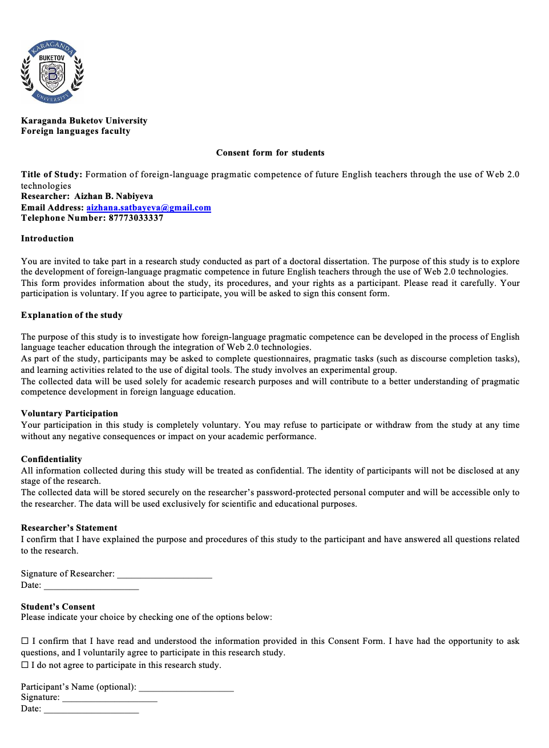

Appendix 2. Some items of DCT

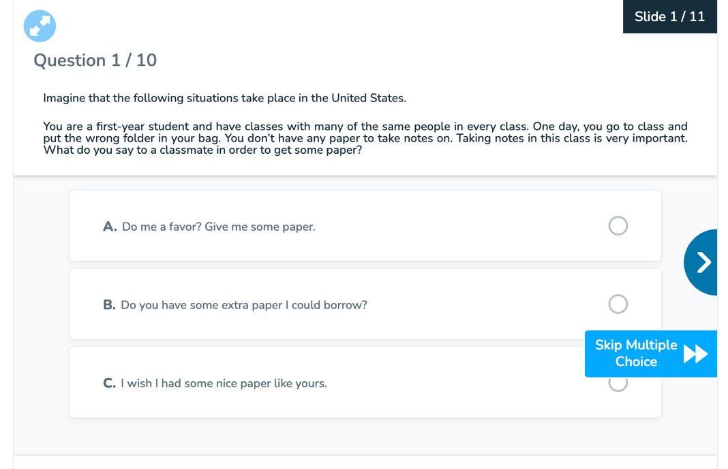
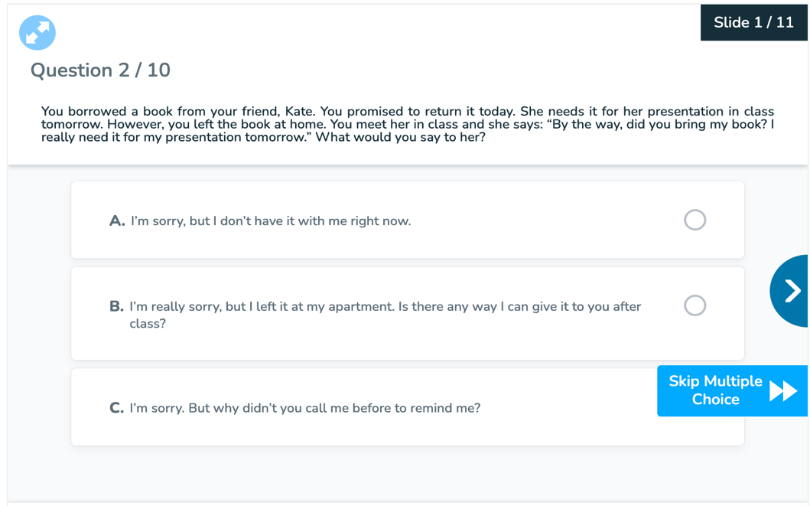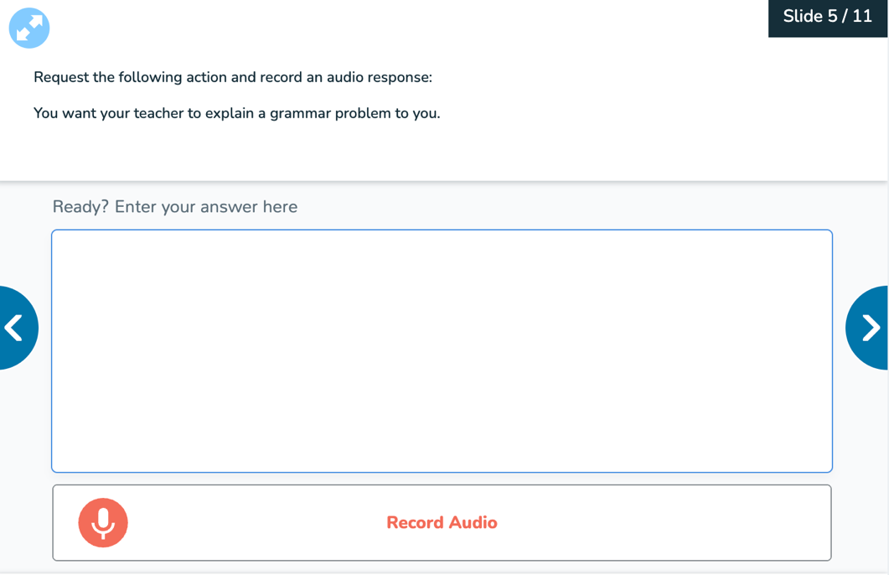

Appendix 3. Students’perception survey

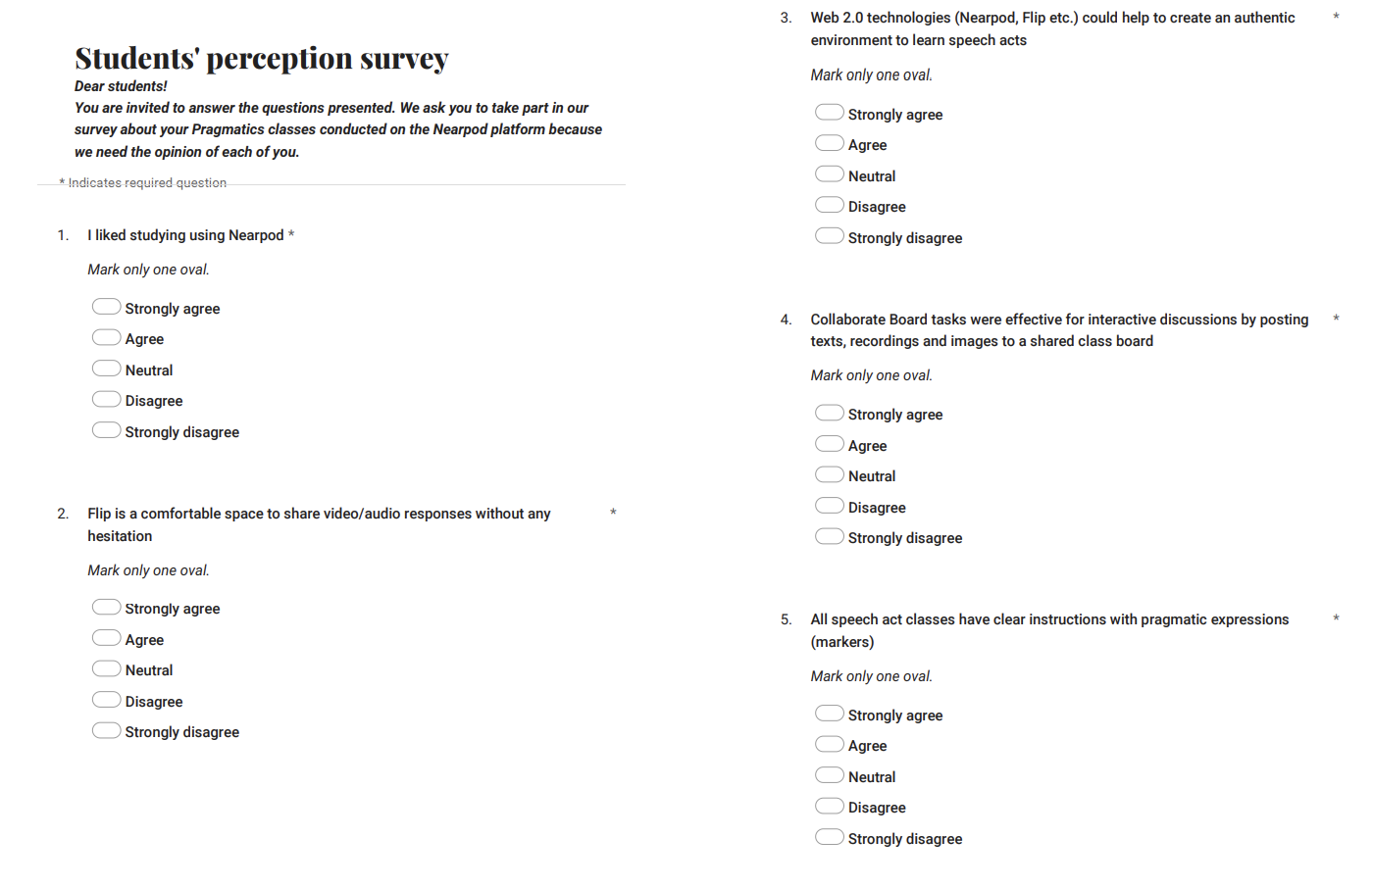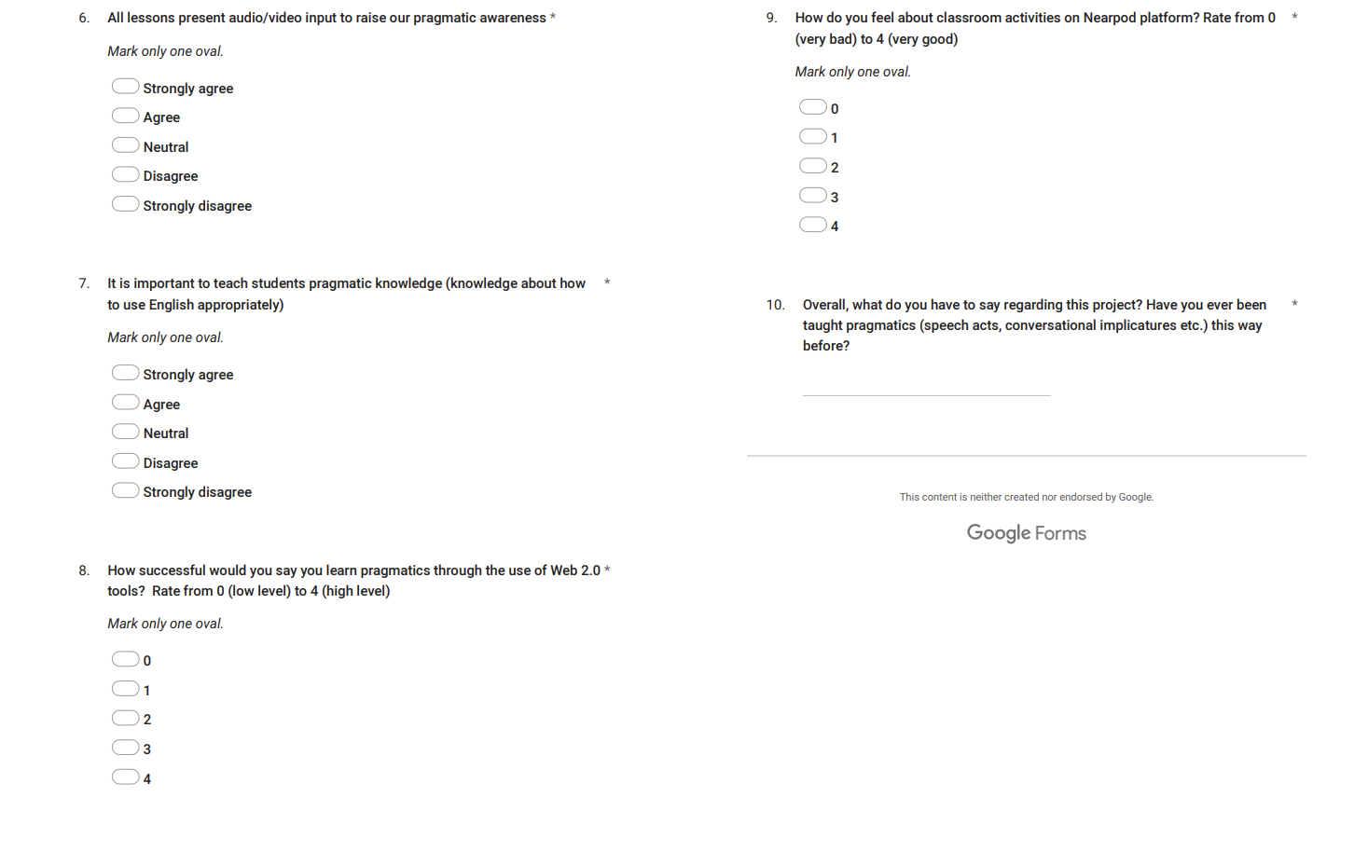

Appendix 4. Act on the implementation of the methodological recommendations into the activities of the university.

Appendix 5. A copyright certificate for the study-guide.

Appendix 6. A copyright certificate for the methodological recommendations.

Appendix 7. Act on the implementation of the Nearpod-based course into the activities of the university.

Appendix 8. Act on the implementation of the study-guide into the activities of the university.

