NJSC «Kazakh national agrarian research university»

UDC: 634.51:632.3 As a manuscript

Elmira Ismagulova Sovetovna

Phytopathological assessment of introduced walnut varieties and the development of protective measures against major diseases for the southern fruit growing zone of Kazakhstan

8D08104 – Plant Protection and Quarantine
Dissertation for the degree of Doctor of Philosophy (PhD)

Scientific Supervisors:
Gulshariya Kairova
Candidate of Agricultural Sciences,
Associate Professor,
Academician of the AAS RK

Hüseyin Basim
Professor, Dr.
Head of Department Akdeniz University,
Faculty of Agriculture,
Department of Plant Protection
(Turkey, Antalya)

Republic of Kazakhstan
Almaty, 2026
CONTENTS

 | NORMATIVE REFERENCES | 4
 | TERMS AND DEFINITIONS | 5
 | LIST OF ABBREVIATIONS AND SYMBOLS | 6
 | INTRODUCTION | 7
1 | SELECTION OF RESEARCH DIRECTION | 11
1.1 | State of knowledge on walnut diseases worldwide | 11
1.2 | Resistance of walnut (J. regia L.) cultivars | 19
1.3 | Diagnostic and protection methods for walnut: global experience | 21
1.4 | Genetic diversity and population structure of walnut (J. regia L.) based on SNP genotyping in Kazakhstan and the global collection | 23
2 | MATERIALS AND METHODS OF RESEARCH | 26
2.1 | Description of research objects | 26
2.2 | Methodology of field research | 36
2.2.1 | Methods for determining the DI and DSI of walnut diseases in the Southern regions of Kazakhstan | 36
2.2.2 | Methods for assessing the resistance of varieties to common diseases (Pantoea agglomerans and Alternaria alternata) | 38
2.3 | Methods of molecular identification of pathogens | 38
2.3.1 | Isolation of pathogens from infected walnut trees and isolation of pure cultures of fungi and bacteria | 38
2.3.2 | Genomic DNA extraction from walnut samples | 39
2.3.3 | PCR amplification and sequencing of ITS and 16S rRNA regions | 40
2.4 | Pathogenicity assays of bacterial and fungal pathogens | 42
2.5 | Methodology for testing fungicides and antibacterial preparations against walnut pathogens | 43
2.5.1 | Laboratory methodology for testing fungicides | 43
2.5.2 | Laboratory methodology for testing antibacterial preparations | 45
2.5.3 | Field methodology for testing fungicides against A. alternata | 46
2.5.4 | Field methodology for testing antibacterial preparations against P. agglomerans | 47
2.6 | Economic efficiency of applying modern preparations against major walnut diseases | 47
2.7 | Materials and methods for genetic diversity and population structure analysis of wild and cultivated walnut | 48
3 | RESULTS AND DISCUSSION | 52
3.1 | Characteristics of fungal and bacterial diseases of walnut identified during monitoring in the southern fruit-growing zone of Kazakhstan | 52
3.2 | Disease severity index and disease incidence of walnut diseases in the southern fruit-growing zone of Kazakhstan | 58
3.3 | Characteristics of pure cultures of fungal and bacterial isolates | 61
3.4 | Identification of fungal and bacterial pathogens using molecular genetic markers | 66
3.5 | Results of pathogenicity assessment of fungal and bacterial isolates | 76
3.6 | Results of genetic diversity and population structure analysis of wild and cultivated Juglans regia | 78
3.7 | Evaluation of the resistance of walnut cultivars to the most prevalent pathogens | 84
3.8 | Effectiveness of modern fungicides and antibacterial preparations against walnut pathogens | 87
3.8.1 | Laboratory evaluation of antibacterial preparations against walnut pathogens | 87
3.8.2 | Laboratory evaluation of fungicides against fungal pathogens of walnut | 91
3.8.3 | Field evaluation of fungicides against major walnut diseases caused by A. alternata and P. agglomerans | 94
3.9 | Economic efficiency of using modern preparations against major walnut diseases | 96
 | DISCUSSION | 98
 | CONCLUSION | 100
 | RECOMMENDATIONS FOR PRODUCTION | 101
 | REFERENCES | 102
 | Appendix A — Calculation of LSD (Least Significant Difference) | 113
 | Appendix B — Calculation of Costs for Fungicide Application per 1 ha of Walnut Plantations (Peasant Farm «Manshuk») | 120
 | Appendix C — Implementation acts | 122
 | Appendix D — Extract from completed works | 124
 | Appendix E — Certificates | 126

NORMATIVE REFERENCES

In this dissertation, references are made to the following standards:
No. 407-IV ZRK | Law of the Republic of Kazakhstan "On Science" dated February 18, 2011.
KR SCSSE 5.04.034-2011 | State Compulsory Standard of Education of the Republic of Kazakhstan. Postgraduate Education. Doctoral Studies. Basic Provisions (amended on August 23, 2012, No. 1080).
GOST 2.105-95 | Unified System for Design Documentation. General requirements for textual documents.
GOST 2.11-68 | Unified System for Design Documentation. Rules of standard control.
GOST 6.38-90 | System of Organizational and Administrative Documentation. Requirements for document formatting.
GOST 7.1-2003 | Bibliographic record. Bibliographic description. General requirements and rules for compilation.
GOST 7.32-2001 | Research report. Structure and formatting rules.
GOST 21507-81 | Plant protection. Definitions and terms.

TERMS AND DEFINITIONS

In this dissertation, the following terms with corresponding definitions are used:
Amplicons – PCR products synthesized during the amplification of a target DNA fragment.
Amplification – the process of increasing the number of DNA copies.
Bacterial preparation (bactericide) – an agent containing live or inactivated bacterial cultures or their metabolites, used to suppress or eliminate pathogenic bacteria in plants.
Fungicide – a chemical or biological preparation intended to suppress or eliminate fungi and plant fungal diseases.
Molecular markers – specific genome regions used to detect genetic differences between organisms or to identify particular traits.
Nucleotides – monomers of nucleic acids consisting of a nitrogenous base (adenine, thymine/uracil, guanine, cytosine), a sugar (deoxyribose or ribose), and a phosphate group.
Phytosanitary monitoring – a system of observation of the development and spread of pests and especially dangerous organisms.
Phytosanitary status – the current condition of agricultural objects, determined by the population density and harmfulness of pests and especially dangerous organisms.
Plant protection – a branch of applied biology that studies the theoretical foundations and methods of preventing and reducing damage caused by harmful organisms, as well as a branch of agricultural production that applies these methods.
Polymerase chain reaction (PCR) – a method of DNA amplification that results in the production of short DNA fragments using specific primers.
SNP (single-nucleotide polymorphism) – a polymorphism at a single nucleotide; this type of marker is increasingly used in genome research.

LIST OF ABBREVIATIONS AND SYMBOLS

The following symbols and abbreviations were used in this dissertation:
AMOVA – Analysis of Molecular Variance
ANOVA – Analysis of Variance
BAN – Brown Apical Necrosis
C – total costs for implementing protective measures, tenge
CFU – Colony-Forming Units
CLSI – Clinical and Laboratory Standards Institute
CTAB – Cetyltrimethylammonium Bromide
CYI – Cost of yield increase
DI – Disease Incidence
DNA – Deoxyribonucleic Acid
DQC – Dish Quality Control
DSI – Disease Severity Index
EDTA – Ethylenediaminetetraacetic Acid
I – Shannon Information Index
ITS – Internal Transcribed Spacer
KazNARU – Kazakh National Agrarian Research University
LD – Linkage Disequilibrium
LLP – Limited Liability Partnership
LSD – Least Significant Difference
MES RK – Ministry of Education and Science of the Republic of Kazakhstan
NA – Nutrient Agar
NCBI – National Center for Biotechnology Information
Ne – Effective number of alleles
NI – Net profit (net income)
P – Selling price of 1 c of product, tenge
PBS – Phosphate-Buffered Saline
PCA – Principal Component Analysis
PCR – Polymerase Chain Reaction
PDA – Potato Dextrose Agar
R – Profitability, %
PF – Peasant Farm
rRNA – Ribosomal Ribonucleic Acid
S – Simpson Index
SNP – Single Nucleotide Polymorphism
UV – Ultraviolet
YI – Yield increase, c/ha

INTRODUCTION

Relevance of the study

The walnut (Juglans regia L.) is one of the most valuable nut-bearing crops, possessing high nutritional, pharmacological, and economic importance. Walnut kernels are rich in biologically active compounds—antioxidants, polyphenols, flavonoids, phenolic acids, and tannins—which determine their significant role in functional nutrition and medicine. In addition, walnut wood is widely sought after in industry.

Against the background of steady growth in global production and expansion of commercial walnut plantations, the search for regions with favorable soil and climatic conditions is of particular relevance. According to international assessments, only about 7% of the planet’s land resources are suitable for industrial cultivation. The southern regions of Kazakhstan meet the ecological requirements of this crop; however, walnut cultivation in the country remains underdeveloped.

The development of industrial walnut production in Kazakhstan has high strategic importance. This sector can ensure not only diversification of agriculture but also a reduction in dependence on imported walnut products, an increase in export potential, and the enhancement of agro-landscape resilience.

One of the key factors limiting the development of walnut cultivation is the high vulnerability of plantations to fungal and bacterial diseases. Climate change, the expansion of plantation areas, and reduced genetic diversity of cultivated material contribute to the intensification of pathogens and increased economic losses.

The situation in Kazakhstan is particularly acute, as there are currently no pesticides officially approved for use in walnut protection (according to the List of Pesticides Permitted for Production (Formulation), Import, Storage, Transport, Sale, and Application in the Republic of Kazakhstan for 2022–2031). As a result, walnut diseases develop without hindrance, causing damage to both commercial plantations and household orchards.

To date, no systematic scientific research has been carried out in the country to comprehensively study the phytopathological status of walnut plantations, identify the key pathogens, or assess the resistance of varieties and genotypes. Moreover, no targeted work has yet been undertaken in Kazakhstan to isolate and characterize fungal and bacterial pathogens of walnut, which significantly complicates the development of effective protective measures and constrains the growth of the walnut industry.

Aim of the study. To assess the phytosanitary condition of walnut (J. regia L.) plantations in the southern regions of Kazakhstan, determine the development and disease index (DI) of major pathogens, and evaluate the resistance of promising cultivars and genotypes of walnut to key pathogens. The study will include pathogen identification using microbiological and molecular-genetic methods, as well as an investigation of the genetic diversity and population structure of walnut cultivars and populations through SNP genotyping. Furthermore, recommendations for plant protection will be developed, taking into account modern fungicides and cultivar resistance.

Research objectives. The current work pursued the following objectives.
1. To identify fungal and bacterial diseases of walnuts during monitoring of plantations in the southern fruit-growing zone of Kazakhstan;
2. To study the DI and dynamics of walnut diseases in the southern fruit-growing zone of Kazakhstan;
3. To isolate and conduct microbiological identification of pure cultures of fungal and bacterial walnut pathogens;
4. To identify fungal and bacterial pathogens using molecular-genetic markers;
5. To perform molecular-genetic assessment of genetic diversity and population structure of various commercially popular, local varieties, and wild populations of walnut from Kazakhstan using SNP genotyping with the Axiom™ J. regia 700K array;
6. To evaluate the resistance of promising walnut varieties and genotypes to key pathogens;
7. To assess the efficacy of modern fungicides against major walnut diseases;
8. To develop scientifically grounded recommendations for walnut protection against fungal and bacterial diseases, taking into account the agroecological conditions of the southern fruit-growing zone of Kazakhstan.
Scientific novelty. The scientific novelty of this work is reflected in the following contributions.
1. For the first time in Kazakhstan, a study of the phytopathogenic complex of walnut has been conducted using microbiological and molecular-genetic methods;
2. The species composition of key fungal and bacterial pathogens of walnut diseases, previously unstudied in the agrocenoses of the republic, has been identified and characterized;
3. Diagnostic profiles of pathogens have been developed based on PCR identification of genomic DNA, which increases the accuracy of disease monitoring and control;
4. The resistance of local and introduced walnut varieties and genotypes to the main phytopathogens has been assessed, and the most promising ones for breeding and industrial use have been identified;
5. The specific features of genetic diversity and population structure of walnut varieties and populations in the southern regions of Kazakhstan have been established through SNP genotyping;
6. Scientifically grounded recommendations for the protection of walnut plantations against diseases have been developed.
Main provisions submitted for defense. The main provisions submitted for defense are as follows.
1. As a result of monitoring surveys of plantations in the southern fruit-growing zone of Kazakhstan, the spread and development of the main fungal and bacterial pathogens of walnut were identified;
2. In the course of scientific research, the causal agents of bacterial and fungal walnut diseases were identified using microbiological and molecular-genetic methods;
3. The feasibility of introducing walnut varieties resistant to bacterial and fungal diseases into practical cultivation and breeding has been established, which will improve the breeding process and increase fruit yield;
4. Genetic diversity and phylogenetic relationships of local and introduced walnut forms have been determined based on SNP genotyping data;
5. Scientifically grounded recommendations have been developed for the protection of walnut (J. regia L.) against fungal and bacterial diseases, taking into account the agroecological conditions of the southern fruit-growing zone of Kazakhstan.
Practical value of the results. The study made it possible to identify and recommend walnut varieties and genotypes with high resistance to phytopathogens, as well as adaptation to the conditions of southern Kazakhstan, for industrial use. The implementation of these results will ensure:
1. An increase in yield and stability of fruiting through the use of resistant varieties and genotypes;
2. A reduction in chemical protection costs due to a targeted disease management strategy;
3. The production of environmentally safe and competitive products with high export potential.
Implementation of the results. The practical recommendations have been introduced into the production activities of the walnut orchard of “Manshuk” Rural Farm (Turgen village, Enbekshikazakh district) and LLP “Fazenda UM” (Bereke village, Talgar district, Almaty region). The implementation covers an area of 10 ha in each farm and is planned for further scaling to other farms in the region.
Personal contribution of the applicant. The personal contribution of the applicant is as follows.
1. Conducting field surveys of walnut plantations in the southern regions of Kazakhstan;
2. Collection and analysis of samples and isolation of pure pathogen cultures;
3. Performing molecular-genetic identification of the pathogens;
4. Conducting an experimental assessment of the effects of fungicides and antibacterial preparations on pathogenicity;
5. Carrying out fungicide trials and evaluating their biological efficacy;
6. Preparing scientific publications and presenting the results at scientific conferences.
Publications based on the research results. A total of 9 scientific works have been published based on the research, including:
1. Four articles in scientific journals recommended by the Committee for Control in the Sphere of Education and Science of the Ministry of Science and Higher Education of the Republic of Kazakhstan;
2. Two articles in the proceedings of international scientific and practical conferences;
3. Two articles were published in journals indexed in the Scopus database with percentile indicators of 65 and 88, including one scientific article published in a journal ranked in the first quartile (Q1) and another in the second quartile (Q2) of the Web of Science;
4. One recommendation prepared for practical implementation in production.
Alignment with state Programs. The dissertation was carried out at the Kazakh National Agrarian Research University within the framework of Budget Program 102 “Grant Financing of Scientific Research”, under the sub-priority “Innovative biological research to improve the productivity and resilience of plant varieties and animal breeds in agriculture”. The work was conducted under the program, Grant Number AP19677936, “Investigation of the main walnut diseases and molecular genetic basis of the resistance of promising varieties to economically important pathogens”.
Approbation of the work. The research materials were presented and discussed at:
1. The International Scientific and Practical Conference of Young Scientists (2023);
2. The International Conference “Plant Biology and Biotechnology” (ICPBB, 2024);
3. The International Conference “Artificial Intelligence, Computer, Data Sciences and Applications” (ACDSA, 2025, Antalya, Türkiye);
4. Meetings of the Department of Plant Protection and Quarantine and the Scientific and Technical Council of the Faculty of Agrobiology.
The study was conducted at.
The Department of Fruit Growing, Vegetable Growing, Plant Protection and Quarantine of the Kazakh National Agrarian Research University, at the Kazakh-Japanese Innovation Center of the Kazakh National Agrarian Research University, at the Kazakh Research Institute of Plant Protection and Quarantine named after Zh. Zhiembayev, and at the Institute of Plant Biology and Biotechnology, Almaty, Kazakhstan.
Structure and volume of the dissertation. The total volume of the dissertation is 127 pages and includes an introduction, the main part consisting of three chapters, a conclusion, recommendations for production, and appendices. The dissertation contains 24 tables and 29 figures. The list of references comprises 156 sources, of which 149 are foreign publications.

1 SELECTION OF RESEARCH DIRECTION
1.1 State of knowledge on walnut diseases worldwide
Pantoea agglomerans is a facultative phytopathogen in the family Erwiniaceae, order Enterobacterales, class Gammaproteobacteria [1]. Historically, it was generally considered an epiphyte or endophyte residing on plant surfaces, seeds, soil, water, and inside the interior tissues of plants, animals, and people [2]. Recent investigations have demonstrated its significant pathogenic potential against various cultivated crops, including walnut (J. regia) [3]. The pathogenicity of P. agglomerans to walnut was initially documented in China, namely in the Shandong and Hebei provinces. Investigations indicated that, alongside other pathogens (Xanthomonas arboricola pv. juglandis, Alternaria spp.), this bacterium has a role in the onset of walnut blight and brown apical necrosis of fruits. These diseases induce necrosis, decay, and dieback in buds, leaves, shoots, and fruits, ultimately leading to significant output reductions [4]. P. agglomerans induces internal fruit necrosis and bacterial black stain on walnuts. Characteristic symptoms include the formation of black water-soaked lesions on leaves, shoots, and buds; progressive tissue necrosis with lesion coalescence; cracking and cankers on young shoots leading to dieback; as well as fruit browning, cracking, and premature abscission. Disease incidence (DI) is particularly severe under high humidity and in cultivars with an early onset of vegetative growth [4, p. 347-354]. An and others proved that P. agglomerans Infection causes significant physiological changes in walnut trees, such as decreased levels of photosynthetic activity and soluble sugars, a significant rise in the activities of antioxidant enzymes (SOD, POD), and increased synthesis of secondary metabolites (phenolics and flavonoids). At the molecular level, growth is inhibited and necrosis is encouraged via the activation of the phenylpropanoid pathway, the upregulation of hormonal signalling (ABA, ET, SA, and JA), and the suppression of auxin signalling. Additionally, immune cascades including MAPK and FLS2-BAK1 are triggered. The complete genome sequence of P. agglomerans strain CHTF15, isolated from diseased walnut leaves, was published in 2023. The genome consists of one circular chromosome and three plasmids with a total length of 4.82 Mb, encoding 4,336 genes. Among these, over 600 are virulence-associated and 285 confer antibiotic resistance. Major pathogenicity determinants include a type III secretion system (T3SS), plant cell wall–degrading enzymes (cellulases, pectate lyases), iron acquisition systems (siderophores), as well as resistance genes to tetracyclines and macrolides [5]. P. agglomerans often acts synergistically with other phytopathogens (X. arboricola pv. juglandis, A. alternata, Botryosphaeria dothidea, Phomopsis spp.), exacerbating brown apical necrosis (BAN) of walnut fruits and shoots. In addition to its phytopathogenic role, certain strains of P. agglomerans are utilized as biological control agents against postharvest fungal pathogens (e.g., Penicillium digitatum in citrus and Rhizopus stolonifer in apples and pears). Nevertheless, such applications require caution, as closely related pathogenic strains can cause severe bacterial diseases in walnut and other crops. In Yunnan Province (China), P. agglomerans was confirmed as one of the primary causal agents of walnut blight. Pathogenic strains were isolated from diseased fruits and leaves, among which strain NO39 exhibited 99.93% sequence homology with P. agglomerans based on 16S rDNA and clustered with typical representatives of the species. This demonstrated unequivocally that it is harmful to walnuts. As a result, P. agglomerans has been identified as a major cause of walnut blight in the Yunnan area [6].
One of the most common bacterial phytopathogens, Pseudomonas syringae pv. syringae, infects over 180 plant species, including woody and agricultural crops [7]. Numerous diseases, including leaf spots, blights, necroses, stem cankers, bud and shoot dieback, and bacterial galls, are linked to the pathogen [8]. Stone fruits, such as plum, apricot, peach, and cherry, have received the most research interest.
In Iran, the first isolations of strains causing bacterial blight of apricot and cherry were reported by Bahar et al. [9] and Banapour et al. [10]. Additional studies investigated its occurrence on olive trees [11] and on stone fruits in different regions of the country [12]. In Europe, strains closely related to P. syringae pv. syringae have been detected on walnut, where they caused weakening and dieback of trees [13]. Similar findings were reported in the USA [14] and the UK [15, 16]. However, there had been no verified reports of walnut (J. regia) infection by this pathogen before to the investigation by Keshtkar et al. (2023). In Iran and throughout the world, that study offered the first instance of a walnut leaf spot causative agent being isolated and identified. Biochemical reactions, pathogenicity testing on model plants, and conventional phenotypic assays (the LOPAT group of tests) are diagnostic techniques [17]. With the development of molecular techniques, phylogenetic marker studies (16S rRNA, gyrB, rpoD genes) and DNA-typing methods (BOX-PCR, ERIC-PCR, REP-PCR) have been used to reliably differentiate strains and revise taxonomic placement [18-22]. On nutrient media such as NA and King’s B medium, the bacterium produces smooth, round colonies with entire margins and a characteristic green fluorescent pigment visible under UV light. It is catalase-positive, oxidase-negative, and arginine-dihydrolase–negative, and it synthesizes levan from sucrose, resulting in mucoid colonies. Pathogenicity is confirmed by the hypersensitive response (HR) in tobacco and geranium leaves. Strains are capable of hydrolyzing starch, arbutin, and esculin, degrading gelatin, and growing in the presence of 4% NaCl, but not at 37 °C. As carbon sources, they utilize erythritol, glutarate, DL-glycerate, sorbitol, mannitol, L-lactate, and sucrose, but do not metabolize D-arabinose, cellobiose, trehalose, or adonitol [8, p. 837-846]. Infection occurs through stomata and mechanical injuries. The bacterium produces cellulases, pectate lyases, and other enzymes that degrade plant cell walls. An additional virulence factor is its ice nucleation activity, which damages tissues during frost events and facilitates infection. On walnut and other crops, symptoms include necrotic leaf spots surrounded by a yellow halo. Under severe infection, shoot dieback, premature leaf drop, and general weakening of plants are observed. On peach and plum, the pathogen induces necrotic lesions on bark and shoots. Given the high agricultural value of walnut, the spread of P. syringae pv. syringae represents a serious threat to horticulture, particularly in regions with humid climates. Yield losses in the absence of timely phytosanitary control can reach several tens of percent.
The bacterium Xanthomonas campestris pv. juglandis is recognized as the causal agent of bacterial blight. The disease was first described in California in 1901 by Pierce, who observed severe necrosis of shoots and fruits. Mulrean and Schroth (1982) further demonstrated the role of overwintering inoculum in buds and catkins, showing that up to 95% of buds of the ‘Payne’ cultivar and more than 40% of catkins could harbor the pathogen, confirming their epidemiological importance. Historically, the pathogen was designated as X. campestris pv. juglandis. However, based on comprehensive DNA–DNA hybridization and polyphasic taxonomic analyses, Vauterin et al. (1995) reclassified it into the novel species X. arboricola pv. juglandis [23]. Burokiene and Pulawska (2012) reported the first case of bacterial blight in Lithuania, collecting 59 strains and identifying several of them as X. arboricola pv. juglandis using PCR, biochemical testing, and pathogenicity tests [24]. The pathogenicity of X. arboricola pv. juglandis isolates from Hungary and Romania was subsequently validated by Bandi et al. (2014), who also showed a high degree of phenotypic similarity between them [25]. The pathogenicity of isolates resistant to copper but sensitive to antibiotics was confirmed when X. arboricola pv. juglandis was discovered in northern Gyeongbuk Province, South Korea [26]. Pardatscher et al. (2019) documented X. arboricola pv. juglandis-caused bacterial blight outbreaks in northern Italy that affected leaves, fruits, and young shoots; pathogenicity was confirmed, while copper-based therapies demonstrated decreased efficacy [27]. The first report of bacterial blight in Poland was made by Kałużna et al. (2014), who verified the pathogenicity and presence of X. arboricola pv. juglandis [28]. Iličić et al. (2021) linked X. arboricola pv. juglandis to the symptoms of vertical oozing canker in Serbia, and pathogenicity was shown in lab settings [29]. Last but not least, Latinović et al. (2025) isolated and verified pathogenic strains from trees exhibiting symptoms, presenting the first proof of bacterial blight caused by X. arboricola pv. juglandis in Montenegro [30]. The bacteria forms spherical, yellow, convex, glossy colonies with smooth edges on nutrient agar (NA). It is oxidase-negative, catalase-positive, and a strict aerobe. The pathogen's capacity to remain in soil and plant tissues can be explained by its low fermentative activity and great tolerance to unfavourable environmental circumstances. The climate of southern China is characterized by high humidity and temperatures between 22 and 28 °C, which are ideal for multiplication. Micro-injuries on leaves, which can result from insect activity or mechanical injury, are the source of infection. Water-soaked lesions that form between veins or along leaf margins are the first signs of the illness [31]. These patches eventually become light brown, clump together, and create large necrotic patches along the margins or across the lamina [30, p. 45-56]. Wilting and leaf death are noted in later stages.
Long believed to be primarily an opportunistic human pathogen, Pseudomonas oryzihabitans causes rare infections in individuals with compromised immune systems [32]. However, since the late 2010s, there has been evidence of its phytopathogenic effect on a number of crops, including melon, rice, and Sichuan pepper [33, 34]. In 2022, a widespread outbreak of walnut (J. regia) leaf spot caused by P. oryzihabitans was reported for the first time in China. The disease was discovered on the cultivar "Xiangling," in Shandong Province nurseries. The mean incidence was 48.6%, with a range of 34.6% to 65.3%. This was the first confirmed case of this virus infecting walnuts worldwide. P. oryzihabitans was long thought to be largely an opportunistic human pathogen that causes uncommon infections in people with weakened immune systems. However, evidence of its phytopathogenic action on a variety of crops, such as rice, Sichuan pepper, and melon, has surfaced since the late 2010s. For the first time, a widespread outbreak of P. oryzihabitans-caused walnut (J. regia) leaf spot was documented in China in 2022. On the cultivar "Xiangling," the disease was found in nurseries in Shandong Province. Incidence levels ranged from 34.6% to 65.3% (mean 48.6%) [35]. This was the first instance of walnut infection by this pathogen that had been verified globally. A similar strain was previously discovered from walnut fruits in 2019, which may indicate that it is part of the microbial complexes that cause bacterial illnesses in walnuts [36]. Isolation on nutrient agar (NA), morphological analysis of Gram-negative rods (about 0.35–0.52 × 0.90–1.24 μm), and sequencing of the 16S rRNA, rpoD, and gyrB genes were the traditional and molecular methods used for species confirmation. With a homology of 98–99% with reference strains, P. oryzihabitans could be identified with certainty. The bacteria forms spherical, golden, convex, glossy colonies with smooth edges on NA media. One crucial distinguishing feature of P. oryzihabitans is that it does not produce fluorescent pigment, in contrast to fluorescent pseudomonads. The bacterium is oxidase-negative, catalase-positive, and a stringent aerobe. Its capacity to remain in soil and plant tissues can be explained by its modest fermentative activity and significant tolerance to adverse environments. The climate of southern China is characterized by temperatures between 22 and 28 °C and humidity levels above 45%, which is when multiplication is most active. Micro-injuries on leaves that result from insect activity or mechanical injury are how infections spread. Water-soaked sores at the edges or in between veins are the first signs of the disease. Along the borders or across the lamina, these progressively turn light brown, combine, and develop large necrotic regions. Later on, leaf death and wilting are noted. In terms of both planted area and production volume, China leads the world in walnut farming. The production of walnuts is thus seriously threatened by the introduction of a novel bacterial disease brought on by P. oryzihabitans, which weakens trees and reduces yield and product quality.
Woody and herbaceous plants are both susceptible to infection by the soilborne pathogen Agrobacterium tumefaciens [37, 38]. The disease is typified by the development of tumours (galls) on the lower trunk, crown, and roots that interfere with the movement of nutrients and water. The walnut rootstock "Paradox" (Juglans hindsii × J. regia), which is utilized on over 75% of orchard area, was found to be particularly susceptible in the early investigations carried out in California. The incidence of crown gall might surpass 90% in contaminated soils. High sequence similarity in 16S rRNA and the presence of the virD2 gene verified the pathogenicity of virulent strains of A. tumefaciens that were also isolated in Iran. On PDA+CaCO₃, TSA, and NA medium, strains—gram-negative motile rods—form white, convex colonies. 16S rRNA analysis is used to identify species, and the presence of the virD2 gene and Ti plasmid is a crucial indicator of pathogenicity. Peritrichous flagella give cells their motility, and they measure between 0.4 and 0.7 x 0.8 and 1.2 μm. Colonies are non-pigmented, spherical, convex, and white to cream in colour. The bacterium is oxidase-negative, catalase-positive, and a stringent aerobe. It breaks down sugars, produces opiates, and uses a variety of carbon compounds. The tumor-inducing plasmid (Ti plasmid), which has a T-DNA region, is the pathogen's distinguishing characteristic. Through a specific transfer pathway, T-DNA enters the host genome after infection. This leads to the production of opines and chemicals that resemble phytohormones, which give the bacterium a source of nutrients and encourage unchecked cell division. The virD2, virG, and virE genes—which control host recognition and T-DNA transfer—are involved in the process. Mechanical damage to the crown and roots might result in infection. The resultant galls hinder the movement of nutrients and water, inhibit plant development, and may eventually lead to tree death. The bacterium's asymptomatic systemic persistence in plant tissues until damage creates entrance sites poses an additional risk. Crown gall is one of the most damaging walnut diseases in California, especially on "Paradox" rootstock, where infection rates in nurseries can approach 94% [39]. Tree deterioration, lower yields, and early decline can result from the pathogen's over ten-year soil persistence. There aren't enough efficient eradication techniques. Strict phytosanitary control of planting materials and the use of seed taken directly from trees rather than from soil are the mainstays of current management. Other strategies include biological control using Agrobacterium radiobacter strain K84 and its derivatives, soil fumigation (Telone C35), which lessens but does not completely eradicate the pathogen, the removal of infected plants, disinfecting tools, and establishing orchards on soils free of pathogens. Additionally, nematodes, insects, or mechanical harm can injure the roots and stems, leading to infection. The T-DNA fragment from the Ti plasmid entering the plant genome is the main pathogenicity mechanism. Significant physiological alterations are brought about by this integration, including an overabundance of phytohormones (auxins and cytokinins) and the manufacture of low-molecular-weight opiates, which act as sources of carbon and nitrogen for bacteria and as intermediaries in the transmission of Ti plasmids between strains [40]. Tumor-like galls develop as a result, weakening the plants, resulting in chlorosis, and making them more vulnerable to secondary infections. Eight isolates of A. tumefaciens were found in Samarkand Province nurseries. Colonies were spherical, convex, smooth, and translucent on MacConkey agar; the cells were motile, Gram-negative rods that were 0.7 × 2.3 μm. On potato and carrot discs, every isolation caused tumours. The capacity to oxidize lactose (with the generation of 3-ketolactose), mannitol, glucose, and sucrose was demonstrated by biochemical tests. Tests of antibiotic sensitivity revealed susceptibility to kanamycin but resistance to gentamicin and tetracycline. The existence of important virulence factors was confirmed by genomic analyses of strain 186, which was isolated from walnuts in California. The Ti plasmid and both circular and linear chromosomes make up its genome (5.72 Mb, GC content 59.4%). The plasmid contains the vir regulon and oncogenes (iaaM, iaaH, ipt, 6b, 5) that cause tumour formation, whereas the chromosomes include the virulence genes (chvI-chvG, chvA, chvB, and chvE). Additionally, putative prophecies were found. These results guide the creation of control measures and offer important insights into the biology of Agrobacterium strains that infect Juglans spp. [41]. Thus, one of the main phytopathogens endangering the growth of walnuts is A. tumefaciens. The use of pathogen-free planting material, phytosanitary grafting, soil treatment, and biocontrol techniques are the main methods of prevention because chemical control treatments are generally unsuccessful. Furthermore, the production of certified pathogen-free seedlings appears to be a promising use of molecular diagnostic techniques (e.g., Ti plasmid–based PCR).
More than 4,000 plant species are infected by the polyphagous fungus A. alternata, which is widely dispersed [42]. This pathogen has been found to cause walnut leaf spot disease in Serbia, Italy, China, and India [43-44]. Necrotic patches with concentric zonation were the disease's initial European manifestation, as reported by Belisario et al. (1999) in Italy [45]. In 2019, DI surpassed 25% of planting leaves in Xinjiang Province, China. The prevalence was as high as 85.3% in India (Jammu and Kashmir, 2021–2022). The fungus, which was isolated from the leaves, branches, and fruits of the "Chandler" cultivar in Serbia, was shown to be harmful both with and without tissue injury. These results highlight the pathogen's great degree of adaptability and wide geographic range. Small brown spots that eventually grow into necrotic lesions with distinctive dark concentric rings are the first signs to show up on leaves. Severe infection causes significant yield losses, premature leaf drop, and shoot dieback. In Serbia, it was shown that leaves, branches, and fruits were all harmful. Colonies on PDA, CMA, and CLA media are white at first, then develop a darker core zone and an olive-green or gray-brown texture with a velvety texture. Conidia have morphologies that range from ellipsoid and obclavate to obpyriform, and they can be carried alone or in chains. Conidial dimensions that have been reported include: Italy: primary conidia 28–60 × 8–15 μm, secondary conidia 10–30 × 7–13 μm; Serbia: 15.6–53.2 × 7.8–18.5 μm (mean 36.0 × 14.2 μm); India: 11–38 × 6–15 μm (mean 23.7 × 9.2 μm); China: 20.6–35.8 × 6.8–11.2 μm (mean 25.5 × 8.7 μm). Conidiophores can be simple or branching, light brown, and septate. At 24 to 28 °C, growth is at its best, and PDA and CMA show the most vigorous development. A wide variety of secondary metabolites, including mycotoxins that increase pathogenicity, are produced by the fungus. Through stomata or tiny wounds to the epidermis, infection takes place. Fruit quality is compromised, plant development is suppressed, and photosynthetic activity is decreased. Significant yield losses result from the high reported incidence rates, which can reach up to 85% in India and 25% in China. Its synergistic relationship with other diseases, including Fusarium spp. and X. arboricola pv. juglandis, is especially worrisome. Molecular markers are commonly used for diagnosis: in China, ITS, endoPG, and H3; in India, ITS, endoPG, and Alt a 1. High homology (99.8–100%) with reference strains of A. alternata was found through sequencing.
A common phytopathogen that affects fruit crops, bulbous plants, palms, and grains is Fusarium proliferatum. In 2002, it was discovered to be a walnut (J. regia) pathogen in Italy, where it was linked to fruit BAN [46]. The disease was found to affect the cultivars "Lara," "Pedro," "Chandler," and "Sunland" in Italy, resulting in yield losses of up to 20%. Necrotic patches on the fruit's floral end and discoloration of the internal tissues were among the symptoms. The fungus was initially identified as the cause of walnut leaf spot in China in 2019 in Hebei Province, where DI in some orchards reached 35%. Colonies grow quickly on PDA medium, resulting in dense aerial mycelium that is first white or cream coloured before turning violet. Macroconidia have 3–5 septa, measure 21.6–47.4 × 2.5–4.6 μm (mean 31.9 × 3.5 μm), and are either straight or slightly curved. On branched conidiophores, lengthy chains of oval microconidia form. The production of chlamydospores in older cultures ensures the survival of the virus. Chinese isolates have been added to GenBank (MZ891582, MZ891583). EF-1α and RPB2 gene sequencing confirms species identity with >99% identity to reference strains. Brown patches emerge at the floral end of fruits (Italy) as a result of primary infection through the stigmatic tissues. The pathogen then causes tissue necrosis and kernel rot as it moves inward through the ovary and style. Brown lesions along the margins of leaves are the first signs of disease, and they eventually spread and cause the entire lamina to dry up. The fungus easily colonizes soil, host tissues, and plant leftovers and develops most actively at 24 to 28 °C. Its development of mycotoxins, especially fumonisins, which increase aggression, is a noteworthy characteristic. The fulfillment of Koch's postulates on both fruits and leaves has verified pathogenicity. Fruit infection by F. proliferatum in Italy lowers fruit quality in Chandler and Sunland and can result in a 20% yield reduction in the cultivar "Lara." The disease's leaf shape lowers photosynthetic activity and yields by 10–30% in China [47]. The spread of F. proliferatum is a major concern to walnut production since it can infect both fruits and foliage.
A common phytopathogen, Fusarium graminearum is well known for causing root rots and Fusarium head blight in cereals. It has been recognized more recently as one of the main fungal factors causing BAN of walnut (J. regia) fruits in Italy. In 1998, BAN was initially discovered in southern France and Italy's Po Valley in heavily maintained orchards. The disease mostly impacted the cultivars "Lara," "Pedro," "Chandler," and "Sunland," with yield losses in extreme years as high as 40%. F. graminearum, F. semitectum, and Alternaria spp. were the most commonly isolated from infected fruits; of these, F. graminearum was the most aggressive, causing more severe fruit drop than Alternaria spp. Colonies on PDA grow quickly and produce a lot of aerial mycelium, which is first white to pinkish and then turns deep crimson or purple. Macroconidia are falcate, 25–45 × 3.5–5.5 μm, thin-walled, and have three to five septa. In older cultures, chlamydospores form, but microconidia are lacking. During flowering, infection spreads through the stigmatized floral tissues. The mycelium enters the ovary and interior fruit tissues through the style. A dark brown patch at the stigmatic end is the first sign, and it grows over time to eventually cover up to two-thirds of the fruit's surface. The kernel deteriorates and darkens as inside tissues necrotize. Often, infected fruits abscise too soon. 24 to 28 °C is the ideal temperature for development [48]. The ideal circumstances for the fungus to invade tissues include high temperatures and high humidity. Elevated temperatures during flowering (the most important factor), high relative humidity, inadequate canopy ventilation (dense plantings, row orientation with respect to wind), and orchard proximity to water bodies are some of the conditions that promote disease development. In contrast to late inoculation, which has a lesser incidence, fruit drop is most severe after early infection (May). BAN brought on by F. graminearum and related infections can result in yield losses of up to 40% in intensive orchards in France and Italy. The disease darkens the shell and degrades the quality of the kernels, making the fruit less marketable. Koch's postulates were fulfilled, confirming pathogenicity: the pathogen was re-isolated from 60–67% of infected fruits, and artificial inoculations replicated field symptoms.
A species complex with broad ecological amplitude and potential for pathogenicity is Fusarium solani. As the cause of necroses, stem cankers, and root rots in both woody and herbaceous plants, it is widely recognized. It has been identified as a significant pathogen of walnut (J. regia) in China, South Africa, and Spain on multiple occasions in recent years. It caused stem cankers with incidence rates ranging from 15 to 40 percent, according to the initial study from China's Xinjiang Province [49]. Up to 30% of trees in Hubei were reported to die as a result of Fusarium wilt that affected the root system [50]. It has been reported that Juglans sigillata infections in Sichuan cause total tree death in as little as 24 days [51]. Thirty percent of plants in South Africa's Gauteng Province experienced shoot dieback and stem cankers due to F. solani [52]. Up to 33% of plants were infected by the virus in nurseries and young orchards of "Chandler" and "Howard" cultivars in Spain in 2017 [53]. On PDA, the back side is light brown, and the colonies are dense, cottony, white to beige, and frequently have pinkish-brown centres [54]. Macroconidia are falcate, have one to six septa, and differ in size depending on the area: Sichuan (J. sigillata) — mean 47.4 × 5.3 μm; Spain — 12.2–20.4 × 3.6–5.7 μm; Xinjiang (China) — 22.8–38.5 × 3.5–6.7 μm. Oval and hyaline, microconidia have dimensions of 4.5–10.5 × 1.8–4.3 μm. Chlamydospores are spherical, single or paired, and range in diameter from 9 to 10 μm. The ITS, EF-1α, and RPB2 domains are sequenced to validate species identity; sequences from several regions are deposited in GenBank (e.g., OP271472, KP001165, KJ528277, MK968891). Wounds in the roots, crown, or stem are usually the source of infection and are frequently brought on by transplanting, mechanical harm, or insect activity. Long, oval, dark brown cankers develop on branches before necrosis sets in. Root rot, cambial necrosis, and vascular browning are symptoms that cause the canopy to wilt and turn yellow. Branch dieback and eventual tree death are caused by severe infections. In every published study, pathogenicity has been verified by the satisfaction of Koch's postulates. 23 to 28 °C is the ideal temperature range for growth. Disease growth is favoured by high planting density, heavy irrigation, and mechanical damage. Water, contaminated equipment, soil, and infected planting material are the main ways that the disease spreads. F. solani is regarded as one of the walnut's most hostile pathogens. Up to 30% of trees in South Africa and up to 33% of seedlings in Spain were infected, frequently resulting in significant mortality upon transplantation. Both J. regia and J. sigillata have experienced significant outbreaks in China, with some cases resulting in the total loss of trees.
Although it shares physical similarities with F. oxysporum, Fusarium redolens is a soilborne fungus of the genus Fusarium that can be distinguished by its molecular and physiological traits. On PDA, it forms flat colonies with mycelium that is somewhat aerial, white to pink, smooth-bordered, and devoid of zonation; as time passes, the colonies take on a pinkish or pale violet hue. Microconidia are unicellular or bicellular, cylindrical, tapering at one end, and range in size from 6.4 to 9.2 × 2.5 to 3.8 μm (mean 7.7 × 3.2 μm). Macroconidia are typically 8.6–16.3 × 3.0–5.2 μm (mean 12.3 × 3.9 μm) in size, with short, thick-walled walls and three septa. The apical cell is hook-shaped, while the basal cell is foot-shaped. There were no chlamydospores found in this investigation. The optimum temperature for mycelial growth is 25 °C, with a minimum of 4.5 °C and a maximum of 31 °C. On PDA, colony growth at optimum conditions is ~5 mm/day, comparable to members of the F. oxysporum complex. The primary infection route is through wounds in the root system and crown, especially under unfavorable conditions. The fungus penetrates the xylem, inducing vascular wilt, root necrosis, and plant death. Disease development is promoted by high soil moisture and temperatures of 25–28 °C. The pathogen spreads via infested soil, water, planting material, and contaminated tools. Experimental studies demonstrated extremely high aggressiveness: in almond, inoculation caused 100% mortality within three months. Identification of strain F. redolens PV-600 was conducted in Spain using tef1 and rpb2 genes. Phylogenetic analysis confirmed its placement within F. redolens sensu stricto, clearly distinct from closely related taxa [55].
Fusarium incarnatum species complex (F. incarnatum, F. semitectum, F. pallidoroseum). The F. incarnatum species complex (FIESC) comprises widely distributed soilborne fungi that infect both vegetative and reproductive plant organs. On walnut (J. regia), members of this complex have been reported in Europe, South America, and Asia, where they cause both fruit necroses and shoot cankers. Colonies are fast-growing, ranging from white to pinkish-beige, with cottony or powdery textures. Macroconidia are straight or slightly curved, with 4–8 septa, measuring 30–38 × 3.5–5.7 μm, consistent with F. incarnatum morphology [56]. These pathogens induce diverse symptoms: on fruits, they cause necrosis of the ovary and tissues at the fruit base, acting as part of the BAN disease complex; on shoots and stems, they produce cankers and necroses that lead to dieback and even tree death; and in seedlings, they cause vascular wilt associated with large-scale mortality. Infection typically occurs through wounds or stomata. In Italy’s Po Valley, F. semitectum was identified as one of the principal agents of walnut BAN, as well as the causal agent of shoot canker on cv. ‘Lara’. In Argentina, shoot canker of young grafted plants was first reported in 1999, with necrotic lesions and cankers; pathogenicity was confirmed by fulfillment of Koch’s postulates. In the Himalayan region of India, seedling disease caused by F. incarnatum resulted in dieback and mortality of up to 60% of plants [57]. Thus, the F. incarnatum species complex represents an important group of walnut pathogens, contributing both to complex fruit diseases such as BAN and to shoot cankers and tree decline. Its broad distribution and polyphagy make it one of the most significant threats to walnut cultivation worldwide.

1.2 Resistance of walnut (J. regia L.) cultivars
The study of frost and disease resistance in promising walnut (J. regia L.) cultivars is becoming more and more important in light of the changing global climate and the growth of fruit crop growing zones. In northern and continental regions, walnut's cold hardiness and disease resistance continue to be limiting constraints, despite the crop's high commercial and biological importance. Cultivars differ in their ability to withstand frost based on their genetic makeup, origin, and capacity for adaptation.
Developed at the Chernivtsi Experimental Station (Ukraine), the cultivar Yarivskiy exhibits strong frost tolerance and relative resistance to main walnut diseases, making it appropriate for areas with high pathogen load. High resilience to frost and resistance to marssonina leaf blotch are characteristics of the cultivars Codrene and Kazaku [58]. Additionally, the cultivars Brichansky and Cogalnicanu have robust resilience to low temperatures and are suggested as cold-tolerant cultivars. The Moldovan cultivar Velnica is very useful for breeding and commercial use because it is resistant to anthracnose and walnut blight [59]. Under continental climates, the Romanian cultivar Germisara has shown great productivity and disease tolerance, indicating resistance to pathogens that cause leaf spot illnesses [60].
Particularly in temperate regions, the French cultivar Fernor, which is distinguished by its late flowering and lateral fruiting, has decreased vulnerability to early-season diseases, such as Xanthomonas and Pseudomonas. Franquette and Lara were crossed to create the new, early-maturing cultivar known as Fernor in France. It is grown commercially in Europe and is distinguished by its lateral fruiting, which is a highly desirable characteristic for the quality of nuts and kernels, and its late flowering, which helps it avoid spring frosts [61].
Dr. Sergey Nikolaevich Oleichenko oversaw the selection of potential walnut varieties at the "Khizhkov" and "Saryagash Zher Syyi" farms as part of continuous breeding efforts. Nineteen of the 137 varieties that were characterized were found to be the most promising; all of them showed grade III winter hardiness. F1/2, F2/1, F2/4, F2/8, F2/12, F2/13, F2/15, F3/4, F3/6, F3/14, F4/7, F5/7, F5/8, F5/9, F6/11, F10/12, F10/15, and F11/14 were among the forms that were chosen from the "Saryagash Zher Syyi" nursery. All of these forms exhibited a negative response to fruit tree bacterial blight pathogens, according to laboratory testing [62].
Although no cultivar is completely resistant to X. arboricola, a number of genotypes have been shown to be tolerant, making them breeding program priorities, according to the European COST Action 873 study [63]. Lara, the cultivar, exhibits a moderate level of disease resistance [64]. Because of the phenological asynchrony between blooming and spring rains, late-flowering cultivars like Codrene are less vulnerable to bacterial infections, which considerably lowers the risk of primary infection [65]. Many people value the great yield, drought resilience, and frost resistance of the cultivar Kishinevsky [66]. Milotai 10 is a cultivar that can withstand temperatures as low as -25 °C [67].
Cultivar Xinxin 2, on the other hand, exhibits poor resilience to biotic and abiotic stress. The greatest semi-lethal temperature (LT₅₀) among the studied samples was −6.51 °C, showing weak frost resilience, according to physiological and biochemical evaluations of cold tolerance [68]. This finding is further supported by low shoot regeneration capacity following cold stress and high relative electrolyte conductivity (REC). Compared to more hardy cultivars like Wen 185, Xinxin 2 shows marked non-stomatal limits and large decreases in photosynthetic activity (PN, Fv/Fm) under disease stress such leaf scorch, indicating serious damage to the photosynthetic machinery [69]. As a result, Xinxin 2 needs extra protection in areas with high disease risk or harsh weather.
Domestically grown cultivars have been found to be very promising under Russia's continental climate. The cultivar of Scoroplodny Levina, which was created for the central region, recovers quickly from winter stress and can tolerate temperatures as low as -38 °C [70]. Introduced to Siberia, the cultivar Ideal maintains a short growth season and great yield despite withstanding temperatures as low as –35 °C [71].
For a steady output, resistance to bacterial and fungal infections is just as important as tolerance to low temperatures. In humid areas, X. arboricola pv. juglandis, the culprit of walnut blight, causes significant harm. While Franquette and Tulare exhibit consistent tolerance to anthracnose induced by Gnomonia spp., Chandler and Howard, two cultivars that are widespread in California, exhibit relative resistance to bacterial blight [72].
It should be noted that under a single genotype, disease resistance and frost tolerance hardly ever coexist. Thus, pathogen DI, local climate, and production objectives (industrial processing, oil, or table nut) must all be taken into consideration when choosing cultivars.

1.3 Diagnostic and protection methods for walnut: global experience
Walnut (J. regia) is highly susceptible to a wide range of dangerous fungal and bacterial diseases that can significantly reduce yield and tree vitality. To prevent epidemics of bacterial and fungal infections, timely protection strategies are required, based on the use of chemical agents – fungicides against fungal pathogens and bactericides against bacterial infections.
In Russia, the primary means of protection against walnut blight include copper-based compounds. The first treatment is applied at the beginning of the growing season (prior to flowering), and the second treatment follows 2–3 weeks after flowering, during active fruit set [73]. Bordeaux mixture (1% copper sulfate and lime) remains one of the standard agents, exerting contact activity by suppressing bacteria on the surface of vegetative and generative plant organs [74]. Internationally, the efficacy of Bordeaux mixture is often enhanced by combining it with mancozeb, which improves the uniform distribution of copper and broadens the activity spectrum through synergism [75, 76].
When used in tank mixes with mancozeb, copper-based formulations (such as copper hydroxide – Kocide and copper oxychloride) continue to be the cornerstone of walnut blight control in the United States. From early vegetative growth to blooming and fruit creation, this tactic is used [77]. Kasugamycin, sometimes known as Kasumin, has been authorized for usage in the United States since 2018. In the context of copper-resistant Xanthomonas strains, its distinct method of action and mild systemic activity enable it to be rotated with copper compounds and mancozeb, greatly enhancing the control of walnut blight [78, 79]. Although their effectiveness is inferior to that of conventional copper-based compounds, the United States uses organic products like Bacillus amyloliquefaciens (SerenadeTM ASO) and copper soaps (e.g., Cueva) in addition to chemical therapies [80]. Along with hygienic practices, 2-3 copper treatments are applied at budbreak and flowering in Bulgaria, Romania, and other Southeastern European nations [81]. Mancozeb, captan, dithianon, and benzimidazoles (benomyl, carbendazim) were once used to treat anthracnose, but their application has been restricted due to resistance problems [82, 83]. Broad-spectrum systemic fungicides, such as tebuconazole and difenoconazole, are used in Europe in conjunction with sulphur and copper compounds [84, 85]. Copper fungicides are the main treatment for bacterial illnesses in China, where they are included into traditional customs. According to Chinese research, prochloraz, tebuconazole, and contemporary SDHI fungicides (SYP-14288) are highly effective against anthracnose [86].
In Ukraine, walnut protection against walnut blight (X. arboricola pv. juglandis) and fungal diseases (anthracnose, marssonina) also relies heavily on copper-based compounds [87]. The first treatment is applied early in spring, before budbreak, to disinfect bark, buds, and overwintering pathogen structures. The second treatment is carried out at the “green cone” stage, the most vulnerable phase for marssonina infection, and the third follows immediately after flowering. Bordeaux mixture (1%) is widely used, exerting contact activity against both bacteria and fungi. Copper oxychloride and copper hydroxide (“Champion,” “Kurzat,” “Kocide”) are also applied for effective tissue coverage and infection suppression. Under high humidity and epidemic threat, mancozeb is added to tank mixes with copper for broader-spectrum control. Specialized bactericides such as Fitolavin and Kasumin, both with systemic antibiotic activity against walnut blight, are applied either alone or in combination with copper-based contact agents. Following antibiotic treatments, biopreparations (Trichodermin, Planriz) are recommended to restore beneficial microflora. For fungal diseases later in the growing season, systemic fungicides such as “Chorus” (effective against marssonina early in the season) and Strobylurin- and triazole-based formulations (e.g., Luna Experience) are successfully used for both preventive and therapeutic purposes.
In Moldova, walnut protection strategies employ intensive technologies, with emphasis on reducing copper applications during summer to maintain vegetative growth and flower bud initiation for the following year. The first treatment (March, pre-budbreak) involves Bordeaux mixture (2–3%) or other copper compounds to eradicate overwintering pathogens. The second treatment is at budbreak, and the third follows flowering. Copper compounds are applied in low concentrations (0.5–1%) during spring–summer to manage Xanthomonas and Marssonina. During fruit set, foliar feeding with boron and nitrogen is additionally applied to enhance plant immunity. Copper efficacy is often boosted with mancozeb, which improves coverage and reduces pathogen resistance risk. At the systemic level, Fitolavin is used to control walnut blight due to its combined bactericidal and fungistatic properties. Its application is paired with colonization by beneficial microflora using biopreparations (Trichodermin, Planriz), which reduce reinfection risk. For fungal diseases (anthracnose, marssonina), modern systemic fungicides are employed throughout the season: Aliette (fosetyl-aluminum) for root and trunk protection, as well as Luna Sensation and Luna Experience for prolonged therapeutic activity against multiple pathogens [88].
Copper compounds remain the traditional agents against walnut blight worldwide, and in most countries they remain the basis of disease management. However, copper resistance in X. arboricola pv. juglandis has been widely reported, significantly reducing the efficacy of treatments [25, p. 121-135]. In Korea, X. arboricola pv. juglandis was shown to be resistant to copper sulfate but remained sensitive to antibiotics such as oxytetracycline and streptomycin [26, p. 137-151]. European studies (Spain, Italy, Poland) also confirmed increasing copper resistance, attributed to long-term, widespread use [28, p. 842-857]. Mixed infections with fungi (Colletotrichum gloeosporioides, Alternaria spp., Fusarium spp.) are frequently observed alongside bacterial blight. In such cases, fungicides are applied jointly with copper bactericides to manage the fungal component of the disease complex, particularly in syndromes such as BAN and vertical oozing canker (VOC) [29, p. 15-23]. In Korea, co-inoculation with X. arboricola pv. juglandis and C. gloeosporioides produced more severe symptoms than either pathogen alone, supporting fungicide use in the presence of fungal flora.
Recent advances have focused on optimizing protection strategies. Phenology-based applications, aligned with walnut growth stages, have reduced copper sprays by nearly 50% without loss of efficacy. Decision-support systems (e.g., WalBlight-risk, XanthoCast™) incorporating humidity, temperature, and walnut phenology are being developed for precise scheduling of bactericide and fungicide applications.
Biological approaches are also being investigated. In Montenegro and Serbia, projects have explored biofungicides and biobactericides, including antagonistic microorganisms and plant extracts, as part of bioprotection programs. In New Zealand, bacteriophages have been studied as a biological alternative to copper. Field experiments demonstrated poor persistence of phages derived from soil on buds and leaves, whereas canopy-derived phages exhibited greater stability and broader activity against diverse Xanthomonas strains. When stored at +4 °C, phage viability reached 90%, confirming their potential as biobactericides despite current challenges with persistence in orchards [89].
In addition, Chinese studies have highlighted the efficacy of antibiotics and novel compounds. Laboratory assays showed the strongest inhibitory activity against X. arboricola pv. juglandis and P. agglomerans streptomycin (72%), whereas benzoates and traditional fungicides were less effective. This underscores the importance of expanding the arsenal of bactericides in China as a critical step for walnut disease management [90].

1.4 Genetic diversity and population structure of walnut (J. regia L.) based on SNP genotyping in Kazakhstan and the global collection
One of the most significant nut crops in the world, the walnut (J. regia L.), also called the Persian walnut or royal walnut, is a species in the genus Juglans (family Juglandaceae) and is prized for its remarkable nutritional profile, economic importance, and numerous uses in industry, food, and medicine [91]. Since the Upper Pleistocene, J. regia has been found in both Europe and Asia, according to archeological data. Early human use of walnuts is demonstrated by the discovery of walnut shells from locations in Italy (7550 BCE) [92], Switzerland (6000–4350 BCE) [93], and Slovenia (5600–5500 BCE) [94, 95]. Iran and Central Asia are said to be the main walnut origin regions. With a preponderance of occurrence in mountain ecosystems, J. regia's natural range stretches from Turkey across the Caucasus (Azerbaijan, Armenia, Georgia, and Russia), through Iran, Afghanistan, and Central Asia, to Xinjiang in China, and further south into temperate regions of northern India and Nepal [96, 97]. According to historical and genetic research, the Silk Road was essential in bringing walnut from its natural habitats in the Middle East and Central Asia to Europe and beyond [98]. Walnuts are still one of the most widely grown nut crops in the world today. With an annual production of 1.4 million metric tons of dried nuts, China is the world's largest producer, followed by the US (747,520 metric tons).
Chile, the EU, Ukraine, and Turkey [99]. The northernmost tip of the walnut's natural range, specifically in the Western Tien Shan, is Kazakhstan. Due to the effects of climate change and agricultural conditions, Kazakhstan's walnut production has varied over time, reaching a peak of 3814 metric tons in 2019 and then falling to 3093 metric tons in 2022 [100]. Only in South Kazakhstan, Zhambyl, Almaty, and Kyzylorda – regions with gentler temperatures and ideal growing conditions – is commercial production possible. With an emphasis on expanding plantation areas, improving cultivation techniques, and increasing output through scientific and technological advancements, a number of programs are presently being created to support the growth of the walnut sector [101]. In Kazakhstan, both native landraces and imported cultivars are grown. A valuable genetic reservoir for breeding is represented by the indigenous landraces, which have adapted to a variety of environmental circumstances. However, bacterial and fungal infections pose a hazard to their cultivation, requiring in-depth research and the creation of efficient management measures. In southern Kazakhstan, surveys have found bacterial diseases, such as P. agglomerans, and fungal infections, such as Alternaria and Fusarium spp. [102]. Plant breeding has been transformed by molecular marker technologies, which allow for accurate genetic analysis. Breeding precision and efficiency have been greatly increased by innovations like genome editing (CRISPR) and next-generation sequencing (NGS) [103]. By enabling high-resolution genetic mapping, marker-assisted selection (MAS), and genomic selection, single nucleotide polymorphisms (SNPs), the most prevalent and stable class of genetic markers, have significantly enhanced breeding tactics [104]. Axiom SNP arrays, one of the most potent instruments for SNP-based genotyping, are extensively used in agrigenomics and offer extremely precise genetic analysis for woody plants and crops alike.
Using the Axiom™ J. regia 700K SNP genotyping array, the study's objective was to assess the genetic diversity and population structure of many commercially popular walnut cultivars from various nations, as well as local landraces and wild populations from Kazakhstan [105]. Breeding, the preservation of genetic resources, and the creation of stress-tolerant cultivars will all benefit from these findings, which will help discover genetic diversity, adaptive features, and evolutionary links among commercial cultivars, local forms, and wild populations.
Key findings from the literature review:
1. Climatic conditions. Pathogen development is strongly stimulated under high humidity (frequent rains, dew, irrigation moisture) combined with moderately warm temperatures (20–28 °C). Prolonged leaf wetness (>12 hours) is particularly critical, as it facilitates pathogen entry through stomata and micro-wounds;
2. Impact on yield. Disease outbreaks can reduce yields by 40–80%, degrade nut quality, cause premature fruit drop, suppress photosynthetic activity, weaken trees, and even lead to mortality. Damage to buds and vegetative tissues also negatively affects the subsequent year’s harvest;
3. Most dangerous pathogens. Among bacteria, the major threats include X. arboricola pv. juglandis, P. agglomerans, and P. syringae. Among fungi, the most significant are A. alternata, F. proliferatum, F. solani, F. graminearum, F. incarnatum, and F. redolens. Additionally, A. tumefaciens is notable as the causal agent of crown gall, capable of persisting in soil for decades and establishing systemic infections;
4. Vulnerable categories. Particularly susceptible are early-flowering cultivars (overlapping with rainy spring weather), cultivars with thin shells or pericarp, and young trees in nurseries. Increased risks are also observed under dense planting and poor canopy ventilation;
5. Economic importance. In unfavorable years, diseases can cause massive yield losses, reduced orchard vitality, shortened productive lifespans of trees, and increased protection costs. These problems are especially acute in regions with humid climates and intensive walnut production systems.

2 MATERIALS AND METHODS of Research

2.1 Description of research objects

Between 2022 and 2024, field surveys were conducted across the following orchards and natural sites:

1. Rural Farm “Manshuk” (Enbekshikazakh District, Almaty Region, Turgen village);

2. “Issyk State Dendrological Park“ RSE (Enbekshikazakh District, Almaty Region, Aktogai village);

3. LLP “Saryagash Zher Syyi” (Saryagash District, Turkestan Region, Zhemisti village);

4. LLP “Silk Alley” (Saryagash District, Turkestan Region, Enkes village);

5. Walnut in the Alma-Arasan Gorge (Almaty Region);

6. LLP “Fazenda UM” (Talgar District, Almaty Region);

7. Tyulkibas village (Tyulkibas District, Turkestan Region);

8. Peasant Farm “Karadala” (Uygur District, Almaty Region, Kyrgyzsai village);

9. Merke village (Merke District, Zhambyl Region).

Figure 1 illustrates the geographic distribution of the walnut sampling sites used in this study, including orchards and natural populations located in the Almaty, Turkestan, and Zhambyl regions of Kazakhstan.

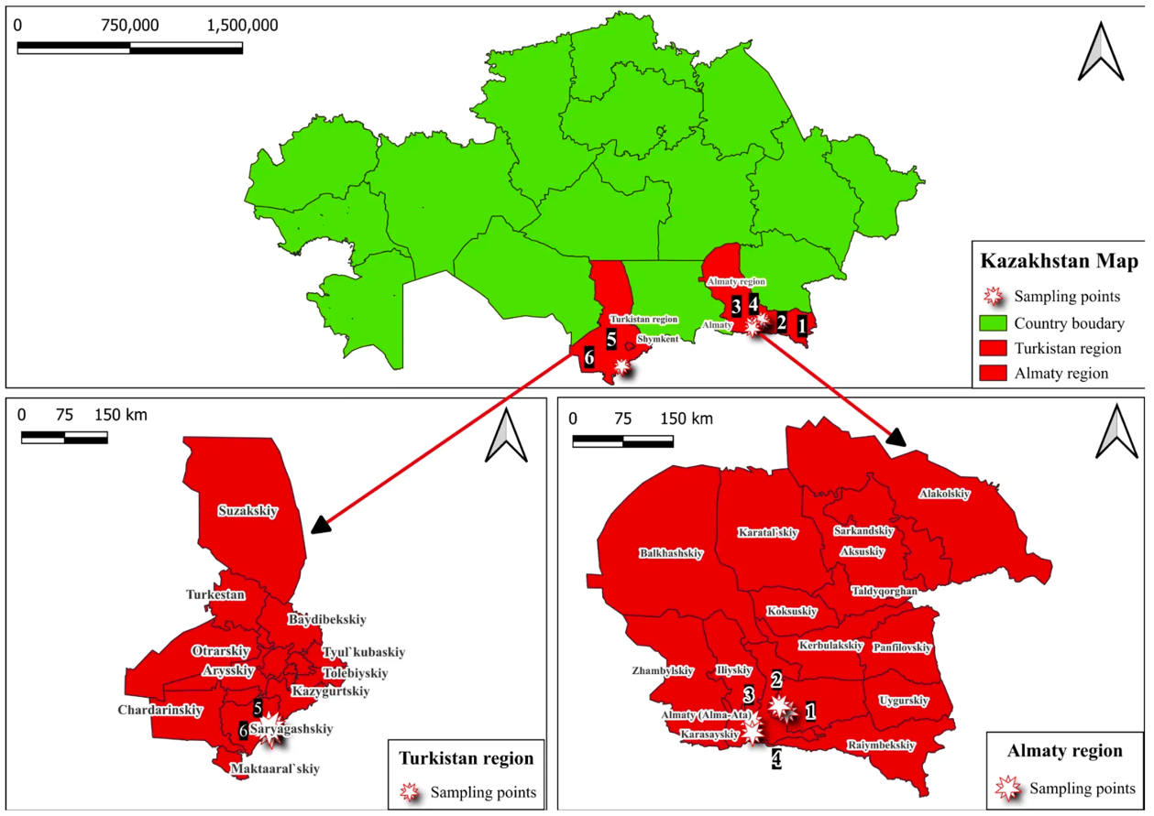

Figure 1 – Geographic locations of the sampling area of walnut fungal and bacterial isolates/strains

LLP “Saryagash Zher Syyi,” founded in 2002 and fully operational since 2005, is located in the Saryagash District of the Turkestan Region. The nursery covers 96 ha, including a 3 ha mother orchard, and maintains a collection of over 40 nut crop species and cultivars. This includes 230 local forms of walnut and introduced material from Iran, China, Kyrgyzstan, Moldova, Russia, and Turkey. A collection orchard and a 20 ha commercial walnut plantation have been established.
LLP “Silk Alley” manages 600 ha of vineyards, nut crops, and ornamental trees. A total of 23 introduced cultivars, local forms, and wild walnut trees were used in the study.
In 2017, the first experimental demonstration walnut orchard in Kazakhstan was established at the “Manshuk” farm on 20 ha. At the Issyk State Dendrological Park, a 0.4 ha experimental walnut plot was planted in 2019 with 200 grafted seedlings of the Chinese cultivar “Liaohe” (Table 1).

Table 1 – Characteristics of introduced cultivars and local forms of walnut (J. regia)

№ | Cultivar / Form | Description | Source
1 | 2 | 3 | 4
1 | Kogylnichany | Medium-sized tree. Mixed fruiting type. Protogenic flowering (female flowers bloom first). Female flowering is prolonged. Optimal results when pollinated with ‘Moldavian Lateral’ + ‘Kazaku’, or ‘Trifan Lateral’ + ‘Yarivskiy’. Kernels are consistently of high quality with excellent flavor. | https://www.gospodarulrediu.com/?go=page&p=238&new_language=2
2 | Peschansky | Medium-sized tree. Mixed fruiting type. Protogenic flowering (female flowers bloom first). Female flowering is prolonged. Effective with pollinators ‘Moldavian Lateral’ + ‘Kazaku’, or ‘Trifan Lateral’ + ‘Yarivskiy’. Kernels consistently of excellent quality. | https://www.gospodarulrediu.com/?go=page&p=246&new_language=2
3 | Yarivskiy | Selected at the Chernivtsi Experimental Station (Ukraine), registered in 1995 (breeder: F. T. Zatokova). Weak-growing tree. Lateral fruiting. Protoandric flowering. Relatively resistant to major walnut diseases; tolerant to low winter temperatures. | https://www.gospodarulrediu.com/?go=page&p=241&new_language=2
4 | Chernivetskiy | Selected at the Chernivtsi Experimental Station (Ukraine), registered in 1997 (breeder: F. T. Zatokova). Medium-sized tree. Recommended pollinators: Peschansky, Redinsky, Falesti Lateral, Miroslava. | https://www.gospodarulrediu.com/?go=page&p=233&new_language=2

Continuation of Table 1

1 | 2 | 3 | 4
5 | Miroslava | Bred at the Mircești Research Station (Iași, Romania). Apical fruiting. Protogenic flowering (female flowers bloom first). Female flowering is early–midseason. Recommended pollinators: Moldavian Lateral, Trifan Lateral, Ovata. | https://www.gospodarulrediu.com/?go=page&p=245&new_language=2
6 | Kazaku | Vigorous tree with a rounded dense crown. Terminal fruiting (on tips of annual shoots). Protogenic flowering. Pollinators: Moldavian Lateral, Trifan Lateral. Resistant to low temperatures, diseases, and drought. | https://www.gospodarulrediu.com/?go=page&p=232&new_language=2
7 | Lateral  lui Trifan | Vigorous tree. Mixed fruiting. Protoandric flowering (male flowers bloom first). Later female flowering reduces frost risk and ensures stable yields. Pollinators: Chernivetskiy, BT-10, Late Pollinator. | https://www.gospodarulrediu.com/?go=page&p=244&new_language=2
8 | Brichansky | Moldavian cultivar. Popular due to large fruit size, high yield, drought and frost tolerance. Large nuts of good commercial quality with excellent taste. Pollinators: Kishinevskiy, Skinoskiy, Kogylnichany, Peschansky. | https://biosad.com.ua/ua/p908563175-gretskij-oreh-brichanskij.html
9 | Codrene | Vigorous tree. Mixed fruiting (30–70% lateral + apical buds). Homogamous flowering (male and female flowers bloom simultaneously). Self-fertile. Late female flowering. Highly winter hardy and frost resistant, suitable for extreme climates. | https://www.gospodarulrediu.com/?go=page&p=235&new_language=2
10 | Kishinevskiy | Moldavian cultivar. Highly popular for its productivity, drought and frost tolerance. High-yielding, undemanding, self-pollinating. | https://biosad.com.ua/ua/p908584721-gretskij-orehkishinevskij.html
11 | Xin Xin 2 | Dwarf, early-maturing Chinese cultivar. Nut diameter 38–42 mm, weight 13–15 g, kernel percentage 55–60%, shell thickness 1.8–2.3 mm, oil content 66.55%. Harvest in August. | https://www.researchgate.net/publication/350459132_Katalog_sazencev

Continuation of Table 1

1 | 2 | 3 | 4
12 | Milotai 10 | Hungarian cultivar. Mid-late flowering (second decade of May). High-yielding with 70% lateral fruiting; stable yields up to 4 t/ha. Frost resistant to –25 °C. High graft success, valued in breeding. | https://www.researchgate.net/publication/350459132_Katalog_sazencev
13 | Liaohe | Dwarf Chinese cultivar. Does not require large planting area. Nut weight ~20 g. Kernel yield ≥50%. Shell relatively thin. | https://www.researchgate.net/publication/350459132_Katalog_sazencev
14 | Ovidiu | Romanian cultivar (Iași SCDP). Early, abundant, and consistent fruiting. Relatively late flowering. | https://agrocorp.ub.ua/ru/goods/view/10721542/all/sajency-oreha-sorta-ovidiu/
15 | Fernor | French cultivar (Franquette × Lara). Late flowering with lateral fruiting. Protoandric type. Pollinators: Mélanèse, Ronde de Montignac, Ivarte. Sensitive to winter temperatures below –20 °C. | https://www.gospodarulrediu.com/?go=page&p=239&new_language=2
16 | Lara | French cultivar (derived from Payne seedlings). Compact, highly productive, fruiting laterally and apically. Suitable for small orchards. | https://www.walnuts-bulgaria.com/english/grafted-trees/lara/
17 | 185 | Famous Chinese cultivar (Xinjiang). Region of origin: Aksu, Xinjiang. Large nuts, high sunlight exposure, ecologically clean area. Major walnut brand in China. | https://ru.youandmewalnut.com/products/185-walnut-in-shell.html
18 | Plin | Vigorous tree with wide pyramidal crown. Mixed fruiting. Nearly 100% nut fill. Late-ripening. Protoandric flowering; female flowers bloom late. | https://agrovektor.com/physical_product/1047729-sazhency-oreha-greckogo-plin.html

Continuation of Table 1

1 | 2 | 3 | 4
19 | Jinlong | Selected in Fenyang, Shanxi Province (China). Vigorous, late-bearing, late flowering. 14% lateral fruiting. Medium nut size, moderately hard shell. Kernel oil content 65%. | 136(6):422–428. 2011.
20 | Lipin 2 | From the Lipin breeding program (Liaoning Economic Forestry Research Institute, since 1970s). Late-fruiting cultivar with medium-sized high-quality nuts. Early vegetation and flowering. Kernel oil content ~70%. | https://www.ijabe.org
21 | Velnica | Moldovan cultivar. Semi-vigorous tree. Large nuts (~13.5 g). Early fruiting (VI–VII year). Medium protogynous flowering. Resistant to walnut blight and anthracnose. | https://agrovektor.com/physical_product/473539-greckiy-oreh-velnica.html
22 | Germisara | Romanian cultivar. Productive under continental conditions, disease resistant, high nut and kernel quality. | https://www.actahort.org/books/442/442_40.htm
23 | CITH- W2 | Indian cultivar (ICAR-CITH, Srinagar, Kashmir). High-yielding, large-fruited, paper-shell, compact, early-bearing. | Indiagardening.com
24 | Saryagash local forms | Trees aged 16–40+ years, stable yield and high adaptability to local climate. Nut weight 12–17 g, kernel yield up to 53%. Harvest late September. Drought and pest tolerant. | https://www.ncste.kz/ru/competition-51?irn=AP05134783
25 | Almaty wild populations | Location: Karasai district, Almaty region. Leaf size 20–30 cm (large, due to age and humidity). Nut size medium (8–12 g), thick shell. Flowering late April–early May. Disease resistance moderate.

Climatic data characterizing the conditions of walnut orchards were collected in 2022–2024 in the Almaty, Turkestan, and Zhambyl regions, where the main J. regia plantations are located [106].

The climate of the Almaty region is characterized by pronounced vertical zonation and overall continental conditions. The foothill zone of the Zailiysky Alatau is distinguished by sufficient moisture availability, relatively mild winters, and moderately warm summers, whereas the lowland areas exhibit large diurnal and annual temperature amplitudes, cold winters, and prolonged hot and dry summers. January is the coldest month, with average temperatures ranging from –11 to –13 °C in the northern and northeastern parts of the region, about –6 °C in the south, and down to –13 °C in mountainous areas. July is the warmest month, with mean temperatures reaching 25 °C in the north and ranging from 8 °C in mountainous zones to 26 °C in the foothills. Absolute minimum temperatures may drop to –40…–45 °C, while absolute maxima reach 46 °C. The duration of the warm period (mean daily temperature above 0 °C) varies from 220 days in southern mountainous areas to 240 days in northern lowlands. Annual precipitation ranges from 125 mm in the north to 900 mm in the southern mountains, with 50–75% falling during the warm period (April–October). Mean annual relative air humidity ranges from about 20% in mountainous zones to 65% in lowland areas [107].

In addition to the Almaty region, walnut orchards are widely distributed in the Turkestan and Zhambyl regions, which are characterized by arid and sharply continental climatic conditions. The Turkestan region belongs to the southern desert–steppe zone and is marked by hot, dry summers and relatively mild winters. Average January temperatures range from –1 to –6 °C, while July temperatures reach 28–32 °C; absolute maxima may exceed 45 °C. The frost-free period lasts 200–230 days, and the sum of active temperatures above 10 °C exceeds 4000 °C, providing favorable conditions for vegetative growth and fruit ripening of Juglans regia. Annual precipitation is low (200–300 mm), with most rainfall occurring in spring, whereas summers are characterized by prolonged droughts and low air humidity.

At LLP “Fazenda UM” (Almaty region), spring 2023 was characterized by high air humidity (up to 92%) and moderately warm temperatures (+1.5 to 23.8 °C), which created favorable conditions for the development of Pantoea agglomerans, actively infecting plants through micro-injuries. During summer, elevated temperatures (mean 26.7 °C) combined with reduced humidity (39–48%) limited pathogen spread, although the infection persisted in a latent form. In autumn, increased humidity (up to 85%) contributed to pathogen survival. In 2024, moderately warm and humid conditions in April–May again resulted in a high infection risk, while hot and dry summer weather restricted bacterial development; favorable conditions re-emerged in September.

In the Issyk State Dendrological Park (Almaty region), spring 2022 was warm and humid, with a mean temperature of +15.2 °C, air humidity up to 80%, and precipitation of 42 mm, creating optimal conditions for the development of P. syringae, F. solani, and A. alternata. In 2023, spring frosts reaching –5.4 °C restricted infection intensity; however, under conditions of moderate humidity (59%) and precipitation of 70.8 mm, infections caused by F. proliferatum and P. agglomerans were recorded. In spring 2024, high precipitation (up to 113 mm) and air humidity of 65–67% promoted active infection by F. proliferatum.

At the “Manshuk” farm (Almaty region), spring 2022 was warm (+15.2 °C), humid (80%), and rainy (42 mm), favoring the development of infections caused by P. syringae and A. alternata. In 2023, a relatively cool spring (mean temperature 10.3 °C) combined with air humidity of 59% contributed to the development of P. agglomerans, Alternaria spp., and Fusarium spp. In spring 2024, increased precipitation (113 mm) and high humidity (up to 87%) created favorable conditions for the development of a complex of pathogens.

In the Alma-Arasan area (Almaty region), spring 2023 was characterized by low temperatures (mean 1.5 °C), but high humidity (up to 93%) and substantial precipitation (159 mm), which increased the risk of infection by P. agglomerans and F. redolens. In 2024, persistently cold and humid spring conditions (approximately 2°C, humidity up to 90%) favored the development of root infections caused by F. redolens. During summer, rising temperatures (11–13 °C) combined with consistently high humidity resulted in peak infection activity in July–August.
Table 2 – Agroclimatic indicators for April–September according to meteorological station data, Almaty region, 2022–2024

Months | T (°C) | P (mm) | RH (%) | T (°C) |  | P (mm) | RH (%) | T (°C) |  | P (mm) | RH (%)
2022 |  |  |  |  | 2023 |  |  |  | 2024
Talgar
April | 15.10 | 42.00 | 51.53 | 10.60 |  | 70.80 | 59.56 | 12.20 |  | 82.80 | 67.23
May | 18.70 | 134.50 | 61.70 | 16.60 |  | 40.20 | 45.74 | 17.90 |  | 113.10 | 64.96
June | 23.80 | 42.00 | 47.46 | 24.70 |  | 12.30 | 39.16 | 24.30 |  | 9.90 | 46.06
July | 25.90 | 14.60 | 37.51 | 26.70 |  | 18.70 | 39.40 | 25.70 |  | 48.20 | 49.64
August | 22.00 | 17.00 | 41.38 | 23.40 |  | 48.10 | 41.25 | 23.30 |  | 23.30 | 45.45
September | 19.60 | 3.90 | 37.16 | 16.50 |  | 54.80 | 59.23 | 19.60 |  | 37.60 | 53.46
Issyk, Turgen
April | 15.20 | 15.20 | 15.20 | 15.20 |  | 15.20 | 15.20 | 15.20 |  | 15.20 | 15.20
May | 17.50 | 17.50 | 17.50 | 17.50 |  | 17.50 | 17.50 | 17.50 |  | 17.50 | 17.50
June | 22.30 | 22.30 | 22.30 | 22.30 |  | 22.30 | 22.30 | 22.30 |  | 22.30 | 22.30
July | 24.40 | 24.40 | 24.40 | 24.40 |  | 24.40 | 24.40 | 24.40 |  | 24.40 | 24.40
August | 20.70 | 20.70 | 20.70 | 20.70 |  | 20.70 | 20.70 | 20.70 |  | 20.70 | 20.70
September | 19.30 | 19.30 | 19.30 | 19.30 |  | 19.30 | 19.30 | 19.30 |  | 19.30 | 19.30
Alma-arasan
April | 6.03 | 6.03 | 6.03 | 6.03 |  | 6.03 | 6.03 | 6.03 |  | 6.03 | 6.03
May | 7.44 | 7.44 | 7.44 | 7.44 |  | 7.44 | 7.44 | 7.44 |  | 7.44 | 7.44
June | 10.90 | 10.90 | 10.90 | 10.90 |  | 10.90 | 10.90 | 10.90 |  | 10.90 | 10.90
July | 13.00 | 13.00 | 13.00 | 13.00 |  | 13.00 | 13.00 | 13.00 |  | 13.00 | 13.00
August | 9.64 | 9.64 | 9.64 | 9.64 |  | 9.64 | 9.64 | 9.64 |  | 9.64 | 9.64
September | 9.35 | 9.35 | 9.35 | 9.35 |  | 9.35 | 9.35 | 9.35 |  | 9.35 | 9.35
Kyrgyzsai
April | 14.20 | 14.20 | 14.20 | 14.20 |  | 14.20 | 14.20 | 14.20 |  | 14.20 | 14.20
May | 16.60 | 16.60 | 16.60 | 16.60 |  | 16.60 | 16.60 | 16.60 |  | 16.60 | 16.60
June | 21.20 | 21.20 | 21.20 | 21.20 |  | 21.20 | 21.20 | 21.20 |  | 21.20 | 42.46
July | 23.30 | 23.30 | 23.30 | 23.30 |  | 23.30 | 23.30 | 23.30 |  | 23.30 | 23.30
August | 20.40 | 20.40 | 20.40 | 20.40 |  | 20.40 | 20.40 | 20.40 |  | 20.40 | 20.40
September | 18.90 | 18.90 | 18.90 | 18.90 |  | 18.90 | 18.90 | 18.90 |  | 18.90 | 18.90
Note* – T – mean air temperature; P – total precipitation; RH – relative humidity

At the “Karadala” farm (Almaty region), cool and humid conditions in April 2023 limited pathogen development; however, in May, optimal temperatures (15–20°C), high humidity, and precipitation promoted active development of P. agglomerans and A. alternata. During the summer period, high temperatures suppressed bacterial development, while Alternaria spp. continued to develop due to the presence of dew and episodic rainfall. In spring 2024, increased humidity (up to 66 mm of precipitation in May) and moderately warm temperatures (+15.9 °C) resulted in mass infections of leaves, shoots, and fruits (Table 2).

The Turkestan region is characterized by pronounced geomorphological diversity, including desert plains, foothills, and mountainous areas, as well as a wide latitudinal extent, which together determine substantial climatic heterogeneity. The regional climate is sharply continental, arid, and characterized by high heat availability. The duration of the warm period with mean daily temperatures above 0 °C varies from approximately 250 days in the northern part of the region to up to 320 days in the southern areas. Summers are long, extremely hot, and dry throughout the region, whereas winters are short and relatively mild, often accompanied by frequent thaws. The mean air temperature in January ranges from –9.6 °C in the north to –0.9 °C in the south, while the absolute minimum temperature reaches –43 °C (Tasty meteorological station). Aridity is a defining feature of the regional climate. Annual precipitation in lowland areas ranges from 150 to 250 mm, increasing to 400–600 mm in foothill zones and reaching up to 750 mm in mountainous areas above 1000 m a.s.l. Precipitation is distributed extremely unevenly throughout the year, with strong seasonal contrasts.

In LLP “Silk Alley” (Turkestan region), spring 2022 was characterized by air temperatures of +14.7–22 °C and relative humidity of 49–59%. Moderate precipitation (23.3 mm in April and 45.4 mm in May), together with regular morning dews, created favorable conditions for infection by A. alternata. The first disease symptoms appeared in May, primarily in the lower canopy layer. Overall, the season can be classified as moderately favorable for the development of brown spot. In 2023, weather conditions in LLP “Silk Alley” contributed to an increased infectious background: April temperatures ranged from +11.5 to 19 °C, relative humidity reached 61–79%, and precipitation amounted to 22.5 mm. These conditions ensured the presence of free moisture, facilitating pathogen spread not only in the lower but also in the upper canopy layers. Spring 2024 was notably wet, with precipitation reaching 82.8 mm in April and 113 mm in May, while temperatures ranged from +6 to +17 °C, further enhancing infection pressure.

In LLP “Saryagash Zher Syyi” (Turkestan region), spring 2022 was marked by temperatures of +14–22 °C and relative humidity of 49–59%, with episodic increases up to 84%, which favored the establishment of primary infections. Morning dew served as the main source of moisture. In contrast, 2023 proved to be the most unfavorable year in terms of phytosanitary conditions: air humidity reached up to 79%, temperatures ranged from +12 to 25 °C, and precipitation events, although limited (up to 6.1 mm), were sufficient to support intensive development of bacterial pathogens (P. agglomerans, Xanthomonas spp., A. tumefaciens) and fungal pathogens (Fusarium spp., Alternaria spp.), resulting in systemic damage to trees. In spring 2024, temperatures in LLP “Saryagash Zher Syyi” ranged from +10 to 15 °C, relative humidity varied between 49 and 69%, and precipitation was minimal. Under these conditions, active disease development was constrained; however, at humidity levels exceeding 65%, the risk of latent infections remained.

In the village of Tyulkibas (Turkestan region), hot and dry weather conditions during May–July 2023 limited the development of P. agglomerans. Nevertheless, periods of elevated infection risk were recorded in April, characterized by moderate temperatures and high humidity; in mid-May, associated with local rainfall at temperatures above 18 °C; and in late August–September, when moderate temperatures coincided with increased precipitation. Spring 2024 was distinguished by persistently high air humidity (65–90%) and substantial rainfall (121 mm in April and 83 mm in May), which promoted the active development of bacterial diseases (Table 3).

Table 3 – Agroclimatic indicators for April–September according to the meteorological post of the Turkestan Region, 2022–2024

Months | T (°C) | P (mm) | RH (%) | T (°C) | P (mm) | RH (%) | T (°C) | P (mm) | RH (%)
Saryagash
2022 |  |  |  | 2023 |  |  | 2024
April | 20.30 | 20.30 | 20.30 | 20.30 | 20.30 | 20.30 | 20.30 | 20.30 | 20.30
May | 21.90 | 21.90 | 21.90 | 21.90 | 21.90 | 21.90 | 21.90 | 21.90 | 21.90
June | 28.10 | 28.10 | 28.10 | 28.10 | 28.10 | 28.10 | 28.10 | 28.10 | 28.10
July | 29.50 | 29.50 | 29.50 | 29.50 | 29.50 | 29.50 | 29.50 | 29.50 | 29.50
August | 26.30 | 26.30 | 26.30 | 26.30 | 26.30 | 26.30 | 26.30 | 26.30 | 26.30
September | 23.70 | 23.70 | 23.70 | 23.70 | 23.70 | 23.70 | 23.70 | 23.70 | 23.70
Tyulkubas
2022 |  |  |  | 2023 |  |  | 2024
April | 18.00 | 18.00 | 18.00 | 18.00 | 18.00 | 18.00 | 18.00 | 18.00 | 18.00
May | 19.00 | 19.00 | 19.00 | 19.00 | 19.00 | 19.00 | 19.00 | 19.00 | 19.00
June | 24.00 | 24.00 | 24.00 | 24.00 | 24.00 | 24.00 | 24.00 | 24.00 | 24.00
July | 27.20 | 27.20 | 27.20 | 27.20 | 27.20 | 27.20 | 27.20 | 27.20 | 27.20
August | 24.00 | 24.00 | 24.00 | 24.00 | 24.00 | 24.00 | 24.00 | 24.00 | 24.00
September | 21.90 | 21.90 | 21.90 | 21.90 | 21.90 | 21.90 | 21.90 | 21.90 | 21.90

Note* – T – mean air temperature; P – total precipitation; RH – relative humidity

The Zhambyl region is also characterized by pronounced continentality and aridity. Its climate is marked by sharp diurnal and seasonal temperature fluctuations, as well as rapid transitions from winter to summer. Summers are very hot: the mean air temperature in July ranges from 21 to 25 °C, while on individual days it may rise to 45–48 °C, representing the absolute maximum. Winters are relatively severe for this latitude. Mean January temperatures range from –8 to –12 °C in the northern part of the region and from –4 to –7 °C in the southern areas.
Annual precipitation in the lowland zones is limited, amounting to 140–220 mm. In foothill areas, precipitation increases to 210–330 mm, while in the Kyrgyz Alatau mountain zone it reaches 400–500 mm. In the Merke district, total precipitation during the spring period (April–May) amounted to 97–103 mm. The mean air temperature during the growing season (April–August) was +22.8 °C.
In the village of Merke (Zhambyl region) during 2022–2024, spring seasons were characterized by elevated air humidity combined with moderate temperatures, which created favorable conditions for the development of walnut pathogens. During summer, high air temperatures (up to 38 °C) and pronounced aridity restricted the development of fungal infections; however, these conditions increased physiological stress in trees, thereby enhancing their susceptibility to bacterial diseases (Table 4). Prolonged heat and drought caused sunburn and thermal stress in young trees, and damaged tissues served as entry points for pathogenic microorganisms.
Overall, the most favorable conditions for the development of walnut pathogens were observed in spring and autumn, when moderate temperatures coincided with high air humidity. Hot and dry summer conditions generally limited active disease development but promoted the persistence of infections in a latent form and increased host vulnerability due to stress-induced tissue damage.

Table 4 – Agroclimatic indicators for April–September according to the Merke meteorological post in Zhambyl Region, 2023–2024

Months | 2022 |  |  | 2023 |  |  | 2024
Months | T (°C) | P (mm) | RH (%) | T (°C) | P (mm) | RH (%) | T (°C) | P (mm) | RH (%)
April | 16.29 | 31.60 | 65.06 | 12.30 | 21.40 | 68.36 | 13.14 | 56.50 | 67.00
May | 19.05 | 42.90 | 69.58 | 17.90 | 30.60 | 58.41 | 17.26 | 71.00 | 63.93
June | 25.02 | 18.60 | 52.16 | 25.67 | 3.60 | 45.76 | 24.98 | 16.90 | 42.60
July | 26.94 | 14.20 | 45.70 | 27.97 | 12.80 | 45.00 | 25.66 | 52.70 | 43.45
August | 22.85 | 15.30 | 52.00 | 24.70 | 13.70 | 50.67 | 25.62 | 8.70 | 40.25
September | 20.73 | 0.00 | 53.66 | 17.79 | 21.20 | 64.03 | 16.75 | 17.90 | 46.86
Note* – T – mean air temperature; P – total precipitation; RH – relative humidity
Thus, the weather conditions of recent years had a substantial impact on the phytosanitary status of walnuts in the southern fruit-growing zone of Kazakhstan. In 2023, early spring frosts down to –5 °C were recorded in the Almaty and Turkestan regions, which caused significant damage to walnut trees and made them especially susceptible to pathogens. In spring, favorable conditions for disease development were established – high humidity (around 70%) and temperatures above 18 °C. The hot and dry summer, with no precipitation until October, stressed the plants and reduced their resistance to diseases. As a result, climatic factors played a key role in enhancing disease focality and promoting their more active spread.
Comparative analysis of agroclimatic conditions across the studied orchards revealed pronounced regional and local differences in the phytosanitary risk for J. regia.
The highest risk of active infection development was observed in orchards located in the foothill and mountainous zones of the Almaty region (Alma-Arasan, Issyk Dendrological Park), where low spring temperatures combined with high air humidity and intensive precipitation created optimal conditions for the development of bacterial and fungal pathogens. Under these conditions, infections were characterized by early onset and high intensity, particularly in spring and early summer.
In contrast, orchards situated in the lowland and foothill areas of the Almaty region (Fazenda UM, Manshuk, Karadala) were mainly affected by seasonal fluctuations in humidity. Here, spring moisture acted as a provoking factor, while hot and dry summer conditions limited active pathogen spread, favoring latent persistence of infections and increasing the vulnerability of trees through thermal and water stress.
In the Turkestan region, characterized by arid and sharply continental climate, the development of walnut pathogens was generally restricted by low precipitation and prolonged summer droughts. However, periods of moderate spring humidity and regular morning dews were sufficient to trigger infection outbreaks, indicating that moisture availability rather than temperature was the key limiting factor in this region.
The Zhambyl region (Merke) exhibited a distinct phytosanitary scenario, where extreme summer heat and drought acted primarily as stress factors, weakening plant resistance and indirectly increasing susceptibility to bacterial infections. In this case, climate conditions functioned not as direct triggers of infection, but as predisposing factors facilitating pathogen penetration through stress-induced tissue damage.
Overall, moderate temperatures combined with high humidity in spring and autumn were identified as the most critical climatic drivers of walnut disease development, whereas hot and dry summer conditions primarily promoted latent infection persistence and stress-related vulnerability. These patterns highlight the necessity of region-specific phytosanitary management strategies based on local agroclimatic conditions.

2.2 Methodology of field research
2.2.1 Methods for determining the DI and DSI of walnut diseases in the Southern regions of Kazakhstan
The objects of study included walnut trees (J. regia L.) cultivated in orchards of the southern regions of Kazakhstan. The research covered both industrial plantations and private farms. To evaluate the condition of stands and the spread of diseases, trees of different age groups were selected – from young seedlings to fruit-bearing mature trees.
Field studies were conducted in 2022–2024 at the following farms and natural sites:
1. Introduced cultivars and forms from the rural farm “Manshuk” (Enbekshikazakh District, Almaty Region);
2. Introduced cultivar Liaohe from RSE “Issyk State Dendrological Park” (Enbekshikazakh District, Almaty Region);
3. Local forms from LLP “Saryagash Zher Syyi” (Saryagash District, Turkestan Region);
4. Introduced cultivar Liaohe from LLP “Silk Alley” (Saryagash District, Turkestan Region);
5. Wild-growing forms from the walnut grove of Alma-Arasan Gorge (Almaty Region);
6. Seedlings from LLP “Fazenda UM” (Talgar District, Almaty Region);
7. Forms from the village of Tyulkubas (Tyulkubas District, Turkestan Region);
8. Local form from the farm “Karadala” (village of Kyrgyzsai, Uighur District, Almaty Region);
9. Local form from the village of Merke (Zhambyl Region).
During the study, standard agronomic field survey methods were applied. Throughout the growing season, route inspections of walnut plantations were conducted at different plant developmental stages to identify and collect leaves with visible disease symptoms. Initial disease assessment was based on visual examination of affected organs, including symptoms such as leaf spots, wet rots, and vascular lesions.
From each symptomatic tree, samples of infected tissues (leaves, petioles, young shoots, and stems) were collected. A composite sample representing different affected organs was obtained from each diseased tree. Samples were placed in airtight bags and labeled with the region, farm, cultivar, and date of collection. At each site, no fewer than 100 trees were examined annually.
For disease assessment, four branches were selected from different sides of each tree, and up to 25 organs (leaves, flowers, and fruits) per branch were evaluated. Sampling was performed under aseptic conditions; affected plant parts were excised together with small portions of healthy tissue. Pathogenetic symptoms, disease type, time of onset, number of affected organs, and disease severity were recorded.
Surveys were conducted annually during the growing seasons from 2022 to 2024 at key phenological stages, including leaf expansion, flowering, and fruit development. The obtained data were averaged across years and study sites.
For disease incidence assessment, each leaf was considered an individual unit. A leaf was classified as diseased if at least one visible disease spot was observed. Disease incidence was expressed as the percentage of diseased leaves relative to the total number of examined leaves.
Disease severity was evaluated using the disease severity index, calculated on a 0–9 rating scale reflecting both the proportion of diseased leaves and the degree of leaf damage, following the methodology of Xie et al. [108] and Jiang et al. [109]:
0: no diseased leaves;
1: < 5% of leaves with disease symptoms;
3: 6% - 10% of leaves with disease symptoms;
5: 11% - 25% of leaves with disease symptoms;
7: 26% - 50% of leaves with disease symptoms;
9: >50% of leaves with disease symptoms.
Disease incidence and disease severity were calculated using the following formulas:
Disease incidence (DI), %
$\begin{matrix} & DI=\left(\frac{∑N_{d}}{N_{t}}\right)×100, & & \text{ (1)}\end{matrix}$

Disease severity index (DSI), %
$$\begin{matrix} & DSI=\left[\frac{∑(n_{i}×r_{i})}{N×R_{max}}\right]×100, & & \text{(2)}\end{matrix}$$

Where, $N_{d}$is the number of diseased units; $N_{t}$is the total number of examined units; $n_{i}$is the number of leaves in the i-th disease severity class; $r_{i}$is the numerical rating of the i-th severity class; $N$is the total number of assessed leaves; $R_{max}$is the maximum severity rating on the scale.
Based on the mean infection score, walnut cultivars were classified into four resistance groups [109, p. 58]: immune or highly resistant (0–1), resistant (1.1–2), moderately resistant (2.1–3), and highly susceptible (3.1–9).
2.2.2 Methods for assessing the resistance of varieties to common diseases (P. agglomerans and A. alternata)
In the southern fruit-growing zones of Kazakhstan, walnut blight caused by the pathogenic bacterium P. agglomerans and brown spot caused by the fungus A. alternata have become widespread in recent years, posing a serious threat to walnut orchards and leading to significant yield losses.
To assess the resistance of walnut cultivars and forms to walnut blight (P. agglomerans) and brown spot (A. alternata), phytopathological surveys were conducted in various regions of southern and southeastern Kazakhstan under natural infection conditions, without artificial inoculation. Disease development was monitored taking into account prevailing weather and climatic conditions.
Disease assessments used for cultivar resistance evaluation were performed at the period of maximum disease development. Cultivar resistance was determined based on the mean DSI, calculated across three consecutive growing seasons (2022–2024) and averaged over all examined trees and study sites. Based on the mean infection score, walnut cultivars were classified as immune, resistant, moderately resistant, or highly susceptible.
During three-year monitoring studies (2022–2024), a comprehensive evaluation of 23 walnut cultivars and forms, including the Chinese cultivar Liaohe, was carried out in the main fruit-producing regions of Kazakhstan: Almaty Region (rural farm “Manshuk”, RSE “Issyk State Dendrological Park”, LLP “Silk Alley”) and Turkestan Region (LLP “Saryagash Zher Syyi”).
The severity of plant infection was assessed using the standard 9-point phytopathological scale described by Xie et al. [108, p. 102-111] and Jiang et al. [109, p. 58], followed by the calculation of DI and DSI according to standard formulas.

2.3 Methods of molecular identification of pathogens
2.3.1 Isolation of pathogens from infected walnut trees and isolation of pure cultures of fungi and bacteria
Fungal pathogens were isolated using the wet chamber method to promote mycelial growth and sporulation. Affected plant fragments were pre-washed in running water to remove surface contaminants, surface-sterilized in 70% ethanol for 30–60 s, and dried on sterile filter paper. Sterile fragments were placed in Petri dishes (90 mm; SPL Life Sciences, Pocheon, Gyeonggi-do, Republic of Korea) containing moistened filter paper disks and incubated in a growth chamber (Binder BD 56, Tuttlingen, Baden-Württemberg, Germany) at 20–22 °C for 2–3 days until visible mycelium and/or sporulation developed. Each isolation was performed in triplicate.
Pathogens were isolated from symptomatic leaves, petioles, young shoots, and fruits collected at the active stage of disease development. Sterility controls were included by incubating non-inoculated media under identical conditions.
For microscopic examination of fungal isolates, preparations were made using the “crushed drop” method. Mycelial fragments were mounted in a glycerol–water solution (1:4) on microscope slides (Menzel-Gläser, Thermo Fisher Scientific, Braunschweig, Lower Saxony, Germany) and examined under a compound microscope (Micros MC 300, St. Veit an der Glan, Carinthia, Austria) at magnifications of ×100–400. Measurements were calibrated using a stage micrometer with 10 μm divisions (Edmund Optics, Barrington, New Jersey, USA). Pure fungal cultures were obtained by single-spore isolation on potato dextrose agar (PDA; HiMedia, Mumbai, Maharashtra, India) and incubated at 28–30 °C under high humidity to induce sporulation. Culture purity was verified microscopically [110].
For bacterial isolation, surface-sterilized tissues were homogenized in 1 mL of phosphate-buffered saline (Sigma-Aldrich, St. Louis, Missouri, USA). Serial dilutions were plated onto nutrient agar (NA; HiMedia Laboratories, Mumbai, Maharashtra, India) using a Drigalski spatula (Brand GmbH, Wertheim, Baden-Württemberg, Germany) and incubated at 28 °C for 3–10 days in a calibrated incubator (Memmert IN55, Schwabach, Bavaria, Germany). Bacterial colonies were selected based on standard morphological characteristics (shape, pigmentation, texture, and consistency), and at least three representative isolates per site were retained for further analysis.
Bacterial isolates were purified by repeated streaking on nutrient agar under aseptic conditions and incubated at 28–30 °C for 2–5 days. Purity was assessed microscopically based on cell morphology and colony characteristics.
Pure fungal and bacterial cultures were maintained on PDA and nutrient agar, respectively, at 4 °C and periodically subcultured. The obtained pure isolates were subsequently used for DNA extraction and molecular identification.
2.3.2 Genomic DNA extraction from walnut samples
Genomic deoxyribonucleic acid (DNA) was extracted from pure fungal and bacterial cultures obtained from infected walnut tissues using the cetyltrimethylammonium bromide (CTAB) method. Approximately 100 mg of fresh mycelium or bacterial biomass was used for each extraction. The CTAB extraction buffer contained 100 mM Tris-HCl, 1.4 M NaCl, 20 mM ethylenediaminetetraacetic acid (EDTA), 4% CTAB, 2% polyvinylpyrrolidone (PVP), and 0.2% β-mercaptoethanol [111].
Samples were homogenized in 1 mL of extraction buffer and incubated at 65 °C for 1 h [112]. Subsequently, 1 mL of chloroform was added, and the mixture was centrifuged at 13,000 rpm for 12 min.
The aqueous phase was transferred to new tubes, and two-thirds of the volume of isopropanol was added to precipitate DNA. The samples were incubated at −20 °C for 1 h, followed by centrifugation at 13,000 rpm for 15 min.
The resulting DNA pellet was washed twice with 70% ethanol, air-dried, and dissolved in 100 μL of sterile distilled water.
RNA was removed by treatment with ribonuclease A at 37 °C for 1 h. DNA quality was assessed by electrophoresis in a 1.5% agarose gel prepared in Tris–acetate–EDTA (TAE) buffer at 70 V for 30 min [113] and visualized under ultraviolet light. DNA concentration and purity were determined using a NanoDrop One spectrophotometer (Thermo Scientific, Massachusetts, USA).
The extracted genomic DNA was used as a template for subsequent PCR amplification and molecular identification of the pathogens.
2.3.3 PCR amplification and sequencing of ITS and 16S rRNA regions
Genomic DNA from pure fungal and bacterial cultures was extracted using the PROBA-NK reagent kit (AgroDiagnostics, Moscow, Russia) according to the manufacturer’s instructions. DNA concentration and purity were assessed using a NanoDrop One spectrophotometer (Thermo Fisher Scientific, Waltham, MA, USA) [114].
PCR amplification of bacterial isolates was performed using universal primers targeting the 16S rRNA gene: 27F (5′-AGAGTTTGATCCTGGCTCAG-3′), 1492R (5′-TACGGCTACCTTGTTACGACTT-3′), Uni340F (5′-CCTACGGGRBGCASCAG-3′), and Uni806R (5′-GGACTACNNGGGTATCTAAT-3′). Fungal identification was carried out using primers ITS5 (5′-GGAAGTAAAAGTCGTAACAAGG-3′) and ITS4 (5′-TCCTCCGCTTATTGATATGC-3′), targeting the ITS region [115].
PCR reactions were performed in a total volume of 25 μL containing 1× PCR buffer, 2.0 mM MgCl₂, 0.2 mM of each dNTP, 0.4 μM of each primer, 1 U of Taq DNA polymerase, and 20–50 ng of template DNA. Negative controls without template DNA were included in each PCR run.
Amplification of the bacterial 16S rRNA gene was carried out under the following conditions: initial denaturation at 95 °C for 5 min; 30 cycles of denaturation at 95 °C for 30 s, annealing at 55 °C for 30 s, and extension at 72 °C for 90 s; followed by a final extension at 72 °C for 7 min. The expected amplicon size was approximately 1,400–1,500 bp.
Amplification of the fungal ITS region was performed with an initial denaturation at 95 °C for 5 min; 35 cycles of denaturation at 95 °C for 30 s, annealing at 54 °C for 30 s, and extension at 72 °C for 60 s; followed by a final extension at 72 °C for 7 min. The expected amplicon length ranged from 500 to 650 bp.
The molecular markers, primer sequences, target regions, and expected amplicon sizes used in this study are summarized in Table 5.

Table 5 – Molecular markers and primers used for PCR amplification and sequencing

Marker / gene region | Primer name | Primer sequence (5′–3′) | Target group | Expected amplicon size (bp) | Reference
ITS region (ITS1–5.8S–ITS2) | ITS5 | GGAAGTAAAAGTCGTAACAAGG | Fungi | 500–650 | White et al., 1990 [115]
ITS region (ITS1–5.8S–ITS2) | ITS4 | TCCTCCGCTTATTGATATGC | Fungi | 500–650 | White et al., 1990 [115]
16S rRNA (full length) | 27F | AGAGTTTGATCCTGGCTCAG | Bacteria | 1400–1500 | Lane, 1991 [116]
16S rRNA (full length) | 1492R | TACGGCTACCTTGTTACGACTT | Bacteria | 1400–1500 | Lane, 1991 [116]
16S rRNA (V3–V4 region) | Uni340F | CCTACGGGRBGCASCAG | Bacteria | ~460 | Klindworth et al., 2013 [117]
16S rRNA (V3–V4 region) | Uni806R | GGACTACNNGGGTATCTAAT | Bacteria | ~460 | Klindworth et al., 2013 [117]

PCR products were verified by electrophoresis in 1.5% agarose gels stained with an intercalating dye and visualized under ultraviolet illumination. Representative isolates of each morphotype were selected for sequencing.
Amplicons were sequenced using a MinION Mk1B device (Oxford Nanopore Technologies, Oxford, United Kingdom). Library preparation was performed with the Native Barcoding Kit SQK-NBD114.24, and sequencing was conducted on a FLO-MIN114 flow cell using MinKNOW software v24.06.5. Raw signal data were base-called using Dorado v7.4.12. Reads were filtered with NanoFilt using a minimum quality threshold of Q15 and aligned with Minimap2 v2.28 against reference 16S rRNA and ITS sequences obtained from the NCBI database.
Phylogenetic analysis was performed using the neighbor-joining method implemented in MEGA software (version 12). Evolutionary distances were calculated using the Kimura two-parameter model, and tree robustness was evaluated with 1,000 bootstrap replications. Multiple sequence alignment was performed using MUSCLE, and ambiguously aligned regions were excluded prior to tree construction. For each disease, an appropriate outgroup sequence from a closely related species was included. The ten most closely related sequences available in GenBank (based on BLASTn similarity) were used for comparative analysis.

2.4 Pathogenicity assays of bacterial and fungal pathogens
Pathogenicity tests were conducted using different walnut organs, including leaves, fruits, branches, shoots, and seedlings. Pure cultures of fungal and bacterial pathogens were obtained from diseased walnut tissues, with fungi cultured on PDA and bacteria on NA. The identity of all isolates was confirmed using morphological and molecular methods prior to inoculation experiments.
For fungal inoculations, conidial suspensions were prepared from actively growing cultures. Conidia were counted using a hemocytometer, and conidial production was calculated as follows:
Conidia production (conidia cm⁻²) = (X × N × 5 × 10⁶) / (n × π × r²), (3)

where, X is the dilution factor, N is the number of conidia counted in five hemocytometer squares, n is the number of agar–mycelium plugs, and r is the inner radius of the perforator.
Four isolates of A. alternata were cultured on PDA for two weeks. Detached walnut leaflets (five per replicate) were surface-sterilized and inoculated with four drops of a conidial suspension (1 × 10⁵ conidia mL⁻¹) and incubated at 25 °C in a moist chamber [116].
Immature walnut fruits (ten per replicate) were inoculated with F. graminearum by placing 5-mm PDA mycelial plugs on the stigma end and incubated at 25 °C and 80–90% relative humidity [117].
Potted walnut leaves (five per replicate) were inoculated with F. proliferatum using a conidial suspension (1 × 10⁷ conidia per 50 μL) and incubated at 28 °C under high humidity [118].
Detached walnut branches (five per replicate) were surface-sterilized with 70% ethanol, punctured with a sterile needle (~1 mm), and inoculated with 300 μL of F. redolens or F. incarnatum suspensions (1 × 10⁶ CFU mL⁻¹). Branches were incubated in sealed containers lined with moistened filter paper [119].
The pathogenicity of F. solani was evaluated on excised walnut shoots. Pre-wounded shoots were inoculated with agar discs containing fungal mycelium, while sterile agar discs served as controls. Shoots were incubated at 25 °C and 100% relative humidity for 21 days, with ten shoots per treatment and two experimental repetitions [120].
Bacterial cell concentrations were determined using a hemocytometer according to the following formula:

C = (N × D × 10⁴) / n, (4)

where, C is the concentration of bacterial cells (cells mL⁻¹), N is the number of cells counted in n hemocytometer squares, D is the dilution factor, and 10⁴ is the conversion coefficient.
A suspension of P. agglomerans (1 × 10⁶ CFU mL⁻¹) was applied to surface-sterilized detached walnut leaves (five per replicate; 500 μL per leaf) and incubated at 28 °C in a moist chamber [121].
Healthy walnut fruits (ten per replicate) were inoculated with X. arboricola pv. juglandis by applying 1 μL of a bacterial suspension (1 × 10⁸ CFU mL⁻¹) to a pre-made wound (~2 mm diameter) and incubated at 28 °C [122].
Young walnut leaves (five per replicate) were inoculated with P. oryzihabitans and P. syringae. Leaves were surface-sterilized in 1% NaOCl, cut along the midrib, inoculated with 20 μL of bacterial suspension (1 × 10⁸ CFU mL⁻¹), and incubated at 24 °C under a 16 h light / 8 h dark photoperiod [123].
Walnut seedlings (five per replicate) were inoculated with A. tumefaciens by making transverse stem cuts with a knife dipped in a bacterial suspension (1 × 10⁹ CFU mL⁻¹). A second inoculation was performed after three weeks [124].
Sterile water and sterile PDA plugs were used as negative controls in all experiments. Inoculated and control samples were arranged randomly within incubation chambers. Each pathogenicity assay was performed in three independent biological replicates.
Disease symptoms were evaluated using standardized scales depending on the inoculated organ. For leaves, disease severity was scored on a 0–5 modified Fang scale based on the percentage of necrotic tissue. For fruits, husk rot severity was rated on a 0–5 scale. For branches and seedlings, lesion length (mm) was measured using a digital caliper. Symptom development was recorded at 6–14 days post-inoculation (dpi) for leaves, three weeks for fruits, 4–6 weeks for branches, and up to 12 months for seedlings.
After symptom development, pathogens were re-isolated from diseased tissues and compared with the original cultures to confirm fulfillment of Koch’s postulates [110, p. 922].

2.5 Methodology for testing fungicides and antibacterial preparations against walnut pathogens
Although chemical plant protection products for walnut are not officially registered in the Republic of Kazakhstan, the fungicides used in this study are registered for application on other fruit and agricultural crops. Their inclusion in the experiments was aimed at evaluating their potential biological efficacy against major walnut pathogens under experimental conditions.
A reference (standard) fungicide was not included in the experimental design because there are currently no fungicides officially registered for walnut protection in the Republic of Kazakhstan. Therefore, the untreated control was used as the baseline for comparative evaluation of the tested products under experimental conditions.
2.5.1 Laboratory methodology for testing fungicides
In the laboratory experiment, pathogens were initially isolated from infected walnut leaves and fruits and identified based on microbiological and molecular-genetic methods [110, p. 922]. As test pathogens, strains of 6 phytopathogenic fungi of walnut were used: F. solani, F. proliferatum, F. graminearum, F. redolens, F. incarnatum and A. alternata.
The effectiveness of 4 fungicides was tested against pathogens under aseptic conditions using the poison food technique [125]. In the study, the effects of fungicides representing three major chemical classes with different modes of action against fungi were examined:
- Triazoles – Score 250, EC (difenoconazole, 250 g/l);
- Anilinopyrimidine – Chorus 750, WG (cyprodinil, 750 g/kg);
- Anilinopyrimidine – Luna Tranquility, SC (fluopyram, 125 g/l + pyrimethanil, 375 g/l);
- Strobilurin – Stroby 50%, WG (kresoxim-methyl, 500 g/kg).
Fungicide solutions were prepared according to the concentrations recommended by the manufacturer as follows: to 100 ml of sterile water, 120 µl of Luna Tranquility SC, 20 µl of Score EC, 20 µl of Stroby WG, and 25 µl of Chorus WG were added. Aqueous solutions of the preparations were prepared on the day of the experiment and used fresh. Distilled water served as the control. For inoculation of both control and experimental variants of the culture medium, a seven-day pure culture of the pathogen grown on PDA was used.
Into each Petri dish with PDA, 300 µl of the aqueous solution of the preparation or water was applied and evenly distributed using a sterile glass spreader over the surface of the nutrient agar. An agar block with fungal mycelium was placed in the center of the Petri dish and incubated at 25 °C in a thermostat. Starting from the seventh day of incubation, the diameter of the growing colonies was measured until the culture completely covered the surface of the medium in the control variant. The experiments were carried out in triplicate, each of which included a control variant without fungicides [125, p. 691].
The growth inhibition rate of plant pathogens was used as an indicator of the effectiveness of the formulations [126]. The biological effectiveness of fungicides – according to the empirical formula:

$$B\left(\%\right)=\frac{\left(Ik-Io\right)}{Ik}*100 , (5)$$
where, B – biological effectiveness, %; Ik – mean colony diameter in the control; Io – mean colony diameter in the treatment.
The evaluation of the biological effectiveness of fungicides was carried out according to the accepted scale:
1) 90–100% — very high effectiveness (the fungicide almost completely suppresses fungal growth);
2) 80–89% — high effectiveness (fungal growth is strongly suppressed);
3) 70–79% — moderate effectiveness (fungal growth is noticeably reduced, but residual growth persists);
4) 60–69% — satisfactory effectiveness (the fungicide partially suppresses fungal growth);
5) <60% — low effectiveness (the fungicide poorly suppresses fungal growth, and colony development continues).
For the evaluation of the effectiveness of antifungal preparations, standardized scales of disease severity were used. Statistical data were analyzed using a one-way analysis of variance (ANOVA), which allowed the identification of differences in the biological effectiveness of the preparations. For each fungal pathogen, treatment effects (fungicide type) were tested using ANOVA based on mean colony diameter measured on the same incubation day, followed by calculation of growth inhibition relative to the untreated control.
To determine the significance of differences between treatments, the least significant difference (LSD) test was applied at a significance level of p < 0.05. The LSD value was calculated according to the following formula:

LSD _{0.05}= t₀.₀₅,df · √(2 · MS ₑᵣᵣₒᵣ / n) $, \left(6\right)$

where t₀.₀₅,df — the critical value of the t-distribution for a significance level of 0.05 and the error degrees of freedom, MSₑᵣᵣₒᵣ - mean square error (within-group variance) obtained from the ANOVA model, n - number of replications (n = 3).
2.5.2 Laboratory methodology for testing antibacterial preparations
Laboratory studies included testing the sensitivity of pathogens to antibacterial preparations using the agar diffusion method with paper discs (Kirby–Bauer method), in accordance with CLSI recommendations (2018) [127]. Pure cultures of P. agglomerans, P. syringae, X. arboricola pv. juglandis, P. oryzihabitans, and A. tumefaciens were used as test objects.
The preparations were selected based on their use in plant protection practice, market availability in Kazakhstan, and different modes of action. Solutions of antibacterial preparations were prepared at concentrations recommended by the manufacturer as follows (working solution consumption rate: 1000 l/ha):
- Kasumin 2% SL (kasugamycin, 20 g/l) – 2 ml/l;
- Kocide 2000, WG (copper hydroxide, 350 g/kg) – 2 g/l;
- Zerox, SC (colloidal silver, 3000 mg/l) – 2 ml/l;
- Bordeaux mixture (172 g/l basic copper sulfate) – 10 ml/l;
- Agri Gent Plus (gentamicin sulfate + oxytetracycline hydrochloride) – 0.8 g/l;
- Phytolavin (BA 120,000 IU/ml, 32 g/l phytobacteriomycin — a complex of streptothricin antibiotics) – 2 ml/l.
Sterile paper discs (10 mm in diameter) were impregnated with 25 µl of each antibacterial solution to ensure uniform distribution of the active substance, in accordance with CLSI standards. Sterile Petri dishes with Mueller–Hinton agar were inoculated with a 24-h culture of the test organism — a bacterial suspension adjusted to ~10⁸ CFU/ml according to the turbidity standard (1.0 McFarland) [128]. The suspension was evenly spread on the agar surface using a sterile swab. Impregnated discs were placed on the inoculated agar surface with sterile tweezers, ensuring a distance of at least 24 mm between discs and 15 mm from the dish edge.
Each experimental treatment was replicated three times to ensure statistical reliability. In the control, discs impregnated with 25 µl of sterile distilled water were used. The plates were kept at room temperature for one hour to allow diffusion of the preparations and then incubated at 27 °C for 24 h. The temperature of 27 °C was chosen considering the optimal growth conditions for phytopathogenic bacteria such as X. arboricola pv. juglandis and P. syringae, which are often tested at 25–28 °C in plant protection studies [129].
After 24 h, visual evaluation and measurement of inhibition zone diameters around each disc were carried out in all replicates. Zone diameters were measured with a digital caliper by performing two perpendicular measurements for each zone and calculating the mean value. The absence of a zone was interpreted as a lack of bactericidal activity. A zone up to 15 mm was considered weak, 15–22 mm — moderate, and more than 22 mm — strong bactericidal activity [130].
Statistical analysis of laboratory data was performed using one-way analysis of variance ANOVA, as the experimental design included a single factor — the type of antibacterial preparation — with multiple levels and a continuous dependent variable (inhibition zone diameter). The analysis was conducted based on mean values obtained from three independent replicates. Differences between treatment means were assessed using Fisher’s LSD test at a significance level of P ≤ 0.05.
2.5.3 Field methodology for testing fungicides against A. alternata
Studies on the biological evaluation of fungicides against the pathogen A. alternata were carried out in 2022–2024 on trees of the Liaohe variety at the rural farm “Manshuk” in Almaty region. The testing of preparations was conducted under field conditions optimal for walnut cultivation, under a natural infection background [131].
The fungicide application scheme was as follows:
- Score 250, EC (250 g/l difenoconazole) – 0.15–0.2 l/ha;
- Chorus 750, WG (750 g/kg cyprodinil) – 0.2–0.35 kg/ha;
- Stroby, 50% WG (500 g/kg kresoxim-methyl) – 0.15–0.2 l/ha;
- Luna Tranquility, SC (125 g/l fluopyram + 375 g/l pyrimethanil) – 0.6–1.2 l/ha. Control plants were sprayed with water for objective comparison.
Fungicides were administered thrice throughout the season, considering meteorological conditions and the particulars of disease progression: at full leaf expansion, at the conclusion of blooming, and 30 days subsequent to the second application. The application rate of the working fluid was 1000 litres per hectare. Each treatment was conducted in triplicate [132].
During the season, four assessments were conducted: before the treatments, as well as on the 25th, 50th, and 80th days after the first treatment.
The DSI was calculated using a 0–9 scale, reflecting both the proportion of diseased leaves and the severity of their damage, as described by Xie et al. [108, p.102-111] and Jiang et al. [109, p. 58]. The biological effectiveness of fungicides – according to the empirical formula [107, p. 1]. The LSD value was calculated according to the formula [133].
Statistical analysis of field data was conducted using one-way ANOVA based on mean DSI values, followed by Fisher’s LSD test (P ≤ 0.05) for comparison of treatment effects.
2.5.4 Field methodology for testing antibacterial preparations against P. agglomerans
Field trials were conducted in 2023–2024 on walnut trees of the Liaohe cultivar under the conditions of the rural farm “Manshuk” (Almaty region) under natural infection background conditions. The Liaohe cultivar was selected due to its wide distribution in the southern fruit-growing zone of Kazakhstan and its high susceptibility to bacterial diseases, which often result in yield losses and reduced fruit quality.
The effectiveness of six antibacterial preparations was evaluated against P. agglomerans: kasugamycin (Kasumin), copper hydroxide (Kocide 2000), colloidal silver (Zerox), tribasic copper sulfate (Bordeaux mixture), phytobacteriomycin (Fitolavin), and a combined preparation of gentamicin sulfate and oxytetracycline hydrochloride (Agri Gent Plus 800). Treatments were carried out three times per season: at full leaf expansion, at the end of flowering, and 30 days after the second treatment [107, p. 1]. Plants sprayed with water served as the untreated control. Each treatment was performed in three replications.
The timing of treatments was determined based on the biology of P. agglomerans, which actively develops under conditions of high humidity and elevated temperatures in spring and early summer. The first treatment (April) aimed to prevent primary infection of young tissues, which are particularly susceptible due to micro-injuries caused by spring frosts. The second treatment (May) protected developing fruits, as infection may occur through floral tissues. The third treatment (June) was intended to suppress secondary spread of the pathogen during the active growth of shoots and fruits, corresponding to the peak of the infection pressure in the southern regions of Kazakhstan.
During the growing season, four assessments were conducted: before treatments and on the 25th, 50th, and 80th days after the first treatment. Disease severity was evaluated visually on four marked branches per tree, oriented according to the cardinal directions. All leaves on the selected branches were inspected. DSI was calculated using a 0–9 scale reflecting both the proportion of diseased leaves and the severity of symptoms, following Xie et al. [108, p. 102-111] and Jiang et al. [109, p.58]. Biological effectiveness of the antibacterial preparations was calculated according to the standard formula [107, p. 1].
Statistical analysis of field data was performed using ANOVA based on mean DSI values. Differences between treatment means were assessed using Fisher’s LSD test at a significance level of P ≤ 0.05.

2.6 Economic efficiency of applying modern preparations against major walnut diseases
Economic efficiency of plant protection measures was evaluated under the conditions of the rural farm “Manshuk” (Almaty region), where walnut plantations established in 2017 had entered the fruit-bearing stage at the time of the study. The assessment included both fungicidal and antibacterial preparations tested against major fungal and bacterial diseases of walnut under field conditions.
The methodology for calculating economic efficiency was based on a comprehensive accounting of production costs and economic outcomes obtained from field experiments. The following indicators were included in the calculations:
1. Direct costs – costs of fungicidal and antibacterial preparations, water for preparation of working solutions, fuel and lubricants, and expenses related to transportation and application of treatments;
2. Additional costs – expenses for harvesting, sorting, and transportation of the crop;
3. Performance indicators – yield (c/ha), gross production value, yield increase relative to the untreated control, net income, and profitability.
Yield data used for economic calculations were obtained from field trials described in Sections 2.5.3 (fungicides against A. alternata) and 2.5.4 (antibacterial preparations against P. agglomerans). Economic calculations were based on average market prices for walnut production in 2023–2024. Economic efficiency was determined using the following formulas [134]:

CYI=YI×P, (7)

where CYI is the cost of yield increase, YI – the yield increase in c/ha, and P – the selling price of 1 c of product in tenge.

NI= CYI – C, (8)
where NI – net income, C – total costs for implementing protective measures, tenge.
R=NI/C×100, (9)
where R – profitability in percentage, NI – net profit (net income), C – costs (production cost or investments).
For fungicidal treatments, yield increase and economic indicators were calculated based on field control of fungal diseases, primarily leaf and fruit spot caused by A. alternata. For antibacterial preparations, economic efficiency was calculated based on field trials against bacterial blight caused by P. agglomerans, taking into account the reduction in disease severity and the resulting yield response.
This methodology enables an objective economic comparison of fungicidal and antibacterial plant protection strategies and provides a basis for selecting economically justified preparation types and application schemes for sustainable walnut production.

2.7 Materials and methods for genetic diversity and population structure analysis of wild and cultivated walnut
A total of 192 walnut (J. regia L.) accessions were initially collected, including wild trees, local genotypes of unknown origin, and commercial cultivars originating from Moldova, France, Hungary, Romania, Ukraine, China, and Uzbekistan and grown under the conditions of Kazakhstan. After quality control, 173 accessions were retained for downstream genetic analyses. Leaf samples were collected from seven locations in two regions of Kazakhstan (Almaty and Turkistan regions), including Almaty city (Table 6).

Table 6 – Geographic origin and classification of walnut samples analyzed in this study

Population | Collec- tion site | Origin of variety | Category | Cultivar | № of samples
KAZ_W | 4 | Kazakhstan | Wild | Unknown | 21
KAZ_L | 3, 6, 7 | Kazakhstan | Local genotypes | Unknown | 42
MDA | 1 | Moldova | Commercial varieties | Kolgunkan, Velnica,  Kohozev, Lateral Lui Trifan, Brichanski, Plin, Codrene, Kogylnichanu, Form 57, N.14++, | 35
FRA | 1 | France | Commercial varieties | Fernor, Lara | 8
HUN | 1 | Hungary | Commercial varieties | Milotai 10 | 4
ROU | 1 | Romania | Commercial varieties | Miroslava, Ovidiu | 6
UKR | 1 | Ukraine | Commercial varieties | Chernоvetski, Yarivski | 6
CHN | 2 | China | Commercial varieties | Xin Xin 2, 185, Jin Long 2, Lipin, Liaohe, U02 | 54
UZB | 5 | Uzbekistan | Commercial varieties | Ideal | 16

To illustrate the spatial distribution of the sampled walnut accessions, the geographic locations of collection sites across Kazakhstan were mapped. Sampling sites were distributed across the Almaty and Turkistan regions and represent both wild populations and cultivated genotypes. The geographic arrangement of the sampling locations is shown in Figure 2, with site numbering corresponding to the collection sites listed in Table 6.

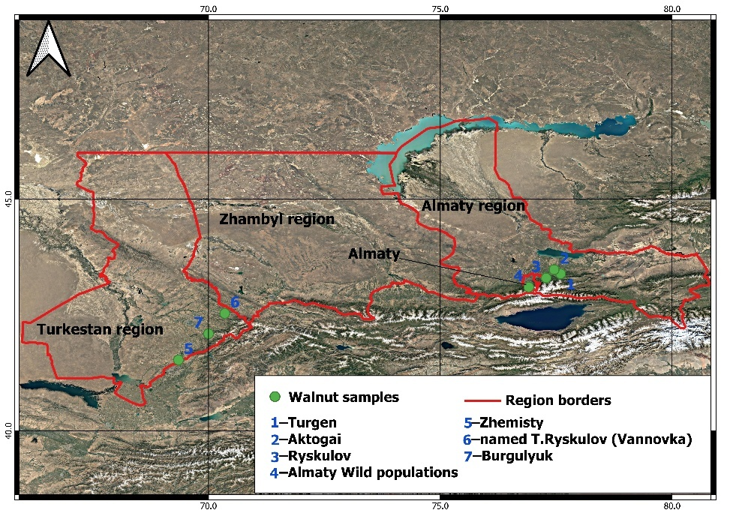

Figure 2 – Geographic distribution of walnut (J. regia) sampling locations, numbered as follows: 1-Turgen; 2-Aktogai; 3-Ryskulov; 4-Almaty; 5-Zhemisty; 6- Ryskulov (Vannovka); 7-Burgulyuk
Morphological and ecological descriptors were selected in accordance with internationally recognized standards for fruit crop characterization, following IPGR (1994) and UPOV-TG/125/6 guidelines (IPGR, 1994; UPOV, 1999). The evaluated traits included leaf size, fruit morphology, flowering time, disease resistance, and adaptation to climatic conditions. All descriptors were recorded using standardized protocols to ensure comparability among accessions.
Genomic DNA was extracted from approximately 100 mg of young leaf tissue using the innuPREP Plant DNA Kit (Analytik Jena, Germany) following the manufacturer’s instructions. DNA quality was assessed by 1% agarose gel electrophoresis, and DNA concentration was quantified using a Qubit Fluorometer (Thermo Fisher Scientific, USA).
Genotyping was performed using the Axiom™ J. regia 700K SNP Genotyping Array on a GeneTitan® Multi-Channel Instrument (Affymetrix, Thermo Fisher Scientific, USA). Raw genotype data were processed using Axiom Analysis Suite v5.2 [135]. Genotype calling quality was assessed at DQC thresholds of 90%, 95%, and 97%. The dataset generated at the 90% DQC threshold was selected for downstream analyses to maximize sample retention while maintaining reliable genotype calls.
Quality control and SNP filtering were conducted using PLINK v1.90b6.21 [136]. SNPs were filtered based on the following criteria: marker missingness (--geno 0.2), minor allele frequency (--maf 0.05), and Hardy–Weinberg equilibrium (--hwe 1 × 10⁻⁵). Linkage disequilibrium pruning was performed using a sliding window approach (--indep-pairwise 50 5 0.8). The final quality-controlled dataset consisted of 173 samples and 145,711 SNP markers.
Population genetic parameters, including observed heterozygosity (Ho), expected heterozygosity (He), and the inbreeding coefficient (F), were calculated using PLINK (--het). Additional diversity indices, including the effective number of alleles (Ne), Shannon’s information index (I), and Simpson’s diversity index (S), were calculated across all loci for each population.
Population structure was inferred using ADMIXTURE [137]. Analyses were performed for values of ancestral populations (K) ranging from 2 to 10, with ten independent runs for each K value. The optimal number of genetic clusters was determined based on cross-validation error values.
Principal component analysis (PCA) was conducted using the SNPRelate package [138] based on the quality-filtered SNP dataset. Analysis of molecular variance (AMOVA) and pairwise F_ST values were calculated using the dartR package [139]. AMOVA was performed with 100,000 permutations, and pairwise F_ST estimates were obtained with 1,000 bootstrap replicates.

3 RESULTS AND DISCUSSION
3.1 Characteristics of fungal and bacterial diseases of walnut identified during monitoring in the southern fruit-growing zone of Kazakhstan
A visual inspection of walnut plantations in the Turkestan, Zhambyl, and Almaty regions revealed a fairly widespread occurrence of walnut blight caused by the pathogen P. agglomerans. The disease symptoms manifested as brownish to dark-brown spots on leaves, young shoots, and fruits, which gradually expanded in size (Figure 3). Young shoots exhibited brown necrotic lesions. During the summer, under conditions of hot and dry weather, disease activity declined, and the infection outbreak subsided. From this period until mid-autumn, consistently dry conditions were observed, characterized by a pronounced lack of moisture, complete absence of precipitation, and high temperatures. As a consequence, the degree of heat damage to the trees increased, and leaves with desiccation and chlorosis were detected (Figure 3).

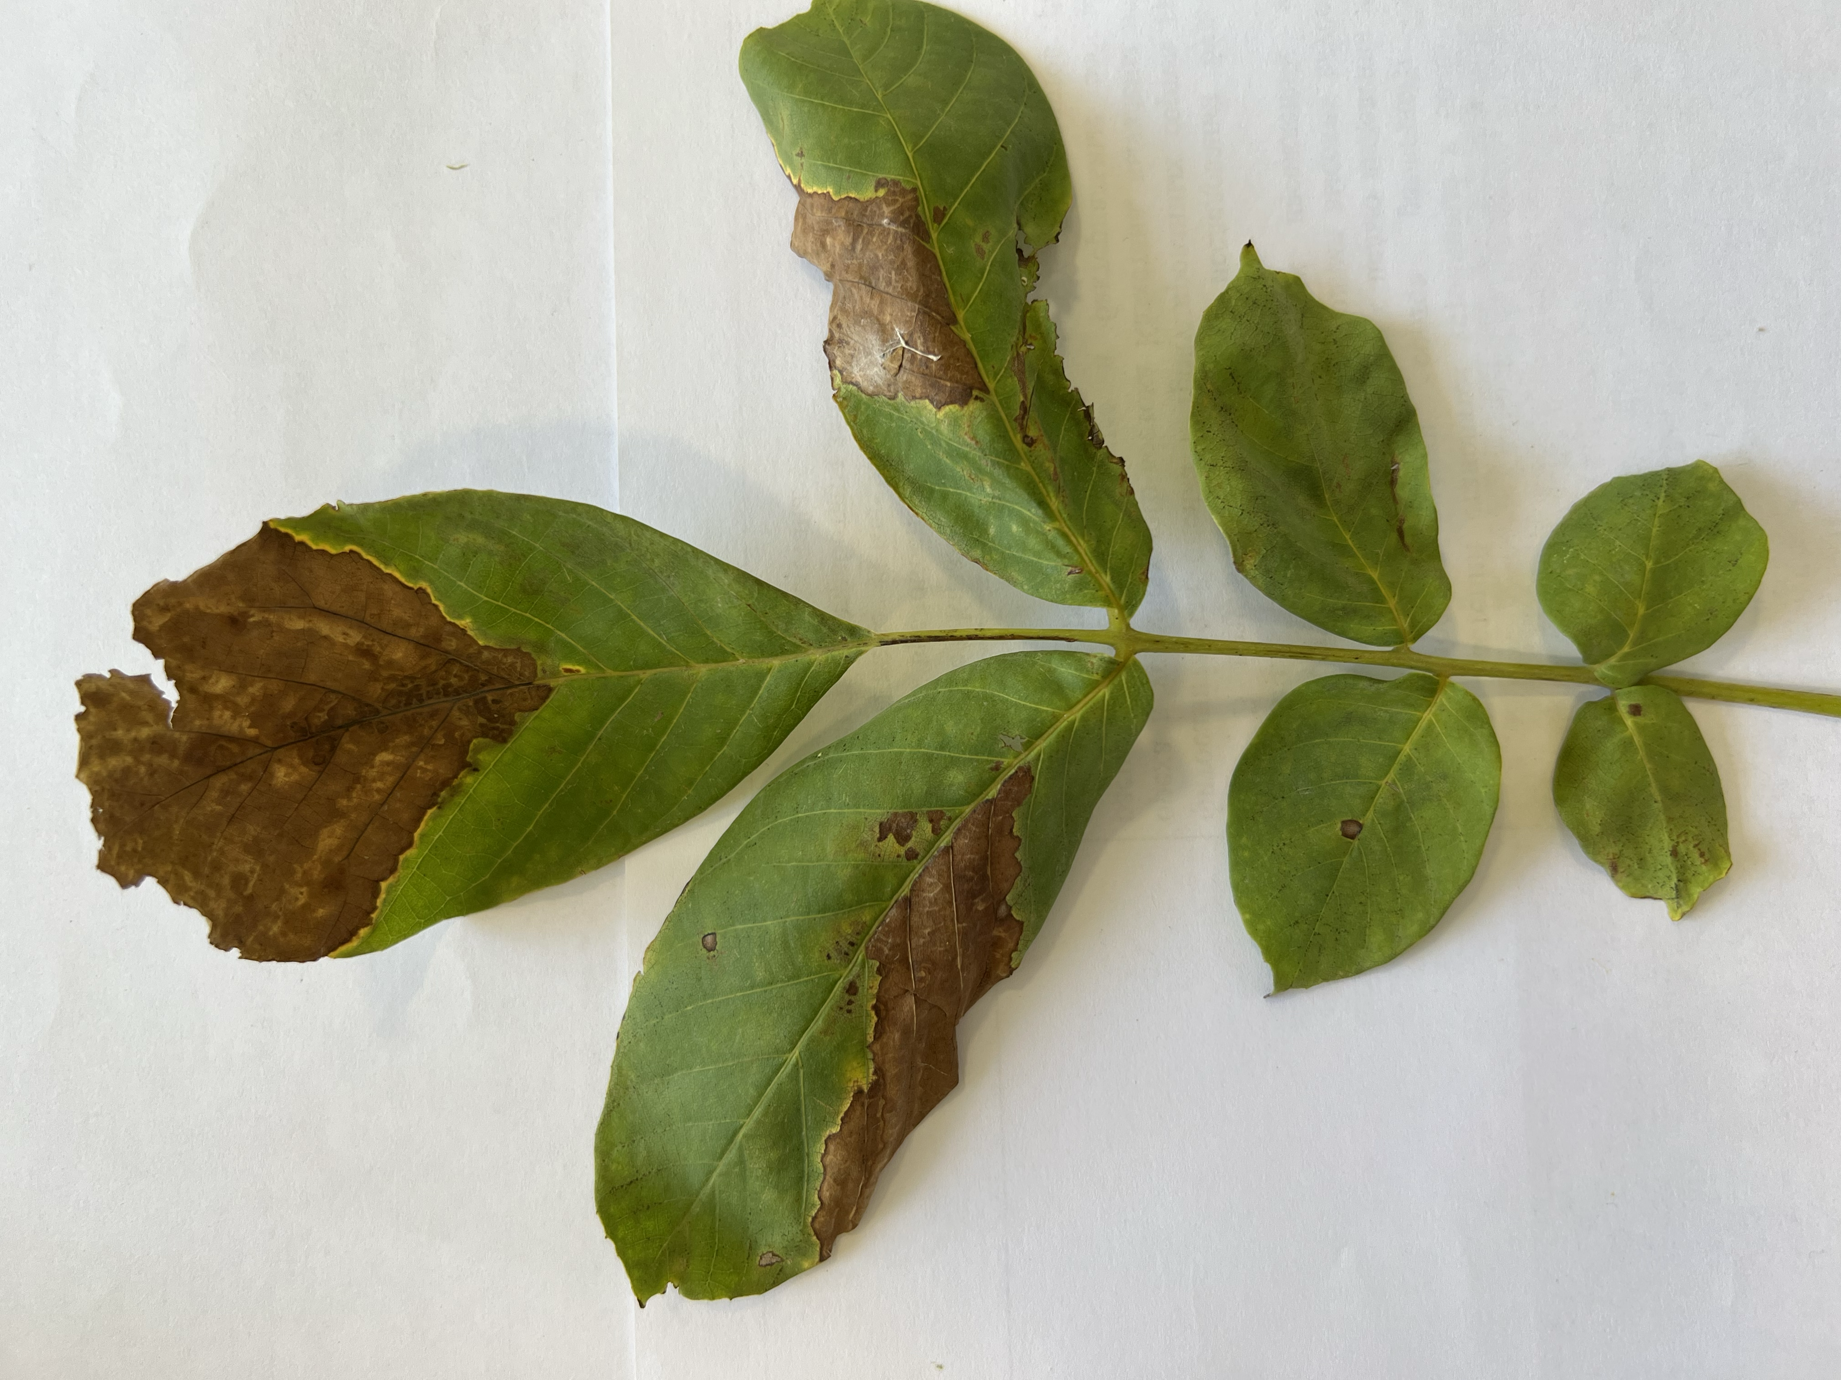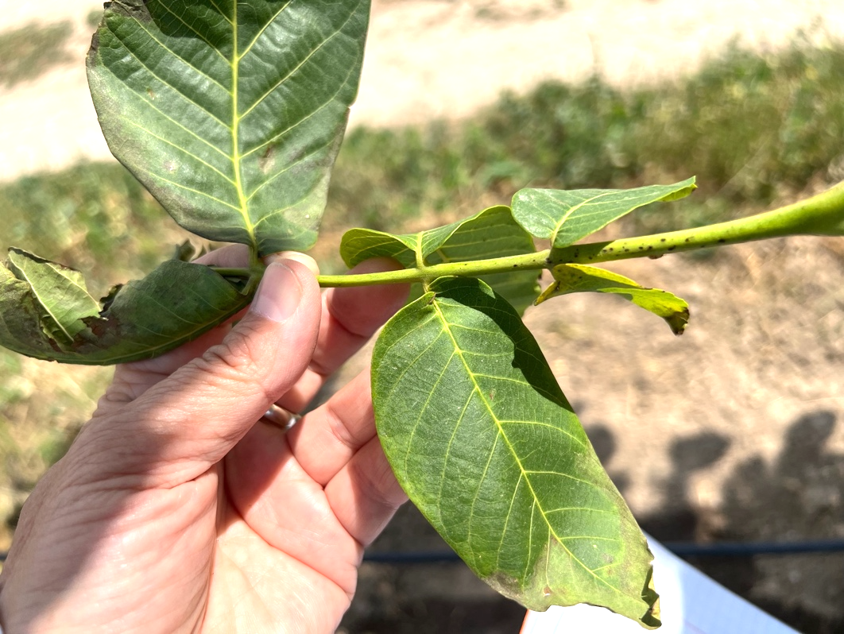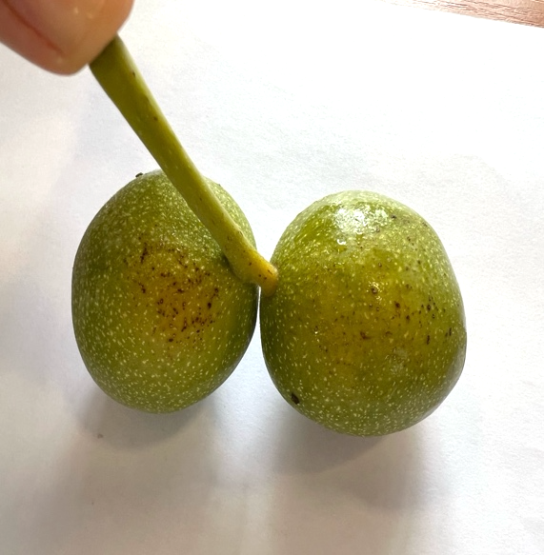

a b c

Figure 3 – Symptoms of walnut blight caused by P. a) agglomerans on walnut leaves, b) shoots, and c) fruits (photographed in Alma-Arasan, “Fazenda UM” LLP, “Manshuk” farm), 2023

Walnut leaf spot disease, caused by the bacterium P. oryzihabitans, is a serious bacterial pathogen that actively develops at temperatures ranging from 20 to 35 °C and induces significant leaf damage, leading to reduced walnut yields. The bacterium penetrates the plant through stomata and micro-injuries arising from mechanical damage, unfavorable weather conditions, or pest activity. Elevated humidity is the principal element facilitating the transmission of infection, especially during extended periods of rainfall and significant dew.
The disease manifests as patches along the leaf margins that progressively deepen and develop a brownish hue. As the infection advances, the afflicted regions enlarge, tissues experience necrosis, and leaves commence wilting and premature abscission (Figure 4). This diminishes the tree's strength, decreases its photosynthetic efficiency, and reduces production by 15–25%. In settings of high humidity, the disease proliferates swiftly, rendering it particularly perilous in areas with prolonged rainy seasons and increased atmospheric moisture.
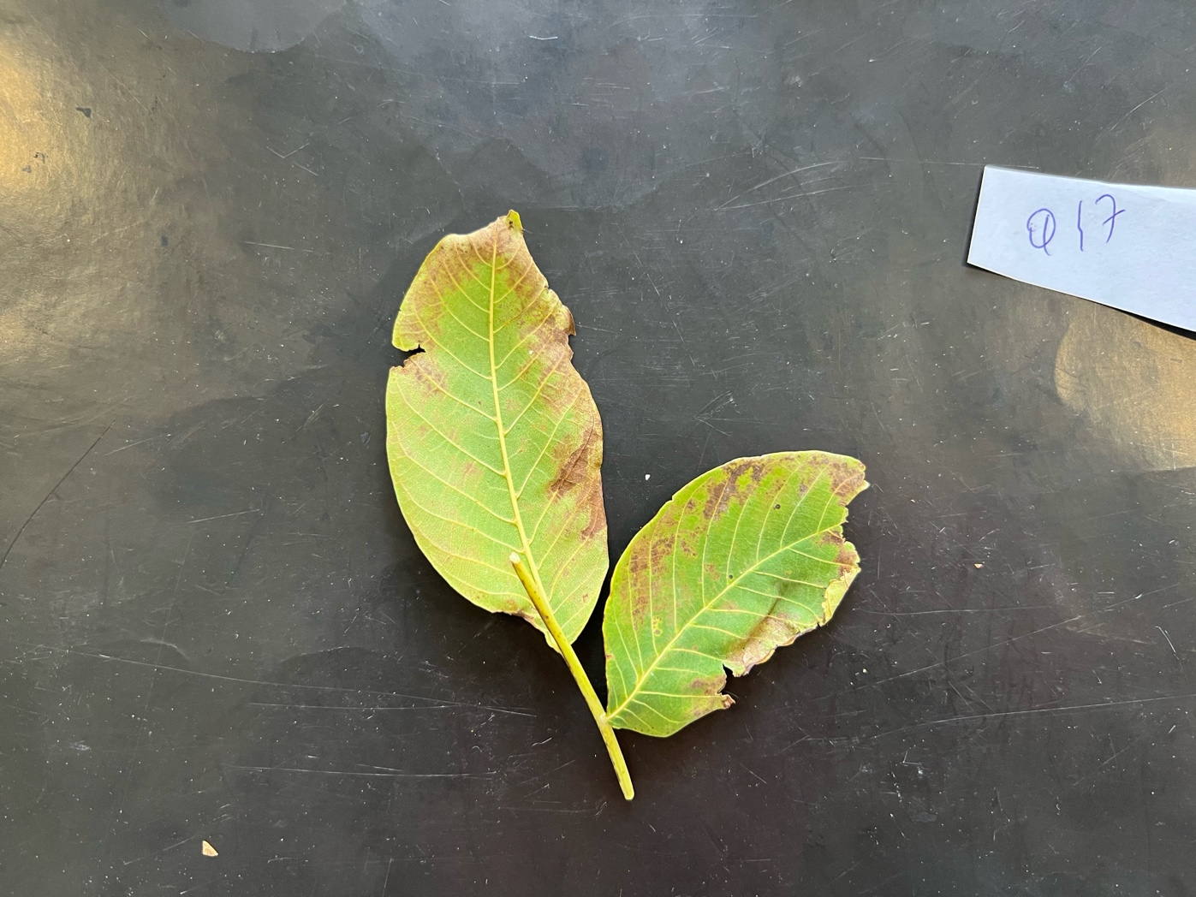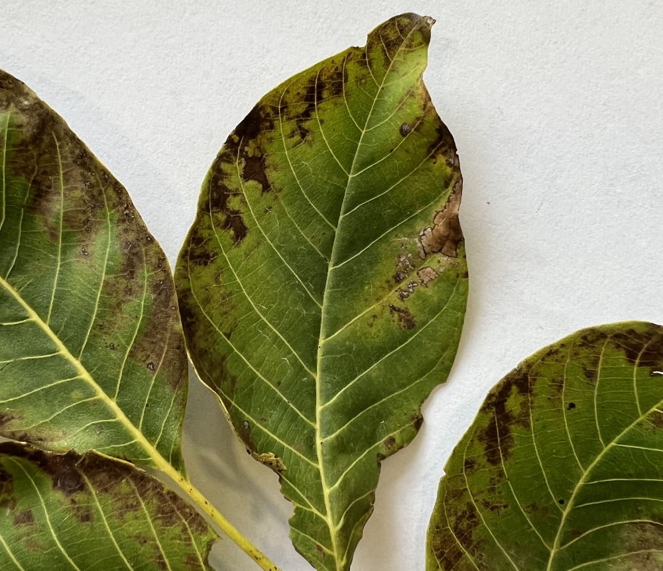

a b

Figure 4 – a) Symptoms of walnut leaf spot disease caused by P. oryzihabitans b) on walnut leaves (photographed in “Manshuk” farm), 2022

Bacterial blight of walnut, induced by the Gram-negative bacterium X. arboricola pv. juglandis, is a prevalent phytopathogen that affects numerous agricultural crops, including nut-bearing species. The disease presents as chlorotic and necrotic lesions on young leaves, which progressively brown, become necrotic, and are frequently encircled by a yellow halo. The impacted regions may merge, resulting in leaf distortion, drying, and early detachment. Obscure, elongated lesions manifest on juvenile shoots and petioles, impeding plant growth. Fruits are likewise vulnerable: little depressed lesions develop on their surface, frequently resulting in decay.

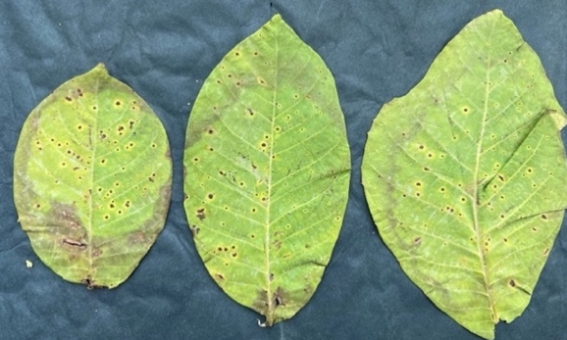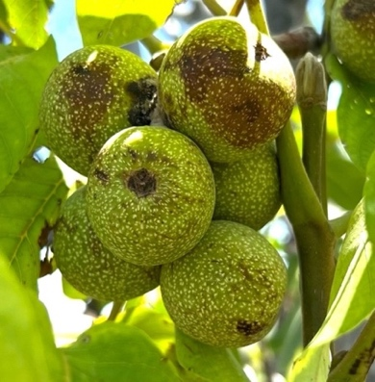

a b

Figure 5 – Symptoms of bacterial blight caused by X. arboricola pv. juglandis a) leaves, b) fruits (photographed at “Saryagash Zher Syiy” LLP), 2024

Infection transpires via natural stomata, mechanical damage (such as those inflicted by hail, insects, or pruning), and contaminated planting material (Figure 5). The disease thrives in high humidity, air temperatures ranging from 25 to 30 °C, and dense plants with inadequate air circulation. The repercussions might be significant, encompassing diminished photosynthetic activity, stunted growth, harm to flowers and fruit development, and ultimately yield reductions of 30–50%, with total crop failure in extreme instances. Efficient disease management necessitates preventive strategies, encompassing the utilization of healthy planting stock, hygienic pruning, compliance with agronomic protocols, spatial separation, application of copper-based treatments, and the development of resistant varieties. The climatic circumstances of southern Kazakhstan and the increasing acreage of walnut orchards render bacterial blight caused by X. arboricola pv. juglandis a significant phytosanitary danger, requiring a systematic strategy to prevention and monitoring.
Crown gall is a bacterial affliction induced by the bacterium A. tumefaciens. This virus can infect over 600 kinds of dicotyledonous plants, including walnut. It exhibits heightened activity in young seedlings and nursery plantations. The primary sign of the disease is the development of tumours (galls) of varied sizes on the roots, root collar, and lower stem. Initially, the galls are pliable, light brown, and smooth; however, they subsequently develop denser, darken, fissure, and impair the plant's nutrient transfer. Infection transpires by micro-injuries to roots and stems resulting from transplantation, pruning, mechanical injury, insect activity, or unfavourable soil conditions. A. tumefaciens transfers a segment of its DNA (T-DNA) into host cells, prompting unregulated cell division – a distinctive instance of horizontal gene transfer between bacteria and plants.
While monitoring walnut plantations, we noted a considerable quantity of stem portions exhibiting cracks (Figure 6). The pathogen A. tumefaciens was extracted from the injured tissues; yet, typical galls were not present. Potential reasons for the lack of galls despite the presence of the virus encompass the age and physiological condition of the trees. Mature plants exhibit a lower susceptibility to gall formation compared to immature seedlings, where cellular division is more vigorous.
1) The mechanical characteristics of the injuries. The bacterium may have inhabited fissures and lesions without inducing tumour development;
2) Genotypic resistance. Some walnut genotypes have enhanced resistance to Agrobacterium-mediated cell transformation;
3) Competition with other microbes. Antagonistic microorganisms in wound microflora may inhibit pathogen activity;
4) Dormant infection. The pathogen may remain dormant in tissues until conditions become favourable;
5) Unfavorable environmental circumstances. Soil, temperature, or moisture conditions may have hindered T-DNA expression and gall formation.

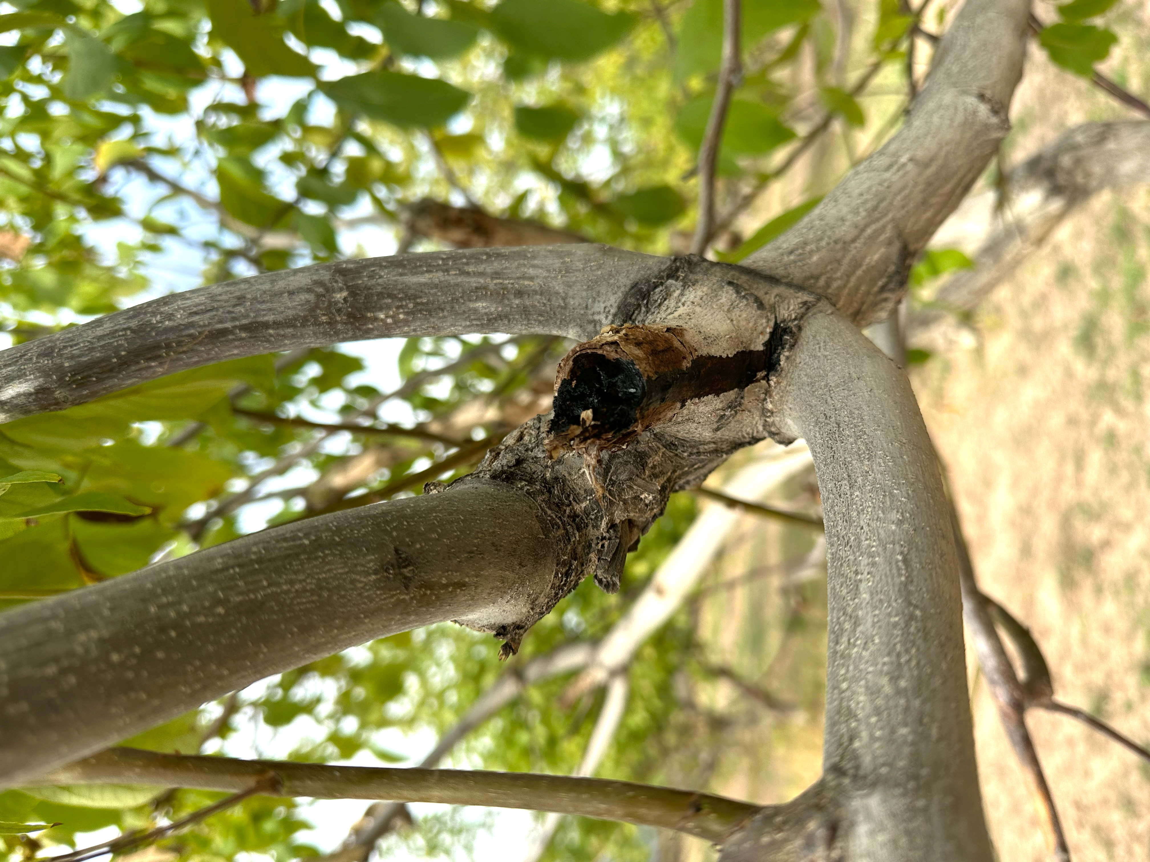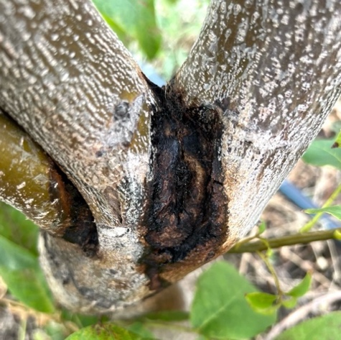

a b

Figure 6 – Characteristic cracks on the trunk and bark of walnut (J. regia), from which A. tumefaciens was isolated: a) on the trunk; b) on the bark (photographed at “Saryagash Zher Syy” LLP), 2023.

Bacterial leaf spot, generated by P. syringae, is an infectious illness caused by this phytopathogenic bacterium. The pathogen exhibits a broad host range, impacting over 180 plant species, including walnut (J. regia). The disease inflicts significant harm on plantations, diminishing tree output and resilience to unfavourable environmental conditions.

Disease development on walnut often commences in spring or early summer under optimal conditions, characterized by temperatures between 20–25 °C and elevated air humidity. The bacterium survives the winter on plant debris, on bud surfaces, and within tree bark. The pathogen disseminates to leaves and infiltrates plant tissues via stomata and minor mechanical damage, facilitated by rain, irrigation water, or dew. Within the tissues, the bacterium proliferates vigorously, causing cellular destruction by the secretion of enzymes and toxins, resulting in cell death and the manifestation of distinctive leaf spots (Figure 7).

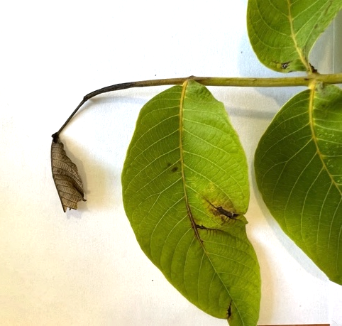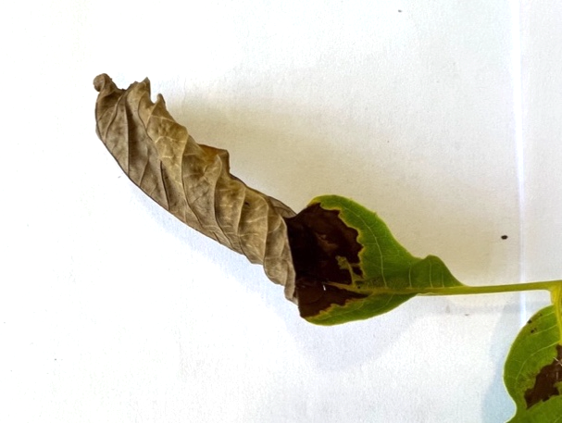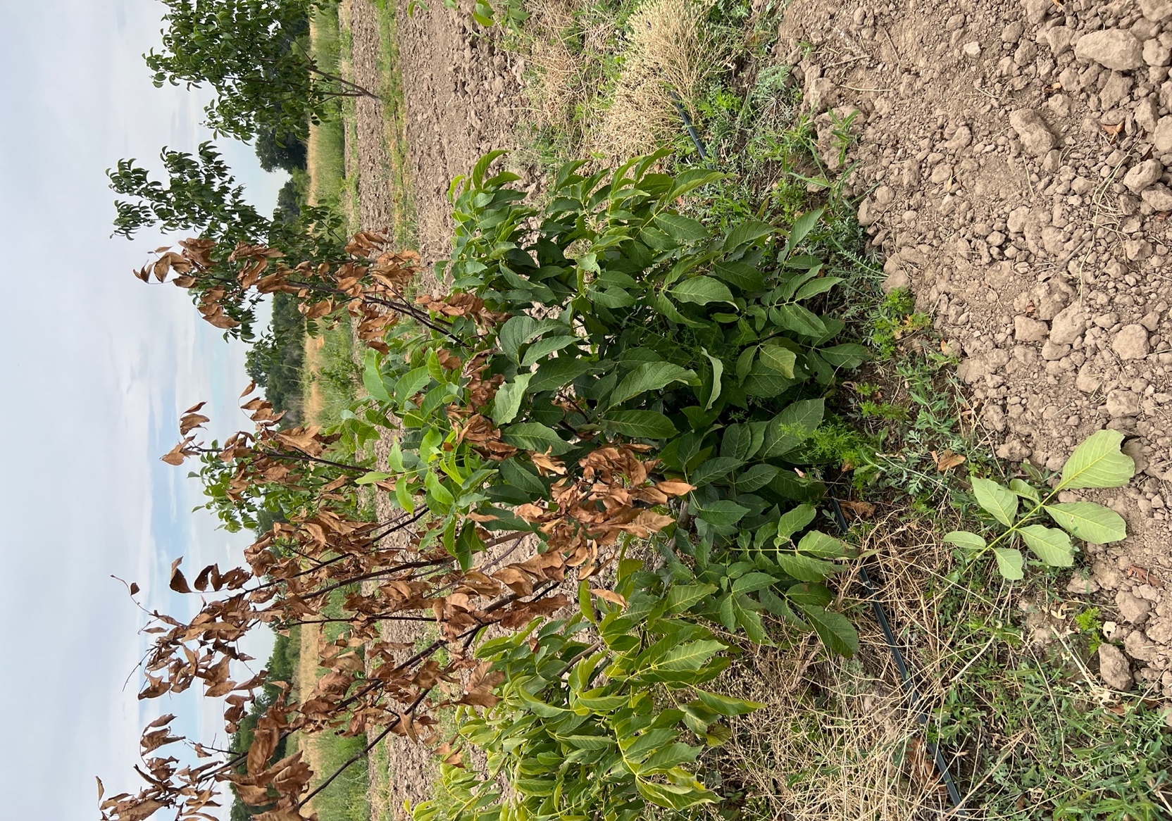

a b c

Figure 7 – Symptoms of bacterial leaf spot caused by P. syringae (photographed at the Issyk State Dendrological Park), a) the beginning of the defeat; b) defeat; c) spread, 2022

In settings of elevated humidity, the illness advances more swiftly and impacts a greater quantity of leaves. The primary symptoms manifest on leaves as diminutive, water-soaked lesions that progressively become brown. As the disease progresses, the lesions may merge, impacting large regions of the leaf blade. In extreme instances, leaves desiccate, curl, and abscise prematurely, resulting in a significant reduction in the crown's photosynthetic area. Young shoots, buds, and even fruits may be impacted if the virus proliferates extensively.
Brown spot is a fungal ailment induced by pathogens belonging to the genus Alternaria. It can impact the leaves, fruits, shoots, and the root system of the tree. The disease proliferates most vigorously at temperatures between 18 and 30 °C, while elevated humidity and substantial precipitation facilitate vigorous sporulation and dissemination of the infection. The fungus Alternaria is propagated through rain splash, wind, and insects, and can endure in contaminated plant debris, on soil surfaces, and within tree bark. The pathogen may survive unfavourable conditions as conidia and mycelium, poised to establish new infections when favourable environmental conditions arise. The initial symptoms manifest as diminutive dark dots encircled by a yellowish halo, generally situated along the leaf margins. The spots progressively expand, coalesce, and the impacted regions become desiccated, resulting in necrosis (Figure 8).

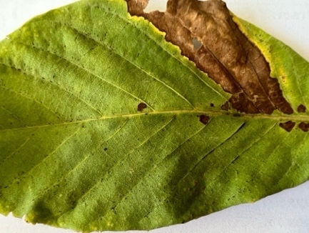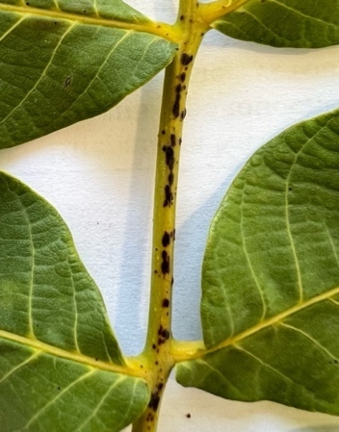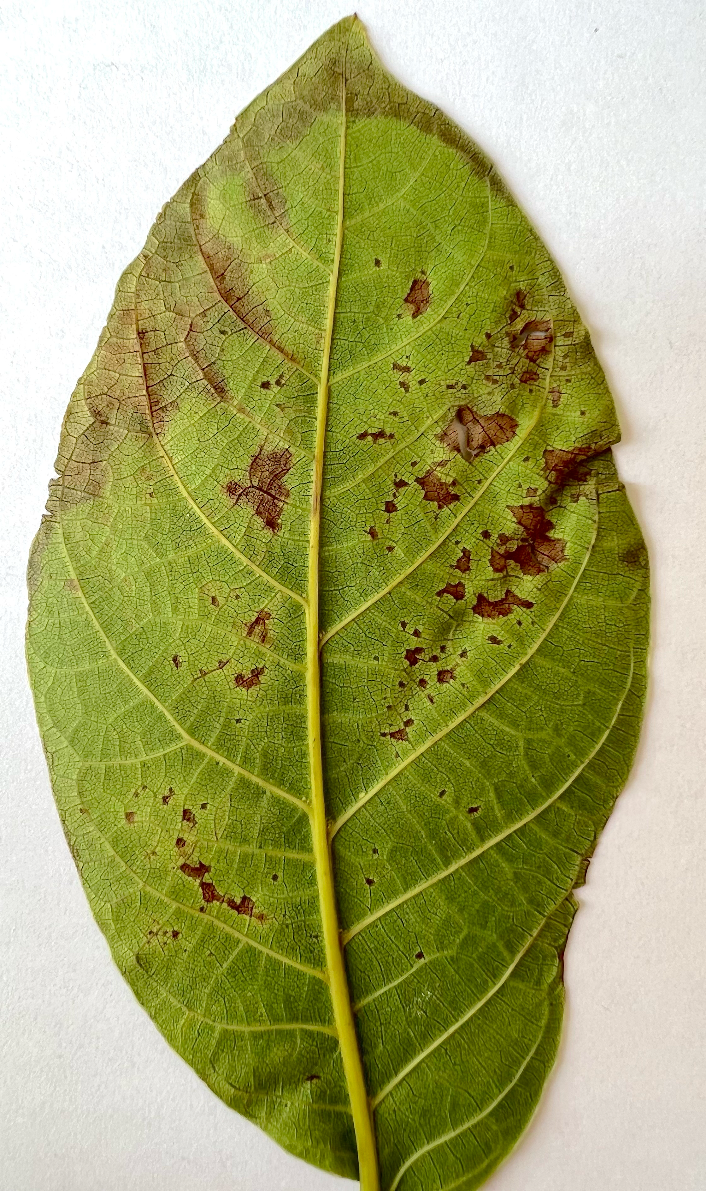

a b c

Figure 8 – Symptoms of brown spot caused by A. alternata: a) on walnut leaves; b) on stems; c) on leaves (photographed at “Manshuk” farm), 2022.

In advanced instances, leaves entirely desiccate and abscise prematurely, diminishing the tree’s photosynthetic efficacy and potentially resulting in output reductions of 20–35%. In conditions of elevated humidity, a velvety fungal sporulation may manifest on the surface of the lesions, promoting further dissemination of the infection. Severe infections may impact immature shoots and fruits, diminishing their commercial quality and making them unsalable. Infected green fruits have dark, deep black or brown lesions; their surface may attain a velvety texture due to fungal sporulation. Nuts that are infected may wither, fail to mature, and fall off prematurely. Dark rot may also manifest within the shell. Infected young shoots develop black or dark brown cankers, resulting in tissue necrosis and branch desiccation. Factors contributing to the emergence of brown spot encompass elevated humidity, substantial precipitation, fog, inadequate crown aeration, and the existence of contaminated plant debris remaining in the orchard. The illness advances particularly swiftly during extended intervals of wet and rainy weather, when leaves remain damp for several continuous hours. Mechanical damage to foliage resulting from hail, bugs, or other ailments also heightens the susceptibility to infection.
Fungi belonging to the genus Fusarium (F. proliferatum, F. graminearum, F. redolens, F. solani, F. incarnatum) are virulent phytopathogens that infect the leaves, stems, shoots, and fruits of walnut trees (Figure 8). They thrive at temperatures between 20 and 30 °C and elevated humidity, infiltrating plants via soil, contaminated seeds, and mechanical damage to the roots. As the illness advances, pronounced shoot wilting, stunted growth, and diminished plant immunity are evident. In extreme instances, infection results in total tree mortality, with production reductions potentially reaching 40–50%. The primary risk factors are elevated soil moisture, particularly when coupled with inadequate drainage, contaminated seeds and planting materials, and insufficient root system aeration. Extended precipitation, water accumulation in tree basins, and inadequate irrigation practices facilitate the proliferation of the pathogen.

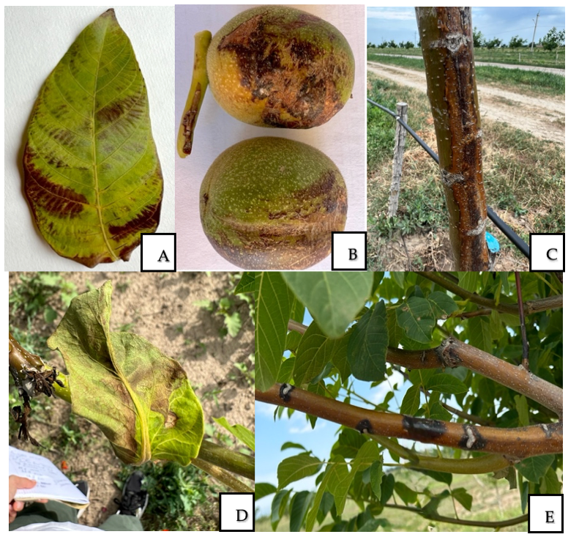

Figure 9 – Fusarium species causing infections of various walnut organs (leaves, bark, shoots, fruits): A – F. proliferatum (Issyk State Dendrological Park); B – F. graminearum (“Saryagash Zher Syiy” LLP); C – F. solani (Issyk State Dendrological Park); D – F. redolens (Alma-Arasan); E – F. incarnatum (“Saryagash Zher Syiy” LLP), 2023

On walnut leaves, the affliction caused by F. proliferatum presents as irregular brown lesions along the leaf margins (Figure 9A). In the initial stages, the impacted regions exhibit leaf curling and wilting. As the disease advances, the lesions progressively extend from the periphery into the centre, encompassing a larger area of the leaf. Ultimately, the entire leaf blade withers, desiccates, and perishes. Necrosis develops on walnut fruits (J. regia) infected with F. graminearum (Figure 9B). Symptoms manifest solely at the stigmatic (stylar) end of the fruit, where a little brown spot develops and progressively enlarges, evolving into a substantial dark brown to black lesion that can encompass up to two-thirds of the fruit's surface. The ovarian tissues and the kernel within the fruit undergo blackening and decay. Premature fruit drop occurs, with potential yield losses reaching 40% in severe instances. Necrosis propagates from the stigma into the fruit's internal tissues, resulting in their destruction. Infected fruits become unfit for consumption due to necrosis and decay. In instances of stem canker induced by F. solani, oval, deep, black-brown necrotic lesions develop on juvenile branches and stems (Figure 9C). The cambial and woody tissues in the impacted regions darken and degrade, resulting in yellowing and dieback of branches. In many instances, only internal discoloration and necrosis of the crown and roots were noted, lacking significant outward symptoms on the shoots. These diseases can impact both nursery planting material and mature trees, resulting in considerable dieback and diminished output of plantations. F. redolens on walnut is one of the most virulent diseases. Infected trees display wilting, overall deterioration, and stoppage of growth. Leaves exhibit turgor loss and subsequently wilt (Figure 9D). The xylem vessels within the stem exhibit darkening, occasionally manifesting as longitudinal streaks, signifying an upward infection originating from the roots. In extreme instances, the tree perishes entirely. F. incarnatum induced cankers of varying dimensions, reaching up to 50 mm, on trunks and lateral branches (Figure 9E). Bud infection was also noted, impacting both lateral and apical buds. Necrotic brown lesions of 20 mm in diameter and up to 5 mm in depth formed on the fruits, resulting in premature fruit drop. In artificial inoculation tests, shoot dieback occurred 30 days post-infection, succeeded by canker formation after an additional month.

3.2 Disease severity index and disease incidence of walnut diseases in the southern fruit-growing zone of Kazakhstan
Monitoring of the phytosanitary status of walnut plantations was carried out in 2022–2024 using route surveys conducted at key stages of plant development. The study included introduced cultivars, local forms, and wild-growing walnut trees (J. regia L.) at the following sites: RF “Manshuk,” RSE “Issyk State Dendrological Park,” LLP “Fazenda UM,” a walnut grove in the Alma-Arasan Gorge, KH “Karadala” (Kyrgyzsai village, Uighur district, Almaty region); in the Turkestan region — LLP “Saryagash Zher Syyi,” LLP “Silk Alley,” and Tulkibas village; and in the Zhambyl region — Merke village. On average, 40 trees were examined at each site, while in smaller orchards approximately 10 trees were assessed. DI and DSI were evaluated at key phenological stages of walnut development, including bud break, active shoot and leaf growth, flowering, fruit set and filling, fruit maturation, and preparation for dormancy.
Annual DI and DSI values for the major walnut diseases recorded at the studied sites during 2022–2024 are summarized in Table 7.

Table 7 – DI and DSI of major walnut diseases in the southern fruit-growing zone of Kazakhstan, 2022–2024

Location | Year | Diseases | DI, % | DSI, %
1 | 2 | 3 | 4 | 5
Alma Arasan | 2023 | P. agglomerans | 54 | 26
Alma Arasan | 2024 | P. agglomerans | 57 | 26
Alma Arasan | 2023 | F. redolens | 22 | 7
Alma Arasan | 2024 | F. redolens | 27 | 8
LLP “Fazenda UM” | 2023 | P. agglomerans | 36 | 13
LLP “Fazenda UM” | 2024 | P. agglomerans | 41 | 14
Merke village | 2023 | P. agglomerans | 23 | 7
Merke village | 2024 | P. agglomerans | 29 | 11
Tulkibas village | 2023 | P. agglomerans | 24 | 7
Tulkibas village | 2024 | P. agglomerans | 27 | 9
Continuation of Table 7

1 | 2 | 3 | 4 | 5
Peasant Farm «Manshuk» | 2022 | P. oryzihabitans | 30 | 9
Peasant Farm «Manshuk» | 2023 | P. oryzihabitans | 28 | 8
Peasant Farm «Manshuk» | 2024 | P. oryzihabitans | 31 | 9
Peasant Farm «Manshuk» | 2022 | P. agglomerans | 40 | 15
Peasant Farm «Manshuk» | 2023 | P. agglomerans | 34 | 12
Peasant Farm «Manshuk» | 2024 | P. agglomerans | 36 | 13
Peasant Farm «Manshuk» | 2022 | A. alternata | 29 | 11
Peasant Farm «Manshuk» | 2023 | A. alternata | 28 | 9
Peasant Farm «Manshuk» | 2024 | A. alternata | 33 | 11
LLP “Saryagash Zher Syyi” | 2022 | P. agglomerans | 45 | 20
LLP “Saryagash Zher Syyi” | 2023 | P. agglomerans | 37 | 18
LLP “Saryagash Zher Syyi” | 2024 | P. agglomerans | 50 | 22
LLP “Saryagash Zher Syyi” | 2023 | X. campestris | 38 | 10
LLP “Saryagash Zher Syyi” | 2024 | X. campestris | 42 | 13
LLP “Saryagash Zher Syyi” | 2022 | A. alternata | 42 | 21
LLP “Saryagash Zher Syyi” | 2023 | A. alternata | 39 | 17
LLP “Saryagash Zher Syyi” | 2024 | A. alternata | 39 | 19
LLP “Saryagash Zher Syyi” | 2023 | A. tumefaciens | 20 | 9
LLP “Saryagash Zher Syyi” | 2024 | A. tumefaciens | 15 | 8
LLP “Saryagash Zher Syyi” | 2023 | F. graminearum | 32 | 10
LLP “Saryagash Zher Syyi” | 2024 | F. graminearum | 41 | 15
LLP “Saryagash Zher Syyi” | 2022 | F. incarnatum | 10 | 20
LLP “Saryagash Zher Syyi” | 2023 | F. incarnatum | 14 | 29
LLP “Silk Alley” | 2022 | A. alternata | 69 | 30
LLP “Silk Alley” | 2023 | A. alternata | 64 | 28
LLP “Silk Alley” | 2024 | A. alternata | 70 | 30
RSE "Issyk State Dendrological Park" | 2022 | P. agglomerans | 38 | 10
RSE "Issyk State Dendrological Park" | 2023 | P. agglomerans | 49 | 13
RSE "Issyk State Dendrological Park" | 2024 | P. agglomerans | 50 | 14
RSE "Issyk State Dendrological Park" | 2023 | F. proliferatum | 40 | 17
RSE "Issyk State Dendrological Park" | 2024 | F. proliferatum | 40 | 13
RSE "Issyk State Dendrological Park" | 2022 | A. alternata | 55 | 30
RSE "Issyk State Dendrological Park" | 2023 | A. alternata | 46 | 23
RSE "Issyk State Dendrological Park" | 2024 | A. alternata | 51 | 26
RSE "Issyk State Dendrological Park" | 2022 | P. syringae | 25 | 10
RSE "Issyk State Dendrological Park" | 2023 | P. syringae | 23 | 9
RSE "Issyk State Dendrological Park" | 2024 | P. syringae | 30 | 12
RSE "Issyk State Dendrological Park" | 2022 | F. solani | 18 | 9
"Karadala" farm | 2023 | P. agglomerans | 35 | 16
"Karadala" farm | 2024 | P. agglomerans | 40 | 20
"Karadala" farm | 2023 | A. alternata | 32 | 12
"Karadala" farm | 2024 | A. alternata | 38 | 15

Surveys were conducted under contrasting climatic conditions of the Almaty, Turkestan, and Zhambyl regions, allowing assessment of the influence of environmental factors on disease development.
The assessment focused on the most economically important bacterial and fungal diseases of walnut, including walnut blight, brown spot, Fusarium-associated infections, and other locally occurring pathogens. The obtained DI and DSI values provide a quantitative basis for comparing disease pressure among locations and years and for identifying dominant pathogens shaping the phytosanitary situation in the southern fruit-growing zone of Kazakhstan.
As a result of assessing the DI and DSI of fungal and bacterial diseases on cultivars, local forms, and wild walnut trees across different regions, a heterogeneous, region-specific distribution of diseases was identified. As shown in Table 7, walnut trees were mainly affected by walnut blight caused by the bacterium P. agglomerans. The DI of the disease ranged from moderate to high: in the Almaty region it reached 34–57% with a DSI of 13–26%. In the Turkestan region, the DI on local walnut forms ranged from 24–50% with a DSI of 7–22%, while in the village of Merke (Zhambyl region) the DI was moderate, ranging from 23–29% with a DSI of 7–11%.
The pathogen of walnut blight, P. agglomerans, may infect walnut trees through several pathways: infected planting material, insect pollinators and pests, rainwater and wind, contaminated agricultural tools and machinery, and contact with other host plants. The warm climate of the southern fruit-growing zone of Kazakhstan, with moderate humidity and hot summers, creates favorable conditions for the spread of bacterial infections. P. agglomerans demonstrates high adaptability, especially when co-occurring with other pathogens. Among fungal pathogens, brown spot caused by A. alternata was widely distributed. The DI of the disease ranged from moderate to high: in the Almaty region, 28–55% with a DSI of 9–30%; in the Turkestan region, 39–70% with a DSI of 17–30%.
Fusarium infections (Fusarium spp.) appeared locally, but across various farms of the southern zone showed a tendency to intensify: DI ranged from 10–41% and DSI from 7–29%. In particular, F. graminearum and F. incarnatum demonstrated increasing levels over the years, indicating accumulation of infection and adaptation in agrocenoses. Alongside these, other pathogens — X. arboricola pv. juglandis, A. tumefaciens, and P. syringae — were recorded locally. In addition to the occurrence of individual diseases, mixed infections were frequently recorded. Most often A. alternata was detected together with bacterial pathogens (P. agglomerans, X. arboricola), while isolated occurrences were uncommon. In the “Issyk State Dendrological Park” RSE, “Manshuk” rural farm, and “Saryagash Zher Syyi” LLP, 100% of the cases of A. alternata occurred together with bacterial pathogens, indicating stable co-infection patterns at these sites. In contrast, at Alma-Arasan and “Fazenda UM” LLP, P. agglomerans acted as an independent pathogen, whereas at “Silk Alley” LLP, A. alternata predominated alone.
Mixed infections were consistently linked to more severe disease progression than single-pathogen cases. Symptoms advanced faster, characterized by enlarged necrotic lesions, untimely leaf and branch mortality, and expedited dissemination within plant tissues. The impacts were more pronounced in the “Manshuk” rural farm, “Saryagash Zher Syyi” LLP, and the “Issyk State Dendrological Park” RSE, where co-infection rates reached their peak.
At “Saryagash Zher Syyi” LLP, the predominant manifestations were bark damage on tree trunks and scaffold branches. These areas had a diverse array of diseases, including both bacterial and fungal species. Bacterial infections were more commonly observed on walnut fruits and leaves, whereas F. incarnatum and A. alternata were actively proliferating on stems and damaged wood, with the latter being nearly ubiquitous. These data suggest that bark fissures and wound injuries functioned as "entry points" for the initiation of mixed infections and the maintenance of a heterogeneous pathogen complex.
Statistical analysis of the experimental data enabled a quantitative assessment of the effects of location and year on disease incidence and severity. For pathogens recorded at two or more locations within the same year (P. agglomerans and A. alternata), one-way analysis of variance (ANOVA) was applied. Based on the ANOVA results, mean square error (MSE) and LSD₀.05 values were calculated. The LSD₀.05 ranged from 3.01 to 4.95, indicating statistically significant differences between several locations and confirming the influence of local environmental conditions on pathogen development and spread.
For pathogens detected at only one location per year (Fusarium spp., Pseudomonas spp., Xanthomonas spp., and Agrobacterium spp.), inferential statistical analysis was not applicable due to limited spatial replication. In these cases, only descriptive statistics (means and within-group variability) were calculated. While these parameters provide reliable estimates of disease severity, they do not allow statistical inference regarding the effect of location. Overall, significant spatial variation was detected only for P. agglomerans and A. alternata, highlighting the key role of ecological and territorial factors in shaping pathogen dynamics in the studied region.

3.3 Characteristics of pure cultures of fungal and bacterial isolates
Between 2022 and 2024, almost 400 samples of diverse plant components were gathered, encompassing leaves, bark, stems, and fruits. This extensive array of samples facilitated the acquisition of a representative assemblage of pathogens, mirroring the diversity of infection origins. In laboratory circumstances, fungal and bacterial pathogens were isolated from damaged plant tissues obtained from the Almaty, Turkestan, and Zhambyl regions.
A total of 88 bacterial isolates were obtained. Identification revealed the presence of the following species: A. tumefaciens, X. arboricola pv. juglandis, P. agglomerans, P. oryzihabitans, and P. syringae.
The largest number of isolates was represented by P. agglomerans, which was recovered from 50 samples. This species was found in stems, leaves, and fruits. X. arboricola pv. juglandis was detected in 8 samples, mainly from fruits. P. oryzihabitans was isolated in 10 cases (mainly from leaves), while P. syringae was found in 15 samples (stems and leaves). The least common was A. tumefaciens, isolated from 5 samples, primarily from bark. Thus, it was established that microorganisms are associated with infections of different plant organs. The distribution of bacterial isolates was analyzed in relation to the infected walnut organs to identify organ-specific colonization patterns. The qualitative presence and frequency of the isolated bacterial species in stems, leaves, fruits, and bark are summarized in Table 8.

Table 8 – Bacterial microflora identified from walnut samples

Bacteria isolated from walnut | Stems | Leaves | Fruits | Bark | Number of examined isolates
P. agglomerans | + | + | + |  | 50
A. tumefaciens | + |  |  | + | 5
P. oryzihabitans |  | + | + |  | 10
X. arboricola pv. juglandis | + | + | + |  | 8
P. syringae | + | + |  |  | 15
Total |  |  |  |  | 88

Statistical evaluation showed that P. agglomerans was the dominant species, accounting for 56.8% of all bacterial isolates (50 of 88), followed by P. syringae (17.0%), P. oryzihabitans (11.4%), and X. arboricola pv. juglandis (9.1%), while A. tumefaciens was least abundant (5.7%). Shannon (H′ = 1.25) and Simpson (D = 0.62) indices indicate moderate bacterial diversity with clear dominance of P. agglomerans. The highest species diversity was observed in leaves, followed by stems, whereas fruits and bark harbored fewer taxa, highlighting leaves as the primary niche for bacterial colonization in walnut trees.

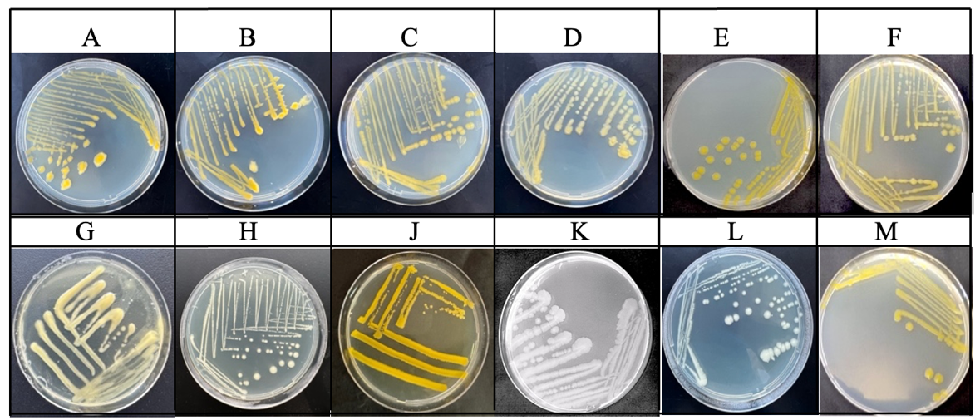

Figure 10 – Pure cultures of phytopathogenic bacteria isolated from infected walnut organs: A–F: P. agglomerans (LLP “Saryagash Zher Syyi,” RSE “Issyk State Dendrological Park,” LLP “Fazenda UM,” Alma-Arasan, Tulkibas village, Merke village); G: X. arboricola pv. juglandis (LLP “Saryagash Zher Syyi”); H: A. tumefaciens (LLP “Saryagash Zher Syyi”); J: P. oryzihabitans (RF “Manshuk”); K–L: P. syringae (RSE “Issyk State Dendrological Park”); M: P. agglomerans (“Karadala” farm)
Pure bacterial cultures were obtained by isolating single colonies on appropriate nutrient media and subsequent subculturing. These monocultures ensured accurate identification of isolates and served as a reliable basis for further morphological, biochemical, molecular, and pathogenicity studies (Figure 10).
Table 9 presents the morphological characteristics of the isolated bacterial pathogens, including colony shape, color, margin, and surface features.

Table 9 – Morphological characterization of bacterial pathogens

Pathogen | Morphological characterization
P. agglomerans | Colonies are round, yellowish, with smooth edges.
X. arboricola pv. juglandis | Colonies are round in shape, light yellow in color, with a smooth, mucous surface.
P. oryzihabitans | Colonies are uniform, round, yellow, convex, shiny, with smooth edges.
P. syringae | Beige or creamy colonies of round shape with smooth edges.
A. tumefaciens | Colonies are round, milky-white or creamy, with smooth edges; the surface is smooth and slightly shiny.

Microscopic examination of pure fungal cultures isolated from leaf, stem, and fruit samples, based on morphological characteristics of the mycelium and sporulation, identified the following fungi: A. alternata, F. proliferatum, F. redolens, F. graminearum, F. solani, as well as Aspergillus niger, Penicillium citrinum, Aspergillus flavus, Aspergillus calidoustus, Penicillium oxalicum, and Alternaria angustiovoidea as secondary colonizers. A total of 108 fungal isolates belonging to twelve species were obtained from walnut samples (Table 10).

Table 10 – Fungal microflora identified in walnut samples

Fungi isolated from walnut samples | Stems | Leaves | Fruits | Number of examined isolates
A. alternata | + | + | + | 40
F. solani | + | + |  | 6
F. proliferatum | + | + |  | 10
F. redolens | + | + |  | 5
F. incarnatum | + |  |  | 7
F. graminearum | + | + | + | 6
A. flavus | + | + |  | 9
A. niger | + | + | + | 6
A. calidoustus | + | + |  | 5
P. oxalicum | + | + |  | 6
P. citrinum | + | + | + | 3
N. oryzae | + |  |  | 5
Total |  |  |  | 108
The dominant species was A. alternata, accounting for 37.0% of the total isolates (Figure 11), followed by F. proliferatum (9.3%) and A. flavus (8.3%). Other taxa, including F. solani, F. graminearum, A. niger, P. oxalicum, and N. oryzae, occurred in lower frequencies (2.8–6.5%). According to the Shannon diversity index (H′ = 1.99) and Simpson’s diversity index (D = 0.82), the fungal community exhibited high species diversity and relatively even distribution among taxa. In terms of organ distribution, the highest fungal diversity was observed in leaves, where the majority of species were detected, followed by stems, whereas fruits harbored fewer taxa. This suggests that leaf tissues represent the most favorable ecological niche for fungal colonization in walnut.

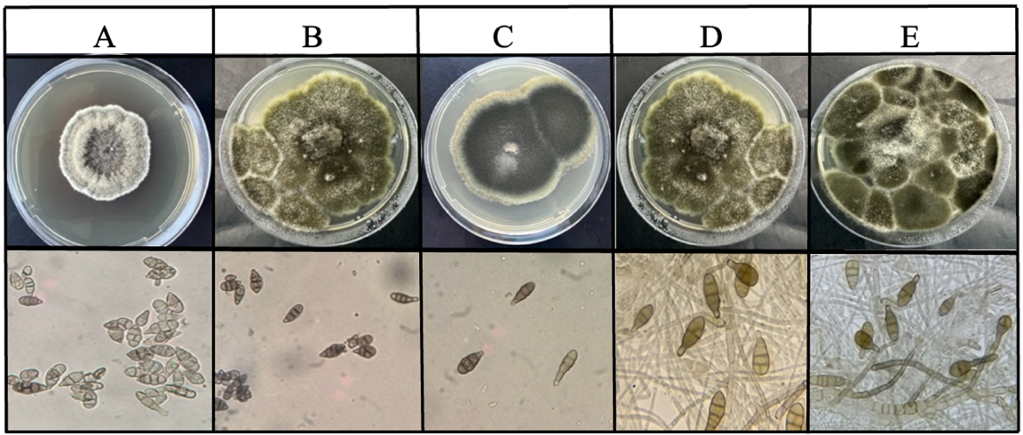

Figure 11 – Cultural, microscopic, and symptomatic manifestations of A. alternata: A – RF "Manshuk"; B – LLP "Saryagash Zher Syyi"; C – RSE "Issyk State Dendrological Park"; D – "Karadala" farm; E – "Silk alley" LLP

Among fungi of the genus Fusarium, the most frequently encountered species was F. proliferatum, isolated in 10 cases (from stems and leaves). F. solani was detected 6 times (stems and leaves), F. graminearum also in 6 cases (from stems, leaves, and fruits), F. redolens in 5 cases (stems and leaves), and F. incarnatum in 7 cases, mainly from stem tissues.
The analysis of Fusarium isolates revealed clear interspecific differences in colony morphology, sporulation patterns, and tissue specificity, indicating distinct ecological preferences and infection strategies among the species. The isolated fungi exhibited characteristic cultural and microscopic features typical of the genus Fusarium, enabling reliable differentiation at the species level based on established morphological criteria. Representative colony morphology on nutrient media and diagnostic microscopic structures of the most frequently encountered Fusarium species isolated from infected walnut organs are presented in Figure 12.
In addition to dominant pathogenic species, a number of secondary colonizers were identified, which, although not primary causal agents, contribute to disease complexity. The presence of fungi from the genera Aspergillus (A. flavus, A. niger), Penicillium (P. oxalicum, P. citrinum), and N.oryzae (Figure 13) likely intensifies plant stress and accelerates symptom development by exploiting weakened host tissues. These secondary fungi may play an important role in the progression of mixed infections and in the overall deterioration of walnut health under field conditions.

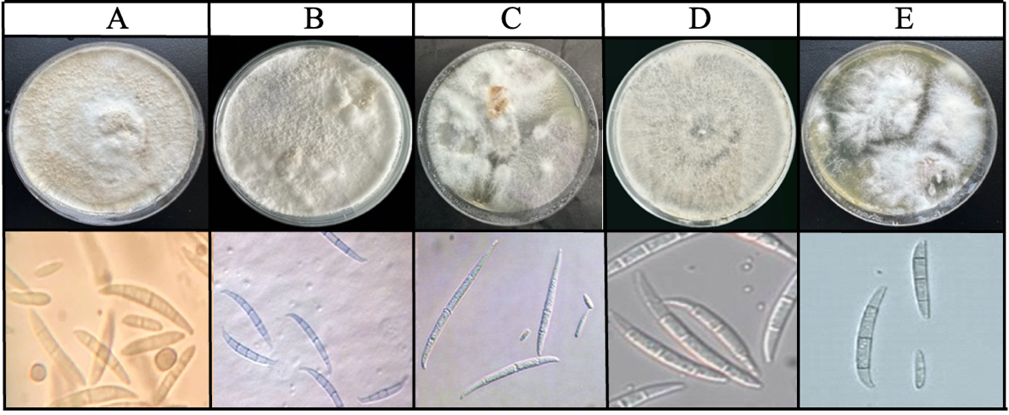

Figure 12 – Cultural, microscopic, and symptomatic manifestations of Fusarium species isolated from infected walnut organs from different farms: A – F.solani (RSE "Issyk State Dendrological Park"); B – F.graminearum (LLP "Saryagash Zher Syyi"); C – F. proliferatum (RSE "Issyk State Dendrological Park"); D – F. incarnatum (LLP "Saryagash Zher Syyi"); E – F.redolens ("Alma-Arasan")

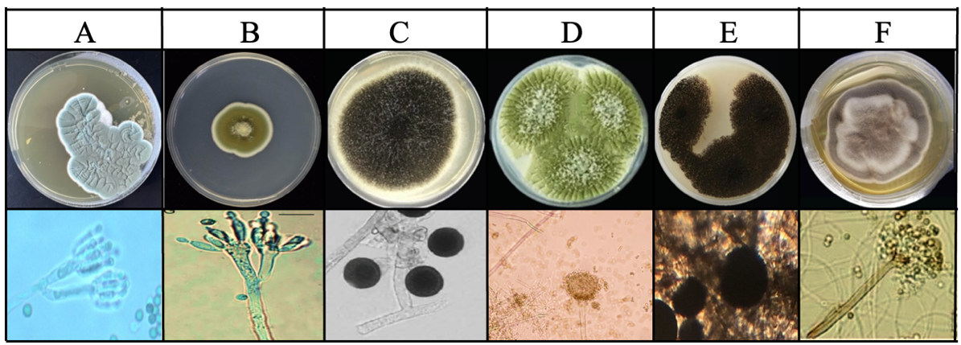

Figure 13 – Morphological characteristics of sporulation of phytopathogenic fungi isolated from infected walnut (J. regia) organs (A – P. citrinum, B – P. oxalicum, C – N. oryzae, D – A. flavus, E – A. niger, F – A. calidoustus)

The morphological characterization of the isolated fungal isolates is presented in Table 11. These data make it possible to compare the main features of the studied cultures and to perform their preliminary identification. The observed variability in colony appearance and sporulation traits reflects interspecific differences and supports the reliability of morphological criteria for distinguishing phytopathogenic fungi. These results provide a necessary foundation for subsequent biochemical and molecular analyses aimed at confirming species identity and clarifying phylogenetic relationships.

Table 11 – Morphological characterization of isolated phytopathogenic fungi

Pathogen | Morphological characterization
A. alternata | Colonies were dark olive green, with the center darker than the edges. Conidia were brown, ovoid, with 1 to 6 transverse septa and 0 to 3 longitudinal septa.
F. graminearum | Colonies are white or yellowish. Macroconidia are large, sickle-shaped, with 3 septa. Microconidia are not observed on PDA.
F. proliferatum | Colonies on PDA are white, later turning pink, with aerial mycelium. Microconidia are oval; macroconidia are slender, almost straight, usually with 3–5 septa.
F.redolens | Colonies are white to pink with a glossy aerial mycelium. Microconidia are cylindrical; macroconidia are robust, with thick walls and broadest at the apical end.
F. solani | Whitish-beige floccose mycelium with oval to cylindrical microconidia and 0–2-septate, cylindrical, slightly curved macroconidia.
F. incarnatum | Colonies are white or light brown, with a floccose surface. Macroconidia are slightly curved, with 3–5 septa and pointed ends; microconidia are oval.

Thus, bacterial and fungal infections represent major limiting factors for the phytosanitary stability of walnut plantations in the studied regions. The obtained results refine the composition, prevalence, and organ-specific distribution of the pathogen complex associated with walnut diseases, enabling a more accurate assessment of their epidemiological potential. These findings provide a scientific basis for the development of integrated disease management strategies, including the optimization of biological control measures and the selection of disease-resistant walnut genotypes. In the long term, the generated dataset supports environmentally sustainable management of walnut agroecosystems and contributes to reducing reliance on chemical plant protection products.

3.4 Identification of fungal and bacterial pathogens using molecular genetic markers
The identification of fungal and bacterial diseases was carried out using PCR analysis to confirm the presence of pathogens in the plants. The internal transcribed spacer (ITS) region was used as a molecular genetic marker for fungi, while the 16S rRNA gene was applied for bacteria. These markers are characterized by relatively high conservatism, extensive study, and the availability of numerous nucleotide sequences in open-access databases.
For molecular genetic identification, DNA was extracted from 11 pure cultures of micromycetes and 5 bacterial isolates obtained from infected walnut plants. The extracted DNA was amplified using the universal primer pairs ITS1/ITS4 and 704F/1495R. As a result of amplification, fragments of approximately 450–700 bp were obtained with ITS1/ITS4 primers, and 700–800 bp with 704F/1495R primers, which correspond to the expected sizes (Figures 14 and 15).

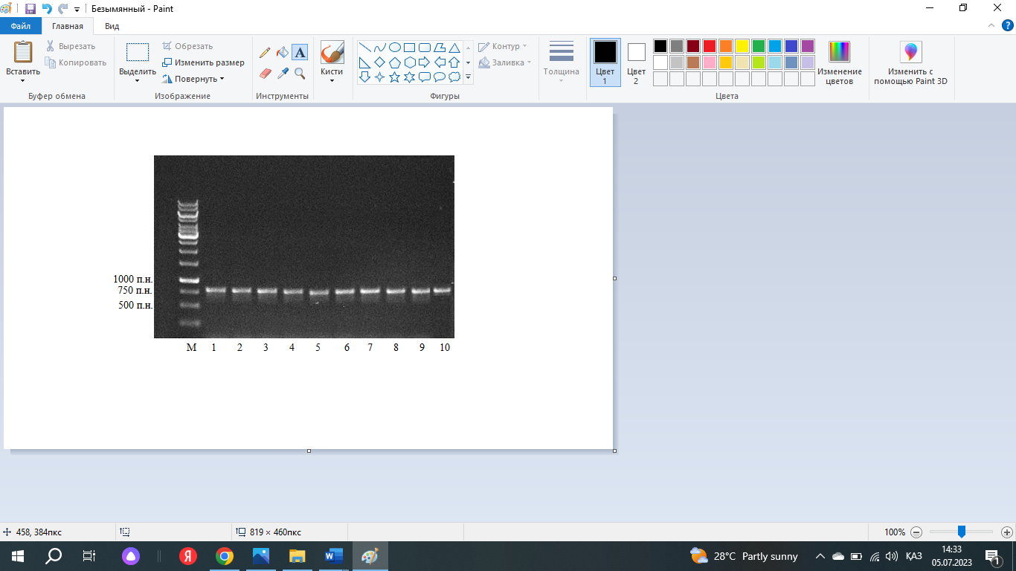

Figure 14 – PCR fragments obtained by amplification of DNA from bacterial isolates using primers 704F/1495R. M – Gene Ruler 1 kb DNA Ladder (Thermo Fisher, USA)

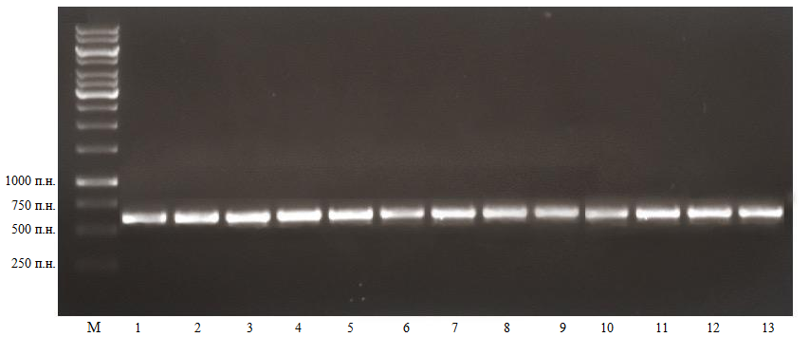

Figure 15 – PCR fragments obtained by amplification of DNA from fungal isolates using primers ITS1/ITS4. M – Gene Ruler 1 kb DNA Ladder (Thermo Fisher, USA)

Positive amplicons of the ITS and 16S rRNA genes were purified using EXOSAP-IT (Thermo Scientific) and sequenced in both directions with the same universal primers on a 3500xL Genetic Analyzer (Applied Biosystems).
In 2023, representative PCR amplicons were sequenced using the Sanger method. In 2024, amplicons were additionally sequenced using Oxford Nanopore technology to increase throughput and enable read-based abundance estimation.

Table 12 – BLAST results for fungi and bacteria, showing closest matches in the GenBank database, 2023

Fungal isolates
Organism | Closest match in GenBank | Accession number | Number of nucleotides | % identity
A. alternata | A. alternata isolate VD1 (ITS) | OR565841.1 | 527 | 99.80%
F. solani | F. solani species complex (FSSC) | MZ562494.1 | 949 | 100%
A. calidoustus / A. ustus complex | A. ustus strain LSU0648 (ITS) | MT000424.1 | 533 | 99.80%
A. niger | A. niger strain MOSFL-FLR7 (ITS1–5.8S–ITS2) | ON720836.1 | 577 | 100%
A. flavus | A. flavus strain Z3-5 (ITS) | MW699681.1 | 547 | 100%
P. citrinum | P. citrinum clone EF_523 (ITS) | MT529172.1 | 560 | 100%
P. oxalicum | P. oxalicum strain PUMCH_Q110 (ITS) | MT940741.1 | 551 | 97.77%
N. oryzae/ gorlenkoana complex | N. gorlenkoana isolate XJAU HC261-2 | OM701823.1 | 928 | 100%
Bacterial isolates
Organism | Closest match in GenBank | Accession number | Number of nucleotides | % identity
P. agglomerans | Pantoea sp. strain RI_103 | OP435520.1 | 1059 | Pantoea sp., closest reference P. agglomerans (98.53%)
P. syringae | P. syringae pv. pisi strain ATCC 11043 | KP211411.1 | 1428 | Pseudomonas sp., closely related to P. syringae (98.40%)
P. oryzihabitans | P. oryzihabitans strain H72 | KX390639.1 | 1362 | Pseudomonas sp., closely related to P. oryzihabitans (98.06%)

The obtained bacterial and fungal sequences were analyzed using BLASTN against the GenBank database (NCBI), and fungal isolates were additionally verified using the BOLD system. The homology of DNA sequences of phytopathogenic fungi and bacteria is presented in Table 12.
For bacterial isolates, the closest GenBank hits corresponded to Pantoea spp. and Pseudomonas spp., with highest similarity to P. agglomerans, P. syringae, and P. oryzihabitans (98.06–98.53%).
As a result of PCR analysis in 2023, bacterial representatives were identified using the 704F/1495R primers. The obtained data, according to the described methods, indicated the presence of bacteria of the genus Pantoea (closest reference — P. agglomerans, 98.53%) and the genus Pseudomonas (closely related to P. oryzihabitans, 98.06%; closely related to P. syringae, 98.40%).
Fungal pathogens were confirmed using ITS1/ITS4 primers. The obtained data revealed the presence of the following taxa: A. alternata, F. solani, A. niger, A. flavus, P. citrinum, P. oxalicum (97.77%), N. oryzae/gorlenkoana complex, A. calidoustus/ustus.
The amplified ITS and 16S rRNA for fungi and bacteria, respectively, were multiplexed across the range of types in order to perform sequencing using the Native barcoding kit. We filtered the reads to retain only those with Phred scores ≥12. After filtering, 58,738 bacterial reads and 43,625 fungal reads remained. Of these, 17,827 bacterial reads and 14,971 fungal reads aligned to the best matching strains or isolates of pathogens (Table 13).

Table 13 – Homology of ITS and 16S rRNA gene sequences of phytopathogenic fungi and bacteria, 2024

Species | Isolate/ strain | Accession number | Median read length, bp | Mapped reads
A. alternata | YICASTK5 | PP346363.1 | 367 | 8,063
F. incarnatum | ISPaVe 1946 | FN430680.1 | 355 | 6,908
P. agglomerans | CTN3 | HQ455830.1 | 288 | 6,907
X. arboricola pv. juglandis (listed as X.campestris in NCBI) | USS-ML18 | PQ460288.1 | 321 | 2,682
A. tumefaciens | RB04 | PQ240107.1 | 318 | 8,238

According to sequencing results in 2024, both fungal and bacterial representatives were confirmed. Among fungi, the highest abundance was recorded for A. alternata (8,063 reads, average length 367 bp) and F. incarnatum (6,908 reads, 355 bp). Among bacterial isolates, A. tumefaciens showed the greatest abundance (8,238 reads, 318 bp), followed by P. agglomerans (6,907 reads, 288 bp). In addition, a pathogen of woody crops — X. arboricola pv. juglandis (listed in the NCBI database as X. campestris) was detected with 2,682 reads (321 bp).
In table 14, data on the fungal and bacterial isolates obtained from infected walnut trees are presented, including the isolate code, sampling location, and the identified pathogen species. The isolates were collected from different walnut-growing sites in the Almaty and Turkestan regions and were identified based on morphological and molecular analyses.

Table 14 – The list of collected fungal and bacterial isolates/strains

The name of strain | Location | The name of the pathogen
1 | 2 | 3
WP001 | “Issyk State Dendrological Park“ RSE, Almaty region | A. alternata
WP002 | “Issyk State Dendrological Park“ RSE, Almaty region | A. alternata
WP003 | Peasant farm "Manshuk“, Almaty region | A. alternata
WP004 | Peasant farm "Manshuk“, Almaty region | A. alternata
WP005 | “Silk alley“ LLP, Turkestan Region | A. alternata
WP006 | “Silk alley“ LLP, Turkestan Region | A. alternata
WP007 | “Silk alley“ LLP, Turkestan Region | A. alternata
WP008 | “Silk alley“ LLP, Turkestan Region | A. alternata
WP009 | “Saryagash zher syi“ LLP, Turkestan region | A. alternata
WP010 | “Saryagash zher syi“ LLP, Turkestan region | A. alternata
WP011 | “Saryagash zher syi“ LLP, Turkestan region | A. alternata
WP012 | “Saryagash zher syi“ LLP, Turkestan region | F. incarnatum
WP013 | “Saryagash zher syi“ LLP, Turkestan region | F. incarnatum
WP014 | “Saryagash zher syi“ LLP, Turkestan region | F. incarnatum
WP015 | “Fazenda UM“ LLP, Almaty region | P. agglomerans
WP016 | “Fazenda UM“ LLP, Almaty region | P. agglomerans
WP017 | “Fazenda UM“ LLP, Almaty region | P. agglomerans
WP018 | “Fazenda UM“ LLP, Almaty region | P. agglomerans
WP019 | Peasant farm "Manshuk“, Almaty region | P. agglomerans
WP020 | Peasant farm "Manshuk“, Almaty region | P. agglomerans
WP021 | Peasant farm "Manshuk“, Almaty region | P. agglomerans
WP022 | Peasant farm "Manshuk“, Almaty region | P. agglomerans
WP023 | Peasant farm "Manshuk“, Almaty region | P. agglomerans
WP024 | “Saryagash zher syi“ LLP, Turkestan region | X. arboricola pv. juglandis
WP025 | “Saryagash zher syi“ LLP, Turkestan region | X. arboricola pv. juglandis
WP026 | “Saryagash zher syi“ LLP, Turkestan region | X. arboricola pv. juglandis

Continuation of Table 14

1 | 2 | 3
WP027 | “Saryagash zher syi“ LLP, Turkestan region | X. arboricola pv. juglandis
WP028 | “Saryagash zher syi“ LLP, Turkestan region | X. arboricola pv. juglandis
WP029 | “Saryagash zher syi“ LLP, Turkestan region | X. arboricola pv. juglandis
WP030 | “Saryagash zher syi“ LLP, Turkestan region | X. arboricola pv. juglandis
WP031 | “Saryagash zher syi“ LLP, Turkestan region | X. arboricola pv. juglandis
WP032 | “Saryagash zher syi“ LLP, Turkestan region | A. tumefaciens
WP033 | “Saryagash zher syi“ LLP, Turkestan region | A. tumefaciens
WP034 | “Saryagash zher syi“ LLP, Turkestan region | A. tumefaciens
WP035 | “Issyk State Dendrological Park“ RSE, Almaty region | A. alternata
WP036 | “Issyk State Dendrological Park“ RSE, Almaty region | A. alternata
WP037 | Peasant farm "Manshuk“, Almaty region | A. alternata
WP038 | Peasant farm "Manshuk“, Almaty region | A. alternata
WP039 | “Saryagash zher syi“ LLP, Turkestan region | A. alternata
WP040 | “Saryagash zher syi“ LLP, Turkestan region | A. alternata
WP041 | “Saryagash zher syi“ LLP, Turkestan region | A. alternata
WP042 | “Saryagash zher syi“ LLP, Turkestan region | A. alternata
WP043 | “Saryagash zher syi“ LLP, Turkestan region | A. alternata
WP044 | “Silk alley“ LLP, Turkestan Region | A. alternata
WP045 | “Saryagash zher syi“ LLP, Turkestan region | F. incarnatum
WP046 | “Saryagash zher syi“ LLP, Turkestan region | F. incarnatum
WP047 | “Issyk State Dendrological Park“ RSE, Almaty region | F. incarnatum
WP048 | “Issyk State Dendrological Park“ RSE, Almaty region | F. incarnatum
WP049 | “Alma Arasan“, Almaty region | P. agglomerans
WP050 | “Alma Arasan“, Almaty region | P. agglomerans
WP051 | “Alma Arasan“, Almaty region | P. agglomerans
WP052 | “Alma Arasan“, Almaty region | P. agglomerans
WP053 | “Alma Arasan“, Almaty region | P. agglomerans
WP054 | “Alma Arasan“, Almaty region | P. agglomerans
WP055 | “Alma Arasan“, Almaty region | P. agglomerans
WP056 | “Alma Arasan“, Almaty region | P. agglomerans

Continuation of Table 14

1 | 2 | 3
WP057 | “Alma Arasan“, Almaty region | P. agglomerans
WP058 | “Alma Arasan“, Almaty region | P. agglomerans
WP059 | “Fazenda UM“ LLP, Almaty region | P. agglomerans
WP060 | “Fazenda UM“ LLP, Almaty region | P. agglomerans
WP061 | “Fazenda UM“ LLP, Almaty region | P. agglomerans
WP062 | “Issyk State Dendrological Park“ RSE, Almaty region | P. agglomerans
WP063 | “Issyk State Dendrological Park“ RSE, Almaty region | P. agglomerans
WP064 | “Issyk State Dendrological Park“ RSE, Almaty region | P. agglomerans
WP065 | “Issyk State Dendrological Park“ RSE, Almaty region | P. agglomerans
WP066 | “Saryagash zher syi“ LLP, Turkestan region | P. agglomerans
WP067 | “Saryagash zher syi“ LLP, Turkestan region | P. agglomerans
WP068 | “Saryagash zher syi“ LLP, Turkestan region | P. agglomerans
WP069 | “Saryagash zher syi“ LLP, Turkestan region | P. agglomerans
WP070 | “Alma Arasan“, Almaty region | F. redolens
WP071 | “Issyk State Dendrological Park“ RSE, Almaty region | F. solani
WP072 | “Saryagash zher syi“ LLP, Turkestan region | F. graminearum
WP073 | “Saryagash zher syi“ LLP, Turkestan region | F. proliferatum
WP074 | "Karadala" farm, Almaty region | P. agglomerans
WP075 | Tulkibas village, Turkestan region | P. agglomerans
WP076 | Merke village, Zhambyl region | P. agglomerans
WP077 | Peasant farm "Manshuk“, Almaty region | P. orizihabitans
WP078 | Peasant farm "Manshuk“, Almaty region | P. orizihabitans
WP079 | “Issyk State Dendrological Park“ RSE, Almaty region | P. syringae
WP080 | “Issyk State Dendrological Park“ RSE, Almaty region | P. syringae
WP081 | "Karadala" farm, Almaty region | A. alternata

In Figure 16-21, representative nucleotide sequences of fungal and bacterial isolates recorded in 2023–2024 are presented, together with the corresponding phylogenetic trees constructed based on ITS (fungi) and 16S rRNA (bacteria) gene regions. Sequence identification was performed using BLAST analysis to confirm species-level taxonomic affiliation.

Figure 16 – Neighbor-joining phylogenetic tree based on ITS region sequences. Based on BLAST similarity and phylogenetic analysis, Samples 5 and 8 cluster with A. alternata

Figure 17 – Neighbor-joining phylogenetic tree based on ITS region sequences. Based on BLAST similarity and phylogenetic analysis, Sample 9 was identified as F. solani and clustered with reference isolates of this species

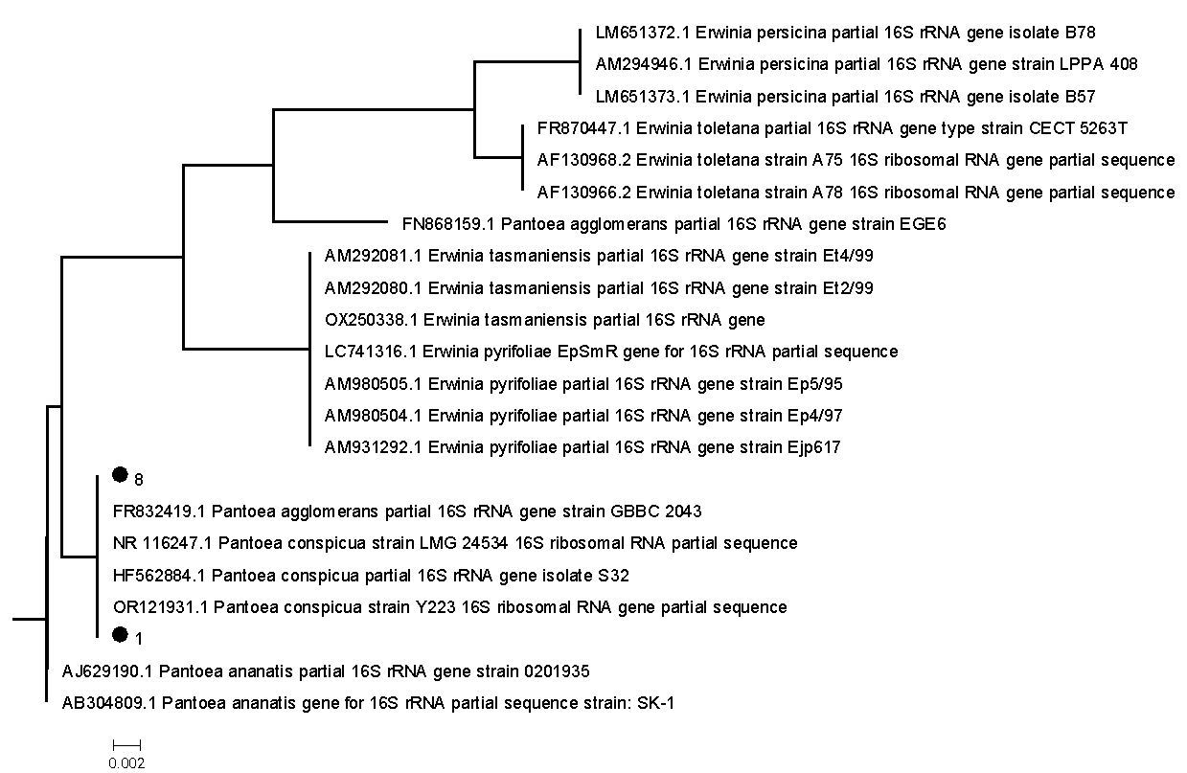

Figure 18 – Neighbor-joining phylogenetic tree based on 16S rRNA gene sequences. Based on BLAST similarity and phylogenetic analysis, Samples 1 and 8 were identified as P. agglomerans and clustered with reference strains

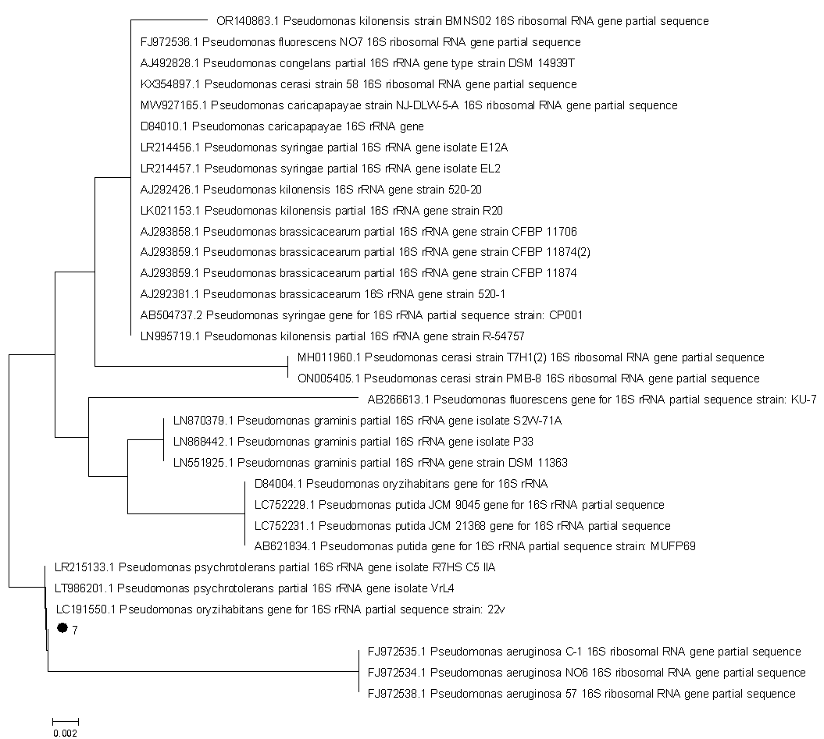

Figure 19 – Neighbor-joining phylogenetic tree based on 16S rRNA gene sequences. Based on BLAST similarity and phylogenetic analysis, Sample 7 was identified as P. oryzihabitans

Figure 20 – Neighbor-joining phylogenetic tree based on 16S rRNA gene sequences. Based on BLAST similarity and phylogenetic analysis, Sample 9 was identified as P. syringae

According to the phylogenetic analysis, the isolates of A. alternata collected in Kazakhstan clustered together with isolates originating from China and Turkey (Figure 21). These related isolates have been reported to cause infections in a wide range of host plants. Nevertheless, the genetic distance separating the Kazakhstani isolates from the nearest group members remains relatively large, suggesting a certain degree of divergence. For F. incarnatum, the Kazakhstani isolate showed phylogenetic proximity to isolates from Europe, Australia, and China. However, no predominant closeness to any single geographical region was observed, indicating a more widespread genetic relatedness across continents. The A. tumefaciens isolate from Kazakhstan grouped together with an isolate originating from Iraq, highlighting a possible regional link within this lineage.
Similarly, the Kazakhstani isolate of P. agglomerans clustered with isolates from Spain, while the X. arboricola pv. juglandis isolate formed a group with those from Chile and Thailand. These findings collectively indicate that Kazakhstani isolates share phylogenetic relationships with geographically distant strains, reflecting the complex evolutionary history and potential global distribution of these pathogens.

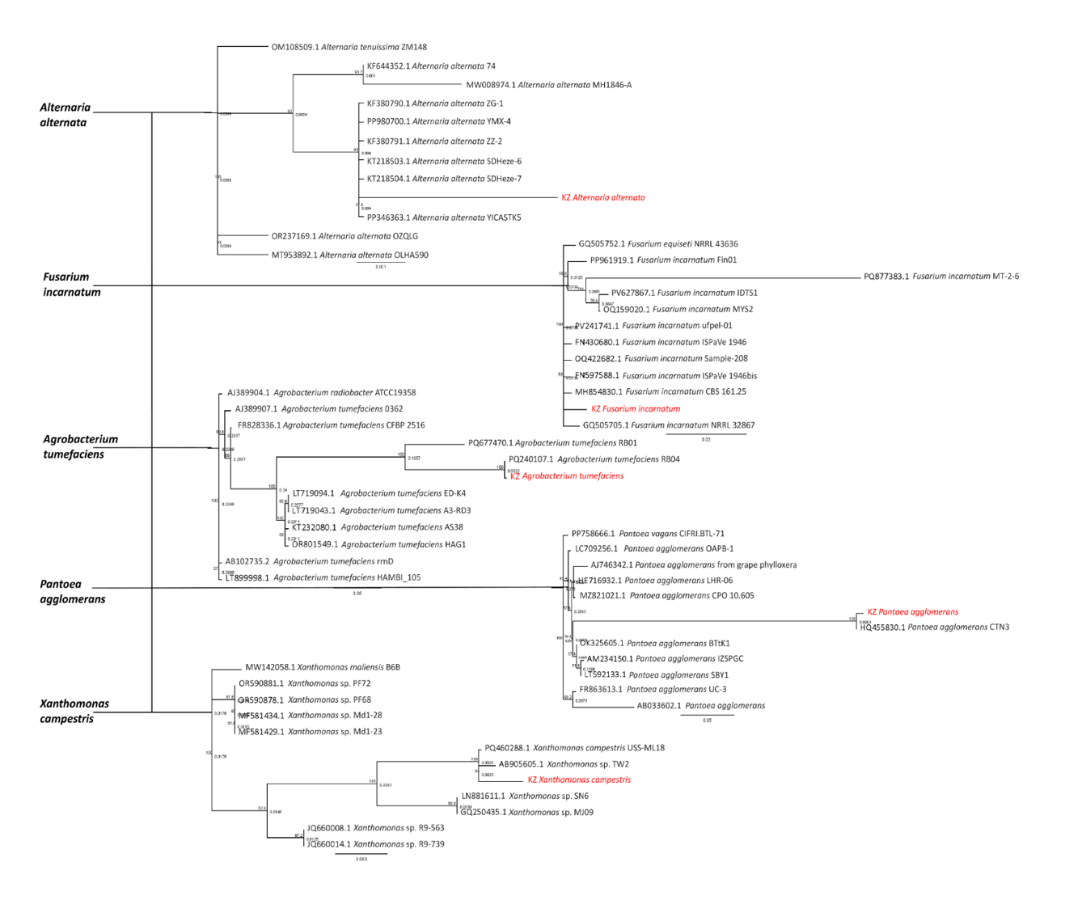

Figure 21 – Neighbor-joining phylogenetic tree of fungal and bacterial pathogens (A. alternata, F. incarnatum, A. tumefaciens, P. agglomerans, and X. arboricola pv. juglandis (listed as X. campestris in NCBI)). Bootstrap values (1,000 replications) are shown at branch nodes. Local isolates are highlighted in red

Overall, the conducted molecular-genetic analyses confirmed the taxonomic identity of the major fungal and bacterial pathogens associated with walnut diseases in the studied regions. The use of ITS and 16S rRNA markers, combined with BLAST comparison and phylogenetic reconstruction, demonstrated high reliability for species-level identification. The revealed phylogenetic relationships indicate that Kazakhstani isolates are genetically related to strains from different geographical regions, reflecting the wide distribution and evolutionary diversity of these pathogens. The obtained molecular data provide a solid foundation for further studies on pathogen epidemiology and support the development of targeted and environmentally sustainable disease management strategies in walnut agroecosystems.

3.5 Results of pathogenicity assessment of fungal and bacterial isolates
Artificial inoculation of walnut (Juglans regia L.) leaves confirmed the pathogenicity of all tested fungal isolates. The first disease symptoms appeared 5–7 days after inoculation, and by day 10 well-developed necrotic lesions were observed (Figure 22). All A. alternata isolates induced chlorotic and necrotic spots on walnut leaves (Fig. 22A). Inoculation with F. graminearum resulted in multiple dark-brown necrotic lesions on fruits (Fig. 22B). F. redolens caused stem necrosis and vascular browning in seedlings (Fig. 22C). Inoculation with F. proliferatum produced restricted necrotic streaks along the main vein of leaves (Fig. 22D). F. incarnatum caused small, localized stem lesions at the inoculation sites (Fig. 22E), whereas F. solani led to pronounced vascular discoloration and extensive necrosis spreading along the stem (Fig. 22F). In contrast, no visible symptoms developed in control plants inoculated with sterile medium. Koch’s postulates were fulfilled by re-isolating the microorganisms from symptomatic tissues and confirming their identity using morphological and molecular analyses, thereby verifying their etiological role in walnut diseases.

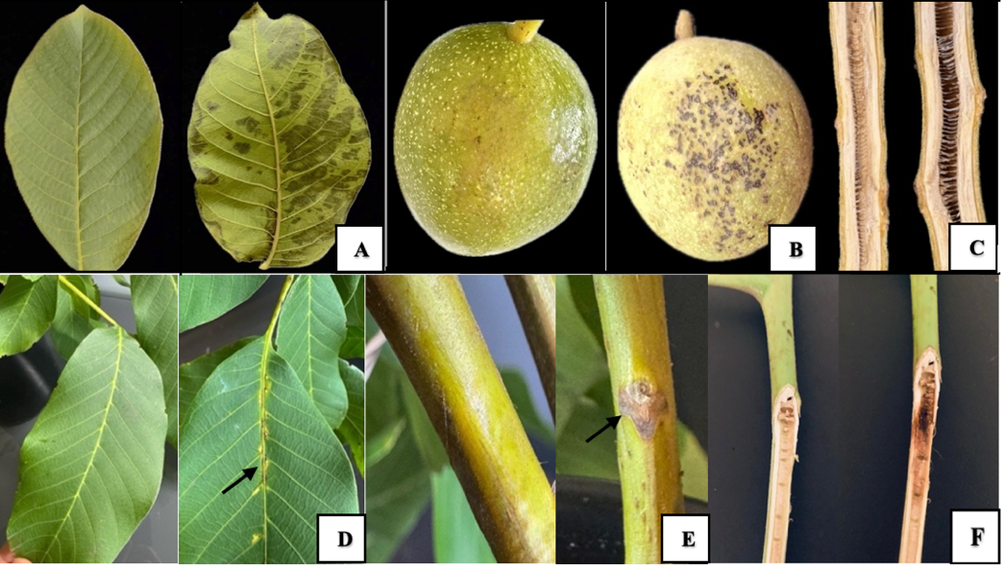

Figure 22 – Pathogenicity tests of fungal pathogens on walnut leaves, fruits, and seedlings after artificial inoculation. (A) Symptoms caused by A. alternata on walnut leaves. (B) Symptoms caused by F. graminearum on walnut fruits. (C) Seedling necrosis caused by F. redolens. (D) Leaf lesions caused by F. proliferatum. (E) Stem lesions on seedlings inoculated with F. incarnatum. (F) Vascular browning and extensive stem necrosis on seedlings inoculated with F. solani

Pathogenicity assays further demonstrated that several bacterial isolates induced distinct disease symptoms on walnut (Fig. 23). Fruits inoculated with X. arboricola pv. juglandis developed initial necrotic lesions at wound sites by 5–7 days post inoculation, which became clearly visible by day 11 and continued to expand progressively up to 13 days (Fig. 23A). Inoculation with P. agglomerans resulted in multiple necrotic spots accompanied by tissue maceration on walnut leaves within 5 days under greenhouse conditions (Fig. 23B). P. oryzihabitans caused localized necrotic spots surrounded by chlorotic halos on leaves (Fig. 23C), whereas P. syringae induced rapidly spreading necrosis affecting large portions of the leaf blade (Fig. 23D). Notably, walnut seedlings inoculated with A. tumefaciens did not develop tumors during the 120-day observation period, indicating the absence of pathogenic interaction under the experimental conditions. Sterile water was used as a negative control in all assays, and no symptoms were observed in control plants. In all cases where symptoms developed, the pathogens were successfully re-isolated from infected tissues and confirmed to be identical to the original strains, thus fulfilling Koch’s postulates and validating the pathogenicity results.

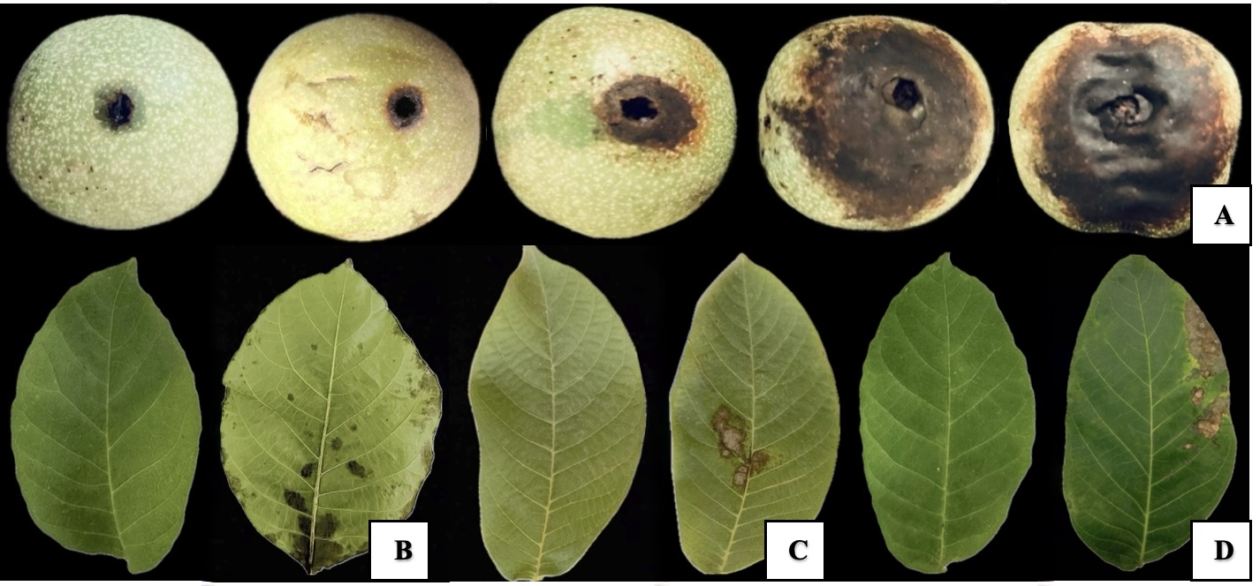

Figure 23 – Pathogenicity test of bacterial isolates on detached walnut fruits and leaves. (A) Walnut fruits: control, followed by fruits inoculated with X. arboricola pv. juglandis showing progressive symptoms at 5, 7, 11, and 13 days post inoculation. (B) Walnut leaves: control and inoculated with P. agglomerans. (C) Walnut leaves: control and with P. oryzihabitans. (D) Walnut leaves: control and with P. syringae

Overall, the pathogenicity tests confirmed that the isolated fungal and bacterial strains are capable of causing typical disease symptoms on walnut. The fulfillment of Koch’s postulates further validates their etiological role and highlights their importance in the walnut pathosystem.

3.6 Results of genetic diversity and population structure analysis of wild and cultivated J. regia
Genetic diversity and population structure of wild and cultivated walnut (Juglans regia L.) were assessed using high-density SNP markers. Based on the quality-filtered dataset comprising 173 accessions and 145,711 SNPs, substantial differences in genetic diversity were detected among wild populations, local genotypes, and commercial cultivars originating from different geographic regions. Observed heterozygosity (Hₒ) varied markedly among the analyzed groups. The lowest Hₒ values were recorded in wild walnut populations from Kazakhstan (Hₒ = 0.29), indicating reduced genetic variability. In contrast, commercial cultivars from France exhibited higher heterozygosity (Hₒ = 0.39), while the highest genetic diversity was observed in Chinese cultivars (Hₒ = 0.48). Local Kazakh genotypes showed intermediate levels of heterozygosity. The inbreeding coefficient (F) was highest in wild Kazakh walnut populations (F = 0.17), suggesting the presence of genetic bottlenecks and limited gene flow, likely associated with habitat fragmentation and population isolation. Lower inbreeding levels were observed in local genotypes (F = 0.08), reflecting a more heterogeneous genetic background. Commercial cultivars generally exhibited low or near-zero inbreeding coefficients, consistent with intensive breeding and germplasm exchange.
Additional diversity metrics, including the effective number of alleles (Nₑ), Shannon’s information index (I), and Simpson’s diversity index (S), supported these patterns, with wild populations displaying reduced allelic richness compared to cultivated groups. Principal component analysis (PCA) revealed a clear genetic separation among walnut accessions according to their geographic origin. The first two principal components distinguished Asian (Chinese) and European walnut groups, with Kazakh accessions positioned between these clusters. This intermediate position suggests that walnut populations in Kazakhstan represent a genetic bridge between eastern and western gene pools.
ADMIXTURE analysis further confirmed this pattern. At the optimal number of genetic clusters (K = 6), wild Kazakh walnuts formed distinct ancestry components, indicating limited admixture with cultivated germplasm. In contrast, commercial cultivars showed complex admixture patterns, reflecting intensive artificial selection and historical germplasm exchange among breeding programs in Europe and Asia.
Analysis of molecular variance (AMOVA) demonstrated that a significant proportion of genetic variation was attributable to differences among population groups, while the remaining variation was distributed within populations. Pairwise F_ST values indicated moderate to high genetic differentiation between wild Kazakh populations and commercial cultivars, whereas lower differentiation was observed among cultivated groups from different countries.

Table 15 – Genetic diversity statistics for nine walnut genotypic groups

Population | N | Ne | I | Ho | He | F | PPL | S. index
KAZ_L | 43 | 1.54 | 0.49 | 0.32 | 0.32 | 0.08 | 97.28 | 0.44
KAZ_W | 19 | 1.51 | 0.50 | 0.29 | 0.30 | 0.17 | 91.54 | 0.41
UZB | 16 | 1.53 | 0.50 | 0.30 | 0.32 | 0.14 | 94.67 | 0.43
CHN | 43 | 1.57 | 0.51 | 0.31 | 0.34 | 0.11 | 99.80 | 0.48
FRA | 3 | 1.50 | 0.59 | 0.39 | 0.29 | -0.12 | 72.57 | 0.28
HUN | 4 | 1.45 | 0.56 | 0.30 | 0.26 | 0.14 | 70.46 | 0.31
MDA | 33 | 1.51 | 0.50 | 0.31 | 0.30 | 0.09 | 90.31 | 0.41
ROU | 7 | 1.45 | 0.55 | 0.34 | 0.26 | 0.02 | 72.09 | 0.34
UKR | 6 | 1.50 | 0.54 | 0.34 | 0.29 | 0.03 | 81.59 | 0.37

Note* N = sample size; Ne= effective number of alleles; I = Shannon’s information index; HO = observed heterozygosity, He= expected heterozygosity; F = fixation index; PPL = percentage of polymorphic loci, Simpson’s Index (1− D) = measure of diversity
The results highlight the distinct genetic identity of wild walnut populations in Kazakhstan, characterized by reduced heterozygosity and elevated inbreeding levels. Despite their lower genetic diversity, these populations represent unique genetic resources shaped by long-term adaptation to local environmental conditions. Their genetic distinctiveness suggests strong potential for use in breeding programs aimed at improving stress tolerance and resilience to biotic and abiotic factors, as well as for the conservation of walnut genetic resources in Central Asia. Heterozygosity analysis indicated a uniform trend of heterozygote deficiency across the examined walnut cultivars and wild population (Table 15).
The mean observed heterozygosity values ranged from 0.29 to 0.39, with French populations showing the highest values (0.39) and Kazakhstani populations showing the lowest (0.29–0.32). Within Kazakhstan, locally bred samples (KAZ_L) exhibited slightly higher heterozygosity (0.32) than their wild counterparts (KAZ_W, 0.29).
The inbreeding coefficients (mean F) demonstrated distinct patterns between wild and local Kazakhstani genotypes. Wild populations (KAZ_W) showed higher inbreeding (F = 0.17) compared to local genotypes (KAZ_L, F = 0.08). The highest standard deviation in F values (sd =0.18) was observed in the wild Kazakhstani samples, indicating more heterogeneous inbreeding patterns within natural populations. The overall index of 0.49 indicated moderate genetic diversity across the dataset, with the Chinese cultivars showing the highest diversity (0.48). Kazakhstani genotypes demonstrated relatively high diversity (KAZ_L: 0.44, KAZ_W: 0.41), similar to other Central Asian genotypes (UZB: 0.43, MDA: 0.41). European genotypes, particularly the French cultivars (0.28), exhibited lower diversity values, consistent with their distinct clustering in previous analyses.

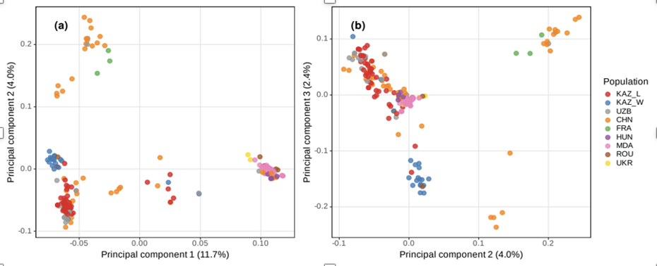

Figure 24 – Principal component analysis (PCA) of walnut genotypes based on genetic variation. a The PCA plot of individuals along the first (11.7%) and second (4.0%) principal components. b The PCA plot of individuals along the second (4.0%) and third (2.4%) principal components

The heterozygosity distribution exhibited persistent deviations from Hardy-Weinberg expectations across all groups, with observed heterozygosity typically lower than anticipated, especially in wild populations. This aberration exhibited a distinct linear trend beneath the theoretical expectation line. Principal component analysis (PCA) and ADMIXTURE analysis demonstrated a different population structure among the walnut samples, with both methodologies offering complementary evidence for separate genetic groupings. In the PC1-PC2 space (Fig. 24a), Chinese (CHN) variations constituted a distinct cluster, segregated from European populations along PC1, which accounts for 11.7% of the variance explained. The Kazakhstani samples exhibited geographic structuring, with wild (KAZ_W) and locally bred (KAZ_L) populations forming different although adjacent clusters. The PC2-PC3 plot (Fig. 24b, 4.0% variance explained) offered enhanced resolution of European populations (FRA, HUN, ROU, UKR), demonstrating partial overlap suggestive of common genetic origin.
The ADMIXTURE analysis (K = 2 to K = 6) validated the PCA results (Fig. 25). At K=2, China, Kazakhstan (both wild and local), Uzbekistan, and France constitute a single genetic group, whereas European types cluster independently, signifying an east-west genetic dichotomy.

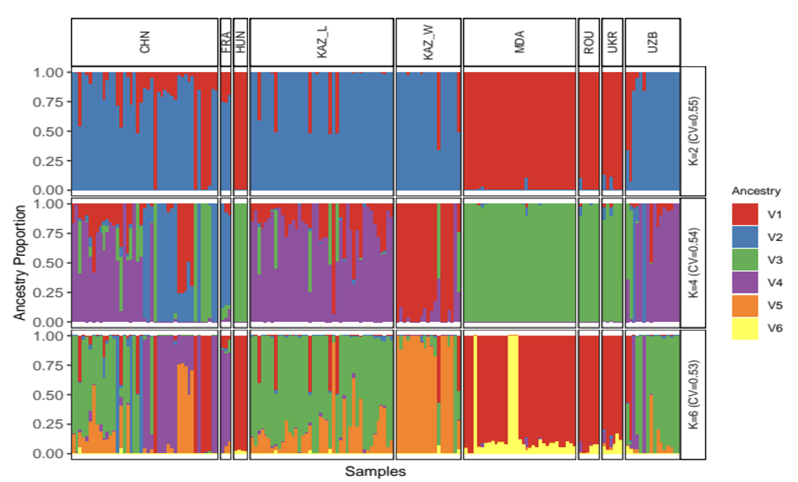

Figure 25 – Genetic ancestry proportions of walnut cultivars and wild genotypes inferred from ADMIXTURE analysis. Each vertical bar represents an individual tree, with colors showing the estimated membership coefficients for each of the six genetic clusters (K =6). Populations are delineated by black vertical lines and labeled along the top

At K=5, Kazakhstani (KAZ_L), China, and Uzbekistan are grouped together, although wild Kazakh walnuts (KAZ_W) and European cultivars remain different. At K=5, heightened complexity was seen, since Kazakh genotypes (both wild and local) exhibited unique genetic components corresponding to their separate PCA clusters. At K=6, further sub-structuring emerges, indicating greater genetic differentiation within Central Asian and European populations.
To examine the distribution of genetic variation, we conducted complementary analyses, including analysis of molecular variance (AMOVA) and pairwise FST calculations (Fig. 26). AMOVA indicated that the majority of genetic variation (65%, SSD = 4.18) was found within populations, whereas inter-population differences comprised 35% (SSD = 1.61). This distribution pattern is particularly significant because of the extensive geographic sampling span from Western Europe to East Asia, including both wild populations and local variants. Pairwise FST analysis revealed a distinct east–west genetic differentiation trend. The wild population of Kazakhstan and its local genotypes exhibited comparatively low pairwise values, albeit their diverse origins (Fig. 26b). Chinese cultivars demonstrated intermediate FST values relative to Central Asian populations, whereas European cultivars consistently exhibited elevated values in comparisons with Asian populations, hence corroborating the demographic structure identified in the PCA.

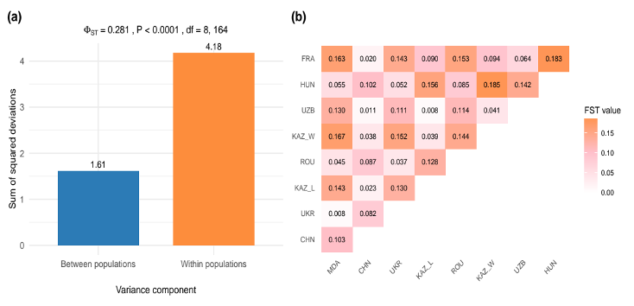

Figure 26 – Analysis of molecular variance (AMOVA) and population differentiation (a) AMOVA results partitioning genetic variation among populations and within populations; (b) Pairwise FST values between cultivated varieties and wild populations of walnut. Darker shading indicates higher levels of genetic differentiation

In recent years, in Kazakhstan, especially in the southern regions with a favorable climate, there has been an increase in walnut production, which is due to increased demand, the introduction of modern agricultural technologies, and government support [140]. In addition to cultivated forms, wild walnuts of unknown origin found in the Ile-Alatau and Sairam-Ugam State National Parks are valuable resources of great interest in terms of their potential adaptive significance [141]. Our study presents the first comprehensive genomic characterization of walnut genetic resources in Kazakhstan, leveraging the AxiomTM J. regia 700 K SNP array. The obtained results complement previous findings using this SNP array in other regions [142-147], emphasizing distinct genetic characteristics observed in wild and cultivated walnuts from Kazakhstan, and suggesting their importance for local breeding and genetic resource conservation.

Our findings revealed clear genetic distinctions between wild and indigenous walnut varieties in Kazakhstan. The elevated inbreeding value in wild populations (0.17) relative to local genotypes (0.08) signifies divergent demographic conditions, maybe attributable to habitat fragmentation and genetic drift. Comparable tendencies have been noted in other plant species, wherein habitat fragmentation results in less genetic diversity and heightened inbreeding risk [148]. Conversely, introduced cultivars exhibited greater genetic variety, indicating the influence of selection and hybridization on their genetic characteristics [149]. This divergence may indicate the influence of human selection and breeding methods, wherein local breeding programs have potentially sustained elevated levels of variety to retain desirable features, as corroborated by PCA. The examination of genetic diversity and population structure indicated that the Kazakh wild population is genetically distinct from both eastern (Chinese) and western (European) populations, underscoring the unique genetic composition of Kazakhstan's walnut resources.

Although Kazakhstan harbours both wild and indigenous genotypes exhibiting considerable genetic diversity, genetic research on walnuts in Central Asia has predominantly focused on specimens from Uzbekistan and Kyrgyzstan [150-153], leading to an inadequate representation of Kazakh walnut populations within the regional genetic framework. However, a recent study involving Kazakhstani accessions indicated that samples from the Tien-Shan genetic cluster displayed moderate genetic variety and gene flow, enhancing the understanding of walnut genetic resources in Central Asia [154]. Our results further substantiate the genetic uniqueness and variety of Kazakh populations. Kazakhstan, as the northernmost area where walnuts thrive naturally, serves as a significant reservoir of genetic diversity, especially for breeding initiatives aimed at improving cold tolerance and other abiotic stress traits, which are increasingly crucial due to climate change and the expansion of nut cultivation into less favourable environments.

Notwithstanding constraints arising from the limited sample numbers of certain European types (e.g., FRA, HUN), which may influence statistical reliability, the overall population pattern remained apparent and consistent. European cultivars exhibited unique genetic groupings, indicative of their independent breeding histories compared to Asian cultivars. The PCA and ADMIXTURE analysis demonstrated clear clustering patterns among cultivars, highlighting significant east-west genetic differentiation. Chinese cultivars (CHN) constituted a distinct cluster, genetically divergent from European cultivars, corroborating prior research that suggests independent domestication and breeding trajectories in these areas [155]. Kazakhstani populations displayed intermediate genetic characteristics, indicating their function as a transitional zone between East Asian and European genetic material. The differentiation between wild (KAZ_W) and local (KAZ_L) genotypes in Kazakhstan indicates possible variations in evolutionary pressures, with cultivated forms exhibiting greater genetic diversity. The ADMIXTURE analysis corroborated these findings, with K=6 yielding the most informative clustering pattern. At lower K values, a clear distinction between Asian and European genotypes was apparent, however at higher K values, sub-structuring within Kazakhstan and Central Asia became obvious. The genetic admixture seen in European varieties can be ascribed to historical gene movement and the incorporation of several cultivars throughout domestication and commercial breeding.

AMOVA revealed that 65% of the total genetic variation was distributed within populations, while 35% occurred among populations, indicating a moderate but structured population differentiation. Such a pattern is characteristic of J. regia as a wind-pollinated, long-lived tree species, in which extensive pollen-mediated gene flow maintains substantial within-population diversity, despite geographic separation.

The observed between-population component (35%) is nevertheless biologically meaningful and reflects clear regional differentiation, as further supported by pairwise F<sub>ST</sub> estimates. In particular, higher F<sub>ST</sub> values between European and Asian genotypes indicate long-term divergence and partially independent domestication or breeding histories in these regions. Chinese cultivars exhibited intermediate F<sub>ST</sub> values relative to Central Asian populations, suggesting their transitional genetic position between eastern and western gene pools.

In contrast, the relatively low pairwise F<sub>ST</sub> values between wild (KAZ_W) and locally bred (KAZ_L) Kazakhstani walnuts indicate limited genetic differentiation, consistent with ongoing or historical gene flow. This pattern may reflect natural hybridization facilitated by wind pollination, as well as human-mediated selection and propagation of locally adapted genotypes, resulting in partial genetic continuity between wild and cultivated forms.

The findings emphasize the necessity of conserving the genetic resources of wild walnut in Kazakhstan, since these populations contain significant genetic diversity for prospective breeding initiatives. Conservation initiatives must emphasize the in situ preservation of genetically unique wild populations, especially those adapted to cold and abiotic stress, while enabling their integration into breeding programs via targeted introgression and the creation of ex situ germplasm repositories to protect allelic diversity. The breeding of European walnut could be improved by integrating genetic resources from Central Asia and China to increase resistance and adaptability. This work enhances the comprehension of walnut genetic variety and establishes a basis for conservation and breeding efforts to ensure the sustainability of global walnut farming. Future research ought to concentrate on genome-wide association studies to pinpoint specific genetic loci linked to advantageous features, alongside the long-term surveillance of genetic diversity in both wild and cultivated populations to guarantee their sustainable management.

3.7 Evaluation of the resistance of walnut cultivars to the most prevalent pathogens
A survey of walnut (J. regia) plantations in the southern fruit-growing zone (Almaty, Turkestan, and Zhambyl regions) revealed that walnut blight, caused by the bacterium P. agglomerans, as well as the fungal disease brown spot, caused by A. alternata, are widely distributed.
Walnut blight induced by P. agglomerans was detected in all surveyed orchards except LLP “Silk Alley”. The high DI of these phytopathogens indicates the necessity for intensified monitoring and preventive measures (Table 16).
Table 16 – Mean DI and Mean DSI values were calculated as the average of disease incidence and disease severity index of introduced walnut cultivars and forms to walnut blight (P. agglomerans) recorded over three consecutive years (2022–2024)

Cultivar | Mean DI (%) | Mean DSI (%) | Mean disease score
Chernovitski | 38.13 | 13.69 | 3
Miroslava | 24.73 | 5.97 | 2
Ovidiu | 23.83 | 6.40 | 2
Velnitsa | 42.57 | 15.77 | 3
Germisara | 32.97 | 6.43 | 2
Yarivski | 27.57 | 9.70 | 2
Peshanski | 30.73 | 10.47 | 2
Kogylnichanu | 30.63 | 9.40 | 2
Xin xin 2 | 40.37 | 15.63 | 3
185 | 32.50 | 10.43 | 2
Jin Long 2 | 43.80 | 17.05 | 3
Lipin 2 | 33.30 | 10.93 | 3
Liaohe (“RF Manshuk”) | 31.30 | 9.87 | 2
Milotai 10 | 44.30 | 16.80 | 3
CITH-W 2 | 43.63 | 16.07 | 3
Fernor | 31.83 | 10.08 | 2
Lara | 40.93 | 16.02 | 3
Lateral lui Trifan | 44.23 | 16.93 | 3
Brichanski | 40.47 | 14.63 | 3
Plin | 24.23 | 6.40 | 2
Codrene | 41.97 | 15.57 | 3
Kazaku | 8.80 | 1.78 | 2
Kishinevski | 29.00 | 9.92 | 2
Liaohe (Issyk) | 45.70 | 12.33 | 3
Saryagash form | 44.00 | 20.00 | 3

The DI of Walnut blight by cultivars in RF "Manshuk" was 7.2–51.7% in 2022, 9.0–38.1% in 2023, and 10.2–51.0% in 2024, with DSI ranging from 1.45–22.35%, 1.8–10.05%, and 2.1–20.5%, respectively. The disease was detected on the leaves of 150 trees, accounting for 53% infection. Resistance assessment of the introduced cultivars and forms showed that the cultivar Kazaku, with minimal infection rates (DI = 7.2–10.2%; DSI = 1.45–2.1%) and an average damage score of 2, should be classified as highly resistant; in some orchards, it exhibited signs of immunity (score 1–2).
Cultivars and forms with a score of 2 on the damage scale and low susceptibility levels (DI = 18–33%) include: Miroslava, Ovidiu, Germisara, Yarivski, Peshanski, Kogylnichanu, 185, Liaohe (RF "Manshuk"), Fernor, Plin, and Kishinevski. These cultivars demonstrated resistance to Walnut blight. Moderately resistant cultivars (average score 3) include: Lipin 2, Chernovitski, Velnitsa, Xin xin 2, Jin Long 2, Milotai 10, CITH-W2, Lara, Lateral lui Trifan, Brichanski, and Codrene, characterized by a higher degree of infection. Severely affected were the local form of walnut Saryagash and the cultivar Liaohe (RSE "Issyk State Dendrological Park"), which had maximum DI rates (up to 51%) and an average damage score of 3.

Table 17 – Mean DI and Mean DSI values represent the average disease incidence and disease severity index of Brown spot (A. alternata) calculated over three consecutive years (2022–2024)

Cultivar | Mean DI (%) | Mean DSI (%) | Mean disease score
Chernovitski | 21.58 | 6.72 | 3
Miroslava | 11.75 | 5.70 | 2
Ovidiu | 20.92 | 5.45 | 2
Velnitsa | 17.67 | 6.07 | 2
Germisara | 22.42 | 7.02 | 2
Yarivski | 27.33 | 8.40 | 2
Peshanski | 29.83 | 10.28 | 3
Kogylnichanu | 31.33 | 10.70 | 3
Xin xin 2 | 27.08 | 9.80 | 2
185 | 34.00 | 11.65 | 3
Jin Long 2 | 34.17 | 10.95 | 3
Lipin 2 | 34.83 | 11.07 | 3
Liaohe (“RF Manshuk”) | 33.83 | 11..53 | 3
Milotai 10 | 50.25 | 22.52 | 3
CITH-W 2 | 50.17 | 15.73 | 3
Fernor | 32.17 | 12.38 | 3
Lara | 27.92 | 8.90 | 2
Lateral lui Trifan | 52.50 | 14.73 | 3
Brichanski | 31.92 | 10.57 | 3
Plin | 27.50 | 7.50 | 2
Codrene | 22.58 | 5.88 | 2
Kazaku | 10.17 | 6.43 | 2
Kishinevski | 31.33 | 11.48 | 3
Liaohe (Issyk) | 50.67 | 26.33 | 3
Saryagash form | 40.00 | 19.00 | 3
Liaohe (Silk alley) | 67.67 | 29.33 | 4

Statistical evaluation showed that both the year and cultivar factors influenced the manifestation of walnut blight, but the cultivar genotype had a stronger effect on DI and DSI. The mean DI and DSI values were generally higher in 2022, decreased in 2023, and slightly increased again in 2024, indicating the influence of environmental conditions. A positive correlation (r ≈ 0.85) was found between DI and DSI, confirming that higher infection incidence was associated with more severe symptoms.
Brown spot was recorded as a primary pathogen in five orchards and as a secondary infection in four others. Data on the DI, DSI, and resistance of various introduced walnut cultivars to walnut blight and brown spot are presented in Table 17.
The DI of Brown spot (A. alternata) across cultivars in RF "Manshuk" was as follows: 10–69% in 2022, 8.25–64% in 2023, and 10–70% in 2024. The DSI ranged from 5.1–30%, 3–28%, and 5–30%, respectively (Table 17). The disease was detected on the leaves of 200 trees.
Statistical evaluation of the data presented in Table 17 demonstrated that both the year and cultivar genotype factors had a significant effect on the development of brown spot caused by A. alternata. Across all cultivars, disease incidence ranged from 8,25% to 70%, while disease severity varied between 3.0% and 30%. The highest DI and DSI values were recorded in 2024, suggesting that environmental conditions during that growing season were particularly favorable for disease development. In contrast, the lowest infection levels were observed in 2023, likely due to drier weather conditions and reduced humidity.
Comparative analysis revealed that the cultivars Miroslava, Ovidiu, Germisara, Yarivski, Xin xin 2, Lara, Plin, Codrene, Velnitsa, and Kazaku exhibited high resistance to brown spot (mean DI ≤ 20% and DSI ≤ 8%). Overall, cultivar genotype played a dominant role in determining disease resistance, whereas environmental conditions primarily regulated the annual dynamics of infection.

3.8 Effectiveness of modern fungicides and bacterial preparations against walnut pathogens
3.8.1 Laboratory evaluation of antibacterial preparations against walnut pathogens
Analysis of growth inhibition zones revealed pronounced differences in the effectiveness of antibacterial preparations against various bacterial pathogens. Detailed results of the growth inhibition zones for all tested pathogens and preparations are presented in Table 18.
Kasumin (kasugamycin) demonstrated the highest efficacy against P. agglomerans (26.0 mm), P. syringae (23.7 mm), and X. arboricola pv. juglandis (27.3 mm), as well as moderate activity against P. oryzihabitans (16.0 mm) and A. tumefaciens (17.0 mm). Its success is attributed to the specific inhibition of protein synthesis and good permeability through the outer membrane of Gram-negative bacteria, making Kasumin a universal preparation for pathogen control.
Agri Gent Plus 800 (gentamicin sulfate + oxytetracycline hydrochloride) showed high efficacy against A. tumefaciens (23.0 mm), P. oryzihabitans (21.3 mm), and P. agglomerans (22.0 mm), as well as moderate activity against P. syringae (18.3 mm) and X. arboricola pv. juglandis (16.0 mm). The synergism of the two antibiotics helps overcome resistance, providing potent bactericidal action, especially against bacteria highly sensitive to aminoglycosides and tetracyclines.
Phytolavin (phytobacteriomycin) exhibited moderate efficacy against A. tumefaciens (17.3 mm), weak activity against P. agglomerans (13.7 mm), P. syringae (13.0 mm), and X. arboricola pv. juglandis (12.0 mm), and low activity against P. oryzihabitans (7.7 mm). Its mechanism is associated with disruption of protein synthesis and membrane integrity, but effectiveness is limited by biofilm formation and potential pathogen resistance.
Zerox (colloidal silver) displayed moderate activity against P. agglomerans (15.7 mm) and P. syringae (17.7 mm), and weak efficacy against X. arboricola pv. juglandis (13.3 mm). However, its activity against P. oryzihabitans and A. tumefaciens was poor due to bacterial resistance to metals, biofilm formation, and limited diffusion of copper and silver ions.
Kocide (copper hydroxide) and Bordeaux mixture (basic copper sulfate) exhibited weak efficacy and were the least effective, with low inhibition zones (ranging from 13.7 to 5.3 mm) against all tested pathogens. The limited solubility of copper and bacterial resistance to alkaline conditions reduced their antimicrobial activity.

Table 18 – Mean inhibition zones (mm) of phytopathogenic bacteria under the action of various antibacterial preparations (mean ± SE, n = 3)

Preparation  (Active Ingredient) | P. agglome-rans | P. syringae | X.arbori-cola pv. juglandis | P. oryzihabi-tans | A. tumefa-ciens
Control (non treatment) | 0.0 ± 0.0 | 0.0 ± 0.0 | 0.0 ± 0.0 | 0.0 ± 0.0 | 0.0 ± 0.0
Kocide 2000 (copper hydroxide) | 12.4 ± 0.3 | 10.7 ± 2.1 | 13.7 ± 1.5 | 11.7 ± 2.1 | 6.7 ± 2.1
Zerox (colloidal silver) | 15.7 ± 2.5 | 17.7 ± 2.1 | 13.3 ± 1.5 | 8.3 ± 2.5 | 7.3 ± 1,5
Phytolavin (phytobacterio-mycin) | 13.7 ± 1.5 | 13.0 ± 1.7 | 12.0 ± 1.7 | 7.7 ± 2.1 | 17.3 ± 1.2
Agri Gent Plus | 22.0 ± 1.0 | 18.3 ± 2.5 | 16.0 ± 1.0 | 21.3 ± 2.1 | 23.0 ± 1.0
Bordeaux mixture | 10.0 ± 1.0 | 10.3 ± 1.5 | 7.3 ± 1.2 | 5.3 ± 0.6 | 9.0 ± 1.0
Kasumin (kasugamycin) | 26.0 ± 1.7 | 23.7 ± 2.1 | 27.3 ± 3.1 | 16.0 ± 1.0 | 17.0 ± 2.0
LSD₀.₀₅ | 2.71 | 3.61 | 3.19 | 3.30 | 2.72

Statistical significance was assessed using one-way ANOVA followed by Fisher’s LSD₀.₀₅ test. Differences between treatments exceeding the LSD₀.₀₅ value were considered statistically significant at p ≤ 0.05.
The inhibition zones of bacterial growth under the action of different bactericides are shown in Figure 27.

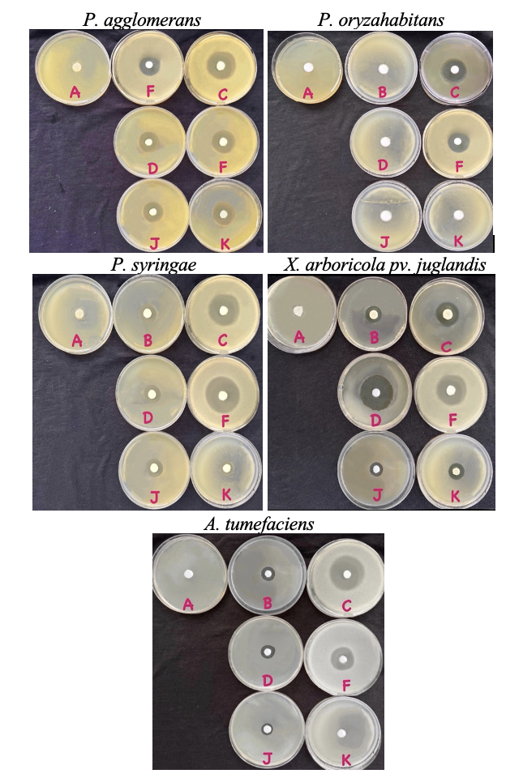

Figure 27 – Bactericidal properties of antibacterial preparations against various bacterial pathogens (A — Control; B — Agri Gent Plus 800 (gentamicin sulfate + oxytetracycline hydrochloride); C — Kasumin (kasugamycin); D — Zerox (colloidal silver); F — Kocide (copper hydroxide); J — Bordeaux mixture (tribasic copper sulfate); K — Phytolavin (phytobacteriomycin — a complex of streptothricin antibiotics))
To confirm the significance of these differences, a one-way analysis of variance (ANOVA) was performed, the results of which are presented in Table 19.

Table 19 – Results of one-way analysis of variance (ANOVA)

Pathogen | F-statistic | p-value | MSW | LSD₀.₀₅ (mm)
P. agglomerans | 74.28 | < 0.0001 | 5.47 | 2.71
P. syringae | 36.64 | < 0.0001 | 9.68 | 3.61
X. arboricola pv. juglandis | 60.12 | < 0.0001 | 7.58 | 3.19
P. oryzihabitans | 53.85 | < 0.0001 | 8.14 | 3.30
A. tumefaciens | 85.47 | < 0.0001 | 5.50 | 2.72

The results of the one-way analysis of variance (ANOVA), presented in Table 19, confirmed the presence of statistically significant differences among treatments for all tested pathogens (p < 0.0001). This indicates a substantial effect of the different antibacterial preparations on the diameter of bacterial growth inhibition zones. The F-statistic values ranged from 36.64 (P. syringae) to 85.47 (A. tumefaciens), reflecting differences in pathogen sensitivity to the tested agents. Mean square within (MSW) values ranged from 5.47 (P. agglomerans) to 9.68 (P. syringae), reflecting the within-group variability of the data. The least significant difference values (LSD₀.₀₅) varied from 2.71 mm (P. agglomerans) to 3.61 mm (P. syringae). To enhance clarity and facilitate interpretation, the results were presented as a heatmap illustrating the inhibition zones of bacterial growth under the action of various antibacterial preparations (Figure 28).

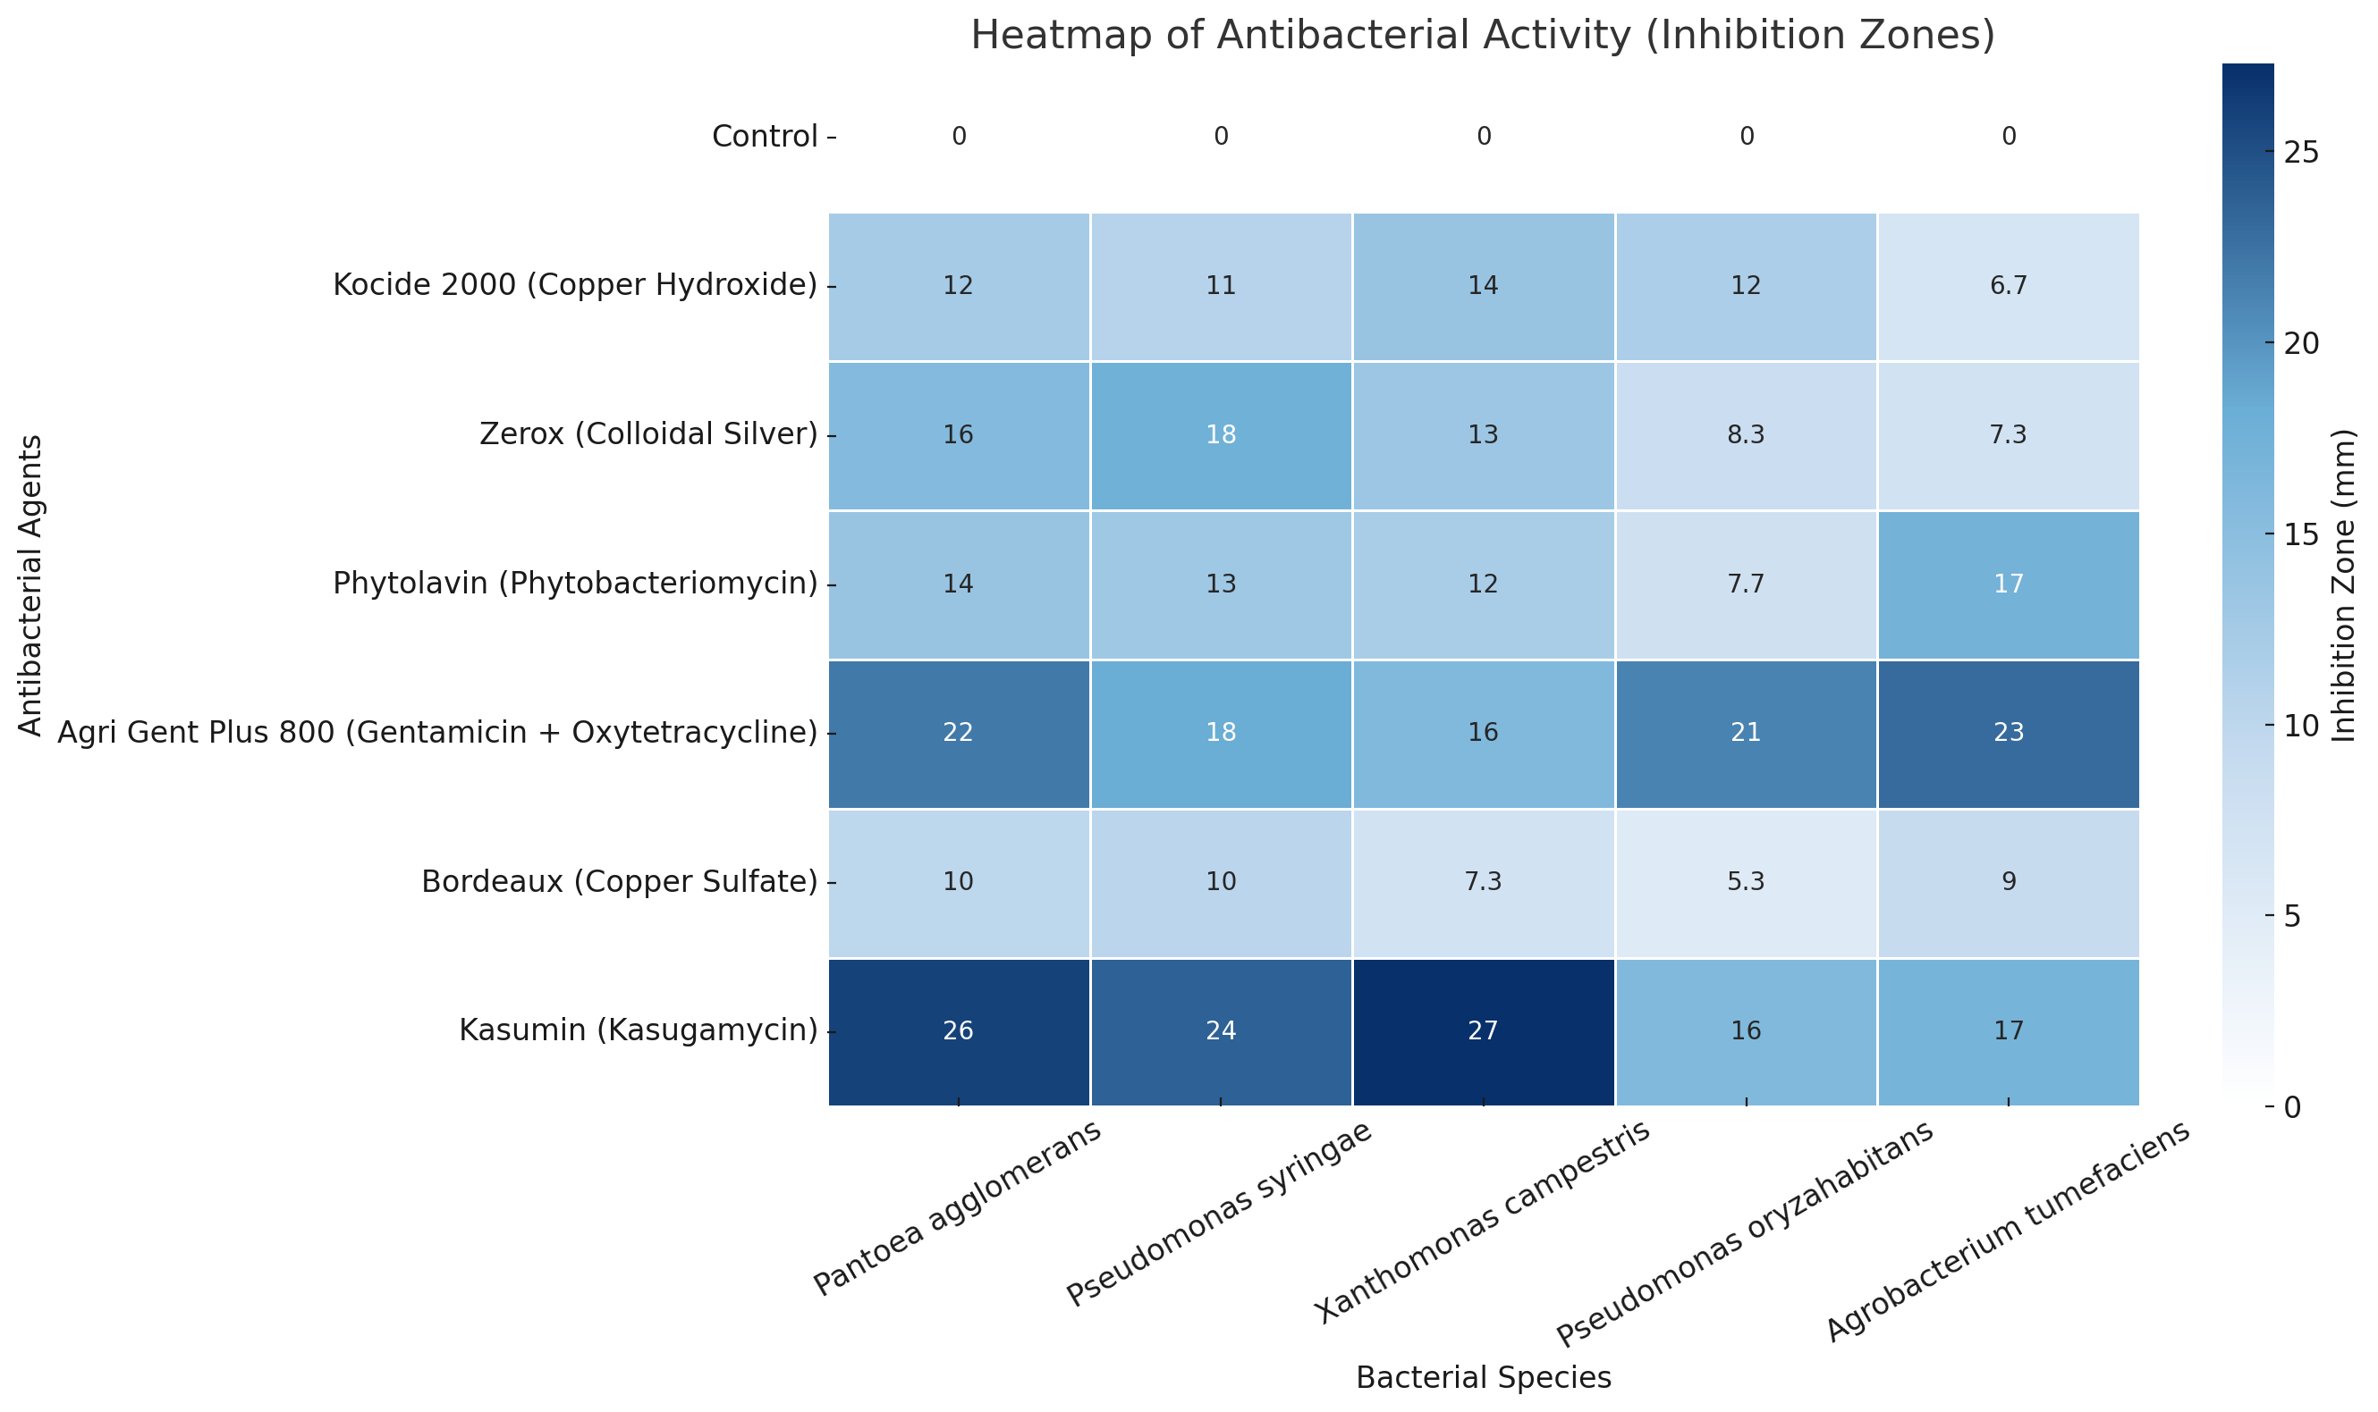

Figure 28 – Heatmap of inhibition zones (mm) for different bacterial strains under the action of antibacterial agents

The heatmap was constructed using the Seaborn library in Python, which enabled a visual representation of the effectiveness of the agents through a color scale and facilitated data interpretation for agronomists and researchers. The color scale on the heatmap reflects the degree of antibacterial activity: dark blue indicates high activity (25–30 mm), blue — moderate activity (15–25 mm), light blue — weak activity (5–15 mm), and nearly white indicates either no effect or a very low level of activity (<5 mm).
The heatmap provides a clear visual summary of the effectiveness of different antibacterial preparations. It confirms the variability in pathogen sensitivity and highlights the practical value of Kasumin and Agri Gent Plus 800 as consistently effective agents. Such visualization helps support decision-making in walnut disease management.
3.8.2 Laboratory evaluation of fungicides against fungal pathogens of walnut
To evaluate the effectiveness of modern fungicides under laboratory conditions, a series of experiments was conducted to assess their impact on the mycelial growth of the most common fungal pathogens of walnut. The table 20 summarizes the results, showing colony growth of isolates treated with different fungicides in comparison with the control. These data make it possible to identify fungicides with the highest inhibitory activity and to distinguish them from those with limited or no effect.

Table 20 – Effect of fungicides on the vegetative growth of fungal isolates (mean colony diameter, mm ± SE, n = 3)

Isolate | Colony diameter, mm
Isolate | Score | Chorus | Stroby | Luna Tranquility | Control (untreated)
F. solani | 0.50 | 5.70 | 2.00 | 3.00 | 7.50
F. solani | 0.40 | 6.00 | 1.50 | 2.90 | 6.70
F. solani | 0.70 | 4.90 | 2.00 | 3.40 | 6.90
Mean value (mm) | 0.53 | 5.53 | 1.83 | 3.10 | 7.03
Growth inhibition, % | 92.42 | 21.33 | 73.93 | 55.92
LSD₀.₀₅ | 0.67
F. proliferatum | 1.80 | 8.90 | 3.80 | 3.00 | 9.00
F. proliferatum | 1.20 | 8.00 | 4.20 | 1.90 | 8.00
F. proliferatum | 2.30 | 8.90 | 4.30 | 2.70 | 9.00
Mean value (mm) | 1.77 | 8.60 | 4.10 | 2.53 | 8.67
Growth inhibition, % | 79.62 | 0.77 | 52.69 | 70.77
LSD₀.₀₅ | 0.93
F. graminearum | 2.80 | 8.50 | 8.90 | 2.00 | 9.00
F. graminearum | 2.60 | 7.20 | 7.10 | 1.80 | 8.60
F. graminearum | 2.30 | 8.00 | 7.30 | 2.50 | 8.90
Mean value (mm) | 2.57 | 7.90 | 7.77 | 1.67 | 8.83
Growth inhibition % | 70.94 | 10.57 | 12.08 | 81.13
LSD₀.₀₅ | 1.04
Continuation of Table 14

A. alternata | 1.20 |  |  | 2.70 | 0.50 |  |  | 5.00 |  |  | 8.00
A. alternata | 0.80 |  |  | 2.90 | 1.20 |  |  | 4.70 |  |  | 7.70
A. alternata | 1.70 |  |  | 1.50 | 1.20 |  |  | 4.50 |  |  | 7.90
A. alternata | 1.23 |  |  | 2.37 | 0.97 |  |  | 4.73 |  |  | 7.87
A. alternata | 84.32 |  |  | 69.92 | 87.71 |  |  | 39.83
LSD₀.₀₅ | 0.82
F. redolens | 8.50 |  | 3.00 |  |  | 2.00 |  |  | 4.00 |  |  | 8.00
F. redolens | 8.00 |  | 3.60 |  |  | 1.50 |  |  | 3.20 |  |  | 9.00
F. redolens | 8.00 |  | 4.00 |  |  | 1.30 |  |  | 3.60 |  |  | 8.90
Mean value (mm) | 8.17 |  | 3.53 |  |  | 1.60 |  |  | 3.60 |  |  | 8.63
Growth inhibition, % | 5.33 |  | 59.10 |  |  | 81.46 |  |  | 58.29
LSD₀.₀₅ | 0.78
F. incarnatum | 9.00 | 2.00 |  |  |  |  | 0.70 |  |  | 5.00 |  |  | 9.00
F. incarnatum | 8.70 | 1.90 |  |  |  |  | 0.50 |  |  | 4.70 |  |  | 9.00
F. incarnatum | 8.90 | 2.10 |  |  |  |  | 0.50 |  |  | 4.50 |  |  | 9.00
Mean value (mm) | 8.87 | 2.00 |  |  |  |  | 0.57 |  |  | 4.73 |  |  | 9.00
Growth inhibition, % | 1.44 | 77.78 |  |  |  |  | 93.64 |  |  | 47.44
LSD₀.₀₅ | 0.27

Differences between treatments were evaluated using one-way ANOVA followed by Fisher’s LSD₀.₀₅ test. LSD₀.₀₅ values were calculated separately for each fungal species.
Based on the data from Table 20, the tested fungicides demonstrated distinct patterns of antifungal activity against the main walnut pathogens. Score (difenoconazole) showed the strongest effect against F. solani and F. proliferatum, while Luna Tranquility (fluopyram + pyrimethanil) was most effective against F. graminearum. Stroby (kresoxim-methyl) provided excellent control of A. alternata, F. redolens, and F. incarnatum. In contrast, Chorus (cyprodinil) generally exhibited weak to moderate activity, and Score was largely ineffective against F. redolens and F. incarnatum.
The effectiveness of the fungicides is further illustrated in Figure 22, which shows the degree of mycelial growth inhibition in all isolates. All agents reduced, to varying degrees, the development of aerial mycelium in the analyzed Fusarium and Alternaria species. In the control treatment, colonies of F. solani and A. alternata completely covered the Petri dish surface by day 9, while colonies of F. proliferatum, F. graminearum, F. redolens, and F. incarnatum reached full coverage by day 7. Moreover, fungicide treatments significantly delayed colony expansion compared to the control, indicating a pronounced suppressive effect on early mycelial development.

F. solani F. proliferatum F. incarnatum
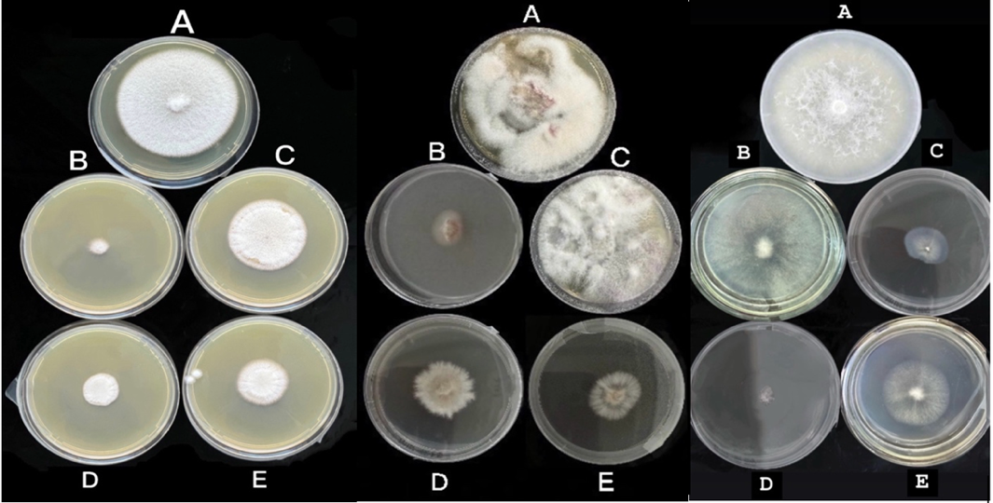

F. graminearum A. alternata F. redolens
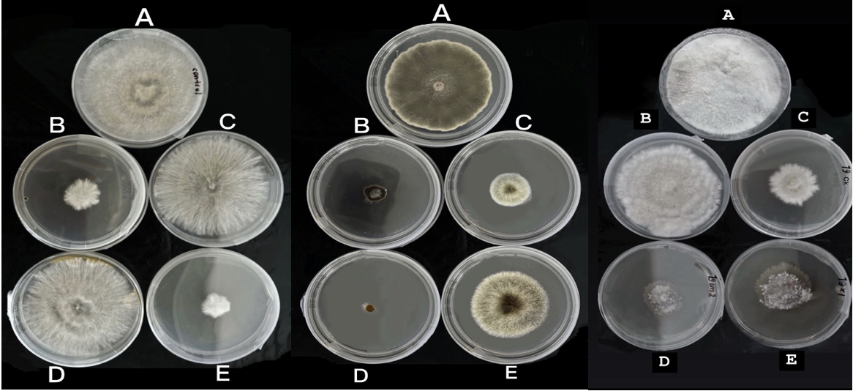

Figure 29 – Effect of different fungicides on the mycelial growth of F. solani, F. proliferatum, F. incarnatum, F. graminearum, A. alternata, and F. redolens (seven days after inoculation). A – Control; B – Score; C – Chorus; D – Stroby; E – Luna Tranquility

The degree of inhibition varied among fungal species and fungicides, reflecting differences in pathogen sensitivity and modes of action of the tested compounds.
3.8.3 Field evaluation of fungicides and antibacterial preparations against major walnut diseases caused by A. alternata and P. agglomerans
As a result of phytosanitary monitoring of walnut plantations in the study areas, the DSI of walnut infection caused by A. alternata was determined during periods of its maximum development. In orchards of the southern fruit-growing zone of Kazakhstan during 2022–2024, A. alternata was identified as the dominant component of the fungal pathogen complex of walnut plantations, with disease development ranging from 28% to 70%.
Table 21 presents data on the biological effectiveness of several fungicides against A. alternata on walnut cv. Liaohe under field conditions. For each year (2022–2024), treatment effects were analyzed separately using one-way ANOVA with three replicates per treatment (n = 3).

Table 21 – Biological effectiveness of several fungicides against A. alternata on walnut cv. Liaohe (Almaty region, Yenbekshikazakh district, 2022–2024)

№ | Treatment (active ingredient) | Application rate, l/kg/ha | Disease development, % (days after treatment) |  |  | Biological effectiveness, %
№ | Treatment (active ingredient) | Application rate, l/kg/ha | 25 days | 50 days | 80 days | Average disease development, %
1 | Control (untreated) | - | 38.60 | 34.80 | 40.40
2 | Score (difenoconazole) | 0.15 | 3.20 | 2.93 | 2.20 | 92.20
3 | Score (difenoconazole) | 0.20 | 2.46 | 2.06 | 2.00 | 93.80
4 | Chorus (cyprodinil) | 0.15 | 22.06 | 17.00 | 9.20 | 57.20
5 | Chorus (cyprodinil) | 0.20 | 14.2 | 9.46 | 6.26 | 73.70
6 | Luna Tranquility (fluopyram + pyrimethanil) | 0.80 | 28.46 | 21.60 | 17.93 | 39.50
7 | Luna Tranquility (fluopyram + pyrimethanil) | 1.20 | 23.06 | 15.60 | 11.60 | 55.30
8 | Stroby (kresoxim-methyl) | 0.15 | 16.80 | 8.20 | 3.06 | 74.50
9 | Stroby (kresoxim-methyl) | 0.20 | 12.00 | 3.73 | 2.46 | 83.50
 | LSD₀.₀₅ | 8.91

As the direction and magnitude of treatment effects were consistent across years, the values presented in Table 21 represent multi-year means of disease development (%). Mean comparisons were performed using Fisher’s least significant difference (LSD) test at the 0.05 probability level.
According to Table 21, the highest biological efficacy against A. alternata was demonstrated by Score (difenoconazole) applied at 0.20 L/ha (93.8%) and Stroby (kresoxim-methyl) at 0.20 L/ha (83.5%). Chorus (cyprodinil) showed moderate efficacy, reaching 73.7% at 0.20 L/ha, whereas Luna Tranquility (fluopyram + pyrimethanil) exhibited 55.3% efficacy at 1.20 kg/ha. Phytotoxicity assessments indicated that none of the tested fungicides caused visible leaf burn or other adverse effects on walnut trees. The calculated LSD₀.₀₅ value (8.91) represents the minimum significant difference in average disease development between treatments at the 0.05 probability level. This value was obtained based on three replications per treatment, with a within-group mean square (MSwithin) of 26.91.
Table 22 summarizes the results of field evaluations of antibacterial preparations against walnut blight caused by P. agglomerans in commercial walnut orchards (cv. Liaohe) of the Almaty region during 2023–2024.

Table 22 – Biological efficacy of antibacterial preparations based on the disease dynamics caused by P. agglomerans under commercial walnut (cv. Liaohe) orchards in the Almaty region in 2023–2024

Preparation | Application rate (L/ha, kg/ha) | Working solution rate (L/ha) | Disease development by year (%) |  | Biological efficacy (%)
Preparation | Application rate (L/ha, kg/ha) | Working solution rate (L/ha) | 2023 | 2024 | 2023 | 2024 | Mean efficacy (%)
Control (untreated) | - | 1000 | 26.90 | 25.20 | - | - | -
Kocide 2000 | 2.0 | 1000 | 20.60 | 20.20 | 23.30 | 19.70 | 21.50
Kocide 2000 | 3.0 | 1000 | 18.70 | 18.60 | 30.50 | 26.00 | 28.30
Kasumin | 2.0 | 1000 | 4.70 | 1.60 | 82.40 | 93.30 | 87.90
Kasumin | 4.0 | 1000 | 3.90 | 1.30 | 85.30 | 94.90 | 90.10
Phytolavin | 1.5 | 1000 | 13.10 | 7.10 | 51.40 | 71.80 | 61.60
Phytolavin | 2.0 | 1000 | 12.50 | 7.10 | 53.40 | 71.80 | 62.60
Agri Gent Plus 800 | 0.8 | 1000 | 9.50 | 6.50 | 64.80 | 77.90 | 71.40
Agri Gent Plus 800 | 1.6 | 1000 | 8.80 | 5.30 | 67.30 | 78.70 | 72.90
Zerox | 2.0 | 1000 | 13.10 | 11.60 | 51.30 | 53.70 | 52.50
Zerox | 4.0 | 1000 | 11.60 | 10.30 | 57.30 | 59.10 | 58.20
Bordeaux mixture | 10.0 | 1000 | 20.60 | 20.26 | 23.30 | 19.40 | 21.36
LSD₀.₀₅ |  |  | 3.55

Among the tested antibacterial agents, Kasumin (kasugamycin) demonstrated the highest and most stable biological efficacy, reaching 87.9–90.1% at application rates of 2.0–4.0 L/ha, corresponding to disease suppression by 8–10 times compared with the untreated control. Agri Gent Plus 800 (gentamicin sulfate + oxytetracycline hydrochloride) also showed consistently high efficacy (71.4–72.9% at 0.8–1.6 kg/ha), providing reliable protection against walnut blight.
Comparative analysis of Phytolavin and Zerox revealed that Phytolavin was significantly more effective (61.6–62.6%) than Zerox (52.5–58.2%). The higher efficacy of Phytolavin may be attributed to its systemic mode of action, enabling penetration into plant tissues and prolonged antibacterial activity under field conditions. In contrast, Zerox, a contact preparation based on colloidal silver, does not penetrate plant tissues and may lose activity under conditions of high solar radiation, limiting its effectiveness in open-field environments.
One-way ANOVA revealed a highly significant effect of antibacterial treatments on disease suppression caused by P. agglomerans (F = 74.6, p < 0.0001) (Table 23).

Table 23 – One-way ANOVA for disease development (%) across all treatment variants (including control and both doses of each preparation), n = 3

Source | Degrees of freedom (df) | Sum of squares (SS) | Mean square (MS) | F-statistic | P-value
Between groups | 11 | 3642.02 | 331.092 | 74.6 | < 0,0001
Within groups | 24 | 106.65 | 4.44
Total | 35 | 3748.67

Post-hoc comparison using Fisher’s LSD test (LSD₀.₀₅ = 3.55) confirmed that application rates of 0.2–0.4% (2–4 L/ha) provided the most effective suppression of P. agglomerans. These results indicate that the observed differences among treatments were statistically significant and attributable to the antibacterial preparations rather than random variation.
Overall, based on laboratory and field trials conducted in 2022–2024, Score and Stroby were identified as the most effective fungicides against brown blight (A. alternata), while Kasumin and Agri Gent Plus 800 proved to be the most effective antibacterial agents against walnut blight caused by P. agglomerans. These preparations can be recommended for use in integrated disease management programs in walnut orchards of the southern fruit-growing zone of Kazakhstan.

3.9 Economic efficiency of using modern preparations against major walnut diseases
The application of advanced disease management technologies in walnut orchards significantly increases plantation resistance to major diseases and helps maintain yield stability under unfavorable weather conditions. The study demonstrated that the use of modern fungicides effectively reduced disease development and contributed to the preservation of walnut yield and quality. In addition to lowering infection levels, these treatments improved marketability and post-harvest quality, which is particularly important for commercial producers.
The economic efficiency of modern fungicide application depends on several key factors, including the cost of plant protection products, their biological effectiveness, yield levels, and market prices of walnuts. Effective control of major diseases, such as walnut blight, brown spot (alternariosis), and related infections, resulted in a significant increase in both yield and nut quality, leading to higher farm income. Cost calculations and economic efficiency assessments of protective measures are presented in Appendix B, while summarized economic indicators for the use of modern fungicides against the main walnut diseases are provided in Table 24.
Field applications of fungicides such as Score, Stroby, and Kasumin had a positive effect on both the quantity and quality of walnut production.
The investigation indicated that fungicide use significantly affects yield and economic performance in walnut production. The maximum economic impact was attained with the application of Score (0.2 L/ha): the yield increased by 7.8 q/ha, net income totaled 1,283,980 tenge, and profitability was 297%. Kasumin (2.0 L/ha) also demonstrated high effectiveness, providing a yield increase of 6.0 q/ha, net income of 949,380 tenge, and profitability of 256%. Treatment with Stroby (0.2 kg/ha) yielded an increase of 5.6 q/ha and generated a net income of 906,580 tenge, resulting in a profitability of 279%.

Table 24 – Economic efficiency of using modern fungicides in walnut disease control (2024)

Prepara-tion | Yield weight (q/ha) | Crop value per ha (tenge) | Total costs per ha (tenge) | Income from preserved yield (tenge) | Net income (tenge) | Profitability level (%)
Score 250 EC | 40.8 | 8976000 | 432020 | 1716000 | 1283980 | 297
Stroby, WG | 38.6 | 8492000 | 325330 | 1232000 | 906580 | 279
Kasumin 2 L, SL | 39.0 | 8580000 | 370620 | 1320000 | 949380 | 256
Control (untreated) | 33.0 | 7260000 | - | - | - | -

Thus, all three preparations contributed to increased productivity and improved economic efficiency in walnut cultivation. The greatest profitability was attained through the utilization of Score, whilst Kasumin offered the most equitable ratio of expenses to end results. This affirms the need for a systematic methodology in plant protection and the identification of effective treatment strategies that consider both the biological traits of the crop and the economic metrics of the farm.

DISCUSSION

In Kazakhstan, there is a growing interest in the industrial cultivation of walnut, particularly in the southern regions, where climatic conditions favor high yields. However, walnut productivity is significantly constrained by fungal and bacterial diseases, and effective disease management is therefore essential. This study documents, for the first time in Kazakhstan, the occurrence of brown spot (A. alternata), walnut canker (F. incarnatum), walnut blight (P. agglomerans), bacterial blight (X. arboricola pv. juglandis), and crown gall (A. tumefaciens). Previously, only marssonina leaf blotch and bacterial blight had been reported on walnut plantations in the Turkestan region [90, p. 1]. Resistance assessments against anthracnose and bacterial blight were conducted by Aksa et al. [91, p. 1959-1967], who found that 2.1% and 36.2% of genotypes were resistant to anthracnose and bacterial blight, while 97.9% and 63.8% exhibited low susceptibility, respectively. Our findings therefore considerably broaden the known spectrum of pathogens affecting walnut in Kazakhstan and highlight the complexity of the pathogen challenge faced by walnut growers.
In our study, various methods were employed to characterize isolates. A total of 138 fungal and bacterial isolates were obtained from the infected leaves, branches, fruits, and bark of walnut trees.
The morphological characteristics of the A. alternata isolates were consistent with descriptions by Simmons [92, p. 91-103]. Brown spot was detected on four farms in both Almaty and Turkestan regions, with the DI and DSI reaching 30% and 70%, respectively, and this was especially widespread in 2024. Similar findings have been reported from China [44, p. 2224] and Serbia [42, p. 224-238], where A. alternata was considered one of the most dangerous walnut pathogens.
Walnut canker, caused by F. incarnatum, was identified only at “Saryagash Zher Syyi” LLP in the Turkestan region, and compared to other diseases showed relatively low aggres- siveness. However, F. incarnatum was successfully re-isolated from all inoculated plants, fulfilling Koch’s postulates. This fungus has previously been reported as a walnut pathogen in Argentina [56, p. 1] and India [57, p. 1]. Walnut blight, caused by P. agglomerans, proved to be the most common disease affecting walnut trees. In 2023 and 2024, outbreaks were detected on all five surveyed farms in the Almaty and Turkestan regions. The highest values for DI and DSI were recorded in Alma—Arasan (Almaty region), at 26% and 57%, respectively. International studies confirm its damaging potential: In China, walnut blight caused by P. agglomerans (often in combination with X. arboricola pv. juglandis and Alternaria spp.) causes serious yield losses. Genomic studies of P. agglomerans isolates from walnut have revealed a wide array of virulence and resistance genes, confirming its high adaptability to stress conditions and its ability to induce severe necrotic symptoms [2, p. 134-137]. Susceptibility to walnut blight depends on multiple factors, including climatic conditions, cultivar characteristics, soil properties, and disease history [93, p. 679-695]. Radix et al. [94, p. 75-89] showed that soil composition may influence polyphenol levels in plant tissues, thereby altering susceptibility to P. agglomerans.
Bacterial blight, caused by X. arboricola pv. juglandis, was confirmed in “Saryagash Zher Syyi” LLP (Turkestan region) with DI and DSI values of 10–13% and 38–42%, respectively. This pathogen is especially damaging in early leafing cultivars during wet years [95, p. 1]. Our findings are consistent with international reports of severe outbreaks in California [96. p. 179-181], Korea [97, p.5324-5330], New Zealand [98, p. 19-24], and France [99, p. 1], as well as more recent cases across Europe and South America [100, p.1]. Some isolates form distinct genetic clusters associated with canker symptoms while retaining the ability to cause classic blight. Pathogenicity of such strains has been demonstrated in previous studies [101, p. 1].
Although A. tumefaciens was isolated from bark showing cracking and localized swelling, pathogenicity tests did not induce tumor formation in seedlings under experimental conditions. This suggests that the isolates may be non-pathogenic or require additional predisposing factors. Similar observations were reported by Yakabe et al. [31, p. 255-261], who noted seasonal variation in A. tumefaciens distribution and gall formation in only 17% of seedlings infected via seeds. This highlights the complexity of interactions between A. tumefaciens and walnut.
Molecular sequencing (ITS and 16S rRNA) identified A. alternata, F. incarnatum, P. agglomerans, X. arboricola pv. juglandis, and A. tumefaciens, with 99–100% similarity to reference strains in GenBank. These results agree with findings from previous studies in other walnut-growing regions [10, p. 67-72; 12, p. 225-235; 18, p. 25-40; 30, p. 45-56; 58–61], thereby supporting our morphological and pathogenicity data and strengthening the accuracy of pathogen identification. The pathogenicity tests in our study demonstrated the virulence of the majority of fungal and bacterial isolates, underscoring their potential to cause significant economic damage to walnut plantations. A. alternata and F. incarnatum proved highly virulent in walnut leaves, stems, and fruits, while X. arboricola pv. juglandis and P. agglomerans produced severe symptoms on leaves, and stems. These results align with previous pathogenicity reports from other walnut-growing regions [9, p. 58-68; 18, p. 25-40; 23. p. 472-489].
The obtained data emphasize certain limitations of the present study. These include the limited number of isolates tested (only three A. tumefaciens strains from a single location), the absence of seasonal repetitions, and potential mismatches between laboratory and natural conditions. Moreover, sampling was restricted to two regions over two years, which may not capture the full diversity of walnut pathogens across Kazakhstan. Environmental and agronomic factors such as irrigation practices, soil characteristics, and cultivar susceptibility were also not systematically evaluated. The unexpected isolation of A. tumefaciens from affected bark without tumor formation in seedlings further illustrates the complexity of host–pathogen interactions and the need for extended research. Future work should broaden geographic and temporal coverage, increase the diversity of isolates, and incorporate multi-year and multi-seasonal sampling. Comparative studies using different inoculation methods, coupled with advanced genomic approaches, would improve the reproducibility and reliability of results, strengthen pathogen identification, and support the development of effective diagnostic and disease.

CONCLUSIONS
During 2022–2024, a complex of bacterial and fungal diseases of walnut was identified in the southern fruit-growing regions of Kazakhstan (Almaty, Zhambyl, and Turkistan). The dominant disease was walnut blight caused by P. agglomerans. The mean disease incidence (DI) across regions was approximately 38%, with an average disease severity index (DSI) of about 15%, confirming its primary phytopathological significance.
Among fungal pathogens, brown spot caused by A. alternata was the most epidemiologically important, with mean DI and DSI values of approximately 48% and 20%, respectively. Frequent co-occurrence of P. agglomerans and A. alternata indicates a synergistic interaction, contributing to increased disease severity in weakened plantations.
Other bacterial pathogens were detected locally or sporadically, including X. arboricola pv. juglandis (DI up to 42%), A. tumefaciens (DI about 20%), P. syringae, and P. oryzihabitans. Their overall epidemiological impact was considerably lower than that of P. agglomerans.
The fungal complex included several Fusarium species (F. solani, F. proliferatum, F. graminearum, F. redolens, F. incarnatum), which showed moderate occurrence (mean DI ≈ 28%) and played a secondary but persistent role in the development of necrosis, wilt, and canker symptoms.
Isolation and molecular identification (16S rRNA for bacteria, ITS region for fungi) confirmed the dominance of P. agglomerans, which accounted for 56.8% of all bacterial isolates, and A. alternata, representing 37% of fungal isolates. Diversity indices indicated moderate bacterial diversity and high fungal diversity within the pathogen complex.
Pathogenicity assays confirmed significant virulence of most isolates. The highest aggressiveness was observed in F. solani among fungi and P. syringae pv. syringae among bacteria. A. tumefaciens did not induce gall formation on walnut seedlings under experimental conditions.
Evaluation of walnut cultivars revealed distinct differences in resistance to the two major pathogens (P. agglomerans and A. alternata), identifying several resistant and moderately resistant genotypes suitable for commercial cultivation and breeding programs.
Chemical control trials demonstrated the absence of a universal treatment effective against all pathogens. Kasumin and Agri Gent Plus 800 showed the highest efficacy against bacterial diseases, whereas Score and Stroby were the most effective fungicides, with activity strongly dependent on the pathogen species. These results indicate the necessity of pathogen-specific disease management strategies for walnut plantations.

RECOMMENDATIONS FOR PRODUCTION

To reduce disease incidence and limit yield losses in walnut plantations of southern Kazakhstan, an integrated plant protection strategy combining varietal selection, agrotechnical measures, sanitary practices, and targeted chemical and biological treatments is recommended.
When establishing new orchards, varietal resistance should be a primary criterion. Introduced cultivars such as Miroslava, Ovidiu, Germisara, Yarivski, Peshanski, Kogylnichanu, Lipin 2, Liaohe, Fernor, Plin, and Kishinevski demonstrated high resistance, while the Moldovan cultivar Kazaku showed immunity or very high resistance to walnut blight caused by P. agglomerans, the dominant pathogen in the region.
Sanitary measures are essential and include regular removal and destruction of infected leaves, shoots, and fruits to reduce inoculum pressure. Pruning tools must be disinfected after each use (70% ethanol or chlorhexidine) to prevent pathogen transmission. Proper orchard ventilation through crown thinning and avoidance of excessive irrigation are critical to limit leaf wetness and reduce infection risk.
Preventive chemical treatments should be synchronized with phenological stages. In early spring, before bud break, orchards should be treated with Bordeaux mixture (1–2%) or copper oxychloride (0.3–0.5%). During bud swelling and early vegetation, Kocide 2000 WG (2–3 kg/ha) is recommended against bacterial pathogens. During bud break and before flowering, Kasumin 2L (2 L/ha) effectively suppresses primary bacterial infections, with repeat applications during periods of high humidity.
At flowering, Zerox SC (4 L/ha) may be applied for additional bactericidal protection. If symptoms develop, Phytolavin SC (2 L/ha) or Agri Gent Plus 800 (1.6 L/ha) should be included in the treatment program. Alternation of antibacterial agents at 7–14-day intervals is necessary to prevent resistance development.
For control of Alternaria and Fusarium spp., fungicide applications should begin during bud swelling with Score 250 EC (0.15–0.2 L/ha). Before and after flowering, Stroby 50 WG (0.15–0.2 L/ha) or Chorus 750 WG (0.15–0.2 kg/ha) are recommended. Under conditions favorable for Fusarium development, systemic fungicides based on flutriafol or fludioxonil may be applied, targeting both foliage and soil.
Throughout the growing season, application of the biological preparation Fitosporin-M (Bacillus subtilis) every 10–14 days is advisable, particularly under high humidity. It can be used alone or in tank mixtures with fungicides to enhance disease suppression.
After harvest, a final treatment with copper-based preparations against bacterial diseases and Score against fungal pathogens is recommended. Complete removal of infected plant residues is mandatory to reduce pathogen overwintering. Regular orchard monitoring and early detection of disease symptoms remain key components of effective walnut disease management.

REFERENCES

1 Walterson A. M., Stavrinides J. P.: Insights into a highly versatile and diverse genus within the Enterobacteriaceae // FEMS Microbiology Reviews. 2015. — Vol. 39, no. 6. — P. 968–984. — DOI: https://doi.org/10.1093/femsre/fuv027
2 Xiao J., Liu Z., Sun S. et al. Complete Genome Sequence of P. agglomerans CHTF15, a Walnut Pathogen. Molecular Plant-Microbe Interactions, 2023, 36(2): 134–137. — DOI: https://doi.org/10.1094/MPMI-10-22-0216-A
3 An X.H., Wang N., Wang H., et al. Physiological and transcriptomic analyses of the response of walnuts (Juglans regia) to P. agglomerans infection. Frontiers in Plant Science, 2023. — DOI: https://doi.org/10.3389/fpls.2023.1294643
4 Zhu Y.F., Yin Y.F., Qu W.W., Yang K.Q. Occurrence and spread of the pathogens on walnut (Juglans regia) in Shandong Province, China. Acta Horticulturae, 2014, 1050: 347–354. — DOI: 10.17660/ActaHortic.2014.1050.47
5 Xiao J., Sun S., Liu Z., et al. Analysis of key genes for the survival of P. agglomerans under nutritional stress. International Journal of Biological Macromolecules, 2023. — DOI: https://doi.org/10.1016/j.ijbiomac.2023.127059
6 Li Ya, Zhang Zhenyin, Xiao Bo, Yang Bin, and Zhao Ning. Identification of the Pathogen of Walnut Blight and Bactericide Screening in Laboratory // Journal of Southwest Forestry University (Natural Science). 2022. 42(5): 104–110. DOI: 10.11929/j.swfu.202104066
7 Bradbury J.F. Guide to plant pathogenic bacteria. — Kew, United Kingdom: CAB International Mycological Institute, 1986. — 190 p.
8 Keshtkar, A.R., Khodakaramian, G., Rouhrazi, K. Isolation and characterization of P. syringae pv. syringae, which induce leaf spot on walnut // European Journal of Plant Pathology.— 2016. — Vol. 146. — P. 837–846. — DOI: https://doi.org/10.1007/s10658-016-0962-2
9 Bahar M., Mojtahedi H., Akhiani A. Bacterial canker of apricot in Isfahan // Iranian Journal of Plant Pathology. — 1982. — Vol. 18. — P. 58–68.
10 Banapour A., Zakiee Z., Amani G. Isolation of P. syringae from sweet cherry in Tehran Province // Iranian Journal of Plant Pathology. — 1990. Vol. 26. P. 67–72.
11 Ashorpour M., Kazempour M., Ramezanie M. Occurrence of P. syringae pv. syringae, the causal agent of bacterial canker on olives (Olea europaea) in Iran // Science Asia. — 2008. — Vol. 34. — P. 323–326.
12 Abbasi V., Rahimian H., Tajick-Ghanbari M. Genetic variability of Iranian strains of P. syringae pv. syringae causing bacterial canker disease of stone fruits // European Journal of Plant Pathology. — 2013. — Vol. 135. — P. 225–235.
13 Scortichini M., Marchesi U., Rossi M.P., Prospero P.D. Bacteria associated with hazelnut (Corylus avellana L.) decline are of two groups: P. avellanae and strains resembling P. syringae pv. syringae // Applied and Environmental Microbiology. — 2002. — Vol. 68. — P. 476–484.
14 Little E.L., Bostock R.M., Kirkpatrick B.C. Genetic characterization of P. syringae pv. syringae strains from stone fruits in California // Applied and Environmental Microbiology. — 1998. — Vol. 64. — P. 3818–3823.
15 Vicente J.G., Roberts S.J. Discrimination of isolates of P. syringae from sweet and wild cherry using rep-PCR // European Journal of Plant Pathology. — 2007. — Vol. 117. — P. 383–392.
16 Vicente J.G., Roberts S.J. Screening wild cherry micropropagated plantlets for resistance to bacterial canker // In: P. syringae and Related Pathogens. — Dordrecht: Springer, 2003. — P. 467–474.
17 Lelliott R.A., Billing E., Hayward A.C. A determinative scheme for the fluorescent plant pathogenic Pseudomonads // Journal of Applied Bacteriology. — 1966. — Vol. 29. — P. 470–489.
18 Versalovic J., Schneider M., de Bruijn F.J., Lupski J.R. Genomic fingerprinting of bacteria using repetitive sequence-based polymerase chain reaction // Methods in Molecular and Cellular Biology. — 1994. — Vol. 5. — P. 25–40.
19 Louws F.J., Rademaker J.L.W., de Bruijn F.J. The three Ds of PCR-based genomic analysis of phytobacteria: diversity, detection, and diagnosis // Annual Review of Phytopathology. — 1999. — Vol. 37. — P. 81–125.
20 Weingart H., Volksch B. Genetic fingerprinting of P. syringae pathovars using ERIC-, REP-, and IS50-PCR // Journal of Phytopathology. — 1997. — Vol. 145. — P. 339–345.
21 Yamamoto S., Kasai H., Arnold D.L., et al. Phylogeny of the genus P. based on gyrB and rpoD sequences // Microbiology. — 2000. — Vol. 146. — P. 2385–2394.
22 Hwang M.S.H., Morgan R.L., Sarkar S.F., et al. Phylogenetic characterization of virulence and resistance phenotypes of P. syringae // Applied and Environmental Microbiology. — 2005. — Vol. 71. — P. 5182–5191.
23 Vauterin, L.; Hoste, B.; Kersters, K.; Swings, J. Reclassification of Xanthomonas. International Journal of Systematic Bacteriology 1995, 45(3), 472–489, doi:10.1099/00207713-45-3-472.
24 Burokiene, D.; Pulawska, J. Bacterial blight of walnut (Juglans regia) caused by Xanthomonas arboricola pv. juglandis in Lithuania. Journal of Plant Pathology 2012, 94(1), S1.43–S1.48.
25 Bandi, A.; Kámán-Tóth, E.; Kolozsváriné Nagy, J.; Hevesi, M. Characterization of Xanthomonas arboricola pv. juglandis strains from Hungary and Romania. Acta Microbiologica et Immunologica Hungarica 2014, 61(2), 121–135, doi:10.1556/AMicr.61.2014.2.2.
26 Kim, H.S.; Cheon, W.; Lee, Y.; Kwon, H.-T.; Seo, S.-T.; Balaraju, K.; Jeon, Y. Identification and characterization of Xanthomonas arboricola pv. juglandis causing bacterial blight of walnuts in Korea. Plant Pathology Journal 2021, 37, 137–151, doi:10.5423/PPJ.OA.12.2020.0217.
27 Pardatscher, R.; Gualandri, V.; Rizza, C.; Martini, M. First report of Xanthomonas arboricola pv. juglandis causing bacterial blight on walnut in Northern Italy. Journal of Plant Pathology 2019, 101(2), 447, doi:10.1007/s42161-018-00178-7.
28 Kałużna, M.; Puławska, J.; Janse, J. D.; Young, J. M.; Sobiczewski, P. Genetic diversity and pathogenicity of Xanthomonas arboricola pv. juglandis strains isolated from walnut trees in Poland. Plant Pathology 2021, 70(4), 842–857, doi:10.1111/ppa.13331.
29 Iličić, R.; Popović, T.; Lalošević, V.; Jelušić, A. Association of Xanthomonas arboricola pv. juglandis with vertical oozing canker of walnut in Serbia. Plants 2021, 10(10), 2109, doi:10.3390/plants10102109.
30 Chorolque, F.; Orellana, R.; Alvarado, I.; Vignolo, G.; Stefani, E. Susceptibility of Chandler and Franquette walnut cultivars to Xanthomonas arboricola pv. juglandis under different climatic conditions in Argentina. Journal of Plant Pathology 2024, 106(1), 45–56, doi:10.1007/s42161-023-01345-y.
31 Latinović, J.; Latinović, N.; Kandić, B.; Jelušić, A.; Popović Milovanović, T. 2025. Evidence and characterization of Xanthomonas arboricola pv. juglandis causing bacterial blight of walnut in Montenegro. Plant Protection Science, 2025, 61(3), 255–261, doi:10.17221/196/2024-PPS28.
32 Keikha M., Soori T., Azadi D., Karami-Zarandi M., Daneshpazhooh M., Rahdar H.A. The first report of P. oryzihabitans infection in a patient with hidradenitis suppurativa // Clinical Case Reports. — 2019. — Vol. 7, № 8. — P. 1514–1517. — DOI: https://doi.org/10.1002/ccr3.2265
33 Hou Y., Zhang Y., Yu L., Ding X., Liu L., Wang L., Huang S. First report of P. oryzihabitans causing rice panicle blight and grain discoloration in China // Plant Disease. — 2020. — Vol. 104, № 11. — P. 3055. — DOI: https://doi.org/10.1094/PDIS-10-19-2186-PDN
34 Liu Z., He Y., Xiang Z. First report of P. oryzihabitans causing fruit black rot in prickly ash in China // Journal of Plant Diseases and Protection. — 2021. — Vol. 128, № 3. — P. 1–4. — DOI: https://doi.org/10.1007/s41348-021-00472-9
35 Huai T., Zhao J., Zhang X., Si D. First report of P. oryzihabitans causing walnut leaf spot disease in China // Plant Disease. — 2023. — Vol. 108, № 2. — P. 514. — DOI: https://doi.org/10.1094/PDIS-08-23-1634-PDN
36 Zou L., Xing X., Fu B. P. oryzihabitans strain YKW14 isolated from walnut blighted fruit // Southwest China Journal of Agricultural Sciences. — 2019. — Vol. 32, № 5. — P. 1057–1061.
37 Yakabe L.E., Parker S.R., Kluepfel D.A. Role of systemic A. tumefaciens populations in crown gall incidence on the walnut hybrid rootstock ‘Paradox’ // Plant Disease. — 2012. — Vol. 96, № 10. — P. 1415–1421. — DOI: https://doi.org/10.1094/PDIS-05-11-0364-RE
38 Rouhrazi K., Rahimian H. Biochemical and genetic characterisation of A. tumefaciens, the causal agent of walnut crown gall disease in Iran // Archives of Phytopathology and Plant Protection. — 2014. — Vol. 47, № 20. — P. 2493–2500. — DOI: https://doi.org/10.1080/03235408.2014.880575
39 Yakabe L.E., Parker S.R., Kluepfel D.A. Incidence of A. tumefaciens biovar 1 in and on ‘Paradox’ (Juglans hindsii × Juglans regia) walnut seed collected from commercial nurseries // Plant Disease. — 2014. — Vol. 98, № 6. — P. 766–770. — DOI: https://doi.org/10.1094/PDIS-07-13-0742-RE
40 Eshbekova G.G., Ismoilov Z.F., Haydarov I.A. Isolation and characterization of A. tumefaciens from walnut nurseries in Zarafshan Valley in Uzbekistan. Vestnik Khorezm Ma’mun Academy, 2022.
41 Poret-Peterson A.T., Bhatnagar S., McClean A.E., Kluepfel D.A. Draft genome sequence of A. tumefaciens biovar 1 strain 186, isolated from walnut. Genome Announcements, 2017.
42 Vasić T., Jevremović D., Živković S., et al. Morphological and pathogenic characteristics of Alternaria alternata isolates on walnut // Journal of Mountain Agriculture on the Balkans. — 2021. — Vol. 24, № 3. — P. 224–238.
43 Raina A., Kaul S., Sharma I., et al. First report of Alternaria alternata causing leaf spot on Juglans regia in India // Plant Disease. — 2025. — Vol. 109. — DOI: https://doi.org/10.1094/PDIS-11-24-2479-PDN
44 Liu Z., Zhang R., Sun D., et al. Alternaria alternata causing brown spot disease on walnut in Xinjiang, China // Plant Disease. — 2023. — Vol. 107. — P. 2224. — DOI: https://doi.org/10.1094/PDIS-07-22-1536-PDN
45 Belisario A., Forti E., Corazza L., van Kesteren H.A. First report of Alternaria alternata causing leaf spot on English walnut // Plant Disease. — 1999. — Vol. 83. — P. 696. — DOI: https://doi.org/10.1094/PDIS.1999.83.7.696A
46 Belisario A., Maccaroni M., Corazza L., Balmas V., Valier A. Occurrence and etiology of brown apical necrosis on Persian (English) walnut fruit // Plant Disease. -2002. - Vol. 86, № 6. -P. 599–602. -DOI: https://doi.org/10.1094/PDIS.2002.86.6.599
47 Wang Z., Liu Y., Yan A., Wang Z. First report of Fusarium proliferatum causing leaf spot on Juglans regia in China // Plant Disease. - 2022. -Vol. 106, № 8. -P. 2265. -DOI: https://doi.org/10.1094/PDIS-11-21-2537-PDN
48 Scotton M., Bortolin E., Fiorin A., Belisario A. Environmental and pathogenic factors inducing brown apical necrosis on fruit of English (Persian) walnut //Phytopathology. -2015. -Vol. 105, № 11. -P. 1427–1436. -DOI: https://doi.org/10.1094/PHYTO-01-15-0029-R
49 Tuerdi M., Lv C., Dan H., Shan L., Zhang R., Chen X. First report of Fusarium solani associated with twig canker of English walnut (Juglans regia) in Xinjiang, China // Plant Disease. — 2023. — Vol. 107. — P. 2858. — DOI: https://doi.org/10.1094/PDIS-03-23-0430-PDN
50 Sun Z.X., Hsiang T., Li J.K., Zhou Y., Deng J.X., Wang F. First report of Fusarium wilt caused by Fusarium solani on walnut in central China // Journal of Plant Pathology. — 2016. — Vol. 98, № 3. — P. 681.
51 Zheng L., Peng Y., Zhang J., Ma W.J., Li S.J., Zhu T.H. First report of Fusarium solani causing root rot of Juglans sigillata Dode in China // Plant Disease. — 2015. — DOI: https://doi.org/10.1094/PDIS-08-14-0801-PDN
52 Chen W., Swart W.J. First report of stem canker of English walnut caused by Fusarium solani in South Africa // Plant Disease. — 2000. — Vol. 84, № 5. — P. 592. — DOI: https://doi.org/10.1094/PDIS.2000.84.5.592A
53 Mulero-Aparicio A., Agustí-Brisach C., Raya M.C., Lovera M., Arquero O., Trapero A. First report of Fusarium solani causing stem canker in English walnut in Spain // Plant Disease. — 2019. — Published online: 15 Oct 2019. — DOI: https://doi.org/10.1094/PDIS-06-19-1163-PDN
54 López-Moral A., Antón-Domínguez B.I., Lovera M., Arquero O., Trapero A., Agustí-Brisach C. Identification and pathogenicity of Fusarium species associated with wilting and crown rot in almond (Prunus dulcis). Scientific Reports. 2024;14:5720. https://doi.org/10.1038/s41598-024-56350-5
55 Belisario A., Luongo L., Vitale S., Santori A. First report of Fusarium semitectum as the agent of twig cankers on Persian (English) walnut in Italy. Plant Disease. 2010. 94(6):791. DOI: 10.1094/PDIS-94-6-0791B.
56 Seta S., Gonzalez M., Lori G. First report of walnut canker caused by Fusarium incarnatum in Argentina. Plant Pathology. 2004. 53:248. DOI: 10.1046/j.1365-3059.2003.00968.x.
57 Singh B., Kalha C.S., Razdan V.K., Verma V.S. First report of walnut canker caused by Fusarium incarnatum from India. Plant Disease. 2011. DOI: 10.1094/PDIS-04-11-0352.
58 LePlants.ru. Juglans regia “Yarivskiy” — variety description and characteristics. URL: https://leplants.ru/juglans-regia-yarivskiy/ (in Russian)
59 Agrovektor. Velnitsa walnut. Available at: https://agrovektor.com/physical_product/473539-greckiy-oreh-velnica.html (in Russian)
60 Walnut.lv. Germisara walnut. Available at: https://ru.walnut.lv/tproduct/1-188341721112-germisara (in Russian)
61 WallStreetTurkey. Fernor walnut. Available at: https://www.wallstreetturkey.com/greckogo-oreh-fernor (in Russian)
62 Kairova, M., Yegizbayeva, T. K., Yausheva, T. V., Oleichenko, S. N., & Apushev, A. K. (2020). Biological properties of walnut genotypes in Kazakhstan. Systematic Reviews in Pharmacy, 11(11), 932–940. (in Russian)
63 Frutos, D., López, G. (2012). Search for Juglans regia genotypes resistant/tolerant to Xanthomonas arboricola pv. juglandis in the framework of COST Action 873. Journal of Plant Pathology, 94(1sup), Article 007. DOI: 10.4454/jpp.v94i1sup.007
64 Walnuts-Bulgaria. (n.d.). Walnut nursery, grafted walnut trees, saplings and seedlings. Retrieved March 27, 2026, from https://www.walnuts-bulgaria.com/english/
65 Agrohoz. Walnut tree. Description. Available at: https://agrohoz.by/product/catalog/crop_husbandry/fruit_trees/walnut-tree/ (in Russian)
66 BioSad. Chisinau walnut (grafted). Available at: https://biosad.com.ua/ua/p908584721-gretskij-oreh-kishinevskij.html (in Russian)
67 ResearchGate. Katalog sazencev [Seedling catalog]. Available at: https://www.researchgate.net/publication/350459132_Katalog_sazencev (in Russian)
68 Milotai 10. Walnussprofi. URL: https://www.walnussprofi.com/milotai-10
69 Guo T., Zhang C., Wang S., Xing C. Effects of leaf scorch on photosynthetic characteristics, fruit yield, and quality of walnuts. Physiology and Molecular Biology of Plants. 2024, vol. 30, pp. 2041–2050.
https://doi.org/10.1007/s12298-024-01510-0
70 “Frost-resistant walnut cultivars.” NutClub Portal. URL: https://nutclub.ru/morozostojkie-sorta-gretskih-orehov.html (in Russian).
71 “Ideal” – a frost-resistant walnut cultivar. SadPlodov.ru. URL: https://sadplodov.ru/oreh/vse-o-morozostoykih-sortah-greckih-orehov (in Russian).
72 Anthracnose / Walnut / Agriculture: Pest Management Guidelines / UC IPM. Integrated Pest Management System, University of California. URL: https://ipm.ucanr.edu/agriculture/walnut/anthracnose/ (accessed on 09.08.2025).
73 Integrated Plant Protection: A Study Guide / compiled by S.I. Rudakova. Kemerovo: Kuzbass State Agricultural Academy, 2018. 316 p. (in Russian).
74 “Bordeaux mixture – protective contact fungicide and bactericide.” Stop Pest: Handbook of Fungicides and Pesticides. URL: stoppest.ru/bordoskaja-zhidkost-instrukcija (in Russian).
75 Pacific Northwest Plant Disease Management Handbook. — Oregon State University. — URL: https://pnwhandbooks.org
76 SacValley Orchards. Bacterial Blight Management in Walnut. — URL: https://sacvalleyorchards.com
77 UCANR. Walnut Bacterial Blight Management. — University of California Agriculture and Natural Resources. — URL: https://ipm.ucanr.edu
78 McManus, P. S.; Stockwell, V. O.; Sundin, G. W.; Jones, A. L. Antibiotic use in plant agriculture. Annual Review of Phytopathology, 2002, 40, 443–465. 10.1146/annurev.phyto.40.120301.093927
79 Arauz L.F., Sutton T.B. — Evaluation of copper, mancozeb, and dodine sprays for control of bacterial spot of peach caused by Xanthomonas campestris pv. pruni // Plant Disease. 1987. Vol. 71, № 4. P. 329–332. — DOI: 10.1094/PD-71-0329
80 McSpadden Gardener B.B., Fravel D.R. — Biological control of plant pathogens: research, commercialization, and application in the USA // Plant Health Progress. — 2002. — DOI: https://doi.org/10.1094/PHP-2002-0510-01-RV
81 Walnuts, Bulgaria. Walnut Disease Prevention Measures. — URL: https://walnuts-bulgaria.com
82 PlantwisePlus Knowledge Bank. Walnut Disease Factsheet. — CABI. — URL: https://plantwiseplusknowledgebank.org
83 Walnut Disease Management Strategies in Europe // IJEAB (International Journal of Environment, Agriculture and Biotechnology). — 2022. — Vol. 7, № 4.
84 EFSA Panel on Plant Protection Products and their Residues (PPR). Peer review of the pesticide risk assessment of the active substance sulphur // EFSA Journal. — 2021. — Vol. 19, № 6. — Article e07805.
85 Fernández L., García-Díez J., Fernández-No I.C., Saraiva C. Use of copper-based fungicides in organic agriculture in Europe: Status, challenges, and prospects // Agronomy. — 2022. — Vol. 12, № 3. — Article 673. — DOI: https://doi.org/10.3390/agronomy12030673
86 Li, F., Chen, J., Chen, Q., Liu, Z., Sun, J., Yan, Y., Zhang, H., & Bi, Y. (2023). Identification, pathogenicity, and sensitivity to fungicide of Colletotrichum species that cause walnut anthracnose in Beijing. Agronomy, 13(1), Article 214. https://doi.org/10.3390/agronomy13010214
87 Saxena, A., Rai, D., Kalra, A., & Saxena, M. J. (2020). Bacterial diseases of crops: Epidemiology, symptoms, and management. International Journal of Current Microbiology and Applied Sciences, 9(6), 1483–1499. https://doi.org/10.20546/ijcmas.2020.906.183
88 Popa, R.-G., Bălăcescu, A., & Popescu, L. G. Organic Walnut Cultivation in Intensive and Super-Intensive System—Sustainable Investment. Case Study: Gorj County, Romania. Sustainability, 2023, 15(2), 1244. https://doi.org/10.3390/su15021244
89 McNeil, D.L.; Romero, S.; Kandula, J.; Stark, C.; Stewart, A.; Larsen, S. Bacteriophages a Potential Biocontrol Agent against Walnut Blight (Xanthomonas campestris pv juglandis). NZPP 2001, 54, 220–224, doi:10.30843/nzpp.2001.54.3743.
90 Li, Y.; Zhang, Z.; Xiao, B.; Yang, B.; Zhao, N. Identification of the pathogen of walnut blight and bactericide screening in laboratory. Journal of Southwest Forestry
91 Martínez M.L., Labuckas D.O., Lamarque A.L., Maestri D.M. — Walnut (Juglans regia L.): Genetic resources, chemistry, by-products // J. Sci. Food Agric.. — 2010. — Vol. 90. — P. 1959–1967.
92 Rottoli, M.; Castiglioni, E. Prehistory of Plant Growing and Collecting in Northern Italy, Based on Seed Remains from the Early Neolithic to the Chalcolithic (c. 5600–2100 Cal b.c.). Veg Hist Archaeobot 2009, 18, 91–103, doi:10.1007/s00334-007-0139-1.
93 Kaltenrieder P., Procacci G., Vannière B., Tinner W. — Vegetation and fire history of the Euganean Hills (Colli Euganei) as recorded by Lateglacial and Holocene sedimentary series from Lago della Costa (NE Italy) // Holocene. — 2010. — Vol. 20. — P. 679–695. — DOI: https://doi.org/10.1177/0959683609358911
94 Jeraj M., Velušček A., Jacomet S. — The diet of Eneolithic pile dwellers and the early formation of the cultural landscape south of the Alps: a case study from Slovenia // Veg. Hist. Archaeobot.. — 2009. — Vol. 18. — P. 75–89. — DOI: https://doi.org/10.1007/s00334-008-0144-z
95 Pollegioni P., Woeste K., Chiocchini F., et al. — Rethinking the history of common walnut (Juglans regia L.) in Europe: its origins and human interactions // PLoS One. — 2017. — Vol. 12. — P. e0172541. — DOI: https://doi.org/10.1371/journal.pone.0172541
96 Akça Y., Mehmet Sen S.. Studies on selection of walnut (Juglans regia L.) in Gürün // Progress in Temperate Fruit Breeding: Proceedings of the Eucarpia Fruit Breeding Section Meeting held at Wädenswil/Einsiedeln, Switzerland, Aug. 30 – Sept. 3, 1993 / Eds. H. Schmidt, M. Kellerhals. — 1994. — P. 179–181.
97 Thakur A.. Juglone: a therapeutic phytochemical from Juglans regia L. // J. Med. Plants Res.. — 2011. — Vol. 5. — P. 5324–5330.
98 Vahdati K. Traditions and folks for walnut growing around the Silk Road // Acta Hortic. — 2014. — Vol. 1032. — P. 19–24. — DOI: https://doi.org/10.17660/ActaHortic.2014.1032.1
99 USDA Foreign Agricultural Service.. Walnuts. — DOI: https://fas.usda.gov/data/production/commodity/0577901
100 Walnut production by country 2024. — Available at: https://worldpopulationreview.com/country-rankings/walnut-production-by-country
101 Kairova M.Zh., Egizbayeva T.K., Apushev A.K. Генотипирование грецкого ореха Казахстана (15–19) // Евразийский Союз Ученых — публикация научных статей. (in Russian)
102 Kairova G., Ismagulova E., Oleichenko S., Hüseyin B., Tursunova A., Korabayeva S. Identification of the main diseases of walnut in the southern fruit-growing zone of Kazakhstan // Izdenister natigeler. — 2024. — DOI: https://doi.org/10.37884/1-2024/10
103 Nadeem M.A., Nawaz M.A., Shahid M.Q., et al.. DNA molecular markers in plant breeding: current status and recent advancements in genomic selection and genome editing // Biotechnol. Biotechnol. Equip. — 2018. — Vol. 32. — P. 261–285.
104 Mammadov J., Aggarwal R., Buyyarapu R., Kumpatla S.. SNP markers and their impact on plant breeding // Int. J. Plant Genomics. — 2012. — P. Article 728398. — DOI: https://doi.org/10.1155/2012/728398
105 Yamamoto E., Matsunaga H., Onogi A., et al.. A simulation-based breeding design that uses whole-genome prediction in tomato // Sci. Rep.. — 2016. — Vol. 6. — P. Article 19454. — DOI: https://doi.org/10.1038/srep19454
106 Meteorological and hydrological databases of the National Hydrometeorological Service of Kazakhstan (2022 and 2023). Available on: https://www.kazhydromet.kz/ru/interactive_cards
107 Методические указания по оценке сравнительной устойчивости плодово-ягодных культур к основным заболеваниям. — Л.: ВИР, 1968. (In Russian)
108 Programme and methodology of varietal studies of fruit, berry and nut crops / Eds. E.N. Sedov, T.P. Ogoltsova. — Orel: VNIISPK Publishing House, 1999. — P. 102–111. (In Russian)
109 ВИЗР. Методы учета болезней растений. — Л.: ВИЗР, 1974. — 58 с. (In Russian)
110 Agrios G.N. Plant pathology. — 5th ed. — Burlington: Elsevier Academic Press, 2005. — 922 p.
111 Murray, M.G.; Thompson, W.F. Rapid isolation of high molecular weight plant DNA. Nucleic Acids Research 1980, 8(19), 4321–4326.
112 Sambrook, J.; Russell, D.W. Molecular Cloning: A Laboratory Manual, 3rd ed.; Cold Spring Harbor Laboratory Press: New York, USA, 2001.
113 Weisburg, W.G.; Barns, S.M.; Pelletier, D.A.; Lane, D.J. 16S Ribosomal DNA Amplification for Phylogenetic Study. J Bacteriol 1991, 173, 697–703, doi:10.1128/jb.173.2.697-703.1991.
114 Muyzer, G.; De Waal, E.C.; Uitterlinden, A.G. Profiling of Complex Microbial Populations by Denaturing Gradient Gel Electrophoresis Analysis of Polymerase Chain Reaction-Amplified Genes Coding for 16S rRNA. Appl Environ Microbiol 1993, 59, 695–700, doi:10.1128/aem.59.3.695-700.1993.
115 White, T.J.; Bruns, T.; Lee, S.; Taylor, J. AMPLIFICATION AND DIRECT SEQUENCING OF FUNGAL RIBOSOMAL RNA GENES FOR PHYLOGENETICS. In PCR Protocols; Elsevier, 1990; pp. 315–322 ISBN 978-0-12-372180-8.
116 Belisario, A., Forti, E., Corazza, L., & van Kesteren, H.A. (2007). First report of Alternaria alternata causing leaf spot on English walnut. Plant Disease, 83(7), 696. https://doi.org/10.1094/PDIS.1999.83.7.696A
117 Chen, J.Y., Wang, Y.X., Xu, X.W., Li, D.W., & Wang, Q.Z. (2019). First report of brown apical necrosis of walnut fruit caused by Fusarium graminearum in Hubei Province, China. Plant Disease, 103(9), 2685. https://doi.org/10.1094/PDIS-05-19-0954-PDN
118 Wang, Z., Liu, Y., Yan, A., & Wang, Z. (2022). First report of Fusarium proliferatum causing leaf spot on walnut in China. Plant Disease, 106(9), 2265. https://doi.org/10.1094/PDIS-11-21-2537-PDN
119 Ma, T., Yang, C., Cai, F., & Osei, R. (2023). Molecular identification and characterization of Fusarium associated with walnut branch blight disease in China. Pathogens, 12(7), 970. https://doi.org/10.3390/pathogens12070970
120 Mulero-Aparicio, A., Agustí-Brisach, C., Raya, M.C., Lovera, M., Arquero, O., & Trapero, A. (2019). First report of Fusarium solani causing stem canker in English walnut in Spain. Plant Disease. Published online 15 Oct. https://doi.org/10.1094/PDIS-06-19-1163-PDN
121 Xiao, J., Liu, Z., Sun, S., Fan, C., Wang, D., & Zhang, D. (2023). Complete genome sequence of P. agglomerans CHTF15, a walnut pathogen. Molecular Plant-Microbe Interactions, 36(2), 134–137. https://doi.org/10.1094/MPMI-10-22-0216-A
122 Kim, H.S., Cheon, W., Lee, Y., Kwon, H.T., Seo, S.T., Balaraju, K., & Jeon, Y. (2021). Identification and characterization of Xanthomonas arboricola pv. juglandis causing bacterial blight of walnuts in Korea. Plant Pathology Journal, 37(2), 137–151. https://doi.org/10.5423/PPJ.OA.12.2020.0217
123 Moragrega, C., Llorente, I., Manceau, C., & Montesinos, E. (2003). Susceptibility of European pear cultivars to P. syringae pv. syringae using immature fruit and detached leaf assays. European Journal of Plant Pathology, 109, 319–326. https://doi.org/10.1023/A:1023574219069
124 Yakabe, L.E., Parker, S.R., & Kluepfel, D.A. (2012). Role of systemic A. tumefaciens populations in crown gall incidence on the walnut hybrid rootstock ‘Paradox’. Plant Disease, 96(10), 1415–1421. https://doi.org/10.1094/PDIS-96-10-1415
125 Nene Y.L., Thapliyal P.N. Fungicides in plant disease control. — 3rd ed. — New Delhi: Oxford & IBH Publishing Co., 1993. — 691 p.
126 Vincent J.M. Distortion of fungal hyphae in the presence of certain inhibitors // Nature. — 1947. — Vol. 159. — P. 850.
127 Clinical and Laboratory Standards Institute (CLSI). Performance standards for antimicrobial susceptibility testing. — 2018.
128 Belyutyukova K.I., Matyshevskaya M.S., Kulikovskaya M.D., Sidorenko S.S. Methods of studying pathogens of bacterial plant diseases. — Kiev, 1968. — P. 264–265. (In Russian)
129 Schaad N.W., Jones J.B., Chun W. Laboratory guide for identification of plant pathogenic bacteria. — 3rd ed. — St. Paul, MN: APS Press, 2001.
130 Steel R.G.D., Torrie J.H. Principles and procedures of statistics: a biometrical approach. — 3rd ed. — New York: McGraw-Hill, 1997. — ISBN 9780070610286.
131 FAO. Manual of field trials in plant pathology. — Rome: FAO Plant Production and Protection Paper, 1971.
132 Guidelines for Conducting Pesticide Trials on Plant Diseases. Moscow: All-Russian Research Institute of Plant Protection, 1985. 72 p. (In Russian).
133 Steel R.G.D., Torrie J.H., Dickey D.A. Principles and Procedures of Statistics: A Biometrical Approach. 3rd ed. McGraw-Hill, 1997. — 666 p.
134 Boyarinova, T. V., & Stepanova, L. V. Methodology for calculating the economic efficiency of plant protection products application. Plant Protection and Quarantine, 2015, no. 6, pp. 41–43. (In Russian).
135 Thermo Fisher Scientific (2022) Axiom TM Analysis Suite v5.2 USER GUIDE
136 Purcell S, Neale B, Todd-Brown K et al (2007) PLINK: a tool set for whole-genome association and population-based linkage analyses. Am J Hum Genet 81:559–575. https:// doi.org/10.1086/519795
137 Alexander DH, Lange K (2011) Enhancements to the ADMIXTURE algorithm for individual ancestry estimation. BMC Bioinform 12:246. https://doi.org/10. 1186/1471-2105-12-246
138 Zheng X, Levine D, Shen J et al (2012) A high-performance computing toolset for relatedness and principal component analysis of SNP data. Bioinformatics 28:3326–3328. https://doi.org/10.1093/bioinformatics/bts606
139 Gruber B, Unmack PJ, Berry OF, Georges A (2018) dartr: An r package to facilitate analysis of SNP data generated from reduced representation genome sequencing. Mol Ecol Resour 18:691–699. https://doi.org/10.1111/1755-0998. 12745
140 Oleychenko S, Yegizbayeva T, Apushev A, Nusipzhanov N (2020) Assessment of promising local walnut forms for the south and south-east of Kazakhstan. Rep Natl Acad Sci Repub Kazakhstan. https://doi.org/10.32014/2020. 2518-1483.115
141 Kushnarenko S, Rymkhanova NK, Aralbayeva M, Romadanova N (2023) In vitro cold acclimation is required for successful cryopreservation of Juglans regia L. shoot tips. CryoLetters 44:240–248. https://doi. org/10.54680/fr23410110612
142 Famula RA, Richards JH, Famula TR, Neale DB (2018) Association genetics of carbon isotope discrimination and leaf morphology in a breeding population of Juglans regia
143 Arab MM, Marrano A, Abdollahi-Arpanahi R et al (2019) Genome-wide patterns of population structure and association mapping of nut-related traits in Persian walnut populations from Iran using the Axiom J. regia 700K SNP array. Sci Rep 9:6376. https://doi.org/10.1038/ s41598-019-42940-1
144 Marrano A, Sideli GM, Leslie CA et al (2019b) Deciphering of the genetic control of phenology, yield, and pellicle color in Persian walnut (Juglans regia L.). Front Plant Sci. https://doi.org/10.3389/fpls.2019.01140
145 Bernard A, Marrano A, Donkpegan A et al (2020) Association and linkage mapping to unravel genetic architecture of phenological traits and lateral bearing in Persian walnut (Juglans regia L.). BMC Genom 21:203. https://doi.org/ 10.1186/s12864-020-6616-y
146 Bernard A, Dirlewanger E, Delmas M et al (2025) Genome- wide association study dissects the genetic architecture of progesterone content in Persian walnut leaves (Juglans regia L.). BMC Genom. https://doi.org/10.1186/ s12864-025-11341-2
147 Chatwin W, Shirley D, Lopez J et al (2022) Female flowers first: QTL mapping in eastern black walnut (Juglans nigra L.)) identifies a dominant locus for heterodichogamy syntenic with that in Persian walnut (Juglans regia L.). Tree Genet Genomes 19:4. https://doi.org/10.1007/ s11295-022-01580-9
148 Honnay O, Jacquemyn H (2007) Susceptibility of common and rare plant species to the genetic consequences of habitat fragmentation. Conserv Biol 21:823–831. https://doi.org/ 10.1111/j.1523-1739.2006.00646.x
149 Swarup S, Cargill EJ, Crosby K et al (2021) Genetic diversity is indispensable for plant breeding to improve crops. Crop Sci 61:839–852. https://doi.org/10.1002/csc2.20377
150 Pollegioni P, Woeste KE, Chiocchini F et al (2014) Landscape genetics of Persian walnut (Juglans regia L.) across its Asian range. Tree Genet Genomes 10:1027–1043. https:// doi.org/10.1007/s11295-014-0740-2
151 Torokeldiev N, Ziehe M, Gailing O, Finkeldey R (2018) Genetic diversity and structure of natural Juglans regia L. populations in the southern Kyrgyz Republic revealed by nuclear SSR and EST-SSR markers. Tree Genet Genomes 15:5.
152 Gaisberger H, Legay S, Andre C et al (2020) Diversity under threat: connecting genetic diversity and threat mapping to set conservation priorities for Juglans regia L. populations in Central Asia. Front Ecol Evolut. https://doi.org/10. 3389/fevo.2020.00171
153 Li X, Wang X, Cui Z et al (2023) Development of polymorphic microsatellite markers and identification of applications for wild walnut (Juglans regia L.) in Middle Asia. Diversity. https://doi.org/10.3390/d1510 1073
154 Ye L, Shavvon RS, Qi H et al (2024) Population genetic insights into the conservation of common walnut (Juglans regia L.) in Central Asia. Plant Divers 46:600–610. https://doi.org/10.1016/j.pld.2024.06.001
155 Roor W, Konrad H, Mamadjanov D, Geburek T (2017) Population differentiation in common walnut (Juglans regia L.) across major parts of its native range-insights from molecular and morphometric data. J Hered 108:391– 404. https://doi.org/10.1093/jhered/esw122
156 Ding YM, Cao Y, Zhang WP et al (2022) Population- genomic analyses reveal bottlenecks and asymmetric introgression from Persian into iron walnut during domestication. Genome Biol. https://doi.org/10.1186/ s13059-022-02720-z

APPENDIX A

Calculation of LSD₀.₀₅ for experiments with preparations

Calculation of LSD₀.₀₅ for Bacterial Inhibition Experiments

Statistical analysis was performed using one-way analysis of variance (ANOVA). Mean comparisons were conducted using Fisher’s least significant difference (LSD) test at a significance level of α = 0.05. The LSD values were calculated based on the mean square within groups (MSW) obtained from ANOVA and the corresponding Student’s t-distribution values. For the bacterial inhibition experiment using bactericidal preparations, LSD₀.₀₅ values were calculated separately for each bacterial species: P. agglomerans, P. syringae, X. arboricola pv. juglandis, P. oryzihabitans, and A. tumefaciens. The least significant difference was calculated using the following formula:

LSD _{0.05}= $t(α/2,df_{error})$× √(2×MSW/n) (А.1)
where: $t(α/2,df_{error})$is the two-tailed critical value of the Student’s t-distribution at α = 0.05, $df_{error}$is the error (within-group) degrees of freedom obtained from ANOVA, MSW is the mean square within groups (error variance), $n$is the number of replicates per treatment (n = 3). The ANOVA was performed by partitioning the total variance into between-group variance (MSB) and within-group variance (MSW), followed by calculation of the F-statistic:
F = MSB / MSW (А.2)
P. agglomerans
Total observations: $N=21$(7 treatments × 3 replicates)
Number of groups: $k=7$
Replicates per group: $n=3$
Degrees of freedom: $df_{B}=6$, $df_{error}=14$
Critical value: $t(0.025,14)≈2.145$
Sum of squares:
SSW = 76.625/ SSB = 2438.571
Mean squares:
MSW = 5.470
MSB = 406.429
F-statistic = 74.28
LSD₀.₀₅ = 2.71

P. syringae
; $k=7$; $n=3$
$df_{B}=6$; $df_{error}=14$
Critical value: $2.145$
Continuation of Appendix A

MSW = 9.680; MSB = 576.980
F = 36.64
LSD₀.₀₅ = 3.61

X. arboricola pv. juglandis
; $k=7$; $n=3$
$df_{B}=6$; $df_{error}=14$
MSW = 7.580; MSB = 756.700
F = 60.12
LSD₀.₀₅ = 3.19

P. oryzihabitans
; $k=7$; $n=3$
$df_{B}=6$; $df_{error}=14$
MSW = 8.140; MSB = 740.000
F = 53.85
LSD₀.₀₅ = 3.30

A. tumefaciens
; $k=7$; $n=3$
$df_{B}=6$; $df_{error}=14$
MSW = 5.500; MSB = 801.700
F = 85.47
LSD₀.₀₅ = 2.72

Calculation of LSD₀.₀₅ in Fungicide Inhibition Experiments
Statistical analysis was performed using one-way analysis of variance (ANOVA). Mean comparisons were conducted using Fisher’s least significant difference (LSD) test at a significance level of α = 0.05. The LSD values were calculated based on the mean square within groups (MSW) obtained from ANOVA and the corresponding Student’s t-distribution values.
For the in vitro fungicide inhibition experiment, LSD₀.₀₅ values were calculated separately for each fungal species (F.solani, F.proliferatum, F.graminearum, A.alternata, F.redolens, and F.incarnatum).
The least significant difference was calculated using the following formula:
LSD _{0.05}= $t(α/2,df_{error})$× √(2×MSW/n) (А.3)
where: $t(α/2,df_{error})$is the two-tailed critical value of the Student’s t-distribution at α = 0.05, $df_{error}$is the error (within-group) degrees of freedom obtained from ANOVA, MSW is the mean square within groups (error variance), $n$is the number of replicates per treatment (n = 3).
Continuation of Appendix A

For all fungal inhibition experiments, the experimental design consisted of five fungicide treatments with three replicates per treatment ($k=5$, $n=3$, $N=15$). Accordingly, the degrees of freedom were:
$df_{B}=k-1=4$,
$df_{error}=N-k=10$.
The critical value of the t-distribution was t(0.025, 10) = 2.228.

Table А.1 – F.solani:

Treatment | Replication 1 | Replication  2 | Replication  3
Control | 7.50 | 6.70 | 6.90
Score | 0.50 | 0.40 | 0.70
Chorus | 5.70 | 6.00 | 4.90
Stroby | 2.00 | 1.50 | 2.00
Luna Tranquility | 3.00 | 2.90 | 3.40
Total observations: $N=15$
Number of groups: $k=5$
Replicates per group: $n=3$
Degrees of freedom: $df_{B}=4$, $df_{error}=10$
MSW = 0.135; MSB = 21.226
F-statistic = 157.23
LSD₀.₀₅ = 0.67
Table А.2 – F. proliferatum:
Treatment | Replication 1 | Replication 2 | Replication 3
Control | 9 | 8 | 9
Score | 1.80 | 1.20 | 2.30
Chorus | 8.90 | 8.00 | 8.90
Stroby | 3.80 | 4.20 | 4.30
Luna Tranquility | 3.00 | 1.90 | 2.70
; $k=5$; $n=3$
$df_{B}=4$; $df_{error}=10$
MSW = 0.260; MSB = 32.748
F = 125.95
LSD₀.₀₅ = 0.93

Continuation of Appendix A
Table А.3 – F. graminearum:
Treatment | Replication 1 | Replication 2 | Replication 3
Control | 9.00 | 8.60 | 8.90
Score | 2.80 | 2.60 | 2.30
Chorus | 8.50 | 7.20 | 8.00
Stroby | 8.90 | 7.10 | 7.30
Luna Tranquility | 2.00 | 1.80 | 2.50
; $k=5$; $n=3$
$df_{B}=4$; $df_{error}=10$
MSW = 0.328; MSB = 31.213
F = 95.16
LSD₀.₀₅ = 1.04
Table А.4 – A.alternata:
Treatment | Replication 1 | Replication 2 | Replication 3
Control | 8.00 | 7.70 | 7.90
Score | 1.20 | 0.80 | 1.70
Chorus | 2.70 | 2.90 | 1.50
Stroby | 0.50 | 1.20 | 1.20
Luna Tranquility | 5.00 | 4.70 | 4.50
; $k=5$; $n=3$
$df_{B}=4$; $df_{error}=10$
MSW = 0.205; MSB = 25.055
F = 122.22
LSD₀.₀₅ = 0.82
Table А.5 – F. redolens:
Treatment | Replication 1 | Replication 2 | Replication 3
Control | 8.00 | 9.00 | 8.90
Score | 8.50 | 8.00 | 8.00
Chorus | 3.00 | 3.60 | 4.00
Stroby | 4.00 | 3.20 | 3.60
Luna Tranquility | 2.00 | 1.50 | 1.30
; $k=5$; $n=3$
$df_{B}=4$; $df_{error}=10$
MSW = 0.186; MSB = 29.132
Continuation of Appendix A
F = 156.65
LSD₀.₀₅ = 0.78

Table А.6 – F. incarnatum
Treatment | Replication 1 | Replication 2 | Replication 3
Control | 9.00 | 9.00 | 9.00
Score | 9.00 | 8.70 | 8.90
Chorus | 2.00 | 1.90 | 2.10
Stroby | 0.70 | 0.50 | 0.50
Luna Tranquility | 5.00 | 4.70 | 4.50
; $k=5$; $n=3$
$df_{B}=4$; $df_{error}=10$
MSW = 0.022
LSD₀.₀₅ = 0.27

Table А.7 – Calculation of LSD₀.₀₅ in the field experiment “Field trials on the Liaohe variety in 2022–2023 on the biological efficacy of fungicides against the pathogen A. alternata.”

Group | Replication 1 | Replication 2 | Replication 3
Control | 38.60 | 34.80 | 40.40
Score 0.15 | 3.20 | 2.93 | 2.20
Score 0.20 | 2.46 | 2.06 | 2.00
Chorus 0.15 | 22.06 | 17.00 | 9.20
Chorus 0.20 | 14.20 | 9.46 | 6.26
Luna Tranquility 0.15 | 28.46 | 21.60 | 17.93
Luna Tranquility 0.20 | 23.06 | 15.60 | 11.60
Stroby 0.15 | 16.80 | 8.20 | 3.06
Stroby 0.20 | 12.00 | 3.73 | 2.46
Statistical analysis was performed using one-way analysis of variance (ANOVA). Mean comparisons were conducted using Fisher’s least significant difference (LSD) test at a significance level of α = 0.05.
The least significant difference was calculated according to the formula:
${LSD}_{0.05}=t\left(\frac{α}{2} , df_{error}\right)×\sqrt{\frac{2⋅MSW}{n}}$ (А.4)

Continuation of Appendix A
where $df_{error}$is the error (within-group) degrees of freedom, MSW is the mean square within groups, and $n$is the number of replicates per treatment.

Experimental design:

Number of treatment variants: $k=9$

Replicates per treatment: $n=3$

Total number of observations: $N=27$

Degrees of freedom: $df_{B}=k-1=8, df_{error}=N-k=18$

Calculation of MSW and LSD

Because all treatments had equal replication ($n=3$), the within-group mean square (MSW) was calculated as the average of the within-group variances: MSW = 26.91

The standard error of the difference between two means was calculated as:

$$SE=\sqrt{\frac{2⋅MSW}{n}}=\sqrt{\frac{2×26.91}{3}}≈4.24 (А.5)$$
For a two-tailed test at α = 0.05 and $df_{error}=18$, the critical value of the t-distribution is:
t(0.025, 18) ≈ 2.101
Thus, the least significant difference was:
$${LSD}_{0.05}=2.101×4.24≈8.91$$
Differences between treatment means exceeding 8.91 were considered statistically significant at the 0.05 probability level.

Calculation of LSD₀.₀₅ in the experiment “Field trials on the Liaohe variety in 2022–2023 on the biological efficacy of antibacterial preparations against the pathogen P. agglomerans.”

Statistical analysis was conducted using one-way ANOVA, followed by Fisher’s LSD test at a significance level of α = 0.05.
The least significant difference was calculated using the formula:

$${LSD}_{0.05}=t\left(\frac{α}{2} , df_{error}\right)×\sqrt{\frac{2⋅MSW}{n}} (А.6)$$

Continuation of Appendix A
Table А.8 – Biological efficacy of antibacterial preparations based on the disease dynamics caused by P. agglomerans in the Almaty region in 2023–2024

№ | Antibacterial preparations | Replication 1 | 2 | 3 | Mean
1 | Control | 25.00 | 26.20 | 26.35 | 26.05
2 | Kocide 2000 | 24.00 | 19.60 | 17.60 | 20.40
3 | Kocide 2000 | 22.20 | 17.20 | 16.50 | 18.63
4 | Kasumin | 4.20 | 3.00 | 2.40 | 3.20
5 | Kasumin | 3.40 | 2.90 | 1.50 | 2.60
6 | Zerox | 11.90 | 10.00 | 8.30 | 10.07
7 | Zerox | 11.40 | 9.60 | 8.40 | 9.80
8 | Agri Gent Plus 800 | 8.90 | 7.60 | 6.00 | 7.50
9 | Agri Gent Plus 800 | 8.50 | 7.20 | 5.50 | 7.07
10 | Phytolavin | 16.70 | 11.80 | 8.50 | 12.33
11 | Phytolavin | 13.90 | 10.60 | 8.10 | 10.87
12 | Bordeaux mixture | 24.10 | 19.60 | 17.60 | 20.43

Experimental design:

Number of treatments: $k=12$, Replicates per treatment: $n=3$, Total number of observations: $N=36$, Degrees of freedom: $df_{B}=k-1=11, df_{error}=k\left(n-1\right)=12×2=24$, Total sum of squares (SST) ≈ 3748.67. Between-group sum of squares (SSB) ≈ 3642.02. Within-group sum of squares (SSW) ≈ 106.65. The mean square within groups (error variance) was calculated as:

$$MSW=\frac{SSW}{df_{error}}=\frac{106.65}{24}≈4.44 (А.7)$$
The standard error of the difference between two treatment means was:

$$SE=\sqrt{\frac{2⋅MSW}{n}}=\sqrt{\frac{2×4.44}{3}}≈1.72 (А.8)$$
For α = 0.05 (two-tailed) and $df_{error}=24$, the critical t-value is: t(0.025, 24) ≈ 2.064 Thus, the least significant difference was:

${\begin{aligned} \\ LSD\end{aligned}}_{0.05}=2.064×1.72≈3.55$ (А.9)

Differences between treatment means exceeding 3.55 were considered statistically significant at the 0.05 probability level.

APPENDIX B

Calculation of Costs for Fungicide Application per 1 ha of Walnut Plantations (Peasant Farm “Manshuk”)

1. Preparation and Transportation of the Working Solution

The cost of water for preparing the working solution was calculated based on the total volume of the solution used:

70 tenge × 2 m³ = 140 tenge.

The cost of transporting the working solution amounted to 230 tenge. Total cost for preparation and transportation: 370 tenge.

2. Cost of Spraying Operations

The cost of carrying out spraying operations was 40.000 tenge per hectare.

3. Fuel and Lubricant Costs

Fuel consumption for spraying 1 ha of orchard was 7.2 L/ha.

At a fuel price of 300 tenge per liter, fuel costs amounted to:
7.2 × 300 = 2.160 tenge.

4. Cost of Fungicides:

1) Score 250 EC

Application rate: 0.2 L/ha

Price: 75.000 tenge per liter

Cost of fungicide used: 15.000 tenge

2) Stroby WG

Application rate: 0.2 kg/ha

Price: 70.000 tenge per kg

Cost of fungicide used: 14.000 tenge

3) Kasumin 2 L, SL

Application rate: 4.0 L/ha

Price: 10.000 tenge per liter

Cost of fungicide used: 40.000 tenge

Total Cost of Fungicide Application per 1 ha

1) Score 250 EC: 57.620 tenge;

2) Stroby WG: 56.620 tenge;

3) Kasumin 2 L, SL: 82.670 tenge.

Continuation of Appendix B

5. Costs for Harvesting, Sorting, and Transportation of Yield Increase

The cost of harvesting, sorting, and transporting 1 centner (100 kg) of walnuts was 48.000 tenge.

Yield increase obtained from fungicide application:

1) Score: 7.8 c/ha;

2) Stroby: 5.6 c/ha;

3) Kasumin: 6.0 c/ha.

Corresponding additional costs:

1) Score: 374.400 tenge;

2) Stroby: 268.800 tenge;

3) Kasumin: 288.000 tenge.

6. Total Production Costs per Hectare:

1) Score 250 EC: 431.930 tenge;

2) Stroby WG: 325.330 tenge;

3) Kasumin 2 L, SL: 370.530 tenge.
The conducted calculations demonstrated that, at an average yield of 4.0 t/ha and a market price of 2.200 tenge per kg, walnut production on an area of 1 ha is highly profitable. Net profit ranged from 800.98 to 1.283 thousand tenge, depending on the costs of spraying, harvesting, storage, and transportation of the crop, while the profitability level reached 185–297%.
These results confirm the economic feasibility and investment attractiveness of walnut cultivation under the conditions of the peasant farm “Manshuk”.

APPENDIX C

Implementation acts

Continuation of Appendix C
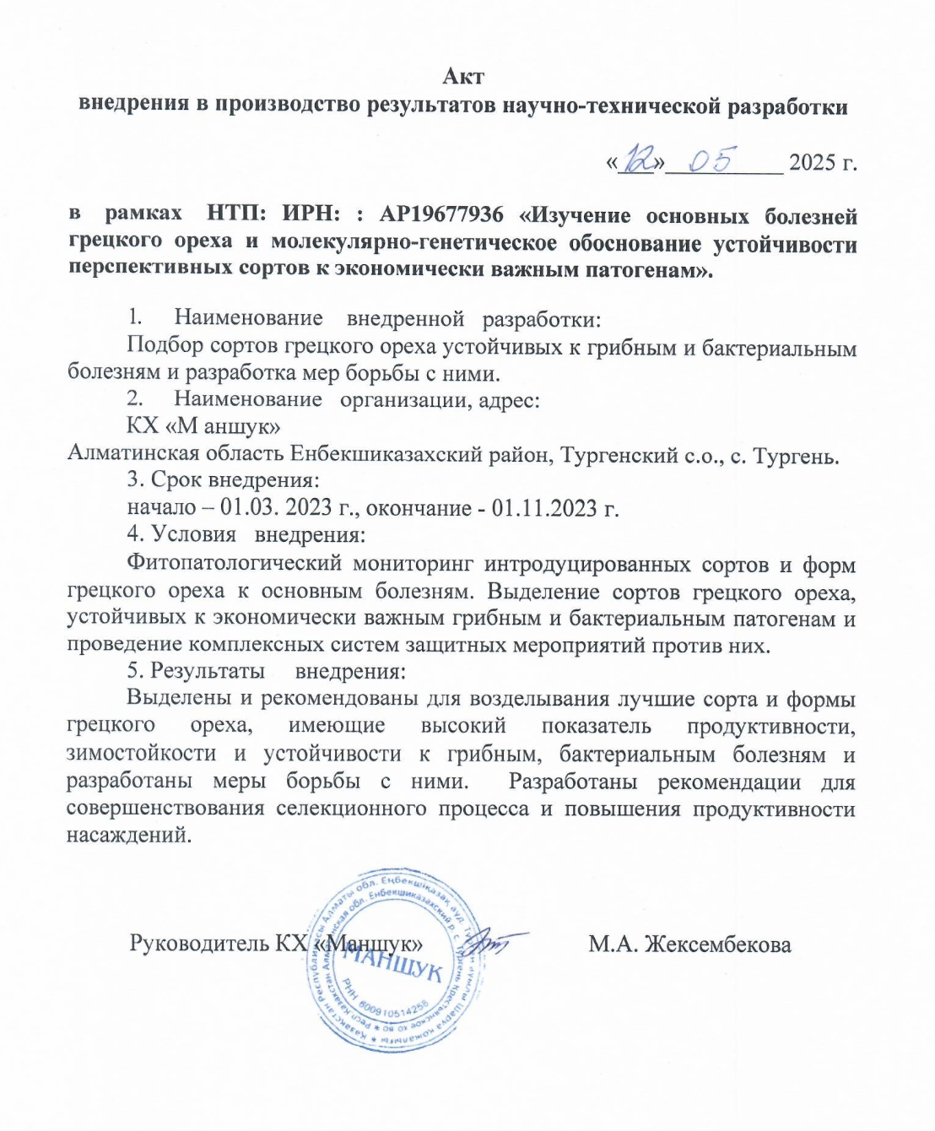

APPENDIX D

Extract from completed works

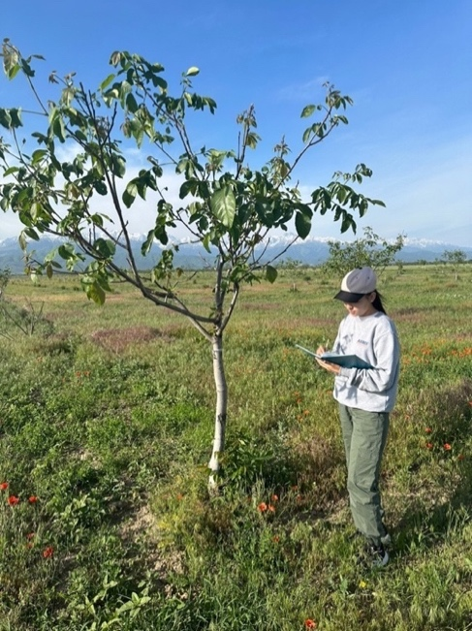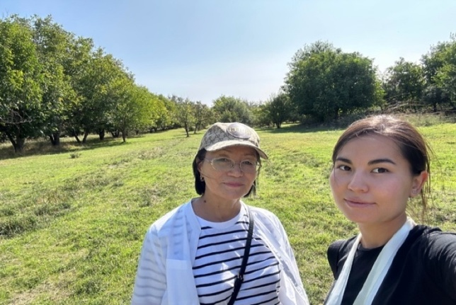

Figure D.1 – Field Monitoring

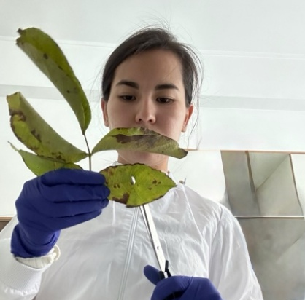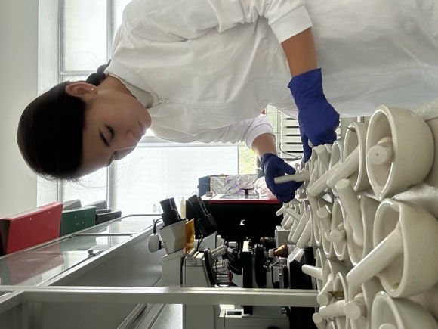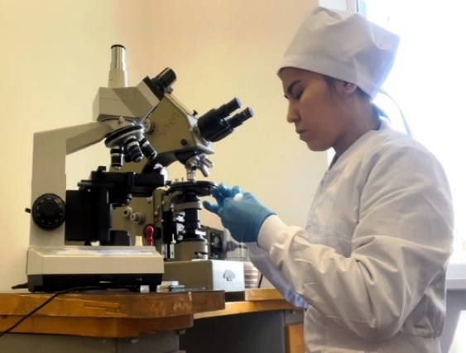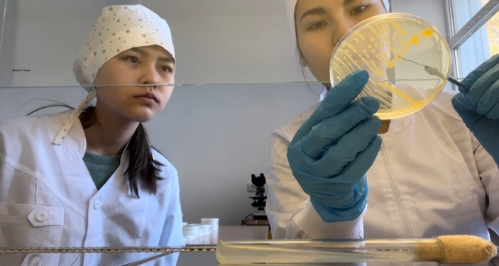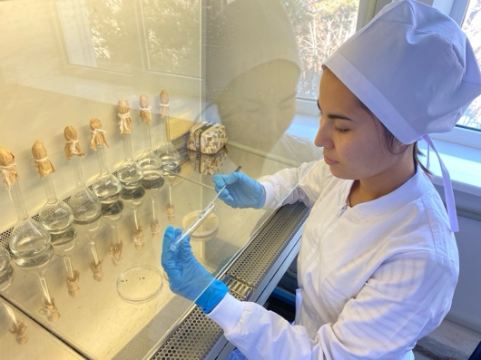

Figure D.2 – Process of Isolating Pure Cultures

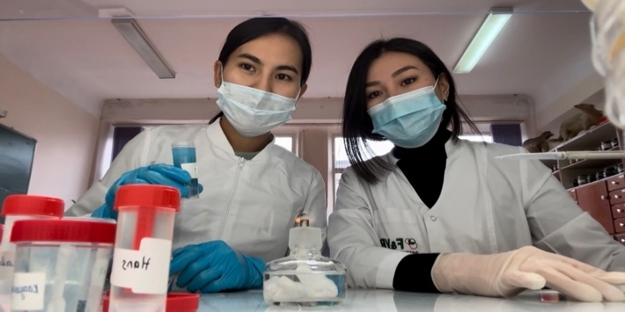

Figure D.3 – Experiment on the Inhibition of Pathogens by Fungicides and Bacterial Preparations
Continuation of Appendix D

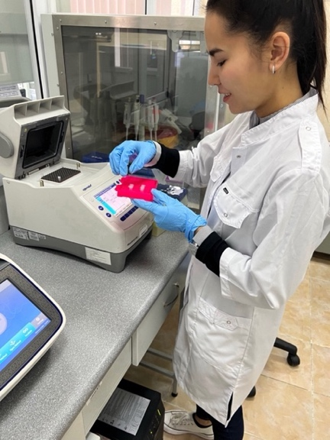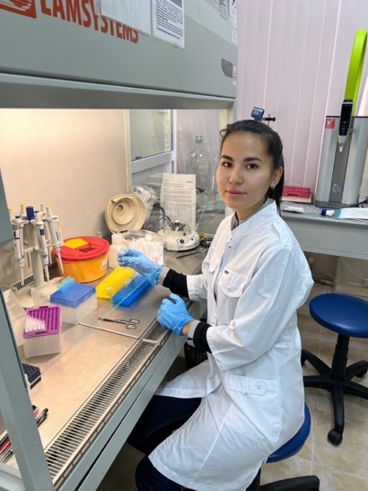

Figure D.4 – PCR Setup Process

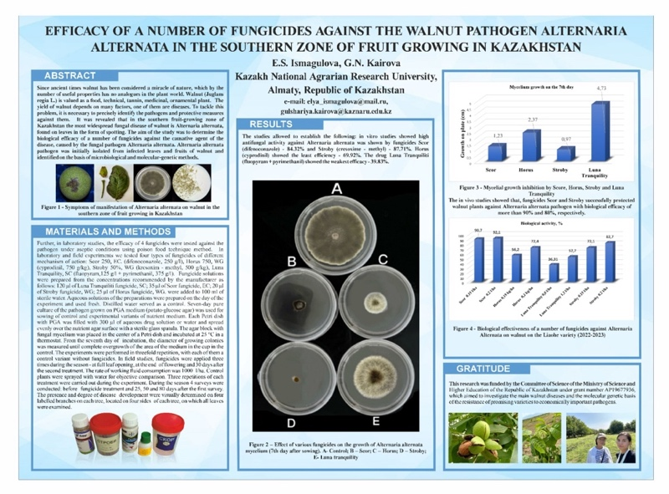

Figure D.5 – Poster or participation in the “International Conference on Plant Biology and Biotechnology (ICPBB 2024), Almaty, Kazakhstan, June 3–6, 2024 – p.151. ISBN 978-601-08-4104-8”

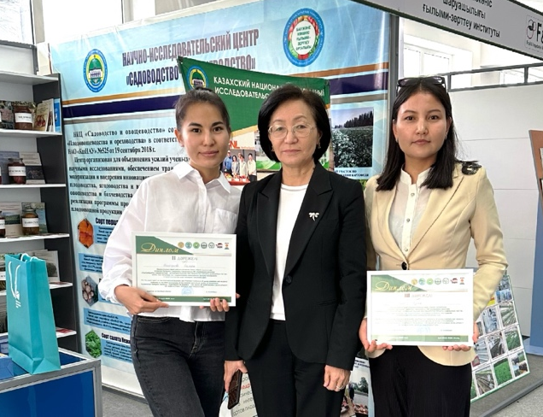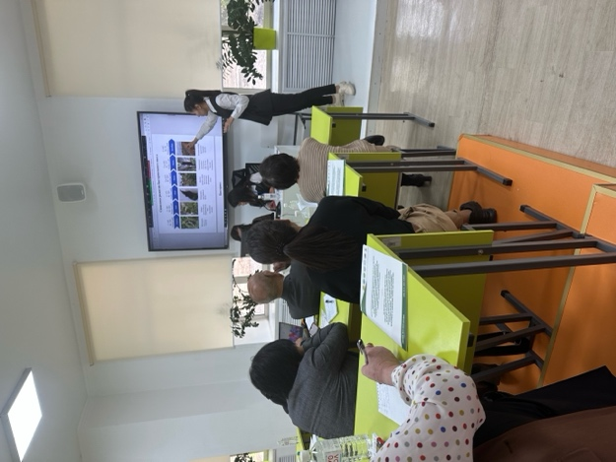

Figure D.6 – Participation in the Conference: Continuity in Science as the Basis for Sustainable Development of Agricultural Science and Production

APPENDIX E

Certificates



Figure E.1 –Second Degree Diploma for the Best Report at the International Scientific and Practical Conference of Young Scientists and Students dedicated to the 90th anniversary of the honored agricultural worker of Kazakhstan, Academician Kaldbek Sabdenov, “Continuity in Science — the Basis of Sustainable Development of Agricultural Science and Production”

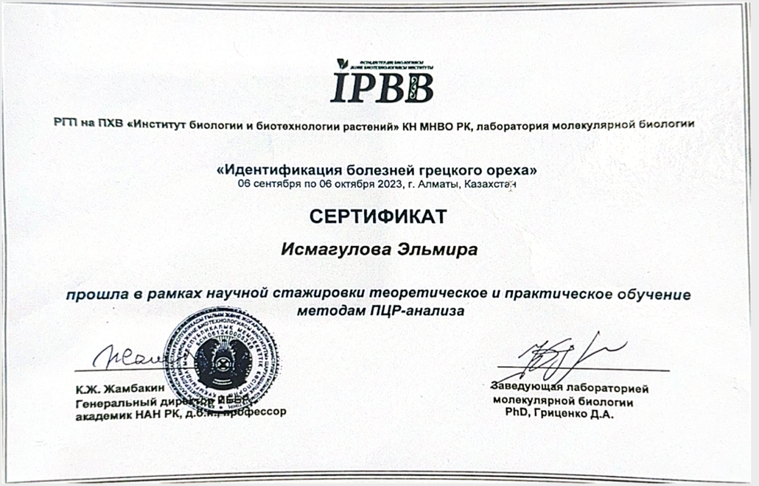

Figure E.2 – Certificate of Completion of Theoretical and Practical Training in PCR Analysis Methods as Part of the Scientific Internship “Identification of Walnut Diseases”
Continuation of Appendix E

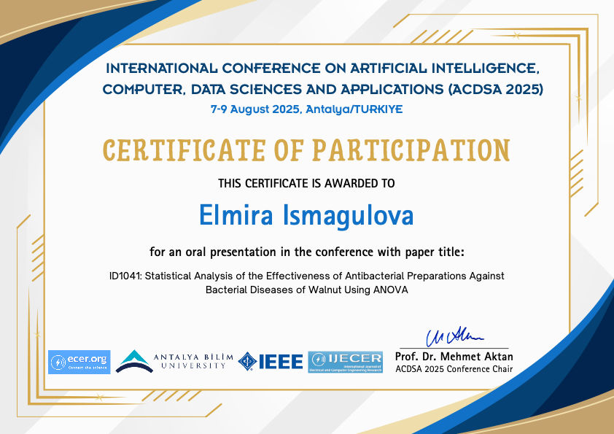

Figure E.3 – Certificate of Participation in the International Conference on Artificial Intelligence, Computer, Data Sciences and Applications (ACDSA 2025)



Figure E.4 – CDC Division of Laboratory Systems Training Certificate in Basic Molecular Biology Module 4: PCR and Real-Time PCR

