The Kazakh-British Technical University

On the rights of manuscript

Xia Yin

Regenerated Nanocellulose Stabilized CO₂ Foam and its Application
in Enhanced Oil Recovery
8D07108-Nanotechnology and Nanomaterials (by areas of application)

Dissertation, Doctor of Philosophy (PhD)

Scientific consultant:
Doctor of Chemical Sciences, Professor
Saule B. Aidarova
PhD, Professor
Wanli Kang
Foreign scientific consultant:
PhD, Associate Professor
Hongbin Yang

The Republic of Kazakhstan
Almaty, 2026

ABSTRACT
CO2 foam provides an efficient technology for anti–gas channeling in low-permeability reservoirs [64, p.1]. However, a critical challenge is the severe instability of conventional foams under harsh reservoir conditions of high temperature and salinity [64, p.1]. In this work, a CO₂ foam reinforced with a bio-resourced regenerated nanocellulose (RC) was introduced to enhance the foam stability under a specific low permeable oil reservoir condition. And then they were compared with stabilizer-free foam. Note that the foam stabilized by RC were shown as the most stable foam under reservoir situations.
The static and dynamic stability of foams was systematically assessed using the modified Ross-Miles method, Warning Blender method, and oscillatory shear rheology [63, 64, p.2-3]. In addition, the evolution of foam over time was quantitatively characterized via multiple light scattering and visualization in a double-layer glass micromodel. Based on these approaches, the stabilization mechanism of regenerated cellulose (RC) and other nanomaterials was proposed and substantiated by correlating foam half-life, solution viscosity, morphological observations, and foam stability metrics. The results demonstrated that the foam formulated with 1% SS163 and 1% RC exhibited the highest stability and regeneration capacity among all systems tested. Furthermore, the dynamic evolution of film thickness and bubble diameter revealed a four-stage aging process characteristic of RC-reinforced CO₂ foam. RC has both the viscosity-thickening properties of the polymer and the stability mechanism of the particles, which effectively improves the stability of foam system. Stabilization mechanisms of RC-stabilized CO₂ foam mainly include: viscosity thickening liquid to slow liquid drainage; RC particles stabilizing foam interface and liquid film; sustained releasing of water stabilizing foam liquid film. Afterwards, the influencing factors such as temperature and salinity of this reinforced foam were evaluated to ensure its performance under different reservoir conditions and application range.
In addition, we introduce the regenerated cellulose in the application of EOR and present the unique stabilization mechanism of RC on CO₂ foam. The interface stabilizing capacity, viscoelasticity, thickened behavior and sustainability of regenerated cellulose highlights the application potential in EOR. Afterwards, the conformance control and EOR performances were evaluated via flooding experiments at representative reservoir conditions of 85ºC and 59737.6 mg/L [63, p.3]. Results have demonstrated that: Compared with CO₂ foam without RC, the CO₂ foam flooding with RC improved the sweep efficiency and increased the injection pressure from 0.20 to 3.1 MPa in the core flooding experiments, suggesting the diversion of fluid from high permeable to low permeable zone. In terms of the EOR, the CO₂ foam flooding with RC improved the oil recovery from 35.5% to 56.4% by core-flooding experiments; the underlying mechanisms are attributed to oil emulsification, rock wettability alteration and foam deformation [63, p.8]. It shows that the presence of RC effectively increases the resistance coefficient and plugging effect of the foam system and reinforces its temperature resistance. Foam flooding can block high-permeability layer through Jamin effect, improving the apparent viscosity of flooding fluid to increase the sweep efficiency, and improving the oil displacement efficiency through emulsification, foam deformation, and etc., thereby improve the overall EOR [63, p.8-9]. The RC-stabilized CO₂ foam exhibits good stability, anti-liability performance, preventing gas breakthrough and EOR effects. As a bio-sourced environmentally friendly material, RC effectively improves the stability and resistance of the system, therefore, have great potential application prospects and practical significance. These insights provide new approaches to maintain foam stability, improve conformance control and EOR performances in heterogenous tight oil reservoirs under harsh conditions.
Keywords: CO₂ foam system, foam stability, regenerated cellulose, stabilization mechanism, enhanced oil recovery

CONTENTS
ABSTRACT 2
SYMBOLS AND ABBREVIATIONS 7
ACKNOWLEDGMENT 10
1. INTRODUCTION 11
2. Literature review 21
2.1 Petroleum and gas development 21
2.2 Enhanced oil recovery by CO₂ flooding 22
2.3 Foam and composition of foam system 28
2.4 Stability mechanism and influencing factors of foam 31
2.5 Application of Regenerated Cellulose 34
2.6 Block situation of Changqing Oilfield 35
2.7 The research scheme 37
3. Material and methods 39
3.1 Material 39
3.2 Foam stability evaluation by Ross-miles and Warning Blender method 41
3.3 Foam stability evaluation by multiple light scattering methods 43
3.4 Morphological inspection of CO₂ foam 45
3.5 Zeta potential analysis 46
3.6 Scanning electron microscope (SEM) 46
3.7 Laser Particle Size Analysis 47
3.8 Micro-model flooding experiment 47
3.9 Heterogeneous core flooding experiment 49
4. Results and Discussion 51
4.1 Formulation of CO₂ foam system 51
4.1.1 Foaming capacity of different surfactants in CO₂ foam 51
4.1.2 Stability and its mechanism of CO₂ foam with different stabilizers 53
4.2 Stabilization mechanism of regenerated cellulose on CO₂ foam 65
4.3 RC reinforced CO₂ foam and its influencing factors 80
4.3.1 Temperature 81
4.3.2 Salinity of brine water 87
4.4 Performance of CO₂, water and CO₂ foam flooding on micro-scale 91
4.5 Conformance control and enhanced oil recovery performances at core-scale 97
5. Conclusions 102
REFERENCES 104

SYMBOLS AND ABBREVIATIONS
CO₂ Carbon dioxide
RC Regenerated cellulose
EOR Enhanced oil recovery
DLVO Derjaguin, Landau, Verwey, and Overbeek theory (describes the case where van der Waals forces are present in combination with electrostatic forces)
SAGD Steam assisted gravity drainage
ATC Interaction parameter between the CO₂-like tails of surfactants and CO₂
ATT Interaction parameters between CO₂ like tails of surfactants
ACC Interaction parameters between CO₂ molecules
AHW Interaction parameter between hydrophilic head and water molecules
AHH Interaction parameters between hydrophilic heads
AWW Interaction parameter between water molecules
AOS Alpha-olefin sulfonate
AES Alkyl ethoxy sulphate
SDS Sodium dodecyl sulfate
SiO₂ Silica dioxide
Al₂O₃ Aluminum oxide
HPAM Partially hydrolyzed polyacrylamide
DLS Dynamic Light Scattering
T Transmission
P Pressure
BS Backscattering
Fc Foam composite index
V₀ Initial foam volume (maximum foam volume)
TSI Turbiscan Stability Index
t_{f} Foam half-time
t_{d} Foam drainage half-time
LSW Lifshitz, Slezov, and Wagner theory
AN Anionic-nonionic
A Anionic
N Nonionic
ω Rate of Ostwald ripening
R Universal gas constant
T Ambient temperature
γ Interfacial tension
r Droplet radii of foam
V_{m} Molar volume of CO₂ employed
C∞ Saturation solubility of CO₂
D Diffusion coefficient of bubbles in continuous phase
r_{N} Number average radius.
R₁, R₂ Principal radii of curvature
Π Disjoining pressure
ζ Zeta potential
EDL electric double layer
PV Pore volume
WAG Water altering gas (injection mode)

ACKNOWLEDGMENT
My thanks and appreciation go to my dear supervisors Prof. Saule B. Aidarova, Prof. Wanli Kang, and Prof. Hongbin Yang. Prof. Aidarova impresses me with her enthusiasm for scientific research and active communication with experts, which always encourages me. Prof. Kang has guided me both in the research work, career and daily life throughout my PhD study. I am also proud and benefited from his over 30 years of experiences in the oilfield, colloid chemistry and application in enhanced oil recovery. His attitude towards precise experiment data and research work inspires me to study further and further in my own research. Thanks to Prof. Yang, he always gave me suggestions and comfort when I am stuck with issues during the experiments.
I would like to show my respect and thanks to Rector Maratbek Gabdullin, Dean Nurzhan B. Beisenkhanov, Vice Rector Nazym Akhanova, and the support of Kazakh-British Technical University (KBTU). I also would like to thank Prof. Stefan Iglauer from Edith Cowan University, Associate Prof. Bauyrzhan Sarsenbekuly, as well as many other cooperators for their kind help with my research work. Thanks to my friends, and teammates Ph.D. candidates Xi Li, Qingzhu Meng, Raziya, and so many people who have helped me. Meanwhile, I also take this opportunity to thank my families, without their support, I wouldn’t be able to complete my study.

INTRODUCTION

The general characteristics of the study
This study aimed at the reinforced foam by regenerated nanocellulose, and the stability, stabilization mechanism and conformance control and enhanced oil recovery performance of reinforced foam were evaluated and studied in detail.
Firstly, this study provides a novel CO₂ foam reinforced by regenerated nanocellulose (RC) to overcome the poor stability of conventional foams under harsh reservoir conditions (85°C, 59,737.6 mg/L salinity). By integrating static/dynamic stability assessments (Ross-Miles, Warning Blender, rheology), and foam dynamic analysis (multiple light scattering, double-layer glass models), the research establishes RC as a superior stabilizer compared to other conventional stabilizers such as particles and polymer at reservoir condition. In the formulation part, the optimum type and concentration of surfactant (compatible with reservoir brine water, foaming capacity, foam stability) and stabilizers (the foam stability) were selected.
Secondly, the work elucidates RC’s unique and integrated stabilization mechanism by rheology study, dynamic analysis by multiple light scattering on macroscopic scale and microscopic study via double layer glass model, and studied the instinct characteristic of RC by Laser size analyzer and SEM. The stabilization mechanism were summarized based on experimental results and theoretical analysis as viscosity thickening, particle adsorption, releasing the water bound in RC molecules, and formation of liquid skeleton.
Moreover, the influencing factors such as temperature, salinity, and their impact on CO₂ foam reinforced by RC were studied to explain the mechanism for those changes and evaluate the foam application conditions.
Lastly, the study quantifies the foam flooding by reinforced CO₂ foam by RC on conformance control and EOR performance in heterogeneous tight oil reservoirs by micro-flooding and heterogenous core flooding experiments.

Relevance of the study
Unconventional reservoirs such as tight and shale oil reservoirs have been one of the most important resources for world fossil energy demand. CO₂ foam flooding is critical for improving sweep efficiency in CO₂-enhanced oil recovery (CO₂-EOR) by mitigating gas channeling. However, conventional foams destabilize under high-temperature, high-salinity reservoir conditions, limiting their industrial applicability. This study addresses this gap by introducing RC, a bio-sourced, eco-friendly nanomaterial, to stabilize CO₂ foam. The findings provide novel insights into foam stabilization mechanisms and advance sustainable solutions for maximizing oil recovery in challenging reservoirs.

The purpose of research
To develop and evaluate a high-performance RC-reinforced CO₂ foam system for improving stability, conformance control, and EOR efficiency under harsh reservoir conditions (85℃, 59,737.6 mg/L salinity), while elucidating its stabilization mechanisms and practical applicability.

Research tasks
- Formulate and ultimate the foam stability of RC-stabilized CO₂ foam and compared with conventional stabilizers, and stabilizer-free systems under high temperature and high salinity reservoir conditions.
- Establish the comprehensive foam dynamics evaluation method by multiple light scattering method, and morphological inspection of foam size and film thickness by double-layer glass model.
- Characterize RC’s unique stabilization mechanism via foam size and film thickness dynamics by morphological inspection, rheology, and multiple light scattering methods.
- Evaluate conformance control and EOR mechanism and performance of RC reinforced CO₂ foam through micro-flooding and core flooding experiments.

Objects of study
Regenerated nanocellulose stabilized CO₂ foam with anionic-nonionic surfactant SS163. Regenerated nanocellulose is a range of cellulose with CI (crystallinity index) of 24.41% and mostly diameter 5-10 nm, length 100-400 nm.

Subject of study
CO₂ foam with anionic-nonionic surfactant SS163 and regenerated nanocellulose as stabilizer was formulated for good compatibility with reservoir water, foaming capacity, and stability under harsh reservoir conditions. Then, the unique stabilization mechanism of RC for CO₂ foam was studied. The influencing factors for the foam were also evaluated. Lastly, the conformance control as well as EOR mechanism and performance were quantitatively analyzed and summarized.

The main provisions for the defense
1. RC-stabilized CO₂ foam exhibits superior stability compared with other types of stabilizers such as HPAM under high temperature and high salinity reservoir conditions (85℃, 59,737.6 mg/L). 1% SS163 + 1% RC CO₂ foam has the highest foam stability and foaming capacity.
2. The RC stabilized foam experiences four-stage dynamic foam aging: Oswald ripening-dominating process, drainage-dominated thinning, RC-mediated stabilization, water release process. RC has both the viscosity-thickening properties of the polymer and the stability mechanism of the particles. Unique stabilization mechanism of RC-stabilized CO₂ foam mainly includes viscosity thickening liquid to slow liquid drainage; RC stabilizing foam interface and liquid film; sustained releasing of water.
3. The temperature resistant and salt tolerance performance of CO₂ foam reinforced by RC was demonstrated by ambient and high-temperature high-pressure foam analyzer. Reinforced foam half-life was elongated by around 3-4.5 times, while drainage half-life extends by 5-10 times at 25-85°C under ambient pressure and 8 MPa contrast with sole surfactant foam. In the salinity range from 0-6×10⁴ mg/L, foaming capacity and half-life of RC foam decreased slightly by 7% and 20%. In the salinity range from 0-6×10⁴ mg/L, foaming capacity and half-life of RC foam decreased slightly by 7% and 20%
4. The core flooding experiments shows that RC enhances sweeping efficiency by increasing injection pressure (0.20 → 3.1 MPa) and diverting fluid to low-permeability zones. RC foam improves oil recovery by 20.9% (35.5% → 56.4%) compared with water flooding; meanwhile, the micro-flooding experiments illustrated the conformance control and EOR mechanism of foam with RC is emulsification, wettability alteration, lamella division and Jamin effect.
The performance of RC stabilized foam guarantees the application potential in the reservoirs, and RC’s bio-sourced nature offers environmental and operational advantages.

Scientific novelty
Regenerated nanocellulose (diameter 5-10 nm, length 100-400 nm) was introduced novelly into CO₂ foam. Hereby, a stable CO₂ foam under high temperature and high salinity reservoir condition was proposed, which is consisted of 1.0% surfactant SS163+1.0% regenerated cellulose. Its stability is ~20 times higher than without RC.
The unique stabilization mechanism of RC-stabilized CO₂ foam was found, including: viscosity thickening liquid to slow liquid drainage, 0.5% RC forms network, 1.0% improves viscosity significantly; RC particles stabilizing foam interface and liquid film and elongate the foam film by ~ 8 times; RC network sustained releasing of water; formation of the foam skeleton by RC inhibiting the Oswald ripening.
The core flooding experiments shows that RC enhances sweeping efficiency by increasing injection pressure (0.20 → 3.1 MPa) and diverting fluid to low-permeability zones. RC foam improves oil recovery by 20.9% (35.5% → 56.4%) compared with water flooding; meanwhile, the micro-flooding experiments illustrated the conformance control and EOR mechanism of foam with RC is emulsification, wettability alteration, and Jamin effect.
The novelty and originality of the work lies in the fact that for the first time, and it ensures the potential for the application in conformance control and enhanced oil recovery:
1. An extremely stable CO₂ foam under high temperature and high salinity reservoir condition was formulated, which consisted of 1.0% surfactant SS163+1.0% regenerated cellulose. Regenerated cellulose (diameter 5-10 nm, length 100-400 nm) was introduced novelly into the stabilization of CO₂ foam and applied in enhanced oil recovery. CO₂ foam reinforced by RC has a higher stability (~20 times longer half-life) than foam with only surfactant.
Related results are published as first author in the journal: A temperature and salinity resistant CO₂ foam reinforced by regenerated cellulose and its anti-channeling Performance: Conformance control and geo-storage in low-permeability reservoirs, Fuel, 408, 2026, 137598. https://doi.org/10.1016/j.molliq.2024.125969
2. This study revealed the unique stabilization mechanism of RC-stabilized CO₂ foam for its special effect of foam film “skeleton” formation by RC and sustained release water from RC network. Regenerated nanocellulose has the synergetic effect of both natural polymer and nanomaterials, therefore, its stabilization mechanism include: viscosity enhancement to slow liquid drainage; RC attachment stabilizing foam interface and liquid film and elongate the foam film by ~ 8 times; RC network sustained releasing of water; formation of the foam “skeleton” by RC inhibiting the Oswald ripening.
Related results are published and presented as first author in the conference paper: The stability, conformance control and enhanced oil recovery study on a novel reinforced CO₂ foam by regenerated cellulose, The First International Conference on Energy and Enhanced Oil Recovery, 2024.
3. The conformance control and enhanced oil recovery mechanism of CO₂ foam reinforced by RC is revealed as oil emulsification, rock wettability alteration, Jamin effect, and lamella division. The core flooding experiments shows that RC enhances sweeping efficiency by increasing injection pressure (0.20 → 3.1 MPa) and diverting fluid to low-permeability zones. RC foam improves oil recovery by 20.9% (35.5% → 56.4%) compared with water flooding; meanwhile, the micro-flooding experiments illustrated the conformance control and EOR mechanism of foam with RC is emulsification, wettability alteration, and Jamin effect.
Related results are published as first author in the journal: The conformance control and enhanced oil recovery performance of CO₂ foam reinforced by regenerated cellulose, Journal of Molecular Liquids, 2024, 415, 125969. (Cite score=10.2, first author) https://doi.org/10.1016/j.molliq.2024.125969

Scientific and practical significance of the work
Scientific: Advances understanding of bio-nanomaterials in foam stabilization and provides a framework for designing sustainable EOR agents.
Practical: RC-stabilized foam offers a cost-effective, eco-friendly solution to improve oil recovery in high-temperature, high-salinity reservoirs, reducing reliance on synthetic chemicals.

Personal contribution of the author
The presented research design, experiments and analysis were all conducted by Xia Yin independently. Foam formulation and evaluation experiments, as well as the quantitative evaluation methods were designed and executed; in particular, the double-layer glass model for foam aging analysis and multiple light scattering method for foam stability analysis were established. Based on which, the stability mechanism of CO₂ foam by RC were summarized and confirmed by rheology, microscale film lamellar quantitative study, and SEM characterization. Meanwhile, the micro-scale and core flooding tests and interpreted EOR mechanisms were conducted. Lastly, proposed RC’s stabilization mechanism and validated its industrial relevance.

Reliability of results
Results validated through triplicate experiments and statistical analysis.
Consistency across multiple methods: Ross-Miles, rheology, core flooding.
Alignment with existing theories (DLVO, Marangoni effect).

Approbation testing of thesis
The results obtained were reported and discussed at the following international conferences: Findings presented at “First International Conference on Energy and Enhanced Oil Recovery”, Almaty, 2024, “Colloids and Nanotechnologies in Industry” International Scientific and Technical Conference, Almaty, 2025 (first author, oral presentation) and published in Fuel (Q1, IF=7.5, first author) and Journal of Molecular Liquids (Q1, Citescore=10.2, first author),. Meanwhile, other publications also include papers on Advances in Colloid and Interface Science (Q1 top), and Applied Energy (Q1 top).

Publications and conferences during PhD
1. Xia Yin, Ning Kang, Saule Aidarova, Wanli Kang, Maratbek Gabdullin, Miras Issakhov. The conformance control and enhanced oil recovery performance of CO₂ foam reinforced by regenerated cellulose, Journal of Molecular Liquids, 2024, 415, 125969. https://doi.org/10.1016/j.molliq.2024.125969
2. Xia Yin, Ning Kang, Wanli Kang, Maratbek Gabdullin, Nazym Akhanova, Saule Aidarova, A temperature and salinity resistant CO₂ foam reinforced by regenerated cellulose and its anti-channeling Performance: Conformance control and geo-storage in low-permeability reservoirs, Fuel, 408, 2026, 137598. https://doi.org/10.1016/j.fuel.2025.137598
3. Xia Yin, Saule Aidarova, Wanli Kang, The stability, conformance control and enhanced oil recovery study on a novel reinforced CO₂ foam by regenerated cellulose, “First International Conference on Energy and Enhanced Oil Recovery”, Almaty, 2024, (conference, first author).
4. Xia Yin, Saule Aidarova, Wanli Kang, Hongbin Yang, Bauyrzhan Sarsenbekuly. Unique stabilization mechanism of evaluation of reinforced CO₂ foam with regenerated nanocellulose, “Colloids and Nanotechnologies in Industry” International Scientific and Technical Conference, Almaty, 2025 (conference, first author).

Relation of the dissertation topic with the plans of scientific works
Aligns with national/institutional priorities on sustainable EOR technologies and carbon neutrality (e.g., CO₂ utilization, bio-nanomaterials). Extends prior work on nanoparticle-stabilized foams by introducing RC as a greener alternative. RC-stabilized foam offers a cost-effective, eco-friendly solution to improve oil recovery in high-temperature, high-salinity reservoirs. This work was carried out with joint scientific cooperation between KBTU and China Petroleum University.

Structure and volume of the dissertation
Structure: 5 chapters (Introduction, Literature Review, Methodology, Results, Conclusions).
Volume: 111 pages, including 36 figures, and 2 tables, 65 references.

LITERATURE REVIEW

2.1 Petroleum and gas development
Despite the transformation of energy structure, fossil fuels will still be the main source of energy for the next half-century according to the reports of the International Energy Administration (IEA) [1,2]. Therefore, Oil and gas field development is critical for meeting global energy demands, driving economic growth, and ensuring energy security. It involves extracting hydrocarbons efficiently while maximizing recovery rates. The process typically includes three stages: 1) Primary Recovery: Utilizes natural reservoir pressure to produce oil; 2) Secondary Recovery: Injects water or gas to maintain reservoir pressure and displace oil; 3) Tertiary Recovery (Enhanced Oil Recovery, EOR): Applies advanced techniques to recover residual oil trapped in reservoirs, significantly boosting recovery rates [3,4]. Usually, after primary and secondary flooding, problems such as lack of energy, formation of preference pathway in the heterogenous reservoirs could be severe, which results in the low efficiency of water flooding and high watercut of produced fluid. In this case, tertiary recovery targets oil unreachable by primary/secondary methods, extending field life and improving resource utilization. Key EOR methods include chemical flooding (e.g., polymers, surfactants), gas injection (e.g., CO₂, nitrogen, hydrocarbon gas), thermal methods (e.g., steam injection, SAGD), microbial EOR and combined flooding with more than one method [4]. The overall EOR mechanism of different methods are summarized as increase of the sweep efficiency and displacement efficiency. Sweep efficiency: Improved by methods that redirect injected fluids to un-swept zones (e.g., polymer thickening, foam blocking, microspheres). Displacement Efficiency: Enhanced by reducing oil-rock adhesion (e.g. surfactants) or altering oil mobility (e.g., thermal thinning).
In the chemical flooding, polymers increase water viscosity and thus decrease the relative mobility ratio between water and oil, so that increase the sweeping efficiency (volumetric coverage); surfactants reduce interfacial tension, and reduce the viscosity of oil, so that increase the displacement efficiency (oil mobilization). As for gas flooding, different kinds of gas could be applied to increase the reservoir energy and under certain circumstances, gas can be miscible with crude oil to form one phase to decrease the flowing resistance and enhance oil recovery. Steam in the thermal methods can decrease oil viscosity and increase the oil volume thermally, boosting both sweep and displacement efficiency.

2.2 Enhanced oil recovery by CO₂ flooding
Of all the gas flooding method, CO₂ is a very important gas in the gas flooding or huff-puff in particular. CO₂-EOR mechanisms include molecular diffusion, CO₂-oil interaction, and CO₂-fluid-rock minerals interaction [5]. Furthermore, it can reaches the supercritical state defined by its critical point, which is approximately 31°C (88°F) and 7.4 MPa (1070 psia) [6]. And supercritical CO₂ performs as an organic solvent to extract the light hydrocarbon in the crude oil.
Firstly, CO₂-crude oil interaction mechanism is the most important of EOR mechanism. CO₂ dissolves into crude oil, increasing oil volume (swelling effect) and reducing oil density and viscosity, thereby improving mobility. And CO₂ selectively extracts light hydrocarbons (C5–C30), further reducing oil viscosity and improving recovery. Meanwhile, above the minimum miscible pressure (MMP), CO₂ achieves dynamic miscibility with oil, eliminating interfacial tension (IFT) and enabling near-complete displacement [5].
Since the development of CO₂ flooding technology in the 1950s [5], the technology and application research of CO₂ flooding have developed rapidly. In the early 1950s, Whorton et al. published the first patent for using CO₂ for oil recovery, explaining the main principle of CO₂ in the oil recovery process [6]. Between 1960 and 2000, CO₂ flooding technology was greatly developed abroad, and field trials of CO₂ flooding were gradually carried out in some technologically advanced countries or regions. Reports showed that the recovery rate could be increased by 10-25%, and the effect of increasing recovery rate was significant [7]. According to statistics from the Oil and Gas Journal, as of 1994, a total of 137 gas miscible flooding projects had been carried out globally, with over 40% of them being CO₂ related projects. The United States has abundant CO₂ gas reservoirs, providing advantageous conditions for CO₂ flooding. There are up to 292 oil fields suitable for its application, and the recovery rate can be increased by 7% to 15% [5,6]. Since the 21st century, with the development of low-permeability oil reservoirs, the application of CO₂ flooding technology to improve oil recovery has been increasing. Among them, the application in the United States is the most mature, with over 90% of global CO₂ flooding production coming from the United States [8].
In the early 1960s, China began to gradually study CO₂ flooding technology and conducted experiments in oil fields. In the mid-1990s, Daqing Oilfield conducted four pilot field tests of CO₂ immiscible oil displacement in different regions or layers, and studied the injection method, design scheme, feasibility, and effectiveness of its application [9]. Subsequently, Shengli Oilfield also carried out field tests of CO₂ flooding [12]. However, due to limited early research and limited gas sources, the development speed of CO₂ enhanced oil recovery technology in China has been relatively slow. But with the discovery of small-scale CO₂ gas reservoirs, CO₂ operations have gradually increased. Pilot and expansion tests have been conducted in blocks such as Hei 59 and Hei 79 in Jilin Oilfield, and good results have been achieved. Especially in low-permeability reservoirs where water injection is difficult and water drive pressure is high, CO₂ drive has a significant effect on improving oil recovery in low-permeability formations and small fault block formations [10].
With the development of CO₂ flooding in the last sixty years, problems such as early gas breakthrough and short effective time due to the gas channeling and gravity override caused by high mobility of CO₂ limited the application of CO₂ flooding for enhanced oil recovery (EOR) [1, 3–5].
CO₂ foam has been considered as an effective method to prevent gas channeling, since it increases the apparent viscosity of fluid by Jamin effect, controls the mobility and improves the sweep efficiency, as shown in Figure 1 [4,6].
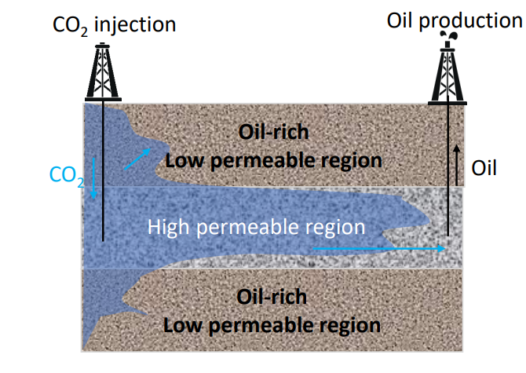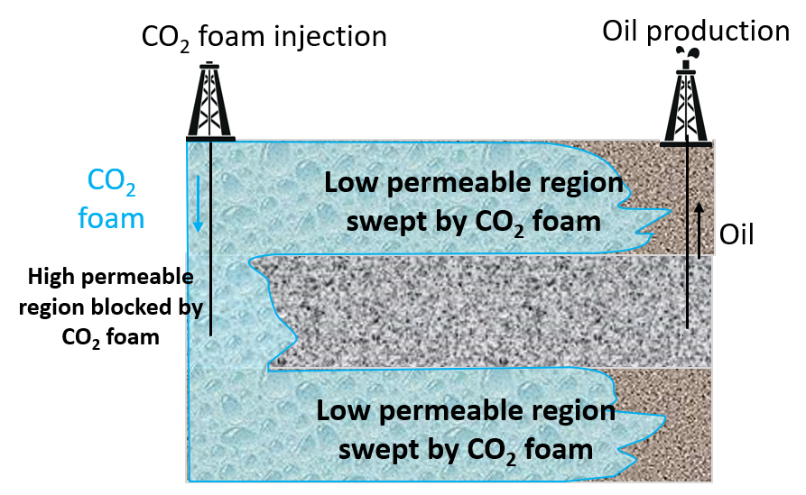
Figure 1 – Conformance control and EOR performance for CO₂ foam vs. CO₂

In order to improve CO₂ flooding efficiency, foam channeling prevention system is proposed as an effective method to control gas mobility and improve gas flooding effect, which can significantly improve sweep efficiency and oil washing efficiency. The main reason for the effect of foam on channeling prevention and enhanced oil recovery is the seepage characteristics of foam in porous media. The foam preferentially enters the high permeability large pore channel. Due to the high apparent viscosity of the foam system when flowing and Jamin effect in the pore channel, the flow resistance increases with the increase of foam injection volume, and the displacement fluid gradually flows into the low permeability small pore channel, expanding the swept volume. In addition, the high permeability layer has high water saturation, low oil content and good foam stability, while the low permeability layer has high oil saturation and poor foam stability, that is, the selective plugging of the water bearing high permeability layer by foam flooding leads to defoaming when encountering oil. The effect of these two factors results in uniform advancement within low-permeability oil reservoirs. In addition, the existence of foaming agent in foam system makes it improve oil recovery by enhancing oil washing efficiency. Therefore, foam flooding can significantly improve oil recovery, which can reach 10-25% in general [13]. Moreover, since the tight oil reservoir has low to ultra-low permeability, foam has another advantage over other chemical flooding methods-the dynamic in-depth conformance control performance. Usually, gel or polymer solution flooding into the low permeable formation leads to high injection pressure and difficulty of injection. Water-altering-gas injection of foam solution and gas leads to a lower injection pressure and can form foam during the dynamic migration in the reservoir. So that, the foam forms during the migration process, which can ensure the in-depth conformance control rather than a short range of conformance near the wellbore.
In recent years, researches on CO₂ foam system used to improve oil recovery has been more and more widely used. The research on its basic research, stability theory, process technology and mechanism has been constantly improved. Its foam system has gradually diversified from basic foaming agents, such as sulfonate type anionic surfactant, such as adding polymer and alkali to strengthen foam [7], composite foam [8], or adding other types of foam stabilizers, such as gel foam system [9], multiphase foam system, and even CO₂ responsive foam system. The stability under reservoir conditions, as well as the ability to control profile and enhance oil recovery, have also been improved.
Around 1950, based on the study of gas flooding, the study of foam system to control gas channeling and improve oil recovery was gradually carried out abroad. Fried's research on foam system in oil displacement in 1956 created a precedent in this field. Subsequently, foam oil displacement were applied [14,15], the United States was the first to carry out laboratory research on foam flooding and conducted pilot tests in the field [4, 13], which is mainly because the United States has rich carbon dioxide gas resources, providing a prerequisite for foam flooding [8, 10].
In the 1980s, China carried out laboratory research and small-scale field test of foam flooding, but the effect was not significant. In the 1990s, China began large-scale laboratory experimental research, and conducted pilot tests in Xinjiang, Daqing, Baise and other oilfields, and achieved good results [14]. In recent years, the application in low-permeability or ultra-low permeability reservoirs in Daqing Oilfield, Jilin Oilfield, and Changqing Oilfield has initially achieved a certain scale and good results. At the national level, the research and development of major projects and 863 projects in this field since this year have played an important role in promoting the application of foam flooding in oil fields [3].
At the same time, with the gradual attention of countries to environmental issues, the capture, storage and utilization of CO₂ has important strategic significance. CO₂ foam flooding combines the advantages of CO₂ flooding and foam flooding to reduce CO₂ emissions.
Nonetheless, the performance of conventional foams is often compromised under harsh reservoir conditions—such as high salinity, elevated temperature, acidic environments, and the presence of supercritical CO₂—leading to reduced stability and foaming capacity [3,7,8]. These limitations have hindered the widespread application of CO₂ flooding for enhanced oil recovery. Given that foam stability directly governs mobility control efficiency and overall EOR performance [3,7,9], substantial efforts have been directed toward developing advanced foam stabilizers, including polymers, solid particles, and nanomaterials [10–16].
Although polymers such as hydrolyzed polyacrylamide (HPAM) and guar gum have been widely employed as foam stabilizers, their susceptibility to thermal degradation, shear, and high salinity restricts their effectiveness, even under moderately harsh reservoir conditions [16,17]. In recent decades, nanoparticle-stabilized foams—utilizing materials such as SiO₂, metal oxides, ceramics, and polyethylene—have attracted considerable research interest [10,13,14,18,19]. However, the presence of metal ions and protons in formation water can interfere with the surface charge of nanoparticles, adversely affecting their interfacial adsorption and consequently limiting foam stability under reservoir-relevant conditions [29, p.2].

2.3 Foam and composition of foam system
Foam is a dispersion system composed of gas dispersion phase and liquid medium. Due to the large difference in density between gas and medium, without adding other substances, foam will quickly float up and be divided into two phases [17]. Under normal temperature and pressure, the volume proportion of gas in the foam system in the total volume of foam is called the foam mass, and when it is lower than 0.54, it is an aerated liquid. When the foam mass is between 0.54 and 0.96, it is foam. When it is greater than 0.96, it appears as fog [13]. When foam system is used to enhance oil recovery, foam system is usually composed of liquid, gas and foaming agent (surfactant). Gases include hydrocarbon gases, CO₂, air, N₂, etc.; Generally, other substances such as foam stabilizer and foam aid are added to adjust the foam performance [3].

    - Foaming agent
The requirements for foaming agent are firstly good foaming performance, strong foam stability and good compatibility with formation water. The types of foaming agents can be mainly divided into surfactant foaming agents, polymer foaming agents, and composite foaming agents. Currently, most of the surfactants used are surfactants, especially anionic surfactants.
(1) Ionic surfactant foaming agent
Anionic surfactants: mainly sulfonate, sulfate, and carboxylate types of surfactants, common ones include sodium dodecyl sulfonate (AS), sodium dodecylbenzene sulfonate (ABS), olefin sulfonate (AOS), sodium dodecyl sulfate (SDS), sodium fatty alcohol ether sulfate (ES), fatty acid soap, sodium phthalate ester, etc. [8,16]. Generally, this type of foaming agent has good foaming ability and moderate price, but poor electrolyte resistance and poor tolerance to high mineralization, especially water with high calcium and magnesium ions.
Cationic surfactants: mainly salts derived from organic amines, which can dissociate surface active cations in water. Due to its cationic nature, it has good tolerance to high mineralization, but its foaming performance is generally not as good as that of anions. Therefore, it has been studied less as a foaming agent compared to anionic surfactants.
Amphoteric surfactants: The surfactants dissociated from water have the characteristics of zwitterions and change with pH, such as betaine type, imidazoline type, amino shuttle acid type, etc. This type of foaming agent has low toxicity and can exhibit pH responsive characteristics, but the cost is relatively high.
(2) Non-ionic surfactant foaming agent
Non ionic surfactants exist in solution in the form of molecules or micelles, with hydrophobic ends typically consisting of carbon chains, benzene rings, and other alkyl groups, as well as polyoxypropylene chains, and hydrophilic ends typically consisting of polyoxymethylene chains, hydroxyl groups, or ether bonds. The commonly used types of foaming agents include ether series, polyoxymethylene fatty alcohol ether series, alkyl amine oxide, etc. [17].
The critical micelle concentration of non-ionic surfactants is relatively low, with high tolerance to mineralization and the ability to achieve low surface tension. However, their foaming performance is average. Additionally, considering the decrease in hydrogen bond strength between non-ionic surfactants and water due to temperature rise, the cloud point appears, which limits their use under high temperature conditions.
(3) Amphiphilic polymer foaming agent
This type of foaming agent refers to polymeric substances with high molecular weight, up to several thousand, tens of thousands, or even millions, and surface activity. For example, the copolymer of acrylamide and acetylacetone propionamide can be applied to mineralized water and condensate oil and gas well drainage [18].
(4) Composite foaming agent
The compounding of different types of surfactants can produce certain synergistic effects, such as improving their electrolyte resistance, improving cloud point to a certain extent, reducing surface tension, and improving the strength of the interfacial strength to a certain extent, which can improve the foaming ability and stability of their foam, or expand their scope of application.

2.3.2 Foam stabilizer
The substance that can stabilize the foam liquid film, effectively slow the liquid discharge of the liquid film and extend the life of the foam is called foam stabilizer. The mechanism of general foam stabilizers for foam stabilization includes: increasing the strength and viscoelasticity of the liquid film, and reducing gas permeation; increasing the viscosity.

2.4 Stability mechanism and influencing factors of foam
The morphology and structure of foam have a great impact on the stability of foam. There are two main types of foam structures: spherical foam with low gas-liquid ratio and polygonal foam with high gas-liquid ratio formed after aging [17]. The former only exists for a short period of time, while the latter is formed by the cross-linking of bubbles in thin and flat liquid films, which are called Plato boats [28].

2.4.1 The bursting process of foam
(1) Rupture mechanism of foam
The foam system is a thermodynamic unstable system. The reasons for the foam rupture are generally considered as follows, namely, the liquid discharge of the liquid film, Ostwald ripening, and bubble coalescence [17,18].
The precipitation of liquid in foam is the result of the mutual extrusion and gravity of bubbles. For vertical liquid films, gravity is the main cause of liquid precipitation in the film. In addition, the squeezing of bubbles is also one of the factors affecting the vertical liquid film discharge; For horizontal liquid films, bubble compression is the decisive cause of drainage. Its compression mainly comes from surface pressure. The intersection of each bubble in the foam (generally the intersection of three bubbles) forms the Platonic boundary. The capillary pressure caused by the curved interface makes the liquid transfer from the position of the level to the Platonic boundary [19].
For the foam system, the existence of the interface leads to high overall free energy and unstable thermodynamics. However, under the condition of the same amount of gas, the larger the surface area of the many and small bubble systems, the higher their free energy, the more unstable it is. Therefore, it shows a tendency to transform to the large and few bubble systems through gas diffusion. At the same time, the large bubbles float up, eventually leading to the collapse of foam. This phenomenon is known as the Ostwald ripening phenomenon [17].
Due to the thermodynamic instability of the foam system, the system is easy to reduce its surface area to reduce the free energy of the overall system, so the gas diffuses, the particle size increases, the liquid film gradually thins to burst, the gas bubbles coalesce, and gradually decay [28].
(2) Stability and stability mechanism of CO₂ foam
The stability of foam is of great significance to the effect of foam flooding. Only when it can exist stably for a long time under the formation conditions and effectively block gas channeling [13], can the enhanced oil recovery effect of foam flooding be obvious. During the stabilization of foam liquid film, the CO₂ hydrophilic balance value (HCB) is introduced, as shown in Formula 1-1.
HCB=(AHW-AHH-AWW)/(ATC-ATT-ACC) (1-1)
In the formula: ATC - the interaction parameter between the CO₂ like tails of surfactant and CO₂;
ATT - Interaction parameters between CO₂ like tails of surfactants;
ACC - Interaction parameters between CO₂ molecules;
AHW - the interaction parameter between hydrophilic head and water molecules;
AHH - Interaction parameters between hydrophilic heads;
AWW - Interaction parameter between water molecules.
The HCB value is used to characterize the size and force balance between the CO₂ friendly and hydrophilic groups of surface active substances.

2.5 Application of Regenerated Cellulose
Regenerated cellulose is cellulose obtained by treating cellulose from different sources with chemical or physical methods to reduce its size and particle size, and then re dispersing it (which can exist in different forms such as fibers, crystals, amorphous fibers, etc.) [34]. In the past decade, regenerated cellulose, especially nano cellulose, has received extensive attention due to its stable interface performance, which has enhanced its application in fields such as pharmacology, coatings, and materials science, such as material design in emulsions and foam [34-37]. According to the particle size of regenerated cellulose at the nanometer level, it is called nanocellulose. Nanocellulose generally exists in the form of fibers or crystals due to its concentrated particle size distribution and similar particle morphology. Amorphous nanocellulose may be a combination of various forms of cellulose regions, resulting in a more dispersed particle size distribution and significant differences in morphology [35-37]. The aggregation of cellulose particles at the interface, while the aggregation between dispersed phases is hindered by steric hindrance or electrostatic effects [38], thus it can play a good stabilizing role at the interface. In addition, nanocellulose also has good self-assembly performance and stable network structure in aqueous solution [39]. The many characteristics of nanocellulose, such as environmental friendliness, high surface area, low density, excellent thermal mechanical properties (high elastic modulus), anisotropy, convenient chemical modification, bio-compatibility, and its widespread presence in nature, have accelerated its existing development and discovered new possibilities for applications [40, 57].
In 1903 and 1907, Ranmsden and Picking's groundbreaking discovery of the role of solid particles on the interface established the research of particles in the field of stable emulsion and foam [18, 19, 41]. In recent studies, many researchers have used nanocellulose or regenerated cellulose as stabilizers for Pickering emulsions, and cellulose has shown excellent stability at the liquid-liquid interface [36]. Meanwhile, cellulose is a relatively stable substance with good tolerance to salts. The temperature also has good stability within the Changqing formation conditions. Research has found that the decomposition temperature of nanocellulose fibers is around 230 ° C, while the decomposition temperature in the amorphous region is slightly lower [37]. Marie Gestraniusa et al. [36,37] found in their study on the stability of O/W oil-water emulsions using nanocrystalline cellulose, nanofiber cellulose, and modified nanofiber cellulose (without the addition of other surfactants) [42] that the stable interfacial properties of nanofiber cellulose were better than those of microcrystals. The application of nano cellulose in foam (aerogel, foam composites) [40] has developed rapidly in the past 20 years. It is generally used as a framework to strengthen the strength of materials or as a carrier of groups to endow materials with functional properties. The aerogel formed by nano cellulose has the advantages of light weight, high strength and deformation recovery ability.
However, the research of nano cellulose in the field of foam mainly focuses on materials, medicine, biology, architecture and other fields, which are used for aerogels and materials with special properties.

2.6 Block situation of Changqing Oilfield
The reservoir of a block in Changqing Oilfield is a typical tight sandstone reservoir in Chang 8 member and the formation temperature and pressure are 85℃, 15 MPa, the matrix permeability is low, the flow channel type is mainly pore, there are micro cracks, severe heterogeneity, good sand body connectivity, stable oil reservoir distribution, and it belongs to the early stage of ultra-low permeability development. The formation water is CaCl₂ type, with a mineralization degree of about 60000 mg/L and a pH value of about 3 under reservoir conditions. Due to the low permeability, high injection pressure, high temperature, and high salt content of water flooding in the region, CO₂ flooding is adopted to improve the recovery rate by reversing the wettability of the reservoir core surface, reducing the oil-water interface tension, increasing formation energy, and reducing the density and viscosity of crude oil [1-3]. However, the development of micro cracks in the formation and long-term water injection in the region form water flooding dominant channels, and CO₂ is in a supercritical state with high fluidity under formation conditions, making it prone to gas breakthrough, viscosity fingering, and other phenomena [9, 11, 12], resulting in a low volume sweep coefficient, and easy occurrence of gas breakthrough and premature gas breakthrough. After gas breakthrough, the production decreases sharply, which inhibits the oil replacement.
Therefore, developing a robust CO₂ foam system capable of withstanding realistic reservoir conditions is of critical importance for enhancing oil recovery. In this context, cellulose has emerged as a promising material in colloidal systems due to its high viscoelasticity, low density, and excellent interfacial stabilization properties [15,19–23]. Recent studies on cellulose-stabilized Pickering emulsions and aerogels have highlighted its substantial potential in colloidal interface engineering [21,23–25]. Researchers have demonstrated that cellulose-based Pickering emulsions exhibit remarkable stability under diverse environmental conditions [26, 27, 58, 60]. Moreover, cellulose-stabilized aerogels, characterized by high mechanical strength and low density, are recognized as environmentally benign materials with broad applicability [22,25,28,54].
Despite these advances, the use of regenerated cellulose (RC) in aqueous foams for enhanced oil recovery (EOR) remains largely unexplored. In the present work, regenerated cellulose is introduced as a stabilizer to improve CO₂ foam stability under the challenging conditions of the CQ Oilfield (85°C, 15 MPa, high salinity, and reservoir heterogeneity). Through comparative evaluation with conventional foam systems, the superior stability of RC-stabilized foam is demonstrated. Furthermore, the distinct aging behavior and underlying stabilization mechanism of RC in aqueous CO₂ foam are systematically investigated using multiple light scattering, rheological analysis, and microscopic morphological observation.

2.7 The research scheme
In our research work, there are four major aspects, including CO₂ foam system and optimization, its influencing factors, stabilization mechanisms of different stabilizers, and CO₂ foam application in porous media core.
In the foam system formulation, the surfactants work as a foaming agents, while stabilizers such as nanoparticles and nano material work as a reinforcement agents for the CO₂ foam. Therefore, the formulation of this foam system with good foaming and stabilizing capacity is of great importance. Meanwhile, the selected foaming agents should be compatible with the reservoir brine water.
Then, the influencing factors such as temperature, pressure, salinity and aging time were evaluated to understand how different factors have a positive or negative effect on the foam. This is also important for the evaluation of the long-term stability and performance of foam in different conditions.
Afterwards, the stabilization mechanism of CO₂ foam with and without different stabilizers is studied by multiple methods in perspective such as rheology, interfacial behavior, rupture mechanisms, Ostwald ripening process, and foam film thinning process. Then, the unique stabilization mechanism of RC were compared with nanoparticles and polymers and summarized.
Finally, the conformance control and enhanced oil recovery performance of CO₂ foam in the application were studied by core flooding experiment and micro-flooding experiments. Thus, the application potential was evaluated and ensured.
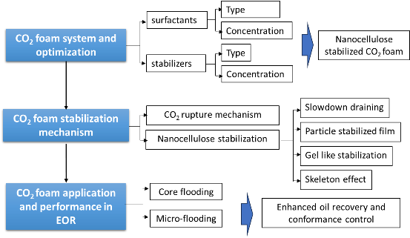

Figure 2 – The scheme line of the research

MATERIAL AND METHODS

3.1 Material
The regenerated cellulose (RC) was provided by Hangzhou Yeuhan Technology Co., Ltd. The surfactant SS163 was provided by Changxing Chemicals Co., Ltd. The chemical structure of regenerated cellulose with the CI (crystallinity index) of 24.41% and SS163 were illustrated in Figure 3 and Figure 4 [29, p.2]. RC with crystal and fiber was mostly 5-10 nm diameter and 100-400 nm length, characterized by SEM. The size distribution of RC in 1%SS163+1%RC was shown in Figure 4. NaCl, CaCl₂, Na₂SO₄, MgCl₂, NaHCO₃ (Analytical pure), surfactant AES, SDS, AOS and Sudan IV, methyl blue was purchased from the Sinopharm Chemical Reagent Co., Ltd. SiO₂ nanoparticles (d = 30 nm) and Al₂O₃ nanoparticles (d = 30 nm) were purchased from Sigma-Aldrich Co., Ltd. Deionized water were prepared by double distillation in the laboratory (resistance = 18.4 MΩ·cm) [63, p.2].
Member 8 of Yanchang Formation in Ordos Basin, China is a typical heterogenous tight oil reservoir with the characteristics of high temperature (85ºC), high salinity (59737.6 mg/L), and high pressure (15 MPa) [63, p.2]. The formation brine compositions included 10021.9 mg/L [Na⁺], 16859.5 mg/L [Ca²⁺], 21.6 mg/L [Mg²⁺], 32259.0 mg/L [Cl-], 24 mg/L [SO₄²⁻], and 335.5 mg/L [HCO³⁻]; the crude oil compositions include 0.97 wt% asphaltene, 2.80 wt% resin, 82.73 wt% saturated hydrocarbon, 13.5 wt% aromatic hydrocarbon, with the viscosity of 4.5 mPa·s and the density of 0.84 g/cm³[63, p.2]. The synthetic formation brine and as-received crude oil were used in the following experiments [63, p.2].

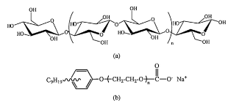
Figure 3 – Chemical structure of (a) regenerated cellulose and (b) surfactant SS163 [65, p.2].

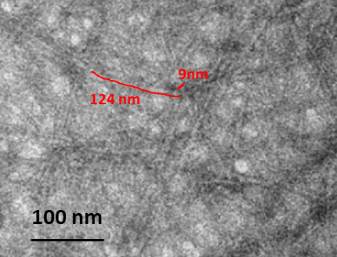
Figure 4 – Regenerated cellulose by TEM (Transmission Electron Microscope).

The artificial sandstone core was designed with permeability contrast at three layers (i.e., 20 mD, 200 mD, 20 mD respectively), to simulate the heterogeneity of the tight oil formations, as illustrated in Figure 5 [63, p.2-3].

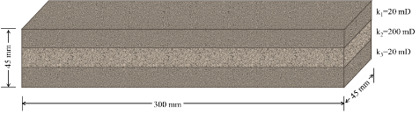
Figure 5 – The artificial sandstone core parameters [63, p.2-3]

The glass micro-model network was prepared based on the characteristics of pores and pore throats in tight sandstones, see details in Figure 6.

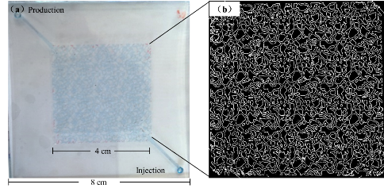

Figure 6 – The structural characteristics of the glass micro-model used in this work. (a) micro-model design; (b) 2-dimensional pore network structure [63, p.2-3].

3.2 Foam stability evaluation by Ross-miles and Warning Blender method
Some part of this Section has been published on my previous articles on Colloids and Surface A: https://doi.org/10.1016/j.colsurfa.2018.07.042.
The foam was frothed by modified Ross-Miles method or Warning Blender method as shown in Figure 7. Those are the most universal and common evaluation methods for foam evaluation, aimed at the foaming capacity and stability of foam.
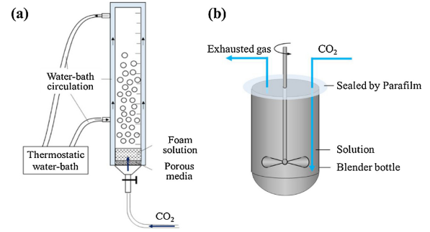
Figure 7 – Schematic diagram for (a) modified Ross-Miles method and (b) Warning Blender method
In the Ross-Miles method, 5 mL of foam solution was introduced into a vessel connected to a CO₂ cylinder at its base. CO₂ gas was then sparged through a porous medium at a flow rate of 100 mL/min (controlled by a flowmeter) and bubbled through the solution for 3 min. Subsequently, the volumes of foam and liquid were recorded as a function of time. For the Warning Blender method, as illustrated in Figure 3(b), 100 mL of foam solution was placed in the blender jar of a high-speed stirrer. To ensure a CO₂-rich atmosphere throughout the experiment, CO₂ was bubbled into the solution for 120 min prior to foaming. Foaming was then conducted at 10,000 rpm for 3 min using the high-speed stirrer [29, p.2]. The resulting foam was immediately transferred to a 1000 mL graduated cylinder, and its volume decay over time was monitored. The foam half-life (t_{f}) is defined as the time required for the foam volume to decrease to half of its initial value (V₀), while the drainage half-life (t_{d}) corresponds to the time when the drained liquid volume reaches half of the original liquid content. The initial foam volume V₀ serves as an indicator of foaming capacity. To comprehensively evaluate foam performance, the foam composite index (F_{c}), calculated by Eq. (1), is employed, which integrates both foam stability and foaming capacity [18, 29, p.2].
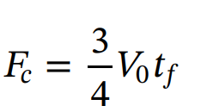 Equation 1

3.3 Foam stability evaluation by multiple light scattering methods
Dynamic Light Scattering (DLS), also known as photon correlation spectroscopy, is a non-invasive analytical technique widely used to characterize the temporal evolution and stability of foam/colloidal systems. Light Interaction Dynamics include Dual Detection Modes: Transmission (0° detection) dominant in transparent/dispersed systems and Backscattering (135° detection) effective for concentrated systems. The parameter T and BS were shown as below.
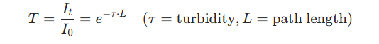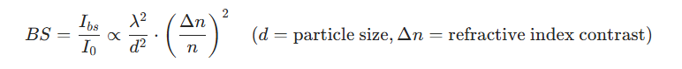
Eq. 2
Eq.3
It is effective for particle migration such as creaming/sedimentation (vertical BS intensity gradient >10%/hour), and coalescence (localized BS fluctuations ±5% pixel variation) and aggregation (BS decreases as aggregate size increases). Meanwhile, it can also evaluate the Ostwald Ripening process in foam (progressive BS homogenization across sample height) [29, p.2].
Table 1. Multiple light scattering method parameters
Parameter | Definition | Stability Threshold
TSI (Turbiscan Stability Index) | Integrates all instability phenomena | <1 (stable), >5 (unstable)
ΔBS/Δh | Backscattering gradient per mm height | <0.5%/mm (homogeneous)
Mean BS Variations | Temporal BS changes at fixed positions | <2%/hour (no significant aging)
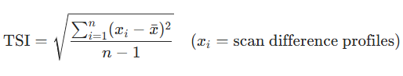
Eq. 4
In which, x_{i} is the scan difference profile at certain time, n is the scan times.
The stability of CO₂ foam with RC at 85ºC was monitored via multiple light scattering methods by Turbiscan Lab Expert Stability Analyser (Formulation, France). The backscattering (135° from the incident light) and transmission light of a pulsed near-infrared light (λ=850 nm) through the sample are detected by the Analyser. In this study, 20 mL of foam was transferred into the sample vials and placed in the Turbiscan Lab Expert Stability Analyser. The scanning mode was applied to detect the dynamic changes of multiple scattering light through the whole height of the sample at 85°C until the foam collapsed. The photo of the test bottle was captured to have a detailed observation [29, p.2].
The backscattering light intensity indicates the colloid system-foam, while the transmission light intensity indicates the liquid layer due to the drainage process of the foam, as shown below.

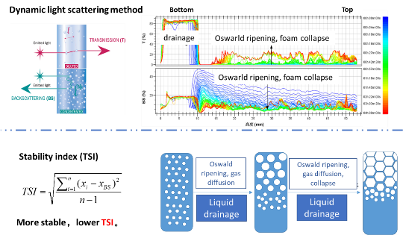
Figure 8 – Mechanism of multiple scattering light for foam evaluation

Foam half-life and liquid drainage half-life were used for the evaluation of the stability of foam. Foam half-life indicates the time when half of the foam volume is left with foam Oswald aging and corruption process. Liquid drainage half-life refers to the time when half of the foam liquid volume was drained from the foam compared with the original foam liquid volume [63, p.2-3].

3.4 Morphological inspection of CO₂ foam
In order to observe the micro-scale morphological details of the foam dynamic aging process, a double layer glass micromodel (20 mm×50 mm×50 μm) were designed to study the foam aging process of different foam solutions at 25°C, and the aging process were recorded and measured by the Optical Microscopy XSJ-2.
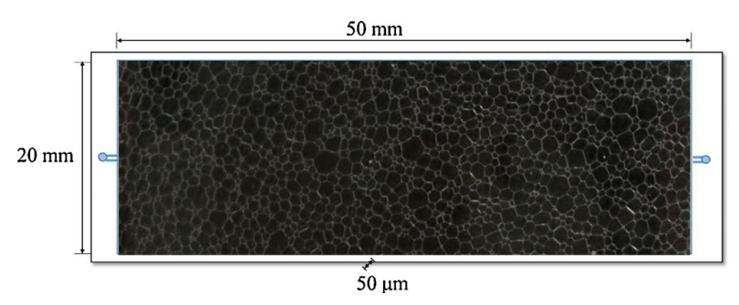
Figure 9 – Double layer glass micromodel for foam aging observation

3.5 Zeta potential analysis
Zeta potential (ζ) measurements were performed at 25°C using a Zetasizer Nano ZS (Malvern Instruments Ltd., UK). The samples are foam liquid with surfactants and stabilizers. For each sample, three parallel replicates were prepared, and each replicate was subjected to three independent measurements to ensure statistical reliability. The final ζ value was reported as the arithmetic mean of the nine measurements (3 replicates × 3 tests per replicate). This protocol minimizes experimental variability and enhances data reproducibility [64, p.2].

3.6 Scanning electron microscope (SEM)
The morphology of regenerated cellulose was characterized using a COXEM EM-30 Plus scanning electron microscope (COXEM Co., Ltd., South Korea). Pretreated samples were prepared by freeze-drying the cellulose solution at −80°C for 48 h (Labconco FreeZone 2.5 L freeze dryer) to preserve nanostructural integrity. The lyophilized samples were sputter-coated with a 5 nm gold-palladium layer (Quorum Q150T ES coater) to enhance conductivity. Imaging was conducted at an accelerating voltage of 20 kV , with magnification ranging from 1,000× to 50,000× to resolve micro- to nanoscale features. Representative micrographs were acquired to assess surface topology and aggregate architecture.

3.7 Laser Particle Size Analysis
The particle size distribution of regenerated cellulose aggregates dispersed in formation water solution was analyzed using a GSL-1020 laser particle size analyzer (Liaoning Instrument Research Institute Co., Ltd., China). Prior to measurement, the solution was homogenized by gentle agitation to ensure uniform dispersion of aggregates. The analyzer employs static laser diffraction principles, with a detection range of 0.1–1000 μm, to quantify particle size based on Mie scattering theory. Triplicate measurements were performed for each sample, and the results were expressed as volume-weighted mean diameter and polydispersity index (PDI) to evaluate aggregation behavior under simulated subsurface conditions. The size distribution was obtained by this method.

3.8 Micro-model flooding experiment
The syringe pumps were applied to control the injection of brine water (colored by methyl blue), simulated oil (kerosene colored by Sudan IV), foam fluid, and CO₂ into the micro-model, and the micro-model was recorded by the microscope, shown in Figure 10. The temperature and pressure were controlled at 85ºC and 0.1 MPa [63, p. 2-3].
- The saturation process: the brine water was saturated in the micro-model and then inject simulated oil at 0.01 mL/min until no water is produced [63, p. 2-3];
- Waterflooding: brine water was injected at 0.05 mL/min into the saturated micro-model for 1.0 PV [63, p. 2-3];
- CO₂ gas flooding: CO₂ was injected at 0.05 mL/min for 1.0 PV into the saturated micro-model after process a. [63, p. 2-3];
- CO₂ foam flooding: CO₂ and foam liquid with 1% SS163 and 1% RC was injected by water alternating gas process at 0.05 mL/min and ratio 1:1 for 0.5 PV into the saturated micro-model after process a. [63, p. 2-3];
- Subsequent water flooding was injected for 1.0 PV [63, p. 2-3].
During this whole flooding process, the produced fluid was collected, measured and observed by microscope as well. Then, the microscopic images were analyzed by Image J to calculate the oil, gas, and water saturation by area [63, p. 2-3].
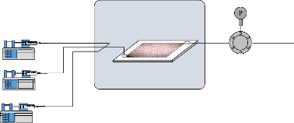
Figure 10 – The scheme of the micro-flooding experiment

3.9 Heterogeneous core flooding experiment [63, p. 2-3]
The artificial sandstone core (45mm×45mm×300mm) was designed with permeability contrast at three equivalent layers (i.e., 20mD, 200mD, 20mD respectively), to simulate the heterogeneity of the tight oil formations [63, p. 2-3]. This whole saturation process and core flooding experiment was operated at 85ºC and 15 MPa. The original oil saturation of the core is 55.1%, which is similar with the original oil saturation (~50%) in the reservoir [63, p. 2-3].
- Saturated with brine water: The heterogeneous core was saturated with brine water for 72 hours at vacuum container -1MPa [63, p. 2-3];
- Saturation with oil: the core was then injected with crude oil at 0.01 mL/min for 24 hours to achieve the original crude oil saturation in the core [63, p. 2-3];
- Water flooding: inject the brine water for 1 mL/min until no oil was produced [63, p. 2-3];
- Foam flooding: CO₂ and foam liquid with 1% SS163 and 1% RC was injected by water alternating gas process at 1 mL/min by 1:1 for 6 cycles and 0.6 PV [63, p. 2-3].
- Subsequent water flooding: brine water was injected at 1 mg/L until no oil was produced. During the process, the produced fluid and injection pressure were collected and measured. And the produced fluid was collected, measured and observed by microscope as well [63, p. 2-3].

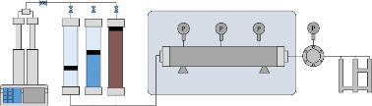
Figure 11 – The scheme of the core flooding experiment setup (Pump→container with brine water, foam liquid, and crude oil→core flooding equipment→ produced fluid measurement) [63, p. 2-3]

RESULTS AND DISCUSSION

4.1 Formulation of CO₂ foam system
Note that this part is published and presented for the conference: Xia Yin, Saule Aidarova, Wanli Kang, The stability, conformance control and enhanced oil recovery study on a novel reinforced CO₂ foam by regenerated cellulose, The First International Conference on Energy and Enhanced Oil Recovery, 2024.

4.1.1 Foaming capacity of different surfactants in CO₂ foam
A surfactant suitable for reservoir applications must exhibit robust salt and acid resistance alongside effective foaming performance, particularly under conditions involving medium to high temperatures, high salinity, and the presence of acidic gases such as CO₂. In general, anionic surfactants demonstrate strong foaming capabilities; however, certain types are prone to precipitation with multivalent cations, resulting in poor hard water tolerance. Non-ionic surfactants offer excellent resistance to high-salinity brines, but their solubility in aqueous solutions may decline at temperatures exceeding their cloud point, potentially reducing the effective surfactant concentration in the foam. Cationic surfactants tend to exhibit high adsorption loss in many geological formations, while amphoteric surfactants can integrate the beneficial characteristics of both ionic types [29, 65].
In this study, the performance of several selected foaming agents was systematically evaluated with respect to compatibility with simulated formation water, foaming capacity, and foam half-life under varied temperature and pressure conditions, as well as dynamic behavior. The comprehensive evaluation results are summarized in Table 2. Compatibility is a critical factor for ensuring sustained foaming performance over extended periods within reservoir environments. Accordingly, surfactants demonstrating favorable compatibility with brine, elevated temperatures, and acidic conditions were prioritized. The acidity arises from the dissolution of CO₂ in formation water under reservoir conditions, which lowers the pH of the brine. Among the candidates, N-NP-15C-H and SS163 remained fully soluble in brine without precipitation at both ambient and reservoir temperatures. Subsequently, the foamability of CO₂ foam generated with these surfactants was assessed [65].

Table 2. the foaming capacity and adaptivity of surfactant for CO₂ foam [29]
Surfactant | Type | Adaptivity  (25℃) | Adaptivity  (85℃, pH=3) | 25℃ Foam evaluation |  |  | 85℃ Foam evaluation
 |  |  |  | V/mL | t_{f}  /min | t_{d}/min | V/mL | t_{f}  /min | t_{d}/min
N-P-12 | N | ↓ | ↓ | 490 | 252.0 | 5.43 | 160 | 35 | 93.3
AOS | A | ↓ | ↓ | 520 | 200.0 | 5.48 | 190 | 47 | 148.8
SDS | A | ↓ | ↓ | 730 | 93.7 | 2.05 | 290 | 25 | 120.8
BS-1 | A | ↓ | ↓ | 330 | 63.0 | 2.83 | 330 | 34 | 187.0
YX-2 | A | ↓ | ↓ | 420 | 301.0 | 5.12 | 290 | 38 | 183.7
A-S-12 | A | ↓ | - | 500 | 152.0 | 3.57 | 295 | 32 | 157.3
AES | AN | ↓ | - | 720 | 171.8 | 3.87 | 255 | 32 | 136.0
N-NP-15C-H | AN | - | - | 635 | 20.5 | 2.53 | 305 | 32 | 162.7
SS163 | AN | - | - | 760 | 132.0 | 4.40 | 345 | 43 | 247.3
* “↓” indicates precipitation, “-” indicates no precipitation. V= foam maximum volume, t_{f} =foam half-time, t_{d}=foam drainage half-time, AN= Anionic-nonionic, N=nonionic, A=anionic.

Among the commercial foaming agents evaluated—including AOS, SDS, AES, as well as the anionic and nonionic-anionic surfactants N-P-12, BS-1, YX-2, and A-S-12—all exhibited precipitation upon contact with reservoir brine. In contrast, N-NP-15C-H and SS163 remained fully compatible with the brine after 24 hours at ambient temperature. Under simulated reservoir conditions (85 °C and pH 3, representing the acidity resulting from CO₂ dissolution in brine at 15 MPa), the surfactants A-S-12, AES, N-NP-15C-H, and SS163 demonstrated satisfactory compatibility following a 24-hour aging period. Further foam performance evaluation revealed that SS163 generated a larger foam volume and exhibited a longer foam half-life than N-NP-15C-H, indicating superior foaming capacity and stability. Based on these combined results, SS163 was identified as the most suitable surfactant for generating CO₂ foam under the targeted reservoir conditions.

4.1.2 Stability and its mechanism of CO₂ foam with different stabilizers
The static stability of aqueous foams under varying thermal conditions was systematically evaluated using a modified Ross-Miles method, with particular emphasis on two key parameters: foam half-life (t_{f}) and liquid drainage half-life (t_{d}). As presented in Figure 12, both t_{d} and t_{f} exhibited pronounced temperature dependence, with t_{f} demonstrating greater sensitivity to elevated temperatures. For foams with and without stabilizers, increasing the temperature from 25°C to 90°C resulted in a 90% reduction in t_{f}, whereas td decreased by 50–90% over the same range. This thermal destabilization is consistent with established colloidal principles: higher temperatures accelerate liquid drainage through two interrelated mechanisms—a reduction in bulk viscosity (following the Arrhenius relationship, η ∝ eEa/RT) and enhanced Marangoni flow at the gas–liquid interfaces, which compromises the Gibbs–Marangoni self-healing effect essential for maintaining foam integrity. As widely reported in the literature, accelerated drainage at elevated temperatures leads to diminished foam stability. The t_{d} values of foams containing RC and HPAM were at least one order of magnitude higher than those of other formulations, attributable to the thickening effect imparted by these polymers. A strong correlation between solution viscosity and td has been frequently observed, particularly in HPAM-stabilized foams [16]. Nevertheless, foam stability is governed by multiple mechanisms, and drainage half-life alone does not serve as a definitive criterion. For instance, although HPAM significantly prolongs td, its tf remains relatively short. In the case of nanoparticle-stabilized foams (SiO₂ and Al₂O₃), a moderate retardation in liquid drainage was also noted, as reflected by their td values [10,11,31]. All tested stabilizers enhanced t_{f} to varying degrees across the temperature range. Notably, foams formulated with RC exhibited t_{f} values 3 to 10 times higher than those of unstable foams, particularly under high-temperature conditions. In contrast, foams stabilized with inorganic nanoparticles or HPAM showed comparatively lower t_{f}. While HPAM effectively delays drainage due to its high viscosity, RC not only retards liquid drainage but also provides superior foam stability, demonstrating the best overall performance among the stabilizers evaluated [29].
The stability and dynamic evolution of foams were characterized using multiple light scattering, with results presented in Figure 13. To elucidate differences in stabilization mechanisms, foams containing 1% RC were compared with several commonly used particulate and polymeric stabilizers [29]. Figure 10 displays the transmission (T) and backscattering (BS) light intensity profiles for foams stabilized with 1% SS163, 1% SiO₂, 1% Al₂O₃, and 0.5% HPAM, where color gradients represent elapsed time. A decrease in T at the bottom of the sample bottles signifies liquid drainage from the foam matrix, leading to the accumulation of a liquid layer; partial sedimentation of solid particles may also contribute to reduced T intensity. Initially, the foam consists of densely packed small bubbles, resulting in near-zero T and elevated BS due to the extended optical path length of backscattered light [30].

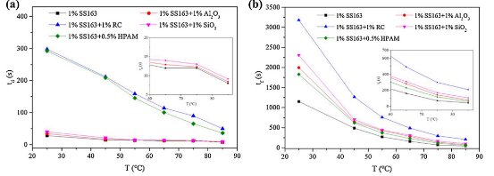
Figure 12 – The liquid drainage half-life t_{d} (a) and foam half-life t_{f} (b) of 1% SS163 with and without different stabilizers.

As Ostwald ripening proceeds, capillary-driven gas diffusion occurs from smaller to larger bubbles, promoting bubble coarsening and coalescence [11,18,31]. Consequently, the liquid films thin and eventually rupture, shortening the BS pathway—manifested as a decline in BS and a concurrent increase in T [2]. Thus, the rise in T serves as an indicator of liquid drainage, while the decrease in BS quantitatively reflects foam decay.
Comparative analysis reveals that foam stabilized with 1% SS163 exhibits the poorest stability, whereas RC imparts the highest robustness. RC markedly increases the viscosity of the foaming solution, thereby substantially retarding liquid drainage. Moreover, the BS intensity of RC-stabilized foam decays more slowly than that of any other formulation, corroborating the trends observed in Ross-Miles tests. Among the stabilizers examined, RC also demonstrates the least sedimentation. Based on the Turbiscan Stability Index (TSI) values presented in Figure 3, the foams rank in descending order of stability as follows: 1% SS163 + 1% RC > 1% SiO₂ > 1% Al₂O₃ > 0.5% HPAM > stabilizer-free. The TSI profiles reveal that, within the first 10 min, all foams except those containing RC undergo a sharp increase, followed by a gradual rise to a plateau. For RC-stabilized foam, the initial rapid TSI evolution extends to 20 min and culminates in a lower plateau value. This indicates that while other stabilizers permit rapid coalescence and bubble growth during the initial 10 min, RC effectively prolongs this destabilization phase to 20 min, demonstrating superior foam retention [29].

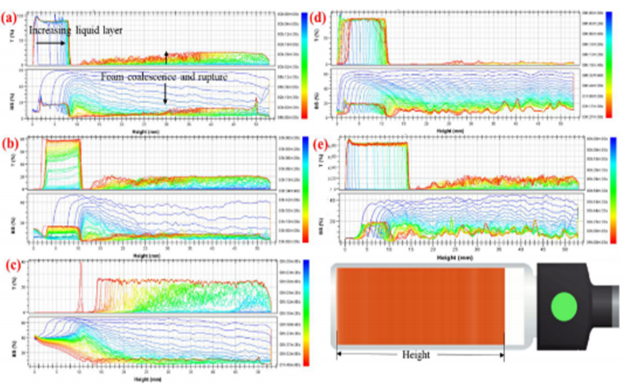
Figure 13 – The transmission and backscattering light intensity of the foams by scanning mode, (a) 1%SS163 (b) 1% SS163 + 1% SiO₂ (c)1% SS163 + 1% Al₂O₃ (d)1% SS163 + 1% RC (e) 1% SS163 + 0.5% HPAM.
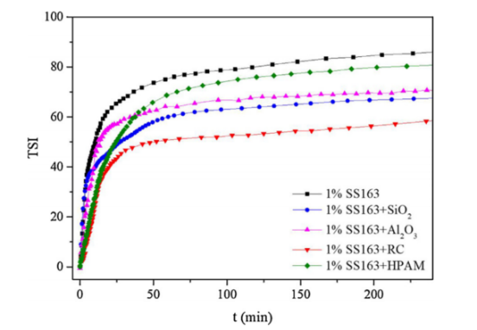
Figure 14 – Turbiscan stability index (TSI) values of different foam.

The dynamic morphological evolution of various foams was investigated using a double-layer glass micro-model coupled with microscopy, as depicted in Figure 15. During foam aging, the Ostwald ripening process was clearly observed, wherein CO₂ diffuses from smaller to larger bubbles, driven by differences in capillary pressure as described by the Young–Laplace equation [11,18,31]. This pressure differential leads to higher gas solubility in the vicinity of smaller bubbles, establishing a concentration gradient within the liquid phase. In accordance with Fick's laws, dissolved gas migrates from regions of high concentration (around smaller bubbles) to low concentration (around larger bubbles). Consequently, larger bubbles expand by absorbing gas, while smaller ones shrink and eventually disappear, resulting in a reduction in bubble number and an increase in mean bubble size. From a thermodynamic standpoint, this process minimizes the system's interfacial free energy by reducing the total gas–liquid surface area, as larger bubbles possess a lower surface-area-to-volume ratio.
Simultaneously, gravitational drainage and capillary suction at the Plateau borders extract liquid from the foam films, progressively diminishing the liquid fraction. Initially spherical bubbles with higher liquid content transform into polyhedral structures as films thin. When the film thickness falls below a critical threshold, rupture occurs. The stability and longevity of these films are governed by the interfacial properties imparted by surfactants and stabilizers. Thus, increases in bubble diameter and reductions in film thickness serve as key quantitative indicators of foam destabilization over time. The micro-model setup enables direct, microscale visualization and measurement of these dynamic changes, offering deeper insight into the underlying mechanisms [29, 63].
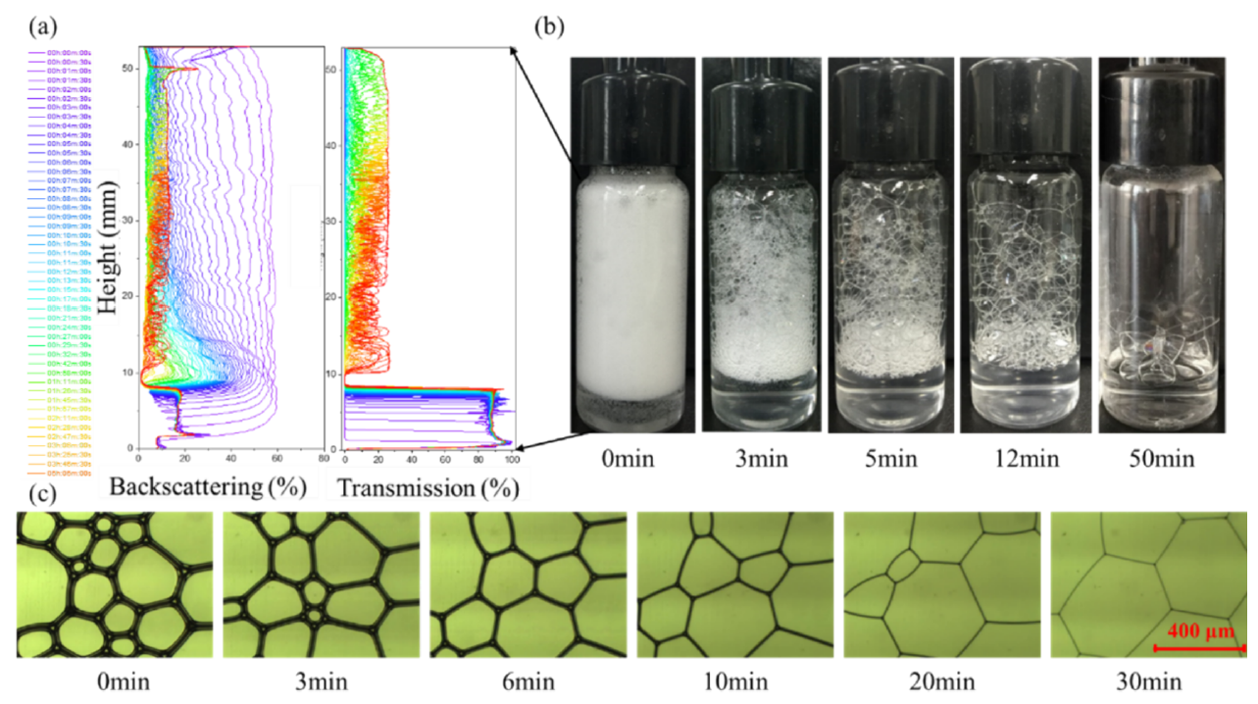
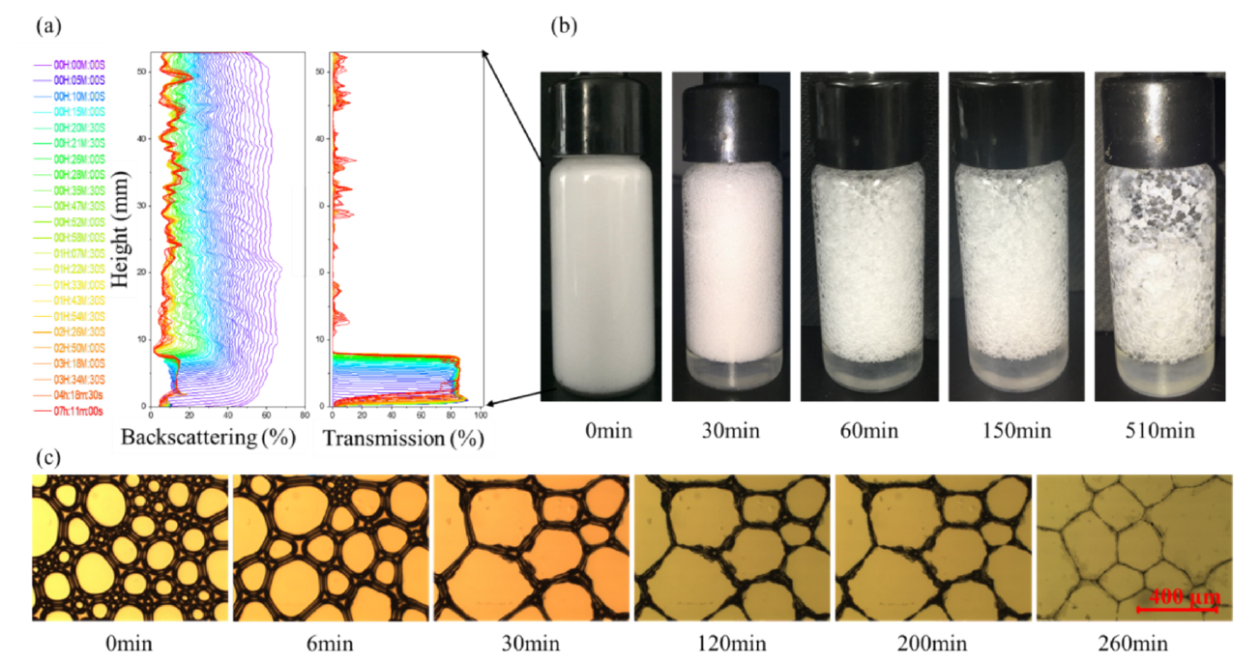
Figure 15 – Evaluation of foam with 1 % SS163 and 1% SS163+1% RC, (a) backscattering and transmission light intensity of the foam with aging at 85 ◦C, (b) images of foam aging process at 85 ◦C, (c) microscopic observation of foam aging process [63]

Therefore, the optical tracking of film thickness evolution showed mainly three distinct regimes as below.
(1) Fast Ostwald ripening process: characterized by the fast-increasing foam diameter due to gas diffusion. Ostwald ripening is driven by magnitude of Laplace pressure, П_{L}, which is pressure difference across a curved interface. П_{L} = 2 γ/a; where γ is the surface or interfacial tension and ‘a’ is the surface area of droplet. In case of an individual bubble, whose surface area has been reduced due to size reduction, П_{L} increases fast, and sets up a chemical gradient. Ostwald ripening of nano scale bubbles or droplets can therefore be very rapid in comparison to regular foam/emulsions as differences in Laplace pressures are much greater [18, 32, 51]. Kinetics of Ostwald ripening has been explained on the basis of Lifshitz, Slezov, and Wagner theory (LSW theory). LSW theory suggests that, in an emulsion consisting of a single oil type with quantifiable aqueous solubility, the number average radius of a bubble undergoing Ostwald ripening increases with cube root of time. It is numerically elaborated as follows [33, 51].
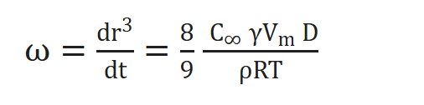 Eq.5
In which ω is the rate of Ostwald ripening, R is universal gas constant, T is the ambient temperature, γ is the interfacial tension at the interface, r is droplet radii of foam, V_{m} is the molar volume of CO₂ employed, C∞ is saturation solubility of CO₂ and D is the diffusion coefficient of bubbles in continuous phase. Physical stability of foam is assessed by measuring foam size as a function of time. Ostwald ripening rates are obtained by plotting slopes of r_{N}³ vs. time, where r_{N} is number average radius [18, 51].
(2) Foam lamellae thinning process: characterized by the decreasing lamellae thickness due to drainage due to both gravity and Plateau borders. Foam drainage, driven by gravity and capillary suction at Plateau borders, is a critical process affecting lamellae thinning and foam stability. Foam consists of gas bubbles separated by thin liquid films (lamellae). Where three or more lamellae meet, forming interconnected channels with curved triangular cross-sections is called Plateau borders. These act as primary pathways for liquid drainage. The gravity-driven drainage refers to that, the liquid in the foam experiences gravitational pull, flowing downward through Plateau borders. This creates a vertical drainage front, drying upper foam layers and accumulating liquid at the base. As liquid drains, lamellae thin, especially in upper regions, reducing their ability to resist rupture from disturbances (e.g., mechanical shocks or thermal fluctuations). Capillary suction by Laplace pressure is induced by the curvature of Plateau borders, which generates a pressure difference via the Young-Laplace equation
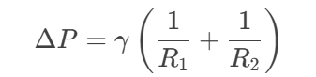 Eq.6.
where γ is surface tension, and R₁, R₂ are principal radii of curvature. The concave curvature creates a lower pressure in Plateau borders, pulling liquid from lamellae into the channels (suction effect). Lower surface tension γ, reducing capillary suction. They also induce Marangoni flows, redistributing liquid to repair thinning regions.
The overall drainage rate is governed by the balance between gravitational force, capillary suction, and viscous resistance. It can be manipulated by increasing the liquid viscosity, and selection of proper surfactants. Gravity and capillary suction synergistically drive liquid drainage through Plateau borders, thinning lamellae and compromising foam stability. The interplay of fluid dynamics, interfacial phenomena, and material properties dictates the foam’s lifespan, with drainage rate being a key determinant of collapse kinetics.
(3) Foam rupture: Foam rupture is a complex process involving the breakdown of thin liquid films separating gas bubbles. It occurs when destabilizing forces overcome stabilizing mechanisms, leading to film thinning, hole nucleation, and rapid collapse [18]. The thin film could be unstable as the intermolecular forces dominate (Van der Wals), i.e., disjoining pressure breakdown. Disjoining pressure (Π) is the net pressure arising from intermolecular forces between the two surfaces of a thin liquid film (e.g., a foam lamella). It determines whether the film thickens (stabilizes) or thins (ruptures) as the surfaces approach each other. This pressure is a superposition of several contributions include attractive and repulsive forces: Van der Waals forces is the attractive forces between molecules, dominant at very short ranges (<10 nm). And Electrostatic repulsion is the repulsive forces between charged surfaces (e.g., ionic surfactants). Steric hindrance is the repulsion from bulky molecules (e.g., polymers) adsorbed at interfaces. Structural forces arise from molecular ordering in confined liquids (e.g., layering of solvent molecules). Thus, when the foam film thickness drops to critical thickness, the attractive force, Van der Wals force, dominates, so that the foam film extracts, and collapses.
In the comparative study of foam with stabilizers in micro-model, it was observed that the system without a foam stabilizer exhibited significantly faster bubble size growth (Ostwald ripening) and liquid film thinning. After 60 minutes, the foam liquid film ruptured, with the film showing noticeable deformation and recovery capabilities, indicating a more viscous nature.
For the RC foam stabilizer system, the initial bubble size was slightly larger than that of particle-stabilized systems or systems without stabilizers, and the size distribution was more dispersed. Additionally, the external films of bubbles in polymer-based systems were thicker due to the hydration layers of polymer molecules. It is worth noting that regenerated cellulose foam differed from other systems. The bubbles were not perfectly spherical, and as drainage progressed, the film thickness on bubble surfaces became increasingly uneven. Amorphous regenerated cellulose combines anisotropic particle properties with natural polymer characteristics. It self-assembles and adsorbs at interfaces to enhance foam stability, with anisotropic particles further stabilizing the foam. The irregular interfacial films and bubble shapes confirm the adsorption of these particles at interfaces. Moreover, hydrogen bonding between surface hydroxyl groups and water molecules, coupled with polymer chain entanglement, generated viscosity and structural viscosity, slowing drainage. In later stages, as the liquid film thinned, cellulose precipitated as irregular solid particles at Plateau borders, shrinking as liquid diminished. This system exhibited the longest pre-rupture film stability at 480 minutes. In the aspect of suppression of Ostwald Ripening, nanomaterials decelerate bubble coarsening by synergistic mechanisms: Reduced Gas Diffusivity, i.e. the adsorbed particle layer increases the interfacial resistance to gas transfer, lowering the effective diffusion coefficient relative to particle-free systems, which reflected by the slower foam size increasing speed.

3.1.3 Summary
(1) Surfactant Screening and Foaming Performance
The anionic-nonionic hybrid surfactant SS163 (1.0 wt%) was identified as the optimal foaming agent through systematic evaluation for its foaming capacity and compatibility with formation brine. SS163 maintains chemical stability in simulated formation water of the tight sandstone reservoir without precipitation.
(2) Stabilizer Optimization with Regenerated Cellulose (RC)
The 1.0% RC formulation demonstrates superior foam stabilizations. RC significantly slows down the liquid drainage process and foam collapse process.
(3) Field-Applicable Foam System Formulation
The optimized CO₂ foam system for target reservoir conditions (85°C, 15 MPa, salinity 59737.6 mg/L) comprises: 1.0 wt% SS163 + 1.0 wt% RC.

4.2 Stabilization mechanism of regenerated cellulose on CO₂ foam
Note that part of this section has been published in the article: Xia Yin, Ning Kang, Saule Aidarova, Wanli Kang, Maratbek Gabdullin, Miras Issakhov. The conformance control and enhanced oil recovery performance of CO₂ foam reinforced by regenerated cellulose, Journal of Molecular Liquids, 2024, 415, 125969, https://doi.org/10.1016/j.molliq.2024.125969, and presented in the conference: Xia Yin, Saule Aidarova, Wanli Kang, Hongbin Yang, Bauyrzhan Sarsenbekuly. Unique stabilization mechanism of evaluation of reinforced CO₂ foam with regenerated nanocellulose, Colloids and nanotechnologies in industry, 2025.
The morphological dynamic changes of different foams on micro-scale were illustrated by a double-layer glass micro-model and microscope. During the foam aging process, CO₂ transfers from smaller bubbles to large bubbles, which results in the fast-increasing foam size and less bubbles, especially for small bubbles [18, 51]. This phenomenon, namely Ostwald ripening, is driven by the different capillary pressure in the bubbles with different diameters according to Young-Laplace Equation. Meanwhile, the liquid in the foam film is drawn by gravity and capillary force on the Plateau border. The Plateau border, named after Belgian physicist Joseph Plateau, refers to the interconnected liquid-filled channels formed at the intersection of three adjacent bubbles in a foam structure. This unique geometric feature plays a critical role in governing foam stability and drainage behavior. Therefore, the liquid gas ratio in the foam keeps on decreasing. The round shaped foam with more liquid gradually becomes polyhedron foam. After the films gradually grow thinner to some extent, the foam film collapses. The breakdown time of the foam film correlates to the properties of interface and liquid film with surfactants and stabilizers.
Therefore, to investigate further, foam diameter increases and the foam film thickness gradually decreases, which can be considered as an indicator to evaluate this dynamic change quantitatively, as shown in Figure 16 [29, p.759-560].
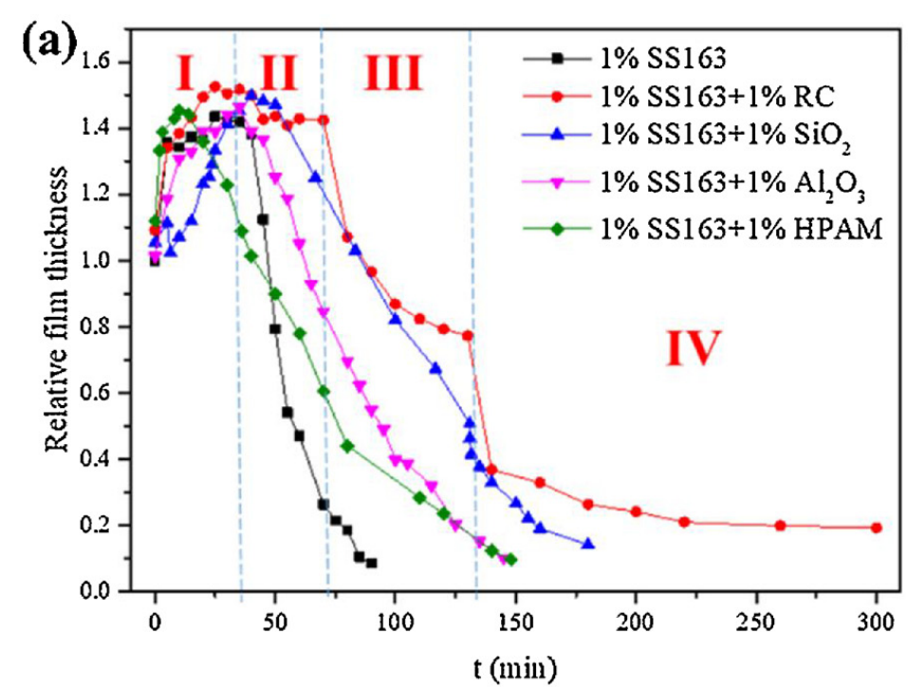
Figure 16 – The foam with stabilizers and comparison with stabilizer free foam (a) film relative thickness

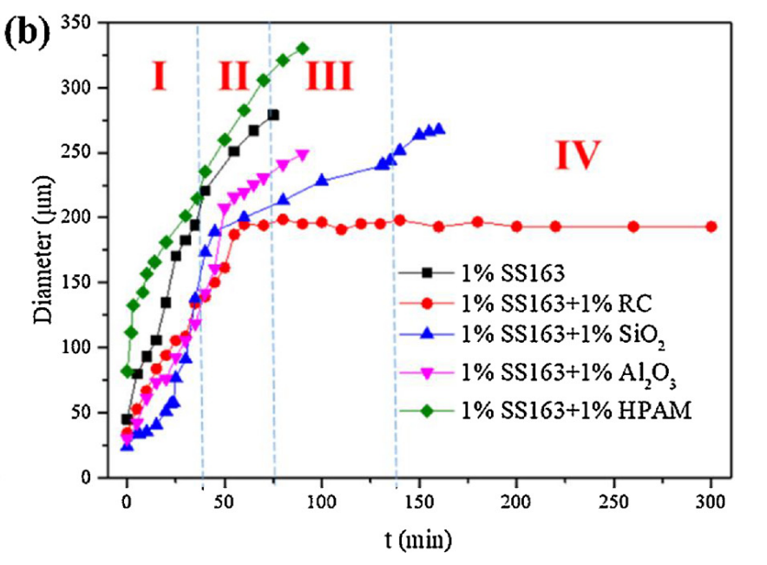
Figure 17 – The foam with stabilizers and comparison with stabilizer free foam (b) diameter changes during foam aging process.

In the case of nanoparticle stabilizers such as SiO₂ and Al₂O₃, foam stabilization is primarily governed by the Pickering mechanism, which operates through several interrelated processes: (1) interfacial adsorption—where partially hydrophobic nanoparticles adsorb at the gas–liquid interface, reducing interfacial energy and enhancing film stability; (2) steric hindrance—whereby a dense monolayer of nanoparticles at the interface acts as a physical barrier against bubble coalescence; and (3) network formation—where nanoparticles bridge adjacent bubbles via van der Waals interactions, constructing a three-dimensional stabilizing framework [18, 29, p.760].
In contrast, RC—a natural polymer—exhibits fundamentally different stabilization behavior and underlying mechanisms compared to rigid nanoparticles. Rather than relying solely on interfacial adsorption, RC stabilizes foam through the formation of an extensive three-dimensional network, driven by abundant intra- and intermolecular hydrogen bonds between cellulose chains, complemented by van der Waals forces. This polymeric network imparts multiple synergistic stabilization effects beyond the classical Pickering regime, contributing to enhanced foam robustness through increased bulk viscosity, retarded liquid drainage, and improved film resilience [29, p.760, 63].
To elucidate the stabilization mechanism of regenerated cellulose (RC), the foam aging process was categorized into four distinct stages based on temporal evolution of bubble diameter and film thickness, as illustrated in Figure X. In Stage I, Ostwald ripening drives a rapid increase in bubble size, accompanied by a transient rise in film thickness due to the reduction in total interfacial area. Relative to other stabilizers, RC exhibits several distinctive features. Initially, the presence of RC aggregates at the gas–liquid interface results in a larger and more heterogeneous bubble size distribution compared to foams stabilized by nanoparticles or HPAM. Moreover, the rates of film thinning and bubble coarsening are markedly suppressed in RC-stabilized foams. Although SiO₂ and Al₂O₃ nanoparticles also retard these processes, RC demonstrates superior efficacy in inhibiting both Ostwald ripening and liquid drainage. This enhanced performance is attributed to the formation of a complex three-dimensional network via hydrogen bonding and van der Waals interactions, which creates a mechanically robust interfacial layer—“thick walls”—that impedes gas diffusion and coalescence [29, p.760].
A particularly noteworthy feature of RC-stabilized foams is the evolution of film thickness over time, which exhibits three distinct plateau regions. Stage II marks the emergence of the first plateau, where film thickness remains relatively constant due to a dynamic equilibrium between Ostwald ripening and substantially slower liquid drainage. During this period, the film thickness in RC systems remains significantly higher than in foams stabilized by nanoparticles or HPAM. The presence of either nanoparticle layers or RC networks reduces gas permeability by creating tortuous diffusion pathways for CO₂ molecules. Additionally, capillary forces introduced by these interfacial structures counteract the Laplace pressure gradient (ΔP = 2γ/r) that typically drives Ostwald ripening. Comparative analysis reveals that bubble coarsening proceeds considerably faster in nanoparticle-stabilized foams than in those containing RC. Notably, HPAM—despite substantially increasing bulk viscosity—fails to retard Ostwald ripening, exhibiting coarsening rates comparable to or even exceeding those of surfactant-only foams. This underscores the critical role of interfacial modification, as imparted by Pickering stabilization, in mitigating ripening phenomena. During Stages III and IV, film thickness continues to decline, each stage characterized by an additional plateau. The rate of film thinning is governed by liquid drainage through Plateau borders and gravitational forces, which is strongly influenced by bulk viscosity. Consequently, RC and HPAM, both viscosity-enhancing agents, significantly prolong drainage relative to nanoparticle-stabilized or stabilizer-free foams (see detailed viscosity analysis in Section 3.2(1)).
Based on these observations, the stabilization mechanism of RC is proposed to involve two complementary contributions:
(1) Viscosity increase leads to slow drainage
As established in foam stability analyses, the drainage half-life (td) exhibits a strong positive correlation with solution viscosity. Figure 18 demonstrates that increasing RC concentration elevates both viscosity and td. However, the nonlinear relationship—marked by inflections at 0% and 0.5% RC—indicates that viscosity alone does not account for the extended td, distinguishing RC from HPAM [9,32]. Despite comparable viscosities, multiple light scattering and Ross-Miles tests reveal that HPAM-stabilized foams are less stable than those containing RC. This discrepancy arises from the dual functionality of RC: on one hand, RC aggregates behave as hydrophilic particles that adsorb at interfaces, analogous to SiO₂ nanoparticles, contributing to film stability even at low concentrations (0–0.1%), where viscosity increase is minimal (see Section 3.3.2) [29, p.760]. On the other hand, RC functions as a natural polymer thickener, retarding liquid drainage and coalescence in a manner similar to conventional water-soluble polymers like HPAM [9,32]. The combination of interfacial activity and viscosity enhancement underpins the superior foam stability conferred by RC.

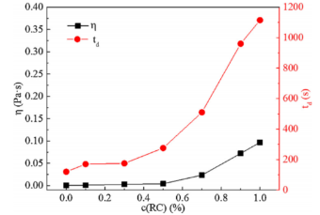
Figure 18 – The liquid drainage half-life td and viscosity η changes with the regenerated cellulose concentration

In addition to viscosity enhancement, the three-dimensional network structure of regenerated cellulose (RC) contributes significantly to prolonging the drainage half-life (td) at concentrations exceeding 0.5%, primarily through hydrogen bonding and immobilization of water molecules within the network, as discussed in the rheological characterization of RC solutions. To elucidate the stabilization mechanism of RC, its rheological properties and structural characteristics were systematically investigated. Figure 19 presents the viscosity, storage modulus (G′), and loss modulus (G″) of RC solutions as functions of concentration. The viscosity exhibits an approximately linear increase up to 0.5% RC, followed by an exponential rise at higher concentrations, indicative of network formation driven by physical entanglement and intermolecular hydrogen bonding [29, p.760].
The abundant hydroxyl groups along cellulose chains facilitate extensive intra- and intermolecular hydrogen bonds, both among cellulose molecules and with surrounding water molecules. Combined with physical entanglement, this hydrogen-bonded architecture promotes the development of a viscoelastic network at concentrations above 0.5%. Notably, this network exhibits thixotropic behavior—reversible disruption under shear and reformation upon cessation—as demonstrated by the thixotropic loop experiment conducted with 1% RC solution (Figure 14). This shear-reversible characteristic confers dual advantages: enhanced foamability under high-shear foaming conditions and improved foam stability under quiescent or low-shear environments. Furthermore, the cellulose network immobilizes water molecules through hydrogen bonding, effectively retarding liquid drainage from foam films and thereby reinforcing foam stability [29, p.561].
As illustrated in Figure 15, the rheological response of RC solutions evolves with concentration. At low concentrations (<0.5%), RC solutions behave predominantly as viscous liquids, with G′ substantially lower than G″. Both moduli increase with RC concentration, but G′ rises more steeply than G″, particularly above the 0.5% threshold, reflecting the transition to a network-dominated regime. At 1% RC, the solution exhibits elastic-dominant behavior (G′ > G″), characteristic of a highly elastic viscoelastic fluid [23, 29]. This three-dimensional network endows the bulk phase with enhanced viscoelasticity, improving both mechanical strength and deformation recovery capacity. Consequently, foam stability and shear resistance are markedly improved, consistent with the observed increases in both t_{d} and t_{f} for RC-stabilized foams.
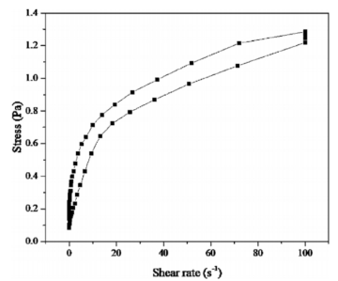
Figure 19 – Thixotropic loop experiment result of 1% RC at 85℃.

Regenerated cellulose particles can be adsorbed and aggregated on the interface of foam and be suspended in the liquid film as shown in Figure 21, which reinforces the foam interface and slows down the liquid drainage. Thus, the foam stability is enhanced by RC based on the results of Ross-Miles and multiple light scattering method. Similar with the stabilization mechanism of the foam with solid particles, the hydrophilic RC aggregates adsorbed on the interface restrict the gas transportation between bubbles, thus inhibit the foam coalescence, while RC suspended in the liquid film slow down the liquid drainage. In the study of Horozov, three possible mechanisms for foam film stabilization by particles were proposed, bridging, closely packed and network of particles in the foam film at different thickness [22, 29, 31].

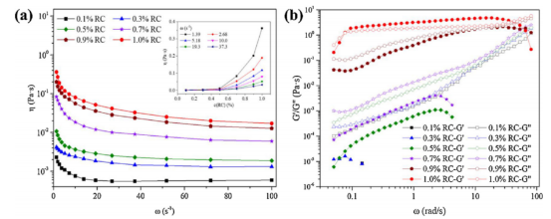
Figure 20 – The (a) viscosity, (b) storage and loss modulus of 1% RC solution [29]
(2) Stabilization of RC aggregates

In addition, RC is capable of forming a three-dimensional network structure through intra- and intermolecular hydrogen bonding, as well as aggregating at the gas–liquid interface, thereby further enhancing interfacial film stability [15,20,22,26]. In contrast to the spherical bubbles with thin, uniform films observed in foams stabilized by SiO₂ and Al₂O₃, RC-stabilized foams exhibit irregularly shaped bubbles with thicker and unevenly distributed films, indicative of RC aggregation at the interface [15,19,33]. Previous investigations into RC-stabilized emulsions have demonstrated its effectiveness in stabilizing liquid–oil interfaces [19,33]; this interfacial stabilization capacity is now extended to CO₂–liquid interfaces in foam systems. The proposed mechanism operates continuously throughout all stages of foam evolution.

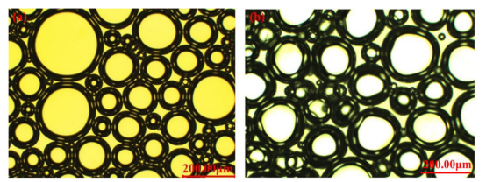
Figure 21 – The microscopic observation of foam (a) 1% SS163 (b) 1% SS163 + 1% RC at t = 3 min.

(3) Water released from the hydrogel
The abundant hydrophilic hydroxyl groups along cellulose chains enable the physically entangled network to swell and retain a substantial volume of water through hydrogen bonding, allowing RC to function as a hydrogel—essentially a water "reservoir"—once a critical concentration is exceeded [34,35]. This hydrogel network, formed without covalent crosslinks, exhibits both flexibility and remarkable robustness [36]. During Stage III of foam evolution, water entrapped within the three-dimensional cellulose network in the liquid phase continues to drain, while the bubble size remains relatively stable. Subsequently, the liquid film thickness begins to gradually decline, eventually reaching a second plateau. As film thinning progresses, the local concentration of RC increases, leading to a more compact arrangement that further impedes liquid drainage. As shown in Figs. 22(a) and (b), cellulose migrates toward the Plateau borders along with the draining liquid, and above a critical concentration, the residual liquid assumes a hydrogel-like state [22, 37]. Within this cellulose network, abundant surface hydroxyl groups immobilize water molecules, thereby regulating and retarding liquid drainage [32, 39].
Once the liquid film has thinned to a critical extent, water molecules bound within the cellulose network at the Plateau borders are gradually released to replenish the film, giving rise to a second thickness plateau. In Stage IV, continued liquid loss diminishes the capacity of the cellulose hydrogel to sustain film thickness, and the film begins to thin once more. This microscale behavior is illustrated in Figure 17(c), where the progressive reduction in film volume and thickness corresponds to the gradual release of water from the hydrated cellulose layers. As dehydration proceeds, cellulose undergoes self-assembly into an ordered three-dimensional structure [26, 29, p.561, 37], depicted in Figure 17(e). During this stage, the liquid film is sustained by water released from the regenerated cellulose network, leading to the formation of a third relatively stable thickness plateau. Concurrently, interfacial surfactants contribute to film stability during this phase, as interpreted by classical common black film and Newton black film theories [39].
Based on the elucidation of RC's unique stabilization mechanism, the superior stability of RC-stabilized foams compared to other formulations can be attributed to multiple synergistic factors: prolonged liquid drainage due to enhanced viscosity, interfacial and film adsorption of cellulose aggregates, reinforcement of the foam film skeleton, and the water-retention capacity of the RC hydrogel. Collectively, these mechanisms strengthen both the interface and the liquid film, thereby significantly enhancing CO₂ foam stability.

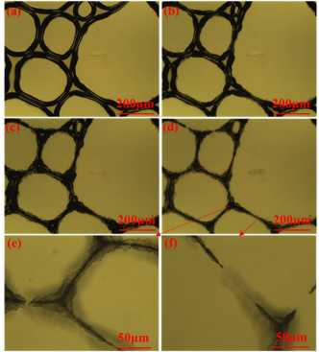
Figure 22 – The microscopic changes during the drainage of liquid film (a) t = 70 min (b) t = 110 min (c) t = 150 min (d) t = 300 min (e) ordered RC aggregates at t = 300 min (f) foam film at t = 300 min [29].
(4) The foam lamella ‘skeleton’
During Stages I and II, the adsorption of regenerated cellulose at the gas–liquid interface, combined with its thickening effect in the bulk phase, effectively retards gas diffusion and slows the evolution of the liquid film, thereby enhancing foam stability, consistent with Ross-Miles observations [29]. Following a more gradual increase in bubble size compared to other stabilizers, the diameter of RC-stabilized foam stabilizes and remains nearly constant. Microscopic analysis reveals that, as drainage proceeds, cellulose aggregates progressively organize into an ordered structure (see SEM image in Figure 18), which exhibits high viscoelasticity and functions as a structural "skeleton" for the foam, as illustrated in Figure 17. It should be noted that the nanocellulose aggregates imaged by SEM were freeze-dried prior to observation; thus, their size and morphology may differ from those in the aqueous state. This ordered, viscoelastic architecture arises from the intrinsic ability of RC suspensions to self-assemble into a stable chiral nematic phase above a critical concentration [36]. The resulting aggregate network provides mechanical reinforcement to the foam film, suppressing Ostwald ripening and stabilizing bubble size.
In contrast to inorganic nanoparticles such as SiO₂, which have been extensively studied as foam stabilizers and typically function by dispersing within the film and adsorbing at interfaces—thereby modifying interfacial and phase properties—RC exhibits a distinct stabilization mechanism. The intermolecular non-covalent interactions in RC are substantially stronger than those among spherical SiO₂ nanoparticles, enabling the formation of a three-dimensional network both at the interface and within the continuous phase, as depicted in Figure 23. This network structure reinforces the interface and imparts viscoelasticity to the film, effectively restricting bubble coarsening and coalescence. Thus, RC enhances foam stability through a unique film "skeleton" mechanism.
In summary, RC confers foam stabilization through multiple synergistic mechanisms that distinguish it from conventional stabilizers: (i) thickening of the liquid phase, which retards drainage during foam aging; (ii) adsorption of RC aggregates at the interface and within the film, enhancing interfacial stability; (iii) formation of a viscoelastic film skeleton that mechanically reinforces the foam; and (iv) a liquid storage effect, wherein the cellulose network retains water and modulates its release to sustain film integrity.

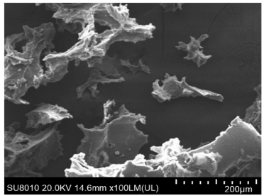

Figure 23 – SEM image of RC aggregates.

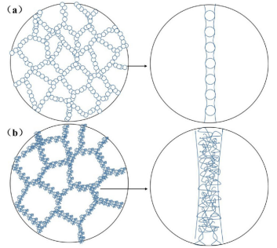
Figure 24 – Schematic graph of the foam film stabilized with (a) SiO₂ (b) RC.

4.3 RC reinforced CO₂ foam and its influencing factors
This part has been published in my article: Xia Yin, Ning Kang, Wanli Kang, Maratbek Gabdullin, Nazym Akhanova, Saule Aidarova, A temperature and salinity resistant CO₂ foam reinforced by regenerated cellulose and its anti-channeling Performance: Conformance control and geo-storage in low-permeability reservoirs, Fuel, 408, 2026, 137598. https://doi.org/10.1016/j.fuel.2025.137598.
Due to the complicated situation of reservoirs, the influence of different environmental factors on foam is of great importance to its long-term performance in the reservoir. The stability of aqueous foams under subsurface conditions is governed by is governed by a complex interplay of physicochemical parameters. Therefore, environmental factors such as temperature, pressure and salinity were taken into consideration for the stability of foam [63, p.1, 64, p.1].

4.3.1 Temperature
According to previous studies, the temperature is one of the most significant factors for foam stability. The thermal destabilization mechanism includes the bulk viscosity reduction of foaming liquid, the acceleration of liquid drainage, and the Ostwald ripening enhancement due to increasing gas diffusion speed [64, p.1]. Thermal destabilization of foam occurs when elevated temperatures weaken or disrupt the stabilizing mechanisms that maintain foam structure [33, 64, p.1]. Stabilizers enhance foam stability by reducing drainage, slowing coalescence, and preventing lamellae rupture as Figure 8 shown. However, temperature increases can compromise these mechanisms through molecular mobility changes, altered interfacial properties, and enhanced gas diffusion [64, p.1].
As shown in Figure 25, when temperature increases from 25 to 85℃ under atmospheric pressure, the foam half-life t_{f} of foam without stabilizer drops from 1158 to 76s, which decreases by over 93%, while that of foam with 1%RC as stabilizer declines from 3195 to 219s. the stability of the CO₂ foam system under ambient pressure exhibits a significant temperature dependence [64, p.1]. In both cases, the foam stability decreases markedly with increasing temperature, characterized by an initial rapid decline followed by a gradual stabilization, indicating a pronounced thermal destabilization effect [64, p.1]. Concurrently, the drainage half-life (a measure of liquid retention within the foam) also diminishes with rising temperature, albeit to a lesser extent compared to the foam half-life [64, p.1].
For the system stabilized with 1% SS163 surfactant, the foam half-life decreased drastically from 20 minutes at 25 °C to 41 seconds at 85 °C, highlighting the severe thermal degradation of foam structure. In contrast, the incorporation of regenerated cellulose into the foam system substantially enhanced stability, extending the foam half-life to 53.3 minutes at 25 °C and 3.5 minutes at 85 °C. In the perspective of molecular mobility, surfactant molecules are more active with higher kinetic energy under higher temperature. Increased temperature amplifies the kinetic energy of molecules, intensifying thermal fluctuations within the foam structure. This disrupts the dynamic equilibrium of interfacial surfactant layers. Such thermal agitation reduces the energy barrier for film rupture, accelerating bubble coalescence. In addition, high temperature also enhances the gas diffusion process, as we have discussed in LSW theory in Eq.5 (the rate of Ostwald ripening is proportional to the C∞ the gas solubility), the then accelerate the Ostwald ripening process [52, 64, p.1]. Another important mechanism must be mentioned is the Marangoni effect. The Marangoni effect is a surface tension-driven fluid flow phenomenon that plays a critical role in stabilizing foams by counteracting drainage and preventing lamellae rupture [18, 19, 52]. The Marangoni effect arises due to gradients in surface tension (γ) at the gas-liquid interface. These gradients can be caused by surfactant concentration variations (local depletion of surfactants (e.g., in thinning lamellae) and temperature gradients. It can help repair the thinning lamellae as well, which enhances the ability to restrain any disturbance on the foam lamellae and increase the foam stability [52, 64, p.4-5].
By comparison with and without the stabilizers, the addition of regenerated cellulose elevates the bulk viscosity of the liquid phase, which decelerates gravitational drainage and reduces liquid loss from lamellar films. This preserves film thickness and mechanical strength, thereby delaying rupture. Firstly, RC absorbed on the interface plays as a gas diffusion inhibition. RC aggregates adsorb at the gas-liquid interface, forming a viscoelastic barrier that impedes gas diffusion between bubbles (Ostwald ripening). This interfacial layer also enhances film elasticity, further stabilizing the foam against coalescence [64, p.4-5].

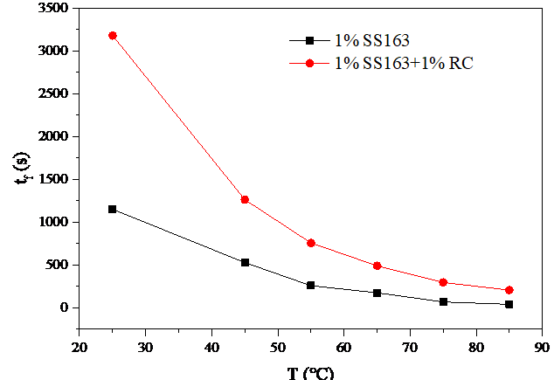
Figure 25 – Influence of temperature on foam half-life t_{f} [64, p.4-5]

Meanwhile, the drainage half-life td of 1%SS183 foam decreases from 28s to 10s, while that of foam with 1%RC decreases from 298s to 50s. As is known, the viscosity of the liquid phase decreases exponentially with temperature (Arrhenius relationship) [64, p.4-5]. At higher temperature, lower viscosity promotes drainage (governed by Reynolds' law), which means the drainage rate is inversely proportional to viscosity. Thus, enhanced drainage thins lamellae, while simultaneous liquid evaporation at elevated temperatures further dehydrates the foam structure, driving it toward collapse [64, p.4-5]. In comparison with the system without stabilizers, the attenuated decline in drainage half-life relative to foam half-life suggests that while temperature accelerates liquid drainage, the primary destabilization mechanism arises from gas diffusion and film rupture rather than purely hydrodynamic effects [64, p.4-5]. These findings underscore the efficacy of cellulose-based additives in mitigating thermal degradation, offering a viable strategy for designing high-temperature-resistant foam systems[64, p.4-5].

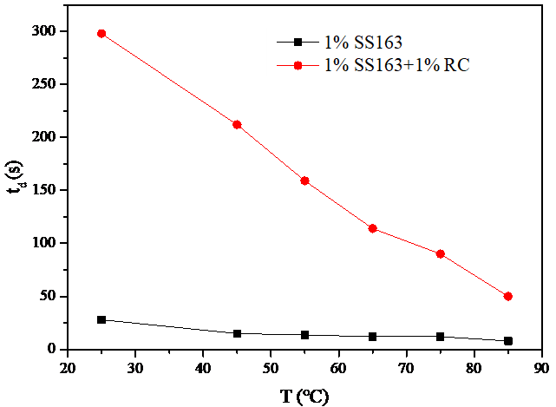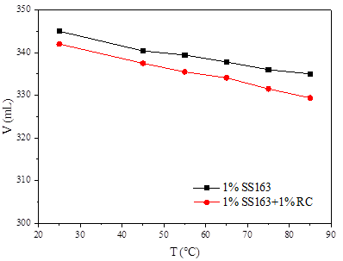
Figure 26 – Influence of temperature on foam drainage half-life t_{d}, foam half-life t_{f} and initial volume V

Apart from the foam stability, the maximum or initial foam volume of the foam system was also studied. Although after increasing the temperature from 25 to 85℃ slightly decreases the foam volume by 5.2% and 4.1% for 1%SS163 and 1%SS163+1%RC respectively, it shows that compared with stability, this is not a big issue at all [64, p.4-5].
The foam stability of various systems at different temperatures was analyzed using a high-temperature high-pressure (HTHP) foam analyzer. The foam system composed of 1% SS163 and 1% regenerated cellulose (RC) was examined under 8 MPa using a visual HPHT foam apparatus compared with that without RC. The results are illustrated in Figure 27 [64, p.4-5].

(a)
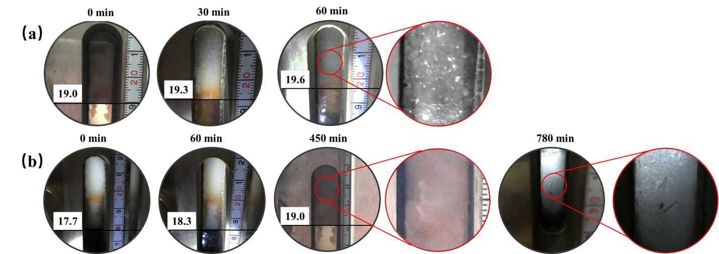
(c)
(b)

Figure 27 – (a) Foam half-life and initial volume at 8 MPa; Foam dynamics in HTHP foam analyzer at 85°C , 8 MPa (b) 1%SS163 foam (c) 1%SS163+1%RC foam [64, p.4-5]

The incorporation of regenerated cellulose effectively extended the foam half-life by 4.5 times from 25°C to 85°C . Although elevated temperature markedly impairs foam stability under atmospheric pressure, when the pressure rose to 8 MPa, temperature sensitivity of the foam system improved substantially. The foam half-life decreased gradually with increasing temperature, and the extent of stability reduction was significantly mitigated. A slight reduction in foam volume was also observed. Super critical CO₂ under 8 MPa significantly increases the gas diffusion speed and gas density, and the drainage is much faster; but the foam Ostwald ripening was much slower than ambient pressure according to observation. Compared with foam with only surfactant, the foam with RC has a much slower Ostwald ripening process and more stable foam lamella, which exhibits markedly longer foam half-life, and reduced sensitivity to temperature, demonstrating enhanced thermal resistance and greatly improved foam stability [64, p.4-5].
Reinforced foam half-life was elongated by around 3-4.5 times, while drainage half-life extends by 5-10 times at 25-85°C under ambient pressure and 8 MPa contrast with sole surfactant foam. The dynamic stability was investigated by the apparent viscosity of foam under shearing, foam with RC not only exhibited better stability but also a re-generation during shearing. In the salinity range from 0 ~ 6×10⁴ mg/L, foaming capacity and half-life of RC foam decreased slightly by 7% and 20%. The foam dynamics on microscopic scale showed that RC forms a “armor” for bubbles and inhibited both the gas diffusion between bubbles and foam coalescence [64, p.4-5].

4.3.2 Salinity of brine water [64, p.4-5]
The brine water in the reservoir contains various kinds of ions due to the process of reservoir formation. Therefore, the salinity of reservoir brine water usually ranges from ranging from 10 kppm for fresh water to 200 kppm for high salinity water. The performance of foam has to adapt to the brine water and injection water for its long-term performance under reservoir conditions. In this study, brine water with salinity ranging from 0 to 60000 mg/L were used to prepare the foam with 1%SS163 and 1%RC and then evaluate the foam half-life and initial volume to investigate the effect of salinity [64, p.4-5].
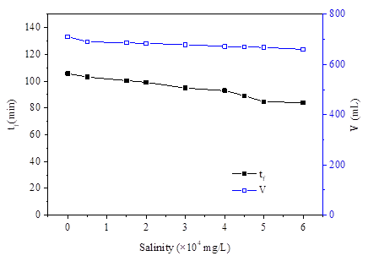
Figure 28 – Salinity effect on foam 1%SS163+1%RC

As for the 1% SS163 + 1% regenerated cellulose foam system, foam volume gradually reduces with increasing salinity. At 60,000 mg/L salinity, the foam volume decreased by 7.0% compared to the baseline. A total decline of approximately 20% foam half-life was observed across the tested salinity range.
The anionic-nonionic surfactant used in this system dissociates to generate anions that adsorb at the gas-liquid interface of foam lamellae, imparting a negative surface charge to the films. This promotes the adsorption of counterions from the solution, forming an electric double layer (EDL) structure [64, p.4-5]. The electrostatic repulsion between similarly charged bubble surfaces effectively mitigates bubble coalescence and retards lamellar thinning. However, increasing salinity compresses the diffuse layer of the EDL (as described by the Debye screening theory), weakening the electrostatic repulsion and diminishing its stabilizing effect, thereby accelerating foam destabilization [63, p.5].
Furthermore, elevated concentrations of metal ions (e.g., Na⁺, Ca²⁺) in the solution perturb the ionization equilibrium of the surfactant molecules, potentially reducing their effective concentration and impairing foam performance. Additionally, regenerated cellulose, a mildly hydrophilic natural polymer particle, exhibits compromised colloidal stability and dispersibility under high-salinity conditions. The compression of its surface EDL reduces particle dispersion efficiency, leading to inhomogeneous distribution within the lamellar films and further destabilizing the foam [53, 64, p.5].
These trends highlight the antagonistic effects of salinity on both interfacial charge stabilization and particle-mediated reinforcement. The cellulose additive partially offsets salinity-induced destabilization by enhancing film viscosity and mechanical integrity, but its efficacy is constrained by ionic strength-dependent colloidal behavior [64, p.4-5].
To investigate the influence of salinity on the electric double layer (EDL) of colloidal particles in the 1% SS163+regenerated cellulose foam system, Zeta potential (ζ) measurements were conducted across varying salinity levels, as illustrated in Figure 29. The regenerated cellulose particles alone exhibited a ζ of -9.93 mV in aqueous solution. Upon addition of the anionic-nonionic surfactant SS163, the ζ decreased to -15.87 mV, attributable to enhanced colloidal stability via surfactant-particle interactions. These interactions likely involve adsorption of surfactant molecules onto cellulose surfaces, augmenting surface charge density and EDL repulsion. Increasing salinity progressively compressed the EDL (governed by the Debye screening effect), reducing ζ magnitudes. At salinities exceeding 100,000 mg/L, a paradoxical ζ increase was observed, signaling colloidal destabilization. This reversal aligns with the Schulze-Hardy rule, where excessive ion concentrations induce particle aggregation by overwhelming electrostatic stabilization [64, p.4-5].

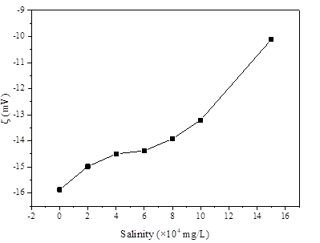
Figure 29 – The influence of salinity on the Zeta potential of RC/surfactant dispersions (C_{RC} 1%, C _{SS163} 1%)

The behavior of cellulose molecules or particles in aqueous environments are significantly affected by salinity, primarily through interactions governed by colloidal science and polymer chemistry. According to the EDL compression and DLVO theory, Colloidal stability arises from a balance between van der Waals attraction and electrostatic repulsion due to surface charges on cellulose particles. Cellulose surfaces, often negatively charged due to hydroxyl or carboxyl groups, develop an EDL in water. The thickness of the EDL decreases with increasing ion concentration (salinity), as described by Debye length, as shown in Eq.7 [53]. Ionic strength increases, the EDL is compressed and reduces the repulsive forces. The salt concentration at which van der Waals forces dominate, leading to particle aggregation and reducing the capacity of RC adsorption evenly on the interface, thus, decreases the foam stability [64, p.4-5].

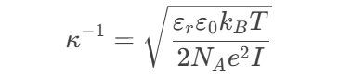 Eq.7

where I is the ionic strength, or = relative permittivity, and e = elementary charge. Higher I compresses the EDL, reducing repulsive forces.
To sum up, salinity could influence both the performance of surfactant and cellulose through a multifaceted interplay of EDL compression, ion-specific effects, solubility changes, and structural factors. These mechanisms collectively dictate colloidal stability, solubility, and macroscopic properties. And in turn, influences the stability of foam.

4.4 Performance of CO₂, water and CO₂ foam flooding on micro-scale
Note that Section4.4 and 4.5 has been published in my article: Xia Yin, Ning Kang, Saule Aidarova, Wanli Kang, Maratbek Gabdullin, Miras Issakhov. The conformance control and enhanced oil recovery performance of CO₂ foam reinforced by regenerated cellulose, Journal of Molecular Liquids, 2024, 415, 125969. https://doi.org/10.1016/j.molliq.2024.125969.
Micro-flooding is a laboratory-scale technique employed to simulate and evaluate foam flooding processes within porous media. This method involves injecting foam into a micro-model—such as a microfluidic chip—designed to replicate the pore structure of reservoir rock. It enables real-time visualization of foam flow behavior, including the generation, stability, and rupture of foam lamellae. In parallel, quantitative parameters such as pressure drop, saturation profiles, and mobility reduction can be accurately measured through microscopic observation [63, p.8].
Figure 30 presents a comparative analysis of micro-flooding outcomes under four different scenarios: original oil saturation, CO₂ flooding, water flooding, and CO₂ foam flooding. The initial oil saturation, determined via image analysis (Image J) based on area percentage, was established at 92.7%. Following the injection of 1 pore volume (PV) of CO₂, the oil saturation decreased to 77.7%, corresponding to an enhanced oil recovery (EOR) of 12.9% (Figure 30b). During CO₂ injection, a gas channel rapidly developed; with continued gas influx, the channel shifted and eventually stabilized. However, the inherently high mobility ratio between CO₂ and crude oil resulted in a poor sweep efficiency of only 15.8% [63, p.8].
In contrast, water flooding (Figure 30c) reduced oil saturation to 57.8%, achieving an EOR of 29.7%. Due to its higher viscosity, water exhibits a more favorable mobility ratio than CO₂. Initially, a preferential water channel formed, which subsequently expanded laterally in the direction of injection, thereby increasing sweep efficiency to 42.4% [63, p.8].
The most effective displacement was observed during CO₂ foam flooding followed by water flooding (Figure 30d). This combined approach reduced oil saturation to 5.1% and yielded an EOR of 92.3%. The injected foam elevated the injection pressure and effectively blocked existing flow paths, redirecting subsequent fluids into previously upswept regions. As a result, the overall sweep efficiency reached 95.4%, underscoring the superior performance of foam flooding in enhancing both macroscopic and microscopic displacement efficiency.
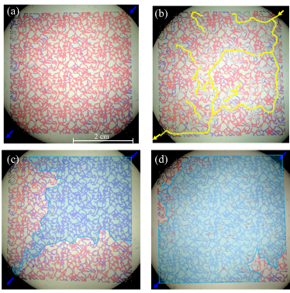
Figure 30 – Micro-flooding results (a) saturated with oil, (b) CO₂ flooding for 1 PV, (c) Water flooding for 1 PV, (d) CO₂ foam stabilized with RC flooding for 0.5 PV and subsequent water flooding for 1 PV. (Blue -brine water, red-simulated oil, yellow arrow and gas phase-CO₂, transparent-glass micro-model) [63, p.8].

Foams with adequate stability effectively confine gas within discrete bubbles rather than permitting it to flow as a continuous phase. This bubble-trapping mechanism increases resistance to flow, preferentially blocks high-permeability channels, and redirects displacing fluids into low-permeability zones containing residual oil [1-3]. Consequently, foam stability is essential for effective conformance control during enhanced oil recovery processes.
A comparative micro-model study was conducted to evaluate the flow behavior of CO₂ foam with and without RC, as illustrated in Figure 31. In the presence of RC (Figure 31a), the foam exhibited a uniform distribution of fine bubbles, with a bubble-to-continuous phase ratio of 1.60. In contrast, foam generated without RC rapidly collapsed, reverting largely to a continuous gas phase, as shown in Figure 31(b), resulting in a markedly lower bubble-to-continuous phase ratio of only 0.19. Furthermore, RC-stabilized foam demonstrated superior sweeping efficiency, mobilizing additional residual oil across a broader area [63, p.8].
In the perspective of flowing resistance, continuous flowing phase has low resistance while flowing bubbles turn out to have higher resistance. Trapped bubbles are trapped in the pore and throats, and increase the flowing resistance of the pores [4]. First, foams tend to flow in the preference pathway with high permeability and low resistance. And various mechanisms were involved to increase the flowing resistance of aqueous phase and modify the mobility [63, p.8]. For instance, bubbles encountered with the throat tend to deform and migrated through the throats, which led to the Jamin effect (Figure 32 (a)) [5, 6]; one or several bubbles gathered could block the channels (Figure 32 (b)) [6, 7]; in other cases, a large bubble encountered different channels and be separated into two or more bubbles, which is so-called lamella division (Figure22 (c)) [8-10]. In addition, the viscosity rise of foam liquid due to natural polymer RC also benefited the mobility control [3]. And then, the subsequently injected fluid was diverted to lower permeable zone to control the conformance [6].

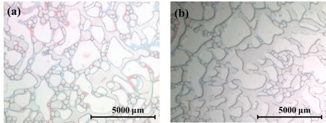
Figure 31 – Flowing foam in the micro-model (a) CO₂ foam with 1% RC, (b) CO₂ foam without RC [63, p.8].
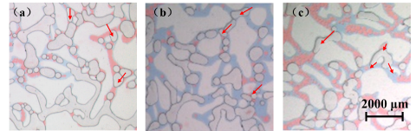
Figure 32 – Foam conformance control phenomena in micro-flooding experiments of CO₂ foam with 1% SS163 + 1% RC: (a) Jamin effect of foam; (b) foams blocked channels; (c) lamella division. Red arrows indicated the phenomena for these mechanisms [63, p.8].

CO₂ foam flooding enhances not only the sweep efficiency, but also increase the displacement efficiency [8, 9]. The foam liquid with surfactant could decrease the interfacial tension, alter the wettability and emulsify the remaining oil (Figure 33 (a)) [6, 10]. Therefore, the remaining oil in the blind end could also be carried with the foam (Figure33 (b)) [63, p.8]. And the foam squeezed and pushed the remaining oil droplets or the oil film on the wall to flow with the aqueous phase (Figure 33 (c)) [7, 10].
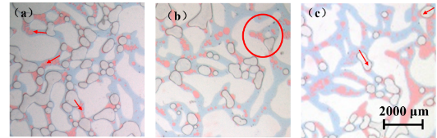
Figure 33 – Foam EOR phenomena in micro-flooding experiments of CO₂ foam with 1% SS163 + 1% RC: (a) emulsification; (b) mobilize remaining oil in the blind end; (c) squeeze and push the oil droplets and film [63, p.8].

4.5 Conformance control and enhanced oil recovery performances at core-scale [63, p.8]
Heterogeneous core flooding experiments are pivotal in bridging lab-scale research and field applications. By evaluating foam’s ability to control fluid mobility and improve sweep efficiency in complex, tight reservoirs, these experiments guide the development of robust EOR strategies, ultimately optimizing hydrocarbon recovery. In this case, the conformance control and EOR performance of CO₂ foam with 1% SS163 and 1% regenerated cellulose was evaluated by the heterogeneous artificial core flooding experiment (the permeability of core fits the real tight reservoirs), as shown in Figure 34 [63, p.8]. In the early stage of the water flooding process, the formation water mainly displaced the crude oil through the high permeability layer, EOR increased rapidly to 22.0%. After water flooding for 0.2 PV, the injection pressure was stable at 0.20 MPa, and EOR kept rising at a lower speed. After 1.1 PV, EOR climbed to 35.5% and became steady. It indicated the preference pathway through the high permeable zone was formed, and even with more injected water for another 0.4 PV, EOR and pressure remained the same. Subsequently, the CO₂ foam flooding was conducted by water alternating gas process (WAG), the pressure rose in a fluctuating manner. After 1 cycle of WAG, EOR and injection pressure began to increase gradually, and the increase was more obvious after four cycles [63, p.8]. These phenomena indicated that the foam was generated during the dynamic migration in the porous media and increased the injection resistance of high permeable region and diverted the fluid to the low permeable region. Correlated with the observation and microscopic images of produced fluid during flooding in Figure 35 (a) and (d), the produced fluid in early stage of foam flooding after 0.4 PV, it consisted of water, emulsion and a small amount of foam with large size. Remaining oil was mainly produced from the low permeable region in the emulsion as droplets, the surfactant in the foam solution carried the remaining oil output in the core through emulsification, which effectively improved the displacement efficiency [10]. The foam with little oil played an important role in blocking the high permeability layer with high water saturation. With the continuous foam flooding, the output of dense foam and the oil content in the emulsion increased significantly, as shown in Figure 35 (b) and (e), which is correlated with the increasing pressure and EOR. After the injection of foam 1.8 PV, EOR continued to increase to 46.7%, while the pressure climbed to 3.1 MPa. With the subsequent waterflooding, the tail end still produced water, foam and emulsion, and then the foam gradually decreased, and the oil content in the emulsion decreased (Figure 35 (c) and (f)). After subsequent water flooding for 0.5 PV, EOR was stable at 56.4%. Compared with water flooding, EOR by foam flooding increased by 20.9%. Those significantly increase of EOR has proved the efficiency of CO₂ foam [63, p.8].

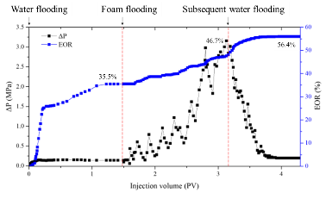
Figure 34 – Pressure and oil recovery of the core flooding experiment results [63, p.8]

In addition, longitudinal sections of flooded heterogenous cores after water flooding and foam with subsequent water flooding were shown in Figure 13. After water flooding, the remaining oil could be observed mainly in the low permeable layers and slightly in the high permeable layer, especially at tail end of core as illustrated in Figure 36 (a). In correlation with results of micro-flooding, it also shows the preference

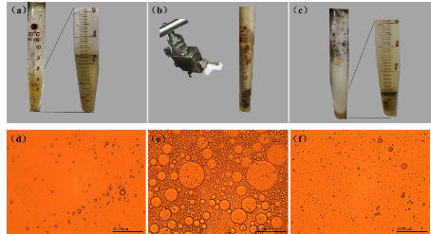
Figure 35 – The observation and microscopic image of produced fluids: (a), (d) after 0.2 PV foam flooding ; (b), (e) after 1.0 PV foam flooding; (e), (f) after 0.2 PV subsequent water flooding [63, p.8]

channel formed after waterflooding, which results in the low sweeping area. With foam flooding, the profile showed a much higher sweep efficiency with only few dark regions in the end tail, and a much higher displacement efficiency with less remaining oil shown in Figure 36 (b) [3, 11, 63, p.8]. These results proved that the injection of the CO₂ foam flooding can effectively control the conformance and improve the oil recovery as explained by the microscopic flooding results and mechanism in Figures 32 and 33 [3]. Therefore, the CO₂ foam stabilized with regenerated cellulose flooding shows great potential in the conformance control and enhanced oil recovery in tight oil reservoirs with strong heterogeneity [63, p.8].

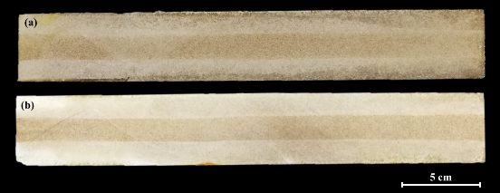
Figure 36 – The longitudinal section of the sandstone core after (a) water flooding, (b) foam flooding. Dark brown represents the remaining crude oil in the core. (4.5*4.5*30 cm, with different permeabilities 20mD,200mD,20mD ) [63, p.7-8]

Based on the micro-scale to core scale analysis, the foam stabilized with regenerated cellulose can not only increase the conformance control performance by altering the preference pathway and increasing the sweep efficiency but also enhance the oil recovery by increasing the displacement efficiency by emulsification, mobilizing the remaining oil mechanism [63, p.7-8].
In the application of this stable foam in the tight oil reservoir, these foam can play significant role in modifying the preference pathways, especially for the dynamic in-depth conformance control by generation and burst of CO₂ foam during migration. In practice, WAG i.e. water alternating gas injection technology can also help to decrease the injection pressure. That effect has been proved by those core-flooding and micro-flooding experiments [63, p.7-8].
CONCLUSIONS
CO₂ foam flooding is one of the most promising technologies for conformance control and enhanced oil recovery (EOR) in heterogenous tight oil reservoirs. In this work, we proposed a new method to reinforce CO₂ foam stability by RC and we also evaluated its stability, conformance control and EOR performances. The following conclusions were drawn:
- Under high temperature and high salinity, the stability of CO₂ foam with RC was significantly enhanced compared with other stabilizers, for its unique property to increase the liquid viscosity and enhance the foam film strength. Thus, the foam liquid drainage half-life and foam half-time was enhanced.
- Four stabilization mechanisms of RC were concluded as follow. The thickening behavior of RC in the liquid phase retards the liquid drainage; the RC aggregates adsorption on the interface and liquid enhances the foam stability; the liquid storage effect of RC supplies the thinning liquid film; the liquid film skeleton formed by RC reinforces the foam.
- In terms of the conformance control, the CO₂ foam with RC increased the injection pressure from 0.20 to 3.1 MPa in the core flooding experiments, suggesting the diversion of fluid from high permeable to low permeable zone and increase of the sweep efficiency.
- In terms of the EOR, the CO₂ foam flooding with RC improved the oil recovery in contrast with the waterflooding from 35.5% to 56.4% by heterogenous core-flooding experiments; the underlying mechanisms are attributed to oil emulsification, rock wettability alteration and foam deformation. These research results reveal the great potential of CO₂ foam with RC in the development of tight oil reservoirs with strong heterogeneity under harsh conditions.
Novelty of the work:
1. Regenerated cellulose (diameter 5-10 nm, length 100-400 nm) was introduced novelly into CO₂ foam. Hereby, a stable CO₂ foam under high temperature and high salinity reservoir condition was proposed, which consisted of 1.0% surfactant SS163+1.0% regenerated cellulose. Its stability is ~20 times higher than without RC.
2. The unique stabilization mechanism of RC-stabilized CO₂ foam was found, including: viscosity thickening liquid to slow liquid drainage, 0.5% RC forms network, 1.0% improves viscosity significantly; RC particles stabilizing foam interface and liquid film and elongate the foam film by ~ 8 times; RC network sustained releasing of water; formation of the foam skeleton by RC inhibiting the Oswald ripening.
3. The core flooding experiments show that RC enhances sweeping efficiency by increasing injection pressure (0.20 → 3.1 MPa) and diverting fluid to low-permeability zones. RC foam improves oil recovery by 20.9% (35.5% → 56.4%) compared with water flooding; meanwhile, the micro-flooding experiments illustrated the conformance control and EOR mechanism of foam with RC is emulsification, wettability alteration, and Jamin effect.

REFERENCES
[1] Energy Information Administration (EIA). Key World Energy Statistics, 2016. https://www.eia.gov/outlooks/ieo/pdf/0484(2016).pdf.
[2] Energy Information Administration (EIA). Key World Energy Statistics, 2016. https://www.eia.gov/outlooks/ieo/pdf/0484(2016).pdf.
[3] E.J. Manrique, C.P. Thomas, R. Ravikiran, M. Izadi Kamouei, M. Lantz, J.L. Romero, V. Alvarado, EOR: Current Status and Opportunities, in: SPE Improved Oil Recovery Symposium, Society of Petroleum Engineers, Tulsa, Oklahoma, USA, 2010.
[4] H. Yang, W. Kang, X. Yin, X. Tang, S. Song, Z.A. Lashari, B. Bai, B. Sarsenbekuly, Research on matching mechanism between polymer microspheres with different storage modulus and pore throats in the reservoir, Powder Technol. 313 (2017) 191–200.
[5] Zhaojie Song, Yilei Song, Yuzhen Li, Baojun Bai, Kaoping Song, Jirui Hou, A critical review of CO2 enhanced oil recovery in tight oil reservoirs of North America and China, Fuel, 276, 2020.
[6] M. Gopalakrishnan, V. Punitha, D. Saravanan, Subramanian Senthilkannan Muthu, Water in Textiles and Fashion, Woodhead Publishing, 2019, 135-153.
[7] S.A.K. Robert, K. Prud’homme, Foam: Theory, Measurements, and Applications, Marcel Dekker, Inc, New York, 1996.
[8] S.S. Di Julio, A.S. Emanuel, Laboratory Study of Foaming Surfactant for CO2 Mobility Control, (1989).
[9] N. Zhang, M. Wei, B. Bai, Statistical and analytical review of worldwide CO2 immiscible field applications, Fuel 220 (2018) 89–100.
[10] J.F. Casteel, N.F. Djabbarah, Sweep Improvement in CO2 Flooding by Use of Foaming Agents, (1988).
[11] S.H. Talebian, R. Masoudi, I.M. Tan, P.L.J. Zitha, Foam assisted CO2-EOR: a review of concept, challenges, and future prospects, J. Pet. Sci. Eng. 120 (2014) 202–215.
[12] S.-H. Chang, R.B. Grigg, Effects of Foam Quality and Flow Rate on CO2-Foam Behavior at Reservoir Temperature and Pressure, 1999.
[13] L. Hernando, H.J. Bertin, A. Omari, G. Dupuis, A. Zaitoun, Polymer-enhanced foams for Water profile control, SPE Improved Oil Recovery Conference, Society of Petroleum Engineers, Tulsa, Oklahoma, USA, 2016.
[14] R. Singh, K.K. Mohanty, Synergy between nanoparticles and surfactants in stabilizing foams for oil recovery, Energy Fuels 29 (2015) 467–479.
[15] B.S. Murray, R. Ettelaie, Foam stability: proteins and nanoparticles, Curr. Opin. Colloid Interface Sci. 9 (2004) 314–320.
[16] S. Fujii, P.D. Iddon, A.J. Ryan, S.P. Armes, Aqueous particulate foams stabilized solely with polymer latex particles, Langmuir 22 (2006) 7512–7520.
[17] R.G. Alargova, D.S. Warhadpande, V.N. Paunov, O.D. Velev, Foam superstabilization by polymer microrods, Langmuir 20 (2004) 10371–10374.
[18] B.P. Binks, Particles as surfactants—similarities and differences, Curr. Opin. Colloid Interface Sci. 7 (2002) 21–41.
[19] S. Lam, K.P. Velikov, O.D. Velev, Pickering stabilization of foams and emulsions with particles of biological origin, Curr. Opin. Colloid Interface Sci. 19 (2014) 490–500.
[20] D. Wang, Q. Hou, Y. Luo, Y. Zhu, H. Fan, Stability comparison between particles stabilized foams and polymer-stabilized foams, J. Dispers. Sci. Technol. 36 (2015) 268–273.
[21] T. Zhu, D.O. Ogbe, S. Khataniar, Improving the foam performance for mobility control and improved sweep efficiency in gas flooding, Ind. Eng. Chem. Res. 43 (2004) 4413–4421.
[22] P. Binks Bernard, S. Horozov Tommy, Aqueous foams stabilized solely by silica nanoparticles, Angew. Chemie Int. Ed. 44 (2005) 3722–3725.
[23] C. Salas, T. Nypelö, C. Rodriguez-Abreu, C. Carrillo, O.J. Rojas, Nanocellulose properties and applications in colloids and interfaces, Curr. Opin. Colloid Interface Sci. 19 (2014) 383–396.
[24] T. Abitbol, A. Rivkin, Y. Cao, Y. Nevo, E. Abraham, T. Ben-Shalom, S. Lapidot, O. Shoseyov, Nanocellulose, a tiny fiber with huge applications, Curr. Opin. Biotechnol. 39 (2016) 76–88.
[25] Abdelaal, A., Gajbhiye, R., & Al-Shehri, D. (2020). Mixed CO2/N2 Foam for EOR as a Novel Solution for Supercritical CO2 Foam Challenges in Sandstone Reservoirs. ACS Omega, 5(51), 33140-33150.
[26] Al Yousef, Z. A., Almobarky, M. A., & Schechter, D. S. (2020). Surfactant and a mixture of surfactant and nanoparticles to stabilize CO2/brine foam, control gas mobility, and enhance oil recovery. Journal of Petroleum Exploration and Production Technology, 10(2), 439-445.
[27] Alizadeh, A. H., Khishvand, M., Ioannidis, M. A., & Piri, M. (2014). Multi-scale experimental study of carbonated water injection: An effective process for mobilization and recovery of trapped oil. Fuel, 132, 219-235.
[28] Aveyard, R., Binks, B. P., Fletcher, P. D. I., Peck, T. G., & Rutherford, C. E. (1994). Aspects of aqueous foam stability in the presence of hydrocarbon oils and solid particles. Advances in Colloid and Interface Science, 48, 93-120.
[29] Xia Yin, Wanli Kang, Shuyang Song, Zitong Huang, Xiaoyu Hou, Hongbin Yang, Stabilization mechanism of CO2 foam reinforced by regenerated cellulose, Colloids and Surfaces A: Physicochemical and Engineering Aspects, 555, 2018, 754-764.
[30] Drenckhan, W., & Saint-Jalmes, A. (2015). The science of foaming. Advances in Colloid and Interface Science, 222, 228-259.
[31] Enick, R. M., Olsen, D., Ammer, J., & Schuller, W. (2012). Mobility and Conformance Control for CO2 EOR via Thickeners, Foams, and Gels - A Literature Review of 40 Years of Research and Pilot Tests SPE Improved Oil Recovery Symposium,
[32] Etemad, S., Telmadarreie, A., Kantzas, A., & Bryant, S. (2022). Conformance control evaluation of the of cellulose nanocrystals based CO2 foams stabilized in synergy with surfactant. Colloids and Surfaces A: Physicochemical and Engineering Aspects, 648, 129274.
[33] Fuseni, A. B., AlSofi, A. M., AlJulaih, A. H., & AlAseeri, A. A. (2018). Development and evaluation of foam-based conformance control for a high-salinity and high-temperature carbonate. Journal of Petroleum Exploration and Production Technology, 8(4), 1341-1348.
[34] M. Lv, Z. Liu, L. Jia, C. Ji, Visualizing pore-scale foam flow in micromodels with different permeabilities. Colloids and Surfaces A: Physicochemical and Engineering Aspects, 600, 124923.
[35] Fuseni, A. B., Julaih, A. H., Al-Aseeri, A. A., & AlSofi, A. M. (2017). Development and Evaluation of Foam-Based Conformance Control for a High Salinity and High Temperature Carbonate SPE Middle East Oil & Gas Show and Conference,
[36] Hawthorne, S. B., Gorecki, C. D., Sorensen, J. A., Miller, D. J., Harju, J. A., & Melzer, L. S. (2014). Hydrocarbon Mobilization Mechanisms Using CO2 in an Unconventional Oil Play. Energy Procedia, 63, 7717-7723.
[37] Jia, C., Zou, C., Li, J., Li, D., & Zheng, M. (2016). Evaluation criteria, major types, characteristics and resource prospects of tight oil in China. Petroleum Research, 1(1), 1-9.
[38] E.J. Manrique, C.P. Thomas, R. Ravikiran, M. Izadi Kamouei, M. Lantz, J.L. Romero, V. Alvarado, EOR: Current Status and Opportunities, in: SPE Improved Oil Recovery Symposium, Society of Petroleum Engineers, Tulsa, Oklahoma, USA, 2010.
[39] H. Yang, W. Kang, X. Yin, X. Tang, S. Song, Z.A. Lashari, B. Bai, B. Sarsenbekuly, Research on matching mechanism between polymer microspheres with different storage modulus and pore throats in the reservoir, Powder Technol. 313 (2017) 191–200.
[40] S.A.K. Robert, K. Prud’homme, Foam: Theory, Measurements, and Applications, Marcel Dekker, Inc, New York, 1996.
[41] S.S. Di Julio, A.S. Emanuel, Laboratory Study of Foaming Surfactant for CO2 Mobility Control, (1989).
[42] N. Zhang, M. Wei, B. Bai, Statistical and analytical review of worldwide CO2 immiscible field applications, Fuel 220 (2018) 89–100.
[43] J.F. Casteel, N.F. Djabbarah, Sweep Improvement in CO2 Flooding by Use of Foaming Agents, (1988).
[44] S.H. Talebian, R. Masoudi, I.M. Tan, P.L.J. Zitha, Foam assisted CO2-EOR: a review of concept, challenges, and future prospects, J. Pet. Sci. Eng. 120 (2014) 202–215.
[45] S.-H. Chang, R.B. Grigg, Effects of Foam Quality and Flow Rate on CO2-Foam Behavior at Reservoir Temperature and Pressure, (1999).
[46] L. Hernando, H.J. Bertin, A. Omari, G. Dupuis, A. Zaitoun, Polymer-enhanced foams for Water profile control, SPE Improved Oil Recovery Conference, Society of Petroleum Engineers, Tulsa, Oklahoma, USA, 2016.
[47] R. Singh, K.K. Mohanty, Synergy between nanoparticles and surfactants in stabilizing foams for oil recovery, Energy Fuels 29 (2015) 467–479.
[48] B.S. Murray, R. Ettelaie, Foam stability: proteins and nanoparticles, Curr. Opin. Colloid Interface Sci. 9 (2004) 314–320.
[49] S. Fujii, P.D. Iddon, A.J. Ryan, S.P. Armes, Aqueous particulate foams stabilized solely with polymer latex particles, Langmuir 22 (2006) 7512–7520.
[50] Binks, B. P., & Vishal, B. (2021). Particle-stabilized oil foams. Advances in Colloid and Interface Science, 291, 102404.
[51] Y. Singh, J.G. Meher, K. Raval, F.A. Khan, M. Chaurasia, N.K. Jain, et al. Nanoemulsion: Concepts, development and applications in drug delivery. Journal of Controlled Release 2017;252:28-49.
[52] F. Zhan, M. Youssef, B. R. Shah, J. Li, B. Li, Overview of foam system: Natural material-based foam, stabilization, characterization, and applications, Food Hydrocolloids, 125, 2022,107435.
[53] P. Attard, Recent advances in the electric double layer in colloid science, Current Opinion in Colloid & Interface Science, 6 (4), 2001, 366-371.
[54] A. Bello, A. Ivanova, A. Cheremisin. Foam EOR as an Optimization Technique for Gas EOR: A Comprehensive Review of Laboratory and Field Implementations. Energies. 2023; 16(2):972.
[55] A. Skauge, J. Solbakken, P. A. Ormehaug, et al. Foam Generation, Propagation and Stability in Porous Medium. Transp Porous Med 131, 5–21 (2020).
[56] T. Majeed, M. S. Kamal, X. Zhou, and T. Solling, A Review on Foam Stabilizers for Enhanced Oil Recovery, Energy & Fuels 2021 35 (7), 5594-5612.
[57] Q. Lv, T. Zhou, Y. Luan, R. Zheng, X. Guo, X. Wang, et al. A green aqueous foam stabilized by cellulose nanofibrils and camellia saponin for geological CO2 sequestration, Journal of Cleaner Production, 2023, 406, 136980.
[58] W. Sun, D. Sun, Y. Wei, S. Liu, S. Zhang, Oil-in-water emulsions stabilized by hydrophobically modified hydroxyethyl cellulose: adsorption and thickening effect, J. Colloid Interface Sci. 311 (2007) 228–236.
[59] J.P.F. Lagerwall, C. Schütz, M. Salajkova, J. Noh, J. Hyun Park, G. Scalia, L. Bergström, Cellulose nanocrystal-based materials: from liquid crystal self-assembly and glass formation to multifunctional thin films, NPG Asia Mater. 6 (2014) e80.
[60] S. Wang, A. Lu, L. Zhang, Recent advances in regenerated cellulose materials, Prog. Polym. Sci. 53 (2016) 169–206.
[61] M. Gestranius, P. Stenius, E. Kontturi, J. Sjöblom, T. Tammelin, Phase behaviour and droplet size of oil-in-water Pickering emulsions stabilised with plant-derived nanocellulosic materials, Colloids Surf. A Physicochem. Eng. Asp. 519, 2017, 60–70.
[62] H.-D. Huang, C.-Y. Liu, D. Zhou, X. Jiang, G.-J. Zhong, D.-X. Yan, Z.-M. Li, Cellulose composite aerogel for highly efficient electromagnetic interference shielding, J. Mater. Chem. A 3 (2015) 4983–4991.
[63] X. Yin, N. Kang, S. Aidarova, W. Kang, M. Gabdullin, M. Issakhov. The conformance control and enhanced oil recovery performance of CO₂ foam reinforced by regenerated cellulose, Journal of Molecular Liquids, 2024, 415, 125969.
[64] X. Yin, N. Kang, W. Kang, M. Gabdullin, N. Akhanova, S. Aidarova, A temperature and salinity resistant CO₂ foam reinforced by regenerated cellulose and its anti-channeling Performance: Conformance control and geo-storage in low-permeability reservoirs, Fuel, 408, 2026, 137598.
[65] Xia Yin, Saule Aidarova, Wanli Kang, The stability, conformance control and enhanced oil recovery study on a novel reinforced CO₂ foam by regenerated cellulose, The First International Conference on Energy and Enhanced Oil Recovery, 2024.

