«L.N.Gumilyov Eurasian National University» NJSC

UDC 621.383.51:544.6.018.4 Manuscript

IBRAYEVA AYAGOZ KAIRULLAKYZY

Design of highly effective novel electrolytes for photovoltaic application

8D05306 – Chemistry

The dissertation submitted as a series of articles for the degree of
Doctor of Philosophy (PhD)

Scientific supervisor
Doctor of Philosophy (PhD),
acting associate professor
Ye.О. Tashenov

External scientific consultant
Doctor of Philosophy (PhD),
medical doctor (MD), lecturer
Robert J. O'Reilly

Republic of Kazakhstan
Astana, 2026

ContentS

1 | Acknowledgments | 3
2 | Article: “Engineering Stable Electrolytes with Covalent Organic Frameworks to Boost Dye-Sensitized Solar Cell Efficiency” | 4-30
3 | Article: “Enhancing the stability and efficiency of dye-sensitized solar cells with MIL-125 metal-organic framework as an electrolyte additive” | 31-51
4 | Review: “Advancements in Carbazole-Based Sensitizers and  Hole-Transport Materials for Enhanced Photovoltaic Performance” | 52-91
5 | Conference: “Metal organic frameworks and covalent organic frameworks as electrolyte enhancers: a pathway to high-efficiently and stable DSSCs” | 94-95
6 | Conference: “Enhancing dye-sensitized solar cells efficiency and stability with Ti-MOF-based quasi-solid-state electrolytes” | 96
7 | Patent: “Method of improving stability and efficiency of dye-sensitized solar cells” | 97

ACKNOWLEDGMENTS

I would like to express my sincere gratitude to Dr. Yerbolat Tashenov, my supervisor, for providing access to the research laboratory and for his support throughout this work. I am deeply thankful to Dr.Mannix P.Balanay for welcoming me into his research group and for generously sharing his expertise, invaluable experience, patience and time.

I would especially like to thank Dr. Bakhytzhan Baptayev for his invaluable guidance, kind encouragement, and continuous support. My sincere thanks also go to the members of the Functional Materials and Computational Chemistry Laboratory, Department of Chemistry and the National Laboratory Astana at Nazarbayev University for their assistance and collaborative environment. I thank Zulfiya Imanbekova, Urker Abibulla, and Diana Suleimenova for their help and support.

I am profoundly grateful to my mother and sister for their constant encouragement. I sincerely thank my husband, Arman, for his unwavering support and belief in me throughout this journey. Above all, I am deeply thankful to my beloved daughter, Tomiris, who has been my greatest source of motivation. I also extend my gratitude to all my relatives for their kind words and encouragement.

Finally, I would like to express my appreciation to the Institute of Natural Sciences at L.N. Gumilyov Eurasian National University and to the Dissertation Council for their valuable work and support.

Article

Engineering Stable Electrolytes with Covalent Organic Frameworks to Boost Dye-Sensitized Solar Cell Efficiency

Ayagoz Ibrayeva^{1,2}, Diana Suleimenova^{1,2}, Zulfiya Imanbekova³, Urker Abibulla³, Bakhytzhan Baptayev¹ *, and Mannix P. Balanay ^{1, 3} *

¹ National Laboratory Astana, Nazarbayev University, 53 Kabanbay Batyr Ave., Astana, 010000, Kazakhstan.
² Department of Chemistry, L.N. Gumilyov Eurasian National University, 2 Satpayev St., Astana, 010008, Kazakhstan.
³ Chemistry Department, Nazarbayev University, 53 Kabanbay Batyr Ave., Astana, 010000, Kazakhstan.

*Corresponding authors. E-mails: bbaptayev@nu.edu.kz; mannix.balanay@nu.edu.kz

Abstract
This study presents a novel strategy to improve the stability and efficiency of liquid electrolytes (LE) in dye-sensitized solar cells (DSSCs) by incorporating a covalent-organic framework (COF) as a functional additive. The COF, synthesized via Schiff base condensation between melamine and terephthalaldehyde, forms a triazine-based porous network capable of effectively encapsulating iodide/triiodide redox species. The resulting LE+COF composite mitigates key limitations of traditional DSSCs, including electrolyte leakage, volatility and evaporation, sealing issues, limited stability, and poor transport charge. Electrochemical and photovoltaic analyses reveal that COF incorporation improves ionic conductivity and lowers charge transfer resistance at the electrode–electrolyte interface. DSSCs with LE+COF achieve an average power conversion efficiency (PCE) of 10.81%, with peaking at 11.74%, with short-circuit current densities up to 18.60 mA/cm² under AM 1.5 illumination. Long-term stability tests at ~23°C show ~95% retention 960 h. Under indoor lighting (6024 ± 39lx), LE+COF-based DSSCs outperform LE-only devices, delivering average and peak PCEs of 25.74%, peaking at 27.40%, compared to 23.69% and 26.28%, respectively. These findings highlight COF-based additives as a promising route toward efficient, durable DSSCs for both outdoor and indoor applications, particularly where low light performance and operational longevity are critical.
Keywords quasi-solid electrolyte; additive; covalent-organic frameworks, triazine, indoor photovoltaics.

Introduction
Recent advancements confirm that liquid electrolytes (LEs) remain among the most effective components in dye sensitized solar cells (DSSCs), achieving a power conversion efficiency (PCE) as high as 15.2% under standard AM 1.5 global sunlight conditions [1]. However, despite their superior performance, LEs suffer from significant drawbacks including corrosion, volatility, and leakage, which hinder the long-term operational stability of DSSCs and impede their commercialization [2,3]. As one of the most critical components influencing DSSC performance, the electrolyte must maintain stability over time. Unfortunately, LEs are prone to evaporation and degradation, leading to reduced open circuit voltage (V_{OC}) and accelerated device deterioration [4].
The most entensively studied classes of sensitizers in DSSCs include ruthenium complex dyes, donor–π–acceptor (D-π-A) structured organic dyes, and porphyrin dyes, each offering distinct charge-transfer mechanisms and performance advantages. PCEs up to 14% have been achived through the integration of advanced device architectures featuring innovative redox mediators, particularly cobalt complexes, and electrodes based on two-dimensional materials, which enhance light harvesting and suppress charge recombination [5]. Recent developments in D-π-A dyes, such as indacenodithiophene, carbazole and triphenylamine donor units, have demonstrated PCEs 13% in co-sensitized or co-adsorbed systems, now rivaling the performance of traditional ruthenium-based dyes [6-9]. Molecular engineering strategies, including push–pull frameworks, π-conjugation extension, and co-sensitization, have also significantly advanced porphyrin dye systems. These modifications have enabled PCEs exceeding 14% in optimized configurations, and nearly 11% when paired with copper(I/II) redox shuttles, which can deliver V_{OC} approaching 0.95V through carefully designed co-sensitization schemes [10].
Extensive research has been focused on creating innovative electrolyte solutions with enhanced electrochemical and transport characteristics to address enduring performance limitations. One promising approach involves incorporating nanofillers such as nano sized metal oxides, metal carbides, and carbon-based materials into the LE. Examples include TiO₂, ZnO, Al₂O₃, TiC, SiO₂, carbon black, graphite, and graphene oxide. Each nanofiller introduces specific properties that enhance charge transfer, facilitate redox mediator diffusion, lower charge recombination resistance, and promote ionic conductivity [11]. Significant advancements have been reported in DSSCs utilizing the N719 dye, particularly in systems employing novel electrolyte materials. For instance, the incorporation of Zn₅(OH)₈Cl₂ as an inorganic filler in poly(vinylidene fluoride)-based electrolytes has yielded a PCE of 7.52% [12], Additionally, the use of poly(ethylene glycol)-functionalized ABA triblock copolymers, comprising poly(acrylonitrile-co-N,N-dimethylacrylamide)-block-poly(ethylene glycol)-block-poly(acrylonitrile-co-N,N-dimethylacrylamide), has demonstrated an improved PCE of 10.02% [13]. Furthermore, electrolytes added with titanium metal-organic frameworks (MOF) have achieved a notable PCE of 10.51% [14].
Covalent organic frameworks (COFs) have recently emerged as versatile materials with applications spanning energy storage, gas separation, catalysis, water splitting, sensing, and photovoltaics [15-17]. Their high surface area, tunable pore sizes, and customizable functional groups make them particularly suitable for use in solar energy devices. COFs, in both two-dimensional (2D) and three-dimensional (3D) forms, are promising materials for photovoltaic (PV) applications. While 2D COFs have been widely explored due to their well-ordered structures and tunable electronic properties, studies involving 3D COFs are relatively limited. This is mainly due to the greater complexity involved in their synthesis and structural control. However, 3D COFs offer several potential advantages, such as larger surface areas, interconnected pores, and efficient charge transport pathways, making them valuable candidates for solar energy applications.
In DSSCs, have primarily been employed as additives in dyes or photoanodes, while their potential role within the electrolyte remains largely unexplored. For instance, incorporating polyimide-based COFs into TiO₂ photoelectrodes has been shown to enhance PCE from 9.05% to 10.46% [18]. However, when COFs have been employed either as sensitizers or as interfacial materials between TiO₂ and the N719 dye, the resulting PCEs have been observed to be up to 2% lower than those of reference cells. This decline may be attributed to the limited light-harvesting capabilities of COFs, suboptimal electronic coupling with TiO₂, or inefficient charge transfer dynamics at the interface [19]. Despite these findings, the application of 3D COFs in DSSCs remains insufficiently explored. Given their high porosity and surface area, 3D COFs offer promising opportunities for enhancing DSSCs device features.
This study presents an application of COFs as functional additives within iodide/triiodide (I⁻/I₃⁻)-based LE, aimed at mitigating charge recombination and improving long-term stability of DSSCs. While prior research has extensively examined the roles of COFs in dyes and photoanodes, their potential impact on LE systems remains largely underexplored. In this work, we propose the integration of COFs directly into the LE matrix, where they function as structural scaffolds. This approach is designed to stabilize the LE composition, suppress dye degradation, and preserve the conduction band alignment of TiO₂, thereby enhancing both the efficiency and durability of the PV system under operational conditions.
By engineering the pore architecture of COFs to ensure compatibility with LE constituents and device interfaces, these materials demonstrate substantial promise in advancing DSSCs’ performance. The inherent properties of COFs, such as their high surface area, pre-designed porosity, and tunable chemical functionality, make them particularly well-suited for this role. This work offers an analysis of synthesis methods, structural characteristics, and functional performance of COFs within the context of LE systems, highlighting their advantages over conventional fillers and MOFs.
Compared to MOFs and traditional inert fillers, COFs provide several key advantages that are highly beneficial for demanding energy storage and conversion applications. These include good chemical and thermal stability, especially in corrosive environments; enhanced structural robustness due to their fully covalent, organic architecture; and lightweight frameworks that facilitate efficient device integration. Furthermore, the electronic and compositional tunability of COFs, enabled through both synthetic and post-synthetic modifications, allows for precise control over surface chemistry and pore characteristics. Their highly ordered and uniform nanochannels facilitate enhanced ion mobility and selectivity, which are critical parameters for the efficient operation of LE systems [20].
The specific COF employed in this study was selected for its robust triazine-based structure, which imparts several performance-critical characteristics often absent in more advanced but less stable ionically conductive COFs. The triazine core contributes significantly to the framework’s exceptional chemical and thermal resilience, structural rigidity, and tunable porosity, enabling the material to retain its integrity under the chemically aggressive conditions typically encountered in DSSCs electrolytes [21]. Moreover, this COF provides highly controlled pore dimensions and surface functionality, essential for selective ion transport and adsorption. The framework’s hydrophilic nature and strong π–π interactions further enhance its efficacy in adsorption and separation processes, which can translate into more stable and efficient electrolyte behavior [21].
Although ionically conductive COFs offer advantages in terms of ionic transport, they frequently suffer from diminished structural stability and selectivity unless reinforced by stable motifs such as triazine units. Thus, the COF chosen for this work represents an optimal balance between ionic accessibility, structural robustness, and functional tunability. Its well-defined, customizable structure makes it a highly suitable candidate for improving the performance and longevity of I⁻/I₃⁻LE in DSSC applications.

2. Materials and Methods
2.1. Materials
All the compounds used in this investigation were of high purity from commercial sources and used without further purification unless otherwise noted. Melamine, 99% (Thermo Scientific); Terephtaldehyde, 99% (Thermo Scientific); Dimethylsulfoxide (DMSO, Sigma Aldrich); Tetrahydrofuran anhydrous (THF, Sigma Aldrich); Dichloromethane anhydrous (DCM, Sigma Aldrich); Acetone anhydrous (Sigma Aldrich), iodine ≥ 99,8% (Sigma Aldrich); Fluorine-doped SnO₂ (FTO) coated glass (7 Ω/sq, 2.2 mm, Sigma Aldrich); light scattering titania paste (Greatcell Solar WER2-O TiO₂ Paste, Sigma-Aldrich); transparent TiO₂ electrode paste (DN-EP03, Dyenamo); screen printable Platinum paste (Greatcell Solar PT1 Pt paste, Sigma-Aldrich); Di-tetrabutylammonium cis-bis(isothiocyanato)bis(2,2’-bipyridyl-4,4’-dicarboxylato)ruthenium (II), 95% (N719, Sigma Aldrich); chenodeoxycholic acid (CDCA, Sigma Aldrich); titanium (IV) isopropoxide, 97% (TTIP) Sigma Aldrich); lithium iodide, 99.9% (LiI, Sigma Aldrich); guanidine thiocyanate, 99% (GuSCN, Alfa Aesar, Thermo Scientific); 3-methoxypropionitrile (MPN, Sigma Aldrich); 4-tert-butylpyridine, 98% (tBP, Sigma Aldrich); acetonitrile (ACN, Acros Organic); tert-butanol, ≥ 99.0% (Sigma Aldrich); and hydrochloric acid > 37% (HDL, Sigma Aldrich).

2.2 Preparation of LE+COF electrolyte
Synthesis of COF: The synthesis of the highly crosslinked 3D network compound was carried out following the procedure outlined by Cheng et al. [22], which has been reported to yield a compound with a BET surface area ranging from 300–1300 m² g⁻¹, indicating its inherent porosity. A pressure vial, equipped with a magnetic stirring bar, was loaded with melamine (313 mg, 2.48 mmol), terephthalaldehyde (500 mg, 3.73 mmol), and dimethyl sulfoxide (15.5 mL) as the solvent. The mixture was then heated at 170 °C for 96 hours under an inert atmosphere. After cooling to room temperature, the resulting precipitate was filtered and thoroughly washed with an excess of anhydrous acetone, anhydrous tetrahydrofuran, and anhydrous dichloromethane. The solvents were subsequently removed under reduced pressure using a rotary evaporator. Final drying was performed at 120°C under vacuum in a tube furnace, yielding a pale-yellow powder with a 64% yield. Elemental analysis for C₃₃H₂₁N₁₈: calculated: C,59.19%; H,3.16%; N,37.65%; found: C,41.84%; H,3.98%; N,44.35%. The elemental analysis results are consistent with those reported in the original publication [22], although slight deviations from the theoretical values are attributed to the rapid crosslinking reaction.
Electrolyte preparation. The liquid electrolyte was prepared with the following composition: 0.03 M I₂, 0.05 M LiI, 0.10 M GuSCN, 0.6 M BMII, and 0.5 M tBP in a 1:1 mixture of ACN and MPN. BMII was synthesized using the method described in the literature [23], with the ¹H NMR spectrum provided in Figure S1 of the supporting information. For the LE+COF mixture, various concentrations of COF were tested (ranging from 10 mg/mL to 40 mg/mL) in Table S1. The concentration was carefully monitored to ensure homogeneity of the electrolyte. In a sealed vessel, 10 mg of COF was added to 0.5 mL of the LE and stirred at room temperature for 3 days to obtain the optimal LE+COF mixture. The resulting LE+COF mixture was stored in dark, sealed containers and continuously stirred to maintain consistency. It was observed that higher COF concentrations resulted in increased viscosity and particle aggregation, which in turn reduced ion mobility and led to a decrease in the efficiency of the DSSC. Representative images of the prepared LE+COF mixture are shown in Figure S2 of the supporting information. The COFs used in DSSCs feature inherently planar, π-conjugated frameworks with nitrogen-rich surfaces, making them prone to aggregation and agglomeration through π-π stacking and hydrogen bonding interactions. Although direct studies on COF agglomeration in DSSCs electrolytes are scarce, similar behavior has been reported in related COF-based systems. These interactions are particularly important when evaluating the performance limitations and optimization strategies for triazine-based COFs in LE environments.

2.3. Fabrication of photoanodes and DSSC assembly
The fabrication of the photoanodes and counter electrodes (CE), as well as the sensitization and device assembly procedures, were carried out following our previously reported method [14]. Briefly, the photoanodes were prepared on fluorine-doped tin oxide (FTO) glass substrates (1.5×2.0 cm) and incorporated a compact TiO₂ layer, a transparent mesoporous TiO₂ layer (particle size: 18–20 nm), and a light-scattering TiO₂ overlayer (particle size: 150–250 nm), applied using the doctor blade technique and sintered through a multi-step thermal process. The films were sensitized using a dye solution containing 0.25 mM N719 and 0.75 mM chenodeoxycholic acid in a 1:1 (v/v) mixture of tert-butanol and acetonitrile, with adsorption carried out in the dark at room temperature for 24 h. Devices were assembled using a 60 μm thick thermoplastic spacer or double-sided adhesive film to define the active area (~1 cm²), and the electrolyte was introduced between the photoanode and Pt-coated CE. All cells were fabricated under identical conditions, and PV performance was evaluated across nine independently prepared devices to ensure reproducibility.

2.4. Characterization
A comprehensive suite of analytical techniques was employed to characterize the synthesized COF. Structural properties were examined using X-ray diffraction (XRD) on a Rigaku SmartLab diffractometer (Cedar Park, TX, USA). Functional groups were identified via attenuated total reflectance Fourier-transform infrared (ATR-FTIR) spectroscopy using an Alpha II spectrometer (Bruker), while molecular vibrational modes were further analyzed by Raman spectroscopy (Horiba LabRam Evolution). Optical properties in the solid state were assessed using a Shimadzu UV-2600i spectrophotometer, which features a double-beam optical design to ensure accurate baseline correction and enhanced spectral resolution. Thermal stability was evaluated through thermogravimetric analysis (TGA) using a Q500 instrument (TA Instruments), providing quantitative data on decomposition temperatures and material robustness under thermal stress.
Morphological and compositional characteristics were examined by transmission electron microscopy (TEM) using a JEOL JEM-1400 Plus and scanning electron microscopy (SEM) with a Carl Zeiss Auriga Crossbeam 540, equipped with an energy-dispersive X-ray spectrometer (EDS). Elemental valence states were analyzed using X-ray photoelectron spectroscopy (XPS) with a Thermo Scientific NEXSA system.
Textural properties, including surface area and pore size distribution, were evaluated by nitrogen adsorption–desorption isotherms using a Quantachrome porosimeter. Liquid-state ¹H nuclear magnetic resonance (¹H NMR) spectroscopy was conducted on a JEOL 500 MHz spectrometer to characterize the BMII compound. Elemental composition was determined using a Unicube® trace organic elemental analyzer.
PV performance of the DSSCs was assessed using an Oriel Sol3A solar simulator (Newport) under AM 1.5G illumination (100 mW/cm²). Current–voltage characteristics were recorded using a Keithley 2440 source meter. Light intensity was calibrated with a Newport Oriel Si reference cell and meter (Model 91150V). Electrochemical studies were conducted with a PalmSens4 potentiostat. Electrochemical impedance spectroscopy (EIS) was performed in the dark with a 10-mV perturbation across a frequency range of 0.1 Hz–100 kHz. For DSSCs measurements, a bias voltage equal to the open-circuit voltage was applied, whereas symmetrical dummy cells were tested at 0 V bias. Cyclic voltammetry (CV) was conducted using a Pt wire as the CE, a nonaqueous Ag/Ag⁺ reference electrode, and the COF material as the working electrode. The measurements were carried out in an acetonitrile solution containing 100 mM LiClO4, 10 mM LiI, and 1 mM I₂ at a scan rate of 0.1 V/s.

3. Results and Discussion
3.1. Characterization of COF
The X-ray diffraction pattern of the synthesized COF (Figure 1a) reveals a broad peak centered at 21.4°, indicative of an amorphous structure lacking distinct crystalline reflections. This diffuse signal arises primarily from structural disorder within the layered framework, particularly due to interlayer slipping or misalignment among stacked two-dimensional sheets. These displacements lead to anisotropic peak broadening and, when sufficiently pronounced, merge multiple reflections into broad humps, resulting in the observed amorphous-like background [24]. The limited crystallinity of COFs further accentuates this effect, as their large unit cells shift reflections to lower angles while small domain sizes reduce coherence length. Additionally, the presence of residual amorphous content raises the baseline of the diffractogram. Collectively, stacking disorder, interlayer variability, and amorphous phase contributions explain the broad feature at 21.4°, in agreement with recent studies on the complex and dynamic nature of COF layer organization.
Further evidence for successful framework formation is provided by the Fourier-transform infrared spectra shown in Figure 1b. The peaks at 3400 cm⁻¹, 1671 cm⁻¹, and 2926 cm⁻¹, corresponding to the NH₂ stretch of melamine, the C=O stretch of aldehydes, and the C–H stretch, respectively, are either significantly reduced or completely absent. In contrast, strong absorption bands at 1465 cm⁻¹ and 1534 cm⁻¹, associated with the semicircle and quadrant vibrational modes of the triazine ring, confirm the formation of the triazine-based network. These spectral changes verify the successful synthesis of the covalently linked COF framework through the elimination of melamine and terephthaldehyde, in agreement with previous findings [25].
Figure 1. Characterization of the synthesized COF: (a) Powder X-ray diffraction pattern, (b) Fourier-transform infrared spectrum, (c) Thermogravimetric analysis curve, and (d) N₂ adsorption–desorption isotherm.
Raman spectroscopic analysis of the material synthesized from melamine and terephthalaldehyde further confirms the formation of an extended conjugated network (Fig. S3). The spectrum displays prominent peaks at approximately 1265 cm⁻¹ and 1527 cm⁻¹, corresponding to the D and G bands, respectively. The D band indicates structural disorder or defects in sp²-hybridized carbon systems, while the G band reflects the in-plane stretching of ordered sp² carbon domains [26]. These features are characteristic of conjugated aromatic structures. Additionally, a peak at around 1055 cm⁻¹ is observed, which may arise from C–N stretching vibrations or ring-breathing modes of triazine or other aromatic heterocycles. This further supports the incorporation of nitrogen-containing units derived from melamine into the framework. The calculated intensity ratio of the D to G bands (ID/IG) is approximately 0.83, suggesting a moderately ordered structure with localized disorder likely introduced by triazine units. This ratio indicates the presence of extended π-conjugation alongside nitrogen-rich domains, consistent with the formation of a COF. Overall, the Raman spectral features confirm a partially ordered, conjugated network with heteroatom incorporation, supporting the successful synthesis of a nitrogen-doped COF-like structure [27].
The solid-state absorption spectrum of the COF exhibits strong absorption in the ultraviolet region, with a pronounced maximum at 253 nm (Fig. S4). This peak is attributed to π–π* electronic transitions within the conjugated aromatic systems of its building blocks, further supporting the presence of extended conjugation. Beyond this maximum, the absorption intensity decreases sharply, with negligible absorbance in the visible range (400–800 nm), indicating a relatively large optical band gap and high transparency to visible light. This optical transparency is particularly advantageous when the COF is used as an additive in the electrolyte for dye-sensitized applications, as it minimizes interference with the dye’s absorption of visible light. Additionally, the strong UV absorption may contribute to electrolyte stability by filtering out high-energy UV photons that could otherwise degrade sensitive components.
Thermogravimetric analysis further supports the stability of the synthesized framework, revealing three distinct weight-loss regions: 25–150⁰C, 200–380⁰C, and 445–800⁰C, as presented in Fig. 1c. The initial weight loss is attributed to the evaporation of physically adsorbed water and residual solvents such as acetone, tetrahydrofuran, dichloromethane, and DMSO, accounting for approximately 10 % mass loss. The second stage, involving a 39 % weight loss, corresponds to the decomposition of oxygen- and nitrogen-containing functional groups, particularly the cleavage of weaker C–N bonds in aminal (–HN–C–NH–) and amine linkages. The third region, beginning above 445⁰C and accounting for 51 % of the mass loss, is associated with the thermal decomposition of aminal covalent bonds within the COF network. Notably, no significant structural decomposition occurs below 445 ◦C, indicating high thermal stability of the framework [25,28].
Nitrogen adsorption–desorption isotherms (Fig. 1d) exhibit a Type III profile with minimal hysteresis, characteristic of a well-ordered microporous structure [21]. The material demonstrates a Brunauer–Emmett–Teller (BET) surface area of 612.01 m²g⁻¹ and a micropore volume of 0.08 cm3 g⁻¹. This high surface area provides abundant active sites for ion interaction, thereby promoting efficient adsorption and desorption of ionic species [29]. The extensive surface further facilitates rapid ion diffusion by lowering resistance to ion migration, which enhances overall ionic conductivity. Interconnected porous channels within the framework support effective ion diffusion and charge transport by enabling charge carriers to move through the structure with minimal energy barriers [30]. Studies have shown that increasing the surface area and pore size of COFs correlates with a higher charge-transfer rate constant, indicating faster electron and ion mobility and leading to improved device performance [31,32]. Moreover, the porous architecture provides efficient pathways for ion transport, significantly reducing diffusion resistance and further contributing to enhanced electrochemical performance [33,34].
SEM, TEM, and EDS analyses (Fig. 2a–c) demonstrate the formation of spherical particles with diameters below 50 nm. Elemental mapping using EDS further confirms the homogeneous distribution and coexistence of carbon and nitrogen within the COF framework (Fig. 2c).
XPS was employed to investigate the local electronic structure and oxidation states of the synthesized material. Survey spectra (Fig. 3a) shows prominent peaks corresponding to C 1s, N 1s, and O 1s, further confirming the successful incorporation of these elements. High-resolution C 1s spectra (Fig. 3b) exhibit four distinct peaks at binding energies of 284.8, 286.1, 287.3, and 288.5 eV, which are assigned to C–C, C–N, C=N, and C=O species, respectively. The N 1s spectra (Fig. 3c) reveal two main peaks at 398.1 and 399.4 eV, corresponding to C–N=C and C–NH–C environments, respectively, in agreement with the triazine and aminal linkages in the framework [35].

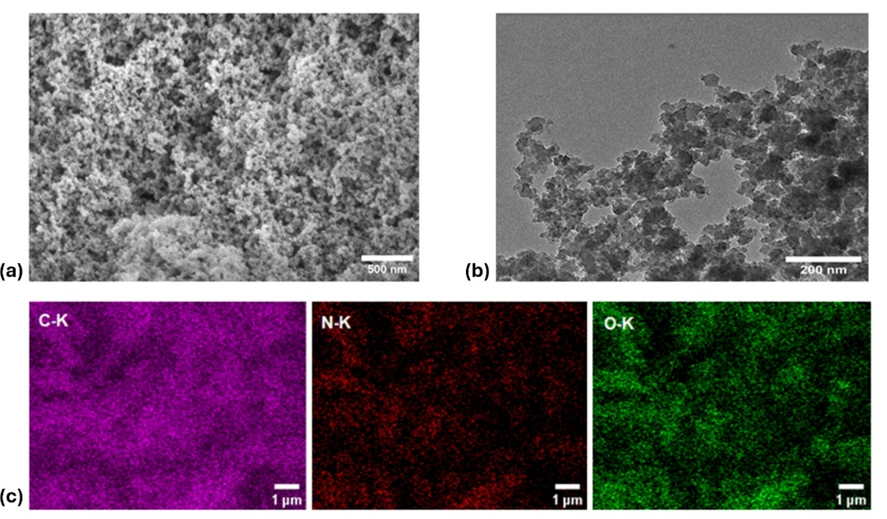
Figure 2. Morphological and elemental characterization of the COF: (a) SEM image, (b) TEM image, and (c) elemental mapping overlay.

Figure 3. X-ray photoelectron spectroscopy analysis of the COF: (a) Survey scan, and high-resolution spectra of (b) C 1s and (c) N 1s regions.
2.5μm
3.2. Electrochemical analysis
The charge-transfer kinetics at the interface between the LE+COF and the platinized counter electrode were examined using Tafel analysis, as shown in Figure 4a. The rates of the redox reactions occurring at this interface can be described by the Butler–Volmer equation, as presented in Equation (1) [36].

$$\begin{aligned}j=-j_{o}\left[\exp{\frac{α_{c}nF}{RT}\left(E-E_{eq}\right)-\exp{\frac{-α_{a}nF}{RT}(E-E_{eq})]}}\right] \#\left(1\right)\end{aligned}$$

In this equation, j represents the electrode current density, j_{o} is the exchange current density, E is the applied voltage, E_{eq} is the I⁻/I₃⁻ electrode potential at equilibrium, n is the number of electrons transferred, F is Faraday's constant, α_{c} and α_{a} are the cathodic and anodic charge-transfer coefficients, respectively, R is the universal gas constant, and T is the absolute temperature. The term (E – E_{eq}) represents the activation overpotential. When |E – E_{eq}| ≫ 0, Equation 1 reduces to the standard Tafel equation, as shown in Equation 2 [36]:

$$\begin{aligned}E-E_{eq}=±β\log_{10}{\frac{j}{j_{o}}} \#\left(2\right)\end{aligned}$$

Here, β denotes the Tafel slope, which represents the rate at which the overpotential must increase to enhance the reaction rate (or current) of an electrochemical reaction by a factor of ten. The anodic slope (β_{a}) and cathodic slope (β_{c}) offer insights into the anodic and cathodic reactions occurring at the TiO₂/electrolyte interface. Tafel polarization tests for the I⁻/I₃⁻ redox reaction was performed in the potential range of ±1 V at a scan rate of 50 mV/s. For this analysis, a symmetric cell with two identical Pt electrodes (active area of 1 cm²) was assembled, and various electrolytes used in DSSCs were employed. The anodic and cathodic slopes reveal information about the reactions taking place at the TiO₂/electrolyte interface.

Figure 4. (a) Tafel polarization curves of LE and LE+COF (b) Nyquist plot of symmetrical dummy cells (inset is the equivalent electrical circuit used for fitting Nyquist plots).

The cathodic Tafel slopes for the LE+COF electrolyte were higher (β_{c} = 237 mV/decade) compared to the LE electrolyte (β_{c} = 214 mV/decade), while the anodic Tafel slopes were slightly higher in the LE electrolyte (β_{a} = 251 mV/decade) than in LE+COF (β_{a} = 250 mV/decade). This suggests a minor decrease in the reaction rate of I⁻ ions at the interface for the LE+COF electrolyte. The gelation of the electrolyte increases its viscosity, which in turn affects the mobility of ions. Our findings indicate that I₃⁻ ions become more prominent because their reactions with the TiO₂ surface typically occur at a higher rate than I⁻ ions.
From Equation 2, it follows that j = j_{o} when the overpotential is at its equilibrium value. The j_{o} value is determined by the intersection of the linear anodic and cathodic branches on the Tafel plot. For the LE electrolyte, j_{o} is 0.95 mA/cm², while for the LE+COF electrolyte, it is 1.08 mA/cm², suggesting a higher electron flow at the TiO₂/LE+COF interface compared to the TiO₂/LE interface. Additionally, j_{o} is related to the charge transfer resistance, R_{CT}, at the interface, as described by Equation 3:

$$\begin{aligned}j_{o}=\frac{RT}{nFR_{CT}} \#\left(3\right)\end{aligned}$$

The charge-transfer resistance can be determined through electrochemical analysis of a symmetrical dummy cell, where two identical Pt electrodes are placed face-to-face, with the electrolyte sample filling the gap between them. Figure 4b shows the Nyquist plot for these symmetrical dummy cells using LE+COF and LE electrolytes. In the Nyquist plot, the x-axis intercept represents the series resistance (R_{S}), the first semicircle indicates the charge-transfer resistance, the second semicircle corresponds to the diffusion resistance of the electrolyte (Z_{W}), and CPE represents a constant phase element that accounts for deviations from ideal capacitance caused by the roughness of the electrode surfaces [37].
The charge-transfer resistance for LE+COF is significantly lower than for LE, measuring 3 ohms compared to 5.5 ohms, which is consistent with the Tafel results. Using these values, the ionic conductivity (σ) of the electrolyte films can be calculated according to Equation 4:
$$\begin{aligned}σ=\frac{d}{R_{CT}A} =nqμ\#\left(4\right)\end{aligned}$$

where d and A are the thickness and area of the electrolyte layer, n is the charge carrier concentration, q is the charge on the mobile carrier, and μ is the carrier mobility [38]. Our results show that LE+COF exhibits higher conductivity (2.01 mS/cm) compared to the LE (1.11 mS/cm). According to Equation 4, the increased conductivity may be attributed to a combination of higher carrier mobility and increased charge carrier concentration, consistent with findings from previous studies [38].
Electrochemical impedance spectroscopy (EIS) was employed to investigate the diffusion behavior of triiodide ions (I₃⁻ ) in symmetrical dummy cells filled with a standard LE and LE + COF. The Nyquist plots were fitted using an equivalent circuit, shown in the inset of Fig. 4b, that includes a Warburg diffusion element, from which the Warburg coefficient (Ws) was extracted [39]. The bulk concentration of the redox species, denoted as C, was used along with the electrode area (A, 1 cm²) to determine the apparent diffusion coefficient (Dapp) using the following Equation (5):

$$D=\frac{d}{2nFC}Jlim \left(5\right)$$

The Warburg coefficient was found to be 4.1 Ω s^{1/2} for the LE system and 2.7 Ω s^{1/2} for the LE + COF system, with a constant redox species concentration and an electrode area of 1.0 cm². Substituting these values into the equation yielded a Dapp of 3.2 × 10⁻¹⁶ cm²/s for LE and a significantly higher value of 7.54 × 10⁻¹⁶ cm²/s for LE + COF. This result indicates that the incorporation of the COF into the LE system enhances the diffusion of triiodide ions. The reduction in Warburg impedance suggests that mass transport resistance was lowered in the presence of the COF, likely due to its porous structure providing more efficient transport pathways.
The CV analysis reveals significant differences in the redox behavior of the I⁻/I₃⁻ couple with and without the presence of a COF in the electrolyte, which correlates with improved PV efficiency. A three-electrode setup was used, consisting of a Pt wire CE, a nonaqueous Ag/Ag+ reference electrode, and a glassy carbon electrode modified with COF as the working electrode. The COF-modified GCE was prepared by dispersing 1.8 mg of COF in ethanol, sonicating for 30 min, and drop-casting the suspension onto the electrode surface. A bare GCE without COF served as the control.
As shown in Fig. S5, the CV curves exhibit characteristic anodic and cathodic peaks corresponding to the two-electron redox processes of the I₃⁻/I⁻₂ and I⁻/I₃⁻ couples [40,41]. The cathodic peak current density (Ipc) reflects the reduction rate of I₃⁻to I⁻, where higher absolute values indicate enhanced electrocatalytic activity. The peak-to-peak separation (Epp) is inversely related to electron transfer kinetics; smaller Epp values signify faster redox reactions. In the control, anodic peaks appear at +0.17 V and +0.53 V, while cathodic peaks are observed at -0.76 V and +0.35 V, consistent with the typical I⁻/I₃⁻ redox process. The observed peak separation of 0.93 V between the anodic and cathodic peaks indicates sluggish electron transfer and quasi-reversible behavior. In contrast, the COF-modified system displays anodic peaks shifted positively to +0.64 V and +0.85 V, and cathodic peaks at -0.64 V and +0.50 V. These shifts indicate stabilization of the oxidized species, likely due to π–π interactions, electrostatic effects, or confinement within the porous COF structure. Theoretical calculations support this interaction, showing Gibbs free energies of formation for COF–I⁻ and COF–I₃⁻ as -464 and -352 kJ/mol, respectively, with the structures shown in Fig. S6. Although the COF system exhibits larger peak separations, up to 1.28 V, implying slower electron transfer kinetics, this can be advantageous in photovoltaic applications. The positively shifted redox potentials enhance the driving force for dye regeneration and may suppress recombination between I₃⁻ or I₂ and photoexcited electrons in the TiO₂ conduction band. Additionally, the COF may facilitate more efficient charge collection by improving ion transport within the LE or enhancing light absorption through scattering effects, as evidenced by the higher Jsc. Interfacial modifications introduced by the COF can also improve charge separation and reduce recombination at the CE. These combined effects account for the enhanced PV performance observed with the COF-containing electrolyte, demonstrating that despite slower apparent redox kinetics, the COF provides a more favorable electrochemical and physical environment for efficient energy conversion.

3.3. Photovoltaic performance
DSSCs were fabricated using an LE enriched with a COF, and their electrochemical and PV properties were systematically evaluated, as summarized in Table 1. The DSSC utilizing the COF +LE exhibited a marked improvement in PCE, achieving a value of 10.81 %, in contrast to 8.87 % observed for the control device containing only the LE. This enhancement in PCE is primarily attributed to a significant increase in the Jsc, with the LE+COF-based device recording 18.60 mA/cm² compared to 15.85 mA/cm² for the LE only cell. The elevated Jsc in the LE+COF system suggests more efficient photo-induced charge generation and transport, likely due to the improved ionic conductivity and optimized charge mobility imparted by the COF additive. These findings are further substantiated by the photocurrent densities derived from the incident photon-to-current efficiency (IPCE) spectra, which show a J_{sc} of 19.23 mA/cm² for the LE+COF device versus 13.91 mA/cm² for the control. These IPCE-derived values are consistent with the results obtained from the J–V measurements, reinforcing the reliability of the observed performance trends. The corresponding J–V characteristics and IPCE spectra are presented in Figs. S7 and S8, respectively.
To further investigate interfacial charge dynamics, electrochemical impedance spectroscopy was performed under dark conditions with a bias voltage near the open-circuit voltage, spanning frequencies from 0.01 Hz to 1 MHz (Figure 5a). Under this bias, electrons from the photoanode recombine with $I_{3}^{-}$ species in the electrolyte, while I– ions are oxidized at the counter electrode. In the resulting Nyquist plots, a large semicircle in the low-to-mid frequency range corresponds to electron recombination resistance (R_{rec}), whereas a smaller high-frequency semicircle reflects charge transfer resistance ($R_{CT}^{'}$) at the CE/electrolyte interface. Analysis of these features (Table 1) shows that incorporating COF into the electrolyte significantly reduced $R_{CT}^{'}$, suggesting enhanced electron transfer at the CE/LE+COF interface. This is consistent with results from symmetrical dummy cells tested via Tafel polarization and Nyquist analysis. Moreover, R_{rec} decreased from 248.6 Ω in the LE device to 168.6 Ω in the LE+COF device, indicating more efficient charge transport despite potentially faster recombination.

Figure 5. (a) Nyquist plot (inset is the equivalent electrical circuit used for fitting of Nyquist plots), (b) open-circuit voltage decay curves (inset is the graph of the electron lifetime vs photovoltage dependence) of DSSCs with LE+COF and LE-based electrolytes.

Table 1. Summary of PV performance parameters for the tested devices under simulated AM 1.5G solar illumination (1 sun, 100mW/cm²)
Electrolytes | J_{SC} (mA/cm²) | V_{OC}  (V) | FF | PCE  (%) | R_{S}  (Ω) | R’_{CT}  (Ω) | R_{rec}  (Ω) | J_{SC} (mA/cm²) from IPCE
LE | 15.85± 0.28 | 0.74 ± 0.00 | 75.67 ± 1.29 | 8.87± 0.12 | 30.6 | 12.4 | 248.6 | 13.91
LE+COF | 18.60± 1.02 | 0.76 ± 0.00 | 76.57 ± 1.23 | 10.81± 0.56 | 30.7 | 9.3 | 168.6 | 19.23

The recombination resistance and chemical capacitance (C_{μ}) were then used to estimate the recombination lifetime (τ_{rec}) via Equation 6:

$$\begin{aligned}τ_{rec}=R_{rec}×C_{μ} \#\left(6\right)\end{aligned}$$

Interestingly, both devices exhibited comparable τ_{rec} values, implying that although COF alters resistance values, it does not dramatically impact the overall recombination timescale. To probe this further, open-circuit voltage decay (OCVD) analysis was performed (Figure 5b). OCVD tracks the temporal decay of V_{OC} after light is turned off, offering insight into the lifetime of photo-generated electrons. The electron lifetime (τ_{e}) was calculated using Equation 7:
$$\begin{aligned}τ_{e}=\left(\frac{k_{b}T}{q}\right){\left(\frac{dV}{dt}\right)}^{-1} \#\left(7\right)\end{aligned}$$

where k_{b} is the Boltzmann constant, T the absolute temperature, q the elementary charge, and dV/dt the slope of voltage decay over time. The electron lifetimes derived from OCVD also supported the EIS results, revealing that although τ_{rec} values are similar, the charge carrier dynamics differ due to the voltage- and method-dependent nature of the two techniques. The use of both EIS and OCVD thus provides a more complete understanding of recombination kinetics [42]. Taken together, these findings suggest that while LE and LE+COF devices exhibit similar recombination lifetimes, the COF-enhanced electrolyte enables more efficient charge extraction and reduced resistive losses, particularly affecting J_{SC} and overall PCE.
Beyond its improved PV performance, the LE+COF demonstrated significantly enhanced ion transport properties and improved redox kinetics. COFs possess abundant nitrogen-containing sites that exhibit strong affinity for iodine species, particularly I⁻ and I₃⁻ ions. These nitrogen sites, which carry lone electron pairs, engage in both charge-transfer and electrostatic interactions with polyiodide species, stabilizing them within the COF framework and mitigating their volatility and mobility [33,43]. Experimental studies on triazine-based COFs have revealed that exposure to I₃⁻leads to observable shifts in XPS and Raman spectra, indicating direct coordination between the framework’s nitrogen atoms and iodine species. This interaction contributes to the confinement and stabilization of I⁻/I₃⁻ ions within the COF’s porous architecture [33]. The ordered, interconnected channels inherent to COF structures further facilitate the diffusion of redox-active iodide species by lowering diffusion resistance and enhancing the mass transport of the I⁻/I₃⁻ redox shuttle [33,34]. While COFs primarily interact with iodine species, they also influence the solvation environment and migration pathways of Li⁺ ions, thereby subtly tuning the overall ionic conductivity and solvation structure within the LE [44]. Moreover, COFs may interact synergistically with electrolyte additives such as GuSCN and tBP to enhance the compositional stability of the LE and suppress parasitic reactions. For example, GuSCN is known to passivate surface trap states on TiO₂ and suppress charge recombination, while tBP modulates the conduction band of TiO₂ and enhances V_{OC}. The inclusion of COF can further stabilize these additives within the LE matrix. Additionally, COFs such as BMII-functionalized frameworks have been reported to accommodate ionic liquid molecules, potentially altering the local viscosity and microenvironment to facilitate improved ion mobility [45].
This multifaceted enhancement in ion transport, redox kinetics, and molecular stabilization leads to marked improvements in PV performance. The enhanced mobility of I⁻/I₃⁻ , coupled with suppressed recombination dynamics, results in higher photocurrents and improved FF in DSSCs [19]. Furthermore, the strong binding of iodine species within the COF structure serves to limit iodine evaporation and leakage, thereby significantly improving the long-term operational stability of the device [19,33].
Electrochemical analysis of the LE+COF revealed higher exchange current densities, reduced charge transfer resistance, and elevated ionic conductivity compared to the unmodified LE. These improvements can be attributed to the COF’s high surface area and tunable porous architecture, which provide a robust scaffold for the uniform distribution of LE constituents. The COF also promotes more efficient interaction with key redox and functional additives, including LiI, I₂, BMII, GuSCN, and tBP. Specifically, I₂ and LiI participate directly in the redox cycle; GuSCN aids in TiO₂ surface passivation; BMII enhances both ionic conductivity and thermal stability of the electrolyte; and tBP fine-tunes the energy alignment and suppresses recombination. The cooperative interactions among these additives and the COF result in more efficient charge transport, reduced interfacial recombination, and enhanced overall device performance.
To assess long-term operational stability, PV parameters were tracked over a 40-day (960-h) period (Fig. 6). Both LE and LE+COF devices showed a slight increase in V_{OC} (Fig. 6a). However, while the FF of the LE+COF device remained stable, the FF of the LE device decreased slightly (Fig. 6b). A pronounced difference was observed in J_{SC} retention: the LE device dropped from 15.85 to 9.33 mA/cm², whereas LE+COF declined modestly from 18.60 to 17.43 mA/cm² (Fig. 6c). Consequently, PCE degradation was limited to 4.2 % in the LE+COF device (from 10.81 % to 10.36 %), while the LE device experienced a much larger reduction of 38.9 % (from 8.87 % to 5.42 %) (Fig. 6d). This highlights the COF’s role in minimizing electrolyte evaporation and leakage, thereby supporting the long-term operational stability of DSSCs.
Figure 6. The stability of the photovoltaic performance of LE+COF and LE based solar cells under AM1.5 100 mW/cm² conditions: (a) V_{OC} vs time, (b) FF vs time, (c) J_{SC} vs time, and (d) PCE vs time.
Furthermore, under indoor lighting conditions (6024±39 lx), LE+COF-based DSSCs demonstrated higher and more stable PCE values than LE-based counterparts after 192 h (Fig. S9). Table 2 summarizes these results: LE devices averaged 23.69 % PCE with a peak of 26.28 %, while LE+COF devices averaged 25.74 % with a peak of 27.40 %. These results underscore the potential of COF +LE based DSSCs for indoor energy harvesting applications, where long-term stability and high efficiency under low illumination are critical.

Table 2. PV performance of the DSSCs under indoor lighting conditions at an illumination intensity of 6024 lux.
Electrolytes | J_{SC}  (mA/cm²) | V_{OC}  (V) | FF | PCEª  (%)
LE | 0.52 ± 0.02 | 0.68 ± 0.01 | 0.73 ± 0.05 | 23.69 ± 2.05 (26.28)
LE+COF | 0.52 ± 0.02 | 0.69 ± 0.01 | 0.77 ± 0.01 | 25.74 ± 1.02 (27.37)
ª Values in parentheses represent the highest recorded PCE.

To examine the material stability of COF after prolonged operation, morphological and chemical analyses were performed using SEM, FTIR, and XRD after over 5352 h of usage (Fig. S10–S12). The LE+COF was extracted from dismantled DSSCs, thoroughly cleaned, centrifuged, and vacuum-dried before analysis. SEM images (Fig. S10) revealed no signs of aggregation or structural degradation. FTIR spectra (Fig. S11) confirmed the preservation of characteristic COF functional groups, and XRD patterns (Fig. S12) matched the original synthesized material, showing no new peaks or shifts, which indicates no significant changes in crystallinity. These results affirm the chemical, structural, and morphological stability of COFs under prolonged electrochemical operation. Their retention of functionality over time strongly supports the feasibility of COF-based electrolytes in next-generation DSSCs and possibly other emerging energy conversion and storage technologies.

4. Conclusions
In summary, an innovative LE+COF hybrid system was successfully developed by simply blending a COF with a traditional I⁻/I₃⁻ liquid electrolyte at room temperature. This innovative strategy effectively overcomes persistent challenges associated with electrolyte leakage and limited long-term stability. The introduction of the COF component significantly enhances ionic conductivity and facilitates more efficient charge transport, thereby strengthening the interfacial interaction between the dye-sensitized photoanode and the LE+COF medium.
Comprehensive electrochemical characterization revealed a marked decrease in charge-transfer resistance within the solar cell configuration, indicating improved kinetics at the electrode–electrolyte interface. As a result, the LE+COF-based DSSCs demonstrated a substantial improvement in PV performance. Specifically, PCE of up to 10.81 % was achieved under standard illumination conditions using the N719 dye, with peak efficiencies reaching 11.74%. This improvement is primarily attributed to an enhanced J_{sc} of 18.60 mA/cm2 and improved long-term operational stability under continuous light exposure.
Moreover, under low-light conditions (~6000 lx), the LE+COF- based devices maintained outstanding performance, attaining a PCE of 27.4 %, which highlights their potential for indoor energy-harvesting applications. These findings demonstrate the considerable promise of LE+COF systems in advancing the design of next-generation DSSCs, combining high efficiency with improved durability and environmental adaptability. Future research may focus on optimizing the COF structures and exploring other redox couples to further enhance the versatility and performance of this promising class of hybrid electrolytes.

CRediT authorship contribution statement
Ayagoz Ibrayeva: Writing – original draft, Visualization, Validation, Methodology, Investigation, Formal analysis, Data curation, Conceptualization. Diana Suleimenova: Methodology, Investigation, Data curation. Zulfiya Imanbekova: Visualization, Software, Methodology, Investigation. Urker Abibulla: Visualization, Software, Methodology, Investigation. Bakhytzhan Baptayev: Writing – review & editing, Supervision, Project administration, Funding acquisition, Formal analysis, Conceptualization. Mannix P. Balanay: Writing – review & editing, Visualization, Validation, Supervision, Software, Resources, Project

Declaration of competing interest
The authors declare the following financial interests/personal relationships which may be considered as potential competing interests: Mannix P. Balanay reports financial support was provided by Ministry of Science and Higher Education of the Republic of Kazakhstan. Mannix P. Balanay has patent pending to Nazarbayev University. Bakhytzhan Baptayev has patent pending to Nazarbayev University. Ayagoz Ibrayeva has patent pending to Nazarbayev University. If there are other authors, they declare that they have no known competing financial interests or personal relationships that could have appeared to influence the work reported in this paper.

Acknowledgments
This research was funded by the Science Committee of the Ministry of Science and Higher Education of the Republic of Kazakhstan (Grant No. AP23489476 (M.P.B.)) and Nazarbayev University, through the Collaborative Research Program No. 111024CRP2006 (M P B) and the Faculty-Development Competitive Research Grants Program No. 20122022FD4122 (M.P.B.). Authors also acknowledge the support of Dr. Aidos Baumuratov and Dr. Zhanar Zhakiyeva from the Office of Research Core Facilities and High-Performance Computing of Nazarbayev University.
Appendix A.Supplementary data
Supplementary data to this article can be found online at https://doi. org/10.1016/j.mtener.2025.102088.

Data availability
The original contributions presented in the study are included in the article/supplementary material, further inquiries can be directed to the corresponding authors.

References
- [1] Y. Ren, D. Zhang, J. Suo, Y. Cao, F.T. Eickemeyer, N. Vlachopoulos, S. M. Zakeeruddin, A. Hagfeldt, M. Gr¨atzel, Hydroxamic acid pre-adsorption raises the efficiency of cosensitized solar cells, Nature 613 (2023) 60, https://doi.org/ 10.1038/s41586-022-05460-z.
- [2] A. Ebenezer Anitha, M. Dotter, A review on liquid electrolyte stability issues for commercialization of dye-sensitized solar cells (DSSC), Energies 16 (2023) 5129, https://doi.org/10.3390/en16135129.
- [3] F. Kabir, S. Manir, M.M.H. Bhuiyan, S. Aftab, H. Ghanbari, A. Hasani, M. Fawzy, G. L.T. De Silva, M.R. Mohammadzadeh, R. Ahmadi, A. Abnavi, A.M. Askar, M. M. Adachi, Instability of dye-sensitized solar cells using natural dyes and approaches to improving stability – an overview, Sustain. Energy Technol. Assessments 52 (2022) 102196, https://doi.org/10.1016/j.seta.2022.102196.
- [4] A. Singh, E. Radicchi, S. Fantacci, F. Nunzi, F. De Angelis, A. Gagliardi, Interface electrostatics of solid-state dye-sensitized solar cells: a joint drift-diffusion and density functional theory study, J. Phys. Chem. C 123 (2019) 14955, https://doi. org/10.1021/acs.jpcc.9b03658.
- [5] J. Biney, M. Madou, G. Jabbour, J. Park, 2D composite materials for electrodes in dye-sensitized solar cells─an overview, ACS Appl. Mater. Interfaces 17 (2025) 17855, https://doi.org/10.1021/acsami.4c13963.
- [6] L. Zhang, X. Yang, W. Wang, G.G. Gurzadyan, J. Li, X. Li, J. An, Z. Yu, H. Wang, B. Cai, A. Hagfeldt, L. Sun, 13.6% efficient organic dye-sensitized solar cells by minimizing energy losses of the excited state, ACS Energy Lett. 4 (2019) 943, https://doi.org/10.1021/acsenergylett.9b00141.
- [7] A. Ibrayeva, U. Abibulla, Z. Imanbekova, B. Baptayev, R.J. O’Reilly, M.P. Balanay, Advancements in carbazole-based sensitizers and hole-transport materials for enhanced photovoltaic performance, Molecules 29 (2024) 5035, https://doi.org/ 10.3390/molecules29215035.
- [8] A. Sen, M.H. Putra, A.K. Biswas, A.K. Behera, A. Groβ, Insight on the choice of sensitizers/dyes for dye sensitized solar cells: a review, Dyes Pigments 213 (2023) 111087, https://doi.org/10.1016/j.dyepig.2023.111087.
- [9] S. Rahman, A. Haleem, M. Siddiq, M.K. Hussain, S. Qamar, S. Hameed, M. Waris, Research on dye sensitized solar cells: recent advancement toward the various constituents of dye sensitized solar cells for efficiency enhancement and future prospects, RSC Adv. 13 (2023) 19508, https://doi.org/10.1039/D3RA00903C.
- [10] Y. Zhang, T. Higashino, K. Namikawa, W.R. Osterloh, H. Imahori, Molecular engineering of porphyrin dyes and copper complexes for enhanced dye regeneration toward high-performance dye-sensitized solar cells using copper(i/ii) redox shuttles, Chem. Sci. (2025), https://doi.org/10.1039/D5SC03537F.
- [11] S. Venkatesan, Y.-L. Lee, Nanofillers in the electrolytes of dye-sensitized solar cells – a short review, Coord. Chem. Rev. 353 (2017) 58, https://doi.org/10.1016/j. ccr.2017.09.026.
- [12] M.-R. Kim, S.S. Park, W. Oh, S. Lee, G. Kim, M. Yoo, H. Ying, P. Oh, S. Lee, Preparation and properties of Zn5(OH)Cl as an inorganic filler in poly(vinylidene fluoride) based electrolytes for dye-sensitized solar cells, Bull. Kor. Chem. Soc. 46 (2025) 211, https://doi.org/10.1002/bkcs.70006.
- [13] Masud, K.M. Kim, H.K. Kim, Polymer gel electrolytes based on PEG-functionalized ABA triblock copolymers for quasi-solid-state dye-sensitized solar cells: molecular engineering and key factors, ACS Appl. Mater. Interfaces 12 (2020) 42067, https:// doi.org/10.1021/acsami.0c09519.
- [14] A. Ibrayeva, Z. Imanbekova, U. Abibulla, Y. Tashenov, B. Baptayev, M.P. Balanay, Enhancing the stability and efficiency of dye-sensitized solar cells with MIL-125 metal-organic framework as an electrolyte additive, Sci. Rep. 15 (2025) 5883, https://doi.org/10.1038/s41598-025-89913-1.
- [15] X. Liu, G.J.H. Lim, Y. Wang, L. Zhang, D. Mullangi, Y. Wu, D. Zhao, J. Ding, A. K. Cheetham, J. Wang, Binder-free 3D printing of covalent organic framework (COF) monoliths for CO2 adsorption, Chem. Eng. J. 403 (2021) 126333, https:// doi.org/10.1016/j.cej.2020.126333.
- [16] N. Keller, T. Bein, Optoelectronic processes in covalent organic frameworks, Chem. Soc. Rev. 50 (2021) 1813, https://doi.org/10.1039/D0CS00793E.
- [17] W. Wang, S. Wang, J. Xu, H. Yang, Y. Liu, M. Li, Y. Zhi, Microblog-assisted synthesis of schiff base network polymers for SO2/epoxide copolymerization and thermal degradation kinetics of the products, ChemistrySelect 9 (2024) e202402919, https://doi.org/10.1002/slct.202402919.
- [18] P.-H. Chang, M.C. Sil, K.S.K. Reddy, C.-H. Lin, C.-M. Chen, Polyimide-based covalent organic framework as a photocurrent enhancer for efficient dye-sensitized solar cells, ACS Appl. Mater. Interfaces 14 (2022) 25466, https://doi.org/10.1021/ acsami.2c04507.
- [19] D. In´acio, A.L. Pinto, A.B. Paninho, L.C. Branco, S.K.S. Freitas, H. Cruz, Application of covalent organic frameworks (COFs) as dyes and additives for dye-sensitized solar cells (DSSCs), Nanomaterials 13 (2023) 1204, https://doi.org/10.3390/ nano13071204.
- [20] A. Devendran, M. Shahmirzaee, A. Nagai, Recent progress on metal organic framework and covalent organic framework based solid-state electrolyte membranes for lithium battery applications, Chemelectrochem 11 (2024) e202300847, https://doi.org/10.1002/celc.202300847.
- [21] Y. Zhuang, H. Shan, Z. Zhang, S. Li, Q. Zhu, Z. Si, S. Yang, Z. Yang, D. Cai, P. Qin, Triazine-based covalent organic polymer as stable luminescent probe for highly selective detection of 2,4,6-trinitrophenol, Dyes Pigments 192 (2021) 109421, https://doi.org/10.1016/j.dyepig.2021.109421.
- [22] R. Rohan, K. Pareek, W. Cai, Y. Zhang, G. Xu, Z. Chen, Z. Gao, Z. Dan, H. Cheng, Melamine–terephthalaldehyde–lithium complex: a porous organic network based single ion electrolyte for lithium ion batteries, J. Mater. Chem. A 3 (2015) 5132, https://doi.org/10.1039/C4TA06855F.
- [23] J. Vitz, T. Erdmenger, C. Haensch, U.S. Schubert, Extended dissolution studies of cellulose in imidazolium based ionic liquids, Green Chem. 11 (2009) 417, https:// doi.org/10.1039/B818061J.
- [24] Y. Zhang, M. Poloˇzij, T. Heine, Statistical representation of stacking disorder in layered covalent organic frameworks, Chem. Mater. 34 (2022) 2376, https://doi. org/10.1021/acs.chemmater.1c04365.
- [25] M.G. Schwab, B. Fassbender, H.W. Spiess, A. Thomas, X. Feng, K. Müllen, Catalyst- free preparation of melamine-based microporous polymer networks through schiff base chemistry, J. Am. Chem. Soc. 131 (2009) 7216, https://doi.org/10.1021/ ja902116f.
- [26] N. Keshmiri, P. Najmi, M. Ramezanzadeh, B. Ramezanzadeh, G. Bahlakeh, Ultrastable porous covalent organic framework assembled carbon nanotube as a novel nanocontainer for anti-corrosion coatings: experimental and computational studies, ACS Appl. Mater. Interfaces 14 (2022) 19958, https://doi.org/10.1021/ acsami.1c24185.
- [27] G.R. Elliott, Z. Iqbal, The Raman spectrum and phase transition in sym-triazine, J. Chem. Phys. 63 (1975) 1914, https://doi.org/10.1063/1.431579.
- [28] S.J. Saghanezhad, L. Vaccaro, A. Zarei Ahmady, R. Farsi, Phosphotungstic acid- supported melamine–terephthalaldehyde covalent organic framework as a novel and reusable nanostructured catalyst in three-component synthesis of 2H-indazolo [2,1-b]phthalazine-trione derivatives, Res. Chem. Intermed. 48 (2022) 3851, https://doi.org/10.1007/s11164-022-04776-9.
- [29] M.M. Khataei, Y. Yamini, H. Asiabi, M. Shamsayei, Covalent organic framework and montomorillonite nanocomposite as advanced adsorbent: synthesis, characterization, and application in simultaneous adsorption of cationic and anionic dyes, J. Environ. Health Sci. Eng. 18 (2020) 1555, https://doi.org/ 10.1007/s40201-020-00572-y.
- [30] J. Liu, J. Yuan, X. Luo, H. Hu, Z. Yang, Q. Sun, X. Hou, D. Xu, Constructing novel inorganic-organic α-Fe2O3/SNW-1 Z-scheme heterojunction for methylene blue photodegradation, J. Solid State Chem. 327 (2023) 124242, https://doi.org/ 10.1016/j.jssc.2023.124242.
- [31] M. Cai, Q. Loague, A.J. Morris, Design rules for efficient charge transfer in metal–organic framework films: the pore size effect, J. Phys. Chem. Lett. 11 (2020) 702, https://doi.org/10.1021/acs.jpclett.9b03285.
- [32] S. Fu, X. Li, G. Wen, Y. Guo, M.A. Addicoat, M. Bonn, E. Jin, K. Müllen, H.I. Wang, Dimensional evolution of charge mobility and porosity in covalent organic frameworks, Nat. Commun. 16 (2025) 2219, https://doi.org/10.1038/s41467- 025-57436-y.
- [33] Z. Han, H. Long, J. Zhang, M. Wen, Y. Li, L. Ma, One step synthesis of nitrogen-rich covalent organic frameworks with flexible secondary amine bonds for efficient iodide capture in aqueous solutions, Natl. Sci. Open 4 (2025) 20240023, https:// doi.org/10.1360/nso/20240023.
- [34] Y. Yang, C. Tu, H. Yin, J. Liu, F. Cheng, F. Luo, Molecular iodine capture by covalent organic frameworks, Molecules 27 (2022) 9045, https://doi.org/ 10.3390/molecules27249045.
- [35] Y. Xiao, Z. Jin, L. He, S. Ma, C. Wang, X. Mu, L. Song, Synthesis of a novel graphene conjugated covalent organic framework nanohybrid for enhancing the flame retardancy and mechanical properties of epoxy resins through synergistic effect, Compos. B Eng. 182 (2020) 107616, https://doi.org/10.1016/j. compositesb.2019.107616.
- [36] K.K. Sonigara, J.V. Vaghasiya, H.K. Machhi, J. Prasad, A. Gibaud, S.S. Soni, Anisotropic one-dimensional aqueous polymer gel electrolyte for photoelectrochemical devices: improvement in hydrophobic TiO2–dye/electrolyte interface, ACS Appl. Energy Mater. 1 (2018) 3665, https://doi.org/10.1021/ acsaem.8b00444.
- [37] O.A. Petrii, R.R. Nazmutdinov, M.D. Bronshtein, G.A. Tsirlina, Life of the tafel equation: current understanding and prospects for the second century, Electrochim. Acta 52 (2007) 3493, https://doi.org/10.1016/j. electacta.2006.10.014.
- [38] A.K. Arof, M. Naeem, F. Hameed, W.J.M.J.S.R. Jayasundara, M.A. Careem, L. P. Teo, M.H. Buraidah, Quasi solid state dye-sensitized solar cells based on polyvinyl alcohol (PVA) electrolytes containing I-/I3- redox couple, Opt. Quant. Electron. 46 (2014) 143, https://doi.org/10.1007/s11082-013-9723-z.
- [39] Masud, Y.S. Kim, H.K. Kim, Quasi-solid-state dye-sensitized solar cells by mechanically stable semi-interpenetrating network polymer gel electrolytes for indoor applications, ACS Appl. Energy Mater. 7 (2024) 5226, https://doi.org/ 10.1021/acsaem.4c00717.
- [40] B. Baptayev, Y. Tashenov, S. Adilov, M.P. Balanay, Facile fabrication of ZnCo2S4@ MWCNT as Pt-free counter electrode for high performance dye-sensitized solar cells, Surf. Interfaces 37 (2023) 102699, https://doi.org/10.1016/j. surfin.2023.102699.
- [41] Y. Tashenov, D. Suleimenova, B. Baptayev, S. Adilov, M.P. Balanay, Efficient one- step synthesis of a Pt-free Zn0.76Co0.24S counter electrode for dye-sensitized solar cells and its versatile application in photoelectrochromic devices, Nanomaterials 13 (2023) 2812, https://doi.org/10.3390/nano13202812.
- [42] S. Ito, R. Humphry-Baker, P. Liska, P. Comte, P. P´echy, M.K. Nazeeruddin, M. Gr¨atzel, Electron-density and electron-lifetime profile in nanocrystalline-TiO2 electrode of dye-sensitized solar cells analysed by voltage decay and charge extraction, Int. Scholarly Res. Not. 2011 (2011) 281329, https://doi.org/10.5402/ 2011/281329.
- [43] Y. Liang, M. Xia, Y. Zhao, D. Wang, Y. Li, Z. Sui, J. Xiao, Q. Chen, Functionalized triazine-based covalent organic frameworks containing quinoline via aza-diels- alder reaction for enhanced lithium-sulfur batteries performance, J. Colloid Interface Sci. 608 (2022) 652, https://doi.org/10.1016/j.jcis.2021.09.150.
- [44] Z. Li, K.-S. Oh, J.-M. Seo, W. Qin, S. Lee, L. Zhai, C. Li, J.-B. Baek, S.-Y. Lee, A solvent-free covalent organic framework single-ion conductor based on ion–dipole interaction for all-solid-state lithium organic batteries, Nano-Micro Lett. 16 (2024) 265, https://doi.org/10.1007/s40820-024-01485-3.
- [45] R.K. Gupta, H. Shaikh, I. Bedja, Understanding the electrical transport–structure relationship and photovoltaic properties of a [succinonitrile–ionic liquid]–LiI–I2 redox electrolyte, ACS Omega 5 (2020) 12346, https://doi.org/10.1021/ acsomega.0c01091.

- SUPPORTING INFORMATION

- 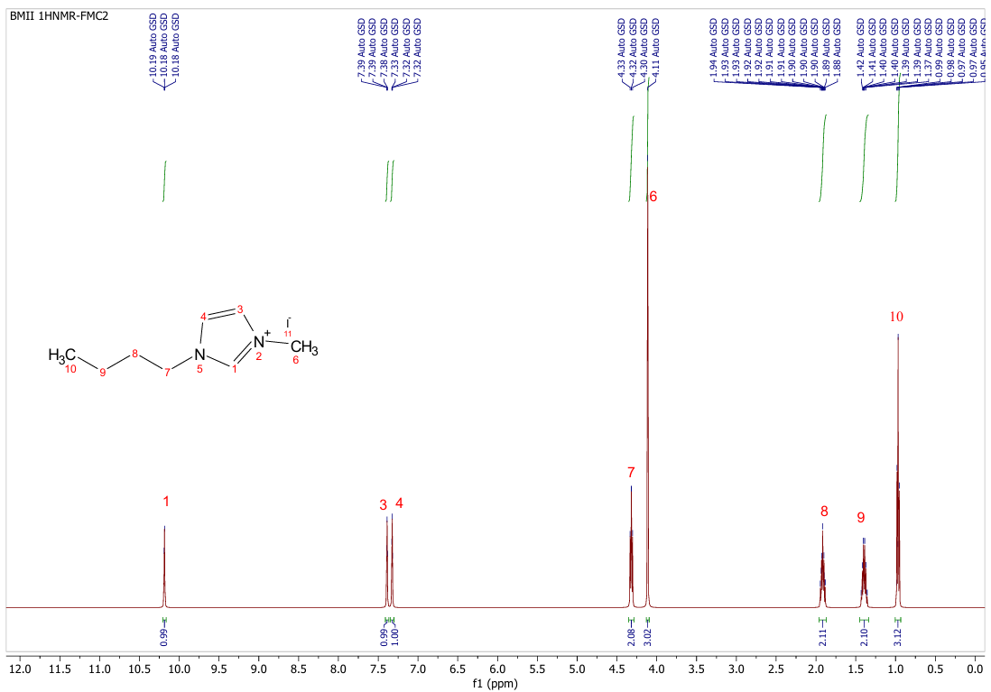
- Figure S1. ¹H NMR of 1-butyl-3-methylimidazolium iodide (BMII) in CDCl_{3.}

- Table S1. Photovoltaic performance parameters of LE+COF devices under standard 1 sun illumination (100 mW/cm²) with varying concentrations of COF

Amount of COF (mg) | J_{SC}  (mA/cm²) | V_{OC}  (mV) | FF  (%) | PCE  (%)
10 | 18.60 | 760 | 76.6 | 10.81
15 | 17.99 | 753 | 77 | 9.56
20 | 17.88 | 740 | 75 | 9.7

- Figure S2. (a) Images of the DSSCs devices incorporating various amounts of COF. (b) Image of the electrolyte containing 10 mg COF.

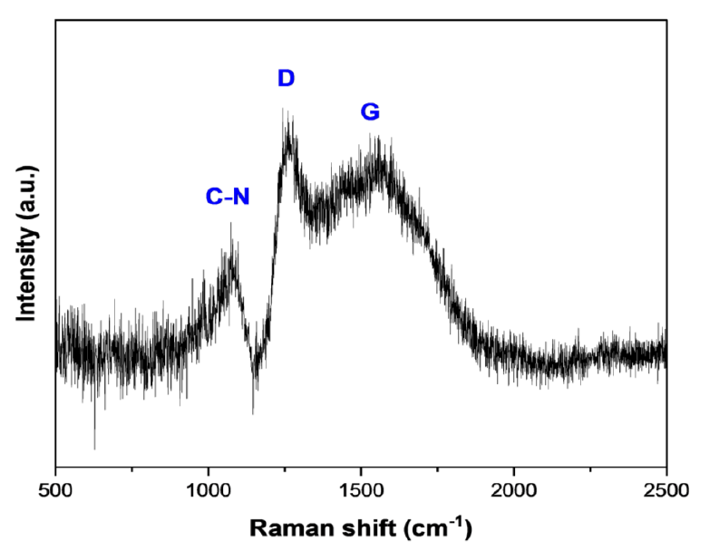
Figure S3. Raman spectrum of the COF using a 785 nm excitation wavelength.

- 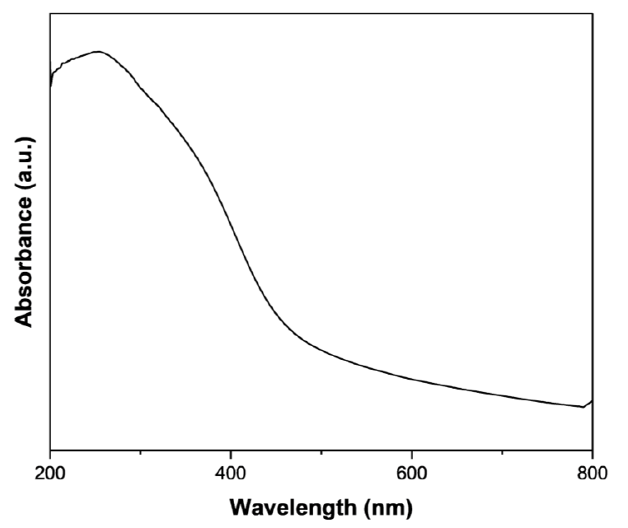
- Figure S4. Solid-state absorption spectra of COF.
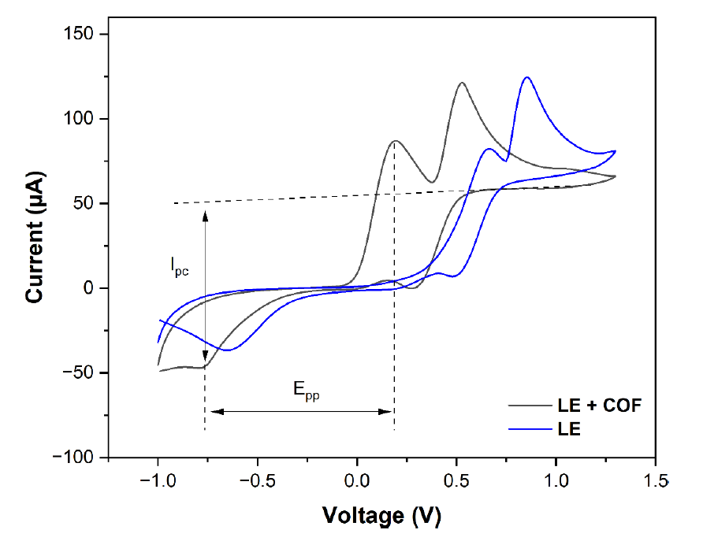
Figure S5. Cyclic voltammograms recorded with bare GCE and COF-modified glassy carbon electrode.

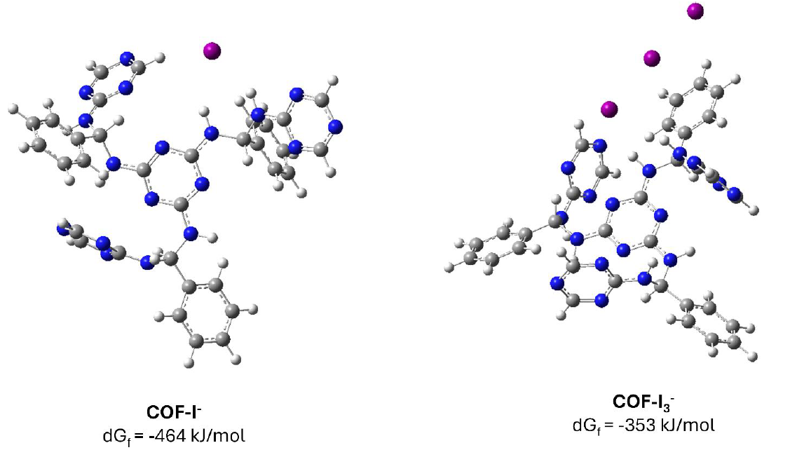
Figure S6. Ground-state optimized geometries of COF interacting with I⁻ and I₃⁻ ions, calculated using the M06-2X functional with the def2-SVP basis set for geometry optimization and def2-TZVP for single-point energies; iodine atoms were treated with the LANL2DZ basis set. All calculations were performed using the Gaussian 16 program.

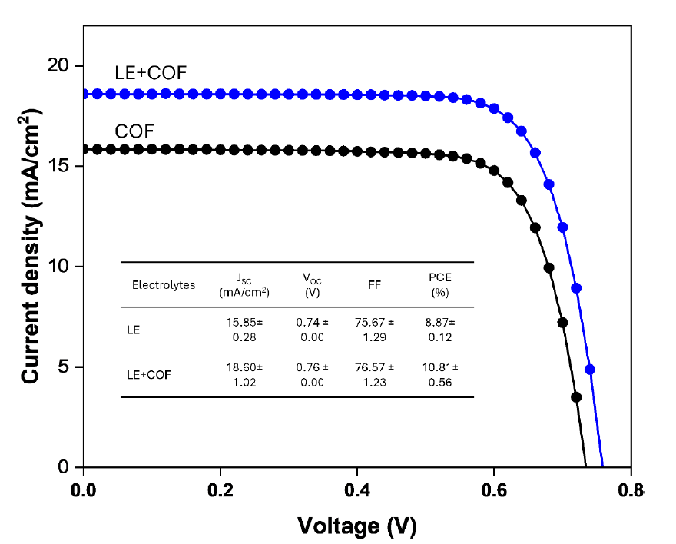
- Figure S7. J–V characteristic curves of DSSCs fabricated with LE and LE+COF electrolytes.
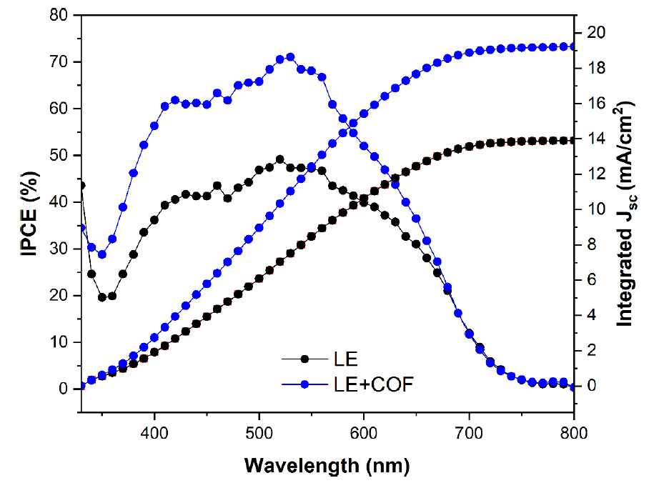
Figure S8. Incident Photon-to-Current Efficiency (IPCE) spectra of DSSCs fabricated with LE and LE+COF electrolytes.

- Figure S9. The stability of the photovoltaic performance of LE+COF and LE based solar cells under indoor conditions (6024 ± 39 lx): (a) V_{OC} vs time, (b) FF vs time, (c) J_{SC} vs time, and (d) PCE vs time.

- Figure S10. SEM images of the COF at various magnifications after a long-term stability test lasting over 5352 hours.

- Figure S11. FTIR spectra of the COF recorded before and after a long-term stability test exceeding 5352 hours.

- Figure S12. Powder XRD patterns of the COF recorded before and after a long-term stability test lasting over 5352 hours.
- Article

Enhancing the stability and efficiency of dye-sensitized solar cells with MIL-125 metal-organic framework as an electrolyte additive

- Ayagoz Ibrayeva^{1,2}, Zulfiya Imanbekova³, Urker Abibulla³, Yerbolat Tashenov², Bakhytzhan Baptayev¹ & Mannix P. Balanay^{1,3}

- ¹National Laboratory Astana, Nazarbayev University, 53 Kabanbay Batyr Ave, Astana 010000, Kazakhstan.
- ²Department of Chemistry, L.N. Gumilyov Eurasian National University, 2 Satpayev St, Astana 010008, Kazakhstan.
- 3Chemistry Department, Nazarbayev University, 53 Kabanbay Batyr Ave, Astana 010000, Kazakhstan. email: ; mannix.balanay@nu.edu.kz

  - This study investigates how to improve the stability of liquid electrolyte (LE) dye-sensitized solar cells (DSSCs) by incorporating a titanium-based metal-organic framework (MIL-125). MIL-125, created through the coordination of Ti⁴⁺ ions with benzene-1,4-dicarboxylic acid, forms a structure that can effectively accommodate I⁻/I ⁻ electrolytes, resulting in a MIL-125@electrolyte assembly. This innovative assembly successfully prevents electrolyte leakage while preserving the LE properties. The study examines how the MIL-125@electrolyte enhances both stability and power conversion efficiency (PCE) of DSSCs. The inclusion of the large-surface-area of MIL-125 improves ionic conductivity, reduces charge transfer resistance, and stops leakage. The optimized MIL-125@electrolyte achieves a high PCE of 10.51%, with a peak value of 10.99%, and a notable short-circuit current density of 20.97 mA/cm², peaking at 22.27 mA/cm², under standard AM 1.5, 100 mW/cm² conditions. It maintains about 75% of its PCE after 1400 h at approximately 23 °C. For indoor applications using LED lighting, the quasi-solid-state DSSC reaches a record PCE of 27.6%, with an average of 25.9%, under 6000 lx illumination.
3
- Keywords Metal-organic frameworks, MIL-125, Quasi-solid-state electrolytes, Dye-sensitized solar cells, Indoor photovoltaics

Liquid electrolytes (LE) are still very efficient for DSSCs, as recent advances show. The highest PCE of 15.2% under a standard air mass of 1.5 global simulated sunlight was achieved with LE¹, and a record PCE of 34% at dimmed indoor fluorescent light (1000 lx) was also obtained with LE². However, despite its excellent performance, LE presents challenges such as corrosion, volatility, and leakage, which hinder the commercialization of DSSCs due to long-term operational limitations³. Efforts are underway to replace the LE with quasi-solid and solid-state electrolytes to address these stability issues. Solid-state hole transport materials (HTMs) could solve the problems of leakage and sealing, but face problems such as poor pore filling, electron recombination at the photoanode interface, and low conductivity, requiring thorough engineering solutions. Quasi-solid-state electrolytes (QSE) are promising as they combine the advantages of LE with the long-term stability of DSSCs. The redox couple commonly used in LE, the iodide/triiodide couple (I-/I -), is also used in QSE⁴, in which the redox couple is enclosed or incorporated in a closed polymer chain or frame with a large surface area. Several recent studies have investigated different materials for QSE, including ionic polymer liquid (PCE:9.83%)⁵, Al2O3(PCE:8.74%) and ZnO nanofillers (PCE:7.59%)⁶, Ti3C2MXene-reduced graphene oxide composite (PCE:8.26%)⁷, PEG-functionalized ABA triblock copolymers (PCE:10.02%)⁸, SiO2aerogel with graphene as a framework (PCE:8.25%)⁹.
3
Metal-organic frameworks (MOFs) offer exceptional chemical diversity due to their unique structure and adjustable organic and inorganic components. This versatility allows for applications across various fields, including magnetism, ferroelectricity, light harvesting, energy transfer, optoelectronics, sensors, and gas management, as well as (photo)catalysis and drug delivery¹⁰. Recently, the use of MOFs in DSSCs has garnered increasing attention¹¹. Researchers are exploring MOFs to enhance the components of DSSCs, including photosensitizers^{12–14}, photoanodes^{15–21}, and counter electrodes^{22–24}, to boost efficiency. Studies indicate that MOFs can serve as charge transfer materials, improving dye adsorption and light scattering due to their high porosity and surface area, which in turn enhances photovoltaic performance. Furthermore, MOFs may enhance electron transport and reduce dark current when combined with materials like reduced graphene oxide¹⁵.
MOFs have proven to be another promising scaffold material for QSE, as they provide a large surface area for LE uptake. The first use of MOF-based QSEs was reported by Bella and colleagues²⁵, who used a polymer composite containing Mg-MOF as a scaffold for QSEs for DSSCs, which exhibited a PCE of 4.80%. The presence of Mg-MOF improved the stability of the DSSCs, with 96% of PCE retained after 500 h. In a similar study, Sarwar et al.²⁶ demonstrated a successful application of a MOF prepared from the reaction of Al³⁺ and trimesic acid. The Al-MOF-based gel electrolyte was reported to retain the function of a LE and exhibit higher cell efficiency and remarkable device stability at a thermal load of 60°C for 250 h compared to LE based DSSCs with a maximum PCE of 6.06%. However, the introduction of a metal cation at the interface between the photoanode and electrolyte may affect the conduction band of the TiO² semiconductor, potentially reducing the V_{OC} of the DSSCs^{28,29}.
This study highlights the promising potential of further research into MOFs for photovoltaic applications, particularly as customizable materials to improve device components. The approach focuses on the use of Ti-based MIL-125 as a scaffold for I-/I⁻₃ based LE to prevent leakage and improve the lifetime and stability of electrons in DSSCs. While MOFs have been extensively researched in DSSCs, their effects on LE remain unclear, emphasizing the critical role of the metal component in MOFs at this interface. This research does not suggest new applications but emphasizes the significant potential of MOFs as charge carriers due to their special chemical and photophysical properties. The study presents innovative methods using MIL-125 as a scaffold to create a QSE that minimizes electrolyte leakage, increases electron lifetime, and preserves the conduction band of TiO₂ while preventing dye degradation. To understand the importance of MOFs with suitable pore sizes and large surface areas for the formation of QSEs, a comprehensive analysis of DSSCs devices is required. This investigation aims to fill gaps in the literature by thoroughly investigating the synthesis, properties, and effects of MIL-125 on DSSCs performance under both outdoor and indoor conditions.
3

Materials and methods
Materials
All the chemicals used in this study were of high purity from commercial sources and used without further purification unless otherwise specified. Fluorine-doped SnO₂ (FTO) coated glass (7 Ω/sq, 2.2 mm, Sigma Aldrich); light scattering titania paste (Greatcell Solar WER2-O TiO₂ Paste, Sigma-Aldrich); transparent TiO₂ electrode paste (DN-EP03, Dyenamo); screen printable Platinum paste (Greatcell Solar PT1 Pt paste, Sigma-Aldrich); Di-tetrabutylammonium cis-bis(isothiocyanato)bis(2,2’-bipyridyl-4,4’-dicarboxylato)ruthenium (II), 95% (N719, Sigma Aldrich); chenodeoxycholic acid (CDCA, Sigma Aldrich); terephthalic acid, 98% (Sigma Aldrich); titanium (IV) isopropoxide, 97% (TTIP) Sigma Aldrich); N,N’-dimethylformamide, anhydrous, 99.8% (DMF, Sigma Aldrich); methanol, ≥ 99.9% (MeOH, Honeywell); iodine ≥ 99,8% (Sigma Aldrich); lithium iodide, 99.9% (LiI, Sigma Aldrich); guanidine thiocyanate, 99% (GuSCN, Alfa Aesar, Thermo Scientific); 1-butyl-3-methylimidazolium iodide (BMII, DN-OD05, Dyenamo); 3-methoxypropionitrile (MPN, Sigma Aldrich); 4-tert-butylpyridine, 98% (tBP, Sigma Aldrich); acetonitrile (ACN, Acros Organic); tert-butanol,≥ 99.0% (Sigma Aldrich); and hydrochloric acid > 37% (HDL, Sigma Aldrich).

Preparation of MIL-125-based quasi-solid-state electrolyte
Synthesis of MIL-125
A solvothermal technique based on the literature was used to synthesize MIL-125 [15]. 1.26 g of terephthalic acid was dissolved in 20 mL DMF and 5 mL MeOH for this purpose. After 15 min of stirring, the mixture was heated to 100 °C. Next, the mixture was mixed with 1.5 mL of titanium isopropoxide and 0.09 mL of water. To produce a white product, the reaction mixture was heated to 100 °C for 35 h. Centrifugation (8,000 rpm, 15 min) was used to extract the product from the mixture, and it was then washed six times in MeOH and three times in DMF.
Electrolyte preparation. The composition of a typical LE is as follows: 0.03 M I₂, 0.05 M LiI, 0.10 M GuSCN, 0.6 M BMII, 0.5 M tBP in ACN: MPN (1:1). To prepare the QSE various concentrations of MIL-125 ranging from 20 mg/mL to 60 mg/mL were tested, with careful monitoring to ensure uniformity of the electrolyte. To prevent aggregation and achieve uniform particle dispersion, MIL-125 was first dispersed in the solvent using ultrasonication for 30 min for each trial. The optimal combination for the QSE was found to be 10 mg of MIL-125 activated at 150 °C, mixed with 0.5 mL of LE, and stirred at room temperature in a closed vessel (Table S1, supporting information). The electrolytes were stored in sealed containers in the dark with continuous stirring. It was observed that higher concentrations led to decreased efficiency in DSSCs due to increased viscosity and particle aggregation, which in turn reduced ion mobility. Images of the prepared QSE are shown in Figure S1 (supporting information).

Fabrication of dye-sensitized solar cells
After immersing in a 50 mM aqueous TTIP solution in 2 M aqueous HCl at 70°C for 35 min, the 1.5×2.0 cm conductive FTO glass electrodes underwent rinsing with DI water and sintering at 500 °C for 30 min. Subsequently, a transparent TiO₂ paste (particle size: 18–20 nm) was applied using a doctor blade technique onto the prepared film. The TiO₂ film underwent a gradual sintering process: initially at 125°C for 5 min, followed by 325°C for 10 min, 425°C for 15 min, and finally 500 °C for 30 min, after an initial hour of air drying. A scattering TiO₂ film (particle size: 150–250 nm) was then doctor-bladed onto the transparent TiO₂ film. After another hour of air drying, this second layer was sintered using the same step-by-step procedure as the transparent TiO₂ layer. Following sintering, the photoanodes were cooled to 70°C and soaked for 24 h at room temperature in the dark with 0.25 mM of N719 dye in tert-butanol: acetonitrile (1:1) solution containing 0.75 mM сhenodeoxycholic acid. The dye-coated photoanodes were subsequently dried in an oven at 70°C after rinsing with ethanol. Simultaneously, a clean FTO glass was coated with Pt paste and heated to 500°C for 30 min to create the counter electrodes (CE). The assembly of the photoanode and CE took place in a sandwich configuration using double-sided tape as a spacer, facilitating the placement of either liquid or quasi-solid electrolytes between them via a drop-casting technique.

Characterization
MIL-125 underwent characterization using various analytical techniques. X-ray diffraction (XRD) analysis was conducted using a Rigaku SmartLab device in Cedar Park, Texas, USA. Fourier-transform infrared (FT-IR) spectroscopy was performed using a ThermoScientific NicoletTM iS5 spectrometer. Thermal analysis was carried out using a TA Instruments TGA Q500 thermogravimetric analyzer (TGA). Morphological and compositional investigations were conducted using a JEOL JEM-1400 Plus transmission electron microscope (TEM) and a Carl Zeiss SEM Auriga Crossbeam 540 scanning electron microscope (SEM) equipped with an energy-dispersive X-ray spectrometer. Thermo Scientific’s NEXSA X-ray photoelectron spectrometer (XPS) was employed to analyze the valence states of elements. Nitrogen adsorption-desorption analysis was performed using a porosimeter from Quantachrome Instruments. The photovoltaic performance of DSSCs was evaluated using an AAA solar simulator (Oriel Sol3A by Newport), with electrochemical studies conducted using a Palmsens4 potentiostat. Device I-V characteristics were measured using a Keithley 2440 source meter under an Oriel Sol3A class solar simulator with an AM 1.5G filter of 100 mW/cm² with a 0.03 cm² mask during photovoltaic performance testing of DSSCs. Light intensity was measured using a calibrated Oriel Si reference cell system (Model: 91150 V Reference Cell and Meter). Each sample underwent the preparation of five cells and reported photovoltaic parameters represent average values. Electrochemical impedance spectroscopy (EIS) was conducted on DSSCs in total darkness, with similar tests on dummy cells under different conditions.

Results and discussion
Characterization of MIL-125
The X-ray diffraction pattern depicted in Fig.1a for the synthesized metal-organic framework exhibits distinct diffraction peaks at 6.81°, 9.75°, 11.67°, 13.67°, 15.03°, 15.42°, 16.62°, 17.93°, 19.02°, and 19.55° which were attributed to (101), (200), (221), (220), (310), (103), (222), (312), (213), and (400) lattice planes closely resembling the diffraction pattern of MIL-125^{30,31}. The absence of additional peaks in the XRD pattern confirms the high purity of the synthesized MOF product. MIL-125 is known for its quasi-cubic tetragonal system, composed of octameric Ti₈O₈(OH)₄ oxo-clusters interconnected with dicarboxylate linkers.
Further analysis through Fourier-transform infrared spectroscopy, as shown in Fig. 1b, reveals the characteristic features of the MIL-125 at the fingerprint region are observed in the range of 800–1200 cm−1 for absorption of benzene rings, while at the 400–800 cm−1range is a characteristic feature of the O-Ti-O vibrations³². The peak at 3395 cm−1belongs to the O-H stretching vibration³³. Signals within the range of 1584–1392 cm⁻¹ are ascribed to aryl vibrations and carboxylate functional groups³⁴.

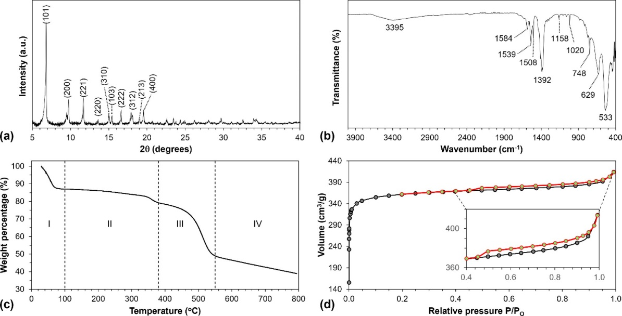
Fig. 1. (a) Powder XRD profile, (b) FT-IR Spectra, (c) TGA curve, and (d) N2 sorption isotherm of MIL-125.

The thermogravimetric analysis shown in Fig.1c highlights four distinct stages of weight loss. In the first stage, which occurs below 100°C, there is a 13% reduction in weight. This loss is attributed to the removal of guest molecules, including moisture, methanol, and some residual DMF trapped in the pores of MIL-125. The second stage, marked by an 8% weight loss, is associated with the further removal of residual DMF³⁵. The most substantial weight loss, between 380°C and 550°C, amounts to 30% and is primarily due to the decomposition of organic linkers, resulting in the formation of inorganic titanium oxide residues³⁶.
The ratio of titanium to TiO₂ can be calculated by dividing the weight loss at 550°C by the weight loss at 380°C, which represents the onset of organic linker decomposition³⁷. This ratio was found to be approximately 62%. Finally, the weight loss observed above 550°C is likely due to the removal of hydroxyl groups on the surface of the TiO₂³⁸. The nitrogen porosimetry data (Fig. 1d) reveals a Type I isotherm with minimal hysteresis, indicating a well-ordered microporous structure³⁹. This structure has a micropore volume (Vp) of 0.61 cm³ g⁻¹ and a high Brunauer–Emmett–Teller (BET) surface area of 1452 m² g⁻¹. Characterization using scanning electron microscopy and transmission electron microscopy (Fig. 2a and b) shows the development of a cake-like morphology with diameters ranging from 750 to 900 nm. Additionally, energy-dispersive X-ray spectroscopy mapping confirms the uniform distribution and coexistence of titanium, oxygen, and carbon in MIL-125 (Fig. 2c).
  - To investigate the local electronic structure and oxidation state of the synthesized MIL-125, LE conducted X-ray photoelectron spectroscopy, as depicted in Fig. 3. The analysis revealed three prominent peaks corresponding to C 1s, Ti 2p, and O 1s, further confirming the successful synthesis of MIL-125 (Fig. 3a). The high-resolution XPS spectra for C 1s, shown in Fig. 3b, display three distinct peaks at 283.6, 285.0, and 287.5 eV,

  - 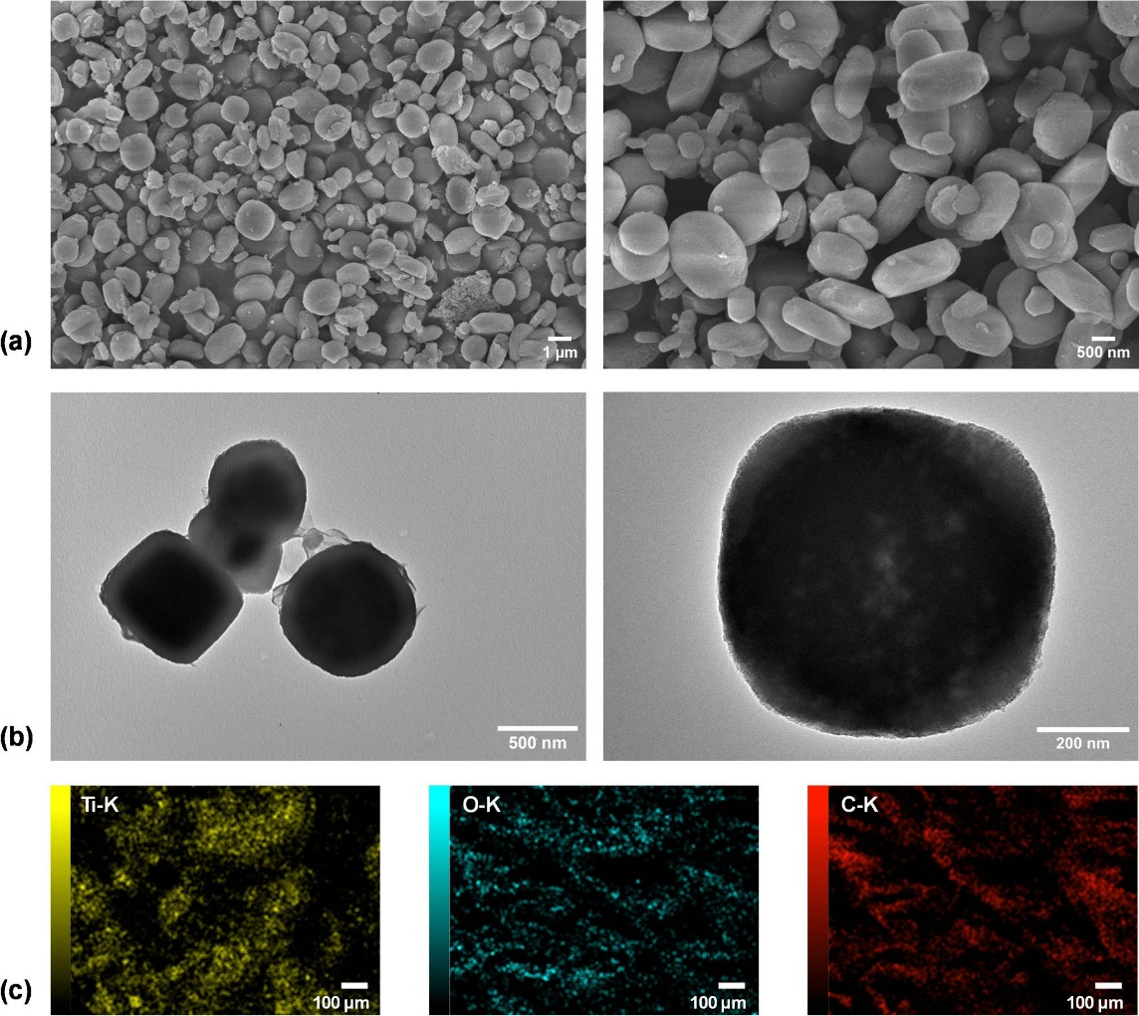
- Fig. 2. (a) SEM and (b) TEM images of MIL-125 at various magnifications. (c) Elemental mapping of MIL-125.
- 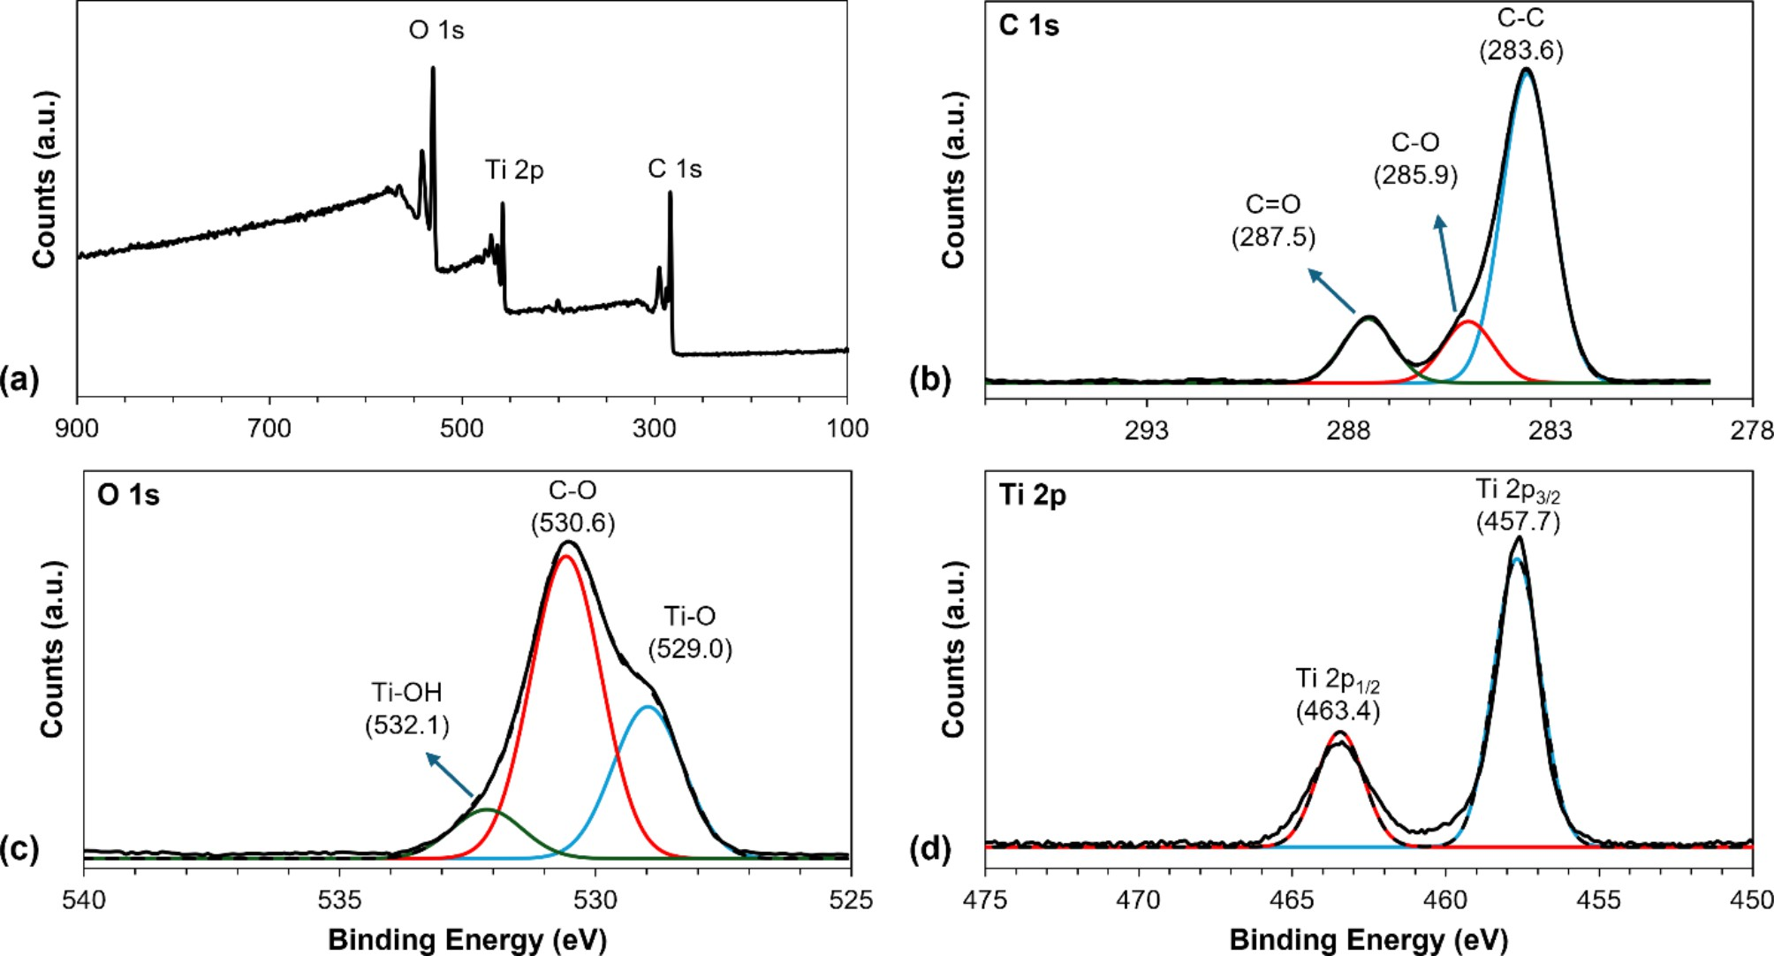
- Fig. 3. (a) XPS survey scan and high resolution XPS spectra of (b) C 1s, (c) O 1s, and (d) Ti 2p for MIL-125.
- 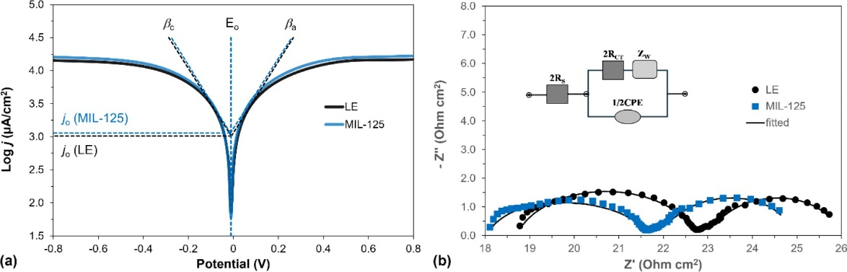
- Fig. 4. (a) Tafel polarization curves of LE and MIL-125 (b) Nyquist plot of symmetrical dummy cells (inset is the equivalent electrical circuit used for fitting of Nyquist plots).

- which are attributed to C-C, C-O, and C = O bonds, respectively40. Figure 3c presents the O 1s spectra, which can be deconvoluted into three peaks at 529.0, 530.6, and 532.1 eV, corresponding to Ti-O, C-O, and Ti-OH bonds, respectively⁴¹. Additionally, the Ti 2p3/2 and Ti 2p1/2 peaks are observed at 457.7 and 463.4 eV, respectively (Fig. 3d), indicating the successful incorporation of Ti4+ ions into the MIL-125 structure.

- Electrochemical analysis of MIL-125-based quasi-solid electrolyte
- The charge-transfer kinetics at the interface between the QSE and the platinized CE were investigated using Tafel analysis (Fig. 4a). The rates of the redox reactions occurring at this interface can be characterized by the Butler–Volmer equation as presented in Eqs. 1^{42–44}.

- $\begin{aligned}j=-j_{o}\left[\exp{\frac{α_{c}nF}{RT}\left(E-E_{eq}\right)-\exp{\frac{-α_{a}nF}{RT}(E-E_{eq})]}}\right] \#\left(1\right)\end{aligned}$

- where j is the electrode current density, jo is the exchange current density, E is the applied voltage, Eeq is the I−/I₃− electrode potential at equilibrium, n is the number of electrons transferred, F is Faraday constant, α_{c}, and α_{a} are the cathodic and anodic charge-transfer coefficients, respectively, R is the universal gas constant, T is the absolute temperature. (E–Eeq) is defined as activation overpotential. When |E–Eeq| ≫ 0, Eq. 1 can be transformed into the original Tafel equation as shown in Eq. 2⁴⁵.

- $\begin{aligned}E-E_{eq}=±β\log_{10}{\frac{j}{j_{o}}} \#\left(2\right)\end{aligned}$
- where is the Tafel slope, the slope of the linear regions of the Tafel polarization curve, and indicates how much the overpotential must be increased to enhance the reaction rate (or current) of an electrochemical reaction by a factor of ten. The anodic slope (βa) and cathodic slope (βc) provide insights into the anodic and cathodic reactions taking place at the TiO₂/electrolyte interface. The Tafel polarization tests on 3I⁻/I₃⁻ redox reaction were done in the potential range between ± 1 at a scan rate of 50 mV/s. For this analysis, a symmetric cell with two identical Pt electrodes with an active area of 0.25 cm² was assembled with different electrolytes used in the DSSCs. The anodic and cathodic slope values reflect the anodic and cathodic reactions occurring at the TiO²/ electrolyte interface. In the case of the QSE, the cathodic Tafel slope was lower (βc = 181 mV/decade) compared to the LE (βc = 186 mV/decade). This suggests that the gelation of the electrolyte in QSE enhances the reaction of I₃⁻ ions at the TiO²/electrolyte interface. Conversely, the anodic Tafel slope was slightly higher in QSE (βa = 188 mV/decade) than in LE (βa = 185 mV/decade), which could indicate a minor decrease in the reaction of I⁻ ions at the interface. The gelation of the electrolyte increases its viscosity, which in turn affects the movement of ions through it. Our results show that I₃⁻ becomes more prominent because its reactions with the TiO₂ surface typically occur at a higher rate compared to I⁻ ions.
3
      - From Eq. 2, it follows that j = jo when the overpotential is at its equilibrium value. The jo value is determined by the intercept of the linear anodic and cathodic branches on the Tafel plot. For the LE, jo is 1.02 mA/cm², while for the QSE, it is 1.14 mA/cm². This indicates that the electron flow at the TiO₂/QSE interface is higher compared to the TiO₂/LE interface. Additionally, j_{o} is related to the charge transfer resistance R_{CT} at the interface, as described by Eq. 3.

- $\begin{aligned}j_{o}=\frac{RT}{nFR_{CT}} \#\left(3\right)\end{aligned}$

- The charge-transfer resistance can be determined through electrochemical analysis of a symmetrical dummy cell, where two identical electrodes (Pt CE) are positioned face-to-face, with an electrolyte sample filling the gap between them. Figure 4b illustrates the Nyquist plot for these symmetrical dummy cells using QSE and LE. In the Nyquist plot, the x-axis intercept represents the series resistance (R_{S}), the first semicircle denotes the charge-transfer resistance (R_{CT}), the second semicircle indicates the diffusion resistance of the electrolyte (ZW), and CPE is a constant phase element that accounts for deviations from ideal capacitance caused by the roughness of the electrode surfaces⁴⁶. The charge-transfer resistance for QSE is significantly lower than that for LE, measuring 1.79 Ohms compared to 1.99 Ohms, which is consistent with the results obtained by the Tafel experiments. Using these values, the ionic conductivity (σ) of the electrolyte films can be calculated according to Eq. 4,

- $\begin{aligned}σ=\frac{d}{R_{CT}A} =nqμ\#\left(4\right)\end{aligned}$

- where d and A are the thickness and area of the electrolyte layer, n is the charge carrier concentration, q represents the charge on the mobile carrier, and µis the carrier mobility⁴⁷. From our results, it was found that the QSE demonstrates higher conductivity (3.36 mS/cm) compared to the LE (3.02 mS/cm). According to Eq. 4, the increased conductivity could be attributed to either a higher carrier mobility, an increase in charge carrier concentration, or a combination of both factors which was observed in previous studies^{26,28,48}.

- Photovoltaic performance of MIL-125-based quasi-solid electrolyte
- A DSSCs was fabricated using an electrolyte enriched with MIL-125, and its electrochemical and photovoltaic parameters were evaluated as shown in Table 1. For comparison, a DSSCs with a conventional LE was also fabricated as a control device. The DSSCs with QSE showed a remarkable improvement in energy conversion efficiency, reaching 10.51% compared to 9.14% for the cell with the LE. This improvement is primarily due to the higher short-circuit current density in the QSE, which was 20.97 mA/cm², compared to 18.01 mA/cm² for the LE cell. This difference was confirmed by incident photon power efficiency (IPCE) measurements (Fig. 5a), which showed that the short-circuit current density derived from the IPCE curve for the QSE was 20.9 mA/cm², exceeding the 17.1 mA/cm² observed for the LE DSSCs.
- Electrochemical impedance spectroscopy was conducted under dark conditions with a bias voltage close to the Voc, spanning a frequency range from 0.01 Hz to 1 MHz, to assess the interfacial properties of the fabricated QSE in DSSCs, as illustrated in Fig. 5b. In the dark, under the applied bias voltage, electrons flow from the photoanode to the electrolyte and recombine with I₃⁻, resulting in I⁻ being oxidized at the CE. In the Nyquist plot, the impedance related to recombination is represented by a large semicircle in the moderate

Electrolytes | J_{SC} (mA/cm2) | V_{OC} (V) | FF (%) | PCE (%) | J_{SC} from IPCE (mA/cm2) | R_{S} (Ω) | R′_{CT} (Ω) | Rrec (Ω) | τrec (msec)
LE | 18.01 | 0.71 | 0.72 | 9.14 | 17.1 | 23.7 | 12.9 | 122.5 | 108
QSE | 20.97 | 0.69 | 0.72 | 10.51 | 20.9 | 28.9 | 8.8 | 57.3 | 57
- Table 1. Photovoltaic parameters of devices under 1 sun (100 mW/cm2) condition.

Metal(organic linker) of MOF | Redox couple | Dye  (soaking time in hours) | Active surface area (cm2) | PCE (%) | Ref.
Co(BDC)b | [Cu(bnbip)(mpi)+1/+2]c, d | 0.5 mM N719 with 0.5 mM CDCA in EtOH (24) | 0.36 | 3.45 | 51
Al(BTC)e | I–/I⁻₃ | N719 (16) f | 0.16 | 8.69 | 28
Al(BTC)e | I–/I⁻₃ | 0.3 mM N719 in EtOH (21) | 0.25 | 6.06 | 26
Mg(BTC)e | I–/I⁻₃ | 0.35 mM N719 in EtOH (12) | 0.22 | 4.80 | 25
Mn(BTC)e | –  I–/I⁻₃ | N719 in MeCN: isopropanol f | – | 5.45 | 52
Ti(BDC)b | I–/I⁻₃ | 0.25 mM N719 and 0.75 mM CDCA in t-BuOH: MeCN (24) | 0.03 | 10.51 | This work
- Table 2. Comparison of literature of DSSCs incorporating MOFs as additives in the electrolyte ª.

- 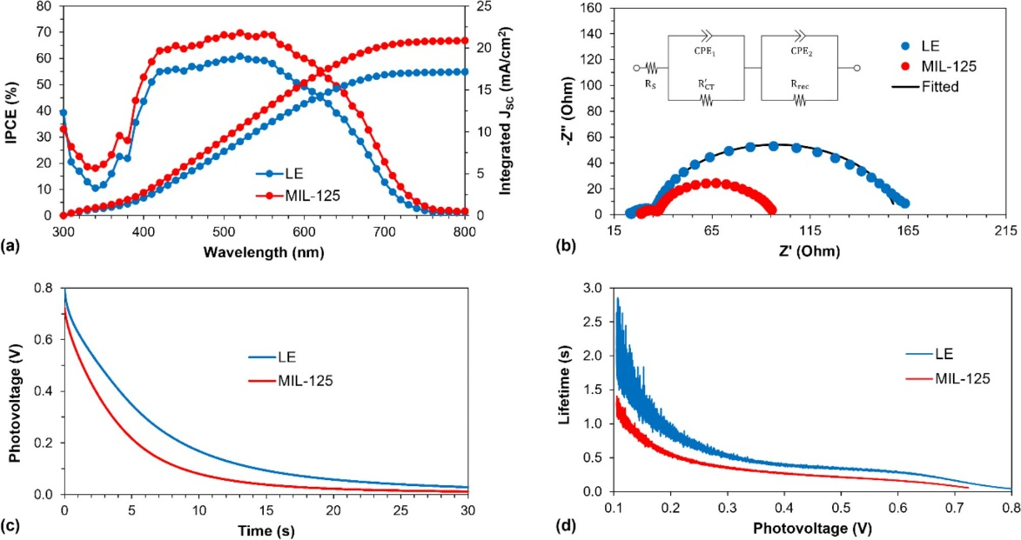
Fig. 5. (a) IPCE spectra and integrated JSC curve, (b) Nyquist plot (inset is the equivalent electrical circuit used for fitting of Nyquist plots), (c) open-circuit voltage decay curves, and (d) electron lifetime vs. photovoltage dependence of DSSCs with QSE- and LE-based electrolytes.

- and low-frequency regions. Conversely, a small semicircle at high frequencies represents the charge transfer impedance at the LE/CE interface. Analysis of these semicircles yields the charge transfer resistance (R_{CT}′) and recombination resistance (R_{rec}) as detailed in Table 1. The inclusion of MIL-125 in the LE led to a decrease in the charge transfer resistance at the CE/QSE interface compared to the CE/LE, indicating enhanced electron flow from the platinized fluorine-doped tin oxide electrode into the QSE. This finding aligns with the results from Tafel polarization and Nyquist plot analysis of symmetrical dummy cells. Notably, the MIL-125-based QSE DSSCs exhibited a significant reduction in recombination resistance, from 122.5 Ω for LE to 57.3 Ω for QSE. The recombination resistance and chemical capacitance allow for the calculation of the recombination lifetime (τ_{rec}) for both types of DSSCs, as described by Eq. 5⁴⁹.

- τ_{rec} = R_{rec} × Cµ (5)

- As a result, the recombination lifetime for QSE decreased by nearly 50% compared to that of LE cells. To further investigate this phenomenon, a Voc decay analysis was performed (Fig. 5c). The decay curve obtained from this analysis was then used to calculate the electron lifetime at various V_{oc} using Eq. 6.

- $\begin{aligned}τ_{e}=\left(\frac{k_{b}T}{q}\right){\left(\frac{dV}{dt}\right)}^{-1} \#\left(6\right)\end{aligned}$

- where k_{b} is Boltzmann constant, T is absolute temperature, q is elementary charge, V is voltage, and t is time. The calculated lifetime reflects the effective duration of conduction band electrons. Figure 5d shows that the electron lifetime in QSE-based DSSCs is shorter than that in LE-based devices, indicating a higher rate of electron

Electolytes | J_{SC}  (mA/cm²) | V_{OC}  (V) | FF | PCE  (%) | J_{SC} (mA/cm²) from IPCE | R_{S}  (Ω) | R’_{CT}  (Ω) | R_{rec}  (Ω) | τrec (msec)
LE | 18.01 | 0.71 | 0.72 | 9.14 | 17.1 | 23.7 | 12.9 | 122.5 | 108
QSE | 20.97 | 0.69 | 0.72 | 10.51 | 20.9 | 28.9 | 8.8 | 57.3 | 57

- Table 1. Photovoltaic parameters of devices under 1 sun (100 mW/cm²) condition.

Metal(organic linker) of MOF | Redox couple | Dye (soaking time in hours) | Active surface area (cm²) | PCE(%) | Ref.
Co(BDC)b | [Cu(bnbip)(mpi)+1/+2]c, d | 0.5 mM N719 with 0.5 mM CDCA in EtOH (24) | 0.36 | 3.45 | 51
Al(BTC)e | I–/I–₃ | N719 (16) f | 0.16 | 8.69 | 28
Al(BTC)e | I–/I–₃ | 0.3 mM N719 in EtOH (21) | 0.25 | 6.06 | 26
Mg(BTC)e | I–/I–₃ | 0.35 mM N719 in EtOH (12) | 0.22 | 4.80 | 25
Mn(BTC)e | I–/I–₃ | N719 in MeCN: isopropanol f | – | 5.45 | 52
Ti(BDC)b | I–/I–₃ | 0.25 mM N719 and 0.75 mM CDCA in t-BuOH: MeCN (24) | 0.03 | 10.51 | This work
- Table 2. Comparison of literature of DSSCs incorporating MOFs as additives in the electrolyte

- recombination in QSE of DSSCs. This increased recombination rate also accounts for the lower V_{oc} observed in QSE-based DSSCs compared to those with LE, as a higher recombination rate typically results in reduced V_{oc}⁵⁰.
- ª The cells were illuminated at a light intensity of 100 mW/cm² and utilized Pt as the CE. ^{b} BDC = 1,4-benzenedicarboxylic acid or terephthalic acid; ^{c} bnbip = 2,6-bis(1-(naphthalen-2-ylmethyl)−1H-benzo[d]imidazol-2-yl)pyridine; ^{d} mpi = 5-methoxy-1-(pyridin-4-yl)−1H-indole; ^{e} BTC = 1,3,5-benzenetricarboxylic acid or trimesic acid; ^{f} no dye concentration and/or soaking time was indicated in the paper.
- In addition, the DSSCs were tested under low-light conditions - at 1000, 3000 and 6000 lx - with a dimmable LED light source. The photovoltaic parameters for these conditions are listed in Table 3, which also includes average values and the highest PCE achieved. It is noteworthy that the DSSCs with MIL-125 (QSE) performed better than those with the standard LE. At 6000 lx, the average PCE for QSE was 25.9%, with a peak value of 27.6%, while the LE-based DSSCs achieved an average PCE of 16.94% with the highest at 21.29%. This level of PCE at 6000 lx under LED light is unprecedented for a DSSCs with N719 dye, Pt CE and I–/I₃– electrolyte. For comparison, see Table 4 for the performance results of other researchers under similar low-light conditions.
3
- To evaluate the stability of MIL-125 based QSE as an electrolyte, the photovoltaic parameters of DSSCs were periodically measured over a 60-day period (1440 h). The results are shown in Fig. 6. Both QSE and LE-based DSSCs exhibited a slight increase in Voc after 60 days (Fig. 6a). QSE demonstrated a very stable fill factor (FF), while the FF of LE decreased significantly from 71.7 to 66.1% (Fig. 6b). The short-circuit current density of LE dropped substantially from 18.01 to 7.21 mA/cm², whereas based QSE experienced a more moderate decline in J_{SC} from 20.97 to 15.51 mA/cm² (Fig. 6c). Overall, the PCE of based QSE decreased by 21.1% (from 10.51 to 8.29%), while LE showed a much larger decrease of 58.9% (from 9.14 to 3.76%). This indicates a notable improvement in photovoltaic stability for DSSCs using MIL-125 as QSE (Fig. 6d).
- Additionally, when tested under dimmed light conditions of 6000 lx, QSE of DSSCs were found to be exceptionally more stable than LE-based devices, retaining over 73% of their initial PCE after 1200 h (Fig. 7). In contrast, LE devices maintained only 53% of their initial PCE after the same period. It is suggested that MIL-125 particles effectively slow down electrolyte evaporation and leakage, thereby supporting the long-term performance of DSSCs.
- We also examined the physical and chemical characteristics of MIL-125 after over 4380 h of use, employing XRD, FTIR, SEM, and XPS analysis, as shown in Figures S2 to S5. To carry out this assessment, we dismantled the DSSCs and retrieved the QSE, which serves as a crucial component in the performance of DSSCs by providing ionic conductivity while maintaining a more stable structure compared to liquid electrolytes. The sample was washed with ethanol and then centrifuged at 7000 rpm for 5 min.; a process repeated three times to ensure thorough cleaning of any impurities or residual materials. The recovered MIL-125 particles were then dried in a vacuum oven at 70°C overnight to remove any remaining solvent.

- 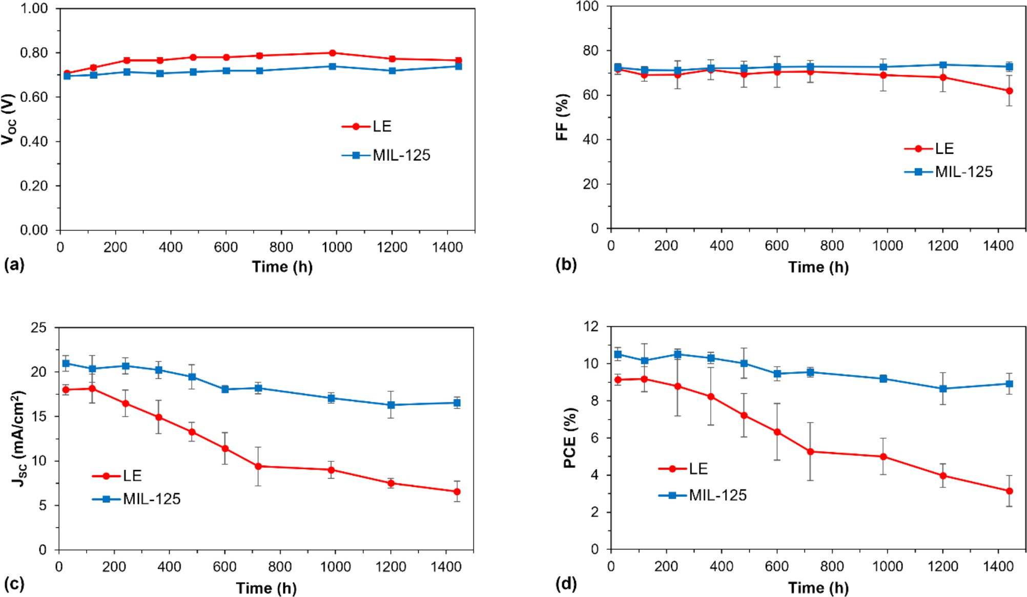
Fig. 6. The stability of the photovoltaic performance of MIL-125 based QSE and LE based DSSCs under AM1.5 100 mW/cm2 conditions: (a) VOC vs. time, (b) JSC vs. time, (c) FF vs. time, and (d) PCE vs. time.

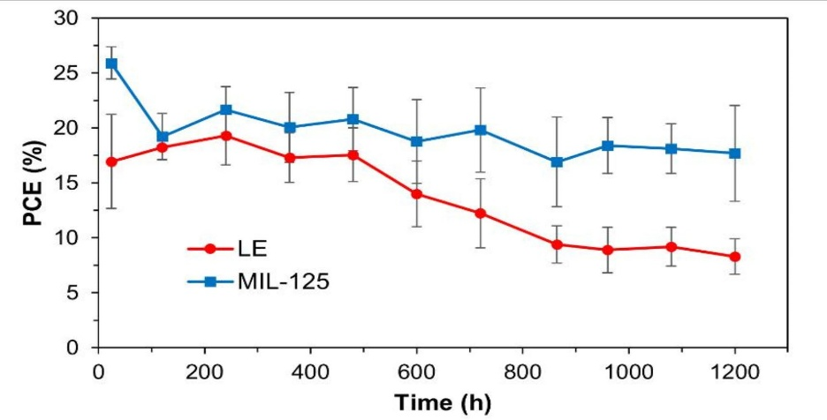
Fig. 7. The stability of the photovoltaic performance of based QSE and LE based DSSCs at 6000 lx.

The powder XRD pattern, shown in Figure S2, closely matches that of the synthesized MIL-125, with no additional peaks, indicating that the MIL-125 structure remained intact after the long-term stability tests. The absence of new peaks suggests that the material did not degrade or undergo any significant changes in crystallinity over the extended testing period. This result is further supported by the FTIR analysis (Figure S3), which shows that the characteristic functional groups of MIL-125 were preserved, indicating no chemical degradation. Additionally, the XPS analysis (Figure S4) confirmed the stability of the surface composition, with no significant shifts in the binding energies, which further indicates the retention of the material’s integrity. The SEM images (Figure S5) also demonstrated that the morphology of the MIL-125 particles remained unchanged, with no signs of aggregation or physical damage.
Together, these findings confirm that MIL-125 maintains its structural, chemical, and morphological stability even after extended exposure to the conditions within the DSSCs, reinforcing its potential for use in long-term applications. The stability of MIL-125, particularly in the QSE environment, is crucial as it ensures the continued efficiency and performance of DSSCs over time, making it an excellent candidate for future energy storage and conversion technologies.

Conclusions
In conclusion, a QSE was successfully developed for the first time by simply mixing a metal-organic framework, MIL-125, with an I–/I₃– LE at room temperature. This innovation addresses critical stability and leakage issues in DSSCs. The combination of MIL-125 and the electrolyte enhances ionic conductivity, which facilitates more efficient charge transfer and improves the incident photon-to-current conversion efficiency by strengthening the interface interaction between the dye-loaded photoanode and the QSE. Experimental results show that the MIL-125@Electrolyte configuration leads to reduced charge-transfer resistance in the assembled DSSCs. Photovoltaic testing revealed a significant increase in PCE, achieving up to 10.51% (with a maximum of 10.99%) using the N719 dye, thanks to a boosted short-circuit current density of 20.97 mA/cm² and improved long-term stability. Furthermore, when tested under dimmed 6000 lx LED light conditions, the MIL-125-based QSE DSSCs demonstrated an unprecedented PCE of 27.6% with the N719 sensitizer.

Data availability
The datasets used and/or analyzed during the current study available from the corresponding author on reasonable request.
Received: 16 October 2024; Accepted: 10 February 2025. Published online: 18 February 2025

References
- Ren, Y. et al. Hydroxamic acid pre-adsorption raises the efficiency of cosensitized solar cells. Nature 613, 60–65. https://doi.org/1 0.1038/s41586-022-05460-z (2023).
- Michaels, H. et al. Dye-sensitized solar cells under ambient light powering machine learning: towards autonomous smart sensors for the internet of things. Chem. Sci. 11, 2895–2906. https://doi.org/10.1039/C9SC06145B (2020).
- Ebenezer Anitha, A. & Dotter, M. A review on liquid electrolyte stability issues for commercialization of dye-sensitized solar cells (DSSC). Energies 16, 5129. https://doi.org/10.3390/en16135129 (2023).
- Wu, J. et al. Progress on the electrolytes for dye-sensitized solar cells. Pure Appl. Chem. 80, 2241–2258. https://doi.org/10.1351/pa c200880112241 (2008).
- Lin, F. S. et al. A novel multifunctional polymer ionic liquid as an additive in iodide electrolyte combined with silver mirror coating counter electrodes for quasi-solid-state dye-sensitized solar cells. J. Mater. Chem. A. 9, 4907–4921. https://doi.org/10.1039/D0TA1 0826J (2021).
- Venkatesan, S. et al. Quasi-solid-state composite electrolytes with Al2O3 and ZnO nanofillers for dye-sensitized solar cells. Electrochim. Acta. 380, 137588. https://doi.org/10.1016/j.electacta.2020.137588 (2021).
- Wen, J. et al. Ti3C2 MXene-reduced graphene oxide composite polymer-based printable electrolyte for quasi-solid-state dye-sensitized solar cells. ACS Appl. Energy Mater. 5, 3329–3338. https://doi.org/10.1021/acsaem.1c03928 (2022).
- Masud, Kim, K. M. & Kim, H. K. Polymer gel electrolytes based on peg-functionalized ABA triblock copolymers for quasi-solid-state dye-sensitized solar cells: molecular engineering and key factors. ACS Appl. Mater. Interfaces. 12, 42067–42080. https://doi.o rg/10.1021/acsami.0c09519 (2020).
- Jiao, S. et al. Development of rapid curing SiO2 aerogel composite-based quasi-solid-state dye-sensitized solar cells through screen-printing technology. ACS Appl. Mater. Interfaces. 12, 48794–48803. https://doi.org/10.1021/acsami.0c14551 (2020).
- Raptopoulou, C. P., Metal-Organic & Frameworks Synthetic methods and potential applications. Materials 14, 310. https://doi.org/10.3390/ma14020310 (2021).
- Perera, I. R., Hettiarachchi, C. V. & Ranatunga, R. J. K. U. in Advances in Solar Energy Research (eds Himanshu Tyagi, Avinash Kumar Agarwal, Prodyut R. Chakraborty, & Satvasheel Powar) 175–219Springer Singapore, (2019).
- Du, X. et al. Cooperative Crystallization of Chiral Heterometallic Indium(III)–Potassium(I) metal–Organic frameworks as Photosensitizers in Luminescence sensors and Dye-Sensitized Solar cells. Cryst. Growth Des. 16, 1737–1745. https://doi.org/10.10 21/acs.cgd.5b01825 (2016).
- Spoerke, E. D. et al. MOF-Sensitized solar cells enabled by a Pillared Porphyrin Framework. J. Phys. Chem. C. 121, 4816–4824. https://doi.org/10.1021/acs.jpcc.6b11251 (2017).
- Abdelhamid, H. N. et al. Towards implementing hierarchical porous zeolitic imidazolate frameworks in dye-sensitized solar cells. Royal Soc. Open. Sci. 6, 190723. https://doi.org/10.1098/rsos.190723 (2019).
- He, Y., Zhang, Z., Wang, W. & Fu, L. Metal organic frameworks derived high-performance photoanodes for DSSCs. J. Alloys Compd. 825, 154089. https://doi.org/10.1016/j.jallcom.2020.154089 (2020).
- Nizamudeen, C., Krishnapriya, R., Mozumder, M. S., Mourad, A. H. I. & Ramachandran, T. Photovoltaic performance of MOF-derived transition metal doped titania-based photoanodes for DSSCs. Sci. Rep. 13, 6345. https://doi.org/10.1038/s41598-023-3356 5-6 (2023).
- Moloto, W., Mbule, P., Nxumalo, E. & Ntsendwana, B. Enhanced optical and electrochemical properties of FeBTC MOF modified TiO2 photoanode for DSSCs application. Sci. Rep. 14, 11292. https://doi.org/10.1038/s41598-024-61701-3 (2024).
- Uğur, A., Imer, A. G., Kaya, E., Karataş, Y. & Gülcan, M. Improved efficiency in dye sensitized solar cell (DSSC) by nano-MIL-101(cr) impregnated photoanode. Z. Naturforsch A. 77, 93–104. https://doi.org/10.1515/zna-2021-0175 (2022).
- Younas, M., Gondal, M. A., Dastageer, M. A. & Helal, A. Metal-organic framework coordinated with cobalt ion as charge recombination retarder in dye-sensitized solar cells. Int. J. Energy Res. 46, 9345–9357. https://doi.org/10.1002/er.7809 (2022).
- Ho Kim, J. et al. High efficiency and stable solid-state fiber dye-sensitized solar cells obtained using TiO2 photoanodes enhanced with metal organic frameworks. J. Energy Chem. 67, 458–466. https://doi.org/10.1016/j.jechem.2021.10.034 (2022).
- Ram Kumar, P., Ramasubbu, V., Sahaya Shajan, X. & Mothi, E. M. Porphyrin-sensitized quasi-solid solar cells with MOF composited titania aerogel photoanodes. Mater. Today Energy. 18, 100511. https://doi.org/10.1016/j.mtener.2020.100511 (2020).
- Wu, J. et al. Metal–organic framework-derived cobalt diselenide as an efficient electrocatalyst for dye-sensitized solar cells. J. Mater. Sci. : Mater. Electron. 31, 12309–12316. https://doi.org/10.1007/s10854-020-03776-y (2020).
- Hsu, S. H. et al. Platinum-free counter Electrode comprised of Metal-Organic-Framework (MOF)-Derived cobalt sulfide nanoparticles for efficient dye-sensitized solar cells (DSSCs). Sci. Rep. 4, 6983. https://doi.org/10.1038/srep06983 (2014).
- Ou, J., Xiang, J., Liu, J. & Sun, L. Surface-supported metal–Organic Framework Thin-Film-Derived Transparent CoS1.097@N-Doped Carbon Film as an efficient counter electrode for Bifacial Dye-Sensitized Solar cells. ACS Appl. Mater. Interfaces. 11, 14862–14870. https://doi.org/10.1021/acsami.8b21626 (2019).
- Bella, F., Bongiovanni, R., Kumar, R. S., Kulandainathan, M. A. & Stephan, A. M. Light cured networks containing metal organic frameworks as efficient and durable polymer electrolytes for dye-sensitized solar cells. J. Mater. Chem. A. 1, 9033. https://doi.org/1 0.1039/C3TA12135F (2013).
- Sarwar, S. et al. Transformation of a liquid electrolyte to a gel inside dye sensitized solar cells for better stability and performance. Thin Solid Films. 704, 138024. https://doi.org/10.1016/j.tsf.2020.138024 (2020).
- Saini, I. & Singh, V. in Metal-organic framework-based nanomaterials for energy conversion and storage (eds Ram K. Gupta, Tuan Anh Nguyen, & Ghulam Yasin) 535–562 (Elsevier, 2022).
- Fan, J. et al. A novel metal–organic gel based electrolyte for efficient quasi-solid-state dye-sensitized solar cells. J. Mater. Chem. A. 2, 15406–15413. https://doi.org/10.1039/C4TA03120B (2014).
- Dong, Y. J. et al. In situ gelation of Al(III)-4-tert-butylpyridine based metal-organic gel electrolyte for efficient quasi-solid-state dye-sensitized solar cells. J. Power Sources. 343, 148–155. https://doi.org/10.1016/j.jpowsour.2017.01.051 (2017).
- Li, Z., Che, G., Jiang, W., Liu, L. & Wang, H. Visible-light-driven CQDs@MIL-125(Ti) nanocomposite photocatalyst with enhanced photocatalytic activity for the degradation of tetracycline. RSC Adv. 9, 33238–33245. https://doi.org/10.1039/C9RA05600A (2019).
- Fu, Y. et al. An amine-functionalized titanium metal–organic framework photocatalyst with visible-light-induced activity for CO2 reduction. Angew Chem. Int. Ed. 51, 3364–3367. https://doi.org/10.1002/anie.201108357 (2012).
- Zhao, Y., Cai, W., Chen, J., Miao, Y. & Bu, Y. A. Highly efficient Composite Catalyst constructed from NH2-MIL-125(Ti) and reduced Graphene Oxide for CO2 photoreduction. Front. Chem. 7, 789. https://doi.org/10.3389/fchem.2019.00789 (2019).
- Song, X., He, J., Wang, Y., Wang, J. & Zhang, S. A novel MIL-125(Ti)-based nanocomposite for enhanced adsorption and catalytic degradation of tetracycline hydrochloride: synergetic mechanism of calcination and the nitrogen-containing reticulated surface layer. J. Colloid Interface Sci. 645, 918–932. https://doi.org/10.1016/j.jcis.2023.05.028 (2023).
- Yang, Z. et al. Preparation of BiVO4/MIL-125(Ti) composite with enhanced visible-light photocatalytic activity for dye degradation. Appl. Organomet. Chem. 32, e4285. https://doi.org/10.1002/aoc.4285 (2018).
- Huang, J., Huang, D., Zeng, F., Ma, L. & Wang, Z. Photocatalytic MOF fibrous membranes for cyclic adsorption and degradation of dyes. J. Mater. Sci. 56, 3127–3139. https://doi.org/10.1007/s10853-020-05473-x (2021).
- Dan-Hardi, M. et al. A New Photoactive Crystalline highly porous Titanium(IV) Dicarboxylate. J. Am. Chem. Soc. 131, 10857–10859. https://doi.org/10.1021/ja903726m (2009).
- Rodríguez, N. A., Parra, R. & Grela, M. A. Triethylamine as a tuning agent of the MIL-125 particle morphology and its effect on the photocatalytic activity. SN Appl. Sci. 2, 1881. https://doi.org/10.1007/s42452-020-03683-1 (2020).
- Al-Taweel, S. S., Saud, H. R., Kadhum, A. A. H. & Takriff, M. S. The influence of titanium dioxide nanofiller ratio on morphology and surface properties of TiO2/chitosan nanocomposite. Results Phys. 13, 102296. https://doi.org/10.1016/j.rinp.2019.102296 (2019).
- Sun, Y. et al. Synergistic effect of oxygen vacancy and high porosity of nano MIL-125(Ti) for enhanced photocatalytic nitrogen fixation. Angew Chem. Int. Ed. 63, e202316973. https://doi.org/10.1002/anie.202316973 (2024).
- Fu, Z., Li, Y., Huang, L., Zhang, W. & Weng, L. Three-Dimensional Porous Structural Polyvinylidene Fluoride-Blending Ethylene Carbonate and MIL-125 (Ti) Composite membrane-based gel polymer Electrolyte for Lithium Metal Battery. J. Electrochem. Soc. 170, 120504. https://doi.org/10.1149/1945-7111/ad0ff3 (2023).
- Liao, X. et al. A Ti-based bi-MOF for the tandem reaction of H2O2 generation and catalytic oxidative desulfurization. Catal. Sci. Technol. 10, 1015–1022. https://doi.org/10.1039/C9CY02318F (2020).
- Sonigara, K. K. et al. Anisotropic one-Dimensional Aqueous Polymer Gel Electrolyte for Photoelectrochemical devices: improvement in hydrophobic TiO2–Dye/Electrolyte interface. ACS Appl. Energy Mater. 1, 3665–3673. https://doi.org/10.1021/acs aem.8b00444 (2018).
- Soderberg, J. N., Co, A. C., Sirk, A. H. C. & Birss, V. I. Impact of Porous Electrode properties on the Electrochemical transfer coefficient. J. Phys. Chem. B. 110, 10401–10410. https://doi.org/10.1021/jp060372f (2006).
- Huo, Z. et al. Low molecular mass organogelator based gel electrolyte gelated by a quaternary ammonium halide salt for quasi-solid-state dye-sensitized solar cells. J. Power Sources. 195, 4384–4390. https://doi.org/10.1016/j.jpowsour.2009.12.107 (2010).
- Petrii, O. A., Nazmutdinov, R. R., Bronshtein, M. D. & Tsirlina, G. A. Life of the Tafel equation: current understanding and prospects for the second century. Electrochim. Acta. 52, 3493–3504. https://doi.org/10.1016/j.electacta.2006.10.014 (2007).
- Liberatore, M. et al. Using EIS for diagnosis of dye-sensitized solar cells performance. J. Appl. Electrochem. 39, 2291–2295. https://doi.org/10.1007/s10800-009-9806-5 (2009).
- Arof, A. K. et al. Quasi solid state dye-sensitized solar cells based on polyvinyl alcohol (PVA) electrolytes containing I- /I3- redox couple. Opt. Quant. Electron. 46, 143–154. https://doi.org/10.1007/s11082-013-9723-z (2014).
- Osman, Z., Ibrahim, Z. A. & Arof, A. K. Conductivity enhancement due to ion dissociation in plasticized chitosan based Polymer electrolytes. Carbohydr. Polym. 44, 167–173. https://doi.org/10.1016/S0144-8617(00)00236-8 (2001).
- Bisquert, J. Interpretation of the recombination lifetime in halide perovskite devices by correlated techniques. J. Phys. Chem. Lett.13, 7320–7335. https://doi.org/10.1021/acs.jpclett.2c01776 (2022).
- Baptayev, B., Adilov, S. & Balanay, M. P. Surface modification of TiO2 photoanodes with In3+ using a simple soaking technique for enhancing the efficiency of dye-sensitized solar cells. J. Photochem. Photobiol A. 394, 112468. https://doi.org/10.1016/j.jphotoche m.2020.112468 (2020).
- Selvaraj, B. et al. Effect of an aqueous copper gel electrolyte with cobalt metal organic framework based additive on performance of aqueous-dye-sensitized solar cells. Sol Energy. 236, 586–598. https://doi.org/10.1016/j.solener.2022.03.034 (2022).
- Kesavan, M., Sannasi, V., Kathiresan, M. & Ramesh, M. Metal-organic framework (Mn-BTC MOF) incorporated polymer gel electrolytes for dye-sensitized solar cells: preparation and device performances. Bull. Mater. Sci. 46, 90. https://doi.org/10.1007/s1 2034-023-02924-4 (2023).
- Nguyen, T. D., Lan, Y. P. & Wu, C. G. The function of chalcogenophene in the cyclomatelated ring of the cycloruthenated dyes applied in dye-sensitized solar cell. Inorg. Chem. 60, 11328–11337. https://doi.org/10.1021/acs.inorgchem.1c01293 (2021).
- Desta, M. B. et al. Pyrazine-incorporating panchromatic sensitizers for dye sensitized solar cells under one sun and dim light. J. Mater. Chem. A. 6, 13778–13789. https://doi.org/10.1039/c8ta04774j (2018).
- Tingare, Y. S. et al. New acetylene-bridged 9,10-conjugated anthracene sensitizers: application in outdoor and indoor dye-sensitized solar cells. Adv. Energy Mater. 7, 1700032. https://doi.org/10.1002/aenm.201700032 (2017).
- Chandra Sil, M. et al. Enhancement of power conversion efficiency of dye-sensitized solar cells for indoor applications by using a highly responsive organic dye and tailoring the thickness of photoactive layer. J. Power Sources. 479, 229095. https://doi.org/10.10 16/j.jpowsour.2020.229095 (2020).
- Wubie, G. Z. et al. Metal-free organic dyes with double auxiliary acceptors for high-performance dye-sensitized solar cells. Solar RRL. 8, 2300913. https://doi.org/10.1002/solr.202300913 (2024).
- Wubie, G. Z. et al. Structural engineering of organic D-A-pi-A dyes incorporated with a dibutyl-fluorene moiety for high-performance dye-sensitized solar cells. ACS Appl. Mater. Interfaces. 13, 23513–23522. https://doi.org/10.1021/acsami.1c00559 (2021).

Acknowledgements
This research was funded by the Science Committee of the Ministry of Science and Higher Education of the Republic of Kazakhstan (Grant Nos. AP23490505 (B.B.) and BR24993138 (M.P.B.) and Nazarbayev University under the Faculty Development Competitive Research Grant Program (Grant No. 20122022FD4122 (M.P.B)).

Author contributions
A.I., Z.I., U.A., Y.T. - Conceptualization, methodology, software, validation, formal analysis, investigation, re-sources, data curation, visualization, writing—original draft preparation; Y.T., B.B., and M.P.B. - supervision; B.B and M.P.B. - writing—review and editing, visualization, project administration, funding acquisition.

Declarations

Competing interests
The authors declare no competing interests.

Additional information
Supplementary Information The online version contains supplementary material available at https://doi.org/1 0.1038/s41598-025-89913-1.
Correspondence and requests for materials should be addressed to B.B. or M.P.B.
Reprints and permissions information is available at www.nature.com/reprints.

SUPPORTING INFORMATION

Table S1. Photovoltaic performance parameters of quasi-solid electrolyte devices under standard 1 sun illumination (100 mW/cm²) with varying concentrations of MIL-125

Amount of MIL-  125 (mg) | JSC  (mA/cm²) | VOC (mV) | FF  (%) | PCE  (%)
10 | 20.97 | 695 | 72.4 | 10.51
20 | 17.99 | 753 | 67.1 | 9.08
30 | 17.88 | 740 | 65.5 | 8.93

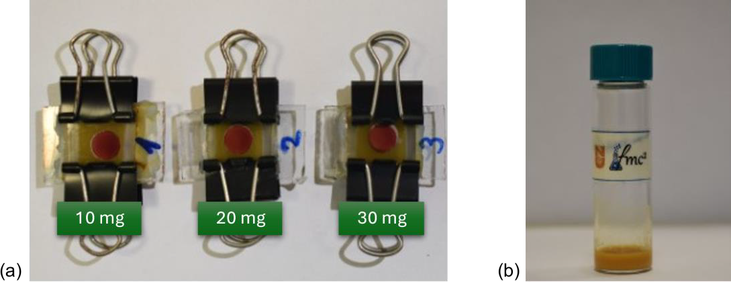
Figure S1. (a) Images of the DSSCs devices incorporating various amount of MIL-125. (b) Image of the electrolyte containing 10 mg MIL-125.

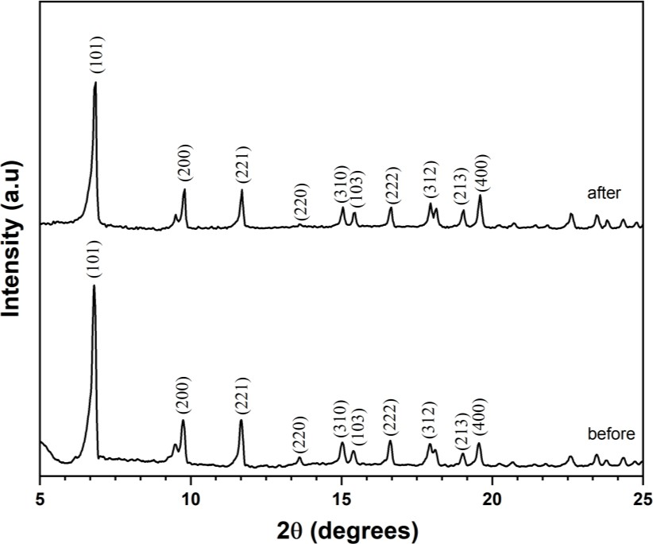
Figure S2. The Powder XRD profile of MIL-125, measured before and after a long-term stability test of over 4380 hours.

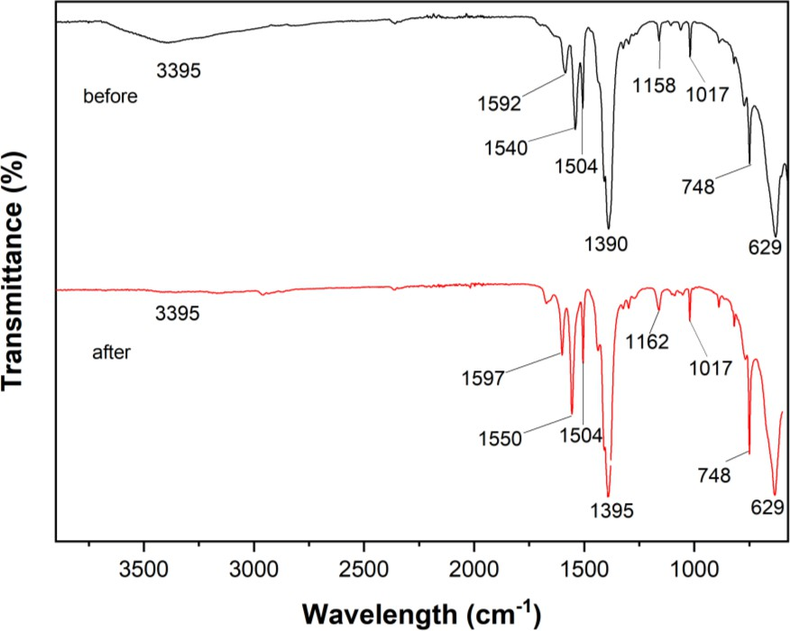
Figure S3. FTIR spectra of MIL-125, measured before and after a long-term stability test of over 4380 hours.
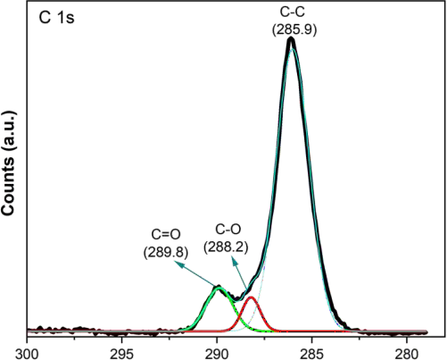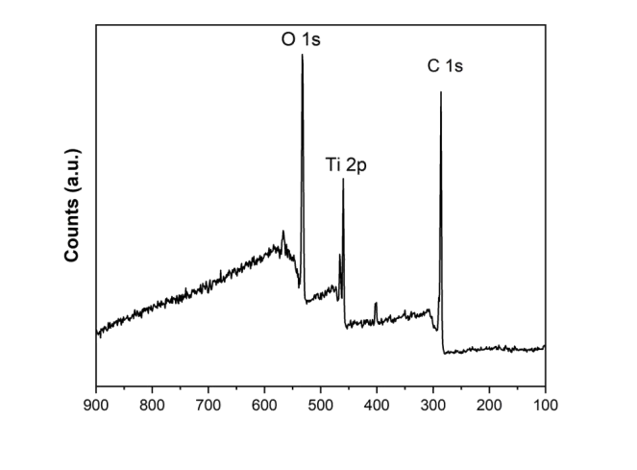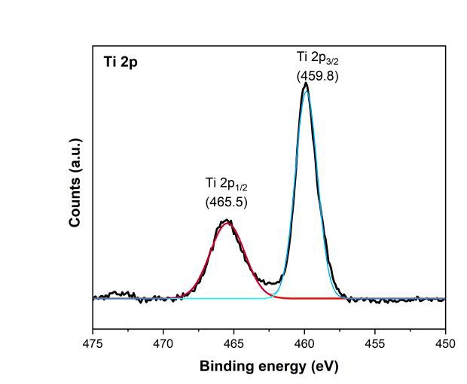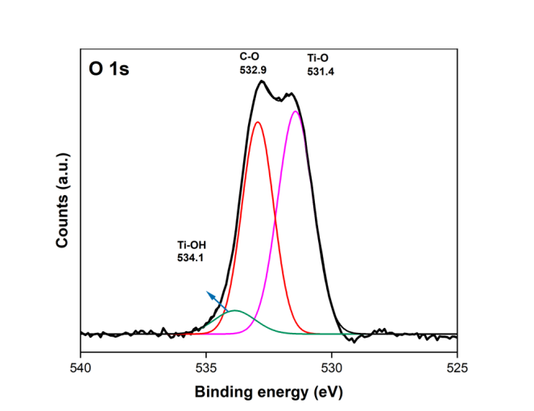
(a)
(b)
(c)
(d)
Figure S4. (a) XPS survey scan and high resolution XPS spectra of (b) C 1s, (c) O 1s, and (d) Ti 2p for MIL-125 after a long-term stability test of over 4380 hours.

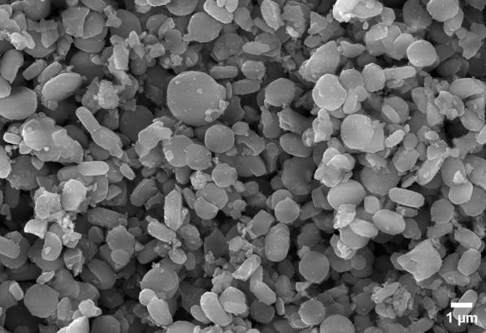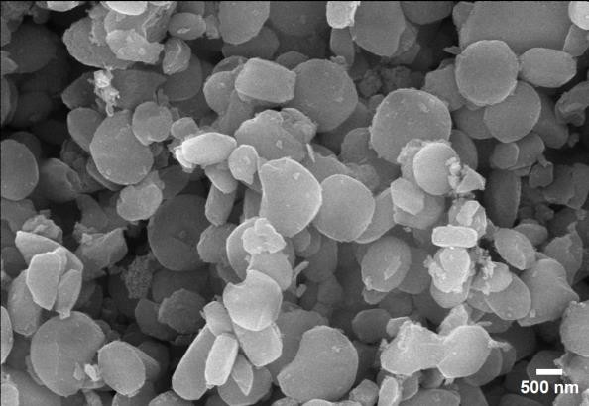
Figure S5. SEM images of MIL-125 at various magnifications after a long-term stability test of over 4380 hours.

Review
Advancements in Carbazole-Based Sensitizers and
Hole-Transport Materials for Enhanced Photovoltaic Performance
Ayagoz Ibrayeva 1,2, Urker Abibulla 3, Zulfiya Imanbekova 3, Bakhytzhan Baptayev 1, Robert J. O’Reilly 4,* and Mannix P. Balanay 1,3,*
1 National Laboratory Astana, Nazarbayev University, 53 Kabanbay Batyr Ave., Astana 010000, Kazakhstan; bbaptayev@nu.edu.kz (B.B.)
2 Department of Chemistry, L.N. Gumilyov Eurasian National University, 2 Satpayev St., Astana 010008, Kazakhstan
3 Chemistry Department, Nazarbayev University, 53 Kabanbay Batyr Ave., Astana 010000, Kazakhstan
4 School of Science and Technology, University of New England, Armidale, NSW 2351, Australia
* Correspondence: roreill6@une.edu.au (R.J.O.); mannix.balanay@nu.edu.kz (M.P.B.); Tel.: +7-7172-69-46-57 (M.P.B.)

Abstract: Carbazole-based molecules play a significant role in dye-sensitized solar cells (DSSCs) due to their advantageous properties. Carbazole derivatives are known for their thermal stability, high hole-transport capability, electron-rich (p-type) characteristics, elevated photoconductivity, excellent chemical stability, and commercial availability. This review focuses on DSSCs, including their structures, working principles, device characterization, and the photovoltaic performance of carbazole-based derivatives. Specifically, it covers compounds such as 2,7-carbazole and indolo[3,2-b]carbazole, which are combined with various acceptors like benzothiadiazole, thiazolothiazole, diketopyrrolopyrrole, and quinoxaline, as reported over the past decade. The review will also outline the relationship between molecular structure and power-conversion efficiencies. Its goal is to summarize recent research and advancements in carbazole-based dyes featuring a D-π-A architecture for DSSCs. Additionally, this review addresses the evolution of carbazole-based hole-transport materials (HTMs), which present a promising alternative to the costly spiro-OMeTAD. We explore the development of novel HTMs that leverage the unique properties of carbazole derivatives to enhance charge transport, stability, and overall device performance. By examining recent innovations and emerging trends in carbazole-based HTMs, we provide insights into their potential to reduce costs and improve the efficiency of DSSCs.

Keywords: carbazole-based dyes; donor-pi-acceptor; metal-free organic sensitizer; hole-transport materials
- Introduction
The global demand for a sustainable energy supply has never been more pressing. As the need for alternative energy sources grows, advancements in solar cell technology have emerged. Although commercially available single- and multi-crystalline silicon and inorganic solar cells are highly efficient at converting sunlight into electricity, they pose environmental challenges due to the use of toxic chemicals like trichlorosilane and silicon tetrachloride, as well as high production costs. Consequently, a new generation of solar cells, such as organic photovoltaics (OPVs), perovskite solar cells (PSCs), and dye-sensitized solar cells (DSSCs), is being explored. These alternatives offer lower manufacturing costs, greater mechanical flexibility, and improved color selectivity. Among these, DSSCs have garnered significant attention for their potential to power both outdoor and indoor applications, thus offering a versatile solution for various electrical devices [1–3].
Proper design and synthesis play a crucial role in advancing innovative organic functional materials for optoelectronic applications, including organic light-emitting diodes (OLEDs), photovoltaics, non-linear optics (NLOs), field-effect transistors (OFETs), and sensors [4]. One such material is a carbazole-based self-assembled monolayer (SAM) containing phosphonic acid known as 2PACz, which has proven effective as hole-transport material (HTM) (HTLs) in perovskite light-emitting diodes (PeLEDs), organic solar cells, and perovskite solar cells, demonstrating exceptional performance [5]. Electrochemical polymerization is widely employed for creating thin films of carbazole-based polymers [6]. Understanding the electrochemical behavior of carbazole and its derivatives is crucial for developing novel materials and devices with desirable properties, such as stability [7]. Carbazole derivatives with diallyl substitutions are particularly effective as host materials for high-efficiency phosphorescent OLEDs in the blue, green, and red color spectrum [8]. Recent reviews highlight the role of carbazole derivatives as donors in combination with various acceptor groups in bulk heterojunction OSCs, DSSCs, and PSCs [9]. Advances in molecular design, hole-transporting properties, power-conversion efficiency (PCE), and thermal stability of organic hole-transporting materials based on different carbazole derivatives have been extensively investigated for PSC applications [10]. Significant research efforts have also been dedicated to the utilization of carbazole derivatives as HTMs in both PSCs [11] and OLEDs [5,12].
In comparison to other photovoltaic technologies like PSCs, which have a higher power-conversion efficiency (PCE) of 26.1% for single-junction devices [13–15], DSSCs stand out due to their lower production costs, better low-light performance, shorter energy-payback times, enhanced environmental sensitivity, and relative ease of fabrication. Initially developed in 1991 by O’Regan and Grätzel using a Ru(II) pyridyl complex dye and an I−/I₃− electrolyte, DSSCs achieved a PCE of 7.9% [16]. Recent advancements have increased the highest reported efficiency for DSSCs to 13.6% with a single dye [17]. However, the use of a co-sensitization approach, in which multiple dyes are employed, has allowed for the rise of DSSCs with PCEs of up to 15.2% [18]. In low-light conditions, DSSCs have a significant advantage over other third-generation photovoltaic technologies due to their simpler chemical composition. Utilizing a co-sensitization process with a copper (II/I) electrolyte, DSSCs have achieved an efficiency of 34% at 1000 lux [19]. Since the theoretical efficiency limits are 33% for AM 1.5 G illumination and 57% for various indoor lighting conditions [20], there is significant potential to enhance the efficiency and versatility of DSSCs. Improvements in module design, substrate integration, architecture, reliability, and adaptable manufacturing methods could greatly advance DSSCs. This potential has sparked considerable research interest and opened promising avenues for commercialization.
Over the last decade, there has been a growing emphasis on hole-transport materials, yet the synthesis, classification, and application of organic HTMs using carbazole in dye-sensitized solar cells have received comparatively little attention. Effective hole transport facilitated by HTMs ensures that generated holes can swiftly reach the anode without significant loss through electron recombination. Proper alignment of energy levels between the HTM, dye, and anode is crucial for efficient charge transfer. A well-chosen HTM contributes to the long-term stability of DSSCs by averting performance degradation. Carbazole derivatives are particularly suitable for HTMs due to their high hole mobility and adaptable electrical properties.
Organic photovoltaic cells face a significant drawback due to their lower charge-carrier mobilities compared to traditional inorganic semiconductors. This limitation is underscored by the dispersive nature of charge-carrier mobility in organic semiconductors, which directly impacts critical processes such as charge-transfer state dissociation, free-charge extraction, and recombination—key factors influencing the efficiency of organic photovoltaics. Recent advancements delved into the influence of charge-carrier mobility on these efficiency-defining mechanisms [21]. In contrast, DSSCs exhibit a distinct advantage with their separation of light absorption and charge-carrier transport activities, enabling more effective light harvesting [22]. Understanding and optimizing charge-carrier mobility is crucial as it influences processes like exciton migration, dissociation, and charge collection at electrodes, pivotal for enhancing solar cell performance [23]. The diffusion model is increasingly favored for simulating charge-carrier densities in DSSCs due to its ability to capture complex transport phenomena [24]. Recent developments in DSSC efficiency focus on improved electrodes, enhanced carrier-transport materials, and molecular engineering [25], aiming to address challenges in scaling up from laboratory to industrial applications to improve efficiency and stability. Additionally, incorporating hexyloxyphenyl substituents has shown promise in enhancing electron lifetime and open-circuit voltage by blocking I₃− ions in the electrolyte [26]. The molecular design also plays a crucial role in optimizing carbazole-based sensitizers for improved electron transfer in DSSCs, with properties like polarizability significantly influencing charge-transfer processes and overall efficiency [27]. These insights underscore the importance of advancing both material science and molecular engineering to propel the efficiency and viability of organic and dye-sensitized solar cells. This review aims to fill a gap in the literature by exploring carbazole-based hole-transport materials (HTMs) and the application of carbazole-based dyes as sensitizers. It will examine the synthesis and fabrication of these materials, along with their electrochemical and photovoltaic characterization, as well as density functional theory (DFT) studies.

- Working Principle of DSSCs
Figure 1 illustrates the general structure of DSSCs, which consist of a dye-sensitized mesoporous photoanode (a film of dye-anchored nanocrystaline titanium dioxide, TiO₂), an electrolyte (generally a I−/I₃− redox mediator, though Co²⁺/Co³⁺ or Cu⁺/Cu²⁺ are also used), and a counter electrode (transparent conductive oxide glass treated with platinum). Sunlight is absorbed by a monolayer of sensitizer attached to the surface of the TiO₂ semiconductor, exciting electrons from the highest occupied molecular orbital (HOMO) to the lowest unoccupied molecular orbital (LUMO). These excited electrons then diffuse from the conductive band of TiO₂ to the platinized counter electrode via an external electrical circuit. The photoelectric cycle is completed when the oxidized dye is regenerated by the I− species, forming I₃−, which then diffuses to the counter electrode and is reduced [1–3].
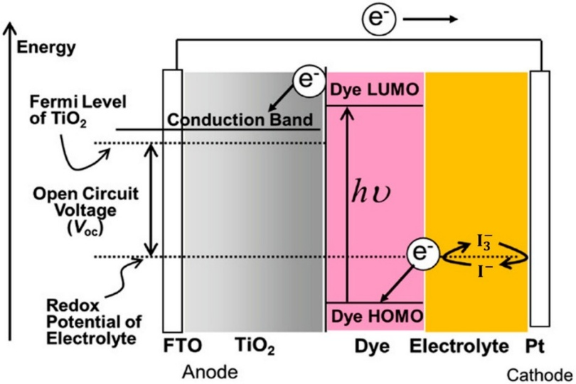
Figure 1. Dye-sensitized solar cell structure and energy diagram. Adapted with permission from reference [3]. Copyright (2018), John Wiley and Sons.
For efficient solar cell operation, each component must perform optimally. The counter electrode needs to have high catalytic activity and stability. While alternative materials like transition metal compounds, polymers, and carbon-based materials show potential, they are not yet thoroughly characterized [28]. Consequently, platinum remains the most efficient, though its degradation upon contact with iodine redox electrolytes, high cost, and scarcity limit its commercial viability.
The electrolyte, which regenerates the oxidized sensitizer and facilitates charge transfer between the counter electrode and the photoanode, must also offer long-term stability. Traditional liquid iodine redox electrolytes and other ionic conductivity-based alternatives face issues such as solvent evaporation, degradation of the dye and counter electrode, and difficulties with cell sealing. Polymer electrolytes address these issues, enhancing cell longevity.
Finally, sensitizers, which are crucial to DSSCs, must meet several criteria: They should absorb a wide spectrum from visible to near-infrared light efficiently, possess stable HOMO and LUMO energy levels to facilitate charge transfer to TiO₂, resist degradation, retain light-harvesting capability for at least 20 years, and attach effectively to the semiconductor oxide film with an anchoring group while being regenerated by the electrolyte [1,29].

- Carbazole-Based Dyes for DSSCs
Dyes can have a range of structural architectures, including D-A, D-π-A, D-D-π-A, D-A-π-A, and D-π-D-π-A, A-π-D-π-A, A-π-D-π-A-π-A, D-π-D-A, D-(π-D-A)2, D-(π-D-A)3, among others. In these structures, “D” represents the donor moiety, “π” signifies the π-linker or π-bridge, and “A” denotes the acceptor or anchoring group, which is typically a carboxylic acid or cyanoacrylic acid. The most conventional and studied structure is the D-π-A configuration, depicted in Figure 2a. This straightforward structure can be modified in numerous ways to enhance its effectiveness, making it particularly suitable for research [30]. Notably, the D-π-A design is highly effective for metal-free organic sensitizers because it offers a broad and strong optical absorption band in the visible spectrum thanks to the efficient intramolecular charge transfer (ICT) from the donor to the acceptor. Upon light irradiation, electrons are excited from the donor’s highest-occupied molecular orbital to the acceptor’s lowest unoccupied molecular orbital and then transferred to the acceptor, which is attached to the TiO₂ substrate via a strong ionic bond. This arrangement promotes efficient electron injection into the conductive band of the TiO₂ semiconductor oxide film [1,31].

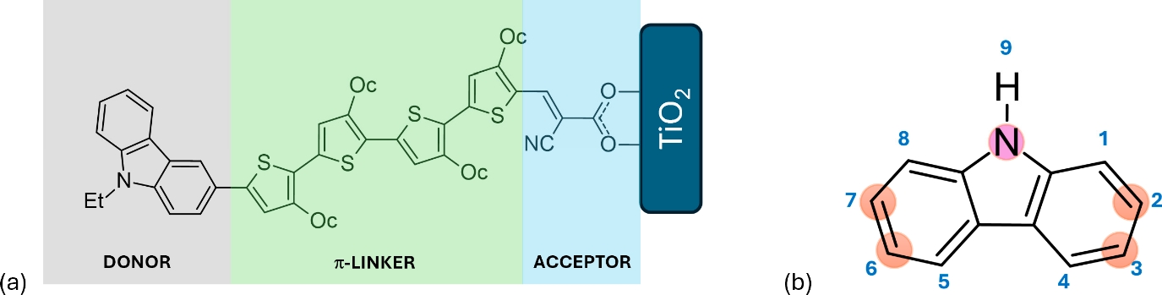Figure 2. (a) Schematic representation of a D-π-A structure featuring a carbazole-based dye, where Et denotes ethyl and Oc denotes octyl groups. (b) Structural depiction of carbazole, highlighting atom numbering and the positions most commonly substituted.
Numerous compounds with a D-π-A structure have been utilized as sensitizers, includ-ing coumarin, triarylamine, carbazole, phenothiazine, diketopyrrolopyrrole, and tripheny-lamine, among others [32–35]. Carbazole, illustrated in Figure 2, is particularly noteworthy due to its electron-rich properties, excellent hole-transport capabilities, commercial avail-ability, and remarkable chemical and thermal stability. Its electron-rich nature makes it suitable for use as an auxiliary donor, donor, or π-bridge. Furthermore, carbazole can be easily functionalized at the 2, 7, 3, 6, and 9 positions, as depicted in Figure 2b [1,3]. Prior to 2011, the primary applications of carbazole-based functional materials were as difunc-tionalized derivatives capable of transporting or emitting holes and serving as donors in donor–acceptor molecular topologies. Recently, the intriguing structure–function cor-relations resulting from the polyfunctionalization of carbazole at various locations have garnered significant attention [4].
This literature review provides an overview of recent research on carbazole-based dyes with a D-π-A architecture, as well as a compilation of various architectural structures of these dyes. The focus is specifically on their applications in dye-sensitized solar cells (DSSCs), as detailed in Tables 1–5. The review investigates how the structural design of carbazole-based sensitizers influences the performance of these devices. These dyes have demonstrated efficiencies comparable to the widely used commercial N719 dye [36], suggesting their potential for commercial use, contingent upon enhancements in physical, chemical, and stability properties. The review underscores the promise of carbazole-based dyes, highlighting their photovoltaic characteristics to stimulate further research interest among scholars and scientists. In DSSCs, the cell’s performance is evaluated using key parameters such as short-circuit current density (J_{sc}) and open-circuit voltage (V_{oc}). The formulas for these parameters are as follows: The short-circuit current density measured in units of mA/cm² or A/m² is determined using the formula:
$Jsc=\frac{Isc}{A}$ (1)
Here, I_{SC} represents the short-circuit current, which is the to
tal current when the solar cell is shorted, provided in mA or A, and A denotes the area of the solar cell in cm2 or m2. Meanwhile, the open-circuit voltage, measured in volts (V), can be calculated using the formula:
$Voc=\frac{kT}{q}ln\frac{Jsc}{J0 }+1$ (2)
In this equation, k is Boltzmann’s constant (1.38×10⁻²³J/K), T is the absolute temperature in Kelvin, q is the charge of an electron (1.6×10⁻¹⁹C), and J_{o} is the saturation-current density, which is the current density at zero voltage, measured in A/m2.
These equations elucidate the critical performance metrics of solar cells, crucial for optimizing the efficiency and viability of carbazole-based dye applications in photovoltaic technologies.
  - Recent Developments on Carbazole-Based Dyes
    - D-π-A Architecture

To broaden the absorption spectra of the D-π-A system through molecular engineering, two primary strategies are employed: increasing the effective conjugation length between the donor and acceptor and enhancing the electron-donating or electron-withdrawing capabilities, as presented in Table 1 and Figure 3. Introducing alkyl chains is a common approach to modifying molecular properties. Alkyl chains can enhance the electron-donating ability of carbazole, influencing its HOMO levels and overall charge-transport characteristics. Additionally, longer or branched alkyl chains can improve solubility in organic solvents, facilitating device fabrication, while they also help prevent π-aggregation, which enhances performance metrics such as charge injection and collection efficiency [37,38].
NMR spectroscopy is essential for characterizing carbazole derivatives and confirming the successful introduction of alkyl chains. The protons on the alkyl chain typically resonate between 0.9 ppm (for methyl groups) and 1.5 ppm (for methylene groups), while the protons on the carbazole ring appear around 7–8 ppm due to their aromatic nature. Moreover, IR spectroscopy offers valuable insights into the functional groups present in carbazole derivatives. For instance, C–H stretching vibrations from alkyl chains are found in the range of 2800–3000 cm−1, while aromatic C=C stretching vibrations are typically observed around 1500–1600 cm−1. The absence of strong peaks near 1700 cm−1 suggests a lack of carbonyl functionalities, indicating that only alkyl groups are present.
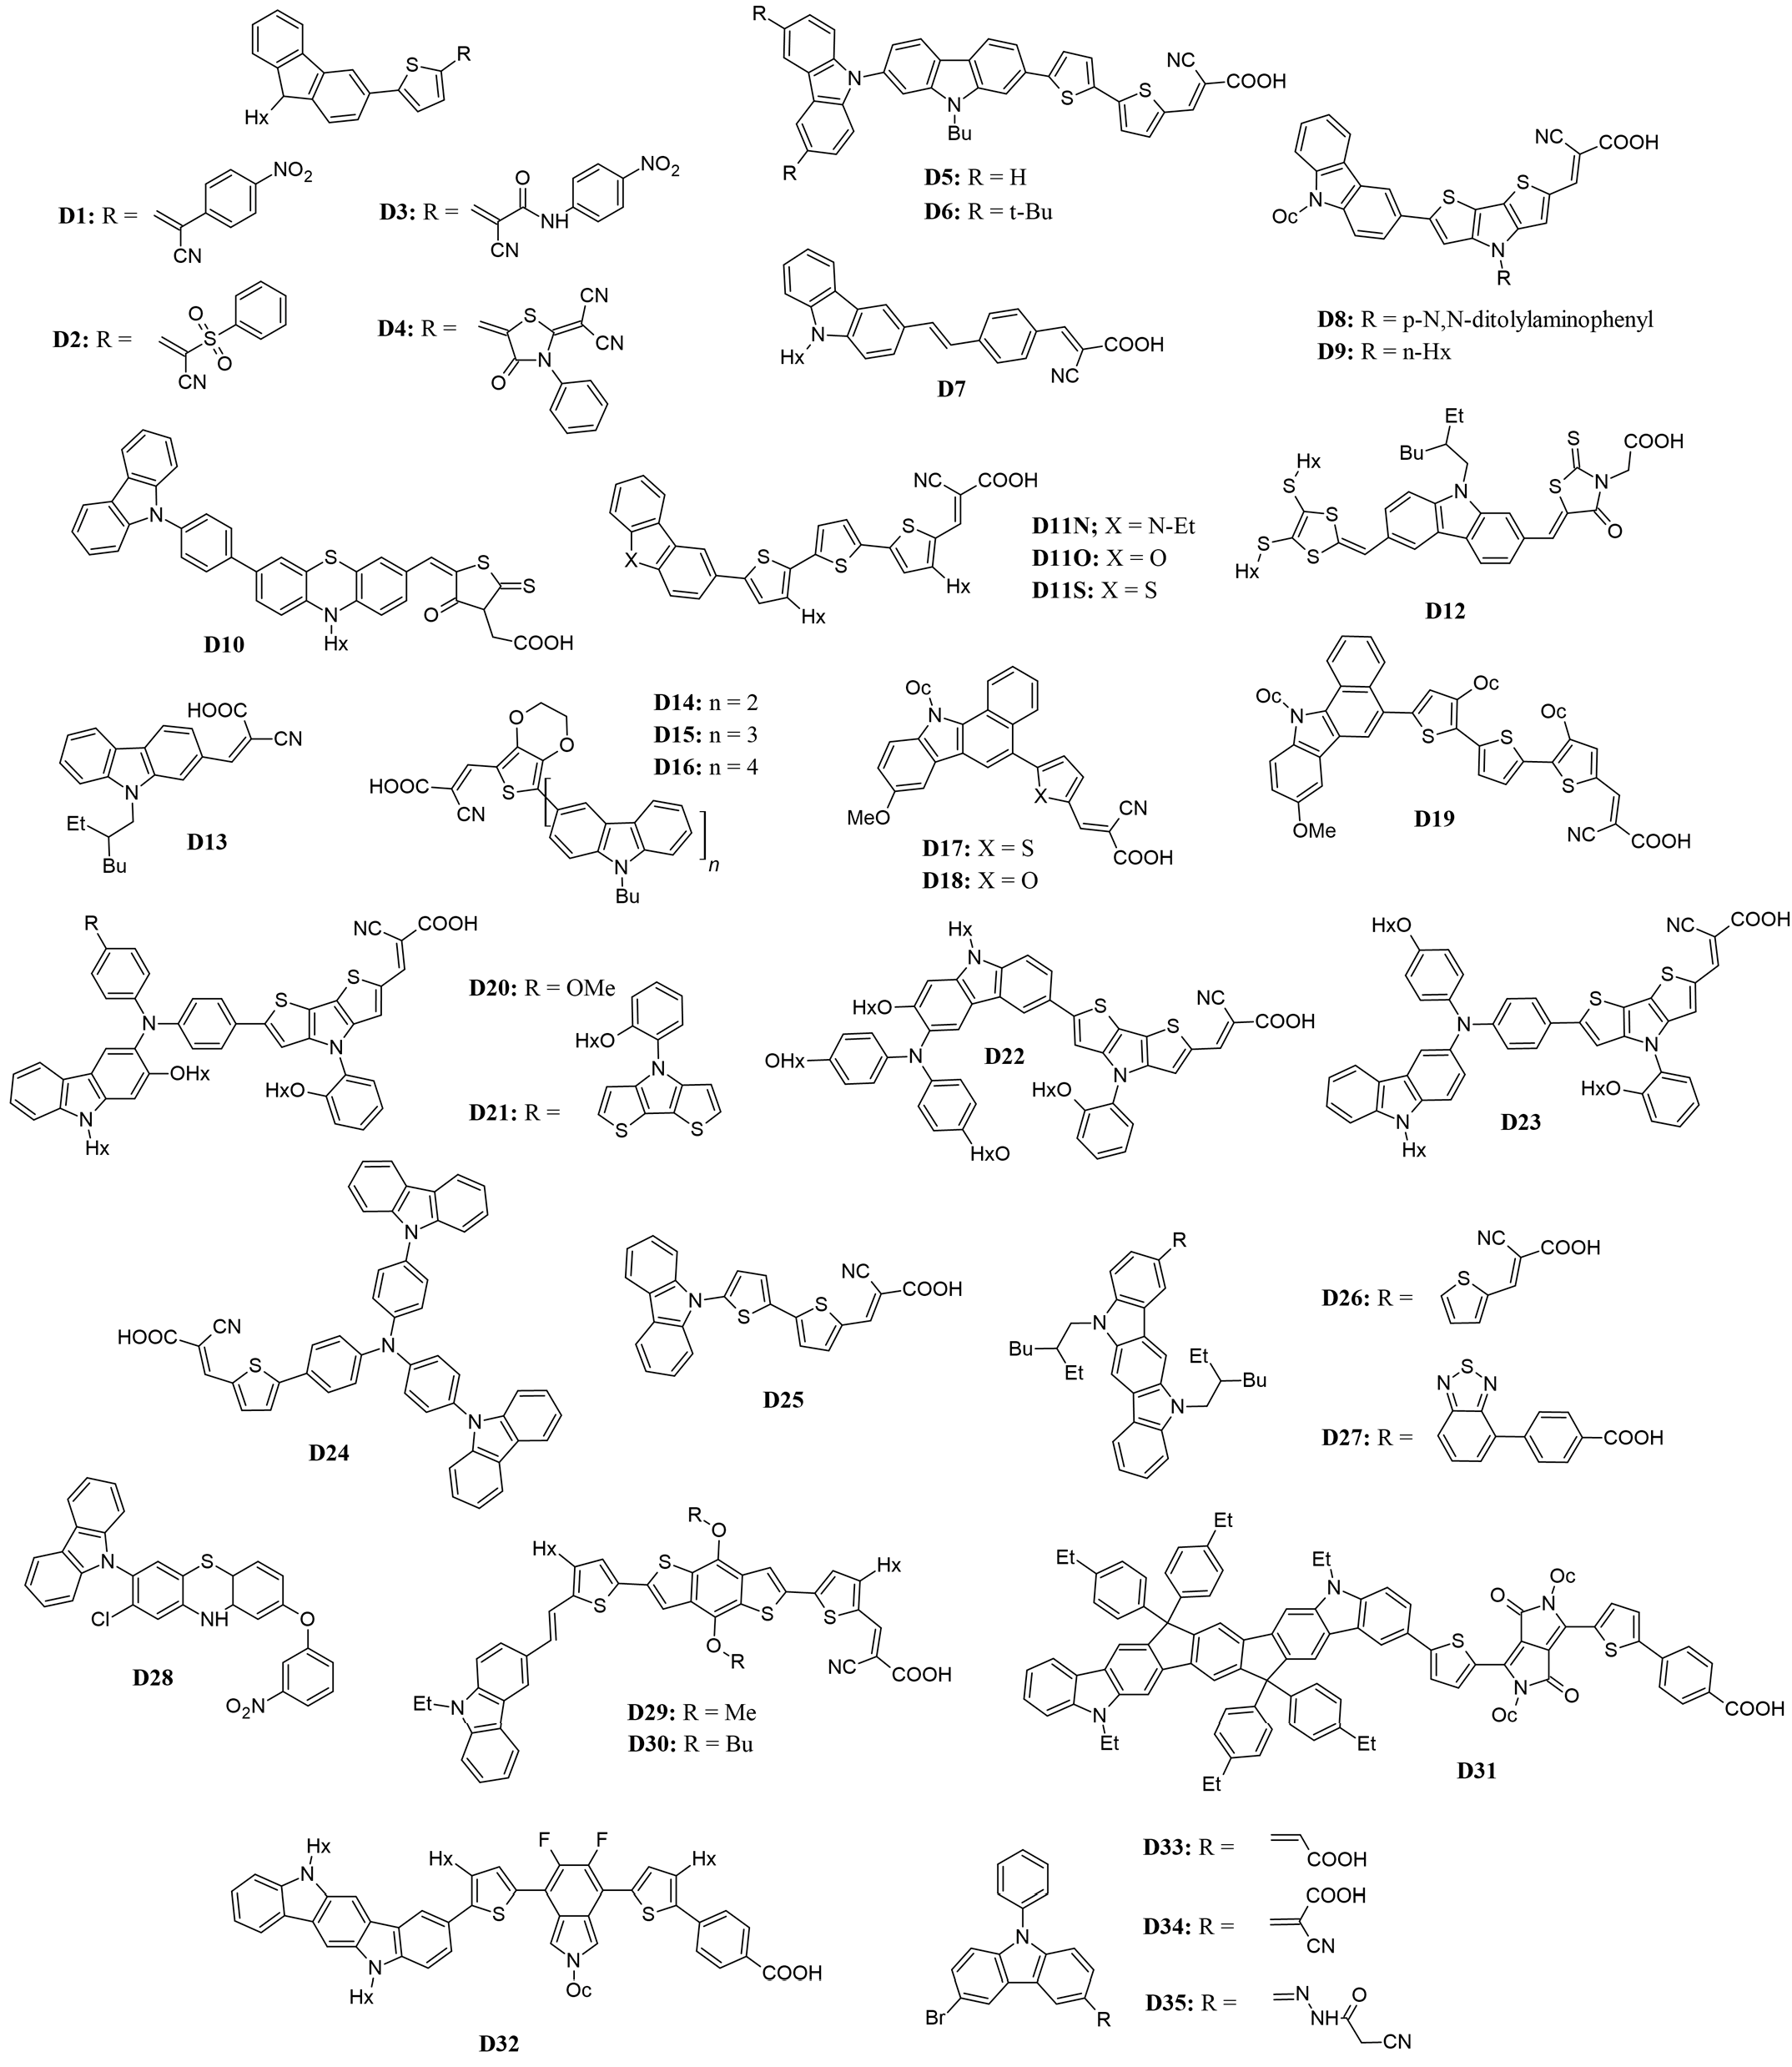
Figure 3. Structure of the carbazole-based molecules with D-π-A architecture (D1 to D35) as sensitiz-ers for DSSCs.

Table 1. Photovoltaic parameters of the DSSCs based on carbazole-based sensitizers having D-π-A architecture.
Dye No. | Electrolyte | λ_{max} nm,  (ε × 10⁴ M^{–1} cm^{–1}) | PCE  (%) | FF | V_{OC}  (V) | J_{SC}  (mA cm^{–2}) | Ref.
D1 | I–/I₃– | 495 (5.13)^{f} | 6.06 | 0.75 | 0.56 | 14.43 | [20]
D2 | I–/I₃– | 491 (5.39)^{f} | 7.39 | 0.66 | 0.70 | 16.00 | [20]
D3 | I–/I₃– | 522 (4.27)^{f} | 8.38 | 0.69 | 0.72 | 16.88 | [20]
D4 | I–/I₃– | 499 (3.15)^{f} | 9.55 | 0.70 | 0.78 | 17.50 | [20]
D5 | I–/I₃– | 476 (4.51)^{b} | 6.04 | 0.64 | 0.601 | 15.78 | [21]
D6 | I–/I₃– | 478 (4.47)^{b} | 5.48 | 0.64 | 0.612 | 14.00 | [21]
D7 | I–/I₃–  Co³⁺/Co²⁺ | 435 (3.42)^{c} | 7.1  9.0 | 0.65  0.67 | 0.645  0.725 | 17.20  18.30 | [22]
D8 | I–/I₃– | 492 (5.64)^{d} | 6.63 | 0.64 | 0.71 | 14.55 | [23]
D9 | I–/I₃– | 496 (6.25)^{d} | 6.50 | 0.63 | 0.70 | 14.71 | [23]
D10 | I–/I₃– | 493 (1.89)^{b} | 5.57 | 0.52 | 0.71 | 15.12 | [24]
D11N | I–/I₃– | 492 (2.43)^{e} | 7.44 | 0.67 | 0.701 | 15.73 | [25]
D11O | I–/I₃– | 476 (2.69)^{e} | 7.68 | 0.69 | 0.714 | 15.61 | [25]
D11S | I–/I₃– | 477 (2.78)^{e} | 7.18 | 0.67 | 0.691 | 15.43 | [25]
D12 | I–/I₃– | 551 (1.15)^{f} | 7.38 | 0.67 | 0.78 | 14.12 | [26]
D13 | I–/I₃– | 552 (1.01)^{f} | 6.90 | 0.69 | 0.76 | 13.19 | [26]
D14 | I–/I₃– | 433 (1.46)^{e} | 6.16 | 0.694 | 0.706 | 12.51 | [27]
D15 | I–/I₃– | 449 (1.07)^{e} | 7.21 | 0.672 | 0.723 | 14.84 | [27]
D16 | I–/I₃– | 447 (1.17)^{e} | 6.97 | 0.683 | 0.707 | 14.44 | [27]
D17 | I–/I₃– | 458 (2.02)^{b} | 6.01 | 0.660 | 0.729 | 12.40 | [28]
D18 | I–/I₃– | 462 (2.15)^{b} | 6.93 | 0.660 | 0.757 | 13.80 | [28]
D19 | I–/I₃– | 477 (3.24)^{b} | 7.54 | 0.680 | 0.744 | 14.80 | [28]
D20 | I–/I₃–  Co³⁺/Co²⁺ | 535 (4.71)^{b} | 7.80  8.67 | 0.690  0.680 | 0.754  0.880 | 15.00  14.50 | [29]
D21 | I–/I₃–  Co³⁺/Co²⁺ | 518 (3.81)^{b} | 5.43  4.65 | 0.680  0.690 | 0.650  0.763 | 12.30  8.8 | [29]
D22 | I–/I₃–  Co³⁺/Co²⁺ | 517 (5.39)^{b} | 6.73  7.06 | 0.690  0.680 | 0.723  0.845 | 13.50  12.3 | [29]
D23 | I–/I₃–  Co³⁺/Co²⁺ | 511 (4.04)^{b} | 6.27  6.77 | 0.670  0.680 | 0.709  0.830 | 13.20  12.00 | [29]
D24 | I–/I₃– | 442 (2.95)^{l} | 5.92 | 0.589 | 0.740 | 13.6 | [30]
D25 | I–/I₃– | 435 (1.65)^{j} | 5.10 | 0.730 | 0.720 | 9.89 | [31]
D26 | I–/I₃– | 500 (5.48)^{b} | 5.41 | 0.590 | 0.745 | 12.55 | [32]
D27 | I–/I₃– | 463 (1.58)^{b} | 5.01 | 0.660 | 0.744 | 10.16 | [32]
D28 | I–/I₃– | 442ª | 5.68 | 0.761 | 0.726 | 11.69 | [33]
D29 | Co³⁺/Co²⁺ | 492 (3.39)^{g} | 5.27 | 0.620 | 0.775 | 11.05 | [34]
D30 | Co³⁺/Co²⁺ | 492 (3.35)^{g} | 5.60 | 0.600 | 0.783 | 11.93 | [34]
D31 | Cu²⁺/Cu⁺ | 625 (4.32)^{b} | 6.0 | 0.754 | 0.95 | 8.30 | [35]
D32 | Cu²⁺/Cu⁺ | 422 (5.08)^{b} | 5.1 | 0.647 | 1.10 | 7.10 | [35]
D33 | I⁻/I₃⁻ | 478^{k} | 6.72 | 0.690 | 0.78 | 11.18 | [36]
D34 | I⁻/I₃⁻ | 466^{k} | 7.46 | 0.710 | 0.81 | 13.57 | [36]
D35 | I⁻/I₃⁻ | 481^{k} | 8.12 | 0.680 | 0.85 | 14.72 | [36]
Note: A Pt electrode was utilized as a counter electrode. Absorption maxima in ª THF, ^{b} DCM, ^{c} EtOH, ^{d} CH2Cl2/THF, ^{e} CHCl3, ^{f} MeCN, ^{g} CH2Cl2, ^{h} 1:1 toluene:MeCN, and ^{i} DMSO solutions.

In a study by Elmorsy et al. [39], four carbazole-based organic sensitizers (D1–D4) were synthesized, demonstrating efficiencies ranging from 6.06% to 9.55% and a broad light-harvesting range from 400 to 800 nm. Notably, the power-conversion efficiency of the D4 dye reached 9.55%, representing a 32% increase compared to the N719 sensitizer, attributed to the incorporation of a thiazolidine-4-one ring that enhances electron injection and reduces recombination. The energy bandgap (E_{g}) of these organic sensitizers was calculated using the difference in energy levels (E_{HOMO}–E_{LUMO}), revealing a decrease in E_{g} values from D1 to D4. Specifically, D4, with its elongated π-conjugated linker due to the new thiazolidine-4-one acceptor, exhibits the smallest bandgap, allowing it to absorb lower-energy photons with longer wavelengths. This characteristic facilitates the excitation of the sensitizer’s electrons into unoccupied π orbitals, shown in Figure 4, thereby enhancing the stability, short-circuit current density, and overall PCE of solar cells.
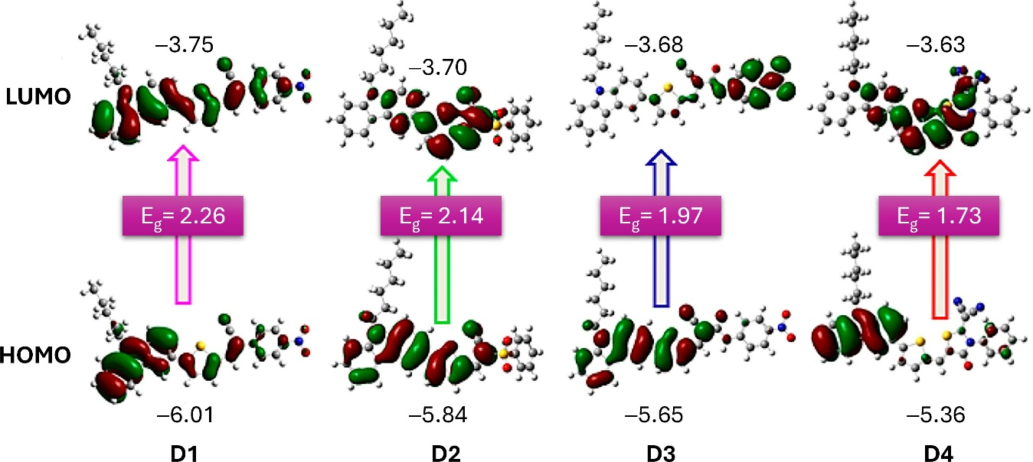
Figure 4. Optimized structures of dyes D1 to D4, illustrating their HOMO and LUMO frontier molecular orbitals. The accompanying values indicate the HOMO and LUMO energy levels, along with the calculated band gap (Eg). Adapted with permission from reference [39]. Copyright (2023), Elsevier.
Venkateswararao et al. [40] introduced a series of new organic dyes (D5–D6) featuring a carbazole/3,6-di(tert-butyl) carbazole donor, a 2,7-carbazole spacer, and cyanoacrylic acid as both the acceptor and anchoring group. Compared to similar dyes with 3,6-carbazole or phenyl linkers, these dyes demonstrated enhanced light-harvesting capabilities. Specifically, the open-circuit voltage (V_{OC}) values for thiophene derivatives (0.635 V and 0.666 V) were higher than those for their bithiophene counterparts D5 and D6 (0.601 V and 0.612 V) due to a more positive LUMO level. Additionally, dyes with tert-butyl substituents (D6) exhibited higher V_{OC} values than their unsubstituted counterparts (D5), owing to the improved light-harvesting properties and a hydrophobic environment that reduces electrolyte contact with the photoanode. The PCE of the bithiophene-based dyes (6.04% and 5.48%) was greater than that of the thiophene-based dyes (4.22% and 4.95%), attributed to superior absorption properties and electron-collection efficiency.
To evaluate the impact of the anchoring group, Soni et al. [41] synthesized two ad-ditional carbazole-based dyes. These dyes used carbazole as the donor and cyanoacrylic acid (D7) or rhodamine-3-acetic acid as the acceptor, connected by a vinylene-phenylene π bridge. The dyes achieved efficiencies of 2.0% for rhodamine-3-acetic acid–acceptor and 7.1% for D7 with an iodine redox electrolyte, as well as 2.4% and 9.0% with a cobalt (II/III) redox electrolyte. The dye with the cyanoacrylic acid acceptor group outperformed the one with the rhodamine-3-acetic acid group, owing to more effective electron injection into the conduction band of TiO₂. This is due to better overlapping with the surface and reduced charge recombination between the injected electron and the oxidized electrolyte.
Zhang and colleagues [42] introduced two innovative dyes (D8–D9) featuring an alkylated carbazole donor, dithienopyrrole (DTP) as a π-bridge, and cyanoacetic acid as the acceptor. The dye with a benzene ring attached to the DTP showed a higher PCE of 6.63% compared to the alkylated DTP dye, which had a PCE of 6.50%. The former also had a higher V_{OC} of 0.71 V versus 0.70 V for the latter. This improvement is attributed to reduced π-π aggregation of the dyes on TiO₂ films and minimized charge recombination. In another research, the group of Jiao et al. [43] evaluated the impact of the meta- and para-positions of donors in the dye structure (D10). In their carbazole, it served as the donor, connected to a phenothiazine spacer through a benzene ring, with rhodamine acetic acid acting as the acceptor and anchoring group. The dye with carbazole connected at the meta position exhibited a lower PCE of 4.56% compared to the para-connected dye (D10), which had a PCE of 5.57%. The para-connected carbazole showed a superior short-circuit current density of 15.12 mA cm−2 due to higher dye loading, more effective ICT, and a broader absorption spectrum. Additionally, the para-connected carbazole’s lower charge-recombination resistance contributed to a longer electron lifetime and lower transport-charge resistance, enhancing dye stability.
A series of dyes (D11N, D11O, and D11S) incorporating heteroatom donors and cyanoacetic acid acceptors linked by alkyl-substituted thiophene units have also been studied [44]. Based on the results of this study, it was shown that the O-substituted dibenzo[b,d]furan-2-yl motif (D11O) achieved the highest conversion efficiency of 7.68%. In addition, this study demonstrated that the N-substituted carbazole motif (D11N) exhibited a better power-conversion efficiency (7.44%) when compared to the S-substituted dye (D11S, which is based on a dibenzo[b,d]thiophen-2-yl motif), which had a PCE of 7.18%. This performance difference is attributed to the greater electron-donating ability of carbazole compared to dibenzothiophene. Furthermore, introducing alkyl chains to the spacer reduced dye aggregation on the semiconductor oxide film, allowing planar dyes to achieve high V_{OC} values (0.701 V, 0.714 V, and 0.691 V for D11N, D11O, and D11S, respectively).
Duvva and Giribabu [45] introduced new dyes featuring a carbazole π-bridge that links a donor dithiafulvalene unit with acceptors cyanoacrylic acid (D12) or rhodanine-3-acetic acid (D13). Devices incorporating cyanoacrylic acid-based dyes achieved the highest efficiency of 7.38%, compared to 6.90% for those using rhodanine-3-acetic acid. The strong electron-donating dithiafulvalene unit in these dyes broadens absorption, causes redshift, reduces aggregation, and promotes rapid regeneration of the oxidized dye in DSSCs, resulting in improved photovoltaic performance compared to a dye without an additional donating group (PCE = 3.96%).
Tian et al. [46] developed three novel dyes (D14–D16), with dye D15 delivering the best photovoltaic performance (PCE = 7.21%, V_{OC} = 0.723 V, J_{SC} = 14.84 mA cm−2, FF = 0.672). The planarization of the side chain in the donor slightly increased HOMO levels, enhancing light-harvesting capabilities, though the effect on ICT processes was minimal.
Using a benzo[a]carbazole donor moiety with a cyanoacryl acid as its acceptor group, Qian and colleagues [47] investigated the effect of various electron-rich spacers such as thiophene (D17), furan (D18), and oligothiophene (D19) as π-linkers. Dye D19 demonstrated a broad incident photon-to-current efficiency (IPCE) response with photocurrent signals extending up to approximately 740 nm, covering most of the UV-visible spectrum. Its absorption maximum was redshifted to 477 nm, with a molar extinction coefficient of 3.24 M−1 cm−1. This indicates that expanding the electron-rich conjugated π-linkers not only enhances donor-acceptor interactions but also reduces the energy gap of the organic dyes. D19-based dye achieved the best PV performance with a J_{SC} of 14.8 mA cm−2, V_{OC} of 0.744 V, and an FF of 0.68, resulting in a PCE of 7.54%.
Another study, which focused on the effect of various π-linkers on the performance of DSSCs, has also been reported [48]. These dyes (D20–D23) contain a carbazole donor and a triarylamine acceptor, as well as a cyanoacrylic acid-anchoring group. Of these, dye D20 exhibited the highest PV performance with a PCE of 8.67%, notably outperforming dyes (D21–D23). The inclusion of the 9-hexyl-2-(hexyloxy)-9H-carbazole unit in triarylamine offered several advantages, including: (i) a redshift of the absorption peak, (ii) an increased maximum molar absorption coefficient, reduced charge recombination in cobalt and iodine cells, and enhanced photocurrent/photovoltage. Taken together, these features led to an improvement in the PCEs of these cells.
Work by Wu et al. [49] has focused on designing effective DSSCs by assessing various donors such as carbazole (D24), phenothiazine (PTZ), or triphenylamine (tPA), which were coupled to an oligothiophene π-spacer and a cyanoacrylic acid acceptor. All these dyes exhibited strong absorption around 400 nm due to their rod-like structures. The carbazole-based dye D24 showed the highest PCE of 5.92%, surpassing tPA (5.30%) and PTZ (5.40%) due to its redshifted absorption band (442 nm) and superior electron-donating capacity. The highest V_{OC} value of 0.740 V was attributed to the larger dihedral angle between the donor and the π-bridge.
To design carbazole dendrons up to the fourth generation as donors, a bithiophene was used as π-linkage and cyanoacrylic acid was used as the acceptor (D25) [50]. Dye D25, containing a first-generation dendron (the smallest molecular volume), exhibited the highest PCE of 5.10% (J_{SC} = 9.89 mA cm−2, V_{OC} = 0.720 V, FF = 0.73). Increasing the size or generation of the carbazole dendritic donor enhanced light absorption but reduced dye uptake per unit TiO₂ area due to the high molecular volume. Electrochemical impedance spectroscopy (EIS) revealed that the donor’s size or generation significantly affected charge-transfer resistance at the TiO₂/electrolyte interface, impacting V_{oc} and, consequently, the PCE.
Three organic dyes based on indolo[3,2-b]carbazole as the donor moiety and various electron-withdrawing groups as acceptors were synthesized (D25–D26), and their performance in solar cell applications was examined [51]. The last dye, presented in the article, demonstrated the broadest light-response range (300–770 nm) in the incident monochromatic photoelectron conversion-efficiency curve, owing to its narrow bandgap. Among these three dyes, dye D26 exhibited the best device performance with a PCE of 5.41% (J_{SC} of 12.55 mA cm−2, V_{OC} of 0.745 V, and FF of 0.59). The introduction of an alkylated indolo[3,2-b]carbazole moiety efficiently suppressed dye aggregation, resulting in better PCE for all three dyes.
Periyasamy et al. [52] introduced three new carbazole-based compounds (D28), featuring a carbazole donor, a 2-chlorophenothiazine π-bridge, and different acceptors, such as triethylamine, ethyl thiophene-2-glyoxylate, and 4-nitrophenol (D28). Among these, dye D28 demonstrated outstanding photovoltaic properties with a PCE of 5.68%, attributed to its superior π-type transitions contributing to absorption in the visible region. In contrast, compounds with acceptors triethylamine and ethyl thiophene-2-glyoxylate showed lower efficiencies, with PCEs of 3.73% (V_{OC} = 0.714 V, J_{SC} = 7.08 mA cm−2, FF = 0.691) and 3.97% (V_{OC} = 0.720 V, J_{SC} = 8.37 mA cm−2, FF = 0.713), respectively.
Wagner et al. [53] reported carbazole-substituted dialkoxybenzodithiophene sensitiz-ers (D29–D30), which included carbazole-based donors and cyanoacrylic acid acceptors separated by benzodithiophene with different alkoxy substituents. These dyes exhibited PCE values of 4.49%, 5.27% (D29), and 5.60% (D30). The extension of the π-system between carbazole and thiophene by a benzene ring achieved a 20 nm red shift, with the highest efficiency due to the long alkoxy chain that effectively reduced recombination by hindering oxidized electrolyte access to the film surface.
Researchers have explored the effect of co-sensitization by synthesizing two carbazole-based dyes (D31–D32) [54]. These dyes exhibited efficiencies of 6.0%, and 5.1%, respectively. The dye incorporating a dicarbazole motif donor and benzoic acid acceptor (D31) achieved the highest PCE, with this result being attributed to the existence of a more positive LUMO level, arising due to the nature of its conjugated structure. Dyes (D31 and D32, which consist of an indolocarbazole donor, benzotriazole-based linker, and benzoic acid acceptor), showed improved efficiency (10.3%) in cosensitization due to the presence of additional fluorine atoms in the benzotriazole unit, which enhanced the light-capturing range of both dyes on the TiO₂ film.
Kumaran et al. [55] synthesized three sensitizers that incorporate bromo phenyl car-bazole as a donor, along with various acceptor moieties: acrylic acid (D33), cyanoacrylic acid (D34), and cyanoacetohydrazide acid (D35). These sensitizers are linked by a π-bridge consisting of a carbon atom. Among them, D35 achieved the highest power-conversion efficiency of 8.12%, while D34 followed with 7.46%. D35 also demonstrated a significant redshift, with a λ_{max} of 481 nm, and exhibited greater electron delocalization throughout the molecule. The introduction of a phenyl moiety at the N-position of the carbazole resulted in a non-planar structure, which effectively prevents aggregation and enhances efficiency in dye-sensitized solar cells. Overall, these dye molecules show promising performance when utilized in DSSCs.
    - D-D-π-A Architecture
In another study, He and his colleagues [56] synthesized four carbazole-based dyes (D36–D39), incorporating linear or branched alkyl side chains as donors, with tripheny-lamine serving as an additional donor and cyanoacrylic acid as the acceptor (Table 2 and Figure 5). Dye D37, which included an octyl-substituted carbazole and a disubsti-tuted furan, exhibited the highest photovoltaic performance, achieving a PCE of 6.68% (V_{OC} = 0.724 V, J_{SC} = 13.26 mA cm−2, FF = 0.66). In contrast, dye D36, featuring a thiophene linker, displayed a lower PCE of 5.59% and an absorption maximum of 442 nm, which has been attributed to the lower electronegativity of sulfur versus oxygen. Additionally, the linear alkyl side chain in dye (D38) resulted in a higher PCE than the branched side chain in dye (D39) (6.35% vs. 6.04%).
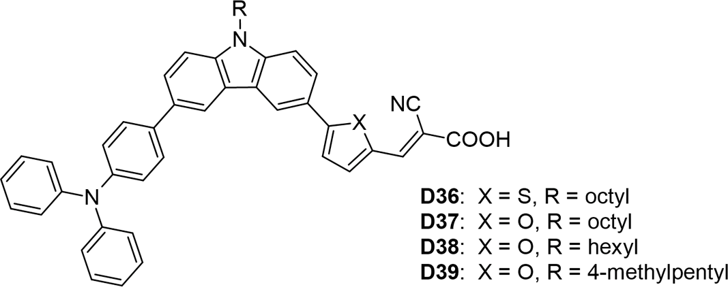
Figure 5. Structure of the carbazole-based molecules with D-D-π-A architecture (D36 to D39) as sensitizers for DSSCs.
Table 2. Photovoltaic parameters of the DSSCs based on carbazole-based sensitizers with iodine electrolyte D-D-π-A architecture.

Dye No. | λmax nm,  (ε×104 M−1 cm−1) | PCE (%) | FF | V_{OC} (V) | J_{SC}  (mA cm−2)
D36 | 442 (3.00) | 5.59 | 0.678 | 0.741 | 11.12
D37 | 468 (3.67) | 6.68 | 0.661 | 0.724 | 13.26
D38 | 468 (3.64) | 6.35 | 0.666 | 0.737 | 12.31
D39 | 468 (3.35) | 6.04 | 0.655 | 0.722 | 12.14
Note: A Pt electrode was utilized as counter electrode and I−/I₃− redox couple as its electrolyte. Absorption maxima in CH₂Cl₂ solution.

    - D-(π-A)₂ Architecture
Su and colleagues [57] developed an innovative synthesis method for indolo[2,3-b]carbazole by a double intramolecular Buchwald–Hartwig reaction. This method produces D40 (Figure 6a), which has two π-bridged 2-cyanoacrylic acid groups that act as bidentate anchors. The dye uses an N-alkylated indolo[2,3-b]carbazole as a geometrically fixed core and reaches an absorption maximum at 467 nm. The effective electron transfer from the HOMO of the indolo[2,3-b]carbazole to the LUMO of a TiO₂ nanocluster, in combination with the bidentate anchoring, leads to an energy-conversion efficiency of 6.02%. The device has a short-circuit current density of 12.45 mA/cm2, an open-circuit voltage of 0.69 V, and a fill factor of 0.70. As shown in Figure 6b, D40 is connected to the (TiO₂)₇₀ nanocluster, with the distance between the two carboxyl groups being 15.2 Å. It was found that the lowest singlet excitation of D40/TiO₂ involves only one HOMO→LUMO transition. The HOMO is primarily localized on the electron-rich indolo[2,3-b]carbazole backbone, while the LUMO is predominantly located on the semiconductor, as shown in the frontier molecule orbital representation in Figure 6b. This complete spatial separation of HOMO and LUMO, and the associated transition, facilitates the efficient electron transfer and injection of D40 into TiO₂.
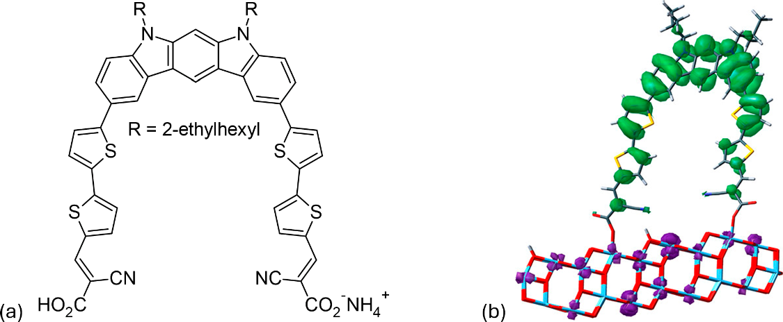
Figure 6. (a) Chemical structure of the D40 dye.(b) Frontier molecular orbitals illustrate the HOMO-to-LUMO transition state of the D40/(TiO₂)70 system, with green indicating holes and purple representing electrons. Adapted with permission from reference [57]. Copyright (2014), American Chemical Society.
    - D-π-D-A, D-(π-D-A)₂, D-(π-D-A)₃ Architecture
Three organic dyes (D41–D43) were synthesized, each featuring a triphenyl core donor, carbazole donors, and cyanoacrylic acid acceptors, as illustrated in Figure 7 [29]. Among these, dye D43 demonstrated the highest values for V_{OC} and PCE at 5.44%, attributed to its greater number of anchoring groups. These groups enhanced electronic coupling with TiO₂, thereby improving light-harvesting efficiency. However, the study did not specify whether all three anchoring moieties were simultaneously attached to the semiconductor. The molar extinction coefficients increased proportionally with the number of anchoring groups: 4.55, 6.50, and 7.50 for dyes D41, D42, and D43, respectively. Dye D41 exhibited a redshifted absorption maximum at 423 nm due to its unidirectional charge-transfer process, whereas dye D42 showed a more blueshifted absorption maximum at 397 nm (Table 3).
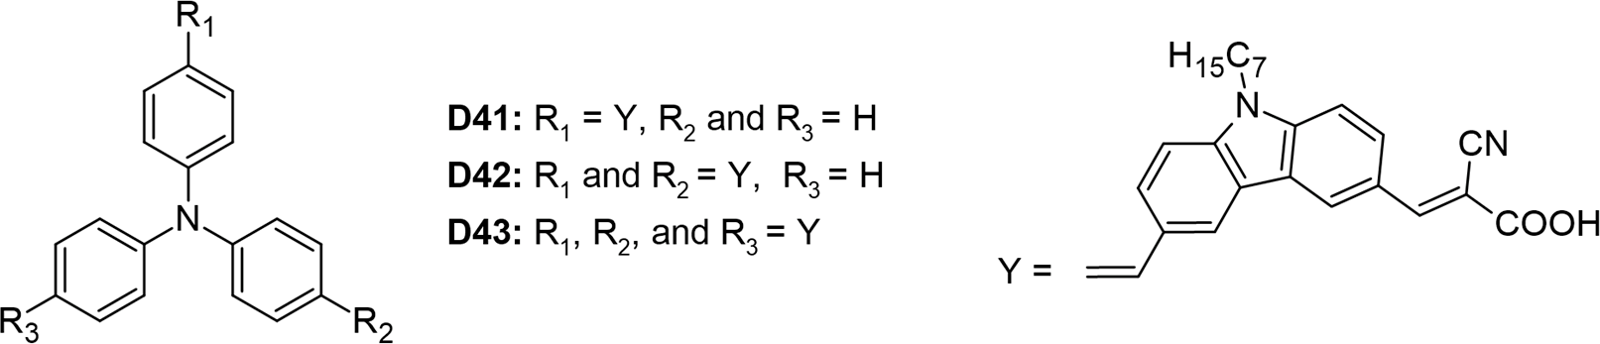
Figure 7. Structure of the carbazole-based molecules with D-π-D-A (D41), D-(π-D-A)₂ (D42), and D-(π-D-A)₃ (D43) architectures as sensitizers for DSSCs.

Table 3. Photovoltaic parameters of the DSSCs based on carbazole-based sensitizers with D-π-D-A, D-(π-D-A)2, and D-(π-D-A)3 architecture.

Dye No. | λmax nm,  (ε×104M–1cm–) | PCE (%) | FF | V_{OC} (V) | J_{SC}  (mAcm–2)
D41 | 423 (4.55) | 5.31 | 0.682 | 0.731 | 10.65
D42 | 397 (6.50) | 4.70 | 0.665 | 0.758 | 9.40
D43 | 402 (7.50) | 5.44 | 0.572 | 0.770 | 12.41
Note: A Pt electrode was utilized as a counter electrode and the I−/I₃− redox couple as its electrolyte. Absorption maxima in DCM solution.

    - D-A-π-A Architecture
Han et al. [58] introduced four new D-A-π-A dyes (D44 to D47), each featuring distinct π-bridges and acceptor groups. The structures of these dyes are illustrated in Figure 8a. Among these, dye D46, featuring a benzene bridge, achieved the highest power-conversion efficiency of 5.40% (V_{OC} = 0.710 V), outperforming dye D44, which had a thiophene bridge (PCE = 5.07%, V_{OC} = 0.610 V). When comparing the effects of different anchoring groups, dyes containing a cyanoacrylic acid moiety (D44 and D46) exhibited superior photovoltaic performance compared to dyes D45 and D47, which utilized rhodamine acetic acid (Table 4). This difference is attributed to the methylene-attached carboxylic group in rhodamine acetic acid, which hinders effective electron injection from the dyes into the conduction band edge of TiO₂, as illustrated in Figure 8b. Additionally, Figure 8b shows that the LUMOs of all four dyes possess similar frontier molecular orbitals that extend throughout the molecules. However, the contributions of the π-bridges (benzene in D46 and D47 versus thiophene in D44 and D45) vary in their delocalization. The thiophene π-bridges exhibit greater delocalization due to a smaller dihedral angle between the benzothiadiazole and thiophene rings. This variation influences both the absorption characteristics and charge-injection capabilities of the dyes.

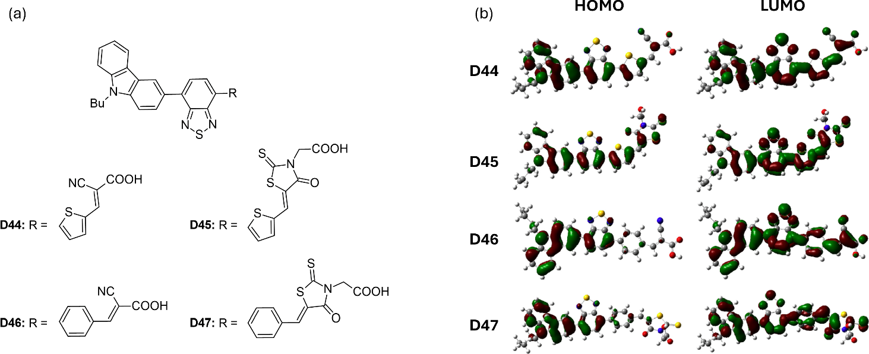
Figure 8. (a) Structure of the carbazole-based molecules with D-A-π-A architecture (D44 to D47) as sensitizers for DSSCs. (b) Frontier molecular orbital of the dyes. Adapted with permission from reference [58]. Copyright (2014), Elsevier.

Table 4. Photovoltaic parameters of the DSSCs based on carbazole-based sensitizers with D-A-π-A architecture.

Dye No. | λmax nm,  (ε×104M−1 cm−1) | PCE (%) | FF | V_{OC} (V) | J_{SC}  (mA cm−2)
D44 | 486 (3.06) | 5.07 | 0.690 | 0.610 | 12.08
D45 | 507 (4.54) | 1.65 | 0.710 | 0.560 | 4.12
D46 | 441 (2.17) | 5.40 | 0.690 | 0.710 | 10.99
D47 | 446 (3.47) | 3.81 | 0.870 | 0.630 | 6.98
Note: A Pt electrode was utilized as counter electrode and I−/I₃− redox couple as its electrolyte. Absorption maxima in 1:10 MeOH:CHCl₃.

    - A-π-D-π-A-π-A Architecture
Ghasempour Nesheli and colleagues [59] developed a series of di-anchoring carbazole-based dyes (D48–D50) with an A-π-D-π-A-π-A structure (Table 5 and Figure 9). The electron-rich carbazole moiety in these dyes was attached to various acceptor/anchoring groups (i.e., cyanoacetic acid (D48), 4-aminobenzoic acid (D49), and malonic acid (D50)) and π-spacers (vinylene and cyano-vinyl thiophene). Dye D49 exhibited the best photo-voltaic performance with a PCE of 2.27%, J_{SC} of 5.95 mA cm−2, V_{OC} of 0.54 V, and FF of 71%. This enhanced performance is attributed to the strong electron-withdrawing properties of the 4-aminobenzoic acid acceptor. According to the theoretical findings, the HOMO levels for the dyes D48 (−5.98 eV), D49 (−5.68 eV), and D50 (−5.72 eV) are sufficiently lower than the redox couple’s electrode potential (−5.2 eV) to promote regeneration. Additionally, as the obtained LUMO levels of D48 (−3.40 eV), D49 (−2.98 eV), and D50 (−2.94 eV) are higher than the CB of TiO₂ (−4.2 eV), it is evident that electron injection is also promoted. It is observed in Figure 9 that the other anchoring group connected to the vinylene unit does not participate in the electron-injection process.
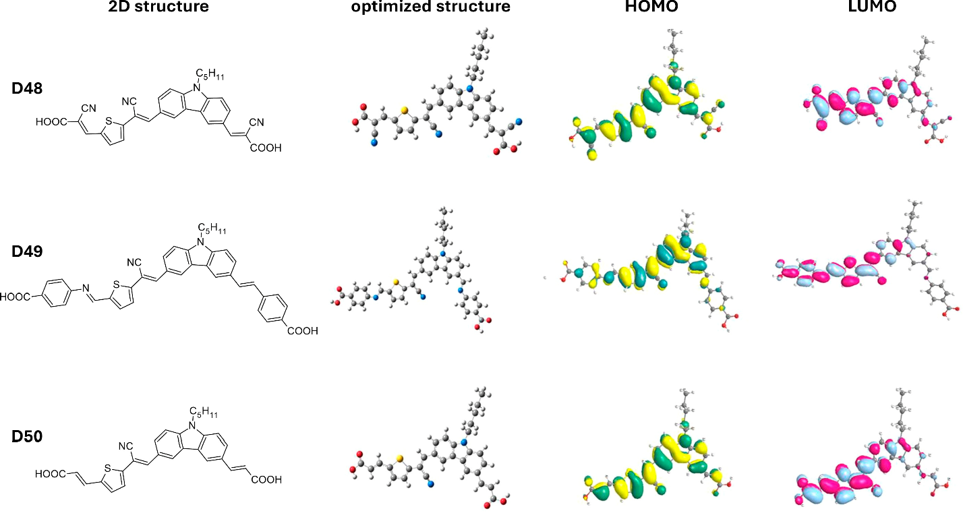
Figure 9. Two-dimensional structure, optimized geometry, and its corresponding HOMO and LUMO orbitals of dyes D48 to D50. Adapted with permission from reference [59]. Copyright (2020), Elsevier.
Table 5. Photovoltaic parameters of the DSSCs based on carbazole-based sensitizers with A-π-D-π-A-π-A architecture.

Dye No. | λmax nm,  (ε×104M−1 cm−1) | PCE (%) | FF | V_{OC} (V) | J_{SC}  (mA cm−2)
D48 | 397 (5.25) | 2.14 | 0.720 | 0.520 | 5.66
D49 | 426 (6.93) | 2.27 | 0.710 | 0.540 | 5.95
D50 | 392 (4.53) | 1.69 | 0.710 | 0.480 | 4.99
Note: A Pt electrode was utilized as a counter electrode and the I−/I₃− redox couple as its electrolyte. Absorption maxima in DMF solution.
We demonstrate the improvement in power-conversion efficiency achieved through various architectures of carbazole-based dyes, as illustrated in Figure 10. By utilizing a simple donor-π-acceptor structure within an I−/I₃− redox electrolyte solution, achieved a promising PCE of 9.55% [39]. This impressive performance underscores the effectiveness of the D-π-A motif in enhancing the light-harvesting capabilities of organic sensitizers. The D-π-A architecture is particularly beneficial because it promotes efficient charge transfer and boosts light absorption. The electron-donating carbazole units in these dyes provide a ro-bust absorption spectrum, while the π-conjugated linkers enhance electronic delocalization, resulting in improved photovoltaic performance.
Moreover, incorporating various substituents on the carbazole core allows for the fine-tuning of optical and electronic properties, making them suitable for specific applications. These findings strongly indicate that the D-π-A motif is a promising approach for develop-ing efficient pure organic sensitizers. Future research should focus on exploring different structural modifications and combinations to further enhance both PCE and stability under operational conditions. By systematically optimizing these parameters, we can advance the potential of carbazole-based dyes in the field of organic photovoltaics, paving the way for more sustainable and cost-effective energy solutions.
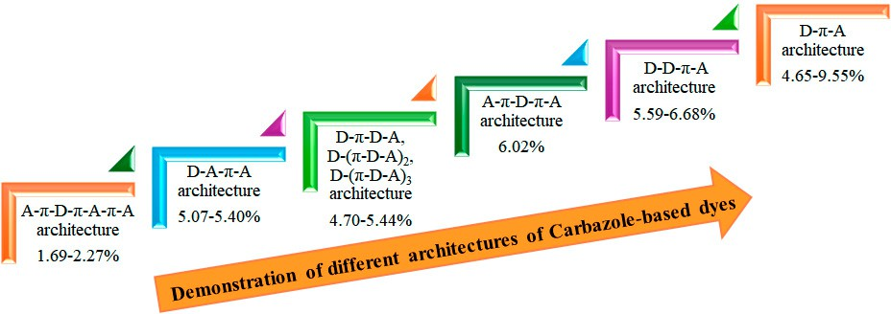
Figure 10. Enhancement PCE by different architectures.
Figure 11 presents a Euler diagram that serves as a tool for identifying dye molecules with optimal photovoltaic performance, particularly focusing on their absorption character-istics in the near-infrared (NIR) region and their redox properties. Among the various dyes analyzed, the D4 dye stands out with a power-conversion efficiency of 9.55%, representing a remarkable 32% improvement over the widely studied N719 dye [39]. This significant advancement underscores the potential of D4 as a more effective option for enhancing the efficiency of solar cells. The superior performance of the D4 dye can be attributed to several key factors. Firstly, its exceptional electron-injection efficiency allows for a more effective transfer of electrons from the dye to the semiconductor, which is crucial for maximizing current output. This increased efficiency is complemented by the dye’s ability to suppress sensitizer aggregation, a common issue that can lead to reduced performance by blocking effective light absorption and hindering charge transport. Additionally, D4 demonstrates a remarkable capability to minimize interface charge recombination, which is a significant loss mechanism in solar cells. By effectively reducing this recombination, the dye not only preserves the generated charge but also enhances the overall charge-carrier lifetime. This increased electron lifetime is vital for improving the stability and performance of the solar cell, allowing for more prolonged energy conversion before the charges recombine and dissipate. Overall, the findings highlight the importance of material properties in the design of efficient dye-sensitized solar cells. The advancements represented by the D4 dye suggest that further exploration of similar materials could lead to even greater improvements in PV performance. Future research should focus on optimizing the molecular structure and exploring other dye combinations that can maximize light absorption and charge transport, ultimately contributing to the development of more efficient and commercially viable solar energy solutions.
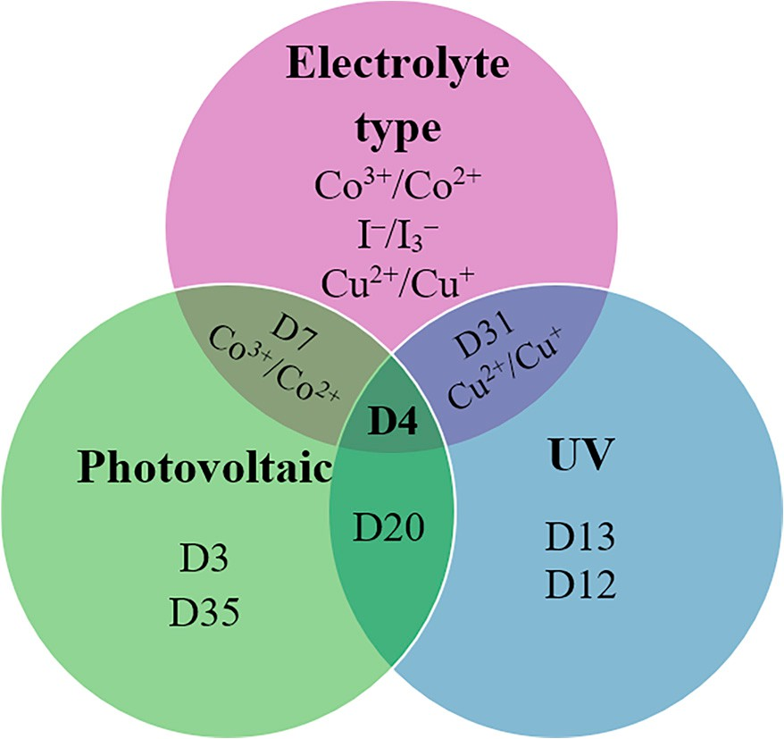
Figure 11. Euler diagram of the carbazole-based sensitizers.
To summarize, this section covers a wide range of carbazole derivatives, each divided into subsections based on their structural variations. Researchers from several teams have improved carbazole as a donor material in devices that convert light energy into electrical energy. The effects of different positions of carbazole derivatives on their properties were analyzed. It was found that the 2,7-carbazole configuration exhibited better planar conju-gation and higher potential. The results emphasize the significant potential of carbazole derivatives for future use in DSSCs as they have inherent advantages. Studies have shown that modifying the structure of carbazole dyes can significantly increase their efficiency in DSSCs by achieving high carrier mobilities. With the ongoing advances in molecular engineering and the development of panchromatic dye designs, carbazole-based materials will perform even better in the future.
    - Comparison of Carbazole with Different Donor Materials
Carbazole is characterized in organic electronics by its significant influence on the energy levels of the frontier molecular orbitals and molecular planarity, especially in comparison to other donor materials such as thiophene and benzene. The nitrogen atom in the ring structure of carbazole enhances its ability to donate electrons, leading to higher energy levels of frontier molecular orbitals. In contrast, thiophene derivatives generally exhibit lower energy levels of frontier orbitals, which is influenced by the presence of sulfur that affects the electronic distribution [60,61]. While thiophene-based materials can improve charge-transport properties, their energy levels do not always match those of carbazole derivatives under certain configurations. Benzene, which donates fewer electrons than carbazole and thiophene, typically has even lower energy levels of frontier orbitals [38]. The absence of heteroatoms in benzene reduces its reactivity and flexibility in tuning electronic properties, limiting its suitability for applications requiring high energy levels [61].
In terms of molecular planarity, carbazole’s structure supports significant planarity, especially with optimized side chains that minimize dihedral angles, thereby enhanc-ing charge-transport efficiency [46,62]. However, certain substitutions can introduce non-planarity due to steric interactions, potentially impacting electronic properties nega-tively [38]. Thiophene derivatives vary in planarity depending on their design but generally maintain a beneficially planar configuration for effective π-π stacking interactions crucial to charge transport [60]. The inclusion of alkyl chains can influence thiophene derivatives’ pla-narity, with longer chains potentially reducing it due to increased steric hindrance [60,63]. Benzene’s inherent fully planar structure contrasts with its limited versatility in modi-fying electronic properties through structural changes, restricting its effectiveness as a donor material compared to carbazole and thiophene derivatives [38,61]. Despite its planarity, benzene lacks the necessary electronic properties to function effectively in hole-transport applications. Carbazole’s advantageous balance of energy levels and molecular geometry continues to position it favorably in numerous organic electronic applications.

- Carbazole-Based Hole-Transporting Materials for Solid-State DSSCs
Compared to inorganic hole-transporting materials, organic HTMs offer numerous advantages, including superior thin-film formation, cost-effectiveness, excellent solubility, the possibility of a wide variety of compositions, environmental friendliness, solution processability, mechanical flexibility, tunable electronic properties, and ease of fabrication. Most HTMs are synthesized by way of metal-catalyzed cross-couplings, such as the Stille, Suzuki, Buchwald–Hartwig, and Ullmann reactions. The glass-transition temperature (T_{g}) is a critical property for HTMs, as it represents the reversible transition in amorphous materials, allowing molecules to move rapidly when heated. The molecular glass properties of HTMs are essential for effectively filling the pores in TiO₂, enhancing the contact area between TiO₂ and the HTM.
While liquid electrolytes can be used in dye-sensitized solar cells to achieve higher power conversion efficiencies, they also have drawbacks like toxicity, leakage, and volatilization [64]. Consequently, the development of solid-state electrolytes has become increasingly important in DSSC research.
This section of the review focuses on solid-state electrolytes based on carbazole for solid-state DSSC (ssDSSC) applications. HTMs can be broadly classified into inorganic and organic types, while ion-conductive electrolytes are divided into ionic liquid polymer electrolytes and ion-conductive polymer electrolytes (Figure 12a). A reliable HTM for ssDSSCs must meet several criteria: (1) It should have an energy level that matches the dye, (2) it should be processed gently to avoid damaging the photoanode, (3) it should exhibit high hole mobility, and (4) it should demonstrate good photoelectrochemical stability [65–70].
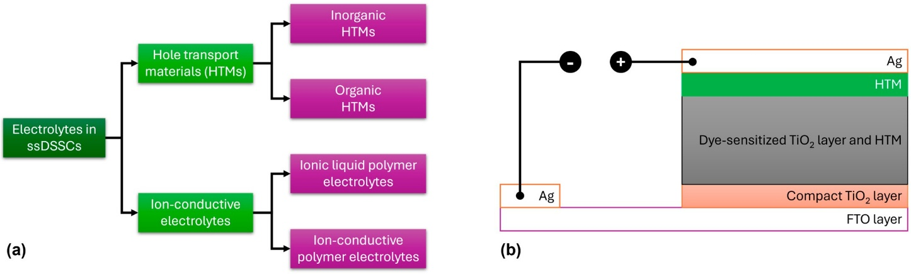
Figure 12. (a) Classification of solid-state electrolytes for ssDSSC applications. (b) Schematic repre-sentation of the commonly used device architecture used in ssDSSCs.
A major difference between DSSCs consisting of a liquid electrolyte and those con-taining a solid-state electrolyte is the nature of the HTM, while, additionally, in the lat-ter, the cathode electrode is commonly constructed using Ag (Figure 12b). Several or-ganic HTMs, such as 2,2′,7,7′-tetrakis-(N,N-di-4-methoxyphenylamino)-9,9′-spirobifluorene (spiro-OMeTAD), poly(3-hexylthiophene) (P3HT), and poly(3,4-ethylenedioxythiophene) (PEDOT), have been extensively studied in ssDSSCs (Figure 13). For organic HTMs, two key factors influencing ssDSSC performance are electrolyte conductivity and electrolyte filling within the TiO₂ film.

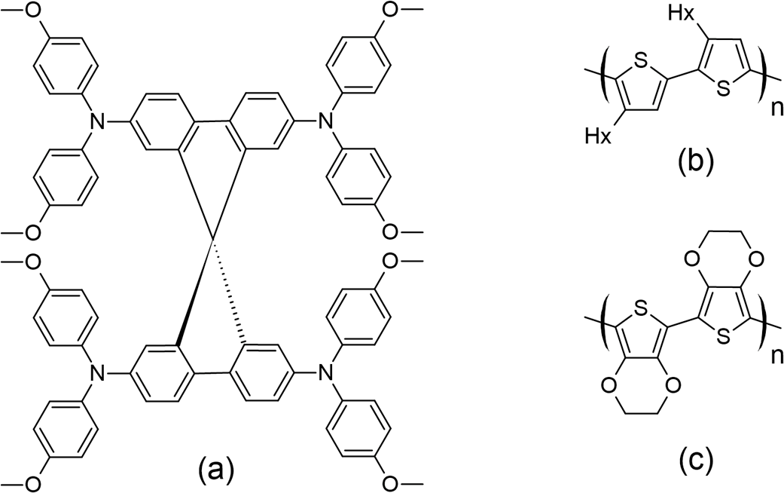
Figure 13. Structures for (a) spiro-OMeTAD, (b) P3HT, and (c) PEDOT as commonly used HTMs in ssDSSCs.

  - Dopants for Hole-Transport Materials
In the context of HTMs, there is often confusion in the literature between additives and proper dopants (p-dopants). Additives, like 1-methyl-3-propylimidazolium iodide (MPII), lithium bis(trifluoromethanesulfonyl)imide (LiTFSI), and 4-tert-butylpyridine (tBP) (the structures of which are presented in Figure 14) are dissolved in the HTM precursor solution to be applied after dye sensitization. They do not directly affect the HTM itself but may migrate to the TiO₂ surface to adjust energy levels, passivate exposed surfaces, improve charge injection, and reduce charge recombination at the TiO₂–HTM interface [71–79]. Proper dopants, on the other hand, directly affect solid-state hole conductors by partially oxidizing the HTM material. This oxidation creates vacancies in the solid-state film, significantly increasing hole mobility and, ultimately, conductivity [79]. Dopants with a more positive redox potential than the HTM (or strong Lewis acids) that act as p-type dopants promote electron removal from the hole conductor. Most of the dopants reviewed have been applied to the spiro-OMeTAD molecule, but they can also enhance conductivity in other hole transport materials [80–82].
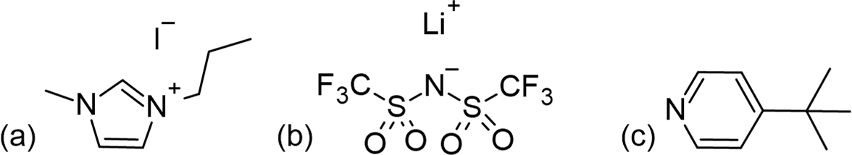
Figure 14. Structures for (a) MPII, (b) LiTFSI, and (c) tBP as commonly used additives in ssDSSCs.

  - Spiro-OMeTAD
Spiro-OMeTAD, the most commonly used HTM, was first synthesized by the Salbeck group in 1997 [83]. The concept behind spiro-OMeTAD involves using an sp3 hybridized atom to link two or more π-conjugated systems while maintaining their electrical properties. The cross-shaped molecular structure of spiro-linked HTMs (Figure 13a) offers benefits such as rigidity, high stability, and efficient excimer formation [84]. Its design minimizes intermolecular bonding interactions, resulting in a lower T_{g} (125 ◦C). Heating the material above T_{g} to the melting temperature (248 ◦C) ensures full coverage of the film, optimizing hole transmission [85]. The presence of methoxy groups at the para position to nitrogen (known as an electron-rich atom) and their mesomeric electron-donating effect led to a low oxidation potential (i.e., a relatively high HOMO level). It has been shown that by moving the methoxy groups to other sites, the HOMO level is stabilized to around 0.12 eV. Since then, more information has come to light about the modification of spiro-linked semiconductors to improve their electrical and chemical properties [84]. A ssDSSC made with spiro-OMeTAD was first reported by Grätzel and colleagues in 1998 [86], but this was associated with a relatively meager efficiency of just 0.74% (using N(PhBr)₃SbCl₆ as a dopant and Li[(CF₃SO₃)₂] as an additive). Due to the complexities associated with synthesizing spiro-OMeTAD, which also renders its synthesis economically costly, researchers explored other HTMs that offer either comparable or superior hole mobility but are vastly easier to synthesize, and with a reduced production cost.
  - Advancements in Carbazole-Based HTMs
Several carbazole-based HTMs with different molecular structures, stability, optical, and electrochemical characteristics have been studied, offering insights into the field’s progress, are presented in Figure 15 with various moieties and attached to either 3,6- or 2,7-positions.
Recent studies have highlighted the effects of methoxy group substitutions at the para-position of diphenylamine in carbazole-based hole-transport materials. Researchers have designed and synthesized four such carbazole-based HTMs, labeled H1 to H4 [87,88]. These materials, developed as effective molecular glasses, are suitable for use in solid-state dye-sensitized solar cells. The performance of these HTMs was influenced by mono-or di-substitution of dimethoxy-diphenylamine groups at the 3 and/or 6 positions of the carbazole moiety. By utilizing a 3,6-substituted carbazole molecular glass derivative H2, the researchers achieved a PCE of 3.4% and a fill factor of 0.53. This performance is comparable to that of a reference device using spiro-OMeTAD, which has a PCE of 3.5% [87]. Additionally, further studies on HTMs suggest that incorporating methoxy groups into diphenylamine moieties can enhance photovoltaic-conversion efficiency. For instance, devices equipped with HTMs featuring methoxy groups H4 have achieved PCEs of 1.75%, even without further optimization [88]. A comprehensive characterization of the HTM properties, such as optical, thermal, electrochromic, and photovoltaic parameters, are presented in Table S1. In this research, they utilized an indoline-based sensitizer (D102), whose structure is presented in Figure 16.
To expand the range of inexpensive low-molecular-weight amorphous compounds for ssDSSCs, the researchers synthesized star-shaped carbazole derivatives with a nitrogen core in which the methoxy groups are positioned differently on the N-phenyl moiety [89]. These derivatives are named H5 and H6, corresponding to the para and ortho position of the methoxy group, respectively (Figure 14). The ortho position in H6 causes the phenyl moiety to be more inclined, possibly affecting its packing configuration and solubility (for example, H6 is less soluble when compared to H5). Despite these differences, both HTMs exhibit very similar optical and electronic properties. Their band gaps are 2.76 eV, which is sufficiently low to avoid interference with the absorption, photoexcitation, and charge transfer of the D102. The solid-state ionization potential (IPs) of HTMS agrees well with that of D102 and provides a driving force of more than 0.2 eV for efficient charge transfer and regeneration of the photooxidized dye. Under simulated AM 1.5 irradiation, H5 achieves a higher J_{sc} of 8.85 mA cm−2, resulting in a PCE of 2.23%. In contrast, H6 shows a significantly lower J_{sc} of 1.57 mA cm−2, which is probably due to insufficient pore filling, poor interface quality, or poor charge-transport properties.

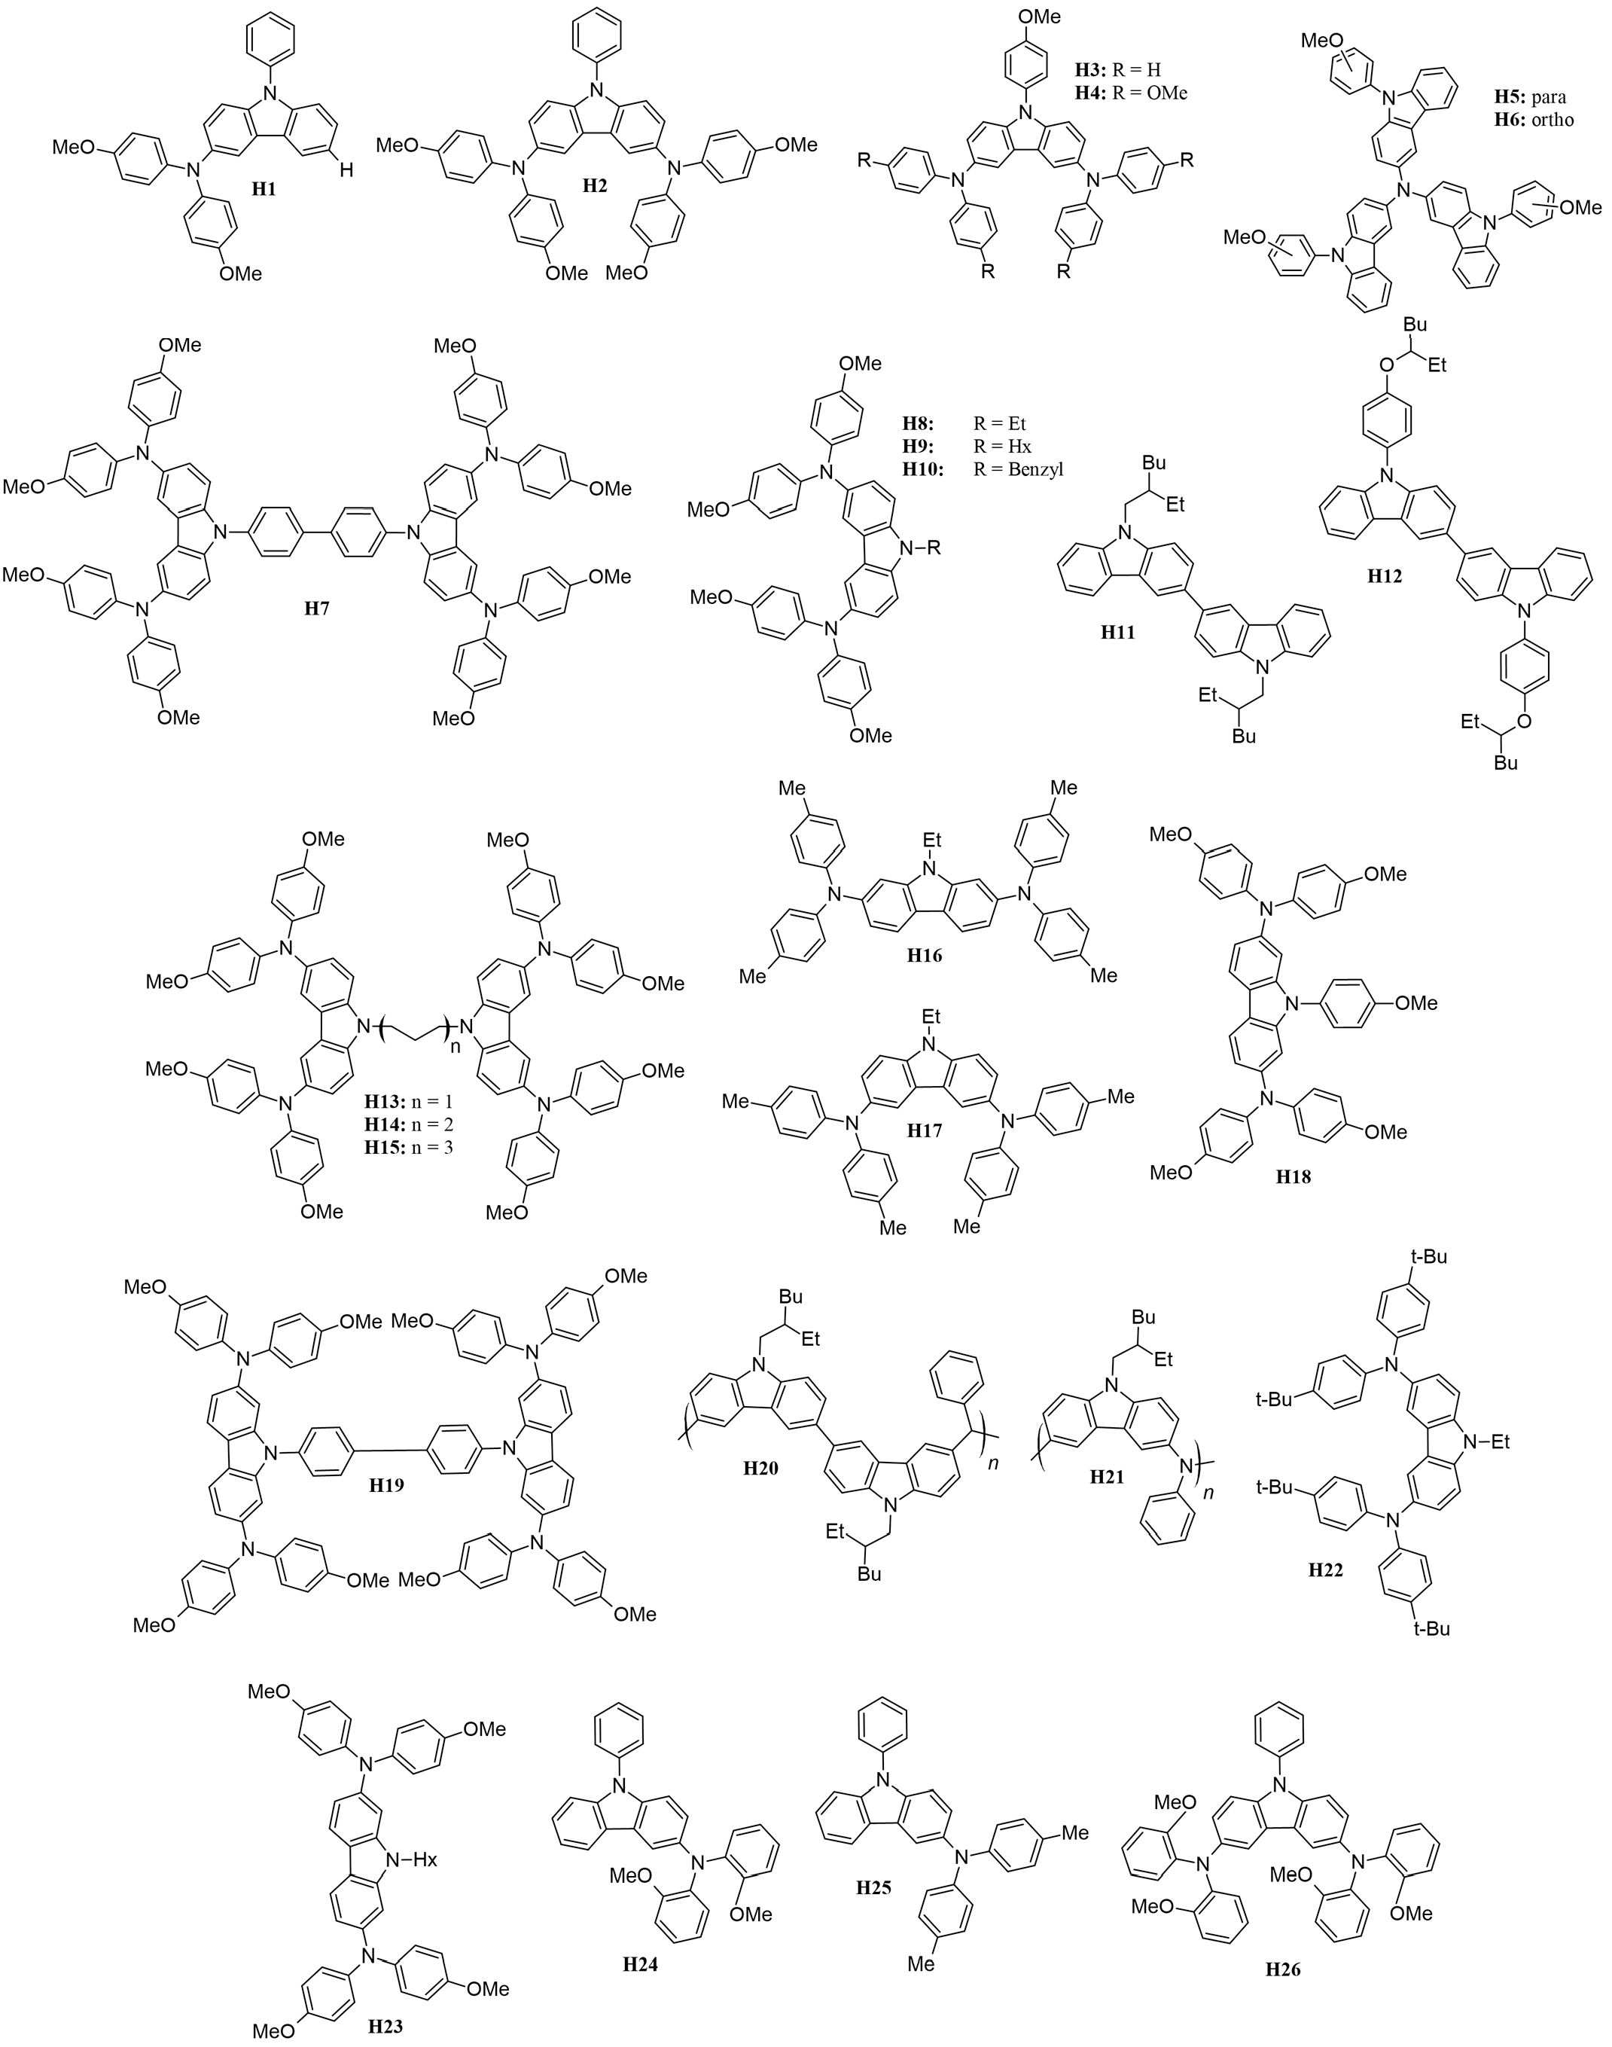
Figure 15. Structures of carbazole-based HTMs used in ssDSSCs.

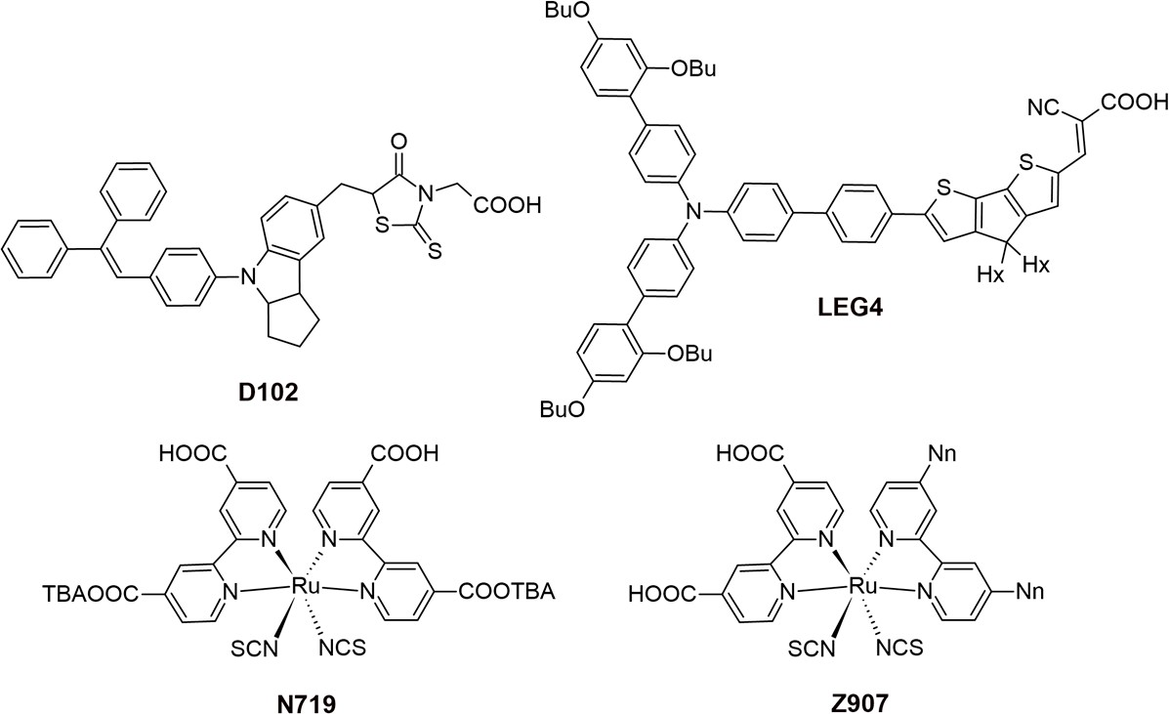
Figure 16. Structures of the sensitizers used in ssDSSCs.
To design a symmetric carbazole with a structure similar to spiro-OMeTAD, Xu and colleagues synthesized mono-carbazole (H4) and bis-carbazole-based (H7) hole-transport materials, as illustrated in Figure 14 [90]. The large conjugated system in H7 facilitates more efficient π-π stacking, resulting in higher conductivity and hole mobility compared to the monomeric system H4. This improved performance translates to better photovoltaic parameters, with H7 achieving a notably high open-circuit voltage of 0.92 V, compared to 0.75 V for H4, owing to its slower recombination rate. Among the hole-transport materials reviewed, H7 not only boasts the highest V_{OC} but also ranks second in terms of overall efficiency.
Researchers have examined how the length and bulkiness of the moiety attached to the nitrogen of the carbazole affect its properties. Specifically, they studied the effects of ethyl (H8), hexyl (H9), and benzyl (H10) groups [91]. They found that increasing the alkyl group from ethyl to hexyl lowers the glass-transition temperature (T_{g}) and enhances hole mobility. This improvement is attributed to the increased flexibility of the hole-transport material as the alkyl chain lengthens. The hexyl chain introduces more free volume and reduces the rigidity of the HTM, which leads to better molecular packing and ordering. This enhanced packing improves π-π stacking interactions, which are essential for efficient charge transport and allow holes to move more freely through the material. In contrast, the benzyl moiety H10 results in very low hole mobility due to poorer molecular packing in the solid state.
The purity of the HTM is a crucial factor, as demonstrated by Degbia and colleagues [92]. They employed a sublimation strategy to enhance the purity of H8, which led to a notable improvement in the solar cells’ power-conversion efficiency, rising from 0.82% to 1.62%.
A similar strategy was used to enhance carbazole-based dyes by examining the im-pact of substituents attached to the nitrogen atom of the carbazole structure. This study employed a bis(carbazole) configuration rather than the previously used mono(carbazole). Specifically, they incorporated 2-ethylhexyl (H11) and 4-[(2-ethylhexyl)oxy]phenyl (H12) as substituents [93]. The introduction of the oxy group in the H12 moiety significantly lowered the HOMO level, thereby widening the band gap by approximately 0.11 eV com-pared to H11. This reduction in the HOMO level likely contributes to a slight decrease in V_{OC} for H12, as it may absorb photons within a shorter wavelength range and pro-duce a lower voltage. Despite this, the 4-[(2-ethylhexyl)oxy]phenyl group resulted in a higher J_{SC} and overall PCE. This improvement is likely attributed to a more efficient charge-transport mechanism in H12, which enhances the extraction of charge carriers and generates more current.
Benhattab et al. [94] synthesized a series of carbazole-based twin molecules, H13 to H15, which exhibit molecular glass behavior. By varying the length of the linker, it is possible to adjust the glass-transition temperature. Notably, reducing the chain length significantly enhances hole mobility, with improvements approaching an order of magnitude. Among the synthesized molecules, H13, which has the shortest chain length, achieved a promising power-conversion efficiency of 2.21%. The study found that the linker length influences both the molecules’ hole mobility and glass-transition temperature, with shorter linkers being associated with increased hole mobility.
Researchers also investigated the performance of 2,7- and 3,6-disubstituted carbazoles, identified in Figure 15 as H16 and H17, respectively [95]. It was found that the 3,6-disubstituted carbazole H17 demonstrated superior pore filling on the mesoporous TiO₂ surface due to its increased solubility. This enhanced solubility led to better photovoltaic performance compared to the 2,7-disubstituted carbazole. Although the 2,7-disubstituted carbazole exhibited good driving force and hole mobility, its effectiveness was limited by its poorer solubility.
To enhance solubility, carbazole-based hole-transport materials were modified by substituting methoxy groups at the 2,7-positions, and the study was extended to include a di-carbazole configuration, labeled HTMs H18 and H19, respectively [96]. For comparison, the performance of these materials was evaluated against HTMs with substitutions at the 3,6-positions, specifically HTMs H4 and H7 [90]. Consistent with previous research, the 2,7-positions yielded significantly better hole mobilities, nearly twice as high as those observed with the 3,6-substituted counterparts. Enhanced hole mobility led to improved photovoltaic performance for the carbazole-based HTMs. Specifically, the di-carbazole HTM H19, which has the highest PCE among the carbazole-based HTMs discussed in this review, achieved a PCE of 6.8%. In comparison, the mono-carbazole HTM H18 exhibited a PCE of 5.8%. Both values surpass the performance of their 3,6-substituted analogs.
Polymeric carbazoles, specifically H20 and H21 (Figure 14), were also studied as potential hole-transport materials for solid-state dye-sensitized solar cells. In polymeric types, molecular weight (MW) plays a crucial role in conversion efficiency. The higher MW of H20, a bis(carbazole)-based polymer, resulted in a 38% increase in conversion efficiency compared to other HTMs reviewed. This improvement is attributed to its superior conductivity and highest hole mobility among the HTMs considered, which enhanced the fill factor, open-circuit voltage, and short-circuit current [97]. In contrast, H21 (i.e., poly[N-(2-ethylhexyl)-3,6-carbazole-alt-aniline]), has significantly lower hole mobility than its bis(carbazole) counterpart and, as a result, achieved a power-conversion efficiency of only 1.5% [98]. Thus, from this observation, a bis(carbazole) configuration is beneficial for polymeric-type HTMs.
Research by Ryu et al. demonstrates that incorporating magnesium(II) bis(trifluoro-methanesulfonyl)imide (Mg(TFSI)₂) as a dopant in the hole-transporting tercarbazole compound (H22) can significantly enhance the energy-conversion efficiency of solid-state dye-sensitized solar cells, outperforming the traditional dopant, LiTFSI [99]. The ssDSSC featuring Mg(TFSI)₂ achieved a power-conversion efficiency of more than 70% higher than that of the reference cell. This notable improvement is attributed to superior electron injection and hole-collection efficiencies, leading to a higher fill factor and a significantly increased short-circuit current due to reduced series resistance. These findings underscore the importance of selecting the right dopant for hole-transporting materials to optimize photovoltaic performance in ssDSSCs. The use of Mg(TFSI)₂ shows considerable promise for enhancing device efficiency and overall performance in solar energy-conversion applications.
Leijtens and colleagues synthesized H23, which features a low glass-transition temperature, low melting point, and high solubility, thereby making it an attractive choice for use in solid-state dye-sensitized solar cells [100]. This compound outperforms its 3,6-substituted counterpart, namely H9 [91], achieving a higher PCE of 2.94% compared to 1.81% for H9. Additionally, the researchers investigated an alternative dopant, tris(4-bromophenyl)aminium hexachloroantimonate (TBPA), as opposed to the commonly used tBP and LiTFSI. TBPA provided higher conductivity, with a value of 2×10⁻⁵ S cm⁻¹, compared to 7×10⁻⁷ S cm⁻¹ for the tBP/LiTFSI mixture. Consequently, devices using TBPA demonstrated improved efficiency, reaching 2.30% compared to 0.50% for devices with tBP and LiTFSI. This group also tested ssDSSCs with a thicker cell (6 µm) due to the increased solubility of the hole-transport material when paired with the new dopant. The performance of the thicker cell was comparable to that of 2 µm-thick cells, with no observed difference in open-circuit voltage in either cell thickness. This indicates that there was no recombination-induced voltage drop in the titania electron quasi-Fermi level.
Tomkeviciene et al. [101] synthesized the compounds H24, H25, and H26 (Figure 15), which exhibit a relatively high degree of thermal stability and are capable of absorbing electromagnetic radiation in the 225–425 nm range. These compounds have ionization energies ranging from 5.04 to 5.56 eV. In their amorphous layers, they display hole-drift mobilities as high as 10⁻³cm²/V·s and achieve a power-conversion efficiency of up to 0.54%. The findings suggest that the thermal, optical, and electrochemical properties of these compounds are significantly affected by the positioning of the methoxy groups.
In summary, carbazole-based HTMs have shown significant potential for improving the efficiency of dye-sensitized solar cells. Ongoing research continues to explore new molecular designs, synthesis methods, and dopants to further enhance the performance and stability of HTMs in ssDSSCs and other solar energy applications.
In Figure 17, the Euler diagram illustrates that H19 demonstrates excellent photovoltaic, electrochromic, and optical properties, with an absorption-emission peak at 416 nm. The synthesis of H19 is relatively straightforward, requiring only four steps and utilizing inexpensive starting materials. Its hole mobility is measured at 2.88× 10⁻⁴ cm²/V·s, while the conductivity is 2.90×10⁻⁴ S/cm, which increases to 8.02×10⁻⁴ S/cm after light soaking. Theoretical calculations indicate that nitrogen atoms in the molecular units of H19, particularly those substituted at the 2,7-position, are more susceptible to oxidation by the p-type dopant, leading to the formation of radical cation intermediates. These radical cations exhibit varying optical properties due to their different linking topologies, aligning well with the UV-Vis absorption results observed post-doping. The H19 solid-state dye-sensitized solar cell devices achieve a power-conversion efficiency of 6.8%, with a J_{SC} of 10.30 mA/cm², V_{OC} of 0.88 V, and FF of 0.75.
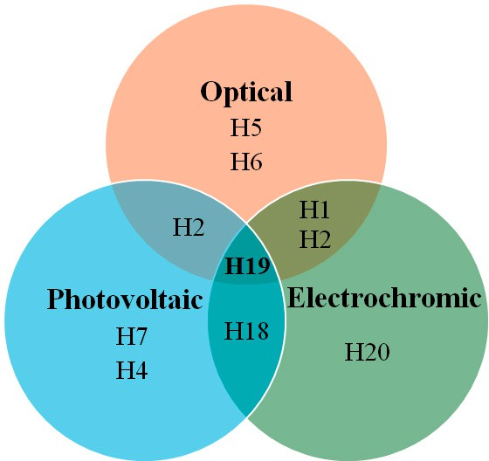
Figure 17. Euler diagram for HTMs.

- Conclusions and Future Outlook
This review addresses various carbazole-based D-π-A dyes, focusing on factors that are crucial for solar cell efficiency, including the bulkiness of dye components, electron de-localization towards the anchoring group, energy levels, dark current, sufficient absorption in the near-infrared region, stability, and cell lifetime. In analyzing DSSCs based on different dyes, key findings have been established regarding the enhancement of photovoltaic performance in solar cells.
First, introducing alkyl and alkoxy groups into the donor or π segments of the dye helps reduce aggregation and decrease electrolyte interaction with the semiconductor oxide film, thereby improving cell stability. Second, cyanoacrylic acid has proven to be the most effective anchoring group, aligning well with the film surface. Third, expanding π conjugation broadens the absorption band, optimizing the short-circuit current. Moreover, the D-π-A alignment of donor and acceptor maximizes the intramolecular charge transfer, enhancing the sensitizer’s efficiency. Additionally, para-positioning of the donor group leads to higher dye loading. Lastly, co-sensitization with two dyes improves electron injection from light-excited dyes to TiO₂ electrodes, resulting in longer cell lifetimes and a broader absorption range.
However, further research is needed in developing sensitizers and enhancing the performance of counter-electrodes and electrolytes. For instance, introducing multiple anchoring groups has been found beneficial for strong binding on semiconductor sur-faces, effective electron injection, and greater device stability. By employing dyes that are strategically developed, it may be possible to create more affordable, stable, and efficient DSSCs.
This review also summarizes the relationship between molecular structure and electronic properties of different types of carbazole-based HTMs with versatile designs. Despite the extensive research on organic HTM derivatives, there remains an urgent need for materials with exceptional characteristics. The primary drawbacks of the state-of-the-art spiro-OMeTAD include its complex multistep synthesis, high cost, and limited stability, motivating material scientists and chemical engineers to design new materials with fewer synthetic steps.
In recent decades, a wide range of HTMs has been engineered, with a focus on better understanding the relationship between HTM structures and device performance. There is a continuing need to design novel HTMs or combine two HTMs with complementary properties to meet the requirements for achieving maximum efficiency in various energy applications. Continued research in this field is essential for gaining a deeper understanding of how the nature, chemical structure, and properties of HTMs influence the efficiency of electronic devices.

Supplementary Materials: The following supporting information can be downloaded at: https:// www.mdpi.com/article/10.3390/molecules29215035/s1, Table S1: A comprehensive characterization of the optical, thermal, electrochromic, and photovoltaic parameters of the carbazole-based hole-transport materials.
Author Contributions: Conceptualization and visualization A.I., U.A. and M.P.B.; investigation, formal analysis, and data curation, A.I., U.A. and Z.I.; writing original draft A.I., U.A. and B.B.; supervision, project administration, and funding acquisition, B.B. and M.P.B.; writing—review and editing, R.J.O. and M.P.B. All authors have read and agreed to the published version of the manuscript.
Funding: This research was funded by the Science Committee of the Ministry of Science and Higher Education of the Republic of Kazakhstan (Grant No. AP23490505, B.B.) and the Nazarbayev University under the Faculty Development Competitive Research Grants Program (Grant No. 20122022FD4122, M.P.B.).
Institutional Review Board Statement: Not applicable.
Informed Consent Statement: Not applicable.
Data Availability Statement: The original contributions presented in the study are included in the article/Supplementary Material. Further inquiries can be directed to the corresponding authors.
Conflicts of Interest: The authors declare no conflicts of interest.
References
- Devadiga, D.; Selvakumar, M.; Shetty, P.; Santosh, M.; Chandrabose, R.S.; Karazhanov, S. Recent developments in metal-free organic sensitizers derived from carbazole, triphenylamine, and phenothiazine for dye-sensitized solar cells. Int. J. Energy Res. 2021, 45, 6584–6643. [CrossRef]
- Kumar, D.; Wong, K.-T. Organic dianchor dyes for dye-sensitized solar cells. Mater. Today Energy 2017, 5, 243–279. [CrossRef]
- Murakami, T.N.; Koumura, N. Development of next-generation organic-based solar cells: Studies on dye-sensitized and perovskite solar cells. Adv. Energy Mater. 2018, 9, 1802967. [CrossRef]
- Konidena, R.K.; Thomas, K.R.J.; Park, J.W. Recent advances in the design of multi-substituted carbazoles for optoelectronics: Synthesis and structure-property outlook. ChemPhotoChem 2022, 6, e202200059. [CrossRef]
- Han, P.; Zhang, Y. Recent advances in carbazole-based self-assembled monolayer for solution-processed optoelectronic devices.
Adv. Mater. 2024, 36, 2405630. [CrossRef]
- Bekkar, F.; Bettahar, F.; Moreno, I.; Meghabar, R.; Hamadouche, M.; Hernáez, E.; Vilas-Vilela, J.L.; Ruiz-Rubio, L. Polycarbazole and Its Derivatives: Synthesis and Applications. A Review of the Last 10 Years. Polymers 2020, 12, 2227. [CrossRef]
- Karon, K.; Lapkowski, M. Carbazole electrochemistry: A short review. J. Solid State Electrochem. 2015, 19, 2601–2610. [CrossRef]
- Krucaite, G.; Grigalevicius, S. 2,7(3,6)-diaryl(arylamino)-substituted carbazoles as components of oleds: A review of the last decade. Materials 2021, 14, 6754. [CrossRef] [PubMed]
- Sathiyan, G.; Sivakumar, E.K.T.; Ganesamoorthy, R.; Thangamuthu, R.; Sakthivel, P. Review of carbazole based conjugated molecules for highly efficient organic solar cell application. Tetrahedron Lett. 2016, 57, 243–252. [CrossRef]
- Chetri, R.; Devadiga, D.; Ahipa, T.N. A review on 4,4′-Dimethoxydiphenylamines bearing carbazoles as hole transporting materials for highly efficient perovskite solar cell. Sol. Energy 2024, 278, 112791. [CrossRef]
- Sambathkumar, S.; Shakila, P.B. Chapter Six—Organic hole-transporting materials for perovskite solar cells: Progress and prospects. In Photovoltaics Beyond Silicon; Sundaram, S., Subramaniam, V., Raffaelle, R.P., Nazeeruddin, M.K., Morales-Acevedo, A., Navarro, M.B., Hepp, A.F., Eds.; Elsevier: Amsterdam, The Netherlands, 2024; pp. 195–220. [CrossRef]
- Radhakrishna, K.; Manjunath, S.B.; Devadiga, D.; Chetri, R.; Nagaraja, A.T. Review on Carbazole-Based Hole Transporting Materials for Perovskite Solar Cell. ACS Appl. Energy Mater. 2023, 6, 3635–3664. [CrossRef]
- Zhao, Y.; Ma, F.; Qu, Z.; Yu, S.; Shen, T.; Deng, H.X.; Chu, X.; Peng, X.; Yuan, Y.; Zhang, X.; et al. Inactive (PbI₂)₂RbCl stabilizes perovskite films for efficient solar cells. Science 2022, 377, 531–534. [CrossRef] [PubMed]
- Yang, S.; Liu, Y.; Lian, X.; Chu, J. Inactive impurity stabilizes the highly efficient perovskite photovoltaics. Joule 2022, 6, 2248–2250. [CrossRef]
- NREL. Best Research-Cell Efficiency Chart. Available online: https://www.nrel.gov/pv/interactive-cell-efficiency.html (accessed on 16 August 2024).
- O'Regan, B.; Grätzel, M. A low-cost, high-efficiency solar cell based on dye-sensitized colloidal TiO₂ films. Nature 1991, 353, 737–740. [CrossRef]
- Zhang, L.; Yang, X.; Wang, W.; Gurzadyan, G.G.; Li, J.; Li, X.; An, J.; Yu, Z.; Wang, H.; Cai, B.; et al. 13.6% Efficient organic dye-sensitized solar cells by minimizing energy losses of the excited state. ACS Energy Lett. 2019, 4, 943–951. [CrossRef]
- Ren, Y.; Zhang, D.; Suo, J.; Cao, Y.; Eickemeyer, F.T.; Vlachopoulos, N.; Zakeeruddin, S.M.; Hagfeldt, A.; Grätzel, M. Hydroxamic acid pre-adsorption raises the efficiency of cosensitized solar cells. Nature 2023, 613, 60–65. [CrossRef]
- Michaels, H.; Rinderle, M.; Freitag, R.; Benesperi, I.; Edvinsson, T.; Socher, R.; Gagliardi, A.; Freitag, M. Dye-sensitized solar cells under ambient light powering machine learning: Towards autonomous smart sensors for the internet of things. Chem. Sci. 2020, 11, 2895–2906. [CrossRef]
- Ho, J.K.W.; Yin, H.; So, S.K. From 33% to 57%—An elevated potential of efficiency limit for indoor photovoltaics. J. Mater. Chem. A 2020, 8, 1717–1723. [CrossRef]
- Shoaee, S.; Stolterfoht, M.; Neher, D. The role of mobility on charge generation, recombination, and extraction in polymer-based solar cells. Adv. Energy Mater. 2018, 8, 1703355. [CrossRef]
- Grätzel, M. Dye-Sensitized Solid-State Heterojunction Solar Cells. MRS Bull. 2005, 30, 23–27. [CrossRef]
- Brédas, J.-L.; Norton, J.E.; Cornil, J.; Coropceanu, V. Molecular understanding of organic solar cells: The challenges. Acc. Chem. Res. 2009, 42, 1691–1699. [CrossRef] [PubMed]
- Maldon, B.; Thamwattana, N. Review of diffusion models for charge-carrier densities in dye-sensitized solar cells. J. Phys. Commun. 2020, 4, 082001. [CrossRef]
- Korir, B.K.; Kibet, J.K.; Ngari, S.M. A review on the current status of dye-sensitized solar cells: Toward sustainable energy. Energy Sci. Eng. 2024, 12, 3188–3226. [CrossRef]
- Koumura, N.; Wang, Z.-S.; Miyashita, M.; Uemura, Y.; Sekiguchi, H.; Cui, Y.; Mori, A.; Mori, S.; Hara, K. Substituted carbazole dyes for efficient molecular photovoltaics: Long electron lifetime and high open circuit voltage performance. J. Mater. Chem. 2009, 19, 4829–4836. [CrossRef]
- Periyasamy, K.; Sakthivel, P.; Venkatesh, G.; Vennila, P.; Sheena Mary, Y. Synthesis and design of carbazole-based organic sensitizers for DSSCs applications: Experimental and theoretical approaches. Chem. Pap. 2024, 78, 447–461. [CrossRef]
- Chandra Sil, M.; Chen, L.-S.; Lai, C.-W.; Lee, Y.-H.; Chang, C.-C.; Chen, C.-M. Enhancement of power conversion efficiency of dye-sensitized solar cells for indoor applications by using a highly responsive organic dye and tailoring the thickness of photoactive layer. J. Power Sources 2020, 479, 229095. [CrossRef]
- Elsherbiny, D.; Yildirim, E.; El-Essawy, F.; Abdel-Megied, A.; El-Shafei, A. Structure-property relationships: Influence of number of anchoring groups in triphenylamine-carbazole motifs on light harvesting and photovoltaic performance for dye-sensitized solar cells. Dye. Pigment. 2017, 147, 491–504. [CrossRef]
- Kakiage, K.; Aoyama, Y.; Yano, T.; Otsuka, T.; Kyomen, T.; Unno, M.; Hanaya, M. An achievement of over 12 percent efficiency in an organic dye-sensitized solar cell. Chem. Commun. 2014, 50, 6379–6381. [CrossRef]
- Kakiage, K.; Aoyama, Y.; Yano, T.; Oya, K.; Fujisawa, J.-i.; Hanaya, M. Highly-efficient dye-sensitized solar cells with collaborative sensitization by silyl-anchor and carboxy-anchor dyes. Chem. Commun. 2015, 51, 15894–15897. [CrossRef]
- Kumavat, P.P.; Sonar, P.; Dalal, D.S. An overview on basics of organic and dye sensitized solar cells, their mechanism and recent improvements. Renew. Sustain. Energy Rev. 2017, 78, 1262–1287. [CrossRef]
- Mishra, A.; Fischer, M.K.R.; Bäuerle, P. Metal-free organic dyes for dye-sensitized solar cells: From structure: Property relationships to design rules. Angew. Chem. Int. Ed. 2009, 48, 2474–2499. [CrossRef] [PubMed]
- Nalzala Thomas, M.R.; Kanniyambatti Lourdusamy, V.J.; Dhandayuthapani, A.A.; Jayakumar, V. Non-metallic organic dyes as photosensitizers for dye-sensitized solar cells: A review. Environ. Sci. Pollut. Res. 2021, 28, 28911–28925. [CrossRef] [PubMed]
- Ooyama, Y.; Harima, Y. Molecular designs and syntheses of organic dyes for dye-sensitized solar cells. Eur. J. Org. Chem. 2009, 2009, 2903–2934. [CrossRef]
- Naik, P.; Su, R.; Elmorsy, M.R.; El-Shafei, A.; Adhikari, A.V. New carbazole based dyes as effective co-sensitizers for DSSCs sensitized with ruthenium (II) complex (NCSU-10). J. Energy Chem. 2018, 27, 351–360. [CrossRef]
- Bouchard, J.; Belletête, M.; Durocher, G.; Leclerc, M. Solvatochromic properties of 2,7-carbazole-based conjugated polymers.
Macromolecules 2003, 36, 4624–4630. [CrossRef]
- Damit, E.F.; Nordin, N.; Ariffin, A.; Sulaiman, K. Synthesis of novel derivatives of carbazole-thiophene, their electronic properties, and computational studies. J. Chem. 2016, 2016, 9360230. [CrossRef]
- Elmorsy, M.R.; Badawy, S.A.; Salem, K.E.; Fadda, A.A.; Abdel-Latif, E. New photosensitizers that are based on carbazoles and have thiophene bridges with a low bandgap do 32% better than N719 metal complex dye. J. Photochem. Photobiol. A 2023, 436, 114421. [CrossRef]
- Venkateswararao, A.; Thomas, K.R.J.; Lee, C.-P.; Li, C.-T.; Ho, K.-C. Organic dyes containing carbazole as donor and π-linker: Optical, electrochemical, and photovoltaic properties. ACS Appl. Mater. Interfaces 2014, 6, 2528–2539. [CrossRef]
- Soni, S.S.; Fadadu, K.B.; Vaghasiya, J.V.; Solanki, B.G.; Sonigara, K.K.; Singh, A.; Das, D.; Iyer, P.K. Improved molecular architecture of D–π–A carbazole dyes: 9% PCE with a cobalt redox shuttle in dye sensitized solar cells. J. Mater. Chem. A 2015, 3, 21664–21671. [CrossRef]
- Zhang, H.; Iqbal, Z.; Chen, Z.-E.; Hong, Y.-P. Effect of structural optimization on the photovoltaic performance of dithieno[3,2-b:2′,3′-d]pyrrole-based dye-sensitized solar cells. RSC Adv. 2017, 7, 35598–35607. [CrossRef]
- Jiao, Y.; Mao, L.; Liu, S.; Tan, T.; Wang, D.; Cao, D.; Mi, B.; Gao, Z.; Huang, W. Effects of meta or para connected organic dyes for dye-sensitized solar cell. Dye. Pigment. 2018, 158, 165–174. [CrossRef]
- Zhang, H.; Iqbal, Z.; Chen, Z.-E.; Hong, Y. Effects of various heteroatom donor species on the photophysical, electrochemical and photovoltaic performance of dye-sensitized solar cells. Electrochim. Acta 2018, 290, 303–311. [CrossRef]
- Duvva, N.; Giribabu, L. Hexyl dithiafulvalene (HDT)-substituted carbazole (CBZ) D–π–A based sensitizers for dye-sensitized solar cells. New J. Chem. 2020, 44, 18481–18488. [CrossRef]
- Tian, L.; Zhang, X.; Xu, X.; Pang, Z.; Li, X.; Wu, W.; Liu, B. The planarization of side chain in carbazole sensitizer and its effect on optical, electrochemical, and interfacial charge transfer properties. Dye. Pigment. 2020, 174, 108036. [CrossRef]
- Qian, X.; Zhu, Y.-Z.; Chang, W.-Y.; Song, J.; Pan, B.; Lu, L.; Gao, H.-H.; Zheng, J.-Y. Benzo[a]carbazole-Based Donor−π–Acceptor Type Organic Dyes for Highly Efficient Dye-Sensitized Solar Cells. ACS Appl. Mater. Interfaces 2015, 7, 9015–9022. [CrossRef]
- Su, J.; Chen, Y.; Wu, Y.; Ghimire, R.P.; Xu, Y.; Liu, X.; Wang, Z.; Liang, M. New triarylamine organic dyes containing the 9-hexyl-2-(hexyloxy)-9H-carbazole for dye-sensitized solar cells. Electrochim. Acta 2017, 254, 191–200. [CrossRef]
- Wu, Z.-S.; Song, X.-C.; Liu, Y.-D.; Zhang, J.; Wang, H.-S.; Chen, Z.-J.; Liu, S.; Weng, Q.; An, Z.-W.; Guo, W.-J. New organic dyes with varied arylamine donors as effective co-sensitizers for ruthenium complex N719 in dye sensitized solar cells. J. Power Sources 2020, 451, 227776. [CrossRef]
- Thongkasee, P.; Thangthong, A.; Janthasing, N.; Sudyoadsuk, T.; Namuangruk, S.; Keawin, T.; Jungsuttiwong, S.; Promarak, V. Carbazole-dendrimer-based donor−π–acceptor type organic dyes for dye-sensitized solar cells: Effect of the size of the carbazole dendritic donor. ACS Appl. Mater. Interfaces 2014, 6, 8212–8222. [CrossRef]
- Xiao, Z.; Chen, B.; Cheng, X. Novel red light-absorbing organic dyes based on indolo[3,2-b]carbazole as the donor applied in co-sensitizer-free dye-sensitized solar cells. Materials 2021, 14, 1716. [CrossRef]
- Periyasamy, K.; Sakthivel, P.; Ragavan, I.; Anbarasan, P.M.; Arunkumar, A.; Shkir, M.; Vidya, C.; Balasubramani, V.; Reddy, V.R.M.; Kim, W.K. Design, synthesis, and optical and electrochemical properties of D–π–A type organic dyes with carbazole-based donor units for efficient dye-sensitized solar cells: Experimental and theoretical studies. J. Electron. Mater. 2023, 52, 2525–2543. [CrossRef]
- Wagner, K.; Wagner, P.; Hasani, F.; Barnsley, J.E.; Gordon, K.C.; Lennert, A.; Guldi, D.M.; Officer, D.L. Carbazole-substituted dialkoxybenzodithiophene dyes for efficient light harvesting and the effect of alkoxy tail length. Dye. Pigment. 2021, 186, 109002. [CrossRef]
- An, J.; Tian, Z.; Zhang, L.; Yang, X.; Cai, B.; Yu, Z.; Zhang, L.; Hagfeldt, A.; Sun, L. Supramolecular Co-adsorption on TiO₂ to enhance the efficiency of dye-sensitized solar cells. J. Mater. Chem. A 2021, 9, 13697–13703. [CrossRef]
- Saravana Kumaran, T.; Prakasam, A.; Vennila, P.; Parveen Banu, S.; Venkatesh, G. New Carbazole-based organic dyes with various acceptors for dye-sensitized solar cells: Synthesis, characterization, dsscs fabrications and DFT study. Asian J. Chem. 2021, 33, 1541–1550. [CrossRef]
- He, J.; Hua, J.; Hu, G.; Yin, X.J.; Gong, H.; Li, C. Organic dyes incorporating a thiophene or furan moiety for efficient dye-sensitized solar cells. Dye. Pigment. 2014, 104, 75–82. [CrossRef]
- Su, J.-Y.; Lo, C.-Y.; Tsai, C.-H.; Chen, C.-H.; Chou, S.-H.; Liu, S.-H.; Chou, P.-T.; Wong, K.-T. Indolo[2,3-b]carbazole synthesized from a double-intramolecular Buchwald–Hartwig reaction: Its application for a dianchor dssc organic dye. Org. Lett. 2014, 16, 3176–3179. [CrossRef]
- Han, L.; Zu, X.; Cui, Y.; Wu, H.; Ye, Q.; Gao, J. Novel D–A–π–A carbazole dyes containing benzothiadiazole chromophores for dye-sensitized solar cells. Org. Electron. 2014, 15, 1536–1544. [CrossRef]
- Ghasempour Nesheli, F.; Tajbakhsh, M.; Hosseinzadeh, B.; Hosseinzadeh, R. Design, Synthesis and Photophysical Analysis of New Unsymmetrical Carbazole-Based Dyes for Dye-Sensitized Solar Cells. J. Photochem. Photobiol. A 2020, 397, 112521. [CrossRef]
- El Fakir, Z.; Idrissi, A.; Habsaoui, A.; Bouzakraoui, S. Small carbazole-based molecules as hole transporting materials for perovskite solar cells. J. Mol. Graph. Model. 2023, 122, 108504. [CrossRef]
- Liu, Y.; Zhang, X.; Li, C.; Tian, Y.; Zhang, F.; Wang, Y.; Wu, W.; Liu, B. Energy-level control via molecular planarization and its effect on interfacial charge-transfer processes in dye-sensitized solar cells. J. Phys. Chem. C 2019, 123, 13531–13537. [CrossRef]
- Wang, Y.; Zhang, G. Effect of molecular shape on the properties of indolo[3,2,1-jk]carbazole-based compounds. Eur. J. Org. Chem.
2022, 2022, e202200494. [CrossRef]
- Zhu, Q.; Zhang, X.; Pang, Z.; Wu, W.; Liu, B. Molecular engineering of the alkyl chain in planar carbazole dyes toward efficient interfacial charge transfer processes. New J. Chem. 2020, 44, 20122–20128. [CrossRef]
- Jang, Y.; Thogiti, S.; Lee, K.-y.; Kim, J. Long-term stable solid-state dye-sensitized solar cells assembled with solid-state polymerized hole-transporting material. Crystals 2019, 9, 452. [CrossRef]
- Liu, J.; Li, Y.; Yong, S.; Arumugam, S.; Beeby, S. Flexible printed monolithic-structured solid-state dye sensitized solar cells on woven glass fibre textile for wearable energy harvesting applications. Sci. Rep. 2019, 9, 1362. [CrossRef] [PubMed]
- Li, D.; Qin, D.; Deng, M.; Luo, Y.; Meng, Q. Optimization the solid-state electrolytes for dye-sensitized solar cells. Energy Environ. Sci. 2009, 2, 283–291. [CrossRef]
- Schmidt-Mende, L.; Grätzel, M. TiO₂ pore-filling and its effect on the efficiency of solid-state dye-sensitized solar cells. Thin Solid Films 2006, 500, 296–301. [CrossRef]
- Snaith, H.J.; Schmidt-Mende, L. Advances in liquid-electrolyte and solid-state dye-sensitized solar cells. Adv. Mater. 2007, 19, 3187–3200. [CrossRef]
- Ding, I.K.; Tétreault, N.; Brillet, J.; Hardin, B.E.; Smith, E.H.; Rosenthal, S.J.; Sauvage, F.; Grätzel, M.; McGehee, M.D. Pore-filling of spiro-OMeTAD in solid-state dye sensitized solar cells: Quantification, mechanism, and consequences for device performance. Adv. Funct. Mater. 2009, 19, 2431–2436. [CrossRef]
- Wu, J.; Lan, Z.; Lin, J.; Huang, M.; Huang, Y.; Fan, L.; Luo, G. Electrolytes in dye-sensitized solar cells. Chem. Rev. 2015, 115, 2136–2173. [CrossRef]
- Krüger, J.; Plass, R.; Cevey, L.; Piccirelli, M.; Grätzel, M.; Bach, U. High efficiency solid-state photovoltaic device due to inhibition of interface charge recombination. Appl. Phys. Lett. 2001, 79, 2085–2087. [CrossRef]
- Kim, J.-Y.; Kim, J.Y.; Lee, D.-K.; Kim, B.; Kim, H.; Ko, M.J. Importance of 4-tert-butylpyridine in electrolyte for dye-sensitized solar cells employing SnO₂ electrode. J. Phys. Chem. C 2012, 116, 22759–22766. [CrossRef]
- Yang, L.; Lindblad, R.; Gabrielsson, E.; Boschloo, G.; Rensmo, H.; Sun, L.; Hagfeldt, A.; Edvinsson, T.; Johansson, E.M.J. Experimental and theoretical investigation of the function of 4-tert-butyl pyridine for interface energy level adjustment in efficient solid-state dye-sensitized solar cells. ACS Appl. Mater. Interfaces 2018, 10, 11572–11579. [CrossRef]
- Nazeeruddin, M.K.; Kay, A.; Rodicio, I.; Humphry-Baker, R.; Mueller, E.; Liska, P.; Vlachopoulos, N.; Graetzel, M. Conversion of light to electricity by cis-X2bis(2,2'-bipyridyl-4,4'-dicarboxylate)ruthenium(II) charge-transfer sensitizers (X = Cl-, Br-, I-, CN-, and SCN-) on nanocrystalline titanium dioxide electrodes. J. Am. Chem. Soc. 1993, 115, 6382–6390. [CrossRef]
- Haque, S.A.; Tachibana, Y.; Willis, R.L.; Moser, J.E.; Grätzel, M.; Klug, D.R.; Durrant, J.R. Parameters influencing charge recombination kinetics in dye-sensitized nanocrystalline titanium dioxide films. J. Phys. Chem. B 2000, 104, 538–547. [CrossRef]
- Krüger, J.; Plass, R.; Grätzel, M.; Cameron, P.J.; Peter, L.M. Charge transport and back reaction in solid-state dye-sensitized solar cells: A study using intensity-modulated photovoltage and photocurrent spectroscopy. J. Phys. Chem. B 2003, 107, 7536–7539. [CrossRef]
- Yu, Q.; Wang, Y.; Yi, Z.; Zu, N.; Zhang, J.; Zhang, M.; Wang, P. High-efficiency dye-sensitized solar cells: The influence of lithium ions on exciton dissociation, charge recombination, and surface states. ACS Nano 2010, 4, 6032–6038. [CrossRef] [PubMed]
- Juar ez-Perez, E.J.; Leyden, M.R.; Wang, S.; Ono, L.K.; Hawash, Z.; Qi, Y. Role of the dopants on the morphological and transport properties of spiro-MeOTAD hole transport layer. Chem. Mater. 2016, 28, 5702–5709. [CrossRef]
- Salzmann, I.; Heimel, G.; Oehzelt, M.; Winkler, S.; Koch, N. Molecular electrical doping of organic semiconductors: Fundamental mechanisms and emerging dopant design rules. Acc. Chem. Res. 2016, 49, 370–378. [CrossRef]
- Xu, B.; Bi, D.; Hua, Y.; Liu, P.; Cheng, M.; Grätzel, M.; Kloo, L.; Hagfeldt, A.; Sun, L. A low-cost spiro[fluorene-9,9′-xanthene]-based hole transport material for highly efficient solid-state dye-sensitized solar cells and perovskite solar cells. Energy Environ. Sci. 2016, 9, 873–877. [CrossRef]
- Luo, J.; Xia, J.; Yang, H.; Chen, L.; Wan, Z.; Han, F.; Malik, H.A.; Zhu, X.; Jia, C. Toward high-efficiency, hysteresis-less, stable perovskite solar cells: Unusual doping of a hole-transporting material using a fluorine-containing hydrophobic Lewis acid. Energy Environ. Sci. 2018, 11, 2035–2045. [CrossRef]
- Hou, Y.; Du, X.; Scheiner, S.; McMeekin, D.P.; Wang, Z.; Li, N.; Killian, M.S.; Chen, H.; Richter, M.; Levchuk, I.; et al. A generic interface to reduce the efficiency-stability-cost gap of perovskite solar cells. Science 2017, 358, 1192–1197. [CrossRef]
- Salbeck, J.; Yu, N.; Bauer, J.; Weissörtel, F.; Bestgen, H. Low molecular organic glasses for blue electroluminescence. Synth. Met.
1997, 91, 209–215. [CrossRef]
- Pudzich, R.; Fuhrmann-Lieker, T.; Salbeck, J. Spiro compounds for organic electroluminescence and related applications. In
Emissive Materials Nanomaterials; Springer: Berlin/Heidelberg, Germany, 2006; pp. 83–142.
- Bailie, C.D.; Unger, E.L.; Zakeeruddin, S.M.; Grätzel, M.; McGehee, M.D. Melt-infiltration of spiro-OMeTAD and thermal instability of solid-state dye-sensitized solar cells. Phys. Chem. Chem. Phys. 2014, 16, 4864–4870. [CrossRef] [PubMed]
- Bach, U.; Lupo, D.; Comte, P.; Moser, J.E.; Weissörtel, F.; Salbeck, J.; Spreitzer, H.; Grätzel, M. Solid-state dye-sensitized mesoporous TiO₂ solar cells with high photon-to-electron conversion efficiencies. Nature 1998, 395, 583–585. [CrossRef]
- Puckyte, G.; Schmaltz, B.; Tomkeviciene, A.; Degbia, M.; Grazulevicius, J.V.; Melhem, H.; Bouclé, J.; Tran-Van, F. Carbazole-based molecular glasses for efficient solid-state dye-sensitized solar cells. J. Power Sources 2013, 233, 86–92. [CrossRef]
- Degbia, M.; Schmaltz, B.; Bouclé, J.; Grazulevicius, J.V.; Tran-Van, F. Carbazole based hole transporting materials for solid state dye sensitizer solar cells: Role of the methoxy groups. Polym. Int. 2014, 63, 1387–1393. [CrossRef]
- Michaleviciute, A.; Degbia, M.; Tomkeviciene, A.; Schmaltz, B.; Gurskyte, E.; Grazulevicius, J.V.; Bouclé, J.; Tran-Van, F. Star-shaped carbazole derivative based efficient solid-state dye sensitized solar cell. J. Power Sources 2014, 253, 230–238. [CrossRef]
- Xu, B.; Sheibani, E.; Liu, P.; Zhang, J.; Tian, H.; Vlachopoulos, N.; Boschloo, G.; Kloo, L.; Hagfeldt, A.; Sun, L. Carbazole-based hole-transport materials for efficient solid-state dye-sensitized solar cells and perovskite solar cells. Adv. Mater. 2014, 26, 6629–6634. [CrossRef]
- Bui, T.-T.; Shah, S.K.; Abbas, M.; Sallenave, X.; Sini, G.; Hirsch, L.; Goubard, F. Carbazole-based molecular glasses as hole-transporting materials in solid state dye-sensitized solar cells. ChemNanoMat 2015, 1, 203–210. [CrossRef]
- Degbia, M.; Ben Manaa, M.; Schmaltz, B.; Berton, N.; Bouclé, J.; Antony, R.; Tran Van, F. Carbazole-based hole transporting material for solid state dye-sensitized solar cells: Influence of the purification methods. Mater. Sci. Semicond. Process. 2016, 43, 90–95. [CrossRef]
- Jung, S.; Kwon, Y. Synthesis and characterization of hole transporting materials containing bis(carbazole) groups for solid-state dye-sensitized solar cells. Mol. Cryst. Liq. Cryst. 2022, 734, 118–128. [CrossRef]
- Benhattab, S.; Nakar, R.; Rodriguez Acosta, J.W.; Berton, N.; Faure-Vincent, J.; Bouclé, J.; Tran Van, F.; Schmaltz, B. Carbazole-based twin molecules as hole-transporting materials in dye-sensitized solar cells. Dye. Pigment. 2018, 151, 238–244. [CrossRef]
- Degbia, M.; Schmaltz, B.; Van, F.T.; Melhem, H.; Bouclé, J.; Tomkeviciene, A.; Grazulevicius, J.V. Comparative study of 2,7 versus 3,6 disubstituted carbazole as hole transporting materials in solid state DSSC. In Proceedings of the 2012 International Semiconductor Conference Dresden-Grenoble (ISCDG), Grenoble, France, 24–26 September 2012; pp. 211–214.
- Wang, L.; Sheibani, E.; Guo, Y.; Zhang, W.; Li, Y.; Liu, P.; Xu, B.; Kloo, L.; Sun, L. Impact of linking topology on the properties of carbazole-based hole-transport materials and their application in solid-state mesoscopic solar cells. Sol. RRL 2019, 3, 1900196. [CrossRef]
- Kong, M.; Kim, K.S.; Nga, N.V.; Lee, Y.; Jeon, Y.S.; Cho, Y.; Kwon, Y.; Han, Y.S. Molecular weight effects of biscarbazole-based hole transport polymers on the performance of solid-state dye-sensitized solar cells. Nanomaterials 2020, 10, 2516. [CrossRef]
- Nguyen, V.N.; Kwon, Y. Synthesis of poly[n-(2-ethylhexyl)-3,6-carbazole-alt-aniline] copolymer and its potential as hole-transporting material to solid-state dye-sensitized solar cells. Mol. Cryst. Liq. Cryst. 2019, 678, 53–61. [CrossRef]
- Ryu, K.H.; Oh, D.H.; Shin, S.; Kim, M.; Han, Y.S. Effects of metal bis(trifluoromethanesulfonyl)imides as dopants of a hole-transporting tercarbazole compound on the photovoltaic performance of solid-state dye-sensitized solar cells. Mol. Cryst. Liq. Cryst. 2023, 765, 132–144. [CrossRef]
- Leijtens, T.; Ding, I.K.; Giovenzana, T.; Bloking, J.T.; McGehee, M.D.; Sellinger, A. Hole transport materials with low glass transition temperatures and high solubility for application in solid-state dye-sensitized solar cells. ACS Nano 2012, 6, 1455–1462. [CrossRef]
- Tomkeviciene, A.; Puckyte, G.; Grazulevicius, J.V.; Degbia, M.; Tran-Van, F.; Schmaltz, B.; Jankauskas, V.; Bouclé, J. Diphenylamino-substituted derivatives of 9-phenylcarbazole as glass-forming hole-transporting materials for solid state dye sensitized solar cells. Synth. Met. 2012, 162, 1997–2004. [CrossRef]

Disclaimer/Publisher’s Note: The statements, opinions and data contained in all publications are solely those of the individual author(s) and contributor(s) and not of MDPI and/or the editor(s). MDPI and/or the editor(s) disclaim responsibility for any injury to people or property resulting from any ideas, methods, instructions or products referred to in the content.

Supporting Information

Table S1. A comprehensive characterization of the optical, thermal, electrochromic, and photovoltaic parameters of the carbazole-based hole-transport materials

HTM | HOMO (eV) | LUMO (eV) | Band gap  (eV) | λ_{max} (soln) (nm) | T_{g} (⁰C) | T_{m} (⁰C) | T_{id} (⁰C) | Hole mobility  (cm2 V–1 s-1) | TiO₂  thickness  (µm) | Dye | CE | dopants | Area (cm2) | J_{SC}  (mA/cm2) | V_{OC} (mV) | FF (%) | PCE (%) | Ref
H1 | –4.95 | –2.10 | 2.85 | 420a | 65 | 97 | 388 | 4.40 x 10–4 | 2 – 2.5 | D102 | Au | LiTFSI, tBP | 0.18 | 2.63 | 630 | 32 | 0.54 | [80]
H2 | –5.12 | –2.17 | 2.95 | 435a | 145 | – | 441 | 3.30 x 10–3 | 2 – 2.5 | D102 | Au | LiTFSI, tBP | 0.18 | 9.47 | 690 | 53 | 3.44 | [80]
H3 | – | – | 2.92 | 355a | 98 | – | 378 | – | 2 – 2.5 | D102 | Au | LiTFSI, tBP | 0.18 | 0.32 | 860 | 44 | 0.12 | [81]
H4 | – | – | 2.95 | 375a | 85 | – | 392 | – | 2 – 2.5 | D102 | Au | LiTFSI, tBP | 0.18 | 6.32 | 680 | 41 | 1.75 | [81]
H4 | –5.43 | –0.50 | 5.93 | 310b | – | – | – | 1.19 x 10−4 | 2 | LEG4 | Ag | LiTFSI, tBP | – | 9.62 | 750 | 62 | 4.50 | [83]
H5 | – | – | – | 420a | 164 | 262 | 490 | – | 0.5 – 1 | D102 | Au | LiTFSI, tBP | 0.18 | 8.85 | 740 | 34 | 2.23 | [82]
H6 | – | – | – | 420a | 175 | 308 | 480 | – | 0.5 – 1 | D102 | Au | LiTFSI, tBP | 0.18 | 1.57 | 730 | 30 | 0.30 | [82]
H7 | –5.43 | –0.50 | 5.93 | 310b | – | – | – | – | 2 | LEG4 | Ag | LiTFSI, tBP | – | 9.27 | 920 | 70 | 6.00 | [83]
H8 | -- | -- | -- | 372a | 80 | -- | 375 | 1.77 x 10–7 | – | D102 | Ag | LiTFSI, tBP |  | 4.41 | 760 | 48 | 1.60 | [84]
H8 | – | – | – | 372a | 68 | – | 370 | – | 2 – 2.5 | D102 | Au | LiTFSI, tBP | 0.18 | 2.68 | 650 | 47 | 0.82 | [85]
H8 |  |  |  |  |  |  |  |  | 2 – 2.5 | D102 | Au | LiTFSI, tBP |  | 3.34 | 800 | 60 | 1.62x | [85]
H9 | -- | -- | -- | 372a | 55 | -- | 398 | 2.87 x10–7 | – | D102 | Ag | LiTFSI, tBP | 0.09 | 5.25 | 750 | 46 | 1.81 | [84]
H10 | -- | -- | -- | 371a | 66 | -- | 336 | 1.18 x 10–7 | – | D102 | Ag | LiTFSI, tBP | 0.09 | – | – | – | – | [84]
H11 | –5.52 | –2.26 | 3.26 | 301 | – | – | – | – | – | N719 | Pt | LiTFSI, tBP,  MPII | 0.25 | 4.9 | 590 | 80 | 2.30 | [86]
H12 | –5.61 | –2.24 | 3.37 | 305 | – | – | – | – | – | N719 | Pt | LiTFSI, tBP,  MPII | 0.25 | 6.55 | 550 | 70 | 2.54 | [86]
H13 | –4.82 | – | – | 303,  372a | 107 | – | – | – | – | D102 | Ag | LiTFSI, tBP | 0.18 | 6.27 | 690 | 51 | 2.21 | [87]

continuation of Table S1

HTM | HOMO (eV) | LUMO (eV) | Band gap  (eV) | λ_{max} (soln) (nm) | Tg  (⁰C) | Tm  (⁰C) | Tid  (⁰C) | Hole mobility  (cm2 V–1 s–1) | TiO₂  thickness  (µm) | Dye | CE | dopants | Area (cm2) | J_{SC}  (mA/cm2) | V_{OC} (mV) | FF (%) | PCE (%) | Ref
H14 | –4.81 | – | – | 302,  372a | 66 | – | – | – | – | D102 | Ag | LiTFSI, tBP | 0.18 | 0.86 | 590 | 38 | 0.20 | [87]
H15 | –4.80 | – | – | 300,  372a | 47 | – | – | – | – | D102 | Ag | LiTFSI, tBP | 0.18 | 0.21 | 660 | 34 | 0.05 | [87]
H16 | –4.7 | – | – | – | 100 | 258 | – | – | 2 | D102 | Au | – | 0.18 | 0.95 | 590 | 32 | 0.18 | [88]
H17 | –5.1 | – | – | – | 99 | 223 | – | – | 2 | D102 | Au | – | 0.18 | 1.57 | 760 | 29 | 0.34 | [88]
H18 | – | – | – | 391c | 95 | – |  | 2.23 x 10–4 | 2 | LEG4 | Ag | LiTFSI, tBP | – | 10.3 | 810 | 58 | 5.80 | [89]
H19 | – | – | – | 416c | 100 | – |  | 2.88 x 10–4 | 2 | LEG4 | Ag | LiTFSI, tBP | – | 10.3 | 880 | 75 | 6.80 | [89]
H20 | –5.11 | –2.27 | 2.84 | 302d | – | – | – | 4.33 | – | N719 | Pt | LiTFSI, tBP,  MPII | 0.25 | 9.54 | 590 | 67 | 3.79y | [90]
H20 | –5.11 | –2.27 | 2.84 | 302d | – | – | – | 1.50 | – | N719 | Pt | LiTFSI, tBP,  MPII | 0.25 | 7.53 | 566 | 64 | 2.73z | [90]
H21 | –5.19 | –2.28 | 2.91 | 309 | – | – | 442 | 0.7 x 10–5 | – | N719 | Pt | LiTFSI, tBP,  MPII | 0.25 | 3.76 | 538 | 74 | 1.5 | [91]
H22 | – | – | – | – | – | – | – | – | – | N719 | Pt | LiTFSI, MPII | 0.25 | 2.48 | 627 | 55 | 0.85 | [92]
H22 | – | – | – | – | – | – | – | – | – | N719 | Pt | AgTFSI, MPII | 0.25 | 1.30 | 661 | 58 | 0.50 | [92]
H22 | – | – | – | – | – | – | – | – | – | N719 | Pt | Zn(TFSI)₂,  MPII | 0.25 | 1.71 | 655 | 56 | 0.63 | [92]
H22 | – | – | – | – | – | – | – | – | – | N719 | Pt | Mg(TFSI)₂,  MPII | 0.25 | 4.02 | 611 | 61 | 1.49 | [92]
H23 | –4.98 | –1.93 | 2.96 | 393d | 59 | 132 | – | 1 x 10–5 | 2 | Z907 | Ag | LiTFSI, tBP | 3 | – | – | – | 0.50 | [93]
H23 | – | – | – | – | – | – | – | 1 x 10–5 | 2 | Z907 | Ag | TBPA | 3 | – | – | – | 2.30 | [93]
H23 | – | – | – | – | – | – | – | – | 6 | Z907 | Ag | TBPA | 3 | 5.38 | 720 | 58 | 2.26 | [93]
H24 | –4.82 | –1.88 | 2.94 | 420a | 65 | 201 | 362 | – | 2 | D102 | Au | LiTFSI, tBP | 0.18 | 2.63 | 630 | 32 | 0.54
H25 | –4.92 | –1.85 | 3.07 | 403a | 69 | 145 | 388 | – | 2 | D102 | Au | LiTFSI, tBP | 0.18 | 0.75 | 573 | 28 | 0.12
H26 | –4.86 | –1.92 | 2.94 | 415a | 89 | 174 | 400 | – | 2 | D102 | Au | LiTFSI, tBP | 0.18 | 1.72 | 531 | 35 | 0.32
The solvent used for the determination of max is a tetrahydrofuran, b dichloromethane, c toluene, and d dichlorobenzene.
x HTM was purified using a sublimation technique. Data from y high and z low molecular weight polymer.

Conference

METAL ORGANIC FRAMEWORKS AND COVALENT ORGANIC FRAMEWORKS AS ELECTROLYTE ENHANCERS: A PATHWAY TO HIGH-EFFICIENTLY AND STABLE DSSCS
^{1,2}Ibrayeva A., ^{1,2}Suleimenova D., ³Imanbekova Z., ¹Baptayev B., ^{1,3}Balanay M.P.
1 National Laboratory Astana, Nazarbayev University, 53 Kabanbay Batyr Ave., Astana, 010000, Kazakhstan.
2 Department of Chemistry, L.N. Gumilyov Eurasian National University, 2 Satpayev St., Astana, 010008, Kazakhstan.
3 Chemistry Department, Nazarbayev University, 53 Kabanbay Batyr Ave., Astana, 010000, Kazakhstan.

This study investigates how to improve the stability of dye-sensitized solar cells (DSSCs) by incorporating a metal-organic framework (MOF) and covalent-organic framework (COF) as an additive to the LE. Major DSSC disadvantages such as electrolyte leakage, volatility, evaporation, sealing problems, limited stability, and poor transport charge can be addressed by the MOF@LE and COF@LE composites. With uses in energy storage, gas separation, catalysis, water splitting, sensing, and photovoltaics, MOFs [1] and COFs [2] materials can be good candidate for the improvement of LE. They are especially appropriate for application in solar energy devices due to their large surface area, adjustable pore diameters, and variable functional groups [3]. Both two-dimensional (2D) and three-dimensional (3D) MOFs and COFs materials show promise for use in photovoltaic (PV) systems. The strategy focuses on using Ti-based MOF and triazine based COF as a framework for I-/I3- based LE to increase the stability and lifetime of electrons in DSSCs and stop leakage. The study examines how MOF@LE and COF@LE enhances both solar cell stability and power conversion efficiency (PCE). Under typical AM 1.5, 100 mW/cm² conditions, the improved MOF@LE obtains a remarkable short-circuit current density of 20.97 mA/cm², peaking at 22.27 mA/cm², and a high PCE of 10.51%, with a peak value of 10.99%. At roughly 23 °C, it retains roughly 75% of its PCE after 1400 hours. Under 6000 lx illumination, the MOF@LE solar cells achieves a record PCE of 27.6% with an average of 25.9% for indoor LED lighting applications. The optimized COF@LE achieves a PCE of 10.81%, with a peak value of 11.74%, and a notable short-circuit current density of 18.60 mA/cm², peaking at 20.22 mA/cm², under standard AM 1.5, 100 mW/cm² conditions. It maintains about 95% of its PCE after 960 hours at approximately 23°C.
References
- Raptopoulou, C. P., Metal-Organic & Frameworks Synthetic methods and potential applications. Materials 14, 310 (2021). https://doi.org/10.3390/ma14020310.
- X. Liu, G.J.H. Lim, Y. Wang, L. Zhang, D. Mullangi, Y. Wu, D. Zhao, J. Ding, A.K. Cheetham, J. Wang, Chem. Eng. J. 403 (2021) 126333. https://doi.org/10.1016/j.cej.2020.126333.
- R. Nakatani, T. Irie, S. Das, Q. Fang, Y. Negishi, ACS Appl. Mater. Interfaces 2025, 17, 17, 24701–24729. https://doi.org/10.1021/acsami.4c21991.

Conference

Enhancing dye-sensitized solar cells efficiency and stability with Ti-MOF-based quasi-solid-state electrolytes
Ayagoz Ibrayevaa,b, Zulfiya Imanbekovac, Urker Abibullac, Bakhytzhan Baptayeva*, and Mannix P. Balanayc*
ª National Laboratory Astana, Nazarbayev University, 53 Kabanbay Batyr Ave., Astana, 010000 Kazakhstan.
^{b} Department of Chemistry, L.N. Gumilyov Eurasian National University, 2 Satpayev St., Astana, 010008 Kazakhstan
^{c} Chemistry Department, Nazarbayev University, 53 Kabanbay Batyr Ave., Astana, 010000 Kazakhstan.
* corresponding authors e-mail: bbaptayev@nu.edu.kz (BB), mannix.balanay@nu.edu.kz (MPB)

Metal organic framewors (MOFs) are three-dimensional compounds consisting of organic ligands and metal ions/clusters as secondary building blocks. MOFs are promising photoactive materials for artificial photosynthesis and photocatalysis due to their highly conjugated frameworks, tunable electronic properties, large surface area, exceptional light and thermal stability, simple and relatively inexpensive synthesis, and structural versatility. These properties make them ideal for use in photovoltaics. MOFs are successfully used as hole- or electron-conducting materials, photoanodic materials or solid-state sensitizers in dye-sensitized solar cells (DSSCs).
For the first time, quasi-solid-state electrolytes based on Ti-MOF are prepared for highly effective quasi-solid-state electrolytes (QSE) for DSSCs. Ti4+ and benzene-1,4-dicarboxylic acid coordinate to form Ti-MOF, which can absorb electrolyte components and largely retains the properties of a liquid electrolyte. Meanwhile, the Ti-MOF-based QSE can effectively penetrate the photoanode film to ensure good interfacial contact. Due to the increased content of I-/I3- redox couples, the short-circuit current density (Jsc) of the QSE cells gradually improves while the open-circuit voltage (Voc) first increases before decreasing. The change in Voc can be attributed to the synergistic function of cations (such as Ti4+, Li+, etc.) and tert-butylpyridine (TBP), which can cause a shift in the conduction band (CB) of the TiO2 photoanode and influence electron recombination. A high conversion efficiency of over 10.51% can be achieved by adjusting the QSE and is higher than the reference liquid electrolyte (LE) 9.14%. For indoor application, the QSE is 11.10% at 1000 lux, 20.24% at 3000 lux and 25.9% at 6000 lux, while the LE is 7.87%, 14.47% and 16.94%, respectively. This work will pave the way for the high-efficiency fabrication of quasi-solid-state electrolytes in DSSCs.

Patent
