Al-Farabi Kazakh National University

UDC 543.06 (043) | On manuscript rights

BEKTASSOV MARAT AIDARULY

Development of comprehensive methods for organic compounds
determination in water

8D05301 – Chemistry

Thesis submitted in fulfillment of the requirements
for the degree of
Doctor of Philosophy (Ph.D.)

Scientific supervisors:

Ph.D., Associate Professor
Nassiba Baimatova

Ph.D., Associate Professor
Marianne Glasius
Department of Chemistry at Aarhus University, Aarhus, Denmark

The Republic of Kazakhstan
Almaty, 2026

TABLE OF CONTENTS

TABLE OF CONTENTS 2
NORMATIVE REFERENCES 4
LIST OF ABBREVIATIONS 5
INTRODUCTION 7
1 LITERATURE REVIEW 12
1.1 Biogenic Volatile Organic Compounds (BVOCs) 12
1.2 Methods for BVOC determination 13
1.3 Headspace Methods: Theoretical Background 14
1.3.1 Principles of Static Headspace Sampling 15
1.3.2 Principles of Dynamic Headspace Sampling 16
1.4 Dynamic headspace method 18
1.5 Green analytical chemistry considerations 21
1.6 Section conclusion 22
2 DETERMINATION OF 2-PENTANONE, DIBROMOMETHANE, Α-PINENE, Δ³-CARENE, AND NONANAL IN ENVIRONMENTAL WATER USING DYNAMIC HEADSPACE EXTRACTION 24
2.1 Introduction 24
2.2 Materials and methods 24
2.2.1 Reagents and materials 24
2.2.2 Preparation of standard solutions 24
2.2.3 GC-MS analysis 25
2.2.4 Optimization of DHS with thermal desorption and cryo-trapping 25
2.2.4.1 Optimization of the trapping parameters 26
2.2.4.2 Optimization of the drying parameters 26
2.2.5 Determination of matrix effects of sea salt and dissolved organic matter 26
2.2.6 Analytical performance of the developed method 26
2.2.7 Calculation of Metrological Characteristics 27
2.2.8 Application of the developed method 27
2.2.9 Environmental water sampling procedure 27
2.3 Results and discussion for the optimization of the DHS-GC-MS method for selected BVOCs in water 28
2.3.1 Effect of the trapping parameters 28
2.3.2 Effect of drying parameters on BVOC recovery 29
2.3.2.1 Drying temperature 29
2.3.2.2 Drying gas volume 31
2.3.3 Sea salt and DOM matrix effect 32
2.3.4 Analytical performance of the developed method 34
2.3.5 Application of the developed method 35
2.3.6 Comparison with existing methods 36
2.4 Section conclusions 38
3 DETERMINATION OF DIMETHYL SULFIDE AND INDIRECT QUANTIFICATION OF DIMETHYLSULFONIOPROPIONATE IN ENVIRONMENTAL WATER USING DHS-GC-MS ………...40
3.1 Introduction 40
3.2 Experimental section 41
3.2.1 Reagents and Materials 41
3.2.2 Preparation of standard solutions 41
3.2.3 GC-MS analysis 42
3.2.4 Optimization of DHS with TDU and CIS 42
3.2.4.1 Optimization of sorbent tube types 43
3.2.4.2 Optimization of the trapping parameters 44
3.2.4.3 Optimization of the drying parameters 44
3.2.5 Determination of DMSP preservation and derivatization 44
3.2.6 Determination of sea salt matrix effect 46
3.2.7 Method validation 46
3.2.8 Determination of the rate of alkaline conversion of DMSP to DMS 46
3.2.9 Application of the developed method 46
3.3 Results and discussion of the optimization of the method for DMS and DMSP in water 47
3.3.1 Selection of the sorbent 47
3.3.2 Incubation temperature 48
3.3.3 Trapping gas volume 49
3.3.4 Drying gas flow rate 50
3.3.5 Drying gas volume 51
3.3.6 DMSP preservation and derivatization 52
3.3.7 Sea salt matrix effect 53
3.3.8 Conversion of the DMSP to DMS 54
3.3.9 Analytical performance of the developed DHS method 55
3.3.10 Application of the developed method 57
3.3.11 Comparison of the developed method with established methods 57
3.3.12 Limitations and potential disadvantages of the DHS-GC-MS method 60
3.3.13 Greenness assessment of the developed methods 60
3.4 Section conclusion 63
4 APPLICATION OF THE METHOD FOR DIMETHYL SULFIDE AND DIMETHYLSULFONIOPROPIONATE IN WATER SAMPLES WITH MICROALGAE …………………………………………64
4.1 Introduction 64
4.2 Methods 65
4.2.1 Microalgal strains 65
4.2.2 Experimental Procedure 65
4.2.3 Aerosol Particle Instrumentation 66
4.2.4 DMSP Measurements 66
4.3 Results and discussion 67
CONCLUSION 70
REFERENCES 72

NORMATIVE REFERENCES

In this dissertation, references to the following standards are used:
ISO 8466-2 Water quality – Calibration and evaluation of analytical methods and estimation of performance characteristics.
ISO 5667-25:2022 Water quality — Sampling. Guideline on the validation of the storage time of water samples
ISO 5667-25:2023 Water quality — Sampling. Guidance on the design of sampling programs, and sampling techniques
ISO 5667-3:2024 Water quality — Sampling. Preservation and handling of water samples
ISO 5725-1:2023 Accuracy (trueness and precision) of measurement methods and results. Part 1: General principles and definitions
ISO 5725-2:2025 Accuracy (trueness and precision) of measurement methods and results. Part 2: Basic method for the determination of repeatability and reproducibility of a standard measurement method
ISO 5725-4:2020 Accuracy (trueness and precision) of measurement methods and results Part 4: Basic methods for the determination of the trueness of a standard measurement method
ISO 27108-2013 Water quality - Determination of selected plant treatment agents and biocide products - Method using solid-phase microextraction (SPME) followed by gas chromatography-mass spectrometry (GC-MS)
ISO/IEC Guide 98-3 (GUM) Uncertainty of measurement — Part 3: Guide to the expression of uncertainty in measurement
ISO 11843-2:2000 «Capability of detection - Part 2: Methodology in the linear calibration case

LIST OF ABBREVIATIONS

AGREEprep | Analytical GREEn metric for sample PREParation
BVOC | Biogenic Volatile Organic Compounds
CCN | Cloud Condensation Nuclei
CIMS | Chemical Ionization Mass Spectrometry
CIS4 | Cold Injection System 4
DHS | Dynamic Headspace
DMS | Dimethyl Sulfide
DMSP | Dimethylsulfoniopropionate
DOM | Dissolved Organic Matter
GAC | Granular Activated Carbon
GC | Gas Chromatography
GC-MS | Gas Chromatography-Mass Spectrometry
GCxGC | Comprehensive Two-Dimensional Gas Chromatography
HS | Headspace
LC-MS | Liquid Chromatography-Mass Spectrometry
LOD | Limit of Detection
LOQ | Limit of Quantification
NIST17 | National Institute of Standards and Technology Mass Spectral Library 2017
P&T | Purge-and-Trap
PTFE | Polytetrafluoroethylene
PTR-MS | Proton Transfer Reaction-Mass Spectrometry
RSD | Relative Standard Deviation
S/N | Signal-to-Noise Ratio
SHS | Static Headspace
SOA | Secondary Organic Aerosol
SPME | Solid-Phase Microextraction
TDU | Thermal Desorption Unit
UHPLC | Ultra-High Performance Liquid Chromatography
VOC | Volatile Organic Compounds
WAC | White Analytical Chemistry

INTRODUCTION

Characterization of the work.
This study aimed to develop a reproducible, robust, and sensitive method for accurate determination of prevalent biogenic volatile organic compounds using dynamic headspace extraction with sorbent tubes coupled with gas chromatography-mass spectrometry.
The relevance and degree of development of the research topic.
Biogenic volatile organic compounds (BVOCs) are the dominant source of atmospheric volatile organic compounds (VOCs), accounting for 75-90% of global VOC emissions. Due to their high reactivity and abundance, BVOCs are fundamental drivers of atmospheric chemistry, affecting photochemical oxidation, ozone production, and secondary organic aerosol (SOA) formation. As precursors to aerosol particles and cloud condensation nuclei (CCN), they influence radiative forcing, cloud characteristics, and the Earth’s energy balance. Therefore, accurate quantification of BVOCs is critical for understanding air quality, the atmospheric oxidative capacity, and global climate patterns. Within the broad range of BVOCs, specific subgroups play distinct biogeochemical roles. Sulfur-containing compounds, particularly dimethyl sulfide (DMS) and its precursor dimethylsulfoniopropionate (DMSP), hold a unique place in the marine sulfur cycle and climate regulation. DMS is the most abundant biogenic sulfur compound in the atmosphere and constitutes a significant pathway for transporting sulfur from aquatic systems to the atmosphere.
In addition to sulfur compounds, BVOCs such as 2-pentanone, dibromomethane, α-pinene, Δ³-carene, and nonanal serve as important indicators of biological and biogeochemical processes, reflecting microbial and plant activity, the marine halogen cycle, and the formation of secondary organic aerosols that affect atmospheric chemistry, climate, and air quality. Despite their environmental relevance, the development of methods for the determination of 2-pentanone, dibromomethane, α-pinene, Δ³-carene, nonanal, DMS, and DMSP remains a challenge. Their low levels, high reactivity, and tendency to degrade require sensitive, reliable analytical methods. Conventional techniques such as liquid-liquid extraction and solid-phase extraction are often labor-intensive, solvent-consuming, and unsuitable for high-throughput environmental monitoring. Analysis of water samples faces additional challenges due to matrix effects, including dissolved organic matter (DOM) and ionic strength.
BVOCs have been studied in atmospheric chemistry, with a focus on their detection in air and water using GC-MS coupled with various sampling techniques. Headspace solid-phase microextraction was established as a green approach for the analysis of volatile compounds in aqueous matrices, which was later widely adopted for BVOCs in water. Using HS-SPME, several research groups successfully quantified sulfur-containing and oxygenated BVOCs, including DMS and DMSP, mainly in seawater, achieving high sensitivity but also demonstrating strong matrix and salinity effects. Purge-and-trap-based methods were developed to improve detection limits for marine BVOCs; however, these methods required large sample volumes and complex instrumentation. Conventional static headspace approaches were applied to BVOCs in water, but their relatively low sensitivity limit trace-level analysis.
Dynamic headspace extraction combined with gas chromatography-mass spectrometry (DHS-GC-MS) offers high sensitivity, automation capability, enhanced preconcentration efficiency, and reduced matrix effects. DHS enables continuous purging of VOCs from the sample headspace onto a sorbent tube, thereby increasing analytical throughput and minimizing manual sample handling. However, despite the method’s advantages, fully optimized DHS-GC-MS protocols designed for 2-pentanone, dibromomethane, α-pinene, Δ³-carene, nonanal, DMS, and DMSP detection in water samples do not exist.
Considering the global significance of BVOCs in atmospheric chemistry and climate regulation and the persistent analytical challenges associated with their quantification, there is an urgent need for robust, sensitive methods for BVOC determination. The development and optimization of DHS-GC-MS methods capable of accurately determining 2-pentanone, dibromomethane, α-pinene, Δ³-carene, nonanal, DMS, and DMSP in complex water samples would substantially enhance biogeochemical monitoring, improve the representation of BVOC and sulfur fluxes in climate models, and provide more reliable tools for evaluating environmental processes. The significance of this work is therefore driven by both fundamental scientific needs and practical challenges in monitoring key atmospheric and marine components within the framework of environmental analytical chemistry.
The aim of the study: Development of new methods for the determination of volatile organic compounds in water samples using the dynamic headspace technique combined with gas chromatography-mass spectrometry.
The tasks of the study:
- To develop and validate a method for the determination of 2-pentanone, dibromomethane, α-pinene, Δ³-carene, and nonanal in water samples using dynamic headspace extraction coupled with gas chromatography-mass spectrometry (DHS-GC-MS), and to apply the developed technique to environmental water samples.
- To develop and validate a DHS-GC-MS method for the determination of dimethyl sulfide and indirect quantification of dimethylsulfoniopropionate in environmental water samples.
- Application of the developed method of dimethyl sulfide and indirect quantification of dimethylsulfoniopropionate for investigating the emissions of dimethyl sulfide during microalgae aerosolization in water.
Objects of the study: Methods for quantification of biogenic volatile organic compounds in water samples using dynamic headspace extraction with gas chromatography–mass spectrometry.
The subject of the research: Optimization of DHS-GC-MS methods for the determination of biogenic volatile organic compounds in environmental water.
The methods of the research: During this dissertation work, scientific and engineering methods were employed to formulate hypotheses, design experiments, and evaluate analytical performance. The following methods were used: dynamic headspace extraction of BVOCs from the gas phase onto sorbent tubes, followed by separation and detection by gas chromatography with mass spectrometric detection.
The scientific novelty of the research
- For the first time, a DHS-GC-MS method for the determination of BVOCs in water was developed and applied to quantify 2-pentanone, dibromomethane, α-pinene, Δ³-carene, and nonanal in model water samples.
- A new DHS-GC-MS method was developed for the first time for the determination of dimethyl sulfide and indirect quantification of dimethylsulfoniopropionate in environmental water.
- The emissions of dimethyl sulfide during microalgae aerosolization were studied for the first time using a new method for the determination of dimethyl sulfide and the indirect quantification of dimethylsulfoniopropionate in water.
The validity and reliability of the obtained results
The obtained results are valid and reliable, as all experiments used one or two independent variables while holding the other variables constant. Dependent variables reflected the main parameters of the methods, including accuracy, recovery, analyte response, limits of detection and quantification, and reproducibility. All measurements were carried out in at least three replicates. For sensitive and selective identification and separation of BVOCs, gas chromatography with mass spectrometric detection was used.
Theoretical and practical significance of the dissertation.
This work improved the theoretical and practical background of methodologies for dynamic headspace-based analysis of volatile organic compounds in water. The established relationships between trapping and drying parameters, analyte enrichment, and water building in sorbent tubes provide valuable insights into the fundamentals and challenges of DHS applied to water samples. The DHS-based method developed for indirect quantification of DMSP broadens the applicability of green sample preparation methods in combination with gas chromatography-mass spectrometry in the analysis of biogenic compounds.
Two new analytical methods for quantification of BVOCs, namely, 2-pentanone, dibromomethane, α-pinene, Δ³-carene, nonanal, dimethyl sulfide, and dimethylsulfoniopropionate in water, were developed by systematic optimization of parameters of dynamic headspace sampling. The developed methods overcome the challenges of BVOCs quantification in water related to matrix interferences, sensitivity, robustness, automation, and sample throughput, thereby strengthening the theoretical and practical foundations of trace-level BVOCs analysis in complex aqueous matrices. Environmental laboratories can use the developed methods for determining BVOCs in water for monitoring, pollution mapping, and studying the influence of biogenic volatile organic compounds on cloud formation and climate change.
The main provisions to be defended
1) Dynamic headspace extraction coupled with gas chromatography-mass spectrometry (7890N/5977A, Agilent) for the determination of 2-pentanone, dibromomethane, α-pinene, Δ³-carene, and nonanal in 5 mL water samples, under optimized parameters including a trapping gas volume of 500 mL at 30 °C and a drying gas volume of 500 mL at 40 °C, provides detection limits of 0.05-0.3 µg L⁻¹, a coefficient of determination in the concentration range 1-200 µg L⁻¹ of R² ≥ 0.998, and recoveries of 100-121%.
2) Indirect determination of dimethylsulfoniopropionate via its alkaline hydrolysis product, dimethyl sulfide, using dynamic headspace extraction coupled with gas chromatography-mass spectrometry (7890N/5977A, Agilent) in 5 mL water samples at the optimized parameters, including incubation temperature 30 °C, trapping gas volume 250 mL, drying gas flow rate 100 mL min⁻¹, and drying gas volume 300 mL, allows to achieve a limit of detection of 0.008 μg L⁻¹, determination coefficients of R² ≥ 0.997 over the concentration range 10 - 1010 µg L⁻¹, and relative standard deviations ≤ 8%.
3) Determination of dimethylsulfoniopropionate via derivatization to dimethyl sulfide combined with optimized dynamic headspace extraction yields a 34-53-fold increase in analytical response relative to a static headspace-based method, at a concentration range of 10 - 1010 µg L⁻¹, lowering the limit of quantification from 7 μg L⁻¹ to 0.05 μg L⁻¹.
Main research results.
The fully automated DHS-GC-MS method for 2-pentanone, dibromomethane, α-pinene, Δ³-carene, and nonanal in water was proposed based on systematic optimization of analyte trapping and sorbent drying parameters. Increasing the trapping temperature above 30°C led to water accumulation in the sorbent tube and the GC column. Increasing the trapping gas volume from 500 to 1500 mL increased the standard deviation of the responses without significantly affecting peak areas. Increasing the drying temperature of the sorbent tube above 40 °C resulted in breakthrough of BVOCs from the sorbent. Sea salt addition did not cause a statistically significant change in responses for 2-pentanone, dibromomethane, α-pinene, Δ³-carene, and nonanal (p > 0.05), confirming matrix robustness. In contrast, high dissolved organic matter levels suppressed the signals of dibromomethane and α-pinene by 18 % and 41 %, respectively, indicating DOM-related adsorption effects.
For dimethyl sulfide, Carbopack B sorbent tubes provided > 34-fold higher peak areas than Tenax TA, establishing Carbopack B as the optimal sorbent. The optimized DHS-GC-MS protocol for DMS and DMSP achieved the spike recoveries of 100-107 %. Alkaline hydrolysis performed by the addition of 500 µL of 10 M NaOH solution to a 5 mL water sample allowed conversion of DMSP into DMS with a consistent efficiency of 19±3 % across a concentration range from 0.05 µg L⁻¹ to 10 µg L⁻¹.
Connection of the dissertation with research and state programs.
This research work was conducted within the framework of projects funded by the Science Committee of the Ministry of Education and Science of the Republic of Kazakhstan: Grant project “Zhas Galym” for the scientific research of young researchers for 2025–2027: “Development of Methods for Quantitative Analysis of Biogenic and Anthropogenic Pollutants in the Environment and Identification of Their Sources”, Project number AP25796583.
Publications.
The main results of this research were published in two scientific papers, including:
- 1 article in an international journal “Microchemical” Web of Science - Q1, Impact Factor 5.1; Scopus - 80th percentile, CiteScore 7.2 according to 2024 data https://doi.org/10.1016/j.microc.2025.113989.
- 1 accepted article in an international journal “Nature portfolio journal: Climate and atmospheric science” Web of Science - Q1, Impact Factor 8.4; Scopus – 94th percentile, CiteScore 8.7 according to 2024 data https://doi.org/10.5281/zenodo.18078207.
- 1 abstract at the EAC 2025 foreign international conference (Lecce, Italy).
The personal contribution of the Ph.D. candidate to the preparation of each article was as follows:
In the article “Advanced determination of biogenic volatile organic compounds in environmental water using dynamic headspace extraction” (Microchemical Journal, 2025), Bektassov M. is the first author, who made a significant contribution to the conceptualization of the study, as well as the development and validation of the methodology. He conducted experimental research, managed data processing, prepared the initial draft of the manuscript, and contributed to its revision following peer review.
In the article “Aerosolisation of microalgae: Unveiling dimethyl-sulfide emissions during bubbling” (Nature portfolio journal: climate and atmospheric science, 2026), Bektassov M. performed the DMSP analyses of DMSP and prepared the initial draft of the manuscript. He also participated in its revision following peer review.
The structure of the thesis. The thesis presents 89 pages and contains 9 tables, 20 figures, and 165 references. The thesis consists of an introduction, four sections, a conclusion, a list of references, and an annex.
Acknowledgments. The author would like to express his sincerest gratitude to the supervisors, Assoc. Prof. Nassiba Baimatova and Assoc. Prof. Marianne Glasius for their ongoing support throughout the Ph.D. journey. The author appreciates the invaluable ideas, advice, and active mentoring and encouragement provided during this process.
I also want to acknowledge my wonderful family for their support and for giving me the time to pursue my Ph.D. research. I am also very grateful to the research group at the Environmental and Analytical Chemistry Laboratory at Al-Farabi Kazakh National University and to the Analytical Chemistry of the Environment group at Aarhus University for their assistance.

1 LITERATURE REVIEW

1.1 Biogenic Volatile Organic Compounds (BVOCs)
Biogenic volatile organic compounds (BVOCs) constitute a significant class of atmospheric trace gases emitted by diverse biological sources, including plants, algae, fungi, bacteria, and marine microorganisms [1]. These compounds encompass chemically diverse groups such as terpenoids, alcohols, carbonyls, halogenated compounds, and organosulfur species, which exhibit distinct physicochemical characteristics and environmental behavior [2]. Over the past decades, scientific attention toward BVOCs has grown considerably due to their significant roles in atmospheric chemistry, air quality, and climate change [3]. This heightened focus has highlighted the pivotal role of BVOCs in shaping environmental processes and has prompted further exploration of their interactions within ecosystems. BVOC emissions exceed those of anthropogenic volatile organic compounds (VOCs), accounting for 75% - 90% of global VOC emissions [4,5]. BVOCs are crucial in photochemical oxidation processes and lead to the formation of secondary organic aerosols (SOA). [6,7]. These affect air quality, visibility, and the Earth’s radiation balance. Many BVOCs also participate in ozone production and destruction cycles, influencing tropospheric oxidative capacity and the concentration of hydroxyl radicals (OH), the atmosphere’s primary cleansing agent. As a result, BVOCs directly shape atmospheric lifetimes of key trace gases, including methane and carbon monoxide. Remarkably, over 20% of ozone and 75% of SOA formation worldwide are attributable to BVOC emissions [3,8,9]. Aerosol particles produced from these processes scatter light and enhance cloud formation, resulting in a net cooling effect on a global scale and reduced visibility in the planetary boundary layer [10].
Furthermore, aerosol particles have a distinct impact on air quality, causing potential health risks by provoking respiratory and vascular disorders in humans [11–13]. Although terrestrial sources dominate BVOC sources, marine environments, including micro- and macroalgae, also contribute substantially. Since aquatic systems (oceans, seas, and lakes) cover more than 70% of the Earth’s surface [14], the implications of marine BVOC sources for atmospheric processes are particularly significant, especially in remote environments. This highlights the need for comprehensive investigations into the multifaceted effects of BVOC emissions on global atmospheric dynamics and human health.
BVOCs in water are crucial for quantifying air-sea exchange fluxes, since BVOCs are formed in seawater and significantly influence atmospheric chemistry, aerosol formation, and climate processes [15]. Water-phase BVOCs also serve as biochemical indicators of ecosystem health, reflecting environmental stress, phytoplankton dynamics, and the development of harmful algal blooms [16,17]. In addition, BVOCs play key roles in biogeochemical cycling of sulfur, carbon, and halogens, making their water-phase concentrations vital for understanding microbial metabolism and element cycling [18,19].
Compounds such as 2-Pentanone, dibromomethane, α-pinene, Δ³-carene, nonanal, dimethyl sulfide (DMS), and dimethylsulfoniopropionate (DMSP) are key BVOCs that link natural ecosystems to atmospheric chemistry. Measuring 2-pentanone, dibromomethane, α-pinene, Δ³-carene, and nonanal enables assessment of plant and microbial activity, stress responses, and biogenic emissions, which are key drivers of atmospheric chemical processes. The list of chosen BVOCs and their physical properties is introduced in Table 1. Their analysis also helps quantify the formation of SOA and other oxidation products that influence air quality, climate, and cloud formation.

Table 1 – Physico-chemical properties of chosen BVOCs

Analytes | Boiling point, °C | Density, g/mL | Molecular weight, g/mol | BVOC relevance | Henry’s constant mol·m⁻³·Pa⁻¹ | Volatility and Analytical Accessibility
Dibromomethane | 96 | 2.180 | 173 | Halogenated VOC, sometimes used as a solvent; environmental tracer | 0.34 | High, moderately volatile
2-Pentanone | 101 | 0.809 | 86 | Ketone, emitted by plants and microorganisms | 0.0015 | High, easily volatile
α-pinene | 156 | 0.858 | 136 | Monoterpene, a common plant BVOC | 0.15 | Moderate, requires mild heating for headspace
Δ³ -carene | 170 | 0.860 | 136 | Monoterpene, plant-emitted BVOC | 0.095 | Moderate, requires heating
Nonanal | 195 | 0.827 | 142 | Aldehyde, product of lipid oxidation | 0.003 | Low, semi-volatile; headspace possible with heating
DMS | 37 | 0.840 | 62 | Sulfur BVOC, a major marine emission | 0.61 | Very high, highly suitable for headspace
DMSP | decomposition >200 | 1.171 | 134 | Sulfur precursor of DMS, non-volatile | 0 | Not suitable for direct headspace; requires conversion to DMS

1.2 Methods for BVOC determination
BVOCs determination depends on analytical methods capable of detecting low-concentration analytes across a range of volatilities. Over recent decades, a wide range of sampling, pre-concentration, and detection techniques has been developed. These methods are generally categorized into direct headspace-based techniques, pre-concentration methods, purge-based sample preparation, and microextraction and trapping techniques.
Direct headspace (HS) analysis is commonly used for samples expected to contain high levels of volatile compounds. In this method, the sample is sealed in an inert container, such as a nylon or Teflon-lined bag, glass vial, or other airtight vessel, and kept at a controlled temperature to encourage the release of volatile substances into the headspace above the sample [20]. A portion of this headspace gas is then directly injected into a gas chromatography-mass spectrometry (GC-MS) for separation and analysis. The heating step is essential because many higher-molecular-weight or less volatile compounds (e.g., long-chain hydrocarbons, semi-volatile organics) have relatively low vapor pressures at room temperature and may not effectively enter the gas phase without thermal assistance. Therefore, controlled heating improves analyte transfer into the headspace, enhances extraction efficiency, and increases the method's overall sensitivity.
Pre-concentration methods, such as sorption tubes [21,22], solid-phase microextraction (SPME), and the cryo-trapping technique [22,23], have been widely applied. These pre-concentration techniques facilitate the collection of a large sample volume, thereby enhancing method sensitivity. However, employing the pre-concentration method in remote locations requires additional instruments, making it time-consuming and impractical to collect a substantial number of samples within a limited timeframe.
GC-based methods typically focus on BVOC emissions from terrestrial plants [24] and ambient air [21,23] under relatively low humidity conditions, thereby avoiding the challenges posed by high moisture content [25]. Conventional analytical methods, including liquid-liquid extraction (LLE) [26] and solid-phase extraction (SPE)-based on techniques, are employed for water-based samples [27]. However, these methods are characterized by high solvent consumption and extended processing times [28]. SPE is a preferred method for water sampling, overcoming the drawbacks associated with humidity. This method allows the concentration of trace organic contaminants from large water samples (> 100 L) using the EPA method 525.2 [29].
Online methods (with direct sampling into the analytical instrument), such as chemical ionization-mass spectrometry (CIMS) and Proton Transfer Reaction-Mass Spectrometry (PTR-MS), provide real-time, high-temporal-resolution measurements of VOCs. However, these methods are cost-intensive and present challenges in field applications [30]. Analysis of marine BVOC poses additional complexities due to the elevated humidity of marine sampling. The sensitivity and reproducibility of PTR-MS ionization are reduced with high relative humidity, complicating marine BVOC analysis [31].

1.3 Headspace Methods: Theoretical Background
The theoretical foundation of headspace analysis lies in the distribution of analytes between a condensed phase (liquid or solid) and the gas phase. When a sealed vial containing a sample is thermostated at constant temperature, volatile compounds partition between the matrix and the headspace until thermodynamic equilibrium is established. This equilibrium is described by Henry’s law, which relates the analyte concentration in the gas phase to its concentration in the condensed phase

$$C_{g}=K_{H}⋅C_{l}$$

where $C_{g}$ is the analyte concentration in the gas phase, $C_{l}$ is the analyte concentration in the liquid phase, and $K_{H}$ is Henry’s law constant, which is strongly temperature dependent [32].
In practical headspace analysis, the equilibrium distribution is more conveniently expressed using a dimensionless partition coefficient $K$, defined as the ratio of analyte concentration in the condensed phase to that in the gas phase:

$$K=\frac{C_{l}}{C_{g}}$$

This formulation is widely used in chromatographic theory and method development [33].
The amount of analyte transferred into the headspace is also controlled by the ratio of gas-phase volume to condensed-phase volume, known as the phase ratio $β$:
$$β=\frac{V_{g}}{V_{l}}$$
where $V_{g}$is the volume of the headspace and $V_{l}$is the volume of the liquid sample or the adequate volume of a solid sample [34] . The phase ratio is a critical parameter in static headspace analysis and is frequently optimized to enhance analytical sensitivity [35].

1.3.1 Principles of Static Headspace Sampling
Static headspace analysis is an equilibrium-based technique. A defined amount of sample is placed in a hermetically sealed vial, which is then heated to a selected temperature and held for a fixed equilibration time. During this period, volatile analytes partition between the sample matrix and the headspace until thermodynamic equilibrium is reached. After equilibration, a fixed volume of the headspace gas is withdrawn, typically using a heated syringe or an automated sampling valve, and injected into the GC or GC-MS system. Comprehensive descriptions of static headspace instrumentation and workflows are provided in dedicated monographs and manufacturer application notes.
The quantitative description of static headspace analysis is based on mass balance considerations. The total amount of analyte initially present in the vial, $n_{0}$, is conserved and distributed between the gas and condensed phases:

$$n_{0}=n_{g}+n_{l}$$

Using the partition coefficient $K$and the phase ratio $β$, the amount of analyte in the gas phase can be expressed as:

$$n_{g}=\frac{n_{0}}{1+K⋅\frac{V_{l}}{V_{g}}}$$

Rewriting this expression in terms of concentrations yields:

$$C_{g}=\frac{C_{0}}{β+K}$$

where $C_{0}$is the initial analyte concentration in the sample. This equation demonstrates that the headspace concentration is inversely proportional to the partition coefficient and directly influenced by the phase ratio. These relationships are extensively discussed in analytical chemistry literature devoted to headspace quantification [36].
The chromatographic detector response, typically expressed as peak area $R$, is proportional to the amount of analyte introduced into the column:

$$R=f⋅C_{g}$$

where $f$represents the instrumental sensitivity factor.

1.3.2 Principles of Dynamic Headspace Sampling
In dynamic headspace analysis, the extraction of volatile analytes from the sample matrix is governed not only by thermodynamic properties but primarily by mass transfer processes occurring at the phase boundary and within the bulk of the sample. The continuous removal of analytes by a flowing purge gas creates concentration gradients that drive diffusion from the condensed phase to the gas phase. Therefore, a thorough description of dynamic headspace extraction requires considering diffusion, interfacial mass transfer, and convective transport phenomena [33,36].
The overall rate of analyte transfer from the liquid or solid matrix into the gas phase can be described by a two-film model, in which mass-transfer resistance is assumed to occur in thin boundary layers adjacent to the phase interface. The molar flux $N_{A}$of an analyte from the liquid phase to the gas phase can be expressed as:

$$N_{A}=k_{L}\left(C_{l}-C_{l}^{*}\right)$$

where $k_{L}$ is the liquid-phase mass-transfer coefficient, $C_{l}$ is the analyte concentration in the bulk liquid, and $C_{l}^{*}$ is the analyte concentration at the interface in equilibrium with the gas phase. The interfacial equilibrium concentration is related to the gas-phase concentration via Henry’s law.
For systems in which gas-phase resistance is non-negligible, the overall mass-transfer coefficient $K_{L}$ can be introduced:

$$\frac{1}{K_{L}}=\frac{1}{k_{L}}+\frac{H}{k_{G}}$$

where $k_{G}$ is the gas-phase mass-transfer coefficient, and $H$ is the dimensionless Henry’s law constant. In most dynamic headspace applications involving aqueous samples and volatile organic compounds, the dominant resistance lies in the liquid phase, thereby simplifying the model.
The mass-transfer coefficient is strongly influenced by hydrodynamic conditions, particularly gas flow rate, sample geometry, and temperature. These relationships are often described using dimensionless correlations involving the Sherwood, Reynolds, and Schmidt numbers. The Sherwood number Sh, which indicates the ratio of convective to diffusive mass transfer, is defined as a number. The Sherwood number $Sh$, which represents the ratio of convective to diffusive mass transfer, is defined as:

$$Sh=\frac{k_{L}L}{D}$$

where $L$ is a characteristic length, and $D$ is the molecular diffusion coefficient of the analyte in the liquid phase. The Sherwood number is typically correlated with the Reynolds number $Re$ and Schmidt number $Sc$:
.
$$Sh=a⋅Re^{b}⋅Sc^{c}$$

The Reynolds number describes the flow regime of the purge gas and is given by:

$$Re=\frac{ρuL}{μ}$$

where $ρ$ is the gas density, $u$ is the linear gas velocity, and $μ$ is the dynamic viscosity. The Schmidt number represents the ratio of momentum diffusivity to mass diffusivity:
$$Sc=\frac{μ}{ρD}$$

These correlations demonstrate that increasing purge gas velocity boosts mass-transfer rates by reducing the boundary-layer thickness at the liquid–gas interface. However, excessively high flow rates might reduce trapping efficiency or lead to analyte breakthrough from the sorbent trap, highlighting the need for careful optimization.
At the macroscopic level, the decrease in analyte concentration within the sample during dynamic headspace extraction can still be approximated by first-order kinetics:

$$\frac{dC_{l}}{dt}=-k_{obs}C_{l}$$

where the observed rate constant $k_{obs}$ incorporates diffusion, interfacial transfer, and convective removal, this kinetic formulation provides a practical bridge between detailed transport theory and experimentally accessible parameters such as extraction time and purge flow rate.
In solid or semi-solid matrices, additional diffusion limitations may arise within the matrix itself. In such cases, analyte transport can be described using Fick’s second law:
$$\frac{∂C}{∂t}=D∇^{2}C$$

where $D$ is the effective diffusion coefficient within the solid matrix, these diffusion-controlled processes are particularly relevant for environmental samples such as soils, sediments, and biological materials.
Although comprehensive transport modeling is rarely necessary for routine analytical method development, understanding these mass-transfer phenomena is crucial for the rational optimization of dynamic headspace parameters. Such considerations are vital when creating new DHS techniques, scaling extraction conditions, or analyzing recovery and breakthrough behavior.

1.4 Dynamic headspace method
The so-called dynamic or purge-based sample preparation techniques include the purge-and-trap (P&T) and dynamic headspace (DHS) methods. P&T, volatiles are bubbled from the sample with inert gas, trapped on a sorbent, thermally desorbed, and analyzed by GC-MS. P&T is sensitive and widely used in environmental water analysis, though it may cause foaming and matrix interferences [37]. DHS-based methods are also used to determine volatile organic pollutants in various matrices and could be promising for the analysis of BVOCs.
First introduced for quantifying dissolved gases in water samples, DHS is an advanced HS-based sample preparation method that enables highly efficient extraction, trapping, and preconcentration of volatile and semi-volatile organic compounds from a broad range of matrices, including liquids, solids, high-viscosity samples, and heterogeneous mixtures [33,35]. The core principle of DHS involves agitating the sample to promote volatilization, followed by continuous purging of the headspace with an inert gas such as nitrogen or helium. The purged analytes are swept directly onto a thermally stable sorbent tube, which serves as a trap for gas-phase compounds. After enrichment, the analytes retained on the sorbent are thermally desorbed and introduced into a GC-MS.
A defining characteristic of DHS is its non-equilibrium extraction mechanism. In contrast to static HS, in which analytes must reach thermodynamic equilibrium between the matrix and the headspace phase, DHS operates in a dynamic regime in which the gas phase is constantly renewed. As purge gas continuously removes vapor-phase analytes, the equilibrium shifts toward further volatilization, effectively driving analytes from the sample matrix into the gas phase throughout the extraction. This continuous depletion of the headspace leads to highly exhaustive extraction. It enables the recovery of a broad spectrum of compounds, including those with relatively low vapor pressures or strong matrix interactions.
The non-equilibrium nature of DHS also confers several analytical advantages. Because analytes are gradually removed from the headspace, discrimination between compounds of different volatilities is reduced, and matrix effects are generally minimized. This results in high enrichment factors and detection limits frequently reaching the low-ppb or even ppt level. In addition, the technique offers exceptional adaptability, enabling reliable extraction from viscous matrices, polymeric materials, foods, soils, sediments, biological tissues, and complex environmental samples. By avoiding direct gas bubbling through the sample during procedural steps in purge-and-trap systems, DHS reduces the risk of water breakthrough onto the sorbent tube, minimizes cross-contamination between samples, and is better suited to problematic matrices, such as those containing suspended solids or humic compounds. These aspects are crucial for environmental monitoring in Kazakhstan, where natural waters, wastewaters, and soil suspensions commonly contain high amounts of particulate and organic matter.
Owing to the described advantages, and particularly to low detection limits (ppb to ppt range), the DHS became a widely used technique, with applications in environmental [38], chemical [39–41], biological [42,43], pharmaceutical/clinical [44,45], food [46–48], and the consumer products industries [49,50]. The design of the method was successfully commercialized for VOC analysis by companies such as GERSTEL with the DHS unit [50–52] and by CTC Analytics AG with an in-tube extraction (ITEX) unit [53].
The initial stages of the DHS method include agitation, sorption, and drying (Figure 1). Accordingly, the DHS unit consists of an agitator for a sample-heating/mixing device, a tube thermostat for cooling and heating the sorption tubes, a gas reductor to ensure constant flow, and a double-needle (transfer line) for piercing the sample/purge vials and directing the flow in the headspace. For coupling with the DHS unit, the GC should be equipped with a thermal desorption unit and a cryocooled injection unit.

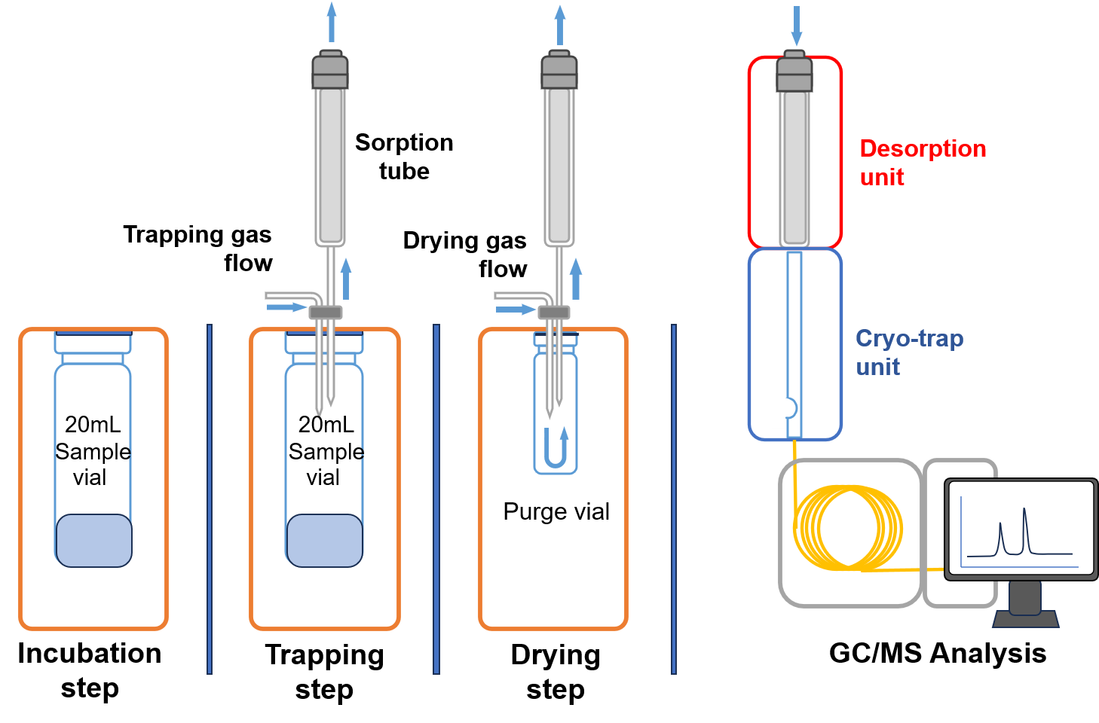

Figure 1 – Scheme of the dynamic headspace sampling process with sequential desorption to the TDU of the GC [54]

Based on the main principles of DHS, other potentially promising methods have been developed. The more commonly used are fully evaporation dynamic headspace (FEDHS) [26,48,50–52,55–59], multi-volatile method DHS (MVM DHS) [47,48,60–62], several types of commercial headspace methods with minor modifications [63–67], and homemade DHS [68–72].

Table 2 – Overview of DHS methods used for the determination of VOC
Object class | Matrix | Analytes | Sorbent tube type | LOD/ LOQ | RSD (%) | Recovery (%) | Reference
Food | Seafood | Low molecular weight PAHs | Tenax® TA Tenax® TA | LOQ  0.2-0.6 ng g ⁻¹ | n/d | 9-45 | [73]
Food | Seafood | High molecular weight PAHs | Tenax® TA Tenax® TA | LOQ  0.01-0.4 ng g ⁻¹ | n/d | 13-62 | [73]
Food | Rice | Hexanal | Tenax® TA | LOD  3.7 ng g⁻¹ | 3.8-47.5 | 97-107 | [46]
 |  |  |  | LOQ  5.1 ng g⁻¹ | 3.8-47.5 | 97-107 | [46]
Food | Vinegars | Furfurals | Tenax® TA  Tenax® GR | LOD  60-500 mg kg⁻¹ | <10 | n/d | [74]
Environment | Refinery effluents | Oxygenated VOCs | Tenax® TA | LOD  0.005-20 mg mL⁻¹ | 0.97-5.00 | 91-105 | [75]
Environment | River water, sea water and drinking water | VOCs | Tenax® TA | LOD  0.01-10 ng L⁻¹ | 2-30 | n/d | [58]
 |  |  |  | LOQ  0.03-34.5 ng L⁻¹ | 2-30 | n/d | [58]
Consumer products | Scented toys | Fragrance allergens | Tenax® TA | LOD  196.0 ng mL⁻¹ | 26.8-54.3 | 50.3-128.2 | [49]
 |  |  |  | LOQ  2.7-13.1 ng mL⁻¹  Hydrophobic compounds  270-632 ng mL⁻¹  hydrophilic compounds | 26.8-54.3 | 50.3-128.2 | [49]
Consumer products | Paints and architectural coatings | VOCs | Tenax®  Poroplot Q | LOD  0.007 - 0.009 wt% | 5.4-13 | n/d | [41]
Organism | Mice blood | Profiling of VOCs | Tenax® TA | LOD  1.2-240 mg L⁻¹ | 1.8-16.4 | n/d | [76]
 |  |  |  | LOQ  3.5-720 mg L⁻¹ | 1.8-16.4 | n/d | [76]
Organism | Rabbit whole blood | Dimethyl trisulfide | Tenax® TA | LOD  0.04-11 mM | 9-10 | 85-115 | [44]
 |  |  |  | LOQ  0.2-35 mM | 9-10 | 85-115 | [44]
Organism | Swine Blood | Dimethyl disulfide | Tenax® TA | LOD  30 nM | <6.4 | 86-89 | [77]
Oils | Extra-virgin olive oil | Aroma fingerprint | 90 mm long quartz tube with a 4 mm o.d. filled with Tenax® GR | LOD  4.2-110 ng g⁻¹ | <13 | 50.9-113.9 | [78]
Note:
PAH – polycyclic aromatic hydrocarbons;
LOD – limit of detection;
LOQ – limit of quantification;
n/d – not detected.

Studies employing traditional DHS (Table 2) have predominantly investigated VOCs in food products (e.g., seafood, beverages, edible oils, spices), industrial materials (e.g., rubber and paint), environmental waters, and biological fluids (e.g., animal blood). These applications demonstrate that DHS is particularly advantageous for extracting VOCs from matrices that are otherwise challenging due to their complexity, low analyte concentrations, or strong matrix effects. While a substantial portion of the reviewed studies focused on qualitative identification, investigating volatile profiles in pistachio extracts, fungal aroma compounds, rubber emissions, essential oils, and sensory profiles [43,79–82]. Several works also reported robust quantitative determinations. Quantitative DHS applications include the analysis of PAHs in seafood [73], hexanal in rice [46], furfurals in vinegars [74], oxygenated VOCs in refinery effluents [75], VOC screening in environmental waters [58], fragrance allergen migration from consumer products [49], and sulfur-containing compounds in animal blood [76,77]. Additionally, DHS is suitable for quantitative aroma fingerprinting of edible oils [78]. Notably, many target analytes across these studies exhibit low water affinity (Table 2), which explains the predominant use of hydrophobic sorbents, such as Tenax® TA and Tenax® GR, as the primary trapping materials.

1.5 Green analytical chemistry considerations
In recent years, the principles of green analytical chemistry (GAC) have become central to the development of environmentally sustainable analytical methods. GAC aims to reduce the environmental impact of analytical processes by reducing hazardous chemical use, lowering energy use, reducing waste, and promoting safer, more efficient workflows. The foundation of this approach is encapsulated in the twelve principles of GAC, often referred to as the significance mnemonic, which emphasizes the prioritization of in-situ measurements, the elimination of toxic reagents, and the minimization of energy consumption during sample preparation and analysis [83]. These principles are especially important in analyzing BVOCs, where traditional techniques often depend on solvents, extensive sample handling, and labor-intensive pre-concentration methods that can produce significant chemical waste. Modern trends in GAC focus on the “greening” of the entire analytical cycle, from sampling to data processing, through the miniaturization of devices and the integration of automated systems [84].
Modern sample preparation methods guided by green chemistry include SPME, stir-bar sorptive extraction, and DHS extraction, all of which decrease solvent use and allow direct analyte extraction from complex samples. Among these, DHS is particularly compatible with GAC because it supports full automation, minimizes sample handling, and reduces secondary waste. Additionally, DHS minimizes energy consumption by efficiently combining pre-concentration and desorption steps, eliminating the need for multiple extraction and concentration procedures.
Furthermore, the evaluation of a method's “greenness” has transitioned from qualitative descriptions to quantitative assessments using specialized metric tools. Instruments such as the Analytical Greenness (AGREE) and AGREEPrep metrics provide a standardized way to calculate a method’s environmental impact based on the 12 GAC principles, offering a transparent score that aids in method comparison [85,86].
Recently, the discourse in analytical chemistry has expanded beyond GAC toward the concept of White Analytical Chemistry (WAC). While GAC focuses primarily on environmental safety, WAC introduces a more holistic RGB model that balances three essential pillars: Red (analytical performance), Green (environmental safety), and Blue (economic and practical aspects) [87]. Transitioning toward WAC ensures that a method is not only sustainable but also maintains the high analytical excellence required for trace-level environmental monitoring without compromising laboratory productivity.

1.6 Section conclusion
BVOCs, such as 2-pentanone, dibromomethane, α-pinene, Δ³-carene, nonanal, and sulfur-containing compounds such as DMS and its precursor, DMSP, play a key role in Earth’s atmospheric chemistry and global biogeochemical cycles. Their emissions from both land and marine ecosystems account for most of the world’s VOC fluxes, underscoring their ecological and climate importance. BVOCs affect essential atmospheric processes, including ozone creation, SOA production, and CCN activity. These processes, in turn, influence Earth’s radiative balance, shape regional and global climate, and affect weather patterns and rainfall. Additionally, BVOCs and their oxidation products have direct effects on human health, contributing to respiratory and cardiovascular illnesses, especially in urban and industrial areas.
Analytically, measuring BVOCs remains difficult due to their chemical properties, the complexity of environmental matrices, and their low concentrations in natural waters. Traditional extraction methods, such as LLE and SPE, are often labor- and solvent-intensive and less suitable for high-throughput environmental monitoring. Pre-concentration techniques, such as sorbent tubes, SPME, and cryo-trapping, have improved sensitivity and detection limits but still face limitations in automation, extraction effectiveness, or performance in high-humidity marine environments. DHS extraction combined with GC-MS offers a promising alternative, providing high extraction efficiency, automation potential, reproducibility, and compatibility with complex matrices. Its ability to preconcentrate VOCs while reducing matrix effects makes DHS-GC-MS a versatile and robust tool for BVOC monitoring.
Despite notable progress, significant knowledge gaps remain. Fully optimized DHS-GC-MS methods for quantifying BVOCs in environmental waters have yet to be developed, and standardized protocols for marine BVOC sampling under high humidity and dynamic conditions are still lacking. Additionally, understanding the mechanisms of BVOC transformations, their interactions with co-emitted compounds, and their role in climate feedback requires further research. Addressing these gaps is vital not only for advancing analytical chemistry but also for improving climate models, environmental policies, and public health assessments.
Ultimately, BVOCs are essential for understanding the interface between biological activity, atmospheric chemistry, and climate. Improving analytical methods, such as optimized DHS-GC-MS techniques, while incorporating sustainability principles, is a crucial step toward more accurate, reproducible, and environmentally friendly monitoring. These advancements will lay the scientific groundwork needed to unravel the complex roles of BVOCs in Earth system processes and support predictive models of atmospheric dynamics, climate feedback mechanisms, and ecosystem responses to environmental change.
Therefore, this study aimed to develop new methods for the determination of VOCs in water samples using DHS coupled with GC-MS. The study involves a systematic investigation to optimize extraction and drying conditions and to evaluate the method’s sensitivity, reproducibility, and recovery. Additionally, matrix effects, including the influence of sea salt and sample preservation, were also examined. Furthermore, the greenness of the proposed sample preparation method was evaluated using the AGREEprep metric [88].

2 DETERMINATION OF 2-PENTANONE, DIBROMOMETHANE, Α-PINENE, Δ³-CARENE, AND NONANAL IN ENVIRONMENTAL WATER USING DYNAMIC HEADSPACE EXTRACTION

Preamble
The part of the materials and results described in this section has been published in the research article “Bektassov, M., Thomsen, L. D., Baimatova, N., & Glasius, M. (2025). Advanced determination of biogenic volatile organic compounds in environmental water using dynamic headspace extraction. Microchemical Journal, 214.” [54] and reprinted with the journal permissions (Annex A). The copyright for these materials belongs to Elsevier, and any requests for further use of this information should be directed to them.

2.1 Introduction
This study aimed to develop and optimize a reproducible, robust, and sensitive analytical method that mitigates the limitations associated with conventional HS extraction-based techniques. A simple, fully automated DHS technique coupled with GC-MS was developed for the determination of BVOCs, including 2-pentanone, dibromomethane, α-pinene, Δ³-carene, and nonanal in water. Structural isomers such as α-pinene and Δ³-carene were specifically selected to optimize the effective separation of similar compounds, thereby enhancing the accuracy of the analytical outcomes. This approach addresses the critical need for accurate quantification of BVOCs in complex environmental matrices.
The method offers several advantages over conventional HS extraction-based techniques, including enhanced reproducibility, robustness, and sensitivity. Employing a fully automated DHS system coupled with GC-MS, this method minimizes limitations associated with manual extraction methods, thereby improving the reliability and efficiency of BVOC determination in water samples.

2.2 Materials and methods

2.2.1 Reagents and materials
Analytical standards, including 2-pentanone, dibromomethane, α-pinene, Δ³-carene, and nonanal, were purchased from Sigma Aldrich (China, USA, Switzerland). Sea salt mix and sodium chloride (NaCl) were obtained from Sigma Aldrich (Darmstadt, Germany). Ultrapure water (18.2 MΩ·cm at 25°C) water (MilliQ) was generated using the Synergy® UV Water Purification System (Milli-Q, France). Stock solutions of analytes were prepared in methanol (UHPLC-grade, CHROMANORM®). Sorbent trap tubes packed with Tenax® TA sorbents were supplied by Gerstel (Mulheim an der Ruhr, Germany).

2.2.2 Preparation of standard solutions
A standard stock solution was prepared by injecting 1 μL of dibromomethane, 2.5 μL of 2-pentanone, 2.5 μL of α-pinene, 2.5 μL of Δ³-carene, and 2.5 μL of nonanal into 5 mL of methanol using a 5 μL microsyringe (SGE, Australia). The initial concentration of the BVOC standard solution was 200 mg L⁻¹.
To optimize the DHS method and GC-MS parameters (Sections 2.3.1 – 2.3.2), a working standard solution (20 μg L⁻¹) was prepared by diluting the initial stock solution (1 μL) in 10 mL of methanol. All prepared standard solutions were stored in a freezer at -18°C to minimize degradation and ensure stability until analysis.

2.2.3 GC-MS analysis
All analyses were performed using a GC-MS 7890B/5977A (Agilent, USA) equipped with a cooled CIS4 system and MPS2 autosampler (Gerstel, Germany). Separation of analytes was conducted using a capillary 30 m × 0.25 mm HP-5ms column (Agilent Technologies, USA) with a 0.25 µm film thickness, and helium (>99.9999% purity, Denmark) was used as carrier gas at a constant ﬂow rate of 1 mL min⁻¹. The oven was programmed from 35°C (held for 5 min), ramped to 100°C at the heating rate of 5 °C min⁻¹ (held for 3 min), then increased to 280°C at 20 °C min⁻¹ (held for 3 min). The total GC run time was 28 min.
The MS ion source, quadrupole, and interface temperatures were 230, 150, and 250°C, respectively. Detection was conducted using electron impact ionization (EI) at 70 eV. The signal acquisition rate was 5 spectra/s in the m/z range of 30–500. Chromatographic data processing and BVOC identification were performed using MassHunter workstation Quantitative analysis software (version 10.1, Agilent, USA) with the National Institute of Standards and Technology database (NIST17).

2.2.4 Optimization of DHS with thermal desorption and cryo-trapping
The method optimization encompassed trapping, drying parameters, and matrix effects. A 20 mL crimp-top vial containing 5 mL of 20 μg L⁻¹ BVOC concentration in water was incubated at 30°C for 60 s within the DHS unit. Sample agitation was performed using an orbital shaker for 60 s at a rotation speed of 500 rpm. To prevent condensation within the needle, the transfer heater at the double needle was heated to 120°C. Pre-purging of the sample headspace before trapping was omitted to avoid BVOC loss.
Commercially available sorbent tubes packed with Tenax® TA (GERSTEL, Germany) and commonly used for BVOC trapping [89], were employed for analysis. Following analyte extraction, the sorption tube was immediately desorbed in a thermal desorption unit (TDU) with cryo-collection using the MPS2 autosampler and the programmed temperature vaporizing inlet CIS4 (GERSTEL, Germany). TDU desorption was conducted in splitless mode, initiating at 30°C for 1 min, ramping to 300°C at a rate of 120 °C min⁻¹, and held for 3 min. BVOCs were cryo-focused by liquid nitrogen in a quartz wool glass liner of the CIS4 injector in split mode at a ratio of 4:1. The temperature of the CIS4 injector ramped from -100°C to 300°C at a ramp rate of 12°C s⁻¹, prior to subsequent GC-MS analysis. All experiments were conducted in triplicate to ensure the robustness and repeatability of the results.

2.2.4.1 Optimization of the trapping parameters
The trapping step is characterized by the following parameters: trapping gas volume, trapping gas flow rate, sample temperature, and sorption tube temperature. The trapping gas flow rate was set at 100 mL min⁻¹ for 5 min, a commonly used trapping speed with sorption tubes [89]. The sorption tube temperature was set at 30°C, the minimum temperature permissible by the DHS device.
The optimization of trapping gas volume during the trapping step was conducted in the range of 500, 700, 1000, and 1500 mL, corresponding to trapping times of 5, 7, 10, and 15 min.
The sample temperature was set at 30°C to prevent water evaporation and terminate the analysis. The drying gas volume was 500 mL with a flow rate of 50 mL min⁻¹ for 10 min at the sorption tube temperature of 40°C.

2.2.4.2 Optimization of the drying parameters
It is critical to eliminate trapped water from the sorbent tube to prevent temporarily disabling the MS filament. The drying step depends on the following parameters: gas volume, gas flow rate, and sorption tube temperature. The DHS and the TDU units remove water from the sorbent tube with a fixed drying gas flow rate of 50 mL min⁻¹.
The gas volume was optimized at 200, 300, 500, and 1000 mL by varying the drying time between 4, 6, 10, and 20 min. In addition, the Tenax® TA sorbent temperature was optimized at 30, 40, 50, and 60°C. After the sorption parameters were optimized, the sorption parameters of the DHS unit were determined.

2.2.5 Determination of matrix effects of sea salt and dissolved organic matter
The assessment of the sea salt matrix effect (Section 2.3.3) involved spiking 5 mL of MilliQ water containing 175 mg of sea salt mix (dissolved) with 20 μg L⁻¹ stock solution of the BVOCs and comparing with a control sample spiked with the same 20 μg L⁻¹ stock solution of the BVOCs in MilliQ water.
To evaluate the matrix effect of dissolved organic matter (DOM) in environmental water samples (Section 2.3.3), 5 mL MilliQ water samples were spiked with 20 μg L⁻¹ stock solution of BVOC and subsequently analyzed using the optimized DHS method. The DOM concentration was 523 µmolC L⁻¹ in the sample from University Lake, Aarhus, Denmark, and 88 µmolC L⁻¹ from Disko Bay, Greenland.

2.2.6 Analytical performance of the developed method
External standard calibration was employed for the validation of the method. Calibration curves were obtained for BVOC under the optimized conditions by serial dilution of standard solutions (200 mg L⁻¹ in methanol) in MilliQ water, ranging from 1 μg L⁻¹ to 200 μg L⁻¹ for each analyte. This ensures that the calibration standards encompass the expected concentration range of BVOCs in the static HS methods.
The limits of detection (LOD) were calculated using the signal-to-noise ratio (S/N), set to 3, providing a reasonable balance between detection sensitivity and the avoidance of false positives. This calculation considers the variability in the analytical signal relative to blank signals, yielding a robust estimate of the limits of quantification (LOQ). To assess the method’s repeatability and precision, relative standard deviation (RSD) values were determined by spiking water samples with 12 μg L⁻¹ of BVOC and analyzing them in three triplicate.

2.2.7 Calculation of Metrological Characteristics
The evaluation of the metrological characteristics of the developed analytical method was performed in accordance with internationally accepted standards governing the validation and accuracy of measurement procedures, including ISO 5725 (Parts 1-6) for the assessment of trueness and precision, ISO 11843-2 for the determination of detection capability, ISO/IEC Guide 98-3 (GUM) for the evaluation of measurement uncertainty, and the relevant provisions of GOST R 8.736-2011 concerning indicators of measurement accuracy. These documents provide the methodological basis for the statistical treatment of experimental data and the validation of analytical performance. The linearity of the process was evaluated over the selected concentration range by calculating the coefficient of determination (R²) using least-squares regression; a high R² and the absence of systematic deviations confirmed acceptable linearity.
The limit of detection and the limit of quantification were calculated based on the analyte amount that can be distinguished from background noise (typically S/N = 3). At the same time, LOQ was defined as the lowest detectable concentration when the analytical signal-to-background noise ratio exceeded 10.

2.2.8 Application of the developed method
The real water samples were collected from University Lake (Aarhus, Denmark; 56°10’N, 10°12’E) and Disko Bay (Greenland; 69°15’N, 53°34’W). At each sampling location, 5 mL aliquots were analyzed in triplicate to ensure analytically reliable and reproducible results. To maintain the sample integrity and avoid potential alteration of the natural BVOC profile, no pretreatment steps were employed. The University Lake water samples were analyzed immediately upon collection, whereas the Disko Bay water samples were stored in a glass bottle with a polytetrafluoroethylene (PTFE)-lined screw cap in the freezer at -18°C. The storage time for Disko Bay samples was 60-90 days.

2.2.9 Environmental water sampling procedure
Water samples were collected in accordance with ISO 5667-1 and ISO 5667-3. They were manually collected by directly filling pre-cleaned 20 mL glass vials with water from the water source. The vials were filled to the rim to reduce gas bubble formation and immediately sealed with gas-tight lids. After collecting, the vials were quickly frozen and stored at -20°C until analysis. Freezing was used to preserve BVOCs, and to prevent biological and chemical changes prior to testing. All samples were analyzed within the specified storage period to maintain data accuracy.

2.3 Results and discussion for the optimization of the DHS-GC-MS method for selected BVOCs in water

2.3.1 Effect of the trapping parameters
The effect of trapping gas volume on BVOC response was investigated over a range 500 to 1500 mL (Figure 2). Statistically significant changes in response (peak areas) were observed for most of the BVOCs (2-pentanone, dibromomethane, and α-pinene) when increasing the trapping gas volume from 500 mL to 1500 mL (analysis of variance p < 0.05, ANOVA, Tukey test). For these compounds, a 19-37% increase in response was observed by increasing the trapping gas volume from 500 to 700 mL. For Δ³-carene and nonanal, no statistically significant variation was observed across the studied trapping gas volumes (p > 0.05).
For all analytes except nonanal, a 7-20% decrease in the response was observed when the trapping gas volume was increased from 700 to 1000 mL. This could be attributed to the breakthrough of these highly volatile compounds from the sorbent. Moreover, higher trapping gas volumes can result in water buildup in the sorbent tube, affecting the adsorption of analytes, as also indicated by higher deviations of the responses at trapping gas volumes above 500 mL.
Since larger trapping gas volumes did not yield significantly better results (larger peak areas) for all analytes, a trapping gas volume of 500 mL was selected in order to aim for a shorter analysis time. Moreover, higher trapping gas volumes result in water contamination in the sorbent tube that could affect the GC-MS equipment.

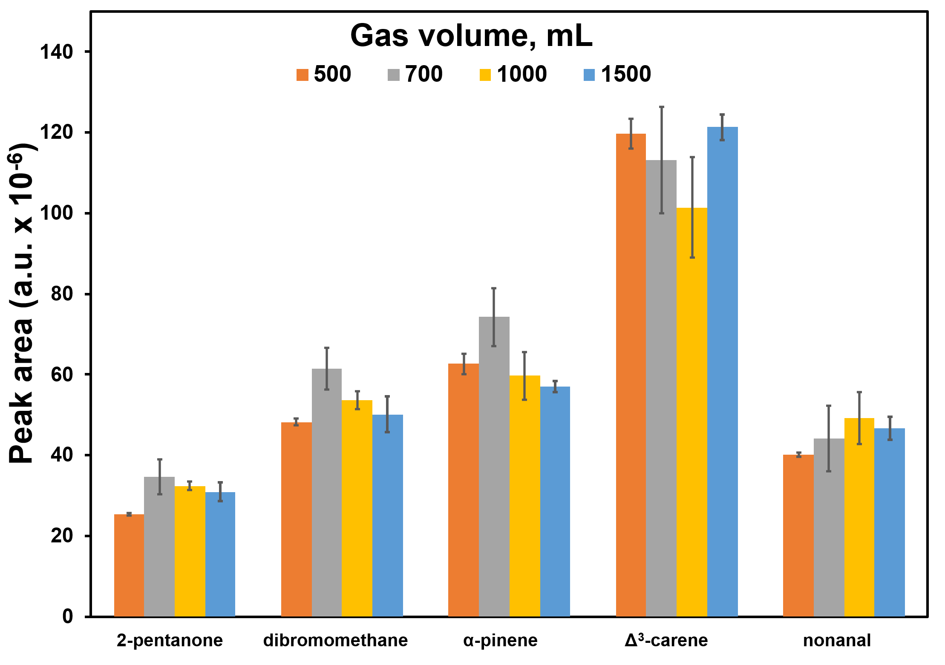
Figure 2 – Effect of trapping gas volume on BVOC responses.
Trapping parameters: incubation temperature 30°C, sample temperature 30°C.
Drying parameters: flow rate 100 mL min⁻¹, gas volume 500 mL, sorbent tube temperature 30°C

Temperature represents a pivotal parameter in HS extraction, significantly affecting the extraction kinetics and the evaporation rates of BVOCs from the sample matrix. However, even a minor increase in sample temperature from 30 °C to 35 °C resulted in excessive water contamination of the GC column, ultimately causing a temporary deactivation of the MS filament during sample analysis. This observation highlights the challenge of controlling water content in the sorbent tube, as elevated temperatures exacerbate water trapping alongside BVOCs without providing a viable method to selectively remove water without compromising the trapped BVOCs.
Consequently, it was concluded that increasing the sample temperature during the trapping phase is unfeasible due to the substantial risk of water accumulation in the sorbent tube and the inability to selectively remove water without causing BVOC desorption. Therefore, a sample temperature of 30°C was optimal for subsequent experiments, facilitating effective BVOC extraction while minimizing water-related complications.
However, while analyzing real samples, controlling trapped water in the sorbent posed a significant challenge, requiring the optimization of drying parameters. Consequently, the drying parameters were systematically optimized to address this limitation effectively.

2.3.2 Effect of drying parameters on BVOC recovery
Effective BVOC analysis in aqueous samples requires water removal from the sorbent tube during the drying phase of the DHS method, especially considering the volatility of the matrix. This section investigated the effect of two primary drying parameters, temperature and gas volume, on BVOCs using Tenax® TA [20].

2.3.2.1 Drying temperature
Optimization of the drying temperature for sorbent tubes requires balancing efficient water removal with minimal BVOC losses. Raising the drying temperature from 30°C to 60°C accelerates the release of trapped water [90][90] from the sorbent tube and significantly (p < 0.05, ANOVA, Tukey test) impacts the recovery of most BVOCs (Figure 3).
This increase in temperature enhances the volatilization and desorption of 2-pentanone, dibromomethane, α-pinene, and nonanal at higher drying temperatures. In contrast, Δ³-carene exhibited no significant difference in recovery across this temperature range (p > 0.05, ANOVA, Tukey test), indicating its stronger affinity for the sorbent material, resulting in minimal desorption at higher temperatures.
The lowest responses for 2-pentanone and nonanal were observed at 30°C, with a significant increase of 31.2% and 44.5%, respectively, at 40°C. Further increasing the drying temperature from 40°C to 60°C resulted in slight changes in BVOC responses (16.3% for 2-pentanone and 15.1% for nonanal). These findings suggest that these compounds exhibit relatively weak interactions with the sorbent material and can be efficiently recovered at moderate temperatures. Dibromomethane showed a minor increase of 2.6% from 30°C to 40°C, followed by a pronounced decrease of 22.2% at 50°C and 22.8% at 60°C. In contrast, α-pinene displayed no significant statistical change from 30°C to 40°C (p > 0.05, ANOVA, Tukey test), but a substantial decline of up to 66.8% was observed from 40°C to 60°C. Overall, optimal recovery of BVOCs was achieved at 40°C.

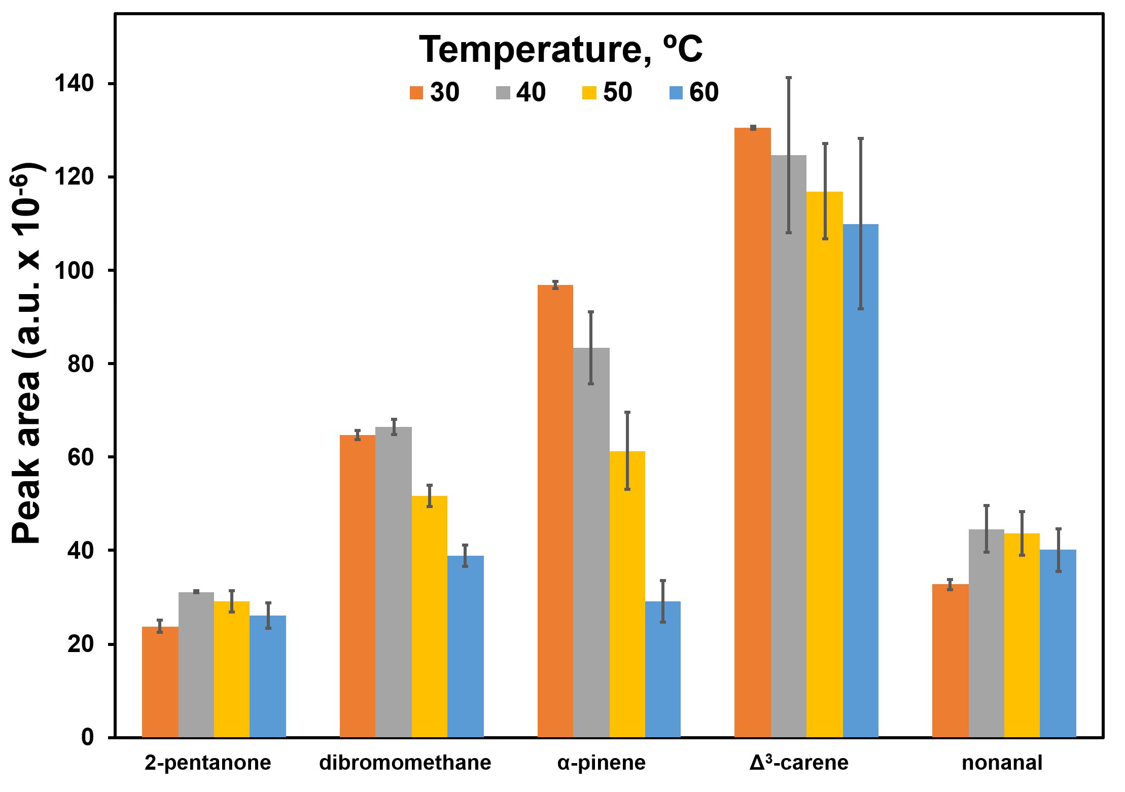
Figure 3 – Effect of drying temperature of the sorption tube on BVOC responses. Trapping parameters: incubation temperature 30°C, sample temperature 30°C, gas volume 500 mL; Drying parameters: flow rate 100 mL min⁻¹, gas volume 500 mL

Further increase in drying temperature from 40°C to 60°C decreased BVOC responses, ranging from 15.1% to 66.8%. This biphasic response indicates a potential interplay between water displacement and thermal desorption. At 40°C, desorbed water likely facilitates improved accessibility of the sorbent sites, contributing to a minor increase in dibromomethane recovery. However, elevated thermal energy at higher temperatures may overcome adsorption forces, resulting in significant dibromomethane desorption and subsequent losses. At the same time, α-pinene exhibited a decreasing recovery trend with rising drying temperatures, indicating a higher susceptibility to thermal desorption than other BVOCs, possibly due to its weaker adsorption properties.
The RSD of BVOC responses varied significantly over the drying temperature range of 30°C to 50°C, ranging from 0.05% to 16%. The highest RSD range (6.0%-16%) was observed at 50°C and 60°C, while the lowest (0.05%-5%) range was found at 30°C and 40°C. Statistical analysis using ANOVA and Tukey tests (p > 0.05) indicated no significant difference in recovery between 30°C and 40°C for most analytes. Based on these findings, 40°C was selected as the optimal drying temperature for further experiments, providing the best compromise between BVOC recovery and analytical precision.

2.3.2.2 Drying gas volume
Increasing the drying gas volume, ranging from 200 mL to 1000 mL, under optimized parameters (trapping gas volume: 500 mL, trapping temperature: 30°C, and sorption tube drying temperature: 40°C), enhanced the release of trapped water [90] from the sorbent tubes and led to the breakthrough of certain BVOCs (Figure 4).
Drying gas volume significantly influenced (p < 0.05, ANOVA, Tukey test) the recovery of most BVOCs, except Δ³-carene and nonanal (p > 0.05), when increased from 300 mL to 1000 mL. This indicates that 2-pentanone, dibromomethane, and α-pinene desorption positively correlated with drying gas volume, while a Δ³-carene and nonanal showed a stronger sorbent tube affinity.
Conversely, an insignificant effect (p > 0.05) was observed for most BVOCs when increasing the drying gas volume from 300 mL to 500 mL, except for dibromomethane (p < 0.05). Compound-specific maximum recoveries were observed at different volumes: nonanal exhibited peak recovery at 500 mL with consistency across the entire range (200-1000 mL); dibromomethane, α-pinene, and Δ³-carene demonstrated maximum recovery at 200 mL, while 2-pentanone peaked at 300 mL.

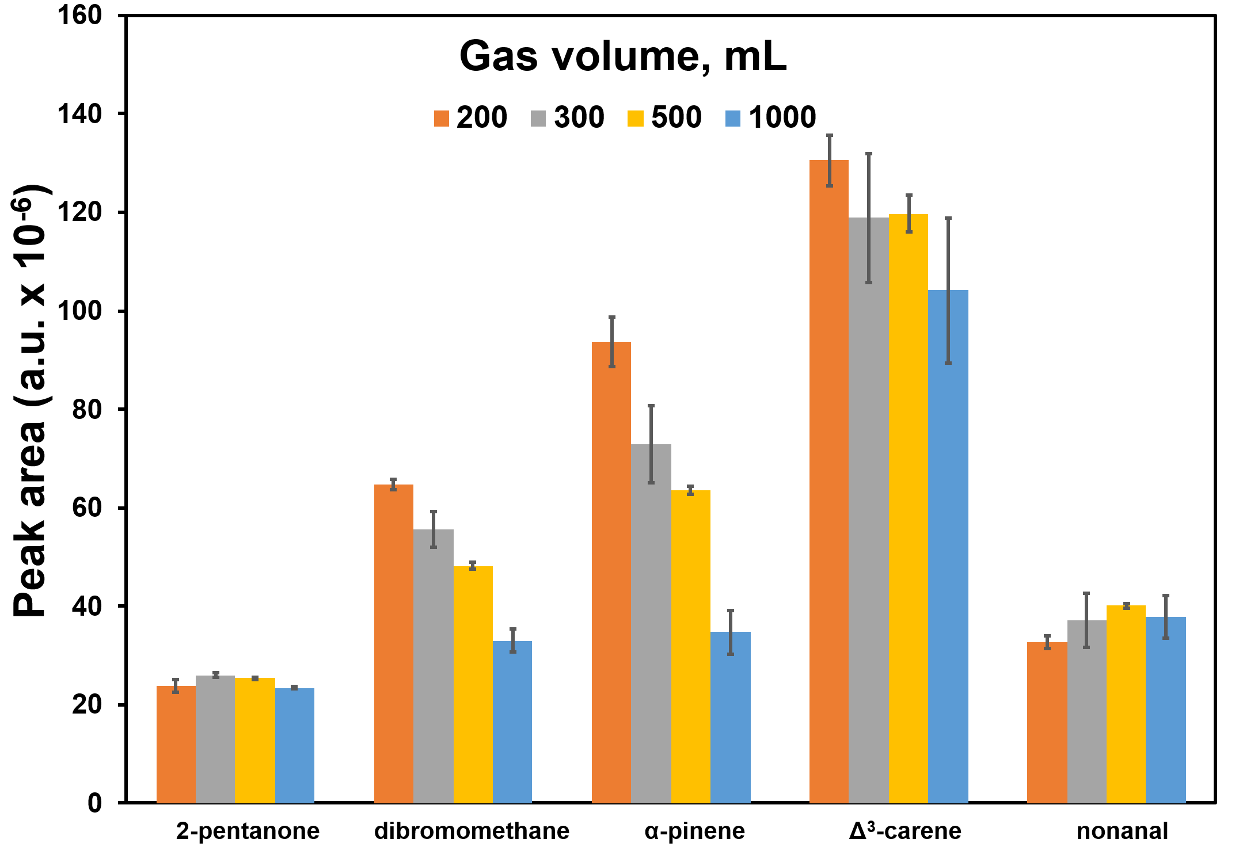
Figure 4 – Effect of drying gas volume on BVOCs responses. Trapping parameters: incubation temperature 30°C, sample temperature 30°C, gas volume 500 mL; Drying parameters: flow rate 100 mL min⁻¹, sorbent tube temperature 40°C

BVOC breakthrough from the sorbent tube demonstrated a drying gas volume-dependent increase, with losses ranging from 10% for 2-pentanone to 60% for α-pinene at 1000 mL compared to 200 mL. However, raising the drying gas volume from 200 mL to 500 mL had minimal impact on BVOC responses. In comparison, a volume of 1000 mL significantly reduced the peak areas of dibromomethane, α-pinene, and Δ³-carene. The difference in BVOC peak areas between 300 mL and 500 mL drying gas volume remained below 10%.
The RSD of the BVOC responses across the 200-1000 mL drying gas volume range varied from 0.2% to 11%, with the lowest RSD values (0.2% - 1.5%) observed at 200 mL and 500 mL. Based on these findings, a drying gas volume of 500 mL was selected as the optimal for subsequent experiments.

2.3.3 Sea salt and DOM matrix effect
The effects of sea salt and DOM matrix on BVOC responses in samples were performed under optimized DHS parameters (trapping gas volume: 500 mL, trapping temperature: 30°C, sorption tube drying temperature: 40°C, drying gas volume: 500 mL) (Figure 5). These optimized parameters were determined to achieve efficient capture and desorption of BVOCs while minimizing matrix effects.
The addition of sea salt to MilliQ water did not result in a statistical difference in BVOC responses (p > 0.05, ANOVA, Tukey test), except for 2-pentanone (p < 0.05). The RSD values ranged from 2% to 11% in MilliQ water and 4% to 18% in sea-salted MilliQ water (Figure 5, a). These findings demonstrate that the optimized DHS method is robust against matrix effects caused by sea salt for most BVOCs, yielding comparable results in both MilliQ and saltwater matrices. The minimal impact of sea salt on BVOC responses simplifies analysis and reduces potential matrix-related errors. Furthermore, the enhanced analytical precision observed with sea salt suggests its potential benefit for routine DHS analysis of environmental samples containing seawater or saline matrices.

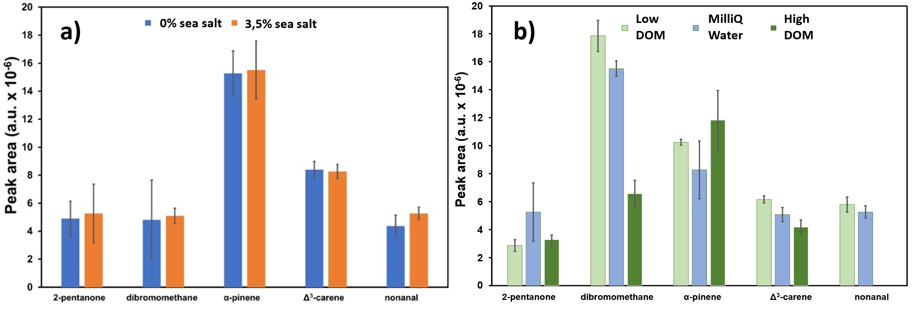
Figure 5 – Effect of a) sea salt and b) DOM (high DOM C= 523 µmolC L⁻¹, low DOM C= 88 µmolC L⁻¹) on BVOC responses at optimized DHS conditions

To evaluate DOM-related matrix effects, samples from the University Lake (high DOM concentration, 523 µmolC L⁻¹) and Disko Bay (low DOM concentration, 88 µmolC L⁻¹) were compared to Milli-Q water (assumed low DOM concentration) using standard solution spikes (Figure 5, b).
Statistically significant differences (p < 0.05, ANOVA, Tukey test) in BVOC responses were observed between samples with high and low DOM concentrations compared to Milli-Q water, indicating the potential influence of DOM on BVOC adsorption and desorption during DHS analysis. However, 2-pentanone and Δ³-carene in Disko Bay samples (Figure 6) exhibited responses comparable to Milli-Q water (p > 0.05), suggesting minimal DOM interaction at lower concentrations. The high DOM levels of University Lake samples displayed a pronounced matrix effect, with dibromomethane and α-pinene showing significantly contrasting peak areas (18% and 41%, respectively) than Milli-Q water, possibly indicating their presence in the original sample. Moreover, nonanal exhibited responses equivalent to Milli-Q water (p > 0.05) in low-DOM concentration Disco Bay samples; however, in high-DOM concentration University Lake samples, the response was below the LOD.

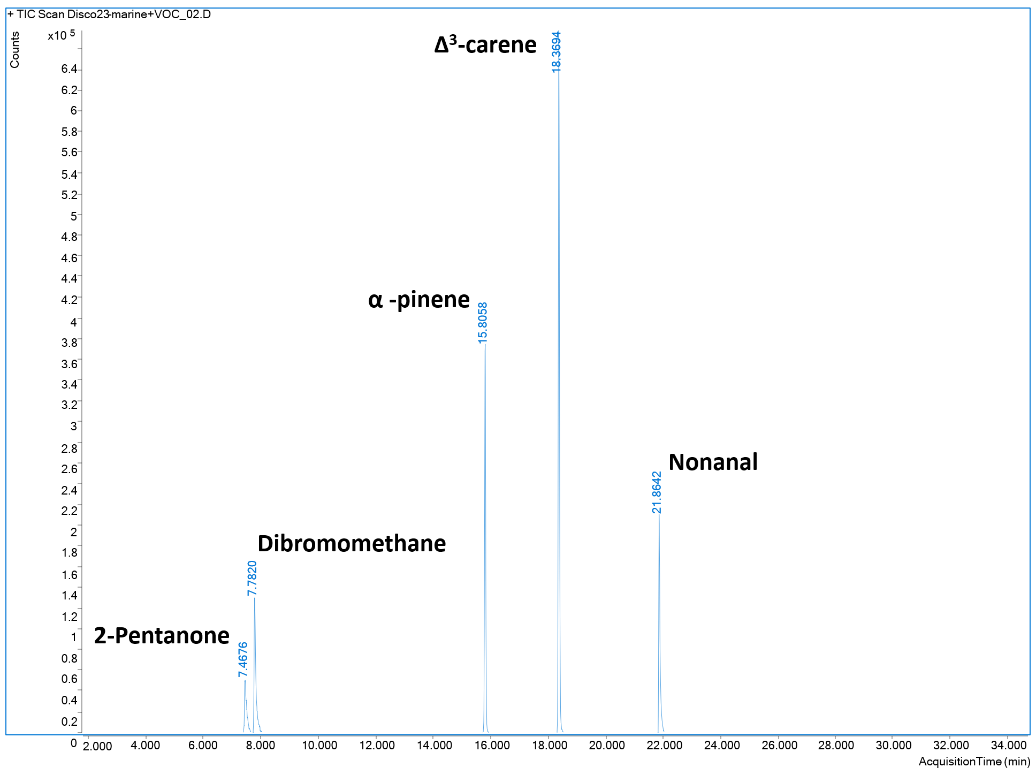
Figure 6 – Chromatogram of water sample from Disko Bay spiked with BVOCs standard

The observed DOM-mediated matrix effects can be attributed to several mechanisms. DOM can adsorb BVOCs, reducing their volatility and potentially suppressing their DHS analysis response. Additionally, competition between BVOCs and DOM for sorption sites on the DHS trap can affect overall BVOC recovery.

2.3.4 Analytical performance of the developed method
Method validation was performed using external calibration across a BVOC concentration range of 1-200 μg L⁻¹, yielding strong linear correlations with coefficients of determination (R²) ≥ 0.99 (Table 3). This high linearity demonstrates the method's robust quantitation capabilities within the specified concentration range. The RSD of the slopes of the obtained calibration plots varied from 2% to 6% for all studied analytes, indicating high reproducibility of the calibration method employed.
Low LOD values, spanning from 0.05 to 0.3 μg L⁻¹, demonstrated the method’s sensitivity for detecting trace levels of BVOCs. Correspondingly, the LOQ values range from 0.18 to 1.02 μg L⁻¹, representing the lowest concentrations at which the analytes can be accurately quantified with acceptable precision and accuracy. The observed RSD values ranged from 4% to 17%. RSD and recovery were evaluated at the concentration level, indicating the sufficient precision and repeatability of the developed method.

Table 3 – Analytical performance of the developed DHS method

Analytes | R² | Linear range (μg L⁻¹) | RSD of slope (%) | RSD (%) | LOD  (μg L⁻¹) | LOQ  (μg L⁻¹) | Recovery (%)
2-Pentanone | 0.998 | 1-200 | 2 | 4 | 0.1 | 0.3 | 100 ± 11
Dibromomethane | 0.998 | 1-200 | 2 | 10 | 0.3 | 1 | 102 ± 3
α -pinene | 0.990 | 1-200 | 6 | 17 | 0.07 | 0.2 | 121 ± 12
Δ³-carene | 0.997 | 1-200 | 3 | 14 | 0.05 | 0.2 | 109 ± 2
Nonanal | 0.994 | 1-200 | 4 | 8 | 0.05 | 0.2 | 111 ± 1

Furthermore, the accuracy of the DHS method was assessed by determining the recoveries of analytes. Satisfactory recoveries were achieved for all analytes, with values ranging from 100% to 121%. The method exhibits strong analytical characteristics appropriate for routine quantitative analysis of BVOC in complex environmental water matrices, where high sensitivity and accuracy are critical. Future research could explore potential matrix effects in different environmental samples and their impact on analyte recoveries and broaden the method’s applicability to additional BVOC classes.

2.3.5 Application of the developed method
The DHS GC/MS method was applied to quantify BVOCs in aqueous samples from Disco Bay (marine ecosystem) and University Lake (freshwater system). Despite the method’s sensitivity (LOD: 0.05-0.3 μg L⁻¹), BVOC concentrations remained below the method’s LOD in both environments (Figure 6).
The observed sub-LOD concentrations could increase fundamental BVOC persistence and environmental roles, particularly given their established importance in atmospheric processes, including secondary organic aerosol (SOA) formation, and their impact on air quality and climate dynamics. Multiple interconnected factors may explain the observed low concentrations. BVOC production is regulated by environmental parameters such as temperature, light availability, nutrient concentrations, and microbial community composition. The contrasting, distinct environmental conditions in Disco Bay (marine ecosystem) and University Lake (freshwater system) suggest variations in BVOC production rates. Additionally, the composition and abundance of BVOC-producing organisms, such as phytoplankton, differ significantly between marine and freshwater environments [91]. Therefore, a comprehensive characterization of the biological communities at both sites is essential for elucidating the mechanisms behind the observed low BVOC concentrations.
Moreover, microbial communities play a dual role in cycling BVOCs through both production and degradation pathways. The presence of BVOC-degrading microorganisms in water samples from both Disco Bay and University Lake may result in rapid BVOC degradation, maintaining concentrations below current analytical detection limits. Although the DHS GC/MS method demonstrates high sensitivity, implementing pre-concentration techniques or advanced analytical sensitive detection systems, such as comprehensive two-dimensional gas chromatography (GCxGC), could enhance detection capability for trace-level BVOCs in aquatic matrices.
Future research directions should include seasonal sampling campaigns to provide insights into potential temporal fluctuations in BVOC concentrations driven by changing environmental conditions and biological activity. Additionally, depth-resolved sampling and site-specific locations could characterize the vertical BVOC distribution. Identifying microbial populations in both Disco Bay and University Lake, alongside assessing their capacity for BVOC degradation, will yield valuable information on BVOC cycling within these systems. Such investigations will advance the understanding of BVOC dynamics in aquatic ecosystems and their role in global biogeochemical cycles.

2.3.6 Comparison with existing methods
The developed DHS method demonstrates competitive analytical performance compared to a few existing studies [22,24,92] (Table 4). Its primary advantage is efficiency and practicality for field applications for BVOC analysis. Most methods for BVOC determination rely on sorbent tubes and on-site sampling, enabling large HS volumes (e.g., 10-50 L) to pass through the sorbent media. However, these methods are time-consuming, costly, labor-intensive, and logistically complex. For instance, on-site sampling using a self-assembled ﬂoating ﬂux chamber with Tenax® TA sorbent tubes may require two low-flow pumps, a power supply, and 50 hours to collect 10 L of HS at a 50 – 100 mL min⁻¹ flow rate.
Additionally, the complexity of transportation of sorbent tubes can compromise data accuracy due to potential degradation or loss [22]. Similarly, a self-made polycarbonate chamber setup involves 15 hours to collect 1 L of HS at a flow rate of 200 mL min⁻¹, using 30 sorbent tubes for samples (plus three blank tubes for quality control), two low flow rate pumps, and meticulous handling of sorbent tubes during transportation to prevent contamination [92]. An alternative BVOC sampling method employed 30 Teflon bags and 15 hours to collect 6 L of HS of the sample at 200 mL min⁻¹, which posed challenges from bulkiness and susceptibility to punctures during transportation [24].
In contrast, the proposed DHS method offers a more efficient and practical solution that requires less than 2 hours, including water sampling of ten amber glass vessels, with 15 mL for triplicate measurements. This represents a 90% reduction in sampling time compared to the HS methods [22,92,93] and eliminates the need for additional equipment and complex transportation protocols, both of which are crucial for capturing the dynamic nature of BVOC emissions in aquatic environments.

Table 4 – Methods for the determination of BVOCs in water samples

Analytes | Sample  volume | Sample preparation and analysis | LOD | RSD (%) | Recovery (%) | Ref
Isoprene and monoterpene Fluxes | 38.4 L (HS from ocean surface) | HS extraction on Tenax® TA sorbent tubes using a floating ﬂux chamber from the ocean surface at ambient air temperature, followed by TDU/CIS and GC/MS analysis | 1±0.3ng | n/i | n/i | [22]
Total BVOCs, isoprene, mono­terpenes, sesquiterpenes | 6 L  (HS from leaves) | Leaves dried at 75 ◦C inside the Teflon bag, HS extraction of BVOCs on Tenax® TA and Carbograph 5TD sorbent tubes followed by TDU/CIS and GC/MS analysis | 0.03-0.9 μg/m³ | 4.0-15.0 | n/i | [24]
21 BVOCs (5 MTs, 12 SQTs, and 4 other VOCs) and 30 compounds (7MTs, 15 SQTs and 8 other VOCs) | 9680 mL (HS from plants) | HS extraction on Tenax® TA sorbent tubes of plant species using airtight polycarbonate chambers at ambient air temperature, followed by TDU/CIS and GC/MS analysis | n/i | n/i | n/i | [92]
2-pentanone, dibromomethane, α-pinene, Δ³-carene, nonanal | 5 mL  (DHS water sample) | DHS extraction on Tenax® TA sorbent tubes used 500 mL of trapping gas at a 100 mL/min flow rate, with the sample and sorbent tube at 30ºC. Drying used  500 mL gas at 50 mL/min, at 40ºС sorbent tube temperature, followed by TDU/CIS and GC/MS analysis | 0.05-0.3 μg L⁻¹ | 4-17 | 100-  121 | This study
Note:
MTs – monoterpenes;
SQTs – sesquiterpenes;
Note: n/i – not identified.

The method’s analytical performance is enhanced by its direct focus on aqueous matrices, circumventing humidity-related limitations of HS-based techniques. The LOD (0.05-0.3 μg L⁻¹) correlates inversely with sample volume, achieving comparable sensitivity to HS-sampling methods despite a smaller sample amount. Moreover, the RSD ranges from 3 to 17%, which aligns with the 4-15% RSDs reported by Yang et al. [24]. This precision is vital for reliable environmental monitoring and supports the method’s field applicability. Notably, the method exhibits no significant matrix interference from sea salt, making it suitable for marine and estuarine studies. When combined with fully automated sample processing and GC/MS analysis, these features enable high-throughput, reproducible measurements that are critical for large-scale environmental monitoring.
Compared to established techniques, the DHS method offers distinct advantages, including operational simplicity and cost-effectiveness, reduced risk of sample contamination or loss during transportation, and faster analysis turnaround, allowing near-real-time monitoring of BVOC dynamics. Its specific suitability for water samples addresses a niche in BVOC analysis often overlooked by HS-focused methods.
Therefore, the developed DHS method significantly advances BVOC analysis in aquatic environments by combining high sensitivity, operational efficiency, and simplicity. As the studies of BVOC emissions from water samples gain importance for understanding global atmospheric chemistry and climate change, this method is poised to become a valuable tool in environmental science. Future work should focus on broadening the range of detectable BVOCs, lowering detection limits for ultra-trace concentrations, and validating the method across diverse environmental matrices to enhance its versatility and applicability.

2.4 Section conclusions

In this study, the DHS extraction method was developed for the determination of five representative BVOCs (2-pentanone, dibromomethane, α-pinene, Δ³-carene, and nonanal). Optimized extraction parameters included a 500 mL trapping gas volume at 30°C and a 500 mL drying gas volume at a tube temperature of 40 °C.
The proposed DHS extraction method offers several advantages, including versatility in adjusting parameters for different analytes, simple sampling, and compatibility with full automation. Notably, this method addresses a significant research gap by enabling BVOC analysis in both fresh and saltwater matrices, expanding its applicability to aquatic environments with varying DOM levels.
Method validation using a 5 mL water sample in a screw-top vial extracted with Tenax® TA tubes demonstrated LOD ranged between 0.05 μg L⁻¹ and 0.3 μg L⁻¹, recovery rates of 100%-121%, and RSDs of 4%-17%. Matrix effects were investigated by comparing spiked Milli-Q water to environmental samples from University Lake (DOM: 523 µmolC L⁻¹) and Disko Bay seawater (DOM: 88 µmolC L⁻¹). Significant signal suppression occurred in high-DOM lake water, marked by suppressed responses for dibromomethane, Δ³-carene, and nonanal, highlighting matrix influence on analyte recovery.
This method is recommended for laboratories analyzing BVOC emissions in freshwater and marine systems, offering robust sensitivity and reproducibility. Future method development directions should focus on increasing sample volume or incorporating sample preconcentration techniques to enhance BVOC recovery, developing hydrophobic sorbents with higher affinity for BVOCs, implementing moisture traps to protect sorbent integrity, and introducing agitation during the sample trapping stage to increase turbulent mixing and enhance extraction efficiency. These advancements could extend the method’s applicability to a broader range of environmental samples and trace-level BVOCs, further advancing research on aquatic BVOC emissions and their environmental impacts.

3 DETERMINATION OF DIMETHYL SULFIDE AND INDIRECT QUANTIFICATION OF DIMETHYLSULFONIOPROPIONATE IN ENVIRONMENTAL WATER USING DHS-GC-MS

Preamble
The materials and results presented in this section are finalized and ready for submission as a manuscript titled: “Bektassov, M., Teng Zh., Rosati B., Orazbayeva D., Baimatova, N., & Glasius, M. Dynamic headspace gas chromatography - mass spectrometry method for determination of dimethyl sulfide and indirect quantification of dimethylsulfoniopropionate in environmental water. Journal of Chromatography A”

3.1 Introduction

Dimethyl sulfide is the most abundant biological sulfur compound in the atmosphere, playing a crucial role in the global sulfur cycle [94]. DMS facilitates the transfer of sulfur from water sources to terrestrial environments via atmospheric transport [95,96] and contributes to the formation of secondary aerosols through photooxidation [14]. Its ﬂux across the air-sea boundary directly affects the Earth’s radiation balance [95], positioning DMS as a key driver in the climate feedback system [20]. Notably, DMS has also been tentatively identified in the atmosphere of exoplanet K2-18b, where it is being investigated as a potential biosignature gas, further highlighting its relevance in planetary-level biogeochemistry [97].
The primary precursor of DMS is DMSP, an organosulfur compound produced by phytoplankton and micro- and macroalgae. DMSP is enzymatically cleaved to yield DMS and acrylic acid [98], making its quantification essential for understanding sulfur dynamics. However, direct analysis of DMSP presents considerable analytical challenges due to its pronounced polarity, non-volatility, and thermal instability. DMSP remains highly water-soluble and chemically stable under ambient conditions, precluding its partitioning into the gas phase and thereby rendering direct gas chromatographic analysis infeasible without prior derivatization. Liquid chromatography-mass spectrometry (LC-MS) approaches often encounter significant matrix interferences, especially in saline or complex environmental waters. Consequently, DMSP is usually determined indirectly by alkaline hydrolysis, which converts it to volatile DMS, making it more amenable to gas chromatographic analysis and offering improved sensitivity and selectivity.
Several analytical strategies have been employed to determine DMS and DMSP in aqueous samples. The P&T methods are widely used for measuring DMS in seawater [99], offering high sensitivity, but are labor-intensive and possess a high risk of cross-contamination between samples. Alternatively, HS analysis provides advantages of speed, simplicity, and cost-effectiveness [20,100]. However, a traditional HS method lacks the sensitivity required for trace-level determinations of DMS and DMSP in environmental water samples [101]. The SPME, a static HS extraction method, allows trace-level detection of DMS and DMSP with minimal sample preparation and full automation [102–104], but is constrained by its sorption capacity and long equilibration times, which restrict its preconcentration efficiency.
In contrast, dynamic headspace (DHS) extraction addresses these limitations by incorporating a preconcentration step, making it suitable for analysis of VOCs in diverse matrices, such as solid and liquid samples [35]. Compared to SPME, DHS offers greater sorption capacity and improved extraction efficiency [45]. Despite its advantages, a comprehensive optimization of the DHS-GC-MS-based method for DMS analysis has not yet been reported.
This study aims to develop and optimize a simple, efficient, and environmentally friendly DHS-GC-MS method for the determination of dimethyl sulfide and indirect quantification of dimethylsulfoniopropionate in water samples. The study involves a systematic investigation to optimize extraction and drying conditions and to evaluate the method’s sensitivity, reproducibility, and recovery. Additionally, matrix effects, including the influence of sea salt and sample preservation, were also examined. AGREEprep metric was used for the assessment of the greenness of the proposed sample preparation method [88].

3.2 Experimental section

3.2.1 Reagents and Materials
Dimethyl sulfide and dimethylsulfoniopropionate analytical standards were purchased from Sigma Aldrich (China, USA, Switzerland). Sea salt mix, sodium chloride (NaCl), 85% ortho-phosphoric acid, and sodium hydroxide (NaOH) were obtained from Sigma-Aldrich (Darmstadt, Germany). Milli-Q water was generated using a Synergy ®UV Water Purification System (Millipore, France). UHPLC-grade methanol (CHROMANORM®, Sigma-Aldrich) was used to prepare analytes for stock solutions. Sorbent trap tubes packed with sorbents Tenax ®TA and Carbopack B were supplied from GERSTEL (Germany).

3.2.2 Preparation of standard solutions
Standard solutions containing DMS and DMSP were prepared by injecting a total of 211 µL of DMS into a 100 mL volumetric flask with methanol using a 250 μL microsyringe, and a second standard of DMSP was prepared by weighing 10.1 mg of the DMSP into a 100 mL volumetric flask with methanol. Then, a 5 mL aliquot of DMSP was transferred and diluted in 100 mL of methanol. The initial standard solution concentrations of DMS were 2.109 mg L⁻¹, and of DMSP, 5.05 mg L⁻¹.
In the experiments optimizing the DHS method and GC-MS parameters, a DMS spiking solution was prepared by diluting 20 μL of the initial standard solution into 1.00 mL of methanol, yielding a final concentration of 42.1 mg/L. A working solution was prepared by spiking 6 µL of the spiking standard solution into 5.00 mL of Milli-Q water, yielding a final concentration of 50.6 µg L⁻¹.
For experiments on DMSP preservation and spiking properties, matrix effect evaluation, and method validation of the developed method, a working DMSP standard solution was prepared by diluting 250 μL of the initial standard solution with 50.00 mL of methanol, resulting in a final concentration of 25.25 μg L⁻¹. Additionally, the working DMSP standard was diluted to 50.00 mL of Milli-Q water, resulting in a final concentration of 1.26 μg L⁻¹. All prepared standard solutions were stored in a freezer at -18 °C to prevent degradation and maintain stability until analysis.

3.2.3 GC-MS analysis
All analyses were performed on GC-MS 7890B/5977A (Agilent, USA) equipped with Cooled Injection System 4 (CIS4) programmed temperature vaporizer (PTV) and MPS2 autosampler (GERSTEL, Germany).
Thermal desorption was performed in the TDU in splitless mode, starting at 30°C (held for 1 min), ramping to 300°C at 120°C min⁻¹ with a final 3-min hold. The desorbed BVOCs were cryo-focused using liquid nitrogen within a CIS4 injector equipped with a quartz wool glass liner, operating at a 4:1 split ratio. To initiate GC-MS analysis, the CIS4 temperature was rapidly increased from -100°C to 300°C at a rate of 12°C s⁻¹.
Separation of analytes was performed using a 30 m × 0.25 mm HP-5ms capillary column (Agilent Technologies, USA) with a 0.25 µm film thickness, and a constant helium (>99.9999% purity, Denmark) flow rate of 1 mL min⁻¹. The oven was programmed to start at 30 °C (held for 3 min) and then increase to 35 °C (held for 3 min) at a heating rate of 5 °C min⁻¹. It was subsequently ramped to 280 °C (held for 3 min) at a heating rate of 30 °C min⁻¹. The total GC run time was 18.17 min.
The MS ion source, quadrupole, and interface temperatures were 250, 150, and 280 °C, respectively. Detection was conducted using electron impact ionization (EI) at 70 eV. The signal acquisition rate was 5 spectra/s in the m/z range of 30-500. The DMS and DMSP data obtained from sample analysis were processed using MassHunter workstation Quantitative analysis version 10.1 (Agilent) with the mass spectral library from the National Institute of Standards and Technology 2017 (NIST17).

3.2.4 Optimization of DHS with TDU and CIS
The method was optimized with respect to sorbent tube selection, incubation parameters, trapping and drying parameters, matrix effects, and the calculated conversion efficiency of DMPS to DMS (Figure 7). A 5.00 mL aliquot of 50.6 μg L⁻¹ DMS solution prepared in Milli-Q water was placed in a 20 mL crimp-top vial. Vial was transferred from the ambient-temperature tray to the DHS unit for incubation at 30 °C for 3 min. Sample agitation was performed using an orbital shaker at 500 rpm for 60 s. To prevent condensation, the DHS unit’s double needle was heated to 120 °C. The pre-purging step was skipped to allow DMS to accumulate in the headspace.
Carbopack B sorbent tubes, which are frequently used for trapping very light VOCs, were employed for the analysis [89]. The trapping step was conducted at sample and sorbent tube temperatures of 30 °C for 2.5 min, with a nitrogen gas flow of 100 mL min⁻¹. Subsequently, the drying step was performed for 3 min using nitrogen gas at 100 mL min⁻¹ and sorbent tube temperature 40 °C. After drying, the sorbent tube was desorbed in a thermal desorption unit (TDU) with cryo-focusing in the PTV. TDU desorption was conducted in splitless mode, starting at 30°C for 1 min, ramping to 350 °C at 120°C min⁻¹, and holding for 3 min. DMS was cryo-focused in a quartz wool glass liner at a temperature of -100 °C, followed by desorption into the column by ramping the PTV temperature to 300 °C at the rate of 12°C s⁻¹ in split mode with a 4:1 split ratio (Figure 7).

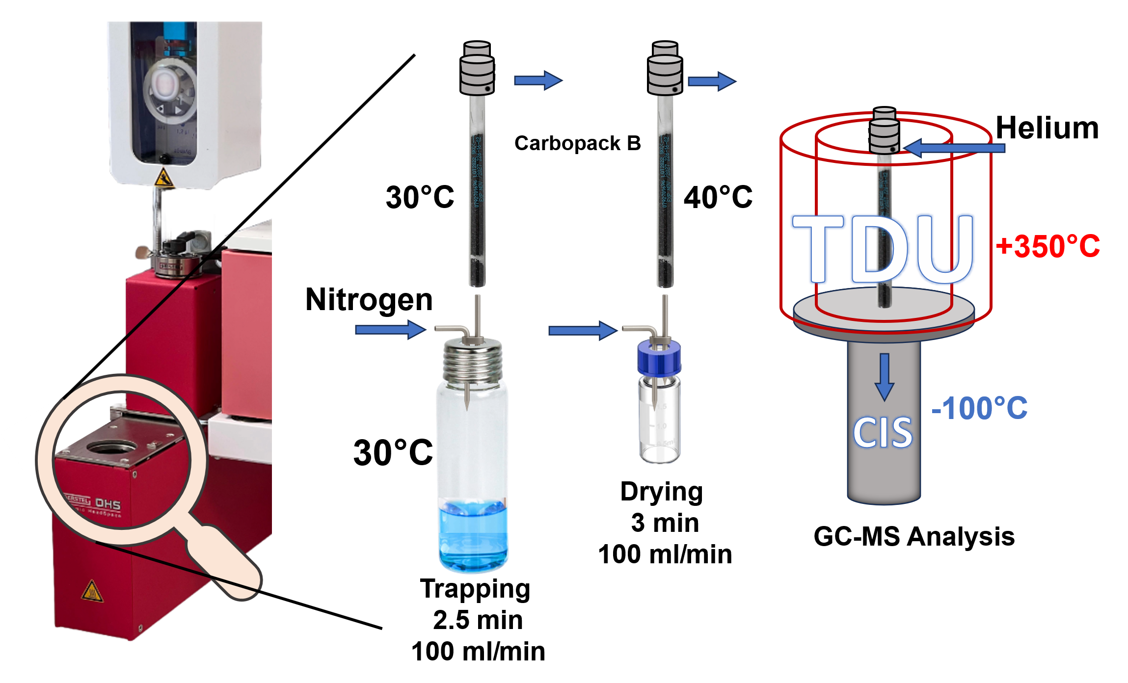

Figure 7 – Workflow of the dynamic headspace sampling process with sequential desorption in the TDU of the GC-MS system

Baseline system integrity was established using instrument blanks before each sequence (Figure 8). Sorbent tubes were pre-conditioned at 300 °C for 60 min. Analyte carryover was assessed by periodic re-desorption of the analyzed tubes; no significant residual peaks were detected, indicating a desorption efficiency >99.5%. All experiments were conducted in triplicate to ensure the robustness and repeatability of the results.

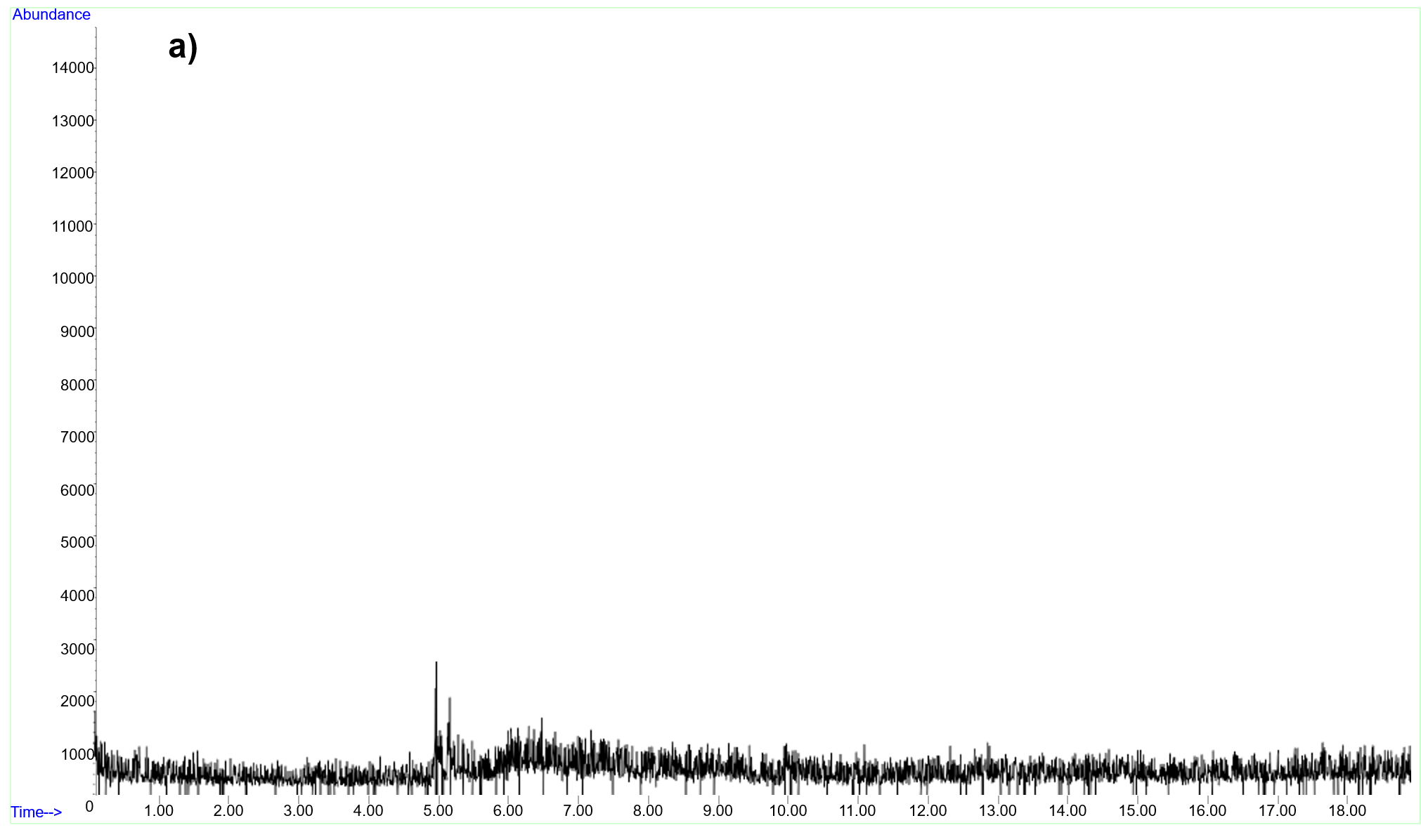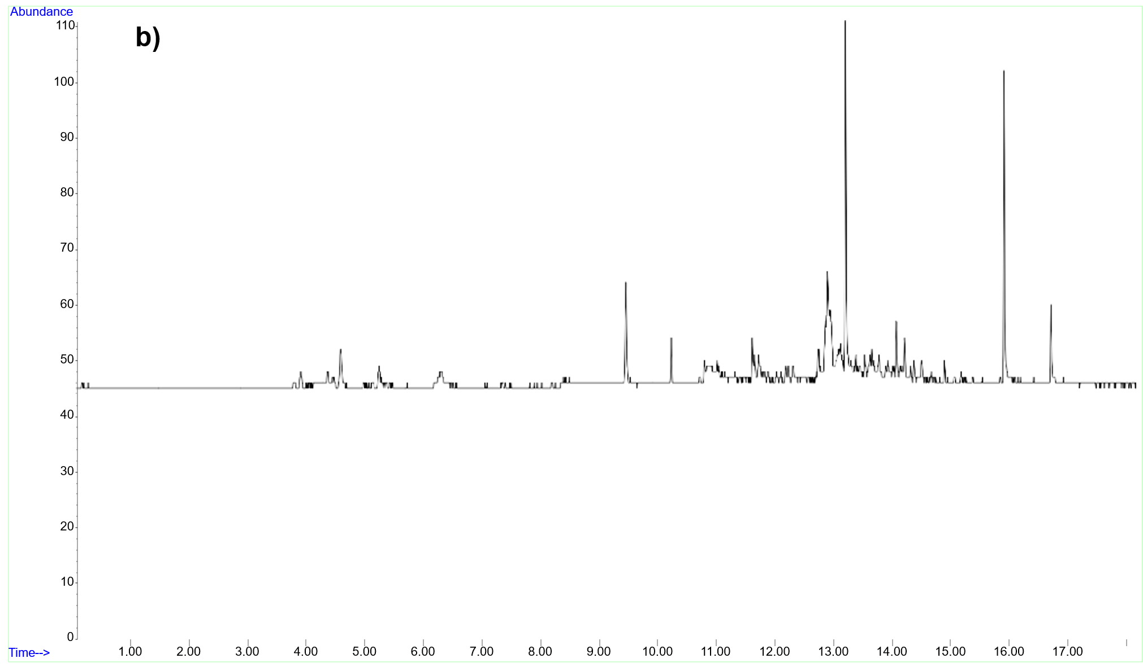
Figure 8 – Carboxen-filled sorbent tubes blanks a) before DMSP samples analysis b) after DMSP samples analysis

3.2.4.1 Optimization of sorbent tube types
Sorbent tubes pre-filled with Tenax® TA are commonly used for determining BVOCs [89]. However, the affinity of DMS for Tenax® TA is limited by its very low boiling temperature (35 °C) and its low molecular mass (62.14 g mol⁻¹). Instead, Carbopack B is often better suited for the adsorption of smaller molecules. However, Carbopack B is highly sensitive to water contamination, leading to poisoning and degradation, whereas Tenax® TA is not. In this study, we compared two sorbent tubes, prefilled with either Tenax® TA or Carbopack B.
The sample temperature of the DHS module was set to 30 °C to prevent water evaporation. The drying gas volume was 500 mL at a flow rate of 50 mL min⁻¹ for 10 min at a sorption tube temperature of 40 °C. The trapping gas volume was set to 100 mL.

3.2.4.2 Optimization of the trapping parameters
The trapping step is characterized by the following parameters: trapping gas volume, trapping gas flow rate, sample temperature, and sorption tube temperature. Additionally, before the trapping step, there is an incubation step characterized by the sample temperature. The trapping gas flow rate was set at 100 mL min⁻¹ for 5 min, a commonly used trapping speed with sorption tubes [89]. Using a sorbent tube prefilled with Carbopack B imposes restrictions on water contamination during subsequent steps, specifically on the sample temperature and the trapping gas volume. The sorption tube temperature was set at 30 °C, the minimum temperature controlled by the DHS device, to maximize the sorption [105].
The optimization of sample temperature at the incubation step was conducted in the range 30, 35, 40, 45, 50°C, and optimization of trapping gas volume during the trapping step was conducted in the range of 50, 100, 150, and 250 mL, corresponding to trapping times of 0.5, 1, 1.5, and 2.5 min.

3.2.4.3 Optimization of the drying parameters
Elimination of trapped water from the sorbent tube is required to prevent temporarily disabling the MS filament and to avoid signal suppression or potential damage to the analytical system.
The drying step is affected by the following parameters: gas volume, gas flow rate, and sorption tube temperature. The drying temperature for sorbent tubes is a crucial optimization challenge, balancing efficient water removal with minimal DMS losses. Increasing the drying temperature from 30°C to 60°C accelerates the release of trapped water [90]. As the DMS boiling temperature is only 35°C, we did not increase the drying temperature and kept it at 30°C to minimize DMS desorption.
The gas flow rate was optimized at 50, 75, and 100 mL min⁻¹ with a gas volume of 500 mL. The gas volume was optimized at 200, 300, 500, and 1000 mL by varying the drying time between 2, 3, 5, and 10 min.

3.2.5 Determination of DMSP preservation and derivatization
In the environment, DMSP is converted to DMS by the enzymes present in the water (Figure 9) [106]. To prevent breakdown of DMSP during sample storage and analysis, it is common to control pH and temperature, typically by acidifying or freezing water samples immediately after collection [20,100,107]. Here, 50 µL of 85% ortho-phosphoric acid was used as a preservation agent for 5mL (pH 1) of the sample [107,108]. To demonstrate the effectiveness of the preservation method, an experiment was conducted comparing the analytical response of DMSP in Milli-Q water with that of a DMSP solution spiked with ortho-phosphoric acid.
In the laboratory, enzymatic breakdown does not occur; instead, conversion to DMS is catalyzed by the addition of sodium hydroxide, NaOH [100,109,110]. To investigate the efficiency of DMSP conversion to DMS (Section 3.3.6), the optimized DHS-based protocol was applied to a 5.00 mL sample of DMSP in acidified Milli-Q water, spiked with 500 µL of 10 M NaOH (pH 13.5).
The primary breakdown produces dimethyl sulfide and acrylate, occurring either via enzymatic DMSP lyases or via chemical conversion under alkaline conditions. Alternative pathways for demethylation generate methanethiol and methylmercaptopropionate, whereas secondary oxidation of DMS yields DMSO and methanesulfonic acid [111]. Methylmercaptopropionate and methanethiol are derived from the demethylation of dimethylsulfoniopropionate, a process involving multiple enzymatic steps catalyzed by DMSP demethylases.

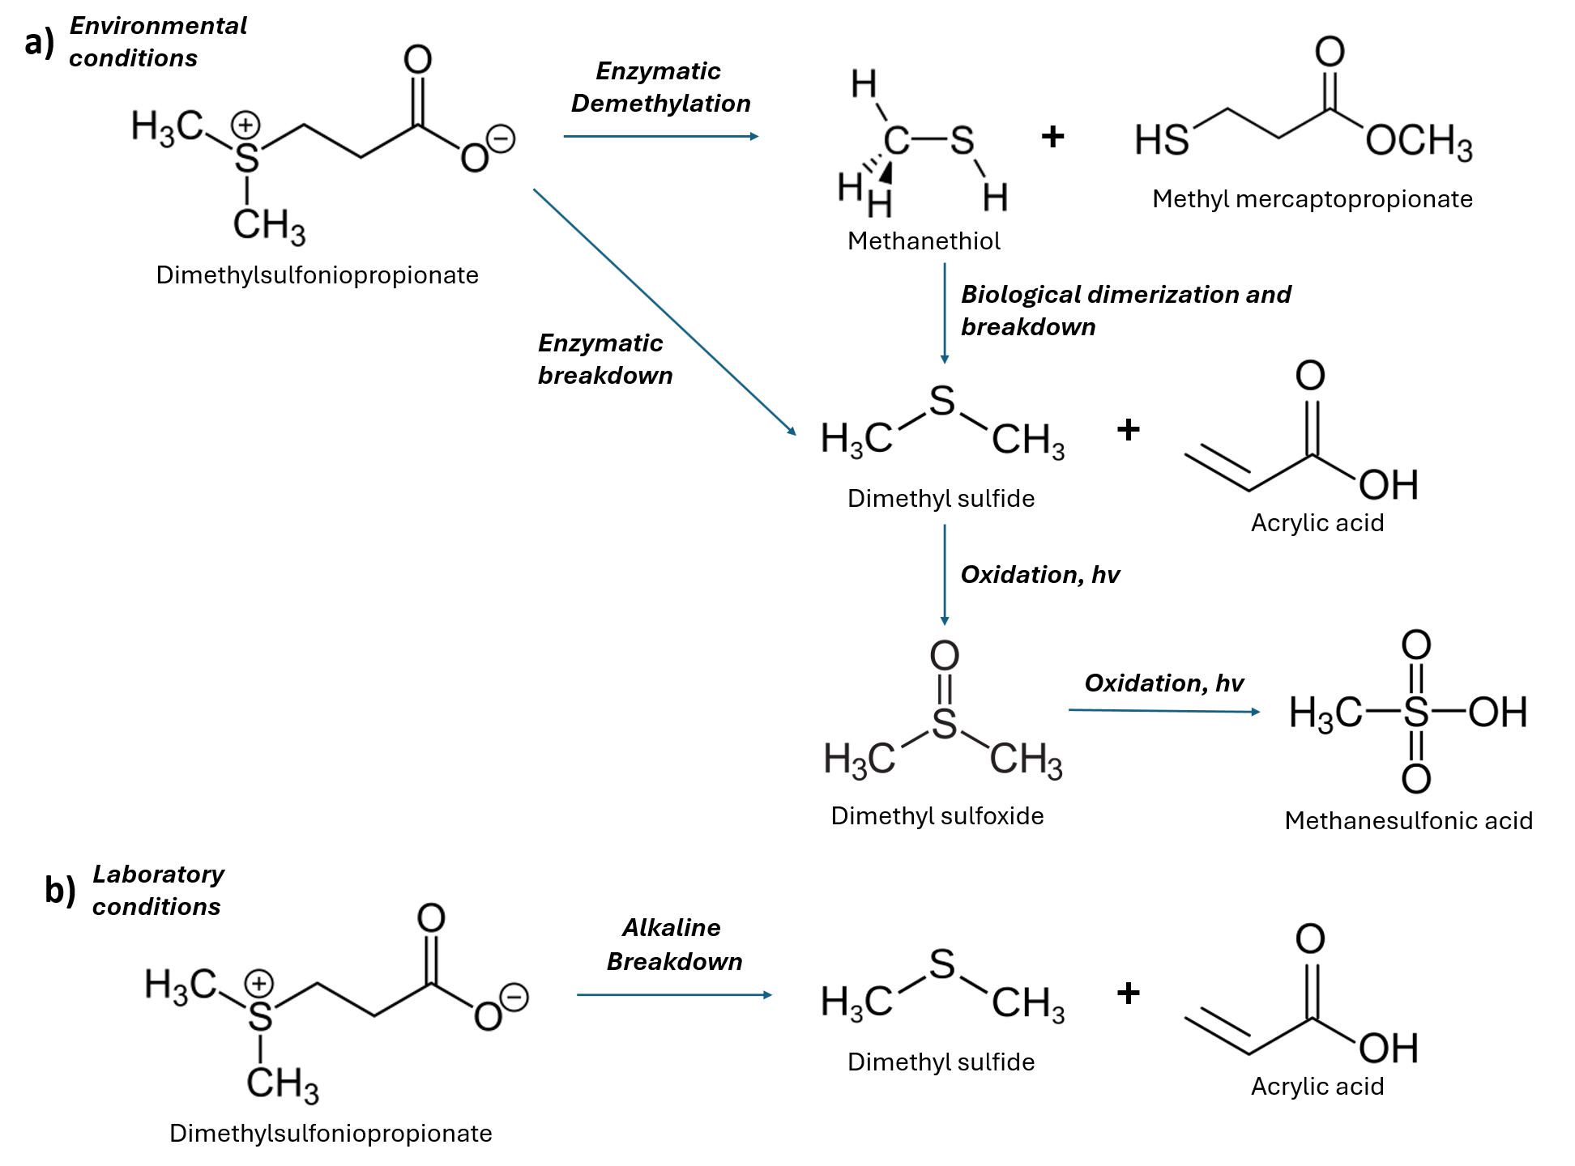
Figure 9 – Dimethylsulfoniopropionate breakdown reactions: a) in environmental conditions, b) in laboratory conditions

DMS also forms secondarily from methanethiol via biological dimerization and subsequently decomposes to DMS and hydrogen sulfide. Although methylmercaptopropionate does not produce DMS directly, it may contribute indirectly by transforming into methanethiol. These pathways are minor compared to the β-elimination of DMSP and are not stoichiometrically complete. Methanesulfonic acid is viewed as a stable product of DMS oxidation. In the atmosphere, it efficiently partitions into particles, thereby aiding secondary aerosol formation and cloud condensation nucleus formation [112]. Further chemical transformations of methanesulfonic acid are limited; slow biodegradation to sulfate has been reported in both aquatic and terrestrial environments.
The performance of the derivatization was evaluated by measuring the DMS in the sample headspace of water samples spiked with a NaOH solution and with Milli-Q water using the optimized DHS settings.

3.2.6 Determination of sea salt matrix effect
To evaluate the sea salt matrix effect (Section 3.3.7), a 5 mL sample of MilliQ water was analyzed as a blank. Then, 5 mL of water containing 100, 150, 200, and 250 mg of dissolved synthetic sea salt mixture was spiked with 10 µL of a 1.263 µg L⁻¹ solution of DMSP, followed by analysis using the optimized DHS method.

3.2.7 Method validation
External standard calibration was employed for method validation. DMSP calibration curves were obtained under the optimized DHS-GC-MS conditions by serial dilution of the initial solution (5,050 mg L⁻¹ in methanol) and the standard solution (25.25 μg L⁻¹ in methanol) in Milli-Q water, ranging from 0.051 μg L⁻¹ to 1010 μg L⁻¹.
The LODs were determined using a signal-to-noise ratio of three, which offers an appropriate compromise between sensitivity and the risk of false positives. This calculation accounts for the variability of the DMS analytical signal relative to the blank signals (3:1), yielding a robust estimate of the LOD. To assess the method’s repeatability and precision, RSD values were determined by spiking water samples with 1.26 μg L⁻¹ of DMSP and analyzing them in triplicate.

3.2.8 Determination of the rate of alkaline conversion of DMSP to DMS
To measure the conversion rate of DMSP to DMS under alkaline conditions, a series of controlled experiments was performed. Samples of 5.00 mL Milli-Q water (in a screw-cap vial) were spiked with DMSP to reach concentrations ranging from 0.05 µg L⁻¹ to 10.1 µg L⁻¹. Then, 500 µL of 10 M sodium hydroxide (NaOH) solution was added to initiate alkaline hydrolysis, breaking the sulfonium bond. The reaction was allowed to proceed for 2 hours, allowing DMS to equilibrate between the aqueous phase and the headspace. This method enables indirect measurement of DMSP by converting it into volatile DMS.

3.2.9 Application of the developed method
The validated method was subsequently applied to two different water samples [20]: i) influent and effluent 24-h composite samples collected from a wastewater treatment plant in Egå (Denmark), and ii) samples from experiments conducted in a sea spray simulation tank. The 5 mL water samples collected in the 20 mL amber glass screw top vial from the wastewater treatment plant in Egå (Denmark) include influent, which is raw water entering the cleaning system, and effluent, which is water after treatment. The samples from laboratory experiments were conducted in a sea-spray tank. The simulation tank investigated the release of DMSP and DMS from aquatic microalgae (haptophytes) in either saltwater or freshwater environments. The primary focus of the study was to determine the fraction of DMS emitted into the air. To simulate bubble-bursting scenarios, multiple plunging jets were used in the sea spray simulation tank. Each 5 mL sample aliquot was analyzed three times using DHS-GC-MS. No pretreatment steps were performed on the DMSP samples. The sea spray simulation tank prepared water samples were stored in a glass bottle with a polytetrafluoroethylene (PTFE)-lined screw cap and kept in a freezer at -18 °C.

3.3 Results and Discussion of the optimization of the method for DMS and DMSP in water

3.3.1 Selection of the sorbent
The influence of sorbent tube type on DMS response was studied using tubes prefilled with either Tenax® TA, known for its low affinity for water, or Carbopack B, which adsorbs low-molecular-weight analytes more efficiently. The effect of sorbent tube type was evaluated at different DMS concentrations ranging from 0.025 mg L⁻¹ to 2.527 mg L⁻¹ (Figure 10).

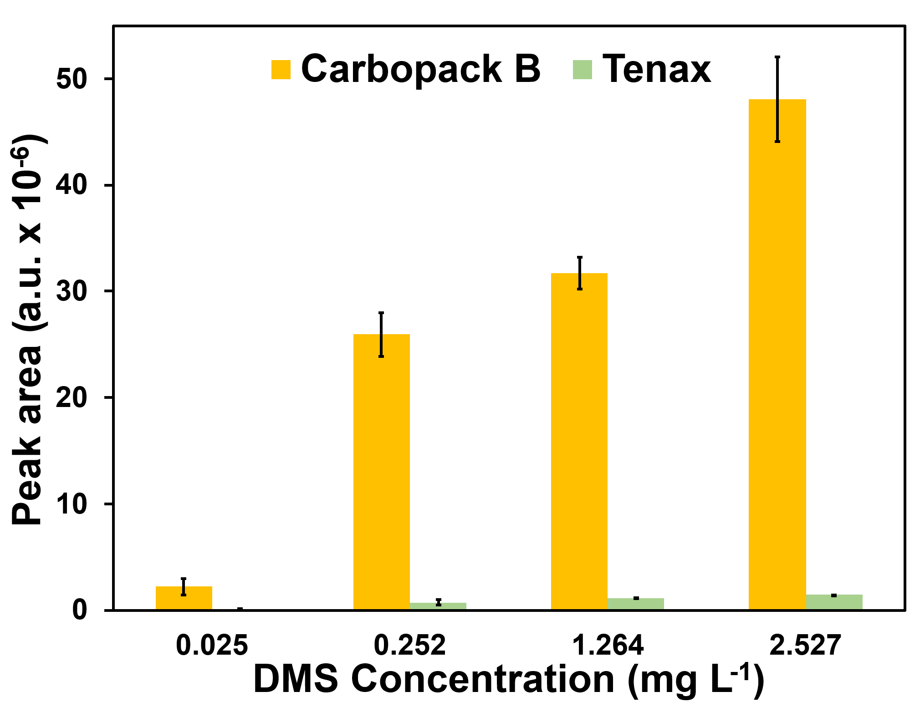

Figure 10 – The effect of sorbent types on DMS response. Trapping parameters: incubation temperature 30°C, sample temperature 30°C, gas volume 100 mL; Drying parameters: flow rate 100 mL min⁻¹, gas volume 500 mL, sorbent tube temperature 30°C
Significantly higher responses (peak areas) were observed with Carbopack B across all concentrations (analysis of variance, p > 0.05, ANOVA; Tukey test).
Sorbent tubes prefilled with Carbopack B showed more than a 34-fold increase in the response (peak areas) of DMS compared to the average response obtained using Tenax® TA prefilled tubes at all studied concentrations. Because DMS has a higher affinity for Carbopack B, this material was selected for further experiments to enhance the sensitivity of DMS analysis.
Although the Carbopack B sorbent tube performs better for DMS adsorption, it is difficult to control, especially in preventing water trapping and sorbent poisoning.

3.3.2 Incubation temperature
Incubation temperature is a vital parameter in the DHS extraction process because it greatly affects the volatilization of analytes from water samples into the headspace. Raising the incubation temperature increases the vapor pressure of water and BVOCs, thereby enhancing their migration into the headspace and improving extraction efficiency. However, optimizing the sample temperature requires balancing the analyte’s water-gas phase transfer with the risk of system contamination with water.
In this study, the effect of incubation temperature on analyte responses was examined within the range of 30 °C to 50 °C (Figure 11). Statistically significant changes in responses (peak areas) were observed when the incubation temperature was increased from 30 °C to 50 °C (analysis of variance p > 0.05, ANOVA; Tukey test).

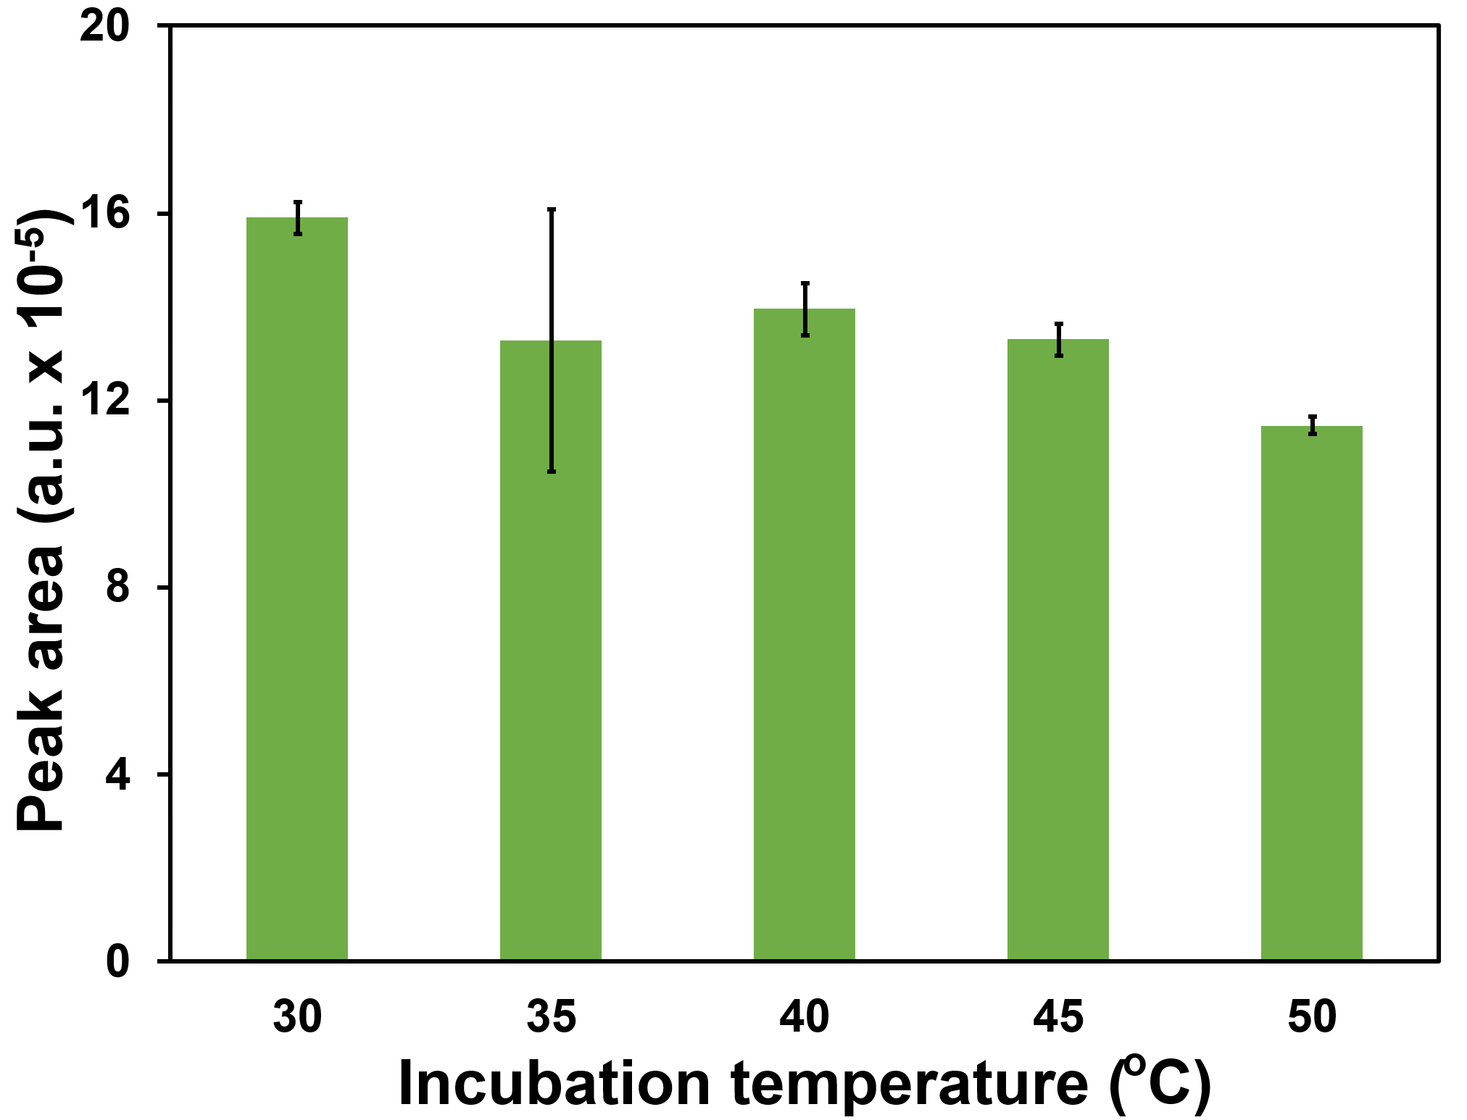

Figure 11 – The effect of vial incubation temperature on DMS response. Trapping parameters: sample temperature 30°C, gas volume 100 mL; Drying parameters: flow rate 100 mL min⁻¹, gas volume 500 mL, sorbent tube temperature 30°C

The response of DMS shows a gradual decrease with increasing incubation temperature up to 50 °C, as demonstrated in Figure 11, which is attributed to elevated water vapor pressure and resulting increased adsorption of water by the sorbent tube. RSDs were between 2% and 4% for most temperatures, except at 35 °C, where RSD was 21%, potentially due to unknown random experimental error in one of the samples.
For further experiments, a 30 °C incubation temperature was chosen as optimal, as it allows faster temperature equilibration of the sample during preparation and provides higher analyte responses.

3.3.3 Trapping gas volume
Due to limitations related to water interference when working with sorbent tubes pre-filled with Carbopack B, the effect of trapping gas volume on the DMS response was investigated over the gas volume range from 50 to 250 mL (Figure 12). Statistically significant changes in peak areas were observed when the trapping gas volume was increased from 150 mL to 250 mL (analysis of variance, p > 0.05, ANOVA, Tukey test).
A trapping gas volume of 250 mL yielded a DMS response that was 1.93 times higher than that obtained at 150 mL. The RSDs were 7% for the 250 mL volume and 19% for the 150 mL volume. Trapping gas volumes were not increased beyond 250 mL due to potential degradation of the Carbopack B sorbent. Since volumes below 250 mL did not significantly improve RSDs and produced lower DMS peak areas, 250 mL was chosen as the optimal volume to enhance analytical sensitivity.

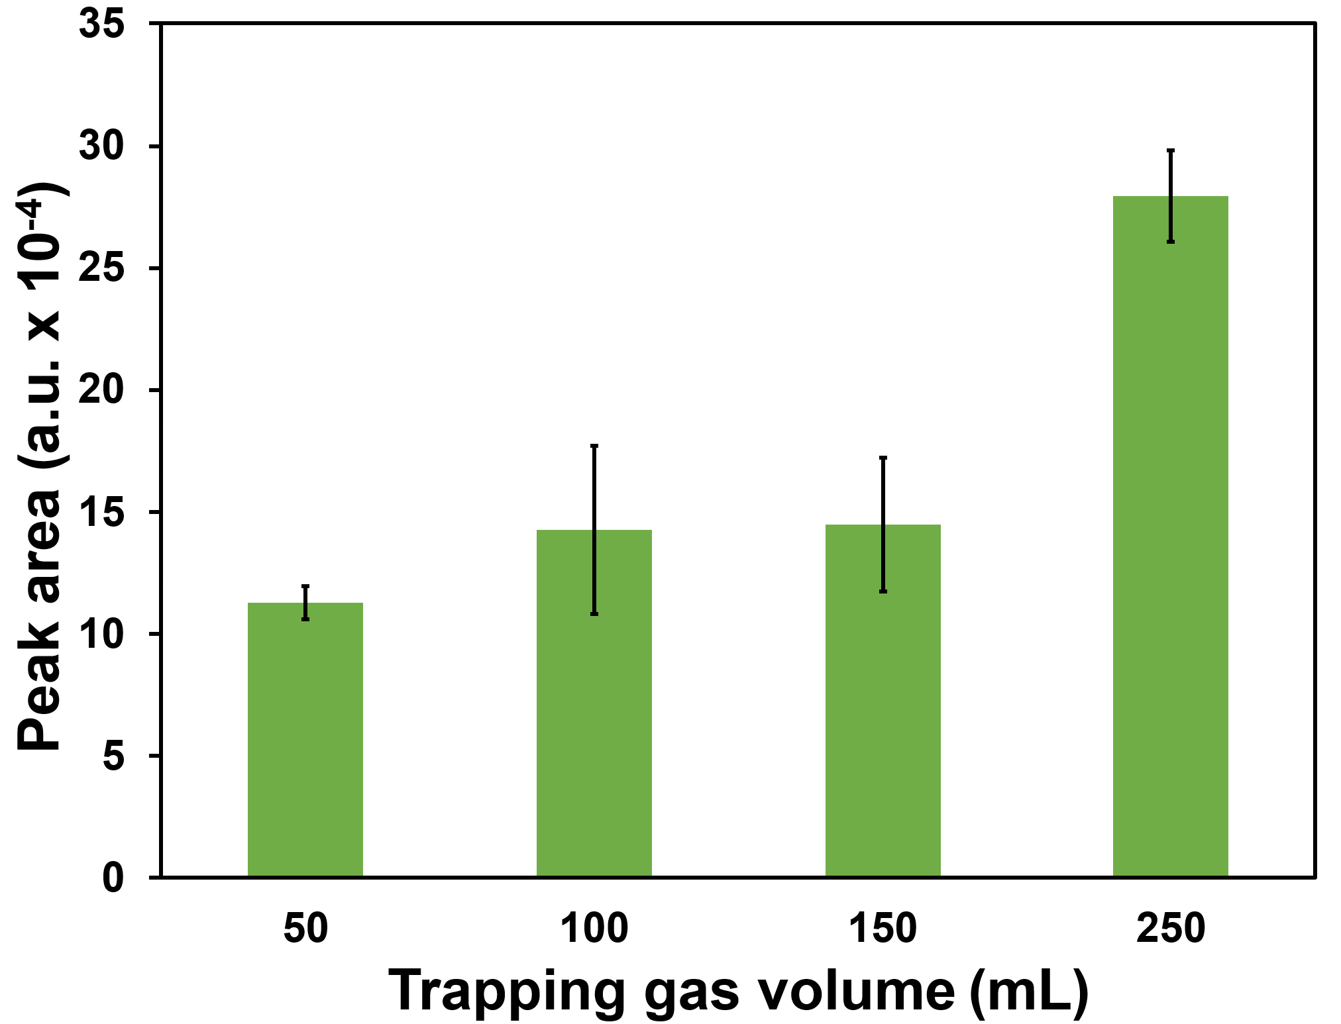

Figure 12 – The effect of trapping gas volume on DMS response. Trapping parameters: incubation temperature 30°C, sample temperature 30°C; Drying parameters: flow rate 100 mL min⁻¹, gas volume 500 mL, sorbent tube temperature 30°C

Increasing the sample temperature during trapping can enhance the mass transfer of analyte from the water sample into the sorbent tube. However, in this study, higher sample temperatures caused excessive water buildup in the GC inlet and cryo-trap. Therefore, the sample temperature for trapping was set to 30 °C to balance effective extraction with the prevention of system contamination with water [54].

3.3.4 Drying gas flow rate
Efficient water removal from the sorbent during the drying phase of the DHS procedure is crucial for analyzing DMS in water samples, primarily due to the high vapor pressure of the matrix. Drying of the sorbent tube investigates the effect of two key parameters on DMS measurements: drying gas flow rate and gas volume. Due to the high volatility (the Henry’s constant 7.1 L atm mol⁻¹ [113] at 25 ºC) and the low boiling point of DMS (35 °C), the drying temperature was set to the lowest possible value of 40°C.
Optimization of the drying gas flow rate in the DHS analysis aimed to balance reducing water contamination of the sorbent and preventing breakthrough of DMS adsorbed in the sorbent tube. Increasing the drying gas flow rate from 50 mL min⁻¹ to 100 mL min⁻¹ accelerates the release of trapped water from the sorbent tube and allows the use of a larger volume of drying gas at the same drying time. However, in this study, the drying gas flow rate did not significantly (p < 0.05, ANOVA; Tukey test) impact the recovery of DMS (Figure 13).

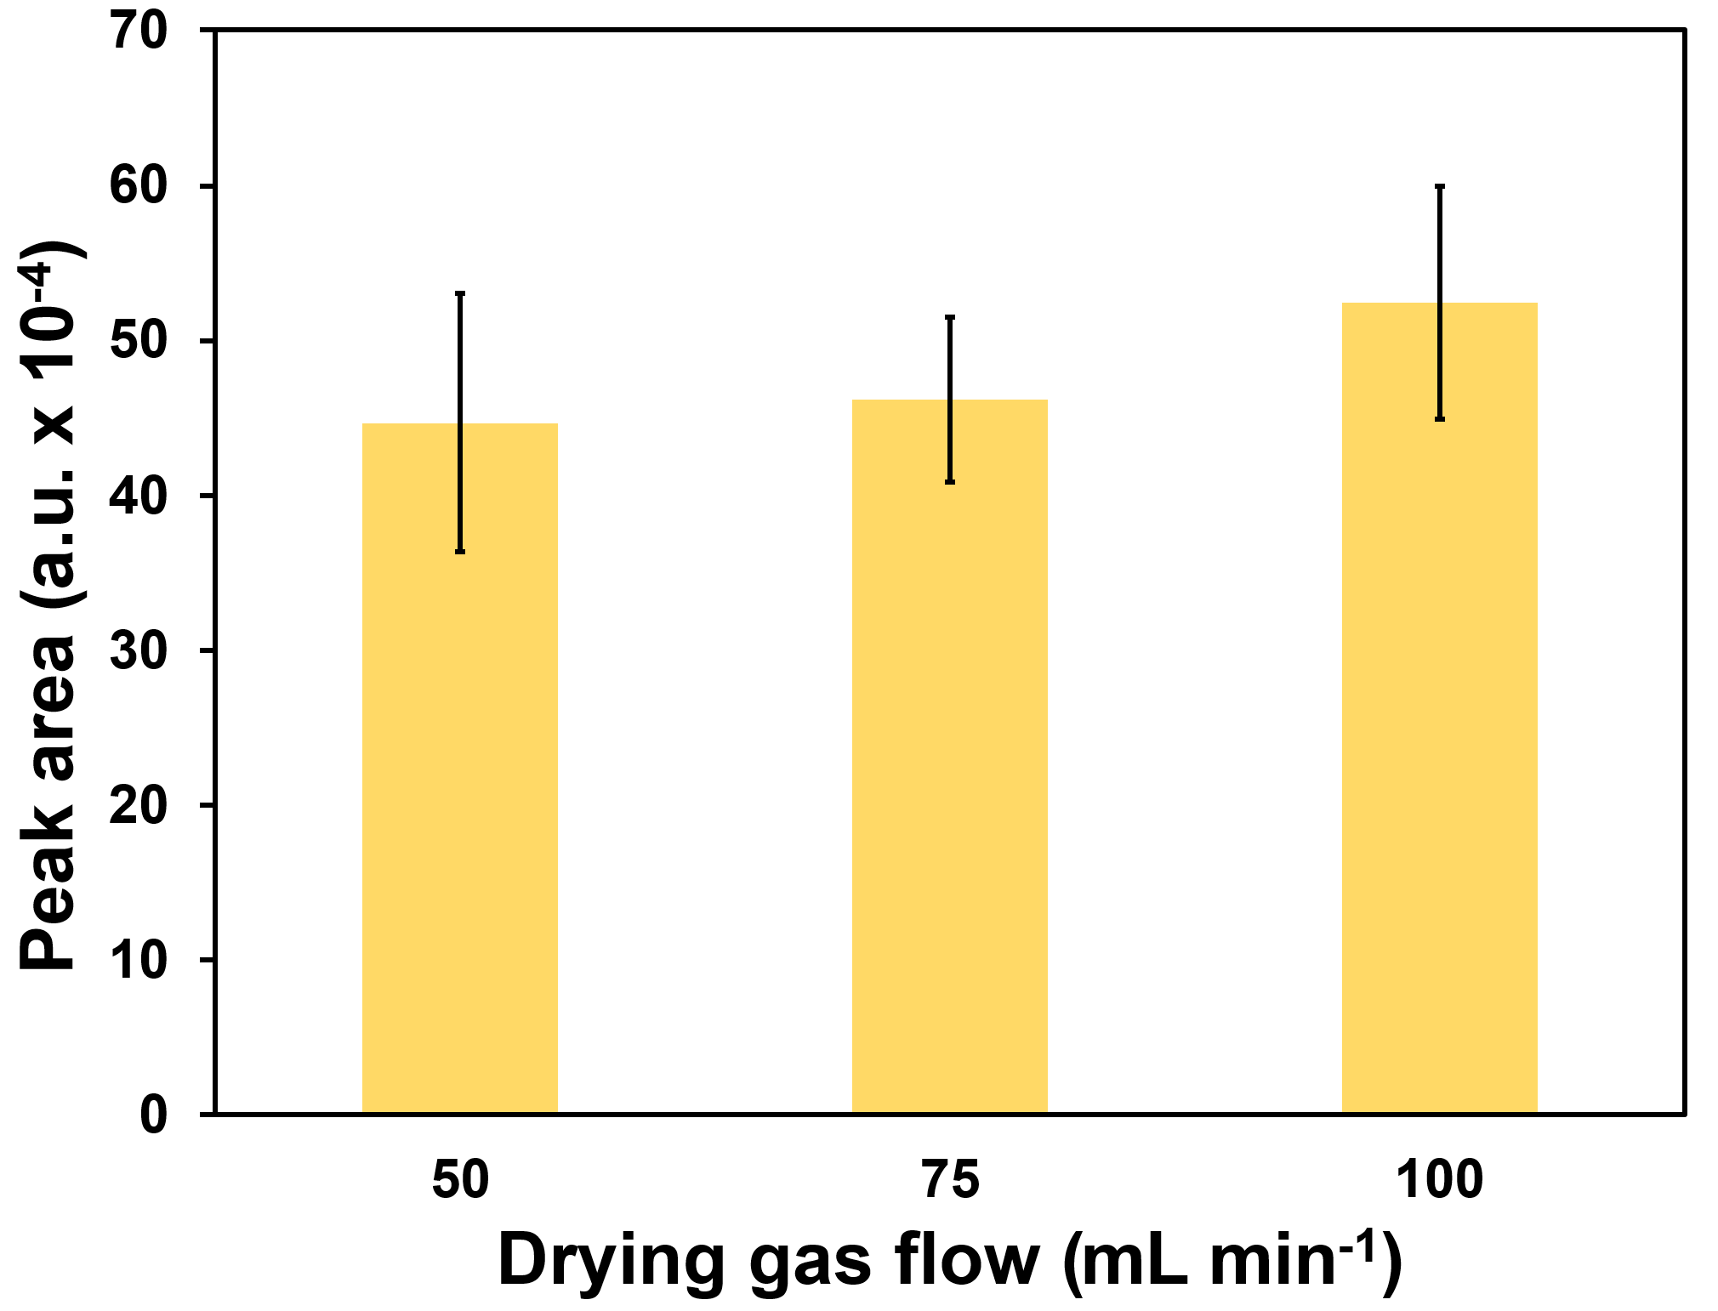

Figure 13 – The effect of drying gas flow rate on DMS response. Trapping parameters: incubation temperature 30°C, sample temperature 30°C, gas volume 250 mL; Drying parameters: gas volume 500 mL, sorbent tube temperature 30°C

The results demonstrate that DMS does not breakthrough from the sorbent due to the high adsorption ability of Carbopack B towards DMS. The RSDs of the DMS responses at the studied drying gas flow rates ranged from 12% to 19%. To reduce the sample preparation time, a drying gas flow rate of 100 mL min⁻¹ was selected as optimal for further experiments.

3.3.5 Drying gas volume
Increasing the drying gas volume from 200 to 300 mL enhanced the analytical response of DMS, however, a further increase to 500 mL led to breakthrough and consequent loss of DMS (Figure 14), using the optimized parameters (sorbent tube with Carbopack B, incubation temperature 30°C, trapping gas volume 250 mL, trapping temperature 30 °C, sorption tube drying temperature 30 °C, and drying gas flow 100 mL min⁻¹). Drying gas volume significantly affects (p < 0.05, ANOVA; Tukey test) the recovery of DMS when increased from 300 mL to 500 mL.
Increasing the drying gas volume from 200 to 300 mL resulted in a pronounced increase in DMS responses, up 42%.
The breakthrough of DMS from the sorbent with increasing drying gas volume from 300 mL to 500 mL and 1000 mL was indicated by peak area reductions of 50% and 53%, respectively.

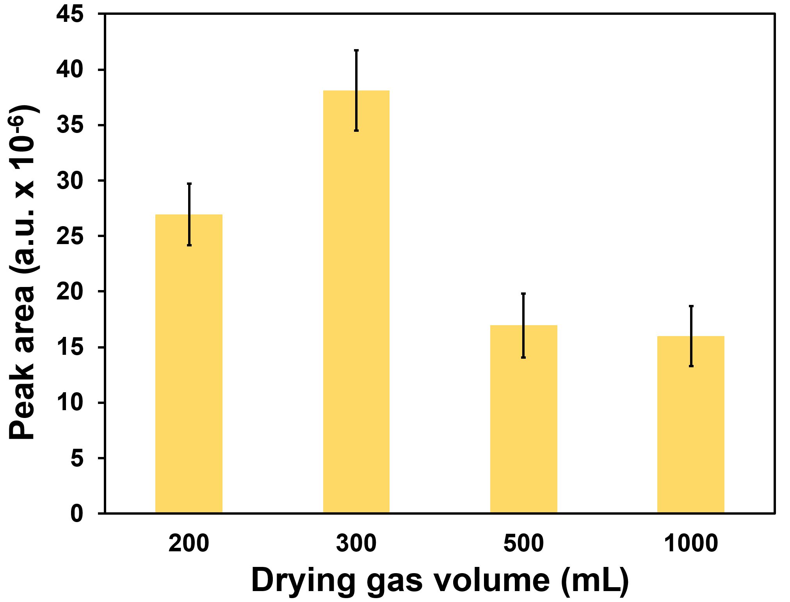

Figure 14 – The effect of drying gas volume on DMS response. Trapping parameters: incubation temperature 30°C, sample temperature 30°C, gas volume 250 mL; Drying parameters: flow rate 100 mL min⁻¹, sorbent tube temperature 30°C

The RSD of responses across different drying gas volumes ranged from 9% to 17%. The lowest RSD of 9% were achieved at 300 mL. To enhance the sensitivity of the analysis, a drying gas volume of 300 mL was selected as the optimal setting for further experiments.

3.3.6 DMSP preservation and derivatization
Due to the presence of propionic groups in the DMSP molecule, shifting the acid-base equilibrium of the samples is commonly used either to increase the stability of aqueous solutions by acidification for sample storage and transportation or to facilitate the release of DMS by alkaline cleavage for analysis. A series of experiments was performed to investigate the effect of pH on the preservation and derivatization of DMSP in water (Figure 15).

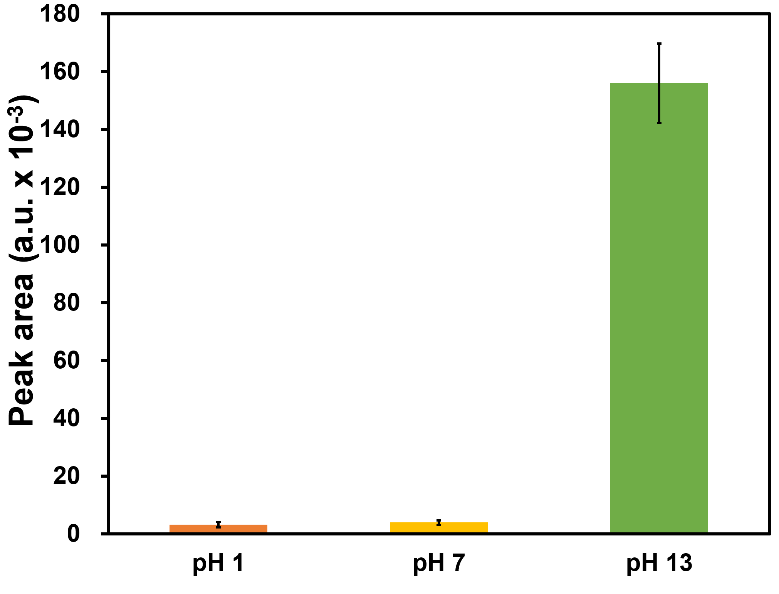
Figure 15 – The effect of pH on the preservation or derivatization of DMSP. DMSP concentration 1.26 µg L⁻¹

To this end, the DMS concentrations in the sample headspace were measured using the optimized DHS parameters (sorbent tube prefilled with Carbopack B, incubation temperature 30°C, trapping gas volume 250 mL, trapping temperature 30°C, sorption tube drying temperature 30°C, drying gas flow rate 100 mL min⁻¹, drying gas volume 300 mL).
Acidification and freezing the sample in gas-tight glassware are key tactics to safely transfer the sample from the field to the laboratory for DMSP analysis [107,108]. In the first set of experiments, we tested the hypothesis that acidifying the water sample containing DMSP would prevent the release of DMS into the sample headspace, resulting in no significant change in its peak area compared to a DMSP water sample at pH 7. To test this hypothesis, we measured DMS peak areas in DMSP water solution at 1.26 µg L⁻¹ (pH 7) and in a 1.26 µg L⁻¹ DMSP solution acidified with 50 µL of 85% orthophosphoric acid (pH 1). The acidified sample (pH 1) exhibited a 19% lower peak area (Figure 15) compared with the neutral solution (pH 7). Acidification of the samples was selected in the optimized method to suppress microbial activity and thereby prevent the biodegradation of DMSP.
Second, we tested the hypothesis that adding 500 µL of 10 M NaOH to 5.0 mL (pH 13) water samples pre-acidified with 50 µL of 85% orthophosphoric acid containing DMSP would release DMS into the headspace through alkaline cleavage of the carbon-sulfur bond. An increase in the pH of the DMSP solution to 13 resulted in a 50 and 41-fold increase in the DMS peak area compared to the acidified and neutral DMSP solutions, respectively (Figure 15). Therefore, the hypothesis was confirmed, demonstrating the reaction of alkaline hydrolysis of DMSP to release DMS into the headspace for subsequent DHS sampling.

3.3.7 Sea salt matrix effect
The effect of the sea salt content on DMS responses in water was studied using optimized DHS parameters to assess the feasibility of comparing DMSP concentrations between saltwater and freshwater. In this study, the matrix effect was determined for sea salt concentrations ranging from 0% to 5% (Figure 16).

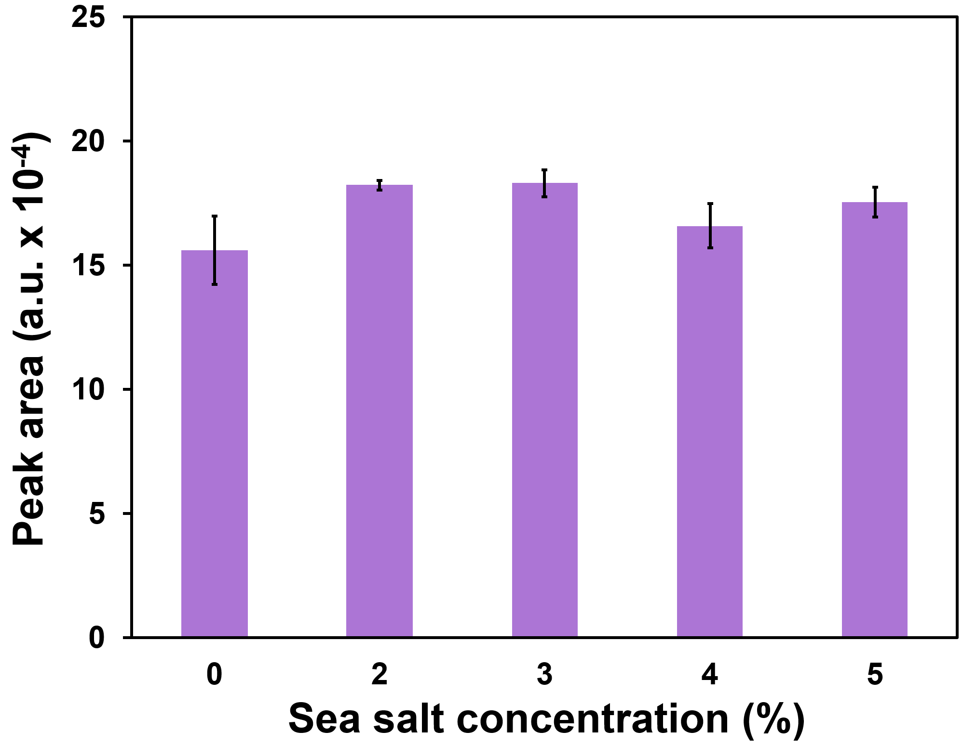

Figure 16 – Effect of sea salt concentrations on DMS response. DMSP concentration 1.26 µg L⁻¹

The addition of a sea salt matrix did not result in a statistically significant difference in DMS responses (p > 0.05, ANOVA; Tukey test). The RSD values ranged from 1% to 9%. Results indicate that the optimized DHS method is robust against sea salt matrix effects for DMSP, yielding comparable results in saltwater, Milli-Q water, and environmental matrices. Sea salt has a minimal impact on the DMS peak area, simplifying sample preparation and reducing potential matrix-related errors. Furthermore, the enhanced analytical precision observed with sea salt suggests its potential benefit for routine DHS analysis of environmental samples containing seawater or saline matrices.

3.3.8 Conversion of the DMSP to DMS
Alkaline hydrolysis of DMSP successfully generated measurable amounts of DMS. The released DMS equilibrated between the aqueous phase and the headspace and was collected using a sorbent tube, then analyzed by GC-MS. Quantification was based on a DMS calibration curve. The calculated DMS concentrations were then compared to the initial spiked DMSP levels to evaluate the conversion efficiency. This method allowed for an accurate indirect determination of DMSP and demonstrated consistent conversion efficiencies across the concentrations studied here.

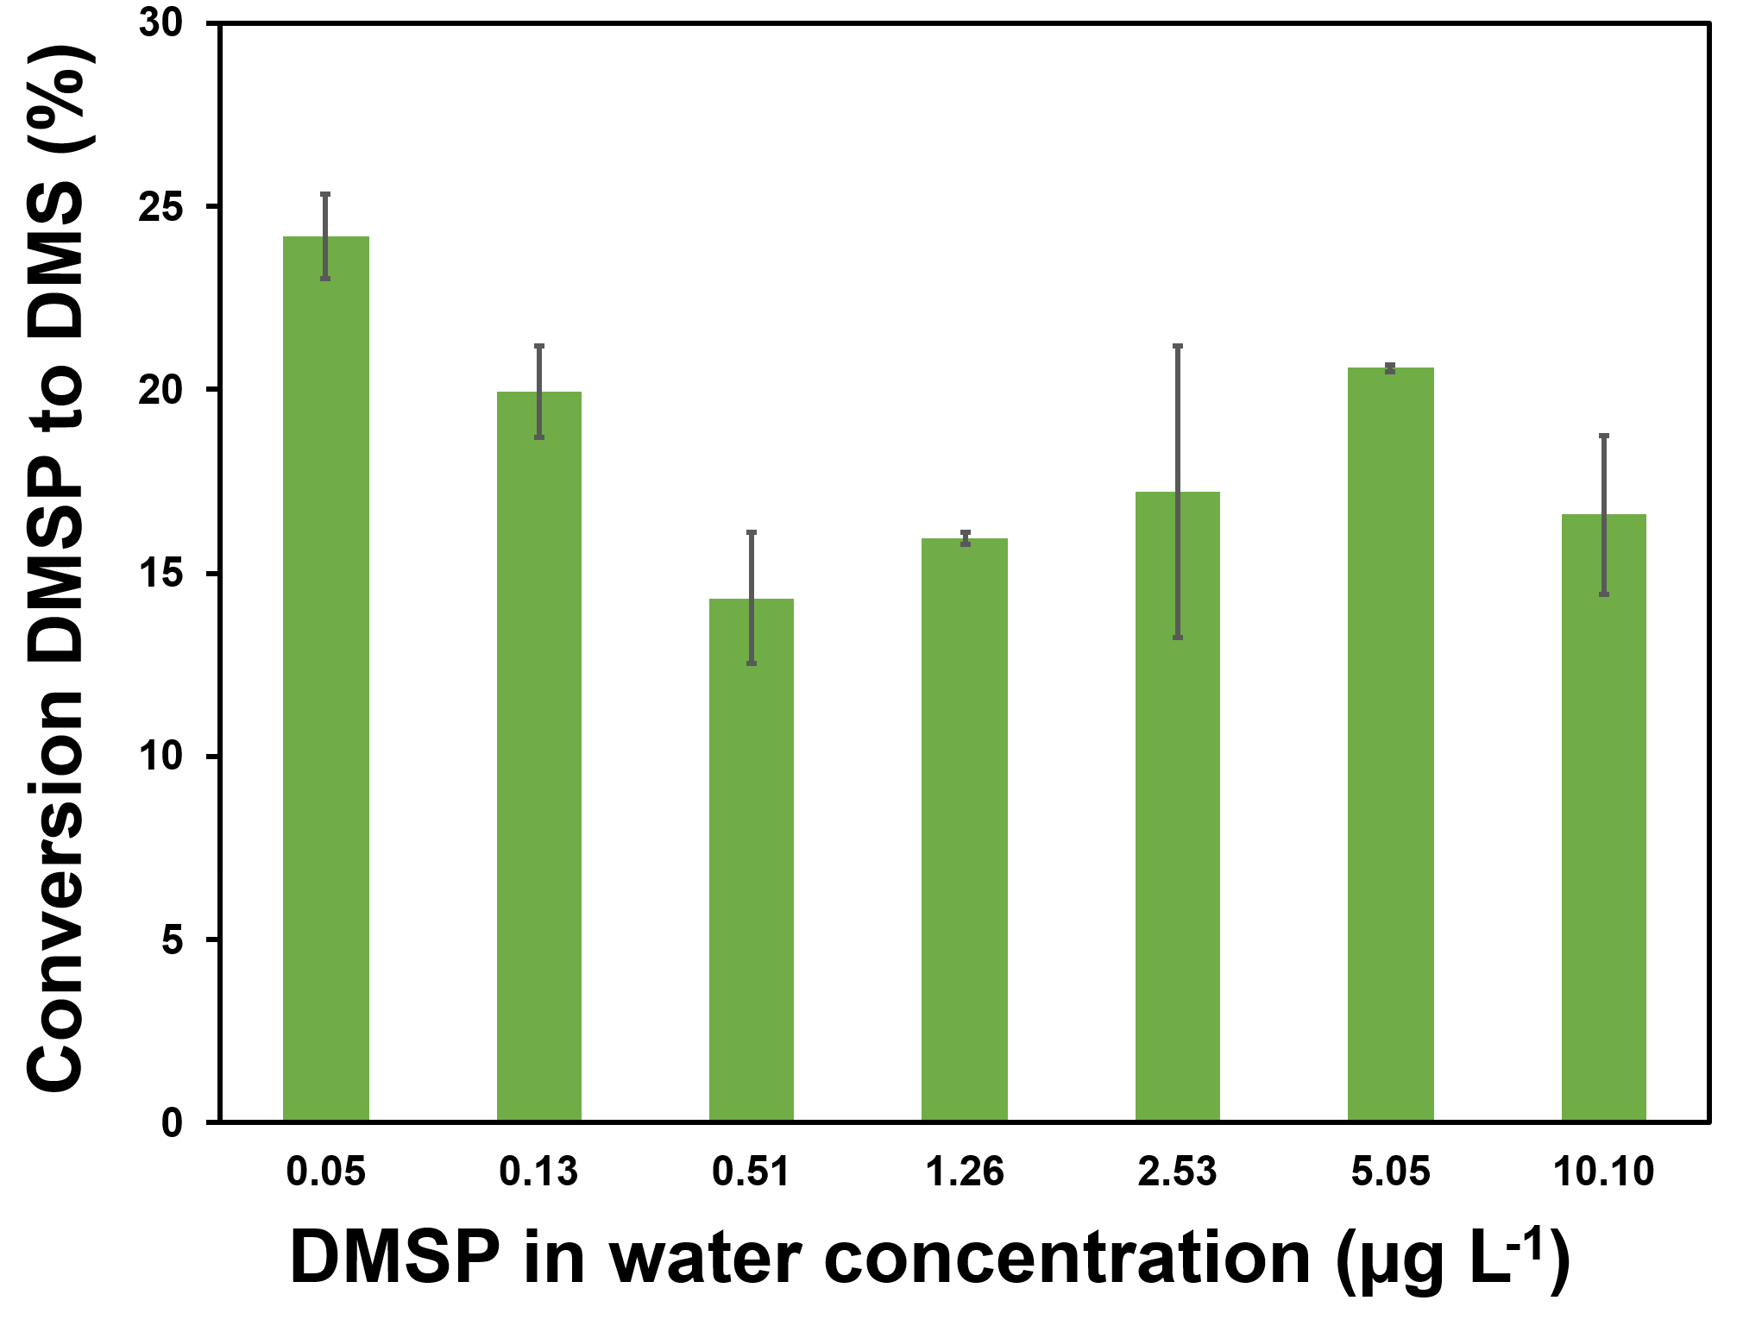

Figure 17 – Conversion of the DMSP to DMS under alkaline conditions

According to the results presented in Figure 17, the conversion of DMSP to DMS via alkaline hydrolysis in aqueous solution exhibited stable efficiency, ranging from 14% to 24% across a wide DMSP concentration range (0.05 µg L⁻¹ to 10.1 µg L⁻¹). On average, 19±5% of the initial DMSP was converted to DMS and successfully trapped on the sorbent tube.
These findings indicate that the alkaline hydrolysis reaction proceeds consistently across the tested concentrations and that a precise fraction of the produced DMS can be recovered for quantification.

3.3.9 Analytical performance of the developed DHS method
Method validation was performed for two DHS-proposed methods for DMSP and DMS, as well as the HS method for DMSP [20], using external calibration. For the DHS method, DMS concentrations in the range of 0.04 - 42 μg L⁻¹ and DMSP concentrations in the range of 0.05-1010 μg L⁻¹ showed strong linear correlations with coefficients of determination (R²) ≥ 0.997 and 0.999, respectively (Table 5).

Table 5 – Comparison of the analytical performance of the proposed DHS-based method with the static headspace method

Method | R² | Linear range  (μg L⁻¹) | RSD of slope (%) | RSD of response (%) | LOD  (μg L⁻¹) | LOQ  (μg L⁻¹) | Recovery (%)
Dynamic Headspace DMS | 0.997 | 0.04 - 42 | 2 | 4 | 0.008 | 0.03 | 105 ± 3
Dynamic Headspace DMSP | 0.999 | 0.05 - 1010 | 0.4 | 8 | 0.014 | 0.05 | 100 ± 4
Headspace DMSP | 0.996 | 10 - 1010 | 4 | 8 | 2 | 7 | 107 ± 2

For the static HS method, DMSP concentrations from 10 μg L⁻¹ to 1010 μg L⁻¹ yielded R² values ≥ 0.996. The RSDs of the slopes for DHS calibration plots were 2.0% for DMS and 0.4% for DMSP, whereas the RSD of the slope for the static HS method was 4%. These results demonstrate the high analytical performance of the developed methods for DMS and DMSP.
Determination of dimethylsulfoniopropionate via derivatization to dimethyl sulfide combined with optimized dynamic headspace extraction yields a 34-53-fold increase in analytical response relative to a conventional headspace-based method (Figure 18).
For the DHS method, the LOD and LOQ were 0.008 μg L⁻¹ and 0.03 μg L⁻¹ for DMS, and 0.01 μg L⁻¹ and 0.05 μg L⁻¹ for DMSP, respectively. In comparison, the static HS method showed much higher LOD and LOQ values for DMSP, at 2.2 μg L⁻¹ and 7.4 μg L⁻¹. These results emphasize the high sensitivity of the DHS technique for detecting trace amounts of DMS and DMSP. The relative standard deviations for the DHS method were 4% for DMS and 9% for DMSP, demonstrating good precision and repeatability. The accuracy was assessed through analyte recoveries, which ranged from 100% to 107% across all tested conditions.

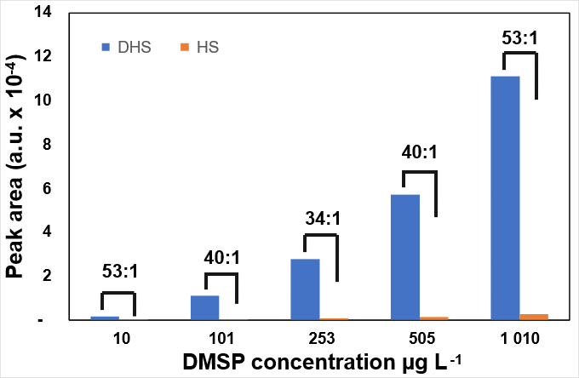

Figure 18 – Analytical response of optimized DHS method relative to a static HS-based method

These findings confirm that the DHS method offers reliable analytical performance for measuring DMS and DMSP in complex environmental water samples, where both sensitivity and accuracy are essential.

3.3.10 Application of the developed method
The proposed method was applied to quantify DMSP concentrations in 2 wastewater treatment plant samples [20] and in 23 samples from laboratory experiments conducted in a sea-spray simulation tank (Table 6).

Table 6 – Application of the proposed DHS-based method on real water samples

Sample description | Water type | DMSP concentration (µg L⁻¹)
Influent wastewater | Sewage water | 9.01
Effluent wastewater | Treated water | <LOD
Multiple Jet Bulk | Salt water | 310
Multiple Jet Bulk | Fresh water | 450

The wastewater treatment plant samples showed a significant decrease in DMSP concentration after treatment. The influent (untreated) wastewater sample (Table 6) exhibited a high DMSP concentration of 9.01 µg L⁻¹. Effluent water samples demonstrated effective removal of impurities with DMSP concentrations below the LOD.
DMSP was detected in bulk water samples from the sea spray simulation tank experiments in both freshwater and saltwater environments. Higher DMSP concentrations were observed in the freshwater environment at 450 µg L⁻¹. Initial algae concentrations in the tank were higher in the saltwater experiment; however, temperatures during the experiment reached levels lethal to many microalgal cells. This could explain lower DMSP values in saltwater experiments, which were 310 µg L⁻¹.

3.3.11 Comparison of the developed method with established methods
Standardized methods for the determination of volatile organic compounds in water, such as US EPA 524.2 and 8260, are typically based on purge-and-trap extraction followed by GC-MS analysis. These methods provide high sensitivity but involve direct purging of the sample, which may lead to water vapor transfer, matrix interferences, and potential losses of semi-volatile compounds. The developed DHS-GC-MS method combines dynamic headspace extraction with TDU and CIS, enabling efficient analyte preconcentration while minimizing water interference. Compared to P&T, the DHS approach avoids direct bubbling through the liquid phase and provides improved robustness in complex matrices such as saline water and samples containing dissolved organic matter. The developed method introduces optimized extraction conditions for compounds with different physicochemical properties and integrates drying and trapping steps to reduce matrix effects. The method demonstrated good analytical performance, including low detection limits (LOD down to 0.014 µg L⁻¹), high linearity (R² > 0.995), and good repeatability (RSD < 5%).
The developed DHS method for targeted analysis of DMS and DMSP in water samples marks a significant improvement in environmental analytical techniques. The DHS method demonstrates competitive analytical performance compared with conventional techniques such as headspace solid-phase microextraction, purge-and-trap, and static headspace. The DHS method achieves lower LOQ and LOD values than those reported for most common headspace, purge-and-trap, and HS-SPME methods (Table 7), highlighting the DHS technique's very high sensitivity for trace-level detection of DHS and DMSP in aquatic environments.
Compared with HS-SPME [103,104,114,115], a widely used method for volatile organic compound analysis, the DHS method exhibits comparable performance. Although HS-SPME can achieve exceptionally low LODs (as low as 0.00001 μg L⁻¹ [114]), it is often limited by fiber fragility, matrix interferences, and inconsistent extraction due to water condensation, particularly in aqueous matrices. DHS includes a drying step before thermal desorption, thereby effectively reducing water-related interferences and ensuring stable analytical signals. Moreover, DHS is more amenable to automation and reproducibility, which are the key factors for routine monitoring.
The P&T method has long been considered a gold standard for VOC analysis [99,116,117] due to its high sensitivity and low detection limits, with reported LODs as low as 0.00005 μg L⁻¹. However, this method is complex, time-consuming, and requires large sample volumes. In comparison, DHS achieves nearly comparable detection limits with significantly smaller sample volumes, lower risk of cross-contamination, and shorter processing times. While P&T systems provide high accuracy, they also incur higher operational and maintenance costs, which limit their practicality.

Table 7 – Methods for the determination of DMSP and DMS in water samples

Sample preparation procedure | Method type | Analyte(s) | Water type | Sample volume (mL) | LOD (μg L⁻¹) | RSD (%) | Recovery (%) | Reference
DHS | GC-MS | DMS | Seawater, Freshwater | 5 | 0.008 | 4 | 105 | This study
DHS | GC-MS | DMSP | Seawater, Freshwater | 5 | 0.014 | 8 | 100 | This study
HS-SPME | GC-MS | DMS, DMSP | Seawater | 5 | 0.00001 | <5 | 93 ± 4 | [114]
HS-SPME | GC-MS | DMS, DMSP | Seawater | 5 | 0.003 | 7 | >90 | [115]
HS-SPME | GC-FPD | volatile sulfur compounds | Freshwater | 5 - 20 | 0.09 | 11.4-4.7 | 87 -112 | [104]
HS-SPME | GC-FPD | DMS, DMSP | Seawater | 10 | 0.173 | NR | NR | [103]
MSSF-CL | photon signal analyzer | DMS | Seawater | 10 | 0.0009 | 1.75 | 94 –108 | [118]
Teflon tube direct connection | PTR-MS | DMS | Seawater | NR | 0.003 | 4.60 | 100 | [119]
P&T | Portable DMS sensor (FDS) and GC-FPD | DMS | Seawater | 800 | 0.00005 | NR | NR | [120]
P&T | GC-MS | DMS, DMSP | Pond water and  seawater | 10 | 0.001 | 0.80 | NR | [116]
P&T | GC-PFPD | DMS | Seawater | NR | 0.003 | NR | NR | [99]
P&T | Organic Sulfur Sequential Chemical Analysis Robot (OSSCAR) | DMS, DMPS, DMSO | Seawater | 2.5 | 0.006 | 10 | 97-100 | [117]
P&T | GC-MS | DMS, DMSP | Seawater | 25 | 0.018 | 2.27-19.56 | 95 | [121]
P&CT | GC-FPD | DMSOd,  DMSOp | Seawater | 40 | 0.046 | NR | NR | [122]
P&T | GC-PFPD | DMS, DMSP, and DMSO | Seawater | 25 | 0.155 | 3.0 - 7.4 | 69 -78 | [123]
P&T | GC-FPD | DMS | Seawater | 10 | 18.63 | NR | NR | [124]
P&T Homemade | GC/MC-ICPMS | DMS, DMSP | Seawater | NR | NR | 3.0-6.2 | >98 | [125]
DHS of DMSP | GC-MS | DMS,  DMSP | Seawater | 5 | 2.2 | 7.8 | 107 | Repeated [20]
HS | GC-FID | DMS | Seawater | 5 | 6.21 | NR | NR | [20]
HS | GC-FPD | DMS,  DMSP | Seawater | 5 | 6.21 | NR | NR | [100]
Note:
HS-SPME – Headspace Solid Phase Microextraction;
P&T – Purge and trap device;
FDS – Fluorescence Detection Sensor;
MSSF-CL – Microslug gas-liquid segmented flow-chemiluminescence;
GC-FPD – Gas chromatography flame photometric detector;
GC-PFPD – Gas chromatography pulsed flame photometric detector;
GC/MC-ICPMS – Gas chromatography coupled with multicollector inductively coupled plasma mass spectrometry;
HS – Headspace;
P&CT – Purge and cryotrap device;
GC-FID – Gas chromatography flame ionization detector;
PTR-MS – Proton transfer reaction-mass spectrometry;
NR - Not reported.
In terms of non-sorptive HS methods [20], although they require minimal sample preparation and demonstrate the lowest equipment costs, they are generally less sensitive, with LODs often above 2 μg L⁻¹ for DMSP. These methods also exhibit strong matrix effects and poor efficiency for low-volatility compounds, limiting their application in complex environmental samples. DHS addresses these limitations by using thermal desorption with cryo-trapping, which enables improved volatilization, analyte focusing, and recovery, even for semi-volatile or reactive analytes such as DMS and DMSP.
Recent advances, such as flow-chemiluminescence (MSSF-CL) and proton-transfer reaction mass spectrometry (PTR-MS), include low detection limits and fast analysis times. However, these methods require specialized, expensive equipment, limiting their accessibility to many environmental laboratories. Moreover, they are not always suitable for complex matrices or require careful calibration to avoid interferences. DHS, while slightly less sensitive in absolute terms, offers broader accessibility and versatility across various sample types and research objectives.

3.3.12 Limitations and potential disadvantages of the DHS-GC-MS method

Despite the advantages of DHS-GC-MS, several limitations should be considered. The method relies on non-equilibrium extraction and sorbent trapping, which may introduce selectivity depending on the sorbent material and extraction conditions, potentially affecting quantitative accuracy for compounds with different volatilities. In addition, optimization of multiple parameters (temperature, purge flow, drying conditions) increases method complexity.
Compared to static HS, DHS provides significantly lower detection limits due to exhaustive extraction; however, static HS offers simpler operation and better representation of phase equilibrium, which may be advantageous for routine analysis. Compared to SPME, DHS generally achieves comparable sensitivity and reproducibility, but the SPME method requires less instrumental configuration.
In comparison with P&T, DHS demonstrates reduced water interference and improved robustness in complex matrices, as it avoids direct bubbling through the sample. However, P&T may provide comparable or higher sensitivity for certain highly volatile compounds and remains a standardized technique in environmental analysis.
Furthermore, DHS requires specialized instrumentation (TDU, CIS, sorbent tubes) and careful control of trapping and desorption steps, which may limit its accessibility. Despite these limitations, the method offers a favorable balance between sensitivity, robustness, and applicability to complex aqueous matrices.

3.3.13 Greenness assessment of the developed methods
Green analytical chemistry (GAC) aims to minimize the environmental impact of analytical procedures by reducing reagent consumption, waste generation, energy consumption, and sample volume while maintaining high analytical performance. In this context, the AGREEprep metric provides a systematic tool for evaluating sample preparation methods based on key GAC principles.
In this study, the adequacy of DHS, static HS, SPME, and P&T extraction methods for DMS/DMSP determination was assessed using the AGREEprep approach. Overall, the DHS method stands out as a green, efficient, and analytically robust technique for the determination of DMS and DMSP. It combines high sensitivity, low detection limits, and strong reproducibility with moderate equipment demands and low operational costs. Its ability to quantify trace-level analytes with minimal sample preparation, coupled with compatibility for automation and environmental greenness (AGREEprep score 0.40, Figure 19), makes DHS particularly well-suited for both laboratory and field-based monitoring of volatile sulfur compounds in marine and freshwater systems.

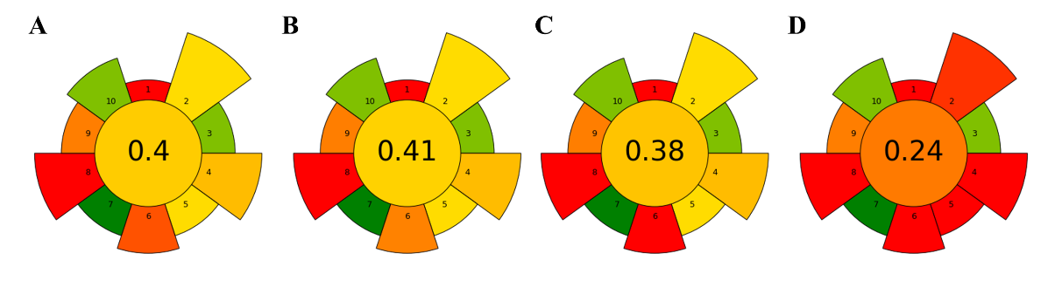
Figure 19 – Comparison of assessment results for methods for the determination of DMS and DMSP in water. (A) Dynamic headspace, (B) Non-sorptive headspace, (C) Solid-phase microextraction, D) Purge-and-trap

In this section, the compliance levels of selected methods for DMS/DMSP determination in water were assessed based on the 10 principles of GAC using the AGREEPrep method. The static headspace (SH) [20], solid phase microextraction [114], and purge-and-trap [116] methods were systematically evaluated. The results of the obtained assessment are summarized in Figure 18. Sample preparation methods are compatible with full automation using commercially available devices and meet the requirements for analyzing DMS and DMSP.
An energy consumption of 900 W was considered consistent across all techniques, as identical GC-MS instrumentation and operating conditions were used. According to the AGREEprep assessment (Table 8), DHS, HS, and SPME showed similar overall greenness scores (0.38-0.41), while purge-and-trap had a markedly lower score (0.24), mainly due to higher solvent use, larger sample sizes, and increased waste production. DHS offered a balanced compromise between analytical performance and environmental sustainability.
The calculated AGREEPrep score of 0.4 indicates that while the method is solvent-free and minimizes waste, it is influenced by the energy-intensive nature of the automated DHS and GC-MS systems. To shift this value towards a more sustainable profile, several approaches can be considered. First, miniaturization of the sampling system would reduce the energy required for heating and cooling cycles. Second, replacing helium with hydrogen from renewable sources as a carrier gas would improve the 'Green' score. Furthermore, transitioning from a strictly GAC perspective to White Analytical Chemistry (WAC) would provide a more holistic evaluation. The WAC 'RGB' model integrates analytical excellence (Red), environmental safety (Green), and cost-effectiveness (Blue). DHS-GC-MS method already demonstrates strong ‘Red’ qualities (low LODs and high precision) and ‘Green’ qualities (no use of organic solvents). By further improving ‘Blue’ aspects through shorter GC run times and increased automation, the method would achieve a better balance, fulfilling the requirements of White Analytical Chemistry for routine environmental monitoring.

Table 8 – Sample preparation procedure comparison based on AGREEprep criteria

Criterion | DHS | HS | SPME | P&T
Sample preparation placement | Ex situ
Hazardous materials (g or mL) | 0.5 | 0.5 | 0.5 | 5
Sustainability, renewability, and  reusability of materials | > 75% of reagents and materials are sustainable or  renewable
Waste, (g or mL) | 5 | 5 | 5 | 100
Mass or volume of the sample, (g or mL) | 5 | 5 | 5 | 100
Sample throughput, [samples/h] | 2 | 3 | 1 | 1
Sample prep. Steps. | automated | automated | automated | automated
Energy consumption, watt | 900 | 900 | 900 | 900
Post-sample preparation  configuration for analysis | gas chromatography with a quadrupole
Operator’s safety | 1 hazard
Overall score | 0.4 | 0.41 | 0.38 | 0.24

The standard static non-sorption HS method received a total score of 0.41. Method presented as: low setup and maintenance cost, minimal sample preparation operations, and the fastest sample preparation method. However, the non-sorptive HS method demonstrates low sensitivity for trace-level analyte detection and a strong matrix effect that negatively affects the response.
The SPME method is a static sorption sampling method and achieved a total score of 0.38. The method offers moderate equipment and maintenance costs, is lightweight, and is suitable for portable sampling, making it a nondestructive sample preparation technique. Nevertheless, as a static method based on sorption on fiber, this method is time-consuming and susceptible to matrix effects, exhibiting relatively higher standard deviations.
The P&T method is a dynamic sampling technique and received an overall score of 0.24. The P&T method offers the highest sensitivity among methods, high reproducibility, and accuracy, with minimal matrix effect. However, this method requires the highest equipment and maintenance costs, is time-consuming, and poses a risk of cross-contamination between samples.
Dynamic headspace is a sorption-based method that achieved an overall score of 0.40. The DHS method demonstrated high sensitivity and repeatability, as well as low matrix effects, owing to the drying step, which removes water from the sorbent tube prior to desorption. The method requires moderately priced equipment but offers low maintenance costs. The DHS method represents a green and efficient approach for the determination of trace levels of DMSP and DMS in water samples, combining solvent-free sample preparation, low waste generation, and good analytical performance. These characteristics demonstrate strong alignment with the principles of Green Analytical Chemistry.

3.4 Section conclusion

In this study, we developed, optimized, and validated a DHS-GC-MS method to quantify DMS accurately and indirectly estimate DMSP in water samples. The advancements provided here tackle key analytical challenges related to the volatility, reactivity, and matrix effects of biogenic sulfur compounds, offering a green, efficient, and reproducible workflow suitable for routine monitoring of complex environmental samples.
Systematic optimization of DHS parameters, including incubation temperature, trapping time, desorption conditions, sorbent choice, and moisture control, resulted in a highly sensitive and robust analytical procedure. The optimized method achieved LOD 0.008 and LOQ 0.014 µg L⁻¹ for DMS, enabling trace-level measurement without the need for large sample volumes or extensive sample preparation. Calibration curves showed excellent linearity over several orders of magnitude (R² > 0.996), with RSDs below 8%.
The alkaline conversion process for indirect DMSP measurement was thoroughly evaluated. Conversion efficiencies remained at an average of 19 ± 5% of the initial DMSP, and the optimized conditions minimized side reactions that could bias the results. Recovery tests in water samples confirmed high accuracy 105 ± 3% for DMS and 100 ± 4% for DMSP.
Applying the method to real environmental samples showed clear and consistent differences in DMSP levels in raw wastewater (9.01 µg L⁻¹), treated effluent (<LOD), and microalgae-rich systems (310 - 450 µg L⁻¹), highlighting its ability to detect biogenic variation and treatment effects. These findings support the method’s relevance for environmental monitoring, ecological studies, and sulfur biogeochemistry research.
From a sustainability standpoint, the DHS-GC-MS approach significantly reduces the use of organic solvents and sample-prep reagents, aligning with green analytical chemistry principles. This is reflected in an AGREEprep score of about 0.40, positioning the method as a greener alternative to traditional purge-and-trap or liquid–liquid extraction methods.
Overall, the developed analytical strategy offers a robust, sensitive, and eco-friendly framework for measuring DMS and DMSP in various water samples. Its high performance, reliability, and suitability for real environmental testing make it a valuable tool for future investigations into biogenic sulfur emissions, algal metabolism, wastewater changes, and climate-related aerosol formation.

4 APPLICATION OF THE METHOD FOR DIMETHYL SULFIDE AND DIMETHYLSULFONIOPROPIONATE IN WATER SAMPLES WITH MICROALGAE

Preamble
The part of the materials and results described in this section is in press in the publication by Bernadette Rosati, Jane Tygesen Skønager, Marat Bektassov, Zihui Teng, Marianne Glasius, Merete Bilde, Marta Barbato, Kasper Vita Kristensen, Sylvie V.M. Tesson, titled “Investigating the emissions of dimethyl-sulfide during aerosolisation of microalgae // Climate and atmospheric science, Nature portfolio journal. – 2025.” – and reprinted in an open-access journal under the Creative Commons Attribution-NonCommercial-NoDerivatives 4.0 license. The copyright to these materials belongs to Springer Nature, and any request for further use of this information should be requested from them.

4.1 Introduction

Atmospheric aerosols have major implications for Earth’s radiative balance by interacting with solar radiation and influencing cloud formation [126,127]. Primary biological aerosol particles (PBAPs), defined as directly emitted airborne particles of biological nature [128], including airborne microalgae, unicellular microorganisms, and one of the least studied organisms in aerobiology [129]. The aerosolisation potential of aquatic microalgae has been described to occur primarily during wave-breaking-mediated bubble bursting at the water surface, transferring compounds present in bulk water into the atmosphere [130,131]. The importance of airborne microalgae for the climate ramains largely unknown.
Emissions of chemical compounds from aquatic microalgae have been extensively studied [132–135]. These include VOCs such as DMS [136], which constitute the largest source of naturally emitted sulfur to the atmosphere. Several studies indicate that only a small fraction, approximately 10%, of the DMS produced in ocean water is emitted into the atmosphere [137], while the majority of DMS is decomposed by microbes [138,139] or photochemically oxidized in water [140,141]. Atmospheric DMS mixing ratios in marine [142–144] and freshwater environments [145–147] range from a few ppt to approximately 12 ppb [17,142,146,148–151]. Atmospheric DMS can be oxidised by hydroxyl radicals to form aerosol particles consisting mainly of methane sulphonic acid (MSA) and sulfuricic acid, ultimately leading to the formation of sulphate aerosols [152–155] that are known to be excellent cloud condensation nuclei [156,157]. Due to the reduction in sulfur-based fossil fuels, natural sulfur emissions now play a key role in global sulphate aerosols [158]. Although the major importance of DMS and sulphate aerosols for climate is recognized, their detailed roles in atmospheric chemistry and the mechanisms involved in VOC release remain unclear.
The DHS-GC-MS-based method developed for quantification of DMS and DMSP (Chapter 3) was used in a study to investigate the aerosolization potential and concurrent release of DMS from two microalgal species of haptophytes from freshwater (FW) and saltwater (SW) habitats in controlled laboratory experiments. The chosen marine species, CCMP284, was previously identified as a common representative of phytoplankton and a major producer of DMSP [159].

4.2 Methods

4.2.1 Microalgal strains
Two haptophyte strains were investigated: the freshwater species Chrysochromulina parva (CCMP291, BIGELOW culture collection) was cultivated in Modified Wright’s Cryptophyte medium [160]. The seawater species Chrysotila dentata was cultivated in L1+Si medium with a salinity of 3.5% [161]. This strain was ordered as CCMP284 (BIGELOW culture collection), but genetic analyses demonstrated that the strain belongs to Chrysotila dentata. The 18S ribosomal DNA gene of the two strains was amplified as described in [162]. Sequences were aligned against the GenBank nucleotide library using the Blastn function. Alignment of the 18S sequences of the freshwater strain (467 bp; PV799978) belongs to Chrysochromulina parva (99.79% identity with AM491019.2) and of the seawater strain (436 bp; PV799979) to Chrysotila dentata, also called Pleurochrysis dentata (100% identity with KJ756811). In the article, the two haplotype strains are mentioned by their habitat characteristics, i.e., freshwater (FW) and seawater (SW) strains in sea ice salinity simulation (SiSS) experiment. Strains were grown in a controlled climate room at 15 °C, 25-30 µmol photon m⁻² s⁻¹, 12 h light: 12 h dark.
Cultures were non-axenic, indicating that associated prokaryotes were present in the culture. Prokaryotes were present attached to the microalgal cells or free-living in the culture medium. Visualization of microalgal bionts was performed by epifluorescence microscopy as described in [135].

4.2.2 Experimental Procedure
The experimental setup was comparable to the one described in [135]. A stainless-steel sea spray generation tank was used to investigate the aerosolization potential of microalgae by simulating processes occurring during wave breaking [163]. For salt water experiments, an aqueous solution containing syntenic sea salt with the composition: 55% Cl⁻, 31% Na⁺, 8% SO4, 4% Mg²⁺, 1%K⁺, 1%Ca²⁺, <1% other (Sigma Aldrich S9883; mass fractions) was mixed with MilliQ water (EMD Millipore, 18.2 MΩ·cm at 25ºC resistivity, 2 ppb TOC) to reach a salinity of 3.5%, as is most common in the ocean [129]. The salinity during the experiments was measured using a portable refractometer (Bie and Berntsen A.S., Denmark) to be 3% (measured during experiment SW5). For freshwater experiments, pure MilliQ water was used. The tank finally contained 10 L of solution and approximately 5 L of headspace. pH was monitored during experiments by using Dosatest® pH test strips (pH 0-14, REF 85410.601, VWR, Germany). The tank was operated either with a single plunging jet (SJ; nozzle diameter 4 mm) or by multiple jets (MJ; eight 2 mm nozzles). The MJ design is configured at a 12° angle relative to the vertical axis. The water flow rates depended on the pump setting and specific jet: SJ with pump setting 1 (SJ1) was 2.44 L min⁻¹, SJ3 4.5 L min⁻¹, and SJ9 6.3 L min⁻¹; MJ with pump setting 3 (MJ3) was 8.7 L min⁻¹. Particularly, SJ9 and MJ3 were chosen as they reached the highest particle number concentrations. Before treatments, a Homogenisation step was included using SJ9 for 10 min to provide a homogenized suspension of salt or freshwater and microalgae ensemble.
2
Clean sweep air (5 L min⁻¹in Exp. SW1, SW2, SW3, FW1, FW2, FW3, and 10 L min⁻¹ in Exp. SW4, SW5, SiSS) was pushed through the headspace, providing slightly more air than needed by the connected instruments. Techniques to monitor aerosolised particles and emitted gases were directly connected to the headspace. Potential wall and bottom effects were not considered.

4.2.3 Aerosol Particle Instrumentation
The aerosolised fraction was continuously monitored with an optical particle size spectrometer (OPSS 3330; TSI) and a white-light aerosol spectrometer (WELAS 2300; Palas). The OPSS utilized a flow of 1 L min⁻¹ to monitor particles with diameters between 0.3 µm and 10 µm optical diameter in 16 bins, while the WELAS had a flow rate of 5 L min⁻¹ and was set to measure particles from 0.25 µm to 10 µm optical diameters in 59 bins. As the OPSS was available during all experiments, total aerosol concentrations are only provided from OPSS. Total number concentrations in Exp. SW4 and SW5 were multiplied by a factor of 2, due to the dilution by the increased sweep air in these experiments compared to the other experiments. Dry aerosol properties were measured by placing a silica gel diffusion dryer in front of OPSS and WELAS. The diameters of the OPSS and WELAS measurements represent sizes of particles with a scattering potential comparable to that of polystyrene latex spheres (PSL) with an index of refraction (IR) of 1.59.
Aerosolised organisms were also collected in an impinger (NS 29/32 25×250 mm, Assistant, Duran) for a duration of approximately 1 h with a flow rate of 2 L min⁻¹ and 50 mL of culture medium (as described in [164]).

4.2.4 DMSP Measurements
Samples of bulk water as well as the impinger were analysed by gas chromatography coupled with mass spectrometry. To preserve DMSP in the water sample, it was spiked with 50 µL of 85 % orthophosphoric acid. 5.00 mL of sample was loaded into a 20 mL crimp-top vial and spiked with 500 µL of 10 M NaOH to perform the laboratory breakdown of DMSP to DMS [20].
All analyses were performed on a GC-MS 7890B/5977A (Agilent, USA) equipped with a cooled CIS4 and MPS2 autosampler system (Gerstel, Germany). Separation of analytes was performed using a 30 m × 0.25 mm HP-5ms capillary column (Agilent Technologies, USA) with a 0.25 μm film thickness, and helium (99.9999 % purity, Denmark) at a constant flow rate of 1 mL min⁻¹. The oven was programmed from 30°C (held for 3 min) to 35°C (held for 3 min) at a heating rate of 5 °C min⁻¹, then ramped to 280 °C (held for 3 min) with a heating rate of 30 °C min⁻¹. The total GC run time was 18.17 min.
Commercially available sorbent tubes filled with Carbopack B were employed for trapping volatile compounds from the headspace. The DHS method was configured with the following parameters: incubation temperature 30°C, trapping gas volume 250 mL, trapping gas flow rate 100 mL min⁻¹, sample temperature 30°C, and sorption tube temperature 30°C. The transfer line heater was set to 120°C for the remainder of the sample preparation process. Prior to analysis, the sorbent tube was dried using 300 mL of purge gas at a flow rate of 100 mL min⁻¹ and a tube temperature of 40°C to remove residual moisture. The developed DHS method enables detection of trace levels of DMSP, with the LOD and LOQ determined to be 0.0075 µg L⁻¹ and 0.025 µg L⁻¹, respectively.

4.3 Results and discussion

During all experiments with salt water (SW1-SW5) and during the pure sea salt experiment (SiSS), a salinity of 3.5% was used. N denotes the total number of cells loaded into 10 liters of water (mean ± SD); Temperature of the air and water indicate the temperature measured at the beginning and the end of the experiment in air and water, respectively (Table 9); flow denotes the aerosolisation type i.e. whether a single jet (SJ) at pump intensities 1, 3 or 9 or a multiple jet (MJ) at pump intensity 3 was used. pH was measured in the water tank at the end of the experiment

Table 9 – Experimental conditions and instrumentation
Exp. | Date | N [10⁶ cells] | T_{air} [°C] | T_{water} [°C] | pH | Flow | Offline analysis
SW1 | 19.01.2022 | 92.4 ± 8.8 | 23.5 / 22.0 | n.m. / 32.0 | n.m. | SJ9, MJ3 | DHS-GC-MS
SW2 | 12.07.2022 | 19.7 ± 4.8 | 25.5 / 25.5 | 25.0 / 29.0 | n.m. | SJ9 | Tenax® Tubes
SW3 | 13.10.2022 | 108.0 ± 5.1 | 20.0 / 21.5 | 20.5 / 23.0 | 8.5 | SJ9, MJ3 | Tenax® Tubes, FCM
SW4 | 08.11.2022 | 26.6 ± 2.9 | 20.5 / 20.5 | 21.5 / 23.0 | 8.5 | SJ9, MJ3 | Tenax® Tubes, FCM
SW5 | 09.11.2022 | 5.3 ± 0.7 | 20.0 / 22.0 | 20.0 / 22.5 | 8.5 | SJ1, SJ3, SJ9, MJ3 | Tenax® Tubes, FCM
FW1 | 25.01.2022 | 32.0 ± 24.8 | 21.5 / 23.0 | 23.0 / 27.0 | n.m. | SJ9, MJ3 | GC-MS-DHS
FW2 | 11.07.2022 | 172.8 ± 36.2 | 24.0 / 24.0 | 23.0 / 25.0 | n.m. | SJ9 | Tenax® Tubes
FW3 | 11.10.2022 | 627.9 ± 57.9 | 20.0 / 21.0 | 21.5 / 23.0 | 6.5 | SJ9, MJ3 | Tenax® Tubes, FCM
SiSS | 23.05.2023 | n.m. | 22.5 / 22.5 | 22.0 / 24.0 | n.m. | SJ1, SJ3, SJ9 | n.m.
Note:
FCM - flow control module;
n.m. stands for ‘not measured’.

DMSP concentrations were analysed using the developed DHS-GC-MS-based method in experiments conducted with salted water and freshwater (Figure 20). Initial DMSP concentrations in the starter samples were low, amounting to approximately 65 µg L⁻¹ in freshwater, while no detectable DMSP was observed in the corresponding salted-water starter samples. An apparent increase in DMSP was observed after Homogenisation (approximately 4-fold, reaching 243 µg L⁻¹ in freshwater compared with the starter DMSP concentration), with comparable values between the salted-water and freshwater experiments. Subsequent treatments involving a single jet and multi jet did not strongly affect DMSP concentrations in salted water, and remained relatively stable, typically between 236 and 324 µg L⁻¹, indicating limited sensitivity to the applied jet treatments. In contrast, freshwater samples exhibited greater variability, with the highest DMSP concentrations (up to 450 µg L⁻¹) observed after multi-jet treatment and the lowest after single-jet treatment (51µg L⁻¹). Simultaneous measurements demonstrated the simultaneous release of microalgal biomass and DMS during bubbling, whereas only background levels of aerosols and DMS were detected after bubbling ceased (salted water), highlighting the critical role of bubble-mediated processes in the exchange of volatile sulfur compounds between air and water.

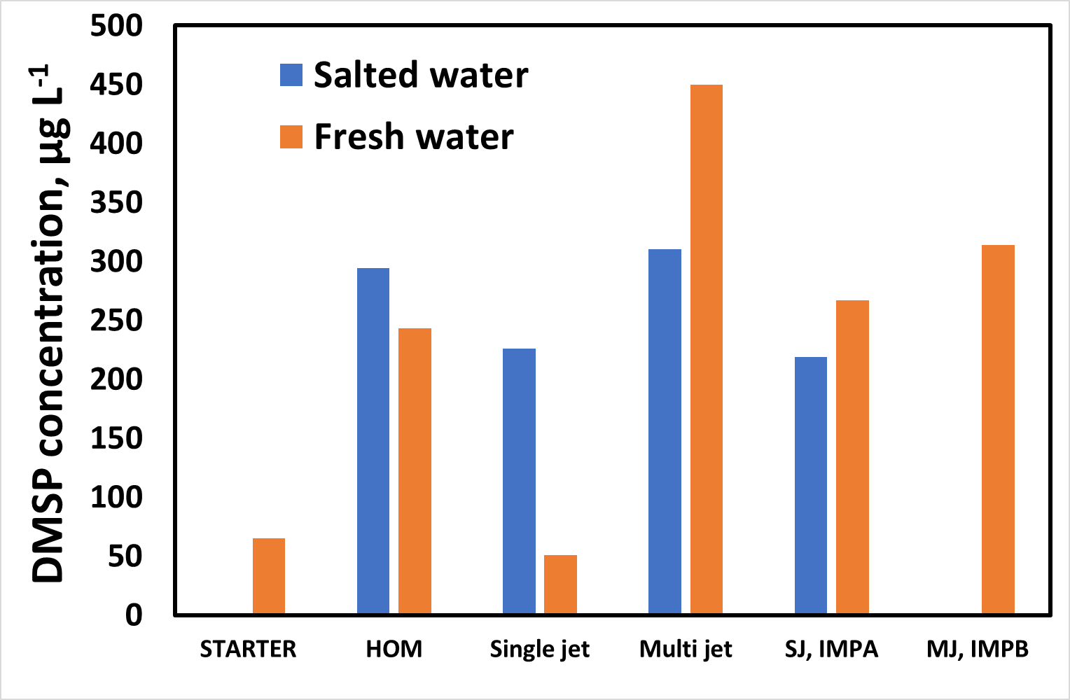

Figure 20 – Dimethylsulfoniopropionate (DMSP) in μg L⁻¹ for different stages of the experiments FW1 and SW1. The samples were taken after the stated treatment. SW - saltwater; FW - fresh water; SJ - single jet; MJ - multiple jet; HOM - homogenisation; IMP – impinger

A concurrent release of the microalgae ensemble and DMS was measured during bubbling. At the same time, background levels of aerosols and DMS were recorded when bubbling was stopped, highlighting the importance of bubbles in the air-sea exchange of volatile compounds in this study. DMS emissions from lakes have typically been found to be considerably lower than those [145–147], over the ocean, whereas results indicate comparable DMS emissions between freshwater and saltwater experiments. A potential explanation is that although the processes of DMS release are equivalent, the conditions encountered in real FW and SW environments differ, resulting in distinct atmospheric outcomes [165]. Moreover, the diversity of microalgae that produce DMS is typically higher in the ocean than in freshwater environments.
Seasonal variations in DMS and DMSP concentrations may be related to the biological cycle of microalgae, including growth phases, bloom formation, and subsequent decomposition processes. Elevated concentrations are typically observed during periods of active growth and bloom, while lower levels may correspond to post-bloom conditions and decreased biological activity. However, in this study, environmental sampling was limited to the method used, and additional biological parameters (e.g., algal biomass or nutrient levels) were not monitored. Therefore, a detailed interpretation of seasonal patterns was beyond the scope of this work.
Therefore, the DHS-GC-MS-based method was successfully applied to monitor the production of DMS and DMSP by freshwater microalgal species Chrysochromulina parva and seawater microalgal species Chrysotila dentata in water under varying aerosolization conditions. The results indicate that dispersal of the studied microalgae strains across geographic scales is unlikely. In contrast, their potential impact on climate is driven by their release of DMS, with implications for new particle formation in the atmosphere and for cloud formation. In addition to its relevance to atmospheric processes, this work highlights the methodological advantages of the optimized DHS–GC-MS approach. The method enables reliable, sensitive, and reproducible quantification of DMS and DMSP in complex aquatic and biological matrices under dynamic spray conditions, demonstrating its suitability for controlled studies of biogenic sulfur emissions and air–water exchange processes. The successful application of the optimized protocol to microalgal systems under controlled bubbling conditions underscores its potential for mechanistic studies of sulfur cycling, as well as for future laboratory and mesocosm investigations aimed at linking biological activity with atmospheric precursor emissions.
The developed DHS-GC-MS method can be considered suitable not only for targeted analysis but also for limited suspect or non-target screening of volatile and moderately volatile organic compounds in water samples. The combination of dynamic headspace extraction and cryo-focusing enables enrichment of trace-level analytes, which may facilitate the detection of previously unidentified compounds. However, the method shows reduced efficiency for low-volatility semi-VOCs due to limited gas-phase transfer and sorbent selectivity. Therefore, its applicability for comprehensive non-target screening is constrained, and complementary extraction techniques would be required for a full coverage of semi-volatile compound classes.

4.4 Section conclusion

The application of the optimized DHS-GC-MS method to freshwater (Chrysochromulina parva) and seawater (Chrysotila dentata) microalgal systems has successfully demonstrated the critical role of bubble-mediated transportation in the sea-air exchange of biogenic sulfur compounds. The results underscore a significant finding: while both microalgal strains were successfully aerosolized via simulated wave-breaking processes, the concurrent release of DMS depended exclusively on active bubbling. The detection of only background levels of DMS once bubbling ceased confirms that bubbles are a primary vector for the rapid transfer of moderately soluble gases such as DMS from the aquatic bulk to the atmosphere, a mechanism that is currently underrepresented in many climate model parametrizations.
The DHS-GC-MS protocol proved sufficiently sensitive to quantify DMSP at trace levels (LOD: 0.008 µg L⁻¹), enabling detection of a 4-fold increase in DMSP concentrations following initial water homogenization. This increase suggests that mechanical stress from bubbling triggers the release of intracellular DMSP into the dissolved phase.
This work demonstrates that the potential for these microalgae to colonize new environments via atmospheric dispersal is remarkably low due to the lethal physical stresses imposed by aerosolization. However, the impact on climate remains substantial due to the bubble-mediated release of DMS, which serves as a vital precursor to new particle formation and cloud condensation nuclei. These findings validate the DHS-GC-MS method as a powerful tool for linking biological activity with atmospheric precursor emissions in complex aquatic matrices.

CONCLUSION

In accordance with the results obtained in the framework of this thesis, the following conclusions were made:
– The dynamic headspace (DHS) method optimized in this study enables sensitive and robust determination of five BVOCs (2-pentanone, dibromomethane, α-pinene, Δ³-carene, and nonanal). Optimal extraction conditions (500 mL trapping gas at 30 °C and 500 mL drying gas at 40 °C) provided low LODs (0.05-0.31 μg L⁻¹), high linearity (R²≥ 0.998), and recoveries (100.2-121.5%) with RSDs of 3.9-17.2%.
– Matrix effects were evaluated across freshwater, seawater, and high-DOM lake water. Although dibromomethane, Δ³-carene, and nonanal showed suppression in high-DOM matrices, the method remained stable and suitable for routine aquatic BVOC determination.
– Carbopack B sorbent tubes demonstrated significantly stronger affinity for dimethyl sulfide (DMS), providing a 34-50-fold increase in DMS responses compared to Tenax TA and enabling successful analysis of DMS and DMSP.
– The optimized DHS-GC-MS method achieved high sensitivity for sulfur compounds, with LODs/LOQs of 0.008/0.03 µg L⁻¹ for DMS and 0.01/0.05 µg L⁻¹ for DMSP, enabling the quantification of trace-level sulfur volatiles in water samples.
– Alkaline hydrolysis using 10 M NaOH converted DMSP to DMS with a reproducible conversion efficiency of 19±3%. The integration of this hydrolysis step into the DHS workflow enabled indirect, accurate quantification of DMSP.
– Recovery experiments demonstrated high analytical accuracy: 102-108% for DMS and 96-104% for DMSP across synthetic water, freshwater, seawater, wastewater, and algal matrices. These results confirmed the method’s robustness toward complex and variable sample compositions.
– Real-sample analysis of wastewater and microalgae cultures revealed distinct DMSP patterns between raw wastewater, treated effluent, and algal matrices, indicating that the method reliably captures environmentally meaningful variability.
– The DHS method exhibited strong alignment with green analytical chemistry principles. The low solvent consumption, small sample volume (5 mL), automation readiness, and energy-efficient operation yielded AGREEprep greenness scores of 0.4, confirming the environmental sustainability of the developed workflow.
Based on these conclusions, the following recommendations were proposed:
– For routine determination of aquatic, DMS, and DMSP, it is recommended to apply the optimized DHS-GC-MS workflow using Carbopack B sorbent tubes, 500 mL trapping/drying volumes, and controlled incubation/drying conditions (30/40 °C).
– Indirect determination of DMSP should be performed via alkaline hydrolysis using 10 M NaOH, followed by DHS extraction of the released DMS, ensuring stable conversion efficiency and high analytical accuracy.
– For complex matrices such as seawater, wastewater, or high-DOM waters, the application of moisture-optimized DHS conditions is recommended to minimize suppression effects and ensure reproducible extraction efficiencies.
– Given its low environmental impact and automation compatibility, the DHS-GC-MS workflow is recommended as a sustainable alternative to traditional purge-and-trap or liquid–liquid extraction methods in aquatic VOC research.
– The demonstrated ability of the DHS method to quantify BVOCs and sulfur compounds at trace levels makes it suitable for integration into air-water interface research, laboratory aerosolization experiments, and studies of secondary aerosol formation potential.
As a result of this study, a comprehensive and sustainable analytical framework was developed, including:
– an optimized DHS-GC-MS method for the quantification of as 2-pentanone, dibromomethane, α-pinene, Δ³-carene, and nonanal in freshwater and saline matrices;
– a highly sensitive DHS workflow for DMS and indirect DMSP determination using Carbopack B sorbent tubes;
– an integrated approach connecting aquatic chemical processes with atmospheric DMS emissions through laboratory aerosolization experiments.
Despite its high sensitivity and automation, the developed DHS-GC-MS method has limitations that must be considered. Highly humid samples remain a critical challenge. An optimized drying step is required due to residual water vapor compromising the stability of the GC-MS system, ultimately causing temporary deactivation of the MS filament during sample analysis. A high risk of analyte breakthrough, particularly for VOCs. Requires optimization of the drying gas volume or temperature. Compared to static HS, which is simpler and less prone to carryover, the DHS-GC-MS method requires more complex instrumentation and longer cycle time per sample. Furthermore, sorbent tubes could be contaminated by matrix components, which require frequent tube regeneration and blank monitoring.
The applicability of the DHS-GC-MS method across a wide spectrum of analytes with diverse physicochemical properties was demonstrated by analyzing compounds with boiling points ranging from DMS at 37 °C to nonanal at 195 °C (Table 1). This performance indicates significant potential for non-target screening, as dynamic enrichment on the sorbent trap facilitates the detection of unknown trace-level volatiles that could be overlooked by static HS techniques. However, the transition to low-volatile and semi-VOCs is governed by the analytes’ partitioning behavior. For instance, nonanal, with a boiling point of 195 °C and a low Henry’s constant (0.003 mol·m⁻³·Pa⁻¹), represents the current practical limit of the method at an incubation temperature of 30 °C. Compounds with lower volatility would require significantly higher extraction temperatures to overcome their affinity for the aqueous phase. While the DHS system can be adjusted for such analytes, it would require optimizing drying steps to prevent water vapor from interfering with the MS detector. Thus, the method is currently optimized for volatile and semi-volatile biogenic markers, which constitute the majority of environmentally relevant BVOCs.
The DHS-GC-MS methods scored 0.4 points in AGREEPrep, reflecting the current environmental footprint, primarily driven by the energy demands of automated thermal desorption and cryo-trapping units. To improve this score, several optimization paths can be identified. Reducing the total cycle time is essential; this could be achieved by utilizing multi-bed sorbent tubes (e.g., Tenax TA combined with Carbopack B), increasing sample throughput, and reducing energy use per analyte. The adoption of low-thermal-mass (LTM) heating technology for the GC column could significantly decrease the power required for oven heating and cooling cycles. The transition to on-site (in situ) analysis using field-portable GC-MS instrumentation would be the most effective way to achieve a higher score, as it eliminates the energy costs associated with sample preservation, refrigeration, and long-distance transport.
While the developed DHS-GC-MS method has been successfully applied to environmental water samples, the current dataset reflects BVOC concentrations rather than a comprehensive characterization of seasonal variability. The emission of BVOCs by micro- and macroalgae is intrinsically linked to their life cycle, which varies significantly through spring, summer, fall, and winter. In the spring and early summer, they often coincide with exponential growth phases and high BVOCs production, while late summer and autumn transitions typically involve bloom degradation and cell destruction, which also leads to a surge in volatile DMS emissions. These variations are critical for understanding atmospheric chemistry, as BVOCs act as precursors to SOA, which influence cloud formation and global climate. Since this work focused primarily on the analytical challenges of enrichment and detection limits in water samples, the limited number of environmental samples analyzed cannot yet be extrapolated to a global seasonal model. However, this study establishes the necessary analytical framework for future long-term monitoring. It paves the way for further research on the correlation between BVOC fluxes and seasonal nutrient availability, providing the high-resolution data required to integrate biogenic emissions into climate change projections.

REFERENCES

[1] A. Guenther, C.N. Hewitt, D. Erickson, R. Fall, C. Geron, T. Graedel, P. Harley, L. Klinger, M. Lerdau, W.A. Mckay, T. Pierce, B. Scholes, R. Steinbrecher, R. Tallamraju, J. Taylor, P. Zimmerman, A global model of natural volatile organic compound emissions, Journal of Geophysical Research: Atmospheres 100 (1995) 8873–8892. https://doi.org/10.1029/94JD02950.
[2] J. Kesselmeier, M. Staudt, Biogenic volatile organic compounds (VOC): An overview on emission, physiology and ecology, J. Atmos. Chem. 33 (1999) 23–88. https://doi.org/10.1023/A:1006127516791.
[3] C. Calfapietra, S. Fares, F. Manes, A. Morani, G. Sgrigna, F. Loreto, Role of Biogenic Volatile Organic Compounds (BVOC) emitted by urban trees on ozone concentration in cities: A review, Environmental Pollution 183 (2013) 71–80. https://doi.org/10.1016/j.envpol.2013.03.012.
[4] A.B. Guenther, X. Jiang, C.L. Heald, T. Sakulyanontvittaya, T. Duhl, L.K. Emmons, X. Wang, The model of emissions of gases and aerosols from nature version 2.1 (MEGAN2.1): An extended and updated framework for modeling biogenic emissions, Geosci. Model Dev. 5 (2012) 1471–1492. https://doi.org/10.5194/gmd-5-1471-2012.
[5] W. Yang, J. Cao, Y. Wu, F. Kong, L. Li, Review on plant terpenoid emissions worldwide and in China, Science of the Total Environment 787 (2021). https://doi.org/10.1016/j.scitotenv.2021.147454.
[6] D. Srivastava, T. V. Vu, S. Tong, Z. Shi, R.M. Harrison, Formation of secondary organic aerosols from anthropogenic precursors in laboratory studies, NPJ Clim. Atmos. Sci. 5 (2022). https://doi.org/10.1038/s41612-022-00238-6.
[7] A. Guenther, T. Karl, P. Harley, C. Wiedinmyer, P.I. Palmer, C. Geron, Estimates of global terrestrial isoprene emissions using MEGAN (Model of Emissions of Gases and Aerosols from Nature), Atmos. Chem. Phys. 6 (2006) 3181–3210. https://doi.org/10.5194/acp-6-3181-2006.
[8] P. Wang, Y. Chen, J. Hu, H. Zhang, Q. Ying, Source apportionment of summertime ozone in China using a source-oriented chemical transport model, Atmos. Environ. 211 (2019) 79–90. https://doi.org/10.1016/j.atmosenv.2019.05.006.
[9] M. Hallquist, J.C. Wenger, U. Baltensperger, Y. Rudich, D. Simpson, M. Claeys, J. Dommen, N.M. Donahue, C. George, A.H. Goldstein, J.F. Hamilton, H. Herrmann, T. Hoffmann, Y. Iinuma, M. Jang, M.E. Jenkin, J.L. Jimenez, A. Kiendler-Scharr, W. Maenhaut, G. McFiggans, Th.F. Mentel, A. Monod, A.S.H. Prévôt, J.H. Seinfeld, J.D. Surratt, R. Szmigielski, J. Wildt, The formation, properties and impact of secondary organic aerosol: current and emerging issues, Atmos. Chem. Phys. 9 (2009) 5155–5236. https://doi.org/10.5194/acp-9-5155-2009.
[10] Core Writing Team, H. Lee and J. Romero (eds.), IPCC, 2023: Climate Change 2023: Synthesis Report. Contribution of Working Groups I, II and III to the Sixth Assessment Report of the Intergovernmental Panel on Climate Change, IPCC, Geneva, Switzerland, 2023. https://doi.org/10.59327/IPCC/AR6-9789291691647.
[11] K. Wang, R.E. Dickinson, S. Liang, Clear Sky Visibility Has Decreased over Land Globally from 1973 to 2007, Science (1979). 323 (2009) 1468–1470. https://doi.org/10.1126/science.1167549.
[12] T. Luan, X. Guo, L. Guo, T. Zhang, Quantifying the relationship between PM2.5 concentration, visibility and planetary boundary layer height for long-lasting haze and fog-haze mixed events in Beijing, Atmos. Chem. Phys. 18 (2018) 203–225. https://doi.org/10.5194/acp-18-203-2018.
[13] W.G. Kreyling, M. Semmler, W. Möller, Dosimetry and Toxicology of Ultrafine Particles, Journal of Aerosol Medicine 17 (2004) 140–152. https://doi.org/10.1089/0894268041457147.
[14] B. Rosati, S. Isokääntä, S. Christiansen, M.M. Jensen, S.P. Moosakutty, R.W. De Jonge, A. Massling, M. Glasius, J. Elm, A. Virtanen, M. Bilde, Hygroscopicity and CCN potential of DMS-derived aerosol particles, Atmos. Chem. Phys. 22 (2022) 13449–13466. https://doi.org/10.5194/acp-22-13449-2022.
[15] A. Lana, T.G. Bell, R. Simó, S.M. Vallina, J. Ballabrera-Poy, A.J. Kettle, J. Dachs, L. Bopp, E.S. Saltzman, J. Stefels, J.E. Johnson, P.S. Liss, An updated climatology of surface dimethlysulfide concentrations and emission fluxes in the global ocean, Global Biogeochem. Cycles 25 (2011) n/a-n/a. https://doi.org/10.1029/2010GB003850.
[16] B. Bonsang, C. Polle, G. Lambert, Evidence for marine production of isoprene, Geophys. Res. Lett. 19 (1992) 1129–1132. https://doi.org/10.1029/92GL00083.
[17] C.A. Marandino, W.J. De Bruyn, S.D. Miller, E.S. Saltzman, DMS air/sea flux and gas transfer coefficients from the North Atlantic summertime coccolithophore bloom, Geophys. Res. Lett. 35 (2008). https://doi.org/10.1029/2008GL036370.
[18] L.J. Carpenter, S.M. MacDonald, M.D. Shaw, R. Kumar, R.W. Saunders, R. Parthipan, J. Wilson, J.M.C. Plane, Atmospheric iodine levels influenced by sea surface emissions of inorganic iodine, Nat. Geosci. 6 (2013) 108–111. https://doi.org/10.1038/ngeo1687.
[19] J. Stefels, M. Steinke, S. Turner, G. Malin, S. Belviso, Environmental constraints on the production and removal of the climatically active gas dimethylsulphide (DMS) and implications for ecosystem modelling, Biogeochemistry 83 (2007) 245–275. https://doi.org/10.1007/s10533-007-9091-5.
[20] M. van Rijssel, W.W.C. Gieskes, Temperature, light, and the dimethylsulfoniopropionate (DMSP) content of Emiliania huxleyi (Prymnesiophyceae), J. Sea Res. 48 (2002) 17–27. https://doi.org/10.1016/S1385-1101(02)00134-X.
[21] Y. Ichikawa, K. Nojiri, K. Sasaka, Determination of BVOCs based on high time-resolved measurements in urban and forest areas in Japan, Asian Journal of Atmospheric Environment 17 (2023). https://doi.org/10.1007/s44273-023-00009-6.
[22] R. Uning, M.T. Latif, H.H.A. Hamid, M.S. Mohd Nadzir, M.F. Khan, S. Suratman, Sea-to-Air Fluxes of Isoprene and Monoterpenes in the Coastal Upwelling Region of Peninsular Malaysia, ACS Earth Space Chem. 5 (2021) 3429–3436. https://doi.org/10.1021/acsearthspacechem.1c00270.
[23] H. Chen, K.F. Ho, S.C. Lee, J.E. Nichol, Biogenic volatile organic compounds (BVOC) in ambient air over Hong Kong: Analytical methodology and field measurement, Int. J. Environ. Anal. Chem. 90 (2010) 988–999. https://doi.org/10.1080/03067310903108360.
[24] W. Yang, B. Zhang, Y. Wu, S. Liu, F. Kong, L. Li, Effects of soil drought and nitrogen deposition on BVOC emissions and their O3 and SOA formation for Pinus thunbergii, Environmental Pollution 316 (2023). https://doi.org/10.1016/j.envpol.2022.120693.
[25] V. Jalili, A. Barkhordari, A. Ghiasvand, A comprehensive look at solid-phase microextraction technique: A review of reviews, Microchemical Journal 152 (2020). https://doi.org/10.1016/j.microc.2019.104319.
[26] C.S.M. Liew, X. Li, H.K. Lee, Miniscale Liquid-Liquid Extraction Coupled with Full Evaporation Dynamic Headspace Extraction for the Gas Chromatography/Mass Spectrometric Analysis of Polycyclic Aromatic Hydrocarbons with 4000-to-14-000-fold Enrichment, Anal. Chem. 88 (2016) 9095–9102. https://doi.org/10.1021/acs.analchem.6b02056.
[27] J. Płotka-Wasylka, N. Szczepańska, M. de la Guardia, J. Namieśnik, Miniaturized solid-phase extraction techniques, TrAC - Trends in Analytical Chemistry 73 (2015) 19–38. https://doi.org/10.1016/j.trac.2015.04.026.
[28] H. Piri-Moghadam, F. Ahmadi, J. Pawliszyn, A critical review of solid phase microextraction for analysis of water samples, TrAC - Trends in Analytical Chemistry 85 (2016) 133–143. https://doi.org/10.1016/j.trac.2016.05.029.
[29] W.L.; J.W. Budde, T.D. Eichelberger, W.L. Behymer, Method 525.2 determination of organic compounds in drinking water by liquid-solid extraction and capillary column gas chromatography/mass spectrometry revision 2.0, 1988.
[30] R. Sheu, A. Marcotte, P. Khare, S. Charan, J.C. Ditto, D.R. Gentner, Advances in offline approaches for chemically speciated measurements of trace gas-phase organic compounds via adsorbent tubes in an integrated sampling-to-analysis system, J. Chromatogr. A 1575 (2018) 80–90. https://doi.org/10.1016/J.CHROMA.2018.09.014.
[31] A. Hansel, W. Singer, A. Wisthaler, M. Schwarzmann, W. Lindinger, Energy dependencies of the proton transfer reactions, Int. J. Mass Spectrom. Ion Process. 167–168 (1997) 697–703. https://doi.org/10.1016/S0168-1176(97)00128-6.
[32] R. Sander, Compilation of Henry’s law constants (version 4.0) for water as solvent, Atmos. Chem. Phys. 15 (2015) 4399–4981. https://doi.org/10.5194/acp-15-4399-2015.
[33] B. Kolb, L.S. Ettre, Static Headspace–Gas Chromatography, Wiley, 2006. https://doi.org/10.1002/0471914584.
[34] Bruno. Kolb, Applied headspace gas chromatography, 1978.
[35] A.C. Soria, M.J. García-Sarrió, M.L. Sanz, Volatile sampling by headspace techniques, TrAC Trends in Analytical Chemistry 71 (2015) 85–99. https://doi.org/10.1016/j.trac.2015.04.015.
[36] N.H. Snow, G.C. Slack, Head-space analysis in modern gas chromatography, TrAC Trends in Analytical Chemistry 21 (2002) 608–617. https://doi.org/10.1016/S0165-9936(02)00802-6.
[37] J. Pawliszyn, H.L. Lord, eds., Handbook of Sample Preparation, Wiley, 2010. https://doi.org/10.1002/9780813823621.
[38] E. Dahl, E. Bagøien, B. Edvardsen, N.Chr. Stenseth, The dynamics of Chrysochromulina species in the Skagerrak in relation to environmental conditions, J. Sea Res. 54 (2005) 15–24. https://doi.org/10.1016/j.seares.2005.02.004.
[39] M.A. Farajzadeh, P. Nassiry, M.R. Afshar Mogaddam, Development of a New Dynamic Headspace Liquid-Phase Microextraction Method, Chromatographia 79 (2016) 773–779. https://doi.org/10.1007/s10337-016-3095-z.
[40] B.C. Giordano, A.L. Lubrano, C.R. Field, G.E. Collins, Dynamic headspace generation and quantitation of triacetone triperoxide vapor, J. Chromatogr. A 1331 (2014) 38–43. https://doi.org/10.1016/j.chroma.2014.01.045.
[41] N.P. Alderman, M. Courville, R. Tokarczyk, Determination of certain VOCs in paints and architectural coatings by dynamic headspace gas chromatography-mass spectrometry, Analytical Methods 13 (2021) 3894–3899. https://doi.org/10.1039/d1ay00273b.
[42] M.A. Teixeira, A.E. Rodrigues, Coupled extraction and dynamic headspace techniques for the characterization of essential oil and aroma fingerprint of Thymus species, Ind. Eng. Chem. Res. 53 (2014) 9875–9882. https://doi.org/10.1021/ie501301u.
[43] F.F. Brescia, W. Pitelas, S. Yalman, F. Popa, H.G. Hausmann, R.C. Wende, M.A. Fraatz, H. Zorn, Formation of Diastereomeric Dihydromenthofurolactones by Cystostereum murrayi and Aroma Dilution Analysis Based on Dynamic Headspace Extraction, J. Agric. Food Chem. 69 (2021) 5997–6004. https://doi.org/10.1021/acs.jafc.1c01478.
[44] S. Bhadra, Z. Zhang, W. Zhou, F. Ochieng, G.A. Rockwood, D. Lippner, B.A. Logue, Analysis of potential cyanide antidote, dimethyl trisulfide, in whole blood by dynamic headspace gas chromatography–mass spectroscopy, J. Chromatogr. A 1591 (2019) 71–78. https://doi.org/10.1016/j.chroma.2019.01.058.
[45] S. Kakuta, T. Yamashita, S. Nishiumi, M. Yoshida, E. Fukusaki, T. Bamba, Multi-Component Profiling of Trace Volatiles in Blood by Gas Chromatography/Mass Spectrometry with Dynamic Headspace Extraction, Mass Spectrometry 4 (2015) A0034–A0034. https://doi.org/10.5702/massspectrometry.a0034.
[46] Y. Wang, J. Ha, Determination of hexanal in rice using an automated dynamic headspace sampler coupled to a gas chromatograph-mass spectrometer, J. Chromatogr. Sci. 51 (2013) 446–452. https://doi.org/10.1093/chromsci/bms161.
[47] N. Ochiai, J. Tsunokawa, K. Sasamoto, A. Hoffmann, Multi-volatile method for aroma analysis using sequential dynamic headspace sampling with an application to brewed coffee, J. Chromatogr. A 1371 (2014) 65–73. https://doi.org/10.1016/j.chroma.2014.10.074.
[48] N. Ochiai, K. Sasamoto, J. Tsunokawa, A. Hoffmann, K. Okanoya, K. MacNamara, Extension of a dynamic headspace multi-volatile method to milliliter injection volumes with full sample evaporation: Application to green tea, J. Chromatogr. A 1421 (2015) 103–113. https://doi.org/10.1016/j.chroma.2015.07.116.
[49] I. Masuck, C. Hutzler, A. Luch, Estimation of dermal and oral exposure of children to scented toys: Analysis of the migration of fragrance allergens by dynamic headspace GC-MS, J. Sep. Sci. 34 (2011) 2686–2696. https://doi.org/10.1002/jssc.201100360.
[50] C. Devos, N. Ochiai, K. Sasamoto, P. Sandra, F. David, Full evaporation dynamic headspace in combination with selectable one-dimensional/two-dimensional gas chromatography-mass spectrometry for the determination of suspected fragrance allergens in cosmetic products, J. Chromatogr. A 1255 (2012) 207–215. https://doi.org/10.1016/j.chroma.2012.01.082.
[51] N. Ochiai, K. Sasamoto, K. MacNamara, Characterization of sulfur compounds in whisky by full evaporation dynamic headspace and selectable one-dimensional/two-dimensional retention time locked gas chromatography-mass spectrometry with simultaneous element-specific detection, J. Chromatogr. A 1270 (2012) 296–304. https://doi.org/10.1016/j.chroma.2012.11.002.
[52] N. Ochiai, K. Sasamoto, A. Hoffmann, K. Okanoya, Full evaporation dynamic headspace and gas chromatography-mass spectrometry for uniform enrichment of odor compounds in aqueous samples, J. Chromatogr. A 1240 (2012) 59–68. https://doi.org/10.1016/j.chroma.2012.03.097.
[53] M.A. Jochmann, X. Yuan, B. Schilling, T.C. Schmidt, In-tube extraction for enrichment of volatile organic hydrocarbons from aqueous samples, J. Chromatogr. A 1179 (2008) 96–105. https://doi.org/10.1016/j.chroma.2007.11.100.
[54] M. Bektassov, L.D. Thomsen, N. Baimatova, M. Glasius, Advanced determination of biogenic volatile organic compounds in environmental water using dynamic headspace extraction, Microchemical Journal 214 (2025) 113989. https://doi.org/10.1016/j.microc.2025.113989.
[55] C.S.M. Liew, X. Li, H. Zhang, H.K. Lee, A fully automated analytical platform integrating water sampling-miniscale-liquid-liquid extraction-full evaporation dynamic headspace concentration-gas chromatography-mass spectrometry for the analysis of ultraviolet filters, Anal. Chim. Acta 1006 (2018) 33–41. https://doi.org/10.1016/j.aca.2017.12.035.
[56] C.S.M. Liew, H.K. Lee, Online water sampling-quickMix-assisted miniscale liquid-liquid extraction coupled with full evaporation dynamic headspace concentration of polybrominated diphenyl ethers, J. Chromatogr. A 1673 (2022). https://doi.org/10.1016/j.chroma.2022.463123.
[57] N. Ochiai, K. Sasamoto, A. Hoffmann, K. Okanoya, Full evaporation dynamic headspace and gas chromatography-mass spectrometry for plantlet volatiles under cadmium-related of odor compounds in aqueous samples, J. Chromatogr. A 1240 (2012) 59–68. https://doi.org/10.1016/j.chroma.2012.03.097.
[58] S.H. López, M.J. Gómez, M.D. Hernando, A.R. Fernández-Alba, Automated dynamic headspace followed by a comprehensive two-dimensional gas chromatography full scan time-of-flight mass spectrometry method for screening of volatile organic compounds (VOCs) in water, Analytical Methods 5 (2013) 1165–1177. https://doi.org/10.1039/c2ay26234g.
[59] C.S.M. Liew, H.K. Lee, Comparison of automated mixer-assisted mini-scale liquid-liquid extraction coupled with full evaporation dynamic headspace extraction with United States Environmental Protection Agency methods for the gas chromatography-mass spectrometric analysis of chlorinated benzenes, J. Chromatogr. A 1647 (2021). https://doi.org/10.1016/j.chroma.2021.462131.
[60] O. Vyviurska, M. Hanobiková, A.A. Gomes, I. Špánik, Multivariate optimization of dual-sorbent dynamic headspace extraction of volatiles in wine analysis, Food Chem. 365 (2021). https://doi.org/10.1016/j.foodchem.2021.130449.
[61] J. Omar, M. Olivares, I. Alonso, A. Vallejo, O. Aizpurua-Olaizola, N. Etxebarria, Quantitative Analysis of Bioactive Compounds from Aromatic Plants by Means of Dynamic Headspace Extraction and Multiple Headspace Extraction-Gas Chromatography-Mass Spectrometry, J. Food Sci. 81 (2016) C867–C873. https://doi.org/10.1111/1750-3841.13257.
[62] E. Liberto, C. Cagliero, C. Cordero, P. Rubiolo, C. Bicchi, B. Sgorbini, Fractionated dynamic headspace sampling in the analysis of matrices of vegetable origin in the food field, J. Chromatogr. A 1489 (2017) 18–28. https://doi.org/10.1016/j.chroma.2017.02.009.
[63] C. Kast, M. Fracheboud, P. Fuchsmann, Quantitation of 1,4-Dichlorobenzene and Thymol in Beeswax Using Dynamic Headspace Vacuum Transfer in Trap Extraction Prior to Gas Chromatography-Mass Spectrometry, Molecules 27 (2022). https://doi.org/10.3390/molecules27175367.
[64] X. Zang, W. Liang, Q. Chang, T. Wu, C. Wang, Z. Wang, Determination of volatile organic compounds in pen inks by a dynamic headspace needle trap device combined with gas chromatography–mass spectrometry, J. Chromatogr. A 1513 (2017) 27–34. https://doi.org/10.1016/j.chroma.2017.07.030.
[65] P. Fuchsmann, M. Tena Stern, P. Bischoff, R. Badertscher, K. Breme, B. Walther, Development and performance evaluation of a novel dynamic headspace vacuum transfer “In Trap” extraction method for volatile compounds and comparison with headspace solid-phase microextraction and headspace in-tube extraction, J. Chromatogr. A 1601 (2019) 60–70. https://doi.org/10.1016/j.chroma.2019.05.016.
[66] R. Rahimpoor, A. Firoozichahak, D. Nematollahi, S. Alizadeh, P.M. Alizadeh, A.A.A. Langari, Bio-monitoring of non-metabolized BTEX compounds in urine by dynamic headspace-needle trap device packed with 3D Ni/Co-BTC bimetallic metal-organic framework as an efficient absorbent, Microchemical Journal 166 (2021). https://doi.org/10.1016/j.microc.2021.106229.
[67] R. Rahimpoor, A. Firoozichahak, D. Nematollahi, S. Alizadeh, P.M. Alizadeh, A.A. Alinaghi Langari, Determination of halogenated hydrocarbons in urine samples using a needle trap device packed with Ni/Zn-BTC bi-MMOFviathe dynamic headspace method, RSC Adv. 11 (2021) 21537–21547. https://doi.org/10.1039/d1ra03227e.
[68] B. Durenne, A. Blondel, P. Druart, M.L. Fauconnier, A laboratory high-throughput glass chamber using dynamic headspace TD-GC/MS method for the analysis of whole Brassica napus L. plantlet volatiles under cadmium-related abiotic stress, Phytochemical Analysis 29 (2018) 463–471. https://doi.org/10.1002/pca.2750.
[69] A. Sousa, M. Alves, S. Neto, D. Dos, S. Garruti, J. Sousa, E. Sousa De Brito, Evaluation of noni (Morinda citrifolia) volatile profile by dynamic headspace and gas chromatography-mass spectrometry Avaliação do perfil de voláteis em noni (Morinda citrifolia) por headspace dinâmico e cromatografia gasosa-espectrometria de massas, (n.d.).
[70] D.A.V. Montero, M.O.M. Marques, L.M.M. Meletti, M.H. Van Kampen, S.C. Polozzi, Floral scent of brazilian Passiflora: Five species analised by dynamic headspace, An. Acad. Bras. Cienc. 88 (2016) 1191–1200. https://doi.org/10.1590/0001-3765201620150285.
[71] Y. Wang, L. Hua, Q. Fu, C. Wu, C. Zhang, H. Li, G. Xu, Q. Ni, Y. Zhang, Rapid Identification of Adulteration in Extra Virgin Olive Oil via Dynamic Headspace Sampling and High-Pressure Photoionization Time-of-Flight Mass Spectrometry, J. Agric. Food Chem. 70 (2022) 6775–6784. https://doi.org/10.1021/acs.jafc.2c01361.
[72] T. Jansson, S. Jensen, N. Eggers, M.R. Clausen, L.B. Larsen, C. Ray, A. Sundgren, H.J. Andersen, H.C. Bertram, Volatile component profiles of conventional and lactose-hydrolyzed UHT milk - A dynamic headspace gas chromatography-mass spectrometry study, Dairy Sci. Technol. 94 (2014) 311–325. https://doi.org/10.1007/s13594-014-0164-7.
[73] I. Guiffard, T. Geny, B. Veyrand, P. Marchand, A. Pellouin-Grouhel, B. Le Bizec, E. Bichon, Quantification of light polycyclic aromatic hydrocarbons in seafood samples using on-line dynamic headspace extraction, thermodesorption, gas chromatography tandem mass spectrometry, based on an isotope dilution approach, J. Chromatogr. A 1619 (2020). https://doi.org/10.1016/j.chroma.2020.460906.
[74] S. Manzini, C. Durante, C. Baschieri, M. Cocchi, S. Sighinolfi, S. Totaro, A. Marchetti, Optimization of a Dynamic Headspace - Thermal Desorption - Gas Chromatography/Mass Spectrometry procedure for the determination of furfurals in vinegars, Talanta 85 (2011) 863–869. https://doi.org/10.1016/j.talanta.2011.04.018.
[75] G. Boczkaj, P. Makoś, A. Przyjazny, Application of dynamic headspace and gas chromatography coupled to mass spectrometry (DHS-GC-MS) for the determination of oxygenated volatile organic compounds in refinery effluents, Analytical Methods 8 (2016) 3570–3577. https://doi.org/10.1039/c5ay03043a.
[76] S. Kakuta, S. Nishiumi, M. Yoshida, E. Fukusaki, T. Bamba, Profiling of volatile compounds in APCMin/+ mice blood by dynamic headspace extraction and gas chromatography/mass spectrometry, J. Chromatogr. B Analyt. Technol. Biomed. Life Sci. 1003 (2015) 35–40. https://doi.org/10.1016/j.jchromb.2015.09.002.
[77] S. Bhadra, V.S. Bebarta, T.B. Hendry-Hofer, D.S. Lippner, J.N. Winborn, G.A. Rockwood, B.A. Logue, Analysis of the Soil Fumigant, Dimethyl Disulfide, in Swine Blood by Dynamic Headspace Gas Chromatography–Mass Spectroscopy, J. Chromatogr. A 1638 (2021). https://doi.org/10.1016/j.chroma.2020.461856.
[78] P. Reboredo-Rodríguez, C. González-Barreiro, B. Cancho-Grande, J. Simal-Gándara, Dynamic headspace/GC-MS to control the aroma fingerprint of extra-virgin olive oil from the same and different olive varieties, Food Control 25 (2012) 684–695. https://doi.org/10.1016/j.foodcont.2011.12.005.
[79] A.B. Demirkoz, M. Karakaş, P. Bayramoğlu, M. Üner, Analysis of volatile flavour components by dynamic headspace analysis/gas chromatography-mass spectrometry in roasted pistachio extracts using supercritical carbon dioxide extraction and sensory analysis, Int. J. Food Prop. 21 (2018) 972–981. https://doi.org/10.1080/10942912.2018.1466322.
[80] S. Sommer, M.A. Fraatz, J. Büttner, A.A. Salem, M. Rühl, H. Zorn, Wild Strawberry-like Flavor Produced by the Fungus Wolfiporia cocos─Identification of Character Impact Compounds by Aroma Dilution Analysis after Dynamic Headspace Extraction, J. Agric. Food Chem. 69 (2021) 14222–14230. https://doi.org/10.1021/acs.jafc.1c05770.
[81] N.H. Kamarulzaman, N. Le-Minh, R.M. Stuetz, Identification of VOCs from natural rubber by different headspace techniques coupled using GC-MS, Talanta 191 (2019) 535–544. https://doi.org/10.1016/j.talanta.2018.09.019.
[82] A. Bonte, L. Brühl, K. Vosmann, B. Matthäus, A chemometric approach for the differentiation of sensory good and bad (musty/fusty) virgin rapeseed oils on basis of selected volatile compounds analyzed by dynamic headspace GC-MS, European Journal of Lipid Science and Technology 119 (2017). https://doi.org/10.1002/ejlt.201600259.
[83] A. Gałuszka, Z. Migaszewski, J. Namieśnik, The 12 principles of green analytical chemistry and the SIGNIFICANCE mnemonic of green analytical practices, TrAC Trends in Analytical Chemistry 50 (2013) 78–84. https://doi.org/10.1016/j.trac.2013.04.010.
[84] S. Armenta, S. Garrigues, M. de la Guardia, Green Analytical Chemistry, TrAC Trends in Analytical Chemistry 27 (2008) 497–511. https://doi.org/10.1016/j.trac.2008.05.003.
[85] W. Wojnowski, M. Tobiszewski, F. Pena-Pereira, E. Psillakis, AGREEprep – Analytical greenness metric for sample preparation, TrAC Trends in Analytical Chemistry 149 (2022) 116553. https://doi.org/10.1016/j.trac.2022.116553.
[86] F. Pena-Pereira, W. Wojnowski, M. Tobiszewski, AGREE—Analytical GREEnness Metric Approach and Software, Anal. Chem. 92 (2020) 10076–10082. https://doi.org/10.1021/acs.analchem.0c01887.
[87] P.M. Nowak, R. Wietecha-Posłuszny, J. Pawliszyn, White Analytical Chemistry: An approach to reconcile the principles of Green Analytical Chemistry and functionality, TrAC Trends in Analytical Chemistry 138 (2021) 116223. https://doi.org/10.1016/j.trac.2021.116223.
[88] W. Wojnowski, M. Tobiszewski, F. Pena-Pereira, E. Psillakis, AGREEprep – Analytical greenness metric for sample preparation, TrAC Trends in Analytical Chemistry 149 (2022) 116553. https://doi.org/10.1016/J.TRAC.2022.116553.
[89] EPA.gov, Determination of Volatile Organic Compounds in Ambient Air Using Active Sampling Onto Sorbent Tubes, 1999. https://www3.epa.gov/ttnamti1/files/ambient/airtox/to-17r.pdf.
[90] T. Kamai, N. Weisbrod, M.I. Dragila, Impact of ambient temperature on evaporation from surface-exposed fractures, Water Resour. Res. 45 (2009). https://doi.org/10.1029/2008WR007354.
[91] L. Naselli-Flores, J. Padisák, Ecosystem services provided by marine and freshwater phytoplankton, Hydrobiologia 850 (2023) 2691–2706. https://doi.org/10.1007/s10750-022-04795-y.
[92] H. Valolahti, M. Kivimäenpää, P. Faubert, A. Michelsen, R. Rinnan, Climate change-induced vegetation change as a driver of increased subarctic biogenic volatile organic compound emissions, Glob. Chang. Biol. 21 (2015) 3478–3488. https://doi.org/10.1111/gcb.12953.
[93] V. Jalili, A. Barkhordari, A. Ghiasvand, A comprehensive look at solid-phase microextraction technique: A review of reviews, Microchemical Journal 152 (2020) 104319. https://doi.org/10.1016/j.microc.2019.104319.
[94] J.E. Lovelock, R.J. Maggs, R.A. Rasmussen, Atmospheric Dimethyl Sulphide and the Natural Sulphur Cycle, Nature 237 (1972) 452–453. https://doi.org/10.1038/237452a0.
[95] R.J. Charlson, J.E. Lovelock, M.O. Andreae, S.G. Warren, Oceanic phytoplankton, atmospheric sulphur, cloud albedo and climate, Nature 326 (1987) 655–661. https://doi.org/10.1038/326655a0.
[96] K.S. Carslaw, O. Boucher, D. V Spracklen, G.W. Mann, J.G.L. Rae, S. Woodward, M. Kulmala, Atmospheric Chemistry and Physics A review of natural aerosol interactions and feedbacks within the Earth system, 2010. www.atmos-chem-phys.net/10/1701/2010/.
[97] N. Madhusudhan, S. Constantinou, M. Holmberg, S. Sarkar, A.A.A. Piette, J.I. Moses, New Constraints on DMS and DMDS in the Atmosphere of K2-18 b from JWST MIRI, Astrophys. J. Lett. 983 (2025) L40. https://doi.org/10.3847/2041-8213/adc1c8.
[98] M.O. Andreae, H. Berresheim, H. Bingemer, D.J. Jacob, B.L. Lewis, S. ‐M. Li, R.W. Talbot, The atmospheric sulfur cycle over the Amazon Basin: 2. Wet season, Journal of Geophysical Research: Atmospheres 95 (1990) 16813–16824. https://doi.org/10.1029/JD095iD10p16813.
[99] M. Zhang, L. Chen, Continuous underway measurements of dimethyl sulfide in seawater by purge and trap gas chromatography coupled with pulsed flame photometric detection, Mar. Chem. 174 (2015) 67–72. https://doi.org/10.1016/j.marchem.2015.05.006.
[100] E. Bucciarelli, V. Stiger‐Pouvreau, S. Connan, A New Protocol Using Acidification for Preserving DMSP in Macroalgae and Comparison with Existing Protocols, J. Phycol. 57 (2021) 689–693. https://doi.org/10.1111/jpy.13113.
[101] Bruno. Kolb, L.S. Ettre, Static headspace-gas chromatography : theory and practice, Wiley, 2006.
[102] S. Catola, S.D.K. Ganesha, L. Calamai, F. Loreto, A. Ranieri, M. Centritto, Headspace-solid phase microextraction approach for dimethylsulfoniopropionate quantification in solanum lycopersicum plants subjected to water stress, Front. Plant Sci. 7 (2016). https://doi.org/10.3389/fpls.2016.01257.
[103] M.D.L.L. Espinosa, A. Martínez, O. Peralta, T. Castro, Spatial variability of dimethylsulfide (DMS) and dimethylsulfoniopropionate (DMSP) in the southern Gulf of Mexico, in: Environmental Chemistry, CSIRO, 2016: pp. 352–363. https://doi.org/10.1071/EN14266.
[104] X. Lu, C. Fan, J. Shang, J. Deng, H. Yin, Headspace solid-phase microextraction for the determination of volatile sulfur compounds in odorous hyper-eutrophic freshwater lakes using gas chromatography with flame photometric detection, Microchemical Journal 104 (2012) 26–32. https://doi.org/10.1016/j.microc.2012.04.001.
[105] E. Woolfenden, Sorbent-based sampling methods for volatile and semi-volatile organic compounds in air. Part 1: Sorbent-based air monitoring options, J. Chromatogr. A 1217 (2010) 2674–2684. https://doi.org/10.1016/j.chroma.2009.12.042.
[106] C. Trossat, K.D. Nolte, A.D. Hanson, Evidence That the Pathway of Dimethylsulfoniopropionate Biosynthesis Begins in the Cytosol and Ends in the Chloroplast, Plant Physiol. 111 (1996) 965–973. https://doi.org/10.1104/pp.111.4.965.
[107] D.A. del Valle, D. Slezak, C.M. Smith, A.N. Rellinger, D.J. Kieber, R.P. Kiene, Effect of acidification on preservation of DMSP in seawater and phytoplankton cultures: Evidence for rapid loss and cleavage of DMSP in samples containing Phaeocystis sp., Mar. Chem. 124 (2011) 57–67. https://doi.org/10.1016/j.marchem.2010.12.002.
[108] A. V. Borges, W. Champenois, Preservation protocol for dimethylsulfoniopropionate and dimethylsulfoxide analysis in plant material of the Mediterranean seagrass Posidonia oceanica, and re-evaluation of dimethylsulfoniopropionate leaf content, Aquat. Bot. 143 (2017) 8–10. https://doi.org/10.1016/j.aquabot.2017.08.004.
[109] H.B. Swan, E.S.M. Deschaseaux, G.B. Jones, B.D. Eyre, Quantification of dimethylsulfoniopropionate (DMSP) in Acropora spp. of reef-building coral using mass spectrometry with deuterated internal standard, Anal. Bioanal. Chem. 409 (2017) 1929–1942. https://doi.org/10.1007/s00216-016-0141-5.
[110] R. Simó, Trace chromatographic analysis of dimethyl sulfoxide and related methylated sulfur compounds in natural waters, J. Chromatogr. A 807 (1998) 151–164. https://doi.org/10.1016/S0021-9673(98)00086-7.
[111] A.R.J. Curson, J.D. Todd, M.J. Sullivan, A.W.B. Johnston, Catabolism of dimethylsulphoniopropionate: microorganisms, enzymes and genes, Nat. Rev. Microbiol. 9 (2011) 849–859. https://doi.org/10.1038/nrmicro2653.
[112] J. O’Brien, A. Focardi, E.S.M. Deschaseaux, K. Petrou, M. Ostrowski, L.E. Beckley, J.R. Seymour, Microbial dimethylsulfoniopropionate (DMSP) cycling in the ultraoligotrophic eastern Indian Ocean, Deep Sea Research Part II: Topical Studies in Oceanography 206 (2022) 105195. https://doi.org/10.1016/j.dsr2.2022.105195.
[113] P.K. Wong, Y.H. Wang, Determination of the Henry’s law constant for dimethyl sulfide in seawater, Chemosphere 35 (1997) 535–544. https://doi.org/10.1016/S0045-6535(97)00118-5.
[114] Z. Cheng-Xu, X. Ji-Lin, Y. Xiao-Jun, H. Yun-Dan, J. Ying, Analysis of dimethylsulfide and dimethylsulfoniopropionate in marine microalgae culture, Fenxi Huaxue/ Chinese Journal of Analytical Chemistry 37 (2009) 1308–1312. https://doi.org/10.1016/S1872-2040(08)60129-2.
[115] T. Niki, T. Fujinaga, M.F. Watanabe, J. Kinoshita, Simple Determination of Dimethylsulfide (DMS) and Dimethylsulfoniopropionate (DMSP) Using Solid-Phase Microextraction and Gas Chromatography-Mass Spectrometry, 2004.
[116] T. Nagahata, H. Kajiwara, S.I. Ohira, K. Toda, Simple field device for measurement of dimethyl sulfide and dimethylsulfoniopropionate in natural waters, based on vapor generation and chemiluminescence detection, Anal. Chem. 85 (2013) 4461–4467. https://doi.org/10.1021/ac303803w.
[117] E.C. Asher, J.W.H. Dacey, T. Jarniková, P.D. Tortell, Measurement of DMS, DMSO, and DMSP in natural waters by automated sequential chemical analysis, Limnol. Oceanogr. Methods 13 (2015) 451–462. https://doi.org/10.1002/lom3.10039.
[118] G. Leng, C.-F. Jin, T.G. Bell, S.J. Ussher, P.J. Worsfold, W.-Y. Li, Automated, high frequency, on-line dimethyl sulfide measurements in natural waters using a novel “microslug” gas-liquid segmented flow method with chemiluminescence detection, Talanta 221 (2021) 121595. https://doi.org/10.1016/j.talanta.2020.121595.
[119] S. Kameyama, H. Tanimoto, S. Inomata, U. Tsunogai, A. Ooki, Y. Yokouchi, S. Takeda, H. Obata, M. Uematsu, Equilibrator inlet-proton transfer reaction-mass spectrometry (EI-PTR-MS) for sensitive, high-resolution measurement of dimethyl sulfide dissolved in seawater, Anal. Chem. 81 (2009) 9021–9026. https://doi.org/10.1021/ac901630h.
[120] B.C. Green, D.J. Suggett, A. Hills, M. Steinke, Optimisation of a fast DMS sensor (FDS) for real time quantification of dimethyl sulfide production by algae, Biogeochemistry 110 (2012) 163–172. https://doi.org/10.1007/s10533-011-9678-8.
[121] G.C. Smith, T. Clark, L. Knutsen, E. Barrett, Methodology for analyzing dimethyl sulfide and dimethyl sulfoniopropionate in seawater using deuterated internal standards, Anal. Chem. 71 (1999) 5563–5568. https://doi.org/10.1021/ac990211q.
[122] J. Yang, G. Yang, J. Yang, Study on the analysis and distribution of dimethylsulfoxide in the Jiaozhou Bay, Acta Oceanologica Sinica 30 (2011) 36–45. https://doi.org/10.1007/s13131-011-0159-7.
[123] M. Li, D.X. Yuan, Q.L. Li, X.Y. Jin, Sequential analysis of dimethyl sulfur compounds in seawater, Chinese Chemical Letters 18 (2007) 99–102. https://doi.org/10.1016/j.cclet.2006.11.005.
[124] S.J. Royer, M. Galí, E.S. Saltzman, C.A. McCormick, T.G. Bell, R. Simó, Development and validation of a shipboard system for measuring high-resolution vertical profiles of aqueous dimethylsulfide concentrations using chemical ionisation mass spectrometry, Environmental Chemistry 11 (2014) 309–317. https://doi.org/10.1071/EN13203.
[125] W. Said-Ahmad, A. Amrani, A sensitive method for the sulfur isotope analysis of dimethyl sulfide and dimethylsulfoniopropionate in seawater, Rapid Communications in Mass Spectrometry 27 (2013) 2789–2796. https://doi.org/10.1002/rcm.6751.
[126] N. Bellouin, J. Quaas, E. Gryspeerdt, S. Kinne, P. Stier, D. Watson‐Parris, O. Boucher, K.S. Carslaw, M. Christensen, A. ‐L. Daniau, J. ‐L. Dufresne, G. Feingold, S. Fiedler, P. Forster, A. Gettelman, J.M. Haywood, U. Lohmann, F. Malavelle, T. Mauritsen, D.T. McCoy, G. Myhre, J. Mülmenstädt, D. Neubauer, A. Possner, M. Rugenstein, Y. Sato, M. Schulz, S.E. Schwartz, O. Sourdeval, T. Storelvmo, V. Toll, D. Winker, B. Stevens, Bounding Global Aerosol Radiative Forcing of Climate Change, Reviews of Geophysics 58 (2020). https://doi.org/10.1029/2019RG000660.
[127] P., S.T., A.K., C.W., D.J.-L., F.D., L.D.J., M.T., P.M.D. ,Watanabe, M., W.M., Z.H. Forster, The Earth’s Energy Budget, Climate Feedbacks and Climate Sensitivity, in: Climate Change 2021 – The Physical Science Basis, Cambridge University Press, 2023: pp. 923–1054. https://doi.org/10.1017/9781009157896.009.
[128] V.R. Després, J.A. Huffman, S.M. Burrows, C. Hoose, A.S. Safatov, G. Buryak, J. Fröhlich-Nowoisky, W. Elbert, M.O. Andreae, U. Pöschl, R. Jaenicke, Primary biological aerosol particles in the atmosphere: a review, Tellus B: Chemical and Physical Meteorology 64 (2012) 15598. https://doi.org/10.3402/tellusb.v64i0.15598.
[129] K. Wiśniewska, A.U. Lewandowska, S. Śliwińska-Wilczewska, The importance of cyanobacteria and microalgae present in aerosols to human health and the environment – Review study, Environ. Int. 131 (2019) 104964. https://doi.org/10.1016/j.envint.2019.104964.
[130] S.V.M. Tesson, C.A. Skjøth, T. Šantl-Temkiv, J. Löndahl, Airborne Microalgae: Insights, Opportunities, and Challenges, Appl. Environ. Microbiol. 82 (2016) 1978–1991. https://doi.org/10.1128/AEM.03333-15.
[131] R. Marks, E. Górecka, K. McCartney, W. Borkowski, Rising bubbles as mechanism for scavenging and aerosolization of diatoms, J. Aerosol Sci. 128 (2019) 79–88. https://doi.org/10.1016/j.jaerosci.2018.12.003.
[132] S. KAMEYAMA, H. TANIMOTO, S. INOMATA, K. SUZUKI, D.D. KOMATSU, A. HIROTA, U. KONNO, U. TSUNOGAI, Application of PTR-MS to an incubation experiment of the marine diatom Thalassiosira pseudonana, Geochem. J. 45 (2011) 355–363. https://doi.org/10.2343/geochemj.1.0127.
[133] K.E. Achyuthan, J.C. Harper, R.P. Manginell, M.W. Moorman, Volatile metabolites emission by in vivo microalgae—an overlooked opportunity?, Metabolites 7 (2017). https://doi.org/10.3390/metabo7030039.
[134] M. Rocco, E. Dunne, M. Peltola, N. Barr, J. Williams, A. Colomb, K. Safi, A. Saint-Macary, A. Marriner, S. Deppeler, J. Harnwell, C. Law, K. Sellegri, Oceanic phytoplankton are a potentially important source of benzenoids to the remote marine atmosphere, Commun. Earth Environ. 2 (2021) 175. https://doi.org/10.1038/s43247-021-00253-0.
[135] S.V.M. Tesson, M. Barbato, B. Rosati, Aerosolization flux, bio-products, and dispersal capacities in the freshwater microalga Limnomonas gaiensis (Chlorophyceae), Commun. Biol. 6 (2023) 809. https://doi.org/10.1038/s42003-023-05183-5.
[136] U. Alcolombri, S. Ben-Dor, E. Feldmesser, Y. Levin, D.S. Tawfik, A. Vardi, Identification of the algal dimethyl sulfide–releasing enzyme: A missing link in the marine sulfur cycle, Science (1979). 348 (2015) 1466–1469. https://doi.org/10.1126/science.aab1586.
[137] X. Deng, J. Chen, L.-A. Hansson, X. Zhao, P. Xie, Eco-chemical mechanisms govern phytoplankton emissions of dimethylsulfide in global surface waters, Natl. Sci. Rev. 8 (2021). https://doi.org/10.1093/nsr/nwaa140.
[138] R.P. Kiene, T.S. Bates, Biological removal of dimethyl sulphide from sea water, Nature 345 (1990) 702–705. https://doi.org/10.1038/345702a0.
[139] B.P. Lomans, C. van der Drift, A. Pol, H.J.M. Op den Camp, Microbial cycling of volatile organic sulfur compounds, Cell. Mol. Life Sci. 59 (2002) 575–588. https://doi.org/10.1007/s00018-002-8450-6.
[140] P. Brimblecombe, D. Shooter, Photo-oxidation of dimethylsulphide in aqueous solution, Mar. Chem. 19 (1986) 343–353. https://doi.org/10.1016/0304-4203(86)90055-1.
[141] R.-C. Bouillon, W.L. Miller, Photodegradation of Dimethyl Sulfide (DMS) in Natural Waters: Laboratory Assessment of the Nitrate-Photolysis-Induced DMS Oxidation, Environ. Sci. Technol. 39 (2005) 9471–9477. https://doi.org/10.1021/es048022z.
[142] G.A. Novak, D.B. Kilgour, C.M. Jernigan, M.P. Vermeuel, T.H. Bertram, Oceanic emissions of dimethyl sulfide and methanethiol and their contribution to sulfur dioxide production in the marine atmosphere, Atmos. Chem. Phys. 22 (2022) 6309–6325. https://doi.org/10.5194/acp-22-6309-2022.
[143] Y. Kurosaki, S. Matoba, Y. Iizuka, K. Fujita, R. Shimada, Increased oceanic dimethyl sulfide emissions in areas of sea ice retreat inferred from a Greenland ice core, Commun. Earth Environ. 3 (2022) 327. https://doi.org/10.1038/s43247-022-00661-w.
[144] W.-L. Wang, G. Song, F. Primeau, E.S. Saltzman, T.G. Bell, J.K. Moore, Global ocean dimethyl sulfide climatology estimated from observations and an artificial neural network, Biogeosciences 17 (2020) 5335–5354. https://doi.org/10.5194/bg-17-5335-2020.
[145] B. Ginzburg, I. Chalifa, J. Gun, I. Dor, O. Hadas, O. Lev, DMS Formation by Dimethylsulfoniopropionate Route in Freshwater, Environ. Sci. Technol. 32 (1998) 2130–2136. https://doi.org/10.1021/es9709076.
[146] S. Sharma, L.A. Barrie, D.R. Hastie, C. Kelly, Dimethyl sulfide emissions to the atmosphere from lakes of the Canadian boreal region, Journal of Geophysical Research: Atmospheres 104 (1999) 11585–11592. https://doi.org/10.1029/1999JD900127.
[147] M. Steinke, B. Hodapp, R. Subhan, T.G. Bell, D. Martin-Creuzburg, Flux of the biogenic volatiles isoprene and dimethyl sulfide from an oligotrophic lake, Sci. Rep. 8 (2018) 630. https://doi.org/10.1038/s41598-017-18923-5.
[148] M.J. Bechard, W.R. Rayburn, VOLATILE ORGANIC SULFIDES FROM FRESHWATER ALGAE ¹, J. Phycol. 15 (1979) 379–383. https://doi.org/10.1111/j.1529-8817.1979.tb00708.x.
[149] M. Zhang, K.-T. Park, J. Yan, K. Park, Y. Wu, E. Jang, W. Gao, G. Tan, J. Wang, L. Chen, Atmospheric dimethyl sulfide and its significant influence on the sea-to-air flux calculation over the Southern Ocean, Prog. Oceanogr. 186 (2020) 102392. https://doi.org/10.1016/j.pocean.2020.102392.
[150] K. Owen, K. Saeki, J.D. Warren, A. Bocconcelli, D.N. Wiley, S.-I. Ohira, A. Bombosch, K. Toda, D.P. Zitterbart, Natural dimethyl sulfide gradients would lead marine predators to higher prey biomass, Commun. Biol. 4 (2021) 149. https://doi.org/10.1038/s42003-021-01668-3.
[151] S.-B. Yan, X.-J. Li, F. Xu, H.-H. Zhang, J. Wang, Y. Zhang, G.-P. Yang, G.-C. Zhuang, Z. Chen, High-resolution distribution and emission of dimethyl sulfide and its relationship with pCO2 in the Northwest Pacific Ocean, Front. Mar. Sci. 10 (2023). https://doi.org/10.3389/fmars.2023.1074474.
[152] R.J. Charlson, J.E. Lovelock, M.O. Andreae, S.G. Warren, Oceanic phytoplankton, atmospheric sulphur, cloud albedo and climate, Nature 326 (1987) 655–661. https://doi.org/10.1038/326655a0.
[153] Ian Barnes, Jens Hjorth, Nikos Mihalopoulos, Dimethyl Sulfide and Dimethyl Sulfoxide and Their Oxidation in the Atmosphere, Chem. Rev. 106 (2006) 940–975. https://doi.org/10.1021/cr020529.
[154] M. Sipilä, T. Berndt, T. Petäjä, D. Brus, J. Vanhanen, F. Stratmann, J. Patokoski, R.L. Mauldin, A.-P. Hyvärinen, H. Lihavainen, M. Kulmala, The Role of Sulfuric Acid in Atmospheric Nucleation, Science (1979). 327 (2010) 1243–1246. https://doi.org/10.1126/science.1180315.
[155] B. Rosati, S. Christiansen, R. Wollesen de Jonge, P. Roldin, M.M. Jensen, K. Wang, S.P. Moosakutty, D. Thomsen, C. Salomonsen, N. Hyttinen, J. Elm, A. Feilberg, M. Glasius, M. Bilde, New Particle Formation and Growth from Dimethyl Sulfide Oxidation by Hydroxyl Radicals, ACS Earth Space Chem. 5 (2021) 801–811. https://doi.org/10.1021/acsearthspacechem.0c00333.
[156] O. Boucher, U. Lohmann, The sulfate-CCN-cloud albedo effect: A sensitivity study with two general circulation models, Tellus B: Chemical and Physical Meteorology 47 (1995) 281. https://doi.org/10.3402/tellusb.v47i3.16048.
[157] J.G. Hudson, X. Da, Volatility and size of cloud condensation nuclei, Journal of Geophysical Research: Atmospheres 101 (1996) 4435–4442. https://doi.org/10.1029/95JD00192.
[158] V. Perraud, J.R. Horne, A.S. Martinez, J. Kalinowski, S. Meinardi, M.L. Dawson, L.M. Wingen, D. Dabdub, D.R. Blake, R.B. Gerber, B.J. Finlayson-Pitts, The future of airborne sulfur-containing particles in the absence of fossil fuel sulfur dioxide emissions, Proceedings of the National Academy of Sciences 112 (2015) 13514–13519. https://doi.org/10.1073/pnas.1510743112.
[159] M.D. Keller, Dimethyl Sulfide Production and Marine Phytoplankton: The Importance of Species Composition and Cell Size, Biological Oceanography 6 (1989) 375–382. https://doi.org/10.1080/01965581.1988.10749540.
[160] R.R.L. Guillard, C.J. Lorenzen, Yellow‐green algae with chlorophyllide, J. Phycol. 8 (1972) 10–14. https://doi.org/10.1111/j.1529-8817.1972.tb03995.x.
[161] R.R.L. Guillard, Culture of Phytoplankton for Feeding Marine Invertebrates, in: Culture of Marine Invertebrate Animals, Springer US, Boston, MA, 1975: pp. 29–60. https://doi.org/10.1007/978-1-4615-8714-9_3.
[162] S.V.M. Tesson, S. Sildever, The pH tolerance range of the airborne species Tetracystis vinatzeri (Chlorophyceae, Chlamydomonadales), Eur. J. Phycol. 59 (2024) 351–361. https://doi.org/10.1080/09670262.2023.2260444.
[163] S.M. King, A.C. Butcher, T. Rosenoern, E. Coz, K.I. Lieke, G. de Leeuw, E.D. Nilsson, M. Bilde, Investigating Primary Marine Aerosol Properties: CCN Activity of Sea Salt and Mixed Inorganic–Organic Particles, Environ. Sci. Technol. 46 (2012) 10405–10412. https://doi.org/10.1021/es300574u.
[164] S.A. Grinshpun, K. Willeke, V. Ulevicius, A. Juozaitis, S. Terzieva, J. Donnelly, G.N. Stelma, K.P. Brenner, Effect of Impaction, Bounce and Reaerosolization on the Collection Efficiency of Impingers, Aerosol Science and Technology 26 (1997) 326–342. https://doi.org/10.1080/02786829708965434.
[165] H. Schafer, N. Myronova, R. Boden, Microbial degradation of dimethylsulphide and related C1-sulphur compounds: organisms and pathways controlling fluxes of sulphur in the biosphere, J. Exp. Bot. 61 (2010) 315–334. https://doi.org/10.1093/jxb/erp355.

ANNEX A

Letters of copyright permission



