Al-Farabi Kazakh National University

UDC 81'243:378:61(043) On manuscript rights

LAURA BAITLEUOVA

Formation of professional foreign language communicative competence of medical students

8D01705 - Foreign Language: Two Foreign Languages

A dissertation submitted for
the degree of Doctor of Philosophy (PhD)

Domestic scientific consultant:
PhD, senior lecturer
Aigerim Aliakbarova
Program Leader of the Department of Professional Training of Foreign Languages of the Kazakh National Women’s Teacher Training University (Almaty, Kazakhstan)

Foreign scientific consultant:
Assoc. Prof. Aydan Irgatoğlu
Director of the School of Foreign Languages
Ankara Hacı Bayram Veli University
(Ankara, Türkiye)

Republic of Kazakhstan
Almaty, 2026

TABLE OF CONTENTS

NORMATIVE REFERENCES....................................................................... | 4
DEFINITIONS.................................................................................................. | 5
NOTATIONS AND ABBREVIATIONS........................................................ | 6
INTRODUCTION............................................................................................ | 7
1 THEORETICAL FOUNDATIONS FOR FORMING PROFESSIONAL FOREIGN LANGUAGE COMMUNICATIVE COMPETENCE OF MEDICAL STUDENTS................................................................................... | 17
1.1 Current Trends in the Development of Professional Foreign Language Training in Medical Education............................................................................ | 17
1.2 The Concept and Structure of Medical Students’ Professional Foreign Language Communicative Competence.............................................................. | 24
1.3 Theoretical Approaches to Developing Medical Students’ Professional Foreign Language Communicative Competence................................................ | 36
Conclusions to chapter 1...................................................................................... | 51
2 METHODOLOGICAL FOUNDATIONS FOR THE DEVELOPMENT OF MEDICAL STUDENTS’ PROFESSIONAL FOREIGN LANGUAGE COMMUNICATIVE COMPETENCE BASED ON PRINCIPLED ECLECTIC APPROACH................................................................................ | 52
2.1 Principled Eclectic Approach as a Theoretical and Methodological Basis for Developing Professional Foreign Language Communicative Competence in Medical Students............................................................................................ | 52
2.2 Structural and Functional Components of the Methodological Model Based on Principled Eclectic Approach for Developing Medical Students’ Professional Foreign Language Communicative Competence............................ | 59
2.3 Content and Implementation of the Methodological Model Based on Principled Eclectic Approach for Developing Medical Students’ Professional Foreign Language Communicative Competence................................................ | 68
Conclusions to chapter 2...................................................................................... | 76
3 EXPERIMENTAL VALIDATION OF THE METHODOLOGICAL MODEL BASED ON PRINCIPLED ECLECTIC APPROACH FOR DEVELOPING MEDICAL STUDENTS’ PROFESSIONAL FOREIGN LANGUAGE COMMUNICATIVE COMPETENCE................................... | 77
3.1 Diagnostic Study of the Current Level of Professional Foreign Language Communicative Competence among Kazakhstani Medical Students and Challenges in English Language Teaching Through Students' and Lecturers' Eyes..................................................................................................................... | 77
3.2 Experimental Teaching for Developing Medical Students’ Professional Foreign Language Communicative Competence……………………………… | 105
3.3 Analysis and Interpretation of the Results of Experimental Teaching……. | 109
Conclusions to chapter 3……………………………………………………….. | 116
CONCLUSION……………………………………………………………….. | 118
LIST OF REFERENCES…………………………………………………….. | 120
APPENDIX A - Questionnaire survey of lecturers……………………………. | 128
APPENDIX B - Questionnaire survey of medical students................................. | 134
APPENDIX C - Interview guide………………………………………………. | 141
APPENDIX D - Pre- and post- test for assessing medical students’ PFCC......... | 142
APPENDIX E - Syllabus for the сourse “Foreign Language”………………… | 150
APPENDIX F - A collection of teaching materials……………………………. | 157
APPENDIX G - Supplementary materials used in the experimental teaching (YouTube videos and web-based articles)……………………………………... | 161
APPENDIX H – Copyright certificate………………………………………… | 162

NORMATIVE REFERENCES

The following state standards were referenced in the dissertation:
- Law of the Republic of Kazakhstan. On Education: adopted July 27, 2007, No. 319-III.
- Decree of the President of the Republic of Kazakhstan dated February 26, 2021 No. 520 “On approval of the National Priorities of the Republic of Kazakhstan until 2025”.
- Resolution of the Government of the Republic of Kazakhstan dated October 16, 2023 No. 914 “On approval of the Concept for the Development of Language Policy in the Republic of Kazakhstan for 2023-2029”.
- Address of the Head of State of the Republic of Kazakhstan Kassym-Jomart Tokayev to the people of Kazakhstan “A Fair State. One Nation. Prosperous Society” dated September 1, 2022.
- Order of the Minister of Education and Science of the Republic of Kazakhstan dated October 31, 2018, No. 603. “On approval of the model curriculum of general education disciplines for institutions of higher and (or) postgraduate education”.
- Order of the Minister of Science and Higher Education of the Republic of Kazakhstan dated 20 July 2022 № 2. “On Approval of State Compulsory Standards of Higher and Postgraduate Education”.
- Order of the Minister of Health of the Republic of Kazakhstan dated 4 July 2022 № KR DSM-63. “On approval of the state compulsory standards by levels of education in the field of health care”.
- Order of the Minister of Healthcare of the Republic of Kazakhstan dated January 9, 2023, No. 4. “On the Approval of Standard Educational Programs in Medical and Pharmaceutical Specialties”.

DEFINITIONS

The following terms are used in the present dissertation with the corresponding definitions:
English for Medical Purposes - a branch of English for Specific Purposes that focuses on teaching the language, terminology, and communication skills needed for study and work in the medical field.
Medical students’ professional foreign language communicative competence - the ability of future healthcare professionals to use a foreign language appropriately and effectively in both general and medical communication contexts taking into account the linguistic, sociocultural, and professional characteristics of medical communication, as well as the ethical and interpersonal demands of healthcare communication.
Foreign language communicative subcompetence - the ability to use a foreign language effectively for general and context-relevant communication in both academic and professional environments;
Sociocultural subcompetence – the awareness of sociocultural norms, communication styles, and patient expectations in diverse clinical situations;
Medically-oriented metalinguistic subcompetence - a mastery of medical terminology, phraseology, abbreviations, and syntactic structures commonly used in professional healthcare communication;
Professional communicative subcompetence - the ability to engage in structured and effective clinical interactions, including history-taking, explaining diagnoses, and giving instructions.
Principled eclecticism - an approach to language teaching that involves the purposeful and systematic combination of different methods and techniques based on learners’ needs, learning context, and teaching objectives, where each element is selected and applied in a balanced and justified way to achieve effective language learning.
Communicative approach - a language teaching approach that focuses on developing students’ ability to use a foreign language effectively in real-life communication through meaningful, purpose-driven activities, with learners as active participants and the teacher as a facilitator.
Grammar-translation approach - a language teaching approach that focuses on developing students’ knowledge of grammatical rules and vocabulary through translation and analysis of texts, with an emphasis on reading and writing rather than communicative use of the language.
Lexical approach - a language teaching approach that focuses on learning vocabulary, phrases, and common word combinations as the main way to develop communication skills.
Needs analysis - the process of identifying learners’ needs, wants, and lacks in order to design and adapt a language course that meets their goals and real-life communication requirements.

NOTATIONS AND ABBREVIATIONS

AMU - Astana Medical University
CEFR - Common European Framework of Reference for Languages
CLIL - Content and Language Integrated Learning
EAP - English for Academic Purposes
EL - English language
ELF - English language as a Lingua Franca
EMP - English for Medical Purposes
EOP - English for Occupational Purposes
EP - Educational program
EPP - English for Professional Purposes
ESP - English for Specific Purposes
FL - Foreign language
FLCSC - Foreign Language Communicative Subcompetence
FLT - Foreign Language Teaching
GE - General English
IWST - Independent work of students under the guidance of a teacher
IWS - Independent work of students
KazNMU - S.D. Asfendiyarov Kazakh National Medical University
KazNU - Al-Farabi Kazakh National University
LO - Learning outcomes
MELF - Medical English as a Lingua Franca
MMSC - Medically-Oriented Metalinguistic Subcompetence
PCSC - Professional Communicative Subcompetence
PFCC - Professional Foreign Language Communicative Competence
SMU - Semey Medical University
SSC - Sociocultural Subcompetence
WKMU - Marat Ospanov West Kazakhstan Medical University

INTRODUCTION

Research relevance. Over the last decades, Kazakhstani higher education system has undergone significant changes. Since joining the Bologna Process, our country has been actively engaged in the internationalization of higher education and the introduction of advanced foreign experience into the educational process. The main aim of all these is to prepare highly qualified specialists who are able to adapt to the requirements of the modern labour market. The main reason for this is that opportunities that seemed distant in the past such as studying abroad, exchanging experience with foreign experts, hosting international conferences and accessing global information databases are now part of the academic reality. In response to these transformations, educational systems are increasingly focused on improving the quality of education by creating favourable conditions for acquiring the knowledge and skills necessary for the professional development of future specialists across various fields, including medicine, where the demand for qualified professionals continues to grow.
According to the Law of the Republic of Kazakhstan “On Education” [1], “the quality of education is a comprehensive characteristic of the effectiveness of educational activities and the extent to which learners’ training meets the requirements of state compulsory education standards, as well as the needs of individuals, society, and the state.” In this regard, developing professional foreign language communicative competence is one of the priority areas of modern higher education, as it contributes to the competitiveness of medical graduates in the modern labour market. The importance of improving the quality of education and developing an effective healthcare system is also highlighted in the national priorities of the Republic of Kazakhstan until 2025 [2]. Therefore, future medical professionals are expected not only to demonstrate solid clinical knowledge but also to communicate effectively with foreign colleagues, participate in international projects, and access scientific literature in English. This explains why the training of highly qualified medical professionals remains a national priority.
In his Address to the Nation “A Fair State. One Nation. Prosperous Society” dated September 1, 2022, President Kassym-Jomart Tokayev stated: “To enhance the competitiveness of domestic healthcare, it is necessary to consistently improve the system of medical training.” [3] Later, in his Address on September 2, 2024, “Just Kazakhstan: Law and Order, Economic Growth, Social Optimism”, the Head of State highlighted the issue of personnel shortage: “The problem of the shortage of qualified medical personnel remains relevant. To solve it, the quality of medical education must be significantly improved…” [4] These statements confirm the relevance of developing effective educational models aimed at forming the professional foreign language communicative competence of future medical professionals as an integral part of their professional training.
In modern education, when preparing future specialists, it is necessary to take into account and link together various important factors such as international standards and guidelines, socio-economic conditions, moral and humanistic principles, professional and methodological approaches, organizational and structural features of the education system [5, p.14]. In other words, the personnel training system should consider all these aspects in a complex so that graduates meet the requirements of the modern world and the labor market. In comparison to the past times, countries are now becoming more open for international collaboration and knowledge exchange. Different opportunities have opened for professionals in almost all spheres such as the access to the world information databases, international conferences, knowledge and experience exchange programs, networking with foreign colleagues and clients, and many other chances to be a part of the international community. Knowing a foreign language has turned into a core element of the professional competence of students. P.K. Yelubayeva emphasizes that the challenges of the twenty-first century place new demands on the education system, directing it toward the training of a new generation of specialists who are not only professionally competent but also capable of successful communication in the context of globalization [6, p.9]. Currently, there are several distinct trends in the sphere of foreign language education such as the growing importance of foreign languages, especially English, students' growing interest in learning them, and learning itself is becoming more applied and oriented towards professional goals. The content of foreign language courses is increasingly adapted to the students' future profession and is aimed at preparing them for real professional communication in their field of activity [7, p.39]. So, the professional competitiveness of today’s specialist depends not only on advanced qualifications in their field but also on the ability to address professional challenges through foreign language communication [8, p.3]. This is why university-level foreign language education has become an essential part of the preparation of competitive professionals ready to operate in the international educational, scientific and professional arena.
According to the Concept for the Development of Higher Education and Science of the Republic of Kazakhstan for 2023-2029, one of the key priorities is the internationalization of higher education [9]. This includes the development of academic mobility, international cooperation, and the implementation of multilingual education. In particular, the Concept states that “the implementation of multilingual education will continue in order to ensure the full participation of students in the global academic community through mobility programs.” It also highlights the importance of introducing global educational standards into the content of education and the learning process. In addition, the Concept emphasizes the importance of aligning educational programs with the needs of the labour market. It states that “the content of educational programs and the model of a university graduate will be updated taking into account key competencies and new challenges of the labour market.” The importance of internationalization and aligning higher education with global standards and labour market needs were also outlined in the earlier Concept for the Development of Higher Education and Science of the Republic of Kazakhstan for 2022-2026 [10]. This means that these ideas have remained important in national educational policy over time. In this context, the development of professional foreign language communicative competence among medical students is essential for their integration into the international academic and professional environment. Therefore, this research contributes to the goals of the Concept by addressing the need for high-quality, professionally oriented foreign language training in medical education.
The Concept of Language Policy Development of the Republic of Kazakhstan for 2023-2029 also emphasizes the importance of developing multilingual competence and increasing the proportion of the population proficient in Kazakh, Russian, and English [11]. This highlights the growing role of English as a language of science and professional communication, particularly in fields such as medicine, where specialists are expected to access international research and interact in global professional environments. According to the Model Curriculum approved for the General Education Discipline “Foreign Language” in higher and postgraduate education institutions [12], the aim of the program is to help students develop intercultural communicative competence through learning a foreign language. Students are expected to reach at least A2 (basic level) or B1 (intermediate level) according to the Common European Framework of Reference (CEFR). If a student already has a level higher than B1 at the beginning of the course, they may reach B2 level by the end of the program.
One of the central elements of these reforms is the competence-based approach. The key idea is that higher education should develop practical skills and competencies in students. These competencies are expected to be displayed in the online portfolio of graduates in order to better inform the employers about their skills and level of competencies. Another important direction in modern methodology is the cognitive-linguocultural approach, described by S.S. Kunanbayeva as a framework where learning a language helps a person understand a different picture of the world and become a participant in intercultural communication [13, p.268]. Language is taught not only as a system of grammar and vocabulary, but also as a carrier of culture and a reflection of a nation’s worldview. Therefore, the purpose of learning is not limited to language proficiency, but also involves the development of a personality capable of effective communication with representatives of other cultures. This approach determines the content of the course and the organization of educational activities.
A series of measures have been taken in this regard. According to the latest orders issued by the Minister of Science and Higher Education and the Minister of Health in 2022, universities have been granted the right to make changes in the content of a number of general education disciplines, including the “Foreign Language” course [14;15]. This opened up new opportunities for adapting curricula to the needs of specific fields, including medicine. However, despite these continued efforts, educational programs still do not fully align with the actual needs of the labour market, as noted in the Concept for the Development of Higher Education and Science in the Republic of Kazakhstan for 2023-2029 [9]. This highlights the growing need for tailoring university-level foreign language education to students’ future professional needs.
In the context of Kazakhstani higher education, a number of researchers have addressed the problem of forming professional foreign language communicative competence among students of non-linguistic universities. Their works have laid a solid theoretical and methodological foundation for profession-oriented foreign language teaching. For example, N.K. Stamgalieva (1999) developed a context-centered methodology for teaching foreign languages to petroleum engineering students, highlighting the importance of contextual learning for forming professional communicative skills [16]. A.B. Tynyshtykbayeva (1999) proposed a methodology for developing professional communication skills among economics students within the framework of so-called “commercial communication,” [17]. G.Sh. Akhmetova (2001) theoretically justified and designed a methodological model for teaching dialogical speech to management students, whereas R.F. Zhusupova (2003) emphasized the role of professionally oriented texts and innovative technologies in forming communicative competence among agroengineering students [18; 19]. Zhusupova’s model employs such communicative tasks such as tasks for activating motivation (warm-up activities), frontally organized intensive reading tasks, intensive reading tasks and tasks aimed at encouraging feedback. As warm-up activities, the author suggests completing association maps as well as using question-answer and question-question techniques in order to develop students’ foreign language speaking, reading, listening, writing skills, and inferencing ability [19, p.65].
Further contributions were made by researchers who focused on specific branches of professional language education. A.K. Aubakirova (2004) developed a modular technology for teaching business German to economics students, while G.O. Rakhimbekova (2005) designed a model for assessing the formation of foreign language communicative competence in line with international standards [20; 21]. L.V. Golikova (2005) explored project-based learning as a means of developing communicative competence among technical students, and S.A. Meiramova (2006) proposed a thesaurus-target approach to teaching professional vocabulary to engineering students [22; 23]. P.K. Yelubayeva (2010) introduced an integrative competence-based model for forming intercultural communicative competence of regional studies students, and G.Z. Moldakhmetova (2010) created a methodological model for teaching informative communication in English based on economic texts [6; 24]. M.A. Serebryanikova (2010) focused on developing students’ readiness for professional communication, and O.D. Moskovchenko (2010) proposed a model for forming key competencies including professional, intercultural, and informational through foreign language learning [25; 26].
In more recent studies, Zh.G. Shaikhyzada (2018) developed a technology for profession-oriented foreign language training of technical students under the conditions of modernization of higher education, while Zh.T. Zhyltyrova (2019) designed a comprehensive model of professional foreign language training for agro-economic specialists aimed at forming integrative competences for international communication [7; 27]. T.V. Mikhaylova (2024) constructed and experimentally validated a methodological model for forming intercultural professional communicative competence among graduates of natural science and pedagogical specialties, and D.R. Akhmetova (2025) integrated massive open online courses (MOOCs) into professional foreign language communication training for engineering students [28; 29].
Although these studies significantly contributed to the theory and practice of profession-oriented foreign language education, their focus was limited to technical, economic, pedagogical, and humanitarian domains. Taking into account the importance of foreign language education for future healthcare professionals, the need for targeted methodological solutions for the formation of professional foreign language communicative competence of medical students also becomes more urgent. However, as a result of our literature review, we have found a limited number of research on the current state of professional foreign language communicative competence among medical students in Kazakhstan, the pedagogical approaches being used and the challenges that students face when learning a foreign language in a professional context. The sphere of medical education, despite its evident need for professional foreign language competence, particularly in doctor-patient communication, clinical collaboration, and international research has remained largely underexplored in Kazakhstani research.
Thus, during the research process, contradictions have emerged between:
- the social demand for highly qualified medical professionals capable of lifelong learning through English-language resources and the insufficient level of medical students’ preparedness for professional foreign-language communication;
- the need to organize an educational process aimed at developing medical students’ professional foreign language communicative competence in the context of their future professional activity and the insufficient methodological support for forming such competence;
- the expansion of opportunities for international cooperation in healthcare education and low level of foreign language preparedness of healthcare professionals.
The object of the research: the process of English language teaching (ELT) in medical faculties.
The subject of the research: the methodology for developing medical students’ professional foreign language communicative competence (PFCC) in the process of English language teaching.
The aim of the research work is to scientifically and theoretically substantiate, develop, and experimentally verify a complex methodological model for developing the professional foreign language communicative competence of medical students.
To achieve this aim, the following objectives are set in the research:
- to conduct a needs analysis of the current state of English language instruction for medical students in Kazakhstan, including teaching practices, challenges, and the perceptions of medical students and English language lecturers;
- to compare English course syllabuses used for teaching medical students in Kazakhstan in order to identify their strengths and limitations in relation to the development of professional foreign language communicative competence;
- to develop a syllabus for teaching English to medical students in which General English and English for Medical Purposes components are taught in an integrated manner;
- to develop a methodological model based on principled eclectic approach and a collection of teaching materials for developing medical students’ professional foreign language communicative competence;
- to experimentally test and evaluate the effectiveness of the proposed methodological model and a complex of teaching materials in a real educational setting ensuring its practical applicability and alignment with contemporary medical education modernization goals.
Research hypothesis. If a comprehensive needs analysis is conducted, addressing medical students’ English language needs, wants, and gaps, along with current teaching practices, challenges, and English language lecturers’ perceptions, if a comparative content analysis of syllabuses for teaching English to medical students is carried out to identify their strengths and limitations in meeting students’ professional language needs, if a methodological model based on the principled eclectic approach is designed to develop medical students’ professional foreign language communicative competence as a system of interconnected subcompetencies, including foreign language communicative, sociocultural, medically oriented metalinguistic, and professional communicative subcompetencies, if a syllabus tailored to medical students’ needs and a collection of teaching materials “English for Medical Purposes” are developed and experimentally verified, then this will lead to the effective development of medical students’ professional foreign language communicative competence. This is because these components ensure the systematic development of students’ linguistic and professional preparedness and facilitate their adaptation to real professional communicative activity.
The leading idea of the research: the effective formation of medical students’ professional foreign language communicative competence is achieved through the implementation of a principled eclectic teaching model, which ensures the development of foreign language communicative, sociocultural, medically-oriented metalinguistic, and professional communicative subcompetencies.
The theoretical and methodological framework of the research is based on the scientific works of domestic and foreign scholars. Issues of professionally oriented foreign language teaching for students of non-linguistic educational programs are explored in the studies of N.K. Stamgalieva, P.K. Yelubayeva, Zh.G. Shaikhyzada, Zh.T. Zhyltyrova, A.B. Tynyshtykbayeva, G.Sh. Akhmetova, M.A. Serebryanikova, G.Z. Moldakhmetova, A.K. Aubakirova, G.O. Rakhimbekova, O.D. Moskovchenko, R.F. Zhusupova. The theoretical and methodological foundations of foreign language teaching are presented in the works of N.D. Galskova, T. Hutchinson, J.C. Richards, I.L. Bim, T.S. Rogers, A.P. Howatt, Q.X. Liu, J.F. Shi, J.D. Brown, I.A. Zimnyaya, O.A. Obdalova, E.I. Passov, K. Graves, E.N. Solovova, T.S. Farrell, J. Scrivener. Issues of communicative competence are addressed in the works of S.S. Kunanbayeva, N. Chomsky, D. Hymes, S.J. Savignon, M. Celce-Murcia, M. Anderson, S. Thurrell, M. Canale, M. Swain, W.M. Rivers, Z. Dörnyei, D. Larsen-Freeman. The principled eclectic approach is analyzed in the studies of B. Kumaravadivelu, F. Al-Khasawneh, D.S.Mwanza, N. Chernus, A. Sivkov, T. Savina, S. Sivkov, A. Zolovitskaya. Student-centered teaching methods and techniques are discussed in the works of H.D. Brown, M. Weimer, I.K. Nagy, S.C. Chang, L.V. Sherba.
Research methods. To achieve the objectives of the study, a range of research methods was applied. Theoretical methods included a comparative analysis of domestic and international practices in teaching English for professional purposes, with a particular focus on current English Language Teaching (ELT) methodology for students majoring in non-linguistic programs. In addition, a quantitative content analysis of syllabuses used in teaching English to Kazakhstani medical students was conducted to examine how English for professional purposes is integrated into the curriculum. Empirical methods included interviews, surveys, and a pedagogical experiment. These methods were used to identify students’ needs, the challenges they face, their current level of professional foreign language communicative competence, and to evaluate the effectiveness of the proposed methodological model.
The sources and materials of the research include legislative and regulatory documents of the Republic of Kazakhstan in the field of education and language policy, such as the Law on Education, presidential decrees, government resolutions, official state addresses, and ministerial orders regulating higher and medical education standards and curricula, along with scientific, pedagogical, and methodological sources. Quantitative data were collected through an online Google Forms questionnaire completed by 901 medical students and 31 English language lecturers from five universities: S.D. Asfendiyarov Kazakh National Medical University (KazNMU), Astana Medical University (AMU), Al-Farabi Kazakh National University (KazNU), Marat Ospanov West Kazakhstan Medical University (WKMU), and Semey Medical University (SMU). The study also included a quantitative content analysis of English language course syllabuses for medical students from four Kazakhstani universities. Qualitative data were obtained through semi-structured interviews with 11 students and 5 lecturers from three universities (KazNMU, KazNU, and SMU).
Experimental base of the study: the pedagogical experiment was conducted within the “Foreign Language” course at the Medical Faculty of Al-Farabi Kazakh National University.
The stages of the research: at the first stage (2022-2023) an extensive study of psychological, pedagogical, methodological, and linguistic literature was undertaken to explore the problem of forming professional foreign language communicative competence among medical university students. At this stage, the object, subject, aim, and objectives of the research were defined, and the working hypothesis was formulated. At the second stage (2023-2024) the experimental research and the development of a model for forming professional foreign language communicative competence of medical university students were completed. The model’s component structure and interrelations were specified and refined. During this period, a comprehensive needs analysis was carried out, including several complementary studies: (1) a survey with medical students and English language lecturers from five Kazakhstani universities; (2) an interview with medical students and English language lecturers from three Kazakhstani universities; and (3) a quantitative content analysis of English language course syllabuses used for teaching medical students at four Kazakhstani universities. At the third stage (2024-2025) the analysis, systematization and generalization of the experimental data obtained was carried out. The effectiveness of the proposed model was verified, conclusions and a complex of teaching materials were developed. At the final stage, the dissertation was prepared.
The scientific novelty of the research:
- a needs analysis of the current state of English language instruction for medical students in Kazakhstan was conducted, including an examination of teaching practices, existing challenges, and the perceptions of medical students and English language lecturers;
- a comparative analysis of English course syllabuses used for teaching medical students in Kazakhstan was carried out in order to identify their strengths and limitations in relation to the development of professional foreign language communicative competence;
- a syllabus for teaching English to medical students was developed, in which General English and English for Medical Purposes components are integrated;
- a methodological model based on the principled eclectic approach, along with a collection of teaching materials, was developed for the formation of medical students’ professional foreign language communicative competence;
- the proposed methodological model and the developed teaching materials were experimentally tested and evaluated in a real educational setting, confirming their effectiveness, practical applicability, and alignment with contemporary trends in the modernization of medical education.
The theoretical significance of the research. The study makes a key contribution to the development of the theory of professionally oriented foreign language education by substantiating the structure and content of medical students’ professional foreign language communicative competence. The research expands the understanding of how a principled eclectic approach can be applied in foreign language teaching by combining different methodological approaches within a unified system. The findings of the study may be used to further develop the theoretical and methodological frameworks for teaching foreign languages in non-linguistic higher education contexts. The results of the dissertation work can be used as a supplementary material in the process of preparation of future foreign language instructors within the scope of such disciplines such as “Methodology of foreign language teaching” and “Specially oriented methods of foreign language teaching”.
The practical significance of the research. The proposed methodological model based on principled eclectic approach can be applied in the process of teaching English to medical students in higher education institutions. The developed complex of teaching materials can be used by foreign language instructors to enhance medical students’ professional foreign language communicative competence. The materials and tasks designed within the framework of the model can be integrated into English for Medical Purposes (EMP) courses and adapted to different levels of language proficiency.
The statements submitted for the defence:
- The current state of English language instruction at Kazakhstani medical faculties is characterized by a mismatch between students’ real communicative needs and existing teaching practices. Both students and lecturers recognize the necessity of integrating more professionally oriented and interactive approaches. The analysis of student and lecturer feedback revealed specific areas for improvement in university-level English courses, including the need for clearer professional focus, practice-based activities, and alignment with students' future career requirements.
- A comparative analysis of English language syllabuses used in Kazakhstani medical universities reveals a structural misalignment between syllabus content and professional requirements. The predominance of General English (GE) over English for Specific Purposes (ESP) in academic syllabuses fails to facilitate the transition from basic literacy to professional foreign language communicative competence. Consequently, despite formal instruction, medical students remain unable to function in clinical or academic English environments.
- The improvement of university-level English instruction depends on a curricular redesign that prioritizes professional communicative situations and clinical communication, bridging the gap between theoretical language acquisition and professional communicative competence.
- The development of professional foreign language communicative competence in medical students is contingent upon an integrated methodological model that systematizes interconnected interconnected foreign language communicative, sociocultural, medically-oriented metalinguistic, and professional communicative subcompetencies. The implementation of this model, supported by purpose-built instructional materials, facilitates a shift from General English proficiency to a specialized functional capacity required for authentic clinical and academic engagement.
- The efficacy of the developed pedagogical model is confirmed through experimental verification, which reveals that the integration of active and student-centred learning approaches leads to a measurable advancement in medical students' communicative competence. Experimental verification demonstrates that the systematic use of Eclectic approach facilitates a statistically significant transition from general linguistic proficiency to specialized professional communicative competence of medical students.
The approbation of the basic principles, results and conclusions of the dissertation. The main results of the dissertation were presented and discussed in 9 scientific publications, including peer-reviewed journals and international conferences, and 1 copyright certificate was obtained:
- 1 publication in a refereed academic journal indexed in the Scopus database:
- Through Students' and Lecturers' Eyes: Kazakhstani Medical Students' Needs and Self-Efficacy Beliefs in Learning English. Novitas-ROYAL (Research on Youth and Language), 2025, 19(1), 1-20. DOI: https://doi.org/10.5281/zenodo.15210243 (Author’s contribution - 85%)
- 4 publications in journals recommended by the Committee for Quality Assurance in Science and Higher Education of the Ministry of Science and Higher Education of the Republic of Kazakhstan:
- Teaching a Foreign Language for Professional Purposes: Overview of the Experience of Kazakhstani Teachers and Methodologists. KazNU Bulletin. Series “Pedagogical Sciences”, 2023, 74(1), 25-35. DOI: https://doi.org/10.26577/JES.2023.v74.i1.03 (Author’s contribution - 90%)
- Active Learning: Using Crossword and Wordsearch Puzzles for Teaching Vocabulary to Students of the Medical Faculty. KazNU Bulletin. Philology Series, 2024, 195(3), 25-34. DOI: https://doi.org/10.26577/EJPh.2024.v195.i3.ph03 (Author’s contribution - 90%)
- Medical English as a Lingua Franca: Patient Experiences and Teaching Strategies. KazNU Bulletin. Series “Pedagogical Sciences”, 2024, 81(4), 173-185. DOI: https://doi.org/10.26577/JES2024v81.i4.15 (Author’s contribution - 90%)
- Motivation for Learning English and Preparedness for Professional Communication: A Study Based on Medical Students’ Self-Assessment. Bulletin of the Karaganda University. Pedagogy Series, 2025, №4, 48-58 DOI: https://doi.org/10.31489/2025ped4/48-58 (Author’s contribution - 90%)
- 3 publications in international conference proceedings:
- Teaching English to Medical Students in Kazakhstan: Comparative Analysis of Syllabuses. Ankara International Congress on Scientific Research-IX Proceedings Book, 2023, p. 1554. Ankara, Türkiye. December 26-29, 2023. (Author’s contribution - 90%)
- Teaching of Professionally-Oriented Foreign Language Communication Skills. International Conference of Students and Young Scientists “Farabi Alemi” Proceedings, 2023, pp. 275-276. April 6, 2023. (Author’s contribution - 90%)
- Teaching Vocabulary to Students of the Faculty of Medicine Through the Kahoot Platform. International Ahanov Readings - XXVI Proceedings, 2023, pp. 161-166. May 8-9, 2023. (Author’s contribution - 90%)
- 1 publication in a scientific-theoretical journal:
- The Importance of Using Authentic Materials for Developing Students’ Communication Skills. Vestnik Barnaulskogo Yuridicheskogo Instituta MVD Rossii: Scientific-Theoretical Journal, 2022, 2(43), 2-3. (Author’s contribution - 100%)
- 1 copyright certificate:
- A Collection of Teaching Materials: English for Medical Purposes. Certificate of registration in the State Register of Copyrighted Works of the Republic of Kazakhstan, No. 69208, March 27, 2026. (Author’s contribution - 90%)
Structure of the research work: The dissertation work consists of introduction, three chapters, conclusions for each chapter, a conclusion, list of references, and appendices.

1 THEORETICAL FOUNDATIONS FOR FORMING PROFESSIONAL FOREIGN LANGUAGE COMMUNICATIVE COMPETENCE OF MEDICAL STUDENTS

1.1 Current Trends in the Development of Professional Foreign Language Training in Medical Education
The history of foreign language teaching (FLT) methods reflects a series of approaches that replaced each other over time. Each method, once considered innovative, now serves as a foundation for the development of new techniques [37, p. 92]. According to Serebryanikova, the periodization of FLT methods begins with grammar-translation and textual translation methods. The grammar-translation method (GTM) emphasized the acquisition of grammar as a form of "mental exercise", prioritizing written language over speaking. In contrast, the textual translation method (TTM) focused on reading and translating literary works. It was particularly focused on fiction literature [25, p. 15]. GTM originally focused on teaching classical languages with an emphasis on the study of morphology, syntax, literary texts and little use of the target language for communication [38, p. 121]. In the second half of the 19th century, people had to apply their foreign language skills in real communication as a result of growing economic and political ties between countries. This caused difficulties for people taught with grammar-translation and text-translation methods as they were primarily focused on theoretical knowledge and could not meet these new communicative needs [39, p. 91].
In response, direct methods began to emerge as an alternative to the grammar-translation method [38, p.121]. These approaches moved away from strict grammar rules, isolated vocabulary memorization and translation practices and focused on spoken language and real-life communication. The supporters of the direct method believed that foreign language learning should mirror how children learn their native language by creating similar conditions for language acquisition [25, p.16]. The main idea was that language can be taught through demonstration and action to help student to induce grammar rules on their own without translation or use of students’ native language [32, p. 11]. The literature review conducted by M.A. Dakhalan and M.C.J. Tanucan shows that the Direct Method is effective in developing speaking and listening skills, especially among beginner and intermediate learners [40]. It helps improve oral fluency, pronunciation and listening comprehension by creating an immersive classroom environment where only the target language is used. Learners become more motivated and confident through active participation in close to real-life communication tasks. The main idea of this method was that after a long exposure to the target language without using students’ mother tongue, they will be able to intuitively grasp text meanings as it usually happens in the mother tongue [32, p.28]. However, the method was less effective for teaching reading and writing as it lacks focus on grammar and academic language. Also, the success of the direct method depended on the teacher’s language proficiency and ability to describe concepts by giving definitions of great length rather than simply explaining them in their native language [32, p.13]
From the mid-1920s to the early 1930s, methodologists made significant contributions to the development of FLT. During this time, practical and educational goals were established. Concepts like active and passive vocabulary were introduced. In 1930, the oral method of language teaching, advocated by Palmer, became widespread. He was one of the first to propose selecting not individual words, but lexical units or ergonyms, based on principles such as frequency, structural compatibility, specificity, proportionality, and relevance [25, p. 17]. The comparative approach was also revived. In 1940, the first steps were taken towards a consciously comparative method in foreign language teaching. The main idea of which was to help learners understand the differences in vocabulary usage through comparisons made between target language and mother tongue. The most active time for new language teaching methods was from the 1950s to the 1980s. In the 1950s and 1960s, the Audiolingual Method and the Situational Method became popular, but later the Communicative Approach replaced them. Around the same time, other methods such as the Silent Way, the Natural Approach, and Total Physical Response had smaller groups of followers. In the 1990s, new methods appeared, such as the Content-Based Instruction and Task-Based Language Teaching, along with Competency-Based Instruction, which focuses on learning outcomes rather than specific teaching methods [33, p.15].
In the 1960s, the communicative approach became popular, which was focused on developing students’ speech skills through structured language exercises and emphasized the importance of learning vocabulary, grammar and pronunciation as the basis for building written and spoken speech [30, p.53]. This teaching method focuses on helping students become good at using the language to communicate. It teaches speaking, listening, reading, and writing in ways that connect language to real communication. Lessons include activities that have a real purpose and are meaningful to the learner. Students are seen as active participants who work to exchange ideas, while lecturers act more as guides, organizers, and helpers rather than just lecturers [41]. However, the main focus was still on mastering language forms rather than real communication. Later, the communicative approach shifted its attention to using language as a tool for real-life communication. The concept of communicative competence has been introduced, meaning the ability to use language effectively in different social situations. The communicative approach has been criticized by some scholars for favouring native-speaker instructors, as it expects students to use a wide range of language and relies on the teacher to handle any language problems. It also promotes group and pair work with little teacher involvement, which can go against traditional teaching methods [42, p.17].
The end of the second world war and expansion of economic relations between countries were the main reasons for the emergence of English for specific purposes due to its status of the international language of technology and commerce. When considering the tree of ELT designed by Hutchinon and Waters in their textbook “English for specific purposes”, we can see that teaching English as a Foreign Language is subdivided into English for Specific purposes and General English [34, p. 3]. Then, ESP flows into English for Science and Technology, English for Business and Economics and English for Social Sciences. Each branch then has two subbranches such as English for Academic Purposes (EAP) and English for Occupational Purposes (EOP). English for Medical Studies grows out of EAP. However, Brown suggests a different classification [43, p.7]. According to Brown, ESP can be subdivided into EAP and EOP. EOP, in its turn, is subdivided into Medical, Hotel, Construction and many other spheres. Despite the differences in these classifications, we can assume that the main difference between teaching English for general and professional purposes lies in their primary learning goals and expected learning outcomes. The increasing need in foreign language proficiency in all industries gave rise to the introduction of professionally-oriented foreign language methodology.
The origins of ESP can be traced back to the early 1950s, when a number of social and economic changes have taken place in the UK and the USA. On the one hand, there was an increase in the number of international students coming to study in universities, as well as emigrants, for whom language proficiency was an important prerequisite for employment. On the other hand, there was a need to create teaching materials for those could use English at a basic level but needed professional language training, such as doctors, engineers, scientists, and specialists in trade and economics [7, p.39].
The methodology of teaching foreign languages in non-linguistic universities in the Soviet period began to develop relatively recently. Its formation dates back to the last fifty years. As early as in the 1950s, specialists began to raise the issue of the need for theoretical understanding of the practice of teaching foreign languages in the system of school and university education. The reason for this was the limitations of the grammar-translation method, which prevailed at that time but did not contribute to the formation of adequate communicative competence. Although at that time knowledge of a foreign language was not an acute social or professional need, it became clear that the lack of focus on practical language skills reduced the effectiveness of teaching and prevented the application of the acquired knowledge in real-life communication situations [7, p.41]. Real steps towards improving foreign language teaching in the USSR began only in the 1960s, when the issue was raised at the state level. A significant initiative was the Resolution of the Council of Ministers of 1961, which emphasized the necessity of foreign language skills for specialists in scientific and technical industries due to the intensification of international relations. This prompted a rethinking of teaching approaches by shifting the emphasis towards professional orientation, the creation of specialized teaching aids and the development of practical communicative skills in students. These changes became the starting point for reforming teaching methods and developing new teaching materials oriented towards the use of the language in professional activities [7, p.42].
While the communicative approach was gaining recognition globally, Kazakhstan undergone its own transformation in the field of education. During the Soviet era, foreign language learning and teaching were mainly information-based as post-soviet countries used to have closed economies and travelling for educational or business purposes was quite rare. The later socio-economic changes that have taken place in Kazakhstan and the signing of the Bologna Declaration in 1999 created the need for reconsideration of the education paradigm from information-based to competency-based education. In the United States, the competency-based education (CBE) started to develop in the 1970s as an educational approach that clearly defines learning goals in measurable terms, describing the knowledge, skills and behaviours that students should have by the end of a course [33, p.141]. In Russia, according to Zimnyaya, the competence-based approach in education started to develop since the 1990s and is aimed at forming a person with positive values who can adapt to real-life situations [44, p.28]. In Kazakhstan, the transfer to competence-based approach was mainly driven by the need to prepare highly-qualified specialists able to adapt to the socio-economic transformation of the country [5, p.10]. The demand for foreign language skills has increased as they have become essential for studying and working in an international environment [7, p.43].
All this is closely related to the theory of intercultural communication, which is also closely intertwined with the methodology of teaching foreign languages. Since the 1980s, many new concepts have appeared in science such as language as a way of thinking, linguistic personality, secondary linguistic personality, linguistic and cognitive consciousness. All of these suggests that the student becomes not just a performer, but an active participant in the educational process and a subject of intercultural communication. Students should not just learn a language, but learn how to use it to express their thoughts, understand others, and solve real communication problems. Thus, the focus shifts to an anthropocentric approach, where the learner becomes the subject of the educational process, which basically means the shift from knowledge to skills. Learners are expected to demonstrate autonomy, solve communicative tasks, and operate consciously in the intercultural context [30, p.13]. From this it follows that education has undergone significant changes in recent years. New teaching methods have emerged, curricula have been updated, and more emphasis has been placed on practical skills. All this is done to ensure that graduates are ready for real professional activity. The competency-based approach plays an important role in these changes as the main goal now is not only to provide knowledge, but also to equip students with the necessary skills and abilities that can be applied in practice. The competence-based model of education differs from the traditional knowledge-based approach by focusing not only on mastering theoretical material, but also on the ability to apply the acquired knowledge in practice. The focus is on the formation of students' readiness to use their knowledge and skills in real professional situations. Thus, the main goal of competence-based education is to reduce the gap between what is taught in university and what is really required in professional life. This leads to a change in priorities since it is important not just to transmit a certain amount of information, but to develop the ability to act effectively in different situations, including non-standard ones. The result of training is no longer a set of knowledge, but the ability to apply it in practice [7, p.17].
In Kazakhstan, a number of dissertation studies have been devoted to the issue of developing professional foreign language communicative competence among students of non-linguistic universities. These works present valuable methodological approaches and models aimed at improving profession-oriented foreign language training in different educational fields. The comparative overview of Kazakhstani dissertation research on teaching foreign languages for professional purposes was first presented in our earlier publication titled “Teaching a Foreign Language for Professional Purposes: Overview of the Experience of Kazakhstani Teachers and Methodologists”, which was published in KazNU Bulletin “Pedagogical Series” [45]. In the present dissertation, this table has been revised and supplemented with additional works, including more recent studies and clarifications on target audiences and methodological focus. The expanded version provides a more complete picture of how professional foreign language communicative competence has been approached across different non-linguistic fields in Kazakhstan. Nevertheless, their scope remains limited to certain disciplines, while the field of medical education has not yet been sufficiently addressed. The summary of these Kazakhstani dissertation studies on methodologies and models for developing professional foreign language communicative competence is presented below:
- N. K. Stamgalieva (1999) A Methodology of Context-Centered Foreign Language Teaching in a Non-Linguistic University (English for Petroleum Engineering Specialties in a Technical University). Target audience/Field of students: Petroleum engineering. Focus of the Dissertation/Model: Development of a context-centered methodology for teaching foreign languages in non-linguistic universities, aimed at forming petroleum engineering students’ professional communicative skills through contextual learning [16];
- A.B. Tynyshtykbayeva (1999) A Methodology for Developing Professional Foreign Language Communication Skills in Technical University Students (English). Target audience/Field of students: Economics. Focus of the Dissertation/Model: Development of a methodology for forming professional foreign language communication skills among economics students within the sphere of “commercial communication” as a poly-professional domain of interaction [17];
- G.Sh. Akhmetova (2001) Teaching Dialogic Speech to Future Managers. Target audience/Field of students: Management. Focus of the Dissertation/Model: Theoretical justification and development of a methodological model for teaching dialogical speech to students of managerial specialties [18];
- R.F. Zhusupova (2003) A Methodology for Developing Communicative Competence in Students of Agroengineering Specialties (Based on English Language Material). Target audience/Field of students: Agroengineering. Focus of the Dissertation/Model: Theoretical justification and practical implementation of a methodology for forming communicative competence in English among agroengineering students through professionally oriented texts and innovative technology in teaching [19];
- A.K. Aubakirova (2004) A Methodology for Teaching Business German to Students of Economics. Target audience/Field of students: Economics. Focus of the Dissertation/Model: Theoretical justification and methodological support for teaching business German to economics students in the field of business and trade based on modular technology [20];
- G.O. Rakhimbekova (2005) Assessment of the Development of Communicative Competence in Students of a Non-Linguistic University. Target audience/Field of students: Finance, accounting, audit. Focus of the Dissertation/Model: Development of a scientifically grounded model for assessing the formation of students’ foreign language communicative competence in non-linguistic universities, aligning assessment procedures with international standards and the competence-based approach [21];
- L.V. Golikova (2005) Developing Professional Foreign Language Communicative Competence in Students of a Non-Linguistic University through Project-Based Learning. Target audience/Field of students: Technical profile. Focus of the Dissertation/Model: Theoretical justification and development of a methodology for forming professional foreign language communicative competence of technical university students through project-based learning due to its efficiency as an active and practice-oriented teaching method [22];
- S.A. Meiramova (2006) A Methodology for Teaching Specialized Foreign Language Vocabulary to Engineering Students (English). Target audience/Field of students: Engineering and technical. Focus of the Dissertation/Model: Theoretical justification and development of a methodology for teaching special foreign language vocabulary for reading authentic professional literature in the field of engineering, based on a thesaurus-target approach and professional content integration [23];
- P.K. Yelubayeva (2010) Modeling Competence-Based Education in the Development of Intercultural Communicative Competence of Regional Studies Specialists. Target audience/Field of students: Regional studies. Focus of the Dissertation/Model: Theoretical justification and practical development of an integrative competence-based model for forming intercultural communicative competence of students in regional studies, emphasizing the combination of cultural, linguistic, and professional training components [6];
- G.Z. Moldakhmetova (2010) A Methodology for Teaching Informative Communication Based on Economic Texts (on the Material of the English Language, Technical University). Target audience/Field of students: Economics. Focus of the Dissertation/Model: Theoretical justification and development of a methodological model for teaching informative communication based on economic texts [24];
- M.A. Serebryanikova (2010) Formation of Readiness for Professional Communication in English among Students of Non-Linguistic Specialties. Target audience/Field of students: Economics. Focus of the Dissertation/Model: Theoretical justification and methodological support for the process of forming students’ readiness for professional communication in English within university-level foreign language education [25];
- O.D. Moskovchenko (2010) Formation of Key Competencies in the Process of Foreign Language Education among Students of Economic Specialties. Target audience/Field of students: Economics. Focus of the Dissertation/Model: Theoretical justification and development of a model for forming key competencies (professional-subject competence, intercultural communicative competence, information technology competence, and social-personal competence) in economics students [26];
- Zh.G. Shaikhyzada (2018) Foreign Language Training of Students of Technical Specialties in Higher Education Institutions under the Conditions of Higher Education Modernization. Target audience/Field of students: Technical profile. Focus of the Dissertation/Model: Scientific justification and development of a technology for foreign language training of technical university students under the conditions of modernization of higher education with an emphasis on profession-oriented content [7];
- Zh.T. Zhyltyrova (2019) Theoretical and Applied Foundations of Modeling the System of Professional Foreign Language Training of Specialists of the Agro-Economic Profile. Target audience/Field of students: Agroeconomics. Focus of the Dissertation/Model: Theoretical and practical development of a comprehensive model of professional foreign language training for agro-economic specialists, aimed at developing integrative professional competences necessary for international business and professional communication [27];
- T.V. Mikhaylova (2024) Theoretical and Methodological Foundations for Developing Intercultural Professional Communicative Competence. Target audience/Field of students: Natural science and pedagogical specialties. Focus of the Dissertation/Model: Scientific and theoretical justification and development of a methodological model for forming intercultural professional communicative competence based on the cognitive-linguocultural methodology and theory of intercultural communication [28];
- D.R. Akhmetova (2025) Features of Teaching Professional Foreign Language Communication to Students of Engineering Educational Programs through Massive Open Online Courses. Target audience/Field of students: Engineering. Focus of the Dissertation/Model: Theoretical justification and development of a model for teaching professional foreign language communication to engineering students through massive open online courses (MOOCs) [29].
A common starting point in most of the above-listed dissertation works is the identified contradiction between the recognized importance of foreign language proficiency in scientific and professional activities and the insufficient development of pedagogical conditions necessary for training such specialists. For instance, the dissertation research of Zh.T. Zhyltyrova was focused on the existence of a contradiction between the social demand for training specialists in the agricultural sector, who can use English for professional international communication and insufficient development of the training model [27]. Zh.T. Zhyltyrova based the model for teaching agricultural specialists on the “Foreign language profession-integrated competence” which embraces four other sub competencies such as integrated metacontent-professional competence (understanding of professional terminology), integrative-professional speech-productive competence (creating and producing simple opinions based on the material being read or listened), professional content-based communicative competence (expressing agreement or disagreement), functional and professional communicative competence (conducting and maintaining discussions and professional communication [27, p.73]. Shaikhyzada argues that the content of the model curriculum for the “Foreign Language” university-level course which is designed as a common basic curriculum for all educational programs is not tailored to the needs of university students. The content of this model curriculum is mostly socially and culturally oriented which do not fully coincide with the new goal of foreign language teaching in the condition of modernized higher education system. As a result, in her dissertation research, Shaikhyzada proposed the draft of the model curriculum for teaching foreign language to students majoring in technical fields with the content being more target oriented. The author suggested that it is more appropriate to create similar model curriculums for students majoring in humanitarian, pedagogical and other areas in order to better align the course content with the student’s needs [7, p.73]. Within the proposed draft of the model curriculum, two major components are highlighted by the author such as the linguistic and professionally-pragmatic components. If previously the teaching process was based only on socially and linguistically relevant content, the new draft encourages lecturers to use professionally relevant content which is more likely to be interesting for students anticipating their future careers.
We agree with the conclusions of Zhyltyrova and Shaikhyzada that foreign language teaching for non-linguistic majors should be closely connected to students’ future professional field. Both researchers correctly emphasize the importance of introducing professionally oriented content and communication practice that reflect real-life situations in students’ specializations. In our research, we take these findings into account and adapt them to the context of medical education.

1.2 The Concept and Structure of Medical Students’ Professional Foreign Language Communicative Competence
Formation of key competences is the main goal of modern professional education and teaching a foreign language plays a crucial role in this complex system as nowadays foreign language has two main functions such as being a tool in oral and written professional communication as well as a tool for professional development [46, p. 29] In the light of our research, it is important to describe what we actually understand under the professional foreign language communicative competence and its components. Therefore, it is important to first explain what the word competence actually means. Looking at definitions from reliable dictionaries helps to identify its main features in both general and linguistic contexts. The Cambridge English Dictionary, Oxford Learner’s Dictionaries (OED) and Collins English Dictionary define competence as “the ability to do something well” or “an important skill that is needed to do a job” [47]. These definitions emphasizes both the quality of performance (“to do something well”) and the role of competence as a prerequisite for professional activity (“an important skill needed to do a job”). Meriam-Webster dictionary provides several definitions for the term "competence", but in linguistics it refers specifically to a speaker’s “knowledge that enables a person to speak and understand a language” [48]. These definitions show that competence is generally understood as the ability to perform something well and as an essential requirement for professional work.
The term "linguistic competence" was first introduced by Noam Chomsky in 1965 in his book Aspects of the Theory of Syntax where he defined it as "the speaker-hearer's knowledge of his language." Chomsky also made a distinction between linguistic competence and performance. Competence was referred as the speaker’s internal knowledge of the rules of a language or the so-called mental grammar, while performance was more about the actual use of language in real situations, which may be affected by different factors such as memory limitations, distractions, or errors [35, p. 4]. However, Dell Hymes argued that knowing a language involves more than just mastering grammatical rules. Hymes (1972) emphasized that "... a normal child acquires knowledge of sentences, not only as grammatical, but also as appropriate. He or she acquires competence as to when to speak, when not, and as to what to talk about with whom, when, where, in what manner” [36, p.277]. This means knowing when it is suitable to speak or remain silent, what topics are appropriate to discuss, who the listener is, where the interaction takes place, and how to express oneself in a socially acceptable way. He further noted that “there are rules of use without which the rules of grammar would be useless”. In other words, the ability to use language appropriately is just as important as knowing how to construct grammatically correct sentences. These insights laid the foundation for Hymes’s concept of communicative competence, which encompasses not only grammatical accuracy but also the ability to use language appropriately in social situations.
Building on Hymes’s foundational idea of communicative competence, Michael Canale and Merrill Swain in their well-known article “Theoretical Bases of Communicative Approaches to Second Language Teaching and Testing” proposed three key components of a communicative competence such as grammatical, sociolinguistic and strategic competence. Grammatical competence was defined by the authors as “... the knowledge of lexical items and rules of morphology, syntax, sentence-grammar semantics, and phonology.” The sociolinguistic competence was referred to as understanding how to use language appropriately in different social settings and consisted of sociocultural rules and of use and rules of discourse. As for the strategic competence, it is connected with the ability to use various verbal and non-verbal communication strategies, such as rephrasing, to overcome communication problems when they arise [49, p. 28]. In a later development of the model, Michael Canale (1983) introduced a fourth component called discourse competence. This refers to the ability to connect individual utterances into coherent and cohesive spoken or written texts. It includes understanding how ideas are organized and how meaning is maintained using different cohesion devices [50, p.97].
Following the foundational work of Canale and Swain, Lyle Bachman (1990) further expanded the understanding of communicative competence by proposing a more comprehensive framework known as the Communicative Language Ability (CLA) model [49, p. 84]. This model includes three components such as language competence, strategic competence, and psychophysiological mechanisms. The language competence encompasses both organizational competence (which includes grammatical and textual competence) and pragmatic competence (covering illocutionary and sociolinguistic competence) [49, p. 87]. Next, Bachman defines the strategic competence as a mental capacity to apply language competence in communication [51, p. 98]. It involves three components: assessment, planning, and execution [51, p. 103]. Finally, the psychophysiological mechanisms refer to the neurological and physiological processes that facilitate language production and comprehension, such as the functioning of sensory channels (auditory and visual) and motor skills involved in speaking and writing [51, p. 107]. So, even if a person has good language knowledge, they also need these physical and mental skills to actually use the language in real situations.
As we can see, the model of Canale and Swain gave a strong theoretical foundation for further research. Later, researchers focused on how communicative competence could be developed in real classroom situations. Sandra Savignon made an important contribution by connecting theory with teaching and emphasizing the need to create appropriate tests, focus on non-linguistic aspects of communication and re-examine instructors’ attitude towards students and language teaching. According to Savignon, communicative competence is not a teaching method but the knowledge that allows native speakers to interact effectively in spontaneous and unrehearsed way [52, p. 4]. It requires more than knowing the language rules and means knowing how to say something, what to say and when to say it, taking into account the situation, the roles of the speakers and non-verbal cues such as distance, posture, gestures and facial expressions. In 1983, Savignon suggested a complex model of communicative competence, consisting of four interrelated components such as grammatical, discourse, sociocultural, and strategic competence [52, p.8]. The author believes that these components function together within communicative contexts and cannot be developed in isolation. Grammatical competence refers to not only knowledge of lexical, morphological, syntactical and phonological rules but the ability to apply these rules in real interaction. In the same way, discourse competence is related not only to the knowledge of isolated words and phrases but to connecting and understanding utterances or sentences within coherent and cohesive texts. Sociocultural component, which is based on Canale and Swain's socio-linguistic competence, concerns the understanding of the social context of communication, including the roles of participants, the information being exchanged and the communication function. Savignon believes that communicative competence is a relative concept and that there is no “ideal native speaker.” Therefore, the linguistic decisions that we make in unfamiliar contexts and the coping strategies that we use form the basis of the strategic competence.
In contrast to Bachman’s more formalized model, Savignon’s approach is primarily pedagogical and aimed at helping learners to develop authentic communication skills through meaningful classroom interaction. Later researchers wanted to describe each part in more detail and make the model more adapted for classroom instruction and curriculum design. In 1995, Celce-Murcia, Dörnyei, and Thurrell proposed a more detailed and classroom-oriented pedagogical model of communicative competence in the form of “a pyramid enclosing a circle and surrounded by another circle”, consisting of five key components: linguistic competence, sociocultural competence, discourse competence, actional competence (a new addition) and strategic competence [53, p. 10]. First, the discourse competence, which is placed at the center of the model, is about how we organize words and sentences and ideas into connected spoken or written texts. It involves the choice of vocabulary and grammar on the microlevel intersecting with meaning, purpose and social context on the macrolevel. The authors emphasize the important role of cohesion and coherence for the clarity and ease of the oral and written discourse. Second, the linguistic competence refers to a speaker’s understanding of grammar, vocabulary, phonology and orthography, as well as knowledge of ready-made phrases and word patterns, which enables them to produce and interpret spoken and written messages accurately and appropriately. Third, the actional competence is about the ability to use the right linguistic form to achieve the desired communication goal but it is not about grammatical correctness but about the appropriateness in a given situation. However, unlike sociocultural competence, which is about understanding social norms and cultural context, actional competence is about choosing the right expressions, structuring them in the right order and adjusting them to the situation to express the real communicative intent. Fourth, the sociocultural competence is the ability to communicate appropriately within the social and cultural context of a language, meaning a speaker can choose and express messages in ways that fit the norms, values, and expectations of the target community, taking into account factors such as participants’ roles, relationships, and status, the situation and setting, degrees of formality, politeness strategies, cultural knowledge, and non-verbal behaviors. Fifth, strategic competence is about the ability to find solutions to maintain the communication when facing challenges, such as forgetting a word, misunderstanding someone or needing time to think. The strategies being used include replacing a difficult word with an easier one, expanding an idea in a different way, using gestures, asking the other person for help or checking if they understood you to keep the conversation smoothly even with low language proficiency. Finally, in comparison to the versions suggested by Savignon and Canale & Swain versions, this model feels more detailed, pedagogically oriented and visually organized.
Building on these foundational theories, the Council of Europe suggested a comprehensive model of communicative language competence in their Common European Framework of Reference for Languages (CEFR). The CEFR incorporates key elements from Canale and Swain’s and Bachman’s models, while further refining them into a functional tool for guiding language instruction, learning outcomes, and assessment for diverse educational contexts. According to the CEFR, communicative language competence consists of three interrelated components such as linguistic, sociolinguistic, and pragmatic [54, p. 13]. Linguistic competence refers to a person’s understanding of vocabulary, grammar, and pronunciation. It is not only about how many words or rules a person knows, but also how they organize this knowledge in their minds and how easily they can access it when speaking or writing. This organization can be different for each person and may depend on how many languages they speak and the cultural background in which they learned them. Sociolinguistic competence is about knowing how to use language appropriately in different social situations. This includes understanding politeness, respecting social roles, and following cultural rules about how people interact. Even if people speak the same language, these social and cultural differences can lead to misunderstandings if not recognized. Pragmatic competence relates to how language is used to achieve specific purposes such as asking for help, giving advice, or making a joke. It also involves being able to structure speech or writing clearly and coherently, and to understand things like irony or humour. All three components of communicative language competence are seen as internal mental systems that explain how people use language in real life. At the same time, these competences can change and develop through learning and experience.
Although the CEFR has become a widely accepted international standard for describing language proficiency, it is equally important to consider how the concept of communicative competence has been developed and interpreted within domestic foreign language education. Several famous Russian scholars have made a significant contribution to the development of the concept of communicative competence and its various subtypes such as foreign language communicative competence and professional foreign language communicative competence: I.A. Zimnyaya, N.D. Galskova & N.I. Gez, A.N. Shukin, S.F. Shatilov, O.A. Obdalova, whose works have provided both theoretical and practical foundations for integrating this concept into foreign language education. According to Zimnyaya (2012), competence can be interpreted from three perspectives: pedagogical, psycho-practical, and psycholinguistic. From the pedagogical perspective, competence is seen as structured and didactically organized content that is intended to be taught and mastered. The psycho-practical perspective views competence as the learner’s internal cognitive and psychophysiological qualities that facilitate the successful acquisition of knowledge and skills. Finally, the psycholinguistic perspective defines competence as a mental representation of knowledge, skills, and their implementation algorithms, which are either already acquired or in the process of being acquired [55]. Zimnyaya also defines competence as a knowledge-based and intellectually-personal quality manifested in socially and professionally oriented activity [44, p. 13]. According to Zimnyaya (2012), communicative competence is a socially and personally conditioned quality of the individual, formed throughout life on the basis of natural language ability and the acquisition and use of language tools and speech strategies. It is culturally and ethnically influenced, activated in receptive and productive speech activities, and serves as the realization of communication as a higher mental function. Zimnyaya states that communicative competence consists of several interrelated components such as knowledge, skills (experience), value-semantic attitude to the purpose and content of actualized competence, emotional-volitional regulation and readiness to act. Although these components can be considered separately, they function as an integrated system that enables effective verbal interaction in various contexts. Obdalova O.A. considers communicative competence as one of the key professional competencies in the 21st century and at the same time the weakest one among young people. This competence implies individual’s ability to solve certain profession-related communicative tasks as a result of identifying the communication goals and intentions of the partner, choosing adequate strategies for communication, and being ready to adapt to the changing situations [56, p. 61].
There are also other interpretations of competence in Russian methodology. Galskova et. al define professional competence as "... a combination of activity-related characteristics necessary for solving professional tasks, and personal qualities that ensure the integrity of the individual and support their continuous and comprehensive development." [39, p. 102]. In their work, Galskova and Gez view foreign language proficiency as a multidimensional concept that consists of general competence and communicative competence. Communicative competence in its turn consists of three components: linguistic, pragmatic and sociolinguistic. The linguistic component covers knowledge of the language system, grammar, vocabulary and pronunciation. The pragmatic component is about the ability to produce and interpret utterances appropriately in different communicative situations and the sociolinguistic component involves understanding and using the language in accordance with the cultural and social norms [30, p. 19].
To define the structure of medical students’ professional foreign language communicative competence, it is first necessary to consider the system of professional competencies that form the foundation of medical education in Kazakhstan. According to the Standard Curriculum for Higher Education in Medical and Pharmaceutical Specialities (Annex 8), the educational program “Medicine” specifies seven key competencies and their corresponding learning outcomes, which reflect the professional profile of future doctors [57]. These competencies serve as the framework for integrating foreign language training into professional education. The list of competencies and learning outcomes is presented in Table 1.

Table 1 − List of competencies and learning outcomes in the EP "Medicine” (translated from the Annex 8 to the Standard Curriculum for Higher Education in Medical and Pharmaceutical Specialities) [57]

No | Competences | Learning Outcomes
1 | Medical knowledge | To be able to demonstrate and practice knowledge of biomedical, clinical, epidemiological and social and behavioural sciences, including common, evolving and continually updated knowledge
2 | Communications | To be able to demonstrate interpersonal and communication skills leading to effective information sharing and co-operation with patients, their families and health care professionals, including through the use of information technology.
3 | Clinical skills | To be able to provide effective patient-centred care that includes appropriate and effective interventions aimed at the diagnosis, treatment and prevention of disease
4 | Professionalism | To be able to demonstrate a commitment to fulfil professional duties and ethical principles
5 | Personal and professional development | To be able to demonstrate the qualities necessary to support continuous personal and professional growth, continuous improvement in the quality of health care through ongoing self-assessment and lifelong learning
6 | Regulatory and legal knowledge | To be able to recognise and demonstrate responsibility for their actions within the current legal and regulatory frameworks of the health system and apply them in their practice to ensure optimal health care.
7 | Research | To be able to demonstrate the ability to research and evaluate the outcomes of their patients, evaluate and implement treatment principles based on scientific evidence

In the medical sphere, a number of dissertations have been devoted to the development of professional foreign language communicative competence, highlighting its role in training future doctors for effective international and intercultural communication. For instance, Bayeva studied the problem of optimizing the process of forming professional foreign language competence of medical students in the context of the information-educational environment of a medical university. Bayeva defined medical students’ foreign language professional competence as a dynamic integrative quality of personality that presupposes a certain amount of linguistic knowledge and the ability to apply it in the field of medicine and helps students understand medical texts, find useful information and communicate professionally in a foreign language [58, p. 9]. According to Bayeva, medical students' professional foreign language communicative competence consists of two structural components: linguistic and professional. The linguistic component implies the mastery of English for Specific Purposes and the ability to use this knowledge in listening, speaking, reading and writing. The professional competence presupposes the ability to use foreign language in professional communication and consists of sociolinguistic and sociocultural subcomponents. The sociolinguistic subcompetence is about how to communicate appropriately depending on the communication goals and situation. For example, engage in research discussion, find simple words to explain something difficult, receive and exchange information in the sphere of medicine, communicate with foreign colleagues or participate in conferences and seminars. The sociocultural subcompetence, on the other hand, is about understanding the cultural norms within the target language, realias of the healthcare and medical education in the country of the target language and specifics of doctor-patient communication.
Another important contribution to the discussion was made by M.A. Griaznova, who considered professional foreign-language communicative competence in the framework of continuous education. Unlike Baeva, who focused on linguistic and professional elements, Griaznova highlighted motivational, discursive, sociocultural, social and personal aspects. M.A. Griaznova defined professional foreign-language communicative competence (PFLCC) of medical specialists as the ability “to integrate into the global information space and to participate in international professional, academic and everyday communication via English [59, p. 8]. The component structure of this competence includes motivational, linguistic, discursive, sociocultural, social and personal elements. The motivational component reflects interest in international professional and scientific activity and the desire for self-development. The linguistic component refers to the knowledge of medical English used in professional and academic communication. The discursive component means the ability to express ideas logically, participate in dialogue and respond appropriately. The sociocultural component covers knowledge of cultural norms and the ability to interpret verbal and non-verbal signals correctly. The social component emphasizes openness, cooperation and adaptation in intercultural interaction. Finally, the personal component includes qualities such as creativity, critical thinking, responsibility, emotional expression and effective presentation skills.
Compared to Baeva’s two-component model and Griaznova’s extended framework with motivational and personal aspects, Belenkova proposed a more systematic and multi-level approach. G.A. Belenkova also focused on the professional foreign‑language communicative competence of medical students but at the college level. She defined professional foreign-language communicative competence as “a combination of knowledge, skills and abilities that students develop as a secondary linguistic personality and use in professional communication” [60, p. 11]. In her dissertation work, Belenko considered professional foreign-language communicative competence (PFLCC) as a multi-level structure including linguistic, sociolinguistic, and pragmatic competencies. The pragmatic level includes basic competencies such as subject-related, professional language and interlinguistic skills, as well as key ones: personal, informational, professional and self-learning. All of them are closely connected and work together as one system. Taken together, these Russian scholars show both differences and similarities in how they understand professional foreign-language communicative competence. Each model has its own structure, but all of them combine knowledge of language with elements that go beyond grammar and vocabulary. Baeva emphasized two main parts: linguistic skills and professional use, which include sociolinguistic and sociocultural aspects. Griaznova added new dimensions such as motivation, discourse, social interaction and personal qualities. Belenkova, in turn, offered a multi-level system with linguistic, sociolinguistic and pragmatic components. The pragmatic level also covers subject-related, informational and self-learning competencies. Together, these works show that the concept has gradually developed from simple language knowledge to a complex and multidimensional structure.
In Kazakhstan, researchers have also contributed to the development of this concept. Communicative competence is highlighted as one of the key competencies of a modern specialist along with skills to transform the received knowledge, gain access to the world data sources, use modern information technologies, possess continuous motivation towards learnin P.K. Yelubayeva focuses on its intercultural and regional aspects. In her dissertation research “Competence Education Modeling in Intercultural and Communicative Competence Formation of Regional Studies Students”, P.K. Yelubayeva defined the intercultural communicative competence of regional studies specialist as the ability to operate effectively within a foreign-language professional subculture, taking into account its thesaurus, culture-specific values, and norms of verbal behaviour, which are formed through the integrated study of the language and culture of the target region [6, p. 62]. P.K. Yelubayeva suggested the following component structure for the intercultural communicative competence of regional studies specialist: foreign language communicative subcompetence, linguo-regional studies subcompetence, regional socio-cultural subcompetence, regional conceptual subcompetence, professional communicative subcompetence. Foreign language communicative subcompetence implies the knowledge the of specialized professional terminology and the ability to use it in professional communication situations. Linguo-regional studies subcompetence assumes that students will be able to gain new linguo-regional complexes based on the accumulation and synthesis of regional information while learning the target language and its culture. Meanwhile, regional socio-cultural subcompetence entails the formation of new cognitive and sociocultural knowledge based on the socio-cultural orientation of the learning content. Regional conceptual subcompetence, in its turn, involves the learning of concepts which comprise the world view of the studied region as a result of holistic and integrated processing mechanism in students’ minds. Finally, the professional communicative subcompetence as a complex of competencies allows for the ability to construct one's own argumentative discourse in profession-specific simulated communication contexts. Clearly, the leading and the most distinct component of any of the above-listed subcompetencies is their regional aspect as dictated by students’ professional orientation. Elubaeva believes that these subcompetencies facilitate the formation and development of students into a “mediator between two intercultural communities” [6, p. 63]
Yelubayeva’s research highlights the importance of regional and intercultural subcompetencies for specialists in regional studies, whereas Moskovchenko turned to the sphere of economics and the competencies of future economists. In her dissertation work “Formation of key competencies in the process of foreign language teaching to students majoring at economics”, Moskovchenko agrees with the interpretation proposed by S.M. Vishnyakova, where competence is defined as a measure of the compliance of a person’s knowledge, skills and experience with the actual complexity of the tasks and problems they perform and solve within the position occupied. Similarly, Moskovchenko understands competency as knowledge, skills and abilities that are developed as a learning outcome, enabling the person to perform independently in their professional field [26, p. 19]. The model of key competencies of the students majoring in economics proposed by Moskovchenko consists of four key competencies: professional-subject competence, intercultural communicative competence, information technology competence, and social-personal competence [61, p. 15]. In the context of our research, we are interested in Moskovchenko’s interpretation of intercultural communicative competence, which she describes as a “double vision” that allows an individual to perceive another culture adequately while preserving their own cultural identity. In her model, this competence consists of several subcomponents: linguocultural, sociocultural, metalinguistic and professional-communicative, which are essential for effective interaction across cultures in professional contexts. The linguocultural subcompetence implies the ability to engage in intercultural communication based on subject knowledge and communicative skills, while the sociocultural subcompetence involves the understanding of the sociocultural context in which the target language is used by native speakers. Likewise, the metalinguistic subcompetence assumes the ability to explain one’s statements using the language itself and professional-communicative subcompetence refers to communicating with representatives of another culture using the appropriate conceptual and terminological framework of the professional field.
Another Kazakhstani researcher who has studied this topic is Zh.G. Shaikhyzada, whose work is related to professional foreign language communicative competence in technical fields. In her dissertation research "Foreign language training of students of technical specialities of universities in the conditions of modernisation of higher education", Zh.G. Shaykhyzada relies on the definition proposed by E.Y. Lukash, according to which professional foreign language communicative competence includes the ability of students to communicate effectively in the professional sphere in a foreign language, acting as a secondary linguistic personality. This means readiness to interact with foreign specialists in a multicultural environment, to participate in international professional contacts, as well as to continuous professional development with reliance on a foreign language as a means of further learning and self-improvement [7, p.23]. In her dissertation research, Zh.G. Shaikhyzada offers a component model of foreign-language professional communicative competence. It includes foreign-language professional linguistic competence, reflecting receptive and productive mastery of grammatical, lexical and speech means for professional communication; foreign-language professional sociolinguistic competence, involving the ability to choose adequate language forms depending on the goals and situation of interaction; foreign-language professional discursive competence, related to the ability to understand and create texts in the scientific and professional sphere taking into account the norms of professional discourse; foreign-language professional sociocultural competence, which implies the speech behaviour in accordance with cultural and social contexts of communication; foreign-language professional social competence, which is expressed in the ability to interact with other participants of the professional process, make decisions, coordinate actions and evaluate results; as well as foreign-language professional strategic competence, which assume communicative strategies such as the compensation of language difficulties with the help of extra-linguistic ones. The proposed structure emphasises the complex nature of foreign language training, aimed not only at the development of language knowledge, but also at the formation of skills necessary for professional interaction in a multicultural environment [7, p. 121].
Zh.T. Zhyltyrova focuses on the needs of students of the agro-economic profile and defines foreign language professionally integrated competence as a systemic quality of a specialist’s personality that reflects readiness and ability to carry out professional activities in a foreign language within their specific field. In her dissertation work “Theoretical and Applied Foundations of Modelling the System of Professional Foreign Language Training of Agro-Economic Specialists”, Zhyltyrova proposes a model of foreign language professional-integrative competence consisting of four subcompetencies [27, p. 68]. The integrative meta-professional competence is about understanding the professional field, mastering industry-specific terminology in a foreign language and being able to interpret and use it correctly in future work. The integrative professional reproductive competence focuses on reproducing professional information, summarising texts, using correct terminology and creating short and logical statements in speech or writing. The profession-specific content-based communicative competence means being able to express professional ideas clearly and briefly, agree or disagree with statements and build communication using the professional thesaurus. The functional professional communicative competence develops the ability to participate in professional discussions, defend your point of view and demonstrate effective foreign language communication in work-related situations. Together, these four subcompetencies prepare specialists for confident and accurate professional communication in an international context.
According to O.A. Andreeva (2021), professional readiness consists of several components such as psychological, motivational, operational, creative, and communicative components [62, p. 23]. Communicative readiness includes the ability to use English in professional activity, which is similar to the idea of professional foreign language communicative competence developed in our research.
In the context of our research, we also refer to Chaklikova’s view of intercultural communicative competence in secondary education. Chaklikova defines intercultural communicative competence as the combined result of socio-technological and cognitive-linguocultural development in foreign language education [63, p. 9]. It is expressed as readiness for intercultural communication and self-development in a foreign language within a synthesized information and educational environment. She includes four subcomponents: the reflexive-linguocultural subcompetence, the reflexive-sociocultural subcompetence, the reflexive-metalinguistic subcompetence and the reflexive-communicative subcompetence [64, p. 78]. The reflexive-linguocultural subcompetence presupposes the formation of new knowledge based on the accumulation and synthesis of cultural information while learning the new language and culture. The reflexive-sociocultural subcompetence focuses on understanding and applying the social and cultural norms of native speakers, also acquired while learning and applying the language in intercultural communication. The reflexive-metalinguistic subcompetence is about using and explaining language with regard to social, cultural, and professional contexts. The reflexive-communicative subcompetence involves creating one’s own argumentative and discussion-based discourse in professionally modelled communication situations.
All of these componential classifications stem to the main aim of professional foreign language education which is the formation of readiness for professional communication as a unity of such structural components as motivational, lexical, grammatical, audiolingual, monologic, and communicative one. Each of which refers to the corresponding level of language knowledge and forms the comprehensive basis for the future specialist’s successful professional activity [65, p. 9].
As a result of this thorough review, we define medical students’ professional foreign language communicative competence as the ability of future healthcare professionals to use a foreign language appropriately and effectively in both general and medical communication contexts taking into account the linguistic, sociocultural, and professional characteristics of medical communication, as well as the ethical and interpersonal demands of healthcare communication. We propose the following component structure of this competence:
- foreign language communicative subcompetence (FLCSC) implies the ability to use a foreign language effectively for general and context-relevant communication in both academic and professional environments;
- sociocultural subcompetence (SSC) entails awareness of sociocultural norms, communication styles, and patient expectations in diverse clinical situations;
- medically-oriented metalinguistic subcompetence (MMSC) requires mastery of medical terminology, phraseology, abbreviations, and syntactic structures commonly used in professional healthcare communication;
- professional communicative subcompetence (PCSC) implies the ability to engage in structured and effective clinical interactions, including history-taking, explaining diagnoses, and giving instructions.
We need to describe each of the subcompetencies to provide a clearer understanding of our component model of medical students’ professional foreign language communicative competence. This will allow us to demonstrate how these components are interrelated and contribute to the overall communicative readiness of future healthcare professionals. First, the foreign language communicative subcompetence serves as the foundation of our model. It refers to the general ability to use a foreign language in everyday and academic communication. Chomsky viewed this competence as the knowledge of the language system [35]. Later, Hymes extended it by showing that knowledge alone is not enough and that the speaker must also know how to use language appropriately in social interaction [36]. Russian researchers, in particular Galskova and Gez, developed this line of thought further and included linguistic and pragmatic components into the structure of communicative competence. In the sphere of medical education, Bayeva emphasized that linguistic competence forms the basis for acquiring more specialized skills [30; 58]. Elubaeva understood foreign language communicative subcompetence as the ability to produce one’s own speech based on the accumulated knowledge, including the professional sphere [99, p. 14]. In our understanding, the foreign language communicative subcompetence is about the ability of medical students to use a foreign language in everyday and academic contexts such as asking for directions at the airport, ordering food in a cafe, checking into a hotel or completing routine documentation. It also includes academic life situations such as classroom discussions, group projects and the preparation of essays or reports. In other words, this subcompetence implies the ability to address every day and academic communication needs in a foreign language, which serves as a basis for acquiring the professionally-oriented language content. Second, the sociocultural subcompetence is expressed in the ability to adjust speech depending on the patient, to use polite forms correctly, to read implicit signals (intonation, gestures, pauses) and to avoid misunderstandings caused by cultural differences. For instance, what may be considered an acceptable “direct” manner in one country could be seen as impolite or even unprofessional in another. Training this sensitivity ensures that future doctors can establish trust and provide care in multicultural environments. Third, the medically-oriented metalinguistic subcompetence is about learning the “professional code” of medicine. Future doctors need to know how to use medical terms correctly, recognize and apply the abbreviations in prescriptions and case notes and understand the typical sentence structures found in professional writing. It also includes the ability to choose the right phrase when talking about a patient’s condition, to explain procedures in professional discussions or to present findings in a precise and concise way. In other words, the subcompetence serves as a bridge between general foreign language knowledge and the professional communication that takes place in hospitals, universities and international conferences. Finally, the professional communicative subcompetence represents the integrative stage, where metalinguistic, sociocultural and professional elements are all function simultaneously. It is defined as the ability to conduct structured and effective clinical interactions, including history-taking, explaining diagnoses, discussing treatment options and giving instructions. In international literature, these skills are often referred to as doctor-patient communication.
It should be noted that the identified subcompetencies do not exist separately but form a unified and interconnected system within the structure of medical students’ professional foreign language communicative competence. The foreign language communicative subcompetence serves as a foundation, providing the basic ability to communicate in general and academic contexts. At the same time, the sociocultural subcompetence ensures that communication is appropriate, taking into account cultural norms, professional ethics, and the specifics of doctor-patient interaction. On this basis, the medically-oriented metalinguistic subcompetence develops the knowledge of professional vocabulary and language structures necessary for communication in the medical field. The professional communicative subcompetence represents the highest level of integration, where all the above components are combined and applied in real or simulated professional situations. Thus, these subcompetencies are closely interconnected: linguistic knowledge supports accuracy, sociocultural awareness ensures appropriateness, and professional communication integrates all elements in practice. Therefore, the proposed structure of professional foreign language communicative competence serves as the theoretical basis for the development of the methodological model in this study, as each component is reflected in its content, teaching methods, and expected learning outcomes.

1.3 Theoretical Approaches to Developing Medical Students’ Professional Foreign Language Communicative Competence
In a wide range of research on the formation of professional foreign language communicative competence of students, researchers conduct an experimental teaching based on their own methodological model which takes into account students needs’ as well as modern teaching methods and approaches. Our study is of no exclusion. Having studied all resent domestic and foreign studies employing the afore-mentioned research design, we have developed our own methodological model aimed at the development of medical students’ professional foreign language communicative competence. However, before delving into the description of our methodological model, we want to clarify such concepts as modelling and methodological model. In order to be able to develop a methodological model with a certain aim, it is important to understand the essence of these concepts and figure out the constitution elements of it. Also, it is very crucial to study existing methodological models as much as possible. Therefore, in the subchapter 1.3, we are going to focus on the definitions and peculiarities of existing methodological models which served as a foundation for different intervention studies.
To begin with, it is important to note that an extensive amount of research has been done about modelling as a research method in foreign language education and model as a tangible outcome of this. In other words, a wide range of definitions of modelling and methodological model, as well as their aims and functions are available in different sources. Despite the fact that all of these definitions have different formulations, they still have common similarities. For instance, according to Bim, modelling is a method of studying a complex system in order to better understand how to manage it effectively. To put it simply, a model is created to figure out how to organize the work to achieve the desired results [31, p. 10]. Meiramova, on the other hand, understood modelling as an imitation of a specific system by creating a model that follows certain organization principles [23, p. 104].
Another Kazakhstani author, Perizat Yelubayeva, understood the methodological design of the didactic process aimed at the formation of intercultural communicative competence of regional studies specialist as a complex multistage activity, which consists of several stages from specific targets to expected learning outcomes [6, p. 57]. To be precise, in her research, Yelubayeva adhered to the definitions of model and modelling suggested by Kunanbayeva. Kunanbayeva distinguished two main functions of modelling which are supposed to be fulfilled by the model. First is its systemic and cognitive function, allowing to view the educational process as an integrated and holistic structure. Second is its formation function, which allows to use the model as a learning and prognostic tool. By prognostic, the author implies its ability to project the learners’ future knowledge which are expected to appear as a result of studying under a certain model.
One of the most detailed explanations of modelling as a research method was given by Kunanbayeva in her book Theory and Practice of Modern Foreign Language Education. She described eight main features of modelling. First, it is a theoretical method used to study complex phenomena. Second, it replaces real objects with their symbolic versions. Third, these symbolic versions are described in a systematic and connected way. Fourth, the model helps researchers gain new knowledge about the object being studied. Fifth, the model has a complex structure and may include several modules. Sixth, it serves both as an object of study and as a tool for transforming the original object in theory. Seventh, modelling is based on the idea that two objects can be similar. Finally, the last stage of modelling is to check whether the developed model matches the research goal [13, p. 158].
Similarly, Tynyshtykbayeva understood modeling in teaching foreign languages as an imitation of a specific system by creating models that reproduce the principles of its organization and functioning, which in the pedagogical process is expressed in creating special models of interaction between communicants in conditions as close as possible to professional activity and contributes to the formation of future specialists' readiness for foreign-language professional communication and achieving a certain level of foreign-language professional competence [17, p. 45]. Serebryanikova considered modelling as a way of ordered reflection of reality, necessary for systematisation of knowledge about a subject. In her dissertation work, the author developed a model for developing the readiness of non-linguistic students for professional communication in English. This model is aimed not only at developing the skills of reading and translating professional texts, but also at forming the ability to communicate fluently in English within the framework of the future profession [25, p. 50]. Meanwhile, the methodological model is defined by Meiramova as a way of organizing students’ cognitive activity that helps to achieve the learning objectives in the most effective and time-efficient way, supports and enhances students’ motivation to learn, and ensures the maximum involvement of each student in the educational process. This is achieved, on the one hand, through the integration of socially and professionally relevant content related to the students’ future profession and, on the other hand, through the meaningful contextualization of that profession in order to form lexical and communicative skills [23, p. 104]. Model is considered by Meiramova as a result and product of design-based research. According to Zhusupova, a methodological model for the formation of communicative competence represents an effective and resource-efficient approach to organizing students’ communicative and cognitive activity, which facilitates the achievement of educational goals and helps to maintain students’ motivation. In her dissertation research, Zhusupova proposed such model for students majoring in agricultural engineering programs. This model represents a system of communicative text-based activities which range from global understanding of the professionally-oriented reading passages to the production of self-developed text-based speech [19, p. 63].
Having reviewed the above-mentioned studies that employ modelling and methodological models as a direct product or outcome of this modelling process, we interpret modelling as a search conducted by the educator-researcher to find the optimal way to organize the learning process in foreign language education, with the aim of achieving certain language learning goals and addressing students’ needs. As for methodological model, we concur with the views of Meiramova and Yelubayeva, defining methodological model as an outcome product of the modelling process that rely on certain didactic principles and serve as an effective and time-efficient roadmap for the teacher and students on their way to achieving the expected learning outcomes. In the context of our quasi-experimental study, the methodological model serves as a central element that connects theoretical understanding with practical teaching. It defines how the process of forming medical students’ professional foreign language communicative competence is organized and managed during the research. The model was designed to systematize teaching activities, to ensure consistency between objectives, content, and expected results, and to make the learning process more effective and purposeful. Based on the reviewed definitions and approaches, our model integrates modern teaching principles and reflects the specific features of medical education.
In the light of the above clarification, it becomes possible to further examine the didactic principles that serve as guidance when choosing what to teach and how to teach it within the developed methodological model. Meiramova describes methodological model as a way of organizing the learning process which helps to achieve the expected learning outcomes in the most effective and time-efficient way. The methodological model is supposed to maintain students’ motivation towards learning, ensuring students’ involvement through professionally-oriented content and context-centered organization of the learning content [23, p. 104]. Meiramova relies on three main principles when developing their methodological model of teaching specialized foreign vocabulary for reading authentic literature to students of engineering and technical universities. These are the principle of context-centered learning, the principle of thesaurus-based goal orientation, and the principle of gradual development of lexical skills. The context-centered principle implies teaching based on professionally-oriented communicative situations with preliminary work on the context-related vocabulary to develop communicative-pragmatic skills in students. The principle of thesaurus-based goal orientation suggests that it is necessary to develop students’ thesaurus and implement the subject-specific and social content of the future profession. The principle of gradual development of lexical skills consists of the exploratory and searching stage, the stereotyping stage, and the stage of variable situations.
In her model of intercultural and communicative competence, Chaklikova identifies three main principles that make the process of language learning more effective in the era of digital education [64, p. 78]. The principle of conceptualization emphasizes learning through authentic digital resources such as videos, audio materials, multimedia platforms, and online communication. These tools allow students to experience real cultural and linguistic contexts and better understand how people of different backgrounds interact in everyday life. The principle of reflexivity highlights the learner’s active and independent role in the educational process: students are encouraged to reflect on their progress, select their own learning paths, and choose strategies that best fit their individual abilities and pace. Finally, the principle of cognitivism focuses on the importance of mental activity in learning. It encourages the use of visual aids, logical schemes, associations, and interactive exercises that help students connect new linguistic and cultural knowledge with their existing understanding, making learning more meaningful and personally engaging.
Stamgalieva emphasizes the importance of thematic-based building of the learning process. As the author suggests, all learning communicative tasks should be well-connected and logically organized which eventually will lead to direct or indirect professionally-relevant communication [16, p. 14]. When working on content selection for technical students, Stamgalieva highlights such didactic principles such as the principle of content sufficiency and minimization, the principle of considering the specific features of productive and receptive language acquisition, and the principle of interconnected content selection also called by the author as the principle of contextual and pragmatic relevance [16, p. 16]. By sufficiency and minimization, the author mentions the fact that the content volume should be achievable and realistic to students. Otherwise, the overload of students with unbearable goals and content volume will inevitably lead to low learning outcomes. Meanwhile, the principle of contextual and pragmatic relevance assumes the fact that significant part of the learning content would be common for reading, speaking and listening. This means that when selecting teaching resources, we are supposed to opt for such material that would be relevant for speaking and listening practice as well.
E.I. Passov defined foreign language education through three dimensions: (1) as education an educational sphere which involves institutions, educators, authors, materials developers and administrators; (2) as an activity where lecturers, students, administrators work together; (3) as a product comprising skills, knowledge, moral qualities and abilities gained by students [66]. Overall, the content of foreign language education consists of two key aspects such as subject-related and procedural components. The subject-related aspect covers the topics of communication, typical situations, communicative goals, cultural and cross-cultural knowledge, as well as linguistic material (phonetic, lexical, grammatical and spelling). The procedural aspect reflects the practical side of learning and includes the formation of oral and written skills (reading, speaking, listening, writing and translation). It also includes compensatory skills (for example, overcoming speech difficulties) and general learning skills. All these elements are aimed at the formation of the ability for intercultural communication [30, p. 124]. All these components are combined and manoeuvred based on specific didactic principles.
Before describing the proposed model based on principled eclectic approach, it is important to review the works that have influenced its methodological foundation. A number of researchers have discussed the concept of curriculum design in the context of language teaching, offering models that emphasize the cyclical and dynamic nature of the process. In particular, the framework of course development presented by Graves (2000) illustrates how needs analysis, goal formulation, and assessment are interrelated components of effective curriculum planning [67, p. 3]. As shown in Figure 1, Graves (2000) explains that course design is not a fixed or linear process. A teacher can begin at any stage of the framework, depending on what seems most logical and relevant in a specific situation. The choice of where to start depends on the teacher’s own beliefs, understanding of teaching, and knowledge about the students and their learning context. For this reason, Graves places “articulating beliefs” and “defining context” at the bottom of the chart, showing that they form the foundation for all other stages of course development. This means that an effective course must grow out of a clear understanding of the teaching philosophy and real conditions in which learning takes place.

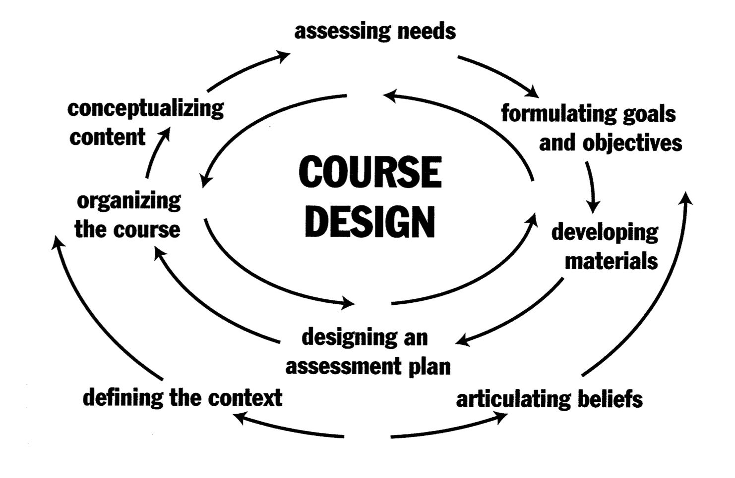
Figure 1 − A framework of course development processes (Graves, 2000, p 3.)

Richards (2001) believes that needs analysis is the basis for creating an effective course, because it helps students understand exactly what is missing in order to successfully operate in their future professional field [68, p. 52]. Without this understanding, it is impossible to make the course relevant and practice-oriented.
Triangulation is the use of multiple instruments for data collection [69]. It is a widely recognized strategy in needs analysis (NA) research that enhances the validity and reliability of findings [43]. Drawing from various lists and his own experience, Brown (2016) defined nine types of triangulations tailored for ESP needs assessments: stakeholder, method, location, time, perspective, investigator, theory, interdisciplinary, and participant-role. In this study, both method and location triangulation were employed. Method triangulation was achieved through the use of an online survey, face-to-face interviews, and content analysis of syllabuses. Location triangulation was realized by collecting data from respondents at five different universities, ensuring that institutional and regional variations were considered.
In modern Kazakhstani methodology for professional foreign language education, there is a trend towards diversity in methodological foundations, which is reflected in a number of dissertations in recent years. This diversity manifests itself in various methods of modelling, organizing and implementing the process of foreign language teaching in non-linguistic universities, which indicates the formation of an integrative methodological paradigm. As a result of the analysis of Kazakhstani dissertations in recent years devoted to developing professional foreign language communicative competence of students with different majors, five main trends have been identified. The identification of trends was based on a comparative content analysis of Kazakhstani dissertation studies, with a focus on their dominant methodological approaches, teaching principles, and types of learning organization. Based on these criteria, five main trends have been identified.
The first trend includes studies that focus on modeling the learning process, where competence-oriented modeling serves as the main research method (Zhyltyrova Zh.T., Elubaeva P.K., Moskovchenko O.D., O.A. Andreeva). In these studies, modelling is understood as a way to create a comprehensive training system where the theory and practice of foreign language teaching are intertwined. Zh. N. Zhyltyrova made a significant contribution to the development of domestic foreign language teaching methodology by developing a model of an integrative modular competence-based educational system, which she described in her dissertation research “Theoretical and applied foundations of modeling the system of professional foreign language training of agroeconomics specialists” [27, p. 88]. This model is aimed at teaching students to use a foreign language specifically in the professional field, not just to master the language, but to apply it in typical situations of their specialty. This model is aimed at developing a specialist's foreign language professional integrated competence, which includes several interrelated components. To achieve this goal, the model combines four key sub-competencies: metacognitive (awareness and management of one's own learning), speech production (the ability to create professional statements in a foreign language), professional content-based (mastery of special vocabulary and professional speech genres), and functional-communicative (the ability to use language to solve specific professional tasks). These competencies are developed through situational and reflective-applied tasks that simulate real-life professional communication. The learning process is implemented in stages from the metacognitive and interpretive stages to the conceptual-presentational and communicative stages, which ensures the gradual development of professional language skills. The methodological basis comprises modular-competence, contextual, integrative, and cognitive-conceptual approaches, and the result is the professional readiness of specialists for foreign language and industry-specific communication. Thus, Zhyltyrova's model is an integrated system that combines elements of different methodological directions.
Another important study was devoted to the formation of the professional thesaurus of the regional studies specialist and it was implemented by Yelubayeva in four distinct stages such as cognitive-metalanguage, information-accumulation, professionally-oriented and professional communication stages. While doing so, the author applies different types of communicative tasks such as motivating activities, intensive reading activities, detailed reading activities and feedback-oriented activities [6, p. 77]. On the cognitive-metalanguage stage, these communicative activities are aimed at activating students’ personal experience and motivating them towards authentic reading and focused on various linguistic phenomena such as grammar, lexis, and phonetics followed by their improvement in speaking practice. On the information-accumulation stage of professional thesaurus formation, students are supposed to acquire as much information as possible through different communicative activities, which are mostly aimed at finding specific information in the text, follow-up text-reproduction activities with a focus on professional terminology used. On the professionally-oriented stage, communicative activities are aimed at in-depth analysis of the reading material, engaging students in the discussion of the received information, and involving them into producing secondary texts. Finally, on the professional-communicative stage of students’ professional thesaurus formation, communicative activities concentrate on feedback mechanisms which assume students working with authentic texts via summarizing, writing essay, engaging in debates, role-playing and thematic dialogues along with adding their own opinions, viewpoint and attitudes towards the received information.
Moskovchenko based her methodological model for the formation of key competencies in students of economic specialties in the process of foreign language teaching on several methodological and methodical principles [26, p. 52]. The methodological principles include the principle of communicative orientation, the learner-centred principle, the principle of cognitivism, and the principle of linguocultural and sociocultural orientation. The methodological teaching principles comprise the following: the principle of manageability of the learning process; the principle of learners’ personal involvement in educational, cognitive-communicative, and quasi-professional/professional activities; the principle of purposeful and consistent modelling in students’ learning activities of the integrated content, forms, and conditions of professional activity; the principle of problem-based and situational content; the principle of authenticity of subject content; the principle of content concentration; the principle of integrated study of the foreign language and the target culture; the principle of gradual development of key competences; and the principle of reflection. As a result of her dissertation research, Moskovchenko developed the structural and functional model for developing key competences in the process of foreign language education [26, p. 54]. The model comprises three phases such as preparatory, processual and reflexive-evolutional. The preparatory phase includes the target group identification, needs and goal analysis, which reflect the expected learning outcomes. The whole learning content is being specified along with methods, technologies that eventually contribute to the formation of intercultural communicative competency in students. The processual phase is represented by cognitive activity-based component and is modelled as a complex system off six interrelated stages such as motivational and goal-oriented, linguoculturally oriented, information-analytical, conceptual and accumulative, communicative and pragmatic, reflective and evaluative stages. The main aim of reflexive-evolutional stage is the monitoring of learning outcomes where evolutional surveys of students are conducted to gain information about what is accomplished and what needs further refinement.
The model proposed by O.A. Andreeva, which is an integrated system for forming the readiness of students of pedagogical specialties to use English in their professional activities, can also be attributed to this area. This model includes five interrelated components such as targeted, meaningful, activity-based, diagnostic and effective [62, p. 63]. The target component defines the main goal, which is the training of a specialist with a high level of professional language readiness, and the basic principles of its formation. The content component reflects the structure of readiness (motivational, cognitive, and praxeological aspects) and describes the pedagogical conditions that ensure the effectiveness of the process (motivation, interdisciplinary integration, and the use of CLIL technologies). The activity component reveals the interaction of the teacher and students through methods, means and forms of organization of training, including the use of teaching materials and electronic manuals. The diagnostic component is aimed at determining the level of readiness through motivation testing and a set of communication-oriented tasks. The model is completed by an effective component that captures the criteria and levels of readiness (low, medium, high) and the final result which is a specialist who speaks English at a high level for successful application in professional activities.
The second trend brings together works based on lexical and content-oriented methodologies (Meiramova S.A., Moldakhmetova G.Z.). Their main idea is to rely on specialised texts and terminology as the basis for the formation of professional lexical competence. The content of the future profession establishes a link between language and professional culture, and the foreign language itself acts as a means of conceptualising the subject area. The main aim of text-based learning and teaching is not only for obtaining information, but also for solving communicative learning tasks. It includes such stages as orientation, planning, implementation and control, where the student learns to predict the content, highlight the main idea and process information. The main goal is to teach how to understand, interpret and communicate the content of a text [24, p. 12].
When developing a methodological model for teaching specialized foreign-language vocabulary to engineering and technical students for the purpose of reading authentic professional literature, Meiramova relied on the following didactic principles: the principle of context-centred learning, the principle of thesaurus-driven and goal-oriented instruction, and the principle of phased methodological organization of the learning process [23, p. 102]. The principle of context centred learning implies the design of professionally-oriented communicative situations that contribute to the formation of students’ thesaurus for reading authentic texts by creating “a feeling of presence” in students’ minds when approaching these tasks. In other words, favourable pedagogical conditions for the formation of professional communicative competence are created by immersing students into professionally-oriented communicative situations and providing them with speaking frames that they can rely on while interpreting the received information and exchanging their opinions. Meanwhile, the principle of thesaurus-driven and goal-oriented instruction lays the foundation for reading and understanding authentic professionally-oriented texts by developing students’ thesaurus and stimulating their communicative and cognitive activity. Finally, by following the principle of phased methodological organization of the learning process, Meiramova defined three distinct stages in her methodological model for teaching specialized foreign lexis for reading professionally-oriented authentic text such as the conceptual-cognitive, informational-accumulative, and communicative-professional stages.
The third group consists of works that develop communicative and dialogical teaching technologies (Tynyshtykbaeva A.B., Akhmetova G.Sh., Serebryanikova M.A.). These works focus on the formation of professional communication skills and the development of interpersonal and business interaction skills in English. The communicative approach is combined with elements of situational and functional analysis, ensuring the transfer of language knowledge to real-life professional discourse.
Serebryanikova based her model for developing students’ readiness for professional communication in English language on such methodological approaches as the systemic approach, the competency-based approach, the differentiated approach, the learner-centred approach, activity-based approach, and the communicative approach [25, p. 52]. As for the didactic principles, the author relied on the principle of communicative and speech orientation, the principle of learner-centred orientation, the principle of activity-based learning, the principle of interactivity, and the principle of professional orientation of the learning material. The whole process of developing students’ readiness for professional communication was implemented by the author in three main stages: the adaptation stage, the preparatory stage and the main stage. The first stage aims to review and adjust what students acquired at secondary school. The second stage prepares students for studying English in modern university environment. The final stage focuses directly on developing stable skills of professional communication among students majoring in non-linguistic programs and is subdivided into three sub-stages. At the first sub-stage, students are taught lexical and grammatical skills through various exercises that will be used at the second sub-stage which involves modelling professional communication situations based on the samples to ensure the flexibility of skills. At the final sub-stage, professional communication situations are created to improve communication foreign language competence and to achieve fluent use of the studied linguistic units in speech. When in comes to methods and technologies, Serebryanikova applies projects-based teaching, role-playing, suggestopedia methods and computer-based programs. The main conditions for the successful implementation of the methodological model are defined by the author as the positive motivation towards learning English, adaptation of students to learning English in university conditions, innovativeness and creativeness of the lecturer’s activity, the use of a complex of innovative technologies. All of these stages in combination with above-mentioned approaches, didactic principles, teaching methods, technologies and pedagogical conditions, are supposed to result in a readiness of a specialist for professional communication in English language.
The fourth trend includes research focused on context-centred and project-based learning technologies (Stamgalieva N.K., Golikova L.V., Shaykhizada Zh.G.). These works demonstrate a transition from traditional teaching to a contextual and activity-based format, in which students learn a foreign language through modelling professional situations, completing projects and solving practice-oriented tasks. This type of teaching ensures a high level of motivation and flexibility in the educational process.
According to Stamgaliyeva, within the framework of the context-centred methodology based on a thematic complex, the learning process consists of four stages [16, p. 92]. The first stage involves teaching the subject-specific foundations of the profession to develop professional communicative skills. The second stage is aimed at developing skills of creative reproduction of texts of various types, using compositional and content models of texts from different speech genres as support. The third stage envisages the development of professional communicative skills through a set of exercises differentiated by skill type. Finally, the fourth stage involves the development and assessment of students’ ability to produce scientific reports and engage in polemical discussions based on them. The author aimed to enable students to comprehend the live foreign speech, express their opinions and clarify information as a result of being taught with a complex of communicative tasks [25, p. 91]. The learning process was based on studying specialized vocabulary, professionally-oriented reading tasks and different types of activities. When selecting activities for developing the readiness for professional communication, the author relied on such principles as the principle of professional orientation and principle of communication-oriented language materials. The whole teaching content was developed around themes defined by the educational programs and each topic was accompanied by lexical and grammar activities organized by the difficulty level. For instance, the student was supposed to first work with the new topical vocabulary, read the professionally-oriented reading passage, comprehend it via different speaking activities and expand their knowledge with the help of additional material developed in connection with the material taught earlier. Serebryanikova believed that in order to form communication skills, it is not enough to complete different types of activities. What is really important is that students should be taught to think actively, solve different problems, engage in discussion and the main aim of the lecturer is to create a smooth transition from mechanic activities to active thinking activity.
Finally, the fifth trend reflects researchers' desire to introduce innovative and digital teaching methods (Akhmetova D.R., Mikhailova T.V.). These works reveal a tendency towards the synthesis of traditional and innovative methods, which makes learning more flexible and focused on the self-development of students. Among the domestic models reflecting the integration of digital technologies and student-centered learning into the process of forming professional foreign language communicative competence, a special place is occupied by the model developed by Akhmetova. The researcher examines the development of professional communication skills in a foreign language among engineering students through the use of online resources (MOOCs), emphasizing the active role of the student in the educational process [29, p. 63]. The model is based on the principles of student-centered, activity-based and competence-based approaches and includes elements of problem-oriented and professionally-oriented learning. There are four interrelated blocks in its structure: analytical and diagnostic, content-based, practical and reflexive-evaluative, which ensure the consistent implementation of the model from defining goals and analyzing needs to reflection and evaluating results. The main methodological principles are practical orientation, integration of professional and linguistic activities, interactivity, flexibility and variability of the educational environment. The use of massive open online courses, electronic textbooks, interactive assignments and multimedia materials contributes to the formation of students' professional communication skills in a digital environment. Akhmetova's model demonstrates the features of a principled eclectic approach as it combines the ideas of various methodological areas such as competence-based, activity-based, professionally-oriented and problem-oriented learning. It uses techniques and technologies typical of communicative and digitalized learning, but their selection is not carried out intuitively. It is based on an analysis of the goals, the level of readiness of students and professional learning objectives. This combination of various methodological solutions in a single framework allows us to consider this model as an example of the implementation of the principles of fundamental principled eclectic approach in modern foreign language education.
Mihailova, on the other hand, oriented her model toward the development of students’ intercultural professional communicative competence (IPCC) in natural science and pedagogical specialties [28, p. 67]. This model was presented in her dissertation “Theoretical and Practical Foundations for Modeling a System of Professional Foreign Language Training for Specialists in Agricultural Economics.” The model contains five interrelated blocks: the target, content, procedural, assessment, and outcome blocks, with aimed at developing three basic subcompetencies such as linguistic-cognitive, professional-discursive, and information-communication. The content block reveals the subject content through intercultural professional and linguistic cognitive modules, typical communication situations and elective courses. The methodological basis consists of competence-based, interdisciplinary and intercultural approaches. The procedural block describes the stages of competence formation and pedagogical conditions such as the use of case technologies, project-based and contextual learning, active and playful methods. The assessment block provides levels of IPCC development from primary to functional, and then to advanced, as well as qualitative indicators such as motivational-value, cognitive-subject and functional-behavioral. The outcome block sees the graduate as someone able to effectively use a foreign language in professionally oriented and intercultural interaction.
The analysis of the considered domestic models shows that none of them is based solely on any one method or approach. On the contrary, researchers strive to combine elements of various theoretical and methodological directions in their concepts such as competence, communication, cognitive activity, intercultural and digital. This integrative combination reflects the trend towards methodological synthesis in the current stage of development of foreign language education in non-linguistic universities. In fact, this is a manifestation of principled eclectic approach, which involves conscious selection and a combination of the most effective approaches, depending on the goals, context and characteristics of professional training. Thus, the models of Zhyltyrova, Mikhailova, Akhmetova demonstrate a common direction of development of the domestic methodology as the transition from mono-method to principled eclectic approach, which confirms the relevance of the theoretical basis of the research we have chosen.
Building upon the analysis of domestic models, it is important to identify the methodological principles that underlie the development of professional foreign language communicative competence in higher education. Each of the analyzed researchers relied on a system of pedagogical and linguistic-didactic principles that ensure the effectiveness, integrity, and flexibility of their models. The combination of these principles demonstrates how the theoretical foundations of modern language education have evolved from isolated methodological systems to integrative frameworks that support the implementation of principled eclectic approach. According to S.S. Kunanbayeva, teaching principles are the main ideas on which the entire educational process is based, ranging from the choice of content and methods to the organization of classes. They set the general direction and help to build an effective teaching strategy [13, p. 265]. Among the general didactic principles of foreign language teaching, Galskova and Gez highlight five main principles such as learner-centered orientation, awareness, creativity, activity-based learning and cognitive orientation [30, p. 141]. The principle of learner-centered orientation focuses on the development of the student’s intellectual abilities, knowledge, linguistic experience and emotional sphere. The principle of awareness emphasizes that students should understand the structure of the language and the nature of intercultural communication, using language as a tool for expressing thoughts and values. The principle of creativity suggests that language acquisition should be based on creative processes such as project work, role-playing or discussion rather than memorization. Meanwhile, the principle of activity-based learning assumes that students actively engage in learning by interacting with their environment and participating in communicative situations. Finally, the principle of cognitive orientation implies that students should be encouraged to think independently and analyze one’s own speech activity along with conscious self-correction. As part of the methodological principles in foreign language teaching, Galskova and Gez highlight the principle of communicative orientation, the principle of integrated teaching of speaking, reading, and writing in a way that reflects the natural use of language in real-life social contexts, and the principle of taking the learners’ native language into account [30, p. 150]. The principle of communicative orientation aims to develop students’ communicative competence when the language is learned in the context of real communication rather than merely as a system of rules. Communication takes place in situations close to real life, taking into account communicative goals, roles, and strategies. The principle of integrated teaching of speaking, reading, and writing suggests that language instruction should mirror real communication by combining these skills in meaningful contexts. Meanwhile, comparison with the native language helps learners understand the structure of the foreign language. Comparing the two languages makes it possible to anticipate difficulties, explain grammatical phenomena, and highlight cultural differences.
Solovova, in turn, identified several core didactic principles: the educational nature of teaching, consciousness, activity, visualization, accessibility and feasibility, durability of learning, and individualization. Among specific didactic principles that guide the foreign language education process, the author highlighted the principle of communicative orientation, the principle of differentiation and integration, and the principle of considering the native language. According to the principle of communicative orientation, language learning process should be based on close to real life activities that take into account the needs and interests of students and focus on meaningful interaction rather than isolated drills. This complex of activities aim at helping learners use the language to achieve their real communication goals. The principle of integration and differentiation implies that when teaching any aspect of a language or type of speech activity, other aspects are also developed at the same time. For instance, when teaching vocabulary, students also practice phonetic, grammatical, reading, listening and writing skills through interconnected activities. The principle of considering the native language, as explained by Solovova, has both positive and negative aspects as similarities can facilitate learning, while differences may lead to errors [70, p. 28].
Serebryanikova, in her model of forming readiness for professional communication, identifies five specific principles in addition to general didactic principles. The first is the principle of communicative and speech orientation, according to which the training should be focused on the development of students' practical skills of communication in a foreign language on the studied topics. The second is the principle of personality-oriented learning, which implies taking into account the level of development, abilities, interests and opportunities of each learner. The third is the principle of activity approach, which emphasises the active participation of students in the process of language learning. The fourth is the principle of interactivity, based on joint cognitive activity, where students share knowledge, ideas and experience. And the fifth is the principle of professional orientation, which provides for the connection of the teaching material with the students' future speciality and their professional interests [8, p. 50].
In their book Essentials for Successful English Language Teaching (2010), Farrell and Jacobs explain that communicative language teaching (CLT) changed how English is taught [71, p. 19]. They believe this approach works best when lecturers use it as a whole system, not as separate techniques. The authors describe eight important parts of successful teaching: learner autonomy, the social nature of learning, curricular integration, focus on meaning, diversity, thinking skills, alternative assessment, and lecturers as co-learners. All these elements are connected and help each other. The main goal is to make learning more student-centered, where learners take an active role, work together, think critically, and use language for real communication.
Maryellen Weimer (2002) in her book Learner-Centered Teaching: Five Key Changes to Practice emphasizes that effective teaching requires shifting the focus from the teacher’s activity to the learner’s active participation [72]. She identifies five core principles that characterize this transformation. First, lecturers should gradually reduce doing learning tasks for students, allowing them to take more responsibility for organizing, summarizing, and problem-solving. Second, instead of constantly explaining and giving answers, lecturers should encourage discovery and exploration, helping students to think critically and find solutions independently. Third, teaching should involve more thoughtful design work, where lessons and assignments are carefully planned to promote engagement, collaboration, and the practical application of knowledge. Fourth, lecturers should act as models of lifelong learning, demonstrating how to approach problems, reflect on mistakes, and keep developing professionally. Finally, Weimer stresses the importance of peer learning, where students learn from and with each other through collaboration and discussion. Overall, her learner-centered approach shifts the teacher’s role from being the main source of information to becoming a facilitator who creates conditions for active, independent, and cooperative learning.
Within the framework of principled eclectic approach, it is important to combine both structural and communicative approaches in a balanced way. As Wilga M. Rivers (1973) notes, language learning involves two essential phases: skill-getting and skill-using [73, p. 25]. The skill-getting phase includes cognitive and mechanical processes such as perception, abstraction, articulation, and construction, which represent the controlled practice of language structures. The second phase, skill-using, emphasizes authentic communication, motivation, and interaction. Thus, language teaching should not stop at drills or controlled exercises but must lead to meaningful and spontaneous communication. This gradual transition ensures that students develop not only linguistic accuracy but also fluency and communicative competence in real-life professional contexts. This idea aligns closely with the concept of principled eclectic approach, where different methods are integrated to support both the form and function of language learning.
Mikhailova’s research, illustrates a model of intercultural professional-communicative activity of graduates in natural science teacher education [28, p. 57]. At the centre of the model stands the graduate, who knows a foreign language and is able to act as a subject of intercultural professionally oriented interaction. The model is built in accordance with the Professional Standard “Teacher”, the National Qualifications Framework of Higher Education of the Republic of Kazakhstan, and the Sectoral Qualifications Framework for the field “Education.” A key element in the model is the introduction of such a concept as intercultural professional-linguo-cognitive modules (IPLKM), which serve as the foundation of subject content and as a means of forming students’ intercultural professional-communicative competence (IPCC). These modules encompass five main spheres of communication: socio-domestic communication, intercultural communication, sociocultural communication, quasi-academic and professional communication, and quasi-professional and production-related communication. In other words, IPLKM include different spheres of communication, main topics, and participants, as well as common situations from social, intercultural, sociocultural, educational, and professional contexts [28, p. 59]. Each module presents simplified examples of real-life situations that are typical for these areas of communication. Thus, Mikhailova’s framework demonstrates a multi-level structure of professional-communicative training, in which foreign language proficiency is viewed as a key instrument for effective interaction in diverse spheres of intercultural and professional activity.
In terms of methodological principles, T.V. Mikhailova adheres to the idea that the formation of intercultural professional-communicative competence (IPCC) should be based on a system of interrelated pedagogical principles ensuring both linguistic and professional development of students [28, p. 68] Her model is grounded in seven core principles: learner-centeredness, communicative and speech orientation, professional relevance of the learning content, cognitive and activity-based learning, integration of all types of speech activity, authenticity of language materials, and interdisciplinary integration. According to Mikhailova, these principles make it possible to organize foreign language education as a holistic, professionally oriented, and intercultural process, where language serves as a means of professional and personal growth. In our research, we share this position and apply similar principles in the process of forming professional foreign language communicative competence (PFCC) of medical students, adapting them to the specific requirements of medical discourse, clinical communication, and authentic healthcare contexts.
Thus, the analysis demonstrates that there are several challenges in foreign language education. It is well known known that the main obstacle on the way to efficient foreign language teaching in EFL Countries is the absence of a language environment and real communication needs. It is closely linked to the limited amount of teaching hours. Another problem is the low level of language preparation and motivation among students majoring in non-linguistic educational programs. That is why when selecting methods and means of teaching, it is important to take into account these problems [24, p. 67]. Tynyshtykbayeva considers professional communication as a complex process of interaction between participants, which is carried out through various types of speech activity and is aimed at solving joint professional tasks [17, p. 31]. Such communication takes place within the framework of labour activity between people united by one profession and possessing common professional knowledge. The basis of this interaction is the need to obtain meaningful information necessary for the fulfilment of professional functions. In modern conditions, a foreign language becomes an important tool of professional communication, and the formation of oral interaction skills in a foreign language is considered as one of the key objectives of teaching students of non-linguistic specialities. Tynyshtykbayeva highlights a number of features and requirements that are typical for professional communication as a form of oral communication in the sphere of labour [17, p. 32]. Firstly, it is a common professional subcode which is a common language formed on the basis of similar professional training of participants. Secondly, the presence of a common information space, which may differ in the degree of awareness and relevance of information for each participant. An important characteristic is also the coincidence of communicative goals with possible differences in specific communication tasks. In addition, professional communication presupposes the formation of special speech skills in each participant, including knowledge of terminology, the ability to construct statements and orientate in typical situations of communication. The final condition is the presence of common motivational stimuli that support and develop the process of professional communication itself.
As a result of this extensive literature review, it became evident that each methodologist-scholar has their own approach to creating such an effective model for developing foreign language communicative competence of students with non-linguistic majors. The variations mainly concern the structure and content, whereas the core framework and underlying didactic principles are largely similar. The main ten features shared by these model-based studies are: (1) professional orientation; (2) presentation of professional foreign-language communicative competence as a complex of interrelated subcomponents; (3) a scaffolded design of the model; (4) content selection grounded in explicit methodological principles; (5) communication and action-orientation; (6) intensive reading as a core input element; (7) progressive task sequencing from reproductive to productive skills; (8) motivation and reflection as prerequisites for effectiveness; (9) a versatile repertoire of activities; and (10) feedback-oriented tasks for monitoring the formation of communicative competence.

Conclusions to chapter 1
In this chapter, the theoretical foundations for the formation of medical students’ professional foreign language communicative competence have been examined. The analysis has shown that foreign language education has undergone significant transformations over time, moving from traditional knowledge-based approaches towards competence-based and communicative paradigms. These changes were influenced by socio-economic, pedagogical, and methodological factors, which have shaped the modern foreign language teaching in higher education.
Second, particular attention in this chapter was paid to the concept of communicative competence in both international and domestic research. The analysis of the models proposed by international and domestic scholars showed that communicative competence is a multidimensional concept. Also, based on this review, the structure of PFCC for medical students was defined as consisting of four interconnected subcompetencies: foreign language communicative subcompetence, sociocultural subcompetence, medically-oriented metalinguistic subcompetence, and professional foreign language communicative subcompetence.
Third, an examination of international and domestic methodological models demonstrated that modern foreign language teaching for student of non-linguistic majors increasingly relies on integrative and flexible methodological solutions. No single approach can fully address the complex needs of learners, especially in specialised fields such as medicine. Researchers utilize a diversity of methodological approaches used in teaching foreign languages for professional purposes based on learner-centeredness, communicative orientation, integration of skills, professional relevance, and active student participation.
Thus, the theoretical analysis conducted in this chapter provides a solid foundation for the development of a methodological model aimed at forming medical students’ professional foreign language communicative competence. The conclusions drawn in this chapter serve as the basis for the next chapter, which focuses on the design and implementation of the methodological model and its application in the educational process.

2 METHODOLOGICAL FOUNDATIONS FOR THE DEVELOPMENT OF MEDICAL STUDENTS’ PROFESSIONAL FOREIGN LANGUAGE COMMUNICATIVE COMPETENCE BASED ON PRINCIPLED ECLECTIC APPROACH

2.1 Principled Eclectic Approach as a Theoretical and Methodological Basis for Developing Professional Foreign Language Communicative Competence in Medical Students
In order to be competitive in today's labor market, future medical professionals should be able to adapt and be able to find solutions in different professional situations. Knowing a foreign language is one of the important skills for medical students as it helps future doctors read international research, join academic exchange programs and communicate with patients and colleagues from different countries. However, developing professional foreign language communicative competence in medical students within the university-level foreign language course is a complex task since medical students need to learn profession-related vocabulary, practice real clinical conversations, and understand cultural differences. According to B. Kumaravadivelu, one of the common misconceptions in language teaching is the belief that there is a single “best” method ready to be discovered. As noted by B. Kumaravadivelu, researchers initially believed they could find one perfect method by studying and comparing different methods but later they realized this is not possible [75, p. 163]. This is because language teaching depends on many things such as students' needs, learning context, teacher's style, goals of the lesson and many other factors. These diverse requirements cannot be fully addressed within the framework of a single teaching method. Similarly, M. Lewis argues that there is no single “best” teaching method that works in all situations [76, p. 189]. Language learning is complex, so one universal method cannot guarantee success. Teachers should not just mix different methods randomly because that can lead to confusion. Instead, they need clear principles and understanding of theory, so they can choose appropriate techniques thoughtfully and effectively depending on the context.
In this regard, an eclectic approach, which combines elements of different methods, appears to be an effective solution. An eclectic approach means that a teacher uses different methods and techniques depending on the learning situation [77, p. 40]. Instead of following one fixed method, the teacher chooses what works best for students’ needs. These choices are based on the teacher’s understanding of how languages are learned. This understanding can change over time as the teacher gains experience. Good teaching happens when theory and classroom practice support each other. In this way, teaching becomes a flexible and continuously improving process. Larsen-Freeman defines the eclectic approach as a teaching process in which a teacher selects techniques from different methods to create a combination that best meets students’ needs. This choice is not random as it still follows certain methodological techniques, principles and teacher's own beliefs. The approach is referred to as principled eclectic approach when lecturers are able to provide clear reasoning for their decisions [74, p. 281].
Instructors have many choices when they plan a lesson, such as focusing on grammar or meaning, accuracy or fluency. There is no single correct answer because teaching depends on the situation and students’ needs. Good instructors think about these options and choose what works best in each context. Their decisions are based on their experience, knowledge, and understanding of how languages are learned. An effective approach is flexible and can change depending on different teaching situations. Research and classroom experience show that teaching is not fixed, so teachers should always be ready to adapt [77, p. 41]. However, despite its potential, the eclectic approach is often misunderstood in practice. This can be seen in studies conducted in different educational contexts. D.S. Mwanza found out three common misconceptions among lecturers in Zambia about eclectic approach [78]. Some lecturers believed that eclectic approach implies starting a lesson with one method and switching to a different one until the teacher finds the most effective one. Mwanze disproved this misconception in his research and explained that eclectic approach is not about using several isolated methods and should be viewed as one approach which has characteristics of more than one method. Second misconception was that students’ low fluency in the target language might be an obstacle for using the eclectic approach, especially the elements of the communicative approach. However, the eclectic approach does not discourage the use of the first or second language in case if students are not confident in using the target language. The third misconception was about the time and effort needed for the implementation of the eclectic approach. It is believed that using eclectic approach is time-consuming and requires a lot of effort on the lecturers’ part. Mwanze believes that the main culprit might be respondent-lecturers’ lack of practical knowledge on proper use of the eclectic approach as it is intended to be student-centred [78, p. 62].
A recent systematic review conducted by Al‑Khasawneh (2022) analyzed research from 2016 to 2021 and confirmed that the eclectic approach in language teaching effectively combines techniques and principles from multiple methods based on clear pedagogical objectives and learner needs. The review showed that the use of this approach consistently demonstrates positive learning outcomes, including enhanced motivation and classroom engagement [79]. Researchers from Sechenov First Moscow State Medical University conducted an experimental study with students and a post-survey of the instructors about their experience on the use of the eclectic approach. Chernus et al. (2022) revealed that English language instructors had mixed opinions about the eclectic approach [80]. Many lecturers reported a positive experience on using this method, pointing that this approach is modern, student-centered and creative. Also, the students’ performance in the experimental groups was higher than those of the control group. However, a significant number of instructors expressed their concerns and stressed that this approach is time-consuming and challenging to organize for the instructors. Also, they believed that it might cause difficulties for students if organized not properly. Chernus et al. suggest that such concerns may stem from a misunderstanding of principled eclectic approach as a combination of unrelated methods, rather than a coherent and principled approach. Overall, the findings suggest that the main advantage of the eclectic approach is its adaptability but it requires a strong understanding of methodology and thoughtful lesson planning.
The eclectic approach in English Language Teaching is not fixed as it depends on the teacher and the specific situation in the classroom. This is why eclecticism is described as subjective. It is shaped by the teacher’s experience, beliefs, and understanding of teaching. One teacher may combine certain methods, while another teacher may choose a completely different combination. Teachers also have the freedom, or autonomy, to decide what is most suitable for their classroom. They are not required to follow only one method. Instead, they can adapt their teaching depending on the situation, lesson goals, and student needs [80, p. 5]. Thus, principled eclecticism gives a general idea of flexible teaching, but it is important to explain how it works in this study. We need to show what exactly this approach includes and how it is used in teaching. In particular, it is necessary to describe the main principles, teaching approaches, and classroom techniques that are combined in the model. Explaining these elements helps to understand how this approach supports the development of professional foreign language communicative competence in medical students.
In this study, the proposed methodological model is based on the principles of principled eclecticism, which allows combining different teaching approaches in a flexible and purposeful way. A significant challenge in defining ELT methodology is the semantic diffusion between the concepts of approach, method, and technique. It is hard to clearly distinguish between approach, method, and technique because they are closely connected. In real teaching, they often overlap, so practitioners sometimes use them interchangeably. To address this issue, Edward Anthony (1963) proposed a three-level hierarchy to describe teaching: Approach, Method, and Technique. An Approach is the foundational set of beliefs and theories about how language is learned and how it should be taught. A Method is the practical, systematic plan for the classroom that is built directly upon the theories of the chosen approach while techniques are the specific, minute-by-minute activities and exercises students do in class that align with the overall method [77, p. 14]. Later, Richards and Rodgers (1982) updated this by using Method as an "umbrella term" but instead of approach, method, technique, they used approach, design, and procedure. The approach still means the theory about language and learning. The design explains how this theory is turned into teaching materials and course planning. The procedure includes the actual classroom activities and techniques. So, they made the model more detailed and showed more clearly how theory connects to practice [77, p. 14].
Based on these theoretical foundations, the proposed model is implemented through the integration of the Communicative Approach, the Grammar-Translation Method, and the Lexical Approach.
The Communicative Approach focuses on developing students’ ability to use a foreign language in real-life and professional situations. In this context, the Communicative Approach functions as a core component within an eclectic model to facilitate meaningful interaction and real-life communication [81, p. 140]. It helps students improve their speaking and interaction skills and prepares them for communication in authentic contexts. In our model, special attention was given to encouraging students to engage in dialogic speech, since doctor-patient communication relies heavily on interactive and two-way interaction. To support this, the course incorporated a variety of communicative tasks aimed at helping students build confidence, use functional phrases, and participate more naturally in short dialogues. Serebryanikova defines dialogue as a communication process between two people with each of them acting as a listener or speaker in turn which suggests that our main goal is to teach listening and speaking [25, p. 93]. In order to teach students to speak naturally and fluently, it is important to introduce structures typical for dialogical speech, speaking frames and different expressive means gradually. On the first stage, three types of activities can be introduced such as memorizing short dialogue lines, combination of replicas based on functional links, grammatical and lexical transformations of the lines. On the second stage, the author suggests short dialogues comprehension activities via simple replication, modification, use in new situations, replacement of different parts of the dialogue, creation of dialogues based on a sample. On the third stage, students are supposed to create dialogues in groups under the guidance of the lecturer, have dialogues with the lecturer, listen to dialogues to compare it with the given situation, roleplay dialogues and create their own dialogues based on the given topic.
The Grammar-Translation Method supports the development of language accuracy. It helps students better understand grammar, learn professional terminology, and develop translation skills, which are especially important in medical communication. The grammar-translation method was one of the first teaching methods used in foreign language education. It became very popular in the nineteenth century [82, p. 2]. It originated from the teaching of classical languages such as Latin and Greek in Europe. The main aim of this method was to develop intellectual abilities and transmit cultural knowledge through literature [83, p. 606]. Language was viewed as an academic subject rather than a tool for everyday communication. Therefore, more attention was given to reading and writing, while speaking and listening were less important. Learning was mainly based on translating texts from the target language into the native language. However, despite criticism, the Grammar-Translation Method still has value, especially in professional language learning. In medical education, it helps students understand complex grammar and learn medical terminology more clearly. Translation tasks also help students connect the foreign language with their native language, which is useful when working with medical texts. Therefore, in this study, the Grammar-Translation Method is not used as the main approach, but as a supportive tool that works together with communicative and lexical approaches.
The Lexical Approach emphasizes the importance of vocabulary, collocations, and ready-made language patterns. It helps students use natural and context-appropriate language, which is essential for effective professional communication. The combination of these approaches allows for the balanced development of fluency, accuracy, and lexical competence, which are all necessary for future professionals. According to M. Lewis, the lexical approach focuses on learning language through real examples and meaningful input rather than isolated grammar rules [76, p. 193]. He states that students learn better in language-rich environments where they are exposed to authentic English. Listening and noticing are important because they help learners understand how language is used in real situations. Lewis also explains that language learning should include input, practice, and activities that help students become more aware of language. He emphasizes that communication is not only about accuracy, but also about fluency and confidence. In addition, many mistakes are caused by lack of vocabulary, so it is important to teach lexical chunks and collocations. Therefore, teachers should help students notice, learn, and use language in context. When compiling a vocabulary minimum for students learning a foreign language, methodologists recommend selecting lexical items based on several key principles. The first suggestion is the principle of frequency which prioritizes words that appear most often in authentic speech and writing. Next, the thematic principle which ensures inclusion of words relevant to common communicative topics and needs. According to the principle of collocability, preference is given to words that form natural and useful combinations with others. The principle of stylistic neutrality favors words that are appropriate in a wide range of formal and informal contexts. Finally, the principle of word-formation productivity emphasizes choosing words that can generate new lexical items through prefixes, suffixes and endings in order to help students to recognize word forms independently [39, p. 132]. According to Galskova et.al., the vocabulary minimum is a limited set of words and expressions that students are expected to learn within a certain period of study. It is selected to match the goals of the course and the learners’ real memorization ability. Since it is unrealistic to learn the entire vocabulary of a language, a practical minimum is chosen to ensure effective communication. The size of this vocabulary depends on the organizational factor which is the number of class hours, physiological factor which implies the learner’s cognitive capacity, and the psycholinguistic factor which encompasses students' actual communicative needs. This approach makes language and vocabulary learning more focused and meaningful. Pogozheva employed lexico-semantic exercises for the consolidation of new vocabulary units in the students’ consciousness through such activities as composing word combinations, sentences, thematic or lexicon-semantic groups of words, semantic fields of the word, as well as recognition of the word by its semantic definition, writing a creative dictation and a composition based on supporting words. All of these exercises were divided by the author into two groups with the first group including exercises connected with working on the meaning of the word, and the second with the use of the word taking into account its meaning [84, p. 101].
The selected approaches contribute to the development of different subcompetencies within the structure of professional foreign language communicative competence. The Communicative Approach primarily supports the development of professional foreign language communicative and professional communication subcompetencies, as it focuses on interaction in real-life clinical situations. The Grammar-Translation Method contributes to the development of metalinguistic subcompetence, as it ensures accuracy, understanding of grammatical structures, and mastery of medical terminology. The Lexical Approach enhances both foreign language communicative subcompetence and medically-oriented metalinguistic subcompetencies by developing students’ knowledge of collocations, phraseology, and formulaic expressions used in medical discourse. In addition, the integration of these approaches also supports the development of sociocultural subcompetence, as students are exposed to culturally appropriate communication in professional contexts.
To support this model in practice, we use a combination of modern, student-centered learning methods or techniques such as Task-Based Learning (TBL) to engage students in meaningful communicative tasks; Case-Based Learning (CBL) to introduce students to realistic professional situations; Game-Based Learning (GBL) to increase their motivation and engagement. The selection of TBL, CBL, and GBL is not random, but is determined by the need to create a student-centered and practice-oriented learning environment. These methods are particularly relevant for medical education, as they simulate real professional situations, promote active learning, and develop both communicative and cognitive skills required in clinical practice.
In order to better understand the role of each technique within the proposed model, each of them will be discussed in more detail. TBL might be considered as a practical way of applying communicative approach in the classroom through tasks and activities [85, p. 10]. In other words, communicative approach is the general philosophy, while TBL is one of its implementations. According to D. Nunan, a pedagogical task is a piece of classroom work in which learners use the target language to understand, produce, or interact in order to express meaning [85, p. 4]. The main focus is on communication rather than on practicing grammatical forms. A task should also have a clear structure, with a beginning, a middle, and an end, and it should represent a complete communicative activityю Among the various types of tasks used in TBLT, the two-way information gap task is considered one of the most widely applied, as it requires active interaction and mutual exchange of information between learners. They must listen, speak, and interact with each other. This helps develop communication skills [86, p. 37].
Case-method was introduced by Christopher Langdel from law faculty of Harward university and gained wide use in teaching of economics, geography, informatics and other subjects [61, p. 58]. Four types of case-based teaching are distinguished in methodological literature such as “case method”, “case-incident method”, “stated-problem method”, and “case-problem method”. Case method is the classic type of case-based teaching where students are given a detailed material where the problem is described but no solution is suggested. Students are supposed to identify the problem along with its solution based on the problem stated. Case-problem method is the simplest form of case-based teaching where students are given a straightforward description of the problem with several different solutions. Students are required to discuss and choose the most optimal solution. Case-incident method encourages students to look for additional material independently for solving the stated problem. Stated problem method provides student with all necessary information and possible solutions to the problem but students are expected to critically analyze the suggested options and develop a better alternative solution. Having analyzed all four types of case-based teaching, Moskovchenko assumed that case-problem method and stated-problem method are the most appropriate for integrating into language learning process. In contrast, case method and case-incident method require more time from lecturer and students as well. Several rules should be followed when developing tasks for case-based teaching such as the difficulty level of the case as its wording should be well-written and understandable [26, p. 60]. Next, the case should be practical as much close to reality as possible. Following that, the case should be subjectively significant to students and based on their current knowledge. Lastly, the tasks should encourage students to independent practical work. The success of case-based teaching depends on a number of factors. First of all, it depends on the qualification level of lecturers whether they are proficient in the methodology of case-based teaching along with knowledge in the sphere which students are majoring in. Another important factor is the material being selected. In foreign literature, there are more than enough textbooks with cases for different spheres; however, in most cases, they appear to be not level-appropriate for using in English teaching classroom. When texts go through the adaptation process, their authenticity and difficulty level might change or even be lost. That is when the expertise of field lecturers might be needed. Despite all these difficulties, case-based learning comes with a wide range of benefits. Having faced with close-to-real situation, students are able to develop their independent learning and research skills. Other benefits include the development of problem-solving skills, cooperative learning skills, and argumentation skills when students try to explain the case and possible solutions. We agree with Moskovchenko that the case-problem and stated-problem methods are the most suitable for language learning. For this reason, we used these two types in our course. All of our case tasks give students a clear situation, the necessary vocabulary, and a simple problem to solve through discussion and role-play. This made case-based learning easier to integrate into English lessons and more effective for developing professional communication skills.
Game-Based Learning (GBL) is a type of learning that uses games with clear educational goals. It focuses on balancing subject content with engaging gameplay. Unlike gamification, which adds game elements like points or rewards to existing tasks, game-based learning redesigns activities to make them more interactive and meaningful. It encourages active participation and motivation through play, which is considered an important part of learning and development [87, p. 259]. Game-based learning should not be confused with the use of multimedia tools such as videos or presentations, nor with edutainment. Unlike edutainment, where learners are often passive recipients, game-based learning requires active participation. It focuses on learning through doing, where students are engaged in meaningful activities. This active involvement helps learners better understand and retain knowledge [88, p. 2]. Language learning requires continuous effort, practice, and concentration over a long period of time. Learners need to understand, repeat, adapt, and use new language in both speaking and writing. In this process, games play an important role as they help maintain students’ interest and motivation. By making learning more engaging, games encourage learners to stay involved and continue practicing the language. Pair and group work are important for ensuring that all learners have opportunities to actively use the language. They promote intensive speaking and listening practice and encourage interaction between students. Although mistakes may occur during such activities, they are a natural part of the learning process and should not prevent communication. The teacher’s role in this context is to monitor, support, and provide feedback when necessary [89, p. 3]. Thus, the integration of communicative, grammar-translation, and lexical approaches within a principled eclectic framework, supported by student-centered methods such as TBL, CBL, and GBL, provides a comprehensive and flexible basis for foreign language teaching in medical education.

2.2 Structural and Functional Components of the Methodological Model Based on Principled Eclectic Approach for Developing Medical Students’ Professional Foreign Language Communicative Competence
The development of the model based on principled eclectic approach for forming medical students’ professional foreign language communicative competence is based on the results of the theoretical and diagnostic stages of the research as well as on the analysis of existing Kazakhstani and international models. Previous studies demonstrated the efficiency of competence-oriented and profession-specific approaches in foreign language teaching; however, they were mainly focused on technical, economic, or humanitarian fields and did not take into account the specific features of medical education. Therefore, it became necessary to design a model that would reflect medical students’ professional training and ensure the balanced formation of foreign language communicative, sociocultural, medically-oriented metalinguistic and professional communicative subcompetencies.
To address this gap, it is important to examine how similar competence-oriented models have been structured in previous research. Several Kazakhstani scholars have proposed models that can serve as a methodological foundation for the present study. For instance, Mikhailova’s model for forming intercultural professional-communicative competence (IPCC) of students in natural science teacher training programs is based on a systemic and competence-oriented approach and includes several interrelated blocks. The model is defined as an open pedagogical system that unites the following basic components: the goal block, which defines the main aim of foreign-language professional education and students’ professional training; the content block, which includes the learning content, subject matter of the process of forming students’ intercultural professional-communicative competence (IPCC) during foreign language classes, methodological approaches, and key teaching principles; the procedural block, which comprises modern pedagogical technologies for IPCC formation, a system of exercises and sets of tasks, as well as the stages of competence formation; the evaluation block, which contains descriptors or qualitative indicators of the formation of the subcompetencies included in IPCC, as well as the levels of its development; and the result block, which reflects the expected outcome of foreign-language professional training of students in the context of professional education [28, p. 66]. A similar approach to structuring the process of professionally oriented foreign language education was proposed by Zh.G. Shaikhyzada et al. (2016), who developed a technological model for university engineering students’ foreign language training in Kazakhstan that includes clearly defined goals and expected outcomes [90, p. 104]. The model is aimed at the formation of their foreign language communicative competence. It consists of goal-related, content-related, organizational-procedural, and monitoring-assessment components, ensuring the systemic formation of foreign language communicative competence and alignment of the assessment tools with European educational standards (ECTS). The core part of the model is represented by content-language integrated learning and contextual education, which imply the use of such methods as role-playing, discussion, case study, project method, and similar explanative, illustrative and reproductive methods, as well as research methods. Tynyshtykbayeva implemented her methodology of teaching "commercial communication" in two parts: preparatory and commercial-communicative stages [17, p. 131]. The former implied the formation of basic linguistic and communication skills, including lexical, grammatical, etiquette, and meta-communicative means. The latter shifted the focus to the formation of strategic and tactical skills for typical profession-related communication situations. This stage included the modeling of different situations and conducting role-plays, which contributed to the formation of professional communicative competence in close-to-real conditions. Taken together, these models demonstrate the importance of a structured, stage-based, and competence-oriented approach to foreign language education. In addition to structural considerations, it is also essential to determine the scope and focus of the competencies included in the model. In this regard, the ideas of O.D. Moskovchenko are particularly relevant. The researcher emphasized that when setting learning objectives, lecturers should clearly decide which competencies need to be developed. According to her, it is better to follow the principle of “less but better” rather than “more but worse” [26, p. 55]. This means that learning goals should be achievable, not lower or higher than students’ abilities. Based on the analysis of the theoretical approaches, existing structural models, and key principles such as competence selection and goal-setting, the proposed model for forming medical students’ professional foreign language communicative competence has been developed (see Figure 2).
Our proposed model based on principled eclectic approach for forming medical students’ professional foreign language communicative competence consists of five interrelated blocks: target, content, process, evaluation, and result. Each block performs a specific function but together they form an integrated system aimed at the development of professional foreign language communicative competence in medical students. The Target Block defines the main goal and objectives of forming medical students’ professional foreign language communicative competence. Once the key competencies are defined, it becomes necessary to operationalize them through clearly formulated goals and objectives. Graves explained that a goal shows what needs to be achieved and objectives explain exactly how we can achieve it [66, p. 76]. Each goal is divided into several smaller and more specific objectives, which are the tasks that help achieve a common goal. For example, if the purpose of the course is to teach students to speak English fluently, then the tasks may include developing listening skills, asking questions, and maintaining a dialogue. Graves also emphasized that there is a cause-result relationship between goals and objectives. If the tasks are completed, the goal will be achieved. But if the goal is not realized, it means that the tasks need to be changed or clarified. In addition, the tasks are always more specific and short-term, while the goals are general and long-term. Therefore, for every big goal, there should be several small tasks that help you achieve the desired result step by step. This principle is particularly important in designing a methodological model, as it ensures coherence between its components and the expected learning outcomes.

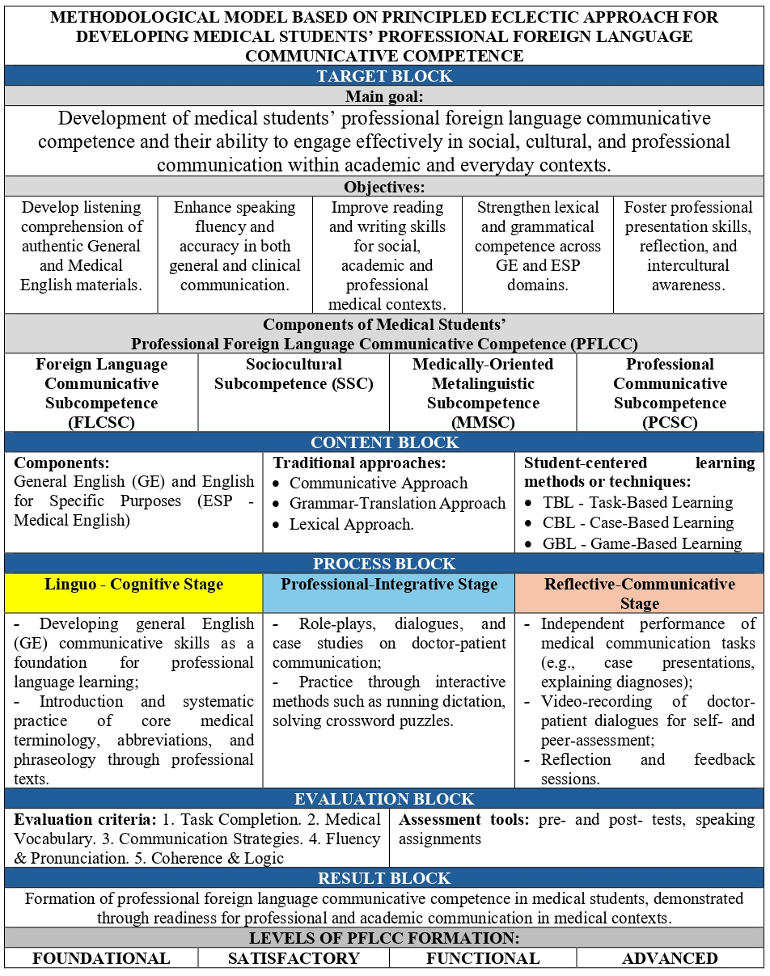

Figure 2 − Model based on principled eclectic approach for developing medical students’ professional foreign language communicative competence

Our target block reflects both the component structure of this competence and the expected learning outcomes outlined in the course syllabus. The overall aim of the model is to prepare future medical professionals for effective communication in academic, social, and professional contexts, ensuring that they can use English appropriately in different medical situations (see Figure 2).
The model focuses on developing four key subcompetencies that together form professional foreign language communicative competence:
- foreign language communicative subcompetence - ability to use English in everyday and academic situations;
- medically-oriented metalinguistic subcompetence - mastery of medical terminology, abbreviations, and language patterns typical for professional communication;
- sociocultural subcompetence - awareness of sociocultural and ethical norms of doctor-patient and doctor-colleague interaction;
- professional communicative subcompetence - ability to conduct structured medical dialogues, explain diagnoses, and give instructions.
The objectives of the Target Block correspond directly to the learning outcomes (LO1-LO5) outlined in the syllabus, ensuring that the formation of each subcompetence is reflected in the course design and assessment system.
- LO1 (Listening) aims to develop students’ ability to comprehend spoken English in both everyday and professional situations. It supports the formation of foreign language communicative subcompetence and partially contributes to professional foreign language communicative subcompetence, as students learn to understand lectures, video materials, and medical dialogues between healthcare professionals and patients. Listening practice focuses on authentic input such as patient interviews, which prepare students for real-life situations in future clinical settings.
- LO2 (Speaking) targets the development of professional foreign language communicative and sociocultural subcompetencies. Through role-plays and case-based discussions, students practice how to take patient history, explain symptoms and treatment, and communicate with colleagues. These speaking activities are designed not only to improve fluency and accuracy, but also to build empathy, politeness, and intercultural awareness that are crucial for effective doctor-patient interaction.
- LO3 (Reading and Writing) contributes to both foreign language communicative and medically-oriented metalinguistic subcompetencies. Reading tasks include authentic medical texts, clinical cases, and hospital documents, which train students to identify key information and understand professional communication. Writing tasks-such as filling out patient registration forms, writing summaries, and short case reports-help students learn how to produce professional written communication in a clear and concise manner.
- LO4 (Lexis and Grammar) forms the linguistic foundation of the entire model and is primarily aimed at developing medically-oriented metalinguistic subcompetence. By mastering the grammatical patterns and lexical units typical for medical English, students acquire the ability to construct grammatically accurate and terminologically appropriate speech. This component bridges general English knowledge with the professional register of medical communication, ensuring that students can function confidently in both contexts.
- LO5 (Professional Presentation) corresponds to the integrative function of the model and develops professional foreign language communicative and sociocultural subcompetencies. Preparing and delivering presentations on medical topics, students practice structuring professional speech, using visual support, and applying persuasive and culturally appropriate communication strategies. Such activities encourage autonomy, confidence, and professional identity formation in English.
Thus, the objectives of the Target Block are operationalized through clearly defined learning outcomes and aligned assessment indicators. This connection between the model’s theoretical structure and the practical course design ensures that all teaching and evaluation activities consistently contribute to the gradual development of professional foreign language communicative competence in medical students.
The Content Block of the model based on principled eclectic approach defines what material and topics are included in the teaching process and how they reflect the professional and communicative needs of medical students. The content is structured around both general English and profession-specific English components, as shown in the syllabus used for the “Foreign Language” course in the spring semester (2023-2024 academic year).
The Content Block defines what material, topics, and skills are included in the process of forming medical students’ professional foreign language communicative competence. It ensures that the content of teaching directly reflects the goals set in the Target Block and corresponds to the real professional needs of future doctors. The structure of the content combines two key dimensions: General English (GE) and English for Medical Purposes (EMP).
The General English component serves as the foundation for further development of professional skills. It covers essential linguistic elements such as grammar, general vocabulary, pronunciation, and everyday communication topics. Within this part of the course, students revise and strengthen their ability to use English in daily life and academic situations such as introducing themselves, describing routines, giving directions, or participating in simple classroom discussions. This supports the development of the foreign language communicative and socio-cultural subcompetencies and prepares students for more complex professional communication tasks.
The English for Medical Purposes component focuses on topics and communication tasks related to the medical field. It includes studying medical terminology, doctor-patient interactions, clinical case descriptions, and reading professional texts. Typical themes cover areas such as “The Structure of the Human Body,” “Symptoms and Diagnosis,” “At the Hospital,” and “Doctor-Patient Communication.” Through these topics, students gradually develop medically-oriented metalinguistic, sociocultural, and professional communicative subcompetencies.
The course syllabus integrates several student-centered learning methods or techniques: TBL - Task-Based Learning, CBL - Case-Based Learning and GBL - Game-Based Learning. The main learning materials include the English File (Oxford University Press) series for General English, Medicine 1 (Oxford English for Careers) for medical communication, as well as authentic video and article resources that link linguistic learning with real-world clinical contexts.
The Process Block shows how the main goals and content of the model are implemented in the real teaching process. It explains what methods and forms of work are used in the classroom, how students and lecturers interact, and how each stage of learning helps to form professional foreign language communicative competence. The process of teaching is based on the principled eclectic approach, which allows combining different methods and techniques depending on the topic, the level of students, and the type of communication activity.
Effective communication in clinical settings is essential for ensuring patient safety, building trust, and delivering high-quality healthcare. It helps doctors understand patients better, provide appropriate treatment, and establish rapport. Therefore, medical students should not only acquire theoretical knowledge of English but also actively practice communication in real-life professional contexts. One of the most effective tools for this purpose is peer role-play. In this method, students take turns acting as doctors and patients, which allows them to practice authentic communication in a safe and supportive classroom environment. Alongside role-play, medical case studies are another effective technique for developing communicative competence. Using medical case studies in English language lessons helps students improve their professional communication skills in realistic and meaningful contexts. A case study presents a real or fictional medical scenario (such as a patient history, diagnosis, or treatment plan) that students read, analyze, and discuss using English. This activity develops critical thinking, problem-solving, and professional vocabulary while reinforcing the integration of linguistic and medical knowledge. In the present research, particular attention is paid to the active learning methods that increase student engagement and foster autonomy. One of the examples of such methods is the use of crossword puzzles for teaching vocabulary to medical students, which was explored in our previous study [91]. In our previous publication, we tested the use of crossword and wordsearch puzzles for teaching professional vocabulary to international medical students. The results showed that they increase student motivation, concentration, and vocabulary retention, while also reducing anxiety during language practice. Based on these positive outcomes, this approach was later integrated into the model based on principled eclectic approach developed in this dissertation. Within the framework of our experimental teaching, we decided to apply the same method with Kazakhstani medical students to see how effectively it supports the development of their professional foreign language communicative competence. During the experiment, crossword puzzles were used not as isolated activities, but as part of communicative lessons, for example as warm-up or consolidation stages after reading or listening tasks. This adaptation allowed us to maintain the balance between general and professionally oriented vocabulary practice, which corresponds to the key principles of the principled-eclectic approach such as flexibility, integration, and contextual learning. The method encouraged students to learn through play and problem-solving, while also improving their lexical accuracy and pronunciation.
The Evaluation Block defines how the progress and results of forming medical students’ professional foreign language communicative competence are monitored and assessed. Shaykhyzada offers several criteria for assessing the level of formation of foreign-language professional communicative competence. Among them are the ability to use professional vocabulary and build grammatically correct statements. It is also important that the student understands the purpose of communication and can select appropriate language means depending on the situation and type of professional discourse. In addition, the ability to communicate in a way that takes into account the norms of intercultural interaction is taken into account. Another criterion is the ability to use foreign language materials as an additional source of information to develop professional knowledge and skills [7, p. 122]. Brown (2007) explains that it is difficult to assess linguistic competence in a second language because what lecturers usually observe in class or in tests is performance which is the learner’s actual speech at a particular moment [92, p. 75]. Adults may show awareness of grammar and make correct language choices, but they cannot always verbalize grammatical rules consciously. Therefore, judgments about a student’s competence should not be based on a single performance sample, since even native speakers make errors. Brown emphasizes that lecturers must distinguish between competence (the underlying knowledge of language) and performance (its use in specific contexts), as performance may vary depending on many factors such as context, task, or momentary conditions.
A number of scholars have developed detailed frameworks describing how communicative competence evolves across different stages. Two such models are presented by Pogozheva and Andreeva. Pogozheva, in her model of the formation of communicative competence of bilingual students in the conditions of the bilingual education, distinguished three levels of formation: acceptable, functional and creative [84, p. 63]. The demonstration of weak communicative skills in native and foreign language, difficulties in monologic and dialogical speech, shallow knowledge about communicative competence and inability to state one’s opinion refers to an acceptable level. Meanwhile, at the functional level, the learner is supposed to possess certain level of knowledge about communicative competence and demonstrate communicative character traits depending on their own interests and motivation. Finally, at the creative level, the learner is expected to realize and understand the components of communicative competence and apply them in real communication situations to make acquittances, take part in public events and resolve conflicts. In her study, O.A. Andreeva (2021) identifies three levels of students’ readiness to use English in professional activity such as hight, medium, and low [62, p. 47]. At a high level, the student is highly motivated, shows a positive attitude toward using English for professionally-related goals, has deep linguistic and communicative knowledge, and can independently and effectively use English in various professional situations. At a medium level, the student has practical motivation and understands the importance of English for future work but shows unstable interest. At a low level, the student has low or negative motivation, fragmented knowledge, and poor practical skills.
As a result of such a thorough review, to make the assessment clear and easy to understand, four levels are used: foundational, satisfactory, functional, and advanced. These levels show how students gradually develop their ability to use the language. At the lower levels, students may have difficulties understanding and expressing ideas, while at higher levels they become more confident, accurate, and independent in communication. Each level is described with specific characteristics, so it is possible to see what students can and cannot do at each stage (see Table 2).
Table 2 − Indicators of Levels of Medical Students’ PFLCC

Subcompetence | Foundational  (0-24 points) | Satisfactory  (25-34 points) | Functional  (35-42 points) | Advanced  (43-50 points)
Foreign Language Communicative Subcompetence (FLCS) | Struggles to understand or respond; relies on memorized phrases; frequent grammatical errors; cannot maintain coherent communication without help. | Can participate in simple exchanges; understands main ideas; grammar and vocabulary are limited but functional; requires scaffolding or repetition. | Communicates independently in most situations; occasional hesitation or simplification; generally accurate grammar and vocabulary; maintains dialogue with minor support. | Communicates fluently in academic and general contexts; adapts tone and register; uses cohesive devices accurately; understands implicit meaning; initiates and sustains dialogue confidently.
Sociocultural Subcompetence (SS) | Lacks awareness of sociocultural norms; may sound abrupt or inappropriate; fails to consider patient perspective. | Understands basic politeness forms; may struggle with culturally appropriate tone; limited awareness of patient expectations. | Shows growing awareness of cultural and interpersonal norms; generally polite and cooperative; occasionally misunderstands sociocultural cues but can recover. | Demonstrates cultural sensitivity; adapts communication strategies to patient needs; uses polite forms and empathy consistently; avoids communication breakdowns.
Medically-Oriented Metalinguistic Subcompetence (MOMS) | Does not recognize or produce medical terminology; relies on everyday vocabulary; makes frequent lexical and structural errors. | Recognizes basic medical vocabulary; uses limited terminology; relies on general words instead of precise medical terms; mixes structures. | Uses common medical terms appropriately; occasional inaccuracies; can describe symptoms and conditions with some paraphrasing; basic clinical syntax mostly correct. | Uses medical terminology accurately and flexibly; applies clinical structures naturally; recognizes synonyms, abbreviations, and collocations; explains symptoms and diagnoses clearly.
Professional Communicative Subcompetence (PCS) | Can not structure medical communication; asks unrelated or unclear questions; cannot explain procedures; communication breaks down. | Can ask simple questions about symptoms; gives short explanations; may skip important elements; limited interaction control. | Can conduct a basic patient interview; asks key questions; provides simple explanations; occasional gaps in structure; some hesitation. | Takes structured medical histories; asks relevant questions; explains procedures clearly; gives instructions and empathic responses.
The assessment focuses not only on general language skills such as grammar and vocabulary, but also on the use of medical terminology, the ability to communicate with patients, and the use of appropriate tone and style in professional situations. This approach makes the evaluation more complete and helps better understand how prepared students are to use English in real medical practice. To assess the development of medical students’ professional foreign language communicative competence, pre-test and post-test (see Appendix D) tasks were developed, each with a maximum score of 50 points. The use of both tests makes it possible to track students’ progress and identify changes in their level of competence over time. These tests were designed to measure students’ level of competence before and after the implementation of the methodological model. The assessment is based on clearly defined levels and indicators, which allow for a consistent evaluation of students’ performance. The detailed description of above-mentioned levels and their indicators is presented in Table 2.
In our model based on principled eclectic approach, assessment is not limited to traditional testing but is viewed as a continuous and integrated process that supports learning. Both formative and summative types of assessment are used to evaluate students’ performance and development at each stage. Formative assessment takes place throughout the semester during classroom interaction, role-plays, discussions, and project work. It helps the teacher to track students’ progress and provide feedback for improvement. Summative assessment includes midterm and final evaluations, which measure how well the learning outcomes (LO1-LO5) have been achieved. A special place in this block is given to independent video assignments, which have become one of the most effective and engaging forms of assessment in our experimental teaching. Each student or small group records short dialogues between a doctor and a patient. These video tasks combine professional communication practice with self-reflection and creativity. Students are asked to demonstrate realistic communication, using correct medical terminology, empathy, and appropriate tone.
The idea of using student-produced videos is supported by international studies, such as Lam and Yunus (2023), who showed that video production tasks enhance language skills, creativity, and collaboration, and by research conducted in Taiwan, which confirmed their positive influence on writing and speaking performance [93]. In the Kazakhstani context, similar techniques were used by M.A. Serebryanikova, who applied classroom video-recording for self-monitoring of students’ monologic and dialogic speech [65, p.90]. Another study on student produced video assignments was done in Taiwan [94]. This study investigated the impact of video-making projects on English as a Foreign Language (EFL) students' writing skills over an 18-week course in Taiwan. Fifty-seven students collaboratively produced videos to introduce aspects of Taiwan's culture. The findings revealed significant improvements in their writing proficiency, particularly in vocabulary usage, structure, and content. Students learned to combine text with visual and audio elements, enhancing their ability to express ideas creatively and logically. They also reported greater confidence in aligning their writing with real-world communicative contexts. This approach fostered multimodal literacy and self-regulation. These findings demonstrate that video-based assignments can improve students’ fluency, pronunciation, self-confidence, and motivation.
In our model, the video assignment serves several purposes at once. It develops professional foreign language communicative competence, encourages autonomous learning, and functions as a reflective evaluation tool. After completing the recording, students watch and analyze their videos. They pay attention to pronunciation, grammar, use of terminology, speech clarity, and interactional strategies such as asking questions, showing empathy, and confirming understanding. The teacher provides brief written or oral feedback and discusses common difficulties with the group. One of the successful examples of how video-recording was used in Kazakhstani foreign language education is displayed in the dissertation research of M.A. Serebryanikova. In this research, students were recorded during the classes when doing monologic and dialogic speech for subsequent self-monitoring. In the preparatory stage, students were supposed to practice dialogues and retelling in front of a mirror and pay attention to their pronunciation, rhythm, time monitoring and self-correction techniques. Proper psychological training on how to behave in front of a camera was provided to students beforehand to reduce the stress during the classes being recorded. Students were highly interested in the process, analyzed and assessed their performances while watching the recordings [25, p.90]. This format allows the evaluation process to become more interactive and student-centered. Instead of testing only theoretical knowledge, students demonstrate their ability to use English in authentic professional situations. In addition, this task strengthens their self-regulation and prepares them for future professional communication where English is used as a working language.
Thus, the proposed model brings together all key elements of the learning process, including goals, content, teaching methods, and assessment. All components of the model are closely connected and work together to support the development of students’ professional foreign language communicative competence. As a result, students not only learn the language, but also develop the ability to use it effectively in real medical situations. The next sectionы will focus on how this model was applied in practice and what results were obtained.

2.3 Content and Implementation of the Methodological Model Based on Principled Eclectic Approach for Developing Medical Students’ Professional Foreign Language Communicative Competence
When we teach English, we make many decisions about what to teach, why we teach it, and how we go about the process. These decisions are not random. They are guided by key parameters or basic aspects, that shape the way language teaching happens. Parameters are the basic aspects that vary across different teaching methods. Widdowson explains that when we teach a language, we should consider two main parameters. The first is why we are teaching the language and what goals we want learners to achieve. The second is about how we teach it such as what roles lecturers and students will take in the learning process. For making the language learning process more meaningful and effective these two aspects should be taken into account and work together [95, p. 201]. In line with these methodological considerations, the practical implementation of the proposed model required the development of a structured set of teaching materials. All the tasks developed for this study are presented in the teaching materials “English for Medical Purposes: A Collection of Teaching Materials”. This collection was used during the experimental teaching and reflects the main ideas and structure of the proposed methodological model. The materials were officially registered in the State Register of Copyrighted Works of the Republic of Kazakhstan (See Appendix F).
Within this collection, particular attention is given to input-based activities, especially reading and listening tasks, which serve as a foundation for further communicative work. Text comprehension can be considered as a form of information-based communication which creates favorable conditions for further analysis, content-based dialogue, active discussion and mental activity among students eventually contributing to the development of professional foreign language communicative competence [96, p. 3]. All texts and videos used during the teaching process are listed in the Appendix E.
In terms of its structure, the collection “English for Medical Purposes: A Collection of Teaching Materials” is organized into a series of topic-based units that reflect key areas of medical communication, such as the human body, hospital environment, patient interaction, and common medical procedures. Each unit is designed to support the gradual development of students’ professional foreign language communicative competence. All units follow a clear and consistent structure. They begin with a lead-in activity that introduces the topic and activates students’ background knowledge. This is followed by vocabulary preparation tasks, which help students understand key terms and expressions needed for the topic. The core of each unit includes reading and listening activities based on authentic or adapted materials. These tasks are accompanied by comprehension exercises that develop students’ ability to understand both general and professional information. After that, students complete vocabulary and grammar activities aimed at reinforcing lexical chunks and language patterns commonly used in medical communication. Each unit also includes communicative tasks, such as role-plays, discussions, and case-based activities, which allow students to practise using English in realistic professional situations. These tasks are designed to simulate doctor-patient interaction and develop not only linguistic accuracy but also fluency, empathy, and interactional skills. In addition, the collection contains supplementary sections, including a list of online resources (videos and articles), crossword puzzles for vocabulary practice, and an answer key for self-assessment. This structure ensures that the materials can be used both in classroom teaching and for independent study.
From a methodological perspective, the design of the tasks in the collection is grounded in several complementary approaches. Task-Based Learning (TBL) was integrated into our model as one of the key approaches as it supports the active and communicative nature of language learning. For medical students, whose professional success depends on effective communication in authentic situations, TBL provides a natural context for language use linked to real-life professional goals. The structure of TBL (pre-task, while and post-task) ensures that students first activate prior knowledge, then perform a communicative task, and finally reflect on language forms and strategies used.
TBL Card 1: “Why Did You Choose Medicine?”. Pre-task: The teacher introduces the topic “Choosing a career in medicine” and asks students what makes this profession interesting or difficult. A short video or discussion helps to activate ideas and introduce useful words such as motivation, challenges, qualities of a good doctor. Task: Students work in pairs and interview each other about their motivation to study medicine. They ask questions like “Why did you choose medicine?”, “Who influenced your choice?”, and “What do you think will be the hardest part of studying?” Each student takes notes and then gives a short one-minute report about their partner’s answers, for example: “Amina chose medicine because her grandmother was a doctor. She wants to help people and become a pediatrician.” Post-task: The class discusses what reasons were most popular and what qualities future doctors need. The teacher gives short feedback on useful phrases and use of correct question forms.
TBL Card 2: “My Motivation to Study Medicine”. This task focuses on developing students’ written and oral communicative skills through reflective writing and peer interaction. Students are supposed to make a list of their personal reasons for choosing the medical profession and to specify their values and goals in clear and structured English. Writing about personal motivation helps students connect language learning with professional identity formation. In this activity, each student writes a short paragraph titled “My Motivation to Study Medicine.” After completing their writing, students exchange paragraphs with a partner and read each other’s texts. They provide simple peer feedback by commenting on clarity, structure and interesting ideas, rather than focusing on minor grammar mistakes. The pair then briefly discuss their similarities and differences in their motivation.
TBL Card 3: “Researching a Common Illness”. Before the task: The teacher reviews basic vocabulary for illnesses and treatments (e.g., symptoms, causes, prevention, medicine, recovery). Students explain what they already know about common diseases such as flu or diabetes. During the task: Students have to choose one common illness (for example, flu or allergy) and look for some information about it. Then they summarize in a few sentences that illness’s main symptoms and typical treatment. After the task: Pairs or groups share their summaries. The teacher asks follow-up questions like “What is the main symptom?” or “How can people prevent this illness?” to help reinforce vocabulary and comprehension.
Case-Based Learning (CBL) was included in the model to provide students with opportunities to apply language knowledge in realistic medical contexts. This approach links linguistic input with clinical reasoning and professional communication, allowing learners to use English not only to describe facts, but to analyse, decide, and explain. CBL bridges the gap between General English and Medical English, helping learners gradually move from everyday topics to professional scenarios. Through discussing short cases, students practise how to identify problems, interpret symptoms, and interact with patients or colleagues using appropriate language and tone. Below are several sample Case-Based Learning (CBL) activities designed for first-year medical students. Each case presents a realistic communicative situation from medical practice and encourages learners to analyse the problem, discuss possible solutions, and act out a dialogue in English. Below, we presented some of the case-based tasks which we used within our experimental teaching.
CBL Card 1: “Helping a Foreign Patient at the Reception”. Before the case: The teacher introduces the topic of hospital registration and explains what kind of information patients usually provide. Students review key vocabulary from the registration form (surname, address, date of birth, allergies) and practise useful expressions for giving instructions politely. During the case: Students read the situation. A foreign patient arrives at the hospital reception and says, “I’m sorry, I don’t understand this form. What should I write here?” In pairs, they role-play the conversation between a receptionist and a patient. The receptionist explains what each section means and helps the patient fill in the form, using simple English and polite tone. After the first round, they switch roles and repeat with different wording. After the case: Students discuss which expressions were most useful and what helped make explanations clearer. The teacher provides short feedback on students’ pronunciation and politeness. To finish, students can write down two or three phrases they could use when helping a foreign patient in real life.
CBL Card 2: “Finding the Cardiology Department”. Before the case: Students togetjer with teacher review vocabulary for hospital departments (such as cardiology, neurology, radiology, surgery, etc.) as well as expressions for giving directions inside a building (go straight ahead, turn left, next to, opposite). Students practise pronunciation with short model dialogues. During the case: Students are given a situation card and read it. It says that a patient needs to find the cardiology department but doesn’t know where to go. In pairs, one student plays the role of the visitor, while the other is the hospital staff member. The staff member gives clear directions in simple English, using polite expressions such as “Let me help you,” “Please follow this corridor,” and “It’s on the second floor next to the reception.” After finishing, they switch roles and repeat the dialogue with a new department. After the case: Students share which phrases were most useful when giving directions. The teacher corrects any pronunciation or preposition errors and highlights polite forms. As a reflection, students write two or three helpful phrases they could use when guiding a real patient or visitor in English.
CBL Card 3: “A Patient with a Cough”. Before the case: The teacher explains what History of Present Illness (HPI) means and why follow-up questions are important in medical interviews. Together, the class reviews vocabulary and question forms for describing symptoms (How long have you had it?, Is the cough dry or wet?, Do you have a fever?). During the case: Students read the situation: A patient says, “I have had a cough for two weeks.” In pairs, one student plays the doctor, and the other plays the patient. The doctor asks follow-up questions about the duration, frequency, and type of the cough, and suggests simple advice. Then the pair switches roles and repeats the dialogue. After the case: The class discusses which questions were most useful and how the doctor could make the patient feel comfortable. The teacher highlights correct question forms and key vocabulary. Students write down two effective questions they would use in a real consultation.
CBL Card 4: “A Difficult Communication”: During an appointment with a doctor, a patient keeps asking “What does that mean, doctor?” because of language barriers. Students need to think of three medical terms that might confuse patients and think of simpler ways to explain them. Then, they write or act out a dialogue where the doctor uses simple English to clarify medical terms. This task develops students’ paraphrasing skills, clarity of explanation and empathy in communication.
CBL Card 5: “The Nervous Patient”: A 45-year-old patient comes to the clinic for a blood test. He looks anxious and says, “Doctor, I’m afraid of blood.” Students decide how the doctor should talk to calm down the patient by using polite and empathetic phrases. They should perform a short dialogue that demonstrates supportive communication. This task helps students practise empathy, politeness, and confidence in professional interaction.
Game-Based Learning (GBL) was integrated into the model to increase student engagement and enhance their motivation by reinforcing key medical English vocabulary and communication skills through play. Games create a low-stress environment that encourages active participation, repetition, and teamwork, which are essential for building fluency and confidence. By turning learning objectives into interactive challenges, students naturally practice listening, speaking, and problem-solving in professional contexts.
GBL Card 1: “Guess the Bone”. Before the game: The teacher reviews names of main bones using a labeled skeleton diagram and practises key expressions for describing location and function (It protects…, It connects…, It is above/below…). Students repeat pronunciation and examples together. During the game: One student chooses a bone and describes it without saying its name. The rest of the class guesses which bone it is. The teacher or a scorekeeper gives one point for each correct answer. After the game: Students write down 3-5 new bones they remembered and one short sentence describing each. The teacher highlights correct anatomical vocabulary and praises clear pronunciation and teamwork.
GBL Card 2: “Symptom Chain”. Before the game: The teacher reviews vocabulary for common symptoms such as cough, fever, sore throat, headache, dizziness, and pain. Students practise pronunciation and short model sentences like “The patient has a cough and fever.” During the game: Students sit in a circle. The first student says one symptom (e.g., “cough”). The next student repeats it and adds another (“cough and fever”), the third continues (“cough, fever, and headache”), and so on. The chain grows longer each turn. If a student forgets a word or makes a mistake, they leave the round. The last student remaining wins. After the game: The teacher repeats the full list of symptoms with the class and asks students to make 2-3 short sentences using the new words. The group discusses which symptoms often occur together and how to describe them in a patient interview.
GBL Card 3: “What Medical Procedure am I?”. Before the game: The teacher introduces or revises key medical procedures such as X-ray, ultrasound, vaccination, blood test, and MRI scan. Students review question forms for asking yes/no questions: “Is it painful?” “Do we use a machine?” “Does it check the heart?” During the game: Each student receives a card with the name of one medical procedure stick to their back so they cannot see it. They walk around the classroom asking classmates yes/no questions to find out what procedure they have. After the game: Students write one or two full sentences describing the procedure they had. The teacher reviews the use of appropriate medical terminology.
GBL Card 4: “Running Dictation”. Pre-task: The teacher introduces the aim of the activity and explains that it focuses on listening, memorizing, and teamwork. Key vocabulary from the medical dialogue (e.g., diagnosis, symptoms, treatment, recovery) is reviewed. The teacher models pronunciation of several phrases and reminds students to use clear, calm communication while working in pairs. While-task: Students work in pairs: one acts as the reader, memorizing short parts of a medical dialogue displayed on the wall, while the other acts as the writer, recording the dictated lines accurately. Post-task: Pairs compare their texts with the original version, correcting spelling and grammar errors. The teacher discusses the meaning of key medical phrases and asks comprehension questions about the interaction. As a reflection, students identify which expressions showed empathy or professionalism and read the full dialogue aloud to practise pronunciation and fluency.
The grammar and lexical activities on pain-assessment questions were created to help first-year medical students develop both linguistic and clinical communication skills necessary for taking a basic pain history in English to be able to ask about location, radiation, onset, duration, quality, intensity, aggravating/relieving factors, and previous episodes. From a methodological perspective, all vocabulary activities are based on principles of the communicative, grammar-translation and lexical approaches.
Gap-Fill Activity: Pain Assessment Questions
Instructions: Complete the questions with the correct missing words. Use the word bank below (in paragraph form). Word bank: spread, like, get, start, night, before, brings, long, describe, worse, better, constant.
- Where do you ________ the pain?
- Does the pain ________ anywhere else?
- Does it wake you up at ________?
- Can you tell me what the pain is ________?
- Can you ________ the pain for me?
- How ________ have you had the pain?
- Is there anything which makes it ________?
- Is there anything which makes it ________?
- When did it ________?
- Is there anything which ________ it on?
- Is the pain ________?
- Have you had the pain ________?
Matching Activity: Question Halves (Pain Assessment)
Instructions: Match the halves of the collocations in Column A with their correct endings in Column B. Write the correct letter (A-L).
Column A: Collocation Beginnings  - Where do you  - Does the pain  - Does it wake you  - What the pain is  - Can you describe the  - How long  - Is there anything  - Is there anything  - When did  - Is there anything which  - Is the pain  - Haver you had | Column B: Question Endings  A. up at night?  B. like?  C. the pain for me?  D. brings it on?  E. spread anywhere else?  F. constant?  G. which makes it worse?  H. which makes it better?  I. the pain before?  J. have you had the pain?  K. it start  L. get the pain?
Matching Activity: Paraphrase Matching (Pain Assessment Questions)
Instructions: Match each doctor’s question in Column A with its simpler rephrased version in Column B. Write the correct letter (A-L).
Column A: Doctor’s Questions  - Where do you get the pain?  - Does the pain spread anywhere else?  - Does it wake you up at night?  - Can you tell me what the pain is like?  - Can you describe the pain for me?  - How long have you had the pain?  - Is there anything which makes it worse?  - Is there anything which makes it better?  - When did it start?  - Is there anything which brings it on?  - Is the pain constant?  - Have you had the pain before? | Column B: Meaning / Function  A. When did the pain begin?  B. Can you explain the feeling of the pain?  C. Does anything make the pain worse?  D. Does the pain go to another part of your body?  E. Is the pain always there or does it come and go?  F. Where exactly do you feel the pain?  G. Does anything make the pain better?  H. Have you had this type of pain in the past?  I. What brings the pain on?  J. Does the pain wake you during the night?  K. How long have you been experiencing this pain?  L. Please give me more details about the pain.
Matching Activity: Pre-Listening Stage (Human Body: Skeleton)
Instructions: You are going to watch the video “Skeletal system | Human skeleton” (see Appendix E.) Read the sentences (1-10). Write the words in bold next to the correct definitions (a-j).
- The skull protects the brain from injuries.
- The clavicle connects the arm to the body.
- The sternum is a long flat bone in the center of the chest.
- The rib cage protects the heart and lungs.
- The spine is made up of many small bones called vertebrae.
- The humerus is the long bone of the upper arm.
- The radius and ulna form the lower arm.
- The pelvic girdle protects organs such as the bladder.
- The femur is the longest and strongest bone in the body.
- The tibia and fibula are bones in the lower leg.
Definitions:
  - ________ (n) a long bone responsible for carrying most of the body weight
  - ________ (n) a flat bone located centrally in the chest area
  - ________ (n) a structure that encloses and protects the brain
  - ________ (n) the main supporting column of the body made up of small bones
  - ________ (n) one of the forearm bones involved in rotation and movement
  - ________ (n) a bone that connects the upper limb to the body
  - ________ (n) a cage-like structure that protects organs in the chest
  - ________ (n) the larger and stronger bone of the lower leg
  - ________ (n) a bone of the upper arm between shoulder and elbow
  - ________ (n) a structure that supports the lower body and protects pelvic organs
Matching Activity: While-Listening (Human Body: Skeleton)
Instructions: Watch the video “Skeletal system | Human skeleton” (see Appendix E) and complete the notes using ONE WORD or A NUMBER.
- The human skeleton has about ______ bones in adults.
- Babies have around ______ bones.
- The smallest bone in the body is in the ______.
- The spine is made up of ______ small bones.
- The ______ protects the brain.
- The rib cage protects the ______ and lungs.
- The longest bone is the ______.
- Bones contain ______ which makes them strong.
Matching Activity: While-Listening (Human Body: Skeleton)
Instructions: Read the statements. Write T (True), F (False) or NG (Not Given) according “Skeletal system | Human skeleton” (see Appendix E.)
- The human skeleton helps the body move and protects internal organs.
- Babies have fewer bones than adults.
- The skull protects both the brain and the face.
- The smallest bone in the human body is located in the ear.
- The clavicle is found only on the left side of the body.
- The rib cage protects the lungs but not the heart.
- The spine is made up of many small bones called vertebrae.
- The femur is weaker than the tibia.
- Bones are made only of calcium.
- Doing exercise can help make bones stronger.
Taken together, the content, methodological tools and classroom activities described in this subchapter show how the model based on principled eclectic approach was implemented in real teaching practice. Instead of relying on one single method, the course combined TBL, CBL, and GBL in a systematic way. General English and Medical English were not taught separately, but were integrated within the same lessons: students first worked with accessible, level-appropriate texts and vocabulary, and then used this language in communicative tasks that simulated real medical situations. Each group of activities had a clear function: text-based tasks provided input and developed reading and comprehension skills; role-plays and case-based tasks focused on speaking, listening, and interaction; game-based tasks increased motivation and helped students remember and recycle key lexical chunks. Special attention was given to medical vocabulary related to symptoms, diagnosis, pain assessment, and patient communication, so that students could gradually move from simple everyday English to more complex professional language.

Conclusions to chapter 2
In this chapter, the methodological foundations for developing medical students’ professional foreign language communicative competence were presented. The analysis showed that modern foreign language teaching, especially in professional contexts such as medical education, requires a flexible and integrated approach. It was demonstrated that relying on a single teaching method is not sufficient to meet the diverse needs of students. Therefore, the principled eclectic approach was justified as an effective methodological basis for organizing the learning process. The chapter explained the main principles of the principled eclectic approach and highlighted its advantages. This approach allows combining different teaching methods in a purposeful and structured way, taking into account students’ needs, learning goals, and professional context. In this study, the integration of the communicative, grammar-translation, and lexical approaches was presented as a balanced solution for developing both general language skills and professional communication competence.
Each of the selected approaches performs a specific function within the model. The communicative approach supports the development of speaking and interaction skills, especially in doctor-patient communication. The grammar-translation method contributes to the development of accuracy, grammatical awareness, and understanding of medical terminology. The lexical approach focuses on vocabulary, collocations, and language patterns, which are essential for effective communication in medical contexts. Together, these approaches ensure the development of different subcompetencies that form professional foreign language communicative competence.
The chapter also described the structure of the proposed methodological model. The model includes five interconnected blocks: target, content, process, evaluation, and result. Each block performs a specific role but works together as part of a unified system. The target block defines the main goal and objectives of learning. The content block combines General English and English for Medical Purposes. The process block explains how teaching is organized through different stages and activities. The evaluation block includes criteria and tools for assessing students’ progress. The result block reflects the expected learning outcomes. Special attention was given to the integration of General English and English for Medical Purposes. It was shown that General English provides the necessary linguistic foundation, while English for Medical Purposes develops professional communication skills. Their integration allows students to gradually move from basic language use to more complex professional interaction in medical contexts. The implementation of the model is based on student-centred learning techniques, such as Task-Based Learning, Case-Based Learning, and Game-Based Learning. These methods create a more interactive and practice-oriented learning environment. In addition, the chapter presented the structure and content of the teaching materials developed for this research.
Thus, the results of this chapter confirm that the proposed methodological model based on the principled eclectic approach provides a coherent and effective framework for developing medical students’ professional foreign language communicative competence. The conclusions of this chapter form the theoretical and methodological basis for the experimental study presented in the next chapter.

3 EXPERIMENTAL VALIDATION OF THE METHODOLOGICAL MODEL BASED ON PRINCIPLED ECLECTIC APPROACH FOR DEVELOPING MEDICAL STUDENTS’ PROFESSIONAL FOREIGN LANGUAGE COMMUNICATIVE COMPETENCE

3.1 Diagnostic Study of the Current Level of Professional Foreign Language Communicative Competence among Kazakhstani Medical Students and Challenges in English Language Teaching Through Students' and Lecturers' Eyes
This chapter focuses on the research methodology and explains the use of an experimental teaching. It is well-known that any research process usually proceeds through the following stages: (1) stating the research problem; (2) formulating hypothesis or research questions; (3) providing essential definitions; (4) conducting an extensive literature review; (5) determining the sample; (6) selecting or developing instrumentation; (7) designing and implementing procedures; and eventually (8) analysing the received data [69, p. 20]. As in any research, these stages might overlap each other and the researcher might move back and forth among them in response to emerging difficulties. Based on the extensive literature review that we did on the current trends in the university-level foreign language education (see Subchapter 1.1); professional foreign language communicative competence of medical students and its components (see Subchapter 1.2); modelling and methodological models (see Subchapter 1.3); benefits of eclectic approach (see Section 2.1), we developed our own methodological model based on principled eclectic approach aimed at developing medical students’ professional foreign language communicative competence, which was presented in subchapters 2.2. and 2.3. In subchapter 3.1, we are going to describe in detail our needs analysis process, while in subchapter 3.2 we are going to describe how we implemented our experimental teaching based on the developed principled eclectic methodological model for developing medical students’ professional foreign language communicative competence and in subchapter 3.3. what results we obtained as a result of it.
At the initial stage of our research, we identified a significant gap in the research literature such as the limited number of studies conducted in the context of Kazakhstan about the development of professional foreign language communicative competences of medical students. To address this gap, we employed a mixed-methods research design that combined both quantitative and qualitative data collection tools. The main reason why we considered it necessary is the lack of research on the state of (1) foreign language teaching at Kazakhstani medical faculties; (2) needs and expectations of medical students and English language lecturers within university-level foreign language education.
Another reason is that meeting learners’ needs helps to motivate them and make the course content and teaching process more relevant for them [96, p. 79]. Ogün İlter, in her doctoral dissertation devoted to the teaching of pharmaceutical English in Türkiye, designed her research within the critical paradigm. This paradigm requires the researcher first to explain the current state of the problem under consideration, then to define the actors and suggest the action plan, and lastly, to provide “achievable practical goals for social transformation” [97, p. 102]. Similarly, our research also adheres to the critical paradigm as it allows us to examine the existing situation, identify key stakeholders, and propose practice-oriented recommendations to improve university-level English course for medical students in Kazakhstan.
In order to identify how foreign language teaching is currently organized in Kazakhstani medical universities, a comparative analysis of curricula and English course syllabi was carried out. The analysis aimed to determine the balance between General English and English for Medical Purposes (EMP) components, the presence of professional communication outcomes, and the extent to which medical terminology and doctor-patient communication are represented in course materials. This analysis helped to reveal the existing gaps and justify the necessity of developing a new model based on principled eclectic approach focused on the professional and communicative needs of medical students. The main goal was to see how English for Medical Purposes (EMP) is taught in Kazakhstani medical universities, how well these courses meet students’ professional needs, and what aspects could be improved. To get real course materials, we sent official letters to the administrations of several medical universities in Kazakhstan. In these letters, we explained the purpose of our research and why it was important to review their English course syllabuses. We also promised that all information would stay confidential and that the names of universities and courses would not be mentioned in the dissertation. Four universities agreed to take part and allowed us to use their syllabuses for analysis. We examined the goals, structure, content, topics, tasks, assessment methods, and professional or medical elements included in the courses. This step helped us understand how English courses for medical students are currently organized and what could be improved in the future.
We employed quantitative content analysis to compare the main features of English course syllabuses across different medical universities. This method helped us identify how many credits were allocated for foreign language study, how the courses were distributed by year and department, and what focus each course had. For syllabuses that were not available, the needed information was received from university administrations and language departments. Table 3 below summarizes the distribution of foreign language courses within the “Medicine” and “General Medicine” programs in four Kazakhstani medical universities. It presents information about the year and term when English is taught, the responsible department, and the number of credits allocated.
Table 3 presents the organization of English courses in four Kazakhstani medical universities. Each university offers English as a required subject with a total of 10 credits, usually divided into two courses of 5 credits each. Most courses are taught by the Departments of Foreign Languages, while only one university (B) includes a subject called “English in Medicine” taught by a medical profiling department. In all universities, English courses are introduced during the early years of study (1st or 2nd year) and continue in the later years (3rd - 4th year), showing a consistent effort to maintain language learning throughout the program. The data indicate that English instruction is an integral part of medical education, but the degree of specialization and professional focus differs between institutions.

Table 3 − Quantitative Content Analysis of English Course Syllabuses in Kazakhstani Medical Universities

University  (Course Level) | Title of the course  (Teaching department) | Year | Term | Number of credits
A (1) | “Foreign language”  (Department of Foreign Languages) | 1st | 1st or 2nd | 5
A (2) | “Foreign language”  (Department of Foreign Languages) | 4th | 7th or 8th | 5
B (1) | “Foreign language”  (Department of Foreign Languages) | 1st | 1st or 2nd | 5
B (2) | “English in Medicine”  (Profiling (Med.) Department) | 3rd | 5th or 6th | 5
C (1) | “Foreign language”  (Department of Foreign Languages) | 1st | 1st | 5
C (2) | “Foreign language”  (Department of Foreign Languages) | 1st | 2nd | 5
D (1) | “Foreign language”  (Department of Foreign Languages) | 2nd | 3rd | 5
D (2) | “Foreign language”  (Department of Foreign Languages) | 3rd or 4th | 5th or 6th  7th or 8th | 5

To better visualize the balance between general and professional content, the proportion of General English (GE) and English for Medical Purposes (EMP) topics in the analyzed syllabuses was calculated. The results of this quantitative comparison are presented in Figure 3 below. It shows how much of each course is devoted to general linguistic development versus medical or professionally oriented themes.

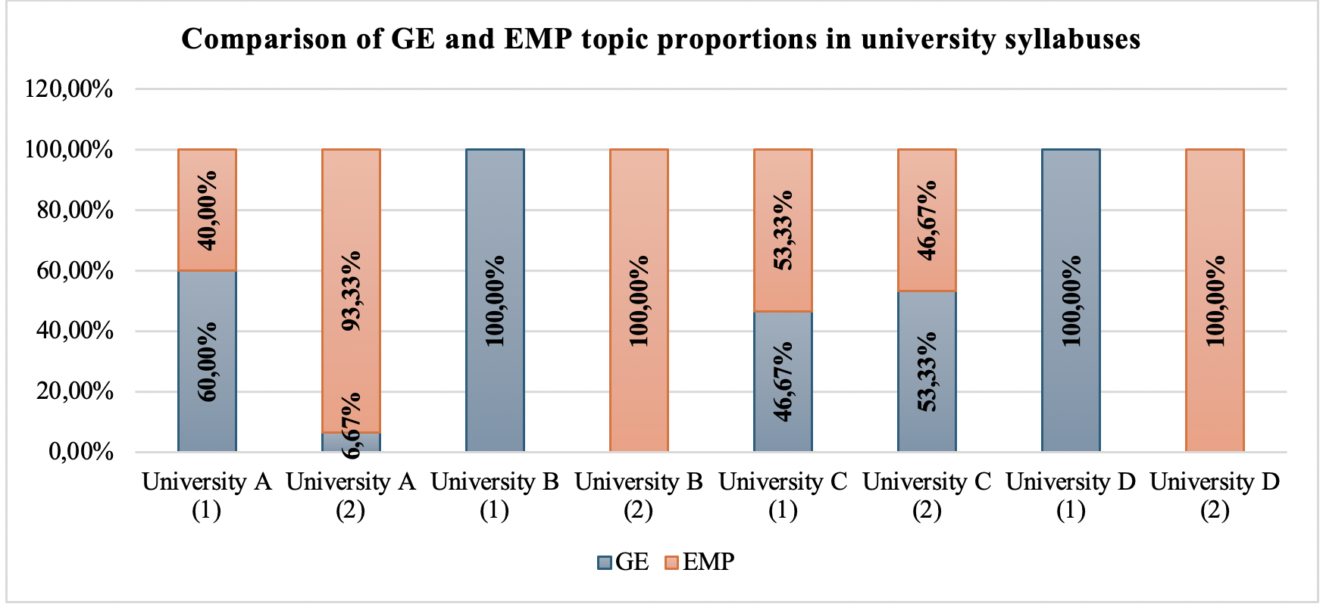

Figure 3 − Proportion of GE and EMP topics in analyzed English course syllabuses for medical students

Figure 3 shows the proportion of General English (GE) and English for Medical Purposes (EMP) topics in the analyzed syllabuses of four medical universities. In University A, the first-year course includes 60% of General English and 40% of Medical English, while in the fourth year, the focus shifts to 93.33% of EMP and contains only 6.67% of GE topics. University B shows 100% of GE topics in the first-year course, while the second course, which was unavailable at the time of our visit, was reported by lecturers to be mainly medical (100% EMP). University C demonstrates a more balanced structure. The first course includes 46.67% of GE and 53.33% of EMP topics, while the second course has 53.33% of GE and 46.67% of EMP elements. In University D, the first course is fully General English (100%), while the second course, according to lecturers, is entirely focused on medical content (100% EMP). Overall, the data suggest that some universities, particularly A and C, combine General and Medical English at different stages of study, while others (B and D) show a clearer division between general and professional focus across academic years. Overall, the data show that Universities A and C try to combine General and Medical English, while in Universities B and D these areas are taught separately at different stages.
Following that, when comparing the stated aims of English language courses across the four medical universities, it became clear that, although all programs aim to develop students’ communicative competence, the degree of professional orientation varies significantly. In University A (1 & 2), the course description emphasizes “preparation of specialists mobile in the international educational and professional space” and the ability to “use foreign literature for solving problems of clinical medicine”. The main goal of the course in University B (1) is to develop students’ communicative skills in a foreign language by using studied lexical and grammatical structures. The wording shows a focus on general language competence rather than a specific professional or medical context. The aims of courses at Universities C and D are almost identical and focus on the “formation of intercultural and communicative competence”. University C demonstrates a more balanced distribution of GE and EMP topics, whereas in University D, the content remains largely general with only limited connection to medical contexts. Overall, the analysis reveals that the professional orientation stated in the aims is not always fully reflected in the actual course content.
In recent years, Kazakhstan's universities have paid much attention to the creation and improvement of textbooks for various specialities. At the same time, more and more foreign teaching materials developed by native speakers and aimed at the development of oral speech are appearing on the market. These manuals have a pronounced communicative character and include a variety of exercises. As a rule, the textbook is supplemented with a workbook, audio and video materials, which helps to develop speaking, writing and listening skills. In addition to materials for everyday communication, there are also specialised textbooks for professional language learning, such as the English for Specific Purposes series [7, p. 98].
Shaykhyzada notes that despite their popularity and strengths, foreign textbooks have a number of serious shortcomings. Firstly, they are not adapted to Kazakhstani realities as such manuals are created for students of different countries and specialities, so they do not take into account the specific goals and conditions of education in our universities. Secondly, the authors assume that students already know the basics of grammar, as in Europe there is a high level of language teaching at school and students have the opportunity to practise the language abroad. Therefore, grammatical material in these manuals is usually not explained, but only repeated. As a result, many important grammatical phenomena are not practised and this can hinder the understanding of texts and tasks. The teacher has to either explain new material quickly, risking that students will not learn it, or spend additional time on it, which is often not enough. The third problem is the lack of translation into the students' native language. Such manuals do not have dictionaries with translation, translation tasks from foreign language and vice versa, which complicates learning. The fourth disadvantage is the repetition of the same topics at different levels which creates a sense of stuckness and hinders progress. Therefore, lecturers had to develop additional materials on their own, adapting textbooks to the needs of their audience. This became an incentive for Kazakhstani universities to start creating their own teaching packages for non-language specialities. Such manuals better correspond to the professional orientation of teaching and can be used both separately and together with foreign materials [7, p. 98].
So, the next step of the syllabus analysis focused on the review of literature and reference materials included in the English course syllabuses. This part of the analysis aimed to identify what types of sources were recommended to students. Below is the overview of literature used in English course syllabuses.
- In University A, the teaching process is supported by the following materials: Main literature: (1) Essential English for Medical Students - Maslova A.M., 2018; (2) Departmental teaching materials (Language Department); Additional literature: (1) Medical. Express Publishing - Virginia Evans, Jenny Dooley, Trang M. Tran, M.D., 2021; (2) Murphy, R. English Grammar in Use: Essential Grammar in Use. Elementary level. Cambridge University Press, 2020; (3) Glendinning, Eric H., & Howard, Ron. Professional English in Use: Medicine. Cambridge University Press, 2007. Online resources: http://www.lib.kaznmu.kz/;
- In University B, the course is supported by the following materials: Main literature: (1) Christina Latham-Koenig, Clive Oxenden, Jerry Lambert, Paul Seligson. English File Student’s Book. Pre-Intermediate. 4th edition. Oxford University Press, 2019; (2) Christina Latham-Koenig, Clive Oxenden, Jerry Lambert, Paul Seligson. English File Workbook. Pre-Intermediate. 4th edition. Oxford University Press, 2019; (3) Raymond Murphy. English Grammar in Use. Cambridge University Press, 2020; Online resources: (1) elibrary.kaznu.kz; (2) openkaznu.kz MOOC "Ағылшын тілі"; (3) British Council - Learning English; (4) Voice of America - Learning English;
- In University C, the following literature is used. Main literature: (1) Кунанбаева, С.С., Кармысова, М.К. и др. Концепция развития иноязычного образования Республики Казахстан. Алматы, 2010; (2) Кунанбаева, С.С. Теория и практика современного иноязычного образования. Алматы, 2010; (3) McMillan. Dictionary of Contemporary English. McMillan, 2010; (4) Harrison, R., Philpot, S., & Curnick, L. New Headway Academic Skills: Reading, Writing, and Study Skills. Oxford University Press, 2009; (5) Burgmeier, A., Zwier, L. J., Rubin, B., & Richmond, K. Inside Reading: The Academic Word List in Context (Pre-Intermediate to Advanced). Oxford University Press, 2009; (6) Murphy, R. Essential Grammar in Use. Intermediate level. Cambridge University Press, 2010; Additional literature: (1) Маслова, А.М. Essential English for Medical Students. М.: ГЭОТАР-Медиа, 2013; (2) McCarter, S. Oxford English for Careers: Medicine I. Student’s Book. Oxford University Press; (3) McCarter, S. Oxford English for Careers: Medicine I. Teacher’s Resource Book. Oxford University Press; (4) McCarter, S. Oxford English for Careers: Medicine I. Class CD. Oxford University Press.Online resources: (1) British National Corpus. http://www.natcorp.ox.ac.uk; (2) The Corpus of Contemporary American English (COCA). http://www.americancorpus.org;
- In University D, students use the following core and supplementary materials. Basic literature: (1) Английский язык для медицинских вузов: учебник / A. M. Маслова, З. И. Вайнштейн, Л. С. Плебейская. - 5-е изд., испр. Москва: ГЭОТАР-Медиа, 2023. - 336 с.; (2) Медициналық жоғарғы оқу орындарына арналған ағылшын тілі: оқулық/ A. M. Маслова, З. И. Вайнштейн, Л. С. Плебейская; қаз. тіл. аудар. Г.М. Ахметова. - Мәскеу: ГЭОТАР-Медиа, 2023. - 336 бет; (3) Марковина И.Ю. Английский язык. Вводный курс.: учебник / Марковина И.Ю., Громова Г.Е., М.:ГЭОТАР - МЕДИА, 2016. - 160 с.; (4) Sam McCarter. Oxford English for careers: Medicine 1. Student’s Book. Sam McCarter. New York: Oxford University Press. 2017. - 143 p.; (5) Sam McCarter. Oxford English for careers: Medicine 2. Student’s Book. Sam McCarter. New York: Oxford University Press. 2017. - 143 p. Additional: (1) Virginia Evans, Jenny Dooly, James Caldwell. Medical. Express Publishing, 2015; (2) Virginia Evans, Jenny Dooly, Craig Anderson. Physician assistant. Express Publishing, 2015; (3) Virginia Evans, Jenny Dooly, John Lehnert. Medical equipment repair. Express Publishing, 2015; (4) Марковина И.Ю., Громова Г.Е. Английский язык для медиков. (грамматический практикум), М.:ГЭОТАР - МЕДИА, 2022; (5) Марковина И.Ю., Максимова З.К., Вайнштейн М.Б. Английский язык. М.: ГЭОТАР - МЕДИА, 2022; (6) Купцова О.Г. Английский язык для медицинских специальностей. КноРус, 2022; (7) Авилова И.С. Английский язык для врачей. Инфра-М, 2023; (8) Морозов Н.В., Марковина И.Ю. Новый англо-русский и русско-английский медицинский словарь: св. 110000 терминов, сочетаний, эквивалентов и значений, с транкрипцией. М.: Живой язык, 2019; (9) Day, J. Cambridge Unlock Level 4. Listening & Speaking skills. Teacher’s Book : учебник Cambridge university press, 2014; (10) Virginia Evans, Jenny Dooley. On Screen 2 Class CD’s. Express Publishing, 2015.
- As we can see in the overview of the recommended literature in the syllabuses of four medical universities, all universities use well-known international textbooks such as English Grammar in Use (2020) and English File (Latham-Koenig et al., 2019), which mainly focus on General English [102; 103]. However, the level of medical or professional orientation (EMP) differs greatly. In University A, the list includes both general and professional sources, for example, Essential English for Medical Students (Maslova, 2018), Professional English in Use: Medicine (Glendinning & Howard, 2007), and Medical (Evans et al., 2021) [104; 105; 106]. This shows an attempt to combine grammar, communication, and medical content. University B mostly uses General English textbooks such as English File and English Grammar in Use, and several open online platforms (e.g., British Council, Voice of America), which help improve general communication skills but do not focus on medical topics. University C uses a wider mix of materials: academic reading and writing books, theoretical works by Kazakhstani scholars and several medical books. This shows a partly professional but mostly linguistic approach. University D has the strongest medical focus, using many up-to-date EMP textbooks published between 2015 and 2023 by Express Publishing, Oxford University Press, and GEOTAR-Media. In general, the analysis shows that all universities aim to improve students’ English skills, but only some (especially Universities A and D) include recent and profession-oriented textbooks. In other universities, the main focus remains on General English, which limits students’ exposure to real medical communication.
The needs analysis in our study was carried out in several stages. To support and share the results of our research, some of the findings from the needs analysis were published in international peer-reviewed journals. The study examining students’ and lecturers’ perspectives on English language learning in medical universities was published in Novitas-ROYAL (Research on Youth and Language) under the title “Through Students' and Lecturers' Eyes: Kazakhstani Medical Students' Needs and Self-Efficacy Beliefs in Learning English” [98]. The needs analysis included several consecutive steps. First, we studied the existing syllabuses of English courses for medical students to see their structure, aims, and how much they focus on professional skills. Then, we conducted online surveys with medical students and English language lecturers. After that, we held semi-structured interviews with students and lecturers to better understand the results of the surveys. The needs analysis was conducted to better understand the real needs, difficulties, and expectations of medical students and lecturers in learning and teaching English.
The results of the needs analysis and diagnostic surveys conducted among medical students and English language lecturers were processed using descriptive statistics [69]. The analysis focused on calculating the frequency (F), mean (M), and standard deviation (SD) for each item in the questionnaire (see Table 4). Frequency analysis was used to identify the most common responses and to determine the overall distribution of opinions among respondents. The mean values helped to represent the general tendency of students’ and lecturers’ perceptions toward each statement, while the standard deviation indicated the degree of agreement or divergence in their opinions. These indicators provided a clear and objective picture of the respondents’ attitudes toward the current state of English language teaching in medical universities, their learning needs, and the perceived importance of different language skills. The obtained data served as the basis for defining the main objectives and structure of the model based on principled eclectic approach developed in this research.

Table 4 − Formulas Used for Descriptive Statistical Analysis

Formula 1 | Formula 2 | Formula 3 | Formula 4
Absolute Frequency (n) | Relative Frequency (%) | Mean (M) | Standard Deviation (Sd)
$$f_{i}=n_{i}$$ | $$p=\frac{n}{N}×100\%$$ | $$\overline{X}=\frac{\sum{X}}{n}$$ | $$Sd=\sqrt{\frac{\sum{{\left(x_{i}-\overline{x}\right)}^{2}}}{n-1}}$$

All values were calculated using Microsoft Excel functions:
- The absolute frequency (n) values were calculated according to the Formula 1, where $f_{i}$ is the absolute frequency of the i-th category, and $n_{i}$ is the number of responses in that category;
- The relative frequency (%) values were computed using the Formula 2, where p is the percentage, n is the number of respondents in the given category, and Nis the total number of respondents;
- The mean (M) was calculated to determine the average score for each survey item according to the Formula 3, where $∑X$ represents the sum of all responses and n denotes the total number of respondents;
- The standard deviation (SD) was calculated to measure the variability of responses around the mean using the Formula 4,
where $Sd$ is the sample standard deviation, $x_{i}$ represents each individual score, $\overset{ˉ}{x}$ is the arithmetic mean, and n is the number of observations.
The standard deviation reflects how widely the values are spread from the mean: a smaller SD indicates higher consistency among responses, while a larger SD shows greater variability in the participants’ opinions.
Having clarified all the mathematical formulas used for the descriptive statistical analysis, we now proceed to the presentation and interpretation of the obtained results.
The second stage of the needs analysis focused on collecting quantitative data through online surveys conducted among medical students and university lecturers. The data collection was organized as follows. In order to reach medical student and lecturer respondents from different parts of Kazakhstan, official inquiry letters were sent to the administrations of eight universities that offer medical education programs, asking for institutional support in carrying out the present study as part of the doctoral dissertation. The letters contained information regarding the research purpose, objectives, and procedural stages. Five universities responded positively and expressed their willingness to assist us in the distribution of the questionnaires. In most cases, the dean’s offices and language departments assisted in distributing the link to the online survey among their students via WhatsApp and corporate emails, with a text message about the study’s purpose, its anonymity, and the right to withdraw at any time. We express our sincere appreciation to these universities for their collaboration in facilitating the research process.
The structure of our online survey among Kazakhstani medical students consisted of three stages. The first stage of the survey focused on the students’ background. It collected information about their age, gender, nationality, university, year of study, educational program, and language of instruction. The second stage was entirely dedicated to students’ English learning experience at university, their satisfaction levels and anticipated improvements. The third stage was developed as a result of thorough literature review on target needs analysis and academic self-efficacy. Particularly, the questions were adapted from the questionnaire developed by Wang, Geng, and Han (2024) using Likert scale [101].
To provide a clearer overview of the participants involved in the study, the following Table 5 presents their distribution of respondents by age, gender, and nationality. The survey was completed by 901 medical students from several Kazakhstani universities representing diverse demographic and educational backgrounds. The detailed demographic characteristics of the student respondents are described in the Table 5.

Table 5 − The demographic characteristics of the student respondents (N = 901)

Variables | Type | n | %
Age group | Under 18 | 127 | 14.10
Age group | 18-20 | 675 | 74.92
Age group | 21-23 | 84 | 9.32
Age group | 24-26 | 6 | 0.67
Age group | 27-30 | 5 | 0.55
Age group | Over 30 | 4 | 0.44
Gender | Male | 285 | 31.63
Gender | Female | 616 | 68.37
Nationality | Kazakh | 813 | 90.23
Nationality | Russian | 18 | 2.00
Nationality | Uzbek | 28 | 3.11
Nationality | Uighur | 8 | 0.89
Nationality | Turkmen | 6 | 0.67
Nationality | Azerbaijani | 6 | 0.67
Nationality | Korean | 5 | 0.55
Nationality | Other | 17 | 1.88

As shown in the Table 5, the total number of respondents was 901 medical students. Most participants belonged to the 18-20 age group (74.92%, n = 675), followed by those under 18 (14.10%, n = 127). Smaller groups included students aged 21-23 (9.32%, n = 84), while very few respondents were 24 years and older (together less than 2%). In terms of gender, the majority of respondents were female (68.37%, n = 616), while male students accounted for 285 respondents (31.63%, n = 285). Regarding nationality, the overwhelming majority were Kazakh (90.23%, n = 813). Smaller numbers represented other ethnic groups: Uzbek (3.11%, n = 28), Russian (2.00%, n = 18), Uighur (0.89%, n = 8), Turkmen (0.67%, n = 6), Azerbaijani (0.67%, n = 6), and Korean (0.55%, n = 5). Additionally, 17 students (1.88%, n = 17) identified as belonging to other nationalities.
In the context of the present study, particular attention was paid to the composition of the research sample, as it plays a crucial role in ensuring the validity, reliability, and representativeness of the obtained results. A clear understanding of the participants’ background characteristics allows for a more accurate interpretation of the data and provides a solid foundation for further analysis. The following figure presents the distribution of the survey respondents according to their university affiliation and year of study. This information provides an overview of the sample structure and ensures the representativeness of the collected data.
As Figure 4 (a) shows, in the survey, we collected data from 901 medical students from five universities in Kazakhstan using an online Google Forms questionnaire: 21.98% (n = 198) were from Asfendiyarov Kazakh National Medical University (KazNMU), 2.89% (n = 26) from Al-Farabi Kazakh National University (KazNU), 54.82% (n = 494) from Astana Medical University (AMU), 11.54% (n = 104) from Semey Medical University (SMU), and 8.77% (n = 79) from Marat Ospanov West Kazakhstan Medical University (WKMU). Regarding the distribution of students by year of study, as shown in Figure 4 (b), The majority of the surveyed medical students were in their second year of study, making up 53.72% (n = 484) of all respondents. First-year students represented 18.09% (n = 163) of the sample, while third-year students accounted for 15.21% (n = 137). The number of fourth-year students was smaller (8.21%, n = 74), and only a few participants were in their fifth (4.22%, n = 38) or sixth year (0.55%, n = 5) of study.

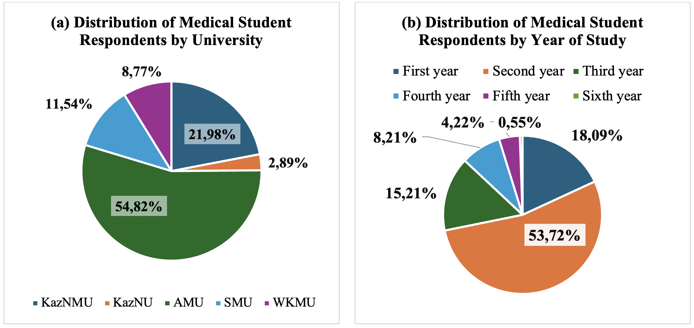

Figure 4 − Distribution of Respondents (Medical Students) According to Their (a) University Affiliation and (b) Year of Study

To understand the background of the respondents, information was collected about the language of instruction and their study programs. This helped to describe the academic environment where students learn English. The obtained data is displayed in the Table 6. According to Table 6, the majority studied in Kazakh as the language of instruction (66.93%, n = 603), followed by Russian (24.53%, n = 221) and English (8.55%, n = 77). In terms of educational programs, the largest groups came from General Medicine (35.96%, n = 324) and Medicine (30.41%, n = 274). Other significant groups included Dentistry (15.76%, n = 142) and Pediatrics (7.55%, n = 68). Smaller numbers of respondents represented Pharmacy (3.44%, n = 31), Public Healthcare (2.55%, n = 23), and Nursing (1.66%, n = 15). Only a few students were enrolled in Medical and Preventive Care (1.33%, n = 12), Pharmaceutical Production Technology (0.67%, n = 6), Kinesitherapy (0.44%, n = 4), and Ergotherapy (0.22%, n = 2). Overall, the data shows that most students study in Kazakh and are enrolled in the main medical specialties like General Medicine and Medicine, which should be considered when designing English courses.

Table 6 − Language of Instruction and Educational Programs of Medical Student Respondents (N = 901)

Variables | Type | n | %
Language of instruction | Kazakh | 603 | 66.93
Language of instruction | Russian | 221 | 24.53
Language of instruction | English | 77 | 8.55
Educational program | Medicine | 274 | 30.41
Educational program | General Medicine | 324 | 35.96
Educational program | Dentistry | 142 | 15.76
Educational program | Pharmacy | 31 | 3.44
Educational program | Pediatrics | 68 | 7.55
Educational program | Nursing | 15 | 1.66
Educational program | Medical and Preventive Care | 12 | 1.33
Educational program | Public healthcare | 23 | 2.55
Educational program | Pharmaceutical production technology | 6 | 0.67
Educational program | Ergotherapy | 2 | 0.22
Educational program | Kinesitherapy | 4 | 0.44

In the second part of our questionnaire, students were asked to describe their English learning experience at university. The questions focused on identifying whether English was taught as a general subject or with a professional or medical orientation. This information was important for understanding how much exposure medical students had to English relevant to their future field. It also helped to see whether their university language training included elements of English for Medical Purposes (EMP).
Based on the data in Table 7, out of the 901 respondents, the majority (741 students, 82.24%) reported that they had studied English for general purposes. A smaller group (87 students, 9.66%) indicated that they had not studied general English at university, while 73 students (8.10%) were not sure. When asked about English for medical or professional purposes, 592 students (65.70%) answered positively, showing that nearly two-thirds of the sample had experience with English related to their future profession. At the same time, 213 students (23.64%) reported that they had not studied professional English, and 96 students (10.65%) were not sure.

Table 7 − Students' English learning background at university (N = 901)

Questions: | Yes |  | No |  | Not sure
Questions: | n | % | n | % | n | %
Did you study English for general purposes at university? | 741 | 82.24 | 87 | 9.66 | 73 | 8,10
Did you study English for medical purposes or professional English at university? | 592 | 65.70 | 213 | 23.64 | 96 | 10,65

Since our study seeks to analyze both the current state and challenges in English language teaching, we think that students’ subjective assessments of English language programs at their institutions also can serve as valuable data for identifying the overall quality of instruction and for highlighting areas that require pedagogical and administrative improvement (see Table 8).

Table 8 − Students’ assessments of language instruction at university (N = 901)

Question | Answers | n | %
How would you rate the quality of the English language programmes offered by your institution? | Excellent | 340 | 37,74
 | Good | 307 | 34,07
 | Satisfactory | 192 | 21,31
 | Unsatisfactory | 52 | 5,77
 | Very poor | 10 | 1,11

As shown in table 8, a total of 901 students rated the quality of the English language programs at their institutions. The largest group of students (340 students, 37.74%) said the programs were excellent, and another 307 students (34.07%) rated them as good. About one-fifth of the respondents (192 students, 21.31%) considered the programs satisfactory. Only a small number thought the quality was low: 52 students (5.77%) described it as unsatisfactory, and 10 students (1.11%) as very poor.
Next, we asked students how they thought the Foreign Language course could be improved in order to better understand their real needs and expectations. Their answers help to show which skills and areas of English they feel are most important and what changes could make the course more useful for them (see Table 9).

Table 9 − Course improvements from students’ viewpoint

Question | Answers | n | %
How do you think the content of the ‘Foreign Language’ course could be improved? (You can choose several answers) | Pay more attention to listening skills | 369 | 15.56
 | Pay more attention to reading skills | 243 | 10.25
 | Pay more attention to speaking skills | 585 | 24.67
 | Pay more attention to writing skills | 212 | 8.94
 | Pay more attention to medical terminology | 346 | 14.59
 | Organise English-speaking clubs, workshops and cultural events to increase the use of the language in social settings | 374 | 15.77
 | Supplement course materials with mobile apps designed for language learning | 242 | 10.21

As shown in table 9, out of 901 student respondents, the most common suggestion was to pay more attention to speaking skills (585 students, 24.67%). This was followed by organizing English-speaking clubs, workshops, and cultural events (374 students, 15.77%) and paying more attention to listening skills (369 students, 15.56%). A considerable number also wanted more focus on medical terminology (346 students, 14.59%). Smaller groups mentioned the need to improve reading skills (243 students, 10.25%) and to supplement course materials with mobile apps (242 students, 10.21%). The least common suggestion was to pay more attention to writing skills, chosen by 212 students (8.94%).
The third part of our online survey among medical students involved target needs analysis (TNA). Many Kazakhstani students do not reach the required English level, so both lecturers and learners face specific challenges [107]. To understand the challenges in teaching and learning English in the medical field, it is important to investigate students’ language needs. These needs include what is necessary for their studies, what they lack, and what they want to achieve [34]. Such analysis also helps to set clear learning goals and improve curricula. Many researchers agree that target needs analysis (TNA) should be carried out regularly to design effective courses (Hutchinson and Waters’s, 1987; Choi, 2021; Kuzembayeva & Zhakanova, 2021; Wang et. al., 2024) [34; 108; 107; 101]. Therefore, within the TNA scale, we included questions concerning students’ necessities (9 items, e.g., “As a medical student, I need to study English…”), lacks (16 items, e.g., “It is difficult for me to…”), and wants (16 items, e.g., “I hope I will be able to… by studying English at university”). To analyse the data systematically, all needs analysis statements were coded (N1 - N9). These codes represent specific types of English language needs for medical students: (N1) I must study English to understand basic spoken English in cafes, shops, and airports; (N2) I need to understand videos, presentations, and lectures on medical topics in English; (N3) I need to read and understand websites and blogs in English; (N4) I need to read and understand medical textbooks and research articles in English; (N5) I need sufficient vocabulary to express my opinions on everyday matters in English; (N6) I need to make presentations and engage in discussions on medical topics in English; (N7) I need to write personal letters or messages in English, as well as non-complex essays and summaries of texts in English; (N8) I must write various academic texts in English, such as academic essays, research articles, and literature reviews; (N9) I must learn English to study abroad as an exchange student or intern. This coding allowed us to distinguish between students’ general language needs (N1, N5), which support everyday communication, their academic needs (N3, N7, N8, N9), which relate to studying and academic achievement, and their profession-related needs (N2, N4, N6), which are directly tied to their future work as medical professionals.
To measure the level of agreement with each statement, a five-point Likert scale was used. The response options included: Strongly Disagree (SD), Disagree (D), Neutral (N), Agree (A), and Strongly Agree (SA). Each of these categories reflects a different degree of agreement with the given statement, ranging from complete disagreement to full agreement. According to the Table 10, the results show that students rated most needs as important, with mean scores ranging from 3.73 to 4.20. The highest-rated items were N5 (vocabulary for everyday opinions) and N9 (English for study abroad), both with a mean of 4.20, followed closely by N2 (understanding medical lectures) and N4 (reading medical textbooks) with means of 4.13. N3 (reading websites and blogs) also scored highly with a mean of 4.09. The lowest-rated items were N8 (writing academic texts) with a mean of 3.73, and N7 (writing short essays and messages) with 3.85, showing that writing was considered less urgent than speaking, reading, or vocabulary. N6 (presentations and discussions in medicine) also had a slightly lower mean of 3.86 compared to other skills.
Table 10 − Students’ Perceived Needs in English for Medical Purposes (TNA Results)

Code | Statements (As a medical student…) | M | Sd | SD  (%) | D  (%) | N  (%) | A  (%) | SA  (%)
N1 | I need to study English to understand basic spoken English in situations such as cafes, shops, and airports. | 3,92 | 1,00 | 26  (2,89) | 42  (4,66) | 207  (22,97) | 329  (36,51) | 297  (32,96)
N2 | I need to understand videos, presentations and lectures on medical topics in English. | 4,13 | 0,90 | 13  (1,44) | 24  (2,66) | 165  (18,31) | 332  (36,85) | 367  (40,73)
N3 | I need to read and understand websites and blogs in English. | 4,09 | 0,88 | 11  (1,22) | 20  (2,22) | 185  (20,53) | 347  (38,51) | 338  (37,51)
N4 | I need to read and understand medical textbooks and research articles in English. | 4,13 | 0,91 | 17  (1,89) | 20  (2,22) | 162  (17,98) | 334  (37,07) | 368  (40,84)
N5 | I need to have sufficient vocabulary to express my opinions on everyday matters in English. | 4,20 | 0,82 | 10  (1,11) | 10  (1,11) | 138  (15,32) | 376  (41,73) | 367  (40,73)
N6 | I need to make presentations and engage in discussions on medical topics in English. | 3,86 | 0,99 | 23  (2,55) | 37  (4,11) | 264  (29,30) | 296  (32,85) | 281  (31,19)
N7 | I need to write personal letters or messages in English, as well as non-complex essays and summaries of texts in English. | 3,85 | 0,98 | 19  (2,11) | 42  (4,66) | 275  (30,52) | 287  (31,85) | 278  (30,85)
N8 | I need to write various academic texts in English, such as academic essays, research articles and literature reviews. | 3,73 | 1,05 | 29  (3,22) | 60  (6,66) | 291  (32,30) | 264 (29,30) | 257 (28,52)
N9 | I need to learn English because I want to study abroad as an exchange student or do an internship. | 4,20 | 0,91 | 14  (1,55) | 16  (1,78) | 166  (18,42) | 287  (31,85) | 418  (46,39)
Note: M - Mean, Sd - Standard deviation, SD - Strongly disagree, D - Disagree, N - Neutral, A - Agree, SA - Strongly agree.

After analyzing students’ perceived needs, the next step is to look at students’ reported lacks and wants, or the areas they find most difficult in English. The subsequent questionnaire items asked students about the difficulties they face in English (L - lacks) and what they expect from their university English courses (W - Wants). Together coded as LW for further quadrant chart analysis, both type of statements asked about the same skills, but one is about problems now and the other is about goals. They answered these questions on a scale from “Strongly disagree” to “Strongly agree” and we calculated the average (M) and standard deviation (Sd) for each statement. To analyze these answers more clearly, we used a chart called the Importance-Performance Analysis (IPA) quadrant chart proposed by Lu et.al. (2023) [113]. Using the quadrant chart illustrated in Figure 5, we placed lacks on the X-axis and wants on the Y-axis.

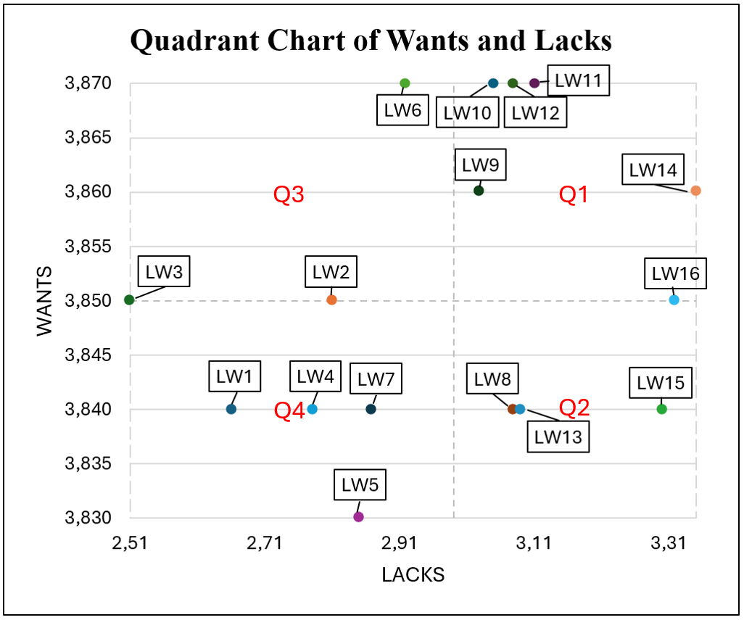

Figure 5 − Quadrant chart: Students' language needs and deficiencies

As shown, in Figure 5, this approach allowed us to see where students’ biggest gaps exist. Quadrant 1 - high wants, high lacks (Q1) includes the most important areas that require immediate attention. Quadrant 2 - lower wants, high lacks (Q2) includes skills where students experience noticeable difficulties, but do not rate them as top priorities. Quadrant 3 - high wants, lower lacks (Q3) represents areas where students feel more confident, but still want to improve. Quadrant 4 - lower wants, lower lacks (Q4) includes skills that students find relatively easy and less important for further development. The detailed results are presented in Table 11 and Figure 5.
Table 11 − Results of the Analysis of Students’ Reported Lacks and Wants in English Language Use
Code | Statements | Lacks (It is difficult for me…) |  | Wants (I hope I will be able to … by studying English at university) |  | Quadrant
Code | Statements | M | Sd | M | Sd | Quadrant
LW1 | Understanding basic spoken English in situations such as cafes, shops, and airports. | 2,66 | 1,16 | 3,84 | 0,95 | Q4
LW2 | Understanding TV shows or YouTube videos in English. | 2,81 | 1,14 | 3,85 | 0,94 | Q3
LW3 | Reading and understanding simple texts or emails in English. | 2,51 | 1,13 | 3,85 | 0,94 | Q3
LW4 | Understanding English-language websites and blogs. | 2,78 | 1,12 | 3,84 | 0,94 | Q4
LW5 | Expressing my opinions on everyday matters in English. | 2,85 | 1,17 | 3,83 | 0,96 | Q4
LW6 | Insufficient vocabulary to talk about everyday topics in English. | 2,92 | 1,20 | 3,87 | 0,94 | Q3
LW7 | Writing personal letters or messages in English. | 2,87 | 1,15 | 3,84 | 0,94 | Q4
LW8 | Writing essays or summaries of texts in English. | 3,08 | 1,15 | 3,84 | 0,95 | Q2
LW9 | Understanding presentations or lectures on medical topics in English. | 3,03 | 1,15 | 3,86 | 0,95 | Q1
LW10 | Understanding English-speaking colleagues or patients. | 3,05 | 1,12 | 3,87 | 0,94 | Q1
LW11 | Reading and understanding medical textbooks or research articles in English. | 3,11 | 1,16 | 3,87 | 0,94 | Q1
LW12 | Reading English-language websites and blogs with medicine-related content. | 3,08 | 1,13 | 3,87 | 0,93 | Q1
LW13 | Making oral presentations in English related to medicine in my studies. | 3,09 | 1,15 | 3,84 | 0,95 | Q2
LW14 | Insufficient professional vocabulary to engage in medical discussions in English. | 3,35 | 1,14 | 3,86 | 0,94 | Q1
LW15 | Writing academic essays or summaries of medical texts in English. | 3,30 | 1,12 | 3,84 | 0,96 | Q2
LW16 | Writing medical case reports or complete medical documentation in English. | 3,32 | 1,12 | 3,85 | 0,95 | Q1

A closer look at the results shows how each statement is positioned based on its mean values for lacks and wants, and how it is placed in the quadrant chart. LW1, “Understanding basic spoken English in situations such as cafes, shops, and airports”, has a relatively low level of lacks (M = 2.66) and a comparatively lower level of wants (M = 3.84) within the overall range. Therefore, it is placed in Quadrant 4 (low wants, low lacks). LW2, “Understanding TV shows or YouTube videos in English”, shows moderate lacks (M = 2.81) and relatively high wants (M = 3.85). This places the item in Quadrant 3 (high wants, lower lacks). LW3, “Reading and understanding simple texts or emails in English”, has low lacks (M = 2.51) and high wants (M = 3.85), indicating that students feel confident but still want improvement. Thus, it belongs to Quadrant 3. LW4, “Understanding English-language websites and blogs”, shows lower lacks (M = 2.78) and comparatively lower wants (M = 3.84). Therefore, it is categorized in Quadrant 4 (low wants, low lacks). LW5, “Expressing my opinions on everyday matters in English”, has moderate lacks (M = 2.85) and one of the lowest wants (M = 3.83). This places it in Quadrant 4. LW6, “Insufficient vocabulary to talk about everyday topics in English”, shows moderate lacks (M = 2.92) and one of the highest wants (M = 3.87). Therefore, it is placed in Quadrant 3 (high wants, lower lacks). LW7, “Writing personal letters or messages in English”, has moderate lacks (M = 2.87) and relatively lower wants (M = 3.84). Thus, it is categorized in Quadrant 4. LW8, “Writing essays or summaries of texts in English”, shows higher lacks (M = 3.08) and comparatively lower wants (M = 3.84). Therefore, it belongs to Quadrant 2 (lower wants, high lacks). LW9, “Understanding presentations or lectures on medical topics in English”, has high lacks (M = 3.03) and high wants (M = 3.86), which places it in Quadrant 1 (high wants, high lacks). LW10, “Understanding English-speaking colleagues or patients”, shows high lacks (M = 3.05) and one of the highest wants (M = 3.87). Therefore, it is in Quadrant 1. LW11, “Reading and understanding medical textbooks or research articles in English”, has high lacks (M = 3.11) and high wants (M = 3.87), placing it in Quadrant 1. LW12, “Reading English-language websites and blogs with medicine-related content”, shows high lacks (M = 3.08) and high wants (M = 3.87). Thus, it is in Quadrant 1. LW13, “Making oral presentations in English related to medicine in my studies”, has high lacks (M = 3.09) and relatively lower wants (M = 3.84). Therefore, it is placed in Quadrant 2. LW14, “Insufficient professional vocabulary to engage in medical discussions in English”, shows the highest lacks (M = 3.35) and high wants (M = 3.86). This places it in Quadrant 1. LW15, “Writing academic essays or summaries of medical texts in English”, has high lacks (M = 3.30) and comparatively lower wants (M = 3.84). Thus, it belongs to Quadrant 2. LW16, “Writing medical case reports or complete medical documentation in English”, shows high lacks (M = 3.32) and high wants (M = 3.85), placing it in Quadrant 1.
Interviews with medical students were conducted to gain deeper insights into the challenges medical students face while learning English at university. A personal interview is a face-to-face method where the interviewer directly interacts with the respondent, allowing for the clarification of questions, follow-up on incomplete answers, and reducing the need for strong reading or writing skills [69]. This qualitative approach allowed us to explore their experiences and perspectives in greater detail, complementing the quantitative data from the survey. A total of 11 students from three universities were interviewed. Table 12 summarizes key characteristics of the interviewed students, including their age group, gender, nationality, university affiliation, academic year, language of instruction, and educational program.

Table 12 − Profiles of interviewed students

Variables | Type | n | %  (n = 11)
Age group | Under 18 | 3 | 27,27
Age group | 18-20 | 7 | 63,63
Age group | 21-23 | 1 | 9,09
Gender | Male | 7 | 63,63
Gender | Female | 4 | 36,36
Nationality | Kazakh | 9 | 81,82
Nationality | Other | 2 | 18,18
University | Asfendiyarov Kazakh National Medical University | 2 | 18,18
University | Al-Farabi Kazakh National University | 4 | 36,36
University | Semey Medical University | 5 | 45,45
Academic year | First year | 2 | 18,18
Academic year | Second year | 8 | 72,73
Academic year | Third year | 1 | 9,09
Language of instruction | Kazakh | 10 | 90,90
Language of instruction | Russian | 1 | 9,09
Educational program | Medicine | 1 | 9,09
Educational program | General Medicine | 6 | 54,55
Educational program | Paediatrics | 1 | 9,09
Educational program | Public healthcare | 3 | 27,27

Table 12 presents the profiles of the interviewed students (n = 11). Most participants were aged 18-20 (63.63%), while 27.27% were under 18 and only 9.09% were aged 21-23. In terms of gender, the majority were male students (63.63%), whereas females accounted for 36.36%. Most respondents were of Kazakh nationality (81.82%, n = 9), with a small proportion of students from other nationalities (18.18%, n = 2). Regarding the university distribution, the largest group of students studied at Semey Medical University (45.45%, n = 5), followed by Al-Farabi Kazakh National University (36.36%, n = 4) and Asfendiyarov Kazakh National Medical University (18.18%, n = 2). Most participants were second-year students (72.73%, n = 8), while first-year students made up 18.18% (n = 2) and third-year students only 9.09% (n = 1). In terms of the language of instruction, the majority studied in Kazakh (90.90%, n = 10), and only one student studied in Russian (9.09%, n = 1). Finally, most students were enrolled in the General Medicine program (54.55%, n = 6), while smaller numbers studied Public Healthcare (27.27%, n = 3), Medicine (9.09%, n = 1), and Paediatrics (9.09%, n = 1).
The main aim of the next interview question was to identify the most common challenges experienced by students across different language skills, including speaking, listening, reading, and writing. Students’ responses were analyzed and are presented in Table 13.

Table 13 − Challenges faced by students in learning English at university

Questions | Results & Examples
What challenges have you encountered while learning English at university? (listening, reading, talking or writing) | Most student interviewees identified speaking as the most challenging aspect of learning English at university, with 9 students highlighting this difficulty. A lack of practice was also frequently mentioned, noted by 4 students, while 1 student pointed to challenges with grammar.  Representative Examples:  “very difficult to conduct speaking…on a regular basis… difficult to find a suitable person for that…”, “…most often, this is probably speaking skills, due to the lack of qualified specialists and little practice”, “…for me, probably the most difficult thing is that there is very little practice…”, “…I think nowadays everybody has difficulties in the speaking aspect because we don't have so much practice and when we were in school we just learnt the rules, not much practice, … we were given memorization exercises….so we just memorized…”, “…since I did not pay much attention to English during school .... at university I have difficulties... when retelling large texts...”, “…I think it's mostly speaking because we understand the questions, but it's hard to answer and express our thoughts…”.

The survey results reveal that speaking is the most commonly reported challenge, with 9 students identifying it as their primary difficulty. A lack of practice was also frequently mentioned, noted by 4 students, while 1 student indicated challenges with grammar. The representative examples from the students highlight the difficulties they experience, particularly in speaking. Many students emphasized the lack of regular practice and the scarcity of qualified instructors, which make it difficult for them to improve their speaking skills. Additionally, students reflected on their previous educational experiences, mentioning that in school, they were often taught grammar rules and memorization exercises rather than having opportunities to practice speaking. This gap in practice is seen as a key barrier to their ability to express themselves fluently in English.
The structure of our online survey among Kazakhstani lecturers teaching a foreign language to students of medical specialties. Online questionnaire survey among lecturers comprised 30 questions, including both multiple-choice and open-ended items, aimed at obtaining comprehensive insights from foreign language lecturers. The questionnaire addressed various aspects of medical language education, such as teaching experience, course content, methods, and materials used. It was designed to include both quantitative and qualitative questions to capture a wide range of opinions and detailed feedback. The detailed information about the background and demographic characteristics of 31 lecturer respondents is shown in Table 16.
Table 14 presents demographic information about the 31 lecturers who participated in the survey. Most participants (n = 11, 35.48%) were between 30-39 years old, followed by those aged 40-49 years (n = 9, 29.03%) and 50 years and above (n = 8, 25.81%). Only three respondents (n = 3, 9.68%) were under 30 years old. The majority of lecturers were female (n = 29, 93.55%), while male lecturers accounted for only a small portion (n = 2, 6.45%). Regarding education level, more than half (n = 18, 58.06%) held postgraduate education, nine respondents (n = 9, 29.03%) had higher education, and four lecturers (n = 4, 12.90%) had an academic degree such as PhD or an academic title. In terms of teaching experience, most respondents had between 10-19 years (n = 14, 45.16%) or 20 years and more (n = 12, 38.71%) of experience. A smaller group had 5 years or less (n = 3, 19.68%) and 6-9 years (n = 2, 6.45%) of teaching experience.

Table 14 − The demographic characteristics of the teacher respondents (N = 31)

Variables | Type | n | % (n = 31)
Age group | Under 30 years | 3 | 9,68
Age group | 30-39 years | 11 | 35,48
Age group | 40-49 years | 9 | 29,03
Age group | 50 years and above | 8 | 25,81
Gender | Male | 2 | 6,45
Gender | Female | 29 | 93,55
Education level | Higher education | 9 | 29,03
Education level | Postgraduate education | 18 | 58,06
Education level | Academic degree (e.g., PhD), academic title | 4 | 12,90
Teaching experience | 5 years or less | 3 | 19,68
Teaching experience | 6-9 years | 2 | 6,45
Teaching experience | 10-19 years | 14 | 45,16
Teaching experience | 20 years and more | 12 | 38,71

The figure 6 (a, b) below illustrates the composition of the lecturer sample in terms of their university affiliation and academic position.

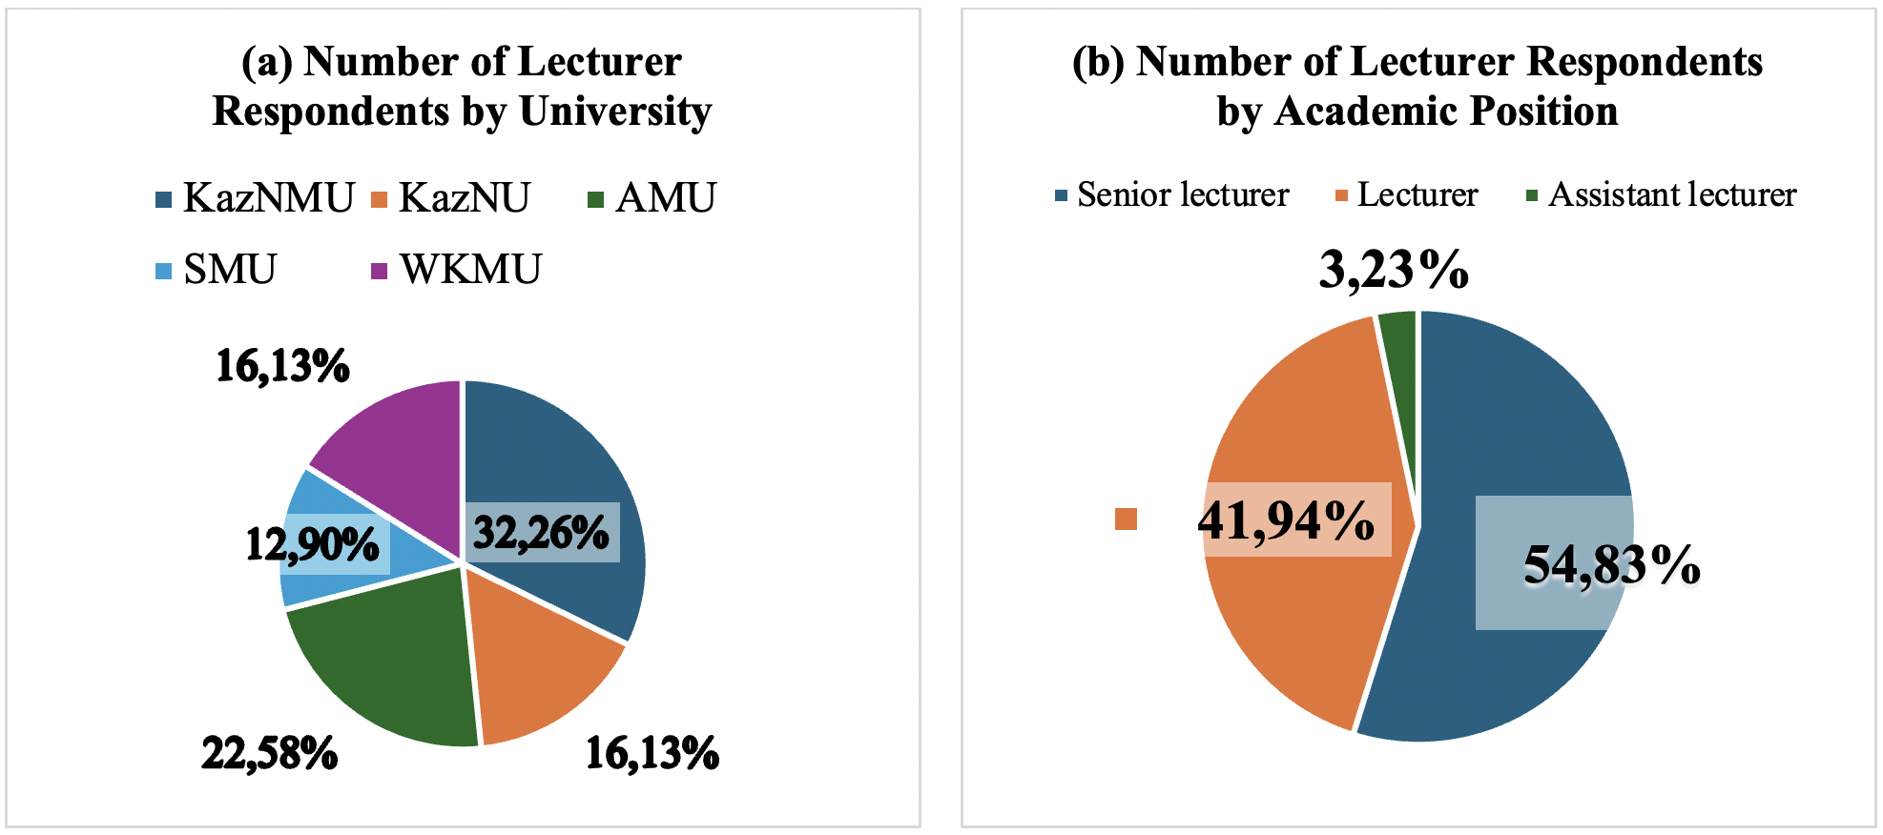

Figure 6 − Distribution of Respondents (University Lecturers) According to Their (a) University Affiliation and (b) Academic Position

As shown in Figure 6 (a), most respondents were from Asfendiyarov Kazakh National Medical University (n = 10, 32.26%), followed by Astana Medical University (n = 7, 22.58%). Smaller groups of lecturers represented Al-Farabi Kazakh National University (n = 5, 16.13%), Semey Medical University (n = 4, 12.90%), and Marat Ospanov West Kazakhstan Medical University (n = 5, 16.13%). Figure 6 (b) presents the distribution of respondents by their academic position. The largest group consisted of senior lecturers (n = 17, 54.84%), followed by lecturers (n = 13, 41.94%). Only one respondent (n = 1, 3.23%) held the position of assistant lecturer, and there were no professors among the participants.
To understand lecturers’ views on the importance of English in medical education, they were asked two key questions. The first question explored whether English proficiency is important for medical graduates at a professional level. Almost all lecturers (96.77%, n = 30) agreed that English is important for medical graduates, while only one respondent (3.23%, n = 1) disagreed. The second question focused on the significance of studying English for Medical Purposes (EMP) for medical students. Again, the majority (96.77%, n = 30) confirmed its importance, with one respondent (3.23%, n = 1) finding it difficult to answer. These results show that nearly all lecturers recognize the essential role of English in both the academic preparation and future professional practice of medical students.
To gain a clearer understanding of the challenges medical students face and their initial English language level, lecturers were asked which language skill (listening, reading, speaking, or writing) is the most difficult for students and what level of English proficiency students usually have when they enter university (see Figure 7 a,b).

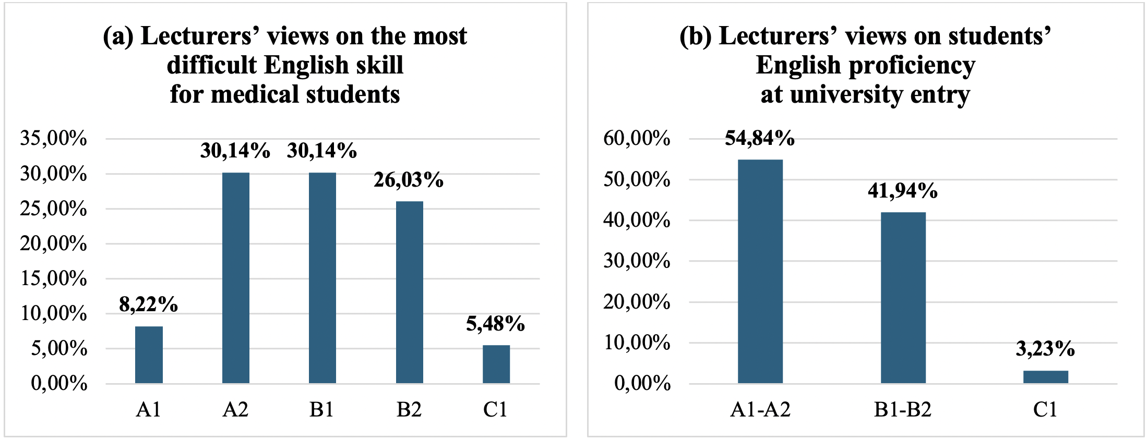

Figure 7 − Lecturers’ perceptions of (a) the most challenging language skills for medical students and (b) students’ English proficiency level upon university entry

According to Figure 7 (a and b), most lecturers (58.06%, n = 18) identified speaking as the most difficult English skill for medical students. Listening was mentioned by 32.26% (n = 10) of respondents, while writing was selected by 9.68% (n = 3). None of the lecturers (0.00%) indicated reading as a challenging skill for students. In terms of students’ English proficiency level at university entry, more than half of the lecturers (54.84%, n = 17) reported that students usually have a basic level (A1-A2). Another 41.94% (n = 13) stated that students have an intermediate level (B1-B2), and only 3.23% (n = 1) indicated an advanced level (C1).
When asked about the types of textbooks mainly used in the process of teaching English to medical students, the majority of lecturers (48.39%, n = 15) reported that they primarily use Russian editions. Almost the same number of respondents (45.16%, n = 14) indicated that they rely on foreign editions in their teaching practice. Only a small number of lecturers (6.45%, n = 2) stated that they use Kazakhstani editions of textbooks. To obtain more specific information about the teaching materials used in medical universities, lecturers were also asked to list the exact English textbooks they use in their courses. Their responses were summarized to identify the most frequently mentioned titles, authors, and publishers. Table 15 below presents the textbooks most commonly used by English language lecturers teaching medical students.

Table 15 − Textbooks used in the EFL classroom in Kazakhstani Medical Universities as reported by university lecturers

Textbook title  [Translation into English] | The author(s) | Publication Year | Publisher [Translation into English] | Frequency of Mentions
- Учебник английского языка для медицинских вузов [Essential English for medical students] | Maslova A.M., Weinstein Z.I., Plebeian L.S. | 2018 | GEOTAR-media Publishing group (Moscow, Russia) | 12
- Oxford English for Careers: Medicine 1 | Sam McCarter | 2009 | Oxford University Press (UK) | 6
- English in Medicine | Eric H. Glendinning, Beverly Holmström | 2005 | Cambridge University Press (UK) | 2
- Английский язык. English in Dentistry [English language. English in Dentistry] | Berzegova L. Yu. | 2013 | GEOTAR-media Publishing group (Moscow, Russia) | 3
- Английский язык для студентов-стоматологов [English for dental students] | Mukhina, V.V. | 2002 | Higher school (Moscow, Russia) | 3
- Check Your English Vocabulary for Medicine: All you need to improve your vocabulary (Check Your Vocabulary) | Rawdon Wyatt | 2006 | A&C Black (London, UK) | 1
- English File | Christina Latham-Koenig, Clive Oxenden, Jerry Lambert, Paul Seligson | 2019 | Oxford University Press (UK) | 1

As shown in Table 15, the most frequently mentioned textbook was “Essential English for Medical Students” by Maslova, Weinstein, and Plebeian, published by GEOTAR-Media in 2018. It was named by 12 lecturers, making it the most widely used resource. The second most popular textbook was “Oxford English for Careers: Medicine 1” by Sam McCarter (Oxford University Press, 2009), mentioned 6 times. Two textbooks were mentioned 3 times each: “English in Dentistry” by Berzegova (GEOTAR-Media, 2013) and “English for Dental Students” by Mukhina (Higher School, 2002). The textbook “English in Medicine” by Glendinning and Holmström (Cambridge University Press, 2005) was referred to 2 times. Two other books such as “Check Your English Vocabulary for Medicine” by Rawdon Wyatt (A&C Black, 2006) and “English File” by Latham-Koenig, Oxenden, Lambert, and Seligson (Oxford University Press, 2019) were mentioned once each.
To explore how independent learning is organized in English language courses for medical students and to decide what types of tasks could be included in our model, lecturers were asked two related questions. The first question asked what types of independent work they use in the “Foreign Language” course. The list included activities such as note-taking, writing essays or reports, solving medical cases, preparing presentations, recording audio or video tasks, and using interactive tools like crosswords, word searches, or Kahoot games. The second question asked which of these activities lecturers think are the most effective for developing professional foreign language communication skills in medical students (see Figure 8).

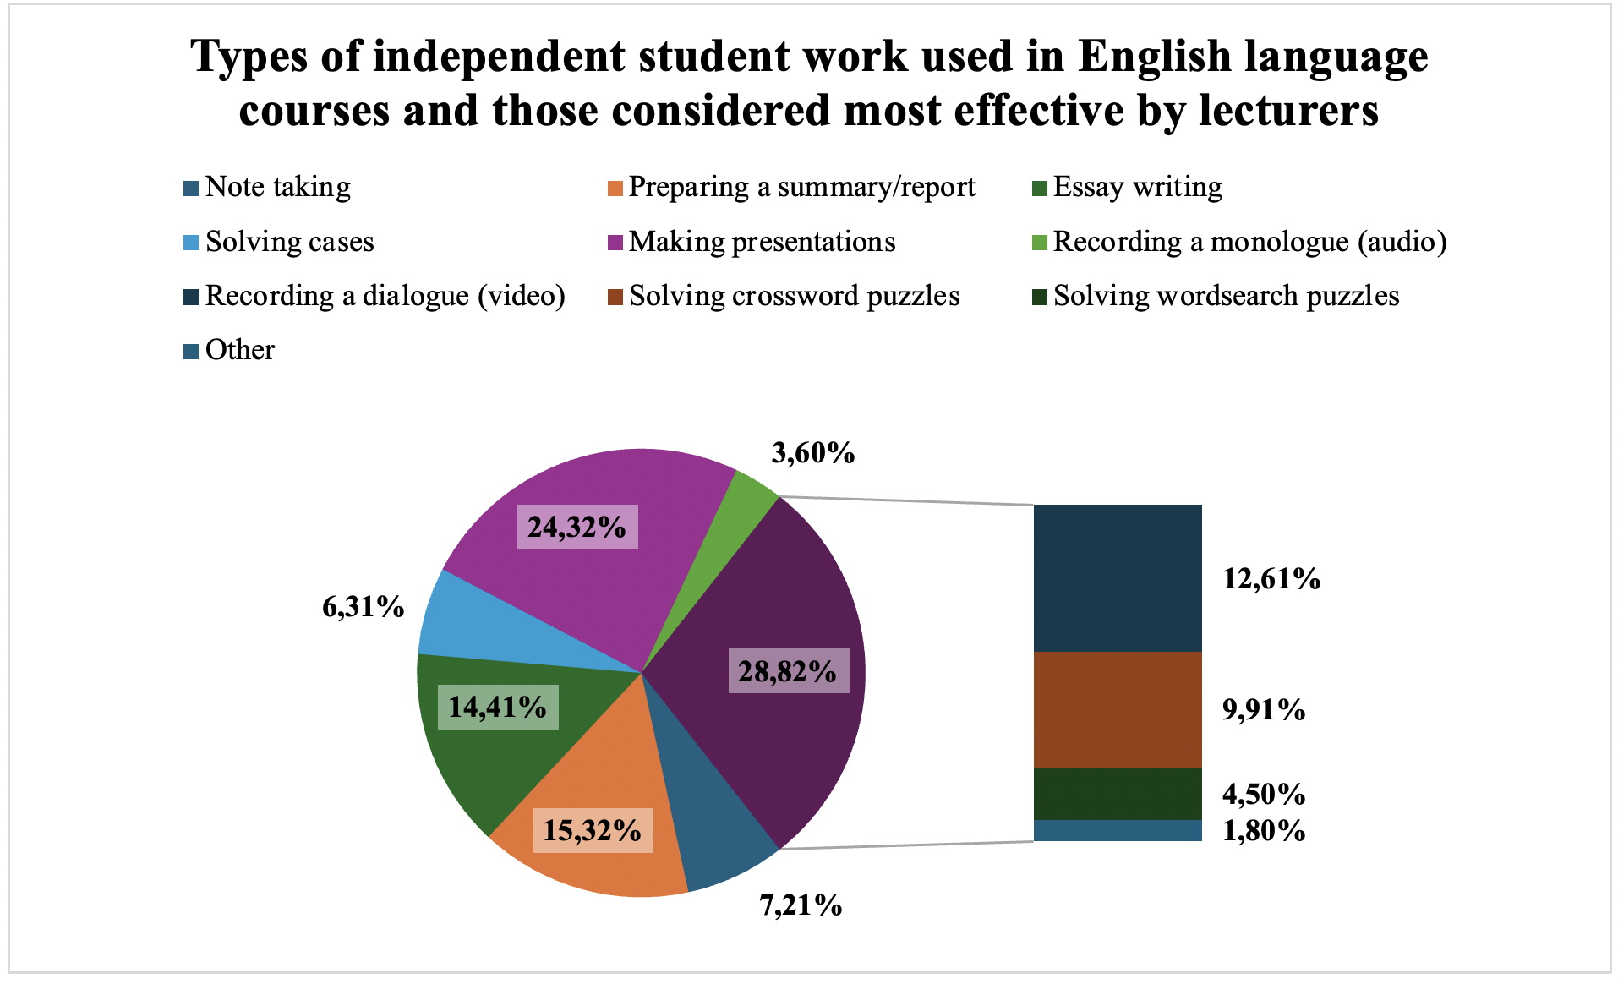

Figure 8 − Lecturers’ responses on the types of extracurricular independent work used in English language courses and the most effective types for forming professional foreign language communicative competence of medical students

According to the results, lecturers reported that the most common types of extracurricular independent work used in English language courses were making presentations (24,32%, n = 27), preparing summaries or reports (15,32%, n = 17), and essay writing (14,41%, n = 16). Other types of independent work included recording dialogues in the form of video clips (12,61%, n = 14) and solving crossword puzzles (9,91%, n = 11). Less frequently used activities were note taking (7,21%, n = 8), solving cases (6,31%, n = 7), recording monologues (3,60%, n = 4), and solving wordsearch puzzles (4,50%, n = 5). Only a few lecturers (1,80%, n = 2) mentioned other types of tasks. When asked which forms of independent work are most effective for forming professional foreign language communicative competence, lecturers most often selected making presentations (29,03%, n = 9) and recording dialogues in the form of video clips (29,03%, n = 9). Some respondents also considered essay writing (12,90%, n = 4) and solving cases (9,68%, n = 3) to be useful. Less frequent answers included preparing summaries or reports (9,68%, n = 3) and solving crossword puzzles (3,23%, n = 1). None of the lecturers chose note taking, wordsearch puzzles, recording monologues, or Kahoot games as effective forms of independent work.
Additionally, we included an open-ended question in our survey, asking respondents, "What difficulties do students face in the process of learning in the 'Foreign Language' course?" This question aimed to provide respondents with the opportunity to elaborate on the challenges students face when learning English. By doing so, lecturers could share their experiences and offer deeper insights into the difficulties students encounter, beyond the scope of closed-ended questions. To analyse the responses, we employed a thematic analysis approach. The lecturers identified a range of issues related to language proficiency and skills development, particularly in speaking and communication:
- Speaking and communication skills (n = 8). A significant challenge identified was the fear of speaking, with many lecturers noting that students are often afraid to speak in English. In addition, lecturers highlighted difficulties with pronunciation, oral speech and retelling texts. Some lecturers specifically mentioned students' inability to use medical terms. Lecturers also reported challenges with grammar and listening skills. Example responses: Respondent 1: “Afraid to speak”; Respondent 8, 17: “Speaking”; Respondent 14: “Fear of speaking English language”; Respondent 16: “Problems with pronunciation, fluent colloquial speech”; Respondent 18: “Problems with oral speech, retelling of the text”; Respondent 20: “Many people cannot verbally present the text”; Respondent 29: “Retelling the text”.
- Resource and time constraints (n = 3). Another significant concern raised by lecturers was the insufficient number of study hours available for instruction. Additionally, lecturers cited a lack of books and methodological literature, implying that students do not have access to enough resources to aid their learning. Another concern was the lack of real practical situations in which students can apply their English skills. Example response: Respondent 3: “Insufficient number of study hours. The lack of real practical situations where students need to apply a foreign language”; Respondent 13: “Provision of educational and methodological literature”; Respondent 14: “Lack of time to prepare”.
- Classroom organization and group dynamics (n = 2). The large number of students in some classes, combined with the inability to separate them by proficiency levels due to class sizes, was another challenge. Furthermore, overloaded class schedules and prioritization of specialized subjects were mentioned as another issue. Example responses: Respondent 18: “Mixing students with different levels of proficiency in the same group.”; Respondent 21: “Different levels of English language proficiency, the inability to separate all students by levels due to their large number studying at the department at the same time, insufficient equipment of classrooms, overloaded class schedules and preferences for special subjects”.
- Cognitive and motivation issues (n = 2) were frequently mentioned by lecturers as significant barriers to student learning. A lack of cognitive effort was highlighted, with lecturers noting that students do not actively engage with the material. Many students resort to passive learning strategies, such as copy-pasting or using tools like ChatGPT. In some cases, students were also reported to have difficulty expressing their thoughts freely. Example responses: Respondent 24: “Inability to communicate their thoughts freely”; Respondent 12: “The main difficulty is that there is no habit and skill to comprehend the material and perform cognitive work. Students do not memorize new words and material, and do not use them as an active dictionary. Some students have a weak ability to choose the appropriate material for the IWS and for their own presentation of the material - students use ready-made solutions (copy-paste, ChatGPT, etc.), spending a minimum of cognitive effort.”
- Insufficient school preparation (n = 5). Finally, lecturers noted that many students, especially those from rural areas, enter the university with a very low level of English proficiency. This poses a significant challenge for lecturers who must help these students improve their language skills. Example responses: Respondent 4: “No basic level”; Respondent 10: “Weak basic knowledge 70%”; Respondent 23: “Low level of knowledge, difficulties in speaking, listening”; Respondent 26: “The level of education received at school is low”; Respondent 28: “They have a very low level of English proficiency, as most students come from rural areas”.
English Course Improvements. Another open-ended question in the survey aimed to gather lecturers' suggestions for improving English courses for medical students. Respondents offered a variety of measures to enhance the quality of these courses, which were grouped into several key categories, as outlined below. These suggestions reflect lecturers' insights into areas for development, ranging from curriculum design to teaching methods and resources:
- Increasing Instructional Hours and Course Coverage (n = 6). Many respondents stressed the importance of increasing the number of hours dedicated to foreign language instruction. Additionally, suggestions included making English mandatory for students in their first and second years and creating more opportunities for practical engagement, such as through structured projects and discussions. Lecturers recommended incorporating activities like international internships and conferences to allow students to apply the language in real-world scenarios. Example responses: Respondent 1: “Give more hours”; Respondent 3: “To increase the number of hours of foreign language teaching. To increase the involvement of students in practical projects in the specialty"; Respondent 4: “To make studying English mandatory for 1st and 2nd year students”; Respondent 10: “To increase the number of hours for teaching English”; Respondent 14: “To allocate hours for IWST”; Respondent 24: “To increase the number of hours”.
- Improving Classroom Resources (n = 8). Lecturers pointed out the need for better classroom resources to enhance language learning. Recommendations included providing modern textbooks, audiovisual tools (such as projectors and smart boards), and other technical equipment to support lessons. Lecturers also emphasized the need for specialized materials to cater to the medical field, ensuring that students have access to the resources they need for their specific studies. Example responses: Respondent 5: “Provide the classrooms with books and equipment”; Respondent 6: “Produce textbooks for them”; Respondent 7: “technical support (new projectors that can be connected via Bluetooth or USB) for IWS and for classes”; Respondent 11: “To purchase a variety of teaching materials for variability in specialties, to provide interactive means of audio visualization of classes (smart boards)”; Respondent 13: “To provide students with all technical and educational tools”; Respondent 15: “To equip classrooms for teaching English”; Respondent 27: “Oxford, Cambridge publications should be used (no possibility)”; Respondent 29: “Teaching with modern books”.
- Enhancing Teaching Methods (n = 5). Several respondents suggested diversifying and modernizing teaching strategies. They highlighted the importance of using active learning techniques, such as interactive games and discussions, to engage students. Role-playing exercises were also proposed to simulate doctor-patient interactions, providing a more practical and immersive learning experience. Example responses: Respondent 16: “Role-playing games, interactive learning methods”; Respondent 17: “Using new technologies (Kahoot, Quizlet, Duolingo)”; Respondent 18: “Motivate with the help of active learning methods, games, discussions”; Respondent 22: “Use digital learning platforms”; Respondent 23: “listening equipment, more interactive whiteboards, speakers”.
- Focusing on Specialized Content (n = 2). A number of lecturers indicated that the course content should be more closely aligned with the medical field. Suggestions included increasing the inclusion of medical terminology in the curriculum and developing specialized textbooks and teaching materials tailored specifically to healthcare students. This would help ensure that the language taught is relevant to their future professional needs. Example responses: Respondent 20: “Introduce more medical terms, develop methodological manuals with a focus on medical terms”; Respondent 3: “To increase the involvement of students in practical projects in the specialty”.
- Promoting Practical Use of Language (n = 2). Lecturers emphasized the importance of providing students with opportunities to practice English in real-life settings. Some suggestions included creating situations such as internships or communication projects where students can use English in authentic contexts. Others recommended establishing online communication platforms for students to interact with peers from different countries, further enhancing language practice. Example responses: Respondent 3: “Creating real situations for using the language - international internships, communication at conferences, work in projects”; Respondent 27: “It is necessary to establish online communication with foreign students (preparation of scientific projects in English, creation of opportunities for participation)”
- Motivation and Quality Control (n = 3). To improve student engagement, respondents suggested adopting methods that encourage active participation, such as oral exams rather than written tests. They also recommended creating opportunities for self-directed learning, thereby motivating students to take greater responsibility for their progress and ensuring the overall quality of the learning experience. Example responses: Respondent 26: “It is necessary to increase the interest”; Respondent 12: “Encourage methods that require students to spend cognitive effort and exclude cheating & using the path of least resistance. For example, remove all multiple-choice tests and clearly check all written works for the use of AI and ChatGPT (put 0 score if detected). Instead, enter a knowledge check that requires an active recall, for example, an oral response to a question”; Respondent 28: “More additional classes, as well as more self-learning in students themselves”.
To complement the survey results and gain a deeper understanding of the context, interviews with university lecturers were conducted. The purpose was to explore their detailed opinions, teaching experiences, and the challenges they face when teaching English to medical students. While questionnaires provided general trends and quantitative data, interviews allowed for more specific and personal insights. They helped clarify why certain teaching methods are used, what difficulties lecturers encounter, and what improvements they believe are necessary. Table 16 presents the demographic and professional profiles of the five interview participants, all of whom are lecturers.

Table 16 − Profiles of interviewed lecturers

Variables | Type | n | %  (n = 5)
Age group | 30-39 years | 1 | 20,00
Age group | 40-49 years | 2 | 40,00
Age group | 50 years and above | 2 | 40,00
Gender | Male | 0 | 0,00
Gender | Female | 5 | 100,00
Education level | Higher education | 3 | 60,00
Education level | Postgraduate education | 2 | 40,00
Teaching experience | 10-19 year | 2 | 40,00
Teaching experience | 20 years or more | 3 | 60,00
University | S.D. Asfendiyarov Kazakh National Medical University | 2 | 40,00
University | Al-Farabi Kazakh National University | 1 | 20,00
University | Semey Medical University | 2 | 40,00
Position | Senior lecturer | 3 | 60,00
Position | Lecturer | 2 | 40,00

In terms of age, 20% of the participants are in the 30-39 age group, while the remaining participants are equally divided between the 40-49 age group (40%, n = 2) and those aged 50 and above (40%; n = 2). All interviewees are female (100%). Regarding educational qualifications, 60% (n = 3) of the participants hold higher education degrees, while the remaining 40% (n = 2) have postgraduate qualifications. In terms of teaching experience, 40% (n = 2) have 10-19 years of experience, and 60% (n = 3) have 20 or more years in the field. The lecturers represent three different universities: S.D. Asfendiyarov Kazakh National Medical University (40%, n = 2), Al-Farabi Kazakh National University (20%, n = 1), and Semey Medical University (40%, n = 2). Their professional roles are predominantly senior lecturers (60%, n = 3), with the remainder serving as lecturers (40%; n = 2).
As summarized in Table 17, to explore both the challenges students face in learning English at university and possible improvements to the course, lecturers were asked two key questions: what difficulties students most often face when learning English at university (listening, reading, speaking, or writing), and how the content of a foreign language course can be improved.

Table 17 − Lecturers’ Perspectives on Students’ Learning Difficulties and Recommendations for Course Improvement

Questions | Results & Examples
What difficulties do students most often face when learning English at university? (listening, reading, speaking or writing) | Students face several challenges when learning English at university. The most common difficulty is speaking (mentioned by 5 lecturers). Writing (mentioned by 3 lecturers) is another major challenge, particularly because of grammar issues and limited foundational skills. Listening (mentioned by 1 teacher) can also be difficult, especially for students who have weaker English backgrounds.  Representative Examples: “…in terms of speech, it is difficult for these people, first, and second. . .there are also difficulties in terms of the writing”, "…speaking skills because we have a lot of different terminology…", “…the majority of our students are students with A2 level…as you know, for a person with A2 level, everything is difficult…they understand what they hear but it is difficult for them to speak…”, “…first, it is speaking what they find difficult and second … writing is also difficult”, “…the main problem is their listening and grammatical errors, this is writing … it's all due to the fact that they have a weak school base”.
How do you think the content of a foreign language course can be improved? | Lecturers suggested improving the course by inviting foreign lecturers, creating debate clubs, and increasing teaching hours, as three hours per week is insufficient.  Representative Examples: “…invite foreign lecturers and create a debate club…”, “…number of hours … we have classes once a week, that is, for three hours… it seems to me that this is not enough”, “…increase the duration…for example, let's say in the first year, then the third year and then the fifth year...”, “…allocate more hours for our course, because it's not just learning medical English, but we need to improve their conversational skills more…”, “…find the connection between…what students need when they graduate from university and what they are studying…”

The results show that students most commonly face difficulties with speaking, as identified by 5 lecturers. Writing was also mentioned as a significant challenge by 3 lecturers, particularly due to grammar issues and limited foundational skills. Listening, noted by 1 teacher, can be difficult for students with weaker English backgrounds, especially when it comes to understanding spoken content. These challenges are reflected in the representative examples provided by lecturers, which highlight the difficulty students face in speaking, writing, and understanding spoken English, particularly at lower proficiency levels.
As for course improvements, lecturers suggested several measures to enhance the learning experience. These included inviting foreign lecturers, creating debate clubs, and increasing the number of teaching hours. Lecturers emphasized that the current three hours per week were insufficient to adequately address both medical English and conversational skills, and they proposed increasing the duration of the course, especially in the early years. They also stressed the importance of aligning course content with students' future professional needs, ensuring it is relevant to their academic and career goals.

3.2 Experimental Teaching for Developing Medical Students’ Professional Foreign Language Communicative Competence
The goal of any experimental research in foreign language education is about designing and employing different treatments, along with studying their effects [69, p. 11]. To achieve this goal, we implemented the intervention-based study approach as a basis for our experimental verification of the effectiveness of our methodological model for developing medical students’ professional foreign language communicative competence.
We designed our own syllabus for the Foreign Language course, which was used during the experimental teaching stage. Graves (2000) argues that goals are a way of expressing main intentions and learning outcomes intended to be achieved by the end of the course [66, p. 75]. Using the metaphor of travel, he says that a course is a path and goals are the destination that lecturers and students strive for. Meanwhile, the objectives act as intermediate points on this path. The formulation of goals helps the teacher to focus on the priorities of the course and not deviate from the intended direction. However, if in the course of teaching it turns out that the chosen goals do not correspond to the level or needs of students, they should be clarified or reformulated. Graves emphasizes that goals should be clear, realistic, and achievable, taking into account student levels, time, and available resources. They set the direction, but should not be too general or vague. It is important that the goals reflect what students need to achieve by the end of the course and serve as a criterion for learning success. Thus, the goals, according to Graves, are a guideline that helps to design, implement and evaluate the course as an integrated system.
Our syllabus was aimed at developing the professional foreign language communicative competence of medical students which is the main goal of our research. According to Stamgaliyeva, the content of the “Foreign Language” course for students of non-linguistic majors should be professionally relevant and focused on the development of professional communicative skills [16, p. 47]. At the same time, Stamgalieva also believes that in order to prepare the university graduates to go abroad for a business trip, the foreign language course should also cover social needs such as arriving at airport, booking and buying tickets, accommodation, buying or ordering food, doing shopping [16, p. 32]. These situations are not related to the professional sphere directly, but inability to interact in such situations might pose significant problems for a person going abroad. We agree with both authors and therefore, our course was divided into several modules. Each module included topics that combined general English with medical-professional content. We made this decision because our students had only three contact hours per week, and spending all this time on general English would not bring real progress. Most students had already learned basic grammar and vocabulary at school, so they needed more practice in using English for medical purposes. Therefore, we focused on creating lessons that connected language learning with real communication in medical settings.
The experimental teaching was organized to empirically verify the effectiveness of the proposed model based on principled eclectic approach in developing medical students’ professional foreign language communicative competence. This stage aimed to identify how the integration of medical content and interactive learning techniques affects students’ ability to communicate effectively in professional medical contexts.
To address these objectives, the study sought to answer the following research questions:
RQ1: Does introducing medical topics into a university-level English course lead to a more significant improvement in students’ doctor-patient communication skills compared to a traditional General English course with limited ESP content and practice?
RQ2: How do students perceive video-creation assignments as a form of independent work within a university-level English course?
RQ3: What improvements can be made to the university-level English course at Kazakhstani medical universities to better meet students’ professional communication needs?
Based on these questions, the following hypothesis was formulated: The formation of professional foreign language communicative competence in medical students will be effective if the learning process is based on a methodological model that reflects its structure as a system of interconnected subcompetencies, including foreign language communicative, sociocultural, medically-oriented metalinguistic, and professional communicative subcompetencies and is grounded in principled eclectic approach, which is the informed and purposeful combination of different teaching methods and approaches through the use of authentic materials and professionally oriented tasks, then this will lead to an improvement in students’ competence, including their professional communication skills and their readiness to use a foreign language in medical contexts, as it ensures a close connection between language learning and profession-related communication practice.
To test this hypothesis, four groups of medical students were chosen. There were two groups treated as the Experimental Group (EG) and two groups as the Control Group (CG). We used a convenience sampling method because random assignment was not possible. The students had already been tested by the faculty and placed into their English groups before the experiment. Therefore, we worked with these existing (intact) groups. This type of research design is known as a quasi-experimental design, which means that the researcher cannot randomly assign students to groups [69, p. 275]. Instead, the study is conducted using already formed groups, and the comparison is made between those receiving the new instructional model and those studying traditionally. Although this limits full control over all variables, it is a common and appropriate approach in real educational settings where intact classes must be used. The groups in our study were mostly at strong elementary language proficiency levels. The experimental training introduced a series of integrated lessons combining general communicative tasks with professionally oriented medical English materials. Both groups studied the same number of hours and followed a comparable course structure; however, the experimental groups received additional input through medical-thematic materials, situational dialogues, and simulation-based communicative tasks designed to mirror doctor-patient interactions.
The instructional period lasted 15 weeks. In addition to regular classes, the syllabus included several Independent Work of Students (IWS) tasks. These tasks required students to work in pairs or small groups to write short scripts, prepare presentations and record videos. Each task focused on practical communication situations. For example, students made a short video about their daily routine, prepared a video on patient registration, presented a patient case, and recorded a short doctor-patient conversation. These activities helped students practice speaking, develop basic research skills, and apply language in simple medical contexts.
Quantitative results of pre and post testing were analyzed statistically to measure the significance of progress between the groups, while qualitative data (from post survey) were used to interpret students’ attitudes toward new forms of learning, such as video-based assignments and case-based activities. To assess the development of medical students’ professional foreign language communicative competence, a set of diagnostic tools was designed and administered at both the pre-experimental and post-experimental stages. These instruments included four sub-tests, each corresponding to a structural component of the competence model: Foreign Language Communicative Subcompetence (FLCSC), Sociocultural Subcompetence (SSC), Medically-Oriented Metalinguistic Subcompetence (MMSC), Professional Communicative Subcompetence (PCSC) Each sub-test was aimed at measuring students’ ability to understand, produce, and interact in English within professional and semi-professional contexts.
In order to assess the initial state of medical students’ Professional Foreign Language Communicative Competence (PFLCC) and to determine the effectiveness of the experimental teaching, the diagnostic test was administered twice: before the experiment (pre-test) and after its completion (post-test). Part 1. Language Test (10 multiple-choice items): Students chose appropriate doctor-patient questions from multiple-choice items to check understanding of: asking about the reason for a clinic visit; asking about pain onset, duration, location, medication history. Each item has one correct answer, and each correct answer is awarded 1 point. Part 2. Controlled gap-fill task based on a doctor-patient dialogue (10 items). Students had to complete the dialogue by choosing appropriate words from a box (e.g. hurts, belly, burning, gastritis, recovery). This subtask assessed their knowledge of high-frequency medical vocabulary and their ability to use it in context when talking about common conditions such as stomach pain and gastritis. Each item has one correct answer, and each correct answer is awarded 1 point. Part 3. Reading Test (5 open-ended question items): Students read a short medical text and answered five comprehension questions, checking their ability to identify: definition, symptoms, diagnosis, treatment, risk groups. Each answer is awarded up to 2 points: 2 points for a fully correct answer, 1 point for a partially correct answer, and 0 points for an incorrect or missing answer. Part 4. Completing a Dialogue (5 gap-filling question items): Students completed a short doctor-patient dialogue by inserting appropriate functional phrases, assessing: discourse patterns, lexical chunks, accuracy of standard medical interview questions. Each answer is awarded up to 2 points: 2 points for a fully correct answer, 1 point for a partially correct answer, and 0 points for an incorrect or missing answer. Part 5. Situational Dialogue (Speaking Interaction): This task aims to evaluate students’ ability to express opinions, agree or disagree, provide arguments, and achieve a communicative goal through negotiation and decision-making.
Instructions for students: You are at a medical centre. Student A is the doctor, and Student B is the patient who thinks they might have a cold. Make a short dialogue (about 2-3 minutes). Discuss the patient’s symptoms (e.g., cough, sore throat, runny nose, fever), how long they have been ill, and what makes the symptoms better or worse. During the conversation, ask and answer simple questions, give suggestions (rest, hot tea, medicine), agree or disagree politely, and decide together what the patient should do next. Try to speak naturally without reading. Your goal is to communicate clearly and reach a simple medical recommendation. The following criteria (see Table 18) were used for accessing students’ performance.

Table 18 − Criteria for Assessing Students’ Doctor-Patient Dialogues

Criterion | 0 points | 1 point | 2 points
1. Task Completion | The student does not address the task or respond appropriately to the situation | The student partially addresses the task but misses key details | The student responds fully and appropriately to the task and situation
2. Medical Vocabulary | No or incorrect use of medical terms | Some correct medical terms used, but with errors or hesitation | Uses relevant medical terms correctly and confidently
3. Communication Strategies | No attempts to clarify, explain, or show empathy | Some attempts at explanation or politeness, inconsistent | Effective use of politeness, explanation, and clarification throughout
4. Fluency & Pronunciation | Difficult to understand; frequent breakdowns | Mostly understandable, but with hesitations or mispronunciation | Clear and fluent speech with natural pacing and minor errors
5. Coherence & Logic | Ideas are unclear or poorly organized | Ideas are somewhat organized, but may lack clarity | Ideas are well organized and easy to follow
To evaluate students’ performance in doctor-patient role-play dialogues, four basic criteria were used. Task Completion checks whether the student understood the task and performed it correctly (for example, asking the right questions or giving advice). Medical Vocabulary looks at how well the student used medical terms and phrases. Communication Strategies assesses whether the student was able to keep the conversation going by asking questions, responding clearly, showing empathy and solving communication problems. Finally, Fluency and Pronunciation focus on how smoothly and clearly the student speaks. Each criterion is scored from 0 to 2, where 0 means the skill is not shown, 1 means it is partly shown, and 2 means it is fully shown.
Content validity is the degree to which a test or measuring tool fully and adequately covers the topic being studied, which is determined by experts based on their professional judgment, without using numerical indicators [114, p.74]. The content validation method was chosen because it allows to determine how well the test tasks really reflect the goals and content of the training. Unlike statistical methods, this approach focuses on meaningful correspondence rather than numerical indicators. To verify the validity, it is important that the test covers all the key components of the competence being studied and does not contain inappropriate elements. The content validity judgment was conducted by three independent English language lecturers, which allowed us to obtain an expert opinion and make the necessary adjustments.
To sum up, the experimental teaching combined different methods and tasks that supported students’ professional language development. The diagnostic test was given before and after the experiment to check students’ improvement. The following section shows the results and discusses their effectiveness.

3.3 Analysis and Interpretation of the Results of Experimental Teaching
This section presents the results of the experimental teaching and evaluates the effectiveness of the proposed model based on principled eclectic approach in developing medical students’ professional foreign language communicative competence. The analysis is based on the comparison of pre-test and post-test data, supported by both quantitative and qualitative findings.
The experimental study was conducted in the spring semester of the 2023- 2024 academic year. The experimental base of the study was the Faculty of Medicine at Al-Farabi Kazakh National University. A total of four groups participated in the research: two experimental groups and two control groups (see Table 19).

Table 19 − Composition of Experimental and Control Groups

Group Type | Group ID | Number of Students | Total Students
Experimental Group (EG) | EG-1 | 6 | 17
Experimental Group (EG) | EG-2 | 11 | 17
Control Group (CG) | CG-1 | 5 | 17
Control Group (CG) | CG-2 | 12 | 17

As shown in Table 19, the Experimental Group consisted of 17 first-year students (Group 1 = 6 students, Group 2 = 11 students), and they were exposed to the principled eclectic methodological model combining General English and English for Medical Purposes. The Control Group also included 17 first-year students (Group 1 = 5 students, Group 2 = 12 students) and continued studying following a traditional General English model with limited medically-oriented content. Both groups of students were majoring in General Medicine education program and completed the full 15-week instructional period as it was scheduled. The first diagnostic test was administered during Week 1 and the post-test was conducted in Week 15. The table below presents individual student scores in absolute numbers and percentages, followed by the difference in performance. The results demonstrate that the vast majority of students showed significant improvement after completing the experimental training process (see Table 20).

Table 20 − Comparison of Pre-Test and Post-Test Scores of the Experimental Group

Group ID | Student | Pre-test scores  (out of 50) | Pre-test (%) | Post-test scores  (out of 50) | Post-test (%) | Difference  (D = Post - Pre)
EG 1 | Student 1 | 21 | 42% | 45 | 90% | +24
EG 1 | Student 2 | 22 | 44% | 39 | 78% | +17
EG 1 | Student 3 | 27 | 54% | 41 | 82% | +14
EG 1 | Student 4 | 26 | 52% | 37 | 74% | +11
EG 1 | Student 5 | 20 | 40% | 46 | 92% | +26
EG 1 | Student 6 | 20 | 40% | 37 | 74% | +17
EG 2 | Student 7 | 18 | 36% | 32 | 64% | +14
EG 2 | Student 8 | 6 | 12% | 28 | 56% | +22
EG 2 | Student 9 | 20 | 40% | 19 | 38% | -1
EG 2 | Student 10 | 12 | 24% | 35 | 70% | +23
EG 2 | Student 11 | 16 | 32% | 42 | 84% | +26
EG 2 | Student 12 | 23 | 46% | 26 | 52% | +3
EG 2 | Student 13 | 7 | 14% | 20 | 40% | +13
EG 2 | Student 14 | 17 | 34% | 36 | 72% | +19
EG 2 | Student 15 | 16 | 32% | 30 | 60% | +14
EG 2 | Student 16 | 14 | 28% | 45 | 90% | +31
EG 2 | Student 17 | 20 | 40% | 16 | 32% | -4

The Table 20 presents a comparison of pre-test and post-test scores of 17 students-members of the experimental group. The results clearly show a noticeable improvement in their performance after the implementation of the experimental methodological model. Most students increased their scores, ranging from +3 to +31 points. For example, Student 1 improved from 21 to 45 points and Student 16 showed the highest progress, rising from 14 to 45 points. Only two students showed a slight decline (-1 and -4), but overall, the majority demonstrated positive growth. These results suggest that our intervention had a generally positive effect on students’ learning outcomes. To compare the overall data gathered from the experimental group, the following table was compiled. However, before presenting it, it is important to clarify the meaning of some statistical indicators used in this table. The mean represents the average score obtained by students in each part of the test. We calculated it by dividing the sum of all scores by the number of participants. In this study, SD was computed using Microsoft Excel’s built-in statistical function = STDEV.S(), which is designed to measure the spread of data in a sample. This formula takes into account each individual score, calculates the average distance from the mean, and provides a single value that shows how consistently students performed. A lower SD indicates that the scores are more clustered around the mean, while a higher SD shows greater variability. The minimum (Min) and maximum (Max) values represent the lowest and highest scores achieved within each section of the pre- and post- experimental tests.
All indicators were calculated using Microsoft Excel and its built-in statistical functions to ensure the accuracy and consistency of data processing. The following table presents the descriptive statistics for the results of the Experimental Group across all five test sections as well as the overall total scores at both the pre-test and post-test stages (see Table 21).

Table 21 − Pre-Test and Post-Test Results of the EG (by Test Sections)

Statistic | Part 1 | Part 2 | Part 3 | Part 4 | Part 5 | Total
Pre-Test
Mean | 3.18 | 2.18 | 7.47 | 1.65 | 3.47 | 17.94
SD | 1.51 | 1.81 | 2.55 | 2.21 | 1.84 | 5.79
Min | 0.00 | 0.00 | 2.00 | 0.00 | 0.00 | 6.00
Max | 6.00 | 7.00 | 10.00 | 6.00 | 6.00 | 27.00
Post-Test
Mean | 5.00 | 6.94 | 7.94 | 6.53 | 7.35 | 33.76
SD | 2.03 | 3.51 | 1.60 | 2.65 | 2.15 | 9.39
Min | 1.00 | 0.00 | 5.00 | 2.00 | 5.00 | 16.00
Max | 9.00 | 10.00 | 10.00 | 10.00 | 10.00 | 46.00

Table 21 demonstrates a clear improvement in students’ overall performance across all test components after the experimental intervention. The mean total score of EG increased from 17.94 at the pre-test stage to 33.76 at the post-test stage. Part 1 of the pre and post testing consisted of 10 multiple-choice questions which were aimed at checking students’ understanding of basic clinical questions that doctors ask when talking to their patients (e.g., reason for visit, symptoms, onset). At the pre-test stage, students scored an average of 3.18 out of 10, which shows limited initial understanding of such types of questions. After the experimental teaching, the mean score increased to 5.00, demonstrating noticeable improvement in recognizing and interpreting standard medical questions. Next, in part 2, where students were supposed to fill 10 gap-filling questions within a doctor-patient dialogue with words from the list of words given. In this section, students showed the largest growth. The mean value for pre-test results was only 2.18, showing that students were not familiar with medical terminology. After the course, the mean score increased to 6.94, meaning students learned and could apply medical terms correctly in communication. In part 3, students were given5 open-ended questions and a medical text. The students initially performed relatively well with a mean score of 7.47 and after experimental teaching, this mean score rose to 7.94, showing moderate but steady growth in their reading comprehension skills. In part 4, students were given a doctor-patient dialogue with 5 open-ended questions. Students were supposed to fill some of the lines in the dialogue. Unfortunately, this was the weakest area at the beginning with a mean of 1.65. After experimental teaching, the mean improved to 6.53, which confirms that role-plays and communicative practice significantly strengthened students’ speaking skills. Finally, in part 5 , students were asked to role-play a dialogue based on the situation given. Since, we were dealing with first year students who do not have enough clinical knowledge, we opted for the most simple scenario where the student was a doctor and the other student was a patient with cold symptoms. They had to talk for 2-3 minutes, ask and answer questions about symptoms, and give simple suggestions, like taking rest or medicine. The goal was to show how well they could speak English in a medical context.
At the pre-test stage, students scored very low at only 1.65 points on average. This showed that they had difficulties speaking freely and using medical English. After the experiment, their average score went up to 6.53, which means they became much more confident and accurate when speaking as doctors. This improvement shows that activities like role-plays, peer conversations, and video tasks helped them practice real medical communication and feel more prepared for real situations. The control group was taught by another lecturer using a traditional textbook-based syllabus. No experimental tasks or video-creation assignments were introduced. They studied the same 15 weeks as the experimental group did. The pre-test was given in the first week and the post-test was also in the last week of the semester. The results are provided in Table 22.

Table 22 − Comparison of Pre-Test and Post-Test Scores of the Control Group

Group ID | Student | Pre-test scores  (out of 50) | Pre-test (%) | Post-test scores  (out of 50) | Post-test (%) | Difference  (D = Post - Pre)
CG 1 | Student 1 | 20 | 40% | 28 | 56% | +8
CG 1 | Student 2 | 15 | 30% | 38 | 76% | +23
CG 1 | Student 3 | 18 | 36% | 28 | 56% | +10
CG 1 | Student 4 | 15 | 30% | 19 | 38% | +4
CG 1 | Student 5 | 19 | 38% | 26 | 52% | +7
CG2 | Student 6 | 23 | 46% | 26 | 52% | +3
CG2 | Student 7 | 14 | 28% | 29 | 58% | +15
CG2 | Student 8 | 20 | 40% | 21 | 42% | +1
CG2 | Student 9 | 15 | 30% | 25 | 50% | +10
CG2 | Student 10 | 26 | 52% | 28 | 56% | +2
CG2 | Student 11 | 10 | 20% | 19 | 38% | +9
CG2 | Student 12 | 14 | 28% | 25 | 50% | +11
CG2 | Student 13 | 18 | 36% | 29 | 58% | +11
CG2 | Student 14 | 16 | 32% | 23 | 46% | +7
CG2 | Student 15 | 14 | 28% | 25 | 50% | +11
CG2 | Student 16 | 7 | 14% | 26 | 52% | +19
CG2 | Student 17 | 16 | 32% | 31 | 62% | +15

The results in Table 22 show that students in the control group improved their scores by the end of the course but their progress was more limited compared to the experimental group. Most students gained between 3 and 11 points, which indicates gradual language development through regular lessons. Unlike the experimental group, these students studied using a traditional syllabus and were exposed only to a limited amount of Medical English. They did not systematically practice clinical dialogues, symptom description, or doctor-patient communication videos.
Table 23 below presents the descriptive statistics of the Control Group’s performance in the pre-test and post-test across all five test sections, as well as the total score. The table also includes the mean, standard deviation, minimum, and maximum values.

Table 23 − Pre-Test and Post-Test Results of the CG (by Test Sections)

Statistic | Part 1 | Part 2 | Part 3 | Part 4 | Part 5 | Total
Pre-Test
Mean | 3.06 | 2.06 | 6.53 | 1.76 | 3.06 | 16.47
SD | 1.39 | 1.75 | 2.35 | 0.97 | 1.82 | 4.52
Min | 1.00 | 0.00 | 2.00 | 0.00 | 0.00 | 7.00
Max | 5.00 | 6.00 | 10.00 | 3.00 | 6.00 | 26.00
Post-Test
Mean | 4.53 | 3.88 | 7.59 | 5.06 | 5,18 | 26.24
SD | 1.07 | 1.45 | 1.46 | 1.95 | 2.67 | 4.56
Min | 3.00 | 1.00 | 5.00 | 1.00 | 1.00 | 19.00
Max | 7.00 | 6.00 | 10.00 | 7.00 | 10.00 | 38.00

Overall, the control group showed moderate improvement after 15 weeks of traditional instruction. The mean total score increased from 16.47 in the pre-test to 26.24 in the post-test (+9.77 points). However, the standard deviation still varied noticeably. The minimum score rose from 7 to 19, while the maximum increased from 26 to 38, which suggests that even the weakest students improved. In Part 1, the mean score increased from 3.06 to 4.53 while the minimum score shifted from 1 to 3 and the maximum from 5 to 7, suggesting that all students improved slightly within a limited range. In Part 2, CG students improved from 2.06 to 3.88 but the maximum value remained unchanged at 6. Part 3 results started relatively high at 6.53 and increased to 7.59, suggesting that reading was initially the strongest skill among these students too. The minimum score rose from 2 to 5, while the maximum remained at 10. Part 4 scores almost tripled, increasing from 1.76 to 5.06, meaning students became more confident in spoken interaction after traditional lessons. Part 5 scores rose from 3.06 to 5.18, showing some improvement in interactive speaking and medical communication. The minimum score increased from 0 to 1, while the maximum rose from 6 to 10.
The table 24 shows how the students’ professional foreign language communicative competence was before and after the experiment. The table compares how many students were at each level in the experimental group (EG) and the control group (CG) before the teaching intervention (pre-test) and after it (post-test). This helps us see how much progress each group made. The table shows clear progress in the experimental group. Before the experiment, most students in the experimental group were at the Foundational and Satisfactory levels. After the experiment, the situation changed significantly. 3 students reached the Advanced level and 7 students reached the Functional level. Only 3 students remained at the Foundational level and 4 at the satisfactory level. This shows strong positive development within the experimental group. In contrast, the control group also improved, but their progress was smaller. Before the course, most students were at the Foundational level and none were at the Advanced or Functional levels. After 15 weeks, only 1 student reached the Functional level and most students transferred to the Satisfactory level. Four students remained at the Foundational level. In summary, both groups improved but the experimental group developed their professional foreign language communicative competence much more strongly. This shows that the experimental methodological model was more effective than traditional instruction.

Table 24 − Development of Professional Foreign Language Communicative Competence Levels in Experimental and Control Groups

Competence Level | Score Range | EG  Pre-test | CG  Pre-test | EG  Post-test | CG  Post-test
Advanced | 43-50 points | 0 | 0 | 3 | 0
Functional | 35-42 points | 0 | 0 | 7 | 1
Satisfactory | 25-34 points | 2 | 1 | 4 | 12
Foundational | 0-24 points | 15 | 16 | 3 | 4

The bar chart below (see Figure 9) shows the medical students’ self-assessment of the professional foreign language communicative competence after completing the experimental course. After completing the experimental course, students were given a post-course reflective questionnaire. They were asked to rate eight statements using a 5-point Likert scale (where 1 = Strongly disagree, 2 = Disagree, 3 = Neutral, 4 = Agree, 5 = Strongly agree). The statements focused on key aspects of professional foreign language communicative competence. The responses below provide insights into how students perceived their own progress after the course.
As shown in Figure 9, there were 17 respondents in total (n = 17) with the following distribution of responses across eight statements. For Statement 1, which sounds as “I feel more confident speaking English after this course,” 58.82% of students strongly agreed, 29.41% agreed, 11.76% were neutral, and there were no students who disagreed with this. For Statement 2, “I can understand and participate in everyday conversations in English more easily than before,” 52.94% strongly agreed, 29.41% agreed, 17.65% were neutral, and no students disagreed. For Statement 3, “I can use basic medical vocabulary when I speak English,” 52.94% strongly agreed, 35.29% agreed, 11.76% were neutral, and no students disagreed. For Statement 4, “I can understand short medical texts or dialogues better than before the course,” the percentages were identical: 52.94% strongly agreed, 35.29% agreed, 11.76% neutral, and 0% disagreed. For Statement 5, “I understand better how doctors are expected to speak to patients in English,” 58.82% strongly agreed, 29.41% agreed, 11.76% were neutral, and no students disagreed. For Statement 6, “I feel more confident showing politeness and empathy when talking to patients in English,” 29.41% strongly agreed, 35.29% agreed, 29.41% were neutral, and 5.88% disagreed. For Statement 7, “I can ask patients questions about their symptoms and medical history in English,” 41.18% strongly agreed, 29.41% agreed, 23.53% were neutral, and 5.88% disagreed. Finally, for Statement 8, “I can give simple medical explanations or recommendations to patients in English,” 41.18% strongly agreed, 29.41% agreed, 23.53% were neutral, and 5.88% disagreed. Overall, the questionnaire results show that the majority of students in the experimental group reported positive changes in their English communicative abilities. Across all eight statements, the dominant responses were “agree” and “strongly agree,” with no “strongly disagree” responses recorded.

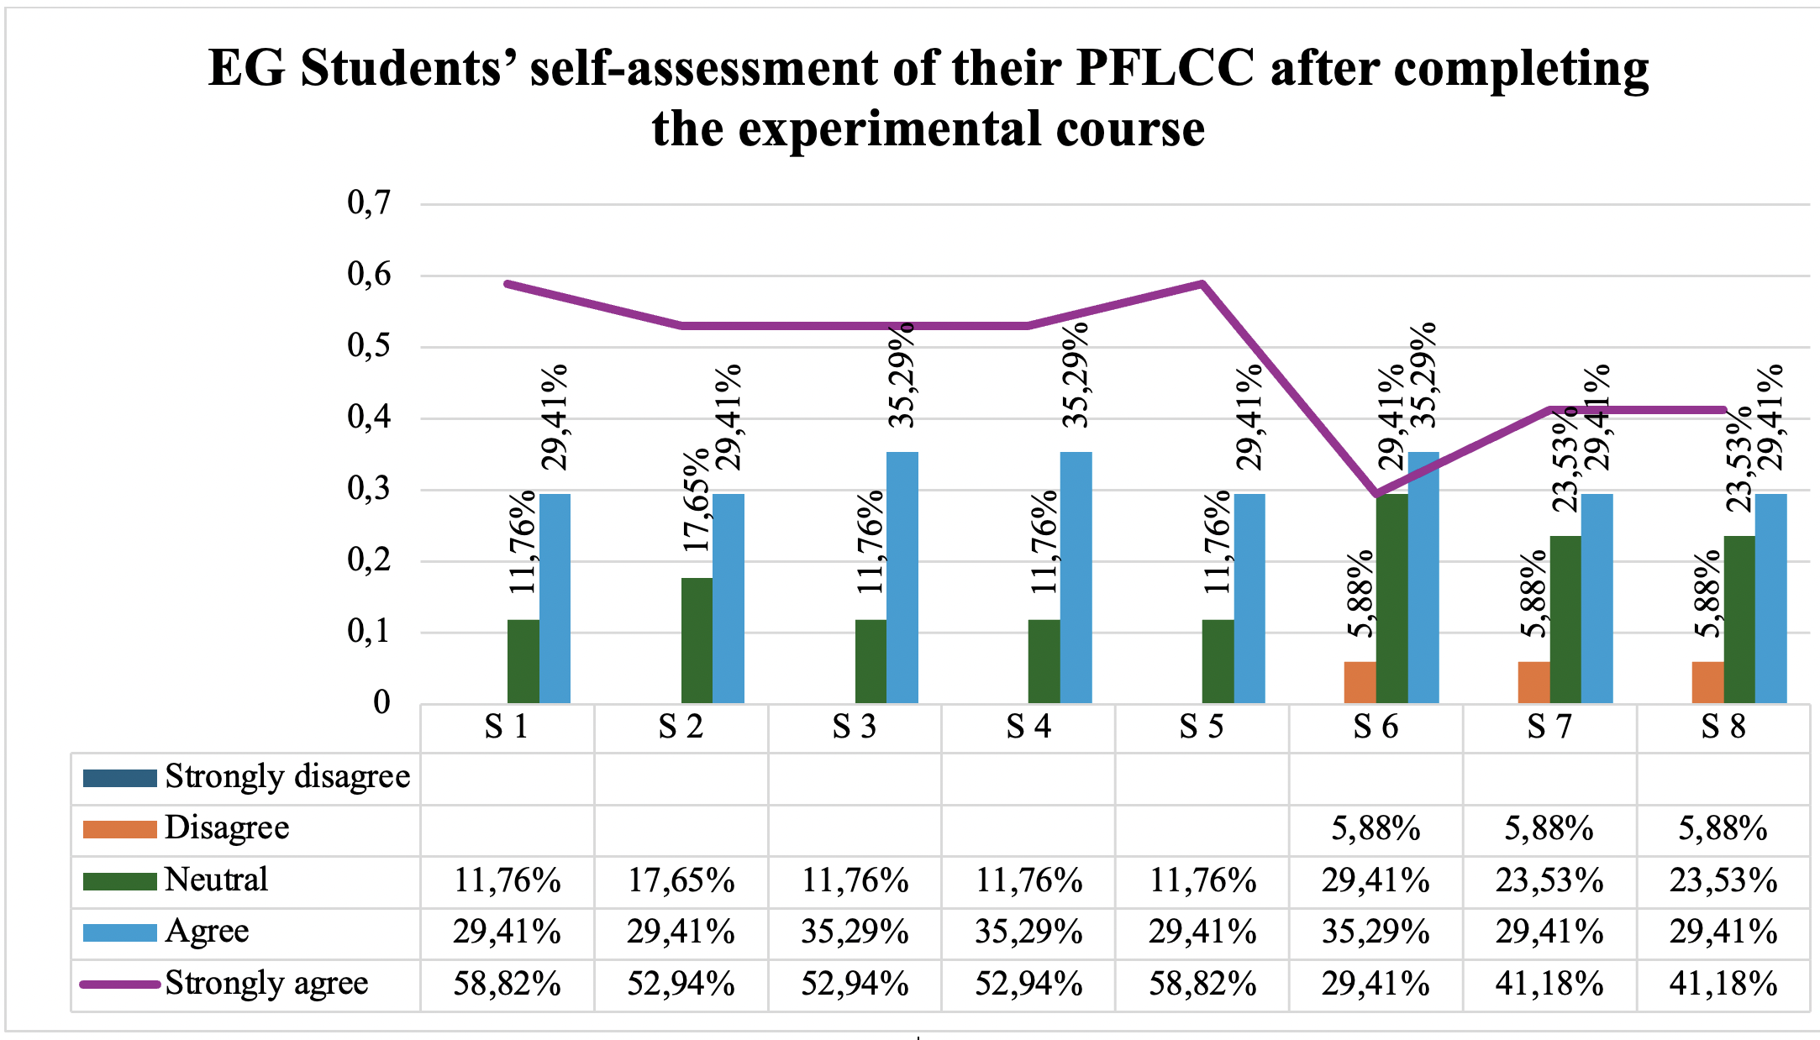

Figure 9 − EG students’ perceptions of their own progress after the course

In addition to the Likert-scale statements, students were also given an open-ended question to gather more detailed qualitative feedback. The question was formulated as follows: “Based on your experience, would you recommend continuing the use of video assignments on doctor-patient communication in English courses? Why or why not?” Students noted that these assignments allow them to better practice real-life dialogue, develop effective communication with patients and gain confidence in explaining medical issues. One student shared that video assignments “help us learn new vocabulary related to doctor-patient dialogues” (“Диалог жасау арқылы ағылшын тілінен жаңа сөздіктер үйрене аламыз”). Another emphasized the professional relevance of such tasks: “Since we will be future doctors, we need to communicate with patients regardless of their language” (“Өйткені біз болашақта дәрігер боламыз... пациенттермен жақсы қарым-қатынас орнатуымыз керек”). Several students mentioned how these video tasks improve speaking confidence, such as one who said, “It helps us speak English better” (“Иә ағылшын тілінде сөйлеуге көмектеседі”). Others noted the practical value: “It teaches us a lot and helps us build a good dialogue with patients” (“Иә ұсынам себебі ол бізге пациентпен жақсы диалог құруға көмегі орасан зор”). Overall, the majority expressed that using video assignments is engaging, relevant, and beneficial for developing communication skills in medical contexts.

Conclusions to chapter 3
This chapter was devoted to the experimental validation of the proposed methodological model based on the principled eclectic approach for developing medical students’ professional foreign language communicative competence. The study included several stages, such as needs analysis, experimental teaching, and analysis of the obtained results. The findings of this chapter provide important insights into the current state of English language teaching in Kazakhstani medical universities and demonstrate the effectiveness of the proposed model.
The results of the syllabus analysis showed that English courses in medical universities are generally included in the curriculum and taught over several years. However, the balance between General English and English for Medical Purposes varies significantly across universities. In many cases, General English dominates, especially in the early years, while professional content is introduced later or remains limited. This creates a gap between students’ language learning and their future professional needs. The analysis of course aims and teaching materials also revealed that although universities declare the development of communicative competence as a goal, this is not always fully reflected in the actual course content. In some cases, the materials focus mainly on general language skills and do not provide enough opportunities for practicing medical communication. As a result, students have limited exposure to real professional situations, such as doctor-patient interaction or working with medical texts.
The needs analysis conducted among medical students and lecturers provided a more detailed understanding of the situation. The results showed that students clearly recognize the importance of English for their future profession. They especially value skills such as understanding medical lectures, reading professional literature, and participating in discussions on medical topics. At the same time, students reported a number of difficulties, particularly in speaking and using professional vocabulary. Writing and academic skills were also identified as challenging, although they were considered slightly less important by students. The quadrant analysis of students’ needs, wants, and lacks demonstrated that the most critical areas are related to professional communication. Skills such as understanding medical lectures, communicating with patients, reading medical texts, and using professional vocabulary were placed in the high-priority quadrant. This means that these skills are both difficult for students and highly important for their future development. On the other hand, general communication skills were perceived as less problematic and less urgent.
The results of interviews with students and lecturers confirmed these findings. Both groups emphasized that speaking is the most problematic skill due to a lack of practice. Students also mentioned that their previous learning experience was often focused on grammar and memorization rather than communication. Lecturers highlighted additional challenges, such as low initial language level, lack of teaching hours, large mixed-ability groups, and insufficient teaching materials. These factors limit the effectiveness of English language teaching and reduce students’ opportunities to develop professional communication skills.
Based on these findings, it became clear that there is a need for a new approach to teaching English to medical students. This approach should integrate general and professional language training, focus on real communication, and provide more opportunities for active student participation. These conclusions served as the basis for the development and implementation of the proposed methodological model. At the second stage, the experimental teaching was carried out to test the effectiveness of the model. The study followed a quasi-experimental design with experimental and control groups. The experimental group was taught using the developed model based on the principled eclectic approach, which integrates communicative, grammar-translation, and lexical approaches. The teaching process included task-based, case-based, and game-based activities, as well as professionally oriented materials and real-life communication tasks. The results of the experimental teaching showed clear positive changes in students’ performance. The comparison of pre-test and post-test results demonstrated that students in the experimental group significantly improved their scores across all components of professional foreign language communicative competence. The greatest improvement was observed in areas related to professional vocabulary, doctor-patient communication, and speaking skills. This confirms that the use of communicative tasks, role-plays, and practical activities helps students develop their ability to use English in real medical contexts. In contrast, the control group also showed some improvement, but it was more limited and gradual. Students in this group studied using traditional methods with a focus on General English and had fewer opportunities to practice professional communication. As a result, their progress was less significant compared to the experimental group. This difference clearly demonstrates the effectiveness of the proposed methodological model.
Another important result of the study is related to students’ attitudes toward the learning process. The use of interactive and practice-oriented activities, such as video tasks, role-plays, and case studies, increased students’ motivation and engagement. Students became more confident in using English and more actively participated in classroom activities. This shows that student-centred approaches play a key role in developing communicative competence. Overall, the results of the experimental study confirm the research hypothesis. The formation of medical students’ professional foreign language communicative competence is more effective when the learning process is based on a methodological model grounded in the principled eclectic approach, supported by relevant teaching materials, and focused on students’ needs.
In conclusion, this chapter demonstrates that the proposed methodological model is effective and can be successfully applied in the context of medical education. The findings highlight the importance of aligning language teaching with professional requirements and emphasize the need for a more practice-oriented and student-centred approach.

CONCLUSION

The present research was devoted to the development and experimental validation of a methodological model for forming medical students’ professional foreign language communicative competence based on a principled eclectic approach. The study was carried out in response to the growing need for professionally oriented foreign language training in the context of modern medical education in Kazakhstan .
The analysis of theoretical and methodological sources has shown that professional foreign language communicative competence is a complex and multidimensional construct. In this research, it has been defined as a system of interconnected subcompetencies, including foreign language communicative, sociocultural, medically oriented metalinguistic, and professional communicative subcompetencies. These components function as an integrated system and ensure the readiness of future medical professionals for effective communication in academic and clinical contexts. The study of current trends in foreign language teaching has demonstrated that no single teaching method can fully address the needs of modern learners. Therefore, the principled eclectic approach was selected as the methodological basis of the research. It allows for the purposeful integration of communicative, grammar-translation, and lexical approaches, ensuring a balanced development of linguistic accuracy, vocabulary competence, and communicative skills.
The results of the needs analysis and content analysis of syllabuses revealed a significant gap between the existing system of English language instruction and the professional needs of medical students. In particular, the predominance of General English over English for Medical Purposes limits students’ ability to use English in real professional situations. Students experience the greatest difficulties in speaking and using professional vocabulary, which confirms the need for a more practice-oriented and professionally focused approach to language teaching.
Based on the obtained results, a methodological model for developing medical students’ professional foreign language communicative competence was designed. The model includes interconnected structural components (target, content, process, evaluation, and result) and is implemented through the integration of General English and English for Medical Purposes. The learning process is organized using student-centred methods, including task-based, case-based, and game-based activities, which create conditions for active learning and the development of communicative skills. A syllabus and a collection of teaching materials “English for Medical Purposes” were developed in accordance with students’ needs and the objectives of professional language training. These materials are aimed at forming practical communication skills in medical contexts and provide opportunities for applying language knowledge in real and simulated professional situations. The effectiveness of the proposed methodological model was confirmed through experimental teaching. The results of the pedagogical experiment demonstrated a statistically significant improvement in the level of medical students’ professional foreign language communicative competence in the experimental group compared to the control group. The most notable progress was observed in speaking skills, professional vocabulary, and doctor-patient communication. Thus, the research hypothesis has been fully confirmed. The formation of medical students’ professional foreign language communicative competence is more effective when it is based on a comprehensive needs analysis, supported by a principled eclectic methodological model, and implemented through a professionally oriented syllabus and teaching materials.
The theoretical significance of the research lies in the substantiation of the structure of medical students’ professional foreign language communicative competence and in the development of a methodological model based on a principled eclectic approach. The study contributes to the theory of professionally oriented foreign language education and expands the understanding of integrative approaches in language teaching. The practical significance of the research is determined by the possibility of applying the proposed methodological model, syllabus, and teaching materials in higher education institutions. The results of the study can be used by foreign language teachers and methodologists for improving English language teaching for medical students and for developing professionally oriented language courses.
In conclusion, the research confirms the importance of aligning foreign language teaching with professional requirements and demonstrates that the integration of different methodological approaches, combined with student-centred learning techniques, creates favourable conditions for developing medical students’ professional foreign language communicative competence.

REFERENCES

- Закон Республики Казахстан. Об образовании: утв. 27 июля 2007 года, № 319-III [Electronic resource]. https://adilet.zan.kz/rus/archive/docs/Z070000319_/02.03.2026. 18.10.2025
- Указ Президента Республики Казахстан «Об Общенациональных приоритетах Республики Казахстан до 2025 года»: утв. 26 февраля 2021 года № 520 [Electronic resource]. https://adilet.zan.kz/rus/docs/U2100000520. 18.10.2025
- Tokayev K.J. Address of the President of the Republic of Kazakhstan to the People of Kazakhstan “A Fair State. One Nation. Prosperous Society”. - Astana: Administration of the President of the Republic of Kazakhstan, 2022. [Electronic resource]. https://www.akorda.kz/en/president-kassym-jomart-tokayevs-state-of-the-nation-address-181857. 18.10.2025
- Tokayev K.J. Address of the President of the Republic of Kazakhstan to the People of Kazakhstan “Just Kazakhstan: Law and Order, Economic Growth, Social Optimism”. - Astana: Administration of the President of the Republic of Kazakhstan, 2024 [Electronic resource]. https://www.akorda.kz/en/president-kassym-jomart-tokayevs-state-of-the-nation-address-just-kazakhstan-law-and-order-economic-growth-social-optimism-482433. 18.10.2025
- Кунанбаева С.С. Современное иноязычное образование: методология и теория. – Алматы: Дом печати «Эдельвейс», 2005. – 264 с.
- Елубаева П.К. Моделирование компетентностного образования в формировании межкультурно-коммуникативной компетенции регионоведа: дис. … канд. пед. наук: 13.00.02. - Алматы, 2010. - 152 с.
- Шайхызада Ж.Г. Иноязычная подготовка студентов технических специальностей вузов в условиях модернизации высшего образования: дис. … д-ра философии (PhD): 6D011900. - Караганда, 2018. - 215 с.
- Серебряникова М.А. Формирование готовности студентов неязыковых специальностей к профессиональному общению на английском языке: дис. … канд. пед. наук: 13.00.08. - Астана, 2010. - 142 с.
- Постановление Правительства Республики Казахстан. Об утверждении Концепции развития высшего образования и науки в Республике Казахстан на 2023-2029 годы: утв. 28 марта 2023 года, № 248. // https://adilet.zan.kz/rus/docs/P2300000248. 18.10.2025
- Постановление Правительства Республики Казахстан. Об утверждении Концепции развития образования Республики Казахстан на 2022-2026 годы: утв. 24 ноября 2022 года, № 941. // https://adilet.zan.kz/rus/docs/P2200000941. 18.10.2025
- Постановление Правительства Республики Казахстан. Об утверждении Концепции развития языковой политики в Республике Казахстан на 2023-2029 годы: утв. 16 октября 2023 года, № 914. [Electronic resource]. https://www.gov.kz/memleket/entities/kyzylorda-sayasat/press/article/details/206305?lang=ru. 18.10.2025
- Приказ Министра образования и науки Республики Казахстан от 31 октября 2018 года № 603. «Об утверждении типовых учебных программ цикла общеобразовательных дисциплин для организаций высшего и (или) послевузовского образования»: зарегистрирован в Министерстве юстиции Республики Казахстан 31 октября 2018 года № 17651. [Electronic resource]. https://adilet.zan.kz/rus/docs/V1800017651#z319. 18.10.2025
- Кунанбаева С.С. Теория и практика современного иноязычного образования: учебник. – Алматы: Эдельвейс, 2010. – 344 с.
- Приказ Министра науки и высшего образования Республики Казахстан от 20 июля 2022 г. № 2. «Об утверждении государственных общеобязательных стандартов высшего и послевузовского образования»: - зарегистрирован в Министерстве юстиции Республики Казахстан 27 июля 2022 г. № 28916. [Electronic resource]. https://adilet.zan.kz/rus/docs/V2200028916. 18.10.2025
- Приказ Министра здравоохранения Республики Казахстан от 4 июля 2022 г. № ҚР ДСМ-63 «Об утверждении государственных общеобязательных стандартов по уровням образования в области здравоохранения»: - зарегистрирован в Министерстве юстиции Республики Казахстан 5 июля 2022 г. № 28716. [Electronic resource]. https://adilet.zan.kz/rus/docs/V2200028716. 18.10.2025
- Стамгалиева Н.К. Методика контекстно-центрированного обучения иностранному языку в неязыковом вузе (нефтяные специальности технического вуза, английский язык): дис…. канд. пед. наук: 13.00.02. - Алматы, 1999 - 146 с.
- Тыныштыкбаева А.Б. Методика формирования умений профессионального общения на иностранном языке у студентов технического вуза (английский язык): дис…. канд. пед. наук: 13.00.02. - Алматы, 1999. - 189 с.
- Ахметова Г.Ш. Обучение диалогической речи студентов-будущих менеджеров: дис. … канд. пед. наук: 13.00.02. - Алматы, 2001. - 135 с.
- Жусупова Р.Ф. Методика формирования коммуникативной компетенции у студентов агроинженерных специальностей (на материале английского языка): дис. … канд. пед. наук: 13.00.02. - Караганда, 2003. - 145 с.
- Аубакирова А.К. Методика обучения деловому немецкому языку студентов экономических специальностей: дис. … канд. пед. наук: 13.00.02. - Алматы, 2004. - 154 с.
- Рахимбекова Г.О. Контроль сформированности коммуникативной компетенции студентов неязыкового вуза: дис. … канд. пед. наук: 13.00.02. - Алматы, 2005. - 144 с.
- Голикова Л.В. Формирование профессиональной иноязычной коммуникативной компетентности студентов неязыкового вуза на основе проектной технологии обучения: дис. … канд. пед. наук: 13.00.08. - Санкт-Петербург, 2005. - 246 с.
- Мейрамова С.А. Методика обучения специальной иноязычной лексике студентов инженерно-технических вузов (английский язык): дис. … канд. пед. наук: 13.00.02. - Алматы, 2006. - 186 с.
- Молдахметова Г.З. Методика обучения информативному общению на основе экономических текстов (на материале английского языка, технический вуз): дис. … канд. пед. наук: 13.00.02. - Алматы, 2000. - 157 с.
- Серебряникова М.А. Формирование готовности студентов неязыковых специальностей к профессиональному общению на английском языке: дис. … канд. пед. наук: 13.00.08. - Алматы, 2010. - 142 с.
- Московченко О.Д. Формирование ключевых компетенций в процессе иноязычного образования у студентов экономических специальностей: дис. … канд. пед. наук: 13.00.02. - Алматы, 2010. - 177 с.
- Жылтырова Ж.Т. Теоретико-прикладные основы моделирования системы профессионально-иноязычной подготовки специалистов агроэкономического профиля: дис. … докт. философии (PhD): 6D011900. - Алматы, 2019. 164 с.
- Михайлова Т.В. Научно-методические основы формирования межкультурной профессионально-коммуникативной компетенции: дис. … докт. философии (PhD): 6D011900. - Кокшетау, 2023. - 165 с.
- Ахметова Д.Р. Особенности обучения студентов инженерных образовательных программ профессиональному иноязычному общению посредством массовых открытых онлайн курсов: дис. … докт. философии (PhD): 6D011900. - Караганда, 2025. - 116 с.
- Гальскова Н.Д., Гез Н.И. Теория обучения иностранным языкам: лингводидактика и методика: учеб. пособие для студ. лингв. ун-тов и фак. ин. яз. высш. пед. учеб. заведений. – 3-е изд., стер. – М.: Издательский центр «Академия», 2006. – 336 с.
- Бим И.Л. Методика обучения иностранным языкам как наука и теория школьного учебника. – М.: Русский язык, 1977. – 288 с.
- Щерба Л.В. Преподавание иностранных языков в средней школе: общие вопросы методики. – М.: Изд-во Академии педагогических наук РСФСР, 1947. – 100 с.
- Richards, J. C. Approaches and Methods in Language Teaching / J. C. Richards, T. S. Rodgers. - 2nd ed. - Cambridge : Cambridge University Press, 2001. - 270 p.
- Hutchinson T., Waters A. English for Specific Purposes: A Learning-Centred Approach. – Cambridge: Cambridge University Press, 1987. – 184 p.
- Chomsky N. Aspects of the Theory of Syntax. – Cambridge, Mass.: The M.I.T. Press, 1964. – 258 p.
- Hymes D.H. On Communicative Competence // Sociolinguistics. Selected Readings / ed. by J.B. Pride, J. Holmes. – Harmondsworth: Penguin, 1972. – P. 269–293.
- Howatt A.P., Smith R. The history of teaching English as a foreign language, from a British and European perspective // Language & History. – 2014. – Vol. 57, № 1. – P. 75–95.
- Nagy I.K. In between language teaching methods: Do we need (to know about) methods at all? // Acta Universitatis Sapientiae, Philologica. - 2019. - Vol. 11, Issue 3. - P. 119-139.
- Гальскова Н.Д., Василевич А.П., Коряковцева Н.Ф., Акимова Н.В. Основы методики обучения иностранным языкам: учебное пособие. – М.: КНОРУС, 2017. – 390 с.
- Dakhalan M.A., Tanucan M.C.J. The Direct Method in Language Teaching: A Literature Review of Its Effectiveness // Lingeduca: Journal of Language and Education Studies. – 2024. – Vol. 3, № 2. – P. 130–143.
- Liu Q.X., Shi J.F. An Analysis of Language Teaching Approaches and Methods: Effectiveness and Weakness // Online Submission. – 2007. – Vol. 4, № 1. – P. 69–71.
- Chang S.C. A contrastive study of grammar translation method and communicative approach in teaching English grammar // English Language Teaching. – 2011. – Vol. 4, № 2. – P. 13–24.
- Brown J.D. Introducing Needs Analysis and English for Specific Purposes. – 1st ed. – London: Routledge, 2016. – 248 p.
- Зимняя И.А. Ключевые компетентности как результативно-целевая основа компетентностного подхода в образовании. – М.: Исследовательский центр проблем качества подготовки специалистов, 2004. – 40 с.
- Aliakbarova A., Baitleuova L. Teaching a foreign language for professional purposes: overview of the experience of Kazakhstani teachers and methodologists // Journal of Educational Sciences. – 2023. – Vol. 74, № 1. – P. 25–35.
- Обдалова О.А. Иноязычное образование в XXI веке в контексте социокультурных и педагогических инноваций. – Томск: Изд-во Том. ун-та, 2014. – 180 с.
- Cambridge Dictionary. Competence [Electronic resource]. https://dictionary.cambridge.org/dictionary/english/competence 18.10.2025
- Merriam-Webster Dictionary. Competence [Electronic resource]. https://www.merriam-webster.com/dictionary/competence 18.10.2025.
- Canale M., Swain M. Theoretical bases of communicative approaches to second language teaching and testing // Applied Linguistics. – 1980. – Vol. 1, № 1. – P. 1–47.
- Bagarić V., Mihaljević Djigunović J. Defining communicative competence // Metodika: časopis za teoriju i praksu metodika u predškolskom odgoju, školskoj i visokoškolskoj izobrazbi. – 2007. – Vol. 8, № 14. – P. 84–93.
- Bachman L.F. Fundamental considerations in language testing. – Oxford: Oxford University Press, 1990. – 408 p.
- Savignon, S. J. Communicative competence: theory and classroom practice. - S. l. : [b. i.], 1976. - 23 p. - Paper presented at the Central States Conference on the Teaching of Foreign Languages (Detroit, Michigan, April 23, 1976).
- Celce-Murcia M., Dörnyei Z., Thurrell S. Communicative competence: a pedagogically motivated model with content specifications // Issues in Applied Linguistics. – 1995. – Vol. 6, № 2. – P. 5–35.
- Council of Europe. Common European Framework of Reference for Languages: Learning, Teaching, Assessment (CEFR). – Strasbourg: Council of Europe, 2001. – 273 p.
- Зимняя И.А. Компетенция и компетентность в контексте компетентностного подхода в образовании // Иностранные языки в школе. – 2012. – № 6. – С. 2–10.
- Обдалова О.А. Иноязычное образование в XXI веке в контексте социокультурных и педагогических инноваций. – Томск: Изд-во Томского ун-та, 2014. – 180 с.
- Приказ Министра здравоохранения Республики Казахстан от 9 января 2023 г. № 4. Об утверждении типовых учебных программ по медицинским и фармацевтическим специальностям [Электронный ресурс]: Зарегистрирован в Министерстве юстиции Республики Казахстан 11 января 2023 г. № 31672. https://adilet.zan.kz/rus/docs/V2300031672. 18.10.2025
- Баева Т.А. Методика формирования профессиональной иноязычной компетенции студентов медицинских вузов в условиях информационно-образовательной среды: автореф. дис. … канд. пед. наук: 13.00.02. – Нижний Новгород, 2013. – 24 с.
- Грязнова М.А. Совершенствование иноязычной профессиональной коммуникативной компетенции медицинских работников в контексте непрерывного образования (на материале английского языка): автореф. дис. … канд. пед. наук: 13.00.02. – Санкт-Петербург, 2012. – 24 с.
- Беленкова Г.А. Формирование профессиональной иноязычной коммуникативной компетенции студентов медицинских колледжей на основе продуктивного подхода (на материале английского и латинского языков): автореф. дис. … канд. пед. наук: 13.00.02. – Санкт-Петербург, 2014. – 23 с.
- Московченко О.Д. Формирование ключевых компетенций в процессе иноязычного образования у студентов экономических специальностей: автореф. дис. … канд. пед. наук: 13.00.02. – Алматы, 2010. – 28 с.
- Андреева О.А. Формирование готовности студентов направления «Педагогические науки» к использованию английского языка в профессиональной деятельности: дис. … д-ра философии (PhD): 6D011900 – Иностранный язык: два иностранных языка. – Караганда, 2025. – 161 с.
- Чакликова А.Т. Научно-теоретические основы формирования межкультурно-коммуникативной компетенции в условиях информатизации иноязычного образования: автореф. дис. … д-ра пед. наук: 13.00.02. – Алматы, 2009. – 40 с.
- Чакликова А.Т. Научно-теоретические основы формирования межкультурно-коммуникативной компетенции в условиях информатизации иноязычного образования:дис. … д-ра пед.наук: 13.00.02. – Алматы, 2009.–340 с.
- Серебряникова М.А. Формирование готовности студентов неязыковых специальностей к профессиональному общению на английском языке: автореф. дис. … канд. пед. наук: 13.00.08. – Алматы, 2010. – 23 с.
- Пассов Е.И. Стратегия иноязычного образования для неязыковых вузов // Дистанционное обучение – образовательная среда XXI века: материалы VII Международной научно-методической конференции. – Минск: БГУИР, 2011. – С. 384–385.
- Graves K. Designing language courses: a guide for teachers. – Boston: Heinle & Heinle, 2000. – 308 p.
- Richards J.C. Curriculum development in language teaching. – Cambridge: Cambridge University Press, 2001. – 321 p.
- Fraenkel J.R., Wallen N.E., Hyun H.H. How to design and evaluate research in education. – 8th ed. – New York: McGraw-Hill Education, 1993. – 641 p.
- Соловова Е.Н. Методика обучения иностранным языкам. Базовый курс лекций: пособие для студентов педагогических вузов и учителей. – М.: Изд-во «Просвещение», 2021. – 240 с.
- Farrell T.S., Jacobs G.M. Essentials for successful English language teaching. – London: Bloomsbury Publishing, 2020.
- Weimer, M. Learner-centered teaching: five key changes to practice / M. Weimer. - San Francisco : John Wiley & Sons, 2013.
- Rivers, W. M. From linguistic competence to communicative competence // TESOL Quarterly. - 1973. - Vol. 7, № 1. - P. 25-34.
- Larsen-Freeman D., Anderson M. Techniques and principles in language teaching. – 3rd ed. – Oxford: Oxford University Press, 2011. – 252 p.
- Kumaravadivelu B. Understanding Language Teaching: From Method to Postmethod. - Mahwah, NJ: Lawrence Erlbaum Associates, 2006. - 258 p.
- Lewis M. The Lexical Approach: The State of ELT and a Way Forward. – Boston: Heinle, Thomson Corporation, 2002. – 200 p.
- Brown H.D. Teaching by Principles: An Interactive Approach to Language Pedagogy. – 2nd ed. – New York: Longman, 2001. – 491 p.
- Mwanza D.S. The eclectic approach to language teaching: its conceptualization and misconceptions // International Journal of Humanities Social Sciences and Education. – 2017. – Vol. 4, № 2. – P. 53–67.
- Al-Khasawneh F. A systematic review of the eclectic approach application in language teaching // Saudi Journal of Language Studies. – 2022. – Vol. 2, № 1. – P. 17–27.
- Chernus N., Sivkov A., Savina T., Sivkov S., Zolotovitskaya A. The eclectic approach to learning English // Eurasian Journal of Applied Linguistics. – 2022. – Vol. 8, № 2. – P. 24–32.
- Mirzayev E. Enhancing Pronunciation Skills through the Eclectic Method in University-Level English Teaching // EuroGlobal Journal of Linguistics and Language Education. – 2024. – Vol. 1, № 2. – P. 139–148.
- Yetgin U. Teachers’ Perceptions of Using the Eclectic Method in ELT // Manisa Celal Bayar University International Journal of English Language Studies. – 2026. – Vol. 5, № 1. – P. 1–22.
- Adamson B. Fashions in Language Teaching Methodology // The Handbook of Applied Linguistics / ed. by A. Davies, C. Elder. – Oxford: Blackwell Publishing, 2004. – P. 604–622.
- Погожева Е.Ю. Формирование коммуникативной компетентности учащихся колледжа в условиях билингвального образования: дис. … канд. пед. наук: 13.00.01. - Барнаул, 2014. - 199 с.
- Nunan, D. Task-Based Language Teaching / D. Nunan. — Cambridge: Cambridge University Press, 2004. — 222 p.
- East, M. Foundational Principles of Task-Based Language Teaching / M. East. — New York: Routledge, 2021. — 214 p.
- Plass, J. L., Homer, B. D., Kinzer, C. K. Foundations of game-based learning // Educational Psychologist. — 2015. — Vol. 50, No. 4. — P. 258-283.
- Ghazal S., Singh S. Game-Based Language Learning: Activities for ESL Classes with Limited Access to Technology // ELT Voices. – 2016. – Vol. 6, № 4. – P. 1–8.
- Wright, A., Betteridge, D., Buckby, M. Games for Language Learning / A. Wright, D. Betteridge, M. Buckby. - 3rd ed. - Cambridge: Cambridge University Press, 2006. - 188 p.
- Shaikhyzada Z.G., Kostina E.A., Zatyneyko A.M., Kubeyeva A.E., Zhetpisbayeva B.A. The model of technology of university engineering students’ foreign language training in conditions of multilingual education in Kazakhstan // Novosibirsk State Pedagogical University Bulletin. – 2016. – Vol. 6, № 4. – P. 92–107.
- Aliakbarova A., Baitleuova L. Active learning: using crossword and wordsearch puzzles for teaching vocabulary to students of the medical faculty // KazNU Bulletin. Philology Series. – 2024. – Vol. 195, № 3. – P. 25–34.
- Brown H.D. Principles of language learning and teaching. – 5th ed. – White Plains, NY: Pearson Education, 2007. – 410 p.
- Lam J.Z., Yunus M.M. Student-produced video for learning: a systematic review // Journal of Language Teaching and Research. – 2023. – Vol. 14, № 2. – P. 386–395.
- Yeh H.C., Heng L., Tseng S.S. Exploring the impact of video making on students’ writing skills // Journal of Research on Technology in Education. – 2020. – Vol. 53, № 4. – P. 446–456.
- Widdowson, H. Defining issues in English language teaching / H. Widdowson. - Oxford : Oxford University Press, 2003. - 193 p.
- Молдахметова Г.З. Методика обучения информативному общению на основе экономических текстов (на материале английского языка, технический вуз): автореф. дис. … канд. пед. наук: 13.00.02. - Алматы, 2000. - 24 с.
- İlter, O. A flipped learning syllabus for teaching English for specific purposes: an action research study : doctoral dissertation / O. İlter. - Erzurum : Atatürk University, Institute of Educational Sciences, 2020. - 311 p.
- Baitleuova L., Irgatoglu A., Aliakbarova A. Through students’ and lecturers’ eyes: Kazakhstani medical students’ needs and self-efficacy beliefs in learning English // Novitas-ROYAL (Research on Youth and Language). – 2025. – Vol. 19, № 1. – P. 1–20.
- Елубаева П.К. Моделирование компетентностного образования в формировании межкультурно-коммуникативной компетенции регионоведа: автореф. дис. … канд. пед. наук: 13.00.02. - Алматы, 2010. - 24 с.
- Larsen-Freeman D. Techniques and principles in language teaching. – Oxford: Oxford University Press, 2000. – 318 p.
- Wang F., Geng X., Han J. Chinese university EFL learners’ English for general academic purposes: relationships between target needs and self-efficacy // Humanities and Social Sciences Communications. – 2024. – Vol. 11. – Article No. 215.
- Murphy R. English Grammar in Use: Essential Grammar in Use. Elementary level. – Cambridge: Cambridge University Press, 2020. – 320 p.
- Latham-Koenig C., Oxenden C., Lambert J., Seligson P. English File. Student’s Book. Pre-Intermediate. – 4th ed. – Oxford: Oxford University Press, 2019. – 168 p.
- Маслова А.М., Вайнштейн З.И., Плебейская Л.С. Английский язык для медицинских вузов: учебник. – 5-е изд., испр. – М.: ГЭОТАР-Медиа, 2018. – 336 с.
- Glendinning E.H., Howard R. Professional English in Use (Medicine). – Cambridge: Cambridge University Press, 2007. – 176 p.
- Evans V., Dooley J., Tran T.M. Medical. – Berkshire: Express Publishing, 2021. – 144 p.
- Kambatyrova A. Parents’ language ideologies in the context of trilingual education policy in Kazakhstan // International Journal of Multilingualism. – 2024. – Vol. 21, № 3. – P. 1201–1217.
- Choi L.J. Implementing English for medical purposes (EMP) in South Korea: nursing students’ ongoing needs analysis // Nurse Education Today. – 2021. – Vol. 104. – Article No. 104989.
- Kuzembayeva G., Zhakanova B. Needs analysis in English language teaching of medical students in Kazakhstan // International Journal of Multilingual Education. – 2021. – № 19. – P. 45–55.
- Yusuf M. The impact of self-efficacy, achievement motivation, and self-regulated learning strategies on students’ academic achievement // Procedia – Social and Behavioral Sciences. – 2011. – Vol. 15. – P. 2623–2626.
- Zimmerman B.J. Self-efficacy: an essential motive to learn // Contemporary Educational Psychology. – 2000. – Vol. 25, № 1. – P. 82–91.
- Hirosawa E., Kono Y., Oga-Baldwin W.Q. The structure of ability beliefs in EFL classrooms: a cross-theoretical analysis bridging self-efficacy and perceived competence needs satisfaction // System. – 2024. – Vol. 124. – Article No. 103383.
- Luo Q., Ahmadi R., Izadpanah S. Exploring the mediating role of self-efficacy beliefs among EFL university language learners: the relationship of social support with academic enthusiasm and academic vitality // Heliyon. – 2024. – Vol. 10, № 2. – Article No. e33253.
- C.R. Research Methodology: Methods and Techniques. – New Delhi: New Age International (P) Limited, 2004. – 401 p.

APPENDIX A

Questionnaire survey of lecturers

Dear Respondent!

We invite you to take part in the survey aimed at researching the opinion of foreign language lecturers on the degree of importance of learning and knowledge of English for students of medical specialities. This survey is carried out in order to improve the process of teaching a foreign language to students of medical specialities within the framework of the dissertation research conducted at Al-Farabi Kazakh National University.

Consent to participate in the survey:
All information obtained during this survey will be available only to the doctoral researcher and his/her supervisors. Data anonymity is guaranteed. Your answers will not affect your work process or your relationship with your employer in any way. There are no right or wrong answers in this survey. Please give as honest an answer as possible, which may reflect your opinion at the time. The results and statistics obtained will be published in the final version of the thesis and publications in academic journals or conferences.

Thank you for taking part in our survey!

Q1 | Age:
A | Under 30 years
B | 30-39 years
C | 41-49 years
D | 50 years and above
Q2 | Gender:
A | Male
B | Female
Q3 | Education level:
A | Higher education
B | Postgraduate education
C | Academic degree (e.g., PhD), academic title
Q4 | Total teaching experience in higher education institutions
A | Up to 5 years
B | 5-10 years
C | 10-15 years
D | 20 years and above
Q5 | What educational institution do you currently work for?
A | S.D. Asfendiyarov Kazakh National Medical University
B | Al-Farabi Kazakh National University
C | Astana Medical University
D | Semey Medical University
E | West Kazakhstan Marat Ospanov Medical University
Q6 | What is your current position?
A | Head of Department
B | Professor
C | Associate Professor
D | Senior lecturer
E | Lecturer
F | Other: ________________________
Q7 | Do you teach ‘Foreign Language’ course to bachelor students majoring in healthcare programs?
A | Yes
B | No
Q8 | To students of what educational programs do you teach the course "Foreign Language" in the current academic year? (You can choose several options)
A | Medicine
B | Dentistry
C | Pediatrics
D | Preventive medicine
E | Nursing
F | Public Health
G | Pharmacy
H | Other: ________________________
Q9 | Do you teach the course ‘Professional Foreign Language’ to bachelor students majoring in healthcare programs?
A | Yes
B | No
Q10 | What is the language level of the course(s) you are teaching? (You can choose several options)
A | A1
B | A2
C | B1
D | B2
E | C1
Q11 | In your opinion, is it important for a medical graduate to know English at a professional level?
A | Yes, it's important.
B | No, not very important
C | Difficult to answer
Q12 | In your opinion, is it important to have a discipline/course aimed at learning English for medical purposes in the curriculum of medical students?
A | Yes, it's important.
B | No, not very important
C | Difficult to answer
Q13 | What teaching methods do you use in the process of teaching a foreign language to students of healthcare programs?
 | Respondent’s own answer: ________________________________________________________
Q14 | Textbooks of which editions do you mainly use in the process of teaching foreign language to students of medical specialties?
A | Kazakhstan editions
B | Russian editions
C | Foreign editions
Q15 | Do you know any textbooks by Kazakhstani authors for teaching foreign language to students of healthcare programs? (If yes, please list the names of textbooks)
 | Respondent’s own answer: ________________________________________________________
Q16 | What textbooks do you use when teaching students of medical specialities in the course ‘Foreign Language’? (Please list the names of the main textbooks)
 | Respondent’s own answer: ________________________________________________________
Q17 | What types of extracurricular independent work for students (IWS/IWST) do you use within the framework of the course ‘Foreign Language’? (Please indicate all appropriate answers)
A | Note taking
B | Preparing an essay/report
C | Essay writing
D | Solving cases
E | Developing presentations
F | Recording a monologue in the form of audio messages
G | Recording a dialogue in the form of video clips
H | Crossword puzzles
I | Solving wordsearch puzzles (wordsearch puzzles)
J | Using Kahoot games
K | Other: ________________________
Q18 | What forms of final examination do you use in the course ‘Foreign language? (Please indicate all appropriate answers)
A | Answering a question in an oral form
B | Answering a question in written form
C | Essay writing
D | Computer test
E | Paper test
F | Project/presentation defence
G | Other: ________________________
Q19 | According to your observations of students, which of the following causes the greatest difficulty for medical students in the process of foreign language learning?
A | Listening
B | Reading
C | Speaking
D | Writing
Q20 | In general, what is the level of English language proficiency of students entering your university?
A | А1-А2
B | В1-В2
C | С1
Q21 | What difficulties do students face in the process of learning in the “Foreign Language” course?
 | Respondent’s own answer: ________________________________________________________
Q22 | What, in your opinion, should/could be done to improve the process of teaching a foreign language to students of healthcare programs?
 | Respondent’s own answer: ________________________________________________________
Q23 | What teaching technologies do you most often apply in the process of teaching a foreign language? (You can choose several options)
A | Problem-Based Learning (PBL)
B | Project-Based Learning (PBL)
C | Team-Based Learning (TBL)
D | Case-Based Learning (CBL)
E | Situation-Based Learning (SBL)
F | Research-Based Learning (RBL)
G | Game-Based Learning (GBL)
H | Other: ________________________
Q24 | Please select the three most important areas, which, in your opinion, should be emphasized in the learning process in order to form professional foreign language communicative competence of medical students?
A | Teaching medical terminology
B | Teaching communication in English with foreign patients who do not speak Kazakh or Russian.
C | Teaching how to negotiate with foreign colleagues in English (orally and in writing).
D | Teaching presentation of own research results for further presentation at international conferences/symposia in English language
E | Teaching how to search and study scientific literature in English
F | Teaching how to write publications in English for subsequent publication in journals represented in international citation databases (Scopus, Web of Science, etc.)
G | Teaching/preparing to pass the international English language proficiency test - IELTS
H | Teaching to read/understand instructions in English on the use of medical equipment
I | Other: ________________________
Q25 | In your opinion, what technology of foreign language teaching can be the most effective for the formation of professional foreign language communicative competence of students of medical specialties?
A | Problem-Based Learning (PBL)
B | Project-Based Learning (PBL)
C | Team-Based Learning (TBL)
D | Case-Based Learning (CBL)
E | Situation-Based Learning (SBL)
F | Research-Based Learning (RBL)
G | Game-Based Learning (GBL)
H | Other: ________________________
Q26 | In your opinion, what type of extracurricular independent work for students (IWS/ IWST) can be the most effective for the formation of professional foreign language communicative competence of medical students?
A | Note taking
B | Preparing an essay/report
C | Essay writing
D | Solving cases
E | Developing presentations
F | Recording a monologue in the form of audio messages
G | Recording a dialogue in the form of video clips
H | Crossword puzzles
I | Solving wordsearch puzzles (wordsearch puzzles)
J | Using Kahoot games
K | Other: ________________________
Q27 | In your opinion, what type of in-class work can be the most effective for teaching terminology to medical students?
A | Note taking
B | Preparing an essay/report
C | Essay writing
D | Solving cases
E | Developing presentations
F | Recording a monologue in the form of audio messages
G | Recording a dialogue in the form of video clips
H | Crossword puzzles
I | Solving wordsearch puzzles (wordsearch puzzles)
J | Using Kahoot games
K | Other: ________________________
Q28 | In your opinion, what would be the most effective way to teach communication skills with foreign patients in English (who do not speak Kazakh or Russian)?
A | Note taking
B | Preparing an essay/report
C | Essay writing
D | Solving cases
E | Developing presentations
F | Recording a monologue in the form of audio messages
G | Recording a dialogue in the form of video clips
H | Crossword puzzles
I | Solving wordsearch puzzles (wordsearch puzzles)
J | Using Kahoot games
K | Other: ________________________
Q29 | Do you agree that the professional orientation of the texts and exercises used can increase students' interest in learning a foreign language?
A | Yes, I agree
B | No, I disagree
C | Difficult to answer
Q30 | Do you agree that the formation of professional foreign language communicative competence of students of healthcare programs is one of the important directions of training future medical specialists?
A | Yes, I agree
B | No, I disagree
C | Difficult to answer

APPENDIX B
Questionnaire survey of medical students

Dear students!
We invite you to take part in the survey, which is conducted as part of the dissertation research at Al-Farabi Kazakh National University. The purpose of the survey: to study the needs and difficulties faced by medical students in learning English. The anonymity of your data is guaranteed. We inform you that your answers will not affect your grades and learning process in any way. The results and statistics obtained will be used for academic and research purposes only.

Thank you for taking part in our survey!

 | QUESTIONS
1 | Age
1 | - (1) Under 18  - (2) 18 - 20  - (3) 21 - 23  - (4) 24 - 26  - (5) 27 - 30  - (6) Over 30
2 | Gender
2 | - (1) Male  - (2) Female
3 | Nationality
3 | - (1) Kazakh  - (2) Russian  - (3) Uzbek  - (4) Uighur  - (5) Turkmen  - Other (Please, specify)
4 | Place of study
4 | - (1) Asfendiyarov Kazakh National Medical University  - (2) Al-Farabi Kazakh National University  - (3) Astana Medical University  - (4) Semey Medical University  - (5) Marat Ospanov West Kazakhstan Medical University
5 | Academic year
5 | - 1  - 2  - 3  - 4  - 5  - 6
6 | Language of instruction at the university
6 | - (1) Kazakh  - (2) Russian  - (3) English
7 | Your educational program (specialty)
7 | - (1) «Medicine»  - (2) «General Medicine»  - (3) «Dentistry»  - (4) «Pharmacy»  - (5) «Pediatrics»  - (6) «Nursing»  - (7) «Medical and Preventive Care»  - (8) «Public health»  - Other (Please, specify)
8 | Did you study English for general purposes at university?
8 | - (1) Yes  - (2) No  - (3) Not sure
9 | Did you study English for medical purposes or professional English at university?
9 | - (1) Yes  - (2) No  - (3) Not sure
10 | How would you rate the quality of the English language programmes offered by your institution?
10 | - (1) Excellent  - (2) Good  - (3) Satisfactory  - (4) Unsatisfactory  - (5) Very poor
11 | How do you think the content of the Foreign Language course can be improved? (Multiple answers can be selected):
11 | - (1) Pay more attention to listening skills  - (2) Pay more attention to reading skills  - (3) Pay more attention to speaking skills  - (4) Pay more attention to writing skills  - (5) Pay more attention to medical terminology  - (6) Organise English-speaking clubs, workshops and cultural events to increase the use of the language in social settings  - (7) Supplement course materials with mobile apps designed for language learning

Please rate how important the following English language learning goals are to you.

NECESSITIES:

CODE | QUESTIONS
N1 | As a medical student I need to study English to understand basic spoken English in situations such as cafes, shops, and airports.
N1 | - Strongly disagree | - Disagree | - Neutral | - Agree | - Totally Agree
N2 | I need to understand videos, presentations and lectures on medical topics in English.
N2 | - Strongly disagree | - Disagree | - Neutral | - Agree | - Totally Agree
N3 | I need to read and understand websites and blogs in English.
N3 | - Strongly disagree | - Disagree | - Neutral | - Agree | - Totally Agree
N4 | I need to read and understand medical textbooks and research articles in English
N4 | - Strongly disagree | - Disagree | - Neutral | - Agree | - Totally Agree
N5 | I need to have sufficient vocabulary to express my opinions on everyday matters in English.
N5 | - Strongly disagree | - Disagree | - Neutral | - Agree | - Totally Agree
N6 | I need to make presentations and engage in discussions on medical topics in English.
N6 | - Strongly disagree | - Disagree | - Neutral | - Agree | - Totally Agree
N7 | I need to write personal letters or messages in English, as well as non-complex essays and summaries of texts in English.
N7 | - Strongly disagree | - Disagree | - Neutral | - Agree | - Totally Agree
N8 | I need to write various academic texts in English, such as academic essays, research articles and literature reviews.
N8 | - Strongly disagree | - Disagree | - Neutral | - Agree | - Totally Agree
N9 | I need to learn English because I want to study abroad as an exchange student or do an internship.
N9 | - Strongly disagree | - Disagree | - Neutral | - Agree | - Totally Agree

The following section is related to the possible difficulties that students face when learning English. Please rate how difficult it is for you to complete the following tasks in English.

LACKS:

CODE | QUESTION (KZ/RU/ENG)
L1 | It is difficult for me to understand basic spoken English in situations such as cafes, shops, and airports.
L1 | - Strongly disagree | - Disagree | - Neutral | - Agree | - Totally Agree
L2 | It is difficult for me to understand TV shows or YouTube videos in English.
L2 | - Strongly disagree | - Disagree | - Neutral | - Agree | - Totally Agree
L3 | It is difficult for me to read and understand simple texts or emails in English.
L3 | - Strongly disagree | - Disagree | - Neutral | - Agree | - Totally Agree
L4 | It is difficult for me to understand English-language websites and blogs.
L4 | - Strongly disagree | - Disagree | - Neutral | - Agree | - Totally Agree
L5 | It is difficult for me to express my opinions on everyday matters in English.
L5 | - Strongly disagree | - Disagree | - Neutral | - Agree | - Totally Agree
L6 | My vocabulary is insufficient to talk about everyday topics in English.
L6 | - Strongly disagree | - Disagree | - Neutral | - Agree | - Totally Agree
L7 | It is difficult for me to write personal letters or messages in English.
L7 | - Strongly disagree | - Disagree | - Neutral | - Agree | - Totally Agree
L8 | It is difficult for me to write essays or summaries of texts in English.
L8 | - Strongly disagree | - Disagree | - Neutral | - Agree | - Totally Agree
L9 | It is difficult for me to understand presentations or lectures on medical topics in English.
L9 | - Strongly disagree | - Disagree | - Neutral | - Agree | - Totally Agree
L10 | It is difficult for me to understand English-speaking colleagues or patients.
L10 | - Strongly disagree | - Disagree | - Neutral | - Agree | - Totally Agree
L11 | It is difficult for me to read and understand medical textbooks or research articles in English.
L11 | - Strongly disagree | - Disagree | - Neutral | - Agree | - Totally Agree
L12 | It is difficult for me to read English-language websites and blogs with medicine-related content.
L12 | - Strongly disagree | - Disagree | - Neutral | - Agree | - Totally Agree
L13 | It is difficult for me to make oral presentations in English related to medicine in my studies.
L13 | - Strongly disagree | - Disagree | - Neutral | - Agree | - Totally Agree
L14 | My professional vocabulary is insufficient to engage in medical discussions in English.
L14 | - Strongly disagree | - Disagree | - Neutral | - Agree | - Totally Agree
L15 | It is difficult for me to write academic essays or summaries of medical texts in English.
L15 | - Strongly disagree | - Disagree | - Neutral | - Agree | - Totally Agree
L16 | It is difficult for me to write medical case reports or complete medical documentation in English.
L16 | - Strongly disagree | - Disagree | - Neutral | - Agree | - Totally Agree

In this section, we want to learn about your hopes and expectations from studying English at university. Please rate how much you hope to master the following skills as a result of learning English.

WANTS

CODE | QUESTIONS
W1 | I hope I will be able to understand basic spoken English in situations such as cafes, shops, and airports by studying English at university.
W1 | - Strongly disagree | - Disagree | - Neutral | - Agree | - Totally Agree
W2 | I hope I will be able to understand TV shows and YouTube videos in English by studying English at university.
W2 | - Strongly disagree | - Disagree | - Neutral | - Agree | - Totally Agree
W3 | I hope I will be able to read and understand simple texts and emails in English by studying English at university.
W3 | - Strongly disagree | - Disagree | - Neutral | - Agree | - Totally Agree
W4 | I hope I will be able to understand English-language websites and blogs by studying English at university.
W4 | - Strongly disagree | - Disagree | - Neutral | - Agree | - Totally Agree
W5 | I hope I will be able to express my opinions on everyday matters in English by studying English at university.
W5 | - Strongly disagree | - Disagree | - Neutral | - Agree | - Totally Agree
W6 | I hope I will be able to improve my vocabulary to talk about everyday topics in English by studying English at university.
W6 | - Strongly disagree | - Disagree | - Neutral | - Agree | - Totally Agree
W7 | I hope I will be able to write personal letters and messages in English by studying English at university.
W7 | - Strongly disagree | - Disagree | - Neutral | - Agree | - Totally Agree
W8 | I hope I will be able to write essays and summaries of texts in English by studying English at university.
W8 | - Strongly disagree | - Disagree | - Neutral | - Agree | - Totally Agree
W9 | I hope I will be able to understand presentations and lectures on medical topics in English by studying English at university.
W9 | - Strongly disagree | - Disagree | - Neutral | - Agree | - Totally Agree
W10 | I hope I will be able to understand English-speaking colleagues and patients by studying English at university.
W10 | - Strongly disagree | - Disagree | - Neutral | - Agree | - Totally Agree
W11 | I hope I will be able to read and understand medical textbooks and research articles in English by studying English at university.
W11 | - Strongly disagree | - Disagree | - Neutral | - Agree | - Totally Agree
W12 | I hope I will be able to read English-language websites and blogs with medicine-related content by studying English at university.
W12 | - Strongly disagree | - Disagree | - Neutral | - Agree | - Totally Agree
W13 | I hope I will be able to make oral presentations in English related to medicine in my studies by studying English at university.
W13 | - Strongly disagree | - Disagree | - Neutral | - Agree | - Totally Agree
W14 | I hope I will be able to expand my professional vocabulary to engage in medical discussions in English by studying English at university.
W14 | - Strongly disagree | - Disagree | - Neutral | - Agree | - Totally Agree
W15 | I hope I will be able to write academic essays and summaries of medical texts in English by studying English at university.
W15 | - Strongly disagree | - Disagree | - Neutral | - Agree | - Totally Agree
W16 | I hope I will be able to write medical case reports and complete medical documentation in English by studying English at university.
W16 | - Strongly disagree | - Disagree | - Neutral | - Agree | - Totally Agree

In this section, you will be able to assess your confidence in your ability to understand English in various contexts. Please read the following statements and evaluate how much you agree with them based on your experience.

APPENDIX C

Interview guide

Questions for interviewing lecturers
- Age: ____________________________________________________
- Gender: __________________________________________________
- Nationality: _______________________________________________
- Education level: ____________________________________________
- Current position: ____________________________________________
- Overall teaching experience in higher education institutions: __________
- Place of work (University): ____________________________________
- How important do you think it is to learn English as a medical student?
- What do you think are the real benefits of knowing English in the future career of a medical student?
- Based on your teaching experience, what difficulties do students most often face when learning English at university? (listening, reading, speaking or writing)
- What textbooks do you use when teaching a foreign language to medical students?
- Are you satisfied with the content of the textbooks?
- How do you think the content of a foreign language course can be improved?

Questions for interviewing students
- Age: _______________________________________________________
- Gender: ____________________________________________________
- Nationality: _________________________________________________
- Academic year: ______________________________________________
- Language of instruction at university: _____________________________
- Educational program: __________________________________________
- Did you study English for General Purposes at university?
- Did you study English for Medical Purposes or Professional English at university?
- How important do you think it is to learn English as a medical student?
- How do you think English language skills will really benefit your future career?
- What difficulties have you encountered in learning English at university? (listening, reading, speaking or writing)

APPENDIX D

Pre- and Post-Test for Assessing Medical Students’ PFCC

PRE- TEST QUESTIONS

PART 1. LANGUAGE TEST (10 MULTIPLE-CHOICE ITEMS)

- What might the doctor say when asking about the patient’s reason for clinic visit?
a) Do you have any questions?
b) What are your symptoms?
c) What allergies do you have?
d) What brings you in today?

- What might the doctor say when asking about the pain onset?
a) When did it start?
b) How can I help you?
c) What are your symptoms?
d) Do you take any medication currently?

- What might the doctor say when asking about the duration of the pain?
a) What brings you in today?
b) How long have you had the pain?
c) Where do you feel the pain?
d) Does the pain move into your back or down your legs?

- What might the doctor say when asking about medication history?
a) Do you have any medical conditions?
b) What medications do you take at home?
c) Do you feel like your medication is effective?
d) What are your symptoms?

- What might the doctor say when asking about the location of the pain?
a) What symptoms do you have?
b) Is the pain constant?
c) Does the pain come and go?
d) Where does it hurt?

- What might the doctor say when asking about pain intensity?
a) How severe is the pain?
b) Where does it hurt?
c) When did it start?
d) Do you have any allergies?

- What might the doctor say when asking about pain frequency?
a) Does the pain come and go?
b) Where do you feel the pain?
c) What medications do you take?
d) How long have you had the pain?

- What might the doctor say when asking about aggravating factors?
a) What are your symptoms?
b) When did it begin?
c) Do you have any allergies?
d) What makes the pain worse?

- What might the doctor say when asking about relieving factors?
a) Where does it hurt?
b) What helps to relieve the pain?
c) How long does it last?
d) Do you take any medication?

- What might the doctor say when asking about past medical history?
a) What are your symptoms?
b) Do you have any chronic illnesses?
c) When did it start?
d) Where is the pain located?

PART 2. CONTROLLED GAP-FILL TASK BASED ON A DOCTOR-PATIENT DIALOGUE (10 ITEMS).

11-20. Complete the following dialogue with the words in the box.
a) hurts | c) gastritis | e) avoid | g) burning | i) hear
b) belly | d) throwing | f) recovery | h) feeling | j) eating

Doctor: Good morning! How are you (11) ________ today?
Patient: Good morning, Doctor. I'm not well. My stomach (12) _______ a lot.
Doctor: I'm sorry to (13) ________ that. Can you tell me where it hurts?
Patient: It's here in my (14) ________, and it feels like (15) ________.
Doctor: I see. Have you been feeling sick or (16) ________up?
Patient: No, I haven't been sick, but I feel like I might if I eat too much.
Doctor: Alright, it sounds like you might have (17) ________, which is when your stomach gets irritated. Have you been (18) ________spicy foods?
Patient: Yes, I had some spicy food yesterday for dinner.
Doctor: That could be the cause. For now, let's try some medicine to help with the pain and irritation. I'll also give you some advice on what foods to (19) ________.
Patient: Okay, thank you, Doctor.
Doctor: Wishing you a speedy (20) ________!

PART 3. READING TEST (5 OPEN-ENDED QUESTION ITEMS)

21-25. Read the text “Pneumonia” and answer questions

PNEUMONIA
Pneumonia is an infection of the lungs. Most types of pneumonia cause fever, cough with sputum (coughed-up mucus), shortness of breath and fatigue. In older patients, fatigue or confusion can be the only or most noticeable symptom. In viral pneumonia, a dry cough without sputum is more common. Your doctor first will ask about your symptoms. During the physical exam, your doctor will check to see if you are breathing rapidly. Using a stethoscope, a health care professional can listen through your back for abnormal sounds from the lungs. The diagnosis of pneumonia most often is confirmed by a chest X-ray. The main treatment for pneumonia is one or more antibiotics. Antibiotic treatment for pneumonia usually lasts from 5 to 14 days. A younger or healthier person can be treated safely with antibiotics at home and can feel better in a few days. Some people are at higher risk of complications and may need to be hospitalized.

21. What is pneumonia?
________________________________________________________________________________________________________________________________________________________________________________________________________

22. What are the symptoms of pneumonia?
________________________________________________________________________________________________________________________________________________________________________________________________________

23. How is pneumonia diagnosed?
________________________________________________________________________________________________________________________________________________________________________________________________________

24. How is pneumonia treated?
________________________________________________________________________________________________________________________________________________________________________________________________________

25. Who might need to be hospitalized for pneumonia treatment?
________________________________________________________________________________________________________________________________________________________________________________________________________

PART 4. COMPLETING A DIALOGUE
(5 GAP-FILLING QUESTION ITEMS)

26-30: Complete the following dialogue with appropriate phrases:

DOCTOR-PATIENT COMMUNICATION
- Patient: Good morning, Doctor! May I come in?
- Doctor: Good morning! (26) ______________________________________?
- Patient: I've been feeling unwell lately. I have a fever and a persistent cough.
- Doctor: I see. (27) _____________________________________________?
- Patient: For about a week now. They seem to be getting worse.
- Doctor: (28) __________________________________________________?
- Patient: No, not really. Just a fever, cough and I am feeling tired.
- Doctor: Alright. (29)______________________ to get a better understanding of what might be causing your symptoms. Is that alright with you?
- Patient: Yes, of course.
(After the examination and chest X-ray)
- Doctor: Based on your symptoms and the results of the X-ray, it seems like you may have pneumonia. (30) ________________________ antibiotics to help clear the infection.
- Patient: Thank you, Doctor.
- Doctor: You're welcome. Get well soon!

PART 5. SITUATIONAL DIALOGUE (SPEAKING INTERACTION)

Instructions for students: You are at a medical centre. Student A is the doctor, and Student B is the patient who thinks they might have a cold. Make a short dialogue (about 2-3 minutes). Discuss the patient’s symptoms (e.g., cough, sore throat, runny nose, fever), how long they have been ill, and what makes the symptoms better or worse. During the conversation, ask and answer simple questions, give suggestions (rest, hot tea, medicine), agree or disagree politely, and decide together what the patient should do next. Try to speak naturally without reading. Your goal is to communicate clearly and reach a simple medical recommendation.

POST-TEST QUESTIONS

PART 1. LANGUAGE TEST (10 MULTIPLE-CHOICE ITEMS)

- What might the doctor say when asking about the reason for the visit?
a) Do you feel better now?
b) What seems to be the problem today?
c) Do you take any medication?
d) Have you been here before?

- What might the doctor say when asking about when the pain began?
a) How long does it last?
b) What are your symptoms?
c) Where does it hurt?
d) When did the pain begin?

- What might the doctor say when asking about how long the pain has lasted?
a) What brings you here today?
b) Where do you feel the pain?
c) How long have you been experiencing this pain?
d) Does it spread anywhere?

- What might the doctor say when asking about current medication use?
a) Do you have any allergies?
b) Are you taking any medication at the moment?
c) What symptoms do you have?
d) When did it start?

- What might the doctor say when asking about the exact place of pain?
a) Is the pain constant?
b) Do you feel tired?
c) What symptoms do you have?
d) Can you show me where it hurts?

- What might the doctor say when asking about how strong the pain is?
a) Where does it hurt?
b) When did it begin?
c) On a scale from 1 to 10, how bad is the pain?
d) Do you have a fever?

- What might the doctor say when asking whether the pain is regular or occasional?
a) Where do you feel the pain?
b) Is the pain constant or does it come and go?
c) What medications do you take?
d) How long have you had it?

- What might the doctor say when asking what makes the pain worse?
a) Do you feel better now?
b) What are your symptoms?
c) Does anything make the pain worse?
d) When did it start?

- What might the doctor say when asking what improves the condition?
a) Where does it hurt?
b) Do you take medication?
c) How long does it last?
d) Does anything help to reduce the pain?

- What might the doctor say when asking about previous illnesses?
a) Have you had any serious illnesses in the past?
b) Where is the pain located?
c) When did it begin?
d) What are your symptoms?

PART 2. CONTROLLED GAP-FILL TASK BASED ON A DOCTOR-PATIENT DIALOGUE (10 ITEMS).

11-20. Complete the following dialogue with the words in the box.
a) hope | c) referral | e) vomiting | g) long | i) colour
b) discuss | d) started | f) tests | h) feeling | j) liver

Doctor: Good afternoon! How are you (11) ____________ today?
Patient: Good afternoon, Doctor. I'm not well. I've been feeling really tired and my stomach hurts.
Doctor: I'm sorry to hear that. How (12) ____________ have you felt this way?
Patient: About a week now. The pain (13)____________ last Monday.
Doctor: Have you noticed any changes in the (14)__________ of your skin or eyes?
Patient: Yeah, they've been a bit yellow.
Doctor: Any nausea or (15)____________?
Patient: Yeah, especially after eating.
Doctor: Alright, I'd like to run some (16) ____________ to understand what's going on. It could be hepatitis, which is inflammation of the (17) ____________. We'll need to do some blood tests to confirm.
Patient: Okay, I (18) ____________ it's nothing too serious.
Doctor: Let's not worry until we have more information. I'll give you a
(19) __________ for the tests and we'll (20) __________ the results together soon.
Patient: Thanks, doctor!

PART 3. READING TEST (5 OPEN-ENDED QUESTION ITEMS)

21-25. Read the text “Migrane” and answer questions 1-5:

MIGRAINE

Migraine is a very common, but very particular, type of headache. The typical migraine headache is throbbing or pulsating, and often is accompanied by nausea, vomiting, or loss of appetite. Most migraines last from four to 12 hours, although they can be shorter or much longer. A doctor usually will diagnose migraine based on your history and symptoms. Not all migraine headaches can be prevented. However, identifying your headache triggers can help to reduce the frequency and severity of migraine attacks. Common migraine triggers include caffeine, certain foods and beverages, stress, lack of sleep, travel or changes in weather, overuse of pain-relieving medications. There are two types of medications to treat migraines — drugs that are taken when a headache starts (called abortive medications) and drugs that are taken every day to prevent migraines (called preventive medications). The decision of whether to take a daily preventive medication or abortive medications is a personal choice that should be made after consultations with the doctor.

21. What is migraine?
________________________________________________________________________________________________________________________________________________________________________________________________________

22. What are the symptoms of migraine?
________________________________________________________________________________________________________________________________________________________________________________________________________

23. How is migraine diagnosed?
________________________________________________________________________________________________________________________________________________________________________________________________________

24. How is migraine treated?
________________________________________________________________________________________________________________________________________________________________________________________________________

25. What are the most common migraine triggers?
________________________________________________________________________________________________________________________________________________________________________________________________________
PART 4. COMPLETING A DIALOGUE
(5 GAP-FILLING QUESTION ITEMS)

26-30: Complete the following dialogue with appropriate phrases:

DOCTOR-PATIENT COMMUNICATION
Doctor: Good morning. (26) ________________________________________?
Patient: Hi doctor, I've been having these really bad headaches.
Doctor: I'm sorry to hear that. (27) ______________________________________?
Patient: They're really painful, like a strong, pulsating sensation in my head. It's been really affecting my day-to-day life.
Doctor: (28) ________________________________________?
Patient: They happen a few times a week.
Doctor: Have you noticed anything that triggers them?
Patient: It seems like stress and not getting enough sleep make them worse.
Doctor: Okay. Based on what you're telling me, it sounds like you might be experiencing migraines. (29) ___________________________________________ .
Patient: Okay, sounds good. In addition to Ibuprofen, should I try anything else?
Doctor: In addition to Ibuprofen, I'd suggest getting enough sleep and minimizing stress as much as possible.
Patient: Thank you, doctor. I'll make sure to get enough rest and try to reduce my stress levels.
Doctor: (30) ____________________________________!

PART 5. SITUATIONAL DIALOGUE (SPEAKING INTERACTION)

You are at a medical centre. Student A is the doctor, and Student B is the patient who thinks they might have a stomach problem. Make a short dialogue (about 2–3 minutes). Discuss the patient’s symptoms (e.g., stomach pain, nausea, loss of appetite, discomfort after eating), how long they have been feeling unwell, and what makes the symptoms better or worse. During the conversation, ask and answer simple questions, give advice (e.g., drink more water, avoid certain foods, take medicine), agree or disagree politely, and decide together what the patient should do next. Try to speak naturally without reading. Your goal is to communicate clearly and reach a simple medical recommendation.

APPENDIX E

Syllabus for the сourse “Foreign Language”
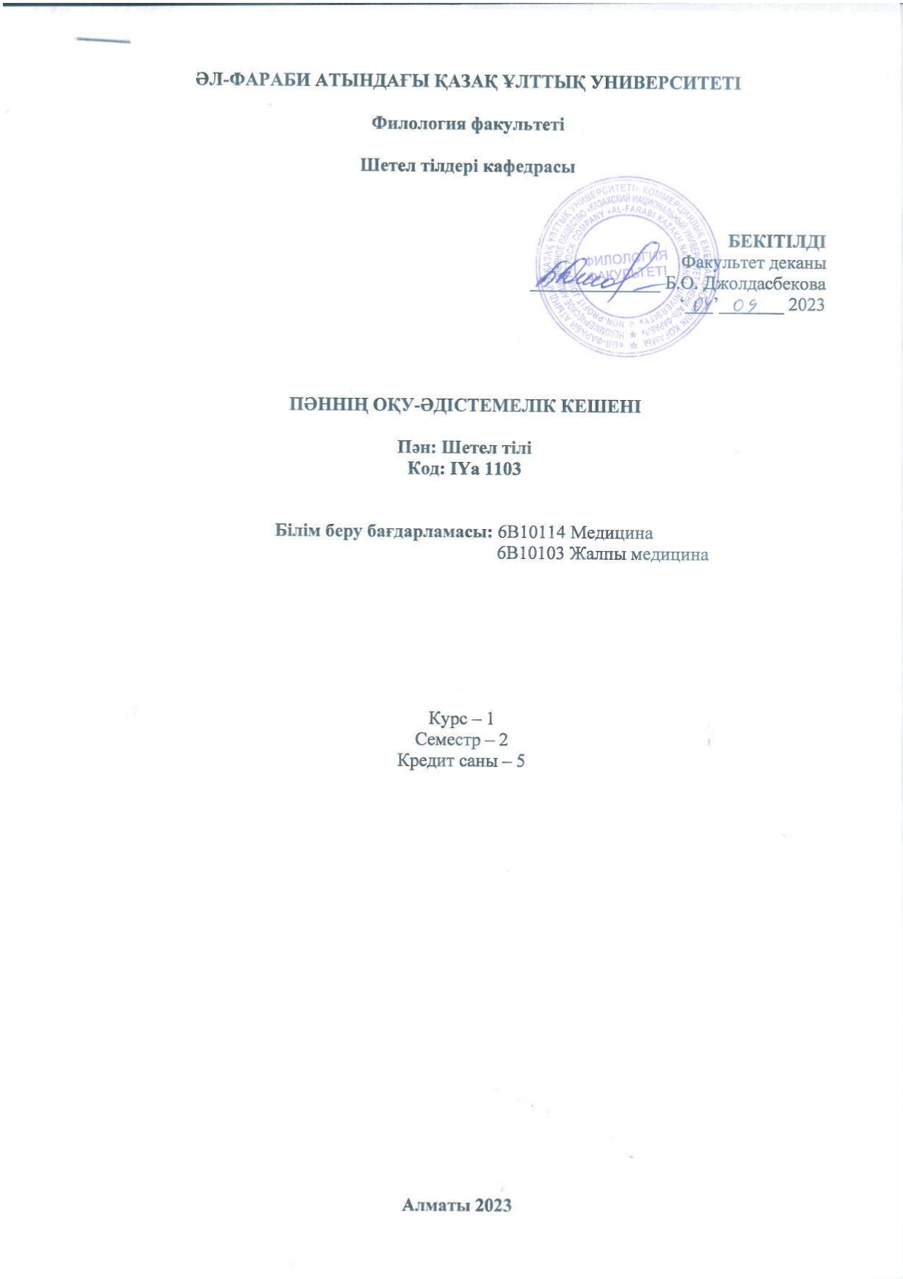
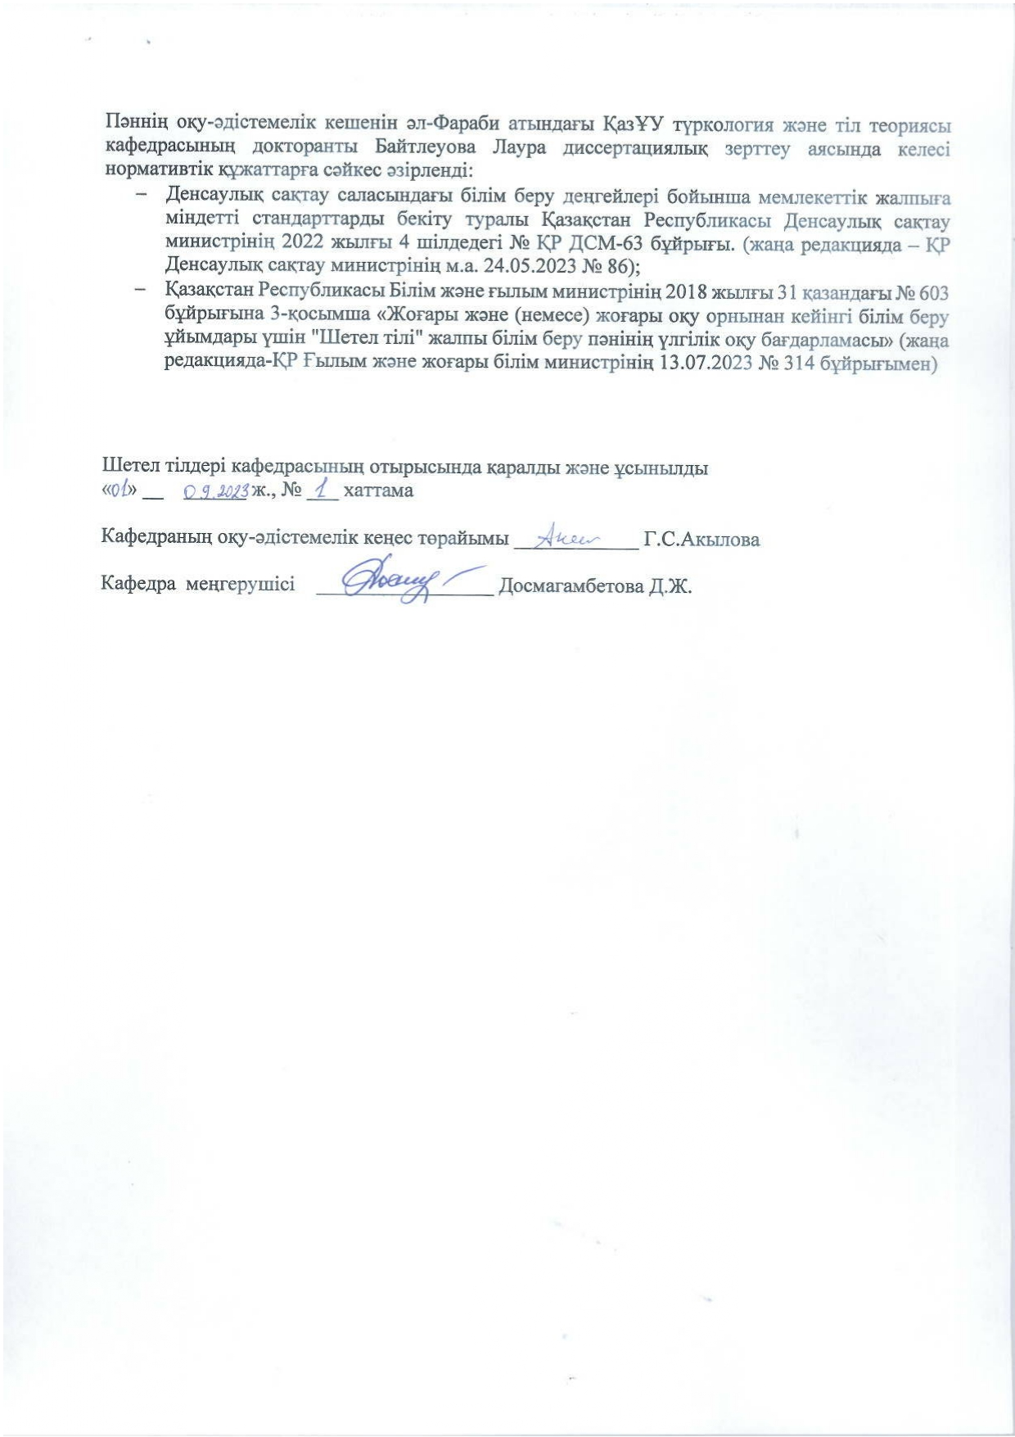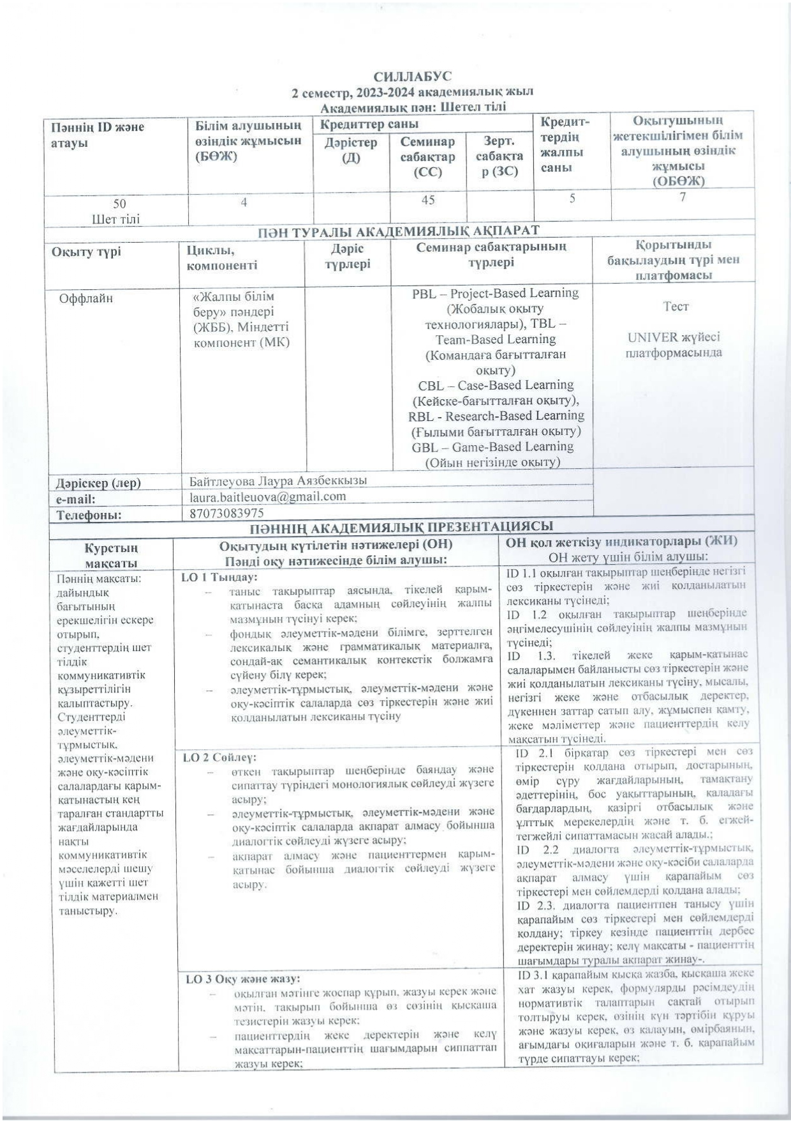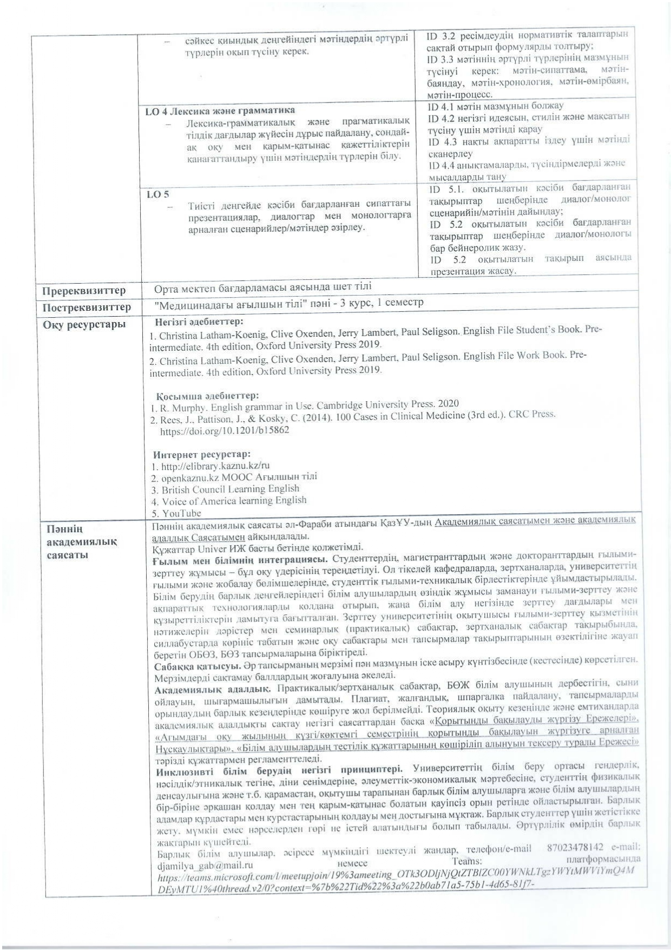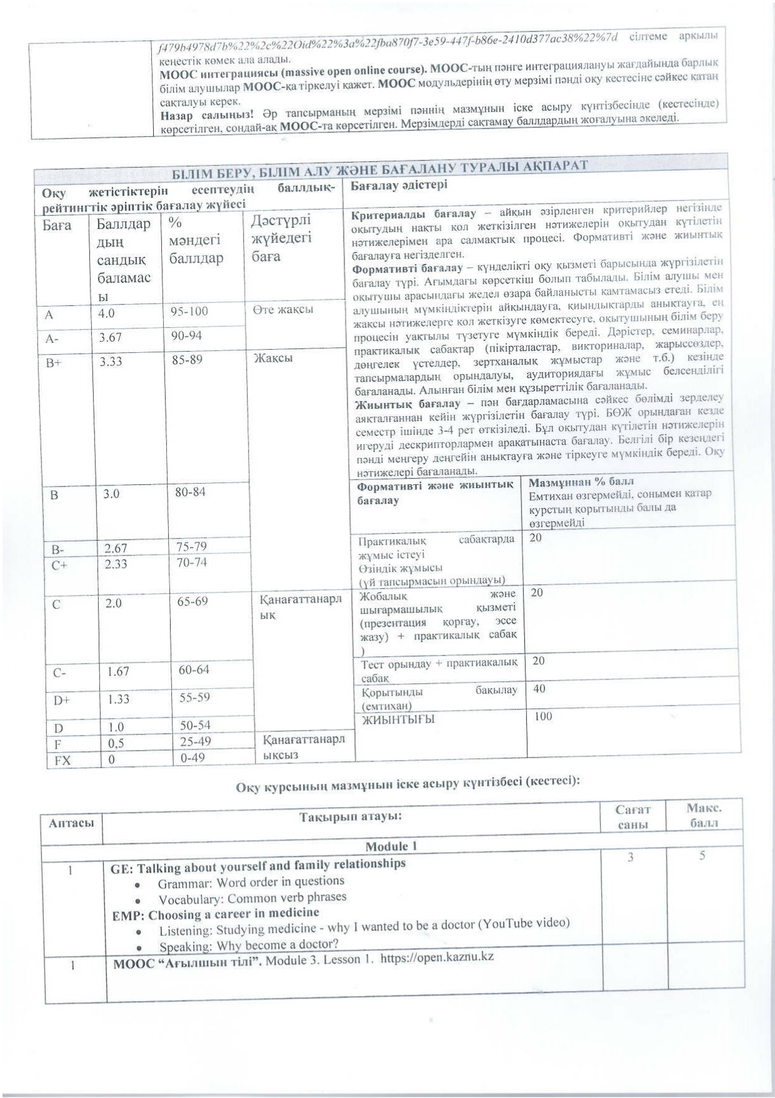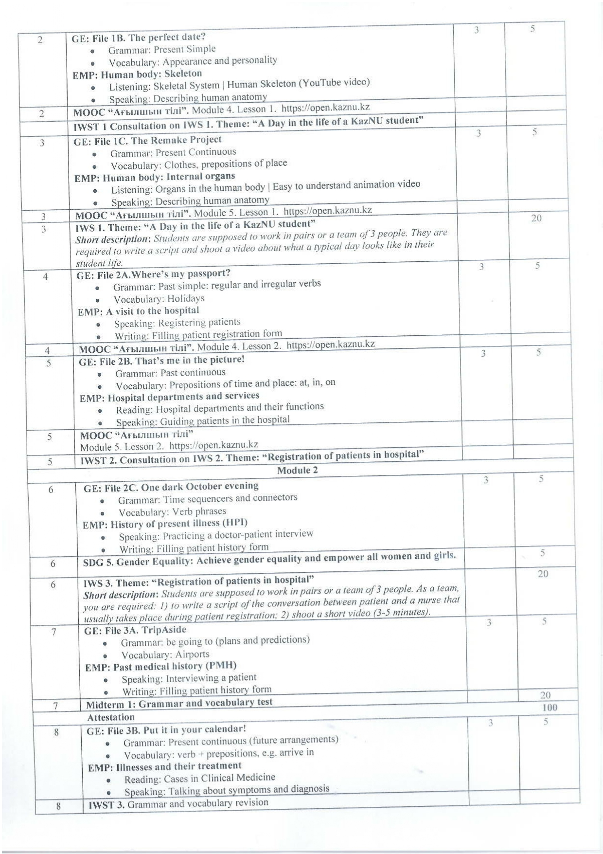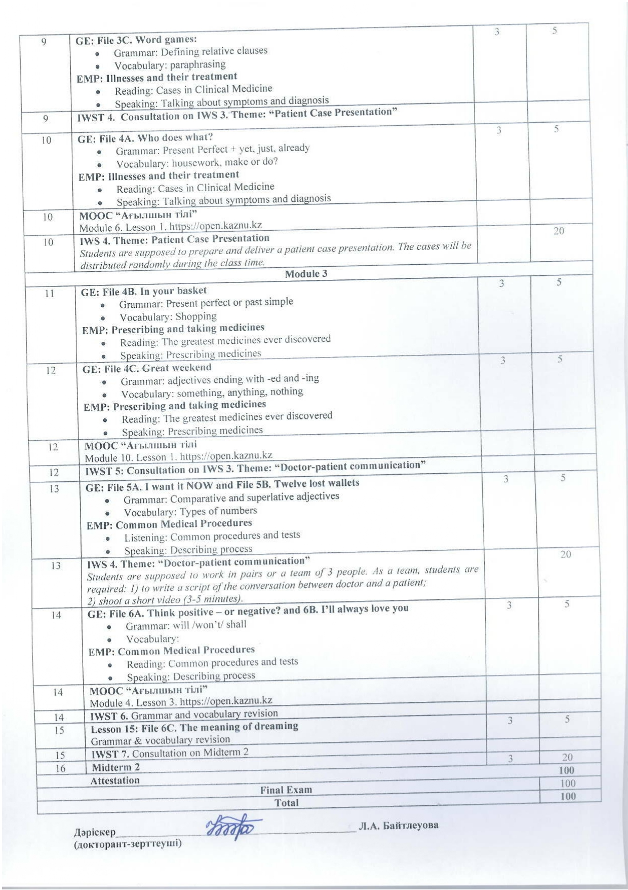

APPENDIX F

A collection of teaching materials
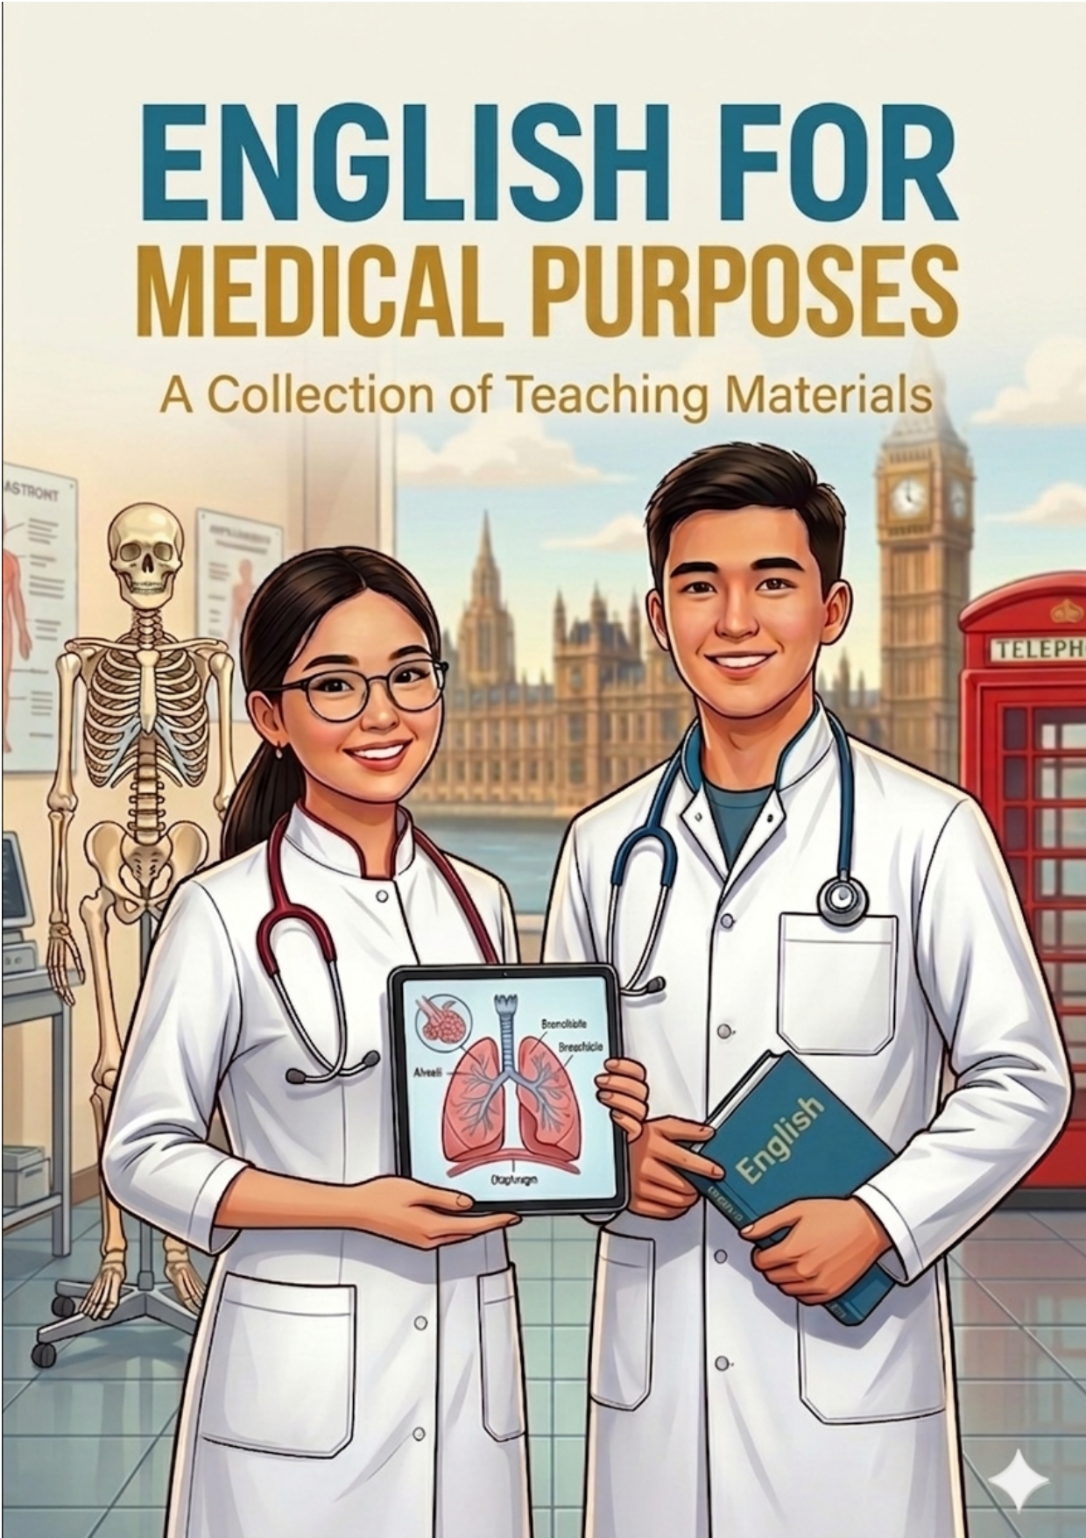
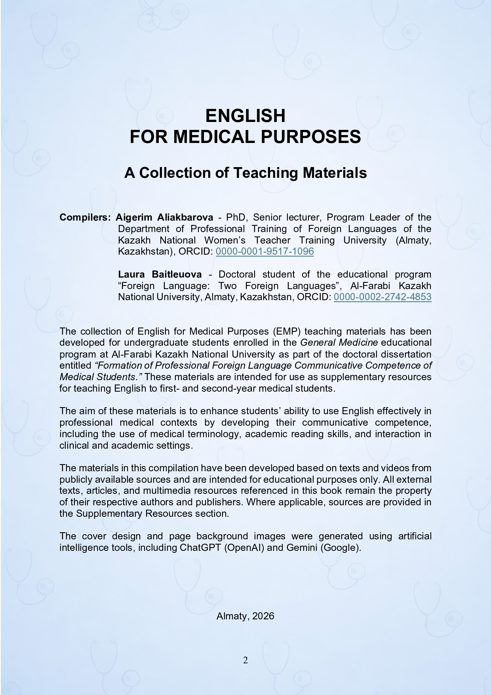

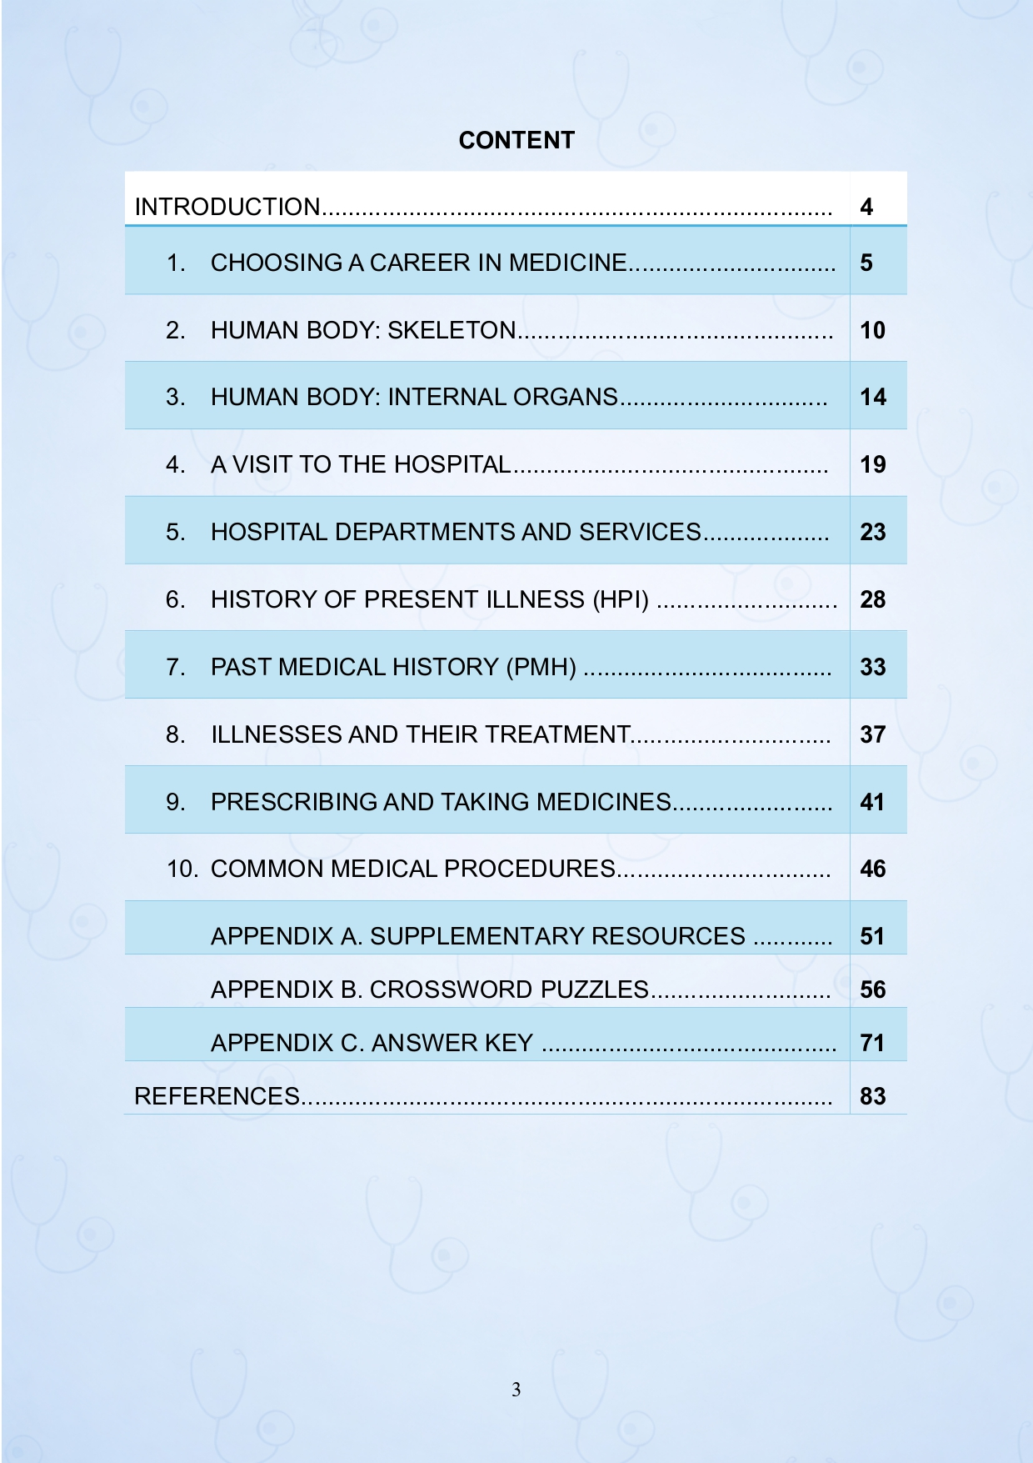

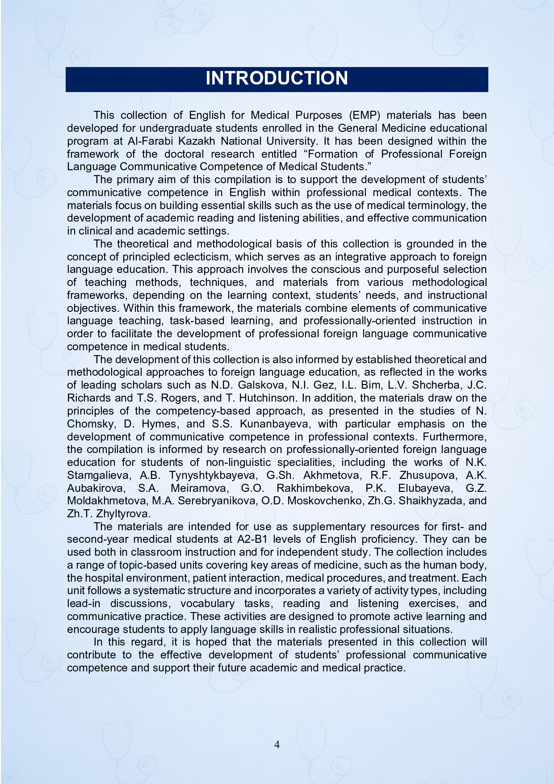

APPENDIX G

Supplementary materials used in the experimental teaching (YouTube videos and web-based articles)

- Marietta Eye Clinic. (2021, October 25). Dr. Andre Cohen - Why did you choose to become a doctor? YouTube. https://www.youtube.com/watch?v=54FCSqI6geY
- Abugaliyeva, M. (2018, July 9). Being a doctor is ‘a gift from God’, says one of Kazakhstan’s 100 New Faces. The Astana Times. https://astanatimes.com/2018/07/being-a-doctor-is-a-gift-from-god-says-one-of-kazakhstans-100-new-faces/
- Learning Junction. (2018, February 3). Skeletal system | Human skeleton [Video]. YouTube. https://youtu.be/2k6H2Vnn3o4
- Ask A Biologist. (2011, February 4). Bone anatomy. Arizona State University. https://askabiologist.asu.edu/bone-anatomy
- National Geographic. (2019, February 21). Heart 101 [Video]. YouTube. https://youtu.be/GMBSU-2GK3E
- Michigan Medicine. (2019, February 27). Anatomy of a human heart. https://www.michiganmedicine.org/health-lab/anatomy-human-heart
- Allied Health. (2020, October 4). Obtain and document patient information [Video]. YouTube. https://youtu.be/SusTA5--82s
- Ankrom, S. (2020, February 28). Dos and don’ts of visiting someone in the hospital. Ohio State Wexner Medical Center. https://wexnermedical.osu.edu/our-stories/visit-someone-in-hospital
- HCA Florida Healthcare. (2022, March 3). UCF Lake Nona Hospital virtual tour [Video]. YouTube. https://youtu.be/keX8E8KSjAE
- Whitlock, J. (2020, April 2). Understanding hospital acronyms for floors and units. Verywell Health. https://www.verywellhealth.com/hospital-floors-and-units-3156895
- Geeky Medics. (2022, June 22). Chest pain history [Video]. YouTube. https://youtu.be/eiRIm6BOzP4
- Jefferies, C. (2022, April 24). The SOCRATES acronym in history taking. Geeky Medics. https://geekymedics.com/the-socrates-acronym-in-history-taking/
- Pulsenotes Team. (2021, September). Past medical history. Pulsenotes. https://app.pulsenotes.com/clinical/histories/notes/basic-history
- Sale, L. (2019, August 13). Case-based learning: Cough. The Pharmaceutical Journal. https://pharmaceutical-journal.com/article/ld/case-based-learning-cough
- Harvard Health Publishing. (2023, December 6). Gastritis. https://www.health.harvard.edu/a_to_z/gastritis-a-to-z
- KidsHealth. (n.d.). Understanding Medicines and What They Do. Nemours KidsHealth. https://kidshealth.org/en/teens/meds.html
- Osmosis. (2023, June 10). The Top 10 Medical Advances in History. https://www.osmosis.org/blog/the-top-10-medical-advances-in-history
- Harvard Health Publishing. (2023, August 16). Abdominal ultrasound. https://www.health.harvard.edu/diagnostic_tests_medical_procedures/abdominal-ultrasound-a-to-z
- Harvard Health Publishing. (2023, September 21). Computed tomography (CT). https://www.health.harvard.edu/diagnostic_tests_medical_procedures/computed-tomography-ct-a-to-z
- Dallas Hip and Knee Center. (n.d.). Patient registration form. https://www.dallashipandknee.com/pdfs/patient-registration-form.pdf

APPENDIX H

Copyright сertificate

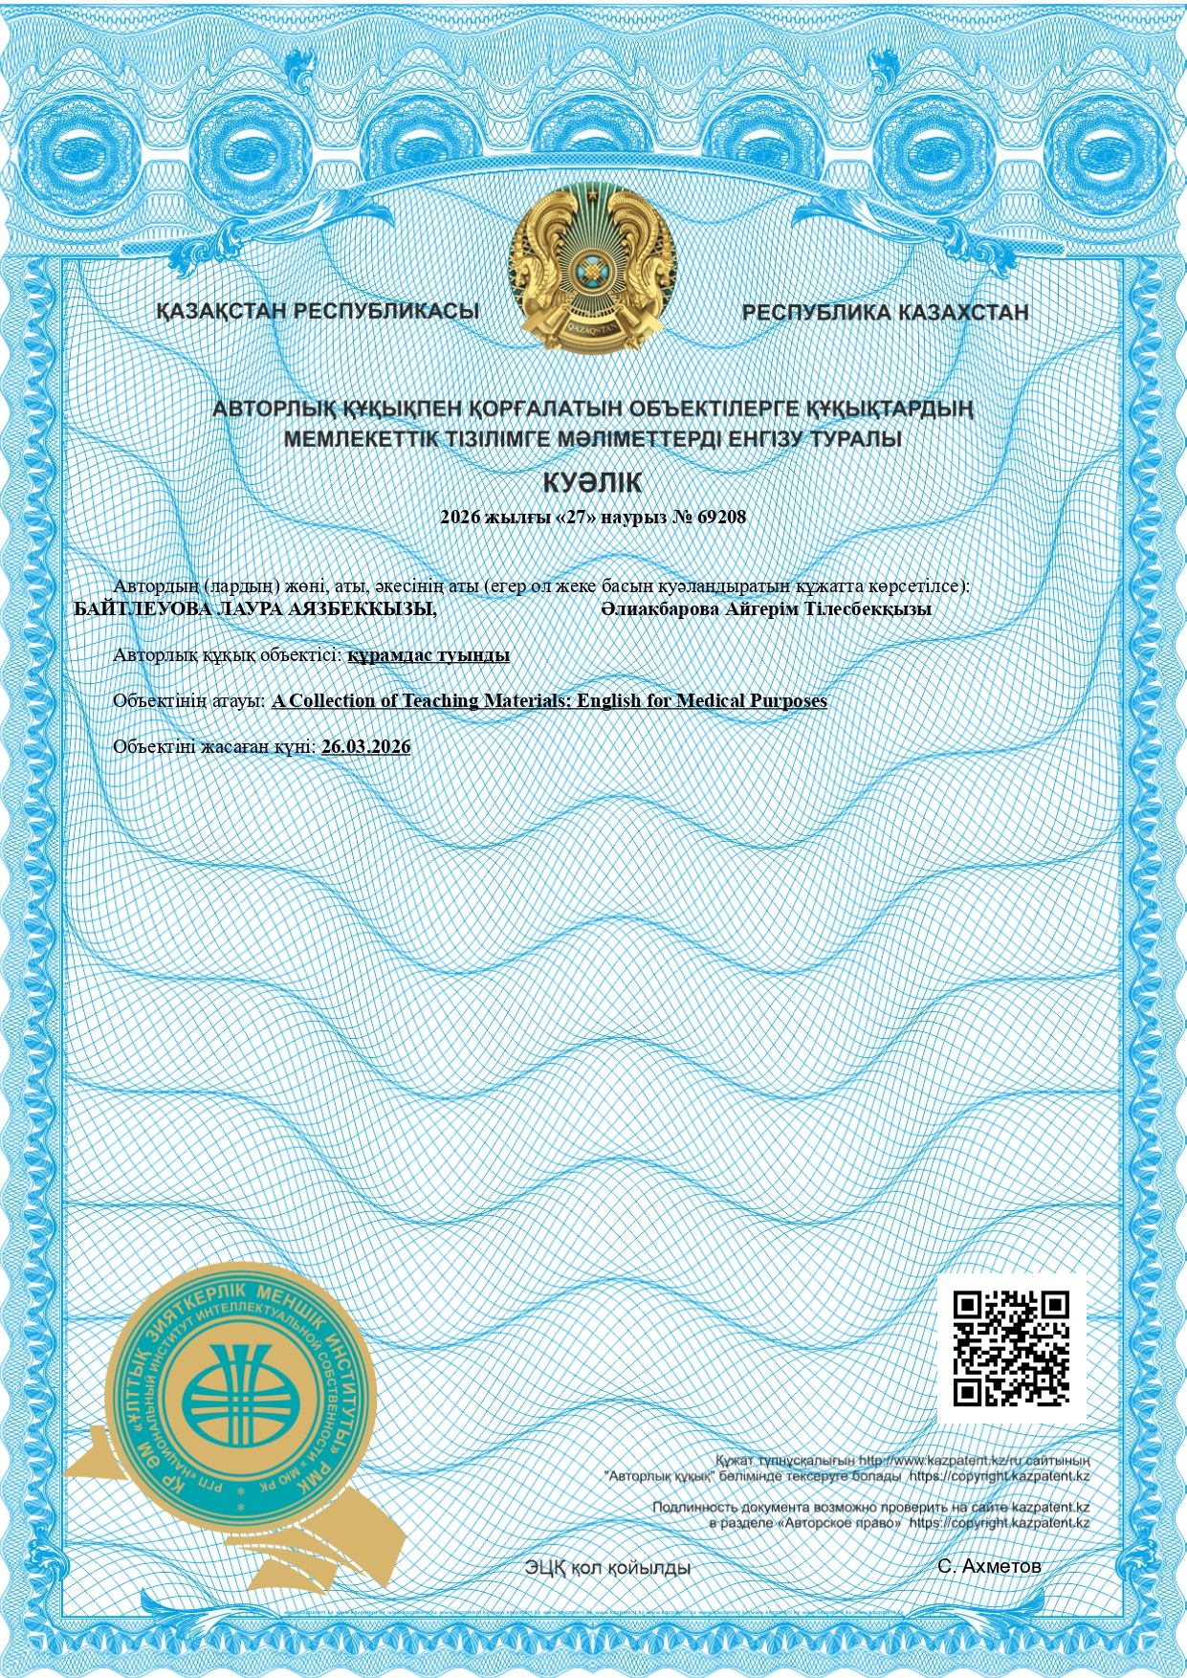
Certificate (in Kazakh) confirming the registration of A Collection of Teaching Materials: English for Medical Purposes in the State Register of Copyrighted Works

Certificate (in Russian) confirming the registration of A Collection of Teaching Materials: English for Medical Purposes in the State Register of Copyrighted Works

