West Kazakhstan Marat Ospanov medical university

UDC 616.24-022.7(574.13):615.33

ABLAKIMOVA NURGUL YERKINKYZY

Features of the microbial flora and its resistance in patients with bacterial pneumonia in Aktobe, the introduction and evaluation of the effectiveness of measures to contain antibiotic resistance

8D10102 – Medicine

Dissertation for the degree of Doctor of Philosophy (PhD)

Scientific consultants:
Candidate of Medical Sciences,
Professor G.A.Smagulova
PhD, Associate Professor A.Z.Mussina
International scientific consultant:
Doctor of Medical Sciences, Professor S.A.Rachina
I.M.Sechenov First Moscow State Medical University

Republic of Kazakhstan
Aktobe, 2025
TABLE OF CONTENTS

1 BIBLIOMETRIC ANALYSIS OF GLOBAL RESEARCH
OUTPUT ON ANTIMICROBIAL RESISTANCE AMONG
PNEUMONIA PATHOGENS (2013-2023) 3
2 ANTIMICROBIAL STEWARDSHIP INTERVENTIONS
IN HOSPITALIZED ADULTS WITH
COMMUNITY-ACQUIRED PNEUMONIA:
A SYSTEMATIC REVIEW AND META-ANALYSIS 24
SUPPLEMENTARY MATERIALS TO ARTICLE 2 52
3 MICROBIAL LANDSCAPE AND ANTIBIOTIC-
SUSCEPTIBILITY PROFILES OF MICROORGANISMS
IN PATIENTS WITH BACTERIAL PNEUMONIA:
A COMPARATIVE CROSS-SECTIONAL STUDY OF
COVID-19 AND NON-COVID-19 CASES IN AKTOBE,
KAZAKHSTAN 70
4 IMPACT OF COMPLEX INTERVENTIONS ON
ANTIBACTERIAL THERAPY AND ETIOLOGICAL
DIAGNOSTICS IN COMMUNITY-ACQUIRED
PNEUMONIA: A 12-MONTH PRE- AND
POST-INTERVENTION STUDY 86
SUPPLEMENTARY MATERIALS TO ARTICLE 4 103
APPENDIX A. CHALLENGES IN DIAGNOSING
POST-COVID PNEUMONIA IN KAZAKHSTAN –
THE ROLE OF POINT-OF-CARE TESTING:
A LETTER TO THE EDITOR 108
APPENDIX B. DIAGNOSING PNEUMONIA IN REAL
TIME: RAPID DIAGNOSTIC TESTS AS GAME-CHANGERS
IN MANAGEMENT STRATEGIES 113
APPENDIX C. IMPLEMENTATION ACTS
CONFIRMING THE INTRODUCTION OF THE
RESEARCH RESULTS INTO PRACTICAL HEALTHCARE 121

BIBLIOMETRIC ANALYSIS OF GLOBAL RESEARCH OUTPUT ON ANTIMICROBIAL RESISTANCE AMONG PNEUMONIA PATHOGENS

(2013-2023)

The article was published in the journal Antibiotics, which is ranked in the first quartile (Q1) by impact factor according to the Journal Citation Reports (Clarivate Analytics), and is available at the following link: Ablakimova N, Smagulova GA, Rachina S, Mussina AZ, Zare A, Mussin NM, Kaliyev AA, Shirazi R, Tanideh N, Tamadon A. Bibliometric Analysis of Global Research Output on Antimicrobial Resistance among Pneumonia Pathogens (2013–2023). Antibiotics. 2023; 12(9):1411. DOI: 10.3390/antibiotics12091411

Authors and Affiliations:

Nurgul Ablakimova 1*, Gaziza A. Smagulova 1, Svetlana Rachina 2, Aigul Z. Mussina 1, Afshin Zare 3, Nadiar M. Mussin 4, Asset A. Kaliyev 4, Reza Shirazi 5, Nader Tanideh 3,6,7and Amin Tamadon 3,8

1 Department of Pharmacology, West Kazakhstan Marat Ospanov Medical University, Aktobe 030012, Kazakhstan;
2 Hospital Therapy Department No. 2, I.M. Sechenov First Moscow State Medical University, 119435 Moscow, Russia;
3 PerciaVista R&D Co., Shiraz 73, Iran;
4 Department of Surgery, West Kazakhstan Marat Ospanov Medical University, Aktobe 030012, Kazakhstan;
5 Department of Anatomy, School of Medical Sciences, Biomedical & Health, UNSW Sydney, Sydney 2052, Australia;
6 Stem Cells Technology Research Center, Shiraz University of Medical Sciences, Shiraz 71348-14336, Iran
7 Department of Pharmacology, Medical School, Shiraz University of Medical Sciences, Shiraz 71348-14336, Iran
8 Department for Scientific Work, West Kazakhstan Marat Ospanov Medical University, Aktobe 030012, Kazakhstan
* Correspondence: n.ablakimova@zkmu.kz; Tel.: +7-707-475-3485

Abstract: Antimicrobial resistance (AMR) is a pressing global concern, posing significant challenges to the effective treatment of infections, including pneumonia. This bibliometric analysis aims to investigate the research output on AMR among pneumonia pathogens from 2013 to 2023. Data were extracted from the Web of Science Core Collection (WOS-CC) using an inclusive search strategy. The analysis included 152 relevant studies published in 99 different sources, involving 988 authors and yielding an average of 16.33 citations per document over the past decade. The findings reveal a notable increase in research on AMR among pneumonia pathogens, indicating a growing awareness of this critical issue. Collaborative studies were prevalent, with the majority of authors engaging in joint research efforts. Bradford’s Law identified twelve core journals that were instrumental in disseminating research in this field, with “Medicine” emerging as the most prolific journal. The USA and China emerged as the leading contributors, while Germany displayed a strong inclination towards collaborative research. Intermountain Medical Center, Saitama Medical University, and Udice-French Research Universities were the most productive institutions, and Yayan J. and Rasche K. were the top authors. Furthermore, the analysis identified commonly encountered microorganisms such as Acinetobacter baumanii and Klebsiella pneumoniae in the context of AMR. Time-based analysis of keywords highlighted the significance of terms like “community-acquired pneumonia” and “ventilator-associated pneumonia”. Overall, this comprehensive study sheds light on the global research landscape of AMR among pneumonia pathogens. The insights gained from this analysis are essential for guiding future research priorities and collaborative efforts to combat AMR effectively and improve treatment outcomes for pneumonia and related infections. As the frequency of reports concerning resistance among pneumonia pathogens, notably A. baumannii and K. pneumoniae, continues to rise, there is an immediate requirement for pharmaceutical manufacturers and healthcare providers to respond proactively and ready themselves for the forthcoming implications of this matter. It also underscores the importance of knowledge dissemination and evidence-based interventions to address this growing public health challenge. However, the study acknowledges the limitations associated with using a single publication database and encourages the inclusion of data from other sources in future research.
Keywords: antimicrobial resistance; pneumonia; pathogens; antibiotics; bibliometrics; drug resistance; microbial; community-acquired infections; ventilator-associated pneumonia; global health
Introduction
Antimicrobial resistance (AMR) is a global challenge that poses a significant risk to the effectiveness of treating a wide range of infections [1]. Furthermore, AMR also has economic implications, as it requires longer treatment durations, additional laboratory tests, and the use of costly medications [2,3]. Addressing the issue of AMR requires collective efforts from governments, healthcare providers, researchers, and the general public. Conducting research, raising awareness, enhancing knowledge, and staying updated on AMR are crucial in minimizing its impact and revising treatment guidelines for different infection types [4–7].
Lower respiratory tract infections (LRTIs) stand as the primary contributor to mortality from infectious diseases globally and hold the fifth position among all causes of death [8]. They also contribute significantly to disability-adjusted life years despite being largely preventable [9]. Over the past decade, there have been changes in the epidemiology of LRTIs, with a decrease in the burden among children under 5 years of age and an increase among individuals over 70 years old [9]. Notably, pneumococcal pneumonia accounts for 55.4% of LRTI-related deaths across all age groups [9].
The economic burden of pneumonia is substantial, as it leads to substantial healthcare costs, prolonged hospitalizations, and increased utilization of medical resources [10,11]. Moreover, pneumonia often serves as a precipitating factor for more severe conditions like sepsis, placing an immense strain on healthcare systems [12]. Understanding the role of resistant pathogens of pneumonia is crucial for both public health management and effective patient care.
Amongst the range of infections affected, pneumonia stands out as a critical area of focus, as it remains a leading cause of morbidity and mortality worldwide [13,14]. Pneumonia pathogens have increasingly developed resistance to commonly used antibiotics [15–17]. The misuse and overuse of antibiotics, both in healthcare and community settings, have contributed to the development of resistant strains of bacteria, rendering traditional treatment approaches less effective [18,19]. This phenomenon not only complicates the management of pneumonia cases but also diminishes the success of other medical interventions that rely on antibiotics. This alarming trend has limited treatment options and heightened the risk of severe complications [20], making it imperative to understand the evolving landscape of antibiotic resistance in pneumonia pathogens. The most significant challenges for clinicians arise when treating pneumonia caused by multidrug-resistant (MDR) pathogens [21,22].
In 2014, the World Health Organization (WHO) released the first global surveillance report on AMR to highlight the clinical consequences of resistant bacteria across WHO regions worldwide [23]. Notably, a considerable amount of time has elapsed since the publication of this initial report, and it is important to acknowledge the transformative impact of the COVID-19 (Coronavirus disease 2019) pandemic, during which there has been an elevated utilization of antibiotics, especially for the patients with pneumonia [24]. Therefore, analyzing the published literature on AMR is crucial for the development of new empirical and therapeutic guidelines for the treatment of pneumonia. Additionally, examining the published literature is essential for understanding the global and regional changes in AMR. While several review articles have discussed AMR among pathogens in the context of LRTIs [25–28], none have specifically analyzed the global research output and trends in this area. Bibliometric analysis proves to be a powerful approach in quantitatively evaluating academic papers, enabling researchers to explore the progression of specific fields; it is a valuable tool that employs mathematical and statistical methods to assess the growth, productivity, and overall patterns of publications related to a specific topic [29,30]. In the medical field, such analyses play a crucial role in illustrating research trends and developments, motivating researchers to identify leading countries and institutions, as well as areas that require improvement. This study will serve as a foundational source of information for future comparisons and assessments. It aims to identify trends and advancements in this area of research and shed light on potential areas for further focus and improvement.
Results
Summary of the Papers
This study aimed to comprehensively examine the global research output on AMR among pathogens associated with pneumonia, covering articles published from 2013 to 2023. A total of 152 relevant studies were carefully reviewed, originating from 99 different sources. The analysis involved the contributions of 988 authors, collectively producing an impressive average of 16.33 citations per document over the past decade. The key findings related to antimicrobial resistance in pneumonia pathogens are presented based on the highest-cited documents over the past decade in Table 1. In addition, the Annual Growth Rate for this research field was calculated to be 2.03%, indicating a steady increase in publications over the study period. The vast volume of research output is further highlighted by the inclusion of 4351 references and 394 unique author keywords. The overwhelming majority of authors participated in collaborative studies (98%).

Table 1. The top 10 most cited documents on antimicrobial resistance among pneumonia pathogens (2013–2023).
Rank | Study ID [references] | Title of the Document | Journal Name | Total Citations | DOI
1 | Shields RK, 2018 [31] | Pneumonia and renal replacement therapy are risk factors for ceftazidime-avibactam treatment failures and resistance among patients with carbapenem-resistant Enterobacteriaceae infections | Antimicrobial Agents and Chemotherapy | 174 | 10.1128/AAC.02497-17
2 | Micek ST, 2015 [32] | An international multicenter retrospective study of Pseudomonas aeruginosa nosocomial pneumonia: impact of multidrug resistance | Critical Care | 154 | 10.1186/s13054-015-0926-5
3 | Zilberberg MD, 2017 [33] | Carbapenem resistance, inappropriate empiric treatment and outcomes among patients hospitalized with Enterobacteriaceae urinary tract infection, pneumonia and sepsis | BMC Infectious Diseases | 131 | 10.1186/s12879-017-2383-z
4 | Gauguet S, 2015 [34] | Intestinal Microbiota of Mice Influences Resistance to Staphylococcus aureus Pneumonia | Infection and Immunity | 127 | 10.1128/IAI.00037-15
5 | Yayan J, 2015 [35] | Antibiotic resistance of Pseudomonas aeruginosa in pneumonia at a single university hospital center in Germany over a 10-year period | Plos one | 105 | 10.1371/journal.pone.0139836
6 | Martin-Loeches I, 2015 [36] | Resistance patterns and outcomes in intensive care unit (ICU)-acquired pneumonia. Validation of European Centre for Disease Prevention and Control (ECDC) and the Centers for Disease Control and Prevention (CDC) classification of multidrug resistant organisms | Journal of Infection | 105 | 10.1016/j.jinf.2014.10.004
7 | Lee SH, 2019 [37] | Performance of a multiplex PCR pneumonia panel for the identification of respiratory pathogens and the main determinants of resistance from the lower respiratory tract specimens of adult patients in intensive care units | Journal of Microbiology, Immunology and Infection | 87 | 10.1016/j.jmii.2019.10.009
8 | Zilberberg MD, 2016 [38] | Multidrug resistance, inappropriate empiric therapy, and hospital mortality in Acinetobacter baumannii pneumonia and sepsis | Critical Care | 76 | 10.1186/s13054-016-1392-4
9 | Fernandez-Barat L, 2017 [39] | Intensive care unit-acquired pneumonia due to Pseudomonas aeruginosa with and without multidrug resistance | Journal of Infection | 65 | 10.1016/j.jinf.2016.11.008
10 | Jamal W, 2014 [40] | Evaluation of Curetis Unyvero, a multiplex PCR-based testing system, for rapid detection of bacteria and antibiotic resistance and impact of the assay on management of severe nosocomial pneumonia | Journal of Clinical Microbiology | 59 | 10.1128/JCM.00325-14

Trend of Publication and Citation
The data indicate fluctuations in the mean total citations per article across the years. In 2015, there was a substantial increase in the mean total citations per article, reaching 37.83, while 2023 recorded the lowest value of 0.36. Furthermore, the number of publications (N) varied from year to year, with the highest number of articles published in 2022 (N = 22) and the lowest in 2013 (N = 9). Figure 1 illustrates the publication trend over the years (Figure 1A).
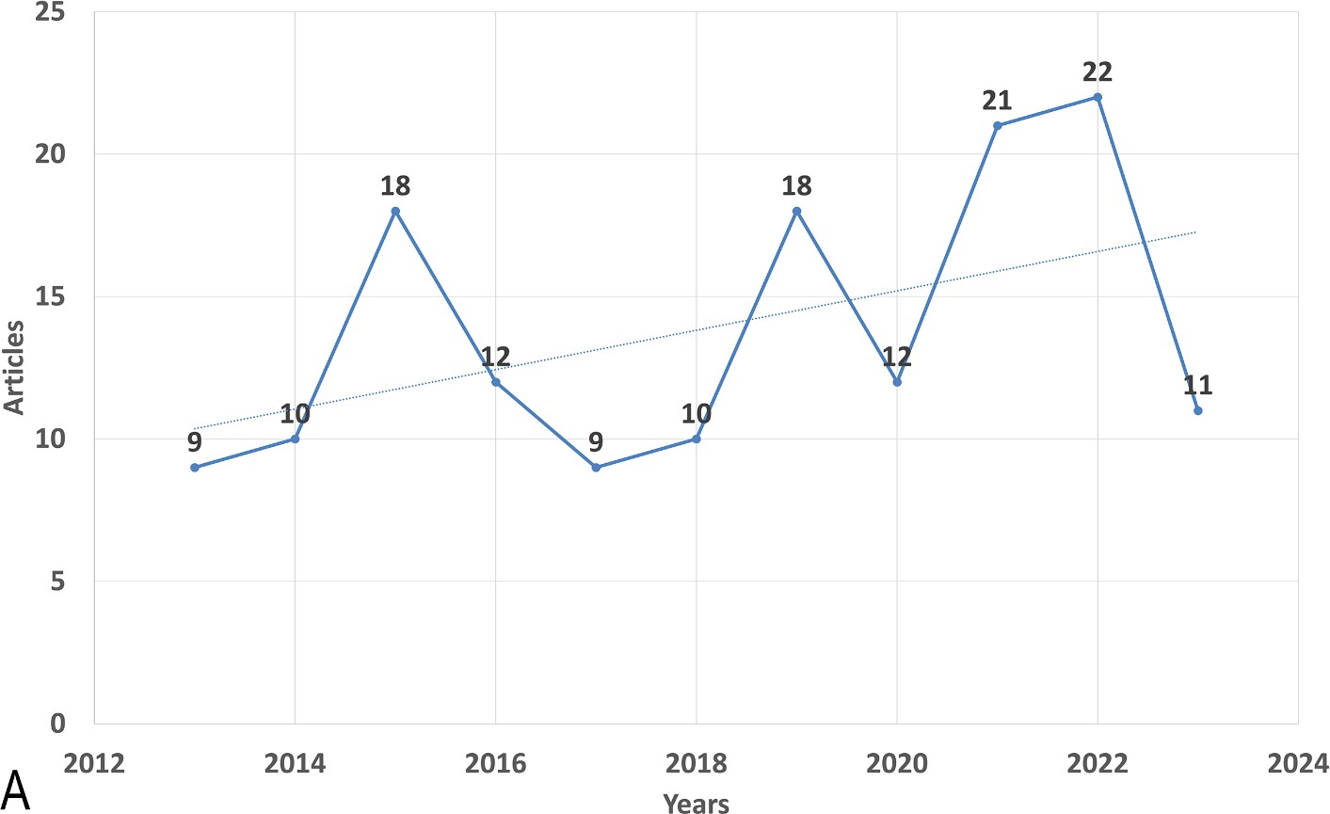

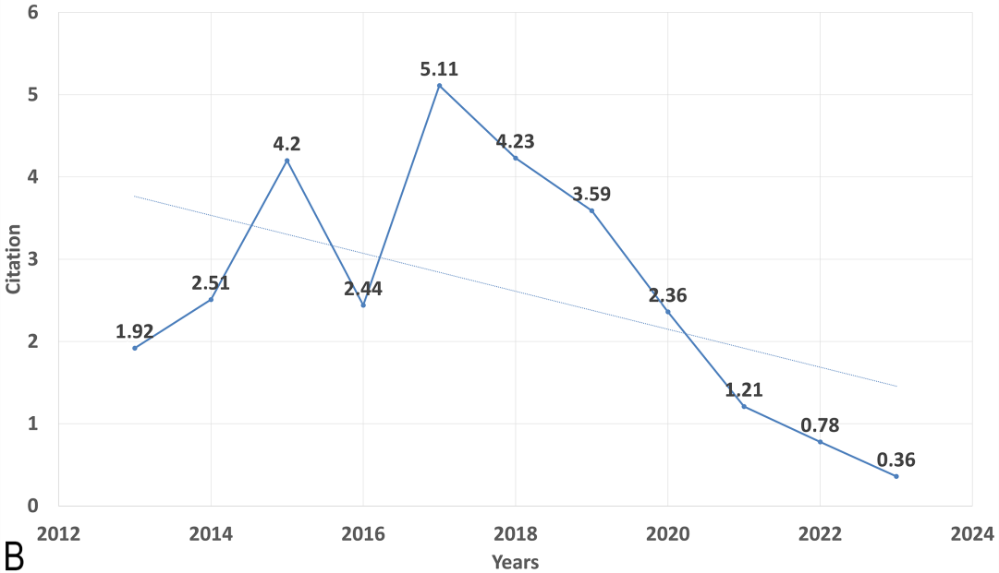
Figure 1. Global annual trend of (A) publication and (B) citation on the antimicrobial resistance among pneumonia pathogens (2013–2023). Dotted lines show the trendlines for better demonstration of trend of increase of articles number and trend of decrease of citations during the period of time.

Utilizing Bradford’s Law, which describes the distribution of scientific articles among different journals, we identified twelve core journals that were deemed to be the top choices for researchers (Figure 2). According to Bradford’s Law, these core journals collectively accounted for a significant portion of the total number of articles published on AMR among pneumonia pathogens. Upon analyzing the publication data from these core journals, we observed that the journal “Medicine” emerged as the most prolific one, contributing a substantial seven articles, which represents approximately 4.6% of the total articles within the study period. Furthermore, we investigated the local citations received by these core journals from other articles within our dataset. Remarkably, “Clinical Infectious Diseases” stood out with the highest number of local citations, amassing an impressive total of 238 citations (Table 2).
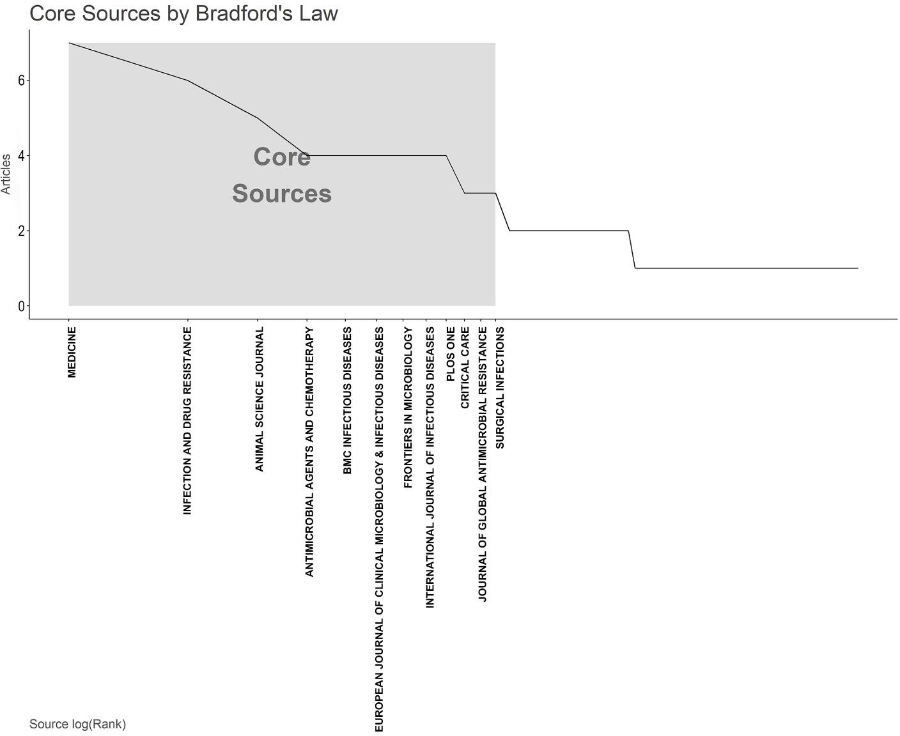

Figure 2. The plot of Broadford’s Law identified twelve core journals on the antimicrobial resistance among pneumonia pathogens (2013–2023).

Table 2. The top 10 most cited journals on antimicrobial resistance among pneumonia pathogens (2013–2023).

Sources | Articles
Clinical Infectious Diseases | 238
Antimicrobial Agents and Chemotherapy | 227
Journal of Clinical Microbiology | 114
American Journal of Respiratory and Critical Care Medicine | 110
Journal of Antimicrobial Chemotherapy | 110
Clinical Microbiology and Infection | 100
PLOS ONE | 92
Chest | 90
Critical Care Medicine | 81

Most Productive Authors, Institutions, Countries and Their Collaboration Network
Intermountain Medical Center (Murray, UT, USA), Saitama Medical University (Moroyama, Japan), Udice-French Research Universities (Paris, French), University of Zagreb (Zagreb, Croatia), Witten Herdecke University (Witten, Germany) emerged as the most productive institutions, contributing the highest number of articles (7, 4.6%) (Figure 3A). Among the authors, Yayan J. stood out with the highest number of articles (9, 5.9%), followed by Rasche K., who produced eight articles (Figure 3B). The Three-Fields Plot vividly illustrates the intricate web of connections among cited references, authors, and author keywords, providing invaluable insights into the complex landscape of antibiotic resistance among pneumonia pathogens during the decade spanning from 2013 to 2023. (Figure 4).

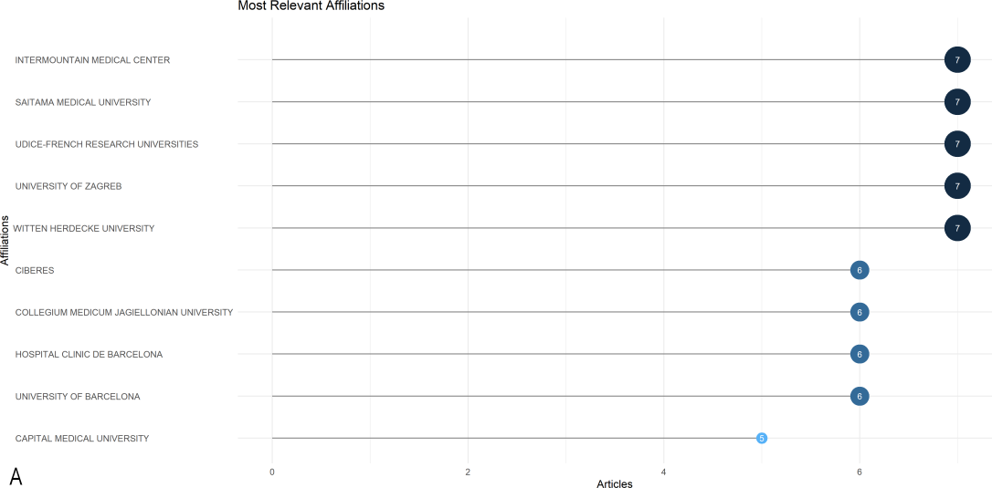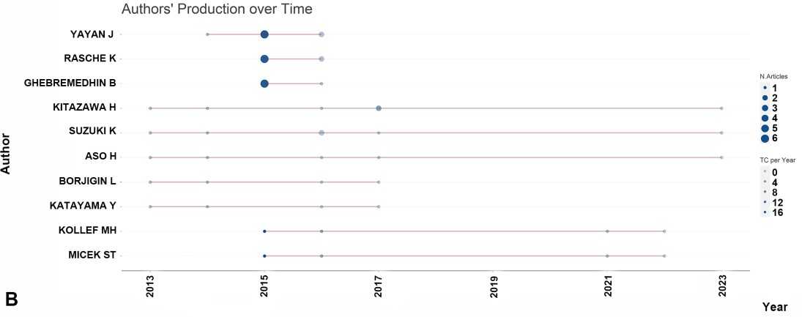

Figure 3. Most productive authors, institutions, countries and their collaboration network (A). (B) Ten most-contributing authors and their production over time on the antimicrobial resistance among pneumonia pathogens (2013–2023).

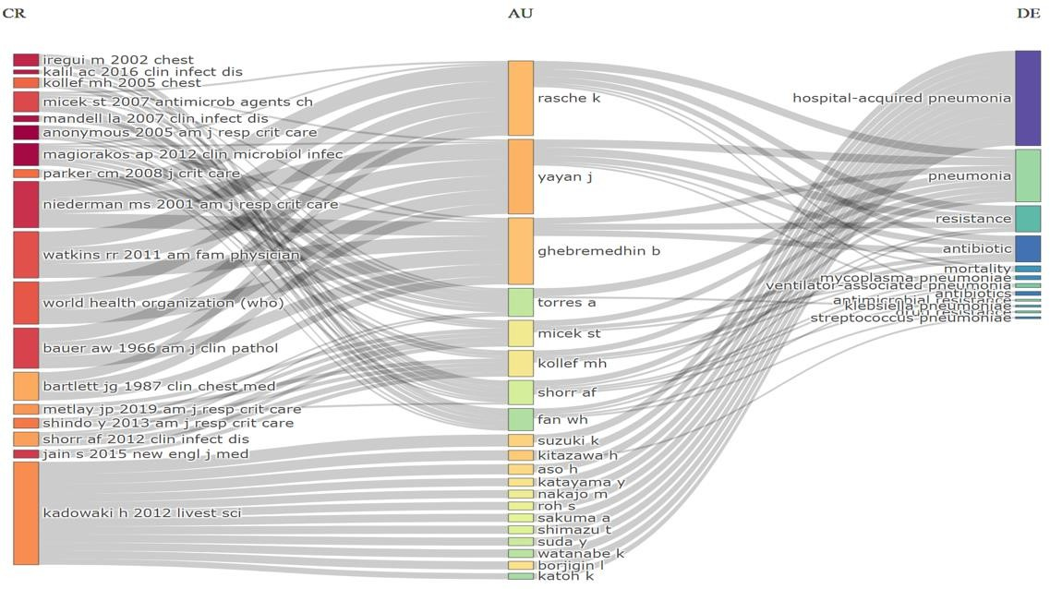

Figure 4. Three-Fields Plot representing the incoming and outgoing flows among cited references, authors and author keywords contributing to antibiotic resistance among pneumonia pathogens (2013–2023). Abbreviations: CR, cited references; AU, authors; and DE; keywords. Explanations of the right columns (DE) from top to bottom: hospital acquired-pneumonia; pneumonia; resistance; antibiotics; mortality; Mycoplasma pneumoniae; ventilator-associated pneumonia; antibiotics; antimicrobial resistance; Klebsiella pneumoniae; drug resistance; Streptococcus pneumoniae.

Over the course of one decade, China and the USA led the scientific production among countries with 104 and 101 publications, respectively, followed by Japan with 50 publications, Spain with 32, and Vietnam with 30 (Table 3). Regarding publication patterns, China exhibited a significant tendency for single-country productions, with 83.7% of its publications. Similarly, the United States demonstrated a high rate of single-country publications at 82.2%. In contrast, Germany engaged in collaborative research, with 65.4% of German authors’ publications being co-authored with researchers from other countries. Collaboration strength was mostly derived from the United States and European countries (Figure 5).

Table 3. Leading publishing countries on antimicrobial resistance among pneumonia pathogens (2013–2023).
Country | Number of Articles
China | 104
USA | 101
Japan | 50
Spain | 32
Vietnam | 30
Iran | 27
Germany | 26
UK | 24
South Korea | 19
India | 13

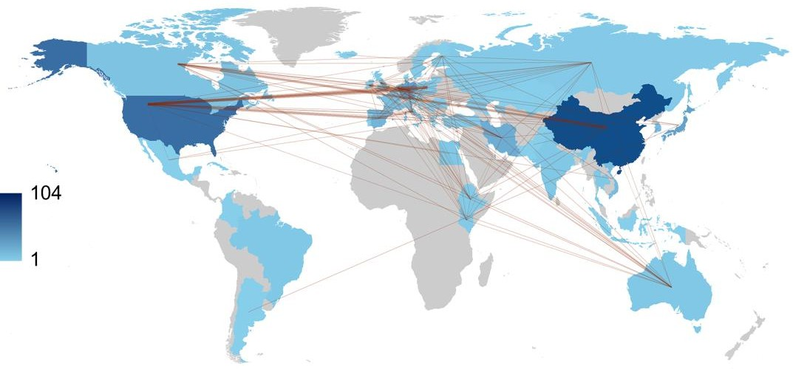

Figure 5. World collaboration map on the antimicrobial resistance among pneumonia pathogens (2013–2023). The intensity of color saturation corresponds to the increasing number of articles within each country. The collaboration between countries is depicted through the thickness of the connecting arrows.

Co-Occurrence, Hotspots and Emerging Keywords
The most commonly found author keywords were examined using Biblioshiny. The analysis covered commonly encountered antimicrobial agents, microorganisms, types of pneumonia and terms related to AMR. Keywords related to antibiotic resistance (“antibiotic resistance”) and antimicrobial resistance (“antimicrobial resistance”) both exhibited an upward trend, with 16 and 14 occurrences in 2023, respectively. The frequency of the keyword “ventilator-associated pneumonia” remained relatively stable over the years, with 14 occurrences in 2023. Research on Acinetobacter baumannii showed a notable increase, with 11 occurrences in 2023, indicating growing attention to this MDR pathogen. Keywords related to Klebsiella pneumoniae demonstrated steady research interest over the years, with eight occurrences in 2023, reflecting continued efforts to address this problematic pathogen (Figure 6).
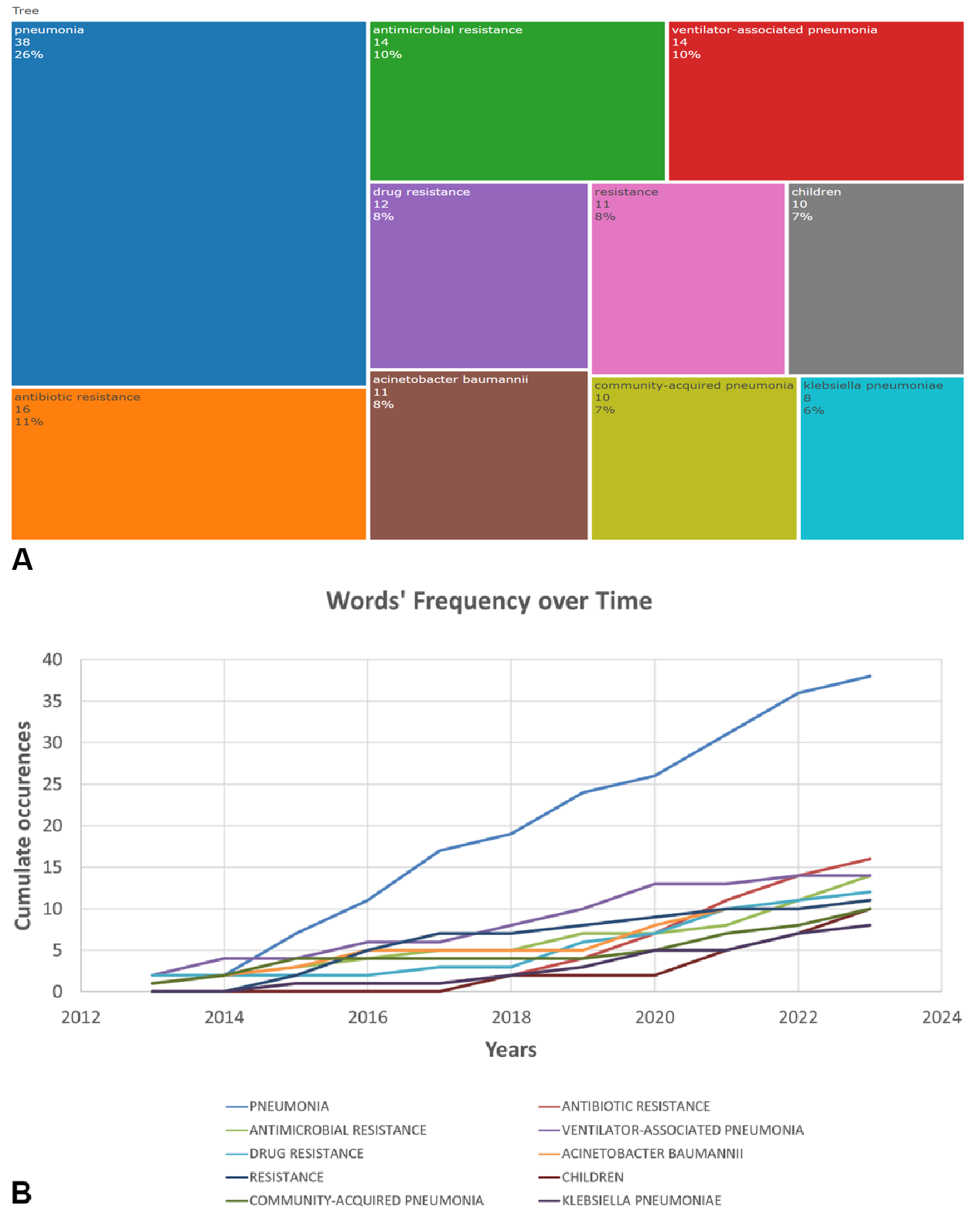

Figure 6. TreeMap (A) and scatter plot (B) representing top ten author’s keywords in the research on the antimicrobial resistance among pneumonia pathogens (2013–2023).

The timeline analysis of important keywords reveals that “community-acquired pneumonia” received peak citations in 2016, with “ventilator associated pneumonia” remaining relevant during the pandemic. Topics such as Epidemiology (19%), Diagnosis (17%), and Risk Factors (17%) also have considerable frequencies, demonstrating the sustained interest in understanding the epidemiology, diagnosis, and risk factors of bacterial pneumonia infections (Figure 7).
In summary, this study comprehensively reviewed global research output on AMR among pneumonia pathogens over the past decade, identifying top journals, impactful articles, collaborations between institutions, authors, and countries, as well as important and emerging keywords. The findings provide valuable insights into the research landscape and highlight potential areas for future studies.

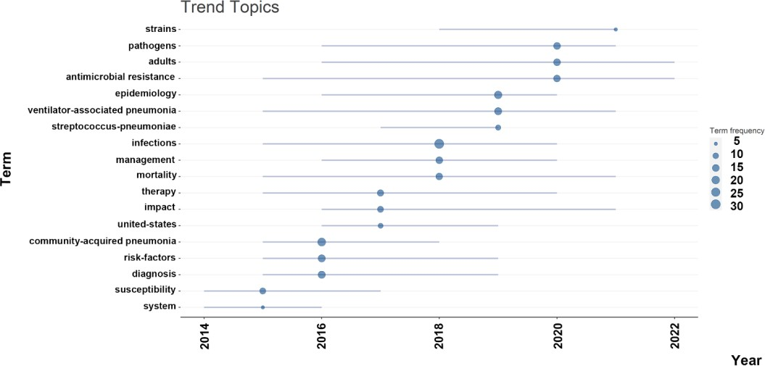

Figure 7. The timeline of the trend topics. Each bubble indicates the peak of frequency used for each, while the line indicates the years it was used.

Discussion
In recent years, bibliometric analysis and scientific mapping have been rapidly advancing because the scientific community has shown a growing interest in the outcomes of various bibliometric analyses [41]. Bibliometric analysis allows for exploring the impact of research fields, the influence of researchers, the significance of individual papers, and can help identify particularly influential papers, thereby enhancing our understanding of the overall intellectual landscape within specific research fields [42].
The analysis revealed a notable increase in research output on AMR among pneumonia pathogens over the past decade [22,43]. This growth indicates a growing awareness of the critical issue of AMR and its impact on the effective treatment of pneumonia. According to Cillinoz et al., the incidence of MDR Gram-negative bacteria is rising among cases of nosocomial pneumonia, such that it is now becoming a significant challenge for clinicians [43]. The increasing number of publications reflects the urgency and importance of addressing this global health challenge, particularly in the context of utilizing reserve antibiotics and exploring novel combinations to combat it effectively [22,44,45].
The analysis of global research output on AMR among pneumonia pathogens over the past decade reveals interesting trends and insights. One noticeable shift in research focus is the transition from community-acquired pneumonia (CAP) to hospital ventilator-associated pneumonia (VAP). VAP has gained prominence as a critical concern due to its association with prolonged hospital stays [46], increased morbidity and mortality rates [47], and the higher likelihood of drug-resistant pathogens [45]. Researchers and healthcare professionals have directed their attention to understanding the underlying mechanisms of AMR in VAP to develop effective treatment strategies and infection control measures. The high interest in VAP may be associated with COVID-19 because nearly half of patients with COVID-19 admitted to ICU may develop VAP, with a pooled estimate of mortality of 42.7% for COVID-19 patients who developed VAP [48]. The high 30-day case fatality of VAP likely represents the sum of the prognostic effects of the underlying viral and superimposed bacterial diseases [49]. This shift may be attributed to the increasing recognition of nosocomial infections and the significance of AMR in healthcare settings.
One of the most frequently cited studies addresses the issue of Staphylococcus aureus resistance, and the research was conducted using an animal model [34]. This underscores the significance of such studies in exploring diseases caused by resistant pathogens. Gaugaet et al. emphasized that further studies are needed to examine the link between the gut microbiota and the production of certain antimicrobial proteins in the lung. The potential use of gut microbiota as an alternative to antibiotics is an emerging area of research and interest in the medical field [50,51]. The concept revolves around harnessing the natural antimicrobial properties of the gut microbiota to combat infections without resorting to traditional antibiotic treatments. This approach has gained attention due to concerns about antibiotic resistance.
Aguilar et al. [52] estimated that in 2019, AMR was linked to approximately 569,000 deaths (95% UI 406,000–771,000) and about 141,000 deaths (99,900–196,000) were connected to bacterial AMR in the 35 countries within the World Health Organization’s Region of the Americas. The six leading pathogens (by order of number of deaths associated with resistance) are S. aureus, Escherichia coli, K. pneumoniae, Streptococcus pneumoniae, Pseudomonas aeruginosa, and A. baumannii. Together, these pathogens were responsible for 452,000 deaths (326,000–608,000) associated with AMR.
Our bibliometric study incorporated research related to all the aforementioned pathogens. Between 2017 and 2019, S. pneumoniae was identified as one of the trending topics. Reports of multidrug-resistant strains of S. pneumoniae have been published since the late 1970s [53]. The global rise in antibacterial resistance within pneumococci continues, particularly affecting β-lactams and macrolides [54,55]. In nations like France and Spain in Europe, up to 40% of pneumococcal strains exhibit resistance to multiple drugs [56].
However, the analysis of author keywords highlights the prominence of A. baumannii and K. pneumoniae among commonly encountered microorganisms in the context of AMR and pneumonia. Both of these pathogens belong to the ESKAPE group, which includes bacteria known for their high resistance to multiple antimicrobial agents [57,58].
Researchers observed a wide variation in the prevalence of MDR among A. baumannii causing HAP and VAP (ranging from 55% to 100%) and mortality rates (ranging from 28% to 68%) between regions and countries [15]. Based on previous research, the primary risk factors for VAP caused by A. baumannii include antibiotic therapy, especially broad-spectrum antibiotics, mechanical ventilation, prolonged hospital stay, invasive procedures, disease severity, and the presence of chronic diseases [59,60]. In a study by Inchai et al. [61], carbapenem treatment was associated with the risk of VAP caused by all three types of A. baumannii drug-resistant profiles, particularly pandrug-resistant (PDR), with odds ratios of 5.2, 6.3, and 12.84 for MDR, extensively drug-resistant (XDR), and PDR A. baumannii VAP, respectively. The use of carbapenems was also identified as a risk factor for XDR A. baumannii VAP in the study by Li et al. [60]. Additionally, previous colistin treatment was found to increase the likelihood of VAP caused by PDR A. baumannii [61].
The current mechanism of resistance of K. pneumoniae involves the production of enzymes called beta-lactamases, which include extended-spectrum ß-lactamases, cephalosporinases, and carbapenemases [62–64]. The presence of carbapenemases and extended-spectrum beta-lactamases in nosocomial K. pneumoniae has resulted in a MDR phenotype, significantly limiting available treatment options [62].
The higher prevalence of AMR in A. baumannii and K. pneumoniae underscores the urgency of targeted research efforts to combat drug resistance in these pathogens. These findings align with the global concern over the rapid spread of drug-resistant infections, emphasizing the need for effective surveillance, infection prevention measures, and novel antimicrobial therapies.
Our study is the first study to access AMR among pneumonia pathogens in a bibliometric way. However, it is essential to acknowledge the limitations of this study, which are associated with the use of a single publication database. WOS has covered many publications; however, some publications from databases, such as Scopus and PubMed, may not be included in this study. Due to our bibliometric analysis approach using empirical data from original articles, we focused on article metadata rather than content, extracting author details, institutions, and countries for productivity, collaboration, and impact assessment. Textual content analysis was not included. Furthermore, it should be noted that only English-language full-text articles were analyzed. Even if abstracts were available in English, such publications were excluded. As a result, certain articles from journals published in national languages might not have been included in the analysis.
Materials and Methods
Search Results
In July 2023, data were collected from the Web of Science Core Collection (WOS-CC) to comprehensively analyze research on AMR among pneumonia pathogens. The search strategy used in this study aimed to be inclusive and covered various aspects of the topic. The search strategy employed was as follows: “resistance” AND “pneumonia” (Title) and “resistance” AND “pneumonia” (Abstract).
To ensure the accuracy and relevance of the data, specific inclusion criteria were applied. These criteria included: (1) articles published between 2013 and 2023, (2) articles written in English, and (3) exclusion of review articles, proceeding papers, book chapters and editorial material. To provide a visual representation of the data extraction process, a PRISMA flowchart outlining the selection process is presented in Figure 8.

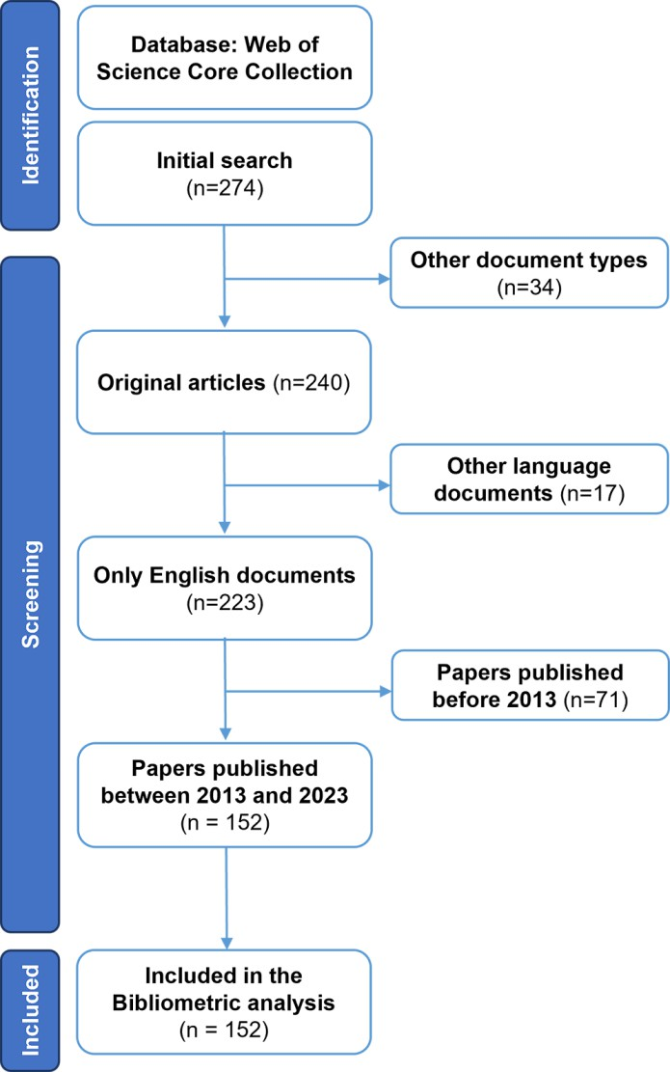
Figure 8. The flow chart of the screening process using PRISMA.

Performance Analysis
In this study, performance analysis and science mapping were conducted using specific software tools. Rstudio v.4.3.1 with the bibliometric R-package (http://www.bibliometrix.org; access date: 19 July 2023), was utilized for these analyses [65]. Biblioshiny, with its web features, was employed for data analysis. This software has the capability to function with a single database only. WOS was chosen due to its provision of comprehensive and detailed citation information. This feature is particularly valuable for conducting thorough bibliometric analysis and assessing the impact of research outputs.
The local publication trends and average total citations per article were measured for each year. To identify the most productive journals, the number of publications was considered, and Bradford’s Law was applied to identify core journals, which are a few journals contributing significantly to citations in the field [66].
Identification of Leading Institutions, Sources, Authors, and Collaborating Countries
The top 10 most productive institutions and authors were ranked based on the percentage of papers they produced. Relationships between institutions and authors were visualized to understand their collaboration patterns. For country analysis, the percentage of articles from each country was used to rank the most productive country, and the percentage of multiple-country production was measured for the top 10 countries. The country collaboration network was mapped based on the number of publications produced by each country.
Keywords Frequencies Analysis
Timeline analysis was performed to observe how frequently specific keywords appeared over the years. TreeMap was created to illustrate the distribution and prominence of the top 10 most frequently occurring keywords. Thematic analysis was conducted to identify the main trends and topics within the selected articles.
Conclusions
Over the past decade, research on AMR among pneumonia pathogens has shown a significant increase. China and the USA have made significant contributions to this field, as evidenced by their representation among the authors of 104 and 101 articles, respectively. Antibiotic-resistant bacterial infections in Africa are still of great concern as they remain poorly understood. It is crucial to update and share research findings from different countries regarding AMR with clinicians to develop appropriate empirical therapy for pneumonia. Addressing this growing health challenge requires converting global data on AMR among pneumonia pathogens into a comprehensive action plan. With an escalating number of reports on resistance among pneumonia pathogens, especially A. baumannii and K. pneumoniae, there is an urgent need for pharmaceutical companies and healthcare providers to take action and prepare for the future consequences of this issue.
Author Contributions: Conceptualization, N.A.; Data curation, N.A., S.R. and A.T.; Formal analysis, N.A. and A.Z.M.; Methodology, N.A., S.R. and A.Z.M.; Project administration, G.A.S.; Resources, N.M.M., A.A.K., R.S. and N.T.; Software, N.A. and A.Z.; Supervision, G.A.S. and S.R.; Validation, R.S., N.T. and A.T.; Visualization, N.M.M., A.A.K. and A.T.; Writing, original draft, N.A.; Writing, review and editing, G.A.S., S.R., A.Z.M., A.Z., N.M.M., A.A.K., R.S., N.T. and A.T. All authors have read and agreed to the published version of the manuscript.
Funding: This study was funded by the West Kazakhstan Marat Ospanov Medical University (3/3/2022 and No. 13/2-18-153) and conducted as part of a research project at the West Kazakhstan Marat Ospanov Medical University, entitled “Concomitant bacterial infections and pharmacoepidemiology of antibiotic resistance in patients with COVID-19: the situation in the Aktobe region”.
Institutional Review Board Statement: Not applicable.
Informed Consent Statement: Not applicable.
Data Availability Statement: Data are contained within the article.
Conflicts of Interest: The authors declare no conflict of interest.
References
- Chokshi, A.; Sifri, Z.; Cennimo, D.; Horng, H. Global Contributors to Antibiotic Resistance. J. Glob. Infect. Dis. 2019, 11, 36–42.
- Pulingam, T.; Parumasivam, T.; Gazzali, A.M.; Sulaiman, A.M.; Chee, J.Y.; Lakshmanan, M.; Chin, C.F.; Sudesh, K. Antimicrobial resistance: Prevalence, economic burden, mechanisms of resistance and strategies to overcome. Eur. J. Pharm. Sci. 2022, 170, 106103.
- Majumder, M.A.A.; Rahman, S.; Cohall, D.; Bharatha, A.; Singh, K.; Haque, M.; Gittens-St Hilaire, M. Antimicrobial stewardship: Fighting antimicrobial resistance and protecting global public health. Infect. Drug Resist. 2020, 13, 4713–4738.
- Ranjalkar, J.; Chandy, S.J. India’s National Action Plan for antimicrobial resistance—An overview of the context, status, and way ahead. J. Family Med. Prim. Care 2019, 8, 1828–1834.
- Ren-Zhang, L.; Chee-Lan, L.; Hui-Yin, Y. The awareness and perception on antimicrobial stewardship among healthcare professionals in a tertiary teaching hospital Malaysia. Arch. Pharm. Pract. 2020, 11, 50–59.
- Iskandar, K.; Molinier, L.; Hallit, S.; Sartelli, M.; Hardcastle, T.C.; Haque, M.; Lugova, H.; Dhingra, S.; Sharma, P.; Islam, S.; et al. Surveillance of antimicrobial resistance in low- and middle-income countries: A scattered picture. Antimicrob. Resist. Infect. Control 2021, 10, 63.
- Sartelli, M.; Hardcastle, T.C.; Catena, F.; Chichom-Mefire, A.; Coccolini, F.; Dhingra, S.; Haque, M.; Hodonou, A.; Iskandar, K.; Labricciosa, F.M.; et al. Antibiotic use in low and middle-income countries and the challenges of antimicrobial resistance in surgery. Antibiotics 2020, 9, 497.
- Disease, G.B.D.; Injury, I.; Prevalence, C. Global, regional, and national incidence, prevalence, and years lived with disability for 354 diseases and injuries for 195 countries and territories, 1990–2017: A systematic analysis for the Global Burden of Disease Study 2017. Lancet 2018, 392, 1789–1858.
- Collaborators, G.L. Estimates of the global, regional, and national morbidity, mortality, and aetiologies of lower respiratory tract infections in 195 countries: A systematic analysis for the Global Burden of Disease Study 2015. Lancet Infect. Dis. 2017, 17, 1133–1161.
- Koulenti, D.; Tsigou, E.; Rello, J. Nosocomial pneumonia in 27 ICUs in Europe: Perspectives from the EU-VAP/CAP study. Eur. J. Clin. Microbiol. Infect. Dis. 2017, 36, 1999–2006.
- Divino, V.; Schranz, J.; Early, M.; Shah, H.; Jiang, M.; DeKoven, M. The annual economic burden among patients hospitalized for community-acquired pneumonia (CAP): A retrospective US cohort study. Curr. Med. Res. Opin. 2020, 36, 151–160.
- Cillóniz, C.; Dominedò, C.; Ielpo, A.; Ferrer, M.; Gabarrús, A.; Battaglini, D.; Bermejo-Martin, J.; Meli, A.; García-Vidal, C.; Liapikou, A.; et al. Risk and Prognostic Factors in Very Old Patients with Sepsis Secondary to Community-Acquired Pneumonia. J. Clin. Med. 2019, 8, 961.
- Eshwara, V.K.; Mukhopadhyay, C.; Rello, J. Community-acquired bacterial pneumonia in adults: An update. Indian J. Med. Res. 2020, 151, 287–302.
- McAllister, D.A.; Liu, L.; Shi, T.; Chu, Y.; Reed, C.; Burrows, J.; Adeloye, D.; Rudan, I.; Black, R.E.; Campbell, H.; et al. Global, regional, and national estimates of pneumonia morbidity and mortality in children younger than 5 years between 2000 and 2015: A systematic analysis. Lancet Glob. Health 2019, 7, E47–E57.
- Lim, S.M.S.; Abidin, A.Z.; Liew, S.M.; Roberts, J.A.; Sime, F.B. The global prevalence of multidrug-resistance among Acinetobacter baumannii causing hospital-acquired and ventilator-associated pneumonia and its associated mortality: A systematic review and meta-analysis. J. Infect. 2019, 79, 593–600.
- Cilloniz, C.; Dominedo, C.; Torres, A. Multidrug resistant gram-negative bacteria in community-acquired pneumonia. Crit. Care 2019, 23, 79.
- Qin, X.; Wu, S.; Hao, M.; Zhu, J.; Ding, B.; Yang, Y.; Xu, X.; Wang, M.; Yang, F.; Hu, F. The colonization of carbapenem-resistant Klebsiella pneumoniae: Epidemiology, resistance mechanisms, and risk factors in patients admitted to intensive care units in China. J. Infect. Dis. 2020, 221, S206–S214.
- Langford, B.J.; So, M.; Raybardhan, S.; Leung, V.; Westwood, D.; MacFadden, D.R.; Soucy, J.R.; Daneman, N. Bacterial co-infection and secondary infection in patients with COVID-19: A living rapid review and meta-analysis. Clin. Microbiol. Infect. 2020, 26, 1622–1629.
- Friedli, O.; Gasser, M.; Cusini, A.; Fulchini, R.; Vuichard-Gysin, D.; Halder Tobler, R.; Wassilew, N.; Plüss-Suard, C.; Kronenberg, A. Impact of the COVID-19 Pandemic on Inpatient Antibiotic Consumption in Switzerland. Antibiotics 2022, 11, 792.
- Yan, C.; Xue, G.; Zhao, H.; Feng, Y.; Li, S.; Cui, J.; Ni, S.; Sun, H. Molecular and clinical characteristics of severe Mycoplasma pneumoniae pneumonia in children. Pediatr. Pulmonol. 2019, 54, 1012–1021.
- Peyrani, P.; Mandell, L.; Torres, A.; Tillotson, G.S. The burden of community-acquired bacterial pneumonia in the era of antibiotic resistance. Expert Rev. Respir. Med. 2019, 13, 139–152.
- Ho, J.; Ip, M. Antibiotic-resistant community-acquired bacterial pneumonia. Infect. Dis. Clin. N. Am. 2019, 33, 1087–1103.
- World Health Organization. Antimicrobial Resistance: Global Report on Surveillance; World Health Organization: Geneva, Switzerland, 2014; p. 232.
- Lai, C.-C.; Chen, S.-Y.; Ko, W.-C.; Hsueh, P.-R. Increased antimicrobial resistance during the COVID-19 pandemic. Int. J. Antimicrob. Agents 2021, 57, 106324.
- Liu, Y.; Zhang, Y.; Zhao, W.; Liu, X.; Hu, F.; Dong, B. Pharmacotherapy of lower respiratory tract infections in elderly-focused on antibiotics. Front. Pharmacol. 2019, 10, 1237.
- Welp, A.L.; Bomberger, J.M. Bacterial community interactions during chronic respiratory disease. Front. Cell Infect. Microbiol. 2020, 10, 213.
- Kocsis, B.; Szabo, D. New treatment options for lower respiratory tract infections. Expert Opin. Pharmacother. 2017, 18, 1345–1355.
- Wenzler, E.; Fraidenburg, D.R.; Scardina, T.; Danziger, L.H. Inhaled antibiotics for gram-negative respiratory infections. Clin. Microbiol. Rev. 2016, 29, 581–632.
- Wu, Y.; Cheng, Y.; Yang, X.; Yu, W.; Wan, Y. Dyslexia: A bibliometric and visualization analysis. Front. Public Health 2022, 10, 915053.
- Chen, Y.; Jin, Q.X.; Fang, H.; Lei, H.; Hu, J.R.; Wu, Y.Q.; Chen, J.; Wang, C.; Wan, Y.H. Analytic network process: Academic insights and perspectives analysis. J. Clean. Prod. 2019, 235, 1276–1294.
- Shields, R.K.; Nguyen, M.H.; Chen, L.; Press, E.G.; Kreiswirth, B.N.; Clancy, C.J. Pneumonia and renal replacement therapy are risk factors for ceftazidime-avibactam treatment failures and resistance among patients with carbapenem-resistant Enterobacteriaceae infections. Antimicrob. Agents Chemother. 2018, 62, e02497-17.
- Micek, S.T.; Wunderink, R.G.; Kollef, M.H.; Chen, C.; Rello, J.; Chastre, J.; Antonelli, M.; Welte, T.; Clair, B.; Ostermann, H.; et al. An international multicenter retrospective study of Pseudomonas aeruginosa nosocomial pneumonia: Impact of multidrug resistance. Crit. Care 2015, 19, 219.
- Zilberberg, M.D.; Nathanson, B.H.; Sulham, K.; Fan, W.; Shorr, A.F. Carbapenem resistance, inappropriate empiric treatment and outcomes among patients hospitalized with Enterobacteriaceae urinary tract infection, pneumonia and sepsis. BMC Infect. Dis. 2017, 17, 279.
- Gauguet, S.; D’Ortona, S.; Ahnger-Pier, K.; Duan, B.; Surana, N.K.; Lu, R.; Cywes-Bentley, C.; Gadjeva, M.; Shan, Q.; Priebe, G.P.; et al. Intestinal microbiota of mice influences resistance to Staphylococcus aureus pneumonia. Infect. Immun. 2015, 83, 4003–4014.
- Yayan, J.; Ghebremedhin, B.; Rasche, K. Antibiotic resistance of Pseudomonas aeruginosa in pneumonia at a single university hospital center in Germany over a 10-year period. PLoS ONE 2015, 10, e0139836.
- Martin-Loeches, I.; Torres, A.; Rinaudo, M.; Terraneo, S.; de Rosa, F.; Ramirez, P.; Diaz, E.; Fernandez-Barat, L.; Li Bassi, G.L.; Ferrer, M. Resistance patterns and outcomes in intensive care unit (ICU)-acquired pneumonia. Validation of European Centre for Disease Prevention and Control (ECDC) and the Centers for Disease Control and Prevention (CDC) classification of multidrug resistant organisms. J. Infect. 2015, 70, 213–222.
- Lee, S.H.; Ruan, S.Y.; Pan, S.C.; Lee, T.F.; Chien, J.Y.; Hsueh, P.R. Performance of a multiplex PCR pneumonia panel for the identification of respiratory pathogens and the main determinants of resistance from the lower respiratory tract specimens of adult patients in intensive care units. J. Microbiol. Immunol. Infect. 2019, 52, 920–928.
- Zilberberg, M.D.; Nathanson, B.H.; Sulham, K.; Fan, W.; Shorr, A.F. Multidrug resistance, inappropriate empiric therapy, and hospital mortality in Acinetobacter baumannii pneumonia and sepsis. Crit. Care 2016, 20, 221.
- Fernandez-Barat, L.; Ferrer, M.; De Rosa, F.; Gabarrus, A.; Esperatti, M.; Terraneo, S.; Rinaudo, M.; Li Bassi, G.; Torres, A. Intensive care unit-acquired pneumonia due to Pseudomonas aeruginosa with and without multidrug resistance. J. Infect. 2017, 74, 142–152.
- Jamal, W.; Al Roomi, E.; AbdulAziz, L.R.; Rotimi, V.O. Evaluation of Curetis Unyvero, a multiplex PCR-based testing system, for rapid detection of bacteria and antibiotic resistance and impact of the assay on management of severe nosocomial pneumonia. J. Clin. Microbiol. 2014, 52, 2487–2492.
- Donthu, N.; Kumar, S.; Mukherjee, D.; Pandey, N.; Lim, W.M. How to conduct a bibliometric analysis: An overview and guidelines. J. Bus. Res. 2021, 133, 285–296.
- Ellegaard, O.; Wallin, J.A. The bibliometric analysis of scholarly production: How great is the impact? Scientometrics 2015, 105, 1809–1831.
- Cilloniz, C.; Dominedo, C.; Torres, A. An overview of guidelines for the management of hospital-acquired and ventilator-associated pneumonia caused by multidrug-resistant Gram-negative bacteria. Curr. Opin. Infect. Dis. 2019, 32, 656–662.
- Russo, A.; Bassetti, M.; Bellelli, V.; Bianchi, L.; Marincola Cattaneo, F.; Mazzocchetti, S.; Paciacconi, E.; Cottini, F.; Schiattarella, A.; Tufaro, G. Efficacy of a fosfomycin-containing regimen for treatment of severe pneumonia caused by multidrug-resistant Acinetobacter baumannii: A prospective, observational study. Infect. Dis. Ther. 2021, 10, 187–200.
- Sarda, C.; Fazal, F.; Rello, J. Management of ventilator-associated pneumonia (VAP) caused by resistant gram-negative bacteria: Which is the best strategy to treat? Expert Rev. Respir. Med. 2019, 13, 787–798.
- Wu, D.; Wu, C.; Zhang, S.; Zhong, Y. Risk factors of ventilator-associated pneumonia in critically III patients. Front. Pharmacol. 2019, 10, 482.
- Feng, D.Y.; Zhou, Y.Q.; Zhou, M.; Zou, X.L.; Wang, Y.H.; Zhang, T.T. Risk factors for mortality due to ventilator-associated pneumonia in a Chinese hospital: A retrospective study. Med. Sci. Monit. 2019, 25, 7660–7665.
- Ippolito, M.; Misseri, G.; Catalisano, G.; Marino, C.; Ingoglia, G.; Alessi, M.; Consiglio, E.; Gregoretti, C.; Giarratano, A.; Cortegiani, A. Ventilator-associated pneumonia in patients with COVID-19: A systematic review and meta-analysis. Antibiotics 2021, 10, 545.
- Giacobbe, D.R.; Battaglini, D.; Enrile, E.M.; Dentone, C.; Vena, A.; Robba, C.; Ball, L.; Bartoletti, M.; Coloretti, I.; Di Bella, S.; et al. Incidence and Prognosis of Ventilator-Associated Pneumonia in Critically Ill Patients with COVID-19: A Multicenter Study. J. Clin. Med. 2021, 10, 555.
- Garcia-Gutierrez, E.; Mayer, M.J.; Cotter, P.D.; Narbad, A. Gut microbiota as a source of novel antimicrobials. Gut Microbes 2019, 10, 1–21.
- Rosca, A.E.; Iesanu, M.I.; Zahiu, C.D.M.; Voiculescu, S.E.; Paslaru, A.C.; Zagrean, A.M. Capsaicin and gut microbiota in health and disease. Molecules 2020, 25, 5681.
- Aguilar, G.R.; Swetschinski, L.R.; Weaver, N.D.; Ikuta, K.S.; Mestrovic, T.; Gray, A.P.; Chung, E.; Wool, E.E.; Han, C.; Hayoon, A.G. The burden of antimicrobial resistance in the Americas in 2019: A cross-country systematic analysis. Lancet Reg. Health Am. 2023, 7, e897–e913.
- Tomasz, A. Antibiotic resistance in Streptococcus pneumoniae. Clin. Infect. Dis. 1997, 24 (Suppl. S1), S85–S88.
- Gonzales, B.E.; Mercado, E.H.; Pinedo-Bardales, M.; Hinostroza, N.; Campos, F.; Chaparro, E.; Del Aguila, O.; Castillo, M.E.; Saenz, A.; Reyes, I.; et al. Increase of macrolide-resistance in Streptococcus pneumoniae strains after the introduction of the 13-valent pneumococcal conjugate vaccine in Lima, Peru. Front. Cell Infect. Microbiol. 2022, 12, 866186.
- Zango, U.U.; Ibrahim, M.; Shawai, S.A.A.; Shamsuddin, I.M. A review on β-lactam antibiotic drug resistance. MOJ Drug Des. Develop. Ther. 2019, 3, 52–58.
- Reinert, R.R. The antimicrobial resistance profile of Streptococcus pneumoniae. Clin. Microbiol. Infect. 2009, 15, 7–11.
- Mulani, M.S.; Kamble, E.E.; Kumkar, S.N.; Tawre, M.S.; Pardesi, K.R. Emerging strategies to combat ESKAPE pathogens in the era of antimicrobial resistance: A review. Front. Microbiol. 2019, 10, 539.
- Ablakimova, N.; Mussina, A.Z.; Smagulova, G.A.; Rachina, S.; Kurmangazin, M.S.; Balapasheva, A.; Karimoldayeva, D.; Zare, A.; Mahdipour, M.; Rahmanifar, F. Microbial Landscape and Antibiotic-Susceptibility Profiles of Microorganisms in Patients with Bacterial Pneumonia: A Comparative Cross-Sectional Study of COVID-19 and Non-COVID-19 Cases in Aktobe, Kazakhstan. Antibiotics 2023, 12, 1297.
- Ozgur, E.S.; Horasan, E.S.; Karaca, K.; Ersoz, G.; Atis, S.N.; Kaya, A. Ventilator-associated pneumonia due to extensive drug- resistant Acinetobacter baumannii: Risk factors, clinical features, and outcomes. Am. J. Infect. Control 2014, 42, 206–208.
- Li, Y.j.; Pan, C.Z.; Fang, C.Q.; Zhao, Z.X.; Chen, H.L.; Guo, P.H.; Zhao, Z.W. Pneumonia caused by extensive drug-resistant Acinetobacter baumannii among hospitalized patients: Genetic relationships, risk factors and mortality. BMC Infect. Dis. 2017, 17, 1–10.
- Inchai, J.; Liwsrisakun, C.; Theerakittikul, T.; Chaiwarith, R.; Khositsakulchai, W.; Pothirat, C. Risk factors of multidrug-resistant, extensively drug-resistant and pandrug-resistant Acinetobacter baumannii ventilator-associated pneumonia in a Medical Intensive Care Unit of University Hospital in Thailand. J. Infect. Chemother. 2015, 21, 570–574.
- Priyanka, A.; Akshatha, K.; Deekshit, V.K.; Prarthana, J.; Akhila, D.S. Klebsiella Pneumoniae Infections and Antimicrobial Drug Resistance; Springer: Berlin/Heidelberg, Germany, 2020; pp. 195–225.
- Liao, W.; Liu, Y.; Zhang, W. Virulence evolution, molecular mechanisms of resistance and prevalence of ST11 carbapenem-resistant Klebsiella pneumoniae in China: A review over the last 10 years. J. Glob. Antimicrob. Resist. 2020, 23, 174–180.
- Aires-de-Sousa, M.; Ortiz de la Rosa, J.M.; Goncalves, M.L.; Pereira, A.L.; Nordmann, P.; Poirel, L. Epidemiology of carbapenemase-producing Klebsiella pneumoniae in a hospital, Portugal. Emerg. Infect. Dis. 2019, 25, 1632–1638.
- Aria, M.; Cuccurullo, C. Bibliometrix: An R-tool for comprehensive science mapping analysis. J. Informetr. 2017, 11, 959–975.
- Alabi, G. Bradford’s law and its application. Int. Libr. Rev. 2014, 11, 151–158.

ANTIMICROBIAL STEWARDSHIP INTERVENTIONS IN HOSPITALIZED ADULTS WITH COMMUNITY-ACQUIRED PNEUMONIA: A SYSTEMATIC REVIEW AND META-ANALYSIS

The article was published in the European Journal of Clinical Microbiology and Infectious Diseases, which is ranked in the second quartile (Q2) by impact factor according to the Journal Citation Reports (Clarivate Analytics), and is available at the following link: Ablakimova N, Rachina S, Silva H. R. D, Vlasenko A, Smagulova G, Mussina A, Sakhanova S, Zhylkybekova A, Tleumagambetova B, Karimoldayeva D, Kozhantayeva S. Antimicrobial stewardship interventions in hospitalized adults with community-acquired pneumonia: a systematic review and meta-analysis. European Journal of Clinical Microbiology & Infectious Diseases. 2025; 1-18.
DOI: 10.1007/s10096-025-05122-8

Authors and Affiliations:
Nurgul Ablakimova^{1,2*}, Svetlana Rachina³, Heshan Radeesha de Silva³, Anna Vlasenko⁴, Gaziza Smagulova¹, Aigul Mussina¹, Svetlana Sakhanova⁵, Aliya Zhylkybekova⁶, Bibigul Tleumagambetova⁷, Dinara Karimoldayeva⁸, Sarkyt Kozhantayeva⁹

¹Department of Pharmacology, Clinical Pharmacology, West Kazakhstan Marat Ospanov Medical University, Aktobe, Kazakhstan
²Department of Hospital Pharmacy, Aktobe Regional Perinatal Center, Aktobe, Kazakhstan
³Hospital Therapy Department No. 2, I.M.Sechenov First Moscow State Medical University, Moscow, Russia
⁴LLC Digital Technologies and Platforms, Moscow, Russia
⁵Scientific and Practical Center, West Kazakhstan Marat
Ospanov Medical University, Aktobe, Kazakhstan
⁶Department of Pathological Physiology, West Kazakhstan Marat Ospanov Medical University, Aktobe, Kazakhstan
⁷Department of Internal Diseases No. 1, West Kazakhstan Marat Ospanov Medical University, Aktobe, Kazakhstan
⁸Respiratory Medicine and Allergology Department, Aktobe Medical Center, Aktobe, Kazakhstan
⁹ Department of Otolaryngology and Ophtalmology, West Kazakhstan Marat Ospanov Medical University, Aktobe, Kazakhstan

Abstract
Purpose This systematic review and meta-analysis evaluate the effectiveness of ASPs in managing community-acquired pneumonia (CAP), focusing on antibiotic optimization and resistance mitigation. Methods Comprehensive literature searches were conducted in PubMed, Scopus, and Web of Science using PICOS criteria. Studies involving adults with CAP exposed to ASPs were included. Data on clinical, economic, diagnostic, and treatment outcomes were extracted. Random-effects meta-analysis using R software pooled effect sizes. Outcomes reported in at least three studies were analyzed for robustness. Results ASPs did not significantly impact in-hospital mortality, length of stay, 30-day readmissions, sample collection rates, or intravenous antibiotic duration. However, notable improvements included shorter time to clinical stability and a 31% reduction in 30-day mortality. Legionella urinary antigen testing frequency increased nearly threefold, and the time from admission to antibiotic initiation was reduced. Enhanced adherence to timely antibiotic administration and recommended regimens was observed, though outcome variability persisted. Conclusion ASPs significantly improve CAP management by enhancing clinical stability and accelerating antibiotic initiation. Multifaceted strategies, including rapid diagnostics and clinician education, yield clinical benefits. However, outcome variability suggests a need for tailored interventions. Future research should isolate specific ASP components influencing prescriber behavior. Ongoing investment in education, diagnostics, and interdisciplinary collaboration is vital to optimize CAP treatment and combat antibiotic resistance.
Keywords: Pneumonia, Community-acquired infections, Disease management, Health knowledge, Attitudes, Practice
Introduction
Bacterial pneumonia, encompassing various forms such as community-acquired pneumonia (CAP), hospital-acquired pneumonia (HAP), and ventilator-associated pneumonia (VAP), represents a substantial global burden of infectious disease and are a leading cause of morbidity and mortality worldwide [1-3]. However, the persistent emergence of antibiotic-resistant bacterial strains poses a grave threat to the effectiveness of antimicrobial therapy, patient outcomes, and healthcare systems [4-6].
The escalation of antibiotic resistance in bacterial pneumonia not only hinders successful treatment but also intensifies the economic and healthcare challenges associated with pneumonia care [7]. Addressing this critical issue demands a multifaceted approach, with a particular emphasis on curbing the inappropriate use of antibiotics. Antimicrobial stewardship programs (ASPs) and interventions have arisen as a promising strategy to bolster antibiotic stewardship practices across various pneumonia types.
ASPs and interventions aimed at healthcare providers, including physicians, nurses, and pharmacists, can deliver vital knowledge and insights into rational antibiotic use, adherence to clinical guidelines, and the potential consequences of antibiotic resistance [8, 9]. These interventions encompass a spectrum of educational methods, including didactic training, workshops, dissemination of clinical guidelines, feedback mechanisms, and the implementation of decision support tools. Additionally, strides are being made in the realm of pneumonia diagnostics through the integration of innovative methods. The implementation of advanced diagnostic techniques, such as molecular assays, imaging technologies, and point-of-care testing, plays a pivotal role in enhancing early detection and accurate diagnosis. The right and quick detection of agents responsible for bacterial pneumonia are crucial as they facilitate the prompt selection of appropriate antibiotics. This targeted approach to antibiotic therapy not only improves patient outcomes but also helps in preventing the development of antibiotic resistance.
In general, the fundamental objectives of antimicrobial stewardship programs include: (1) ensuring the appropriate selection of empiric antibiotics at suitable doses based on organ function; (2) de-escalating antibiotic treatment upon receiving culture and sensitivity results; (3) transitioning from intravenous infusion to oral dosage forms; and (4) maintaining an appropriate duration of therapy. Previous research has explored various interventions aimed at enhancing antimicrobial stewardship [10]. Educational measures are recognized as a potent and essential element of antimicrobial stewardship [11]. A global systematic review in 2014, covering 78 educational interventions, revealed enhanced adherence to guidelines in 46% of the studies and a reduction in antibiotic prescribing in 41% of cases [12]. A more recent worldwide systematic review and meta-analysis demonstrated that digital education proved to be more effective and cost-efficient compared to traditional educational methods in improving rational prescribing [3].
The efficacy of stewardship programs and interventions in the context of CAP holds great promise in ameliorating the overuse and misuse of antibiotics, consequently mitigating the development and dissemination of antibiotic resistance. However, the comprehensive assessment of existing evidence regarding the impact of stewardship interventions on antibiotic resistance prevention in pneumonia patients is paramount.
This systematic review and meta-analysis endeavor to critically evaluate the available literature on antimicrobial stewardship programs and interventions in the management of CAP and their effectiveness in preventing antibiotic resistance. By synthesizing the findings of relevant studies, we seek to offer insights into the outcomes and implications of antimicrobial stewardship programs and interventions across the spectrum of CAP.
Materials and methods
This systematic review and meta-analysis strictly adhered to the Preferred Reporting Items for Systematic Reviews and Meta-Analyses (PRISMA) guidelines [13] (Supplementary Table S1). The meta-analysis protocol was preregistered in the international prospective register of systematic reviews, PROSPERO, with the registration ID CRD42023492494 [14].
Search strategy
We conducted a comprehensive search of Web of Science, Scopus and PubMed databases, covering the period from January 2000 to January 2024. Only studies published in English were considered, and various search strategies were employed, as outlined in Table S2, which were designed according to the PICOS criteria. Detailed search strategies comprised terms related to pneumonia, stewardship and antimicrobial therapy. We employed Boolean operators (OR and AND) to combine terms within sets. Additionally, we performed manual searches on Google Scholar using specific terms and cross-referenced studies found in the search. However, no new articles were identified that had not already been retrieved through our initial search strategy.
Inclusion and exclusion criteria
Selection of relevant studies involved the use of the PICOS framework, as defined by the Centre for Evidence-Based Medicine at Oxford University, Oxford, UK [15]. Our research question and eligibility criteria were explicitly outlined within this framework, ensuring a systematic and comprehensive approach to the identification of eligible studies. We excluded studies conducted in outpatient settings and papers published as reviews, protocols, or conference abstracts.
Participants: the study focused on adults aged 18 years and older who were diagnosed with CAP. The diagnostic criteria for inclusion required participants to have a confirmed diagnosis of pneumonia, established through clinical, radiological, or laboratory criteria.
Intervention: In this study, the intervention variable under investigation was the utilization of ASPs in the context of CAP management. The inclusion criteria encompassed diverse structured strategies aimed at optimizing the use of antimicrobial agents, specifically antibiotics. These strategies included but were not limited to antibiotic protocols, guidelines, and various interventions implemented to enhance the appropriateness and effectiveness of antimicrobial therapy for pneumonia.
The intervention variable was systematically classified based on the administration modality of ASPs, rather than the specific type of antimicrobial agent used. This approach aimed to explore potential variations in the impact of these programs on pneumonia management, considering factors such as antibiotic selection and de-escalation, duration of antibiotic treatment, and route of administration. It is noteworthy that the classification was not based on the specific type of antibiotic used, as many studies do not consistently report the detailed pharmaceutical formulations. Furthermore, the study considered exposure of any duration or frequency, ensuring a comprehensive evaluation of the effectiveness of ASPs in pneumonia treatment across a diverse range of implementation approaches.
Outcome: This study meticulously examined a diverse range of outcomes to comprehensively evaluate the effectiveness of ASPs in the management of CAP. The primary outcomes focused on key clinical measures, including the timely administration of antibiotics within 8 h, adherence to first-line therapy recommendations, and the overall concordance with guideline-based antibiotic prescribing. Additionally, critical clinical indicators such as 30-day mortality, length of hospital stay (LOS), door-to-drug delivery (DDD), and hospital mortality were evaluated. The study also assessed secondary outcomes like blood culture collection before antibiotics, ICU stay, days to clinical stability, and the use of diagnostic tools like urine antigen tests for Legionella spp. and Streprococcus pneumoniae (S. pneumoniae). Other important outcomes included the duration of antibiotic therapy, and compliance with antibiotic measures. Furthermore, economic outcome like the frequency of readmissions within 30 days was included to provide a comprehensive analysis of the impact of ASPs on CAP management. The study also consolidated outcomes such as sputum culture procurement and other respiratory sample collections into a unified category. Moreover, outcomes related to “first-line initial therapy”, “patients receiving recommended antibiotic therapy”, and “overall concordant antibiotic prescribing” were collectively termed as “adherence to recommended antibiotic therapy”.
Study type: Following the guidelines of the Cochrane Effective Practice and Organization of Care (EPOC) [16], the study included the following designs: randomized clinical trials (RCTs), cluster-randomized clinical trials (C-RCTs), non-randomized clinical trials (NRCTs), controlled before-after studies (CBA), interrupted time series (ITS) studies, and quasi-experimental studies.
Data selection and extraction
All retrieved articles from databases and manual searches were managed using EndNote 20.5 (Clarivate Analytics, Philadelphia, USA) and Zotero version 6 (Corporation for Digital Scholarship, George Mason University, Virginia, USA). Articles were organized into separate folders for each database or manual search, followed by the removal of duplicates. In some studies, the interventions were not solely for CAP, but also targeted other diseases; however, only studies where data specific to CAP could be extracted separately were included in the systematic review. For the meta-analysis, only outcomes reported in three or more studies were used. NA and HRS independently screened the titles and abstracts of the identified studies. In cases of disagreement, a third researcher (SR) was consulted, or the issue was resolved through discussions involving all authors.
Quality assessment
The quality of the studies included in this systematic review was assessed using appropriate tools tailored to the specific designs of the studies. Given the diversity of study designs, we employed different risk of bias assessment tools as follows:
For studies employing a before-and-after design, we utilized the ROBINS-I (Risk Of Bias In Non-Randomized Studies of Interventions) tool. This tool allows for the systematic evaluation of bias across multiple domains, including selection bias, performance bias, detection bias, attrition bias, and confounding. Each domain was rated as having low, moderate, serious, or critical risk of bias based on the information reported in the studies.
The quality of ITS studies was evaluated using the EPOC tool. This tool is designed to assess the risk of bias in studies that analyze the effects of interventions over time, focusing on factors such as timing of the intervention, temporal trends, regression to the mean, autocorrelation, and the presence of concurrent interventions.
For RCTs, we employed the Cochrane Risk of Bias Tool (ROB2). This tool assesses several key domains, including randomization process, allocation concealment, blinding, attrition, and selective reporting. Each domain was assessed to determine the overall risk of bias, contributing to the reliability of the findings.
The Cochrane Risk of Bias Tool for Cluster-RCTs was used for studies that involved cluster randomization. This tool addresses specific issues related to cluster-level allocation, contamination, intra-cluster correlation, blinding, and adjustments for cluster size. Each domain was evaluated to ensure the robustness of the evidence derived from these trials.
Similar to the before-and-after studies, the ROBINS-I Tool was employed to assess the risk of bias in quasi-experimental studies. This tool focuses on evaluating selection bias, confounding, temporal bias, consistency in measurement, and the comparability of groups.
Each study was independently assessed by two reviewers (NA and HRS), and any discrepancies in the risk of bias ratings were resolved through discussion or consultation with a third reviewer (SR). The findings from these quality assessments were synthesized to inform the interpretation of the overall evidence and to provide context for the conclusions drawn in this systematic review.
Statistical analysis
The statistical analysis was conducted using the R environment (version 3.6, GNU GPL2 license). Data analysis was performed using the meta package, which provides tools for conducting meta-analysis and assessing heterogeneity between studies [17]. To ensure data comparability, median values were converted to means [18]. If, for a specific outcome, one or more studies provided only the ES (with a 95% CI) without presenting the raw data, the analysis was conducted in two ways: (1) Excluding such studies and performing the analysis according to the standard protocol; (2) Estimating the ES based on the raw data, followed by pooling all calculated and reported ESs using the metagen function, which implements the DerSimonian and Laird procedure [19]. For studies with more than four outcomes, a Leave-One-Out analysis was performed, where each outcome was sequentially excluded to assess the robustness and the impact of each outcome on the overall results.
Results
Study selection
A total of 1002 relevant studies were identified in the databases (Fig. 1). After reviewing the titles, abstracts, and full-texts, 25 studies were included in the qualitative synthesis, and 22 were included in the quantitative synthesis.
Study characteristics
Of the included studies, 12 were single-center and 13 were multicenter. According to the study design, 16 were before- and-after studies, 1 - a C-RCT, 2 - ITS studies, 3 - QES, and 3 - RCTs (Table 1).
Interventions
Across the 25 studies included in this review, various interventions aimed at improving CAP management were implemented (Table 1). In total 5 studies [20-24] incorporated feedback mechanisms. 6 studies [25-30] disseminated evidence-based CAP treatment guidelines and critical pathways. These interventions involved the distribution of clinical pathways, standardized orders, algorithm-based antibiotic selections, and bilingual patient education materials to support consistent treatment practices. Educational sessions were conducted in 7 studies [20, 21, 25, 31-34]. These sessions often involved team-based education, monthly in-service training, academic detailing, or hands-on sample collection training. Education was frequently supplemented by feedback on antibiotic selection and duration, ensuring real-time guidance for healthcare providers. Pharmacists played a key role in 4 studies [35-38]. In these studies, pharmacists initiated modifications to antimicrobial therapy, audited guideline compliance, and provided feedback. Some studies also utilized clinical decision-support tools, such as CAP bundles or the inpatient antibiotic stewardship tool, to optimize antibiotic stewardship. Only 3 studies [39-41] employed technological tools, including electronic decision-support systems, mobile apps with decision trees, and automated dispensing systems, to aid CAP management. These systems integrated guideline recommendations and reminders, facilitating adherence to best practices in antibiotic treatment and duration. Altogether 5 studies [25-27, 31, 33] implemented multifaceted strategies combining guideline dissemination, education, electronic tools, and real-time feedback. These approaches aimed to enhance guideline adherence through a comprehensive, multidisciplinary strategy involving clinicians, pharmacists, and nurses.
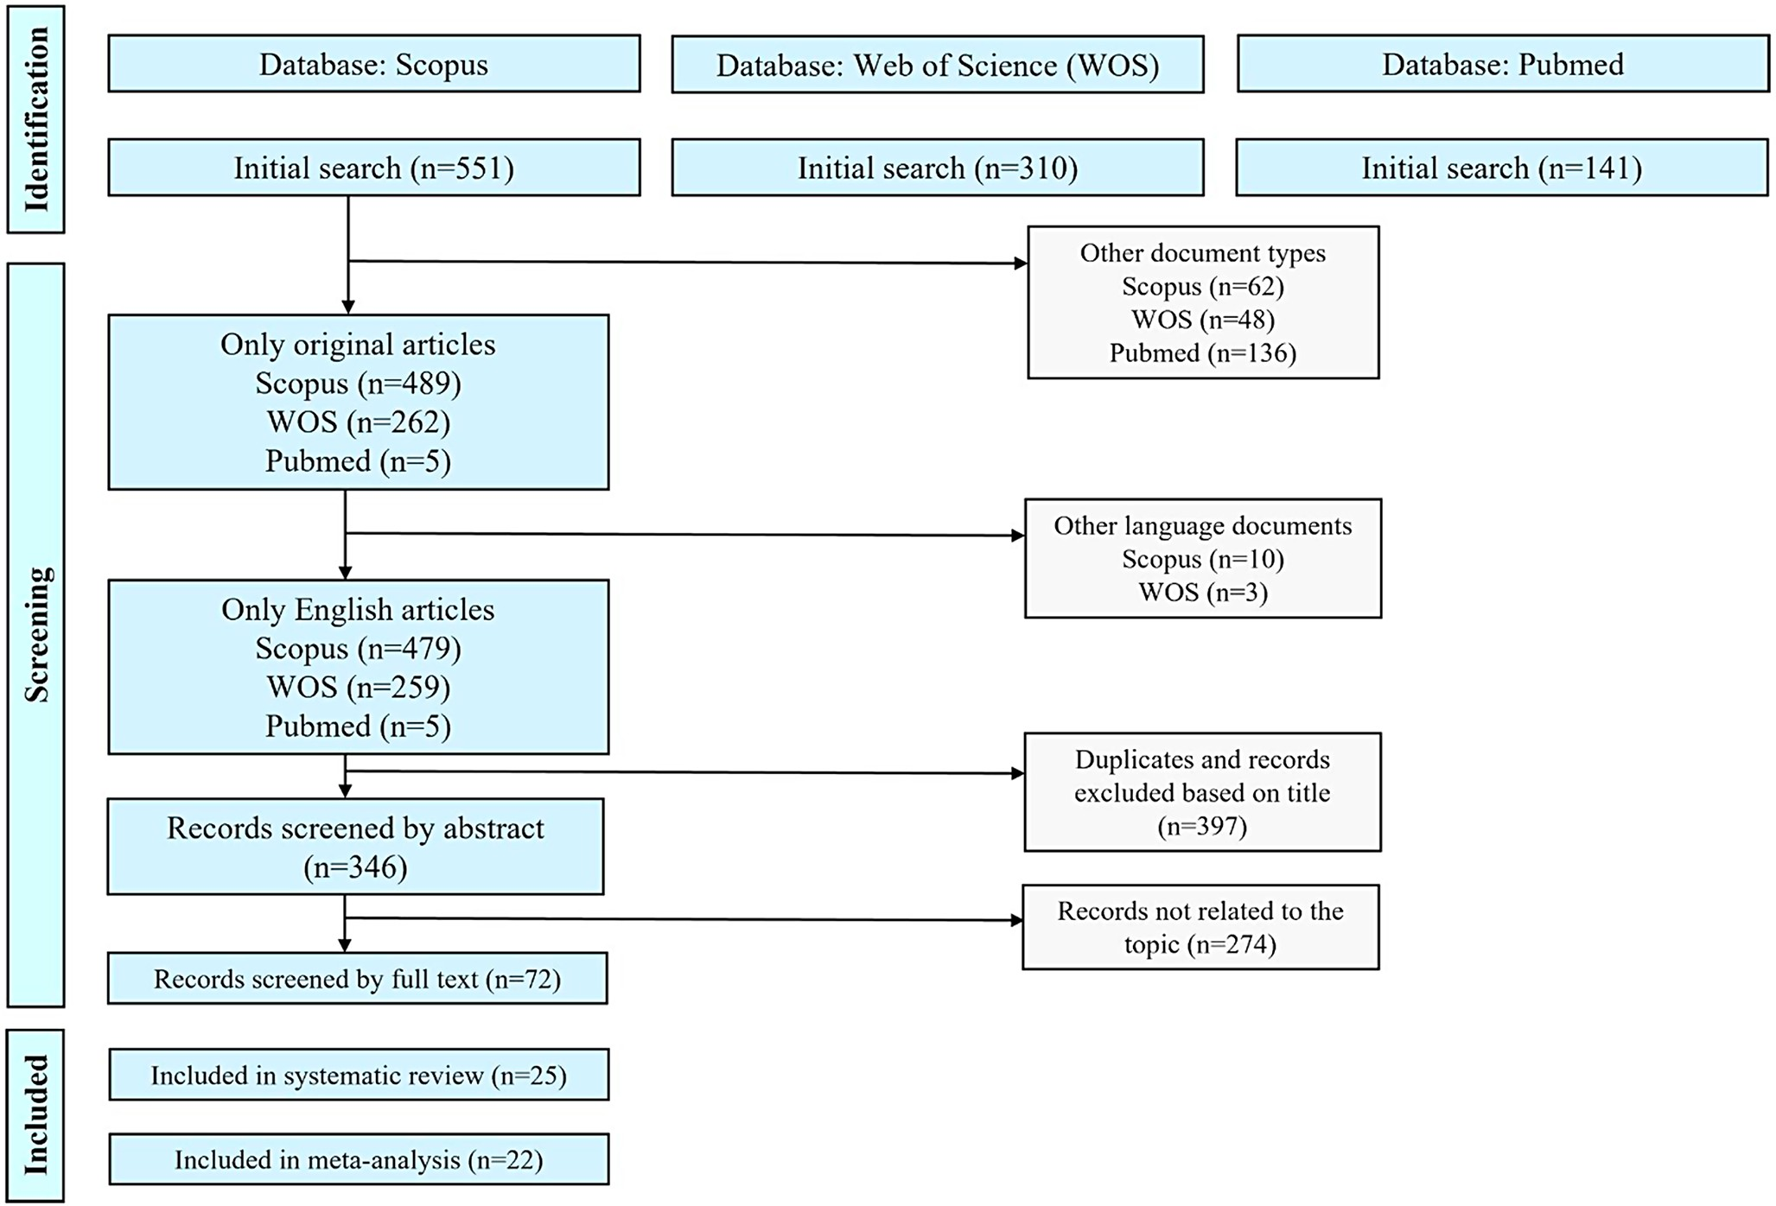

Fig. 1 PRISMA flow chart

Table 1 Characteristics of included studies

First Author, Year | Country | Setting and district | Study design | Intervention details | Target illness | Duration of intervention | Outcomes
Meehan, 2001 [20] | USA | 31 acute care hospitals in Connecticut | Before-and-after study | feedback of  performance data,  dissemination of an evidence-based pneumonia  critical pathway, and sharing of  pathway implementation experiences. | CAP | from June 1996 – to January 1997 | Blood culture collection within 24 hours, blood culture collection before antibiotics, oxygenation assessment within 24 hours, 30-day mortality, 30-day readmissions, LOS
Lawrence, 2002 [21] | USA | Barnes-Jewish Hospital in St. Louis, Missouri | Before-and-after study | team-based educational project (monthly in-service education and feedback on DDD and rates of preantibiotic expectorated sputum procurement) | CAP | December 1, 1996 – March 31, 1997 | Administration of antibiotics within 8 hours, DDD, LOS, LRT sample procurement, inpatient mortality, DDD less than 4 hours
Halm, 2004 [25] | USA | 4 academic health centers in New York City metropolitan area | Before-and-after study | implementation of evidence-based treatment guidelines, critical pathways, educational sessions for physicians, pocket reminder card distribution, standardized order promotion, and bilingual patient education materials by a multidisciplinary team of opinion leaders | CAP | April 30, 2000 – November 1, 2000 | Administration of antibiotics within 8 hours, blood culture collection before antibiotics, LOS, inpatient mortality, DDD less than 4 hours, blood culture procurement, days to clinical stability, ICU stay, switch to oral antibiotics, adherence to recommended antibiotic therapy
Schouten, 2006 [26] | Netherlands | 6 medium-to-large Dutch hospitals | C-RCT | multifaceted guideline-implementation strategy | CAP, COPD | March 1, 2003 – September 1, 2004 | DDD less than 4 hours, blood culture procurement, Legionella urinary antigen detection
Buising, 2008 [27] | Australia | Royal Melbourne Hospital | ITS | provision of electronic and paper guidelines, the training of senior clinicians, a pharmacist, and a nurse for academic detailing, the promotion of posters and laminated cards with CAP recommendations, and the integration of these guidelines into a web-based decision support system | CAP | April 2003 – September 2006 | DDD, adherence to recommended antibiotic therapy
Weiner, 2009 [22] | USA | 1 hospital, Boston, MA | Before-and-after study | weekly e-mail reminders indicating the percentage of patients with antibiotics timing less than 4 hours from arrival. | CAP | November 30, 2005 – February 1, 2006 | DDD, DDD less than 4 hours, arrival to X-ray order time, from X-ray order to antibiotic time, PSI score use
McIntosh, 2010 [23] | Australia | 37 hospitals, including public, private, rural and metropolitan institutions | Before-and-after study | educational interventions included academic detailing, group feedback presentations  and prescribing prompts | CAP | August 2004 – December 2004 | PSI score use, adherence to recommended antibiotic therapy
Avdic, 2012 [31] | USA | The John Hopkins Hospital, Baltimore, Maryland | Before-and-after study | education and prospective feedback to teams regarding antibiotic choice and duration | CAP | March 31, 2008, February 1, 2010 | 30-day readmissions, LOS, duration of antibiotic treatment
Julian-Jimenez 2013 [32] | Spain | Toledo University Hospital | Before-and-after study | implementation of CAP management guideline, training sessions | CAP | September 30, 2008 – October 4, 2008 | 30-day readmissions, LOS, DDD less than 4 hours, days to clinical stability,  adherence to recommended antibiotic therapy, Legionella urinary antigen detection, duration of antibiotic treatment, duration of intravenous antibiotics
Ostrowsky, 2013 [28] | USA | Montefiore Medical Center, Bronx, NY | Before-and-after study | an algorithm for ED providers identifying appropriate antibiotic selections, development of a  CAP kit consisting of appropriate antibiotics and dosing regimens bundled with the treatment algorithm, and preloading an automated  ED medication dispensing and management system | CAP | Q 2-3 2009 – Q1 2011 | adherence to recommended antibiotic therapy
Murray, 2013 [24] | Scotland | Ninewells Hospital, Dundee | Before-and-after study | an antibiotic duration based on the CURB65 score, automatic stop dates and pharmacist feedback to prescribers | CAP, COPD, BA, and other LRTIs | May 12, 2012 – June 2012 | duration of antibiotic treatment
Dean, 2015 [39] | USA | 7 Intermountain Healthcare hospitals, Utah | QES | application of real-time electronic clinical decision support | CAP, HAP | November 2010 – December 2011 | 30-day mortality, 30-day readmissions, LOS, DDD, inpatient mortality, administration antibiotics against atypical pathogens
Uranga, 2016 [29] | Spain | 4 teaching hospitals in the Basque Country | RCT | implementing recommendations for duration of antibiotic treatment based on clinical  stability criteria | CAP | January 1, 2012 – August 31, 2013 | 30-day mortality, 30-day readmissions, inpatient mortality, LOS, days to clinical stability, duration of antibiotic treatment, duration of intravenous antibiotics, clinical success rate
Levine, 2018 [42] | USA | Saint Francis Hospital and Medical Center, Hartford, Connecticut | Before-and-after study | use of PCT to discontinue antibiotics | AB, AP, CAP, HAP | March 2016 – December 2016 | LOS
Kulwicki, 2019 [36] | USA | Teaching hospital, Michigan | Before-and-after study | involvement of emergency medicine pharmacist in patient care | CAP, IAI | December 31, 2014 - January 1, 2016 | adherence to recommended antibiotic therapy
Yoon, 2019 [40] | New Zealand | Auckland City Hospital, Middlemore Hospital | Before-and-after study | mobile phone application with decision tree | CAP, UTI | 3 months | adherence to recommended antibiotic therapy
Bianchini, 2019 [35] | USA | Urban medical center, Detroit, Michigan | QES | pharmacy-driven pneumonia diagnostic stewardship bundle | CAP | November 2017 – March 2018 | LOS, duration of antibiotic treatment
O'Kelly, 2020 [41] | Ireland | Sligo University Hospital | Before-and-after study | mobile audience response system, promotion of the antimicrobial app, development of a  physical card with local guidelines, and incorporating CURB-65 into the unscheduled admission  proforma | CAP | September 2018 – May 2019 | LOS, DDD, LRTI sample procurement, inpatient mortality, blood culture procurement, adherence to recommended antibiotic therapy, Legionella urinary antigen detection, S. pneumonia urinary antigen detection, duration of antibiotic treatment, CURB-65 use, SIRS use
Fally, 2020 [33] | Netherlands | 4 regional hospitals in Denmark: Nordsjaellands Hospital, Gentofte Hospital, Silkeborg Regional Hospital and Hvidovre Hospital | QES | hands-on training for sample collection, educational sessions with feedback, streamlined diagnostic processes, and enhanced electronic health record tools. | CAP | 8 months | administration of ABT within 8 hours,  LRTI sample procurement, CURB-65 use,  X-ray order
van den Bergh, 2020 [43] | South Africa | 39 hospitals | Before-and-after study | a CAP bundle of seven process measures (diagnostic and AS) that pharmacists used to audit compliance and provide feedback. CAP bundle compliance rates and change in  outcome measures [mortality, length of stay (LOS) and infection-related (IR)-LOS] during pre- and post-implementation periods were compared. | CAP | 4 weeks | mortality, length of stay (LOS) and infection-related (IR)-LOS
Kyriazopoulou, 2021 [44] | Greece | 6 departments of Internal Medicine in Athens, 1 department in Piraeus | RCT | procalcitonin-guided discontinuation of antimicrobials | CAP, HAP, VAP | 6 months | Duration of antibiotic treatment
Ridgway, 2021 [37] | USA | 4 North Shore hospitals | RCT | inpatient antibiotic stewardship  tool called the weighted incidence syndromic combination  antibiogram (WISCA) | UTI,  ABI, NPC, CAP, AP, and NHAP | 3 years | LOS, 30-day mortality
Colmerauer, 2022 [30] | USA | 5 Hartford HealthCare hospitals | Before-and-after study | implementation of an updated CAP order-set with accompanying provider education | CAP | October 31 , 2019 – September 1, 2020 | 30-day readmissions, LOS, inpatient mortality, adherence to recommended antibiotic therapy, duration of antibiotic treatment
Hu, 2022 [34] | China | 3 county-level hospitals, Sanming | ITS | Sanming healthcare reform on the appropriate use of antibiotics in public hospitals | AURI, AB, CAP | 7 years | adherence to recommended antibiotic therapy
Iovino, 2023 [38] | Canada | Windsor Regional Hospital, Ontario | Before-and-after study | pharmacist-initiated modification of antimicrobial therapy | COPD, CAP | October 2020 – March 2021 | duration of antibiotic treatment

Abbreviations: USA, United States of America; C-RCT, cluster-randomized clinical trial; RCT, randomized clinical trial; ITS, interrupted time series; QES, quasi-experimental study; CAP, community-acquired pneumonia; COPD, chronic obstructive pulmonary disease; BA, bronchial asthma; LRTI, lower respiratory tract infection; HAP, hospital-acquired pneumonia; AB, acute bronchitis; AP, aspiration pneumonia; IAI, intraabdominal infection; UTI, urinary tract infection; VAP, ventilator-associated pneumonia; ABI, abdominal-biliary infection; NPC, nonpu- rulent cellulitis; NHAP, nursing home-associated pneumonia; AURI, acute upper respiratory infection; LOS, length of stay; DDD, door-to-drug delivery; LRT, lower respiratory tract; ICU, intensive care unit; PSI, pneumonia severity index; ABT, antibiotic treatment; SIRS, systemic inflammatory response syndrome

Outcomes of interest
Clinical outcomes
- Days to clinical stability were assessed by 3 authors [25, 29, 32] as measures of intervention impact on recovery speed.
- 30-Day mortality was frequently reported, serving as a benchmark for short-term survival post-intervention. 5 studies [20, 29, 37, 39, 40] reported this outcome, emphasizing its importance in assessing CAP treatment impacts.
- Hospital mortality, indicating death occurring during the hospital stay, was also a key outcome in 7 studies [21, 25, 27, 29, 30, 39, 41].
- Clinical success rate, indicating overall treatment effectiveness, was highlighted in one research [29].
Economical outcomes
- LOS was one of the most widely assessed outcomes, featured in 13 studies [20, 21, 25, 27, 30–32, 35, 37, 40–43]. These studies highlight LOS as a primary con- sideration in optimizing CAP care pathways and intervention strategies.
- 30-Day readmissions were highlighted in 7 studies [20, 29–32, 39, 42], indicating the frequency of recurrence or complications and underscoring the need for improved initial treatment adherence.
- ICU stay was reported in one study [25], reflecting the severity of cases and resources required when CAP management did not achieve desired early outcomes.
Diagnostic outcomes
- Blood culture collection before antibiotics was measured in 2 studies [20, 25] as a means of ensuring that diagnostic accuracy is not compromised by premature antibiotic use.
- Blood culture and lower respiratory tract (LRT) sample procurement were also significant measures, highlighting the role of diagnostic precision. Blood culture pro- curement was evaluated in 3 studies [25, 26, 41], meanwhile, three studies [21, 33, 41] focused on LRT sample collection.
- Urinary antigen testing for pathogens provides a rapid diagnostic tool that can guide targeted antibiotic therapy. This testing was reported by three authors and their teams [26, 32, 41], with three studies focusing on Legionella pneumophila and two on S. pneumoniae.
- Arrival to X-ray order time and from X-ray order to antibiotic time were evaluated in one study [22], X-ray order compliance was also reported in one study [33]. These outcomes underline the importance of radiological support in CAP management.
- Severity and prognosis assessment was carried out using various scales. PSI (Pneumonia Severity Index) score use was recorded in 2 studies [22, 23] as a guideline- supported measure for assessing CAP severity. CURB- 65 and SIRS score use was also examined, with CURB- 65 use reported by 2 authors [33, 41], and SIRS by one author [41].
Treatment and antibiotic therapy
- Administration of antibiotics within 8 h was a commonly studied outcome, reported in 4 studies [20, 21, 25, 33]. Timely antibiotic administration is critical to ensuring early pathogen control, especially in severe cases.
- Door-to-Drug Delivery (DDD), the time from patient arrival to antibiotic administration, was assessed in 4 studies [21, 22, 26, 27]. These studies highlight DDD as an operational metric in CAP management and an area for potential intervention improvements. Additionally, the outcome of DDD being less than 4 h was evaluated in 5 studies [21, 22, 25, 26, 32], further emphasizing the importance of timely antibiotic administration in improving patient outcomes.
- Adherence to recommended antibiotic therapy was reported across 11 studies [23, 25, 27, 28, 30, 32, 34, 36, 40, 41, 43]. This outcome underscores the emphasis on guideline-based therapy for optimal patient outcomes.
- Duration of antibiotic treatment was commonly recorded, with multiple studies tracking this outcome to assess optimal therapy length [24, 29–32, 35, 38, 41, 44].
- Duration of intravenous antibiotics was highlighted in 3 studies [29, 32, 41], where early transition to oral antibiotics, when feasible, is encouraged to reduce IV-related complications and hospital stays.
- Switch to oral antibiotics was another key focus in one study [25], underscoring the push for timely step-down therapy to expedite patient discharge.
- Administration of antibiotics against atypical pathogens was noted in one study [39], reflecting the need to address diverse microbial profiles in CAP cases.
Protocol adherence
- Compliance with diagnostic and treatment protocols was consistently emphasized, particularly in 3 studies [30, 32, 41], highlighting the role of adherence in achieving standardized, high-quality care.
Risk of bias assessment
The assessment of the risk of bias for the included studies is detailed in Supplementary Material (Figure S1-5). These figures provide visual representations of the risk of bias across studies, including domain-level evaluations and overall judgments.
Effects of the interventions
The impact of ASP interventions on clinical outcomes in patients with CAP was analyzed across several key measures.
The first outcome evaluated was the time to clinical stability, defined as the duration required for patients to achieve resolution of vital signs and symptoms, facilitating a transition to oral therapy or discharge. The pooled analysis of three studies (Fig. 2A) showed a standardized mean difference (SMD) of -0.16 (95% CI: -0.24 to -0.07), indicating a small but statistically significant reduction in the time to clinical stability among patients receiving ASP interventions compared to standard care. The heterogeneity across studies was negligible, highlighting the consistency of this finding.
The second outcome, 30-day mortality, was assessed using two statistical approaches. The standard method (Fig. 2B) excluded one study and yielded an odds ratio (OR) of 0.72 (95% CI: 0.55 to 0.92), demonstrating a significant reduction in mortality with ASP interventions. Using the method, which included all studies (Fig. 2C), the pooled OR was 0.69 (95% CI: 0.56 to 0.85), confirming a consistent and significant mortality benefit. Both methods revealed low heterogeneity, further supporting the robustness of these results.
The analysis of hospital mortality (Fig. 2D) showed an OR of 1.16 (95% CI: 0.80 to 1.67), with moderate heterogeneity. This outcome did not demonstrate a statistically significant difference between ASP interventions and standard care, suggesting that while ASPs can improve some clinical outcomes, their effect on hospital mortality remains unclear. For a more detailed analysis, the forest and funnel plots for these two outcomes are presented in the supplementary materials (Supplementary Figures S6-S11).
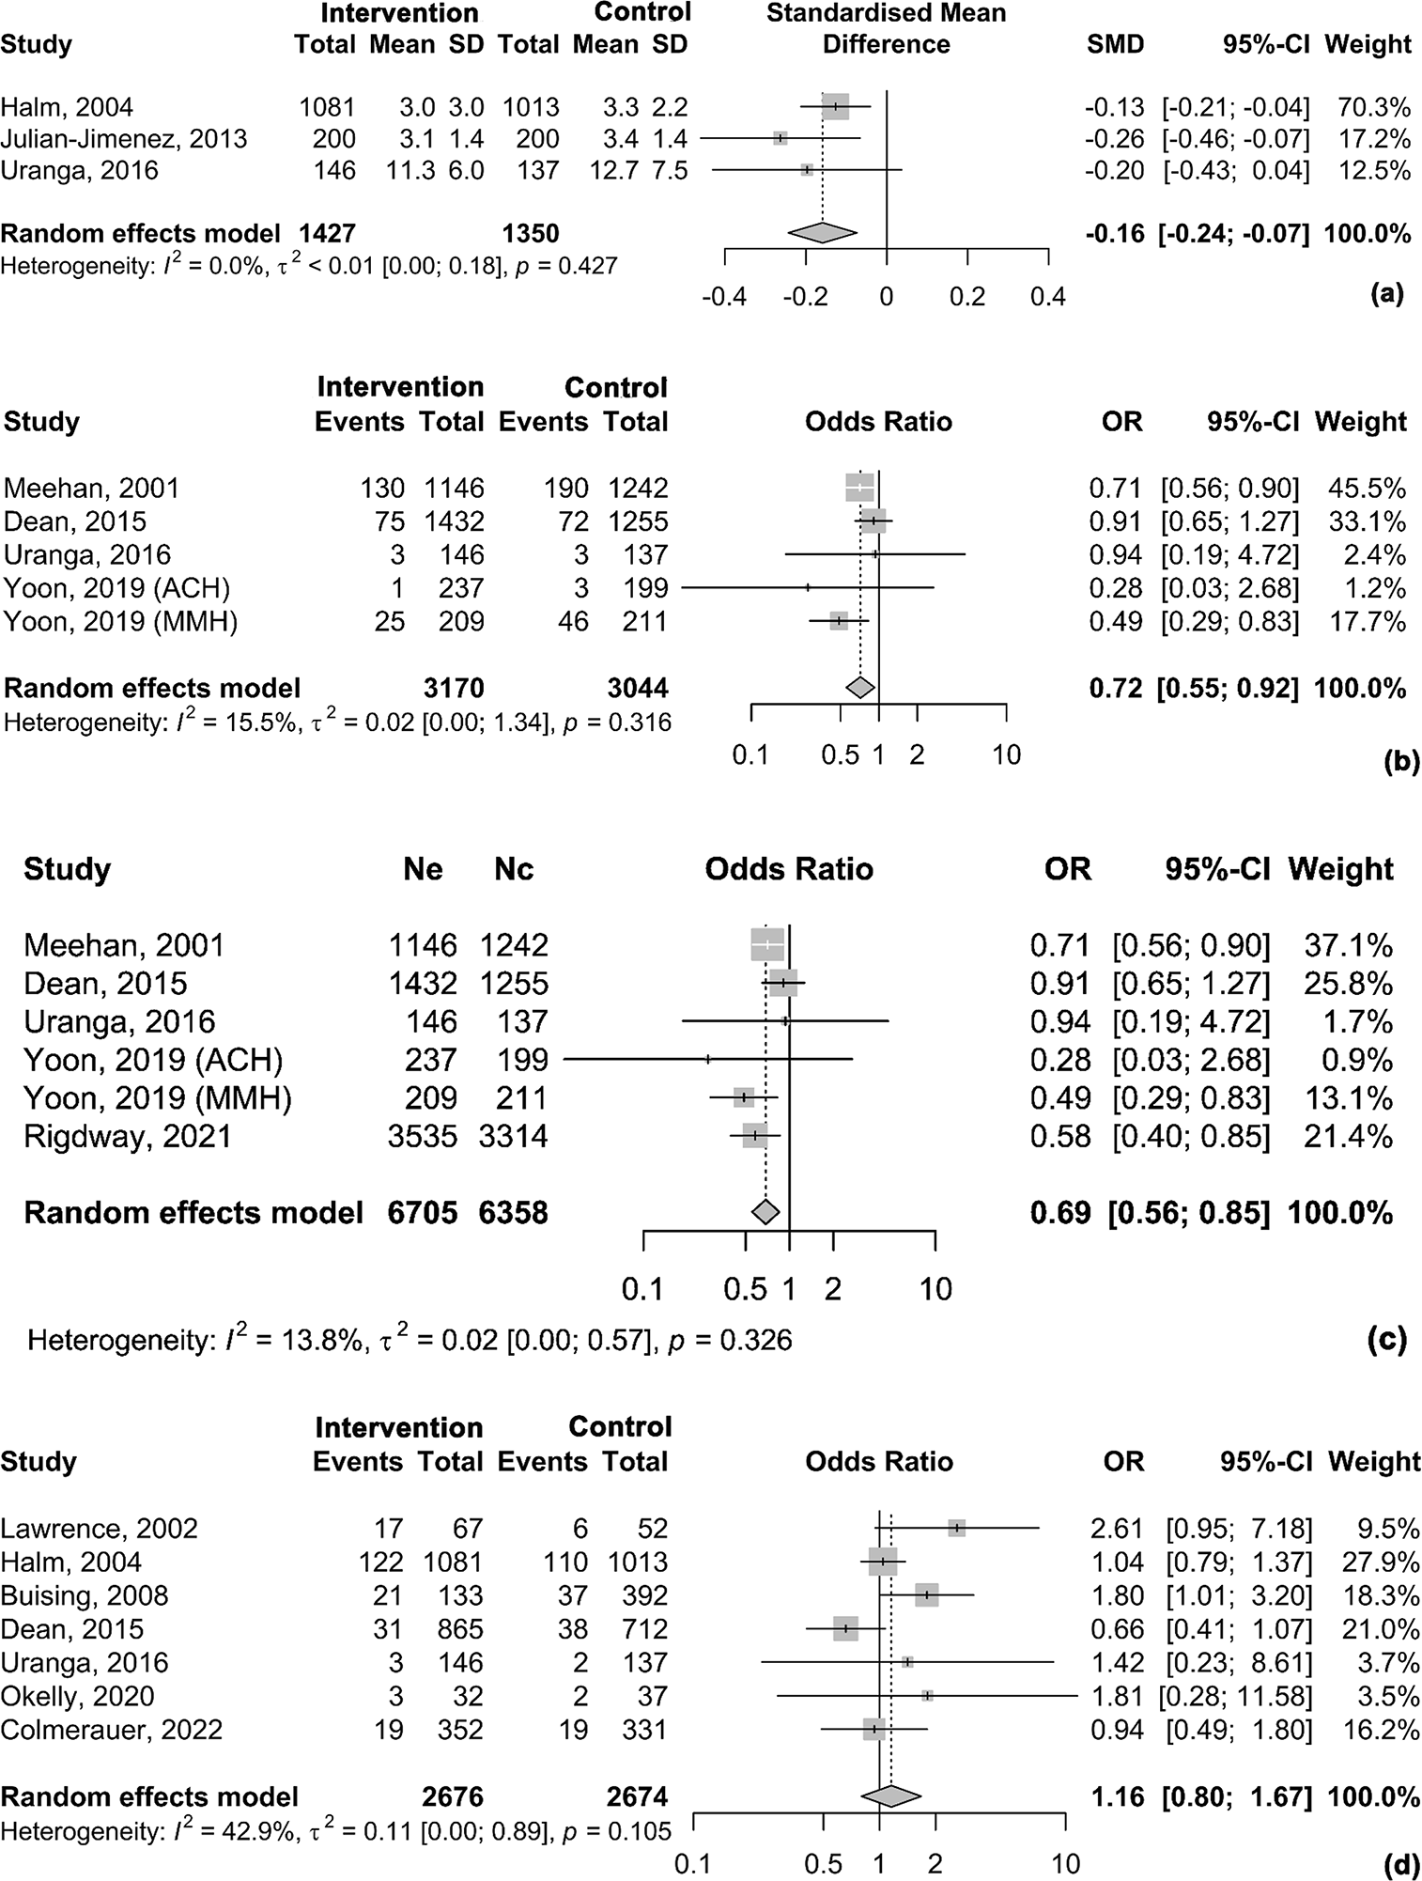

Fig. 2 Effect of ASP interventions on clinical outcomes. Abbreviations: ACH, Auckland City Hospital; MMH, Middlemore Hospital; SD, standard deviation; SMD, standardized mean difference; OR, odds ratio; CI, confidence interval. Notes: (a) Effect of ASP interventions on time to clinical stability; (b) Effect of ASP interventions on 30-day mortality using standard method; (c) Effect of ASP interventions on 30-day mortality using inverse variance method; (d) Effect of ASP interventions on hospital mortality [20, 21, 25, 27, 29, 30, 32, 37, 39–41]

The economic impact of ASPs on the management of CAP was assessed through key. The LOS was evaluated using two approaches. The standard method (Fig. 3A), which excluded one study, showed a pooled SMD of -0.15 (95% CI: -0.34 to 0.04) using a random-effects model. Although the estimate suggested a slight reduction in LOS with ASP interventions, the result was not statistically significant. High heterogeneity was observed in this analysis.
Similarly, the method, which included all studies (Fig. 3B), yielded a comparable pooled SMD of -0.14 (95% CI: -0.31 to 0.03), also indicating no statistically significant reduction in LOS. The heterogeneity remained high, suggesting variability among the included studies.
These findings indicate that while ASPs may influence clinical workflows, their impact on reducing the length of hospital stay is not conclusive and varies across different settings.
Our sensitivity analysis demonstrated that the pooled effect size (ES) remained small and consistent, even when individual studies were excluded. This is illustrated in the supplementary materials, where four figures are provided: the forest plot and funnel plot for the standard method, and the same plots for the inverse approach, based on the Der-Simonian-Laird method (Figures S12–S15). The ESs are clustered near zero, suggesting that the intervention being studied has a minimal or negligible impact on the outcome. The high heterogeneity across analyses indicates variability among the included studies, which may reflect differences in study populations or methodologies. Despite this variability, the results appear robust, as no single study disproportionately influenced the overall findings.
The overall OR for 30-day readmissions in patients exposed to ASP interventions was 0.62 (95% CI: 0.34 to 1.15), suggesting a 38% reduction in the odds of readmission. However, the confidence interval includes 1, indicating that this effect is not statistically significant.
Substantial heterogeneity was observed, with an I² value of 71.4% and a tau-squared (τ²) of 0.43, indicating variability in the effect across studies. The p-value of 0.002 suggests that the reduction in readmissions is unlikely to be due to chance. Sensitivity analysis using a leave-one-out approach did not significantly alter the overall findings. Forest and funnel plots of ES are shown in Figure S16-17.

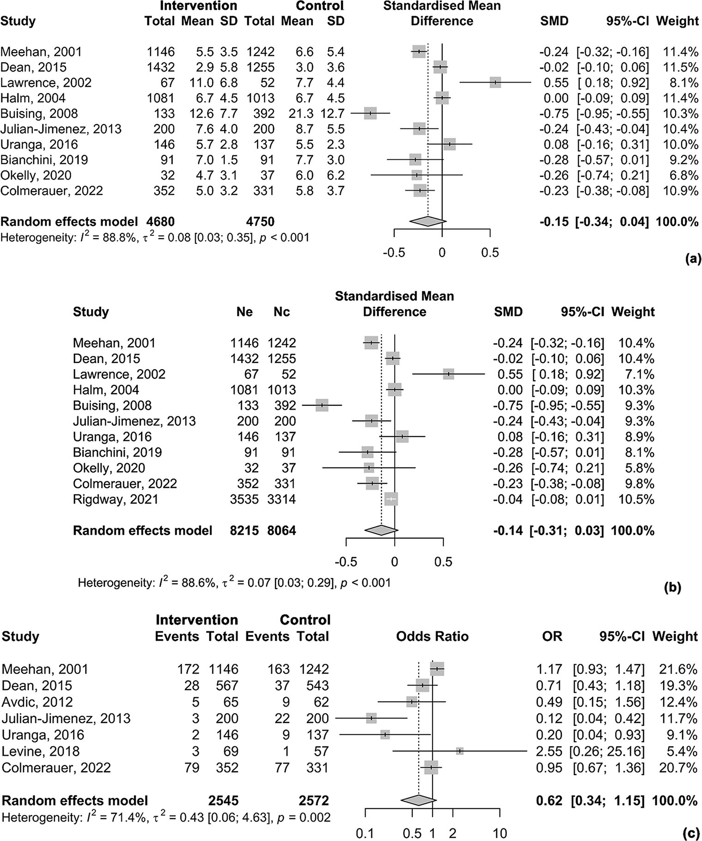

Fig. 3 Effect of ASP interventions on economical outcomes. Abbreviations: SD, standard deviation; SMD, standardized mean difference; OR, odds ratio; CI, confidence interval. Notes: (a) Effect of ASP interventions on duration of hospital stay using standard method; (b) Effect of ASP interventions on duration of hospital stay using inverse variance method; (c) Effect of ASP interventions on 30-day readmissions [20, 21, 25, 27, 29–32, 35, 37, 39, 41, 42]

The meta-analysis assessed the impact of ASP interventions on diagnostic outcomes, with Legionella urinary antigen testing being one of the measures evaluated. The combined OR for this outcome was 2.91 (95% CI: 1.56 to 5.42), suggesting a significant association between ASP interventions and improved diagnostic performance in Legionella testing (Fig. 4A).
Heterogeneity across the three studies included in the analysis was low, with an I² statistic of 19.3%, indicating moderate consistency in the ESs observed. The between-study variance was 0.11 (95% CI: 0.00 to 10.87), reflecting minimal variability across the studies. Given that only three studies were included, these results may be influenced by the limited sample size, which could explain the moderate heterogeneity observed.
For blood culture procurement, the combined OR was 1.09 (95% CI: 0.84 to 1.43), suggesting no significant association between ASP interventions and improved rates of blood culture procurement (Fig. 4B).
For LRT sample procurement, the combined OR was 1.48 (95% CI: 0.86 to 2.56), indicating a modest, but not statistically significant, improvement in sample procurement with ASP interventions (Fig. 4C).

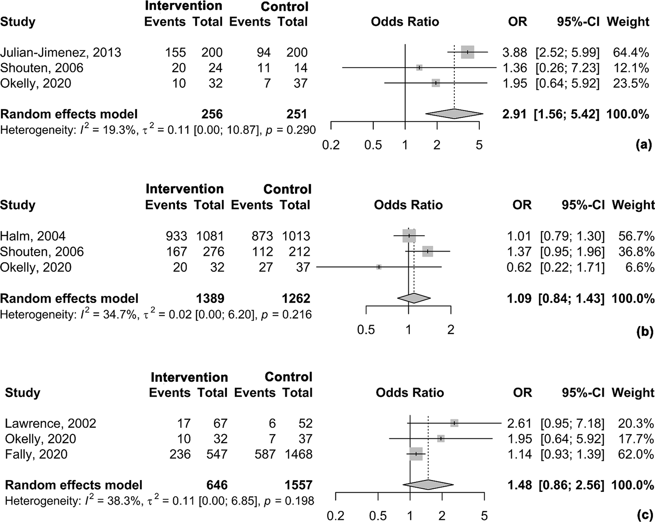

Fig. 4 Effect of ASP interventions on diagnostic outcomes. Abbreviations: OR, odds ratio; CI, confidence interval. Notes: (a) Effect of ASP interventions on the frequency of determination of Legionella antigenuria (b) Effect of ASP interventions on blood sampling frequency (c) Effect of ASP interventions on LRT sample collection frequency [21, 25, 26, 32, 33, 41]

The OR for the administration of antibiotics within 8 h was 1.32 (95% CI [1.02; 1.72]), indicating a positive effect of ASP interventions on timely antibiotic administration. The heterogeneity was moderate, with an I² of 74.2% (τ² = 0.05 [0.00; 1.83]), and the result was statistically significant (Fig. 5A).
The odds ratio (OR) for antibiotics administered within 4 h was 2.05 (95% CI [0.98; 4.29]), indicating a higher likelihood of timely antibiotic administration with ASP interventions (Fig. 5B). However, this result did not reach statistical significance, as the confidence interval includes 1 (the null value). The leave-one-out sensitivity analysis demonstrated that the overall results were robust, with no single study significantly altering the pooled ES or the direction of the results (Figure S18-19).
For the outcome of DDD time, the SMD was − 0.23 (95% CI [-0.41; -0.04]), indicating a modest but statistically significant reduction in DDD time following ASP interventions. The heterogeneity was moderate, with an I² of 51.2% (τ² = 0.01 [0.00; 1.89]), suggesting some variability among the included studies. However, the p-value for heterogeneity was not statistically significant, indicating that the observed differences could be due to random variation rather than true heterogeneity among studies (Fig. 5C).
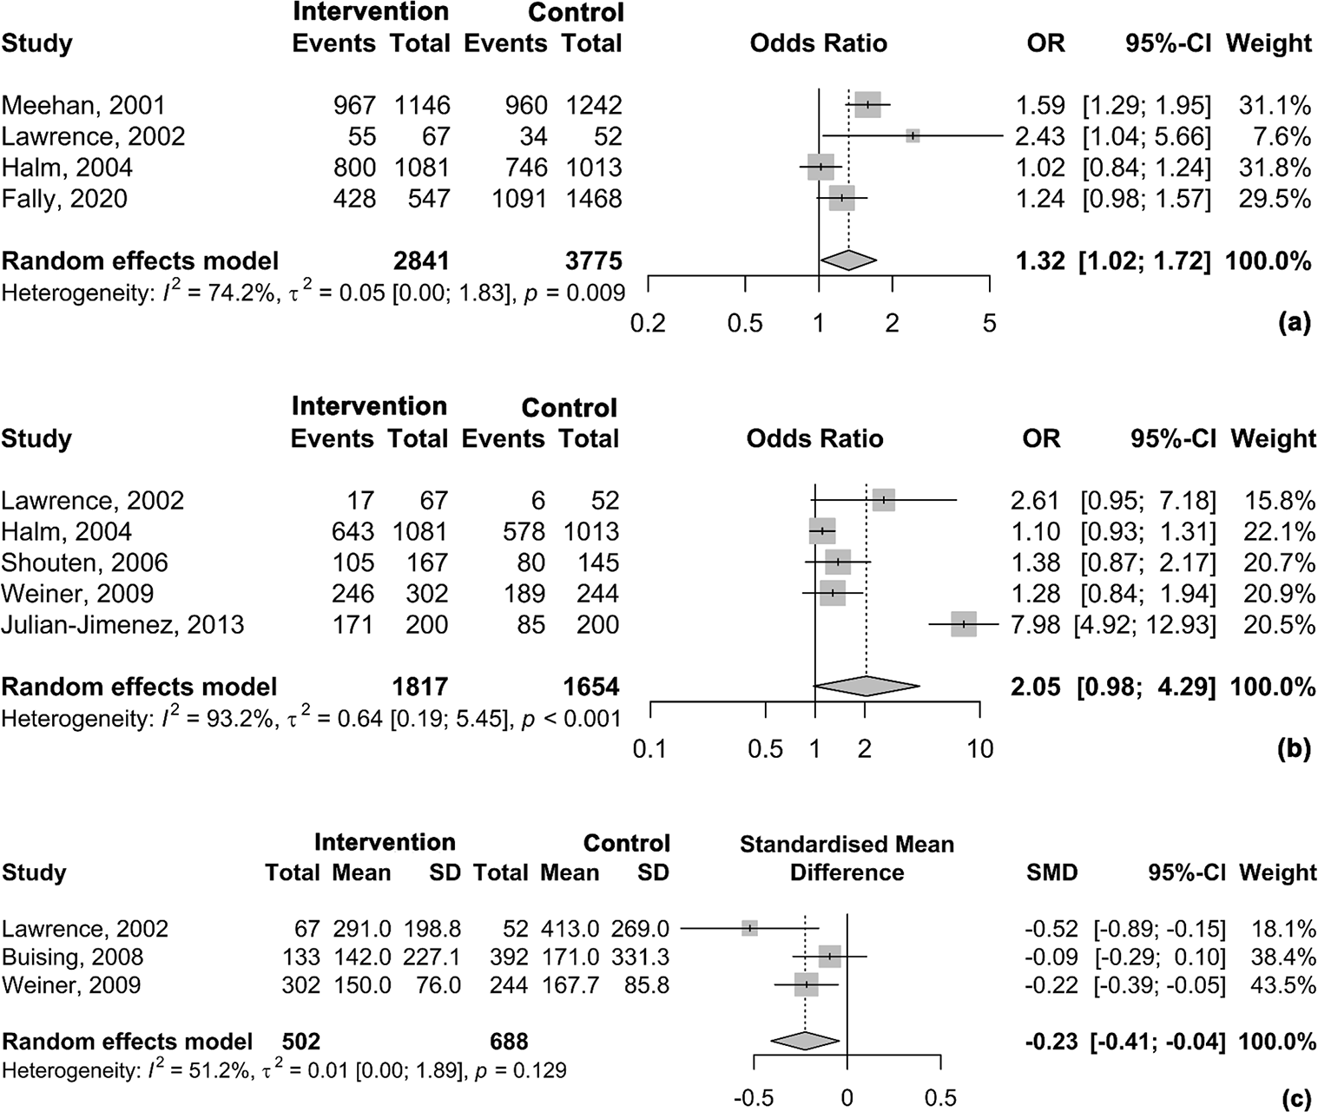

Fig. 5 Effect of ASP Interventions on timeliness of antibiotic administration. Abbreviations: SD, standard deviation; SMD, standardized mean difference; OR, odds ratio; CI, confidence interval. Notes: (a) Effect of ASP interventions on administration of antibiotics within 8 h after hospitalization (b) Effect of ASP interventions on administration of antibiotics within 4 h after hospitalization (c) Effect of ASP interventions on time of first antibiotic dose administration [20–22, 25–27, 32, 33]

For the duration of intravenous antibiotic administration, the mean and standard deviation were estimated from the reported median and interquartile range (IQR). The SMD was 0.05 (95% CI [-0.34; 0.44]), indicating no significant effect of ASP interventions on the duration of intravenous antibiotic therapy (Fig. 6A).
For the duration of antibiotic treatment, the SMD was − 1.05 (95% CI [-2.03; -0.06]), indicating a reduction in treatment duration following ASP interventions. However, the heterogeneity was extremely high, with an I² of 97.9% (τ² = 2.23 [1.00; 8.42]), and the p-value for heterogeneity was statistically significant (p < 0.001), suggesting considerable variability among the studies (Fig. 6B). The leave-one-out sensitivity analysis identified one study as a potential outlier [29]. Despite its exclusion, the pooled effect remained within the confidence interval (Figure S20-21), supporting the robustness of the results. The funnel plot analysis indicated some asymmetry, which was further supported by Egger’s test (p = 0.07), suggesting potential publication bias in the included studies.
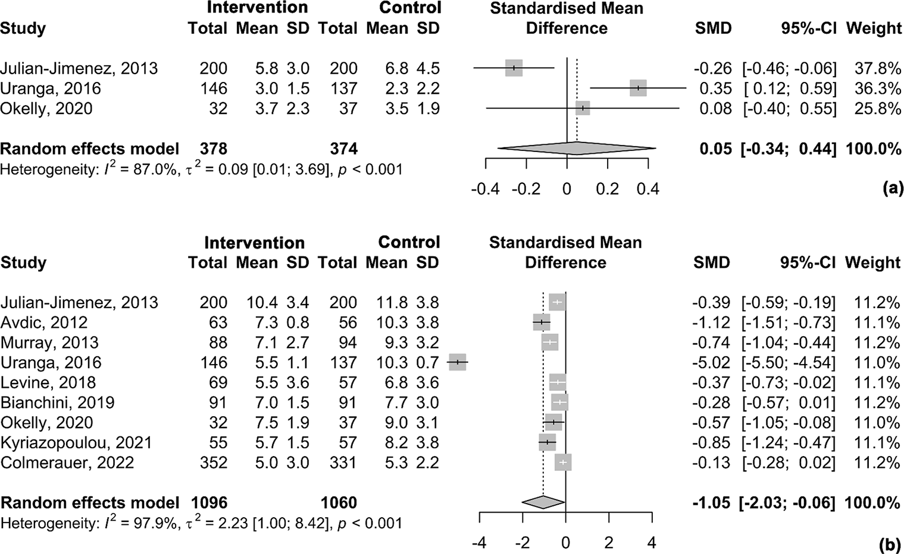

Fig. 6 Effect of ASP Interventions on antibiotic treatment duration. Abbreviations: SD, standard deviation; SMD, standardized mean difference; CI, confidence interval. Notes: (a) Effect of ASP interventions on duration of intravenous antibiotic administration (b) Effect of ASP interventions on duration of antibiotic treatment [24, 29–32, 35, 41, 42, 44]

The effect of the ASP interventions on adherence to recommended antibiotic treatment was assessed using a standard methodology. The meta-analysis revealed a pooled OR of 3.01 (95% CI: 1.56–5.81), indicating that the intervention significantly increased adherence compared to the control group (Fig. 7). But a high degree of heterogeneity was observed among the studies, with I² = 97.1%, suggesting substantial variability in the results. The between-study variance was estimated at τ² = 0.94 (95% CI: 0.39–3.63). The p-value for heterogeneity was < 0.001, indicating that the variation between studies was statistically significant (Figure S22-23).

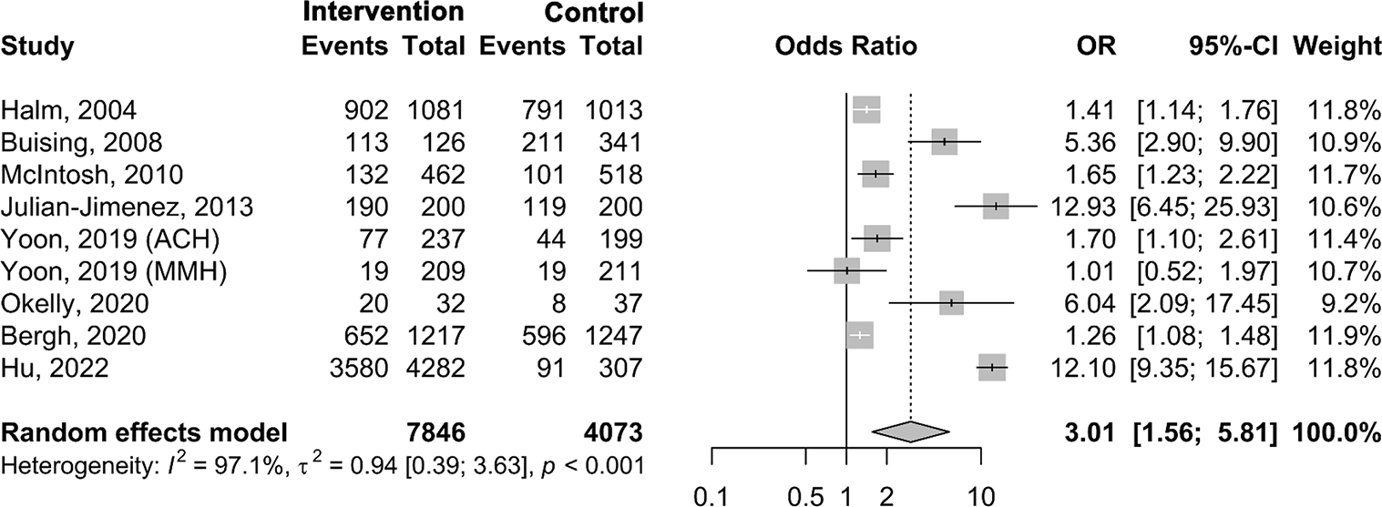

Fig. 7 Effect of ASP Interventions on adherence to recommended antibiotic treatment. Abbreviations: OR, odds ratio; CI, confidence interval [23, 25, 27, 32, 34, 40, 41, 43]

Discussion
This systematic review and meta-analysis evaluated the influence of key interventions in the management of CAP and their impact on clinical and process-related outcomes in hospital settings. The findings provide important insights into current practices and highlight areas for improvement to optimize patient care.
The effectiveness of ASPs was evaluated based on their impact on diagnostic accuracy, clinical outcomes, and economic efficiency. However, due to the significant variability of ASP interventions, establishing specific targets and performance criteria requires synthesizing data from diverse settings across different diseases and conditions, making this topic particularly suitable and interesting for a meta-analysis study.
In 2021, the WHO released practical guidelines on interventions for the rational use of antimicrobial agents, highlighting ten key strategies. These interventions are divided into pre-prescription or during-prescription actions and post-prescription actions. Pre-prescription strategies include educating clinicians to increase knowledge about appropriate antibiotic use, educating patients and the public about the risks and importance of proper antibiotic use, developing institution-specific guidelines for managing common infections, using cumulative antibiograms to guide antibiotic selection, requiring pre-authorization for restricted antimicrobial use, correcting erroneous antibiotic allergy labels, and optimizing antibiotic dosing based on patient characteristics. Post-prescription actions involve conducting prospective audits with feedback to improve antibiotic use, encouraging antibiotic time-outs for clinicians to reassess the need for continued therapy, and ensuring the appropriate duration of antibiotic therapy to avoid unnecessary prolonged use [45]. Despite earlier studies included in our review, most of these key interventions were implemented in a comprehensive manner.
We found that the outcomes where no significant effect from interventions was observed include in hospital mortality, LOS, 30-day readmissions, blood and respiratory sample collection frequencies, and the duration of intravenous antibiotic therapy.
However, significant positive effects were observed for specific outcomes. The time to clinical stability was shorter in the intervention group, showing improved recovery rates. There was a 31% reduction in the risk of 30-day mortality, and the frequency of orders for Legionella urinary antigen testing increased nearly threefold. Point-of-care tests (POC), such as rapid urinary antigen tests, are crucial in the management of severe CAP. In 2019, a large, monocenter observational study showed that S. pneumoniae, Staphylococcus aureus, viruses, and Legionella spp. are among the most frequent causative pathogens of severe CAP [46]. In the studies included in this systematic review, rapid urinary tests for two of these main pathogens were reported, emphasizing the role of POC in improving diagnosis and treatment of severe pneumonia.
Additionally, the time from admission to antibiotic initiation was reduced, reflecting earlier treatment in the intervention group. Outcomes such as antibiotic administration within 8 h, within 4 h, duration of antibiotic therapy, and adherence to recommended regimens also showed effects but were characterized by high heterogeneity across studies. The timely initiation of antibiotics is a critical component of managing infections, particularly in settings where sepsis or septic shock is a concern. Measuring the time from admission to antibiotic administration allows healthcare providers to assess the adequacy of their response to bacterial infections and is often used as a performance metric for quality care. However, the optimal timing of antibiotic therapy can vary depending on the severity of the infection. Recent meta- analysis suggests that while early broad-spectrum antibiotic therapy (within 1–3 h) is essential in patients with severe sepsis or septic shock, this urgency is not always necessary for patients with mild to moderate infections [47]. In fact, for these patients, delays of up to 4-8 h in the emergency department have not consistently been linked to worse clinical outcomes [47]. This indicates that a more nuanced approach, which involves waiting for diagnostic results and conducting a thorough clinical reassessment, may offer several advantages. Not only can this approach help optimize the diagnosis, but it can also facilitate the use of more targeted antibiotic therapy. Such a strategy may improve patient outcomes while reducing unnecessary antibiotic use, which is crucial in combating antibiotic resistance.
While our meta-analysis focused on outcomes reported in 3 or more studies, several important clinical variables, including ICU stay, clinical success rate, blood culture collection before antibiotics, time from X-ray order to antibiotics administration, timely switch from intravenous to oral antibiotics, prescription of antibiotics covering atypical pathogens and the use of risk stratification tools like PSI, CURB-65, and SIRS, were not included into meta-analysis due to insufficient data. However, these outcomes remain crucial in evaluating the effectiveness of ASP interventions. The duration of ICU stay is a key indicator of CAP severity and effective treatment, with shorter stays suggesting better management [48]. Halm et al. reported that the average ICU stay decreased from 14.3 days preintervention to 11.7 days postintervention, although this difference was not statistically significant [25]. However, since this result is based on only one study, it is insufficient to draw definitive conclusions or evaluate the overall impact of ASPs on ICU stay. Clinical success, defined by clinical cure or improvement, is crucial for assessing the benefits of ASPs, especially in cases with multidrug-resistant pathogens [49]. In one study, the clinical success rate at day 10 increased from 50.4% in the control group to 59.7% in the intervention group, and at day 30, it was 92.7% in the control group and 94.4% in the intervention group (p = 0.54), though neither difference was statistically significant. Blood culture collection before antibiotic administration is crucial for guiding targeted therapy. In one study, the rate of blood culture collection before antibiotics increased from 78.2% preintervention to 80.6% postintervention, though the difference was not statistically significant (p = 0.18) [25]. Another study showed a significant increase in the rate from 62.5% at baseline to 69.3% at follow-up (p < 0.01), although the difference was not statistically significant (p = 0.09) [20]. There was no statistically significant difference in the time from X-ray order to antibiotic administration, in the rate of X-ray orders within 8 h, or in the switch to oral antibiotics. However, these outcomes remain important today in cases of appropriate diagnosis and treatment. Dean et al. observed that more dual antibiotics with atypical pathogen activity were administered post-deployment in the intervention group, increasing from 90 to 94% [39]. This is important as atypical pathogens are often implicated in etiology of CAP, and appropriately targeting them with dual antibiotics can improve treatment outcomes and help prevent the development of antimicrobial resistance [39].
In four studies, the use of scales to assess patients was considered an indicator of the quality of the interventions performed [22, 23, 33, 41]. The American Thoracic Society recommends that clinicians, in addition to clinical judgment, should use a validated clinical prediction rule for prognosis, with preference for the PSI over CURB-65 to determine the need for hospitalization in adults diagnosed with CAP [50]. Both PSI and CURB-65 were developed to predict 30-day mortality in immunocompetent pneumonia patients, with PSI demonstrating higher discriminative power and identifying more low-risk patients compared to CURB-65 [51, 52]. All quality indicators for CAP care mentioned in this review, including those selected as outcomes by a small number of authors like this one, are essential and are included in most international protocols and clinical guidelines [16, 53, 54].
To our knowledge, this is the first review evaluating the efficacy of ASPs and interventions for CAP management. Our findings provide an evidence base for future studies in this domain. Nevertheless, there are limitations. Firstly, unpublished studies were not included in our search and analysis. Secondly, the limited number of articles reviewed restricts our ability to determine which specific ASP interventions are most effective, because interventions were often implemented as bundled measures, we could not isolate the effect of individual strategies, such as rapid diagnostic testing combined with educational components in one program. Future studies should address this gap. Thirdly, the included studies exhibited significant heterogeneity in terms of study design, intervention components, and outcome measures, which limits the comparability of findings and the ability to draw definitive conclusions. Finally, as outcomes were primarily reported at the facility level rather than at the individual level, the results may have been influenced by factors such as staff turnover or inclusion of healthcare providers not exposed to the interventions. Future studies should aim to evaluate changes in individual prescribing behaviors rather than overall facility-level prescribing trends.

Conclusion
This systematic review and meta-analysis provide a comprehensive evaluation of the impact of key interventions in the management of CAP, particularly ASPs. While no significant effects were observed for hospital mortality, LOS, or 30-day readmissions, several positive outcomes highlight the benefits of ASPs in clinical practice. Notably, interventions led to a shorter time to clinical stability, a 31% reduction in 30-day mortality risk, increased use of rapid diagnostic tests, and a reduction in the time from admission to antibiotic initiation.
Despite the observed benefits, the high heterogeneity among ASP interventions and study designs limits the ability to identify the most effective strategies. The inclusion of bundled interventions also prevents the isolation of individual intervention effects. Furthermore, several clinically relevant outcomes, such as ICU stay, clinical success rate, and appropriate antibiotic de-escalation, lacked sufficient data for meta-analysis, underscoring the need for further research.
Moving forward, future studies should aim to standardize ASP interventions, assess their impact on individual prescribing behaviors, and explore the role of rapid diagnostic testing and targeted educational programs in optimizing CAP treatment. Addressing these gaps will help refine antimicrobial stewardship efforts and improve patient outcomes while mitigating the risk of antibiotic resistance.
Supplementary Information The online version contains supplementary material available at https://doi.org/10.1007/s10096-0 25-05122-8.
Acknowledgements The authors declare that no external support, funding, or assistance was received for the conduct of this study.
Author contributions All authors contributed to the study conception and design. Conceptualization and supervision were provided by S.R. and G.S. Material preparation was conducted by A.M., S.S., S.K., and D.K. Data collection and analysis were performed by S.R., N.A., H.R.S., A.Z., and B.T. Statistical analysis was conducted by A.V., S.R., and N.A. The first draft of the manuscript was written by N.A., and all authors commented on previous versions of the manuscript. All authors read and approved the final manuscript.
Funding This research received no external funding.
Competing Interests: The authors declare no conflicts of interest.
Data availability No datasets were generated or analysed during the current study.
Declarations
Ethical approval Not applicable.
Competing interests The authors declare no competing interests
References
- Hespanhol V, Barbara C (2020) Pneumonia mortality, comorbidities matter? Pulmonology 26(3):123–129 Epub 20191129. https://doi.org/10.1016/j.pulmoe.2019.10.003
- GBD 2017 Disease and Injury Incidence and Prevalence Collaborators (2018) Global, regional, and national incidence, prevalence, and years lived with disability for 354 diseases and injuries for 195 countries and territories, 1990-2017: a systematic analysis for the Global Burden of Disease Study 2017. Lancet 392(10159):1789–1858. https://doi.org/10.1016/S0140-6736(18)32279-7. Epub 20181108.
- Kyaw BM, Tudor Car L, van Galen LS, van Agtmael MA, Costelloe CE, Ajuebor O et al (2019) Health professions digital education on antibiotic management: systematic review and Meta-Analysis by the digital health education collaboration. J Med Internet Res 21(9):e14984 Epub 20190912. https://doi.or g/10.2196/14984. PubMed PMID: 31516125; PubMed Central PMCID: PMC6746065
- Mohd Sazlly Lim S, Zainal Abidin A, Liew SM, Roberts JA, Sime FB (2019) The global prevalence of multidrug-resistance among Acinetobacter baumannii causing hospital-acquired and ventilator-associated pneumonia and its associated mortality: A systematic review and meta-analysis. J Infect 79(6):593–600 Epub 20190930. https://doi.org/10.1016/j.jinf.2019.09.012
- Cilloniz C, Dominedo C, Torres A (2019) Multidrug resistant Gram-Negative bacteria in Community-Acquired pneumonia. Crit Care 23(1):79 Epub 20190309. https://doi.org/10.1186/s13054-019-2371-3
- Ablakimova N, Smagulova GA, Rachina S, Mussina AZ, Zare A, Mussin NM et al (2023) Bibliometric Analysis of Global Research Output on Antimicrobial Resistance among Pneumonia Pathogens (2013–2023). Antibiotics (Basel). 12(9). Epub 20230906. https://doi.org/10.3390/antibiotics12091411. PubMed PMID: 37760709; PubMed Central PMCID: PMC10525339
- Divino V, Schranz J, Early M, Shah H, Jiang M, DeKoven M (2020) The annual economic burden among patients hospitalized for community-acquired pneumonia (CAP): a retrospective US cohort study. Curr Med Res Opin 36(1):151–160 Epub 20191017. https://doi.org/10.1080/03007995.2019.1675149
- Dyar OJ, Huttner B, Schouten J, Pulcini C, Esgap (2017) What is antimicrobial stewardship? Clin Microbiol Infect 23(11):793–798 Epub 20170904. https://doi.org/10.1016/j.cmi.2017.08
- Nathwani D, Varghese D, Stephens J, Ansari W, Martin S, Charbonneau C (2019) Value of hospital antimicrobial stewardship programs [ASPs]: a systematic review. Antimicrob Resist Infect Control 8:35 Epub 20190212. https://doi.org/10.1186/s13756-019-0471-0
- Yao L, Yin J, Huo R, Yang D, Shen L, Wen S et al (2020) The effects of the primary health care providers’ prescription behavior interventions to improve the rational use of antibiotics: a systematic review. Glob Health Res Policy 5(1):45 Epub 20201017. http s://doi.org/10.1186/s41256-020-00171-2
- Finch RG, Metlay JP, Davey PG, Baker LJ (2004) International forum on antibiotic resistance C. Educational interventions to improve antibiotic use in the C.mmunity: report from the international forum on antibiotic resistance (IFAR) C.lloquium, 2002. Lancet Infect Dis 4(1):44–53. https://doi.org/10.1016/s1473-309 9(03)00860-0PubMed PMID: 14720568
- Roque F, Herdeiro MT, Soares S, Teixeira Rodrigues A, Breitenfeld L, Figueiras A (2014) Educational interventions to improve prescription and dispensing of antibiotics: a systematic review. BMC Public Health 14:1276 Epub 20141215. https://doi.org/10.1 186/1471-2458-14-1276
- Page MJ, McKenzie JE, Bossuyt PM, Boutron I, Hoffmann TC, Mulrow CD et al (2021) The PRISMA 2020 statement: an updated guideline for reporting systematic reviews. BMJ 372 Epub 20210329. https://doi.org/10.1136/bmj.n71
- Schiavo JH (2019) PROSPERO: an international register of systematic review protocols. Med Ref Serv Q 38(2):171– 180.1588072. PubMed PMID: 31173570
- Eriksen MB, Frandsen TF (2018) The impact of patient, intervention, comparison, outcome (PICO) as a search strategy tool on literature search quality: a systematic review. J Med Libr Association: JMLA 106(4):420
- Garritty C, Hamel C, Trivella M, Gartlehner G, Nussbaumer- Streit B, Devane D et al (2024) Updated recommendations for the Cochrane rapid review methods guidance for rapid reviews of effectiveness. BMJ 384:e076335 Epub 20240206. https://doi.org/ 10.1136/bmj-2023-076335
- Balduzzi S, Rucker G, Schwarzer G (2019) How to perform a meta-analysis with R: a practical tutorial. Evid Based Ment Health 22(4):153–160 Epub 20190928. https://doi.org/10.1136/e bmental-2019-300117
- Wan X, Wang W, Liu J, Tong T (2014) Estimating the sample mean and standard deviation from the sample size, median, range and/or interquartile range. BMC Med Res Methodol 14:1–13
- Schwarzer G (2007) Meta: an R package for meta-analysis. R News 7(3):40–45
- Meehan TP, Weingarten SR, Holmboe ES, Mathur D, Wang Y, Petrillo MK et al (2001) A statewide initiative to improve the care of hospitalized pneumonia patients: the Connecticut pneumonia pathway project. Am J Med 111(3):203–210. https://doi.org/10.1 016/s0002-9343(01)00803-8 PubMed PMID: 11530031
- Lawrence SJ, Shadel BN, Leet TL, Hall JB, Mundy LM (2002) An intervention to improve antibiotic delivery and sputum procurement in patients hospitalized with community-acquired pneumonia. Chest 122(3):913–919. https://doi.org/10.1378/ches t.122.3.913PubMed PMID: 12226032
- Weiner SG, Brown SF, Goetz JD, Webber CA (2009) Weekly E-mail reminders influence emergency physician behavior: a case study using the Joint Commission and Centers for Medicare and Medicaid Services Pneumonia Guidelines. Acad Emerg Med. 16(7):626– 31. Epub 20090615. https://doi.org/10.1111/j.1553-2712.2009.00442.x. PubMed PMID: 19538501
- McIntosh KA, Maxwell DJ, Pulver LK, Horn F, Robertson MB, Kaye KI et al (2011) A quality improvement initiative to improve adherence to National guidelines for empiric management of community-acquired pneumonia in emergency departments. Int J Qual Health Care 23(2):142–150 Epub 20101203. https://doi.org/10.1093/intqhc/mzq077
- Murray C, Shaw A, Lloyd M, Smith RP, Fardon TC, Schembri S et al (2014) A multidisciplinary intervention to reduce antibiotic duration in lower respiratory tract infections. J Antimicrob Chemother 69(2):515–518 Epub 20130910. https://doi.org/10.1093/j ac/dkt362
- Halm EA, Horowitz C, Silver A, Fein A, Dlugacz YD, Hirsch B et al (2004) Limited impact of a multicenter intervention to improve the quality and efficiency of pneumonia care. Chest 126(1):100–107. https://doi.org/10.1378/chest.126.1.100 PubMed PMID: 15249449; PubMed Central PMCID: PMC4301308
- Schouten JA, Hulscher ME, Trap-Liefers J, Akkermans RP, Kull- berg BJ, Grol RP et al (2007) Tailored interventions to improve antibiotic use for lower respiratory tract infections in hospitals: a cluster-randomized, controlled trial. Clin Infect Dis 44(7):931–941 Epub 20070220. https://doi.org/10.1086/512193. PubMed PMID: 17342644
- Buising KL, Thursky KA, Black JF, MacGregor L, Street AC, Kennedy MP et al (2008) Improving antibiotic prescribing for adults with community acquired pneumonia: does a computerised decision support system achieve more than academic detailing alone?>--A time series analysis. BMC Med Inf Decis Mak 8:35 Epub 20080731. https://doi.org/10.1186/1472-6947-8-35
- Ostrowsky B, Sharma S, DeFino M, Guo Y, Shah P, McAllen S et al (2013) Antimicrobial stewardship and automated pharmacy technology improve antibiotic appropriateness for community-acquired pneumonia. Infect Control Hosp Epidemiol 34(6):566–572 Epub 20130422. https://doi.org/10.1086/670623. PubMed PMID: 23651886
- Uranga A, Espana PP, Bilbao A, Quintana JM, Arriaga I, Intxausti M et al (2016) Duration of antibiotic treatment in Community-Acquired pneumonia: A multicenter randomized clinical trial. JAMA Intern Med 176(9):1257–1265. https://doi.org/10.1001/ja mainternmed.2016.3633PubMed PMID: 27455166
- Colmerauer JL, Linder KE, Dempsey CJ, Kuti JL, Nicolau DP, Bilinskaya A (2022) Impact of Order-Set modifications and provider education following guideline updates on Broad-Spectrum antibiotic use in patients admitted with community acquired pneumonia. Hosp Pharm 57(4):496–503 Epub 20211108. https://doi.org/10.1177/00185787211055797. PubMed PMID: 35898261; PubMed Central PMCID: PMC9310309
- Avdic E, Cushinotto LA, Hughes AH, Hansen AR, Efird LE, Bartlett JG et al (2012) Impact of an antimicrobial stewardship intervention on shortening the duration of therapy for community-acquired pneumonia. Clin Infect Dis 54(11):1581–1587 Epub 20120410. https://doi.org/10.1093/cid/cis242
- Julian-Jimenez A, Palomo de los Reyes MJ, Parejo Miguez R, Lain-Teres N, Cuena-Boy R, Lozano-Ancin A (2013) Improved management of community-acquired pneumonia in the emergency department. Arch Bronconeumol 49(6):230–240 Epub 20130309. https://doi.org/10.1016/j.arbres.2012.12.008
- Fally M, von Plessen C, Anhoj J, Benfield T, Tarp B, Clausen LN et al (2020) Improved treatment of community-acquired pneumonia through tailored interventions: results from a controlled, multicentre quality improvement project. PLoS ONE 15(6):e0234308 Epub 20200611. https://doi.org/10.1371/journal.pone.0234308
- Hu L, Fu M, Wushouer H, Ni B, Li H, Guan X et al (2022) The impact of Sanming healthcare reform on antibiotic appropriate use in County hospitals in China. Front Public Health 10:936719 Epub 20220627. https://doi.org/10.3389/fpubh.2022.936719
- Bianchini ML, Mercuro NJ, Kenney RM, Peters MA, Samuel LP, Swiderek J et al (2019) Improving care for critically ill patients with community-acquired pneumonia. Am J Health Syst Pharm 76(12):861–868. https://doi.org/10.1093/ajhp/zxz068 PubMed PMID: 31361849
- Kulwicki BD, Brandt KL, Wolf LM, Weise AJ, Dumkow LE (2019) Impact of an emergency medicine pharmacist on empiric antibiotic prescribing for pneumonia and intra-abdominal infections. Am J Emerg Med 37(5):839–844 Epub 20180729. https://doi.org/10.1016/j.ajem.2018.07.052
- Ridgway JP, Robicsek A, Shah N, Smith BA, Singh K, Semel J et al (2021) A randomized controlled trial of an electronic clinical decision support tool for inpatient antimicrobial stewardship. Clin Infect Dis 72(9):e265–e71. https://doi.org/10.1093/cid/ciaa1 048PubMed PMID: 32712674
- Iovino G, Nadeau L (2023) Effect of Pharmacist-Initiated interventions on duration of antibiotic therapy for acute exacerbation of chronic obstructive pulmonary disease and Community-Acquired pneumonia. Can J Hosp Pharm 76(4):296–301 Epub 20230901. h ttps://doi.org/10.4212/cjhp.3421
- Dean NC, Jones BE, Jones JP, Ferraro JP, Post HB, Aronsky D et al (2015) Impact of an electronic clinical decision support tool for emergency department patients with pneumonia. Ann Emerg Med 66(5):511–520 Epub 20150226. https://doi.org/10.1016/j.anneme rgmed.2015.02.003
- Yoon CH, Ritchie SR, Duffy EJ, Thomas MG, McBride S, Read K et al (2019) Impact of a smartphone app on prescriber adherence to antibiotic guidelines in adult patients with community acquired pneumonia or urinary tract infections. PLoS ONE 14(1):e0211157 Epub 20190129. https://doi.org/10.1371/journal.pone.0211157
- O’Kelly B, Rueda-Benito A, O’Regan M, Finan K (2020) An audit of community-acquired pneumonia antimicrobial compliance using an intervention bundle in an Irish hospital. J Glob Antimicrob Resist 23:38–45 Epub 20200812. https://doi.org/10. 1016/j.jgar.2020.07.021
- Levine AR, Riggott R, Vulaj K, Falcetti TR, Ali S, Singh G (2018) A collaborative approach to improve consistent use of procalcitonin in lower respiratory tract infections. Ann Pharmacother 52(6):538–545 Epub 20180111. https://doi.org/10.1177/1060028017753411. PubMed PMID: 29322872
- van den Bergh D, Messina AP, Goff DA, van Jaarsveld A, Coetzee R, de Wet Y et al (2020) A pharmacist-led prospective antibiotic stewardship intervention improves compliance to community-acquired pneumonia guidelines in 39 public and private hospitals across South Africa. Int J Antimicrob Agents 56(6):106189 Epub 20201009. https://doi.org/10.1016/j.ijantimicag.2020.106189
- Kyriazopoulou E, Liaskou-Antoniou L, Adamis G, Panagaki A, Melachroinopoulos N, Drakou E et al (2021) Procalcitonin to reduce Long-Term Infection-associated adverse events in sepsis. A randomized trial. Am J Respir Crit Care Med 203(2):202–210. https://doi.org/10.1164/rccm.202004-1201OC. PubMed PMID: 32757963; PubMed Central PMCID: PMC7874409
- Organization WH (2021) Antimicrobial stewardship interventions: a practical guide. World Health Organization. Regional Office for Europe
- Ferrer M, Travierso C, Cilloniz C, Gabarrus A, Ranzani OT, Polverino E et al (2018) Severe community-acquired pneumonia: characteristics and prognostic factors in ventilated and non-ventilated patients. PLoS ONE 13(1):e0191721 Epub 20180125. https://doi.org/10.1371/journal.pone.0191721
- Naucler P, Huttner A, van Werkhoven CH, Singer M, Tattevin P, Einav S et al (2021) Impact of time to antibiotic therapy on clinical outcome in patients with bacterial infections in the emergency department: implications for antimicrobial stewardship. Clin Microbiol Infect 27(2):175–181 Epub 20200229. https://doi.org/10.1016/j.cmi.2020.02.032
- Yu LR, Jia WJ, Tian WM, Cha HT, Yong JJ (2024) Optimal timing for early mobilization initiatives in intensive care unit patients: A systematic review and network meta-analysis. Intensive Crit Care Nurs 82:103607
- Morris S, Cerceo E (2020) Trends, epidemiology, and management of multi-drug resistant gram-negative bacterial infections in the hospitalized setting. Antibiotics 9(4):196
- Metlay JP, Waterer GW, Long AC, Anzueto A, Brozek J, Crothers K et al (2019) Diagnosis and treatment of adults with Community-acquired pneumonia. An official clinical practice guideline of the American thoracic society and infectious diseases society of America. Am J Respir Crit Care Med 200(7):e45–e67. https://d oi.org/10.1164/rccm.201908-1581STPubMed PMID: 31573350; PubMed Central PMCID: PMC6812437
- Fine MJ, Auble TE, Yealy DM, Hanusa BH, Weissfeld LA, Singer DE et al (1997) A prediction rule to identify low-risk patients with community-acquired pneumonia. N Engl J Med 336(4):243–250. https://doi.org/10.1056/NEJM199701233360402PubMed PMID: 8995086
- Yealy DM, Auble TE, Stone RA, Lave JR, Meehan TP, Graff LG et al (2005) Effect of increasing the intensity of implementing pneumonia guidelines: a randomized, controlled trial. Ann Intern Med 143(12):881–894. https://doi.org/10.7326/0003-4819-143-12-200512200-00006PubMed PMID: 16365469
- Martin-Loeches I, Torres A, Nagavci B, Aliberti S, Antonelli M, Bassetti M et al (2023) ERS/ESICM/ESCMID/ALAT guidelines for the management of severe community-acquired pneumonia. Intensive Care Med 49(6):615–632
- Calabretta D, Martìn-Loeches I, Torres A (eds) (2024) New guidelines for severe Community-acquired pneumonia. Seminars in respiratory and critical care medicine. Thieme Medical Publishers, Inc

Supplementary Materials

Supplementary Table S1. PRISMA checklist.
Section and Topic | Item # | Checklist item | Location where item is reported, pp
TITLE
Title | 1 | Identify the report as a systematic review. | 1
ABSTRACT
Abstract | 2 | See the PRISMA 2020 for Abstracts checklist. | 1
INTRODUCTION
Rationale | 3 | Describe the rationale for the review in the context of existing knowledge. | 2-4
Objectives | 4 | Provide an explicit statement of the objective(s) or question(s) the review addresses. | 4
METHODS
Eligibility criteria | 5 | Specify the inclusion and exclusion criteria for the review and how studies were grouped for the syntheses. | 4-6
Information sources | 6 | Specify all databases, registers, websites, organisations, reference lists and other sources searched or consulted to identify studies. Specify the date when each source was last searched or consulted. | 4
Search strategy | 7 | Present the full search strategies for all databases, registers and websites, including any filters and limits used. | Suppl.  4-5
Selection process | 8 | Specify the methods used to decide whether a study met the inclusion criteria of the review, including how many reviewers screened each record and each report retrieved, whether they worked independently, and if applicable, details of automation tools used in the process. | 6
Data collection process | 9 | Specify the methods used to collect data from reports, including how many reviewers collected data from each report, whether they worked independently, any processes for obtaining or confirming data from study investigators, and if applicable, details of automation tools used in the process. | 6
Data items | 10a | List and define all outcomes for which data were sought. Specify whether all results that were compatible with each outcome domain in each study were sought (e.g. for all measures, time points, analyses), and if not, the methods used to decide which results to collect. | 6
Data items | 10b | List and define all other variables for which data were sought (e.g. participant and intervention characteristics, funding sources). Describe any assumptions made about any missing or unclear information. | 6
Study risk of bias assessment | 11 | Specify the methods used to assess risk of bias in the included studies, including details of the tool(s) used, how many reviewers assessed each study and whether they worked independently, and if applicable, details of automation tools used in the process. | 7-8
Effect measures | 12 | Specify for each outcome the effect measure(s) (e.g. risk ratio, mean difference) used in the synthesis or presentation of results. | 8
Synthesis methods | 13a | Describe the processes used to decide which studies were eligible for each synthesis (e.g. tabulating the study intervention characteristics and comparing against the planned groups for each synthesis (item #5)). | 8
Synthesis methods | 13b | Describe any methods required to prepare the data for presentation or synthesis, such as handling of missing summary statistics, or data conversions. | 8
Synthesis methods | 13c | Describe any methods used to tabulate or visually display results of individual studies and syntheses. | 8
Synthesis methods | 13d | Describe any methods used to synthesize results and provide a rationale for the choice(s). If meta-analysis was performed, describe the model(s), method(s) to identify the presence and extent of statistical heterogeneity, and software package(s) used. | 8
Synthesis methods | 13e | Describe any methods used to explore possible causes of heterogeneity among study results (e.g. subgroup analysis, meta-regression). | 8
Synthesis methods | 13f | Describe any sensitivity analyses conducted to assess robustness of the synthesized results. | 8
Reporting bias assessment | 14 | Describe any methods used to assess risk of bias due to missing results in a synthesis (arising from reporting biases). | 8
Certainty assessment | 15 | Describe any methods used to assess certainty (or confidence) in the body of evidence for an outcome. | 8
RESULTS
Study selection | 16a | Describe the results of the search and selection process, from the number of records identified in the search to the number of studies included in the review, ideally using a flow diagram. | 8, 32
Study selection | 16b | Cite studies that might appear to meet the inclusion criteria, but which were excluded, and explain why they were excluded. | Suppl.  5-10
Study characteristics | 17 | Cite each included study and present its characteristics. | 25-31
Risk of bias in studies | 18 | Present assessments of risk of bias for each included study. | Suppl.  11-13
Results of individual studies | 19 | For all outcomes, present, for each study: (a) summary statistics for each group (where appropriate) and (b) an effect estimate and its precision (e.g. confidence/credible interval), ideally using structured tables or plots. | 25-34
Results of syntheses | 20a | For each synthesis, briefly summarise the characteristics and risk of bias among contributing studies. | 25-34, Suppl. 11-13
Results of syntheses | 20b | Present results of all statistical syntheses conducted. If meta-analysis was done, present for each the summary estimate and its precision (e.g. confidence/credible interval) and measures of statistical heterogeneity. If comparing groups, describe the direction of the effect. | 36-45
Results of syntheses | 20c | Present results of all investigations of possible causes of heterogeneity among study results. | 36-45
Results of syntheses | 20d | Present results of all sensitivity analyses conducted to assess the robustness of the synthesized results. | Suppl. 13-22
Reporting biases | 21 | Present assessments of risk of bias due to missing results (arising from reporting biases) for each synthesis assessed. | Suppl. 11-13
Certainty of evidence | 22 | Present assessments of certainty (or confidence) in the body of evidence for each outcome assessed. | 25-34
DISCUSSION
Discussion | 23a | Provide a general interpretation of the results in the context of other evidence. | 16-19
Discussion | 23b | Discuss any limitations of the evidence included in the review. | 19-20
Discussion | 23c | Discuss any limitations of the review processes used. | 19-20
Discussion | 23d | Discuss implications of the results for practice, policy, and future research. | 20
OTHER INFORMATION
Registration and protocol | 24a | Provide registration information for the review, including register name and registration number, or state that the review was not registered. | 4
Registration and protocol | 24b | Indicate where the review protocol can be accessed, or state that a protocol was not prepared. | 4
Registration and protocol | 24c | Describe and explain any amendments to information provided at registration or in the protocol. | 4
Support | 25 | Describe sources of financial or non-financial support for the review, and the role of the funders or sponsors in the review. | End-matter
Competing interests | 26 | Declare any competing interests of review authors. | End-matter
Availability of data, code and other materials | 27 | Report which of the following are publicly available and where they can be found: template data collection forms; data extracted from included studies; data used for all analyses; analytic code; any other materials used in the review. | End-matter

Supplementary Table S2. Search strategy for the databases.
Web of Science
1 | (TI=(Stewardship OR Intervention OR Education )) OR AB=(Stewardship OR Intervention OR Education ) | 2,437,377
2 | (TI=(Anti biotic OR Antibiotic OR Antimicrobial OR Anti microbial OR Anti bacterial OR Antibacterial )) OR AB=(Anti biotic OR Antibiotic OR Antimicrobial OR Anti microbial OR Anti bacterial OR Antibacterial ) | 721,244
3 | (TI=(Inpatient OR In-patient OR hospital OR hospitalized )) OR AB=(Inpatient OR In-patient OR hospital OR hospitalized ) | 3,298,061
4 | (TI=(Adult OR geriatric OR elderly )) OR AB=(Adult OR geriatric OR elderly ) | 1,963,923
5 | (TI=(pneumonia OR lower respiratory tract infection )) OR AB=(pneumonia OR lower respiratory tract infection ) | 146,668
6 | #1 AND #2 AND #3 AND #4 AND #5 | 310
7 | #1 AND #2 AND #3 AND #4 AND #5 Article (Document Types) | 262
8 | #1 AND #2 AND #3 AND #4 AND #5 Article (Document Types) and English (Languages) | 259
Scopus
1 | TITLE-ABS-KEY ( stewardship OR intervention OR education ) | 4,318,103
2 | ( TITLE-ABS-KEY ( stewardship OR intervention OR education ) AND TITLE-ABS-KEY ( anti AND biotic OR antibiotic OR antimicrobial OR anti AND microbial OR anti AND bacterial OR antibacterial) AND TITLE-ABS-KEY (inpatient OR in-patient OR hospital OR hospitalized ) AND TITLE-ABS-KEY ( adult OR geriatric OR elderly ) AND TITLE-ABS-KEY ( pneumonia Or lower AND tract AND infection ) ) | 551
3 | ( TITLE-ABS-KEY ( stewardship OR intervention OR education ) AND TITLE-ABS-KEY ( anti AND biotic OR antibiotic OR antimicrobial OR anti AND microbial OR anti AND bacterial OR antibacterial) AND TITLE-ABS-KEY (inpatient OR in-patient OR hospital OR hospitalized ) AND TITLE-ABS-KEY ( adult OR geriatric OR elderly ) AND TITLE-ABS-KEY ( pneumonia Or lower AND tract AND infection ) ) AND (LIMIT-TO ( DOCTYPE , “ar” ) ) | 489
4 | ( TITLE-ABS-KEY ( stewardship OR intervention OR education ) AND TITLE-ABS-KEY ( anti AND biotic OR antibiotic OR antimicrobial OR anti AND microbial OR anti AND bacterial OR antibacterial) AND TITLE-ABS-KEY (inpatient OR in-patient OR hospital OR hospitalized ) AND TITLE-ABS-KEY ( adult OR geriatric OR elderly ) AND TITLE-ABS-KEY ( pneumonia Or lower AND tract AND infection ) ) AND (LIMIT-TO ( DOCTYPE , “ar” ) ) AND (LIMIT-TO ( LAMG?UAGE , “English” ) ) | 480
PubMed
1 | Stewardship[Title/Abstract] OR Intervention[Title/Abstract] OR Education[Title/Abstract] | 1,412,358
2 | Anti biotic[Title/Abstract] OR Antibiotic[Title/Abstract] OR Antimicrobial[Title/Abstract] OR Anti microbial[Title/Abstract] OR anti bacterial[Title/Abstract] OR antibacterial[Title/Abstract] | 523,676
3 | Inpatient[Title/Abstract] OR In-patient[Title/Abstract] OR hospital[Title/Abstract] OR hospitalized[Title/Abstract] | 1,491,875
4 | Adult[Title/Abstract] OR geriatric[Title/Abstract] OR elderly[Title/Abstract] | 1,248,979
5 | Pneumonia[Title/Abstract] OR lower tract infection[Title/Abstract] | 157,421
6 | #1 AND #2 AND #3 AND #4 AND #5 | 141
7 | #1 AND #2 AND #3 AND #4 AND #5 Filters: Clinical Trial, Randomized Controlled Trial | 5

Supplementary Table S3. The main reasons for excluding articles from the systematic review and meta-analysis.
№ | Study reference | Reason for exclusion
1 | Srinivas P, Rivard KR, Pallotta AM, Athans V, Martinez K, Loutzenheiser S, Lam SW, Procop GW, Richter SS, Neuner EA. Implementation of a stewardship initiative on respiratory viral PCR‐based antibiotic Deescalation. Pharmacotherapy: The Journal of Human Pharmacology and Drug Therapy. 2019 Jun;39(6):709-17. | The study focuses on respiratory diseases, but it does not provide specific data on community-acquired pneumonia (CAP)
2 | Shen J, Sun Q, Zhou X, Wei Y, Qi Y, Zhu J, Yan T. Pharmacist interventions on antibiotic use in inpatients with respiratory tract infections in a Chinese hospital. International Journal of Clinical Pharmacy. 2011 Dec;33:929-33. | The study focuses on respiratory diseases, but it does not provide specific data on CAP
3 | Paulson CM, Handley JF, Dilworth TJ, Persells D, Prusi RY, Brummitt CF, Torres KM, Skrupky LP. Impact of a systematic pharmacist-initiated antibiotic time-out intervention for hospitalized adults. Journal of Pharmacy Practice. 2022 Jun;35(3):388-95. | The study focuses on respiratory diseases, but it does not provide specific data on CAP
4 | Moncayo-Nieto OL, Reid P, Laurenson IF, Simpson AJ. Improving the use of sputum cultures in lower respiratory tract infection. The Journal of the Royal College of Physicians of Edinburgh. 2013 Jan 1;43(2):108-13. | The study focuses on respiratory diseases, but it does not provide specific data on CAP
5 | Mercuro NJ, Lodise TP, Kenney RM, Rezik B, Vemulapalli RC, Costandi MJ, Davis SL. Impact of unit-specific metrics and prescribing tools on a family medicine ward. Infection Control & Hospital Epidemiology. 2020 Nov;41(11):1272-8. | The study focuses on respiratory diseases, but it does not provide specific data on CAP
6 | Layios N, Lambermont B, Canivet JL, Morimont P, Preiser JC, Garweg C, Ledoux D, Frippiat F, Piret S, Giot JB, Wiesen P. Procalcitonin usefulness for the initiation of antibiotic treatment in intensive care unit patients. Critical care medicine. 2012 Aug 1;40(8):2304-9. | The study focuses on respiratory diseases, but it does not provide specific data on CAP
7 | Bolten BC, Bradford JL, White BN, Heath GW, Sizemore JM, White CE. Effects of an automatic discontinuation of antibiotics policy: a novel approach to antimicrobial stewardship. American Journal of Health-System Pharmacy. 2019 Sep 1;76(Supplement_3):S85-90. | The study focuses on respiratory diseases, but it does not provide specific data on CAP
8 | Paul M, Andreassen S, Tacconelli E, Nielsen AD, Almanasreh N, Frank U, Cauda R, Leibovici L, TREAT Study Group. Improving empirical antibiotic treatment using TREAT, a computerized decision support system: cluster randomized trial. Journal of Antimicrobial Chemotherapy. 2006 Dec 1;58(6):1238-45. | The study focuses on respiratory diseases, but it does not provide specific data on CAP
9 | Lau VI, Xie F, Fowler RA, Rochwerg B, Johnstone J, Lauzier F, Marshall JC, Basmaji J, Henderson W, Khwaja K, Loubani O, Niven DJ, Zarychanski R, Arabi YM, Cartin-Ceba R, Thabane L, Heels-Ansdell D, Cook DJ. Health economic evaluation alongside the Probiotics to Prevent Severe Pneumonia and Endotracheal Colonization Trial (E-PROSPECT): a cost-effectiveness analysis. Can J Anaesth. 2022 Dec;69(12):1515-1526. | The study does not fit the purpose of the review
10 | Mangino JE, Peyrani P, Ford KD, Kett DH, Zervos MJ, Welch VL, Scerpella EG, Ramirez JA, IMPACT-HAP Study Group not@ valid. com. Development and implementation of a performance improvement project in adult intensive care units: overview of the Improving Medicine Through Pathway Assessment of Critical Therapy in Hospital-Acquired Pneumonia (IMPACT-HAP) study. Critical Care. 2011 Feb;15:1-0. | The study focused on hospital-acquired pneumonia (HAP)
11 | Miller MM, Van Schooneveld TC, Stohs EJ, Marcelin JR, Alexander BT, Watkins AB, Creager HM, Bergman SJ. Implementation of a rapid multiplex polymerase chain reaction pneumonia panel and subsequent antibiotic de-escalation. InOpen Forum Infectious Diseases 2023 Aug (Vol. 10, No. 8, p. ofad382). US: Oxford University Press. | All types of pneumonia were included when it was not possible to distinguish between them – CAP, ventilator-associated pneumonia (VAP), HAP.
12 | Moghnieh R, Abdallah D, Awad L, Jadayel M, Haddad N, Tamim H, Zaiter A, Awwad DC, Sinno L, El-Hassan S, Lakkis R. The effect of an antibiotic stewardship program on tigecycline use in a Tertiary Care Hospital, an intervention study. Annals of clinical microbiology and antimicrobials. 2020 Dec;19:1-1. | All types of pneumonia were included when it was not possible to distinguish between them – CAP, ventilator-associated pneumonia (VAP), HAP.
13 | Yoshimura J, Yamakawa K, Ohta Y, Nakamura K, Hashimoto H, Kawada M, Takahashi H, Yamagiwa T, Kodate A, Miyamoto K, Fujimi S. Effect of gram stain–guided initial antibiotic therapy on clinical response in patients with ventilator-associated pneumonia: the GRACE-VAP randomized clinical trial. JAMA network open. 2022 Apr 1;5(4):e226136-. | The study focused on VAP
14 | Palin V, Welfare W, Ashcroft DM, Van Staa TP. Shorter and longer courses of antibiotics for common infections and the association with reductions of infection-related complications including hospital admissions. Clinical Infectious Diseases. 2021 Nov 15;73(10):1805-12. | There is no intervention in the study.
15 | Putot A, Astruc K, Barben J, Mihai AM, Nuss V, Bador J, Putot S, Dipanda M, Laborde C, Vovelle J, Da Silva S. Impact of a diagnosis-centered antibiotic stewardship on incident clostridioides difficile infections in older inpatients: An observational study. Antibiotics. 2020 Jun 5;9(6):303. | Different infections, it is impossible to single out pneumonia separately to assess the effectiveness of the intervention
16 | Semret M, Schiller I, Jardin BA, Frenette C, Loo VG, Papenburg J, McNeil SA, Dendukuri N. Multiplex respiratory virus testing for antimicrobial stewardship: a prospective assessment of antimicrobial use and clinical outcomes among hospitalized adults. The Journal of infectious diseases. 2017 Oct 15;216(8):936-44. | The study focuses on respiratory diseases, but it does not provide specific data on CAP
17 | Serigstad S, Ritz C, Faurholt-Jepsen D, Markussen D, Ebbesen MH, Kommedal Ø, Bjørneklett RO, Heggelund L, Clark TW, van Werkhoven CH, Knoop ST. Impact of rapid molecular testing on diagnosis, treatment and management of community-acquired pneumonia in Norway: a pragmatic randomised controlled trial (CAPNOR). Trials. 2022 Aug 1;23(1):622. | This is a research protocol, there is no results.
18 | Shengchen D, Gu X, Fan G, Sun R, Wang Y, Yu D, Li H, Zhou F, Xiong Z, Lu B, Zhu G. Evaluation of a molecular point-of-care testing for viral and atypical pathogens on intravenous antibiotic duration in hospitalized adults with lower respiratory tract infection: a randomized clinical trial. Clinical Microbiology and Infection. 2019 Nov 1;25(11):1415-21. | The study focuses on respiratory diseases, but it does not provide specific data on CAP
19 | Siljan WW, Sivakumaran D, Ritz C, Jenum S, Ottenhoff TH, Ulvestad E, Holter JC, Heggelund L, Grewal HM. Host transcriptional signatures predict etiology in community-acquired pneumonia: potential antibiotic stewardship Tools. Biomarker Insights. 2022 Jun;17:11772719221099130. | There is no intervention in the study.
20 | Spigelmyer A, Howard C, Rybakov I, Burwell S, Slain D. Impact of clinical pharmacist discharge prescription review on the appropriateness of antibiotic therapy: a retrospective comparison. International Journal of Clinical Pharmacy. 2023 Jun;45(3):769-73. | All types of pneumonia were included when it was not possible to distinguish between them – CAP, VAP, HAP.
21 | Subedi B, Louzon P, Zappas K, Onyia W, DeBoer K. Impact of pharmacist-led procalcitonin-guided antibiotic therapy in critically ill patients with pneumonia. Hospital Pharmacy. 2020 Jun;55(3):204-10. | All types of pneumonia were included when it was not possible to distinguish between them – CAP, VAP, HAP.
22 | Van Der Westhuyzen M, Samodien N, Brink AJ, Moodley C. Utility of the BioFire® FilmArray® Pneumonia Panel plus assay for syndromic testing of lower respiratory tract infections in a low/middle-income setting. JAC-Antimicrobial Resistance. 2023 Feb 1;5(1):dlac139. | There is no intervention in the study.
23 | Mauro J, Kannangara S, Peterson J, Livert D, Tuma RA. Rigorous antibiotic stewardship in the hospitalized elderly population: saving lives and decreasíng cost of inpatient care. JAC-Antimicrobial Resístance. 2021 Sep 1;3(3):dlab118. | Different infections, all types of pneumonia were included when it was not possible to distinguish between them – CAP, VAP, HAP.
24 | O’Riordan F, Shiely F, Byrne S, O’Brien D, Palmer B, Dahly D, O’Connor TM, Curran D, Fleming A. An investigation of the effects of procalcitonin testing on antimicrobial prescribing in respiratory tract infections in an Irish university hospital setting: a feasibility study. Journal of Antimicrobial Chemotherapy. 2019 Nov 1;74(11):3352-61. | The study focuses on respiratory diseases, but it does not provide specific data on CAP
25 | Pickens C, Wunderink RG, Qi C, Mopuru H, Donnelly H, Powell K, Sims MD. A multiplex polymerase chain reaction assay for antibiotic stewardship in suspected pneumonia. Diagnostic microbiology and infectious disease. 2020 Dec 1;98(4):115179. | There is no intervention in the study.
26 | Al-Omari, A., Al Mutair, A., Alhumaid, S., Salih, S., Alanazi, A., Albarsan, H., ... & Al Subaie, M. (2020). The impact of antimicrobial stewardship program implementation at four tertiary private hospitals: results of a five-years pre-post analysis. Antimicrobial Resistance & Infection Control, 9(1), 95. | Еhe study is not aimed at a specific disease, but at certain antibacterial drugs
27 | Albin, O. R., Saravolatz, L., Petrie, J., Henig, O., & Kaye, K. S. (2022, June). Rethinking the “Pan-Culture”: clinical impact of respiratory culturing in patients with low pretest probability of ventilator-associated pneumonia. In Open Forum Infectious Diseases (Vol. 9, No. 6, p. ofac183). Oxford University Press. | There is no intervention in the study.
28 | Enne, V. I., Aydin, A., Baldan, R., Owen, D. R., Richardson, H., Ricciardi, F., ... & O’Grady, J. (2022). Multicentre evaluation of two multiplex PCR platforms for the rapid microbiological investigation of nosocomial pneumonia in UK ICUs: the INHALE WP1 study. Thorax, 77(12), 1220-1228. | There is no intervention in the study.
29 | Greenfield, A., Marsh, K., Siegfried, J., Zacharioudakis, I., Ahmed, N., Decano, A., ... & Dubrovskaya, Y. (2022, January). Impact of Streptococcus pneumoniae urinary antigen testing in patients with community-acquired pneumonia admitted within a large academic health system. In Open Forum Infectious Diseases (Vol. 9, No. 1, p. ofab522). US: Oxford University Press. | There is no intervention in the study.
30 | Gursoy, G., Omrum, U. Z. U. N., Metan, G., Yildirim, M., Bahap, M., Demirkan, S. K., ... & Serhat, U. N. A. L. (2022). Do antimicrobial stewardship programs improve the quality of care in ICU patients diagnosed with infectious diseases following consultation? Experience in a tertiary care hospital. International Journal of Infectious Diseases, 115, 201-207. | The study focused on VAP
31 | High, J., Enne, V. I., Barber, J. A., Brealey, D., Turner, D. A., Horne, R., ... & INHALE Study Group. (2021). INHALE: The impact of using FilmArray Pneumonia Panel molecular diagnostics for hospital-acquired and ventilator-associated pneumonia on antimicrobial stewardship and patient outcomes in UK Critical Care—Study protocol for a multicentre randomised controlled trial. Trials, 22, 1-12. | This is a research protocol, there is no results.
32 | Kristoffersen, K. B., Søgaard, O. S., Wejse, C., Black, F. T., Greve, T., Tarp, B., ... & Sodemann, M. (2009). Antibiotic treatment interruption of suspected lower respiratory tract infections based on a single procalcitonin measurement at hospital admission—a randomized trial. Clinical Microbiology and Infection, 15(5), 481-487. | The study focused on respiratory diseases, but it does not provide specific data on CAP
33 | Cantudo-Cuenca, M. R., Jimenez-Morales, A., & la Plata, J. E. M. D. (2022). Pharmacist-driven antimicrobial stewardship program in a long-term care facility by assessment of appropriateness. European Geriatric Medicine, 13(6), 1357-1364. | The study focused on different infections in long-term care facilities, data on pneumonia cannot be isolated
34 | Chaloernpoj, K., Wangchinda, W., Koomanachai, P., Thamlikitkul, V., & Rattanaumpawan, P. (2023). Development and Implementation of a Mobile Application for Choosing Empirical Antimicrobial Therapy for Bacteremia, Pneumonia, Urinary Tract Infection, and Skin and Soft Tissue Infection among Hospitalized Patients. Antibiotics, 12(1), 113. | Different types of pneumonia were included when it was not possible to distinguish between them – CAP, HAP.
35 | Chansamouth, V., Chommanam, D., Roberts, T., Keomany, S., Paphasiri, V., Phamisith, C., ... & Newton, P. N. (2022). Evaluation of trends in hospital antimicrobial use in the Lao PDR using repeated point-prevalence surveys-evidence to improve treatment guideline use. The Lancet Regional Health–Western Pacific, 27. | There is no intervention in the study.
36 | DeSear, K. E., Thompson-Leduc, P., Kirson, N., Chritton, J. J., Ie, S., Van Schooneveld, T. C., ... & Schuetz, P. (2020). ProCommunity: Procalcitonin use in real-world US community hospital settings. Current medical research and opinion, 36(9), 1529-1532. | The study focused on sepsis and lower respiratory tract infections, but it does not provide specific data on CAP
37 | Deshpande, A., Walker, R., Schulte, R., Pallotta, A. M., Tereshchenko, L. G., Hu, B., ... & Rothberg, M. B. (2023). Reducing antimicrobial overuse through targeted therapy for patients with community-acquired pneumonia: a study protocol for a cluster-randomized factorial controlled trial (CARE-CAP). Trials, 24(1), 595. | This is a research protocol, there is no results.
38 | Do, N. T. T., Vu, T. V. D., Greer, R. C., Dittrich, S., Vandendorpe, M., Pham, N. T., ... & Lewycka, S. (2023). Implementation of point-of-care testing of C-reactive protein concentrations to improve antibiotic targeting in respiratory illness in Vietnamese primary care: a pragmatic cluster-randomised controlled trial. The Lancet Infectious Diseases, 23(9), 1085-1094. | The study focused on respiratory diseases, but it does not provide specific data on CAP
39 | Douglas, I. S., Price, C. S., Overdier, K. H., Wolken, R. F., Metzger, S. W., Hance, K. R., & Howson, D. C. (2015). Rapid automated microscopy for microbiological surveillance of ventilator-associated pneumonia. American journal of respiratory and critical care medicine, 191(5), 566-573. | The study focused on VAP
40 | Dronamraju, V., Moffat, G. T., & Nakeshbandi, M. (2020). Adherence to procalcitonin measurement in inpatient care: a guide for antibiotic stewardship and high value care. Journal of general internal medicine, 35, 609-610. | Different types of pneumonia were included when it was not possible to distinguish between them
41 | Borges, I., Carneiro, R., Bergo, R., Martins, L., Colosimo, E., Oliveira, C., ... & Nobre, V. (2020). Duration of antibiotic therapy in critically ill patients: a randomized controlled trial of a clinical and C-reactive protein-based protocol versus an evidence-based best practice strategy without biomarkers. Critical Care, 24, 1-11. | Different types of pneumonia were included when it was not possible to distinguish between them
42 | Buchan, B. W., Windham, S., Balada-Llasat, J. M., Leber, A., Harrington, A., Relich, R., ... & Huang, A. (2020). Practical comparison of the BioFire FilmArray pneumonia panel to routine diagnostic methods and potential impact on antimicrobial stewardship in adult hospitalized patients with lower respiratory tract infections. Journal of Clinical Microbiology, 58(7), 10-1128. | The study focuses on respiratory diseases, but it does not provide specific data on CAP
43 | Lesprit, P., Landelle, C., Girou, E., & Brun-Buisson, C. (2010). Reassessment of intravenous antibiotic therapy using a reminder or direct counselling. Journal of antimicrobial chemotherapy, 65(4), 789-795. | The study focused on different infections, data on pneumonia cannot be isolated
44 | Vuong, L., Kenney, R. M., Thomson, J. M., Faison, D. J., Church, B. M., McCollom, R., ... & Veve, M. P. (2023). Implementation of indication-based antibiotic order sentences improves antibiotic use in emergency departments. The American journal of emergency medicine, 69, 5-10. | The study focused on different infections, data on pneumonia cannot be isolated
45 | Van Der Westhuyzen, M., Samodien, N., Brink, A. J., & Moodley, C. (2023). Utility of the BioFire® FilmArray® Pneumonia Panel plus assay for syndromic testing of lower respiratory tract infections in a low/middle-income setting. JAC-Antimicrobial Resistance, 5(1), dlac139. | The study focused on respiratory diseases, but it does not provide specific data on CAP
46 | Nowak, M. A., Nelson, R. E., Breidenbach, J. L., Thompson, P. A., & Carson, P. J. (2012). Clinical and economic outcomes of a prospective antimicrobial stewardship program. American Journal of Health-System Pharmacy, 69(17), 1500-1508. | The study focused on different infections, data on cannot be isolated
47 | el Moussaoui, R., De Borgie, C. A., Van den Broek, P., Hustinx, W. N., Bresser, P., Van den Berk, G. E., ... & Prins, J. M. (2006). Effectiveness of discontinuing antibiotic treatment after three days versus eight days in mild to moderate-severe community acquired pneumonia: randomised, double blind study. | There is no intervention in the study.
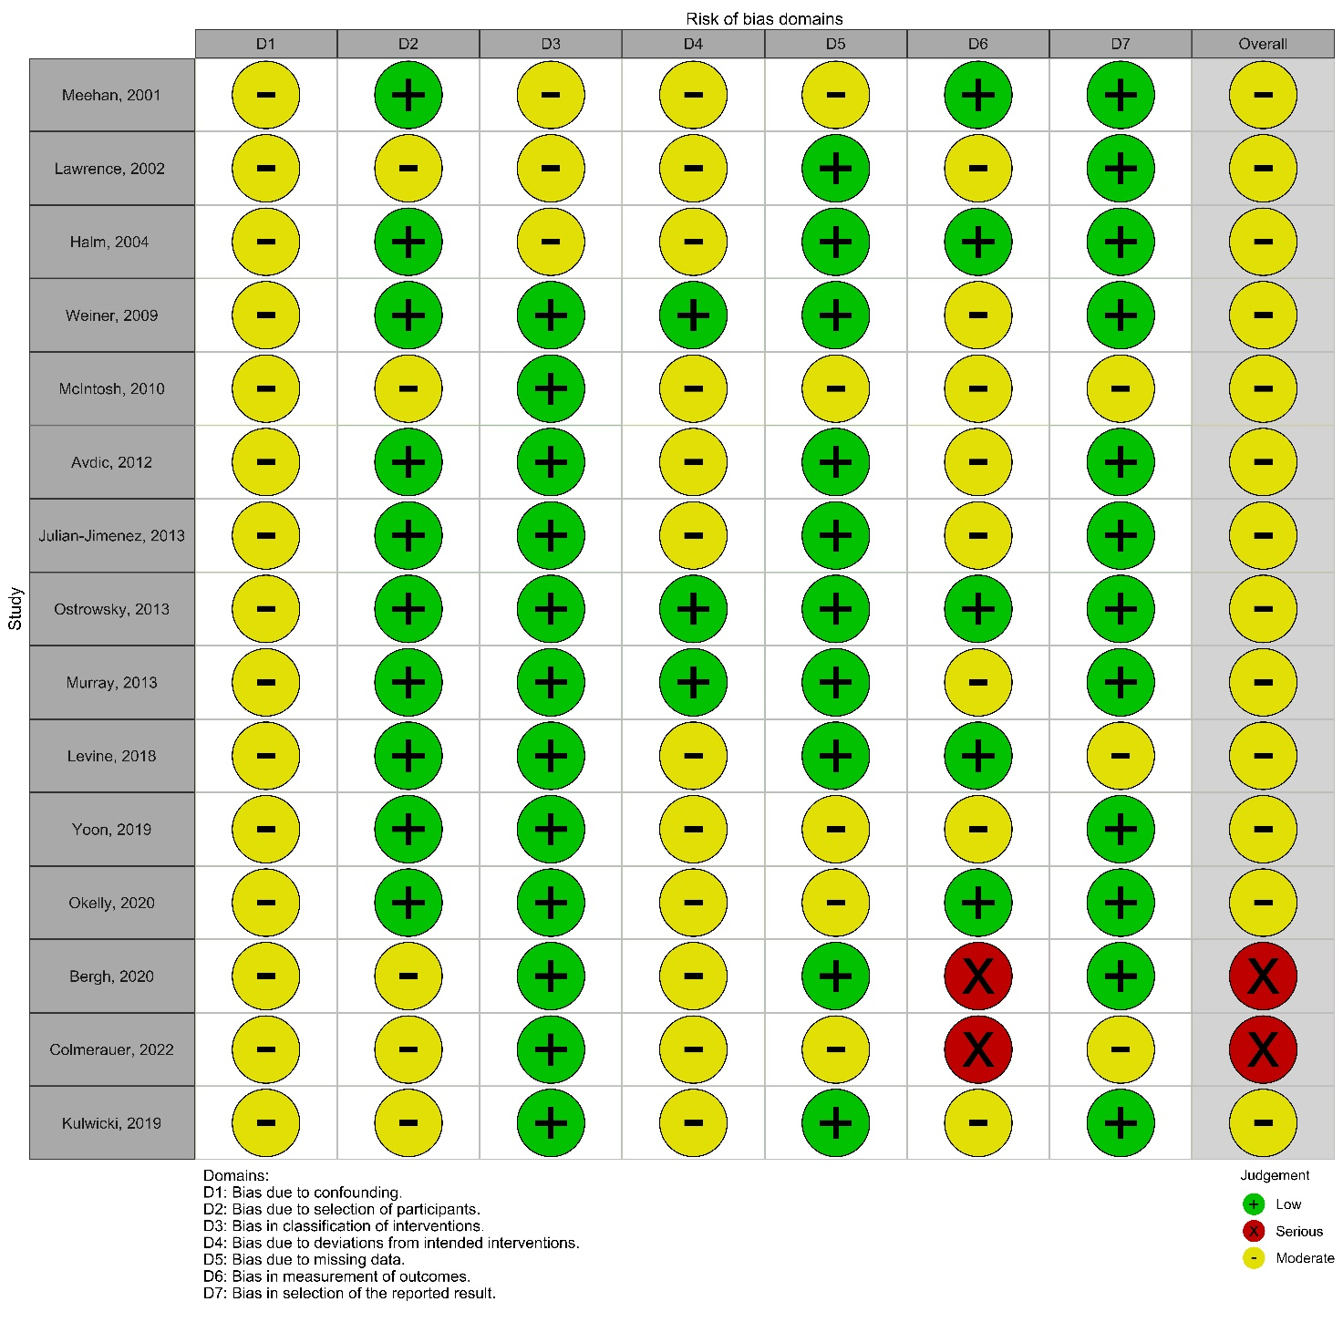
Supplementary Figure S1. Risk of Bias Assessment Using ROBINS-I for Non-Randomized Studies

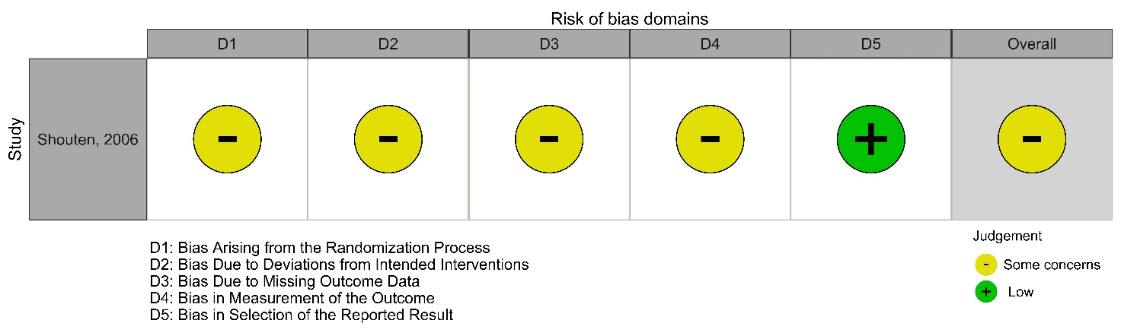
Supplementary Figure S2. Risk of Bias Assessment Using the Cochrane Risk of Bias Tool for Cluster-Randomized Controlled Trials

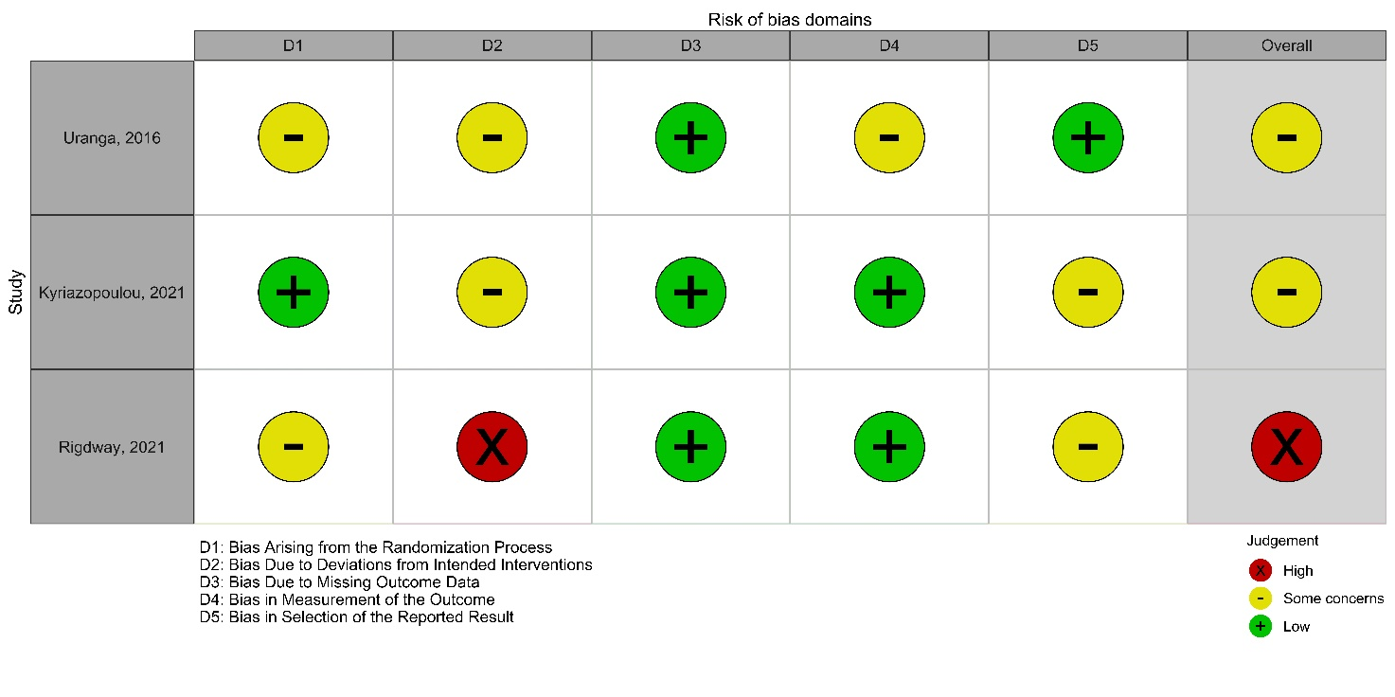
Supplementary Figure S3. Risk of Bias Assessment Using the Cochrane Risk of Bias Tool for Randomized Controlled Trials

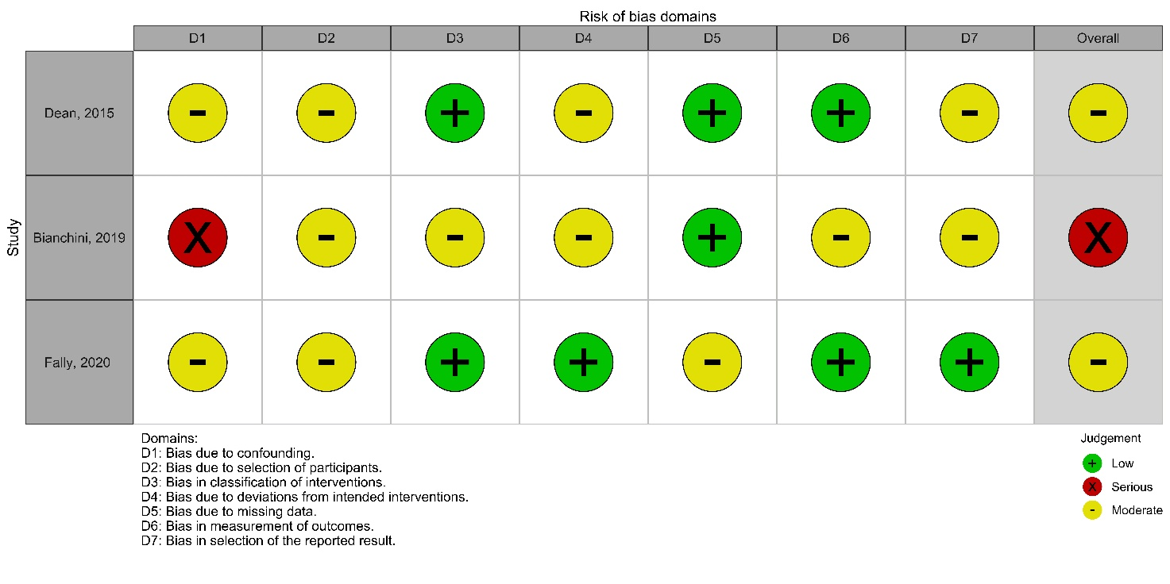
Supplementary Figure S4. Risk of Bias Assessment Using ROBINS-I for Quasi-Experimental Studies

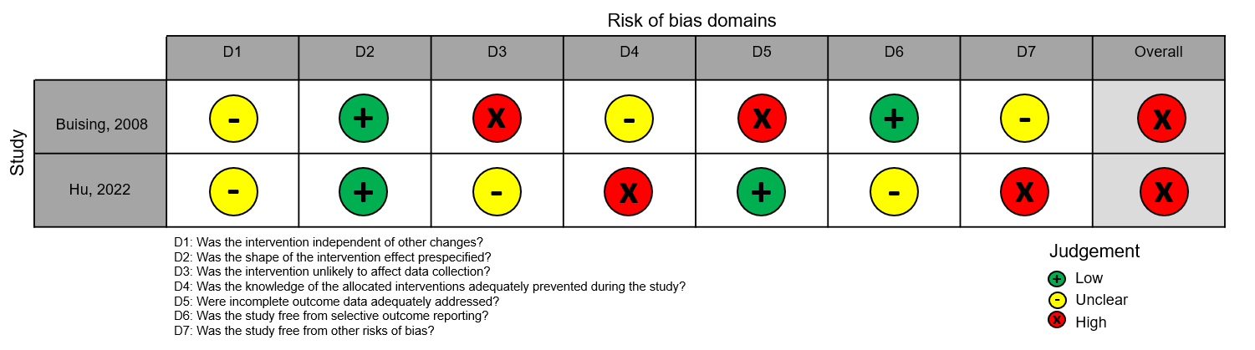

Supplementary Figure S5. Risk of Bias Assessment Using the Cochrane EPOC Tool for Interrupted Time Series Studies

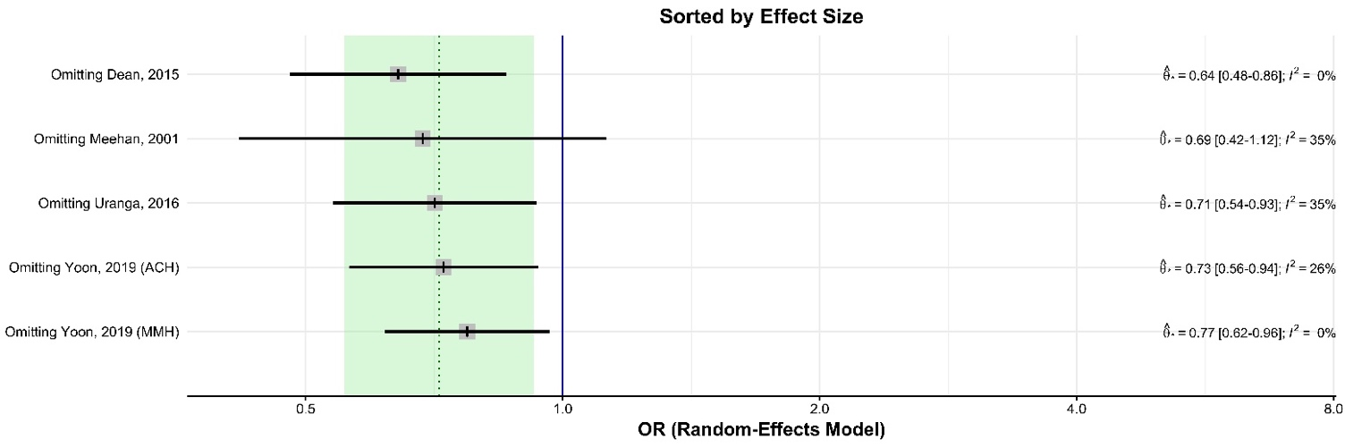
Supplementary Figure S6. Sensitivity analysis for 30-day mortality: effect sizes after exclusion of individual studies (standard method).
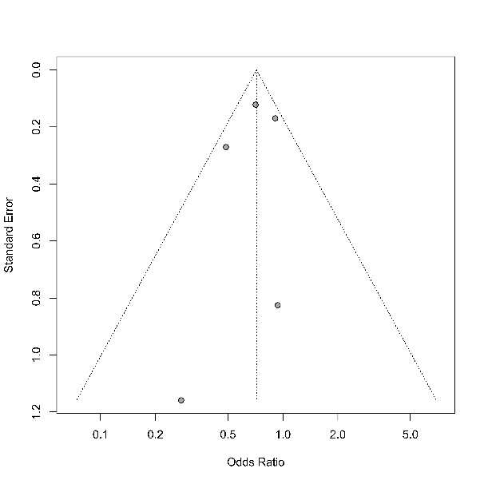
Supplementary Figure S7. Funnel plot for sensitivity analysis: effect sizes after exclusion of individual studies 30-day mortality (standard method). Test result: t = -0.60, df = 3, p-value = 0.5893.

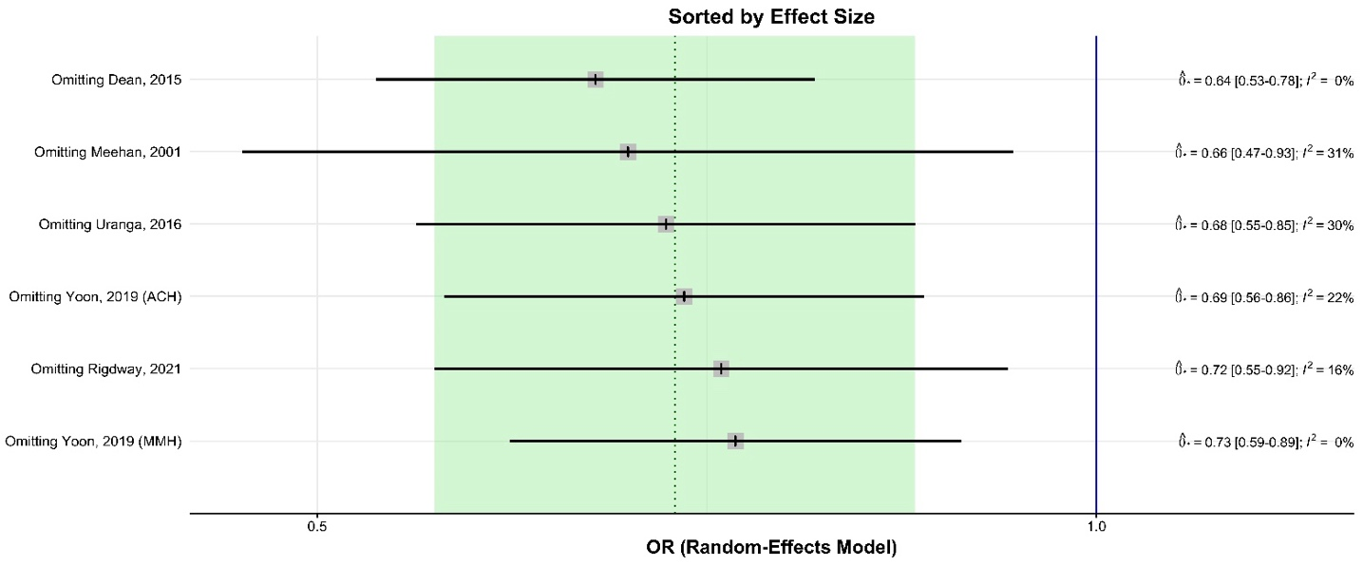
Supplementary Figure S8. Sensitivity analysis for 30-day mortality: effect sizes of individual studies (inverse variance method).
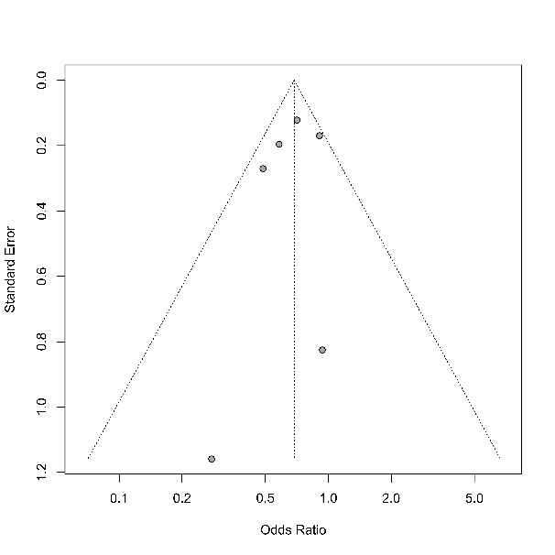
Supplementary Figure S9. Funnel plot for sensitivity analysis: effect sizes of individual studies for 30-day mortality (inverse variance method). Test result: t = -0.73, df = 4, p-value = 0.5063

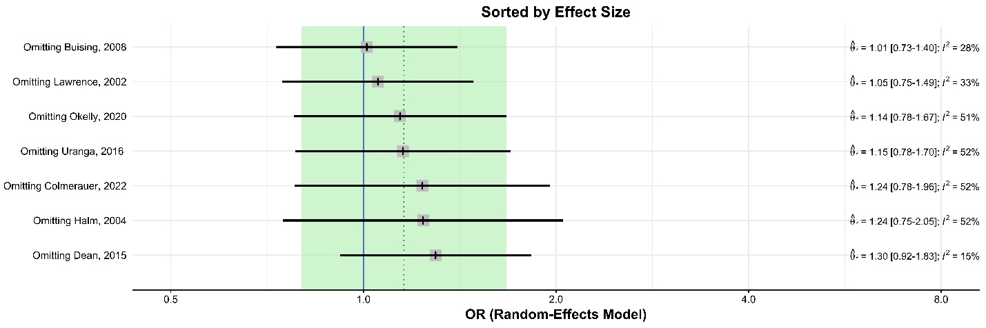
Supplementary Figure S10. Sensitivity analysis for hospital mortality: effect sizes of individual studies

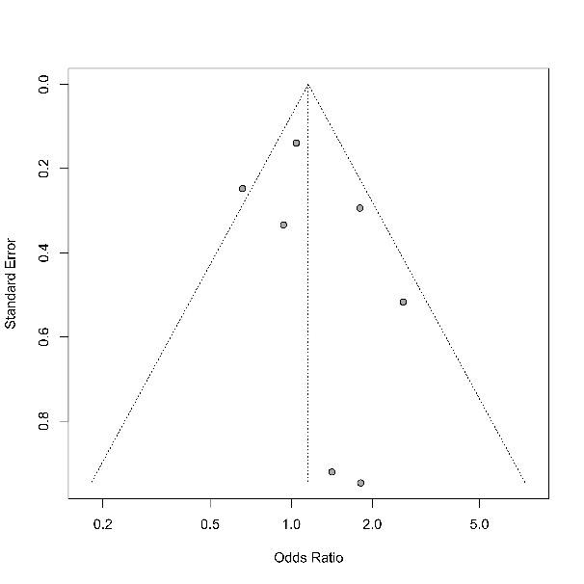
Supplementary Figure S11. Funnel plot for sensitivity analysis: effect sizes of individual studies for 30-day mortality. Test result: t = 1.00, df = 5, p-value = 0.3625

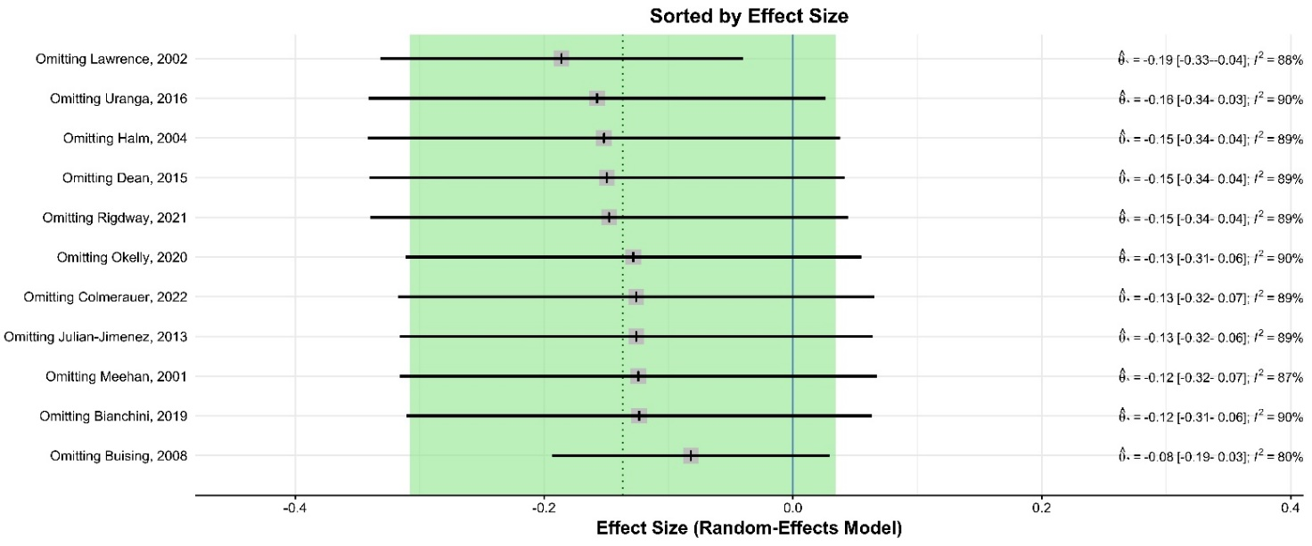
Supplementary Figure S12. Sensitivity analysis for length of stay: effect sizes after exclusion of individual studies (standard method).

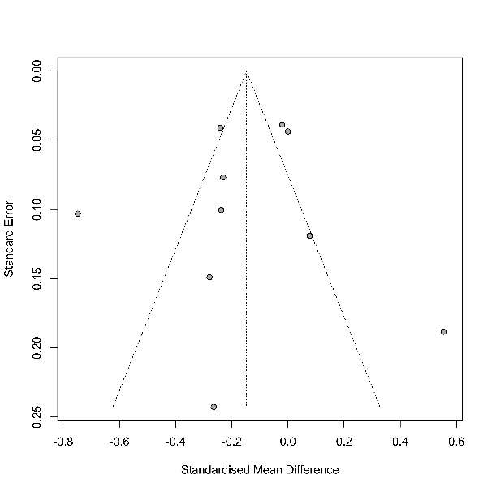
Supplementary Figure S13. Funnel plot for sensitivity analysis: effect sizes after exclusion of individual studies for length of stay (standard method). Test Result: t = -0.45, df = 8, p-value = 0.6666

Supplementary Figure 14. Sensitivity analysis for length of stay: effect sizes of individual studies (inverse variance method).

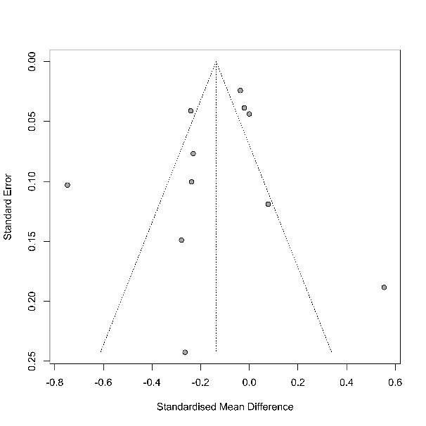
Supplementary Figure S15. Funnel plot for sensitivity analysis: effect sizes of individual studies for length of stay (inverse variance method). Test result: t = -0.88, df = 9, p-value = 0.4043

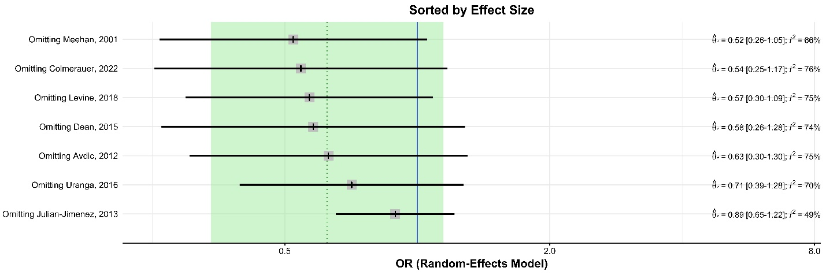
Supplementary Figure S16. Sensitivity analysis for 30-day readmissions: effect sizes of individual studies

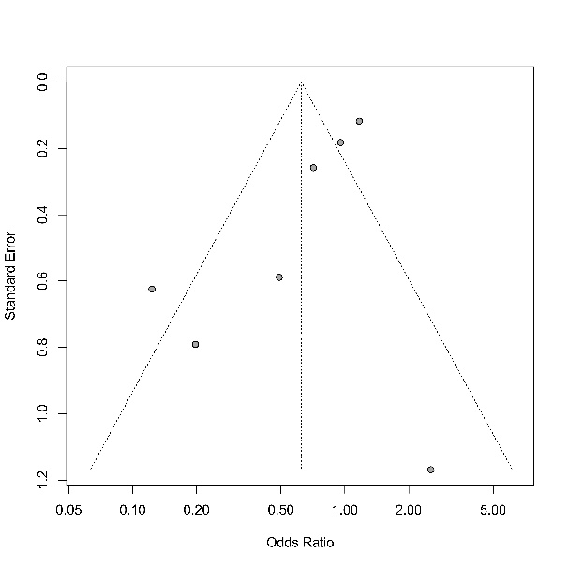
Supplementary Figure S17. Funnel plot for sensitivity analysis: effect sizes of individual studies for 30-day readmissions. Test result: t = -1.89, df = 5, p-value = 0.1169

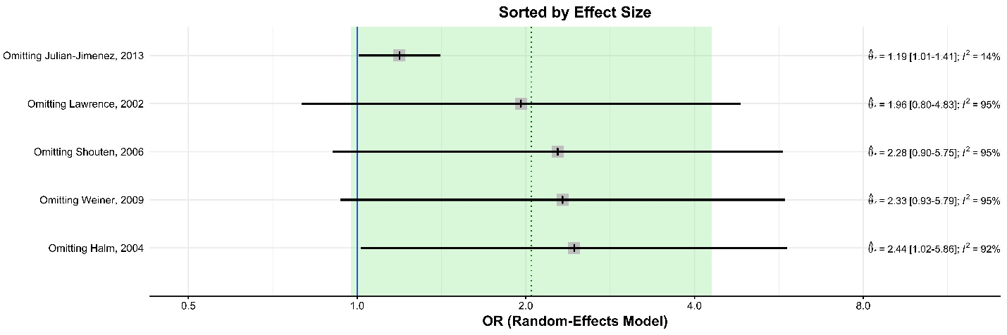
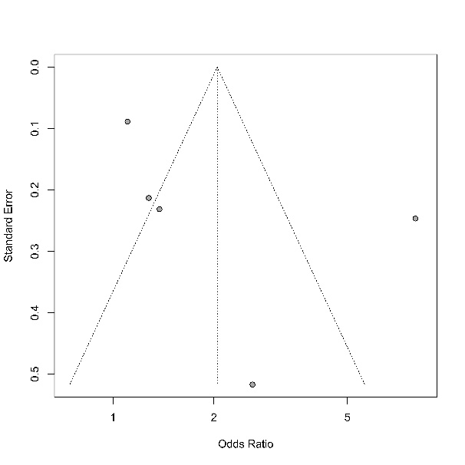
Supplementary Figure S18. Sensitivity analysis for DDD less than 4 hours: forest plot of effect sizes of individual studies

Supplementary Figure S19. Funnel plot for sensitivity analysis: effect sizes of individual studies for DDD less than 4 hours. Test result: t = 1.08, df = 3, p-value = 0.3587
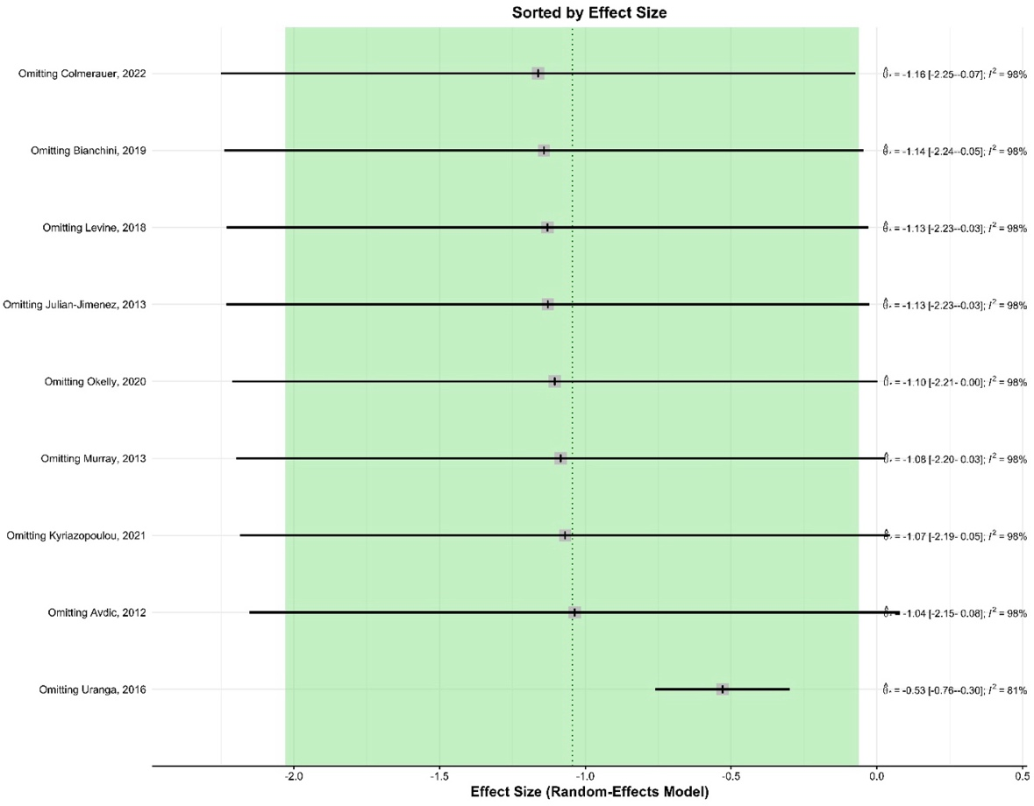
Supplementary Figure S20. Sensitivity analysis for duration of antibiotic treatment: forest plot of effect sizes of individual studies
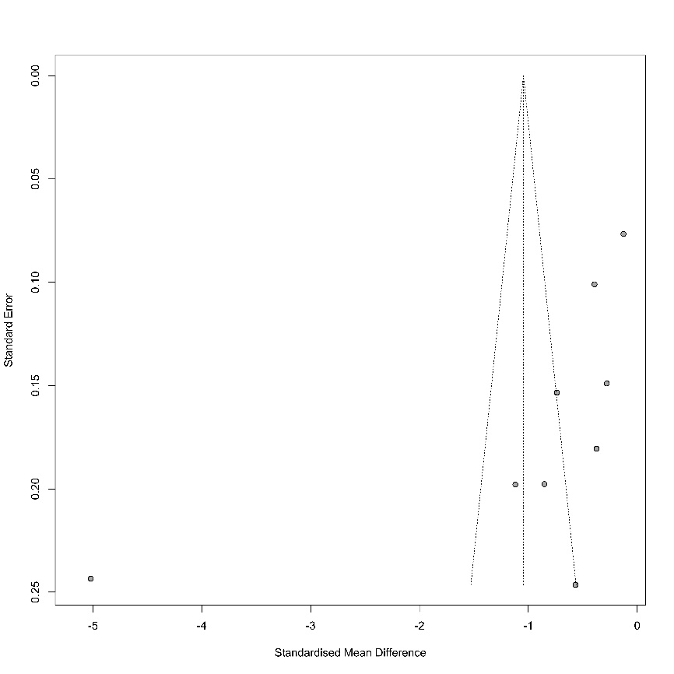
Supplementary Figure S21. Funnel plot for sensitivity analysis: effect sizes of individual studies for duration of antibiotic treatment. Test result: t = 1.08, df = 3, p-value = 0.3587
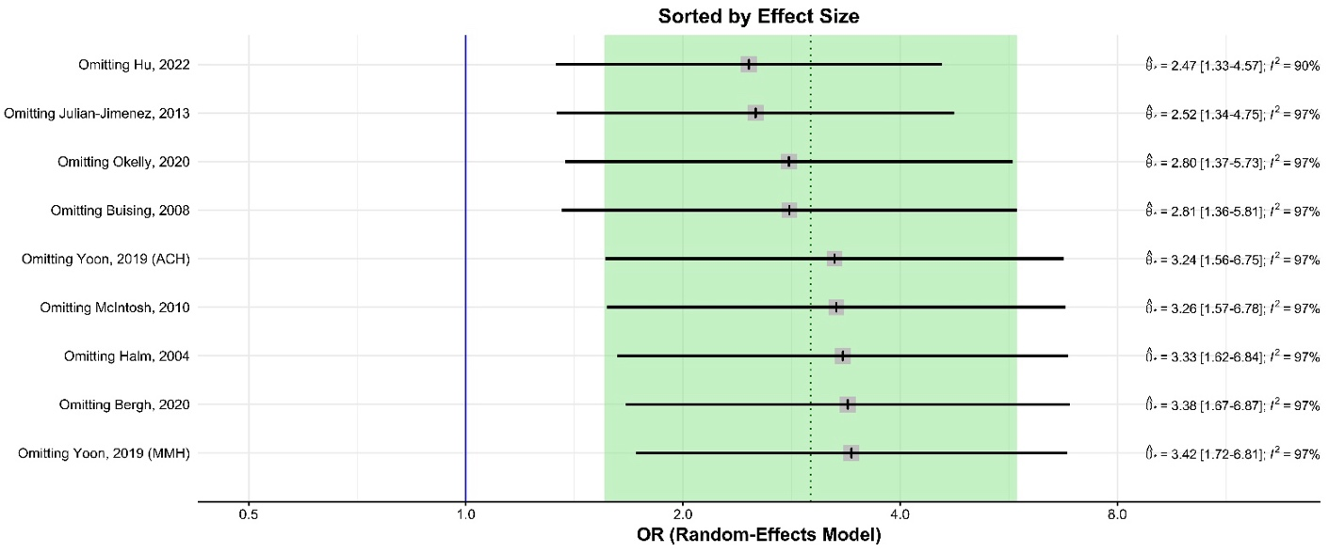

Supplementary Figure S22. Sensitivity analysis for adherence to recommended antibiotic treatment: forest plot of effect sizes of individual studies
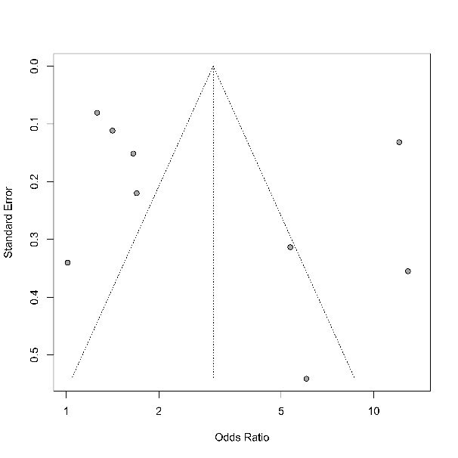
Supplementary Figure S23. Funnel plot for sensitivity analysis: effect sizes of individual studies for duration of antibiotic treatment. Test result: t = 0.95, df = 7, p-value = 0.3748

MICROBIAL LANDSCAPE AND ANTIBIOTIC-SUSCEPTIBILITY PROFILES OF MICROORGANISMS IN PATIENTS WITH BACTERIAL PNEUMONIA: A COMPARATIVE CROSS-SECTIONAL STUDY OF COVID-19 AND NON-COVID-19 CASES IN AKTOBE, KAZAKHSTAN

The article was published in the journal Antibiotics, which is ranked in the first quartile (Q1) by impact factor according to the Journal Citation Reports (Clarivate Analytics), and is available at the following link: Ablakimova N, Mussina AZ, Smagulova GA, Rachina S, Kurmangazin MS, Balapasheva A, Karimoldayeva D, Zare A, Mahdipour M, Rahmanifar F. Microbial landscape and antibiotic-susceptibility profiles of microorganisms in patients with bacterial pneumonia: a comparative cross-sectional study of COVID-19 and non-COVID-19 cases in Aktobe, Kazakhstan. Antibiotics. 2023; 12(8):1297. DOI: 10.3390/antibiotics12081297

Authors and Affiliations:
Nurgul Ablakimova ^{1*}, Aigul Z. Mussina ¹, Gaziza A. Smagulova ¹, Svetlana Rachina ², Meirambek S. Kurmangazin ³, Aigerim Balapasheva ¹, Dinara Karimoldayeva ⁴, Afshin Zare ⁵, Mahdi Mahdipour ^{6,7} and Farhad Rahmanifar ⁸

1 Department of Pharmacology, West Kazakhstan Marat Ospanov Medical University, Aktobe 030012, Kazakhstan;
2 Hospital Therapy Department No. 2, I.M. Sechenov First Moscow State Medical University, Moscow 119435, Russia;
3 Department of Infectious Disease, West Kazakhstan Marat Ospanov Medical University, Aktobe 030012, Kazakhstan;
4 Respiratory Medicine and Allergology Department, Aktobe Medical Center, Aktobe 030017, Kazakhstan;
5 PerciaVista R & D Co., Shiraz 71676-83745, Iran;
6 Stem Cell Research Center, Tabriz University of Medical Sciences, Tabriz 51666-53431, Iran;
7 Department of Applied Cell Sciences, Faculty of Advanced Medical Sciences, Tabriz University of Medical Sciences, Tabriz 51666-53431, Iran
8 Department of Basic Sciences, School of Veterinary Medicine, Shiraz University, Shiraz 71348-14336, Iran;
* Correspondence: n.ablakimova@zkmu.kz; Tel.: +7-707-475-3485

Abstract: This cross-sectional study investigated the microbial landscape and antibiotic-resistance patterns in patients with bacterial pneumonia, with a focus on the impact of COVID-19. Sputum samples from individuals with bacterial pneumonia, including coronavirus disease 2019-positive polymerase chain reaction (COVID-19-PCR+), COVID-19-PCR− and non-COVID-19 patients, were analyzed. Surprisingly, the classic etiological factor of bacterial pneumonia, Streptococcus pneumoniae, was rarely isolated from the sputum samples. Furthermore, the frequency of multidrug-resistant pathogens was found to be higher in non-COVID-19 patients, highlighting the potential impact of the pandemic on antimicrobial resistance. Strains obtained from COVID-19-PCR+ patients exhibited significant resistance to commonly used antibiotics, including fluoroquinolones and cephalosporins. Notably, the ESKAPE pathogens, Staphylococcus aureus, Klebsiella pneumoniae, Pseudomonas aeruginosa, Enterobacter cloacae, and Enterobacter aerogenes, were identified among the isolated microorganisms. Our findings underscore the urgent need for infection control measures and responsible antibiotic use in healthcare settings, as well as the importance of enhancing pneumonia diagnostics and implementing standardized laboratory protocols.
Keywords: pneumonia; bacterial; etiology; sputum; pathogens; COVID-19; antibiotics; antimicrobial resistance
Introduction
Pneumonia, a respratory infection associated with significant morbidity and mortality [1], poses a global health challenge, despite progress in the field of antimicrobial treatments, diagnostic techniques for microbiological identification, and preventive strategies. It is one of the leading causes of sepsis [2] and is responsible for a significant number of calls to emergency departments worldwide, especially during the coronavirus disease 2019 (COVID-19) pandemic [3]. According to Dagenais et al. [4], respiratory tract diseases account for 8.5% of all hospital admissions, with 0.5% resulting in mortality. A study of the global burden of diseases, injuries, and risk factors conducted in 2017 revealed that lower respiratory tract infections, including bacterial pneumonia, result in nearly 2.56 million deaths across various age groups [5]. Additionally, hospital-acquired pneumonia (HAP) is one of the most common healthcare-associated infections contributing to death and is estimated to increase hospital stays by up to 12 days and durations of mechanical ventilation by up to 10 days [6].
Different pathogens have been identified as causes of pneumonia, including bacteria, viruses, and fungi. However, only a small number of these pathogens are responsible for the majority of cases in individuals with a healthy immune system [7]. Among the viral pathogens, influenza and rhinovirus have been identified as causes in approximately one- third of community-acquired pneumonia (CAP) cases [8]. However, confirming the viral etiology has been challenging in the past due to the frequent co-occurrence of bacterial and viral infections [9] and the possibility that viruses may sometimes be present as colonizers rather than true pathogens. Numerous studies have reported that typical pneumonia is primarily caused by Streptococcus pneumoniae, Staphylococcus aureus, Klebsiella pneumoniae, Haemophilus influenzae, Pseudomonas aeruginosa, Moraxella catarrhalis, and Escherichia coli [2] while atypical pneumonia is predominantly caused by Legionella pneumophila, Chlamydia pneumoniae, and Mycoplasma pneumoniae [10]. Although S. pneumoniae is the most prevalent pathogen causing CAP worldwide across all age groups, gram-negative bacteria, such as K. pneumoniae, Acinetobacter baumannii, P. aeruginosa, and E. coli, are commonly associated with HAP [11].
The rapidly escalated COVID-19 pandemic has focused attention on the diagnosis and treatment of patients with acute respiratory infections. Furthermore, it is reported that many ‘suspected’ cases displaying typical clinical characteristics of COVID-19 and identical, specific computed tomography images were not diagnosed by using the polymerase chain reaction (PCR) method, considered the ‘gold standard’ [12]. Moreover, identifying coinfecting pathogens is crucial in the treatment of COVID-19 patients as coinfection with bacterial pathogens has been associated with increased disease severity and mortality [13,14]. Therefore, the accurate detection and management of bacterial coinfections are of great significance in the overall treatment approach for COVID-19-infected individuals. The efficacy of antibiotics used in the treatment of bacterial pneumonia has been compromised due to the increasing prevalence of resistant pathogens [15]. As the microbial landscape and antibiotic susceptibility of pathogens involved in bacterial pneumonia continue to evolve, it is crucial to investigate and understand these changes.
The most reliable method for identifying the cause of pneumonia is detecting respiratory pathogens in samples collected directly from the affected area, specifically the lungs [16]. This can be accomplished through procedures such as bronchoalveolar lavage, obtaining samples of pleural fluid, or performing a lung biopsy [17]. Despite this, sputum testing remains the most commonly used method for detecting the etiology of pneumonia in Kazakhstan, given its origin from the LRT and the non-invasive nature of the sample collection. Therefore, this study aims to compare the characteristics of pathogens isolated from the sputum samples of patients with COVID-19 with positive for PCR (PCR+) or negative for PCR (PCR−) and those with bacterial pneumonia without COVID-19 (non-COVID-19). Additionally, we assessed the level of pathogen resistance to antimicrobial drugs.
Results
Population Characteristics and Frequency of Multidrug Resistance
This research investigated the findings of a sputum analysis performed on individuals receiving treatment for bacterial pneumonia at hospitals in the city of Aktobe between 2021 and 2022. The analysis involved patients who had bacterial pneumonia as their primary ailment, as well as those who had bacterial pneumonia as a comorbidity. The study population was categorized into three groups: COVID-19 patients who had typical clinical characteristics of COVID-19 and radiological data and tested PCR+, COVID-19 patients who also had typical clinical characteristics and radiological data but tested PCR−, and non-COVID-19 patients with bacterial pneumonia without signs of COVID-19 infection and negative results for the PCR. The analysis revealed that non-COVID-19 patients with bacterial pneumonia had a higher frequency of isolating multidrug-resistant (MDR) microorganisms from their sputum samples compared to patients with COVID-19 (Table 1).

Table 1. Characteristics of the studied COVID-19-PCR+, COVID-19-PCR−, and non-COVID-19 patients with bacterial pneumonia in two hospitals in Aktobe, Kazakhstan, 2021-2022.

Factors | COVID-19-PCR+ | COVID-19-PCR− | Non-COVID-19
Population, n | 133 | 133 | 74
Age, year; mean ± SE | 59.8 ± 1.3 | 55.9 ± 1.5 | 55.2 ± 1.8
Gender  Male, n (%) | 58 (17.1) | 62 (18.3) | 42 (12.4)
Female, n (%) | 75 (22.1) | 71 (20.9) | 31 (9.1)
Intensive care unit (ICU) 31 (9.1) |  | 13 (3.8) | 31 (9.1)
Multidrug resistance 66 (19.4) |  | 31 (9.1) | 45 (13.2)

Most of the Microorganisms Which Were Identified Were Not the Main Etiological Factors of Pneumonia
Out of the 340 samples analyzed, all showed positive cultures. The samples were obtained from adult patients. Mixed cultures were detected in 6.18% (21) of the samples, all of which were collected from non-COVID-19 patients (25% of the total). A total of 35 distinct microorganisms were identified, with gram-negative bacteria accounting for 46.8%, gram-positive bacteria for 37.6%, and fungi for 15.6% of the cases. The distribution of each identified pathogen is illustrated in Figure 1.
Enterobacterales and S. aureus Were Found Most Often in COVID-19 and Non-COVID-19 Patients
In 59% of cases in patients with the COVID-19 infection, potential pneumonia pathogens were isolated; meanwhile, in 41% of cases, non-pathogenic microorganisms or commensals were identified, mainly Candida spp. and S. epidermidis. A similar situation was observed in non-COVID-19 patients, where the main causes of pneumonia were found in 55% of all cases. The comparison of the potential pathogens’ frequencies is shown in Figure 2.
During the study and analysis of the results, it was observed that the classic etiological factor of bacterial pneumonia, S. pneumoniae, was rarely isolated from the sputum samples, only occurring in one case. K. pneumoniae, the predominant microorganism, was isolated in 17.65% of all cases. There was no significant difference in the frequency of this pathogen among the three groups. Among COVID-19-PCR− patients, the most commonly isolated microorganism was S. aureus, accounting for 20.3% of cases. In non-COVID-19 patients, the frequency of S. aureus was lower compared to the COVID-19 groups.
The ESKAPE Pathogens S. aureus, K. pneumoniae, P. aeruginosa, E. cloacae, and E. aerogenes were Identified among the Pathogens Analyzed
In February 2017, the World Health Organization (WHO) published a list of pathogens that necessitate the urgent development of novel antimicrobial drugs, providing guidance and prioritizing research and development endeavors. Within this comprehensive list, a group of pathogens known as ESKAPE pathogens (comprising Enterococcus faecium, S. aureus, K. pneumoniae, A. baumannii, P. aeruginosa, and Enterobacter spp.) were specifically recognized as having “priority status” [18]. Our study identified S. aureus, K. pneumoniae, P. aeruginosa, E. cloacae, and E. aerogenes among the pathogens analyzed. However, A. baumannii and E. faecium were not detected. The resistance profiles of gram-negative pathogens, belonging to the ESKAPE group, isolated from the sputum of COVID-19 and non-COVID-19 patients are presented in Figure 3.
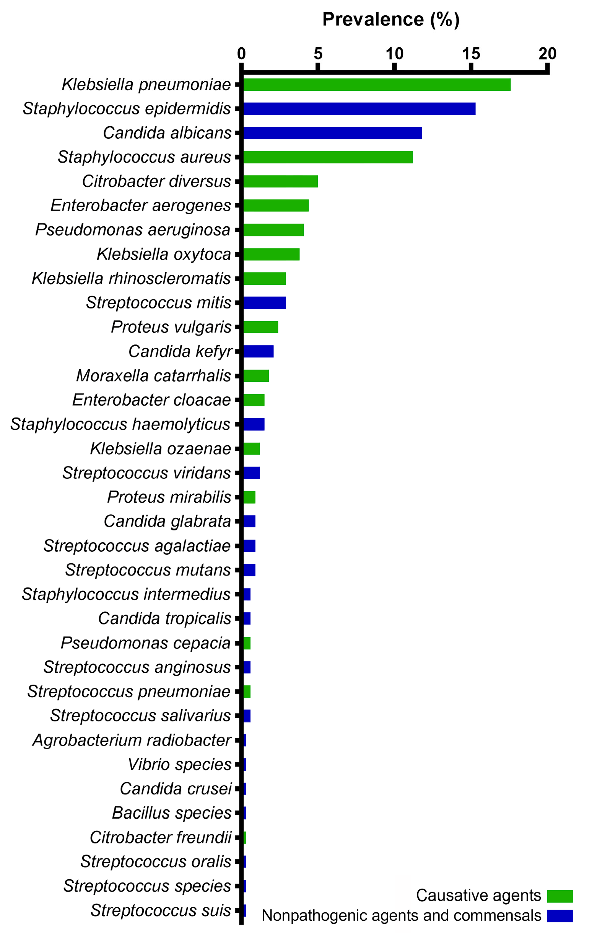

Figure 1. The microbial landscape of the isolated microorganisms from the sputum samples of the patients with COVID-19 and non-COVID-19 bacterial pneumonia in two hospitals in Aktobe, Kazakhstan, 2021–2022.

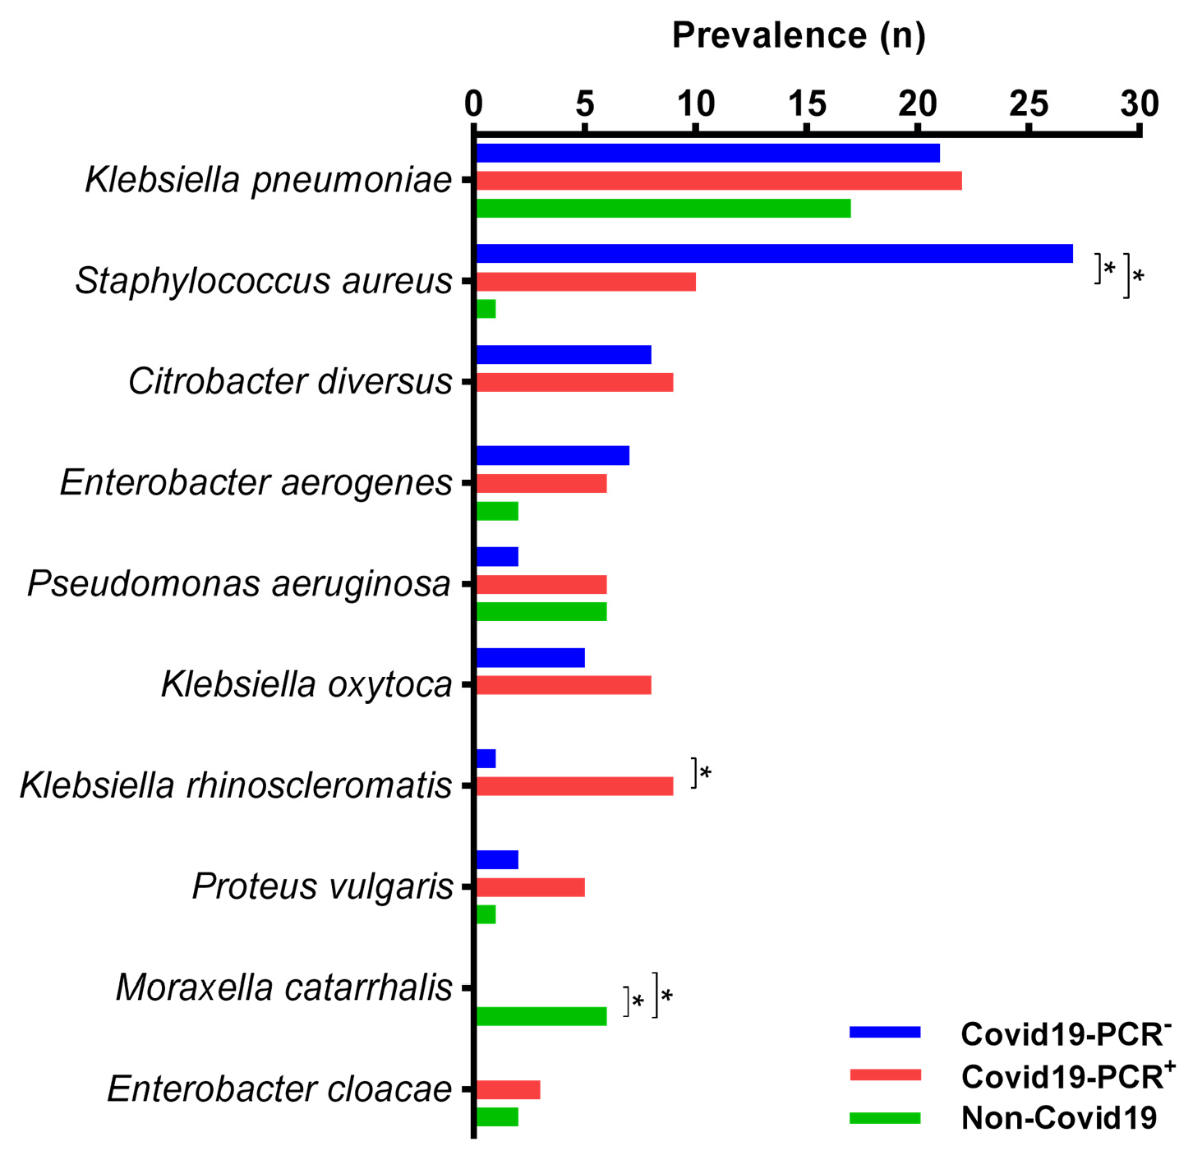
Figure 2. Percentage frequency of bacterial pathogen occurrence from sputum samples of COVID-19-PCR+, COVID-19-PCR−, and non-COVID-19 patients with bacterial pneumonia in two hospitals in Aktobe, Kazakhstan, 2021-2022. * stars show significant differences between columns (p < 0.05).

Gram-Negative Bacteria Obtained in COVID-19 and Non-COVID-19 Patients Showed Different Degrees of Resistance to Commonly Used Antibiotics
Among the microorganisms isolated from the sputum samples of patients with bacterial pneumonia, 25.6% were identified as members of the Klebsiella genus. These pathogens showed a high level of resistance to levofloxacin (51.5% in COVID-19 patients, 29.4% in non-COVID-19 patients), as well as to ciprofloxacin (32.9% in COVID-19 patients, 27.3% in non-COVID-19 patients) and amikacin (27.1% in COVID-19 patients, 47% in non-COVID-19 patients). COVID-19 patients also exhibited significant resistance to cefepime (51.4%). Citrobacter diversus, which was detected only in the sputum samples of patients with COVID-19 (n = 17), showed high resistance to fluoroquinolones and cephalosporins: levofloxacin 68.8%, ciprofloxacin 58.8%, cefepime 52.9%.
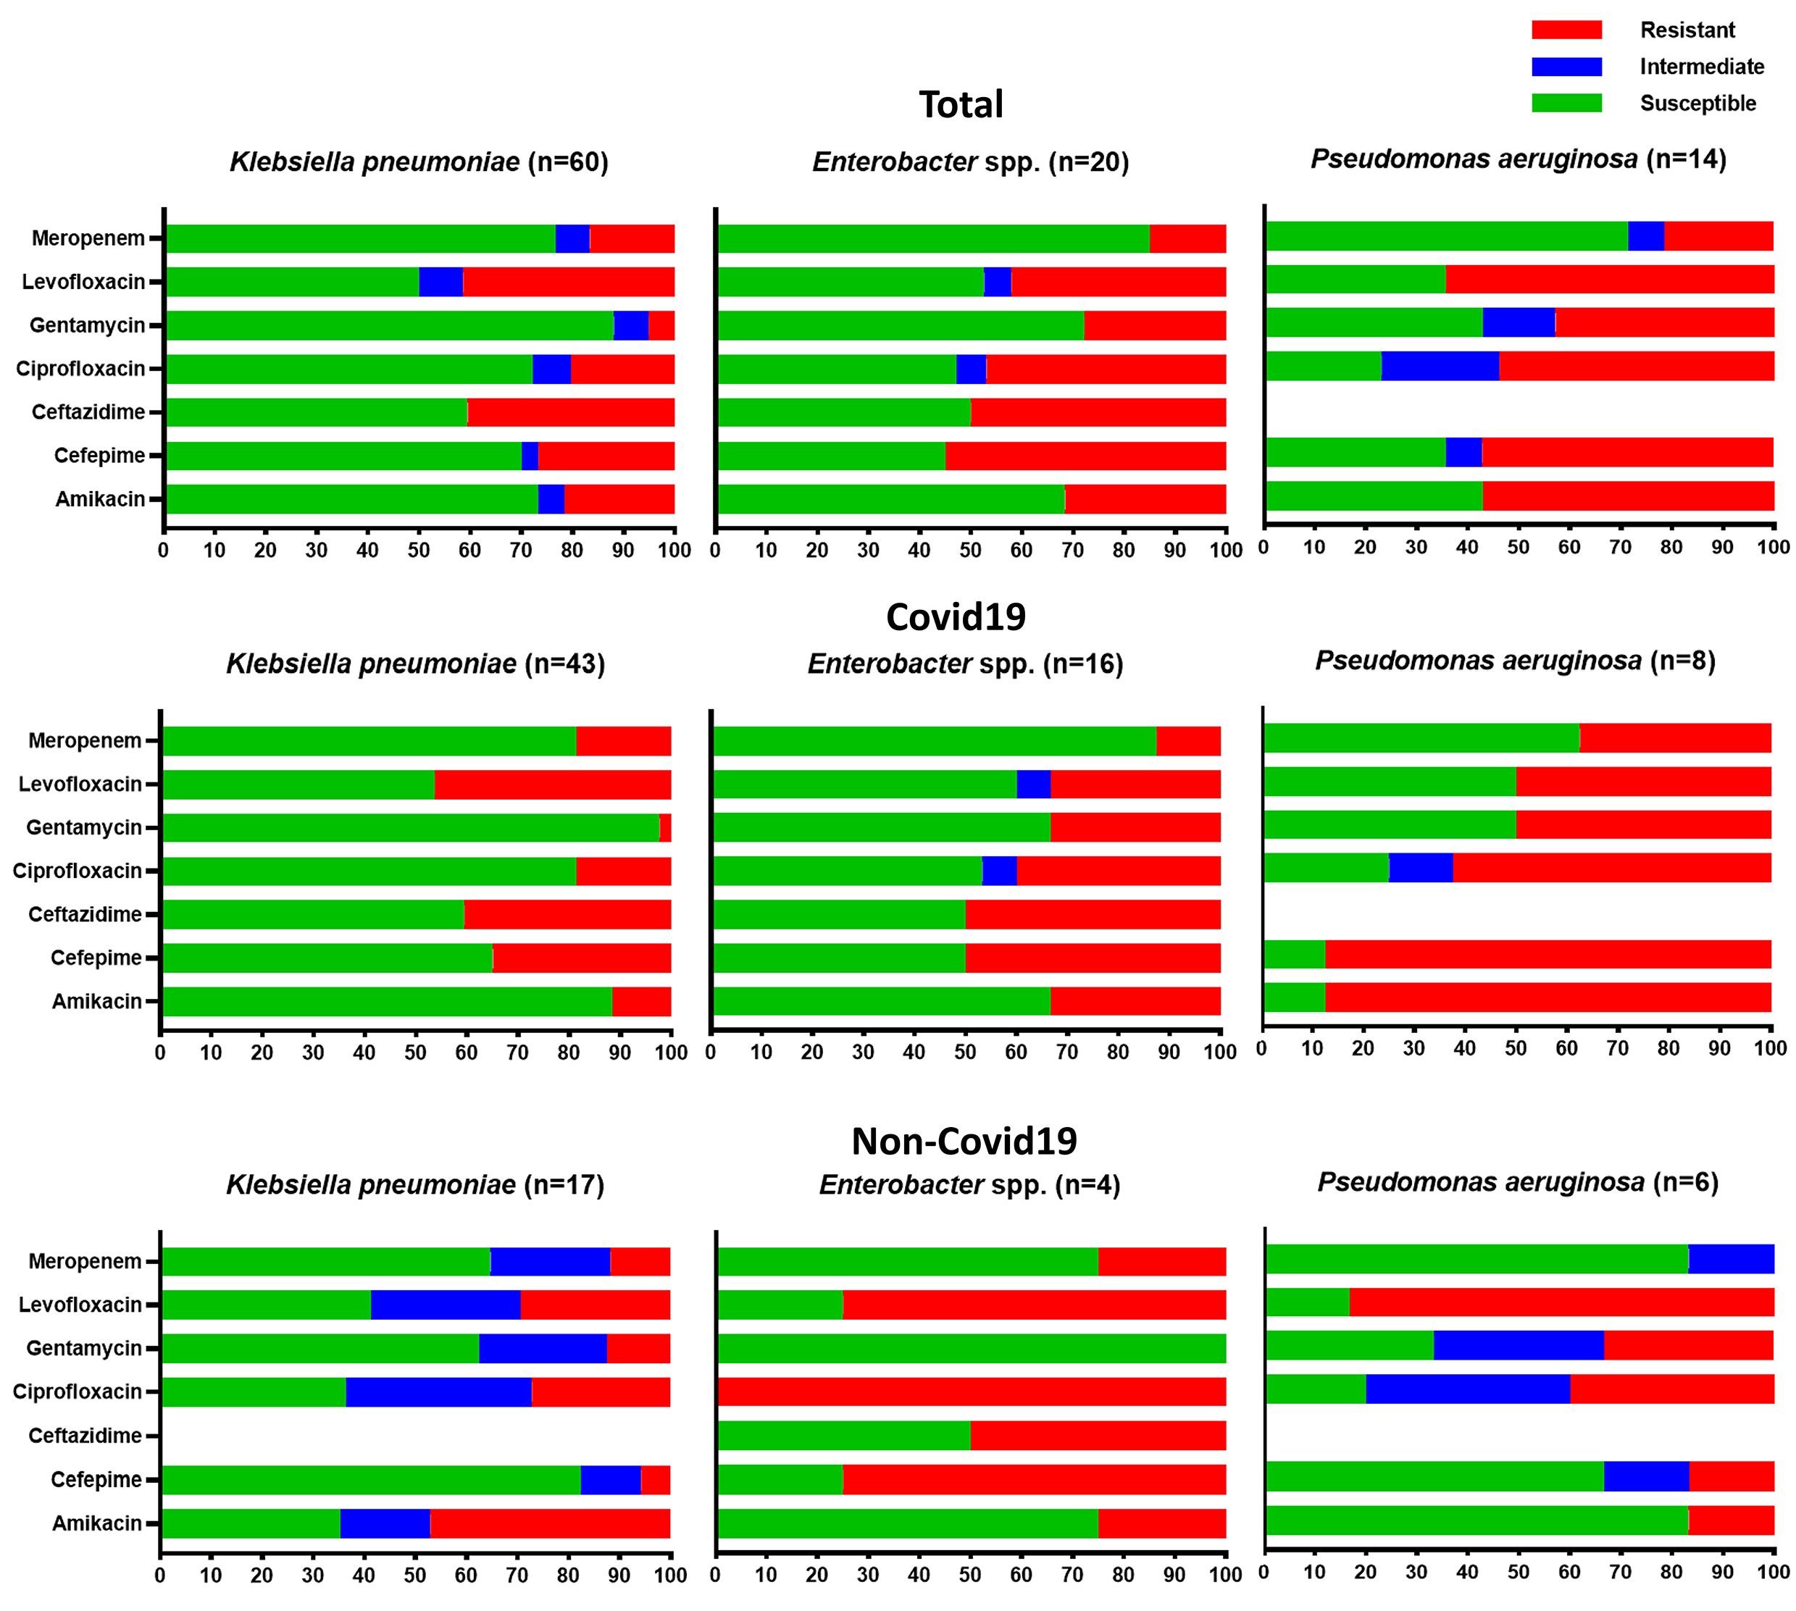

Figure 3. Susceptibility profiles of gram-negative isolates belonging to the ESKAPE pathogen group from sputum samples of patients in two hospitals from COVID-19 and non-COVID-19 patients with bacterial pneumonia in Aktobe, Kazakhstan, 2021-2022.

Discussion
Most of the pathogens which were identified were not the main etiological factors of pneumonia. During the study and analysis of the results, it was observed that the classic etiological factor of bacterial pneumonia, S. pneumoniae, was rarely isolated from the sputum samples. The wide range of these figures can be attributed to difficulties in obtaining high-quality sputum samples from the lower respiratory tract, differences in the sensitivity of diagnostic media and tests used, and the prior use of antimicrobial agents for treating the disease before an etiological diagnosis is conducted. These factors contribute to the variability in the detection rates of S. pneumoniae [19]. However, similar findings were reported by Lavrinenko et al. [20], where, in only 1% of the cases (specifically three out of two-hundred-nine patients from Almaty, Karaganda and Atyrau, Kazakhstan) with coronavirus infection included in the study were they found to have a pneumococcal infection. Physical distancing and other measures used during COVID-19 can be some of the reasons for the significant reduction in invasive diseases caused by S. pneumoniae [21]. These results show that the quality and technique used for collecting sputum samples can greatly influence the detection of bacterial pathogens.
The frequency of multidrug-resistant pathogens’ isolation was higher after the COVID-19 pandemic. Our research supports this observation as we noticed an increased incidence of bloodstream infections and higher mortality rates following MDR infections during the post-COVID-19 period. In fact, 68.8% of bloodstream cultures showed MDR bacteria, compared to 40.0% in the pre-COVID-19 period [22]. Supporting our findings, La et al. [23] also reported a significant rise in the prevalence of MDR organisms after the COVID-19 pandemic, particularly in cases of bacteremia in South Korean hospitals. This surge may be attributed to the inappropriate use of antibiotics during the pandemic. Despite a low overall proportion of bacterial coinfections among COVID-19 patients, the usage of antibiotics was high [24]. These findings indicate that the improper use of antibiotics during the pandemic, despite the low overall proportion of bacterial coinfections among COVID-19 patients, might have contributed to the emergence and spread of multidrug-resistant strains.
S. aureus, S. epidermidis, K. pneumoniae, and C. albicans were found most often in patients with COVID-19. In line with previous studies, S. aureus was categorized as an emerging copathogen in individuals affected by COVID-19 [25]. The isolation of Candida fungi from the sputum of COVID-19 patients also has been reported by other authors [20,26–30]. There is a significant need for a cautious interpretation of fungal isolates from respiratory samples, especially in non-critically ill patients with a low pre-test probability of invasive fungal infections due to poor oral hygiene [31-33], immune dysregulation [34], and viral cytopathic effects on epithelial cells [35]. The frequent isolation of commensals may also indicate shortcomings in laboratory diagnostics, particularly the need for careful evaluation of the quality of the provided biomaterial and the mandatory performances of microscopic examination and gram staining. Further research and careful consideration of all of these factors are needed to better understand the clinical implications of these pathogens in the context of COVID-19.
Bacterial strains, including, in particular, the obtained ESKAPE pathogens S. aureus, K. pneumoniae, P. aeruginosa, and Enterobacter spp., in patients with COVID-19 showed a high degree of resistance to commonly used antibiotics. The studies conducted by other researchers also emphasize the general pattern of rising antimicrobial resistance. Among the 159 strains of bacteria isolated from COVID-19 patients in Wuhan, China, 85.5% were gram-negative, with A. baumannii (35.8%), K. pneumoniae (30.8%), and Stenotrophomonas maltophilia (6.3%) as the top three bacteria causing bloodstream infections while carbapenem resistance was high in A. baumannii (91.2%) and K. pneumoniae (75.5%) and meticillin resistance was observed in all S. aureus and coagulase-negative staphylococci [36]. In another study conducted by Fu et al., it was found that five critically ill COVID-19 patients experienced secondary infections caused by extended-spectrum beta-lactamase-producing K. pneumoniae, S. maltophilia, Burkholderia cepacia, and P. aeruginosa, which were identified as the responsible pathogens [37]. Table 2 compares the effect of COVID-19 on the landscape and the level of resistance change during the pandemic in our study and previous ones. The analysis of articles from Web of Knowledge using the search terms “covid”, “antibiotic resistance”, and “respiratory” in the abstract or title led us to find 55 relevant articles, of which a 10th of them evaluated the effect of COVID-19 on landscape change in antibiotic resistance. Between them, eight articles demonstrated the impact of COVID-19 on these changes.

Table 2. Comparisons of the effect of COVID-19 on the landscape and level of antibiotic resistance changes during the pandemic.

Country | No. of Strains No. of Patients | Landscape and Level of Resistance Change | References
China | 18965 ND 1 | Yes | [38]
India | 28 200 | No | [39]
India | ND 2000 | Yes | [40]
Indonesia | 733 2786 | Yes | [41]
Iran | 192 192 | Yes | [42]
Italy | 245 157 | Yes | [43]
Italy | 2002 1090 | Yes | [44]
Kazakhstan | 340 340 | Yes | Current study
Korea | 696 1023 | No | [45]
Serbia | 1410 834 | Yes | [46]
USA | 31 13 | Yes | [47]
1 ND, no data.

In contrast to our findings, Zeshan et al. [48] reported that isolated strains of
K. pneumoniae in 88%, P. aeruginosa in 75%, and S. aureus in 45% of cases were resistant to ciprofloxacin. Other researchers also noted that there is high resistance to fluoroquinolone and cephalosporins among the gram-negative bacteria isolated from the COVID-19 patients [41,49]. This may be a reflection of the widespread use of these medications for empirical therapy. As indicated by the meta-analysis on bacterial coinfection in COVID-19 [24], a significant proportion of patients (approximately 74%) have received broad-spectrum antibiotics in the form of cephalosporins and fluoroquinolones as an empirical treatment approach. The findings of this study and other research indicate a concerning trend of high antimicrobial resistance among bacterial strains obtained from patients with COVID-19.
There are several limitations of our study that need to be pointed out, starting with those related to the retrospective study design. Firstly, we were limited in our ability to investigate the accuracy of bacterial pneumonia diagnoses and the relationship between the initiation of empirical therapy and the timing of specimen collection, which may have influenced the results. Secondly, it also restricted our ability to examine the role of glucocorticoid medications in the development of resistance. Thirdly, the COVID-19 patient beds in the infectious hospital were temporarily opened and the sputum analysis of non-COVID-19 patients was already being conducted in a different laboratory. However, both laboratories operate according to the same directives and recommendations. The PCR testing of sputum samples was not conducted, thus leaving the role of atypical pathogens unclear in the microbiological landscape. Further studies are required to examine the resistance genes responsible for the observed sensitivity results.
Materials and Methods
Cases and Ethics
This study was conducted as part of a research project at the West Kazakhstan Marat Ospanov Medical University, entitled “Concomitant bacterial infections and pharmacoepidemiology of antibiotic resistance in patients with COVID-19: the situation in the Aktobe region”. Ethical approval was obtained from the local bioethics committee (Approval No. 8, dated 15 October 2021). A retrospective analysis was carried out, examining 340 medical records of adult patients who were admitted to the COVID-19 wards at the Aktobe Regional Clinical Infectious Hospital between 1 January 2021 and 31 December 2021 and patients who were diagnosed with bacterial pneumonia and treated at the Multidisciplinary Regional Hospital, Aktobe in 2022. The diagnoses of the COVID-19 infection were established based on clinical and epidemiological data, radiological examinations, and the presence of PCR analyses for detecting SARS-CoV-2 RNA from nasopharyngeal swabs. All patients included in this study had documented diagnoses of bacterial pneumonia, according to medical records.
Pathogen Identification
All patients underwent laboratory testing (“Bacteriological culture of sputum with determination of susceptibility to antibacterial agents”) according to standard methods and procedures. After the isolation of a pure culture, the identification of microorganisms was carried out using the MicroScan AutoScan 4 system (SIEMENS, West Sacramento, CA, USA) and MicroScan Rapid system (Beckman Coulter, Sacramento, CA, USA).
Antibiotic Susceptibility
The determination of antimicrobial sensitivity was carried out for the microorganisms in each group of patients. An assessment of the susceptibility of bacterial isolates to antibacterial drugs was carried out by the disk diffusion method. The interpretation of the results was based on the comparison of the growth-inhibition diameter of the tested strains with the tabulated data in accordance with the Clinical and Laboratory Standards Institute (CLSI) recommendations. Internal quality control was performed using reference strains in the microbiology laboratories. A MDR analysis, as defined by the resistance of bacterial strains to three or more groups of antibiotics [50], was conducted to assess the prevalence of MDR among the different patient groups.
Sample Size Calculation
To calculate the sample size to investigate the prevalence of antibiotic resistance in patients with bacterial pneumonia, we selected K. pneumoniae in a specific hospital setting. The researchers wanted to estimate the proportion of patients with antibiotic-resistant K. pneumoniae with a desired level of precision and statistical power.
Desired Level of Precision: the researchers wanted to estimate the prevalence of antibiotic resistance in K. pneumoniae with a 95% confidence level and a margin of error (precision) of ±5%.
Statistical Power: the researchers wanted to achieve a statistical power of 80%, which meant this study would be able to detect a significant difference if it existed.
Methodology for Sample Size Calculation:
Estimating Prevalence: as no previous estimate of the prevalence of antibiotic resistance in this specific setting was available, the researchers decided to use a conservative estimate of 30% based on the available preliminary data analysis, assuming the proportion is evenly split between resistant and non-resistant cases.
Z-score for Confidence Level: for a 95% confidence level, the Z-score corresponding to a 95% confidence level was 1.96.
Margin of Error (Precision): the desired margin of error was ±5%, which translates to 0.05.
Estimating Standard Deviation: as the actual proportion of antibiotic resistance was unknown, the researchers used a conservative estimate of 0.5 for the standard deviation, assuming the highest variability.
Calculating Sample Size: using the formula for sample size calculation for estimating a proportion in a population:
n = (Z² × p × (1 − p))/(E²)
where:
n = required sample size;
Z = Z-score corresponding to the desired confidence level; p = estimated proportion of antibiotic resistance;
E = margin of error (precision). Plugging in the values:
n = (1.962 × 0.3 × 0.5)/(0.052) ≈ 231.
Statistical Analysis
Descriptive statistcs were employed to analyze the demographic of the patients’ factors. Continuous variables were presented using the mean ± standard deviation (SD) while categorical variables were represented using frequencies. The distribution of categorical variables was assessed using the X2 test. Statistical significance was determined as a p-value below 0.05. Data analysis was carried out using IBM SPSS Statistics 22 (SPSS Inc., Chicago, IL, USA) and GraphPad software (Version 9.5.1, San Diego, CA, USA) was employed for graphical visualization.
Conclusions
The global outbreak of the coronavirus infection serves as a reminder of the significance of infection control measures and the responsible utilization of antimicrobial agents in healthcare settings. Advancing pneumonia diagnostics requires a multifaceted approach that includes expanding laboratory networks, implementing standardized protocols, enhancing microbiologists’ expertise, and promoting collaboration among stakeholders. By prioritizing these tasks, healthcare systems can strengthen their ability to diagnose pneumonia accurately, manage antimicrobial resistance effectively, and promote rational antibiotic use across all levels of healthcare.
Author Contributions: Conceptualization, N.A., A.Z.M., G.A.S. and S.R.; Data curation, N.A., S.R., M.S.K., A.B. and D.K.; Formal analysis, N.A., A.Z., M.M. and F.R.; Funding acquisition, G.A.S.; Investigation, N.A.; Methodology, N.A.; Project administration, A.Z.M. and G.A.S.; Resources, A.Z.M., G.A.S. and A.Z.; Software, N.A. and A.Z.; Supervision, A.Z.M., G.A.S. and S.R.; Validation, N.A.; Visualization, S.R.; Writing-original draft, N.A.; Writing-review and editing, A.Z.M., G.A.S., S.R., M.S.K., A.B., D.K., M.M. and F.R. All authors have read and agreed to the published version of the manuscript.
Funding: This study was funded by the West Kazakhstan Marat Ospanov Medical University (3 March 2022 and No. 13/2-18-153) and conducted as part of a research project at the West Kazakhstan Marat Ospanov Medical University, entitled “Concomitant bacterial infections and pharmacoepidemiology of antibiotic resistance in patients with COVID-19: the situation in the Aktobe region”.
Institutional Review Board Statement: Ethical approval was obtained from the West Kazakhstan Marat Ospanov Medical University bioethics committee (Approval No. 8, dated 15 October 2021).
Informed Consent Statement: Not applicable.
Data Availability Statement: Data are available on request due to ethical restrictions.
Conflicts of Interest: The authors declare no conflict of interest.
References
- Troeger, C.; Blacker, B.F.; Khalil, I.A.; Rao, P.C.; Cao, S.J.; Zimsen, S.R.M.; Albertson, S.; Stanaway, J.D.; Deshpande, A.; Farag, T.; et al. Estimates of the global, regional, and national morbidity, mortality, and aetiologies of lower respiratory infections in 195 countries, 1990–2016: A systematic analysis for the Global Burden of Disease Study 2016. Lancet Infect. Dis. 2018, 18, 1191–1210.
- Cilloniz, C.; Martin-Loeches, I.; Garcia-Vidal, C.; San Jose, A.; Torres, A. Microbial etiology of pneumonia: Epidemiology, diagnosis and resistance patterns. Int. J. Mol. Sci. 2016, 17, 2120.
- Jaffe, E.; Sonkin, R.; Strugo, R.; Zerath, E. Evolution of emergency medical calls during a pandemic – An emergency medical service during the COVID-19 outbreak. Am. J. Emerg. Med. 2021, 43, 260–266.
- Dagenais, G.R.; Leong, D.P.; Rangarajan, S.; Lanas, F.; Lopez-Jaramillo, P.; Gupta, R.; Diaz, R.; Avezum, A.; Oliveira, G.B.F.; Wielgosz, A.; et al. Variations in common diseases, hospital admissions, and deaths in middle-aged adults in 21 countries from five continents (PURE): A prospective cohort study. Lancet 2020, 395, 785–794.
- Disease, G.B.D.; Injury, I.; Prevalence, C. Global, regional, and national incidence, prevalence, and years lived with disability for 354 diseases and injuries for 195 countries and territories, 1990–2017: A systematic analysis for the Global Burden of Disease Study 2017. Lancet 2018, 392, 1789–1858.
- Koulenti, D.; Tsigou, E.; Rello, J. Nosocomial pneumonia in 27 ICUs in Europe: Perspectives from the EU-VAP/CAP study. Eur. J.Clin. Microbiol. Infect. Dis. 2017, 36, 1999–2006.
- Shoar, S.; Musher, D.M. Etiology of community-acquired pneumonia in adults: A systematic review. Pneumonia 2020, 12, 11.
- Jain, S.; Self, W.H.; Wunderink, R.G.; Fakhran, S.; Balk, R.; Bramley, A.M.; Reed, C.; Grijalva, C.G.; Anderson, E.J.; Courtney, D.M.; et al. Community-acquired pneumonia requiring hospitalization among U.S. adults. N. Engl. J. Med. 2015, 373, 415–427.
- Ruuskanen, O.; Lahti, E.; Jennings, L.C.; Murdoch, D.R. Viral pneumonia. Lancet 2011, 377, 1264–1275.
- Dueck, N.P.; Epstein, S.; Franquet, T.; Moore, C.C.; Bueno, J. Atypical pneumonia: Definition, causes, and imaging features. Radiographics 2021, 41, 720–741.
- Feng, D.Y.; Zhou, Y.Q.; Zou, X.L.; Zhou, M.; Zhu, J.X.; Wang, Y.H.; Zhang, T.T. Differences in microbial etiology between hospital-acquired pneumonia and ventilator-associated pneumonia: A single-center retrospective study in Guang Zhou. Infect. Drug Resist. 2019, 12, 993–1000.
- Tahamtan, A.; Ardebili, A. Real-time RT-PCR in COVID-19 detection: Issues affecting the results. Expert Rev. Mol. Diagn. 2020, 20, 453–454.
- Jose, M.; Desai, K. Fatal superimposed bacterial sepsis in a healthy coronavirus (COVID-19) patient. Cureus 2020, 12, e8350.
- Cox, M.J.; Loman, N.; Bogaert, D.; O’Grady, J. Co-infections: Potentially lethal and unexplored in COVID-19. Lancet Microbe 2020, 1, e11.
- Chen, G.; Xu, K.; Sun, F.; Sun, Y.; Kong, Z.; Fang, B. Risk factors of multidrug-resistant bacteria in lower respiratory tract infections: A systematic review and meta-analysis. Can. J. Infect. Dis. Med. Microbiol. 2020, 2020, 7268519.
- Murdoch, D.R.; O’Brien, K.L.; Scott, J.A.; Karron, R.A.; Bhat, N.; Driscoll, A.J.; Knoll, M.D.; Levine, O.S. Breathing new life into pneumonia diagnostics. J. Clin. Microbiol. 2009, 47, 3405–3408.
- Feikin, D.R.; Hammitt, L.L.; Murdoch, D.R.; O’Brien, K.L.; Scott, J.A.G. The enduring challenge of determining pneumonia etiology in children: Considerations for future research priorities. Clin. Infect. Dis. 2017, 64, S188–S196.
- Tacconelli, E. Global Priority List of Antibiotic-Resistant Bacteria to Guide Research, Discovery, and Development; World Health Organization (WHO): Geneva, Switzerland, 2017; pp. 1–7.
- Musher, D.M.; Abers, M.S.; Bartlett, J.G. Evolving understanding of the causes of pneumonia in adults, with special attention to the role of pneumococcus. Clin. Infect. Dis. 2017, 65, 1736–1744.
- Lavrinenko, A.; Kolesnichenko, S.; Kadyrova, I.; Turmukhambetova, A.; Akhmaltdinova, L.; Klyuyev, D. Bacterial co-infections and antimicrobial resistance in patients hospitalized with suspected or confirmed COVID-19 pneumonia in Kazakhstan. Pathogens 2023, 12, 370.
- Brueggemann, A.B.; van Rensburg, M.J.J.; Shaw, D.; McCarthy, N.D.; Jolley, K.A.; Maiden, M.C.J.; van der Linden, M.P.G.; Amin-Chowdhury, Z.; Bennett, D.E.; Borrow, R.; et al. Changes in the incidence of invasive disease due to Streptococcus pneumoniae, Haemophilus influenzae, and Neisseria meningitidis during the COVID-19 pandemic in 26 countries and territories in the Invasive Respiratory Infection Surveillance Initiative: A prospective analysis of surveillance data. Lancet Digit. Health 2021, 3, e360–e370.
- Gasperini, B.; Cherubini, A.; Lucarelli, M.; Espinosa, E.; Prospero, E. Multidrug-resistant bacterial infections in geriatric hospitalized patients before and after the COVID-19 outbreak: Results from a retrospective observational study in two geriatric wards. Antibiotics 2021, 10, 95.
- La, Y.; Hong, J.Y.; Lee, H.S.; Lee, E.H.; Lee, K.H.; Song, Y.G.; Kim, S.B.; Han, S.H. Increase of multidrug-resistant bacteria after the COVID-19 pandemic in South Korea: Time-series analyses of a long-term multicenter cohort. J. Infect. 2022, 85, 702–769.
- Langford, B.J.; So, M.; Raybardhan, S.; Leung, V.; Westwood, D.; MacFadden, D.R.; Soucy, J.R.; Daneman, N. Bacterial co-infection and secondary infection in patients with COVID-19: A living rapid review and meta-analysis. Clin. Microbiol. Infect. 2020, 26, 1622–1629.
- Merenstein, C.; Liang, G.X.; Whiteside, S.A.; Cobian-Guemes, A.G.; Merlino, M.S.; Taylor, L.J.; Glascock, A.; Bittinger, K.; Tanes, C.; Graham-Wooten, J.; et al. Signatures of COVID-19 severity and immune response in the respiratory tract microbiome. Mbio 2021, 12, e0177721.
- Segrelles-Calvo, G.; de S Araújo, G.R.; Llopis-Pastor, E.; Carrillo, J.; Hernandez-Hernandez, M.; Rey, L.; Melean, N.R.; Escribano, I.; Anton, E.; Zamarro, C.; et al. Candida spp. co-infection in COVID-19 patients with severe pneumonia: Prevalence study and associated risk factors. Respir. Med. 2021, 188, 106619.
- Denny, S.; Abdolrasouli, A.; Elamin, T.; Gonzalo, X.; Charani, E.; Patel, A.; Donaldson, H.; Hughes, S.; Armstrong-James, D.; Moore, L.S.; et al. A retrospective multicenter analysis of candidaemia among COVID-19 patients during the first UK pandemic wave. J. Infect. 2021, 82, 276-316.
- Raghubanshi, B.R.; Karki, B.M.S. Bacteriology of sputum samples: A descriptive cross-sectional study in a tertiary care hospital.
J. Nepal Med. Assoc. 2020, 58, 24–28.
- Bondarenko, A.P.; Shmylenko, V.A.; Trotsenko, O.E.; Kotova, V.O.; Butakova, L.V.; Bazykina, E.A. Characteristics of bacterial microflora isolated from sputum of patients with pneumonia registered in Khabarovsk City and Khabarovsk Territory in the initial period of COVID-19 pandemic in May–June, 2020. Probl. Osob. Opasnykh Infektsii 2020, 3, 43–49.
- Sharifipour, E.; Shams, S.; Esmkhani, M.; Khodadadi, J.; Fotouhi-Ardakani, R.; Koohpaei, A.; Doosti, Z.; Ej Golzari, S. Evaluation of bacterial co-infections of the respiratory tract in COVID-19 patients admitted to ICU. BMC Infect. Dis. 2020, 20, 646.
- Nakajima, M.; Umezaki, Y.; Takeda, S.; Yamaguchi, M.; Suzuki, N.; Yoneda, M.; Hirofuji, T.; Sekitani, H.; Yamashita, Y.; Morita, H. Association between oral candidiasis and bacterial pneumonia: A retrospective study. Oral Dis. 2019, 26, 234–237.
- Oancea, R.; Amariei, C.; Eaton, K.A.; Widstrom, E. The healthcare system and the provision of oral healthcare in European Union member states: Part 5: Romania. Br. Dent. J. 2016, 220, 361–366.
- Pisano, M.; Romano, A.; Di Palo, M.P.; Baroni, A.; Serpico, R.; Contaldo, M. Oral candidiasis in adult and pediatric patients with COVID-19. Biomedicines 2023, 11, 846.
- Nambiar, M.; Varma, S.R.; Jaber, M.; Sreelatha, S.V.; Thomas, B.; Nair, A.S. Mycotic infections – Mucormycosis and oral candidiasis associated with COVID-19: A significant and challenging association. J. Oral Microbiol. 2021, 13, 1967699.
- Arastehfar, A.; Carvalho, A.; Nguyen, M.H.; Hedayati, M.T.; Netea, M.G.; Perlin, D.S.; Hoenigl, M. COVID-19-associated candidiasis (CAC): An underestimated complication in the absence of immunological predispositions? J. Fungi. 2020, 6, 211.
- Lai, C.C.; Chen, S.Y.; Ko, W.C.; Hsueh, P.R. Increased antimicrobial resistance during the COVID-19 pandemic. Int. J. Antimicrob. Agents 2021, 57, 106324.
- Fu, Y.; Yang, Q.; Xu, M.; Kong, H.; Chen, H.; Fu, Y.; Yao, Y.; Zhou, H.; Zhou, J. Secondary bacterial infections in critical ill patients with coronavirus disease 2019. Open Forum Infect. Dis. 2020, 7, ofaa220.
- Meng, Q.; Li, W.; Jiang, H.; Yan, H.; Wang, H.; Ye, B.; Zhou, L.; Chen, Y. Comparison of the distribution and changes in the antibiotic resistance of clinical bacterial isolates from the lower respiratory tract of children in Shenzhen before the epidemic, during the epidemic, and during the period of normalized prevention and control of COVID-19. Infect. Dis. Ther. 2023, 12, 563–575.
- Bhat, K.A.; Madi, D.; Bhat, S.; Mary, T.; Shenoy Mulki, S.; Kotian, H. Profile of secondary bacterial and fungal infections in hospitalized COVID-19 patients in a tertiary care centre. Infect. Drug Resist. 2022, 15, 5705–5714.
- Sahu, C.; Singh, S.; Pathak, A.; Patel, S.S.; Ghoshal, U.; Singh, U.S.; Hashim, Z. Trends of drug resistance to the commonly used antibiotics to combat the COVID-19 pandemic: Experience from a super-speciality institute of Northern India. J. Fam. Med. Prim. Care 2022, 11, 6255–6259.
- Subagdja, M.F.M.; Sugianli, A.K.; Prodjosoewojo, S.; Hartantri, Y.; Parwati, I. Antibiotic resistance in COVID-19 with bacterial infection: Laboratory-based surveillance study at single tertiary hospital in Indonesia. Infect. Drug Resist. 2022, 15, 5849–5856.
- Mobarak Qamsari, M.; Sahebi, L.; Salehi, M.R.; Labbani-Motlagh, Z.; Shavandi, M.; Alijani, N.; Amini, S.; Sefidbakht, S.; Feizabadi,
M.M. Respiratory bacterial and fungal superinfections during the third surge of the COVID-19 pandemic in Iran. Microb. Drug Resist. 2023, 29, 104–111.
- Floridia, M.; Giuliano, M.; Monaco, M.; Palmieri, L.; Lo Noce, C.; Palamara, A.T.; Pantosti, A.; Brusaferro, S.; Onder, G.; Italian National Institute of Health, C.-M.G. Microbiologically confirmed infections and antibiotic-resistance in a national surveillance study of hospitalised patients who died with COVID-19, Italy 2020–2021. Antimicrob. Resist. Infect. Control 2022, 11, 74.
- Stefanini, I.; De Renzi, G.; Foddai, E.; Cordani, E.; Mognetti, B. Profile of bacterial infections in COVID-19 patients: Antimicrobial resistance in the time of SARS-CoV-2. Biology 2021, 10, 822.
- Roh, E.J.; Lee, M.H.; Lee, J.Y.; Kim, H.B.; Ahn, Y.M.; Kim, J.K.; Kim, H.Y.; Jung, S.S.; Kim, M.; Kang, E.K.; et al. Analysis of national surveillance of respiratory pathogens for community-acquired pneumonia in children and adolescents. BMC Infect. Dis. 2022, 22, 330.
- Gajic, I.; Jovicevic, M.; Popadic, V.; Trudic, A.; Kabic, J.; Kekic, D.; Ilic, A.; Klasnja, S.; Hadnadjev, M.; Popadic, D.J.; et al. The emergence of multi-drug-resistant bacteria causing healthcare-associated infections in COVID-19 patients: A retrospective multi-centre study. J. Hosp. Infect. 2023, 137, 1–7.
- Gomez-Simmonds, A.; Annavajhala, M.K.; McConville, T.H.; Dietz, D.E.; Shoucri, S.M.; Laracy, J.C.; Rozenberg, F.D.; Nelson, B.; Greendyke, W.G.; Furuya, E.Y.; et al. Carbapenemase-producing Enterobacterales causing secondary infections during the COVID-19 crisis at a New York City hospital. J. Antimicrob. Chemother. 2021, 76, 380–384.
- Zeshan, B.; Karobari, M.I.; Afzal, N.; Siddiq, A.; Basha, S.; Basheer, S.N.; Peeran, S.W.; Mustafa, M.; Daud, N.H.A.; Ahmed, N.; et al. The usage of antibiotics by COVID-19 patients with comorbidities: The risk of increased antimicrobial resistance. Antibiotics 2022, 11, 35.
- Bezruk, V.V.; Shkrobanets, I.D.; Godovanets, O.S.; Buriak, O.H.; Pervozvanska, O.I.; Honcharuk, L.M.; Voytkevich, N.I.; Makarova, O.V.; Yurkiv, O.I.; Sheremet, M.I.; et al. Management of antibacterial therapy of infectious and inflammatory diseases of the urinary tract in children and regional peculiarities during the COVID-19 pandemic. J. Med. Life 2022, 15, 617–619.
- Magiorakos, A.P.; Srinivasan, A.; Carey, R.B.; Carmeli, Y.; Falagas, M.E.; Giske, C.G.; Harbarth, S.; Hindler, J.F.; Kahlmeter, G.; Olsson-Liljequist, B.; et al. Multidrug-resistant, extensively drug-resistant and pandrug-resistant bacteria: An international expert proposal for interim standard definitions for acquired resistance. Clin. Microbiol. Infect. 2012, 18, 268–281.

IMPACT OF COMPLEX INTERVENTIONS ON ANTIBACTERIAL THERAPY AND ETIOLOGICAL DIAGNOSTICS IN COMMUNITY-ACQUIRED PNEUMONIA: A 12-MONTH PRE- AND
POST-INTERVENTION STUDY

The article was published in the journal Frontiers in Pharmacology, which is ranked in the first quartile (Q1) by impact factor according to the Journal Citation Reports (Clarivate Analytics), and is available at the following link: Ablakimova N, Rachina S, Smagulova G, Vlasenko A, Mussina A, Zhylkybekova A, Yessenzhulova A, Koshmaganbetova GK, Iztleuov Y. Impact of complex interventions on antibacterial therapy and etiological diagnostics in community-acquired pneumonia: a 12-month pre- and post-intervention study. Frontiers in Pharmacology, 2025. 16:1627858. DOI: 10.3389/fphar.2025.1627858

Authors and Affiliations:
Nurgul Ablakimova¹*, Svetlana Rachina²*, Gaziza Smagulova¹, Anna Vlasenko ³, Aigul Mussina ¹, Aliya Zhylkybekova ⁴, Ardak Yessenzhulova ⁵, Gulbakit K. Koshmaganbetova⁶ and Yerbolat Iztleuov⁷

¹Department of Pharmacology, Clinical Pharmacology, West Kazakhstan Marat Ospanov Medical University, Aktobe, Kazakhstan
²Hospital Therapy Department No. 2, I.M.Sechenov First Moscow State Medical University, Moscow, Russia
³LLC Digital Technologies and Platforms, Moscow, Russia
⁴Department of Pathological Physiology, West Kazakhstan Marat Ospanov Medical University, Aktobe, Kazakhstan
⁵Respiratory Medicine and Allergology Department, Aktobe Medical Center, Aktobe, Kazakhstan
⁶Department of Evidence-Based Medicine and Scientific Management, West Kazakhstan Marat Ospanov Medical University, Aktobe, Kazakhstan
⁷Department of Radiology, West Kazakhstan Marat Ospanov Medical University, Aktobe, Kazakhstan

Abstract. Background: Antimicrobial resistance (AMR) is a growing global health concern, with community-acquired pneumonia (CAP) remaining a leading cause of hospitalization and empirical antibiotic use. However, adherence to clinical guidelines in CAP management is inconsistent, particularly in resource-limited settings. Objectives: This study aimed to evaluate the impact of a complex antimicrobial stewardship intervention on the quality of antibacterial therapy and diagnostic practices in hospitalized patients with CAP in Aktobe, Kazakhstan. Methods: A 12-month pre- and post-intervention study was conducted in two multidisciplinary hospitals. The intervention included educational sessions, implementation of protocol-based care, and improved access to diagnostic tools. Key indicators assessed included adherence to national antibiotic guidelines, use of severity scoring tools, timely antibiotic administration, microbiological diagnostics, and step-down therapy. Results: Significant improvements were observed in several indicators: guideline-adherent antibiotic prescribing increased from 75% to 93.5% (p < 0.001), step- down therapy from 2.7% to 8.2% (p = 0.021), and use of CURB-65/CRB-65 from 0% to 8.7% (p < 0.001). Use of urinary antigen tests increased from 0% to 12% (p < 0.001), while evaluation of antibiotic effectiveness at 48-72 h rose from 40.2% to 70.1% (p < 0.001). Multivariable logistic regression confirmed the independent impact of the intervention, adjusting for factors such as age, pneumonia severity, and shift type (day shift vs off-duty shift). Conclusion: A targeted, context-specific intervention significantly improved key quality indicators in CAP management. These findings support the effectiveness of multifaceted stewardship strategies in improving clinical practice and mitigating AMR.
KEYWORDS: pneumonia, point-of-care testing, antimicrobial stewardship, health education, medical records
Introduction
Community-acquired pneumonia (CAP) remains a significant global health burden, contributing to high morbidity and mortality rates worldwide (Anderson and Feldman, 2023; Tsoumani et al., 2023). According to the World Health Organization (WHO), lower respiratory tract infections (LRTI) rank among the leading causes of death, particularly in vulnerable populations such as the elderly, immunocompromised individuals, and those with chronic comorbidities (Troeger et al., 2017; Blanc et al., 2021). In addition to its clinical implications, CAP imposes a substantial economic burden on healthcare systems due to prolonged hospital stays, complications, and the need for intensive care (Niederman and Torres, 2022; Kitaw et al., 2024).
In Kazakhstan, according to the Committee for Sanitary and Epidemiological Control of the Ministry of Health, 49,704 cases of pneumonia were registered in the first half of 2024 – representing a 19.2% increase compared to the same period in the previous year. This surge in incidence underscores the persistent burden of lower respiratory infections and the urgent need for effective strategies to improve CAP management at the national level.
One of the key challenges in managing CAP is the judicious use of antibacterial therapy (Waagsbø et al., 2022). CAP account for a significant proportion of antibiotic prescriptions globally, often leading to inappropriate use (Montes-Andujar et al., 2021; Martin-Loeches et al., 2022). This, in turn, contributes to the growing problem of antimicrobial resistance (AMR), a public health crisis that jeopardizes the efficacy of existing antibiotics (Bassetti et al., 2022). The overuse and misuse of antibiotics, coupled with diagnostic uncertainty in CAP management, underscore the critical need for evidence-based interventions to optimize antibiotic prescribing practices (Hedberg et al., 2022; Mandell et al., 2022).
Antimicrobial stewardship programs (ASPs) have emerged as a cornerstone in the fight against AMR (Ya et al., 2023). These programs aim to improve clinical outcomes, minimize adverse effects, and reduce resistance by promoting the appropriate selection, dosing, and duration of antimicrobial therapy, while also decreasing healthcare costs and limiting the selection of resistant microorganisms. However, implementing effective ASPs in CAP management requires addressing diagnostic challenges, particularly in resource-limited settings (Kitaw et al., 2024). Ensuring timely and accurate etiological diagnostics is essential to guide targeted therapy and reduce reliance on broad-spectrum antibiotics.
To address these challenges, we conducted a 12-month pre- and post-intervention study in two multidisciplinary hospitals in Aktobe, Kazakhstan, focusing on complex interventions aimed at improving antibacterial therapy and etiological diagnostics in CAP.
This study evaluates the impact of these interventions on diagnostic accuracy, antimicrobial prescribing practices, and overall patient outcomes, contributing to the growing body of evidence supporting ASPs in CAP management.
Materials and methods
Study design
This study employed a before-and-after design to evaluate the impact of a complex intervention on antibacterial therapy and etiological diagnostics CAP. This study was approved by the Local Ethical Committee of the West Kazakhstan Marat Ospanov Medical University (Approval №1; dated 24.01.2023). Informed consent was obtained from the patients. If a patient was unable to provide consent, it was obtained from their legally authorized representative. The study was conducted over 12 months, including a 6-month pre-intervention period, followed by the implementation of targeted interventions and a 6-month post-intervention period. The intervention targeted two multidisciplinary hospitals in Aktobe, Kazakhstan.
Intervention
The complex intervention was developed and implemented by a multidisciplinary research team including internists, a pulmonologist, a clinical pharmacologist, and a microbiologist. Its design was informed by existing national and international guidelines for CAP management, including diagnostic and antimicrobial stewardship principles, but was tailored to the local context through the creation of standard operating procedures (SOPs), training sessions, and point-of-care adaptations.
Educational activities targeted both nursing and physician staff. A one-time training session was delivered to all nurses in both participating hospitals by trained clinical educators from the research team. The session focused on proper techniques for collecting respiratory and blood specimens, supported by a written SOP that was integrated into routine workflow. Following the initial session, senior nurses in each department were responsible for cascading the training, ensuring continued adherence to the protocol.
For physicians, two structured educational sessions were conducted. These addressed key aspects of CAP management, including microbial etiology, diagnostic strategies, interpretation of microbiological data, rational antibiotic selection (considering resistance patterns, pharmacodynamics, and potential drug interactions), and integration of new diagnostic tools such as urinary antigen testing and rapid viral diagnostics.
Additional components included the implementation of QR- code-accessible clinical scoring tools (PORT, CRB-65, CURB-65) and the creation of an online support group via messenger platform to provide real-time guidance and consultation on antimicrobial therapy. A summary of the intervention components is provided in Table 1.
TABLE 1 Components of complex intervention.

Intervention component | Description
Educational Session for Nurses | a single training workshop on proper specimen collection techniques for respiratory and blood samples, accompanied by the implementation of standard operating procedures for specimen collection
Educational Sessions for Physicians | two targeted training sessions for physicians (including therapists, pulmonologists, clinical pharmacologists, and anesthesiologists) focusing on CAP etiology, diagnostics, and treatment
Integration of Diagnostic Tools | POC tests for Legionella spp. and Streptococcus pneumoniae urinary antigens, as well as rapid tests for COVID-19 and influenza A/B, were introduced
Digital Support Tools | clinical scoring systems with QR code access were provided to facilitate ease of use
Continuous Support via Online Messenger Group | an online support group was established to offer real-time consultations and guidance on antibiotic therapy selection and evaluation
CAP, community-acquired pneumonia; POC, point-of-care tests, COVID-19, coronavirus disease 2019; QR, quick tesponse.

Settings
The study was conducted in two multidisciplinary hospitals in Aktobe, Kazakhstan, which serve as the primary referral centers for the hospitalization of patients with CAP in the city. General information about these hospitals is provided in Table 2.
TABLE 2 Characteristics of hospitals included in the study.
Study site | Location | Type of institution | Number of beds | Number of departments | Number of staff | Hospital profile | Patients in “before” group | Patients in “after” group | Total patients
Site 1 | Aktobe, Kazakhstan | regional hospital | 400 | 14 | 578 | multidisciplinary | 78 (42%) | 86 (47%) | 164
Site 2 | Aktobe, Kazakhstan | regional hospital | 320 | 10 | 800 | multidisciplinary | 106 (58%) | 98 (53%) | 204

Inclusion and exclusion criteria
Patients were included in the study if they provided written informed consent, were 18 years or older, and had a diagnosis of CAP in accordance with the criteria established by the Centers for Disease Control and Prevention (CDC) and the Clinical Protocol of the Ministry of Health of the Republic of Kazakhstan, “Community- Acquired Pneumonia in Adults,” protocol No. 169, dated 16 September 2022. Patients were screened consecutively upon admission to internal medicine and pulmonology wards. Exclusion criteria comprised conditions that could confound the study outcomes, including cystic fibrosis, active tuberculosis, pulmonary embolism, lung cancer, or lung metastases. Pregnant or breastfeeding women were also excluded, along with patients presenting with severe leukopenia (<1.0 × 10⁹/L).

Quality indicators
The quality of CAP management was evaluated using key quality indicators (QIs). These indicators included the use of prognostic scales (PORT, CURB-65, CRB-65) and severity assessment to guide hospitalization decisions, particularly ensuring timely intensive care unit (ICU) admission for severe community-acquired pneumonia (SCAP). As part of the educational intervention, physicians were provided with a standardized checklist incorporating the severity criteria proposed by the Infectious Diseases Society of America (IDSA) and the American Thoracic Society (ATS) for severe community-acquired pneumonia (SCAP), including major and minor criteria.
The selected QIs were developed by the research team based on a synthesis of international best practices and evidence-based guidelines, as well as the national clinical protocol. These indicators reflect critical elements of care identified in the literature as having the highest potential to improve outcomes when incorporated into antimicrobial stewardship programs (Yoon et al., 2019; Fally et al., 2020; O’Kelly et al., 2020).
Diagnostic measures were assessed based on the on the collection of respiratory and blood samples before antibiotic therapy (ABT) initiation, as well as the use of rapid tests for pneumococcal and Legionella antigen detection. The appropriateness of antibiotic treatment was evaluated through adherence to national clinical guidelines, timely administration of the first dose, implementation of step-down therapy, and stratification of patients based on pathogen risk factors and resistance profiles. Additional indicators focused on rational drug combinations, safety considerations for patients with comorbidities, and regular assessment of ABT effectiveness within 48–72 h based on clinical and laboratory parameters. Further, the study examined the adjustment of ABT in cases of treatment failure, timely transition from parenteral to oral therapy, and the adequacy of criteria used for ABT discontinuation.
Data collection
Data on demographic characteristics, clinical symptoms, radiology, microbiology, and antibiotic therapy were collected retrospectively and prospectively from the medical information systems (MIS) («Damumed» and «Avicenna») throughout each patient’s hospital course. A trained research team carried out data extraction and verification using a standardized checklist specifically developed for this study to ensure consistency and completeness. The data collection process was conducted over a period of 6 months, with each patient’s record requiring approximately 60 min for full review. To standardize interpretation and minimize subjective bias, all data collectors were trained using a unified protocol. Prior to statistical analysis, data management involved double-entry verification, coding of variables, and anonymization of patient identifiers. All collected data were stored in a secure electronic database with restricted access, and quality control checks were performed at regular intervals to ensure data integrity.
Sample size calculation
Sample size calculation was performed for three key efficacy outcomes, each analyzed as a comparison of independent proportions (Chow et al., 2017). A two-sided test for two proportions was used to estimate the required sample size, with a significance level of α = 0.05 and power of 1 – β = 0.80. The input data for the calculations (expected proportions in the compared groups) are presented in Table 3. The minimum required sample size was determined as the maximum value among the three calculated sample sizes, yielding 163 participants per group. Accounting for potential patient dropout and to enhance study reliability, 184 participants were enrolled in each group. Logistic regression assumptions and model evaluation results are provided in Supplementary Table S1, and the assessment of the linearity assumption is illustrated in Supplementary Figure S1.

TABLE 3 Expected outcome proportions and required sample sizes based on published studies.
Outcomes | First author, year | Experimental | Control | The calculated number of patients per group
Adherence to recommended antibiotic therapy | Hu (2022) | 3580/4282 (83.6%) | 91/  307 (29.6%) | 10
Frequence of Legionella and Streptococcus  antigenuria | O’kelly et al. (2020) | 10/32 (31.3%) | 7/37 (18.9%) | 163
Frequency of LRT sample collection | Lawrence et al. (2002) | 17/67 (25.4%) | 6/52 (11.5%) | 120
LRT, lower respiratory tract.

Statistical analysis
Descriptive statistics for quantitative variables were presented as the median and interquartile range. Comparisons between groups were performed using the Mann-Whitney U test. Categorical variables were presented as absolute and relative frequencies of patients with the corresponding characteristic in each group. Comparisons between groups were carried out using the Chi-square test (Fisher’s exact test was applied when the expected frequencies were less than 5%). Effect size was assessed using the difference in means and Cohen’s h, with corresponding 95% confidence intervals. Multivariable analysis was performed using logistic regression (for outcomes with zero events in one of the groups, Firth’s bias-reduced logistic regression was applied). Risk differences (RD) and Cohen’s h in multivariable analysis were estimated based on the predicted probabilities for each group derived from the covariates in the regression model (Austin, 2010; Muller and MacLehose, 2014). Confidence intervals for effect sizes in multivariable analysis were calculated using the bootstrap method. Differences were considered statistically significant at p ≤ 0.05. All statistical analyses and graphical visualizations were performed using the R statistical software (v3.6, GNU GPL2 license).
Results
Patients’ characteristics
A total of 368 patients were included in the study, with 184 in the pre-intervention group and 184 in the post-intervention group. In the post-intervention phase, 197 patients were initially assessed, but 13 were excluded due to alternative diagnoses. Patient demographics, comorbid conditions, and lifestyle factors are summarized in Table 4. Notably, the median length of hospital stay (OS) was significantly longer in the post-intervention group compared to the pre-intervention group (8 [7; 9] vs 7 [6; 9] days, p = 0.002). Additionally, there was a significant increase in the prevalence of respiratory failure in the post-intervention group (85.3% vs 95.7%, p = 0.001). In contrast, the prevalence of pleuritis and lung abscess did not differ significantly between groups (p = 0.057 and p = 0.177, respectively). Furthermore, the prevalence of alcoholism increased significantly in the post-intervention period (1.6% vs 6.0%, p = 0.029), while other characteristics, including smoking status, showed no statistically significant differences.

TABLE 4 Patient’s characteristics.
 | Before (184) | After (184) | p-value
Age (years) Median (IR) | 60 [40,5; 70] | 55 [35,5; 69] | 0.244
Gender  Female, n (%) [95%CI] | 106 (57.6)% [50.3–64.5]% | 104 (56.5%) [49.3–63.5]% | 0.833
Length of stay (days) | 7 [6; 9] | 8 [7; 9] | 0.002
Hospital mortality, n | 7 (3.8%) [1.9–7.6]% | 8 (4.3%) [2.2–8.3]% | 0.792
Complications  Pleuritis, n  Lung abscess, n  Respiratory failure, n | 13 (7.1%) [4.2–11.7]%  1 (0.5%) [0.1–3]%  157 (85.3%) [79.5–89.7]%) | 24 (13%) [8.9–18.7]%  4 (2.2%) [0.8–5.5]%  176 (95.7%) [91.7–97.8]% | 0.057  0.177  0.001
Comorbid conditions, No. (%) Arterial hypertension, n  COPD, n  CHF, n  Anemia, n  Diabetes mellitus, n  Ischemic heart disease, n  Chronic bronchitis, n  Bronchial asthma, n  Pulmonary emphysema, n | 102 (55.4%) [48.2–62.4]%  22 (12%) [8–17.4]%  24 (13%) [8.9–18.7]%  32 (17.4%) [12.6–23.5]%  28 (15.2%) [10.7–21.1]%  32 (17.4%) [12.6–23.5]%  11 (6%) [3.4–10.4]%  8 (4.4%)[2.2–8.3]%  3 (1.6%) [0.6–4.7]% | 98 (53.3%) [46.1–60.3]%  31 (16.8%) [12.1–22.9]%  40 (21.7%) [16.4–28.2]%  38 (20.7%) [15.4–27.1]%  28 (15.2%) [10.7–21.1]%  30 (17.4%) [11.7–22.3]%  18 (9.8%) [6.3–14.9]%  10 (5.4%) [3–9.7]%  3 (1.6%) [0.6–4.7]% | 0.675  0.181  0.028  0.425  1.000  0.781  0.171  0.637  1.000
Lifestyle factors  Smoking  Alcoholism  Obesity | 30 (16.3%) [11.7–22.3]%  3 (1.6%) [0.6–4.7]%  17 (9.2%) [5.8–14.3]% | 35 (19%) [14–25.3]%  11 (6%) [3.4–10.4]%  15 (8.2%) [5–13]% | 0.494  0.029  0.711
COPD, Chronic obstructive pulmonary disease; CHF, Chronic heart failure.

Outcomes
A comparison of selected clinical quality indicators before and after the intervention demonstrated meaningful improvements in the management of CAP, while also highlighting areas where practice remains unchanged (Table 5). The use of severity assessment tools increased significantly: overall assessment of CAP severity rose from 29.9% to 55.4% (p < 0.001), and the CURB-65/CRB-65 score began to be applied in 8.7% of cases (p < 0.001), reflecting progress in structured risk stratification. In contrast, the PORT/PSI score was not used either before or after the intervention, indicating that this tool has not yet been integrated into routine clinical practice. Diagnostic capacity improved through the introduction of rapid urinary antigen tests for S. pneumoniae (Streptococcus pneumoniae) and L. pneumophila (Legionella pneumophila), which were used in 12% of cases post-intervention (p < 0.001). Adherence to national guidelines for the initial antibiotic regimen improved from 75% to 93.5% (p < 0.001), and the use of step-down antibiotic therapy increased from 2.7% to 8.2% (p = 0.021). Clinical reassessment of antibiotic therapy at 48–72 h rose from 40.2% to 70.1% (p < 0.001), and documentation of criteria for antibiotic discontinuation increased from 28.3% to 52.2% (p < 0.001). Meanwhile, some indicators, such as the use of rational drug combinations and microbiological testing of sputum, showed no statistically significant change.

TABLE 5 Comparison of clinical quality indicators in the management of community-acquired pneumonia before and after the implementation of a multifaceted intervention.
Indicator | Before (184) | After (184) | p-value | RD [95%CI] | Cohen’s H [95%CI]
PORT/PSI Score Assessment | - | - | - | - | -
CURB-65/CRB-65 Score Assessment | 0 | 16 (8.7%) [5.4–13.7]% | <0.001 | 8.7% [4.6 to 12.7] | 0.59 [0.39 to 0.80]
Severity Assessment of CAP | 55 (29.9%) [23.7–36.9]% | 102 (55.4%) [48.2–62.4]% | <0.001 | 25.5%  [15.7%–35.3%] | 0.52 [0.32 to 0.77]
Hospitalization/transfer of a patient with SCAP to the ICU within 1 h of admission | 14 (77.8%) from  18 [54.8–91]% | 17 (89.5%) from  19 [5.8–14.3]% | 0.404 | 11.7%  [-11.9 to 35.3] | 0.32 [-0.32 to 0.97]
Collection of Sputum/Respiratory Sample Before ABT | 39 (45.9%) from  85 [35.7–56.4]% | 45 (49.5%) from  91 [39.4–59.5]% | 0.64 | 3.5%  [-11.2 to 18.3] | 0.07 [-0.22 to 0.37]
Blood Culture Collection Before ABT (for SCAP) | 1 (5.6%) from  18 [1–25.8]% | 4 (21.1%) from  19 [8.5–43.3]% | 0.339 | 15.4%  [-5.6 to 36.6] | 0.47 [-0.17 to 1.12]
Use of Rapid Tests for Pneumococcal and  Legionella Antigenuria | 0 | 22 (12%) [8–17.4]% | <0.001 | 12% [7.2 to 16.6] | 0.70 [0.50 to 0.91]
Administration of the First Dose of Systemic Antibiotic ≤8 Hours | 146/166 (88%) [82.1–92.1]% | 155/165 (94%) [89.2–96.7]% | 0.058 | 5.9% [-0.1 to 12.1] | 0.21 [-0.003 to 0.43]
Administration of the First Dose of Systemic Antibiotic ≤1 Hour (for SCAP) | 9 (50%) from 18 [29–71]% | 13 (68.4%) from  19 [46–84.6]% | 0.189 | 18.4%  [-12.7 to 49.5] | 0.37 [-0.26 to 1.02]
Adherence of Initial ABT Regimen to National Clinical Guidelines | 138 (75%) [68.3–80.7]% | 172 (93.5%) [88.9–96.2]% | <0.001 | 18.5%  [11.3 to 25.7] | 0.53 [0.33 to 0.74]
Step-Down ABT | 5 (2.7%) [1.2–6.2]% | 15 (8.2%) [5–13]% | 0.021 | 5.4% [0.8 to 10] | 0.25 [0.04 to 0.45]
Risk Stratification Based on Pathogen Structure and ABR Profile | - | - | - | - | -
Use of Rational and/or Safe Drug Combinations | 169 (91.8%) [87–95]% | 174 (94.6%) [90.3–97]% | 0.300 | 2.7% [-2.4 to 7.8] | 0.11 [-0.09 to 0.31]
Effectiveness and Safety Assessment of ABT at 48–72 Hours | 74 (40.2%) [33.4–47.4]% | 129 (70.1%) [63.1–76.3]% | <0.001 | 29.9%  [20.2 to 39.6] | 0.61 [0.41 to 0.82]
Assessment of ABT Discontinuation Criteria | 52 (28.3%) [22.3–35.2]% | 96 (52.2%) [45–59.3]% | <0.001 | 23.9% [14.2%  to 33.6] | 0.49 [0.29 to 0.70]
CAP, community-acquired pneumonia; SCAP, severe community-acquired pneumonia; ICU, intensive care unit; ABT, antibiotic therapy; ABR, antibiotic resistance; RD, risk difference.

Multivariable analysis results
To further evaluate the independent effect of the intervention on clinical practice, a multivariate logistic regression analysis was conducted, adjusting for patient age, shift (day shift/off-hours shift), and CAP severity. The results demonstrated that the intervention remained a statistically significant predictor of improvement across multiple quality indicators, even after adjustment (Table 6).
The strongest association was observed for the implementation of rapid urinary antigen testing for S. pneumoniae and L. pneumophila, with an adjusted regression coefficient (b) of 5.49 (SE 1.37, p < 0.001). This remained significant despite the modest influence of the duty shift and age, and was weakly influenced by CAP severity (p = 0.10). Similarly, severity assessment of CAP was significantly more likely after the intervention (b = 1.21, SE 0.24, p < 0.001), with severity level (b = 3.33, p < 0.001) independently associated with this outcome.
Adherence to national clinical guidelines for initial antibiotic therapy improved significantly (b = 1.55, SE 0.34, p < 0.001), and was independently associated with both the intervention and disease severity (b = 1.19, p = 0.048). The likelihood of performing step- down antibiotic therapy also increased (b = 1.25, SE 0.55, p = 0.02), and this was strongly associated with CAP severity (b = 3.16, p < 0.001).

The intervention led to higher rates of antibiotic effectiveness and safety reassessment at 48-72 h (b = 1.33, SE 0.23, p < 0.001), with a significant contribution from severity (b = 2.42, p < 0.001). Finally, assessment of criteria for antibiotic discontinuation was also significantly more frequent after the intervention (b = 1.00, SE 0.22, p < 0.001), although this was not independently influenced by other covariates.
These findings confirm that the improvements in key indicators were largely attributable to the intervention itself, with CAP severity contributing meaningfully to certain outcomes.

TABLE 6 Results of multivariable analysis on community-acquired pneumonia management indicators.
Indicator | Before/After |  | Age |  | Off-day shift |  | Severity of CAP |  | RD [95%CI] | Cohen’s H [95%CI]
Indicator | b (SE) | p | b (SE) | p | b (SE) | p | b (SE) | p | RD [95%CI] | Cohen’s H [95%CI]
CURB-65/CRB-65 Score Assessment | 3.57  (1.37) | <0.001 | 0.01  (0.01) | 0.41 | 0.46  (0.52) | 0.38 | −0.18  (0.86) | 0.83 | 11% [5 to 18] | 0.58 [0.36 to 0.75]
Severity Assessment of CAP | 1.21  (0.24) | <0.001 | 0 (0.01) | 0.57 | 0.11  (0.23) | 0.64 | 3.33  (0.67) | <0.001 | 28%  [17 to 37] | 0.59 [0.35 to 0.79]
Use of Rapid Tests for Pneumococcal and  Legionella Antigenuria | 5.49  (1.37) | <0.001 | 0.01  (0.01) | 0.34 | −1.27  (0.62) | 0.04 | 1.13  (0.69) | 0.10 | 21% [5 to 38] | 0.89 [0.45 to 1.25]
Adherence of Initial ABT Regimen to National Clinical Guidelines | 1.55  (0.34) | <0.001 | −0.01  (0.01) | 0.41 | −0.36  (0.3) | 0.22 | 1.19  (0.68) | 0.048 | 22%  [13 to 33] | 0.57 [0.39 to 0.86]
Step-Down ABT | 1.25  (0.55) | 0,02 | 0 (0.01) | 0.89 | −0.45  (0.5) | 0.38 | 3.16  (0.51) | <0.001 | 2% [0 to 5] | 0.16 [0.03 to 0.31]
Effectiveness and Safety Assessment of ABT at 48–72 Hours | 1.33  (0.23) | <0.001 | 0 (0.01) | 0.66 | −0.27  (0.23) | 0.24 | 2.42  (0.59) | <0.001 | 32%  [22 to 42] | 0.65 [0.44 to 0.87]
Assessment of ABT Discontinuation Criteria | 1,00  (0.22) | <0.001 | 0 (0.01) | 0.67 | −0.08  (0.22) | 0.70 | 0.52  (0.36) | 0.14 | 23%  [14 to 32] | 0.48 [0.28 to 0.68]
CAP, community-acquired pneumonia; ABT, antibiotic therapy; RD, risk difference.

Discussion
Antimicrobial resistance is swiftly spreading around the world, presenting a major challenge to global health (Tang et al., 2023; Ho et al., 2025). ASPs play a crucial role in combating this threat by promoting the responsible use of antibiotics and improving patient outcomes. CAP remains one of the most common infectious diseases requiring hospitalization and empirical antibiotic therapy (Montes-Andujar et al., 2021). Proper selection and timely initiation of antibiotics are critical for improving clinical outcomes and reducing complications (Fally et al., 2021). However, adherence to treatment guidelines for empirical antibiotic prescribing in hospitalized patients with CAP shows considerable variation in the literature, ranging from 47.8% to 65% (Blasi et al., 2008; McCabe et al., 2009; Alnajjar et al., 2023).
To improve guideline adherence and address existing gaps in diagnostic and treatment practices, a follow-up study was conducted. This 12-month pre- and post-intervention project in two multidisciplinary hospitals in Aktobe, Kazakhstan, aimed to evaluate the effectiveness of targeted interventions in optimizing antibacterial therapy and etiological diagnostics for CAP.
Clinical risk stratification and severity assessment
The selected indicators reflect key dimensions of quality in the management of CAP, particularly in guiding early decision-making, timely initiation of therapy, microbiological diagnostics, adherence to clinical guidelines, and antimicrobial stewardship (Ablakimova et al., 2025). The significance of severity assessment tools, such as the PORT/PSI and CURB-65/CRB-65 scores, is well established in international guidelines, where their use is strongly recommended to guide hospitalization decisions and initial treatment strategy (Zaki et al., 2023; Noguchi et al., 2024). In our study, the implementation of CURB-65/CRB-65 assessment increased from 0% to 8.7% (p < 0.001), while general severity assessment rose from 29.9% to 55.4% (p < 0.001), indicating a modest improvement in clinical risk stratification after the intervention. Although this increase is statistically significant, the absolute change may appear relatively small. One possible explanation is that physicians are often reluctant to treat patients with CAP in outpatient settings due to concerns over clinical deterioration or medicolegal consequences (Brar and Niederman, 2011). Nevertheless, the use of standardized severity scores can support safe outpatient management for low-risk patients, reducing unnecessary hospital admissions (Metlay et al., 2019). This practice has been shown to improve outcomes related to antimicrobial resistance by limiting hospital-acquired infections and curbing the overuse of broad-spectrum antibiotics, while also alleviating the economic burden on healthcare systems (Baumann and Wyss, 2021).
Timeliness of care and ICU transfer
Timely transfer of patients with SCAP to the ICU is crucial to reducing mortality (Zhou et al., 2025; Pereverzeva et al., 2021), and although our rates were relatively high before (77.8%) and after (89.5%), the observed improvement did not reach statistical significance. Similarly, timely administration of the first systemic antibiotic dose – an indicator linked to improved survival (Fally et al., 2021) – showed high baseline adherence (88%) with a trend toward improvement post-intervention (93.9%, p = 0.058). For SCAP specifically, administration within 1 h increased from 50% to 68.4%. However, as highlighted by Fally et al., the real challenge in CAP management lies in accurately distinguishing those patients who require immediate antibiotic therapy from those for whom delaying treatment until diagnostic confirmation would not pose harm. This distinction is crucial to balancing timely care with antimicrobial stewardship (Mi et al., 2019).
Microbiological diagnostics and rapid testing
Microbiological diagnostics play a vital role in pathogen identification and antimicrobial stewardship (Jinks et al., 2024). Our intervention led to modest but non-significant improvements in pre-antibiotic sputum (45.9%–49.5%) and blood cultures (5.6%– 21.1% in SCAP). However, the use of rapid urinary antigen tests for S. pneumoniae and Legionella saw an increase from 0% to 12% (p < 0.001), reflecting a significant shift toward point-of-care diagnostics. Although this increase is statistically significant, the absolute number remains modest, with only 12% of patients in the post- intervention group benefiting from these tests. This represents only the beginning of their integration into clinical practice, as prior to the intervention, these tests were not commonly used by physicians. In many low- and middle-income countries, access to such rapid diagnostic tools remains limited, making their widespread use challenging (Moore et al., 2023; Salluh and Kawano-Dourado, 2023). Nonetheless, the adoption of these tests, even at a modest level, is a promising step toward more precise and timely diagnosis, which could ultimately improve patient management and reduce unnecessary antibiotic use.
Antibiotic stewardship and treatment optimization
One of the most notable improvements was adherence to the initial antibiotic regimen as per national guidelines, which increased from 75% to 93.5% (p < 0.001). This aligns with the evidence that standardized regimens improve outcomes and reduce resistance (Markussen et al., 2024). Furthermore, step-down antibiotic therapy – a practice encouraged once clinical stability is achieved – rose significantly (2.7%–8.2%, p = 0.021), suggesting better clinical monitoring and stewardship awareness (Montes- Andujar et al., 2021).
Evaluation of antibiotic effectiveness and safety at 48–72 h (40.2%–70.1%, p < 0.001), and assessment of discontinuation criteria (28.3%–52.2%, p < 0.001), also improved significantly. These indicators are pivotal in preventing prolonged or inappropriate therapy and are a cornerstone of stewardship programs (Hwang and Kwon, 2021; Cilloniz et al., 2023).
Finally, although the use of rational and safe antibiotic combinations was already high before the intervention (91.8%), it showed a slight increase post-intervention (94.6%). While risk stratification based on pathogen structure and resistance profile was not quantitatively assessed in this study, its inclusion in the educational program likely influenced the improvements in adherence and step-down practices.
Impact and implications of the intervention
Together, these results demonstrate that complex interventions can significantly improve adherence to quality indicators in CAP management. These improvements likely translate into better patient outcomes, reduced unnecessary antibiotic exposure, and contribute meaningfully to antimicrobial resistance prevention efforts. Multivariable logistic regression confirmed that the intervention had a statistically significant and independent impact on the improvement of key clinical practice indicators in CAP management. These findings underscore the value of complex interventions as effective tools for enhancing adherence to quality-of-care measures, even when adjusting for patient age, duty shift, and disease severity.
Context-specific implementation and limitations
Our findings underscore the importance of context-specific, multifaceted stewardship strategies tailored to local gaps in care. The lack of local treatment guidelines in our setting prior to the intervention contributed to low compliance and inconsistent diagnostic practices. The introduction of educational sessions, protocol-based care pathways, and improved access to rapid diagnostics significantly improved key stewardship indicators.
The intervention also demonstrated that even in resource-limited settings, modest but targeted changes can have meaningful impact. Importantly, these indicators not only enhance individual patient care but also contribute to long-term AMR mitigation by reducing unnecessary antibiotic exposure and promoting pathogen-directed therapy.
As with many real-world interventions, our study had limitations. The bundled nature of interventions prevents attribution of effects to individual components. In addition, outcome data were collected at the facility level, potentially masking individual prescribing behavior changes. Furthermore, the study was conducted over a 12-month period, encompassing different seasons. Since CAP incidence and pathogen distribution may vary by season, this temporal factor could have influenced diagnostic and treatment patterns independently of the intervention. Finally, the potential impact of the Coronavirus Disease 2019 (COVID-19) pandemic on hospital practices during the study period cannot be entirely excluded. However, the study was conducted after the acute phase of the pandemic, during a period when routine hospital operations had largely returned to standard practice. In the prospective phase, all 184 patients were tested for COVID-19 upon admission using rapid diagnostic tests. Only one patient tested positive, and this case was included because the clinical presentation and diagnostic workup confirmed a concurrent bacterial infection consistent with CAP. Therefore, the likelihood that pandemic-related factors substantially influenced the findings is minimal. Future research should incorporate seasonal adjustment or stratification to account for such variability. Individual-level metrics and assessment of the long-term sustainability of behavior change are also recommended in subsequent studies.
Local epidemiology and future directions
Furthermore, the role of atypical pathogens, particularly Mycoplasma and Chlamydia, in our region, as detected through polymerase chain reaction testing, highlights the importance of considering local etiology in guideline development. ASPs must remain adaptable, incorporating evolving diagnostic technologies and local microbiological data into practice.
While our bundled intervention improved clinical indicators, it limits the ability to isolate the effect of each component. Future studies could use a phased or step-wedge design to evaluate the individual impact of educational, diagnostic, and protocol-based measures, improving reproducibility and guiding targeted implementation.
Conclusion
This study demonstrates that a complex antimicrobial stewardship intervention can significantly improve the quality of care in the management of CAP. Targeted educational efforts, implementation of protocol-based care, and enhanced access to diagnostics led to notable improvements in guideline adherence, early risk assessment, rational antibiotic use, and diagnostic practices. These changes are critical for improving patient outcomes and advancing efforts to combat antimicrobial resistance. While certain improvements, such as increased use of severity scoring tools and rapid diagnostics, were modest, they reflect important initial steps toward a more standardized and evidence- based approach to CAP management. The substantial rise in adherence to national antibiotic guidelines and appropriate step-down therapy underscores the potential of structured interventions
to drive meaningful clinical change.
Sustaining and expanding such programs, with emphasis on local pathogen profiles and diagnostic capacity, will be essential for ongoing progress. Future studies should explore the long-term impact of these interventions on patient outcomes and resistance patterns, and evaluate the scalability of similar stewardship strategies across diverse healthcare settings.
Data availability statement
The raw data supporting the conclusions of this article are available from the corresponding author upon reasonable request.
Ethics statement
This study was approved by the Local Ethical Committee of the West Kazakhstan Marat Ospanov Medical University (Approval №1; dated 24.01.2023). The studies were conducted in accordance with the local legislation and institutional requirements. The participants provided their written informed consent to participate in this study.
Author contributions
NA: Conceptualization, Formal Analysis, Methodology, Resources, Writing – original draft. SR: Conceptualization, Methodology, Supervision, Writing – review and editing. GS: Project administration, Supervision, Writing – review and editing. AV: Formal Analysis, Resources, Writing – review and editing. AM: Methodology, Writing – review and editing. AZ: Resources, Writing – review and editing. AY: Formal Analysis, Writing – review and editing. GK: Resources, Writing – review and editing. YI: Resources, Writing – review and editing.
Funding
The author(s) declare that financial support was received for the research and/or publication of this article. This study was funded by the West Kazakhstan Marat Ospanov Medical University (3 March 2022 and No. 13/2-18-153) and conducted as part of a research project at the West Kazakhstan Marat Ospanov Medical University, entitled “Concomitant bacterial infections and pharmacoepidemiology of antibiotic resistance in patients with COVID-19: the situation in the Aktobe region”.
Acknowledgments
We would like to thank Multidisciplinary Regional Hospital, and Aktobe Medical Center for their collaboration and support in conducting this study. We greatly appreciate the resources, facilities, and the dedication of the staff involved in the research.
Conflict of interest
Author AV was employed by LLC Digital Technologies and Platforms.
The remaining authors declare that the research was conducted in the absence of any commercial or financial relationships that could be construed as a potential conflict of interest.
Generative AI statement
The author(s) declare that no Generative AI was used in the creation of this manuscript.
Publisher’s note
All claims expressed in this article are solely those of the authors and do not necessarily represent those of their affiliated organizations, or those of the publisher, the editors and the reviewers. Any product that may be evaluated in this article, or claim that may be made by its manufacturer, is not guaranteed or endorsed by the publisher.
Supplementary material
The Supplementary Material for this article can be found online at: https://www.frontiersin.org/articles/10.3389/fphar.2025.1627858/
References
Ablakimova, N., Rachina, S., Silva, H. R. d., Vlasenko, A., Smagulova, G., Mussina, A., et al. (2025). Antimicrobial stewardship interventions in hospitalized adults with community-acquired pneumonia: a systematic review and meta-analysis. Eur.
J. Clin. Microbiol. and Infect. Dis., 1–18. doi:10.1007/s10096-025-05122-8
Alnajjar, M. S., Alnsour, L., Saeed, D., Kurdi, H. B., Bsoul, S., Aburuz, S., et al. (2023). The impact of adherence to community-acquired pneumonia (CAP) management guidelines on improving clinical outcomes in hospitalized patients. Pharm. Pract. 21 (3), 01–07. doi:10.18549/pharmpract.2023.3.2844
Anderson, R., and Feldman, C. (2023). The global burden of community-acquired pneumonia in adults, encompassing invasive pneumococcal disease and the prevalence of its associated cardiovascular events, with a focus on pneumolysin and macrolide antibiotics in pathogenesis and therapy. Int. J. Mol. Sci. 24 (13), 11038. doi:10.3390/ ijms241311038
Austin, P. C. (2010). Absolute risk reductions and numbers needed to treat can be obtained from adjusted survival models for time-to-event outcomes. J. Clin. Epidemiol. 63 (1), 46–55. doi:10.1016/j.jclinepi.2009.03.012
Bassetti, S., Tschudin-Sutter, S., Egli, A., and Osthoff, M. (2022). Optimizing antibiotic therapies to reduce the risk of bacterial resistance. Eur. J. Intern. Med. 99, 7–12. doi:10.1016/j.ejim.2022.01.029
Baumann, A., and Wyss, K. (2021). The shift from inpatient care to outpatient care in Switzerland since 2017: policy processes and the role of evidence. Health Policy 125 (4), 512–519. doi:10.1016/j.healthpol.2021.01.012
Blanc, E., Chaize, G., Fievez, S., Féger, C., Herquelot, E., Vainchtock, A., et al. (2021). The impact of comorbidities and their stacking on short-and long-term prognosis of patients over 50 with community-acquired pneumonia. BMC Infect. Dis. 21, 949–10. doi:10.1186/s12879-021-06669-5
Blasi, F., Iori, I., Bulfoni, A., Corrao, S., Costantino, S., and Legnani, D. (2008). Can CAP guideline adherence improve patient outcome in internal medicine departments? Eur. Respir. J. 32 (4), 902–910. doi:10.1183/09031936.00092607
Brar, N. K., and Niederman, M. S. (2011). Management of community-acquired pneumonia: a review and update. Ther. Adv. Respir. Dis. 5 (1), 61–78. doi:10.1177/ 1753465810381518
Chow, S.-C., Shao, J., Wang, H., and Lokhnygina, Y. (2017). Sample size calculations in clinical research. New York: Chapman and Hall/CRC.
Cilloniz, C., Pericas, J. M., and Curioso, W. H. (2023). Interventions to improve outcomes in community-acquired pneumonia. Expert Rev. Anti-infective Ther. 21 (10), 1071–1086. doi:10.1080/14787210.2023.2257392
Fally, M., Israelsen, S., Benfield, T., Tarp, B., and Ravn, P. (2021). Time to antibiotic administration and patient outcomes in community-acquired pneumonia: results from a prospective cohort study. Clin. Microbiol. Infect. 27 (3), 406–412. doi:10.1016/j.cmi. 2020.08.037
Fally, M., Von Plessen, C., Anhøj, J., Benfield, T., Tarp, B., Clausen, L. N., et al. (2020). Improved treatment of community-acquired pneumonia through tailored interventions: results from a controlled, multicentre quality improvement project. PLoS One 15 (6), e0234308. doi:10.1371/journal.pone.0234308
Hedberg, P., Johansson, N., Ternhag, A., Abdel-Halim, L., Hedlund, J., and Nauclér,
P. (2022). Bacterial co-infections in community-acquired pneumonia caused by SARS- CoV-2, influenza virus and respiratory syncytial virus. BMC Infect. Dis. 22 (1), 108. doi:10.1186/s12879-022-07089-9
Ho, C. S., Wong, C. T., Aung, T. T., Lakshminarayanan, R., Mehta, J. S., Rauz, S., et al. (2025). Antimicrobial resistance: a concise update. Lancet Microbe 6 (1), 100947. doi:10. 1016/j.lanmic.2024.07.010
Hu, L., Fu, M., Wushouer, H., Ni, B., Li, H., Guan, X., et al. (2022). The impact of sanming healthcare reform on antibiotic appropriate use in county hospitals in China. Front. Public Health 10, 936719. doi:10.3389/fpubh.2022.936719
Hwang, S., and Kwon, K. T. (2021). Core elements for successful implementation of antimicrobial stewardship programs. Infect. and Chemother. 53 (3), 421–435. doi:10. 3947/ic.2021.0093
Jinks, T., Subramaniam, S., Bassetti, M., Gales, A. C., Kullar, R., Metersky, M. L., et al. (2024). Opportunities to enhance diagnostic testing and antimicrobial stewardship: a qualitative multinational survey of healthcare professionals. Infect. Dis. Ther. 13 (7), 1621–1637. doi:10.1007/s40121-024-00996-1
Kitaw, T. A., Azmeraw, M., Temesgen, D., and Haile, R. N. (2024). Time to recovery from severe community-acquired pneumonia and its determinants among older adults admitted to north wollo hospitals: a multi-centred cohort study. J. Glob. Health 14, 04203. doi:10.7189/jogh.14.04203
Lawrence, S. J., Shadel, B. N., Leet, T. L., Hall, J. B., and Mundy, L. M. (2002). An intervention to improve antibiotic delivery and sputum procurement in patients hospitalized with community-acquired pneumonia. Chest 122 (3), 913–919. doi:10. 1378/chest.122.3.913
Mandell, L. A., Zhanel, G. G., Rotstein, C., Muscedere, J., Loeb, M., and Johnstone, J. (2022). “Community-acquired pneumonia in Canada during coronavirus disease 2019,” in Open forum infectious diseases. Oxford University Press US.
Markussen, D. L., Wathne, J. S., Ritz, C., van Werkhoven, C. H., Serigstad, S., Bjørneklett, R. O., et al. (2024). Determinants of non-adherence to antibiotic treatment guidelines in hospitalized adults with suspected community-acquired pneumonia: a prospective study. Antimicrob. Resist. and Infect. Control 13 (1), 140. doi:10.1186/ s13756-024-01494-2
Martin-Loeches, I., Garduno, A., Povoa, P., and Nseir, S. (2022). Choosing antibiotic therapy for severe community-acquired pneumonia. Curr. Opin. Infect. Dis. 35 (2), 133–139. doi:10.1097/QCO.0000000000000819
McCabe, C., Kirchner, C., Zhang, H., Daley, J., and Fisman, D. N. (2009). Guideline- concordant therapy and reduced mortality and length of stay in adults with community- acquired pneumonia: playing by the rules. Arch. Intern Med. 169 (16), 1525–1531. doi:10.1001/archinternmed.2009.259
Metlay, J. P., Waterer, G. W., Long, A. C., Anzueto, A., Brozek, J., Crothers, K., et al. (2019). Diagnosis and treatment of adults with community-acquired pneumonia. An official clinical practice guideline of the American thoracic society and infectious diseases society of America. Am. J. Respir. Crit. Care Med. 200 (7), e45–e67. doi:10. 1164/rccm.201908-1581ST
Mi, M. Y., Klompas, M., and Evans, L. (2019). Early administration of antibiotics for suspected sepsis. N. Engl. J. Med. 380 (6), 593–596. doi:10.1056/NEJMclde1809210
Montes-Andujar, L., Tinoco, E., Baez-Pravia, O., Martin-Saborido, C., Blanco- Schweizer, P., Segura, C., et al. (2021). Empiric antibiotics for community-acquired pneumonia in adult patients: a systematic review and a network meta-analysis. Thorax 76 (10), 1020–1031. doi:10.1136/thoraxjnl-2019-214054
Moore, L. S. P., Villegas, M. V., Wenzler, E., Rawson, T. M., Oladele, R. O., Doi, Y., et al. (2023). Rapid diagnostic test value and implementation in antimicrobial stewardship across low-to-middle and high-income countries: a mixed-methods review. Infect. Dis. Ther. 12 (6), 1445–1463. doi:10.1007/s40121-023-00815-z
Muller, C. J., and MacLehose, R. F. (2014). Estimating predicted probabilities from logistic regression: different methods correspond to different target populations. Int.
J. Epidemiol. 43 (3), 962–970. doi:10.1093/ije/dyu029
Niederman, M. S., and Torres, A. (2022). Severe community-acquired pneumonia.
Eur. Respir. Rev. 31 (166), 220123. doi:10.1183/16000617.0123-2022
Noguchi, S., Katsurada, M., Yatera, K., Nakagawa, N., Xu, D., Fukuda, Y., et al. (2024). Utility of pneumonia severity assessment tools for mortality prediction in healthcare-associated pneumonia: a systematic review and meta-analysis. Sci. Rep. 14 (1), 12964. doi:10.1038/s41598-024-63618-3
O’Kelly, B., Rueda-Benito, A., O’Regan, M., and Finan, K. (2020). An audit of community-acquired pneumonia antimicrobial compliance using an intervention bundle in an Irish hospital. J. Glob. Antimicrob. Resist. 23, 38–45. doi:10.1016/j.jgar. 2020.07.021
Pereverzeva, L., Uhel, F., Peters Sengers, H., Cremer, O. L., Schultz, M. J., Bonten, M. M., et al. (2021). Association between delay in intensive care unit admission and the host response in patients with community-acquired pneumonia. Ann. intensive care 11, 142–13. doi:10.1186/s13613-021-00930-5
Salluh, J. I., and Kawano-Dourado, L. (2023). Implementing the severe community- acquired pneumonia guidelines in low-and middle-income countries. Intensive Care Med. 49 (11), 1392–1396. doi:10.1007/s00134-023-07220-7
Tang, K. W. K., Millar, B. C., and Moore, J. E. (2023). Antimicrobial resistance (AMR). Br. J. Biomed. Sci. 80, 11387. doi:10.3389/bjbs.2023.11387
Troeger, C., Forouzanfar, M., Rao, P. C., Khalil, I., Brown, A., Swartz, S., et al. (2017). Estimates of the global, regional, and national morbidity, mortality, and aetiologies of lower respiratory tract infections in 195 countries: a systematic analysis for the global burden of disease study 2015. Lancet Infect. Dis. 17 (11), 1133–1161. doi:10.1016/S1473- 3099(17)30396-1
Tsoumani, E., Carter, J. A., Salomonsson, S., Stephens, J. M., and Bencina, G. (2023). Clinical, economic, and humanistic burden of community acquired pneumonia in Europe: a systematic literature review. Expert Rev. Vaccines 22 (1), 876–884. doi:10. 1080/14760584.2023.2261785
Waagsbø, B., Tranung, M., Damås, J. K., and Heggelund, L. (2022). Antimicrobial therapy of community-acquired pneumonia during stewardship efforts and a coronavirus pandemic: an observational study. BMC Pulm. Med. 22 (1), 379. doi:10. 1186/s12890-022-02178-6
Ya, K. Z., Win, P. T. N., Bielicki, J., Lambiris, M., and Fink, G. (2023). Association between antimicrobial stewardship programs and antibiotic use globally: a systematic review and meta-analysis. JAMA Netw. open 6 (2), e2253806. doi:10.1001/ jamanetworkopen.2022.53806
Yoon, C. H., Ritchie, S. R., Duffy, E. J., Thomas, M. G., McBride, S., Read, K., et al. (2019). Impact of a smartphone app on prescriber adherence to antibiotic guidelines in adult patients with community acquired pneumonia or urinary tract infections. PLoS One 14 (1), e0211157. doi:10.1371/journal.pone.0211157
Zaki, H. A., Alkahlout, B. H., Shaban, E., Mohamed, E. H., Basharat, K., Elsayed, W. A. E., et al. (2023). The battle of the pneumonia predictors: a comprehensive meta-analysis comparing the pneumonia severity index (PSI) and the CURB-65 score in predicting mortality and the need for ICU support. Cureus 15 (7), e42672. doi:10.7759/cureus. 42672
Zhou, Y.-L., Duan, S., Zhong, X., Yang, L., and Qiu, J. (2025). Association of admission times on mortality in adult patients with severe community-acquired pneumonia. J. Intensive Care Med. 08850666251332116. doi:10.1177/ 08850666251332116

Supplementary Material

Table S1. Testing logistic regression assumptions and model evaluation results
Indicator | Hosmer-Lemeshow Goodness-of-Fit  Test |  | Tjur's R2 | Overdispersion check
Indicator | 2 | p | Tjur's R2 | Overdispersion check
CURB- 65/  CRB-65  Score Assessment | 2.61 | 0.956 | 0.06 | 0.91
Severity  Assessment of CAP | 7.80 | 0.45 | 0.19 | 0.59
Use of Rapid Tests for Pneumococcal  and Legionella Antigenuria | 0.77 | 0.99 | 0.46 | 0.95
Adherence of Initial ABT Regimen to National Clinical  Guidelines | 10.28 | 0.24 | 0.09 | 0.07
Step-Down ABT | 7.87 | 0.45 | 0.22 | 0.99
Effectiveness and Safety Assessment of ABT at 48-72  Hours | 13.27 | 0.10 | 0.16 | 0.32
Assessment of ABT  Discontinuation Criteria | 5.18 | 0.74 | 0.07 | 0.42
CAP – community-acquired pneumonia, ABT - antibiotic therapy

Supplementary Figure 1. Assessment of the Linearity Assumption

- CURB-65/CRB-65 Score Assessment
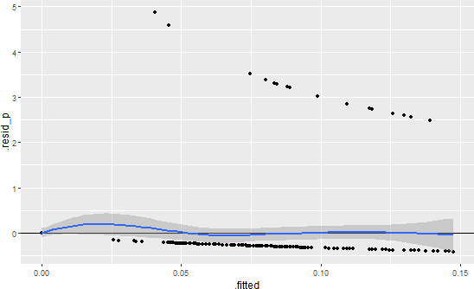

- Severity Assessment of CAP
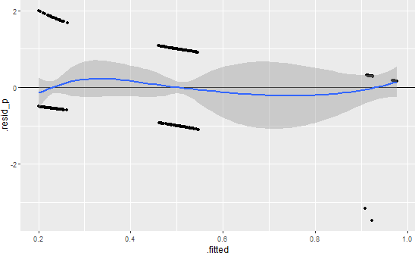

C) Use of Rapid Tests for Pneumococcal and Legionella Antigenuria
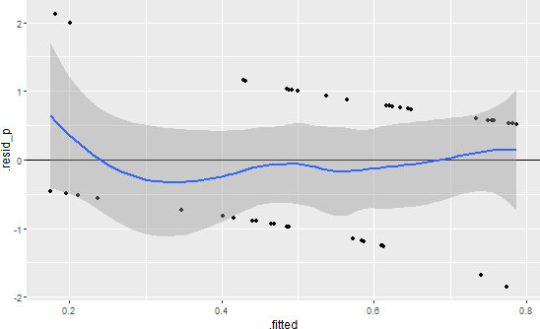

- Adherence of Initial ABT Regimen to National Clinical Guidelines
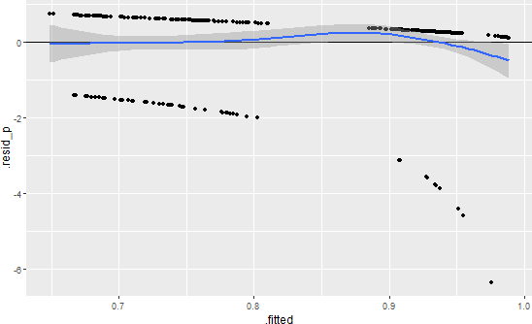

- Step-Down ABT
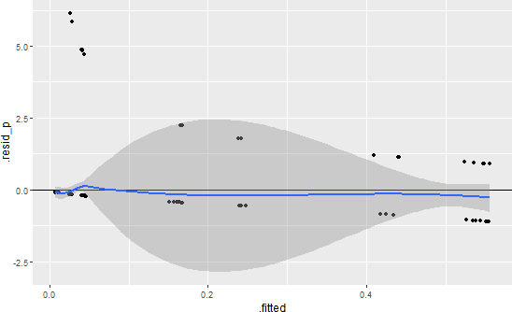

- Effectiveness and Safety Assessment of ABT at 48-72 Hours
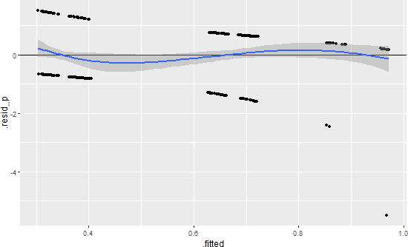

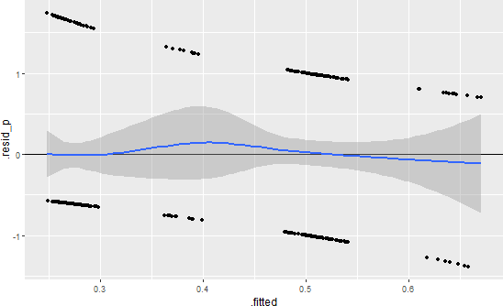
- Assessment of ABT Discontinuation Criteria

APPENDIX A

CHALLENGES IN DIAGNOSING POST-COVID PNEUMONIA IN KAZAKHSTAN – THE ROLE OF POINT-OF-CARE TESTING:
A LETTER TO THE EDITOR

Our results were published as a Letter to the Editor in the Iranian Journal of Medical Sciences, which is indexed in Scopus and ranked in the 72nd percentile according to CiteScore metrics, and is available at the following link: Ablakimova, N., Rachina, S., Smagulova, G., Mussina, A., Sakhanova, S., Smagulova, D., Kozhantayeva, S., de Silva, H. R. Challenges in Diagnosing Post-COVID Pneumonia in Kazakhstan – The Role of Point-of-Care Testing: A Letter to the Editor. Iranian Journal of Medical Sciences, 2025; 50(9): 654-657.
DOI: 10.30476/ijms.2025.105571.3939

Authors and Affiliations:
Nurgul Ablakimova ^{1, 2*}, Svetlana Rachina ³, Gaziza Smagulova ¹, Aigul Mussina ¹, Svetlana Sakhanova ⁴, Daniya Smagulova ⁵, Sarkyt Kozhantayeva ⁶, Heshan Radeesha de Silva ³

¹ Department of Pharmacology, Clinical Pharmacology, West Kazakhstan Marat Ospanov Medical University, Aktobe, Kazakhstan
² Department of Hospital Pharmacy, Regional Perinatal Center, Aktobe, Kazakhstan
³ Hospital Therapy Department No. 2, I.M.Sechenov First Moscow State Medical University, Moscow, Russia
⁴ Scientific and Practical Center, Kazakhstan Marat Ospanov Medical University, Aktobe, Kazakhstan
⁵ Department of Natural Sciences, West Kazakhstan Marat Ospanov Medical University, Aktobe, Kazakhstan
⁶ Department of Otolaryngology and Ophthalmology, West Kazakhstan Marat Ospanov Medical University, Aktobe, Kazakhstan

Dear Editor
Community-acquired pneumonia (CAP) remains a major public health challenge worldwide.1 Empirical antimicrobial therapy for CAP must balance broad-spectrum coverage with judicious use to address rising antibiotic resistance. Therefore, establishing microbiological epidemiology data is essential to propose the most appropriate treatment.
The coronavirus disease 2019 (COVID-19) pandemic has altered the etiology of adult lung injury, with a greater emphasis on viruses. However, its impact on the causative structure of CAP remains unclear.
We conducted a cross-sectional study from January to June 2024 in two multidisciplinary hospitals in Aktobe, Kazakhstan, to evaluate the etiology of CAP in the post-COVID period. This study was approved by the Local Ethical Committee of the West Kazakhstan Marat Ospanov Medical University (Approval no:1; dated 24.01.2023). Written informed consent was obtained from all patients. The study included 184 hospitalized adults diagnosed with CAP. Examination and treatment followed clinical practice and local guidelines. To determine the etiology of CAP, culture testing of lower respiratory tract samples (sputum) was performed, along with rapid urinary antigen tests for Legionella and Streptococcus (S.) pneumoniae (Vegal Pharmaceuticals, Spain). Polymerase Chain Reaction (PCR) testing for atypical pathogens (Mycoplasmoides (M.) pneumoniae and Chlamydia (C.) pneumonia) was conducted using the DT-95 DNA amplifier (DNA Technology, Russia). Additionally, immunochromatographic rapid tests for influenza A/B and severe acute respiratory syndrome coronavirus 2 (SARS-CoV-2) antigen detection were performed using respiratory swabs (Rapid Bio, Russia). Immunochromatographic rapid tests were conducted for all patients; urinary antigen tests were performed in severe CAP cases, and sputum cultures or PCR testing were carried out for patients able to provide sputum samples. Key characteristics, comorbidities, and diagnostic method distribution are detailed in table 1.

Table 1. Patient’s characteristics
Characteristics | Value
Demographic characteristics
Age, years (median [IQR]) | 55 [35.5; 69]
Female, n | 104 (56.5%)
Comorbidities
Arterial hypertension, n | 98 (53.3%)
COPD, n | 31 (16.8%)
CHF, n | 40 (21.7%)
Anemia, n | 38 (20.7%)
Diabetes mellitus, n | 28 (15.2%)
Ischemic heart disease, n | 30 (16.3%)
Diagnostic approaches
Immunochromatographic rapid tests, n | 184 (100%)
PCR testing, n | 92 (50%)
Culture testing, n | 91 (49.5%)
Rapid urinary antigen tests, n | 22 (12%)
Outcomes
Length of stay, days (median [IQR]) | 8 [7; 9]
Hospital mortality, n | 8 (4.3%)
COPD - Chronic obstructive pulmonary disease, CHF – Chronic heart failure, PCR – polymerase chain reaction;

Among 91 sputum samples collected for culture testing, 60 were excluded after bacterial microscopy and were not further cultivated. PCR testing was performed on 92 respiratory samples. An etiological diagnosis was established in 53 (28.8%) patients using at least one diagnostic method. Among 61 detected pathogens, the most prevalent were M. pneumoniae 21 (34.4%), S. pneumoniae 12 (19.7%), Klebsiella pneumoniae 7 (11.5%), C. pneumoniae 6 (9.8%), and Moraxella catarrhalis 6 (9.8%) cases (figure 1). Viruses were less common, with only 1 case of SARS-CoV-2 infection was identified. Co-infections were observed in 18.9% of patients with established etiological diagnoses, including the following combinations: M. pneumoniae + S. pneumonia (2 cases, 3.8%), C. pneumoniae + S. pneumoniae (2 cases, 3.8%), C. pneumoniae + Haemophilus (H.) influenza (2 cases, 3.8%), M. pneumoniae + H. influenzae (2 cases, 3.8%), M. pneumoniae + M. catarrhalis (1 case, 1.9%), and M. pneumoniae + SARS-CoV-2 (1 case, 1.9%).

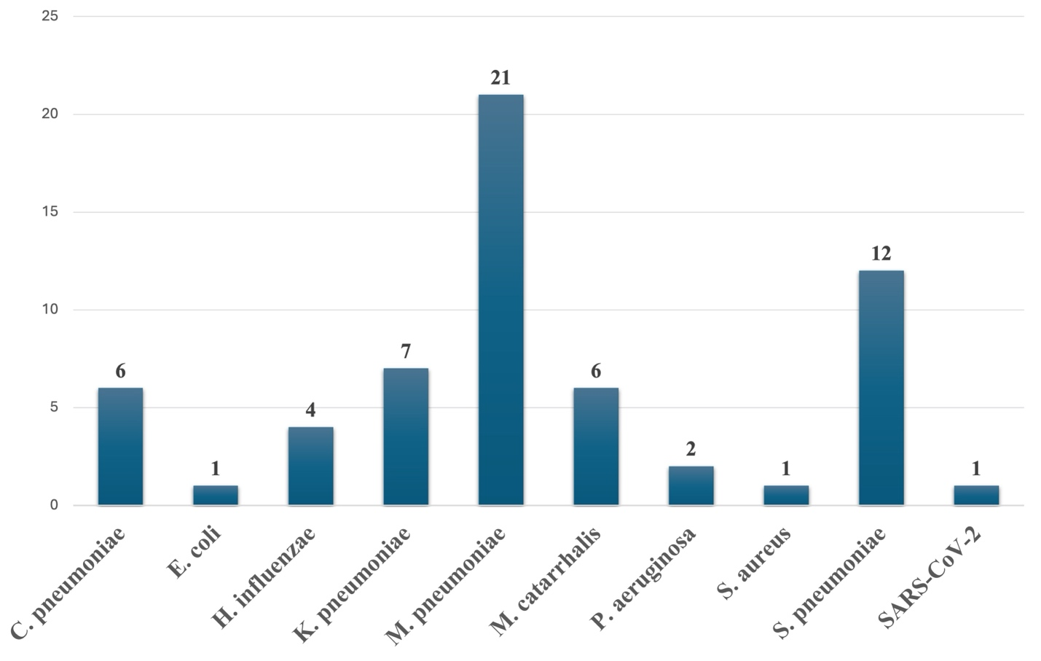
Figure 1. The bar chart illustrates the frequency of different pathogens in patients with community-acquired pneumonia in Aktobe, Kazakhstan.

To our knowledge, this is the first post-COVID-19 study in Kazakhstan to examine CAP etiology in hospitalized adults, using comprehensive PCR and point-of-care (POC) testing.
In the pre-antibiotic era, pneumococcus caused 90-95% of pneumonia cases. However, its prevalence has significantly declined due to widespread pneumococcal vaccination, reduced smoking, early empiric antibiotic use, and improved PCR diagnostics which enabled better detection of atypical and viral pathogens.2
Large pre-pandemic studies indicated viral pathogens were more prevalent than bacterial causes in pneumonia cases.3 However, the findings of the present study indicated only one case of SARS-CoV-2, and no influenza A and B viruses were detected.
The prevalence of atypical pathogens such as M. pneumoniae over pneumococcus might stem from poor sputum quality, underestimating pneumococcal pneumonia. Conventional culture, the gold standard for bacterial detection in CAP, has limited sensitivity and serotype identification, especially in adults.4 Additionally, antibiotic pretreatment further diminishes bacterial culture sensitivity. In the present study, one-third of pneumococcal cases were detected using rapid urinary antigen tests, which were not affected by previous antibiotic use, and thus provide a reliable detection method despite prior therapy. The patient population indicated frequent hospitalization of patients with mild pneumonia who could have been managed outpatient. This hospitalization pattern might also influence the CAP etiology. Notably, we detected a predominance of M. pneumoniae infections, consistent with its known epidemiological pattern of regional outbreaks occurring every 3-7 years and lasting 1-2 years. This finding was consistent with other post-pandemic reports of increased M. pneumoniae detection in adults.5
In conclusion, the etiology of CAP in adults in our region appeared unchanged from the pre-COVID era. Given the frequent detection of hard-to-culture bacteria, broader PCR use in clinical practice is recommended. An important consideration was that many pneumonia patients either could not produce sputum or provided poor-quality samples, which significantly compromised microscopy-based diagnostic pathways.
To address this limitation, broader implementation of POC testing should be prioritized. These rapid diagnostic tools enable reliable CAP etiology determination even when traditional culture-based methods are precluded by insufficient or poor-quality biological specimens.
Authors’ Contribution
N.A: Conceptualization, formal analysis, investigation, methodology, writing original draft; S.R: Conceptualization, formal analysis, investigation, methodology, supervision, reviewing and editing; G.S: Supervision, reviewing and editing; A.M, S.S, D.S, S.K, H.R: Data curation, reviewing and editing. All authors have read and approved the final manuscript and agree to be accountable for all aspects of the work in ensuring that questions related to the accuracy or integrity of any part of the work are appropriately investigated and resolved.
Conflict of Interest: None declared.
References
1 Zhou F, Wang Y, Liu Y, Liu X, Gu L, Zhang X, et al. Disease severity and clinical outcomes of community-acquired pneumonia caused by non-influenza respiratory viruses in adults: a multicentre prospective registry study from the CAP-China Network. Eur Respir J. 2019;54. doi: 10.1183/13993003.02406-2018. PubMed PMID: 31164430.
2 Yasuo S, Murata M, Nakagawa N, Kawasaki T, Yoshida T, Ando K, et al. Diagnostic accuracy of urinary antigen tests for pneumococcal pneumonia among patients with acute respiratory failure suspected pneumonia: a systematic review and meta-analysis. BMJ Open. 2022;12:e057216. doi: 10.1136/bmjopen-2021-057216. PubMed PMID: 35953247; PubMed Central PMCID: PMCPMC9379505.
3 Alimi Y, Lim WS, Lansbury L, Leonardi-Bee J, Nguyen-Van-Tam JS. Systematic review of respiratory viral pathogens identified in adults with community-acquired pneumonia in Europe. J Clin Virol. 2017;95:26-35. doi: 10.1016/j.jcv.2017.07.019. PubMed PMID: 28837859; PubMed Central PMCID:
4 Ogawa H, Kitsios GD, Iwata M, Terasawa T. Sputum Gram Stain for Bacterial Pathogen Diagnosis in Community-acquired Pneumonia: A Systematic Review and Bayesian Meta-analysis of Diagnostic Accuracy and Yield. Clin Infect Dis. 2020;71:499-513. doi:10.1093/cid/ciz876. PubMed PMID: 31504334; PubMed Central PMCID: PMCPMC7384319.
5 Goeijenbier M, van der Bie S, Souverein D, Bolluyt D, Nagel M, Stoof SP, et al. Post COVID-19 Pandemic Increased Detection of Mycoplasma Pneumoniae in Adults Admitted to the Intensive Care. J Clin Med. 2024;13. doi: 10.3390/jcm13123443. PubMed PMID: 38929972; PubMed Central PMCID: PMCPMC11204797.

APPENDIX B

DIAGNOSING PNEUMONIA IN REAL TIME: RAPID DIAGNOSTIC TESTS AS GAME-CHANGERS IN MANAGEMENT STRATEGIES

The article was published in the West Kazakhstan Medical Journal, which is included in the List of publications recommended by the Committee for Quality Assurance in the Sphere of Education of the Ministry of Education of the Republic of Kazakhstan for the publication of the main results of scientific activity, and is available at the following link: Ablakimova N. Diagnosing pneumonia in real time: rapid diagnostic tests as game-changers in management strategies. West Kazakhstan Medical Journal. 2024;66(2):111-8.
DOI: 10.18502/wkmj.v66i2.16453

Authors and Affiliations:
Nurgul Ablakimova¹*

¹Department of Pharmacology, Clinical Pharmacology, West Kazakhstan Marat Ospanov Medical University, Aktobe, Kazakhstan

Keywords: pneumonia, pathogen, antibiotic resistance, global health, diagnostics

1. Introduction
Pneumonia, a prevalent respiratory infection, remains a substantial global health challenge due to its potential severity and impact on public health [1]. In spite of the swift advancement in novel therapies, pneumonia remains a significant contributor to elevated rates of health complications and mortality [2]. Characterized as a sudden infection affecting the lung’s parenchyma, it arises from a diverse range of microorganisms, encompassing bacteria, viruses, and fungi [3]. The identification of the responsible organism becomes exceptionally valuable when it leads to a shift in treatment approach. Diagnostic strategies exhibit variability based on the seriousness of the ailment and the suspected pathogen. The consensus among most healthcare practitioners is that microbiologic tests in outpatient settings are likely to yield limited results and contribute minimally to the selection and duration of antibiotic courses [4]. Among hospitalized individuals, especially those afflicted by severe sepsis or septic shock, pinpointing the causative microorganism can notably enhance survival rates [5]. For all hospitalized patients who exhibit purulent sputum, it is imperative to subject it to Gram staining and culture analysis [6]. In scenarios where patients lack purulent sputum or are incapable of providing lower respiratory samples, culture outcomes may lack precision and frequently reflect upper respiratory tract or oropharyngeal colonizers rather than actual pathogens [7]. Routine blood cultures in cases of pneumonia exhibit minimal effectiveness and usefulness, regardless of the severity and risk factors involved [8]. Moreover, collecting cultures after the initiation of antibiotic therapy can significantly impact diagnostic informativeness [9]. Early and accurate diagnosis is a cornerstone of effective pneumonia management [10]. The advent of rapid diagnostic tests (RDTs) has ushered in a new era of diagnostics, promising real-time identification of pathogens and influencing treatment strategies [11]. In this review, we explore the transformative potential of RDTs in the management of pneumonia.
2. Traditional Diagnostic Approaches for Pneumonia
The typical manifestation of pneumonia involves the sudden onset of infectious symptoms affecting the lower respiratory tract, accompanied by consistent radiographic patterns. These symptoms often encompass fever, cough, pleurisy, shortness of breath, and heightened sputum production. However, pneumonia’s presentation can deviate from the norm, with some individuals primarily experiencing nonrespiratory symptoms like general discomfort, muscle pain, confusion, and diarrhea. Among the elderly, this atypical presentation may occur more frequently, potentially causing delays in treatment and elevated mortality rates. To establish a pneumonia diagnosis, it’s crucial to have radiographic evidence of lung involvement. The appearance of pneumonia on radiographs can vary significantly. While computed tomography (CT) offers the most detailed detection of lung infiltrates, plain chest X-rays are more common, especially in outpatient settings. Although CT scans provide more specific information (refer to Figures 1D–F), they have downsides such as increased radiation exposure, inability to be done at the bedside, and real-time interpretation challenges.
Plain chest X-rays have a limited sensitivity of 38%–75% for identifying infiltrates. In critical cases, the less optimal anteroposterior view is often used, and image quality suffers due to factors like weak inhalation, obesity, and suboptimal positioning.
Point-of-care ultrasonography has emerged as an alternative to plain chest X-rays for detecting lung consolidations. Its advantages include real-time bedside imaging and interpretation, absence of radiation exposure, and better sensitivity com- pared to X-rays. Distinguishing between lung consolidation and pleural effusion is also easier with ultrasonography. However, achieving sensitivities above 95%, as reported in some literature, requires skilled practitioners to evaluate the lungs from various angles, which can be time-consuming.
For individuals suspected of having pneumonia, standard laboratory tests are generally recommended, particularly when hospitalization becomes necessary. A complete blood cell count can reveal an elevated white blood cell count or the presence of immature white blood cells, indicative of an acute infection. Serum chemistry analysis can offer insights into potential organ involvement, like liver or kidney dysfunction, and contribute valuable data for assessing the severity of pneumonia.
Procalcitonin (PCT) is a serum protein that gets released when the body responds to bacterial infections. Notably, its release is suppressed during viral infections through the action of interferon gamma, an inhibitory cytokine. This characteristic renders PCT a valuable biomarker for distinguishing between viral and bacterial causes of community-acquired pneumonia (CAP). In various studies involving both outpatient and inpatient groups, setting a lower threshold value for PCT has been shown to discourage unnecessary antibiotic use, resulting in reduced antibiotic consumption without adversely affecting mortality rates. However, due to the significant risks associated with delaying or withholding essential antibiotics in pneumonia, there isn’t a unanimous consensus on the routine use of PCT in this context. Moreover, the latest treatment guidelines do not currently include its routine use.
Traditional methods of diagnosing pneumonia, including clinical assessment, chest radiography, and microbiological testing, have long been the mainstays of medical practice. While these methods have provided valuable insights into the presence of infection, they are not without limitations. Clinical symptoms often overlap with other respiratory conditions [12], chest radiography lacks specificity [12], and microbiological cultures can be time-consuming and result in false positives due to contamination [13].
3. The Rise of Rapid Diagnostic Tests
The emergence of RDTs represents a paradigm shift in pneumonia diagnostics. These tests harness advanced molecular and immunochromatographic technologies to swiftly detect specific pathogen markers (Table 1) [14]. The speed of these tests has the potential to transform the diagnostic landscape, enabling real-time identification and timely initiation of appropriate treatment [15]. Unlike traditional methods that rely on time-consuming cultures or complex molecular assays, RDTs deliver results within minutes, allowing healthcare providers to make prompt and precise treatment decisions. This advancement is particularly crucial in the context of pneumonia, where timely intervention can be a matter of life and death. Furthermore, RDTs are instrumental in combatting the global challenge of antibiotic resistance, as they enable clinicians to differentiate between bacterial and viral infections, reducing unnecessary antibiotic prescriptions [16]. As we witness the rise of RDTs in the field of pneumonia diagnosis, we move closer to achieving more efficient and targeted patient care, ultimately improving outcomes for individuals affected by this respiratory condition. Urinary antigen testing has gained widespread popularity for numerous impactful respiratory infections, notably those caused by Legionella pneumophila (L.pneumophila) and Streptococcus pneumoniae (S.pneumoniae) [17] These tests are considerably less affected by previous antibiotic treatment compared to sputum or blood culture [18].
4. Mechanisms and Technologies Behind Rapid Diagnostic Tests
Antigen shedding: When a person is infected with certain bacteria, such as L.pneumophila or S.pneumoniae, the bacteria shed specific antigens. Antigens are substances produced by the bacteria that trigger an immune response in the body.
Urine collection: The patient provides a urine sample. Unlike traditional diagnostic methods that require samples from the respiratory tract, urinary antigen tests offer a noninvasive and easily accessible alternative.
Immunoassay detection: The urine sample is then subjected to an immunoassay, which is a laboratory technique that relies on the specific binding of antibodies to antigens. In the case of urinary antigen testing, the test employs capture antibodies that are specific to the antigens produced by the target bacteria (Figure 1).
Enzyme-Linked Immunosorbent Assay (ELISA) or Immunochromatographic/Lateral Flow Assay (LFA): The immunoassay can take different forms, such as an enzyme-linked immunosorbent assay (ELISA) or an immunochromatographic/lateral flow assay (LFA). ELISA involves the use of enzymes to produce a color change when the target antigen is present. LFA, on the other hand, produces visible lines on a test strip [17].
Positive or negative result: If the specific antigens related to L.pneumophila or S.pneumoniae are present in the urine, the test will yield a positive result. This indicates an active infection with the respective pathogen. Conversely, a negative result suggests the absence of these specific antigens.
Interpretation and diagnosis: A positive result can be indicative of pneumonia caused by the targeted bacteria, influencing treatment decisions. However, a negative result does not rule out pneumonia entirely, as these tests may not detect all strains or species of the pathogens.

Table 1: Comparison of detection methods of pneumonia pathogens.

Test | Time | Advantages and Disadvantages
Culture method | 3–7 days | Likely to identify true pathogen if detected. it is advisable to isolate it for susceptibility testing and conduct further investigations such as serotyping and sequencing. Obtaining a high-quality specimen from sputum can be challenging, and it’s important to note that bacteremia is not always linked with pneumonia.
Molecular assays | 2–4 hours | Rapid outcomes, high sensitivity, and the potential inclusion of susceptibility or other genetic markers (such as species or serotyping) are advantages. However, there is no isolate available for additional testing, and the approach lacks standardization, with various laboratory-developed tests in use.
Serology | 2 hours–2 days | Valuable for epidemiological investigations and capable of differentiating Pneumo-
Serology | 2 hours–2 days | coccus serotypes. However, not suitable for acute diagnosis, lacks an isolate for
Serology | 2 hours–2 days | additional testing, and results may be influenced by prior pneumococcal vaccination.
Urinary antigen test | 15 minutes | Swift and highly specific, enabling prompt adjustments to therapy upon a positive result, FDA-approved tests are accessible. Narrow number of pathogens that can be identified. Moreover, there is no isolate for subsequent testing.

5. Comparative Sensitivity and Specificity
The sensitivity and specificity of RDTs compared to traditional methods have been subjects of rigorous evaluation. Legionella urine antigen assays utilize specific capture antibodies for L.pneumophila serogroup 1, recognized as the primary cause of Legionnaires’ disease (LD). Consequently, these assays demonstrate optimal performance in the context of L.pneumophila serogroup 1 infections, exhibiting a combined clinical sensitivity and specificity of 74% and 99%, respectively, for LD, as indicated by a comprehensive meta-analysis [19]. Notably, these sensitivity findings are considerably lower than the individual claims made by each manufacturer. Essentially, the pooled clinical test performance suggests that a positive Legionella antigen test can indicate LD, but a negative result cannot reliably rule out the diagnosis. However, these assays poorly detect other serogroups of L. pneumophila and non-pneumophila Legionella species (sensitivity ranging from 5%–40%), potentially leading to an underestimation of the true clinical significance of these organisms [20].
The immunochromatographic (ICT) urinary antigen test is particularly advantageous for detecting pneumococcal pneumonia in situations where obtaining timely cultures is challenging or when antibiotic therapy has already been initiated. In sequential specimens from confirmed bacteremic cases, the ICT assay could still detect the pneumococcal urinary antigen in 83% of the cases even after 3 days of therapy [21]. This form of urinary antigen testing offers key additional benefits, including rapid results (around 15 minutes), simplicity, and reasonable specificity in adults. Studies in adults have demonstrated a sensitivity ranging from 50%–80% and a specificity exceeding 90% [22]. In a specific study, the use of the ICT pneumococcal urinary antigen test increased the rate of identifying the cause of community-acquired pneumonia (CAP) from 39.1%–53.1%. Among 269 patients without a defined etiology using conventional methods, 25.7% showed a positive pneumococcal urinary antigen test. Moreover, the immunochromatography assay is highly accurate in diagnosing pneumococcal meningitis, with a sensitivity of 95% using cerebrospinal fluid and 57% using urine, along with 100% specificity [23].

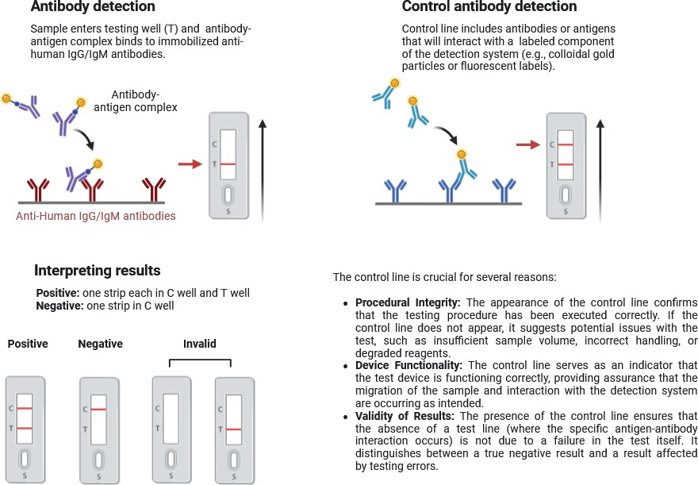

Figure 1: Assay principle and visual result interpretation.

6. Clinical Implementation and Impact
Tests for LD and pneumococcal CAP in urine are quick and easily accessible laboratory methods. These should be integrated into all testing procedures for CAP. Because clinical implementation of RDTs for pneumonia has ushered in a new era of precision and efficiency in patient management [24]. By significantly reducing diagnostic turnaround times, RDTs enable clinicians to swiftly identify the causative agents of pneumonia, allowing for the prompt initiation of targeted treatments. This not only enhances patient outcomes but also contributes to the global effort to combat antibiotic resistance by minimizing the inappropriate use of antibiotics. Furthermore, RDTs play a pivotal role in optimizing healthcare resource utilization, as they reduce the need for extensive laboratory infrastructure and the associated costs. The impact of these tests is especially notable in critical care settings, where rapid and accurate diagnoses are paramount. As RDTs continue to evolve and become more widely adopted, they are poised to revolutionize pneumonia management, driving improvements in patient care, antimicrobial stewardship, and healthcare efficiency.

7. Challenges and Considerations
Despite their numerous advantages, the implementation of RDTs for pneumonia does come with some notable challenges and considerations. One significant challenge is the cost associated with acquiring and maintaining these specialized testing systems, which may limit their accessibility, particularly in resource-constrained healthcare settings [25]. Additionally, the accuracy of RDTs can be influenced by factors like sample quality and timing, necessitating strict adherence to proper testing protocols. Furthermore, the everevolving landscape of infectious pathogens poses a challenge for RDT developers to ensure broad pathogen coverage. Urinary antigen detection tests continue to have significant limitations, including their inability to identify all pneumococcus serotypes and other species of Legionella [24]. The interpretation of RDT results also demands a level of expertise, highlighting the need for training and education for healthcare professionals. Moreover, while RDTs can differentiate between viral and bacterial infections to some extent, they may not always provide the full spectrum of information required for precise treatment decisions. These challenges and considerations underscore the importance of carefully evaluating the role of RDTs in pneumonia diagnosis and treatment within the context of each healthcare setting and patient population.

8. Future Directions and Innovations
The rapid diagnostic field continues to evolve, with ongoing research focused on refining existing technologies and developing novel approaches. The integration of artificial intelligence and machine learning is poised to enhance diagnostic accuracy further, potentially predicting disease severity and guiding treatment decisions. Well- designed studies are now essential to assess the usefulness of these tests in relation to clinical outcomes. Continued collaboration between researchers, clinicians, and industry stakeholders will shape the future landscape of rapid pneumonia diagnostics.

9. Conclusion
In conclusion, RDTs have emerged as game-changers in the management of pneumonia. By offering real-time pathogen identification, these tests contribute to optimized treatment strategies, reduced antibiotic misuse, and improved patient care. As the field advances, it is crucial to address challenges and maintain a vigilant approach to research, development, and implementation, ultimately ensuring better outcomes for individuals affected by pneumonia. RDTs, strategically integrated into the diagnostic process and selectively utilized for patients who stand to gain the most from these technologies, could serve as a compelling and practical tool. This approach has the potential to enhance the precision of treatment timing, particularly concerning the timely adjustment or cessation of antibiotic therapy.

References
[1] Watkins K, Sridhar D. Pneumonia: a global cause without champions. The Lancet. 2018;392(10149):718-9.
[2] Lopardo GD, Fridman D, Raimondo E, Albornoz H, Lopardo A, Bagnulo H, et al. Incidence rate of community-acquired pneumonia in adults: A population-based prospective active surveillance study in three cities in South America. BMJ open. 2018;8(4):e019439.
[3] Lanks CW, Musani AI, Hsia DW. Community-acquired pneumonia and hospital-acquired pneumonia. Med- ical Clinics. 2019;103(3):487-501.
[4] van der Eerden MM, Vlaspolder F, de Graaff CS, Groot T, Jansen HM, Boersma WG. Value of intensive diagnostic microbiological investigation in low- and high-risk patients with community-acquired pneumonia. Eur J Clin Microbiol Infect Dis. 2005;24(4):241-9.
[5] Uematsu H, Hashimoto H, Iwamoto T, Horiguchi H, Yasunaga H. Impact of guideline-concordant microbiological testing on outcomes of pneumonia. Int J Qual Health Care. 2013;26(1):100-7.
[6] Mandell LA, Wunderink RG, Anzueto A, Bartlett JG, Campbell GD, Dean NC, et al. Infectious diseases society of America/American thoracic society consensus guidelines on the management of community-acquired pneumonia in adults. Clin Infect Dis. 2007;44(Supplement_2):S27-S72.
[7] Nakajima M, Umezaki Y, Takeda S, Yamaguchi M, Suzuki N, Yoneda M, et al. Association between oral candidiasis and bacterial pneumonia: A retrospective study. Oral Dis. 2019;26(1):234-7.
[8] Zhang D, Yang D, Makam AN. Utility of blood cultures in pneumonia. The Am J Med. 2019;132(10):1233-8.
[9] Musher DM, Montoya R, Wanahita A. Diagnostic value of microscopic examination of Gram-stained sputum and sputum cultures in patients with bacteremic pneumococcal pneumonia. Clin Infect Dis. 2004;39(2):165-9.
[10] Huang Y, Liu A, Liang L, Jiang J, Luo H, Deng W, et al. Diagnostic value of blood parameters for community-acquired pneumonia. Int immunophar- macol. 2018;64:10-5.
[11] Miyashita N, Kawai Y, Yamaguchi T, Ouchi K, Oka M, Group APS. Clinical potential of diagnostic methods for the rapid diagnosis of mycoplasma pneumoniae pneumonia in adults. Eur J Clin Microbiol Infect Dis. 2011;30:439-46.
[12] Niederman MS. Imaging for the management of community-acquired pneumonia: What to do if the chest radiograph is clear. Chest. 2018;153(3):583-5.
[13] Johansson N, Kalin M, Tiveljung-Lindell A, Giske CG, Hedlund J. Etiology of community-acquired pneumonia: Increased microbiological yield with new diagnostic methods. Clin Infect Dis. 2010;50(2):202- 9.
[14] Le Dorze M, Gault N, Foucrier A, Ruppé E, Mourvillier B, Woerther P, et al. Performance and impact of a rapid method combining mass spectrometry and direct antimicrobial susceptibility testing on treatment adequacy of patients with ventilator- associated pneumonia. Clin Microbiol and Infect. 2015;21(5):468. e1-. e6.
[15] Monard C, Pehlivan J, Auger G, Alviset S, Tran Dinh A, Duquaire P, et al. Multicenter evaluation of a syndromic rapid multiplex PCR test for early adaptation of antimicrobial therapy in adult patients with pneumonia. Critical Care. 2020;24(1):434.
[16] Sinclair A, Xie X, Teltscher M, Dendukuri N. Systematic review and meta-analysis of a urine-based pneumococcal antigen test for diagnosis of community- acquired pneumonia caused by Streptococcus pneumoniae. J Clin Microbiol. 2013;51(7):2303-10.
[17] Couturier MR, Graf EH, Griffin AT. Urine antigen tests for the diagnosis of respiratory infections: legionellosis, histoplasmosis, pneumococcal pneumonia. Clin Lab Med. 2014;34(2):219-36.
[18] File TM, Jr. New diagnostic tests for pneumonia: What is their role in clinical practice? Clin Chest Med. 2011;32(3):417-30.
[19] Shimada T, Noguchi Y, Jackson JL, Miyashita J, Hayashino Y, Kamiya T, et al. Systematic review and metaanalysis: Urinary antigen tests for Legionellosis. Chest. 2009;136(6):1576-85.
[20] Fields BS, Benson RF, Besser RE. Legionella and Legionnaires’ disease: 25 years of investigation. Clin Microbiol Rev. 2002;15(3):506-26.
[21] Smith MD, Derrington P, Evans R, Creek M, Morris R, Dance DA, et al. Rapid diagnosis of bacteremic pneumococcal infections in adults by using the Binax NOW Streptococcus pneumoniae urinary antigen test: a prospective, controlled clinical evaluation. J Clin Microbiol. 2003;41(7):2810-3.
[22] Selickman J, Paxos M, File Jr TM, Seltzer R, Bonilla H. Performance measure of urinary antigen in patients with Streptococcus pneumoniae bacteremia. Diagn Microbiol Infect Dis. 2010;67(2):129-33.
[23] Samra Z, Shmuely H, Nahum E, Paghis D, Ben-Ari J. Use of the NOW Streptococcus pneumoniae urinary antigen test in cerebrospinal fluid for rapid diagnosis of pneumococcal meningitis. Diagn Microbiol Infect Dis. 2003;45(4):237-40.
[24] Viasus D, Calatayud L, McBrown MV, Ardanuy C, Carratalà J. Urinary antigen testing in community- acquired pneumonia in adults: An update. Expert RevAnti Infect Ther. 2019;17(2):107-15.
[25] Bellew S, Grijalva CG, Williams DJ, Anderson EJ, Wunderink RG, Zhu Y, et al. Pneumococcal and Legionella urinary antigen tests in community-acquired pneumonia: Prospective evaluation of indications for testing. Clin Infect Dis. 2019;68(12):2026- 33.

APPENDIX C

IMPLEMENTATION ACTS CONFIRMING THE INTRODUCTION OF THE RESEARCH RESULTS INTO PRACTICAL HEALTHCARE

