KIMEP University

UDC 338.2 On Manuscript Copyright

YU TONGXIN

Factors Influencing Entrepreneurial Intention among Foreigners in Kazakhstan

6D050700 – Management

Dissertation for the Scientific Degree of
Doctor of Philosophy (PhD)

Main Supervisor
Nadeem Khalid
(PhD, Professor, KIMEP University, Kazakhstan)

External Supervisor
Umair Ahmed
(PhD, Professor, Arab Open University, Bahrain)

Republic of Kazakhstan
Almaty, 2023
CONTENT

NORMATIVE REFERENCES………………………………………......….. | 7
DEFINITIONS…………………………………………………………….…. | 8
DESIGNATIONS AND CONTRACTIONS……………………………. ….. | 10
INTRODUCTION……………………………………………………………. | 13
1 CONTEXT OF ENTREPRENEURSHIP IN KAZAKHSTAN…………. | 29
1.1 Introduction………………………………………………………………... | 29
1.2 Profile of Kazakhstan…………………………………………………….... | 30
1.2.1 Geography……………………………………………………………….. | 30
1.2.2 People………………………………………………………………......... | 30
1.2.3 History………………………………………………………………….... | 30
1.2.4 Government and Political System………………………………………... | 31
1.2.5 Economy…………………………………………………………….….... | 31
1.2.6 Foreign Relations………………………………………………………… | 33
1.2.7 Language………………………………………………………................ | 33
1.3 Overview of Business Climate in Kazakhstan……………………….……. | 33
1.4 Entrepreneurship Ecosystem (EE) in Kazakhstan…………………………. | 34
1.4.1 Access to Finance………………………………………………………... | 35
1.4.2 Government Support (GS)……………………………………………….. | 35
1.4.3 Education and Training…………………………………………….……. | 37
1.4.4 R&D Transfer……………………………………………………………. | 38
1.4.5 Commercial and Legal Infrastructures………………………………….... | 38
1.4.6 Internal Market…………………………………………………………... | 38
1.4.7 Physical Infrastructure………………………………………………….... | 38
1.4.8 Socio-cultural Norms……………………………………………............. | 39
1.4.9 Senior Entrepreneurship…………………………………………………. | 39
1.4.10 Foreign Entrepreneurship………………………………………………. | 39
1.5 Synthetic View and International Position of Kazakhstan’s EE…………… | 40
1.5.1 Synthetic View…………………………………………………………... | 40
1.5.2 International Position……………………………………………………. | 40
1.6 Main Constraints and Facilitators of Entrepreneurship in Kazakhstan...….. | 41
Summary of the Chapter…………………………………….………………..... | 41
2 LITERATURE REVIEW……………………………………….…….….... | 43
2.1 Introduction…………………………………………….……….…………. | 43
2.2 Definition and Conceptualization of Entrepreneurial Intention (EI)……..... | 43
2.3 Approaches to Research on EI………………………….………………….. | 44
2.3.1 Content-oriented EI Research………………………….………………… | 44
2.3.2 Process-oriented EI Research……………………………………………. | 45
2.4 Approach to EI Research in This Study………………………………….... | 45
2.4.1 TPB Explaining EI…………………………………….………………..... | 46
2.4.1.1 Personal Attitude (PA) ……………………………………………...…. | 47
2.4.1.2 Subjective Norms (SNs)……………………………………...………... | 47
2.4.1.3 Perceived Behavioral Control (PBC)……………………………….….. | 48
2.4.2 Applicability of TPB in EI Research………………….…………………. | 49
2.4.3 Extension of TPB in EI Research………………………………………… | 50
2.5 Single Factors Influencing EI………………………………………………. | 51
2.5.1 Demographic Factors…………………………………………………….. | 52
2.5.2 Personality or Personal Factors………………………………….………. | 52
2.5.3 Situational Factors……………………………………………….………. | 52
2.5.4 Cognitive Factors……………………………………………………….... | 53
2.5.5 Social Factors…………………………………………………………….. | 53
2.5.6 Environmental Factors………………………………………………….... | 53
2.6 Combined (Groups of) Single Factors Influencing EI……………………… | 54
2.7 Established Models Explaining EI…………………………………………. | 54
2.7.1 Entrepreneurial Event Model……..………................................................ | 54
2.7.2 Implementing Entrepreneurial Ideas Model……………………………… | 55
2.7.3 Entrepreneurial Attitude Orientation Model…........................................... | 55
2.7.4 Intentional Basic Model………………………………………………….. | 56
2.7.5 Theory of Planned Behavior Entrepreneurial Model…………………….. | 56
2.7.6 Entrepreneurial Potential Model………………......................................... | 56
2.7.7 Personal and Contextual Intention Model……………………….............. | 57
2.7.8 Economic-psychological Model…………………………………………. | 57
2.7.9 Maximization of Expected Utility Model………………………………… | 58
2.7.10 Contextual Intention Model…………………………………………….. | 59
2.8 Hypotheses Formulation and Research Framework……………………….. | 60
2.8.1 Proposed Factors and Hypotheses Formulation……….…………………. | 61
2.8.1.1 PA and EI………………………………………………………………. | 61
2.8.1.2 SNs and EI……………………………………………………………... | 62
2.8.1.3 PBC and EI…………………………………………………………….. | 63
2.8.1.4 Effects of GS………………………..……………………………...…... | 64
2.8.2 Research Framework………………………………………………….…. | 65
Summary of the Chapter……….……………………………………………..... | 66
3 RESEARCH METHODOLOGY………………………………………….. | 67
3.1 Introduction……………………………………………………………. ….. | 67
3.2 Data Collection…………………………………………………………….. | 67
3.2.1 Sampling Method……………………………………………………….... | 67
3.2.1.1 Population and Sampling Frame……………………………………….. | 68
3.2.1.2 Sampling Design……………………………………………………….. | 70
3.2.1.3 Sample Size……………………………………………………………. | 71
3.2.2 Administering Questionnaires…………………………………………… | 72
3.2.2.1 Types of Questionnaire Distribution………………………………….... | 72
3.2.2.2 Questionnaire Design…………………………………………………... | 72
3.2.3 Measuring Instruments and Scaling…………………………………….... | 75
3.2.3.1 Operationalization and Instruments……………………………………. | 75
3.2.3.2 Scaling Technique……………………………………………………... | 76
3.2.4 Goodness of Measures…………………………………………….……... | 77
3.2.4.1 Types of Validity and Reliability………………………………………. | 78
3.2.4.2 Reliability Tests………………………………………………………... | 78
3.2.4.3 Validity Tests…………………………………………………………... | 83
3.2.5 Data Collection Procedure……………………………………………….. | 87
3.3 Data Examination………………………………………………………….. | 89
3.3.1 Analyzing Missing Data…………………………………………………. | 89
3.3.2 Detecting Outliers…………….………………………………………….. | 91
3.3.3 Testing Assumptions of Multivariate Analysis………………………….. | 93
3.3.3.1 Normality………………………………………………………………. | 93
3.3.3.2 Homoscedasticity……………………………………………………… | 94
3.3.3.3 Linearity……………………………………………………………….. | 94
3.3.3.4 Absence of Correlated Errors………………………………………….. | 95
3.4 Data Analysis………………………………………………………………. | 95
3.4.1 Overview of Data Analytical Techniques………………………………... | 95
3.4.2 Descriptive Analysis……………………………………………………... | 96
3.4.3 Pearson’s Correlation Analysis……………………………………….….. | 97
3.4.4 Multiple Regression Analysis……………………………………………. | 97
3.4.4.1 Examination of the “TPB” Model…………………………………….... | 98
3.4.4.2 Examination of the “TPB+Moderator” Model…………………………. | 99
3.4.4.3 Assumptions in the Multiple Regression Analysis…………………….. | 100
3.4.4.4 Assessing the Overall Model’s Fit……………………………………... | 102
3.4.4.5 Interpreting the Regression Variate……………………………………. | 103
3.4.4.6 Validation of the Results………………………………………………. | 105
Summary of the Chapter……………………………………………………….. | 105
4 RESEARCH FINDINGS…………………………………………………... | 107
4.1 Introduction………………………………………………………………... | 107
4.2 Data Examination………………………………………………………….. | 107
4.2.1 Analyzing Missing Data…………...…………………………………….. | 107
4.2.2 Detecting Outliers….……………………..……………………………… | 107
4.2.3 Testing Normality………………………………………………………... | 119
4.2.4 Testing Homoscedasticity……………………………………………….. | 127
4.2.5 Testing Linearity…………………………………………………………. | 128
4.2.6 Testing Independence of the Residuals……………………….………….. | 129
4.2.7 Recap of the Data Examination……………………..………………….... | 132
4.3 Descriptive Analysis……………………………………………………….. | 133
4.4 Pearson’s Correlation Analysis…………………………………………….. | 135
4.5 Multiple Regression Analysis…………………………………………….... | 135
4.5.1 Assessing the Overall Model’s Fit………………………………………. | 137
4.5.1.1 Significance Tests of Coefficient of Determination (R²)………………. | 137
4.5.1.2 Significance Tests of Regression Coefficients…………………………. | 138
4.5.2 Interpreting the Regression Results…………………………………….... | 138
4.5.2.1 Assessing the Variables’ Importance…………………….…………….. | 138
4.5.2.2 Identifying Multicollinearity…………………………………………... | 140
4.5.2.3 Examining Correlations………………………………………………... | 140
4.5.3 Validating the Results……………………………………………………. | 141
4.5.4 Justification of the Hypotheses under Study……………………………... | 143
Summary of the Chapter……………………………………………………….. | 144
5 DISCUSSIONS AND IMPLICATIONS………………………………….. | 146
5.1 Introduction……………………………………………….……………….. | 146
5.2 Discussions on Research Findings…………………………….................... | 146
5.2.1 PA versus EI of Foreigners in Kazakhstan………………………............. | 146
5.2.2 SNs versus EI of Foreigners in Kazakhstan………………………............ | 147
5.2.3 PBC versus EI of Foreigners in Kazakhstan……………………………… | 147
5.2.4 Moderation Effects on EI of Foreigners in Kazakhstan………………….. | 148
5.3 Addressing the Research Questions and Objectives.………...….................. | 149
5.3.1 Factors, Theories, and Models that Predict EI…………………………… | 150
5.3.2 Theoretical Factors that Predict EI of Foreigners in Kazakhstan…........... | 150
5.3.3 Empirical Factors that Predict EI of Foreigners in Kazakhstan…………... | 151
5.4 Implications ……………….………………………………………………. | 151
5.4.1 Implications for Academics……………………………………………… | 151
5.4.2 Implications for Researchers…………………………............................... | 152
5.4.3 Implications for Practitioners…………………………............................. | 153
5.4.4 Implications for Policy-makers……………………….............................. | 153
5.4.4.1 Improving the General EE………………………...…………………… | 154
5.4.4.2 Strengthening the Social Values on Entrepreneurship………………… | 155
5.4.4.3 Supporting the Entrepreneurial Innovation and Competitiveness……... | 156
5.4.4.4 Increasing Economic Diversification through Entrepreneurship……… | 156
5.4.4.5 Attracting More Potential Foreign Entrepreneurs……………………... | 157
5.4.5 Implications due to COVID-19………………………………………….. | 157
Summary of the Chapter……………………………………………………….. | 158
6 SUMMARIES……………………….……………………………………… | 159
6.1 Introduction………………………………………………………………... | 159
6.2 Recap of the Chapters……………………………………………………… | 159
6.3 Primary Contributions of the Study…….…………………………………... | 160
6.3.1 Contributions in the Theoretical Area…………………………………... | 160
6.3.2 Contributions in the Methodological Area…………………………….... | 167
6.3.3 Contributions in the Practical Area……………………………………... | 168
6.4 Limitations of the Study……………………………………………………. | 168
6.5 Suggestions for Further Study……………………………………………… | 169
CONCLUSION……………………………………………………………….. | 172
LIST OF SOURCES USED………………………………………………….. | 174
APPENDIX A – Kazakhstan in World Bank’s “doing business” ranking…..... | 203
APPENDIX B – Classification of entrepreneurs…………………………….... | 204
APPENDIX C – Indices of PESTEL factors………………………………….. | 205
APPENDIX D – Averages for Kazakhstan’s EE………………………………. | 206
APPENDIX E – Average status of Kazakhstan’s EE compared to GEM…….. | 207
APPENDIX F – Average status of Kazakhstan’s EE compared to BRICS……. | 208
APPENDIX G – Main constraints and facilitators for entrepreneurship in Kazakhstan…….……………….………............................................................ | 209
APPENDIX H – Single factors influencing EI……………………….………. | 210
APPENDIX J – Examples of combined (groups of) single factors………….... | 212
APPENDIX K – Established or frequently cited intention-based models…..... | 214
APPENDIX L – Forms of government support (GS)……………………….... | 216
APPENDIX M – Requests to Atameken, COS, and DOJ on providing data for research work (original in English and Russian) ……...……………………… | 217
APPENDIX N – Replies from Atameken, COS, and DOJ on providing data for research work (original in Russian and/or Kazakh; translation in English) | 223
APPENDIX P – Probability and non-probability sampling designs ………..... | 230
APPENDIX Q – Morgan’s table…………………………………………..….. | 232
APPENDIX R – Survey Questionnaires ……………………………………... | 233
APPENDIX S – Advantages and disadvantages of different modes of questionnaire distribution ………………………………………………...…… | 249
APPENDIX T – Reviewed instruments for constructs of the study ….…… | 250
APPENDIX U – Properties of the four scales ………………………………... | 252
APPENDIX V – Types of validity ……………………………………...……. | 253
APPENDIX W – Types of reliability ………………………………….……… | 254
APPENDIX X – Forms of reliability and validity …………………….……… | 255
APPENDIX Y – Demographic characteristics of the sample (N=362)..……… | 256
APPENDIX Z – A summary list of similar empirical studies………….……… | 258
APPENDIX I – Overview of primary research methods employed in the study…………………………………………………………………………… | 263

NORMATIVE REFERENCES

This dissertation uses references to the following standards:
Law of RoK “On Science”. No. 407-IV LRK dated February 18, 2011.
GOST RK 5.04.034-2011. State Mandatory Education Standard of RoK. Postgraduate Education. Doctorate. Main Provisions. No. 1080 (Amendments as of August 23, 2012).
Rules for “Conferring Academic Degrees”. No. 127 (as of March 31, 2011).
GOST 7.32-2001. Research Report. Intergovernmental Standards. Structure and Formatting Rules (Amendments as of 2006).
GOST 7.1-2003. Bibliographic Description. Bibliographic Record. General Requirements and Rules for Drawing Up.

DEFINITIONS

In this dissertation work, the following terms are used with the corresponding definitions:
Entrepreneur(s) – Entrepreneurs apply natural and social supplies to enhance economic development and people’s well-being. Entrepreneurs produce employments, find new approaches, tap technologies, and communicate worldwide.
Foreign Entrepreneur(s) – Individual business owners who have created and are doing their business in a country where they are not native or not naturalized. In this study, the foreigners do not include the immigrants who have already become a permanent citizen of Kazakhstan; instead, they are the expats who lives outside their own country.
Entrepreneurship – entails adequate skills and willingness to start up, organize, and manage a new firm, as well as to handle uncertainties, take challenges, address difficulties, and combat risks.
Intention(s) – The indicator of, with how much willingness people want to attempt, or how much effort they want to spend, to carry out a behavior.
Entrepreneurial Intention(s) – The extent of cognitive awareness leading to the foundation of a new firm subsequently. The awareness shows an individual’s commitment to launching a new firm.
Government Support (GS) – The support from a government, which aims to facilitate entrepreneurship during the process of its start-up, surviving and thriving. GS comes in miscellaneous forms, e.g., either of educational, financial, environmental, socio-cultural supports, government policies, and government programs. This study focuses on GS with respect to government policies and programs.
Moderator(s) – A moderator alters the magnitude and direction of a relationship. A moderator specifies when or under what conditions a specific effect can be expected. A moderator may strengthen (in magnitude), weaken (in magnitude), or reverse (in direction), a relationship.
Theory of Planned Behavior (TPB) – Intentions, as TPB posits, are deemed the instantaneous precursor of a certain behavior. The greater desire a person shows towards a certain behavior, the higher chance for the behavior to be fulfilled. Three components, namely, personal attitude (PA) (pertaining to the degree to which one favorably or unfavorably views or appraises the behavior), subjective norms (SNs) (relating to the perceived motivation from a society to participate in or perceived inhibition to refrain from engaging in a certain activity), as well as perceived behavioral control (PBC) (concerning the sensed complexity or simplicity in carrying out a particular action), determine an intention.
Descriptive Analysis – involves the creation of particular indices from the raw dataset, such as those for determining the central tendency and characterizing dispersion. Central tendency measures which variables tend to cluster together. Dispersion measures how the values of a variable’s items disperse around the true value of the average.

Pearson’s Correlation Analysis – reveals the statistical significance, sign, and size of the bivariate correlations between all variables. Although it is unknown which variable causes the other, it is known that the two variables are related.
Multiple Regression Analysis – A fundamental method among statistical techniques that can be used for the evaluation of causal link(s) between a single independent variable (IV) (or a set of IVs) versus a dependent variable (DV). Regression analysis aims to predict and explain the researcher-selected single DV by virtue of known values of IV(s).

DESIGNATIONS AND CONTRACTIONS

ABC | - Actual behavior control
ADB | - Asian development bank
AIFC | - Astana international financial center
ANOVA | - Analysis of variance
ATB | - Attitude of becoming a social entrepreneur
AVE | - Average variance extracted
BE | - Board of entrepreneurs
BKD | - Bank of Kazakhstan Development
BRICS | - Brazil, Russia, India, China, and South Africa
BW | - The belt and the way
CED | - Corporation for export development
CETT | - Center of engineering and transfer of technology
CFA | - Confirmatory factor analysis
CIS | - Commonwealth of independent states
COS | - Committee on statistics of Kazakhstan
COVID-19 | - Coronavirus disease 2019
CR | - Composite reliability
DAMU | - Small entrepreneurship development fund
DBK | - Development bank of Kazakhstan
DBI | - Department of business and industry
DED | - Department of entrepreneurship development
DF | - Degrees of freedom
DOC | - Department of commerce
DOJ | - Department of justice
DV | - Dependent variable
DW | - Durbin-Watson
EBO | - Established business ownership
EDI | - Entrepreneurship development institute
EE | - Entrepreneurship education
EE | - Entrepreneurial ecosystem
EFA | - Exploratory factor analysis
EFC | - Entrepreneurial framework condition
EI | - Entrepreneurial intention
EO | - Entrepreneurial orientation
EP | - Entrepreneurial passion
EP | - Entrepreneurial performance
ERBD | - European bank for reconstruction and development
EU | - European Union
FDI | - Foreign direct investment
FOE | - Forum of entrepreneurs
FOS | - Fund of science
GCC | - Gulf cooperation council
GDP | - Gross domestic product
GEI | - Global entrepreneurship index
GEM | - Global entrepreneurship monitor
GNI | - Gross national income
GS | - Government support
ICT | - Information and communications technology
IDB | - Islamic development bank
IF | - Investment fund
IFC | - International finance cooperation
IFK | - Investment fund of Kazakhstan
IMF | - International monetary fund
IQR | - Interquartile range
IV | - Independent variable
KMO | - Kaiser-Meyer-Olkin
KS | - Kolmogorov-Smirnov
KSBDP | - Kazakhstan small business development project
KZT | - Kazakhstani Tenge
LLP | - Limited liability partnership
MANOVA | - Multivariate analysis of variance
MAR | - Missing at random
MCAR | - Missing completely at random
MD | - Mahalanobis distance
MID | - Ministry of investment and development
MIT | - Ministry of industry and trade
MLSP | - Ministry of labor and social protection
MNE | - Ministry of national economy
N-Ach | - Need for achievement
NBK | - National bank of Kazakhstan
NES | - National experts survey
NIF | - National innovation fund
OBOW | - One belt and one way
OECD | - Organization of economic cooperation and development
OLS | - Ordinary least squares
OR | - October revolution
OSCE | - Organization for security and cooperation in Europe
PA | - Personal attitude or attraction
PAF | - Perceived access to finance
PBC | - Perceived behavioral control
PCA | - Partnership and cooperation agreement
PED | - Program for economic development
PESTEL | - Political, economic, socio-cultural, technological, environmental, and legal (factors)
PLS-SEM | - Partial least squares structural equation modeling
PPP | - Purchasing power parity
RBT | - Resource-based theory
R&D | - Research and development
SARS | - Severe acute respiratory syndrome
SBA | - Small business administration
SC | - Self-confidence
SCO | - Shanghai cooperation organization
SE | - Self-efficacy
SE | - State emergency
SEE | - Shapero’s entrepreneurial event
SEM | - Structural equation modeling
SME | - Small and medium-sized enterprise
SNs | - Subjective norms
SNT | - Social network theory
SU | - Soviet Union
SW | - Shapiro-Wilks
TEA | - Total early-stage entrepreneurship activity
TPB | - Theory of planned behavior
TRA | - Theory of reasoned action
TVET | - Technical and vocational education and training
UK | - United Kingdom
UN | - United Nations
USA | - United States of America
VIF | - Variance inflation factor
WB | - World bank
WEF | - World economic forum
WHO | - World health organization
WJP | - World justice project
WTO | - World trade organization

INTRODUCTION

Introduction
This starting chapter first demonstrates the background to this study on factors motivating foreigners in the context of Kazakhstan to launch a business with entrepreneurial intention (EI). Then, the research gaps are identified, and the corresponding research questions are posed. Next, the research scope and objectives of the entire study are outlined. Finally, structure of the dissertation is briefly presented.

Background of the Study
Background to this research revolves necessity and urgency of the research subject (EI) of foreigners who are permanently working in Kazakhstan, the highlighted function of government support (GS), as well as the impact of COVID-19 epidemic. Specifically speaking, the following four aspects are discussed in detail:
1) the practical significance of entrepreneurship worldwide and in Kazakhstan;
2) the call for urgent actions to improve the (foreign) entrepreneurship in Kazakhstan;
3) the essential role of GS in propelling (foreign) entrepreneurship in Kazakhstan;
4) the new features of (foreign) entrepreneurship in Kazakhstan under COVID-19.

- Practical significance of entrepreneurship in Kazakhstan
Kazakhstan has achieved great economic success, which contributes to the global economy, thanks to its richness in natural resources, its educated workforce, and the government that has offered strong support for business sectors inclusive of entrepreneurship along with small and medium-sized enterprises (SMEs) [1]. Nowadays, crude oil and gas, telecommunications, and energy power are among the most important industries in Kazakhstan’s economy [2].
In the era of globalization, entrepreneurship has become an engine and the main catalyst for economic growth. Entrepreneurship has been considerably benefiting the economy, society, as well as humankind [3]. Generally speaking, entrepreneurship functions to [4-8]:
1) stimulate innovation and technological progress;
2) enhance quality management towards products and services;
3) create financial capital and jobs;
4) promote social mobility;
4) exploit natural resources and human capital;
5) increase government revenues;
6) distribute social wealth and mitigate poverty;
7) diversify business activities; and
8) speed up economic growth.
Baumol [9] states that entrepreneurship is regarded as a critical element during the process of economic growth. Entrepreneurship is indeed crucial for understanding economic progress in a country [10].
Developed countries usually set entrepreneurial start-ups and performances as their strategic approach to speeding up a stagnated economy and resolving unemployment issues [11]. Likewise, Neace [12] notices that sustainable economic success, particularly in developing countries, rests significantly on the expansion of a network of SMEs.
Substantial evidence shows that the growth of entrepreneurship and SMEs contributes significantly to the real economy. According to the prior experience, new market trends can be quickly identified and commercialized by entrepreneurship and SMEs (especially in turbulent times when there are increasing opportunities), together with proper policies and strategies for the regulators and entrepreneurs [13].
As can be seen from the above facts and findings, entrepreneurship is indeed practically significant in any country that emphasizes economic growth, social stability, and well-being of its people. Apparently, Kazakhstan - the venue of this study - is no exception to highly valuing the practical significance of entrepreneurship in the process of its development.
In 1991, from the former Soviet Union (SN), Kazakhstan gained sovereignty, and has since become one of the most economically successful nations in the post-SN era. Kazakhstan has accomplished significant strides in its economic transformation (from the SN-commanded economy into the market-based economy) [1]. The aforementioned economic development and transformation are largely facilitated by the support of entrepreneurship and SMEs [1; 6]. As stated by Nursultan Nazarbayev (the first President of Kazakhstan), the competitiveness of Kazakhstani enterprises ensures the competitiveness of the national economy. Therefore, in order to achieve economic prosperity, shaping the highly competitive enterprises is indispensable in Kazakhstan [14].
Concisely speaking, it is of great necessity to execute the entrepreneurial research in the circumstances of Kazakhstan, in order to explore how to further benefit its economy, society, and people. Entrepreneurship is examined in this study as it occurs in SMEs. Prior studies have demonstrated that the two terms - “entrepreneurship” and “SMEs” - are closely associated in concept. Entrepreneurship and SMEs are regarded as the motor of technical upgrade and economic development [14, p. 57; 15].

- State of general entrepreneurship in Kazakhstan
Since the inception of Kazakhstan’s independence, its government has initiated to emphasize the growth of entrepreneurial activities in SMEs. In the past decade, only 25% of the total value added in Kazakhstan was accredited to SMEs representing only 37% of the total employment. Comparatively, in the majority of the “organization of economic cooperation and development” (OECD) economies, the above two percentages are 57% and 60-70%, respectively. In addition, as much as 60% of the SMEs in Kazakhstan perform in low value-added industries [16]. Furthermore, the worldwide statistics show that approximately 90% of enterprises and over 50% of employment are comprised of SMEs. In emerging economies, the entrepreneurial contribution of the gross domestic product (GDP) is around 40% [17]. In comparison, the entrepreneurial contribution to GDP in Kazakhstan in 2019 was 28.5% (far lower than the above-cited average of 40%) [18], indicating that there is still considerable room for enhancement of entrepreneurship in Kazakhstan.
The government of Kazakhstan has realized the significancy and urgency to foster entrepreneurship in order to increase the entrepreneurial contribution to the country’s GDP. The government is being dedicated to increase the SMEs’ share to 36% in GDP by 2030 and to 50% by 2050 [16, p. 3].
In the “ease of doing business” (see figure 1) rankings reported by World Bank, Kazakhstan ranked at the 22nd place in 2020 among 190 countries in terms of starting a business. Kazakhstan has been taking on a progressively and generally upward trend for the past decade (especially since 2015), as shown in Appendix А [17; 19].

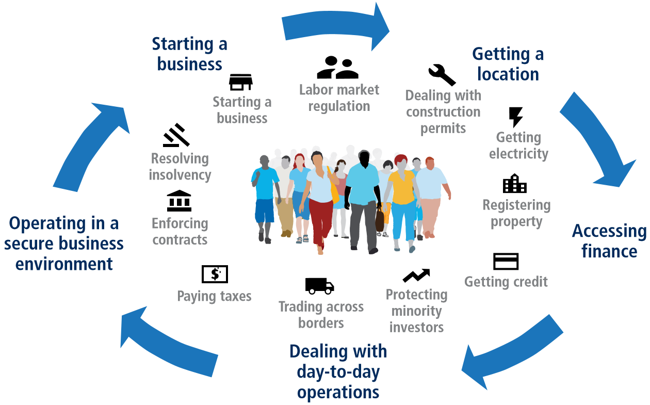

Figure 1 – What is measured in “doing business”

Note – Extracted from the source [17]

Despite the promising tendency of rankings in the past years, the figures with respect to entrepreneurship and SMEs indicate that there may be still some loopholes in Kazakhstan’s entrepreneurial system. The insufficiencies shall be promptly addressed so that the entrepreneurship can be further enhanced in this country.
The “global entrepreneurship monitor” (GEM) Kazakhstan [16, p. 17-20] report shows some features of entrepreneurship in this country, in terms of societal values, self-perceptions, profile of entrepreneurs, entrepreneurial impact, and regional differences.
Societal values on entrepreneurship in Kazakhstan. Societal values on entrepreneurship evaluate how citizens of a society perceive the prestige or status about becoming an entrepreneur, assess the attraction of becoming an entrepreneur, and look at the magnitude of media coverage of entrepreneurship. Apparently, entrepreneurial intentions (EIs) tend to be higher in cultures where entrepreneurship is highly valued [16, p. 5].
Around 75% of the surveyed respondents in Kazakhstan think of entrepreneurship as a good choice of employment. This percentage indicates that the attitudes towards entrepreneurship remain remarkably positive in this country [16, p. 17].
Self-perceptions of entrepreneurship in Kazakhstan. Entrepreneurial perceptions are crucial because they reveal the extent to which potential entrepreneurs recognize opportunities, trust in themselves, and/or fear potential failures. The capacity to see possibilities and their benefits, together with self-assurance and a low fear of failure, constitute the prerequisites for launching a business [16, p. 17].
Kazakh people are inclined to identify entrepreneurial opportunities, and meanwhile are assertive about their capability to commercialize such opportunities. In other words, they have strong self-confidence (SC) and self-efficacy (SE) in entrepreneurship activities. However, many of the potential entrepreneurs have extreme fear and worries of failure which could refrain them from starting up a business. In Kazakhstan, the level of recognitions on good opportunities is almost equal to the average level in factor-driven GEM economies [16, p. 45].
Kazakhstan has high entrepreneurial ambitions reflected in its economy, in spite of the ongoing COVID-19. During the pandemic, there still appear to be strong intentions among Kazakh adults to create a venture. 59% of them state that they plan to start up a venture within the subsequent three years. Interestingly, only 53% among those intentional entrepreneurs regard the pandemic as a factor to some extent. This implies that a great number of Kazakh people still intend to pursue entrepreneurship regardless of the difficult macroeconomic situation caused by COVID-19 [20].
Kazakhstan’s “total early-stage entrepreneurship activity” (TEA) rate is 20%, ranking at the top position among the Central and East Asia GEM economies. The ambition is also shown in the percentage of Kazakh entrepreneurs planning to hire at least six employees over the next five years. The “established business ownership” (EBO) rate in Kazakhstan is 4.3%, one of the relatively low rates among all GEM economies. Furthermore, 80% of the EBO entrepreneurs lack confidence in finding new opportunities due to COVID-19, indicating a pessimism among those experienced entrepreneurs in Kazakhstan [20, p. 29].
Profile of entrepreneurs in Kazakhstan. Entrepreneurs can be classified into potential, intentional, nascent, new, established, and discontinued entrepreneurs as defined in Appendix B [20, p. 22]. Unless otherwise indicated, the term “entrepreneur(s)” in this study represents all the above-mentioned categories of entrepreneur(s).
People from the 25-34 age group (16.5%) tend to be more active entrepreneurs in Kazakhstan. Interestingly, among those willing to start entrepreneurship in Kazakhstan, the 45-54 age group (9.6%) is the most active, followed by the 35-44 age group (7.4%), and the 18-24 age group (9.4%) as the least [16, p. 20-23].
In general, male entrepreneurs do not significantly differentiate from female ones in number, owing to the high involvement of women in the employment in Kazakhstan. Generally speaking, the situation of female entrepreneurship in Kazakhstan is on par with the situation in other comparison groups. On the other hand, Kazakhstan is different from the other group members in terms of the TEA percentage and the proportion of opportunity-driven versus necessity-driven entrepreneurship [16, p. 20-23].
Entrepreneurial impact in Kazakhstan. The key determinants of economic development in a certain country are job expectations and level of innovation. Kazakhstan’s business community is quite confident about new job creations [16, p. 20-23].
Among the early-stage business owners in Kazakhstan, 24.7% of them plan to originate 1-5 employments in the subsequent 5 years; while 34.4% expect to produce at least 6 new vacancies in the next 5 years [16, p. 20-23].
Another important harvest of entrepreneurship is innovation that could boost the national economy. In Kazakhstan, the score for innovation rates is on par with the factor-driven economy average, but not as good as the averages of efficiency- and/or innovation-driven economies/y. The wholesale and retail sectors saw most newly created businesses. The ratio of mining business in number is lower than the GEM averages. In comparison with innovation-driven economies, there are much fewer new initiatives in such areas as information and communications technology (ICT), finance, and service industry [16, p. 20-23].
Regional differences of entrepreneurship in Kazakhstan. Aktobe and Pavlodar regions, as well as the Nur-Sultan city have seen most opportunity-driven entrepreneurs; while all of the surveyed entrepreneurs of the North Kazakhstan region are necessity-driven. Nearly 50% of the entrepreneurs in the Almaty region are both opportunity- and necessity- driven. Interestingly, all of the surveyed respondents in the Kyzylorda region expect to pursue a business, although they already have permanent jobs [16, p. 20-23].
The Mangystau region has the highest level of entrepreneurial ratio. Meanwhile, this region provides the highest level of average income in Kazakhstan. The reason may be the abundant entrepreneurial opportunities in such large metropolitan areas and oil-rich regions as Mangystau. In comparison, the regions such as Akmola, Kostanay, and North Kazakhstan, where the per capita income is lower, have less opportunities for entrepreneurship at the same time [16, p. 20-23].
Potential entrepreneurs from Nur-Sultan and Almaty cities, and the Pavlodar region are most confident about their capabilities to overcome the stress of possible failure. The responders from Mangystau, South Kazakhstan, and Karaganda areas are manifestly pessimistic [16, p. 20-23].

- State of foreign entrepreneurship in Kazakhstan
Entrepreneurship comes across national boundaries along with the expanding global markets which have the access to required resources in the worldwide [21]. Thanks to its favorable geopolitical location, enormous land, wealthy natural resources, stable political and economic environment [22], and substantive government support (GS), Kazakhstan has the capacity to attract increasing external investment and international entrepreneurs to launch businesses in this country. Today, investors are enticed by Kazakhstan’s great potential and low risks in investment, stable legal foundation, striking macroeconomic endowments (enormous natural reserves, abundant labor forces, and sound infrastructures), and considerable consumers’ demands. Kazakhstan possesses the majority of the aforementioned characteristics, which explains why investment is increasing at a rapid rate [22, p. 237]
It is necessary to point out that, in order to grasp the dynamics of investment from the foreign entrepreneurs performing business activities in Kazakhstan, the author attempted to acquire the relevant statistics on the foreign investment. However, due to the dearth of reliable information and confidential nature of the data (see more detail in Chapter 3), the planned statistical acquisition was unfeasible.
Considering that:
- the foreign entrepreneurs are largely influenced and guided by the directions of major foreign direct investments (FDIs) flowing into Kazakhstan;
- many of these foreign entrepreneurs invest their capital through their preliminarily established parent company based in another country (not Kazakhstan) in practice (for various reasons, e.g., taxation privilege, flexibility, security, etc.), this study contends that the FDIs could, to a great extent, represent the dynamics of foreign entrepreneurial investment in Kazakhstan. Therefore, the FDIs are discussed in this study with a view to showcase the vitality of the foreign entrepreneurship in Kazakhstan.
Since its declaration of independence, Kazakhstan has done a variety of reforms to stimulate its economic development and induce investment from foreign sources. The country remains the 2nd largest recipient of FDIs, accounting for more than 70% (totaling to USD 3.1 billion in 2019) of all FDIs among the Central Asian countries, behind Russia [23, 24]. The oil and metallurgy industries are the main sources attracting FDIs to Kazakhstan. Kazakhstan’s main challenges remain [25]:
- luring investment in non-natural-resource sectors as natural resources contribute more than 70% of overall FDI stock;
- keeping established investors in the economy.
Among the sources of investment, China has become Kazakhstan’s main partner in the economy in terms of FDIs, loans, and joint ventures. Kazakhstan and China cooperate in such spheres as energy, oil, mining, ferrous and non-ferrous metallurgy, chemical industry, and fertilizer production [26]. China’s President – Xi Jinping, presented his speech about the vision of “reconstruction of the historic Silk Road” from Chinese perspective, at the Nazarbayev University in September 2013. The corresponding program is known as “one belt - one way” (OBOW) or “the belt and the way” (BW) initiative. The program aims to build closer economic ties, facilitate the cooperation, and expand the development in the Eurasian region [18]. The new Kazakh president - Kassym-Jomart K. Tokayev, seeks to continuously strengthen the bilateral economic relations with China [25]. Kazakhstan’s economic indicators proved the important role of FDIs from Chinese investors and entrepreneurs. The FDIs have stimulated the bilateral trade and other forms of mutually beneficial cooperation during the implementation of projects, including industrial and transnational infrastructure projects (e.g., transport infrastructure projects) in the past years [26, p. 8; 27].
To date, Kazakhstan has been reputed for a good investment climate. The government has dedicated to further improve its business climate and plans to establish a state-owned corporation - “Qazaq Invest”, which aims to enhance the foreigners’ investment in Kazakhstan [28].
Undoubtedly, the foreign entrepreneurship can be deemed an indispensable part of the general entrepreneurship in Kazakhstan. “Foreign entrepreneurs” in concept are similar to “minority entrepreneurs” who do not represent the major population in a country [29]. The author takes “foreign entrepreneurs” as the individual business owners who are starting up or have been doing business in a country where they are living as expats (not native or not naturalized) (see more detail in Chapter 1). The study population in this work is confined to the “new and established entrepreneurs” among foreigners who have been doing business in the country of Kazakhstan.

- Role of GS for entrepreneurship in Kazakhstan
Government support (GS) as one of the environmental factors that encourage entrepreneurship, is absolutely essential for the economic health of a country [30]. Audretsch et al. [31] explained that politicians, to a significant part, direct the entrepreneurial process. Policy-makers are accountable for designing and implementing strategies and regulations that cultivate a positive business environment for entrepreneurs to succeed and lead in a society’s economic growth. Hence, it is unsurprising to observe a substantial link between the economic development and a country’s ease of doing business. [30, p. 40].
Governments, regardless of nation, are primarily concerned about identifying factors at both regional and local levels that promote entrepreneurship. This is due to the fact that, in the era of knowledge-based economy, entrepreneurship, among other factors, is playing a crucial role in developing and sustaining economic growth [32]. Meanwhile, entrepreneurship has been well recognized as a key source of job creation. Therefore, nowadays, all governments around the world are actively implementing favorable policies and programs to facilitate entrepreneurship [8, p. 6]. Moreover, governments can enhance a society’s entrepreneurship through education and training programs, social recognition, access to the market, financial support, available funds, taxation support, customs duties reduction, bilateral treaties, innovation, e-governance, etc. [30, p. 46; 33-35]. Support from a government can also be in the forms of simplicity in doing business regulations, low penalties for entrepreneurs, improved knowledge and empathy of government officials towards entrepreneurship, provision of good infrastructure and telecommunications, creation of opportunities and favorable environments, and sharing of information, etc. [36].
GS functions in providing SMEs with access to scarce resources and motivating their start-up and sustainable growth in a turbulent market [37]. It is also acknowledged that GS may not considerably add the business proﬁtability, however instead, signiﬁcantly drives a ﬁrm’s survival and success [38].
Specifically speaking, Kazakhstan’s government has initiated a lot of supportive programs, e.g., the “Innovative Industrial Development Strategy for 2003-2015”, the “Kazakhstan Strategy 2030”, the “30 Corporate Leaders of Kazakhstan”, and the “Kazakhstan Strategy 2050”, etc. Many innovative attentions to growth of non-oil/gas sectors, economic modernization, interactions between government and business sectors, were considered in these programs [2, p. 101]. The government has dedicated to formulate a middle class through the development of manufactures featured by the entrepreneurship-orientation, high-quality, and high-technology [39].
COVID-19’s emergence and proliferation have had a significant impact on the general public. Governments all around the world have been put to the test and stretched to their limits. Governments worldwide have tried to play an essential role in re-establishing confidence over survival through the implementation of new rules, norms and actions during the crisis [40; 41]. So does the government of Kazakhstan, which is to be discussed in the following section.

- COVID-19’s impact on entrepreneurship in Kazakhstan
March 13, 2020 saw the arrival of COVID-19 in Kazakhstan. On that day, three Kazakh citizens returned from Germany to Almaty, and later on one more citizen arrived from Italy to Nur-Sultan [18]. Meanwhile, the COVID-19 epidemic occurred when oil prices plummeted, giving Kazakhstan a double attack [42].
Not only is the worldwide pandemic a tremendous hygienic and health-caring catastrophe influencing masses of people globally; but also, it is producing an unprecedented economic slump in the world, which businesses are facing [43]. Since the outbreak of COVID-19, over 70% of new firms have chosen to discontinue full-time employment. Many enterprises have relocated to new markets for goods or services as a result of the crisis [40].
The pandemic has an intensively negative effect on the present and upcoming business execution of entrepreneurship. Statistics predict that, only around 25% of companies that lack a sustainable strategy are likely to stay alive within 3 years after the breakout of a disaster or crisis [44]. The following three aspects related to the impact of COVID-19, among others, are being frequently discussed.
Strategy of business survival. Under COVID-19, most enterprises face difficulties in operation, which may result in early business termination or shutdown, decreased revenue, a dramatic fall in the marketing demands for products and services, shortage of funds, and lack of liquidity, etc. Entrepreneurs are constrained to provide services to their customers, to pay their workforce, and to be committed to their downstream suppliers. As a consequence, a large number of SMEs are faced with a failure during and after COVID-19 [13, p. 1]. It is crucial to investigate how micro-entrepreneurs and SMEs deal with the crisis and what decisions they make to ensure their company’s survival [45].
Perceptions of entrepreneurship. COVID-19-induced alterations might be considered in metaphor as a “double-edged sword”. While some entrepreneurs may believe that the disaster would have a detrimental impact on business-related risks, obstructing new ventures, others may believe that the changes will transform attitudes of entrepreneurship for the better [40] as a result of the following positive sentiments [40; 43]:
- Entrepreneurs are optimistic and resilient fighters in their DNA by nature. Every crisis will finally end, and this will encourage entrepreneurs to undertake something creative to overcome the difficulties.
- The industries, especially those in social sectors such as hospitality, are most affected by COVID-19; the entrepreneurs in those industries could take the chance to innovate in their business strategies in order to strengthen their ties with their customers.
3) To be lucrative and sustainable, a firm needs three essential assets: money (access to capital), know-how or particular experience, and a team (people). Given the assets, entrepreneurs must use their nimbleness to seek for possibilities in order to break the crisis.
Crisis management. While many businesses may perish as a result of the crisis, others, including new start-ups, may thrive [40]. Under the detrimental impact of COVID-19, many company leaders and entrepreneurs are concerned about how to guarantee the survival and continuity of their business [46]. During the pandemic, some nascent start-ups were more opportunistic through innovations of repurposing and redirecting to new marketing demands that have evolved. The so-called “new normal” [40] has emerged as a result of this circumstance.
McCarthy [47] suggests that experiencing a crisis may help entrepreneurs to be more prudent and purposeful in their decision-making. To combat the crisis, entrepreneurs are employing survival mechanisms such as marketing innovations, alternative distribution channels, product re-engineering, as well as affordable and effective web campaigns [48-50].
In response to the economic downturn due to the pandemic and oil price drop, the government of Kazakhstan has implemented numerous direct supports to businesses, such as tax deferrals or breaks, fewer audits, cheaper credit, subsidized loans, and other financial support [25; 51]. In addition, a package of emergency measures was applied, including the declaration of a state of emergency (SE), lockdowns, grace period for repayment of loans, tax exemption, customs tariff and non-tariff regulatory measures, special simpliﬁed procedure for state procurement, restrictions on currency exchange operations for legal entities, employment-related measures, etc. [18]. These urgent supports and emergency measures targeted at protecting the people, stabilizing the macroeconomic situation, reducing the impact of COVID-19 on SMEs, providing assistance for healthcare positions, and assisting the most vulnerable in surviving the pandemic [42; 52; 53].
The total investment for anti-crisis actions totaled to more than 4 trillion Tenge (by the end of 2020) which was around 9.3 billion USD according to the exchange rate (1:430, USD versus Tenge), including the state budget (2.1 trillion Tenge), the national fund (1.8 trillion Tenge), and the infrastructure bonds fund, etc. [18].

Problem Statement and Research Questions
Based on the afore-demonstrated background with respect to the practical significance of entrepreneurship, the state of (foreign) entrepreneurship, the role of GS, as well as the challenges and opportunities brought by the spreading global crisis of COVID-19, hence, this research found a triple problem: the entrepreneurship owned by foreigners, the attacks by COVID-19, the involvement of GS, and the research setting in Kazakhstan. Specifically speaking, fostering foreign entrepreneurship and SMEs is undeniably important and urgent for Kazakhstan’s incremental economic progress. In addition, GS plays an essential part in encouraging (foreign) entrepreneurship, especially under the new circumstances incurred by the COVID-19 pandemic.
As COVID-19 transforms from a general pandemic to an economic tragedy, potential and experienced entrepreneurs, as well as policy-makers, are more concerned about identifying major trends in the post COVID-19 time, predicting how entrepreneurship around the world will do as a reaction, and where and how to work together [13, p. 1]. This study argues that SMEs and foreign entrepreneurship will be one of the central focuses for the crisis management strategy in Kazakhstan’s economy.
Regarding the role of GS, this study shed light on “government policies” and “government programs” that have great impact on the entrepreneurial process. “Government policies” that support entrepreneurs include but not limited to taxation, anti-bureaucracy, business registration, etc.; while “government programs” include but not limited to public programs, specific initiatives, public incubators, countryside programs, etc. [20, p. 76]. In general, the more supportive and favorable policies and programs a government implements, the more favorable entrepreneurship tends to be produced. As can be seen from the responses of governments across the world in the fight against COVID-19, governments have been playing a vital role in rebuilding confidence and helping economies out [40]. Particularly, the government of Kazakhstan has launched an effective package of measures in terms of state emergency measures, tax incentives, state procurement, currency exchange, medical actions, and business support, etc. to mitigate the crisis [18].
Then the initiating question is:
How should the research on encouraging (foreign) entrepreneurship be conducted in the context of GS, COVID-19, and Kazakhstan?
Modern research on entrepreneurship has found that entrepreneurial intention (EI) acts as the strongest (best) single determinant of entrepreneurial activity [54; 55] because of the essential role EI functions in the decision-making on launching a firm [56; 57]. Entrepreneurship is created by entrepreneurs in line with innovative ideas and the creative integration of favorable resources; during the creation process, an individual’s entrepreneurial behavior is to a great degree determined by the individual’s intention [58]. In other words, EI revolves mental views (i.e., desires, wishes, and hopes) affecting the entrepreneurial option of individuals [59].
Therefore, this study moved the focus from boosting entrepreneurship to fostering EI. Now the above question turns into:
How to conduct the research on motivating (foreigners’) EI in the above-mentioned setting?
To go one step forward, in order to find the solutions to enhancing EI, influencing factors should be first identified and investigated. Prior literatures revealed that there are substantial studies with respect to factors affecting EI in various settings. This study on influencing factors may lay the foundation for addressing the issue of improvement on EI, and in turn for the improvement on entrepreneurship in the research context. Thus, this study decided to:
Focus on the factors affecting (foreigners’) EI in the research setting.
To present, however, there is a serious dearth of study pertaining to foreign entrepreneurship and the factors that influence foreigners’ EI in Kazakhstan. In addition, the function of GS in facilitating (foreign) business in Kazakhstan has not gotten a great deal of attention [60]. Moreover, the new complexity incurred by the pandemic has produced a void for research in terms of (foreigners’) EI and its influencing factors. Hence, the study attempted to:
Address the research voids through exploring the foreigners’ EI and the function of GS under the current setting in Kazakhstan while the pandemic of COVID-19 is still ongoing.
To fill the aforementioned research gaps, it is necessary to fixate the appropriate research approach. Basically speaking, there are two approaches to research on EI and its influencing factors: content-oriented and process-oriented approaches [61]. The former approach focuses on individual or contextual factors rooted in the ground of the “pull theory” (contending the attraction of internal forces such as traits, characters, and demographic factors) or the “push theory” (arguing the attraction of external factors such as dissatisfaction, previous experience, opportunities, and influences) [62]. As a result, numerous single factors and combined (groups of) single factors have been explored, investigated, and tested in the past empirical research. The latter approach stresses an individual’s cognitive processes (such as “EIs”) which result in activities (such as “entrepreneurship”). As a reaction, numerous intention-based models have been developed to predict and understand entrepreneurship [63]. Among these models, the “theory of planned behavior” model (simply known as “TPB”) [56, p. 182] has been most established upon substantial studies [64].
As many researchers believe the superiority of process-oriented approach over content-oriented approach [65], this empirical study adopted a process-oriented methodology and utilized the most accepted “TPB” model. According to TPB [56, p. 188], intentions (such as “EIs”) are facilitated by personal attitude (PA) (such as “PA towards entrepreneurship”), subjective norms (SNs) (such as “SNs about entrepreneurship”), and perceived behavioral control (PBC) (such as “PBC over entrepreneurship”). Alternatively speaking, a human behavior (such as “entrepreneurship”) is directed by three beliefs (through which intentions, such as “EIs”, are influenced) [66]:
- behavioral beliefs regarding probable outcomes of the behavior – PA;
- normative beliefs about important other’s expectations – SNs; as well as
- control beliefs concerning the capabilities that might promote or constrain behavior fulfillment – PBC.
Ajzen [56, p. 206] proposed that the relative weight of the three components (PA, SNs, and PBC) may vary across regional and national cultures, ethnicities, organizations, and individuals, despite the fact that TPB is already a generic model that holds true in different contexts. Likewise, this current study towards the foreigners in Kazakhstan under COVID-19 may take on different features. Moreover, despite its robustness and effectiveness in EI research, TPB can still be extended [67-69] for further sufficiency by adding mediators [70; 71] and/or moderators [72] as the external variables.
A mediator variable tells how or why a certain effect or relationship occurs; it defines the cognitive process that happens to build the association and, as such, is always about dynamic individual properties (e.g., beliefs, emotions, behaviors) [73]. A moderator variable modifies the magnitude of an effect between two variables; it indicates when or how a particular effect can be anticipated; it may increase, decrease, or reverse a relationship [74].
Numerous authors have researched the moderating effect of GS in its various forms in the academic area of entrepreneurship in different contexts. For example:
Khalid et al. [75] studied how the government financing (financial support of GS) moderates the association between entrepreneurial culture versus business performance, and the link between entrepreneurial training versus business performance, in the public universities in Pakistan. The analysis uncovered a substantial moderating influence of government funding on the aforementioned culture versus performance relationship.
Shah et al. [76] investigated the moderation power of entrepreneurial education (EE) (educational support of GS) on the prediction for students’ EIs in Oman exerted by PA, SNs, and self-efficacy (SE). The results reported that EE strengthens the relationships of PA-EIs and SE-EIs, while it weakens the relationship of SNs-EIs.
Maria and Allam [77] discovered that the general form of GS significantly moderates the entrepreneurship-economic growth relationship among the “gulf cooperation council” (GCC) countries.
In the works of Purbo [78], perceived social support (cultural support of GS) moderates the association between the attitude of becoming a social entrepreneur (ATB) and the social EI in Indonesia. The better the perceived social support, the larger the impact of ATB on social EI, according to this study.
Jamilu [79] expanded the “TPB” model by investigating the moderating influence on Nigerian students from the “technical and vocational education and training” (TVET) department, who are converting EIs into IT-related entrepreneurship. The findings suggested that naturally occurring PA and PBC alone are insufficient to affect the EIs of TVET students; PA and PBC must be enhanced by effective training and government supports towards entrepreneurship (educational, cultural, and environmental supports of GS).
In Nigeria, Maryam et al. [80] created a model for evaluating and justifying the moderating power of policies (government policies of GS) over the connection of entrepreneurship orientation (EO) versus entrepreneurship performance (EP).
Jan et al. [81] discovered evidence that regional institutions (government policies and programs of GS) exert distinctive and unique impacts on the EI-action link in European areas. Specifically, the results demonstrated that the intention-behavior relationship is reinforced in locations where GS quality is high.
In Pakistan, Temoor et al. [82] discovered a substantial positive connection between entrepreneurial passion (EP) and EIs. The study discovered that the perception of university participation (educational support of GS) has a moderating effect on the EP-EIs association.
Abubakar et al. [83] found in their study towards Nigerian youth corps members that the perceived access to finance (PAF) (financial support of GS) significantly intensifies the EO-EI relationship.
In the above-mentioned studies, GS is examined in terms of educational, cultural, environmental, financial, policy-related, and program-related supports. Specifically, this study focuses on “government polies and programs” to conceptualize GS, as stated in the previous text. Similarly, drawing on the experience of previous researchers, this study argues that among foreigners in Kazakhstan, GS dramatically modifies the association between TPB components and EIs.
In summary, this study attempts, in the COVID-19-accompanied context of Kazakhstan, to focus on the foreigners’ EI, identify and examine factors influencing the said EI, and shed light on the function of GS in fostering the start-ups of entrepreneurship and SMEs among foreigners in this country. According to the findings of this research, the author aims to draw implications about how to promote foreign entrepreneurship in contribution to the economic development of Kazakhstan. The major research questions are herein raised:
1) How do the factors (TPB components) exert an impact on foreigners’ entrepreneurial intention (EI) in Kazakhstan?
2) How does the government support (GS) affect the foreigners’ EI?
3) What are the implications for increasing and improving new businesses to be launched by foreigners in Kazakhstan?

Research Scope and Objectives
This study seeks to recognize and test the factors impacting foreign entrepreneurs to start up a business in Kazakhstan, and to probe into the function of GS in encouraging their EI in this country.
Accordingly, the objectives are set forward as below:
1) investigating the relevant factors and models in the domain that are used to predict EI;
2) creating and justifying a research framework that integrates GS with some other predictors or models that influence foreigners’ EI in Kazakhstan; and
3) providing researchers, academics, practitioners, and policy-makers with insights into strengthening (foreign) entrepreneurship and recommendations for future study.

Dissertation Structure
The dissertation consists of introduction, main content (chapters 1-6), conclusion, list of references, and 25 appendices.
Next to this introductory chapter (INTRODUCTION), Chapter 1 serves as an overview of the context for entrepreneurship in Kazakhstan. It describes Kazakhstan in terms of general profile, business climate, and entrepreneurship ecosystem, which meanwhile enriches the research background demonstrated in the INTRODUCTION. The role of GS in Kazakhstan is highlighted in Chapter 1.
Directed by the established research objectives and proposed research questions in this chapter, Chapter 2 centers on the literature review. It classifies the miscellaneous single factors which have been frequently examined in the past research, enumerates some typical examples using combined (groups of) single factors, and lists the well-acknowledged and well-established intention-based models. Based on the systematic literature review, this study ultimately embraces the “TPB” model as the foundation of research framework, and integrates it with the “GS” to develop an innovative conceptual framework of “TPB+Moderator (GS)” model in the research setting. The role of GS, and the focus on foreign entrepreneurship under the circumstances featured by COVID-19 in Kazakhstan, constitute the research context. The hypotheses corresponding to the extended “TPB+GS” model, are formulated in Chapter 2.
Chapter 3 deals with the research methodology. It outlines the methods in detail on three sections: data collection, examination, and analysis. Data collection involves sampling method, questionnaire administration, measuring instruments and scales, pilot study (for tests of reliability and validity), and data-gathering procedures. Data examination aims to diagnose possible missing data, detect potential outliers, and test underlying assumptions to ensure the dataset is eligible for multivariate data analysis. Data analysis employs appropriate techniques to yield and interpret research results. Furthermore, Chapter 3 explains the entire process of data collection in accordance with the relevant guidance, and presents the corresponding outcomes with respect to the “goodness of measures”.
Guided by Chapter 3, the following Chapter 4 proceeds with the processes of data examination and data analysis. It reports the outcomes of examination and the results of empirical analysis. It first presents the data examination revolving missing data, outliers, and tests of assumptions, until the “goodness of data” is ensured. Then, the rest of Chapter 4 is engaged in the multivariate data analysis consisting of multiple regression, Pearson’s correlation, and descriptive analyses, to discover research findings with regard to the “goodness of fit” and the significance of hypotheses developed in Chapter 2.
In Chapter 5, the research findings are discussed in more detail and related back to the research objectives and questions presented in this chapter. Implications for academics, researchers, practitioners, and policy-makers are drawn in light of the detailed discussions.
In Chapter 6, the study summarizes the entire research work. It begins with a recap of the separate chapters of this dissertation. Then, it demonstrates the primary contributions to the bulk of knowledge relevant to the influencing factors for foreigners’ EI in connection to the Kazakhstani context. Research limitations of this study are stated. Chapter 6 finally advises new directions and areas for further study.
The final part of CONCLUSION presents very briefly the essence of this study again.

Summary of the Chapter
With an aim to build up the research scope and objectives of this work, the section of problem statement is demonstrated and the set of research questions is proposed based on a review of the overall research background. The context identifies the significance and immediacy of enhancing entrepreneurship in general and among the foreigners, the influence exerted by the pandemic of COVID-19, and the input from GS of Kazakhstan. The “TPB” model is adopted as the research framework, and the “GS” is nominated as the moderator in the model.
This study focuses on the affecting predictors for foreigners’ EI in the setting of Kazakhstan, targeting at finding solutions to further facilitating the (foreign) entrepreneurship in this country.
In the meantime, this study serves to fill the voids since there is still a dearth of research that assessed the status of EI among foreigners in Kazakhstan, and that employed the “TPB” model for the said assessment. Furthermore, COVID-19 has added new features to the Kazakhstani context since the beginning of 2020, which proffers another research gap on this subject. Besides, as evidenced by the overall functions of governments in economic activities and by the responses of governments to COVID-19 around the world, the role of GS is increasingly and exceptionally essential in facilitating entrepreneurial start-ups and performance. Hence, the inclusion of GS as the moderator in the “TPB” model is also an originality in EI research in the specific setting.
In short, this study made a modest attempt to fill the identified research gaps relevant to the factors impacting EI of foreigners in Kazakhstan under the circumstances of the COVID-19 pandemic. This dissertation research highlighted the role of GS which was designated as the moderator between TPB components and EIs.

Acknowledgements
In the first place, I cannot wait to profoundly express my warm thanks to my main supervisor, Dr. Nadeem Khalid, for his unwavering support and advice. The suggestions and encouragement that I received from him helped me out through the long darkness during my entire study and research work. His kindness, enthusiasm, and patience built up my firm confidence and perseverance. His research knowledge is always a plus, and I found it to be really beneficial to me. Second, many thanks to Dr. Dewan Islam, who offered significant help, particularly in terms of sharing his research skills in literature review, research methodology, and publications. He instructed me a lot for my first publication when I was still a novice at writing scientific papers. Third, I greatly appreciate the input from Dr. Umair Ahmed, my last foreign (external) supervisor who joined the team late in 2020, yet promptly contributed his in-depth consultations to each chapter of my dissertation. A particular thank-you also goes to Dr. Ashfaq Ahmad who was my first foreign (external) supervisor; his suggestions and appraisal at the beginning stage of my research and publication were very motivating. He gave me a big hand for my second publication by streamlining my thoughts and improving the formatting of my paper. I deeply express my gratitude to them all.
A big thank-you note also goes to Mrs. Honig Maratovna (Master of International Law), my sweet colleague at work, who was always so intelligently and patiently assisting me. At the stage of data collection, she represented me to make contacts and guided me to meet the state bodies and officials for obtainment of relevant statistics; she urged her international friends in Kazakhstan to circulate my survey questionnaires and collect responses; she always acted as my loyal reader, spectator, and listener during the whole journey of my study and research. She was always willing and ready to help whenever I was in urgent need. Appreciation also goes to the other colleagues of mine who assisted me in writing and thinking by means of providing suggestions and inspirations; they were so considerate by sharing the great load of company work while I was struggling to conduct my study and research.
I am also deeply grateful to my dear friends who participated in my research and helped me to collect data through their networks. Without their generous assistance, the data-collection work would never have been successful. A special thank-you note shall also be given to Mr. Zhang Li (MBA), my business partner and close friend, who shared so much burden of the tough business work, hence, allowing me to devote myself to the study and research.
My sincere gratitude also goes to the Pre-defense Council of KIMEP for the wonderful organization of my pre-defense dated December 18, 2021 and subsequently recommending me to NARXOZ University for public defense; to the industry experts, the experienced practitioners, the government officials, as well as the senior academics and researchers, for reviewing my work, and offering the crucial feedbacks through the pre-defense meeting, review reports, emails, or other forms of communications, which to a large extent determined the success of my research. Among them are Mrs. Lazzat Tashanova (MBA), Dr. Dewan Islam, Dr. Diana Amirbekova, Dr. Bolat Tatibekov, Dr. Monowar Mahmood, Dr. Liza Rybina, Dr. Nejat Capar, Dr. Nadim Naqvi, Dr. Joseph Luke, Dr. Umair Ahmed, and Dr. Nadeem Khalid.
Most importantly, I would like to express my great respect and thanks to the Public-defense Council of NARXOZ, for their perfect organization of my final defense dated December 14, 2022 and provision of decisive instructions. Without their high affirmation and critical comments, my dissertation work would never have reached up to the current altitude in its final version. Among them are Mrs. Svetlana Seitimova (MBA), Miss Aizada Okanova (MBA), Mr. Alisher Sansyzbayev (MBA), Mr. Nurakhmet Aitenov (MBA), Dr. Murat Isabayev, Dr. Kairat Moldashev, Dr. Agipa Monobaeva, Dr. Sanat Kozhahmet, Dr. Kanat Ergaliev, Dr. Reazul Islam, Dr. Armiyash Nurmagambetova, Dr. Natalya Radko, Dr. Ainur Kenebaeva, Dr. Nurlan Kurmanov, Dr. Dametken Turekulova, Dr. Maria Elo, Dr. Anjan Ghosh, and Dr. Aizhan Tleuberdinova.
This section would never be complete if I do not say a heartfelt “thank you” to my whole family who supported me from the very beginning to the end of my doctoral study in the past four years. They endured and experienced together with me during this long and lonely journey. I deeply appreciate the strong support from all of them.
Taken together, my hearty thanks go to all of those, who are either mentioned above or not, for being with me along my PhD path!
All the best wishes!
Yu Tongxin
KIMEP University
January 7, 2023
1 CONTEXT OF ENTREPRENEURSHIP IN KAZAKHSTAN

1.1 Introduction
This chapter targets at building a solid understating of the entrepreneurial context in Kazakhstan, so as to provide a broader view of the setting under which this study is carried out.
This chapter first overviews Kazakhstan in terms of its geography, people, history, government and political system, economy, foreign relations, and language; then looks at the business climate in Kazakhstan; subsequently explores the entrepreneurship ecosystem (EE) in Kazakhstan from perspectives of finance, government support (GS), R&D transfer, education and training, internal market, infrastructures, socio-cultural norms, senior and foreign entrepreneurship; next, synthesizes the overall ecosystem and evaluates its international position in comparison with “Brazil, Russia, India, China, and South Africa” (BRICS) and “global entrepreneurship monitor” (GEM) countries; and finally discusses about the constraints and facilitators for the entrepreneurship in Kazakhstan.
To serve as a guide for better understanding of this chapter, figure 1.1 below depicts the primary scopes of knowledge relevant to the research context of this study viewed from multiple lenses. The purpose of this chapter is to strengthen the research background described in INTRODUCTION.
GS
Research Background to This Study

Context of Entrepreneurship in Kazakhstan
EE in Kazakhstan
Business Climate in Kazakhstan
Profile of Kazakhstan

Figure – 1.1 Structure of this chapter
Notes:
1. Given the scope of “research background” within the light green rectangular boundaries, the area within the dark green rectangular boundaries defines the scope of “context of entrepreneurship in Kazakhstan”, which sheds light on the research subject of entrepreneurship in this country.
2. The area inside the orange circumference is viewed from the wide-angle lens, which displays a general picture of Kazakhstan indicated by the “profile of Kazakhstan” (see Section 1.2) in the dimension of entrepreneurship context.
3. The area surrounded by the light blue circumference is observed from the medium telephoto lens, which takes a closer look at the context indicated by PESTEL factors (“business climate in Kazakhstan”) (see Section 1.3).
4. The yellow area is seen from the telephoto lens, which captures an even closer sight of the business environment indicated by the “entrepreneurship ecosystem (EE) in Kazakhstan” (see Sections 1.4 and 1.5).
5. The three intercorrelated and non-exclusive indicators – profiling, PESTEL indices, and EE – are selected as the components of a framework in order to succinctly assess the various aspects of entrepreneurship context in Kazakhstan. However, detailed discussion of the indicators in concept is beyond the scope of this study and thus is not conducted in full swing.
6. All the perspectives are focused on the highlighted “role of government support (GS)” faced with current facilitators and constraints of entrepreneurship in Kazakhstan (see Section 1.6).

1.2 Profile of Kazakhstan
This section provides a general overview of Kazakhstan, including its geography, population, history, government, politics, economy, international relations, and language.

1.2.1 Geography
The Central Asia (CA) country, Kazakhstan, spans 2,724,900 km². It was ranked as the largest republic in territorial area, with the exception of Russia, in the former Soviet Union’s (SU’s) era. It is now the world’s ninth-largest country. Its west border is the Caspian Sea, east neighbors are China and Mongolia, north neighbor is Russia, and south neighbors are Turkmenistan, Uzbekistan, and Kyrgyzstan. Kazakhstan’s geography consists mostly of steppe. Deserts are located in its southern and central areas. Its southeast is the range of mountains. Its continental climate makes the temperatures varying from -45°C in winter (the lower limit in Kazakhstan) to +30°C in summer (the upper limit in Kazakhstan) [84].

1.2.2 People
Kazakhstan has a population of about 19.1 million people, including 1.8 million in Almaty – the country’s biggest city and former capital, and 1 million in Nur-Sultan – the country’s second largest city and the current capital. Kazakhstan has a population density of roughly 7 persons per km², rendering it one of the least populous nations in the world. Approximately speaking, among the population, 68% are Kazakhs, and 19.3% are Russians; other ethnic groups altogether make up the remainder (12.7%) [84; 85].

1.2.3 History
Kazakhstan was initially dwelled by nomadic tribes (known as “Kazakh Khanate”) during the late 15th and early 16th centuries. Three ethno-territorial groupings emerged in this region as a consequence of ethno-political and economic reasons: the senior, medium, and junior “Zhuz”s. Specifically speaking, the division into “Zhuz”s was due to the emergence of Kazakh ethnic groupings, which left a distinctive cultural and political mark. During the 18th and 19th centuries, the Kazakh “Khanate” joined the “Russian Empire”. The Bolsheviks captured the region after the “October Revolution” (OR). Kazakhstan was declared a republic of the former SU on December 5, 1936, and given the name “Kazakh Soviet Socialist Republic”. Kazakhstan declared independence on December 16, 1991 [84].
In an article dated November 21, 2018 and written by the first President – Nursultan Nazarbayev, seven advantages are demonstrated for this great-steppe country, i.e., horseback riding, ancient metallurgy, hunnic style, golden man, cradle of the Turkic world, famous silk road, and home of apples and tulips.

1.2.4 Government and Political System
The main political party in the country is “Nur Otan”, which has outstood out of every parliamentary election since 1991 [84].
The President of Kazakhstan is both the country’s head of state and the military’s top commander. He is in charge of the country’s internal and foreign policy, as well as completely representing the country in international affairs. The President holds a wide range of powers under the Constitution, including [84]:
1) issuing decrees;
2) initiating constitutional amendments;
3) dissolving Parliament;
4) vetoing legislation;
5) appointing and dissolving the government;
6) appointing local heads of the government.
The President has the authority to make decrees that have legal force in specific circumstances. Kazakhstan’s legislative body is divided into two chambers: the “Upper Chamber” (the “Senate”) and the “Lower Chamber” (the “Mazhilis”) [84].
The Prime Minister is the head of government, who is designated by and report to the President. The government is composed of the Chancellery and 16 ministries. Kazakhstan’s courts have judicial power, with the highest appeal court (or “Supreme Court”) handling both criminal and civil issues (including commercial disputes) [84].
In December 1997, Kazakhstan’s capital was moved from Almaty to Akmola. In May 1998, Akmola was renamed “Astana” which in the Kazakh language means “Capital”. In March 2019, it obtained its new name “Nur-Sultan” (in honor of the country’s first President, Nursultan Nazarbayev). Almaty retains its importance as Kazakhstan’s scientific, cultural, financial, and industrial center [84; 86].
On March 19, 2019, the first President Nazarbayev announced his resignation. Since Kazakhstan’s independence in 1991, he has been the country’s sole leader. As the second and current President, Kassym-Jomart Tokayev took the oath of office [86].

1.2.5 Economy
Kazakhstan is now rated 52nd in terms of “purchasing power parity” (PPP) per capita and 69th according to its nominal “gross domestic product” (GDP) per capita, out of 192 countries [87], suggesting that it is a prosperous country in the global economy. Kazakhstan intends to become one of the world’s 50 most competitive economies by 2030 [88].
Kazakhstan contributes to the global economy with its vast natural resources (such as oil reserves, minerals, and metals) and extensive agricultural sector (owing to its endowed enormous steppe lands for the livestock and grain production). Southern highlands are the natural habitat of apples and walnuts. Kazakhstan’s industrial growth depends on the exploitation and utilization of these natural reserves [89]. However, the development has been impeded because Kazakhstan, as a landlocked country, are facing high costs on its infrastructure and transport (especially for the trade of bulk commodities). The political and economic instability of Kazakhstan’s neighbors also impedes the country’s prospective export routes. Notwithstanding the above, the abundance of natural resources has stimulated the interest of foreign investors, especially in the oil and gas industries [84]. Kazakhstan now has the greatest level of foreign direct investment (FDI) among former SU members [84].
Over the past decade, Kazakhstan has made striking progress in policy-making and earned substantial revenues from natural resources. However, diversification remains weak for a country whose oil reserves ranks as the ninth-largest in the world (the hydrocarbon output accounted for 21% of its GDP and around 70% of its exports in 2020) [17]. Kazakhstan is in the process of achieving its goal of becoming a modern industrial and service economy. In order to ensure intensive economic growth during the transition process [90], the first President Nazarbayev introduced the “Third Modernization of the Economy” initiative, which seeks for a new economic-growth model, the predominance of private sectors, diversification of productivity, promotion of non-oil/gas exports, and the enhancement of human powers [16, p. 19]. In pursuance of these aims, the role of SMEs and entrepreneurship in economic development must be considered [91].
Kazakhstan is the wealthiest CA country in both per capita and absolute terms, however its currency (Tenge) suffered a sharp devaluation between 2013 and 2016. Worse still, the COVID-19 epidemic in 2020 wreaked havoc on Kazakhstan’s economy, resulting in a negative growth rate of 2.7%. Its growth may not stabilize until 2022, according to the IMF’s forecast (an estimated growth of 4.3%). More severely, the average price of crude oil decreased to the minimal level in the past twenty years (21 USD per barrel) in April 2020. Kazakhstan’s economy remains substantially supported (35% of GDP) by oil prices, and its economy is strongly reliant (75% of the exports) on hydrocarbons. The economy has become even more susceptible as a result of this. Furthermore, the epidemic has caused damage on other industries including retail, hotel, wholesale, and transportation, which altogether account for around 30% of employment in Kazakhstan’s major cities [25]. With the employment and incomes being negatively hit, the poverty rate increased to a high level of 14% in 2020. Inflation reflected in the higher food prices, and the devaluation of Tenge are still ongoing [17].
The crisis of COVID-19 entails the urgent need of measures and actions to cushion the health and economic consequences. Many of the emerging and developing countries, such as Kazakhstan, are confronted with daunting vulnerabilities. It is crucial to strengthen public health systems, and implement reforms to address the challenges [17].

Kazakhstan’s government has implemented numerous reforms in order to revive the economy. The package of measures involves removing price controls, promoting the industrial and service sectors, liberalizing foreign trading activities, lowering tariffs and duties (for boosting exports), easing capital transfers, and loosing exchange controls, enticing FDIs, enhancing the “National Bank of Kazakhstan” (NBK), improving the tax and customs system, and more [84].

1.2.6 Foreign Relations
Kazakhstan has built up diplomatic ties with over 139 countries since gaining independence. Besides, it has membership among the “Commonwealth of Independent States” (CIS), the “Organization for Security and Cooperation in Europe” (OSCE), the “International Monetary Fund” (IMF), the “United Nations” (UN), the “World Bank” (WB), the “International Finance Corporation” (IFC), the “Asian Development Bank” (ADB), the “European Bank for Reconstruction and Development” (EBRD), and the “Islamic Development Bank” (IDB). Kazakhstan concluded a “Partnership and Cooperation Agreement” (PCA) with the “European Union” (EU) in January 1995, aiming to strengthen ties in economic and political areas. In December 2015, Kazakhstan participated in the “World Trade Organization” (WTO) [84].
Kazakhstan envisages to pursue a multi-vector foreign policy, and retain harmonious relations with the West, China, and Russia. It is a priority in its diplomatic policy that Kazakhstan is trying to avoid excessive reliance on any country or bloc by means of diversifying trade and investment links [27, p. 5].

1.2.7 Language
Kazakhstan’s official language is Kazakh, as defined by the Constitution and the Language Law. For administrative and legislative purposes, as well as judicial proceedings and record-keeping, Kazakh is the official language. Russian, on the other hand, may be used on an equal footing with Kazakh in the above-mentioned occasions due to historical and socio-cultural reasons [84].
Agreements among Kazakhstani parties are supposed to be written in both Kazakh and Russian languages. Certain information of goods such as name, origin, manufactory date, and applicable standards must be included in both Kazakh and Russian in case of certain commodities being imported or sold [84].

1.3 Overview of Business Climate in Kazakhstan
To illustrate the business circumstances in Kazakhstan, this study chose a group of critical indices (see Appendix C) called “political, economic, socio-cultural, technological, environmental, and legal” (PESTEL) factors [17; 23; 89; 92-99]. Kazakhstan has a stable political climate, an increasing economy, a promising socio-culture, advancing technologies, an attractive ecology, and an upgrading legal framework, according to the PESTEL indices. The country has a positive business environment that offers potentials, prospects, and appeals to foreign investors and entrepreneurs.

1.4 Entrepreneurship Ecosystem in Kazakhstan
According to the “global entrepreneurship index” (GEI) [99, p. 3] measuring the quality and dynamics of an entrepreneurship ecosystem (EE) (see figure 1.2), Kazakhstan ranked at the 59th place among 137 countries in 2019, and at the 64th place in 2020.

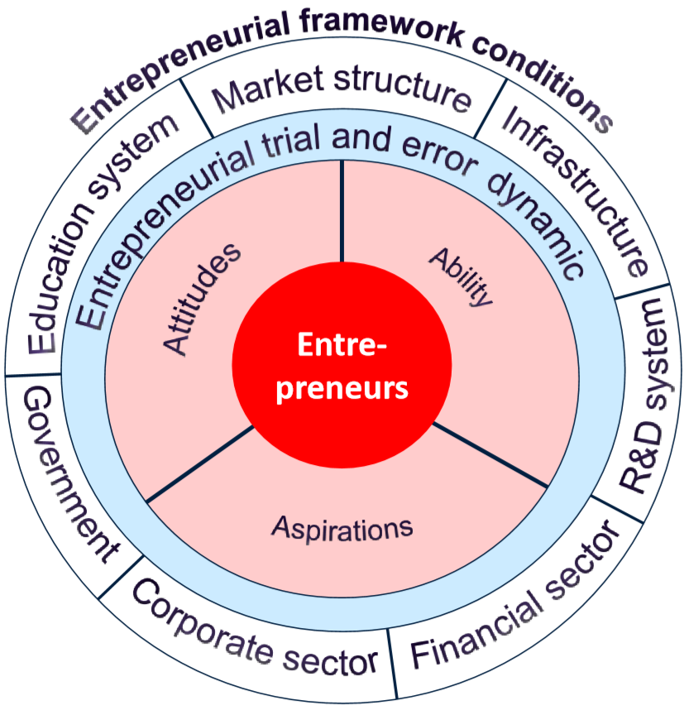

Figure 1.2 – The entrepreneurial ecosystem configuration

Note – Extracted from the source [99, p. 3]

EE is a critical aspect in guaranteeing economic security in any country. The setting in which entrepreneurial activities occur is shaped by an EE [100].
To show the state of EE in Kazakhstan, this study used the “national experts survey” (NES) reports. The data from Kazakhstan is compared to the averages of the BRICS and GEM countries. Financing, taxes, anti-bureaucracy, entrepreneurial training and education, access to infrastructures, R&D transfer, internal market dynamics and burdens, government policies and programs, and socio-cultural norms are evaluated by GEM. NES identified the strengths and weaknesses, i.e., in what areas of the EE Kazakhstan is doing well or needs to improve in order to stimulate new start-ups and their growth, in comparison with other GEM economies [16, p. 44].
The major findings in the NES reports are summarized as below [16, p. 48]:
1) The “access to finance for entrepreneurs” has been in progress since 2014.
2) The “government policies” and “government programs” are generally positive except that bureaucracy and corruption remain major constraints.
3) The “R&D transfer to SMEs” is still inadequate.
4) The “science parks and incubators” are expected to be more productive although growing in number.
5) Entrepreneurship requires greater defense against sizable and quasi-state entities that might use their scale and strength to impede the emerging businesses.
6) Entrepreneurial education should be given more emphasis by the government.
7) Establishing a suitable entrepreneurial culture based on socio-cultural norms is critical.

1.4.1 Access to Finance
Because many entrepreneurs require fresh infusions of money to launch a new firm, entrepreneurial finance is a crucial “entrepreneurial framework condition” (EFC) [16, p. 28].
In Kazakhstan, there are three basic categories of “access to finance” for SMEs [1; 101]:
1) second-tier banks;
2) entities that provide banking services; and
3) microcredit institutions.
The “National Innovation Fund” (NIF), the “Investment Fund of Kazakhstan” (IFK), the “Fund of Science” (FOS), the “Small Entrepreneurship Development Fund” (DAMU), the “Development Bank of Kazakhstan” (DBK), and the “Astana International Financial Center” (AIFC), are all involved in financing services in Kazakhstan. Experts are now optimistic about the availability of funding in Kazakhstan [16, p. 28].

1.4.2 Government Support (GS)
Firms can get various assistance from their government, such as tax allowances, loans, subsidies, grants, tariffs, access to information, social support, productivity support, access to business services and physical resources, management training, deduction of administration and transaction costs, establishment of ties with external bodies, entry to foreign market, reinforcement of legal framework, ﬁnancial capital and incentives, etc. [32, p. 1560; 102-105]. The “social network theory” (SNT) [106] demonstrates that an entity may use solid relationships with external bodies such as the government and other organizations to get access to rare resources that could contribute to its business performance. Likewise, the “resource-based theory” (RBT) implies that, firms with distinctive, uncommon, and inimitable resources have a long-term competitive advantage and outperform their competitors in a volatile and challenging market [107].
Kazakhstan’s government has been putting particular effort to the prosperity of entrepreneurship since its independence from SU. The national program of “Support and Development of Entrepreneurship for 1992-1994” was enacted in 1992, as was the law on the “Protection of and Support to Private Entrepreneurship”. As a consequence, in 1997, the first President Nazarbayev signed a decree creating the “Fund DAMU”. Kazakhstan was among the first countries to conclude a direct cooperative agreement with the United States of America (USA) in 2007, termed the “Program for Economic Development” (PED). Kazakhstan took the lead among the CIS countries to join the “GEM Consortium” in January 2007 [108]. Kazakhstan approved the “Entrepreneurial Code” in October 2015 [84]. The first President Nazarbayev designated promotion of mass entrepreneurship as one of the government’s top goals in September 2016. Clearly, creating a favorable business climate is critical to the country’s successful economic development [16, p. 53].
There are a number of commercial institutions established by the government in Kazakhstan to enhance the GS and stimulate the development of entrepreneurship and SMEs. The “Ministry of Industry and Trade” (MIT) is the top governmental authority, in charge of implementing government programs and encouraging entrepreneurship [2, p. 103]. The “Department of Entrepreneurship Development” (DED) is affiliated to MIT, which is responsible for the GS under the legal regulation [39]. The “Board of Entrepreneurs” (BE) under the President, the “Corporation for Export Development” (CED), the “Center of Engineering and Transfer of Technology” (CETT), the NIF, the IFK, and the DBK are some of the other organizations that support and accelerate entrepreneurial advancement. Kazakhstan has outperformed its peers from the CIS region and continues leading ahead [2, p. 103].
Kazakhstan surpassed other GEM and BRICS countries in terms of public support for government policies and taxes. Kazakhstan’s average score in the support of “government programs” was close to the GEM average [16, p. 45]. As follows, this chapter demonstrates a few typical supports regarding policies and programs from the government of Kazakhstan.

- Bilateral ties
Kazakhstan has signed bilateral treaties with forty-eight (48) countries with an aim to encourage and mutually protect investments. In addition, Kazakhstan has signed a number of international treaties relating to FDIs. When an arbitration agreement is missing, the investment treaties give a range of safeguards, including “most favored nation treatment”, protection against discrimination, and the right to settle disputes through international arbitrations [84].

- Taxation
In a major address concerning institutional reforms to the nation in 2015, the first President Nazarbayev proposed to improve Kazakhstan’s tax system through optimizing the tax (and customs) policies and procedures. In light of this vision, the new “Tax Code” which was adopted on December 25, 2017 and took effective on January 1, 2018, simplified tax administration and revised some tax preferences and benefits. The notion of good faith became one of the most emphasized new provisions in the “Tax Code” [84].
Entrepreneurs, analysts, and experts provided positive assessments on the new “Tax Code” in terms of the tax burden, the predictability and consistency of the new policies [16, p. 22].

- Innovation
In Kazakhstan, a significant part of innovation activities is stimulated directly by the state, and the majority of research work is carried out in public institutions [109]. Kazakhstan is gradually developing innovative economy, which has become one of the major priorities in its national strategy. Kazakhstan has already developed a functioning modern innovation system with the formation of all the main elements in the system [110].
Today, Kazakhstan has established a multi-level (governmental, regional, and enterprise levels) system of support to the development of innovative entrepreneurship. The governmental level is represented by the “Ministry of Investment and Development” (MID) together with the “Ministry of National Economy” (MNE). The regional system includes the local executive authorities and the “Departments of Business and Industry” (DBI). The enterprise level is reflected in the chain of implementation of the innovative entrepreneurship [111].

- E-Governance
In the biennial ranking of the global e-government development among all emerging nations (including those in the Central and South Asian regions), Kazakhstan has achieved the highest level of ICT-driven public administration reforms [112]. Kazakhstan has strong traditions of unitary governance and centralized structure of political management at all levels of public administration. Hence, politically and technologically, e-government has become a universal single-entry platform for all ICT-driven initiatives in national and local public administration [113].
According to Bhatnagar and Apikul [114], Yu et al. [115], Bertot et al. [116], Kapital [117], ITU News [118], Ionescu [119], NITES [120], Satpaev [121], Glushkova [122], as well as Gulmira and Jim [123], e-governance in Kazakhstan is playing the crucial role in terms of:
- facilitating electronic and transparent communications;
- reducing discretion of officials and authorities;
- resulting in a decrease in minor corruptions;
- decreasing bureaucratic administrative hurdles;
- mitigating red-tapes;
- Using e-procurement to provide equitable circumstances for competition and budget reduction;
- improving efficiency through e-licensing and e-business registrations;
- providing information stimulating business to entrepreneurs;
- promoting marketing activities; and
- contributing to education and training practices.

1.4.3 Education and Training
High-quality education can add to human capital. Therefore, education has become one of the most crucial components for assuring economic achievement through innovation [124].
Experts gave high appraisals to the “management and business education” on new venture creation in Kazakhstan. Further, experts scored most highly on the “vocational, professional and continuing education” on entrepreneurship. However, Kazakhstan’s “education and training” statistics are among the lowest among GEM nations. This shows that Kazakhstan’s “entrepreneurship education” (EE) entails further improvement [16, p. 33].

1.4.4 R&D Transfer
For the surveyed experts in Kazakhstan, effective transfer and commercialization of R&D, as well as scientific and technological information (derived from research institutes and universities) to the new and growing firms, is a major problem [16, p. 35].
The knowledge transfer is still inadequate despite the increased government subsidies. In comparison with large and established organizations, this puts young and expanding businesses at a competitive disadvantage. There are still inadequate opportunities for technical commercialization. As a result, it is critical to foster an atmosphere that makes it simpler for academics and engineers to commercialize their works. Kazakhstan’s average in the “R&D transfer” category is much lower than many other GEM countries [16, p. 35].

1.4.5 Commercial and Legal Infrastructures
There are a number of state bodies, organizations, associations and projects regarding commercial and legal infrastructures operating in Kazakhstan, e.g., the “Small Business Administration” (SBA) [125], the “Entrepreneurship Development Institute” (EDI) [126], the “Kazakhstan Small Business Development Project” (KSBDP) [127], the “Forum of Entrepreneurs” (FOE) [128], the business incubators for sharing business services, and technology parks such as the “Alatau IT-City” envisioned as the heart of Central Asia’s future high-tech intellectual center [125].
Kazakhstan’s experts are optimistic about the number of available subcontractors, which will help new and developing businesses in Kazakhstan; they are particularly optimistic about the high-quality financial services. However, making subcontractors not just more available but also more inexpensive for new and developing companies is critical. Kazakhstan’s average score in the “commercial and legal infrastructure” was slightly below the GEM average [16, p. 37].

1.4.6 Internal Market
Kazakhstan’s experts considered “consumer goods market” as rather stable. Kazakhstan’s “internal market dynamics” was scored less than the GEM average level, indicating that there is some stagnation in the marketplace. More effort is required to make it simpler for new-born and expanding businesses to join the market. New and growing ventures in Kazakhstan are still facing obstacles due to their disadvantages at cost, and the unfair competition from the sophisticated companies [16, p. 39].

1.4.7 Physical Infrastructure
Kazakhstan’s average in the “physical infrastructure” category is slightly lower than the GEM average, except that “the affordability of basic utilities” is scored high. Thus, the physical infrastructure that provides support for new ventures has been improving over the past years, yet still much lower than many other GEM countries. Moreover, there is increasing access to the communications and fundamental utilities in Kazakhstan. However, Kazakhstan should further facilitate the conditions of its physical infrastructure and the accessibility of its basic utilities [16, p. 41].

1.4.8 Socio-cultural Norms
Kazakhstan scored a little higher than the GEM average in terms of “cultural and social norms”. Despite the improvement of assessment on this category, it is still important to emphasize the responsibility of the individuals in Kazakhstan for managing their own life. Entrepreneurial risk-taking should be encouraged; individual and organizational innovation (or creativity) as highly desirable characteristics should also be highly praised [16, p. 54].

1.4.9 Senior Entrepreneurship
Experts agreed that it is harder for the senior people who are 50 and older to be employed in Kazakhstan, which shows that the discrimination on age is a concern in the country. This injustice shall be addressed through the state legislation and the alteration of public opinions. Experts were skeptical about the finding that the senior are more active than other groups. Programs and tax benefits are lacking to encourage start-ups among these people. Experts doubted that the senior have more experience and accumulated knowledge in general to increase their chance of achieving success in business. The aged entrepreneurs are more interested in supplementing their income than developing their business [16, p. 55].

1.4.10 Foreign Entrepreneurship
“Ethnic entrepreneurs”, “immigrant entrepreneurs”, and “minority entrepreneurs” are the comparable examples of “foreign entrepreneurs”. “Ethnic entrepreneurs” establish a network of contacts and engagement among persons who share a common national background or migratory experience. “Immigrant entrepreneurs” build their own firms by harnessing their personal connections with established peers of the same background, shortly after their arrival in the host country. In accordance with the definition coined by the US “Department of Commerce” (DOC) [29, p. 127], “foreign business owners” are those “minority entrepreneurs” who, in the host country, do not comprise the major population. A foreigner is defined as a person who comes from another country [129]; or a person not native to or naturalized in the country [130]. Therefore, drawing on the above definitions, “foreign entrepreneurs” can be distinctively defined, in this study, as the individual business owners who have created and are doing their business in a country where they are living as expatriates (or “expats”) [129; 130] but not native or not naturalized. The “foreign entrepreneurs” in this study perform business in Kazakhstan on the basis of their work permit or visa (see more detail in Chapter 3), and do not include the immigrants who have already become the citizens of Kazakhstan.
According to Kazakhstan’s “Ministry of Labor and Social Protection” (MLSP), 19,145 foreign people are working in the country (as of January 1, 2020). This number is based on the issued work permits for foreign citizens and on the participation of foreign labor [18]. There are 2,040 employers who have hired foreign workers. These employers have hired 508,785 Kazakhs, accounting for 96.3% of the entire workforce in their businesses [18]. More details of foreign entrepreneurship are to be discussed in Chapter 3 later in this study.

1.5 Synthetic View and International Position of Kazakhstan’s EE

1.5.1 Synthetic View
The indicative data for the conditions of entrepreneurial framework were summarized using the “principal components factor analysis”, and reported in Appendix D [16, p. 44].

- Strengths
The EE in Kazakhstan has many strengths [16, p. 44] including:
- government support (GS) for start-ups in Kazakhstan is well praised;
- entrepreneurship programs are properly functioning; and
3) physical, commercial, and legal infrastructures support new companies adequately.

- Weaknesses
Meanwhile, some weaknesses require continual improvement [16, p. 44]:
- entrepreneurial education needs to be enhanced;
- R&D transfer is currently insufficient and should be firmly improved;
- research institutions should better transfer knowledge to new and growing ventures;
- legislations should be enforced to prevent unfair competition of the established firms;
- business incubators and science parks are supposed to be more productive, effective, and expanding; and
- equity financing shall provide more help for high-tech firms to start up and scale up.

1.5.2 International Position
Generally speaking, compared with the synthetic indicators of GEM averages (see Appendix E) [16, p. 45] and BRICS’ data (see Appendix F) [16, p. 45] in the framework of the basic EE conditions, Kazakhstan’s EE matches very well with all the GEM groups and BRICS.
However, the major weaknesses are reflected in the following areas [16, p. 45]:
- R&D transfer;
- school and post-school education;
3) socio-cultural norms; and
4) physical infrastructure.

1.6 Main Constraints and Facilitators of Entrepreneurship in Kazakhstan
This section provides a summary list of NES’ responses (see Appendix G) [16, p. 48] with regard to the constraints and facilitators on entrepreneurship development in Kazakhstan.
Top five constraints [16, p. 48] are the issues related to:
- government policies;
- corruption;
- financial assistance;
4) political and institutional framework; and
5) economic climate.
Moreover, there is a serious lack of education and training, such as the relevant business education for nurturing economy with qualified labor resources [16, p. 48].
Financial support remains a drawback since:
1) Kazakhstan has a lack of equity funding;
2) getting bank loans is difficult because most entrepreneurs lack the requisite collateral assets; and
3) many banks decline to finance SMEs because the banks fear risks from the said financing.
Some of the government policies may hold back the entrepreneurial advancement in Kazakhstan since they are non-transparent, unpredictable, unsystematic, and uninformed. Corruption is a severe problem that makes starting a firm difficult for potential entrepreneurs [16, p. 48]. According to some analysts, the three greatest obstacles to productive state-business interactions are red-tape (the prolonged timeframe for documentation), corruption, and bureaucracy [100, p. 108].
Meanwhile, “government programs” are seen as Kazakhstan’s most essential promoter of entrepreneurship. In addition, “government policies” generally serve as a stimulus for new-born and expanding businesses. Kazakhstan’s political, institutional, and social climate is functional and favorable to business. Many people who are active and have a solid understanding of entrepreneurship show an intense desire to start their own firm. Notably, some analysts consider Kazakhstan’s economic conditions to be an incentive as well. Both bad and good aspects of entrepreneurship are reflected in low levels of competition, the presence of niches, or unmet requirements in certain sectors [16, p. 51].

Summary of the Chapter
Kazakhstan is the world’s 9th largest country, with a population of 19.1 million people of various ethnicities, the majority of whom are Kazakhs. In 1991, Kazakhstan declared independence from the former Soviet Union. The first President Nazarbayev started to lead the country until 2019 when the second and current President Tokayev assumed office. The Presidential office, Constitution, Parliament, and Government of Kazakhstan are based in Nur-Sultan, while the former capital city of Almaty remains the center for science, culture, finance, and industry. Kazakhstan has a wealth of natural reserves, consisting of oil, gas, minerals, and coals, as well as agricultural resources that have drawn significant international investment. To promote the economy of the landlocked country, the government has implemented significant reforms in a variety of areas. Kazakhstan has built diplomatic ties with over 139 nations and obtained membership to a number of international and regional organizations. The state and official language is Kazakh while the Russian language is also used officially in most cases on an equal basis with Kazakh.
Kazakhstan’s economy is undergoing a shift towards diversification and modernization. There are a lot of governmental and commercial institutions which serve as the foundation of support for the transformation. Kazakhstan occupied the 22nd position among 190 countries at the “ease of doing business” ranking in 2020, and the 64th place among 137 countries at the “global entrepreneurship index” (GEI) ranking in 2020. Kazakhstan has been improving business conditions in recent years.
Regarding the entrepreneurship ecosystem (EE) of Kazakhstan, positively speaking,
- government policies and programs” are successfully encouraging and promoting entrepreneurship;
- there are growing opportunities for entrepreneurial financing; and
- the commercial infrastructure is well developed.
However, negatively speaking,
- the equity finance remains insufficient;
- the entrepreneurial education (EE) needs to be addressed;
- the R&D transfer is disadvantageous compared to most GEM economics, which makes it critical for the new and growing enterprises to have more access to advanced technologies;
- the physical infrastructure remains less developed and needs more improvement;
- competing with the experienced and sophisticated rivals is not easy for SMEs and entrepreneurship, which implies the government pay more attention to the training on and supporting to the new and growing businesses;
- the socio-cultural norms need to be further enhanced through, for example, the public media propagating success stories, commercial acumen, and individual responsibility; and
- corruption, bureaucracy, and red-tape remain the major constraints on entrepreneurship.

2 LITERATURE REVIEW

2.1 Introduction
This present chapter firstly showcases a typical list of definitions about entrepreneurial intention (EI) relevant to entrepreneur, entrepreneurship, and intention; then introduces two approaches to EI research and determines the approach and theoretical foundation of this study; next systematically categorizes the single factors influencing EI, and thoroughly reviews the combined (groups of) single factors and established intention-based models. A holistic and firm understanding of these factors, theories, and models assists in formulating the theoretical framework to fill the gaps under the setting of this study, which is characterized by the context of Kazakhstan, COVID-19 epidemic, foreigners, and government support (GS). The humble attempt of a systematic and exhaustive literature review also paves the way for future research in this domain. Finally, the hypotheses and research framework are developed. The originality of the framework lies in the application of “TPB” model and inclusion of “GS” as the moderator in the research setting. Positioning of the research model in terms of its novelty and contribution to scholarship is to be claimed in Chapter 6.

2.2 Definition and Conceptualization of Entrepreneurial Intention (EI)
As its names implies, entrepreneurial intention (EI) relates to entrepreneur, entrepreneurship, and intention, which are defined by numerous authors from various perspectives. Among them are the following acknowledged definitions which capture their essence in concept.
Smith [131] defined an entrepreneur as an individual capable of foreseeing a potential market need and converting it into a supply. Likewise, Schumpeter [132] regarded an entrepreneur as an inventor who identifies new markets and profits from them by merging diverse resources to produce a new function. In the business area, entrepreneurs employ social and natural reserves to facilitate an economy and benefit the people through generating employments, inventing innovative approaches to existing problems, developing efficient technologies, and spreading ideas around the world; entrepreneurs are the gateway connecting creativity and commerce [99, p. 1].
Entrepreneurship underlines innovativeness, creativity, and invention when developing something original or improved for a society. It also stresses the capability and desire to launch, manage, and run a company and deal with difficulties, problems, uncertainties, and potential harms in order to earn a wealth that is more relevant to success and accomplishment than financial gains [133, 134].
Bird [54, p. 442] stated that intentionality is a cognitive awareness including experience, concentration, and individual activity towards a certain objective or behavior; and it is a condition of mind leading the personal attention to a particular target or way in effort to make accomplishment. According to Ajzen [56, p. 182], intention is the indicator of how much dedication individuals are ready to make in order for performance of the behavior. Intentions also reflect, as Shook et al. [135] mentioned, a conscious condition of mind preceding a behavior.
As a common rule, when there is a stronger intention, a person will more likely perform a planned behavior. Kolvereid and Isaksen [136] claimed that intention, at a single factor level, can provide most accurate prediction for the majority of planned behaviors, including entrepreneurship. Intention has been discovered to be a reliable precursor of actions, for example, in employment choices [137]. Besides, it is significantly practical to investigate the intention rather than directly observing the behavior itself in order to obtain the understanding of a behavior because it is difficult to accurately measure a real behavior in study [138].
Based on the above separate conceptualizations on entrepreneur, entrepreneurship, and intention, hence, EI as a comprehensive concept becomes explicit in connotation. As Bird and Jellinek [139] defined, EI is a level of cognitive awareness that promotes the formation of a new firm in the future [140]. Similarly, Krueger and Carsrud [141] described EI as the individual commitment to launching a new venture.

2.3 Approaches to Research on EI
The contemporary entrepreneurship research has identified EI as the strongest, most basic, persistent, and widely utilized predictor, indicator, and construct of entrepreneurship and business success [54, p. 443; 55, p. 17; 105, p. 387; 142-145]. Evidence from the extant literature affirms that EI plays an important part in deciding to commence a new venture [54, p. 443; 57, p. 77; 143, p. 411; 146; 147]. Meta-analyses confirm that intentions can account for up to 39% of the variation in actual behavior [148].
EI has been studied from various viewpoints by scholars in diverse areas, which gave this specific construct the multiple faces [61, p. 1447]. Among the viewpoints are entrepreneurial and psychological traits [149; 150], entrepreneurial behaviors [151], and economics [152; 153]. Furthermore, two types of approaches [62, p. 45] have arisen in the EI research area:
1) content-orientation approach seeking to identify the particular elements within persons that originate, guide, maintain, and terminate a behavior; as well as
2) process-orientation approach method explaining how a behavior is started, led, maintained, and ceased.

2.3.1 Content-oriented EI Research
More specifically, the content-oriented approach focuses on individual factors and contextual factors, which could be illuminated with the “pull” and “push” theories [62, p. 45]. The “pull theory” posits that people are usually drawn to entrepreneurial activities by internal forces such as personalities, traits, and demographic characteristics in pursuit of independence, self-actualization, prosperity, and other desirable outcomes. The “push theory” contends that persons are driven into venture creation by negative and external powers such as difficulties in getting a satisfactory job, a poor salary, rigid work schedules, dissatisfaction in prior work experiences, availability of different resources, governmental influences, social and political predicaments, chances from markets and industries, and presence of financial aid for entrepreneurship [154; 155]. Empirical research indicates that “pull” factors predominates over “push” factors in stimulating individuals to become entrepreneurs [156; 157]. The single factors and combined (groups of) single factors are to be exhaustively reviewed later in this chapter.

2.3.2 Process-oriented EI Research
Starting up a new firm consists of a number of behaviors, such as generating a novel business idea, analyzing and validating the idea, locating potential co-founders or partners, obtaining necessary resources, developing a business plan, interacting with different stakeholders, designing and checking the new service or product, marketing promotion, and the like, before a new venture is created [66, p. 536]. Therefore, unlike the content-oriented approach, the process-oriented approach centers on individuals’ cognitive processes which lead to activities. Humans can assess possible outcomes in the future, which are relatively more desirable among these outcomes, and whether it is applicable to attain these results through pursuit. It is unrealistic to expect people to pursue objectives that they believe are unpleasant or impossible to achieve [158]. As a result, a large number of prominent intention-based models and theories were originated to provide a new method of motivating and explaining entrepreneurial behaviors [63, p. 25], such as the notable “theory of planned behavior” (TPB) model [56, p. 182], the model of “Shapero’s entrepreneurial event” (SEE) [159], the “implementing entrepreneurial” (IE) model [54, p. 444], the model of “entrepreneurial intentions” [160-162], the “economic-psychological” model [163], and the “expectancy” model [164], etc. There are some other models which have gained great attention in EI research as well including the “intention” model [165], the “entrepreneurial attitude-orientation” model [155, p. 23], the “intentional basic” model [141, p. 317], the “TPB entrepreneurial” model [141, p.323], the “entrepreneurial potential” model [166], the model of “maximization of expected utility” [167], as well as the “contextual intention” model [168], etc.
The intention-based models look at people’s cognitions, perceptions, motivations, and intentions [169]. Researchers emphasize the cognitive comprehension on entrepreneurship and development of intentions in order to fully catch the core of entrepreneurship [165, p. 65], since intention seems to be fundamentally essential to the decision-making process [170]. To a significant extent, these models are comparable in that all of them incorporate attitudes, the “social learning theory” (SLT), and single determinants that affect the determination to establish a firm [171]. Among these models, nonetheless, only TPB and SEE remain most influential and stand out in the literature owing to their robustness in prediction. Particularly, many studies [65, p. 7; 67, p. 12] recognized the even superior model of TPB. Hence, TPB was designated as the theoretical foundation of this study. In order to present a holistic view, the other models are to be briefly discussed as well later in this chapter.

2.4 Approach to EI Research in This Study
Many scholars argue that the focus of entrepreneurship study is supposed to shift away from content-oriented profiles of entrepreneurs, and instead, highlight the entrepreneurial process as it occurs in a multifaceted social environment [65, p. 5; 172].
Based on:
- the holistic understanding of single factors, combined (groups of) single factors, and well-established theories and models built on relevant single factors, and
- the consideration that intention models yield more predictive power than single factors [70, p. 49; 141, p. 315; 173] in explaining behaviors,
this study, hence, chose the process-based approach and adopted Ajzen’s “TPB” model [56, p. 182], one of the best recognized models, as the research ground.

2.4.1 TPB Explaining EI
TPB is the most widely adopted theory in explaining and predicting human behaviors among the jungle of psychological theories [70, p. 47; 71, p. 269]. TPB claims that intent is the immediate precursor of an action; the greater the desire to participate in a certain activity, the more probable it is to be carried out [56, p. 185]. Entrepreneurial intention (or “EI”) is an intentional and conscious choice to become an entrepreneur [143, p. 411]. It involves the process of timing, planning, and cognitive work to start up a new firm (entrepreneurial behavior) [174]. Thus, an entrepreneurial employment option belongs to the category of planned behaviors; the most applicable models are intention-based ones for this kind of option [54, p. 445]. EIs, in turn, are a determinant leading to entrepreneurial behaviors [136, p. 866].
TPB claims that, intentionality is triggered by personal attraction or attitude (known as “PA”), subjective norms (known as “SNs”), as well as perceived behavioral control (known as “PBC”), in a person. To put it differently, personal behavior is directed by behavioral beliefs (corresponding to PA), normative beliefs (corresponding to SNs), and control beliefs (corresponding to PBC) [66, p. 536].
In particular, the cognitive variables – such as the PA, SNs, and PBC – that inﬂuence intentions are known as “motivational antecedents” by Ajzen [56, p. 182]. As specially noted, the earlier “theory of reasoned action” (TRA) [175] established the theoretical foundation for TPB; in fact, TRA is regarded as a specific instance of TPB [56, p. 182]. TPB includes PBC as a further antecedent of intents and actions, whereas TRA does not. Specifically, it is anticipated that PBC moderates the correlations between PA-intention and SNs-intention, whereas actual behavior control (ABC) moderates the link between intention and behavior. Under situations of perfect PBC and ABC, degree of control becomes unimportant and the TPB decreases to TRA [66, p. 536].
TPB has been the most popular model utilized by academics in entrepreneurship study for several reasons:
- TPB provides a cohesive and universally practical theoretical foundation (including both personal and societal aspects) for understanding and predicting EIs [176];
- entrepreneurship is deemed a planned behavior which is a non-spontaneous action [143, p. 412];
- SNs appear to be a more effective indicator in comparison with the generic cultural norms as SNs focus on a society’s specific beliefs to entrepreneurship [177];
- TPB has been well testified with adequate evidence to be useful across a wide range of behaviors [56, p. 188; 143, p. 412].

2.4.1.1 Personal Attitude (PA)
PA towards a behavior pertains to the degree to which one favorably or unfavorably views or appraises the behavior. The more favorable the person’s attitude is towards the action and, thus, the greater their propensity to engage in such an activity, and, ultimately, the stronger the intention to conduct this action [66, p. 537].
In the case of entrepreneurship, personal attitude or personal attraction (PA) towards the behavior relates to how favorable or badly an individual’s overall personal appraisal of being an entrepreneur is [56, p. 182]. People acquire attitudes derived from behavioral beliefs regarding the results or consequences, as well as some other aspects out of the behavior, according to TPB. Both internal and external benefits, such as financial gains, autonomy, individual fulfillment, and household security, are examples of such outcomes. All of these benefits have a favorable or unfavorable effect on the desire to establish a venture. Negative or expensive result expectations, such as the perception of risks linked with entrepreneurial activities, affect unfavorably the desire to launch a business [178; 179].
The “expectancy-value” model, interestingly, addresses the link between behavioral beliefs and attitudes towards the behavior. As a result, the magnitude of each conviction is determined by the anticipation of a consequence, and the products are accumulated over all readily available beliefs [66, p. 537]. Thus, two people who share the same strong idea that, for example, may have completely opposite attitudes, because one may see these challenges as good while the other sees them as bad, and vice versa [56, p.182].

2.4.1.2 Subjective Norms (SNs)
SNs relate to the perceived motivation from a society to participate in or perceived inhibition to refrain from engaging in a certain activity. This concept is derived from beliefs regarding whether significant others (or called “reference individuals or groups”), including good friends, parents, relatives, and siblings, agree or disagree with an individual beginning to take actions to establish a new firm, and how much this agreement or disagreement counts to the person [56, p. 182]. The more an individual’s care for the opinion of a reference group, the higher the personal willingness to partake in these behaviors [66, p. 538].
SNs include two elements: normative convictions and the willingness to follow such convictions [175, p. 288]. The normative beliefs address the anticipated chance that significant referent persons or groups would accept or reject a given behavior; they specify how the individual should act. The second element, willingness to follow, indicates an individual’s readiness to adhere to these standards, i.e., to act in accordance with the anticipations of reference groups. Subject to the specific societal situation, these forces might serve as a catalyst or an obstacle for the realization of entrepreneurship. Consequently, SNs are the result of normative ideas multiplied by the incentive to adhere to these social referents. In general, SNs contribute weakly to intention, depending on the conformity tendency and personality traits of the individual [56, p. 189; 180].

2.4.1.3 Perceived Behavioral Control (PBC)
PBC concerns the sensed complexity or simplicity in carrying out a particular action. PBC is generated in accordance with the control beliefs on the presence or absence of the desirable opportunities and resources for actions. The greater the PBC over launching a venture, the stronger intention a person has to partake in such an action [66, p. 539]. To put it in a different way, PBC is a person’s conviction and assurance in his or her capacity to conduct entrepreneurship and achieve domination and accomplishment in entrepreneurship [56, p. 182].
Virtually all behaviors require a number of steps in process and the performance can be blocked at any stage due to some impeding factors, such as the insufficient qualifications, the lack of needed cooperation, and the inadequate finances. Successful execution of the behaviors thus relies on the individuals’ degree of control over them. PBC results from such beliefs on control, i.e., convictions regarding the availability of conditions that might assist or inhibit implementation of the activity, multiplied by the perceived level of these conditions [66, p. 539].
People typically perform behaviors that they believe they can handle and master. It is very similar to, or even the same as, entrepreneurial “self-efficacy” (SE) [143, p. 413; 181], a Bandura [182; 183] concept referring to one’s conviction over his or her attitudes, capacities, and skills to be successful, dependent on the information acquired by the person and the person’s capacity to understand it [182, p. 122; 183, p. 1175; 184-186]. Both PBC and SE are concerned with the perceived capacity to accomplish an activity, such as starting a business. SE was even used to replace PBC in several studies [136, p. 867; 143, p. 413; 181, p. 552], because SE is more well defined and significantly connected with goals than PBC, according to Armitage and Conner [180, p. 489].
In summary, according to TPB [56, p. 182], intention and behavior are founded on an affective and cognitive foundation consisting of three readily accessible beliefs (PA, SNs, and PBC) at the time of behavior. PBC stands for feasibility; PA and SNs together define the desirability part of the EI. In the generic form of research on EI, scholars (e.g., [143, p. 413; 187-189]) basically support the roles of PA, SNs, and PBC in predicting entrepreneurial behavior, and intention appears intense when there exists a positive PA, favorable SNs, and an effective belief of PBC.
Typically speaking, the three intentional antecedents (PA, SNs, and PBC) in TPB are considered as independent components in a linear prediction model; meanwhile, PBC theoretically moderates the predictive power of PA and SNs on intention. In other words, positive PA and SNs lead to the transformation of an intention into a behavior to the degree that people believe they are able to execute the behavior (PBC). In addition, it is anticipated that the relative significance of PA and SNs as intention predictors would vary across activities, populations, and time periods [66, p. 536].
Figure 2.1 below graphically illustrates the “TPB” model.

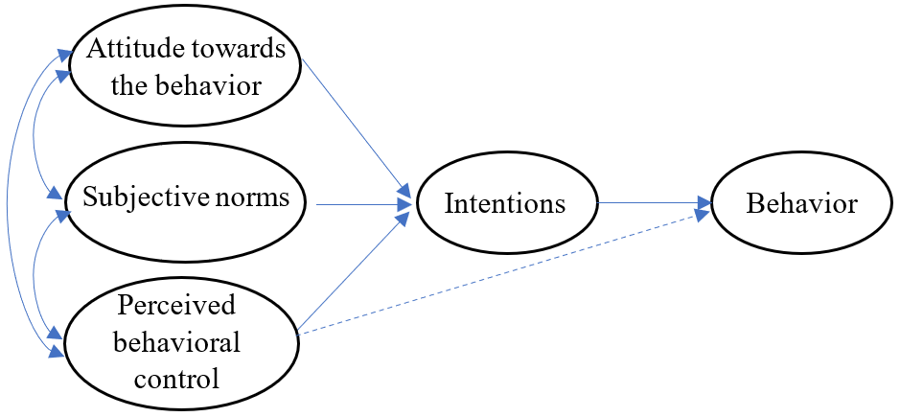
Figure 2.1 – The model of “TPB” developed by Ajzen

Note – Extracted from the source [56, p. 182]

2.4.2 Applicability of TPB in EI Research
Research on the establishment of EI has earned a great deal of interest and focus from academics in this field, among whom Ajzen (particularly with Fishbein) was one of the pioneers to study intentions and behavior from the late 1960s. Consequently, the popular “theory of planned behavior” (TPB) came into being [56, p. 182]. Since its birth, the “TPB” has been examined, improved, and questioned in plenty of social scientific areas and, hence, attracted a myriad of interests among academics. For one thing, the seminal article by Ajzen [56, p. 179-200] alone has generated at least 60,000 citations up to date [66, p. 540].
TPB has gotten its applications in a broad number of behaviors, consisting of family planning, technological adoption, dietary and exercising, recycling and energy saving, leisure activities, blood donation, and so forth. It has also been extensively applied in the domain of entrepreneurial behavior. More than 2,000 empirical investigations on the “TPB” model’s use in the aforementioned behavioral areas have been published. TPB has been used to steer behavior in addition to explaining and predicting it. TPB has, in general, withstood the test of time for more than 30 years, and it continues to provide a helpful platform for understanding, forecasting, and influencing human behaviors, including the start-up of a business [66, p. 540; 190].
TPB has shown great robustness in explaining and predicting EI [191], and substantial studies have justified it (e.g., [167, p. 81; 176, p. 363; 192-196]). To name a few, TPB has been employed successfully in the prior research to evaluate the EI among students, in the USA (e.g., [143, p. 411; 194, p. 145]), in the Netherlands (e.g., [181, p. 538]), in Norway (e.g., [70, p. 47]), in Russia (e.g., [71, p. 269]), in Finland and Sweden (e.g., [194, p. 145]), in Germany (e.g., [197]), in Spain and Taiwan (e.g., [147, p. 2]), and in South Africa (e.g., [198]).
TPB’s strength, when viewed from the perspective of its elements, is that it considers not just personal aspects, but also social and environmental circumstances around persons. As a result, EI, as one’s self-faith that he or she is willing to launch a nascent venture and deliberately prepares to do so afterwards [199], can be better comprehended and motivated due to its coherent structure [143, p. 411]. The framework consists of three proximal components that influence EIs: PA (assertive/unassertive appraisal of entrepreneurship), SNs (agreement or disagreement on entrepreneurship of the reference groups), and PBC (awareness of the individual’s entrepreneurial talents) [147, p. 2]. Both the attitudinal components (PA and SNs) and the control component (PBC) correlate often to the constructs of “desirability” and “feasibility” from the “SEE” model [181, p. 538; 200, 201].
According to the extant research, intentions represent roughly 30% of the variation in behavior [180, p. 417], or precisely, 39% [148, p. 473]. In addition, prior studies show that the three TPB components account for ranging from 21% [194, p. 145] to 55% [147, p. 3] of the variation in explaining EI, depending on each specific study. TPB, according to Kolvereid [70, p. 47], Liñán and Chen [147, p. 1], explains 30-45% of EI in variation. TPB predicts 27% of the variation in behavior and 39% in intention, according to a meta-analysis [180, p. 417]. A sum up to 59% of the variance in motivating intents is estimated by PA, SNs, and PBC altogether, according to Kautonen et al. [191, p. 655]. A substantial portion of these disparities may be attributable to the measurement difficulties [202], as measuring cognitive factors is challenging [203]. Thus, the results of diverse empirical tests are, to a large extent, divergent.
Despite the fact that TPB does not require all of its three determinants to be present simultaneously, the greater the combined strength of the three variables, the stronger the intention would be [56, p. 182]. Krueger et al. [143, p. 411] found empirical evidence for TPB’s dominant plausibility when they used a comparison approach between the predictive powers of TPB and SEE [159, p. 511]. Autio et al. [194, p. 145] found that, all of the three components in TPB affect EI individually, with PBC contributing the strongest power and SNs the weakest. Lüthje and Franke [204], using their slightly modified model of TPB, found that PA is the most important determinant of EIs. Likewise, Ajzen [56, p. 182] proposed that, although the “TPB” model is universally applicable across various cultures and circumstances, the relative weight of the components may vary among national and regional cultures, ethnic communities, organizations, and individuals. Moriano et al. [205] studied six nations (Iran, India, Germany, Poland, Spain, and the Netherlands) for the purpose of testing the cross-cultural generalizability of TPB; the results substantiated the universal effects of PA and PBC on EIs (across a wide range of cultural backgrounds), but revealed substantial variation in the effect of SNs (across these different cultures).

2.4.3 Extension of TPB in EI Research
According to Ajzen [56, p. 182; 67, p. 142], TPB is already a sufficient model to explain behavioral intentions (including EIs); and the extrinsic factors (e.g., personality traits, demographics, and past experiences) affect the (entrepreneurial) intentions indirectly via their effects on the TPB components (PA, SNs, and PBC). Hence, based on this ground, two published studies among others, involved additional factors (external to the fundamental “TPB” model) in order to verify TPB’s sufficiency in predicting EIs.
One study conducted by Kolvereid [70, p. 47] tested the EIs of undergraduate business students in Norway, revealing the following results:
- the three TPB components (PA, SNs and PBC) do significantly influence the students’ EIs;
- there is no direct association between the demographic variables and the EIs;
- the demographic factors do have indirect influence on the EIs through their effects on the three TPB components.
The other study undertaken by Tkachev and Kolvereid [71, p. 269] examined the EIs among undergraduates in Russia. The results showed that:
- the Russian students’ PA, SNs and PBC all determine their EIs directly;
- neither of the demographic factors nor the tracking variable predicts their EIs directly, contradicting the hypothesis that children are heavily impacted by parental role models and are more inclined to plan to act as entrepreneurs if their parents were ever entrepreneurs;
- the demographic and tracking factors have only indirect impacts on the EIs depending on how much they affect the three antecedents of TPB.
The above evidence shows, despite the fact that TPB has been widely recognized as a solid rationale and demonstrated to be a useful tool in EI studies, there still exists an opportunity to include certain factors that probably affect the model [68, p. 44; 69, p. 109]. As such, Ajzen [67, p. 142] expanded the “TPB” model by introducing new components (e.g., personal, demographic, societal, and environmental factors) which act as the indirect determinants of EIs and behaviors. In addition to the approach of extension by virtue of the above-mentioned external variables and mediating effects of the TPB components, Fayolle and Liñán [72, p. 663] argued that new work on moderating effects included in the “TPB” model might potentially be meaningful.
This study incorporates moderation effects into TPB (see Section 2.8). A moderating variable alters the size and/or sign of an IV-DV relationship. Examples of a moderator are gender, race, or societal class (in qualitative instance), and level of income (in quantitative instance). Moderation indicates that the causal relationship between two variables varies according to the moderator [73, p. 1173; 206].
The assignment of moderators should be in light of theoretical ground with considerable literature support [207]. When there is an unanticipated weak or inconsistent association between a precursor and an outcome across studies, moderating factors are likely to be included [73, p. 1173; 207, p. 115].
Going a step backward, in order to build up the framework of this research, a systematic and overall understanding of (combined groups of) single factors and established models are deemed necessary in the first place. Thus, the following sections (2.5, 2.6 and 2.7) attempt to exhibit a complete profile of affecting factors and well-acknowledged models through an exhaustive literature review in the relevant area.

2.5 Single Factors Influencing EI
The term “factor” is analogous to a variety of other terms which appear frequently in the relevant literature, including “determinant’, “antecedent”, “precursor”, “motivator”, “predictor”, “indicator”, “trigger”, “driver”, “stimulator”, “facilitator”, “precipitator”, and so on. These exchangeable terms hold the same meaning in essence in this study.
It is particularly pertinent to investigate into predictors of EI, as EI is considered the key to understanding the initial step, the lengthy and complicated process of entrepreneurship [208]. This study managed to classify the major factors extracted from the extant literature into six categories which are to be discussed very tersely one by one as below, and summarized thereafter in Appendix H.

2.5.1 Demographic Factors
Demographic determinants include gender, age, education level, ethnicity, nationality, religion, and location, among others [209-214].
Attempts to establish a connection between a person’s demographic features and entrepreneurial behavior were largely unsuccessful [215-219]. Gartner [172, p. 696] suggested that entrepreneurs are not a uniform group, hence it is fruitless to stereotype them depending on a combination of typical characteristics. The impact of demographic variables on such determinants as attitudes (e.g., PA), norms (e.g., SNs), and self-efficacy (e.g., PBC), etc. are shown to influence the self-employment decision (or alternatively, the “EI”) indirectly (e.g., [70, p. 47; 143, p. 411; 220]).

2.5.2 Personality or Personal Factors
Prior studies on intentions or EIs paid close attention to traits or personality characteristics of an individual [221]. An important body of the research attempted to relate intentions to individual characteristics. Networking capability, need for achievement (N-Ach), self-efficacy (SE), leadership, and risk-taking propensity are some of the examples [143, p. 411; 150, p. 205; 222-224].
Some other typical personality traits are competitiveness, creativity (innovativeness), talents (intelligence), lifestyle, optimism, independence (autonomy), internal locus of control, tolerance of uncertainty, and tolerance of pressure [150, p. 205; 204, p. 135; 208, p. 7; 222, p. 62; 223, p. 259; 225-234]. Moreover, personal traits such as technical expertise, professional skills, managerial aptitude, leadership and entrepreneurial experience appear to influence EIs [236].
On the one hand, it is well believed that personality is a significant determinant of entrepreneurship and that entrepreneurship study in this regard remains of interest [237-239]. However, opponents of this direction recommended abandoning the further research on personality traits (e.g., [240]) as they were unable to establish a conclusive relationship between personal qualities and entrepreneurial activity [149, p. 23; 151, p. 27; 241-246]. Low and McMillan [245, p. 139] argued that personality-based descriptive research does not contribute to the development of an entrepreneurial theory. Limited empirical findings are available that demonstrate the causal link between personality characteristics versus behavior (such as entrepreneurship) [56, p. 182].

2.5.3 Situational Factors
Situational factors or triggering events, such as an alteration in one’s life trajectory (e.g., mobility to a different region, unemployment, and inheritance), constraints on time, job dissatisfaction, low level of reward, task complexity, opportunities, and the impact of other important people through socio-cultural pressure, could be instances to induce individuals to make a career choice of entrepreneurship [160, p. 5; 165, p. 63; 168, p. 23; 173, p. 361; 247-253].
Situational factors do provide a degree of predictive capability regarding the selection of an entrepreneurial profession [254]. Nonetheless, situational factors are also proven to be weak antecedents of entrepreneurial behaviors [143, p. 411]. The dispute on significance and predictive power of situational factors will be an ongoing issue among academics [173, p. 361].

2.5.4 Cognitive Factors
“Cognitive style” describes how to process information that is associated with an entrepreneurial action. Two major research lines have evolved in the cognitive literature [255]:
1) the investigation into “cognitive structure”; and
2) the investigation into “cognitive processes”.
Targeting at (1), some authors have endeavored to find out what knowledge structures entrepreneurs utilize to assess, judge, or decide during the process of evaluating opportunities, creating a venture, and developing the venture [256-258]. Towards (2), some other studies are based on the rationale that individuals acquire, use, and process information through their “cognitive processes”, to influence the way the individuals think, say or do [259; 260]. The second perspective of “cognitive processes” implies that entrepreneurs and non-entrepreneurs perceive and process information differently; thus, these distinctions may play a role in distinguishing entrepreneurs (who would develop or seek to establish enterprises) from non-entrepreneurs (who will not establish or not intend to do so) [174, p. 221; 256, p.2].
The major cognitive features reflected in the literature of entrepreneurship include scripts (or knowledge structures) (e.g., [258, p. 974; 261-263]), cognitive styles (e.g., [256; 264; 265]), and heuristics (or decision-making) (e.g., [266]). As specially noted, the TPB components are also typical cognitive processing factors [56, p. 179; 158, p. 42; 174, p. 221].

2.5.5 Social Factors
Liñán and Chen [147, p. 10] found that social inequalities probably have an impact on how entrepreneurial motivating antecedents are perceived. Substantial empirical research on EIs has highlighted social factors including past experiences [159, p. 511; 163, p. 15; 188, p. 45; 229, p. 15; 267-273], role models [143, p. 420; 160, p. 10; 173, p. 370; 211, p. 30; 274-278], educational support [143, p. 420; 229, p. 16; 279-284], and business incubators [252, p. 49; 285, 286], as the main determinants of EIs [287-289].

2.5.6 Environmental Factors
Environmental factors that affect EIs include cultural and social norms (e.g., [290-292]), social relations or networks (e.g., [293; 294]), economic and political infrastructure (e.g., [241, p. 155]), physical and institutional infrastructure (e.g., [35, p. 3; 295]), commercial and legal infrastructure (e.g., [35, p. 3; 296, 297]), entrepreneurial finance or access to capital (e.g., [35, p. 3; 294, p. 1018; 298]), government policy or support (e.g., [31, p. 8; 34, p. 40]), research and development (R&D) transfer (e.g., [35, p. 4; 230; 299]), internal market dynamics (e.g., [300-302]), entry regulation (e.g., [35, p. 5; 297, p. 10; 303]), and availability of information (e.g., [294, p. 1018; 304, 305]), etc. Moreover, Specht [306] found five major environmental factors, i.e.,
1) social indicator;
2) political indicator;
3) economic indicator;
4) market emergence indicator; and
5) infrastructure development indicator.
The single factors enumerated above are summarized and classified in Appendix H.

2.6 Combined (Groups of) Single Factors Influencing EI
There are a variety of approaches to studying EI’s influencing factors. Given a particular setting, many scholars selectively exploited various single determinants to create their respective study models [208, p. 7; 307, 308].
The method of selecting and grouping individual factors in various combinations, in this study, is named “combined (groups of) single factors”. Some of the studies using this approach are displayed in Appendix J [167, p. 81; 169, p. 142; 201, p. 165; 204, p. 135; 208 p. 7; 233, p. 285; 235, p. 5; 309-317].

2.7 Established Models Explaining EI
Established models are viewed as a special kind of combined (groups of) single factors. Current assessments of EIs primarily shed light on two primary directions. The first was created by Ajzen [56, p. 182] and is known as the “TPB” model (see Section 2.4), while the other was the “SEE” model coined by Shapero and Sokol [159, p. 511]. According to Ajzen [56, p. 179], EIs are predicted by PA towards behavior, SNs about behavior, and PBC over behavior. Likewise, Shapero and Sokol [159, p. 511] centered on the component of “propensity to act”, as well as the “desirability and feasibility” perceptions.
A number of other well-recognized models are selectively and concisely illustrated below except the “TPB” model which has been introduced in the preceding Section 2.4. Reviewing of these models helps to better understand TPB in terms of its position and connotation among the jungle of models.

2.7.1 Entrepreneurial Event Model
As briefly mentioned above, this model, known as the “SEE” model (see figure 2.2), hypothesizes that EIs are determined by three precipitators: “propensity to act”, “perceived desirability”, and “perceived feasibility”.
“Propensity to act” means the degree to which one shows his or her inclination to perform the determination. “Perceived desirability” indicates the extent to which one perceives lured to self-employment. “Perceived feasibility” measures the level about how practical and realistic one clearly thinks to establish a new venture [159, p. 511].

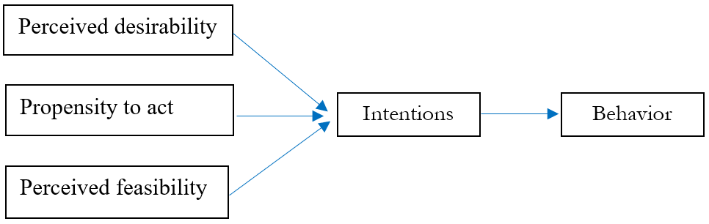

Figure 2.2 – The model of “SEE” developed by Shapero

Note – Extracted from the source [146, p. 294]

2.7.2 Implementing Entrepreneurial Ideas Model
This model (see figure 2.3) argues that individuals are prone to intention depending on both personal and environmental factors. Personal factors consist of personal characteristics and abilities, personal history, past experiences, and demography. Contextual factors include influences in terms of society, politics, and economy. Environmental and personal factors influence rational and analytic thinking (e.g., business execution plans, opportunity recognition, access to resources, etc.) and intuitive holistic thinking (e.g., business vision) [165, p. 63].
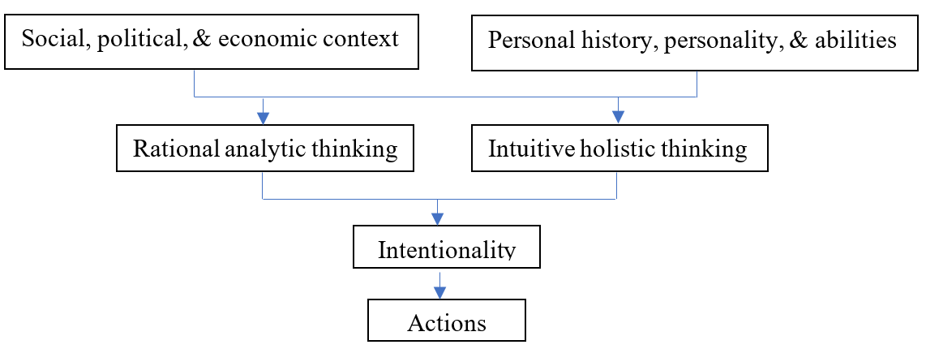

Figure 2.3 – The model of “implementing entrepreneurial ideas” developed by Bird

Note – Extracted from the source [54, р. 444]

2.7.3 Entrepreneurial Attitude Orientation Model
This model, proposed by Robinson et al. [141, p. 317], describes the attitude-prediction link with four sub-scales:
1) accomplishment in firm performance;
2) creativity in firm performance;
3) sensed controllability over firm performance; and
4) sensed confidence in firm performance.
Respectively, sub-scale 1) refers to the concrete outcomes with respect to the start-up and development of a venture; sub-scale 2) relates to the operation of business activities in original, creative, and distinctive ways; sub-scale 3) concerns his or her perception of control over the business; and sub-scale 4) pertains to his or her self-confidence and competency gained from the business.
The scales explain three kinds of reactions accordingly [71, p. 269; 318; 319]:
- the affective reaction (favorable or unfavorable feelings towards the target);
- the cognitive reaction (the attitudes that a person has about an object); and
- the conative reaction (the tendencies to conduct in a certain way).

2.7.4 Intentional Basic Model
In this model (see figure 2.4), intentions directly affect behavior and attitudes affect intentions. Exogenous influences (personal or situational variables) either stimulate attitudes directly, or moderate the intentions-behavior relationship indirectly [141, p. 317].

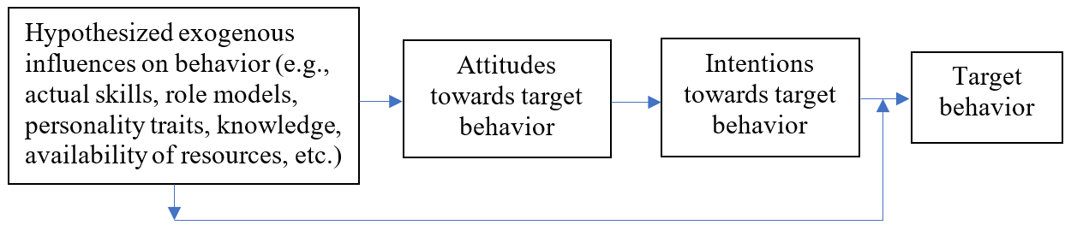

Figure 2.4 – The model of “intentional basic” developed by Krueger and Carsrud

Note – Extracted from the source [141, p. 317]

2.7.5 Theory of Planned Behavior Entrepreneurial Model
This model (see figure 2.5) is grounded on Ajzen’s “TPB” model. Nevertheless, it is modified to meet the context of entrepreneurship. According to this model, launching a firm is a deliberate procedure impacted by a person’s attitude on venture formation, the sensed societal pressure, and the perceived control over business [141, p. 323].

2.7.6 Entrepreneurial Potential Model
This model (see figure 2.6) simplifies the preceding models of “SEE” [159, p. 511] and “TPB” [56, p. 182] by correlating “perceived desirability” with “PA and SNs”; and “perceived feasibility” with “SE” [166, p. 95]. Krueger [160, p. 5] cited proof that “perceived credibility” plus “propensity” collectively explains more than half of the variance in triggering EIs. Among the aforementioned components, the “perceived feasibility” is the most influential stimulator.

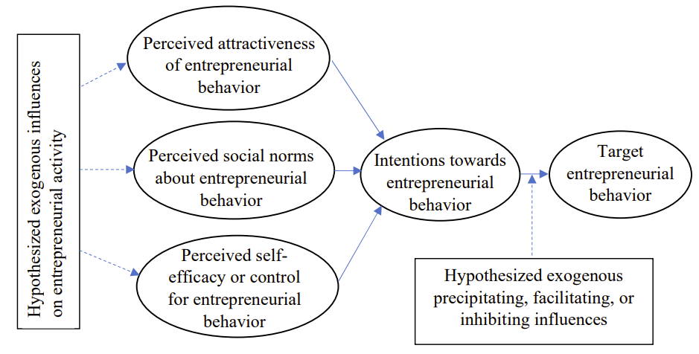

Figure 2.5 – The “TPB entrepreneurial” model developed by Krueger and Carsrud

Note – Extracted from the source [141, p. 323]
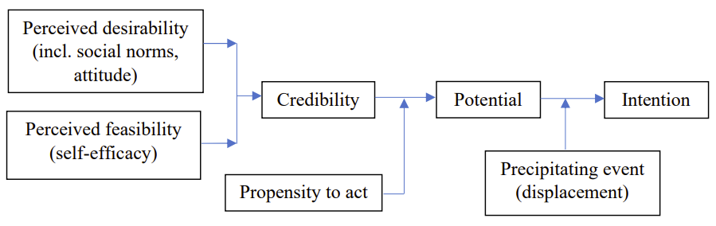

Figure 2.6 – The model of “entrepreneurial potential” developed by Krueger and Brazeal

Note – Extracted from the source [166, р. 95]

2.7.7 Personal and Contextual Intention Model
This model (see figure 2.7) asserts that a person’s SE (conviction in one’s capacity to perform a behavior) drives the entrepreneurial process (especially an EI and activity). Another variable is “stored information”, referring to the repository of information that a person has accumulated as a result of their personal and contextual history [165, p. 69].

2.7.8 Economic-psychological Model
This model (see figure 2.8) involves economic and psychological components that facilitate one’s intent to establish a new firm. Specifically speaking, an intention can be predicted by “general attitudes”, “personal background”, “conviction”, “domain attitudes”, and “situation” [163, p. 5].

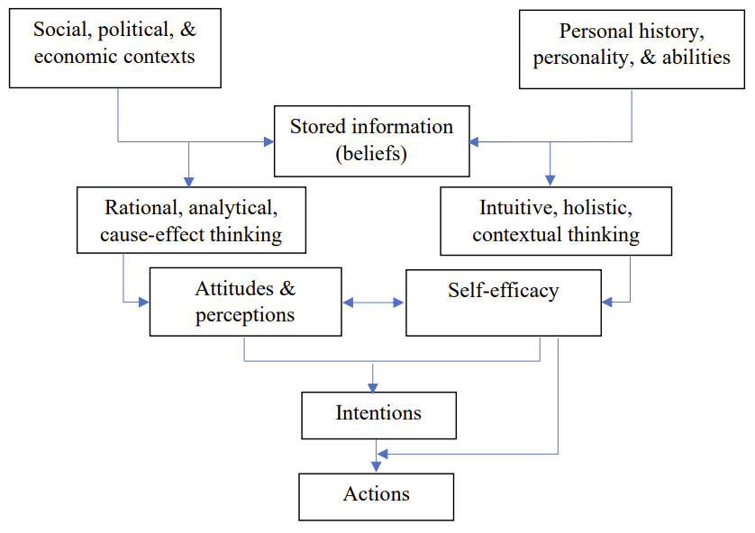

Figure 2.7 – The “intention” model developed by Boyd and Vozikis

Note – Extracted from the source [165, p. 69]

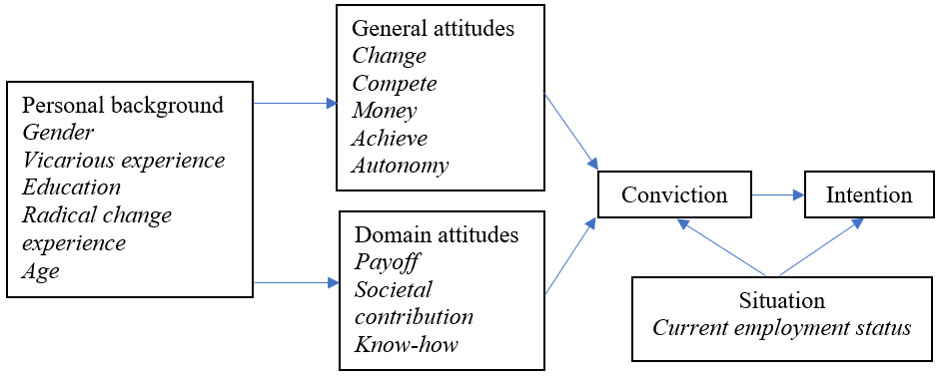

Figure 2.8 – The “economic-psychological” model developed by Davidsson

Note – Extracted from the source [163, p. 5]

2.7.9 Maximization of Expected Utility Model
This model, created by Douglas and Shepherd, explained EIs through integration of “expected utility maximization”. It is based on the “theory of utility maximization” of individual behaviors, arguing that one’s attitude on earning a living, individualism, risk-taking, and workload impacts one’s career choice; the more favorable a person’s attitude is, the greater his or her desire to launch a new business [167, p. 82].
The model, however, has some limitations [167, p. 82]:
1) it does not represent the complexity of social activities (such as entrepreneurship) that necessitate a contextual and comprehensive evaluation; and
2) the application of regression analysis approach retains some of the same limitations as emerged in the earlier research.

2.7.10 Contextual Intention Model
This model (see figure 2.9) contends that EIs lead to entrepreneurial objectives, which in turn may result in entrepreneurial behavior.
The realization of the behavior stimulates the changes of “motivation”. The changes then, subsequently, act as the “triggering event” leading to EIs [168, р. 29]. EIs are originated from “perceived desirability and feasibility”, “superordinate goal”, and “opportunity evaluation”. The above factors revolve the EIs and have mutual effects in a multiple dimension.
This model suggests that “motivation” and “self-efficacy” (SE) have virtually no direct effect on EIs. [168, p. 29].
This model aims to connect goals, SE, motivations, and intentions (e.g., [141, p. 315; 162, p. 5; 166, p. 91]). However, the plausibility of the proposed framework of integrating all the diverse variables into a single intention-behavior model has not received wide recognition due to the limited empirical evidence.
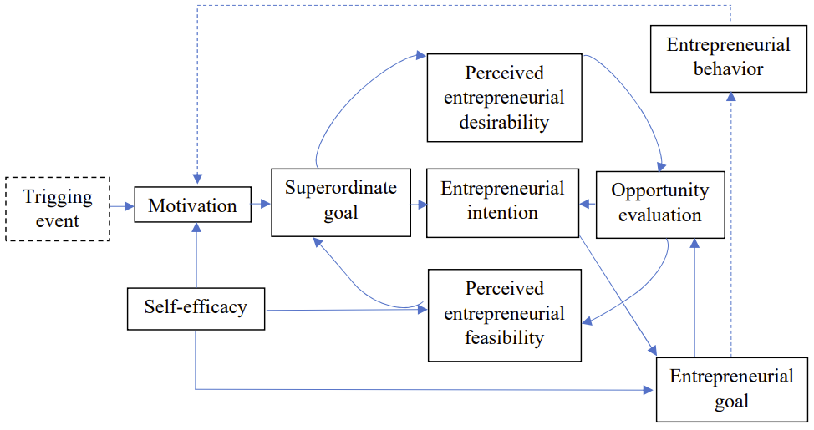

Figure 2.9 – The “contextual entrepreneurial intention” model developed by Elfving

Note – Extracted from the source [168, p. 29]
All of the above-reviewed models are collectively exhibited in Appendix K [54, p. 444; 56, p. 182; 141, p. 317; 155, p. 13; 159, p. 511; 163, p. 5; 165, p. 69; 168, p. 29].
Till now and in response to Section 2.4, a systematic and holistic understanding of affecting factors in single (see Section 2.5 and Appendix H) or combined (groups of) single forms (see Section 2.6 and Appendix J), and established explaining models (see Section 2.7 and Appendix K) based on relevant single factors and pertinent theories has been built up. Thus, this study affirmatively adopted the most frequently cited and justified “TPB” model as the ground framework and attempted to extend the model in accordance with the research setting under study, which was previously demonstrated in INTRODUCTION and Chapter 1, and will also be briefly discussed in the following section.

2.8 Hypotheses Formulation and Research Framework
Sections 2.5, 2.6, and 2.7 exhaustively demonstrated the various single factors influencing EI (see Appendix H), combined (groups of) single factors (see Appendix J), and the established and frequently cited models of entrepreneurial research (see Appendix K), respectively. Hence, based on the insights into the affecting factors and models, as well as aiming to tackle the research questions outlined in INTRODUCTION, the author embraced the most established and empirically tested “TPB” model [320]. This model is expected to examine the foreigners’ EI in Kazakhstani context under the ongoing COVID-19 pandemic. The moderating effects of GS in facilitating foreigners’ EI in Kazakhstan is highlighted.
With the robustness of TPB and the role of GS as the moderator being tested, this study envisaged the applicability and sufficiency of this extended “TPB” model in the current research setting featured by the distinctive context and the continuous pandemic in this country.
Retrospectively and briefly speaking, the “TPB” model coined by Ajzen [56, p. 182] is a prominent socio-cognitive rationale. It has been most frequently and successfully employed in a broad range of areas including entrepreneurship research (e.g., [321; 322]). In an attempt to further increase the predictive capacity of TPB, there are basically two approaches towards the extension of the model.
The first approach is conducted by adding external variables and exerting the mediating role of TPB components, as according to the “TPB” model, PA, SNs, and PBC are the only elements that directly impact intentions; all other variables are thought to trigger intentions indirectly by means of the three components [323]. The second approach is developed through expanding new control variables to TPB [72, p. 663], which moderate the relationship between the TPB components and intentions.
This study,
- drawing on some of the past research (e.g., [76, p. 19-1; 78, p. 86; 79, p. у05504-3; 81]) which examined GS as a moderator in the “TPB components versus EI” relationships,
- considering that TPB is already the most established model yet the relative importance of the three factors (PA, SNs, and PBC) can vary from one context to another [324], as well as,
- realizing that GS is validated to facilitate entrepreneurship as discussed in general and in COVID-19 circumstances,
thus, attempted to:
- add the environmental factor – GS – as the moderator to the basic “TPB” model to increase TPB’s ability in explanation and prediction of the intention among foreigners in Kazakhstan; and
- examine the relative importance of the “TPB” components in the current research setting.
This attempt is meaningful in terms of both theory and practice.
Theoretically speaking,
- evaluating an extensively studied model – TPB – among foreigners in Kazakhstan and under COVID-19 is essential for enhancing the generalizability and explanatory power of the “TPB” rationale; and
2) investigating whether the extrinsic variable of GS has substantial interaction effects is an innovative attempt to improve the sufficiency of TPB in this study’s context.
Practically speaking,
1) exploring the role of GS may shed light on the motivation to foreign entrepreneurial activities, and
2) hence stimulate the policy-makers to make proper new rules and regulations to facilitate the foreign entrepreneurship towards the economic growth of this country.

2.8.1 Proposed Factors and Hypotheses Formulation
According to the above discussions, this study attempted to test the relationships between each of these three components – PA, SNs, and PBC – versus EI in the specific setting faced by the foreigners in Kazakhstan’s context and under the COVID-19 crisis. Besides, this study included one more exogenous component – the role of GS – explained by “government policies” and “government programs”, as the moderator among the said relationships.
Taking into account that the components of PA, SNs, and PBC have already been explicitly demonstrated in Section 2.4, hence, the following part will briefly capture the essence of each variable and focus primarily on the results derived from past empirical studies on their relationships with EI, which lays the solid foundation for the formation of hypotheses in this study.

2.8.1.1 PA and EI
Ajzen’s [56, p. 182] concept of personal attitude (PA) is comprised of two elements:
- the affective reasons (for instance, “I want to start my own business because it is appealing to me.”); and
- the evaluative reasons (for instance, “it is favorable for me to start my own business.”).
In other words, an individual’s attitude is affected by the beliefs relating an action to many outcomes in the future. The weight of each belief is determined by the outcome evaluation. As a result, such (positive or negative) attitudes may influence the extent to which people engage in that specific action, or, to put it another way, whether they act or do not act. The more advantageous the behavior is considered to be, the more intense the intent is to carry out such a behavior. On the other hand, the more detrimental, undesirable, or disagreeable the conduct is, the less likely people are to engage in it [56, p. 182]. PA explains the personal desirability of any given behavior such as entrepreneurship.
Many studies found that PA towards entrepreneurship is the most robust predictor of EIs (e.g., [71, p. 269; 143, p. 411; 144, p. 1090; 147, p. 1; 167, p. 81; 180, p. 417; 181, p. 538; 191, p. 655; 192, p. 4029; 196, p. 335; 323, p. 162; 325-327]). The positive association of PA versus EIs has also been proved in various settings [323, p. 162; 328]. However, conversely evidenced from some other studies, PA has been considered as an insignificant antecedent of EIs [308, p. 147].
Nevertheless, generally speaking, where there is a more favorable PA towards a behavior, there is a stronger intention to conduct that behavior. Therefore, People may raise business ideas and establish their own firms if they perceive entrepreneurship as a more appealing and advantageous choice [56, p. 182]. Accordingly, this study posed the first hypothesis as below:
Hypothesis 1 (H1): PA towards entrepreneurship positively affects EI of foreigners in Kazakhstan.

2.8.1.2 SNs and EI
According to Ajzen [56, p. 182], the concept of perceived subjective norms (SNs) is the “social pressure” capturing what “significant or reference people” in a person’s own life consider with regard to accomplishing a certain behavior (e.g., entrepreneurship). The “significant people” may come from his or her family, co-workers, friends, role models, and mentors, who hope the individual to aspire to be an entrepreneur [165, p. 63]. The power of the “significant or influential others”’ beliefs is formulated by the person’s preparation and assertiveness to fulfill according to these opinions [329]. Thus, SNs have two sorts of convictions: “normative belief” as well as “motivation to comply”. The former conviction indicates whether or not significant groups would like to support such an action as launching a venture. The latter indicates the individual’s incentive to follow these rules and his or her readiness to conduct according to the support of influential others and comply with the norms [56, p. 182; 329, р. 323].
It is a critical decision for individuals to consider entrepreneurship as a job option. Therefore, individuals may consult the people (the “significant others”) around them for advice and support; and as a result, the “reference people”’s opinions would influence the individuals’ decision to “perform or not an entrepreneurial behavior” [181, p. 538]. SNs explain the individual perception on “significant others” or the desirability of their close circles or “influential others” in that human behavior is influenced by the attitudes of others about a certain action [188, p. 35]. Although the attitude to SNs is assumed effective across diverse cultures and cases, the “significant others” may differ for various individuals [166, p. 91].
It is argued in general that a strong connection exists between beliefs and intentions subject to a person’s inclination to follow and personality traits and when intention is measured appropriately [180, p. 417], in particular within collectivistic countries, in which SNs play an effective role in predicting intentions [147, p. 1; 200, p. 195; 308, p. 147]. Cialdini and Trost [330] suggested that when situations are unknown, SNs have the greatest influence. Numerous studies have found empirical evidence that SNs are the strong antecedent of EI (e.g., [71, p. 269; 176, p. 353; 308, p. 147]).
However, some scholars (e.g., [194, p. 145; 331]) have controversially asserted that perceived SNs have minimal explanatory power for EIs. SNs, for example, have been deemed insignificant or the least significant predictor of EIs (e.g., [143, p. 411; 147, p. 34; 192, p. 4029; 194, p. 145; 332]).
Despite the fact that, in certain works on EI research, SNs have a minor function in TPB in terms of the pattern of associations, the inconsistency is not that evident [143, p. 411; 194, p.145; 201, p. 165; 333]. Therefore, in order to learn more about the SNs-EI association among the foreign entrepreneurs in Kazakhstani context, the second hypothesis is conceived accordingly:
Hypothesis 2 (H2): SNs about entrepreneurship positively affect EI of foreigners in Kazakhstan.

2.8.1.3 PBC and EI
Ajzen [56, p. 182] conceptualized that PBC in the case of entrepreneurship consists of both the perception of competence to initiate an entrepreneurial behavior and the perception of capability to manage the behavior. PBC can be interpreted with the concepts of “SE” [334] and “PF” [159, p. 511]. The three constructs – PF, SE, and PBC – are all connected with the sensed aptitude to conduct an activity [56, p. 182; 144, p. 1090; 335]. Nevertheless, the discrepancies among the concepts rest on the fact that PBC captures both the awareness of capability and the sense of controllability [335, p. 666].
PBC can be improved by providing individuals with necessary resources and opportunities, as well as removing barriers [66, p. 536; 201, p. 165; 336, 337]. If a task is viewed as simple, it is more likely to be completed. People are less likely to participate in anything if it is thought to be extremely tough. Ajzen [56, р. 183] stated that, these control beliefs may be subject to an individual’s prior experiences, and experiences of significant others, relevant to the behavior. These experiences may improve or reduce the sensed complexity of conducting the behavior.
Moreover, PBC plays two roles in the “TPB” model:
- affecting behaviors directly (such as launching a venture); and
- affecting behaviors indirectly via the mediating role of intentions (such as “EIs”).
In cases when a person has a high degree of controllability over his or her conduct, intention is an adequate predictor of whether or not the individual will devote effort and take action to attain the objective [56, p. 182]; or the intention completely mediates the influence of PBC on the behavior [180, p. 414]. PBC should also serve to the prediction of behavior in instances when control problems exist, in addition to its partially mediated influence via intention, by acting as a substitute for actual behavioral control (ABC) [56, p. 182; 338]. In other words, either PBC predicts the behavior separately when the intention is a weak determinant of the activity (such as in the case of entrepreneurship); or intention fully mediates the effect of PBC-behavior instead.
Considerable empirical evidence proves that PBC has a favorable influence on EI (e.g., [105, p. 387; 143, p. 411; 147, p. 1; 158, p. 42; 159, p. 511; 165, p. 63; 176, p. 353; 180, p. 417; 181, p. 538; 192, p. 4029; 194, p. 145; 204, p. 135; 279, p. 11; 308, p. 147; 323, p. 162; 326, p. 752; 339-351]). Actually, PBC seems to be the strongest and best factor for intention according to some of the past research. Hence, the third hypothesis is established subsequently:
Hypothesis 3 (H3): PBC over entrepreneurship positively affects EI of foreigners in Kazakhstan.

2.8.1.4 Effects of GS
As already elaborated in INTRODUCTION, Chapter 1 (Section 1.4.2), as well as in this chapter (Section 2.5), it is definitive that the government led by policy-makers indeed plays a vital role in supporting start-ups, surviving, and thriving of entrepreneurship and SMEs in any country. The government support (GS), in turn, propels the economic development of a country [35, p. 1].
In light of the discussions in the above-mentioned sections, this study synthesized the forms of GS in broad concepts as shown in Appendix L [32, p. 1557; 36, p. 43; 38, p. 1027; 102, p. 13; 103, p. 679; 104, p. 1037; 105, p. 387; 113, p. 84].
Among the variety of forms of GS, two fundamental components are “government policies” and “government programs” in terms of taxes, anti-bureaucracy, regulations, human capital, initiative projects, etc. [22, p. 171]. Thus, aiming to conceptualize the “role of GS”, this study determined to center on the concepts of “government policies” and “government programs”.
Kazakhstan’s government has undertaken many assisting programs over the past years [2, p. 101]; and the current crisis of COVID-19 has once again demonstrated the significance of Kazakhstan’s GS in rebuilding optimism and reviving the economy by swiftly implementing appropriate measures. The measures include the support for foreign entrepreneurship in this country, in terms of state emergency measures, tax incentives, state procurement, currency exchange, medical actions, and business support, etc. to mitigate the crisis [40, p. 1].
Nonetheless, there is a startling dearth of works on GS that have been applied in intention-based models; and almost no study is available on its impact over EI of foreigners in the context of Kazakhstan. Therefore, taking into account the above aspects, this research claimed that TPB components predict EI; and the driving forces from TPB might be contingent on the moderation effected by GS. Thus, the final three hypotheses are formed as following:
Hypothesis 4 (H4): GS intensifies the relation between PA towards entrepreneurship versus EI of foreigners in Kazakhstan.
Hypothesis 5 (H5): GS intensifies the relation between SNs about entrepreneurship versus EI of foreigners in Kazakhstan.
Hypothesis 6 (H6): GS intensifies the relation between PBC over entrepreneurship versus EI of foreigners in Kazakhstan.
Table 2.1 below provides an alternate version of the aforementioned hypotheses.

Table 2.1 – Research hypotheses

Hypothesis | Statement | Description
H1 | PA towards entrepreneurship positively affects EI of foreigners in Kazakhstan. | PA → EI
H2 | SNs about entrepreneurship positively affect EI of foreigners in Kazakhstan. | SNs → EI
H3 | PBC over entrepreneurship positively affects EI of foreigners in Kazakhstan. | PBC → EI
H4 | GS intensifies the relation between PA towards entrepreneurship versus EI of foreigners in Kazakhstan. | PA×GS→ EI
H5 | GS intensifies the relation between SNs about entrepreneurship versus EI of foreigners in Kazakhstan. | SNs×GS → EI
H6 | GS intensifies the relation between PBC over entrepreneurship versus EI of foreigners in Kazakhstan. | PBC×GS → EI
Note – Compiled by the author

2.8.2 Research Framework
The research framework is depicted in figure 2.10 below by adopting TPB as the theoretical foundation, and role of GS as the moderator [352].
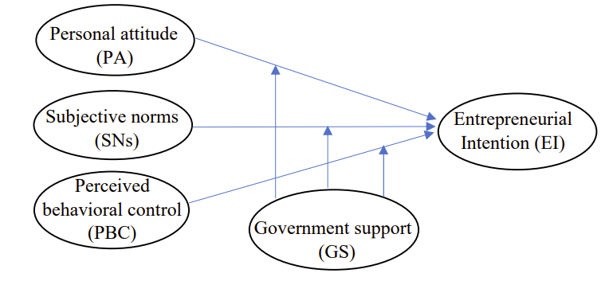

Figure 2.10 – Research Framework

Note – Compiled by the author

In line with this framework, which is also called the extended “TPB” model in this study, “EI” – the DV– is hypothesized to be triggered by three direct IVs – “PA”, “SNs”, and “PBC”. Their prediction powers are independently affected by the moderator variable “GS”, which is explained by “government policies” and “government programs” in this work.
The uniqueness and novelty of this framework are to be articulated in the section of primary contributions in Chapter 6.

Summary of the Chapter
This current study embraces the “TPB” model with the purpose of exploring entrepreneurial intentions (EIs), while in an effort to examine the extent to which the three components – personal attitude (PA) towards entrepreneurship, subjective norms (SNs) about entrepreneurship, and perceived behavioral control (PBC) over entrepreneurship – predict EIs of foreigners in Kazakhstan. In addition, government support (GS) is designated as the moderator to formulate an extensive framework of “TPB+Moderator (GS)” model.
In order to build up the research framework, an exhaustive source of literature was reviewed resulting in a systematic classification of single factors (i.e., demographic factors, personality or personal factors, situational factors, cognitive factors, social factors, and environmental factors), a list of empirical examples of combined (groups of) single factors, and best-recognized intention models based on relevant single factors. The well-assorted package by the author, of single factors, combined (groups of) factors, and established models serves additionally for a comprehensive comprehension of factors and models impacting EIs in this domain.
This study contends that, in the research setting of Kazakhstan and under the COVID-19 crisis, the three TPB components – PA, SNs, and PBC – influence positively foreigners in this country to start up a venture; and GS intensifies the relations between the above three factors versus the foreigners’ EI. GS in this study is explained by “government policies” and “government programs”. Other forms of GS, such as educational support, cultural support, financial support, environmental support, and the like, are beyond the scope of this work.

3 RESEARCH METHODOLOGY

3.1 Introduction
Three primary sections are involved in this present chapter, namely, “data collection”, “data examination”, and “data analysis”, in an effort to achieve “goodness of measures”, “goodness of data”, and “goodness of model’s fit” (or simply “goodness of fit”), respectively.
Data collection centers on sampling method, questionnaire administration, measuring instruments and scales, tests on goodness of measures (reliability and validity), and data collection procedure, which are all to be discussed in detail in this chapter.
Data examination comes next after quantitative data have been collected using the established measures from a representative sample. It is essential to perform data examination to screen and clean any abnormalities, and preliminarily make sure that the dataset is correct, complete, and acceptable for subsequent analysis. Specifically, data examination examines missing data, detects potential outliers, and verifies the basic assumptions of most multivariate approaches. The assumptions are comprised of “linearity”, “normality”, “homoscedasticity”, and “independence”. Remedies shall be made for the “goodness of data” if any hidden effects caused by the above nuisances are revealed. Results and remedies will be covered in Chapter 4.
This study employs descriptive and inferential statistics, i.e., descriptive, Pearson’s correlation, and multiple regression analyses. The goal of descriptive analysis is to summarize and overview the data. Pearson’s correlation analysis is utilized to check on the bivariate associations between the DV and the IVs. Multiple regression analysis is used as the major approach to assess the hypotheses and research model developed in Chapter 2, i.e., to check on the two models’ “goodness of fit”.
The outcomes of the multivariate data analyses and interpretations will be reported in Chapter 4.

3.2 Data Collection
Data collection enables the researcher to acquire a vast array of different types of data from respondents using the most suitable method(s) in order for data analysis and subsequent research findings [353]. The method of dada collection in this research is described in detail as below.

3.2.1 Sampling Method
A few reasons determined the need to sample instead of a census in this study.
1) Researching a subset of the population, i.e., the complete researched group of people, events, or items of interest, rather than a census for the entire population, may generate more dependable results and overall greater accuracy [354]. This is most likely because data collection fatigue is minimized, resulting in fewer mistakes and biases [353, p. 235].
2) It would be impracticable to investigate the complete population due to the limitations on budget, time, and energy [355].
3) The insufficiency of access to the entire population prevented a census survey (see more detail later this section).
4) The outbreak of COVID-19 and quarantine restricted the implementation of research activity.
As a result, the sampling approach, as the best alternative to a census, was finally adopted for this research. The sampling procedure is critical for assuring the validity and representation of the obtained data so that findings can be generalized to the full population [356].

3.2.1.1 Population and Sampling Frame
This study targeted at new and established entrepreneurs who are foreign nationals currently doing business in Kazakhstan and most likely occupy a middle-to-upper managerial or specialized position in a SME, which is the sampling unit. Simply speaking, they mainly come from the expats in Kazakhstan.
As previously indicated in INTRODUCTION, “new entrepreneurs” are defined as those who are performing business that have existed for 3-42 months, whereas “established entrepreneurs” are operating a developed firm that is more than 42 months old [22, p. 178]. Focusing on “new and established” entrepreneurs among foreigners rather than other categories (i.e., discontinued, nascent, intentional, or potential) maximizes the possibility for which affirmative EIs have resulted in the launching of their businesses.
Next, the suitable “sampling frame”, described as the physical components in the population where the sample is selected [353, p. 235], must be decided now that the target population has been properly specified. Unexpectedly, the assignment of appropriate sampling frame for this study experienced a lot of obstacles.
The first possible channel for seeking out the target population relies on the law on “engagement of foreign workers: work permits and visas” in Kazakhstan, according to which the foreign engagement requires work permit of 1st, 2nd, or 3rd category (except for the nationals from Russia and Belarus) and work visa of C3 category [357].
Kazakhstan’s “Ministry of Labor and Social Protection” (MLSP) statistics show that, 19,145 foreigners were employed as of January 1, 2020 (according to the number of visas or permits for work issued to foreigners and the number of firms with participation of foreign employment), and the foreigners’ distribution in Kazakhstan by category, sphere, and nationality is listed below [18]:
1) By category:
- 1st category (managers and their deputies) - 4% (770 people);
- 2nd category (heads of structural divisions) - 23% (4,445 people);
- 3rd category (experts) - 50% (9,632 people);
- seasonal workers - 4% (767 people);
- skilled workers - 9% (1,818 people);
- others - 9% (1,713 people).
2) By industry:
- mining sector - 12% (2,213 people);
- construction sector - 45% (8,623 people);
- scientific, technical and professional activities - 8% (1,557 people);
- manufacturing sector - 7% (1,397 people);
- agriculture, forestry, and fishery sectors- 0.3% (55 people);
- others - 28% (5,300 people).
3) By nationality:
- Chinese - 24% (4,524 people);
- Indian - 10% (1,893 people);
- Turkish - 10% (1,964 people);
- British - 7% (1,368 people);
- Uzbek - 4% (781 people);
- Others - 45% (8,615 people).
In spite of the statistical absence of the actual number of foreign entrepreneurs working in SMEs and contact information, the magnitude of this study’s target population is confirmed to be in the range of managers and their deputies (770 people), heads (4,445 people), and experts (9,632 people), which altogether amount to 14,847 people with a very high probable majority of Chinese nationals according to the statistics by country of origin. If all of them were entrepreneurs at extreme (which is not possible in reality), then the upper limit of target population would be 14,847 people.
The second possible way to reach the foreign entrepreneurs is through the SMEs where they are self-employed. The total number of small (21,972) and medium-sized (317) legal companies, branches, and representative offices having foreign engagement was 22,289 as of January 1, 2021 [358]. However, the number of individual foreign entrepreneurs working in Kazakhstan cannot be inferred from the above statistics. Luckily, according to Kazinform [18], the total number of employers in Kazakhstan who have foreign workers is 2,040, which shall be already included in the above-mentioned foreign-invested enterprises in Kazakhstan. If each SME has at least one entrepreneur, the lower limit of target population is assumed to be 2,040 people.
The third possible approach to finding the foreign entrepreneurs is highly relevant to the two major cities (Nur-Sultan and Almaty) because the SMEs are mostly based in these two cities as opposed to other cities of Kazakhstan [358]. However, no statistics on the exact size of target population in the two cities were discovered from public sources of information.
The fourth possible option comes from the state bodies which may have database on the target population. Based on a thorough consultation, the researcher decided to resort to three state sources in Kazakhstan:
1) the “Committee on Statistics” (COS);
2) the “National Chamber of Entrepreneurs” (ATAMEKEN); and
3) the “Department of Justice” (DOJ).
The researcher sent a formal letter in Russian and English (see Appendix M) to each of the three bodies in quest for the information on SMEs (i.e., list of companies, contact information, etc.), and/or foreign entrepreneurs (i.e., contact information, nationalities, etc.). It was a pity again that the replied letters (see Appendix N) indicate that no such information would be allowed to offer due to the confidential nature of the quested data (as replied by COS and DOJ), or there is severe lack of data for the requested answers (as replied by ATAMEKEN). However, DOJ reminded that any publicly available information about a legal entity might be contained in the “eGov.kz” web portal. Unfortunately, it was later found that the required information regarding individuals and legal entities with foreign participation is not available at the portal.
With all the above attempts failing, only the last alternative – the “networks” – seems to be feasible. The researcher himself is a typical established foreign entrepreneur who is already one of the sample respondents and has the abundant chances to meet other foreign peers during business activities. Thus, he planned to make all the effort to seek assistance from his own circle of friends initially, and then more and more eligible respondents would be reached through the continuous expansion of the networks in the business community of Kazakhstan.
To this point, the sampling frame was finally determined as the “networks”. The “networking approach” is, either towards (indirectly) SMEs with foreign engagement operating in Kazakhstan, or towards (directly) individual foreign entrepreneurs working in Kazakhstan. The target population (ranging between 2,040 and 14,847 elements under survey) are expected to be randomly identified and primarily reached through the expansion of the networks.

3.2.1.2 Sampling Design
Basically speaking, sampling design involves “probability” and “non-probability” methods.
Probability sampling provides a non-zero and known probability that the population elements will be selected as sample subjects; while non-probability sampling does not offer a known or predefined probability for the selection of elements as subjects [353, p. 235; 359]. Appendix P [353, p. 242; 359, p. 214] compares the probability versus non-probability sampling designs, as well as their advantages versus disadvantages.
The areas in Kazakhstan are divided into the following regions: Aktobe, Almaty, Atyrau, West Kazakhstan, Karaganda, Kostanay, Mangystau, Zhambyl, Kyzylorda, East Kazakhstan, South Kazakhstan, Pavlodar, Akmola, and North Kazakhstan. The primary representatives of the regions are the major cities including Nur-Sultan, Almaty, Taraz, Shymkent, Kyzylorda, Aktobe, Aktau, Oral, Atyrau, Kostanay, Petropavl, Karaganda, Pavlodar, Oskemen. The most economically developed cities – Nur-Sultan and Almaty – contain the largest numbers of SMEs compared to other cities of Kazakhstan, i.e., 73,407 and 124,992 respectively, according to the statistics [358].
This study in essence adopted the combination of “probability sampling” (area sampling or geographic cluster sampling), and “non-probability sampling” (convenience sampling), determined by the distribution of its target population and the procedure of its data gathering. Specifically speaking, the data are collected from new and established foreign entrepreneurs who are either the researcher’s own friends, or his friends’ friends, or the snowballing circle of friends (networks) with two main features:
- they are most probably based in Almaty and Nur-Sultan; and
- through the expansion of friend circles (networks), some of the respondents are deemed random representative elements of the target population.

3.2.1.3 Sample Size
Sample size is determined by six considerations [353, p. 241]:
1) the research objective;
2) the confidence level;
3) the confidence interval;
4) the population size;
5) the variation in the target population; and
6) the limitations on time and expenses.
Specifically speaking, the more the anticipated accuracy, the larger the sample size must be, particularly where population variation is high. In this study, the sample size was confirmed by multiple considerations and combinational benchmarks.
Firstly, the widely recognized standard for the vast majority of business research is a confidence level of 95% (p≤0.05), which indicates how certain it is that the estimations will be accurate for the population. Neither very large nor undersized sample sizes are advantageous for research projects [353, p. 242]. In this study, a conventional 95% (p≤0.05) was thus chosen as the significance level.
Secondly, for this study, the following two “rules of thumb” were also considered for determination of sample size [360]:
- Sample sizes between 30 and 500 are adequate for majority of research, and
2) Sample size shall be equal to or beyond 10 times as many variables under investigation.
The research framework proposed in this study (see Chapter 2) indicates that there are totally 5 variables (PA, SNs, PBC, GS, and EI) under study, therefore, a sample size of between 50 and 500 would be acceptable.
Thirdly, the appropriate sample size is 5% of the overall population according to Cooper and Schindler [361]. Given the population size of between 2,040 and 14,847, the sample size shall be between 102 and 742 at extremes.
Fourthly, Krejcie and Morgan [362] greatly simplified the process of decision-making on sample size by generating a table (see Appendix Q) [362, p. 610] that assures a good decision model. According to Appendix Q, for the population ranging from 2,040 to 14,847, the targeted sample falls in a size (N) between 322 and 375 respondents.
Fifthly, as inferred from INTRODUCTION and Chapter 1, the substantial majority of FDIs flowing into Kazakhstan are based on sectors of oil extraction and natural resources operated by large companies other than SMEs. Hence, the foreigners are most probably employed in those large entities. The foreign entrepreneurs are assumed to account for far less than half of the total foreign population. This assumption would determine confidently a sample size of 360 for a magnitude of 6,000-7,000 people.
Based on the results derived from the above diverse criteria, an ultimate sample size of 360 subjects, which can meet all the standards at one time, was determined corresponding to the 95% confidence level (p≤0.05) nominated for this study.

3.2.2 Administering Questionnaires

3.2.2.1 Types of Questionnaire Distribution
This research adopted survey questionnaires (see Appendix R) – other than interviewing or observing people – for data collection. Questionnaires are often used to collect vast quantities of quantitative data and are regarded as the most prevalent approach. Questionnaires can be delivered via mails, electronically sent, or personally distributed to the respondents [353, p. 142]. In Appendix S [353, p. 142; 359, p. 360], the strengths (advantages) and shortcomings (disadvantages) of the three kinds of surveys (personally-administered, postal, and electronic) are detailed.
Among the three modes, personally-administered and electronic questionnaires were employed for the survey in this study. The personally-delivered questionnaires were sent to and collected at the workplace of the target “friends” or “SMEs”, or used for encounters at any time, particularly in Almaty. Electronic questionnaires were taken as the main source of data collection conducted via email or social media apps (i.e., WhatsApp, WeChat, Messenger, Telegram, Signal, etc.) to reach the target “friends” with ease and convenience, which is particularly applicable due to the circumstances of quarantine, lockdown, and other restrictions caused by COVID-19.

3.2.2.2 Questionnaire Design
Questionnaire is the key to a survey operation. As shown in the questionnaires of this study (see Appendix R), a questionnaire usually contains both objective variables (e.g., demographic information including an individual’s particulars: gender, age, marital status, citizenship, educational level, job level, income of respondents, etc.), and subjective variables (e.g., beliefs, perceptions, attitudes, etc.).
Three key issues in questionnaire design can help reduce study bias [353, p. 142; 355, p. 100; 359, p. 360]:
- wording of the question items;
- categorization, scaling, and numbering for the constructs and the collected responses; and
- general appearance of the questionnaires.
Moreover, it is also crucial to pretest the instruments to ensure the proper understanding of the questions and the appropriate wording or measurement [353, p. 142; 355, p. 100; 359, p. 360].

- Language and wording
In general, the design of questions is based on the following concerns [353, p. 142; 355, p. 100; 363]:
- all questions should be easily comprehended, simple, concrete, and meet to the most extent the respondent’s way of thinking, his or her educational level, and the culture;
- use different forms of questions (open‐ended versus closed questions);
- avoid ambiguous questions, double‐barreled questions, loaded questions, leading questions, those involving distant recall, and questions prone to tap socially desirable answers;
- length of questions is supposed to be less than 20 words (or confined within one line);
- questions are sequenced from more general to specific nature, and from comparatively easy to progressively more complicated ones;
- ensure confidentiality and sensitivity of classification data or personal information.
Accordingly, in the questionnaires of this study (see Appendix R), Section one uses absolutely closed questions. Section two consists of two closed questions (1-2), one open question (3), and three mixed questions (4-6) to meet all respondents in any circumstances. The questionnaires are mainly composed of positively worded questions; Q5-7 was changed from negatively worded question to positive one – from “not unduly difficult” to “easy” – for clearer understanding as recommended by the examiners in pretesting. Finally, only one negatively worded question (Q5-5) was retained in that it was not found difficult to comprehend during the pretest. Ambiguous questions, double-barreled questions, loaded questions, leading questions, and socially desirable questions are absolutely avoided or excluded through direct adoption of established instruments or pretesting of the items. The questions are all within 20 words in length. In this study, it is assumed that the new and established entrepreneurs surely have clear memory about their attitudes towards the start-up of their own business because this is no doubt so impressive in their life. Hence, the distance-recall questions (for the entrepreneurs in Section one) are as such formed. With regard to the sequencing of questions, the questionnaire arranges the constructs in a logical order as in the corresponding research framework demonstrated in Chapter 2.
The questionnaires fully considered confidentiality and sensitivity of the respondents and did not ask the name of the respondents as clearly stated in the cover letter. Instead, in order to properly characterize the sample features in the study findings, the researcher added “Section two” to obtain demographic data, taking care to provide a variety of response possibilities while avoiding sensitive questions. When the respondents arrive at the questionnaire’s ending part, they have been convinced of the legality and authenticity of the items, and therefore have more willingness and readiness to reveal personal data [353, p. 142].
The questionnaires used three languages – English, Russian, and Chinese – to formulate three versions of questionnaire. The English version was the original and standard one whose questions were mainly borrowed from the precedented and established research; the other two versions were translated first by native speakers of Russian (senior Kazakh employees who are working at the researcher’s firm) or Chinese (the researcher himself) who are all proficient at English. The translated versions were then verified and amended by the certificated professional translators (invited from external source) to guarantee the accuracy of translation. All items ended up using a “translation-back-translation” method [364] to guarantee that the meaning of the items was kept during the translation process; and passed the pretesting.

- Measurement
Measurement is defined as the assigning of symbols or other codes to the qualities (or properties) of objects in accordance with predetermined rules. Suitable scales should be employed according to the nature of data to be collected [353, p. 142; 355, p. 100]. The questionnaires in this study applied interval scales (Likert scales) and assessed the “goodness of measures” through tests of validity and reliability which will be discussed later in this chapter. The Likert scale was utilized because it is simple to design, intuitively appealing, adaptable, and generally reliable [361, p. 290; 365; 366]. Likert scales allow respondents to pick among the offered alternatives, which allows the researcher to request replies about the given statement using a set of option numbers [353, p. 142].

- General appearance
An appealing and clear questionnaire with a proper instruction, and well-arranged question items will make it simpler for participants to reply [353, p. 142].
The questionnaires in this study begin with an introduction that clearly states the author’s identity, conveys the survey’s purpose, guarantees the anonymous and confidential treatment, and inspires the respondents to provide most honest responses. Next, the instructions, sections, and questions are logically and neatly arrayed so that the respondents can complete the task of reading and answering with ease and comfort. All personal data free of sensitive or very private questions are requested at last in the end of the questionnaire, and are expected to be answered by the respondents with confidence and rapport built with the researcher through prior questions. Finally, the questionnaires end with a courteous note and reminder of full performance of the survey questions.

- Pretesting
Pretesting uses a small sample of responders to evaluate the relevance and comprehension of the questionnaire. Pretesting helps to correct deficiencies, if any, prior to giving the questionnaire to respondents, hence reducing bias. It would be beneficial to discuss the pre-test results and understand better how the small group of responders felt about completing the instruments in the questionnaire [353, p. 142].
This study invited a small group of respondents who are the colleagues or friends of the researcher to do the pretesting. Since the items of each instrument (English version) were adopted directly from established works in the past research, the researcher hardly made any change to them, except revising some typing errors and slightly adjusting a few words in translation (with question Q5-7 being the most modified from double negative wording “not unduly difficult” into positive wording “easy”). Hence, the rectification work in terms of content, wording, and sequence particularly focused on the single-item question in Section one and demographic questions in Section two, which were mainly developed by the author by drawing on a variety of business research and incorporating the questions in common.
It is specially noted that, further to the above-mentioned pretesting, the questionnaire would continue to go through a pilot study which is to be discussed later in this chapter. Conclusively, the questionnaire passed the pilot study, hence no more changes to the questionnaire were necessary.

3.2.3 Measuring Instruments and Scaling

3.2.3.1 Operationalization and Instruments
Operationalization is the reduction of abstract notions to make them quantifiable and concrete. Unlike objective variables (e.g., age, educational level) that can be easily measured with simple and straightforward questions, abstract and subjective concepts (e.g., feelings, attitudes) can only be measured through operationalizations [353, p. 142; 355, p. 100].
Measures for frequently investigated concepts in business studies may have already been operationalized by precedent researchers in the relevant field. The use of existing measurement scales saves large time and effort. The borrowing of well-developed scales allows to re-examine the findings of others, and to make possible improvement on the works of others. Only a carefully operationalized and justified instrument can be recognized and extensively adopted by subsequent researchers [353, p. 142].
The structured research instruments for the survey questionnaire in this study were developed by adopting the existing well-designed, well-structured and validated measures and scales. The survey question items pertaining to the constructs listed below: “personal attitude” (PA) towards entrepreneurship, “subjective norms” (SNs) about entrepreneurship, “perceived behavioral control” (PBC) over entrepreneurship, role of “government support” (GS) to entrepreneurship, and “entrepreneurial intention” (EI). The reviewed instruments for the above constructs are demonstrated in Appendix T [105, p. 387; 143, p. 411; 144, p. 1090; 145, p. 566; 147, p. 1; 154, p. 269; 160, p. 5; 163, p. 1; 169, p. 142; 188, p. 35; 194, p. 145; 199, p. 669; 201, p. 165; 204, p. 135; 246, p. 341; 293, p. 45; 333, p. 129; 339, p. 295; 344, p. 55; 367-379].
Considering the compatibility, established reliability and validity of the existing scales (measures), the author made the following choices:
- EI is measured using the mixture of Liñán and Chen’s [371, p. 20] items and Solesvik’s et al. [372, p. 452] items;
- the same sources in 1) apply to the items of PA and SNs;
- items of PBC are adopted from Solesvik et al. [372, p. 452], as well as Liñán, Urbano, and Guerrero [380];
- GS derives its items from “government policies” and “government programs” developed by GEM [20, p. 30, р. 32].
Table 3.1 below exhibits the instruments for the constructs in question.

Table 3.1 – Research instruments

Construct | Questionnaire items | Sources and established reliability
EI | Q1. (1-6) | Liñán and Chen R¹=0.848 Solesvik et al. R=0.91
PA | Q2. (1-6) | Liñán and Chen R=0.909  Solesvik et al. R=0.87
SNs | Q3. (1-6) | Liñán and Chen R=0.852  Solesvik et al. R=0.87
PBC | Q4. (1) and Q4. (2-5) | Liñán, Urbano, and Guerrero R = 0.818  Solesvik et al. R=0.78
GS | Q5. (1-7) and Q5. (8-13) | GEM for government policies R (Not indicated)  GEM for government programs R (Not indicated)
Notes:
1. ¹R=Reliability (using Cronbach’s coefficient alpha) indicated by the previous research. Complete versions of the questionnaire are attached as Appendix R.
2. Compiled by the author based on the sources [20, p. 30, p. 32; 371, p. 20; 372, p. 452; 380, p. 215]

3.2.3.2 Scaling Technique
A scale is a tool or process for distinguishing individuals based on their differences on the constructs in a study. Objects are positioned on a continuum created by scaling. In terms of measurement types of variables, there are “nominal”, “ordinal”, “interval”, and “ratio” scales. As further fine-tuning is accomplished, the attributes of the various scales are summarized in Appendix U [353, p. 206; 355, p. 76].
Specially speaking, in business research, with regard to the measurement of attitudes and behaviors, Likert scales are the most frequently used type. It measures how much respondents agree or disagree with statements. The replies can be evaluated and analyzed either item-by-item or by summing across all items. Likert scales are often considered as interval scales, allowing researchers to compute their means and standard deviations and use other advanced statistical tools [353, p. 206].
Cooper and Schindler [361, p. 290] contended that the measure’s reliability grows as the scales increase in number, and the assigned number of scales must reflect the construct’s extent of complexity. According to psychological studies, responders can reliably grasp seven (7) distinctions [381]. 7-point scales capture greater differences than 5-point scales, according to Ahire et al. [382]. Respondents can complete the items consistently and readily utilizing a 7-point Likert scale, particularly when a self-administered survey questionnaire is employed [383]. Memon et al. [384] discovered that a 7-point Likert scale works better for a moderating variable opposed to those scales with fewer scale points in the Malaysian setting owing to collectivistic culture. Bendig’s [385] research indicated that the number of a given scale determines the reliability of rating scales. Mattell and Jocoby [386] discovered that there appears no distinctive pattern of validity and reliability when varied numbers of options are used.
Based on the above discussions and drawing on the empirical study of Charitomeni and Dimitra [387] where 7-point Likert scales were employed for the almost identical instruments to this study, accordingly, the author made the same option as well, where [388]:
“1” denotes “strongly disagree”,
“2” denotes “disagree”,
“3” denotes “somewhat disagree”,
“4” denotes “neutral”,
“5” denotes “somewhat agree”,
“6” denotes “agree”,
“7” denotes “strongly agree”.
Besides, one single-item direct question (“are you already an entrepreneur with experience of more than 3 months and still running a business currently?”) was included for the general identification of “new and established entrepreneurs”.

3.2.4 Goodness of Measures
It is crucial to examine the “goodness” of the developed measures in order to guarantee that the instrument devised to measure a specific notion is really accurately and consistently assessing the variable [353, p. 193]. To put it another way, sound measurement must pass validity and reliability tests [355, p. 69].
The author in this study developed the questionnaire mainly based on various existing scales which are already well-validated, reliable, and reputed to be good. However, a different context and culture where the research is carried out may render an instrument valid but not reliable [389]. Thus, all borrowed instruments for this study were re-piloted to validate their reliability and validity in the current setting in order to collect true and dependable data and, as a consequence, achieve the truthful results [58, p. 6].
According to Emory and Cooper [390], a pilot study with 25-100 responders is suitable. The results of the pilot study should help to refine the questionnaire further [361, p. 290; 391]. In addition, in the pilot study, factor analysis was used. Hair et al. [392] recommended 50 as the minimal absolute sample size for factor analysis based on the “rule of thumbs” that the ratio of number of observations to variable is at least 5, and preferably 10. This study comprises a total of 5 variables (EI, PA, SNs, PBC, and GS), hence a pilot sample of 50 participants was chosen. To minimize biases as much as possible, the following criteria were established for the pilot panel (study group):
1) distinctive category of foreign entrepreneurs (new and established ones);
2) variety in particulars (age, gender, citizenship, sector, and position);
3) managerial experience or technical expertise; and
4) fluency in English is mandatory, with Russian or Chinese as an extra requirement.
The participants are typical foreign entrepreneurs selected from (or through) the author’s close friends. They were deemed good representatives of the target population, and met the above-mentioned criteria established for the study group. They were kindly requested to fully examine the questionnaire, give suggestions and critiques, as well as fill out the question items. No substantive problems were identified in the pilot study, and the questionnaire received positive appraisal instead. The collected responses were used for the tests of validity and reliability as discussed next.

3.2.4.1 Types of Validity and Reliability
Validity (as a necessary condition) is the most important criterion and reflects how well an instrument works for its intended measurement [355, p. 90]. Alternatively speaking, validity concerns if the correct concept is being measured [353, p. 223]. In general, validity consists of “content validity”, “criterion validity”, and “construct validity” (see Appendix V for further information) [353, p. 223; 355, p. 90; 393-397].
Reliability (as a sufficient condition) examines how consistently an instrument is measuring the concept. To put it differently, the reliability represents how stable and consistent when the instrument measures the intended concept. It aids in determining a measure’s goodness. Reliability entails “stability” and “internal consistency” of measures, with the former consisting of “parallel-form reliability” and “test-retest reliability”, and the latter consisting of “split-half reliability” and “interitem consistency reliability” (see Appendix W) [353, p. 223; 355, p. 90; 398].
Based on the above descriptions, the “goodness of measures” obtained from different sorts of validity and reliability tests is collectively illustrated in Appendix X [353, p. 223].

3.2.4.2 Reliability Tests
Due to the constraints on budget, energy, and time, as well as the inconvenience to contact the same respondents for the second time, this research planned to gather cross-sectional data only. Besides, the above-mentioned constrains did not allow for the tests on a comparable set of measures either. Therefore, stability test was not applied, and merely interitem consistency test, using Cronbach’s coefficient alpha (α), of the instruments was fulfilled for the purpose of reliability. As a supplementary test, composite reliability (sometimes called “construct reliability”) (CR) was also tested during construct validity tests. CR is advantageous than Cronbach’s alpha (α) in that it involves the indicator variables’ various outer loadings [399].
In the beginning, the author applied Cronbach’s alpha (α) for reliability test as it is a commonly used method for Likert scales’ internal consistency [398, p. 89]. An α value equal to 0.6 indicates the reliability of an instrument. If the α approaches the value of 1.0, it means the instrument is almost perfectly reliable with absolutely high internal consistency [398, p. 89]. Hair et al. [392, p. 11] stated that an α value of 0.6-0.7 should represent the minimum acceptable level. Nunnally and Bernstein [340, p. 147; 400] recommended that a reliability coefficient of 0.5-0.6 is adequate for early-stage basic research. Crano and Brewer [401] proposed that an α value of at least 0.75 implies adequate internal consistency. Cronbach [402] and Hu and Bentler [403] posed a cutoff value of α ≥0.7 in order to meet internal consistency.
All items on a reliable scale should be associated with the total score [389, p. 1561]. The “corrected item-total correlation” values were utilized in this study to evaluate each scale’s items. An item must have a minimum value of around 0.3 before it can be included in the final scale [389, p. 1561]. It may be necessary to eliminate items with values below 0.3 as they do not significantly associate with the overall scale. The “Cronbach’s alpha if item deleted” column illustrates the value at which the overall reliability decreases if an item is removed from the overall scale. Therefore, omitting the item (question) that has a value greater than the reliability α, may increase the scale’s reliability.
The situation will be serious when the reliability coefficient is lower than 0.70 and meanwhile there is no item in the “Cronbach’s alpha if item deleted” column having a score larger than the existing α. It implies that the scale’s items span a wide range of topics and require rethinking [389, p. 1561; 404].
In line with these criteria, results displayed in the tables below (see tables 3.2, 3.3, 3.4, 3.5, 3.6) applying IBM SPSS 18.0 indicate how the questionnaire of this study was validated.
Table 3.2 – Reliability and total-item statistics for EI
Reliability statistics |  | Item-total statistics
Cronbach’s alpha | N of items | Scale means if item deleted | Scale variance if item deleted | Corrected item-total correlation | Cronbach’s alpha if item deleted
.898 | 6
I am ready to do anything to be an entrepreneur. |  | 26.6400 | 19.419 | .776 | .872
My professional goal is to become an entrepreneur. |  | 26.1600 | 20.341 | .693 | .886
I will make every effort to start and run my own firm. |  | 26.2400 | 21.411 | .770 | .873
I am determined to create a firm in the future. |  | 26.4200 | 22.289 | .685 | .886
I have very seriously thought of starting a firm. |  | 26.3800 | 22.730 | .721 | .882
I have the firm intention to start a firm some day. |  | 26.6600 | 20.719 | .737 | .877
Note – Compiled by the author based on the output from SPSS

Table 3.2 above indicates an acceptable value equal to 0.898 for the index of Cronbach’s alpha (α) as this value is over the minimum benchmark (0.7). As shown in the column of “corrected item-total correlation”, values of all of the six items are greater than the minimal benchmark (0.30). The column of “Cronbach’s alpha if item deleted” indicates fairly satisfactory results as a whole, because the results are all over 0.7 and no value is larger than the α value (0.898). Therefore, this scale is deemed sufficiently valid.

Table 3.3 – Reliability and total-item statistics for PA

Reliability statistics |  | Item-total statistics
Cronbach’s alpha | N of items | Scale means if item deleted | Scale variance if item deleted | Corrected item-total correlation | Cronbach’s alpha if item deleted
.909 | 6
Being an entrepreneur implies more advantages than disadvantages to me. |  | 27.3800 | 20.036 | .714 | .902
It is desirable for me to become an entrepreneur. |  | 26.8400 | 22.178 | .738 | .895
It is attractive for me to become an entrepreneur. |  | 26.9400 | 20.425 | .864 | .876
If I had the opportunity and resources, I would love to start a business. |  | 26.5600 | 22.374 | .773 | .891
Being an entrepreneur would give me great satisfaction. |  | 26.4600 | 21.070 | .739 | .894
Among various options, I would rather be an entrepreneur. |  | 26.4200 | 22.167 | .700 | .899
Note – Compiled by the author based on the output from SPSS
All of the six items (see table 3.3 above) report a remarkably high value for the α (0.909). Both the “corrected item-total correlation” and the “Cronbach’s alpha if item deleted” columns are deemed credible, as, in the former column, all scores are above 0.3; and in the latter column, all values are above 0.7 with no score exceeding the α value (0.909). Consequently, this scale is regarded as internally consistent.
As revealed in table 3.4 below, the α value is quite high (0.923). The two groups of values in the last two decision columns remarkably exceed the thresholds of 0.3 and 0.7, respectively. “Cronbach’s alpha if item deleted” contains no score above the α value (0.923). Thus, this scale is accepted as reliable.
Table 3.4 – Reliability and total-item statistics for SNs
Reliability statistics |  | Item-total statistics
Cronbach’s alpha | N of items | Scale means if item deleted | Scale variance if item deleted | Corrected item-total correlation | Cronbach’s alpha if item deleted
.923 | 6
1 | 2 | 3 | 4 | 5 | 6
My closest family members think that I should pursue a career as an entrepreneur. |  | 24.1200 | 28.353 | .781 | .912
I do care about what my closest family members think as I decide on whether or not to pursue a career as self-employed. |  | 23.9400 | 26.833 | .707 | .919
My closest friends think that I should pursue a career as an entrepreneur. |  | 24.1000 | 26.622 | .802 | .907
Continuation of table 3.4
1 | 2 | 3 | 4 | 5 | 6
I do care about what my closest friends think as I decide on whether or not to pursue a career as self-employed. |  | 24.1600 | 24.872 | .746 | .917
People that are important to me think I should pursue a career as an entrepreneur. |  | 24.1600 | 25.892 | .816 | .905
I do care about what people important to me think as I decide on whether or not to pursue a career as self-employed. |  | 23.9200 | 25.014 | .873 | .896
Note – Compiled by the author based on the output from SPSS

Table 3.5 – Reliability and total-item statistics for PBC
Reliability statistics |  | Item-total statistics
Cronbach’s alpha | N of items | Scale means if item deleted | Scale variance if item deleted | Corrected item-total correlation | Cronbach’s alpha if item deleted
.878 | 5
If I wanted to, I could easily become an entrepreneur. |  | 17.5600 | 12.292 | .822 | .823
Starting a business and keeping it viable would be easy for me. |  | 18.1600 | 13.443 | .689 | .857
I am able to control the creation process of a new business. |  | 17.7000 | 13.398 | .718 | .850
If I tried to start a new business, I would have a high chance of being successful. |  | 16.8800 | 14.149 | .651 | .865
I know most about the practical details needed to start a business. |  | 17.2200 | 13.971 | .667 | .861
Note – Compiled by the author based on the output from SPSS
Table 3.5 above shows the α index is scored quite high (0.878) as well. The two columns, “corrected item-total correlation” and “Cronbach’s alpha if item deleted”, report scores all larger than their respective cutoff points (0.3 and 0.7). Neither of the scores in the “Cronbach’s alpha if item deleted” decision column exceeds the α value (0.878). Hence, it is assumed that this scale’s internal consistency is met.
Table 3.6 below again reports an extremely high joint value of α (0.955). The column of “corrected item-total correlation” displays scores much above the 0.3 criterion. Neither of the scores out of the “Cronbach’s alpha if item deleted” decision column falls below 0.7 (actually, all values are far above 0.9); and neither of them surpasses the α value of 0.955. Thus, the reliability of this scale is achieved.
Table 3.6 – Reliability and total-item statistics for GS
Reliability statistics |  | Item-total statistics
Cronbach’s alpha | N of items | Scale means if item deleted | Scale variance if item deleted | Corrected item-total correlation | Cronbach’s alpha if item deleted
.955 | 13
Government policies (e.g., public procurement) consistently favor new firms. |  | 36.4400 | 143.394 | .822 | .950
The support for new and growing firms is a high priority for policy at the national government level. |  | 36.3200 | 135.202 | .883 | .948
The support for new and growing firms is a high priority for policy at the local government level. |  | 36.8400 | 143.402 | .742 | .952
New firms can get most of the required permits and licenses in about a week |  | 37.4400 | 145.558 | .746 | .952
The amount of taxes is NOT a burden for new and growing firms. |  | 36.9400 | 148.956 | .837 | .950
Taxes and other government regulations are applied to new and growing firms in a predictable and consistent way. |  | 37.1000 | 147.806 | .736 | .952
Coping with government bureaucracy, regulations, and licensing requirements is easy for new and growing firms. |  | 37.5200 | 155.193 | .712 | .953
A wide range of government assistance for new and growing firms can be obtained through contact with a single agency. |  | 36.8400 | 145.811 | .738 | .952
Science parks and business incubators provide effective support for new and growing firms. |  | 36.8600 | 146.694 | .776 | .951
There are an adequate number of government programs for new and growing businesses. |  | 36.7000 | 143.194 | .797 | .950
The people working for government agencies are competent and effective in supporting new and growing firms. |  | 37.7000 | 146.173 | .747 | .952
Almost anyone who needs help from a government program for a new or growing business can find what they need. |  | 37.6400 | 145.949 | .801 | .950
Government programs aimed at supporting new and growing firms are effective. |  | 37.3400 | 149.658 | .729 | .952
Note – Compiled by the author based on the output from SPSS
In summary, the values for the index of Cronbach’s alpha (α) in this research fall in the range of 0.878-0.955, suggesting that the complete set of instruments is extremely reliable. No item was deleted from the survey questionnaires after the other evaluations on the “Cronbach’s alpha if item deleted” and the “corrected item-total correlation” columns were conducted. The additional test over composite reliability (CR) will be covered later in the construct validity tests.

3.2.4.3 Validity Tests
Two types of validities – construct validity and content validity – were measured in this work. Content validity was examined through face validity; while construct validity was tested via discriminant validity and convergent validity. As this research did not differentiate the foreign entrepreneurs by their demographic nature when examining the hypotheses developed in Chapter 2, criterion-related validity was not tested.

- Face validity
Face validity, which is regarded as the minimal indication of content validity [353, p. 220], however is the most significant validity test, demonstrates that the questions appear to gauge the idea based on the experts’ judgment [405]. Content validity guarantees that the measures sufficiently demonstrate the concept to be tapped [365, p. 100]. As almost all the questions in this survey were borrowed from preceding studies and remained almost absolutely unchanged, face validity or content validity is undoubtedly there. The panel of participants in the pilot study reconfirmed face validity through their judgment based on the face value of each test item in the questionnaire.

- Construct validity
Factor analysis and confirmatory factor analysis (CFA) were employed in this research to assess CR and construct validity. Construct validity confirms the dimensions of the operationally defined concept and indicates which items best match each dimension; it is reflected by convergent validity and discriminant validity [353, p. 220]. Construct validity gives assurance that items derived from a certain sample match the authentic value that is available in the entire target population [392, p. 776].
Convergent validity reflects that all items tapping a certain construct are supposed to share a significant amount of variance in common [392, p. 776]. Factor loadings, AVE, and CR [392, p. 776] are among the indicators for measuring this kind of validity.
Factor loadings. Large loadings on a factor show convergence on a common point when there is presence of strong convergent validity. All values of factor loadings are supposed to be significant statistically at a minimal level. Kim and Mueller [406] regarded 0.3 as the lowest cutoff point, and anything beyond 0.7 is adequate. Comrey and Lee [407] suggested that a loading of 0.71, 0.63, 0.45, and 0.32 is deemed exceptionally good, fairly good, sufficient, and inadequate, respectively. Standardized estimates of loadings shall be from 0.5 as minimum to 0.7 or above as ideal [392, p. 777].
The pre-conditions for determining the factorability of each dimension are a significant “Bartlett’s test of sphericity” value and meanwhile a score beyond 0.50 for its “Kaiser-Meyer-Olkin” (KMO) index [408]. Regarding the KMO criteria, some authors proposed that 0.6 and above is mediocre, 0.5-0.6 is unpleasant, and below 0.5 is unacceptable. Field [389, p. 1561] suggested that 0.5-0.7 is mediocre, 0.7-0.8 is good, and 0.8-0.9 is excellent.
Table 3.7 reports the output of factor analysis using IBM SPSS 18.0. The values of Bartlett’s tests are all significant, and KMO’s values are all above 0.7. Thus, CFA was performed next using SPSS AMOS 18.0 (see results in table 3.8 and figure 3.1).
Table 3.7 – Results for Bartlett’s and KMO tests
Construct | KMO | Bartlett’s test
 |  | Chi-square | df | Sig
EI | .791 | 212.634 | 15 | .000
PA | .854 | 196.257 | 15 | .000
SNs | .799 | 235.712 | 15 | .000
PBC | .816 | 124.020 | 10 | .000
GS | .851 | 644.525 | 78 | .000
Note – Compiled by the author based on the output from SPSS
Table 3.8 – Standardized factor loading for each item
Construct | Description of items | Factor loading
1 | 2 | 3
EI | I am ready to do anything to be an entrepreneur. | .799
 | My professional goal is to become an entrepreneur. | .751
 | I will make every effort to start and run my own firm. | .838
 | I am determined to create a firm in the future. | .749
 | I have very seriously thought of starting a firm. | .749
 | I have the firm intention to start a firm some day. | .771
PA | Being an entrepreneur implies more advantages than disadvantages to me. | .819
 | It is desirable for me to become an entrepreneur. | .771
 | It is attractive for me to become an entrepreneur. | .923
 | If I had the opportunity and resources, I would love to start a business. | .810
 | Being an entrepreneur would give me great satisfaction. | .745
 | Among various options, I would rather be an entrepreneur. | .704
SNs | My closest family members think that I should pursue a career as an entrepreneur. | .784
 | I do care about what my closest family members think as I decide on whether or not to pursue a career as self-employed. | .745
 | My closest friends think that I should pursue a career as an entrepreneur. | .836
 | I do care about what my closest friends think as I decide on whether or not to pursue a career as self-employed. | .787
 | People that are important to me think I should pursue a career as an entrepreneur. | .887
 | I do care about what people important to me think as I decide on whether or not to pursue a career as self-employed. | .901
PBC | If I wanted to, I could easily become an entrepreneur. | .890
 | Starting a business and keeping it viable would be easy for me. | .766
 | I am able to control the creation process of a new business. | .758
 | If I tried to start a new business, I would have a high chance of being successful. | .714
 | I know most about the practical details needed to start a business. | .721
Continuation of table 3.8
1 | 2 | 3
GS | Government policies (e.g., public procurement) consistently favor new firms. | .857
 | The support for new and growing firms is a high priority for policy at the national government level. | .922
 | The support for new and growing firms is a high priority for policy at the local government level. | .757
 | New firms can get most of the required permits and licenses in about a week. | .769
 | The amount of taxes is NOT a burden for new and growing firms. | .879
 | Taxes and other government regulations are applied to new and growing firms in a predictable and consistent way. | .753
GS | Coping with government bureaucracy, regulations, and licensing requirements is easy for new and growing firms. | .720
 | A wide range of government assistance for new and growing firms can be obtained through contact with a single agency. | .756
 | Science parks and business incubators provide effective support for new and growing firms. | .772
 | There are an adequate number of government programs for new and growing businesses. | .791
 | The people working for government agencies are competent and effective in supporting new and growing firms. | .743
 | Almost anyone who needs help from a government program for a new or growing business can find what they need. | .821
 | Government programs aimed at supporting new and growing firms are effective. | .735
Note – Compiled by the author based on the output from SPSS

As indicated from table 3.8 above, the overall item loadings fall between 0.704 and 0.923 (36 items in total), with loading of 24 items being 0.7-0.8, 9 items being 0.8-0.9, as well as 3 items being 0.9 and above. According to the criterion, the convergent validity of the scales is very satisfactory.
Alternatively, figure 3.1 below illustrates the path diagram for the construct validity tests. The values in the diagram were rounded to the nearest hundredth for simplicity.
AVE (or VE). The “average percentage of variance extracted” (known as “AVE” or “VE”) indicates the summary convergence in CFA. It equals to the “average squared factor loading”. VE can be computed simply by means of the standardized loadings as below:
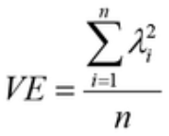
where i – number of items;
λ – standardized factor loading.
The conventional threshold is 0.5 or an even greater value for AVE, indicating sufficient convergence [392, p. 777; 403, p. 10; 409; 410]. All the AVE values (see table 3.9) are above 0.5, hence the convergent validity is met.
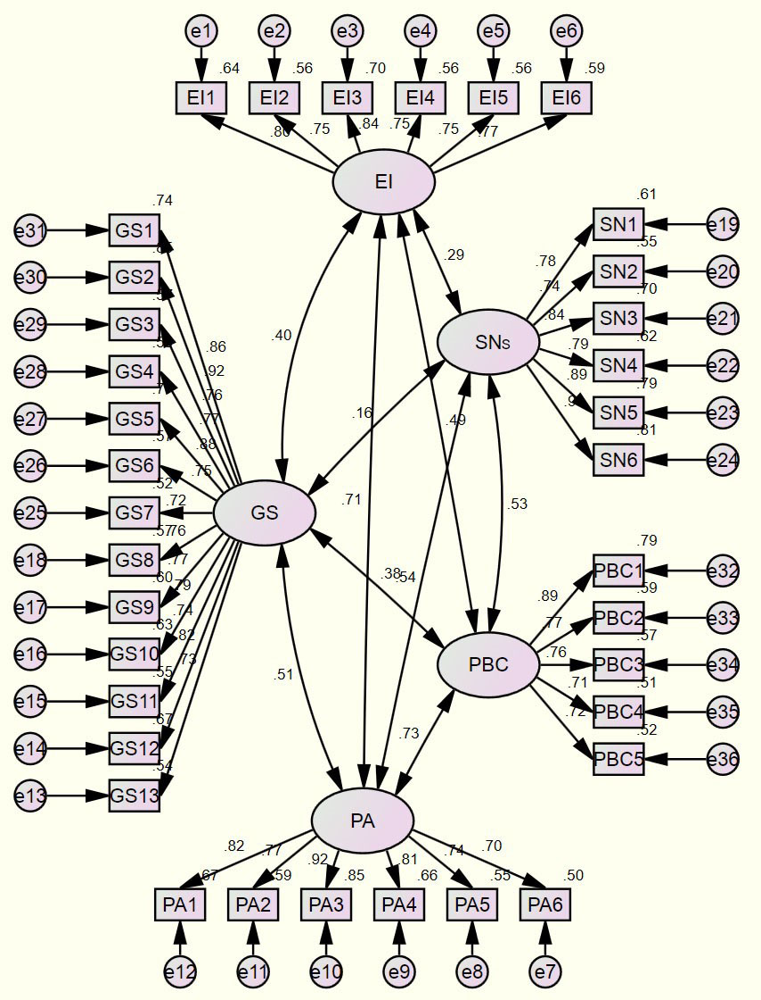

Figure 3.1 – Path diagram for construct validity tests

Notes:
1. Extracted from the output of SPSS.
2. Measured indicators are displayed in a box whose labels correspond to the measurement items. Ovals are used to depict latent constructs. Each measured indicator is related to an error term (e). Two-headed links denote a relationship between two constructs. One-headed links imply a causal relationship between an indicator and a construct.

CR. Reliability is also the indication of convergent validity, and “composite reliability” (CR) value is frequently utilized among different reliability estimates. It is simply calculated using the following formula [392, p. 777]:

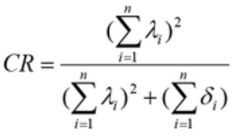

where i – number of items;
δ – error variance;
λ – standardized factor loading.
According to the rules of thumb, a score of 0.7 or above implies strong reliability. In addition, a high value of CR suggests internal consistency, meaning that all of the measurement items consistently capture the same concept to be operationalized [392, p. 777; 411; 412]. CR values (see table 3.9) in this study all meet the threshold (0.7) indicating adequate convergent validity and reliability again.
Discriminant validity evaluates, among the entire set of constructs, the extent to which one stands out from the others. In the meantime, it requires that each item to be measured correspond to a single latent construct. Thus, high degree of discriminant validity suggests that one particular construct is distinctive and taps events not captured by other measures [392, p. 778]. A popular test makes comparison between the AVE value for a construct and the square value of each of its related correlation coefficients, or comparison between the AVE’s square root value and each of its associated coefficient estimates. In case of existence of significant discriminant validity, the former value should be bigger than the latter value in each comparison above, as a latent construct is supposed to explain its own item measurements best [392, p. 778; 413]. Table 3.9 demonstrates that each value of AVE’s square root exceeds all of its respective correlation estimates. Consequently, discriminant validity is attained.

Table 3.9 – Results for construct validity tests
Construct | AVE | Square root of AVE | CR | Correlations
 |  |  |  | EI | PA | SNs | PBC | GS
EI | .604 | .777 | .901 | 1 | .709 | .295 | .493 | .401
PA | .637 | .798 | .913 | .709 | 1 | .535 | .726 | .509
SNs | .681 | .825 | .927 | .295 | .535 | 1 | .532 | .160
PBC | .597 | .773 | .880 | .493 | .726 | .532 | 1 | .376
GS | .628 | .792 | .956 | .401 | .509 | .160 | .376 | 1
Note – Compiled by the author based on the output from SPSS

To this point, the preceding results altogether show that the values of Cronbach’s alpha, factor loadings, AVE, CR, and comparison between square root of AVEs and correlations are all sufficient and acceptable. Hence, the “goodness of measures” reflected by the reliability as well as validity of the instruments is achieved.

3.2.5 Data Collection Procedure
Data collection in this survey was performed using both self-administered questionnaires and electronic questionnaires, contingent on various sources of respondents. As previously concluded (see Section 3.2.2.1), the “networking” approach [414; 415] turned out to be the only access to foreign entrepreneurs being engaged in SMEs in Kazakhstan while the alternative sampling frames were all proved infeasible. The other reason for the reliance on this access was that each foreign entrepreneur, due to business interactions, is bound to have a network of entrepreneurial peers in his or her respective business community. In other words, the foreign entrepreneurs are bound to be connected among miscellaneous business circles, and can be identified and reached given adequate patience and proper approach.
Thus, the data collection work began with the invitation to the author’s 50 direct and/or indirect friends (foreign entrepreneurs currently doing business in Kazakhstan) for the pilot study. The first group of 50 participants initiatively contributed their responses using electronic questionnaires, and provided their comments on the items in any version(s) of the questionnaire. Then the pilot study was performed, the “goodness of measures” was achieved, and the three versions of questionnaire were finalized for further data collection.
Subsequently, 30 printed questionnaires were sent out to and completed by some other foreign entrepreneurial friends (and their investment partners) – the second group of 30 participants – at their workplaces. The author took the “face-to-face” opportunity to explain the content of the questionnaire in detail and kindly asked them for further support. Then the author sent the electronic versions in English, Russian, and Chinese to the second group as well. The two groups of participants – 80 in total – started to help circulate the e-questionnaires and collect completed responses through the networks including their friend(s)’ circles, referrals, and gatekeepers of the surveyed foreign SMEs. E-questionnaires served as the major source of data collection especially during the period of quarantine and lockdown caused by COVID-19. In addition, the author always took some printed questionnaires whenever going out and kindly asked any identified foreign entrepreneur(s) in any case to answer the questions, and usually a small gift was offered for respect and gratitude. Furthermore, the author resorted to any new foreign entrepreneurial friends acquainted from his business activities, and any newly reached friends, for additional support of filling out the questionnaire by themselves or collecting responses from around. Finally, the foreign firms in the business center (“SAT” business center) where the author works were also contacted for survey.
Consequently, 398 copies of fulfilled questionnaires were gathered, among which 382 were collected from “new and established foreign entrepreneurs” meeting the sampling design. After further data screening work on missing data and outliers, 362 questionnaires (with a slight excess over the designed sample size of 360) were finally determined for data analysis. Since it was unnecessary and impossible to know exactly how many persons were contacted indirectly through the networks, the response rate was unknown. The duration of data collection is 6 months from August 1, 2020 to January 31, 2021. Appendix Y reports the demographic information of the drawn sample.
Apparently, the majority of survey respondents are male (72.7%); most of them are aged 42-49 years (30.7%) or 34-41 years (26.0%). In most cases, they are either married (44.8%) or single (35.0%). They are typically highly educated, as evidenced by 42.0% holding a graduate degree or 33.1% holding an undergraduate degree. They occupy top/senior (39.2%) positions or middle/specialist positions (33.1%). They come primarily from Asia, including China (9.9%) and India (3.3%), or the CIS, including Russia (8.8%), Ukraine (4.7%), Kyrgyzstan (8.0%), Uzbekistan (4.7%), Belarus (4.7%), and Georgia (2.2%). Turkey, a nation in Eurasia, also has a considerable number of representatives (5.2%). The Netherlands (3.6%), Romania (4.4%), the United Kingdom (UK) (3.6%), Italy (3.0%), and the Czech Republic (2.1%) are the European nations with the highest proportion of foreign entrepreneurs. Canada is the leading North American representative (3.3%). Among the Middle Eastern nations, the UAE supplied the greatest number (2.5%) of respondents. In general, foreign entrepreneurs representing 60 countries in total were engaged at random in this survey.

3.3 Data Examination
Achieving the “goodness of data” is the fundamental and crucial stage in any analysis. Data examination is done to assess the missing data, identify potential outliers, and test the underlying assumptions for most kinds of multivariate analysis. It is for the purpose of revealing the easily ignored hidden effects caused by missing data, outliers, and violation of the assumptions, and thus adjusting accordingly the sample data to ensure the outcomes yielded from the multivariate analysis are accurate and valid [392, p. 49].
Hence, this research went through the complete process of data examination before applying multivariate data analysis. This section will merely focus on the stages, aspects, concepts, and methods in data examination, while the results and remedies, if any, will be presented in Chapter 4.

3.3.1 Analyzing Missing Data
Rarely will a researcher be able to avoid some form of missing data problems, which occurs when valid values are incomplete for one or more variables. As a result, the analysis may not output generalizable results due to a reduction in the sample size that was available for analysis, and/or biases may arise from the non-random missing data [392, p. 49].
The most common reasons for missing data include mistakes made during the process of data collection or input to the computer, as well as the omission of survey responses. There are known and unknown missing data processes. The known processes, which are due to procedural factors, can be easily identified.
The examples of known factors include [392, p. 54]:
1) information disclosure restrictions;
2) errors in data entry;
3) the morbidity of the respondents; and
4) failure to complete all of the questionnaire items.
Unknown processes are more difficult to identify and address. Most often, these events are directly tied to the responders [392, p. 54].
In order to fix the problems, if any, raised by missing data, this study followed the guidelines stated below to make proper remedies.

- Determining the level of missing data
The extent of missing data can be checked with the most straightforward method by calculating:
1) the ratio of variables in each case that contains missing data, or
2) the ratio of cases for each variable that contains missing data.
Less than 10% for the above-mentioned ratios may usually be overlooked, unless they occur in a non-random manner. Variables with 15% missing data can be regarded for removal, but even greater missing-data levels (up to 20% or 30%) should normally be corrected. When replacement values are not considered for addressing missing data problems, the complete-data cases in number are supposed to be sufficient enough for the chosen analytic approach [392, p. 54].

- Diagnosing the randomness
This process determines the randomness level in the missing data, according to which appropriate treatments are to be determined. There are two levels of randomness: “missing at random” (MAR) and “missing completely at random” (MCAR). The level of “MCAR” is so largely random that all forms of missing-data remedies can be handled [392, p. 56].

- Selecting the imputation method
The technique of predicting a missing value according to the valid value obtained from another variable or another case is known as imputation [392, p. 58].
MAR. Only one remedy is appropriate for a non-random or MAR missing data process. This remedy involves two modeling approaches [392, p. 58]:
1) the maximum likelihood estimation approaches that model the missing processes to look for the most accurate and reasonable estimations; or
2) the direct incorporation of missing values into the analysis, rendering the incomplete cases a subset of the sample.
MCAR. Two basic approaches can be applied for a process involving MCAR missing data [392, p. 59]:
1) defining replacement estimates for the missing values; or
2) using only valid values.
More specifically speaking, there are six methods:
1) Complete case approach. In this approach, only valid data are utilized for imputation, and hence, only cases with complete data are concerned. It is suitable when a sufficiently large sample size is present, there is minimal extent of missing data, and the correlations are so robust that they are not impaired by any missing-data process.
2) Imputation utilizing only valid data while imputing the distribution features or relationships for each valid value.
3) The imputation of the hot or cold deck using known replacement values. The replacement values are derived from another similar observation in the sample using the “hot deck” approach. For substitute values, “cold deck” imputation utilizes an outer source (e.g., earlier research, alternative samples, etc.).
4) Case substitution with known replacement values (especially for complete missing data). The whole observations with missing data will be replaced by a new observation that was not sampled.
5) Mean substitution by use of mean values. This strategy was chosen on the grounds that the single best substitution value is supposed to be the mean value.
6) Regression imputation. Regression analysis predicts the replacement value based on the connection between the missing value and other variables in the dataset.

- Rules of thumb
No single method is most suitable for all situations, and each method has its strengths and weaknesses. Therefore, the researcher must select the best imputation method according to each specific missing data situation. The multiple imputation strategy shall also be strongly considered during the selection process. Suggestions are [392, p. 64]:
1) All imputation approaches are suitable when the ratio of missing data is below 10%, although the complete case approach is the last one for recommendation.
2) For MCAR data, the hot deck case replacement, all-available approach, and the regression approach are favored, whereas model-based methods are optimal for MAR values when the extent of missing data is within 10%-20%.
3) When the degree of missing data is greater than 20% and imputation is still required, regression approaches are better for MCAR cases, but model-based approaches are more appropriate when MAR occurs.

3.3.2 Detecting Outliers
Outliers are observations that have a distinct set of features that distinguish them from the rest of the data. Typically, it is a variable with an exceptionally large or small value, or a distinctive mix of observations across many variables. These characteristics distinguish the values from others. Practically speaking, outliers can have a large effect on empirical studies. Substantively speaking, outliers must be examined on how representative they are of the population [392, p. 73].
The different sources of their uniqueness can divide outliers into four classes [392, p. 73]:
1) A procedural error causes the first class of outlier (e.g., data entry error, a mistake in coding).
2) The second class is one that arises due to an unusual event.
3) The third class is made up of unusual observations that have no acceptable explanation.
4) The fourth and last class is found in the normal range of values, which are not abnormally too up or too down on any single variable, however are distinctive across these variables in their combination.
It is important to emphasize that an outlier is not necessarily a mistake, therefore it cannot be classified as either advantageous or disadvantageous. However, outliers do have a marked effect on the research outcomes. Therefore, outliers shall be handled with much care within the research context, and should be examined based on the sorts of information they may offer [353, p. 276; 392, p. 6].
The following guidance was followed in this study to detect and determine outliers.

- Methods of detecting outliers
Outliers can be discovered, by the number of studied variables, through univariate, bivariate, or multivariate approaches.
Boxplot. The univariate technique checks on the distribution of each variable’s data and finds those that fall outside the distribution’s ranges as outliers. A boxplot is a visual depiction of the data distribution that makes it simple to identify outliers. The upside and downside quartiles in the distribution of data define the box’s top and bottom borders. The distance from the 25th to 75th percentile measures the box’ length, which is termed the “interquartile range” (IQR). The median is depicted by the line inside the box. The smallest and biggest observations, whose values are less than one IQR calculating from either end of the box, are separated by two lines (or termed “whiskers”) [392, p. 74].
Values above 3 IQRs calculated from either end of the box are regarded as “extremes” in IBM SPSS, which are denoted with an asterisk (*). “Outliers” are defined as values that are in the range of 1.5 to 3 IQRs from either of the box’s ends, which are denoted with an “o” [392, p. 74].
Scatterplot. In a scatterplot, isolated points (outliers) are significantly outside the spread of the other observations [392, p. 74]. This research examined the bivariate associations between the DV and IVs in regression.
Mahalanobis distance (MD) measures. The Mahalanobis D² measure evaluates each observation across a set of variables in multivariate analysis by measuring, in multidimensional space, the distance of each observation away from the centroid among all the observations; a single value is then assigned to each observation no matter how many variables are concerned. The disadvantage of this technique is that it does not give any insight into specific variables leading to a high D²; it merely provides an overall evaluation. The estimated values (D²/df), i.e., the number of variables into the D² measures, are t-value distributed in form. Typically, the conservative significance levels (e.g., 0.005 or 0.001) are indicated as the threshold values for identifying an outlier. As a general rule, observations with a D² value more than 2.5 in case of small samples (less than 100 observations) and 3 or 4 in case of large samples (as in this study with 362 observations) might be identified as potential outliers [392, p. 75].
The alternative approach using MD is to examine the statistical significance of Chi-square probability [416; 417], with significance level at p<0.001 serving as the threshold for multivariate outliers [417, p. 63].
Analysis of residuals. Most computer programs offer residual analysis for spotting outliers, as well as diagnostic tools for identifying leverage points and other influential data. Outliers, having a disproportionate influence on the regression, are easy to spot. They are most likely from the observations with large standardized residuals (greater than 2.0 in particular) [392, p. 220].

- Outlier designation
The researcher must be prudent to designate and delete outliers just because the observations are different and inconsistent with the remaining cases. It is prudent to advise the researcher to discard genuinely extraordinary observations (real outliers), but not to delete those that are unique but nonetheless indicative of the total population [392, p. 76].

- Retention or deletion of outliers
A great deal of advice suggests that outliers should be kept if they represent an element or a part of the population (or unless they are proven really abnormal and do not represent any cases in the entire population). The retention ensures that the results are applicable to the entire population. In contrast, by removing outliers, the researcher may increase the multivariate analysis while reducing its generalizability. If outliers are truly troublesome in a certain analytic approach, they should be dealt in a manner that does not significantly distort the analysis [392, p. 76; 418; 419].

3.3.3 Testing Assumptions of Multivariate Analysis
The researcher must analyze the “goodness of data” before employing any multivariate technique. In doing so, the researcher employs four key statistical assumptions underpinning multivariate approaches, namely “normality”, “linearity”, “homoscedasticity”, and “absence of correlated errors” (or simply called “independence”) [392, p. 204].
The above-mentioned assumptions shall be tested twice: for the individual variables and for the multivariate model’s variate. The former test(s) is/are similar to the univariate analysis; while in the latter, the variate works collectively for the individual variables under survey [392, p. 204].
This section contains guidance for the testing of individual variables. In a subsequent part on regression analysis for this study, the tests for multivariate model variate will be covered.

3.3.3.1 Normality
Normality indicates that the form of the data distribution for a single metric variable displays a normal curve. Normality serves as the standard for statistical methods. Two factors affect the level of non-normality: the pattern of the deviated distribution and the sample size [392, p. 208; 420].
Impacts due to distribution shape. Kurtosis and skewness can be employed to characterize the shape of any distribution. “Kurtosis” involves the “peakedness”, “flatness”, or “humpedness” of the distribution relative to the normal curve. Skewness defines the distribution’s degree of “imbalance” or “asymmetry”. A distribution is positively (or negatively) skewed when it is unbalanced or asymmetrical to the left or right [355, p. 68; 392, p. 208]. There are empirical measurements for both skewness and kurtosis in any statistical software.
Impacts due to sample size. Large sample sizes diminish the negative consequences of non-normality. Significant deviations from the normality may largely distort the results in case of minor samples containing 50 or less observations (especially less than 30). For sample sizes of at least 200, the impact may become insignificant [392, p. 208].
Graphical analysis of normality. A visual examination of the “histogram” is the simplest and most direct method for assessing normality. A histogram is used to compare the data to a distribution that is nearly normal. The “normal probability plot” method is a more trustworthy alternative. The graph makes comparisons between the cumulative distribution of actual observations versus an intended normal curve. Normal curves show a beeline in the diagonal, which are used to compare against the displayed data of observations. If an actual distribution in shape appears to be represented by a beeline which closely overlaps an ideally straight line in the diagonal, the distribution is supposed to look normal [392, p. 208; 417, p. 68].
Statistical tests of normality. Using the statistical tools such as IBM SPSS, a z value for either skewness (z_{skewness}) or kurtosis (z_{kurtosis}) can be determined. If either of estimated z values exceeds the given criterion, the distribution is deemed non-normal [392, p. 208].
As suggested by George and Mallery [421], a simple technique is to make comparison between the skewness and kurtosis values against the cutoff value (±2). In addition, the Shapiro-Wilks (SW) and Kolmogorov-Smirnov (KS) tests are available in all statistical applications for large sample sizes (i.e., N>250) used to determine the significance level for the non-normal distributions [392, p. 208]. The significance levels for SW and KS tests operate in reverse; if the significant levels are less than 0.05 (p<0.05), the data are deemed abnormally distributed [416, p. 52].

3.3.3.2 Homoscedasticity
This assumption refers to the condition in which the variance of the dependent variable(s) (DV(s)) is equal to the range of the independent variable(s) (IV(s)). Homoscedasticity is desired because, in a dependence relationship, the variance of the DV should not be only focused on a narrow range of the IVs. If the dispersion across values of an IV is uneven, the association is heteroscedastic, which may result in stronger predictions at certain levels of the IV. This heterogeneity impacts the standard errors and renders hypothesis testing either excessively rigorous or too insensitive [392, p. 207].
For multiple regression, the most conventionally adopted approach is a graphical analysis of homoscedasticity, which is based on DV and IV dispersions [392, p. 207].

3.3.3.3 Linearity
Linearity is an implicit assumption underpinning all correlation-based multivariate approaches. Examining all relationships for deviations from linearity that may impact the correlation is always recommended [392, p. 205].
The most frequent technique to check on linearity and find any non-linear patterns in the data is to use scatterplots of the variables. Regarding the usage of graphical comparisons and diagnoses, there is a saying that means one picture may speak a thousand words. Scatterplots offer a straight line which may be used to identify any non-linear properties [392, p. 205].
Scatterplot matrix is one of the various scatterplots that is particularly well suited to multivariate techniques. Scatterplots for all pairs of variables are shown in the lowest section of a matrix. Histograms of the variables are displayed in the matrix along the diagonal. A histogram graphically represents a single variable to show how frequently data values (also known as “occurrences”) occur within data categories. To compare the actual distributions with the desired normal ones, the normal curve can be overlaid on the histogram. Scatterplot matrix is a fast and easy method to analyze the strength and magnitude of any bivariate correlation, as well as to discover any non-linear patterns that can be missed if just bivariate associations based on a linear connection are investigated [392, p. 205].
A second method for identifying linearity is to investigate the residuals using a simple regression analysis. The residuals represent the non-linear (unexplained) part of the “DV” [392, p. 205].
A third approach is to expressly identify a non-linear connection based on an alternate model specification (also known as “curve fitting”) that reflects the non-linear elements [392, p. 205].

3.3.3.4 Absence of Correlated Errors
Despite the fact that no prediction in any dependence technique would be flawless, any prediction errors should be uncorrelated. In general, the assumption that errors are uncorrelated is violated in two ways [392, p. 207].
The first one, which is the most common, results from the data collection process, in which similar factors affect (with uneven level) the different groups. The combined effect from different groups, therefore, creates bias in the results. This suggests that the estimation (or prediction) of the dependence relationship is hampered by an unknown reason. Time series data is the other major source of correlated errors. To put it another way, the data are strongly linked to specific time periods [392, p. 207].
This study analyzed the studentized residuals versus possible factors to check on the violation. Besides, the “Durbin-Watson” (DW) value was obtained for testing the correlation between the error terms. According to Kautonen et al. [192, p. 4029], for independency of observations, the DW value should fall between 1.5 and 2.5.

3.4 Data Analysis
Chapter 2 looked at the scholarly research on the determinants that drive EIs. It adopted Ajzen’s “TPB” model, the most frequently cited theoretical model, with the addition of GS as the moderator between the “TPB” factors and the EI of foreigners in the Kazakhstani context and under the global crisis of COVID-19. This study attempted to test the “TPB” and the moderating impact of GS in the specific setting.
The previous sections of this chapter have conducted data collection and data examination, which have paved the way for data analysis. This section will cover the data analysis techniques, methods, and procedures employed for this study; the corresponding results will be displayed in Chapter 4.

3.4.1 Overview of Data Analytical Techniques
Multivariate analysis is a growing set of data analysis techniques. There are both known and new techniques to address a wide range of research scenarios. These techniques at least consist of the following [392, p. 17]:
1) multiple regression and multiple correlation;
2) exploratory factor analysis (EFA);
3) confirmatory factor analysis (CFA);
4) canonical correlation analysis;
5) analysis of variance (ANOVA);
6) multivariate analysis of variance (MANOVA);
7) logistic regression analysis;
8) multiple discriminant analysis;
9) cluster analysis;
10) perceptual mapping analysis;
11) structural equation modeling (SEM) analysis;
12) correspondence analysis; and
13) conjoint analysis.
In order from the above list to choose the most appropriate technique(s) adaptive to the setting in question, this study first reviewed various studies using the “TPB” model or component(s) from both the empirical and methodological perspectives as shown in Appendix Z [59, p. 95; 70, p. 47; 71, p. 269; 145, p. 566; 147, p. 1; 173, p. 361; 176, p. 353; 180, p. 417; 188, p. 35; 194, p. 145; 198, p. 711; 205, p. 162; 226, p. 30; 229, p. 1; 320, p. 87; 323, p. 162; 371, p. 1; 372, p. 441; 380, p. 187; 422-432].
This study used both descriptive and inferential statistics, specifically speaking, the descriptive, correlation, and regression analyses, to achieve the research objectives, based on the above summary of empirical research and taking into account the characteristics of the current research framework.
Simply speaking, descriptive analysis was employed to display a variable concentrating on two features: the central tendency and the dispersion.
In the extended “TPB” model, the relationship for each pair of the IVs (direct and moderation variables, namely, EI/PA/SNs/PBC, (PA/SNs/PBC)×GS) was examined using Pearson’s correlation technique. The association determines whether each pair of variables has a link, and its strength and direction, if any.
To test the entire extended model (“TPB+Moderator”), a moderated regression analysis was performed. In the setting of this study, the IVs (PA, SNs, and PBC) are hypothesized to individually and collectively influence the DV (EI) of foreigners in Kazakhstan, moderated by the role of GS. Hypotheses were examined through simultaneous regression and hierarchical multiple regression analyses in sequence. Coefficients were calculated by means of “ordinary least squares” (OLS). The moderating effects were examined using significance values of the moderation terms.
Specific methods of the above three techniques employed in this research are to be demonstrated in detail subsequently.

3.4.2 Descriptive Analysis
This technique is concerned with the creation of indices from the dataset (for example, to measure the central tendency or to describe the dispersion).
“Mode”, “median”, and “mean” are indices for measuring central tendency. A “mode” is the score that appears most often. After the data have been placed in ascending or descending sequence by magnitude, the “median” appears – it is the midway value or mid-point. A “mean” is an arithmetic average that takes into account all data values [359, p. 171; 353, p. 278; 355, p. 19; 353, p. 278].
“Range” (including inter-quartile range), “mean deviation”, “variance”, and “standard deviation” are indices used to describe dispersion. The “range” of a series represents the differentiation between the maximal versus the minimal values. The difference between the middle 50% of values is known as the “inter-quartile range”. The “mean deviation” is the average of the deviations between the scores of items and some average of the series. The average of squared deviations from the mean is used to determine “variance”, which is a measurement of variability. The variance’s square-root is the “standard deviation”, which is the amount by which values deviate from the mean [353, p. 278; 355, p. 19; 359, p. 171].
Measures of central tendency (also known as “statistical averages”) reveal which items have an inclination to cluster. Central tendency is thought to be the most representative of the complete set of data. Dispersion measures offer an understanding of the spread of the values of items of a variable in a series around the true average value [353, p. 278].

3.4.3 Pearson’s Correlation Analysis
The size, sign, and significance of the zero-order (or simply “bivariate”) associations among all the variable pairs are shown in a Pearson’s correlation matrix. Correlations might be anything from -1.0 to +1.0. The conventionally acceptable standard for the significance level is 0.05 (p<0.05) in social scientific studies. This indicates [298, p. 79; 353, p. 312]:
- there is a 95% chance that the correlation between the two variables is truly present and significant; or in other words,
- there is only a 5% probability that their relationship does not actually exist.
Which variable causes which is unknown, but the two variables are associated with each other is known for sure. Thus, examining the correlation between the two variables could justify a hypothesis postulating their significantly positive (or negative) relationship [353, p. 312].

3.4.4 Multiple Regression Analysis
A generally used statistical method for analyzing the connection of DV-IVs is multiple regression analysis [391, p. 421]. The goal of this technique is to predict and explain the value of a single DV using the known values of IVs [353, p. 312].
The DV in this study is EI of foreigners in Kazakhstan, as indicated in Chapter 2, and the three components of “TPB”, namely, PA towards entrepreneurship, SNs about entrepreneurship, and PBC over entrepreneurship, comprise the set of IVs. The “TPB” model was evaluated using a “simultaneous multiple regression analysis”.
In addition, this research attempted to investigate the role of GS, which is postulated to moderate the relationships between the “TPB” components and “EI”. Thus, this study utilized a “hierarchical multiple regression analysis”, in which more variables (the moderation terms associated with the “GS” in this study) are included in the basic “TPB” model step wisely, which are called the “blocks”. This is done to check whether an adding variable(s) could significantly improve a model’s predictive ability, and/or to examine a moderation effect of a variable (as “GS” in this study), over and beyond what is explained by other precursors added earlier in the preceding analysis [352, p. 571; 433]. Hierarchical regression aims to assess the theory-based hypotheses, but not to optimize prediction [352, p. 571; 433, p. 512; 434]. When employing hierarchical regression, change in R² (denoted as “ΔR²”) and its related alteration in F (denoted as “ΔF”) as well as p values are the statistical measures of highest relevance [434, p. 512]. It is noted that multicollinearity shall be tested to avoid its negative effect on the interpretability of the results [435].

3.4.4.1 Examination of the “TPB” Model
This study firstly examined the basic “TPB” model in the research setting. The regression variate (also known as the “regression equation” or the “regression model”) can be denoted as:

Y=b₀+b₁X₁+b₂X₂+b₃X₃+e

where Y – DV: EI;
X₁, X₂, X₃ – IVs: PA, SNs, PBC;
b₀ – constant (intercept);
b₁, b₂, b₃ – slopes (regression coefficients);
e – prediction error (residual).

The value on the Y axis where the line produced by the regression variate meets the axis is called the “intercept”. The intercept may have a management interpretation in addition to its function of prediction. If the lack of the IVs makes sense, the intercept denotes that amount [392, p. 186].
The “ordinary least squares” (OLS) mathematical approach can be applied to estimate the regression coefficients. The goal of OLS is to have the minimum sum of squared errors feasible for the best prediction accuracy. A coefficient in simple regression analysis indicates the amount of variation in the DV that corresponds to a one-unit alteration in the IV. The coefficients in a multiple regression equation become partial coefficients [392, p. 183].
The discrepancy between the real and estimated values of the DV is known as the “prediction error”. The “coefficient of determination” (R²) represents the degree of prediction accuracy. The overall accuracy of prediction can be assessed solely by the R² value, expressing the combined influence of the complete variate in prediction. It is computed by dividing the totality of squares regression by the sum of squares [392, p. 185].
Furthermore, the sample size directly affects the suitability and statistical power in multiple regression. The likelihood of identifying a certain level of R² as statistically significant at a pre-determined significance level corresponding to a certain sample size is referred to as “power”. For most research situations, a sample of at least 50 and ideally 100 cases, is required to keep power at 0.80 in multiple regression [392, p. 185].
In addition, the level of generalizability in the outcomes may vary according to the sample size through raising the degree of freedom (df) (df=sample size – number of estimated variables) or increasing the ratio of observations versus IVs. As a general guideline, the ratio should be at least 5:1, which means that 5 observations are collected for each IV in the variate. The desirable level for each IV is between 15 and 20 observations [392, p. 197].
The pre-determined sample size (360) in this study adequately satisfied the above-mentioned criterion on the number of observations and ratio of observations to IVs, which guaranteed the statistical power and the generalizability in multiple regression.

3.4.4.2 Examination of the “TPB+Moderator” Model
Moderating effect (also known as “interactive effect”) happens when a third IV (the moderator variable) causes a DV/IV pair’s relationship to alter subject to the score of the moderator variable [392, p. 201].
Using a path diagram as both a descriptive and analytic tool makes it feasible to capture both the correlational and experimental perspectives of a moderator variable inside a single framework. Using this methodology, figure 3.2 illustrates the important characteristics of a moderator variable.
The statistical analysis must quantify and evaluate the differential impact of the IVs on the DV in relation to the moderator. If the interaction (Path c) is substantial, the moderator hypothesis is validated. Substantial main effects for the predictor and moderator (Paths a and b) may also be available, but they are conceptually irrelevant to evaluating the moderator hypothesis [73, p. 1174].
As seen in figure 3.2, the moderator term (or “interaction term”) is a compound variable, the product of one IV and the moderator [392, p. 201]. A simple method of evaluation on moderation effect is by developing a moderated regression model. The model can explain whether the moderator changes the size and/or sign of an IV-DV association [73, p. 1174; 436].
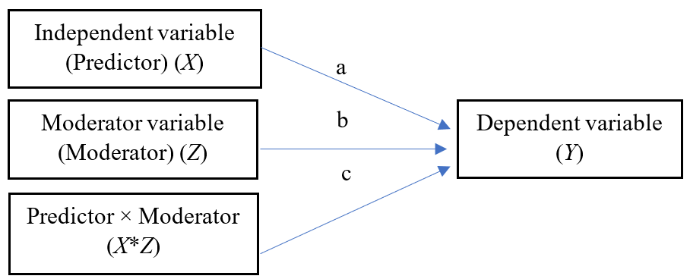
Figure 3.2 – Statistical moderator model
Note – Extracted from the sources [73, p. 1174; 384, p. 7]
Therefore, the regression variate with inclusion of the moderator for this research can be represented as:

Y=b₀+b₁X₁+b₂X₂+b₃X₃+b₄X₁Z+b₅X₂Z+b₆X₃Z+e
where Y – DV: EI;
X₁, X₂, X₃ – IVs: PA, SNs, PBC;
Z – moderator variable: GS;
b₀ – constant (intercept);
b₁, b₂, b₃ – regression coefficients for linear effect;
b₄, b₅, b₆ – regression coefficients for moderator effect;
e – prediction error (residual).

This study utilized a three-step procedure to evaluate whether the moderating impact is substantial:
1) calculating the relationship without moderation using the “TPB” model;
2) estimating the relationship that is moderated for the “TPB+Moderator (GS)” model; and
3) evaluating the change (results of steps 1 and 2) in the R² or adjusted R² (the incremental effect); the moderating effect is statistically significant if the change is statistically significant.

3.4.4.3 Assumptions in the Multiple Regression Analysis
Further to Section 3.3.3 on testing of assumptions (normality, linearity, homoscedasticity, and absence of the error terms) from the standpoint of individual variables (DV and IVs), this section will be focused on the variate itself.
The assessment of the statistical assumptions underlying multiple regression technique is important because it is essential to generate unbiased results of prediction for the DV and reliable explanations for the IVs. Likewise, the assumptions of regression analysis shall be met in these four areas [392, p. 204]:
- normality,
- linearity,
- homoscedasticity, and
4) absence of correlated errors.

- Examination of residual plots
Residuals come from the differentiation between the predicted versus observed values in the DV. Use of residues is the most common method to quantify prediction errors for the variate. The studentized residuals (especially when it is substantially large) are the most commonly used kind, making the evaluation fairly simple because t values correlate to these residual values [392, p. 205].
A fundamental approach of assessing assumption violations for the overall multiple regression variate is plotting the residuals versus the DV or each IV. If any deviations of each assumption exist, they can be identified by examining particular shapes in the residuals. The null residual plot, which displays the residuals dropping in a random manner with nearly equivalent scatter around nil and hardly obvious trend to be either larger or smaller than nil when all assumptions are fulfilled, is one figure of particular relevance [392, p. 205].
Some other complementary tests are also discussed as follows.

- Normality of the error term distribution
Multivariate normality signifies that the any single variable (in a univariate sense) is normal, and so are their mixtures. The straightforward diagnostic analysis for multivariate normality is through a histogram of the residuals, which gives a visual inspection to see if the residual distribution closely resembles the normal distribution.
A superior option is “normal probability plots”, in which the plotted standardized residuals (creating a residual line) are compared with the normal distribution (a straight diagonal line in this instance). Normal distributions have residual lines that closely follow the diagonal [392, p. 208].

- Linearity of the phenomenon
Linearity relationship of DV-IVs indicates the extent to which a change in DV is correlated to an IV. The regression coefficient is a constant value across all values in IV. Similarly, the correlation is predicated on a linear relationship. Partial regression plots can be used to illustrate the link between a single IV and the DV while controlling for the effect of each other IV, hence, illustrating the unique dependence association. Depending on the direction (positive or negative) of the regression coefficient for a given IV, a line slopes up or down across the center of these plots [392, p. 205].

- Homoscedasticity
Occurrence of uneven constant variances (also known as “heteroscedasticity”) is another common assumption violation that may be discovered using residual plots or straightforward statistical tests. Statistical computer programs (such as IBM SPSS) provide heteroscedasticity tests. Levene’s test is one of the several methods for measuring the homoscedasticity for any variables in pairs. Levene’s test is preferably suggested as it is relatively less susceptible to non-normality in regression analysis [392, p. 207].

- Absence of correlated errors
Each prediction in regression should ideally be independent and unrelated to other prediction values. They are not sequentially dependent on any variable. The easiest way to identify such an event (violation of independence) is to plot residuals across all available sequencing variables. If residuals are genuinely uncorrelated, the distribution type should resemble the null plot of residuals and look random. In contrast, a persistent pattern in the residuals may suggest the existence of violations [392, p. 207].
In a nutshell and comparatively speaking, residual analysis (with statistical tests or residual plots), offers a basic but potent series of analytical instruments with the purpose of evaluating the suitability of the regression variate. Overall, it is necessary to identify violations of assumptions for the DV, IVs, and the entire variate. In most situations, graphical analyses (such as plots of residuals, plots of partial regression, and plots of normal probability) are used to evaluate the assumptions for the variate [392, p. 208].

3.4.4.4 Assessing the Overall Model’s Fit
This study employed confirmatory specification (referred to as “simultaneous regression approach”) of DV and IVs, as “TPB” is already an established model which provides strong theoretical foundation. In this manner, both prediction and explanation of the regression variate can be completely well controlled. This method is particularly applicable in instances of replication or validation of previous research.
As precedingly discussed [392, p. 209],
- individual variables contained in the regression variate are supposed to meet the assumptions on “linearity”, “normality”, “homoscedasticity”, and “independence”;
- the regression variate must satisfy these assumptions as well.
After the assumptions towards the individual variables and the overall regression variate have been achieved, the statistical significance of the regression model shall be examined.
If there is only one sample obtained for the research and the regression model is based on this sample, the researcher is running the risk of non-generalizability (results depending only on this sample). Hence, it is strongly advised to verify that the predictive model may also represent the full population, utilizing tests of R² and other regression coefficients [392, p. 209].

- Significance test of the overall model
F ratio. It can be derived using ANOVA. Its purpose is to establish whether or not the amount of variance that can be attributed to the regression model is greater than the prediction determined by the baseline. (i.e., whether the R² is significantly larger than zero). F distribution can be used to evaluate whether or not the ratio is statistically significant (significantly apart from nil). A ratio that is statistically significant demonstrates that the regression model is applicable to several samples of the population, not just this one. Large R² values result in higher F values, but statistically significant results may not be practically significant. This is especially true for large samples, where even small R² values can be significant, statistically but not practically; the reason for this is that such levels of explanation cannot be accepted for further analysis in practice. Therefore, the adjusted R² is recommended as the measure of overall model predictive accuracy, which is particularly applicable when comparing regression variates with varying numbers of IVs or various sample sizes [392, p. 215].

- Significance tests of regression coefficient
In scientific research, it is far from enough to obtain the estimated regression coefficients from and just for the specific sample drawn for use; it is also important that the coefficients should withstand the tests with repeated samples [392, p. 216].
Significance level. Determining the significance level (α) indicates the researcher’s readiness to make a mistake regarding the significance of the calculated coefficient (whether substantially different from zero). The standard significance level is 0.05 (α=0.05) [392, p. 216]. Hence, this study established α at 0.05.
Sampling error. Sampling error results in the difference in predicted regression coefficients obtained for each sample selected from the entire population. In case of small sample sizes, the sampling error is relatively large, and the computed coefficients are more probably to change significantly between samples. The range in the estimated coefficients diminishes as the sample size expands (hence lowering the sampling error), implying that the samples better represent the overall population [392, p. 216].
Standard error. Standard error can also be used to evaluate the accuracy of predictions. It is the change in estimated coefficients (both constant and regression coefficients) that is predicted owing to sampling error. Similar to the standard deviation for a variable, the standard error indicates the estimated variation of coefficients from samples of the same size that were taken repeatedly. Predictions are more reliable when their standard errors are smaller [392, p. 217].
Confidence interval. Given the selected significance level and the calculated standard error, the confidence interval can be determined for a regression coefficient. The coefficient is considered significant statistically if the confidence interval does not contain nil. Larger samples allow for more precise testing, but they cannot ensure that the coefficients will not contain zero. Any significant coefficient should be evaluated for its sign and size to ensure that it fits the research requirements [392, p. 218].
t test. It is applied to establish the coefficient’s significance level. The t value indicates how many standard errors the coefficient contains away from nil; it is equal to the standard error into the coefficient and can be computed in the software applied for analysis. The computed t value is compared against the standard table value for the corresponding sample size and confidence level to check whether this coefficient substantially departs away from nil. If the t value exceeds the corresponding value in the table, the regression variate coefficient is deemed significant statistically (at the established confidence level) [392, p. 219].

3.4.4.5 Interpreting the Regression Variate
The researcher must now evaluate the estimated regression coefficients, also known as “b” coefficients, as a means to describe the regression variate. A coefficient (“b”) shows the nature of association (positive or negative) as well as the magnitude of the link between the DV and each IV in the regression equation. The coefficients play dual roles in achieving the objectives of any regression analysis: prediction and explanation purposes [392, p. 223].
Prediction. Prediction is an integral part in the estimation and forecasting situations in a regression analysis. By minimizing the residuals, the estimation process determines the weights of the variate. The predicted value of the variate, as a result, can be used to reflect the overall effect of the regression variate, and the residuals can be applied to diagnose the entire regression equation. The actual benefits of prediction, on the other hand, come from forecasting applications that employ other observations that are not utilized in estimation [392, p. 223].
Explanation. Accurate predictions represent the validity of a regression model. However, many research questions are more interested in assessing each IV’s nature and impact on the DV in the prediction process. The relationship between the DV and IVs are evaluated by the relative contributions of each IV. Specifically speaking, all other things equal, the larger regression coefficient the IV has, the greater contribution to the prediction the IV makes. In addition, the beta (“β”) coefficients (to be discussed in more detail below) are practically used for explanatory purposes as the β coefficients ensure comparable scales [392, p. 224].
Beta (β) coefficients. In order for all variables to be comparable, standardization is needed for converting the variables to a common scale and variability. Based on this consideration, multiple regression provides the regression coefficients (“b”), and the standardized “β” coefficients. β coefficients are used to measure the relative weights for the purpose of direct comparison. However, β coefficients, on the other hand, should only be employed to compare (among the IVs with the smallest possible multicollinearity in the variate) the relative importance [392, p. 225].
Multicollinearity. Multicollinearity refers to the correlation among the IVs, which might lower the predictive power of any one IV by the amount to which it is linked to the other IVs. Therefore, in an effort to get the most predicting power from the given IVs, the researcher should look for IVs that simultaneously meet two standards [392, p. 227]:
1) low multicollinearity with the other IVs; and
2) high correlations with the DV.
The marked effects of multicollinearity are reflected in either estimation or explanation process. Multicollinearity produces shared variance among variables, hence diminishing each IV’s relative capability to predict the DV, which is the underlying cause of the observed effects. There are instances in which considerably strong multicollinearity renders neither of the separate regression coefficients statistically significant, while the total prediction accuracy of the regression model is still significant. The effect of multicollinearity on each IV’s predictive ability can be demonstrated independently using shared and unique variance [392, p. 227].
Using the correlation matrix for the IVs is the most straightforward and simplest method for identifying multicollinearity. In general, a high correlation (0.90 or above) suggests evident multicollinearity. For measuring multicollinearity, “tolerance” (to be described in detail below) and the inverse of tolerance value, termed “variance inflation factor” (VIF) (to be discussed below) are also frequently employed. A typical threshold value is either 10.0 for VIF (equivalent to 0.10 for tolerance). More precisely, given a value of VIF above 4.0 (equivalent to below 0.20 for a tolerance value), multicollinearity becomes a nuisance [392, p. 227].
Tolerance. Tolerance is defined as the proportion of the selected IV’s variance that cannot be accounted for by the other IVs. The greater the tolerance value is, the lower the multicollinearity degree becomes. In other works, the other IVs do not jointly have any marked portion of shared variance. A tolerance value can be obtained in two steps [392, p. 227]:
- selecting one IV at each time, making it a DV predicted by all the other remaining IVs, and calculating the IV’s R^{2*} – the amount of that IV accounted for by the remaining IVs in the variate; and
- computing the tolerance value (1-R^{2*}).
VIF. Since VIF (as already briefly mentioned above) is determined using the inverse value of the tolerance, low values of tolerance, which result in high VIF values, suggest significant levels of multicollinearity. The VIF’s square root reflects how much multicollinearity has raised the standard error. While the tolerance value directly indicates the extent of multicollinearity, the VIF converts the tolerance into an effect on the estimate procedure. The rise in standard error widens the confidence ranges surrounding the calculated coefficients, making it more challenging to examine whether the coefficient is substantially different from zero [392, p. 227].
Bivariate (or zero-order) correlation. When the regression variate comprises a single IV, the regression coefficient is determined by the bivariate (or called “zero-order”) association between the DV and the IV. Simply square the bivariate correlation to establish the share of variance explained for the DV [392, p. 230].
Partial correlation. The partial correlation coefficient is the correlation between an IV (Xi) and the DV (Y) after the effects of all other IVs have been subtracted from (Xi) and (Y). The partial correlation indicates the incremental predictive power of one IV relative to the aggregate effect of all others and is utilized to discover the IV(s) with the highest incremental predictive effect when a collection of IVs has already been included in the regression model [392, p. 231].
Part correlation. The part or semi-partial correlation displays the correlation between an IV and the DV while allowing for all other IVs’ predictive effects on Xi. The part correlation indicates the unique relationship predicted by an IV after all shared predictions with other IVs have been eliminated. Therefore, the part correlation is utilized to allocate variance among the IVs. The unique variance explained by the IV is obtained by squaring the part correlation [392, p. 231].

3.4.4.6 Validation of the Results
It is the ultimate concern, after the optimal regression model has been identified, to validate the outcomes out of the study. The principal purpose of validation serves to ensure the generalizability and transferability. Generalizability means the identified model represents the general population, and not (a) specific sample(s). Transferability indicates the model’s appropriateness for the situations in which it will be used.
Testing the regression variate on a new sample obtained from the entire population is regarded as the most appropriate empirical method of validation; yet, its use is sometimes constrained or disallowed by reasons such as cost, time constraints, or the lack of respondents. Therefore, numerous other approaches are suggested, such as calculating the adjusted R² and assessing the regression variate on two or more sub-samples if no additional sample can be possibly present [392, p. 233].

Summary of the Chapter
In an effort to achieve the objectives enumerated below, this current chapter outlined and fulfilled a complete set of analyzing methods.
- the “goodness of measures” (through the process of sampling method, measurement instrument and scales, tests on construct reliability and validity, questionnaire design and administration, and data-collection procedure);
- the “goodness of data” (through data examination on missing data, outliers, as well as testing assumptions of normality, linearity, homoscedasticity, and independence);
- the “goodness of model’s fit” (through descriptive, correlation, and regression analyses).
The “goodness of measures” was dealt with the systematic methodology and corresponding results; the “goodness of data” and “goodness of model’s fit” were only described with outlined methods in this chapter as the guidance to be followed in the subsequent conduction of analyses, and the results will be presented in the next chapter accordingly.
This study was finally dependent on the “networking” approach to collect data from an estimated target population ranging from 2,040 to 14,847, using a combination of probability sampling (“area sampling” or “geographic cluster sampling”), and non-probability sampling (“convenience sampling”). The sample size was pre-determined to be 360 respondents and ended up with 362 who were from a total of 60 foreign countries. Due to the COVID-19 pandemic’s constraints, as well as convenience and efficiency reasons, this study adopted both personally-distributed and electronic questionnaires. The demographic set of questions was created by the author himself drawing on prior similar studies, whereas the measurements for the five constructs in the survey questionnaire were borrowed straightly from prior researchers (English version) and employed 7-point Likert-type scales. After the development of questionnaires in three languages (original version in English; translated versions in Russian and Chinese), the pretesting was undertaken and the results were fairly acceptable. Following that, a pilot study was performed to re-examine the questionnaires and further establish the questionnaires’ reliability and validity. Tests of validity included “face validity” and “construct validity”. Face validity was assessed by the study panel based on the face values of the question items. Construct validity was analyzed through “convergent” and “discriminant” validities by virtue of factor analysis and CFA using factor loadings, AVE, and CR. The reliability was examined employing “Cronbach’s coefficient alpha” (α) and CR. The outcomes of pilot study suggested that there was sufficient “goodness of measures”, providing a foundation for the entire following process of data gathering, cleaning, and analyzing.
The selection of descriptive, correlation, and regression analyses was determined in light of a comprehensive review of prior studies in the same domain, as well as on the author’s self-judgment.

4 RESEARCH FINDINGS

4.1 Introduction
The quantitative data are displayed, evaluated, and decoded in this chapter. Firstly, this chapter examines the survey data in terms of diagnosis on missing data and detection on outliers, and then evaluates assumptions for both separate variables and the entire regression model. Secondly, the descriptive analysis is conducted and discussed. Thirdly, the Pearson’s correlation analysis is performed and interpretated. Finally, the multiple regression analysis is carried out. IBM SPSS 18.0 is employed for all the above-mentioned data analyses and yields corresponding outputs, conforming to the research methods delineated in Chapter 3.

4.2 Data Examination

4.2.1 Analyzing Missing Data
Although a lot of efforts were devoted to questionnaire design and administration, the nuisance of missing data resulted from data collection was not avoided in this study.
Specifically, the missing data came from four sources:
- those who did not answer the question about whether or not new and established entrepreneurs or ticked “No” to the question (unusable for this study);
- the participants who are citizens of Kazakhstan (inapplicable for this study);
- the cases in which respondents chose multiple responses to a single question; and
- the respondents who missed answer to a question.
A total of 398 surveys were initially gathered. Among them:
1) 16 copies were from unsure and neither-new-nor-established foreign entrepreneurs, with a ratio for this case was 4.0%;
2) 20 copies contained omitted or repetitive responses, with the ratio of 5.0%;
3) no variable or observation had a ratio of over 10% in missing data; the bulk of the flawed surveys had a large number of replies missing only one item, and some participants omitted up to two or three; and
4) the pattern of the missing data appeared to be MCAR.
Due to the aforementioned conditions, this research used the “complete case approach” to keep only those cases with complete data. Thankfully, the ultimate sample size (N=362) is still sufficient to satisfy the intended size of 360.
After having entered the unprocessed data into the SPSS spreadsheet, the author examined the correctness and completeness of the data entry. Some errors were identified and rectified. SPSS identified no further missing data.

4.2.2 Detecting Outliers
This study employed boxplots for the single variables, scatterplots for the pairs of variables, and Mahalanobis distance (MD) measure for the entire set of variables, respectively, to detect any potential outliers [392, p. 75]. Tabachnick et al. [417, p. 63] referred MD to be the measure between an observation and the centroid of all the rest of observations. Centroid is the location where all the variables’ means cross. In addition, this study attempted to identify whether there are any influential observations having an outsized impact on regression outcomes in the TPB model by virtue of plots of residuals and partial regressions.
For univariate detection, figure 4.1 displays the boxplots of single variables in this study. In the boxplots, there are no values identified as extremes or outliers. Extremes, if available, would be marked with an asterisk (*), over 3 IQRs’ distance apart from the ending boundary of the corresponding box. Outliers, if available, would be marked with “o”, ranging from 1.5 to 3 IQRs’ distance away from the ending boundary of the belonged box. Therefore, there were no outliers in the individual variables.
For bivariate detection, figure 4.2 shows the bivariate relationships for each pair of the five constructs in this research (PA, SNs, PBC, EI, and GS), with one linear fit line added in the middle and the other two lines superimposed over each scatterplot. The two (upper and lower) lines define the bivariate normal distribution with 95% confidence interval. Ten scatterplots were formed for a total of ten pairs of variables accordingly. In each bivariate relationship, the scatterplot demonstrated no notable outliers that fall outside of the normal range. As a result, all of the observations were kept.

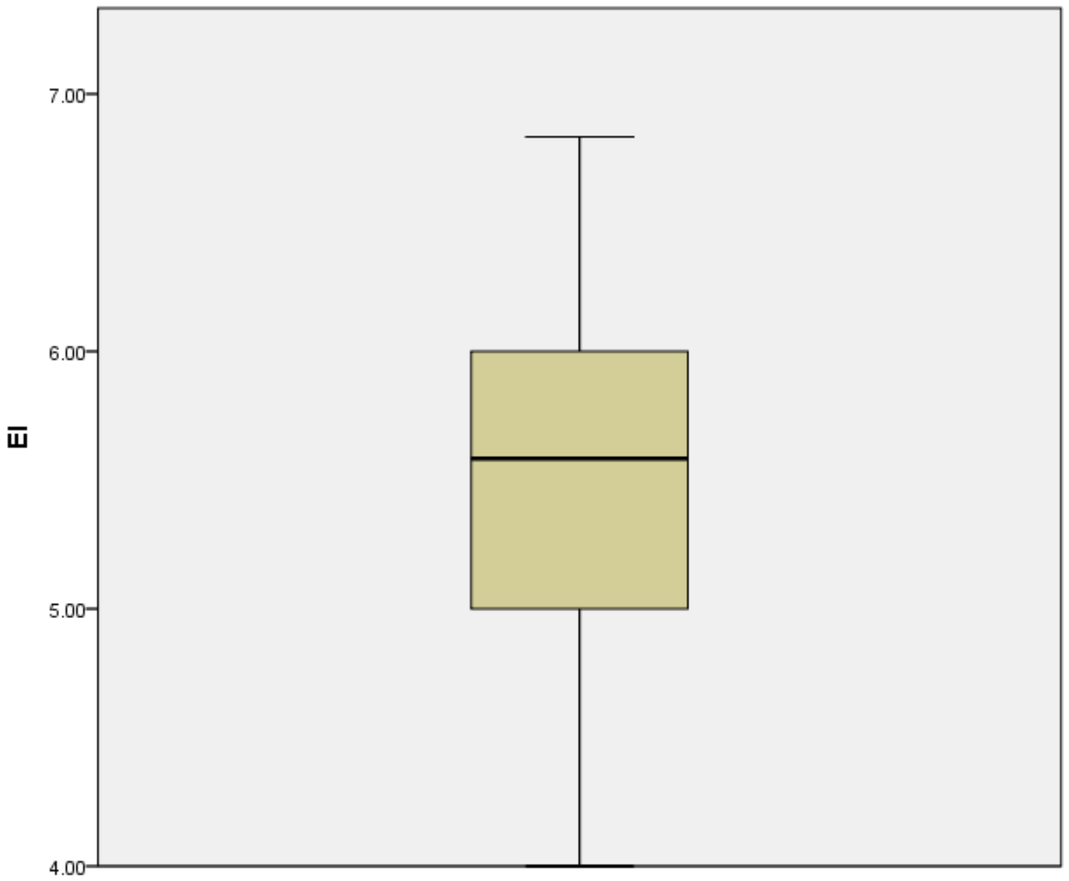
a

a – Boxplot for EI

Figure 4.1 – Univariate detection: boxplots for EI, PA, SNs, PBC, and GS, sheet 1
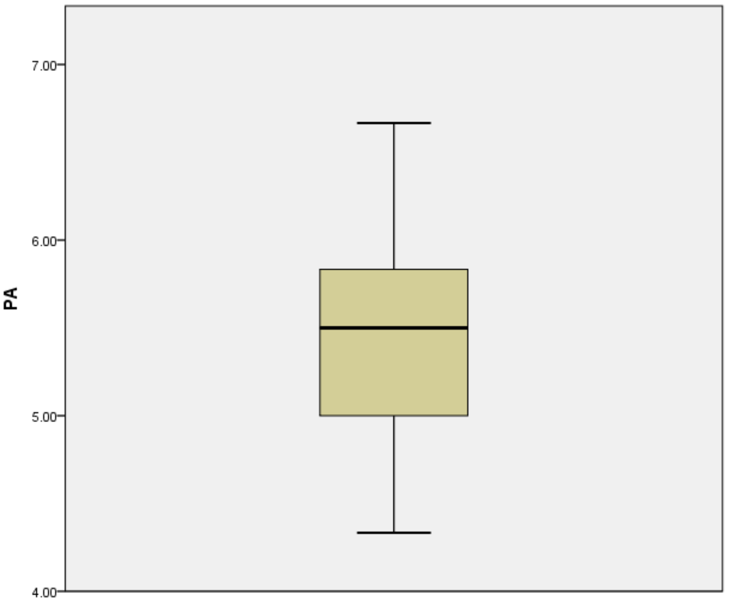

b
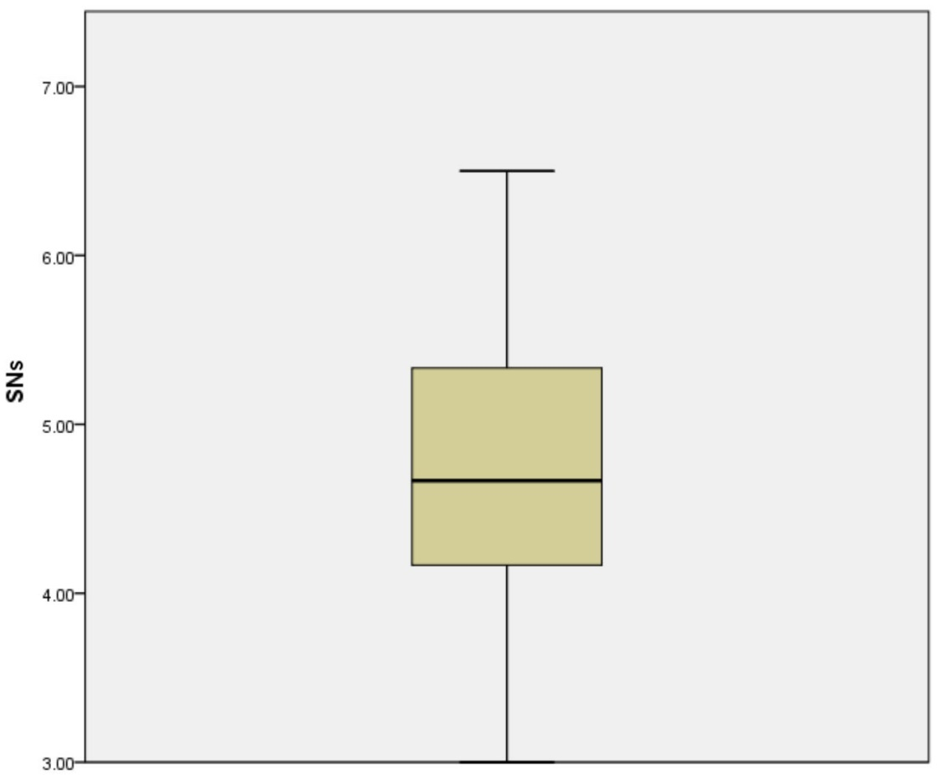
c

b – Boxplot for PA; c – Boxplot for SNs

Figure 4.1, sheet 2
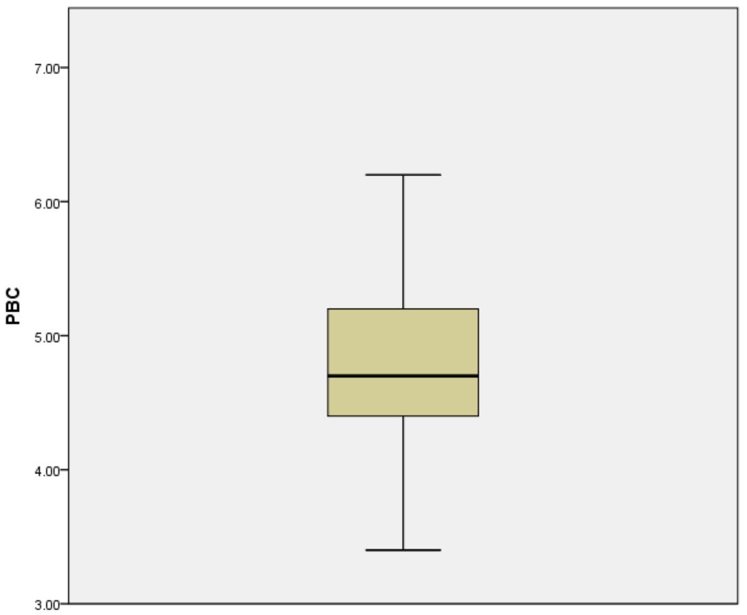
d
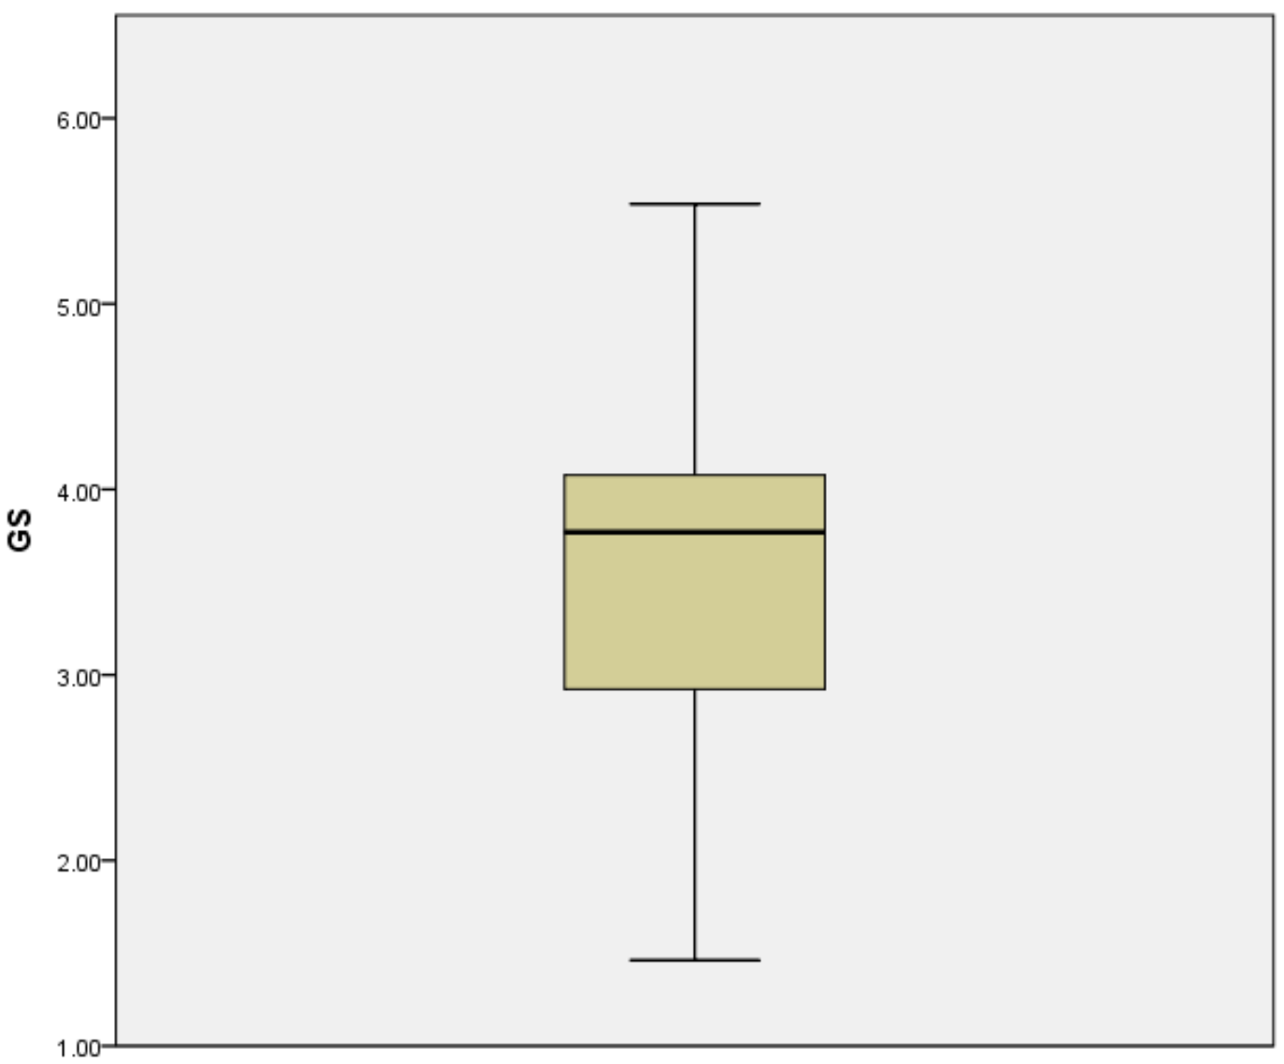
e

d – Boxplot for PBC; e – Boxplot for GS

Figure 4.1, sheet 3

Note – Extracted from the output of SPSS
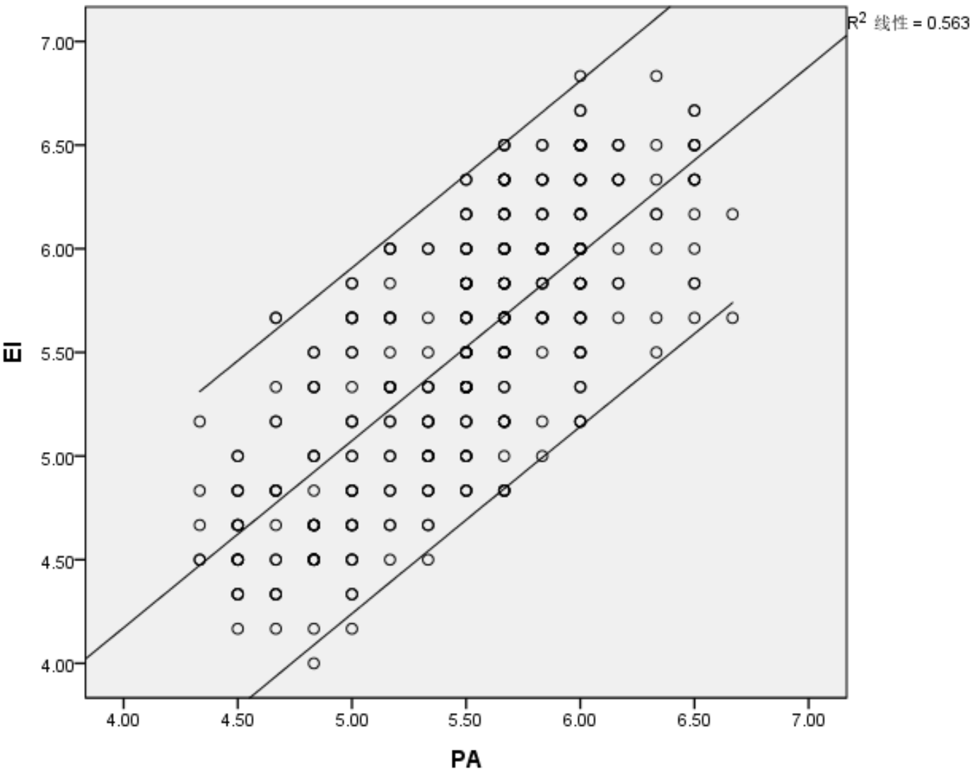
R²=0.563
a
R²=0.353
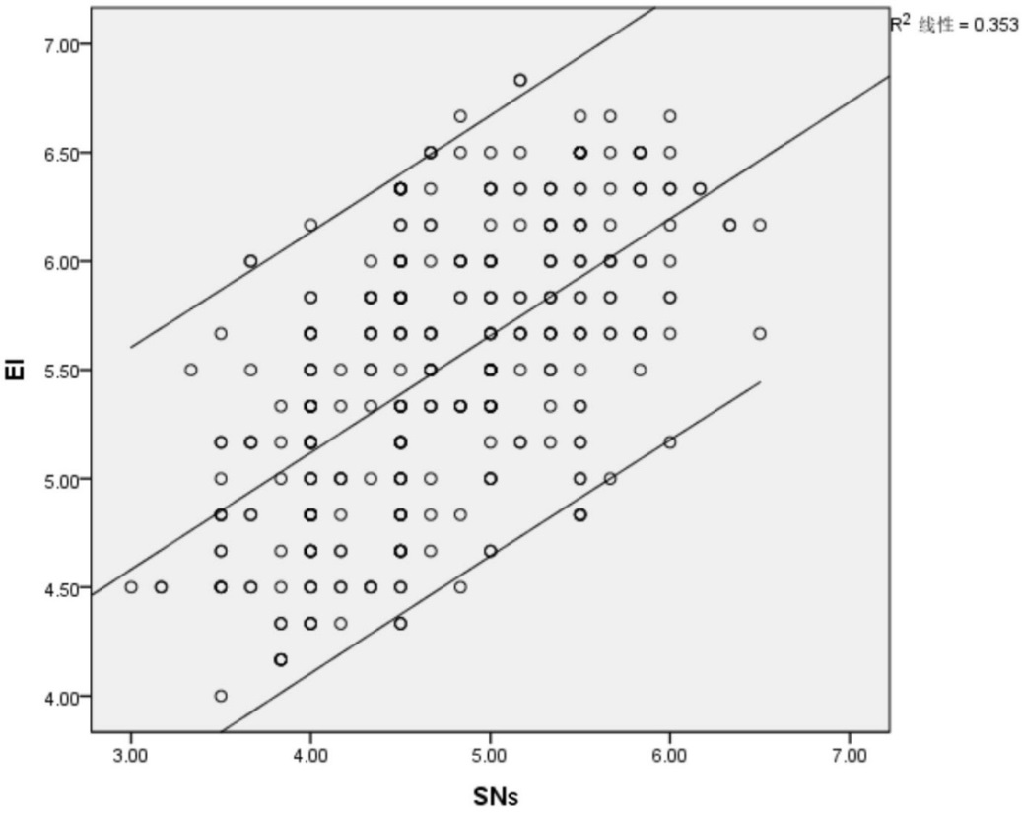
b
a – Scatterplot for EI-PA relationship; b – Scatterplot for EI-SNs relationship
Figure 4.2 – Bivariate detection: scatterplots for relationships among EI, PA, SNs, PBC, and GS, sheet 1
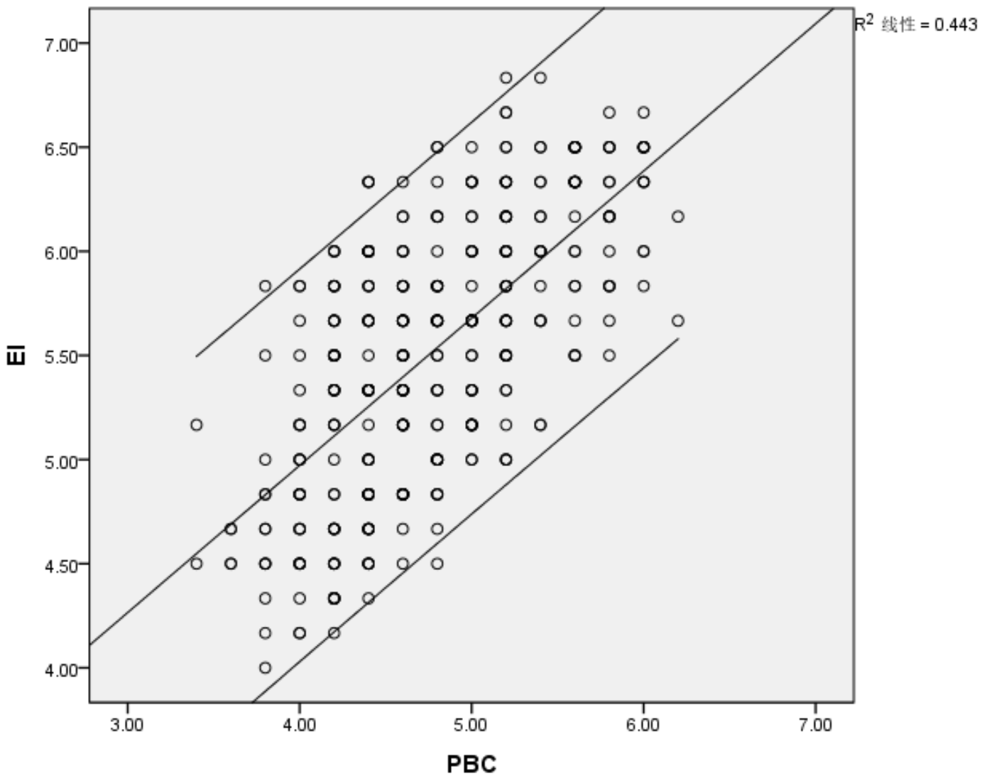
R²=0.443
c
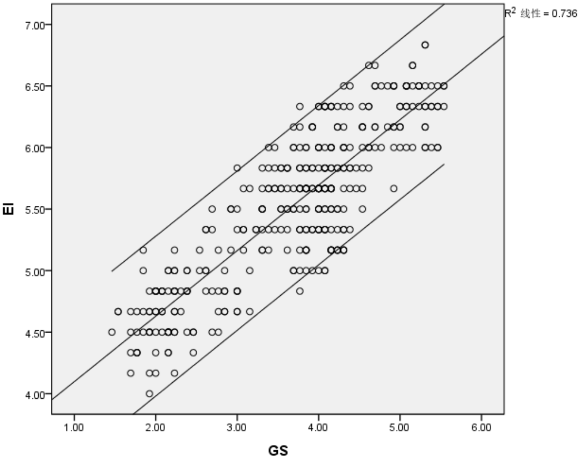
R²=0.736
d

c – Scatterplot for EI-PBC relationship; d – Scatterplot for EI-GS relationship

Figure 4.2, sheet 2
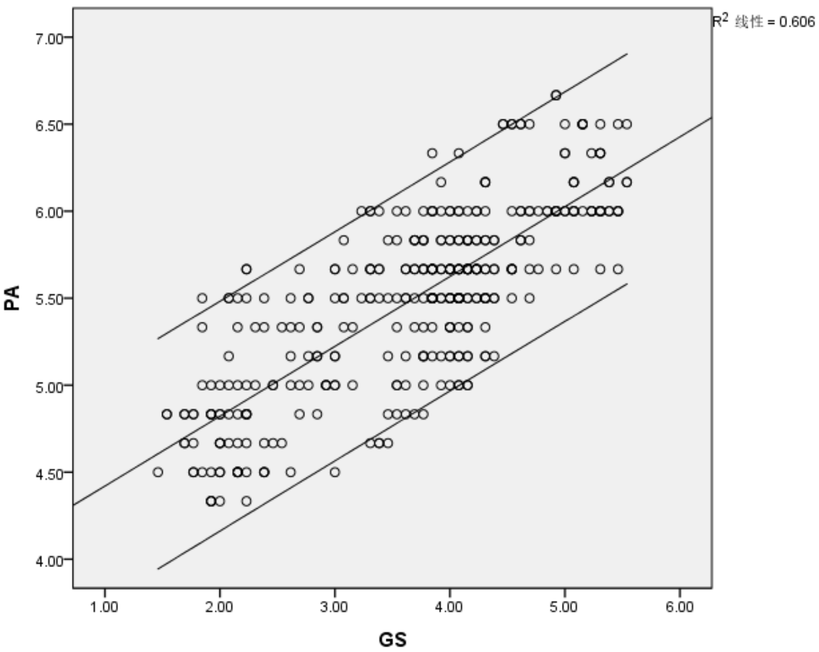
R²=0.349
R²=0.606
e
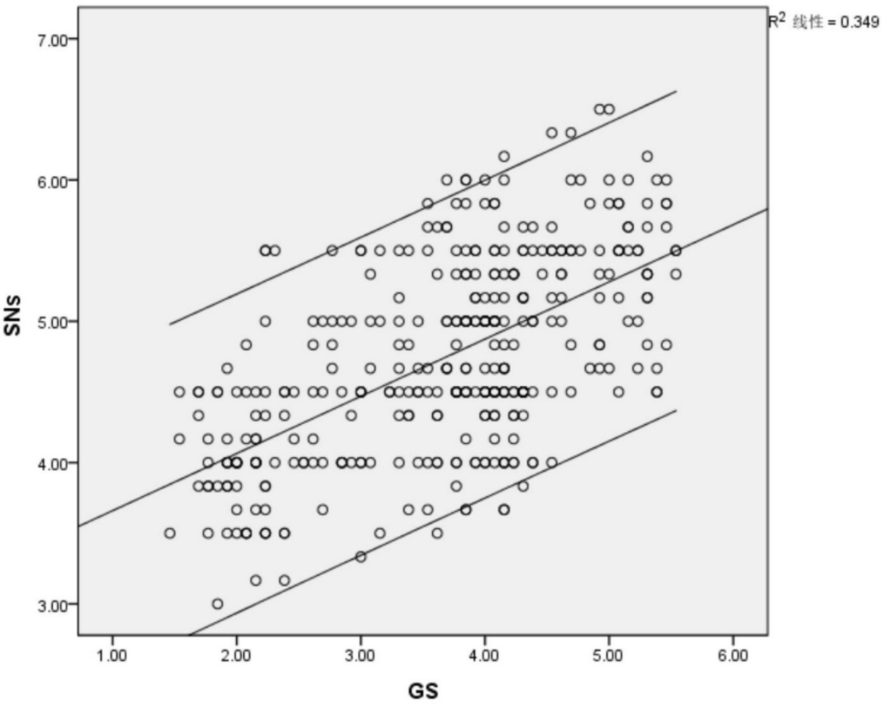
f

e – Scatterplot for PA-GS relationship; f – Scatterplot for SNs-GS relationship

Figure 4.2, sheet 3
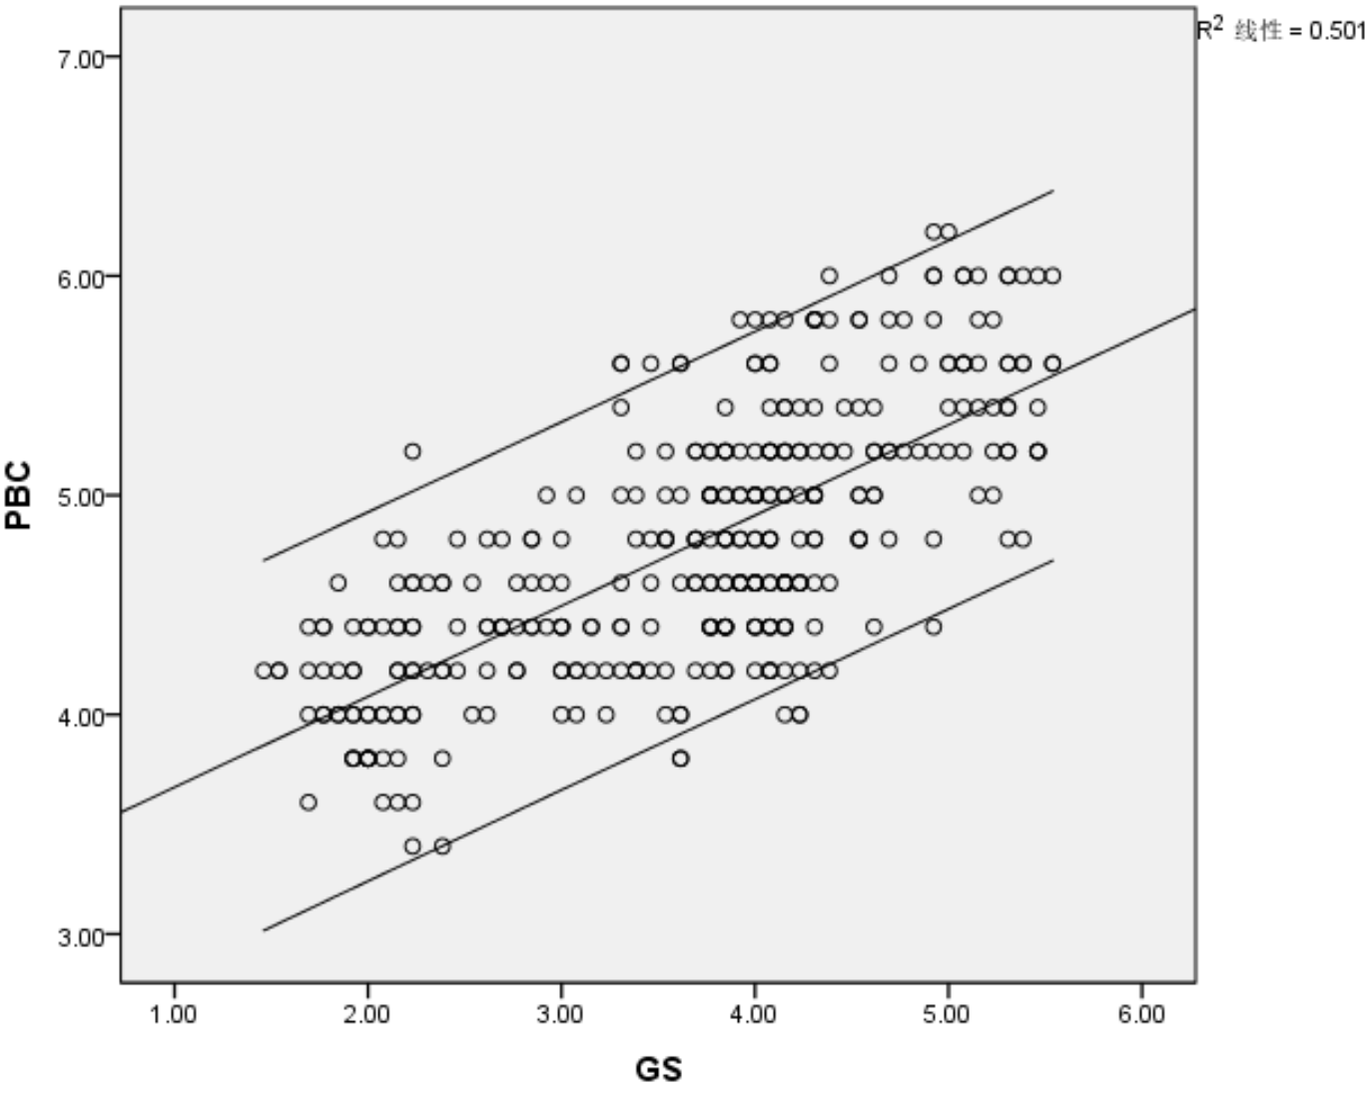
R²=0.501
g
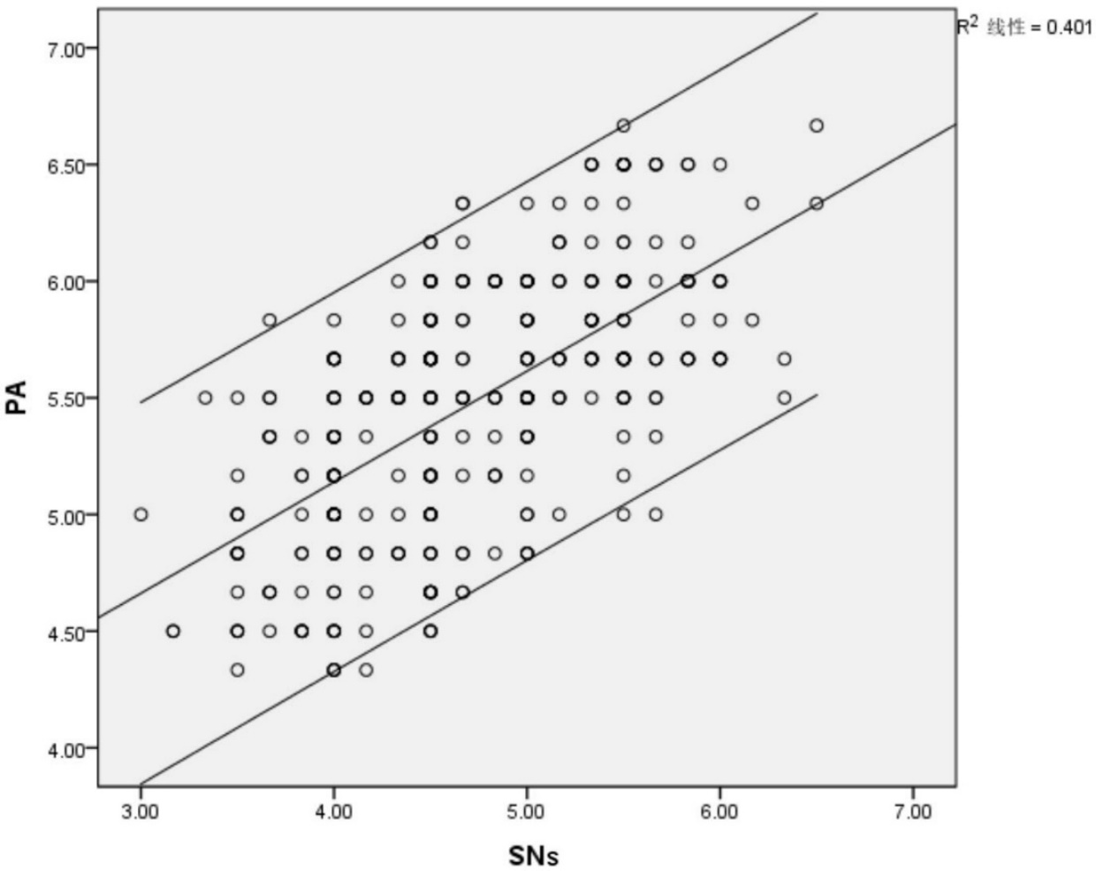
R²=0.401
h

g – Scatterplot for PBC-GS relationship; h – Scatterplot for PA-SNs relationship

Figure 4.2, sheet 4
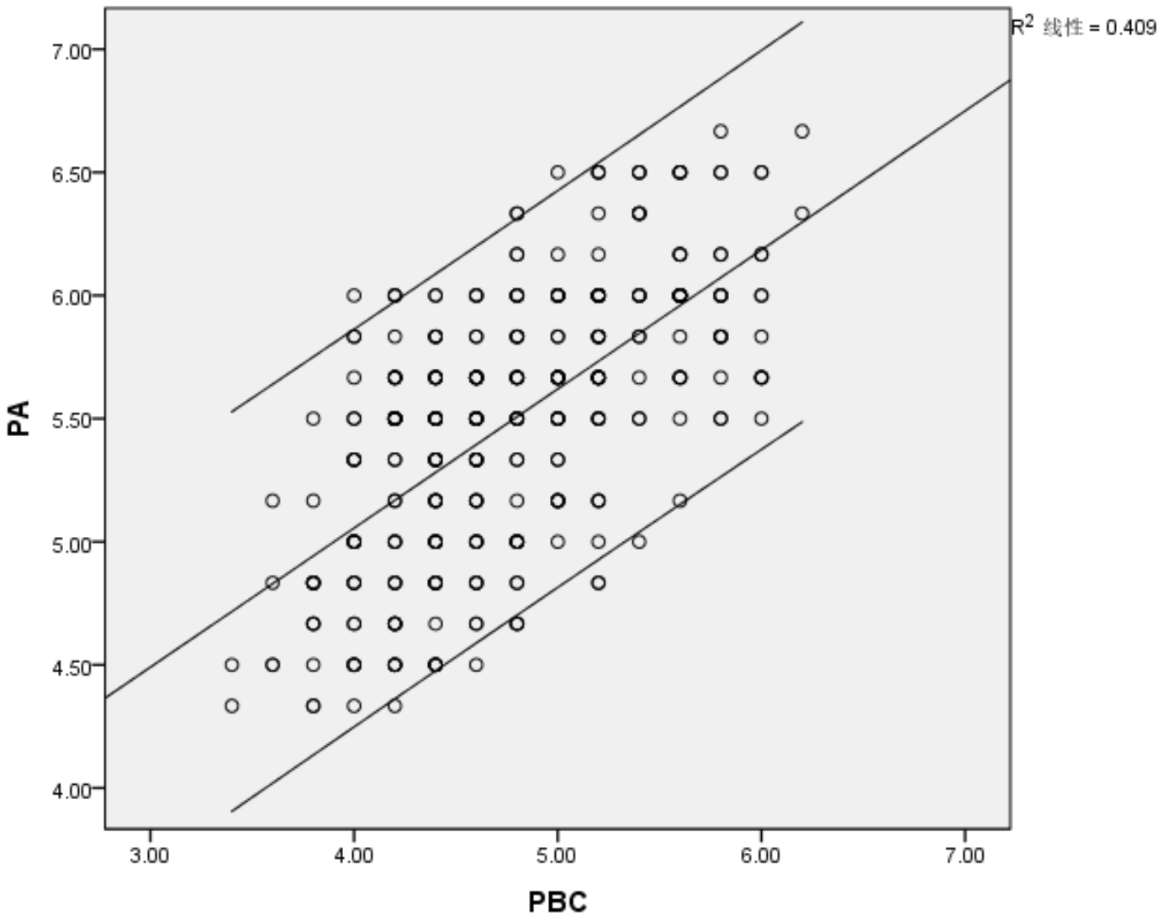
R²=0.409
i
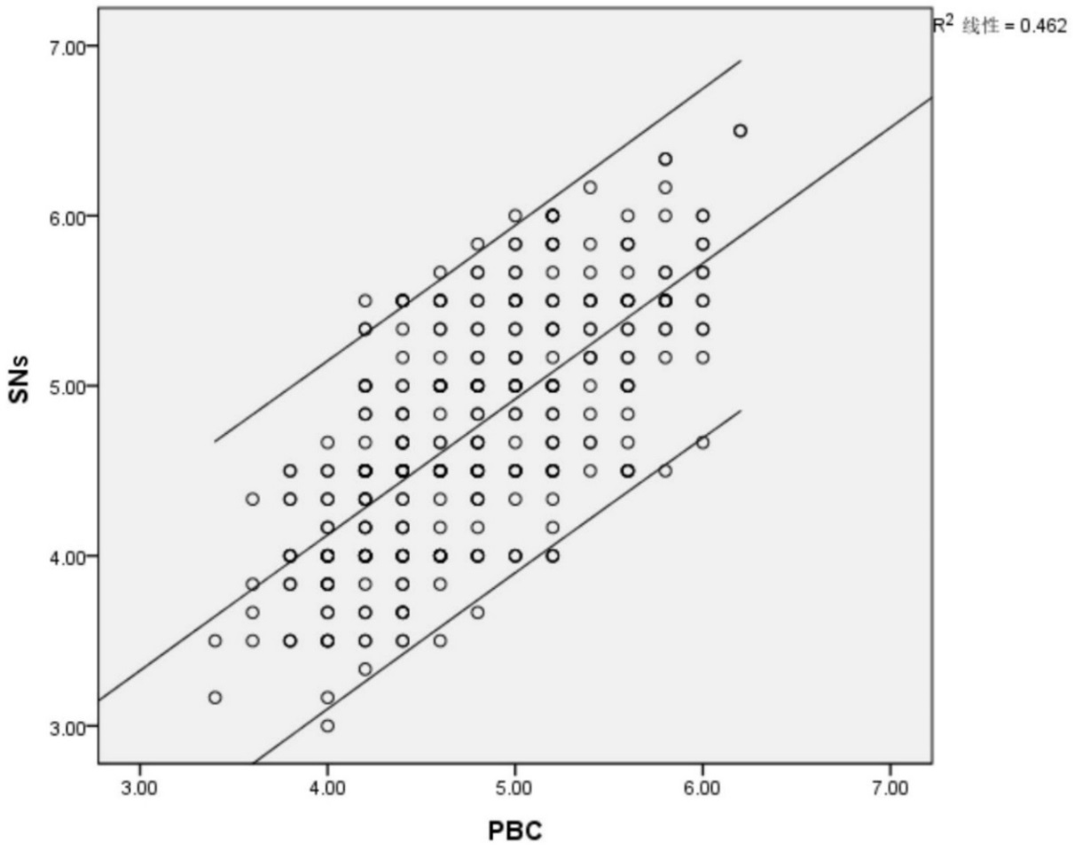
R²=0.462
j

i – Scatterplot for PA-PBC relationship; j – Scatterplot for SNs-PBC relationship

Figure 4.2, sheet 5

Note – Extracted from the output of SPSS
For multivariate detection, the author employed MD to examine the availability of possible outliers in the dataset. MD test does not require any dependent variable (DV), but in SPSS the only way to conduct the test is through multiple regression. Therefore, the author had to name a continuous variable except from the tested variables to be the DV (hence, the “case ID” was chosen as the “DV”), and all the tested variables (EI, PA, SNs, PBC, and GS) as the independent variables (IVs), which renders the degree of freedom 5 (df=5).
SPSS yielded the MD values displayed in a separate column (see column “MAH_1” in table 4.1 below) in the original dataset of SPSS, based on which the values of inverse Chi-square probability (i.e., 1-CDF.CHISQ(MAH_1,5)) (see column “Probability” in table 4.1 below) were computed.
In making the assessment, the conservative significance level for probability was set as 0.001. Table 4.1 displays the highest ten scores for MD, and the correspondingly lowest ten scores for probability level which are to be used for making comparison with the significance level at 0.001 (p<0.001).
As seen from the results, even the minimal value of probability, 0.00748, exceeds 0.001. Therefore, there was no case of statistically significant multivariate outlier in the collected data.

Table 4.1 – Multivariate detection: Mahalanobis distance measure
Case ID | MAH_1 | Probability
49 | 15.78806 | .00748
12 | 11.09176 | .04959
164 | 10.99930 | .05139
48 | 10.86153 | .05420
36 | 10.70664 | .05752
198 | 10.21241 | .06944
275 | 10.13561 | .07148
77 | 9.88970 | .07842
186 | 9.63508 | .08626
225 | 9.58209 | .08798
Note – Compiled by the author based on the output from SPSS

To this point, no substantive outliers were identified from any of the univariate, bivariate, and multivariate detections demonstrated in the above text.
As a supplementary and final step, the standardized residual plot (see figure 4.3) and the standardized partial regression plots (see figure 4.4) were performed to identify outliers over regression results.

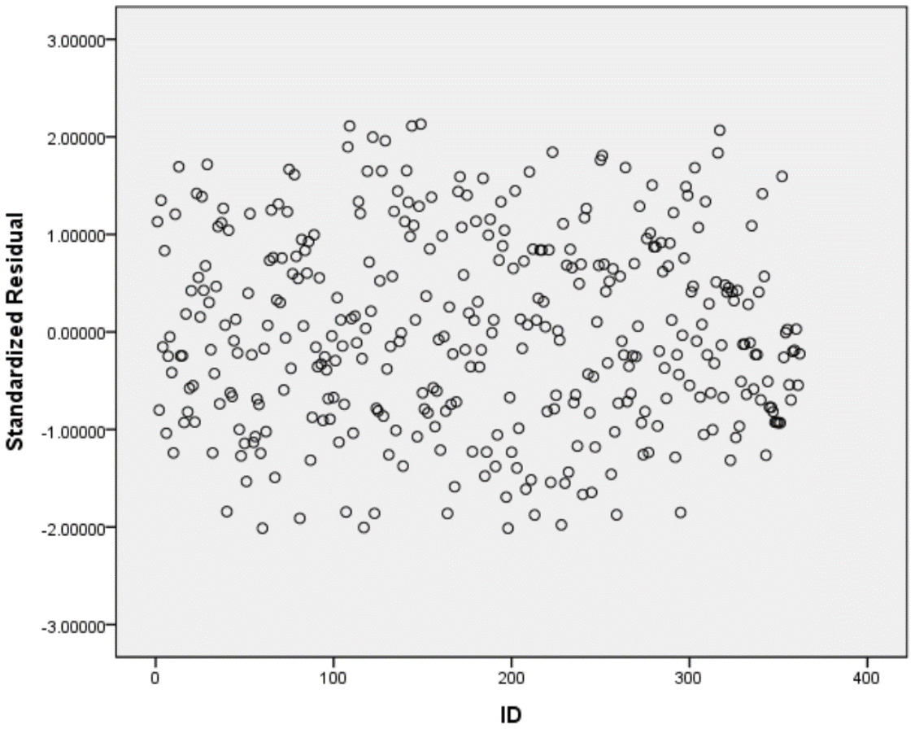
Figure 4.3 – Plot of standardized residuals versus case ID

Note – Extracted from the output of SPSS

According to the guidance on detection of outliers in Chapter 3, the residuals were compared against the t value. Given the significance level at 0.05 (α=0.05), the t value would be 1.96 (approximately 2.0).
As shown in figure 4.3 above, there was not any absolute value which is beyond the rough threshold (2.0); therefore, no standardized residuals were present.
Hence, the above plot indicates that the “TPB” regression results did not exhibit any influential outliers.
At the end, the plots of standardized partial regression for pairs of the DV (“EI”) versus each IV (any of “PA”, “SNs”, and “PBC”) relationship are displayed in figure 4.4 below. Each plot contains two outer lines enclosing the boundary corresponding to the 95% confidence interval. Again, no observations were observed as substantial outliers across each graph.
Thus, based on the aforementioned miscellaneous detections in terms of univariate, bivariate, and multivariate senses, including for the separate variables and the entire “TPB” variate, not any influential outlier was available and found in the end.
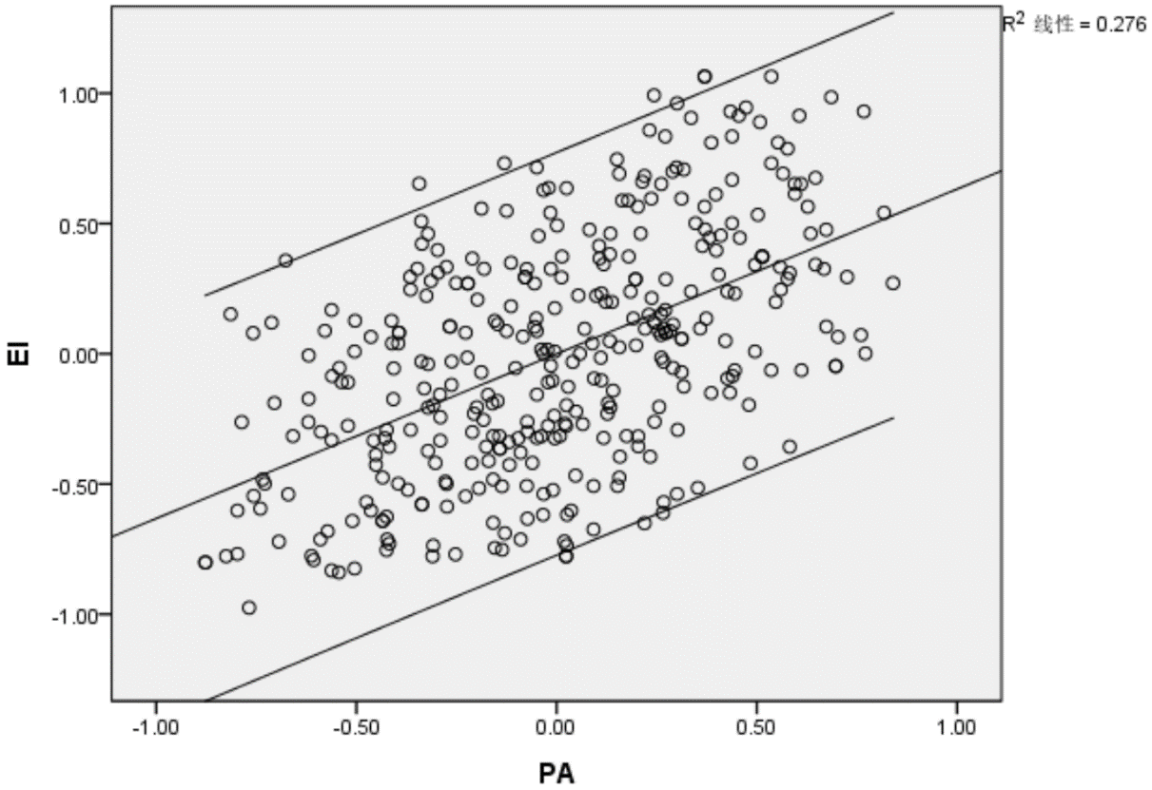
R²=0.276
a

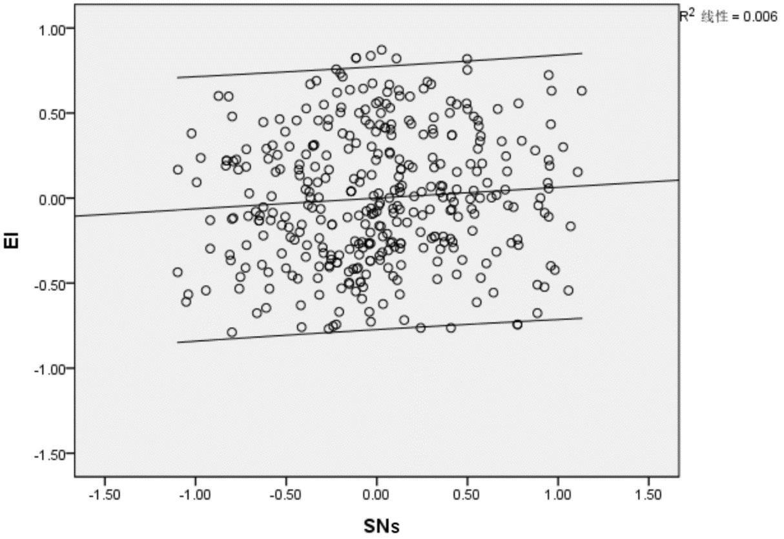
R²=0.006
b
a – Standardized partial regression plot (EI vs. PA)
b – Standardized partial regression plot (EI vs. SNs)

Figure 4.4 – Standardized partial regression plots, sheet 1
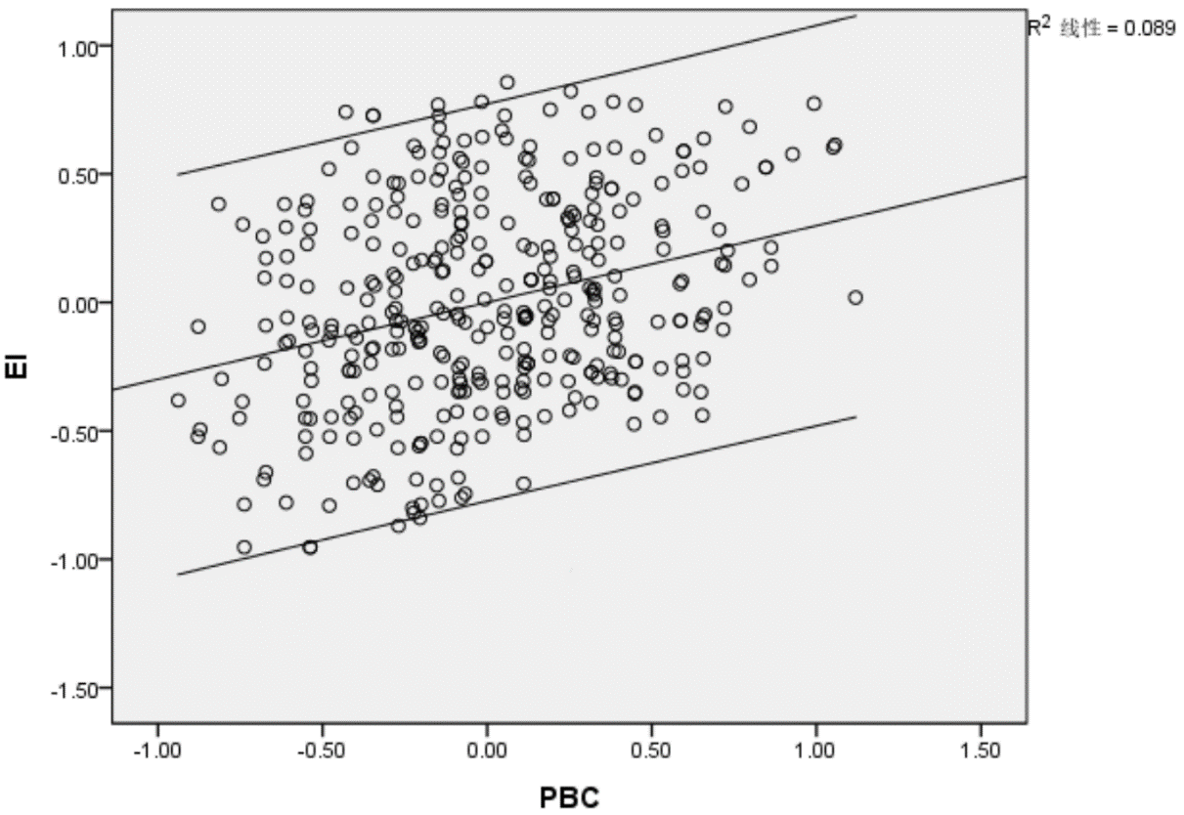
R²=0.089

c

c – Standardized partial regression plot (EI vs. PBC)

Figure 4.4, sheet 2

Note – Extracted from the output of SPSS

4.2.3 Testing Normality
Although the large sample size (N=362) generated in this study can render negligible effect of non-normality on the results, the author still tested the level of the departure from normality of each variable. Besides, this study utilized visual plots for the residuals of normal probability to evaluate the extent to which the error terms of the entire variate are in normal distribution.
Figure 4.5 displays the histograms of each variable (EI, PA, SNs, PBC, and GS) that are compared with a normal curve. Apparently, all data distributions take on some extent of non-normality.
The “normal probability plots” (termed “Q-Q plots”) for all set of variables are shown in figure 4.6. The cumulative normal distribution in the plots is used as the benchmark to check that of actual data values. The plots show that the observed data values in each of EI, PA, SNs, and PBC closely follow the diagonal line, while the values in GS generally follow the diagonal line yet slightly depart in the middle from the line. In other words, the data of EI, PA, SNs, and PBC are almost normally distributed, while GS tends to be more non-normal in its data distribution.

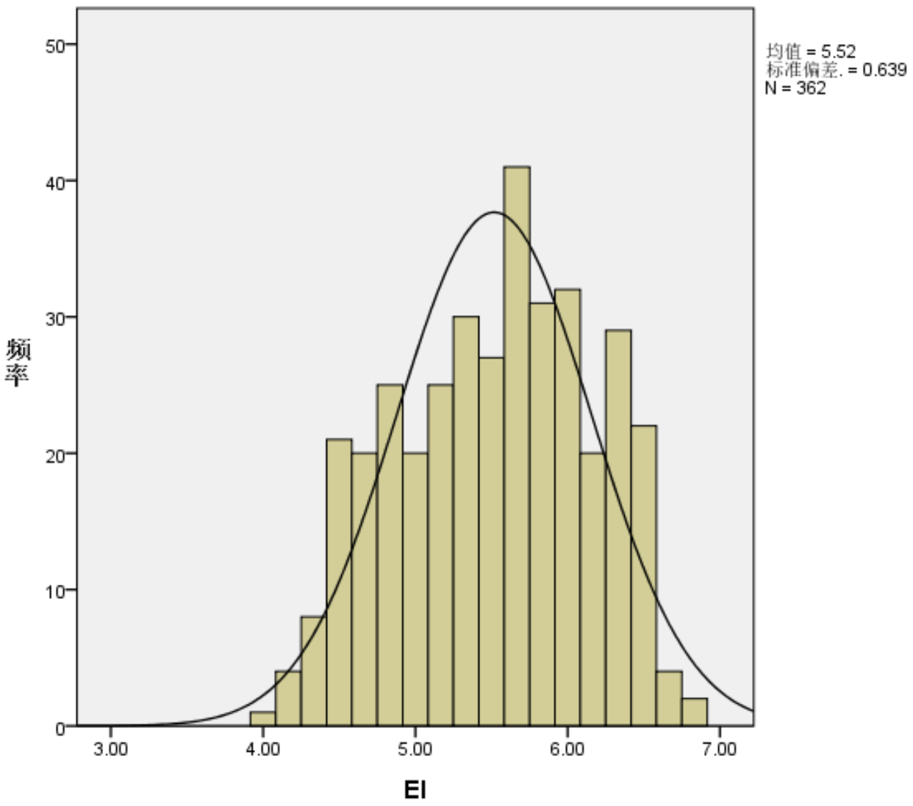
Frequency
Frequency
Mean=5.52
Std. deviation=0.639
N=362
a
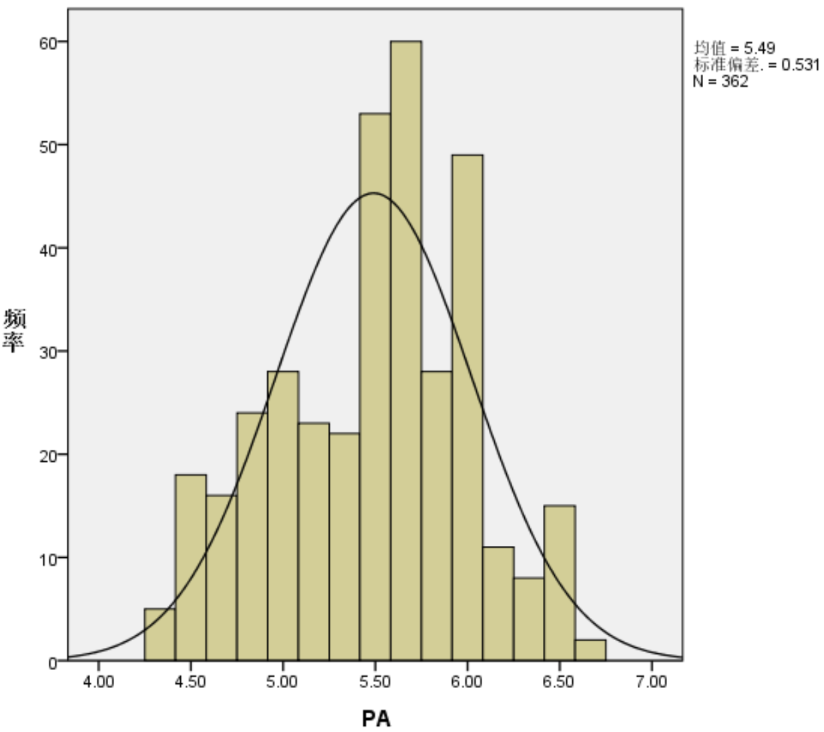
Mean=5.49
Std. deviation=0.531
N=362
b

a – Histogram of EI; b – Histogram of PA
Figure 4.5 – Histograms of EI, PA, SNs, PBC, and GS, sheet 1
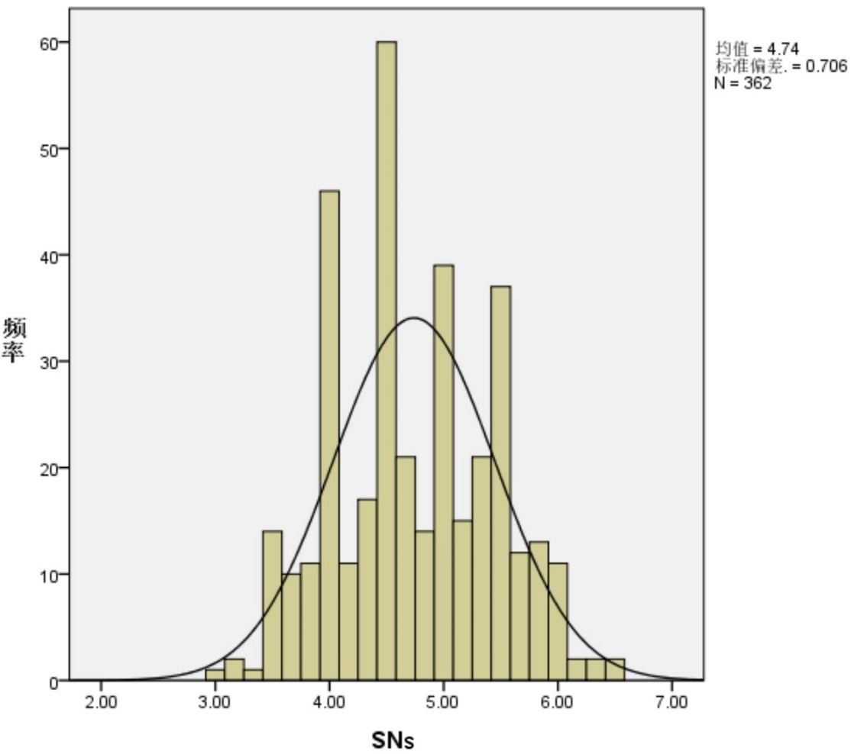
Frequency
Mean=4.74
Std. deviation=0.706
N=362
c
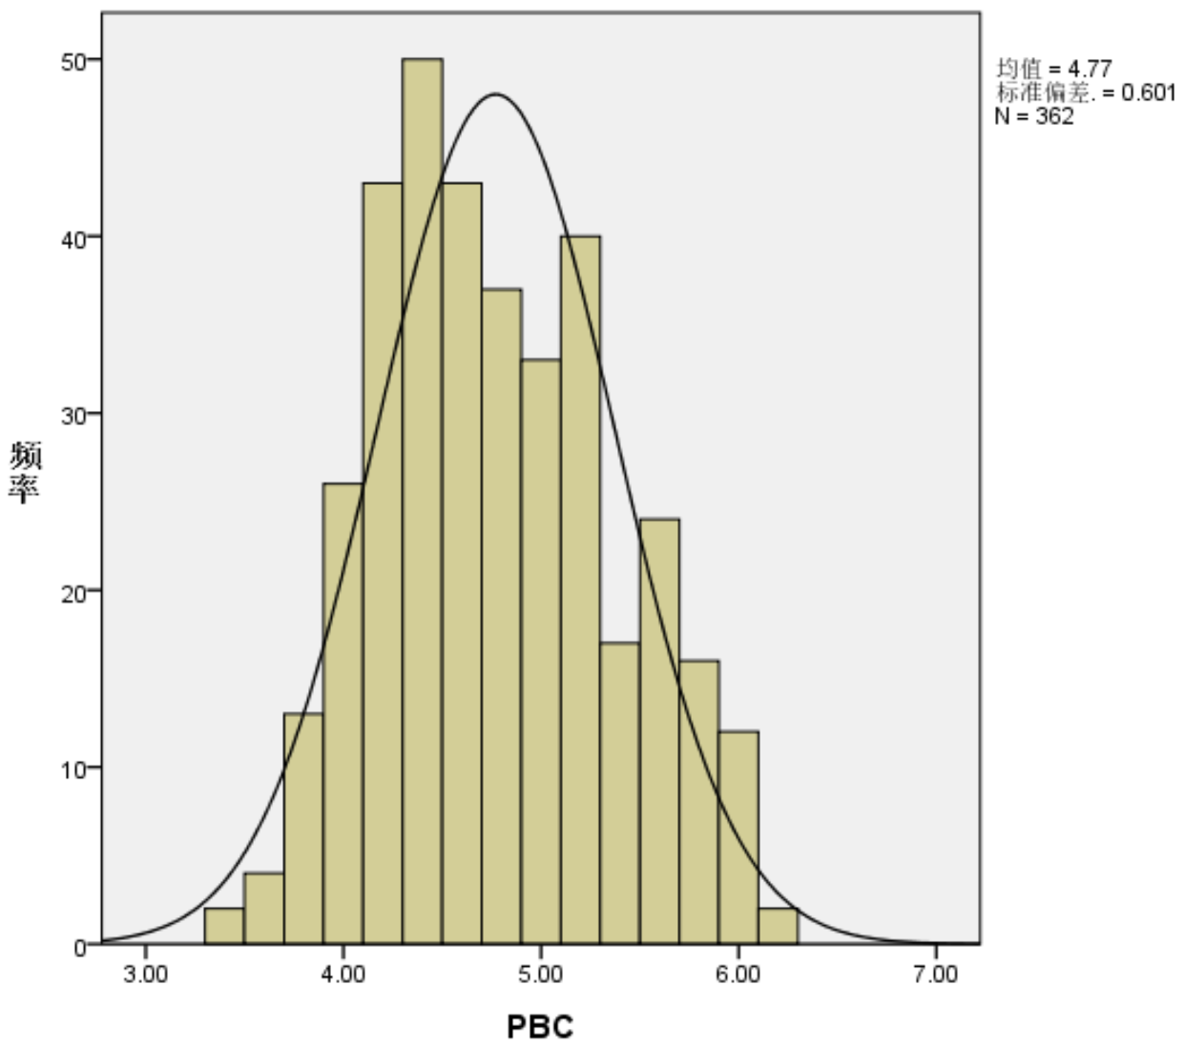
Frequency
Mean=4.77
Std. deviation=0.601
N=362
d
c – Histogram of SNs; b – Histogram of PBC

Figure 4.5, sheet 2
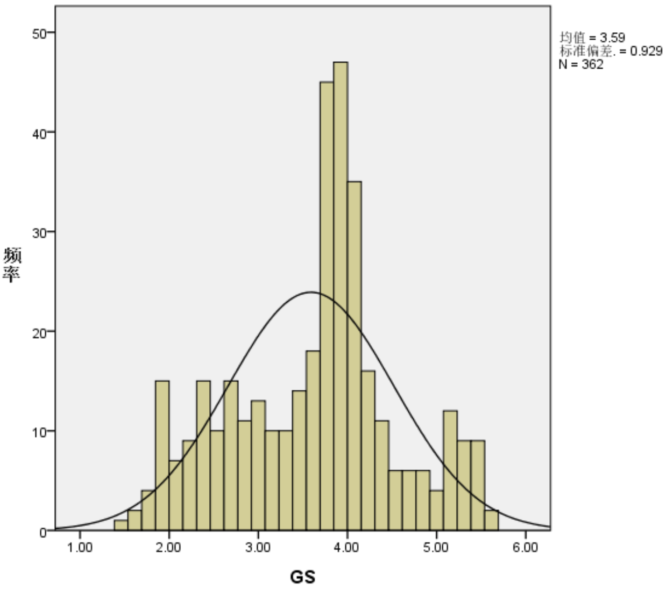
Mean=3.59
Std. deviation=0.929
N=362
Frequency
e
e – Histogram of GS

Figure 4.5, sheet 3

Note – Extracted from the output of SPSS
Normal Q-Q Plot for EI
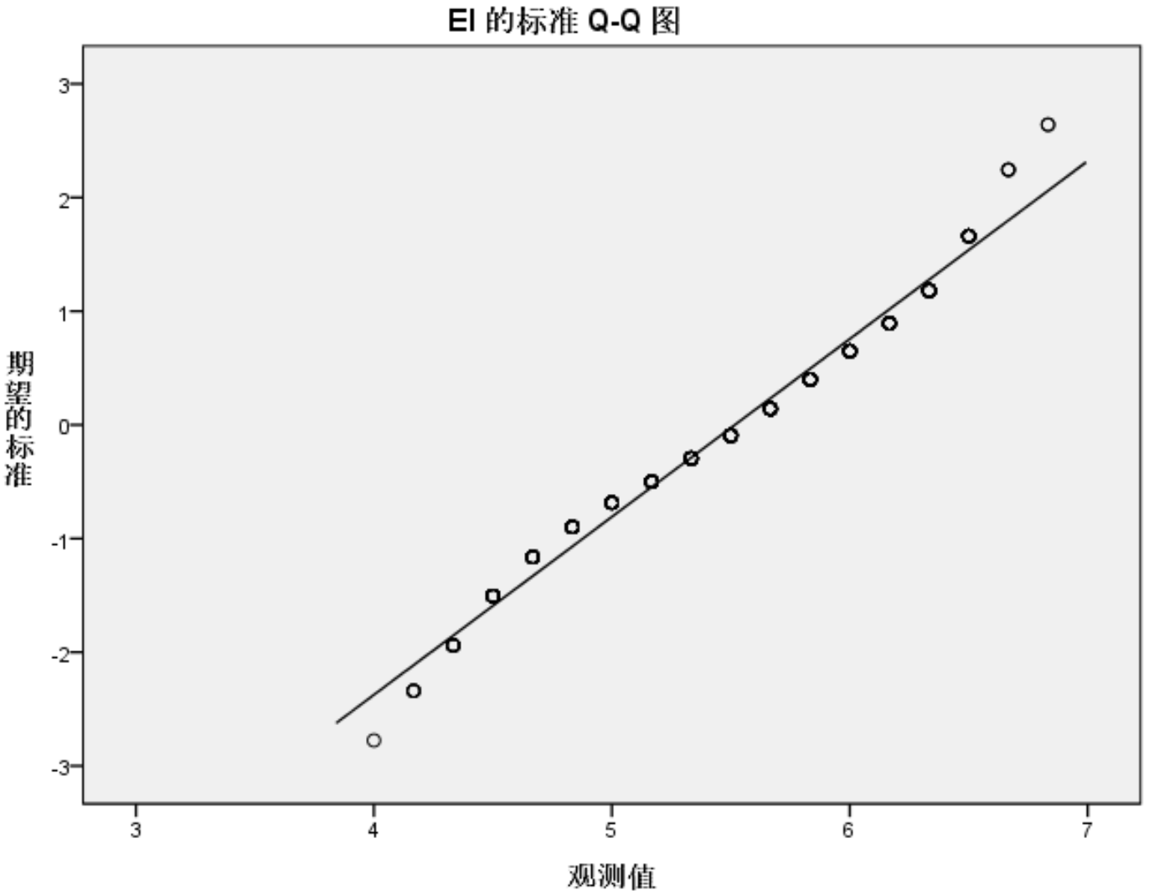
Expected Normal Value
Observed Value
a
a – EI’s Q-Q plot

Figure 4.6 – Q-Q plots for EI, PA, SNs, PBC, and GS, sheet 1
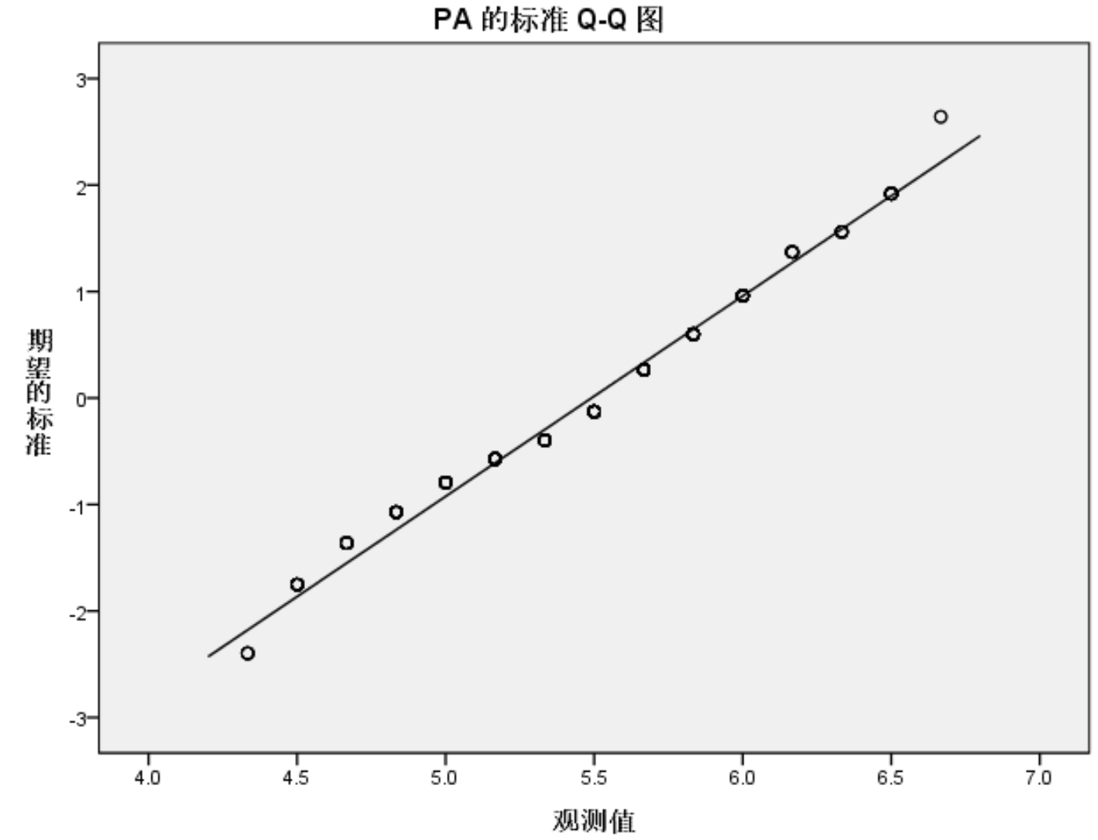
Normal Q-Q Plot for PA
Expected Normal Value
Observed Value
b
Normal Q-Q Plot for SNs
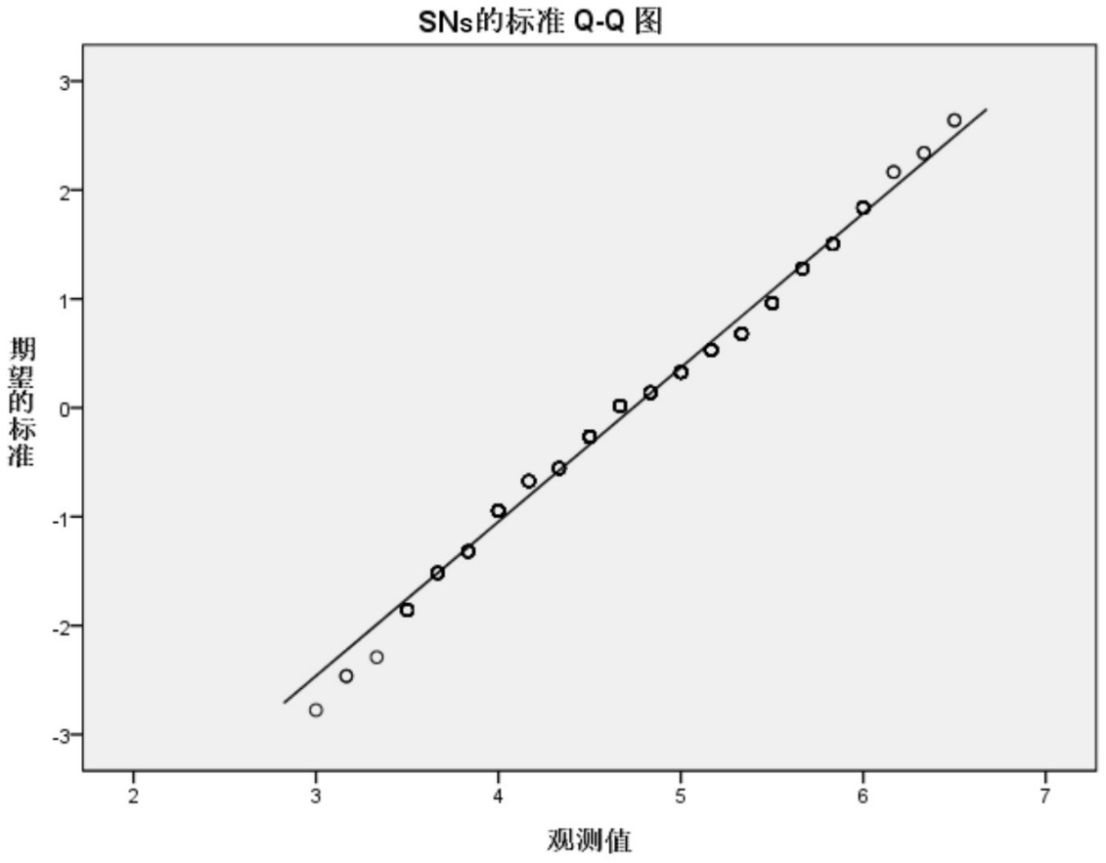
Expected Normal Value
Observed Value
c

b – PA’s Q-Q plot; c – SNs’ Q-Q plot

Figure 4.6, sheet 2
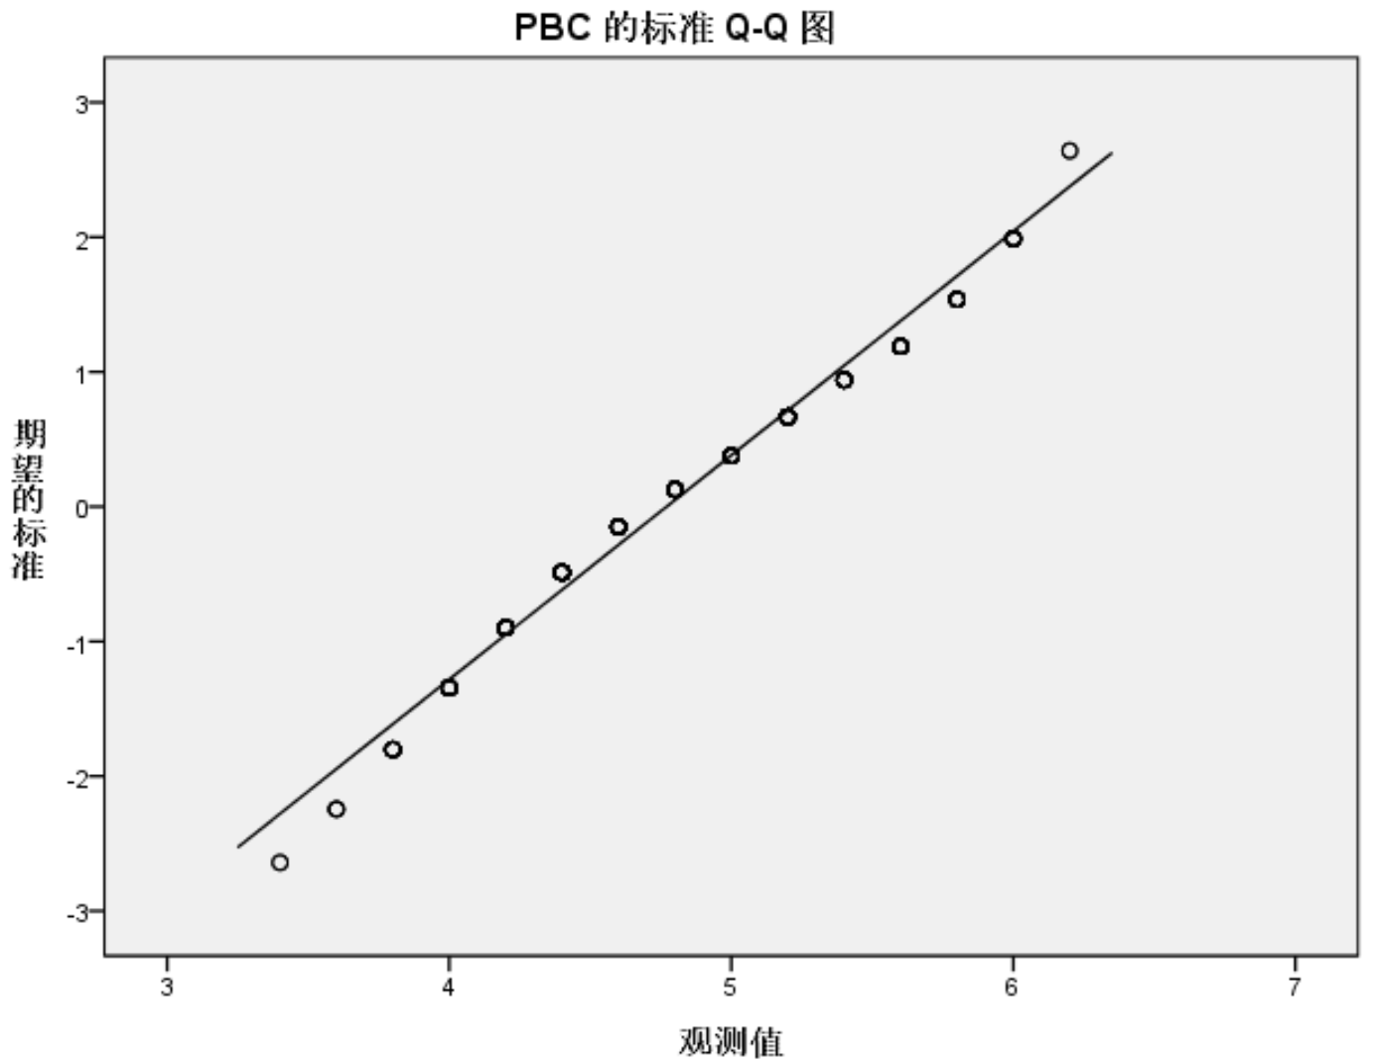
Normal Q-Q Plot for PBC
Expected Normal Value
Observed Value
d
Normal Q-Q Plot for GS
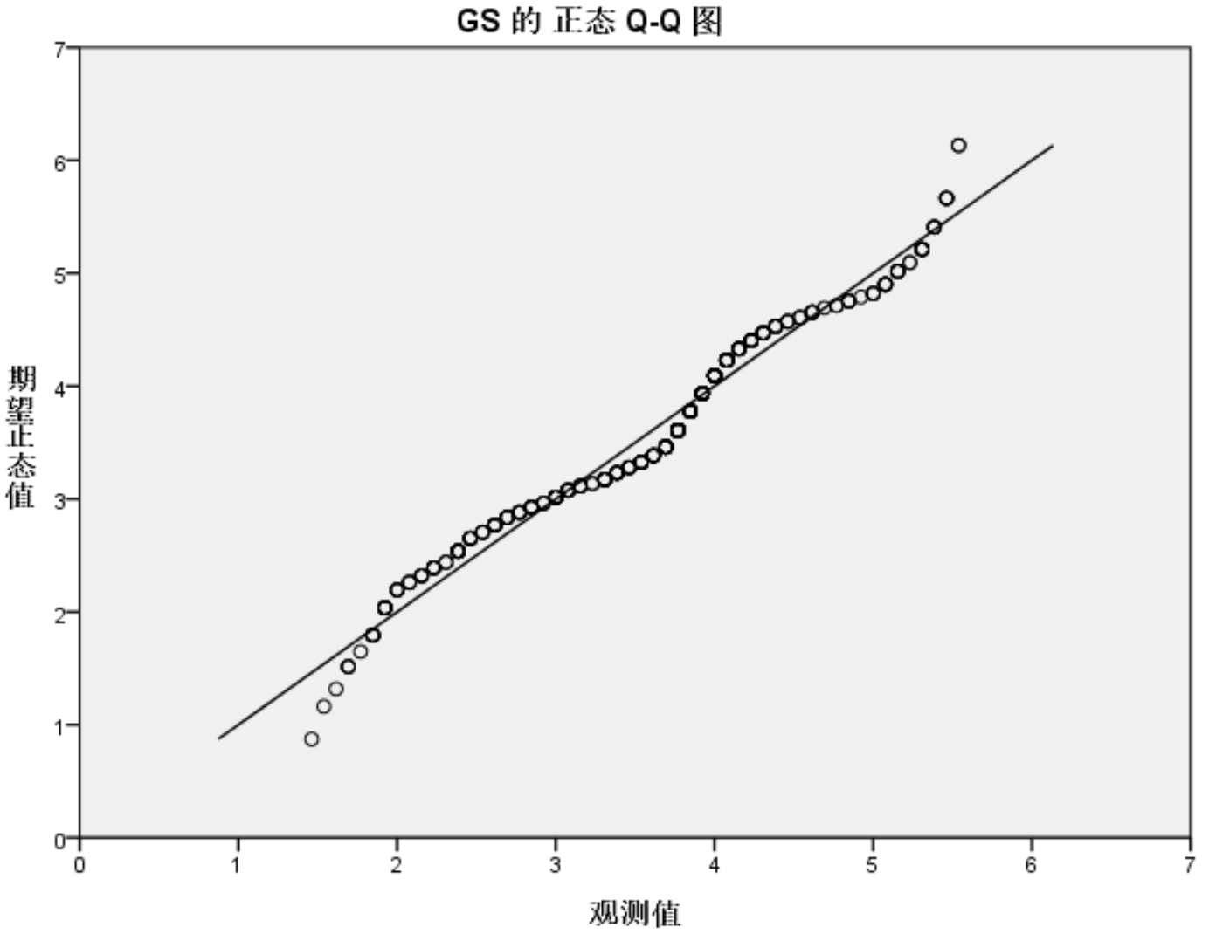
Expected Normal Value
Observed Value
e
d – PBC’s Q-Q plot; e – GS’ Q-Q plot

Figure 4.6, sheet 3

Note – Extracted from the output of SPSS
Furthermore, this study employed the statistical approach using skewness, kurtosis, SW, and KS, for testing the normality of data distribution. Table 4.2 and 4.3 report the statistical output from SPSS. According to corresponding criteria stated in Chapter 3, the outcomes reveal that each of the five direct variables (EI, PA, SNs, PBC, and GS) is significantly non-normal in general (p<0.05); however, the scores of skewness and kurtosis fall within the threshold (±2). In other words, all the variables reveal a little amount of non-normality.

Table 4.2 – Assessment on normality with KS and SW tests
Construct | Kolmogorov-Smirnovª Statistic | df | Sig. | Shapiro-Wilks Statistic | df | Sig.
EI | .093 | 362 | .000 | .971 | 362 | .000
PA | .131 | 362 | .000 | .970 | 362 | .000
SNs | .110 | 362 | .000 | .979 | 362 | .000
PBC | .112 | 362 | .000 | .972 | 362 | .000
GS | .118 | 362 | .000 | .969 | 362 | .000
Note:
1. a. Lilliefors significance correction. All variables are statistically non-normal (p<0.05) according to Ho and Yu [437].
2. Compiled by the author based on the output from SPSS.

Table 4.3 – Assessment on normality with skewness and kurtosis statistics
Construct | N | Skewness | Std. Error | Kurtosis | Std. Error
 | Statistic | Statistic |  | Statistic
EI | 362 | -.166 | .128 | -.886 | .256
PA | 362 | -.194 | .128 | -.568 | .256
SNs | 362 | .084 | .128 | -.695 | .256
PBC | 362 | .268 | .128 | -.658 | .256
GS | 362 | -.125 | .128 | -.429 | .256
Note:
1. All the values fall within the threshold of ±2 [421, p. 21], revealing a very slight extent of non-normality
2. Compiled by the author based on the output from SPSS.

Combining the above results on normality tests, and considering the advantageous effect of large sample size on the data analysis, this study argues that with the slight and negligible extent of non-normality, the collected data adequately meet the criteria of normality. Hence, the subsequent data analysis can proceed without substantive bias being incurred.
Further to the univariate normality tested above, the multivariate normality was also checked to ensure that the combination of the individual variables is also normal. In other words, the normality of the “TPB” variate’s error terms shall be achieved.
Figure 4.7 displays the histogram of studentized residuals of regression variate of the “TPB” model, which visually matches the normal curve very well.
The “normal probability plot” (Q-Q plot) of the studentized residuals is shown in figure 4.8, in which the residual line strictly follows the diagonal line representing the normal distribution, with minor deviations (but no significant or systematic deviations) between the lines in the center; the residuals are regarded as having a normal distribution. Hence, the “TPB” regression variate satisfied the assumption of normality as well.
To this point, both the assumptions of univariate and multivariate normality were acceptable for further data analysis.

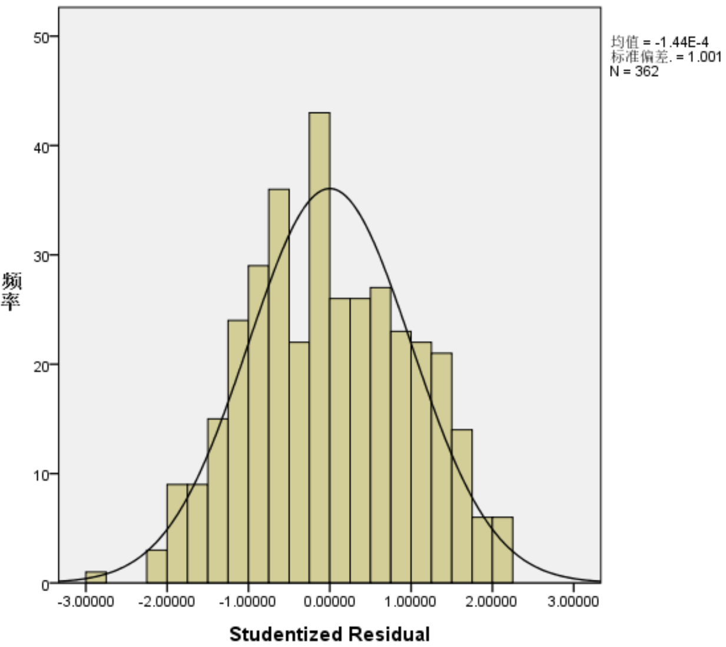
Mean=-1.44E-4
Std. deviation=1.001
N=362
Frequency

Figure 4.7 – Histogram of standardized residuals

Note – Extracted from the output of SPSS
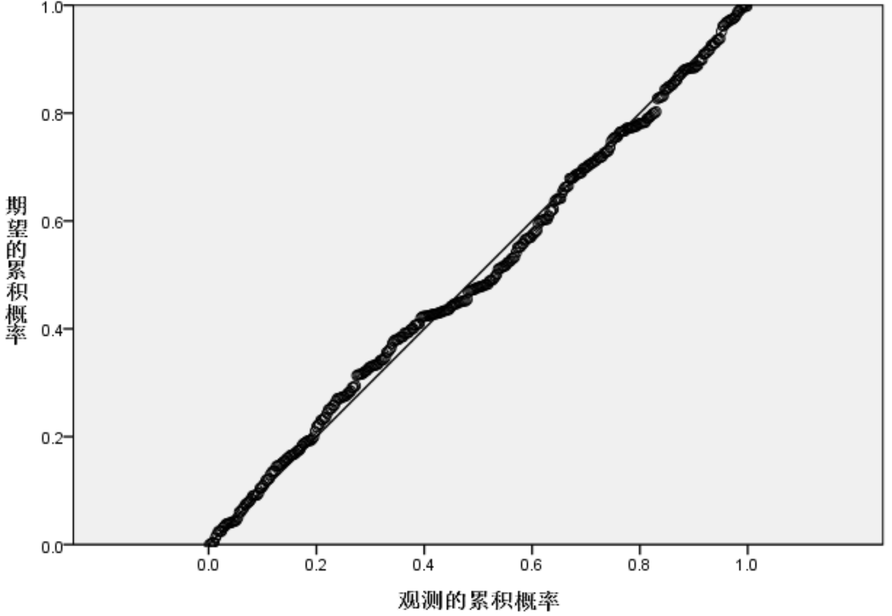
Expected Cum Prob
Observed Cum Prob

Figure 4.8 – Q-Q plot of standardized residuals

Note – Extracted from the output of SPSS

4.2.4 Testing Homoscedasticity
Homoscedasticity is concerned with the constancy of the residuals over all IVs’ values. Diagnosis was conducted utilizing a residual plot and Levene’s test for the assessment of constant variance of error terms (also called “homoscedasticity” or “homogeneity”).
The graph between studentized residuals versus predicted values is the most fundamental sort of residual plot. Figure 4.9 exhibits the residual plot of this sort for DV values in the “TPB” model. There is no persistent pattern of growth or decline in the distribution of residuals. This result shows evidence of existence of multivariate homoscedasticity.
ANOVA was applied to run Levene’s test over each pair of variables between the DV and each IV of the “TPB” model. Table 4.4 reveals that all of the significance values are above 0.05; hence, no unequal variances are present.
Therefore, the assumption of homoscedasticity was fulfilled.
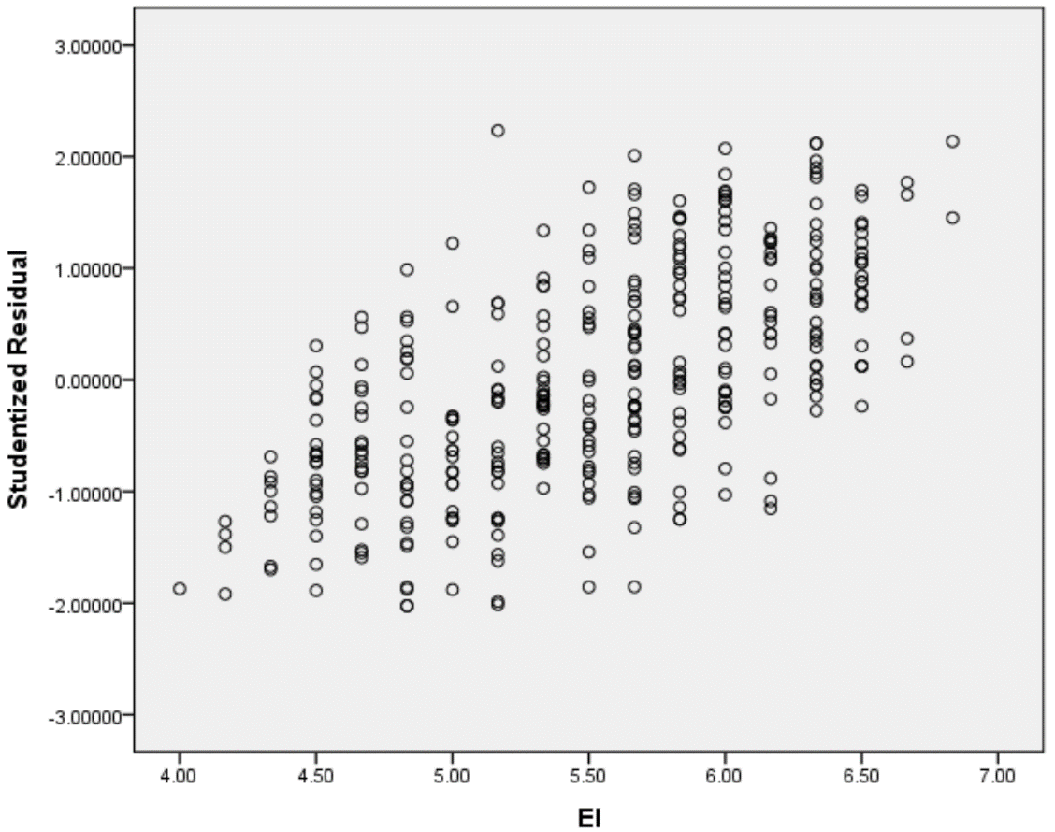

Figure 4.9 – Plot of studentized residuals versus DV (EI)

Note – Extracted from the output of SPSS

Table 4.4 – Levene’s test of homogeneity
Construct | Levene’s Statistic | df1 | df2 | Sig.
EI-PA | .946 | 21 | 340 | .531
EI-SNs | 2.395 | 24 | 333 | .052
EI-PBC | 1.479 | 21 | 338 | .082
Note:
1. No unequal variances are present because all the values are non-significant at the p<0.05 level.
2. Compiled by the author based on the output from SPSS.

4.2.5 Testing Linearity
Bivariate scatterplots (see figure 4.2) have been precedingly presented during the outliers screening procedure. This study paid close attention to the linear relationships between EI and each of TPB components (PA, SNs, and PBC). The fit line in the center for each investigated scatterplot revealed the presence of independent linear relationship. Figure 4.10 below presents the bivariate profiling of relationships (EI-PA, EI-SNs, and EI-PBC) in a different format: scatterplot matrix. In the first row from up, the three bivariate graphs to the right, all look like a straight thick line in distributional shape. The circles representing the values are evenly scattered around the line of symmetry, which reflect conventional linear correlations.
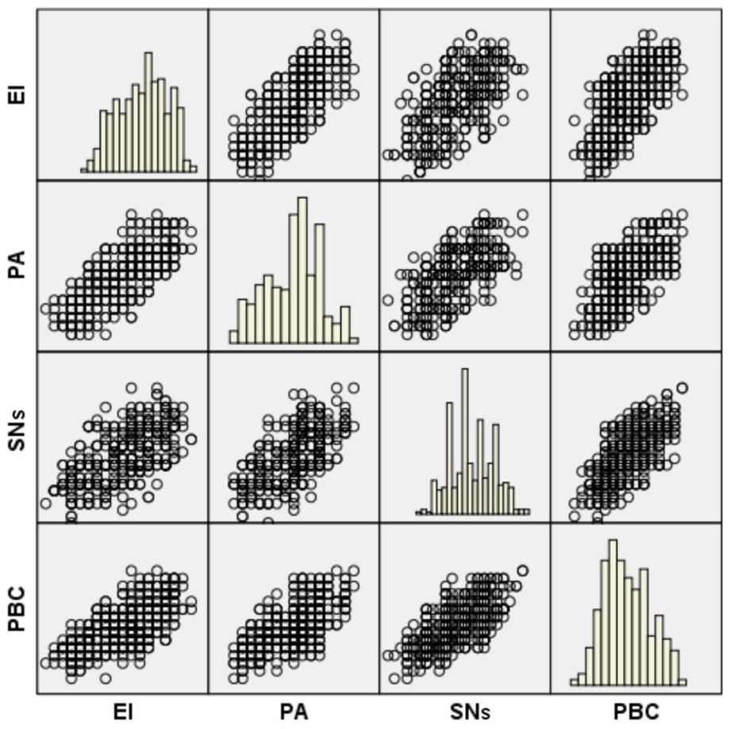

Figure 4.10 – Scatterplot matrix among PA, SNs, PBC, and EI

Note – Extracted from the output of SPSS

In addition, the analysis of residuals was used for assessing linearity of the overall variate; and partial regression plots were used to determine linearity for each IV in question. The residuals in figure 4.9 (analysis of studentized residuals) show no non-linear patterns, indicating that the overall equation is linear. Partial regression plots (see figure 4.4) were precedingly presented during the detection on outliers, where all of the EI-PA, EI-SNs, and EI-PBC relationships show a linear pattern through the fit line in the center of each graph, thus satisfying the assumption of linearity for each IV (PA, SNs, and PBC).
As such, there is no violation of assumption on bivariate linear relationships among the investigated variables under study and on overall variate linearity.

4.2.6 Testing Independence of the Residuals
“Independence of the residuals” deals with the effect of carryover from one observation to the next, thus rendering the correlated error terms not independent [392, p. 207]. Independence of the residuals shall be tested to ensure that the predicted values or prediction errors are not affected by any other unspecified cause or sequencing variable.
In this study, the case ID numbers represent the order in which the responses were collected. Hence, this study plotted the studentized residuals against the ID variable (see figure 4.11). Besides, each of the IVs (PA, SNs, PBC, and GS) was also examined (see figure 4.12). No consistent pattern was found among the residual plots.
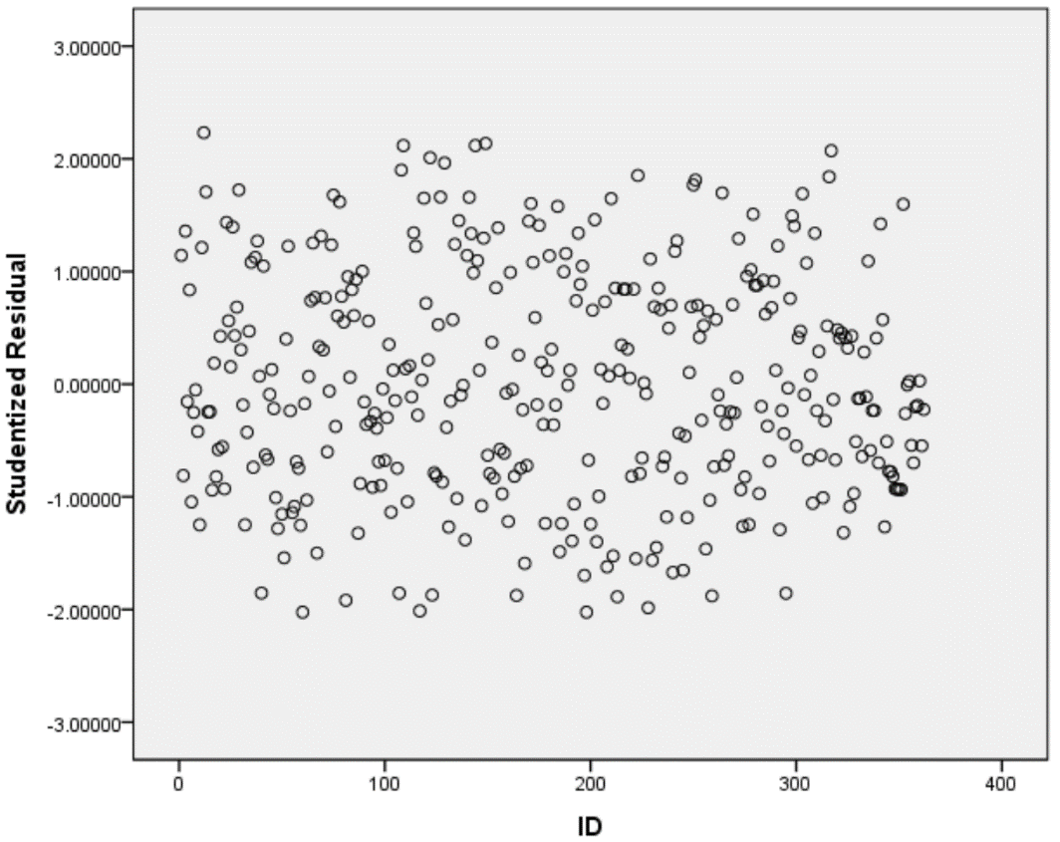

Figure 4.11 – Plot of studentized residuals versus case ID

Note – Extracted from the output of SPSS

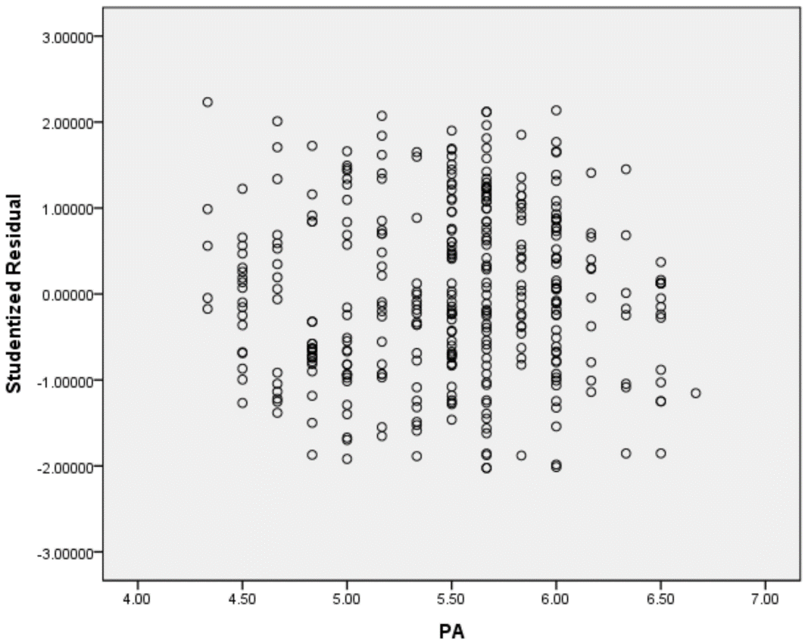
a

a – Plot of studentized residuals versus PA

Figure 4.12 – Plots of studentized residuals versus PA, SNs, PBC, and GS, sheet 1
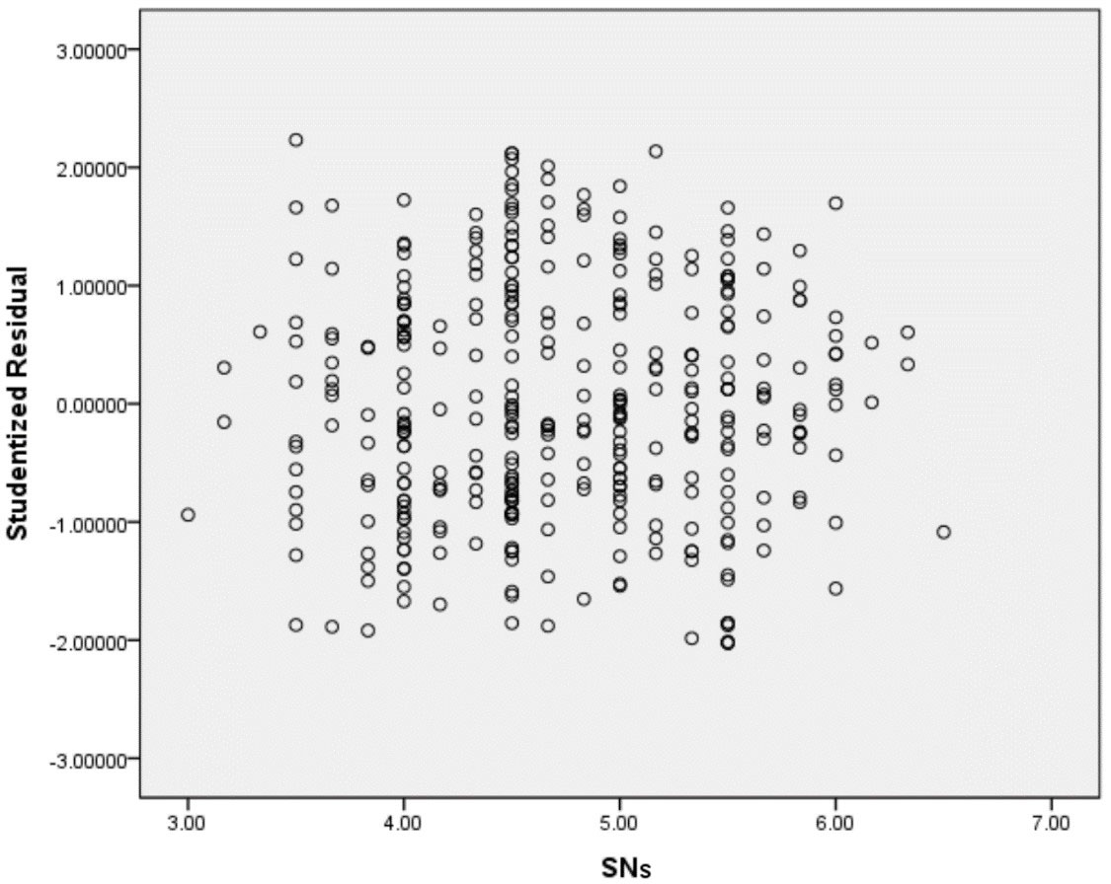
b
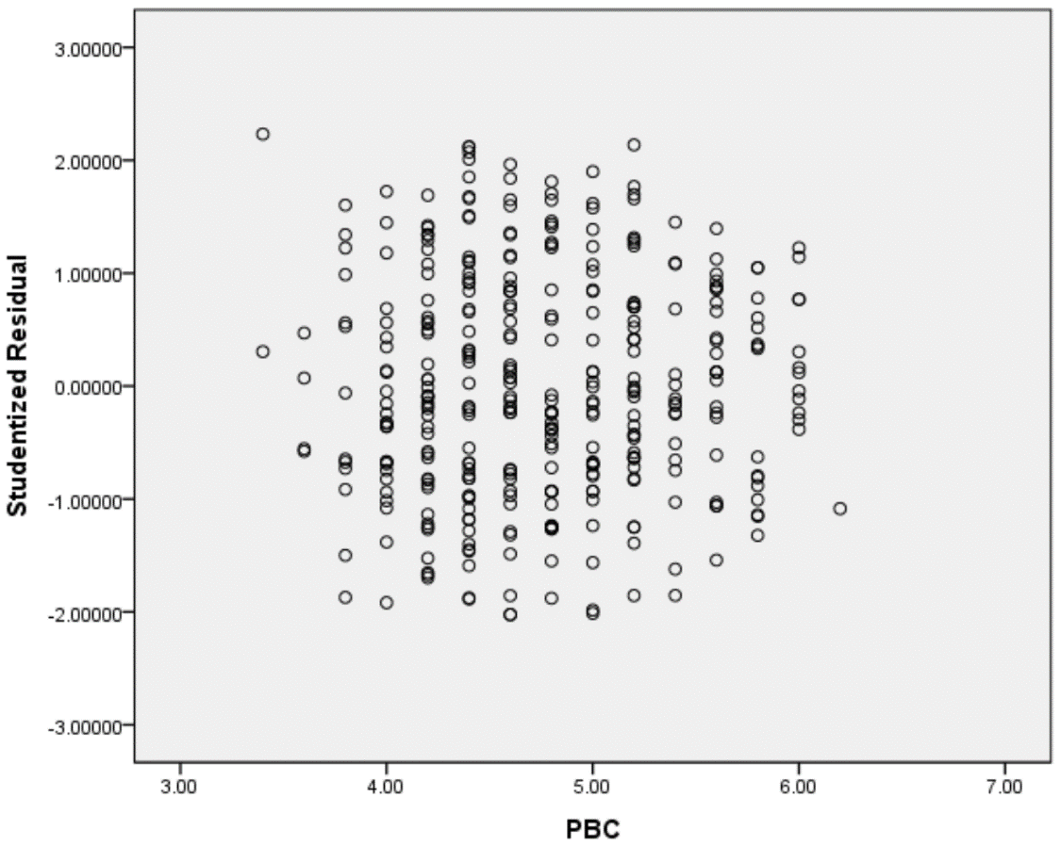
c

b – Plot of studentized residuals versus SNs; c – Plot of studentized residuals versus PBC

Figure 4.12, sheet 2
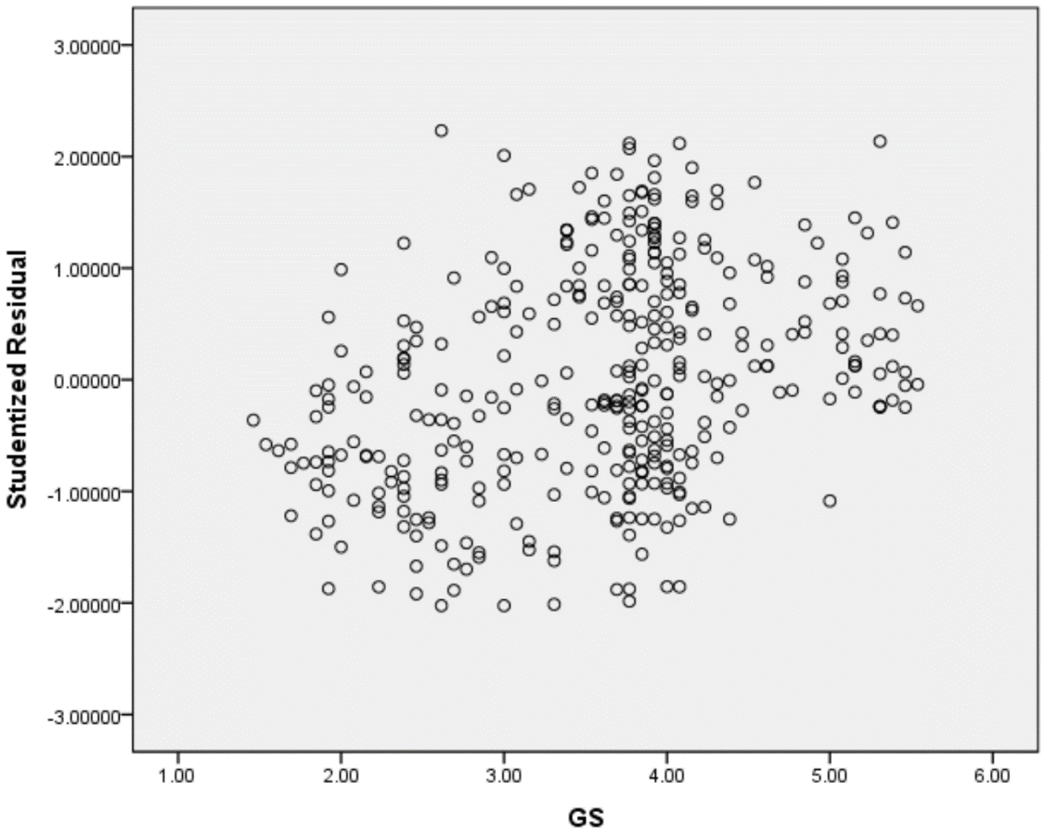
d
d – Plot of studentized residuals versus GS
Figure 4.12, sheet 3
Note – Extracted from the output of SPSS

In addition, the Durbin-Watson value (1.917) was obtained in the research. As such, no association between the error terms was detected according to the criterion (1.5-2.5) for independency of the observation [192, p. 4029].

4.2.7 Recap of the Data Examination
This section examined the dataset in terms of:
- missing data;
- outliers;
- normality;
- homoscedasticity;
- linearity; and
- independence of residuals.
Missing data was dealt with the “complete case approach” which created an ultimate sample size of 362.
Detection on outliers was conducted by means of univariate boxplots, bivariate scatterplots, the multivariate MD, as well as plots of standardized residuals and partial regression. No substantive outliers were identified.
The univariate and multivariate assumptions were tested through the approaches of graphical analyses and statistical methods. The former was performed through histograms, a scatterplot matrix, plots of partial regressions, plots of residuals, and Q-Q plots. The latter was conducted using skewness, kurtosis, Durbin-Watson value, as well as KS, SW, and Levene’s tests. The outcomes indicated that, except for a very tiny degree of non-normality, which can be offset by the large sample size of 362, all of the assumptions were adequately supported.

4.3 Descriptive Analysis
As each of the constructs (EI, PA, SNs, PBC, and GS) in this research is treated as an “interval scale”, and each is measured as a continuous variable, it is meaningful to undertake analysis and interpretation for each of them [392, p. 23].
The descriptive statistics (see table 4.5) report the “percentiles”, “mode”, “standard deviation”, “mean”, and “range” for the constructs and the constituent items for each construct.
Table 4.5 – Descriptive statistics (N=362; 7-point Likert-type scales)

Construct | Range |  | Mean | Std. Deviation | Mode | Percentile
 | min | max |  |  |  | 25th | 50th (median) | 75th
1 | 2 | 3 | 4 | 5 | 6 | 7 | 8 | 9
EI | 4.00 | 6.83 | 5.52 | .639 | 5.67 | 5.00 | 5.58 | 6.00
EI (1) | 3 | 7 | 5.22 | .772 | 5 | 5 | 5 | 6
EI (2) | 3 | 7 | 5.38 | 1.025 | 6 | 5 | 5 | 6
EI (3) | 3 | 7 | 5.41 | .818 | 5 | 5 | 5 | 6
EI (4) | 3 | 7 | 5.39 | .884 | 6 | 5 | 5 | 6
EI (5) | 4 | 7 | 5.86 | .720 | 6 | 5 | 6 | 6
EI (6) | 4 | 7 | 5.84 | .755 | 6 | 5 | 6 | 6
PA | 4.33 | 6.67 | 5.49 | .531 | 5.67 | 5.00 | 5.50 | 5.83
PA (1) | 3 | 7 | 5.00 | .829 | 5 | 4 | 5 | 6
PA (2) | 4 | 7 | 5.78 | .682 | 6 | 5 | 6 | 6
PA (3) | 4 | 7 | 5.74 | .708 | 6 | 5 | 6 | 6
PA (4) | 4 | 7 | 5.86 | .730 | 6 | 5 | 6 | 6
PA (5) | 4 | 7 | 5.26 | .639 | 5 | 5 | 5 | 6
PA (6) | 3 | 7 | 5.30 | .701 | 5 | 5 | 5 | 6
SNs | 3.00 | 6.50 | 4.74 | .706 | 4.50 | 4.17 | 4.67 | 5.33
SNs (1) | 3 | 7 | 4.72 | .829 | 5 | 4 | 5 | 5
SNs (2) | 2 | 7 | 4.70 | .820 | 5 | 4 | 5 | 5
SNs (3) | 3 | 7 | 4.81 | .872 | 5 | 4 | 5 | 5
SNs (4) | 2 | 7 | 4.69 | .849 | 4 | 4 | 5 | 5
SNs (5) | 3 | 7 | 4.80 | .907 | 5 | 4 | 5 | 5
SNs (6) | 2 | 7 | 4.71 | .885 | 4 | 4 | 5 | 5
PBC | 3.40 | 6.20 | 4.77 | .602 | 4.40 | 4.40 | 4.70 | 5.20
PBC (1) | 2 | 6 | 4.56 | .814 | 4 | 4 | 5 | 5
PBC (2) | 2 | 7 | 4.35 | .861 | 4 | 4 | 4 | 5
PBC (3) | 3 | 7 | 4.58 | .752 | 4 | 4 | 4 | 5
PBC (4) | 3 | 7 | 5.45 | .713 | 5 | 5 | 5 | 6
PBC (5) | 2 | 7 | 4.92 | .838 | 5 | 4 | 5 | 5
GS | 1.46 | 5.54 | 3.59 | .929 | 3.77 | 2.92 | 3.77 | 4.08
GS (1) | 1 | 7 | 3.97 | 1.302 | 5 | 3 | 4 | 5
GS (2) | 2 | 7 | 4.12 | 1.270 | 5 | 3 | 4 | 5
GS (3) | 1 | 7 | 4.07 | 1.258 | 5 | 3 | 4 | 5
GS (4) | 1 | 7 | 4.02 | 1.154 | 4 | 3 | 4 | 5
GS (5) | 1 | 6 | 3.46 | 1.114 | 4 | 3 | 4 | 4
GS (6) | 1 | 7 | 3.97 | 1.136 | 4 | 3 | 4 | 5
Continuation of table 4.5
1 | 2 | 3 | 4 | 5 | 6 | 7 | 8 | 9
GS (7) | 1 | 7 | 3.24 | 1.199 | 3 | 2 | 3 | 4
GS (8) | 1 | 6 | 3.37 | 1.043 | 3 | 3 | 3 | 4
GS (9) | 1 | 7 | 3.48 | 1.109 | 3 | 3 | 3 | 4
GS (10) | 1 | 6 | 3.46 | 1.047 | 3 | 3 | 3 | 4
GS (11) | 1 | 6 | 3.22 | .997 | 3 | 3 | 3 | 4
GS (12) | 1 | 5 | 2.90 | .927 | 3 | 2 | 3 | 3
GS (13) | 1 | 6 | 3.40 | 1.146 | 3 | 3 | 3 | 4
Note:
1. The score for each construct is derived from the aggregate of its constituent items.
2. Compiled by the author based on the output from SPSS.

The surveyed respondents (new and established business owners among foreigners currently performing entrepreneurship in Kazakhstan), as indicated by table 4.5 above, expressed remarkably intense EIs in general (interpreted by “Mean=5.52”) to launch a firm. In particular, their EIs range from a medium to a remarkably great extent (“Min=4.00”; “Max=6.83”). No one gave a low (i.e., less than moderate) score for any of the items, and the most frequent response showed that they were actively ready to perform entrepreneurship (“Mode=5.67”).
As similar to the level of their EIs, the investigated entrepreneurs had an overwhelmingly favorable PA towards entrepreneurship (“Mean=5.49”). Nobody had a negative belief (“Min=4.33”). In majority of the instances, the respondents reported a great extent of willingness to launch a new business (“Mode=5.67”).
On average, the participated foreigners valued conservatively on SNs about entrepreneurship (“Mean=4.74”). Some foreigners showed minor care or recognition over the opinions of important others about his or her self-employment (“Min=3.00”), while some others paid close attention to the support and advice of influential persons (“Max=6.50”). Most commonly, they were significantly impacted by persons they considered important (“Mode=4.50”).
Jointly as a whole, and most frequently, the respondents were rather modest regarding their PBC over entrepreneurship (“Mean=4.77”; “Mode=4.40”). Prior to choosing to start up a business, a large proportion of them lacked confidence in their ability to achieve success (“Min=3.40”); on the contrary, some others were extremely optimistic about their entrepreneurship to be established soon (“Max=6.20”).
Most of the surveyed entrepreneurs regarded the level of GS as being average (“Mean=3.59”; “Mode=3.77”). Some participants scored extremely low values on GS (“Min=1.46”), while some others gave high marks (“Max=5.54”). Furthermore, the individual entrepreneurs responded with extreme answers (“1” and “7”) to the question items, reflecting the presence of vastly divergent views on the current state of GS in Kazakhstan.
Obviously, for each construct, no distinct difference occurs among its “Modes”, “Means”, and “Medians”, indicating that the most frequently occurred response (the “Modes”) represents both the average level of perception (the “Means”) and the middle value (the “Medians”) of recognition, among the surveyed entrepreneurs.
4.4 Pearson’s Correlation Analysis
In statistics, Pearson’s correlation analysis generates a bivariate correlation coefficient (“r”) between two continuous variables, which evaluates the strength and direction of their linear correlation [392, p. 19]. It is known for sure that −1≤ r ≤1 [438]. In this study, the DV (EI), the TPB components and the moderation variables – PA/SNs/PBC and (PA/SNs/PBC)×GS – all underwent a correlation analysis.
It is generally revealed in the correlation matrix (see table 4.6) that, EI is strongly and favorably associated with all of the TPB components and the interaction terms as mentioned above. In the basic “TPB” model, the bivariate coefficients fall between 0.594 and 0.750, whereas in the extensive model of “TPB+Moderator (GS)”, they are in the range of 0.335 to 0.890. The correlation coefficients between PA, SNs, and PBC are statistically significant and vary from 0.639 to 0.680. Coefficients for pairs of the moderation variables fall in the range of 0.335 to 0.890, and are significantly inter-correlated as well.

Table 4.6 – Pearson’s correlation matrix
Variable | 1 | 2 | 3 | 4 | 5 | 6 | 7
1. EI | 1
2. PA | .750 | 1
3. SNs | .594 | .633 | 1
4. PBC | .665 | .639 | .680 | 1
5. PA×GS | .473 | .541 | .351 | .490 | 1
6. SNs×GS | .362 | .396 | .629 | .529 | .877 | 1
7. PBC×GS | .350 | .335 | .345 | .702 | .890 | .872 | 1
Note:
1. The correlations are significant at the 0.001 level (p<0.001) (two-tailed).
2. Compiled by the author based on the output from SPSS.

The correlation analysis shows the probability of the “TPB” components and the moderating variables having a predictive impact on EI, which was then examined using a multiple regression analysis subsequently.

4.5 Multiple Regression Analysis
The simultaneous and hierarchical regression analyses were employed for the basic “TPB” and the extended “TPB+Moderator” models in this study, respectively, as guided by the methodology discussed in Chapter 3.
Tables 4.7 and 4.8 below demonstrate the regression outcomes in detail corresponding to these two models in survey.
The two tables contain three primary sections, i.e., the statistics for the “overall model’s fit”, for the “analysis of variance” (ANOVA), as well as for the “regression coefficients, correlations, and collinearities”.
The interpretations of the regression results are to be performed in the following text after the tables.

Table 4.7 – Results of the simultaneous regression analysis (“TPB”; DV= “EI”)
Overall model’s fit
Multiple R |  |  |  |  |  |  |  |  |  |  |  | .790
Coefficient of Determination (R²) |  |  |  |  |  |  |  |  |  |  |  | .624
Adjusted R² |  |  |  |  |  |  |  |  |  |  |  | .620
Standard error of the estimate |  |  |  |  |  |  |  |  |  |  |  | .394
Analysis of variance (ANOVA)
- |  | Sum of squares |  |  | df |  | Mean square |  |  | F |  | Sig.
Regression |  | 91.890 |  |  | 3 |  | 30.630 |  |  | 197.657 |  | .000
Residual |  | 55.477 |  |  | 358 |  | .155 |  |  | - |  | -
Total |  | 147.367 |  |  | 361 |  | - |  |  | - |  | -
Regression coefficients, correlations, and collinearity statistics
Variables | Regression coefficients |  |  |  |  | Statistical significance |  |  | Correlations |  |  |  | Collinearity statistics
 | B |  | Std. error | Beta |  | t |  | Sig. | Zero-order |  | Partial | Part | Tolerance | VIF
(Constant) | .318 |  | .075 | - |  | 4.184 |  | .000 | - |  | - | - | - | -
PA | .632 |  | .054 | .526 |  | 11.672 |  | .000 | .750 |  | .525 | .379 | .518 | 1.930
SNs | .064 |  | .043 | .070 |  | 1.488 |  | .138 | .594 |  | .078 | .048 | .471 | 2.122
PBC | .299 |  | .051 | .281 |  | 5.915 |  | .000 | .665 |  | .298 | .192 | .465 | 2.152
Note:
1. N=362; EI: entrepreneurial intention; PA: personal attitude towards entrepreneurship; SNs: subjective norms about entrepreneurship; PBC: perceived behavioral control over entrepreneurship; significant regression coefficients are in bold.
2. Compiled by the author based on the output from SPSS.

Table 4.8 – Results of the hierarchical regression analysis (“TPB+GS”; DV= “EI”)
1
Overall model’s fit
Multiple R |  |  |  |  |  |  |  |  |  |  |  |  | .868
Coefficient of Determination (R²) |  |  |  |  |  |  |  |  |  |  |  |  | .753
Adjusted R² |  |  |  |  |  |  |  |  |  |  |  |  | .749
Standard error of the estimate |  |  |  |  |  |  |  |  |  |  |  |  | .320
Analysis of variance (ANOVA)
- |  | Sum of squares |  |  | df |  | Mean square |  |  |  | F |  |  |  | Sig.
Regression |  | 110.991 |  |  | 6 |  | 18.498 |  |  |  | 180.528 |  |  |  | .000
Residual |  | 36.376 |  |  | 355 |  | .102 |  |  |  | - |  |  |  | -
Total |  | 147.367 |  |  | 361 |  | - |  |  |  | - |  |  |  | -
Regression coefficients, correlations, and collinearity statistics
Variables | Regression coefficients |  |  |  |  | Statistical significance |  |  | Correlations |  |  |  |  | Collinearity statistics
 | B |  | Std. error | Beta |  | t |  | Sig. | Zero-order | Partial |  | Part |  | Tolerance |  | VIF
Block 1
(Constant) | .224 |  | .065 | - |  | 3.413 |  | .001 | - | - |  | - |  | - |  | -
PA | .514 |  | .133 | .506 |  | 3.845 |  | .000 | .750 | .518 |  | .414 |  | .593 |  | 1.687
SNs | .023 |  | .138 | .025 |  | .169 |  | .866 | .594 | .009 |  | .006 |  | .586 |  | 1.705
PBC | .253 |  | .087 | .240 |  | 2.888 |  | .004 | .665 | .245 |  | .209 |  | .626 |  | 1.598
Continuation of table 4.8
1
Block 2
PA×GS | .026 | .006 | .151 | 4.110 | .000 | .473 | .152 | .127 | .314 | 3.182
SNs×GS | -.013 | .041 | -.082 | -.310 | .757 | .362 | -.016 | -.010 | .782 | 1.278
PBC×GS | .022 | .008 | .138 | 2.669 | .008 | .350 | .131 | .109 | .401 | 2.495
Note:
1. N=362; EI: entrepreneurial intention; PA: personal attitude towards entrepreneurship; SNs: subjective norms about entrepreneurship; PBC: perceived behavioral control over entrepreneurship; GS: government support to entrepreneurship; significant regression coefficients are in bold.
2. Compiled by the author based on the output from SPSS.
4.5.1 Assessing the Overall Model’s Fit
As precedingly presented in the data examination stage, both individual variables (EI, PA, SNs, and PBC) included in the basic “TPB” model and the overall regression variate have all met the assumptions of normality, linearity, homoscedasticity, and independence. Subsequently, the statistical significance was examined with respect to both the “TPB” regression model and the moderator effects.
The statistical tests were employed for both the variation explained (R²) and the regression coefficients according to the methodology outlined in Chapter 3.

4.5.1.1 Significance Tests of Coefficient of Determination (R²)
The overall model’s statistical significance can be checked by evaluating R², or adjusted R² using the F ratio. R² indicates the overall model’s predictive accuracy, while adjusted R² can be used for comparing across multiple regression equations. R², adjusted R², and the F ratio for the “TPB” model are 0.624, 0.620, and 197.657, respectively (see table 4.7). At the 0.001 level (p<0.001), the F ratio exhibits statistical significance. As a result, the basic “TPB” model’s fit is deemed significant.
In this study, the “TPB” components altogether explains 62.4% of the variation in EI, demonstrating a more robust outcome than earlier research in this regard. Despite differences in measurement [202, p. 101], past research indicated that the conventional “TPB” components represent 21-55% of the variation in predicting intentions [70, p. 47; 147, p. 1; 180, p. 417; 194, p. 145], varying from study to study. Specifically, Kautonen et al. [191, p. 655] discovered that TPB accounts for 59% of the variance in intention. This study’s large R² value is therefore in line with earlier studies.
This study contends that the remarkably increased variance in explaining EI is attributable to the features of the selected sample, which consists of both new and experienced foreign entrepreneurs. In earlier research, intention accounted for 30-39% of the variance in behavior [148, p. 473; 180, p. 417] on average [148, p. 473; 180, p. 417]. In this study, however, the surveyed entrepreneurs have already transformed their intentions into real entrepreneurial activities with a 100% of likelihood. Consequently, the study sample is believed to have a more positive and intense intention than the general target population of foreigners, if otherwise investigated.
Table 4.8 shows the respective values of 0.753, 0.749, and 180.528 for R², adjusted R², and the F ratio. The significant F ratio at the 0.001 level (p<0.001) indicates statistical significance of the overall fit for the expanded “TPB+GS” model. The extended model represents 75.3% of variation in explaining EI, with a remarkable 12.9% of increase in the adjusted R² derived from the moderation effects. Additionally, as the standard error of estimate dropped from the generic “TPB” model (0.394) to the expanded “TPB+GS” model (0.320), the overall model’s fit improved. It is proven that GS plays a crucial role in fostering EI.

4.5.1.2 Significance Tests of Regression Coefficients
In this work, the level of statistical significance for multivariate analysis was determined at 0.05; and the t values were compared against the determined level to evaluate whether the computed coefficients are significant statistically.
Consequently, the regression results (see table 4.7) in the “TPB” model suggest that, at the level of 0.001 (p<0.001), the b coefficients (for the constant/PA/PBC) all appear statistically significant, so do the β coefficients (for PA/PBC).
The regression results (see table 4.8) in the “TPB+GS” model exhibit significant b and β coefficients for PA and PBC at the respective p<0.001 and p<0.01 levels. Meanwhile, the results reveal the b coefficient for the constant is significant at the p<0.01 level. In addition, at the respective p<0.001 and p<0.01 levels, the moderation variables, PA×GS as well as PBC×GS are considered to be both significant.
However, neither of the b and β coefficients for SNs in the two models are significant, nor is the interaction term (SNs×GS) in the extended model, at the established level (p>0.05). While some authors discovered evidence about SNs being a robust determinant of EI (e.g., [71, p. 269; 176, p. 353; 308, p. 147]), some other works (e.g., [56, p. 179; 180, p. 417; 194, p. 145; 331, p. 3]) concluded that SNs, on the contrary, are a weak factor in predicting power or even an insignificant factor in predicting EI (e.g., [143, p. 411; 147, p. 1; 332, p. 345]).
This study claims that, neither SNs nor SNs×GS is significant in the two models probably because:
1) the study sample (collected from 60 countries with substantial contextual variations) is a too broad representative of the target population, and thus too divergent in forming a uniform tendency of SNs in influencing EIs of the foreigners;
2) the influence of important others’ opinions on the foreign entrepreneurs who were determined to go abroad to pursue entrepreneurship in Kazakhstan is not so significant in comparison with the PA/PBC levels of the foreigners;
3) GS in nature might not be able to affect the important others’ thoughts or the entrepreneurs’ compliance with these thoughts; instead, GS mainly functions to motivate the PA/PBC levels of the foreigners;
4) the GS conditions in Kazakhstan were perceived as mediocre, thus constraining its moderation effect with SNs (SNs×GS); and
5) the COVID-19 pandemic added to the insignificance of SNs and of its interaction effect with GS.

4.5.2 Interpreting the Regression Results
4.5.2.1 Assessing the Variables’ Importance
Regression coefficients (b) can be used to interpret the regression variate. The interpretation includes two aspects: “prediction” and “explanation”. The relative contributions of the IVs to the prediction value are weighted according to their b coefficients. Simply speaking, the IV with a larger coefficient makes a greater contribution to the prediction. Thus, the b coefficients show the relative influence and significance of the IVs in explanation. Moreover, the standardized beta coefficients (β) play the role in straightforwardly comparing the relative effects of the IVs across different models [392, p. 225].
As in this study, with the computed b coefficients, the variate equations for the “TPB” and the extended “TPB+Moderator” models can be simply denoted as below, respectively:

“TPB” model:

EI=0.318+0.632×PA+0.299×PBC

“TPB+Moderator” model:

EI=0.224+0.514×PA +0.253×PBC +0.026×PA×GS+0.022×PBC×GS

where EI – entrepreneurial intention;
PA – personal attitude towards entrepreneurship;
PA×GS - moderation effect of GS with PA on EI;
PBC – perceived behavioral control over entrepreneurship;
PBC×GS - moderation effect of GS with PBC on EI;
GS – the role of government support to entrepreneurship.
Note – SNs (subjective norms about entrepreneurship) and the moderating term (SNs×GS) were excluded from the equation(s) due to their insignificant coefficients in this study.

Individually speaking, the b coefficients reflected in the equations suggest that:
1) PA has the highest predictive value leading to EI in both models, making it the 1st greatest factor; PBC acts as the 2nd powerful factor; and
2) further in the “TPB+GS” model, PBC’s predictive power is greater than the moderation impact of GS on PA-EI (the 3rd greatest factor) and PBC-EI (the 4th greatest factor), respectively.
Collectively speaking, the β coefficients indicate that the relative importance of the IVs across both models is sequenced (in upward ranking) as: PBC×GS, PA×GS, PBC, and PA.
The relative weight of PA/PBC is found to be in accordance with the evidence from prior studies that PA acts as the most powerful predictor of EI in TPB [204, p. 135]. As Ajzen [56, p. 206] stated, the relative importance of the components may vary across boundaries, cultures, ethnicities, organizations, and individuals, despite the fact that TPB is a general model that holds across cultures and circumstances. PA is a more potent factor than PBC, according to the findings derived from this study.
The discovery of interaction effects exerted by GS-PA and GS-PBC is the originality of this study. The greater the degree of GS that is perceived, the better PA and PBC may predict EI.

4.5.2.2 Identifying Multicollinearity
Multicollinearity happens when the IVs in research become strongly correlated [439], possibly twisting and distorting a model’s interpretation [440] and affecting its statistical significance [392, p. 227; 441]. Furthermore, multicollinearity might raise coefficient standard errors, resulting in statistical non-significance of the coefficients [417, p. 106; 439, p. 519].
High multicollinearity can seriously distort the results and make the results highly unreliable, in turn result in ungeneralizable findings [392, p. 227]. Hence, this study assessed whether there is multicollinearity in the range of IVs.
The most direct and easiest method of detecting multicollinearity is by looking at the correlation matrix. The precedingly presented bivariate correlations (see table 4.6) indicates that, the correlations among the three “TPB” components and three interaction terms range from 0.335 to 0.890, indicating the absence of strong correlations with values of 0.9 or higher. Thus, in this study, there is no obvious multicollinearity among the six IVs (PA/SNs/PBC and (PA/SNs/PBC)×GS).
Furthermore, the values of tolerance and VIF were utilized to assess the multicollinearity among the IVs. The higher the value of tolerance, the little the degree of multicollinearity. Thus, if the tolerance value of a variable approaches zero, there is presence of extremely high multicollinearity, suggesting that this variable is nearly all explained by the other variables [392, p. 227]. VIF equals to the reciprocal value of the tolerance; thus, little values of VIF indicate low degree of collinearity between each pair of the variables under study [392, p. 227].
The collinearity statistics are presented in Tables 4.7 and 4.8, where the tolerance values are in the range of 0.314 to 0.626 and the VIF values fall between 1.598 and 3.182. In comparison to the criteria mentioned in Chapter 3, neither of the values for tolerance is below 0.2, and neither of the values for VIF is beyond 4.0, suggesting that the degree of multicollinearity in both the basic and extended models is not troublesome.
Hence, no multicollinearity distorting the results’ generalizability was identified in this research, which means that the two models’ fit as well as their regression results are deemed stable.

4.5.2.3 Examining Correlations
As already discussed in Chapter 3 and in the instance of this study, the zero-order correlation simply defines the bivariate association between the DV (EI) versus the six IVs – PA/SNs/PBC and (PA/SNs/PBC)×GS; the part correlation displays the unique relationship anticipated by one IV after the predictions shared with all other IVs are taken out; and the partial correlation reflects the incremental predictive power of one IV from the cumulative influence of all other IVs [392, p. 244].
As shown from tables 4.7 and 4.8:
1) PA shows the closest correlation with EI in both models, followed by PBC and SNs with EI. Among all of the bivariate associations, the moderation effects of (PA/SNs/PBC)×GS leading to EI are relatively weak in the extended model. With the exception of SNs×GS and SNs, all other IVs in the two models exhibit significantly additional power in prediction.
2) In the “TPB” model, PA (0.379²=14.36%) and PBC (0.192²=3.69%) contribute substantial unique variance; hence, the remaining variance of 44.35% (62.4% - 14.36% - 3.69%) is shared by PA and PBC in common.
3) Likewise, in the “TPB+Moderator” model, PA (0.414²=17.14%) and PBC (0.209²=4.37%) contribute significant unique variances; the remaining unique variances are accounted for by PA×GS (0.127²=1.61%) and PBC×GS (0.109²=1.19%); the common variance of 50.99% (75.3% - 17.14% - 4.37% - 1.61% - 1.19%) is explained by the four IVs (PA/PBC and (PA/PBC)×GS) altogether.

4.5.3 Validating the Results
The final step the researcher needs to take is to validate the generated regression model, with the primary concern to guarantee that the research findings are generalized to the entire population, not particular to the study sample [392, p. 259].
The most common method is to draw from the population a new sample and compare the results of the original and the new samples in an effort to evaluate the validity [392, p. 259].
However, due to the restrictions resulted from the limited time and financial budget, the restricted access to the survey participants, the inconveniences incurred by the pandemic, etc., it was impossible to generate a new sample. Consequently, the author relied alternatively upon:
- evaluating the adjusted R² values; as well as
- comparing the sub-samples split from the original sample.
Checking the R² values against the corresponding adjusted R² values (0.624 versus 0.620 in table 4.7; 0.753 versus 0.749 in table 4.8) showed negligible reduction in predictive power, suggesting the absence of overfitting, which would be indicated by a more noticeable loss in predictive power [392, p. 259].
This study divided the original sample into two sub-samples with identical size (N=181 for either sub-sample), examined the “TPB” and “TPB+Moderator” regression models based on the two sub-samples, and compared their results.
The results of the sub-samples for the two models are presented in table 4.9 and table 4.10. Comparing the overall models’ fit in the sub-samples reveals a significant degree of similarity reflected in the results of standard error of estimate, R², and adjusted R².
Nonetheless, as the sample size becomes smaller (from 362 to 181), both models’ overall predictive power diminishes. Comparison of the separate coefficients in the sub-samples revealed no significant differences, so did the comparison with the prior regression outcomes for either model; the statistical significance and comparative importance indicated in the coefficients exhibited the same phenomena, i.e.:
- the coefficients for SNs and SNs×GS are insignificant; and
- PBC×GS, PA×GS, PBC, and PA (with an ascending ranking of relative importance in influencing EI) are statistically significant.

Table 4.9 – Split-sample validation (“TPB”; DV= “EI”)
Overall model’s fit
- |  |  |  |  |  |  |  |  |  |  |  |  |  | Sample 1 |  |  |  | Sample 2
Multiple R |  |  |  |  |  |  |  |  |  |  |  |  |  | .751 |  |  |  | .726
Coefficient of Determination (R²) |  |  |  |  |  |  |  |  |  |  |  |  |  | .564 |  |  |  | .527
Adjusted R² |  |  |  |  |  |  |  |  |  |  |  |  |  | .557 |  |  |  | .519
Standard error of the estimate |  |  |  |  |  |  |  |  |  |  |  |  |  | .447 |  |  |  | .378
Analysis of variance (ANOVA)
- |  | Sample 1 |  |  |  |  |  |  |  |  |  | Sample 2
 |  | Sum of squares |  | df |  | Mean square |  | F |  | Sig. |  | Sum of squares |  |  | df |  | Mean square |  |  | F |  | Sig.
Regression |  | 45.833 |  | 3 |  | 15.278 |  | 76.289 |  | .000 |  | 28.212 |  |  | 3 |  | 9.404 |  |  | 65.693 |  | .000
Residual |  | 35.446 |  | 177 |  | .200 |  | - |  | - |  | 25.338 |  |  | 177 |  | .143 |  |  | - |  | -
Total |  | 81.280 |  | 180 |  | - |  | - |  | - |  | 53.550 |  |  | 180 |  | - |  |  | - |  | -
Regression coefficients, correlations, and collinearity statistics
Variables | Sample 1 |  |  |  |  |  |  |  |  |  | Sample 2
 | Regression coefficients |  |  |  |  |  | Statistical significance |  |  |  | Regression coefficients |  |  |  |  |  |  |  | Statistical significance
 | B |  | Std. error |  | Beta |  | t |  | Sig. |  | B |  | Std. error |  |  | Beta |  |  | t |  | Sig.
(Constant) | .779 |  | .321 |  | - |  | 2.430 |  | .016 |  | .720 |  | .276 |  |  | - |  |  | 2.603 |  | .010
PA | .565 |  | .074 |  | .493 |  | 7.596 |  | .000 |  | .699 |  | .087 |  |  | .526 |  |  | 8.058 |  | .000
SNs | .022 |  | .059 |  | .025 |  | .364 |  | .716 |  | .086 |  | .058 |  |  | .100 |  |  | 1.482 |  | .140
PBC | .317 |  | .068 |  | .324 |  | 4.656 |  | .000 |  | .247 |  | .079 |  |  | .207 |  |  | 3.121 |  | .002
Note:
1. N=181; EI: entrepreneurial intention; PA: personal attitude towards entrepreneurship; SNs: subjective norms about entrepreneurship; PBC: perceived behavioral control over entrepreneurship; significant regression coefficients are in bold.
2. Compiled by the author based on the output from SPSS.

Table 4.10 – Split-sample validation (“TPB+GS”; DV= “EI”)
Overall model’s fit
- |  |  |  |  |  |  |  |  |  |  |  |  |  | Sample 1 |  |  |  | Sample 2
Multiple R |  |  |  |  |  |  |  |  |  |  |  |  |  | .837 |  |  |  | .834
Coefficient of Determination (R²) |  |  |  |  |  |  |  |  |  |  |  |  |  | .701 |  |  |  | .696
Adjusted R² |  |  |  |  |  |  |  |  |  |  |  |  |  | .691 |  |  |  | .685
Standard error of the estimate |  |  |  |  |  |  |  |  |  |  |  |  |  | .303 |  |  |  | .377
Analysis of variance (ANOVA)
- |  | Sample 1 |  |  |  |  |  |  |  |  |  | Sample 2
 |  | Sum of squares |  | df | Mean square |  |  | F |  | Sig. |  | Sum of squares |  |  | df | Mean square |  |  |  | F |  | Sig.
Regression |  | 37.529 |  | 6 | 6.255 |  |  | 67.931 |  | .000 |  | 56.536 |  |  | 6 | 9.423 |  |  |  | 66.260 |  | .000
Residual |  | 16.021 |  | 174 | .092 |  |  | - |  | - |  | 24.744 |  |  | 174 | .142 |  |  |  | - |  | -
Total |  | 53.550 |  | 180 | - |  |  | - |  | - |  | 81.280 |  |  | 180 | - |  |  |  | - |  | -
Regression coefficients, correlations, and collinearity statistics
Variables | Sample 1 |  |  |  |  |  |  |  |  |  | Sample 2
 | Regression coefficients |  |  |  |  |  | Statistical significance |  |  |  | Regression coefficients |  |  |  |  |  |  |  | Statistical significance
 | B |  | Std. error |  |  | Beta | t |  | Sig. |  | B |  | Std. error |  |  |  | Beta |  | t |  | Sig.
Block 1
(Constant) | .251 |  | .111 |  |  | - | 2.245 |  | .026 |  | .388 |  | .178 |  |  |  | - |  | 2.174 |  | .031
PA | .597 |  | .071 |  |  | .522 | 8.396 |  | .000 |  | .567 |  | .061 |  |  |  | .519 |  | 9.303 |  | .000
SNs | .041 |  | .064 |  |  | .044 | .645 |  | .520 |  | .115 |  | .062 |  |  |  | .120 |  | 1.858 |  | .065
PBC | .338 |  | .069 |  |  | .337 | 4.925 |  | .000 |  | .269 |  | .077 |  |  |  | .222 |  | 3.486 |  | .001
Block 2
PA×GS | .027 |  | .010 |  |  | .198 | 2.730 |  | .007 |  | .036 |  | .013 |  |  |  | .207 |  | 2.685 |  | .008
SNs×GS | -.018 |  | .050 |  |  | -.186 | -.348 |  | .728 |  | -.048 |  | .065 |  |  |  | -.490 |  | -.726 |  | .469
PBC×GS | .019 |  | .007 |  |  | .120 | 2.682 |  | .008 |  | .013 |  | .006 |  |  |  | .099 |  | 2.069 |  | .040
Note:
1. N=181; EI: entrepreneurial intention; PA: personal attitude towards entrepreneurship; SNs: subjective norms about entrepreneurship; PBC: perceived behavioral control over entrepreneurship; GS: government support to entrepreneurship; significant regression coefficients are in bold.
2. Compiled by the author based on the output from SPSS.

4.5.4 Justification of the Hypotheses under Study
Grounded on the comprehensive analysis and results yielded in this study, the hypotheses proposed in Chapter 2 were adequately evaluated. The research findings are demonstrated below:
- PA towards entrepreneurship positively affects EI of foreigners in Kazakhstan.
- SNs about entrepreneurship insignificantly affect EI of foreigners in Kazakhstan.
- PBC over entrepreneurship positively affects EI of foreigners in Kazakhstan.
- GS intensifies the relation between PA towards entrepreneurship and EI of foreigners in Kazakhstan.
- GS insignificantly alters the insignificant relation between SNs about entrepreneurship and EI of foreigners in Kazakhstan.
- GS intensifies the relation between PBC over entrepreneurship and EI of foreigners in Kazakhstan.
The above findings are denoted in an alternative form in table 4.11 as follows.

Table 4.11 – Research findings of the study

Statement | Description
PA towards entrepreneurship positively affects EI of foreigners in Kazakhstan. | PA → EI
SNs about entrepreneurship insignificantly affect EI of foreigners in Kazakhstan. | SNs EI
PBC over entrepreneurship positively affects EI of foreigners in Kazakhstan. | PBC → EI
GS intensifies the relation PA towards entrepreneurship and EI of foreigners in Kazakhstan. | PA×GS → EI
GS insignificantly alters the insignificant relation between SNs about entrepreneurship and EI of foreigners in Kazakhstan. | SNs×GS EI
GS intensifies the relation between PBC over entrepreneurship and EI of foreigners in Kazakhstan. | PBC×GS → EI
Note – Compiled by the author

Summary of the Chapter
This chapter aims to obtain research findings relevant to the hypotheses developed in Chapter 2. The “TPB” and “TPB+Moderator” models were validated using descriptive and inferential statistics, which are in particular, the descriptive, correlation, and regression analyses, as per the methods outlined in Chapter 3. Before doing multivariate analysis, the author screened the collected data for missing data, outliers, and assumptions for both separate variables and the overall regression model. The outcomes of data examination determined the appropriate sample size (N=362) and acceptable conditions for further multivariate analyses; hence, the “goodness of data” was achieved.
The descriptive analysis found that new and established entrepreneurs among foreigners in Kazakhstan established their businesses with a fairly intense EI, an active PA towards entrepreneurship, medium SNs about entrepreneurship, and a moderate PBC over entrepreneurship. Their general perception of GS in Kazakhstan was moderate, but there were extreme responses at both ends of the scales, indicating that their views were highly dispersed.
The Pearson’s correlation analysis revealed that the DV (EI) is strongly intercorrelated with all IVs, i.e., the three “TPB” factors and the three interaction terms. Besides, the bivariate correlations among the six IVs (direct IVs: PA/SNs/PBC; indirect IVs: (PA/SNs/PBC)×GS) indicate moderate to high magnitude and positive direction.
The multiple regression analysis included a simultaneous method (for “TPB”) together with a hierarchical method (for “TPB+GS”). The results demonstrated that the two models adequately explain the EI; hence, the “goodness of model’s fit” was attained. The direct effects of PA/PBC, as well as the moderating impacts of (PA/PBC)×GS are statistically significant, according to an examination of the regression coefficients. Statistically, neither SNs nor the moderation effect (SNs×GS) is significant. The significant variables are rated in terms of their relative importance (from least powerful to most powerful) as PBC×GS, PA×GS, PBC, and PA.
In brief, corresponding to the hypotheses formulated in Chapter 2, this chapter discovered the following findings:
1) PA and PBC positively affect EI of foreigners in Kazakhstan; however, SNs do not exert a substantial influence on EI.
2) Moderated by GS, the relations of both PA-EI and PBC-EI increase, whereas the relation of SNs-EI remains insignificant, among foreigners in Kazakhstan.

5 DISCUSSIONS AND IMPLICATIONS

5.1 Introduction
This current chapter conducts further in-depth discussions over the research findings discovered in Chapter 4 while relating them to the research objectives and questions proposed in INTRODUCTION. In addition, this chapter seeks to draw positive suggestions for researchers, scholars, practitioners, and government officials who are interested in or connected to the research topic in the context of Kazakhstan.

5.2 Discussions on Research Findings
Retrospectively, the empirical research findings from Chapter 4 revealed that both the basic “TPB” and extended “TPB+Moderator” models are significantly fit in predicting EI of foreigners in Kazakhstan. In terms of the separate influence on EI:
- the greatest power comes from their PA towards entrepreneurship;
- their PBC over entrepreneurship plays the second important role;
- the moderation effect of GS with PA (PA×GS) on EI provides the third powder in magnitude;
- the moderation effect of GS with PBC (PBC×GS) on EI ranks as the least determinant in comparison; and
- unexpectedly, their SNs about entrepreneurship and the corresponding moderation effect (SNs×GS) on EI were found insignificant. Insights into the insignificance of SNs and SNs×GS will be explored and discussed later in the following subsections.

5.2.1 PA versus EI of Foreigners in Kazakhstan
PA involves one’s cognition of the consequence of his or her activity and the degree to which he or she favors or disfavors conducting the action [56, p. 182]. The outcome researched in this work is the realization of entrepreneurship, or to rephrase it, the establishment of his or her own business.
Thus, theoretically, the more intense PA towards entrepreneurship the foreigners show, the more possibly they found their businesses. The empirical findings of this study revealed strong PA towards entrepreneurship by the foreigners in Kazakhstan. It is noteworthy that not any less-than-moderate level of PA was shown from the responses, indicating the general high level of PA reflected in the surveyed respondents. Most of them strongly thought that being an entrepreneur would be more advantageous for them, and they saw entrepreneurship as an appealing career path. They also firmly believed that if the chances were mature and the resources were present, they would launch their own firms immediately. The rationale behind this is that they view entrepreneurship as highly satisfying and would choose it over other career options.
Therefore, PA is the theoretical and also the most statistically significant factor among all the constructs or independent variables (IVs) in this study to influence EI of new and established foreign entrepreneurs performing in Kazakhstan. In addition, among all correlations, PA showed the closest correlation with EI. All findings led to the consistent conclusion that PA is the most influential factor for facilitating EI of foreigners in Kazakhstan.

5.2.2 SNs versus EI of Foreigners in Kazakhstan
SNs relate to the individually perceived social pressure towards his or her engagement in a certain activity. In the instance of entrepreneurship, the pressure is a function of:
1) the normative beliefs held by the “influential others” regarding approval or disapproval of one’s starting a new venture [56, p. 182]; and
2) one’s willingness to adhere to these beliefs [175, p. 131].
Specifically, this study investigated how the opinions from the closest friends, family members, and important others of the surveyed participants about whether they should pursue a vocation as an entrepreneur and how they care about or follow these opinions. The collected data showed very unevenly responses of SNs ranging from very low scores to full scores in terms of the perceived opinions and willingness to comply with these opinions. The bivariate correlation between SNs and EI is significant in general, yet the multiple regression analysis yielded insignificant coefficients for SNs, which is not an uncommon phenomenon though because SNs appear in general to be a strong factor but also tends to be controversial reflected in various studies [56, p. 182; 180, p. 417]. Chapter 4 mentioned a few previous researchers (e.g., [143, p. 411; 147, p. 1; 332, p. 345]) who found SNs to be insignificant in their earlier studies. Similarly, Solesvik et al. [371, p. 1] discovered statistically insignificant SNs in their research on 192 students from the “University of Ukrainian Economics and Business”. Paco et al. [422, p. 20] and Liñán et al. [200, p. 195] conducted comparable research with respect to insignificant SNs. Moreover, Autio et al. [194, p. 145] found no statistical significance for SNs in their research on 3,542 students from four countries – the UK, the USA, Finland, and Sweden.
The underlying reasons of lacking causal link between SNs and EI as claimed in Chapter 4 are restated herein:
1) Determination of the target population (or more precisely, the study population of new and established foreign entrepreneurs) generated an overly diverse (culturally or contextually) sample (respondents coming from 60 countries). Therefore, either excessively varied normative views or heterogeneous conformity with these views occurred. In other words, it was not possible to develop a consistent pattern of SNs to impact their EI.
2) In comparison with the effects exerted by their PA and PBC, their SNs have relatively weak effect on the foreigners leading to their EI.
3) The considerable instabilities and risks posed by the onset of pandemic might have altered the overall perceptions of starting up one’s own business, not to mention moving overseas for pursuit of entrepreneurship in a foreign country, particularly among the new entrepreneurs under survey.

5.2.3 PBC versus EI of Foreigners in Kazakhstan
PBC is the conviction that a person can perform his or her schemes and that those schemes are under his or her firm control [56, p. 182]. In the entrepreneurial context, the “scheme” would be to launch a new business. All things being equal, the more individuals think they have command over such schemes, the more likely they could succeed [9, p. 893].
According to the participants’ responses, most foreigners in the study sample showed moderate assertiveness towards their PBC, in terms of “how easily they could become an entrepreneur”, “how easy it would be to start a business and keep it viable”, “how well they could control the creation process of their business”, “what a chance they have of being successful”, and “how much practical details they know about starting a business”. Some of them scored very low on the statements, while some others expressed very strong confidence.
The association between PBC and EI is significant, and the regression results indicate PBC is significant as well, with all the regression coefficients being the second weightiest among all the factors in explaining EI of foreigners in Kazakhstan.

5.2.4 Moderation effects on EI of Foreigners in Kazakhstan
GS is explained in this study by “government policies” and “government programs”. Questions regarding “government policies” involve public procurement, support for new and developing firms, time required to obtain permits and licenses, taxes burden, coping with bureaucracy, etc.; “government programs” include government assistance, business incubators and science parks, efficiency and competence of government agencies, quality of government programs (availability, adequacy, and effectiveness), etc. Surprisingly, the average assessment on the level of GS in Kazakhstan is scored less than moderate. In other words, the participants in general do not regard the current conditions of GS already appropriate and favorable for entrepreneurship, with some of them strongly disagreeing with the present supporting level reflected in GS by scoring the minimum scale in their responses. On the contrary, some others provided high recognition of the GS in facilitating new and growing firms by giving the highest score.
The interactive variables (PA×GS and PBC×GS) are found to be moderately correlated with EI, and the coefficients of their separate interaction effect are also moderate as well as statistically significant in this study, denoting that with the consideration of favorable GS, the predicting powers exerted by PA and PBC over EI further increase. The reason, as assumed by this study, is that the perceived favorable GS brought confidence and assistance to the foreigners, which in turn enhanced their PA towards entrepreneurial pursuit in Kazakhstan, and encouraged their PBC to expect a higher chance of success than if GS were not considered.
Relatively speaking, PA×GS and PBC×GS are deemed supplementary determinants in terms of their magnitude compared to PA and PBC discussed previously.
On the other hand, SNs×GS ended up being insignificant in their coefficients computed from the multiple regression analysis, although it is significantly correlated with EI. The reasons as presented in Chapter 4, in addition to the insignificance of SNs, also probably lied in:
- the role of GS in Kazakhstan affected neither the important others’ opinions nor the entrepreneurs’ reaction to the opinions. By comparison, GS functions more effectively to motivate their PA and PBC towards their self-employment;
- the generally low level of GS in Kazakhstan limited its interaction effect with SNs, thus contributing weak power to enhancing EI through SNs;
- the COVID-19 decreased the proper function of GS in enhancing SNs, especially for the new entrepreneurs under survey.

5.3 Addressing the Research Questions and Objectives
In INTRODUCTION, the research background in the setting of Kazakhstan was delineated with regard to the impact of COVID-19, the role of GS, as well as the practical significance and dynamics of (foreign) entrepreneurship. Hence, the issue to be addressed was identified (in the problem statement) corresponding to the specific setting under study, i.e., the particular context in Kazakhstan, the role of GS in Kazakhstan, the ongoing COVID-19 crisis faced by Kazakhstan, the general foreigners in Kazakhstan. The research subject was finally focused on the EI of foreigners in Kazakhstan, and the affecting factors to EI. The basic “TPB” model was designated as the theoretical foundation. GS, as an assumed moderator variable, was integrated into the extended research model of “TPB+GS”. In turn, the research questions were raised as below:
1) How do the factors (TPB components) exert an impact on foreigners’ entrepreneurial intention (EI) in Kazakhstan?
2) How does the government support (GS) affect the foreigners’ EI?
3) What are the implications for increasing and improving new businesses to be launched by foreigners in Kazakhstan?
Subsequently, the research scope and objectives were stated as below:
1) investigating the relevant factors and models in the domain that are used to predict EI;
2) creating and justifying a research framework that integrates GS with some other predictors or models that influence foreigners’ EI in Kazakhstan; and
3) providing researchers, academics, practitioners, and policy-makers with insights into strengthening (foreign) entrepreneurship and recommendations for future study.
Revolving the above-mentioned research topics and goals, this work overviewed the context of entrepreneurship in more detail in Chapter 1. The main findings closely relevant to the research subject are:
1) Kazakhstan has great richness in natural reserves and agricultural resources attracting foreign investment.
2) The government of Kazakhstan has been actively reforming (including encouraging entrepreneurship) to stimulate its transitional economy towards diversification and modernization. Foreign entrepreneurship is growing along with the increasing opportunities while the government continuously builds up international relations with other countries and organizations.
3) The business conditions are improving in Kazakhstan as shown, for example, by the rankings at “ease of doing business” (22nd/190 in 2020) and “global entrepreneurship index” (64th/137 in 2020). More indices in terms of PESTEL factors are summarized in Appendix C.
4) On the other hand, corruption, bureaucracy, and red-tape remain major constraints on entrepreneurship in Kazakhstan; entrepreneurial equity finance remains insufficient; entrepreneurial education and training are lacking that need to be addressed; R&D transfer of innovative and advanced technologies is prevented to new and growing ventures; physical infrastructure is still less advanced and demands more attention; market dynamics is inflexible for new and developing firms due to the domination of sophisticated rivals; socio-cultural entrepreneurship norms need more influential promotion.
With the purpose to formulate the theoretical foundation for this research, the author determined to start with an overview and a firm comprehension of the miscellaneous single factors, theories, and models in the EI research domain. In doing so, the systematic and exhaustive literature review was conducted in Chapter 2.
Chapter 2 ended with the research model (see figure 2.10) and the propositions (see table 2.1), followed by Chapter 3 and Chapter 4 which covered the research methodology and the research findings, respectively. This chapter (Chapter 5) in the prior text presented the discussions in more detail on research findings and interpretations elaborated in Chapter 4.
To this point, the research questions and objectives can be jointly addressed from a general and systematic perspective, and the implications will be drawn in a separate subsection later.

5.3.1 Factors, Theories, and Models that Predict EI
Through the author’s integration and classification, the literature review in Chapter 2 resulted in an exhaustive package of single (individual) factors (see Appendix H), combined (groups of) single factors (see Appendix J), and established models (see Appendix K). The single factors include six groups, i.e., demographic factors, personality or personal factors, situational factors, cognitive factors, social factors, and environmental factors. Based on each specific research setting and the selection of relevant individual factors, the combined (groups of) single factors come in different forms. The established or best-recognized intention models are based on the fundamental theories and relevant single factors. Hence, the influencing single factors and underlying rationales are the foundation of various frameworks that explain EI. Among all the established models, the “TPB” model rooted in the “theory of planned behavior” [56, p. 182] is recognized as one of the best established as well as most often cited models in the domain of EI research.

5.3.2 Theoretical Factors that Predict EI of Foreigners in Kazakhstan
This research embraced “TPB” [56, p. 182] as the basic model in examining the components – PA, SNs, and PBC – that explain EI of foreigners in Kazakhstan. According to the “TPB” model, PA and SNs together define the desirability of the foreigners to start up a business, while PBC stands for their perception of feasibility to perform the business. Their intention may strengthen when there is a favorable PA, supportive SNs, and an effective belief of PBC.
In addition, as earlier stated, the role of GS is assumed to be an extra influential factor in predicting EI of foreigners in Kazakhstan. Therefore, GS, acting as the moderator variable, was included into the basic model of “TPB”. The extended model of “TPB+ GS” was developed to highlight and examine the moderating effect of GS on EI via each of PA, SNs, and PBC. It was hypothesized that when there is a favorable GS, the pairwise causal relations of PA-EI, SNs-EI, and PBC-EI strengthen.
Supplementarily speaking, according to the concepts, the “TPB” components of “PA, SNs, and PBC” fall in the cognitive factors [56, p. 182; 158, p. 42; 174, p. 221], while “GS” belongs to the environmental factors [31, p. 1; 34, p. 3].

5.3.3 Empirical Factors that Predict EI of Foreigners in Kazakhstan
With an aim to acquire the empirical findings for the theoretical models, Chapter 3 elaborated the research methodology, according to which the empirical study was carried out in Chapter 4.
Unexpectedly, the empirical evidence did not satisfy all of the theoretical expectations on determinants impacting EI of foreigners in Kazakhstan. The empirical findings revealed that the foreigners’ PA and PBC favorably impact their EI, however their SNs have no significant impact. The moderator GS improves the associations of PA versus EI and PBC versus EI; however, GS does not modify the link between SNs and EI, as indicated by the insignificance of SNs×GS.
Among the four statistically significant variables (PA/PBC/PA×GS/PBC×GS), the greatest stimulating power on EI is contributed by PA, the least power in boosting EI by PBC×GS, the 2nd greatest power by PBC, and the 3rd greatest power by PA×GS. In other words, PA and PBC are both significant determinants of EI of the foreigners interested in entrepreneurial pursuit in Kazakhstan with PA being more predictive than PBC; while GS contributes additional facilitating effect to the relationships of PA-EI and PBC-EI with relatively less power than either of the two direct TPB components (PA/PBC).

5.4 Implications
Corresponding to the research objectives, research questions, research findings, interpretations, and discussions, which have been demonstrated in the previous and the present chapters, the author now modestly makes implications for academics, researchers, practitioners, and policy-makers in the relevant domain.

5.4.1 Implications for Academics
According to the findings of this study, both PA and PBC improve EI of foreigners in Kazakhstan. As a result, any mechanism that has a positive impact on PA and PBC is likely to enhance EI of the foreigners in question.
Training and educational programs for entrepreneurship offered by universities, colleges, and other institutes in Kazakhstan are considered essential for encouraging PA and PBC of future entrepreneurs, who may largely come from the participants (students and trainees) who attend the courses. In particular, international students and other general foreigners are included in the program participants. As a consequence, faculty members and academics seem to have important functions in spotting, inspiring, and supporting future (domestic and international) entrepreneurs.
Positive PA distinguishes between those who have more propensities to act entrepreneurially or launch their own venture and those who are not [176, p. 353; 201, p. 165; 372, p. 441]. The author proposes that the educational platforms welcome prominent entrepreneurs, trade union representatives, and political figures to deliver business presentations on a regular basis. These discussions may instill confidence in potential entrepreneurs’ business opportunities and successes, and also inspire their PA to think and dream creatively when it comes to taking actions to pursue business development in Kazakhstan. Cultivating potential entrepreneurs’ aspirations and capabilities through entrepreneurship education allows them to visualize and evaluate business prospects [442; 443].
As a typical example, KIMEP University where the author studies, meets the above suggestions well with a variety of practice. The student club – “The House of Young Entrepreneurs of KIMEP” (opened on February 8, 2022) aims to nurture a fresh crop of business elites in Kazakhstan. The “House” is dedicated to provide or to find funding for start-up projects, in exchange for a share in the “Limited Liability Partnership” (LLP). The “House” will also provide assistance in legal advice, the general operational management, and basic training for young entrepreneurs and employees of new companies. Furthermore, KIMEP invites (on a regular basis) top management of major companies, government officials, consulate diplomats, etc. to deliver speeches and presentations (through forums, seminars, and webinars) in terms of political, economic, cultural, managerial insights, and so on to the students. All these activities are expected to enhance the intentions of potential entrepreneurs among the students and their capabilities in operation of new businesses.

5.4.2 Implications for Researchers
The streams of approach for this study regarding entrepreneurship are composed of:
1) selection of EI as the research subject because EI is the solidest and most frequently researched predictor which explains up to 39% of variance in actual entrepreneurship [54, p. 442; 55, p. 16; 148, p. 473];
2) adoption of “process-oriented method” because EI focuses on human cognitive processes which result in activities, rather than “content-oriented method” which focuses on the “pull” and “push” theories;
3) embracement of the most established “TPB” model in the domain of EI research;
4) extension of the “TPB” model by adding the moderator – GS;
5) the study sample (new and established entrepreneurs among foreigners working in Kazakhstan); and
6) descriptive and inferential statistics (descriptive, correlation, and regression analyses).
The above-mentioned approaches are hopefully to provide a referential example for peer researchers who are interested in the similar subject. Research findings revealed that the basic “TPB” (R²=0.624) and the extended “TPB+Moderator (GS)” (R²=0.753) models are both significantly fit in the Kazakhstani context, except that the individual variables – SNs and SNs×GS – are insignificant due to the possible reasons precedingly discussed in this work. The author asserted that the insignificance of SNs and SNs×GS does not detract from the replicable use of the two models – “TPB” and “TPB+GS”. It is necessary to point out that the highlighted GS brings new insights into the area of EI research. The foreigners as targeted research elements are also a new attempt in EI research.
Furthermore, the author enumerated other well-recognized intention-based models and categorized single factors (see Chapter 2) derived from the past research. The models and single factors provide a clear profiling of predictors to EI in research. Drawing on this profiling, the researchers in this domain could build up frameworks corresponding to their specific research settings. Some exemplary frameworks were collected in the section of combined (groups of) single factors (see Chapter 2). In addition, qualitative analyses, such as focus group interviews, and other quantitative analyses, such as SEM, are also suggested for EI research. More recommendations in this regard are to be covered in Chapter 6.

5.4.3 Implications for Practitioners
This study serves as a reminder that practicing entrepreneurs may turn to:
1) entrepreneurial programs to broaden their business view and enhance their capabilities, and
2) government bodies and authorities for necessary assistance.
Entrepreneurs can increase their business effectiveness by broadening their knowledge of entrepreneurial operations and acquiring adequate GS.
Prior research, on the other hand, identified the critical role that experienced and successful entrepreneurs might play in complementing the effort institutions undertake to encourage or mentor entrepreneurship among students and newcomers [36, p. 43; 444; 445]. As a result, successful entrepreneurs may be able to make a greater contribution by serving as mentors for potential entrepreneurs emerging from university students and for other promising newcomers. Established entrepreneurs might also provide internships to students or would-be entrepreneurs with creative company ideas, or introduce these young members to the business circles by means of their established network. Universities should encourage successful business owners to share their knowledge and experiences with the committees for curriculum development in order to stay current with best practices.

5.4.4 Implications for Policy-makers
This study found that a positive GS encourages PA and PBC to impact EI; to put it in another way, when the GS is favorable, the predictive powers exerted by their PA and PBC over EIs of the foreign entrepreneurs in Kazakhstan increase. Thus, the favorable impact of GS on foreigners’ EI in Kazakhstan was empirically validated. As a result, governmental policy-makers are urged to raise the level of GS in order to assist Kazakhstan’s long-term entrepreneurial development, in turn, to reduce the overly dependence on revenues from oil and gas, and ensure more sustainable and broad-based economic growth [446].
The author proposes that, in doing so, there should be more productive measures and more effective implementation of them in terms of government programs and policies.
Evidence shows that government programs are of great importance to promote entrepreneurial activities in the emerging and newly industrialized economy of Kazakhstan [446, p. 1]. Since its independence, Kazakhstan has been executing a good number of national programs to support the growth of SMEs. Among them are the “National Development Plan until 2025” [447] which aims to achieve fundamental changes toward building a diversified and innovative economy, with the priority being the stimulation of entrepreneurship and formation of competitive SMEs; the “Business Road Map 2025” [448] whose purpose is ensuring sustainable and balanced growth of regional entrepreneurship, as well as maintaining existing and creating new permanent jobs; the “National Project for the Development of Entrepreneurship for 2021-2025” [449] targeting at qualitative changes in the structure of entrepreneurship; and the “National Strategy: Kazakhstan 2050” [450] that considers entrepreneurship the leading force of national economy and names three aspects to be addressed, i.e., creation of favorable conditions, consolidation of entrepreneurs, and large-scale privatization.
Government policies should assist in overcoming the primary impediments existing in the present state of GS in Kazakhstan, as outlined in this chapter and earlier in Chapter 1. Corruption, tardiness in document processing (red-tape), bureaucracy, lack of equity investment for entrepreneurship, insufficient education and training for entrepreneurship, inadequate R&D transfer, shortage of infrastructures, inactive market vitality, and weak socio-cultural norms are among the obstacles.
It is worth noting that, faced with COVID-19, it is extremely essential for the government of Kazakhstan to keep up regular and open communications with business communities to understand the current circumstances and urgent issues with regard to entrepreneurship and SMEs [451]. As a consequence, more instrumental and feasible programs and policies are supposed to be designed and implemented.

5.4.4.1 Improving the General EE
As described in Chapter 1 (see Appendix D), an EE consists of infrastructures, socio-cultural norms, internal market conditions, education and training, R&D transfer, finance, as well as government programs and policies [16, p. 27].
The drawbacks of Kazakhstan’s EE were outlined in Chapter 1, and the survey data in this study further indicated that Kazakhstan’s perceived level of GS is far from appropriate. Thus, corresponding measures and actions, such as establishing a robust network of communication among the stakeholders (business owners, non-profit organizations, government officials, and educational institutions, etc.) [452], should be taken aiming for the enhancement of entrepreneurship in this country. By fostering a business-friendly institutional, legal, and cultural environment for conducting business in Kazakhstan [453], GS plays a significant role in fixing the issues (or enhancing the overall ecosystem). To support entrepreneurship, the government must steer and integrate emerging enterprises into legal and productive sectors of the country’s economy.
GS could also be in the form of cooperation by providing such conveniences as a better infrastructure for new businesses, useful information for new business opportunities, and by reducing excess procedures, time, and costs in licensing and permit requirements.
Appropriate medium- and long- term economic development strategies should be further implemented, based on:
- improving the institutional transparency;
- providing more institutional support through the reduction of administrative barriers, and the establishment of business development centers for SMEs;
- setting up a dialogue between the executive bodies and the entrepreneurship communities;
- favoring new and growing firms through tax incentives, start-up funds, and technical supports; as well as
- encouraging the development of entrepreneurship and SMEs.
As such, the already well-developed e-governance in Kazakhstan should be continuously updated to address the constraints of corruption, bureaucracy, and red- tape. As in the instance of foreign entrepreneurship in Kazakhstan, a positive business environment, favorable government supports, and stable economic strategies will ensure more sustainable foreign investment and business activities.

5.4.4.2 Strengthening the Social Values on Entrepreneurship
It is important for the government to realize the essential contribution of the entrepreneurs and SME owners in the development of national economy (such as creating jobs, increasing economic productivity, etc.). It is therefore crucial for the government officials to consider entrepreneurship and SMEs as the backbone of the market-oriented economy [453, p. 61] in Kazakhstan.
One of the most important inputs from a government is to influence the values placed on entrepreneurship within the society. It is imperative that the media maintain their significant and beneficial role in society by reporting on the general entrepreneurial spirit [452, p. 18], encouraging the entrepreneurship, and also promoting the practical meaningfulness brought by the entrepreneurs in Kazakhstan.
In recent years, some of the positive changes in social values on various forms of entrepreneurship in Kazakhstan have occurred including:
1) more attention has been paid to women’s entrepreneurship and gender inequality is being reduced [454];
2) increasing emphasis has been made on the role of SMEs in reducing youth unemployment [455];
3) the socio-economic role of freelancing market has earned more attraction [456];
4) network forms of innovative entrepreneurship are emerging [457]; and
5) macro-economic environment is becoming more mature for, e.g., tourism entrepreneurship [458].
It is particularly expected that the sector of entrepreneurship among foreigners in Kazakhstan will also be more valued and encouraged in this society.

5.4.4.3 Supporting the Entrepreneurial Innovation and Competitiveness
The government of Kazakhstan can foster innovation and competitiveness in entrepreneurship by promoting the knowledge-based economy. Meanwhile, the government shall improve the ways in which enterprises and people gather, exchange, and disseminate experience and knowledge. This approach entails persistent investment in facilitation of technology funding and R&D transfer, higher education, sound legal framework on intellectual protection, and encouragement of a science culture in society [459]. For example, in reality, as a creator of new knowledge and innovative ideas, Nazarbayev University has built up the groundwork for the future of science in Kazakhstan’s emerging industrial sectors [111, p. 1045]. Foreign entrepreneurship, which is the major emphasis of this study, can be a sizable source of creativity and competitiveness imported to Kazakhstan, in that foreign entrepreneurs have a strong desire to introduce sophisticated technology embedded in their goods and services to Kazakhstan in order to gain profit. Therefore, the local entrepreneurs could take the chance to learn and absorb from the innovative technologies through collaboration with the localized foreign ventures in Kazakhstan, and in turn, stimulate the growth of innovative entrepreneurship and SMEs in the country.
With regard to the firm competitiveness, many successful international companies have provided the insights. The majority of them have a distinct and valuable market strategy, as well as cost-control and cost-minimization expertise. These businesses are competitive because their products are more valuable to customers, or because their prices are cheaper than their competitors’ pricing (quality being equivalent), or because they have both cost and distinctiveness advantages over their competitors [14, p. 63]. Further, these international companies usually take the lead in creating or following international standards and certification. Therefore, firms in Kazakhstan might adopt these strategies.

5.4.4.4 Increasing Economic Diversification through Entrepreneurship
Kazakhstan has three typical features that have shaped its development path:
1) a landlocked country;
2) a transitional economy; and
3) heavy dependence on natural reserves (oil in particular).
Although a country endowed with natural resources can reach high GDP per capita, Kazakhstan finds it difficult to transform into a modern industrial and service-oriented economy as long as its production and export structures are strongly geared around oil. Furthermore, a non-diversified economic structure poses significant risks [88, p. 160].
With Kazakhstan’s per capita income approaching that of a high-income country and the ambitious goals set out in the “Strategy 2030” and “Strategy 2050”, it is critical that a proper policy framework be put in place to allow the country to catch up to the income and productivity standards of more developed countries [460]. For this reason, it is necessary for Kazakhstan to rely on the economic diversification which can be facilitated by the development of entrepreneurship and SMEs [88, p. 160]. Motivating the foreign entrepreneurship could enable the economic base in Kazakhstan to gradually diversify through the inflow of foreign investment and the collaboration between the foreign and local entrepreneurs, which will finally mitigate the heavy reliance on natural resources.

5.4.4.5 Attracting More Potential Foreign Entrepreneurs
In order to protect the domestic labor market, Kazakhstan’s government sets annual quota on foreign labors to work in this country. Comparable to the profile of foreigners demonstrated in Chapter 3, the latest statistics showed that, as of December 1, 2021, there were 15,527 legal foreign workers in Kazakhstan. Among them, there were 643 people in the first category (managers and their deputy managers), and 3,210 people in the second category (heads of subordinate and institutions). The third category (experts) was 7,748, and the fourth category (qualified workers) was 735. A total of 1,261 companies (or enterprise) in Kazakhstan employed foreign workers, 97% of whom were Kazakh citizens. The majority of foreign labors working in Kazakhstan were from China – 3,784, followed by the United Kingdom – 1,996, Turkey – 1,985, India – 1,182, and Uzbekistan – 1,138 [18].
While setting the limitation on number of working permits or visas issued for foreigners for the above-mentioned protection purpose, the government shall also consider attracting more foreigners who are potential entrepreneurs. The foreign entrepreneurs may create more employments and revenues to the society opposed to the general foreign workers. The policy-makers may improve the regime on identifying, screening, and luring those foreigners who are more inclined to start up their business in Kazakhstan.

5.4.5 Implications due to COVID-19
COVID-19 has impacted most sectors including entrepreneurship and SMEs in the world economy. According to a survey on the impact of the crisis in Kazakhstan [451, p. 3], the most affected entrepreneurship in this country are the micro-SMEs whose employees are less than ten in number; the SMEs are highly concentrated in Nur-Sultan and Almaty, and in trade and service sectors. During the past years, the government of Kazakhstan has taken a wide range of effective measures (especially the tax and loan incentives) toward economic recovery and, in particular, support for SMEs. The above survey [451, p. 6] identified a package of three-phased strategies to help SMEs out from the crisis and ensure sustainable development in the post-crisis period, i.e., phase 1 – survival strategy (aiming for the restart after the shock), phase 2 – recovery strategy (aiming for the slow recovery after the ongoing crisis), and phase 3 – productivity growth strategy (aiming for the quality growth).
In the long run, entrepreneurship will be redefined under the circumstances of the COVID-19 pandemic [40]. Faced with the changing conditions, scholars (academics and researchers), business owners (entrepreneurs), and government officials (policy-makers and politicians) should collaborate and complement one another. Scholars are suggested to continue investigating how the crisis influences entrepreneurial beliefs and awareness, as well as providing fresh interpretations on the factors that promote EI. Business owners are urged to utilize the research evidence as a guide and try to succeed in the face of adversity. As a consequence, their practice gives actual proof for scholars to use in further research. Government officials may consider the accomplishments of both scholars and practitioners when developing programs and implementing policies that encourage EI and entrepreneurial activities. Also, the government of Kazakhstan should support more academic studies in the relevant field.

Summary of the Chapter
The research findings were further examined in depth. Based on the holistic interpretation, this chapter addressed the research objectives and research questions proposed earlier in INTRODUCTION. On the basis of discussions in this chapter, implications are derived towards academics, researchers, practitioners, and policy-makers in relevance, as well as for the context of COVID-19.
The overall model’s fit for the “TPB” and “TPB+(Moderator) GS” frameworks is significant in describing EI of foreigners in Kazakhstan. PA towards entrepreneurship and PBC over entrepreneurship considerably and positively affect EI of foreigners, and the magnitude of effects produced by PA and PBC grows when there is substantive GS for entrepreneurship in this country. However, the empirical findings showed that in this study, neither SNs about entrepreneurship nor its moderation effect via GS (SNs×GS) is significant.
The empirical findings back up the well-known “TPB” model in the context of Kazakhstan, and originally prove the rationale of the extended “TPB+GS” model. GS is therefore highlighted in the implications and suggestions for, alternatively speaking, universities, theorists, practicing entrepreneurs, and politicians, relevant to Kazakhstan.

6 SUMMARIES

6.1 Introduction
This chapter summarizes all of the previous chapters, argues for the contributions and enumerates limitations of the research, and makes recommendations for further study. It starts with a recap of the separate chapters along the research path; then the additions to the corpus of knowledge in the relevant field are claimed; afterwards it identifies the research limitations; and finally, it gives suggestions for future study. Some of the restrictions and recommendations present topics for the author to study further in his post-doctoral research.

6.2 Recap of the Chapters
The primary goal of this research, as stated in INTRODUCTION, is to uncover answers for what factors promote EI of foreigners in Kazakhstan. In the context of Kazakhstan, the research setting includes (foreign) entrepreneurship, the function of government support (GS), and the impact of COVID-19. The research subject and setting have so far received little attention and empirical verification, thus making the study both theoretically explorative and practically contributive. Accordingly, the problem statement was made and the research questions were raised. The attempted adoption of the “TPB+GS” model was illustrated.
To meet the research objectives, this study began with an overview of entrepreneurial context in Kazakhstan in Chapter 1, in terms of profile of Kazakhstan (geography, population, history, government and political system, economy, foreign relations, language, etc.), business climate in Kazakhstan (PESTEL indices) [461; 462], entrepreneurship ecosystem (EE) in Kazakhstan (access to finance, education and training, government support, infrastructures, internal market, socio-cultural norms, R&D transfer, senior and foreign entrepreneurship, etc.), as well as main constraints and facilitators of entrepreneurship in Kazakhstan. The overview, further to INTRODUCTION, provided a more detailed background to this study.
Chapter 2 aimed to build up the scientific framework and propose the propositions for this study. In doing so, a holistic and firm understanding of the concept – entrepreneurial intention (EI) – and its affecting factors, was first obtained through a thorough and systematic literature review. The review covers approaches of EI research; and single factors, combined (groups of) single factors, as well as established theories and models, in explaining EI. The framework embraced the “TPB” model, and incorporated GS as the moderator; the hypotheses, accordingly, claim that:
- the TPB components, i.e., PA towards entrepreneurship, SNs about entrepreneurship, and PBC over entrepreneurship, each and together, have a beneficial impact on foreigners’ EI in Kazakhstan; and
- the influence of PA, SNs, and PBC each will increase when there is an effective GS.
With an aim to verify the models and propositions formulated in Chapter 2, the following Chapters 3 and 4 collectively centered on three sections – data collection, data examination, and data analysis with an effort to achieve the “goodness of measures, data, and model’s fit”, respectively. The data collection mainly involved sampling method, questionnaire administration, measuring instruments and scales, tests of reliability and validity, and collecting procedures. The data examination was performed to analyze missing data, identify outliers, and check on assumptions (i.e., “linearity”, “normality”, “homoscedasticity”, and “independence”) to ensure that the data were adequately qualified for multivariate data analysis. This study adopted three techniques for data analysis: descriptive analysis (for a basic and general insight into the data), Pearson’s correlation analysis (for evaluating the bivariate associations), and multiple regression analysis (for examining the overall models and hypotheses). The multiple regression analysis acted as the primary tool to yield major empirical findings. The results suggested that, both the “TPB” and the extended “TPB+GS” models achieved sufficient “goodness of fit”. Moreover, the significance of PA, PBC, and their interaction effects with GS was satisfied as well.
Chapter 5 dealt with further discussions on the primary research findings, with the purpose of meeting the research objectives and addressing its questions, both proposed in INTRODUCTION. Implications and suggestions were accordingly made for academics, practitioners, researchers, and policy-makers, in accordance with the theoretical foundation and the empirical evidence about foreigners’ EI in the research setting. GS was highlighted across the entire study.
The present chapter – Chapter 6, serves to:
- summarize all the separate chapters from a holistic perspective and in line with the research trajectory;
- humbly present the contributions of the study;
- explicitly state the limitations embedded in the research;
- conclude the essential insights, and key findings; and
- recommend the directions and areas for further research.

6.3 Primary Contributions of the Study
The existing pool of knowledge on EI was enriched in three primary areas by this research [463].

6.3.1 Contributions in the Theoretical Area
Narrowly speaking, at the empirical level, this study argues for theoretical contributions in four aspects as below:
1) the population of interest (foreigners in Kazakhstan);
2) the scientific foundation (the expanded model of “TPB+GS”);
3) the emphasized role of “GS”; and
4) the survey environment (Kazakhstan under the pandemic of COVID-19).
Foreigners in Kazakhstan. There has been very little study on EI of foreign citizens in Kazakhstan. In order to examine their EI, this research gathered data from new and established entrepreneurs among the foreigners who are employed in this country.
“TPB+GS” model. In constructing the research framework, this study attempted to combine the mature “TPB” theory with the moderator of “GS”. Expectations for profound comprehension of the established direct impacts (the “TPB” components) and explorative indirect impacts (such as the investigated moderation effects in this study) on EI [146, p. 291; 205, p. 162; 464] were the inspiration for this innovation. As a result, this study made a humble attempt to construct the expanded “TPB+GS” model. In previous studies, neither the fundamental “TPB” model nor the extended “TPB+GS” model gained much attention or use in Kazakhstan.
Role of “GS”. In the context of this study, “GS” is a novel research subject. The expanded “TPB+GS” framework helped us better understand the factors that affect EI generally and among the target population of foreigners in Kazakhstan particularly.
Impact of COVID-19. The COVID-19 pandemic has further complicated EI research as the attitudinal or perceptional magnitude of the constructs in the models is drastically altering as a result of the pandemic in terms of travel restrictions, economic downturns, gloomy expectations, etc.
Broadly speaking, at the conceptual and strategic level, the theoretical novelties are claimed in three aspects as below:
- the category of contribution;
- the stage of theory building; and
- the current trends and future directions in entrepreneurship research.
Category of contribution. Nicholson et al. [465] developed a framework comprising five meta categories and eleven sub-categories of contribution (see figure 6.1 [465, p. 217] and table 6.1 [465, p. 206-218; 466]) based on an analytical review of large volume of scholarly works. Examining this research work in line with the contribution framework reveals that multiple contributions can be proposed.
First, incremental contribution (Type 2) using neglect spotting approach (Type 2.1) was identified because the “role of GS” was largely under-researched in prior studies relevant to EI research, and the “TPB+GS” model represents the new direction in entrepreneurship discipline.
Second, replicatory contribution (Type 3) utilizing close replication approach (Type 3.2) earned a position as this study further tested the generalizability of “TPB” together with a slight variation in conceptual (the “TPB+GS” model), methodological (the exploration into moderator effects), and substantive (the focus on foreigners in Kazakhstan) aspects.
Third, differentiated context contribution (Type 5) applying new context spotting approach (Type 5.1) was recognized in that the existing theory of “TPB” was for the first time examined in the country of Kazakhstan – a new context for such an examination. Entrepreneurship may take on different forms and features in different cultures across countries and regions [446, P. 1]. Hence, this study flagged the inception of TPB’s application in this country, bravely argued by the author, as nearly no other similar work was found in the extant literature with respect to the verification of “TPB” in Kazakhstan and even in the CA countries represented by Kazakhstan.
Fourth, in the process of model building, this study deployed a systematic review approach (Type 4.1) to investigating single factors (see Appendix H), combined (groups of) single factors (see Appendix J), and acknowledged intention-based models (see Appendix K) and put the results into one piece of work. This undertaking may serve as a marginal consolidatory contribution (Type 4) to the body of understating on determinants affecting EIs.
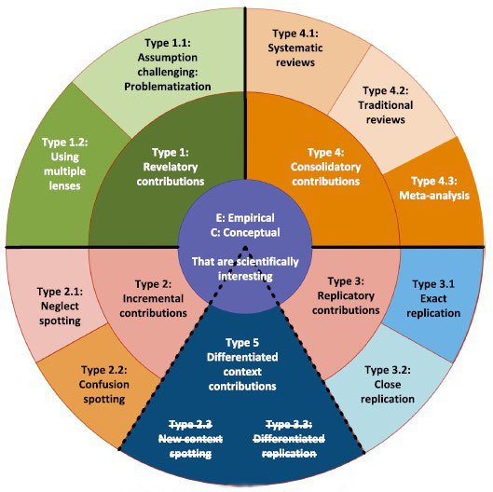
Figure 6.1 – Conceptual framework (revised version):
dimensions of contribution in research works
Note – Extracted from the source [465, p. 217]

Table 6.1 – Dimensions of contribution in research works
1 | 2 | 3 | 4
Meta category | Description | Sub-category | Description
Type 1:  Revelatory contributions | Contributions with unexpected, challenging, and surprising results based on a revolutionary theory revealing imagination, conceptual development, and speculative thought. | Type 1.1:  Assumption challenging: Problematization | To challenge or even oppose the underlying assumptions or the consensus in a body of work to formulate novel research questions.
Continuation of table 6.1
1 | 2 | 3 | 4
 |  | Type 1.2:  Using multiple lenses | To focus on the integration and combination of concepts and constructs (termed “theory borrowing” and “theory blending”) through multi-disciplinary or interdisciplinary research.
Type 2: Incremental contributions | Contributions predicted on incremental originality and based on a traditional gap spotting approach to reviewing literature. | Type 2.1:  Neglect spotting | To focus on overlooked or under-researched areas (in theories, constructs, or methodologies) or areas with substantially conceptual rather than empirical support.
 |  | Type 2.2:  Confusion spotting | To rationalize previously published results and search for competing explanations where confusion exists within a theme or subject.
Type 3:  Replicatory contributions | Contributions made by extending generalizability through replication and verification in conceptual (C), methodological (M), and substantive (S) aspects. | Type 3.1:  Exact replication | To draw the same correlations between the same variables in the same way using the same procedures with a different sample from the same population, where C, M, and S remain constant.
 |  | Type 3.2:  Close replication | To allow a slight variation in C, M, or S where the sample frames should be broadly representative in terms of questions asked.
Type 4:  Consolidatory contributions | Contributions based on dedicated literature review of state-of-the-art papers in the field that advance knowledge in some way. | Type 4.1:  Systematic reviews | To present literature in an objective manner because results are provided which can be generalized and replicated to some extent.

Continuation of table 6.1
1 | 2 | 3 | 4
 |  | Type 4.2:  Traditional reviews | To conceptually present literature in a subjective manner (also known as a narrative or conventional review).
 |  | Type 4.3:  Meta-analysis | To focus on testing hypotheses and aggregating and comparing the empirical findings from different studies, as well as inspecting the sampling instruments used in each case.
Type 5:  Differentiated context contributions | Contributions made through contextual extension or distinctive replication. | Type 5.1 (2.3):  New context spotting | To identify a new application or context, thus extending and complementing an existing theory.
 |  | Type 5.2 (3.3):  Differentiated replication | To establish the generalization of a previous study by deliberately designing the variances in C, M, and/or S.
Note – Summarized and compiled by the author based on the sources [465, p. 206-218; 466, p. 23-41].

Stage of theory building. A strong theory goes through two major stages in its process of building – the descriptive stage and the normative stage (see figure 6.2 [467]). The two stages lend support to uncover the systematic reasons for a particular phenomenon [468] in research.
As indicated in the pyramids in figure 6.2, three steps – observation, categorization, and association – occur within each of the two stages [467, p. 2]. In the descriptive stage, the three steps aim to develop constructs, form research frameworks, and yield correlational models, respectively [467, p. 2-5]; while in the normative stage, the three steps target at empirical observations, classification of different contexts, and causality of the relations [467, p. 5-8]. Throughout the inductive and deductive cycles, anomalies – outcomes which the theory cannot predict and explain – are essential in theory building because the identification of an anomaly provides a chance to further improve the theory, even in case the theory is already well-established [467, p. 9-11].
Theory itself is considered a product or a continuum [469] which is approximated more often than it is realized [470]. Theory arises frequently with such words as “guess, speculation, supposition, conjecture, proposition, hypothesis, conception, explanation, model, etc. [469, p. 386]”. In this sense, theory construction always requires process of theorizing or theorization [469, p. 387].
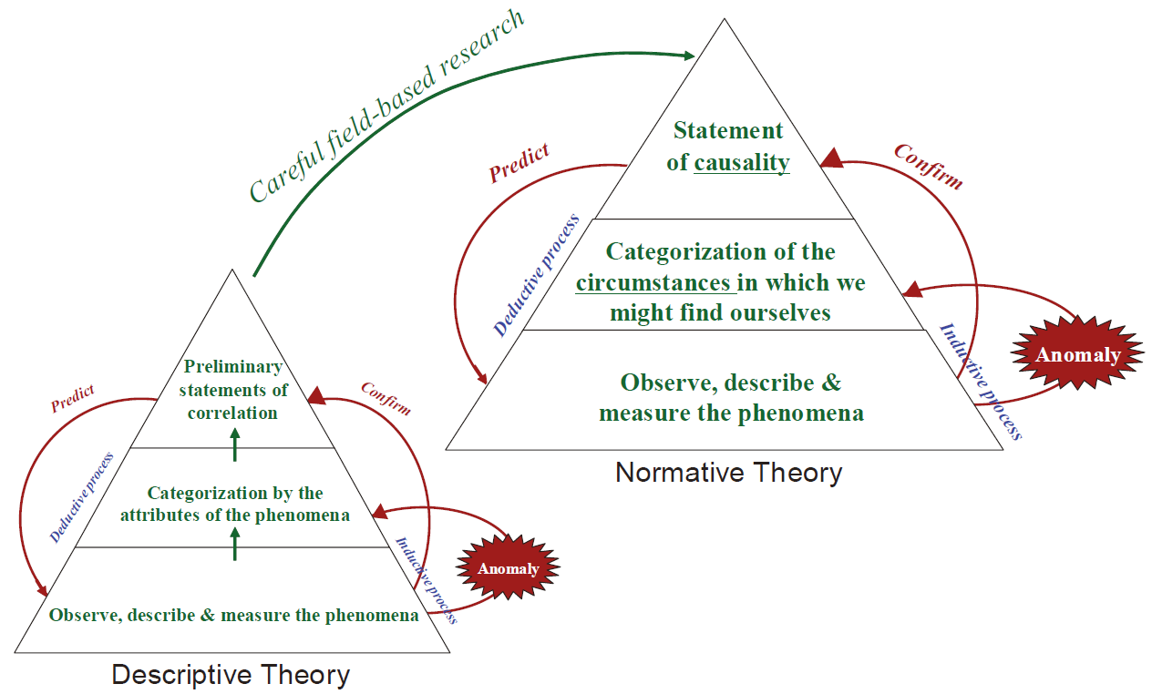
Figure 6.2 – The process of theory building
Note – Extracted from the source [467, p. 6]
The role of theorizing, acting as the bridge between theory testing and building, functions in activities like “abstracting, generalizing, relating, selecting, explaining, synthesizing, and idealizing [469, p. 389]”. In fact, activities of theorization can be allocated into the aforementioned three steps (i.e., observation, categorization, and association) [467, p. 2]. Products of these activities are termed “five elements” – “reference lists, data, lists of variables, diagrams, and lists of hypotheses [468, p. 371]”. Although these elements shall not be used in lieu of theory due to the probable absence of logic streams and/or causal explanations herein [468, p.371-378], the elements can serve as a valuable means to theory construction [469, p. 387] in a cumulative manner [471] via extension of the existing knowledge [472].
Drawing on the preceding insights, in this study, despite “TPB” is a widely-accepted [56, p. 182] normative theory, the testing over it in a different context (Kazakhstan under the ongoing COVID-19) has substantive utility. This is because that the new testing may further improve TPB’s sufficiency and generalizability toward the realization of “TPB”. No anomalies were discovered in the empirical results (the five elements); hence, the existing “TPB” was soundly supported once again in the normative cycle of theory testing.
In contrast, the “TPB+GS” framework is conceptualized as a novel model, which is constructed at a solid ground elaborated in Chapter 2. That having been said, the model is still at the descriptive stage and indeed acquires rigorous theorizing. In this sense, this empirical study made a conceptual contribution to the extension of “TPB”. Theorizing activities were carried out in accordance with the above-mentioned scope by Weick [469, p. 389].
Taken together, standing from the perspective of theory building, this study further solidified “TPB” through deductive testing in a new circumstance and initiated the step toward the expanded model of “TPB+GS” through theorizing and inductive testing.
Current trends and future directions in entrepreneurship research. Over the past years, a considerable amount of entrepreneurship literature has utilized “TPB” as the theoretical foundation, or altered “TPB” (by means of adding mediators or moderators), to explain and predict EIs and entrepreneurial behaviors [473].
Also, the review of relevant literature reveals gaps and inconsistencies which can be addressed in future research using “TPB”. Table 6.2 [473, p. 951; 474] below lists the proposed research suggestions in this regard.
Table 6.2 – Suggestions for future entrepreneurship research using “TPB”
1 | 2
Category | Research suggestions
Level of analysis and theory building | To utilize a meso-level approach to theory building and empirical research.
To conduct more research at the environmental/institutional level of
analysis.
 | To focus more efforts on the nexus of entrepreneurial opportunities, enterprising individuals or teams, and modes of organizing within the overall context of dynamic environments.
 | To ground more research in theoretical arguments from perspectives of decision and prospect theories, start-up factors of production, information processing and network theory, as well as temporary dynamics.
Uses of “TPB” | To examine the link between opportunities and intentions.
 | To explore the connections between intentions and planning.
 | To investigate the full “TPB” in the context of entrepreneurship.
Data | To utilize more longitudinal data.
 | To continue to stay away from student samples.
 | To incorporate more qualitative research such as interviews.
Measures and scales | To validate the two intention scales (one developed by Liñán and Chen [147, P. 40] and the other by Thompson [199, p.673]).
 | To refine and create scales for the other four major constructs (PA, SNs, PBC, and behavior) of “TPB” in the entrepreneurship context.
Literature gaps | To focus on the themes that have received less research attention: venture development intentions, venture creation behaviors, and venture development behaviors; the theme “venture creation intentions” has been largely researched.
Continuation of table 6.2
1 | 2
 | To investigate the PBC to behavior link while still expanding the research base for the other relationships as well.
 | To use established relationships of main constructs with differing variables.
Note – Extracted from Lortie and Castogiovanni [473, p. 951]; incorporated and revised by the author based on Busenitz et al. [474, p. 296-303].
Five aspects in this work are found to be well aligned to the current trends and future directions discussed above in entrepreneurship research.
First, effects of the environmental/institutional factor – GS – in moderating relationships between “TPB” antecedents versus EI are highlighted, which helps fill the existing gaps in the area of entrepreneurship study. It is also valuable that the research framework “TPB+GS” was grounded and investigated toward the extension of the established theory of “TPB”, thus making contributes to address more insightful understanding of multi-faceted entrepreneurship phenomena. This aspect is identified in the category of “level of analysis and theory building”.
Second, this study is especially the case of expanding boundaries and intersections of entrepreneurship research [474, p. 296] when the phenomenon of foreigners performing in Kazakhstan under COVID-19 is investigated. According to the “prospect theory” predicting that risk is based more the decision-maker’s reference point than on probable outcomes [475], COVID-19 might be deemed by the foreigners either beneficial or detrimental to start up a business. The influence of crisis was embedded in the foreigners’ attitudinal answers to the survey questions of this study. Hence, logical explanations to the beliefs regarding EIs can be explored with more ease and comfort in the research. This aspect also fits the category of “level of analysis and theory building”.
Third, selection of foreigners in Kazakhstan as the target population meets the suggestion to move attention away from students to other samples of interest. In fact, the study population of foreign entrepreneurs in Kazakhstan is claimed as a novel attempt of exploration in EI research. This aspect finds itself in the category of “data”.
Fourth, the borrowed instruments in the questionnaires (see Appendix R) of this study are mainly derived from Liñán and Chen [147, p. 40], one of the two strongly recommended sources of “measures and sales” (indicating the matched category also).
Fifth, due to the nature of the study population – new and established foreign entrepreneurs – who have already translated their “intentions of venture creation and development” into “behaviors of venture creation and development”, this study captured a sense of the themes in filling “literature gaps” (indicating the allocated category as well).

6.3.2 Contributions in the Methodological Area
This study exhaustively assimilated and integrated the methods utilized by other peer academics in their previous works of a similar topic. The goal is to implement a thorough procedure of gathering, reviewing, and analyzing data that is suitable for the extended model of “TPB+GS”.
The primary methodological stages, research assignments, as well as corresponding designs, assessments, tests, tools, indicators, etc. are summarized and displayed in Appendix I [16, p. 27; 371, p. 1; 372, p. 441; 380, p. 187].
Appendix I methodically describes a full example of the research methodology employed. Future comparable research (EI research in particular) in the setting of Kazakhstan may benefit from the research methodology developed in this study.

6.3.3 Contributions in the Practical Area
In terms of practical application, this research helps in three ways:
1) the verification of direct determinants – PA and PBC – impacting EI of the target population (foreigners working in Kazakhstan);
2) the moderation of GS leading to EI of the target population; and
3) the solid understanding on the strength and direction of the said effects exerted by PA/PBC, and (PA/PBC)×GS on EI of the target population.
It was demonstrated that both PA and PBC directly and positively affect EI of the target population; PA has greater predictive power than PBC over EI. GS could intensify the predictive power of either PA or PBC; the interaction of GS with PA (PA×GS) is more powerful than with PBC (PBC×GS) in inspiring EI of the target population.
As mentioned earlier in Chapter 5, any measure that seeks to increase the strength of PA, PBC, and GS in Kazakhstan favors EI of the target population. Therefore, higher education institutions, scholars, practicing business owners, and government authorities should be committed to the society on a regular basis through:
- bringing original thoughts;
- exchanging and expanding expertise and skills;
- nurturing newcomers in business creation; and
- improving the EE.

6.4 Limitations of the Study
In general, the major flaws or inadequacies in this study are found mostly in data gathering aspect. These are the limitations of this study:
1) designation of the study population;
2) estimate size of the study population;
3) validity of the sample representativeness;
4) data collection procedure;
5) accuracy of responses; and
6) mixture of longitudinal and cross-sectional data.
Firstly, for the purpose of assuring the presence of EI, the study sample was confined to new and established entrepreneurs among foreign nationals in Kazakhstan. Non-entrepreneurs were not considered, nor were the discontinued, nascent, intentional, and potential entrepreneurs (see Appendix B).
Secondly, due to the severe lack of relevant statistics, the target population’s size was unable to be precisely confirmed; consequently, only an estimate size could be produced from the restricted data.
Thirdly, the sample dataset was collected from 60 countries, raising the doubt of whether the data truly represent the elements of target population. In reality, the selected sample in nature might have already determined the generalizable degree due to the population’s considerable variety.
Fourthly, strictly speaking, the data gathered by means of “networking” approach might yield slightly insufficient randomness in that the initiating “group of friends” were limited to a rather narrow scope of individuals. Besides, the author’s self-participation as a respondent in completing the questionnaire and starting up the rolling of network related to him might cause biases in the results due to the unavoidable subjectivity in his considerations and operations.
Fifthly, the authenticity of the replies was questionable. Even though the questionnaire underwent pre-testing and a pilot study, the author could not rule out the likeliness that some of the questions in the survey were misinterpreted by the responders due to the fact that some of the questions were derived from research conducted in countries other than Kazakhstan. During the completion of surveys, several participants asked for explanations on some items. The words that were unclear could be explained for individuals who could easily contact the author, but not for others who could not.
Lastly, it was intended that cross-sectional data be collected. However, due to the constraints brought by the COVID-19 pandemic and the inability to use alternate frames of sample, the data gathering procedure lasted for as long as 6 months. This provided the data with a longitudinal feature. As COVID-19 kept spreading, the dynamics of entrepreneurial perceptions, particularly among the new-comers, may have rendered their answers inconsistent.
All of the aforementioned restrictions have the possibility to introduce biases into the results, resulting in conclusions that cannot be generalized.

6.5 Suggestions for Further Study
In an effort to attract greater interest and care for entrepreneurial activities among the foreign nationals in Kazakhstan, the author proposes a number of suggestions for future studies including research model, measures and scales, data collection, data analysis method, software tools, and research setting. Specifically speaking:
Firstly, this study developed the expanded “TPB+Moderator (GS)” framework as a reference for future scholars in the field of research concerning EI and its predictors. This model can be utilized in future works to examine its credibility in general and in the particular context of Kazakhstan.
Secondly, the moderator in the conceptual model – the role of “GS” – was operationalized in connection with “government policies and programs”. New studies may decode the notion of “GS” construct with greater dimensions.
Thirdly, this study did not distinguish among foreigners according to their citizenship or nationality; for the purpose of simplicity, the study treated them as a single group. Therefore, future research may take into account the disparities between the foreigners from various areas or nations and gather independent sets of data accordingly. This distinction might enable the academics to acquire distinct empirical findings for every sub-group of foreigners. Furthermore, the respondents can be classed further dependent on the type of their experience in entrepreneurial activities. Examples for the classification include business-owners against non-business-owners, new/established entrepreneurs versus entrepreneurs of either of other types (prospective, purposeful, emergent, or terminated entrepreneurs), and etc.
Fourthly, due to the failure of all alternative access methods, this study depended on the “networking” method to collect data. This strategy was not the top priority, but it was the only viable option available throughout the research duration. That having been said, networking approach is proven as a potent method with scientific merits, including its non-random-but-controllable access (to achieve adequate randomness as in this study) of “snowball sampling” rolled by the expanding interpersonal relationships through chain-referrals, gatekeepers, friends, etc. [476], as well as the adaptability, convenience, ease, and comfort (as realized in this study) for data collection under restrictions caused by the COVID-19 crisis. Future studies are supposed to gather data by means of direct contacts with foreigners or enterprises, given a substantial number of statistics. Data might be acquired via more effective interactions with Kazakhstan’s government, perhaps with the support of higher academic institutions, diplomatic authorities, or private sector groups.
Fifthly, this research employed solely quantitative method in data analysis, that could not eliminate the likeliness of collecting erroneous responses due to possible misinterpretations during the process of questionnaire completion. Moreover, the quantitative analyses were unable to extract adequate information from the participants’ attitudinal responses. Therefore, future studies may include qualitative analyses (such as focus group research) to get a deeper understanding of the determinants and their foundational philosophies.
Sixthly, the primary methods of analysis this study utilized consist of descriptive, Pearson’s correlation, and multiple regression analyses. Other techniques including meta-analysis, SEM, EFA, CFA, ANOVA, MANOVA, etc. are also suggested for future research, which may yield novel insights in the researched subject of this work. In addition, this study employed IBM SPSS; other statistical software tools, such as SAS/STAT, MINITAB, GRAPHPAD PRISM, STATA, among the top picks, are also advised for use.
Seventhly, with respect to the measures and scales, this study applied established instruments developed by Liñán and Chen [371, p. 20], Solesvik et al. [372, p. 452;], Liñán, Urbano, and Guerrero [380, p. 215], GEM [20, p. 30, р. 32] and Likert-type scales. Other sources of well-validated existing scales enumerated in Appendix T are also recommended for adoption. Furthermore, self-developed instruments suited to the target population of foreigners and the research context in Kazakhstan are encouraged as well. Likert scales, for all of their uses, do have some drawbacks [477]; hence, other types of scales can also be investigated, and accordingly, other analytical techniques, such as multinomial logistic regression analysis, can be considered for use.
Finally, the pandemic’s attack on business and economy, especially on SMEs and entrepreneurship, is still being experienced internationally and in Kazakhstan. Uncertainties and hazards brought by the epidemic have given rise to new aspects of study in a variety of fields. Future works, especially with respect to the domain of EI research, shall rethink the existing beliefs and reveal new findings that will benefit the individuals and society concerned. Kazakhstan is calling for an increasing number of empirical research including in the scientific area of EI investigations.

CONCLUSION

Kazakhstan, the largest Central Asian country, is endowed with copious natural resources. Kazakhstan gained independence from the former SU in 1991 and is now a member of CIS. Three typical features have been shaping Kazakhstan’s development path, i.e., the largest landlocked country, the transitional economy, and particular dependence on oil. Kazakhstan is actively participating in the global economy and has built up diplomatic ties with over 139 nations. Kazakhstan is a multi-ethnic country with a population of around 19.1 million people. The country takes on a wide range of diversified cultures.
Kazakhstan has a generally favorable business climate. Together with the opportunities resulting from the above-mentioned economic, political, and cultural characteristics, Kazakhstan is continuously drawing substantial foreign investment to localize, and increasing number of foreigners to pursue business, in this country.
Among the variety of business activities, entrepreneurship (including foreigners’ entrepreneurship, e.g., from Chinese entrepreneurs [478]) has become a priority in Kazakhstan’s economic strategy. Support from the government of Kazakhstan is playing an essential role in promoting the (foreign) entrepreneurship which further contributes to the national economic development. The COVID-19 epidemic proved once more the essential role of government support (GS) in maintaining and fostering entrepreneurship in Kazakhstan and other countries. Therefore, “GS” shall be highlighted in academic research, and became a focal point in this study as well.
Entrepreneurial intention (EI) was determined as the subject of this study on how to stimulate (foreign) entrepreneurship in Kazakhstan as “EI” has been reckoned as the best single factor predicting entrepreneurial activity and firm success [54, p. 442; 55, p. 16]. In order to examine the foreigners’ EI under the circumstances of Kazakhstan, this study employed the most prevalent “TPB” model and, in an unusual move, added the function of “GS” as the moderator variable. The integrated “TPB+Moderator (GS)” model hypothesized that the “TPB” components – PA towards entrepreneurship, SNs about entrepreneurship, and PBC over entrepreneurship – positively affect the EI of foreign nationals in Kazakhstan, and that GS further strengthens the effects of the “TPB” components leading to EI. The construct of GS in this study was explained collectively by “government programs” and “government policies”.
To evaluate the above-mentioned hypotheses, the methodology was devised and implemented through the stages of “goodness of measures” for data collection, “goodness of data” for data examination, and “goodness of model’s fit” for data analysis. The questionnaire instruments were drawn from prior research and passed the “goodness of measures” test. A final sample of 362 respondents from 60 countries met the criteria for “goodness of data” and was therefore deemed competent for multivariate analysis. The empirical findings derived from the multiple regression analysis demonstrated that both the generic “TPB” and the integrated “TPB+GS” models supported the “goodness of model’s fit”.
This study found that, the new and established entrepreneurs among foreigners operating in Kazakhstan launched their own venture with a remarkably intense EI, a favorable degree of PA, a medium level of SNs, and a modest perception of PBC. In Kazakhstan, foreigners sense a low to moderate degree of GS, with individual impressions being quite widely dispersed. The three “TPB” components (PA/SNs/PBC) are all closely and positively linked with their EI, and so are the three moderation terms ((PA/SNs/PBC)×GS). Their EI is favorably affected by their PA and PBC. The causal links of PA-EI and PBC-EI become more intense when GS moderates. Unexpectedly, the impacts of SNs and SNs×GS on EI were found to be insignificant. PA, PBC, GS×PA, and GS×PBC are ranked in descending order in terms of their predictive powers.
It is noteworthy that, in comparison with and in contrast to the hypotheses stated preliminarily, it is verified that the general models’ fit of the “TPB” and the “TPB+GS” were supported, while SNs and its interaction effect with GS (SNs×GS) on EI were not. However, the result of insignificance of SNs is still consistent with prior studies as demonstrated by Krueger et al. [143, p. 411], Liñán and Chen [147, p. 40], and Tarek [332, p. 345], among others. Furthermore, the discovery of PA proved as the strongest determinant of EI is also consistent with findings from past research (e.g., [204, p. 135]).
This study claimed primary contributions with a particular focus on theoretical dedication to the body of knowledge in entrepreneurship research area. Meanwhile, limitations of the study were outlined and suggestions for further research were provided.

LIST OF SOURCES USED

  - Teal E.J., Toxanova A.N., Izzo M.G. Entrepreneurial Development in Kazakhstan: A Review and Update // https://aabri.com/manuscripts. 10.01.2019.
  - Dostiyarova A. Dynamics of Entrepreneurship Development in Kazakhstan // Journal of Marketing Development and Competitiveness. – 2012. – Vol. 6(2). – P. 101-111.
  - Baron R.A. Entrepreneurship: A Process Perspective // In book: The Psychology of Entrepreneurship. – NY., 2007. – P. 19-39.
  - Schumpeter J.A. The Creative Response in Economic History // The Journal of Economic History. – 1947. – Vol. 7(2). – P. 149-159.
  - Hoselitz B.F. Entrepreneurship and Economic Growth // Journal of Economics and Sociology. – 1952. – Vol. 12(1). – P. 97-110.
  - Ayyagari M., Demerguc-Kunt A., & Beck T. Small and Medium Enterprises across the Globe: A New Database // https://deliverypdf.ssrn.com. 05.03.2019.
  - Antai A.S., Anam B.E., & Ita J.J. Entrepreneurship as a Strategy for the Economic Development of the Niger Delta Region of Nigeria // European Journal of Business and Management. – 2012. – Vol. 4(17). – P. 89-99.
  - Global Entrepreneurship Monitor (GEM): Luxembourg 2017/2018. – STATEC, Luxembourg, 2018. – P. 1-60.
  - Baumol W.J. Entrepreneurship: Productive, Unproductive and Destructive // Journal of Political Economy. – 1990. – Vol. 98. – P. 893-921.
  - Acs Z.J., Szerb L. The Global Entrepreneurship and Development Index (GEDI) // Procced. sum. conf. “Opening Up Innovation: Strategy, Organization and Technology at Imperial College London Business School”. – London, 2010. – Р. 1-40.
  - Teixeira A.A., Forte R.P. Unbounding Entrepreneurial Intents of University Students: A Multidisciplinary Perspective. – Portugal, Universidade do Porto, 2009. –P. 1-36.
  - Neace M.B. Entrepreneurs in Emerging Economies: Creating Trust, Social Capital, and Civil Society // Annals of the American Academy of Political and Social Scienceю – 1999. – Vol. 565. – P. 148-161.
  - Syriopoulos K. The Impact of Covid-19 on Entrepreneurship and SMES // Journal of the International Academy for Case Studies. – 2020. – Vol. 26(2). – P. 1-2.
  - Almas M. Competitiveness and Development of Kazakhstani SMEs // Periodica Polytechnica. – 2014. – Vol. 22(1). – P. 57-64.
  - Wennekers S., Thurik R. Linking Entrepreneurship and Economic Growth // Small Business Economics. – 1999. – Vol. 13(1). – P. 27-56.
  - Kazakhstan 2018/2019: National Report / Global Entrepreneurship Monitor. – Nur-Sultan, Graduate School of Business of Nazarbaeyev University, 2019. – 55.
  - World Bank Data // https://data.worldbank.org/. 10.09.2021.
  - Kazinform Data // https://www.inform.kz/. 01.10.2021.
  - Trading Economics Data // http://tradingeconomics.com.20. 10.10.2021.
  - Diagnosing COVID-19 Impacts on Entrepreneurship: Exploring Policy Remedies for Recovery / Global Entrepreneurship Research Association. – London: Business School, 2020. – 198 p.
  - Todorovic Р. Managing Cross-culturalism within a Global Company – The Case of Jotun Paints. – Ljubljana: University of Ljubljana, 2013. – 73 р.
  - Kazakhstan Today / The Kazakhstan Institute for Strategic Studies under the President of the Republic of Kazakhstan. – Almaty, 2010. – 356 р.
  - The Astana Times // https://astanatimes.com/2019/10/kazakhstan-ranks-55th-in-global-competitiveness-index-moves-up-four-spots/. 05.12.2019.
  - World Investment Report – 2020: United Nations Conference on Trade and Development / UNCAD. – NY.: United Nations Publications, 2020. – 247 р.
  - Export-enterprises // https://www.export-entreprises.com/. 06.06.2020.
  - Abaganov A., Dayuen D.B. The Role of Chinese Entrepreneurs in the Economy of Kazakhstan // Journal of Oriental Studies. – 2017. – Vol. 4(83). – P. 4-10.
  - Kazakhstan: report / Economist Intelligence Unit. – London, 2018. – 33 p.
  - UNCTAD Data // https://unctad.org/. 08.02.2020.
  - Kim G.N. Formation and Development of Ethnic entrepreneurship of Koryo Saram in Kazakhstan // International Area Review. – 2009. – Vol. 12(1). – P. 127-162.
  - José G.V.H. The Role of Government in Enhancing Entrepreneurship of Small and Medium Enterprises for Economic Growth // Revista da Micro e Pequena Empresa, Campo Limpo Paulista. – 2010. – Vol. 3(4). – P. 40-52.
  - Audretsch D.B., Grilo I., Thurik A.R. Explaining Entrepreneurship and the Role of Policy: A Framework // In book: The Handbook of Research on Entrepreneurship Policy. – Cheltenham: Edward Elgar Publishing Ltd, 2007. – P. 1-17.
  - Doh S., Kim B. Government Support for SME Innovations in the Regional Industries: The Case of Government Financial Support Program in South Korea // Research Policy. – 2014. – Vol. 43. – P. 1557-1569.
  - Women’s Entrepreneurship: Lessons and Good Practice: National Case Studies from Cambodia, Indonesia, Malaysia and Philippines. – Bangkok: United Nations, 2018. – 49 р.
  - Fizza S. Measuring Entrepreneurial Intentions: Role of Perceived Support and Personality Characteristics. – Islamabad: Department of Management Sciences, 2017. – 85 р.
  - Sánchez A.M. Environmental Factors that Affect the Entrepreneurial Intention. – Barcelona, 2018. – 60 p.
  - Kamrul A., Patrick L.K.C. Critical Issues of Starting Entrepreneurship in Kazakhstan // The IUP Journal of Entrepreneurship Development. – 2006. – Vol. 3(2). – P. 43-51.
  - Hansen H., Rand J., Tarp F. Enterprise Growth and Survival in Vietnam: Does Government Support Matter? // The Journal of Development Studies. – 2009. – Vol. 45. – P. 1048-1069.
  - Fajnzylber P., Maloney W.F., Montes-Rojas G.V. Releasing Constraints to Growth or Pushing on a String? Policies and Performance of Mexican Micro-ﬁrms // Journal of Development Studies. – 2009. – Vol. 45. – P. 1027-1047.
  - The Structure of Support of Small Business // http://www.damu.kz. 08.05.2020.
  - Cuyper L.D., Kucukkeles B., Reuben R. Discovering the Real Impact of COVID-19 on Entrepreneurship // https://www.weforum.org/agenda/2020/06/how-covid-19-will-change-entrepreneurial-business. 19.07.2020.
  - Global Economic Effects of COVID-19 // https://sgp.fas.org/crs/row/ R46270.pdf. 07.08.2020.
  - UNDP Supports Kazakhstan during the Novel COVID-19 Pandemic // https://www.kz.undp.org/content/kazakhstan/en/home/presscenter/news. 15.04.2020.
  - What are the Impacts of COVID-19 on Entrepreneurship? Glion Institute of Higher Education // https://www.glion.edu/blog/impacts-covid-19. 21.05.2020.
  - Cook J. A Six-stage Business Continuity and Disaster Recovery Planning Cycle // SAM Advanced Management Journal. – 2015. – Vol. 80(3). – P. 22-33.
  - Fabeil N.F., Pazim K.H., Langgat J. The Impact of Covid-19 Pandemic Crisis on Micro-Enterprises: Entrepreneurs’ Perspective on Business Continuity and Recovery Strategy // Journal of Economics and Business. – 2020. – Vol. 3(2). – P. 837-844.
  - Sinha D. Post Covid-19 Trends of Entrepreneurship According to the Changed Market Demand // https://www.entrepreneur.com/article. 20.07.2020.
  - McCarthy B. Strategy is Personality‐driven, Strategy is Crisis‐driven: Insights from Entrepreneurial Firms // Management Decision. – 2003. – Vol. 41, Issue 4. – P. 327-339.
  - Naidoo V. Firm Survival through a Crisis: The Influence of Market Orientation, Marketing Innovation and Business Strategy // Industrial Marketing Management. – 2010. – Vol. 39(8). – P. 1311-1320.
  - Bourletidis K., Triantafyllopoulos Y. SMEs Survival in Time of Crisis: Strategies, Tactics and Commercial Success Stories // Procedia Social and Behavioral Sciences. – 2014. – Vol. 148. – P. 639-644.
  - Yu-lian W. The Optimization Model of Distribution Channels Farm Produce in Heilongjiang Province // Commercial Research. – 2008. – №4. – P. 173-176.
  - Government and Institution Measures in Response to COVID-19 // https://home.kpmg/xx/en/home/insights/2020/04/kazakhstan-government. 11.05.2020.
  - Economic Stabilization and Business Support in Kazakhstan During COVID-19 // https://www.morganlewis.com/pubs/economic. 13.04.2020.
  - Kazakhstan Outlines Plan to Shelter Economy from COVID-19 // https://eurasianet.org/kazakhstan-outlines-plan-to-shelter-economy-from. 18.05.2020.
  - Bird B.J. Implementing Entrepreneurial Ideas: The Case for Intention. Academy of Management Review. – 1988. – Vol. 13(3). – Р. 442-453.
  - Arasti Z., Pasvishe F.A., Motavaseli M. Normative Institutional Factors Affecting Entrepreneurial Intention in Iranian Information Technology Sector // Journal of Management and Strategy. – 2012. – Vol. 3(2). – P. 16-25.
  - Ajzen I. The Theory of Planned Behavior // Organizational Behavior and Human Decision Processes. – 1991. – Vol. 50. – P. 179-211.
  - Liñán F., Nabi G., Krueger N. British and Spanish Entrepreneurial Intentions: A Comparative Study // Revista De Economia Mundial. – 2013. – Vol. 33. – P. 73-103.
  - Kong F.Z., Zhao L., Tsai C.H. The Relationship between Entrepreneurial Intention and Action: The Effects of Fear of Failure and Role Model // Frontiers in Psychology. – 2020. – Vol. 11. – P. 1-9.
  - Peng Z., Lu G., Kang H. Entrepreneurial Intentions and its Influencing Factors: A Survey of the University Students in Xi’an China // Creative Education. – 2012. – Vol. 3 (Supplement). – P. 95-100.
  - Yu T.X., Khalid N., Islam D.M.Z., Ahmad A. Building up the Entrepreneurial Intention Construct among Foreigners in Kazakhstan // Central Asian Economic Review. – 2019. – Vol. 6(129). – P. 31-44.
  - Abdullahi A.I., Zainol F.A., Daud W.N.W. et al. Entrepreneurial Intention Revisited: Measuring the Impact of Socio-Cultural Business Environment Using Structural Equation Modeling // World Applied Sciences Journal. – 2017. – Vol. 35(8). – P. 1445-1456.
  - Gilad B., Levine P. A Behavioral Model of Entrepreneurial Supply // Journal of Small Business Management. – 1986. – Vol. 24(4). – P. 45-54.
  - Sexton D.L. Advancing Small Business Research: Utilizing Research from Other Areas // American Journal of Small Business. – 1987. – Vol. 11(3). – P. 25-31.
  - Fayolle A., Liñán F., Moriano J.A. Beyond Entrepreneurial Intentions: Values and Motivations in Entrepreneurship // International Entrepreneurship and Management Journal. – 2014. – Vol. 10. – P. 679-689.
  - Sandberg W.R., Hofer C.W. Improving New Venture Performance: The Role of Strategy, Industry Structure, and the Entrepreneur // Journal of Business Venturing. – 1987. – Vol. 2(1). – P. 5-28.
  - Tornikoski E., Maalaoui A. Critical Reflections – The Theory of Planned Behavior: An Interview with Icek Ajzen with Implications for Entrepreneurship Research // International Small Business Journal: Researching Entrepreneurship. – 2019. – Vol. 37(5). – P. 536-550.
  - Ajzen I. Attitudes, Personality and Behavior. – Ed. 2nd. – Maidenhead: Open University Press (McGraw-Hill), 2005. – 178 p.
  - Sondari M.C. Is Entrepreneurship Education Really Needed? Examining the Antecedent of Entrepreneurial Career Intention // Procedia-Social and Behavioral Science. – 2014. – Vol. 115. – P. 44-53.
  - Deci E., Ryan R. The General Causality Orientations Scale: Self-determination in Personality // Journal of Research in Personality. – 1985. – Vol. 19(2). – P. 109-134.
  - Kolvereid L. Prediction of Employment Status Choice Intentions // Entrepreneurship Theory and Practice. – 1996. – Vol. 21(1). – P. 47-58.
  - Tkachev A., Kolvereid L. Self-employment Intentions among Russian Students // Entrepreneurship and Regional Development. – 1999. – Vol. 11(3). – P. 269-280.
  - Fayolle A., Liñán F. The Future of Research on Entrepreneurial Intentions // Journal of Business Research. – 2014. – Vol. 67(5). – P. 663-666.
  - Baron R.M., Kenny D.A. The Moderator–Mediator Variable Distinction in Social Psychological Research: Conceptual, Strategic, and Statistical Considerations. Journal of Personality & Social Psychology. – 1986. – Vol. 51(6). – P. 1173-1182.
  - Cooper M.L., Russell M., Frone M.R. Work Stress and Alcohol Effects: A Test of Stress-induced Drinking // Journal of Health and Social Behavior. – 1990. – Vol. 31. – P. 260-276.
  - Khalid N., Ahmed U., Tundikbayeva B. et al. Entrepreneurship and Organizational Performance: Empirical Insight into the Role of Entrepreneurial Training, Culture and Government Funding across Higher Education Institutions in Pakistan // Management Science Letters. – 2019. – Vol. 9(5). – P. 755-770.
  - Shah I.A., Amjed S., Jaboob S. The Moderating Role of Entrepreneurship Education in Shaping Entrepreneurial Intentions // Economic Structures. – 2020. – Vol. 9. – P. 19-1-19-15.
  - Hamdan A., Saberi M. The Moderating Role of Governmental Support in the Relationship between Entrepreneurship and Economic Growth: A Study on the GCC Countries // Journal of Entrepreneurship in Emerging Economies. – 2018. – Vol. 11(6). – P. 1-18.
  - Jadmiko P. Perceived Social Support as Moderator Variable Between the Attitude of Becoming a Social Entrepreneur (ATB) on Social Entrepreneurial Intention // Journal of Islamic Economic and Business Research. – 2021. – Vol. 1(1). – P. 86-99.
  - Salisu J.B. Entrepreneurial Training Effectiveness, Government Entrepreneurial Supports and Venturing of TVET Students into IT Related Entrepreneurship – An Indirect-path Effects Analysis // Heliyon. – 2020. – Vol. 6(11). – P. e05504-1-е05504-9.
  - Ibrahim M.I., Keat O.Y. et al. Moderating Effect of Government Supports Policy on the Relationship between Entrepreneurial Orientation and SMEs Performance in Nigeria: A Framework // International Journal of Management Research and Review. – 2016. – Vol. 6(12). – P. 1-14.
  - Weiss J., Anisimova T., Minola T. et al. Putting Entrepreneurial Intentions into Context: Regional Institutions and the Intention-behavior Link // https://deliverypdf.ssrn.com/delivery.php?ID. 11.04.2020.
  - Anjum T., Heidler P., Amoozegar A. et al. The Impact of Entrepreneurial Passion on the Entrepreneurial Intention; Moderating Impact of Perception of University Support // Administrative Sciences. – 2021. – Vol. 11(2). – P. 1-14.
  - Abubakar S.A., Mahmud M.L., Abduhrahim Y.O. Moderating Role of Perceive Access to Finance in the Relationship between Entrepreneurial Orientation and Entrepreneurial Intention Among Youth Corp Members in North-East, Nigeria // World Journal of Entrepreneurial Development Studies. – 2018. – Vol. 2(2). – P. 49-58.
  - Doing Business in Kazakhstan (2021). Baker McKenzie – CIS, Limited // www.bakermeckenzie.com. 01.01.2022.
  - Worldometer Data // https://www.worldometers.info/. 01.10.2021.
  - BBC News Data // http//bbc.com/news. 02.11.2020.
  - IMF – 2019 // https://en.wikipedia.org/wiki/Economy. 03.06.2020.
  - Jesus F., Cesar A.H. Economic Diversification: Implications for Kazakhstan // In book: Development and Modern Industrial Policy in Practice. – Northampton, MA, 2015. – P. 160-196.
  - CIA – 2021 // https://en.wikipedia.org/wiki/Demographics. 07.07.2021.
  - Luthans F., Stajkovic A., Ibrayeva E. Environmental and psychological challenges facing entrepreneurial development in transitional economies // Journal of World Business. – 2000. – Vol. 35(1). – P. 95-110.
  - Tolmachev D.E., Ulianova E.A., Pleaner L.M. The development of small and medium business in the region. Formation of priority directions on the example of Sverdlovsk region // Region Economy: Socio-economic Problems of the Region. – 2015. – Vol. 1. – P. 115-131.
  - Freedom House // https://freedomhouse.org/country. 01.02.2021.
  - LIF // https://www.prosperity.com/globe/kazakhstan. 01.02.2021.
  - WEF // https://www.qazaqtimes.com/en/article/64870. 01.02.2021.
  - GII // 01.10.https://www.theglobaleconomy.com/Kazakhstan. 01.08.2020.
  - USNEWS – 2019 // https://www.usnews.com/news. 01.10.2020.
  - EPI – 2018 // https://epi.envirocenter.yale.edu/epi-country. 01.20.2019.
  - WJP – 2020 // https://qazaqtimes.com/en/article/64870. 01.11.2021.
  - Global Entrepreneurship Index (GEI) / The Global Entrepreneurship and Development Institute (GEDI). – Washington, January 2020. – 64 p.
  - Petrenko E., Iskakov N., Metsyk O. et al. Ecosystem of Entrepreneurship: Risks Related to Loss of Trust in Stability of Economic Environment in Kazakhstan // Entrepreneurship and Sustainability Issues. – 2017. – Vol. 5(1). – P. 105-115.
  - Townsend D., Witt D.A. New Tax Code in Kazakhstan // Journal of International Taxation. – 2010. – Vol. 21(3). – P. 60-63.
  - Amsden A.H. Asia’s Next Giant: South Korea and Late Industrialization. – Oxford: Oxford University Press on Demand, 1992. – 379 р.
  - Choi J.J., Jiang C., Shenkar O. The Quality of Local Government and Firm Performance: The Case of China’s Provinces // Management and Organization Review. – 2015. – Vol. 11. – P. 679-710.
  - Storey D.J., Tether B.S. Public Policy Measures to Support New Technology-based Frms in the European Union // Research Policy. – 1998. – Vol. 26. – P. 1037-1057.
  - Wilson F., Kickul J., Marlino D. Gender, Entrepreneurial Self-efficacy, and Entrepreneurial Career Intentions: Implications for Entrepreneurship Education // Entrepreneurship Theory and Practice. – 2007. – Vol. 31(3). – P. 387-406.
  - Burt R.S. The Network Structure of Social Capital // Research in Organizational Behavior. – 2000. – Vol. 22. – P. 345-423.
  - Barney J. Firm Resources and Sustained Competitive Advantage // Journal of Management. – 1991. – Vol. 17(1). – P. 99-120.
  - Toxanova A.N. The Country of Kazakhstan Barriers of Entrepreneurship and Support for Entrepreneurship // http://www.unece.org/fileadmin. 15.01.2019.
  - Kenzhebayeva A., Turchekenova R. State Support for Innovation Policy: Timeline // Life Science Journal. – 2014. – Vol. 11(9s). – P. 251-256.
  - Turysbekova G., Ospanov Y., Alimkulova E. Governmental Support of Innovative and Industrial Development of the Economy // Mediterranean Journal of Social Sciences. – 2015. – Vol. 6(3). – P. 445-452.
  - Sarsengali A.A, Aigul N.T., Alma H.G. et al. Government Support of Innovative Business in the Republic of Kazakhstan // IEJME- Mathematics Education. – 2016. – Vol. 11(5). – P. 1033-1049.
  - E-Government for the Future We Want 04.12.http://unpan3.un.org/ egovkb/Reports/UN-E-Government-Survey-2014. 04.12.2018.
  - Kassen M. E-Government in Kazakhstan: A Case Study of Multidimensional Phenomena. – London: Routledge, 2017. – 133 р.
  - Bhatnagar S., Apikul C. Fighting Corruption with E-Government Applications // http://www.apdip.net/apdipenote/8.pdf. 03.01.2020.
  - Yu T.X., Khalid N., Ahmad A., Islam D.M.Z. E-Government in Enhancing SMEs Entrepreneurship Performance in Kazakhstan: A Conceptual Framework // Kazakh Economic Review. – 2019. – No. 3. – P. 62-69.
  - Berto, J.C., Jaeger P.T., Grimes J.M. Using ICTs to Create a Culture of Transparency: E-Government and Social Media as Openness and Anti-corruption Tools for Societies // Government Information Quarterly. – 2010. – Vol. 27. – P. 264-271.
  - Public Service Helps One Become Rich Quickly in Kazakhstan // http://kapital.kz/economic/9103/bystro-razbogatet-v-rk. 08.01.2020.
  - Electronic licensing in Kazakhstan // https://itunews.itu.int/Ru. 06.07.2020.
  - Ionescu L. The Impact that E-Government can Have on Reducing Corruption and Enhancing Transparency // Economics, Management and Financial Markets. – 2013. – Vol. 8(2). – P. 210-215.
  - Board Chair of NIT Ruslan Ensebaev reported on the results of the activities of the company to the Parliamentary Committee for Social-Cultural Development // http://www.nitec.kz/story/435tretgrert. 02.08.2020.
  - Satpaev D. Corruption in Kazakhstan and the quality of governance // http://www.ide.go.jp/English/Publish/Download/Dp/pdf/475.pdf. 09.09.2020.
  - Glushkova S. Speaking of Corruption - But Silent on How Much http://rus. azattyq.org/content/kazakhstan-korrupcia-reiting /27049235.html. 09.09.2020.
  - Sheryazdanova G., Butterfield J. E-Government as an Anti-corruption Strategy in Kazakhstan // Journal of Information Technology and Politics. – 2017. – Vol. 14(1). – P. 83-94.
  - Kurmanov N., Aibosynova D. The Modern State of Enterprise Innovation Activity in Kazakhstan // Procced. internat. conf. on Innovation, Technology Transfer and Education (CBU). – Prague, 2015. – P. 129-140.
  - Supporting Entrepreneurship Development in Kazakhstan (2010) // http://www.europeandcis.undp.org. 10.04.2019.
  - Entrepreneurship Development Institute Centre in Kazakhstan // http://smetimes.tradeindia.com. 04.01.2019.
  - USAID – 2010 // http://usaid.gov. 04.01.2019.
  - Siegel S. Breaking Down Administrative Barriers to Entrepreneurship in Kazakhstan // http://www.cipe.org. 04.01.2019.
  - Cambridge Dictionary – 2021 // https://dictionary.cambridge.org/zhs. 05.04.2021.
  - Collins Dictionary – 2021 // https://www.collinsdictionary.com /zh/dictionary/english/foreigner. 05.05.2021.
  - Smith A. An Inquiry into the Nature and Causes of the Wealth of Nations. – Ed. 5th. – London: Methuen and Co., 1776. – 1094 p.
  - Schumpeter J.A. The Theory of Economic Development: An Inquiry into Profits, Capital, Credit, Interest, and the Business Cycle. – Cambridge MA: Harvard University Press, 1934. – 255 p.
  - Hisrich R.D., Peters P.M., Shepherd D.A. Entrepreneurship with OLC. – Illinois: McGraw Hill, 2005. – 591 р.
  - Mellor R., Coulton G., Chick A.B.A. et al. Entrepreneurship for Everyone. – London: SAGE Publication, 2009. – 257 p.
  - Shook C.L., Priem R.L., Mcgee J.E. Venture Creation and the Enterprising Individual: A Review and Synthesis // Journal of Management. – 2003. – Vol. 29. – P. 379-399.
  - Kolvereid L., Isaksen E. New Business Start-up and Subsequent Entry into Self-employment // Journal of Business Venturing. – 2006. – Vol. 21(6). – P. 866-867.

Lent R.W., Brown S.D., Hackett G. Toward a Unifying Social Cognitive Theory of Career and Academic Interest, Choice, and Performance // Journal of Vocational Behavior. – 1994. – Vol. 45(1). – P. 79-122.
  - Wu J. The Impact of Corporate Supplier Diversity Programs on Corporate Purchasers’ Intention to Purchase from Women-owned Enterprises: An Empirical Test // Business and Society. – 2010. – Vol. 49(2). – P. 359-380.
  - Bird B.J., Jellinek M. The Operation of Entrepreneurial Intentions // Entrepreneurship Theory and Practice. – 1989. – Vol. 13(2). – P. 21-30.
  - Gartner W.B. “Who is an Entrepreneur?” Is the Wrong Question // American Journal of Small Business. – 1988. – Vol. 12. – P. 11-32.
  - Krueger N.F., Carsrud A.L. Entrepreneurial Intentions: Applying the Theory of Planned Behavior // Entrepreneurship and Regional Development. – 1993. – Vol. 5(3). – P. 315-330.
  - Webster F.A. Entrepreneurs and Ventures: An Attempt at Classiﬁcation and Clariﬁcation // Academy of Management Review. – 1977. – Vol. 2(1). – P. 54-61.
  - Krueger N.F., Reilly M.D., Carsrud A.L. Competing Models of Entrepreneurial Intentions // Journal of Business Venturing. – 2000. – Vol. 15(5-6). – P. 411-432.
  - Carr J.C., Sequeira J.M. Prior Family Business Exposure as Intergenerational Influence and Entrepreneurial Intent: A Theory of Planned Behavior Approach // Journal of Business Research. – 2007. – Vol. 60(10). – P. 1090-1098.
  - Souitaris V., Zerbinati S., Al-Laham A. Do Entrepreneurship Programs Raise Entrepreneurial Intention of Science and Engineering Students? The Effect of Learning, Inspiration and Resources // Journal of Business Venturing. – 2007. – Vol. 22(4). – P. 566-591.
  - Schlaegel C., Koenig M. Determinants of Entrepreneurial Intent: A Meta-analytic Test and Integration of Competing Models // Entrepreneurship Theory and Practice. – 2014. – Vol. 38(2). – P. 291-332.
  - Liñán F., Chen Y.W. Development and Cross-cultural Application of a Specific Instrument to Measure Entrepreneurial Intentions // Entrepreneurship Theory and Practice. – 2009. – Vol. 33(3). – P. 1-47.
  - Bullough A., Renko M., Myatt T. Danger Zone Entrepreneurs: The Importance of Resilience and Self-Efficacy for Entrepreneurial Intentions // Entrepreneurship Theory and Practice. – 2014. – Vol. 38(3). – P. 473-499.
  - Shaver K.G., Scott L.R. Person, Process, Choice: The Psychology of New Venture Creation // Entrepreneurship Theory and Practice. – 1991. – Vol. 27(2). – P. 23-45.
  - McClelland D.C. Entrepreneurial Behavior and Characteristics of Entrepreneurs // In book: The Achieving Society. – Princeton, NJ: Van Nostrand, 1961. – P. 205-300.
  - Gartner W.B. Some Suggestions for Research on Entrepreneurial Traits and Characteristics // Entrepreneurship Theory and Practice. – 1989. – Vol. 14(1). – P. 27-37.
  - Schumpeter J.A., Opie R. The Theory of Economic Development: An Inquiring into Profits, Capital, Credit, Interest and the Business Cycle. – Cambridge, MA 02138, USA: Harvard University Press, 1936. – 255 р.
  - Eisenhauer J.G. The Entrepreneurial Decision: Economic Theory and Empirical Evidence // Entrepreneurship Theory and Practice. – 1995. – Vol. 19. – P. 67-80.
  - Franke N., Lüthje C. Entrepreneurial Intentions of Business Students-A Benchmarking Study // International Journal of Innovation and Technology Management. – 2004. – Vol. 1(3). – P. 269-288.
  - Robinson P.B., Stimpson D.V., Huefner J.C. et al. Attitude Approach to the Prediction of Entrepreneurship // Entrepreneurship Theory and Practice. – 1991. – Vol. 15(4). – P. 13-32.
  - Keeble D., Bryson J., Wood P. The Rise and Fall of Small Service Firms in the United Kingdom // International Small Business Journal. – 1992. – Vol. 11(1). – P. 11-22.
  - Orhan M., Scott D. Why Women Enter into Entrepreneurship: An Explanatory Model // Women in Management Review. – 2001. – Vol. 16(5). – P. 232-243.
  - Segal G., Borgia D., Schoenfeld J. The Motivation to Become an Entrepreneur // International Journal of Entrepreneurship Behavior and Research. – 2005. – Vol. 11(1). – P. 42-57.
  - Shapero A., Sokol L. The Social Dimensions of Entrepreneurship // In book: The Encyclopedia of Entrepreneurship. – Englewood Cliffs: Prentice-Hall, 1982. – Р. 511-539.
  - Krueger N.F. The Impact of Prior Entrepreneurial Exposure on Perceptions of New Venture Feasibility and Desirability // Entrepreneurship Theory and Practice. – 1993. – Vol. 18(1). – P. 5-21.
  - Krueger N.F., Reilly M.D., Carsrud A.L. Competing Models of Entrepreneurial Intentions // Journal of Business Venturing. – 2000. – Vol. 15(5/6). – P. 411-432.
  - Krueger N.F. The Cognitive IL infrastructure of Opportunity Emergence // Entrepreneurship Theory and Practice. – 2000. – Vol. 25(3). – P. 5-23.
  - Davidsson P. Determinants of Entrepreneurial Intentions: Paper prepared for the RENT IX Workshop. Piacenza, 1995. – P. 1-30.
  - Vroom V.H. Work and Motivation. – NY.: John Wiley, 1964. – 331 p.
  - Boyd N.G., Vozikis G.S. The Influence of Self-efficacy on the Development of Entrepreneurial Intentions and Action // Entrepreneurship Theory and Practice. – 1994. – Vol. 18. – P. 63-77.
  - Krueger N.F., Brazeal D.V. Entrepreneurial Potential and Potential Entrepreneurs // Entrepreneurship: Theory Practice. – 1994. – Vol. 18. – P. 91-104.
  - Douglas E.J., Shepherd D.A. Self-employment as a Career Choice: Attitudes, Entrepreneurial Intentions, and Utility Maximization // Entrepreneurship Theory and Practice. – 2002. – Vol. 26(3). – P. 81-90.
  - Elfving J., Brännback M., Carsrud A. Towards a Contextual Model of Entrepreneurial Intentions // In book: Understanding the Entrepreneurial Mind. – NY.: Springer Science and Business Media, 2009. – P. 23-35.
  - Türker D., Selçuk S.S. Which Factors Affect Entrepreneurial Intention of University Students? // Journal of European Industrial Training. – 2008. – Vol. 33(2). – P. 142-159.
  - Krueger N.F. Entrepreneurial Intentions are Dead: Long Live Entrepreneurial Intentions // In book: Understanding the Entrepreneurial Mind. – NY.: Springer, 2009. – P. 51-72.
  - Sarri A., Laspita S., Panopoulos A. Deliverable 2 of WP2 entitled “Entrepreneurial Intention Models and Female Entrepreneurship” // http://foremost.tuc.gr/wp-content/uploads/2017/08/D2. 02.01.2020.
  - Gartner W. A Conceptual Framework for Describing the Phenomenon of New Venture Creation // Academy of Management Review. – 1985. – Vol. 10(4). – P. 696-706.
  - Jeger M., Sušanj Z., Mijoč J. Entrepreneurial Intention Modeling Using Hierarchical Multiple Regression // Croatian Operational Research Review. – 2014. – Vol. 5. – P. 361-373.
  - Baron R.A. The Cognitive Perspective: A Valuable Tool for Analyzing Entrepreneurship’s Basic «Why» Questions // Journal of Business Venturing. – 2004. – Vol. 19(2). – P. 221-239.
  - Fishbein M., Ajzen I. Belief, Attitude, Intention, and Behavior: An Introduction to Theory and Research. – Reading, MA: Addison-Wesley, 1975. – 480 р.
  - Iakovleva T., Kolvereid L., Stephan U. Entrepreneurial Intentions in Developing and Developed Countries // Education and Training. – 2011. – Vol. 53(5). – P. 353-370.
  - Spencer J.W., Gomez C. The Relationship among National Institutional Structures, Economic Factors, and Domestic Entrepreneurial Activity: A Multi-country Study // Journal of Business Research. – 2004. – Vol. 57(10). – P. 1098-1107.
  - Choo S., Wong M. Entrepreneurial Intention: Triggers and Barriers to New Venture Creations in Singapore // Singapore Management Review. – 2006. – Vol. 28(2). – P. 47-64.
  - Vanevenhoven J., Liguori E. The Impact of Entrepreneurship Education: Introducing the Entrepreneurship Education Project // Journal of Small Business Management. – 2013. – Vol. 51(3). – P. 315-328.
  - Armitage C.J., Conner M. Efficacy of the Theory of Planned Behavior: A Meta-analytic Review // British Journal of Social Psychology. – 2001. – Vol. 40(4). – P. 417-499.
  - Van Gelderen M.V., Brand M., Van Praag M. et al. Explaining Entrepreneurial Intentions by Means of the Theory of Planned Behavior // Career Development International. – 2008. – Vol. 13(6). – P. 538-559.
  - Bandura A. Self-efficacy Mechanism in Human Agency // American Psychologist. – 1982. – Vol. 37(2). – P. 122-147.
  - Bandura A. Human Agency in Social Cognitive Theory // American Psychologist. – 1989. – Vol. 44(9). – P. 1175-1184.
  - Bandura A. On the Functional Properties of Perceived Self-efficacy Revisited // Journal of Management. – 2012. – Vol. 38(1). – P. 9-44.
  - McGee J.E., Peterson M., Mueller S.L. et al. Entrepreneurial Self-efficacy: Refining the Measure // Entrepreneurship Theory and Practice. – 2009. – Vol. 33(4). – P. 965-988.
  - Solomon G. An Examination of Entrepreneurship Education in the United States // In book: Entrepreneurship and Higher Education. – Paris: OECD, 2008. – Р. 95-118.
  - Li W. Ethnic Entrepreneurship: Studying Chinese and Indian Students in the United States // Journal of Developmental Entrepreneurship. – 2007. – Vol. 12. – P. 449-466.
  - Engle R.L., Dimitriadi N., Gavidia J.V. et al. Entrepreneurial Intent: A Twelve-country Evaluation of Ajzen’s Model of Planned Behavior // International Journal of Entrepreneurial Behavior and Research. – 2010. – Vol. 16(1). – P. 35-57.
  - Pihie Z.A., Bagheri A. Malay Secondary School Entrepreneurial, Attitude Orientation and Entrepreneurial Self-efficacy: A Descriptive Study // Journal of Applied Science. – 2011. – Vol. 11(2). – P. 316-322.
  - Fishbein M., Ajzen I. Predicting and Changing Behavior: The Reasoned Action Approach. – NY.: Psychology Press, 2010. – 538 р.
  - Kautonen T., Van Gelderen M., Fink M. Robustness of the Theory of Planned Behavior in Predicting Entrepreneurial Intentions and Actions // Entrepreneurship Theory and Practice. – 2015. – Vol. 39(3). – P. 655-674.
  - Almobaireek,W.N., Manolova T.S. Who Wants to be an Entrepreneur? Entrepreneurial Intentions among Saudi University Students // African Journal of Business Management. – 2012. – Vol. 6. – P. 4029-4040.
  - Aloulou W.J. Predicting Entrepreneurial Intentions of Final Year Saudi University Business Students by Applying the Theory of Planned Behavior // Journal of Small Business and Enterprise Development. – 2016. – Vol. 23. – P. 1142-1164.
  - Autio E., Keeley H., Klofsten R. et al. Entrepreneurial Intent among Students in Scandinavia and in the USA // Enterprise and Innovation Management Studies. – 2001. – Vol. 2(2). – P. 145-160.
  - Barton M., Schaefer R., Canavati S. To Be or Not to Be a Social Entrepreneur: Motivational Drivers amongst American Business Students // Entrepreneurial Business and Economics Review. – 2018. – Vol. 6(1). – P. 9-35.
  - Farooq M.S., Salam M., Ur Rehman S. et al. Impact of Support from Social Network on Entrepreneurial Intention of Fresh Business Graduates: A Structural Equation Modelling Approach // Education and Training. – 2018. – Vol. 60. – P. 335-353.
  - Jacob K., Richter P.G. Absichten zur Gründung eines unternehmens bei Studierenden [Students’ intentions to found a business] // Wirtschaftspsychologie. – 2005. – Vol. 2. – P. 51-70.
  - Gird A., Bagraim J.J. The Theory of Planned Behavior as Predictor of Entrepreneurial Intent amongst Final-year University Students // South Africa Journal of Psychology. – 2008. – Vol. 38(4). – P. 711-724.
  - Thompson E.R. Individual Entrepreneurial Intent: Construct Clarification and Development of an Internationally Reliable Metric // Entrepreneurship Theory and Practice. – 2009. – Vol. 33(3). – P. 669-694.
  - Liñán F., Rodríguez‐Cohard J.C., Rueda‐Cantuche J.M. Factors Affecting Entrepreneurial Intention Levels: A Role for Education // International Entrepreneurship and Management Journal. – 2011. – Vol. 7. – P. 195-218.
  - Veciana J.M., Aponte M., Urbano D. University Students’ Attitudes towards Entrepreneurship: A Two Countries Comparison // The International Entrepreneurship and Management Journal. – 2005. – Vol. 1(2). – P. 165-182.
  - Chandler G.N., Lyon D.W. Issues of Research Design and Construct Measurement in Entrepreneurship Research: The Past Decade // Entrepreneurship Theory and Practice. – 2001. – Vol. 25(4). – P. 101-113.
  - Baron R.A. Cognitive Mechanisms in Entrepreneurship: Why and When Entrepreneurs Think Differently than Other People // Journal of Business Venturing. – 1998. – Vol. 13(4). – P. 275-294.
  - Lüthje C., Franke N. The Making of an Entrepreneur: Testing a Model of Entrepreneurial Intent among Engineering Students at MIT // R&D Management. – 2003. – Vol. 33(2). – P. 135-147.
  - Mariano J.A., Gorgievski M., Laguna M. et al. A Cross-Cultural Approach to Understanding Entrepreneurial Intention // Journal of Career Development. – 2012. – Vol. 39(2). – P. 162-185.
  - Dawson J.F. Moderation in Management Research: What, Why, When, and How // Journal of Business and Psychology. – 2014. – Vol. 29(1). – P. 1-19.
  - Frazier P.A., Tix A.P., Barron K.E. Testing Moderator and Mediator Effects in Counseling Psychology Research // Journal of Counseling Psychology. – 2004. – Vol. 51(1). – P. 115-134.
  - Thu T.D.T., Hieu H.L. Building up the Entrepreneurial Intent Construct among Technical Students in Vietnam // Journal of Small Business and Entrepreneurship Development. – 2017. – Vol. 5(1). – P. 7-18.
  - Churchill, N.C., Lewis, V.L. The Five Stages of Small Business Growth // Harvard Business Review. – 1983. – Vol. 61 – P. 30-50.
  - Hisrich R.D. The Woman Entrepreneur: Characteristics, Skills, Problems and Prescriptions for Success // In book: The Art and Science of Entrepreneurship. – Cambridge, MA., Ballinger Publishing Co., 1986. – Р. 61-84
  - Matthews C.H., Moser S.B. A Longitudinal Investigation of the Impact of Family Background and Gender on Interest in Small Firm Ownership // Journal of Small Business Management. – 1996. – Vol. 34(2). – P. 29-43.
  - Wang C.K., Wong P. Entrepreneurial Interest of University Students in Singapore // Technovation. – 2004. – Vol. 24. – P. 163-172.
  - Basu A., Virick M. Assessing Entrepreneurial Intentions amongst Students: A Comparative Study in National Collegiate Inventors and Innovators Alliance // Proceed. of the Annual conf. «National Collegiate Inventors and Innovators Alliance». – Dallas, 2008. – Р. 79-86.
  - Nizam Z.M., Rozaini M.R.M. Assessing “ME Generation’s” Entrepreneurship Degree Programmes in Malaysi // Education and Training. – 2010. – Vol. 52(6-7). – P. 508-527.
  - Cooper A.C., Bruno A. Success among High Technology Firms // Business Horizon. – 1977. – Vol. 20(2). – P. 16-22.
  - DeCarlo J.F., Lyons P.R. A Comparison of Selected Personal Characteristics of Minority and Non-minority Female Entrepreneurs // Journal of Small Business Management. – 1979. – Vol. 17. – P. 22-29.
  - Hornaday J.A., Aboud J. Characteristics of Successful Entrepreneurs // Personnel Psychology. – 1971. – Vol. 24. – P. 141-153.
  - Roure J.B., Maidique M.A. Linking Prefunding Factors and High-technology Venture Success: An Exploratory Study // Journal of Business Venturing. – 1986. – Vol. 1(3). – P. 295-306.
  - Stuart R.W., Abetti P.A. Impact of Entrepreneurial and Management Experience on Early Performance // Journal of Business Venturing. – 1990. – Vol. 5(3). – P. 151-162.
  - Sahinidis A.G., Giovanis A.N., Sdrolias L. The Role of the Gender, on Entrepreneurial Intention among Students: An Empirical Test of the Theory of Planned Behavior in a Greek University // International Journal of Integration Management. – 2012. – Vol. 1. – P. 61-79.
  - Bhaskar A.U., Garimella S. A Study of Predictors of Entrepreneurial Intentions: Development of Comprehensive Measures // Global Business Review. – 2017. – Vol. 18(3). – P. 629-651.
  - Suárez-Álvarez J., Pedrosa I. The Assessment of Entrepreneurial Personality: The Current Situation and Future Directions // Papeles del Psicólogo. – 2016. – Vol. 37(1). – P. 62-68.
  - Joyce N., Gomathi S. The Influence of Personality Traits and Demographic Factors on Social Entrepreneurship Startup Intention // Journal of Business Ethics. – 2010. – Vol. 95(2). – P. 259-282.
  - Brockhaus R.H. Risk Taking Propensity of Entrepreneurs // The Academy of Management Journal. – 1980. – Vol. 23(3). – P. 509-520.
  - Athayde R. Measuring Enterprise Potential in Young People // Entrepreneurship Theory and Practice. – 2009. – Vol. 33(2). – P. 481-500.
  - Terek E., Nikolić M., Ćoćkalo D. et al. Enterprise Potential, Entrepreneurial Intentions and Envy // Central European Business Review. – 2017. – Vol. 6(2). – P. 30-41.
  - Caird S. Testing Enterprise Tendency in Occupational Groups // British Journal of Management. – 1991. – Vol. 12. – P. 177-186.
  - Rotter J.B. Generalized Expectations for Internal versus External Control of Reinforcement // Psychological Monographs: General and Applied. – 1966. – Vol. 80(1). – P. 1-28.
  - Ozaralli N., Rivenburgh N. Entrepreneurial Intention: Antecedents to Entrepreneurial Behavior in the U.S.A. and Turkey // Journal of Global Entrepreneurship Research. – 2016. – Vol. 6(3). – P. 1-32.
  - Carr C. Using Someone Else’s Intellectual Property Comes at a Price. Entrepreneur // https://www.entrepreneur.com/article/227570. 11.01.2019.
  - Brockhaus R.H., Horwitz P.S. The Psychology of the Entrepreneur // https://papers.ssrn.com/sol3/papers.cfm?abstract_id=1497760. 01.07.2020.
  - Brockhaus R.H. Entrepreneurial Folklore // Journal of Small Business Managementю – 1987. – Vol. 25. – P. 1-6.
  - Ang S.H., Hong D. Entrepreneurial Spirit among East Asian Chinese // Thunderbird International Business Review. – 2000. – Vol. 42. – P. 285-309.
  - Rauch A., Frese M. Let’s Put the Person Back into Entrepreneurship Research // European Journal of Work and Organizational Psychology. – 2007. – Vol. 16. – P. 353-385.
  - Scott M.G., Twomey D.F. The Long-term Supply of Entrepreneurs: Students' Career Aspirations in relation to Entrepreneurship // Journal of Small Business Management. – 1988. – Vol. 26(4). – P. 5-14.
  - Rychlak J.F. Introduction to Personality and Psychotherapy: A Theory-construction Approach. – Boston: Houghton Mifflin, 1981. – 869 р.
  - Rauch A., Frese M. Psychological Approaches to Entrepreneurial Success: A General Model and an Overview of Findings // In book: International Review of Industrial and Organizational Psychology, Chichester: Wiley, 2000. – Р. 101-142.
  - Shapero A. The Entrepreneurial Event // In book: The Environment for Entrepreneurship. – Lexington: Lexington Books, 1984. – P. 21-40.
  - Bird B.J. Entrepreneurial Behavior. – Glenview: Scott Foresman and Co, 1989. – 418 p.
  - Aldrich H.E. Organizations Evolving. – London: SAGE Publications, 1999. – 413 p.
  - Aldrich H.E., Wiedenmayer G. From Traits to Rates: An Ecological Perspective on Organizational Foundings // In book: Advances in Entrepreneurship, Firm Emergence, and Growth, Greenwich, CT: JAI Press, 1993. – P. 145-195.
  - Brockhaus R.H., Horwitz P.S. The Psychology of Entrepreneurship // In book: The Art and Science of Entrepreneurship. – NY.: Ballinger, 1986. – P. 3-23.
  - Davidsson P. Entrepreneurship and Small Business Research: How do We Get Further? – Umeå: Umeå Business School, 1991. – №126. – 205 p.
  - Herron L., Sapienza H.J. The Entrepreneur and the Initiation of New Venture Launch Activities // Entrepreneurship Theory and Practice. – 1992. – Vol. 17(1). – P. 49-55.
  - Low M., MacMillan I. Entrepreneurship: Past Research and Future Challenges // Journal of Management. – 1988. – Vol. 14(2). – P. 139-161.
  - David J.L., Kerry M.W. The Controversial Role of Personality Traits in Entrepreneurial Psychology // Education and Training. – 2003. – Vol. 45(6). – P. 341-345.
  - Lee S.H., Wong P.K. An Exploratory Study of Technopreneurial Intentions: A Career Anchor Perspective // Journal of Business Venturing. – 2004. – Vol. 19(1). – P. 7-28.
  - Ajzen I. Attitudes, Traits, and Actions: Dispositional Prediction of Behavior in Personality and Social Psychology // In book: Advances in Experimental Social Psychology. – NY.: Academic Press, 1987. – P. 1-63.
  - Tubbs M.E., Ekeberg S.E. The Role of Intentions in Work Motivation: Implications for Goal-setting Theory and Research // Academy of Management Review. – 1991. – Vol. 14. – P. 361-384.
  - Petty M., Mcgee G., Cavender J. A Meta-Analysis of the Relationships between Individual Job Satisfaction and Individual Performance // The Academy of Management Review. – 1984. – Vol. 9(4). – P. 712-721.
  - Froese F., Xiao S. Work Values, Job Satisfaction and Organizational Commitment in China // The International Journal of Human Resource Management. – 2012. – Vol. 23(10). – P. 2144-2162.
  - Gruffman T., Ward M. Entrepreneurial Intention: The Awakening of New Businesses. – Umeå: Umeå Universitet, 2017. – 109 p.
  - Bruyat C., Julien P. Defining the Field of Research in Entrepreneurship // Journal of Business Venturing. – 2001. – Vol. 16(2). – P. 165-180.
  - Akanbi P.A., Ofoegbu O.E. An Examination of the Influence of Some Selected Situational Factors on Entrepreneurial Intentions in Nigeria // International Business and Management. – 2011. – Vol. 3(1). – P. 189-196.
  - Sánchez J.C., Carballo T., Gutiérrez A. The Entrepreneur from a Cognitive Approach // Psicothema. – 2011. – Vol. 23(3). – P. 433-438.
  - Bouckenooghe D., Cools E., Broeck A.V. et al. An Exploration of the Cognitive Style Profiles among Entrepreneurs // https://public.vlerick.com/ Publications/a0fb92cf-69a9-e011. 10.03.2019.
  - Gaglio C.M., Katz J.A. The Psychological Basis of Opportunity Identification: Entrepreneurial Alertness // Small Business Economics. – 2001. – Vol. 16(2). – P. 95-111.
  - Mitchell R.K., Morse E., Seawright K. et al. Cross-cultural Cognitions and the Venture Creation Decision // The Academy of Management Journal. – 2000. – Vol. 43(5). – P. 974-993.
  - Baron R.A., Markman G.D. Cognitive Mechanisms: Potential Differences between Entrepreneurs and Non-entrepreneurs // In book: Frontiers of Entrepreneurship Research. – Wellesley, MA: Babson College, 1999. – P. 163-172.
  - Evans M., Krueguer J. If You Don’t Want to Be Late, Enumerate: Unpacking Reduces the Planning Fallacy // Journal of Experimental Social Psychology. – 2004. – Vol. 5(40). – P. 586-598.
  - Mitchell R.K., Smith J.B., Morse E.A. et al. Are Entrepreneurial Cognitions Universal? Assessing Entrepreneurial Cognitions across Cultures // Entrepreneurship Theory and Practice. – 2002. – Vol. 26(4). – P. 9-32.
  - Busenitz L.W., Lau C.M. A Cross-cultural Cognitive Model of New Venture Creation // Entrepreneurship Theory and Practice. – 1996. – Vol. 20(4). – P. 25-39.
  - Westhead P., Wright M., Ucbasaran D. Information Search and Opportunity Identification: The Importance of Prior Business Ownership Experience // International Small Business Journal. – 2009. – Vol. 27(6). – P. 659-680.
  - Bridge S., O’Neil K., Cromie S. Understanding Enterprise, Entrepreneurship and Small Business. – NY.: Macmillan, 2003. – 520 p.
  - Allison C.W., Chell E., Hayes J. Intuition and Entrepreneurial Behavior // European Journal of Work and Organizational Psychology. – 2000. – Vol. 9(1). – P. 31-43.
  - Khaneman D., Tversky A. Availability: A Heuristic for Judging Frequency and Probability // Cognitive Psychology. – 1973. – Vol. 5(2). – P. 207-232.
  - Pintea S. Teoriipsiho-sociologice Ale Comportamentului Antreprenorial // Cogniţie, Creier, Comportament. – 2004. – Vol. 8(1). – P. 99-120.
  - Seelig T. inGenius: A Crash Course on Creativity. – NY.: HarperCollins, 2012. – 224 p.
  - Page S.E. The Difference: How the Power of Diversity Creates Better Groups, Firms, Schools, and Societies. – Princeton: Princeton University Press, 2007. – 424 p.
  - Zaki J. The Curious Perils of Seeing the Other Side // Scientific American Mind. – 2012. – Vol. 23(3). – P. 20-21.
  - Dannenberg A.L., Frumkin H., Jackson R.J. Making Healthy Places: Designing and Building for Health, Well-being, and Sustainability. – Washington: Island Press, 2011. – P. 248-251.
  - Vesper K.H. New Venture Strategies. – NY.: Prentice-Hall, Englewood Cliffs, 1980. – 303 p.
  - Brockhaus R.H. Nord W.R. An Exploration of Factors Affecting the Entrepreneurial Decision: Personal Characteristic vs. Environmental Conditions // Risk-taking propensity of entrepreneurs. Academy of Management Journal. – 1979. – Vol. 23. – P. 509-520.
  - Urbano D., Toledano N., Ribeiro-Soriano D. Socio-cultural Factors and Transnational Entrepreneurship: A Multiple Case Study in Spain // International Small Business Journal. – 2011. – Vol. 29(2). – P. 119-134.
  - Delmar F., Davidsson P. Where do They Come From? Prevalence and Characteristics of Nascent Entrepreneurs // Entrepreneurship and Regional Development. – 2000. – Vol. 12. – P. 1-23.
  - Eby L.T. Mentoring // In book: APA handbook of industrial and organizational psychology. – Washington, DC: American Psychological Association, 2010. – P. 505-525.
  - Clutterbuck D. Everyone Needs a Mentor: Fostering Talent in Your Organization. – Ed. 4th. – London: Chartered Institute of Personnel and Development, 2004. – 208 p.
  - Smith M. Modern Mentoring: Ancient Lessons for Today // Music Educators Journal. – 2005. – Vol. 92(2). – P. 62-67.
  - Liñán F. Intention-based Models of Entrepreneurship Education // Piccolla Impresa/Small Business. – 2004. – Vol. 3. – P. 11-35.
  - Shepherd D.A., DeTienne D.R. Prior Knowledge, Potential Financial Reward, and Opportunity Identification // Entrepreneurship Theory and Practice. – 2005. – Vol. 29(1). – P. 91-112.
  - Venkataraman S. The Distinctive Domain of Entrepreneurship Research: An Editor’s Perspective // In book: Advances in Entrepreneurship, Firms Emergence and Growth. – Greenwich: JAI Press, 1997. – P. 119-138.
  - Gimeno J., Folta T., Cooper A. et al. Survival of the Fittest? Entrepreneurial Human Capital and the Persistence of Underperforming Firms // Administrative Science Quarterly. – 1997. – Vol. 42(4). – P. 750-783.
  - Lee S.M., Chang D., Lim S.B. Impact of Entrepreneurship Education: A Comparative Study of the U. S. and Korea // International Entrepreneurship and Management Journal. – 2005. – Vol. 1. – P. 27-43.
  - De Jorge-Moreno J., Castillo L.L., Triguero M.S. The Effect of Business and Economics Education Programs on Student’s Entrepreneurial Intention // European Journal of Training and Development. – 2012. – Vol. 36(4). – P. 409-425.
  - Getting Started with Business Incubators. Entrepreneur – 2017 // https://www.entrepreneur.com/article/52802. 10.12.2018.
  - Clausen T., Korneliussen T. The Relationship between Entrepreneurial Orientation and Speed to the Market: The Case of Incubator Firms in Norway // Technovation. – 2012. – Vol. 32(9-10). – P. 560-567.
  - Birley S. The Role of Networks in the Entrepreneurial Process // Journal of Business Venturing. – 1985. – Vol. 1(1). – P. 107-117.
  - Dubini P., Aldrich H. Personal and Extended Networks are Central to the Entrepreneurial Process // Journal of Business Venturing. – 1991. – Vol. 6(5). – P. 305-313.
  - Greve A., Salaff J.W. Social Networks and Entrepreneurship // Entrepreneurship Theory and Practice. – 2003. – Vol. 28(1). – P., 1-22.
  - Hofstede G. Culture’s Consequences: Comparing Values, Behaviors, Institutions, and Organizations across Nations. – Thousand Oaks: Sage, 2001. – 596 p.
  - Morrison A. Entrepreneurship: What Triggers It? // International Journal of Entrepreneurial Behavior and Research. – 2000. – Vol. 6(2). – P. 59-71.
  - Sivakumar K., Nakata C. Designing Global New Product Teams: Optimizing the Effects of National Culture on New Product Development // International Marketing Review. – 2003. – Vol. 20(4). – P. 397-445.
  - Hmieleski K.M., Corbett A.C. Proclivity for Improvisation as a Predictor of Entrepreneurial Intentions // Journal of Small Business Management. – 2006. – Vol. 44(1). – P. 45-63.
  - Mat S.C., Maat S.M., Mohd N. Identifying Factors that Affecting the Entrepreneurial Intention among Engineering Technology Students // Procedia - Social and Behavioral Sciences. – 2015. – Vol. 211. – P. 1016-1022.
  - Carter N.M., Gartner W.B., Reynolds P.D. Exploring Start-up Event Sequences // Journal of Business Venturing. – 1996. – Vol. 11. – P. 151-166.
  - Taylor S. How Long Does It Take to Start a Small Business? UK Start-ups // https://www.ukstartups.org/how-long-does-it-take-to-start-a. 01.06.2019.
  - Djankov S., La Porta R., Lopez-de-Silanes F. et al. The Regulation of Entry // The Quarterly Journal of Economics. – 2002. – Vol. 117(1). – P. 1-37.
  - Indarti N., Kristianse S. Determinants of Entrepreneurial Intention: The Case of Norwegian Students // Gadjah Mada International Journal of Business January. – 2003. – Vol. 5(1). – P. 79-95.
  - Upadhyaya V. Why Intellectual Property is Critical for Start-ups. Entrepreneur // https://www.entrepreneur.com/article/254442. 01.07.2019.
  - Shapero A. Entrepreneurship and Economic Development // in William Naumes (ed.), The Entrepreneurial Manager in the Small Business // Addison-Wesley, Reading, MA – 1978. – P. 183- 202.
  - Gibb A.A., Ritchie J.R. Understanding the Process of Starting Small Businesses // European Small Business Journal. – 1982. – Vol. 1(1). – P. 26-46.
  - Perotti E., Volpin P. Lobbying on Entry // https://deliverypdf.ssrn.com/ delivery.php?ID. 01.07.2019.
  - Levie J.D., Autio E. A Theoretical Grounding and Test of the GEM Model // Small Business Economics. – 2008. – Vol. 31(3). – P. 235-263.
  - Singh K.A., Krishna K.V.S.M. Agricultural Entrepreneurship: The Concept and Evidence // Journal of Entrepreneurship. – 1994. – Vol. 3(1). – P. 97-111.
  - Kristiansen S. Competition and Knowledge in Javanese Rural Business // Singapore Journal of Tropical Geography. – 2002. – Vol. 23(1). – P. 52-69.
  - Specht P.H. Munificence and Carrying Capacity of the Environment and Organization Formation // Entrepreneurship Theory and Practice. – 1993. – Vol. 17(2). – P. 77-86.
  - Shinnar R.S., Giacomin O., Janssen F. Entrepreneurial Perceptions and Intentions: The Role of Gender and Culture // Entrepreneurship Theory and Practice. – 2012. – Vol. 36(3). – P. 465-493.
  - Siu W.S., Lo E.S.C. Cultural Contingency in the Cognitive Model of Entrepreneurial Intention // Entrepreneurship Theory and Practice. – 2013. – Vol. 37(2). – P. 147-173.
  - Scherer R.F., Adams J.S., Carley S. et al. Role Model Performance Effects on Development of Entrepreneurial Career Preference // Entrepreneurship Theory and Practice. – 1989. – Vol. 13(3). – P. 53-72.
  - Learned K.E. What Happened before the Organization? A Model of Organization Formation // Entrepreneurship Theory and Practice. – 1992. – Vol. 17(1). – P. 1-7.
  - Langowitz N., Minniti M. The Entrepreneurial Propensity of Women // Entrepreneurship Theory and Practice. – 2007. – Vol. 31(3). – P. 341-364.
  - Graevenitz G. von, Harhoff D., Weber R. The Effects of Entrepreneurship Education // Journal of Economic Behavior & Organization. – 2010. – Vol. 76(1). – P. 1-39.
  - Wang W., Lu W., Millington J.K. Determinants of Entrepreneurial Intention among College Students in China and USA // Journal Glob Entrep Res. – 2011. – Vol. 1(1). – P. 35-44.
  - Jayshree S., Ramraj R. Entrepreneurial Ecosystem: Case Study on the Influence of Environmental Factors on Entrepreneurial Success // European Journal of Business and management. – 2012. – Vol. 4(16). – P. 95-102.
  - De Clercq D., Honig B., Martin B. The Roles of Learning Orientation and Passion for Work in the Formation of Entrepreneurial Intention // International Small Business Journal. – 2013. – Vol. 31(6). – P. 652-676.
  - Fayolle A., Gailly B. The Impact of Entrepreneurship Education on Entrepreneurial Attitudes and Intention: Hysteresis and Persistence // Journal of Small Business Management. – 2015. – Vol. 53(1). – P. 75-93.
  - Schillo R.S., Persaud A., Jin M. Entrepreneurial Readiness in the Context of National Systems of Entrepreneurship // Small Business Economics. – 2016. – Vol. 46(4). – P. 1-22.
  - Paramond S. Attitude towards Entrepreneurship in Organizations // The Journal of Entrepreneurship. – 2004. – Vol. 13(1). – P. 53-68.
  - Tan W.L., Long A., Robinson P. Entrepreneurship Attitude Orientation and the Intention to Start a Business // Journal of Small Business Management. – 1996. – Vol. 13(4). – P. 50-61.
  - Sabah S. Entrepreneurial Intention: Theory of Planned Behavior and the Moderation Effect of Start-Up Experience // In book: Entrepreneurship – Practice-Oriented Perspectives. – Rijeka, 2016. – Р. 87-101.
  - Beck L., Ajzen I. Predicting Dishonest Actions Using the Theory of Planned Behavior // Journal of Research in Personality. – 1991. – Vol. 25. – P. 285-301.
  - Harland P., Staats H., Wilke H. Explaining Pro-Environmental Intention and Behavior by Personal Norms and the Theory of Planned Behavior // Journal of Applied Social Psychology. – 1999. – Vol. 29(2). – P. 505-528.
  - Moriano J.A., Gorgievski M., Laguna M. et al. A Cross-cultural Approach to Understanding Entrepreneurial Intention // Journal of Career Development. – 2012. – Vol. 39(2). – P. 162-185.
  - Ajzen I., Fishbein M. Questions Raised by Reasoned Action Approach: Comment on Odgen // Health Psychology. – 2004. – Vol. 23(4). – P. 431-434.
  - Al-Jubari I., Hassan A., Liñán F. Entrepreneurial Intention among University Students in Malaysia: Integrating Self-determination Theory and the Theory of Planned Behavior // International Entrepreneurship and Management Journal. – 2019. – Vol. 15(4). – P. 1323-1342.
  - Aragon-Sanchez A., Baixauli-Soler S., Carrasco-Hernandez A.J. et al. A missing Link: The Behavioral Mediators between Resources and Entrepreneurial Intentions // International Journal of Entrepreneurial Behavior and Research. – 2017. – Vol. 23(5). – P. 752-768.
  - Wach K., Wojciechowski L. Entrepreneurial Intentions of Students in Poland in the View of Ajzen’s Theory of Planned Behavior // Entrepreneurial Business and Economics Review. – 2016. – Vol. 4. – P. 83-94.
  - Jones P., Miller C., Jones A. et al. Attitudes and Motivations of Polish Students towards Entrepreneurial Activity // Education and Training. – 2011. – Vol. 53(5). – P. 416-432.
  - Krueger J. The Projective Perception of the Social World: A Building Block of Social Comparison Processes // In book: Handbook of social comparison: theory and research. – NY.: Kluwer Academic/Plenum Publishers, 2000. – P. 323-351.
  - Cialdini R., Trost M. Social Influence: Social Norms, Conformity, and Compliance // In book: The Handbook of Social Psychology. – Ed. 4th. – NY.: McGraw-Hill, 1998. – Vol. 2. – P. 151-192.
  - Ridder A. The Influence of Perceived Social Norms on Entrepreneurial Intentions: thes. … mast. appl. commun. scien. – Enschede: University of Twente, Netherlands, 2008. – 44 p.
  - Tarek B.E.N. Explaining the Intent to Start a Business among Saudi Arabian University Students // International Review of Management and Marketing. – 2016. – Vol. 6. – P. 345-353.
  - Peterman N.E., Kennedy J. Enterprise Education: Influencing Students’ Perceptions of Entrepreneurship // Entrepreneurship Theory and Practice. – 2003. – Vol. 28(2). – P. 129-144.
  - Bandura A. Self-efﬁcacy: The Exercise of Control. – NY.: Freeman, 1997. – 604 p.
  - Ajzen I. Perceived Behavioral Control, Self-efficacy, Locus of Control, and the Theory of Planned Behavior // Journal of Applied Social Psychology. – 2002. – Vol. 32. – P. 665-683.
  - Bandura A., Adams N., Hardy A. Test of the Generality of Self-efficacy Theory // Cognitive Therapy and Research. – 1980. – Vol. 4. – P. 39-66.
  - Swan W., Chang-Schneider C., McClarity K. Do People’s Self-Views Matter? // American Psychologist. – 2007. – Vol. 62(2). – P. 84-94.
  - Ajzen I. From Intentions to Actions: A Theory of Planned Behavior // In book: Action Control: From Cognition to Behavior. – NY.: Springer-Verlag, 1985. – P. 11-39.
  - Chen C.C., Greene P.G., Crick A. Does Entrepreneurial Self-efﬁcacy Distinguish Entrepreneurs from Managers? // Journal of Business Venturing. – 1998. – Vol. 13. – P. 295-316.
  - Chen Y., He Y. The Impact of Strong Ties on Entrepreneurial Intention: An Empirical Study Based on the Mediating Role of Self-efficacy // Journal of Chinese Entrepreneurship. – 2011. – Vol. 3(2). – P. 147-158.
  - Drost E., McGuire J. Fostering Entrepreneurship among Finnish Business Students: Antecedents of Entrepreneurial Intent and Implications for Entrepreneurship Education // International Review of Entrepreneurship. – 2011. – Vol. 9(2). – P. 83-112.
  - Finisterra do Paco A.M., Ferreira J., Raposo M. Behaviors and Entrepreneurial Intention: Empirical Findings about Secondary Students // Journal of International Entrepreneurship. – 2011. – Vol. 9. – P. 20-38.
  - Henley A. From Entrepreneurial Aspiration to Business Start-up: Evidence from British Longitudinal Study // Academy of Entrepreneurship Journal. – 2005. – Vol. 10(1-2). – P. 1-2.
  - Kristiansen S., Indarti N. Entrepreneurial Intention among Indonesian and Norwegian Students // Journal of Enterprising Culture. – 2004. – Vol. 12(1). – P. 55-78.
  - Lee L., Wong P., Foo M. Entrepreneurial Intentions: The Influence of Organizational and Individual Factors // Journal of Business Venturing. – 2011. – Vol. 6(1). – P. 124-136.
  - Lope Pihie Z., Bagheri A. Malay Secondary School Students’ Entrepreneurial Attitude Orientation and Entrepreneurial Self-efficacy: A Descriptive Study // Journal of Applied Sciences. – 2011. – Vol. 11(2). – P. 316-322.
  - Melin K. Yrittäjyysintentiot ja niiden taustatekijät Virossa ja Suomessa. Vertailukohteina eräissä ammatillisissa oppilaitoksissa opiskelevat nuoret kummassakin maassa // Acta Wasaensia. – 2001. – Vol. 93. – P. 1-31.
  - Prodann I., Drnovsek M. Conceptualizing Academic Entrepreneurial Intentions: An Empirical Test // Technovation. – 2010. – Vol. 30(5-6). – P. 332-347.
  - Sequeira J., Mueller S., McGee J. The Influence of Social Ties and Self-efficacy in Forming Entrepreneurial Intentions and Motivating Nascent Behavior // Journal of Developmental Entrepreneurship. – 2007. – Vol. 12(3). – P. 275-293.
  - Urban B. Entrepreneurship in the Rainbow Nation: Effect of Cultural Values and ESE on Intentions // Journal of Developmental Entrepreneurship. – 2006. – Vol. 11(3). – P. 171-186.
  - Zhao F. Exploring the Synergy between Entrepreneurship and Innovation // International Journal of Entrepreneurial Behavior and Research. – 2005. – Vol. 11. – P. 25-41.
  - Cohen B.H. Explaining Psychological Statistics. – Ed. 2nd. – NY.: Wiley, 2001. – 745 p.
  - Uma S., Roge B. Research Methods for Business. – Ed. 7th. – NY.: John Wiley and Sons, 2016. – 420.
  - Henry G.T. Practical Sampling. – Newbury Park, CA: Sage, 1990. – 139 p.
  - Kothari C.R. Research Methodology: Methods and Techniques. – Ed. 2nd. – New Delhi: New Age International Publications, 2004. – 418 p.
  - Pedhazur E.J., Schmelkin L.P. Measurement, Design, and Analysis: An Integrated Approach. – New Jersey: Lawrence Erlbaum Associates, 1991. – 819 p.
  - Kazakh Service Center Data // https://kazakhservicecenter. 17.03.2019.
  - Committee on Statistics, Ministry of National Economy of the Republic of Kazakhstan. Available online: http://sat.gov.kz. 01.05.2021.
  - Saunders M., Lewis P., Thornhill A. Research Methods for Business Students. – Ed. 5th. – Harlow: Edinbuegh Gate, 2009. – 614 р.
  - Roscoe J.T. Fundamental Research Statistics for the Behavioral Sciences. – Ed. 2nd. – NY.: Holt Rinehart & Winston, 1975. – 483 p.
  - Cooper D., Schindler P. Business research methods. – Ed. 10th. – NY.: McGraw-Hill/Irwin, 2008. – 742 p.
  - Krejcie R.V., Morgan D.W. Determining Sample Size for Research Activities // Educational and Psychological Measurement. – 1970. – Vol. 30. – P. 607-610.
  - Festinger L., Katz D. Research Methods in the Behavioral Sciences. – NY.: Holt, Rinehart and Winston, 1966. – 660 p.
  - Hambleton R.K. Guidelines for Adapting Educational and Psychological Tests: A Progress Report // European Journal of Psychological Assessment. – 1994. – Vol. 10. – P. 229-244.
  - Babbie E.R. Survey Research Methods. – Belmont, CA: Wadsworth Publishing Company, 1990. – 395 p.
  - Nunnally J.C. Psychometric Theory. New York: McGraw-Hill, 1978. – 640 p.
  - Brenner O.C., Pringle C.D., Greenhaus J.H. Perceived Fulfilment of Organizational Employment versus Entrepreneurship: Work Values and Career Intentions of Business College Graduates // Journal of Small Business Management. – 1991. – Vol. 29(3). – P. 62-74.
  - Shook C.L., Bratianu C. Entrepreneurial Intent in a Transitional Economy: An Application of the Theory of Planned Behavior to Romanian Students // International Entrepreneurship and Management Journal. – 2010. – Vol. 6. – P. 231-247.
  - Kennedy J., Peterman N.E. Enterprise Education: Influencing Students’ Perceptions of Entrepreneurship // Entrepreneurship Theory and Practice. – 2003. – Vol. 28(2). – P. 129-144.
  - Kolvereid L., Moen O. Entrepreneurship among Business Graduates: Does a Major in Entrepreneurship Make a Difference? // Journal of European industrial training. – 1997. – Vol. 21(4). – P. 154-160.
  - Liñán F., Chen Y.W. Testing the Entrepreneurial Intention Model on a Two-Country Sample: Documents de Treball. – Barcelona, Departament d'Economia de l'Empresa, 2006. – 37 p.
  - Solesvik M.Z., Westhead P., Kolvereid L. et al. Student Intentions to Become Self-employed: The Ukrainian Context // Journal of Small Business and Enterprise Development. – 2012. – Vol. 19(3). – P. 441-460.
  - Moriano J.A. El perfil psicosocial del emprendedor // Revista de Psicología del Trabajo y de las Organizaciones. – 2006. – Vol. 22(1). – P. 75-99.
  - Jeffery S.M., Shaker A.Z. Regulatory Focus and Executives’ Intentions to Commit Their Firms to Entrepreneurial Action // Frontiers of Entrepreneurship Research. – 2009. – Vol. 26(23). – P. 1-14.
  - Noel T.W. Effects of Entrepreneurial Education on Intent to Open a Business: An Exploratory Study // Journal of Entrepreneurship Education. – 2002. – Vol. 5. – P. 3-13.
  - Urbig D., Weitzel U., Rosenkranz S. et al. Exploiting opportunities at all cost? Entrepreneurial intent and externalities // Utrecht School of Economics. – 2011. – Vol. 33(2). – P. 379-393.
  - Van Auken H., Stephens P., Fry F.L. et al. Role Model Influences on Entrepreneurial Intentions: A Comparison between USA and Mexico // The International Entrepreneurship and Management Journal. – 2006. – Vol. 2(3). – P. 325-336.
  - Zampetakis L., Kafetsios K., Bouranta N. On the Relationship between Emotional Intelligence and Entrepreneurial Attitudes and Intentions // International Journal of Entrepreneurial Behavior and Research. – 2009. – Vol. 15(6). – P. 595-618.
  - Ahmad S.Z., Xavier S.R. Entrepreneurial Environments and Growth: Evidence from Malaysia GEM Data // Journal of Chinese Entrepreneurship. – 2012. – Vol. 4(1). – P. 50-69.
  - Liñán F., Urbano D., Guerrero M. Regional variations in entrepreneurial cognitions: Start-up intentions of university students in Spain // Entrepreneurship and Regional Development. – 2011. – Vol. 23(3-4). – P. 187-215.
  - Bowen C., Martin B.A., Hunt S.T. A Comparison of Ipsative and Normative Approaches for Ability to Control Faking in Personality Questionnaires // The International Journal of Organizational Analysis. – 2002. – Vol. 10(3). – P. 240-259.
  - Ahire S.L., Golhar D.Y., Waller M.A. Development and Validation of TQM Implementation Constructs // Decision Sciences. – 1996. – Vol. 27(1). – P. 23-56.
  - Kim Y. A Multidimensional Model of Public Entrepreneurship. – Ann Arbor, Michigan, ProQuest, 2007. – 372 р.
  - Memon M.A., Cheah J.H., Ramayah T. et al. Moderation Analysis: Issues and Guidelines // Journal of Applied Structural Equation Modeling. – 2019. – Vol. 3(1). – P. 1-11.
  - Bendig A.W. Reliability and the Number of Rating Scale Categories // Journal of Applied Psychology. – 1954. – Vol. 38. – P. 38-40.
  - Mattell M.S., Jocoby J. Is There an Optimal Number of Alternatives for Likert-scale Items? // Journal of Applied Psychology. – 1972. – Vol. 56(6). – P. 506-509.
  - Chartomeni T., Dimitra P. The Role of Theory of Planned Behavior on Entrepreneurial Intention of Greek Business Students // International Journal of Synergy and Research. – 2015. – Vol. 4(1). – P. 23-37.
  - Vagias W.M. Likert-type Scale Response Anchors. Clemson, SC: Recreation and Tourism Management // http://www.clemson.edu/centers-institutes/tourism/documents/sample-scales.pdf. 07.07.2019.
  - Field A. Discovering Statistics Using IBM SPSS Statistics. – London: SAGE Publications Limited, 2013. – 1561 р.
  - Emory W., Cooper D.R. Business Research Methods. – Homewood: Richard D Irwin, 1991. – 760 р.
  - Neuman W.L. Social Research Methods: Qualitative and Quantitative Approaches. – Ed. 3rd. – Boston: Allyn and Bacon, 1997. – 599 р.
  - Hair J.F., Black W.C., Babin B.J. et al. Multivariate Data Analysis. – Ed. 7th. – NY.: Prentice Hall, 2009. – 816 p.
  - Awang Z. A Handbook on SEM for Academicians and Practitioners: The Step-by-Step Practical Guides for the Beginners // Bandar Baru Bangi: MPWS Rich Resources. – 2014. – Vol. 10(3). – P. 32-45.
  - Borg W.R., Gall M.D. Educational research: An introduction. – NY: Longman, 1989. – 939 p.
  - Wiersma W., Jurs S.G. Educational Measurement and Testing. – Boston: Allyn and Bacon, 1985. – 360 p.
  - Lindeman R.H. Educational Measurement. – Glenview, IL: Foresman and Company, 1967. – 173 p.
  - Karmel L.J. Measurement and Evaluation in the Schools. – Toronto: The MacMillan Company, 1970. – 492 p.
  - Onwuegbuzie A.J., Daniel L.G. A Framework for Reporting and Interpreting Internal Consistency Reliability Estimates // Measurement and Evaluation in Counseling and Development. – 2002. – Vol. 35(2). – P. 89-103.
  - Hair J.F., Hult G.T.M., Ringle C.M. et al. A Primer on Partial Least Squares Structural Equation Modelling (PLS-SEM). – Los Angeles: SAGE Publications Inc, 2014. – 329 p.
  - Nunnally J.C., Bernstein I.H. The Assessment of Reliability // Psychometric Theory. – 1994. – Vol. 3. – P. 248-292.
  - Crano W.D., Brewer M.B. Observational and Archival Data // In book: Principles and Methods of Social Research. – Newton, MA: Allyn-Bacon, 1986. – P. 279-309.
  - Cronbach L.J. Coefficient Alpha and the Internal Structure of Test // Psychometrika. – 1951. – Vol. 16(3). – P. 297-334.
  - Hu L.T., Bentler P.M. Cutoff Criteria for Ft Indexes in Covariance Structure Analysis: Conventional Criteria versus New Alternatives // Structural Equation Modelling. – 1999. – Vol. 6. – P. 1-55.
  - Bryman A., Bell E. Business Research Methods. – Oxford: Oxford University Press, 2011. – 765 p.
  - Sekaran U. Research Methods for Business: A Skill Building Approach. – Ed. 4th. – NY: John Wiley and Sons, 2002. – 464 p.
  - Kim J.O., Mueller C.W. Factor Analysis: Statistical Methods and Practical Issues. – Beverly Hills, CA: Sage, 1978. – 88 p.
  - Comrey A.L., Lee H.B. A First Course in Factor Analysis. – Hillsdale; New Jersey: Erlbaum, 1992. – 442 p.
  - Hair J.F., Anderson R., Tatham R.B. Multivariate Data Analysis. – New Jersey: Prentice Hall, 1998. – 730 p.
  - Henseler J., Ringle C.M., Sinkovics R.R. The Use of Partial Least Squares Path Modeling in International Marketing // In book: Advances in International Marketing. – Bingley, UK: Emerald, 2009. – P. 277-320.
  - Rodgers W., Pavlou P. (2003). Developing a Predictive Method: A Comparative Study of the Partial Least Squares vs Maximum Likelihood Techniques: (Working Paper). – Riverside, CA: University of California, 2006. – 54 p.
  - Chin W.W. How to Write Up and Report PLS Analyses // In book: Handbook of Partial Least Squares: Concepts, Methods and Application. – NY.: Springer, 2010. – P. 645-689.
  - Requelme H.E., Rios R.E. The Moderating Effect of Gender in the Adoption of Mobile Banking // International Journal of Bank Marketing. – 2010. – Vol. 28. – P. 328-341.
  - Komiak S.Y.X., Benbasat I. The Effects of Personalization and Familiarity in Trust and Adoption of Recommendation Agents // MIS Quarterly. – 2006. – Vol. 30. – P. 941-960.
  - Urbansli M.U., Haque A. et al. Are You Environmentally Conscious Enough to Differentiate between Greenwashed and Sustainable Items? A Global Consumers Perspective // Sustainability. – 2020. – Vol. 12(5). – P. 1786-1-1786-25.
  - Haque A.U., Nair S.L.S., Kucukaltan B. Management and Administrative Insight for the Universities: High Stress, Low Satisfaction and No Commitment // Polish Journal of Management Studies. – 2019. – Vol. 20. – P. 236-255.
  - Ho R. Handbook of Univariate and Multivariate Data Analysis and Interpretation with SPSS. – Florida: Chapman and Hall/CRC, 2006. – 406 p.
  - Tabachnick B.G., Fidell L.S., Ullman J.B. Using Multivariate Statistics. – Ed. 5th. – Boston, MA: Allyn and Bacon, 2006. – 1008 p.
  - Bollen K.A. Outliers and Improper Solutions: A Confirmatory Factor Analysis Example // Sociological Methods and Research. – 1987. – Vol. 15(4). – P. 375-384.
  - Widhiarso W., Sumintono B. Examining Response Aberrance as a Cause of Outliers in Statistical Analysis // Personality and Individual Differences. – 2016. – Vol. 98. – P. 11-15.
  - Ringle C.M., Sarstedt M., Straub D.W. Editor’s Comments: A Critical Look at the Use of PLS-SEM // MIS Quarterly. – 2012. – Vol 36(1). – P. 1-12.
  - George D., Mallery P. SPSS for Windows Step by Step. A Simple Study Guide and Reference. – Ed. 10th. – Boston: Allyn and Bacon, 2009. – 400 p.
  - Paço A.M.F., Ferreira J.M., Raposo M. et al. Behaviors and Entrepreneurial Intention: Empirical Findings about Secondary Students // Journal of International Entrepreneurship. – 2011. – Vol. 9. – P. 20-38.
  - Sabrina O.S. Comparing Entrepreneurship Intention: A Multigroup Structural Equation Modeling Approach // International Research Journal of Business Studies. – 2012. – Vol. 5(1). – P. 57-71.
  - Kibler E., Kautonen T., Fink M. Regional Social Legitimacy of Entrepreneurship: Implications for Entrepreneurial Intention and Start-up behavior // Regional Studies. – 2014. – Vol. 48(6). – P. 995-1015.
  - Sahinidis A.G., Vassiliou E.E., Hyz A.B. Factors Affecting Entrepreneurs’ Intention to Start a New Venture: An Empirical Study // International Journal on Strategic Innovative Marketing. – 2014. – Vol. 1. – P. 1-16.
  - Weerakoon W., Gunatissa H. Antecedents of Entrepreneurial Intention (With Reference to Undergraduates of UWU, Sri Lanka) // International Journal of Scientific and Research Publications. – 2014. – Vol. 4(11). – P. 1-6.
  - Aliyu D.M., Sirajo A., Selim A. Entrepreneurial Intention among Nigerian University Students // American Journal of Business Education. – 2015. – Vol. 8(4). – P. 1-10.
  - Joseph O.C. Redirecting Education System towards Entrepreneurship Development in Nigeria: A Panacea for Poverty Alleviation // The Internal Business Journal. – 2015. – Vol. 4(5). – P. 1-12.
  - Salwah C.M., Siti M.M., Norhatta M. Identifying Factors that Affecting the Entrepreneurial Intention among Engineering Technology Students // Procedia - Social and Behavioral Sciences. – 2015. – Vol. 211. – P. 1016-1022.
  - Yaghmaei O., Ghasemi I. Effects of Influential Factors on Entrepreneurial Intention of Postgraduate Students in Malaysia // International Letters of Social and Humanistic Sciences. – 2015. – Vol. 51. – P. 115-124.
  - Şen H., Yilmaz V., Ari E. Factors Affecting the Entrepreneurial Intentions of Women Entrepreneur Candidates: A Structural Equation Model // Journal of Business Research-Türk. – 2018. – Vol. 10(1). – P. 275-293.
  - Suratno E., Ade K. The Analysis of the Effect of Entrepreneurship Education, Perceived Desirability, and Entrepreneurial Self-Efficacy on University Students’ Entrepreneurial Intention // Universal Journal of Educational Research. – 2019. – Vol. 7(11). – P. 2507-2518.
  - Aron A., Aron E.N. Statistics for Psychology. – Ed. 2nd. – New Jersey: Prentice Hall, 1999. – 726 p.
  - Wampold B.E., Freund R.D. Use of Multiple Regression in Counseling Psychology Research: A Flexible Data-analytic Strategy // Journal of Counseling Psychology. – 1987. – Vol. 34. – P. 372-382.
  - John V.P. Hierarchical Multiple Regression in Counseling Research: Common Problems and Possible Remedies // Measurement and Evaluation in Counseling and Development. – 2003. – Vol. 36. – P. 9-22.
  - Andersson U., Cuervo-Cazurra A., Nielsen B. From the Editors: Explaining Interaction Effects within and across Levels of Analysis // Journal of International Business Studies. – 2014. – Vol. 45(9). – P. 1063-1071.
  - Ho A.D., Yu C.C. Descriptive Statistics for Modern Test Score Distributions: Skewness, Kurtosis, Discreteness, and Ceiling Effects // Educational and Psychological Measurement. – 2014. – Vol. 75. – P. 365-388.
  - Ahmed Z., Kumar S. Pearson’s Correlation Coefficient in the Theory of Networks: A Comment // https://arxiv.org/pdf/1803.06937.pdf. 07.07.2020.
  - Grewal R., Cote J.A., Baumgartner H. Multicollinearity and Measurement Error in Structural Equation Models: Implications for Theory Testing // Marketing Science. – 2004. – Vol. 23(4). – P. 519-529.
  - Tu Y.K., Kellett M., Clerehugh V. et al. Problems of Correlations between Explanatory Variables in Multiple Regression Analyses in the Dental Literature // British Dental Journal. – 2005. – Vol. 199(7). – P. 457-461.
  - Chatterjee S., Yilmaz M.R. Chaos, Fractals and Statistics // Statistical Science. – 1992. – Vol. 7(1). – P. 49-68,
  - Zahra S., Welter F. Entrepreneurship Education for Central, Eastern and South-eastern Europe // In book: Entrepreneurship and Higher Education. – Paris: OECD, 2008. – P. 165-189.
  - Fiet, J.O. (2001). The Pedagogical Side Entrepreneurship Theory // Journal of Business Venturing. – 2001. – Vol. 16(2). – P. 101-117.
  - Luczkiw E. Entrepreneurship Education in an Age of Chaos, Complexity and Disruptive Change // In book: Entrepreneurship and Higher Education. – Paris: OECD, 2008. – P. 65-93.
  - Solomon G., Kickul J., Wilson F. et al. Are Misalignments of Perceptions and Self-efficacy Causing Gender Gaps in Entrepreneurial Intentions among Our Nation’s Teens? // Journal of Small Business and Enterprise Development. – 2008. – Vol. 15(2). – P. 321-335.
446 Smagulova S., Nurseiytova, G., Madjarova R., Spankulova L., Koptayeva G., Dzhunusov A., Omarkulova M., Bikenova A., Turekulova A., Imashev A. Entrepreneurship and Investment Environment in the Central Asian Transition Countries: Case Kazakhstan // Academy of Entrepreneurship Journal. – 2018. – Vol. 24(4). – P. 1-4.
447 State Program Document for “National Development Plan until 2025” // https://adilet.zan.kz/rus/docs/U1800000636/. 22.12.2022.
448 State Program Document for “Business Road Map 2025” // https://adilet.zan.kz/rus/docs/P1900000968/. 22.12.2022.
449 State Program Document for “National Project for the Development of Entrepreneurship for 2021-2025” // https://adilet.zan.kz/rus/docs/P2100000728/. 22.12.2022.
450 State Program Document for “National Strategy: Kazakhstan 2050” // https://adilet.zan.kz/rus/docs/K1200002050/. 22.12.2022.
451 Babushkina K. Impact of the Coronavirus Crisis on SMEs in Kazakhstan // https://assets.ey.com/content/dam/ey-sites/ey-com/en_kz/topics/consulting/ey-impact-of-the-coronavirus-crisis-on-sme-in-kazakhstan-key-conclusions.pdf/. 24.12.2022.
452 Tatyana T., Leyla G. et al. An Assessment of Regional Sustainability via the Maturity Level of Entrepreneurial Ecosystems // Journal of Open Innovation: Technology, Market, and Complexity. – 2021. – Vol. 7(1). – P. 1-23.
453 Lee J.W., Tai S.W. Motivators and Inhibitors of Entrepreneurship and Small Business Development in Kazakhstan // World Journal of Entrepreneurship, Management and Sustainable Development. – 2010. – Vol. 6(1-2). – P. 61-75.
454 Bulkhairova Z.S., Nurmukhametov N.N., Kizimbayeva A., Shametova A.A. The Current State and Development of Women’s Entrepreneurship in Kazakhstan Economy // Economics: The Strategy and Practice. – 2022. – Vol. 17(2). – P. 231-245.
455 Sabirova R.K., Mussayeva A., Tazhidenova A. The Role of Small Businesses in Reducing Youth Unemployment // Economics: The Strategy and Practice. – 2021. – Vol. 16(1). – P. 117-129.
456 Abdreissova D.Z., Baitenizov D.T., Azatbek T.A., Valieva S.N. Freelance Market Development Factors // Economics: The Strategy and Practice. – 2021. – Vol. 16(4). – P. 188-207.
457 Talimova L.A., Taubayev А.А., Kernebaev A.S., Jakupova D.Y. Conditions and Prerequisites for the Development of Network Forms of Innovative Entrepreneurship in Kazakhstan // Bulletin of Turan University. – 2022. – Vol. 1. – P. 20-27.
458 Tleuberdinova, A., Shayekina, Z., Salauatova, D., Pratt, S. Macro-economic Factors Influencing Tourism Entrepreneurship: The Case of Kazakhstan // Journal of Entrepreneurship. – 2021. – Vol. 30(1). – P. 179–209.
459 Sagieva R.K., Zhuparova A.S. Management of Innovation Processes in Terms of Development of National Economy of Kazakhstan // Procedia - Social and Behavioral Sciences. – 2012. – Vol. 65. – P. 88-93.
460 Buiter W.H., Rahbari E. Why Economists (and Economies) Should Love Islamic Finance // Journal of King Abdulaziz University-Islamic Economics. – 2015. – Vol. 28(1). – P. 139-162.
461 Yu T.X., Khalid N., Ahmad A. National Culture and Entrepreneurship: The Experience of Kazakhstan and China // Central Asian Economic Review. – 2020. – Vol. 3(132). – P. 48-66.
462 Yu T.X., Khalid N., Ahmed U. Business Climate and Implications for Foreign Entrepreneurship Development in Kazakhstan // International Scientific and Practical Conference (InterConf). – Dec 16-18, 2020. –Vol. 2(38). – P. 37-45.
463 Yu T.X., Khalid N., Ahmed U. Factors Influencing Entrepreneurial Intention among Foreigners in Kazakhstan // Sustainability. – 2021. – Vol. 13(13). – P. 1-33.
464 Carsrud A., Brännback M. Entrepreneurial Motivations: What do We Still Need to Know? // Journal of Small Business Management. – 2011. – Vol. 49(1). – P. 9-26.
465 Nicholson J.D., LaPlaca P., Al-Abdin A., Breese R., Khan Z. What do Introduction Sections Tell Us about the Intent of Scholarly Work: A Contribution on Contributions // Industrial Marketing Management. – 2018. – Vol. 73. – P. 206-219.
466 Sandberg J., Alvesson M. Ways of Constructing Research Questions: Gap-spotting or Problematization? // Organization. – 2011. – Vol. 18(1). – P.23-44.
467 Carlile P.R., Christensen C.M. The Cycles of Theory Building in Management Research // Division of Research, Harvard Business School. – 2005. – P.1-23.
468 Sutton R.I., Staw B.M. What Theory is Not // Administrative Science Quarterly. – 1995. – Vol. 40(3). – P. 371-384.
469 Weick K.E. What Theory is Not, Theorizing is // Administrative Science Quarterly. – 1995. – Vol. 40. – P. 385-390.
470 Runkel P.J., Runkel M. A Guide to Usage for Writers and Students in the Social Sceinces // Totowa, NJ: Rowman and Allanheld. – 1984.
471 Van Maanen J. Some Notes on the Importance of Writing in Organization Studies // Harvard Business School Research Colloquium. – 1989. – P. 27-33.
472 Weick K.E. Agenda Setting in Organizational Behavior: A Theory-focused Approach // Journal of Management Inquiry. – 1992. – Vol. 1. – P. 171-182.
473 Lortie J., Castogiovanni G. The Theory of Planned Behavior in Entrepreneurship Research: What We Know and Future Directions // International Entrepreneurship Management Journal. – 2015. – Vol. 11. – P. 935–957.
474 Busenitz, L.W., West G.P., Shepherd D., Nelson T., Chandler G.N., Zacharakis A. Entrepreneurship Research in Emergence: Past Trends and Future Directions // Journal of Management. – 2003. – Vol. 29(3). – P. 285-308.
475 Kahneman D., Tversky A. Prospect Theory: An Analysis of Decision under Risk // Econometrica. – 1979. – Vol. 47. – P. 263-291.
476 Mendez A. Enlisting the Gatekeeper: Chain-referral and Elite Access in Foreign Policy Analysis. – 2020. – SAGE Research Methods Cases.

477 Rimsevica S. Measure Attitude with Likert Scale Survey Question // https://www.questionpro.com/blog/likert-scale-survey-question/ 20.12.2022.
478 Yu T.X., Khalid N., Ahmed U. Organizational Culture and Chinese Entrepreneurship Operating in Kazakhstan: A Conceptual Framework // International Scientific and Practical Conference (InterConf). – December 6-8, 2020. – Vol. 1 (37). – P. 172-180.

APPENDIX A

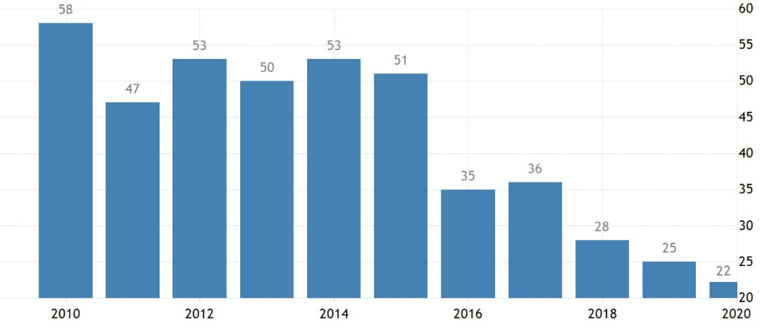

Figure A.1 – Kazakhstan in World Bank’s “doing business” ranking (2010-2020)

Note – Extracted from the source [17; 19] and further compiled by the author

APPENDIX B

Table B.1 – Classification of entrepreneurs
Classification | Description
Potential entrepreneurs | Those that recognize opportunities in their circumstances, have the ability to launch a new firm, and are fearless of failure
Intentional entrepreneurs | Those that aim to launch a new firm in the near future (in the subsequent three years)
Nascent entrepreneurs | Those that have made preparations to launch a new firm, but have not yet paid wages or salaries for over three months
New entrepreneurs | Those that have been operating their firm for between three and forty-two months
Established business owners | Those that have been operating their firm for more than forty-two months
Discontinued entrepreneurs | Those that have given up running their firm in the last year for whatever reason
Note – Compiled by the author based on the source [16, p. 11]

APPENDIX C
Table C.1 – Indices of PESTEL factors
Factor | Index | Description | Result | Assessment
P | Freedom | Based on 15 civil liberties and 10 political rights | 22/100  (2019 scores) | Not free
 | Political stability index | World average in 2018 for 195 countries: -0.05 points | 0  (2018 scores) | Politically stable
S | Population growth rate | Estimated population: 19.1 million (68% of Kazakhs, 19.3% of Russians, and others); growth rate: 0.89% | 89th/171 (2019 rank) | Low population growth rate
 | Net migration rate | 0.4 migrants/1,000 people | 51st/121 (2019 rank) | Low migration rate
 | Life expectancy | Median age: 31.6 years; life span: 72 years | 85th/138 (2019 rank) | Relatively low life span
 | Prosperity index | High scores in education and investment environment; largest enhancement in social capital | 68th/167 (2019 rank) | Increasingly promising
 | Global social mobility index | Key indicators: health, education, technology, work, protection, and institutions; Overall index score: 64.8 | 38th/82 (2020 rank) | High capacity for a child to experience a better life than their parents
T | Global competitive index | Stimulators of productivity and long-term economic development reported by WEF; score: 63 points (at 12 pillars or 103 indicators) | 55th/141 (2019 rank) | Increasingly competitive
 | Global innovation index | Based on innovation capabilities; 80 indicators | 79th/129 (2019 rank) | Increasingly innovative
E | The world’s best countries | Citizenship (1.7), adventure (5.2), entrepreneurship (0.6), cultural influence (0.0), movers (26.6), heritage (3.2), power (7.8), open for business (29.9), and quality of life (4.9) | 66th/80 (2019 rank) | Relatively low among the best countries
 | Environmental performance index | Scores: 54.56/100 | 101st/180 (2018 rank) | Medium environmental performance
 | Global tourism ranking | Reported by WEF | 81st/136 (2018 rank) | Medium tourism ranking
 | Rule of law index | Compliance with international best practices and upgrade of legal framework reported by WJP | 62nd/128 (2020 rank) | Highest in Central Asia
L | Doing business ranking | Ease of doing business | 22nd/190 (2020 rank) | High ranking
 | Global  entrepreneurship index | GEI | 64th/137 (2020 rank) | Medium entrepreneurial ranking
Note – Compiled by the author based on the sources [17; 23; 89; 92; 93; 94; 95; 96; 97; 98; 99, p. 19]

APPENDIX D

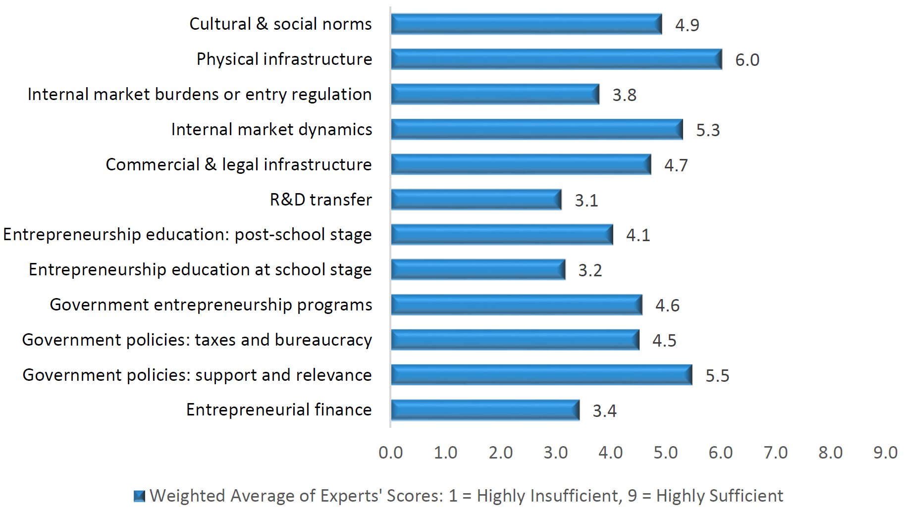

Figure D.1 – Averages for Kazakhstan’s EE (2019)
Note – Extracted from the source [16, p. 44]
APPENDIX E

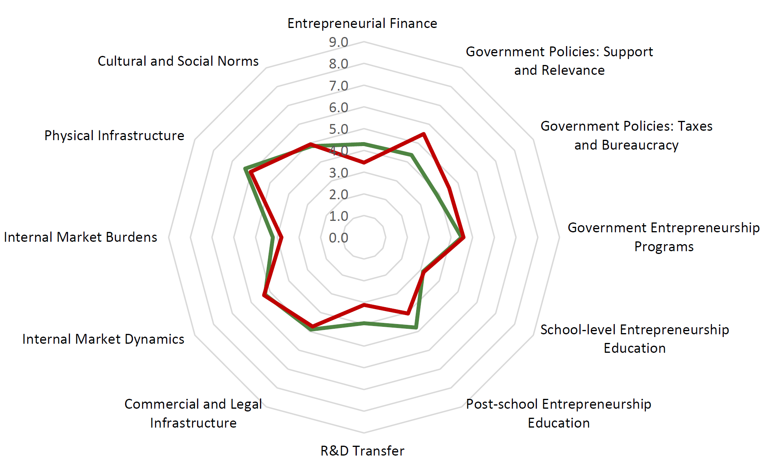
Figure E.1 – Average status of Kazakhstan’s EE compared to GEM averages (2019)
Note – Extracted from the source [16, p. 45]
APPENDIX F

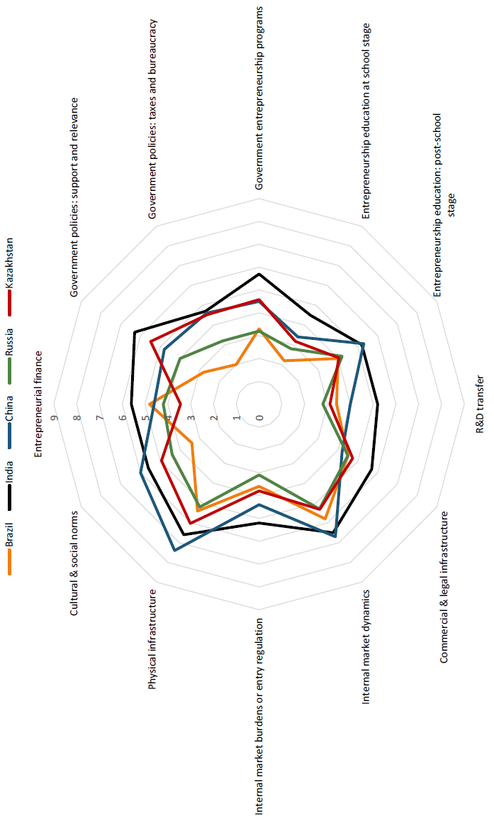
Figure F.1 – Average status of Kazakhstan’s EE compared to BRICS averages (2019)
Note – Extracted from the source [16, p. 46]

APPENDIX G

Table G.1 – Main constraints and facilitators for entrepreneurship in Kazakhstan (2019)
Constraints | % | Facilitators | %
Financial support | 52.9 | Government policies | 78.8
Political, institutional, and social climate | 44.1 | Government programs | 42.4
Government policies | 38.2 | Economic conditions | 24.2
Economic conditions | 32.3 | Financial support | 15.1
Corruption | 29.4 | Education and training programs | 12.1
Education and training programs | 23.5 | Political, institutional, and social climate | 12.1
Physical infrastructure | 11.8 | Internationalization | 12.1
Access to internal market | 8.8 | Entrepreneurial capacity | 9.0
Labor expenses, access, and regulation | 5.9 | Socio-cultural norms | 6.0
Socio-cultural norms | 5.9 | Labor expenses, access, and regulation | 3.0
Entrepreneurial capacity | 5.9 | Corruption | 3.0
R&D transfer | 2.9
Notes:
1. Experts could indicate several constraining and facilitating factors.
2. Compiled by the author based on the source [16, p. 48].

APPENDIX H

Table H.1 – Single factors influencing EI
Category | Factors | Typical variables
1 | 2 | 3
Demographic factors | Gender, age, ethnic background, education level, nationality, religion, geography, etc. | – Gender;  – Age;  – Religion
Personality or Personal factors | Personal characteristics or personality traits including need for achievement (N-Ach), capacity to generate networks, self-efficacy (SE), risk-taking propensity, innovativeness or creativity, competitiveness, intelligence or talents, lifestyle, optimism, autonomy or need for independence, stress tolerance, tolerance of ambiguity, locus of internal control, management capability, technical professional ability, business expertise or experience in leadership and entrepreneurship, etc. | – Optimism;  – N-Ach;  – Competitiveness;  – Innovativeness;  – Locus of control;  – Risk-taking propensity;  – Leadership;  – SE;  – Perceived skills;  – Perceived barriers;  – Rebelliousness;  – Empathy
Situational factors | Triggering events, such as an alteration in the person’s life path, time constraints, job satisfaction, unemployment, low income, task difficulty, ideas and opportunities, the influence of other people, etc. | – Ideas and opportunities;  – Job satisfaction;  – Low income
Cognitive factors | cognitive structures (knowledge structures), cognitive processes, etc. | – Arrangement scripts;  – Willingness scripts;  – Ability scripts;  – Cognitive styles;  – Decision making
Social factors | Previous managerial, entrepreneurial, or industrial experiences, life experiences, role models (e.g., close friends, immediate family, extended family, mentors), business incubators, education support, etc. | – Prior experiences;  – Role models;  – Entrepreneurship education;  – Business incubators
Environmental factors | Socio-cultural norms, social relations or networks, economic and political infrastructure, physical and institutional infrastructure, commercial and legal infrastructure, entrepreneurial finance or access to capital, government policy or support, | – Culture;  – Entry regulation;  – Access to capital;  – Availability of information;  – Social networks;  – Government support;  – R&D transfer;

Continuation of table H.1
1 | 2 | 3
Environmental factors | research and development (R&D) transfer, entry regulation, market dynamics, information, industry sectors, competitors, customers, supply of materials, techniques of production, human resources, etc. | – Physical infrastructure;  – Commercial and legal infrastructure;  – Economic and political infrastructure;  – Internal market dynamics
Note – Compiled by the author based on the sources [31, p.8; 34, p.40; 35, p.3,4,5; 56, p.179,182; 70, p.47; 143, p.411,420; 149, p.23; 150, p.205,209; 151, p.27; 158, p.42; 159, p.511; 160, p.5,10; 163, p.15; 165, p.63; 168; p.23; 172, p.696; 173, p.361,370; 174, p.221; 188, p.45; 204, p.135; 208, p.7; 209-210; 211, p.30; 212-220; 222, p.62; 223, p.259; 224-228; 229, p.15,16; 230-234; 236-239; 241, p.155; 242-251; 252, p.49; 256; 257; 258, p.974; 259-293; 294, p.1018; 295-296; 297, p.10; 298-306]

APPENDIX J

Table J.1 – Examples of combined (groups of) single factors

Researches | Combined (groups of) single factors
1 | 2
Scott and Twomey | – Parental influence;  – Work experience
Scherer et al. | – Internal attributes (personality, characteristics, etc.);  – External attributes (competition, consumers, investors, etc.)
Learned | – Psychological traits;  – Background experiences;  – Favorable situations
Ang and Hong | – Personality traits (risk-taking propensity, tolerance for ambiguity, internal locus of control, innovativeness, and independence);  – Motivational factors (love for money, desire for security, and desire for status);  – Contextual factors
Douglas and Shepherd | – Personal traits (independence, and risk-taking propensity);  – Potentiality of income
Lüthje and Franke | – Internal factors (self-optimism, and willingness);  – External factors (opportunities, support, and education)
Veciana et al. | – Desirability;  – Feasibility;  – Gender;  – Entrepreneurial history
Langowitz and Minniti | – Socio-demographic factors;  – Perceptual variables;  – Contextual factors
Türker and Selçuk | – Personality characteristics;  – External factors
Von Graevenitz et al. | – Background factors;  – Environmental factors
Wang et al. | – Family background;  – Work experience
Jayshree and Ramraj | – Networking;  – Finance;  – Technology;  – Market;  – Environment;  – Moral support;  – Social support;  – Government support
De Clercq et al. | External factors such as:  – a lack of regular employment options;  – an unfavorable economic environment
Fayolle and Gailly | – Entrepreneurial training programs;  – Start-up experience
Schillo et al. | – Analysis of individual level;  – analysis of country level
Continuation of table J.1
1 | 2
Thu and Hieu | – TPB components;  – Perceived level of risks;  – Demographic factors (gender, age, parent occupation, prior exposure, and work experience);  – Entrepreneurship education programs
Note – Compiled by the author based on the sources [56, p. 179; 167, p. 81; 169, p. 142; 201, p. 165; 204, p. 135; 208, p. 7; 233, p. 285; 235, p. 5; 309; 310, p. 1; 311, p. 341; 312, p. 1; 313, p. 35; 314, p. 95; 315, p.; 315, p. 652; 317, p. 1]

APPENDIX K

Table K.1 – Established or frequently cited intention-based models
Model | Factors
1 | 2
Shapero’s model of entrepreneurial event (SEE) | – Perceived desirability;  – Perceived feasibility;  – Propensity to act
Bird’s implementing entrepreneurial ideas model | – Social, political, and economic context;  – Rational and analytic thinking;  – Personal history, personality, and abilities;  – Intuitive holistic thinking
Robinson’s et al. entrepreneurial attitude orientation model | – Achievement in business;  – Perceived personal control of business outcomes;  – Innovation in business;  – Perceived self-esteem in business
Ajzen’s theory of planned behavior model (TPB) | – Personal attitude (PA);  – Subjective norms (SNs);  – Perceived behavioral control (PBC)
Krueger and Carsrud’s intentional basic model | – Exogenous influences on behavior;  – Attitudes towards target behavior
Krueger and Carsrud’s theory of planned behavior entrepreneurial model | – Exogenous influences on entrepreneurial activity;  – Perceived social norms about entrepreneurial behavior;  – Perceived self-efficacy (SE) for entrepreneurial behavior;  – Perceived attractiveness of entrepreneurial behavior;  – Exogenous precipitating, facilitating or inhibiting influences
Krueger and Brazeal’s entrepreneurial potential model | – Perceived desirability;  – Perceived feasibility;  – Credibility;  – Potential;  – Propensity to act;  – Precipitating event
Boyd and Vozikis’ intention model | – Personal history, personality, and abilities;  – Social, political, and economic context;  – Stored information (beliefs);  – Intuitive, holistic, and contextual thinking;  – Rational, analytical, and cause-effect thinking;  – Attitudes and perceptions;  – SE
Davidsson’s economic-psychological model | – Personal background;  – General attitudes;  – Domain attitudes;  – Conviction;  – Situation
Douglas and Shepherd’s maximization of expected utility model | – Income;  – Individuality;  – Risk-taking;  – Workload
Continuation of table K.1
1 | 2
Elfving’s et al. contextual intention model | – Trigging event;  – Motivation;  – SE;  – Superordinate goal;  – Entrepreneurial goal;  – Perceived entrepreneurial desirability;  – Perceived entrepreneurial feasibility;  – Opportunity evaluation;  – Entrepreneurial behavior
Note – Compiled by the author based on the sources [54, p. 444; 56, p. 182; 141, p. 317; 155, p. 13; 159, p. 294; 163, p. 5; 165, p. 65; 166, p. 95; 167, p. 18; 168, p. 29]

APPENDIX L

Table L.1 – Forms of government support (GS)
Government support | Description
Educational support | – Entrepreneurial education and training
Cultural support | – Socio-cultural norms on entrepreneurship;  – Increasing the knowledge and empathy of government officials towards entrepreneurship;  – Building confidence in new and growing ventures
Environmental support | – Access to market;  – Access to information;  – Creation of opportunities;  – Improving commercial, legal, and physical infrastructures;  – Provision of resources;  – Favorable external connections
Financial support | – Financial aid;  – Grants;  – Loans;  – Subsidies;  – Investment;  – Funds
Government policies | – Health system and medical measures;  – Employment-related measures;  – Maintaining and stimulating markets;  – Monetary and fiscal policies;  – Regulatory measures on customs duties and tariffs;  – Tax incentives;  – Simplified regulations for doing business;  – National-level and state-level emergency measures;  – Anti-red-tape measures;  – Anti-corruption measures;  – Anti-bureaucracy measures;  – Agency services;  – E-governance
Government programs | – Public procurement;  – Business incubators and science parks;  – Specific initiatives for new and growing ventures;  – Innovation activities
Note – Compiled by the author based on the sources [32, р. 1557; 36, р. 43; 38, р. 1027; 102, р. 13; 103, р. 679; 104, р. 1037; 105, р. 387; 113, р 106]

APPENDIX M

Requests to Atameken, COS, and DOJ on providing data for research work
(original in English and Russian)
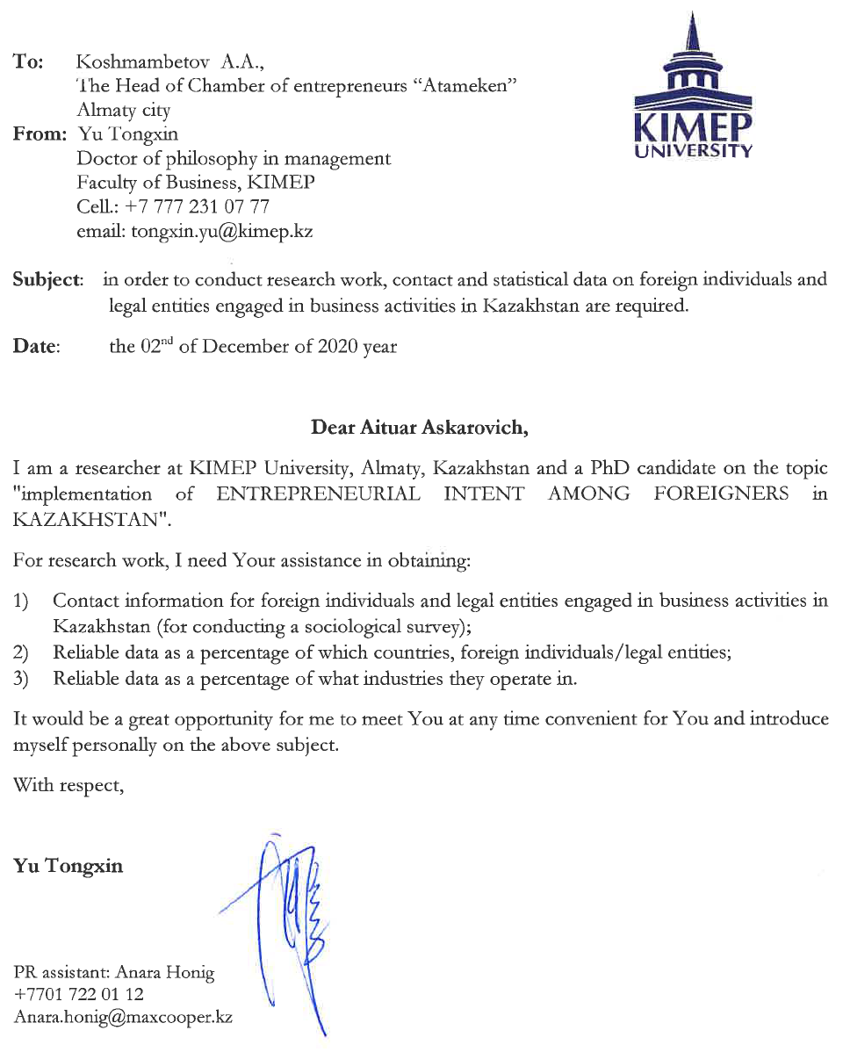

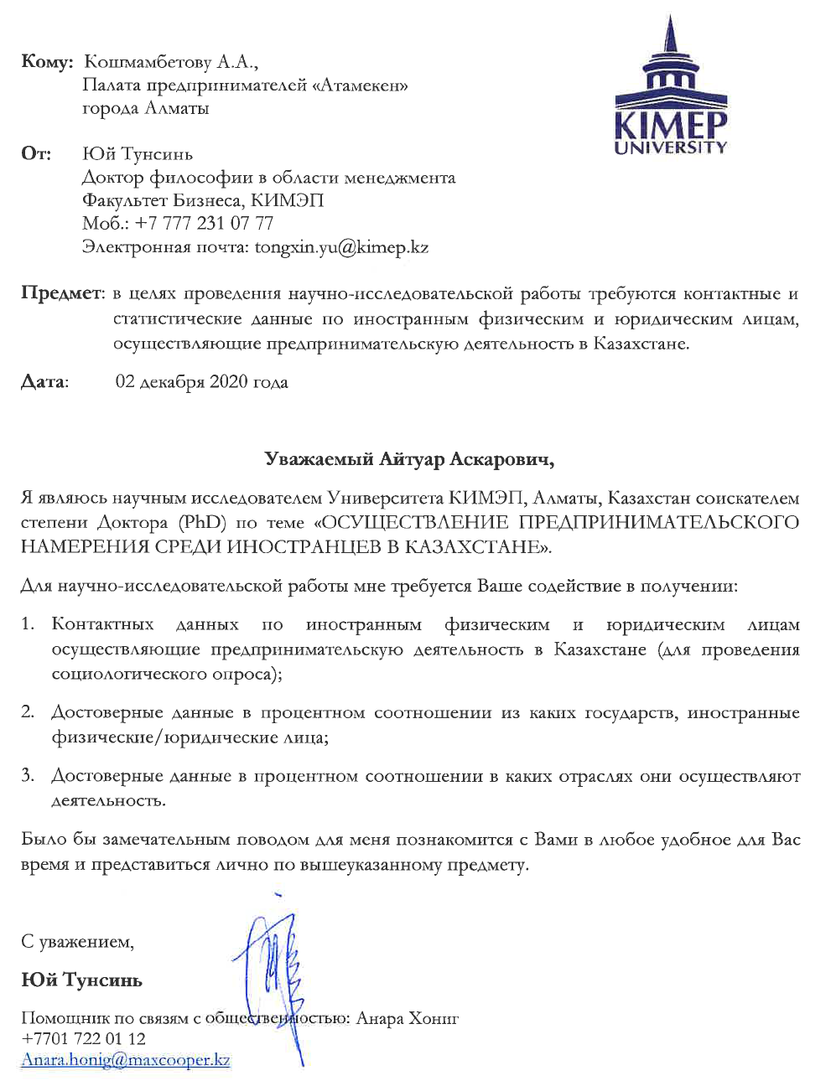

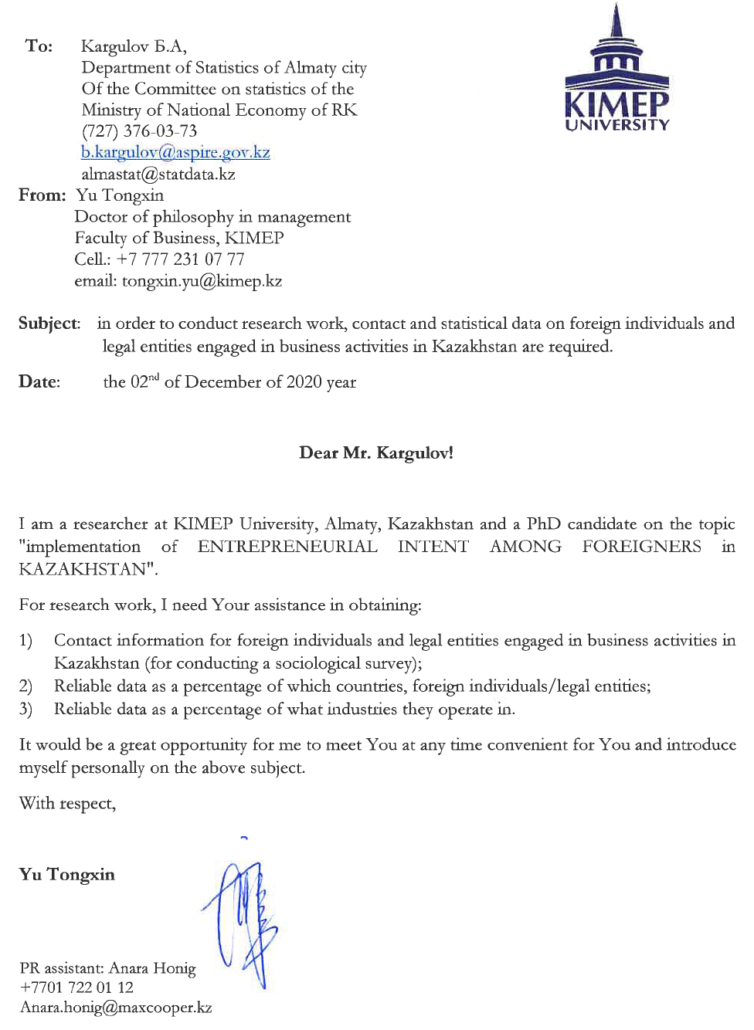

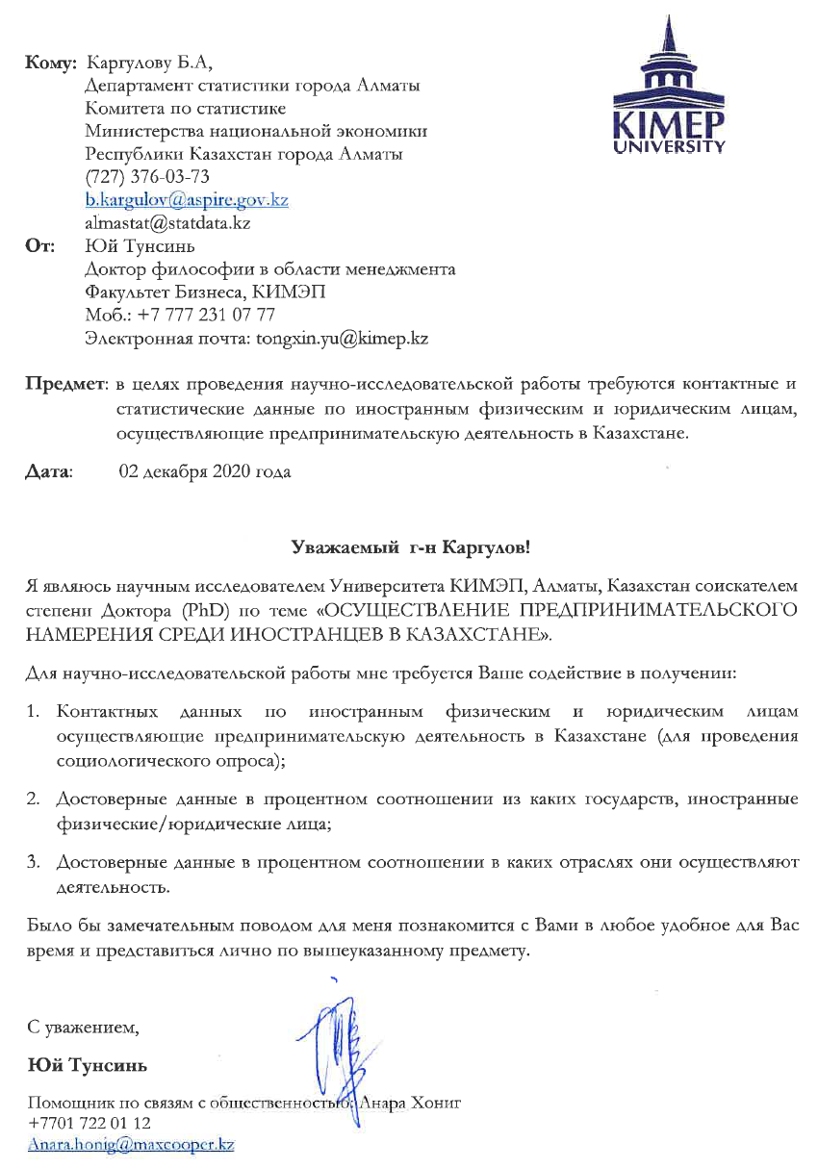


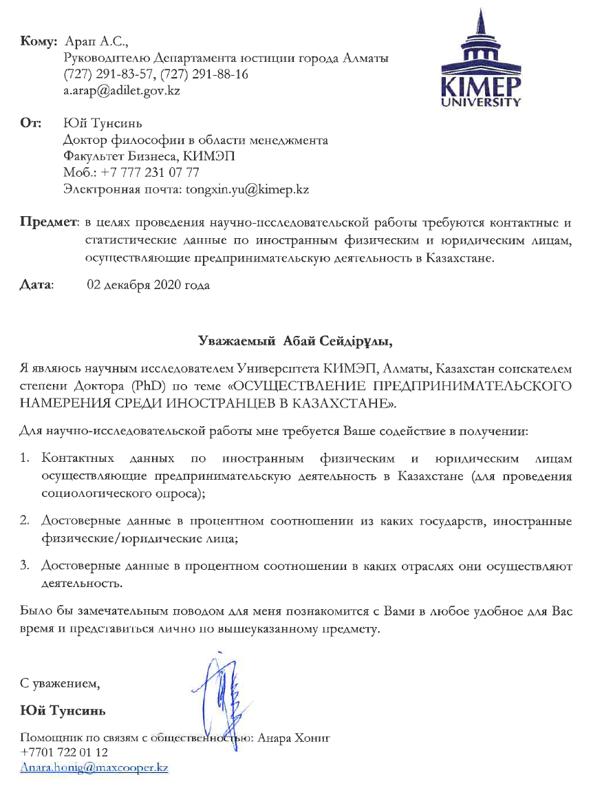

APPENDIX N

Replies from Atameken, COS, and DOJ on providing data for research work
(original in Russian and/or Kazakh; translation in English)

Reply from Atameken (original in Russian)

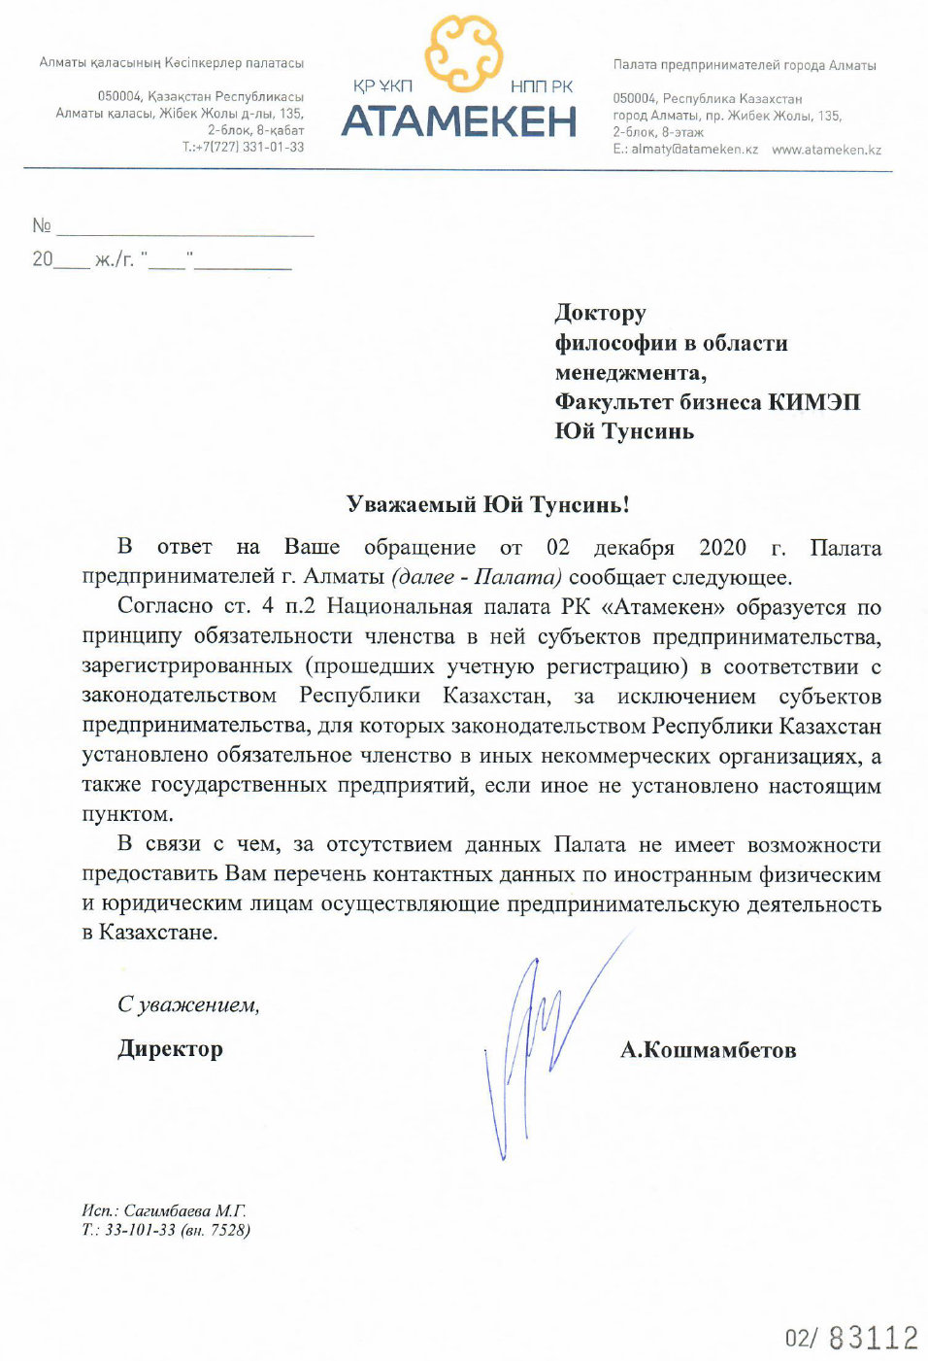
Reply from Atameken (translation in English)

Doctor of Philosophy in Management
Faculty of Business, KIMEP
Yu Tongxin
tongxin.yu@kimep.kz

Dear Yu Tongxin,
In response to your request dated December 2, 2020, the Chamber of Entrepreneurs of Almaty (hereinafter referred to as “the Chamber”) informs the following.
According to Article 4, paragraph 2, the National Chamber of the Republic of Kazakhstan “Atameken” is formed on the principle of mandatory membership in it of business entities registered in accordance with the legislation of the Republic of Kazakhstan, with the exception of subjects entrepreneurship, for which the legislation of the Republic of Kazakhstan establishes mandatory membership in other non-profit organizations, as well as state-owned enterprises, unless otherwise established by this paragraph.
In this regard, due to the lack of data, the Chamber is not able to provide you with a list of contact details for foreign individuals and legal entities engaged in entrepreneurial activity in Kazakhstan.

Regards,
Director A. Koshmambetov

Reply from COS (original in Kazakh and Russian)



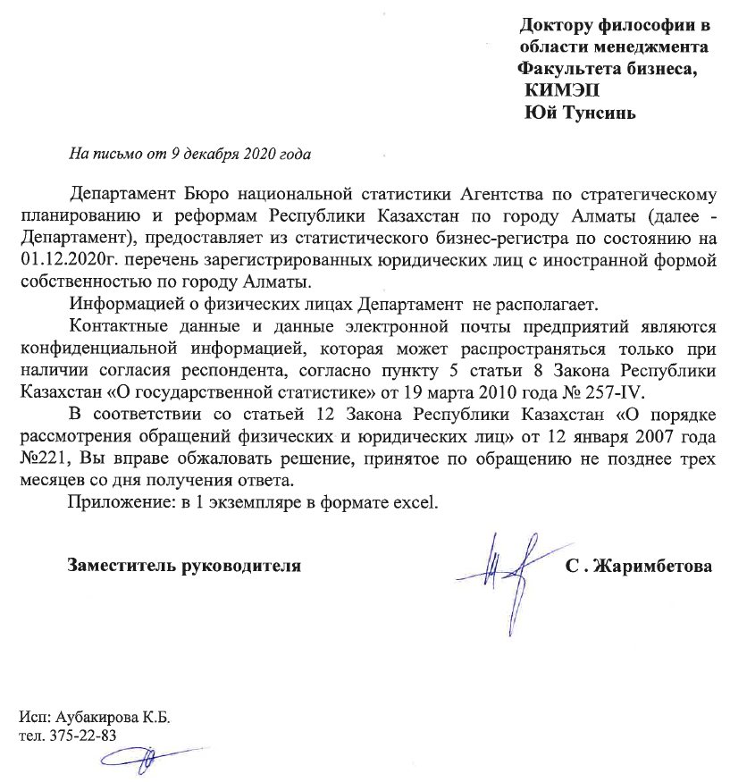

Reply from COS (translation in English)

Doctor of Philosophy in Management
Faculty of Business, KIMEP
Yu Tongxin
tongxin.yu@kimep.kz

To the letter dated December 9, 2020
Department of the Bureau of National Statistics of the Agency for Strategic Planning and Reforms of the Republic of Kazakhstan in the city of Almaty (hereinafter -the Department), provides from the statistical business register as of 01.12.2020 a list of registered legal entities with foreign ownership in the city of Almaty.
The Department does not have information about individuals.
Contact data and e-mail data of enterprises are confidential information that can be distributed only with the consent of the respondent, according to paragraph 5 of Article 8 of the Law of the Republic of Kazakhstan “On State Statistics” dated March 19, 2010 No. 257-IV.
In accordance with Article 12 of the Law of the Republic of Kazakhstan “On the procedure for considering appeals of individuals and legal entities” dated January 12, 2007 № 221, you have the right to appeal the decision taken on the appeal no later than three months from the date of receipt of the response.
Application: in 1 copy in excel format.

Deputy head S. Zharimbetova
Isp: Aubakirova K. B.
Tel. 375-22-83

Reply from DOJ (original in Russian)

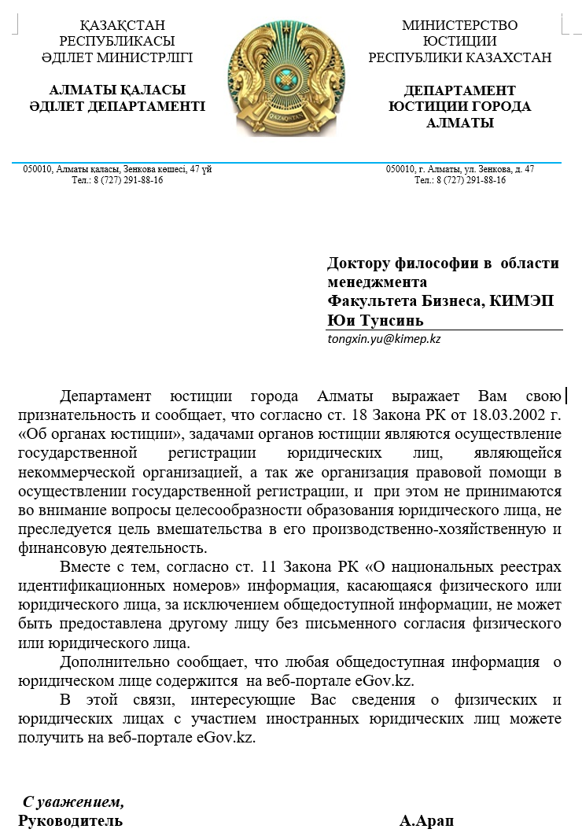

Reply from DOJ (translation in English)

Doctor of Philosophy in Management
Faculty of Business, KIMEP
Yu Tongxin
tongxin.yu@kimep.kz

The Department of Justice of the city of Almaty expresses its gratitude to you and informs that according to Art. 18 of the Law of the Republic of Kazakhstan dated March 18, 2002 “judicial authorities”, the tasks of the justice authorities are the implementation of state registration of legal entities, which is a non-profit organization, as well as the organization of legal assistance in the implementation of state registration, and at the same time the issues of the expediency of education are not taken into account legal entity, the purpose of interference in its production, economic and financial activities is not pursued.
At the same time, according to Art. 11 of the Law of the Republic of Kazakhstan “On National Registers of Identification Numbers”, information relating to an individual or legal entity, with the exception of publicly available information, cannot be provided to another person without the written consent of an individual or legal entity.
Additionally, it informs that any publicly available information about a legal entity is contained on the eGov.kz web portal.
In this regard, the information you are interested in about individuals and legal entities with the participation of foreign legal entities can be obtained on the eGov.kz web portal.

Yours faithfully,
Head A. Arap

APPENDIX P

Table P.1 – Probability and non-probability sampling designs
Sampling design | Description | Advantages | Disadvantages
1 | 2 | 3 | 4
Probability sampling
Simple random sampling | Every element of the population is taken into account, and each element has an equal probability of being picked as the subject. | Findings are high generalizable. | Less effective than stratified sampling.
Systematic sampling | Beginning at a random position in the sample frame, every nth element of the population is selected. | If the sample frame is accessible, it is simple to utilize. | There can be systematic biases.
Stratified random sampling (Str.R.S.)  Proportionate Str.R.S.  Disproportionate Str.R.S. | First, the population is split into meaningful segments; then, subjects are selected in proportion to their original numbers. Other than their initial population counts, they were chosen based on various criteria. | Among all probability designs, this one is the most efficient.  All groups are well-represented, and comparisons between them are conceivable. | Stratification has to be meaningful. It takes more time than simply random or systematic sampling. It is critical to have a sampling frame for each stratum.
Cluster sampling | The members of heterogeneous groups are first identified, then some are picked at random, and all of the members in each of the randomly chosen groups are examined. | Data collecting expenses are cheap in geographic clusters. | Because subsets of clusters are more homogenous than diverse, it is the least stable and efficient of all probability sampling designs.
Area sampling | Within a certain area or location, cluster sampling is used. | Cost‐effective. Members of heterogeneous groups are initially identified, after which some are chosen at random and all members of each of the randomly chosen groups are inspected to a certain location. | It takes time to gather data from a certain location.

Continuation of table P.1
1 | 2 | 3 | 4
Double sampling | The same sample, or a subset of it, is investigated twice. | Provides additional in-depth information on the subject of study. | Any existing biases will be carried over. Individuals may not be satisfied with a second response.
Non-probability sampling
Convenience sampling | Subjects are picked from among the members who are the most conveniently available. | Fast, easy, and cost-effective. | Not at all generalizable.
Judgment sampling | Subjects were chosen based on their knowledge of the subject under investigation. | Sometimes, the only useful method of investigation. | Generalizability is doubtful; not applicable to the entire population.
Quota sampling | Subjects are simply selected from targeted groups based on a preset quantity or quota. | When minority involvement in a study is crucial, this tool comes in handy. | It's difficult to generalize.
Note – Compiled by the author based on the sources [353, р. 240; 359, р. 210]

APPENDIX Q

Table Q.1 – Morgan’s table

P | N | P | N | P | N | P | N | P | N
10 | 10 | 100 | 80 | 280 | 162 | 800 | 260 | 2800 | 338
15 | 14 | 110 | 86 | 290 | 165 | 850 | 265 | 3000 | 341
20 | 19 | 120 | 92 | 300 | 169 | 900 | 269 | 3500 | 346
25 | 24 | 130 | 97 | 320 | 175 | 950 | 274 | 4000 | 351
30 | 28 | 140 | 103 | 340 | 181 | 1000 | 278 | 4500 | 354
35 | 32 | 150 | 108 | 360 | 186 | 1100 | 285 | 5000 | 357
40 | 36 | 160 | 113 | 380 | 191 | 1200 | 291 | 6000 | 361
45 | 40 | 170 | 118 | 400 | 196 | 1300 | 297 | 7000 | 364
50 | 44 | 180 | 123 | 420 | 201 | 1400 | 302 | 8000 | 367
55 | 48 | 190 | 127 | 440 | 205 | 1500 | 306 | 9000 | 368
60 | 52 | 200 | 132 | 460 | 210 | 1600 | 310 | 10000 | 370
65 | 56 | 210 | 136 | 480 | 214 | 1700 | 313 | 15000 | 375
70 | 59 | 220 | 140 | 500 | 217 | 1800 | 317 | 20000 | 377
75 | 63 | 230 | 144 | 550 | 226 | 1900 | 320 | 30000 | 379
80 | 66 | 240 | 148 | 600 | 234 | 2000 | 322 | 40000 | 380
85 | 70 | 250 | 152 | 650 | 242 | 2200 | 327 | 50000 | 381
90 | 73 | 260 | 155 | 700 | 248 | 2400 | 331 | 75000 | 382
95 | 76 | 270 | 159 | 750 | 254 | 2600 | 335 | 1000000 | 384
Notes:
1 – P is population size; N is sample size.
2 – Extracted from and compiled by the author based on the source [362, p. 607-610]

APPENDIX R

Survey Questionnaires


Questionnaire (English version)

Dear Participant,

I am doing research at KIMEP University in Almaty, Kazakhstan, and I would like to ask for your help in gathering data for my research. This survey aims to learn more about how “personal attitude”, “subjective norms”, and “perceived behavioral control” impact foreigners’ “intention” to start businesses in Kazakhstan, as well as how “government support” moderates these impacts. The ultimate goal is to present specific proposals that will encourage foreign entrepreneurship and enhance the country’s economic prospects. The survey will take around 15 minutes to complete. It is entirely voluntary for you to participate in this study, and I greatly appreciate it. You may discontinue participation in this survey, if you wish, at any point and time.
Please rest assured that this is an anonymous survey, and that none of the data obtained will be disclosed. The data will be used only for the purposes of this study. As a result, no personal information will be released. Only numbers will be used to identify you; your name will never be linked to any of your responses. To improve the credibility of the final report, please do feel free to provide your most genuine responses to the question items.
Please do not hesitate to reach me, using the information listed below for contact, if you have any ambiguities regarding the questionnaire. Your valuable time and kind contribution would be highly appreciated!
Yours sincerely,
Yu Tongxin
Ph.D. in Management
Bang College of Business
KIMEP University, Almaty, Kazakhstan.
Mob: +7 777 231 07 77
Email: tongxin.yu@kimep.kz

Questionnaire on “Entrepreneurial Intention among Foreigners in Kazakhstan”
Section 1: Factors Influencing Entrepreneurial Intention
Instructions: This section is completed by ticking (√) the applicable boxes. For single-item questions, please select between “Yes” and “No”; for other statements, scores “1-7” means that you “strongly-normally-somewhat disagree-neutral-somewhat-normally-strongly agree”, respectively. There is no classification of correct or incorrect responses. Your comments solely reflect your own views. Please complete all the questions to assure of its usefulness for the survey.
Q1. Entrepreneurial Intention
Are you already an entrepreneur with experience of more than 3 months and still running a business currently? 1☐ Yes 2☐ No

Table Q.1 – Please tick (√) the boxes which best represent your level of agreement. If you are already an entrepreneur, please choose the answers based on the situation before starting up your own business.
Statement | Level of Agreement
 | Strongly Disagree | Neutral |  |  |  |  | Strongly Agree
Entrepreneurial intention
I am ready to do anything to be an entrepreneur. | 1☐ | 2☐ | 3☐ | 4☐ | 5☐ | 6☐ | 7☐
My professional goal is to become an entrepreneur. | 1☐ | 2☐ | 3☐ | 4☐ | 5☐ | 6☐ | 7☐
I will make every effort to start and run my own firm. | 1☐ | 2☐ | 3☐ | 4☐ | 5☐ | 6☐ | 7☐
I am determined to create a firm in the future. | 1☐ | 2☐ | 3☐ | 4☐ | 5☐ | 6☐ | 7☐
I have very seriously thought of starting a firm. | 1☐ | 2☐ | 3☐ | 4☐ | 5☐ | 6☐ | 7☐
I have the firm intention to start a firm some day. | 1☐ | 2☐ | 3☐ | 4☐ | 5☐ | 6☐ | 7☐

Q2. Personal Attitude

Table Q.2 – Please tick (√) the boxes which best represent your level of agreement. If you are already an entrepreneur, please choose the answers based on the situation before starting up your own business.
Statement | Level of Agreement
 | Strongly Disagree | Neutral |  |  |  |  | Strongly Agree
Personal attitude
Being an entrepreneur implies more advantages than disadvantages to me. | 1☐ | 2☐ | 3☐ | 4☐ | 5☐ | 6☐ | 7☐
It is desirable for me to become an entrepreneur. | 1☐ | 2☐ | 3☐ | 4☐ | 5☐ | 6☐ | 7☐
It is attractive for me to become an entrepreneur. | 1☐ | 2☐ | 3☐ | 4☐ | 5☐ | 6☐ | 7☐
If I had the opportunity and resources, I would love to start a business. | 1☐ | 2☐ | 3☐ | 4☐ | 5☐ | 6☐ | 7☐
Being an entrepreneur would give me great satisfaction. | 1☐ | 2☐ | 3☐ | 4☐ | 5☐ | 6☐ | 7☐
Among various options, I would rather be an entrepreneur. | 1☐ | 2☐ | 3☐ | 4☐ | 5☐ | 6☐ | 7☐
Q3. Subjective Norms

Table Q.3 – Please tick (√) the boxes which best represent your level of agreement. If you are already an entrepreneur, please choose the answers based on the situation before starting up your own business.
Statement | Level of Agreement
 | Strongly Disagree | Neutral |  |  |  |  | Strongly Agree
Subjective norms
My closest family members think that I should pursue a career as an entrepreneur. | 1☐ | 2☐ | 3☐ | 4☐ | 5☐ | 6☐ | 7☐
I do care about what my closest family members think as I decide on whether or not to pursue a career as self-employed. | 1☐ | 2☐ | 3☐ | 4☐ | 5☐ | 6☐ | 7☐
My closest friends think that I should pursue a career as an entrepreneur. | 1☐ | 2☐ | 3☐ | 4☐ | 5☐ | 6☐ | 7☐
I do care about what my closest friends think as I decide on whether or not to pursue a career as self-employed. | 1☐ | 2☐ | 3☐ | 4☐ | 5☐ | 6☐ | 7☐
People that are important to me think I should pursue a career as an entrepreneur. | 1☐ | 2☐ | 3☐ | 4☐ | 5☐ | 6☐ | 7☐
I do care about what people important to me think as I decide on whether or not to pursue a career as self-employed. | 1☐ | 2☐ | 3☐ | 4☐ | 5☐ | 6☐ | 7☐

Q4. Perceived Behavioral Control

Table Q.4 – Please tick (√) the boxes which best represent your level of agreement. If you are already an entrepreneur, please choose the answers based on the situation before starting up your own business.
Statement | Level of Agreement
 | Strongly Disagree | Neutral |  |  |  |  | Strongly Agree
Perceived behavioral control
If I wanted to, I could easily become an entrepreneur. | 1☐ | 2☐ | 3☐ | 4☐ | 5☐ | 6☐ | 7☐
Starting a business and keeping it viable would be easy for me. | 1☐ | 2☐ | 3☐ | 4☐ | 5☐ | 6☐ | 7☐
I am able to control the creation process of a new business. | 1☐ | 2☐ | 3☐ | 4☐ | 5☐ | 6☐ | 7☐
If I tried to start a new business, I would have a high chance of being successful. | 1☐ | 2☐ | 3☐ | 4☐ | 5☐ | 6☐ | 7☐
I know most about the practical details needed to start a business. | 1☐ | 2☐ | 3☐ | 4☐ | 5☐ | 6☐ | 7☐

Q5. Government Support

Table Q.5 – Please tick (√) the boxes which best represent your level of agreement.
Statement | Level of Agreement
 | Strongly Disagree | Neutral |  |  |  |  | Strongly Agree
Government policies
Government policies (e.g., public procurement) consistently favor new firms | 1☐ | 2☐ | 3☐ | 4☐ | 5☐ | 6☐ | 7☐
The support for new and growing firms is a high priority for policy at the national government level | 1☐ | 2☐ | 3☐ | 4☐ | 5☐ | 6☐ | 7☐
The support for new and growing firms is a high priority for policy at the local government level | 1☐ | 2☐ | 3☐ | 4☐ | 5☐ | 6☐ | 7☐
New firms can get most of the required permits and licenses in about a week | 1☐ | 2☐ | 3☐ | 4☐ | 5☐ | 6☐ | 7☐
The amount of taxes is NOT a burden for new and growing firms | 1☐ | 2☐ | 3☐ | 4☐ | 5☐ | 6☐ | 7☐
Taxes and other government regulations are applied to new and growing firms in a predictable and consistent way | 1☐ | 2☐ | 3☐ | 4☐ | 5☐ | 6☐ | 7☐
Coping with government bureaucracy, regulations, and licensing requirements is easy for new and growing firms. | 1☐ | 2☐ | 3☐ | 4☐ | 5☐ | 6☐ | 7☐
Government programs
A wide range of government assistance for new and growing firms can be obtained through contact with a single agency | 1☐ | 2☐ | 3☐ | 4☐ | 5☐ | 6☐ | 7☐
Science parks and business incubators provide effective support for new and growing firms | 1☐ | 2☐ | 3☐ | 4☐ | 5☐ | 6☐ | 7☐
There are an adequate number of government programs for new and growing businesses | 1☐ | 2☐ | 3☐ | 4☐ | 5☐ | 6☐ | 7☐
The people working for government agencies are competent and effective in supporting new and growing firms | 1☐ | 2☐ | 3☐ | 4☐ | 5☐ | 6☐ | 7☐
Almost anyone who needs help from a government program for a new or growing business can find what they need | 1☐ | 2☐ | 3☐ | 4☐ | 5☐ | 6☐ | 7☐
Government programs aimed at supporting new and growing firms are effective | 1☐ | 2☐ | 3☐ | 4☐ | 5☐ | 6☐ | 7☐

Section 2: About Yourself
Instructions: You may complete this section in one of the two ways: by filling in the blanks or by ticking the boxes. Please fill in the blanks or tick (√) the appropriate boxes. The answers to these questions will be kept completely private. To guarantee that each questionnaire is informative, please answer all of the questions.
1) Gender: 1☐ Male 2☐ Female
2) Age (years old): 1☐ 18-25 2☐ 26-33 3☐ 34-41 4☐ 42-49 5☐ 50 and above
3) Country of origin………………………...
4) Are you currently: 1☐ Single 2☐ Married 3☐ Widowed 4☐ Divorced or separated 5☐ Other (specify)……………………...
5) Highest completed level of education: 1☐ Elementary school 2☐ High school 3☐ Undergraduate degree 4☐ Graduate degree 5☐ Other (specify)……….....
6) Job status: 1☐ Top management or senior specialist 2☐ Middle management or specialist 3☐ Nonmanagerial position 4☐ Other (specify)…………...

This is the end of the questionnaire.
Please double-check that you have not skipped any questions by accident.
Thank you!


Questionnaire (Russian version)

Анкета социологического опроса

Уважаемый участник,

Я являюсь научным исследователем Университета КИМЭП, Алматы, Казахстан и прошу Вас любезно оказать помощь в предоставлении информации для моих исследований. Эта анкета предназначена для дальнейшего понимания того, влияют ли на «намерения» иностранцев по открытию бизнеса в Казахстане «личностные качества», «субъективные нормы», «воспринимаемый поведенческий контроль» и регулируемый «государственной поддержкой». Главная цель – представить стратегические предложения, направленные на развитие иностранного предпринимательства и улучшающие тем самым экономические перспективы страны. Заполнение анкеты занимает около 15 минут. Участие в этом исследовании является абсолютно добровольным, и я буду Вам крайне признателен за это. Вы имеете право прервать участие в опросе в любое время по собственному желанию без объяснения причин.
Я заверяю вас, что эта анкета анонимна, а все собранные данные и информация являются конфиденциальными и используются только для целей исследования, таким образом личные данные участников не подлежат обнародованию. Вам будет присвоен специальный номер, и Ваше имя никогда не будет связано с каким-либо из Ваших ответов. Не стесняйтесь отвечать на вопросы честно и искренне, чтобы повысить доверие к сводному отчету.
В случае возникновения вопросов, Вы можете связаться со мной, используя контактную информацию, указанную в анкете. Я высоко ценю Ваше содействие и время, которое Вы затрачиваете на него.
С уважением,
Юй Тунсинь
Доктор философии в области менеджмента
Факультет Бизнеса имени Бэнга, КИМЭП
Моб.: +7 777 231 07 77
Электронная почта: tongxin.yu@kimep.kz

Опрос по предпринимательским намерениям среди иностранцев в Казахстане
Раздел 1: Факторы, влияющие на предпринимательские намерения
Инструкции: Этот раздел заполняется, ставя галочки в соответствующие поля. Для вопросов из одного пункта, выберите “Да” или “Нет”; для других утверждений баллы “1”, “2”, “3”, “4”, “5”, “6”, а “7 " означает, что вы “категорически не согласны”, “не согласны”, “несколько не согласны”, “нейтральны”, “несколько согласны”, “согласны” и “полностью согласны” соответственно. Нет правильных или неправильных ответов, но есть выражение ваших взглядов. Пожалуйста, ответьте на все вопросы, чтобы обеспечить полезность каждой анкеты.

Вопрос № 1. Предпринимательское намерение
Вы уже являетесь предпринимателем с опытом работы более 3 месяцев и все еще ведете бизнес? 1☐ Да 2☐ Нет
Пожалуйста, отметьте (√) поля, которые лучше всего отражают ваш уровень согласия.

Таблица Q.1 – Если вы уже являетесь предпринимателем, пожалуйста, выберите ответы в зависимости от ситуации, прежде чем начинали собственное дело.
Утверждение | Уровень согласия
 | Категорически не согласен | Нейтрально |  |  |  |  | Полно стью согласен
Предпринимательские намерения:  Я готов сделать все, чтобы стать предпринимателем. | 1☐ | 2☐ | 3☐ | 4☐ | 5☐ | 6☐ | 7☐
Моя профессиональная цель – стать предпринимателем. | 1☐ | 2☐ | 3☐ | 4☐ | 5☐ | 6☐ | 7☐
Я приложу все усилия для того, чтобы открыть свою собственную фирму. | 1☐ | 2☐ | 3☐ | 4☐ | 5☐ | 6☐ | 7☐
Я полон решимости открыть фирму в будущем. | 1☐ | 2☐ | 3☐ | 4☐ | 5☐ | 6☐ | 7☐
У меня серьезные намерения по открытию фирмы. | 1☐ | 2☐ | 3☐ | 4☐ | 5☐ | 6☐ | 7☐
У меня твердое намерение, когда ни будь открыть свою фирму. | 1☐ | 2☐ | 3☐ | 4☐ | 5☐ | 6☐ | 7☐

Вопрос № 2. Личное отношение
Пожалуйста отметьте (√) поля, которые лучше всего отражают ваш уровень согласия.
Таблица Q.2 – Если вы уже являетесь предпринимателем, пожалуйста, выберите ответы в зависимости от ситуации, прежде чем начинали собственное дело

Утверждение | Уровень согласия
 | Катего рически не согласен | Нейтрально |  |  |  |  | Полно стью согласен
1 | 2 | 3 |  |  |  |  | 4
Личное отношение
Быть предпринимателем для меня подразумевает больше преимуществ, чем недостатков. | 1☐ | 2☐ | 3☐ | 4☐ | 5☐ | 6☐ | 7☐
Продолжение таблицы Q.2
1 | 2 | 3 |  |  |  |  | 4
Для меня желательно стать предпринимателем. | 1☐ | 2☐ | 3☐ | 4☐ | 5☐ | 6☐ | 7☐
Для меня привлекательно стать предпринимателем. | 1☐ | 2☐ | 3☐ | 4☐ | 5☐ | 6☐ | 7☐
Если бы у меня была возможность и ресурсы, я бы с удовольствием начал свой бизнес. | 1☐ | 2☐ | 3☐ | 4☐ | 5☐ | 6☐ | 7☐
Быть предпринимателем доставило бы мне большое удовлетворение. | 1☐ | 2☐ | 3☐ | 4☐ | 5☐ | 6☐ | 7☐
Среди различных вариантов я бы предпочел быть предпринимателем. | 1☐ | 2☐ | 3☐ | 4☐ | 5☐ | 6☐ | 7☐

Вопрос № 3. Субъективные нормы
Отметьте (√) поля, которые лучше всего отражают ваш уровень согласия.

Таблица Q.3 – Если вы уже являетесь предпринимателем, пожалуйста, выберите ответы в зависимости от ситуации, прежде чем начинали собственное дело

Утверждение | Уровень согласия
 | Категорически не согласен | Нейтрально |  |  |  |  | Полностью согласен
Субъективные нормы
Мои ближайшие родственники считают, что я должен заниматься карьерой предпринимателя. | 1☐ | 2☐ | 3☐ | 4☐ | 5☐ | 6☐ | 7☐
Я забочусь о том, что думают мои самые близкие члены семьи, если я решу заниматься ли карьерой в качестве самозанятого или нет. | 1☐ | 2☐ | 3☐ | 4☐ | 5☐ | 6☐ | 7☐
Мои самые близкие друзья считают, что я должен заниматься карьерой предпринимателя. | 1☐ | 2☐ | 3☐ | 4☐ | 5☐ | 6☐ | 7☐
Я забочусь о том, что думают мои самые близкие друзья, если я решу, заниматься ли карьерой в качестве самозанятого или нет. | 1☐ | 2☐ | 3☐ | 4☐ | 5☐ | 6☐ | 7☐
Люди, которые важны для меня, считают, что я должен заниматься карьерой предпринимателя. | 1☐ | 2☐ | 3☐ | 4☐ | 5☐ | 6☐ | 7☐
Для меня важно, что думают близкие для меня люди, если я решу заниматься карьерой в качестве самозанятого или нет. | 1☐ | 2☐ | 3☐ | 4☐ | 5☐ | 6☐ | 7☐

Вопрос №4. Воспринимаемый поведенческий контроль
Отметьте (√) поля, которые лучше всего отражают ваш уровень согласия.

Таблица Q.4 – Если вы уже являетесь предпринимателем, пожалуйста, выберите ответы в зависимости от ситуации, прежде чем начинали собственное дело

Утверждение | Уровень согласия
 | категорически не согласен | нейтрально |  |  |  |  | полностью согла сен
Воспринимаемый поведенческий контроль
Если бы я хотел, я мог бы легко стать предпринимателем. | 1☐ | 2☐ | 3☐ | 4☐ | 5☐ | 6☐ | 7☐
Начать бизнес и сохранить его жизнеспособным было бы легко для меня. | 1☐ | 2☐ | 3☐ | 4☐ | 5☐ | 6☐ | 7☐
Я могу контролировать про цесс создания нового бизнеса. | 1☐ | 2☐ | 3☐ | 4☐ | 5☐ | 6☐ | 7☐
Если бы я попытался начать новый бизнес, у меня был бы высокий шанс быть успешным. | 1☐ | 2☐ | 3☐ | 4☐ | 5☐ | 6☐ | 7☐
Я знаю больше всего о практических деталях, необхо димых для начала бизнеса. | 1☐ | 2☐ | 3☐ | 4☐ | 5☐ | 6☐ | 7☐

Вопрос №5. Государственная поддержка

Таблица Q.5 – Пожалуйста, отметьте (√) поля, которые лучше всего отражают ваш уровень согласия

Утверждение | Уровень согласия
 | Категорически не согласен | Нейтрально |  |  |  |  | Полно стью согла сен
1 | 2 | 3 |  |  |  |  | 4
Государственная политика
Государственные правила (например, государственные закупки) всегда благоприятствует новым фирмам. | 1☐ | 2☐ | 3☐ | 4☐ | 5☐ | 6☐ | 7☐
Поддержка новых и развиваю щихся фирм является одним из главных приоритетов политики государства на уровне центрального правительства. | 1☐ | 2☐ | 3☐ | 4☐ | 5☐ | 6☐ | 7☐
Продолжение таблицы Q.5
1 | 2 | 3 |  |  |  |  | 4
Поддержка новых и развивающихся фирм является одним из главных приоритетов политики государства на уровне местных органов власти. | 1☐ | 2☐ | 3☐ | 4☐ | 5☐ | 6☐ | 7☐
Новые фирмы могут получить практически все необходимые разрешения и лицензии примерно за неделю. | 1☐ | 2☐ | 3☐ | 4☐ | 5☐ | 6☐ | 7☐
Сумма налогов НЕ является обременительной для новых и развивающихся фирм. | 1☐ | 2☐ | 3☐ | 4☐ | 5☐ | 6☐ | 7☐
Налоги и другие меры государственного регулирования применяются к новым и развивающимся фирмам закономерно и последовательно. | 1☐ | 2☐ | 3☐ | 4☐ | 5☐ | 6☐ | 7☐
Новым и развивающимся фирмам легко разобраться с правительственной бюрократией, нормативными документами и лицензионными требованиями. | 1☐ | 2☐ | 3☐ | 4☐ | 5☐ | 6☐ | 7☐
Государственные программы
Широкий спектр государственной помощи для новых и растущих компаний можно получить, связавшись с одним агентством. | 1☐ | 2☐ | 3☐ | 4☐ | 5☐ | 6☐ | 7☐
Научные парки и бизнес-инкубаторы оказывают эффективную поддержку новым и развивающимся компаниям. | 1☐ | 2☐ | 3☐ | 4☐ | 5☐ | 6☐ | 7☐
Есть достаточное количество государственных программ для нового и растущего бизнеса. | 1☐ | 2☐ | 3☐ | 4☐ | 5☐ | 6☐ | 7☐
Люди, работающие в государственных учреждениях, компетентны и эффективны в поддержке новых и растущих компаний. | 1☐ | 2☐ | 3☐ | 4☐ | 5☐ | 6☐ | 7☐
Практически любой, кому нужна помощь в рамках государственной программы для нового или растущего бизнеса, может найти то, что ему нужно. | 1☐ | 2☐ | 3☐ | 4☐ | 5☐ | 6☐ | 7☐
Правительственные программы, направленные на поддержку новых и растущих компаний, эффективны. | 1☐ | 2☐ | 3☐ | 4☐ | 5☐ | 6☐ | 7☐
Раздел 2: О себе
Инструкции: Этот раздел заполняется двумя способами: заполняя пробелы или ставя галочки. Введите соответствующую информацию или отметьте (√) соответствующие поля. Ответы на эти вопросы будут строго конфиденциальны. Пожалуйста, ответьте на все вопросы, чтобы убедиться в полезности каждой анкеты.
1) Пол: 1☐Мужской 2☐ Женский
- Возраст (лет): 1☐ 18-25 2☐ 26-33 3☐ 34-41 4☐ 42-49 5☐ 50 и выше
- Cтрана рождения………………………...
- Семейное положение 1☐ Холостой 2☐ Женат/Замужем 3☐ Вдовец/Вдова 4☐ Разведен(а) или Проживаю отдельно от партнера 5☐ Другое (укажите)
- Высший уровень образования: 1☐ Начальное 2☐ Среднее 3☐ Среднее специальное 4☐ Высшее 5☐ Другое (укажите)……………………….
- Рабочий статус: 1☐ Высшее руководство 2☐ Руководители среднего звена 3☐ Не управленческий 4☐ Другое (укажите)……………….

Это конец анкеты.
Убедитесь, что вы случайно не пропустили ни одного вопроса.
Спасибо!

Questionnaire (Chinese version)

调查问卷

亲爱的参加者：

我是哈萨克斯坦共和国阿拉木图市KIMEP大学的研究员，特此邀请您协助为我的研究提供信息。本问卷旨在进一步了解在哈外籍人员的创业意向是否受“个人态度”，“主观规范”和“知觉行为控制”这些因素影响，同时这些影响程度还受“政府支持”的调节。该研究的总体目标是提出鼓励外籍人员在哈创业的政策建议，从而助力哈国的经济发展。完成调查表大约需要15分钟。非常感谢您的自愿参与！您可随时中止参与本次调查，无需任何解释。
问卷是匿名的，收集的所有数据和信息都是保密的，仅用于研究目的，因此不会公开个人信息。您的身份信息只会用数字代替；您的名字将永远不会链接到您的任何答案。请您提供最真实的答案，以增加最终报告的可信度。
如有任何疑问，请用以下联系方式与我联系。非常感谢您的宝贵时间和贡献！

此致，

于同信
管理学博士项目
Bang商学院
哈萨克斯坦阿拉木图KIMEP大学
手机：+7 777 231 07 77
电子邮件：tongxin.yu@kimep.kz

哈萨克斯坦外籍人员创业意向调查表
说明：请在适用的方框中打（√）完成问卷。对于单项问题，请选择“是”或“否”；对于其他陈述，“1” 表示您“非常不同意”，“2”表示“不同意”，“3” “有些不同意”，“4” “中立”，“5” “有些同意”，“6” “同意”，以及“7” “非常同意”。答案没有对错之分，仅代表您的个人观点。请回答所有问题，以确保每份问卷的可用性。

问题1.创业意向
您已经是创业者（3个月以上）并且目前正在经营企业吗？1☐是 2☐否

表Q.1 -请在最能代表您同意程度的方框中打（√）。如果您已经是一名创业者，请根据创业之前的情形选择答案。

问题陈述 | 同意程度
 | 非常  不同意 | 中立态度 |  |  |  |  | 非常  同意
创业意向
（1）我将做一切准备成为一名创业者。 | 1☐ | 2☐ | 3☐ | 4☐ | 5☐ | 6☐ | 7☐
（2）我的职业目标是成为一名创业者。 | 1☐ | 2☐ | 3☐ | 4☐ | 5☐ | 6☐ | 7☐
（3）我将竭尽全力创办和经营自己的公司。 | 1☐ | 2☐ | 3☐ | 4☐ | 5☐ | 6☐ | 7☐
（4）我决心在将来创建一家公司。 | 1☐ | 2☐ | 3☐ | 4☐ | 5☐ | 6☐ | 7☐
（5）我非常认真地考虑过要创办一家公司。 | 1☐ | 2☐ | 3☐ | 4☐ | 5☐ | 6☐ | 7☐
（6）我坚定地打算有一天开始创业。 | 1☐ | 2☐ | 3☐ | 4☐ | 5☐ | 6☐ | 7☐

问题2.个人态度

表Q.2 -请在最能代表您同意程度的方框中打（√）。如果您已经是一名创业者，请根据创业之前的情形选择答案。

问题陈述 | 同意程度
 | 非常  不同意 | 中立态度 |  |  |  |  | 非常  同意
个人态度
（1）对我来说，创业利大于弊。 | 1☐ | 2☐ | 3☐ | 4☐ | 5☐ | 6☐ | 7☐
（2）我很想成为一名创业者。 | 1☐ | 2☐ | 3☐ | 4☐ | 5☐ | 6☐ | 7☐
（3）创业作为职业选择对我有吸引力。 | 1☐ | 2☐ | 3☐ | 4☐ | 5☐ | 6☐ | 7☐
（4）如果我有机会和资源，我很想创业。 | 1☐ | 2☐ | 3☐ | 4☐ | 5☐ | 6☐ | 7☐
（5）成为一名创业者会让我非常有满足感。 | 1☐ | 2☐ | 3☐ | 4☐ | 5☐ | 6☐ | 7☐
（6）在各种职业选择中，我宁愿创业。 | 1☐ | 2☐ | 3☐ | 4☐ | 5☐ | 6☐ | 7☐
问题3.主观规范

表 Q.3 -请在最能代表您同意程度的方框中打（√）。如果您已经是一名创业者，请根据创业之前的情形选择答案。

问题陈述 | 同意程度
 | 非常  不同意 | 中立态度 |  |  |  |  | 非常  同意
主观规范
（1）我最亲近的家人认为我应该从事创业。 | 1☐ | 2☐ | 3☐ | 4☐ | 5☐ | 6☐ | 7☐
（2）在决定是否从事自主创业时，我确实在乎我最亲近的家人的想法。 | 1☐ | 2☐ | 3☐ | 4☐ | 5☐ | 6☐ | 7☐
（3）我最亲密的朋友们认为我应该从事创业。 | 1☐ | 2☐ | 3☐ | 4☐ | 5☐ | 6☐ | 7☐
（4）在决定是否从事自主创业时，我确实在乎我最亲密的朋友们的想法。 | 1☐ | 2☐ | 3☐ | 4☐ | 5☐ | 6☐ | 7☐
（5）对我很重要的人认为我应该从事创业。 | 1☐ | 2☐ | 3☐ | 4☐ | 5☐ | 6☐ | 7☐
（6）当我决定是否从事自主创业时，我确实关心那些对我很重要的人的想法。 | 1☐ | 2☐ | 3☐ | 4☐ | 5☐ | 6☐ | 7☐

问题4.知觉行为控制

表Q.4 -请在最能代表您同意程度的方框中打（√）。如果您已经是一名创业者，请根据创业之前的情形选择答案。

问题陈述 | 同意程度
 | 非常  不同意 | 中立态度 |  |  |  |  | 非常  同意
知觉行为控制
（1）如果我愿意，我会很容易成为一名创业者。 | 1☐ | 2☐ | 3☐ | 4☐ | 5☐ | 6☐ | 7☐
（2）对我来说，开办一家企业并使其保持生存很容易。 | 1☐ | 2☐ | 3☐ | 4☐ | 5☐ | 6☐ | 7☐
（3）我能够控制新企业的创建过程。 | 1☐ | 2☐ | 3☐ | 4☐ | 5☐ | 6☐ | 7☐
（4）如果我尝试创业，我很有可能获得成功。 | 1☐ | 2☐ | 3☐ | 4☐ | 5☐ | 6☐ | 7☐
（5）我全面了解创业实践所需的细节知识。 | 1☐ | 2☐ | 3☐ | 4☐ | 5☐ | 6☐ | 7☐

问题5.政府支持
表Q.5 -请在最能代表您同意程度的方框中打（√）。

问题陈述 | 同意程度
 | 非常  不同意 | 中立态度 |  |  |  |  | 非常  同意
政府政策
（1）政府政策（例如公共采购）始终有利于新公司。 | 1☐ | 2☐ | 3☐ | 4☐ | 5☐ | 6☐ | 7☐
（2）对新兴企业和成长型企业的支持是国家政府层面制定政策的高度优先事项。 | 1☐ | 2☐ | 3☐ | 4☐ | 5☐ | 6☐ | 7☐
（3）对新兴企业和成长型企业的支持是地方政府层面制定政策的高度优先事项。 | 1☐ | 2☐ | 3☐ | 4☐ | 5☐ | 6☐ | 7☐
（4）新公司可以在大约一周内获得经营所需的大部分许可证和执照。 | 1☐ | 2☐ | 3☐ | 4☐ | 5☐ | 6☐ | 7☐
（5）税收金额对于新兴企业和成长型企业而言不是大的负担。 | 1☐ | 2☐ | 3☐ | 4☐ | 5☐ | 6☐ | 7☐
（6）税收和其他政府法规以可预测和一致的方式适用于新兴企业和成长型企业。 | 1☐ | 2☐ | 3☐ | 4☐ | 5☐ | 6☐ | 7☐
（7）对于新兴企业和成长型企业来说，容易应付政府的官僚机制、法规和许可要求。 | 1☐ | 2☐ | 3☐ | 4☐ | 5☐ | 6☐ | 7☐
政府计划
（8）通过与单个机构的联系可以获得针对新兴企业和成长型企业的广泛政府援助。 | 1☐ | 2☐ | 3☐ | 4☐ | 5☐ | 6☐ | 7☐
（9）科学园区和孵化器为新兴企业和成长型企业提供有效的支持。 | 1☐ | 2☐ | 3☐ | 4☐ | 5☐ | 6☐ | 7☐
（10）有足够数量的针对新兴企业和成长型企业的政府计划。 | 1☐ | 2☐ | 3☐ | 4☐ | 5☐ | 6☐ | 7☐
（11）为政府机构工作的人员有能力并有效地支持新兴企业和成长型企业。 | 1☐ | 2☐ | 3☐ | 4☐ | 5☐ | 6☐ | 7☐
（12）几乎任何新兴或成长型企业都能从政府计划中获得所需的帮助。 | 1☐ | 2☐ | 3☐ | 4☐ | 5☐ | 6☐ | 7☐
（13）旨在支持新兴企业和成长型企业的政府计划是有效的。 | 1☐ | 2☐ | 3☐ | 4☐ | 5☐ | 6☐ | 7☐

第2节：关于您自己
说明：请以填空或打勾两种方式作答。请在空白处输入相关信息或在适用的方框中打勾（√）。对这些问题的回答将严格保密。请回答所有问题，以确保每份问卷的可用性。
1）性别：1☐男性2☐女性
2）年龄（岁）：1☐ 18-25 2☐ 26-33 3☐ 34-41 4☐ 42-49 5☐ 50及以上
3）出生国家...............................
4）婚姻状况：1☐ 单身 2☐ 已婚 3☐ 丧偶 4☐ 离婚或分居
5☐ 其他（请注明）.......................
5）最高学历：1☐ 初级学校 2☐ 高中 3☐大学 4☐ 研究生
5☐ 其他（请注明）.......................
6）职位：1☐ 高层管理人员或高级专家 2☐ 中层管理人员或专家
3☐ 非管理岗位 4☐其他（请注明）...............................

问卷到此结束。
请您再次检查以确保没有遗漏任何问题。
谢谢！

APPENDIX S

Table S.1 – Advantages and disadvantages of different modes of questionnaire distribution
Mode of data collection | Advantages | Disadvantages
Personally-administered questionnaires | – Can build connection with respondents and inspire them;  – Doubts can be cleared;  – Less expensive when administered to groups of participants;  – Approximately 100% response rate is guaranteed;  – Anonymity is high. | – Explanations may induce bias;  – Time and effort are required.
Mail questionnaires | – High anonymity;  – Wide geographic reach;  – Symbolic presents can be contained to entice cooperation;  – Respondent can take more time to respond at their convenience. | – The rate of response is almost always low (30% is quite fine);  – Inability to explain inquiries;  – The need for follow-up processes for non-responses.
Electronic questionnaires | – Simple to administer;  – Worldwide reach;  – Low cost;  – Quick delivery;  – Respondents can reply at their convenience, similar to a postal questionnaire;  – Automatic processing of responses. | – A basic knowledge of computers is required;  – Problems with sampling;  – A high rate of non-response;  – Findings are not always generalizable;  – The responder must be willing to participate in the survey;  – People find email invites impolite and disrespectful; emails are deleted or complaints are generated.
Note – Compiled by the author based on the sources [353, p. 271; 359, p. 360]

APPENDIX T

Table T.1 – Reviewed instruments for constructs of the study
Constructs | Operationalization
1 | 2
Entrepreneurial intention (EI); Personal attitude (PA); Subjective norms (SNs); Perceived behavioral control (PBC) | Expectation (4-item likelihood, Likert)
 | Behavior (index of 6 actions, dichotomous)
 | Attitude (preferred choice of career, dichotomous); Expectation (likely career choice, dichotomous)
 | Behavior (considered entrepreneurship, Likert)
 | Expectation (likelihood, Likert); Behavior (considered entrepreneurship, dichotomous)
 | Attitude (interest in starting up, Likert); Intention (try hard to start up, Likert); Expectation (how soon to launch, Likert); Behavior (considered entrepreneurship, Likert); Behavior (extent of efforts, Likert); Behavior (planned for entrepreneurship, Likert)
 | Attitude (preference for self-employment, Likert); Expectation (likelihood of pursuing self-employment, probability); Expectation (likelihood of self-employed, probability)
 | Expectation (self-employed ever, Likert); Behavior (currently self-employed, dichotomous)
 | Attitude (preferred choice of career, Likert); Expectation (2 items, career in entrepreneurship, Likert)
 | Expectation (2-item likelihood, Likert); Behavior (considered entrepreneurship, Likert)
 | Expectation (likelihood, Likert); Behavior (considered entrepreneurship, Likert); Behavior (planned for entrepreneurship, Likert)
 | Intention (try to launch ever, dichotomous); Expectation (likely to start business ever, Likert)
 | Expectation (likelihood, probability)
 | Expectation (start-up ever, dichotomous)
 | Attitude (ready for anything, Likert); Intention (professional goal, Likert); Intention (try hard to start up, Likert); Intention (try to launch ever, Likert); Intention (start-up ever, Likert); Behavior (considered entrepreneurship, Likert)
 | Intention (try to launch ever, dichotomous)
 | 1 item, dichotomous
 | Intention (start a business, Likert); Behavior (search for opportunities, Likert); Behavior (saving for start-up capital, Likert); Behavior (study how to start up, Likert); Behavior (planned to launch, Likert); Behavior (ready about how to start, Likert)
 | Attitude (desire to own a business ten years out, Likert)
 | Intention (plan to start up, dichotomous)
 | Intention (scale: commit firm to 11 entrepreneurial actions, Likert)
 | 4 subscales, 7-point Likert scale
 | Expectation (likelihood 5 years out, probability)
 | Expectation (open a business in 1, 2 or 5 years, Likert); Behavior (currently own a business, dichotomous)
Continuation of table T.1
1 | 2
 | Intention (start up soon, Likert); Intention (work hard on startup, Likert)
 | Attitude (interest in starting up/ownership, dichotomized Likert)
 | Attitude (interest in startup, Likert); Attitude (interest in acquisition of small business, Likert); Attitude (interest in growing a new business, Likert); Attitude (interest in growing an acquired business, Likert)
Government support (GS) | 6 items, Likert
 | 13 items, Likert
Note – Compiled by the author based on the sources [16, p. 29; 105, p. 387; 143, p. 411; 144, p. 1090; 145, p. 566; 147, p. 1; 154, p. 269; 160, p. 5; 163, p. 1; 169, p. 142; 188, p. 35; 194, p. 145; 199, p. 669; 201, p. 165; 204, p. 135; 246, p. 341; 293, p. 45; 333, p. 129; 339, p. 295; 344, p. 55; 351, p. 25; 367, p. 62; 368, p. 231; 369, p. 129; 370, p. 154; 371, p. 20; 372, p. 441; 373, p. 75; 374, p. 5; 375, p. 3; 376, p. 379; 377, p. 325; 378, p. 595]

APPENDIX U

Table U.1 – Properties of the four scales
Scale | Highlights |  |  |  |  | Measures of dispersion | Some tests of significance
 | difference | order | distance | unique origin | measures of central tendency
Nominal | Yes | No | No | No | Mode | – | χ²
Interval | Yes | Yes | Yes | No | Arithmetic mean | Standard deviation, variance, or coefficient of variation | t, F
Ordinal | Yes | Yes | No | No | Median | Semi-interquartile range | Rank-order correlations
Ratio | Yes | Yes | Yes | Yes | Arithmetic or geometric mean | Standard deviation, variance, or coefficient of variation | t, F
Notes:
1) The interval scale has an artificial starting point of 1; the ratio scale has a valid natural origin of 0.
2) Compiled by the author based on the sources [353, p. 210; 355, p. 40].

APPENDIX V

Table V.1 – Types of validity
Validity | Description
Content validity | Is the measurement accurate in capturing the concept?
Face validity | Do “experts” testify for the instrument’s ability to measure what it claims to measure?
Criterion-related validity | Does the measure distinguish in a way that aids in the prediction of a dependent variable?
Concurrent validity | Does the measure presently distinguish in a way that aids in the prediction of a dependent variable?
Predictive validity | Is the measure able to distinguish persons in a way that aids in the prediction of a future criterion?
Construct validity | Is the instrument able to tap into the theoretical concept?
Convergent validity | Do two instruments that measure the same concept have a strong correlation?
Discriminant validity | Is there a poor correlation between the measure and a variable that is meant to be unrelated to this variable?
Note – Compiled by the author based on the sources [353, p. 349; 355, p. 74; 393, p. 71; 394, p. 500; 395, p. 180; 396, p. 85; 397, p. 200]

APPENDIX W

Table W.1 – Types of reliability
Reliability | Description
Stability of measures | The capacity of a measure to stay the same throughout time, despite unpredictable testing settings or the status of the respondents. Indicates its stability and low sensitivity to change in the situation.
Test-retest reliability | The reliability coefficient achieved after administering the same measure to the same respondents a second time.
Parallel-form reliability | The reliability achieved when responses on two comparable sets of measurements addressing the same construct are closely linked with minimum error variation caused by phrasing, ordering, or other factors.
Internal consistency | Indicates that the items in the measure that taps the construct are homogeneous. The items should “fit together as a set” and be capable of measuring the same concept separately.
Interitem consistency reliability | A test of whether respondents’ responses to all of the items in a measure are consistent. Cronbach’s coefficient alpha is the most often used index in virtually all circumstances.
Split-half reliability | The correlations between the two halves of an instrument are reflected. The estimations will differ based on how the measure’s items are divided into two halves.
Note – Compiled by the author based on the sources [353, p. 348; 355, p. 74; 398, p. 90]

APPENDIX X
Stability
Interitem consistency reliability
Parallel-form reliability
Test-retest reliability
Split-half reliability

Reliability
Goodness of measures
Internal consistency
Validity

Logical validity (content)
Congruent validity (construct)
Criterion-related validity

Convergent
Concurrent
Predictive
Discriminant
Face validity

Figure X.1 – Forms of reliability and validity

Note – Extracted from the source [353, p. 221]

APPENDIX Y

Table Y.1 – Demographic characteristics of the sample (N=362)

Demographic characteristics | Percentage  (%) | Demographic characteristics | Percentage (%)
1 | 2 | 3 | 4
Gender |  | Country of origin
Male | 72.7 | Czech | 2.1
Female | 27.3 | Egypt | .9
Age |  | Estonia | .9
18-25 | 5.2 | France | 1.4
26-33 | 18.5 | Georgia | 2.2
34-41 | 26.0 | Germany | 1.4
42-49 | 30.7 | Greece | .6
50 and above | 19.6 | Hungary | .3
Marital status |  | India | 3.3
Single | 35.0 | Indonesia | .3
Married | 44.8 | Italy | 3.0
Widowed | 1.7 | Japan | .8
Divorced or separated | 15.7 | Kyrgyzstan | 8.0
Other | 2.8 | Latvia | .6
Education |  | Lithuania | .3
Elementary school | 3.3 | Luxembourg | .3
High school | 20.7 | Malaysia | .3
Undergraduate degree | 33.1 | Moldova | 1.2
Graduate degree | 42.0 | Mongolia | .3
Other | .9 | Netherlands | 3.6
Job status |  | New Zealand | .3
Top management or senior specialist | 39.2 | Norway | .6
Middle management or specialist | 33.1 | Pakistan | .3
Non-managerial position | 25.4 | Poland | 1.2
Other | 2.3 | Romania | 4.4
Country of origin |  | Russia | 8.8
Albania | .3 | Saudi Arabia | .6
Angola | .3 | Serbia | .3
Argentina | .3 | Singapore | .3
Armenia | 1.7 | Slovenia | .3
Australia | .6 | South Africa | .6
Austria | .3 | South Korea | .3

Continuation of table Y.1
1 | 2 | 3 | 4
Azerbaijan | 1.1 | Spain | .3
Bangladesh | .9 | Tajikistan | .9
Belarus | 4.7 | Turkey | 5.2
Belgium | .3 | Turkmenistan | .6
Bolivia | .3 | UAE | 2.5
Brazil | .3 | UK | 3.6
Bulgaria | 1.1 | Ukraine | 4.7
Canada | 3.3 | USA | .6
China | 9.9 | Uzbekistan | 4.7
Croatia | .3 | Venezuela | .3
Cyprus | .8 | Vietnam | .3
Note – Compiled by the author based on the output from SPSS

APPENDIX Z

Table Z.1 – A summary list of similar empirical studies

Researcher | Country researched | Sample | Statistical tool | Factors researched
1 | 2 | 3 | 4 | 5
Kolvereid | Norway | 128 undergraduates (business faculty) | SEM | – Gender;  – Entrepreneurial experience;  – PA;  – SNs;  – PBC
Armitage and Conner | Miscellaneous countries | 161 articles | Meta-analysis | – PA;  – SNs;  – PBC
Autio et al. | Finland, Sweden, USA, and UK | 3,452 undergraduate/ graduate students | OLS - multiple regression | – Demographic factors;  – Situational factors;  – PA;  – PBC
Tkachev and Kolvereid | Russia | 512 university students | OLS - multiple regression | – PA;  – SNs;  – PBC
Gird and Bagraim | South Africa | 248 senior undergraduates | OLS - multiple regression; Hierarchical multiple regression | – PA;  – SNs;  – PBC
Souitaris  et al. | UK and France | 232 university students | ANOVA/ descriptive/  correlation/ regression analyses | – Entrepreneurship education (EE);  – PA;  – SNs;  – PBC
Iakovleva et al. | Australia, Brazil, Canada, Czech, France, Germany, Mexico, the Netherlands, Norway, Romania, Russia, Spain, and Ukraine | 225 students (Bachelor and Master; business and other faculties) | SEM | – PA;  – SNs;  – PBC;  – Age
Continuation of table Z.1
1 | 2 |  | 3 | 4 | 5
Liñán and Chen | Spain and China (Taiwan) |  | 533 individuals | SEM | – Age;  – Gender;  – PA;  – SNs;  – PBC (SE)
Liñan and Chen | Spain and Taiwan |  | 567 students | SEM | – PA;  – SNs;  – PBC;  – Age;  – Gender;  – Role model;  – Self-employment experience
Engle et al. | Bangladesh, Russia, USA, Germany, Spain, France, Egypt, Finland, Sweden, Ghana, China, and Costa Rica |  | 1,748 undergraduates (business faculty) | OLS - multiple regression | – PA;  – SNs;  – PBC
Moriano et al. | The Netherlands, Spain, Poland, Iran, India, and Germany |  | 1,074 university students | SEM | – Culture;  – PA;  – SE;  – SNs;  – PBC
Liñan, Urbano, and Guerrero | Spain |  | 549 senior undergraduates (economics and business administration faculties) | SEM | – PA;  – SNs;  – PBC;  – Immigrant and work experience;  – Valuation of entrepreneurship;  – Self-employment experience;  – Age;  – Gender;  – Role model
Mariano et al. | Germany, India, Iran, Poland, Spain, and Netherlands |  | 1,070 students (Bachelors and Masters) | SEM | – Employment status;  – Age;  – Gender;  – Major;  – PA;  – SNs;  – SE
Continuation of table Z.1

1 | 2 |  | 3 | 4 | 5
Paço et al. | Portugal |  | 74 secondary students (14/15 years old) | SEM | – PA;  – SNs;  – PBC
Sabrina | Indonesia |  | 294 (146 business students and 148 non-business students) | SEM; CFA | – Attitude towards success;  – PA;  – SNs;  – PBC
Solesvik  et al. | Ukraine |  | 192 undergraduates (business and economics faculties) | SEM | – Age;  – Entrepreneurial parents;  – Propensity to act;  – Perceived feasibility (PF);  – Perceived desirability;  – PA;  – SNs;  – PBC
Peng et al. | China |  | 2,010 senior undergraduates | SEM | – Gender;  – N-Ach;  – Risk-taking propensity;  – Innovativeness;  – Entrepreneurial role models;  – Entrepreneurial experience;  – Entrepreneurial resistance;  – Competence and individual control;  – PA;  – SNs;  – SE
Sahinidis et al. | Greece |  | 696 small business owners and self-employed individuals | Descriptive analysis; EFA; SEM | – PA;  – SNs;  – PBC;  – Social valuations;  – Demographic factors
Continuation of table Z.1

1 | 2 | 3 |  | 4 |  | 5
Jeger et al. | Croatia | 345 second-year graduate students |  | EFA |  | – PA;  – SNs;  – PBC
Kibler et al. | Austria and Finland | 732 respondents in Finland and 252 in Austria |  | Descriptive/ correlation/  Regression/  factor analyses |  | – Regional social legitimacy of entrepreneurship;  – PA;  – SNs;  – PBC
Aliyu et al. | Nigeria | 205 university students (sciences, engineering, management, education, and environmental faculties) |  | EFA; CFA; SEM |  | – PA;  – SNs;  – PBC
Salwah  et al. | Malaysia | 554 engineering technology students |  | Descriptive analysis; Multiple regression |  | – PA;  – SNs;  – N-Ach;  – Locus of control;  – Instrumental readiness;  – Perceived support/barriers
Joseph | Nigeria | 1,129 senior undergraduates |  | PLS-SEM; Focus group interviews |  | – Personality traits;  – Perceived support and barriers;  – PA;  – SNs;  – PBC
Ozaralli and Rivenburgh | Turkey and USA | 589 undergraduates (junior and senior) |  | Multiple regression |  | – Personality factors (optimism and innovation)
Yaghmaei and Ghasemei | Malaysia | 380 male and female final-year master students |  | Descriptive analysis; Correlation analysis; ANOVA; Multiple regression; Factor analysis |  | – PA;  – SNs;  – PBC;  – Education;  – Role models;  – Previous experience;  – Age
Continuation of table Z.1
1 | 2 | 3 | 4 | 5
Şen et al. | Turkey | 252 women entrepreneur candidates | Descriptive analysis; SEM | – PA;  – SNs;  – PBC
Terek et al. | Serbia | 380 students from the first to the fifth year | Descriptive analysis; Correlation analysis; Regression | – Envy;  – Leadership;  – Creativity;  – N-Ach;  – Personal control;  – SNs;  – PBC
Sabah | Turkey | 528 undergraduate business administration students | Hierarchical multiple regression; OLS -multiple regression | – SNs;  – SE;  – PA;  – Start-up experience
Suratno et al. | Indonesia | 505 alumni | Multiple regression | –EE;  – Perceived desirability (PA and PBC);  – Entrepreneurial SE
Note – Compiled by the author based on the sources [59, p. 95; 70, p. 47; 71, p. 269; 145, p. 566; 147, p. 2; 173, p. 361; 176, p. 353; 180, p. 417; 188, p. 35; 194, p. 145; 198, p. 711; 205, p. 162; 226, p. 30; 229, p. 2; 320, p. 87; 323, p. 162; 371, p. 15; 372, p. 441; 380, p. 187; 422, p. 20; 424, p. 995; 425, p. 3; 427, p. 3; 428, p. 3; 429, p. 1016; 430, p. 115; 431, p. 275; 432, p. 2507]

APPENDIX I

Table I.1 – Overview of primary research methods employed in the study

Data work | Description of the methods | Results, tools, or indicators
1 | 2 | 3
Stage 1: data collection
Target population | – All of the foreigners in Kazakhstan as the investigated population;  – Consideration on the characteristics of the surveyed population and the impact of COVID-19 in defining the target population;  – Estimation of the population size due to the lack of statistics | – New and established entrepreneurs among foreign nationals working in Kazakhstan;  – Ranging from 2,040 to 14,847 people
Sampling frame | – Through the work permits and visas (inapplicable due to the lack of contact information);  – Through SMEs (inapplicable due to the lack of exact information);  – Through major cities (inapplicable due to the lack of statistics);  – Through state bodies (inapplicable due to the data’s confidentiality);  – “Networking” approach (the only possible way) | – Networks
Sampling design | – Probability sampling (geographic cluster sampling or area sampling);  – Non-probability sampling (convenience sampling) | – Most probably based in Almaty and Nur-Sultan in area;  – Through the expansion of the networks (circles of friends, referrals, gatekeepers, etc.) in a random manner
Sample size | – Confidence level (p≤0.05);  – Sample size usually being 30-500;  – Ideally minimal 10 times the number of variables under survey (5 variables);  – 5% of the total population;  – Morgan’s table;  – Distribution of the foreigners according to the nature of the working firms | – Pre-determined size of 360;  – Actual size of 362 (after stage 2: data examination)
Questionnaire distribution | – Personally-administered questionnaires (initially for target friends or SMEs; for encounters in Almaty; for business neighbors);  – Electronic questionnaires (suitable in the pandemic situation);  – Mail questionnaires (inapplicable due to the lack of contact information) | – Distribution of personally-administered questionnaires conducted at the workplaces in the initial stage, or wherever and whenever encounters were met in Almaty (the author’s working city), or in the “SAT” business center (the author’s firm location);  – Electronic questionnaires (via e-mails or social media apps) as the primary type of distribution
Continuation of table I.1

1 | 2 | 3
Questionnaire design | – Language and wording;  – Measurement;  – General appearance;  – Pretesting | – English, Russian, and Chinese versions;  – Interval scales;  – Introduction, guidelines, and a well-organized set of questions and choices;  – Collogues and friends as the participants for the pretesting on the appropriateness of the questions
Instruments and scales | – Review and adoption of existing measuring instruments and scales;  – Demographic questions | – 7-point Likert scales;  – Liñán and Chen*;  – Solesvik et al.**;  – Liñán, Urbano, and Guerrero**;  – GEM****  – Demographic questions developed by the author
Pilot study (reliability tests) | – Stability tests (inapplicable due to the various constraints);  – Internal consistency tests;  – Composite reliability (CR) using factor analysis and confirmatory factor analysis (CFA) | – Cronbach’s alpha (α) coefficient;  – Item-total statistics;  – CR
Pilot study (validity tests) | – Content validity (face validity);  – Construct validity (convergent validity and discriminant validity) using factor analysis and CFA;  – Criterion-related validity (inapplicable because the foreigners were not differentiated in analysis of this study) | – Face validity by the study group (pilot panel);  – KMO and Bartlett’s test;  – CFA;  – Factor loadings;  – Path diagram;  – CR;  – AVE;  – Comparison between square root of each AVE and its corresponding correlations
Data collection procedure | – Through self-administered questionnaires;  – Through electronic questionnaires | – The first data-collection-networking group for the pilot study (50 foreign entrepreneurial friends);  – The second data-collection-networking group – the other 30 foreign entrepreneurial friends meeting at workplaces;  – Responses from the expanding networks, including the encounters, the new acquaintances and their circles, as well as the firms nearby (working in the “SAT” business center);  – From a total of 60 countries of origin
Continuation of table I.1
1 | 2 | 3
Stage 2: data examination
Diagnosis of missing data | – Evaluating the extent;  – Determining the randomness;  – Selecting the imputation method (for MAR or MCAR) | – MCAR;  – Complete case approach
Assessment of outliers | – Univariate, bivariate, and multivariate detections;  – Analysis of residuals | – Boxplot;  – Scatterplot;  – Mahalanobis distance (MD) measure;  – Standardized residual plot;  – Standardized partial regression plot
Assumption test (normality) | – Graphical analysis;  – Statistical test | – Histogram of individual variables;  – Histogram of studentized residuals;  – Q-Q plot;  – Skewness;  – Kurtosis;  – KS test;  – SW test
Assumption test (homoscedasticity) | – Graphical analysis;  – Statistical test | – Studentized residual plot;  – Levene’s test (ANOVA)
Assumption test (linearity) | – Graphical analysis;  – Analysis of residuals | – Bivariate scatterplot;  – Scatterplot matrix;  – Studentized residual plot;  – Standardized partial regression plot
Assumption test (absence of correlated errors) | – Analysis of residuals;  – Statistical test | – Studentized residuals versus possibly unspecified factors;  – Durbin-Watson (DW) value
Stage 3: data analysis
Data analysis techniques | – Review of past research on the “TPB” model;  – The author’s self-judgment according to the research setting and framework | – Descriptive analysis;  – Pearson’s correlation analysis;  – Multiple regression analysis
Descriptive analysis | – Measures of central tendency;  – Measures of dispersion | – Rang (min, max);  – Mean;  – Standard deviation;  – Mode;  – Percentiles (25th, 50th, 75th) (the “median” is another name for 50th)
Pearson’s correlation analysis | – Pearson’s correlation matrix | – Zero-order correlation coefficient
Continuation of table I.1
1 | 2 | 3
Multiple regression analysis | – Simultaneous regression analysis;  – Hierarchical regression analysis;  – Significance level (α=0.05) | – Coefficient of determination (R²);  – Adjusted R²;  – F ratio;  – t value;  – Standard error of the estimate;  – Regression coefficients (b and β)
 | – Assumption tests (in the data examination stage);  – Identifying multicollinearity;  – Overall model’s fit;  – Significance of coefficients;  – Examining correlations;  – Validating the results;  – Verifying the hypotheses | – Tolerance;  – VIF;  – Zero-order correlation coefficient;  – Partial correlation coefficient;  – Part correlation coefficient;  – Adjusted R² validation;  – Split-sample validation
* – Based on source [371, p. 20];
** – Based on source [372, p. 452];
*** – Based on source [380, p. 215];
**** – Based on source [16, p. 30, p. 32];
Note – Compiled by the author based on this study

