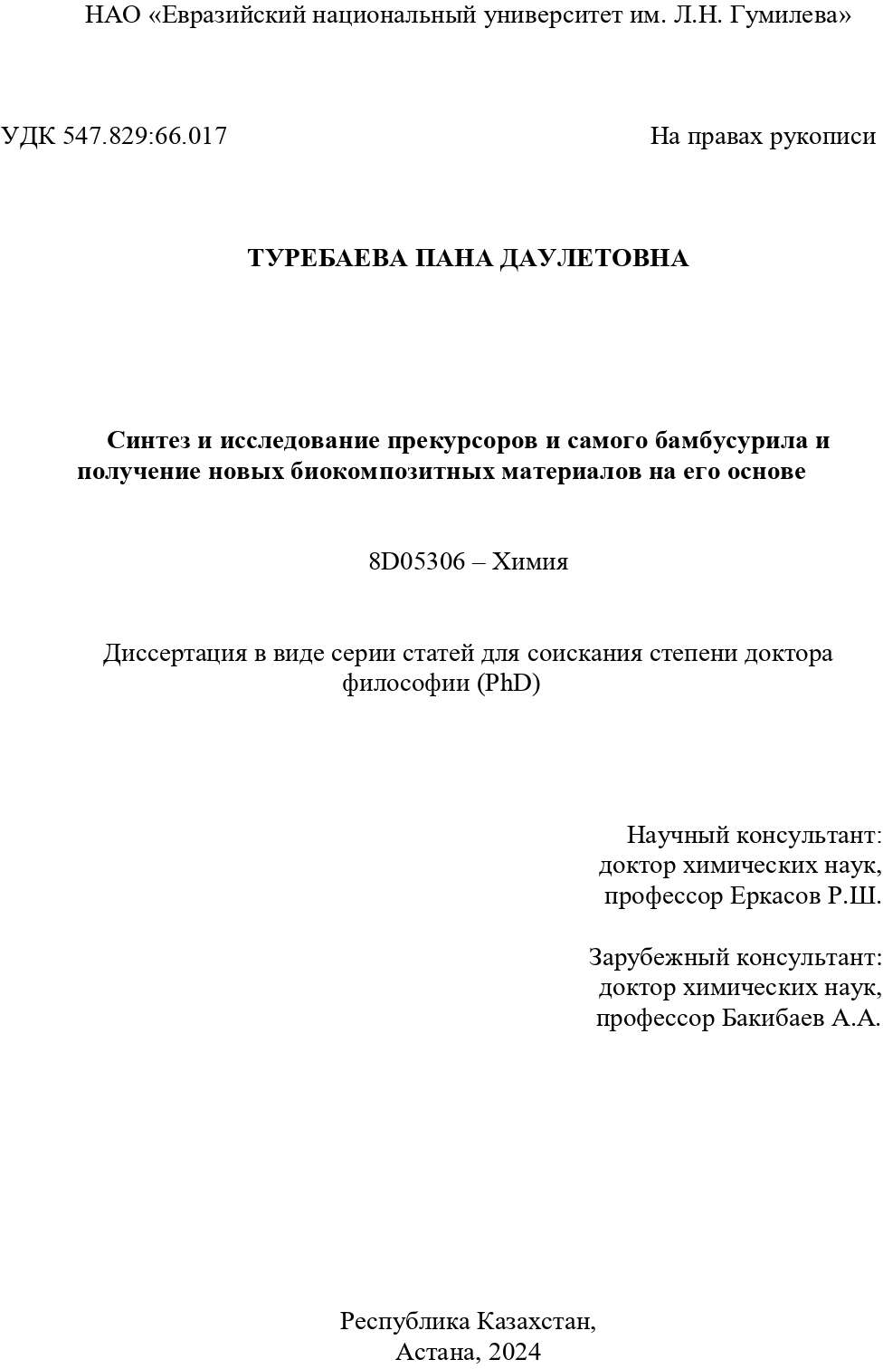

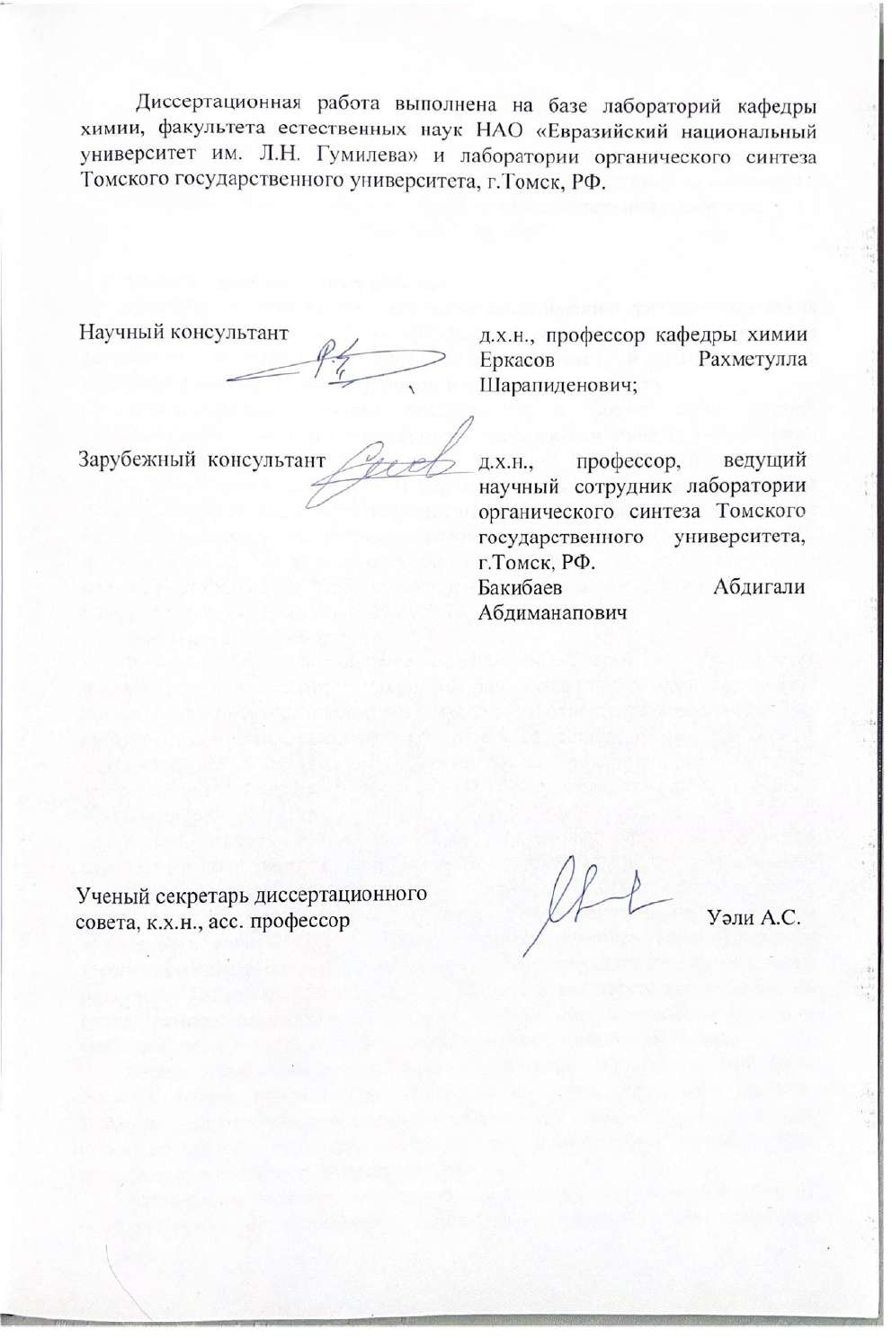

**АННОТАЦИЯ**

диссертационной работы Туребаевой Паны Даулетовны на тему «Синтез и исследование прекурсоров и самого бамбусурила и получение новых биокомпозитных материалов на его основе», представленной на соискание степени доктора философии (PhD) по образовательной программе

«8D05306 – Химия»

**Общая характеристика работы.**

Диссертационная работа посвящена исследованию физико-химических свойств макромолекулы бамбус[6]урила и его прекурсоров, а также разработке методов получения биокомпозитных и наноматериалов модифицированных бамбус[6]урилом и изучению их свойств.

Диссертационная работа представлена в форме серии статей, опубликованных докторантом согласно требованиям пункта 5–1 Правил присуждения степеней, утвержденных приказом Министра образования и науки Республики Казахстан от 31 марта 2011 года № 127 (зарегистрирован в Реестре государственной регистрации нормативных правовых актов под № 6951) с изменением, внесенным приказом Министра образования и науки РК от 30.04.2020 № 170 и в соответствии с приказом Министра образования и науки РК от 09.03.2021 №98, изменениями, внесенными и.о. Министра науки и высшего образования РК от 09.01.2023 года № 7.

**Актуальность работы.**

В современной эпохе персонализированной медицины существует потребность в разработке материалов для имплантатов, которая требует нахождения оптимальных компромиссов в отношении множества их характеристик. Эти характеристики включают состав, форму, структуру, механические свойства, биосовместимость, а также способность стимулировать рост сосудов или костей и обладать антимикробной активностью.

Ранее никто не использовал супрамолекулярные соединения гликолурильного типа в качестве биоактивных молекул, наполняющих пористые материалы с целью повышения биосовместимости и стимулирования остеогенеза. Привлекательным веществом для насыщения поверхности является бамбус[6]урил, который способен инкапсулировать терапевтические агенты и пролонгированно высвобождать их под действием различных факторов. При этом в научной литературе отсутствуют данные об исследованиях, направленных на установление взаимосвязей структуры и свойств пористых скаффолдов, модифицированных бамбус[6]урилом.

Химия бамбус[6]урила активно развивается, однако, по сей день остается много вопросов по изучению их надмолекулярных свойств. Известно, что бамбус[6]урил обладает свойствами «хозяин-гость», но до сих пор не изучена его пригодность для синтеза и стабилизации, металлических наночастиц, в частности, наночастиц серебра.

Актуальным является проведение комплексных исследований влияния бамбус[6]урила на поверхность пористых материалов и на получение наночастиц серебра и определение их биомедицинских свойств. Такого рода исследования открывают многообещающий путь к разработке и созданию новых биокомпозитных материалов с заданными свойствами.

**Цель диссертационного исследования.**

**Цель работы –** синтез бамбус[6]урила и его прекурсоров, определение их свойств и разработка методов получения нано- и биокомпозитных материалов на основе бамбус[6]урила и исследование их биомедицинских свойств.

**Задачи:**

1. Исследовать абсорбционную/десорбционную способность бамбус[6]урила по отношению к воде.

2. Установить влияние модификации серебром на физико-химические свойства бамбус[6]урила, исследовать антибактериальную активность и цитотоксичность полученного биоматериала.

3. Провести модификацию некоторых пористых материалов бамбус[6]урилом и исследовать их биомедицинские свойства.

4.Исследовать комплексообразование прекурсоров бамбус[6]урила – N-метилгликолурилов с нитратами ряда редкоземельных элементов.

**Объекты исследования –** комплексы бамбус[6]урила с бактерицидными компонентами, пористые материалы на основе гидроксиаппатита и диатомита, модифицированные бамбус[6]урилом, комплексы N – метилгликолурилов (прекурсоров бамбусурила) с нитратами редкоземельных элементов.

**Научная новизна работы**.

1. Впервые выполнены квантово - химические расчеты аквакомплексов бамбус[6]урила (Bu[6]) методом DFT с целью исследования возможностей для включения молекул воды в полость макроцикла. DFT расчеты показали, что связывание молекул воды с бамбус[6]урилом происходит посредством образования водородных связей экваториальных атомов водорода Bu[6] и атома кислорода молекул воды. Образование дигидрата энергетически выгоднее, чем связывание двух дополнительных молекул воды с образованием тетрагидрата BU[6]. Полученные расчетные данные согласуются с результатами кинетического эксперимента.

2. Впервые установлено, что введение ионов серебра Ag+ в бамбус[6]урил приводит к образованию наночастиц Bu[6]-Ag/AgCl с высокой антибактериальной активностью в отношении *S. aureus* и *E. coli:* средний диаметр зон подавления роста бактерий составил 17,5 мм для *S. aureus* и 17,4 мм – для *E. coli.*

3. Впервые были получены новые биокомпозиты на основе пористых скаффолдов (гидроксиапатит и диатомит) и бамбус[6]урила. Полученные композиционные материалы Bu[6] + HA, Bu[6] + IDA и Bu[6] + CDA были охарактеризованы с помощью ИК- спектроскопии и СЭМ, для них определен гемолитический эффект и адсорбция белка плазмы на поверхности.

4. Cинтезированы новые комплексные соединения N-метилгликолурилов – прекурсоров бамбусурила (N-монометилгликолурила, 2,4-N,N-диметилгликолурила, 2,6-N,N-диметилгликолурила, 2,4,6,8-N,N,N,N-тетраметилгликолурила) с гидратами нитратов трехвалентных редкоземельных элементов (лантана, церия, празеодима, неодима, самария, тербия, диспрозия, эрбия, иттербия). На основании результатов ИК-спектроскопии, установлено, что за счет особенностей строения метилгликолурилы склонны формировать биядерные комплексы с редкоземельными элементами с координированием через карбонильные группы мочевинных фрагментов.

**Основные положения диссертации, выносимые на защиту.**

1. Воздействие на бамбус[6]урил аргоном, пропущенным через дистиллированную воду (скорость газового потока - 30 л/ч) приводит к абсорбции паров воды бамбус[6]урилом (Bu[6]) (константы скорости абсорбции и десорбции 0,166 мин−1 и 0,0221 мин−1 соответственно), при этом абсорбционная ёмкость бамбус[6]урила равна 4 молям воды на 1 моль Bu[6], что согласуется с результатами теоретических расчётов методом DFT.

2. Введение серебра Ag+ к бамбус[6]урилу при выбранных условиях (t – 30 мин., Т – 25 °С, растворитель – ДМСО/CHCl3) приводит к образованию наночастиц BU[6]-Ag/AgCl, появлению антибактериальной активности у бамбус[6]урила относительно грамотрицательной (*E. coli*) и грамположительной (*S. aureus*) микрофлоры и повышению его цитотоксичности относительно мононуклеаров.

3. Осаждение бамбус[6]урила с использованием погружного метода на поверхность пористых материалов: гидроксиапатита и диатомита, приводит к снижению адсорбции белков плазмы, уменьшению тромбогенности и увеличению гемосовместимости полученных биоматериалов.

4. Введение нитратов редкоземельных элементов к N-метилгликолурилам (прекурсорам бамбусурила) при выбранных условиях (t – 10 мин., Т – 25 °С, растворитель – ацетон) приводит к образованию комплексных соединений, при этом N -метилгликолурилы реализуют бидентатную, хелатирующую и мостиковую функции и склонны формировать биядерные комплексы с редкоземельными элементами с координированием через карбонильные группы мочевинных фрагментов.

**Практическая значимость работы**.

Получены новые результаты в области синтеза супрамолекулярных соединений, имеющих фундаментальное значение в области химии и материаловедения. Получены новые данные о влиянии бамбус[6]урила на биомедицинские свойства пористых неорганических материалов (скаффолдов).

Практическая значимость состоит в том, что в данном диссертационном исследовании были разработан метод получения наночастиц на основе серебра и бамбус[6]урила, имеющих высокую антибактериальную активность в отношении грамположительной и грамотрицательной микрофлоры, которые могут быть использованы для различных биомедицинских целей.

Также заключается в разработке метода осаждения бамбус[6]урила на пористые материалы на основе гидроксиапатита и диатомита. Результаты показали, что материалы, содержащие бамбус[6]урил на поверхности материала, не проявляют собственных антибактериальных и гемолитических эффектов, что дает надежную основу для их использования в качестве биосовместимых материалов. Полученные результаты являются многообещающей альтернативой для создания устойчивых и эффективных биокомпозитов, позволяющих в перспективе реализовать супрамолекулярные стратегии с участием, в подобных процессах, инкапсулированных бамбус[6]урилов.

**Личный вклад автора** в диссертационное исследование заключается в анализе литературных источников, проведении экспериментальных и расчётных работ, интерпретации и обсуждении полученных экспериментальных результатов, а также в подготовке рукописей статей.

**Апробация работы.** Основные положения, выводы и научные результаты диссертации докладывались и обсуждались на международных конференциях: Международная научно-практическая конференция «Актуальные направления развития науки и образования в области естествознания» (Алматы, 2022), The international scientific and technical online conference (Norway, 2024), ХII Международной научно-практической конференции «Актуальные проблемы естественных наук» (Петропавловск, 2024), International Scientific Conference «Modern scientific technology» (Stockholm, Sweden, 2024).

**Публикации.** Основные результаты диссертационного исследования отражены в **10** опубликованных работах, из них **3** статьи в научных изданиях, входящих в первый и/или второй квартиль по импакт-фактору по данным Journal Citation Reports (Жорнал Цитэйшэн Репортс) компании Clarivate Analytics (Кларивэйт Аналитикс); **1** публикация в зарубежном научном издании, **6** работ в материалах республиканских и международных конференций.

В статье **Turebayeva, P.;** Luchsheva, V.; Fedorishin, D.; Yerkassov, R.; Bakibaev, A.; Bolysbekova, S.; Tugambayeva, T.; Sergazina, S.; Nurmukhanbetova, N. Nanoparticles Based on Silver Chloride and Bambus[6]uril[6] for the Fine-Tuning of Biological Activity. Int. J. Mol. Sci. 2023, 24, 16126. соискатель является первым автором. Журнал «International Journal of Molecular Sciences» за 2023 год имеет Impact Factor равный 4,9, и имеет квартиль по биохимии и молекулярной биологии – Q1; по химии, мультидисциплинарной – Q2. Имеет за 2023 год CiteScore равный 8,1, процентиль по неорганической химии – 90; процентиль по органической химии – 87; процентиль по спектроскопии – 86; процентиль по физической и теоретической химии – 82; процентиль по приложениям в области компьютерных наук – 80; процентиль по молекулярной биологии – 70; процентиль по катализу – 65. Докторант участвовал в проведении экспериментов и интерпретации результатов, занимался подготовлением и оформлением оригинального проекта статьи. Кроме того, Туребаева П.Д. занималась оформлением статьи в соответствии с требованиями журнала.

Докторант является первым автором в статье **Turebayeva, P.;** Guslyakov, A.N.; Novikova, S.A.; Khlebnikov, A.I.; Befus, E.A.; Meshcheryakov, E.P.; Bakibaev, A.A.; Kusepova, L.; Kassenova, N.; Sharipova, S.; et al. Absorption of Water Vapor by Bambus[6]uril and a Density Functional Theory Study of Its Aqua Complexes. Molecules 2023, 28, 7680. Журнал «Molecules» за 2023 год имеет Impact Factor равный 4,2, и квартиль по биохимии и молекулярной биологии, химии, мультидисциплинарной – Q2. Имеет CiteScore за 2023 год равный 7,4, процентиль по химии (разное) – 83; процентиль по органической химии – 81; процентиль по физической и теоретической химии – 80; процентиль по аналитической химии – 78; процентиль по фармацевтической науке – 81; процентиль по открытию наркотиков – 73; процентиль по молекулярной медицине – 68.

В статье Zhumabayeva, G.; **Turebayeva, P.;** Ukhov, A.; Fedorishin, D.; Gubankov, A.; Luchsheva, V.; Kurzina, I.; Bakibaev, A.; et al. Development of Novel Composite Biocompatible Materials by Surface Modiﬁcation of Porous Inorganic Compounds Using Bambus[6]Uril. Materials 2023, 16, 7257. докторант является автором-корреспондентом. Журнал «Materials» имеет Impact Factor за 2023 год равный 3,1 и квартиль по химии физической – Q3; по материаловедению, мультидисциплинарному – Q2; по металлургии и металлургическому машиностроению – Q1; по физике прикладной – Q2; по физике, конденсированному веществу – Q2. Имеет CiteScore за 2023 год равный 5,8, процентиль по физике конденсированного состояния – 73; процентиль по общему материаловедению – 67. Туребаева П.Д. принимала непосредственное участие в получении экспериментальных данных, обработке и интерпретации экспериментальных результатов, в написании выводов по эксперименту для оформления статьи. Соискатель также занималась подачей статьи в журнал, поддерживала контакт и вела переписку с редакцией журнала во время рецензирования и публикации статьи.

Докторант принимал непосредственное участие в получении экспериментальных данных, обработке и интерпретации результатов для оформления материалов, и тезисов 6 докладов на республиканских и международных научных конференциях.

«8D05306 – Химия» білім беру бағдарламасы бойынша философия докторы (PhD) дәрежесін алу үшін ұсынылған Туребаева Пана Дәулетқызының «Прекурсорларды және бамбусурилдің өзін синтездеу және зерттеу және оның негізінде жаңа биокомпозиттік материалдар алу» тақырыбындағы диссертациялық жұмысына

**АҢДАТПА**

**Диссертациялық зерттеудің жалпы сипаттамасы.**

Диссертациялық жұмыс бамбус[6]урил макромолекуласының және оның прекурсорларының физика-химиялық қасиеттерін зерттеуге, сондай-ақ бамбус[6]урилмен модификацияланған биокомпозиттік және наноматериалдарды алу әдістерін әзірлеуге және олардың қасиеттерін зерттеуге арналған.

Диссертациялық жұмыс докторанттың ҚР Білім және ғылым министрінің 30.04.2020 жылғы №170 Бұйрығымен өзгерістер енгізілген Қазақстан Республикасы Білім және ғылым министрінің 2011 жылғы 31 наурыздағы №127 (нормативтік құқықтық актілерді мемлекеттік тіркеу тізілімінде № 6951 болып тіркелген) бұйрығымен бекітілген дәрежелерді беру қағидаларының 5-1 тармақтарына және ҚР Ғылым және жоғары білім министрінің м.а. 09.01.2023 жылғы № 7 өзгертулері енгізілген ҚР Білім және ғылым министрінің 09.03.2021 жылғы №98 бұйрығының талаптарына сәйкес жариялаған мақалалар сериясы түрінде ұсынылады.

**Зерттеудің өзектілігі.**

Жекелендірілген медицинаның қазіргі дәуірінде имплантанттарға арналған материалдарды әзірлеу қажеттілігі туындайды, бұл олардың көптеген сипаттамаларына қатысты оңтайлыиссаға келуді талап етеді. Бұл сипаттамаларға құрамы, пішіні, құрылымы, механикалық қасиеттері, биоүйлесімділігі, сондай-ақ тамырлардың немесе сүйектердің өсуін ынталандыру және микробқа қарсы белсенділік жатады.

Бұрын ешкім биоүйлесімділікті арттыру және остеогенезді ынталандыру мақсатында кеуекті материалдарды толтыратын биоактивті молекулалар ретінде гликолурил типті супрамолекулалық қосылыстарды қолданбаған. Бетті қанықтыру үшін тартымды зат - бамбус[6]урил, ол терапевтік агенттерді инкапсуляциялауға және оларды әртүрлі факторлардың әсерінен ұзақ уақыт босатуға қабілетті. Бұл ретте ғылыми әдебиеттерде бамбус[6]урилмен модификацияланған кеуекті скаффолдтардың құрылымы мен қасиеттерінің өзара байланысын орнатуға бағытталған зерттеулер туралы деректер жоқ.

Бамбус[6]урил химиясы белсенді дамып келеді, алайда олардың супрамолекулалық қасиеттерін зерттеуге қатысты көптеген сұрақтар әлі де бар. Бамбус[6]урилдің «үй иесі-қонақ» қасиеттері бар екені белгілі, бірақ оның металл нанобөлшектерін, атап айтқанда күміс нанобөлшектерін синтездеуге және тұрақтандыруға жарамдылығы әлі зерттелмеген.

Бамбус[6]урилдің кеуекті материалдардың бетіне және күміс нанобөлшектерін алу тәсілдеріне әсері және олардың биомедициналық қасиеттерін анықтау бойынша кешенді зерттеулер жүргізу өзекті болып табылады.

**Зерттеудің мақсаты.** Жұмыстың мақсаты – бамбус[6]урил мен оның прекурсорларын синтездеу, олардың қасиеттерін анықтау және бамбус[6]урил негізіндегі нано және биокомпозиттік материалдарды алу әдістерін әзірлеу және олардың биомедициналық қасиеттерін зерттеу.

Бұл мақсатқа жету келесі **міндеттерді** шешуді қамтиды:

1. Бамбус[6]урилдің суға қатысты абсорбция/десорбция қабілетін зерттеу.

2. Бамбус[6]урилдің физика-химиялық қасиеттеріне күміспен модификацияның әсерін анықтау, алынған биоматериалдың бактерияларға қарсы белсенділігі мен цитоуыттылығын зерттеу.

3. Кейбір кеуекті материалдарды бамбус[6]урилмен модификациялау және олардың биомедициналық қасиеттерін зерттеу.

4. Бамбус[6]урил прекурсорларының – N-метилгликолурилдердің сирек жер элементтердің нитраттарымен комплекс түзілуін зерттеу.

**Зерттеу нысаны** - бактерицидтік компоненттері бар бамбус[6]урил (Bu[6]) кешендері, бамбус[6]урилмен модификацияланған гидроксиаппатит және диатомит негізіндегі кеуекті материалдар, сирек жер элементтерінің нитраттары бар N-метилгликолурил (бамбус[6]урил прекурсорлары) кешендері.

**Жұмыстың ғылыми жаңалығы.**

1. Макроцикл қуысына су молекулаларын қосу мүмкіндіктерін зерттеу мақсатында DFT әдісімен бамбус[6]урил (Bu[6]) аквакомплекстерінің кванттық химиялық есептеулері жүргізілді. DFT есептеулер су молекулаларының бамбус[6]урилмен байланысуы Bu[6] экваторлық сутегі атомдарының және су молекулаларының оттегі атомының сутегі байланыстарын қалыптастыру арқылы жүретінін көрсетті. Дигидраттың түзілуі бамбус[6]урилдің тетрагидраты түзу үшін қосымша екі су молекуласын байланыстырғаннан гөрі энергетикалық тұрғыдан тиімдірек. Алынған есептік деректер кинетикалық эксперименттің нәтижелеріне сәйкес келеді.

2. Бамбус[6]урилге Ag+ күміс иондарын енгізу *S. aureus* және *E. coli* бактерияларға қарсы белсенділігі жоғары Bu[6]-Ag/AgCl нанобөлшектерінің пайда болуына әкелетіні алғаш рет анықталды: бактериялардың өсуін тежейтін аймақтардың орташа диаметрі *S. aureus* үшін 17,5 мм және *E. coli* үшін 17,4 мм болды.

3. Алғаш рет кеуекті скаффолдтарға (гидроксиапатит және диатомит) және бамбус[6]урилге негізделген жаңа биокомпозиттер алынды. Алынған Bu[6] + HA, Bu[6] + IDа және Bu[6] + CDA композициялық материалдары ИҚ спектроскопиясы және СЭМ арқылы сипатталды, олар үшін гемолитикалық әсері және плазма ақуызының беткі адсорбциясы анықталды.

4. N-метилгликолурилдердің – бамбус[6]урил прекурсорлары (N-монометилгликолурил, 2,4-N,N-диметилгликолурил, 2,6-N,N-диметилгликолурил 2,4,6,8-N,N,N,N-тетраметилгликолурил) үш валентті сирек жер элементтерінің (лантан, церий, празеодим, неодим, самарий, тербий, диспрозий, эрбий, иттербий) нитраттарының гидраттарымен жаңа кешенді қосылыстары синтезделді. ИҚ спектроскопиясының нәтижелеріне сүйене отырып, құрылымның ерекшеліктеріне байланысты метилгликолурилдер мочевина фрагменттерінің карбонил топтары арқылы қосыла отырып, сирек жер элементтері бар биядролық кешендер құруға бейім екендігі анықталды.

**Қорғауға ұсынылған диссертацияның негізгі ережелері:**

1. Дистилденген су арқылы өтетін аргонмен бамбус[6]урилге әсер ету (газ ағынының жылдамдығы - 30 л/сағ) бамбус[6]урилге (Bu[6]) су буының сіңуіне әкеледі (абсорбция және десорбция жылдамдығының тұрақтылары сәйкесінше 0,166 мин−1 және 0,0221 мин−1), бамбус[6]урилдің абсорбция сыйымдылығы 1 моль Bu[6] үшін 4 моль суға тең, бұл DFT әдісімен теориялық есептеулердің нәтижелеріне сәйкес келеді.

2. Ag+ күмісін бамбус[6]урилге таңдалған жағдайларда (t – 30 мин., Т – 25 °С, еріткіш – DMSO/CHCl3) енгізу Bu[6]-Ag/AgCl нанобөлшектерінің пайда болуына, бамбус[6]урилде грам-теріс (*E. coli*) және грам-оң (*S. aureus*) микрофлораға қатысты бактерияларға қарсы белсенділіктің пайда болуына және оның мононуклеарларға қатысты цитоуыттылығын арттыруына әкеледі.

3. Батыру әдісін қолдану қолдану арқылы бамбус[6]урилдің кеуекті материалдардың: гидроксиапатит және диатомит бетіне тұндыру, тромбогенділік пен плазма ақуыздарының адсорбциясының төмендеуіне, және алынған биоматериалдардың гемосәйкестігінің жоғарылауына әкеледі.

4. Таңдалған жағдайларда N-метилгликолурилдерге (бамбус[6]урил прекурсорларына) сирек жер элементтерінің нитраттарын енгізу (t – 10 мин., Т – 25 °С, еріткіш – ацетон) күрделі қосылыстардың түзілуіне әкеледі, ал N-метилгликолурилдер бидентат, хелат және көпір функцияларын жүзеге асырады және мочевина фрагменттерінің карбонил топтары арқылы үйлестіре отырып, сирек жер элементтері бар биядролық кешендер түзуге бейім.

**Жұмыстың практикалық маңыздылығы.**

Химия және материалтану саласында іргелі маңызы бар супрамолекулалық қосылыстардың синтезі саласында жаңа нәтижелер алынды. Бамбус[6]урилдің кеуекті бейорганикалық материалдардың (скаффолдтар) биомедициналық қасиеттеріне әсері туралы жаңа мәліметтер алынды.

Бұл диссертациялық зерттеуде әртүрлі биомедициналық мақсаттарда қолдануға болатын грам-позитивті және грам-теріс микрофлораға қарсы белсенділігі бар күміс және бамбус[6]урил негізіндегі нанобөлшектерді алу әдісі әзірленді.

Сондай-ақ гидроксиапатит пен диатомит негізіндегі кеуекті материалдарға бамбус[6]урилді тұндыру әдісін әзірлеуден тұрады. Нәтижелер бетінде бамбус[6]урилі бар материалдар бактерияларға қарсы және гемолитикалық әсерін етпейтінін көрсетті, бұл оларды биоүйлесімді материалдар ретінде пайдалануға сенімді негіз береді. Алынған нәтижелер капсулаланған бамбус[6]урилдердің қатысуымен супрамолекулалық стратегияларды болашақта жүзеге асыруға мүмкіндік беретін тұрақты және тиімді биокомпозиттерді құрудың перспективалы баламасы болып табылады.

**Автордың диссертациялық зерттеуге қосқан жеке үлесі** әдеби дереккөздерді талдау, эксперименттік және есептеу жұмыстарын жүргізу, алынған эксперименттік нәтижелерді түсіндіру және талқылау, мақалалардың қолжазбасын дайындау болып табылады.

**Жұмысты апробациялау.** Диссертацияның негізгі ережелері, қорытындылары мен ғылыми нәтижелері халықаралық конференцияларда баяндалды және талқыланды: «Жаратылыстану саласындағы ғылым мен білім беруді дамытудың өзекті бағыттары» Халықаралық ғылыми-практикалық конференциясы (Алматы, 2022), The international scientific and technical online conference (Norway, 2024), «Жаратылыстану ғылымдарының өзекті мәселелері» ХІІ Халықаралық ғылыми-практикалық конференциясы (Петропавл, 2024) және International Scientific Conference «Modern scientific technology» (Stockholm, Sweden, 2024).

**Жарияланымдар.** Диссертациялық зерттеудің негізгі нәтижелері жарияланған 10 жұмыста көрсетілген, оның ішінде Clarivate Analytics (Кларивэйт Аналитикс) компаниясының Journal Citation Reports (Journal Citeishen reports) деректері бойынша импакт-фактор бойынша бірінші және/немесе екінші квартильге кіретін ғылыми басылымдардағы 3 мақала; шетелдік ғылыми басылымда 1 жариялау, республикалық және халықаралық ғылыми конференцияларда 6 жұмыс.

**Turebayeva, P**.; Luchsheva, V.; Fedorishin, D.; Yerkassov, R.; Bakibaev, A.; Bolysbekova, S.; Tugambayeva, T.; Sergazina, S.; Nurmukhanbetova, N. nanoparticles based on Silver chloride and Bambus[6]uril[6] fine-tuning of biological activity үшін. Int. J. Mol. Sci. 2023, 24, 16126. Өтініш беруші – бірінші автор. «International Journal of Molecular Sciences» журналының 2023 жылғы Импакт-факторы 4,9-ға тең және биохимия және молекулалық биология – Q1; химия, көпсалалы – Q2 квартилі бар. 2023 жылы CiteScore 8,1-ге тең, бейорганикалық химия бойынша процентиль – 90; органикалық химия бойынша процентиль – 87; спектроскопия бойынша процентиль – 86; физикалық және теориялық химия бойынша процентиль – 82; информатика саласындағы қосымшалар бойынша процентиль – 80; молекулалық биология бойынша процентиль – 70; катализ бойынша процентиль – 65. Докторант эксперименттер жүргізуге және нәтижелерді талқылауларға қатысып, мақаланың түпнұсқа жобасын дайындаумен және рәсімдеумен айналысты. Сонымен қатар, П.Д. Туребаева журналдың талаптарына сәйкес мақаланы рәсімдеумен айналысқан.

**Turebayeva, P**.; Guslyakov, A. N.; Novikova, S. A.; Khlebnikov, A. I.; Befus, E. A.; Meshcheryakov, E. P.; Bakibaev, A. A.; Kusepova, L.; Kassenova, N.; Sharipova, S.; және басқалар. Absorption of Water Vapor by Bambus[6]uril and a Density Functional Theory Study of Its Aqua Complexes. Molecules 2023, 28, 7680. Докторант – бірінші автор. «Molecules» журналының 2023 жылғы Импакт-факторы 4,2-ге тең және биохимия және молекулалық биология, химия, көпсалалы – Q2 квартилі бар. 2023 жылғы CiteScore 7,4, химия бойынша процентиль (әр түрлі) – 83; органикалық химия бойынша процентиль – 81; физикалық және теориялық химия бойынша процентиль – 80; аналитикалық химия бойынша процентиль – 78; фармацевтика ғылымы бойынша процентиль – 81; есірткіні табу бойынша процентиль – 73; молекулалық медицина бойынша процентиль – 68. П.Д. Туребаева зерттеулер жүргізуге, деректерді өңдеуге және мақаланы ресімдеуге белсенді қатысты.

Zhumabayeva, G.; **Turebayeva, P.;** Ukhov, A.; Fedorishin, D.; Gubankov, A.; Luchsheva, V.; Kurzina, I.; Bakibaev, A.; et al. Development of Novel Composite Biocompatible Materials by Surface Modiﬁcation of Porous Inorganic Compounds Using Bambus[6]Uril. Materials 2023, 16, 7257. Докторант – корреспондент-автор. «Materials» журналының 2023 жылғы Импакт-факторы 3,1-ге тең және физикалық химиясы – Q3; материалтану, мультидисциплинарлық – Q2; металлургия және металлургиялық машина жасау – Q1; қолданбалы физика – Q2; физика, конденсацияланған зат – Q2 квартиліне ие. 2023 жылғы CiteScore 5,8-ге тең, конденсацияланған күй физикасы бойынша процентиль 73-ке; жалпы материалтану бойынша процентиль 67-ге тең. П.Д. Туребаева эксперименттік деректерді алуға, эксперименттік нәтижелерді өңдеуге және түсіндіруге, мақаланы ресімдеу үшін эксперимент бойынша қорытынды жазуға тікелей қатысты. Өтініш беруші журналға мақала жіберумен де айналысты, мақаланы рецензиялау және жариялау кезінде журналдың редакциясымен байланыста болып, хат жазысып отырды.

Докторант республикалық және халықаралық ғылыми конференцияларда 6 баяндаманың материалдары мен тезистерін ресімдеу үшін эксперименттік деректерді алуға, нәтижелерді өңдеуге және түсіндіруге тікелей қатысты.

**ANNOTATION**

on the dissertation of Turebayeva Pana Dauletovna on the topic “Synthesis and research of precursors and bambusuril itself and the production of new biocomposite materials based on it”, submitted for the degree of

Doctor of Philosophy (PhD) in the educational program “8D05306 – Chemistry”

**General description of the work.**

The dissertation work is devoted to the study of the physico-chemical properties of the bambus[6]uril macromolecule and its precursors, as well as the development of methods for obtaining biocomposite and nanomaterials modified with bambus[6]uril and the study of their properties.

The dissertation work is presented in the form of a series of articles published by a doctoral student in accordance with the requirements of paragraph 5-1 of the Rules for Awarding Degrees approved by Order No. 127 of the Minister of Education and Science of the Republic of Kazakhstan dated March 31, 2011 (registered in the Register of State Registration of Normative Legal Acts under No. 6951) as amended by Order No. 170 of the Minister of Education and Science of the Republic of Kazakhstan dated 30.04.2020 and in accordance with the Order of the Minister of Education and Science of the Republic of Kazakhstan dated 09.03.2021 No. 98, as amended by the Acting Minister of Science and Higher Education of the Republic of Kazakhstan dated 09.01.2023 No. 7.

**The relevance of the work.**

In the modern era of personalized medicine, there is a need to develop materials for implants, which requires finding optimal compromises with respect to their many characteristics. These characteristics include composition, shape, structure, mechanical properties, biocompatibility, as well as the ability to stimulate vascular or bone growth and possess antimicrobial activity.

Previously, no one had used supramolecular glycoluryl compounds as bioactive molecules filling porous materials in order to increase biocompatibility and stimulate osteogenesis. An attractive substance for saturating the surface is bambus[6]uril, which is able to encapsulate therapeutic agents and release them in a prolonged manner under the influence of various factors. At the same time, there is no data in the scientific literature on studies aimed at establishing the interrelationships of the structure and properties of porous scaffolds modified with bambus[6]uril.

The chemistry of bambus[6]uril is actively developing, however, to this day there are many questions about the study of their supramolecular properties. Bambus[6]uril is known to have host-guest properties, but its suitability for the synthesis and stabilization of metallic nanoparticles, in particular silver nanoparticles, has not yet been studied.

It is relevant to conduct comprehensive studies of the effect of bambus[6]uril on the surface of porous materials and to obtain silver nanoparticles and determine their biomedical properties. This kind of research opens up a promising path to the development and creation of new biocomposite materials with desired properties.

**The purpose of the dissertation research.**

The purpose of the work is the synthesis of bambusuril and its precursors, the determination of their properties and the development of methods for obtaining nano- and biocomposite materials based on bambusuril and the study of their biomedical properties.

**Tasks:**

1. To investigate the absorption/desorption ability of bambus[6]uril in relation to water.

2. To establish the effect of silver modification on the physico-chemical properties of bambus[6]uril, to investigate the antibacterial activity and cytotoxicity of the resulting biomaterial.

3. To modify some porous materials with bambus[6]uril and to investigate their biomedical properties.

4. To investigate the complexation of precursors of bambus[6]uril – N-methylglycoluryl with nitrates of a number of rare earth elements.

The objects of research are complexes of bambus[6]uril with bactericidal components, porous materials based on hydroxyappatite and diatomite modified with bambus[6]uril, complexes of N – methylglycolurils (precursors of bambus[6]uril) with nitrates of rare earth elements.

**The scientific novelty of the work.**

1. For the first time, quantum chemical calculations of bambus[6]uril (Bu[6]) aquacomplexes were performed using the DFT method in order to study the possibilities for including water molecules in the cavity of a macrocycle. DFT calculations have shown that the binding of water molecules to bambus[6]uril occurs through the formation of hydrogen bonds of the equatorial hydrogen atoms Bu[6] and the oxygen atom of water molecules. The formation of a dihydrate is energetically more advantageous than the binding of two additional water molecules to form BU tetrahydrate[6]. The calculated data obtained are consistent with the results of the kinetic experiment.

2. It was established for the first time that the introduction of Ag+ silver ions into bambus[6]uril leads to the formation of BU[6]-Ag/AgCl nanoparticles with high antibacterial activity against *S. aureus* and *E. coli:* the average diameter of the bacterial growth suppression zones was 17.5 mm for *S. aureus* and 17.4 mm for *E. coli.*

3. For the first time, new biocomposites based on porous scaffolds (hydroxyapatite and diatomite) and bambus[6]uril were obtained. The obtained composite materials Bu[6] + HA, Bu[6] + IDА and Bu[6] + CDA were characterized using IR spectroscopy and SEM, and the hemolytic effect and adsorption of plasma protein on the surface were determined for them.

4. A new complex compounds of N-methylglycolurils - precursors of bambus[6]uril (N-monomethylglycoluryl, 2,4-N,N-dimethylglycoluryl, 2,6-N,N-dimethylglycoluryl, 2,4,6,8-N,N,N,N-tetramethylglycoluryl) with nitrate hydrates of trivalent rare earth elements (lanthanum, cerium, praseodymium, neodymium, samarium, terbium, dysprosium, erbium, ytterbium) have been synthesized. Based on the results of IR spectroscopy, it was found that due to the structural features of methylglycolurils, they tend to form binuclear complexes with rare earth elements with coordination through carbonyl groups of urea fragments.

**The main provisions of the dissertation submitted for defense.**

1. Exposure to bambus[6]uril with argon passed through distilled water (gas flow rate - 30 l/h) leads to absorption of water vapor by bambus[6]uril (Bu[6]) (rate constants of absorption and desorption 0.166 min−1 and 0.0221 min−1, respectively), while the absorption capacity of bambus[6]uril is 4 moles of water per 1 mol of Bu[6], which is consistent with the results of theoretical calculations using the DFT method.

2. The introduction of silver Ag+ to bambus[6]uril under selected conditions (t – 30 min., T – 25 °C, solvent – DMSO/CHCl3) leads to the formation of Bu[6]-Ag/AgCl nanoparticles, the appearance of antibacterial activity in bambus[6]uril relative to gram-negative (*E. coli*) and gram-positive (*S. aureus*) microflora and an increase in its cytotoxicity relative to mononuclears.

3. Precipitation of bambus[6]uril using the immersion method on the surface of porous materials: hydroxyapatite and diatomite, leads to a decrease in plasma protein adsorption, a decrease in thrombogenicity and an increase in hemocompatibility of the obtained biomaterials.

4. The introduction of nitrates of rare earth elements to N-methylglycolurils (precursors of bambus[6]uril) under selected conditions (t – 10 min., T – 25 °C, solvent – acetone) leads to the formation of complex compounds, while N-methylglycolurils realize bidentate, chelating and bridging functions and tend to form binuclear complexes with rare earth elements with coordination through carbonyl groups urea fragments.

**The practical significance of the work.**

New results have been obtained in the field of synthesis of supramolecular compounds of fundamental importance in the field of chemistry and materials science. New data on the effect of bambus[6]uril on the biomedical properties of porous inorganic materials (scaffolds) have been obtained.

The practical significance lies in the fact that in this dissertation research, a method was developed for the production of nanoparticles based on silver and bambus[6]uril, which have high antibacterial activity against gram-positive and gram-negative microflora, which can be used for various biomedical purposes.

It also involves the development of a method for depositing bambus[6]uril on porous materials based on hydroxyapatite and diatomite. The results showed that materials containing bambus[6]uril on the surface of the material do not exhibit their own antibacterial and hemolytic effects, which provides a reliable basis for their use as biocompatible materials. The results obtained are a promising alternative for the creation of stable and effective biocomposites, which in the future allow the implementation of supramolecular strategies involving encapsulated bambus[6]uriles in such processes.

**The author's personal contribution** to the dissertation research consists in analyzing literary sources, conducting experimental and computational work, interpreting and discussing the experimental results obtained, and preparing manuscripts of articles.

**Approbation of the work.** The main provisions, conclusions and scientific results of the dissertation were reported and discussed at international conferences: The International Scientific and Practical Conference "Current trends in the development of science and education in the field of natural sciences" (Almaty, 2022), The international scientific and technical online conference (Norway, 2024), the XII International Scientific and Practical Conference "Actual Problems of Natural Sciences Sciences" (Petropavlovsk, 2024) and International Scientific Conference "Modern scientific technology" (Stockholm, Sweden, 2024).

**Publications.** The main results of the dissertation research are reflected in 10 published works, including 3 articles in scientific publications included in the first and/or second quartile of the impact factor according to the Journal Citation Reports of Clarivate Analytics; 1 publication in a foreign scientific publication, 6 works in the materials of the republican and international conferences.

In the article **Turebayeva, P.**; Luchsheva, V.; Fedorishin, D.; Yerkassov, R.; Bakibaev, A.; Bolysbekova, S.; Tugambayeva, T.; Sergazina, S.; Nurmukhanbetova, N. Nanoparticles Based on Silver Chloride and Bambus[6]uril[6] for the Fine-Tuning of Biological Activity. Int. J. Mol. Sci. 2023, 24, 16126 the applicant is the first author. The International Journal of Molecular Sciences for 2023 has an Impact Factor of 4.9, and has a quartile in biochemistry and molecular biology – Q1; in chemistry, multidisciplinary – Q2. For 2023, CiteScore has a score of 8.1, the percentile in inorganic chemistry is 90; the percentile in organic chemistry is 87; the percentile in spectroscopy is 86; the percentile in physical and theoretical chemistry is 82; the percentile in computer science applications is 80; the percentile in molecular biology is 70; the percentile in catalysis is 65. The doctoral student participated in conducting experiments and interpreting the results, was engaged in the preparation and design of the original draft of the article. In addition, P.D. Turebayeva was engaged in the design of the article in accordance with the requirements of the journal.

The doctoral student is the first author in the article **Turebayeva, P**.; Guslyakov, A.N.; Novikova, S.A.; Khlebnikov, A.I.; Befus, E.A.; Meshcheryakov, E.P.; Bakibaev, A.A.; Kusepova, L.; Kassenova, N.; Sharipova, S.; et al. Absorption of Water Vapor by Bambus[6]uril and a Density Functional Theory Study of Its Aqua Complexes. Molecules 2023, 28, 7680. The journal "Molecules" for 2023 has an Impact Factor of 4.2, and the quartile for biochemistry and molecular biology, chemistry, multidisciplinary is Q2. The CiteScore for 2023 is 7.4, the percentile in chemistry (miscellaneous) is 83; the percentile in organic chemistry is 81; the percentile in physical and theoretical chemistry is 80; the percentile in analytical chemistry is 78; the percentile in pharmaceutical science is 81; the percentile in drug discovery is 73; the percentile in molecular medicine is 68. P.D. Turebayeva took an active part in conducting research, in collecting literature and processing data and in the design of the article.

In the article Zhumabayeva, G.; **Turebayeva, P.**; Ukhov, A.; Fedorishin, D.; Gubankov, A.; Luchsheva, V.; Kurzina, I.; Bakibaev, A.; et al. Development of Novel Composite Biocompatible Materials by Surface Modiﬁcation of Porous Inorganic Compounds Using Bambus[6]Uril. Materials 2023, 16, 7257. the doctoral student is a corresponding author. The «Materials» journal has an Impact Factor for 2023 equal to 3.1 and a quartile in physical chemistry – Q3; in materials science, multidisciplinary – Q2; in metallurgy and metallurgical engineering – Q1; in applied physics – Q2; in physics, condensed matter – Q2. It has a CiteScore for 2023 equal to 5.8, a percentile in condensed matter physics – 73; a percentile in general materials science – 67. P.D. Turebayeva was directly involved in obtaining exp erimental data, processing and interpreting experimental results, and writing conclusions on the experiment for the design of the article. The applicant was also involved in submitting an article to the journal, maintained contact and corresponded with the editorial board of the journal during the review and publication of the article.

The doctoral student was directly involved in obtaining experimental data, processing and interpreting the results for the preparation of materials and abstracts of 6 reports at national and international scientific conferences.

[International Journal of](https://www.mdpi.com/journal/ijms)



[***Molecular Sciences***](https://www.mdpi.com/journal/ijms)

*Article*

Nanoparticles Based on Silver Chloride and Bambusuril[6] for the Fine-Tuning of Biological Activity

# Pana Turebayeva 1 , Venera Luchsheva 2 , Dmitriy Fedorishin 2 , Rakhmetulla Yerkassov 1, Abdigali Bakibaev 2,*, Saltanat Bolysbekova 3 , Tokzhan Tugambayeva 4, Samal Sergazina 5 and Nurgul Nurmukhanbetova 5

1 Department of Chemistry, L.N. Gumilyov Eurasian National University, 010000 Astana, Kazakhstan; [pana90@mail.ru](mailto:pana90@mail.ru) (P.T.); [erkass@mail.ru](mailto:erkass@mail.ru) (R.Y.)

2 Faculty of Chemistry, National Research Tomsk State University, 634050 Tomsk, Russia;

[kuscherbaeva_venera@mail.ru](mailto:kuscherbaeva_venera@mail.ru) (V.L.); [strix187@yandex.ru](mailto:strix187@yandex.ru) (D.F.)

3 Higher School of Scientific Research, Astana International University, 010000 Astana, Kazakhstan; [bolysbekova.s@mail.ru](mailto:bolysbekova.s@mail.ru)

4 Department of Chemistry and Chemical Technologies, Toraighyrov University, 140008 Pavlodar, Kazakhstan;

[togzhan_1963@mail.ru](mailto:togzhan_1963@mail.ru)

5 Department of Chemistry and Biotechnology, Sh. Ualikhanov University, 020000 Kokshetau, Kazakhstan; [samal_sergazina@mail.ru](mailto:samal_sergazina@mail.ru) (S.S.); [nn_nurgul@mail.ru](mailto:nn_nurgul@mail.ru) (N.N.)

**\*** Correspondence: [bakibaev@mail.ru](mailto:bakibaev@mail.ru)



**Citation:** Turebayeva, P.; Luchsheva, V.; Fedorishin, D.; Yerkassov, R.; Bakibaev, A.; Bolysbekova, S.; Tugambayeva, T.; Sergazina, S.; Nurmukhanbetova, N. Nanoparticles Based on Silver Chloride and Bambusuril[6] for the Fine-Tuning of Biological Activity. *Int. J. Mol. Sci.*

**2023**, *24*, 16126. [https://doi.org/](https://doi.org/10.3390/ijms242216126)

[10.3390/ijms242216126](https://doi.org/10.3390/ijms242216126)

Academic Editor: Soo-Jin Choi Received: 17 October 2023

Revised: 3 November 2023

Accepted: 5 November 2023

**Abstract:** The prevalence of numerous infectious diseases has emerged as a grave concern within the realm of healthcare. Currently, the issue of antibiotic resistance is compelling scientists to explore novel treatment approaches. To combat these infectious diseases, various treatment methods have been developed, harnessing cutting-edge disinfecting nanomaterials. Among the range of metallic nanoparticles employed in medicine, silver nanoparticles (AgNPs) stand out as both highly popular and well-suited for the task. They find extensive utility in cancer diagnosis and therapies and as effective antibacterial agents. The interaction between silver and bacterial cells induces significant structural and morphological alterations, ultimately leading to cell demise. In this study, nanoparticles based on silver and bambusuril[6] (BU[6]) were developed for the first time. These NPs can be used for different biomedical purposes. A simple, single-step, and effective synthesis method was employed to produce bambusuril[6]-protected silver chloride nanoparticles (BU[6]-Ag/AgCl NPs) through the complexation of BU[6] with silver nitrate. The NPs were characterized using X-ray phase analysis (XPS), infrared spectroscopy (IR), thermogravimetric analysis (TGA), scanning electron microscopy (SEM) and energy-dispersive X-ray spectroscopy (EDS). When the SEM images were examined, it was seen that the synthesized BU[6]-Ag/AgCl NPs were distributed with homogeneous sizes, and the synthesized NPs were mostly spherical and cubic. The EDS spectra of BU[6]-Ag/AgCl NPs demonstrated the presence of Ag, Cl, and all expected elements. BU[6]-Ag/AgCl NPs showed high antibacterial activity against both *E. coli* and *S. aureus* bacteria.

**Keywords:** bambusuril[6]; silver chloride nanoparticles; MTT-test; thermal analysis; supramolecular chemistry; antibacterial activity

Published: 9 November 2023



**Copyright:** © 2023 by the authors. Licensee MDPI, Basel, Switzerland. This article is an open access article distributed under the terms and conditions of the Creative Commons Attribution (CC BY) license ([https://](https://creativecommons.org/licenses/by/4.0/) [creativecommons.org/licenses/by/](https://creativecommons.org/licenses/by/4.0/) 4.0/).

# Introduction

Currently, metallic nanoparticles based on silver (Ag), gold (Au), and copper (Cu) are widely employed in various applications such as biosensors, catalysis, targeted drug delivery, and antibacterial therapies. Among these nanoparticles, silver nanoparticles AgNPs have attracted significant attention due to their exceptional antibacterial activity against diverse microorganisms, including bacteria, viruses, and fungi [1–6].

Various reagents have been used to synthesize AgNPs. Green synthesis of silver–silver chloride nanoparticles (Ag–AgCl NPs) has been proposed as a simple, easy, eco-friendly

and cost-effective method. Ag/AgCl NPs synthesized from *Azadirachta indica* lalex are currently known to be active against fluconazole-resistant *Candida tropicalis* [7]. There is a known easy and green synthesis method for carrageenan-coated silver NPs. The nanoparticles have antimicrobial activity for *E. coli* and *S. aureus* bacteria [8]. The leaf extract of Sasa borealis is a source for the reduction of silver nitrate into Ag-AgCl NPs. Phytochemicals of the leaves act as both reducing and stabilizing agents. Sasa borealis Ag-AgCl NPs exhibit significant antibacterial activity against Gram-positive and Gram- negative pathogens and anticancer activity against AGS (gastric adenocarcinoma) cells [9]. Novel Ag-AgCl NPs were developed from the bacteria *Shewanella* sp. Arc9-LZ, which were isolated from the deep sea of the Arctic Ocean [10]. These nanoparticles have negative effects on the breast cancer cell line MCF-7 [11,12].

The unique properties of AgNPs are directly influenced by their sizes and shapes, with AgNPs typically consisting of 20 to 15,000 silver atoms and exhibiting sizes ranging from 1 to 100 nm [13,14]. Moreover, due to the large surface area to volume ratio, NPs exhibit remarkable antimicrobial activity, even at low concentrations [15]. AgNPs possess the ability to combat both aerobic and anaerobic microorganisms, making them effective agents for microbial eradication [16]. The remarkable antibacterial properties of AgNPs stem from their ability to interact with the disulfide (S-S) bonds found in metabolic enzymes, disrupting the cellular integrity and impairing respiratory processes [17]. Upon contact with bacteria, these nanoparticles adhere to the cell wall and membrane, where they exhibit dual modes of action. Some AgNPs penetrate the interior, interacting with phosphate- containing compounds such as DNA and RNA, whereas others bind to sulfur-containing proteins on the membrane [18].

Interestingly, AgNPs, in addition to antibacterial activity, exhibit anticancer properties against various cancer cell lines, including breast cancer cells (MCF-7) [19], colon cancer cells (HCT116) [20], prostate cancer cells [21], and lung carcinoma cells. The anticancer activity of AgNPs is attributed to their ability to induce cell death in mammalian cells. AgNPs accumulate within endosomes upon entering the body and subsequently fuse with lysosomes. Within the acidic environment of lysosomes, AgNPs release Ag+ ions at an increased rate. These reactive ions disrupt cellular homeostasis and, depending on the specific characteristics of the target cells, can trigger apoptotic cell death [22]. This mechanism of action, often referred to as the “Trojan horse” mechanism, showcases the cytotoxic properties of AgNPs post cellular uptake [23,24]. Additionally, AgNPs have shown potential for enhancing the effectiveness of combined radiation and chemotherapy treatments [25].

Supramolecular compounds have gained significant recognition beyond nanopar- ticles. Supramolecular chemistry aims to utilize non-covalent interactions to construct intricate chemical systems [26–30]. Most commonly, the interacting species are held to- gether by hydrogen bonds. The definition excludes compounds formed by electrostatic interactions, which are referred to as ion pairs. Among the various supramolecular ar- chitectures, macrocycles have emerged as highly versatile entities due to their inherent cavities that are capable of hosting guest molecules [31–33]. The expansion and change in size of the ring cavity and the selective complexation of macrocyclic compounds with inorganic and organic small molecules and metal ions have brought new attention to macro- cyclic chemistry. Chemists have extensively researched macrocycles and their derivatives to achieve structure-specific and highly selective recognition properties, which provide opportunities for exploring advanced applications in sensing, transport, catalysis, and drug/gene delivery. Nitrogen-containing heterocycles are structures that are widely found in natural products and pharmaceutical molecules. Compounds containing such struc- tures often have unique physiological and pharmacological properties. Macrocycles based on Bambusuril[n] (BU[n]) were discovered relatively recently by the scientists Jan Svec and Vladimir Sindelar in 2010. BU[n] represents a new class of macrocyclic compounds consisting of n-2,4-substituted glycoluril units connected by a single row of methylene bridges. These macrocycles combine the structural features of both cucurbituril[n] and

hemicucurbituril[n] [34]. At a height of 12.7 A, BU[6] has a significantly deeper cavity than cucurbit[n]urils, whose height is 9.1 A. BU[6] has a high affinity for negatively infected molecules and ions [35–37]. Recent studies focused on the chemistry of bambusuril and its use as an effective and selective adsorbent for anions [38,39]. Recent discoveries have revealed that bambusuril can selectively bind to [Au(CN)2]− ions [40], suggesting their potential application in the gold mining industry. Additionally, it has been found that semithiobambusuril, featuring terminal thiocarbonyl groups, has a fascinating ability to form highly stable and well-ordered monolayers on gold surfaces. The attachment of bambusuril molecules to gold surfaces induces significant conformational changes.

The chemistry of bambusuril is actively developing; however, there are still many questions regarding its supramolecular properties. It is known that bambusuril possesses “host–guest” properties [40,41], but to date, the suitability of BU[6] for the synthesis and stabilization of metallic nanoparticles, particularly AgNPs, has not been investigated. Previously, AgNPs stabilized with cucurbituril[7] were obtained in an aqueous medium in the presence of NaOH at room temperature [42].

In our previous studies, we developed a biomaterial based on porous titanium nicke- lide and bambusuril[6] [43,44]. By employing a supramolecular methodology, a complex that combines bambusuril[6] and benzalkonium chloride was successfully synthesized. The ongoing advancement of supramolecular systems based on bambusuril[6] and therapeutic agents shows great promise for the creation of novel materials with the ability to release drugs over an extended period under the influence of various factors.

The main concept of this work is to create new BU[6]-protected AgNPs. In this work, we obtained NPs by a simple method using the reaction of silver nitrate with bambusuril[6] in DMSO/CHCl3 at room temperature.

# Results and Discussion

In the first stage of our work, BU[6] was synthesized according to the traditional approach [35] of 2,4-dimethylglycoluryl and the acid-catalyzed Mannich-type condensation of disubstituted glycoluril with paraformaldehyde in a solvent at reflux (Scheme 1).

O

H H

N N O

H H OH-



O

HN NH

H+

HCl

O **Cl**

H2

6

N N C

H + O

HN NH

N N N N

O H HO OH

H3C

CH3

O

H3C

O

CH3

**Scheme 1.** Synthesis of bambusuril[6].

The structure of the obtained bambusuril was confirmed through NMR and X-ray crystallography. The X-ray structural analysis (Figure 1) of bambusuril[6] revealed that the macrocycle contains six structural units. Bambusuril[6] adopts a monoclinic symmetry, and its crystalline lattice belongs to the space group P-6. The cell parameters were determined as follows: a—12.2731 Å (10), b—12.2731 Å (10), c—31.569 Å (2); *α* = 90, *β* = 90, *γ* = 120.

Notably, the interior cavity of bambusuril[6] accommodates the Cl− ion. The presence of a

templating anion is essential for the preferential formation of BU[6] over BU[4].

# A B

**Figure 1.** The X-ray crystal structure of BU[6] (**A**) cross-section of BU[6], (**B**) cell parameters. The interior cavity of bambusuril[6] accommodates Cl−.

In the experiment, we dissolved bambusuril[6] in DMSO/CHCl3 and added AgNO3 and water, and the addition of water led to the formation of a brownish-gray solution, indicating the formation of AgNPs (Figure 2).

O **Cl**

H2

O **AgCl**

H2

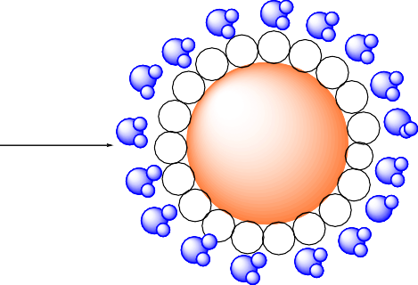

**BU[6]-Ag/AgCl NPs**

6

N N C

6 + Ag+

H2O DMSO/CHCl3

N N C

H3C

N N

CH3

O

 BU[6]  H2O

H3C

N N

CH3

O

**Figure 2.** The scheme shows the synthesis of BU[6]-Ag/AgCl NPs.

Under certain conditions, it is anticipated that BU[6] would preferentially assist with the adsorption, reduction, and growth of metal, which would result in the formation of nanoscale structures. The diverse polar carbonyl portals in BU[6] contribute significantly to the reduction of Ag+ ions via cumulative negative surface charges, resulting in the formation of AgNPs. Bambusuril[6] contains Cl− inside its cavity (Figure 1); therefore, Ag0 binds to Cl− inside its cavity, forming BU[6]-Ag/AgCl NPs. As the metallic particles condense to the nanoscale, effective stabilization is achieved through either electrostatic or steric mechanisms. BU[6] molecules serve as excellent stabilizers by forming a protective coating on the silver nanoparticle surfaces, counteracting Van der Waals forces that promote particle agglomeration. We propose a possible interaction model in which the carbonylated portals of BU[6] interact with the surfaces of the NPs, similar to the behavior observed with CB[7] [42]. Experimental evidence, supported by an FTIR analysis, demonstrates a notable decrease in the intensity of the characteristic carbonyl peak of BU[6] in the spectrum of the BU[6]-stabilized Ag/AgCl NPs. Additionally, a significant high-frequency shift from 1683 to 1694 cm−1 indicates supramolecular interactions between the carbonyl groups and the NPs surfaces.

Further, the formation of AgNPs was confirmed using UV-visible spectrophotometry (Figure 3). BU[6]-Ag/AgCl NPs absorbed light in the visible region due to surface plasmon resonance and produced a singular peak point at 430 nm [45].

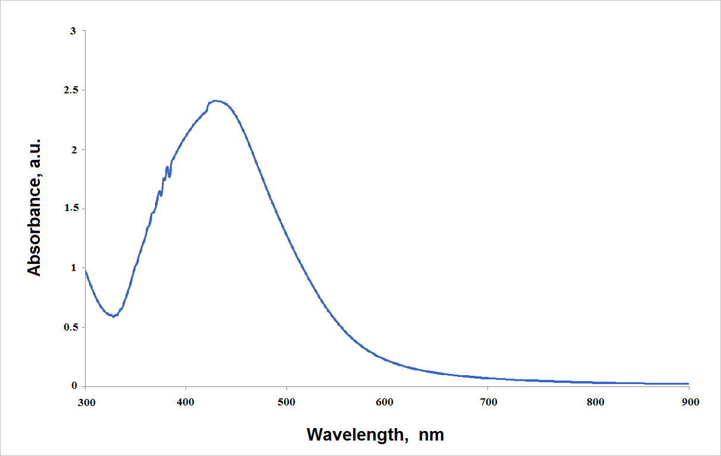

**Figure 3.** UV-visible spectrophotometry of BU[6]-AgCl NPs.

The solution of AgNO3 in the presence of DMSO/CHCl3 did not show the charac- teristic surface plasmon band, indicating that bambusuril[6] may play a decisive role in the reduction of silver salts to Ag0. Our results are in agreement with the literature, as the UV-visible spectra show that silver NPs have similar wavelength characteristics [46,47].

The morphologies of the synthesized particles were examined by SEM, and the SEM BU[6]-Ag/AgCl NPs samples are shown in Figure 4. When the SEM images were examined, it was seen that the synthesized BU[6]-Ag/AgCl NPs were distributed with homogeneous sizes, and the synthesized AgNPs were mostly spherical and cubic. Certain elements found in the BU[6]-Ag/AgCl NPs were determined by the EDS analysis, and the results are given in Figure 5. The EDS spectra of the BU[6]-Ag/AgCl NPs showed the presence of Ag, Cl, and all expected elements. A strong signal at 3 keV revealed the presence of metallic silver in BU[6]-Ag/AgCl NPs [48]. It was also shown that BU[6]-Ag/AgCl NPs did not contain any impurities. The C, O, and N peaks are evidence that bambusuril[6] was used during BU[6]-Ag/AgCl NP synthesis.

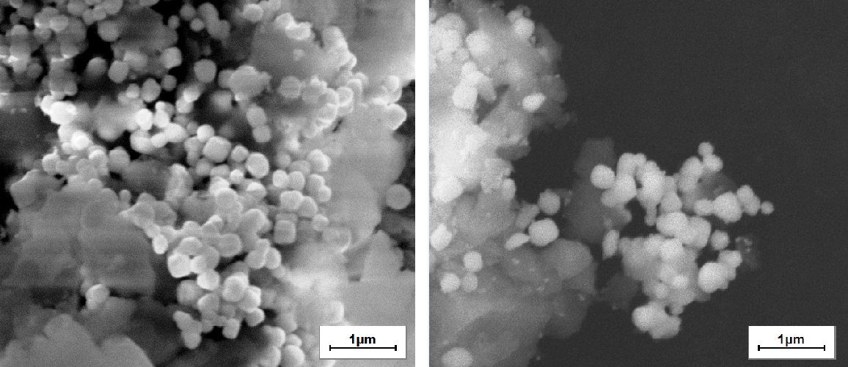

**Figure 4.** SEM image of synthesized BU[6]-Ag/AgCl NPs.

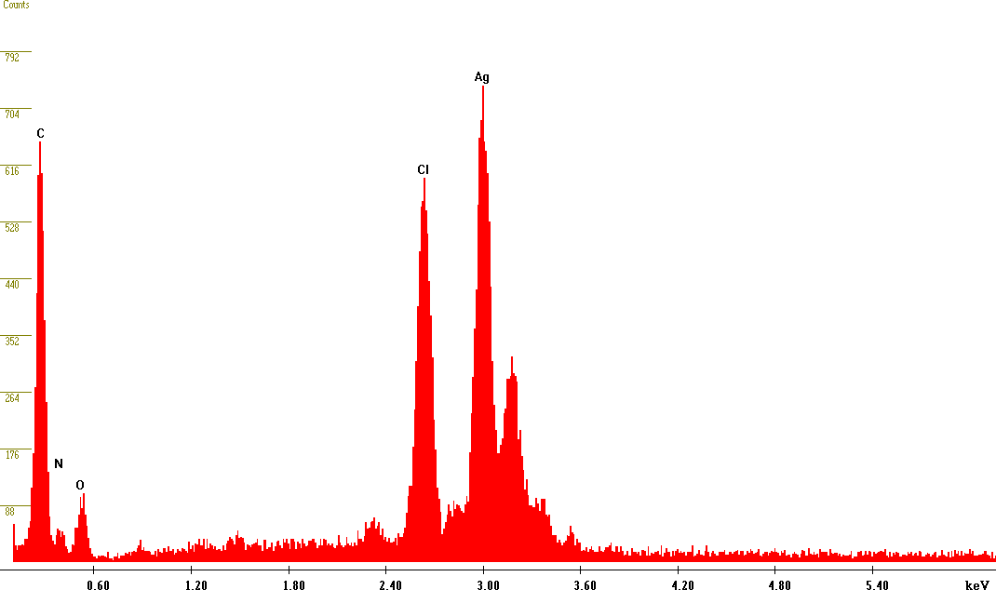

**Figure 5.** EDS analysis of synthesized BU[6]-Ag/AgCl NPs.

The crystalline nature of the synthesized silver nanoparticles, bambusuril[6], and AgNO3 was investigated using X-ray diffraction (XRD). The XRD pattern of BU[6]-Ag/AgCl NPs showed peaks at 27◦, 32◦, 46◦, 54◦, 57◦, 67◦, 74◦, and 77◦ (Figure 6), corresponding to the different orientation planes at 111, 200, 220, 311, 222, 400, 331, and 311 for the AgCl NPs, indicating a face-centered cubic structure of silver crystals (JCPDS card No. 31-1238). Additionally, some lower peaks were seen at 38◦ and 65◦ at an angle of 2*θ*, which indicated the cubic phase of Ag NPs (JCPDS no. 65-2871). Thus, the XRD pattern clearly demonstrates that the formed NPs have a crystalline nature. The present findings are in good agreement with previous studies of silver chloride NPs synthesis using arctic Marine Bacterium [10], leaf extract of pineapple peel [12], and *Sasa borealis* [9].

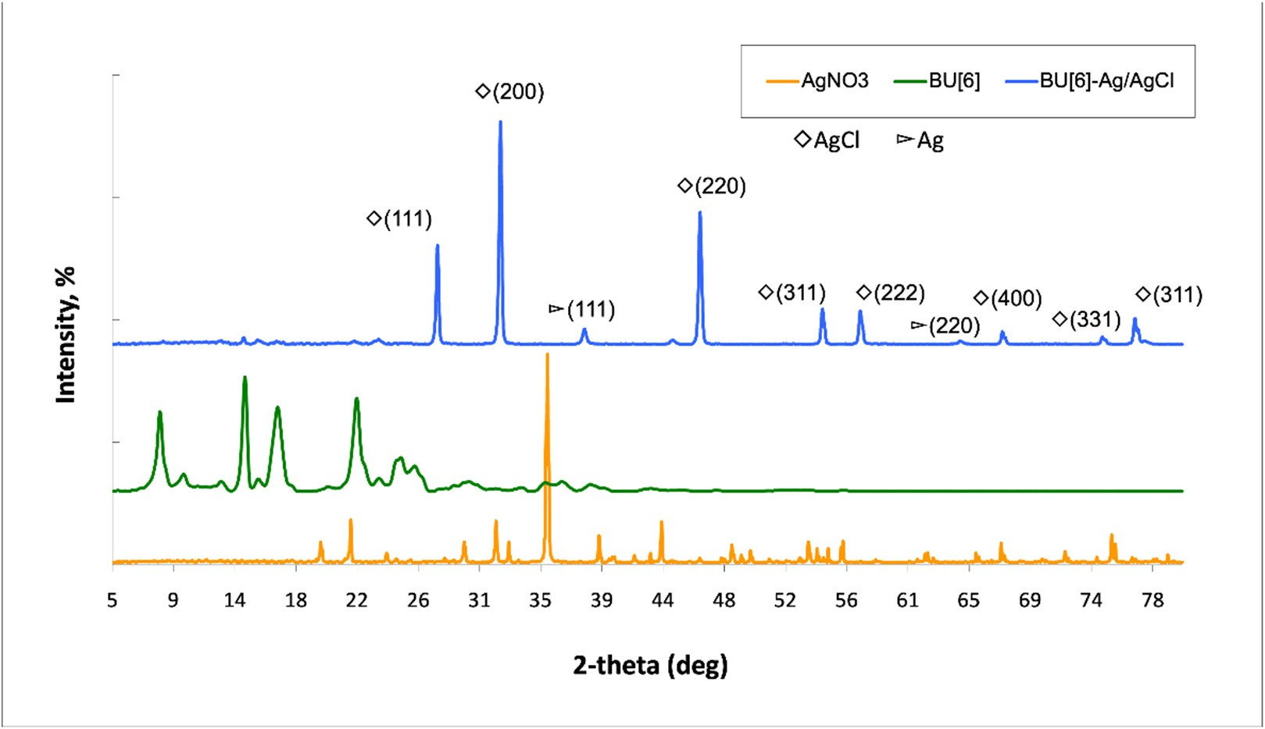

**Figure 6.** XRD patterns of BU[6], AgNO3, BU[6]-Ag/AgCl NPs.

Reflections from the (111), (200), (220), (311), and (222) lattice planes of AgCl NPs can be seen as a series of intense Bragg reflections. All of the reflections are consistent with

the crystalline structure of silver chloride with a face-centered cubic symmetry. The high degree of crystallinity of the silver NPs is evident in the intensities of the peak position reflections. The crystallite size of silver NPs was determined using the Debye Scherrer equation:

−

*D* = 0.89*λ*

*β*cos *θ*

where the Cu Kα X-ray wavelength *λ* = 0.154056 nm, *θ* is Bragg’s diffraction angle (◦ or radian), and *β* (radian) is the full width at half-maximum (FWHM) of the maxi- mum intensity peak ◦. The results show that the average crystallite size of BU[6]-AgCl NPs is 25.35 nm (Table 1).

**Table 1.** Data showing the crystallite diameter size of the BU[6]-Ag/AgCl NPs.

|  |  |  |  |  |  |
| --- | --- | --- | --- | --- | --- |
| **Miller Indices (hkl) 2*θ* of the Intense** | | ***θ* of the Intense** | **FWHM,** | **FWHM, Crystallite** | |
|  | **Peak (**◦**)** | **Peak (Radian)** | ***β* (**◦**)** | ***β* (Radian)** | **Diameter,**  **D (nm)** |
| 111 (AgCl) | 27.71 | 0.241077 | 0.25 | 0.004363 | 31.40 |
| 200 (AgCl) | 32.11 | 0.283692 | 0.41 | 0.007156 | 19.14 |
| 220 (AgCl) | 46.33 | 0.409326 | 0.35 | 0.006109 | 22.43 |
| 311 (AgCl) | 54.93 | 0.485307 | 0.25 | 0.004363 | 31.40 |
| 222 (AgCl) | 57.6 | 0.508896 | 0.35 | 0.006109 | 22.43 |
| 111 (Ag) | 38.13 | 0.336879 | 0.45 | 0.007854 | 17.44 |

The size of the polycrystalline particles is depicted by the SEM image (Figure 4). The particle sizes were estimated to be 240 nm. Most metals, including Ag, have FCC structures and grow from nucleation into twinned and multiply twinned particles with surfaces bordered by the lowest-energy facets [49]. AgCl NPs tend to agglomerate due to the high surface energy and high surface tension of the ultrafine NPs, which may account for the observation of some larger NPs. SEM can be used to estimate the particle size and XRD can be used to calculate the crystallite size. The crystallite size is different from the particle size. A particle may be made up of several different crystallites [50]. This is the main reason for the difference in particle sizes measured by SEM and XRD.

Figure 7 shows the FTIR spectra of BU[6], AgNO3, and BU[6]-Ag/AgCl. The IR spectrum of BU[6]-Ag/AgCl NPs exhibits a new absorption peak at 1251 cm−1, indicating the formation of van der Waals interactions between silver and the carbonyl groups of

bambusuril[6]. Additionally, the peak at 609 cm−1 indicates the binding of Ag to oxygen C=O bambusuril[6]. As observed from the spectra, the position of the characteristic carbonyl peak of bambusuril[6] shifted to the high-frequency region in the BU[6]-Ag/AgCl NPs spectrum, from 1679 to 1687 cm−1, which indicates a supramolecular interaction between carbonyl groups and the surface of NPs.

The thermograms of bambusuril[6] and BU[6]–AgCl show a loss of mass during thermal decomposition (Figure 8). The thermogram of bambusuril[6] indicates multistage degradation, with the first mass loss resulting from the evaporation of water and the next mass loss occurring due to the melting of bambusuril[6].

At the end of the experiment, the residue of pure bambusuril[6] at 500 ◦C was found

to represent 10.76% of the total mass. For BU[6]-Ag/AgCl, the first stage of degrada- tion involves the evaporation of water from the structure, followed by the melting of silver nanoparticles in the second stage. Based on these results, the thermal stability of bambusuril[6] changed upon the addition of silver (Figure 9). At 500 ◦C, the residue of BU[6]-Ag/AgCl NPs was found to be 22.9% of the total mass. Thus, it can be concluded that the silver content in BU[6]-Ag/AgCl NPs is 12.14%.

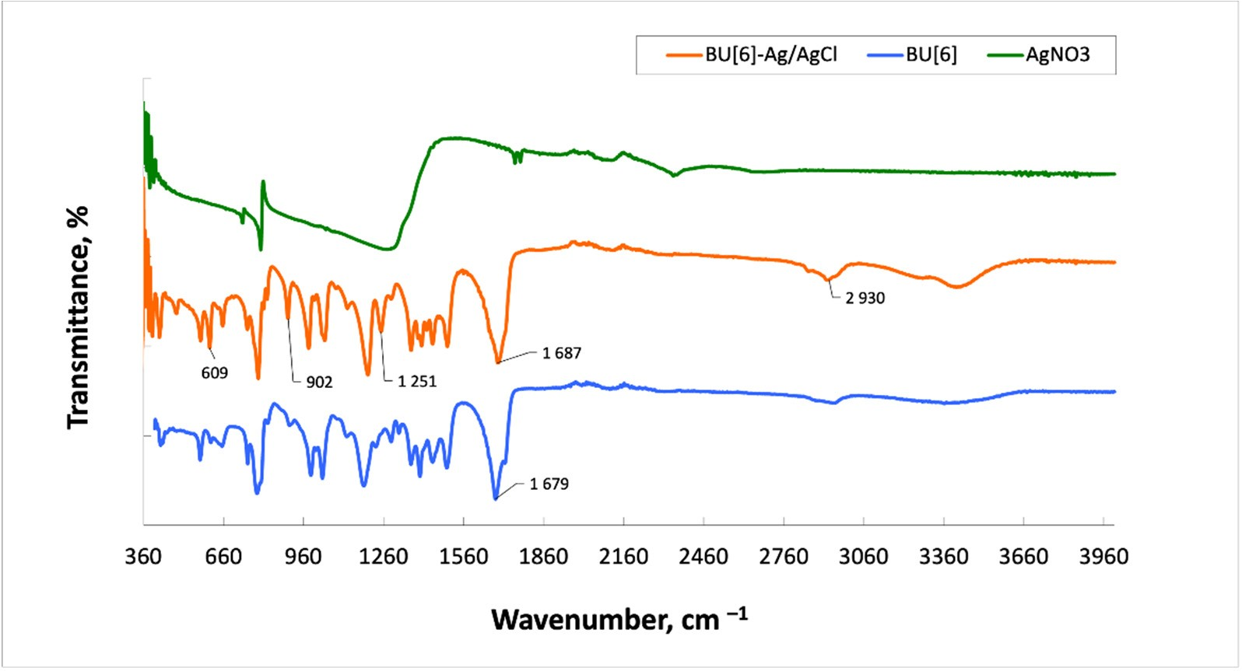

**Figure 7.** FTIR spectra of BU[6], AgNO3, and BU[6]-Ag/AgCl.

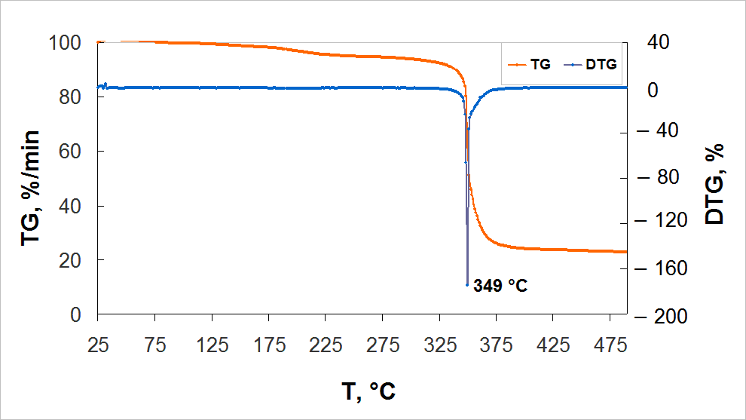

**Figure 8.** Thermal analysis of BU[6]-Ag/AgCl.

Strains of *Staphylococcus aureus* (*S. aureus*) and *Escherichia coli* (*E. coli*) were used as test objects to study the effect of BU[6]-Ag/AgCl NPs on Gram-positive and Gram- negative microflora. An 0.9% NaCl solution was added to the medium as a negative control, and bambusuril[6] and BU[6]-Ag/AgCl NPs solutions were added as samples. The concentration of the bacteria used in this measurement was about 1 108 cells/mL, and the concentration gradient of BU[6]-Ag/AgCl NPs was from 8 to 1 mg/mL. When the inhibition diameter of pure bambusuril[6] was examined, it was seen that there was no inhibition zone in either type of bacteria. These results showed that pure bambusuril[6] did not have an antimicrobial effect on both bacteria species. It can be seen that BU[6]-Ag/AgCl NPs displayed antimicrobial activity against both *S. aureus* and *E. coli* (Table 2). The zone of inhibition was found to increase in accordance with an increasing concentration of BU[6]- Ag/AgCl NPs. *E. coli* was a bit more sensitive to BU[6]-Ag/AgCl NPs than *S. aureus*, which was shown by the larger zones of inhibition. It was observed that 1 mg/mL BU[6]-Ag/AgCl NPs did not have an antimicrobial effect on either *E. coli* or *S. aureus*. In this study, the MICs of BU[6]-Ag/AgCl NPs against *S. aureus* and *E. coli* were determined by the macrodilution

×

method, and both were found to be effective at 2 mg/mL. One study demonstrated that the MIC of 10 nm silver NPs is a concentration of 1.35 mg/mL against *S. aureus* [51].

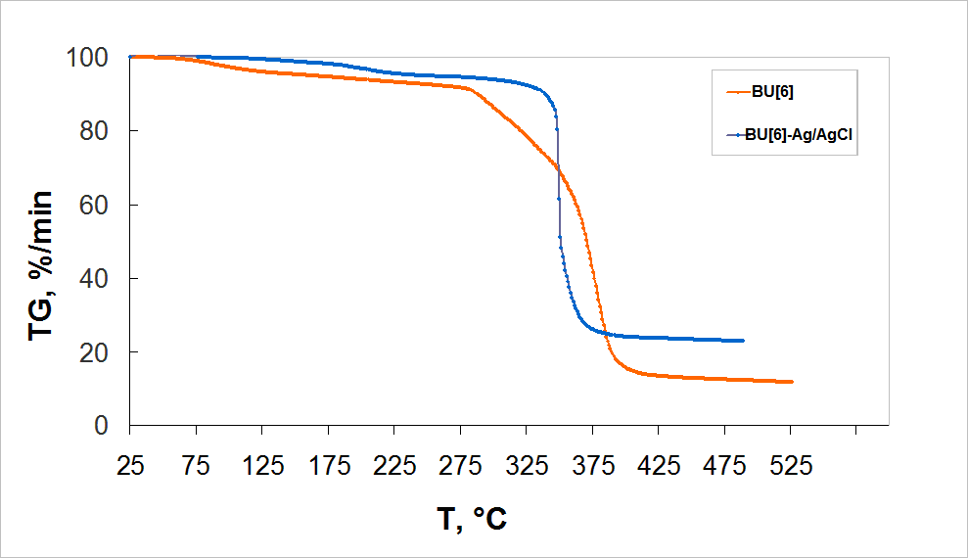

**Figure 9.** Thermal analysis for BU[6] and BU[6]-Ag/AgCl.

**Table 2.** Antimicrobial results of the samples.

**Samples Inhibition Zone of**

|  |  |  |  |
| --- | --- | --- | --- |
|  | ***E. coli* (mm)** |  | ***S. aureus* (mm)** |
| Negative control (NaCl) | 0 |  | 0 |
| 10 mg/mL Bambusuril[6] | 0 |  | 0 |
| 1 mg/mL BU[6]-Ag/AgCl NPs | 0 |  | 0 |
| 2 mg/mL BU[6]-Ag/AgCl NPs | 12.4 |  | 12.1 |
| 4 mg/mL BU[6]-Ag/AgCl NPs | 13.9 |  | 13.4 |
| 8 mg/mL BU[6]-Ag/AgCl NPs | 17.5 |  | 17.4 |
| MIC |  | 2 mg/mL |  |

**Inhibition Zone of**

It was found that bambusuril[6] reduced the cytotoxicity of porous materials in our previous studies. The surface of titanium nickelide was modified with bambusuril[6] [43]. In vitro tests proved the high biocompatibility and low toxicity of porous TiNi treated with BU[6] under vacuum. The control sample and the sample with the surface modified under vacuum exhibited enhanced surface cytocompatibility. The percentage of live cells MCF-7 in these samples exceeded 90%.

There is no information about the biocompatibility of bambusuril[6]. The biocompati- bility of bambusuril[6] was assessed by studying hemolysis (Table 3). The level of hemolysis for bambusuril[6] is 0.3%. It was found that bambusuril[6] does not cause erythrocyte death, since the level of hemolysis of biomaterials in contact with the internal environment of the body does not exceed 5% [52], which indicates the cytocompatibility and non-toxicity of BU[6].

**Table 3.** Hemolysis of BU[6].

**Samples Hemolysis, %**

BU[6] 0.3

CTRL (plasma) 0

A preliminary investigation was conducted to determine the cytotoxicity of BU[6] and BU[6]-Ag/AgCl NPs on human immune system cells (Table 4). Leukocyte fractions enriched with monocytes were used as a test system. The cytotoxicity of the samples was studied using the MTT test based on the standard for determining the viability of cell cultures (Figure 10) [53]. Cells cultured on a plate without samples were used as a control condition. The differentiation of living and dead cells was carried out visually according to the method proposed by J. Kzhyshkowska [54]. Living cells are lighter than dead cells and have well-defined shapes. The accuracy of this method was confirmed via fluorescence microscopy by staining with DAPI.

**Table 4.** Investigated materials and abbreviations.

|  |  |  |
| --- | --- | --- |
| **Samples** | **Name** | **Concentration, mg/mL** |
| BU[6] | D1 | 10 |
| BU[6] | D2 | 5 |
| BU[6] | D3 | 2.5 |
| BU[6]-Ag/AgCl | D4 | 10 |
| BU[6]-Ag/AgCl | D5 | 5 |
| BU[6]-Ag/AgCl | D6 | 2.5 |

# A B C D

**Figure 10.** Micrograph of the culture of human mononuclear cells incubated with (**A**,**C**) BU[6] and (**B**,**D**) BU[6]-Ag/AgCl NPs. The incubation durations were 24 h (**A**,**B**) and 144 h (**C**,**D**). A total of 1 mL of cell medium containing cells at a concentration of 1 × 106 cells and 10 µL of the sample suspension (BU[6]-Ag/AgCl NPs; BU[6]) was added to each well of a 24-well plate. Black arrows—live cells, dotted arrows—live cells.

A visual evaluation of the mononuclear viability in the presence of the test objects showed that BU[6]-Ag/AgCl NPs had a significant negative effect on the cell viability after 24 h of incubation. A considerable number of dead cells were observed after 144 h, and a large number of cells were identified as necrotic (Figure 10D). In contrast, bambusuril[6] did not have a significant negative effect on the cell viability (Figure 10A). Similar effects were observed after 144 h of incubation (Figure 10B), but they were more pronounced. Differences in the absolute values of cytotoxicity between donors were due to the differences in the mononuclear content in the blood of donors.

The results of the MTT test for evaluating the cell viability are consistent with the results of the visual evaluation. D1, D4, D5, and D6 had negative impacts on the cells (*p* < 0.05), while the level of mononuclear viability in the presence of sample D3 did not differ from the control sample (*p* > 0.05) (Figure 11). Bambusuril[6], at a concentration 2.5 mg/mL, did not induce mononuclear cell death. The toxicity of bambusuril[6] at a concentration of 10 mg/mL could be attributed to its ability to bind to mononuclear cells. It is known that cucurbituril[7] can form complexes with amino acids, peptides, and proteins [55–57]. According to data in the literature, CB[7] can bind to albumin [58,59]. Concentrations of

bambusuril[6] higher than 5 mg/mL are not required for medicinal purposes.

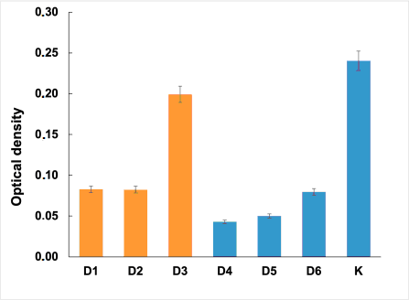 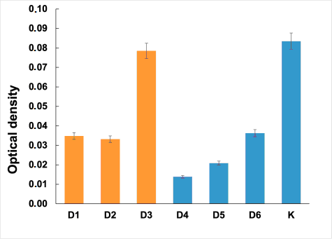 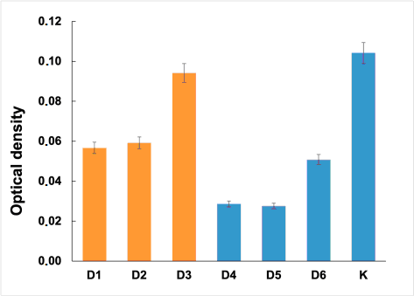

**Figure 11.** MTT test used for evaluating the cell viability levels of different donors after the incubation of BU[6] and BU[6]-Ag/AgCl NPs for 144 h.

There is research in the article of Mitzi J. Ramírez-Hernández regarding the cytotoxic selectivity on cancer cells with biogenically synthesized Ag/AgCl NPs [12]. Systems with Ag/AgCl were tested in mononuclear cells, particularly in monocytes. It was found that NPs were also cytotoxic to monocytes at a concentration of 25 µg/mL. In fact, their half maximal inhibitory concentration (IC50) was lower than that of MCF-7 cells, being 13 and 12 µg/mL, respectively. Interestingly, an unexpected result was that, for concentrations above 35 µg/mL, especially at 50 µg/mL, the cytotoxic effect of NPs was more pronounced on cancer cells than on monocytes [12]. Therefore, the increased cytotoxicity observed with the stabilization of silver NPs by bambusuril[6] against mononuclear cells in vitro suggests that these NPs may possess inherent properties for the effective interaction and eradication of cancer cells. However, these data have never been reported before, so the specific mechanism underlying this process remains unexplored and further investigation is warranted.

# Materials and Methods

Glyoxal was purchased from Novochem (Tomsk, Russia), and silver nitrate was purchased from Reachim (Sverdlovsk, Russia). All other chemicals were purchased from Merck/Sigma–Aldrich (Darmstadt, Germany).

* 1. *Bambusuril[6] Synthesis*

BU[6] was synthesized by the condensation of 2,4-dimethylglycoluryl with formalde- hyde in 5.4M HCl, with a yield of 30% [35]. 1H NMR (400 MHz, DMSO-d6/CHCl3 (1:1), 30 ◦C, TMS), ppm: 5.29 (s, 12H), 5.06 (s, 12H), 2.51 (s, 36H). 13C NMR (100.63 MHz,

[D6]DMSO/CDCl3 (1:1), 30 ◦C, TMS), ppm: 159.32, 158.45, 67.82, 48.78, 31.06.

* 1. *Synthesis of 4,5-Dihydroxy Imidazolidin-2-One*

The 4,5-dihydroxy imidazolidin-2-one was synthesized by mixing 50 g of urea with 107 mL of 40% glyoxal, followed by the gradual addition of NaOH until reaching pH 6–7. Once the pH was stabilized, the mixture was heated to 45 ◦C for 6–7 h. Subsequently, the mixture was cooled, the pH was adjusted to 8, and the mixture was left in a refrigerator at 5 ◦C for 2 days for crystal formation. The obtained DHI exhibited a melting point range of 157–160 ◦C. The 1H NMR (DMSO-d6 (1:1), TMS) spectrum showed peaks at 7.12 ppm (doublet, 2H), 5.98 ppm (doublet, 2H), and 4.61 ppm (doublet, 2H), while the 13C NMR (DMSO-d6 (1:1), TMS) spectrum displayed peaks at 161.01 ppm (C=O) and 84.24 ppm (C-H).

* 1. *Synthesis of 2,4-Dimethylglycoluril*

A total of 20 g of DHI was dissolved in 45 mL of distilled water, followed by the addition of 23 g of dimethylurea. Concentrated sulfuric acid was added gradually to adjust the pH to 2–3. The solution was heated to 85 ◦C for 2 h, and water was evaporated to yield a precipitate. The obtained precipitate was washed with ethanol. The resulting

2,4-dimethylglycoluril exhibited a melting point of 260 ◦C. The 1H NMR (DMSO-d6 (1:1), TMS) spectrum showed peaks at 7.53 ppm (complex, 2H), 5.12 ppm (complex, 2H), and

2.83 ppm (complex, 6H), while the 13C NMR (DMSO-d6 (1:1), TMS) spectrum displayed

peaks at 161.56 ppm (C=O), 158.22 ppm (-C=O), 67.67 ppm (C-H), and 28.22 ppm (-CH3).

* 1. *Synthesis of BU[6]-Ag/AgCl NPs*

A total of 1.13 g of bambusuril[6] was dissolved in a mixture of solvents consisting of 400 mL of DMSO/CHCl3 (1:1). Then, 0.53 g of silver nitrate was added to the solution. The mixture was stirred for 2 h at room temperature with a stirring rate of 150 rpm. The addition of water resulted in the formation of a dark gray precipitate between the water and the organic solvent layers.

* 1. *Infrared Spectroscopy*

Infrared (IR) spectra were recorded using an Agilent Cary 630 Fourier transform in- frared spectrometer (Agilent Technologies, Santa Clara, CA, USA) with the attenuated total reflection (ATR) technique (diamond crystal) in the wave number range of 4000–400 cm−1.

* 1. *NMR Spectroscopy*

The NMR analysis was conducted using a Bruker AVANCE 400 III HD NMR spec- trometer (Bruker, Billerica, MA, USA). One-dimensional spectra were recorded for the 1H (at a frequency of 400.17 MHz) and 13C (at a frequency of 100.63 MHz) nuclei to confirm the structure. The solvents used were dimethyl sulfoxide (DMSO D-6) with 99.9% atom D and heavy water (D2O).

* 1. *Thermogravimetric Analysis (TGA)*

TGA was conducted using TG-DTA Instruments NETZSCH STA 449F1 (NETZSCH, Selb, Germany). A sample weighing approximately 5 mg was measured and heated from room temperature to 600 ◦C with a heating rate of 10 ◦C/min under a nitrogen flow rate of 20 mL/min.

* 1. *Antibacterial Analysis*

The *S. aureus* (ATCC 6538D-5) and *E. coli* (ATCC 25922) strains were used as test objects. The antibacterial activity was determined using the agar diffusion test. Serial two-fold dilutions of BU[6]-Ag/AgCl NPs at concentrations ranging from 8 mg/mL to 1 mg/mL were used to determine the MIC. A test strain was inoculated by the lawn method for each Petri dish with 15 mL of agar medium (0.1 mL of cell suspension at a concentration of

1 108 cells/mL, 0.5 McFarland’s standard) from a pure mother culture. Then, a well with

×

a diameter of 7 mm was made in the center of the dish using a sterile cork borer over the entire thickness of the agar layer. A total of 0.1 mL of the sample solution was introduced into the well. After incubation, the zone of bacterial growth inhibition was measured with an accuracy level of 0.1 mm. The MIC endpoint was the lowest concentration of silver NPs for which no visible growth was seen in the tubes.

* 1. *MTT Test*

The MMT test involved the extraction of cells from the leukocyte–platelet layer of a human using the methodology presented by Kzhyshkovskaya Y.G. with modifications by the author [54]. The difference between the used technique and the presented one is that, in the modified version of the technique, the magnetic cell sorting step is omitted, which allows for the exctraction of all mononuclear cells. This makes it possible to assess the overall cytotoxicity of the samples towards immune system cells. Since the samples used in the study were poorly soluble in water, a suspension of the study objects was prepared in a PBS solution at the concentrations indicated in Table 1 for the ex-tempore experiment. After the cells had been extracted, 1 mL of the cell medium containing cells at a concentration of 1 × 106 cells and 10 µL of the sample suspension were added to each

well of a 24-well plate. Before each addition of the sample suspension, it was carefully resuspended. The incubation process was carried out at a temperature of 37 ◦C and 7.5% CO2 for 144 h. Cells cultivated on plastic without samples were used as positive controls. The level of cytotoxicity was assessed on mononuclear cells extracted from the blood of three donors—one male (A) and two females (B and C). After incubation, the condition of the cells was visually assessed, and cytotoxicity was assessed using the MTT test method. The optical density was measured using an automatic plate microreader (Tecan Infinite F50, Tecan, Austria) at wavelengths of 560 and 620 nm.

* 1. *Hemolysis*

Healthy donor blood containing sodium citrate (3.8 wt.%) was diluted in a ratio of 9:1 with normal saline (4:5 ratio by volume). The erythrocyte hemolysis test shows the interaction of the entire surface of the biomaterial with blood cells, which are necessary for oxygen transfer by the blood to tissue cells and promote oxidative processes. Samples were dipped into a standard tube containing 10 mL of normal saline that had been previously incubated at 37 ◦C for 30 min. Next, 0.2 mL of diluted blood was added to the standard tube, and the mixtures were incubated for 60 min at 37 ◦C. Similarly, normal saline solution was used as a negative control, and deionized water was used as a positive control. After that, all of the tubes were centrifuged for 5 min at 3000 rpm, and the supernatant was carefully removed and transferred to a cuvette for spectroscopic analysis at 545 nm. In addition, hemolysis was calculated using a Uniplan ultraviolet spectrophotometer (Pikon, Moscow, Russia). The hemolysis percent is the average of three replicates, which was calculated as follows:

H, % = (OD(testsample) − OD(negativecontrol) 100% OD(positivecontrol) − OD(negativecontrol)

∗

H, % = percentage of hemolysis

OD(test sample) = absorbance of sample

OD(negative control) = absorbance of negative control with erythrocytes OD(positive control) = absorbance of positive control

* 1. *XRD*

The crystal structure of the solid samples was determined using the X-ray diffraction (CRD) analysis performed on a Shimadzu XRD 6000 diffractometer (Shimadzu, Kyoto, Japan) with Cu K*α* radiation. The data were collected in the angular range of 5◦ < 2θ > 50◦

at a scanning rate of 20 deg/min.

* 1. *X-ray Crystallography*

The structural characterization of bambusuril[6] was carried out using a SmartLab SE X-ray diffractometer (Rigaku, Japan). The X-ray source employed copper (Cu) radiation with a power of 2.2 kW. The diffractometer had a vertical goniometer in the Theta–Theta geometry configuration with a measurement diameter of 600 mm. The angular range covered in the analysis was from 10 to 160◦.

* 1. *SEM*

The samples structures were studied by scanning electron microscopy (SEM, VEGA 3 SBH, Tescan, Brno, Czech Republic). Energy dispersive X-ray spectroscopy (Oxford Instruments, Abingdon, UK) was used for the elemental analysis.

# Conclusions

This paper presents a simple and effective method for synthesizing silver NPs based on the macrocycle–silver system. Previously, there were no known instances of using bambusuril[6] to obtain silver NPs without the use of conventional reducing agents or external energy sources. The introduction of silver into bambusuril[6] leads to the formation

of BU[6]-Ag/AgCl NPs, which exhibit a characteristic surface plasmon resonance peak centered at 430 nm in the UV-visible range. When the SEM images were examined, it was seen that the synthesized BU[6]-Ag/AgCl NPs were distributed with homogeneous sizes, and the synthesized AgNPs were mostly spherical and cubic. The EDS spectra of BU[6]-Ag/AgCl NPs showed the presence of Ag, Cl, and all expected elements. The introduction of Ag+ into bambusuril[6] led to the formation of silver NPs with a yield of 30% by mass compared to the theoretical value. Silver NPs stabilized by bambusuril[6] demonstrated high antibacterial activity against *S. aureus* and *E. coli*. The zone of inhibition was found to increase in accordance with increasing concentrations of BU[6]-Ag/AgCl NPs. *E. coli* was a bit more sensitive to BU[6]-Ag/AgCl NPs than *S. aureus*, as shown by the larger zones of inhibition. In this study, the MICs of BU[6]-Ag/AgCl NPs against

*S. aureus* and *E. coli* were determined by the macrodilution method, and both were found to be effective at 2 mg/mL. The results of the MTT test for evaluating the cell viability level of mononuclear cells from different donors after incubation for 144 h with BU[6] and BU[6]-Ag/AgCl NPs are consistent with the results of the visual evaluation. It was found that BU[6] had a negative effect on mononuclear cells at concentrations above 10 mg/mL, while the level of mononuclear viability in the presence of BU[6] at a concentration of

2.5 mg/mL did not differ from that of the control sample. BU[6]-Ag/AgCl NPS was shown to induce high toxicity levels for mononuclear cells at all concentrations. The toxicity of bambusuril[6] at concentrations above 10 mg/mL may be associated with its ability to bind to mononuclear immune cells, similar to cucurbituril[7]. Additionally, it should be noted that BU[6]-Ag/AgCl NPs could possess the ability to bind to cancer cells and provoke their demise, further contributing to their anticancer potential. However, these data have never been reported before, so the specific mechanism underlying this process remains unexplored and further investigation is warranted.

# References

**Author Contributions:** Investigation, P.T., V.L. and D.F.; resources, A.B.; data curation, R.Y.; writing— original draft preparation, P.T., S.B. and T.T.; writing—review and editing, S.S. and N.N. All authors have read and agreed to the published version of the manuscript.

**Funding:** This research was funded by the Tomsk State University Development Program (Priority- 2030), Russia.

**Institutional Review Board Statement:** Not applicable.

**Informed Consent Statement:** Not applicable.

**Data Availability Statement:** The data presented in this study are available in this article.

**Conflicts of Interest:** The authors declare no conflict of interest.

1. Cassano, D.; Mapanao, A.-K.; Summa, M.; Vlamidis, Y.; Giannone, G.; Santi, M.; Guzzolino, E.; Pitto, L.; Poliseno, L.; Bertorelli, R.; et al. Biosafety and Biokinetics of Noble Metals: The Impact of Their Chemical Nature. *ACS Appl. Bio Mater.* **2019**, *2*, 4464–4470. [[CrossRef](https://doi.org/10.1021/acsabm.9b00630)]
2. Sondi, I.; Salopek-Sondi, B. Silver Nanoparticles as Antimicrobial Agent: A Case Study on *E. coli* as a Model for Gram-Negative Bacteria. *J. Colloid Interface Sci.* **2004**, *275*, 177–182. [[CrossRef](https://doi.org/10.1016/j.jcis.2004.02.012)]
3. Sharma, V.K.; Yngard, R.A.; Lin, Y. Silver Nanoparticles: Green Synthesis and Their Antimicrobial Activities. *Adv. Colloid Interface Sci.* **2009**, *145*, 83–96. [[CrossRef](https://doi.org/10.1016/j.cis.2008.09.002)]
4. Gurunathan, S.; Kalishwaralal, K.; Vaidyanathan, R.; Venkataraman, D.; Pandian, S.R.K.; Muniyandi, J.; Hariharan, N.; Eom, S.H. Biosynthesis, Purification and Characterization of Silver Nanoparticles Using *Escherichia coli*. *Colloids Surf. B Biointerfaces* **2009**, *74*, 328–335. [[CrossRef](https://doi.org/10.1016/j.colsurfb.2009.07.048)]
5. Panácˇek, A.; Kolárˇ, M.; Vecˇerˇová, R.; Prucek, R.; Soukupová, J.; Kryštof, V.; Hamal, P.; Zborˇil, R.; Kvítek, L. Antifungal Activity of Silver Nanoparticles against *Candida* spp. *Biomaterials* **2009**, *30*, 6333–6340. [[CrossRef](https://doi.org/10.1016/j.biomaterials.2009.07.065)]
6. Zodrow, K.; Brunet, L.; Mahendra, S.; Li, D.; Zhang, A.; Li, Q.; Alvarez, P.J.J. Polysulfone Ultrafiltration Membranes Impregnated with Silver Nanoparticles Show Improved Biofouling Resistance and Virus Removal. *Water Res.* **2009**, *43*, 715–723. [[CrossRef](https://doi.org/10.1016/j.watres.2008.11.014)]
7. Aboody, M.S. Silver/silver chloride (Ag/AgCl) nanoparticles synthesized from *Azadirachta indica* lalex and its antibiofilm activity against fluconazole resistant *Candida tropicalis*. *Artif. Cells Nanomed. Biotechnol.* **2019**, *47*, 2107–2113. [[CrossRef](https://doi.org/10.1080/21691401.2019.1620257)]
8. Gok, Z.G.; Karayel, M.; Yig˘ itog˘ lu, M. Synthesis of carrageenan coated silver nanoparticles by an easy green method and their characterization and antimicrobial activities. *Res. Chem. Intermed.* **2021**, *47*, 1843–1864. [[CrossRef](https://doi.org/10.1007/s11164-021-04399-6)]
9. Patil, M.P.; Palma, J.; Simeon, N.C.; Jin, X.; Liu, X.; Ngabire, D.; Kim, N.H.; Tarte, N.H.; Kim, G.D. *Sasa borealis* leaf extract-mediated green synthesis of silver-silver chloride nanoparticles and their antibacterial and anticancer activities. *New J. Chem.* **2017**, *41*, 1363–1371. [[CrossRef](https://doi.org/10.1039/C6NJ03454C)]
10. Li, S.; Zhang, H.; Cong, B.; He, P.; Liu, W.; Liu, S. A Novel Ag-AgCl Nanoparticle Synthesized by Arctic Marine Bacterium: Characterization, Activity and Mechanism. *Int. J. Mol. Sci.* **2022**, *23*, 15558. [[CrossRef](https://doi.org/10.3390/ijms232415558)]
11. Morais, M.; Teixeira, A.L.; Dias, F.; Machado, V.; Medeiros, R.; Prior, J.A.V.J. Cytotoxic Effect of Silver Nanoparticles Synthesized by Green Methods in Cancer. *Med. Chem.* **2020**, *63*, 14308–14335. [[CrossRef](https://doi.org/10.1021/acs.jmedchem.0c01055)]
12. Ramírez-Hernández, M.; Valera-Zaragoza, M.; Viñas-Bravo, O.; Huerta-Heredia, A.; Peña-Rico, M. In search of cytotoxic selectivity on cancer cells with biogenically synthesized Ag/AgCl nanoparticles. *Beilstein J. Nanotechnol.* **2022**, *13*, 1505–1519. [[CrossRef](https://doi.org/10.3762/bjnano.13.124)]
13. Graf, C.; Vossen, D.L.J.; Imhof, A.; van Blaaderen, A. A General Method to Coat Colloidal Particles with Silica. *Langmuir* **2003**, *19*,

6693–6700. [[CrossRef](https://doi.org/10.1021/la0347859)]

1. Albanese, A.; Tang, P.S.; Chan, W.C.W. The Effect of Nanoparticle Size, Shape, and Surface Chemistry on Biological Systems.

*Annu. Rev. Biomed. Eng.* **2012**, *14*, 1–16. [[CrossRef](https://doi.org/10.1146/annurev-bioeng-071811-150124)]

1. Saravanan, M.; Barik, S.K.; MubarakAli, D.; Prakash, P.; Pugazhendhi, A. Synthesis of Silver Nanoparticles from *Bacillus brevis* (NCIM 2533) and Their Antibacterial Activity against Pathogenic Bacteria. *Microb. Pathog.* **2018**, *116*, 221–226. [[CrossRef](https://doi.org/10.1016/j.micpath.2018.01.038)]
2. Shah, A.; Lutfullah, G.; Ahmad, K.; Khalil, A.T.; Maaza, M. Daphne Mucronata-Mediated Phytosynthesis of Silver Nanoparticles and Their Novel Biological Applications, Compatibility and Toxicity Studies. *Green Chem. Lett. Rev.* **2018**, *11*, 318–333. [[CrossRef](https://doi.org/10.1080/17518253.2018.1502365)]
3. Ilangovan, R.; Subha, V.; Ravindran, R.S.E.; Kirubanandan, S.; Renganathan, S. Chapter 2—Nanomaterials: Synthesis, Physico- chemical Characterization, and Biopharmaceutical Applications. In *Nanoscale Processing*; Thomas, S., Balakrishnan, P., Eds.; Micro and Nano Technologies; Elsevier: Amsterdam, The Netherlands, 2021; pp. 33–70. [[CrossRef](https://doi.org/10.1016/B978-0-12-820569-3.00002-5)]
4. Klasen, H.J. Historical Review of the Use of Silver in the Treatment of Burns. I. Early Uses. *Burns* **2000**, *26*, 117–130. [[CrossRef](https://doi.org/10.1016/S0305-4179(99)00108-4)]
5. Gurunathan, S.; Han, J.W.; Eppakayala, V.; Jeyaraj, M.; Kim, J.-H. Cytotoxicity of Biologically Synthesized Silver Nanoparticles in MDA-MB-231 Human Breast Cancer Cells. *BioMed Res. Int.* **2013**, *2013*, 535796. [[CrossRef](https://doi.org/10.1155/2013/535796)]
6. Gurunathan, S.; Kang, M.-H.; Qasim, M.; Kim, J.-H. Nanoparticle-Mediated Combination Therapy: Two-in-One Approach for Cancer. *Int. J. Mol. Sci.* **2018**, *19*, 3264. [[CrossRef](https://doi.org/10.3390/ijms19103264)]
7. Firdhouse, M.J.; Lalitha, P. Biosynthesis of Silver Nanoparticles Using the Extract of Alternanthera Sessilis—Antiproliferative Effect against Prostate Cancer Cells. *Cancer Nanotechnol.* **2013**, *4*, 137–143. [[CrossRef](https://doi.org/10.1007/s12645-013-0045-4)]
8. Cameron, S.J.; Hosseinian, F.; Willmore, W.G. A Current Overview of the Biological and Cellular Effects of Nanosilver. *Int. J. Mol.* *Sci.* **2018**, *19*, 2030. [[CrossRef](https://doi.org/10.3390/ijms19072030)]
9. Trojan-Horse Mechanism in the Cellular Uptake of Silver Nanoparticles Verified by Direct Intra- and Extracellular Silver Speciation Analysis|Environmental Science & Technology. Available online: <https://pubs.acs.org/doi/abs/10.1021/es504705p>(accessed on 29 June 2023).
10. Park, E.-J.; Yi, J.; Kim, Y.; Choi, K.; Park, K. Silver Nanoparticles Induce Cytotoxicity by a Trojan-Horse Type Mechanism. *Toxicol.* *Vitr.* **2010**, *24*, 872–878. [[CrossRef](https://doi.org/10.1016/j.tiv.2009.12.001)]
11. Kovács, D.; Igaz, N.; Gopisetty, M.K.; Kiricsi, M. Cancer Therapy by Silver Nanoparticles: Fiction or Reality? *Int. J. Mol. Sci.* **2022**,

*23*, 839. [[CrossRef](https://doi.org/10.3390/ijms23020839)]

1. Ariga, K.; Kunitake, T. *Supramolecular Chemistry—Fundamentals and Applications: Advanced Textbook*; Springer Science & Business Media: Berlin/Heidelberg, Germany, 2006.
2. Schneider, H.-J. *Applications of Supramolecular Chemistry*; CRC Press: Boca Raton, FL, USA, 2012.
3. Wang, F.; Zhang, J.; Ding, X.; Dong, S.; Liu, M.; Zheng, B.; Li, S.; Wu, L.; Yu, Y.; Gibson, H.W.; et al. Metal Coordination Mediated Reversible Conversion between Linear and Cross-Linked Supramolecular Polymers. *Angew. Chem. Int. Ed.* **2010**, *49*, 1090–1094. [[CrossRef](https://doi.org/10.1002/anie.200906389)]
4. Zhang, Z.; Luo, Y.; Chen, J.; Dong, S.; Yu, Y.; Ma, Z.; Huang, F. Formation of Linear Supramolecular Polymers That Is Driven by C—H π Interactions in Solution and in the Solid State. *Angew. Chem. Int. Ed.* **2011**, *50*, 1397–1401. [[CrossRef](https://doi.org/10.1002/anie.201006693)]

· · ·

1. Wang, F.; Han, C.; He, C.; Zhou, Q.; Zhang, J.; Wang, C.; Li, N.; Huang, F. Self-Sorting Organization of Two Heteroditopic

Monomers to Supramolecular Alternating Copolymers. *J. Am. Chem. Soc.* **2008**, *130*, 11254–11255. [[CrossRef](https://doi.org/10.1021/ja8035465)]

1. Yu, J.; Qi, D.; Li, J. Design, Synthesis and Applications of Responsive Macrocycles. *Commun. Chem.* **2020**, *3*, 189. [[CrossRef](https://doi.org/10.1038/s42004-020-00438-2)]
2. Harada, A.; Kobayashi, R.; Takashima, Y.; Hashidzume, A.; Yamaguchi, H. Macroscopic Self-Assembly through Molecular Recognition. *Nat. Chem.* **2011**, *3*, 34–37. [[CrossRef](https://doi.org/10.1038/nchem.893)]
3. Liu, J.; Lan, Y.; Yu, Z.; Tan, C.S.Y.; Parker, R.M.; Abell, C.; Scherman, O.A. Cucurbit[n]Uril-Based Microcapsules Self-Assembled within Microfluidic Droplets: A Versatile Approach for Supramolecular Architectures and Materials. *Acc. Chem. Res.* **2017**, *50*, 208–217. [[CrossRef](https://doi.org/10.1021/acs.accounts.6b00429)]
4. Svec, J.; Necas, M.; Sindelar, V. Bambus[6]Uril. *Angew. Chem. Int. Ed.* **2010**, *49*, 2378–2381. [[CrossRef](https://doi.org/10.1002/anie.201000420)]
5. Lizal, T.; Sindelar, V. Bambusuril Anion Receptors. *Isr. J. Chem.* **2018**, *58*, 326–333. [[CrossRef](https://doi.org/10.1002/ijch.201700111)]
6. Yawer, M.A.; Havel, V.; Sindelar, V. A Bambusuril Macrocycle That Binds Anions in Water with High Affinity and Selectivity.

*Angew. Chem. Int. Ed.* **2015**, *54*, 276–279. [[CrossRef](https://doi.org/10.1002/anie.201409895)]

1. Svec, J.; Dusek, M.; Fejfarova, K.; Stacko, P.; Klán, P.; Kaifer, A.E.; Li, W.; Hudeckova, E.; Sindelar, V. Anion-Free Bambus[6]Uril and Its Supramolecular Properties. *Chem.–Eur. J.* **2011**, *17*, 5605–5612. [[CrossRef](https://doi.org/10.1002/chem.201003683)] [[PubMed](https://www.ncbi.nlm.nih.gov/pubmed/21484899)]
2. Valkenier, H.; Akrawi, O.; Jurcˇek, P.; Sleziaková, K.; Lízal, T.; Bartik, K.; Šindelárˇ, V. Fluorinated Bambusurils as Highly Effective and Selective Transmembrane Cl−/HCO3− Antiporters. *Chem* **2019**, *5*, 429–444. [[CrossRef](https://doi.org/10.1016/j.chempr.2018.11.008)]
3. Hamacek, J.; Sokolov, J.; Šindelárˇ, V. Bambusuril Macrocycles as Mediators of Supramolecular Interactions: Application to the Europium Cage Helicate. *Chem.–Eur. J.* **2021**, *27*, 5492–5497. [[CrossRef](https://doi.org/10.1002/chem.202005140)] [[PubMed](https://www.ncbi.nlm.nih.gov/pubmed/33442893)]
4. Rando, C.; Vázquez, J.; Sokolov, J.; Kokan, Z.; Necˇas, M.; Šindelárˇ, V. Highly Efficient and Selective Recognition of Dicyanoaurate(I) by a Bambusuril Macrocycle in Water. *Angew. Chem.* **2022**, *134*, e202210184. [[CrossRef](https://doi.org/10.1002/ange.202210184)]
5. Sokolov, J.; Štefek, A.; Šindelárˇ, V. Functionalized Chiral Bambusurils: Synthesis and Host-Guest Interactions with Chiral Carboxylates. *ChemPlusChem* **2020**, *85*, 1307–1314. [[CrossRef](https://doi.org/10.1002/cplu.202000261)]
6. Premkumar, T.; Lee, Y.; Geckeler, K.E. Macrocycles as a Tool: A Facile and One-Pot Synthesis of Silver Nanoparticles Using Cucurbituril Designed for Cancer Therapeutics. *Chem.–Eur. J.* **2010**, *16*, 11563–11566. [[CrossRef](https://doi.org/10.1002/chem.201001325)]
7. Marchenko, E.; Luchsheva, V.; Baigonakova, G.; Bakibaev, A.; Vorozhtsov, A. Functionalization of the Surface of Porous Nickel– Titanium Alloy with Macrocyclic Compounds. *Materials* **2023**, *16*, 66. [[CrossRef](https://doi.org/10.3390/ma16010066)]
8. Luchsheva, V.R.; Bakibaev, A.A.; Marchenko, E.S. Development of bioactive composite material based on bambusuril and porous titanium nickelide. *Vopr. Materialoved.* **2023**, *4*, 35–42. [[CrossRef](https://doi.org/10.22349/1994-6716-2022-112-4-35-42)]
9. Heath, J.R. Size-Dependent Surface-Plasmon Resonances of Bare Silver Particles. *Phys. Rev. B* **1989**, *40*, 9982–9985. [[CrossRef](https://doi.org/10.1103/PhysRevB.40.9982)]

[[PubMed](https://www.ncbi.nlm.nih.gov/pubmed/9991532)]

1. Gün Gök, Z.; Günay, K.; Arslan, M.; Yig˘ itog˘ lu, M.; Vargel, I˙. Coating of Modified Poly(Ethylene Terephthalate) Fibers with Sericin-Capped Silver Nanoparticles for Antimicrobial Application. *Polym. Bull.* **2020**, *77*, 1649–1665. [[CrossRef](https://doi.org/10.1007/s00289-019-02820-0)]
2. Aramwit, P.; Bang, N.; Ratanavaraporn, J.; Ekgasit, S. Green Synthesis of Silk Sericin-Capped Silver Nanoparticles and Their Potent Anti-Bacterial Activity. *Nanoscale Res. Lett.* **2014**, *9*, 79. [[CrossRef](https://doi.org/10.1186/1556-276X-9-79)]
3. Devi, T.B.; Ahmaruzzaman, M.; Begum, S. A rapid, facile and green synthesis of Ag@AgCl nanoparticles for the effective reduction of 2,4-dinitrophenyl hydrazine. *N. J. Chem.* **2016**, *40*, 1497–1506. [[CrossRef](https://doi.org/10.1039/C5NJ02367J)]
4. Ali, H.; Azad, A.K.; Khan, K.A.; Rahman, O.; Chakma, U.; Kumer, A. Analysis of Crystallographic Structures and Properties of Silver Nanoparticles Synthesized Using PKL Extract and Nanoscale Characterization Techniques. *ACS Omega* **2023**, *8*, 28133–28142. [[CrossRef](https://doi.org/10.1021/acsomega.3c01261)] [[PubMed](https://www.ncbi.nlm.nih.gov/pubmed/37576647)]
5. Ali, M. Etching of photon energy into binding energy in depositing carbon films at different chamber pressures. *J. Mater. Sci.* *Mater. Electron.* **2023**, *34*, 1209. [[CrossRef](https://doi.org/10.1007/s10854-023-10604-6)]
6. Ayala-Nunez, V.; Villegas, L.; Ixtepan, C.; Turrent, L. Silver nanoparticles toxicity and bactericidal effect against methicillin- resistant Staphylococcus aureus: Nanoscale does matter. *Nanobiotechnology* **2009**, *5*, 2–9. [[CrossRef](https://doi.org/10.1007/s12030-009-9029-1)]
7. *ISO 10993-4:2017*; Biological Evaluation of Medical Devices—Part 4: Selection of Tests for Interactions with Blood—Technical

Committee: ISO/TC 194. ISO: Geneva, Switzerland, 2017; p. 69.

1. Buranaamnuay, K. The MTT Assay Application to Measure the Viability of Spermatozoa: A Variety of the Assay Protocols. *Open* *Vet. J.* **2021**, *11*, 251–269. [[CrossRef](https://doi.org/10.5455/OVJ.2021.v11.i2.9)]
2. Popova, A.; Kzhyshkowska, J.; Nurgazieva, D.; Goerdt, S.; Gratchev, A. Pro- and Anti-Inflammatory Control of M-CSF-Mediated Macrophage Differentiation. *Immunobiology* **2011**, *216*, 164–172. [[CrossRef](https://doi.org/10.1016/j.imbio.2010.06.003)]
3. Gamal-Eldin, M.A.; Macartney, D.H. Selective Molecular Recognition of Methylated Lysines and Arginines by Cucurbit[6]Uril and Cucurbit[7]Uril in Aqueous Solution. *Org. Biomol. Chem.* **2012**, *11*, 488–495. [[CrossRef](https://doi.org/10.1039/C2OB27007B)]
4. Bailey, D.M.; Hennig, A.; Uzunova, V.D.; Nau, W.M. Supramolecular Tandem Enzyme Assays for Multiparameter Sensor Arrays and Enantiomeric Excess Determination of Amino Acids. *Chem. Weinh. Bergstr. Ger.* **2008**, *14*, 6069–6077. [[CrossRef](https://doi.org/10.1002/chem.200800463)] [[PubMed](https://www.ncbi.nlm.nih.gov/pubmed/18509840)]
5. Chinai, J.M.; Taylor, A.B.; Ryno, L.M.; Hargreaves, N.D.; Morris, C.A.; Hart, P.J.; Urbach, A.R. Molecular Recognition of Insulin by a Synthetic Receptor. *J. Am. Chem. Soc.* **2011**, *133*, 8810–8813. [[CrossRef](https://doi.org/10.1021/ja201581x)] [[PubMed](https://www.ncbi.nlm.nih.gov/pubmed/21473587)]
6. Cáceres, J.; Robinson-Duggon, J.; Tapia, A.; Paiva, C.; Gómez, M.; Bohne, C.; Fuentealba, D. Photochemical Behavior of Biosupramolecular Assemblies of Photosensitizers, Cucurbit[n]Urils and Albumins. *Phys. Chem. Chem. Phys.* **2017**, *19*, 2574–2582. [[CrossRef](https://doi.org/10.1039/C6CP07749H)] [[PubMed](https://www.ncbi.nlm.nih.gov/pubmed/28059428)]
7. Lei, W.; Jiang, G.; Zhou, Q.; Zhang, B.; Wang, X. Greatly Enhanced Binding of a Cationic Porphyrin towards Bovine Serum Albumin by Cucurbit[8]Uril. *Phys. Chem. Chem. Phys.* **2010**, *12*, 13255–13260. [[CrossRef](https://doi.org/10.1039/c001013h)] [[PubMed](https://www.ncbi.nlm.nih.gov/pubmed/20824256)]

**Disclaimer/Publisher’s Note:** The statements, opinions and data contained in all publications are solely those of the individual author(s) and contributor(s) and not of MDPI and/or the editor(s). MDPI and/or the editor(s) disclaim responsibility for any injury to people or property resulting from any ideas, methods, instructions or products referred to in the content.

[molecules](https://www.mdpi.com/journal/molecules)



*Article*

**Absorption of Water Vapor by Bambus[6]uril and a Density Functional Theory Study of Its Aqua Complexes**

Pana Turebayeva 1,* , Alexey N. Guslyakov 2 , Svetlana A. Novikova 3, Andrei I. Khlebnikov 3 , Ekaterina A. Befus 2 , Evgeniy P. Meshcheryakov 2 , Abdigali A. Bakibaev 2 , Lyazat Kusepova 1 , Nazira Kassenova 4 , Sarzhan Sharipova 5 and Rakhmetulla Yerkassov 1



1 Department of Chemistry, L.N. Gumilyov Eurasian National University, Astana 010008, Kazakhstan; [kusepova71@mail.ru](mailto:kusepova71@mail.ru) (L.K.)

2 Faculty of Chemistry, National Research Tomsk State University, 634050 Tomsk, Russia;

[guslyakov.aleksej@bk.ru](mailto:guslyakov.aleksej@bk.ru) (A.N.G.); [ekaterina.befus@mail.ru](mailto:ekaterina.befus@mail.ru) (E.A.B.); [meevgeni@mail.ru](mailto:meevgeni@mail.ru) (E.P.M.)

3 Kizhner Research Center, Tomsk Polytechnic University, 634050 Tomsk, Russia; [san22@tpu.ru](mailto:san22@tpu.ru) (S.A.N.)

4 Department of Chemistry and Biotechnology, Sh. Ualikhanov Kokshetau University, Kokshetau 020000, Kazakhstan; [nazira09_83@mail.ru](mailto:nazira09_83@mail.ru)

5 Department of Pharmaceutical and Toxicological Chemistry, Pharmacognosy and Botany, Asfendiyarov

Kazakh National Medical University, Almaty 050000, Kazakhstan

**\*** Correspondence: pana90@mail.ru; Tel.: +7-707-3488487



**Citation:** Turebayeva, P.; Guslyakov, A.N.; Novikova, S.A.; Khlebnikov, A.I.; Befus, E.A.; Meshcheryakov, E.P.; Bakibaev, A.A.; Kusepova, L.; Kassenova, N.; Sharipova, S.; et al.

Absorption of Water Vapor by Bambus[6]uril and a Density Functional Theory Study of Its Aqua Complexes. *Molecules* **2023**, *28*, 7680. [https://doi.org/10.3390/](https://doi.org/10.3390/molecules28237680) [molecules28237680](https://doi.org/10.3390/molecules28237680)

Academic Editor: Federico Totti

Received: 29 September 2023

Revised: 8 November 2023

Accepted: 15 November 2023

Published: 21 November 2023



**Copyright:** © 2023 by the authors. Licensee MDPI, Basel, Switzerland. This article is an open access article distributed under the terms and conditions of the Creative Commons Attribution (CC BY) license ([https://](https://creativecommons.org/licenses/by/4.0/) [creativecommons.org/licenses/by/](https://creativecommons.org/licenses/by/4.0/) 4.0/).

**Abstract:** The absorption/desorption of water vapor by bambus[6]uril (Bu[6]) has been studied. According to kinetic experiments, the absorption capacity of Bu[6] is 4 moles of water per 1 mole of Bu[6] with the absorption duration of 20 min and the complete desorption duration of 100 min. Experimental rate constants for water vapor absorption and desorption by Bu[6] have been deter- mined to be 0.166 min*−*1 and 0.0221 min*−*1, respectively. The obtained results are in agreement with theoretical calculations using the DFT method. A hypothetical structure of bambus[6]uril tetrahydrate (Bu[6]*·*4H2O) has been proposed based on the experimental and DFT data.

**Keywords:** bambus[6]uril; water absorption; DFT calculations; water desorption; aqua complex

1. Introduction

Bambus[n]urils with n = 4, 6 (Bu[n]) were discovered relatively recently by a group of Czech scientists [1]. Bu[n] represents a new class of macrocyclic compounds consisting of N,N’-disubstituted glycoluril units connected through a series of methylene bridges (Figure 1).

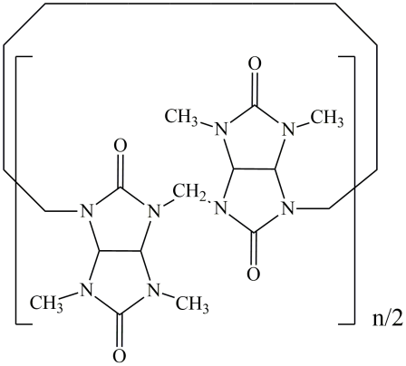

**Figure 1.** The structure of bambus[n]uril, where n = 4, 6.

These macrocycles combine the structural characteristics of both cucurbit[n]urils and hemi-cucurbit[n]urils [1]. With a height of 12.7 Å, Bu[6] possesses a significantly deeper cav- ity compared to cucurbit[n]urils, which have a height of 9.1 Å. It also exhibits a high affinity to negatively charged ions [2–5]. Current research on the chemistry of bambus[n]urils focuses on their utilization as efficient and selective absorbents for anions [6–8] owing to their propensity for host–guest interactions [9,10] and the formation of supramolecular complexes. In 2023, it was found that bambus[6]uril-treated porous titanium nickelide exhibits high biocompatibility and low toxicity [11].

The synthesis of bambus[6]uril occurs in a hydrochloric acid solution [2], resulting in the inclusion of residual traces of water in Bu[6]. The aqua complexes formation often causes a hydrolysis of different guest molecules within the cavity or hinders a guest release from the supramolecular complex. Thus, the presence of strongly bound water molecules in the inner cavity of Bu[6] complicates the formation of bambusuril-based inclusion compounds. While the host–guest chemistry of bambusurils continues to develop actively, the Bu[n] capacity towards such a simple and ubiquitous solvent like water remains unexplored.

Density Functional Theory (DFT) calculations are widely used for modeling supramolec- ular systems and the estimation of interaction energies between host and guest molecules. For example, a theoretical investigation of encapsulated systems based on Bu[6] and halide anions has been conducted recently [12].

In light of the aforementioned points, the objective of our study was to investigate the absorption/desorption capacity of bambus[6]uril towards water, determine the kinetic parameters of these processes, and explore the hydration of bambus[6]uril using the DFT method.

1. Results and Discussion
   1. *2.1. Synthesis of Bambus[6]uril*

Bu[6] was synthesized following the traditional approach [2] through the cyclization reaction of 2,4-dimethylglycoluril with paraformaldehyde in 6 M HCl, thus resulting in the product yield of 25%. The obtained Bu[6] was further treated with hydroiodic acid, followed by subsequent processing with hydrogen peroxide to remove chloride ions [13]. The 1H NMR spectroscopy analysis of Bu[6] (DMSO-d6/CDCl3 (1:1), TMS, δ, ppm) showed the following signals: 5.29 (s, 12H) corresponding to the methine protons, 5.06 (s, 12H) assigned to the methylene protons, and 2.51 (s, 36H) corresponding to the methyl groups. In the 13C NMR spectrum (DMSO-d6/CDCl3 (1:1), TMS, δ, ppm) of the product, the following signals are present: 159.32 and 158.45 (the nonequivalent carbonyl fragments),

67.82 (the methine carbon atoms), 48.78 (the methylene groups), and 31.06 (the methyl car- bon atoms). The IR spectrum indicated absorption bands at 3381 cm*−*1 (traces of absorbed

water), 1722 cm*−*1 (ν C=O of the urea moiety), 1703 cm*−*1 (ν C=O of the 1,3-dimethylurea fragment), 1402 cm*−*1 (δ C–H of –CH3), 1260 cm*−*1 (δ C–H of –CH2–), 1129 cm*−*1 (ν C–C), and 793 cm*−*1 (ν N–C–N). These chemical shifts and IR bands are in agreement with the literature data [1,14].

* 1. *2.2. Determination of the Dynamic Absorption Capacity of Bambus[6]uril for Water*

The absorption capacity of bambus[6]uril for water was determined using a gravi- metric method with McBain–Bakr quartz spring balances (Figure 2) [15]. The sensitivity of the balances was 2.9 10*−*3 g mm*−*1. An optimal amount of absorbent (0.02–0.03 g) was carefully chosen to ensure a single-layer arrangement of the absorbent in the quartz cup. Prior to conducting the absorption experiments, Bu[6] was regenerated to remove any residual water by heating at 200 *◦*C under a continuous flow of argon gas with impurity content not exceeding 10 ppm. Dehydration of Bu[6] occurs at 100–130 *◦*C, which was confirmed by the data of the DSC analysis [14]. The argon gas was supplied at a rate of 5 L h*−*1 for a duration of 1 h.

*·*

*× ·*

To initiate the absorption process of water vapor, the sample was exposed to argon gas passed through two Dreschel flasks containing distilled water (gas humidity 100%) (Figure 2). To eliminate the potential influence of the water vapor delivery rate on the external surface of Bu[6], a series of preliminary experiments were conducted using progressively increasing

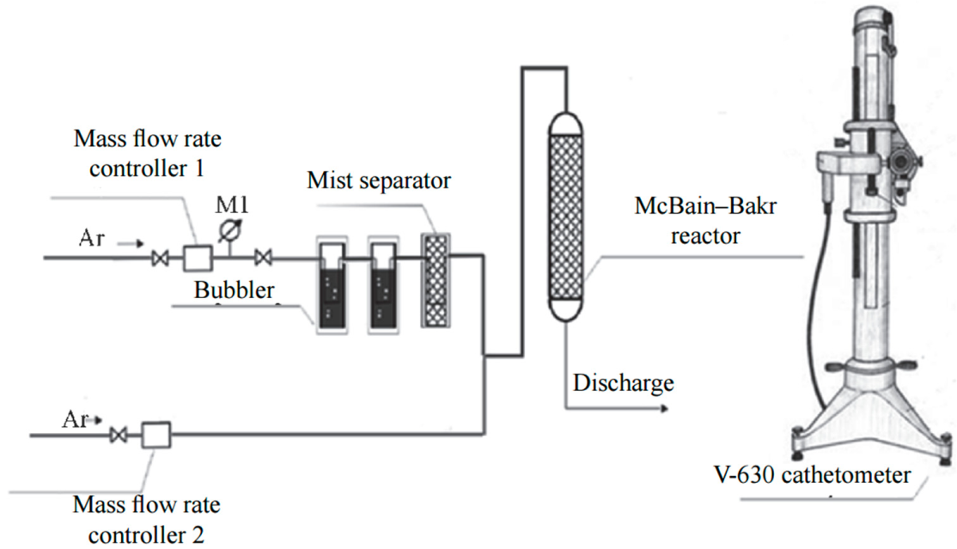flow rates. Based on the experimental findings, a gas flow rate of 30 L h*−*1 was selected as the optimal condition for the absorption process.

*·*

**Figure 2.** Scheme of the absorption setup for studying the kinetics of water vapor absorp- tion/desorption.

Upon reaching the saturation with water upon the absorption by bambus[6]uril, the desorption process was initiated by introducing dry argon flow at a rate of 10 L h*−*1. Figure 3 shows the kinetic curve of water absorption by the investigated Bu[6] sample. The curve was built based on the average data of three individual experiments at 25 *◦*C.

*·*

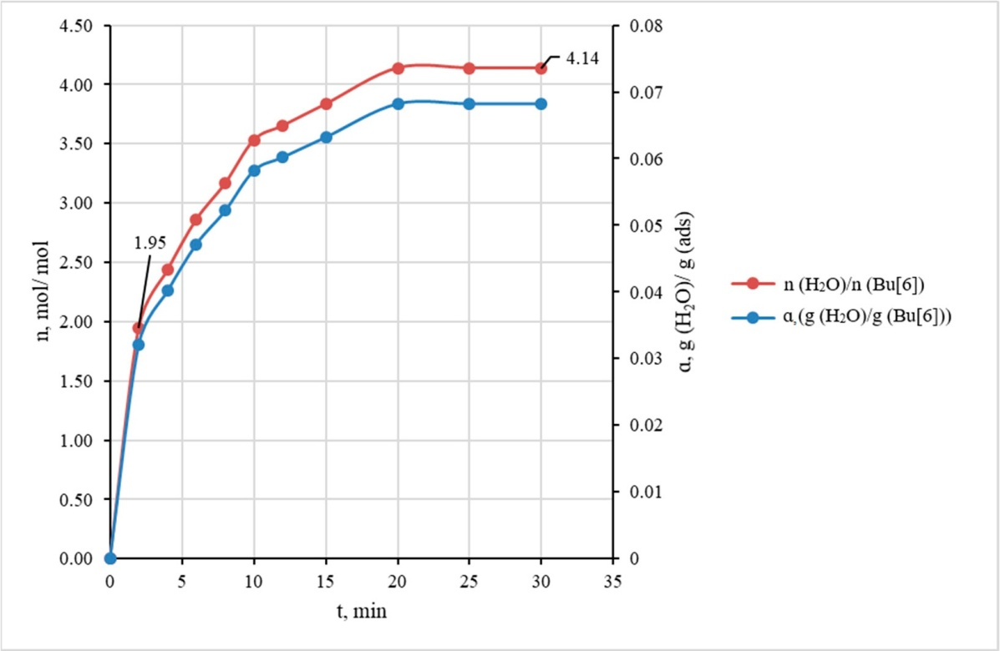

**Figure 3.** The kinetic curves of water vapor absorption expressed in terms of mass ratio g(H2O)/g(Bu[6]) and molar ratio n(H2O)/n(Bu[6]) (gas flow rate of 30 L*·*h*−*1).

From the absorption curve (Figure 3) it is evident that the highest rate of water absorp- tion occurs within the initial 2 min period when the Bu[6] sample absorbs approximately half of its maximum capacity for H2O. For clarity, the kinetic curve in Figure 3 is also presented in terms of molar ratio n(H2O)/n(Bu[6]). These experimental data show that the

maximum absorption capacity corresponds to 4 moles of water per mole of bambus[6]uril, with the saturation being attained after approximately 20 min.

To simulate the dynamic absorption of water vapor on the absorbent surface, the widely used pseudo-first-order model was applied. For isothermal absorption under a constant partial pressure, the absorption process can be described by Equation (1) [16]:

*d*α

*dt* = *kabs*(α*max −* α), (1)

where α is the mass ratio g(H2O)/g(Bu[6]) measured at time *t*; α*max* is the maximum value of α achieved upon the sample saturation with water; and *kabs* is the absorption rate constant.

The integral form of this kinetic equation is a linear function of *t* (2):

ln (α*max −* α) = *−kabst* + ln α*max*. (2)

From the linear plot (Figure S1) based on Equation (2), the value of the absorption rate constant *kabs* = 0.166 0.008 min*−*1 was estimated.

*±*

Figure 4 illustrates the curve of water desorption from Bu[6] obtained from the average data of three individual experiments. This curve indicates that the complete removal of bound water from the sample was attained within 100 min at 25 *◦*C and a flow rate 10 L h*−*1 of dry argon.

*·*

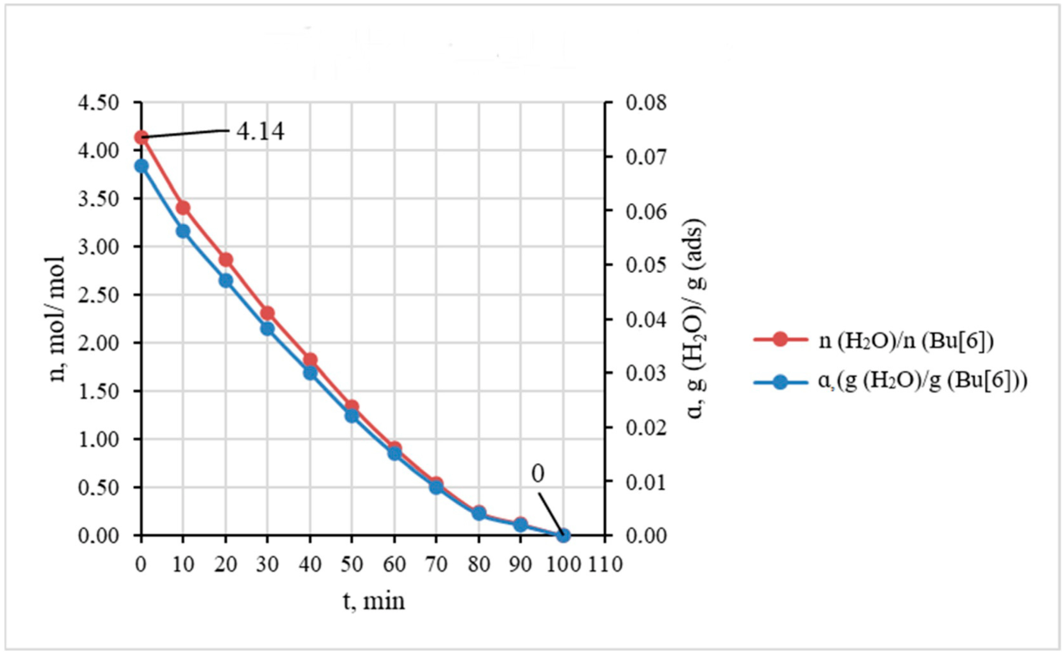

**Figure 4.** The kinetic curves of water desorption expressed in terms of mass ratio g(H2O)/g(Bu[6]) and molar ratio n(H2O)/n(Bu[6]) (gas flow rate 10 L*·*h*−*1).

The rate constant for water desorption can be determined from the pseudo-first-order model (3):

ln α= *−kdest* + ln α*max*, (3)

where *kdes* is the desorption rate constant.

The linearity according to Equation (3) was observed at up to 50 min of the experi- ment’s duration (Figure S2). The desorption rate constant *kdes* = 0.0221 *±* 0.0013 min*−*1 was calculated from this model. The errors of *kabs* and *kdes* were estimated using the variances of linear approximations (Figures S1 and S2) with the confidence level of 0.95.

According to our experiments, the absorption of water vapor by Bu[6] and its desorp- tion follow the first-order kinetic equations (the *r*2 values are 0.988 and 0.989 for models

(2) and (3), respectively), although the aqua complex formation should be a multi-stage process (see below). These experimental results support diffusion control of the kinetics. The ratio α*max* observed upon saturation corresponds to the formation of relatively stable aqua complex Bu[6] 4H2O. Nevertheless, this mass ratio shows that Bu[6] upon hydration

*·*

contains just about 7% of water, being hydrophobic in nature.

* 1. *2.3. Investigation of Bambus[6]uril Hydration Using the DFT Method*

In order to investigate the potential incorporation of water molecules into the cavity of Bu[6] through gas-phase sorption, we performed quantum chemistry calculations using the DFT method. These calculations were conducted for the Bu[6] molecule itself and for the inclusion compounds Bu[6] nH2O (where n ranged from 1 to 5). To optimize the geometry of both Bu[6] and the supramolecular complexes, a modern variant of DFT, the composite method B97-3c [17], was employed. This method is low cost and quite accurate, being well suited for handling large molecular systems. Also, it accounts for dispersion interactions and corrects the basis set superposition errors (BSSE), which is especially important for DFT calculations of supramolecular systems and coordination compounds.

*·*

The geometry optimization of Bu[6] in the gas phase led to the structure shown in Figure 5. Within the Bu[6] molecule, six of the twelve carbonyl oxygen atoms are positioned at the molecule’s periphery, while the remaining six O atoms are located near the central plane of the twenty-four-membered macrocycle. Oxygen atoms of the latter type can be referred to as equatorial (Figure 5A).

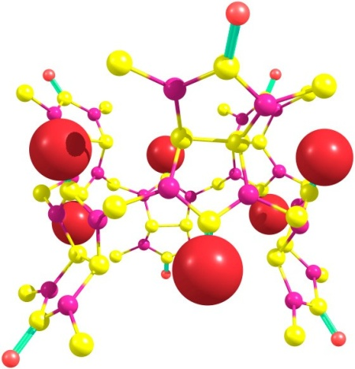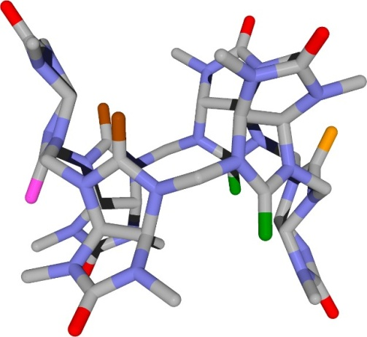

* + 1. (**B**)

**Figure 5.** Structure of Bu[6] molecule optimized using the B97-3c method. Hydrogen atoms are omitted for clarity. (**A**) The equatorial carbonyl oxygen atoms are represented by larger red spheres, while the peripheral oxygen atoms are depicted as smaller red spheres. (**B**) The peripheral oxygen atoms are shown as red cylinders. In relation to the equatorial oxygen atom highlighted by the pink cylinder, the other equatorial oxygen atoms are positioned in *syn*-, *gauche*-, or *trans*-orientations, as indicated by the green, brown, or orange cylinders, respectively.

To define the terminology used in this study, it is essential to establish the relative arrangement of the equatorial oxygen atoms. The *syn* position refers to two equatorial oxygen atoms located on the same side of the macrocycle as the current equatorial atom; the *gauche* position denotes the pair of equatorial oxygen atoms closest to the current one from the opposite side of the macrocycle; lastly, the *trans* position represents the carbonyl oxygen atom that is farthest from the current equatorial atom. In Figure 5B, the respective positions are visually indicated and will be designated as *s*, *g*, and *t*.

According to our DFT results, the outer diameter of the Bu[6] molecule in the gas phase calculated as twice the average distance of the three peripheral oxygen atoms from their geometric center equals 11.3 Å. The distance between the geometric centers of three

“upper” and three “lower” peripheral oxygen atoms is 9.1 Å. This value can be regarded as the height of the molecule. However, it is reasonable to measure the effective Bu[6] diameter and height by adding two van der Waals radii of the oxygen atom (2 1.40 Å) to these values, which gives 14.1 and 11.9 Å, respectively. It would be also informative to calculate a diameter of the inner cavity within the Bu[6] molecule. We evaluated this characteristic as twice the average distance of the twelve central hydrogen atoms (proton nuclei) in CH-CH fragments of glycoluril moieties from their geometric center. Such a calculation gives the diameter of 7.0 Å. Considering that the effective size of the inner cavity should be evaluated by subtracting two van der Waals radii of the hydrogen atom (2 1.2 Å) from this value, we estimated the effective inner diameter to be 4.6 Å. The calculated geometric characteristics of the Bu[6] molecule in the gas phase can be useful for further approximate size comparisons of potential guest molecules or ions with the bambus[6]uril host in the design of supramolecular systems.

*×*

*×*

In the interaction with Bu[6], one water molecule preferably binds to the equatorial carbonyl oxygen atom, thus acting as a hydrogen bond (HB) donor. This “equatorial” bind- ing mode allows the H2O molecule to further interact with the C-H bonds of neighboring glycoluril residues, thereby stabilizing the resulting Bu[6] H2O monohydrate. Figure 6 depicts the optimized DFT structures of Bu[6] with the water molecule positioned in both “in” and “out” orientations within the Bu[6] cavity.

*·*

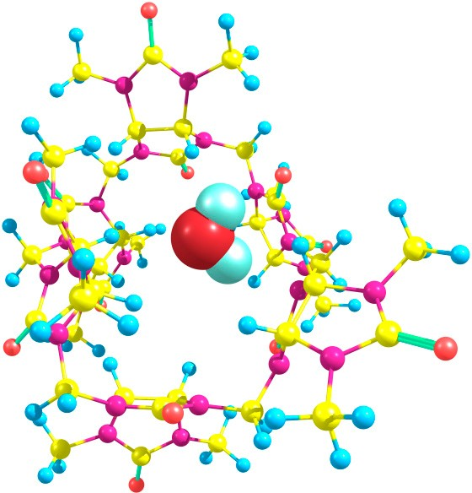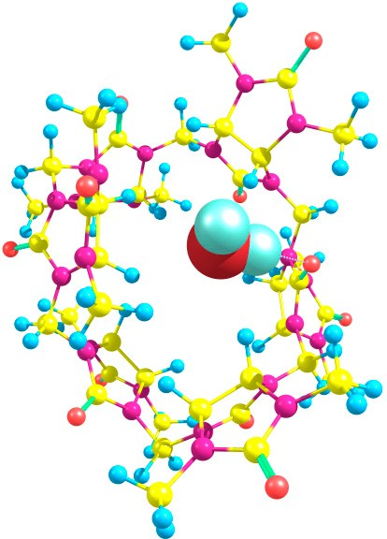

“in” “out”

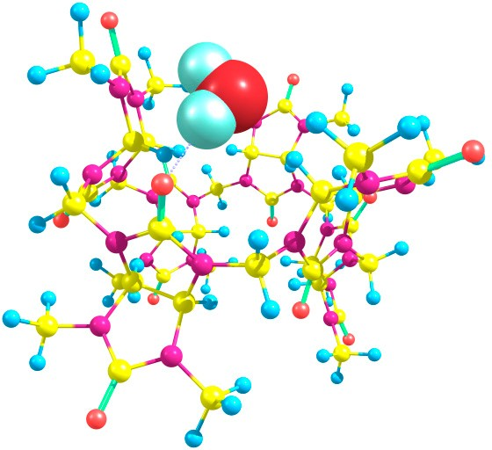

“peripheral”

**Figure 6.** Structures of Bu[6]*·*H2O optimized using the DFT method. In the two upper panels, the water molecule forms a hydrogen bond with one of the equatorial oxygen atoms and is oriented inside (“in”) and outside (“out”) the cavity of bambus[6]uril. In the bottom panel, the water molecule forms a hydrogen bond with one of the peripheral oxygen atoms.

In order to compute the energy change for the hydration process, it is essential to have DFT results for both the Bu[6] and Bu[6] H2O systems, as well as for the water molecule, which are obtained at the same level of theory. Given that water molecules exhibit strong association even in the gas phase [18], we employed a cluster model for water and performed calculations for the (H2O)8 and (H2O)9 clusters. Although water molecules easily form clusters of different sizes both in the liquid and gas phases, we chose the eight- and nine-molecule clusters, which have, respectively, cubic and modified cubic geometries [19] convenient for modeling due to their definite and non-flexible structures. Thus, the monohydrate formation process can be represented by the following scheme:

*·*

Bu[6] + (H2O)9 *→* Bu[6]*·*H2O + (H2O)8 (4)

Our DFT calculations show that the energy change ∆E for this process is determined to be 1.51 and 3.01 kcal/mol for the “in” and “out” structures of the product, respectively. The larger energy release obtained for the “out” monohydrate can be attributed to the formation of relatively strong additional C-H OH2 hydrogen bonds. In the optimized “out” structure, the H O distances between the water oxygen atom and the methine hydrogen atoms of neighboring glycoluril moieties are found to be 2.49 Å. Notably, the strongest hydrogen bond, which is formed between the water molecule and the equatorial carbonyl oxygen, measures 1.87 Å in length. We have also optimized the structures of monohydrate Bu[6] H2O containing a water molecule bound in different orientations to one of the peripheral oxygen atoms. In the found low-energy “peripheral” monohydrate (Figure 6), the H O hydrogen bond length equals 1.90 Å. The associated water molecule also acts as an HB donor to a nitrogen atom in one of the neighboring glycoluril fragments and as an HB acceptor to a CH hydrogen in another neighboring glycoluril moiety. The lengths of these weaker hydrogen bonds are 2.58 and 2.20 Å, respectively. However, the energy of the “peripheral” monohydrate is 4.06 kcal/mol higher in comparison with the “out” structure described above. Hence, the energy change ∆E for process (4) when the mono-hydration at the peripheral oxygen occurs can be easily calculated as +1.05 kcal/mol. This result is in agreement with our initial assumption that a water molecule preferably binds to the equatorial oxygen atom of Bu[6] than to the peripheral one.

*·*

*— −*

*· · ·*

*· · ·*

*· · ·*

Two water molecules upon binding to Bu[6] can participate in hydrogen bonding with the equatorial oxygen atoms in different relative positions (*syn*-, *gauche*-, and *trans*-) while adopting two distinct orientations (“in” and “out”). To explore the energetics, we performed calculations for dihydrates while considering various possible combinations of positions and orientations. Remarkably, the dihydrate with the lowest energy was found to possess an out_in(*g*) structure (Figure 7).

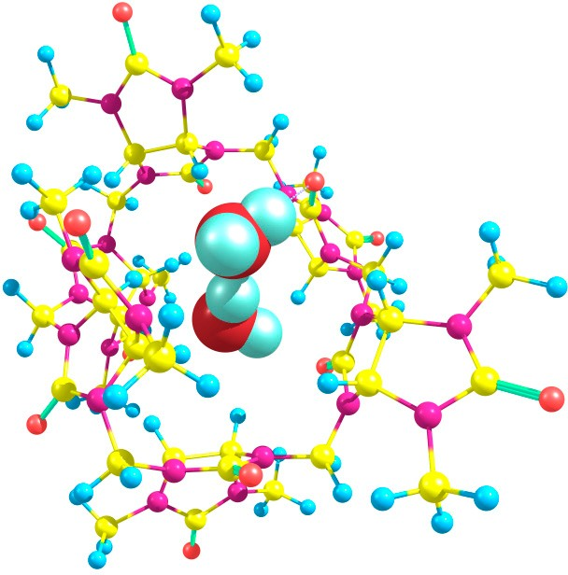

**Figure 7.** The structure of the most stable dihydrate Bu[6]*·*2H2O, corresponding to the out_in(*g*) arrangement, as determined using the DFT method.

The dihydrate formation can be considered according to the following process (5) involving the water clusters:

Bu[6]*·*H2O + (H2O)9 *→* Bu[6]*·*2H2O + (H2O)8 (5)

The energies calculated using the DFT method for the starting compounds and prod- ucts yield a value of ∆E = 4.65 kcal/mol for this process. Therefore, the overall energy change upon dihydrate formation starting from Bu[6] is 7.66 kcal/mol, indicating that the binding of two water molecules to Bu[6] is highly energetically favorable. In the out_in(*g*) dihydrate, the water molecules form hydrogen bonds with the equatorial carbonyl oxygen atoms (1.88 and 2.10 Å) as well as with each other (HB length of 1.89 Å). It is worth noting that hydrogen bonds between water molecules are also formed in other explored dihydrate structures, except for two out of the three structures with *trans*-oriented water molecules: out_in(*t*) and out_out(*t*). The calculated relative energies of the dihydrates span a consider- able range, with the least stable out_in(*t*) dihydrate being 9.52 kcal/mol higher in energy compared to the out_in(*g*) structure.

*−*

*−*

Trying to optimize the structures of trihydrate Bu[6] 3H2O with different relative

*·*

positions and orientations of three water molecules bound to equatorial oxygen atoms, we obtained the energies of the corresponding aqua complexes varying within the interval of 4.54 kcal/mol. Among them, the out_out(*s*)_in(*t*) structure (Figure 8) had the lowest energy. It is noteworthy that the starting geometry before its optimization corresponded to the out_in(*g*)_in(*t*) arrangement and thus resembled a modification of the low-energy dihydrate out_in(*g*). However, during the optimization procedure, it was rearranged to out_out(*s*)_in(*t*).

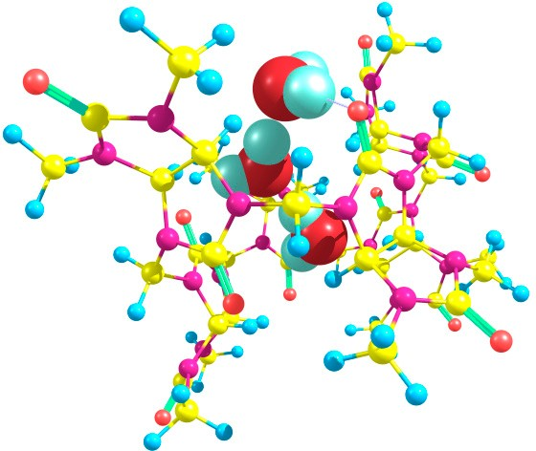

**Figure 8.** The structure of the most stable trihydrate Bu[6]*·*3H2O, corresponding to the out_out(*s*)_in(*t*) arrangement, as determined using the DFT method.

The dihydrate to trihydrate conversion with the participation of water clusters can be described by process (6):

Bu[6]*·*2H2O + (H2O)9 *→* Bu[6]*·*3H2O + (H2O)8 (6)

The energy change ∆E calculated for reaction (6) is 0.90 kcal/mol. Thus, the energy release in this process is much lower than for the dihydrate formation via reaction (5). In the out_out(*s*)_in(*t*) trihydrate, two water molecules form strong hydrogen bonds with the equatorial oxygen atoms of Bu[6] with the H O distances of 1.86 and 2.02 Å, whereas the third water molecule having the *trans*-“in” orientation forms a very weak HB with the

*−*

*· · ·*

*trans*-oxygen atom (H O distance 3.15 Å) while it is hydrogen-bonded to the nearest nitrogen atom (H N distance 2.43 Å). The three water guest molecules hosted by Bu[6] form hydrogen bonds with each other. The lengths of these bonds are 1.78 and 1.79 Å.

*· · ·*

*· · ·*

We have discovered that a linear chain of four hydrogen-bonded water molecules, (H2O)4, can also be encapsulated within the cavity of the bambus[6]uril host. The tetrahy- drate Bu[6] 4H2O with the lowest energy was obtained based on the out_out(*s*)_in(*t*) trihydrate, and it can be classified as out_out(*s*)_w_out(*t*). In this arrangement, three water molecules form hydrogen bonds with the equatorial carbonyl oxygen atoms of the Bu[6] molecular container. However, one of the H2O molecules denoted as “w” is not hydrogen bonded to Bu[6], except a weak HB of the CH OH2 type (H O distance of 2.38 Å). The corresponding structure, optimized using the DFT method, is depicted in Figure 9. Our

*·*

*· · · · · ·*

attempts to optimize Bu[6] tetrahydrates with other positions and orientations of the four H2O molecules led to higher-energy structures, the highest of them being the Bu[6] with the inclusion of a branched (H2O)4 guest cluster. This structure was 8.16 kcal/mol above the out_out(*s*)_w_out(*t*) tetrahydrate.

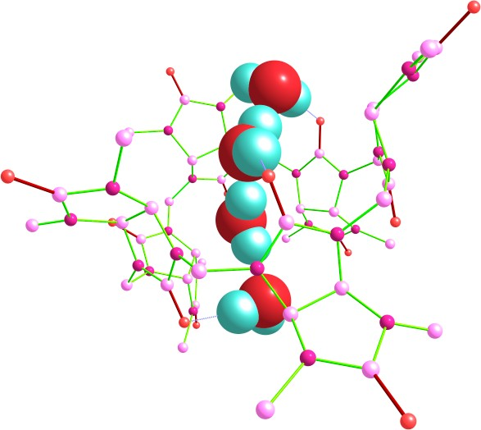

**Figure 9.** Structure of the tetrahydrate Bu[6]*·*4H2O, corresponding to the out_out(*s*)_w_out(*t*) ar- rangement, as determined using the DFT method. Hydrogen atoms in the Bu[6] molecule are not shown.

In the tetrahydrate structure with the out_out(*s*)_w_out(*t*) arrangement, the hydrogen bonds involving the carbonyl oxygen atoms exhibit lengths ranging from 1.81 to 1.95 Å. The hydrogen bonds between the water molecules themselves have lengths between 1.82 and 1.94 Å. The process (7) corresponds to the tetrahydrate formation from the trihydrate, involving the water clusters.

Bu[6]*·*3H2O + (H2O)9 *→* Bu[6]*·*4H2O + (H2O)8 (7)

According to the DFT results, the energy change associated with this process is

∆E = 3.20 kcal/mol. It is easy to calculate the value of ∆E = 4.10 kcal/mol for the tetrahydrate formation from dihydrate via the sequence of steps (6) and (7). This value indicates that the binding of two additional molecules following schemes (6) and (7) is less energetically favorable compared to the binding of the first two H2O molecules during the dihydrate formation ( 4.10 vs. 7.66 kcal/mol). The obtained computational data agree with the results of the kinetic experiment presented above (Figure 3), indicating the rapid

*— −*

*— −*

binding of two H2O molecules to the Bu[6] container, followed by the slower inclusion of two other water molecules.

Finally, we tried to model several pentahydrate Bu[6] 5H2O structures, including those with branched and non-branched guest (H2O)5 clusters. The lowest energy after the DFT optimization corresponded to the structure classified as out_out(*s*)_w_out(*t*)_in(*g*) (Figure 10), which was based on the geometry of the lowest-energy tetrahydrate (see above).

*·*

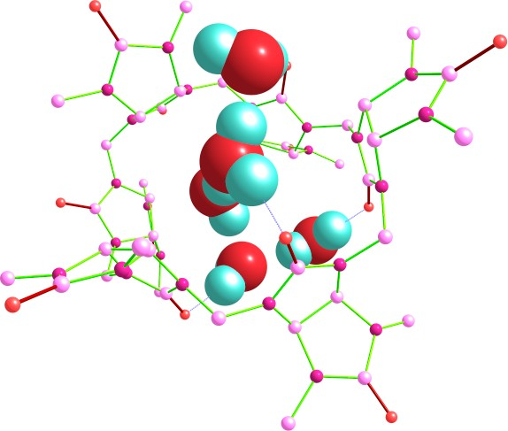

**Figure 10.** Structure of the pentahydrate Bu[6]*·*5H2O, corresponding to the out_out(*s*)_w_out(*t*)_in(*g*) arrangement, as determined using the DFT method. Hydrogen atoms in the Bu[6] molecule are not shown.

The mono-hydration of the tetrahydrate giving the pentahydrate can be described by process (8):

Bu[6]*·*4H2O + (H2O)9 *→* Bu[6]*·*5H2O + (H2O)8 (8)

The value of ∆E = +1.23 kcal/mol was calculated for the pentahydrate formation ac- cording to Equation (8). Hence, further hydration of the tetrahydrate Bu[6] 4H2O becomes energetically unfavorable. This result can be explained by conformational peculiarities of Bu[6] necessary for the accomodation of five water molecules simultaneously. Indeed, for the inclusion of four or less H2O molecules, the Bu[6] container can be readily distorted to ensure efficient H O, H N, and CH O hydrogen bond formation with the corre- sponding guest cluster. In the case of pentahydrate, the Bu[6] host is forced to become less distorted (see Figure 10), and it has lower possibilities for simultaneous hydrogen bonding with all of the captured water molecules.

*·*

*· · · · · · · · ·*

It is more reasonable to analyze reaction thermodynamics rather than the ∆E values for hydration processes (4)–(8). For this purpose, we calculated the frequencies of normal vibrations by the DFT method for the optimized Bu[6] molecule, all the low-energy hy- drates of Bu[6] (Figures 6–10), and the water clusters (H2O)8 and (H2O)9. No imaginary frequencies were found in any case, which indicates the attainment of real energy minima for these structures upon the geometry optimizations. It should be noted that the contour of the DFT-simulated IR spectrum obtained with the Lorentzian broadening of peaks for Bu[6] in the gas phase contains bands of high and medium intensity at 1766, 1751, 1467, 1425, 1219, 1041, and 796 cm*−*1, which are in a satisfactory agreement with the experimental IR spectrum of a solid Bu[6] sample (see above). The thermodynamic characteristics (enthalpy

∆H*◦*298 and Gibbs free energy ∆G*◦*298) for the sequential reactions (4)–(8) were calculated based on the computed frequencies. These values, along with the energies ∆E, are shown

in Table 1.

**Table 1.** Values of ∆E, ∆H*◦*298, and ∆G*◦*298 (in kcal/mol) for the hydration processes (4)*–*(8) calculated using the DFT method.

**Reaction Product ∆E ∆H***◦***298 ∆G***◦***298**

(4) Bu[6]*·*H2O *−*3.01 *−*2.96 *−*2.58

(5) Bu[6]*·*2H2O *−*4.65 *−*4.23 *−*3.23

(6) Bu[6]*·*3H2O *−*0.90 *−*0.39 +0.67

(7) Bu[6]*·*4H2O *−*3.20 *−*2.78 *−*2.28

(8) Bu[6]*·*5H2O +1.23 +1.51 +2.28

*−*

The ∆H*◦*298 values of the sequential mono-, di-, tri-, and tetra-hydration indicate the exothermic nature of these processes, while the addition of the fifth water molecule is endothermic. The experimentally observed formation of the tetrahydrate from Bu[6] and four H2O molecules via processes (4)–(7) is highly exothermic according to the DFT data (∆H*◦*298 = 10.36 kcal/mol). The calculated Gibbs free energies ∆G*◦*298 are less negative (or more positive) than the enthalpies ∆H*◦*298 because of the unfavorable influence of entropy on all of the reactions (4)–(8). Nevertheless, the tetrahydrate formation from anhydrous Bu[6] through the sequence of these reactions has a totally negative ∆G*◦*298 sum of 7.42 kcal/mol, in spite of the positive free energy change in stage (6). Importantly, for the first two stages, (4) and (5), of the dihydrate formation, the sum of Gibbs energies equals 5.81 kcal/mol, while for the following two stages, (6) and (7), the corresponding

∆G*◦*298 sum is 1.61 kcal/mol. This result is in good agreement with the observed rapid

*−*

*−*

*−*

formation of dihydrate Bu[6] 2H2O followed by its slower conversion to tetrahydrate Bu[6] 4H2O (Section 2.2), although we did not estimate energy barriers for the sequential hydration reactions.

*·*

*·*

Thus, the DFT method can be regarded as a powerful tool for the description of geo- metric and thermodynamic properties of supramolecular systems based on bambus[6]uril.

1. Materials and Methods

The infrared (IR) spectrum was recorded using a Nicolet 6700 Fourier Transform Infrared (FT-IR) spectrometer (Thermo Electron Corporation, Waltham, MA, USA) equipped with a diamond crystal and an attachment for attenuated total reflectance (ATR). The spectral resolution was set at 4 cm*−*1, with 64 scans collected over the range of 400–4000 cm*−*1.

For nuclear magnetic resonance (NMR) analysis, a Bruker AVANCE 400 IIIHD NMR spectrometer (Bruker, Billerica, MA, USA) was utilized. One-dimensional spectra were acquired for both proton (1H) and carbon (13C) nuclei at frequencies of 400.17 MHz and

100.63 MHz, respectively. A DMSO-d6/CDCl3 mixture in a 1:1 ratio was used as the solvent.

*DFT Calculations*

The geometry optimizations of Bu[6], its hydrates, and water clusters were performed by the composite DFT method B97-3c [17] using the ORCA 5.0.2 software [20] on a server (16 2.4 GHz CPU, 16 Gb RAM) operating under Ubuntu 20.04. No implicit solvation model or symmetry constraints were applied. The Bu[6] molecule, water clusters (H2O)8, (H2O)9, and low-energy structure of each type of hydrate (mono-, di-, tri-, tetra-, and penta-hydrated bambus[6]uril) were subjected to further normal vibration analysis and thermochemistry calculations using the DFT approximation mentioned above. Enthalpies and Gibbs free energies were calculated using the Quasi-RRHO approach [21], which provides the most correct account for low-frequency normal vibrations, which is especially important in calculations of supramolecular systems. The visualization of the results and the simulation of IR bands were performed with the use of Chemcraft 1.8 software [22].

*×*

1. Conclusions

In this study, we investigated for the first time the absorption/desorption capacity of bambus[6]uril towards water using the gravimetric method with the use of McBain–Bakr quartz spring balances. It was found that the absorption capacity of Bu[6] was 4 moles of water per mole of bambus[6]uril, and the time to reach saturation at 25 *◦*C was 20 min, while the time for complete removal of water was 100 min. The pseudo-first-order model was employed to calculate the absorption and desorption rate constants for these processes, resulting in values of *kabs* = 0.166 0.008 min*−*1 and *kdes* = 0.0221 0.0013 min*−*1, respectively.

*± ±*

The DFT calculations revealed that the binding of water molecules to bambus[6]uril occurs through the formation of hydrogen bonds between the equatorial oxygen atoms of Bu[6] and the hydrogen atoms of water molecules. The formation of the dihydrate was found to be thermodynamically more favorable compared to binding two additional water molecules to form the tetrahydrate. These computational results are in agreement with the experimental observations and indicate that the DFT method can be a useful tool for predicting and interpreting experimental data regarding the formation of inclusion complexes with the bambus[6]uril molecular container.

Our studies suggest the structures of bambus[6]uril aqua complexes. The presence of strongly bound water molecules in the inner cavity of bambus[6]uril can affect the formation and stabilities of supramolecular host–guest compounds.

**Supplementary Materials:** The following supporting information can be downloaded at: [https:](https://www.mdpi.com/article/10.3390/molecules28237680/s1)

[//www.mdpi.com/article/10.3390/molecules28237680/s1](https://www.mdpi.com/article/10.3390/molecules28237680/s1), Figures S1 and S2 with the linear plots corresponding to equations (2) and (3); ZIP archive with ORCA output files containing the DFT- optimized 3D structures of Bu[6], its low-energy hydrates, and water clusters. Figure S1. Plot of the experimental data for the absorption kinetics of water vapor by Bu[6]. Axis x: time, minutes. Axis y: ln (α*max −* α); Figure S2. Plot of the experimental data for the desorption kinetics of water vapor

from the water-saturated Bu[6]. Axis x: time, minutes. Axis y: ln α.

**Author Contributions:** Investigation, P.T., A.N.G., S.A.N., A.I.K., E.A.B. and R.Y.; resources, A.A.B.;

data curation, A.I.K.; writing—original draft preparation, P.T., A.N.G., A.I.K., S.S., E.P.M. and E.A.B.; writing—review and editing, A.I.K., L.K. and N.K. All authors have read and agreed to the published version of the manuscript.

**Funding:** This research was funded by the Tomsk State University Development Program (Priority 2030) and the Tomsk Polytechnic University Development Program (Project Priority-2030-NIP/IZ- 009-375-2023).

**Institutional Review Board Statement:** Not applicable.

**Informed Consent Statement:** Not applicable.

**Data Availability Statement:** The data presented in this study are available in this article.

**Conflicts of Interest:** The authors declare no conflict of interest.

References

1. Svec, J.; Necas, M.; Sindelar, V. Bambus[6]Uril. *Angew. Chem. Int. Ed.* **2010**, *49*, 2378–2381. [[CrossRef](https://doi.org/10.1002/anie.201000420)] [[PubMed](https://www.ncbi.nlm.nih.gov/pubmed/20217882)]
2. Lizal, T.; Sindelar, V. Bambusuril Anion Receptors. *Isr. J. Chem.* **2018**, *58*, 326–333. [[CrossRef](https://doi.org/10.1002/ijch.201700111)]
3. Yawer, M.A.; Havel, V.; Sindelar, V. A Bambusuril Macrocycle That Binds Anions in Water with High Affinity and Selectivity.

*Angew. Chem. Int. Ed.* **2015**, *54*, 276–279. [[CrossRef](https://doi.org/10.1002/anie.201409895)] [[PubMed](https://www.ncbi.nlm.nih.gov/pubmed/25385515)]

1. Havel, V.; Babiak, M.; Sindelar, V. Modulation of Bambusuril Anion Affinity in Water. *Chem. Eur. J.* **2017**, *23*, 8963–8968. [[CrossRef](https://doi.org/10.1002/chem.201701316)] [[PubMed](https://www.ncbi.nlm.nih.gov/pubmed/28485818)]
2. Havel, V.; Svec, J.; Wimmerova, M.; Dusek, M.; Pojarova, M.; Sindelar, V. Bambus[n]Urils: A New Family of Macrocyclic Anion Receptors. *Org. Lett.* **2011**, *13*, 4000–4003. [[CrossRef](https://doi.org/10.1021/ol201515c)] [[PubMed](https://www.ncbi.nlm.nih.gov/pubmed/21707115)]
3. Valkenier, H.; Akrawi, O.; Jurcˇek, P.; Sleziaková, K.; Lízal, T.; Bartik, K.; Šindelárˇ, V. Fluorinated Bambusurils as Highly Effective and Selective Transmembrane Cl /HCO3 Antiporters. *Chem* **2019**, *5*, 429–444. [[CrossRef](https://doi.org/10.1016/j.chempr.2018.11.008)]

*— −*

1. Hamacek, J.; Sokolov, J.; Šindelárˇ, V. Bambusuril Macrocycles as Mediators of Supramolecular Interactions: Application to the Europium Cage Helicate. *Chem. Eur. J.* **2021**, *27*, 5492–5497. [[CrossRef](https://doi.org/10.1002/chem.202005140)] [[PubMed](https://www.ncbi.nlm.nih.gov/pubmed/33442893)]
2. Itterheimová, P.; Bobacka, J.; Šindelárˇ, V.; Lubal, P. Perchlorate Solid-Contact Ion-Selective Electrode Based on Dodecabenzylbam- bus[6]Uril. *Chemosensors* **2022**, *10*, 115. [[CrossRef](https://doi.org/10.3390/chemosensors10030115)]
3. Sokolov, J.; Šindelárˇ, V. Chiral Bambusurils for Enantioselective Recognition of Carboxylate Anion Guests. *Chem. Eur. J.* **2018**, *24*,

15482–15485. [[CrossRef](https://doi.org/10.1002/chem.201802748)] [[PubMed](https://www.ncbi.nlm.nih.gov/pubmed/29995305)]

1. Sokolov, J.; Štefek, A.; Šindelárˇ, V. Functionalized Chiral Bambusurils: Synthesis and Host-Guest Interactions with Chiral Carboxylates. *ChemPlusChem* **2020**, *85*, 1307–1314. [[CrossRef](https://doi.org/10.1002/cplu.202000261)] [[PubMed](https://www.ncbi.nlm.nih.gov/pubmed/32558370)]
2. Marchenko, E.; Luchsheva, V.; Baigonakova, G.; Bakibaev, A.; Vorozhtsov, A. Functionalization of the Surface of Porous Nickel– Titanium Alloy with Macrocyclic Compounds. *Materials* **2023**, *16*, 66. [[CrossRef](https://doi.org/10.3390/ma16010066)] [[PubMed](https://www.ncbi.nlm.nih.gov/pubmed/36614409)]
3. Ortolan, A.O.; Madureira, L.; Rodríguez-Kessler, P.L.; Maturana, R.G.; Olea Ulloa, C.; Caramori, G.F.; Parreira, R.L.T.; Muñoz- Castro, A. The Nature of the Central Halide Encapsulation in Bambusuril Hosts (BU[6]). Structural and Interaction Energy Insights in BU[6] X (X = Cl, Br, I) from Relativistic DFT Calculations. *Inorganica Chim. Acta* **2023**, *555*, 121596. [[CrossRef](https://doi.org/10.1016/j.ica.2023.121596)]

*· −*

1. Svec, J.; Dusek, M.; Fejfarova, K.; Stacko, P.; Klán, P.; Kaifer, A.E.; Li, W.; Hudeckova, E.; Sindelar, V. Anion-Free Bambus[6]Uril and Its Supramolecular Properties. *Chem. Eur. J.* **2011**, *17*, 5605–5612. [[CrossRef](https://doi.org/10.1002/chem.201003683)] [[PubMed](https://www.ncbi.nlm.nih.gov/pubmed/21484899)]
2. Cicolani, R.S.; Job, A.E.; Tonin, F.G.; Correia, H.D.; Demets, G.J.-F. Thermal behaviour of bambus[6]uril and its chloride caviplex.

*J. Therm. Anal. Calorim.* **2018**, *136*, 1195–1199. [[CrossRef](https://doi.org/10.1007/s10973-018-7755-0)]

1. Neimark, I.E.; Sheinfain, R.Y. *Silica Gels: Preparation, Properties and Application*; Naukova Dumka: Kiev, USSR, 1973.
2. Yuh-Shan, H. Citation review of Lagergren kinetic rate equation on adsorption reactions. *Scientometrics* **2004**, *59*, 171–177. [CrossRef]
3. Brandenburg, J.G.; Bannwarth, C.; Hansen, A.; Grimme, S. B97-3c: A Revised Low-Cost Variant of the B97-D Density Functional Method. *J. Chem. Phys.* **2018**, *148*, 064104. [[CrossRef](https://doi.org/10.1063/1.5012601)] [[PubMed](https://www.ncbi.nlm.nih.gov/pubmed/29448802)]
4. Mhin, B.J.; Lee, S.J.; Kim, K.S. Water-Cluster Distribution with Respect to Pressure and Temperature in the Gas Phase. *Phys. Rev. A* **1993**, *48*, 3764–3770. [[CrossRef](https://doi.org/10.1103/PhysRevA.48.3764)] [[PubMed](https://www.ncbi.nlm.nih.gov/pubmed/9910048)]
5. Hainam, D.; Besley, N.A. Structural optimization of molecular clusters with density functional theory combined with basin hopping. *J. Chem. Phys.* **2012**, *137*, 134106. [[CrossRef](https://doi.org/10.1063/1.4755994)]
6. Neese, F.; Wennmohs, F.; Becker, U.; Riplinger, C. The ORCA quantum chemistry program package. *J. Chem. Phys.* **2020**,

*152*, 224108. [[CrossRef](https://doi.org/10.1063/5.0004608)] [[PubMed](https://www.ncbi.nlm.nih.gov/pubmed/32534543)]

1. Grimme, S. Supramolecular Binding Thermodynamics by Dispersion-Corrected Density Functional Theory. *Chem. Eur. J.* **2012**, *18*, 9955–9964. [[CrossRef](https://doi.org/10.1002/chem.201200497)] [[PubMed](https://www.ncbi.nlm.nih.gov/pubmed/22782805)]
2. Chemcraft—Graphical Software for Visualization of Quantum Chemistry Computations. Version 1.8, Build 654. Available online: [https://www.chemcraftprog.com](https://www.chemcraftprog.com/) (accessed on 15 August 2023).

**Disclaimer/Publisher’s Note:** The statements, opinions and data contained in all publications are solely those of the individual author(s) and contributor(s) and not of MDPI and/or the editor(s). MDPI and/or the editor(s) disclaim responsibility for any injury to people or property resulting from any ideas, methods, instructions or products referred to in the content.

Article

**Development of Novel Composite Biocompatible Materials by Surface Modification of Porous Inorganic Compounds Using Bambus[6]Uril**

**Gulstan Zhumabayeva 1, Pana Turebayeva 1 * Arthur Ukhov 2, Dmitry Fedorishin 2, Alexander Gubankov 2, Venera Luchsheva 2, Irina Kurzina 2, Abdigali Bakibaev 2, Roza Ryskaliyeva 3, Gulnara Abdullina 4, Saltanat Bolysbekova 5 and Rakhmetulla Yerkassov 1**

|  |
| --- |
|  |

1. Department of Chemistry, L.N. Gumilyov Eurasian National University, 010000 Astana, Kazakhstan (G.Zh.: gulistan2009@mail.ru, P.T.: pana90@mail.ru, R.Ye.: erkass@mail.ru)
2. Faculty of Chemistry, National Research Tomsk State University, 634028 Tomsk, Russia (A.U.: artyryxov1@gmail.com, D.F.: strix187@yandex.ru, A.G.: 4.4.gub4nk0v@gmail.com, V.L.: kuscherbaeva_venera@mail.ru, I.K.: kurzina99@mail.ru, A.B.: bakibaev@mail.ru)
3. Faculty of Chemistry and chemical technology, department of general and inorganic chemistry, Al-Farabi Kazakh National University, 050000 Almaty, Kazakhstan (roza12_11_64@mail.ru)
4. Faculty of Engineering, Department of Mechanics and Oil and Gas Engineering, Toraigyrov University

140008 Pavlodar, Kazakhstan (gulnara_1277@mail.ru)

1. Higher School of scientific research, Astana International University, 010000 Astana, Kazakhstan(bolysbekova.s@mail.ru)

* Correspondence: pana90@mail.ru; Tel.: +7-707-3488487

**Abstract:** In this present investigation, a novel series of composite materials based on porous inorganic compounds - hydroxyapatite and diatomite - have been innovatively formulated for the first time through surface modification employing the promising macromolecular compound, bambus[6]uril. The process entailed the application of a bambus[6]uril dispersion in water onto the surfaces of hydroxyapatite and diatomite. Extensive characterization was carried out, involving IR spectroscopy and SEM. The materials underwent assessment for hemolytic effects and plasma protein adsorption. The results revealed that materials containing surface-bound bambus[6]uril did not demonstrate inherent hemolytic effects, laying a robust groundwork for their use as biocompatible materials. These findings hold significant promise as an alternative pathway for the development of durable and efficient bio-composites, potentially unveiling supramolecular strategies incorporating encapsulated bambus[6]urils in analogous processes.

**Keywords:** Bambus[6]urils; hydroxyapatite; diatomite; biocompatible materials; hemolytic effect; plasma protein adsorption.

**1. Introduction**

In the contemporary era of personalized medicine, the necessity arises to develop implant materials that strike an optimal balance across various characteristics. These aspects encompass composition, shape, structure, mechanical properties, biocompatibility, as well as the potential to stimulate vessel or bone growth. In the context of implants or materials for wound treatment, all these attributes collectively determine the material's ability to interact with the surrounding tissue. Bioactive materials can serve as a scaffold for the development of new tissue [1]. Conversely, a material interacting within the body's internal environment should ideally exhibit minimal toxicity toward cells and tissues. This emphasizes the nature and extent of interaction between biomaterials and host tissues, presenting one of the critical challenges in biomaterial research [28-30]. Biocompatibility is defined by the immune response or inflammatory reactions of surrounding tissue systems in reaction to the presence of foreign entities within the body.

As clinical demands for all biomedical devices reach unprecedented heights, a meticulous surface modification process becomes imperative prior to their integration into the human body. Consequently, the development of materials that achieve a delicate equilibrium between biocompatibility and distinctive biological activity poses a significant challenge.

Moreover, contemporary clinical treatment modalities rely on the oral or intravenous administration of a medicinal agent, leading to a rapid surge in the drug's concentration in the bloodstream immediately after administration. Following administration, the drug's bloodstream concentration may reach toxic levels, only to subsequently fall below the therapeutic range, thereby compromising the efficacy of the therapy [31].

Implants designed for drug release have emerged as a promising alternative to conventional oral and intravenous drug delivery methods, presenting a variety of clinical treatment possibilities. Currently, established materials used for creating drug-releasing implants include titanium nanotubes, porous silicon, polymers, hydrogels, and microtechnologies. Drug-releasing implants offer the potential for sustained, remotely controlled, programmable, and localized drug release at specific sites, thereby enhancing therapeutic efficacy while minimizing adverse effects for patients. These capabilities extend beyond the scope of traditional systemic drug administration [32].

Modified hydroxyapatite (HA), enriched with bioactive compounds, serves as a tool for creating materials that have the potential to possess predetermined properties. Hydroxyapatite (HA) constitutes a fundamental building block of bones (accounting for around 50% of the total mass) and teeth (96% in enamel), and it is present in both synthetic and natural forms. Within the medical field, synthetic hydroxyapatite (HA) is used as a filler for the restoration of lost bone segments and as a coating on implants to stimulate the growth of new bone [2].

Another notable material of interest is diatomite (DA), the fossilized residue of diatom planktonic algae found in aquatic environments worldwide. Mainly composed almost entirely of silicon dioxide (SiO2) [3], diatomite (DA) is non-toxic, odorless, abundantly available in nature, easily purified, and relatively cost-effective. Among natural materials, diatomite (DA) boasts unique properties, including high porosity (10-100 nm), permeability, fine particle size, substantial surface area (29 m²/g), and pore volume (0.09 cm³/g) [4]. It also exhibits low thermal conductivity and chemical inertness [5], making it suitable for applications in various domains such as construction, water filtration, agriculture, and more [6]. Diatomite (DA) finds use as a contact insecticide in arid climates, as well as a soil conditioner and additive in animal feed and human food products [6].

Presently, surface modification techniques for porous materials through the impregnation of biologically active compounds, including macromolecular entities [7], are gaining prominence. These approaches enable precise control over the release of antibiotics, pharmaceutical agents, bioactive substances, and cells [8]. Macromolecular compounds are often preferred over other drug delivery systems, such as dendrimers, liposomes, micelles, carbon nanotubes, hydrogels, and polymers, due to their stability and controlled drug release rates [9-13].

In the context of surface modification for porous materials, macromolecular systems based on bambus[6]uril are particularly suitable. These macrocyclic compounds, interconnected through bridges along the equator of the macrocycle, consist of dimethylglycoluril units [14]. Notably, these macrocyclic entities possess the unique ability to encapsulate therapeutic agents, thus facilitating controlled and sustained release under various influences, including light exposure, pH variations, and temperature fluctuations [15]. Bambus[6]uril (Bu[6]) engages in weak hydrogen bonding with anions within its hydrophobic cavity [16]. Its more positively charged electrostatic region attracts anions, while the portal carbonyl oxygen atoms create a negative region that can interact with positively charged particles. Materials based on the synergy of methylviologen and Bu[6] have been utilized in the development of energy storage systems and the engineering of light-emitting diodes [17]. Bu[6] also serves as a versatile carrier in liquid membranes for applications like electromembrane extraction [18].

Therefore, surface modification techniques of inorganic porous materials using macrocyclic compounds, including Bu[6], hold significant promise for practical applications across various fields. This potential is further highlighted by the limited instances of such techniques documented in the literature, with only one example based on titanium nickelide [7]. In this research, Bu[6] has been applied to the surface of porous materials (hydroxyapatite and diatomite) for the first time, employing various techniques. This advancement lays the groundwork for loading the Bu[6] cavity with therapeutic agents, enhancing the porous materials' therapeutic potential and expediting osteogenesis. Hence, the objective of this study is to assess how BU[6] deposition methods influence the continuity, structure, and in vitro hemocompatibility of the porous surface of hydroxyapatite and diatomite.

**2. Materials and Methods**

Glyoxal was purchased from Novochem (Tomsk, Russia), silver nitrate from Reachim (Sverdlovsk, Russia). All other chemicals were from Merck/Sigma–Aldrich (Darmstadt, Germany).

*2.1. Synthesis of HA*

Hydroxyapatite (HA) synthesis was accomplished through a liquid-phase method employing microwave irradiation at a pH of approximately 11, following the provided scheme [24]:

10Ca(NO3)2 + 6(NH4)2HPO4 + 8NH4OH → Ca10(PO4)6(OH)2 + 20NH4NO3 + 6H2O

For the preparation of initial solutions, the following reagents were used: calcium nitrate tetrahydrate Ca(NO3)2 x 4H2O, ammonium hydrogen phosphate (NH4)2HPO4, 25% aqueous ammonia solution, and distilled water.

A 300 mL chemical beaker was utilized to create a solution with a concentration of 0.5 mol/L, where Ca(NO3)2 х 4H2O (47.20 g) was dissolved in 200 mL distilled water. Similarly, (NH4)2HPO4 (15.84 g) was dissolved in 200 mL distilled water to form a solution with a concentration of 0.3 mol/L. The prepared solutions were combined in a single 500 mL beaker and adjusted to pH 11 by the gradual addition of 25% aqueous ammonia solution under continuous stirring. The beaker with the reaction mixture was covered with a film, placed in a microwave oven, set to a working power of 100-150 W, thereby initiating the heating process. Microwave irradiation continued until the reaction mixture reached its boiling point. To prevent local overheating, the contents of the reaction vessel were periodically stirred at precise intervals of 15 minutes during the microwave synthesis. The total duration of microwave heating was 45 minutes. Subsequently, the beaker with its contents was taken out and left at room temperature for 48 hours to facilitate the formation of the hydroxyapatite phase. The resulting precipitated HA was filtered, dried in a drying oven at 110°C until a constant mass was achieved (approximately 20 hours), and then milled to obtain a uniform state. From the resulting hydroxyapatite HA powder, carriers were shaped into tablets, 2 cm in width and approximately 1 mm in thickness, and subjected to calcination at 600°C.

*2.2. Bu[6] Synthesis*

**Bu[6]** was synthesized, isolated, and purified using a traditional method [14] based on the preliminary formation of 2,4-dimethylglycoluril, followed by acid-catalyzed cyclization with formaldehyde to produce the desired product.

In the initial stage, the synthesis of 4,5-dihydroxyimidazolidinone-2 (**DGI**) was conducted (Figure 1). The synthesis took place in a round-bottom flask equipped with a reflux condenser and a magnetic stirrer. Urea (50 g) was loaded into the flask, and 100 mL of a 40% glyoxal solution was added. The pH was adjusted to 7 by the addition of a 10% solution of sodium hydroxide. The synthesis was carried out for 7 hours with continuous stirring at a temperature of 50°C. Upon completion of the reaction and subsequent cooling of the solution to room temperature, the pH was increased to 9 using a 10% solution of sodium hydroxide. The solution was refrigerated for three days to facilitate the crystallization of 4,5-dihydroxyimidazolidinone-2. The resulting crystals were filtered and air-dried, providing 61.8 g (60.5%) of **DGI** with a melting point of 160-162°C. The synthesized product exhibited a white crystalline appearance.

Afterward, the acquired DGI was utilized for the synthesis of 2,4-N-dimethylglycoluril (DMGU). The synthesis process took place in a round-bottom flask furnished with a reflux condenser and magnetic stirrer. The flask contained 40 g of 4,5-dihydroxyimidazolidinone-2 and 35.2 g of dimethylurea, along with 100 mL of water. The pH was adjusted to 2 using concentrated hydrochloric acid. The synthesis lasted for 4 hours at 90°C. Upon completion, the solution was partially evaporated, and 10 mL of acetone was added. The resulting mixture was refrigerated for 48 hours, leading to the formation of precipitated sediment. The resulting precipitate underwent two rounds of recrystallization from acetone, yielding 31.2 g (48%) of DMGU with a melting point of 254-256°C. The measurement was conducted within the temperature range of room temperature to 350 °C, with an increment rate of 5 °C per minute. The synthesized product manifested as pure white crystals.

1H NMR (DMSO-d6, δ, ppm): 2.64 (6H, s, CH3), 5.12 (2H, s, CH), 7.54 (2H, s, NH).

13C NMR (CDCl3, δ, ppm): 158.22 and 160.20 (C=O), 28.22 (CH3), 76.67 (C-H).

The final phase entailed the synthesis of Bu[6]. This process occurred in a chemical flask equipped with a magnetic stirrer. The flask contained 30 g of DMGU, 30 mL of concentrated hydrochloric acid, and 45 mL of a 40% formaldehyde solution. The resulting mixture was continuously stirred for 24 hours. Subsequently, the mixture was poured into 400 mL of water and agitated for 2 hours. The suspension was then filtered, and the precipitate was air-dried, yielding 5.2 g (16%) of bambus[6]uril. The product underwent recrystallization from concentrated hydrochloric acid.



**Figure 1.** Visual Representation of the **Bu[6]** Application onto **HA** and **DA** Surfaces.

The obtained **Bu[6]** was identified using NMR and IR spectroscopic techniques. The IR spectrum displayed peaks at 2940 cm-1 (CH2), 1681 cm-1 (C=O), 1446 cm-1 (CH3), 789 cm-1, and 656 cm-1 (C-H).

The NMR spectrum of Bu[6] showed chemical shifts in the 1H NMR (DMSO-d6/CDCl3 (1:1), TMS) as follows: 5.29 (s, 12H, CH), 5.06 (s, 12H, CH2), 2.51 (s, 36H, CH3). The 13C NMR (DMSO-d6/CDCl3 (1:1), TMS) exhibited shifts at: 159.32 (C=O, Me2Urea), 158.45 (C=O, Urea), 67.82 (C-H, CH3), 48.78 (CH, –CH2–), 31.06 (CH, CH3-).

*2.3. Refining СDA for Enhanced Purity*

For research purposes, diatomaceous earth (DA) obtained from "Quant" LLC (Penza Region) was utilized in different forms - in its original state (IDA) and further purified (CDA) to remove various cations and anions. The purification of diatomaceous earth was carried out using a boiling method in an 18% hydrochloric acid solution [25]. To accomplish this, a sample of diatomaceous earth (m = 40 g) was placed into a solution of 18% hydrochloric acid (V = 300 mL). Subsequently, the solution was brought to a boil and left to stand for 24 hours. Following this, the diatomaceous earth was filtered and air-dried at room temperature until a constant mass was achieved. Both the untreated IDA and the refined CDA were compressed into tablet-shaped carriers, each measuring 2 cm in width and approximately 1 mm in thickness, and then subjected to calcination at 600°C.

*2.4. Physicochemical characterization of composite materials*

2.4.1. FTIR

The identification and structural analysis of the Bu[6] samples were performed using Fourier-transform infrared (FT-IR) spectroscopy with a Nicolet 6700 infrared spectrometer from Thermo Fisher Scientific. The samples were examined using the attenuated total reflection (ATR) method over the spectral range of 400 to 4000 cm–1, with a resolution of 4 cm–1. The resulting reflection spectra were transformed into absorption spectra using the Kubelka-Munk transformation.

2.4.2. NMR spectroscopy

NMR spectroscopy of Bu[6] and DMGU was conducted using a Bruker Avance 400 III HD NMR spectrometer in DMSO-d6 solution at a temperature of 25 °C. The proton nuclei were operating at a frequency of 400 MHz, while the carbon nuclei were at 100 MHz. Samples for NMR analysis were prepared at a concentration of 10 mg/ml, with a volume of 0.5 ml.

2.4.3. Scanning Electron Microscopy (SEM)

The analysis was performed using a QUANTA 200 3D system equipped with both electron and focused-beam capabilities. The system operated with a continuous range of accelerating voltages from 200 to 30000 V. In ESEM mode, a remarkable resolution of 3.5 nm was achieved at 30 kV, while in low vacuum mode at 3 kV, a resolution of < 15 nm was attained.

2.4.4. X-ray Diffraction (XRD)

The investigation of crystalline powders of **HA** and **Bu[6]** was conducted using X-ray phase analysis. The sample analysis was carried out on a XRD-7000 X-ray diffractometer (Shimadzu, Japan) with a Cu anode, X-ray wavelength of Kα(Cu) = 1.5406 Å, measurement range of 5-50° in 2θ, and measurement speed of 30°/min. Identification of the analyzed samples was achieved by matching their spectra with the diffraction patterns of reference substances using diffraction data from The Cambridge Crystallographic Data Centre database.

The XRD findings demonstrate the establishment of a hexagonal crystal system during the synthesis of stoichiometric **HA**, gr. P63\m, with the overall formula described as Ca10(PO4)6(OH)2 (Table 1). The unit cell parameters of the synthesized **HA** closely correspond to the data in the reference table. (JCPDS data, №9-432 [Powder diffraction file (inorganic phases). Joint Committee on Powder Diffraction Standards (JCPDS) File № 9-432, International Centre of Diffraction Data, Newton Square, PA, 1980.]).

**Table 1. Phase composition of HA synthesis products**

|  |  |  |  |  |
| --- | --- | --- | --- | --- |
| Sample | The inorganic phase | Parameters of the electronic cell, Ǻ | | |
|  | |  | a | c |
| Synthesis product (HA) | Ca10(PO4)6(OH)2 |  | 9,411 | 6,863 |
| JCPDS data, №9-432 | Ca10(PO4)6(OH)2 |  | 9,418 | 6,884 |

IDPhaseProfiles

**Figure 2.** Diffractogram of synthesized stoichiometric **HA**

The melting points of the samples were determined using the BÜCHI Melting Point M-560 apparatus in an open capillary setup.

*2.5. Assessment of Hemocompatibility of Biocomposites*

One method to evaluate the overall cytotoxicity of compounds and materials is to study their hemolytic activity [26, 23]. When the material exhibits poor hemocompatibility, the destruction of erythrocytes leads to the release of hemoglobin into the solution. Increased hemoglobin presence in the solution results in higher optical density. Therefore, elevated optical density indicates lower hemocompatibility of the material.

Peripheral blood samples were collected from consenting healthy volunteers.

To assess the hemocompatibility of the examined samples, whole anticoagulated blood from a healthy donor was employed. The blood underwent centrifugation, leading to the separation of the erythrocyte mass. The resulting erythrocyte mass was then diluted with a sterile 1X PBS solution at 37°C in a 1:9 ratio. The samples were placed in a standard 12-well cell culture plate and covered with the prepared blood-PBS solution at a ratio of 1 ml solution per 1 cm² of the sample's surface area. Deionized water served as the positive control (100% hemolysis), while a 1X PBS solution acted as the negative control (0% hemolysis). Similarly, IDA and CDA samples were utilized as control materials. Subsequently, the plate was incubated in a thermostat at 37°C for 60 minutes. After the incubation period, blood from the wells was transferred to centrifuge tubes and centrifuged for 5 minutes at 3000 rpm to separate the remaining erythrocytes. The supernatant was carefully removed and transferred to a standard 96-well plate for spectroscopic analysis. Optical density measurements were performed using the state-of-the-art IFA-reader Tecan Infinite F50 (Tecan Inc., USA) operating at a wavelength of 492 nm.

The percentage of hemolysis was determined as the average of three replicates and calculated using the formula [23]:

$$\text{Hemolisys, \%}=\frac{\text{(}\text{O}{\text{D}}_{\text{test}\text{ sample}}-\text{O}{\text{D}}_{\text{control}}^{\text{negative}})}{\begin{aligned}\text{(}\text{O}{\text{D}}_{\text{control}}^{\text{positive}}-\text{O}{\text{D}}_{\text{control}}^{\text{negative}}) \\ \end{aligned}}×\text{100\%}$$

The Ethical Committee of Tomsk State Univercity approved the study design and the recruitment of subjects. Subjects provided written informed consent. The relevant guidelines and regulations were followed when performing the experiments.

*2.6. Evaluation of Plasma Protein Adsorption by Biocomposites*

The adsorption of plasma proteins onto our developed samples was investigated using a modified solution depletion method. This approach involves two quantitative determinations of protein concentration in the blood plasma - before and after incubation of the samples [26].

Peripheral blood was obtained from healthy volunteers after receiving their written consent.

Plasma was separated from whole anticoagulated blood obtained from a healthy donor through centrifugation. The protein content within the plasma was determined utilizing the biuret reaction method. Subsequently, 2 mL of plasma was applied to the samples and incubated at 37°C for 24 hours. Following incubation, another assessment of protein concentration was conducted. The variance in protein concentration between the intact plasma and the post-incubation sample indicated the extent of protein adsorption by the samples. A greater disparity between these measurements indicated a higher degree of protein adsorption on the sample.

Under alkaline conditions, serum proteins interacted with copper sulfate, resulting in the formation of complex compounds exhibiting a violet color due to the presence of peptide bonds. The intensity of this color was directly proportional to the protein concentration in the solution.

During the experiment, 2 mL of plasma was applied to the samples and incubated at 37°C for 24 hours. After the incubation period and removal of the samples from the solution, a biuret reaction was conducted, followed by an optical density measurement.

The biuret reaction involved the mixing of 0.1 mL of blood plasma with 5.0 mL of a working solution of the biuret reagent, with precautions taken to prevent the formation of foam. A concurrent control experiment was conducted in parallel, involving the mixing of 0.1 mL of a 0.9% sodium chloride solution with 5 mL of the prepared working biuret reagent solution. After a precise interval of 30 minutes (but no later than one hour), the optical density of the solution was recorded using the Tecan Infinite F50 microplate reader (Tecan Inc., USA) at a defined wavelength of 492 nm, with reference to the control.

**3. Results and discussion**

In this study, we examined the influence of the macromolecular compound - bambus[6]uril **(Bu[6])** - on the biocompatibility of hydroxyapatite **(HA)** and diatomite **(IDA and CDA)** to establish a matrix for prospective biomedical composite materials.

To apply **Bu[6]** onto porous inorganic surfaces, an immersion method was employed (Fig. 3). For the execution of this methodological approach, a dispersion of **Bu[6]** was prepared in water at a concentration of 1 mg/mL in deionized water, volume of solution was 15 mL. Subsequently, the **HA, IDA,** and **CDA** carriers were subjected to immersion in the **Bu[6]** solution and left to interact for a duration of 40 minutes. Post-immersion, the solution was decanted, and the resulting composite specimens **(HA+Bu[6], IDA+Bu[6], and CDA+Bu[6])** were subjected to gentle air-drying at room temperature until a consistent weight was achieved.

The ensuing composite materials underwent comprehensive analysis through IR Spectroscopy and SEM. The quantification of applied **Bu[6]** was determined via gravimetric assessment. The residual solution, after the application process, was dried to a steady state, and the remaining **Bu[6]** content was precisely measured. The quantity of **Bu[6]** applied was 10 mg.

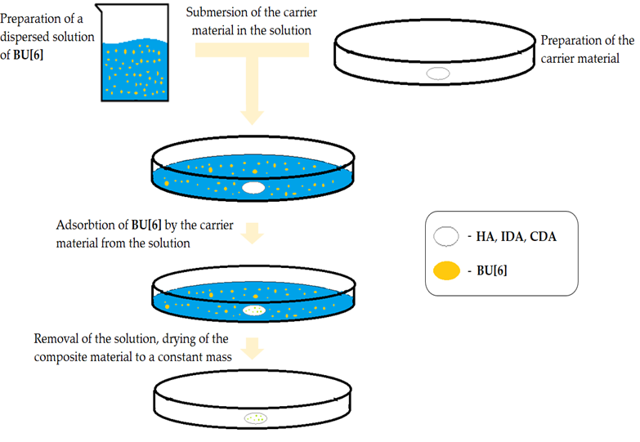

**Figure 3.** Illustration of the Deposition Method of **Bu[6]** onto **HA** and **DA.**

The spectrum of HA with Bu[6] (Fig. 4) displays characteristic absorption bands of Bu[6] at 1716 cm-1 and 1696 cm-1, which correspond to the valence vibrations of carbonyl (C=O) groups within the glycoluril units. The presence of two distinct signals suggests the existence of non-equivalent carbonyl groups in Bu[6], namely Me2Urea (a fragment of dimethylurea) and Urea (a fragment of urea). In the HA+Bu[6] spectrum, a shift of these characteristic absorption bands of the C=O functional groups by 19 cm-1 towards the short-wavelength region compared to the IR spectrum of Bu[6] is observed, indicating an interaction with the HA surface through C=O gateway groups of bambusuril. Additionally, the spectrum exhibits an absorption band at 1502 cm-1 corresponding to the CH3 group, with C-H bonds identified at 792 cm-1. Deformation vibrations of CH2 groups are identified in the range of 1200-1500 cm-1.

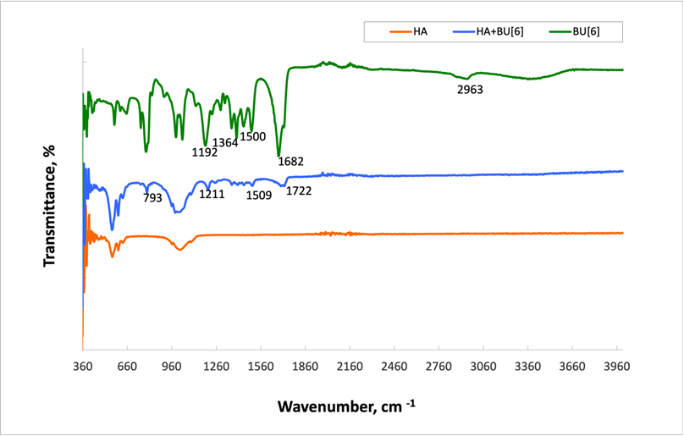

**Figure 4.** Infrared Spectra of Samples: **Bu[6], HA+BU[6], HA**.

In the **IDA+Bu[6]** spectrum (Fig. 5), characteristic absorption bands of **Bu[6]** are observed at 1716 cm-1 and 1694 cm-1, corresponding to the carbonyl (C=O) stretching vibrations in the N,N-2,8-dimethylglycoluril units. Similar to the **HA+Bu[6]** spectra, a shift of carbonyl groups is evident, with shifts of 19 cm-1 and 16 cm-1, respectively, compared to the original **Bu[6]** spectrum. The peak at 1500 cm-1 is attributed to the CH3 group, and C-H bonds are also identified at 792 cm-1. Deformation vibrations of CH2 groups are identified within the range of 1200-1500 cm-1. The absorption band at 2941 cm-1 corresponds to the carbonyl stretching vibrations in the methylene bridges.

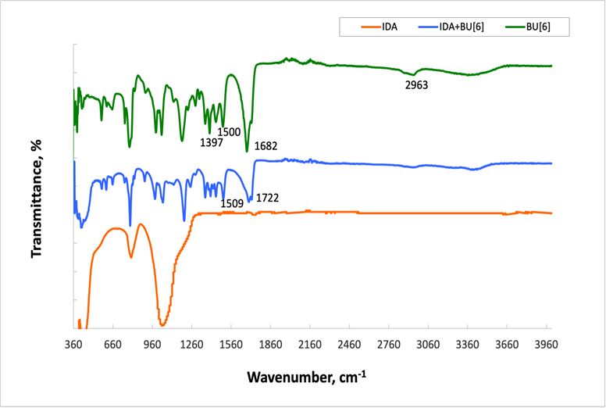

**Figure 5.** Infrared Spectra of Samples: **Bu[6], IDA +BU[6], IDA**.

Upon examination of the IR spectrum of **CDA**, a similar pattern is observed (Fig. 6). The obtained results indicate the presence of **Bu[6]** on the surfaces of both **IDA** and **CDA**.

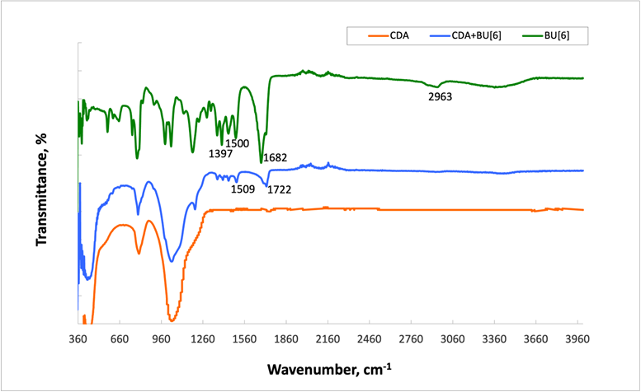

**Figure 6.** Infrared Spectra of Samples: **Bu[6], CDA + Bu[6], CDA**.

Furthermore, the characterization of the obtained composites included a thorough examination using SEM. In Figure 7A, the surface of HA before modification is depicted. Following the HA modification, an uneven distribution of molecules across the surface is evident. Notable, the SEM image **Bu[6] + HA** sample (Fig. 7B and 7C), vividly reveals a conglomerate ensemble of **Bu[6]** molecules, self-assembled into structures approximately 10 µm in size. This observation strongly confirms the presence of **Bu[6]** on the surface of the composite material **Bu[6] + HA.**

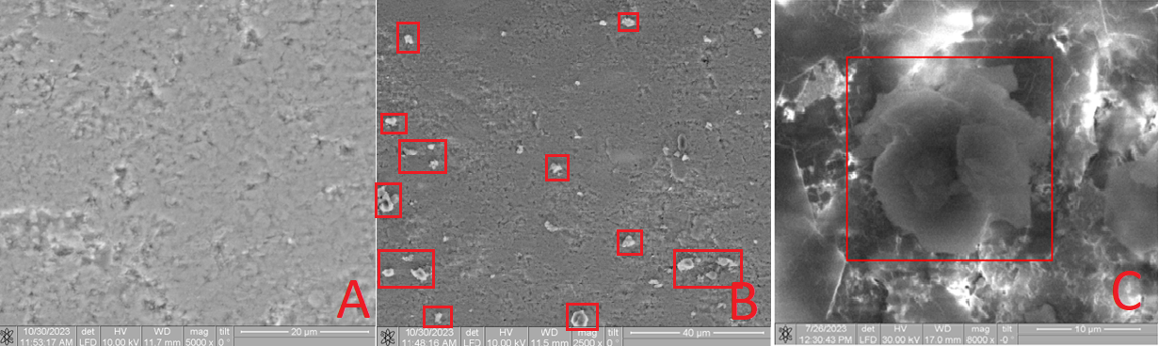

**Figure 7.** SEM Image of the **HA** (A) and **Bu[6] + HA** sample with varying resolution (B and C), highlighting the conglomerate of **Bu[6]** molecule ensembles in a red square.

Upon SEM analysis of the **Bu[6] + IDA** sample (Fig. 8B and 8C), a comparable phenomenon is apparent, revealing a conglomerate assembly of **Bu[6]** molecules on the **IDA** surface with dimensions spanning 5 to 15 µm. The unexpected formation of these associates, contrary to the typical behavior of bambus[6]uril with a molecule diameter of ≤10 Å [29], can be attributed to the inherent tendency of the dispersed **Bu[6]** solution in water to engage in such associative interactions.

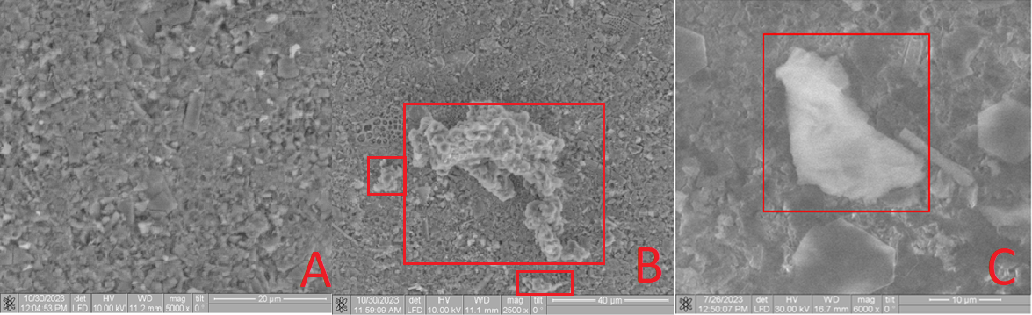

**Figure 8.** SEM image of the **IDA** (A) and **Bu[6] + IDA** sample with varying resolution (B and C), highlighting the conglomerate of **Bu[6]** molecule ensembles in a red square.

The **CDA** surface (Fig 9A) and the surfaces of the **Bu[6]+CDA** material exhibit comparable results. The larger diameter of the **Bu[6]** particles surpasses both the pore size of the diatomite carriers **(IDA, CDA)** and the hydroxyapatite **(HA),** indicating their pore overlap and the surface retention of the **Bu[6]** macrocycle. The collective evidence corroborates the presence of **Bu[6]** on the surfaces of **Bu[6] + HA, Bu[6] + IDA, and Bu[6] + CDA.**

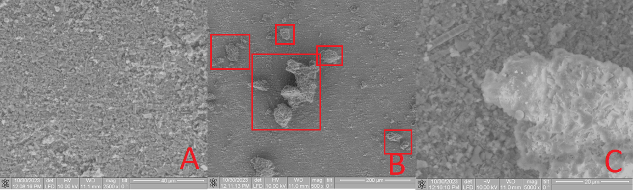

**Figure 8.** SEM image of the **CDA** (A) and **Bu[6] + CDA** sample with varying resolution, highlighting the conglomerate of **Bu[6]** molecule ensembles in a red square.

The toxicological effects of the developed biocomposites were assessed through the investigation of their hemocompatibility and plasma protein adsorption.

One approach to evaluating the overall cytotoxicity of a material involves examining its hemolytic activity. The hemolysis test is based on the degree of erythrolysis and hemoglobin dissociation upon material contact with erythrocytes in vitro.

Hemocompatibility and thromboresistance of biomaterials constitute crucial components of their biocompatibility. When foreign materials come into contact with blood, coagulation or thrombus formation may occur. Thromboresistance, the ability of a biomaterial to prevent thrombus formation, is a pivotal characteristic of biological compatibility. Hemocompatibility, on the other hand, represents an aspect of material-blood interaction and can be viewed from various perspectives, influenced by both chemical and physical material properties [19].

The results of the experimental assessment of hemolytic activity levels of the **HA+Bu[6]** group samples are presented in Table 2, compared with individual hydroxyapatite **HA** and **bambus[6]uril Bu[6].**

**Table 2.** Hemocompatibility Level of **HA, Bu[6],** and **HA+Bu[6]** group samples.

|  |  |  |
| --- | --- | --- |
| № | Sample | Hemolysis (%) |
| 1 | HA | 1.6814±0.0012* |
| 2 | Bu[6] | 0.2989±0.0017 |
| 3 | HA+Bu[6] | 0.9884±0.0033 |
| 4 | CTRL 100 % | 100 |
| 5 | CTRL 0 % | 0 |

Note: **HA** - hydroxyapatite; **Bu[6]** - bambus[6]uril; **CTRL** - control.

* – hemolysis level significantly differs from positive control (p < 0.05).

The examination of Table 2 indicates that the unaltered hydroxyapatite (**HA**) sample showed signs of hemolytic activity. Similar hemolytic tendencies were also observed in the **Bu[6]** and **HA+Bu[6]** samples. However, no statistically significant differences in the level of hemolysis between these samples and the negative control (**CTRL** 0%) were found (p > 0.05).

The hemolytic activity of the unmodified hydroxyapatite (**HA**) could potentially be attributed to the decrease in porosity caused by the treatment with various substances. According to existing literature, hemolysis on the surface of inert biomaterials is closely associated with the adsorption of plasma proteins, particularly fibrinogen, onto the material's surface in contact with blood, where increased plasma protein adsorption corresponds to heightened hemolysis [14].

Hydroxyapatite is a porous material with small pore sizes (14-20 nm) [20], significantly limiting the potential for extensive plasma protein adsorption on its surface [21]. This limitation on adsorption may contribute to the noticeable hemolytic activity observed in the unmodified hydroxyapatite **HA** samples.

The research conducted demonstrated that the application of **Bu[6]** reduced the hemolytic activity of hydroxyapatite (**HA**), as observed in the **HA+Bu[6]** composite sample. However, statistically significant differences in the level of hemolysis between the **HA+Bu[6]** sample and the negative control (**CTRL** 0%) were not established (p > 0.05). According to existing literature, protein adsorption occurs on any abiotic surface, and the nature of the adsorbed protein layer depends on the magnitude and potential difference on the surface. If the material's positive potential exceeds that of blood, the likelihood of thrombosis increases [22].

Based on the above, it can be speculated that **Bu[6]**, acting as a potent complexing agent, binds ions from the blood solution, thereby reducing the positive potential of the porous material's surface, ultimately reducing the adhesion of blood cellular components and enhancing hemocompatibility.

To determine whether the level of hemolytic activity correlates with the degree of plasma protein adsorption on the samples, we examined the extent of reduction in plasma protein concentration after incubation with the samples.

The data presented in Table 3 indicates that the **HA** group samples experienced a decrease in plasma protein concentration after incubation, which was statistically confirmed (p < 0.05). Moreover, the **HA** samples displayed higher protein adsorption compared to the modified **bambus[6]uril** **HA+Bu[6]** samples.

**Table 3.** Plasma protein adsorption levels of **HA, Bu[6],** and **HA+Bu[6]** group samples.

|  |  |  |  |
| --- | --- | --- | --- |
| № | Sample | Optical Density | Δ of Optical Density |
| 1 | HA | 0.1359±0.0115 | 0.1255 |
| 2 | Bu[6] | 0.2318±0.0237 | 0.0382 |
| 3 | HA+Bu[6] | 0.2100±0.0330 | 0.0600 |
| 4 | CTRL (PBS) | 0.1228±0.0059 | 0.1472 |
| 5 | CTRL (Plasma) | 0.2700±0.0164 | 0.0000 |

Note: **HA** – hydroxyapatite; **Bu[6]** – bambus[6]uril; **CTRL** (PBS) – empty experiment; **CTRL** (Plasma) – protein content in intact plasma.

The research conducted suggests that the modification of hydroxyapatite (HA) samples with bambus[6]uril (Bu[6]) enhances their hemocompatibility and reduces adsorption.

In the subsequent phase of our study, we examined the biocompatible properties of intact diatomite (**IDA**), purified **CDA** diatomite, bambus[6]uril (**Bu[6]**), and their compositions (**IDA+Bu[6] and CDA+Bu[6]**).

According to the data presented in Table 3, the samples in the **Bu[6]** and **CDA+Bu[6]** groups exhibited some hemolytic activity; however, no statistically significant differences between these samples and the negative control were observed (p > 0.05). Conversely, samples from the other groups did not display any hemolytic activity (Table 4). The absence of hemolytic activity in these groups can be attributed to the inherently high biocompatibility of diatomite, as supported by existing literature [6].

**Table 4.** Hemocompatibility Levels of **IDA**, **CDA**, and **DA+Bu[6]** group samples.

|  |  |  |
| --- | --- | --- |
| № | Sample | Hemolysis (%) |
| 1 | IDA | 0 |
| 2 | CDA | 0 |
| 3 | Bu[6] | 0.2989±0.0017 |
| 4 | IDA+Bu[6] | 0 |
| 5 | CDA+Bu[6] | 0.7971±0.0008 |
| 6 | CTRL 100 % | 100 |
| 7 | CTRL 0 % | 0 |

Note: **IDA** - intact diatomite; **CDA** - purified diatomite; **Bu[6]** -bambus[6]uril; **CTRL** -control.

* – hemolysis level is statistically significantly different from positive control (p < 0.05).

The primary challenge of preventing unwanted blood coagulation upon contact with implanted materials and devices remains a persisting concern. This challenge stems from the absence of protective mechanisms present in healthy vascular endothelium, which counteracts thrombosis. Foreign materials, on the other hand, tend to promote blood clotting through a series of interconnected processes, including protein adsorption, platelet and leukocyte adherence, thrombin generation, and complement activation [14]. Given this context, the development of strategies that mitigate hemolysis while modifying biocompatible materials holds paramount significance.

It is important to note, however, that the level of hemolysis for biomaterials interacting with the body's internal environment should not exceed 5% [23]. According to the experimental data, none of the samples surpassed this threshold, leading to the conclusion that all the tested samples demonstrate hemocompatibility.

As illustrated in Table 5, the unmodified **Bu[6]** samples (**IDA** and **CDA**) exhibited a decrease in plasma protein concentration after incubation, a phenomenon that was statistically confirmed (p < 0.05). These samples demonstrated higher adsorption compared to their modified counterparts with bambus[6]uril. Similarly, the **Bu[6]**-modified samples (**IDA+Bu[6]** and **CDA+Bu[6])** also showed a decrease in protein concentration, but no statistically significant differences were observed between these samples and the negative control (p > 0.05).

**Table 5.** Plasma Protein Adsorption Levels of IDA, CDA, and DA+Bu[6] group samples.

|  |  |  |  |
| --- | --- | --- | --- |
| № | Sample | Optical Density | Δ of Optical Density |
|  | IDA | 0.1386±0.0133 | 0.1227 |
|  | CDA | 0.1366±0.0053 | 0.1247 |
| 1 | Bu[6] | 0.2318±0.0237 | 0.0382 |
| 2 | IDA+Bu[6] | 0.1865±0.0318 | 0.0835 |
| 3 | CDA+Bu[6] | 0.1946±0.0084 | 0.0754 |
| 4 | CTRL (PBS) | 0.1228±0.0059 | 0.1472 |
| 5 | CTRL (Plasma) | 0.2700±0.0164 | 0.0000 |

Note: **IDA** – Intact Diatomite; **CDA** – Cleaned Diatomite; **Bu[6]** – Bambus[6]uril; **CTRL** (PBS) – Blank Experiment; **CTRL** (Plasma) – Protein Content in Intact Plasma.

The data obtained from Table 5 indicates that the modification of **Bu[6]** samples results in decreased protein adsorption, consequently enhancing their hemocompatibility.

It is crucial to emphasize that the hemolysis level of biomaterials within the body's internal environment should not surpass 5% [23]. According to the findings of the experiments, none of the modified **Bu[6]** samples of hydroxyapatite and diatomite exceeded this threshold, leading to the conclusion that all the investigated samples exhibit hemocompatibility.

The reduction in hemolysis level and adsorption during the modification of **Bu[6]** samples is attributed to alterations in the material's surface properties, including surface tension, free surface energy, roughness, and hydrophilicity. The deposition of **Bu[6]** onto the surfaces of porous materials induces changes in their surface charge, making it more akin to blood. Consequently, plasma protein adsorption diminishes, leading to reduced thrombogenicity and enhanced hemocompatibility of the developed biocomposites.

**4. Conclusions**

This study has pioneered the successful development of novel biocomposites by integrating bambus[6]uril onto various porous substrates, namely hydroxyapatite and **diatomite.** The composite materials, **Bu[6] + HA**, **Bu[6] + IDA**, and **Bu[6] + CDA**, underwent comprehensive characterization using sophisticated techniques, including infrared spectroscopy (IR) and scanning electron microscopy (SEM). The investigation focused on examining the hemolytic effects and plasma protein adsorption of the materials. Notably, the findings revealed the formation of a complex assembly of **Bu[6]** molecules within the biocomposites, leading to a significant decrease in plasma protein adsorption and a substantial improvement in hemocompatibility.

**HA**, **IDA**, and **CDA** are well-known porous materials widely recognized for their strong biocompatibility. Consequently, the incorporation of bambus[6]uril onto the surfaces of these porous materials is expected to facilitate the creation of potential materials featuring an optimal microenvironment for osteogenesis and the controlled release of bioactive compounds, including antibacterial drugs. These innovative biocomposites exhibit promising potential for finely regulating biological responses through host-guest interactions enabled by **Bu[6]** immobilization on customized carriers, which will be the focal point of our upcoming research endeavors.

**Author Contributions:** Investigation, G.Zh., P.T., A.U., D.F., A.G. and V.L.; resources, I.K., A.B. and R.Ye.; data curation, A.B. and R.Ye.; writing—original draft preparation, G.Zh., P.T., A.U., D.F., A.G. and V.L.; writing—review and editing, R.R. G.A. and S.B.

**Funding:** This study was supported by the Tomsk State University Development Programme (Priority-2030).

**Institutional Review Board Statement:** Not applicable.

**Informed Consent Statement:** Not applicable.

**Data Availability Statement:** Not applicable.

**Acknowledgments:** The data presented in this study are available in this article.

**Conflicts of Interest:** The authors declare no conflict of interest.

**References**

(1) Vikhrov, S. P.; Kholomina, T. A.; Begun, P. I.; Afonin, P. N. *Biomedical Materials Science*; Hotline - Telecom: Moscow, 2006.

(2) Antoniac, I. *Handbook of Bioceramics and Biocomposites*; 2016. https://doi.org/10.1007/978-3-319-12460-5.

(3) *Diatomaceous earth | Uses, Benefits & Safety | Britannica*. https://www.britannica.com/science/diatomaceous-earth (accessed 2023-09-30).

(4) Evdokimova, E. V.; Matskan, P. A.; Mamontov, G. V. MIL-100(Fe)/Diatomite Composite with Hierarchical Porous Structure for Sorption of Volatile Organic Compounds. *Russ. J. Phys. Chem. A* **2022**, *96* (1), 171–178. https://doi.org/10.1134/S0036024422010083.

(5) Sprynskyy, M.; Pomastowski, P.; Hornowska, M.; Król, A.; Rafińska, K.; Buszewski, B. Naturally Organic Functionalized 3D Biosilica from Diatom Microalgae. *Mater. Des.* **2017**, *132*, 22–29. https://doi.org/10.1016/j.matdes.2017.06.044.

(6) Ghobara, M. M.; Ghobara, M. M.; Ghobara, M. M.; Mohamed, A. Diatomite in Use: Nature, Modifications, Commercial Applications and Prospective Trends. In *Diatoms: Fundamentals and Applications*; John Wiley & Sons, Ltd, 2019; pp 471–509. https://doi.org/10.1002/9781119370741.ch19.

(7) Marchenko, E.; Luchsheva, V.; Baigonakova, G.; Bakibaev, A.; Vorozhtsov, A. Functionalization of the Surface of Porous Nickel–Titanium Alloy with Macrocyclic Compounds. *Materials* **2023**, *16* (1), 66. https://doi.org/10.3390/ma16010066.

(8) Kolesnichenko, I. V.; Anslyn, E. V. Practical Applications of Supramolecular Chemistry. *Chem. Soc. Rev.* **2017**, *46* (9), 2385–2390. https://doi.org/10.1039/C7CS00078B.

(9) Svenson, S.; Tomalia, D. A. Dendrimers in Biomedical Applications—Reflections on the Field. *Adv. Drug Deliv. Rev.* **2012**, *64*, 102–115. https://doi.org/10.1016/j.addr.2012.09.030.

(10) Sharma, A.; Sharma, U. S. Liposomes in Drug Delivery: Progress and Limitations. *Int. J. Pharm.* **1997**, *154* (2), 123–140. https://doi.org/10.1016/S0378-5173(97)00135-X.

(11) Husseini, G. A.; Pitt, W. G. Micelles and Nanoparticles for Ultrasonic Drug and Gene Delivery. *Adv. Drug Deliv. Rev.* **2008**, *60* (10), 1137–1152. https://doi.org/10.1016/j.addr.2008.03.008.

(12) Lacerda, L.; Bianco, A.; Prato, M.; Kostarelos, K. Carbon Nanotubes as Nanomedicines: From Toxicology to Pharmacology. *Adv. Drug Deliv. Rev.* **2006**, *58* (14), 1460–1470. https://doi.org/10.1016/j.addr.2006.09.015.

(13) Li, J.; Loh, X. J. Cyclodextrin-Based Supramolecular Architectures: Syntheses, Structures, and Applications for Drug and Gene Delivery. *Adv. Drug Deliv. Rev.* **2008**, *60* (9), 1000–1017. https://doi.org/10.1016/j.addr.2008.02.011.

(14) Lizal, T.; Sindelar, V. Bambusuril Anion Receptors. *Isr. J. Chem.* **2018**, *58* (3–4), 326–333. https://doi.org/10.1002/ijch.201700111.

(15) Das, D.; Assaf, K. I.; Nau, W. M. Applications of Cucurbiturils in Medicinal Chemistry and Chemical Biology. *Front. Chem.* **2019**, *7*, 619. https://doi.org/10.3389/fchem.2019.00619.

(16) Cova, T. F. G. G.; Nunes, S. C. C.; Valente, A. J. M.; Pinho e Melo, T. M. V. D.; Pais, A. A. C. C. Properties and Patterns in Anion-Receptors: A Closer Look at Bambusurils. *J. Mol. Liq.* **2017**, *242*, 640–652. https://doi.org/10.1016/j.molliq.2017.07.065.

(17) Fiala, T.; Ludvíková, L.; Heger, D.; Švec, J.; Slanina, T.; Vetráková, L.; Babiak, M.; Nečas, M.; Kulhánek, P.; Klán, P.; Sindelar, V. Bambusuril as a One-Electron Donor for Photoinduced Electron Transfer to Methyl Viologen in Mixed Crystals. *J. Am. Chem. Soc.* **2017**, *139* (7), 2597–2603. https://doi.org/10.1021/jacs.6b08589.

(18) Šlampová, A.; Šindelář, V.; Kubáň, P. Application of a Macrocyclic Compound, Bambus[6]Uril, in Tailor-Made Liquid Membranes for Highly Selective Electromembrane Extractions of Inorganic Anions. *Anal. Chim. Acta* **2017**, *950*, 49–56. https://doi.org/10.1016/j.aca.2016.11.010.

(19) Manabu, S. *Medical Polymers*; Medicine: Moscow, Russia, 1981.

(20) Maitz, M. F.; Martins, M. C. L.; Grabow, N.; Matschegewski, C.; Huang, N.; Chaikof, E. L.; Barbosa, M. A.; Werner, C.; Sperling, C. The Blood Compatibility Challenge. Part 4: Surface Modification for Hemocompatible Materials: Passive and Active Approaches to Guide Blood-Material Interactions. *Acta Biomater.* **2019**, *94*, 33–43. https://doi.org/10.1016/j.actbio.2019.06.019.

(21) Rasskazova, L. A.; Korotchenko, N. M.; Zeer, G. M. Microwave Synthesis of Hydroxyapatite and Physicochemical Study of Its Properties. *Russ. J. Appl. Chem.* **2013**, *86* (5), 691–695. https://doi.org/10.1134/S1070427213050145.

(22) Brash, J. L.; Horbett, T. A.; Latour, R. A.; Tengvall, P. The Blood Compatibility Challenge. Part 2: Protein Adsorption Phenomena Governing Blood Reactivity. *Acta Biomater.* **2019**, *94*, 11–24. https://doi.org/10.1016/j.actbio.2019.06.022.

(23) Kulinets, I. 1 - Biomaterials and Their Applications in Medicine. In *Regulatory Affairs for Biomaterials and Medical Devices*; Amato, S. F., Ezzell, R. M., Eds.; Woodhead Publishing Series in Biomaterials; Woodhead Publishing, 2015; pp 1–10. https://doi.org/10.1533/9780857099204.1.

(24) 14:00-17:00. *ISO 10993-4:2017*. ISO. https://www.iso.org/standard/63448.html (accessed 2023-09-29).

(25) Goren, R.; Baykara, T.; Marsoglu, M. A Study on the Purification of Diatomite in Hydrochloric Acid. *Scand. J. Metall.* **2002**, *31* (2), 115–119. https://doi.org/10.1034/j.1600-0692.2002.310205.x.

(26) Mondal, H.; Thomas, J.; Amaresan, N. Assay of Hemolytic Activity. In *Aquaculture Microbiology*; Thomas, J., Amaresan, N., Eds.; Springer Protocols Handbooks; Springer US: New York, NY, 2023; pp 187–189. https://doi.org/10.1007/978-1-0716-3032-7_24.

(27) Burtis, C. A.; Ashwood, E. R.; Border, B.; Tietz, N. W. *Tietz Fundamentals of Clinical Chemistry*, 5th ed.; W.B. Saunders: Philadelphia, 2001.

(28) Williams, D. F. Tissue-Biomaterial Interactions. *J. Mater. Sci.* **1987**, *22* (10), 3421–3445. https://doi.org/10.1007/BF01161439.

(29) Laurencin, C.T.; Elgendy H. The biocompatibility and toxicity of degradable polymeric materials: implications for drug delivery. In: *AJ Domb*, editor. Polymeric site-specific pharmacotherapy. Chichester: Wiley, 1994, 27–46.

(30) Babensee, J. E.; Anderson, J. M.; McIntire, L. V.; Mikos, A. G. Host Response to Tissue Engineered Devices. *Adv. Drug Deliv. Rev.* **1998**, *33* (1), 111–139. https://doi.org/10.1016/S0169-409X(98)00023-4.

(31) *Drugs on Target | Science*. https://www.science.org/doi/10.1126/science.1063273 (accessed 2023-09-30).

(32) Deanesly, R.; Parkes, A. S. Testosterone. *Br. Med. J.* **1936**, *1* (3923), 527–528.

**Disclaimer/Publisher’s Note:** The statements, opinions and data contained in all publications are solely those of the individual author(s) and contributor(s) and not of MDPI and/or the editor(s). MDPI and/or the editor(s) disclaim responsibility for any injury to people or property resulting from any ideas, methods, instructions or products referred to in the content.