L.N. Gumilyov Eurasian National University

UDC 640.4:351.777.61 Manuscript Copyright

TANSEL TERCAN

Improving the efficiency of the hotel business: waste management and its improvement

6D090200 – Тourism

Thesis for the Degree of
Doctor of Philosophy (PhD)

Scientific consultant
PhD, associate professor
G. Yeshenkulova

Foreign scientific consultant
Dr., professor
M. Gülmez

Republic of Kazakhstan
Nur Sultan 2021
CONTENT

NORMATIVE REFERENCES | 3
DEFINITION | 4
DESIGNATIONS AND ABBREVIATIONS | 5
INTRODUCTION | 6
1 THEORETICAL AND METHODOLOGICAL FOUNDATIONS OF WASTE MANAGEMENT | 12
1.1 Waste and Recycling Management | 12
1.2 Characteristics of Hotels and Waste Management of Hotel Industry | 20
1.3 Waste and Recycling in the Context of Sustainable Efficiency | 34
1.4 Waste Disposal and Recycling in the Republic of Kazakhstan | 39
1.5 Research Method | 43
2 ANALYSIS AND FINDINGS | 48
2.1 Housekeeping Departments | 48
2.2 Technical Service Departments | 52
2.3 Front Office Departments | 57
2.4 Purchasing Departments | 63
2.5 F&B Departments | 72
2.6 Kitchen Departments | 79
3 RECOMMENDATIONS | 86
3.1 Efficiency and Improvement in Hotels with Waste Management | 86
3.2 Hotel Waste Management Model and Recommendation | 92
CONCLUSION | 111
REFERENCES | 119
ANNEXES … | 125

NORMATIVE REFERENCES

This dissertation uses references to the following standards:
Decree of the President of the Republic of Kazakhstan dated December 29, 2000, "Priority Measures for the Development of the Travel Industry."
Law of the Republic of Kazakhstan on tourism activity in the Republic of Kazakhstan: Adopted on June 13, 2001, No. 211-II.
Decree of the President of the Republic of Kazakhstan "2003-2005 Tourism Sector Development Program"
Order of the Minister of Tourism and Sports of the Republic of Kazakhstan dated November 11, 2008 No. 01-08/200 “On approval of the Rules for the classification of tourist accommodation” (registered in the Register of State Registration of Normative Legal Acts No. 5367).
ST RK 3.7-96. The procedure for certification of tourist and excursion and hotel services.
GOST 28681.2-95. Tourist and excursion service. Tourist services. General requirements.
Resolution of the Government of the Republic of Kazakhstan. State program of development of tourism industry of the Republic of Kazakhstan for 2019-2025: Tv. May 31, 2019, №360.
Decree of the President of Kazakhstan, Strategy "Kazakhstan-2050" and "Kazakhstan-2030: Prosperity, Security and Growing Welfare of All the Kazakhstanis"

DEFINITION

The following definitions are used in this dissertation:
Food Waste – Food waste is organic waste, and they occur during production, distribution, storage, sales, preparation, cooking, and service stages.
Hotel Sector – Hotel sector is a sector composed of businesses that meet temporary accommodation, food, beverage, partly entertainment, and other tourists' social needs.
Gas Wastes – Gas wastes originate from fuels used for heating purposes, from industries, motor vehicles, and irregularly planned landfills.
Non-decomposing Solid Wastes – Wastes such as wood, straw, paper, cardboard, brick construction rubble, cans, metal, and glassware.
Non-preventable Food Waste – Non-preventable food waste is generally wasted that humans cannot eat, such as fruit - vegetable peels, bones, shells from seafood.
Preventable Food Waste – Preventable food waste is food that is prepared for human consumption but not consumed for any reason.
Recyclable Solid Waste – Recyclable solid wastes (paper, cardboard, plastic, metal, glass) can be added to the economy after being subjected to physical and chemical treatment in domestic and domestic industrial wastes.
Recycling – Recycling recycles recyclable waste materials, which are out of use, through various recycling methods as raw materials.
Systematic Waste Management – Systematic waste management ensures that all waste is disposed of in a controlled manner, recycled, minimized damage to nature and humans, and recycling disposed products.
Thermal System (Incineration) – Incineration is the process of converting the combustible wastes in the waste into an inert residue (ash) and provides energy recovery.
Tourism Industry – Tourism industry is a non-profit industry that combines different services and activities under one umbrella, such as tourism organization, marketing, accommodation, transportation services, food and beverage activities, retail stores, and various other activities.
Waste –Waste is the substance or objects disposed of following national law requirements or intended to be disposed of.
Waste Management – Waste management aims to transform waste into an input for the economy rather than being a threat to the environment and human health are adopted.

DESIGNATIONS AND ABBREVIATIONS

B&B | – Bed and Breakfast
EMS | – Environmental Management System
EPA | – Food Waste Hierarchy
E.U. | – European Union
F&B | – Food and Beverage
F.A.O. | – Food and Agriculture Organization
FB | – Full Board
FIFO | – First In First Out
F.M.I. | – Food Marketing Institute
FSSC | – Food Safety System Certification
G.D.P. | – Gross Domestic Product
G.M.A. | – Grocery Manufacturers Associaton
HB | – Half Board
IoT | – Internet of Things
I.S.O. | – International Organization for Standardization
Kg | – Kilogram
LED | – Light-emitting Diode
LNG | – Liquefied Natural Gas
LPG | – Liquefied Petroleum Gas
N/A | – Not Applicable
OHSAS | – Occupational Health and Safety Assessment Series
RO | – Room Only
SDGs | – Sustainable Development Goals
SGS | – Smart Garbage System
U.K. | – United Kingdom
UN | – United nations

INTRODUCTION

The relevance of the research topic.
1st President of the Republic of Kazakhstan, Nursultan Nazarbayev, in the program "The Nation's Plan - 100 concrete steps to implement five institutional reforms" pays great attention to the development of tourism in the country, committing to attract investors with the best experience in the development of tourism [1]. The President of the Republic of Kazakhstan, Kassym-Jomart Tokayev, at the "Ulytau – 2019" International Tourism Forum said that "In the near future, Kazakhstan may become one of the most attractive places for foreign and domestic tourists, as well as one of the world's centers of ethnic-tourism. For this, we have adopted a sectoral State program. Its full implementation will increase the share of tourism in GDP to 8%. The number of inbound visitors is to rise to 9 million and domestic tourists to 8 million. The number of people employed in this area should be increased to 650 thousand people" [2].
Tourism is one of the factors that significantly affect the country's economies. Tourism and economy are intertwined concepts. For this reason, the tourism economy is an area where individuals are labor-intensive, trying to meet their tourism needs by using tourism resources. The tourism sector, which has been developing rapidly globally and Kazakhstan, has an essential role in today's world, where economic conditions and challenging competition are experienced.
The tourism sector, which also affects other sectors' development, is one of today's fundamental building blocks. As a developing country, especially in Kazakhstan's tourism sector, the industry shows a continuous growth trend. The main reasons such countries are interested in the tourism industry are; bringing solutions to foreign currency problems helps solve economic issues such as tourism's financial blocking, tariff, and quota. Due to the foreign exchange mobility of international tourism, the main objectives of both developed and developing countries are to balance the stability of payments by increasing revenues from abroad.
It is not always possible for tourism movements occurring in a region to be positive. Sometimes, tourism development or the decrease in the benefit provided from tourism reveals the adverse effects of tourism. For example, suppose the local population purchasing power is lower than foreign tourists in developing countries like Kazakhstan. In that case, tourists are considered to accept the payment of goods and services at high prices. Prices of products and services at retailers in the region can be increased. Due to this increase, cost increase also occurs, and regional inflation arises. Opportunity cost, called selection among limited resources, is an important factor for the development of tourism. The opportunity to prioritize the growth of the tourism sector is to invest its revenues by investing in the limited resources of tourism.
The hotel business as an industry is characterized by a fast pace of development. Accommodation services are a backbone of the tourism industry. However, at present there is a lack of scientific research in the field of analysing the specifics of the hotel business functioning as one of the key elements of the tourism industry, as well as a lack of full-fledged research in the field of finding ways to increase the efficiency of hotel business management.
In the context of increasing rivalry among hotels, it became obvious that improving their efficiency can serve as their competitive advantage.
The current situation is also characterized by the following negative factors: the volume of solid waste is continuously increasing, worsening the sanitary condition of urban and sub-urban areas, the composition of solid waste is becoming noticeably more complicated, including an increasing number of environmentally hazardous components, and the costs of waste management are increasing. There is a serious problem with the disposal of electrical household appliances, electronic and computer equipment, electric batteries, accumulators, cars, and their parts. But the situation is gradually changing: the society's awareness of the inadmissibility of preserving the existing system, its futility, and destructiveness for the country's further development is growing. The most important of problems is the wastes occurring in the hotels while there are limited resources. Recycling activities need to be carried out to bring these wastes back into the economy. Thus, the problem of waste management of hotel enterprises in Kazakhstan is acquiring exceptional relevance and calls for a deep theoretical study, comprehensive analysis and development of sound practical recommendations.
Therefore, in the thesis research, waste and recycling management of 5-star hotels operating in Kazakhstan and different countries were examined. It is crucial to examine the hotels' waste and recycling activities as the hotels' waste is high and brought into the economy. The scope of this thesis research will clarify what kind of waste is generated in hotels, why waste is generated, what policies hotels follow for waste reduction, and how they contribute to the economy with recycling activities.
The work on the thesis research and review started in 2018 my and the screening studies were completed in 2019. During the doctoral program, the Covid-19 pandemic ourbroke, which continued in the education process at the beginning of 2020, and in this process, the pandemic quickly showed its effect all over the world. As in every industry, the new lifestyle brought by the new world order, with its effects in the accommodation sector, has revealed the paradigm shift of a new century.
Level of the research topic. Issues of assessing waste management, recycling, and alternative management scenarios in terms of cities Nur-Sultan and Almaty are analyzed in detail in the works of Inglezakis V.J. et al., Mukasheva A. et al., Aliyeva S. et al. and Serikova A., Abylkhani B. et al.
The analysis of the methodological framework for the waste and recycling management of the tourism industry in different areas of the tourism market carried out by foreign scientists: Abdulredha M. et al., Alonso-Almeida M.M., Mateu-Sbert J. et al., Manomaivibool P., Pirani S.I. et al., Shamshiry E. et al. and Diaz-Farina E. et al.
Theoretical bases of waste management and recycling in hotel enterprises are reflected in the works of Diaz-Farina E. et al., Radwan H.R. et al., Estay-Ossandon, Hong I. et al., Hu X., Kasavan S. et al., Marthinsen J., Mateu-Sbert J. et al., Okazaki W.K., Phu S. et al., Trung N., Kumar S., Owen N. et al. and Tang J. Kazakhstani scientists dedicated to the development waste management and Recycling in the tourism industry market: Aliyeva S. et al., Inglezakis V.J. al., Shortan Serikova A., Myrzaliyev B.S. et al.
The purpose of the dissertation. The purpose of the dissertation work is to develop a conceptual model for increasing the efficiency of hotel business in the long run through waste and recycling management based on comprehensive analysis of the waste and recycling management's theoretical and methodological foundations in the hotel industry. According to the results, practical recommendations for waste management and recycling are given to both the hotel industry and practitioners.
The development of the hotel industry is strongly influenced by globalization processes. This process manifests itself primarily in the spread of global hotel chains. Foreign management brings with it a high level of service quality. International hotels have a modern material and technical basis and are the most competitive on the market. This is evidenced by high occupancy rates, service quality and therefore profitability and financial stability. Such international hotels have management experience and a number of competitive advantages [3]. Therefore, in line with the purpose of this thesis, it is aimed to examine waste management and recycling in international hotels.
The research object is represented by 5-star international hotels.
Research tasks:
- Review of the theoretical foundations of waste management and the practice of their processing in the framework of hotel activities.
- To identify the types of waste generated in various departments of five 5-star international hotels operating in different countries.
- Determination of the waste disposal practices generated in various departments of 5-star international hotels operating in different countries.
- Analysis and evaluation of the accumulated domestic and foreign experience in providing waste collection services.
- Determination of ways to address the problems of providing services for the collection of solid waste in hotels.
- Justification of the feasibility for implementing a system of selective collection of solid waste and the development of criteria for determining an effective system of providing services for solid waste collection and the mechanism for its implementation.
The dissertation research is specified to analyze waste and recycling management and develop suggestions by collecting data from finance, housekeeping, technical service, front office, purchasing, F&B, and kitchen departments of 21 international chain hotel Groups Kazakhstan, Turkey, United Arab Emirates, Egypt, and Russia.
The study's theoretical and methodological basis is Kazakhstani and foreign scientists' work on the theoretical and methodological basis of waste management in terms of tourism and development of recycling system to reuse this waste and turn them into economic.
The research methods: The dissertation uses systematic, statistical, descriptive content, in-depth interview, questionnaire, and visual methods. The data obtained through the interview were subjected to content analysis. SPSS statistical program was employed for short questionnaires to calculate descriptive results (means and standard deviations). Photographs of waste and recycling from research hotels are presented in the appendix of the dissertation.
The information base of the study includes primary data obtained from 5-star hotels operating in Kazakhstan and in different countries with an in-depth interview with purchasing, housekeeping, finance, kitchen, front office, technical service, and service and bar department managers. In the theory part, regulations and laws of the Republic of Kazakhstan in tourism, documents of international organizations, scientific conferences, articles, forums, seminars, and periodicals were used.
The scientific novelty of the dissertation research is as follow:
1. Unification of the waste and recycling management's theoretical and methodological bases regarding the tourism industry, identification, and categorization of the waste generated in 5-star hotels operating in Kazakhstan and different countries.
2. Determination of change in waste amount according to origin countries of tourists.
3. Determining the cause of waste, giving suggestions for recycling practices, and bringing the waste to the economy.
4. A model for waste management and recycling has been created that hotels can put into practice.
5. It was explained how waste management and recycling would affect efficiency in hotels.
6. Things to be done regarding waste management and recycling in Kazakhstan hotels were proposed.
The main provisions proposed for the defense:
– The wastes and their amounts generated in the departments of 5-star hotels operating in Kazakhstan and other countries were determined;
– The causes of the waste generated in the departments of the hotels were identified;
–The kind of recycling applications subjected for generated wastes in the departments of hotels were determined;
– The impact of countries of tourists’ origins and other issues on waste management identified;
– The new technological trends about reducing waste and increasing recycling (such as compact machines, IoT technology, big data, artificial intelligence), sustainable development of the tourism market were identified, and future opportunities were clarified. The benefits of this new generation of technologies regarding hotel waste management are given in the dissertation's recommendation part.
The scientific and practical significance of the dissertation research: The dissertation's scientific results can be used in future research in waste management and recycling practices in tourism in the Republic of Kazakhstan and enterprises.
The study results are recommended for organizations managing the waste and recycling services in tourism industries to decrease waste and increase Recycling. The proposals presented in the dissertation were accepted for consideration by the Rixos President Astana Hotel (especially for using the compact machine, it will be the first usage in the Republic of Kazakhstan).
This researches allowed us to systematize the knowledge obtained during the study of scientific literature, apply it in the first and second chapters of the dissertation, study and analyze the theoretical and methodological base of foreign scientific works, search for information, international statistics on the research work, develop practical recommendations for the formation and promotion of a positive image of the Republic of Kazakhstan, aimed at creating a recognizable brand of the country in terms of sustainable and zero waste tourism and hotel industry development. “Zero Waste” is a goal defined as a waste prevention approach that includes the prevention of waste, the more efficient use of resources, the reduction of the amount of waste generated, the establishment of an effective collection system, and the recycling of waste. For example, paper is a completely recyclable material, and hotels can monitor a zero-waste policy for paper.
Papers publisshed within the scope of dissertation:
1. Waste management in the tourism industry: a systematic review // Reports of the National Academy of Sciences of the Republic of Kazakhstan. – 2019. – №3(325). – Р. 244-252.
2. Bibliometric analysis of waste management and Recycling in tourism science from past to today // Bulletin of Pavlodar State University named after S.M. Toraigyrov. – 2020. – №3. – Р. 220-236. (Humanitarian Series).
3. Analysing waste management and recycling practices for the hotel industry (Scopus) // Journal of Environmental Management and Tourism. – 2021. – №12(2). – Р. 382-381.
4. Investigation of the all-inclusive system in hotel enterprises in terms of waste (in press).
Conference paper 1: Sustainability of tourism businesses: Rixos Sungate example // Proceedings of 7th SCF International Conference on “the Future of the European Union and Turkey-European Union Relations”. – Usak, 2019. – Р. 747-756 (April 11-13).
Conference paper 2: The usage potential of industry 4.0 technologies in waste management in hotel enterprises. Ұлы жібек жолы – Бейбітшілік келісім және тұрақтылық жолы: I халықаралық конференциясының материалдары, түркістан. – 2019. – Б. 73-80.
Conference paper 3: A proposal for smart restaurant business development // Proceedings of the International Online-Conference «Modern Trends of Hotel and Restaurant Business Development». – 2020. – Р. 3-6 (12 March).
Approbation of the research results: The thesis research was supported by the waste management practices of Accor Hotels (planet 21 programs) and Rixos Hotel. The answers given about the theme related to the solution proposals, applications and the results obtained created an archive for the thesis. At the end of the dissertation, a model related to waste management has been created. The management of hotel businesses can integrate and configure this model into their accommodation systems. It can be said that waste management can be realized at the desired level, and efficiency will increase if hotels use this model. The research results are published in 7 papers in domestic and foreign scientific journals, including 1 article in scientific publications included in the Scopus database list, 3 articles in journals approved by the Science Committee of the Ministry of Education and Science, and 3 articles foreign conferences.
Structure and scope of the dissertation. The dissertation consists of normative references, definitions, abbreviations, introduction, three sections, conclusion, references, additional photographs, and annexes. The dissertation content consists of 124 pages, 97 references, 23 tables, 28 figures, 14 annexes.

1 THEORETICAL AND METHODOLOGICAL FOUNDATIONS OF WASTE MANAGEMENT

This chapter consists of two main topics. Firstly, waste management and recycling are illustrated. Secondly, waste management and recycling in the hotel industry are explained. Then, waste management and recycling in the economy and world literature, new technology examples for waste management, and its place in Kazakhstan's hotel industry are reviewed. In this context theoretical structure of literature review as follow; waste management, recycling management, characteristic of hotels, waste management of hotel industry, and sustainable efficiency.

1.1 Waste and Recycling Management
Considering the definitions made in the literature, it is noteworthy that waste is a subjective concept. According to some study results, a product that must be disposed of for someone can be the source of valuable something for someone else [4]. The waste is the substance or objects disposed of by national law requirements or intended to be disposed of [5]. Within the scope of the sustainable development approach worldwide, waste management strategies aiming at transforming waste into an input for the economy rather than being a threat to the environment and human health are adopted [6].
It is possible to classify waste according to various criteria [5, р. 48];
- According to a physical condition (solid, liquid, gas).
- According to the original use (packaging waste, kitchen waste, etc.).
- According to the substance group (glass, paper, plastic, metal, etc.).
- According to physical characteristics (flammable, compostable, recoverable, etc.).
- According to the source (urban, commercial, institutional, agricultural, industrial, etc.).
- According to safety level (dangerous, non-hazardous, etc.).
In the European Waste Catalog published by the Environmental Protection Agency, waste is classified as follows:
- Wastes generated during exploration, extraction, operation, physical and chemical treatment of mines.
- Wastes from agriculture, horticulture, water culture, forestry, hunting and fishing, food production, and processing.
- Wood processing and wastes from paper, cardboard, pulp, panel, and furniture production.
- Wastes from leather, fur, and textile industries.
- Waste from petroleum refining, natural gas purification, and pyrolytic processing of coal.
- Waste from inorganic chemical processes.
- Waste from organic chemical processes.
- Wastes from manufacture, formulation, and use of primers, adhesives, sealants, and printing inks.
- Waste from the photographic industry.
- Waste from heat treatment.
- Wastes from chemical surface treatment and coating of metal and other materials; non-ferrous hydrometallurgy.
- Waste from physical and mechanical surface treatment and shaping of metals and plastics.
- Oil wastes and liquid fuel wastes.
- Waste organic solvents, coolers, and propellants.
- Waste packaging; absorbers, wiping cloths, filter materials, and protective clothing not otherwise specified.
- Wastes not otherwise specified in the list.
- Construction and demolition waste.
- Waste from human and animal health and/or research on these subjects (except for kitchen and restaurant wastes not directly related to health).
- Wastes from waste management facilities, off-site wastewater treatment plants, and water treatment plants for human consumption and industrial use.
- Municipal wastes, including discrete collected fractions (domestic wastes and similar commercial, industrial and institutional wastes).
The waste is divided into two categories: controlled and uncontrolled wastes—collected waste; industrial, domestic, commercial, and clinical waste. Untreated wastes are mining and agricultural wastes.
Consisting of domestic, commercial, or industrial areas, including semi-solid sludges resulting from mining, agricultural operations, and water treatment units, are solid waste [7]. According to another definition, the wastes from the solid wastes, the wastes resulting from the commercial and industrial activities, the wastes that occur in the studies related to mining and agriculture, and fluid enough to be fluent are the wastes. All kinds of solid waste and residues that can be produced in the household as a result of daily activities are generally food waste (components resulting from food preparation, cooking, and eating processes) and other waste that can be recycled (packaging materials such as paper, glass, plastic, metal) waste definition [8]. The solid wastes classified and showed on figure 1 [7, p. 5].
Primarily, wastes consisting of packaging materials such as paper, glass, plastic, and metal can be recycled, and they are both an essential raw material source and a tremendous economic value. Therefore, domestic solid wastes are grouped according to their households' qualifications and collected and disposed of in separate pouches. As a matter of fact, in many developed countries, domestic solid wastes are separated according to their qualifications in the houses, and they are re-evaluated and economic gain [9].

Figure 1 – Solid Waste Classification

Note – Composed by source [7, p. 5]

In short, some of the issues that consumers and families should focus on to reduce the damage of domestic solid wastes to the environment [10];
- when shopping, the products sold in bottles and aluminum cans should be preferred;
- the manufacturer marks recycling marking. When purchasing, recyclable and made of environmentally friendly materials (paper, glass, aluminum, etc.) should be selected;
- recyclable waste packagings (paper, glass, metal, plastic types, etc.) must be disposed of in a separate package and disposed of in recycling bins if possible. Thus, these substances must be recovered without contamination;
- environmentally friendly products should be preferred in shopping. Products that damage nature (hairspray, aerosol canisters, deodorants, and some paints) must not be used during the manufacture, use, and disposal of the product. Unbranded, unlabelled plastic materials should not be used;
- you should use cloth bags, baskets, or net, which can be used instead of disposable plastic bags, and should be used more than once if using plastic bags. For example, it can be considered a garbage bag;
- battery-operated or solar-powered devices should be preferred to replace battery-operated watches, calculators, toys, or rechargeable batteries instead of used batteries;
- used batteries should be collected separately, not for children to play. It should be noted that batteries contain chemicals such as nickel and cadmium, and rechargeable batteries should be preferred;
- when storing food, it should be placed in storage containers reused for wrapping instead of wrapping plastic wrappers or aluminum foils.
Water consumption across the world is rapidly increasing due to industrial development and the rising level of prosperity. The agricultural sector demands a significant portion of the total water supply in the world today (about 66%). In other words, 84% of the water consumed is used for agricultural activities. During the 20th century, when the number of people who needed to be fed exceeded 1.5 billion to more than 6 billion, the water used for agricultural activities increased 5.7 times. In this case, the net water consumption of farming activities in 2025s is expected to increase by 1.2 times to 2152 km³/year. Similarly, it is anticipated that industrial water consumption will increase by 1.4, and domestic water consumption will increase by 1.9 times in 2025s [11]. Some measures to prevent water pollution and to ensure the efficient use of water are the following [12]:
- to reduce pollution, soap powders may be used instead of detergents containing phosphates, and vinegar may be used instead of polishers in dishwashers. In-house cleaning, soda, and Arab soap in carpets and floor coverings and vinegar can be used;
- waste oil should not be poured into the kitchen sink since it is high pollution in the water and cannot be cleaned by ventilation. It should be collected in separate containers and delivered to the municipal employees who contain waste oil;
- treatment facilities should be expanded to prevent water pollution from domestic and industrial wastes;
- chemical fertilizers and agrochemicals should not be used excessively and unconsciously. Natural fertilizers should be used in agriculture instead;
- lakes, dams, groundwaters, and seas throughout the country should be well evaluated and kept clean;
- drip irrigation methods must be made mandatory for water-saving use, and the proper product pattern selection should be made in agriculture.
Gas wastes originate from fuels used for heating purposes, from factories, motor vehicles, and irregularly planned landfills. This pollution brings out many diseases, especially respiratory diseases, in all living organisms breathing air and is one of the most critical global environmental problems. It is also the result of burning fossil fuels such as wood, coal, the oil used in industrial facilities, houses, and vehicles. The increase in greenhouse gases (carbon dioxide, water vapor, ozone, methane, diazotmonoxide, chlorofluorocarbon) from technological means, including refrigeration systems and other sources, brings about global warming. As we all know well, global warming causes the world's temperature to rise excessively, unwanted climate changes, melting glaciers, flooding and flooding in some places, and drought and desertification in some areas [12, p. 25].
The GMA (The Grocery Manufacturers Association)/FMI (Food Marketing Institute) describes food waste as 'raw or cooked, solid or liquid food in the process of being thrown out or disposed of.' Food waste is organic waste, and it occurs during the production, distribution, storage, sales, preparation, cooking, and service stages [13]. Food waste is expressed as "any food that occurs at any stage of the food chain and is not consumed by humans" [14].
Food waste contained in solid wastes has become an important global problem today. Many countries, institutions, and non-governmental organizations are working on edible food waste. Disposal of edible food waste causes environmental, economic, and ethical problems [15]. Food waste is one of the most critical issues taken into consideration worldwide since it plays a direct threat to environmental, social, and economic sustainability [16]. Food waste can be classified as edible food waste and unbeatable food waste.
It is also possible to separate the edible food waste in the food and beverage business from the kitchen waste (during the meal preparation) and the customer's waste (plate waste). Non-invulnerable food waste is used for waste such as bones, eggshells, and coffee grounds that humans cannot consume [17]. Food, cooking, preparation, sales, storage, and transportation of organic and animal origin of the resulting organic decomposable substances [7, p. 12].
It is possible to divide food waste into compulsory food waste and preventable food waste. Mandatory food waste (cannot be prevented/prevented) is generally waste that humans cannot eat, such as fruit - vegetable peels, bones, and shells from seafood [18]. Preventable food waste is food that is prepared for human consumption but not consumed for any reason. According to another definition, food waste is discarded for any reason and is therefore not eaten by humans. Food waste is generally divided into preventable food waste and irreversible food waste in the literature [19]. Preventable food waste is avoidable before being disposed of. For example, food waste, which is not suitable to be consumed under normal conditions, is food waste such as coffee grounds, eggshells [20].
In EU countries, incineration, landfill, compost, and recycling technology are used as waste disposal methods. Romania eliminates most of its solid wastes by regular storage, while Germany removes most solid additives by incineration, compost, and recycling technology [21]. In the study, thermal systems (incineration), modern landfill, compost, and recycling techniques widely used worldwide are included.
A thermal system (incineration) is the process of converting the combustible wastes in the waste into an inert residue (ash) and provides energy recovery [22]. This method's primary purpose is to reduce volume and mass due to a controlled combustion process of combustible wastes [23]. The waste can be directly burned, or it can be pre-treated to increase the thermal value and provide more efficient process control in the incineration plant [22, p. 9].
The most common waste disposal method used in the world is regular storage. Although it is not brought, this technique wastes chemically innocuous, facilitating isolation of wastes from the environment [24]. Considering the protection of public health and the environment, it is not treated as hazardous liquid and solid waste gases and seepage. The tank base's hot water systems are made entirely impenetrable and adequate storage space as underground water quality to a monitoring system [21, p. 13].
In Germany and Switzerland, the year 2012 has been reset the nominal amount of waste sent to landfills [25]. According to the Environmental Action Plan, the quantity of municipal waste going directly to landfills in the EU member countries is expected to be completely reset by 2030 [21, p. 26].
Efficient and systematic waste management ensures that all waste is disposed of in a controlled manner, recycled, minimized damage to nature and humans, and recycling disposed products. If the waste is not managed correctly, it can create a severe health hazard [26]. Waste management is, therefore, an important issue that requires practical solutions. Landfill or incineration is an important method used for waste in most countries. Despite these methods, solid waste management is still a severe problem for most countries. When the material consumption seen as economic progress is encouraged, purchase and generate large quantities of solid waste resulting from throwing away [27]. The recycling subject; An efficient and effective solid waste management system is frequently encountered [28]. Recycle is a process formed by previously collected, processed, reproduced, and used materials [29].
Recycling is the most positively perceived and feasible practice in waste management practices. Recycling ensures that recyclable materials in solid waste are separated and returned to production [21, p. 17]. Compost is the soil healing agent produced by decomposing organic solid wastes in the anaerobic or anaerobic environment [22, p. 9]. The aerobic process products are odorless and harmless, they last for a short time, and the height is up to 65°C, and the pathogens are destroyed. Anaerobic process products emit an unpleasant odor. The process takes a long time and should give heat. The pathogenic microorganism removal is lower [23, p. 10]. Today, developed countries tend to make compost by classifying organic substances among themselves. Composting studies continue, especially without mixing the kitchen waste and garden wastes [30].
There is no doubt that natural resources are not unlimited and that these resources will run out one day if they are not used carefully. In addition to avoiding waste of resources, developed countries have seen and developed methods for the recovery and reuse of waste through efforts to raise living standards and the resulting energy crisis [31].
Evaluable solid waste refers to wastes (paper, cardboard, plastic, metal, glass) added to the economy after being subjected to physical and/or chemical treatment in domestic and domestic industrial wastes. Besides, a significant portion of the packaging materials forms plastic, paper, and metal boxes. As social welfare increases, the share of packaging materials in total solid waste also increases. In this context, the primary recycling agents can be grouped as follows [9, p. 23]:
- Glass: Recyclable for infinite times. It is used in the production of glass materials by re-melting the glass shredding powder. Window glass, car glass bottles, and similar articles can be made.
- Metal: It can be manufactured from aluminum and tin and can be re-made for metal products.
- Paper-Cardboard: Newspaper, packaging paper, and paperboard can be recycled, and second quality paper and packaging materials can be produced.
- Plastics: Plastic bags, pipes, general-purpose plastic goods and materials such as buckets, basins, flowerpots, blinds, bottles, waterproof plastic goods and materials, auto parts, construction materials, textile products made of synthetic fibers, yarn, toys, office supplies can be produced.
For this reason, in recent years, especially in developed countries, intensive scientific studies are carried out to recover solid wastes, and some concepts have come to the schedule. Recovery, Recycling, symbolized as 3R in the recovery of solid wastes, comes to the fore. This 3R is a direct approach to achieving less waste disposal by various mitigation strategies. These approaches can be defined more clearly below [32]:
- Reuse: produced and collected from the solid waste without any treatment, except for clearing, the process is repeatedly reused until the completion of economic life.
- Recovery: glass in solid waste, plastic, metal, paper, and cardboard materials such as physical, chemical, and spend the biological process and processes thereof of the second product and raw materials to obtain, called to re-evaluate the materials.
- Recycling: physically produced solid waste, reuse chemical and biological methods are called recovery to obtain primary or secondary raw materials and energy treatment. It is a broad concept that involves Recycling, Recycling, and reuse. In a general sense, the use as a source of raw material and fuel or producing various solid waste compost materials from solid wastes or other sources and utilizing defined as the recovery of solid waste.
There are two main methods for the recovery of solid wastes [9, p. 20]:
- Central separation system: All solid waste collected in this system is contained in the same bag and separated and recovered by applying various facilities. Facilities are needed to realize this system. However, the cost of these facilities is relatively high. Moreover, the quality of the materials recovered in this way is low, especially in developed countries; instead, this method in the source separation method is used.
- Welding separation system: Domestic solid wastes in this system; can be recovered by collecting them in separate bags, grouped with families' participation in the houses where they are thrown. To be efficient, it is necessary to educate the public and make the packaging materials deposit and return.
In the reduction and recovery methods in welding, the first aim is to reduce the amount of material used, provide less waste, and use natural resources economically. For example, less product use for packaging, increasing the recyclable portion of products, producing reusable products instead of disposable products are some of these applications. If people and industry are informed about this issue, the amount of waste produced per person can be reduced by 25% [32, p. 21]. Therefore, participation in resource allocation should be increased; for this, it should be ensured that people acquire a month voluntary habit to educate them. This method is more commonly described in U.S. Pat. and Germany, where participation and education are high, and the consumer is relatively easily motivated. It is also possible to include multi-collection piggy banks in certain districts. Another method is to make recycling compulsory by various laws and regulations in industrialized countries [33].
This internationally recognized approach has led to the adoption of the integrated waste management approach. Integrated waste management is planned for a single waste type or a single source, and all substances and production sources make up the waste generated in a residential area. In other words, recycling processes, minimization of domestic, medical, and hazardous and non-hazardous wastes, separate collection at the source, intermediate storage, the establishment of transfer centers for wastes, when necessary, transportation, recovery, disposal, recovery, and disposal of waste disposal facilities is a form of management that includes post-maintenance maintenance, monitoring, and control processes. Thus, it is aimed to ensure sustainability both in environmental and economic terms. For example, the economic values that can be obtained from the solid waste system are recoverable material, compost, and available biogas (regular storage and anaerobic compost), and the like. The income to be obtained from these is closely related to the market conditions and the investment cost. For this reason, economic analysis should be done very well in the planning stage. Therefore, waste management priority is Prevention - Resource reduction - Reuse - Recycling/Recycling - Pre-treatment (Including incineration) – Disposal.
The essential benefits of recovery can be listed as follows [33, p. 9; 34]:
- With the addition of consumed substances into the recycle ring, the raw material requirement is reduced. In other words, wastes are introduced as secondary raw materials, and the consumption rate of primary raw materials is reduced. For example, cutting a ton of wastepaper into the pulp and cutting 8 trees can be prevented.
- Reducing the natural balance by reducing the amount of waste and preventing damage to nature. Besides, by reducing the amount of waste to the trash by recycling application, less space and less energy are used to handle and store waste. For domestic wastes, this decrease is not significant but is quite substantial when viewed volumetrically. Particularly in metropolitan areas of densely populated areas, the pressure on the landfills' environment and the irregularly discharged landfills are minimized.
- Environmental pollution is prevented. Recycled paper in paper production can reduce air pollution by 74-94%, water pollution by 35%, and water usage by 45%. In iron and steel, reuse reduces air pollution by 85%, water pollution by 76%, and water use by 40%, and it destroys all environmental pollution by mining.
- Saves energy. For example, recyclable aluminum saves up to 35% of energy compared to remanufacturing aluminum. The energy required to reproduce paper separated in solid wastes is also 50% necessary for routine processes. Thus, reuse saves energy and slows down the exhaustion rate of oil and other energy sources. Moreover, acid rain caused by fossil fuels and carbon dioxide increase in the atmosphere is also reduced [34, p. 29].
- Our natural resources are protected. For example, with the recycling of paper, it is possible to cut trees less in the forests. Similarly, recycling plastic waste can save oil.
- Business opportunities arise with new individuals' work in enterprises to be established in recycling and transformation sectors.
As a result, there is waste in every financial industry. In the literature, these wastes are classified as glass, paper, food wastes, etc. These wastes should not pollute the world and should be brought to the economy by various methods. These methods are Prevention - Reduction in resource - Reuse - Recycling / Recycling - Pre-treatment (Including incineration) - Disposal. In this context, it is expected that waste and food residues generated in hotels will be managed most effectively and efficiently, as stated in the literature. Waste and food residues in the hotels and their reasons will be determined in the dissertation. In this context, effective and efficient waste management and recycling recommendations will be given to hotels.

1.2 Characteristics of Hotels and Waste Management of Hotel Industry
Each hotel has a different waste management approach. For example, some collect only the debris from a single point without separating, while others do the sorting at the source to contain the appropriate substances for recycling. Whatever the size of a hotel business and the operating system, it is necessary to establish a plan to manage the waste to minimize costs [17, р. 1] effectively.
Wastes from hotel enterprises were examined in five ways. The first one is organic waste. Organic waste is usually produced from the hotel business kitchen and is produced by the raw materials during the preparation stage. After the watermelon has been cut, the shell can be given as an example. Recyclable wastes are another type of waste from hotel businesses. Hotel businesses, plastic, metal, glass, paper, and food solid waste for recycling and the natural environment classification are essential. To ensure efficiency in recycling, the program should be developed, and accordingly, staff and customer participation should be provided [35]. For example, glass bottles from hotel bars, wastepaper from the reception, or worn-out sheets are recyclable waste. The third type of waste is medical wastes, and waste syringes from hotel infirmaries are usually medicine capsules. Examples of waste from hotel businesses are hazardous waste, paint-type substances, chemical wastes, batteries, and hazardous waste. Finally, agricultural wastes are the wastes of the hotel enterprises in the garden and landscape stage-for example, the chemicals used in garden spraying, grasses, etc., after cutting the grass.
Hotel businesses generate many wastes in different types (glass, metal, paper, plastic, cloth, wood, hazardous waste, organic waste, oil waste). Table 1 shows non-hazardous and unsafe wastes and resources in hotel enterprises [36]. When Table 1 is examined, it is seen that the most waste sections are the food and beverage department, housekeeping, and technical service.

Table 1 – Samples of Potential Waste in Hotels

Sample of Non-Hazardous Waste
Type of Waste | Sample Components | Source
1 | 2 | 3
Household Waste | Wastewater, food, kitchen waste or contaminated dirty papers and winding rolls, rolls of different materials mix, etc. | Different parts of the hotel
Cartons | Packaging, cardboard, etc. | The hotel's purcha sing departments, reception restaurants, guest rooms
Paper | Written documents, brochures, me nus, maps, magazines, newspapers, etc. | Management, reception, guest rooms, restaurants
Plastic | Containers, bags, bottles (not containing substances), household products, single-portioned portioning materials for different products, etc. | Kitchen, restaurants, bars, guest rooms, management
Metal | Cans, soda dryers, food containers, mayonnaise, tomato cons boxes, jam caps, aluminum packages, etc. | Kitchen, restaurants, bars, guest rooms
Pine | Bottles, jams, eliminate the small spit (flasks), etc. | Kitchen, restaurants, bars, guest rooms,
Cloth | Tablecloths, bedspreads, napkins, co-lick, shabby furnishings, etc. | Kitchens, restaurants, bars, bathrooms, guest rooms,
Continuation of the table 1

1 | 2 | 3
Wooden | Wooden pallets, pans, trays, etc. | Purchasing
Organic waste | Fruits and vegetables with shells, flowers and herbs, herbs, branches, raw ingredients, leaves, etc. | Kitchen, restaurants, bars, guest rooms, gardens
Sample of Hazardous Waste
Components |  | Source
Frying oils |  | Kitchen, restaurant
Mineral yağlar Mineral oils |  | Technical service
Solvent residues |  | TTechnical service
Flammable materials (gas and oil derivatives) |  | Kitchen, garden, Technical service
Fertilizers and chemicals (insecticides, fungicides, herbicides) |  | Garden
Cleaning chemicals |  | Technical service
Ink cartridges |  | Administration
Batteries |  | Technical service, administration, guest rooms
Note – Composed by source [36, р 321]

To provide a price advantage, the purchase of food orders and the lack of proper stock control cause the food purchased to be spoiled before use and the formation of food waste. For this reason, it is vital to ensure that the stock control is done correctly and that the raw material order can be met in minimum quantities that can meet the need for waste. As the food packaging is not damaged during the acceptance of raw materials, it should be ensured that the products are delivered at the appropriate temperature since there is no contamination of the product. When a product that is not in compliance with the operating standards is detected, contact with the supplier and the product's quality should be discussed. According to the first-in-first-out principle, food products should be stored based on the label information's storage conditions [37]. Microbial spoilage occurs when food products are stored in unsuitable storage conditions, and consequently, losses occur without consuming foods [38].
In whole untreated vegetables and carcass meat, losses usually occur due to stripping and stripping [37]. For example, when this process is done with a workforce instead of specially made peeling-stripping tools, it has been determined that 10% of the waste is up to 45% [38]. When preparing the dishes in the kitchen, care should be taken to train more than semi-finished products. Otherwise, spoilage or quality losses due to microbial growth may occur in semi-processed foods which are surplus [36, р. 322]. In the cooking stage, it should be ensured that the furnaces and hearths to be used are calibrated and that the personnel working in the kitchen have sufficient knowledge about the properties and functions of the used furnaces and hearths. Otherwise, due to the mistakes caused by the stove or the furnace or the carelessness of the personnel/lack of information, there is a burning of food, and there are losses [38, p. 92].
It will also prevent the loss of food resulting from the preparation of the wrong order by the service personnel to receive the customer orders clearly and thoroughly and communicate correctly to the kitchen. Service personnel should be informed about the contents, portion size, the cooking method of the dishes in the menu to direct the customers correctly [37].
Some points should be considered to prevent the losses in foods in the cooked product storage stage. To prevent microbial growth, it should be ensured that the newly cooked dishes' temperature is cooled as quickly as possible in the shortest possible time (90 minutes) and properly maintained. Furthermore, to prevent possible contamination and maintain product quality, after the dishes are closed without air, a label with the product name and date of preparation must be maintained in coolers with temperatures between - 1ºC and 5ºC [37].
The front office department is the center of the hotel business [39]. Potential solid waste from the front office department of hotel enterprises are:
- Check-in cards (These cards are usually made of thin cardboard. After the customer completes this card, the information is transferred to the computer. According to the hotel's policy, these cards are kept for a certain period and then discarded or recycled).
- Customer check-in envelopes (This envelope contains customer room key and information sheets. Not applicable for every hotel business).
- Customer message papers (In some hotels, each hotel business may not have these documents in it as it can leave a message on the phone).
- Customer room keys (New hotel businesses are given a magnetic card instead of a key. This card can be reused in some hotels, and in some hotels, it can be used as single use. The card contains plastic or Pvc material).
- Room status report (This report is passed to the front office by a computer in some hotels. Rooms found clean by housekeeper can be coded by phone and seen on the front desk computer).
- All reports related to the rooms are sent out to each department. This removes both print cartridges and toner waste, and paper waste.
- Other office materials used in the front office (Room message cards, carrier (Bellboy) luggage cards, vehicle cards and luggage labels, room change cards, invoices and slips received by the customer after making the payment, parking cards, reservation papers, paper clips, staples, notes papers, photocopy paper fax paper, straw paper, adhesives, batteries, tires, lead and ballpoint pens).
- Wastes from front office department personnel (disposable plastic cups, food waste, packaging waste).
In hotels, especially in large hotels, there is a considerable amount of solid and liquid waste, which requires good waste management. The classification and classification of hotels to recycle plastic, metal, glass, paper, and solid food waste are essential for protecting the natural environment [40]. Particularly in some destinations (where there are different natural features or attractions and attracting visitors) - for example, in small islands such as the Maldives - removing waste from the environment is a fundamental problem. For this purpose, waste must be transported by ships outside the island. In some countries, hotels discharge liquid wastes directly to the sea or rivers without any processing. This situation causes significant problems in terms of the health and environmental protection of living things. One critical issue is that employees and guests in hotels are trained in environmental sensitivity and respect [41].
In the 1990s, the responses of hotel enterprises to the programs to reduce solid waste were negative. The company is believed to incur additional charges because of the labor costs and equipment costs [42]. In terms of hotel operations, solid waste management is beneficial in terms of the hotel's economic activities and reducing the environmental pollution in the sustainability of tourism and the surrounding community's health [43].
As large-scale hotel establishments have more solid waste than other scale hotel establishments, waste management is more comprehensive. Waste management in hotel enterprises done to prevent waste generation, to minimize the amount of waste. It is defined as making decisions that will enable it to work in a harmonious, efficient, and effective manner, implement these decisions, and evaluate the results.
Waste management in hotel facilities is made for four main reasons. These; the reasons arising from the legal regulations and regulations, the increase in the number of customers who are conscious of protecting the environment, the development of eco-tourism, and the operational advantages are arising from the savings. For these reasons, hotel management should be more careful about waste management. Because if a hotel does not allocate the waste at the source of random storage and then delivered it to the municipality in this way, there is a criminal sanction [44]. This raises the costs of the hotel business. To not be exposed to this situation, if the hotel business separates its waste from its source and applies waste management, it fulfills its legal obligations. It avoids the costs of the penalty [45].
The waste hierarchy constitutes one of the basic principles of EU waste management policies. The recovery hierarchy's primary priority is preventing waste before it occurs during the production phase and reducing the waste amount if it cannot be avoided. The secondary importance in the waste hierarchy is the recovery of waste through reuse, recycling, and energy recovery. The last option in the recovery hierarchy is the burning or safe storage of non-recyclable wastes without causing harm to the environment. The food recovery hierarchy published by the EPA is given in figure 2.

Source Reduction
Reduce the volume of surplus food generated
Feed the hungry people
Donate extra food to food bank
Feed the Animals
Divert food scrapt to animal food
Compost
Energy Recovery
Burning, Recessed
Last resort to disposal
Most Preferred
Least Preferred

Figure 2 – Gıda Atık Hiyerarşisi (EPA) Food Recovery Hierarchy (EPA)

Note – Composed by source [46]

The Food Recovery Hierarchy prioritizes actions organizations can take to prevent and divert wasted food. Each tier of the Food Recovery Hierarchy focuses on different management strategies for your wasted food. The top levels of the hierarchy are the best ways to prevent and divert wasted food because they create the most benefits for the environment, society, and the economy [46].
There are three main waste reduction strategies in the food waste hierarchy [47]:
- preventing waste before reduction or waste build-up;
- reuse;
- recycling/Composting.
The most important and influential option to consider in waste management; to reduce the amount of money spent on the materials purchased and the waste transported to the trash. Some of the waste reduction measures that can be applied as standard in the hospitality sector are as follows [33, p. 171]:
- At least 40% of the wastes from a hotel is made of packaging materials. It should not be purchased from products marketed more than packaging materials (e.g., cardboard, plastic film, plastic foam, glass/metal/plastic containers, and boxes).
- Foodstuffs should be purchased in large packages and bulk, not in small packages, and should be served in reusable containers (e.g., sugar, salt, pepper, jam, sauce, butter, cereal, sherbet, cream, juice). Wholesale purchased food supplies cost less and generate less packaging waste.
- Disposable materials such as plastic or paper plates, cups, cutlery, plates, aprons, and chef's hats should be reduced or not used.
- Pipette usage should be minimized: eg. The pipette should be served as received by the guests, or only the pipette should be dispensed for mixed drinks.
- Use permanent cups instead of replaced paper coasters/napkins with each beverage.
- The use of decorative plastic and paper table mats or tablecloths on buffet lines should be minimized.
- Replace disposable fuel cartridges to keep food warm on buffet lines; electrical resistors, refillable alcohol stoves, or LPG burners should be used.
- Wipes should be used instead of disposable paper towels as much as possible.
- Replace plastic bags to collect and redistribute towels, linens, and laundry; cloth bags or baskets should be used.
- Refillable boxes, bottles, and so on in the bathrooms of the rooms. It should be used. Significantly when liquid soaps, shampoos, and cleaning materials used in hotels are purchased in large containers and offered to the customer's service in refillable containers, plastic material waste formation is reduced.
- Chemicals should be purchased in bulk and should be used in refillable bottles or containers.
- The purchase of hazardous chemicals to health should be reduced as much as possible and monitored for use (e.g., sink openers, descaling agents, and bleach).
- Garden wastes must be collected and disposed of in tarpaulins or hand trolleys instead of disposable plastic bags.
Instead of disposable products in hotels, the use of durable alternatives can save many surprises. Each product should be reused for the same or different purposes instead of being thrown away directly after use. If there is no possibility of reuse in the same place, the case of giving to others, charities, or local schools should be investigated. Some standard reuse measures that may be applied in the hospitality sector may be [47, p. 25]:
- beverage services should be made in refillable return bottles or barrels;
- work with suppliers who market their products in returnable, reusable/recyclable cases such as boxes, boxes, and bottles;
- ınstead of disposable fuel cartridges in a buffet line with 3 meals per day and 10 meals in each meal, electrical resistors' choice can reduce the food heaters' operating costs by approximately € 11,400 per year;
- increased meals that are left out of service should be donated to a charity;
- the backsides of used file sheets should be reused for draft documents and internal correspondence;
- products that are more or less used in the rooms' bathrooms should only be replaced after the guests have evacuated/departed from the hotel;
- ıncreased materials from used products should be used in other hotel parts (e.g., hand soaps can be used to wet laundry or hand wash) or given to those who need them;
- plastic bags placed in trash cans in rooms should only be replaced when contaminated or cannot be used anymore;
- use refillable cartridges for printers and copiers;
- use rechargeable batteries in flashlights, radios, and other battery-operated devices.
Many non-reusable materials can be sold or recycled. Generally recyclable materials [47, p. 26]:
- paper and cardboard;
- glass bottles and jars;
- Plastic bottles and cans;
- metals (aluminum, steel, copper, brass);
- used cooking and motor oils.
Wastepaper boxes should not be placed near existing waste containers. Piggybank should be blue. The type of paper to be discarded and what kind of paper should not be dumped should be written on the piggy bank. When the paper is recovered on these piggy banks, the environment's benefits must be in writing. The atmosphere of the piggy bank should be consistently hygienic, well maintained, and clean. The wastepaper should not be deposited out of the boxes/containers. Glass bottles and jars must be stored in the glass piggy bank on the streets to help them recover. In this way, the glass bottles collected are crushed in the factories and loaded into the glass furnaces after washing and grinding.
On the other hand, brown-colored returnable bottles are cleaned and refilled. Non-glass parts should not be disposed of in glass collection containers during separate deposition. Discarded glass materials should be hollow. Otherwise, the residues in it can cause rotting and hygienic problems. We have to be careful when throwing bottles into the glass collection piggy bank to differ in their color (green, brown, colorless) in the future [33, p. 130].
Tang [48] conducted a study on the hotel solid waste management program in Bali, Indonesia, to examine the basic concepts and issues related to solid waste management in developing countries. Bali's local environmental non-governmental organization has developed and applied a model to improve waste management and solid waste management from hotels in the study. It determined that the used model helped improve hotel waste management, thereby contributing to Bali's sustainable tourism development.
In a study on small hotels in Sweden, Hu [49] explored the least harmful hotel practices. He stated that there are many difficulties in practice and that business owners have essential tasks in overcoming the problems. He also stated that there is a need for significant financial resources for small hotels. Interviews with the Bastedalen Herrgard hotel; the hotel's environmental management practices were deficient. It has been observed that guests are often given positive answers to support the solution to ecological questions. However, according to these responses, it is observed that actual behaviors do not reflect this. This result revealed that there should be a more in-depth study to show the correct behavior of hotels. However, despite all the difficulties, the hotel in Bastedalen Herrgard has managed to use renewable energy and solve waste transport. Thus, it is concluded that small hotel businesses need more support to go further. While the case study showed that the guests could provide substantial assistance, this hotel business's success could not achieve the desired result. Despite this, it is seen that communication between the guest and the hotel owner in environmental management is the easiest and the lowest cost and beneficial for both sides.
Chan and Ho [50] examined three hotels adapted to the EMS to encourage more organizations to participate in the international Environmental Management System (EMS). Based on their research experience, hoteliers were urged to establish a team with green members by applying to the research fund for EMS research and implementation. In these three hotels, a single case study was adopted to mobilize resources to establish EMS. A documentary evidence searches and interview with hotel staff were selected as the primary means of data collection. Besides, the energy performance contract method was discussed to finance environmental improvement projects in hotels. The Shangri-la hotel has developed a template with its resources to set up its own EMS and strategically use other hotels that follow them. The other two hotels, Nikko and Grandstanford, have adopted the same template to mobilize resources for the EMS. Both hotels had to resort to external resources, including the university's engineering department, school management, green organizations, government funds (support), and trade associations to develop and implement their EMS. The study also identified the energy performance contract as another promising financing tool for implementing the EMS energy-related part. The representative and general nature of the three cases in the metropolitan area of Hong Kong was limited to large hotels in urban areas. The findings, however, provided informative details on how to establish internationally accepted environmental management systems and how to secure external resources to use energy-saving opportunities for hotel operators safely.
Chan [51] has been determined the green measures at three hotels in Hong Kong certified by ISO 14001. Both qualitative and quantitative data were collected and analyzed. The data were analyzed by regression analysis, and it was aimed to examine the relationship between the variables. Monthly public input (electricity, gas, fuel oil, and water) and activity parameters were evaluated. Data were collected by asking 113 questions. It was determined that energy savings were not achieved in approximately half of the responses to these questions. Also, energy consumption for water and electricity consumption is high, and gas fuel consumption is low.
In the United States, customers who have stayed in green hotels were contacted via the internet by Leea et al. [52]. This research aimed to explore how a green hotel image and brand can be developed using cognitive concepts. This examination was applied to 416 hotel customers to investigate how the green hotel image affects the customer's behavioral intention (intention to revisit, intention to give others positive advice about the hotel, willingness to pay premium, etc.). In the research, customers were given information about the green hotel and environmentally friendly practices (energy saving, recycling, providing reusable things to those who need them and reducing pollution, etc.). The questionnaire questions were asked. The findings confirmed that the cognitive image components (nouns and quality characteristics) could positively affect the overall image of green hotels. Also, the quality qualities of the hotel on the customer (the hotel is clean, comfortable, hygienic, impressive, as well as the food be fresh and healthy), the value of the hotel's value (the benefit from the hotel, the value of the price paid to the hotel) has a more substantial effect it was found.
Radwan et al. [53] researched solid waste management issues in small hotels in a local authority in Wales and examined the public sector's role in effectively managing solid waste in small hotels. The results revealed that only a tiny part of the hotels implement sustainable solid waste management and feel that solid waste management is a problem that requires government intervention. Shamshiry et al. [43, p. 1] investigated solid waste management practices on Langkawi Island. In this context, the types of solid waste occurring in the Langkawi region have been identified. The views of local people and tourists on issues related to solid waste management have been determined. The results of the study showed that the rawest material solid waste on the island. Raw material and food waste constitute 26.68% of total solid waste. Paper and plastic bag wastes include the second and third highest groups (18.15% and 17.04%).
Day and Cai [54] examined the relationship between tourism, energy, and the environment. This research approached tourism as a complex system adapted from consumers, transport providers, travel agents, destinations, tourism-related multiple companies, and other stakeholder groups. The challenges that arise with the addition of environmental and energy-related components to the system that forms a whole as enterprises and individuals are examined in various units. For this purpose, 92 articles on energy and tourism between 1974 and 2011 were reviewed. Simultaneously, the effects of the social and cultural differences of the United States and China on environmental and energy-related issues are addressed. As a result of the research, suggestions have been made for problems related to the problems such as building system capacity, technology development, and adaptation, supporting behavior change of individuals, understanding of the balances and interactions within the system, and adopting multidisciplinary approaches to these difficulties in the tourism system.
Alonso-Almeida [55] conducted a study to analyze women's power to make essential decisions on water management and their contribution to society through the companies they established in the tourism sector. The research shows that women can positively promote environmentally designed practices to manage existing water resources, increasing the local community's wealth.
Radwan et al. [53, p. 533] investigated the solid waste management practices of green and non-green hotels in the UK (Geern Dragon Environmental Standard Rad). They developed a Solid Waste Management Model Dragon for them. To analyze sustainable solid waste management practices in semi-structured interviews with hoteliers, barriers to attitude and approach were investigated. The findings revealed that small hotels tend to use high landfill levels to dispose of solid wastes and feel pessimistic about implementing more sustainable solid waste management alternatives. On the contrary, it was found that small green hotels used the garbage area as a last resort and preferred other waste hierarchy options targeted as much as possible. In line with this result, an efficient solid waste management practices model has been developed in the UK central government and small hotels for local authorities.
Shieh [56] examined the financial impact of environmentally friendly green practices on Taiwan's hotel industry. In the study, the cost-efficiency of the 68 international hotels in Taiwan was determined according to the 7-stage green hotel criteria. These stages are; corporate environmental management (9 items), energy-saving measures (12 items), water conservation measures (6 items), green supply (2 items), reduction of disposable products and wastes (3 items), hazardous substances management (3 items) and garbage separation and Recycling (3 items) was determined. The data obtained; green applications have shown that the hotel has a negative and meaningful relationship with cost-efficiency. In other words, green practices were ineffective in the financial decisions of the hotel.
Minthapala and Mudadeniya [57] examined the environmentally friendly sustainability practices of hotels in Sri Lanka after the war in terms of the customer. The study was conducted on 4500 tourists at the airport; 13 key estimation trends in the five-phase scale were likely to impact hotels in Sri Lanka directly. According to the findings obtained from the customers, environment-friendly sustainable practices are not luxurious. They contain simple hotels (brand building, target positioning, public communication, advertising, pricing, personnel selection, staff training, etc.).
Mensah [58] investigated the primary and secondary factors affecting Accra's city's environmental performance in Ghana. It was also investigated whether the hotel's size affected the hotel's environmental performance. In determining the hotels' environmental performance, 33 variables are taken as a basis in the 10 critical areas of environmental management in the literature. Questionnaires were applied with a stratified random sampling method in hotels with different management categories in Accra. At the end of the research, the first degree of customer and management effect on hotels' environmental performance was that the hotel's size was influential in the second degree.
In a study conducted by Nayak and Rao [59] in India, the effect of green hotels on consumer behavior was investigated. The study was based on how many hotels affect the choice of guests. Although behavioral intent has been widely accepted as attitudinal commitment, hotel customers do not prefer more hotels to pay more money when looking at the market and hospitality literature indicators. In other words, they are usually reported by consumers, spending less and tend to stay in green hotels. This result reflects the fact that hotels that are green in consumer behavior are also economical.
Siu-wa Chan [60] investigated the customer's perceptions of green hotel marketing strategies in Hong Kong; respondents have developed a questionnaire that includes 30 statements to measure the levels of perception of green marketing strategies of different hotels. To determine the validity of the questionnaire, 5 factors were defined as a result of the factor analysis: 1) green partnership; 2) green products and services development; 3) original green products and services; 4) higher price for green products and services; 5) reliability of green promotion. T-test and one-way ANOVA tests were conducted to determine the differences between the demographic variables and the hotel customers' importance scores for the identified factors. As a result of the research, it was emphasized that green marketing should address the customers' needs and desires who care about the environment. Moreover, in line with the findings, practical solutions were discussed to help hotel marketers apply their green marketing strategies more effectively.
Trung and Kumar [61] evaluated resource use and management in the hotel industry in Vietnam. The data were obtained by surveying energy and water consumption and waste generation at 50 hotels. In addition to energy and water use, wastes produced in various hotel categories were estimated and compared with those in other countries. As a result of the study, it has been suggested that hotels focus on and analyze resource use and management in each area/department. Besides, hotel staff and guest participation training have been determined to increase effective resource management significantly.
Abdulredha et al. [62] researched hoteliers' wishes to sort into waste and participate in the recycling program during significant festivals. A survey was conducted with 150 participants for 20 days during a main religious event to achieve this goal. The questions are designed to gather information about environmental knowledge, willingness to participate, preferred ranking alternatives, and actions. The result of the research clearly shows that most of the participants are environmentally conscious. However, 68% would like to participate in the waste sorting program. In the study, the provision of recycling containers was identified as the highest priority to promote the separation of waste.
Phu et al. [63] focused on evaluating waste separation at the source and evaluating the hotel industry's recycling potential in Hoi An, a famous tourist city in the center of Vietnam. Five recycling scenarios have been designed based on the status and intention of hotels' waste management practices and the hierarchical structure of recycling, determined by the analytical hierarchy process method. The study revealed that the hotel industry’s solid waste management system in Hoi An city has a high potential to develop recycling applications. Mohan et al. [64] tried to compile the information obtained from the literature on waste reduction and management in hotel industries. According to the current literature, the “5 Rs Transition Strategy” is an excellent way to manage the waste motel and hotel industries.
Abdulredha et al. [65] investigated Kerbala hotels' municipal solid waste production rate during significant festivals. At the Arba’een festival, one of the largest festivals globally and attended by about 18 million participants, a field survey was conducted with 150 hotels to determine how much municipal solid waste was produced and how hotels affected it. In general, it was found that each hotel guest made an estimated 0.89 kg municipal solid waste per day. However, this figure varies according to the rating of the hotels. Average municipal solid waste products from one and four-star hotels were found as 0.83 and 1.22 kg per guest per day.
Kasavan et al. [66] conducted research to identify the driving forces of food waste production and the barriers to sustainable food waste management in island-based hotels. Data were collected using an in-depth interview at 23 hotels on Langkawi Island, Malaysia. According to the results, there are four causes of food waste identified as internal factors that affect the implementation of food waste management: 1) poor hotel management and policies; 2) lack of skills in food preparation; 3) lack of facilities and food waste technology, and (4) waste control and waste separation is not applied. There are two food waste causes for external factors: (1) customers’ unsustainable food consumption patterns and (6) the risk of food components deterioration.
Diaz-Farina et al. [67] conducted a study to estimate tourism's contribution to mixed waste production in an island destination to identify socio-demographic, economic, and disposal factors. The study was carried out for Tenerife (Spain) from 2004 to 2015 using municipal panel data. Estimates show that the main tourism activities generate 0.40 kg of mixed waste per tourist per day, while housing and economic sectors are 1.19 kg for daily residents.
Lombrano [68] conducted research to provide clear guidelines for public sector managers. According to the study, the landfill-based waste disposal model should develop into a recovery model. For this to happen, the extension of collection areas should be increased. If these policies are implemented immediately, the system may progress gradually towards higher environmental standards and lower management costs.
Yuan et al. [69] analyzed the dynamics of construction and demolition waste management practices and the cost-benefit of this process. Data on concrete and aggregate of a construction project in Shenzhen was collected to implement the proposed model. The findings reveal that net benefits from conducting construction and demolition waste management will occur. Still, a higher landfill charge will lead to a higher net benefit, as well as an earlier realization of the net benefit.
Zaman [70] conducted research to improve Sweden's waste management to identify case studies' critical factors. Social, economic, and environmental factors are defined and presented in the study. The study identified personal behavior, local waste management practice, waste consumption, and production as vital social factors. Resource value of waste, the economic benefit from waste treatment facilities, and landfill tax have been acknowledged as economic drivers for developing waste treatment technology.
Mateu-Sbert et al. [71] conducted research to estimate the impact of the tourist population on municipality solid waste, both total and separately collected, for the period 1998-2010, for the Mediterranean island Menorca (Spain). The results show that, on average, a 1% increase in the tourist population in Menorca causes an overall municipality solid waste increase of 0.282%, and one more tourist in Menorca generates 1.31 kg per day.
Sealey and Smith [72] explored the costs and resources needed to recycle food waste and barriers to more effective solid waste management for small islands' tourism industry. The islands face a severe problem in scale economy for integrated solid waste management. Workplace education needs to be implemented with department heads and unions to ensure a smooth implementation of a sorted solid-waste stream from resorts and hotels.
Ali et al. [73] conducted research to estimate municipal solid waste recycling potential and cost benefits for Qum city in 2006, in a 20-year vision. In the study, the daily economic use of dry solid waste recycling in 2011 was determined to be 15801520 Rial. This advantage can be increased to 63211640 and 189664400 Rials for 20% to 60% recycling if recycling programs are encouraged.
Manomaivibool [74] presents a case of tourism waste generation on the Thai side of the Golden Triangle. Based on 207 observations at hotels and guesthouses, tourist attractions, and transit stations, it highlights the unsatisfactory aspects of the present situation regarding the quantity and the composition of tourism waste. There is also a concern that more waste will be generated to expand the region's tourism activities. Nevertheless, a multivariate model shows that a greener scenario leading to 60-70% waste diversion would also be possible.
Omidiani and Hezaveh [75] reviewed literature in waste-audit, WARM model, equivalency calculator, and cost-benefit analysis techniques on hotel properties and examined the current status of waste management for some hotels industry India. The study aims to manage hotel wastes and generate profit from wastes to create sustainable wastes. The study reveals that proper waste management can lead to higher profitability and environmental pollution for the hotel.
Bekiroğlu et al. [76] examined the factors affecting source-separated collection processes of wastepaper in Istanbul hotels and the correlation among these factors. In the study, the economic value of the default benefits of wastepaper separated from its source was also calculated. As a result, it has been determined that 70% of the managers and employees of Istanbul hotels are sensitive to wastepaper recycling. Still, they are not aware of all the benefits of wastepaper recycling. Also, it was determined that 18 thousand trees, 5 million kWh electricity, 3 thousand tons of water, and 1.3 thousand tons of fuel were saved, and 27 thousand tons of CO2 production was prevented each year due to wastepaper recycling. Hotels in Istanbul provide the economy with an annual average of 752 tons of wastepaper, which corresponds to 78% of Turkey’s paper and paper products sector's foreign trade deficit in the last five years.
Estay-Ossandon and Mena-Nieto [77] examined Spanish Balearics using a case study. The results show that by implementing the improvements proposed in the simulated alternative scenarios, the model predicts that by 2030, the generation of municipal solid waste will have increased by 15% compared to 2014, mainly due to the effect of the tourist population, which is 37.5% higher than the resident population. Besides, for the most optimistic scenario, the amount of municipal solid waste sent to landfills would decrease by 40%, and selective collection would increase by 30%, compared to 2014.
Öner et al. [78] examined waste management systematic in Bodrum Municipality of Muğla province. Urban waste management and waste management were evaluated depending on internal and external tourism in the coastal regions. Depending on the region's tourism activities, a difference of 728% was observed between summer and winter populations at the end of the study. The private sector carries out waste collection and transportation activities in Bodrum in two regions and the municipality. In the district of Bodrum, parallel to the increase in the tourist population in summer, domestic wastes increased from 180 tons/day to 490 tons/day, and park-garden wastes risen from 10 tons/day to 450 tons/day.
Pumpinyo and Kuchareonpasit [79] examined hotel-based solid waste production, composition, reuse, and recycling. The study analyzed the economic feasibility of waste management projects employing organic waste materials through cost-benefit analysis. Results show that waste recycling is economically viable and a better system for waste management.
As a result, different wastes occur in various departments of the hotels. The disposal method of these wastes also varies according to hotels. Hotels have waste management and recycling practices for reducing costs, saving energy, and complying with legal regulations. In this context, the waste generated in different hotel departments was determined with the data obtained. The waste management of the hotels related to how they were disposed of was revealed. Recommendations have been made the minimize the wastes generated in hotels and the obstacles to their disposal or recycling.

1.3 Waste and Recycling in the Context of Sustainable Efficiency
Technological and industrial developments that started in the second half of the 20th century, increasing their pace today, cause a rapid decrease in natural resources and environmental values. The increasing amount of waste and treatment costs direct the institutions and sectors that produce products and services to seek practical solutions and trigger social-environmental awareness. Significantly, increasing environmental awareness in the last 20 years causes consumers to prefer environmentally friendly products and processes, especially in developed countries.
As a result of this new trend, approaches such as increasing productivity in the production and service sectors, replacing raw materials used as production inputs with less dangerous equivalents to protect the ecological balance, and reducing resource consumption, especially water and energy consumption, have begun to be put forward in the literature. The importance of the researches conducted within the scope of waste reduction, recycling, designing products and services in a more environmentally friendly manner has increased, and the pollution control approaches, which are set forth as the elimination of pollution after its emergence, have begun to be replaced by eco-efficiency approaches.
In the studies carried out on the eco-efficiency approach at national and international levels, it is said that improvements to be made to use inputs more efficiently in production processes will both reduce raw material losses and minimize waste generation. Besides, eco-efficiency approaches to increase efficiency are emerging in the service sector.
The eco-efficiency concept is expressed as more economical and environmental efficiency with more product and service provision or less energy and less natural resources. This concept focuses on efficiency, profitability, and competitiveness when considered from the business point of view. With the image of eco-efficiency, while productivity can be increased in various sectors regardless of its activity and size, environmental and economic gains can be achieved.
Eco-efficiency refers to the prevention of environmental effects at their source, not their destruction after they occur. Unlike pollution control approaches, this concept includes ecological problems such as industrial, urban, and agricultural parameters in planning processes. Pollution control accepts pollution as an inevitable result of design and production processes. It creates extra costs for businesses and institutions to solve this problem after the emergence of pollution. On the other hand, eco-efficiency ensures that enterprises' production costs are reduced, and the increase in environmental performance improves resource costs, prevents pollution sources, and environmentally friendly products.
Today, environmental issues are essential for businesses due to ecological legislation pressures and additional costs for environmental protection and reduce waste, water, energy consumption, efficient use of raw materials, minimize production and waste disposal costs, workplace and worker safety. It turns into a more comprehensive recovery that includes the issues of providing.
Increasing process efficiency, one of the main objectives of eco-efficiency, directly depends on operational efficiency and results in a reduction in energy, natural resources, and raw materials that add value to a business. It also means that functionally equivalent products are produced using less energy, natural resources, and raw materials, reducing product costs and increasing operating profitability. Thanks to improved production processes, the working environment is indirectly enhanced, and a higher quality and consistent product.
The World Sustainable Development Business Council defines the main objectives of eco-efficiency as follows:
To reduce the amount of material and energy used while creating a product or service:
- ıncreasing product and service efficiency;
- to reduce the density and effects of toxic substances on the environment;
- ımproving recyclability;
- to reduce the consumption of non-renewable resources;
- ımproving product durability and product life cycle.
While eco-efficiency practices for industrialists often result from increased environmental regulatory pressures and additional costs for environmental protection, this concept includes reducing raw materials, water, and energy consumption, reducing waste, recycling, and minimizing production and waste disposal costs. It provides significant contributions to businesses by gaining an identity that encompasses various possibilities. Increasing process efficiency, reducing the use of energy, natural resources, and raw materials, which are among the main objectives of eco-efficiency, are factors that directly increase operational efficiency and add value to the business. Thanks to improved production processes, both working environment efficiency and product quality can be improved.
Some sample businesses that reflect the results obtained from the eco-efficiency application are given below:
- STMicroelectronics is estimated to save 38 million pounds annually in energy costs and 8 million USD in water costs with eco-efficiency applications. The total savings of the business will reach 900 million USD in ten years.
- United Technologies Corporation saves USD 50,000 a year by managing test cells, waste streams, and underground storage tanks.
- Dupont saves USD 17 million a year by reducing energy consumption to one-third. It has also reduced greenhouse gas pollution by 50% per product cost. The business saved USD 400 million in 2000 thanks to increased resources and productivity.
- SC Johnson has reduced production waste by 50% in five years while increasing production by the same amount. The annual cost savings of the business are more than USD 125 million.
Businesses that develop and implement eco-efficiency strategies benefit from complying with today’s regulations and preparing themselves for legal restrictions and environmental management standards, which will increase in the future. Thus, eco-efficiency practices enable businesses to strengthen their image and seize new market opportunities with products that meet higher standards.
Within the scope of environmentally friendly production principles, utilizing clean and renewable energy resources, switching to clean technologies, and observing energy efficiency are vital for reducing the effects that cause climate change and businesses to make a difference in the competitive environment. In recent years, it has been observed that there has been an increasing effort to integrate production and service processes with sustainable systems due to global, economic, and environmental crises. In this respect, eco-efficient approaches focus on minimizing resource consumption while providing goods and services that meet human needs by reducing environmental impacts.
“Zero Waste” is a goal defined as a waste prevention approach that includes the prevention of waste, the more efficient use of resources, the reduction of the amount of waste generated, the establishment of an effective collection system, and the recycling of waste. Without being evaluated in the recycling and recovery process, waste disposal causes severe resource losses in material and energy. In recent years, zero waste implementation studies have become widespread throughout the world individually, institutionally, or throughout the municipalities.
Natural resources support the functioning of the global economy and quality of life. These resources include raw materials such as fuels, minerals, metals, food, soil, water, air, biomass, and ecosystems. A well-functioning economy depends on an uninterrupted flow of natural resources and raw materials. Sustainable and efficient management of resources is an inevitable necessity today. Today compared to 1900:
- energy consumption per person tripled;
- raw material usage doubled;
- the world population has increased 5 times.
Increasing population and urbanization, together with the technological innovations that emerged due to the industrial revolution, lead to the differentiation of living standards and consumption habits; consequently, it creates more waste than in the past. This situation also causes air, water, and soil pollution that threatens all living things, significantly depleting natural resources and climate change. Within sustainable development principles, the zero-waste principle should be targeted, and waste management should be provided with an integrated approach to control our waste and leave a clean, developed Kazakhstan and a livable world to future generations.
With the recycling of 1 ton of waste paper:
- cutting 17 trees are prevented;
- up to 12400 m3 greenhouse gases are prevented;
- 2.4 m3 waste storage area is saved.
Compared to new production, 95% energy savings can be achieved with metal and plastic recycling. For every 1 ton of glass recycled, approximately 100 liters of oil can be saved. Waste glasses again to glass products; plastics can turn into many materials such as fibers and filling materials, and waste metals can turn into metal products again. With compost that can be obtained from organic wastes, our soils become more efficient.
Vegetable fruit waste, park-garden waste, etc. waste is called organic waste. Composting is a process in which microorganisms stabilize organic materials in aerobic or anaerobic conditions. Compost is made in the open field or by machine. The resulting compost is used as a soil improver in parks and gardens.
Vegetable oil waste causes the narrowing and clogging of wastewater collection systems; soil pollution causes groundwater pollution. Therefore, it must be collected separately. Waste electrical and electronic equipment is one of the wastes that may have harmful effects on the environment and human health due to the heavy metals and must be collected separately. Waste batteries are among the wastes that may have detrimental effects on the environment and human health due to the heavy metals and must be collected separately. Hazardous wastes are: flammable, caustic, carcinogenic, explosive, irritant, toxic wastes and must be ordered separately.
Wastes that cannot be prevented can be recycled within the company or sold as a by-product. On-site recycling or reuse involves collecting wastes and their reuse in the same or different parts of production. Re-use of washing water originating from one process in another cleaning process is an example application given to this application. The creation of by-products includes collecting waste (if necessary, an inevitable process) and their sale to consumers or other companies as input.
Each year, an estimated one third of all food produced – equivalent to 1.3 billion tonnes worth around $1 trillion – ends up rotting in the bins of consumers and retailers, or spoiling due to poor transportation and harvesting practices. If people worldwide switched to energy efficient light bulbs the world would save US$120 billion annually. Should the global population reach 9.6 billion by 2050, the equivalent of almost three planets could be required to provide the natural resources needed to sustain current lifestyles [80]. In terms of sustainability, the Sustainable Development Goals (SDGs), also known as the Global Goals, were adopted by the United Nations in 2015 as a universal call to action to end poverty, protect the planet, and ensure that by 2030 all people enjoy peace and prosperity [81]. These goals are directly and indirectly related to the thesis topic. Hotels contribute to these goals with waste management and recycling. There are 17 goals of sustainability:
- Goal 1: End poverty in all its forms.
- Goal 2: Zero hunger.
- Goal 3: Good health and well-being.
- Goal 4: Quality education.
- Goal 5: Gender equality.
- Goal 6: Clean water and sanitation.
- Goal 7: Affordable and clean energy.
- Goal 8: Decent work and economic growth.
- Goal 9: Industry, ınnovation and ınfrastructure.
- Goal 10: Reduced ınequality.
- Goal 11: Sustainable cities and communities.
- Goal 12: Responsible consumption and production.
- Goal 13: Climate action.
- Goal 14: Life below water.
- Goal 15: Life on land.
- Goal 16: Peace and justice strong ınstitutions.
- Goal 17: Partnerships to achieve the goal.
The COVID-19 pandemic has demonstrated the critical importance of sanitation, hygiene and adequate access to clean water for preventing and containing diseases. Hand hygiene saves lives. According to the World Health Organization, handwashing is one of the most effective actions you can take to reduce the spread of pathogens and prevent infections, including the COVID-19 virus. Yet billions of people still lack safe water sanitation, and funding is inadequate [80]. Waste management is one of the most critical parts of the process when the sensitivity and necessity for environmental health and personal hygiene increase due to the Covid19 virus epidemic. The management of individual protective equipment waste such as masks, gloves, and visors should be done in hotels-holiday villages, recreational and touristic facilities, and the Covid19 pandemic. Such as [82]:
- ın outdoor areas such as parking lots, gardens, beaches, and common areas, a gray-colored waste box with a pedal or photocell with the inscription "Mask-Glove Waste Boot" should be created;
- a warning should be written on these piggy banks saying, "Do Not Throw Other Than Mask-Gloves";
- a black, thick plastic, durable, and sealed garbage bag must be placed inside the fabric;
- the piggy bank should be checked continuously by the hotel or facility cleaning staff. When there is ¾ occupancy in it, it should be tightly tied and moved to the temporary waste warehouse to be created in the facility's closed area or the open space;
- ıf the temporary waste depot is a closed area, it must be ventilated by force or naturally with a trench to be created, based on at least 10 changes/hour;
- these wastes should be kept tightly closed for at least 72 hours in the temporary waste storage and then delivered to the municipal garbage collection services as household waste. If it cannot be kept in the temporary waste storage for 72 hours, it should be removed as medical waste;
- reliable cleaners should use personal protective equipment;
- the waste box should also be disinfected after each discharge;
- cooperation should be established with the institutions and organizations that carry out the waste collection in waste management.
Everything we do during and after this crisis, Covid-19 must be with a strong focus on building more equal, inclusive, and sustainable economies and societies that are more resilient in the face of pandemics, climate change, and many other global challenges we face [83]. As a result, the vital contribution of waste management and recycling to sustainable development cannot be denied. Earnings of some companies from waste management and recycling activities are given above as an example. In this context, hotels must implement an effective waste and recycling system to reduce costs, be environmentally friendly and reduce other industrial adverse effects. Suggestions for the improvement of the waste and recycling systems and practices of the hotels that emerged within the scope of the thesis were also reflected.

1.4 Waste Disposal and Recycling in the Republic of Kazakhstan
The hotels that can meet the international conditions within the accommodation facilities are the following hotels in Almaty and Nur-Sultan:
- The Ritz-Carlton, Nur-Sultan.
- St. RegisHotels & Resorts, Nur-Sultan.
- Hampton by Hilton, Nur-Sultan.
- Hilton, Nur-Sultan.
- Rixos President Astana Hotel, Nur-Sultan.
- Marriott, Nur-Sultan.
- Raddison, Nur-Sultan.
- Kempinski Hotel and Residence Almaty.
- The Ritz-Carlton Almaty.
- Ramada Almaty.
- Holiday Almaty.
- Rixos Almaty.
- InterContinental Almaty.
As seen in the table below (table 2), there is a stagnation in the tourism sector in 2015-2016 as seen in the state and other sectors' economy. However, a year later, this stagnation has ended, and the developments in tourism, in other words, the number of visitors, has increased rapidly.

Table 2 – Hotel Occupancy Rates by Regions of Kazakhstan

Regions | Year/Percentage
Regions | 2015 | 2016 | 2017 | 2018 | 2019 | 2020
Republic of Kazakhstan | 22,8 | 22,7 | 25,0 | 23,2 | 23,7 | 17,3
Akmola region | 13,3 | 16,8 | 17,4 | 14,7 | 17,0 | 17,2
Aktobe region | 19,9 | 20,2 | 20,3 | 20,7 | 21,1 | 14,8
Almaty region | 20,4 | 19,3 | 19,7 | 19,6 | 18,3 | 15,6
Atyrau region | 28,0 | 27,7 | 26,7 | 26,2 | 24,5 | 13,5
Western Kazakhstan region | 31,8 | 31,4 | 33,4 | 31,2 | 32,7 | 19,2
Jambyl region | 17,9 | 15,7 | 17,0 | 18,8 | 16,9 | 16,8
Karagandy | 20,5 | 17,6 | 17,8 | 20,6 | 21,1 | 15,9
Kostanay | 21,9 | 21,1 | 28,4 | 28,7 | 27,9 | 20,2
Kyzylorda | 18,9 | 18,3 | 20,7 | 17,1 | 13,3 | 14,5
Mangystau | 28,2 | 20,7 | 21,8 | 25,2 | 21,0 | 19,4
South Kazakhstan | 16,8 | 17,5 | 19,7 | 29,6 | 26,5 | 12,8
Pavlodar | 26,0 | 20,6 | 27,2 | 26,4 | 22,7 | 17,4
North Kazakhstan | 25,3 | 21,4 | 25,4 | 19,3 | 20,0 | 20,2
East Kazakhstan | 26,1 | 25,3 | 24,7 | 28,6 | 27,6 | 18,4
Nur-Sultan | 25,1 | 27,9 | 31,4 | 20,4 | 24,1 | 13,4
Almaty | 26,3 | 26,3 | 29,8 | 29,4 | 29,2 | 18,5
Note – Composed by source [84]

The number of visitors in Kazakhstan accommodation facilities increased in 2017 due to Nur-Sultan EXPO-2017 and a decrease in 2018. Visitor preferences in 2018 are West-Kazakhstan and Almaty regions. When the number of visitors is examined, the level increases rapidly. When the number of visitors is examined, the level decreased in 2020. It is may be because of the Covid-19 pandemic. Considering the years of 2016-2018, there is an increase in the state's economy and other sectors. Accommodation tends to increase in parallel with the rise in visitor rate. In this context, earned income creates regional contributions by providing economic income [85]. The current situation in waste management in Kazakhstan is characterized by the following problems in the “Kazakhstan 2050” strategy:
- Industrial waste legacy: Large volumes of historically heavy industry, industrial agriculture, and mining wastes, much of which is toxic and some nuclear, were accumulated during the previous several decades.
- Growing volumes of new industrial wastes: Due to the development of the mining industry, processing, and heavy industries, Kazakhstan produces significant industrial waste volumes that need to be managed according to international best practices.
- Growing volumes of household waste: The production of household waste in urban areas (330 kg/inhabitant/year) is mainly in line with its peers where GDP per capita is similar. Household waste generation is likely to grow by more than 50% by 2025, along with growth in prosperity.
- Inadequate services: Outside of the big cities, only about one-quarter of the population has access to MSW collection services. There are also significant regional differences in terms of service coverage.
- Improper transfer and disposal practices: 97% of MSW is taken to uncontrolled dumps and substandard authorized landfills without processing or recycling.
Besides the development of the hospitality sector, it brings environmental problems such as an increase in waste. In this context, with the development of the accommodation sector, local governments and governments make necessary arrangements and create a recycling infrastructure. In this context, some scientific researches about Kazakhstan are given below.
Mukasheva et al. [86] conducted a theoretical study in the Republic of Kazakhstan to improve renewable energies' efficient use. The research revealed that the Republic of Kazakhstan's current legislation does not adequately regulate the use of renewable energy in Kazakhstan. The research also examined legislation on the legal support of renewable energy sources in the Republic of Kazakhstan and identified existing legislation gaps in using renewable resources. As a result, it is recommended to make amendments and additions to the Republic of Kazakhstan's existing legislation to use and develop renewable energy sources in the Republic of Kazakhstan.
Shortan [87] carried out studies on food waste in Kazakhstan in 2014 at FAO Regional Office for Europe and Central Asia. The study aimed to identify critical points and models of food waste in some food supply chains. In the study, food waste was determined as food waste percentages at each stage. It was revealed that the highest food wastes in Kazakhstan are wheat and potatoes. This is explained by the fact that these products are generally sold at much lower prices. Therefore, more attention is paid to valuable products into food waste.
The study of Inglezakis [88] provides an overview of municipal solid waste management in Kazakhstan. The study focused on the new capital Nur-Sultan and the country’s old capital Almaty. The legislation, current management policy, facilities and infrastructure, and typical solid waste amount and composition have been analyzed in detail in the light of the recently approved long-term waste management plan. As a result, a specific municipal solid waste plan has been proposed to be used as a basis for more detailed feasibility studies.
According to the report of Global Recycling [89], the city of Nur-Sultan, with a population of 804,474, produced approximately 1.39 kilograms/residents/day municipal solid waste per day. This means approximately 1,118 tons of production per day. Waste collection capacity is reported as approximately 600 to 800 tons per day (collection rate: about 72%). Waste composition food and garden waste (29.5%), plastic (18.5%), paper (13%), glass (14.5%), textiles (9.5%), metals (0.9%) and others (14.1%). In the current facility, approximately 23 to 34 tons of recycling (paper, metal, glass, bottle, film, plastic, etc.) wastes are separated daily.
Abylkhani et al. [90] examined a seasonal municipal solid waste composition facility in Nur-Sultan from September 2017 to June 2018. The results over the four different seasons showed that the average recyclable fraction of municipal solid waste on a wet basis of 33.3 wt.%, and combustibles fraction was 8.3 wt.%. The most considerable fraction was the organics (47.2 wt.%), Followed by plastic (15.4 wt.%) and paper (12.5 wt.%). Minor seasonal changes have been observed for organics, paper, plastic, and glass waste. The highest values were found in summer for organic waste, spring for paper and plastic, and autumn for glass.
Aliyeva et al. [91] examined the social and economic effects of tourism in the East Kazakhstan Region. The research was carried out using indicators such as the number of tourists, accommodation units, billing of tourism facilities, and other statistical data for 2009-2018. According to the results, tourism's economic and social effects in the East Kazakhstan Region have increased significantly from 2003 to 2018.
Serikova et al. [92] focused on collecting, disposal, and recycling municipal solid waste in Kazakhstan. The research examined the municipal solid waste sources, the leading indicators of municipal solid waste collection, transportation, classification, disposal, and recycling. The following three suggestions were made to solve municipal solid waste collection, removal, and recycling problems: 1) control over the implementation of laws in waste management is needed; 2) necessary to change people’s ecological behavior; 3) availability of the primary-secondary resources market.
In line with the official data obtained, Kazakhstan has gained an important position in international tourism activity, especially in recent years. Therefore, tourism investments (such as international chain hotels) in Kazakhstan are increasing. As the hotels increase, the economic income increases and the environment can be damaged. The most critical environmental damage is waste management and recycling that is not done effectively and efficiently. In this context, waste management and recycling activities carried out by hotels, especially in Kazakhstan, have been determined. Also, difficulties encountered in waste management and recycling activities were identified, and recommendations were given to hotels, local authorities, and policymakers in this context. The thesis study started before Covid-19, and data were collected before Covid-19. Therefore, it is necessary to address sustainable consumption and production in the pre and post Covid-19 periods.
The world continues to use national resources unsustainably. In 2010, the global material footprint was 73,2 billion tons. In 2017, the global material footprint was 85,9 billion tons. From 2010 to 2019, electronic waste grew by 38%, but less than 20% is recycled. In 2016, 13,8% of food was lost in the supply chain. As seen, while the amount of waste and food loss increases every year, the recycling rate decreases. In this context, the Covid-19 pandemic offers an opportunity to develop recovery plans that build a more sustainable future. Zero waste can be achieved in hotels with the targets to be developed. In this context, some sample targets for 2030 are as follows [93]:
- ımplement the 10-year framework of programs on sustainable consumption and production, all countries taking action, with developed countries taking the lead, taking into account the development and capabilities of developing countries;
- by 2030, achieve sustainable management and efficient use of natural resources;
- by 2030, halve per capita global food waste at the retail and consumer levels and reduce food losses along production and supply chains, including post-harvest losses;
- by 2030, achieve the environmentally sound management of chemicals and all wastes throughout their life cycle, according to agreed international frameworks, and significantly reduce their release to air, water, and soil to minimize their adverse impacts on human health and the environment;
- by 2030, substantially reduce waste generation through prevention, reduction, recycling, and reuse;
- encourage companies, substantial and transnational companies, to adopt sustainable practices and integrate sustainability information into their reporting cycle;
- promote public procurement practices that are sustainable following national policies and priorities;
- by 2030, ensure that people everywhere have the relevant information and awareness for sustainable development and lifestyles in harmony with nature;
- develop and implement tools to monitor sustainable development impacts for sustainable tourism that creates jobs and promotes local culture and products.
In line with the results obtained in the thesis, some targets were determined in the hotels' recommendations section.

1.5 Research Method
Qualitative research methods have been decided to be appropriate because the thesis aims to focus on waste management and recycling issues and to understand the ideas, perceptions and experiences of department managers in hotel businesses. As a result, the direction of the research was determined from a wider perspective in line with the management structure of hotel businesses, current research and the ideas of department managers. In the research and analysis of the thesis, the interview technique formed a framework as a method. Data were collected from purchasing, housekeeping, finance, kitchen, front office, technical, service and bar departments of international chain hotels. As a result of the literature review, questions were selected from the question repositoryl and separate questionaire sets were prepared for each section on the basis of causality.
A total of 11 open-ended questions were asked to purchasing managers. These are questions such as measures taken to prevent food waste during the purchase, attention to recycling in purchasing, selection of suppliers done to avoid waste and to recycling, and what are the wastes generated in the purchasing department. The purchasing department also asked for information on how many hotel products were bought in 2018. The interview questions prepared for purchasing department are given (Annex A).
A total of 11 open-ended questions were asked to the housekeeping managers. These questions include how hotel customers are informed about waste and recycling activities, how hygiene of waste storage areas are made, how textile wastes are evaluated, how waste in rooms is managed, and the waste generated in the housekeeping department. The interview questions prepared for the housekeeping department are given (Annex B).
Hotel-related questions were directed to the finance department. Questions such as the number of rooms, bed capacity, occupancy rate of the last two years, number of personnel, number of customers, certificates, annual water consumption, yearly electricity consumption were asked. Apart from this, the questions of how waste management affects efficiency, the hotel's annual expenses for waste disposal, and the earnings from recycling activities were also asked to finance managers. Also, data related to the cost of the purchase of some products and waste amounts for the last two years were obtained from the financial department. The interview questions prepared for the finance department are given (Annex C).
A total of 28 open-ended questions were asked to the executive chef. Some of these questions are related to general waste and recycling activities. Some of them are related to food waste. The executive chefs were asked questions such as wastes generated during food preparation in the kitchen, food waste occurring in the buffets, heating and cooling processes of food, energy reduction, water saving, waste oils, and training for the personnel. The interview questions prepared for the kitchen department are given (Annex D).
A total of 19 open-ended questions were asked to the front office managers. Generated waste quantities (in kilogram) related to some wastes (such as room cards, papers, photocopies, room reports, customer foils) and how they are evaluated were asked. Apart from this, it was also asked how technology was used in the front office department to prevent paper waste. Besides, the question of what wastes are generated in the front office department is also addressed. The interview questions prepared for the front office department are given (Annex E).
A total of 14 open-ended questions were asked to the F&B managers. Firstly, the hotel's daily pax amount in and out of season, the average daily amount of food waste generated in the F&B department, and the reason for these wastes were asked. Then the question was asked how food wastes are affected by the customer profile and how these food wastes are re-evaluated. Finally, F&B managers were asked about the waste generated in restaurants and bars and how recycling activities are managed. The interview questions prepared for the service and bar department are given (Annex F).
A total of 17 open-ended questions were asked to the technical service managers. Technical service managers are often asked questions about energy saving. The technical service managers were asked about the heating, cooling, general area lighting, measures to save water, disposal of electronic waste. The interview questions prepared for the technical service department are given (Annex G).
Both qualitative and quantitative data collection techniques were applied in the thesis. Qualitatively, open-ended questions were asked for each department. Quantitatively, questions were asked to measure the departments' waste management and recycling perceptions prepared with 5-point Likert scale. These questions have been designed for each department, specific to the department. Thus, waste management and recycling practices specific to departments in hotels were revealed, and departmental-specific recommendations were made in this context in the recommendation part.
Table 3 shows the international hotel chain codes and countries where the interviews were conducted within the dissertation's scope.

Table 3 – Research Sample

Country | Hotel Code
Turkey | T1
Turkey | T2
Turkey | T3
Turkey | T4
Turkey | T5
Turkey | T6
Turkey | T7
Turkey | T8
Turkey | T9
United Arab Emirates | U1
United Arab Emirates | U2
United Arab Emirates | U3
United Arab Emirates | U4
Egypt | E1
Egypt | E2
Egypt | E3
Russia | R1
Kazakhstan | K1
Kazakhstan | K2
Kazakhstan | K3
Kazakhstan | K4
Note – Compiled by author

In the dissertation, interview form data were collected with department managers of 21 5-star hotels operating in international chain hotels in 2018. Data were collected through online interview forms because hotels operate in different countries. Interviews were held with 21 international chain hotels in 2018. The thesis started in 2018. The data and figures collected belong to 2018. Therefore, waste management in hotels within the measures taken after the Covid-19 pandemic in 2020 is not included in the study data. The 9 of these hotels are operating in Turkey, 4 of these hotels are working in the United Arab Emirates, 3 of these hotels are operating in Egypt, 1 of these hotels are operating in Russia, and 4 of these hotels are operating in Kazakhstan.
Table 4 shows the characteristics (year of establish, number of rooms, and bed capacity) of the dissertation's hotels. As shown in table 4, the first hotel that started its operations was T4 in 2002, while the most recently established hotel was U4 in 2018. Regarding the number of rooms and beds, the hotel with the highest number of rooms and beds is T6 operating in Turkey. Regarding the number of rooms and beds, the hotel with the lowest number of rooms and beds is R1, running in Russia.

Table 4 – Characteristics of the Hotels

Hotel Code | Year of Establishment | Number of Rooms | Number of Beds
T1 | 2015 | 740 | 1682
T2 | 2014 | 217 | 542
T3 | 2003 | 348 | 844
T4 | 2002 | 770 | 1938
T5 | 2016 | 401 | 804
T6 | 2005 | 1094 | 2378
T7 | 2014 | 187 | 402
T8 | 2011 | 360 | 720
T9 | 2011 | 116 | 246
U1 | 2012 | 316 | 638
U2 | 2013 | 650 | 1792
U3 | 2017 | 414 | 886
U4 | 2018 | 378 | 1203
E1 | 2012 | 695 | 1131
E2 | 2014 | 254 | 546
E3 | 2016 | 783 | 1145
R1 | 2014 | 114 | 228
K1 | 2005 | 184 | 368
K2 | 2009 | 237 | 310
K3 | 2014 | 177 | 376
K4 | 2012 | 200 | 600
Note – Compiled by author

Statistical Package for Social Sciences (SPSS) version 23 was employed to analyse the empirical data of the present study. Generally, quantitative analysis is defined as the numerical representation and manipulation of observations for the purpose of describing and explaining the phenomena that those observations reflect. First frequency analysis was applied. The frequencies of the wastes generated in the housekeeping department were calculated. Recycling rates in housekeeping departments are tabulated. The answers to the open-ended questions directed to the housekeeping departments were examined with content analysis within the interviews' scope. Finally, the mean and standard deviations of the 5 Likert items produced to determine housekeeping department managers' perceptions regarding waste management were calculated. Similar analyzes were carried out within the data collected from other department managers. Waste amounts obtained from the front office department were divided by the number of customers accommodated, and the amount of waste generated per customer was calculated. The part of purchasing some of the products obtained from the purchasing departments was divided by the number of customers staying. The number of products purchased per customer was determined.
Homogeneity has been paid attention to in hotel selection. Data were obtained from a total of 21 5-star international chain hotels from 5 different countries. Department-based waste management and recycling activities of hotels were revealed with the data obtained. Thus, suggestions were made in the section on department-based waste management and recycling practices.

2 ANALYSIS AND FINDINGS

In this section, the data obtained from the interviews with the hotels' department managers are given.

2.1 Housekeeping Departments
The answers to the question regarding the wastes generated in the housekeeping department were subjected to frequency analysis. Figure 3 shows the wastes generated in the housekeeping department and their frequencies.

Figure 3 – Wastes Generated in the Housekeeping Department

Note – Compiled by author

As shown in figure 1, the most common waste generated in the housekeeping department was plastic packaging, followed by paper, glass, hotel guest amenities, toilet paper, batteries, food waste (fruit in the room, etc.), and organic waste.
Hotel guests are informed about waste prevention, usually using leaflets placed in the room. The hotels have medical waste bags in their bathrooms. The housekeeping managers stated that there were environmentally friendly recycling bins in general areas (Annex H). Guests are also informed about environmentally friendly practices during check-in. All rooms and public toilets have information cards regarding environmental protection. Therefore, it is safe to say that guests are informed sufficiently about environmentally friendly practices in the study's hotels.
The housekeeping managers give some significant answers to the question about hygienic conditions in areas where waste is stored as follows:
- As per housekeeping cleaning plan and pest control plan. Regarding department should follow the Chain Hotel instructions. Cleaning is doing by using water-chemical by pest control materials.
- Wastes are brought in bags with separate colors and stored separately and independently in containers in the storage area. The waste area is indoors and has internal ventilation.
- The waste is removing daily, and we have a contractor to do monthly pest control treatment. Also, we do a regular inspection to measure the cleanliness of the area.
- We have a waste storage area built according to ISO standards. There is a hazardous waste storage area in this area, wet waste storage, and dry waste storage area. Garbage collected from various parts of the hotel is sorted by type and discarded; garbage trucks come daily to pick up the garbage, and then the garbage rooms are cleaned including the walls.
- Waste storage areas are disinfected regularly. Organic waste is kept in cold rooms.
The housekeeping managers answered the question, “how do you control the use of chemicals that are harmful to human health and cause permanent pollution in wastewater (e.g., drain openers, descaling agents, dishwasher polish, laundry bleach, etc.)” by stating that they avoided such products as much as possible. They noted that the hotels were regularly inspected for Legionella, water hardness measurements were conducted, and the staff was given training on the subject. Suppose the use of chemicals that are harmful to human health and cause permanent pollution is inevitable. In that case, the product is taken from the warehouse controlled and used only by the authorized person. Also, wastes generated due to such products as empty bottles are collected separately, and the monthly consumption is tracked. Therefore, it can be said that the hotels included in the study handle dangerous chemicals carefully and by the established procedures.
At the end of their life cycle, napkins and tablecloths are used to clean cloth in bars or cover objects in warehouses. Large tablecloths are converted into smaller products such as napkins, if possible, and reused. If these products are not usable, they are sent to contracted textile companies as textile waste for recycling purposes. Therefore, napkins and tablecloths at the end of their life cycle are firstly reduced in the hotels and sent for recycling if they are not in a usable condition. In this way, the hotel's costs are reduced, and the recycling activity contributes to the national economy.
The hotels included in the study stated that hazardous wastes (batteries, etc.) were sorted by housekeepers and stored in appropriate bins. It was also noted that there were separate bins for hazardous wastes at specific locations in general areas of the hotels and administrative offices. These bins are emptied at certain intervals, and wastes are sent to the technical or quality department to be delivered to authorized and licensed companies. Separate collection and recycling of batteries enable more effective and economical use of natural resources.
Some general and similar answers are given by housekeeping managers to the question “how do you make sure that hazardous wastes are disposed of appropriately?” are as follows:
- Housekeeping department dividing garbage only by outlets. By color, we may see where this garbage came from: toilets garbage goes to black bags, guests zone and rooms in white bags and all lobby, meeting rooms, etc. in transparent bags.
- The quality department keeps a record of its monthly inspections and the medical waste sent to appropriate facilities. We hold a meeting at the facility with licensed companies every 6 months. Authorized companies replace cartridges and toners.
- We have separate color-coded baskets for hazard and batteries, and they remain separated in the dump house till it is collected by local waste authority.
- For example, when maid change battery in the TV remote. First of all, she has to give us the old one-not to put it into the garbage.
We mention that hazardous wastes are collected and sorted, delivered to authorized companies, necessary forms are taken from these authorized companies, trainings are given to the personnel on the subject and instant checks are made.
The hotels stated that they used disposable products due to hygiene concerns in general areas, widespread showers, and public toilets. Soap is generally provided in stationary soapboxes or a sensor foam soap dispenser. There is no shampoo in common shower areas, such as the one in the pool area. Due to the Covid19 pandemic, the issue of hygiene in hotels has gained importance. Therefore, new regulations have been introduced in the context of Kazakhstan. Housekeeping has come to the fore as an essential department at this point.
Forks and knives are made of metal, and cups are made of glass in restaurants. However, disposable cups are used in pool areas for safety reasons. Besides, products such as disposable forks, knives, and cups are sometimes used in places where hygiene is a concern, such as the children's club. The staff responsible for cleaning general areas use disposable gloves and bonnets. Considering the answers given, it is safe to say that hotels sometimes use disposable products in public areas for safety and hygiene reasons. However, stationary boxes are used in general areas for soap and shampoo instead of single-use products.
In the context of the data emerging from the evidence, nano technological products are not used in the cleaning of materials such as carpet and textile washing in the housekeeping department. The most important reason for this was expressed to be the fact that nano-technological products are usually not offered by suppliers. Those who use nano-technological products only use nano-technological rags. It was also noted that the hotels' contracted cleaning companies used nano-technological products for cleaning carpets, beds, armchairs, and windows.
Figure 4 shows the recycling rate of waste collected by the hotels' housekeeping department included in the study. Since 13 hotels did not provide information regarding the recycling rate of wastes collected by the housekeeping department, the data covers only 8 hotels.
As shown in figure 4, the hotel with the highest recycling rate was hotel E3, 76%. The recycling rate of wastes collected by the housekeeping department varies from 30 to 76%. It can be said that this rate is relatively low in the context of recycling and zero waste.

Figure 4 – Recycling Rates of Housekeeping Departments

Note – Compiled by author

Table 5 shows the awareness levels and standard deviation values for statements directed to housekeeping managers based on a 5-point Likert scale. The values in the table are the arithmetic mean and standard deviation rates of the data collected from housekeeping managers with 5-Likert (1: strongly disagree, 2: disagree, 3: undecided, 4: agree, 5: strongly agree) scale.

Table 5 – Awareness Levels of Housekeeping Managers Regarding Waste

Statement | Mean | SD
Purification water is used in garden irrigation | 3.67 | 1.653
The key card is used for energy saving in rooms. | 4.71 | 0.902
The bulbs in the rooms are energy-efficient. | 4.67 | 0.658
Solar energy is used in our hotel. | 2.33 | 1.623
Customer request is taken into account for change of towels and sheets. | 4.95 | 0.218
Photocell lighting is used in public toilets. | 3.67 | 1.592
Environmentally friendly or green-certified cleaning products are used. | 4.43 | 0.926
As much as possible, disposable paper towels are used instead of cleaning cloths | 3.81 | 1.365
Chemicals used for cleaning purposes are used in refillable bottles or containers. | 4.90 | 0.436
Stationary soapboxes are used in the hotel. | 4.29 | 1.189
Cloth napkins and reusable tablecloths are used in the hotel. | 4.76 | 0.539
Care is taken to dry the linen in natural ways. | 2.38 | 1.396
Water-efficient washing machines are used. | 4.14 | 1.195
Note – Compiled by author

If participation (or perception) to statement is high, its average is closer to 5. If the participation in the statement is low, the average is closer to 1. According to table 38, the highest perception level was observed for “customer request is taken into account for change of towels and sheets” with 4.95 and “chemicals used for cleaning purposes are used in refillable bottles or containers” with 4.90. The lowest awareness level was observed for the statements “solar energy is used in our hotel” with 2.33 and “care is taken to dry the linen in natural ways” with 2.38. When the standard deviation values are examined, it is seen that the values are the expected values.
According to the results, plastic packaging, paper, glass, hotel guest amenities, toilet paper, etc., waste occurs in the hotels' housekeeping department. Although these are collected separately, it has been determined that housekeeping waste recycling rates in hotels are unsatisfactory. Especially in the Covid-19 period, the wastes must be collected separately in the housekeeping department and immediately returned to the recycling enterprises or disposed of in the hotel. Within the scope of the results given under this heading, suggestions were made in the housekeeping department to reduce waste and increase recycling in the thesis's requests. Simultaneously, the effects of these housekeeping applications on hotels are given in detail in the recommendations section.

2.2 Technical Service Departments
The answers to the question regarding the technical service department's wastes were subjected to frequency analysis. Figure 5 shows the wastes generated in the technical service department and their frequencies.

Figurec 5 – Wastes Generated in the Technical Service Department

Note – Compiled by author

As shown in figure 3, the most common waste generated in the hotels' technical service departments were batteries, light bulbs, debris, cardboard/paper, electronic products, wood, metal, plastic, and chemicals.
The hotels usually use energy-efficient products for lighting. The laundry room and kitchen have an energy-efficient dishwasher and washing machine. The hotels ensure that heats in cafeterias, televisions in guest rooms, and water heating appliances and refrigerators in the kitchen are energy efficient. Motion sensor lighting is used in areas such as fire escape stairs to save energy. The hotels use mechanical automation systems. Air conditioning systems in general areas have automatic heat control to save energy. Therefore, it can be said that the hotels included in the study pay attention to energy saving.
The technical service managers of 12 hotels included in the study stated that they had separate submeters in some departments to monitor electricity and water consumption in their hotels. One of these hotels has a separate water meter to monitor the water consumption only in the housekeeping department. In contrast, three hotels have a separate meter to monitors gas and electricity consumption only. One of the hotels had different counters in the SPA, laundry room, villas, and shops in the hotel. Two hotels have separate meters in each department. These hotels calculate daily energy costs and share them with department managers.
Based on the technical service managers' answers, it can be said that water-saving equipment is used in all hotels. Similarly, water consumption is monitored daily as well as monthly. Some of the equipment used to save water in the hotels includes a sprinkler system in the dishwashing unit, an aerator in lavatory faucets, a drip irrigation system in the garden, touch tap faucets, and two-stage reservoirs, and a sprinkler system for garden irrigation. One of the hotels has a plan for rainwater collection; the water collected is used for irrigation. Therefore, it can be said that the hotels use the necessary equipment to reduce water consumption.
It was found that three of the hotels included in the study did not use heat exchangers (with high thermal efficiency) for hot water, whereas three hotels were found to use heat exchangers in every department. It was noted that the other hotels only used heat exchangers in certain areas. These areas include the dishwashing unit, technical service (boiler room), kitchen, laundry room, guest rooms, bath, indoor pools, SPA, restaurant, and general.
All of the hotels have maintenance schedules for heating and cooling systems. Maintenance is performed four times a year in seven hotels, twice a year in four hotels, and once a year in four hotels. Five hotels perform maintenance on heating and cooling systems at intervals recommended by the manufacturer, while one hotel performs maintenance during the winter. Similarly, all hotels keep a record of their electricity consumption monthly. The technical service managers of seven hotels stated that they kept a description of the electricity consumption daily. Three hotels have electricity-generating cogeneration systems. Hotel T9 generated 1745766 kW using the cogeneration system, hotel T1 generated 5437280 kW, and hotel K4 generated approximately 150000 kW of electricity in 2018.
The technical service managers were asked about the heat recovery systems used in their hotels. The heat recovery systems used in the hotels include heat pumps, air units, heat exchangers, pipe insulation, central ventilation, central cold room, pool water heating, and absorption chillers. Some of the significant goals set by the hotels included in the study to ensure energy efficiency are as follows:
- Achieving minimum energy consumption with several devices, equipment, buildings, and energy services, performance rating and labeling to retire non-efficient products.
- Monitoring and controlling energy consumption per person.
- Using sustainable energy sources such as solar, wind energy.
- Providing training on automation systems. Switching to LED lamps with sensors.
- Obtaining an Estidama certificate, which is similar to a LEED certificate.
- Solar energy use and heat recovery systems.
- Replacing lamps with LEDs, installing motion sensors, using energy-saving equipment.
- Reducing energy and heat loss to zero.
- Our first goal is to install an automation system in the hotel, and a solar heat system is also among our plans.
- Installing solar energy systems.
- Installing an automation system.
- Replacing all non-LED lamps with LED lamps.
Considering the energy-saving goals given above, it can be said that the first goal of the hotels is to use LED lamps instead of regular lights. Similarly, the hotels stated that their plans included using solar energy more and installing automation systems. The interviews found that 4 hotels used alternative energy sources such as solar power and wind power. Hotel E3 and hotel U2 use alternative energy sources to illuminate walkways. Hotel T6 uses solar energy for water heating. Solar energy accounted for 20% of the energy consumed by Hotel T6 for water heating in 2018.
Similarly, hotel T4 uses solar energy to heat water, saving 48000 kg of LNG in 2018. As can be seen, alternative energy sources help hotels save energy. Nevertheless, these energy sources are somewhat challenging to use as they require technological investment.
Energy-saving lighting systems such as LED lamps help hotels save energy. Therefore, it was determined that LED lights were used in various places in all the study hotels. 11 hotels were found to use LED lamps in all areas of the hotel. LED lights are generally used in the outside garden, meeting rooms, guest corridors, restaurants, general areas, kitchens, and front offices in the other hotels. However, it was found that the remaining 10 hotels had plans to switch to LED lamps in the entire hotel in the coming years. With the Covid-19 pandemic, the costs of hotels started to increase. Therefore, it has been essential to use electricity efficiently in hotels and to contribute economically.
The hotels were designed and built with glass walls and/or ceilings overlooking the atrium in the lobby, main building, and floor corridors to benefit from solar power. Glass walls and ceilings provide natural lighting. The room windows of the study's hotels are equipped with stained glass, which allows for natural lighting. Therefore, it can be said that the hotels were designed in a way that saves energy.
The hotels could not implement the sustainable green concept as they mostly purchase cheap products, equipment, machinery, and devices with a short life span. The technical service managers were asked to evaluate their hotels in this respect. The two hotels' technical service managers stated that access to high-quality products with a long life span was difficult due to its location. The other hotels' technical service managers indicated that they researched the products to be purchased and procured high-quality products compliant with their respective countries' quality standards.
Wastes generated in the hotels' technical service departments such as batteries, light bulbs, mineral oil, paint, and solvent residues are stored under appropriate conditions and delivered to authorized disposal companies at specific intervals.
Figure 6 shows the recycling rate of waste generated in the hotels' technical service departments included in the study. 10 of the hotels stated that the recycling rate for the technical service department was not known. Therefore, the recycling rate of the waste collected in the technical service departments of the remaining 11 hotels was given.
As shown in figure 6, the hotels with the highest recycling rate of waste generated in the technical service department are hotel T2 and hotel T7, with a 100% recycling rate (zero waste). The recycling rate of waste generated in the technical service department varies from 10 to 100%. Considering that the technical service department waste recycling rate of other hotels except 3 hotels is 60% and above, it can be said that the hotels have average rates in terms of recycling and zero waste.

Figure 6 – Recycling Rates of Technical Service Departments

Note – Compiled by author

Table 6 shows the awareness levels and standard deviation values for statements directed to technical service managers based on a 5-point Likert scale. The values in the table are the arithmetic mean and standard deviation rates of the data collected from technical service managers with 5-Likert (1: strongly disagree, 2: disagree, 3: undecided, 4: agree, 5: strongly agree) scale.
If participation (or perception) to statement is high, its average is closer to 5. If the participation in the statement is low, the average is closer to 1. According to table 39, the highest level of awareness was observed for “attention is paid to monitoring and eliminating water leaks” with 4.95 and “lighting elements used in outdoor lighting are arranged to prevent light from going into the sky” with 4.69. The lowest awareness level was observed for the statements “equipment and machines used throughout the hotel have high efficiency and low electricity consumption technology” with 3.68 and “there is a time-regulated system that allows the water used in the kitchen and garden to shut down” with 3.81 automatically. When the standard deviation values are examined, it is seen that the values are the expected values.

Table 6 – Awareness Levels of Technical Service Managers Regarding Waste

Statement | Mean | SD
There are wind or air curtains at the entrance doors of the buildings | 4.32 | 1.041
Throughout the facility, heating and cooling control is performed automatically | 4.45 | 1.101
Equipment and machines used throughout the hotel have high efficiency and low electricity consumption technology | 3.68 | 1.171
The indoor and outdoor lighting in the hotel has been designed by experts and positioned according to the minimum lighting requirement | 4.36 | 0.848
Motion-sensitive lighting elements are used in the hotel | 3.82 | 1.532
Lighting elements used in outdoor lighting are arranged to prevent light from going into the sky | 4.69 | 0.646
There is a central heating system | 4.23 | 1.572
The central heating system can be used according to the need. The building can be divided into sections and heated | 4.27 | 1.386
In general and personnel showers and toilets, showerheads and taps, unique fixtures save flowing water | 4.59 | 0.734
There are settings to reduce water consumption in public toilets and staff toilets every time the reservoirs are used | 4.50 | 0.740
Attention is paid to monitoring and eliminating water leaks | 4.95 | 0.213
A time-regulated system allows the water used in the kitchen and garden to shut down automatically | 3.81 | 1.500
In garden irrigation, drip, sprinkler, etc., which prevents unnecessary water consumption, technologies are used | 4.68 | 0.894
Note – Compiled by author

According to the results, batteries, light bulbs, debris, cardboard/paper, electronic products, wood, metal, plastic, etc., waste occurs in the hotels' technical service department. These wastes are recycled wastes. Although these are collected separately, it has been determined that the recycling rates of technological department wastes in hotels are quite a few. In the Covid-19 period, hotels need to make some technical arrangements. Disinfectant stands should be installed in the corridors, lobby, and public areas. Also, since these are chemical waste, the technical service department has an essential role in their disposal. In this context, housekeeping and technical service departments should work more jointly. Within the scope of the results given under this heading, suggestions were given in the technical service department to reduce waste and increase recycling in the thesis's requests. Simultaneously, the effects of these technical service applications on hotels are given in detail in the recommendations section.

2.3 Front Office Departments
During the semi-structured interviews, the front office managers were asked which types of waste were generated in the front office department. Figure 7 shows the results of the frequency analysis performed based on the answers given by the managers. The top three types of waste generated in the hotels' front office department were customer account folios, other office materials used, and customer entry cards.

Figure 7 – Types of Waste Generated in Front Office Department

Note – Compiled by author

The answers to the question regarding the wastes generated in the front office department were subjected to frequency analysis. Figure 8 shows the wastes generated in the front office department and their frequencies.

Figure 8 – Wastes Generated in the Front Office Department

Note – Compiled by author

As shown in Figure 6, the most common waste generated in the hotels' front office departments in order frequency were paper, personnel waste, cartridges, office supplies, club car batteries, and room cards.
The front office managers were asked about the average annual amount (kg) of particular wastes. Since 11 hotels did not record the amount of waste as kg per year, no data could be obtained from these 11 hotels. The other hotels provided only the average annual waste amount of certain products. Results are:
- The average annual amount of waste generated in the front office department of hotel K4 in 2018 was 155 kg for customer entry cards, 132 kg for customer message papers, 48 kg for guest room keys/cards, 137 kg for room reports, 386 kilograms for customer account folios. The number of overnight stays was 35819 for hotel K4 in 2018. Therefore, hotel K4 generated 4.33 g of customer entry card waste, 3.67 g of customer message paper waste, 1.34 kg of customer room key/card waste, and 10.78 g of customer account folio waste per person 2018. The average annual amount of waste generated in the front office department of hotel T7 in 2018 was 300 kg for personnel waste and 10 kilograms of other office materials used. The number of overnight stays was 87571 for hotel T7 in 2018. Therefore, hotel T7 generated 0.11 g of other office material waste per person staying overnight in 2018.
- The average annual amount of waste generated in the front office department of hotel E3 in 2018 was 78 kg for customer entry cards, 125 kg for customer message papers, 147 kilograms of guest room keys/cards, 215 kg for rooms reports, 123 kg for personnel waste, 43 kilograms of other office materials used, and 72 kg for customer account folios. The number of overnight stays was 148493 for hotel E3 in 2018. Therefore, hotel E3 generated 0.52 g of customer entry card waste, 0.84 g of customer message paper waste, 0.99 g of customer room key/card waste, 1.45 g of room report waste, 0.29 g of other office material waste, and 0.48 g of customer account folio waste per person in 2018.
- The average annual amount of waste generated in the front office department of hotel E1 in 2018 was 76 kg for customer entry cards, 10 kg for customer message papers, 140 kilograms for guest room keys/cards, 260 kg for rooms reports, 159 kilograms of personnel waste, 57 kilograms of other office materials used, and 71 kg for customer account folios. The number of overnight stays was 199998 for hotel E1 in 2018. Therefore, hotel E1 generated 0.38 g of customer entry card waste, 0.10 g of customer message paper waste, 0.70 g of customer room key/card waste, 1.30 g of room report waste, 0.29 g of other office material waste, and 0.36 g of customer account folio waste per person in 2018.
- The average annual amount of waste generated in the front office department of hotel T5 in 2018 was 150 kg for customer entry cards, 50 kg for customer message papers, 200 kilograms of guest room keys/cards, 50 kg for rooms reports, 150 kg for personnel waste, 40 kilograms of other office materials used, and 75 kg for customer account folios. The number of overnight stays was 147392 for hotel T5 in 2018. Therefore, hotel T5 generated 1.02 g of customer entry card waste, 0.34 g of customer message paper waste, 1.36 g of customer room key/card waste, 0.34 g of room report waste, 0.27 g of other office material waste, and 0.51 g of customer account folio waste per person in 2018.
- The average annual amount of waste generated in the front office department of hotel T9 in 2018 was 70 kg for customer entry cards, 5 kg for customer message papers, 20 kg for guest room keys/cards, 10 kg for rooms reports, 50 kilograms of personnel waste, 7 kilograms of other office materials used, and 30 kilograms of customer account folios. The number of overnight stays was 65438 for hotel T9 in 2018. Therefore, hotel T9 generated 1.07 g of customer entry card waste, 0.08 g of customer message paper waste, 0.31 g of customer room key/card waste, 0.15 g of room report waste, 0.11 g of other office material waste, and 0.46 g of customer account folio waste per person in 2018.
- The average annual amount of waste generated in the front office department of hotel T2 in 2018 was 360 kg for customer entry cards, 20 kg for customer message papers, 5 kilograms of guest room keys/cards, 30 kg for rooms reports, 30 kilograms of personnel waste, 10 kilograms of other office materials used, and 20 kg for customer account folios. The number of overnight stays was 114706 for hotel T2 in 2018. Therefore, hotel T2 generated 3.14 g of customer entry card waste, 0.17 g of customer message paper waste, 0.04 g of customer room key/card waste, 0.26 g of room report waste, 0.09 g of other office material waste, and 0.17 g of customer account folio waste per person in 2018.
- The average annual amount of waste generated in the front office department of hotel K2 in 2018 was 350 kg for room reports and 175 kilograms of customer account folios. The number of overnight stays was 60000 for hotel K2 in 2018. Therefore, hotel K2 generated 5.83 g of room report waste and 2.92 g of customer account folio waste per person staying overnight in 2018.
- The average annual amount of waste generated in the front office department of hotel T3 in 2018 was 180 kg for customer entry cards and 30 kilograms of customer account folios. The number of overnight stays was 96465 for hotel T3 in 2018. Therefore, hotel T3 generated 1.87 g of customer entry card waste and 0.31 g of customer account folio waste per person staying overnight in 2018.
- The average annual amount of waste generated in the front office department of hotel T4 in 2018 was 520 kg for customer entry cards, 15 kg for customer message papers, 56 kilograms of guest room keys/cards, 84 kg for rooms reports, 360 kg for personnel waste, 180 kilograms of other office materials used, and 32 kg for customer account folios. The number of overnight stays was 260237 for hotel T4 in 2018. Therefore, hotel T4 generated 1.99 g of customer entry card waste, 0.06 g of customer message paper waste, 0.22 g of customer room key/card waste, 0.32 g of room report waste, 0.69 g of other office material waste, and 0.12 g of customer account folio waste per person in 2018.
As seen above, there is two key waste in the front office department. They are paper and guest room keys. Paper is a completely recyclable material, and hotels can monitor a zero-waste policy for paper. It is recommended that communication and reports be carried out electronically in the front office in this context. Thus, the paper cost of the hotels will be reduced, and nature will be protected. When necessary, the used papers should be collected separately and recycled. At this point, both economic contributions will be made, and nature will be protected. Especially since climate change is seen as a big problem for tourism, hotels should be more sensitive about paper. Room cards are generally plastic material. These room cards also need to be collected and recycled. In this context, room cards can be removed using new generation technologies (IoT, NFC).
Table 7 shows the amount of waste generated in the hotels' front office departments included in the study by the number of overnight stays.

Table 7 – The Amount of Waste Generated in the Front Office Departments by the Number of Overnight Stays

Hotel Codes | Amount of Waste Per Person Staying Overnight (g)
Hotel Codes | Customer entry card | Customer message paper | Customer room key/card | Room reports | Other office materials | Customers folios
K1 | 4.33 | 3.67 | 1.34 | - | - | 10.78
T7 | - | - | - | - | 0.11 | -
E3 | 0.52 | 0.84 | 0.99 | 1.45 | 0.29 | 0.48
E1 | 0.38 | 0.10 | 0.70 | 1.30 | 0.29 | 0.36
T5 | 1.02 | 0.34 | 1.36 | 0.34 | 0.27 | 0.51
T9 | 1.07 | 0.08 | 0.31 | 0.15 | 0.11 | 0.46
T2 | 3.14 | 0.17 | 0.04 | 0.26 | 0.09 | 0.17
K2 | - | - | - | 5.83 | - | 2.92
T3 | 1.87 | - | - | - | - | 0.31
T4 | 1.99 | 0.06 | 0.22 | 0.32 | 0.69 | 0.12
Note – Compiled by author

The question asked to find out what processes were in place for other equipment used in the front office department that could generate solid waste (computers, printers, scanners, cartridges/toners, furniture, bellboy trolleys, iron or wooden shelves in the luggage room, staff clothes) when they get old yielded some critical findings.
When computers complete their life cycle, their parts are used in other devices or sent for recycling. Contracted suppliers generally perform recycling. In short, it can be said that the hotels pay attention to warranty and recycling when purchasing computers. There are two significant findings regarding printers and scanners. Like computers, some hotels use printers and scanners or send them to contracted companies for recycling. Other hotels rent printers and scanners instead of buying and return them to the rental company in case of failure. When the renting method is used, the repair and maintenance of printers/scanners in these hotels are also carried out by the rental company. Cartridges used in front office printers are refilled 3-4 times on average. If they start printing distorted pages, they are returned to the suppliers for recycling by the IT department. If the IT department decides that a particular cartridge cannot be used for recycling, it is considered hazardous waste. In terms of waste management, it can be said that appropriate waste management is performed in the front office departments when it comes to computers, printers, scanners, and cartridges.
In case of aging or breakage of furniture in the front office department of hotels included in the study, the first option is to have them repaired by the technical service department. If a piece of furniture cannot be repaired, it is used to make other items. If this is not possible, some old furniture is donated to charities. As a final option, the scrap form is filled with the decision of the accounting manager or general manager and sent to the appropriate recycling companies.
The materials included in the furniture group in the luggage room, old and broken nightstands and iron/wooden shelves are sent to the technical service for reuse. Solution for materials that can no longer be used in the luggage room, such as bellboy carts and iron/wood shelves in the luggage room; The scrap form is filled and sent to the appropriate recycling companies with the decision of the accounting manager or general manager. If the clothes of the personnel working in the front office departments of the hotels included in the research are worn, stained or torn, they are sent to the laundry. After evaluating whether or not the clothes can be reused, they are either given to employees working in the background, or if they cannot be repaired or reused, they are used in other departments as cleaning equipment. In some cases, old staff clothes can be donated to help those in need. The front office managers were asked “yes” and “no” questions to determine the waste and recycling practices in the front office department. The answers were subjected to frequency analysis, and the results are shown in table 8.

Table 8 – Waste and Recycling Practices of the Front Office Departments

Question | Yes | No
Are electronic communication channels used in internal correspondence? | 21 | -
Do you use the computer as a communication tool for external talks? | 21 | -
Do you have a fax machine in the front office department? | 13 | 8
Do you write a home page when sending a fax? | 11 | 10
Do you use a photocopy machine in the front office department? | 21 | -
Is your copy machine Duplex feature? | 19 | 2
Are the toners of your copier reusable? | 15 | 6
When printing computer output (is toner saving considered), economist (30% toner or cartridge saving) is printing? | 17 | 4
Are the cartridges reused? | 18 | 5
Does the front office also have separate garbage cans for recycled solid wastes? | 13 | 8
Note – Compiled by author

Table 8 shows that electronic correspondence reduces paper waste in all of the hotels. However, 11 of the 13 front office departments with a fax machine write a homepage when sending fax may increase paper waste. No recycling bins are available in the front office of 8 hotels for wastes. When printing, the front office departments usually use the economist feature, and empty cartridges are sent back to refilling suppliers.
Figure 9 shows the recycling rate of waste generated in the hotel's front office departments in the study. 10 of the hotels stated that the recycling rate for the front office was not known. Therefore, the recycling rate of the waste collected in the front office departments of the remaining 12 hotels was given.

Figure 9 – Recycling Rates of Front Office Departments

Note – Compiled by author

As shown in figure 7, the hotels with the highest recycling rate of waste generated in the front office department are hotel T7 and hotel T5, with a 100% recycling rate (zero waste). These hotels are followed by hotel T1, with a 90% recycling rate. The recycling rate of other hotels varies between 10% and 50%. Some of the hotels' high recycling rate suggests that recycling can be implemented in front office departments. However, some front office managers stated that the lack of recycling facilities around the hotel due to their location also affected their recycling practices. As a result of the interviews, it was determined that the front office departments did not generate any revenue from recycling solid wastes because recyclable wastes were given to local governments or authorized companies free of charge.
According to the results, paper and room keys are two main waste occurred in front office department of hotels. Although these are collected separately, it has been determined that the recycling rates of front office wastes in hotels are pretty few. The most important department at risk during the Covid-19 is the front office. Because every guest comes and visits the front office, in this context, new generation technologies (IoT, NFC, mobile applications, etc.) are gaining importance. Hotels can automatically assign rooms to guests who make reservations through their mobile applications. When the guest arrives at the hotel, they can check-in without visiting the front office. If their rooms are ready, messages can be sent to their smartphones. Room doors can also be designed to be opened with NFC, allowing the guest to enter the room with a smartphone. In this way, paper and room card waste in the front office will be reduced. Within the scope of the results given under this heading, suggestions were given to the front office department to reduce waste and increase recycling in the thesis's directions. Simultaneously, the effects of these front-office applications on hotels are shown in detail in the recommendations section.

2.4 Purchasing Departments
The answers to the question regarding the purchasing department's wastes were subjected to frequency analysis. Figure 10 shows the wastes generated in the purchasing department and their frequencies.

Figure 10 – Wastes Generated in the Purchasing Department

Note – Compiled by author

As shown in figure 10, wastepaper is the most common waste generated in the hotels' purchasing departments. Other wastes include batteries, plastic packaging, office supplies, cartridges, plastic water bottles, paper cups, leftover food, metal, and domestic wastes.
The purchasing managers were asked how they approached food waste during the food purchasing process. According to the findings, the purchasing managers consider the product's expiration date, packaging, quality standards, and the manufacturer’s ISO documents. The hotels' purchasing managers included in the study stated that they did not usually prefer food products that completed their half-life and effects with a high wastage rate. It was found that the hotels preferred products with high packaging weight to prevent food waste during the purchasing process.
Mistakes made in the food storage process can increase the amount of food waste in hotels. During the interviews held with the hotels' purchasing managers included in the study, they were asked what kind of food storage procedure they had in their hotels. According to the findings, the hotels use the FIFO system. The minimum and maximum stock amounts of food products are predetermined. Accordingly, when a particular food product in the warehouse reaches the minimum level, more product is purchased. The purchasing managers stated that the expiration date of food products in the warehouse was checked at specific intervals, such as weekly. Suppose there are any food products in the warehouse with an expiration date approaching. In that case, a list was containing such products sent to the kitchen department to ensure they are used before the expiration date. When purchasing food products, products that do not have a sufficiently long expiration date are not accepted and sent back to the supplier. The purchasing managers stated that the storage conditions recommended by the suppliers were strictly followed during storage. Based on the findings, it can be said that the hotels have specific procedures in place to avoid food waste at the storage stage and that these are followed within the hotels.
Food waste is rarely generated due to mismatch-planning errors at the purchasing stage, according to the findings. If the supplier sends faulty or incorrect products, such food products are returned without acceptance. However, mistakes are inevitable where the human factor is involved. The hotels have specific procedures in place, including returning expired products to the supplier company, creating exceptional use opportunities, and imposing a penalty on those who make such mistakes. Companies sometimes order more food products than they intend to by mistake. It was found that the purchasing department alerted the relevant department that created the request for the development and notified that urgent measures must be taken to prevent excess products from turning into food waste in such cases.
It was found that only one of the study's hotels did not consider whether or not food products are recyclable. Other hotels pay attention to recycling during the purchasing process. Particular attention is given to recycling deep fryer oil, soaps used in rooms, lamps, and office equipment. In hotels with ISO 14000 Environmental Management Certificate, some products must be recyclable. However, it was found that this was ignored for some products. Sometimes, if the recyclable product is too expensive, it is not preferred. Paper products or products with polyethylene packaging are not chosen in purchases for the kitchen department. However, some hotels stated that there was a shortage of suppliers in the location where they operate. The hotels prefer to purchase recycled products, if available. It is also ensured that the hotel's supplier for recycling picks up recyclable product packaging such as cardboard boxes, wooden crates, and plastic crates.
The hotels' purchasing managers included in the study that they purchased some products with excessive packaging for reasons such as the hotel's location, guest satisfaction, and cost. However, it was found that the necessary actions were taken to prevent these products from being used in the hotels. Products are purchased in industrial and bulk packages as much as possible if offered by suppliers. Unfortunately, due to the limited product range of the supply chain, it can be said that products with excessive packaging are purchased. However, it was stated that the packaging waste generated by these products was returned to the supplier for recycling. If the supplier does not pick up packages for recycling, these are delivered to authorized recycling companies.
When inferior quality products are purchased, the consumption tends to be higher. For example, when it comes to vegetables and fruits, while guests consume 900 g of 1 kg 1st class tomato, they consume 600 g of 1 kg 3rd class tomato, which is considered cheaper and provides a financial advantage. However, inferior quality products cost more as a higher portion is wasted and unit consumption increases. The purchasing managers were asked about this issue and to evaluate their hotels in this context. Some introductory statements were as follows:
- The kitchen establishes standards for each product, and necessary quality and cost analysis is performed before the product is purchased.
- We are doing ‘Supplier Assessment’ for each supplier we work as a new and suppliers currently working. In the supplier assessment form, all quality requirements are written, which Hotels Procedure asks.
- Products are purchased after a quality assessment and cost calculation.
- Before working with a new company or purchasing new products, the company officials explained the desired product according to the specifications. When an order is placed, we specifically ask them to send the same product. If the product does not meet the desired specifications, it is either replaced or returned. We had a similar situation in our hotel concerning tomatoes. Since fresh tomatoes cost more than chopped and canned tomatoes, we mostly prefer canned tomatoes.
- By procuring good quality food items from approved suppliers, which will avoid wastage during preparation. Receiving team or concerned department will be monitoring the quality of items at the time of receiving delivery. If the delivery does not meet our quality, we will be returning/replacing the products.
- We firstly test the products to be purchased for the hotel and then proceed with the purchase.
Waste reduction needs to purchase food and beverage items in large packages and wholesale rather than small packages. The purchasing managers of 19 hotels included in the study stated that food and beverage items were purchased in large boxes and wholesale and considered their occupancy rate. However, the purchasing managers of the 2 hotels said that they could not buy oversized packages of products due to the limited number of suppliers in their area. The purchasing managers of 18 hotels indicated that they worked with suppliers offering packaged products such as recyclable wooden/plastic cases, boxes, and bottles. As with large package products, the purchasing managers of 3 hotels stated that the number of suppliers was limited due to the hotel's location. They were not able to purchase products in recyclable packages. Therefore, limited supplier options can be an influential element in the waste management of hotels.
When poor quality and incorrect food products come from suppliers, hotels usually do not accept them and return them. In line with their contracts with these suppliers, some hotels stop working with certain suppliers entirely if the same incident occurs more than once.
Table 9 shows the awareness levels and standard deviation values for statements directed to purchasing managers based on a 5-point Likert scale. The values in the table are the arithmetic mean and standard deviation rates of the data collected from purchasing managers with 5-Likert (1: strongly disagree, 2: disagree, 3: undecided, 4: agree, 5: strongly agree) scale.

Table 9 – Awareness Levels of Purchasing Managers Regarding Waste

Statement | Mean | SD
Suppliers take back empty packaging. | 3.00 | 1.268
It is crucial to buy recyclable featured products in the purchase. | 3.81 | 0.858
It is essential to buy reusability featured products in the purchase. | 3.90 | 1.021
It is essential to buy products from local suppliers. | 3.62 | 0.951
We purchase durable foodstuff in wholesales. | 4.00 | 0.834
We purchase low-energy consumption equipment. | 3.86 | 0.826
We purchase oxygen-containing detergents. | 3.48 | 0.933
Note – Compiled by author

If participation (or perception) to statement is high, its average is closer to 5. If the participation in the statement is low, the average is closer to 1. According to Table 42, the highest awareness level was observed for “we purchase durable foodstuffs in wholesales” with 4.00 and “it is important to buy reusability featured products in purchase” with 3.90. The lowest awareness level was observed for the statements “suppliers take back empty packaging” with 3.00 and “we purchase oxygen-containing detergents” with 3.48. When the standard deviation values are examined, it is seen that the values are the expected values.
The hotels' purchasing departments were asked to provide information on 14 food products purchased in 2018 in kg. As hotel U3 did not share this information, data were collected for 20 hotels. According to the data obtained, the quantities of the first 7 food products purchased are shown in table 10.

Table 10 – Quantities of Some Food Products Purchased by Hotels in 2018 – I (kg)

Hotel | Tomato | Carrot | Pumpkin | Potato | Eggplant | Cucumber | Onion
1 | 2 | 3 | 4 | 5 | 6 | 7 | 8
K1 | 16000 | 10000 | 2165 | 16160 | 2950 | 8500 | 7535
T8 | 25000 | 10000 | 6000 | 31000 | 13000 | 21000 | 30000
E1 | 111529 | 16722 | 5551 | 41046 | 21419 | 46225 | 32626
E3 | 114618 | 23739 | 2106 | 71093 | 23429 | 58995 | 40249
T6 | 98740 | 27850 | 15586 | 35029 | 25013 | 46955 | 30116
T7 | 25967 | 8283 | 5412 | 16251 | 6948 | 8617 | 9332
T9 | 2791 | 1145 | 785 | 1839 | 1096 | 1819 | 1250
Continuation of the table 10

1 | 2 | 3 | 4 | 5 | 6 | 7 | 8
U4 | 12000 | 7700 | 1170 | 18000 | 3600 | 5560 | 2200
U1 | 18862 | 15345 | 125 | 27245 | 9578 | 10448 | 6284
T5 | 95000 | 2000 | 150 | 50000 | 35000 | 17000 | 60000
T2 | 29000 | 47070 | 4718 | 99230 | 74210 | 8122 | 10030
K2 | N/A | N/A | 1000 | N/A | 1600 | N/A | N/A
K3 | 1500 | 1000 | 300 | 1500 | 1800 | 1800 | 1900
T3 | 36340 | 10042 | 3763 | 40421 | 11842 | 13296 | 21907
T1 | 129426 | 28306 | 17054 | 78413 | 23479 | 35380 | 35916
E2 | 35656 | 4791 | 238 | 14667 | 7137 | 13556 | 10625
U2 | 79865 | 29475 | 6247 | 41155 | 19506 | 39993 | 34247
K4 | 12210 | 8033 | 1294 | 21352 | 2669 | 8862 | 10786
T4 | 66000 | 12940 | 3459 | 24619 | 17137 | 26179 | 20883
R1 | 6300 | 4100 | 213 | 7000 | 1500 | 4100 | 2700
Total | 916804 | 268541 | 77336 | 636020 | 302913 | 736344 | 368586
Note – Compiled by author

According to table 10, the three most commonly purchased food products are tomatoes, cucumbers, and potatoes. The quantities of purchased food products given in table 44 were divided by the number of overnight stays in 2018 to make an in-depth analysis. Hotel E2 was excluded from the analysis as the number of overnight stays in 2018 was not known. Results are given in table 11.

Table 11 – Quantities of Some Food Products Purchased by in 2018 per person – I (kg)

Hotel | Tomato | Carrot | Pumpkin | Potato | Eggplant | Cucumber | Onion
K1 | 0.45 | 0.28 | 0.06 | 0.45 | 0.08 | 0.24 | 0.21
T8 | 0.18 | 0.07 | 0.04 | 0.22 | 0.09 | 0.15 | 0.22
E1 | 0.56 | 0.08 | 0.03 | 0.21 | 0.11 | 0.23 | 0.16
E3 | 0.77 | 0.16 | 0.01 | 0.48 | 0.16 | 0.40 | 0.27
T6 | 0.20 | 0.06 | 0.03 | 0.07 | 0.05 | 0.10 | 0.06
T7 | 0.30 | 0.09 | 0.06 | 0.19 | 0.08 | 0.10 | 0.11
T9 | 0.04 | 0.02 | 0.01 | 0.03 | 0.02 | 0.03 | 0.02
U4 | 0.46 | 0.29 | 0.04 | 0.69 | 0.14 | 0.21 | 0.08
U1 | 0.11 | 0.09 | 0.00 | 0.16 | 0.06 | 0.06 | 0.04
T5 | 0.64 | 0.01 | 0.00 | 0.34 | 0.24 | 0.12 | 0.41
T2 | 0.25 | 0.41 | 0.04 | 0.87 | 0.65 | 0.07 | 0.09
K2 | N/A | N/A | 0.02 | N/A | 0.03 | N/A | N/A
K3 | 0.06 | 0.04 | 0.01 | 0.06 | 0.07 | 0.07 | 0.07
T3 | 0.38 | 0.10 | 0.04 | 0.42 | 0.12 | 0.14 | 0.23
T1 | 0.36 | 0.08 | 0.05 | 0.22 | 0.07 | 0.10 | 0.10
U2 | 0.10 | 0.01 | 0.00 | 0.04 | 0.02 | 0.04 | 0.03
K4 | 1.33 | 0.49 | 0.10 | 0.68 | 0.32 | 0.66 | 0.57
T4 | 0.05 | 0.03 | 0.00 | 0.08 | 0.01 | 0.03 | 0.04
R1 | 3.66 | 0.72 | 0.19 | 1.36 | 0.95 | 1.45 | 1.16
Note – Compiled by author
When we examine the average food product purchases per overnight stay in the hotels, it can be said that potatoes, eggplants, cucumbers, and onions are the products purchased in the highest quantities per person. The findings are as follows by-product:
- the hotel with the highest quantity of tomatoes purchased per person staying overnight was E3 (0.77 kg), while the hotel with the lowest amount per person was T9 (0.04 kg). Hotel E3 operates on an Ultra All Inclusive basis, whereas hotel T9 offers B&B;
- the hotel with the highest quantity of carrots purchased per person staying overnight was T2 (0.41 kg), while the hotel with the lowest amount per person was T5 (0.01 kg). Hotel T2 operates on an all-Inclusive basis, while hotel T5 offers B&B, HB, and FB;
- the hotel with the highest quantity of pumpkins purchased per person staying overnight was T7 and K1 (0.06 kg), while U1 and T5 did not purchase pumpkins at all. Hotel T7 offers FB and hotek K1 offers B&B;
- the hotel with the highest quantity of potatoes purchased per person staying overnight was R1 (1.36 kg), while the hotel with the lowest amount per person was T9 (0.03 kg). Hotel R1 offers both B&B and All-Inclusive packages, while hotel T9 offers B&B;
- the hotel with the highest quantity of eggplants purchased per person staying overnight was R1 (0.95 kg), while the hotels with the lowest amount per person were T9 and U2 (0.02 kg). Hotel R1 offers B&B and All-Inclusive packages, hotel T9 offers B&B, and hotel U2 operates on an All-Inclusive basis;
- the hotel with the highest quantity of cucumbers purchased per person staying overnight was R1 (1.45 kg), while the hotels with the lowest amount per person were T9 and T4 (0.03 kg). Hotel R1 offers B&B and All-Inclusive packages, hotel T9 offers B&B, and hotel T4 operates on an All-Inclusive basis;
- the hotel with the highest quantity of onions purchased per person staying overnight was R1 (1.16 kg), while the hotel with the lowest amount per person was T9 (0.02 kg). Hotel R1 offers both B&B and All-Inclusive packages, while hotel T9 offers B&B.
According to the purchasing managers' data, the other 7 food products are shown in table 12.

Table 12 – Quantities of Some Food Products Purchased by in 2018 – II (kg)

Hotel | Pear | Apple | Watermelon | Lemon | Banana | Orange | Pineapple
1 | 2 | 3 | 4 | 5 | 6 | 7 | 8
K1 | 2960 | 6800 | 6670 | 3670 | 3965 | 9740 | 3150
T8 | 5000 | 9000 | 19000 | 26000 | 25000 | 30000 | 1700
E1 | 8053 | 30243 | 9657 | 22600 | 39406 | 40463 | 12440
E3 | 8111 | 24378 | 44735 | 21746 | 36983 | 42959 | 24995
T6 | 18810 | 43581 | 168521 | 48471 | 56589 | 41642 | 48615
T7 | 3982 | 1000 | 35946 | 9897 | 900 | 5401 | 1747
T9 | 302 | 722 | 992 | 800 | 414 | 1500 | 180
U4 | 3500 | 12680 | 56000 | 6560 | 9300 | 8200 | 21060
Continuation of the table 12

1 | 2 | 3 | 4 | 5 | 6 | 7 | 8
U1 | 1803 | 11428 | 41567 | 7826 | 11660 | 45026 | 30279
T5 | 4000 | 14000 | 90000 | 8000 | 20000 | 25000 | 500
T2 | 1432 | 3489 | 32756 | 10036 | 5059 | 5136 | 3412
K2 | N/A | N/A | 3600 | 2700 | N/A | 6700 | 3000
K3 | 300 | 1100 | 200 | 750 | 650 | 900 | 550
T3 | 7301 | 28717 | 73975 | 24040 | 9420 | 7715 | 6422
T1 | 14107 | 40383 | 130777 | 40961 | 42199 | 93636 | 21254
E2 | 808 | 8300 | 8394 | 800 | 17553 | 30992 | 1024
U2 | 8870 | 98919 | 190450 | 17950 | 47180 | 21710 | 21795
K4 | 3171 | 8398 | 4670 | 2958 | 4220 | 6753 | 1250
T4 | 9157 | 16859 | 184942 | 29161 | 31945 | 41702 | 30332
R1 | 1700 | 3700 | 1600 | 1800 | 1700 | 7500 | 2600
Total | 103367 | 363697 | 1104452 | 286726 | 364143 | 472675 | 236305
Note – Compiled by author

According to table 12, the three most commonly purchased food products are watermelons, oranges, and bananas. The quantities of purchased food products given in Table 12 were divided by the number of overnight stays in 2018 to make an in-depth analysis. E2 was excluded from the analysis as the number of overnight stays in 2018 was not known. The results are given in table 13.

Table 13 – Quantities of Some Food Products Purchased by in 2018 per person – II (kg)

Hotel | Pear | Apple | Watermelon | Lemon | Banana | Orange | Pineapple
K1 | 0.08 | 0.19 | 0.19 | 0.10 | 0.11 | 0.27 | 0.09
T8 | 0.04 | 0.07 | 0.14 | 0.19 | 0.18 | 0.22 | 0.01
E1 | 0.04 | 0.15 | 0.05 | 0.11 | 0.20 | 0.20 | 0.06
E3 | 0.05 | 0.16 | 0.30 | 0.15 | 0.25 | 0.29 | 0.17
T6 | 0.04 | 0.09 | 0.35 | 0.10 | 0.12 | 0.09 | 0.10
T7 | 0.05 | 0.01 | 0.41 | 0.11 | 0.01 | 0.06 | 0.02
T9 | 0.00 | 0.01 | 0.02 | 0.01 | 0.01 | 0.02 | 0.00
U4 | 0.13 | 0.49 | 2.15 | 0.25 | 0.36 | 0.31 | 0.81
U1 | 0.01 | 0.07 | 0.25 | 0.05 | 0.07 | 0.27 | 0.18
T5 | 0.03 | 0.09 | 0.61 | 0.05 | 0.14 | 0.17 | 0.00
T2 | 0.01 | 0.03 | 0.29 | 0.09 | 0.04 | 0.04 | 0.03
K2 | N/A | N/A | 0.06 | 0.05 | N/A | 0.11 | 0.05
K3 | 0.01 | 0.04 | 0.01 | 0.03 | 0.02 | 0.03 | 0.02
T3 | 0.08 | 0.30 | 0.77 | 0.25 | 0.10 | 0.08 | 0.07
T1 | 0.04 | 0.11 | 0.36 | 0.11 | 0.12 | 0.26 | 0.06
U2 | 0.02 | 0.27 | 0.52 | 0.05 | 0.13 | 0.06 | 0.06
K4 | 0.05 | 0.14 | 0.08 | 0.05 | 0.07 | 0.11 | 0.02
T4 | 0.04 | 0.06 | 0.71 | 0.11 | 0.12 | 0.16 | 0.12
R1 | 0.09 | 0.21 | 0.09 | 0.10 | 0.09 | 0.42 | 0.14
Note – Compiled by author

Figure 9 shows the changes in the purchase of some 5-year products of the hotel K1. As shown in figure 11, the top 5 most purchased products are potatoes, tomatoes, apples, oranges, and carrots.

Figure 11 – Purchased Amount of Some Products of Hotel K1

Note – Compiled by author

In figure 12, the number of overnight stays was added to the graph. As shown in Figure 10, the amount of potato purchases is more than the number of overnight stays.

Figure 12 – Purchased Amount of Some Products and Overnight Stay of Hotel K1

Note – Compiled by author
When we examine the average food product purchases per overnight stay in the hotels, it can be said that watermelons, lemons, bananas, oranges, and pineapples are the products purchased in the highest quantities per person. The findings are as follows by-product:
- The hotel with the highest pears purchased per person staying overnight was U4 (0.13 kg), whereas T9 did not buy any. Hotel U4 operates on an All-Inclusive basis, while hotel T9 offers B&B.
- The hotel with the highest quantity of apples purchased per person staying overnight was U4 (0.49 kg), while the hotels with the lowest amount per person were T9 and T7 (0.01 kg). Hotel U4 operates on an All-Inclusive basis, hotel T9 offers B&B, and hotel T7 gives FB.
- The hotel with the highest quantity of watermelons purchased per person staying overnight was U4 (2.15 kg), while the hotel with the lowest amount per person was K3 (0.01 kg). Both hotels U4 and K3, operate on an All-Inclusive basis.
- The hotels with the highest lemons purchased per person staying overnight were U4 and T3 (0.25 kg), while the hotel with the lowest amount per person was T9 (0.01 kg). Both hotels U4 and T3, operate on an All-Inclusive basis.
- The hotel with the highest quantity of bananas purchased per person staying overnight was U4 (0.36 kg), while the hotels with the lowest amount per person were T9 and T7 (0.01 kg). Hotel U4 operates on an All-Inclusive basis, hotel T9 offers B&B, and hotel T7 gives FB.
- The hotel with the highest quantity of oranges purchased per person staying overnight was R1 (0.42 kg), while the hotel with the lowest amount per person was T9 (0.02 kg). Hotel R1 offers both B&B and All-Inclusive packages, while hotel T9 offers B&B.
- The hotel with the highest quantity of pineapples purchased per person staying overnight was U4 (0.81 kg), whereas T9 did not buy any. Hotel U4 operates on an All-Inclusive basis, while hotel T9 offers B&B.
The hotels cannot easily access all kinds of food because of the regions and countries. When some imported products are too expensive, the hotels may turn to alternative products instead of expensive food products. It can be said that the quantity of food products per person staying overnight is less for hotels operating on a B&B basis compared to hotels operating on an All-Inclusive basis. Considering the room sales prices in the hotels' financial statements, it was found that All Inclusive hotels sold their rooms at a lower price point compared to B&B hotels, yet purchased more food products than B&B Hotels.
According to the results, paper, batteries, plastic packaging, office supplies, cartridges, plastic water bottles, etc., waste occurs in the hotels' purchasing department. Sometimes, if the recyclable product is too expensive, it is not preferred. Cleaning and sanitation have become an essential issue with Covid-19. Therefore, care should be taken in the purchasing department, especially during delivery. Also, purchasing products in large boxes requires less time spent on their sanitation. However, non-urgent products can be bought in small packages, as hotels cannot sell all rooms and there is no exact information about the future. Within the scope of the results given under this heading, suggestions were made in the purchasing department to reduce waste and increase recycling in the thesis's requests. Simultaneously, the effects of these purchasing applications on hotels are given in detail in the recommendations section.

2.5 F&B Departments
In the interviews, the hotels' service and bar managers were first asked about the average amount of meals served per day in 2018, both during the season and the off-season. We could not obtain data on the average amount of meals served per day in 3 of the hotels. The average amount of meals served per day in the remaining 18 hotels are shown in figure 13.
The average amount of meals served per day remains the same throughout the year in 2 of the hotels since they are not affected by seasonality. Considering the hotels' number of rooms and occupancy rates, the hotels that served the highest meals on average during the season were T4, T7, and T3. As these are sea-sand-sun hotels and hotels hosting events such as conferences, the average amount of meals served is higher than others. Additionally, these hotels operate on an All-Inclusive basis. The hotels that served the highest amount of meals on average during the off-season were hotel T3, T1, and U2. The hotels that serve the highest amount of meals on average during the off-season operate on an All-Inclusive basis. The hotels that served the highest meals per day were hotel T9, R1, and K3. These hotels use on a B&B and HB basis, so the amount of meals served per day is less than other hotels.

Figure 13 – The Number of Meals Served Per Day During the Season and the Off-Season in 2018 (pax)

Note – Compiled by author

The service and bar managers were asked for data on the average amount of food waste in their hotels and the share of food waste in all wastes. One of the managers stated that food waste was not separated due to the hotel's location. 8 managers indicated that they did not know the amount of food waste per day and the share of food waste in all wastes, while 3 managers stated that they did not see the percentage of food waste in all wastes only. The data obtained are shown in table 14. As shown in table 14, the highest daily food waste hotels were T6, U2, and E1. These three hotels operate on an All-Inclusive basis. The share of food waste in all waste is unknown for T6 and U2, although they have the highest food waste per day. The hotels with the highest share of food waste in all wastes were T2 (All-Inclusive hotel), K4 (B&B and HB hotel), and E1 (All-Inclusive hotel). Hotels K1, T9, and T8 were the hotels with the lowest food waste per day and the share of food waste in all wastes. These three hotels operate on a B&B basis.
When we examine figure 11 and table 12 together, the food waste in the hotels operating on a B&B and HB basis seems to be less than those working on an All-Inclusive basis.

Table 14 – The Amount of Food Waste Generated by Hotels and the Share of Daily Food Waste in All Wastes in 2018

Hotel Name | Amount of waste (kg) | Share of food waste in all wastes (%)
K1 | 20 | 15
E1 | 261 | 31
E3 | 174 | 23
T6 | 486 | N/A
T5 | 50 | 25
T9 | 30 | 20
U3 | 100 | N/A
T2 | 250 | 50
K2 | 15 | 3
T3 | 180 | 30
U2 | 325 | N/A
K4 | 50 | 40
T8 | 15 | 10
Note – Compiled by author

The answers to the question regarding the wastes generated in the service and bar department were subjected to frequency analysis. Figure 14 shows the wastes generated in the service and bar departments and their frequencies.

Figure 14 – Wastes Generated in the Service and Bar Department

Note – Compiled by author

As shown in figure 14, glass bottles are the most common waste generated in the service and bar departments of the hotels. Glass bottles are followed by cardboard packaging, food left on plates, tin cans, paper, paper napkins, vegetables, fruits, straws, plastic cups, and paper cups.
The service and bar managers were asked about the reasons behind the waste of food waste in their hotels. The frequencies of the data obtained are given in figure 15.

Figure 15 – Causes of Food Waste Waste

Note – Compiled by author

As shown in figure 13, the service and bar managers attributed the formation of food waste in their hotels to only 5 reasons. The most important ones are unconscious guests (filling their plates with excessive food), large portions, and short shelf life. All-Inclusive and FB hotels generally offer their guests an open buffet to get more food than they can consume. As for large portions, garnishes on plates such as rice and salad are left as waste. In open buffets, especially during breakfast service, foods susceptible to spoiling quickly, such as cheese and milk, turn into waste. Additionally, when some products such as oranges are provided as freshly made juice or when lemons are used in beverages, the wastage rate increases.
The service and bar managers were asked if they had any procedures in place to prevent food waste and, if they did, what it was. Some introductory statements were as follows:
- Small portions and preparing menu according to forecast.
- We have a checklist procedure to control shelf life, storage conditions, and expiration dates.
- Preparing meals according to the occupancy rate. Preparing the menu in a way that would prevent food waste. For example, turning some salads and chopped vegetables into a hot meal for the next meal.
- The majority of the main meals served at the buffet are made upon the guest’s request.
- Reduced the number of servings of food on à la carte.
- Tailoring the buffet carefully according to the nationality of the guests in the hotel.
- Especially baked goods are collected and given to milk production facilities.
- We keep spoilage rates close to zero by working with minimum par inventories during the low season and making more frequent but smaller purchases”.
- We prepare the product immediately upon order during the breakfast buffet and keep the amount of leftover food to a minimum. We re-use the remaining products in other departments that will not cause any problems in terms of food safety.
- We maintain strict controls and produce food according to the number of people. There is no procedure for this, but we have years of experience.
Wastes generated in the service and bar departments are usually recyclable wastes. In this context, the service and bar managers interviewed were asked which wastes generated by the service and bar department were recycled in their hotels. As recycling is not possible due to one of the hotel's locations, wastes are used primarily for decorative purposes or discarded. figure 16 shows the wastes recycled in the service and bar departments and their frequencies.
As shown in figure 16, glass bottles, empty cans, and cardboard packages are the most commonly recycled waste in the hotels' service and bar departments. Other recycled wastes include plastic bottles, glass wastes, paper, foods served for the first time at the buffet, napkins, and leftover food on guest plates.

Figure 16 – Wastes Recycled in the Service and Bar Department

Note – Compiled by author

It was found that some hotels used paper coasters, and these coasters were also recycled. The reason for using paper coasters instead of re-usable coasters was stated to be increased water, electricity, and detergent consumption due to constant washing. Some hotels were found to use coasters which are discarded after 50 uses. Some hotels used coasters made of materials such as wood and leather.
The hotels serve sugar in paper packaging with the hotel’s logo on it. Spices such as salt and pepper are usually performed to guests in porcelain or glass containers. Sauces such as ketchup and mayonnaise are served in glass or porcelain jars or sauce containers at buffets. Drinks offered in bars as “take away” are served to guests in paper cups and plastic cups. The hotels that offer beverages in paper cups separate and collect these cups in recycling bins. In general, glass cups are not used in pool and beach bars for safety reasons; instead, beverages are used in plastic and polycarbonate cups. Glass cups are preferred only for in-room service, lobby bars, main bars, and vitamin bars.
Apart from 3 hotels, all of the hotels were found to separate leftover foods on guests’ plates after the service, and either disposed of these wastes directly in garbage bins or sent these to local authorities for recycling. 2 hotels deliver leftover foods to animal shelters upon request, while 1 hotel give leftover foods to stray animals.
Each nation has different food preferences as well as different consumption preferences. In this context, the service and bar managers were asked whether the amount of food waste increased depending on nationality. 3 service and bar managers stated that the amount of food waste did not increase depending on nationality. 2 service and bar managers could not answer this question since they always worked with guests of the same nationality. Other services and bar managers were asked which nationalities and regions produced more waste. The results are shown in figure 17.

Figure 17 – Nationalities and Regions that Produce More Waste

Note – Compiled by author

According to the service and bar managers, as shown in figure 17, Russian, Arabic, and Turkish guests increase the amount of waste generated in the service and bar departments. Other nationalities and regions include Middle Eastern countries, Israel, Iran, Kazakh, Kyrgyz, Egypt, and China.
Figure 18 shows the recycling rate of waste generated in the hotels' service and bar departments included in the study. 7 of the hotels stated that the recycling rate for the service and bar department was not known. One manager stated that recycling was almost non-existed, and one manager said that recycling was not possible due to the hotel's location. Therefore, the recycling rate of the waste collected in the service and bar departments of the remaining 13 hotels were given.

Figure 18 – Recycling Rates of Service and Bar Departments

Note – Compiled by author
As shown in figurec 16, the hotels with the highest recycling rate of waste generated in the service and bar department are T2, T6, T3, and T7 with 90, 80, 80, and 70%, respectively. The recycling rate of other hotels varies between 10% and 59%. Some of the hotels' high recycling rate suggests that recycling can be implemented in service and bar departments. However, some elements, such as the hotel’s location, may limit the recycling rate. The hotels with the highest recycling rate seem to operate in Antalya and Mugla, Turkey. These two destinations are tourist attractions that host an increased number of guests as holiday centers. Therefore, the agglomeration effect and non-governmental organizations' activities against tourism may be suggested as factors that increase the recycling rate in these hotels.
Table 15 shows the awareness levels and standard deviation values for statements directed to service and bar managers based on a 5-point Likert scale. The table values are the arithmetic mean and standard deviation rates of the data collected from service and bar managers with 5-Likert (1: strongly disagree, 2: disagree, 3: undecided, 4: agree, 5: strongly agree) scale.
If participation (or perception) to statement is high, its average is closer to 5. If the participation in the statement is low, the average is closer to 1. As shown in Table 47, the highest level of awareness was observed for “customers consume more in buffet service than à la carte service” with 4.38 and “service personnel are sensitive to food waste” with 4.14. The lowest level of awareness was observed for the statements “customers request food and drink by considering food waste” with 2.67 and “training on food waste management is sufficient for service personnel” with 3.81. When the standard deviation values are examined, it is seen that the values are the expected values. As can be understood from the awareness levels, we can say that offering an open buffet increases the amount of waste generated in the service and bar departments.

Table 15 – Awareness Levels of Service and Bar Managers Regarding Waste

Statement | Mean | SD
Service personnel is sensitive to food waste | 4.14 | 0.793
Customers consume more in buffet service than à la carte service | 4.38 | 0.921
The hotel's food waste management and measures are adequate | 4.10 | 0.768
Environmental sustainability training is sufficient for service personnel | 3.95 | 1.024
Customers request food and drink by taking into account food waste | 2.67 | 1.111
Training on “food waste management” is sufficient for service personnel | 3.81 | 1.123
Note – Compiled by author

According to the results, glass bottles, empty cans, cardboard packages, plastic bottles, glass wastes, paper, foods served for the first time at the buffet, etc., waste occurs in the hotel's service and bar department. Although these are collected separately, it has been determined that the recycling rates of housekeeping wastes in some hotels are not satisfactory. With Covid-19, the open buffet service in hotels should be removed because both social distance and open meals on large plates can cause the virus to be transmitted. In this context, it can be said that hotels will use food service to the table. Thus, it can be predicted that food residues will decrease due to the open buffet. Within the scope of the results given under this heading, suggestions were made in the service and bar department to reduce waste and increase recycling in the thesis's requests. Simultaneously, the effects of these service and bar applications on hotels are given in detail in the recommendations section.

2.6 Kitchen Departments
There are no authorized personnel carrying out the environment-friendly applications in the kitchen department of the 8 hotels within the studied hotels. In other hotels, quality managers, executive chefs, steward chefs, food engineers, sous chefs, and demi chef parties generally carry out environment-friendly kitchen department applications. 13 hotels within the study do not have an eco-friendly certificate in terms of the kitchen. On the other hand, the other hotels generally have ISO 14001, Green Star, and White Lilly environment certificates.
11 hotels within the study do not allocate an amount from the kitchen budget for the environment-friendly applications. A certain amount is given from the kitchen budget for waste sorting (trash bins, colored bags, etc.), environment training of the personnel, and environment certificate applications in other hotels. The kitchen departments of 8 hotels within the study have not monitored the costs related to environment-friendly applications. In other hotels, trash bag usage, amount of waste oil, and the food waste generated during manufacturing and recycling rates were monitored.
The answers given to the waste generated in the kitchen department were subjected to frequency analysis. The waste generated in the kitchen department and the frequencies are shown in figure 19.

Figure 19 – The Waste Generated in the Kitchen Department

Note – Compiled by author

As shown in figure 17, the most frequent waste observed in the hotels' kitchen departments is glass, food waste, plastic, and cardboard. The other waste is respectively production loss waste, metal, tissue, and waste oil.
The question was asked to the kitchen managers whether disposable materials such as plastic or paper plates, glasses, forks/knives, plate stands (American services), aprons, and chef's hats are used or not. In some hotels, chef’s hats are disposable. To minimize the waste deriving from these, some hotels take measures in their usage, for example providing disposable caps with signature. On the other hand, some hotels prefer disposable bonnets due to the lower costs than the hats. It was found out that plastic or paper plates, glasses, and forks/knives are only used in snack bars, pool bars, and beaches.
It was asked to the kitchen managers how the leftovers or food that is not served kept in safe conditions are used. General re-used methods are as follows:
- serving in the personnel cafeteria;
- recycling by keeping in cold storage;
- using in buffet once more if it is not heated;
- disposing of as food waste without using anywhere;
- using available ones in other dishes.
As a result of the interviews, it was found that decorative plastic and paper plate stands are not used in the buffet lines of the hotels. Instead, porcelain, wooden, metal, steel, and glass products are used in the buffets. The kitchen managers were asked whether disposable fuel cartridges are used instead of electric resistances, refillable alcohol stoves, or LPG stoves in keeping the dishes warm in buffet lines or not. The results are shown in figure 20.

Figure 20 – Fuel Types Used in Buffets

Note – Compiled by author

As shown in table figure 20, the hotels use induction heaters to keep the dishes warm in the buffet lines. Other fuel types used to keep the plates warm in the buffet lines are disposable fuel cartridges, electric resistance, electric stove, electric bain-marie, refillable chafing dish fuel, and LPG stoves. It was stated that chafing dish fuels and disposable fuel cartridges keep the dishes warm in the buffets located in the hotel's outer spaces.
It was found that the hotel kitchens generate electronic waste such as printer cartridges, club car accumulators, batteries, thermometers, and broken - irreparable refrigerators, stoves, and heaters. It was stated that the technical service department sells damaged products such as refrigerators, stoves, and ovens to the waste collectors for recycling purposes. Printer cartridges are re-used by refilling. The hazardous wastes such as batteries are delivered to the technical service department by licensed waste disposal companies.
One of the study hotels does not recycle due to the location where the hotel operates, and therefore there is no recycling bin in the kitchen department. Other hotels have recycling bins in the kitchen departments, ranging from 3 to 15 on average. It was found that the recycling bins in the kitchen department are used to sorting paper, glass, plastic, metal/tin, and organic waste.
It was found that the refrigerators in the kitchens of the hotels are placed following the energy conservation principles. The kitchen managers stated that the refrigerators are placed 15-20 cm from the wall, away from the sunlight and heat-emitting devices such as grills and ovens. According to the results, the refrigerators' ventilation systems are periodically cleaned, and the technical service department carries out their maintenance. All the hotels within the study have smoke detection alarm systems. This system is manually controlled in 4 hotels. It was found that 2 hotels have gas detectors as well as smoke detecting alarm systems. Timers are available for fume extractor motors used in the kitchen.
Water-saving equipment (sprinkler) is not available in the kitchens of the two hotels. In other hotels, sprinklers, timed sinks, sprinkler hoses, sensor-fitted faucets, pedal-operated sinks, aerators, and knee-controlled sinks are used as water-saving equipment.
Kitchen managers were asked which tools are used for frying, such as fryers, pans, and how many liters of waste oil are generated per week and how this waste oil is used. According to the findings, both pans and fryers are used for frying in hotels. The hotels decide to change the used oil with methods such as total polymer material measurement of oil to ensure maximum usage. The waste oil amounts of the hotels with weekly average oil waste amounts are shown in figure 21.
As shown in Graphic 19, the average oil waste of the hotels per week depends on the hotels' size and the number of people who stay at the facility. The hotels with a high weekly average amount of waste oil are U3, T6, and T4. The hotels' kitchen managers stated that the waste oil is kept under suitable conditions and delivered to the authorized waste oil collection companies to agree within return of documents (Annex H).

Figure 21 – Weekly Average Amount of Waste Oil (lt)

Note – Compiled by author

Some of the essential answers given to the question of how do you use the food waste generated in the kitchen (wrong order preparation etc.) are as follows:
- They are used in the personnel kitchen per its suitability. If they are not suitable, the pets are fed with it.
- Trying to use for a different service if able, (i.e., if some Turkish doner remains from the buffet we are using this meat for pizza ingredients), sometimes such kind of products send to staff cafeteria for consumption.
- They are disposed.
- They are stored in chillers (maximum 2 days) and are used within that time gap.
- If it is a food that cannot be reused in the hotel, pets within the hotel are fed with it.
- Wrong order can be used in another dish if it does not pose a risk in terms of food safety and its recipe is suitable.
- If we can use the wrong order for the next order, we will keep it or else will keep it in the buffet.
The kitchen managers were asked how the buffet's food waste, such as salads, cooked meat, fish, chicken, and fried food, is used. The generally stated usage methods are as follows:
- serving in the personnel kitchen;
- disposing of due to food safety;
- re-serving in the buffet by taking approval from the kitchen chef and the food engineer;
- giving products to the animal shelter.
The kitchen managers were asked how the food with the upcoming expiry date is used. According to the answers, the food with the forthcoming expiry date is used in the first events, changed with the new product from the supplier, used in the personnel cafeteria, returned to the supplier, and given other hotels within the group needed. On the other hand, the expired products are sent to the authorities (cost control, purchasing, etc.) by issuing a report.
One study hotel stated that a separate trash bin is not used for food waste generated in the kitchen and services. On the other hand, the food waste is collected in organic waste bins and green waste bins in the kitchen and stored in cold landfills. Some hotels deliver the waste to the municipality's authorized companies daily, while other hotels deliver it to the management's approved animal shelters.
It was stated by the kitchen managers of two hotels that the personnel is not trained in waste management. Other hotels provide specific training to their personnel in daily, weekly and monthly periods. These trainings are instructed by quality departments, environmental consultants, and local government instructors. The training is focused on waste management, recycling, waste sorting, ecological awareness, saving, waste usage, waste reduction in production. It was stated that this training reduced the waste generation partially in the seasonal (on which season affects) hotels and increased the recycling ratios. The movement has little effect in seasonal hotels because some of the personnel are hired during the peak period and are directly involved in the operation when it starts.
The kitchen managers of the 6 hotels within the study stated that fruits and vegetables are not used as decoration to prevent wastage. In 3 hotels, the fruits and vegetables used as decorations are disposed of once they expire, and new decorations are bought. On the other hand, other hotels stated that they change the decorations daily and use the available ones. The usage of these decorations is as follows;
- making fruit juice from the fruits;
- using the vegetables in the kitchen;
- using them in the personnel cafeteria;
- making canned fruit and compote;
- using them in products such as fruit pie;
- using in the buffet as peeled and sliced fruits.
The essential opinions of the kitchen managers about how the preparation of the dishes with inferior quality products affects the food waste are as follows:
- It causes the dishes to spoilage early. It may cause more food waste due to the low amount of consumption.
- Directly and highly effecting. Poor quality products will affect the duration of shelf life and the taste negatively.
- Increases food waste.
- It negatively affects all aspects of a dish; smell, taste, and flavor.
- Due to the loss of flavor in the dishes prepared with poor quality products, consumption gets lower as the number of waste increases.
- Guest complaints.
- Waste is increased since the desired efficiency cannot be achieved.
- Waste amount and loss will increase as food made with poor quality products will not be consumed.
- The desired taste cannot be achieved in dishes prepared with poor quality products. For example, you need to use 1 kg more of good quality butter to make up for the rice's poor and low quality. Using poor quality products requires using 1-2 products of good quality; otherwise, the dish becomes a complete waste.
- It increases the food waste.
- Poor quality products will result in more wastage during the production process. Furthermore, the finished product will not have good taste, appearance, and flavor. Hence less consumption resulting in more leftovers and making it nearly impossible to recycle.
- The number of waste increases following the loss ratio.
As can be understood from the kitchen managers' statements, using poor quality products results in food waste and increases the costs.
The recycle ratio of the waste collected in the hotels' kitchen departments within the study is shown in figure 22. Six of the hotels stated that they do not have the data on the recycle ratio. The five hotels noted that recycling is almost non-existent. Therefore, the recycling percentage of the waste collected in the kitchen departments of the remaining 10 hotels is shown in figure 20.
When figure 22 is examined, it is seen that the hotels with the highest recycling ratio of waste collected in the Kitchen Departments are T2 with 90%, T5 with 80%, K4 with 85%, and K3 with 80%. The recycle ratio of other hotels ranges between 10% and 60%. The high rate of recycling in some hotels indicates that recycling can be implemented in kitchen departments.

Figure 22 – Recycling Rates of Kitchen Department

Note – Compiled by author

The perception levels and standard deviation values of the kitchen managers to the statements directed to them with a 5-point Likert scale are given in table 16. The values in the table are the arithmetic mean and standard deviation rates of the data collected from kitchen managers with 5-Likert (1: strongly disagree, 2: disagree, 3: undecided, 4: agree, 5: strongly agree) scale.

Table 16 – Awareness Levels of the Kitchen Managers Regarding Waste

Statement | Mean | SD
Food supplies are kept in reusable containers (e.g., sugar, salt, sauce, butter, etc.) | 4.52 | 1.123
Care is taken to provide guests with locally grown products and/or organic foods. | 4.24 | 1.136
The kitchen staff is disposed of in the trash or recycle bin by sorting waste according to their type. | 4.38 | 1.203
Energy-saving equipment is used (minimum B Class) | 4.19 | 0.873
A separate filtering meter is available for the kitchen to monitor electricity and water consumption | 3.62 | 1.203
Dishwashers are operated when full | 4.57 | 0.746
Water consumption is recorded in monthly periods | 4.57 | 0.870
Cooling systems are used for kitchen | 4.67 | 0.730
Softening and conditioning operations are performed in inlet water | 4.24 | 1.044
The heat exchanger is available for hot water | 4.38 | 1.117
Waste oils are delivered to the relevant institutions | 5.00 | -
The kitchen staff is sensitive to food waste | 4.52 | 0.814
Food waste is transformed into compost | 2.67 | 1.653
Note – Compiled by author

If participation (or perception) to statement is high, its average is closer to 5. If the participation in the statement is low, the average is closer to 1. When Table 16 was examined, it was found that the states with the highest perception level were “waste oils are delivered to the relevant institutions,” with a mean score of 5.00. All hotels agree to this statement since it is a legal liability for waste oils. Other comments that have high perception are “cooling systems are used for kitchen” with a mean score of 4.67, “dishwashers are operated when full” with 4.57, “water consumption is recorded in monthly periods.” The statements with the lowest perception rates are “food waste is transformed into compost” with 2.67 and “separate filtering meter is available for the kitchen to monitor electricity and water consumption” with 3.62. When the standard deviation values are examined, it is seen that the values are the expected values.
According to the results, glass, food waste, plastic, cardboard, production loss waste, metal, tissue, waste oil, etc., waste occurs in the hotels' kitchen department. These wastes are collected separately; it has been determined that the recycling rates of kitchen waste hotels are satisfactory. With Covid-19, more attention should be paid to sanitation and hygiene in hotel kitchens. Meals should be prepared according to the guests’ requests. Within the scope of the results given under this heading, suggestions were made in the kitchen department to reduce waste and increase recycling in the thesis's directions. Simultaneously, the effects of these kitchen applications on hotels are given in detail in the recommendations section.

3 RECOMMENDATIONS

3.1 Efficiency and Improvement in Hotels with Waste Management
The hotels were responsible for separating the waste into three waste streams: wet waste from the kitchens, dry waste from the guest rooms and other outlets, and garden waste from the gardens. A couple of the hotels had their facilities for composting garden waste onsite. The proposed waste management scheme for efficiency and improvement of five-star hotels in Rixos Hotels is given in figure 23.

Check-in to Hotel
Kitchen Production
Food - Drink
Visiting
Entertainment
Check-out from Hotel

Solid, liquid and hazardous waste
Domestic solid waste
Glass Bottles
Battery
Waste water treatment plants, garden irrigation
Domestic waste water
Municipalities, local governments, recycling companies
Licensed transport and sorting companies, composting
Wet waste
Packaging waste
Accumulator
Waste battery should be given to licensed companies. Slips should be checked by the state.
Hazardous packaging
Mineral oil
Medical waste
Vegetable waste oil

Licensed transport and sorting companies
Disposal and recycling

Figure 23 – Proposed waste management scheme for efficiency and improvement of five-star hotels in Rixos Hotel

Note – Developed by author

One month's expenses (approximately) for solid waste hauling service for a five-star Rixos Hotel are given in table 17. As seen in table 16, the total variable cost is 1870 USD, while the total fixed cost is 880 USD. The average monthly solid waste hauling service cost of a five-star Rixos Hotel is 2750 USD in total.
Table 17 – Expenses for Solid Waste Hauling Service for Five Star Rixos Hotels

Type of Expense | Cost for Month in USD
Variable Costs
Labour | 900
Equipment | 100
Landfill Ticket | 120
Sludge Treatment Service | 300
Fuel | 450
Total Variable Costs | 1.870
Fixed Costs
Labour Salaries | 500
Electricity | 30
Telephone | 50
Truck Insurance | 100
Truck Maintenance | 150
Miscellaneous | 50
Total Fixed Costs | 880
Grand Total | 2.750
Note – Composed by an author from the annual reports of Rixos Hotels

Approximately land rental expenses for garden waste composting for five-star Rixos Hotel are given in table 18. Costs are based on composting of 3-4 m³ of raw material per day.

Table 18 – Land Rental Expenses for Garden Waste Composting for Five Star Rixos Hotels

Item | Unit | Cost for 5 years (USD) | Cost per year (USD) | Cost per month (USD)
Sorting area | 10 m² | 150 | 30 | 2,50
Compositng area | 100 m² | 1500 | 300 | 25
Maturing area | 20 m² | 300 | 60 | 5
Screening area | 5 m² | 75 | 15 | 1,25
Warehouse area | 2 m² | 30 | 6 | 0,5
Waste residue area | 8 m² | 120 | 24 | 2
Total area | 145 m² | 2175 | 435 | 36,25
Note – Composed by an author from the annual reports of Rixos Hotels

Approximately equipment expenses for garden waste composting for five-star Rixos Hotel are given in table 19. Costs are based on composting of 3-4 m³ of raw material per day.
Approximately operational costs for garden waste composting for five-star Rixos Hotel are given in table 20. Costs are based on composting of 3-4 m³ of raw material per day.

Table 19 – Equipment Expenses for Garden Waste Composting for Five Star Rixos Hotels

Item | Unit | Unit Price (USD) | Total (USD)
Rakes | 3 | 10 | 30
Shovels | 2 | 25 | 50
Grass cutter | 2 | 10 | 20
Bucket | 2 | 10 | 20
Saw | 1 | 15 | 15
Axe | 1 | 10 | 10
Thermometer | 3 | 50 | 150
Cart | 1 | 200 | 200
Screen | 1 | 100 | 100
Windrow | 25 | 35 | 875
Uniform | 6 | 65 | 390
Boots | 3 | 30 | 90
Hats | 3 | 10 | 30
Total |  |  | 1980
Note – Composed by an author from the annual reports of Rixos Hotels

Table 20 – Operational Costs for Garden Waste Composting for Five Star Rixos Hotels

Item | Unit | Unit Price (USD) | Total (USD)
Labor | 3 | 200 | 600
Supervisor | 1 | 150 | 150
Equipment maintenance | 1 | 50 | 50
Compost residue disposal | 10 | 20 | 200
Total cost |  |  | 1000
Note – Composed by an author from the annual reports of Rixos Hotels

Efficiency increase is very closely related and directly proportional to the production or service standard. Job simplification in the food and beverage departments and business simplification was less common in hotel businesses than in other companies. Despite this, efficiency in restaurant services and kitchen production in hotels also increases by 20-50%. A diagram has been drawn for efficiency, productivity, and waste management. The diagram is below (figure 24).
Approximately 34,000 registration forms are used in the hotel business. The weight of one of these forms is 3gr. About 100 kg of paper waste came from this department. The financial equivalent of the paper waste that this department produces 100 kg annually is around 4 USD. Besides, the printouts taken from this department through the printer are taken in the toner saving option, and in this respect, 30% of toner or cartridges are saved. On the other hand, hotels are the facilities that consume the most water. Using water efficiently, by protecting 40%, more hygienic and clean environments can be provided, and a more economical operation can be made.
In hotels in hot and humid climates, the HVAC air conditioning system uses 35-50% of the total energy in cooling. With ice storage air conditioning technology, this can be reduced by 80%. By conducting a feasibility study for hotels, it is possible to reduce current energy consumption and invoice costs by approximately 40% with a sustainable and intelligent management system, reduce greenhouse gas carbon emission and prevent air and water pollution.

Current situation
Waste management and recycling
Increasing in efficiency
Decrease in cost and price
Increase in demand
Increase in productivity

Figure 24 – Proposed Relationship with Waste Management, Recycling, Efficiency, and Productivity

Note – Compiled by author

Energy usage areas in five-star Rixos Hotels are given in figure 25. As seen in the graph, energy is mainly used for heating, cooling, and hot water.

Figure 25 – Energy Usage Areas in Five Star Rixos Hotels

Note – Composed by an author from the annual reports of Rixos Hotels
Incandescent and halogen bulbs should be removed from use. LED bulbs should be used for lighting in all hotels. Although the investment cost seems high, they are both long-lasting and consume 80% less energy. Investment in LED lamps pays for itself in 1.5-2 years. Walls and ceilings should be painted with light matte paints for maximum light reflection. While bright, bright, and matte colors (such as white) reflect the incoming light 80%, dark and intense colors (black and brown) reflect only 10% of the incident light.
Energy consumption can be reduced by 70% with steam holders in the laundry and heating system, and the radiator efficiency in hotel rooms can be increased by 75%. 20% energy savings can be achieved by installing an inverter on the used fans and pumps.
Drip faucets or showerheads consume 3,750 liters of water per week. While old, damaged, and worn taps flow 8-10 liters of water per minute, low flow (ventilated) faucets consume 4-5 liters of water. While conventional showerheads consume an average of 15-22 liters of water per minute, it is possible to reduce water consumption by 60% with low flow (ventilated) eco-shower heads (7-9 liters/minute or 4.73 liters/minute). An average 7-minute shower is a great goal. Thus, instead of consuming 90-120 liters of hot water during an average of 7 minutes of shower, it is possible to do the same and save 50% water by consuming 49-63 liters of warm water. Therefore, both water is used efficiently, and the water bill is lower. Thus, clean water resources are preserved. At least 40% less energy is used to heat the water used in the bathroom.
Using low flow (ventilated) nozzles (2-7.5 lt / min or 3, 3.8 or 4.85 lt/ min) in the faucet in the bathroom, water can be used 25-35% more efficiently and less. At that rate, the use of hot water can be reduced. Low-flow showerheads (1.9 to 7.6 lt / min) use and consume water efficiently, low-flow ventilated armature heads in the sink (0.95 lt / min-1.9 lt / min for hand and face washing and dishwashing 8.33 lt / minute) should be installed.
Reservoirs that consume 1.5 liters or 1.8 liters of water with double washing options should be used in hotel rooms instead of reservoirs that consume 16 liters of water per siphon. Thus, it is possible to save thousands of liters of water per year. On the other hand, the toilet reservoir may leak. This amount wastes 185-700 liters of water per day. Add a few drops of dyed water to the reservoir to check the leaking water. If you see this color in the toilet within 5-7 minutes, there is a leak. Leaking reservoirs should be repaired.
The water temperature in the bathroom and sink should not be more than 40-50°C. The energy required for heating the water can be calculated by equation, Energy Consumption = the amount of hot water consumed * specific heat of water * temperature difference/860.
Bath and shower temperature is generally 42°C. If we assume tap water temperature as 20°C, the energy required to heat 1 m3 of water to 42°C is 22.000 Kcal (25.58 kWh). The energy needed to heat this water to 100°C is 80.000 Kcal/hour (93.02 kWh). When bathing at low temperatures instead of high-temperature baths, energy consumption decreases significantly.
7% of the total water used in hotels is consumed in the hotel's kitchen. It consumes 5.3 lt/shelf water with the old dishwasher, 2.6 lt/shelf for the new ones, and 2.7 lt/shelf water for the ones using the water efficiently. Extravagance can be avoided using a low-flow faucet that flows 5.2 liters per minute instead of a traditional faucet that consumes about 17 liters of water per minute. Instead of auto shut-off spray heads that consume 14-15 liters of water per minute, use low volume nozzles that consume 7-8 liters of water per minute. Eco dishwasher should be used, and the washing temperature should not be 85°C, but the maximum of 60°C.
Choose models that consume 320 liters of water per hour from rack-mounted dishwashers or 150 liters of water from hanging machines. Water-cooled ice machines consume 10 times more water than similar-sized air-cooled machines. Water-cooled ice makers consume 600 liters of water per day for cooling. Air-cooled engines use less water than a water-cooled machine, and you can save 50 USD – 100 USD per month.
Do not forget that used cooking oil poured into the sewer causes severe damage to the sewerage system and contaminates the wastewater 25% more. A faucet with one drop of water per second will drain 7,000 liters of water a year. The water cost is paid as both clean water and wastewater. Preloaded machines consume 60-65% less water than standard top loaders. Preloaded engines use energy more efficiently.
When you are not using the pools, cover the pool with the pool cover to prevent evaporation and heat loss, especially in summer. Thus, 95% of water loss can be prevented by evaporation. It is possible to reduce water consumption by 30% to 50% by planting drought-resistant plants in hotels' gardens, using it as the collected rainwater, and using an electronically controlled and moisture sensor irrigation system. Waste generation per guest in hotels is on average 1 kg/guest/night. 84-85% of the waste generated in hotels is recyclable and can be used as alternative raw materials.
When the amount of waste generated in hotel businesses is calculated per month, approximately 180 tons food per month, 31 tons glass per month, 27 tons paper and cardboard per month, 15 tons plastic per month, 12 tons metal per month, and total waste generated per month are 266 tons. In this case, the rate of valuable recycled wastes (glass, paper-cardboard, plastic, metal) in all types of waste can be calculated as approximately 32%.
High-pressure discharge lamps use 35% less energy than fluorescent lamps with 38 mm diameter (mainly applied in swimming pools and sports rooms). 75% energy savings can be achieved by using compact fluorescent lights instead of tungsten filament lamps. Lamps can increase their life 8-10 times. These lamps can be used in corridors, reception, stairwells, elevator entrance areas, and toilets.
Using 12 V (Volt) or 24 V tungsten halogen lamps instead of tungsten or parabolic aluminum reflector (PAR) lamps, energy consumption can be reduced by 50-70%. Thus, the life of the lights can increase 2-3 times. While conventional showerheads consume an average of 15-22 liters of water per minute, it is possible to reduce water consumption to 7-9.5 liters with low-flow aerator showerheads. Thus, it is possible to do the same with 45-60 liters of hot water instead of 90-120 liters of hot water during a 5-6-minute shower. Therefore, both water is used efficiently, and less energy is spent on heating. Soap waste can be reduced using liquid soap instead of 12-20 grams of soap in hotel rooms. The reduced liquid soap can be completed by installing a liquid soap system in the bathroom and toilet.
Businesses can obtain biogas and compost from their organic wastes by setting up their bio-digester systems. Thus, the biogas can be used for the stoves in the hotel's kitchen and heating water. The compost obtained can be used as an efficient fertilizer source in the garden.
In a hotel, on average, 450 kg to 500 kg of wet waste is generated daily. As per the estimation of the solid waste manual, at least three weeks are required for converting wet waste to compost. Currently, the approximate cost of composting is 0,42 USD per kg, so 130 kg to 150 kg of waste can generate approximately 63 USD. In a year, there are 52 weeks, and the entire waste can cause 3276 USD.

3.2 Hotel Waste Management Model and Recommendation
There are various cases in literature talk about waste management model in hotel industry (figure 26). The model considers four main steps to reach zero waste [94]:
Step 1: Gain hotel commitment to waste management.
Step 2: Select a waste carrier.
Step 3: Undertake a waste audit.
Step 4: Implement a waste management programme based on the waste hierarchy.

Step 1: Hotel commitment to waste management,
Step 2: Select a waste carrier,
Step 3: Undertake a waste audit,
Step 4: Implement waste management based on hierarchy

Reduce
Reuse
Recover
Disposal
Most fovoured option
Less fovoured option

Figure 26 – Best Practice Model of Waste Management in Hotels

Note – Adapted from [95]
EPA in the year 1990 suggesting that the industrial “Waste Management Policy” must be implemented for reduction of waste. The policy adopts the following preference of options:
- waster eduction and avoidance;
- waste recycling and reuse;
- waste properly treatment;
- waste disposal.
There are many example of waste audit; it depends on type of waste generated and its area. Using the table 21, list the items you have found, their weights and the percentage this is of the total. Remember to include any small items:

Table 21 – Waste Audit Check in Hotel

Material Type | Weight | Percentage of Total
Office papers
Mixed papers
Cardboards
Food and beverage cans
Plastic
Glasses
Organic waste
…. Etc
Note – Composed by source [96]

EPA [97] emphasis on the compelling need for hotel waste auditing. Indicate the example of a hotel in which recycling practices of mixed office paper, corrugated cardboard, mixed paper, green garden waste, glass etc. are implemented. Table 22 shows an example of waste characterization.

Table 22 – Example of Waste Characterization

Waste Category | % | Waste Type | %
Paper | 35 | Cardboards | 20
Paper | 35 | Newspapers | 10
Paper | 35 | Mixed papers | 5
Plastic | 22 | Bottle | 8
Plastic | 22 | Polystyrene & other | 14
Glass | 1 | Redemption glass & other | 1
Metal | 4 | Steel can | 4
Metal | 4 | Aluminum can | 4
Metal | 4 | Other metal | 4
Organics | 17 | Food waste | 17
Textiles | 6 | Linens, towels etc | 6
Other waste | 15 | All type | 15
Total | 100 |  | 100
Note – Composed by source [96, р. 40]

Model for Hotel Waste Management
Profitability from hotel waste
Sustainability from hotel waste
Rooms, Halls
Source of hotel waste
Technic
Seperation
Recyclable
F&B, HK
Purchasing
Compostable
Garden
Recyclable waste material
Vegetables waste, leftover food, dairy etc.
Vegetables waste, leftover food, dairy etc.
Multipit (suitable for large sclae composting)
Biodigester (suitable for small scale compost)
Economical-Saving land resources
Cardboard
Plastic
Selling to waste recycling firms
Glass
Used in hotel restaurant and kitchen
Paper
… etc
Manure
Bio gas
Slurry
Environmental impact
Profit from salvage value of recyclable waste materials
Used in garden / farming
Inner Dependent

Outer Dependent

Figure 27 – Proposed Model For Five Star Rixos Hotels Waste Management

Note – Developed by author

The developed model for hotel waste management is given in figure 27. With this model's help, it has been proved that waste is a revenue-earning source for the hotel industry. This model shows several sources where waste is generated, for example, living room, kitchen, banquet hall, garden, conference hall, etc. These wastes are segregated according to their nature, like the category of recyclable waste and compostable waste. Recyclable waste like paper, plastic, aluminum, glass, cardboard, newspaper, etc., are further categorized in a sense for selling to scrap dealers or recycling units. This will add profit to the overall profitability of the hotel.
Similarly, compostable waste like kitchen waste, restaurant waste, garden waste, leftover food, etc., is used for composting or biogas. There are two ways in which these compostable wastes are processed. One is multi-pit, which is suitable for large-scale composting that generates compost, a soil conditioner. This compost is either used for horticulture in the hotel or selling this compost to farmers. The second option is bio-digester; this is suitable for small-scale composting, in which hotels use bio-digester to generate biogas for their kitchen uses. We know that the fuel for cooking food is going to be more costly. This will save the enormous amount of money invested in the kitchen and restaurant for cooking food. The remaining part of biogas generation, like slurry, is used as compost in the garden.
As an example, Rixos President Astana hotel data is used. Rixos President Astana operates with 184 rooms. The annual food consumption in the hotel is 1.758.000 $. The annual food consumption in hotel is 51.000 kg. Therefore, the annual cost of food per room is $9,554. Considering only 1% annual food waste, the hotel loses $17,580 annually on food waste. Therefore, with a good food management, food waste and waste can be prevented and the profitability of the hotel can be increased.
With the Covid-19 pandemic, hotels have taken some precautions and developed procedures for the technical service department. Energy and maintenance costs may go up slightly because of the preventive measures; therefore, budget accordingly. Some of those [82] and their effect on hotels are:
- ıncrease outdoor air ventilation, increase air exchange rate, and keep systems running longer hours (24/7 if possible). With outdoor air ventilation, energy saving will also be achieved as the hotels will be reduced using the central system;
- maintain public and high-density risk areas at negative pressure if available. Provide 100% exhaust of public areas;
- bypass energy recovery ventilation systems that leak potentially contaminated exhaust air back into the outdoor air supply:
- maintain humidity between RH 40-60% to create unfavorable survival conditions for microorganisms and improve human resistance to respiratory infections. Hotels will consume energy to keep the moisture constant. Therefore, it can be said that energy consumption will increase with this application;
- add portable room air cleaners with high-Merv filters with due consideration to the clean air delivery rate. This application means the cost for hotels;
- water safety protocols must be reinforced due to the hotel reopening and low occupancy to avoid legionella occurrences;
- ıncrease sanitizing of ice machines like these will be handled by staff and guests more frequently;
- have hydroalcoholic gel dispensers at the workshop and in the main technical rooms. These gels must be collected separately and recycled;
- place information materials in the workshop and the technical rooms. “wash your hands before and after using any common equipment,” the instructions for using gloves and masks. There should be a separate garbage bin for these gloves and masks, and these ara should send recycling firms;
- tools and devices are disinfected at the end of each service;
- provide each technician with a bag including a sufficient number of disposable gloves, masks, hydroalcoholic gel, overshoes, disposable coverall, and disinfectant wipes. These applications create a separate expense for hotels. This equipment must be collected separately and recycled.
As an example in terms of developed model (figure 28), 5-year waste amount (kg) of some products of Rixos President Astana is given in figure 28. As seen in figure 28, the most wastes are paper and bouquet materials in kilograms.

Figure 28 – Waste Amount of Some Products of Rixos President Astana

Note – Compiled by author

According to findings, there is no data on the hotels’ average annual revenue from recyclable waste sales and the amount spent on hazardous waste disposal. Similarly, the hotels generally does not keep waste statistics by department, and the hotels’ annual recycling rate is unknown.
As a result, due to the Covid-19 pandemic, hotels continue their activities by taking some precautions. In the context of the technical department, hotels should do their ventilation, heating, and cooling more carefully. In addition, the use of masks, gloves, and hygiene gels are now more, so such wastes should be collected separately and recycled or disposed of as necessary directions.
A sample application has been made regarding the model developed within the scope of the thesis. Table 23 shows the information on the sample hotel.

Table 23 – Information of Sample Hotel

Item | Waste | Price USD | Salvage Income USD
Plastic Bottle | 21.96 | 350 | 7686
Other Plastic | 16.33 | 200 | 1176
Aluminum | 48.33 | 1300 | 22620
Glass | 27.00 | 5 | 49
Newspaper | 31.67 | 35 | 399
Cardboard | 33.00 | 100 | 330
Compost | 259.33 | Income | 32776
Trash | 75.67
Total |  |  | 65036
Note – Compiled by author

Notes: Waste represents total waste in tons per year; the price represents a price per ton.
The data in Table 23 shows that out of total trash thrown in the dumpster for which the hotel would be charged a hauling fee of USD70 per ton, only 13% respectively are “true” trash, which should go to the landfill, the rest, 87% were recyclable. Ashauling charges are measured by weight and not by time; average waste per day is multiplied by 360 for a year (assuming that average working days in a hotel are 360 days) and converted into tons. Thus, 212.16 tons of waste would be generated from this hotel in a year, for which USD14,851 (212.16 tons × USD70) come as hauling charges. However, as the actual trash is only13%, the hotel needs to pay only USD1931 to save USD12,920 per year. The remaining waste (87%) is recyclable, segregated, and sold as salvage value. As per the rate of different waste materials, this hotel could earn an additional USD65.036 per year by selling cyclable material coming out of its waste stream. As a result, hotels can earn from recycling by sorting their waste and recycling them.
The following stood out among the recommendations of the technical service managers to prevent wastes in the technical service department:
- Training and more separation bins.
- Using rechargeable batteries wherever possible.
- Use of long-lasting equipment. Preventive maintenance to extend the life of all equipment. Using recyclable materials for all purposes.
- Taking advantage of technology to reduce waste paper.
- Creating a separate workshop for waste generated and making decorative products.
- All waste in the technical service department should be sorted and recycled.
- Preferring products in large packages to reduce packaging waste.
As a result, it is necessary to have separation waste bins in the technical service department and provide the necessary training. In addition, it is necessary to buy rechargeable batteries, recycled technical products, and large packaged products.
With the Covid-19 pandemic, hotels have taken some precautions and developed procedures for housekeeping. Some of those [82] and their effect on hotels are:
- avoid assigning the room for 72 hours minimum between each stay in case of suspected cases Covid-19. Hotels earn income from room sales. This practice will cause hotels to reduce their income;
- remove all non-essential items from the bedrooms (pens, flyers, room directory) and available at reception upon request. With this application that came with Covid-19, it can be said that the waste in the housekeeping department of the hotels will be reduced. Thus, hotels will reduce their costs for waste;
- highly recommended to switch to single-use plastic glasses in the bathroom, paper glasses in the room (water, coffee, tea). With this application that comes with Covid-19, the hotels will tend to use more disposable plastic and cardboard materials in rooms. Therefore, considering the need to reduce disposable product's inefficient waste management, this practice shows the importance of recycling practices. Disposable materials should be collected separately and recycled;
- any cutlery in the room should be replaced with single-use alternatives;
- all unused bathroom amenities and tea/coffee facilities were sanitized inbox for 72 hours and then replaced on departure. With this application comes because of Covid-19, the workforce requirement of hotels will increase even more;
- minibars should be emptied, and items should be provided upon request;
- adjust the number of towels in the bathrooms to the number of guests to avoid unused towels.
As a result, hotels are required to take Covid-19 precautions regarding rooms. In this context, disposable cups and disposable boucle products should be used in the rooms. The minibar must be kept empty and refilled on demand. The number of people in the room should be taken into account to reduce towels and sheets and ensure disinfection.
The following stood out among the recommendations of the housekeeping managers to prevent wastes in the housekeeping department:
- Collected wastes could be sold to companies; water-saving efficient washing machines should be used as much as possible.
- It is necessary to recruit a person who would sort the garbage, i.e., batteries, textile, plastic, glass, etc., and then these would be delivered for recycling.
- We could reduce the weight of single-use soaps and use hotel guest amenities that are not intended for single-use (Annex H).
- Hotel guest amenities offered to guests need to be renewed on demand.
- We should avoid disposable chemicals and recycle if possible.
- We need to inform the staff, prepare more visual materials to attract the attention of our guests.
- We could sort organic and non-organic wastes.
- We could use cloth laundry bags instead of plastic laundry bags to prevent plastic waste. If garbage bins in rooms and general areas do not contain very dirty items and a high amount of waste, we could take their contents out and use the same garbage bag to prevent waste generation. Laundry rinse water may be used for garden irrigation.
- We used to buy products in larger packages, and the chemical rooms should have a formulator system.
- We can keep par inventories high, which would allow for using textile products for a longer period and prevent textile wastes.
As a result, the waste in the room should be separated and collected in different bags. In the rooms, visual materials about the environment should be to reduce waste. Necessary measures should be taken to reduce textile waste. In addition, training on the use of chemicals should be given to housekeeping personnel.
With the Covid-19 pandemic, hotels have taken some precautions and developed procedures for the front office department. Some of those [82] and their effect on hotels are:
- ın the hotel, entrances are installed rope barriers and display official notices to inform guests of the hotel rules to follow during the stay-mandatory hand disinfection hub with sanitizer gel. In line with local legislation, the hotel may take the guest's temperature on arrival. This practice brings extra staff, extra time, and extra costs to hotels;
- limit the number of people in the lobby at any one time by controlling Access at the entrance, space the waiting areas.
- ınstallation of safety distance markers of 1m minimum;
- marked pathway to public toilets, with access doors, propped open in such a way as to ensure that they always stay open. As public restrooms will be cleaned more frequently, more chemicals will be used in hotels. These need to be collected separately and recycled;
- limit one person at a time in lift initially (accept families). This means more energy and electricity will be used in hotels;
- guest provided with individual wipes and mask at arrival or upon request. Therefore, separate bins for these materials should be placed in rooms and general areas;
- customers are invited to drop their key cards in keybox at check out, and cards are sprayed with disinfectant and wiped clean. This means more work for the staff;
- remote debit authorization activated, and guests strongly encouraged to pay by bank card, contactless payment. For cash payment, do not pass money from hand to hand (use a receptacle);
- as a preference, send invoices by email rather than printing them (online check-in and fast check-out). Sending invoices by mail should be applied by hotels for paper use and paper waste reduction, even if no Covid-19;
- credit card machines, telephones, keyboards, room cards, encoders, and pens must be disinfected after each use.
One of the departments where the most Covid-19 precautions should be taken is the front office. Because the customers interact with the front desk until they first arrive and leave the hotel, masks and hygiene gels must always be available at the front desk. According to the hotel's occupancy rate, there should be a minimum number of staff at the front desk. Devices such as keys and telephones should always be disinfected. Used masks, gloves, and hygiene gels should be collected separately.
The following stood out among the recommendations of the front office managers to prevent waste generation in the front office department:
- The process should be carried out by the quality department and the consulting firm. Training and information should be provided, field inspections should be made, reports should be prepared, and the existing environmental management system should be monitored. Plans and projects should be prepared specifically for each department.
- Training and more supervision. Training and supervision are important for waste minimization. Staff should be trained to reduce paper use, especially in the front office. Training on electronic mails and not receiving unnecessary printouts should be provided to the front desk personnel. In this way, the cost of paper and waste separation will be reduced, and nature is also protected.
- Unused papers should be used as scratch paper before being discarded. Pages should be printed as double-sided sheets, and documents should not be printed unless necessary.
- Booking forms should be transferred to front office software.
- We should promote digital instead of hard copy.
- First of all, we should improve the awareness level of our employees. Then the collection should be carried out by performing the necessary sorting, and the best performing departments should be rewarded.
- To make some rearrangements and to save necessary information in electrical versions.
- We should promote using a scanner instead of printing or copying. Training should be provided on efficient equipment use. Training should be provided on recycling and garbage separation.
- To pay attention to room key card returns and reevaluate the papers.
As a result, new generation technologies should be used to reduce waste in the front office department. E-mails should be used in correspondence. Room key waste can be eliminated by using customers' phones for room keys. Similarly, with the self-check-in process, the interaction of customers with the front desk can be reduced.
With the Covid-19 pandemic, hotels have taken some precautions and developed procedures for purchasing departments. Some of those [82] and their effect on hotels are:
- the purchasing department should make purchasing plans for the required masks, cleaning kits, and sanitizations. Buying these materials in large boxes will reduce waste. Even agreements should be made with suppliers to ensure the recovery of wastes such as masks. Thus, these wastes will be recycled. Besides, the hotel can get discounts from suppliers for products such as waste masks, gloves;
- purchasing department must be ensured to buy Covid-19 medical kits for required departments. Covid-19 medical kits containing; disinfectant, wet wipes for cleaning, face masks, eye protection, gloves, protective apron, long-sleeved pinafore, disposable biological waste bag, non-contact infrared thermometer for use guests if needed. These should not be taken too much as they bring the extra cost to the hotel. Therefore, the purchasing department must provide good planning and procurement;
- forbid access to food storage areas for anybody not directly involved in kitchen and service;
- single-use gloves and masks are to be made available for each delivery. Ensure the pen is cleaned before signing the receipt;
- a holding zone is set up to store non-food products and dry products, awaiting secondary packaging decontamination;
- for fresh food products arriving packaged in boxes, unpack in the appropriate area and disinfect with food-safe wipes before being put away;
- fruit and vegetables to be decontaminated for a minimum of 5 minutes with appropriate product in the preparation area. They must then be peeled and decontaminated for a further 5 minutes in the same product.
As a result, the purchasing department needs to purchase products such as masks, gloves, and hygiene gels necessary for Covid-19 in a way that will always be available at the hotel. It is imperative to restrict access to food storage. Incoming foods and packages should be disinfected under appropriate conditions and stored in storage.
The following stood out among the recommendations and projects of the purchasing managers to prevent waste generation in the purchasing department:
- Starting from 2019, we will be working with a new garbage collection company. We now direct waste generated in the hotel to a recycling facility after sorting plastic, glass, and paper products. Also, we will start the ‘Soap and Hope’ project with Diversey. In this project, two brand name hotels will recycle used soaps and distribute them in authorized areas.
- Attention is paid to purchase products in large packages and wholesale.
- We need to separate products in the goods receiving area or in relevant areas of products are processed and make sure they are reused.
- Right product/right quality/right size from right source will prevent waste.
- We evaluate the supplier before making the purchase. In this respect, companies that we are constantly having problems with are warned, and if the issue continues, we change either the supplier or the product.
- We need to choose companies that we work with carefully, and one of the criteria should be a waste reduction. Maximum attention should be paid to product’s life span.
- We require a certificate of environmental management system from our suppliers, and we avoid products that generate excessive amounts of waste.
- By keep buying quality items from approved suppliers, and we will be proposing new recyclable items if that suit in our operations.
As a result, the purchasing department needs to purchase products in large packages whenever possible. It should be ensured that the suppliers' products take the waste back from the hotel. It should be noted that the suppliers have environmental certificates.
With the Covid-19 pandemic, hotels have taken some precautions and developed procedures for the service and bar department. Some of those [82] and their effect on hotels are:
- the takeaway, room service is recommended. The buffet is as limited much as possible. This means more service employees and adds extra cost to the hotel;
- service with gloves and mask;
- remove order forms from bedrooms in favour of remote ordering. Hotels can use new generation technologies (digital display of menu);
- ımplement a collection point in the restaurant for takeaway meals;
- Trays or bags containing meals must be appropriately covered or closed;
- ınform guest to place tray outside the room after breakfast and call for collection;
- using 100% cardboard delivery. This means more waste will be generated. These need to be separated and recycled.
Due to Covid-19, it is necessary not to use open buffets. Because there is much human interaction in open buffets, food and beverage services should always be done using gloves and masks. Waste collection areas should be created at restaurant entrances so that customers can leave their plates. Paper and disposable products should always be used, and they should be collected separately for recycling.
The following stood out among the recommendations and projects of the service and bar managers to prevent waste generation in the service and bar department:
- We should implement best practices.
- Training and more supervision. Up to guest request preparing orders.
- A la minute service rules should be applied.
- Offering HB or B&B instead of All-Inclusive.
- Using returnable bottles as much as possible.
- Every bar and restaurant employee should be provided with the training. We plan to keep an employee in the garbage area to work with the steward and particular wastes.
- To bring small plates in the buffet counter so therefore the guests will control and take a small amount of food as we have an all-inclusive concept.
- When the hotel occupancy is less, we do not serve the buffet, and we are offering ala cart or set menu for guests to prevent waste.
- Packaged products should be recyclable. The use of glass and polycarbonate products should be promoted. Glass products are preferred in our hotel instead of plastic.
- Fewer disposable service materials should be used without ignoring guest expectations and reducing presentation quality.
Since one of the reasons for the most food waste in hotels is an open buffet, open buffets should not be used much. Bottles and plastic wastes generated in bars should be collected separately for recycling purposes. It is essential to provide training to the personnel on waste separation and recycling.
With the Covid-19 pandemic, hotels have taken some precautions and developed procedures for the kitchen department. Some of those [82] and their effect on hotels are:
- before returning to food preparation and storage areas, carry out a thorough cleaning to remove dust and disinfect the kitchen and provisions;
- set up a goods holding area to avoid any communication and contact with the delivery personnel and safeguard the clean areas;
- remove and discard packaging before placing goods in the holding areas;
- each secondary packaging should be disinfected before going to the cold storage;
- wipe preserves jars, dry products, and other products destined for dry storage with food-friendly disinfectant wipes;
- access to the kitchen is strictly forbidden to all non-kitchen staff;
- mandatory kitchen attire with head covering, gloves and mask; the uniform is to be washed every day;
- hands to be washed using supplier recommendation in approved washbasins;
- door handles, swing doors, drawers, bells, trolley handles must be cleaned every hour with disinfectant wipes.
Hygiene rules have gained more importance in the kitchen department within the scope of Covid-19 precautions. Packages must be disinfected before using the products. Similarly, kitchen equipment should be constantly disinfected. Only kitchen staff should be allowed to enter the kitchen areas. Staff should always wear masks and wash their hands constantly.
The recommendations and projects that draw attention when the proposals and projects of the kitchen managers preventing the waste generated in the kitchen department:
- Suitability of the high-quality products and the equipment must be checked.
- Training or finding experienced and sensible personnel and even more importantly, creating the infrastructure and training of these systems.
- Preparing food in small portions.
- To take an extra action in live cooking stations in the buffets and to prepare food according to the hotel occupancy.
- Following First In First Out (FIFO) policy. All the food items are stored in chillers for only 3 days and are consumed within that period. Reducing preparation of backup food and using real-time preparation.
- We must work with the minimum waste principle.
- Order according to the consumption, recycling process, proper waste sorting.
- Large products that will generate less waste should be preferred instead of small products.
- Instant fresh preparations must be made.
- Need to implement recycling system.
- We re-use and rework system in the winnow application (winnow, artificial intelligence technology used in commercial kitchens). Prepare the right quantity of food according to assumed guest consumption.
- Portioned food as far as possible in buffets, more live stations.
- To have the proper equipment for each job.
- Most important to have training on the waste management and awareness.
- Disposable products must be reduced. Meat, chicken, and fish products that have a low loss ratio must be used.
Products used in the kitchen should be purchased in large packages. The instant cooking method should be used. The amount of waste during product preparation should be reduced by using the right equipment. Foods that produce excessive waste during the preparation phase should be removed from the menus.
To prevent food waste, the kitchen managers were asked how to pay attention to the consistency between guests staying at the hotel and food preparation. Some of the essential statements are as follows:
- According to the number of guests staying at the hotel, evaluation is made on the recipes of the available menus (including events-banquets). Furthermore, the products favored by the customers are considered as well.
- Menu and preparation plan has been decided 1 week before the guest occupancy.
- Checking the daily hotel report including the guest number and the nationalities to make menus matching with their preferences will reduce the food waste.
- The hotel occupancy and the number of average guests for all dishes are calculated, and the chefs are informed so that they can prepare the quantity of food required.
- Monitor the forecast and estimate.
- Food is prepared following the number and portfolio of guests by examining the forecast reports.
- A la minute preparation is carried out following the in-house reports and banquet-event orders.
- Menu designs are made according to the nationalities.
- Menus are prepared under the guest portfolio. The number of adults and children are taken into account in preparation.
New generation technologies should be used for correct menu planning in the kitchen. The number of customers, their demographic characteristics, and past requests should be analyzed with artificial intelligence and, accurate and instant menus should be created to reduce waste. Instant meal preparation methods should be used to prevent food waste in the buffet.
As a result of the research within the systematic review scope, many hotels' waste was suitable for recycling. Therefore, it can be said that a large part of the wastes can be reused if a sustainable and effective recycling policy to be applied in hotel enterprises. Considering the results given above, the following recommendations have been developed within the scope of the thesis:
- within the scope of the study, it was determined that there is no department or personnel directly responsible for waste management and recycling. Each department implements the hotel's waste management and recycling procedures. Therefore, it can be said that waste management and recycling practices will not be healthy in hotels where communication between departments is not healthy. Therefore, it is recommended that hotels designate a department and personnel directly responsible for waste management and recycling;
- the new technological trends about reducing waste and increasing recycling (such as compact machines, IoT technology, big data, artificial intelligence) sustainable development of the tourism market must be applied. Thus, while energy savings increase in hotels, waste can be reduced;
- for customers' contribution to waste and recycling, garbage bins that classify wastes themselves can be placed in general areas. It is possible with a system that deploys a high-resolution camera to capture waste images and sensors to detect the waste type and classify them. Thus, guests will be informed about waste and recycling. Guests will also contribute to recycling.
- hotels can increase efficiency and productivity by using IoT technology in general waste collection areas. IoT-based innovative waste bin management system that the waste management system in IoT empowers the cleaning and recycling operators to detect waste collection issues in real-time. Therefore, this system helps in increasing overall productivity and cleanness. Thus, hotels will save time. Costs can also be minimized with timely waste collection;
- energy and water-saving should be achieved in the laundry department using energy-efficient products such as washing machines and irons. Washing machines in hotels should be energy efficient. In this way, energy savings will be achieved in hotels as the electricity consumed decreases;
- waste generated in the hotel rooms can be reduced by reducing the disposable products such as soap and shampoo in the rooms or using products without disposable packaging. With Covid-19, the recovery of these materials and their cleaning with disinfectant brings extra costs to hotels. It is recommended that these materials be given to the rooms in line with the guests’ requests in this context. In this way, hotels will save both money, and the amount of waste will decrease;
- ıf disposable bouquet materials are used in the rooms due to guest satisfaction, replacing these materials based on the guest's request can reduce waste generation;
- ıt is needed to remove disposable chemical products in cleaning rooms and common areas, or the recycling of these products must be ensured. Purchasing these materials in large packages will reduce waste;
- ıt is needed to inform and train the personnel on waste management and recycling. More visual publications should be prepared to attract the attention of the guests. With Covid-19, materials such as masks and gloves are also available in hotels. In particular, information should be given to both guests and staff to collect them separately. Thus, these will be collected separately and recycled. By returning these products to the suppliers, hotels can get discounts;
- organic and non-organic waste should be collected and stored separately to apply to recycle healthily. Thus, the waste recycling rate of hotels will increase;
- ıf it is not very dirty and a high amount of waste in the garbage bags used in the trash bins in the rooms and common areas, the waste should be taken and used without changing the same garbage bag. However, this application may not be applicable due to the Covid-19 pandemic;
- battery waste should be reduced in hotels by using rechargeable batteries as much as possible. In this way, the hotel will recharge the batteries in its path, and costs will be reduced because it is more expensive to buy new batteries every time (Annex H);
- electronic technologies should be used for paper waste; printings should be double-sided and should not be printed unless necessary. Invoices can be sent by mail. This will reduce the hotels’ paper waste. At the same time, the money spent on paper will stay at the hotel;
- scanner usage should be encouraged instead of printing or copying; Personnel should be trained to use equipment efficiently;
- products with oversized packaging should be preferred to reduce the packaging waste of the purchased materials. It is more affordable to buy products in large packages. In this way, the waste of the hotel will decrease as well as its costs;
- ıf the products are processed, they should be separated and re-used. Thus, zero waste targets can be achieved, especially in the kitchen department. Therefore, the cost of the hotel will also decrease;
- the supplier companies' proper selection and determining one of the working conditions' clauses as the lowest waste. Working with suppliers who take back their garbage will ensure that the hotel complies with the legal rules and does not spare time for recycling;
- products generating a high amount of waste should not be preferred. If these products have to be used, suppliers who take back these wastes should be chosen;
- returnable products should be used at the maximum level in hotels;
- ın the open buffets of Full Board and All-Inclusive hotels, the plate sizes should be reduced to encourage the guests to take less food at first. Because in open buffets, guests take more than they can eat. Food residues will be prevented as guests cannot get too much food on small plates;
- a la carte service with less food selection can be used in low season instead of a buffet in low season. Due to the Covid-19 pandemic, room service or takeaway services are recommended. In this way, food residues will be prevented;
- more glass products should be preferred in the service and bar departments of the hotels. Due to the Covid-19 pandemic, hotels started to use plastic and cardboard cups. These need to be separated as necessary and brought into the economy by recycling;
- ınstant food preparations should be made in open buffets considering the occupancy rate to reduce food waste;
- meat, chicken, and fish products with low production loss rates should be used. In this way, food residues will be prevented (Annex H);
- use water carefully, not leaving taps on when not necessary;
- make the best possible use of natural light. The basic idea for lighting is to make the most natural light, which is better for the sight and costs nothing. This measure can be accompanied by painting the walls in light colors that absorb less light or opening the curtains;
- avoid the excessive lighting of exteriors (facades, balconies, signs). Correctly designed lighting highlighting specific points and using low-consumption bulbs helps to economize on energy without losing brightness;
- place each waste type in the correct container, provided that there are containers provided for the separation of different waste types. The correct classification of waste is a step that is strictly necessary for its subsequent recycling, or where this is not possible, for its disposal in a way that is appropriate to the waste type Recycling will permit the treatment of waste intended for its later reuse, avoiding accumulation in landfill sites and the damaging effects of its indiscriminate incineration;
- reuse paper on both sides for internal use notes. On many occasions, we use new paper for taking notes or sketching that could be done on used paper, either on a part that has not yet been written on or on the back. In this way, paper is saved. Also, the use of recycled paper is recommended;
- use IT formats and avoid printing documents if it is not necessary. New technologies allow us to communicate using electronic media that avoid the constant use of paper. E-mail can therefore help us with this saving measure. In addition to this, it is often unnecessary to print all of the work documents received on the computer as, if they are short enough, they can be read on the screen;
- toner and ink cartridges for photocopiers, printers, and fax machines should be put in their specific container for their correct treatment. This waste is considered hazardous, together with other waste such as batteries, paints, fluorescent lights, and medicines. They, therefore, require special treatment by companies specialized in managing this type of waste. Cartridges can usually be removed and replaced following their cleaning and refilling and can be used up to fifty times, offering the same print quality as a new cartridge;
- when changing equipment, choose the machinery that ensures the lowest level of environmental impact. The machinery in a hotel is not changed every day. Still, this department must know the market options for cleaner technologies intended to reduce the environmental impact of their use and the processes in which they are used. It is a matter of incorporating these machines as machinery that becomes obsolete or needs to be changed for other reasons;
- ask suppliers to minimize their packaging. It is therefore of great importance to try and reduce the quantity of this waste. Sometimes the function of packaging is more for presentation than actual usefulness. Consequently, it therefore important to try and communicate the waste reduction policy to suppliers, asking them to reduce packaging as much as possible. Agreements can also be made with suppliers that, wherever possible, use returnable packaging. In any case, if the packaging is single-use, the suppliers are responsible for the packaging, undertaking to manage it correctly;
- avoid products in individual portions to minimize waste. Packaging can be reduced by using concentrated products. Another way of saving waste is to change outcomes in individual amounts (sugar, jam, etc.) for those sold in large quantities. Similarly, the purchase of single-use products should be avoided, giving preference to those that can be reused;
- open refrigerators only for the necessary time. Each time refrigerator doors are opened, plenty of energy escapes. Therefore, it helps spread the doors as little as possible and only for the necessary time. It is also helpful to remove all the products required in one go and have them well organized to be found quickly. When putting products in to freeze, wait until they are cold first. It is recommended that the refrigerator be defrosted regularly, as the ice layer that forms on the walls reduces its efficiency;
- cover cooking pots when we are cooking. Heat energy is lost each time we uncover cooking pots or open the oven's door, and it is helpful to do this for as little as possible. When the correct cooking temperature is reached, the heat should be reduced. In addition to this, it is helpful to use pots that cover the entire heat source. If an electric cooker is used, rings should be switched off before cooking is finished, as the residual heat will finish off cooking the food;
- follow washing machine programs, only using them when they are complete and with cold water whenever possible. Half filling a washing machine means consuming a double amount of energy necessary. Hot water should only be used where necessary to save energy.
It is necessary to have separation waste bins in the technical service department and provide the necessary training. In addition, it is necessary to buy rechargeable batteries, recycled technical products, and large packaged products. The waste in the room should be separated and collected in different bags. In the rooms, visual materials about the environment should be to reduce waste. Necessary measures should be taken to reduce textile waste. In addition, training on the use of chemicals should be given to housekeeping personnel. New generation technologies should be used to reduce waste in the front office department. Room key waste can be eliminated by using customers' phones for room keys.
Similarly, with the self-check-in process, customers' interaction with the front desk can be reduced. The purchasing department needs to purchase products in large packages whenever possible. It should be ensured that the suppliers' products take the waste back from the hotel. It should be noted that the suppliers have environmental certificates. Since one of the reasons for the most food waste in hotels is an open buffet, open buffets should not be used much. Bottles and plastic wastes generated in bars should be collected separately for recycling purposes. It is crucial to provide training to the personnel on waste separation and recycling. New generation technologies should be used for correct menu planning in the kitchen. The number of customers, their demographic characteristics, and past requests should be analyzed with artificial intelligence and, accurate and instant menus should be created to reduce waste. Instant meal preparation methods should be used to prevent food waste in the buffet.
In Kazakhstan, the waste management's current situation is an underdeveloped waste collection, processing, and disposal infrastructure. Technology and infrastructure do not meet current standards due to a lack of economic incentives and other motivational aspects. For instance, some standards/requirements are in place, but enforcement is weak due to insufficient state control. Moreover, there has been little incentive for local authorities and businesses in the waste disposal sector to increase added value recovery through recycling, composting, or energy recovery from urban waste, with recycled volumes, reported to be less than 5% of total MSW volumes. Kazakhstan needs to build a new integrated waste management system because of an institutional and legal framework. The norms for rational waste management are insufficient, and the responsibility for the building and functioning of a more integrated system is not distributed. There are no provisions to mandate sustainable financing of both infrastructure development and its operation. This system should be formed using the following approaches:
- establishing organized waste management, full-service provision, and landscape protection across the board;
- reducing landfill numbers through a broad shift to recycling/reuse and energy recovery;
- building a “circular economy” where material flows are connected useful to find new applications within or outside the value chain;
- ımproving the environmental situation and reducing human-made ecological impact.
To minimize industrial waste, a state program should be developed to recycle and dispose of the legacy and today’s industrial waste, which should include the following initiatives:
- evaluate all major landfills in terms of the content of valuable substances and inspect to see that 100 percent of waste complies with environmental standards;
- refine waste classification rules and align them with EU standards to reflect the actual volume of waste and the status of places where landfills are located;
- perform a technical and economic assessment at all major landfills with this type of waste to define the cost-effectiveness of their recycling and calculate the investments needed to ensure compliance with standards;
- define options for recycling/burial of hazardous and toxic waste for 100 percent of waste;
- based on the economic and environmental impact assessment, prioritize this type of waste for further recycling and define required financing sources and appropriate incentives to implement projects targeting recycling and ensuring safe storage of 100 percent of washery refuse;
- create infrastructure and enterprises to recycle industrial waste, incentivize their sustainable operation;
- articulate a precise interaction mechanism between various ministries and agencies to develop policies and control industrial waste management;
- ımprove regulatory mechanisms for chemical substances, bring HSE legislation (including the chemical products register) into compliance with the requirements of the law “on chemical product safety”;
- ensure that environmentally safe technologies and processes, including the technologies on destroying wastes containing persistent organic pollutants and other hazardous wastes, are introduced;
- ıntroduce international systems of chemical substance classification and marking;
- ımprove the statistical reporting system and accounting of chemical substances at the state level with the formation of emission registers and transfer of chemical substances at the regional and national levels;
- provide material-technical equipment of territorial analytical laboratories to receive reliable online data on pollution of surface and underground waters, soil, and atmospheric air.
The accumulation of industrial and consumer waste becomes one of the significant environmental problems in Kazakhstan. Kazakhstan's government seeks practical solutions to improve the current waste management situation, including the sanitation and closure of illegal landfills, upgrading landfills with CH4 recovery, waste incineration with energy recovery, composting of organic waste, and recycling and waste minimization. For effective mitigation, industry professionals must understand the benefits of tackling hospitality food waste and comprehend the challenges that can hinder relief. By implementing more effective food logistics, storage, and preparation, hospitality businesses can minimize waste collection and disposal costs. Furthermore, by donating unsold food to the people in need, hospitality businesses can take advantage of tax deductions, subject to national legislation. In this context, it is recommended that the Government of Kazakhstan arranges for the utilization of food waste in hotels. It is recommended that hotels in Kazakhstan should dispose of waste with compost and municipalities should encourage hotels. There is a need to develop a low-cost wastewater treatment/recycling system suitable for Kazakhstan hotels by municipalities. To increase the awareness/knowledge of hotel managers, assistance in dissemination, promotion, green labeling, pilot projects, training courses, and regular meetings of hotel managers to share their experiences of good environmental performance should be extended by the concerned government agency.

CONCLUSION

The knowledge-based economy is the economy in which the production and use of knowledge plays a fundamental role in increasing welfare and raising the standard of living. In such an economic structure, all kinds of information are used and consumed effectively in all economic activities. The knowledge-based economy is the result of two main factors: the globalization of economic activities and the increase in knowledge intensity in economic activities. Information technology increases the coding of information in a certain order and the share of coded information in the information stock in the industrial economy. Since information can be coded and is a commodity, it is possible to transfer information globally at a very low cost. This process also facilitates the dissemination of information and the acceleration of economic transactions. Information and communication technologies significantly reduce costs in certain areas and increase the coding capacity of organizations to transfer information and processes, while disrupting the balance between coded information and original information, causing a lack of real information. The fact that access to information is easier and cheaper makes it important to have the skills related to the selection and effective use of information and the original knowledge and experience required to use the coded information. Therefore, working and operating in a knowledge-based economic structure increasingly requires the possession of conceptual and specific human abilities such as management and communication skills.
The knowledge economy for innovation, inventions and knowledge networks is an economy based on the production and dissemination and use of knowledge. The success of businesses and the country's economy depends on the acquisition, internalization and effective use of knowledge as well as the production of knowledge. The knowledge economy is a chain of networks where the socio-economic status of companies and individuals participating in knowledge and learning-intensive relations is positively affected, where it is important to seize opportunities and to have certain skills, and where knowledge and experience lead. based on learning and change. Therefore, firms have to adopt new organizational and management techniques to acquire new technologies and access new opportunities. "Knowledge" in the hospitality industry; Although studies in the innovation and invention process and public activities regarding new technologies are mostly focused on the industrial sector, the role of some strategic services in the formation of competition and comparative advantage in the information economy is increasing. After knowledge has become one of the main sources of added value and started to be accepted as a good, the services sector based on advanced technology, innovation and invention are extremely important in terms of national productivity and competitiveness. Companies that produce knowledge-intensive services are companies based on professionalism or expertise in a specific technical or functional area. These types of companies become the primary source of information through reports, training, consultancy, and play an important role in the development of new technologies by providing services in the field of bio-technology, new materials, environmental technologies and information technology.
The facilities' waste storage fields contain hazardous, organic, glass, construction, housekeeping, general, garden, solid, herbal, packaging, contaminated, electronic, mineral oil, recycled, and wet waste. Waste can be turned into a resource, and climate change benefits from appropriate collection and recycling. Based on the results of the dissertation, the following conclusions were made:
1. Technical service department waste and recycling applications of the hotels within the study's scope: The energy-efficient equipment is generally used in the hotels' lighting systems. Energy-efficient dishwashers and washing machines are available in the laundry and kitchen (Annex H). The hotels pay attention to ensure that the buffets' heaters, televisions in the guest rooms, and water heaters and refrigerators in the kitchen are energy-efficient. Motion sensor lighting is used in areas, such as the fire escape, for energy saving. Mechanical automation systems are available in hotels. The air conditioning systems in common areas have automatic temperature control to save energy. In line with the technical service managers' answers, it can be said that water-saving equipment is used in all hotels. Similarly, water consumption is checked on a daily and monthly basis. Some equipment used for water saving in hotels is the sprinkler system in dishwashers, aerator in sink faucets, drip irrigation system in the garden, touch taps, two-stage reservoir, and sprinkler system in garden irrigation. One of the hotels stated that they had developed a method to collect rainwater and then use it for irrigation. The hotels save energy with energy-efficient lighting systems, such as LED lamps. Therefore, all the study hotels stated that they use LED lights in various areas (Annex H). In 11 hotels, LED lamps are used in all areas. In other hotels, LED lamps are used in the exterior garden, meeting halls, guest corridors, restaurants, common areas, kitchens, and front office in general (Annex I). However, the rest of the 10 hotels stated that they aim to use LED lamps in all upcoming years. The use of led lights in hotels should be encouraged by law to reduce energy use in Kazakhstan and other countries.
Hotels were designed and built with glass walls and/or ceilings overlooking the atrium space in the lobby, the main building, and room corridors to use solar energy (Annex J). The natural lighting of the hotel was provided with glass walls and ceilings. The windows of the hotel rooms within the study are also lightened naturally with stained glass. Therefore, the hotels' designs during the construction process must be to provide energy saving. The use of glass walls and ceilings in hotel construction should be encouraged to save energy use in Kazakhstan and other countries.
The waste generated in the hotels' technical service departments within the examination, such as batteries, lamps, mineral oils, paint, and solvent wastes, are stored in proper warehouses and sent to the certified disposal companies in specific periods in exchange for forms.
2. The most common waste generated in the hotels' housekeeping department is plastic packaging, paper, glass, boucle materials, toilet paper, batteries, food waste (fruit in the room, etc.), and organic waste. The hotel guests are generally informed of the leaflets left in the room for waste prevention purposes. Medical waste bags are left in the bathrooms. Housekeeping managers stated environment-friendly recycling bins in general areas (Annex H). Furthermore, the guests are informed about the environment-friendly applications during check-in. All rooms and standard toilets have information cards about the environment (Annex K).
The hotels stated that Legionella audits and the water hardness measurements are carried out regularly, and the personnel is trained on this matter. When it is obligatory to use chemicals harmful to health and cause residual contamination, these products are taken from the warehouse controlled and used only by authorized persons. Furthermore, the waste of these products, such as empty bottles, is separately collected, and their monthly consumption amount is monitored. Napkins and tablecloths with expired lifespans are used as ware cloths in warehouses or cleaning cloths in bars. Large tablecloths, if possible, are converted into products such as smaller napkins and are reused. Participant hotels stated that the hazardous waste in the hotel rooms (such as batteries) is sorted by the housekeepers and stored in suitable bins. Hotels said they use some disposable products due to hygiene in common areas, showers, and toilets. The soap is generally dispensed with stationary soapboxes or sensor-fitted soap machines (Annex L).
The shampoo is not available in common shower areas such as the pools. In restaurants, knives and forks are metal, while glasses are glass. However, disposable glasses are used in the pool areas due to safety reasons. Furthermore, disposable utensils, knives, and glasses may be used in child clubs where hygiene is essential. The personnel responsible for the cleaning of the common areas use disposable gloves and bonnets. When the answers are considered, hotels sometimes use disposable products in common areas due to safety and hygiene reasons. However, soap and shampoo are used in refillable dispensers in common areas instead of using disposable products (Annex H).
3. The most common wastes generated in the front office department are paper (Annex H), personnel waste, cartridges, stationery, club car batteries, and room cards, respectively. Some significant findings were found as a result of the question asked to learn what kind of processes are followed when the materials that can create solid waste used in the front office department (computers, printers, scanners, cartridges/toners, furniture, bellboy cars, iron or wooden shelves in the safety room, personnel clothes). The parts of the old computers are used in different devices or recycled. Contracted suppliers usually carry out the recycling service. In short, it can be said that the hotels pay attention to guarantee and recycling in buying computers. There are two crucial findings on printers and scanners. Some hotels follow the same procedure as in computers and use the old printers and scanners or send them to the contracted suppliers for recycling.
On the other hand, other hotels use rented printers and scanners and return them to the rental company in case of breaking down. The rental company carries out the repairing and maintenance of the rented printers/scanners. The cartridges used in the printers of the front office are refilled 3-4 times on average. It is returned to suppliers through the IT department for recycling if it starts to print streaked and dirty. The cartridges deemed as unsuitable by the IT department are sorted as hazardous waste.
4. The most common waste generated in the purchasing department of the hotels is paper. Other types of waste are batteries, plastic packaging, stationery products, cartridges, plastic water bottles, paper cups, leftovers, metal, and household waste, respectively (Annex H). According to the results, the expiry date, packaging, quality standards, and the supplier company's ISO certificates are paid attention to. The purchasing managers of the hotels within the study stated that they do not generally prefer food products with half shelf life and high production loss rate. It was found that hotels prioritize products with high packaging weight to prevent food waste during the purchasing process (Annex H). A model should be developed to coordinate manufacturer's and retailers' profits in the supply chain with the revenue-sharing contract. In this context, the purchasing department must make a recycling agreement with the suppliers. The minimum and maximum inventory amount of the food products is determined, and a food product is purchased when it reaches the minimum level in the inventory. Purchasing managers stated that the stock's expiry dates are checked in specific periods, such as weekly. If there are any products in the inventory with an upcoming expiry date, the list of these products is sent to the kitchen department to use before the expiry date. The food products with a short expiry date are sent back to the supplier company during the purchasing process. Purchasing managers stated that the storage conditions recommended by the suppliers are certainly followed in storing the products in the warehouse. When hotels receive poor quality and wrong food products from the suppliers, they generally return without receiving them. Some contracted suppliers' purchasing procedures are entirely ceased in some hotels if a similar situation occurs more than once. The hotels may not have access to all kinds of food due to their operating region and countries. The hotels may use alternative products at times since importing some food products is costly. It can be said that the amount of food produced per person spending the night at the hotel is lower in hotels operating with the B&B concept compared to hotels operating in the All-Inclusive concept. Considering the room sales prices in the hotels' financial statements, it has been determined that All-Inclusive hotels sell rooms at lower prices compared to other hotels, while they purchase more food than B&B hotels. According to the results, it can be said that food waste in hotels operating with B&B and HB concepts is less compared to those providing service with the All-Inclusive concept. When the collected data are examined in the context of the disadvantages of the all-inclusive system, the three statements that are considered necessary are: “Quality problems arise with the use of low-cost products, and the formation of unconscious consumers, the proliferation of wastes can also be evaluated, the waste system can not be created, to increase unconscious consumer satisfaction of the product range ready and unhealthy foods, additive to the harmful direction of progress, the number of qualified members rapidly decline,” “decrease in quality, increase in the rate of waste, decrease in income. If the expected service is not given, it becomes a disadvantage” “the number of waste increases as guests get more than they can consume. Besides, the waste of packaging and service materials increases as the number of consumption increases”. According to the results, it can be said that an all-inclusive system can increase satisfaction in terms of customers, decrease costs in hotels and increase profitability and productivity and provide job opportunities for personnel. According to the study results, most participants stated that the all-inclusive system has an essential role in reducing waste because the consumption can be estimated and bought with high weight. Considering the disadvantages identified in the study results, it can be said that the customers in the all-inclusive system tend to unconsciously consumption the hotel because they have paid in advance, and this, in turn, leads to an increase in food waste. Unconscious consumption also increases the intensity of work, so hotels begin to employ unskilled staff, and as a result, customer dissatisfaction can occur.
5. The most common wastes generated in the service and bar department of the hotels is glass bottles. Other types of waste are plastic bottles, cardboard packaging, leftovers, cans, paper, paper napkins, vegetables, fruits, straws, plastic, and paper cups, respectively (Annex H). According to the service and bar managers, the reasons for waste generation in the hotels are insensible guests (taking more than they can eat), big portions, and short shelf life. Guests take more than they can eat in all-inclusive and FB hotels since these hotels generally service food in open buffets (Annex H). As for large portions, garnish on the dishes, such as rice and salads, are generated as waste. Foods that can spoil quickly, such as cheese and milk, emerge as waste in open buffets, especially in breakfast services-using some fresh juice products such as oranges or lemons increases these products' production loss ratio. The most recycled waste types in the hotels' service and bar departments are empty bottles, used cans, and cardboard packaging. Other recycled waste types are plastic bottles, glass waste, paper, products offered for the first time in the buffet, napkins, and guests' leftovers. According to the service and bar managers, guests with Russian, Arabian, and Turkish nationalities increase the waste in services and bars. Other nationalities and regions that grow the waste amount are Middle Eastern countries, Israel, Iran, Kazakh, Kirgiz, Egypt, and China.
6. The most common waste types generated in the hotels' kitchen department are glass, leftovers, plastic, and cardboard. Other waste types are production loss waste, metal, napkin, and waste oil, respectively. In some hotels, disposable chef caps are used. To minimize the use of these caps, their use is under control; for example, some hotels offer disposable caps for signature. In some hotels, disposable bonnets are preferred in the kitchen since the cost is lower than that of the caps. It was found that plastic or paper plates, cups, and forks/knives are only used in the snack bar, pool bar, and beach areas. It was asked to the kitchen staff how the leftovers or food that is not served kept in safe conditions are used. General evaluation methods are as follows:
- serving in the personnel cafeteria;
- recycling by keeping in cold storage (Annex H);
- using in buffet once more if it is not heated (Annex H);
- disposing of as food waste without using anywhere;
- using available ones in other dishes.
The food with the upcoming expiry date is used in the first events, changed with the new product from the supplier, used in the personnel cafeteria, returned to the supplier, and given other hotels within the group if needed. The expiry date approach is planned to be used according to the current events and served in the staff kitchen. Some products that are close to their expiry dates are returned to the companies. The products whose expiry dates passed are kept in the report and delivered to the relevant authorities for disposal. Products whose expiration dates passed are disposed of in cost control monitoring. Food waste from the kitchen and the service is collected in separate trash bins at all four hotel businesses. If food waste is not usable, it is disposed of. Food wastes to be used are delivered to authorized companies for use in pet feeding or animal farms. The food waste is collected in organic waste bins and green waste bins in the kitchen and stored in cold landfills. Some hotels deliver the waste to the municipality's authorized companies daily, while other hotels deliver it to the management's approved animal shelters.
As can be understood from the kitchen staff's statements, using poor quality products results in food waste and increases the costs. It can be said that the amount of food and menu preparations of the hotels are affected by the occupancy rate of the hotel, the events, the nationality of the guests, the number of adult guests, and child guests. Internet of Things technology can help managers to reduce food waste. The authors developed an IoT-based smart garbage system (SGS). For one year, the proposed SGS had been operated as a pilot project in Gangnam district, Seoul, Republic of Korea. The experiment showed that the average amount of food waste could be reduced by 33%. It can be said that the amount of food and menu preparations of the hotels are affected by the occupancy rate of the hotel, the events, the nationality of the guests, the number of adult guests, and child guests.
The amount of oil waste used for frying in the kitchen varies according to the season. These oil wastes are taken from hotel businesses by a licensed company. According to their suitability, food waste produced in the kitchen (wrong order preparation, etc.) is re-evaluated in the staff kitchen. Food waste generated in production is used for pet feeding. Food waste not consumed in the open buffet (salads, cooked meat, fish, chicken, frying) is re-evaluated in the staff kitchen.
Similarly, food waste from the buffet is evaluated for feeding pets unless it is used. Training related to waste management is provided to kitchen employees at regular periods. Executive chefs say that the amount of waste is reduced by this training. In all four hotels, some vegetables and fruits are used as decor in limited. Vegetables and fruits used as decor are thrown away. Preparing meals with poor quality products triggers food to be less vertebrate and causes food to be consumed in a small amount as it will cause less consumption. Low-quality products also increase food waste during the meal preparation process. According to the number of guests staying at the hotel, considering the available menus (including events-banquets-banquets) and the guests' consumption rate, the high consumption of products can prevent food safety. Considering the executive chefs' projects and suggestions, it can be said that both solid and food wastes in the kitchen can be reduced with appropriate waste management applications. In this context, kitchen staff should be provided with waste management and recycling training. The results of the training should be checked by necessary monitoring about the wastes in the kitchen department. Waste management and recycling courses can also be provided by allocating budget to kitchen staff.
The new technological trends about reducing waste and increasing recycling (such as compost machines, IoT technology, big data, artificial intelligence) sustainable development of the tourism market must be applied. As tourism is a rapidly affected sector by technological developments, hotel businesses should adapt to the new generation technologies developing with Industry 4.0. Because generation Z is intensely involved in the tourism movement, adapting to new generation technologies is important for competitive advantage. Hotels can use big data and Internet of Things technologies in the context of waste management. For example, a system to be established with artificial intelligence between the big data and the guests' demographic characteristics and the amount of buffet waste can reduce food waste. With the help of algorithms and big data collected in the kitchen department, automated menus can be created by artificial intelligence to reduce waste. Thus, waste reduction can also be achieved during food preparation and cooking. Sensors can measure humidity, temperature in the kitchen, food storage areas, buffet areas, and systems activated with the Internet of Things when necessary.
Using new generation technologies allows the hotel to decrease costs by energy-saving and cost-saving in saving energy both as an employee and whole. Electronic keys in a smartphone or reusable plastic bottle in the bathroom (instead of a small one) can decrease plastic waste. Automating service where possible (without losing guest contact) can decrease the number of employees. Managers do not refuse the new business opportunities emerging through new generation technologies interns of waste management.
Composting is the decomposition of organic waste by bacteria and fungi in the presence of oxygen, and the result it gives is an organic fertilizer popularly known as compost. After the invention of the compost machine, composting process becomes easy for hotels. This machine turns out a large amount of biodegradable solid waste into compost. Hotels can turn organic waste into compost like soil supplements in less than 24 hours: no dedicated workforce, no odour, no pests with compost machine. Hotels can hang all types of organic waste, including food waste, vegetable waste, meat and bones, eggshells, garden waste, etc., to manure without any mess. Annex M.1 shows the function of the compost machine (Annex M).
Some of the benefits of using compost in agriculture or gardening in hotels are:
- It is good if we want to build a healthy garden.
- It is better to use compost for plants or crops as it is an organic fertilizer.
- It ameliorates soil quality.
- It helps in controlling soil erosion.
- It cleans up the contaminated soil.
In Annex N.1, the compost machine for the hotels is given. The use of the device is quite simple, as shown in the photograph. For example, Grand Hyatt is the first five-star hotel in Victoria to implement a compost machine sustainable recycling program (Annex N). The hotel composts 12 tonnes of food waste each month, which previously was going to landfill, into a high-quality composted organic fertilizer. Implementing the composting system means Grand Hyatt Melbourne will reduce their CO2 emissions by 100 tonnes yearly.
Due to the current Covid-19 pandemic, waste management and recycling in hotels have become more important. Some measures taken by hotels in Kazakhstan are as follows:
- to ensure an irreplaceable (not less than five-day) stock of disinfectants for cleaning rooms and sanitizer for employees, respiratory protective equipment. Masks to be changed not less than every 3 hours, gloves at least 2 times during the shift;
- sanitizers with a skin antiseptic should be installed at the entrance, in the halls, corridors every 30-50 m, and access to elevators and sanitary facilities;
- hotel occupancy should not increase estimated capacity;
- strongly recommend payment by bank card and express check-out service;
- the air conditioning system should be checked, with a special focus on filter cleaning. Every 2 hours to air workplaces and guest areas;
- housekeeping maids and the engineering team should make disinfection in protective clothing using personal protective equipment (gloves, medical mask).

REFERENCES

1 Nazarbayev N.A. The Plan of the Nation - 100 Concrete Steps to Implement Five Institutional Reforms // https://afmrk.gov.kz/en/activity/strategy-and-program/100-concrete-steps-towards-the-implementation-of.html. 8.10.2021.
2 A speech by the Head of State K.-J. Tokayev at the "Ulytau – 2019" International Tourism Forum // https://www.akorda.kz/en/speeches/internal _political_affairs/in_speeches_and_addresses/a-speech-by-the-head-of. 8.10.2021.
3 Rakhimbekova Zh.S. Quality management of hotel services in Kazakhstan: dis. … of the cand. of econ. scien.: 08.00.05. – Almata, 2007. – 28 p.
4 Pongracz E. Re-Defining the Concepts of Waste and Waste Management: Evolving the Theory of Waste Management. – Linnanmaa: University of Oulu, 2002. – 168 р.
5 Bontoux L., Leone F. The Legal Definition of Waste and its Impact on Waste Management in Europe. – Sevilla Spain, 1997. – 119 р.
6 Saltabaş F., Soysal Y., Yıldız Ş., Balahorli V. Evsel Katı Atık Termal Bertaraf Yöntemleri ve İstanbul'a Uygulanabilirliği // Katı Atık Yönetimi sempoz. – İstanbul: Yıldız Teknik Üniversitesi, 2009. – P. 1-7.
7 Güler Ç., Çobanoğlu Z. Katı Atıklar. T.C. Sağlık Bakanlığı. – Ankara, 1994. – 41 р.
8 Hayta B. Çevre Kirliliğinin Önlenmesinde Ailenin Yeri ve Önemi // Ahi Evran Üniversitesi Kırşehir Eğitim Fakültesi Dergisi (KEFAD). – 2016. – Vol. 7(2). – P. 359-376.
9 Mert M. Lise Öğrencilerinin Çevre Eğitimi ve Katı Atıklar Konusundaki Bilinç Düzeylerinin Saptanması: ortaöğ. fen ve matem. anabil. dali yük. lisans tezi. – Ankara, 2006. – 81 р.
10 Demirci A., Ersoy S. Tüketicinin Sağlıklı Bir Çevreye Sahip Olma Hakkının Korunmasında Alınması Gereken Önlemler // Karınca. – 2005. – Vol. 70(824). – P. 9-13.
11 Postel S. Son Vaha: Su Sıkıntısıyla Karşı Karşıya. – Ankara, 2000. – 218 р.
12 Ersoy S., Nazik M.H. Tüketim Sonucu Oluşan Çevre Kirliliği ve Çözüm Önerileri // Pankobirlik. – 2008. – Vol. 19(23). – P. 24-27.
13 Food Waste Study - Tier 1 Assessment / GMA and FMI // https://foodwastealliance.org/wp-content/uploads/2020/05/FWRA_BSR_ 8.10.2021.
14 Okazaki W.K., Turn S.Q., Flachsbart P.G. Characterization of Food Waste Generators: A Hawaii Case Study // Waste Management. – 2008. – №28. – P. 2483-2494.
15 Marthinsen J., Sundt P., Kaysen O., Kirkevaag K. Prevention of Food Waste in Restaurants, Hotels, Canteens, and Catering. – Kopenghang, 2015. – 119 р.
16 Marra F. Fighting Food Loss and Food Waste in Japan: unpubl. thes. – Leiden: Leiden University, 2013. – 40 р.
17 Owen N., Widdowson S., Shields L. Waste Mapping Guidance for Hotels in Cyprus: Saving Money and Improving the Environment. – Bristol: The Travel Foundation, 2013. – 86 р.
18 Schott A.B.S., Andersson T. Food Waste Minimization From A Life-Cycle Perspective // Journal of Environmental Management. – 2015. – №147. – Р. 219-226.
19 Schneider F. Review of Food Waste Prevention on an International Level // Waste and Resource Management. – 2013. – №166. – Р. 187-203.
20 Parfitt J., Barthel M., Macnaughton S. Food Waste within Food Supply Chains: Quantification and Potential for Change To 2050 // Philosophical Transactions of the Royal Society B. – 2010. – №365. – Р. 3065-3081.
21 Katı Atık Geri Dönüşüm ve Arıtma Teknolojileri / Türkiye Belediyeler Birliği. – Ankara, 2015. – 298 р.
22 Erdoğan D. Atık Konusunda Uygulamada Belediyelerin Rolü. – İstanbul, 2012. – 35 р.
23 Filibeli A. Arıtma Çamurlarının İşlenmesi. – İzmir, 1996. – 12 р.
24 Zanbak C. Ulusal Çevre Eylem Planı Tehlikeli Atıkların Yönetimi: devlet planlama teşkilatı. – Ankara, 1997. – 67 р.
25 Kozmiensky K.T., Thiel S. Waste to Energy // Waste Management. – 2014. –№4. – Р. 1-38.
26 Miller G.T. Living in the Environment: Principles, Connections, and Solutions. – Belmont, 2000. – 800 р.
27 Read A.D. A Weekly Doorstep Recycling Collection // Resources, Conservation and Recycling. – 1999. – №26. – Р. 217-249.
28 Hoo Y. Recycling As A Sustainable Waste Management Strategy for Singapore: An Investigation to Find Ways to Promote Singaporean’s Household Waste Recycling Behaviour: thesis. – Lund: Lund University, 2002. – 47 р.
29 Schultz P.W., Oskamp S., Mainieri T. Who Recycles and When? A Review of Personal and Situational Factors // Journal of Environmental Psychology. – 1995. – №15. – Р. 105-121.
30 Kemirtlek A. Entegre Katı Atık Yönetimi // https://istac.istanbul/contents/44/ cevre-makaleleri_130838592910380265.pdf. 8.10.2021.
31 Kayalak T.Ç. Kırıkkale İlinin Evsel Katı Atıklarının Bertarafının Çevresel ve Ekonomik Boyutuyla İncelenmesi: mast. … thes. – Ankara: Gazi University, 2007. – 91 р.
32 Yaman T. İstanbul’da Kentsel Katı Atık Yönetimi ve Geri Kazanım Potansiyelinin Belirlenmesi: mast. … thes. – Gebze, 2007. – 108 р.
33 Sheikhkanloymilan L. Evsel Kökenli Katı Atıkların İçinde Bulunan Yeniden Değerlendirilebilir Maddelerin Geri Kazanımı ve Ankara: mast. … thes. – Ankara, 2006. – 191 р.
34 Tuncel Z. Çorum İlinde Katı Atıklar, Düzenli Depolama ve Ayrıştırma Ünitelerinin Modellemesi: mast. … thes. – Ankara, 2006. – 113 р.
35 Enz C., Siguaw J. Best Hotel Environmental Practices // Cornell Hotel and Restaurant Administration Quarterly. – 1999. – Vol. 40(5). – Р. 72-77.
36 Pirani S.I., Arafat H. Solid Waste Management in the Hospitality Industry: A Review // Journal of Environmental Management. – 2014. – №146. – Р. 320-336.
37 Less Food Waste More Profit: A Guide To Minimising Food Waste in The Catering Sector // http://www.tipperarycoco.ie/sites/default/files. 8.10.2021.
38 Altınel H. Menü Yönetimi ve Menü Planlama. – Ankara, 2011. – 264 р.
39 Foster D. An Introduction to Hospitality. – NY.: McGraw-Hill International, 1992. – 251 р.
40 Emeksiz M. Küçük Otel İşletmeleri ve Çevre Yönetimi // Balıkesir Üniversitesi Sosyal Bilimler Enstitüsü Dergisi. – 2007. – Vol. 10(18). – Р. 141-156.
41 Cooper C., Fletcher J., Fyall A. et al. Tourism Principles, and Practice. – Harlow: Prentice Hall, 2008. – 704 р.
42 Wilco W., Lam C.J. Environmental Accounting of Municipal Solid Waste Originating from Rooms and Restaurants in the Hong Kong Hotel Industry // Journal of Hospitality & Tourism Research. – 2001. – Vol. 25(4). – Р. 371-385.
43 Shamshiry E., Nadi B., BinMokhtar M. et al. Integrated Models for Solid Waste Management in Tourism Regions: Langkawi Island, Malaysia // Journal of Environmental and Public Health. – 2011. – Vol. 2011. – P. 1-5.
44 Kirk D. Environmental Management For Hotels: a student’s handbook. – Oxford: Butterworth-Heinemann, 1996. – 142 р.
45 Ramachandra T.V. Management of Solid Waste. – Bangalore: Capital Publishing Company, 2006. – 336 р.
46 EPA. A Guide to Conducting and Analyzing a Food Waste Assessment // https://www.epa.gov/sites/production/files/201508/documents/r5_fd. 8.10.2021.
47 Karaman H. Otellerin Kurumsal Çevre Politikalarının Ve Mutfaklarında Çevreye Duyarlı Uygulamalarının Mutfak Personeli Aracılığıyla Belirlenmesi (Konya Örneği): mast. … thes. – Konya, 2015. – 93 p.
48 Tang J. A Case Study of A Hotel Solid Waste Management Program in Bali, Indonesia: master thesis. – Ontario: University of Waterloo, 2004. – 189 p.
49 Hu X. Environmental Management at Small Hotels - A Case study at Bastedalen Herrgard: bachel. … thes. – Linköping: Linköping University, 2007. – 42 p.
50 Chan W.W., Ho K. Hotels’ Environmental Management Systems (ISO 14001) Creative Financing Strategy // International Journal of Contemporary Hospitality Management. – 2006. – Vol. 18(4). – Р. 302-316.
51 Chan W.W. Hotels’ Environmental Management Systems (ISO 14001) // International Journal of Contemporary Hospitality Management. – 2009. – Vol. 21(5). – Р. 542-560.
52 Leea J., Hsub L., Hanc H., Kim Y. Understanding How Consumers View Green Hotels: How A Hotel’s Green Image Can Influence Behavioural Intentions // Journal of Sustainable Tourism. – 2010. – Vol. 18(7). – Р. 901-914.
53 Radwan H.R.I., Jones E., Minoli D. Solid Waste Management in Small Hotels: A Comparison of Green and Non-Green Small Hotels in Wales // Journal of Sustainable Tourism. – 2012. – Vol. 20(4). – Р. 533-550.
54 Day J., Cai L. Environmental and energy-related challenges to sustainable tourism in the United States and China // International Journal of Sustainable Development & World Ecology. – 2012. – Vol. 19(5). – Р. 379-388.
55 Alonso-Almeida M.M. Water and waste management in the Moroccan tourism industry: The case of three women entrepreneurs // Women’s Studies International Forum. – 2012. – №35. – Р. 343-353.
56 Shieh H. The Greener, the more Cost Efficient? An Empirical Study of İnternational Tourist Hotels in Taiwan // International Journal of Sustainable Development & World Ecology. – 2012. – №19(6). – Р. 536-545.
57 Minthapala S., Mudadeniya D. Responding to Trends: Environmentally-friendly Sustainable Operations (ESO) of Sri Lankan Hotels // Worldwide Hospitality-Tourism Themes. – 2013. – Vol. 5(5). – Р. 442-455.
58 Mensah I. Stakeholder Pressure and Hotel Environmental Performance in Accra, Ghana // Management of Environmental Quality. – 2014. – Vol. 25(2). – Р. 227-243.
59 Nayak N.P., Rao A.K. Customer’s Awareness of Environment-Friendly Initiatives in Hotels // Procced. 1st Middle East conf. on Global Business, Economics, Finance and Banking. – Dubai, 2014. – P. 10-12.
60 Siu-wa Chan E. Green Marketing: Hotel Customers’ Perspective // Journal of Travel & Tourism Marketing. – 2014. – Vol. 31(8). – P. 915-936.
61 Trung N., Kumar S. Resource use and waste management in Vietnam hotel industry // Journal of Cleaner Production. – 2015. – №13. – P. 109-116.
62 Abdulredha M., Khaddar R., Jordan D., Alattabi A. Facing up to waste: how can hotel managers in Kerbala, Iraq, help the city deal with its waste problem? // Procced. Creative Construction conf. – Primosten, 2017. – P. 1-8.
63 Phu S., Fujiwara T., Hoang M. et al. Waste separation at source and recycling potential of the hotel industry in Hoi An city, Vietnam // Journal of Material Cycles and Waste Management. – 2019. – №21. – P. 23-34.
64 Mohan V., Deepak B., Mona S. Reduction and Management of Waste in Hotel Industries // Journal of Engineering Research and Application. – 2017. – Vol. 7(7). – P. 34-37.
65 Abdulradha M., Khaddar R., Jordan D. et al. Estimating Solid Waste Generation Hospitality Industry During Major Festivals: A Quantification Model Based on Multiple Regression // Waste Management. – 2018. – №77. – P. 388-400.
66 Kasavan S., Mohamed F.A., Halim S.A. Drivers of Food Waste Generation: Case Study of Island-based Hotels in Langkawi, Malaysia // Waste Management. – 2019. – №91. – Р. 72-79.
67 Diaz-Farina E., Diaz-Hernandez J., Padron-Fumero N. The Contribution of Tourism to Municipal Solid Waste Generation: A Mixed Deman-supply Approach on the Island of Tenerife // Waste Management. – 2020. – Vol. 102(1). – Р. 587-597.
68 Lombrano A. Cost Efficiency in the Management of Solid Urban Waste // Resources, Conservation, and Recycling. – 2009. – №53. – P. 601-611.
69 Yuan H.P., Shen L.Y., Hao J.L. et al. A model for cost-benefit analysis of construction and demolition waste management throughout the waste chain // Resources, Conservation and Recycling. – 2011. – №55. – P. 604-612.
70 Zaman A.U. Identification of waste management development drivers and potential emerging waste treatment technologies // International Journal of Environmental Science Technology. – 2013. – №10. – P. 455-464.
71 Mateu-Sbert J., Ricco-Cabello I., Villalonga-Olives E. et al. The Impact of Tourism on Municipal Solid Waste Generation: The Case of Menorca Island (Spain) // Waste Management. – 2013. – Vol. 33(12). – P. 2589-2593.
72 Sealey S.K., Smith J. Recycling for small island tourism developments: Food waste composting at Sandals Emerald Bay, Exuma, Bahamas // Resources, Conservation and Recycling. – 2014. – №92. – P. 25-37.
73 Ali N., Mahdi F., Ayoub R. et al. The 20 years view the study of dry waste recycling in Qom and Its economic benefits // Journal of Sabzevar University of Medical Sciences. – 2014. – Vol. 20(4). – P. 530-538.
74 Manomaivibool P. Wasteful tourism in developing economy? A present situation and sustainable scenarios // Resources, Conservation and Recycling. – 2015. – №103. – Р. 69-76.
75 Omidiani A., Hezaveh S. Waste Management in Hotel Industry in India: A Review // International Journal of Scientific and Research. – 2016. – Vol. 6(9). – Р. 670-680.
76 Bekiroğlu S., Elmas M., Yagshiev Y. Contribution to Sustainability and the National Economy Through Recycling Waste Paper from Istanbul’s Hotels in Turkey // BioResources. – 2017. – Vol. 12(4). – Р. 6924-6955.
77 Estay-Ossandon C., Mena-Nieto A. Modelling the Driving Forces of the Municipal Solid Waste Generation in Touristic Islands. A Case Study of Baleric Islands (2000-2030) // Waste Management. – 2018. – Vol. 75. – P. 70-81.
78 Öner B., Çalışkan E.S., Salihoğlu N. Turistik Sahil Bölgelerinde Atık Yönetimine Bir Örnek: Bodrum // Uludağ Üniversitesi Mühendislik Fakültesi Dergisi. – 2019. – Vol. 24(1). – P. 207-281.
79 Pumpinyo S., Kuchareonpasit S. Economic Benefits from Waste Management in Hotel Business: A Case Bangkok Thailand // Procced. internat. conf. on Advanced Research in Social Sciences. – London, 2019. – 24 p.
80 United Nations // https://www.un.org/sustainable development/sustainable-consumption-production/. 8.10.2021.
81 United Nations Development Programme // https://www.undp.org /sustainable-development-goals. 8.10.2021.
82 Sanitary Guidelines Post Covid-19 // https://group.accor.com/en/ Actualites/2020/05/allsafe-cleanliness-prevention-label. 8.10.2021.
83 The sustainable development goals report 2020 // https://unstats.un.org/sdgs/report/2020. 8.10.2021.
84 Agency for Strategic planning and reforms of the Republic of Kazakhstan Bureau of National statistics // www.stat.gov.kz/official/industry/22. 8.10.2021.
85 Bakbergenov T. Kosvenno v Semi Turisti // Puteşestviy Journal – 2017. – Vol. 2017. – Р. 22-34.
86 Mukasheva A., Sharapatova G., Khassenov M. Problems of Renewable Energy Sources Use in the Republic of Kazakhstan (within EXPO-2017) // Global Journal on Advances in Pure & Applied Sciences. – 2013. – №1. – P. 862-868.
87 Shortan S. Food losses, and waste in Kazakstan: Country Report. – Rome, 2014. – 69 p.
88 Inglezakis V.J., Moustakas K., Khamitovac G. et al. Municipal solid waste management in Kazakhstan: Nur-Sultan and Almaty case studies // Chemical Engineering Transactions. – 2017. – №56. – P. 565-570.
89 Kazakhstan: Investor to Build Recycling Plant in Nur-Sultan // https://global-recycling.info/archives/2108. 8.10.2021.
90 Abylkhani B., Aiymbetov B., Yagofarova A. et al. Seasonal characterization of municipal solid waste from Nur-Sultan city, Kazakhstan: Composition and thermal properties of combustible fraction // Waste Management & Research. – 2019. – Vol. 37(12). – P. 1271-1282.
91 Aliyeva S., Xi C., Degang Y. et al. The Socioeconomic Impact of Tourism in East Kazakhstan Region: Assessment Approach // Sustainability, MDPI, Open Access Journal. – 2019. – Vol. 11(17). – P. 1-14.
92 Serikova A., Baidakov A., Syrlybayeva N. The organization of the municipal solid waste collection, disposal, and recycling in Kazakhstan // E3S Web of Conferences. – 2020. – №159. – P. 1-7.
93 Ensure sustainable consumption and production patterns. https://sdgs.un.org/goals/goal12. 8.10.2021.
94 Babbie E. The practice of social research. – Belmont: Cengage Learning, 2012. – 62 p.
95 Radwan H.R.I., Jones E., Minoli D. Managing solid waste in small hotels // Journal of Sustainable Tourism. – 2010. – Vol. 18(2). – P. 175-190.
96 Guidelines for preparing waste assessments, a practical guide towards cleaner production / Environment Protection Authority. – Melbourne, 1994. – 46 p.
97 Hotel waste reduction recommendation report / EPA. – https://www.epa.gov/ 8.10.2021.

ANNEX A

Purchasing Department Interview Questions

- How do you pay attention to food waste in your hotel during the food purchase process?
- In your hotel, how do you pay attention to food waste during the food storage process?
- Does food waste occur due to non-compliance-planning mistakes at the purchasing stage? How are these wastes used?
- Is there any attention to the recyclability of materials in purchasing?
- Do you purchase products that contain more packaging material? (eg. Paper/plastic boxes). How do you use these packaging materials in a hotel?
- Do you purchase food and beverage supplies in large packages and wholesale, not in small containers for waste reduction?
- Do you work with suppliers offering products in the package, such as recyclable cases, boxes, and bottles?
- Does waste increase with the arrival of poor quality and inappropriate materials from suppliers? What are your precautions about this issue?
- Consumption of poor quality products is higher than good quality products. For example, first-class quality 1 kg of tomatoes will be used as a 900gr, but third class quality 1 kg of tomatoes will be used as a 600gr for production. As seen, cheap tomato is financially good, but it is more expensive because unit consumption increases in third-quality products. How do you pay attention to such issues in the purchasing process?
- What are your proposals/plans and projects to prevent waste from your hotel during the purchasing process?
- What are the wastes in your department?

Table A.1 – Please indicate how many kilograms you purchased from the following products in 2018

Product | Quantity (kg) | Product | Quantity (kg)
Tomato |  | Pear
Carrot |  | Apple
Pumpkin |  | Watermelon
Potatoes |  | Lemon
Eggplant |  | Banana
Cucumber |  | Orange
Onion |  | Pineapple

Table A.2 – Please specify your level of participation in the statements

Items | Strongly Disagree | I disagree | Undecided | I agree | Absolutely  I agree
Suppliers take back empty packaging | (1) | (2) | (3) | (4) | (5)
It is important to buy recyclable featured products in the purchase | (1) | (2) | (3) | (4) | (5)
It is important to buy reusability featured products in the purchase | (1) | (2) | (3) | (4) | (5)
It is important to buy products from local suppliers | (1) | (2) | (3) | (4) | (5)
We purchase durable foodstuffs in wholesales | (1) | (2) | (3) | (4) | (5)
We purchase low energy consumption equipments | (1) | (2) | (3) | (4) | (5)
We purchase oxygen-containing detergents | (1) | (2) | (3) | (4) | (5)

ANNEX B

Housekeeping Department Interview Questions

- How is information provided to hotel customers to prevent waste formation? (leaving brochures in rooms, broadcasting on hotel TV channels, hanging warning signs in various hotel places, etc.)
- How are hygienic conditions provided in the areas where waste is stored?
- How is the use of chemicals harmful to health and cause permanent pollution in wastewaters controlled? (eg. Drano, descalers, dishwasher, gloss, bleach, etc.)
- How can unusable napkins and tablecloths be reevaluated in another way?
- How is hazardous waste (battery etc.) decomposed and disposed of?
- How is it controlled that hazardous wastes are disposed of properly?
- Do you use disposable materials (shampoo, soap, shower bonnet, cups, plates, cutlery, etc.) in general common areas, shower, and toilet? What are the applications in this topic? Is it important not to use disposable materials?
- Do you use nanotechnological products during washing and cleaning (for carpets etc.)? Is it used? What are these products?
- What is the recycling rate for waste collected in your department?
- What are your suggestions/plans and projects to prevent waste from housekeeping in your hotel?
- What are the wastes in your department?

Table B.1 – Please specify your level of participation in the statements

Item | Strongly Disagree | I Disagree | Undecided | I agree | Absolutely  I agree
Purification water is used in garden irrigation | (1) | (2) | (3) | (4) | (5)
The key card used for energy saving in rooms | (1) | (2) | (3) | (4) | (5)
The bulbs in the rooms are energy-efficient | (1) | (2) | (3) | (4) | (5)
Solar energy is used in our hotel | (1) | (2) | (3) | (4) | (5)
Customer request is taken into account for change of towels and sheets | (1) | (2) | (3) | (4) | (5)
Photocell lighting is used in public toilets | (1) | (2) | (3) | (4) | (5)
Environmentally friendly or green-certified cleaning products are used | (1) | (2) | (3) | (4) | (5)
As much as possible, disposable paper towels are used instead of cleaning cloths. | (1) | (2) | (3) | (4) | (5)
Chemicals used for cleaning purposes are used in refillable bottles or containers | (1) | (2) | (3) | (4) | (5)
Stationary soap boxes are used in hotel | (1) | (2) | (3) | (4) | (5)
Cloth napkins and reusable tablecloths are used in hotel | (1) | (2) | (3) | (4) | (5)
Care is taken to dry the linen in natural ways | (1) | (2) | (3) | (4) | (5)
Water-efficient washing machines are used | (1) | (2) | (3) | (4) | (5)

ANNEX C

Finance Department Interview Questions

- Facility Name:
- Year of established:
- Destination of the facility:
- What type of service is offered at the facility? (bed and breakfast, all-inclusive).:
- The number of rooms:
- The number of bed capacity:
- The annual occupancy rate: 2016: 2017: 2018:
- The number of personnel of the facility: 2016: 2017: 2018:
- The number of guests stayed at the facility (please specify by nationality): 2016: 2017: 2018:
- What are the waste storage areas in the facility?
- Which of the following certificate do you have at the facility? ( ) ISO 9001 ( ) ISO 22000 ( ) ISO 14001 ( ) Other-...................
- Annual water consumption (M3) 2016: 2017: 2018:
- Annual electricity consumption (kW) 2016: 2017: 2018:
- Annual LPG consumption 2016: 2017: 2018:
- What is the average age group of guests who prefer the facility? 2016: 2017: 2018:
- What is the average annual room rate (in USD)? 2016: 2017: 2018:
- Do you have national certificates and awards? What are they?
- Do you have international certificates and awards? What are they?
- How do Waste Management and recycling affect the profitability and productivity of the facility?
- What are the annual average earnings (in USD) from the recycling waste sales of the facility?
- What is the expenditure (in USD) for the disposal of hazardous waste?
- Are waste statistics kept according to departments? What are the waste ratios of the front office, floor services, service, kitchen, purchasing, and technical departments for 2018 years?
- What is the recycling rate of the facility? 2016: 2017: 2018:
- How do you use wastewater in the facility? (drainage, garden irrigation, etc.).

Table C.1 – Please specify your level of participation in the statements

Items | Strongly Disagree | I Disagree | Undecided | I agree | Absolutely  I agree
The facility has a written waste management policy | (1) | (2) | (3) | (4) | (5)
There is an executive/committee responsible for environmental and waste management at the facility | (1) | (2) | (3) | (4) | (5)
Waste management meetings are held periodically | (1) | (2) | (3) | (4) | (5)
There are targets for waste management and activity plans to realize them | (1) | (2) | (3) | (4) | (5)
In addition to waste management approaches, public awareness is provided on the facility's Web page. | (1) | (2) | (3) | (4) | (5)

Table C.2 – Please specify the annual purchase cost (in USD) of the following products

Products | 2016 (USD) | 2017 (USD) | 2018 (USD)
Bouquet material
Textile materials used in the room
Textile materials used in F & B
Used kitchen oil
Bread
Glass
Paper
Metal
Plastic
Battery

Table C.3 – Please specify the annual Waste amount (kilogram) of the following products

Products | 2016 (kg) | 2017 (kg) | 2018 (kg)
Bouquet material
Textile materials used in the room
Textile materials used in F & B
Used kitchen oil
Bread
Glass
Paper
Metal
Plastic
Battery

ANNEX D

Kitchen Department Interview Questions

- Please specify if there are people (title) and kitchen-related sections in your hotel kitchen that carry out eco-friendly applications?
- Does your hotel have an eco-friendly certificate in the kitchen? What are they?
- Is there a specific portion of your hotel's kitchen budget allocated to eco-friendly applications?
- Do you monitor the costs associated with environmentally friendly applications in the kitchen?
- Are disposable materials such as plastic or paper plates, cups, cutlery, plate mats (American services), smock, and chef hats used in the kitchen? What applications do you use to reduce these wastes?
- How do you use dishes that are left out of service and stored in safe conditions?
- Are there any attempts to reduce the use of decorative plastic and paper plate mats in buffet lines? What alternatives are used instead?
- Instead of disposable fuel cartridges to keep food warm on the buffet lines, are electric resistance, fillable alcohol burners, or LPG burners used? What are the applications related to your hotel buffet?
- What kind of electronic waste comes out in the kitchen, and is it delivered to licensed institutions? How are these wastes disposed of?
- Are there recycling boxes in the kitchen for paper, glass, metal, and plastic? How many pieces are there?
- How are the refrigerators in the kitchen positioned? It is positioned according to saving energy (such as having away heat sources such as oven, stove, sunlight, etc.).
- What technologies are used for hoods used in the kitchen, such as the time clock, smoke-sensitive sensor system?
- Which water-saving equipment (such as a fountain faucet) is available in the kitchen?
- Which tools are used for frying pans and fryers in the kitchen? How many oil waste liters are generated per week, and how do you evaluate these oil wastes?
- How do you use food waste produced in the kitchen (wrong order preparation, etc.)?
- How do you use food wastes that are not consumed in the open buffet (salads, cooked meat, fish, chicken, roast)?
- How do you use food that is approaching or passing the date of consumption?
- Are separate garbage cans used for food waste from the kitchen and the service? How are these stored and disposed of?
- Is the staff trained in Waste Management? Do these trainings reduce waste and increase recycling?
- How are some fruits and vegetables used after decor?
- How does the preparation of foods with poor quality products affect food waste?
- What is the recycling rate for waste generated in your department?
- What are your suggestions/plans and projects to prevent waste in the kitchen in your hotel?
- How is the consistency between the number of customers staying in the hotel and food production in the kitchen to avoid food wastage?
- How many garbage containers are there in your hotel?
- How many liters is the volume of garbage containers in your hotel?
- How often are garbage containers taken from the hotel?
- What are the wastes in your department?

Table D.1 – Please specify your level of participation in the statements

Items | Strongly Disagree | I disagree | Undecided | I agree | Absolutely  I agree
Food supplies are kept in reusable containers (e.g., sugar, salt, sauce, butter, etc.) | (1) | (2) | (3) | (4) | (5)
Care is taken to provide guests with locally grown products and/or organic foods. | (1) | (2) | (3) | (4) | (5)
The kitchen staff is disposed of in the trash or recycle bin by sorting waste according to their type. | (1) | (2) | (3) | (4) | (5)
Energy saving equipment is used (minimum B Class) | (1) | (2) | (3) | (4) | (5)
A separate filtering meter is available for the kitchen to monitor electricity and water consumption | (1) | (2) | (3) | (4) | (5)
Dishwashers are operated when full | (1) | (2) | (3) | (4) | (5)
Water consumption is recorded in monthly periods | (1) | (2) | (3) | (4) | (5)
Cooling systems are used for kitchen | (1) | (2) | (3) | (4) | (5)
Softening and conditioning operations are performed in inlet water | (1) | (2) | (3) | (4) | (5)
The heat exchanger is available for hot water | (1) | (2) | (3) | (4) | (5)
Waste oils are delivered to the relevant institutions | (1) | (2) | (3) | (4) | (5)
The kitchen staff is sensitive to food waste | (1) | (2) | (3) | (4) | (5)
Food waste is transformed into compost | (1) | (2) | (3) | (4) | (5)

ANNEX E

Front Office Department Interview Questions

1. Which of the following wastes are in your front office department?
- customer entry cards;
- customer message papers;
- customer room keys/cards;
- room reports;
- waste of personnel;
- other office materials used;
- customer account folios;
- other.....
2. What is the annual average amount of the following Front Office waste for your department (kg)?
- customer entry cards ....;
- customer message papers ……;
- customer room keys/cards .......;
- room reports.......;
- waste of personnel ………;
- other office materials ..........;
- customer account folios........;
- other.…
3. How are the following materials used at the front office reevaluated when they are worn out?
- computers;
- printers ;
- scanner;
- cartridge/toner;
- furniture;
- bellboy cars;
- iron or wooden shelves in the safety deposit box;
- staff cloths.
- Are electronic communication channels used in internal correspondence (memoranda, etc.)?
- Do you use the computer as a communication tool for external talks?
- Do you have a fax machine in the front office department?
- Do you write a home page when sending a fax?
- Do you use a photocopy machine in the front office department?
- Is your copy machine Duplex feature?
- Are the toners of your copier reusable?
- When printing computer output (is toner saving considered), economist (30% toner or cartridge saving) is printing? (Thanks to the printouts received in this way, the cartridge life is longer)
- Are the cartridges reused?
- Does the front office also have separate garbage cans for recycled solid wastes?
- Do you have an agreement with any institution/organization for the storage and disposal of solid wastes that occur in the front office department? Do you pay any price if it exists?
- What is the recycling rate for waste collected in your department?
- If the front office earnings are within the framework of recycled solid wastes, how many USD per annum?
- According to you, is the waste assessment done in the front office enough? If not, what is the reason?
- What are your suggestions/plans and projects to prevent waste in the front office at your hotel?
- What are the wastes in your department?

ANNEX F

Service and Bar Department Interview Questions

- What is the average serving amount per day? In season: Outside of the season:
- What is the average amount of food waste per day (kg)?
- What is the daily average ratio of food waste in other wastes?
- What are the causes of food waste? (improper storage, expiration date, large portions, etc.)
- Do you have any procedures to prevent food waste? What are there?
- What is your recycled food waste? (returning food from the buffet, plate waste, glass waste, empty bottles on the bar, juice boxes, etc.)
- Do you use permanent cupboards instead of paper cupboards replaced with each beverage? If the paper is used, how is it disposed of?
- Do you serve food supplies in reusable pots? (eg. sugar, salt, sauce, butter, etc.)
- What kind of glasses using for serves in bars (Main bar, Beach Bar, Pool Bar, etc.)? Do you separate cartons and plastic glasses for recycling in bars?
- How do you use the food waste left on the customer's return/return plates after service? (drinks, salad, food, etc.)
- Does the amount of waste increase depend on the nationality of the customers? In which countries do people consume more waste?
- What is the recycling rate for waste collected in your department?
- What are your suggestions/plans and projects to prevent waste from services and bars in your hotel?
- What are the wastes in your department (in service and bars)?

Table F.1 – Please specify your level of participation in the statements

Items | Strongly Disagree | I disagree | Undecided | I agree | Absolutely  I agree
Service personnel are sensitive to food waste | (1) | (2) | (3) | (4) | (5)
Customers consume more in buffet service than a la carte service. | (1) | (2) | (3) | (4) | (5)
The hotel's food waste management and measures are adequate | (1) | (2) | (3) | (4) | (5)
Environmental sustainability training is sufficient for service personnel | (1) | (2) | (3) | (4) | (5)
Customers request food and drink by taking into account food waste | (1) | (2) | (3) | (4) | (5)
Training on “food waste management” is sufficient for service personnel. | (1) | (2) | (3) | (4) | (5)
Customers consume food and beverage by taking into account food waste. | (1) | (2) | (3) | (4) | (5)
ANNEX G

Technical Service Department Interview Questions

- Do you use energy-efficient equipment in the hotel? (Minimum B Class). What is the energy-saving equipment used in the hotel?
- Are there separate meters available for the kitchen, housekeeping, and restaurant for monitoring electricity and water consumption?
- What equipment is used in the hotel that saves water (such as sprinklers)? Is water consumption recorded in monthly periods?
- Is there a heat exchanger (heat exchanger device that provides high thermal efficiency) for hot water? In which departments are there heat exchangers?
- Do you have maintenance programs for heating and cooling systems? At what periods is the maintenance performing in the hotel?
- Do you record the purchased electricity consumption monthly?
- Does the hotel have a cogeneration system that produces electricity? What is the amount of electricity produced in 2018, if any?
- In the hotel, what kind of heat recovery systems are used?
- What are the goals set to ensure energy efficiency?
- Alternative energy sources (solar energy, wind energy, etc.) are used? What was the contribution of the hotel in 2018?
- Which energy-saving lighting systems (such as LED lamps) are used and in which areas of the hotel?
- How do you use sunlight for lighting in your hotel?
- How do you disposed of waste such as batteries, lamps, lube oil, paint, and solvent waste?
- Sustainable green concept formation cannot be realized since cheap products (equipment, machinery, and equipment) were chosen during the hotel's construction. Can you evaluate your hotel on this issue?
- What is the recycling rate for waste collected in your department?
- What are your suggestions/plans and projects to prevent waste in the technical department of your hotel?
- What are the wastes in your department?

Table G.1 – Please specify your level of participation in the statements

Items | Strongly Disagree | I disagree | Undecided | I agree | Absolutely  I agree
There are wind or air curtains at the entrance doors of the buildings. | (1) | (2) | (3) | (4) | (5)
Throughout the facility, heating and cooling control is performed automatically. | (1) | (2) | (3) | (4) | (5)
Equipment and machines used throughout the hotel have high efficiency and low electricity consumption technology. | (1) | (2) | (3) | (4) | (5)
The indoor and outdoor lighting in the hotel has been designed by experts and positioned according to the minimum lighting requirement. | (1) | (2) | (3) | (4) | (5)
Motion-sensitive lighting elements are used in the hotel | (1) | (2) | (3) | (4) | (5)
Lighting elements used in outdoor lighting are arranged to prevent light from going into the sky | (1) | (2) | (3) | (4) | (5)
There is a central heating system. | (1) | (2) | (3) | (4) | (5)
According to the need, the central heating system can be used; the building can be divided into sections and heated. | (1) | (2) | (3) | (4) | (5)
In general and personnel showers and toilets, showerheads and taps, unique fixtures save flowing water. | (1) | (2) | (3) | (4) | (5)
There are settings to reduce water consumption in public toilets and staff toilets every time the reservoirs are used. | (1) | (2) | (3) | (4) | (5)
Attention is paid to monitoring and eliminating water leaks. | (1) | (2) | (3) | (4) | (5)
A time-regulated system allows the water used in the kitchen and garden to shut down automatically. | (1) | (2) | (3) | (4) | (5)
In garden irrigation, drip, sprinkler, etc., which prevents unnecessary water consumption, technologies are used. | (1) | (2) | (3) | (4) | (5)

ANNEX H

Additional photographs

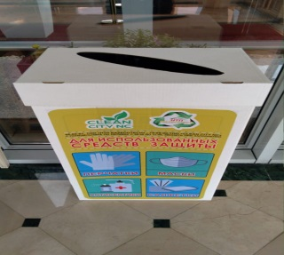 | 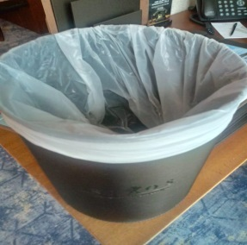 | 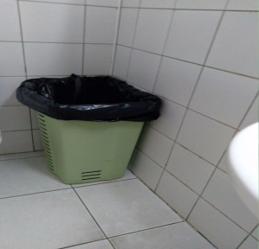

Figure H.1 – Photos of recycling bins in public areas of the hotel in Nur-Sultan, Kazakhstan
Note – Compiled by author

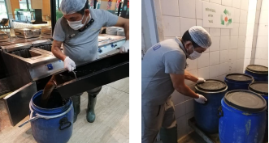
Figure H.2 – Photos of waste oil collection in a hotel in Turkey

Note – Compiled by author

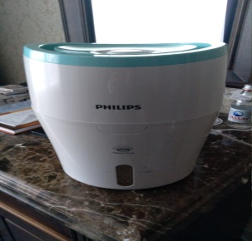 | 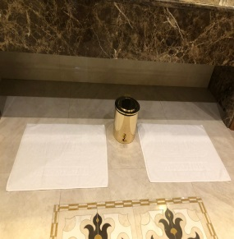
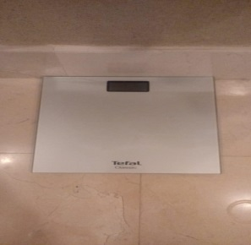 | 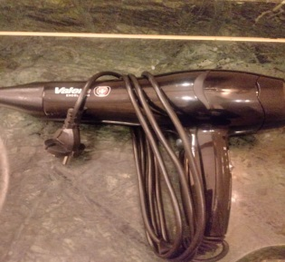

Figure H.3 – Photos of information on environmentally used things in bathrooms in the room in the hotel in Nur-Sultan, Kazakhstan

Note – Compiled by author

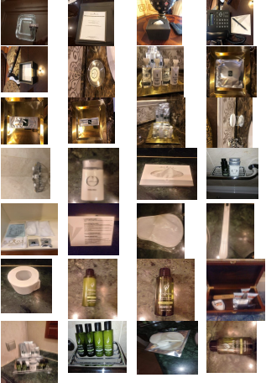
Figure H.4 – Photos of disposable products used in the bathroom in the hotel rooms in Nur-Sultan, Kazakhstan

Note – Compiled by author

.

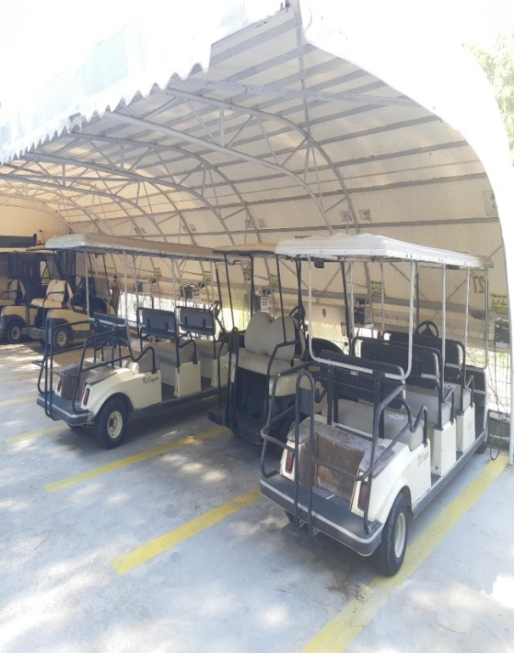 | 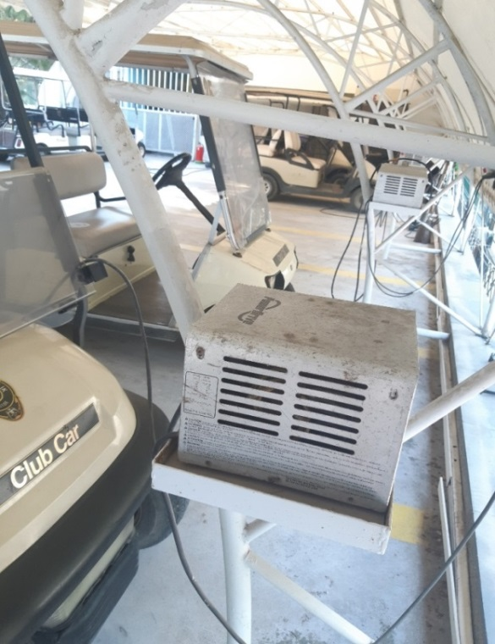

Figure H.5 – Photos of batteries or Club Cars charging area in a hotel in Turkey

 | 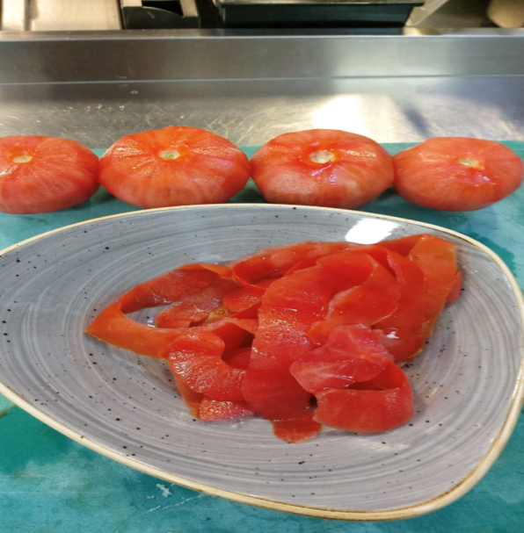
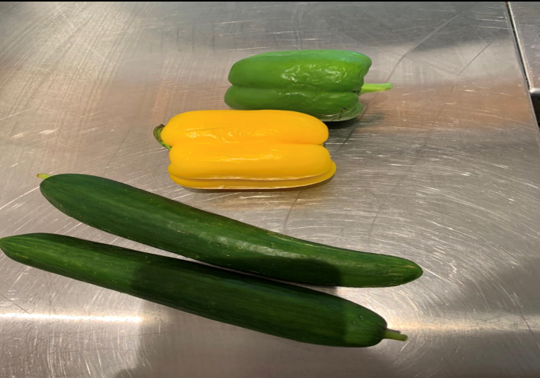 | 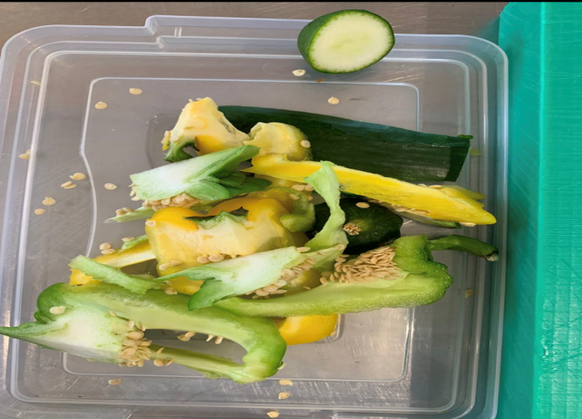

Figure H.6 – Photos of leftovers while preparing food in a hotel in Nur-Sultan, Kazakhstan
Note – Compiled by author
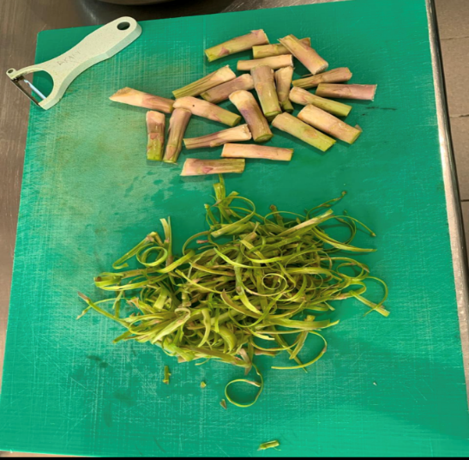 | 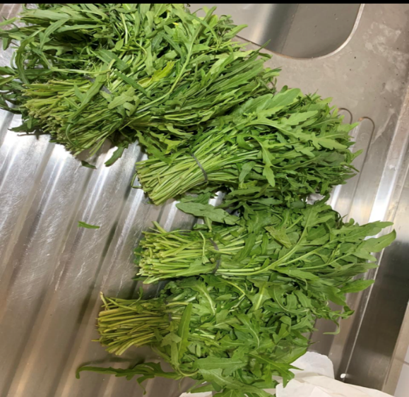
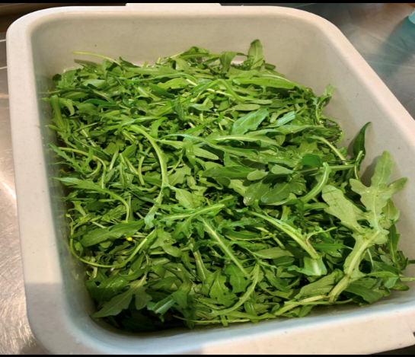 | 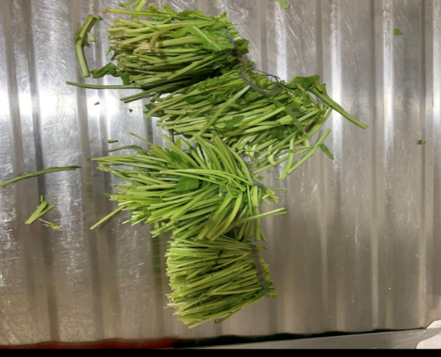

Figure H.7 – Photos leftover about the processing occurs when making a meal in the kitchen in a hotel in Turkey

Note – Compiled by author

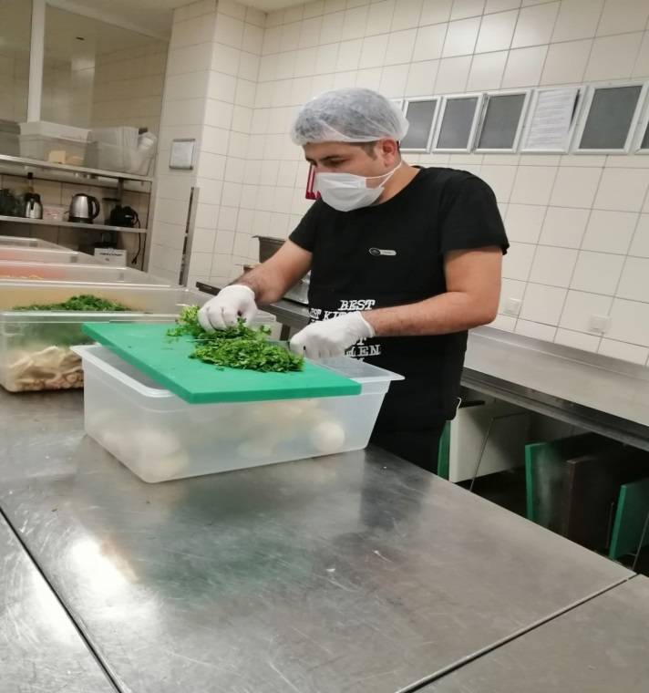 | 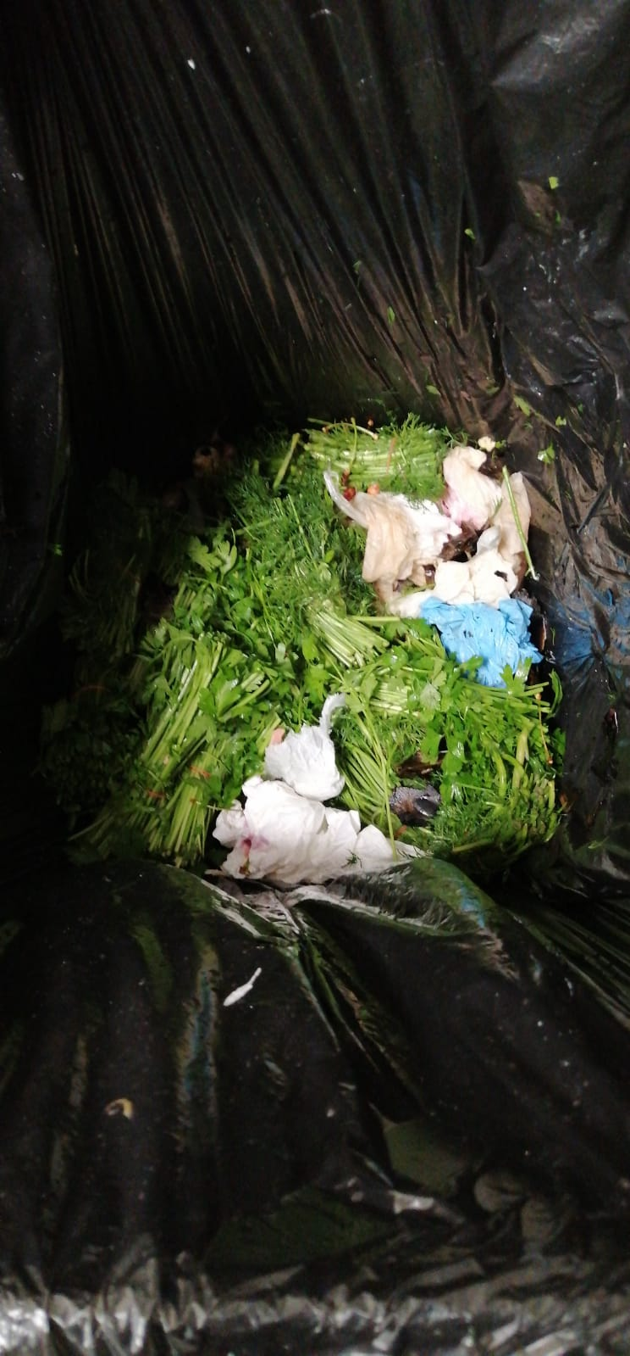

Figure H.8 – Photos of residues that occur while cooking and their reuse in a hotel in Turkey

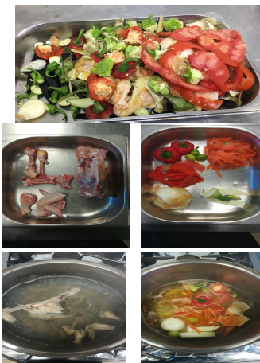

Figure H.9 – Photos of energy-efficient machines in a hotel in Turkey

Note – Compiled by author
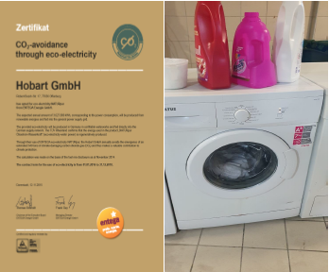
Figure H.10 – Photos of LED lamps in hotel rooms and public areas in a hotel in Turkey

Note – Compiled by author

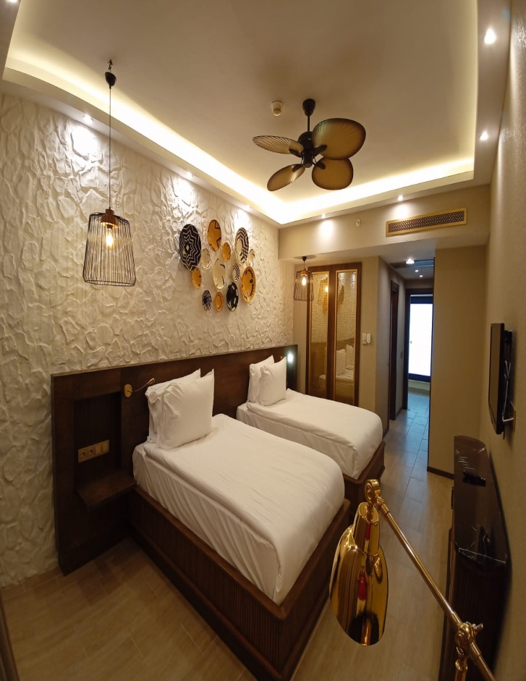 | 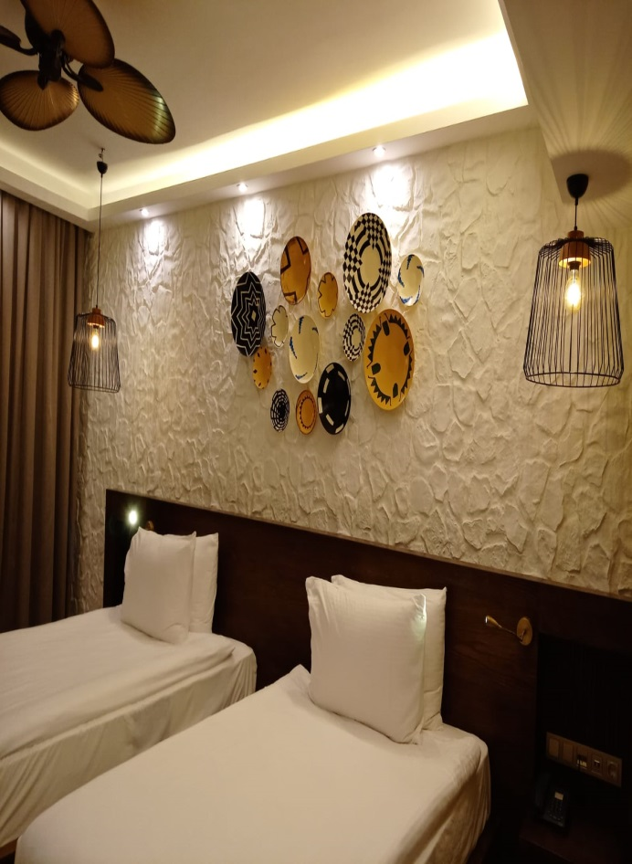
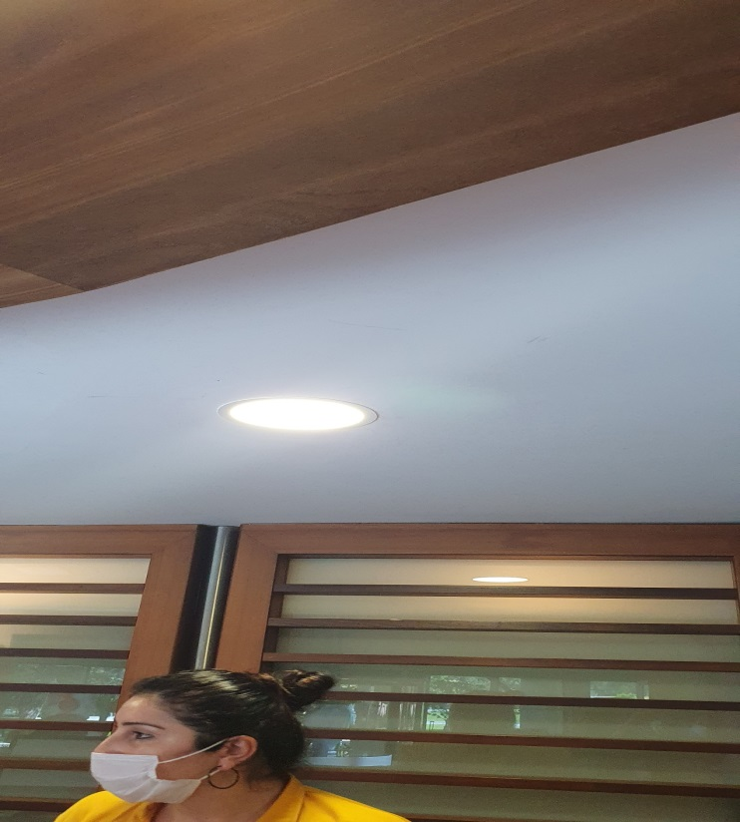 | 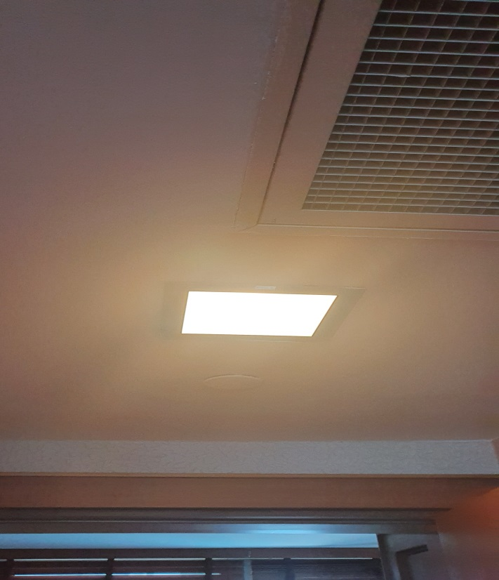

Figure H.11 – Photos of recycling bins in public areas in a hotel in Turkey

Note – Compiled by author
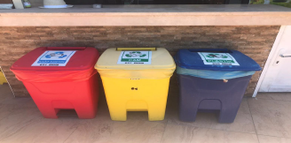
Figure H.12 – Photos of recycling bins in public areas in a hotel in Turkey

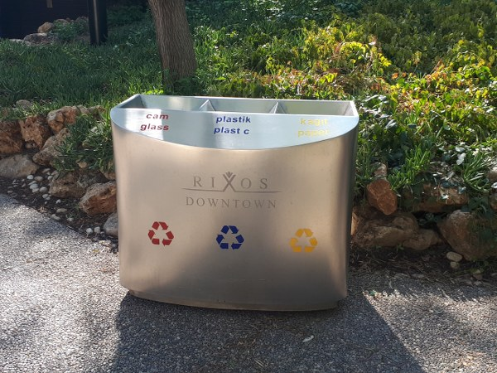 | 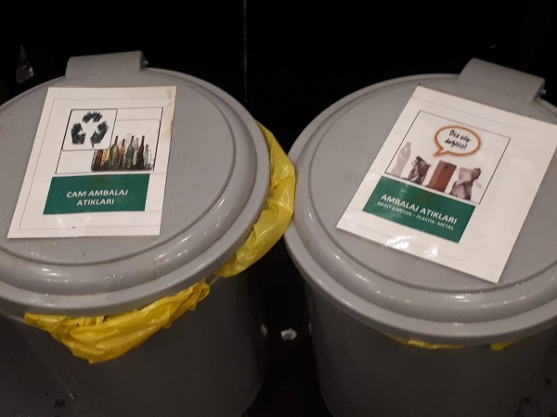

Figure H.13 – Photos of recycling bins in a hotel in Turkey

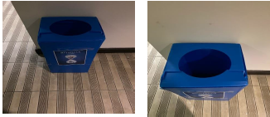
Figure H.14 – Photos of refillable soap dispensers used in bathrooms or wc in public areas etc., in the hotel in Nur-Sultan, Kazakhstan

Note – Compiled by author
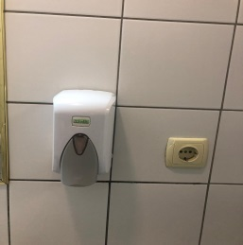 | 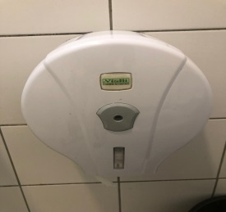
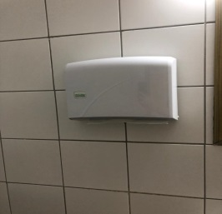 | 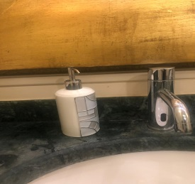

Figure H.15 – Photos of waste from the front office in a hotel in Turkey

Note – Compiled by author

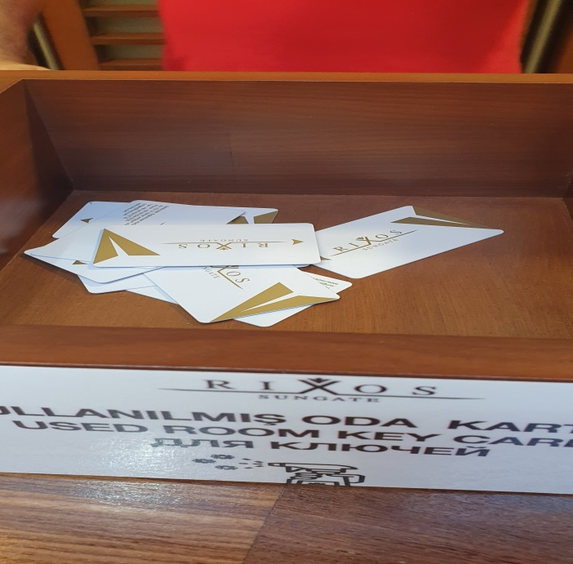 | 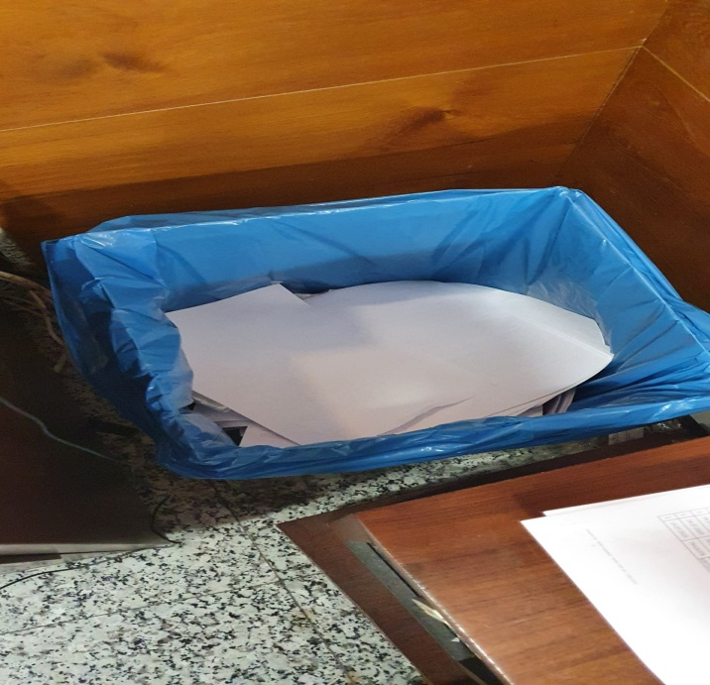

Figure H.16 – Photos of waste such as packages, parcels, and plastics that arise in purchasing, bars, and restaurants in a Turkey hotel

Note – Compiled by author
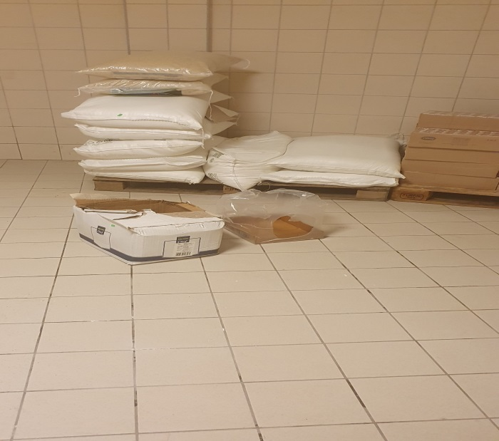 | 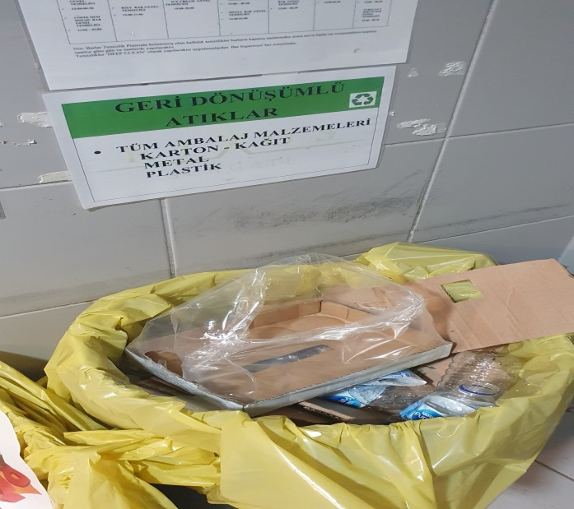

Figure H.17 – Photos of products bought in large packages in a hotel in Turkey

Note – Compiled by author

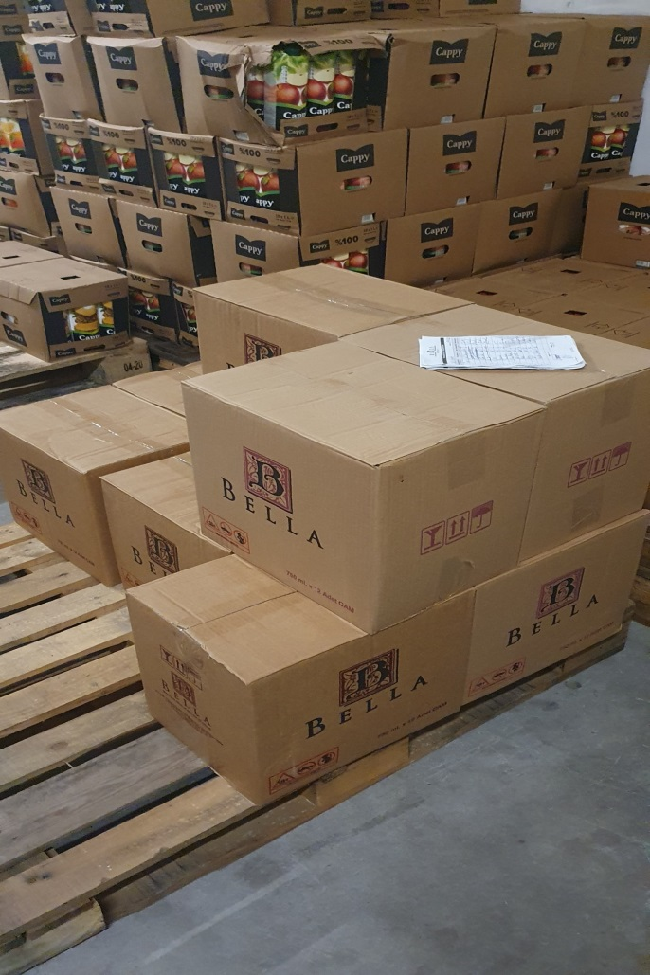 | 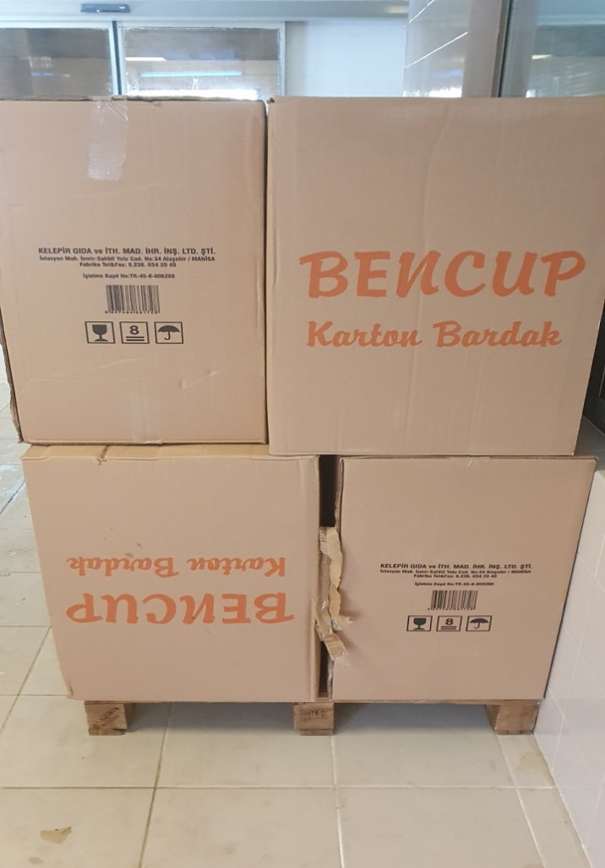

Figure H.18 – Photos of disposable cups used in places such as pool beach etc., in a hotel in Turkey

Note – Compiled by author
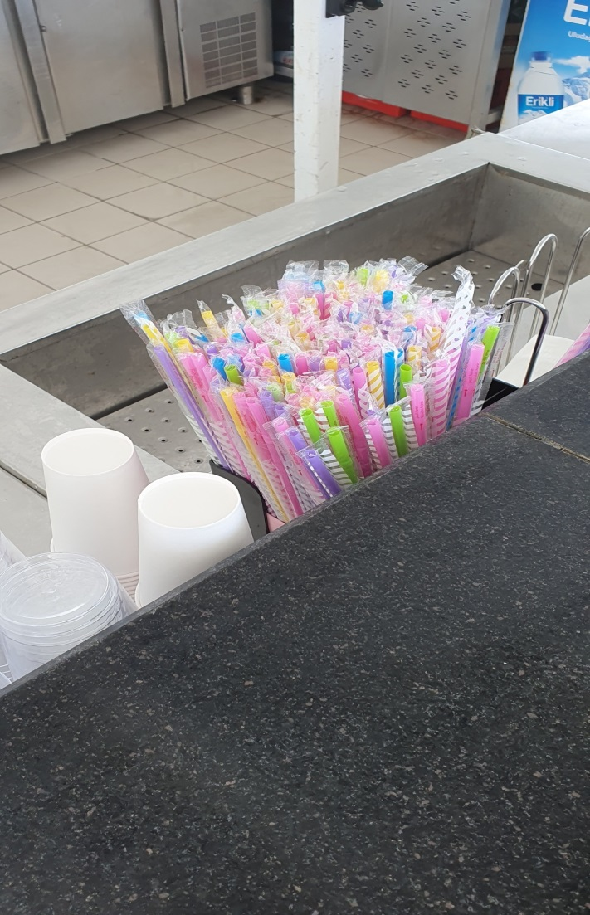 | 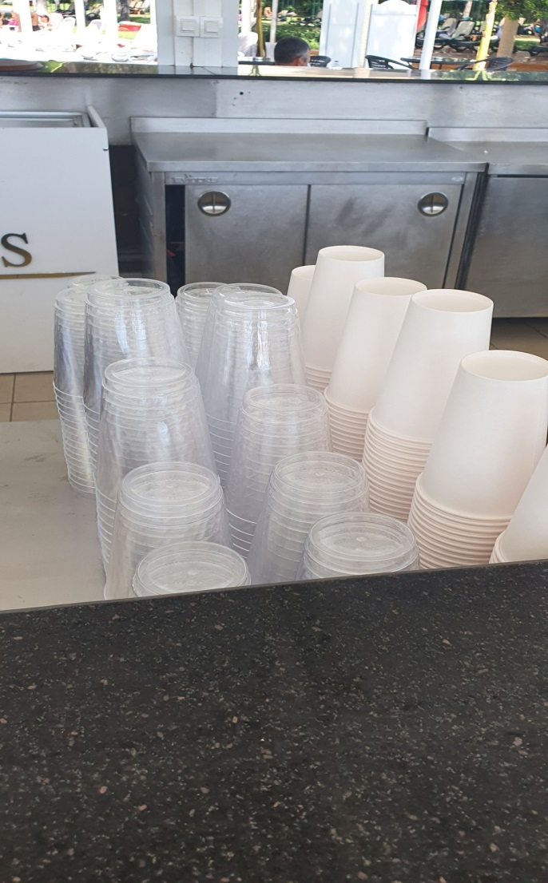

Figure H.19 – Photos of disposable cups used in places such as pool beach etc., in a hotel in Turkey

Note – Compiled by author

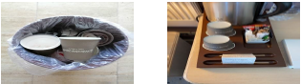

Figure H.20 – Photos of plastic bottle waste from bars in a hotel in Turkey

Note – Compiled by author
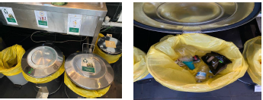

Figure H.21 – Photos of foods on the open buffet in a hotel in Turkey

Note – Compiled by author

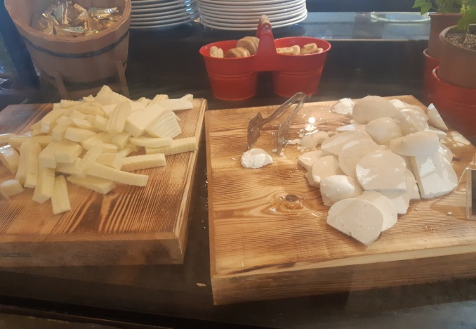 | 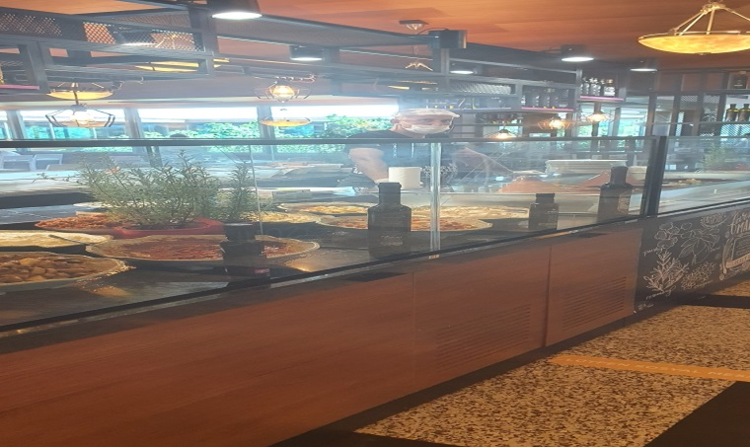
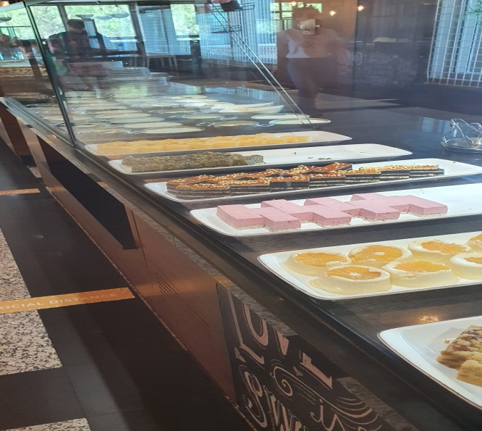 | 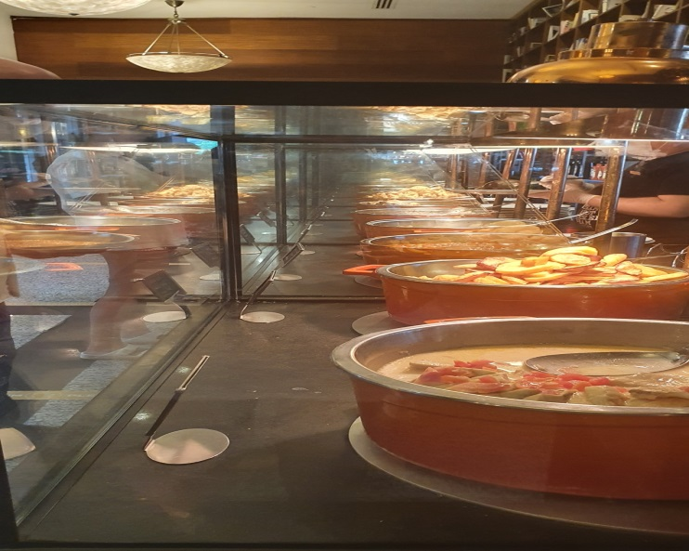

Figure H.22 – Photos of leftover dishes left on the table in a hotel in Turkey

Note – Compiled by author
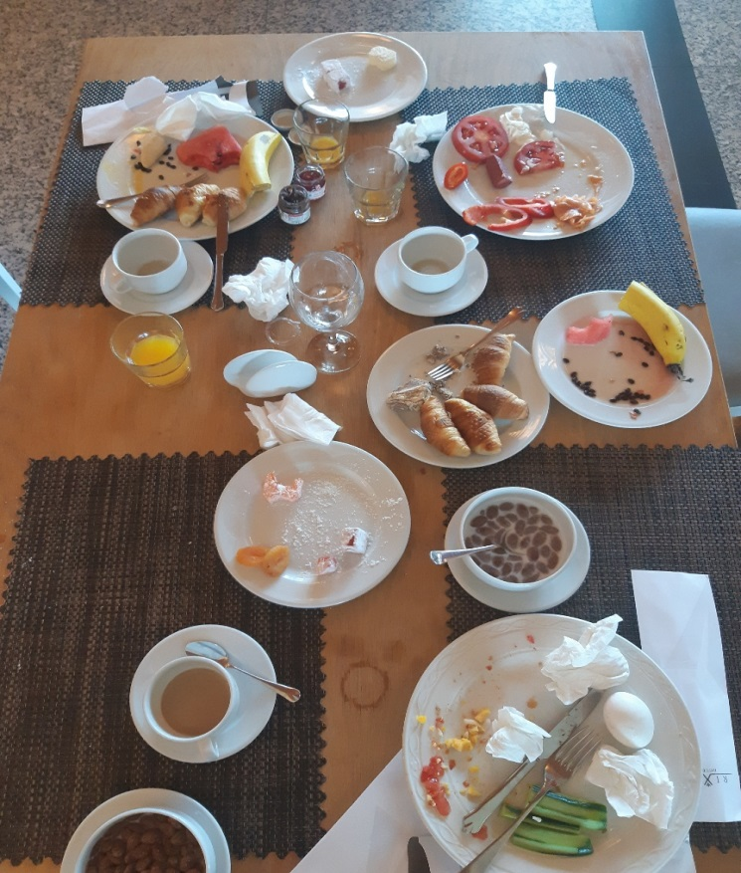 | 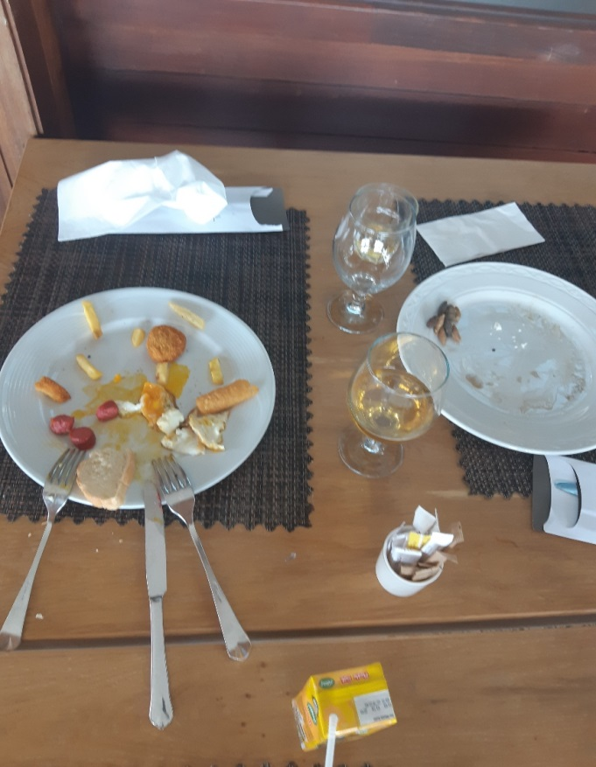
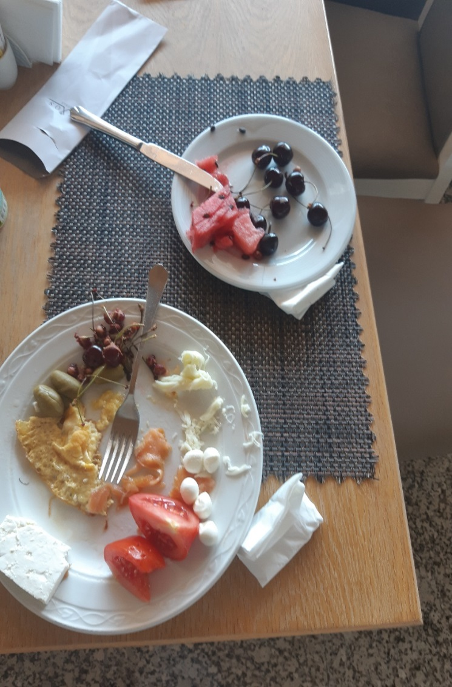 | 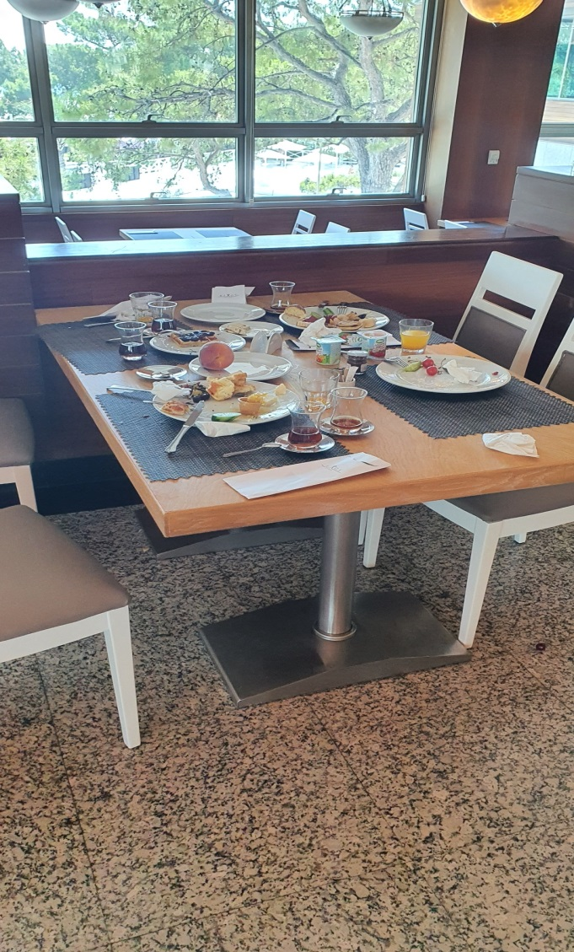
Figure H.23 – Photos of leftovers on the table and servants in a hotel in Turkey

Note – Compiled by author
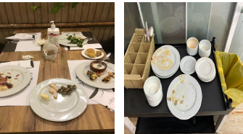
Figure H.24 – Photos of main dish plates used by customers in buffets in a hotel in Turkey
Note – Compiled by author

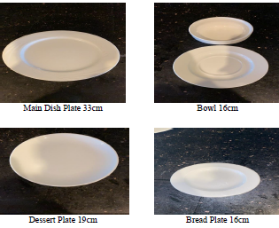
Figure H.25 – Photos of excess food removed from the buffet in the closet in a hotel in Turkey

Note – Compiled by author
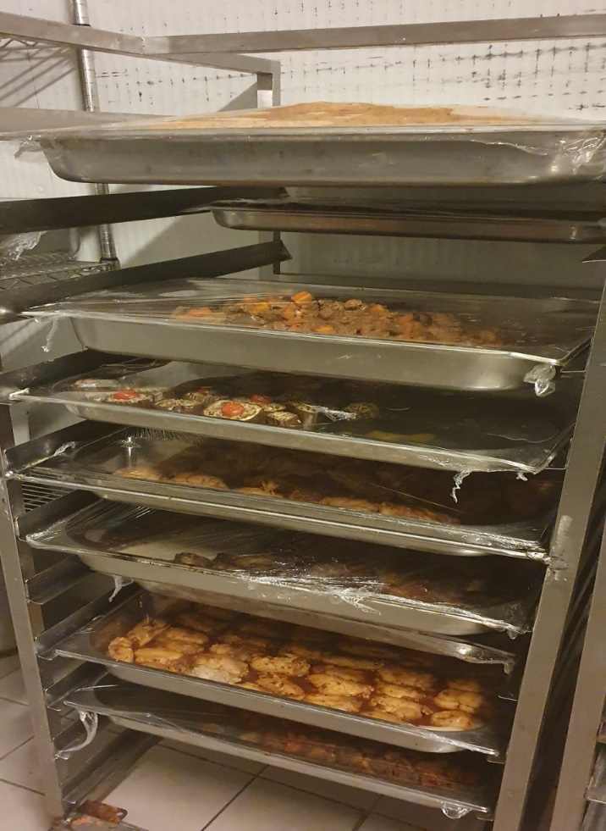 | 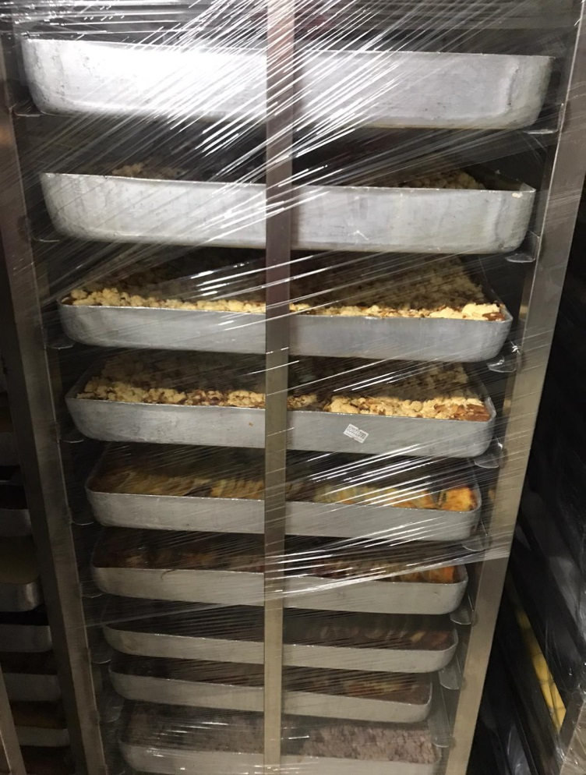
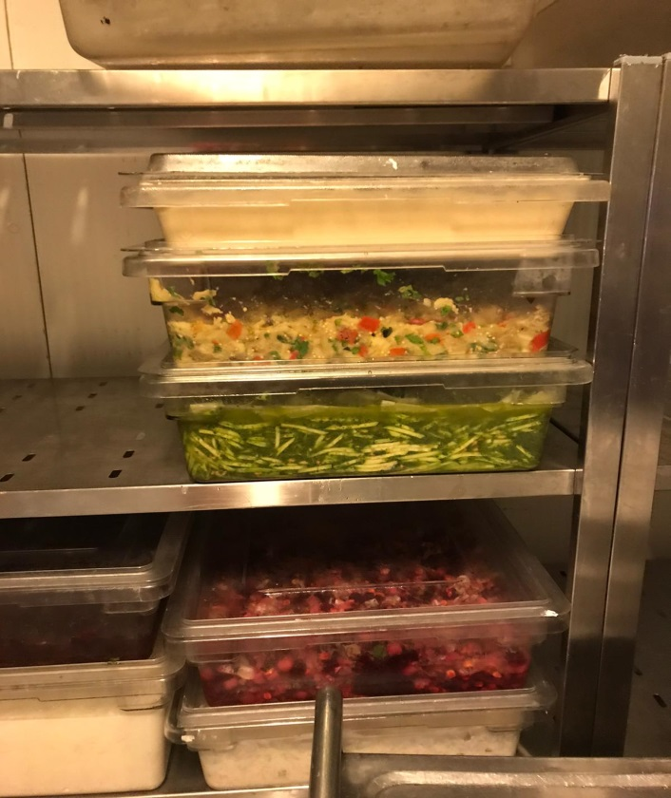 | 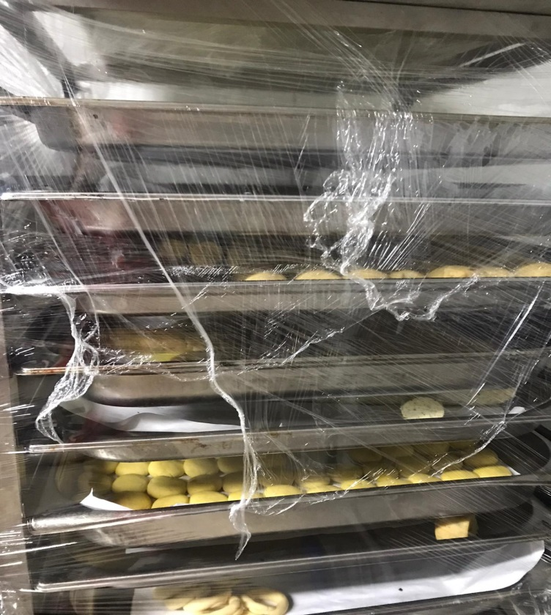

Figure H.26 – Photos of organic waste collection area in a hotel in Turkey

Note – Compiled by author
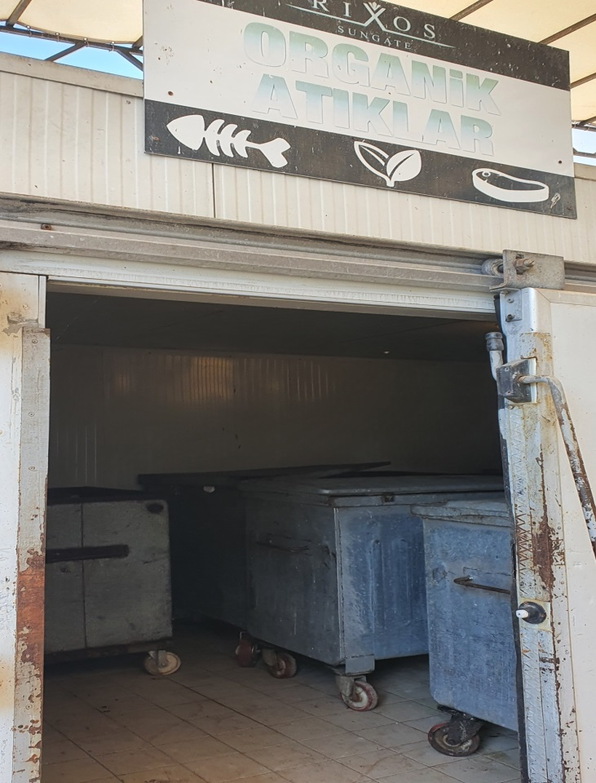 | 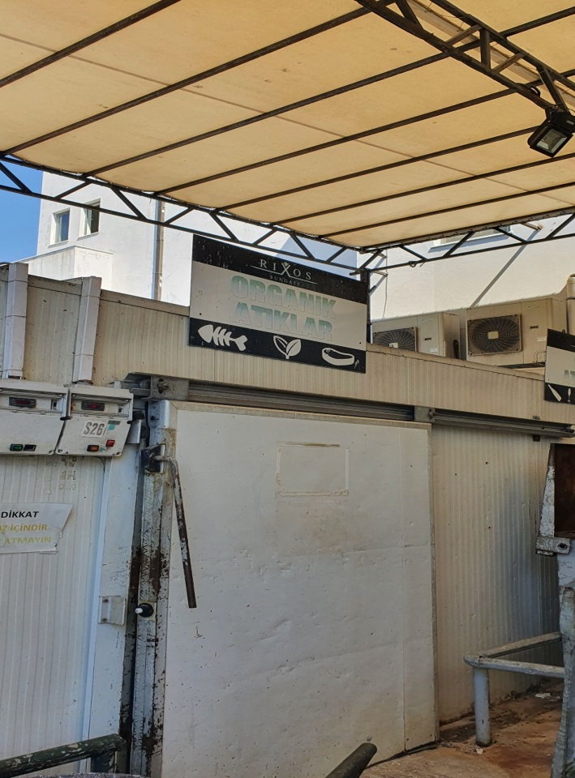

Figure H.27 - Organic Waste Collection Area.

Note – Compiled by author
The photos are taken from hotels in Rixos Hotels, Kazakhstan, and Turkey

ANNEX I

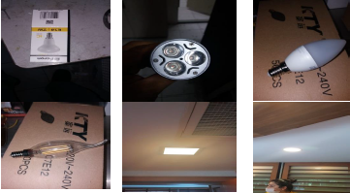

Figure I.1 – LED Lamps Used in Hotels

Note – Compiled by author

ANNEX J

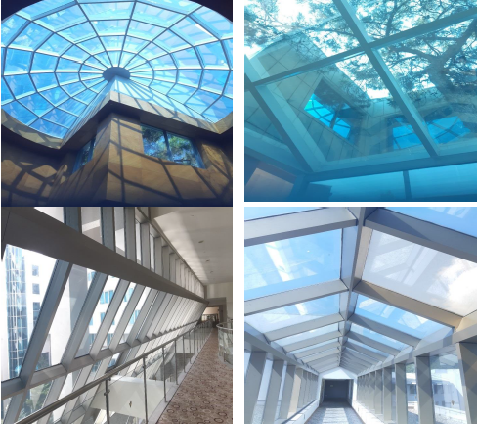

Table J.1 – Glass Walls and Ceilings Used in Hotels

Note – Compiled by author

ANNEX K

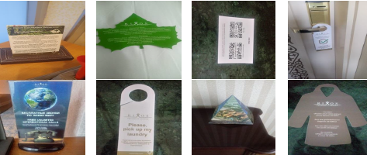

Figure K.1 – Environmental Informations Used in Hotels

Note – Compiled by author

ANNEX L

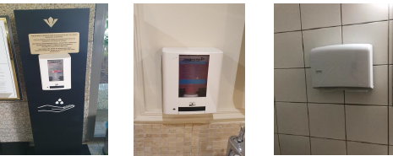

Figure L.1 – Stationary or Sensor Soap Used in Hotels

Note – Compiled by author

ANNEX M

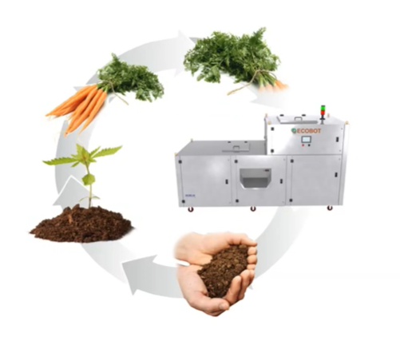

Figure M.1 – Function of Organic Waste Compost Machine

Note – Retrieved from https://www.ecobot.co.in/

ANNEX N

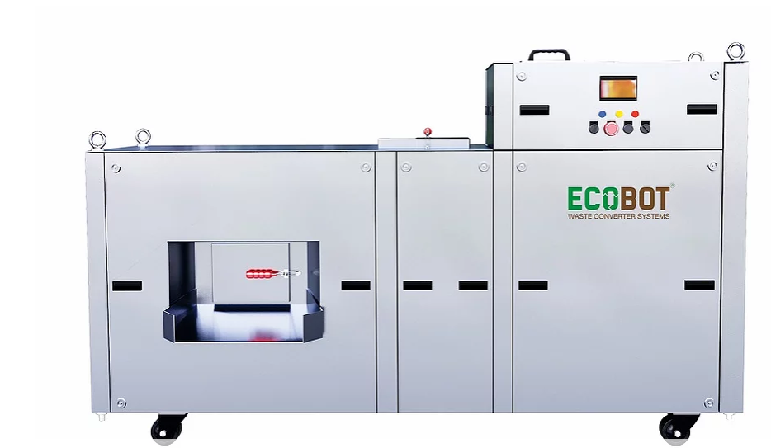

Figure N.1 – Example of Compost Machine for Hotels and Usage

Note – Retrieved from https://www.ecobot.co.in/ecobot

