Al-Farabi Kazakh National University

UDC 530.24 On manuscript rights

**SERIKBOLOVA ALBINA ASKAROVNA**

**Branes and monopoles in modified gravities and Yang-Mills theories**

8D05306-Physics

Thesis is submitted in fulfillment of the requirements for the degree of

Doctor of Philosophy (PhD)

Scientific Supervisors:

Doctor of Phys.-Math. Sciences,

Professor Dzhunushaliev V.D.,

PhD, Professor Jutta Kunz

Republic of Kazakhstan

Almaty, 2022

**CONTENT**

**DESIGNATIONS AND ABBREVIATIONS………………………………….........3**

**INTRODUCTION ...………………………………………………………………4**

**1 MODERN PHYSICS THEORIES …………………………………………...10**

1.1 Multidimensional Kaluza–Klein theory ………………………………………10

1.2 Modified theory of gravity …………………………………………………14

1.3 Theory of gauge fields ………………………………………………………24

1.3.1 Problem of the mass gap………………………………………………………..29

**2 BRANES IN MULTIDIMENSIONAL SPACE–TIME…………………….......32**

2.1 Brief overview of the Branes……………………………………………………..32

2.2 Branes in multidimensional space-time within the framework of $F(R)$ modified theory of gravity………………………………………………………………….......34

2.3 Presentation of the results………………………………………………………...38

**3 MAGNETIC MONOPOLES …………………………………………………47**

3.1 History of magnetic monopoles ……………………………………………….47

3.2 Monopoles in classical electrodynamics …………………………………52

3.3 Dirac’s monopole ……………………………………………………………54

3.4 Dirac’s string …………………………………………………………………55

3.5 Solitons in field theory ……………………………………………………59

3.6 ’t Hooft–Polyakov monopoles ……………………………………………63

3.6.1 Soliton solutions in SO(3)–model …………………………………………63

3.6.2 ’t Hooft–Polyakov’s soliton as a magnetic monopole…………………………..67

3.7 Monopole searches ……………………………………………………………69

3.7.1 Early searches for $Ms$. ……………………………………………………69

3.7.2 $Ms$ in spin ice ……………………………………………………………73

3.7.3 Superfluid liquid helium as $Ms$……………………………………………….75

3.7.4 Magnetic monopole in Bose-Einstein condensate………………………….......76

3.7.5 Searches for $Ms$ in colliders ………………………………………………..77

**4** **YANG**–**MILLS MONOPOLE WITH SPINOR SOURCE AND MASS GAP………………………………………………………………………………….79**

4.1 Theory of Yang-Mills fields coupled to a nonlinear Dirac field……......................80

4.2 Anzätze and equations ………………………………………………...................81

4.3 Monopole-like +spinor field solutions……………………………………….......83

4.4 Energy spectrum…………………………………………………………………90

**CONCLUSION……………………………………………………………………..96**

**REFERENCES……………………………………………………………………100**

**DESIGNATIONS AND ABBREVIATIONS**

GR – general theory of relativity

QFT – quantum field theory

QED – quantum electrodynamics

QCD – quantum chromodynamics

GUT – grand unified theory

MG – modified theory of gravity

$λ$– coupling constant

$R$– scalar curvature of space

$R_{μν}$– Ricci tensor

$g_{μν}$– metric tensor

$g$– determinant of the metric $g_{μν}$

$T_{μν}$– energy–momentum tensor

$G_{AB}$– multidimensional metric, *A,B=0,1,2,3,….,N*

$Γ_{AB}^{L}$– Christoffel symbols

$S$– action

$dS^{2}$– metric

$L_{matter}$– matter Lagrangian

$k$– gravitational constant in *n*-dimensional space

$H$– Hubble parameter

$a$– scale factor

FRW – Friedmann–Robertson–​Walker universe

AdS – Anti-de Sitter Space

dS – de Sitter Space

Branes – браны

M – theory – string theory

Δ – mass gap

$Ms$– magnetic monopoles

DQC – Dirac Quantization Condition

AMANDA – Antarctic Muon And Neutrino Detector Array

ANITA – Antarctic Impulse Transient Antenna

ANTARES – Astronomy with a Neutrino Telescope and Abyss environmental RESearch

LHC – Large Hadron Collider

MACRO – Monopole, Astrophysics and Cosmic Ray Observatory

MODAL – MOnopole Detector At LEP

MoEDAL – Monopole and Exotics Detector At the LHC

## INTRODUCTION

General description of the research

The dissertation work shows the results of the mass gap research in the energy spectrum of a monopole-like object with nonlinear spinor source and hypothetical objects in multidimensional space-time – Branes in the framework of the modified gravity.

**Relevance of the topic**

In modern physics for understanding and describing the structure and evolution of the Universe there is a necessity for the investigation of models of the Universe in higher-dimensional space-time. There are many applications of the theory of multidimensional space-time in string theory, Grand Unified Theory (GUT), cosmology. It is well known that unified field theory is the unification at ultra-high energies of all fundamental interactions – gravitational, electromagnetic, weak and strong.

A very promising way for unification of two of them – gravitational and electromagnetic interactions first was proposed by Kaluza and Klein in the 1920s within the framework of 5 – dimensional theory. Later, superstring theories requiring extra space dimensions were created. Nowadays, models of the Universe in higher-dimensional space-time are under consideration. There are huge applications of these models in a wide range of physics, especially in high-energy physics for solving different problems such as the problem of mass hierarchy, stability of the proton, ect.

Another argument in support of a transition to the geometry of a higher-dimensional space is the possibility to analyze and investigate various compact astrophysical objects: domain walls, thick branes. According to the theory of gravity, it is supposed that we live in the thin brane, which is n-dimensional hypersurfaces embedded in the multidimensional space-time (bulk). Whereas, according to the string theory brane objects are multidimensional hypothetical fundamental objects, which have a dimension less than the dimension of the space in which they are located. These objects were first predicted within the framework of Einstein’s theory of gravity. Within the framework of theories of the brane world, it is possible to naturally describe the hierarchy of masses of elementary particles, as well as to solve a number of other problems of the theory of elementary particles.

In fundamental physical theories such as Maxwell’s electrodynamics or General Relativity (GR), regular solutions are very important. Regular solutions are solutions with finite energy for which the corresponding fields are finite in the entire space: in the center and at infinity, respectively.

The first part of the work consists of the considering regular solutions of the gravitational equations describing Branes in multidimensional space-time within the framework of $F(R)$ modified theories. The first thing that needs to be said is that modified theories of gravity can be interpreted as an alternative to the cosmological constant (or dark energy) for explaining the accelerated expansion of the Universe. One way to describe and explain the accelerated expansion of the Universe is the assumption of the existence of mysterious dark energy. Alternatively, there is another interesting approach in explaining it – modified theories of gravity. The most surprising thing about these theories is that the modified theories of gravity can explain inflation at the early stage of the Universe. Another good thing about these theories is that they can explain the modern accelerated expansion of the Universe. In 1998, when observing supernovae type Ia the accelerated expansion of the Universe was discovered.

This is a completely new approach in describing the accelerated expansion of the Universe, since we do not use the old methods of GR and try to modify them. Therefore, these theories are called modified theories of gravity (MG). One of the most striking features of these theories is that the Lagrangian density is no longer the scalar curvature *R* (as in GR), but some non-linear function of the scalar curvature $F(R)$*.* In addition, it should be possible to obtain within these $F(R)$ theories hypothetical objects predicted by GR without matter like Branes in multidimensional space-time.

The second part of the work is consist of considering magnetic monopoles ( $Ms)$ within the framework of non-Abelian Yang – Mills fields interacting with a spinor field. It is clear that a magnetic monopole is a hypothetical elementary particle with a nonzero magnetic charge – the source of a radial magnetic field. A magnetic monopole can be considered as a single pole (north or south) of a long and thin permanent magnet. The electrical and magnetic components of the electromagnetic field are described by similar equations, but behave differently. It is very clear from the observations that the electric field can be created by a single "pole", such a system is called monopole. On the other hand, we can observe that the magnetic field is created only by a dipole – a pair of poles, north and south. There is no real physical confirmation of the existence of a magnetic monopole. It is known that between electric and magnetic charges could exist a symmetry, so that it would be natural to assume that Maxwell’s equations become symmetric when containing the density of the magnetic charge. So, if it would be found, it would be necessary to rewrite Maxwell’s equations.

In 1931 Paul Dirac demonstrated this possibility theoretically. He suggested that from the Quantum electrodynamics (QED), which is asymmetric, there is a possibility to construct a symmetric QED by adding a magnetic term-magnetic charge. This hypothetical magnetic object was firstly proposed by Dirac and called Dirac monopole. Later, magnetic monopoles in non-Abelian gauge theories were discovered independently by Gerard ’t Hooft and Alexander Polyakov. In theoretical physics, the ’t Hooft Polyakov monopole is similar to the Dirac monopole but without any singularities.

90 years have passed, but the problem of the existence of a $Ms$ is still **relevant**, and more and more experiments are being carried out to solve it. It is important to investigate properties of a magnetic monopole like: magnetic field strength, energy spectrum. As yet there is no evidence for the existence of $Ms$, but they are interesting theoretically. They find their applications in a huge variety of topics in theoretical physics, including problems in the standard model, GUT, astrophysics, cosmology.

In this research, in SU(2) Yang – Mills theory, which contains a doublet of nonlinear spinor fields monopole-like solutions will be obtained. It would be supposed that these solutions describe a magnetic monopole created by a spherical lump of nonlinear spinor fields. One might suppose that, if it would be possible to find regular monopole–like solutions without involving scalar fields, then they might already be topologically trivial. This would be of great interest, if it turns out that there is a minimum in the energy spectrum of such monopole-like objects. Such a minimum in the energy spectrum can be considered as a mass gap. Using the obtained results, one then may try to understand the nature of the mass gap in a more complicated situation in QCD.

The most surprising thing about the mass gap is that problems of the existence of a mass gap and Yang-Mills theory are one of 7 challenging unsolved Millennium Prize Problems in mathematics. If this problem is successfully solved, [Clay Mathematics Institute](https://en.wikipedia.org/wiki/Clay_Mathematics_Institute) offered a prize of $1,000,000. The difficulty of solving this problem lies in the fact that it is necessary to prove that any compact gauge group G includes a non–trivial quantum theory of Yang-Mills of R4 and has a positive mass gap Δ > 0.

[Yang-Mills theory](https://en.wikipedia.org/wiki/Yang%E2%80%93Mills_theory) is a gauge field theory. [The mass](https://en.wikipedia.org/wiki/Mass_gap) gap (Δ) is the mass of the least massive particle predicted by the theory. As an example, consider the theory of the strong interaction – G=SU(3). To solve this problem, the winner must prove that glueball-quanta of the strong interaction have a lower mass boundary and, therefore, cannot have any light values. At a deeper level, it means that there are no massless particles predicted by the theory (except the vacuum state). The mass gap has been discovered experimentally and confirmed through computer modeling, however it is not understood theoretically.

All these moments indicate **relevance of the problem** for the development of fundamental science, studied in this dissertation work.

**The goals of the research:** To obtain and investigate regular solutions of Branes in multidimensional space-time within the framework of $F\left(R\right)=-αR^{n}$ modified theories of gravity and study topologically trivial monopole-like solutions within the confines of SU(2) Yang-Mills theory including a nonlinear doublet of spinor fields and show the presence of a minimum in energy spectrum (mass gap).

To achieve these goals, it is necessary to solve the following **objectives**:

In the first part of the research:

– make a historical review of modern physics theories;

– consider a historical review of modified theories of gravity;

– make a brief overview of the hypothetical objects – Branes ($D$– branes);

– obtain flat-symmetric solutions describing branes in multidimensional space-time;

– get phase portraits.

In the second part of the research:

– make a brief overview of magnetic monopoles;

– make a brief overview of Dirac and ’t Hooft-Polyakov monopoles;

– make an overview of searches of magnetic monopoles;

– write the Lagrangian and field equations for SU(2) Yang-Mills theory + nonlinear spinor fields;

– present the Ansatz for vector and spinor fields and investigate the corresponding field equations;

– obtain topologically trivial monopole-like solutions within the confines of SU(2) Yang-Mills theory including a doublet of nonlinear spinor fields;

– study energy spectra of these solutions and show that they have a global minimum (mass gap);

– show that the obtained monopole-like solution differs from ’t Hooft-Polyakov monopole.

**Object of the research:** Modified theory of gravity, SU(2) Yang-Mills theory which contains spinor fields and regular solutions in it.

**Subject of the research:** Branes in $F(R)$ modified theory and SU(2) Yang-Mills monopole with nonlinear spinor source.

**Research methods:** Numerical and analytical methods for studying nonlinear differential equations of modified theories of gravity describing Branes and monopole-like solutions within SU(2) Yang-Mills theory including nonlinear spinor fields.

**Scientific novelty**

The novelty and originality of research lies in the fact that:

– new flat-symmetric solutions in multidimensional modified theories of gravity for Branes are obtained;

– the properties of Branes in modified theories of gravity are investigated;

– it has been demonstrated that the possibility of the appearance in modified theories of gravity Branes is significantly determined by the type of function: $F\left(R\right)=-αR^{n};$

– new Yang-Mills monopole with the source of nonlinear spinor fields was obtained;

– the properties of Yang-Mills monopole are investigated;

– it was shown that Yang-Mills monopole with the source of nonlinear spinor fields differs from the Dirac and ’t Hooft-Polyakov monopole;

– it was demonstrated that monopole-like solutions have a minimum in the energy spectrum, which can be considered as mass gap;

– it has been demonstrated that the main reason of the appearance of a mass gap in the energy spectrum of monopole-like objects in SU(2) Yang-Mills theory was the presence of a doublet of nonlinear spinor fields.

The following pointsclarify **the scientific and practical significance of this dissertation work**, which are:

– hope for contribution to a deeper understanding of the obtained results, where our Universe considered like a brane world;

– obtained new regular solutions in gravitational theories are an interesting and necessary task for understanding the gravity interaction. Thick branes are hypothetical objects that may be discovered in the future. Therefore, the study of their properties is an important task in theoretical physics;

– obtained new monopole-like solutions in SU(2) Yang-Mills theory aim to give a comprehensive account for understanding the properties of magnetic monopole. Magnetic monopoles are hypothetical particles that are actively researched. The investigation of their properties might shed light on the problem of symmetry of QED;

– obtained new monopole-like solutions in SU(2) Yang-Mills can open up the door to investigate at the deeper level the concept of «mass gap», which is one of 7 Millennium Prize Problems;

– physical interpretation of obtained solutions is that they describe a consistent monopole+sea quarks system. Therefore, the obtained solutions can be used to describe some quasiparticles, which is monopole+sea quarks system in a quark-gluon plasma.

**Defense Provisions:**

1. In the theory of gravity with a modified Lagrangian $F\left(R\right)=-αR^{n}$ there are thick branes with anti-De Sitter asymptotics and with a special point located at the centre of the brane and existing at the following range of parameters of :.

2. SU(2) Yang-Mills theory with the source of doublet of nonlinear spinor field leads to the existence of topologically trivial monopole-like objects with $H\sim M/r^{3}$ asymptotic behavior of the SU(2) magnetic field.

3. Yang-Mills monopole with the source of nonlinear spinor field has a minimum in the energy spectrum (mass gap) – ${{\tilde{(W}}_{t})}_{min}=5.812$ and $53.748$ for the ground and first excited state for $\tilde{E}=0.955$, the appearance of which is the consequence of nonlinearity of Dirac field.

**The personal contribution of the author** lies in the fact that the entire volume of dissertation work, the choice of research method, problem solving and numerical calculations are performed by the author independently. Setting tasks and discussing the results were carried out jointly with scientific supervisors.

**Reliability and validity of the obtained results.** The dissertation used the modified theories of gravity and SU(2) Yang-Mills theory including a doublet of nonlinear spinor fields and proven mathematical methods of numerical solutions of ordinary differential equations in Wolfram Mathematica and Maple packages. The obtained results on the basis of numerical calculations are consistent with the qualitative study of the obtained differential equations, as well as with studies conducted earlier by other authors. Also, the reliability and validity of the results obtained are confirmed by publications in journals of far abroad with high impact factors and in publications recommended by the Committee for Control in the Field of Education and Science of the Ministry of Education and Science of the Republic of Kazakhstan, and in the proceedings of international scientific conferences of near and far abroad.

**Approbation of the dissertation.** The results obtained in the dissertation work were reported and discussed:

– at the second International Scientific and Practical Internet Conference "Actual issues of modern research" (2019, Nur-Sultan, Kazakhstan).

– at the International Scientific Conference of Students and Young Scientists "Farabi Alemi" (2020, Almaty, Kazakhstan);

– at 1st Electronic Conference on Universe (Online, 22-28 February 2021, China)

– research in the field of monopole solutions was awarded in the Republican competition of research among universities of the Republic of Kazakhstan conducted by the Aktobe Regional University named after K. Zhubanov (2021, Aktobe, Kazakhstan);

– and also discussed with Professor Jutta Kunz in the framework of international cooperation and internship (from November 2021 to February 2022, Oldenburg, Germany) .

**Publications.** Based on the materials of the dissertation, 8 printed works were published: 2 - publication in Kazakh journals, which are recommended by the Committee for Control in the Field of Education and Science of the Ministry of Education and Science of the Republic of Kazakhstan (KKSON MON RK) and 3 articles in journals of foreign countries with high impact factors included in the international information resource Web of Knowledge (Thomson Reuters, USA) and Scopus (Elsevier, the Netherlands); 3 works in the collections of International Scientific Conferences.

**The structure and scope of the thesis:** The thesis consists of an introduction, 4 sections, conclusion and list of references. The work is presented on 110 pages of printed text, contains 54 drawings and 2 tables. The list of references contains 161 items.

## MODERN PHYSICS THEORIES

## Multidimensional Kaluza-Klein theory

## This section is devoted to consider the historical background of multidimensional

## Kaluza-Klein theory, since in the second chapter, we are investigating of Branes solutions in multidimensional space-time.

It is known from GR, that space-time is four-dimensional and there is no doubt that this theory is in amazing agreement with observations. In the twentieth century, after developing string theory and M-theory, there arose the idea of existence of more than four (n>4) space-time dimensions. Such a kind of space-time is called multidimensional space-time.

Currently, almost in all physical theories, investigation and existance of extra dimensions is play important and fundamental role in attempts to explain and combine all physical interactions on the basis of general principles. One argument in support of studying of extra dimensions is that any realistic candidate for a GUT such as superstring /M-theory are formulated in multidimensional space-time. Therefore, the concept of multidimensional space-time is essential for superstring theory, which is the most promising high-energy theory, combining quantum gravity with gauge field theory. Low-energy consequences of this theory require, for example, (9 + 1) -dimensional space-time and (10 + 1) - dimensional space-time for M-theory, while other dimensions are forbidden. Naturally, when we look around the Universe, we only ever see 4-dimensional space-time. Hereupon, two important questions related to the dimensionality of our universe automatically and logically had been arisen:

• Why do we observe and feel only (3 + 1) dimentional space-time of the Universe?

• If it turns out that the dimension of space-time is more than 4, then where and how are these extra dimensions hidden?

Looking to the second question, it is believed that the extra dimensions are compactified (as if they rolled up into "tubes"), and this is the reason why they are not visible by us. Traditionally, the observed 4-dimensional space-time appears as a result of compactification of extra dimensions, where the characteristic size of extra dimensions becomes much smaller than the size of 4-dimensional space-time. Much attention is given to the second question, so that finding answer to it and if dimensions are hidden from observations, then, it would be natural to assume that the visible universe is 4-dimensional.

In the next section we will consider in detail a completely different approach to solving previous problems. This approach and method is absolutely a new promising way of evolution of extra dimensions. Such approach is called «brane world» or sometimes «brane world scenario». One of the most striking features of this theory is that according to the «brane world scenario», particles related to electromagnetic, weak and strong interactions are limited by some hypersurface (like a thin leaf) - brane, which is included in some multidimensional space – bulk [1]. It is assumed that such a «brane world scenario» is realized in our Universe. This method has become very popular among scientists and was studied in the following articles [2-4].

Before moving on to our main topic of branes, it is important to keep in mind the historical backgroud of multidimensional theories. Thus, we will briefly discuss the history of these theories, in particular, we will briefly focus our attention on the Kaluza – Klein theory.

As was mensioned, one of the main problems of multidimensional theories of space-time is the mechanism, due to which additional dimensions become hidden. The appearance of additional dimensions can contribute to solving known problems of particle theory: the problem of hierarchy, the cosmological constant. To solve these problems, field theory models, which have their own advantages and disadvantages were created. One of the advantages of these models is that by considering different models a number of new phenomena can be discovered. The disadvantages are related to the fact that some models may have nothing to do with the fundamental theory and, accordingly, cannot be realized in nature.

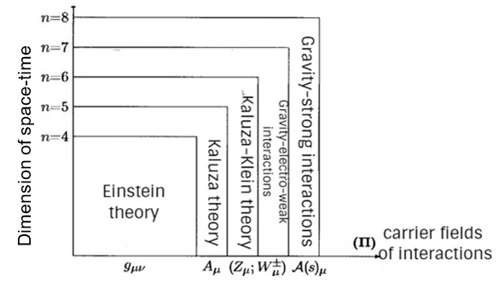 One has created the cube of physical reality, which represents a geometrization of models of multidimensional space-time for all fundamental interactions, see Figure 1.1 [5].

Figure 1.1 – The cube of physical reality [5, p.119]

In the Figure 1.1 , on the vertical axis located space-time of dimension $n≥4$, while the horizontal axis gives the carriers of fields interactions. Firstly, lets take the electromagnetic interaction, where the force carriers are photons, described by the vector $A_{μ}$. Secondly, the carriers of gravitational interaction – gravitons. Thirdly, the weak force is carried by the ${W^{±}}_{μ}$ and $Z_{μ}$ bosons and finally, the carriers of strong interactions – gluons, described by the vector $A_{N}$. It is noticeable from the cube of physical reality, that Einstein theory (GR) is geometrized in 4-dimentional space-time, Kaluza (electromagnetic) and Kaluza - Klein theory in 5-dimentional, in extra dimensions - gravity-electro-weak interactions and gravity-strong interactions [5, p. 120].

Theodor Franz Eduard Kaluza was the first German scientist who introduced the ideas about multidimensional space in 1921 [6]. To create a five-dimensional space-time, Kaluza took the idea of German mathematician Hermann Weyl [7]. In 1918, the main goal of Kaluza’s work was to combine all known types of interactions and create a unified theory of everything.

In 1919 Kaluza put forward the idea of a "folded" fifth dimension through which 2 types of fields can be combined. The main peculiarity of Kaluza theory is the geometrization of the electromagnetic and gravitational interactions. In 1930, Swedish physicist Oskar Klein improved and the extended Kaluza’s ideas, so the theory of five-dimensional space-time was called “Kaluza-Klein Theory”.

After the creation of superstring theory, the Kaluza-Klein theory was revived again and still is relevant and became a popular research topic [9-13]. Until recently, the main focus was on theories like the Kaluza-Klein model, in which the extra dimensions are compact and essentially homogeneous. It is the compactness of the extra dimensions that provides in such models the effective four-dimensions of space-time at distances exceeding the compactification scale (the size of the extra dimensions). In this case, excess dimensions should be microscopic in size. According to the widespread point of view, the scale of the compactification should be of the order of the Planck scale. On the Planck scale (distance $l_{pl}\sim 10^{-33}cm$, the corresponding energy is $M_{Pl}\sim 10^{19}GeV$), the direct detection of extra dimensions seems hopeless.

Much attention is given to the mathematical glory and elegance of Kaluza- Klein theory. It was already mentioned that the main goal of Kaluza- Klein theory was the geometrization of the electromagnetic and gravitational interactions, respectively. The metric for the gravitational field has the form:

$dS^{2}=g_{μν}dx^{μ}dx^{ν},$ (1.1)

where $μ,ν=0, 1, 2, 3$ space-time coordinates. By analogy with the previous equation, Kaluza successfully combined the geometry of gravity and electromagnetism by rewriting the above equation in the following way:

$dI^{2}=G_{AB}dx^{B}dx^{A},$ (1.2)

where $A,B=0, 1, 2, 3, 5$. To illustrate this, it is necessary to decompose $g_{μν}$, which is the metric tensor, to a matrix with a field of 5 **x** 5. Similarly, with $g_{μν}$, there will be created [5, p. 67]:

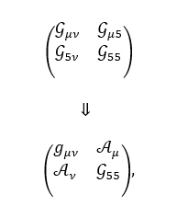

where , , , and $φ$ is scalar field. One of the most amazing features of the metric tensor $G_{AB}$, is that their components were renamed. At a deeper level, in Figure 1.2 you can follow the renaming of elements of the matrix to the original Einstein field and the Maxwell field. One can use the visualization of Kaluza-Klein method in Figure 1.2.

Figure 1.2 – Kaluza- Klein theory

It is supposed, that by using $G_{AB}$ can manage to modify Einstein’s equations:

$R_{AB}-\frac{1}{2}g_{AB}R=\frac{8πG}{c^{4}}T_{AB}.$ (1.3)

So by introducing the new $G_{AB}$ one can manage geometrization of gravity and electromagnetism. Just by adding to the gravitational field electromagnetic one, Kaluza and Klein was able to create a five-dimensional theory. There are some consequences of such theory, which were later called "miracles of Kaluza-Klein".

1. The main miracle of Kaluza-Klein theory is that 15 Einstein equations decayed into the 3 fields:10 four-dimensional general gravity equations + 4 Maxwell equations + 1 scalar field;
2. the next miracle is that in the equations automatically $T_{μν}$ appeared;
3. the last miracle is that the equations of the geodesic line:

$\frac{dx^{5}}{dS}=\frac{-2q}{\sqrt{G}m},$ (1.4)

with momentum

$P^{5}=m\frac{dx^{5}}{dS}=-2\sqrt{G}q.$ (1.5)

Therefore, the multidimensional metric tensor $G_{MN}$, can be presented by the following matrix [5, p. 68]:

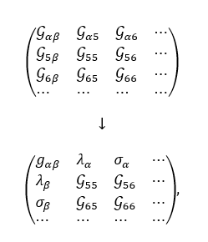

where the mixed components, for example $G_{56}$ or $G_{65}$ related to the vector potentials of the corresponding interactions.

To draw the conclusion, according to the above shortcomings of Kaluza-Klein theory in the modern theory «brane world» approach is more popular.

### Modified theory of gravity

In this section, I will provide a historical overview of modified theories of gravity. One need to consider MG, so that it should be possible to obtain within these theories astrophysical objects predicted by GR without matter: thick branes ($D$– branes) in multidimensional space-time.

In 1915 Albert Einstein demonstrated his genius by publishing the theory of general relativity. After proposing Einstein’s new theory, it was largely ignored for several decades. But in the second half of the 20th century, GR had become very popular. The theory works so well that it is consistent with observations such the perihelion precession of [Mercury](https://en.wikipedia.org/wiki/Mercury_(planet))'s orbit, the [deflection of light](https://en.wikipedia.org/wiki/Gravitational_lens) by the [Sun](https://en.wikipedia.org/wiki/Sun), gravitational redshift [14].

Despite of these tremendous successes, however, scientists are convinced that GR does not provide us with the full picture, so that new approaches and theories have to be created or one has to start testing old theories with new experimental data. It seems to confirm the idea of generalization of Einstein’s theory of gravity, which is called as modified theories of gravity (MG) or alternative theories of gravity.

It is interesting to note that searching new approches began even before Einstein’s creation of the theory of relativity, with attempts to modificate Poisson’s equation. Alternative theories continued to flourish over the next years. One reason could have been the very small number of experiments prior to the late 1960s. The fact of a small number of experiments led to the creation of a large number of alternatives to Einstein’s theory. Interestingly, these alternative models revived the theory of gravity and played a primary role in the development of new experiments.

Recently, from the point of view of observations scientists has been concerned with GR for some important reasons. First of all, GR had never been tested directly on weights greater than the Solar System. Einstein's gravity has undergone many additional tests over the past century, such as the impressive gravitational wave detection reported in 2016 [15]. But it is impossible to test this theory under all conceivable conditions. And experts have long suspected that GR may not hold true in regions with extremely high mass densities.

The second reason to generalize GR is the concept of a dark energy. Its existence is postulated to explain the observed accelerated expansion of the Universe, which is otherwise impossible in the Universe governed by GR and containing only the matter species like radiation and matter.

Indeed, if GR ever fail, numerous competing theories of gravity proposed in recent decades will be waiting in the wings. Therefore, the classification of modified theories of gravity started in the XVII-XIX centuries. The discovery of MG is associated with such scientists as: Saul Perlmutter, Brian P. Schmidt and Adam Riess, who were awarded by the Shao Astronomy Prize in 2006 and the Nobel Prize in Physics in 2011 for proving accelerated expansion of the universe.

There is no generally accepted definition of modified gravity. But it is clear that this must be a low-energy modification explaining the late time of the Universe, at a deeper level it has to explain current accelerating expansion of the Universe. In fact, the early Universe requires additional fields such as the inflaton or other modifications. It is well-known that the model which explains the early acceleration of the Universe is known as inflation, whereas model that explains the late acceleration of the Universe is called dark energy.

Alan Guth firstly proposed the inflationary model, which was studied by many physicists such as Starobinsky A., Linde A., Mukhanov V. and a number of other scientists [16-21]. The inflationary theory of the Universe was developed relatively recently. Today, it is considered as an accepted part of the Big Bang theory, even though the central ideas of the Big Bang theory were well established long before the inflationary theory was formulated.

According to Alan Guth, the Universe had to have a high energy density. According to thermodynamics, the density of the universe should cause it to expand at an incredible rate. With a help of this model, it is possible to explain the temperature uniformity of all regions of the Universe.

The accelerated expansion of the Universe was first proposed by recent observations of supernovae of type Ia and agrees with the large-scale structure of the Universe, baryonic acoustic vibrations and weak lensing [23].

It has long been established that it is extremely important to apply the scale factor. This requires a reliable way to determine the distances to distant objects, independent of the check. Measuring distances in cosmology is not an easy task. However, in the late 1970s-1980s, important results have appeared on the discovery of a class of astronomical sources that could help solve this problem - these are type Ia supernovae.

Type Ia supernovae are thermonuclear explosions of white dwarfs, and since, on average, white dwarfs explode at similar masses, such supernovae have similar light curves and show luminosity. For this reason, flashes are called standard candles. As a result of almost two studies, astronomers are based on the detection of brightness and on the spectrum of the determination of the luminosity of supernovae Ia. Awareness of the luminosity at maximum brightness makes it possible to obtain independent feedback to them (and, therefore, to the galaxies in which they are found).

Throughout the 1990s. several groups of scientists have been working on using Ia supernovae in cosmology as standard candles. As a result, in 1997-1999 results were obtained that made it possible to discover the acceleration of the expansion of the Universe. Observations have shown that supernovae at redshifts greater than 0.5 are further away (look weaker) than would be expected from the then standard model, in which the Universe is slowing down its expansion all the time. In order for supernovae to be at a more distant distance, it is necessary that the Universe has been expanding faster and faster over the past few billion years. The accelerated expansion of the Universe was discovered in 1997–1999. according to the results of observations of type Ia supernovae.

From these facts, one may conclude that in 1998, one of the amazing discoveries of that time was discovered - the accelerated expansion of the Universe, which was a big surprise for physicists and even was criticized for some time. For such outstanding discovery Saul Perlmutter, Adam Riess, and Brian Schmidt were awarded by Nobel Prize in Physics.

From these facts, one may conclude that the problem of explaining the phenomenon of the accelerated expansion of the Universe has led to a huge growth of models, for example, two types of models are distinguished in the literature:

1) Many scientists believe that one of the methods of explaining this phenomenon is the assumption of the existence of "dark energy";

2) another method is creating modified theories of gravity, so that they try to replace or connect such physical concepts as "inflation", "dark matter" and "dark energy".

To begin with, there is no answer at the moment to what dark energy is, but the name comes from the fact that it is necessary to introduce a hypothetical energy to explain the acceleration of the universe, because it was not directly observed. In 2013 Planck Space Observatory created a cosmic microwave background radiation (CMBR) map or it sometimes called like «cosmic cake». The most surprising thing about this cosmic cake, is that it has allowed scientists to extract the most precise values of the Universe's components: dark energy (68.3%) and dark matter (26.8 %) [25].

According to some experts «dark energy» is considered as matter with very exotic properties: it has negative pressure and has a very unusual relationship between the pressure and density of this matter. In addition, this form of matter should interact extremely weakly with electromagnetic radiation. If all these conditions are met, one cannot deny that this is dark energy. Nowadays, there are many models of dark energy: Chaplygin gas, phantom matter, quintessence, and so on [26].

On the other hand, there is a completely new approach to describing the accelerated expansion of the Universe, since we do not use the old methods of general relativity, but modify them. In order to consider reasons for using modified theories of gravity and different types of them I have created the following illustations, see Figure 1.3 and 1.4.

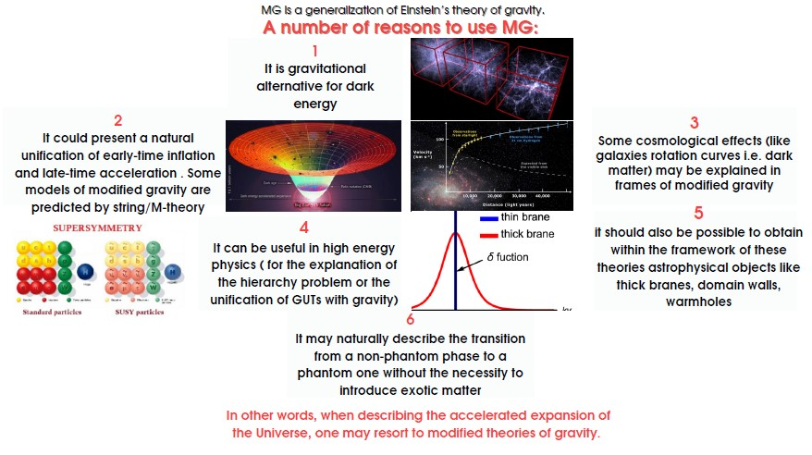

Figure 1.3 – Motivation for MG

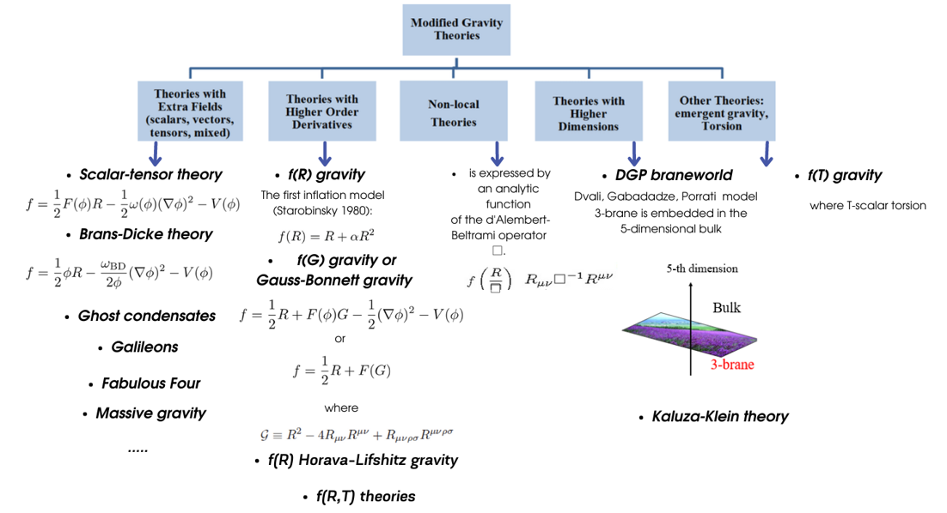

Figure 1.4 – Types of modified theories of gravity

It can be noticed from the Figure 1.4, there are a list of popular modified gravity theories: theories with exra fields, theories with higher order derivatives, non-local theories,theories with higher dimensions. One of the most remarkable features of the modified theory of gravity is that the density of the Lagrangian is no the scalar curvature $R$ (as in GR), but has more complicated dependence on the curvature tensor and possibly further fields. Instead of curvature also torsion and nonmetricity can be used. A particular attractive set of models related to the theories with higher order derivatives are $F(R)$ gravity and Gauss-Bonnett gravity or $F(G)$ gravity. Another approach to modified gravity is $F(T)$, where T is scalar torsion. In addition, it should be possible to use the Lagrange function, depending on different types of matter, only by variation the corresponding function. In this regard, as we will see in Chapter 2, the fundamental field equations become differential equations of the 4-th order. The most striking thing about these theories is that such modified theories of gravity explain not only inflation at the early stage of the Universe, but also the current accelerated expansion of the Universe.

Recently Harko et al. [27] proposed the theory $F(R,T)$ taking into account the gravitational Lagrangian as a function of the Ricci scalar $R$ and the energy-stress tensor $T$. They obtained the equation of motion of a test particle and the gravitational field equation in the metric formalism. The $F(R,T)$ gravity models can serve as a justification for the late cosmic accelerated expansion of the Universe. Many authors studied completely different cosmological models in $F(R,T)$ theory [28-32].

Lets consider the main idea of some of the modified theories of gravity illustrated in Figure 1.4. As for the possible modifications of GR, which can lead to equivalent behavior of dark energy and that are capable to realize the late accelerated expansion of the Universe, it is worth note here $F(R)$ theory of gravity.

Note that the literature on $F(R)$-gravity is extensive, and reviews of this theory are given in [33-38].

Including a $R^{2}$-term in the Lagrangian fields the so-called model of Starobinsky [37, p. 3]. This action is one of the earliest inflation models and remains one of the best inflation models to comply with the latest constraints. It is also interesting to note that many classes of models are identical to Starobinsky’s model for inflation. Due to the popularity of the model, it is natural to extend it to the acceleration of the Universe in recent years, which led to the emergence of $F(R)$-models defined by the generalized scalar function of curvature $\sqrt{-g}F(R)$ instead of the action in GR defined by $\sqrt{-g}R$.

To consider the $F(R)$ generalizations of Einstein’s equations it is necessary to consider the Lagrangian density:

$L=\sqrt{-g}F(R).$ (1.6)

This is a common generalization of the Einstein-Hilbert density. Now let us derive the field equations by using the metric variational approach. After integrating the equation (1.6) over the 4-total volume, one gets:

$S=\frac{1}{16πG}\int{‍}d^{4}x\sqrt{-g}[F(R)+L_{matter}],$ (1.7)

where $F(R)$ is the analytical Ricci function of the scalar $R$, $g$ defines the determinant of the metric $g_{μν}$, and $L_{matter}$ is the general Lagrangian for an ideal liquid substance. After varying the action (1.7) one can get the equations of motion for modified gravity:

$\frac{1}{2}g_{μν}F(R)-R_{μν}F^{'}(R)-g_{μν}◻F^{'}(R)+∇_{μ}∇_{ν}F^{'}(R)=-\frac{k^{2}}{2}T_{matterμν},$ (1.8)

where $F^{'}(R)=∂F(R)/∂R$, $k^{2}=8πG$ and $T_{matterμν}$ is the energy-momentum tensor of matter.

It is possible to rewrite the action [39] :

$S=\frac{1}{2k^{2}}\int{‍}d^{4}x\sqrt{-g}F(R)+S_{m}[g_{μν, }Ψ_{m}],$ (1.9)

where $Ψ_{m}$ represent the matter fields. By introducing an auxiliary field $σ$ one can rewrite the previous action to the following form:

$S=\frac{1}{2k^{2}}\int{‍}d^{4}x\sqrt{-g}[f^{'}(σ)R+f(σ)-σf^{'}(σ)]S_{m}[g_{μν,}Ψ_{m}],$ (1.10)

variation of this action with respect to $σ$, gives $f^{''}(σ)(R-σ)=0.$

Provided $f^{''}(σ)≠0$, it follows $σ=R$ which after substitution in (1.10) gives (1.9). Working with an action having an explicit coupling between the auxiliary field and the curvature, $f^{'}(σ)R$ is known as the Jordan frame or also Pauli frame and it turns out that some discussions are simpler in so-called Einstein frame where the direct coupling disappears, for which we have to perform a conformal transformation ${\tilde{g}}_{μν}=f^{'}(σ)g_{μν}$ which gives:

$S=\int{‍}d^{4}x\sqrt{-\tilde{g}}\left[\frac{\tilde{R}}{2k^{2}}-\frac{1}{2}(∂_{μ}ϕ)^{2}-V(ϕ)\right]F(R)+S_{m}[e^{\frac{-\sqrt{2}}{3}kϕ}{\tilde{g}}_{μν},Ψ_{m}],$ (1.11)

where the new scalar field $ϕ$ (known as the scalaron) is defined by:

$f^{'}(σ)=e^{\sqrt{\frac{2}{3}}kϕ}$ (1.12)

and the potential is

$V(ϕ)=\frac{f^{'}(σ)σ-f(σ)}{2k^{2}f^{'}(σ)^{2}}.$ (1.13)

The equivalence of this model to quintessence coupled to matter explains why this theory is free from the Ostrogradsky instability. But also, this coupling to matter in the Einstein frame is the origin of the modification of gravity.

As it was mentioned above, tt has become an active field of research following work by Starobinsky on cosmic inflation [36-38]. Starobinsky gravity has the following form: $F(R)=R+\frac{R^{2}}{6M^{2}}$, where $M$ has the dimensions of mass.

Starobinsky model can be defined by following action [40, p.1]:

$S=\frac{1}{2k^{2}}\int{‍}d^{4}x\sqrt{-g}[\left(R+αR^{2}\right)],$ (1.14)

for which we obtain the field equations:

$G_{μν}=\frac{1}{1+2αR}\left[k^{2}T_{μν}-\frac{α}{2}R^{2}g_{μν}+2α∇_{μν}R-2αg_{μν}◻R\right].$ (1.15)

With no matter and for the Ricci tensor $R_{μν}$ being covariantly constant, the equation of motion corresponding to the action (1.7) is:

$0=2f(R)-Rf'(R) ,$ (1.16)

which is an algebraic equation with respect to $R$. If the solution of equation (1.16) is positive, it expresses a de Sitter universe and if negative an anti-de Sitter universe. De Sitter space is the maximally symmetric vacuum solution of Einstein’s field equations with a positive cosmological constant $Λ$. Anti-de Sitter space is a maximally symmetric

Lorentzian manifold with constant negative scalar curvature, see Figure 1.5.

In the FRW universe metric has the form [40, p.2]:

$ds^{2}=-dt^{2}+\hat{a}(t)^{2}\sum_{i=1}^{3}{‍}{\left(dx^{i}\right)}^{2}.$ (1.17)

Assuming $R$ is equal to $R=12H^{2}+6\dot{H}$. Without the matter Eq.(1.8) gives

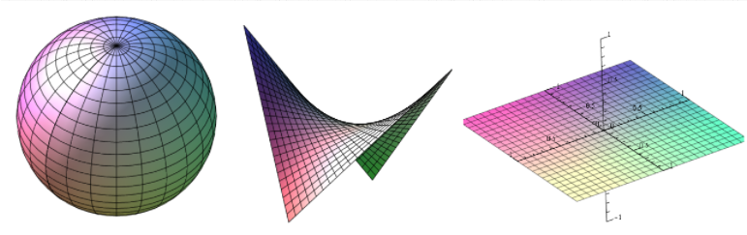 $0=-\frac{1}{2}f(R)+3\left(H^{2}+\dot{H}\right)f'(R)-6\frac{\dot{H}}{H}f''(R)-18H^{2}\frac{d}{dt}\left(\frac{\dot{H}}{H^{2}}\right)f''(R) .$ (1.18)

a) b) c)

Figure 1.5 – a) Spherical Universe (positive curvature); b) hyperbolic Universe (negative curvature); c) Flat Universe (zero curvature) [40, p. 4]

Our main purpose is to look for accelerating cosmological solutions of the following form: de Sitter (dS) space, where $H$ is constant and $a(t)∞e^{Ht}$, quintessence and phantom like cosmologies:

$a=\left\{\begin{matrix}a_{0}t^{h_{0}}, & when h_{0}>0 (quintessence) \\ a_{0}{\left(t_{s}-t\right)}^{h_{0}}, & when h_{0}<0 (phantom) \\ & \end{matrix}\right. .$ (1.19)

Introducing the auxiliary fields, $A$ and $B$, one can rewrite the action (1.7) as follows:

$S=\int{‍}d^{4}x\sqrt{-g}\left[\frac{1}{κ^{2}}\left\{B\left(R-A\right)+f(A)\right\}+L_{matter}\right] .$ (1.20)

One is able to eliminate $B$, and to obtain

$S=\int{‍}d^{4}x\sqrt{-g}[\frac{1}{κ^{2}}\left\{f'(A)\left(R-A\right)+f(A)\right\}+L_{matter}] ,$ (1.21)

and by using the conformal transformation $g_{μν}→e^{σ}g_{μν}$ $\left(σ=-lnf'(A)\right)$, the action (1.21) is rewritten as the Einstein-frame action:

$S_{E}=\int{‍}d^{4}x\sqrt{-g}[\frac{1}{κ^{2}}\left(R-\frac{3}{2}g^{ρσ}∂_{ρ}σ∂_{σ}σ-V(σ)\right)+L_{matter}^{σ}] .$ (1.22)

Here,

$V(σ)=e^{σ}G\left(e^{-σ}\right)-e^{2σ}f\left(G\left(e^{-σ}\right)\right)=\frac{A}{f'(A)}-\frac{f(A)}{f'(A)^{2}} .$ (1.23)

The action (1.21) is called the Jordan-frame action. In the Einstein-frame action, the matter couples with the scalar field $σ$.

Lets consider MG with negative and positive powers of the curvature. The first gravitational alternative for dark energy [40, p. 3]:

$f(R)=R-\frac{c}{{\left(R-Λ_{1}\right)}^{n}}+b{\left(R-Λ_{2}\right)}^{m} .$ (1.24)

Here we assume the coefficients $n$, $m$, $c$, $b>0$ but $n$, $m$ may be fractional. This model leads to cosmic speed-up and is consistent with Solar System tests. For the $f(R)$ equation (1.24) has the following form:

$0=-R+\frac{(n+2)c}{{\left(R-Λ_{1}\right)}^{n}}+(m-2)b{\left(R-Λ_{2}\right)}^{m} .$ (1.25)

Especially when $n=1$ and $m=2$, one gets:

$R=R_{±}=\frac{Λ_{1}±\sqrt{Λ_{1}^{2}+12c} }{2} .$ (1.26)

If $c>0$, one solution corresponds to de Sitter space and another to anti-de Sitter.

The next theory is $lnR$ gravity. Other gravitational alternatives for dark energy [40, p.4, 4-47]:

$f(R)=R+α'ln\frac{R}{μ^{2}}+βR^{m} .$ (1.27)

One should note that the choice $m=2$ simplifies the model. Assuming $R$ is constant and the Ricci tensor is also covariantly constant, the equations (1.16) are:

$0=2f(R)-Rf'(R)=\tilde{f}(R)≡R+2α'ln\frac{R}{μ^{2}}-α'.$ (1.28)

* If $α'>0$, $\tilde{f}(R)$ is a monotonically increasing function. This solution may correspond to inflation;
* if $α'<0$, $\tilde{f'}(R)=1+\frac{α'}{R}$, the minimum of $\tilde{f}(R)$, where $\tilde{f'}(R)=0$, is given by $R=-2α'$;
* if $\tilde{f} (-2α')>0$, there is no solution of (1. 28);
* if $\tilde{f}(-2α')=0$, there is only one solution and if $\tilde{f}(-2α')<0$, there are two solutions.

Since the square root of the curvature $R$ corresponds to the rate of the expansion of the universe, the larger solution in two solutions might correspond to the inflation in the early universe and the smaller one to the present accelerating universe.

### Theory of gauge fields

As already mentioned in the introduction, we investigate monopole-like solutions in the theory of Yang-Mills fields coupled to a nonlinear Dirac field. Therefore, it is necessary to consider historical background of gauge fields [48].

It is well-known that there are 4 types of fundamental interactions in nature - gravitational, strong, electromagnetic and weak. Most studies show that the generally accepted division of the types of interaction by strength is permissible only at low energies. Indeed, with an increase in energy, one will be able to observe the unification of weak interactions and electromagnetic, strong and weak and electromagnetic interactions. So that, the strong, weak and electromagnetic interactions will be combined into one universal interaction. The universal interaction as a consequence of the unified theory of all interactions also must take into account the gravitational interaction [49, 50].

One of the main ideas of the theory of gauge fields is to use such a mathematical apparatus to combine all types of interactions of elementary particles into one [51-54] . These interactions have a common gauge nature, therefore, they can be described by the gauge symmetries of the Lie group [55, 56]. The electromagnetic interaction is described by the gauge symmetry U (1), the weak interaction is described by the gauge symmetry SU (2), and the strong interaction described by the gauge symmetry SU (3) [57]. Nowadays, the modern theory of the interaction of elementary particles is precisely based on the quantum theory of gauge fields. Let’s consider briefly the historical background of scientific research that preceded the discovery of these gauge fields.

The unification of quantum mechanics with the theory of relativity has led to the completion of the construction of the foundation of QFT, the main task of which is to describe the interaction of elementary particles. The next step in the construction of gauge fields was played by quantum electrodynamics. QED was formulated in the 30s in the scientific works of Dirac, Pauli, Feynman and other prominent physicists [58-61]. It is stated that Maxwell’s electrodynamics was created on the assumption that light, electrical and magnetic interactions are all types of the same electromagnetic interaction [62].

The next step in the transition to non-Abelian gauge symmetries is construction the Yang-Mills fields. Yang-Mills fields were discovered in 1954 by C. Yang and his student R. Mills [63]. Based on the analogy of light quanta - photons, the theoretical physicists suggested that the weak and the strong interactions are caused by the exchange of energy quanta, called the quanta of the Yang - Mills fields. The quanta of the Yang-Mills fields are vector particles, i.e. bosons with spin 1 having zero mass. If one consider the weak interaction, then the quantum corresponding to the Yang-Mills field are $W^{±}$, $Z^{0}$ particles. For the strong interaction, the quantum corresponding to the Yang-Mills field is the "glue" that holds protons and neutrons together, which is called gluon [64-65]. Later it was shown that using the mechanism of spontaneous symmetry breaking, the Yang-Mills fields can acquire a nonzero mass [66-68].

There had arisen some difficulties in constructing the gauge theory in the 1960s.

In 1964 M. Gell-Mann and G. Zweig independently proposed a composite quark model of hadrons [69, 70]. According to this model hadrons are composite particles consisting of quarks or antiquarks. Moreover, one of the important quantum numbers of quarks is color, which was introduced in 1965 in the works of the Dubna scientists N.N.Bogolyubov, B.V. Struminsky, A.N. Tavkhelidze and independently M. Khan and I. Nambu [71]. This quantum number characterizes all strongly interacting particles.

The forces that allow quarks to be held inside hadrons have been explained by theoretical physicists as a result of the presence of a non-Abelian gauge gluon field carrying a quantum number-color. The color space is 3-dimensional and the corresponding Yang-Mills fields are associated with the SU (3) group. The emerging theory is called "Quantum chromodynamics" -the fundamental theory of nuclear forces [72-74].

Furthermore, one should accept that gauge theory is a generalization of Maxwell’s theory. This means that Yang-Mills fields are a generalization of the Maxwell field introduced to describe light. Moreover, there is a very important difference between the Maxwell equations and the Yang-Mills equations. This difference lies in the fact that the Yang - Mills equations are nonlinear, which is the result of field self-interaction. Each gauge field can affect not only particles but also itself. In other words, quanta of the Yang-Mills field, unlike photons, interact with each other.

Self-interaction of the field is determined by the structure of the corresponding gauge group. In the case of an electromagnetic field, which is an example of the simplest gauge field (Abelian gauge field), the gauge group has one parameter, therefore the field equations coincide with Maxwell’s equations (there is no self-interaction in this case).

Due to the nonlinearity of the Yang-Mills equations, solving the equations as well as describing the models of the gauge fields is a complex process. These models are difficult to quantize, renormalize, reveal symmetry breaking mechanisms and lead to unique behavior at short distances. These equations can be solved approximately using perturbation theory in quantum mechanics.

At the moment, it is also not fully understood how this nonlinearity of the equation leads to the observed phenomenon in strong interactions, which consists in the impossibility of obtaining quarks in a free state (confinement phenomenon).

As already mentioned, the problem of gauge invariance in the 1960s was finding massless quanta of interaction. However, in 1961 J. Goldstone and E. Nambu showed that as a result of spontaneous symmetry breaking, massless particles are formed [75]. These particles were called the Goldstone-Nambu bosons. However, the discovery of these particles by J. Goldstone and E. Namou did not solve the problem of gauge invariance. This particle was not suitable for the role of a quantum of the gauge field in view of the fact that the spin of this particle is equal to 0.

In 1967, L.D. Fadeev, V.N. Popov and B. De Witt developed a sequential scheme for quantizing massless Yang-Mills fields [76, 77]. In the same year S. Weinberg and A. Salam independently proposed a unified gauge model of weak and electromagnetic interactions [78, 79].

The construction of the theory of quantum gauge fields is associated with the solution of two theoretical questions:

* renormalizability of gauge fields;
* the origin of the mass of vector particles.

P. Higgs was able to solve this problem in 1964 by proposing a mechanism of spontaneous breaking of local gauge symmetry, which made it possible to impart mass to the quanta of gauge fields and ensure renormalizability of the theory of mass fields [80-82]. The Higgs mechanism makes it possible to assign masses to vector gauge fields without violating the local gauge invariance of the theory.

The next step was to introduce the Higgs field, which could cause spontaneous symmetry breaking. Initially, $W^{±}$ and $Z^{0}$ quanta have no mass, but symmetry breaking leads to the fact that some Higgs particles merge with $W^{±}$ and $Z^{0}$ particles, giving them mass. Salam argued that the $W^{±}$ and $Z^{0}$-particles “eat” the Higgs particles in order to gain weight. Photons do not participate in this process and remain massless. The quantum of the Higgs field was called Higgs boson. In fact, this mechanism for the acquisition of mass by particles was introduced earlier by Ernst Stueckelberg in 1957 [83]. Higgs’ merit lies in the assumption that the mass of a vector boson appears as a result of the interaction with a scalar field. In the equations of motion, it was necessary to take into account the mass of these particles. However, in this case, these equations will be non-invariant with respect to local gauge symmetries.

The discovery of $W^{±}$ and $Z^{0}$ particles in 1983 meant the triumph of the Weinberg - Salam theory. The theory of the electroweak interactions has decisively influenced the development of physics in the following years. For their outstanding achievements, Weinberg and Salam were awarded the 1979 Nobel Prize in Physics, sharing it with Sheldon Glashow of Harvard University, who had earlier laid the foundations of this theory. Physicists were interested in this model also because of the possibility of a further unification of the fundamental interactions, but there is so far no observational evidence for such a theory.

Yang-Mills fields have a peculiar geometric interpretation. This geometric interpretation is constructed by analogy with the Christofell symbols in the theory of gravitation. According to this, the Yang-Mills fields describe the parallel transport in the charge space and determine the curvature of this space.

The next important step in the construction of gauge fields is to combine the strong and electromagnetic interactions. Strong and electromagnetic fields have the following differences: the electromagnetic interaction has one type of charge, and the strong interactions have 3 colors. The gluon has color quantum numbers, but the photon is electrically neutral particle.

This difference has led to other remarkable properties of Yang-Mills fields, called "asymptotic freedom" and "confinement". This discovery is associated with the names of D. Gross, F. Wilczek and D. Politzer [84-86].

Each interaction is characterized by a coupling constant that determines its strength. However, the study of interactions at ever higher energies showed that the coupling constant depend on energy. The decrease in the constant of the strong interactions with increasing energy is a consequence of the anti-shielding of the strong (color) charge, leading to asymptotic freedom. The constant of the electromagnetic interactions due to shielding increases with increasing energy.

The phenomenon of "asymptotic freedom" is that strong interactions weaken at small distances. This phenomenon became the basis of the theory of strong interactions.

The phenomenon of "confinement" consists in the fact that when quarks move away at distances of more than 10-13 cm, their connection will increase. As one can see, electromagnetic and weak interactions, when viewed superficially, are very different in nature.

However, S. Weinberg and A. Salam showed that in reality these fields are two types of a single - the so-called electroweak interaction of leptons and quarks, carried out through the exchange of four particles - massless photons (electromagnetic interaction) and heavy vector bosons (weak interaction). Thus, one can conclude that, based on the Yang-Mills theory, two theories of the Standard Model of elementary particle physics were built: QCD (theory of strong interactions) based on the SU (3) group and the theory of electroweak interactions based on the SU (2) group.

This kind of unification does indeed occur in string theory. However, quantum string theory has not been built yet.

The Standard Model was unable to lead to a unified field theory. It does not include the theory of gravitation, which began the geometrization of physics at the beginning of the 20th century and does not describe dark matter and dark energy. The subsequently proposed string theory was designed to fill this gap. For great achievements in the field of gauge theory, in 1999 M. Veltman and G. Hooft and in 2004 D. Gross, F. Wilczek and D. Politzer were awarded the Nobel Prize.

After a brief historical overview, we turn to the mathematical description of the Yang-Mills field. In QED [87], gauge invariance is satisfied under transformations of the Abelian group. Such phase transformations form the U(1) group.

QED combines the theory of interacting fields: the vector electromagnetic field $A_{μ}=(A_{0}(x),\vec{A}(x))$ and the Dirac field of electrons-positrons $Ψ_{α}(x)$. Later, Yang and Mills generalized U (1) -symmetry to the non-Abelian case, thus theories possessing gauge invariance under the transformations of the non-Abelian Yang-Mills group. For a non-Abelian group SU(N), one write down, by analogy with quantum electrodynamics, the covariant derivative as follows:

${\hat{D}}_{μ}→∂_{μ}-igA_{μ}^{a}T^{a},$ (1.29)

where $g$ is the coupling constant, similar to the charge in QED, and the $T^{a}$ are the generators of the SU (N) group.

The main objects that are considered in gauge theories are Yang-Mills potentials. These potentials are a set of vector quantities (fields) $A_{μ}^{a}(x)$ (where $a=1,2,...,N$; $μ=0,1,2,3)$. The vector field $A_{μ}$ is defined as follows:

$A_{μ}=gT^{a}A_{μ}^{a}.$ (1.30)

The field strength tensor has the form:

$F_{μν}^{a}=∂_{μ}A_{ν}^{a}-∂_{ν}A_{μ}^{a}+gf^{abc}A_{μ}^{b}A_{ν}^{c},$ (1.31)

where $f^{abc}$ are the structure constants of the gauge group. Maxwell’s equations have the form: $∂_{μ}F^{μk}=-J^{k}$, where $J^{k}=e\overline{Ψ}γ^{κ}Ψ$ with source and without source $∂_{μ}F^{μk}=0$, whereas the Yang-Mills equations have the form:

${\hat{D}}_{μ}F_{a}^{μν}=J_{a}^{k},$ (1.32)

where

$J_{a}^{k}=-g\overline{Ψ}t_{a}γ^{κ}Ψ,$ (1.33)

with source,

${\hat{D}}_{μ}F_{a}^{μν}=0$, (1.34)

without source.

It is important to note that the Lagrangian of a non-Abelian gauge group, in contrast to an Abelian one, contains terms of $A_{μ}$ of higher orders, which is a consequence of the nonlinearity of the Yang-Mills equations.

* + 1. **Problem of the mass gap**

The second part of the research is partly connected with the concept of the mass gap,

therefore this section devoted to this concept. The first thing that needs to be said is that the problem of the existence of the mass gap and Yang-Mills theory is one of 7 challenging unsolved Millennium Prize Problems in mathematics and physics. There is a list of the relevant, complicated and unsolved millennium problems in science which were established by the [Clay Mathematics Institute](https://en.wikipedia.org/wiki/Clay_Mathematics_Institute) in 2000 [88]:

1. [Birch and Swinnerton-Dyer conjecture](https://en.wikipedia.org/wiki/Birch_and_Swinnerton-Dyer_conjecture);
2. [Hodge conjecture](https://en.wikipedia.org/wiki/Hodge_conjecture);
3. [Navier–Stokes existence and smoothness](https://en.wikipedia.org/wiki/Navier%E2%80%93Stokes_existence_and_smoothness);
4. [P versus NP problem](https://en.wikipedia.org/wiki/P_versus_NP_problem);
5. [Poincaré conjecture](https://en.wikipedia.org/wiki/Poincar%C3%A9_conjecture) (had been solved);
6. [Riemann hypothesis](https://en.wikipedia.org/wiki/Riemann_hypothesis);
7. [Yang–Mills theory and mass gap](https://en.wikipedia.org/wiki/Yang%E2%80%93Mills_existence_and_mass_gap) existence.

If this problem is successfully solved, the [Clay Mathematics Institute](https://en.wikipedia.org/wiki/Clay_Mathematics_Institute" \o "Clay Mathematics Institute) will reward the winner with a prize of $1,000,000. The difficulty of solving this problem lies in the fact that it is necessary to prove that any compact gauge group G includes a non-trivial quantum theory of Yang-Mills of R4 and has a positive mass gap Δ > 0 [89].

As discussed in the previous section, half a century ago, Yang and Mills introduced astonishing theory that can describe elementary particles. Its predictions have been tested empirically many times but the mathematical representation is not incomprehensible. [Yang-Mills theory](https://en.wikipedia.org/wiki/Yang%E2%80%93Mills_theory) is a gauge field theory based on SU(N) group. The theory of Yang-Mills can be successfully used with a quantum property of elementary particles - the mass gap. [The mass](https://en.wikipedia.org/wiki/Mass_gap) gap Δ is the mass of the least massive particle predicted by this theory. As an example, consider the gauge group G=SU(3)-the theory of the strong interactions [89, p. 2]. To solve this problem, the winner must prove that glueball-quanta of the strong interactions have a lower mass boundary and, therefore, cannot have any lighter values. At a deeper level, it means that there are no massless particles predicted by the theory (except the vacuum state). The mass gap has been discovered experimentally and confirmed through computer modeling, however it is not understood theoretically.

The history of the development of the mass gap concept is inseparably connected with the modern quantum gauge theory of the strong interactions of elementary particles - Quantum Chromodynamics (QCD). QCD was formulated by [analogy](https://www.merriam-webster.com/dictionary/analogy) with QED. A common name for all elementary particles involved in the strong interactions is hadrons.

In QED, the electromagnetic interactions of charged particles are described and transmitted by carrier particles – the massless photons. By analogy with QED, in QCD, the carriers of the strong interactions are gluons. There is only one type of electric charge in QED, which can be positive or negative. Unlike QED, where the exchanged photons are electrically neutral, QCD gluons also carry “color charges”. It is well-known, that hadrons as compound particles are composed of quarks and antiquarks. The quark model of elementary particles was independently postulated in 1964 by American physicists Murray Gel-Mann and George Zweig [90, 91].

In 1965, N. N. Bogolyubov, M. Khan, E. Nambu and others independently postulated that quarks have additional degrees of freedom of the SU (3) gauge group, later called "color charges" [92]. Quarks are described by three different types of color charge, each of which can be colored or anti-colored. The three types of charge are called red, green and blue by analogy with the primary colors of light, although there is no connection with color in the general case.

Thus, quarks interact through the strong interactions, exchanging gluons. A quark of one color can transform into a quark of different colors by emitting a colored gluon. Moreover, in order to describe all possible interactions between the three colors of quarks, there should be eight gluons, each of which usually carries a mixture of color and anti-color of different type. Therefore, this gauge group has 8 generators, each of which corresponds to a quantum of the vector gauge field - gluon. Since gluons carry color, they can interact with each other, which is the main difference between strong interaction and electromagnetic one.

QED obeys the inverse - square law, that is, it describes a force that can propagate in space and becomes weaker as the distance between two charges increases. In QCD, however, interactions between gluons emitted by color charges prevent these charges from flying apart. This also explains confinement of quarks.

At that moment, there is no doubt that confinement, as well as other dynamic effects, such as spontaneous / dynamic symmetry breaking, bound state problems, etc., are not available with perturbation methods, and therefore they are very important non-perturbative effects [93]. In turn, this means that for their study it is necessary to find non-perturbative solutions, methods and approaches. This is especially necessary because the aforementioned non-perturbative effects are related to low-energy / impulsive (long distance) phenomena and, as well known, perturbation methods usually do not apply to them.

Using perturbation techniques, it was predicted that QCD correctly describes hadrons interactions at higher energies and momentum transfers $Q^{2}≫m_{ρ}^{2}≈0.6 {GeV}^{2}$ [93, p.4]. However, standard perturbation methods do not work when applied to QCD at low-energy. Also the discovery of the Higgs boson does not solve the problem of masses arising from the nonperturbative behavior of QCD. Therefore, the introduction of the "mass gap" is a new method pioneered by Arthur Jaffe and Edward Witten. This method is based on showing that a mass scale parameter (mass gap) is needed to explain the QCD mass spectrum instead of other massive particles. Thus, the mass gap is the energy gap between the lowest and the vacuum state in the quantum Yang-Mills theory. It is responsible for the large-scale structure of the QCD ground state and, therefore, also for its non-perturbative phenomena at low energies. After all, each mass of a hadron must be expressed in terms of renormalized mass gap, i.e., ${M }_{h}={ const}_{h} × ∆$, where *h* determines any hadron, аnd ${ const}_{h}$- corresponds to a dimensionless constant. In other words, the spectrum of hadrons must depend on the mass gap.

In the chapter 4, we will present that the energy spectrum of monopole-like solutions possesses a global minimum, which can be interpreted as a mass gap, whose appearance is caused by the nonlinear spinor fields. We wish to emphasize that the mass gap that would be obtained in the present work can be considered as the QCD effect in non-QCD theory. The obtained results, then may try to explain the nature of the mass gap in a more complicated situation in QCD.

Of course, there are many big questions in gauge theory that have not yet been answered. However, the amazing beauty of this theory and the experimental discoveries that have been made in recent years allow us to hope that in the near future answers to these questions will be found.

## BRANES IN MULTIDIMENSIONAL SPACE-TIME

## 2.1 Brief overview of the Branes

## In this chapter, we will consider flat-symmetric solutions of branes in $-αR^{n}$ modified theory of gravity. There are articles [94-99] where one can follow some searches of thick brane solutions in 5 and 6-dimensional space-time. In the current research, we will investigate thick branes in multidimensional space-time.

This chapter explains a new approach to the problem of non-observability of extra dimensions, which is called the «brane world scenario», see Figure 2.1. This approach is very different from the traditional compactification approach. As we mentioned before, at this approach, particles related to electromagnetic, weak and strong fields are bounded by some hypersurface, which is the brane, which is embedded in a bulk - some multidimensional space.

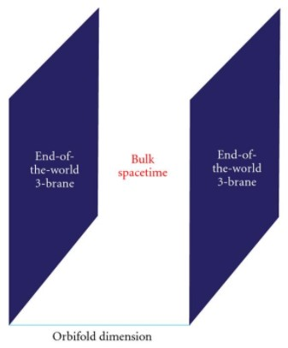

Figure 2.1 $-$ Brane world scenario

The Universe is thought to be such a brane-like object. This idea was first phenomenologically formulated in [100-104] and was confirmed in string theory. In the «brane world scenario», the limit on the size of additional dimensions becomes weaker. The idea of a prototype world on the brane appeared quite a long time ago. Now, the concept of "brane model" indicates different approaches to solve some fundamental problems of high-energy physics.

$D -$ branes are a very important objects in string theory. According to string theory a $D$ $-$ brane is attached to the ends of strings and can move in some enveloping space, see Figure 2.2.

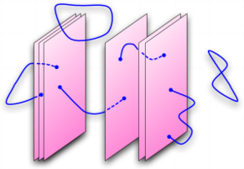

Figure 2.2 – D2-brane in string theory

Currently, $D_{4}$- branes (the so-called brane world scenario) are actively used to solve some problems in high energy physics: the problem of the hierarchy of fermionic masses , the nature of dark energy and dark matter [105, 106].

In this work we will investigate this issue and show that regular vacuum brane solutions can exist in multidimensional modified theories of gravity. As far as we know, for getting all these solutions require the presence of matter. And this is physically understandable, since in GR, regular solutions almost always can be obtained in the presence of some sources. Such examples can be solutions with scalar, vector and spinor fields. The natural question that arises in this regard is the question of the presence or absence of vacuum regular brane solutions.

From a realistic point of view, the brane should has a thickness. It is also widely believed that the most fundamental theory would have a minimum length scale. In some cases, the influence of the thickness of the brane may be important. The inclusion of the thickness of the brane gives us new possibilities and new problems. In many multidimensional field theories related to gravity, there are solutions to topological defects. They have led to a richer variety of worlds on the brane.

We will now give our precise definition of thick branes to avoid possible problems associated with possible differences in terminology. Our definition is based on the following form of multidimensional metric: for five-dimensional solution problems with a metric [45, p.8]:

${ds}^{2}=a^{2}\left(y\right)g_{μν}{dx}^{μ} {dx}^{ν}-{dy}^{2}$ (2.1)

where $-∞<y<∞$- additional dimension coordinate. Four-dimensional $g_{μν}$- it is Minkowski function or de Sitter spacetime (or anti-de Sitter), $a\left(y\right)$- warp factor or the deformation function, which is regular, has a maximum on the brane and falls quickly away from the brane. Typical wrap factor behavior in thin and thick branes is shown in Figure 2.3.

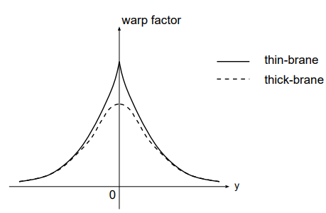

Figure 2.3 $-$ The warp factor $a\left(y\right)$ of the thin and the thick brane solutions.

It was shown in [98, 99] that in a 4,5 and 6-dimensional space-time there can exist a brane, which is a regular vacuum solution. In this study, we want to show that Branes with codim =1 can be obtained as regular vacuum solutions in modified theories of gravity. This means that the presence of matter is not necessary for the construction of such Branes.

### 2.2 Branes in multidimentional space-time within the framework of $F(R)$ modified theory of gravity

### In this section, we investigate Branes in multidimentional space-time within the framework of $F(R)$ modified theory of gravity using the methods of solving for thick branes that was considered in the articles [98, 99].

Let’s consider Branes with codim = 1 in multidimensional space-time with dimension N. The corresponding gravitational action can be represented in the following form:

$S=\int{‍}d^{N}x\sqrt{-G}\left[-R+f(R)\right],$ (2.2)

where $f(R)$ is an arbitrary function of the scalar curvature $R$; $G_{AB}$ is the multidimensional metric.

Variation of action (2.2) with respect to the $N$-dimensional metric $G_{AB}$ give us the equations of modified gravity:

$R_{A}^{B}-\frac{1}{2}δ_{A}^{B}R={\hat{T}}_{A}^{B},$ (2.3)

where are capital Latin letters $A,B,...=0,1,...,N-2,N$; the right side is determined in the following way:

${\hat{T}}_{A}^{B}=-\left[\left(\frac{∂f}{∂R}\right)R_{A}^{B}-\frac{1}{2}δ_{A}^{B}f+\left(δ_{A}^{B}g^{LM}-δ_{A}^{L}g^{BM}\right){\left(\frac{∂f}{∂R}\right)}_{;L;M}\right],$ (2.4)

where the semicolon defines the covariant derivative and ${\hat{T}}_{A}^{B}$ denotes the source of effective geometric matter.

The Ricci tensor is defined as:

$R_{AB}=\frac{∂Γ_{AB}^{L}}{∂x^{L}}-\frac{∂Γ_{AL}^{L}}{∂x^{B}}+Γ_{AB}^{L}Γ_{LM}^{M}-Γ_{AL}^{M}Γ_{BM}^{L},$ (2.5)

and Ricci scalar:

$R=g^{AB}R_{AB}.$ (2.6)

As was mentioned at the beginning, we explore $f(R)$ gravity in the following form:

$f(R)=-αR^{n},$ (2.7)

where $α>0$ and $n$ some constants.

**According to some research, in order to study the present accelerated expansion of the Universe, there are some ranges of $n$ that do not contradict the observational cosmological data.** So, it seems logically to consider these values of $n$ for Branes.

In this work, we are looking for Branes with codim = 1 in the N -dimensional space, so the metric has the form:

$ds^{2}=e^{2β(x^{N})}[(dx^{0})^{2}-(dx^{1})^{2}-...-(dx^{N-1})^{2}]-(dx^{N})^{2},$ (2.8)

The metric (2.8) has the following components of the Ricci tensor, which were calculated by using formula (2.5):

$R_{00}=e^{2β}{(β}^{''}+Nβ^{'2}),$ (2.9)

$R_{AA}=-e^{2β}\left(β^{''}+Nβ^{'2}\right),A=1,2,...,N-1,$ (2.10)

$R_{NN}=-N(β^{''}+β^{'2}).$ (2.11)

Here $'$ means the derivative with respect to $x^{N}$. We also take into account that the Ricci scalar looks like:

$R=2Nβ^{''}+N(N+1)β^{'2}.$ (2.12)

We will use the following notation values: $f_{R}=\frac{∂f(R)}{∂R}$, $f_{RR}=\frac{∂^{2}f(R)}{∂R^{2}}$, $f_{RRR}=\frac{∂^{3}f(R)}{∂R^{3}}$.

Let’s get the equations of modified gravity for the components of $A,B=$ ( $\frac{0}{0}).$ Substitution of the metric (2.8) and the components of the Ricci tensor (2.9)-(2.11) into the equations of modified gravity (2.3), give us:

1. Left side of the equation of (2.3) is:

2) Right side of the equation of (2.3) is:

$-f_{R}R_{0}^{0}+\frac{1}{2}δ_{0}^{0}f-δ_{0}^{0}g^{LM}f_{RRR}\frac{∂R}{∂x^{L}}\frac{∂R}{∂x^{M}}-δ_{0}^{0}g^{LM}f_{RR}\frac{∂}{∂x^{L}}\left(\frac{∂R}{∂x^{M}}\right)+δ_{0}^{0}g^{LM}f_{RR}Г_{LM}^{K}\frac{∂R}{∂x^{K}}=- β^{''}f_{R}-Nβ^{'2}f_{R}+\frac{1}{2}f-\left(N-1\right)β^{'}\left[2Nβ^{'''}+2\left(N^{2}+N\right)β^{'}β^{''}\right]f_{RR}-{4N^{2}f}_{RRR}{ β}^{'''2}-8N^{2}\left(N+1\right)β^{'}β^{''}β^{'''}f_{RRR}-4{\left(N^{2}+N\right)}^{2}β^{'2}β^{''2}f_{RRR}-2Nβ^{''''}f_{RR}-2N\left(N+1\right)β^{''2}f_{RR}-2N\left(N+1\right)β^{'}β^{'''}f_{RR}=\begin{matrix} & -(β^{''}+Nβ^{'2})f_{R}+\frac{1}{2}f+ \\ & [4N^{2}β^{'}β^{'''}+2N(N^{2}-1)β^{'2}β^{''}+2Nβ^{''''}+2N(N+1)β^{''2}]f_{RR}+ \\ & [4N^{2}β^{'''2}+8N^{2}\left(N+1\right)β^{'}β^{''}β^{'''}+4N^{2}\left(N+1)^{2}β^{'2}β^{''2}\right]f_{RRR}.\end{matrix}$*=*

The final result after collecting the left and right sides of the equation (2.3) give us the following equation:

$\begin{matrix} & (1-N)β^{''}+\frac{N(1-N)}{2}β^{'2}=-(β^{''}+Nβ^{'2})f_{R}+\frac{1}{2}f+ \\ & [4N^{2}β^{'}β^{'''}+2N(N^{2}-1)β^{'2}β^{''}+2Nβ^{''''}+2N(N+1)β^{''2}]f_{RR}+ \\ & [4N^{2}β^{'''2}+8N^{2}\left(N+1\right)β^{'}β^{''}β^{'''}+4N^{2}\left(N+1)^{2}β^{'2}β^{''2}\right]f_{RRR.}\end{matrix}$ (2.13)

Now, let’s get the equations of modified gravity for the components $A,B=$ ($\frac{N}{N}).$

1. Left side of the equation of (2.3) is:
$$R_{N}^{N}-\frac{1}{2}δ_{N}^{N}R=Nβ^{''}-{Nβ}^{'2}-Nβ^{''}-\frac{\left(N^{2}-N\right)}{2}β^{'2}=\frac{N(1-N)}{2}β^{'2}.$$

2. Right side of the equation of (2.3) is :

$$-f_{R}R_{N}^{N}+\frac{1}{2}δ_{N}^{N}f-δ_{N}^{N}g^{LM}f_{RRR}\frac{∂R}{∂x^{L}}\frac{∂R}{∂x^{M}}-δ_{N}^{N}g^{LM}f_{RR}\frac{∂}{∂x^{L}}\left(\frac{∂R}{∂x^{M}}\right)+δ_{N}^{N}g^{LM}f_{RR}Г_{LM}^{K}\frac{∂R}{∂x^{K}}=-Nβ^{''}f_{R}-Nβ^{'2}f_{R}+\frac{1}{2}f+2Nβ^{'}β^{'''}f_{RR}+2\left(N^{2}+N\right)β^{'2}β^{''}f_{RR}+2N\left(N-1\right)β^{'}β^{'''}f_{RR}+2\left(N-1\right)\left(N^{2}+N\right)β^{'2}β^{''}f_{RR}=-N\left(β^{''}+β^{'2}\right)f_{R}+\frac{1}{2}f+2N^{2}β^{'}\left[β^{'''}+\left(N+1\right)β^{'}β^{''}\right]f_{RR}.$$

The final result after collecting the left and right sides of the equation (2.3) give us the following equation:

$\frac{N(1-N)}{2}β^{'2}=-N(β^{''}+β^{'2})f_{R}+\frac{1}{2}f+2N^{2}β^{'}[β^{'''}+(N+1)β^{'}β^{''}]f_{RR}$. (2.14)

Taking into account (2.7) and (2.12) one can write:

$f_{R}=-αn[2Nβ^{''}+N(N+1)β^{'2}]^{n-1}$, (2.15)

$f_{RR}=-αn(n-1)[2Nβ^{''}+N\left(N+1\right)β^{'2}]^{n-2},$ (2.16)

$f_{RRR}=-αn(n-1)(n-2)[2Nβ^{''}+N\left(N+1\right)β^{'2}]^{n-3}.$ (2.17)

Consider equation (2.14), since, according to the Bianchi identity, equation (2.13) is a consequence of equation (2.14). Dividing the equation (2.14) by the coefficient of $β^{'''}$, we obtain the following equation:

$\begin{matrix} & β^{'''}-\frac{1}{n}\frac{β^{''2}}{β^{'}}+\frac{(N-1)(1+N-2n)}{4n(n-1)}β^{'3}+\frac{2(N+1)(n^{2}+1)-n(3N+5)}{2n(n-1)}β^{'}β^{''}- \\ & \frac{N-1}{4αNn(n-1)}{\left[N(N+1)β^{'2}+2Nβ^{''}\right]}^{2-n}β^{'}=0.\end{matrix}$ (2.18)

The solution at the origin, aligned with the center of Branes, we seek in the form

$β[x^{N}]≈β_{0}+γ(x^{N})^{δ}+...,$ (2.19)

where $γ,δ$ are some constants. Without loss of generality, we can set $β_{0}=0$ which corresponds to the redefinition of coordinates $e^{β_{0}}x^{A}→x^{A},A=1,2,…$.

Since in equation (2.18) there is a third derivative with respect to $x^{N}$, then in order for this term to be finite, it is necessary to put $δ>3$. The leading terms in this equation are the terms with $β^{'''}$ and $\frac{β^{''2}}{β^{'}}$.

Then, substituting expansion (2.19) into (2.18) and equating to zero the coefficient at $(x^{N})^{δ-3}$, we obtain the following expression for the parameter $δ$:

$\frac{1}{n}(δ-1)=\left(δ-2\right).$ (2.20)

After simple calculations, we obtain the condition for $δ$:

$δ=\frac{2n-1}{n-1}.$ (2.21)

Also, to ensure the regularity of the equation (2.18) it is necessary that $β^{'''}$ would be finite at $x^{N}→0$, that leads to $δ>3$. As a result, we have an interesting result: the relationship between parameters $δ$ and $n$ does not depend on the dimensions of the enclosing space.

Considering this condition and (2.21) we find that solutions can exist only when $n$ is in the following range of values:

$n<2.$ (2.22)

The asymptotic behaviour is described in the form:

$β≈k|x^{N}|,$ (2.23)

and after substitution in (2.18) we obtain:

$k=\left\{\frac{[N(N+1)]^{\frac{1}{2(n-1)}}}{αN(N-2n+1)}\right\}.$ (2.24)

### Presentation of results

Apparently, it is impossible to obtain an analytical solution to equation (2.18) with constraints (2.19) and (2.21) describing Brane with codim = 1. Numerical investigation of this equation for an arbitrary dimension is also impossible; therefore, we will perform a numerical investigation for some dimensions. It is obvious that the solutions with an even values of the parameter $δ=2p$ (where $p$ is an integer) are even functions with respect to the variable $x^{N}$. The independent parameters for equation (2.18) that determine the solution are the dimension of the space $N$, the exponent $n$, and the quantity $γ$, which determines the value of the function $β$ at the center of the brane. Much more complex solutions exist for an arbitrary value of the exponent $n$:

* Numerical analysis showed that for the exponent $n=(2p+1)/(2q+1)$, where *p, q* are integers, a regular solution exists for $x^{N}>0$, and for $x^{N}<0$ the solution becomes singular. Our analysis showed that in this case regular solutions can exist for $γ<0$. In this case, one can obtain a regular brane solutions by matching these regular solutions for $x^{N}=0$. This can be done, since with our choice of the exponent $δ$, the value of the function $β(0)$*,* as well as its first and second derivatives at the center of the brane, are equal to zero: $β(0)=β^{'}(0)=β^{''}(0)=0$.
* A much more difficult task is to construct solutions for irrational numbers $δ$. The fact is that for $x^{N}<0$, a situation may arise near the origin of coordinates when it will be necessary to calculate the degree of some negative number. By highlighting the minus sign in front of such a number, the problem arises of calculating the number $(-1)^{δ}$ for an irrational number $δ$. As you know, $(-1)^{δ}=exp\left(imπδ\right)=cos\left(mπδ\right)+isin\left(mπδ\right)$, $m$ is an integer. In the general case, this number becomes complex, and in this case the solutions, apparently, do not exist.

The investigated solutions depend on the following parameters: the exponent $δ$ and the constant $γ$ in expression (2.19) for the behavior of the function $β(x^{N})$ near the origin $x^{N}=0$; constants $α$ and $n$ from expression (2.7) for the form of the modified theory of gravity, and $α$ is some parameter expressed in terms of the new fundamental length in the modified gravity of this type, and $n$ determines the type of modified gravity.

* Figure 2.4 shows the dependence of the metric function $β^{'}(x^{N})$ on the exponent $δ$ in expression (2.19).
* Figure 2.5 shows the phase portrait of equation (2.18), that is, the dependence $β^{''}\left(β^{'}\right).$
* Figure 2.6 shows the dependence of the energy density $T_{0}^{0}$ on the $x^{N}$ coordinate.
* Figures 2.4 and 2.5 demonstrate the asymptotic AdS behavior of the metric function $β$: $β^{'}\left(x^{N}→∞\right)→k$, where the constant $k$ is defined by expression (2.24).
* Figures 2.7 – 2.9 show, respectively, the metric function $β'(x^{N})$, the phase portrait $β^{''}(β^{'})$ and the energy density $T_{0}^{0}$ for different $γ$.
* Figures 2.10 – 2.12 show, respectively, the metric function $β'(x^{N})$, the phase portrait $β^{''}(β^{'})$ and the energy density $T_{0}^{0}$ for different $α$.
* Figures 2.13 – 2.15 show, respectively, the metric function $β'(x^{N})$, the phase portrait $β^{''}(β^{'})$ and the energy density $T_{0}^{0}$ for different $N$.

Analyzing these results, the following conclusions can be drawn:

– As the parameter $α$ increases, saturation occurs: all curves tend to a certain limit. This result can be easily explained: the fact is that it is seen from equation (2.18) that the last term in this equation tends to zero with increasing $α$, which leads to the equation

$β^{'''}-\frac{1}{n}\frac{{β^{''}}^{2}}{β^{'}}+\frac{(N-1)(1+N-2n)}{4n(n-1)}{β^{'}}^{3}+\frac{2(N+1)(n^{2}+1)-n(3N+5)}{2n(n-1)}β^{'}β^{''}=0,$ (2.25)

not containing the parameter $α$. This equation gives the solution to which the solutions of equation (2.18) tend with increasing $α$.

– With an increase in the value of the parameter *n*, there is also saturation: all curves tend to a certain limit. This can be explained in a similar way: as $n→∞$, equation (2.18) takes on the following simple form

$β^{'''}+(N+1)β^{'}β^{''}=0,$ (2.26)

which solution is

$β=c_{3}+\frac{2lncosh\sqrt{c_{1}\frac{N+1}{2}}\left(x^{N}+c_{2}\right)}{N+1},$ (2.27)

and it is an approximate solution of equation (2.18) for large *n*.

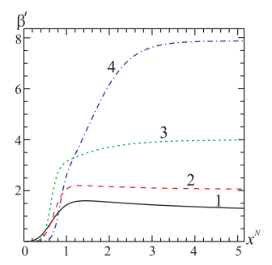

Figure 2.4 $-$ Behaviour of the function $β^{'}(x^{N})$ depending on different values of the parameter $δ$. For curves 1, 2, 3, 4, respectively, $δ=4, 6, 8, 10$, where $f(R)=-αR^{n}$: *n*= $\frac{3}{2}$, $\frac{5}{4}$, $\frac{7}{6}$, $\frac{9}{8}$; *N*=3; $α=1;γ=1$

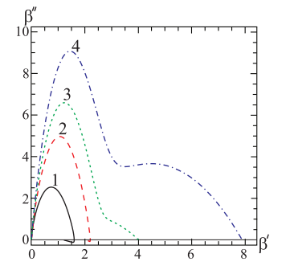

Figure 2.5 $-$ Phase portrait depending on different values of the parameter $δ$. For curves 1, 2, 3, 4, respectively, $δ=4,6,8,10$, where $f(R)=-αR^{n}$: *n*= $\frac{3}{2}$, $\frac{5}{4}$, $\frac{7}{6}$, $\frac{9}{8}$; *N*=3; $α=1;γ=1$

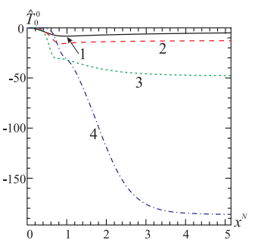

Figure 2.6 $-$ Effective energy density $T_{0}^{0}$ depending on different values of the parameter $δ$. For curves 1-4, respectively, $δ=4,6,8,10$; *n*= $\frac{3}{2}$, $\frac{5}{4}$, $\frac{7}{6}$, $\frac{9}{8}$; *N*=3; $α=1;γ=1$

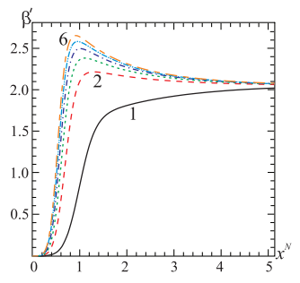

Figure 2.7 $-$ Behaviour of the function $β^{'}(x^{N})$ depending on different values of the parameter $δ$. For curves 1-6 respectively, $δ=0.1,1.08,2.06,3.04,4.02,5.0$; $n=\frac{5}{4}$; *N*=3; $α=1;γ=6$

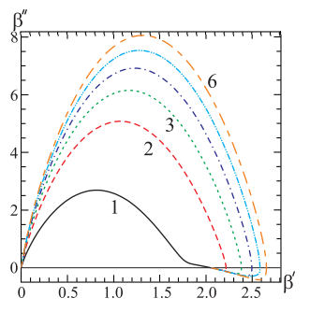

Figure 2.8 $-$ Phase portrait depending on different values of the parameter $δ$. For curves 1-6 respectively, $δ=0.1,1.08,2.06,3.04,4.02,5.0$; $n=\frac{5}{4}$;*N*=3, $α=1,γ=6$

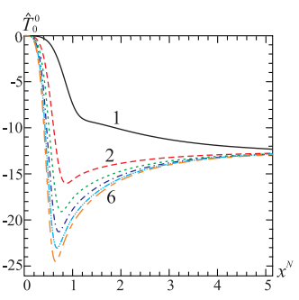

Figure 2.9 $-$ Effective energy density $T_{0}^{0}$ depending on different values of the parameter $δ$. For curves 1-6 respectively, $δ=0.1,1.08,2.06,3.04,4.02,5.0$; $n=\frac{5}{4}$; *N*=3, $α=1,γ=6$

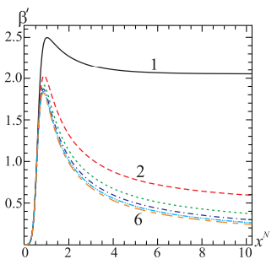

Figure 2.10 $-$ Behaviour of the function $β^{'}(x^{N})$ depending on different values of the parameter $α$. For curves 1-6 respectively, $α=1,2,3,4,5,6$; $n=\frac{5}{4}$; *N*=3, $δ=6,γ=1$

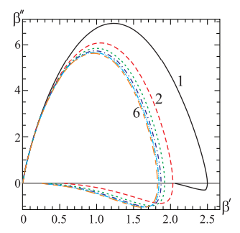

Figure 2.11 $-$ Phase portrait depending on different values of the parameter $α$. For curves 1-6 respectively, $α=1,2,3,4,5,6$; $n=\frac{5}{4}$; *N*=3, $δ=6,γ=1$

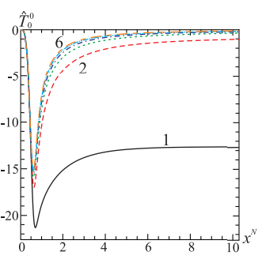

Figure 2.12 $-$ Effective energy density $T_{0}^{0}$ depending on different values of the parameter $α$.For curves 1-6 respectively, $α=1, 2, 3, 4, 5, 6$; $n=\frac{5}{4}$;*N*=3, $δ=6,γ=1$

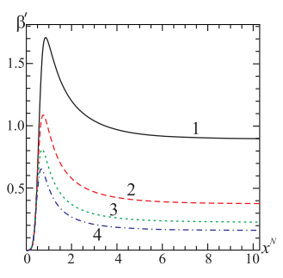

Figure 2.13 $-$ Behaviour of the function $β^{'}(x^{N})$ depending on different values of dimensions of space *N*=4,6,8,10 respectively, $α=1$; $n=\frac{5}{4}$; $δ=6,γ=1$

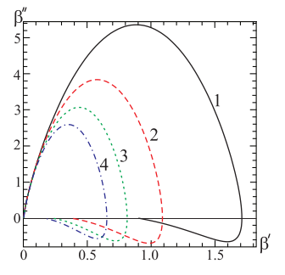

Figure 2.14 $-$ Phase portrait depending on different values of dimensions of space *N*=4, 6, 8,10 respectively, $α=1$; $n=\frac{5}{4}$; $δ=6, γ=1$

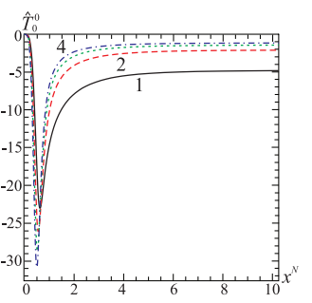

Figure 2.15 $-$ Effective energy density $T_{0}^{0}$ on different values of dimensions of space *N* =4, 6, 8, 10 respectively, $α=1$; $n=\frac{5}{4}$; $δ=6,γ=1$

In this part of the dissertationregular flat-symmetric solutions in multidimensional $f(R)=-αR^{n}$ theory of gravity. From a physical point of view, these solutions present a model of our Universe as a Brane with codim=1.

The properties of these branes depend on the following parameters: $γ$ and $δ$, describing the properties of the solution in the center of the brane, and parameters $α$ and $n$, describing a type of modified theory of gravity. To analyze the obtained solutions, phase portraits of the corresponding autonomous differential equations were constructed. The results show that brane solutions have AdS asymptotics. When increasing the parameters $α,n→∞$ solutions tend to a limit that is no longer dependent on the values of these parameters. It has been shown that the effective energy density $T_{0}^{0}$ is negative and its dependence on the parameter values $γ,δ,α,N$ was investigated. The obtained results are published in the following works [107-110].

## 3 MAGNETIC MONOPOLES

### 3.1 History of magnetic monopoles

This section is devoted to study the history of magnetic monopoles $(Ms)$. The magnetic monopoles has the unique distinction of being the first among hypotetical objects and constructions that despite their unsuccessful searches and experimental evidence, they have remained the focus of intensive attention of scientists. Theoretical physics has no analogy in the research history of existence of a magnetic monopole. In the process of studying their history, a strong connection with other current field researches in theoretical physics will be noticed: the problem of confinement in QCD, the problem of proton decay, evolution of the early Universe and many others. The main goal of this section is to show theoretical and experimental data of $Ms$ and their role in our comprehension of theoretical physics, both historically and today. Magnetism has a very long journey and most of this time perceived as something mysterious. Even nowadays, we still don’t quite understand one basic property of magnets: Why it is not possible to get a magnet with two poles (North and South)?

The first description of magnetism is related to Thales of Miletus, the Greek philosopher, who reported that the pieces of stone from Magnesia known as magnetic stone had weird properties. He also noticed that amber after being rubbed can attract feathers or hair and other light objects. Unlike amber, magnet do not need rubbing to obtain these properties, but when an iron needle was rubbed by a magnet, these properties were transferred to it. The magnet was also known in other countries, for example in China. While the Greeks thought the rocks were brought to the place of extraction, the noticed that a piece of magnet actually always pointed north or south. Chinese were first who guessed to use this effect of a magnet as a navigation instrument – a compass and after that in 1187 this invention came to Europe [111, 112].

Attempts to explain and understand these properties of magnets were based on purely philosophical speculation until 1269, when Petrus Peregrinus de Maricourt wrote a letter called *Epistola de magnete*, which describes the experiments that he conducted on magnets. He contributed to the discovery such properties of a magnet: a) a magnet has two opposite poles: north and south; b) introduced the term "pole" to describe them; c) when a magnet is cut into two halves, each half still has two opposite poles; d) two like poles repel each other.

In 1600, William Gilbert, English physician, published a book called *De Magnete,* in which he tried to build the first consistent theory of magnetism based on careful and systematic experimentation [113]. In particular, he was the first who realized that the needle orientation of the compass has been due to magnetism of the Earth. This book is considered as the beginning of the scientific study of magnetism.

It was widely believed that magnetism was caused by two oppositely charged magnetic fluids, which are composed of magnetic molecules or magnetic monopoles. This idea persisted until the 19-th century, until Andre-Marie Ampere, French physicist, showed that magnetic fields are created by electric currents and finally Michael Faraday, English scientist, demonstrated that magnetic fluids do not exist.

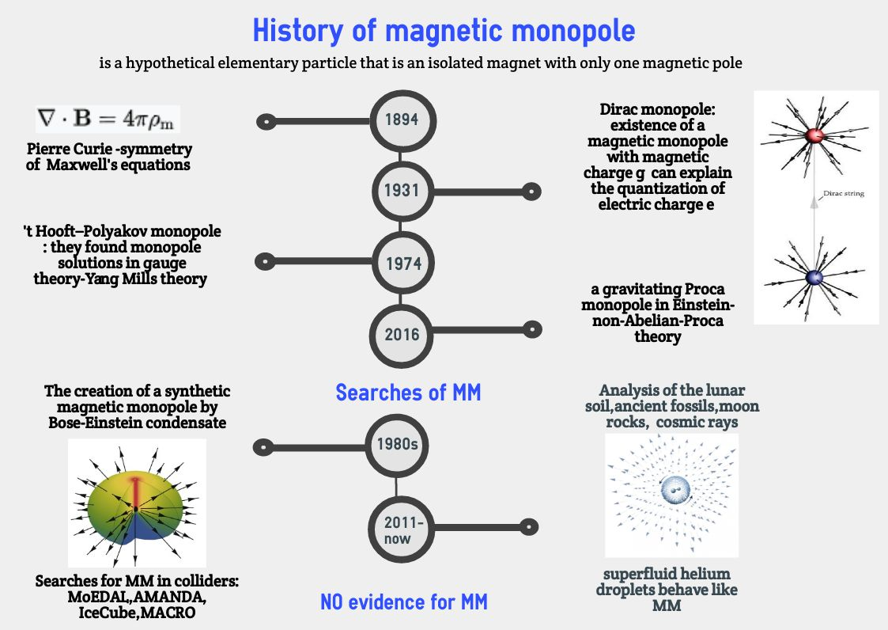The first poles that you probably knew were geographic poles of the Earth. Next, were the magnetic poles. There is geological evidence that the Earth’s magnetic poles have been reversed in the past. For all magnetic poles such as for Earth, a compass and a magnet it holds that that they always come in pairs. These pairs are called magnetic dipoles. But our research is devoted to another special and mystical object: magnetic monopoles $(Ms)$. Let’s have a look at the main historical points in the study of $Ms$ using the following illustration:

Figure 3.1 $-$ Historical background of a magnetic monopole

According to the above illustartion, a magnetic monopole is a hypothetical particle with a single magnetic charge, analogous to an electric charge. There is no way to get a separate south pole and a separate north pole-one get two half-size magnets, and each again has two poles (magnetic dipoles), oriented the same way as the original magnet. Magnetic fields (not only in permanent magnets, but, for example, in the Earth and the Sun, in other planets and stars) are generated not by magnetic charges, but by electric currents. In other words, there are no known magnetic monopoles in nature.

It is well-known that the Standard Model of elementary particles describes 61 particles (the Higgs boson became the last one to be discovered). However, theorists have been actively working on various extensions of the Standard Model, usually leading to the prediction of new particles that experimenters are trying to discover. They try to find such exotic particles as supersymmetric particles, magnetic monopoles, tachyons, axions, WIMP particles, which have non-standard properties and have not yet been discovered, but are included in various theoretical models. Sometimes these searches last for decades, as has happened with the magnetic monopole [114-120].

There are strong theoretical arguments why magnetic monopoles should exist, but in spite of extensive searches they have never been found. This fact underlines the amazing asymmetry between magnetism and electricity. In some dictionaries, symmetry considered as the critical source for beauty judgment. One cannot deny that the more symmetric the theory, the more beautiful it looks. According to the Biot-Savart law, magnetic fields are excited when electric charges move, and the first Faraday’s law of electromagnetic induction shows that the motion of magnets excites electric currents. However, carriers of electric charges can be separated - for example, electrons carry a negative charge and protons positive. With magnets, apparently, the situation is different.

Based on Faraday’s discoveries, James Clerk Maxwell developed his theory of electrodynamics, which have been published in 1864 [121]. This theory was a huge breakthrough in physics, because it not just combined magnetism and electricity in one theory, but also explained the properties of light as an electromagnetic wave traveling through space. In addition, the theory showed that the speed of light had to be constant, and therefore he also paved the way for the development of the theory of relativity.

Nothing in classical electrodynamics prohibits magnetic monopoles; in fact, they would make the theory more symmetric. The asymmetry of Maxwell’s equations with respect to magnetic and electrical phenomena is quite obvious, and the symmetry can be easily restored by introducing in addition to the observed electric charges and currents, hypothetical magnetic charges and magnetic currents. For the first time, Pierre Curie mentioned such a possibility in one of his notes in 1894 see Figure 3.1[122], but since no one had ever observed such charges and currents, then this suggestion was forgotten.

For reaching a new level in investigation of $Ms$, the creation of quantum mechanics helped. In 1931, Paul Dirac found a method of explaining one of the greatest mysteries of physics which relies on the fact of the existence of at least one magnetic monopole in the Universe. He was interested in the symmetry between electricity and magnetism and showed that the introduction of magnetic charges can elegantly solve the long-standing mystery of nature - the quantization of electric charge [123].

Dirac noticed that if there is only one magnetic monopole, it defines the smallest possible value for an electric charge. All observed charges must be integer multiples of this minimum value; in other words, charge must be quantized. The existence of a monopole would therefore explain the experimental observation that electric charge is quantized. So that, it would be necessary to modify the formulations of some theorems and equations describing the phenomena of magnetism, in particular Gauss’ theorem for the magnetic field.

Gauss’ law for magnetism in the differential form can be written as [114, p. 2]:

$∇⋅B=0,$ (3.1)

where $∇$ denotes the divergence, and ***B*** is the magnetic field.

According to Gauss’ law- one of the four Maxwell’s equations, the magnetic field **B** has a divergence equal to zero. In other words, that it is a solenoidal vector field. It is equivalent to the statement that magnetic monopoles do not exist. Let’s imagine a magnetic monopole isolated in space, surrounded by a closed surface of arbitrary configuration. At every point on the surface, there will be a magnetic field produced by a monopole. According to Gauss’s law, the total magnetic flux passing through such a closed surface should be zero, but if there is a magnetic monopole inside it, it will obviously be nonzero. That is, Gauss’ law does not allow the existence of $Ms$.

Let us suppose that $Ms$ will be discovered so that Gauss’ law for magnetism has to be rewritten. In the other words, this law would be proportional to the magnetic charge density $ρ_{m}$, analogous to Gauss’ law for electric field. This suggestion was proposed by Dirac and these particles are called Dirac monopoles [123].

The modification of Gauss’ theorem under the assumption that magnetic monopoles exist:

$∇⋅B=4πρ_{m},$ (3.2)

where $∇$ denotes the divergence, and ***B*** is the magnetic field, see Figure 3.2.

In 1974, independently Gerard ’t Hooft and Alexander Polyakov showed that magnetic monopoles are predicted by many particle physics models, especially by GUTs, which aim to describe electromagnetic, weak and strong interactions by a single unified theory [124, 125]. Additionally, in the following article [126] monopole solutions in non-Abelian Proca-Dirac-Higgs theory were studied. They have investigated a system consisting of a non-Abelian SU(2) Proca field interacting with nonlinear scalar (Higgs) and spinor fields. The first use of a Proca field was by Yukawa to describe pions. Proca theories are gauge theories-Abelian and non-Abelian ones, where the gauge invariance is broken by introducing a mass term. Proca theory has found applications in various fields of modern theoretical physics.

The use of a Proca field results in the following consequences: a photon may acquire a rest mass, Einstein-Proca gravity involves a graviton of nonzero rest mass. The scalar field is described by the Klein-Gordon equation spinor field is described by the Dirac equation.

Figure 3.2 $-$ Magnetic fields of a monopole

The results obtained in the article [126] describe a Proca monopole. For such a system, it has been shown that particlelike spherically symmetric solutions with finite energy do exist. The main reason why such solutions can exist is the presence of the mass of the non-Abelian Proca field, and also because of the structure of the Dirac equation leading to the existence of regular solutions of this equation. Additionally, energy spectra of a Proca monopole were studied. It has been shown that the energy spectrum has a minimum, one can say that there is a mass gap in non-Abelian Proca-Dirac-Higgs theory. If such a mass gap does exist, this would be of great significance. The reason is that in quantum field theory there is a problem to prove the existence of a mass gap in QCD.

Another interesting research presented in the article [127], where a gravitating Proca monopole in Einstein-non-Abelian-Proca theory has been studied.

In our research we show that not only in non-Abelian Proca theory, but also in Yang-Mills theory, there are monopole-like solutions and for obtaining them no need to introduced a Higgs field. It would be of special interest if we can prove that the energy spectrum of such monopole-like objects has a minimum.

The presence of a mass gap in particlelike solutions was firstly demonstrated in [128] within nonlinear Dirac theory. The corresponding mass gap was called «the lightest stable particles», because the term «mass gap» at that time was not yet known.

In the Figure 3.1 some important searches for $Ms$ can be traced. These searches for magnetic monopoles were conducted in 2 directions: in the first way scientists try to detect preexisting magnetic monopoles and in the second way they try to create and find new candidates for magnetic monopoles.

One of the important searches is the creation of a "virtual" analogue of the monopole generated by a Bose-Einstein condensate, which is a liquid of many atoms of rubidium, which behaves like one giant atom at ultralow temperatures and some other conditions. The scientists noticed that a Bose-Einstein condensate behaves unusually in the presence of an external magnetic field. They predicted that inside the condensate there is a so-called "Dirac string" - a hypothetical one-dimensional object, at the ends of which there must be monopoles. Physicists took advantage of this property of the Bose-Einstein condensate and tried to find "virtual" monopoles in it to study their properties .

Next, in the Figure 3.1 one can see that there were performed a huge number of experiments like the MoEDAL experiment which look for monopoles and other exotic objects at CERN’s Large Hadron Collider . It is supposed that the energy (mass) even one magnetic monopole is so large, so that magnetic monopoles are probably will not occur in accelerators.

If scientists manage to find them in nature or create them in the laboratory, then this discovery will confirm the assumption that the electric charges of all particles assume discrete values on which almost all modern physical theories are based. Therefore, it would be natural to assume that searches for magnetic monopoles ($Ms$) is a fascinating journey and finding them would be an incredible breakthrough for all modern physical theories.

Still we do not exactly know any theoretical reason why such hiding particles could not exist. Are we still missing an important piece of the puzzle of the theory? Or do magnetic monopoles exist and we just have not managed to discover them? In the next sections we will investigate all these fundamental aspects at a deeper level.

### 3.2 Monopoles in classical electrodynamics

It is well known that classical electromagnetism is perfectly described by Maxwell’s equations. If there are no any electric and magnetic charges they have following form [114, p.3]:

$∇⋅E=0,$ (3.3)

$∇⋅B=0,$ (3.4)

$∇×B-∂_{0}E=0,$ (3.5)

$∇×E+∂_{0}B=0,$ (3.6)

where $E$ and $B$ represent the electric and magnetic fields, respectively. In the equations (3.3)-(3.6) the symbol $∇⋅$ is the divergence of the vector field, and $∇×$ is the curl. A non-zero divergence would indicate that field lines are ending, whereas the curl characterize their curvature. Therefore, equations (3.3) and (3.4) show that neither electric nor magnetic field lines have initial or final points, in other words, they are closed. Equations (3.5) and (3.6) show that time-dependent magnetic fields generate electric fields, and conversely.

In the presence of any electric charges Maxwell’s equations take the form:

$∇⋅E=ρ,$ (3.7)

$∇⋅B=0,$ (3.8)

$∇×B-∂_{0}E=j,$ (3.9)

$∇×E+∂_{0}B=0,$ (3.10)

where $ρ$ and $j$ stand for electric charge and current densities.

Let us consider duality transformations which is a useful method for a transition from standard classical electromagnetism to the theory where magnetic charges (magnetic monopoles) exist.

These equations can be written in the covariant form with the help of the tensor of the electromagnetic field $F^{μν}$ [129]:

$∂_{ν}F^{μν}=-j^{μ},$ (3.11)

$∂_{ν}{\tilde{F}}^{μν}=0,$ (3.12)

where

$j^{μ}=\left(ρ,j\right),$ (3.13)

$F^{0i}=-E^{i},$ (3.14)

$F^{ij}=-ε^{ijk}B^{k}.$ (3.15)

The dual tensor is identified as:

${\tilde{F}}^{μν}=\frac{1}{2}ε^{μνρσ}F_{ρσ}.$ (3.16)

In vacuum, where $j_{μ}=0$, Maxwell equations (3.11) and (3.12) are symmetrical according to duality transformations:

$F^{μν}→{\tilde{F}}^{μν},{\tilde{F}}^{μν}→-F^{μν},$ (3.17)

which corresponds to the permutation of electricity and magnetism : $E→B$**, $B→-E$** . It means, if we replace the electric and magnetic fields the equations remain unchanged. This means that the electric and magnetic fields themselves behave exactly in the same way. The term $j_{μ}$ in (3.11) breaks this symmetry. So, let us introduce a magnetic current $k^{μ}=\left(σ,κ\right)$ on the right hand side of the equation (3.12), so that we obtain modified Maxwell equations:

$∂^{ν}F_{μν}=-j_{μ},$ (3.18)

$∂_{ν}{\tilde{F}}^{μν}=-k^{μ},$ (3.19)

where $(F,\tilde{F}),(E,B),(j,k)$ are «dual vectors». The introduction of $k^{μ}$ leads to the existence of magnetic monopoles. Let’s consider Maxwell’s equations with the presence of magnetic monopoles see Figure 3.3 [130].

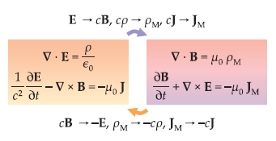

Figure 3.3 $-$ Maxwell’s equations with the presence of magnetic monopoles

On the right hand side of figure 3.3, terms on the right-hand sides of the equations arise due to magnetic monopoles. The arrows illustrate transformations that obey duality symmetry. There **E** and **B** are the electric and magnetic fields, respectively; $ε_{0}$ and $μ_{0}$ are the permittivity and permeability of vacuum; *c* is the speed of light; $ρ$ and $J$ are the electric charge and current densities; $ρ_{M}$ and $J_{M}$ are the magnetic charge and current densities.

It is well-known that electric charges exist, and lines of electric fields start and end at electric charges. More precisely, the electric field strength around the electric charge $q$ is[114, p.3]:

$\vec{E}\left(\vec{r}\right)=\frac{q}{4πr^{3}}\vec{r}.$ (3.20)

Lorentz force acting on the elecrtic charge moving in an electromagnetic field with velocity $\vec{υ}$ has the form:

$\vec{F}=q\left(\vec{E}+\vec{υ}×\vec{B}\right).$ (3.21)

If magnetic charges exist, then according to the duality, the magnetic field around a magnetic charge $g$ would be similar to the equation (3.20):

$\vec{B}\left(\vec{r}\right)=\frac{g}{4πr^{3}}\vec{r},$ (3.22)

Lorentz force acting on the magnetic charge $g$:

$\vec{F}=g\left(\vec{B}+\vec{υ}×\vec{E}\right).$ (3.23)

### 3.3 Dirac monopole

In the previous section it was mentioned that after developing quantum mechanics, quantization of electric charge was explained, which was like a mystery. In 1931 Paul Dirac showed that especially the existence of $Ms$ would shed light on this problem [119, 123].

He established that on the quantum level the existence of $Ms$ leads to the following condition [123, p.2]:

$qg=\frac{nℏc}{2}→g=ng_{D}=n\frac{ℏc}{2q}\sim n⋅\frac{137}{2}q,$ (3.24)

where *q* and $g$ represents electric and magnetic charge; *n* is an integer; $g_{D}=\frac{ℏc}{2q}$ is the unit Dirac charge. This is recognizable Dirac’s condition of quantization - which means that if monopoles exist there is quantization of electric charge. To be precise, possible values of the electric charge of any particle takes only integer multiples values of the elementary charge. Indeed, it is well-known that all particles have charges with integer multiples of the electric charge of the electron. The exceptions are quarks (have fractional charges) which not obey the quantization condition. So, the above quantization condition of the electric charge can be considered as evidence for the existence of $Ms$.

The quantization condition can be proven in the next way. We will consider the case when particles do not carry both charges, so it carries either electric or magnetic charges. Values of electric and magnetic charges can be expressed by $q_{i}$ and $g_{i},$ respectively. Dirac’s quantization condition considering the above assumption has the following form [129, p.2]:

$\frac{q_{i}g_{i}}{4π}=\frac{1}{2}n_{ij},$ (3.25)

where $n_{ij}$ is an integer number. So, assume that there is an elementary electrical charge $q_{0}$ and an elementary magnetic charge $g_{0}$:

$q_{i}=n_{i}q_{0},$ (3.26)

$g_{i}={n'}_{i}g_{0},$ (3.27)

$\frac{q_{0}g_{0}}{4π}=\frac{1}{2}n_{0},$ (3.28)

where $n_{i},{n'}_{i},n_{0}$ are integers. From the last equation one can see the interaction between two $Ms$:

$g_{0}^{2}\sim q_{0}^{2}\frac{n_{0}^{2}}{4}{\left(\frac{4π}{q_{0}^{2}}\right)}^{2}\sim {\left(\frac{n_{0}}{2α}\right)}^{2}q_{0}^{2}.$ (3.29)

### 3.4 Dirac’s string

By considering the motion of a particle in a given electromagnetic field it is possible to derive the Dirac’s quantization condition. General quantization of the electromagnetic field in the absence of $Ms$, the electromagnetic field strength $F_{μν}$ is expressed through the 4-vector potential $A_{μ}=(φ,\vec{A})$:

$F_{μν}=∂_{μ}A_{ν}-∂_{ν}A_{μ},$ (3.30)

or

$\vec{E}=-\frac{∂\vec{A}}{∂t}-\vec{∇}φ,$ (3.31)

$\vec{B}=\vec{∇}×\vec{A},$ (3.32)

and condition $∂_{μ}{\tilde{F}}^{μν}=0$ automatically satisfied. The Schrödinger equation describing the motion of a particle in the electromagnetic field takes the form:

$\left[\frac{1}{2m}(\vec{p}-e\vec{A})^{2}+eφ\right]ψ=i\frac{∂ψ}{∂t}.$ (3.33)

This equation is invariant under gauge transformations:

$\vec{A}(x)→\vec{A}(x)+\frac{1}{e}∇α(x),$ (3.34)

$ψ(x)→e^{iα(x)}ψ(x),$ (3.35)

where $α(x)$ is an arbitrary function. However, if $Ms$ exists, then the vector potential can’t exist in any space-time point. For solving this problem Dirac introduced the concept of a string. Let’s consider the magnetic field strength of a monopole, which has a form:

$B=\frac{g}{4πr^{2}}\hat{r}.$ (3.36)

For any closed surface enclosing the origin, one has:

$g=\oint_{s}{‍}|\vec{B}d\vec{S}|.$ (3.37)

Let’s consider the field created by an infinitely long and thin solenoid located along the negative axis $z$ whose positive pole (having a magnetic charge) is at the origin. The magnetic field strength has the form:

${\vec{B}}_{sol}=\frac{g}{4πr^{2}}\vec{\hat{r}}+gθ(-z)δ(x)δ(y)\vec{\hat{z}},$ (3.38)

Since the magnetic field strength given in (3.36) is not created by any sources ($\vec{∇}⋅{\vec{B}}_{sol}=0$), one can take:

${\vec{B}}_{sol}=\vec{∇}×\vec{A}.$ (3.39)

Then from the (3.42), (3.44), (3.45) expressions one can show that the magnetic field strength of a monopole is:

$\vec{B}=\frac{g^{2}}{4πr^{2}}\vec{\hat{r}}=\vec{∇}×\vec{A}-gθ(-z)δ(x)δ(y)\vec{\hat{z}},$ (3.40)

which is illustrated in the Figure 3.4. The line along which the solenoid is located is called Dirac’s string.

Figure 3.4 $-$ Dirac’s string

The 4- vector potential $A_{μ}$ created by solenoid is:

$\vec{A}=\frac{g}{4πr}\left(\frac{1-cosθ}{sinθ}\right)\vec{\hat{ϕ}}.$ (3.41)

In fact, in quantum theory the problem of the existence of $Ms$ is much more complex than in others, but still interesting. This is due to the fact that in quantum mechanics, electromagnetic forces are described by scalar and vector potentials $φ$ and $\vec{A}$, instead of electric and magnetic strength fields $\vec{E}$ and $\vec{B}$:

$\vec{E}=-\frac{∂\vec{A}}{∂t}-\vec{∇}φ,$ (3.42)

$\vec{B}=\vec{∇}×\vec{A}.$ (3.43)

In this representation scalar and vector potentials do not satisfy to the duality symmetry between $\vec{E}$ and $\vec{B}$. In fact, there are an infinite number of potentials that can create the same electric and magnetic fields, so that they remain unchanged by changing $φ$ and $\vec{A}$ by:

$φ→φ-\frac{∂λ}{∂t},\vec{A}→\vec{A}+\vec{∇}λ,$ (3.44)

where $λ$ is any function. This equation is known as a gauge transformation. Physical quantities will not change under gauge transformations, so that such a kind of theory is a gauge symmetry theory. Maxwell equations have gauge symmetry which is mathematically denoted as U(1).

However, these potentials arise to forbid magnetic charges. This fact is taken from the vector analysis that the divergence of the curl of a vector field always vanishes:

$\vec{∇}⋅\vec{B}=\vec{∇}⋅\left(\vec{∇}×\vec{A}\right)=0.$ (3.45)

Therefore, if the magnetic field is described by (3.49), then its magnetic field lines could never have end points. This leads to the conclusion that a vector potential cannot describe $Ms$. So, because the vector potential cannot describe $Ms$, does this mean that quantum mechanics prohibits the existence of magnetic charges? Paul Dirac showed that it does not. He was able to search for a vector potential that will describe $Ms$. He made it with the same method like Faraday had constructed magnetic monopole 110 years earlier in his experiments.

Let us consider a long and thin solenoid, see Figure 3.5. When an electric current moves through this solenoid, it creates a magnetic field inside it. Because the field lines cannot end, this field spreads out in all directions from the end of the solenoid. This phenomena can be described in terms of the magnetic flux $Φ$, which is the magnetic field integrated over a cross-sectional surface,

$Φ=\int{‍}d\vec{S}⋅\vec{B}.$ (3.46)

If one takes the condition that the length of the solenoid is much greater than its width, the shape of the magnetic field around the end of the solenoid looks precisely like in a magnetic monopole with magnetic charge $g$, so $g=Φ$.

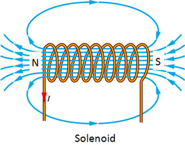

Figure 3.5 $-$ Magnetic field created by a solenoid

Mathematically, one can imagine it by making the solenoid infinitesimally thin and long, so that the other endpoint is infinitely far away, then forget about the solenoid itself and only keep the vector potential, which can be written as:

$\vec{A}(\vec{r})=\frac{g(\vec{r}×\hat{k})}{4π|\vec{r}|(|\vec{r}|-\vec{r}⋅\hat{k})},$ (3.47)

where $\hat{k}$ is a unit vector pointing in the direction of the solenoid. This equation describes a magnetic monopole connected to an infinitesimally thin line carrying $Φ$ to it. Such a system is called a Dirac string.

If we consider a Dirac string placed between two slits, the complex phase difference between the two slits $Δθ$ is:

$Δθ=q\oint_{c}{‍}\vec{r}⋅\vec{A}=q\int{‍}d\vec{S}⋅\vec{B}=q⋅Φ=q⋅g.$ (3.48)

It is important to realise that the complex phase is only defined modulo $2π$. Two complex numbers whose phases differ by an integer multiple of $2π$ are equal. Therefore, the Dirac string is only observable if the phase difference $Δθ$ is not an integer multiple of $2π$.

To conclude, according to Dirac’s monopole which is illustrated in Figure 3.6, any magnetic north pole is attached to a magnetic south pole by using a concept of a Dirac’s string-a line of singularity, a string, which carries magnetic flux and preserves the continuity of the magnetic field lines. If the magnetic charge of the monopoles satisfies the Dirac’s quantization condition, the Dirac string is unobservable and does not affect the motion or behavior of the monopoles which it connects.

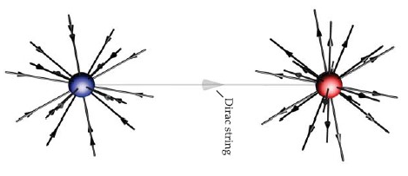

Figure 3.6 $-$ Dirac’s monopole

### 3.5 Solitons in field theory

In order to discuss a monopole in non-Abelian gauge theory in Section 4, let us first consider the classical field theory with finite-energy solutions, which are called solitons. As an example, consider the theory $λϕ^{4}$ in one spatial and one time dimensions. The Lagrangian of this theory has the form [129]:

$L=\int{‍}\left[\frac{1}{2}(∂_{0}ϕ)^{2}-\frac{1}{2}(∂_{x}ϕ)^{2}-V(ϕ)\right]dx,$ (3.49)

where

$V(ϕ)=\frac{λ}{2}(ϕ^{2}-a^{2})^{2},a^{2}=\frac{μ^{2}}{λ}.$ (3.50)

The corresponding Hamiltonian is given by the formula:

$H=\int{‍}\left[\frac{1}{2}(∂_{0}ϕ)^{2}+\frac{1}{2}(∂_{x}ϕ)^{2}+V(ϕ)\right]dx,$ (3.51)

when $μ^{2}>0$, the classical configuration corresponding to the ground state has the form:

$ϕ=±a=±\sqrt{\frac{μ^{2}}{λ}},$ (3.52)

and the energy of the ground state $E=0$. An interesting feature of this model is that it contains static (time-independent) solutions of the equations of motion with finite energy (solitons). Time-independent solutions of the equations of motion can be obtained from the Lagrangian $L$ using the variational principle:

$-δL=δ\int{‍}dx\left[\frac{1}{2}(∂_{x}ϕ)^{2}-V(ϕ)\right]=0.$ (3.53)

From a mathematical point of view, such a problem is equivalent to the problem of the motion of a particle of unit mass in the potential field $V(x)$; the equation of motion in this case is derived from the relation:

$-δ\int{‍}dtL'=δ\int{‍}dx\left[\frac{1}{2}(\frac{dx}{dt})^{2}-V(x)\right]=0.$ (3.54)

Any motion of a particle in the field of the potential $-V(x)$ corresponds to a time-independent solution of the field equation. Nevertheless, not all of these solution of the field equation with finite energy . The condition in order to obtain a solution with finite energy is that the field $ϕ$ tends to a zero of the function $V(ϕ)$ as $x→±∞$ so the energy integral (3.57) is finite.

It follows from the condition that the energy is finite when the solution at $t→±∞$ takes vacuum values $(±a$). For example, there are motions of a particle that starts from the top of one hump and moves to the top of another, having zero energy, see Figure 3.7 [129].

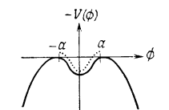

Figure 3.7 $-$ Motion of a particle in the field of the potential $-V(x)$ [129, p. 3]

The law of energy conservation for the particle motion with zero energy, one has:

$\frac{1}{2}\left({\frac{dx}{dt}}^{2}+[-V(x)]\right)=0,$ (3.55)

this related to the equation:

$\frac{1}{2}\left({\frac{dϕ}{dx}}^{2}\right)=V\left(ϕ\right),$ (3.56)

in the case of field theory. One can solve Equation (3.62) by integrating, and the result has the form:

$x=±\int_{ϕ_{0}}^{ϕ}{‍}dϕ'[2V(ϕ')]^{-1/2},$ (3.57)

where $ϕ_{0}$ is the value of $ϕ$ at the point $x=0$; it can be any number in the range of $a$ and $-a$. The potential which is given by formula (3.56), in the case of the $λϕ^{4}$ theory and the solutions with finite energy following from (3.67) can be expressed in the form:

$ϕ_{+}(x)=ath(μx),$ (3.58)

$ϕ_{-}(x)=-ath(μx).$ (3.59)

The solution $ϕ_{+}$ is usually called a kink, and $ϕ_{-}$ is called an antikink. The energy of a kink (antikink) can be calculated from (3.58), (3.59), (3.56) and equals to:

$E=4\frac{μ^{3}}{3λ}$ (3.60)

and really is finite. It is clear that as $x→±∞$ the solution $ϕ_{+}$ (or $ϕ_{-}$) approaches a zero of the function $V(ϕ)$, i.e.

$ϕ_{+}(x)→±a,x→±∞.$ (3.61)

This behaviour is shown in Figure 3.8.

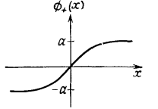

Figure 3.8 $-$ The solution $ϕ_{+}$ (or $ϕ_{-}$) [129, p. 4]

The topological properties of a kink (antikink) in the theory $λϕ^{4}$ in two-dimensional space-time can be studied by proceeding as follows. From the requirement that the energy be finite, we have at spatial infinities:

$ϕ(∞)-ϕ(-∞)=n(2a),$ (3.62)

where *n*=0 corresponds to the ground state, *n* = 1 is a kink, and *n* = -1 - antikink. The ratio (3.68) can be written as:

$\int_{-∞}^{∞}{‍}(∂_{x}ϕ)dx=n(2a).$ (3.63)

Thus, if we define the current as:

$J_{μ}(x)=ε_{μν}∂^{ν}ϕ(x),$ (3.64)

then it will be automatically conserved, since $ε_{μν}$ is the antisymmetric tensor. The corresponding conserved charge exactly coincides with the expression:

$Q=\int_{-∞}^{∞}{‍}J_{0}(x)dx=\int_{-∞}^{∞}{‍}∂_{x}ϕdx=n(2a).$ (3.65)

It follows that the kink number *n* in (3.65) is a conserved quantum number. Thus, the transitions between kinks (antikinks) and ground states are impossible, i.e., kinks (antikinks) are stable. This conservation law, usually called the topological conservation law.

Thus, the topological conservation law (3.65) splits the entire set of solutions with finite energy into separate sectors: *n = 0* (vacuum), *n = 1* (kink), *n = -1* (antikink), etc. In the theory $λϕ^{4}$, the set of minima of the potential, given by formula (3.65), also consists of two discrete points $±a$; we’ll call it $M_{0}$:

$M_{0}=ϕ:V(ϕ)=0.$ (3.66)

The condition for the finiteness of the energy of the solution to the equation of motion leads to the fact that the asymptotic values of $ϕ(x)$ must coincide with a zero of the function $V(ϕ)$:

$lim_{x→±∞}ϕ(x)=ϕ∈M_{0}.$ (3.67)

This condition can be viewed as a mapping from the set S to the set $M_{0}$. For example, in the case of a ground state configuration, both points $±∞$ are mapped to the point $a$ (or - $a$), and in the case of a kink configuration $ϕ_{+}$, the mapping $+∞$ to $a$ and $-∞$ to $-a$ occurs.

### 3.6 ’t Hooft-Polyakov monopoles

In the previous section $Ms$ in classical electromagnetism were discussed. There is also was shown that the existence of $Ms$ can explain the quantization of electric charge - Dirac’s quantization condition. This section is devoted to more the complicated theory of SU(3) Yang Mills theory coupled to a Higgs field, which is referred to as ’t Hooft-Polyakov monopole [124, 125].

#### 3.6.1 Soliton solutions in SO(3)-model

In the gauge theory with scalar fields one can find topologically non-trivial solutions with finite energy. So, in this section we study ’t Hooft-Polyakov monopole. In 1974 Gerard ’t Hooft and Alexander Polyakov found so called "hedgehog" solutions for quantum field theories. According to them, these solutions describe "lumps" of fields with finite, nonzero size, which acquire a magnetic charge. If the lumps are small they can be considered as point-like $Ms$, see Figure 3.9.

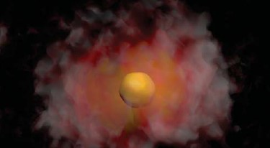

Figure 3.9 – ’t Hooft-Polyakov monopole surrounded by a quantum field cloud, simulated using lattice field theory

In this theory a monopole arises as a topologically non-trivial solution with finite energy. A good example of a non-abelian theory with $Ms$ is the SO(3) Georgi-Glashow model, which can be considered as a simplified version of the Weinberg-Salam electroweak theory with spontaneous symmetry breaking due to the Higgs mechanism. This model is based on the gauge group SO(2) with a triplet of Higgs fields $ϕ$. This theory is described by the following Higgs-Yang-Mills Lagrangian:

$L=-\frac{1}{4}F_{a}^{μν}F_{aμν}+\frac{1}{2}(D^{μ}ϕ)(D_{μ}ϕ)-V(ϕ),$ (3.68)

$F_{μν}^{a}=∂_{μ}A_{ν}^{a}-∂_{ν}A_{μ}^{a}-eε^{abc}A_{μ}^{b}A_{ν}^{c},$ (3.69)

$(D_{μ}ϕ)^{a}=∂_{μ}ϕ^{a}-eε^{abc}A_{μ}^{b}ϕ^{c},$ (3.70)

$V(ϕ)=\frac{λ}{4}(ϕ∙ϕ-a^{2})^{2}.$ (3.71)

Equations of motion take the following forms:

$(D_{ν}F^{μν})_{a}=-eε_{abc}ϕ_{b}(D^{μ}ϕ)_{c},$ (3.72)

$(D^{μ}D_{μ}ϕ)_{a}=-λϕ_{a}(ϕ∙ϕ-a^{2}),$ (3.73)

In this model the set of values $ϕ$, which is minimizing the potential energy $V(ϕ)$ is defined as:

$M_{0}=\left\{ϕ=η;η^{2}=a^{2}\right\}.$ (3.74)

Lets take the vector $ϕ$ as:

$ϕ=(0,0,a).$ (3.75)

Electrical and magnetic fields are defined as:

$F_{3}^{oi}=E^{i},F_{3}^{ij}=ε^{ijk}B^{k}.$ (3.76)

For obtaining solutions with finite energy let’s require that for $r→∞,ϕ(r)$ tends the the some value from $M_{0}$. By mapping each point $S^{2}$ into the corresponding point of 2-sphere $S^{2}$ from $M_{0}$, configurations with non-trivial topology will be obtained:

$ϕ_{i}^{∞}=η_{i}=a{\hat{r}}_{i}.$ (3.77)

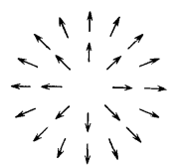

Figure 3.10 $-$ $ϕ$ field configuration for a monopole

By considering this configuration the *Ans $\ddot{a}$ tz* will be chosen in the form of:

$ϕ_{b}=\frac{r^{b}}{er^{2}}H(aer),$ (3.78)

$A_{b}^{i}=-ε_{bij}\frac{r_{j}}{er^{2}}[1-K(aer)],$ (3.79)

$A_{b}^{0}=0,$ (3.80)

where *H* and *K* are dimensionless functions, which have to be obtained from the equation of motion. According to the *Ans $\ddot{a}$ tz* the energy of the system has the following form:

$E=\frac{4πa}{e}\int_{0}^{∞}{‍}\frac{dξ}{ξ^{2}}[ξ^{2}(\frac{dK}{dξ})^{2}+\frac{1}{2}(ξ\frac{dH}{dξ}-H)^{2}+\frac{1}{2}(K^{2}-1)^{2}+K^{2}H^{2}+\frac{λ}{4e^{2}}(H^{2}-ξ^{2})^{2}],$ (3.81)

where $ξ=aer$. The condition of stationarity of the energy *E* under variation fields for *H* and *K* the equations:

$ξ^{2}\frac{d^{2}K}{dξ^{2}}=KH^{2}+K(K^{2}-1),$ (3.82)

$ξ^{2}\frac{d^{2}H}{dξ^{2}}=2K^{2}H+\frac{λ}{e^{2}}H(H^{2}-ξ^{2}).$ (3.83)

These equations of motion for *H* and *K* can also be obtained by substituting *Ans $\ddot{a}$ tz* (3.84)-(3.86) into the equations of motion (3.78 ), (3.79). From the asymptotic condition (3.83) follows:

$H(ξ)\sim ξ,ξ→∞.$ (3.84)

To ensure the convergence of the integral in (3.87), we require fulfillment of the following conditions:

$K(ξ)→0,ξ→∞,$ (3.85)

and

$H≤O(ξ),K(ξ)-1≤O(ξ),ξ→0.$ (3.86)

It turns out that solutions of the equations (3.88), (3.89) with boundary conditions (3.90) – (3.92) do exist, and the functions *H* and *K* behave as shown in Figure 3.11.

The total energy of this solution, which we will interpret as the classical mass, can be obtained from (3.87):

$mass=\frac{4πa}{e}f(\frac{λ}{e^{2}}),$ (3.87)

where $f(\frac{λ}{e^{2}})$ value of the integral in (3.87), found numerically which turned out to be of the order of unity in a wide range of values $\frac{λ}{e^{2}}$.

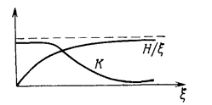

Figure 3.11 $-$ Behaviour of the functions *H* and *K*

#### 3.6.2 ’t Hooft - Polyakov’s soliton as a magnetic monopole

From the asymptotic condition (3.58) –(3.60) it is seen that at large distances:

$F_{a}^{ij}\sim \frac{1}{er^{4}}ε^{ijk}r_{a}r_{k}\sim \frac{1}{aer^{3}}ε^{ijk}r^{k}ϕ_{a},$ (3.88)

the magnetic field at large distances:

$\vec{B}\sim \frac{-1}{c}\frac{\vec{r}}{r^{3}}.$ (3.89)

Comparing this equation with $\vec{B}=\frac{g}{4πr^{2}}\vec{\hat{r}}$, one see, that this field is the field of a monopole which has a magnetic charge:

$g=-\frac{4π}{e}.$ (3.90)

The constant *e* in (3.96) is the electromagnetic coupling constant, which in this simple model is related to the operator of electric charge as follows:

$Q=eT_{3},$ (3.91)

where $T_{3}$- is the third component of the weak isospin operators, which are generators of the SO(3) gauge symmetry. Since the smallest possible nonzero electric charge that can appear in the theory is $q_{0}=e/2$, which corresponds to $T_{3}=1/2$, then from (3.96) it follows:

$\frac{q_{0}g}{4π}=\frac{-1}{2}.$ (3.92)

Thus, comparing with Dirac’s quantization condition, we see that the magnetic charge $g$ of the found monopole takes the smallest value. This classical topologically nontrivial solution with finite energy is called the ’t Hooft - Polyakov monopole.

The considered ’t Hooft - Polyakov monopole differs from the Dirac monopole in two important aspects: the ’t Hooft monopole -Polyakov has a finite core, while the Dirac monopole is a point object, and there is no need to introduce a Dirac string for the ’t Hooft - Polyakov monopole. The final size of the core of the ’t Hooft - Polyakov monopole comes from the fact that, for large $ξ$, the equations (3.88) and (3.89) take the form:

$\frac{d^{2}K}{dξ^{2}}=K,\frac{d^{2}h}{dξ^{2}}-\frac{2λ}{e^{2}}h=0,$ (3.93)

where $H=h+ξ$. Thus, for large $ξ$ we have:

$K\sim e^{-ξ}≈e^{-Mr},$ (3.94)

$H-ξ\sim e^{-μξ/M}≈e^{-μr},$ (3.95)

where $μ=(2λ)^{1/2}a$ and $M≈ea$ are the scalar and gauge boson masses, respectively. Hence it follows that the approach to the asymptotics of each field is controlled by the masses of the corresponding particles. Therefore, we can assume that the ’t Hooft - Polyakov monopole has a certain size, determined by its mass.

At distances less than this size, the role of massive fields is reduced to providing a smooth structure, and at distances greater than the size of the monopole, they rapidly decrease, leading to field configurations indistinguishable from the Dirac monopole. We divide the contribution to the energy in (3.87) into two parts corresponding to the values of the fields inside and outside the core monopole respectively. Outside the core $D_{μ}ϕ=0$ and the electric field $E=0$.

The magnetic field remains:

$\int{‍}d^{3}x\frac{1}{2}B^{2}=\frac{1}{2}(\frac{g}{4π})^{2}\int_{1/M}^{∞}{‍}4πr^{2}dr\frac{1}{r^{4}}=\frac{1}{2}\frac{4π}{e^{2}}M.$ (3.96)

Thus, the monopole is heavy, since it has a small core, and the Coulomb magnetic energy becomes infinite at $r→0$. As for the Dirac string in the case of the ’t Hooft Polyakov monopole , then it is replaced by a scalar field. To see this, we write the asymptotic solutions in the form:

$A_{a}^{i}=ε^{aij}\frac{r_{j}}{er^{2}},ϕ_{b}=\frac{ar_{b}}{r}.$ (3.97)

Field $A_{a}^{i}$ in (3.103) can be represented as:

$A_{a}^{i}=\frac{1}{a^{2}e}ε^{abc}ϕ^{b}∂^{i}ϕ^{c},$ (3.98)

and the tensor of the magnetic field at large distances then has the form:

$F_{3}^{ij}=∂^{i}A_{3}^{j}-∂^{j}A_{3}^{i}-e(A_{1}^{i}A_{2}^{j}-A_{2}^{j}A_{1}^{i})=∂^{i}A_{3}^{j}-∂^{j}A_{3}^{i}+\frac{1}{ea^{3}}ϕ(∂^{i}ϕ×∂^{j}ϕ).$ (3.99)

Thus, the magnetic field tensor is determined by the formula:

$F^{ij}=∂^{i}A^{j}-∂^{j}A^{i}+additional term.$ (3.100)

By comparing the Dirac monopole and ’t Hooft - Polyakov monopole, the additional term is singular for Dirac monopole and has a Dirac string, while for the ’t Hooft - Polyakov monopole, the additional term is a smooth function and includes scalar fields. To conclude, one can say that in the SO(3) -model, where the non-Abelian symmetry is spontaneously broken to the electromagnetic U(1)-symmetry, there exists a topologically nontrivial solution with finite energy – the ’t Hooft - Polyakov monopole with the following features:

1. It behaves in the same way as Dirac’s monopole at large distances.

2. It has a finite core, the size of which is determined by the masses of the gauge boson or scalar particle.

3. The classical mass of the monopole is of the order of the scale of spontaneous symmetry breaking, i.e, the vacuum scalar field.

4. There is no need to introduce the Dirac string.

### 3.7 Monopole searches

This section is devoted to the diversity of theories and approaches which were made in relation to magnetic monopoles. More precisely, different theories make very different predictions, and even within the same approach, the properties of monopoles can vary greatly.

In the 1930s, the famous theorist Paul Dirac predicted the existence of unique particles with only one magnetic pole - magnetic monopoles. Since then, scientists around the world have tried to detect these particles in nature. Therefore, intensive searches for magnetic monopoles have been carried out since the early 1980s.

#### 3.7.1 Early searches for $Ms$.

In the previous section we have shown that Paul Dirac in 1931, made a connection of isolated poles and the quantization of electric charge, which was the first strong scientific motivation for searches of magnetic monopoles. He inspired scientists for conducting a large variety of imaginative experiments.

Another interesting point is that $Ms$ compared to another particles are supposed to be absolutely stable. Take the Higgs boson as an example, which has a lifetime $10^{-22}s.$, whereas $Ms$ can be destroyed only with other $Ms$ of opposite charge, where would be annihilation processes with the production of a burst of elementary particles and radiation. Such a scenario means that if $Ms$ are stable particles, which were produces in the early Universe, then they would still exist.

A hundred years before Dirac’s prediction of the monopole, another scientist, Michael Faraday, discovered the phenomenon of electromagnetic induction: a changing magnetic field creates an electric current in a circuit. This phenomenon was another interesting way to find monopoles. When a monopole carrying a Dirac magnetic charge flies through a superconducting ring, the current in the ring changes so that the magnetic flux through the ring changes by exactly two quanta of magnetic flux. This is how scientific groups have been looking for monopoles for a long time.

In the first of such experiments, which collected data over five months, a current jump occurred, very similar to the desired event of a monopole passing through the coil. This incident, called the "Cabrera event" (by the name of the experimenter who noticed it-Blas Cabrera of Stanford University), occurred in 1982 [131]. It has never been explained. Later and much more sensitive experiments did not find anything like this. In experimental physics, a single observation does not give the right to announce a discovery. Only multiple confirmations of the effect, preferably in different laboratories, would make it possible to speak of the evidence-based detection of the desired particle. It is now believed that this mysterious event was caused by some unaccounted for external influences on the detector.

There is another interesting research which studies the GUT’ monopoles. In 1974 it was realized [132-133] that the electric charge is naturally quantized in GUTs of the strong and electroweak interactions. $Ms$ appear at the phase transition corresponding to the spontaneous breaking of the unifed group into subgroups, one of which is U(1), which describes electromagnetism. In Figure 3.12 is illustrated [134]:

a) the GUT monopole configuration, where the different zones related to the following:

1) corresponds to Grand Unification zone, which contains virtual X bosons.

2) corresponds to the electroweak unification zone, which contains virtual $W^{±}$ and $Z^{0}$ bosons.

3) corresponds to the confinement zone, which contains virtual photons, gluons, a fermion-antifermion condensate and four-fermion bags.

4) For radii greather than a few femtometers, there is a field of a magnetic charge $B=g/r^{2}$.

b) The monopole catalysis of proton decay due to the reaction $p+M→M+e^{+}+π^{0}$.

c) The effect of the presence of a four-fermion condensate, $\overline{u}ude^{+}$ can stimulate proton decay.

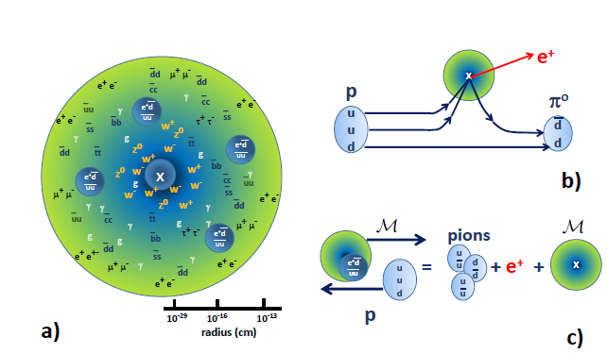

Figure 3.12 $-$ The GUT monopole configuration [134, p.3]

It is estimated that the mass of GUT’s monopoles is very high, approximately $10^{17}GeV/c^{2}$, which is much more massive than a proton - $1GeV/c^{2}$. Such a heavy mass of a monopole makes it difficult to find them in experiments. So, the LHC provides a maximum collision energy ($\sim 10^{4}GeV$), which is not enough for searching such a massive monopoles. The creation of such particles requires enormous energies, and they could appear only in the first moments of the life of the Universe [135].

One of the important components of modern cosmological scenarios is the inflation model. Its main idea is that in the earliest stages, the Universe experienced a period of accelerating expansion. One of the reasons for creating this scenario was the so-called monopole problem [136]. This problem was a key motivation for the creation of a theory of cosmological inflation. The fact is that the early Universe was so hot that very massive particles, including monopoles, could easily arise in it. But by the early 1980s, it was already clear from experiments that monopoles are very rare, and it was necessary to come up with some kind of mechanism leading to the almost complete disappearance of such relict particles. The idea is extremely simple. To make the density of particles small, it is necessary to sharply increase the volume of particles they occupy, while the number of particles remains the same. Inflation is a perfect explanation for this.

Thus, the so-called cosmic monopoles are related to the Big Bang theory as topological defects arising when the Universe expanded and cooled. But then they could survive to this day, and we can hope to register such objects from space.

There are large-scale magnetic fields in our Galaxy. A magnetic charge that has flown into such a field will take energy from it, accelerating to high speeds. If there are many monopoles, they will simply "eat up" the magnetic field of the Galaxy. However, in reality one can see that the magnetic field of the Galaxy is not significantly disturbed. The existence of a galactic magnetic field makes it possible to place an upper limit on the total number of such particles so this limitation is called the Parker limit or bound, named after the astrophysicist Eugene Parker [137]. In Figure 3.13 [130] illustrated is the strength of the present galactic magnetic fields, the upper limit on the monopole flux $F$ through a unit area. $F$ is the number density $n$ of monopoles: $F=\frac{nυ}{4π}$, where $υ$ is the monopole velocity.

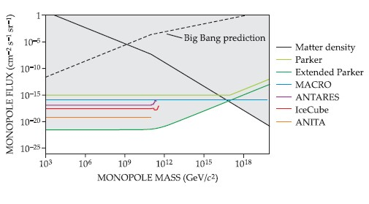

Figure 3.13 $-$ Upper bounds on the cosmic monopole flux [130, p.5]

In Figure 3.13 with other coloured lines upper bounds on the monopole flux from the MARCO, ANITA, ANTARES, IceCube experiments are presented.

The classical Dirac monopole has no electric charge. However, in some models, monopoles, in addition to magnetic, also have an electric charge. Such particles, dyons, were invented by the American theoretical physicist Julian Schwinger . They are exotic, but they are also been looked for. Or maybe ordinary particles have a magnetic charge, but a very small are? This assumption was also checked, and, for example, no traces of a magnetic charge were found on the electron.

The next searches were carried out both in the analysis of the lunar soil, and in the study of ancient fossils. One of the first scientific experiments with moon rocks was to search for a concentration of magnetic monopoles by Alvarez [138].

A moving magnetic charge induces a circular electric field around itself, interacting with the surrounding electric charges. In particular, it can remove electrons from their orbits in atoms. This means that the entire group of ionization methods developed for the detection of electrically charged particles can be used to detect monopoles - gas, scintillation, semiconductor, spark [139-141].

Dirac monopoles have a large charge, therefore they cause very high ionization in matter, and, in contrast to electrically charged particles, the ionization of matter by monopoles is almost independent of velocity in a wide range of energies. In addition to ionization by an electric field, a magnetic monopole is capable of causing a specific magnetic ionization effect in atoms, which is not observed for electrically charged particles. The huge charge of monopoles makes it possible to search for them by Cherenkov radiation - the light emitted by a particle in a transparent medium (in water, ice, etc.) when the particle’s speed is higher than the speed of light in this medium [141]. A relativistic monopole emits almost 7000 times more Cherenkov light than an ordinary electrically charged particle moving at the same speed. Such events were looked for using the NT200 neutrino telescope (consisting of photomultipliers submerged under the ice of Lake Baikal) and in the AMANDA experiment, which worked in the Antarctic ice at the South Pole [142-143]. All these experiments were unsuccessful.

#### 3.7.2 $Ms$ in spin ice

Let’s consider the next interesting approach in searching for $Ms$. Despite the fact that such particles have not yet been found in nature, physicists were able to observe objects in some substances that behave like magnetic monopoles. Let’s take spin ice as an example. Spin ice is a substance in which the magnetic moments of atoms are organized in the same way as protons are organized in ordinary ice. At temperatures close to absolute zero, the spins of atoms line up in such a way that some of them “look” into the cell of the crystal lattice, and some look out. As a result, a quasi-particle is formed in the spin ice, resembling a magnetic charge, not tied to a specific physical carrier. In other words, in spin ice there are collective states of electrons that behave like magnetic monopoles — separate magnetic charges, see Figure 3.14 [118].

So, in spin ice, collective electron formations with special magnetic properties can exist. They can move around the crystal, interact with a magnetic field, are attracted to each other - in general, they can behave like magnetic monopoles. If we have a pair of opposite monopoles in a crystal, then due to attraction they will begin to get closer, and when they find themselves near, they - it seems- should annihilate.

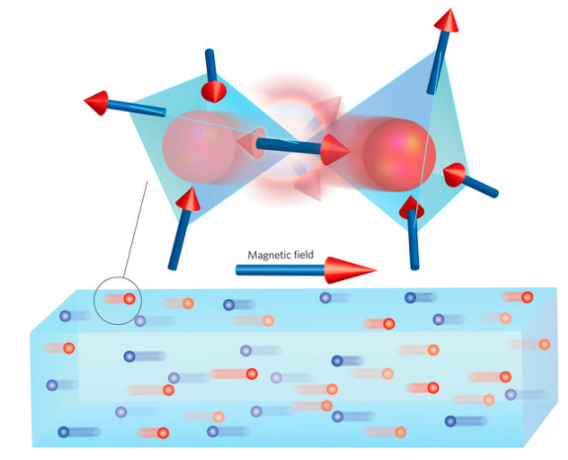

Figure 3.14 – Monopole in spin ice. Under the action of an external magnetic field, such monopoles will move to opposite ends of the sample, forming a magnetic current (below). At the level of individual crystal cells, such motion is obtained by jumping the monopole from one site to another, caused by an electron spin flip (above). [118]

This would be a completely natural phenomenon, which resembles the mutual elimination of opposite electric charges - for example, the annihilation of an electron and a positron, or the "contraction" of electrons and holes in semiconductors.

But this is where the analogy between magnetic monopoles and electric charges does not work. It turns out that magnetic monopoles of opposite signs are not always easy to eliminate. They can be very close, within walking distance from each other, but at the same time, for some reason, they may not want to annihilate.

Let’s explain this method in detail. For each electron, we assign an arrow (this is its spin), which points from one atom to another. We will assume that the main magnetic state of the lattice is when at each site two arrows enter and two go out (rule "2-2"). We will assume that it does not matter at all from which side the arrows enter and from which they exit - in this model only their number will be important. An example of such situation is shown in Figure 3.15 [144].

Now take and turn over one arrow (Figure 3.16 , left). Then, in two neighboring nodes, the balance of arrows is disturbed: in one node (it is shown in red) three enter, and one comes out (node "3-1"), and in the other - on the contrary (node "1-3" it is shown in blue). We will consider these two nodes as magnetic monopoles of the opposite sign. Monopoles do not have to be located near to each other. One can, for example, turn over another couple of arrows, and then the nodes of the form "3-1" and "1-3" will diverge, but no new monopoles will appear in this case. For example, in Figure 3.16 on the right, at all nodes, except for two colored ones, the rule "2-2" is fulfilled. This situation can be obtained from the ground state of the crystal by turning over three arrows along the path highlighted in yellow.

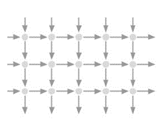

Figure 3.15 $-$ Square lattice with arrow links simulating spin ice. The most energetically favorable state of the lattice is when, at each site, two arrows point inward, and two – outward [144]

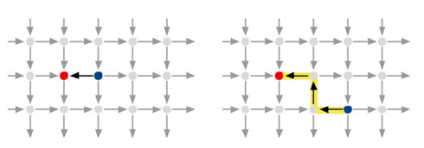

Figure 3.16 $-$ Lattices with a pair of monopoles [144]

By turning over the arrows further, you can lengthen the highlighted line and spread the monopoles even further from each other. Since a couple of monopoles can be created, then it can be eliminated. For example, if in Figure 3.16 , on the left, turn around the black arrow - the monopoles will disappear. Faraway monopoles can also be eliminated - for this you just need to turn over one by one arrow on the highlighted path. The new technique which was discussed here opens up broad prospects for studying the new unusual state of matter. It is believed that new experiments with spin ice will make it possible to better understand the dynamics of magnetic defects in matter and correspondingly properties of magnetic monopoles.

#### 3.7.3 Superfluid liquid helium as $Ms$

Over time, physicists have learned how to create systems that behave like magnetic monopoles, for example, some crystal structures which were discussed in the previous subsection. However, only recently physicists and mathematicians from the Austrian Institute of Science and Technology (2017) have proved that systems that do not need to be created artificially can acquire the properties of monopoles, for example, nanodroplets of superfluid (flowing without friction at ultra-low temperatures) helium [145]. They, as it turned out, behave like magnetic monopoles in relation to the molecules of other substances immersed in them. Superfluid helium has been studied for a long time, but this characteristic was described for the first time.

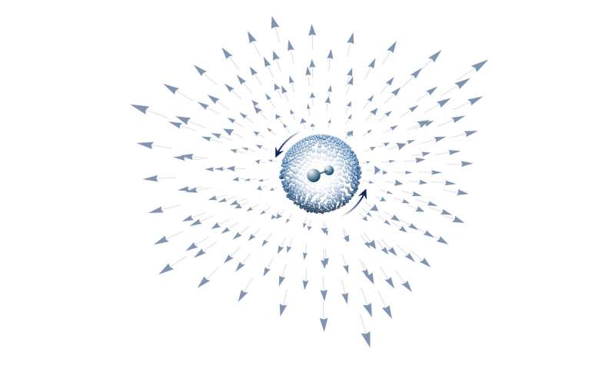

Figure 3.17 $-$ Superfluid helium droplets behave like magnetic monopoles

#### 3.7.4 Magnetic monopole in Bose-Einstein condensate

Other searches of $Ms$ were made by a team of physicists from Amherst College and Aalto University in Finland [119]. Physicistscreated synthetic monopoles in a Bose-Einstein condensate. For this purpose, they have created an artificial (synthetic) magnetic field generated by a Bose-Einstein condensate - a cold gas of rubidium atoms, whose temperature is close to absolute zero. In this case, the atoms stop behaving as separate particles and experience collective quantum behaviour.

As a result of the experiment, scientists obtained evidence of the existence of synthetic monopoles in the form of snapshots of a cloud of atoms, where monopoles appeared at the ends of microscopic quantum vortices in an ultracold gas, see Figure 3.18.

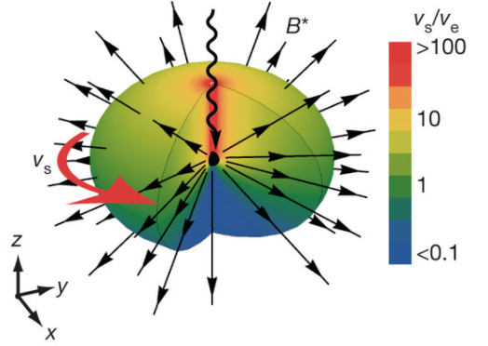

Figure 3.18 $-$ Schematic representations of the monopole creation process.

In the Figure 3.18 illustrated bose condensate cloud with unusual superfluid rotation. The speed of superfluid motion is shown in color, and the vortex of this rotation is shown by arrows. This vortex plays the role of a synthetic magnetic field, which has a monopole form. The wavy line shows a synthetic Dirac string.

In fact, the synthetic magnetic monopole obtained in this work is not a Dirac monopole, but the authors of the article emphasize their connection. The connection exists, because the real magnetic monopole in electrodynamics is the magnetic charge at the end of the Dirac string (the wavy line in Figure 3.18). In other experiments with artificial magnetic monopoles, it was difficult to register this string. In this work, due to the fact that the synthetic potential can be measured, which is an analogue of the Dirac string they can manage it. This string, as well as a synthetic magnetic charge equal to the Dirac charge, therefore these facts allowed the authors to claim that they were observing the quantum aspects expected from a Dirac monopole.

Scientists hope that his discovery will inspire CERN employees to conduct an experiment at the LHC. And then, who knows, perhaps it will be possible to find natural monopoles, or at least understand where in the Universe they should be looked for.

#### 3.7.5 Searches for $Ms$ in colliders

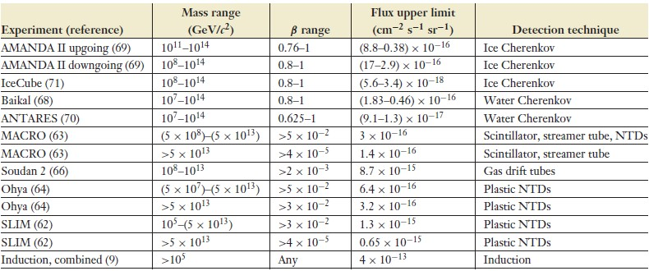If there is no chance to find $Ms$ with the help of the previous considered methods, there is a way to produce them in colliders. Let’s take the MoEDAL (For Monopole and Exotic Detector at the LHC) experiment [147,148], which searched for $Ms$ at a collision energy of 13 *TeV*. No traces of magnetic monopoles with masses up to 6 *TeV* and magnetic charges up to 5 Dirac units were found. Summing up all experiments (AMANDA, IceCube, MACRO and others [149-152]) one can illustrated a table with most of the results from GUT monopole searches, see Figure 3.21.

Figure 3.21 $-$ Flux upper limits for GUT and Mass Monopoles from different experiments

During all experiments that were carried out the suggested properties of magnetic monopoles were established. Most of them can be considered as a consequence of the Dirac relation $eg=\frac{nℏc}{2}$.

So, the main properties of are:

1. (like the electric one) must be conserved. This means that even if heavy monopoles can decay into lighter ones, the lightest ones will be stable particles. Accordingly, once the monopoles have been created, they cannot be completely destroyed (you can only annihilate the northern monopole with the southern).

2. If we take $n=1$ and the electric charge will be the charge of the electron, then the magnetic charge will take the value: .

3. It is well-known that electric charges have a very small coupling constant- the fine-structure constant $α=\frac{e^{2}}{ℏc}≃\frac{1}{137}$. So that drawing analogy one can create the dimensionless magnetic-coupling constant as: .

4. Dirac’s theory does not predict the monopole mass. So that nowadays there is no unanimous opinion according the to estimation of the monopole mass. Lower estimates for the monopole can be calculated from the classical electron radius: $r_{0}=\frac{e^{2}}{4πε_{0}m_{0}c^{2}}=\frac{α_{E}λ_{0}}{2π}$, where $λ_{0}$ is the Compton electron wavelength, $m_{0}$ is the electron mass. So that drawing analogy one can obtain the value of the classical magnetic monopole radius: $r_{D0}=\frac{g_{D}^{2}}{4πμ_{0}m_{D}c^{2}}=\frac{α_{E}λ_{0}}{2π}$, where $m_{D}$ is the monopole mass. So equating the classical radii, one can obtain a lower estimate for the monopole mass:

5. For calculating the energy that can be acquired by the $Ms$ in a magnetic field, one take the formula $W=ng_{D}Bl=n20.5keV/Gcm$.

### YANG-MILLS MONOPOLE WITH SPINOR SOURCE AND MASS GAP

In recent decades magnetic monopoles obtained within the framework of non-Abelian Yang-Mills theories find their applications to a wide variety of topics in theoretical physics, including various problems in the standard model and its extensions, astrophysics, and cosmology [153]. The simplest example of a regular localized monopole solution in SU(2) Yang-Mills theory is the well-known ’t Hooft-Polyakov monopole, which was considered in a previous section. The obligatory condition for its existence is the inclusion into the system of a triplet of Higgs scalar fields ensuring the presence of a topological charge. A distinctive feature of such scalar fields is their nontrivial behaviour at spatial infinity. In this connection, one might suppose that, if it would be possible to find regular monopole-like solutions without involving scalar fields, then they might be topologically trivial. Consistent with this, the main purpose of the present research is to demonstrate the possibility of the existence of monopole-like solutions without scalar fields, which are replaced by a nonlinear spinor field.

The study of nonlinear spinor fields was initiated by W. Heisenberg in the 1950’s. His main idea was the assumption that the nonlinear Dirac equation can describe the internal structure of an electron. In other words, this equation is a fundamental equation which enables one to get all main characteristics of an electron: its spin, charge, and mass. However, with the advent of quantum electrodynamics, further investigations in this direction were discontinued; one of the reasons for that was that the theory based on the nonlinear Dirac equation is nonrenormalizable. Next time the nonlinear Dirac equation has appeared as applied to an approximate description of hadrons within the Nambu-Jona-Lasinio model [154-155]. In that model, a nonlinear spinor field is not fundamental but is used as some approximation within QCD. Notice also that, unlike the Nambu-Jona-Lasinio model, in the present work we study the nonlinear Dirac equation with a mass term.

Thus, in QCD, the problem of mass gap is one of the important and key problems in the theory of the strong interactions. This is due to the fact that this problem can only be solved using nonperturbative quantization methods applied to the SU (3) Yang - Mills theory. Since, the solving of the mass gap problem in QCD very complicated process, we try to replace such quantum systems by some approximate classical systems. This method will be considered in this dissertation, where we try study this problem in simpler situation for understanding the reason of appearance of the mass gap there. One can hope that using obtained results of the current research it would be possible to understand the nature of the mass gap in QCD.

In this way, it was demonstrated that in the non-Abelian Proca theory, which interacts with a scalar Higgs field and nonlinear spinor fields, there was the mass gap [156]. Authors of this article, by analyzing the corresponding equations, showed that without the Higgs field the investigated particlelike solutions do not exist.

In the following dissertation our main goal is to demonstrate the possibility of the existence regular particlelike solutions not in the non-Abelian Proca theory and without the Higgs field, but in the theory of Yang-Mills. It would be of great interest if we find out that the energy spectrum of such monopole-like objects will have the mass gap.

The presence of a mass gap in the energy spectrum of a particlelike solution in classical field theory is a rather rare phenomenon. Perhaps this property of the energy spectrum

was firstly discovered for particlelike solutions of the nonlinear Dirac equation [157]. The corresponding mass gap was called as «the lightest stable particle» , since the term «mass gap» was not popular at that time.

In this research, we show that in SU (2) the Yang - Mills theory including with the nonlinear spinor field there is a mass gap. Therefore, we study topologically trivial monopole-like solutions in SU(2) Yang-Mills theory with a source in the form of a spinor field described by the nonlinear Dirac equation. An interesting feature of the aforementioned solution is that the energy spectrum has a global minimum—the mass gap. This property of the energy spectrum is caused by the presence of the nonlinear spinor field.

It is demonstrated that the main reason for the existence of a mass gap is the nonlinear Dirac spinor field. We suppose that the nonlinear Dirac equation can approximately describes virtual “sea” quarks interacting with virtual “sea” gluons. According to this assumption, the physical interpretation of these solutions is that they describe a self-consistent system of monopoles created by “sea” quarks. Such a monopole+sea quarks object may behave yourself as a quasiparticle in a quark-gluon plasma. This give us chance to understand the properties of such a quark-gluon plasma.

That solution differs in principle from the ’t Hooft- Polyakov monopole by the fact that it is topologically trivial, and the asymptotic behavior of the radial magnetic field is different.

It should be noted here that the asymptotic behavior does not permit us to introduce the notion of a magnetic charge, since the integral of the magnetic field over a closed surface goes to zero at infinity. On the other hand, the asymptotic behavior of the radial magnetic field is similar to the asymptotic behavior of a Maxwellian dipole magnetic field, but the energy density is spherically symmetric, in contrast to a Maxwellian dipole. The research is organized as follows. In subsection 4.1, we write down the Lagrangian and general field equations for SU(2) Yang-Mills theory containing a nonlinear spinor field. In subsection 4.2, we present the *Ans $\ddot{a}$ tze* for vector and spinor fields and also the corresponding equations. The numerical solutions of these equations are sought in subsection 4.3, while in subsection 4.4 we study their energy spectrum, show the presence of global minimum and study the dependence of the dimensionless mass gap of the monopole on the dimensionless coupling constant between gauge and spinor fields.

#### 4. 1 Theory of Yang-Mills fields coupled to a nonlinear Dirac field

Firstly we have to write the Lagrangian describing a monopole-like+ quark system in non-Abelian SU(2) field $A_{μ}^{a}$ interacting with a nonlinear spinor field $ψ$:

$\begin{matrix}L= & -\frac{1}{4}F_{μν}^{a}F^{aμν}+iℏc\overline{ψ}γ^{μ}D_{μ}ψ-m_{f}c^{2}\overline{ψ}ψ+\frac{Λ}{2}gℏc{\left(\overline{ψ}ψ\right)}^{2}.\end{matrix}$ (4.1)

Here $m_{f}$ is the mass of the spinor field; $D_{μ}=∂_{μ}-i\frac{g}{2}σ^{a}A_{μ}^{a}$ is the gauge-covariant derivative, where $g$ is the coupling constant and $σ^{a}$ are the SU(2) generators (the Pauli matrices); $F_{μν}^{a}=∂_{μ}A_{ν}^{a}-∂_{ν}A_{μ}^{a}+gε_{abc}A_{μ}^{b}A_{ν}^{c}$ is the field strength tensor for the SU(2) field, where $ε_{abc}$ (the completely antisymmetric Levi-Civita symbol) are the SU(2) structure constants; $Λ$ is a constant; $γ^{μ}$ are the Dirac matrices in the standard representation; $a,b,c=1,2,3$ are color indices and $μ,ν=0,1,2,3$ are spacetime indices.

More precisely, the Lagrangian consists of 4 terms, where the first term is related to the non-Abelian SU(2) field $A_{μ}^{a}$, whereas the 3 others refer to the nonlinear spinor field $ψ,$ with $\frac{Λ}{2}gℏc{\left(\overline{ψ}ψ\right)}^{2}$ the nonlinear part. Its is important to mention that monopole-like solutions exist due to the presence of this nonlinear spinor term.

Using Eq. (4.1), the corresponding field equations can be written in the form

$D_{ν}F^{aμν}=\frac{gℏc}{2}\overline{ψ}γ^{μ}σ^{a}ψ,$ (4.2)

$iℏγ^{μ}D_{μ}ψ-m_{f}cψ+Λgℏψ\left(\overline{ψ}ψ\right)=0.$ (4.3)

Let us list some distinctive characteristics of the monopole+sea-quark system under consideration:

1. There are monopole-like solutions of the equations (4.2) and (4.4) only for some particular choices of the parameters $f_{2}$ and $u_{1}$;
2. There are particlelike solutions of the nonlinear Dirac equation (4.3) in the absence of the vector field $A_{μ}^{a}$;
3. The Yang-Mills equation (4.2) has no static globally regular solutions in the absence of the spinor field;
4. The set of equations (4.2) and (4.3) has no static regular solutions in the case of linear spinor field (i.e.,when $Λ=0$).

To obtain particlelike solutions, Eqs. (4.2) and (4.3) will be solved numerically as an eigenvalue problem for the parameters $f_{2}$ and $u_{1}$, since apparently it is impossible to find their analytical solution.

#### 4.2 *Ans $\ddot{a}$ tze* and equations

Our purpose is to study monopole-like solutions of the equations Eqs. (4.2) and (4.3) describing objects consisting of a radial magnetic field and a nonlinear spinor field. To do this, we use the standard SU(2) *Ans $\ddot{a}$ tze:*

$A_{i}^{a}=\frac{1}{g}\left[1-f\left(r\right)\right]\left(\begin{matrix}0 & sinφ & sinθcosθcosφ \\ 0 & -cosφ & sinθcosθsinφ \\ 0 & 0 & -\sin^{2}θ\end{matrix}\right)$ (4.4)

$i=r,θ,φ (in polar coordinates),$

$A_{t}^{a}=0,$ (4.5)

and the *Ans $\ddot{a}$ tze* for the spinor field [156, p.3].

$ψ^{T}=\frac{e^{-i\frac{Et}{ℏ}}}{gr\sqrt{2}}\left(\begin{matrix}0 \\ -u \\ \end{matrix}\right),\left(\begin{matrix}u \\ 0 \\ \end{matrix}\right),\left(\begin{matrix}ivsinθe^{-iφ} \\ -ivcosθ \\ \end{matrix}\right),\left(\begin{matrix}-ivcosθ \\ -ivsinθe^{iφ} \\ \end{matrix}\right),$ (4.6)

where the functions $u$ and $v$ depend on the radial coordinate $r$ and $E/ℏ$ is the spinor frequency. In Eq. (4.6), each row describes a spin- $1/2$ fermion, and these two fermions have the same mass $m_{f}$ and opposite spins and are located at one point.

Equations for the unknown functions $f,u$, and $v$ can be obtained by substituting the expressions (4.4)-(4.6) into the field equations (4.2) and (4.3),

$-f^{''}+\frac{f\left(f^{2}-1\right)}{x^{2}}+{\tilde{g}}^{2} \frac{\tilde{u}\tilde{v}}{x}=0,$ (4.7)

$\tilde{v'}+\frac{f\tilde{v}}{x}=\tilde{u}\left(-{\tilde{m}}_{f}+\tilde{E}+\tilde{Λ}\frac{{\tilde{u}}^{2}-{\tilde{v}}^{2}}{x^{2}}\right),$ (4.8)

$\tilde{u'}-\frac{f\tilde{u}}{x}=\tilde{v}\left(-{\tilde{m}}_{f}-\tilde{E}+\tilde{Λ}\frac{{\tilde{u}}^{2}-{\tilde{v}}^{2}}{x^{2}}\right).$ (4.9)

Here, equation (4.7) can be interpreted as a nonlinear generalization of the Maxwell equation with nonlinear part $\frac{f\left(f^{2}-1\right)}{x^{2}}$ and the density of magnetic charge ${\tilde{g}}^{2} \frac{\tilde{u}\tilde{v}}{x}$. Equations (4.8)-(4.9) describe dependence of spinor field on radial coordinate *r*.

For convenience of making numerical calculations, we have introduced the following dimensionless variables: $x=r/λ_{c}$, where $λ_{c}=\frac{ℏ}{m_{f}c}$ is the Compton wavelength; $\tilde{u}=u\sqrt{\frac{Λ}{λ_{c}g}},\tilde{v}=v\sqrt{\frac{Λ}{λ_{c}g}},\tilde{E}=\frac{λ_{c}E}{ℏc}$, ${{\tilde{g}}^{2}}_{Λ}=\frac{gℏc{λ_{c}}^{2}}{Λ}$, $\tilde{Λ}=\frac{g}{{λ_{c}}^{2 }}Λ, \tilde{m_{f}}=1$. The prime denotes differentiation with respect to $x$. Then, equations (4.7)-(4.9) becomes independent of $\tilde{Λ}:$

$-f^{''}+\frac{f\left(f^{2}-1\right)}{x^{2}}+{{\tilde{g}}^{2}}_{Λ} \frac{\tilde{u}\tilde{v}}{x}=0,$ (4.10)

$\tilde{v'}+\frac{f\tilde{v}}{x}=\tilde{u}\left(-1+\tilde{E}+\frac{{\tilde{u}}^{2}-{\tilde{v}}^{2}}{x^{2}}\right),$ (4.11)

$\tilde{u'}-\frac{f\tilde{u}}{x}=\tilde{v}\left(-1-\tilde{E}+\frac{{\tilde{u}}^{2}-{\tilde{v}}^{2}}{x^{2}}\right).$ (4.12)

#### 4.3 Monopole-plus-spinor-fields solutions

The purpose of this section is to study in more detail the properties of the monopole solution of Eqs. (4.10)-(4.12). To understand how the solution and hence the energy of the monopole depend on the parameters of the system, let us consider the series expansion of the functions $f(x),\tilde{u}(x)$, and $\tilde{v} (x)$ appearing in Eqs. (4.10)-(4.12) in the vicinity of the origin of coordinates :

$f=1+\frac{f_{2}}{2}x^{2}+…, \tilde{u}={\tilde{u}}_{1}x+\frac{{\tilde{u}}_{3}}{3!}x^{3}+…, \tilde{v}=\frac{{\tilde{v}}_{2}}{2}x^{2}+\frac{{\tilde{v}}_{4}}{4!}x^{4}+…,$ (4.13)

where ${\tilde{v}}_{2}=2{\tilde{u}}_{1}\left(\tilde{E}-1+\tilde{Λ}{\tilde{u}}_{1}^{2}\right)/3$ was found from (4.10)–(4.12). These expansions and Eqs. (4.10)–(4.12) contain the following set of parameters: $f_{2},{\tilde{u}}_{1},{\tilde{v}}_{2}, {\tilde{g}}_{Λ},\tilde{E}.$ We will solve Eqs. (4.10)-(4.12) numerically as a nonlinear problem for the eigenvalues $f_{2}$ and ${\tilde{u}}_{1}$ and the eigenfunctions $\tilde{u}(x),\tilde{v}(x),$ and $f(x)$, whose typical behavior is shown in Figure (4.1)-(4.6) both for the ground state of the system under consideration and for the first excited state when the functions $\tilde{u}$ and $\tilde{v}$ possess one node. The results of the calculations of the system parameters are given in Table 1.

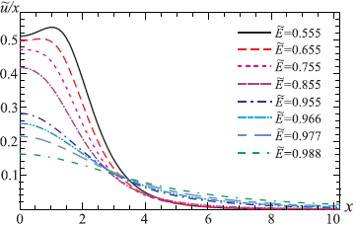

Figure 4.1 $-$ The function $\tilde{u}(x)/x$ for different values of the parameter $\tilde{E}$ with $\tilde{Λ}=8$, ${\tilde{m}}_{f}=1$, and $\tilde{g}=1$ for the ground state of the system

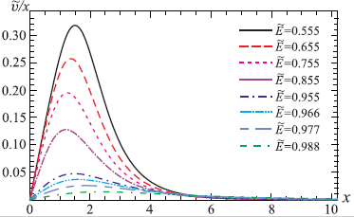

Figure 4.2 $-$ The function $\tilde{v}(x)/x$ for different values of the parameter $\tilde{E}$ with $\tilde{Λ}=8$, ${\tilde{m}}_{f}=1$, and $\tilde{g}=1$ for the ground state of the system

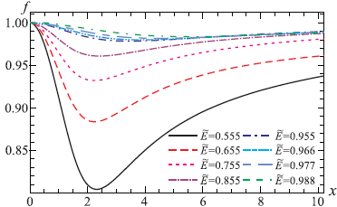

Figure 4.3 $-$ The function $f(x)$ for different values of the parameter $\tilde{E}$ with $\tilde{Λ}=8$, ${\tilde{m}}_{f}=1$, and $\tilde{g}=1$ for the ground state of the system

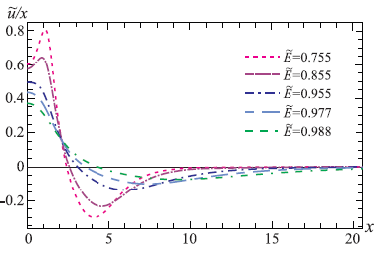

Figure 4.4 $-$ The function $\tilde{u}(x)/x$ for different values of the parameter $\tilde{E}$ with $\tilde{Λ}=8$, ${\tilde{m}}_{f}=1$, and $\tilde{g}=1$ for the first exited state of the system

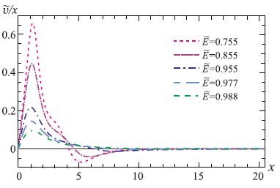

Figure 4.5 $-$ The function $\tilde{v}(x)/x$ for different values of the parameter $\tilde{E}$ with $\tilde{Λ}=8$, ${\tilde{m}}_{f}=1$, and $\tilde{g}=1$ for the first exited state of the system

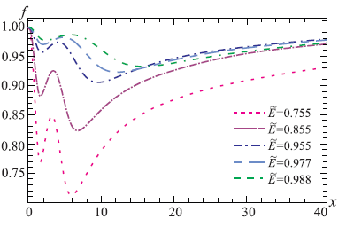

Figure 4.6 $-$ The function $f(x)$ for different values of the parameter $\tilde{E}$ with $\tilde{Λ}=8$, ${\tilde{m}}_{f}=1$, and $\tilde{g}=1$ for the first exited state of the system

Table 1 $-$ Eigenvalues ${\tilde{u}}_{1}$ and $f_{2}$ and the total energy ${\tilde{W}}_{t}$ for different values of the parameter $\tilde{E}$ with $\tilde{Λ}=8$, ${\tilde{m}}_{f}=1$, $\tilde{g}=1$.

|  |  |  |  |  |  |  |  |  |  |
| --- | --- | --- | --- | --- | --- | --- | --- | --- | --- |
| **The ground state** | | | | | | | | | |
| $$\tilde{E}$$ | 0.555 | 0.655 | 0.755 | 0.855 | 0.955 | 0.966 | 0.977 | 0.988 |
| $$f_{2}$$ | -0.21167 | -0.1438 | -0.092587 | -0.0519 | -0.016338 | -0.012473 | -0.00854 | -0.0046 |
| $${\tilde{u}}_{1}$$ | 0.51075 | 0.4972 | 0.4714560 | 0.41848 | 0.2834 | 0.25342 | 0.2151 | 0.163 |
| $${\tilde{W}}_{t}$$ | 15.6339 | 11.718 | 8.6202 | 6.4621 | 5.8124 | 6.049896 | 6.5242 | 7.3827 |
| **The first excited state, one-node solutions** | | | | | | | | | |
| $$\tilde{E}$$ |  |  | 0.755 | 0.855 | 0.955 | 0.977 | 0.988 |  |
| $$f_{2}$$ |  |  | -0.43377 | -0.23663 | -0.087295 | -0.0526425 | -0.03217 |  |
| $${\tilde{u}}_{1}$$ |  |  | 0.6005 | 0.57331012 | 0.494131 | 0.43494 | 0.37143 |  |
| $${\tilde{W}}_{t}$$ |  |  | 76.182 | 62.582 | 53.748 | 57.3803 | 65.957 |  |

Asymptotical (as $x→∞$) behavior of the solutions is expressed by the following equation:

$f(x)≈1-\frac{f_{∞}}{x}, \tilde{u}(x)≈{\tilde{u}}_{∞}e^{-x\sqrt{1-{\tilde{E}}^{2}}}, \tilde{v}(x)≈{\tilde{v}}_{∞}e^{-x\sqrt{1-{\tilde{E}}^{2}}},$ (4.14)

where $f_{∞},{\tilde{u}}_{∞}$, and ${\tilde{v}}_{∞}$ are integration constants.

Now, lets describe the behavior of the Yang-Mills magnetic field. Physical components of the Yang-Mills magnetic field is defined as $H_{i}^{a}=-(1/2)\sqrt{γ} ε_{ijk}F^{ajk},$ where $i,j,k$ are space indices. The radial component of the Yang-Mills magnetic field has the form:

$H_{r}^{a}\sim \frac{1-f^{2}}{gr^{2}},$ (4.15)

where $a=1,2,3$ and we have dropped the dependence on the angular variables. The corresponding graphs for the radial components of the Yang-Mills magnetic field are shown in Figure 4.7 and 4.9. More precisely, its asymptotic behavior $x→∞$ is

$H_{r}^{a}\sim \frac{2f_{∞}}{gr^{3}}.$ (4.16)

It can be shown from this expression that, by its asymptotic behavior, the system monopole+nonlinear spinor fields differs in principle from the ’t Hooft-Polyakov monopole, magnetic field of which decreases as $r^{-2}$.

It is also interesting that in our theory there are also nonzero tangential components of the Yang-Mills magnetic field:

$H_{θ}^{a}\sim \frac{1}{g}f^{'}, H_{φ}^{b}\sim \frac{1}{g}f^{'},$ (4.17)

where $a=1,2,3$ and $b=1,2$. Their behavior is shown in Figure 4.7 and 4.10.

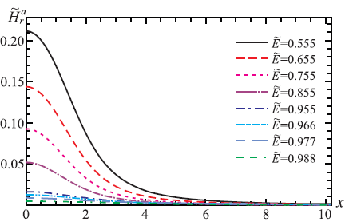

Figure 4.7 $-$ The distributions of the color magnetic fields for different values of the parameter $\tilde{E}$: the radial component ${\tilde{H}}_{r}^{a}≡gr_{0}^{2}H_{r}^{a}$- to the ground state of the system

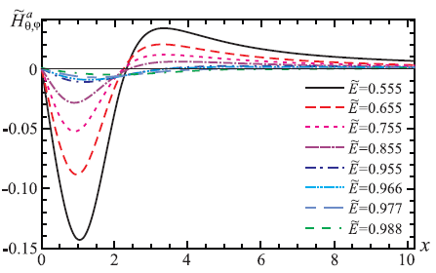

Figure 4.8 $-$ The distributions of the color magnetic fields for different values of $\tilde{E}$: the tangential components ${\tilde{H}}_{θ,φ}^{a}≡gr_{0}H_{θ,φ}^{a}$- to the ground state of the system

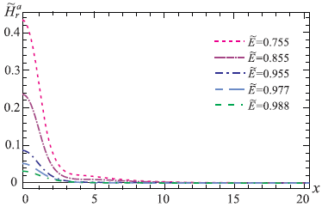

Figure 4. 9 $-$ The distributions of the color magnetic fields for different values of the parameter $\tilde{E}$: the radial component ${\tilde{H}}_{r}^{a}≡gr_{0}^{2}H_{r}^{a}$– to the first excited state.

Figure 4. 10 $-$ The distributions of the color magnetic fields for different values of the parameter $\tilde{E}$: the tangential components ${\tilde{H}}_{θ,φ}^{a}≡gr_{0}H_{θ,φ}^{a}$- to the first exited state of the system

To conclude, we have found the topologically-trivial solutions describing the self-consistent system of the non-Abelian magnetic field and non-linear spinor field.

#### 4.4 Energy spectrum

In this subsection lets consider the total energy density of the monopole+spinor fields system, which has the following form:

$\tilde{ε}={\tilde{ε}}_{m}+{\tilde{ε}}_{s}=\frac{1}{{{\tilde{g}}_{Λ}}^{2}}\left[\frac{{f'}^{2}}{x^{2}}+\frac{{\left(f^{2}-1\right)}^{2}}{2x^{4}}\right]+\left[\tilde{E}\frac{{\tilde{u}}^{2}+{\tilde{v}}^{2}}{x^{2}}+\frac{{\left({\tilde{u}}^{2}-{\tilde{v}}^{2}\right)}^{2}}{{2x}^{4}}\right],$ (4.18)

where the expressions in the square brackets related to the dimensionless energy densities of the monopole ${\tilde{ε}}_{m}≡\left(\frac{λ_{c}^{4}g^{2}}{{\tilde{g}}_{Λ}^{2}}\right)ε_{m}$, and of the spinor field ${\tilde{ε}}_{s}≡\left(\frac{λ_{c}^{4}g^{2}}{{\tilde{g}}_{Λ}^{2}}\right)ε_{s}$.

The corresponding distributions of the total energy density along the radius are shown in Figures 4.11-4.12.

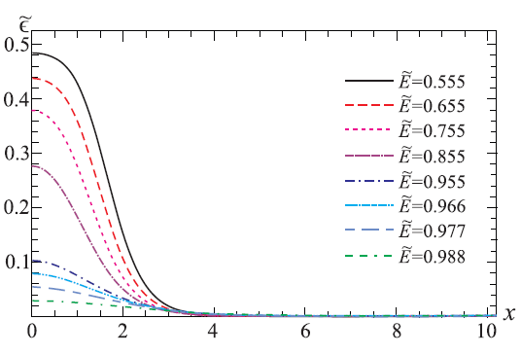

Figure 4.11 $-$ The energy density $\tilde{ε}$ from Eq. (4.18) for different values of the parameter $\tilde{E}$- to the ground state of the system

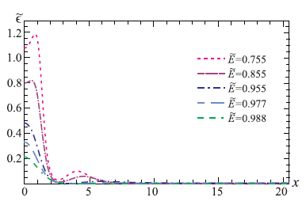

Figure 4.12 $-$ The energy density $\tilde{ε}$ from Eq. (4.18) for different values of the parameter $\tilde{E}$– to the first excited state.

Now, we have to investigate the energy spectrum of the system under consideration as a function of the parameter $\tilde{E}$. As the consequence, we will demonstrate the presence of a mass gap. For this purpose, we introduce the equation for a dimensionless total energy of the monopole-like object in the following form:

${\tilde{W}}_{t}≡\frac{λ_{c}g^{2}}{{\tilde{g}}_{Λ}^{2}}W_{t}=4π\int_{0}^{∞}{‍}x^{2}\tilde{ε}dx={\left({\tilde{W}}_{t}\right)}_{m}+{\left({\tilde{W}}_{t}\right)}_{s},$ (4.19)

where the energy density $\tilde{ε}$ is taken from Eq. (4.18). One can follow from this equation that the total energy of the system is expressed in the sum of energies of the monopole ${\left({\tilde{W}}_{t}\right)}_{m}$ and of the spinor fields ${\left({\tilde{W}}_{t}\right)}_{s}$ despite the presence of the direct interaction between the vector and spinor fields. Using Eq. (4.19), we have calculated the magnitude of the total energy and presented them in Table 1.

Next, using this, we have plotted the corresponding energy spectrum of the system, see Figure 4.13. After that, we have plotted the curve that illustrates the existence of a mass gap- minimum in the energy spectrum of the monopole-like solutions obtained.

After that, we continued investigations in this direction by studying the dependence of the mass gap of the monopole on the dimensionless coupling constant between gauge and spinor fields. By calculating of the equations (4.10)-(4.12) and found the energy spectrum for each pair of $\tilde{Λ}, \tilde{g}$, where each value of total energy ${\tilde{W}}_{t}$ depends on the value $\tilde{E}.$ The results of the calculations are presented in Table 2.

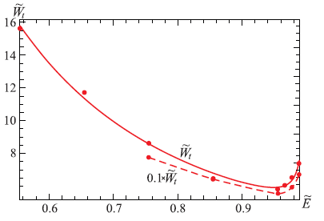

Figure 4.13 $-$ The spectrum of the total energy for the ground (solid line) and excited (dashed line) states from Eq. (4.19) as functions of the parameter $\tilde{E}$ (the bold dots show the values of ${\tilde{W}}_{t}$ taken from Table 1).

Table 2 $-$ Eigenvalues ${\tilde{u}}_{1}$ and $f_{2}$ and the energy of the mass gap ${{\tilde{(W}}_{t})}_{min}$ as functions of the dimentionless coupling constant ${\tilde{g}}_{Λ}.$

|  |  |  |  |  |  |  |  |  |
| --- | --- | --- | --- | --- | --- | --- | --- | --- |
| $$\tilde{E}$$ | 0.895 | 0.901 | 0.910 | 0.925 | 0.919 | 0.920 | 0.9220 | 0.922 |
| $$f_{2}$$ | -0.27 | -0.224 | -0.134 | -0.064 | -0.045 | -0.037 | -0.031 | -0.027 |
| $${\tilde{u}}_{1}$$ | 1.064 | 1.043 | 1.016 | 0.960 | 0.9895 | 0.983 | 0.979 | 0.976 |
| $${\tilde{g}}_{Λ}$$ | 1.020 | 0.944 | 0.750 | 0.559 | 0.447 | 0.408 | 0.377 | 0.353 |
| $${{\tilde{(W}}_{t})}_{min}$$ | 35.355 | 36.750 | 40.165 | 43.080 | 44.640 | 45.071 | 45.380 | 45.623 |

|  |  |  |  |  |  |  |  |  |
| --- | --- | --- | --- | --- | --- | --- | --- | --- |
|  | 0.934 | 0.933 | 0.935 | 0.934 | 0.934 | 0.935 | 0.935 | 0.935 |
| $$f_{2}$$ | -0.017 | -0.015 | -0.013 | -0.010 | -0.0071 | -0.004 | -0.002 | -0.0013 |
| $${\tilde{u}}_{1}$$ | 0.921 | 0.928 | 0.919 | 0.924 | 0.924 | 0.919 | 0.919 | 0.920 |
| $${\tilde{g}}_{Λ}$$ | 0.306 | 0.283 | 0.265 | 0.237 | 0.193 | 0.159 | 0.118 | 0.075 |
| $${{\tilde{(W}}_{t})}_{min}$$ | 45.8804 | 46.065 | 46.207 | 46.376 | 46.686 | 46.824 | 46.985 | 47.029 |

Next, for every spectrum, we have calculated the magnitude of the mass gap ${{\tilde{(W}}_{t})}_{min}$ and plotted contour profile of the mass gap values and dependence of ${{\tilde{(W}}_{t})}_{min}$ on ${\tilde{g}}_{Λ}$ in Figure 4.14 and 4.15. The corresponding values of the mass gap ${{\tilde{(W}}_{t})}_{min}$, the eigenvalues $f_{2}$, ${\tilde{ u}}_{1}$ and the values of the dimensionless coupling constant ${\tilde{g}}_{Λ}$ are collected in Table 2 .

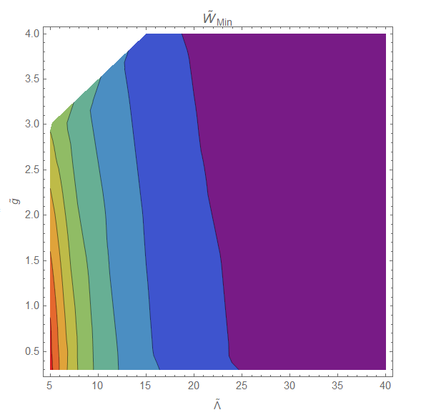

Figure 4.14 – Contour profile of the mass gap values ${{\tilde{(W}}_{t})}_{min}$

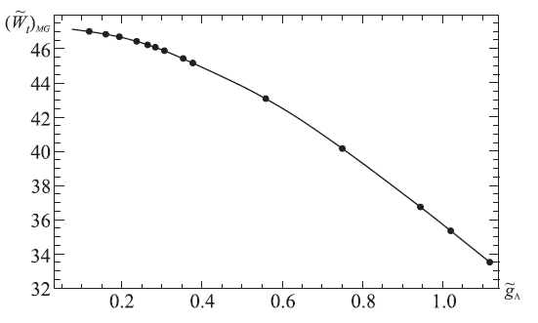

Figure 4.15 – The dependence of the mass gap ${{\tilde{(W}}_{t})}_{min}$ on the coupling constant ${\tilde{g}}_{Λ}$

From Figure 4.15 we can conclude that the mass gap of the monopole interacting with the nonlinear spinor field depends on one parameter ${\tilde{g}}_{Λ}$ only. Physical meaning is that the dimensionless energy of the monopole and its mass gap depend only on the ratio of the coupling constant $g$ between the gauge and spinor fields to the constant $Λ$ of the nonlinear spinor field.

In this part of the dissertation regular finite-energy monopole-like solutions within SU(2) Yang-Mills theory containing the doublet of nonlinear spinor fields are obtained. Physical interpretation of these solutions is that they describe a self-consistent monopole-plus-sea-quarks system. The solutions obtained have been used to describe quasiparticles (monopole-plus-sea-quarks system) in a quark-gluon plasma.

This problem was solved numerically as a nonlinear problem for the eigenvalues $f_{2}$ and ${\tilde{u}}_{1}$ and the eigenfunctions $\tilde{u}(x),\tilde{v}(x),$ and $f(x)$. To analyze the obtained solutions, typical behavior of the the eigenfunctions, the distributions of the color magnetic fields, distributions of total energy density $\tilde{ε}$ along the radius and energy spectrum of the system for different values of the parameter $\tilde{E}$ both for the ground state and for the first excited state were plotted.

It is of interest to follow the behavior of the magnetic Yang-Mills field. Asymptotic behavior of the radial magnetic field as $x→∞$ is $H_{r}^{a}\sim \frac{2f_{∞}}{gr^{3}}.$ It is seen from this expression that, by its asymptotic behavior, the system monopole-plus-nonlinear-spinor-fields differs in principle from the ’t Hooft-Polyakov monopole, whose magnetic field decreases as $r^{-2}$. This indicates that a distant observer does not see such an object like a color magnetic charge. On comparing the fall-off with Maxwell’s electrodynamics, one might suppose that the solution obtained by us describes a non-Abelian magnetic dipole; therefore, it should be emphasized here that, in contrast to a Maxwellian dipole, the energy density of our system is spherically symmetric.

Results of calculations:

1. The set of equations (4.10) and (4.12) has regular, finite energy solutions only in the presence of the spinor field;
2. The set of equations (4.10) and (4.12) has monopole-like solutions only for some

special choices of the system parameters $f_{2}$ and $u_{1}$;

1. In the absence of the vector field $A_{μ}^{a}$, there exist particlelike solutions of the nonlinear Dirac equation which describe a system possessing a minimum in the energy spectrum;
2. In the absence of the spinor field, there are only trivial $\tilde{u}=\tilde{v}=0,f=0,±1;$
3. To the best of our knowledge, in the case of linear spinor field (i.e., when $Λ=0$) the set of equations (4.10) and (4.12) has no static regular solutions as well;
4. The nonlinear Dirac equations possess regular solutions with finite energy and mass gap;
5. The reason for the appearance of the mass gap in the monopole solution is the presence of the nonlinear spinor field.

To conclude, the important result of the calculations is that the energy spectrum possesses a global minimum, which can be interpreted as a mass gap, whose appearance is caused by the nonlinear spinor fields. We wish to emphasize once again that the notion of the mass gap obtained in the present work differs from that employed in QCD. By the mass gap we mean a minimum in the energy spectrum of regular particlelike solutions. Next, we have plotted contour profile of the mass gap values and dependence of the mass gap ${{\tilde{(W}}_{t})}_{min}$ on the coupling constant ${\tilde{g}}_{Λ}$. All results presented in following articles [158-161].

**CONCLUSION**

This dissertation is devoted to the study of two relevant and significant topics in the modern theoretical physics. The first part of the work is aimed to study the modified theories of gravity, their types, as well as in-depth research and qualitative analysis within the framework of these theories of regular solutions of compact astrophysical objects $–D–$ branes. As for the second important part of the dissertation, it focuses on the one of the long-sought particles in the Universe – magnetic monopoles.

**There are the following main results of the research:**

**In the first part of the research:**

– A class of modified theories of gravity, which expand the general theory of relativity, preserving its positive features, was considered. It was illustrated that GR is modified in different ways, so that different theories were constructed. The first thing that needs to be said is that modified theories of gravity can be interpreted as providing an alternative to the cosmological constant or dark energy for explaining the observed accelerated expansion of the Universe. We took more attention on a higher order derivatives type of modified theory, especially on the Starobinsky model $F(R)$, due to the fact that it looks simpler than other theories. In addition, much attention has been paid at analysing within these $F(R)$ theories astrophysical objects predicted by GR without matter like branes in multidimensional space-time.

– The multidimensional theory of gravity, especially the five-dimensional theory of Kaluza-Klein was analysed, where authors combined gravitational and electromagnetic interactions. One argument in support of studying extra dimensions is that this GUT is formulated only in higher-dimensional space-time.

– Another argument in support of a transition to the geometry of a higher-dimensional space is the possibility to analyze and investigate various compact extended objects like thick branes. In superstring theories, a brane is attached to the ends of strings and can move in some enveloping space whose number of dimensions varies from zero (a point) to nine. Many scientists believe that we live in the thin brane embedded in the multidimensional space-time.

– The research aims to give a comprehensive account of regular solutions of branes in multidimensional space-time within the framework of $F(R)$ modified theory of gravity. Regular, flat-symmetric solutions in a vacuum at certain parameter values $n$ and $δ$ are obtained $δ$. The obtained solutions are of great interest, since they are vacuum solutions, in contrast to similar solutions in general relativity.

As a result:

1) All regular solutions have AdS asymptotics.

2) When increasing the parameters $α, n →∞$ the solutions tend to a limit that is no longer dependent on the values of these parameters.

3) Not for all parameter of values $n$ there are solutions: $n$

– if $n=(2p+1)/(2q+1)$, where $p,q$ are integers, then the solution is regular when $x^{N}>0$ and can be singular when $x^{N}<0$;

– If the exponent $n$ is an irrational number, then there are generally no solutions.

4) According to the equation $R_{A}^{B}-\frac{1}{2}δ_{A}^{B}R={\hat{T}}_{A}^{B},$ the right part plays the role of an effective energy-momentum tensor ${\hat{T}}_{μν}$. It has been shown that in this case the effective energy density $T_{0}^{0}$ is negative and its dependence on the parameter values $γ,δ,α,N$ is investigated;

5) Phase portraits for the $D$– branes are obtained;

6) It is shown that regular solutions have a special point located in the center of the brane. As follows from the analytical analysis of the behavior of the solutions in the region of this point, such a point exists only at certain values of the parameter $n$: $т.е 1<n<2.$ $1<n<2$.

The resulting brane solutions can be an interesting model for cosmological research. The results are published in articles and conference papers.

**In the second part of the research:**

– This part deals withthe mainhypothetical elementary particlewith a one magnetic charge - the magnetic monopole. The main historical background of ideas about monopoles in classical electrodynamics, Dirac monopoles, ’t Hooft-Polyakov monopoles was considered.

– In the history of physics, the magnetic monopole is the most searched for elementary particle. Different methods and approaches of searching for Dirac monopoles like for instance cosmic rays, lunar soil, ancient fossils, moon rocks or their creation in a Bose-Einstein condensate were discussed. They have also been extensively searched for at LHC. Scientists haven't found them yet, so they have to keep searching.

– This part offers monopole-like solutions within SU(2) Yang-Mills theory containing a doublet of nonlinear spinor fields. The main goal is to illustrate the presence of a minimum in the energy spectrum which can be considered as “mass gap”, which addresses one of the seven unsolved Millennium Prize Problems. [The mass](https://en.wikipedia.org/wiki/Mass_gap) gap Δ is the mass of the least massive particle predicted by the theory.

Summarizing the results obtained,

1. topologically trivial monopole-like solutions within SU(2) Yang-Mills theory

containing a doublet of nonlinear spinor fields were found;

1. we suppose that these solutions describe a magnetic monopole-like object created by a spherical lump of nonlinear spinor fields;
2. the spherically symmetric solutions obtained here do not exist without the spinor fields which are the source of the color magnetic field. This enables us to arrive at an interesting conclusion that the reason for the appearance of a minimum in the energy spectrum is the presence of the nonlinear Dirac fields;
3. it was demonstrated that the energy spectrum has a global minimum, both for the ground state and for the first excited state. This minimum considered as a mass gap;
4. it was shown that the main reason for the appearance of the minimum in the energy spectrum is the presence of the nonlinear spinor fields;
5. The distributions of the color magnetic fields ${\tilde{H}}_{r}^{a}$ and ${\tilde{H}}_{θ,φ}^{a}$, the energy density $\tilde{ε}$, the spectrum of the total energy for the ground and excited states for different values of the parameter $\tilde{E}$ were illustrated. Next, the dependence of the mass gap ${{\tilde{(W}}_{t})}_{min}$ on the coupling constant ${\tilde{g}}_{Λ}$ was studied.
6. it was shown that our monopole-like solutions differs in principle from the ’t Hooft-Polyakov monopole in that they are topologically trivial.

The results are published in the articles and conference papers. **The tasks in the dissertation** are fully solved: Differential equations describing $D$– branes in multidimensional modified theories of gravity and Yang-Mills monopole-like solutions with spinor fields were obtained. For these equations, the corresponding numerical solutions were obtained. We summed up theoretical and practical experience of the carried out investigation and gave a coprehensive understanding of the brane and monopole-like solutions. A lot of graphs and tables were given to illustrate the results of the work.

**Recommendations.** Summarizing,the results obtained in the dissertation are of value for the development of the theory of gravity, grand unified theory, string theory and astrophysics. Based on the obtained results, the properties of $D$– branes and magnetic monopole-like objects can be described. Also, the obtained results of $D$– branes in modified theory of gravity can be used to solve the problem of hierarchies, compactify additional dimensions and explain some cosmological problems.

It is supposed that the obtained results will contribute to a deeper understanding of the accelerated expansion of the Universe not only at the initial stages of the evolution of the Universe, but also at the present stage. The obtained regular brane solutions in gravitational theories are an interesting and valuable task for understanding the gravity interaction. From a higher dimensional point of view, thick branes are hypothetical objects that may be discovered in the future. Therefore, the study of their properties is an important task in theoretical physics.

Looking to the magnetic monopoles, although there is no evidence for the existence of magnetic monopoles, they are interesting theoretically. The magnetic monopole has the unique distinction of being the first among hypothetical objects and constructions that despite their unsuccessful searches and experimental evidence, they have remained the focus of intensive attention of scientists. Theoretical physics has no analogy in the research history of existence of a magnetic monopole. In the process of studying their history, a strong connection with other current research fields in theoretical physics is noticed: problems in the standard model, GUT, astrophysics, cosmology, the problem of confinement in QCD, the problem of proton decay, evolution of the early Universe and many others.

The obtained monopole-like solutions in SU(2) Yang-Mills theory aim to give a comprehensive account to improve our understanding of the properties of magnetic monopoles. There is the possibility in the future to demonstrate the symmetry between electricity and magnetism and show that the introduction of magnetic charges can elegantly solve the long-standing mystery of nature - the quantization of electric charge. It is proposed that these monopole-like solutions describe a self-consistent monopole-plus-sea-quarks system. These solutions have been used to describe quasiparticles in a quark-gluon plasma.

If scientists manage to find magnetic monopoles in nature or create them in the laboratory, then this discovery will confirm the assumption that the electric charges of all particles assume discrete values on which almost all modern physical theories are based. Therefore, it would be natural to assume that searching for magnetic monopoles is a fascinating journey and finding them would be an incredible breakthrough for all modern physical theories.

The corresponding minimum in the energy spectrum which is the mass gap has been discovered experimentally and confirmed through computer modeling, however it is still not clear theoretically, therefore it is supposed that these monopole-like solutions will help at the deeper level analyze and investigate this Millennium Unsolved Problem. We wish to emphasize that the mass gap obtained in the present work can be considered as the QCD effect in non-QCD theory.

In conclusion, I would like to express my hope that this dissertation work demonstrates new significant solutions, methods and concepts that contribute not only to the further development of science but also to a deeper understanding of the structure of the Universe.

**REFERENCES**

1. Dzhunushaliev V., Folomeev V., Minamitsuji M. Thick brane solutions // Rept. Prog. Phys. – 2010. – Vol. 73. – №. 6. – P. 41.
2. Akama K. An early proposal of Brane world // Lect. Notes in Phys. – 1982. – P. 267 – 271.
3. Rubakov V.A., Shaposhnikov M.E. Do we live inside a domain wall // Phys. Lett. B. – 1983. – Vol. 125. – P. 136 – 138.
4. Lorenzana A. P. An Introduction to the Brane World // Revista Mexicana De Fisica. – 2006. – Vol. 53 (2). – P. 85 – 102.
5. Владимиров Ю.С. Пространство – время: явные и скрытые размерности. –Изд. 2-е, перер. и доп.– М.:Книжный дом «Либроком», 2010. – 208 с.
6. Kaluza T. Zum Unitatsproblem der Physik // Sitz. Preuss. Akad. Wiss. Phys. Math. K. – 1921. – Vol. 1. – P. 966 – 969.
7. Weyl H. Gravitation and Electricity // Sitzungsber. Preuss. Akad. Wissenschaften. – 1918. – Vol. 26. – P. 465 – 478.
8. [Green](https://www.amazon.com/s/ref=dp_byline_sr_book_1?ie=UTF8&field-author=Michael+B.+Green&text=Michael+B.+Green&sort=relevancerank&search-alias=books) M. B., [John H. Schwarz](https://www.amazon.com/John-H-Schwarz/e/B001HCV9X2/ref=dp_byline_cont_book_2), [Edward W](https://www.amazon.com/s/ref=dp_byline_sr_book_3?ie=UTF8&field-author=Edward+Witten&text=Edward+Witten&sort=relevancerank&search-alias=books). Superstring Theory // Cambridge University Press. – 2012. – Vol. 2.
9. [Overduin](https://www.sciencedirect.com/science/article/abs/pii/S0370157396000464#!) J.M., [Wesson](https://www.sciencedirect.com/science/article/abs/pii/S0370157396000464#!) P.S. Kaluza – Klein gravity // [Physics Reports](https://www.sciencedirect.com/science/journal/03701573). – 1997. – [Vol. 283. –](https://www.sciencedirect.com/science/journal/03701573/283/5) P. 303 – 378.
10. Bailin D., Love A. Kaluza – Klein theories // Rep. Prog. Phys. – 1987. – Vol. 50. – P. 1087.
11. [Freund](https://www.sciencedirect.com/science/article/abs/pii/0550321382901067#!) P.G.O. Kaluza – Klein cosmologies // [Nuclear Physics. –](https://www.sciencedirect.com/science/journal/05503213) 1982. – [Vol. 209. –](https://www.sciencedirect.com/science/journal/05503213/209/1) P. 146 – 156.
12. Tao Han, Joseph D. Lykken, Ren-Jie Zhang Kaluza – Klein states from large extra dimensions // Phys. Rev. D. – 1999. – [Vol. 59. –](https://www.sciencedirect.com/science/journal/05503213/209/1) P. 105 – 106.
13. [Salam](https://www.worldscientific.com/doi/abs/10.1142/9789812795915_0054) A., [Strathdee](https://www.worldscientific.com/doi/abs/10.1142/9789812795915_0054) J. On Kaluza - Klein Theory [Selected Papers of Abdus Salam // World Scientific. – 1994. – [Vol. 5. –](https://www.sciencedirect.com/science/journal/05503213/209/1) P. 451 – 487.](https://www.worldscientific.com/worldscibooks/10.1142/2265)
14. [Einstein A.](https://en.wikipedia.org/wiki/Albert_Einstein) [The Foundation of the General Theory of Relativity](https://en.wikisource.org/wiki/The_Foundation_of_the_Generalised_Theory_of_Relativity) // Annalen der Physik. – 1916. – [Vol. 49 (7). –](https://www.sciencedirect.com/science/journal/05503213/209/1) P. 769 – 822.
15. Abbott B. P. Observation of Gravitational Waves from a Binary Black Hole Merger // Phys. Rev. Lett. – 2016. – [Vol. 116. –](https://www.sciencedirect.com/science/journal/05503213/209/1) P. 61 – 102.
16. [Guth, Alan H.](https://en.wikipedia.org/wiki/Alan_Guth) [The Inflationary Universe: The Quest for a New Theory of Cosmic Origins](https://archive.org/details/inflationaryuniv0000guth) // American Journal of Physics. – 1997. – [Vol. 66. –](https://www.sciencedirect.com/science/journal/05503213/209/1) P. [233](https://archive.org/details/inflationaryuniv0000guth/page/233) – 234.
17. Lev Kofman, Andrei L., Starobinsky A.A. [Reheating after inflation](http://adsabs.harvard.edu/abs/1994PhRvL..73.3195K) // Phys. Rev. Lett. – 1994. – [Vol. 73. –](https://www.sciencedirect.com/science/journal/05503213/209/1) P. 3195.
18. Linde A. D. Particle Physics and Inflationary Cosmology // Harwood Academic Publishers, Chur. – 1990. – [Vol. 22. –](https://www.sciencedirect.com/science/journal/05503213/209/1) P. 259.
19. Starobinsky A.A. A new type of isotropic cosmological models without singularity // Phys. Lett. – 1980. – [Vol. 91. –](https://www.sciencedirect.com/science/journal/05503213/209/1) P. 99 – 102.
20. Starobinsky A. A. The Perturbation Spectrum Evolving from a Nonsingular Initially De-Sitter Cosmology and the Microwave Background Anisotropy // Sov. Astron. Lett. – 1983. – [Vol. 9. –](https://www.sciencedirect.com/science/journal/05503213/209/1) P. 302.
21. Gurovich V.T., Starobinsky A.A. Quantum effects and regular cosmological models // Journal of Experimental and Theoretical Physics. – 1979. – [Vol. 77. –](https://www.sciencedirect.com/science/journal/05503213/209/1) P. 1683 – 1700.
22. Carter B., Longair M. S. Confrontation of Cosmological Theories with the Data // Physics. – 1974. – [Vol. 63. –](https://www.sciencedirect.com/science/journal/05503213/209/1) P. 393.
23. Vallinotto A., Dodelson S., Schimd C., Uzan J. P. Weak lensing of baryon acoustic oscillations // Phys. Rev. D. – 2007. – [Vol. 75. –](https://www.sciencedirect.com/science/journal/05503213/209/1) P. 103 – 509.
24. [Riess A. Observational Evidence from Supernovae for an Accelerating Universe and a Cosmological Constant // Astronomical Journal.**– 1998**. – [Vol. 116. –](https://www.sciencedirect.com/science/journal/05503213/209/1) P. 1009 – 1038.](http://dx.doi.org/10.1086/300499)
25. Planck 2013 results. XVI. Cosmological parameters // Astronomy and Astrophysics. – 2013. – [Vol. 571. –](https://www.sciencedirect.com/science/journal/05503213/209/1) P. 69.
26. [Khurshudyan](https://arxiv.org/search/gr-qc?searchtype=author&query=Khurshudyan%2C+M) M., [Chubaryan](https://arxiv.org/search/gr-qc?searchtype=author&query=Chubaryan%2C+E) E.,  [Pourhassan](https://arxiv.org/search/gr-qc?searchtype=author&query=Pourhassan%2C+B) B. Interacting Quintessence Models of Dark Energy // Int. J. Theor. Phys. – 2014. – [Vol. 53. –](https://www.sciencedirect.com/science/journal/05503213/209/1) P. 2370 – 2378.
27. [Tiberiu H.](https://arxiv.org/search/gr-qc?searchtype=author&query=Harko%2C+T), [Francisco S.N. Lobo](https://arxiv.org/search/gr-qc?searchtype=author&query=Lobo%2C+F+S), [Shin'ichi N.](https://arxiv.org/search/gr-qc?searchtype=author&query=Nojiri%2C+S), Odintsov [S. D.](https://arxiv.org/search/gr-qc?searchtype=author&query=Odintsov%2C+S+D)  f(R,T) gravity // Phys.Rev.D. – 2011. – [Vol. 84. –](https://www.sciencedirect.com/science/journal/05503213/209/1) P. 20 – 24.
28. [Myrzakulov](https://arxiv.org/search/physics?searchtype=author&query=Myrzakulov%2C+R) R. Dark Energy in F(R,T) Gravity // Eurasian International Center for Theoretical Physics. – 2012.
29. [Nagpal](https://arxiv.org/search/gr-qc?searchtype=author&query=Nagpal%2C+R) R.,  [Singh](https://arxiv.org/search/gr-qc?searchtype=author&query=Singh%2C+J+K) J. K.,  [Beesham](https://arxiv.org/search/gr-qc?searchtype=author&query=Beesham%2C+A) A., [Shabani](https://arxiv.org/search/gr-qc?searchtype=author&query=Shabani%2C+H) H. Cosmological aspects of a hyperbolic solution in f(R,T) gravity // Annals of Physics. – 2019. – [Vol. 405. –](https://www.sciencedirect.com/science/journal/05503213/209/1) P. 234 – 255.

1. [Moraes](https://arxiv.org/search/gr-qc?searchtype=author&query=Moraes%2C+P) P.H.R.S.,  [Sahoo](https://arxiv.org/search/gr-qc?searchtype=author&query=Sahoo%2C+P) P.K. Wormholes in exponential f(R,T) gravity // Eur. Phys. J. C. – 2019. – [Vol. 79. –](https://www.sciencedirect.com/science/journal/05503213/209/1) P. 677.
2. [Elizalde](https://arxiv.org/search/gr-qc?searchtype=author&query=Elizalde%2C+E) E., [Khurshudyan](https://arxiv.org/search/gr-qc?searchtype=author&query=Khurshudyan%2C+M) M. On wormhole formation in f(R,T) gravity: varying Chaplygin gas and barotropic fluid // Physical Review D. – 2018. – [Vol. 98. –](https://www.sciencedirect.com/science/journal/05503213/209/1) P.123 –525.
3. [Tretyakov](https://arxiv.org/search/gr-qc?searchtype=author&query=Tretyakov%2C+P+V) P. V. Cosmology in modified f(R,T) gravity // Eur. Phys. J. C. – 2018. – [Vol. 78. –](https://www.sciencedirect.com/science/journal/05503213/209/1) P. 896.
4. Buchdahl, H. A. Non-linear Lagrangians and cosmological theory // Monthly Notices of the Royal Astronomical Society. – 1970. – [Vol. 150. –](https://www.sciencedirect.com/science/journal/05503213/209/1) P. 1 – 8.
5. Starobinsky A. A., Motohashi H. f(R) constant-roll inflation //Eur.Phys.J. – 2017. – [Vol. 77(8). –](https://www.sciencedirect.com/science/journal/05503213/209/1) P.538.
6. Nojiri S., Odintsov S.D., Tretyakov P.V. Dark energy from modified $f(R)$-scalar-Gauss-Bonnet gravity // Phys. Lett. – 2007. – Vol. 651 – P. 224.
7. Starobinsky A. A., [Castellanos](https://inspirehep.net/literature?q=a%20A.R.R.Castellanos.1) A. R. R., [Sobreira](https://inspirehep.net/authors/1191687) F., [Shapiro](https://inspirehep.net/literature?q=a%20I.L.Shapiro.1) I. L. On higher derivative corrections to the R+R^2 inflationary model // JCAP. – 2018. – [Vol. 12. –](https://www.sciencedirect.com/science/journal/05503213/209/1) P.007.
8. Starobinsky A.A. [Lectures on modern problems of cosmology](https://inspirehep.net/literature/1344025) // International School on Gravitation and Cosmology. – 2014. – P. 48– 58.
9. Valtancoli P. Exactly solvable $f\left(R\right)$ inflation // [International Journal of Modern Physics D](https://www.researchgate.net/journal/International-Journal-of-Modern-Physics-D-0218-2718). – 2019.  – [Vol. 28 (07). –](https://www.sciencedirect.com/science/journal/05503213/209/1) P. 12.
10. Gannouji R. Modified gravity // International Journal of Modern Physics D. – 2018. – [Vol. 28 (07).](https://www.sciencedirect.com/science/journal/05503213/209/1)
11. Odintsov S. D., Nojiri S. Introduction to modified gravity and gravitational alternative for dark energy // International journal of geometric methods in modern physics. – 2007. – Vol. 04. – P. 115 – 145.
12. Nojiri S., Odintsov S. D. Modified gravity with negative and positive powers of the curvature: unification of the inflation and of the cosmic acceleration // Phys. Rev. D. – 2003. – Vol. 68. – P. 123 – 512.
13. Nojiri S., Odintsov S. D. Dark Energy and Modified Gravities // Mod. Phys. Lett. A. – 2004. – Vol. 19. – P. 627.
14. Chiba T. 1/R gravity and scalar-tensor gravity // Phys. Lett. B. – 2003. – Vol. 575. – P. 1 – 3.
15. Flanagan E.E. Palatini form of $1/R$ gravity // Phys. Rev. Lett. – 2004. – Vol. 92. – P. 71 – 101.
16. Nojiri S., Odintsov S. D. Where new gravitational physics comes from: M – theory? // Phys. Lett. B. – 2003. – Vol. 576. – P. 5 – 11.
17. Nojiri S., Odintsov S. D. Sasaki M. Gauss – Bonnet dark energy // Phys. Rev. D. – 2005. – [Vol. 71. –](https://www.sciencedirect.com/science/journal/03702693/622/1)15. – P. 123 – 509.
18. Nojiri S., Odintsov S. D. Final state and thermodynamics of a dark energy universe // Phys. Rev. D. – 2004. – Vol. 70. – P. 103–522.
19. Славнов А.А., Фадеев Л.Д. Введение в квантовую теорию калибровочных полей. – М.:Изд-во «Наука». – 1978. – 240 с.
20. [Brenner](https://www.tandfonline.com/author/Brenner%2C+Charles) C. On the Nature and Development of Affects: A Unified Theory // The Psychoanalytic Quarterly. – 1974. – Vol. 43. – P. 532 – 556.
21. [Richard A. E.](javascript:;) Income and Happiness: Towards a Unified Theory // The Economic Journal. – 2008. – Vol. 111. – P. 465 – 484.
22. Квантовая теория калибровочных полей: сборник статей / Пер. с англ. под ред. Н. П. Коноплевой. – М.:Изд. «Мир», 1977. – 432 с.
23. Коноплева Н.П., Попов В.Н. Калибровочные поля. – М.:Изд. «Мир», 1972. – 240 с.
24. Faddeev L. D., Slavnov A. A. Gauge Fields: Introduction Theory // Westview Press. – 1991.
25. Nambu Y. Strings, monopoles and gauge fields // Phys. Rev. D10. – 1974. – Vol. 10. – P. 4262 – 4268.
26. [Iserles](https://hal.archives-ouvertes.fr/search/index/q/*/authFullName_s/Arieh+Iserles) A., [Munthe-Kaas](https://hal.archives-ouvertes.fr/search/index/q/*/authFullName_s/Hans+Munthe-Kaas) H., [Norsett](https://hal.archives-ouvertes.fr/search/index/q/*/authFullName_s/Syvert+N%C3%B8rsett) S., [Zanna](https://hal.archives-ouvertes.fr/search/index/q/*/authFullName_s/Antonella+Zanna) A. Lie-group methods // Acta Numerica, Cambridge University Press. – 2005. – Vol. 9. – P. 1 – 148.
27. [Celledoni](https://www.sciencedirect.com/science/article/abs/pii/S0167739X02001619#!) E., [Marthinsen](https://www.sciencedirect.com/science/article/abs/pii/S0167739X02001619#!) A. Commutator-free Lie group methods // [Future Generation Computer Systems](https://www.sciencedirect.com/science/journal/0167739X). – 2003. – [Vol. 19](https://www.sciencedirect.com/science/journal/0167739X/19/3). – P. 341 – 352.

1. [Macdonald](https://link.springer.com/article/10.1007%2FBF01392542" \l "auth-I__G_-Macdonald) I. G.  The volume of a compact Lie group // Inventiones math. – 1980. – Vol. 56. – P. 93 – 95.
2. [Dirac](https://en.wikipedia.org/wiki/Paul_Dirac) P. A. M. [The Quantum Theory of the Emission and Absorption of Radiation](https://doi.org/10.1098%2Frspa.1927.0039) // [Proceedings of the Royal Society of London A](https://en.wikipedia.org/wiki/Proceedings_of_the_Royal_Society_of_London_A). – 1927. – Vol. 114. – P. 243 – 265.
3. [Fermi](https://en.wikipedia.org/wiki/Enrico_Fermi) E. Quantum Theory of Radiation // [Reviews of Modern Physics](https://en.wikipedia.org/wiki/Reviews_of_Modern_Physics). – 1932. – Vol. 4(1). – P. 87 – 132.
4. [Feynman](https://en.wikipedia.org/wiki/Richard_Feynman) R.P. [Mathematical Formulation of the Quantum Theory of Electromagnetic Interaction](https://authors.library.caltech.edu/3528/1/FEYpr50.pdf) // [Physical Review](https://en.wikipedia.org/wiki/Physical_Review). – 1950. – Vol. 80(3). – P. 440 – 457.
5. [Schwinger](https://en.wikipedia.org/wiki/Julian_Schwinger) J. Quantum Electrodynamics. I. A Covariant Formulation // [Physical Review](https://en.wikipedia.org/wiki/Physical_Review). – 1948. – Vol. 74(10). – P. 1439 – 1461.
6. Jackson J. D. [Maxwell](http://videoglossary.lbl.gov/#n45) equations. Science Glossary. – 2010.
7. [Yang, C. N.](https://en.wikipedia.org/wiki/Chen-Ning_Yang), [Mills R.](https://en.wikipedia.org/wiki/Robert_Mills_(physicist)) [Conservation of Isotopic Spin and Isotopic Gauge Invariance](https://doi.org/10.1103%2FPhysRev.96.191) // [Physical Review](https://en.wikipedia.org/wiki/Physical_Review). – 1954. – Vol. 96(1). – P. 191 – 195.
8. [Hooft G](https://en.wikipedia.org/wiki/Gerard_%27t_Hooft). 50 Years of Yang – Mills theory // Singapore: [World Scientific](https://en.wikipedia.org/wiki/World_Scientific). – 2005. – P. 500.
9. [Gross, D.](https://en.wikipedia.org/wiki/David_Gross)  [Gauge theory – Past, Present and Future](https://scholar.google.se/scholar_url?url=http://www.colin-baxter.com/academic/bib/downloads/955.pdf&hl=sv&sa=X&scisig=AAGBfm0MBLXQuVbYC78zgUqhhplqMGAWfw&nossl=1&oi=scholarr&ei=-DRJVafYG8KUsgHOuIDYBQ&ved=0CB8QgAMoADAA) // Chinese Journal of Physics. – 1992. – Vol. 30. – P. 955 – 972.
10. Miransky V. A. [Dynamical Symmetry Breaking in Quantum Field Theories](https://books.google.com/books?id=UOpY9kmL3YQC&pg=PA15) // Singapore: World Scientific. – 1993. – P. 552.
11. Sakurai J.J. Theory of strong intarctions // Ansals of physics. – 1960. – Vol. 11. – P. 1 – 48.
12. [Ikeda](javascript:;) M., [Ogawa](javascript:;) S., [Ohnuki](javascript:;) Y. The Full Symmetry Theory of the Sakata Model // Physics. – 1961. – Vol. 19. – P. 44 – 65.
13. [Gell – Mann M.](https://en.wikipedia.org/wiki/Murray_Gell-Mann) A Schematic Model of Baryons and Mesons // [Physics Letters](https://en.wikipedia.org/wiki/Physics_Letters). –1964. – Vol. 8(3). – P. 214 – 215.
14. [Zweig G.](https://en.wikipedia.org/wiki/George_Zweig) [An SU (3) Model for Strong Interaction Symmetry and its Breaking](http://cds.cern.ch/record/352337/files/CERN-TH-401.pdf). CERN Report № 8182/TH.401. – 1964.
15. [Bogolyubov N.N.](https://inis.iaea.org/search/search.aspx?orig_q=author:%22Bogolyubov,%20N.N.%22) [Color quarks as a new stage of knowledge of microcosm](https://inis.iaea.org/search/searchsinglerecord.aspx?recordsFor=SingleRecord&RN=18007677) // Vestnik Akademii Nauk. – 1985. – Vol. 18. – P. 54 – 62.
16. Greiner W., Schramm S., Stein E. [Quantum Chromodynamics](https://www.springer.com/gp/book/9783540485346#otherversion=9783540485353) // Berlin Heidelberg: Springer. – 2007.
17. Creutz M. Quarks, Gluons and Lattices // Cambridge University Press. – 1985.
18. Gell-Mann M. The Eightfold Way: A Theory of strong interaction symmetry // California Inst. of Tech., Pasadena. Synchrotron Lab. – 1964.
19. Goldstone J. [Field theories with "Superconductor" solutions](http://cds.cern.ch/record/343400) // Nuovo Cimento. – 1961. – Vol. 19(1). – P. 154 – 164.
20. [Faddeev](https://www.sciencedirect.com/science/article/abs/pii/0370269367900676#!) L.D., [Popov](https://www.sciencedirect.com/science/article/abs/pii/0370269367900676#!) V.N. Feynman diagrams for the Yang – Mills field // [Physics Letters B](https://www.sciencedirect.com/science/journal/03702693). – 1967. – Vol.25. – P. 29 – 30.
21. Bryce S. DeWitt Quantum Theory of Gravity // Phys. Rev. – 1967. – Vol. 162. – P. 1195.
22. Faddeev L. D. Gauge Fields An Introduction To Quantum Theory (Second Edition) // CRC Press. – 2018.
23. Goldstone J., Salam A., Weinberg S. Broken Symmetries // Phys. Rev. – 1962. – Vol. 127. – P. 965.
24. Anderson P.W. Plasmons, gauge invariance, and mass // Physical Review. – 1962. – Vol. 130 (1). – P. 439 – 442.
25. Englert F., Brout R. [Broken symmetry and the mass of gauge vector mesons](https://doi.org/10.1103%2FPhysRevLett.13.321) // Physical Review Letters. – 1964. – Vol. 13 (9). – P. 321 – 323.
26. Peter W. Higgs. [Broken symmetries and the masses of gauge bosons](https://doi.org/10.1103%2FPhysRevLett.13.508) // Physical Review Letters. – 1964. – Vol. 13. – P. 508 –509.
27. Stueckelberg E. Interaction energy in electrodynamics and in the field theory of nuclear forces // Helvetica Physica Acta. – 1938. – Vol. 11. – P. 299 – 312.
28. Gross D.J., Wilczek F. [Ultraviolet behavior of non – abelian gauge theories](https://doi.org/10.1103%2FPhysRevLett.30.1343) // [Physical Review Letters](https://en.wikipedia.org/wiki/Physical_Review_Letters). – 1973. – Vol. 30 (26). – P. 1343 – 1346.
29. Politzer H.D. [Reliable perturbative results for strong interactions](https://doi.org/10.1103%2FPhysRevLett.30.1346) // [Physical Review Letters](https://en.wikipedia.org/wiki/Physical_Review_Letters). – 1973. – Vol. 30 (26). – P. 1346 – 1349.

1. [The Nobel Prize in Physics 2004](http://nobelprize.org/nobel_prizes/physics/laureates/2004/). https://www.nobelprize.org. 24.10.2010.
2. Rubakov V. Classical theory of gauge fields // Editorial URSS. – 1999.
3. Millennium Prize Problems. <https://en.wikipedia.org>. 14.04.2013.
4. Jaffe A., Witten E. Quantum yang–mills theory. <https://www.arthurjaffe.com> 21.01.2000.
5. [Gell-Mann, M.](https://en.wikipedia.org/wiki/Murray_Gell-Mann) A Schematic Model of Baryons and Mesons //  [Physics Letters](https://en.wikipedia.org/wiki/Physics_Letters). – 1964. – Vol. 8 (3).– P. 214 – 215.
6. [Zweig, G.](https://en.wikipedia.org/wiki/George_Zweig) [An SU(3) Model for Strong Interaction Symmetry and its Breaking](http://cds.cern.ch/record/352337/files/CERN-TH-401.pdf). – 1964.
7. [Bogolyubov N.N.](https://inis.iaea.org/search/search.aspx?orig_q=author:%22Bogolyubov,%20N.N.%22) Color quarks as a new stage of knowledge of microcosm // Vestnik Akademii Nauk SSSR. – 1985. – Vol. 18. – P. 54 – 62.
8. Gogokhia V., Barnafoldi G. The Mass gap and its Applications // Physics. – 2013. – Vol. 24. – P. 236.
9. Randjbar – Daemi S., Salam A., Strathdee J. Generalized spin systems and sigma models // Nucl.Phys. B. – 1984. – Vol. 242. – P. 447 – 467.
10. Gell-Mann M., Zwiebach B. Spacetime compactication induced by scalars // Phys. Lett. B. – 1984. – Vol. 141. – P. 333 – 338.
11. Scherk J., Schwarz J.H. Dual Field Theory of Quarks and Gluons // Phys. Lett. B. – 1975. – Vol. 57. – P. 463 – 487.
12. Dzhunushaliev V., Folomeev V. 4D static solutions with interacting phantom fields // Int. J. Mod. Phys. D. – 2008. – Vol. 17. – P. 2125 – 2142.
13. Dzhunushaliev V., Kim Sung – Won., Nurtayeva G.K., Protsenko N.A., Idrissov A. Thick brane solutions in modified theories of gravity // **Recent Contributions to Physics**. – 2018. – Vol. 66.– P. 12 – 20.
14. Джунушалиев В.Д., Нуртаева Г.К., Серикболова А.А. Плоско-симметричные решения в – αRn гравитации // Вестник КазНУ. Серия физическая. –2019. – Т. 68. – С. 4 – 12.
15. Akama K., Kikkawa K., Nakanishi N., Nariai H. Lecture Notes in Physics // Springer-Verlag. – 1983. – P. 267 – 271.
16. Rubakov V.A., Shaposhnikov M.E. Do we live inside a domain wall? // Phys. Lett. B. – 1983. – Vol. 125.– P. 136 – 138.
17. Visser M. An exotic class of Kaluza-Klein models // Phys.Lett. B. – 1985. – Vol. 159. – P. 22 – 29.
18. Squires E. J. Scalar brane background in higher order curvature gravity // Phys. Lett. B. – 1986. – Vol. 167.– P. 286 – 291.
19. Gibbons G. W., Wiltshire D. L. Spacetime as a membrane in higher dimensions // Nucl. Phys. B. – 1987. – Vol. 287. – P. 717 – 747.
20. [Kakushadze](https://www.sciencedirect.com/science/article/abs/pii/S0550321399000826#!) Z., [Henry Tye S.H.](https://www.sciencedirect.com/author/16027482300/henry-tye)  Brane world // [Nuclear Physics B](https://www.sciencedirect.com/science/journal/05503213). – 1999. – Vol. 548. – P. 180 – 204.
21. [Cai](https://www.sciencedirect.com/science/article/abs/pii/S0550321307004816#!) R., [Li – Ming Cao](https://www.sciencedirect.com/science/article/abs/pii/S0550321307004816#!). Thermodynamics of apparent horizon in brane world scenario // [Nuclear Physics B](https://www.sciencedirect.com/science/journal/05503213). – 2007. – Vol. 785.– P. 135 – 148.
22. Нуртаева Г.К., Серикболова А.А. Thick brane в 6-мерном пространстве-времени // International Scientific Conference of Students and Young Scientists «Farabi Alemi». – Almaty. – 2019. –P. 70.
23. Джунушалиев В.Д., Нуртаева Г.К., Серикболова А.А. Плоско-симметричные решения в $-αR^{n}$ гравитации // Вестник КазНУ. Серия физическая. – 2019. – Т. 68. – С. 4 – 12.
24. Джунушалиев В.Д., Фоломеев В.,Нуртаева Г.К., Серикболова А.А., Kим С.В. $D$-браны с коразмерностью 1 в модифицированных гравитациях // Вестник КазНУ. Серия физическая. – 2019. – Т. 70. – С. 4 – 12.
25. Dzhunushaliev V., Folomeev V., Nurtayeva G.K., Serikbolova A., Sung -Won Kim. Thick branes with codim =1 in modified gravities // International Journal of Modern Physics A. – 2020. – Vol. 35. – P. 4.
26. Вайли Дж. Магнитная монополия // Квант . – 1998 . – Т.1, №2. С. 1 – 6.
27. Бурдюжа В. В. Магнитные монополи и темная материя // Москва. – 2018. – Т. 4 (10). – С. 751 – 760.
28. William Gilbert De Magnete // Book 6. – Ch. 6,7. – 2013.
29. Rajantie A. Introduction to magnetic monopoles // Contemporary Physics. – 2012. – Vol. 53. – P. 195 – 211.
30. Dan Hooper [Dark Cosmos: In Search of Our Universe's Missing Mass and Energy](https://books.google.com/books?id=tGBUvLpgmUMC&pg=PA192) // Harper Collins. – 2009.
31. Wen X., Witten E. Electric and magnetic charges in superstring models // Nuclear Physics B. – 1985. – Vol. 261. – P. 651 – 677.
32. Coleman S. The Magnetic Monopole 50 years Later // Physics. – 1983.
33. Castelnovo C., Moessner, R., Sondhi S. L. Magnetic monopoles in spin ice // Nature. – 2008. – Vol. 451. – P. 42 – 45.
34. Ray M. W., Ruokokoski E., Kandel S., Möttönen M., Hall D. S. Observation of Dirac monopoles in a synthetic magnetic field // [Nature](https://en.wikipedia.org/wiki/Nature_(journal)). – 2014. – Vol. 505. – P. 657 – 660.
35. Price P. B., Shirk E. K., Osborne W. Z., Pinsky L. S. Evidence for Detection of a Moving Magnetic Monopole // Physical Review Letters. – 1975. – Vol. 35. – P. 487 – 490.
36. James C. M[. A dynamical theory of the electromagnetic field](https://upload.wikimedia.org/wikipedia/commons/1/19/A_Dynamical_Theory_of_the_Electromagnetic_Field.pdf) // Philosophical Transactions of the Royal Society of London. – 1865. – Vol.155. – P. 459 – 512.
37. [Curie](https://www.atomicheritage.org/profile/pierre-curie) P. Atomic Heritage Foundation. <https://www.atomicheritage.org>. 2021.
38. [Dirac P.A.M.](https://en.wikipedia.org/wiki/Paul_Dirac) [Quantized Singularities in the Electromagnetic Field](https://doi.org/10.1098%2Frspa.1931.0130) // [Proceedings of the Royal Society A](https://en.wikipedia.org/wiki/Proceedings_of_the_Royal_Society_A). – 1931. – Vol. 133. – P. 60 – 72.
39. ’[t Hooft G.](https://en.wikipedia.org/wiki/Gerardus_%27t_Hooft)  [Magnetic monopoles in unified gauge theories](https://dspace.library.uu.nl/bitstream/1874/4686/2/14058.pdf) // Nuclear Physics B. – 1974. – Vol. 79. – P. 276 – 284.
40. [Polyakov A. M.](https://en.wikipedia.org/wiki/Alexander_Markovich_Polyakov) [Particle Spectrum in the Quantum Field Theory](http://www.jetpletters.ac.ru/ps/1789/article_27297.pdf) // JETP Letters. – 1974. – Vol. 20. – P. 194 – 195.
41. Dzhunushaliev V., Folomeev V., Makhmudov A. Non-Abelian Proca – Dirac – Higgs theory: Particlelike solutions and their energy spectrum // Physical review D. – 2019. – Vol. 99. – P. 9.
42. Ponglertsakul S., Winstanley E. Solutons and hairy blach holes in Einstein – non – Abelian – Proca theory in anti – de Sitter spacetime // Phys. Rev. D. – 2016. – Vol. 94. – P. 48.
43. Finkelstein R., LeLevier R., Ruderman M. Nonlinear Spinor Fields // Phys. Rev. – 1951. – Vol. 83. – P. 326.
44. Ченг Т.П., Ли Л.Ф. Калибровочные теории в физике элементарных частиц. – М.: Мир, 1987. – 624 с.
45. Rajantie A. The search for magnetic monopoles // Physics. – 2016. – Vol. 69. – P. 40 – 46.
46. Cabrera B. First Results from a Superconductive Detector for Moving Magnetic Monopoles // Phys. Rev. Lett. –1982. – Vol. 48. – P. 19 – 21.
47. Rajantie A. Introduction to Magnetic Monopoles // Contemp. Phys. – 2012. –Vol. 53. –P. 195 – 211.
48. 't Hooft Magnetic Monopoles in Unified Gauge Theories // Nucl. Phys. – 1974. – Vol. 79. – P. 276.
49. Patrizii L., Spurio M. Status of Searches for Magnetic Monopoles // Annu. Rev. Nucl. Part. Sci. – 2015. Vol. 25. – P. 279.
50. Kephart T. W., Shafi Q. Family unification, exotic states and magnetic monopoles // Phys. Lett. –2001. – Vol. 520. – P. 313.
51. Olive K.A. Review of particle physics // Chin. Phys. C. –2014. – Vol. 38. –P. 901.
52. Adams F. Extension of the Parker bound on the ux of magnetic monopoles // Phys. Rev. Lett. – 1993. – Vol. 70. – P. 2511.
53. [Luis W. Alvarez](https://www.science.org/doi/10.1126/science.167.3918.701#con1), [Philippe H., Eberhard](https://www.science.org/doi/10.1126/science.167.3918.701#con2), [Ronald R., Ross](https://www.science.org/doi/10.1126/science.167.3918.701#con3)and, [Robert D. Watt](https://www.science.org/doi/10.1126/science.167.3918.701#con4) Search for magnetic monopoles in the lunar samples of Apollo 11 // Phys. Rev. D. – 1970 . – Vol. 167. – P. 701 – 703.
54. Price P. B., Guo-Xiao Ren, Kinoshita K. Search for highly ionizing particles at the Fermilab proton anti-proton collider // Phys. Rev. Lett. – 1987. – Vol. 59. – P. 2523 –2526.
55. Price P. B., Gui-Rui Jing, Kinoshita K. High luminosity search for highly ionizing particles at the Fermilab collider // Phys. Rev. Lett. – 1990. – Vol. 65. – P. 149 –152.
56. Van Rens B.A.P. Detection of Magnetic Monopoles below the Cherenkov Limit. // PhD thesis . –2006.
57. Aynutdinov V., Avrorin A., Balkanov V., Belolaptikov I., Budnev N., Danilchenko I., Domogatsky G., Doroshenko A., Dyachok A., Dzhilkibaev Z.A. Search for relativistic magnetic monopoles with the Baikal Neutrino Telescope // Astropart. Phys. –2008. – Vol. 29. – P. 366 – 372.
58. Abbasi R., Abdou Y., Abu-Zayyad T., Adams J., Aguilar J.A., Ahlers M., Andeen K., Auffenberg J., Bai X., Baker M. Search for relativistic magnetic monopoles with the AMANDA-II neutrino telescope // Eur. Phys. J. C . – 2010. – Vol. 69. – P. 361 –378.
59. Paulsen C. [Far-from-equilibrium monopole dynamics in spin ice](http://www.nature.com/nphys/journal/vaop/ncurrent/abs/nphys2847.html) // Nature Physics. –2014.
60. Yakaboylu E., Deuchert A., Lemeshko M. Emergence of Non-Abelian Magnetic Monopoles in a Quantum Impurity Problem // Phys. Rev. Lett. –2017. –Vol. 119. – P. 23–30.
61. Markoulakis E., Chatzakis J., Konstantaras A., Antonidakis E. A Synthetic Macroscopic Magnetic Unipole. – 2020.
62. MoEDAL Collaboration. Search for magnetic monopoles with the MoEDAL forward trapping detector in 13 TeV proton-proton collisions at the LHC // Phys. Rev. Lett. – 2017. – Vol. 118. –P. 61 – 81.
63. MoEDAL Collaboration. Magnetic monopole search with the full MoEDAL trapping detector in 13 TeV pp collisions interpreted in photon-fusion and Drell–Yan production // Phys. Rev. Lett. – 2019. – Vol. 123. –P. 21–82.
64. Epele L.N., Fanchiotti H., Garcia, Canal C.A., Vento, V. Monopolium production from photon fusion at the Large Hadron Collider // Eur. Phys. J. C. – 2009. –Vol. 62. – P. 587 – 592.
65. MACRO Collaboration. Final results of magnetic monopole searches with the MACRO experiment // Eur. Phys. J. C . – 2002. – Vol. 25. – P. 511 – 522.
66. ANTARES Collaboration. Search for Relativistic Magnetic Monopoles with the ANTARES Neutrino Telescope // Astropart. Phys. – 2012. – Vol. 35. – P. 634 – 640.
67. IceCube Collaboration. Search for relativistic magnetic monopoles with IceCube // Phys. Rev. D. – 2013. – Vol.87. – P. 220.
68. Shnir Ya. Magnetic Monopoles. Springer Berlin Heidelberg New York. – 2005.
69. Nambu Y., Jona-Lasinio G. Dynamical model of elementary particles based on an analogy with superconductivity // Phys. Rev. – 1961. – Vol. 122. – P. 345.
70. Kojo T., Su N. The quark mass gap in a magnetic field // Phys. Lett. B. – 2013. – Vol. 720. – P. 192.
71. Dzhunushaliev V., Folomeev V., Makhmudov A. Non-Abelian Proca-Dirac-Higgs theory: Particlelike solutions and their energy spectrum // Phys. Rev. D. – 2019. –Vol. 99. – P.9.
72. Wang K. L., Zhang J. Z. The Problem Of Existence For The Fermion - Dyon Selfconsistent Coupling System In A SU(2) Gauge Model. – 1985.
73. Dzhunushaliev V., Serikbolova A.A. Monopole solutions in SU(2) Yang-Mills and Nonlinear Spinor Field Theory // Phys. Sci. Forum «First Electronic Conference on Universe». – 2021. – [Vol.](https://www.sciencedirect.com/science/journal/03702693/806/supp/C) 2*.* – P. 47.
74. Dzhunushaliev V., Folomeev V., Serikbolova A.A. Monopole solutions in SU(2) Yang-Mills-plus-massive-nonlinear-spinor-field theory // Physics Letters B. –2022. – Vol. 806. –P. 5.
75. Джунушалиев В.Д., Серикболова А.А. Mass gap for monopoles created by sea quarks // Международная научная конференция студентов и молодых ученых «Фараби Әлемі». – Алматы, 2020. – C. 33.
76. Dzhunushaliev V., Burtebayev N., Folomeev V., Kunz J., Serikbolova A.A., Tlemisov A. Mass gap for a monopole interacting with a nonlinear spinor field // Physical Review D. – 2021. – Vol. 104. – P. 6.