Al-Farabi Kazakh National University

Institute of Mathematics and Mathematical Modeling

UDC519.633.6:621.31 On the manuscript rights

**NAURYZ TARGYN ATANBEKULY**

**The method of heat polynomials and special functions for the problem of heat equation in regions with free boundaries and their application**

6D070500 – Mathematical and Computer Modeling

A dissertation submitted in partial fulfillment of the requirements

for the degree of Doctor of Philosophy (PhD)

Supervisor

Stanislav Nikolaevich Kharin

Academician of NAS RK,

Dr. of Phys.-Math.Sci, Professor,

Institue of Mathematics

and Mathematical Modeling

Abroad supervisor

Bogdan Miedzinski,

Professor, PhD

Wroclaw University of

Science and Technology

The Republic of Kazakhstan

Almaty, 2022

**ACKNOWLEDGEMENT**

Throughout the writing of this dissertation I have received a great deal of support and assistance.

With the deepest sincerity, I would first like to thank my supervisor, professor Stanislav Nikolaevich Kharin, whose expertise was invaluable in formulating the research problems and methodology. His insightful feedback pushed me to sharpen my thinking and brought my work to a higher level.

I would like to thank my overseas supervisor, professor Bogdan Miedzinski, for their excellent cooperation. I'm very dissappointing that I couldn't go to abroad due to pandemic. I would especially like to highlight my collegeous assoc. prof. Kassabek Samat who always supported me througout writing this dissertation and gave some advice for solving problems.

In addition, I would like to thank my parents, brothers and sister for their supporting. Finally, I could not have completed this dissertation without the support of my wife, Nurshuak, who always motivating me.

CONTENT

**INTRODUCTION** **4**

**1** **THE HEAT POLYNOMIALS AND SPECIAL FUNCTIONS FOR FREE BOUNDARY PROBLEM** **8-21**

1.1 Integral Error Functions 8

1.2 Heat Polynomials 11

1.3 The radial heat polynimials and associated functions 13

1.4 Cylindrical axisymmetric heat polynomials 17

1.5 Special functions for generalized heat equation 19

**2** **APPLICATIONS OF HEAT POLYNOMIALS AND SPECIAL FUNCTIONS** **22-68**

2.1 Spherical inverse Stefan heat problem 22

2.2 Two-phase Stefan problem for generalized heat equation 28

2.3 Two phase spherical Stefan inverse problem solution with linear combination of radial heat polynomials and integral error functions in electrical contact process 40

2.4 Solution of two-phase one dimensional cylindrical Stefan problem by using special functions 54

2.5 Approximate solution of two-phase spherical Stefan problem with heat polynomials 60

**3** **STEFAN PROBLEMS ARISING IN ELECTRICAL CONTACT PROCESSES WITH NONLINEAR MODEL** **69-105**

3.1 One-phase spherical Stefan problem with Dirichle condition and temperature dependent coefficients 68

3.2 One-phase spherical Stefan problem with Neumann condition and temperature dependent coefficients 79

3.3 Two-phase spherical Stefan problem with non-linear thermal conductivity 90

3.4 The mathematical model of a short arc at the blow-off repulsion of electrical contacts during the transition from metallic phase to gaseous phase 100

**CONCLUSION** **106**

**REFERENCES** **108**

**APPENDIX** **112**

**INTRODUCTION**

The dissertation has a twofold purpose: to introduce the heat polynomials and special functions and their applications for some more refined models of (first-order) phase transitions, and also to illustrate solution method for the analysis of associated nonlinear initial- and boundary-value problems. These two aspects might hardly be separated, for the interplay between modelling and analysis is the blood and life of research on Stefan-type problems.

The main idea of ​​using the heat polynomial method to solve applied heat transfer problems in areas with free boundaries is that this method allows you to construct a solution to the problem in a form that exactly satisfies the differential equation, and the unknown coefficients in the solution structure and expansion coefficients of the free boundary are selected in such a way as to exactly or approximately satisfy the initial and boundary conditions. This method makes it possible to obtain an approximate solution with any degree of accuracy and estimate the approximation error using the maximum principle. This structure of the solution allows us to analyze the dynamics of heat and mass transfer processes with phase transformations in the presence of a large number of factors affecting this dynamics, which seems impossible using other methods, including numerical ones.

Analytical methods for solution of heat and mass transfer problems have recently received a new stimulus to their further development due to the growing need to solve multi-criteria problems for which numerical methods are unable to estimate the influence of a large number of input parameters on the behavior of the solution and especially on its dynamics. In particular, an integral thermal balance method, a perturbation method, and a number of other methods are widely used to solve problems of the Stefan type with a free boundary, describing heat transfer with phase transitions. The main problem with the use of this method is the estimation of the approximation error, which, as a rule, is replaced for applied problems by comparison of the analytical solution with the experimental data.

In contrast, the method of heat polynomials makes it possible to satisfy the heat equation, and the error in the satisfying the initial and boundary conditions is relatively easy evaluated by the maximum principle. We have a certain scientific backlog in this topic. In particular, the two-phase Stefan problem with a given heat flux was solved using the method of integral error functions that are closely related to heat polynomials. The method of heat polynomials was successfully implemented also to solve the one-phase Stefan problem.

**The aim of the dissertation.** The main goal of the dissertation is to develop new accurate and approximate analytical methods for solving heat and mass transfer problems with phase transformations of matter based on the methods of heat polynomials and their use to study the dynamics and calculation of erosion of electrical contact systems of low-voltage devices. The solution of these problems and their analysis will allow us to find new promising areas for the creation of modern low-voltage electric devices and choose the optimal modes of their switching ability. and also develop on this basis practical recommendations for reducing bridge and arc erosion of contacts, increasing the reliability and service life of electrical devices, saving precious and scarce electrical contact materials (silver, gold, platinum, tungsten) for equivalent composite materials.

One of the goals of the dissertation is also to elucidate the possibilities of developing the apparatus of heat polynomials for solving other problems of the parabolic type in areas with a free boundary, in particular, problems of the Verigin type on the oil-water contact.

**Dissertation objectives.** The dissertation consists of the following tasks:

* One-dimensional heat polynomials and associated functions;
* Heat polynomials for solving spherical and cylindrical heat conduction problems;
* Special functions for solving heat process problems in electrical contact processes.
* Similarity solution of heat problems with temperature dependence coefficients.

To build mathematical models describing the processes of heat and mass transfer, provided for in the first task of the dissertation, you must first systematize the known properties of one-dimensional heat polynomials and supplement them with new properties that will make it possible to use them to solve problems in areas with free boundaries and estimate the approximate error solutions. The solution of spherical problems will be implemented using their reduction to the corresponding plane-one-dimensional problems. It is supposed to solve cylindrical problems using the connection of heat polynomials with Laguerre polynomials. Using the obtained solution, a description of the dynamics of the free boundary will be given and a procedure will be developed for calculating the motion of phase transition isotherms (softening, melting, and evaporation) of the electrode material.

For the generalized heat equation, the corresponding heat polynomials and associated functions will be constructed, for which it is supposed to find the generating function and use the Appel transform. Using the constructed heat polynomials, a solution to the problem of coupling the spherical and axial models by the method of thermal polynomials will be obtained and a method for calculating the dynamics of the bridge and the bridge erosion of electrical contacts will be developed.

The one of the next task of the dissertation is related to the construction of radial heat polynomials for solving problems of heat and mass transfer. They are functions of three independent variables: time, radial coordinates. It is necessary to establish for them properties analogous to one-dimensional polynomials, recurrent formulas that generate a function, conditions for the convergence of the corresponding series in polynomials.

With the help of such polynomials, analytical and approximate solutions of axisymmetric problems of the Stefan type will be constructed and a methodology for calculating the arc erosion of electrical contact systems in vacuum circuit breakers will be developed.

**Scientific novelty and significance of the dissertation.** Recently, analytical methods for solving heat and mass transfer problems have received a new incentive for their further development due to the growing need to solve multicriteria problems for which numerical methods are unable to assess the influence of a large number of input parameters on the behavior of the solution and especially on its dynamics. In particular, to solve the Stefan type problems with a free boundary that describe heat transfer with phase transitions, the integral method of heat balance [1] - [3], the perturbation method [4] - [6], and a number of other methods are widely used. The main problem when using this method is the estimation of the approximation error, which for applied problems, as a rule, is replaced by a comparison of the analytical solution with experimental data. In contrast to this, the method of heat polynomials developed in this dissertation makes it possible to precisely satisfy the differential heat equation, and the error in satisfying the initial and boundary conditions can be estimated using the maximum principle. Heat polynomials introduced by P.S. Rosenbloom and D.V. Widder [7], can be considered as basic functions for constructing a solution to the heat equation in the form of their linear combination. A number of interesting results have been obtained in this area for solving the classical problems of heat conduction [8] - [10].

Further development of this method for solving applied problems of heat transfer with phase transitions seems very promising. In this direction, we have a certain scientific basis. In particular, using the apparatus of integral error functions that are closely related to thermal polynomials, the two-phase Stefan problem with a given heat flux was solved [11], and the method of thermal polynomials was successfully implemented to solve the single-phase Stefan problem [12] - [13].

One of the important areas of application of problems with a free boundary is the mathematical modeling of phenomena in the low-temperature plasma of an electric arc and the contacts of electrical devices. An analysis of the solutions makes it possible to test the theoretical results obtained, verify the effectiveness of the developed algorithms for specific evolutionary processes in electrical devices, and give an interpretation of the available experimental data. The bridge and arc processes under study are so transient (the nano and microsecond range) that their experimental study is very difficult. In some cases, only mathematical modeling is able to give an idea of ​​their dynamics. Thus, the need for modeling is due not only to the need to optimize experimental design, but also to the inability to use a different approach.

The method of heat polynomials will be used to solve spherical and cylindrical problems with phase transitions (softening and melting) that arise when studying the process of heating closed electrical contacts in magnetic fields, which will determine the limiting welding currents. To solve heat transfer problems with phase transitions in bodies with a variable cross-section (liquid metal bridge, electric arc), an apparatus of heat polynomials will be developed that generalizes one-dimensional heat polynomials, for which a generating function will be found and the corresponding associated functions biorthogonal to generalized heat functions will be constructed using the Appel transform polynomials.

**The method of research.** For spherical one and two-phase Stefan problem heat polynomials and special function (integral error function) will be used for solution. For generalized heat problems special function method (Laguerre polynomials and congruent hypergeometric functions) will be considered. In spherical Stefan problem radial heat polynomials are also effective. To approximate problems using heat polynomials there will be used variational and collocation approximation methods. Convergence of series represented by linear combination of heat polynomials and special functions will be proved.

The similarity method will be used to solve spherical Stefan problem with temperature dependence coefficients. This method is very useful to reduce Stefan problem with partial differential equation to ordinary second order nonlinear differential equation, it is helpful to simplify the problem and solving it by using integral equation Volterra type. Existence of the solution of nonlinear model will be proved by using fixed point theorem.

**Publications.** On the topic of the dissertation 11 papers were published and accepted: 7 journal articles (3 of them in Scopus databases journals, 4 in journals recommended by the Committee for Control in Education and Science of the Ministry of Education and Science of the Republic of Kazakhstan, also 3 of them indexed in Clarivate Web of Science), and 4 works in collections of international scientific conferences (one of them indexed in Scopus).

**Personal involvement of the author.** Construction mathematical model of the problems made by scientific advisor and the all main results: solution of these problems by using heat polynomials, special functions and analysing effectiveness of these methods, proving convergence of the series obtained by linear combination of heat polynomials and special functions by utilizing analogous approach in work of P.C. Rosenbloom and D.V. Widder [7] , in third and last sections, the idea of the solution of the Stefan problem with temperature dependence coefficients using similarity principle was given by S.N. Kharin and the solution of one- and two-phase spherical Stefan problem with thermal conductivity and representing solution with integral equation Volterra type, proving existence of the solution done by me.

**The structure of the dissertation.** The dissertation work consists of a title page, acknowledgement, content, introduction, three sections and a conclusion, references, appendix. The total volume of the dissertation is 117 pages, including 22 figures and 6 table.

1. **THE HEAT POLYNOMIALS AND SPECIAL FUNCTIONS FOR FREE BOUNDARY PROBLEMS**

**1.1 Integral Error Function.**

The integral error functions determined by recurrent formulas

, n=1,2,…  (1.1.1)

were introduced by Hartree [14] in 1935.

One can obtain from (1.1.1)

  (1.1.2)

They satisfy the differential equation

 (1.1.3)

and recurrent formulas

 (1.1.4)

Integral error functions (sometimes they are called also Hartree functions) are very useful for investigation of heat transfer, diffusion and other phenomena which can be described by the equation

 (1.1.5)

in a region  with free boundary , since the functions



satisfy the equation (1.1.5) as well as their linear combination or even series



for any constants, . We can choose these constants to satisfy the boundary conditions at  and , if given boundary functions can be expanded into Taylor series with powers  or  [15] – [16] .

Integral error functions were generalized later for non-integer and for negative index  with applications to certain problems [17] – [19] .

**Properties of integral error functions.**

Let us derive the properties of Hartree functions.

1. If  is an integer , then

with  and Hermitian polynomials  in the right side . Indeed , using formula (1.1.2) one can write



Using formula for Hermitian polynomials one can derive

 (1.1.6)

If , then



In particular

,

 ,

.

If , then

 (1.1.7)

In particular

,

 ,

.

1. The proof of the formula

 (1.1.8)

where



can be obtained by mathematical induction method using recurrent formula (1.1.3).

3. Differentiating the right side of formula (1.1.7), we obtain

, (1.1.9)

where polynomials  and  are defined by formulas

 ,  (1.1.10)

4. From (1.1.7), (1.1.8) we can obtain the explicit expressions for functions of an integer index

 (1.1.11)

 (1.1.12)

5. Using L’Hopital rule and representation (1.1.1), it is not difficult to show that

. (1.1.13)

**Integral error functions and heat potentials**

Let us consider now the relationship between integral error functions and heat potentials. If a function is an analytical function then integrating by parts the potential of the double layer we get

 (1.1.14)

Similarly, the integral responsible for the initial condition

 (1.1.15)

for the analytical function  can be written in the form

(1.1.16)

* 1. **Heat polynomials.**

The heat polynomials can be introduced from the solution of the heat equation in terms of the integral error functions using the expression (1.1.6.)



where



If we replace the time variable  by the new variable  ,then we can put in above expressions. If we multiply all heat polynomials by the factor , then the coefficient at  becomes equal to 1. It is more convenient at calculations. Thus we can define the heat polynomials by the expression

 (1.2.1)

The generating function for the heat polynomials is

 (1.2.2)

and the first heat polynomials are



The associated functions  can be defined using the Appel transformation

 (1.2.3)

where  is the source solution of the heat equation

.

They are the solution of the heat equation

.

The generating function for  is

. (1.2.4)

The set is biorthogonal to the set 

. (1.2.5)

**Convergence of series.**

**Theorem 1**. If

 (1.2.6)

then the series

 (1.2.7)

converges absolutely in the half-plane and does not converge everywhere in any including half-plane.

**Theorem 2**. If

 (1.2.8)

then the series

 (1.2.9)

converges absolutely in the strip and does not converge everywhere in any including strip.

**1.3 The radial heat polynomials and associated functions**

**The fundamental solution and radial heat polynomials.**  The fundamentalsolution for the generalized equation can be obtained by the solution of this equation with the initial condition containing delta-function using the Laplace transform in the form

 (1.3.1)

If we consider the corresponding heat potentials for this solution

 (1.3.2)

and integrate by parts, we obtain the explicit formula for the heat polynomials:

 (1.3.3)

It is more convenient for applications to multiply both sides of this formula by . Then

 (1.3.4)

and

. (1.3.5)

It can be expressed in terms of the confluent hypergeometric function and generalized Laguerre polynomials:

. (1.3.6)

In particular,

 (1.3.7)



The generating function for radial polynomials can be written in the form

 (1.3.8)

and the fundamental source solution for the generalized heat equation

 (1.3.9)

The associated radial functions can be obtained using the Appel transform in the form

 (1.3.10)

and the generating function for radial associated functions is

. (1.3.11)

The very important property for applications is the condition of bi-orthogonality

 (1.3.12)

where

. (1.3.13)

**Axisymmetric case.** Let us consider the problem for the axisymmetric dimensionless heat equation ().

 (1.3.14)

with the condition on the moving boundary

. (1.3.15)

Here  is the dimensionless Fourier criterion.

The initial condition is omitted because the domain degenerates into a point. The solution of this problem can be represented in the form of the heat polynomials

. (1.3.16)

Satisfying the boundary condition (1.3.15) we get

 (1.3.17)

where

. (1.3.18)

It can be rewritten in the form

 (1.3.19)

Comparing the coefficients at similar order of  we get the recurrent expression for the unknown coefficients 

 (1.3.20)

It should be noted that this method is very useful for the small values of the Fourier criterion . In this case we can take an approximate solution not in the form of a series but as a polynomial. We can use also the another approach for the solution of this problem using the orthogonality of the Laguerre polynomials

. (1.3.21)

Any function  can be expanded into the power series with respect to Laguerre polynomials

 (1.3.22)

Thus, satisfying the solution  the boundary condition we can expand the function  into series (1.3.22) and then find the coefficients .

The method described above can be applied also for the generalized heat equation

 (1.3.23)

if we use the generalized Laguerre polynomials for the solution of the equation (1.3.23):

 (1.3.24)

and the condition of the orthogonality

. (1.3.25)

**1.4 Cylindrical axisymmetric heat polynomials**

The heat equation

 (1.4.1)

has the solution of the form

, (1.4.2)

where

,  (1.4.3)

are the heat polynomials for the heat equations

. (1.4.5)

Taking into account that

 (1.4.6)

we can satisfy the boundary condition

 (1.4.7)

and the initial condition

 (1.4.8)

by the appropriate choice of .

Sometimes it is more convenient to consider another form of the solution, replacing the formula (1.4.2) by the formula

 (1.4.9)

where

  (1.4.10)

In particular,

. (1.4.11)

The experimental data for engineering applications are approximated as a rule by the parabola. For example,

 (1.4.12)

Then, if , it is sufficiently to consider only a few first polynomials of the type (1.4.11). Similarly we can apply this method for the solution of the Stefan problem for the equation (1.4.1). The moving boundary  can be determined from the Stefan conditions on this boundary using Faa di Bruno formula and recurrent formulas.

**1.5 Special functions for generalized heat equation**

The main principle of application of special functions for the solution of free boundary problems for the heat equation is based on the idea to find a linear combination of special functions which satisfy a priori the heat equation, but coefficients of this combination should be chosen to satisfy the initial and boundary conditions exactly or approximately. The error of an approximate solution can be estimated using maximum principle for the heat equation. In the capacity of such function may be used the confluent hypergeometric function, integral error functions, Laguerre polynomials etc. These special functions have a close link with the heat polynomials introduced by P.C. Rosenbloom and D.V. Widder.

Let us consider the equation

 , , . (1.5.1)

It is well known that this equation has two linearly independent solutions

,  (1.5.2)

where  is the confluent (degenerate) hypergeometric function . Setting , where , one can find that  satisfies the equation



Using this equation one can check up that the function



satisfies the equation

 (1.5.3)

Hence the functions

,

 (1.5.4)

satisfy the equation (1.5.3).

If  is an even integer, , the function can be expressed in terms of the generalized Laguerre polynomials

 (1.5.5)

 (1.5.6)

where . It should be noted that this formula is valid for only.

**Properties.** Using the integral representation for the degenerate hypergeometric function

 (1.5.7)

and the asymptotic formula



it is possible to show that

. (1.5.8)

In particular,

. (1.5.9)

For ******both functions (1.5.2) coincide:



In this case, the second linearly independent solution of the equation (1.5.3) is [4]

 (1.5.10)

where

.

1. **APPLICATIONS OF HEAT POLYNOMIALS AND SPECIAL FUNCTIONS**

**2.1 Spherical heat inverse Stefan problem**

The method of integral error functions and heat polynomials for solving heat equation in a domain with free boundary enables one to obtain the solution in the form handy for engineering application. The solution of the spherical Stefan problem with the boundary heat flux condition using this method is considered in [20]. It was shown that a given boundary function can be approximated by the linear combination of the system of the integral error functions  and the first five terms of this combination are sufficient to obtain the error less than 1%. It means according to the maximum principle for the heat equation that the error of approximation of the final solution has the same error. Then this approach was successfully applied for solving different Stefan type problems. One of the most important problems in the theory of phenomena in electrical contacts is determining the arc heat flux entering electrodes. The experimental measuring the dynamics of this flux is very difficult, and sometimes the mathematical modeling only is capable to obtain required information [21]. The mathematical model describing the process of the interaction of the electrical arc with electrodes and the dynamics of their melting is based on the spherical Stefan problem, and if we want to define the arc heat flux, the inverse spherical Stefan problem should be considered [22].

The inverse Stefan problem consists in determining the arc heat flux  and the temperature distribution  in the molten contact hemisphere  if  is given from the measurement. If the arc burning period is  and the final radius of the molten zone at  is , then the dynamics of the arc radius increasing at the melting can be approximated by the formula

 (2.1.1)

The heat equation for the melting zone can be written in the form

 (2.1.2)

The initial and boundary conditions are

 (2.1.3)

 (2.1.4)

and on the interface of the phase transformation

 (2.1.5)

 (2.1.6)

where  is the melting temperature,  are coefficients of the heat conductivity, latent heat of melting and density, respectively.

To simplify the calculation, we can introduce the new dimensionless time , then the time interval of arcing changes to . Thus, we can take  at once in (2.1.2).

This problem for the spherical heat equation can be reduced to the ordinary one-dimensional equation by the substitutions

. (2.1.7)

The solution of this problem can be represented in the form:

 (2.1.8)

 (2.1.9)

 (2.1.10)

 (2.1.11)

 (2.1.12)

The solution of this problem can be represented in the form:

 (2.1.13)

where

 (2.1.14)

are heat polynomials satisfying (2.1.8) at arbitrary coefficient , which should be chosen to satisfy the boundary conditions.

We solved this problem numerically by using variation method.

**Numerical solution of the problem**

Similarly like in [23], we take the parameters  and experimental data [29] for calculations at the first stage for  are given in the Table 1.

|  |  |
| --- | --- |
| Latent heat of melting |  |
| Density |  |
| Heat capacity |  |
| Melting temperature, | 1233 |
| Heat conductance | 307 |
| Arc radius |  |

**Table 1.** Material properties 

We take the exact solution for heat flux which can be obtained by solving the Stefan problem [24], [25], [26], [27],[28].

We want to solution (2.1.14) to satisfy the boundary conditions (2.1.11) and Stefan’s condition (2.1.12). To determine the coefficients  we require to minimize the functional in the form



Differentiating the functional  with respect to  and after equating the results to zero  we get the system of equations

 (2.1.15)

where





In Figure 1 we can see the result of numerical calculation which represent exact and approximate heat flux solution in  for 

A Table 2 represents the comparison of exact, approximate heat flux solution and absolute error of the approximation for  The Figure 2 depicts the approximate temperature solution on melting interface condition and it implies that approximation with  gives us better approximation for liquid region temperature at  We can also see in Figure 3 the absolute error of approximate solution comparison with exact solution is presented and we can conclude that  gives better approximation than 

|  |  |  |  |  |  |  |  |
| --- | --- | --- | --- | --- | --- | --- | --- |
|  |  |  |  |  |  |  |  |
| 0 | 0.20000 | 0.187178 | 0.122068 | 0.074094 | 0.012822 | 0.077932 | 0.125906 |
| 0.1 | 0.34400 | 0.399123 | 0.341146 | 0.358827 | 0.004877 | 0.002854 | 0.014827 |
| 0.2 | 0.47600 | 0.476958 | 0.505116 | 0.501662 | 0.000958 | 0.029116 | 0.025662 |
| 0.3 | 0.59600 | 0.600684 | 0.624388 | 0.615895 | 0.004684 | 0.028388 | 0.019895 |
| 0.4 | 0.70400 | 0.710301 | 0.714129 | 0.712844 | 0.006301 | 0.010129 | 0.008844 |
| 0.5 | 0.80000 | 0.805809 | 0.790127 | 0.794265 | 0.005809 | 0.009873 | 0.005735 |
| 0.6 | 0.88400 | 0.887208 | 0.864659 | 0.871209 | 0.003208 | 0.019341 | 0.012791 |
| 0.7 | 0.95600 | 0.954498 | 0.942361 | 0.942396 | 0.001502 | 0.013639 | 0.013604 |
| 0.8 | 1.01600 | 1.007679 | 1.016088 | 1.004382 | 0.008321 | 0.000088 | 0.011618 |
| 0.9 | 1.06400 | 1.046750 | 1.062789 | 1.069363 | 0.017250 | 0.001211 | 0.005363 |
| 1 | 1.10000 | 1.071713 | 1.039366 | 1.083604 | 0.028287 | 0.060634 | 0.016396 |

**Table 2.** Comparison of exact value of heat flux () and approximate value of heat flux () and Absolute Error () of approximation.

In this work we have presented the application of the method of heat polynomials solving the inverse one-phase spherical Stefan problems. The presented method enables us to find the numerical inverse Stefan problems. The heat polynomial method is based on the representation of the solution in the form of series of heat polynomials that a priori satisfy a differential equation. Considered test problem shows good accuracy and stability in comparison with the exact solution. It was shown in the test problem that by maximum principal error doesn't exceed 2.83% for  7.8 % for  and  for polynomials degree  for material  properties.

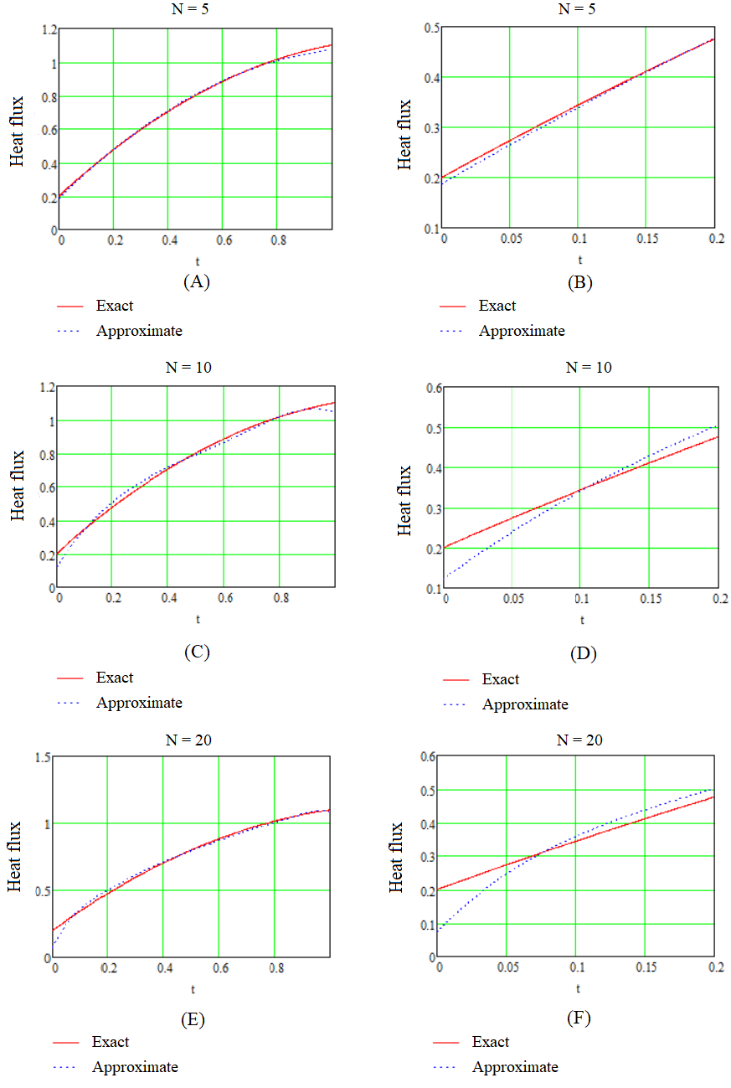

**Figure 1.** Graph of exact and approximate heat flux functions:

(A), (C), (E) for  and (B), (D), (F) for

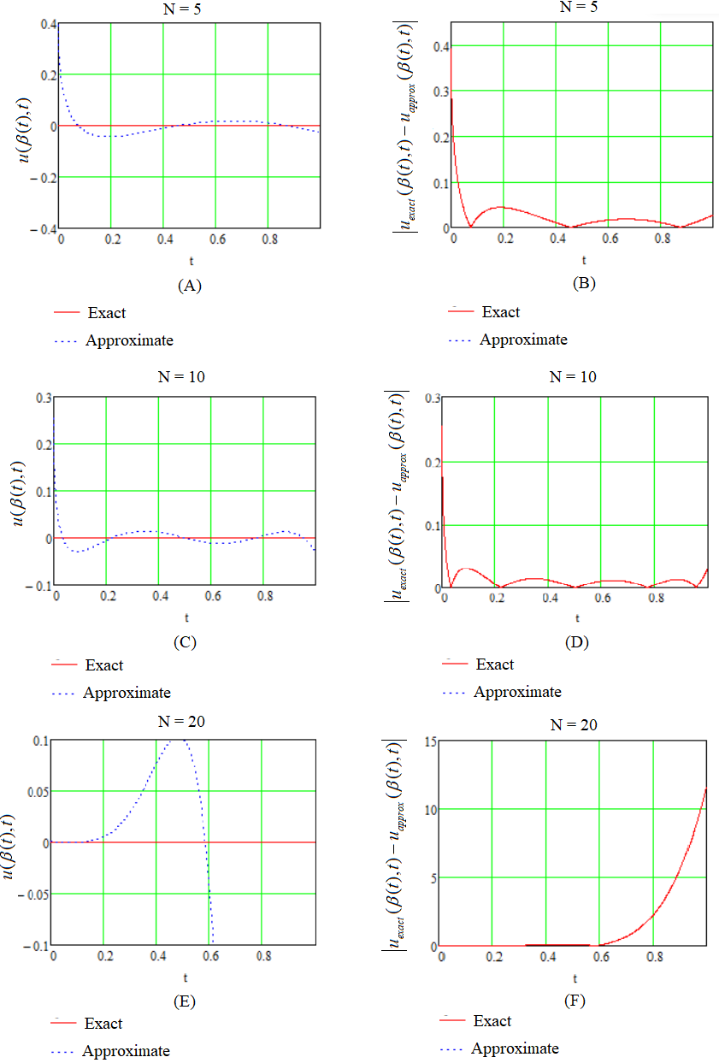

**Figure 2.** Graph of the temperature function  in (A), (C), (E) on boundary in and (B), (D), (F) absolute error function

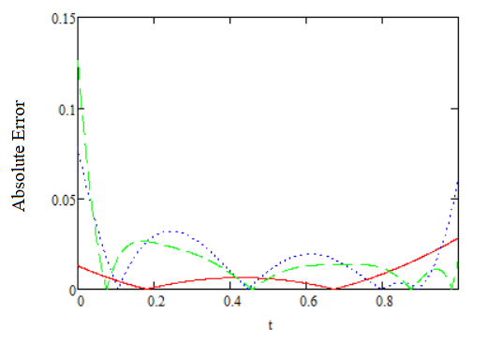

**Figure 3.** Absolute Error for heat flux function

() for , () for , () for 

**Conclusion**

In the section we obtained numerical approximate solution of the heat flux function which allows us to consider inverse Stefan problem. Temperature enters to electrical contact material through electrical contact spot with radius and heat distributes spherically in electrical material. The heat flux and temperature field in liquid region are determined by using heat polynomials and variational method. We can conclude that heat polynomials method is an effective and we can get better approximation for  on the boundary , but on the free boundary  we have the better approximation for harmonic number 

**2.2 Two-phase Stefan problem for generalized heat equation.**

The two-phase Stefan problem for generalized heat equation is considered for the case when one of the phases degenerates into a point at the initial time. That creates a serious difficulty for the solution by the standard method of reduction of the problem to the integral equations because these equations in this case are singular. We use another method when the solution is represented in the form of series for special functions (Laguerre polynomials and the confluent hypergeometric function) with undetermined coefficients.

These series satisfy a priori the heat equation, and their coefficients should be found to satisfy the initial and boundary condition, and the Stefan condition for a free boundary. Such approach seems to be very useful because if the boundary conditions are satisfied even approximately with some error , then the error of the solution should be not greater than  according to the maximum principle for the heat equation. The unknown coefficients are determined using the Faa-di Bruno formula, the convergence of obtained series for the solution is proved.

**Problem formulation**

Let us consider the two-phase Stefan problem for the equations

 (2.2.1)

 (2.2.2)

with the initial conditions

 (2.2.3)

 (2.2.4)

the boundary conditions

 (2.2.5)

 (2.2.6)

 (2.2.7)

and the Stefan condition

. (2.2.8)

**` The method of solution**

Suggesting that the initial and boundary functions can be expanded in Maclaurin series

 (2.2.9)

we represent the solution in the form

 (2.2.10)

 (2.2.11)

where .

Satisfying the boundary condition (2.2.5) and using the formula (1.5. 8) for  we obtain



and

 (2.2.12)

Using the initial condition (2.2.4) and the formula (1.5.8) for, for the first term with  and for the second term with  we get

,

Thus

. (2.2.13)

Now we should use the conditions (2.2.6) and (2.2.8) to get additional three equations for the definition of all coefficients and the free boundary. Thus  can be written in the form



where .

Now we rewrite the conditions (2.2.6) and (2.2.8) in terms of  and compare the powers in the left and the right sides of equations using -th differentiation and putting then . We obtain

 (2.2.14)

 (2.2.15)

At first, we use Leibniz formula for -th derivative for (2.2.14) equation and we obtain for the first term of .



and for second term we have



where .

For this purpose, we use the Faa di Bruno formula (Arbogast formula) for a derivative of a composite function. For the first term of temperature equation we have



 satisfy the following equations





for the second term we have analogously.

Then from condition (2.2.6) we get the following expressions



 (2.2.16)

 (2.2.17)

As coefficient  is known from (2.1.2), then by making substitution to (2.2.16) we can find coefficient . From system of equations (2.2.13) and (2.2.17) we can determine the coefficients  and 

 (2.2.18)

 (2.2.19)

 (2.2.20)

where











In particular, when  and  we have



From Stefan’s condition (2.2.8) and (2.2.14) we have the expression







 (2.2.21)

We can find coefficient  and  from (2.2.12), (2.2.18)-(2.2.20) and free boundary we can determine from (2.2.21).

**Convergence of series**

Convergence of series (2.2.10)-(2.2.11) can be proved as following. Let  for any . Then series (2.2.10) can be written as

 (2.2.22)

The series (2.2.10) and (2.2.11) must be convergence because . Then there exists some constant  independent of  and for the first term of (2.2.22) we have

. (2.2.23)

Since  bounded, then multiply both sides of (2.2.23) by  we obtain

(2.2.24)

Similarly, for the second term of (2.2.23) we have some constant  which satisfy

 (2.2.25)

Analogously, if we multiple both sides of (2.2.25) by



we get



 (2.2.26)

These geometric series and  convergence for all  and the same  convergence for all  and . Convergence for  can be determined analogously from (2.2.21).

**Numerical result of test problem**

In this section we consider test problem to analyze the special function method for the heat transfer Stefan problem with generalized heat equation arising in electrical contact processes. We take the parameters  and boundary functions , free boundary we consider in form of  and analyze effectiveness of the method for liquid region.

From condition (2.2.5) we take minimum of functional in the form

 (2.2.27)

and differentiating functional respect to  and equalizing to zero as  we have the following system of equation

 (2.2.28)

where

 (2.2.29)

 (2.2.30)

 (2.2.31)

where  can be determined from (2.2.18).

To find approximate coefficient  we take minimum of functional from condition (2.2.6) such that

 (2.2.32)

and similar way if we differentiate (2.2.29) respect to  and equalizing to zero as  we have system of matrix equation as follows

 (2.2.33)

where

 (2.2.34)

 (2.2.35)

where

 (2.2.36)

From system (2.2.28) we can find approximation of coefficient  and (2.2.33) gives us approximate coefficient value of  then we can obtain the following results.

In Figure 4 and Figure 5, there are shown the analytical exact solution which can be obtained by using recurrent formula of undetermined coefficients (2.2.18) – (2.2.20) and approximate solution of the temperature that obtained by variational method in liquid region at boundary conditions 

Table 3 presents the values of error in the reconstruction of the temperature distribution  in liquid region on boundary , and the temperature  on free boundary  for different parameters  We can easily in this table that  gives us better approximation on fixed face  and  enables us to get

better approximation on free boundary  Figure 6 depicts the graph of the absolute error of approximations for different value of 

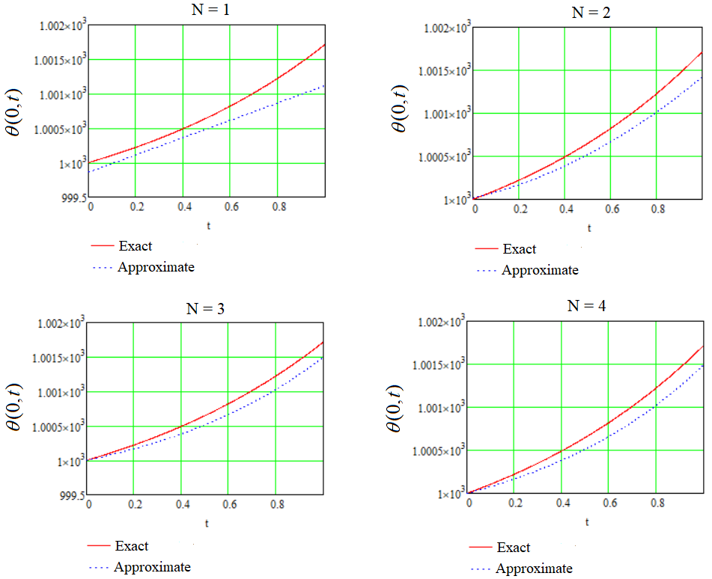

**Figure 4.** Graph of exact and approximate temperature solution  on the boundary 

Numerical results for solid region can be analyzed in similar way by using method of collocation. Now let’s analyze the solution of the free boundary  Table 4 shows us to maximum error of approximation for free boundary for different value of  In Figure 7 we can see the behavior of free boundary for different variable  and we make conclusion that melting process goes faster of  and slowly when 

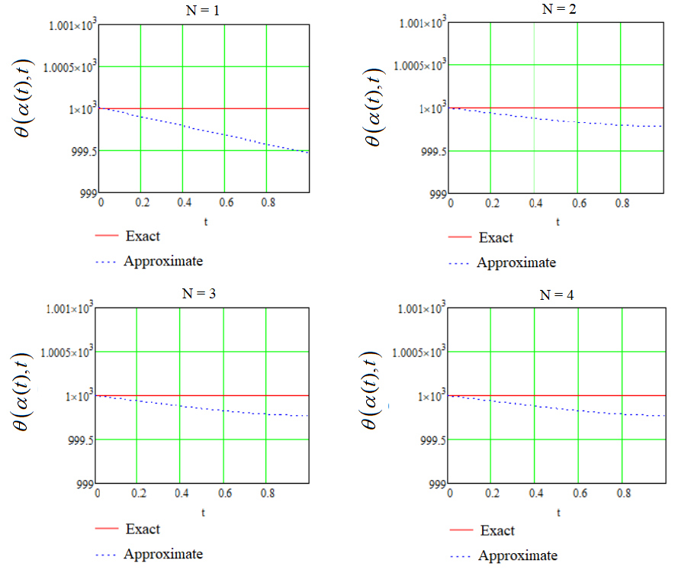

**Figure 5.** Graph of exact and approximate temperature solution 

for liquid region on the boundary 

|  |  |  |
| --- | --- | --- |
|  |  |  |
| 1 | 0.598 | 0.534 |
| 2 | 0.296 | 0.223 |
| 3 | 0.218 | 0.225 |
| 4 | 0.222 | 0.227 |
| 5 | 0.223 | 0.227 |

**Table 3.** The maximum error for heat distribution  and 

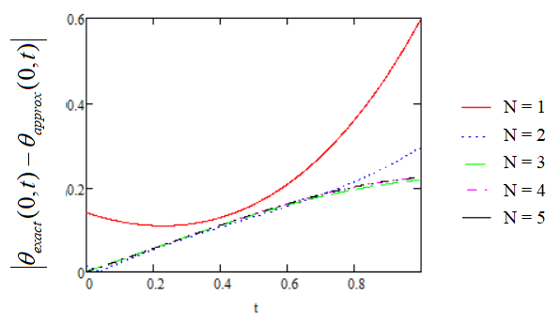

**Figure 6.** Graph of the Absolute Error

|  |  |
| --- | --- |
|  |  |
| 2 | 0.012 |
| 3 |  |
| 4 |  |
| 5 |  |
| 6 |  |

**Table 4.** The maximum error for free boundary

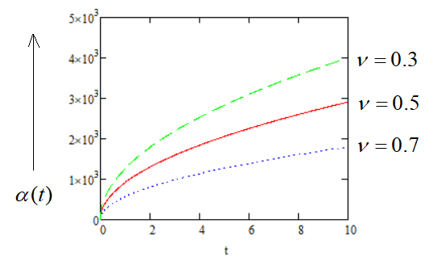

**Figure 7.** Behavior of the free boundary for different parameter of 

**Conclusion**

A mathematical model of describing heat distribution for generalized heat in electrical contacts on liquid and solid zone is constructed by two-phase Stefan problem. Temperature for liquid zone  and for solid zone  which given in the form summation two special functions as Laguerre polynomial and confluent hypergeometric function are determined and their coefficients  and  are founded from equations (2.2.12) and (2.2.18)-(2.2.20) and free boundary on melting isotherm is described in recurrent formula (2.2.21). The convergence of series is proved.

**2.3 Two phase spherical Stefan inverse problem solution with linear combination of radial heat polynomials and integral error functions in electrical contact process**

In this research the inverse Stefan problem in spherical model where heat flux has to be determined is considered. This work is continuing of our research in electrical engineering that when heat flux passes through one material to the another material at the point where they contact heat distribution process takes the place. At free boundary contact spot starts to boiling and at  stars to melting and there appear two phase: liquid phase and solid phase. Our aim to calculate temperature in liquid and solid phase, then find heat flux entering into contact spot. The exact solution of problem represented in linear combination of series for radial heat polynomials and integral error functions. The recurrent formulas for determine unknown coefficients are represented. The effectiveness of method is checked by test problem and approximate problem in which exact solution and approximate solution of heat flux is compared. The coefficients of heat at liquid and solid phases and heat flux are found. The heat flux equation is checked by testing problem by using Mathcad program.

Heat flux entering in electrical contact materials from electrical arc distributes radially and axially. Spherical model is most convenient, introduced by Holm R. [15], in the problem of heat distribution in electrical materials. In this problem generalized heat equation can be used. The generalized heat equation of the form



have the fundamental solution with delta-function containing initial condition by using Laplace transform can be represented as



where

.

We can consider the heat potentials related to this solution in form [29]



and by using integration by parts method we have the following explicit formula of heat polynomials



For applications it is convenient to multiply both sides of this equation by  and we get the following solution



which satisfy the generalized heat equation.

In this research we consider  which allow to transform to generalized heat equation to spherical heat equation [30].

**Problem formulation**

Let us consider the liquid phase described in domain and solid phase in  with spherical heat equations

 (2.3.1)

and each phase has initial condition as follows

 (2.3.2)

 (2.3.3)

Heat flux entering  into spherical domain from electrical arc with radius  in process of heat transfer within electrical contact materials can be determined from condition

 (2.3.4)

Temperatures in liquid and solid phase at free boundary  is equal to melting temperature

 (2.3.5)

Motion of the free boundary can be calculated at Stefan’s condition

 (2.3.6)

and temperature of solid zone at infinity turns to zero

 (2.3.7)

**The solution of the problem**

The solution of problem (2.3.1)-(2.3.7) we represent as linear combination of series for radial heat equation and integral error functions



 (2.3.8)



 (2.3.9)

The equations (2.3.8) and (2.3.9) satisfy heat equation (2.3.1) and undetermined coefficients  and  have to be founded to determine temperatures in phases. The function at initial condition for  is represented in expansion by Maclaurin series  and free boundaries can be considered in power series and . Heat flux which have to be determined from condition (2.3.4) can be written in



At first, we must find temperatures in liquid and solid zones, then by using property of integral error function to condition (2.3.3) we get

. (2.3.10)

By comparing the power of  in both sides (2.3.10) we obtain the following form

 (2.3.11)

and from conditions (2.3.5) we have



 (2.3.12)



 (2.3.13)

and from Stefan’s condition we obtain





 (2.3.14)

where  and .

Firstly, we take -th derivative both sides of (2.3.13) when  using Leibniz rule for first and second term of (2.3.13)

 (2.3.15)



 (2.3.16)

Using Faa-di Bruno for (2.3.15) and (2.3.16) we get

 (2.3.17)

(2.3.18)

From system of equations (2.3.11) and (2.3.13) we determine the coefficients . Multiplying both sides of (2.3.13) by  we have



where



Taking -th derivative both sides of this expression and using (2.3.10) we have

 (2.3.19)

 (2.3.20)

where





Multiplying  both sides of (2.3.12) and (2.3.14) we have

 (2.3.21)





 (2.3.22)

where  and



Taking -th derivative both sides of equations (2.3.21) and (2.3.22) at  we get

(2.3.23)

and









(2.3.24)

From recurrent equations (2.3.23) and (2.3.24) we can determined the coefficients  and as free boundary is known.

,  (2.3.25)

where









From condition at heat flux entering we have the following equation





 (2.3.26)

Multiplying both sides by we obtain the next equation



 (2.3.27)

where and

.

Analogously, taking -th derivative of both sides of equation (2.3.27) we have









(2.3.28)

From recurrent equation (2.3.28) we can determine the coefficients of heat flux in process of electrical contact materials.

**Exact solution of test problem**

In this section we consider test problem to check effectiveness of method of radial heat polynomials and integral error functions for inverse problem of spherical Stefan problem (2.3.1)-(2.3.7). The free boundaries are given in the form  and , then from the initial condition (2.3.3) and boundary condition (2.3.6) we have

 (2.3.29)

(2.3.30)

 (2.3.31)

and from Stefan’s condition at free boundary  we obtain





 (2.3.32)

For  from system of equations (2.3.29)-(2.3.30) we have

 (2.3.33)

 (2.3.34)

and from system of equations (2.3.30)-(2.3.31) we obtain

 (2.3.35)

 (2.3.36)

For  we have the following results

 (2.3.37)

where



Using this result and put in (2.3.29) we can find coefficient  directly. And for other coefficients we get the following coefficient

 (2.3.38)

where







and

 (2.3.39)

Heat flux can be determined form condition (2.3.3) which takes the form



 (2.3.40)

Then from expression (2.3.40) we obtain the coefficients of heat flux passes through liquid and solid phases









 (2.3.41)

and even indexed coefficients of heat flux . By using Mathcad 15 and taking  and melting temperature  we get exact values of first three coefficients of temperature in two phase  and  are calculated from system of equations (2.3.33)-(2.3.39). Then first three coefficients of heat flux is and  which can be found from (2.3.41).

**Approximate solution test problem**

In this section we consider collocation method that useful to engineers for testing and we try to show that by using three points  and  we can obtain no error estimates. Let  and , then for calculation Mathcad 15 is used and we get the next approximate coefficients for temperature in liquid and solid zones  and  and  . Then approximate values of first three heat flux is similar to exact values. The Figure 8 shows the graphs of approximate heat flux (**approx_P(t)**) and exact heat flux (**exact_P(t)**).

Then we can summarize that method radial heat polynomials and integral error functions is the most effective in the heat transfer problem appearing in electrical contact process.

**Conclusion**

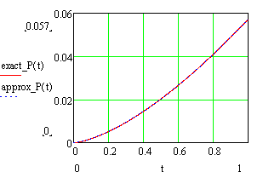The new method radial heat polynomials are introduced and is used for testing heat process in two phases when heat flux passes through these two zones. The coefficients of temperatures  and  are determined from recurrent formulas (2.3.19),

F**igure 8** Graphs of approximate and exact heat flux functions.

(2.3.20) and (2.3.25), then by using these coefficients and comparing degree of time from condition (2.3.3) heat flux is described. To testing effectiveness of radial heat polynomials and integral error function test problem is considered in which free boundaries are represented in self-similar form  and  which are convenient for testing and with approximation method (collocation method) checked the error estimates between exact solution and approximate solution of this inverse problem.

**2.4 Solution of two-phase one-dimensional cylindrical Stefan problem by using special functions.**

In this section two-phase Stefan problem for the cylindrical heat equation is considered. One of the phase turns to zero at initial time. In this case, it is difficult to solve by radial heat polynomials because the equations are singular. The solution is represented in linear combination series of special functions Laguerre polynomial and confluent hypergeometric function. The undetermined coefficients are founded. The convergence of series proved.

The one dimensional cylindrical heat equation is an important in mathematical modeling of heat transfer in bodies which cylindrical domain. The solution, with another words temperature distribution, in such model can take form of series for special function (Laguerre polynomials).

We consider the following problem

 (2.4.1)

 (2.4.2)

 (2.4.3)

 (2.4.4)

 (2.4.5)

 (2.4.6)

 (2.4.7)

The algorithm to solve this problem is from condition (2.4.4) and (2.4.5) we can find temperature for liquid and solid zones in cylindrical contact materials. Then from Stefan’s condition (2.4.6) the free boundary can be determined.

**Problem solution**

For  we can represent solution of (2.4.1)-(2.4.7) as the following form



 (2.4.8)

 (2.4.9)

where  . The equations (2.4.8) and (2.4.9) satisfy the problem (2.4.1)-(2.4.7), the function and free boundary  are given. From (2.4.4) we have

 (2.4.10)

and

 (2.4.11)

The algorithm to find coefficients  and  is that from condition (2.4.5) we express coefficient  and by making substitution to (2.4.6) we can get coefficient . At first, we take -th derivative from (2.4.5) and (2.4.6) when , where .

 (2.4.12)

 (2.4.13)

We use the Leibniz rule for (2.4.12), then we have



and









where . Then we use Faa-di Bruno formula for taking derivative from composite function and we get

 (2.4.14)

(2.4.15)

 (2.4.16)

 (2.4.17)

where  and satisfy the following equation



In particular, when  and  we have

 (2.4.18)



By using formulas (2.4.14)-(2.4.17) we have the next recurrent formulas for condition (2.4.5) and (2.4.6)



 (2.4.19)

and









(2.4.20)

where .

From recurrent formula (2.4.19) we express coefficient  and making substitution to (2.4.20) we can determine  as free boundary is given and coefficient can be founded from (2.4.11).

**Convergence of series**

Convergence of series (2.4.8)-(2.4.9) can be proved as following. Let  for any . Then series (2.4.10) can be written as



 (2.4.21)

The series (2.4.8) and (2.4.9) must be convergence because . Then there exists some constant  independent of  and for the first term of (2.4.21) we have

 (2.4.22)

Since  bounded, then multiply both sides of (2.4.22) by  we obtain

 (2.4.23)

For second term of (2.4.21) we consider that there exists some constant  and we obtain

. (2.4.24)

As  is bounded, multiplying both sides of (2.4.24) by



we have



 (2.4.25)

These geometric series and  convergence for all  and the same  convergence for all  and . Convergence for equation (2.4.9) and  can be determined analogously from (2.4.8).

**2.5 Approximate solution of two-phase spherical Stefan problem with heat polynomials**

In this section, the solution method of two-phase spherical Stefan problem represented in linear combination of heat polynomials. The required coefficients are determined. In this problem heat flux is given and the solution of this problem considered directly. Heat polynomials and their properties is introduced. Test problem is considered to show that linear combination of heat polynomials gives better approximation at heat flux.

The Stefan problem in spherical model can be solved by using integral error function and heat polynomials. The solution of heat equation

 (2.5.1)

is represented in the following form

 (2.5.2)

In particular, we have

  (2.5.3)

then corresponding to (2.6.3) we have two heat polynomials for even and odd part

 (2.5.4)

These heat polynomials satisfy the equation (2.5.1). Heat polynomial has the following properties:

1.  (2.5.5)
2.  (2.5.6)
3.  (2.5.7)

1.  (2.5.8)
2.  (2.5.9)

1.  (2.5.10)
2.  (2.5.11)
3.  (2.5.12)
4.  (2.5.13)
5. 

 (2.5.14)

**Mathematical model of problem**

Let consider the following problem

 (2.5.15)

 (2.5.16)

 (2.5.17)

 (2.5.18)

 (2.5.19)

 (2.5.20)

 (2.5.21)

By using substitution  we reduce problem (2.5.15) - (2.5.21) to the following problem

 (2.5.22)

 (2.5.23)

 (2.5.24)

 (2.5.25)

 (2.5.26)

(2.5.27)

 (2.5.28)

The heat flux  is given. We have to find temperature and free boundary .

**Method of solution**

We consider solution in the following form

 (2.5.29)

 (2.5.30)

and function at initial condition we expand in Maclaurin series as  and heat flux as .

Then using property (2.5.5) and property of integral error function  we have

 (2.5.31)

From (2.5.31) by comparing degree of  we get

 (2.5.32)

Then by using (2.5.8) to condition (2.5.25) we have



By expanding left side into two even and odd series and using (2.5.6), (2.5.7) we get the following expression

 (2.5.33)

From (33) we get by comparing degree of  we get

 (2.5.34)

By taking integral both sides of (2.5.22) and using (2.5.9) for left side we have

(2.5.35)

and using (2.5.11), (2.5.12) or using (2.5.13), (2.5.14) we get



For the right side of (2.5.22) we have



And by using (2.5.8) and condition (2.5.25) we get

 (2.5.36)

By making substitution (2.5.35) and (2.5.36) to the equation (2.5.22) we obtain

 (2.5.37)

Similarly, for (2.5.23) we obtain



 (2.5.38)

Then system (2.5.37) and (2.5.38) can be written as follows

 (2.5.39)

where









From (2.5.39) using linear combination of  and integral error function we can determine coefficients  and  if  is known. The coefficients and  also can be determined directly from condition (2.5.26).

**Approximation of free boundary**

To approximate free boundary, we represent iteration in form



1.  From Stefan’s condition (2.5.27) and taking into account that  we get

.

1.  Putting  into condition (2.5.27) and using (2.5.4) and condition (2.5.26) we have the following expression

(2.5.40)

As coefficients  and  are known from (2.5.32), (2.5.34), (2.5.39) then  can be determined from (2.5.40).

**Test problem**

Let given that  and  and free boundary as . By taking several five points at  and calculating coefficients with **linfit(a,b,c)** function in Mathcad 15 we have the result that shown in Figure 9. In Figure 9 we see heat flux solutions for  and Figure 10 depicts that most error takes the place at  and error estimate is 7.2 percent in  and most error for  takes place at  with estimation 0.25 percent. Then we can deduce that linear combination of functions is also give good approximation to given heat flux. In Figure 11, we can see the graph of the exact and approximate solution of the temperature in melting region at boundary  and Figure 12 shows the Relative Error of the approximations.

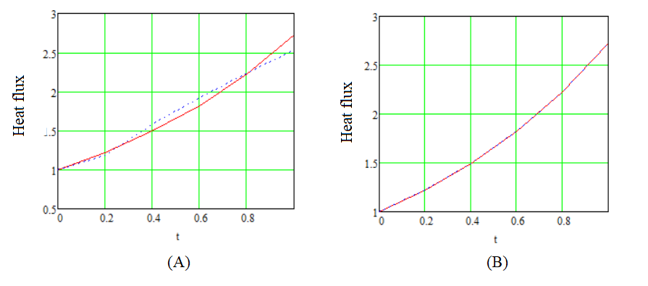

**Figure 9.** Graph of exact () and approximate () heat flux function for

 in (A) and  in (B)

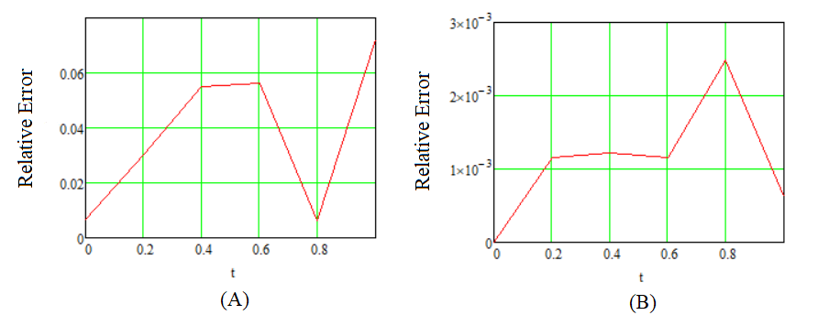

**Figure 10.** Graph of the Relative Error of the heat flux approximation:

1. ; (B) 

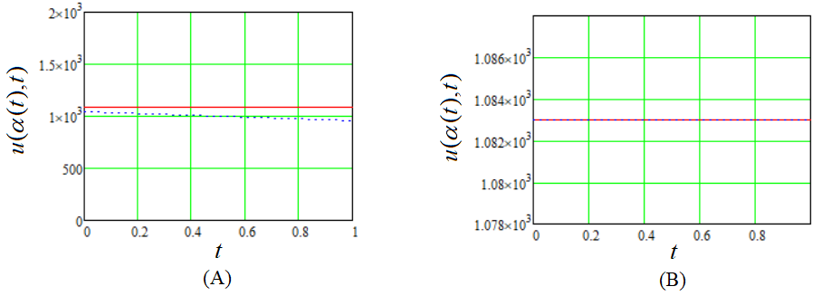

**Figure 11.** Graph of exact () and approximation () temperature

solution on melting condition for (A)  and (B) 

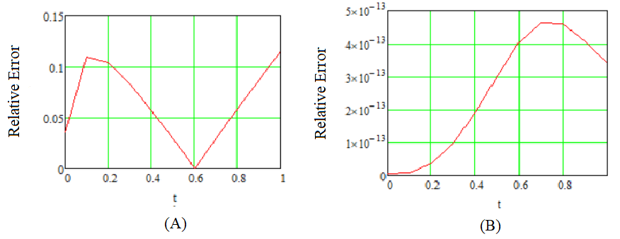

**Figure 12.** Graph of the Relative Error at boundary : (A)  (B) 

We can easily see that most error arises in  with estimation 11.6% and  gives us better approximation with error estimation less than 0.1 percent.

1. **STEFAN PROBLEMS ARISING IN ELECTRICAL CONTACT PROCESSES WITH NONLINEAR MODEL**

**3.1 One-phase spherical Stefan problem with Dirichle condition and temperature dependent coefficients**

The one-phase spherical Stefan problem with coefficients depending on the temperature is considered. The method of solving is based on the similarity principle, which enables us to reduce this problem to a nonlinear ordinary differential equation, and then to an equivalent nonlinear integral equation of the Volterra type. It is shown that the obtained integral operator is a contraction operator and a unique solution exists.

The method of similarity for solving the Stefan problem (automodel solution) with thermal coefficients depending on the temperature has been widely developed in recent years. The one-dimensional Stefan problem with given temperature and heat flux condition at fixed face for a semi-infinite material is considered in papers [31]-[32].

Recently, Huntul and Lesnic also discussed an inverse problem of determining the time-dependent thermal conductivity and the transient temperature satisfying the heat equation with initial data [33]. The inverse Stefan problems for finding the time-dependent thermal conductivity using shifted Chebyshev polynomials [34] and the latent heat depending on the position using Kummer functions [33] are considered successfully on the base of the similarity principle. The detailed information concerning this approach can be found in the references of papers [31]-[32].

Mathematical modeling of the arc erosion in electrical contacts should take into account the temperature dependence of all thermal and electrical coefficients, which is very essential for the correct description of melting and boiling dynamics [22]. The method of similarity is applied in this paper to modeling of the temperature field of a liquid spherical metal zone between two free moving boundaries related to the melting and boiled isotherms.

The temperature distribution in a liquid metal zone at the interaction of electrical contacts with the arc can be described by the spherical model introduced by R. Holm [14]

 (3.1.1)

 (3.1.2)

 (3.1.3)

and Stefan’s conditions

 (3.1.4)

 (3.1.5)

Here  is the temperature distribution in a liquid zone,  is temperature of boiling,  is the temperature of melting,  and  are gives coefficients of the heat capacity, density, heat conductivity correspondingly, are the specific heats of evaporation and melting,  are the radii of boiling and melting isotherms,  and . After the substitution

 (3.1.6)

we get the following new problem

 (3.1.7)

 (3.1.8)

 (3.1.9)

 (3.1.10)

 (3.1.11)

where  are specific heat,  are Stefan numbers and



Using the similarity principle [31], the solution of problem (3.1.7)-(3.1.11) can be represented in the following form

 (3.1.12)

for some . Then

 (3.1.13)

and problem (3.1.7)-(3.1.11) takes the form

 (3.1.14)

 (3.1.15)

 (3.1.16)

 (3.1.17)

 (3.1.18)

where  are diffusivity of the material and



Let us consider the obtained differential equation

 (3.1.19)

By using the substitution we get the following equation

 (3.1.20)

where



Solving the equation (3.1.20) with respect to  we get



where, by the definition of the function  and conditions (3.1.15) and (3.1.17),

 (3.1.21)

By the substitution  using condition (3.1.15) we get the following non-linear integral equation of the Volterra type with respect to 



which we can rewrite as follows

 (3.1.22)

where





Integral equation (3.1.22) is equivalent to differential equation (3.1.14) plus conditions (3.1.15) and (3.1.17), and the initial problem of finding a solution to differential equation (3.1.14), satisfying conditions (3.1.15)-(3.1.18), is equivalent to the problem of finding a solution to integral equation (3.1.22), satisfying conditions (3.1.16) and (3.1.18).

If  is a solution to nonlinear integral equation (3.1.22), satisfying conditions (3.1.16) and (3.1.18), then by (3.1.12) the desired temperature distribution in a liquid zone  has the form

 (3.1.22a)

**Existence of unique solution.**

Using the fixed point theorem we find conditions ensuring that integral equation (3.1.22) has a unique solution if . Let us denote . We suppose that there exist positive constants  and , such that for all 

 (3.1.23)

We assume that the specific heat and dimensionless thermal conductivity are Lipschitz functions and there exist positive constants and such that

 (3.1.24)

where  and .

**Lemma 3.1.**  For  we have



*Proof:* To prove, for example, the right-hand-side inequality it suffices to note that



**Lemma 3. 2.** For we have





where  and  is defined by (3.1.21).

*Proof.* By Lemma 3.1 we have



By making the substitution  we obtain



Analogously we can obtain the left-hand-side inequality. 

**Lemma 3.3.** Let . If (3.1.23)-(3.1.24) hold, then for all  we have



*Proof:* By using the inequality we obtain









**Lemma 3.4.** Let . Suppose that (3.1.23)-(3.1.24) hold. Then for all  we

Have



where  defined by (3.1.21).

*Proof:*



From Lemma 3.3 we get







and





Then we have



**Theorem 1.**  Let . Suppose that (3.1.23)-(3.1.24) hold. If the following inequality is satisfied

 (3.1.25)

where  is defined by (3.1.21), then there exists a unique solution  of integral equation (3.1.22).

*Proof:*  Let be the operator defined by



A solution of (3.1.22) is a fixed point of the operator , that is



Let , then we obtain



Finally, by using Lemmas 3.2 – 3.4 we have



Hence, if condition (3.1.25) is satisfied,  is a contraction operator and by the fixed point theorem there exists a unique solution of integral equation (3.1.22). 

**Numerical solution of the test problem**

In this section we test the spherical Stefan problem to show efficiency of the method proposed in this work. For testing, we use Runge-Kutta (RK) method to check accuracy of the solution (3.1.22). For calculation we take parameters  and we assume that thermal coefficients are constant such that ** and ** and dividing interval **into subintervals with ** where ** we get the result of evaluation that we can see in Figure 13 where blue graph is exact solution and red graph is approximation numerical result of RK. Then we can see that in the Figure 13 with 5 subintervals, it is possible to get better approximation than 10 subintervals. It follows that the solution (3.1.22) is effective for the problem (3.1.14)-(3.1.18). We can also see comparison of numerical results of exact and approximate solutions in Table 5.

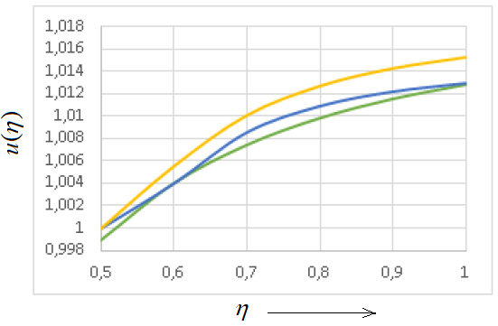

**Figure 13.** Exact and approximation solution of nonlinear model (green – exact **, blue – approximation **, yellow – approximation **)

In Figure 14 we represent error of approximation and we can see that greatest error for N = 5 is approximately 0.12 % which less than sub intervals N = 10 that has greatest error 0.28 % and we can get better approximation even if we take several 5 points. Then we can make conclusion that similarity method is effective for engineering problems.

The Figure 15 (A) depicts that the boiling interface moves faster if Stefan number increases and in the (B) it depicts that if we increase Stefan number then melting process goes faster and liquid zone melted quickly.

Temperature distribution in liquid is found by using similarity substitution (3.1.12) and obtained new form of solution (3.1.22). A free boundaries on boiling and melting interfaces are determined from (3.1.17) and (3.1.18). It is also easy to check

**Table 5.** Comparison of exact value of temperature (**) and approximate value of temperature (**) and Relative Error (**) of approximation.

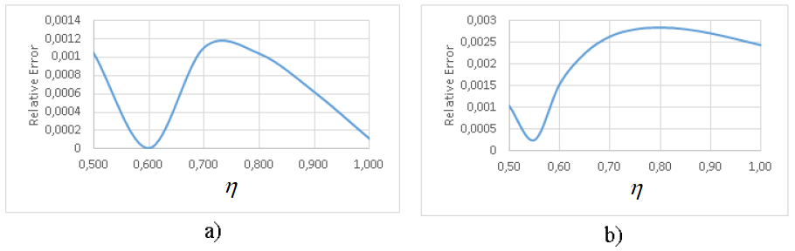

**Figure 14.** Relative Error a) for ** and b) for **

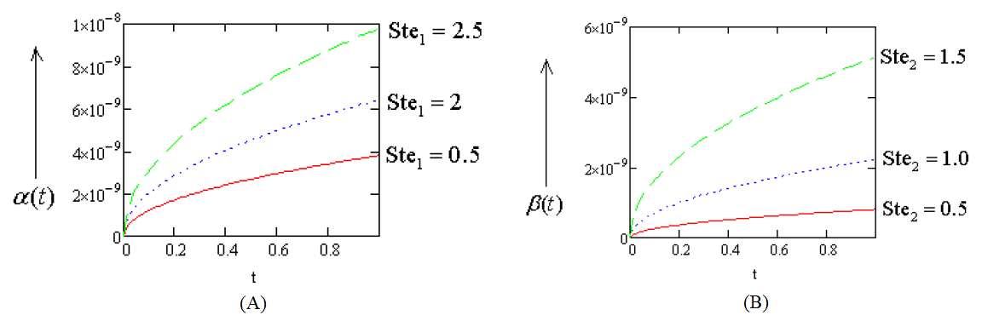

**Figure 15.** Behaviour of free boundaries (A) for ** and (B) for ** on different values of Stefan numbers

that (3.1.22a) satisfies spherical heat equation and all conditions (3.1.2)-(3.1.5). The main goal of this work is to improve the problem (3.1.1)-(3.1.9) by representing in new form of solution is achieved and existence is proved. Approximation solution of the problem is represented and efficiency of the method is described.

**3.2 One-phase spherical Stefan problem with Neumann condition and temperature dependent coefficients**

In Stefan problem with temperature-dependent thermal coefficients to determine heat process between on melting isotherm is an important to give attention to temperature dependence of specific heat and thermal conductivity. Similarity principle is very useful method to solve these kind of problems that enable us to reduce free boundary partial differential problem to ordinary differential equation with fixed boundary.

In this article we consider one-phase spherical Stefan problem with two free boundaries which one of them is given. This problem encounters in electrical contact phenomena, when heat flux enters to material through electrical contact spot which takes the form ideal hemisphere and heat distributed in spherical domain. We assume that contact surface of material with spot at the given radius  initial time takes melting temperature () and melted liquid phase domain lies between two moving boundaries. The aim of the article, finding temperature solution for liquid phase and the second free boundary on melting interface. The existence and uniqueness of the solution is proved by fixed point Banach theorem. Solution of the problems with particular types of nonlinear thermal coefficients are presented.

**Mathematical model and its solution**

The mathematical model describing the process of the interaction of the electrical arc with electrodes and the dynamics of their melting is based on the spherical model introduced by R. Holm [14]. The mentioned problem can be modelled as:

 (3.2.1)

 (3.2.2)

 (3.2.3)

 (3.2.4)

 (3.2.5)

where  and  are the heat capacity, mass density and thermal conductivity of the electrical contact material that depend of temperature

in liquid phase which has to be determined, - melting temperature,  represents heat flux entering in electrical contact spot at free boundary  and  is the given constant . We suppose that the left free boundary  is known and denotes the location of the moving melting interface which has to be determined, is the latent heat of melting and is the density of the material.

If we use the following dimensionless transformation

 (3.2.6)

the problem (3.2.1)-( 3.2.5) becomes

 (3.2.7)

 (3.2.8)

 (3.2.9)

 (3.2.10)

 (3.2.11)

where  and  are heat capacity, density, thermal conductivity and thermal diffusivity of the material and



To solve the problem (3.2.7)-( 3.2.11) we use similarity substitution

 (3.2.12)

From (3.2.9)- (3.2.12) , it can be supposed that given and unknown free boundaries must be proportional to  and can be presented as follows:

 (3.2.13)

whereis given positive constant and  is an unknown constant to be found.

With help of (3.2.12), the problem (3.2.7)-( 3.2.11) becomes

 (3.2.14)

 (3.2.15)

 (3.2.16)

 (3.2.17)

where ,  and

 (3.2.18)

We can deduce that  is the solution of the problem (3.2.14)-( 3.2.17) if and only if  satisfy the integral equation

 (3.2.19)

where

 (3.2.20)

 (3.2.21)

together with condition (3.2.17) which becomes

 (3.2.22)

From (3.2.22) we can determine unknown constant .

**Existence and uniqueness of the similarity solution of the problem.**

To analyze existence of solution (18) we assume that  is given constant. At first we consider the space  of continuous real valued functions defined on interval  endowed with supremum norm

 (3.2.23)

To prove that we use the fixed point Banach theorem as () is a Banach space. Let we define the operator on  that is

. (3.2.24)

By using the fixed point Banach we have to that for each there exists a unique function  such that

 (3.2.25)

which is the solution to (3.2.19).

We assume that  are bounded and satisfy Lipschitz inequalities as follows

1. There exists and such that

 (3.2.26)

There exists  such that

 (3.2.27)

1. There exists  and  such that

 (3.2.28)

There exists  such that

 (3.2.29)

Now we have to obtain some preliminary results to prove the existence and uniqueness of the solution to the equation (3.2.25).

**Lemma 3.2.1.** *For all*  the following inequalities hold

 (3.2.30)



 (3.2.31)

*Proof.* Lemma can be proved analogously by using definition of (3.2.20)-( 3.2.21) and assumptions (3.2.26)- (3.2.29).

**Lemma 3.2.2.** *Let given*  *and for all* * and*  *the following inequalities hold*

 (3.2.32)

 (3.2.33)

*where*



 (3.2.34)

*Proof:* Taking into account assumptions (3.2.29)-( 3.2.31) and inequality we have



In similar way, we obtain the next result



where









Then we obtain



Now we are able to prove the following theorem.

**Theorem 3.2.1.** *Suppose that*  and  *satisfy the conditions (3.2.26)-(* *3.2.29). If  where  is defined as unique solution to with*

** (3.2.35)

*where*  *is given by (3.2.34), then there exists a unique solution  for the integral equation (3.2.19) .*

*Proof:*  We have to show that operator  defined by (3.2.25) is contracting operator.

Let we have  and using Lemma 3.2.2 we have the following





It follows that



where  defined by (3.2.35) . Notice that



Then we can make conclusion that is increasing function and thus there exists a unique such that  so the operator becomes a contraction operator of mapping. By the fixed point Banach theorem there must exist a unique solution  to integral equation (3.2.19).

Now let us analyze the existence of unique solution for (3.2.22). We have to show that equation

 (3.2.36)

where



has a unique solution .

**Lemma 3.2.3.** *Suppose (3.2.25)-(* *3.2.28) hold, then for all  we have that*

** (3.2.37)

*where  and  are functions defined by*

** (3.2.38)

*which satisfy the following properties*



** (3.2.39)

*Proof:* Inequality references directly to bound (3.2.30) and using straightforward definition (3.2.38) and (3.2.30) we can easily obtain properties  and .

**Lemma 3.2.4.** *There exists a unique solution*  *to the equation*

 (3.2.40)

*and there exists a unique solution  to the equation*

 (3.2.41)

*Proof:* We can prove by using properties of  and  shown in Lemma 3.2.3.

**Theorem 3.2.2.** *Suppose (3.2.26)-( 3.2.29) hold. Consider  and  determined from (3.2.40) and (3.2.41) . If , where  is defined by (3.2.35), then there exists at least one solution to the equation (3.2.36).*

*Proof:* By hypothesis of Lemma 3.2.3 if  then we have that the inequality (36) holds for each  and  As function  is continuous decreasing function we obtain that there exists at least one solution  to the equation (3.2.36).

Now we can make conclusion by following main theorem.

**Theorem 3.2.3.** *Assume that (3.2.26)-(* *3.2.29) hold and  where  defined by (3.2.35) and defined from (3.2.41) then there exist at least one solution to the problem (3.2.1)-(3.2.5) where unknown free boundary is given by*

** (3.2.42)

*where  defined from Theorem3.2. 2 and temperature is given by*

** (3.2.43)

*where being similarity substitution and  is the unique solution of the integral equation (3.2.19) which was established in Theorem 3.2. 1.*

**Particular cases for nonlinear thermal coefficients**

In this section we are going to represent solution forms of the problem (3.2.1)-

(3.2.5) considering types of nonlinear thermal coefficients. The existence of each solution will be proved.

1. **Constant thermal coefficients**

If we take ** and **as follows

** (3.2.44)

then solution of the problem , taking into account that  defined by (3.2.18), must satisfy the following function

 (3.2.45)

and condition

 (3.2.46)

where , .

To show the existence and uniqueness of solution, it is sufficient to show that exists unique value  which satisfy the equation (3.2.46) such that

 (3.2.47)

where

.

We can easily check that function  is always decreasing function on interval

 as  and  and  for all positive parameter.

It implies that equation (3.2.47) has unique solution.

1. **Linear thermal coefficients**

We assume that density  of the material is constant and specific heat  and thermal conductivity  are linear as follows

 (3.2.48)

where  and .

From (3.2.18) we get

.

Let we have  and if we assume that ,  and from consumptions (3.2.26) and (3.2.28) taking  and  then we obtain that  must satisfy the following inequality

. (3.2.49)

Then solution (3.2.19) and condition (3.2.22) becomes



 (3.2.50)

 (3.2.51)

To prove existence and uniqueness of the solution, it is enough to show that there is unique solution of the equation

 (3.2.52)

where



It is easy to check that  is decreasing function on interval  such that  and  and . It follows that equation (3.2.52) has unique solution.

**Conclusion**

We have studied one-phase spherical Stefan problem with heat flux entering to electrical contact material through electrical arc and temperature in liquid metal zone and free boundary on melting interface are determined. Existence and uniqueness of the similarity solution imposing Neumann condition at the given left free boundary. We have represented solution forms to the particular cases when nonlinear thermal coefficients are constant or linear and for each cases existence and uniqueness of the solution is proved.

**3.3 Two-phase spherical Stefan problem with non-linear thermal conductivity**

In Stefan problem with nonlinear thermal coefficients it is an important to draw the attention to the temperature dependence of specific heat and thermal conductivity to find the temperature distribution between the melting and boiling isotherms [22]. One-dimensional Stefan problem with thermal coefficient at fixed face is considered in papers [31]- [34].

The process of closure of electrical contacts is accompanied by the explosion of a micro-asperity at the attaching point, the ignition of the electrical arc and the formation of three zones, metallic vapor zone, liquid and solid zones, which start to move simultaneously. The temperature fields in all zones can be described by the heat equation. For the vapor zone we have

 (3.3.1)

for the liquid zone

 (3.3.2)

and for the solid zone

 (3.3.3)

At initial time the vapor and liquid zones collapse into the point



and the initial conditions for the temperatures are

 (3.3.4)

The arc heat source with the temperature of metallic vapor ionization  which is placed at the point  is

 (3.3.5)

Finally, the Stefan conditions should be written on the surfaces of the phase transformations

 (3.3.6)

 (3.3.7)

 (3.3.8)

 (3.3.9)

where - temperature of vapor zone,  - temperature of liquid zone and - temperature of solid zone.  and  are material's density, specific heat and thermal conductivity.  - are boiling and melting temperature,  - free boundaries.

If the value of the heat flux entering into the solid zone from the liquid zone is small in comparison with the value of the heat flux consumed for the phase transformation of the solid into the liquid the conditions (3.3.8)-(3.3.9) transform into the one-phase conditions

 (3.3.10)

 (3.3.11)

while the temperature of the solid zone remains the same value like at the initial time  , and the equation (3.3.3) should be omitted.

Thus, the final version of the problem includes equations (3.3.1)-(3.3.2), (3.3.4)-(3.3.7), (3.3.10)-(3.3.11). It should be noted that the problem is a classical Stefan problem without fitting conditions (3.3.4) and (3.3.5) which was introduced and considered by Stefan, Lame and Clapeyron.

**Similarity solution of the problem**

To solve the problem (3.3.1)-(3.3.11) we use the substitution



and get the following problem

 (3.3.12)

 (3.3.13)

 (3.3.14)

 (3.3.15)

 (3.3.16)

 (3.3.17)

 (3.3.18)

 (3.3.19)

Now we focus on to obtain similarity solution to problem (3.3.12)-(3.3.19). Using the similarity principle, we introduce the solution in the following form

 (3.3.20)

and free boundaries in the form

 and 

Then we obtain the following free boundary problem with non-linear ordinary differential equations

 (3.3.21)

 (3.3.22)

 (3.3.23)

 (3.3.24)

 (3.3.25)

 (3.3.26)

 (3.3.27)

where



To solve the non-linear ordinary differential equation  we use substitution

 (3.3.28)

and we have the following equation

 (3.3.29)

where . By solving equation (3.3.29) for  we have the solutions

 (3.3.30)

 (3.3.31)

By making substitution (3.3.30) and (3.3.31) to (3.3.28) and using the conditions (3.3.23)-(3.3.24) and (3.3.26) we have the following solutions

 (3.3.32)

where  and

 (3.3.33)

where









The equations (3.3.32) and (3.3.33) satisfy the problem (3.3.21)-(3.3.27). From Stefan's condition (3.3.25) and (3.3.27) we obtain

 (3.3.34)

 (3.3.35)

The coefficient of free boundaries  and  can be founded from expression (3.3.34)-(3.3.35). In next section we will prove the existence of similarity solutions (3.3.32) and (3.3.33).

**Existence of similarity solution of the problem.**

To prove existence of solution of the non-linear integral equations (3.3.32) and (3.3.33) we use the fixed point theorem. We suppose that there exists constants  and  which satisfy the inequalities

 (3.3.36)

We consider that thermal conductivity and specific heat are Lipchitz functions and satisfy the following inequality

 (3.3.37)

by contraction mapping to ordinary differential equation. Let denote  for convenient proving. Before proving existence of unique solution of similarity solutions (3.3.32)-(3.3.33) we must consider the following lemmas.

**Lemma 3.3.1*.***  *If for any positive  (3.3.36) and (3.3.37) hold, then the following inequalities*

1. **
2. **

*hold for .*

*Proof.* For the second inequality we have the following prove



The first inequality can be proved similarly. 

**Lemma 3.3.2***. If (3.3.36)-(3.3.37) hold, then*

1. *For  we have*

**

1. *For  we have*

**

**

*Proof.* By using Lemma 3.3.1 let's try to prove the second inequality





After making substitution  and solving this integral we finished proving of the first inequality. The first is proved analogously. 

**Lemma 3.3.3.** *If (3.3.36)-(3.3.37) inequalities are hold then*

1. *For all  we have*

**

1. *For all  we have*

**

*Proof.* For the second inequality we have



by using  we get





The first inequality proved analogously as the second. 

**Lemma 3.3.4.** *If (3.3.36)-(3.3.37) hold then*

1. *For all  and  we get  as integral defined for  is divergent at .*
2. *For all  and  we get*

**

*Proof.* By using Lemma 3.3.2 and Lemma 3.3.3 for second inequality we obtain



where



and



By making summation we can prove the second inequality. The first has analogous proof. Now we try to prove theorem about existence of unique solution of integral equation (3.3.26). 

**Theorem 3.3.1.***Let  be a given positive real number and suppose that (3.3.36)-(3.3.37) holds. If satisfies the following inequality*





*where*

**



**

*then there exists unique solution  of the integral equation (3.3.33).*

*Proof.*We have operator ** which can be defined as

**

the solution to the equation (3.2.33) is the fixed point of the operator *,* that is

**

We suppose that ** then by using Lemmas 2 - 4 we get



**

where 

Finally, from Lemma 3.3.3 and3.3. 4 we have that



We can see that W is contraction operator and if inequality (3.3.38) holds then there exists unique solution for integral equation (3.3.33). Existence of unique solution for integral equation (3.3.32) also can be proved analogously as Theorem 3.3.1. 

**3.4 The mathematical model of a short arc at the blow-off repulsion of electrical contacts during the transition from metallic phase to gaseous phase.**

Mathematical modeling of the electrical arc is very important to understand its dynamics and to estimate arc parameters because experimental methods give as a rule only the resulting information about arcing and arc erosion because of a fleeting process. General models describing phenomena in the arc plasma are based on the systems of partial differential equations of the magneto-hydrodynamics (MHD) [35] – [39]. These models are too complicated for the practical investigation of the arc dynamics in electrical contacts. The non-stationary model presented in the paper [40] describes temperature and electromagnetic fields in a short electrical arc taking into account near-electrode phenomena. However, its application is also not so simple.

The arc appearing at blow-open contact repulsion has specific particular qualities conditioned by the electromagnetic and metallic vapor pressure. The non-stationary model of the dynamics of repulsion is presented in the paper [41]. It was found that the metallic vapor pressure plays a very important role in the process of the repulsion. However, this model has two drawbacks. Firstly, in this model there was no heat equation for the arc, and secondly, all the coefficients appearing in the model, such as thermal and electrical conductivities, heat sources, heat capacitance etc. were assumed constant. However, for a high current the temperature dependence of all these coefficients is very essential, thus this model should be corrected, and this idea is the main aim of this paper.

**Mathematical model**

At the initial stage of the blow-off repulsion, when the arc is burning in the metal-dominated phase with following transition to the gas-dominated phase, it can be considered as a short arc, i.e. the occupied by the arc domain has the form of a thin disk which radius is much greater than the thickness(Figure 16).

The equation for the temperature field of the arc can be written in the form

 (3.4.1)

Here  are the coefficients of the arc heat capacity, density, thermal and electrical conductivity correspondingly, is the arc current density,  and  are the volumetric arc power radiation and power losses due to the arc heat conduction into contacts.

The temperature dependence of the coefficients [41] is presented in Figure 17 and Figure 18.

The metallic arc phase continues up to the time ,when the temperature maximum at the center of the arc disk reaches the value of the gas ionization (approximately about 

 (3.4.2)

Thus, for the equation (3.4.1) we consider the domain

 (3.4.3)

for the temperature range

 (3.4.4)

where  is the temperature of the metallic vapor ionization (approximately about ).

As can be seen from Figure 7, the arc radiation can be neglected in the temperature range (3.4.4) and we should take into account only the power losses  due to the arc heat conduction into the zone of metallic vapour  via the zone of the ideal thermal and electrical conductivity  introduced by R. Holm [14]. This loss can be calculated using the formula

 (3.4.5)

It was shown in the paper [6] that the contact gap, i.e. the arc disk thickness , increases in the initial stage of the metallic arc phase at the blow-off repulsion due to



$$\left.r_{A}(t\right)$$

$$D_{0}$$

$$D_{1}$$

$$D_{2}$$

$$D_{A}$$

$$θ_{A}$$

$$θ_{1}$$

$$θ_{2}$$

$$D_{3}$$

$$θ_{3}$$

**Figure 16 -** The axial contact cross-section of the spherical domains. - the disk occupied by the arc, - the Holm sphere of the ideal conductivity, - the sphere of metallic vapours,  - the sphere of liquid metal, - the solid zone.

the summary action of electromagnetic and vapor forces according to the expression

 (3.4.6)

where the constant  depends on the current amplitude.

For the considered time interval  it is possible to approximate the alternative current  by the expression

 (3.4.7)

where

 (3.4.8)

Substituting the expressions (3.4.5) – (3.4.8) into the equation (3.4.1) we get

(3.4.9)



**Figure 17 -** Temperature dependence of the thermal and electrical conductivity and radiation losses for the arc burning in air  and .

Domain for the temperature  is



where



At the initial time the domain  collapses into a point,  where the temperature should be equal to the threshold of metal ionization temperature:

 (3.4.10)

This temperature remains the same value on the boundary of the disk for :

 (3.4.11)

The arc heat flux passes through the sphere of ideal conductivity without any power losses and enters into vapor zone  through the spherical surface  which temperature is the same like (3.4.11):

 (3.4.12)



**Figure 18 -** Temperature dependence of  and  for the arc burning in air

The phenomena occurring in the vapor zone are too complicated for mathematical modeling in the frame of our approach, thus let us consider this zone as the thermal resistivity between the arc zone  and the liquid zonewith a linearly decreasing temperature

 (3.4.13)

The temperature fields of the liquid zone  and the solid zone satisfy the heat equations

 (3.4.14)

The Stefan conditions hold on the interfaces of the phase transformations:







(3.4.15)

Here  are specific heats of evaporation and melting,



The last boundary condition for the solid zone is

 (3.4.16)

At the initial time all zones collapse into a point:

 (3.4.17)

The solution of the above-formulated problem can be found using the similarity principle (See Appendix 2).

**Numerical solution**

The arc temperature at the transition from metallic phase to the gaseous stage, which changes in the range , was calculated for the parameters of the blow-off repulsion presented in the paper [40], [41], which are shown in Figure 1 (in Appendix 3).

The metallic and transition stages last from 0 to 4 ms (AB C zone). During this stage the temperature increases up to, and the function in the expressions (3.4.32) and (3.4.37), which is the quantity inverse to the thermal diffusivity of the air) decreases more than twice, as can be seen from Figure 2 and Figure 3 (in Appendix 3).

The results of the numerical solution of the problem (3.4.21) – (3.4.29) is presented in the Figure 3 (in Appendix 3).

One can see that presented in this paper non-linear model gives better approximation to the experimental data in the considered transition time interval then the linear model, however outside this interval it cannot be applied. The results of calculation of the radii of zones indicated in Figure 10 are shown in Figure 4 (in Appendix 3). Thus, the average value of the arc radius at the transition arc stage is equal approximately , that in a good agreement with experimental data [43].

**CONCLUSION**

Heat polynomials are constructed to solve spherical and special functions are constructed to solve cylindrical and generalized heat equation problems with phase transitions of the Stefan type. By analogy with the one-dimensional case, the generating function, associated functions orthogonal to heat polynomials are introduced, and criteria for the convergence of series in heat polynomials is considered.

The mathematical apparatus that will be used to study the problems of heat and mass transfer with phase transitions is based on the representation of the solution in the form of linear combinations or series in heat polynomials, which a priori satisfy the differential equation. The main solution method is based on the approximation of boundary and initial functions by linear combinations of heat polynomials in the form of series or finite sums. If the approximate solution is constructed in the form of a finite sum of heat polynomials and the boundary conditions are also approximated by similar polynomials with a certain error, then the solution error will not be higher than the same error in accordance with the maximum principle. The fundamental difficulty in the practical implementation of this method consists in obtaining recurrent formulas for determining the unknown coefficients in the formulas for the temperature and the free boundary of the phase transition.

A critical moment in the development of the method of heat polynomials is the proof of the convergence of the series obtained. In this work convergence of series which written by linear combination of special functions Laguerre polynomials and congruent hypergeometric functions and heat polynomials is proved. In the one-dimensional case, as well as for the generalized heat equation, we must obtain conditions imposed on the boundary functions, which guarantee the convergence of the series representing the solution of the problem. One of the possible problems in constructing a solution for unbounded domains can be the problem of satisfying the solution to the condition at infinity. To overcome it, it is proposed to include in the structure of the solution, along with heat polynomials, other special functions, in particular, integral functions of errors.

The main obtained results are the following:

First result: One-phase spherical inverse Stefan problem is solved by using heat polynomials method. Two approximation methods (variational method and collocation method) are compared and conclusion is that variational method gives best approximation heat flux in this problem [44].

Second result: Two-phase direct Stefan problem is solved. Mathematical model is considered in generalized heat equation. The method special function (Laguerre polynomial and congruent hypergeometric function) is represented and shown that this is effective method. Convergence of series is proved [45]. Mathematical model two-phase cylindrical direct problem is constructed and solved by linear combination special functions and convergence is proved [46]. Exact solution of two-phase spherical Stefan problem is obtained by using linear combination of integral error function and radial heat polynomials. Numerical result is found and analysed that radial heat polynomials is also effective method [47].

Third result: One-phase spherical Stefan problem with temperature dependence coefficients is considered. Effectiveness of similarity principle is shown that we can reduce our problem to ordinary second order nonlinear differential equation problem [48], [49],[51].

Fourth result:Similarity solution of the problem is considered where we can obtain nonlinear model of the problem and one can see that presented in this work non-linear model gives better approximation to the experimental data in the considered transition time interval then the linear model, however outside this interval it cannot be applied.

In the last section of dissertation, spherical Stefan problem is considered with temperature dependence coefficients which arising in electrical contact processes. The main three notes are taken: 1. The non-linear mathematical model of a short arc temperature at its transition from metallic to gaseous stages describes the dynamics of the blow-off repulsion of electrical contacts in a good agreement with experimental data; 2. The dynamics of increase of the radii of interfaces between zones of the phase transformations can be described by the self-similar law; 3. Generalizing of this model for the gaseous arc stage is possible by the replacement of the one-dimensional model of the arc disc for the two-dimensional model of the arc cylinder [50].

**REFERENCES**

1. Sadoun, N., Si-Ahmed, E. K., Colinet, P., On the Refined Heat Balance Integral Method for the One-Phase Stefan Problem with Time-Dependent Boundary Conditions// Appl. Math. Modelling, 30 (2006), 6.-P. 531-544
2. Wood, A. S., A New Look at the Heat Balance Integral Method// Appl. Math. Modelling, 25 (2001), 10/-P. 815-824
3. Mosally, F., Wood, A. S., Al-Fhaid, A., On the Convergence of the Heat Balance Integral Method// Appl. Math. Modelling, 29 (2005), 10.-P. 903-9012
4. F. Yigit, A Simplified Analytical Solution of a Two-Dimensional Stefan Problem with a Periodic Boundary Condition//Int. Review of Chemical Engineering, V. 7, №6 (2015), pp. 121 -129
5. Caldwell and Y.Y. Kwan, On the perturbation method for Stefan problem with time-dependent boundary conditions, Int. J. Heat Mass Transfer, Vol. 46, pp. 1497-1501, 2003.
6. Yigit, Perturbation Solution for Solidification of Pure Metals on a Sinusoidal Mold Surface, Int. J. Heat and Mass Transfer, Vol. 50, pp. 2624-2633, 2007.
7. P.C. Rosenbloom and D.V. Widder, "Expansions in terms of heat polynomials and associated functions", Trans. Amer. Math. Soc., Vol. 92 (1959), 220-266.
8. C. Nasim, On generalized heat polynomials, International. J. Math. & Math. Sci. VOL. ii NO. 2 (1988) pp. 393-400
9. K. Grysa, Heat polynomials and their applications, Archives of Thermodynamics, vol. 24 (2003) No. 2, pp. 107-124
10. S. Futakiewicz, L. Hozejowski, Heat polynomials method in solving the direct and inverse heat conduction problems in a cylindrical system of coordinates, Transactions on Engineering Sciences vol. 20, © 1998 WIT Press, www.witpress.com, ISSN 1743-3533
11. S.N. Kharin, The analytical solution of the two-phase Stefan problem with boundary flux condition, Математический журнал, Том 14, № 1 (51), 2014, стр. 55 – 76.
12. M. Sarsengeldin, S.N. Kharin, Method of the Integral Error Functions for the Solution of the One- and Two-Phase Stefan Problems and Its Application, Filomat 31:4 (2017), 1017–1029 DOI 10.2298/FIL1704017S, Available at: <http://www.pmf.ni.ac.rs/filomat>.
13. M. Sarsengeldin, S.N. Kharin, et al., Exact Solution of One Inverse Stefan Problem, Filomat 31:4 (2017), 1017–1029 DOI 10.2298/FIL1704017S, Available at: <http://www.pmf.ni.ac.rs/filomat>.
14. R. Holm, Electrical Contacts, Fourth Edition. Springer Verlag, 1981, pages. 482.
15. L.I. Rubinstein, The Stefan Problem, Transl. Math. Monogr. 27, AMS, Providence, RI, 1971.
16. E. Hetzmannseder, W. Rieder, “Arc Mobility on Bouncing Contacts”, Proc. 42-nd IEEE Holm Conf. on Electrical Contacts, Chicago, USA, 1996, pp 87 – 91.
17. T.S. Davies, H. Nouri and F. Britton, “Towards the Control of Contact Bounce”, IEEE Transactions on CPMT, Part A, Vol. 19, No 3, 1995, pp 353 – 359.
18. J.W. McBride and S.M. Sharkh, “Electrical Contact Phenomena During Impact”, IEEE Transactions on CPMT, Part A, Vol. 15, No 2, 1992, PP 184 – 192.
19. H. Nouri, N. Larsen and T.S. Davies, “Contact Bounce Simulation Using MATLAB”, Proc. 43-rd IEEE Holm Conf. on Electrical Contacts, Philadelphia, USA, 1997, pp. 284 – 288.
20. Kharin S.N., The analytical solution of the two-phase Stefan problem with boundary flux condition, Mathematical Journal, 1 (2014), pp. 55-75.
21. Slade P. Electrical Contacts. Principles and Applications, Second Edition, CRC Press, (2014), 1-1268.
22. Kharin S.N. The Mathematical Models of Phenomena in Electrical Contacts, The Russian Academy of Sciences, Siberian Branch, A.P. Ershov Institute of Informatics System. Novosibirsk, (2017), pp. 1-193.
23. Kharin S.N., Sarsengeldin M.M., Nouri H. Analytical solution of two-phase spherical Stefan problem by heat polynomials and integral error functions, AIP Conference Proceedings 1759, 020031(2016); <https://doi.org/10.1063/1.4959645>.
24. Sarsengeldin M., Kharin S.N. Method of the Integral error functions for the solution of the one- and two-phase Stefan problems and its application, Filomat 31:4 (2017), 1017-1029. <https://doi.org/10.2298/FIL1704017S>.
25. Kharin S.N., Jabbarkhanov K. Method of the heat polynomials for the solution of free boundary problems for the generalized heat equation, News of the International Kazakh-Turkish University. HA. Yasavi, sir. Mathematics, physics, computer science, 4:1 (2018), 166-170.
26. Merey. M. Sarsengeldin, Stanislav N. Kharin, Samat Kassabek, Zamanbek Mukambetkazin. Exact Solution of the One Phase Stefan Problem, Filomat, 32:3 (2018), 985-990, <http://www.pmf.ni.ac.rs/filomat>.
27. Kavokin A.A., Nauryz T.A., Bizhigitova N.T. Exact solution of two phase spherical Stefan problem with two free boundaries, AIP Conference Proceedings, 1759:1 (2016), 020117.
28. Merey M. Sarsengeldin, Abdullah S. Erdogan, Targyn A. Nauryz, Hassan Nouri. An approach for solving an inverse spherical two-phase Stefan problem arising in modeling of electric contact phenomena, Mathematical Methods in the Applied Sciences, 41:2 (2018), 850-859.
29. V.I. Kudrya, A.E. Pudy, S.N. Kharin. Fundamental solution and heat potentials of heat equation for a rod with a variable cross-section. Equations with discontinuous coefficients and their applications, Nauka, Almaty, 1985, pp 76-81.
30. S.N. Kharin, M.M. Sarsengeldin, H.Nouri. Analytical solution of two phase spherical Stefan problem by heat polynomials and integral error functions. AIP Conference Proceedings 1759, 020031; doi: <http://dx.doi.org/10.1063/1.4959645>.
31. A.C. Briozzo, M.F. Natale, D.A. Tarzia, Existence of an exact solution for a one-phase Stefan problem with nonlinear thermal coefficients from Tirskii’s method, Nonlinear Analysis 67 (2007), 1989–1998, <https://doi.org/10.1016/j.na.2006.07.047>.
32. A.C. Briozzo, M.F. Natale, A nonlinear supercooled Stefan problem, Z. Angew. Math. Phys. 2 (2017), 46–68, <https://doi.org/10.1007/s00033-017-0788-6>.
33. M.J. Huntul, D. Lesnic, An inverse problem of finding the time-dependent thermal conductivity from boundary data, Int. Commun. Heat Mass Transfer 85 (2017), 147-154.
34. A. Kumar, A.K. Singh, Rajeev, A Stefan problem with temperature and time dependent thermal conductivity, Journal of King Saud University of Science, (2018), March, 32-41, <https://doi.org/10.1016/j.jksus.2018.03.005>.
35. E. Tomas, I. Browne, Circuit Interruption, Marsel Dekker, New York, 1984.
36. P. Slade, Electrical Contacts. Principles and Applications, CRC Press, Second Edition, 2014.
37. Frank Karetta,Manfred Lindmayer, Simulation of the gas-dynamic and electromagnetic processes in low voltage switching arcs, IEEE Transactions on Components Packaging and Manufacturing Technology, Part A, 21(1), 1998, pp. 95-103.
38. Xiayu Liao, Xue Zhou, Kai Bo, Guofu Zhai, 3-D Hydrodynamic Model of Metal Droplet Sputtering and Molten Pool Formation Under Electric Arc, Proc. Of 29th ICEC and 64th IEEE Holm Conference on Electrical Contacts, 2018, pp. 56-60.
39. S.N. Kharin, Mathematical Model of the Short Arc Phenomena at the Initial Stage, Proc. 43-th IEEE Holm Conf. on Electrical Contacts, Philadelphia, USA, 1991, pp 289-305.
40. S.N. Kharin, H. Nouri, M. Bizjak, Effect of Vapour Force at the Blow-open Process in Double-break Contacts, IEEE Transactions on Components and Packaging Technologies, March 2009, Vol. 32, № 1,

2009, pp. 180-190.

1. V.S. Engelsht, Mathematical modelling of the electrical arc, ILIM Edition, Frunze, 1983 (Rus.)
2. S. N. Kharin, H. Nouri, B. Miedzinski, Phenomena of Arc Root Immobility in Electrical Contacts, Proceedings of the 58th IEEE Holm Conference on Electrical Contacts, Portland, OR, USA, 2012, pp. 11-15.
3. Luc Nedelec, Contribution a l etude des Arcs electriques et de leurs consequence sur les materiaux de contacts: Application aux commutateurs automobiles, Docteur These, Univ. de Rennes, 1997.
4. S.N. Kharin, T.A. Nauryz, K. Jabbarkhanov. Solving two-phase spherical Stefan problem using heat polynomials. Kazakh Mathematical Journal, 19:1 (2019), pp. 59-68.
5. S.N. Kharin, T.A. Nauryz. Two-phase Stefan problem for generalized heat equation. News of the National Academy of Sciences of the Republic of Kazakhstan, Vol. 2, No. 330 (2020), pp. 40-49. DOI: <https://doi.org/10.32014/2020.2518-1726.13>.
6. S.N. Kharin, T.A. Nauryz. Solution of two-phase cylindrical direct Stefan problem by using special functions in electrical contact processes. International Journal of Applied Mathematics, 2021, 34(2), pp 237-248. (Scopus,  SJR 0.268, перцентиль 31), DOI: <http://dx.doi.org/10.12732/ijam.v34i2>.
7. S.N. Kharin, T.A. Nauryz,B. Miedzinski. Two phase spherical Stefan inverse problem solution with linear combination of radial heat polynomials and integral error functions in electrical contact process. **International Journal of Mathematics and Physics,** Vol 11, No. 2, (2020), pp. 4-13, (Clarivate Web of Science),DOI: <https://doi.org/10.26577/ijmph.2020.v11.i2.01>.
8. S.N. Kharin, T.A. Nauryz. One-phase spherical Stefan problem with temperature dependent coefficients. Eurasian Mathematical Journal, 2021, 12(1), pp 49-56. (Scopus, SJR 0.277, перцентиль 25), DOI: <https://doi.org/10.32523/2077-9879-2021-12-1-49-56>.
9. S.N. Kharin, T.A. Nauryz.Two-phase spherical Stefan problem with non-linear thermal conductivity. Kazakh Mathematical Journal, 20:1 (2020), pp.27-37.
10. S.N. Kharin, T.A. Nauryz. Mathematical model of a short arc at the blow-off repulsion of electrical contacts during the transition from metallic phase to gaseous phase. Fifth International Conference on Analysis and Applied Mathematics, Turkey, AIP Conference Proceedings 2325, 020007 (2021); (Indexed in Scopus).DOI: <https://doi.org/10.1063/5.0040412>.
11. Nauryz T.A., Kharin S.N. Existence and uniqueness for one-phase spherical Stefan problem with nonlinear thermal coefficients and heat flux condition. International Journal of Applied Mathematics, 2022, 35(5), 645-659. Doi: <http://dx.doi.org/10.12732/ijam.v35i5.2>

**APPENDIX**

**Appendix 1. Temperature dependence of the coefficients for the arc burning in nitrogen**

|  |  |  |  |  |  |  |  |
| --- | --- | --- | --- | --- | --- | --- | --- |
| Tempe-rature | Density | Viscosity | Radiation | Enthalpy | Heat conductivity | Heat capacity | Electrical conductivity |
| 300 | 1.1400 | 0.0179 | 0 | 311 | 0.026 | 1050 | 0 |
| 500 | 0.6340 | 0.0257 | 0 | 526 | 0.039 | 1100 | 0 |
| 1000 | 0.3420 | 0.0400 | 0 | 1091 | 0.065 | 1160 | 0 |
| 1500 | 0.2280 | 0.0506 | 0 | 1686 | 0.094 | 1220 | 0 |
| 2000 | 0.1710 | 0.0694 | 0 | 2316 | 0.126 | 1300 | 0 |
| 2500 | 0.1370 | 0.0810 | 0 | 2976 | 0.152 | 1340 | 0 |
| 3000 | 0.1130 | 0.0920 | 0 | 3656 | 0.180 | 1380 | 0 |
| 3500 | 0.0978 | 0.1040 | 0 | 4355 | 0.210 | 1415 | 0 |
| 3700 | 0.0924 | 0.1090 | 0 | 4641 | 0.226 | 1450 | 0 |
| 4000 | 0.0853 | 0.1160 | 0 | 5090 | 0.255 | 1540 | 0 |
| 4500 | 0.0755 | 0.1270 | 0 | 5942 | 0.369 | 1870 | 0 |
| 5000 | 0.0668 | 0.1380 | 0 | 7085 | 0.657 | 2700 | 0 |
| 5500 | 0.0575 | 0.1520 | 0 | 8960 | 1.278 | 4800 | 2 |
| 5700 | 0.0541 | 0.1580 | 0 | 10080 | 1.645 | 6400 | 6 |
| 6000 | 0.0495 | 0.1680 | 0 | 12352 | 2.550 | 8750 | 14 |
| 6500 | 0.0419 | 0.1810 | 0 | 17890 | 4.500 | 13400 | 50 |
| 7000 | 0.0335 | 0.1950 | 0 | 25590 | 5.160 | 17400 | 179 |
| 7500 | 0.0273 | 0.2080 | 0.001 | 34257 | 4.525 | 16700 | 590 |
| 7700 | 0.0253 | 0.2120 | 0.002 | 37377 | 4.000 | 14500 | 700 |
| 8000 | 0.0233 | 0.2170 | 0.005 | 41315 | 3.130 | 11750 | 915 |
| 8500 | 0.0210 | 0.2270 | 0.010 | 46377 | 2.200 | 8500 | 1550 |
| 9000 | 0.0192 | 0.2330 | 0.025 | 49685 | 1.730 | 5450 | 2010 |
| 9500 | 0.0180 | 0.2390 | 0.060 | 52470 | 1.575 | 5050 | 2550 |
| 10000 | 0.0167 | 0.2430 | 0.100 | 55083 | 1.525 | 5470 | 3030 |
| 10500 | 0.0156 | 0.2420 | 0.240 | 58063 | 1.620 | 6450 | 3500 |
| 11000 | 0.0144 | 0.2370 | 0.420 | 61763 | 2.050 | 8350 | 4000 |
| 12000 | 0.0123 | 0.2100 | 1.000 | 72213 | 2.850 | 12550 | 4950 |
| 13000 | 0.0102 | 0.1720 | 2.150 | 87343 | 3.720 | 17710 | 5860 |
| 14000 | 0.0085 | 0.1170 | 3.800 | 107248 | 4.330 | 22100 | 6720 |
| 14500 | 0.0077 | 0.0940 | 4.700 | 118423 | 4.420 | 22600 | 7150 |
| 15000 | 0.0071 | 0.0760 | 5.650 | 129635 | 4.370 | 22250 | 7500 |
| 15500 | 0.0066 | 0.0610 | 6.650 | 140473 | 4.170 | 21100 | 7910 |
| 16000 | 0.0060 | 0.0490 | 7.400 | 150473 | 3.875 | 18900 | 8180 |
| 17000 | 0.0053 | 0.0330 | 8.550 | 166573 | 3.325 | 13300 | 8800 |
| 18000 | 0.0049 | 0.0250 | 9.200 | 177948 | 2.975 | 9450 | 9410 |
| 19000 | 0.0045 | 0.0210 | 9.460 | 186273 | 2.850 | 7200 | 9960 |
| 20000 | 0.0043 | 0.0180 | 9.260 | 191891 | 2.900 | 5950 | 10500 |
| 21000 | 0.0040 | 0.0170 | 8.650 | 197403 | 3.070 | 5500 | 11030 |
| 22000 | 0.0038 | 0.0170 | 8.050 | 203203 | 3.270 | 6100 | 11500 |
| 23000 | 0.0036 | 0.0170 | 7.680 | 210003 | 3.525 | 7500 | 11960 |
| 24000 | 0.0034 | 0.0160 | 7.550 | 218928 | 3.825 | 10350 | 12260 |
| 26000 | 0.0030 | 0.0150 | 8.250 | 248478 | 4.400 | 19200 | 12350 |
| 28000 | 0.0026 | 0.0130 | 9.800 | 296478 | 5.000 | 28800 | 12160 |

**Appendix 2. Solution of the problem**

According to the similarity principle we represent the solution in the form

 (1)

where

, 

Then we get

 (2)

 (3)

and the equation (3.3.9) takes the form

 (4)

Similarly, the equations (3.3.14) can be written in the form

 (5)

Thus, the problem is reduced to the solution of the ordinary differential equations (4), (5). The boundary conditions (3.4.12), (3.4.15) for these substitutions transform into expressions

 (6)

 (7)

 (8)

 (9)

 (10)

 (11)

 (12)

The problem (4) – (12) can be solved using the Runge-Kutta method.

Sometimes, for an analytical analysis of the temperature dynamics, it is more convenient to reduce this problem to the system of the integral equations. In particular, the equation (4) after the substitution

 (13)

can be written in the form

 (14)

where

 (15)

 (16)

The equation (14) is equivalent the non-linear integral equation

 (17)

Similarly, the equations (5) can be written in the form

 (18)

where

 (19)

 (20)

or in equivalent form of integral equations

 (21)

 (22)

The integral equations (3.4.17), (3.4.21),(3.4.22) are the equations of the Volterra type, and if the kernels of integral operators are differentiable, then these operators are contraction and the solution can be obtained by the iteration method.

**Appendix 3. Figures**

**0

2

4

6

8

10

12

14

16

0

10

20

30

40

50

60

**A**

**B**

**C**

**D**

**E**



0.2

0.4

0.6

0.8

1.0

1.2

- 0.2

- 0.4

- 0.6



0

0.3

0.6

0.9

1.2

1.5

1.8



0**

**Figure 1** -Dynamics of voltage , current, and contact

displacement.



**Figure 2 -** The temperature dependence of [41]



**Figure 3** - Dynamics of the arc temperature: 1 - experimental data [40] , 2 – calculation by the non-linear model, 3 – calculation by the linear model [42]



**Figure 4 -** Dynamics of the arc radii.  is the arc radius calculated in [42].