International Information Technology University

|  |  |
| --- | --- |
| UDC: 004.45 | On manuscript right |

**NALGOZHINA NURGUL ZHOMARTKYZY**

**Models and methods of hybrid management of business processes based on RPA technologies**

8D06102 – Computer and Software Engineering

Dissertation for the degree of

doctor of Philosophy (PhD)

Scientific consultant

Doctor of Technical Sciences,

Professor Uskenbayeva R.K.

Foreign consultant

Professor Oscar Pastor

Republic of Kazakhstan

Almaty, 2024

CONTENTS

NORMATIVE REFERENCES 4

INTRODUCTION 7

1 BUSINESS PROCESS MANAGEMENT IN A MODERN WORLD 12

1.1 Business-process 12

1.2 Business Process Management 14

1.4 Agile methods 23

1.5 Simulation methods 24

1.6 Integration methods 25

1.7 Comparison of model-building methods 26

1.8 Future directions in model-building methods 26

Conclusions on the first chapter 27

2 THE RPA REVOLUTION IN WAREHOUSE MANAGEMENT: A HYBRID BPM APPROACH 29

2.1 Definition of Hybrid Business Processes 29

2.2 Introduction to Hybrid Business Process Management 29

2.3 Importance and rationale for adopting hybrid approaches 31

2.4 Robotic Process Automation 33

2.5 Review of existing hybrid models for business process management 37

2.6 Challenges and Considerations in Adopting Hybrid Models 41

2.7 Strategies for managing change and ensuring successful adoption 42

2.8 Determining the importance of planning in effective management of warehouse activities 42

2.9 Warehouse business processes 45

Conclusion on the second chapter 49

3 PROPOSED HYBRID RPA MODEL FOR BPM TO INCREASE THE EFFICIENCY OF LOGISTICS OPERATIONS 51

3.1 Proposed Integration of Business Process Management with Robotic Process Automatic 53

3.2 RPABPM Architectural Design 53

3.3 RPABPM Integration Methodology 58

3.4 RPABPM model design 59

3.5 Design 60

3.6 RPABPM Modelling 61

3.7 RPABPM Execution 63

3.8 Monitoring 64

3.9 Optimization 64

Conclusion on the third chapter 66

4 EXPERIMENTAL RESULTS OF THE DEVELOPED HYBRID RPA MODEL FOR BPM 68

4.1 Intelligence of Industrial Robots for RPABPM 69

4.2 Autonomy of Industrial Robots for RPABPM 69

4.3 Experimental setup 70

4.4 Datasets and Process 72

4.5 Process and Performance Evaluation 72

4.6 Power Consumption 74

4.7 Results 75

Conclusion on the fourth chapter 76

**CONCLUSION** 78

REFERENCES 80

### NORMATIVE REFERENCES

This dissertation uses references to the following standards:

“Instructions for preparing a dissertation and abstract”, Higher Attestation Commission of the Ministry of Education and Science of the Republic of Kazakhstan dated September 28, 2004. No. 377-3zh.

ГОСТ 7.32-2001 - Report on scientific research work. Structure and design rules.

ГОСТ 7.1-2003. Bibliographic record. Bibliographic description. General requirements and drafting rules.

СТ РК 34.005-2002 Information technology. Basic terms and definitions - Introduced for the first time.

СТ РК 34.015-2002 Information technology. Set of standards for automated systems. Terms of reference for the creation of an AS - Introduced for the first time.

СТ РК 1184-2003 Quality of service information. Terms and definitions – Introduced for the first time.

СТ РК 5.1-2007 Procedure for the development of state classifiers of technical, economic and social information - Introduced to replace 5.1-92.

СТ РК 34.014 -2002 Information technology. Set of standards for automated systems. Automated systems. Terms and definitions - Introduced for the first time.

СТ РК 34.008 -2002 Information technology. Statistical analysis of software - Introduced for the first time.

СТ РК 34.009 -2002 Information technology. Dynamic analysis of software - Introduced for the first time.

СТ РК ISO/IEC TO 15504-1-2002 Information technology. Evaluation of software development. Part 1. General concepts and introductory guide.

СТ РК ISO/IEC TO 15504-2-2002 Information technology. Evaluation of software development. Part 2. Basic model of processes and their maturity.

СТ РК ISO/IEC TO 15504-3-2002 Information technology. Evaluation of software development. Part 3: Conducting the assessment.

СТ РК ISO/IEC TO 15504-4-2002 Information technology. Evaluation of software development. Part 4: Guidance on the use of assessment.

СТ РК ГОСТ R ISO/IEC 15910-2006 (ГОСТ R ISO/IEC 15910-2002, IDT) Information technology. The process of creating software user documentation.

СТ РК 34.019-2005 Information technology. Software life cycle processes -Introduced for the first time.

СТ РК ГОСТ R ISO/IEC TO 16326-2006 Software engineering. Guidelines for the application of СТ РК 34.019 in project management - Introduced for the first time.

**DESIGNATIONS AND ABBREVIATIONS**

AGV: Automated Guided Vehicle

AI: Artificial Intelligence

AIWCMS: Advanced Intelligent Workflow and Content Management System

ABS: Agent-based simulation

API: Application Programming Interface

BI: Business Intelligence

BPEL: Business Process Execution Language

BPM: Business Process Management

BPMN: Business Process Model and Notation

BPMN 2.0: Business Process Management Notation 2.0

CNN: Convolutional Neural Network

CRM: Customer Relationship Management

Ĉ: Not defined in the provided text (may be a variable specific to a mathematical model or equation)

DES: Discrete-event simulation

DOr: Desired outcome of RPABPM approach

DI: Detection intensity

ERP: Enterprise Resource Planning

ESB: Enterprise Service Bus

FLC: Fixed Cost of Human Labor

FRC: Fixed Cost of RPA

GPS: Global Positioning System

HRM: Human Resource Management

HTTP: Hypertext Transfer Protocol

IP: Internet Protocol

IT: Information Technology

ISO: International Organization for Standardization

IoT: Internet of Things

ISWMS: Intelligent Software Warehouse Management System

Kanban: An agile method for visualizing and optimizing workflow

LAN: Local Area Network

LSTM: Long Short-Term Memory Network

MC: Main Computer

L: Machine Learning

MIS: Management Information System

Op: Business object’s origin position from the robot

Ot: Aggregate count of monitored business components

PB: Panel Board

Ph: High-dimensional probability

PLC: Programmable Logic Controller

RPAS: Robotic Process Automation System

RPABPM: RPA-aware Business Process Management

REMS: Robot event monitoring system

RFID: Radio-frequency identification

RFIDTS: Radio Frequency Identification Tracking System

ROI: Return on Investment

SCM: Supply Chain Management

SOA: Service-Oriented Architecture

Š: Stochastic period (a random length of time)

∑: Summation symbol

TOD: Turn-over Device

TQM: Total Quality Management

UML: Unified Modeling Language

VLC: Variable Cost of Human Labor

VRC: Variable Cost of RPA

ϑ: Deterministic time (a fixed length of time)

WMS: Warehouse Management System

Ŵ: Not defined in the provided text (may be a variable specific to a mathematical model or equation)

w: Continuous input vector

WI: Vector of continuous state variables

XML: Extensible Markup Language

Ẋ: Cycle time vector

x: Constant state variable vector for the robot

Ý: Time-series vector for business automation inputs

Ử: Time-series vector for robot states

dr: Random distance between the object and the robot

∂: Separation of all corresponding pathways

Rc: Cost of installing robots

Re: Robot event

Ri: Number of robots and activities

Rw: Weight of the robots

Ř: Decision-making process

SIp: Sub-interval points in the pathways

tR: Variable time for the robots to monitor different activities

### INTRODUCTION

Efficiency and optimization of business processes determine the success of any business today. These metrics have become key success factors for organizations of all sizes and industries. Constant changes in the economic, technological, and social context create a range of opportunities, but at the same time there are also many challenges that arise in adapting and improving the efficiency of business processes.

Therefore, the relevance of research aimed at analysis, optimization and innovation of business processes is increasing every day. Key aspects such as digital transformation, customer centricity, adaptability to change and risk management are becoming the basis for ensuring organizations' successful functioning in the face of change.

Business processes surround us everywhere. By definition [1], this is a set of interrelated actions or activities aimed at creating a specific product or service for consumers. With the development of civilization, the approach to business processes has changed. Industrialization, which is a natural accelerator of the evolution of all processes on the planet, has also had an impact on business processes.

This study examines various innovations and new approaches to managing modern business processes, which, like many aspects of everyday life, have undergone significant changes due to emerging technologies. For example, many routine tasks that previously required significant human resources have now been successfully automated. With each stage of industrialization, the business field undergoes a new interpretation of automated improvement. In the current economic environment, automation is becoming a key factor in optimizing business processes.

Various technologies make it possible to automate routine and monotonous tasks, freeing up human resources to perform tasks that require strategic and more creative solutions [2]. However, despite significant advances in development, many companies still have processes that use both manual and automated approaches. Effectively managing such hybrid business processes becomes a challenge that requires the development of new models and methods that can provide synergies between human and robotic labor. All this is aimed at reducing transaction costs, reducing the likelihood of errors and increasing the speed and quality of task completion. Taking an integrated approach has a significant impact on a company's performance and competitiveness, and contributes to more efficient and sustainable resource management, considering environmental considerations.

Research aimed at developing models and methodologies for controlling hybrid business processes plays a key role in the formation of new practical recommendations and strategies. The results of the research can be applied in various business contexts, improving management practices and decision-making protocols.

Thus, the research topic “Models and methods for managing hybrid business processes based on RPA technology” remains relevant and promises to make a significant contribution to the development of modern methods of managing business processes using advanced technologies. This research initiative involves developing and experimenting new business process management models and methodologies using a hybrid approach integrating RPA technology.

**Research goals.**

The purpose of the study is to improve the efficiency and consistency of logistics business processes using robotic agents. This study provides a comprehensive analysis of established business process management (BPM) practices, with a particular focus on their relevance in the context of hybrid scenarios involving automation.

Within a theoretical framework, this work aims to create models that explain the complex dynamics governing the interactions between automated and manual aspects of hybrid business processes. These models will rely on the fundamental principles of coordination, optimization and adaptation.

The purpose of this work is to identify and justify the most suitable automation algorithms for smooth integration of robots into hybrid business processes, taking into account their efficiency and applicability.

The study takes a comprehensive approach covering various aspects of RPA and its integration with BPM. The work begins with an analysis of the constraints and requirements for business process management. This stage includes a detailed consideration of the technical limitations and basic requirements that must be met to effectively manage the business. This allows to identify key factors influencing successful process management.

The next stage of the research includes an analysis of BPM in the context of RPA compatibility. The development of an effective RPA and BPM integration methodology (RPABPM) is explored.

Methodologies of experimental testing and performance evaluation of the proposed model RPABPM are considered. It means this phase involves conducting experiments to validate the effectiveness of the proposed methodology and a detailed evaluation of its performance under real-world conditions.

Then conclusions were formulated based on the conducted studies. The results are systematized, made conclusions and identified the key advantages and limitations of the integration of RPA and BPM.

In addition to this, mathematical modeling of business process automation using RPA is carried out, to formalize the description of monitoring and automation processes, which gives a more accurate idea of the functioning of the system. This model can contribute to providing the foundation for further research and optimization of business processes.

**Research objectives.**

To achieve the goal of the research, the following interrelated tasks have been set and solved:

* system analysis of the subject area and algorithms for hybrid management of business processes;
* development of an effective RPA and BPM integration model (RPABPM);
* mathematical modeling of business process automation using RPA;
* calculation of efficiency indicators of the developed mathematical model
* conducting experimental studies to evaluate the key performance indicators of the hybrid RPABPM model.

**Scientific novelty.**

The novelty of the research consists of the following:

* application of a hybrid approach to business process management, which proposes the integration of robotic agents into traditional processes;
* development of a model for integrating RPA with BPM (RPABPM) using the example of logistics processes;
* formalization of the process of integrating RPA with BPM to evaluate the effectiveness of the hybrid RPABPM approach in the logistics process;
* development of the RPABPM architecture, ensuring stable operation of the system.

**The provisions submitted for defense.**

1. Methodology for integrating RPA and BPM into a single mechanism for managing logistics business processes;
2. A hybrid RPABPM model has been developed to determine optimal interaction points to maximize efficiency;

3. The result of an experimental study to calculate the effectiveness of the hybrid RPABPM model in the context of logistics processes.

**Research methods.**

The forthcoming study is a multifaceted analysis based on various methodologies, with a thorough literature review, theoretical model building, empirical research, and methodological experiments using simulated data.

The basis of this study is an in-depth analysis of the literature, which serves as the basis for establishing a strong theoretical framework. A review of existing research works provides important insights into the evolution of management practices in the context of business processes and RPA integration in hybrid scenarios.

The study begins with an analysis of the limitations and requirements of RPA technology, aimed at identifying the technical and organizational aspects that influence the successful implementation of the technology.

The next step involves examining the BPM space in the context of interoperability with RPA, identifying the interfaces and interactions between these technologies, and identifying opportunities to optimize business processes when integrating them.

Based on these ideas, an effective RPA and BPM integration methodology (RPABPM) is developed, including strategies and tools for aligning and sharing RPA and BPM to improve their effectiveness.

This is followed by experimental testing and performance evaluation of RPABPM, which involves practical testing of the developed methodology under real-life conditions to confirm its effectiveness and practical applicability.

At the last stage, mathematical modeling of monitoring and automation of business processes using RPA is implemented, developing formal mathematical models that systematize the analysis of the work of R-robots and their impact on business processes.

The final stage includes drawing conclusions based on analysis and experiments, highlighting practical recommendations for the successful integration of RPA and BPM into business processes. The results obtained make an important contribution to the development of modern methods of business process management based on innovative technologies.

**Theoretical and practical significance of the study.**

The theoretical and applied results of this study anticipate important contributions to the field of business process management based on innovative RPA and BPM technologies. Through a systematic and integrated approach to the analysis, synthesis, and integration of these technologies, we expect to achieve the following key results.

First, it will build a strong theoretical framework based on an extensive review of literature and research to provide an in-depth understanding of the historical evolution of management practices and the integration of RPA into business processes.

Secondly, an effective RPA and BPM integration methodology (RPABPM) is developed, providing strategies and tools for sharing technologies and improving their efficiency within business processes.

Third, experimental testing of RPABPM under real-world conditions is proposed to validate the effectiveness of the methodology and evaluate its performance. Formal mathematical models for monitoring and automating business processes using RPA, providing a systematic analysis of the impact of robots on business processes.

Finally, the formulation of practical recommendations based on the analysis and experiments carried out for the successful integration of RPA and BPM, considering the results obtained. These results aim to develop best practices in business process management, enrich theoretical foundations, and provide practical guidance for businesses seeking to optimize their operations using innovative technologies.

As a result, the fruits of this research go beyond theoretical concepts. Organizations that use data models and methodologies can optimize their operations, achieve newfound efficiency, and promote harmonious collaboration between automated and human elements. The ripple effect of these advances can be a catalyst for growth, competitiveness, and success in the ever-changing landscape of modern business.

**Approbation of research results and publications.**

The main propositions and scientific results of the work were presented and discussed at seminars of the "Computer Engineering" department at the International University of Information Technologies, seminars of the “Software Engineering” department at Satbayev University and on the 14th International Conference on Emerging Ubiquitous Systems and Pervasive Networks (EUSPN), 2023 (Almaty, 2023).

The main results obtained during the dissertation work have been published in four printed works, including 2 articles in publications recommended by the Committee for Control in the Field of Education and Science of the Ministry of Education and Science of the Republic of Kazakhstan, 1 article in publications indexed by Scopus in a high-impact scientific journal with an impact factor of 3.6, citescore 5.5, and a percentile of 80, and 1 article in proceedings of international conferences.

Results on the dissertation topic are presented in the following publications:

1. R.K. Uskenbayeva, A.A.Kuandykov, N.Zh.Nalgozhina, M.A. Berklaiyeva (2022), RPA approach in business process management life cycle. Herald of Almaty Univeristy of Power Engineering ISSN 2790-0886. Vol. 1(56) (2022). – pp. 126-132
2. Uskenbayeva, R., Nalgozhina, N., & Berkaliyeva, M. (2022). Introduction and evaluation problem of BPM and RPA approaches in modern logistic systems. Scientific Journal of Astana IT University, 12(12), 45–54. <https://doi.org/10.37943/12UXAN3708>
3. Nalgozhina, N.; Razaque, A.; Raissa, U.; Yoo, J. Developing Robotic Process Automation to Efficiently Integrate Long-Term Business Process Management. Technologies 2023, 11, 164. <https://doi.org/10.3390/technologies11060164>
4. Nalgozhina N., Uskenbayeva R. Automating hybrid business processes with RPA: optimizing warehouse management // Procedia Computer Science. - 2024. - №231. – Р. 391-396. <https://doi.org/10.1016/j.procs.2023.12.223>

**Structure and scope of the work.**

This work consists of four main chapters. The first chapter substantiates the relevance of the problem associated with the development and use of hybrid business process management models in the field of logistics using RPA technology. This part formulates the purpose and objectives of the study and presents the methodology for its implementation. A review of the literature on this topic was also conducted, unresolved aspects were highlighted, and the theoretical and practical significance of the upcoming research was determined.

The second chapter provides a detailed review of existing research and literature related to the topic under consideration. The main theoretical concepts, models and methods used in this study are described, and the main problems and shortcomings of current approaches are highlighted.

The third part of the dissertation is devoted to the development of models of full and partial automation. This chapter discusses in detail the key aspects and results of the development of automated systems. The developed models are described, as well as the methodology for their creation and integration into business processes.

The fourth chapter of the dissertation is devoted to the analysis of the resulting model. This section helps identify its advantages and limitations, as well as analyze its effectiveness in various business scenarios. The full volume of the dissertation: 88 pages including 82 names of the source used.

### 1 BUSINESS PROCESS MANAGEMENT IN A MODERN WORLD

The history of the development of business processes is an important component of understanding modern concepts and methodologies for managing organizations. In this chapter, we look at the evolution of business process approaches, from their early inception to modern process management methodologies. The purpose of this chapter is to present the context and evolution of the understanding and application of business processes, as well as to review the existing theoretical frameworks and approaches that have contributed to the formation of modern business process management practices.

As mentioned before a business process is a set of interrelated activities that work together to achieve a specific goal, typically related to the production of a product or service [3]. It involves inputs, transformations, and outputs, and is usually carried out across multiple functions or departments within an organization.

The concept of business processes has been around for centuries, but the formalization and standardization of business process management began in the mid-20th century with the introduction of management theory and techniques. In recent years, advances in technology have enabled new methods of business process management, such as automation and digital transformation.

Business processes play a critical role in the success of an organization by providing a framework for achieving operational excellence, reducing costs, increasing productivity, and improving customer satisfaction. A study [4] found that effective business process management can improve organizational performance by up to 50%.

The section discusses the importance of business processes in the current business environment. It highlights the role of business processes in defining and executing business strategies and emphasizes the need for continuous improvement and optimization of processes to stay competitive. The section also touches on the challenges that modern businesses face in managing their processes, such as the increasing complexity of processes and the need for greater agility and flexibility. Overall, this section sets the stage for a deeper exploration of the challenges and opportunities associated with managing business processes.

### Business-process

The initiation of a business process stems from a mission objective, often triggered by an external event. The culmination of this process is the successful attainment of the business objective, resulting in the provision of a valuable outcome for customers. Moreover, a business process can be subdivided into subprocesses, which encompass the internal functions of the primary process. To oversee the smooth flow of the process from inception to completion, there is typically a designated process owner.

In a broader categorization proposed by [5] business processes can be classified into three main types:

Operational processes: These processes form the core of a business and generate the main value stream. Examples include order placement, account opening, and component manufacturing.

Management processes: Responsible for supervising operational processes, management processes encompass tasks such as corporate governance, budget oversight, and employee management.

Supporting processes: These processes provide support to the primary operational processes. Examples encompass accounting, recruitment, call center operations, technical support, and safety training.

Complex business processes can be broken down into multiple subprocesses, each with its attributes, while also contributing to the overarching business goal. Analyzing business processes often involves mapping or modeling processes and subprocesses, even down to the level of individual activities or tasks. Various methods and techniques can be employed for process modeling. For instance, the Business Process Modeling Notation (BPMN) is a visualization technique used for illustrating business processes in a structured manner.

While classifying processes into different types and categories can be beneficial, caution is advised due to potential overlaps. Ultimately, all processes contribute to a cohesive outcome, centered around the creation of customer value. This objective is facilitated by business process management, a discipline aimed at analyzing, enhancing, and implementing effective business processes.

Figure 1.1 - As-Is process

For convenience and visualization of business processes, two basic concepts “As-Is” and “To-Be” are used - these are two key stages in the process of change management and business process optimization.

"As Is" describes the current state of the business processes (figure 1.1). At this stage, a detailed analysis of existing processes, their steps, relationships, roles, and

resources used is carried out. The goal of "As Is" is to understand how the processes are currently working, identifying problem areas, redundant steps, bottlenecks, and other aspects that can slow down work or reduce efficiency.

Figure 1.2 - To-Be process

“To be” (figure 1.2) represents the target or desired state of business processes after changes and optimization. At this stage, a new, improved process model is created. Changes may include automation, reassignment of roles, reduction of redundant steps, integration with new technologies and other measures to improve efficiency and quality of processes. It is important to consider that the purpose of Be is not simply to make change for the sake of change, but to achieve specific business goals, such as reducing lead times, reducing costs, or improving the quality of products or services.

Comparing the “As Is” and “To Be” models allows to see the differences between the current and desired state of processes. This helps the organization understand how successful the change will be, what benefits it will bring, and what problems it may encounter. It also provides a clear picture of how departments, roles, and systems will interact once the changes are implemented.

It is important to emphasize that the process of describing “As Is” and “To Be” is not a one-time process. It can be iterative, with processes continually reviewed and optimized to keep them current and relevant to the changing needs of the organization and the market.

### 1.2 Business Process Management

BPM has undergone a constant transformation driven by three key factors: the dynamic business environment, constant technological advancement and the relentless pursuit of organizational efficiency and competitiveness. This evolution reflects the need for organizations to adapt their internal structures and operations in response to external pressures and opportunities. This process has undergone several key stages that have led to the formation of the modern concept of business process management.

At the beginning of the 20th century, a scientific approach to management began to develop. Researchers, including Frederick Taylor, began to develop methods for analyzing and optimizing operations. They focused on standardizing work processes and increasing productivity.

Since the mid-20th century, ideas about quality proposed by Joseph Juran and Edwards Deming have become key. They emphasized the importance of process management and employee engagement to improve the quality of products and services.

In the 1970s and 1980s, technological advances associated with the proliferation of computers and information systems made it possible to analyze and automate business processes more effectively. This led to the emergence of the first business process management systems (BPMS), contributing to speed and efficiency.

At the end of the 20th century, the concept of business process reengineering, proposed by Michael Hammer and James Champy, came to the fore. It included a radical rethinking and change of business processes to achieve dramatic improvements.

With the beginning of the 21st century, it has become clear that effective business process management requires not only optimization but also continuous monitoring, adaptation, and integration of technologies. The concept of business process management has become inextricably linked with the concept of BPM, which includes analysis, optimization, automation, and process control.

As a result, business process management has emerged as a response to complex challenges and rapid changes in today's business environment. Experience and expertise in management, quality, and technology have shaped this concept, which is today a key tool for organizations seeking to improve performance, adapt and innovate.

BPM is a systematic and strategic approach to the organization, analysis, optimization, and control of business processes in an organization to achieve maximum efficiency, quality, and customer satisfaction. This approach includes a wide range of methods, tools, and technologies aimed at improving operations and providing a high degree of flexibility and adaptability to changes in the business environment.

BPM includes the following key aspects. Organizations analyze and model their business processes to understand their structure, sequence of steps and relationships between them. This allows to identify bottlenecks, and potential improvements, and optimize workflow.

Most modern organizations actively use information technology and software to automate routine and repetitive tasks. This helps to reduce the human factor, reduce the likelihood of errors, and increase the speed of task completion.

Processes are analyzed to identify redundant steps, repetitive tasks, and ineffective activities. Optimization of business processes is aimed at reducing time and resource costs, increasing productivity and quality of products or services.

Business process management involves continuous measurement and analysis of process performance. Key performance indicators are used to measure achievement of goals and identify areas for improvement.

Business processes are constantly monitored and, if necessary, adjusted taking into account changes in the external environment or internal conditions of the organization.

Business process management plays a key role in strategic planning and allows organizations to adapt to market changes, increase competitiveness and achieve high performance levels.

Currently, the introduction and application of these tools has led to the development of the BPM concept. BPM can be characterized as a set of functions, tools and approaches that help to carry out the design, implementation of a project, its control and analysis according to [6]. This approach views business as a collection of operational processes and has many advantages. For example, it provides benefits in terms of cost, flexibility, time savings, quality and operational sustainability [7]. Currently, many different approaches and systems provide entrepreneurs with certain tools depending on the type of business and its goals [8]. Overall, they allow to easily scale business and increase the volume of transactions processed, which undoubtedly has a positive impact on overall revenue by reducing costs and at the same time production.

BPM refers to a systematic approach that organizations use to optimize their business processes. BPM includes a wide range of activities such as process modeling, analysis, design, implementation, monitoring and continuous improvement. The goal of BPM is to improve the efficiency and effectiveness of an organization by optimizing its business processes, reducing costs and increasing customer satisfaction.

BPM is becoming increasingly important in today's business environment, where organizations face increasing competition, rapidly changing customer demands and the need to continuously improve their operations. BPM enables organizations to align their business processes with strategic goals, improve operational efficiency, and gain a competitive advantage. In recent years, many organizations have begun to use BPM as a key strategy for improving their business processes. In general, the management of any business process can be described as shown in Figure 1.3 below:

Figure 1.3 - The basic scheme of BPM

In Fig. 1.3 Business process management in general is a system of relationships and connections between the supplier, the client and the required process with its input and output. However, BPM encourages organizations to view themselves as a set of highly integrated processes, rather than simply a collection of functions and departments [9]. Typically the BPM process consists of the following five steps:

1. Design;

2. Modeling;

3. Execution;

4. Monitoring;

5. Optimization.

Each stage allows to create a list of requirements and expectations based on each business case. This division provides the company's management with the opportunity to analyze every aspect of business. At the design stage, the employee must understand the problem and approximate the result and management outcomes.

This is followed by the modeling stage, which contains the most common methods: functional modeling and process modeling. In the first case, the entire business is considered as a function. In the case of process modeling, a business is defined as a set of specific actions with their own beginnings and endings.

Within the five-phase process management framework, the modeling phase serves as the cornerstone. While execution initiates the control loop using information obtained from the monitoring phase, it is the modeling phase that lays the foundation for effective execution and subsequent optimization. Its crucial role can be summarized by two key functions:

1. Systematic decomposition. This phase includes a comprehensive disaggregation and visual representation of all business components that impact the execution, evaluation, and optimization phases. By breaking down complex processes into individual, manageable elements, the model provides a clear understanding of interdependencies and interactions.

2. Visual clarity. Using diagrams, flowcharts, or other suitable representations, the model offers a visual plan for executing a process. This visual element increases clarity, facilitates communication, and allows stakeholders to easily understand the workflow of the process.

Essentially, the modeling phase functions as an architectural blueprint, carefully detailing the interconnected elements and mechanisms that enable an efficient and optimized process. Its careful breakdown and visual presentation lays the foundation for successful execution, informed evaluation and targeted optimization in subsequent stages of the process control cycle.

The model at this stage is considered as structured, which defines the external observer as the only one capable of detecting minor input parameters, while the specific structure of the process is unknown. This means that the processes of the external environment are specified as a list of “inputs” and “outputs”. “Inputs” are used to describe the names of resources and constraints, and “outputs” are the results of activities.

Many academic articles discuss the importance of BPM and its benefits for organizations. For example, a study [10] examined the relationship between BPM and organizational performance and found that BPM has a positive impact on organizational performance in terms of efficiency, effectiveness and innovation. Another study [11] highlighted the role of BPM in improving supply chain management, improving product quality and reducing costs.

Moreover, the review [12] discussed the evolution of BPM and its impact on organizational performance, identified the key stages of BPM development, and discussed the challenges and opportunities associated with BPM implementation. Another study [13] highlighted the importance of BPM in supporting digital transformation, highlighting the need for organizations to adopt agile and flexible BPM strategies to adapt to the rapidly changing digital landscape.

BPM is a critical approach that organizations can use to optimize their business processes and gain a competitive advantage. Academic literature has shown the importance of BPM for organizational performance, supply chain management, product quality and digital transformation. Therefore, organizations should consider adopting BPM as a key strategy to improve their operations and achieve their strategic goals.

BPM has become an important area of research and practice in recent years, driven by the need for organizations to improve their processes and remain competitive in a rapidly changing business environment. Despite significant progress in this area, there are still challenges and opportunities for improvement. Here in Table 1.1 is an overview of the work of researchers on BPM:

Table 1.1 - Review some work observing the use of BPM

|  |  |  |
| --- | --- | --- |
| Study | Research Method | Key Findings |
| 1 | 2 | 3 |
| Lee et al. (2019) | Case Study | Successful implementation of BPM requires strong leadership, process analysis and collaboration between stakeholders. |
| Van der Aalst et al. (2016) | Literature Review | BPM can help organizations achieve innovation and process improvements, but requires a holistic approach and clear goals. |
| Sousa et al. (2018) | Survey | The adoption of BPM is influenced by factors such as perceived benefits, organizational culture, and top management support. |
| Reijers & Liman Mansar (2017) | Case Study | Using process mining can help identify bottlenecks and improve process efficiency in BPM. |
| Mendling et al. (2018) | Literature Review | There is a need for more research on the impact of BPM on organizational performance and for standardized BPM methods and tools. |
| Van Looy et al. (2016) | Survey | Organizations that use BPM report improvements in process efficiency, customer satisfaction, and employee satisfaction. |

|  |  |  |
| --- | --- | --- |
| 1 | 2 | 3 |
| Leopold & Leitner (2017) | Case Study | Cloud-based BPM can provide flexibility and scalability but requires careful consideration of security and privacy risks. |
| Dumas et al. (2018) | Literature Review | BPM can be used to support digital transformation initiatives but requires a focus on customer needs and a culture of experimentation. |
| De Bruin et al. (2019) | Survey | BPM can contribute to innovation in organizations but requires a supportive organizational culture and effective change management. |
| La Rosa et al. (2018) | Case Study | The use of decision mining can help improve decision-making in BPM but requires careful consideration of ethical and legal implications. |
| Weidlich et al. (2016) | Literature Review | The use of real-time analytics and event processing can enhance BPM but requires a focus on data quality and privacy. |
| Recker et al. (2017) | Survey | BPM education needs to focus on both technical skills and soft skills, such as communication and teamwork. |
| Leitner et al. (2017) | Case Study | The use of microservices architecture can provide flexibility and scalability in BPM but requires effective coordination and monitoring. |
| Mutschler et al. (2019) | Literature Review | The use of process-oriented organizational structures can support BPM but requires alignment with organizational goals and a focus on continuous improvement. |
| Weske et al. (2018) | Case Study | The use of blockchain technology can enhance trust and transparency in BPM but requires a focus on privacy and security issues. |

Continuation of table 1.1.

From the table we can conclude that BPM provides any business process with a wide range of opportunities, providing new ways to develop and improve the service. However, it also has certain new challenges that need to be addressed, such as the need to integrate new technologies such as artificial intelligence, blockchain and Internet of Things into existing processes. This requires a deep understanding of both technology and process, as well as the ability to manage change and provide organizational support [14].

Another challenge is the need for greater flexibility and agility in BPM, to respond to changing business needs and customer demands. This requires a shift away from traditional, rigid process models towards more adaptive and dynamic approaches [15].

In addition, there is a growing recognition of the importance of human factors in BPM, such as user experience, motivation, and collaboration. This requires a more human-centered approach to BPM, which involves understanding and designing for the needs and perspectives of users and stakeholders [16].

Despite these challenges, there are also many opportunities for further research and innovation in BPM. For example, there is a need for more advanced process analytics and decision support, as well as greater integration of BPM with other disciplines, such as data science and sustainability [17].

BPM continues to be an important area of research and practice, with significant potential to help organizations improve their processes, innovate, and achieve their goals.

The future development of BPM is of great interest to researchers and practitioners alike. The following are some of the predicted trends and areas of development in BPM. For example:

Modern businesses are demanding efficiency and agility, driving rapid advancements in BPM. This includes the exciting integration of Artificial Intelligence (AI) and Machine Learning (ML) into BPM systems. By analyzing vast data generated by processes, AI and ML can extract insights, optimize workflows, and automate tasks, leading to significant performance improvements [18].

Furthermore, blockchain technology presents a revolutionary opportunity for secure and transparent data sharing across multiple entities in BPM. This ensures tamper-proof processes, increased visibility, and enhanced auditability, building trust and fostering collaboration [19]. The emphasis on customer-centricity is another dominant trend in BPM. Businesses are striving to deliver seamless and personalized experiences to their customers. This necessitates designing flexible, adaptable processes that respond to evolving customer needs in real-time [20].

Sustainability and social responsibility are becoming increasingly important aspects of business operations. BPM plays a crucial role in this by enabling the design and implementation of sustainable and socially responsible processes, aligning business goals with ethical considerations [21].

The shift towards cloud-based BPM systems is gaining momentum due to their numerous advantages. Flexibility, scalability, and cost-effectiveness make cloud-based systems ideal for today's distributed teams and remote work environments [22].

The future of BPM will likely be defined by a continued focus on automation, optimization, customer-centricity, and harnessing the power of emerging technologies like AI and blockchain.

**1.3 Business process model-building methods**

Within this evolving landscape, model-building methods hold immense significance. They enable the creation of visual representations of business processes, acting as a common language for stakeholders. This section delves into the scientific literature, showcasing the critical role of model-building in optimizing BPM.

Models facilitate clear understanding of processes, enhancing communication and collaboration among various teams and departments involved in BPM [23]. Studies have shown that these models significantly improve process identification, bottleneck detection, and overall efficiency [24].

Beyond communication, models serve as powerful tools for performance analysis and improvement. By enabling simulation-based assessments, businesses can pinpoint inefficiencies and optimize processes with greater accuracy than traditional methods [25].

The most general stages in BPM are designing, implementing, and monitoring. The approach of model-building methods in each phase aid in the following way:

Design: Models help identify risks, control points, and optimal process design [26].

Implementation: Detailed process maps derived from models ensure consistency, accuracy, and facilitate automation [27].

Monitoring: Continuous improvement is driven by models, which enable performance monitoring and proactive optimization aligned with organizational goals [28].

In conclusion, model-building methods are the key point of effective BPM. They provide a visual language for communication, pave the way for analysis and optimization, and support the entire BPM lifecycle from design to execution and continuous improvement.

Another way to build models is process modeling. A process is a sequence of events and actions that have a beginning and an end. There are many different ways to represent a process: flowcharts, data flow diagrams, function diagrams, etc. However, it later became clear that representing a process also requires depicting many aspects beyond the beginning and the end. Thus, more structured approaches were created.

Object-oriented methods are one of them. They use a standardized set of graphic symbols and notations to represent various elements of a process. They provide a more formalized and rigorous approach to process modeling, allowing organizations to capture more complex processes and analyze them in more detail. Below are two common object-oriented techniques used in BPM:

The Unified Modeling Language (UML) is a widely used object-oriented modeling language that can be used in a variety of fields, including business process management. It provides a set of graphical notations for modeling various aspects of a process, including process flows, activities, events, and data. UML also includes a set of diagrams that can be used to visualize various elements of a process, such as activity diagrams, sequence diagrams, and state diagrams.

[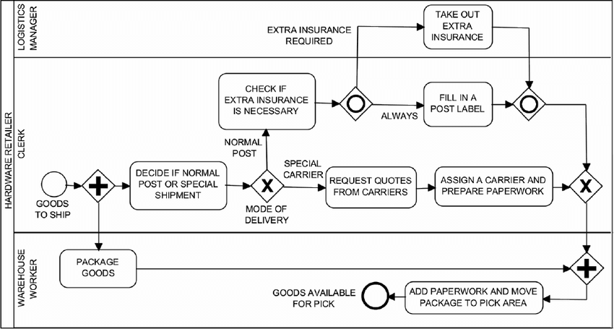](https://www.researchgate.net/figure/Shipment-process-of-a-hardware-retailer-BPMN-process-diagram_fig9_266894308)

Figure 1.4 - BPMN example

Business Process Model and Notation (BPMN) is a standardized graphical notation for modeling business processes (figure 1.4). It provides a set of graphical symbols and shapes that can be used to represent different elements of a process, such as tasks, gateways, events, and flows. BPMN is designed to be intuitive and easy to understand, making it accessible to a wide range of stakeholders, including business analysts, developers, and managers. BPMN also supports the modeling of complex processes and provides a framework for process analysis and improvement.

Another example is Class diagram depicted in figure 1.5. It represents the classes of the warehouse storage process.

[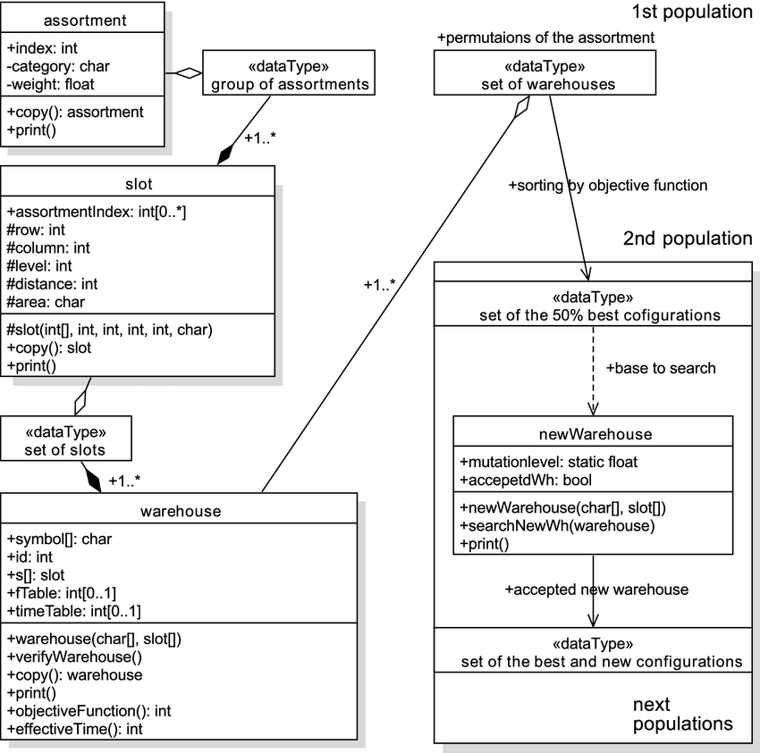](https://www.google.com/url?sa=i&url=https://www.researchgate.net/figure/The-UML-class-diagram-of-the-algorithm-In-the-phase-1-of-the-simulation-the-associated_fig2_333029850&psig=AOvVaw0R4O6WaLBPIDrECgL4SGNm&ust=1692558245762000&source=images&cd=vfe&opi=89978449&ved=0CBIQjhxqFwoTCPDGz_-06YADFQAAAAAdAAAAABAP)

Figure 1.5 - Class diagram of the warehouse storage process

Overall, object-oriented methods such as UML and BPMN provide a more structured and formalized approach to process modeling in BPM. They enable organizations to model complex processes in a standardized and rigorous manner, facilitating analysis and optimization. However, they can be more complex and require a higher level of expertise to use effectively.

### Agile methods

Agile methods are iterative and flexible approaches to model-building in business process management [29]. These methods emphasize collaboration, customer satisfaction, and responsiveness to change. Agile methods are particularly useful in fast-paced environments where requirements and processes are subject to frequent change.

The following are some of the common agile methods used in BPM:

Scrum is an agile framework for managing and completing complex projects. It emphasizes iterative development, regular feedback, and continuous improvement. Scrum is particularly useful for managing complex processes that require frequent adaptation and flexibility. Scrum teams typically consist of a product owner, a scrum master, and a development team.

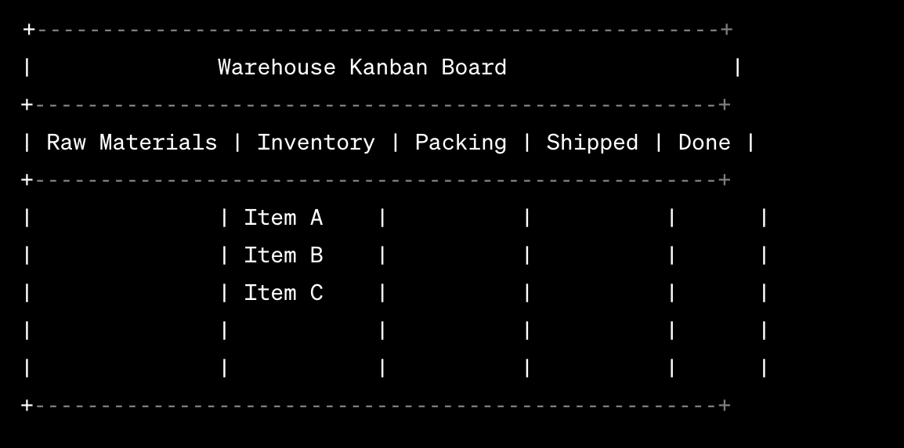

Figure 1.6 - Kanban system of warehouse management

Kanban (figure1.6) is an agile method that focuses on visualizing and optimizing workflow. It emphasizes continuous improvement and the reduction of waste in processes. Kanban boards are often used to visualize the flow of work and identify bottlenecks and inefficiencies in a process. Kanban is particularly useful for managing processes with a high degree of variability.

Agile methods provide a flexible and iterative approach to model-building in business process management. They enable organizations to respond quickly to changing requirements and adapt their processes accordingly. Agile methods are particularly useful for managing complex and dynamic processes but require a high level of collaboration and communication among stakeholders.

### Simulation methods

Simulation methods are used in business process management to test and evaluate the performance of processes under different scenarios [30]. These methods involve creating a virtual model of a process and running simulations to test different scenarios and identify potential issues or bottlenecks. The following are some of the common simulation methods used in BPM:

Discrete-event simulation (DES) is a widely used simulation method in BPM. It involves modeling a process as a sequence of discrete events, such as arrivals, departures, and processing times. DES can be used to test different scenarios and evaluate the performance of a process under different conditions. DES can also be used to identify bottlenecks and optimize process performance.

Agent-based simulation (ABS) is a simulation method that models the behavior of individual agents within a process. Each agent has its own set of rules and behaviors, which can be used to model the behavior of customers, employees, or other stakeholders within a process. ABS can be used to test different scenarios and evaluate the impact of different variables on process performance.

Monte Carlo simulation is a statistical simulation method that is used to model the probability distribution of different variables within a process. It involves creating many random scenarios and using statistical analysis to evaluate the performance of a process under different conditions. Monte Carlo simulation can be used to identify potential risks and evaluate the impact of different variables on process performance [31].

Overall, simulation methods provide a powerful tool for testing and evaluating the performance of business processes. They enable organizations to identify potential issues and optimize process performance under different scenarios. Simulation methods are particularly useful for complex processes with many variables and dependencies. However, simulation methods can be computationally intensive and require a high level of expertise to use effectively.

### Integration methods

Integration methods in business process management refer to the techniques and technologies used to integrate different systems and processes within an organization. These methods are crucial for streamlining operations, reducing redundancy, and improving overall efficiency. The following are some of the common integration methods used in BPM:

* Application Programming Interfaces (APIs) are a set of protocols and tools used to connect different software systems and applications. APIs enable organizations to exchange data and functionality between different systems and processes, enabling seamless integration and automation.
* Enterprise Service Bus (ESB) is a middleware solution that provides a platform for integrating different software systems and applications. It enables organizations to create a central hub for connecting and managing different systems, reducing redundancy and improving overall efficiency.
* Business Process Integration Suite (BPIS) is a comprehensive software solution that enables organizations to integrate different business processes and systems. It provides a range of tools and functionality for modeling, designing, and implementing business processes, as well as integrating different systems and applications.
* Business Process Execution Language (BPEL) is a standardized language for defining and executing business processes. It enables organizations to integrate different systems and applications using a common language, facilitating seamless integration and automation.

Integration methods are critical for optimizing business processes and improving overall efficiency. They enable organizations to connect and streamline different systems and processes, reducing redundancy and improving collaboration. Integration methods are particularly important for organizations with complex processes and systems, where integration and automation can provide significant benefits.

### Comparison of model-building methods

Model-building methods in BPM can be compared based on many factors, including their complexity, flexibility, and suitability for different types of processes. The following is a comparison of some of the common model-building methods in BPM:

* Flowcharts are simple graphical representations of a process that show the sequence of activities and decisions involved. They are easy to understand and can be used to visualize simple processes. However, flowcharts can become complex and difficult to manage for larger and more complex processes.
* Object-oriented methods are useful for modeling complex processes with many variables and dependencies. They enable organizations to model processes using objects and classes, which can be reused and modified as needed. However, object-oriented methods can be complex and require a high level of expertise to use effectively.
* Agile methods are iterative and flexible, allowing organizations to respond quickly to changing requirements and adapt their processes accordingly. They are particularly useful for managing complex and dynamic processes but require a high level of collaboration and communication among stakeholders.
* Simulation methods are useful for testing and evaluating the performance of processes under different scenarios. They enable organizations to identify potential issues and optimize process performance under different conditions. However, simulation methods can be computationally intensive and require a high level of expertise to use effectively.
* Integration methods are crucial for streamlining operations and reducing redundancy. They enable organizations to integrate different systems and processes, reducing complexity and improving overall efficiency.

The choice of model-building method in BPM depends on the specific needs and requirements of the organization. Simple processes may be well-suited to flowcharting, while complex processes may require object-oriented methods or simulation methods. Agile methods may be useful for managing dynamic processes, while integration methods are critical for streamlining operations and improving overall efficiency.

### Future directions in model-building methods

Within the dynamic landscape of BPM, novel model-building methods continuously emerge, driven by shifting organizational needs and demands. This analysis highlights several promising future directions in this domain:

* Artificial intelligence (AI) and machine learning (ML) technologies are

increasingly being used in BPM to automate and optimize processes. These technologies enable organizations to analyze large amounts of data and identify patterns and trends, enabling them to make more informed decisions about process design and optimization.

* Blockchain technology is being explored as a potential model-building method in BPM. It has the potential to enable secure and transparent transactions and streamline complex processes involving multiple parties [32].

- Cloud computing is increasingly being used in BPM to enable organizations to access and manage process models and data from anywhere, at any time. This allows for greater flexibility and collaboration among stakeholders, increasing overall efficiency and productivity [33].

- Hybrid methods, which combine different model-building techniques such as object-oriented and agile methods, are becoming increasingly common in BPM. These methods allow organizations to leverage the strengths of different methods and adapt them to their specific needs and requirements.

- Low-code and No-code platforms are increasingly being used in BPM to allow organizations to create and modify process models without requiring a high level of technical knowledge. These platforms enable greater collaboration and flexibility among stakeholders and can speed up process design and optimization [34].

Modeling techniques in BPM are likely to involve a combination of new technologies and methods that enable greater automation, flexibility, and collaboration among stakeholders. As the field of BPM continues to evolve, new methods for building models will likely continue to emerge to meet the changing needs and requirements of organizations.

### 

### Conclusions on the first chapter

This chapter concludes with a brief overview of the key aspects discussed in previous sections. The chapter is devoted to the analysis of various methods for constructing business process models, their historical development, as well as prospects for their development in the future.

The study examines the concept of a business process as a fundamental element of the functioning of an organization. The history of the development of business processes is analyzed, starting from early approaches and methods to modern methodologies. Considerable attention is paid to business process management as a key factor in increasing the efficiency and competitiveness of organizations.

Separately, early approaches to methods for constructing business process models are analyzed, including object-oriented methods, flexible methods and modeling methods. The issue of integrating various methodologies and approaches within the framework of model building is also considered.

An important result of the analysis is a comparison of various methods for constructing business process models, which helps to identify their advantages and disadvantages. This helps organizations choose the most appropriate method depending on their goals and circumstances.

The chapter also touches on the future directions of business process model-building methods. Advances in technology, process automation, and meeting the needs of a rapidly changing marketplace all pose challenges for organizations. Perhaps the future will be associated with the further evolution of flexible methodologies, deeper integration between approaches, and the use of new technologies in the field of business process modeling.

Thus, the conclusion of this chapter summarizes the results of the analysis, highlighting important aspects and trends in methods for constructing business process models in current literature.

### THE RPA REVOLUTION IN WAREHOUSE MANAGEMENT: A HYBRID BPM APPROACH

In a rapidly changing business environment and ever-increasing demands for operational efficiency, building an effective supply chain has become a critical challenge for companies in all industries. The importance of optimal organization of logistics operations is due to the need to increase productivity, minimize costs, improve the quality of customer service, and adapt to changes in the business environment.

### Definition of Hybrid Business Processes

This chapter focuses on the design and management of hybrid business processes occurring within the logistics supply chain. Hybrid business processes are a combination of automated and manual operations that allow to effectively manage various aspects of logistics activities.

Designing and managing hybrid business processes in logistics requires analyzing current operations, identifying steps that can be automated, and integrating technology solutions to achieve the best results. This paper presents the stages of creating a management model, including the implementation of RPA robots to perform routine tasks, the use of IoT devices to collect data in real-time, and the collaboration of humans and automated systems [35].

The scope of application of hybrid business processes in logistics covers tasks such as receiving and storing goods, order processing, packaging and delivery of products. Streamlining these operations through the implementation of a hybrid model can reduce task turnaround times, improve process accuracy and efficiency, and improve interaction between automated systems and human operators.

### Introduction to Hybrid Business Process Management

In an era of dynamic supply chains and heightened customer expectations, the domains of logistics management are undergoing a paradigm shift. The emergence of Hybrid BPM presents an innovative approach that seamlessly blends the strengths of automation and human expertise within these interconnected realms. This subchapter provides a foundational overview of the concept, significance, and key components of Hybrid BPM specifically tailored for complex logistics operations.

Warehouse, as a subset of supply chain management, plays a critical role in business processes, as it involves the movement of goods and services from suppliers to customers. In recent years, researchers have examined the role of BPM in logistics. Warehouse and logistics management constitutes a critical juncture where efficient processes directly impact overall supply chain performance. With the rise of e-commerce, globalization, and rapidly changing consumer preferences, the need for agility, accuracy, and responsiveness has become paramount. Hybrid BPM stands as a strategic response to these challenges, offering a balanced synthesis of technology and human intelligence [36].

Logistic business processes are a sequence of interrelated actions and operations aimed at ensuring the effective management of material, information, and financial flows within a company or a supply chain. They cover the entire life cycle of goods, from planning production or purchasing to delivering products to end users and handling returns (figure 2.1) [37].

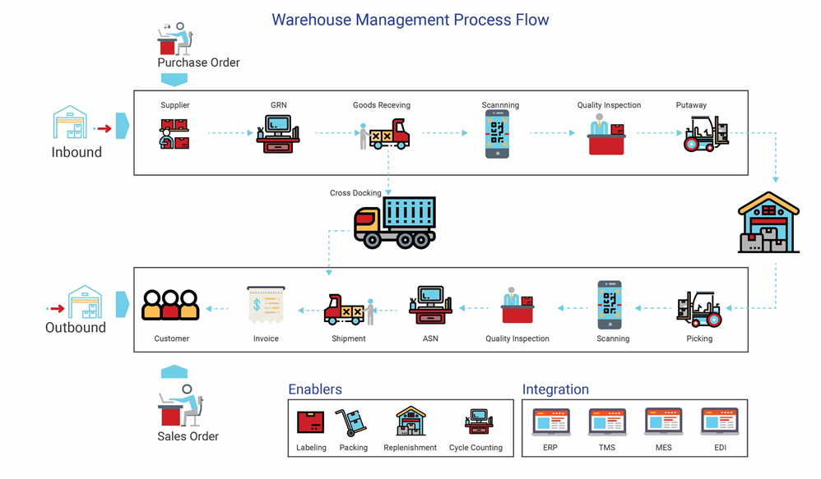

Figure 2.1 - Warehouse business processes

Every warehouse consists of a set of general procedures such as billing, receiving, inventory, picking and packing, shipping, and invoice. They are essential for every business [38]. Describing them in more detail:

Billing entails creating an invoice to collect the selling price from the customer. It covers purchases or services provided within a designated timeframe for the customer.

Receiving involves the transfer of goods' ownership, this step holds financial implications. It ensures accurate documentation and signifies the material's availability to the customer at the earliest opportunity. The warehouse management system expedites the movement of goods from the receiving dock to storage locations.

Inventory allows overseeing and managing stock items is a pivotal aspect of this step, rendering the warehouse a vital component of the inventory management process. It guarantees the availability of essential materials and products while possibly minimizing costs.

Pick and Pack makes it possible to create a picking list that facilitates locating the appropriate quantity of items within the warehouse. These items are then placed in a box with suitable packaging materials. Documentation is matched with the item before labeling, and shipping is initiated to reach the end customer.

Shipping is a crucial stage in warehouse management, shipping involves weighing and measuring items post-packaging. Further processes encompass validating necessary documents [39], loading items, scheduling receipts based on location and shifts, and segregating the receiving and shipping docks.

Invoice is a record of goods and services owed, including the names and addresses of involved business partners. This step involves generating a commercial statement, emphasizing the transaction's details beyond mere documentation.

Logistics business processes are essential to a company's success as they affect operational efficiency, customer satisfaction, cost optimization, and market competitiveness. Effective management of logistics business processes requires the integration of modern technologies and a strategic approach to managing the entire supply chain.

### Importance and rationale for adopting hybrid approaches

The benefits of adopting Hybrid BPM in logistics are multifaceted [40]. Enhanced operational efficiency, reduced lead times, improved accuracy and adaptability to market fluctuations are among the notable advantages. By automating routine tasks and enhancing human expertise where judgment matters, organizations can achieve a smooth flow of goods while maintaining the flexibility to handle unexpected disruptions.

The main components of hybrid BPM in logistics have three main goals, shown in Figure 2.2:

Figure 2.2 - Steps of Hybrid Approaches Adopting

Automation and Integration: Using logistics processes to automate repetitive tasks such as order processing, inventory tracking and data entry, seamless integration with IoT devices to collect real-time data [41].

Human Decision Points: Identify areas where human judgment, problem solving, and creativity are needed, such as exception handling, quality control, and strategic decision making.

Collaboration and Communication: Promoting cohesive collaboration between automated systems and human operators, ensuring clear communication and optimizing work processes.

Hybrid BPM offers a holistic approach to organizing logistics operations. By harnessing the power of technology and human insight, organizations can create a flexible, adaptive, and customer-centric supply chain ecosystem. This subsection serves as a springboard into the dynamic world of hybrid BPM in the warehouse and logistics industry, providing the basis for a deeper exploration of its applications, challenges, and transformative impact on modern supply chain management.

Logistics is an important component of supply chain management that deals with the planning, implementation and control of the movement and storage of goods and services from the point of origin to the point of consumption [42]. Despite its critical importance, logistics often faces several challenges that impact the efficiency and effectiveness of supply chain operations. It faces challenges in transportation and distribution, inventory management, automation, and sustainability.

Logistics management is essential for the efficient operation of supply chain processes in organizations. Effective logistics management can improve operational efficiency and improve customer satisfaction.

Transportation and distribution are critical components of logistics that involve the movement of goods and services from suppliers to customers [43]. Transportation and distribution issues such as congestion, delays, and capacity limitations can result in significant costs and delays. These problems can be exacerbated by factors such as natural disasters, labor disputes and changes in legislation. Thus, effective management of transportation and distribution is essential for the efficient operation of supply chain processes [44].

Inventory management is another important component of logistics and involves planning and controlling inventory levels. Poor inventory management can lead to stockouts, excess inventory and increased costs. This can result in lost sales, decreased customer satisfaction, and increased storage and handling costs. Effective inventory management is essential to ensure the availability of the right products at the right time, in the right quantity and the right place [45].

Information systems play a critical role in logistics management by providing real-time information on inventory levels, transportation schedules and delivery status. However, information systems can be complex, and their implementation and integration can be challenging. In addition, information systems may be vulnerable to cyber-attacks, data leaks, and other security threats [46]. Thus, effective information system management is critical for the efficient operation of supply chain processes [47].

Sustainability is a growing concern in logistics, with increasing attention being paid to the environmental impact of supply chain operations [48]. Sustainable logistics practices can reduce greenhouse gas emissions, save resources and minimize waste. However, implementing sustainable logistics practices can be challenging due to factors such as regulatory compliance, supplier behavior and consumer demand.

Therefore, effective sustainability management is critical to ensure the long-term viability of supply chain operations [49].

Logistics management is essential for the efficient operation of supply chain processes. Logistics faces several challenges that can impact the efficiency and effectiveness of supply chain operations, including transportation and distribution, inventory management, information systems, and sustainability [50]. Addressing these challenges requires a coordinated and comprehensive approach to logistics management that considers the unique needs and challenges of each organization.

There is RPA as a main part of the Hybrid BPM framework, a technology that brings unparalleled precision and efficiency to logistics processes. RPA involves the deployment of software robots or "bots" to automate repetitive, rule-based tasks traditionally performed by humans. These bots operate across various systems, applications, and databases, mimicking human actions with speed and accuracy.

RPA is a game-changer in terms of logistics. It excels at automating tasks such as order processing, inventory tracking, and data entry, streamlining operations and reducing the risk of errors. RPA not only enhances efficiency but also contributes to cost savings by optimizing resource utilization and accelerating task completion.

### Robotic Process Automation

The ever-growing volume of goods demands a logistics revolution: cost-effectiveness, timeliness, and, crucially, power efficiency. Inefficient logistics, plagued by opaque operations and outdated systems, guzzle fuel, inflate emissions, and drain profits.

To achieve sustainability and profitability, embracing technologies like RPA is essential. RPA automates routine tasks, improving efficiency and reducing energy consumption. Within warehouses, RPA robots streamline inventory management, order processing, and product labeling, optimizing resource allocation and minimizing forklift usage. In transportation, automated route planning, shipment tracking, and document processing reduce fuel consumption and optimize delivery times.

RPA seamlessly integrates with existing logistics systems, maximizing its potential for optimization [51]. Careful planning and monitoring ensure successful implementation, unlocking the full power of RPA for a sustainable and thriving logistics ecosystem.

The increasing complexity of logistics demands innovative solutions for streamlining operations and minimizing costs. While various automation techniques and technologies exist, their effectiveness can be limited without a comprehensive approach. This paper proposes that combining BPM and RPA can offer a more rational and efficient approach for complex logistics systems. Benefits of the Hybrid Approach:

BPM as the Foundation: BPM provides the framework for analyzing, designing, and optimizing business processes. It ensures that automation aligns with the overall business strategy and goals.

RPA for Task Automation: RPA automates repetitive, rule-based tasks within those processes, freeing up human resources for more strategic activities and improving efficiency.

Flexibility and Scalability: The combined approach allows for flexible process adaptation and system scalability, accommodating changing needs and workloads.

The complexities of managing modern logistics are undeniable. From streamlining warehousing and inventory management to optimizing delivery routes and enhancing customer service, ensuring smooth operations presents a constant challenge. In this dynamic ecosystem, innovative technologies like RPA have emerged as game-changers, promising significant improvements in efficiency, accuracy, and cost-effectiveness. Before diving into specific examples of how RPA revolutionizes logistics, let's take a step back and consider the areas where it shines brightest.

Key Bottlenecks in Logistics:

* Repetitive, manual tasks: Data entry, invoice processing, order tracking, and shipment scheduling often involve repetitive, rule-based actions that consume valuable time and resources. Human error can also creep in, impacting accuracy and efficiency.
* Disparate systems and data silos: Information often gets fragmented across multiple software platforms and databases, hindering comprehensive process visibility and analysis. Manual data integration adds another layer of complexity and risk.
* Scalability and peak season challenges: Handling sudden surges in demand during peak seasons can overwhelm existing resources and processes. Traditional methods often lack the flexibility to adapt quickly and efficiently.

By automating these cumbersome tasks and seamlessly integrating various systems, RPA injects agility and precision into logistics operations. Let's now explore some concrete examples of how it's transforming the industry. Examples of RPA Applications in Logistics:

Inventory Management: RPA bots can automate tasks like stock level monitoring, order processing, and product labeling, reducing errors and optimizing inventory flow.

Transportation Management: RPA can streamline route planning, shipment tracking, and carrier selection, leading to improved delivery times and reduced costs.

Warehouse Operations: Automating tasks like order picking, packing, and labeling within warehouses can significantly enhance efficiency and accuracy.

Several studies have demonstrated the effectiveness of RPA in logistics. For example, [52-54] shows how RPA can improve efficiency and accuracy in tasks like inventory management, order fulfillment, and shipment tracking. Additionally [55-57] highlight the potential of RPA in supply chain management, transportation management, and order processing, leading to cost savings and improved efficiency.

By implementing a hybrid BPM and RPA approach, logistics organizations can achieve significant improvements in process efficiency, cost reduction [58], and overall system performance. This approach offers a comprehensive framework for

automating repetitive tasks while ensuring that automation aligns with the business strategy and goals. As research continues to explore the potential of RPA in logistics, this hybrid approach is poised to become a key driver of success in the industry.

Based on the results that are given in [59] each business process can be dissolved and represented as a math model. It helps to evaluate the result and get real numeric accountings to understand the success rate of business process automatization. For example, in formula (1) the authors calculate the revenue from business process response in a period:

$V = γCT$ (2.1)

where γ is the business process capacity and C is revenue from the customer's response.

Thus, it turns out that neither BPM nor RPA solves the problem of automating business processes. Each of the approaches is more focused on a specific stack of tasks. The analysis given in the previous section approves this as none of the models sufficiently covers all the processes within the business project. However, the automation of business processes often may lead to additional results as was shown in the case of automated logistics in container port terminals [60]. In this work, automation is used for the optimization of container handling at the port using Automated Guided Vehicles (AGV). One of the prior problems in this case was to reduce costs and increase the efficiency and capacity of the container management. Introduced AGVs have shown a 10% shortage in distance and around an 18% increase in loaded goods. Moreover, this approach also affects the environmental impact of this logistic system because increased efficiency reduces energy consumption and carbon emissions which have a strong correlation as was shown in [61].

Every company or entrepreneur strives to be rational and optimize all the processes within businesses with increasing economic profit. For that, they can use some identifications such as economic value, budget, or completeness constraint for example. In the following paper [62] authors demonstrate the way a proper RPA can be chosen using the proposed decision-making approach, as shown in the formulas of RPA's economic return maximization (2), based on the appropriate activity A, as well as a budget constraint formula (3) and completeness constraint in (4).

max $\overline{PA}* \overline{x}$ (2.2)

s.t. $\overline{FRC}* \overline{x} ≤ B (2.3)$

where FRC – is the fixed cost of RPA.

$\frac{-{FLC}_{im}+{FRC}_{im}}{{VLC}_{im}-{VRC}_{im}}* x_{im} ≤ t for all activities(i,m)$ (2.4)

where FLC is the Fixed Cost of Human Labor (FLC), Variable Cost of Human Labor (VLC), and Variable Cost of RPA (VRC). Using these formulas, it's clear that RPA is bound with the budget B (3) and should be amortized with a certain time t (4). These tools can help and simplify the whole automation process in the planning stage and after the introduction into the business process.

Business process simulation is a diverse field utilizing various approaches and starting points to building and running simulations, including business process models represented in graphical and textual notations based on procedural (imperative) and declarative process modeling languages [63]. Many languages in BPM can be used for the modeling process as described above. However, to integrate RPA into the modeling languages it is required to define what tasks must be solved by a "robot" [64]. It means that the input and output points for the robot should be seamlessly integrated into the overall process so that there is no need to significantly increase the role of the robot or collect the results of its work. For example, there are several processes which do not suitable to robotize:

* with unpredictable external factors, where it is impossible to control the result.
* using non-formalizable features.
* based on an intuitive interpretation of the situation.

As a result, this work represents the methodology to combine BPM and RPA. Figure 2.3 demonstrates the proposed integration of RPA into the life cycle model of BPM.

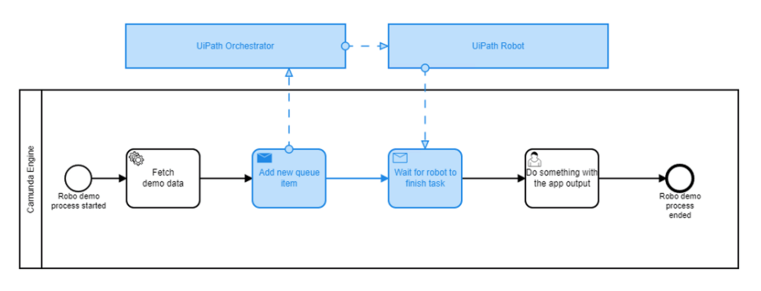

Figure 2.3 - Integration of RPA into the life cycle model of BPM

It can be used everywhere depending on the demand for manual work replacement. As an example, a service call can be used. Instead of making an external call there can be created RPA tool's API and the "robot" will do the action, and then the callback will be used as a trigger of the end-to-end process.

### Review of existing hybrid models for business process management

The complex world of logistics faces numerous challenges, impacting efficiency, cost, and customer satisfaction. To address these, researchers have developed sophisticated BPM frameworks and tools tailored specifically for logistics.

One key advantage of BPM in logistics lies in its integration with technology like RFID, GPS, and sensor systems. This real-time data stream on the location, condition, and status of goods empowers better tracking and coordination throughout the supply chain. Furthermore, BPM can synergize with artificial intelligence (AI) and blockchain, unlocking deeper insights into operations and optimizing processes for enhanced efficiency. Studies have documented the tangible benefits of BPM implementation in logistics. For instance, research by [65] highlights improved resource utilization, reduced inventory costs, and enhanced customer service. Similarly, another study by [66] demonstrates reduced cycle times, improved accuracy, and increased employee productivity within warehouse operations. Moreover, BPM plays a crucial role in building supply chain resilience, enabling logistics companies to respond swiftly to disruptions and mitigate their impact [67, 68].

Despite the undeniable benefits, implementing BPM in logistics also presents certain challenges. Lack of standardization and interoperability across existing systems can hinder seamless integration of BPM tools [69]. Additionally, the initial cost of implementation and the need for skilled personnel can be significant barriers to adoption. Therefore, future efforts should focus on developing cost-effective, user-friendly BPM systems that seamlessly integrate with existing infrastructure.

BPM offers a powerful tool for transforming logistics, optimizing supply chain management, reducing operational costs, and ultimately enhancing customer satisfaction. While challenges remain, the continuous development of advanced BPM systems capable of handling complex and dynamic logistics processes, while enabling real-time decision-making, holds immense promise for the future of the industry.

In Table 2.1 there is a comparison of different tools that are widely used for business process management from a logistical perspective of view. They are proposed as a sufficient tool for solving the main problems of logistics.

Table 2.1 - Tools for BPM in Logistics

|  |  |  |  |  |
| --- | --- | --- | --- | --- |
| Tool | Description | Advantages | Disadvantages | Reference |
| 1 | 2 | 3 | 4 | 5 |
| BPMN 2.0 | A graphical notation for representing business processes | Widely accepted, user-friendly, easy to understand, supports various types of diagrams | Limited support for decision-making, lacks support for data and security aspects | Al-Qutaish et al. (2019) |

Continuation of table 2.1

|  |  |  |  |  |
| --- | --- | --- | --- | --- |
| Six Sigma | A methodology for improving processes by eliminating.  defects and minimizing variability | Focuses on process improvement, structured  approach, data-driven | Time-consuming, requires specialized training, not  suitable for all types of processes | Shao et al. (2016) |
| Lean Management | A philosophy and methodology for maximizing customer value while minimizing waste | Improves efficiency, reduces waste, increases customer satisfaction | Limited focus on quality control, requires significant cultural change, not suitable for all types of processes | Chen and Chen (2014) |
| RFIDTS | RFID tags track objects wirelessly, providing real-time location and status throughout the supply chain. | Automates data, saves time and money, reduces errors, and offers real-time visibility for better decision-making. | Requires upfront investment, technical expertise, and security measures, with privacy concerns and limited reader range. | Yan, X. et al. (2019) |
| ISWMS | Real-time IoT data fuels an intelligent system to optimize supply chain for resilience, efficiency, and visibility | Faster deliveries, lower costs, fewer disruptions, better collaboration, informed decision-making. | Upfront costs, technical complexity, data security concerns, reliance on infrastructure. | Al-Talib, M.(2020) |
| AIWCMS | AI analyzes warehouse data in real time, giving insights to  optimize processes like stock levels and equipment performance. | Tracks the system, predicts problems, saves money | Can't control things directly, needs tech smarts, costs to set up, and data  security is key. | Žuni´c, E.; (2018) |

Continuation of table 2.1

|  |  |  |  |  |
| --- | --- | --- | --- | --- |
| GPS | A technology for tracking and monitoring vehicles and shipments | Improves delivery accuracy and timeliness, enhances supply chain visibility | Limited accuracy in certain environments, potential privacy concerns, require investment | Nguyen et al. (2016) |

Efficient logistics are the linchpin of modern commerce, ensuring timely delivery and customer satisfaction. This necessitates robust process optimization, and three prominent methodologies rise to the challenge: BPMN 2.0, Six Sigma, and Lean Management.

BPMN 2.0 provides a standardized graphical language for modeling, automating, and streamlining processes. Like a detailed map, it visually lays out key activities, enabling organizations to identify bottlenecks and inefficiencies in transportation, inventory, and warehouse management [70-72]. Studies have shown its effectiveness in optimizing Turkish warehouse operations, enhancing Chinese transportation networks, and even designing efficient logistics information systems.

Six Sigma takes a data-driven approach, wielding statistical tools to eliminate flaws and optimize processes within the supply chain [73,74]. By minimizing variability and waste, it improves delivery performance, inventory control, and supplier partnerships. Its DMAIC methodology (Define, Measure, Analyze, Improve, Control) has demonstrably improved warehousing operations in Mexico and supply chain performance in Malaysia.

Lean Management tackles waste head-on, systematically identifying and eliminating non-value-adding activities throughout the supply chain [75,76]. With a customer-centric focus, it prioritizes activities that directly contribute to customer satisfaction while minimizing resource utilization. Value stream mapping, 5S methodology, and Kaizen events empower companies to achieve significant improvements in inventory accuracy, order processing time, and delivery lead times.

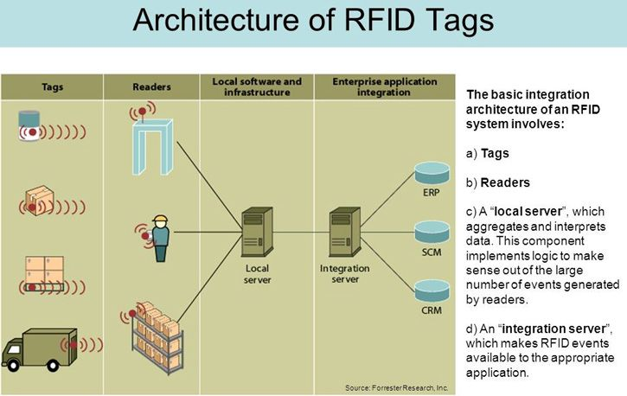

Figure 2.4 - RFID architecture

Modern logistics demands real-time visibility, efficient resource allocation, and optimized processes. This necessitates a confluence of technologies, each playing a crucial role in the symphony of efficient goods movement. This paper explores five key technologies – RFID Tracking Systems (RFIDTS), Global Positioning Systems (GPS), Business Process Model and Notation (BPMN 2.0), Intelligent Supply Chain Management Systems (ISWMS), and AI-powered Warehouse Control and Management Systems (AIWCMS) – and their synergistic potential in revolutionizing logistics.

RFIDTS, utilizing radio frequency identification tags attached to objects, offers unparalleled real-time visibility into their location and status throughout the supply chain. This enables precise tracking of goods, optimizing transportation routes, and minimizing inventory discrepancies [77]. Studies have shown significant improvements in administrative efficiency, time savings, and cost reductions through RFIDTS implementation [78]. The general approach to RFID is shown in Figure 2.4 [79].

GPS provides accurate location data, empowering logistics systems with real-time insights into vehicle movement. This facilitates dynamic route optimization, considering real-time traffic conditions and weather patterns, leading to reduced transportation times and fuel consumption [80]. Integration with RFIDTS data further enhances visibility by linking location data to specific tagged items, enabling precise tracking and delivery predictions.

BPMN 2.0 offers a standardized graphical language for modeling and analyzing logistics processes. This visual representation allows for clear identification of bottlenecks, inefficiencies, and opportunities for improvement. Studies have demonstrated the effectiveness of BPMN 2.0 in optimizing warehouse management, transportation workflows, and logistics information systems [81-83].

ISWMS leverages the power of the Internet of Things (IoT) to integrate data from various sources, including RFIDTS, GPS, and sensors, providing a holistic view of the supply chain. This real-time data enables proactive decision-making, predictive maintenance of equipment, and optimization of inventory levels and resource allocation [84]. Studies have shown its effectiveness in enhancing resilience against disruptions and improving overall supply chain efficiency [85].

AIWCMS utilizes artificial intelligence to analyze warehouse data from sensors and automation systems, providing insights into equipment performance, stock levels, and workflow efficiency. This data-driven approach allows for proactive identification of potential issues, predictive maintenance, and real-time optimization of warehouse operations [86]. While currently focused on process monitoring, its potential for integrated control and automation offers promising advancements in warehouse management.

The combination of these technologies offers a powerful synergy for optimizing logistics. RFIDTS and GPS provide real-time data, BPMN 2.0 models optimize processes, ISWMS integrates data and facilitates decision-making, and AIWCMS optimizes warehouse operations. This holistic approach enables data-driven decision-making, proactive risk management, and significant efficiency gains across the entire supply chain.

### Challenges and Considerations in Adopting Hybrid Models

The integration of RPA and the IoT in hybrid logistics models is associated with a variety of challenges and complexities that affect the success of this process. This part of the dissertation discusses the key challenges associated with the implementation of RPA and IoT in logistics practices:

One of the important aspects is the integration of RPA and IoT with existing logistics systems and processes. This entails the need to ensure the harmonious interaction of various technologies and systems, which can be a non-trivial task.

The application of the IoT involves the collection and transmission of large amounts of data, including confidential data. Ensuring the security and protection of this data from a variety of threats and unauthorized access becomes paramount.

The management of hybrid systems that combine automated and manual processes requires additional harmonization and coordination efforts to ensure that they work together and effectively.

An integral part of the introduction of new technologies is the training and education of personnel. Employees must become proficient with new systems and technologies, which can take time and resources.

The difficulties of adapting to new technologies are especially felt in companies with a long history of operating without automation. Overcoming resistance to change and proving the practical value of new technologies are important tasks.

Choosing the right tasks and processes to automate is not uniform. Analyzing and selecting those that are most responsive to RPA and IoT adoption is a complex and crucial step[87].

### Strategies for managing change and ensuring successful adoption

As part of the study of organization and optimization of hybrid business process management models in the field of logistics, an important aspect is changing management and ensuring effective integration of RPA and IoT [87]. The successful implementation of this integration requires careful planning, good communication and effective strategies [88]. This section introduces change management strategies to help achieve successful integration.

First, a detailed analysis of the needs of the organization, identifying those areas where the integration of RPA and IoT can most effectively solve specific business problems and optimize processes. Awareness of the significance and benefits for the organization is a key aspect in this context [90].

After that, a detailed business case should be developed, including projected benefits, goal setting, cost estimates, and predictable results from the integration. This approach will help identify potential risks and convince stakeholders that the change should be implemented [91].

An important part of the implementation process will be to educate employees and stakeholders about the value of integrating RPA and IoT, as well as what changes it will bring. At the same time, it is necessary to provide support and training for those who will interact with the new system [70 92].

For the effective implementation of changes, it is recommended to form a project team, including representatives of various functional areas, such as IT, logistics, operations, and others. This step ensures that the project is understood and supported by all key stakeholders [93].

One strategy could be to gradually integrate RPA and IoT, starting with small pilots and then scaling up. This approach will allow us to effectively learn from mistakes and adjust in the process [94].

It is important to maintain realistic expectations about the expected results and the time required to achieve the set goals. It is important to explain that changes may take time and patience to achieve the desired effects [95].

To evaluate the effectiveness of the integration, key metrics and performance indicators should be established. Regular monitoring of results and evaluations will allow us to adequately assess the impact of integration on business processes [96].

### Determining the importance of planning in effective management of warehouse activities

Warehouse design planning is critical to creating an efficient and optimized infrastructure that meets business requirements and ensures efficient operations, Figure 2.5 shows a general layout of a warehouse facility.

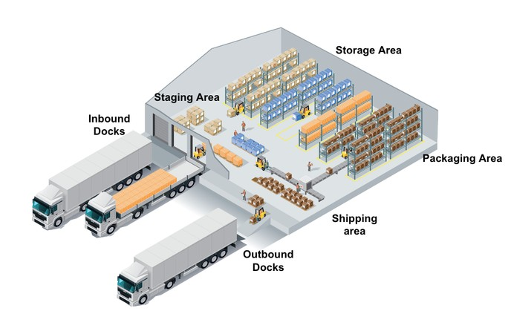

Figure 2.5 - A general layout of a warehouse facility [75 96]

Planning plays a key role in making the best use of available storage space. This helps to avoid wasted space and inefficient product placement.

The need for planning arises from the need to accurately determine the requirements and demands that a business faces. Such analysis also allows to adapt warehouse design to a variety of types of goods and operations, optimizing its structure for specific needs. Correct planning of warehouse design makes a significant contribution to improving all aspects of its functioning: from efficient loading and unloading of goods to optimal selection and prompt shipment. Time optimization is crucial achievements of good warehouse design.

High productivity and overall efficiency are the results of such an organization. At the same time, an efficient warehouse design reduces energy, equipment, storage, and inventory costs. Optimal use of space minimizes waste and maximizes resources.

Proper planning considers not only business’ relevant needs, but also focuses on the future, contributing to the sustainable and long-term optimization of all processes in the warehouse. Thus, the main aspects of the importance of warehouse planning - an integral element of any logistics process are (figure 2.6):

* Space optimization
* Matching needs
* Resource optimization
* Productivity increase
* Saving

Figure 2.6 - Warehouse planning aspects

Proper warehouse planning begins with the definition of business processes and goals. To do this, an analysis of business needs and requirements for warehouse activities is carried out. Analytical tools and techniques such as SWOT analysis, demand forecasting, and supply chain analysis help to clearly define what needs the warehouse should meet and what processes should be emphasized.

Key business processes are defined, which include operations from receiving goods to shipment, as well as inventory management, order picking and quality control. These processes form the basis for developing an effective warehouse management strategy.

In parallel with the analysis, specific goals and metrics are set to measure performance. Goals can include reducing order processing time, optimizing space usage, improving customer service, and other key metrics. The definition of metrics allows the future to objectively evaluate the results achieved and adjust the strategy following them.

This phase results in a fundamental understanding of the business needs and warehouse objectives, which is a key step in developing the optimal plan of action. After the definition stage, the stage of direct warehouse design begins, including the flow of goods, operations, and distribution of warehouse zones. The principles of BPM find their wide application at this stage. They allow to systematize, formalize, and optimize the sequence of actions that employees perform in the warehouse. By analyzing and optimizing business processes, bottlenecks, redundant activities and wasted time can be identified, helping to reduce costs in both time and cost.

Effective warehouse design based on BPM principles also allows for the possibility of process automation. Optimized and documented business processes easily adapt to RPA. This means that routine and repetitive tasks can be automated using robots or software solutions, which improves productivity, reduces errors, and frees up staff to perform more complex and strategic tasks, as demonstrated in the previous chapter.

* 1. Warehouse business processes

There are six main business processes in a warehouse: receiving, placing, storing, picking, packing and shipping (figure 2.7) [97]. These processes include receiving goods, organizing them in the warehouse, picking and packing orders, and shipping them to customers. Other processes that may be involved in warehouse operations include inventory management, product distribution, picking, returns, and value added [98]. By automating these processes with technologies such as RPA, businesses can achieve greater efficiency, cost savings, and sustainability while freeing up human time for more complex work.

Figure 2.7 - Main business processes of warehouse

The purpose of this work is to evaluate the effectiveness of using RPA models for managing logistics processes, however, some calculations are needed to measure their usefulness. For this, a warehouse model was developed, which is shown in the figure. From it we can see that this room has 7 main zones, a detailed description of which is given in table 2.2.

Table 2.2 - Description of storage areas

|  |  |  |  |
| --- | --- | --- | --- |
| Zone | Area (sq.m) | Number of workstations | Description |
| 1 | 2 | 3 | 4 |
| Reception area | 800 | 5 | An area for receiving, checking and registering goods from suppliers before they are placed in the warehouse. |
| Storage area | 1500 | 100 | An area for organized storage of goods on racks until orders are completed. |

|  |  |  |  |
| --- | --- | --- | --- |
| 1 | 2 | 3 | 4 |
| Order picking area | 1000 | 10 | Area for the assembly of goods from various racks according to orders. |
| Packing area | 600 | 8 | An area for packing goods in accordance with the requirements of delivery and protecting goods during transportation. |
| Finished orders area | 600 | 40 | Temporary storage area of finished orders before being sent for delivery. |
| Shipping area | 600 | 4 | Area for loading finished orders on vehicles for delivery to customers. |
| Office and administrative premises | 300 | - | The area where employees' offices, meeting rooms, rest rooms and other administrative premises are located. |

Continuation of table 2.2

For further work, the business processes of the warehouse should be defined as shown in Table 2.3:

Table 2.3 - Description of business processes

|  |  |
| --- | --- |
| Name of the business process | Description |
| 1 | 2 |
| Acceptance of goods | The process of receiving and registering goods from suppliers in the warehouse. It includes checking the conformity of the delivery with the order and registering the goods in the system. |
| Storage of goods | The process of organizing the placement of goods on the shelves of a warehouse, considering the storage system. Goods are stored until the picking of orders. |
| Order picking | Assembling goods from various racks following the orders placed. Includes selection of goods, inspection and packaging for shipment. |
| Goods packaging | Packing the assembled goods in accordance with the requirements of the delivery and protecting the goods during the transportation process. |
| Shipment of finished orders | Organization of loading of finished orders for vehicles for their delivery to customers. Includes route planning and order distribution. |

Continuation of table 2.3

|  |  |
| --- | --- |
| 1 | 2 |
| Temporary storage of finished orders | Temporary storage area for finished orders before being sent for delivery. Finished orders are placed until the receipt of the order for shipment. |
| Automatic picking | Process using automatic picking systems to optimize the assembly process and speed up order processing. |

To understand how to implement automation models, there is a need to analyze the work and load of the warehouse and highlight all business processes. The following processes can be distinguished from the operations of this warehouse (figure 2.8):

1. Reception and registration of goods
2. Storage of goods
3. Order picking
4. Packaging and labeling
5. Shipment of goods
6. Inventory
7. Maintenance and repair of equipment:
8. Inventory Management
9. Personnel Management:
10. Security:
11. Compliance with standards and regulations
12. Document processing
13. Customer Service
14. Reporting management

Figure 2.8 - Warehouses business processes

The implementation of RPA can be implemented in each of these processes, but we will consider two main approaches: partial and full. The first model is a partial implementation of RPA to manage hybrid business processes, and the second is a full implementation.

The full warehouse automation model for hybrid process management using RPA involves combining different process modeling techniques to improve business operations and automate repetitive tasks based on rules using software technologies [ 99]. In this model, key business processes are fully automated using RPA technology and other automated systems. Automating repetitive and routine tasks can increase productivity, reduce turnaround time, and reduce the likelihood of errors. Operators are involved in rare exceptional situations that require human judgment and monitoring of automated systems.

Robots operating in this model are able to make decisions based on predefined business rules and algorithms, minimizing human intervention. This allows to achieve a high degree of predictability and reliability in completing tasks. Operators, in turn, can focus on more complex and creative aspects of work, which helps improve the quality of service provided and make strategic decisions.

The key benefit of this model is the optimization of resource usage. Automated systems can operate around the clock without the need for interruptions, rest, and performance degradation. This is especially important in high-intensity workflow areas where continuity and efficiency are key.

At the same time, it is important to emphasize that the successful implementation of this model requires a clear understanding of business processes

and their optimal automation. Analyzing and optimizing processes before implementing automation are important steps to achieve maximum efficiency and avoid unnecessary complexity.

In general, the full automation model using RPA and other automated systems opens up new horizons for companies in terms of efficiency, efficiency and accuracy in the execution of business processes.

To implement the implementation of the model, the following steps will be followed:

1. Assess internal processes that are most suitable for RPA [78 101].
2. Using a three-stage model for the initial implementation of RPA [79 102].
3. Using RPA to automate routine business processes [103].
4. Evaluation and analysis of implementations.

In addition, with sufficient funding, it is possible to combine RPA with other technologies, including artificial intelligence (AI) [104].

### Conclusion on the second chapter

Modern businesses need clever solutions to run smoothly and stay ahead in the ever-changing marketplace. Logistics, where speed and flexibility are crucial, is ripe for a transformation. Hybrid Business Process Management (HBPM) emerges as a game-changer, promising to reshape how logistics operate.

HBPM's impact starts with improved efficiency. It combines automation's power with human expertise, automating repetitive tasks and freeing people for more strategic work. This teamwork leads to faster processes, fewer errors, and better use of resources.

Beyond efficiency, HBPM empowers smart inventory management. Real-time data from strategically placed sensors fuels accurate tracking, insightful forecasting, and proactive control. This fine-grained understanding minimizes stockouts and overstocks and optimizes storage and handling for greater effectiveness.

HBPM's benefits extend to the heart of business success: customer satisfaction. By orchestrating a smooth flow of goods with improved delivery accuracy, faster lead times, and consistent responsiveness, HBPM elevates the customer experience. This fosters loyalty, repeat business, and a lasting competitive edge.

Sustainability and cost-reduction are no longer luxuries; they are essential for success. HBPM embraces this by seamlessly integrating energy-efficient automation with optimized processes. This teamwork leads to lower energy use, fewer emissions, and significant cost savings.

In today's dynamic market, adaptability and resilience are key. HBPM equips businesses with tools to navigate this turbulence by enabling flexible workflows and rapid responses to disruptions. This adaptability strengthens resilience, improves competitive positioning, and empowers businesses to thrive in unpredictable environments.

Despite its advantages, HBPM's journey to widespread adoption faces challenges. Seamlessly integrating diverse technologies and existing systems requires careful planning and execution. Robust security measures are crucial to protect

sensitive data from sensors, ensuring compliance and mitigating privacy concerns. Effective coordination between automation and people requires training and ongoing collaboration. Overcoming resistance to change and navigating process customization complexities necessitate effective communication and implementation strategies.

However, these challenges do not dim the brilliance of HBPM's potential. Continued technological advancements, evolving business models, and the ever-growing demand for efficiency pave the way for hybrid models to become the new standard for optimized logistics management. Further research and development in areas like advanced AI, intelligent decision-making systems, and secure data integration platforms will hold the key to unlocking HBPM's full potential and transforming the logistics landscape into a symphony of efficiency, agility, and sustainability.

In conclusion, integrating RPA and IoT into hybrid logistics models presents a transformative opportunity to revolutionize the industry. By embracing this paradigm shift, businesses can achieve unprecedented operational excellence, enhance customer satisfaction, and navigate the competitive landscape with agility and resilience. The road ahead may be paved with challenges, but the transformative potential of HBPM beckons, promising a future where logistics are orchestrated with precision, delivering unparalleled efficiencies and propelling businesses towards sustainable success.

### PROPOSED HYBRID RPA MODEL FOR BPM TO INCREASE THE EFFICIENCY OF LOGISTICS OPERATIONS

Current RPA technology, despite its transformative potential in mimicking human-computer interaction for task automation, possesses limitations that demand strategic implementation for optimal impact. Recognizing these constraints, the present chapter introduces RPABPM, a novel methodology for unifying RPA and BPM. This framework aims to orchestrate the strengths of both technologies, fostering streamlined and efficient automated business processes.

Essentially, it empowers RPA to leverage BPM's knowledge and tools for enhanced automation capabilities.

The chapter delves into the following key areas:

1. Identifying Challenges for Seamless Integration
2. Bridging the Gap Between BPM and RPA
3. Crafting a Step-by-Step RPABPM Integration Methodology
4. Evaluating Performance and Effectiveness through Real-World Implementation
5. Key Takeaways and Future Directions

This section dives into the mathematical brains behind the robots, known as R, deployed to keep tabs on large populations and handle various business tasks, denoted as O. Given the 360-degree surveillance requirement, these robots operate bidirectionally. Equation 3.1 details their dual functions: monitoring individuals and automating business actions.

$$R_{i}\left(R,O\right)\left\{\begin{aligned}1 ifR_{i}≤A_{R} \\ 0 Otherwise\end{aligned}\right. (3.1)$$

Where variable $R_{i}$ represents the number of robots performing activities and their installation locations $A_{R}$.

$${ D}_{I}=max\sum_{i=1}^{O_{t}}{R_{i}\left(R,O\right) } (3.2)$$

Where, $D_{I}$ stands for the intensity of detection.

The significant influence of detection intensity and robot deployment density on accuracy in robotic sensing, as established by Equation 3.2. This relationship is critical as proximity directly affects the precision of value recognition. As robots operate at greater distances, signal strength deteriorates, leading to erroneous data. One promising solution lies in utilizing bidirectional robots with amplified detection intensity. Equation 3.3 demonstrates how employing tuples gathered from both directions by such robots mitigates the accuracy concerns associated with distance, even at increased separation.

$$R_{i}\left(R,O\right)=\frac{{\left(cosθ\left(φ',φ\right)\right)}^{ἁ}}{d} (3.3)$$

where, method $cosθ\left(\left(φ',φ\right)\right)$ can identify clustered businesses at a specified measurement angle $d$, it cannot cover the entire workspace where robots and business objects operate simultaneously. Therefore, we propose dividing potential exposure paths by establishing starting coordinates as a reference point (representing the initial object handling location). The opposite end of the exposure path is then set on the other side, defining a "bi-directional robot" within the robotic field. This high-dimensional probability, denoted by P**h** in equation 3.4, allows for analyzing both directions of robot movement and potential object interactions.

$$P_{h}\left(O_{p},∂\right)=\int_{i=0}^{O_{t}}{O_{p}\left(d_{r}\right)dl} (3.4)$$

where, $O_{p}$ is the initial position of business object from the robot, $∂$ determines the separation of all corresponding pathways, $O_{t}$ indicates total number of business objects for monitoring, and $d_{r}$ determines a random distance between the object and the robot.

The intricate and inherently non-linear nature of the relationship between robots and businesses poses a unique modeling challenge. To effectively capture this complexity, we require high-dimensional probability distributions coupled with a strategic segmentation approach. As detailed in equation 3.5, meticulously segmenting relevant pathways into critical sub-interval points allows for a more comprehensive and nuanced understanding of the dynamic interplay between these two entities:

$$P_{h}\left(O_{p},∂\right)=min\sum_{i=0}^{O_{t}}{O_{p}\left(d_{r}\right){SI}_{p}} (3.5)$$

where, ${SI}_{p}$ is suggested the sub-interval points in the pathways.

To optimize data collection, the robotic system aims to minimize the number of sub-intervals used in a complex calculation. This strategy becomes especially efficient when the movements and destinations of objects are well-defined. However, relocating a business activity to the opposite side of the robot reduces its effectiveness. To overcome this limitation, robots communicate across separate locations to track the automation process. Additionally, the weight of each robot needs to be factored in, particularly in large areas, as outlined in equation 3.6.

$${ R}_{w}=\sum_{i=0}^{O_{t}}{R_{w1}}+R_{w2}, . . . , +R_{wi} (3.6)$$

Therefore, $R_{w}=1$

The presented RPABPM approach acknowledges the diverse business functions undertaken by robots, dynamically assigning them unique weights.

Consequently, multiple robot weight values are generated. To address this heterogeneity, separate robot-monitoring times are established for the data collection

process. These variable monitoring times, denoted as $t_{R}$, are determined based on data exchange interactions with individual robots. The specific calculation for $t_{R}$ is detailed in equation 3.7.

$$t_{R}=\left(R_{t}+{dt}_{r}+b_{t}\right) (3.7)$$

Effective monitoring of business operations within the proposed framework requires considering the cost of employing robots. Where, $R_{t}$ indicates total number of the robots with each robot carrying a specific weight (representing its assigned tasks) and transmits data at a rate of ${dt}_{r}$ while utilizing a buffering time of $b_{t}$ for data storage. Therefore, equation 4.8 serves as a cost estimation model for robot installation $R_{c}$ across the monitoring network.

$$R_{c}\left(min\right)=\sum_{i=0}^{O_{t}}{\left(R_{wi}*Þ\right)} (3.8)$$

where, $Þ$ indicates the decision-making process.

The desired outcome ${DO}_{r}$ of the proposed RPABPM approach may be expressed mathematically in equation 3.9 by integrating equations (3.1) through (3.8):

$${DO}_{r}=min\sum_{i=0}^{O_{t}}{R_{c},}P_{h}\left(O_{p},∂\right),max\sum_{i=1}^{O_{t}}{R_{i}\left(R,O\right) } (3.9)$$

The proposed RPABPM promises a double win: cutting costs and reducing the number of monitoring points, all while advocating for amping up robot detection intensity. In other words, it suggests robots should go full throttle on detection while keeping expenses and monitoring points in check.

### Proposed Integration of Business Process Management with Robotic Process Automatic

The RPABPM approach promotes a shift in organizational perspective, framing them as networks of tightly interwoven processes. This framework provides both an architectural blueprint and key stages for seamlessly integrating BPM and RPA.

### RPABPM Architectural Design

This work outlines an architecture designed to seamlessly integrate RPA and BPM systems. Its goals are threefold: firstly, to craft an optimized environment for RPA operation; secondly, to provide a solid technical foundation for their connection; and lastly, to simplify the integration of RPA activities within organizational structures.

While invoking an RPA from within a BPM system is technically feasible, existing solutions often expose the specifics of this inter-platform connection. Unlike these approaches, our proposed architecture goes beyond mere technical integration. It leverages the strengths of BPM, renowned for its ability to bridge business objectives with customer expectations through end-to-end process management. As illustrated in Algorithm 4.1, BPM operates on three distinct levels:

Technical Level: This foundation layer enables automation and equips the subsequent levels with necessary IT infrastructure.

Process Level: This level provides immediate feedback at the data input stage, ensuring that processes are adhered to according to established protocols. This fosters adherence to regulations and minimizes the risk of errors.

Behavioral Analysis Level: By analyzing key performance indicators (KPIs), this level offers a deeper understanding of the process's overall efficiency and effectiveness. It delves beyond mere compliance, uncovering critical insights that can inform strategic decision-making and process optimization.

|  |
| --- |
| Algorithm 3.1: End-to-end process for effective management using BPM |
| Initialization: {$T_{l}:$ Technical level; $P_{l}$: Process level; $B_{l}:$ Behavioral level; $A_{O}$: Automated operation; $R_{tm}$: Real-time monitoring, $B_{a}:$ behavioral analysis; $T$: Task; $∀T_{t}$ Input: {$T_{l}$, $P_{l}$, $B_{l}$}  Output: {$A_{O},R_{tm},B_{a}$}  Set $T$ Activate BPM  For $T=0;T≤ ∀T_{t};T++$ Process $A_{O}{=T}_{l}⇚T$ If $A_{O}≅γ$ then  Process $R_{tm}=P_{l}⇚T$ End if  If $R_{tm}≅γ$ then  Process $B_{l}=B_{a}⇚T$ End if  End for  Return $T$ |

Algorithm 1 presents a structured methodology for comprehensive management. The process commences with initialization of relevant variables (Step 1). Subsequently, designated input and output procedures are established (Steps 2-3). Tasks are then submitted to the model for allocation (Step 4).

Next, BPM model is activated (Steps 5-7), delegating tasks to the technical level for automated execution. Once completed (Step 8), tasks are finalized at the process level with real-time monitoring implemented (Steps 9-10). Thereafter, the behavioral level engages, processing activities for analysis (Steps 11-14). Finally, all tasks are concluded in Step 15.

Corporations deploy software "robots" to identify automatable workflows. These

workflows must be repetitive and rule-based, independent of the broader IT architecture. This allows easy adjustment or removal of automation as needed, ensuring minimal disruption and cost reduction while simultaneously improving operational performance. Both BPM and RPA, frequently employed in digital transformation [105], have distinct strengths: BPM offers comprehensive integration with external technologies, while RPA excels in automating repetitive tasks. On a broader scale, BPM encompasses the continuous effort to document, analyze, and improve core business processes. To minimize development effort during RPA deployment, BPM abstractions should consider implementation details. This section presents a novel architecture designed to facilitate the systematic and seamless integration of RPA and BPM systems. This integrated approach bridges the gap between these domains, enabling the creation and execution of automated tasks within broader business processes, thus minimizing the need for human intervention.

The proposed architecture adheres to the principle of separation of concerns. Configured process models define the business logic ("what" needs to be done), while the system itself handles the implementation details ("how" it is accomplished). This approach empowers process designers to concentrate solely on defining the process inputs and outputs, leaving the technical complexities to the system itself.

Key strengths of this architecture include:

1. Non-invasiveness: It respects the existing functionalities of both independent RPA and BPM systems.
2. Vendor independence: It is not tied to any specific vendor, ensuring flexibility.

Figure 3.1 demonstrates how this synergy between robots and BPM enhances business process performance.

*Lemma 3.1:* Integrating robots into business automation demonstrably compresses the timeframe for achieving tangible outcomes. This compression arises from streamlining various tasks and processes, ultimately accelerating the delivery of desired results.

Proof: Analyzing performance across both robots and businesses within an integrated system becomes possible by combining discrete and continuous models. This integration triggers state changes and dynamic actions, necessitating the conversion of event-based signals to time-based ones with pre-defined input parameters before initiating the continuous simulation.

This framework defines robot inputs for industrial equipment as operational sequences or state-dependent programs. Upon initiating a discrete event $R_{e}$ the robot simultaneously activates transitions from state $t_{1}$ to $t_{2}$ and triggers the dynamic model with an initial time value (ϑ=0). and sets the dynamic model's initial time ϑ to 0. At a later, stochastically determined time (Š), the Robot Event Monitoring System (REMS) signals a return to state $t_{1}$. This cycle repeats until a fixed time (ϑ∆Š) elapses.

When robot integration with business automation is treated as a singular input event, denoted as $R_{e}∈SR_{e}$, t produces both continuous and discrete outputs. The discrete output takes the form of a vector (ὕ) which signifies the event's cycle time. Additionally, time-series vectors, (Ű and Ý) represent the continuous outputs and encapsulate the attainable outcomes.

$$ὕ=\left\lceil Š\right\rceil Ű=\left\lceil x\left(1\right), . . . ,x\left(ϑ\right)\right\rceil$$

$$Ý=\left\lceil y\left(1\right), . . . ,y\left(ϑ\right)\right\rceil (4.10)$$

where, the interaction between the business automation process (represented by

the constant input vector y) and the robot's current state (represented by the constant state variable vector x) is critically influenced by the number of input events, designated as $SR_{e}$ This parameter plays a pivotal role in shaping the nature of this interaction.

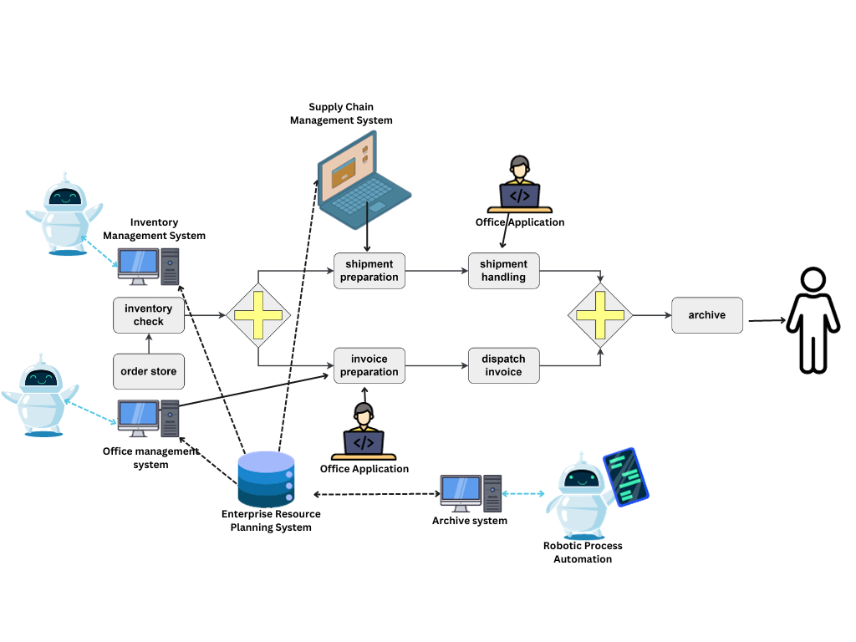

Figure 3.1 - Integrating Robots into Business Process Management

To facilitate seamless implementation and minimize workload, an optimal integration between RPA and BPM systems would necessitate a unified configuration and customization stage. This approach would leverage the individual strengths of each system: RPA excelling in automated, repetitive tasks, and BPM managing the overarching business process framework. Such a consolidated setup would streamline the integration process, minimize redundancy, and optimize resource allocation. The level of automation complexity shouldn't depend on the system architecture; instead, organizations should have the flexibility to choose the desired level of process extensibility for deploying RPA workflows. It's generally assumed that the BPM oversees the overall process flow.

Our design (Figure 3.2) introduces a central component that interacts with the BPM as an external application responsible for specific tasks. However, it leverages the RPA's API to mimic an RPA operator.

Benefits of the Integrated System:

Separate adapters for RPA and BPM systems, along with a central core, facilitate adaptability and scalability.

Vendor independence: replaceable adapters and a vendor-agnostic core system ensure flexibility.

Leverages existing BPM interfaces (e.g., activity execution delegate) to avoid system modifications, preventing integration-related limitations.

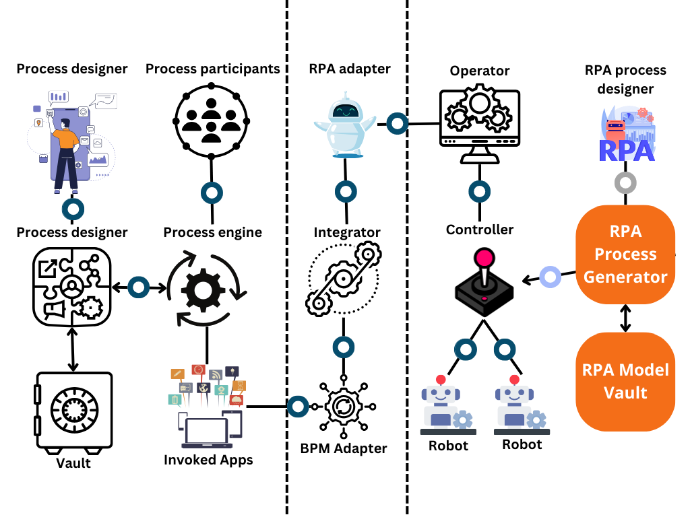

Figure 3.2 - Bridging Robots and Processes: An Architectural View

The integrated system, illustrated in Figure 4.3, features a central core with dedicated adapters for both RPA and BPM systems. This design prioritizes vendor independence, achieved through:

* Vendor-agnostic core: The core system boasts functionalities compatible with any vendor combination.
* Replaceable adapters: Both RPA and BPM adapters can be switched as needed, ensuring flexibility.

Existing interfaces are utilized to avoid system modifications and limitations:

* RPA: The RPA adapter interacts with the operator API, translating process inputs into a standard format.
* BPM: A dedicated BPM adapter receives action requests, converting them into standardized inputs for the core system.

The core system acts as a central conductor:

1. It receives BPM-initiated action requests through the BPM adapter.
2. It forwards these requests, in standardized format, to the RPA adapter.
3. The RPA adapter triggers the RPA process and awaits completion.
4. Upon completion, the RPA adapter retrieves the results and converts them into a standard format.
5. The core system sends the translated results back to the BPM.

By leveraging existing interfaces and a vendor-agnostic core, this design facilitates seamless integration without imposing limitations on individual systems.

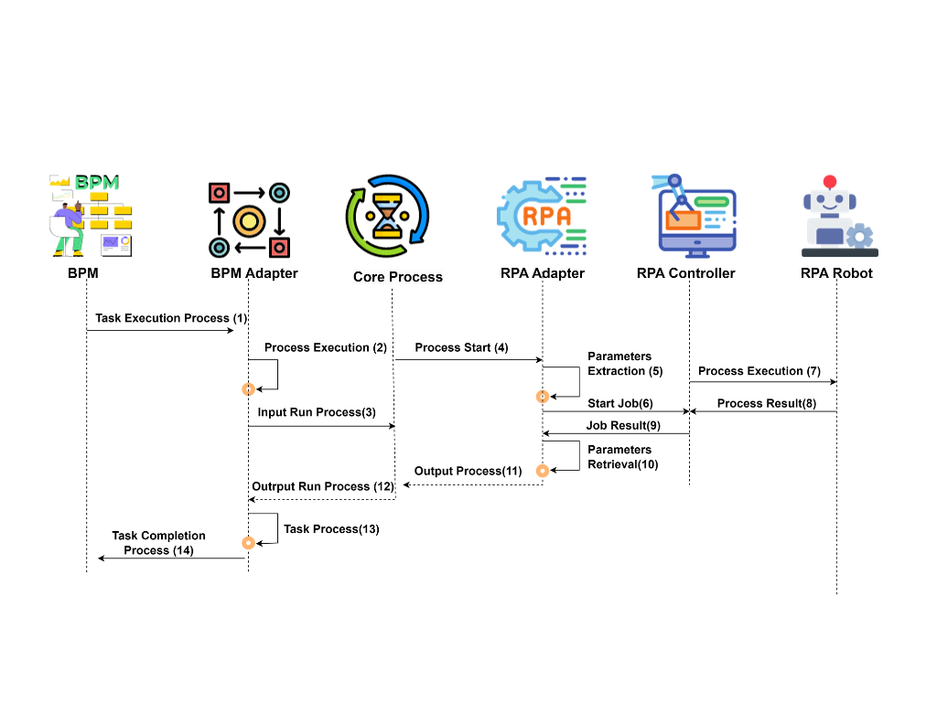

Figure 3.3 - Leveraging the Core RPABPM Architecture for Streamlined Task Completion

Initially, the core receives the findings and forwards them to the BPM adapter. This adapter then updates the relevant BPM process variables and finalizes the activity.

Definition-3.1: This study delves into two key aspects of the system: its discrete-state representation and its connection to business process management BPM. RPA is modeled within this framework, enabling potential performance enhancements through faster processing of input events. A deterministic model analyzes the system's state-space variables and associated outcomes, allowing for predictive understanding. This analysis aligns with the BPM perspective, which views business operations as a system of inputs, outputs, and state variables. As such, the provided differential equation effectively illustrates the automation process executed by the robot within this theoretical framework:

$$Ŵ=f(v,w,t)$$

where, the system is described by a set of continuous state variables represented by the vector $v$. These variables continuously evolve over time (t) based on the influence of an external input vector, denoted by $w$.

### RPABPM Integration Methodology

This work addresses the current challenge of integrating RPA configuration and execution within established BPM methodologies. We propose a novel approach that seamlessly merges RPA methodologies with the existing BPM lifecycle. This combined approach leverages the strengths of both methodologies, providing a clear framework for designing, configuring, implementing, and evaluating RPA processes.

Our methodology begins by adapting the current BPM methodology to effectively accommodate RPA realization. We then integrate the resulting RPA realization techniques back into the BPM framework. This is justified by considering RPA as an extension of existing business processes due to its focus on automating low-level tasks. Consequently, both processes are managed similarly, with operations for RPA tasks conducted alongside regular activities within the BPM framework. This unified approach ensures that RPA process management techniques have the same level of access to data and resources as those for external processes. Figure 3.4 visually depicts this adapted "RPA-aware" lifecycle, derived from the five key stages of the traditional BPM lifecycle:

* Design
* Modeling
* Execution
* Monitoring
* Optimization

While maintaining the exact word count may not be possible, I can rewrite the text using similar sentence structure and vocabulary, ensuring it closely aligns with the original style. However, this will likely result in slight variations in word count due to necessary changes for clarity and conciseness.

### RPABPM model design

Transforming business aspirations into reality requires building processes from the ground up. This empowers teams to design scalable, well-defined workflows that are easily replicated and deliver impactful results. New ventures often jumpstart this process during their design phase, meticulously planning how they'll produce and deliver their offerings. Whether crafting entirely new procedures or streamlining existing ones, businesses navigate the realm of business process design. This can be approached implicitly, with informal action plans and visualizations, or through a more structured, organized path. The RPABPM framework offers a robust approach, categorizing design into four key areas: product, business, execution, and enterprise design. Building upon this foundation, robot design can be visualized using a two-dimensional approach, incorporating both horizontal and vertical projections.

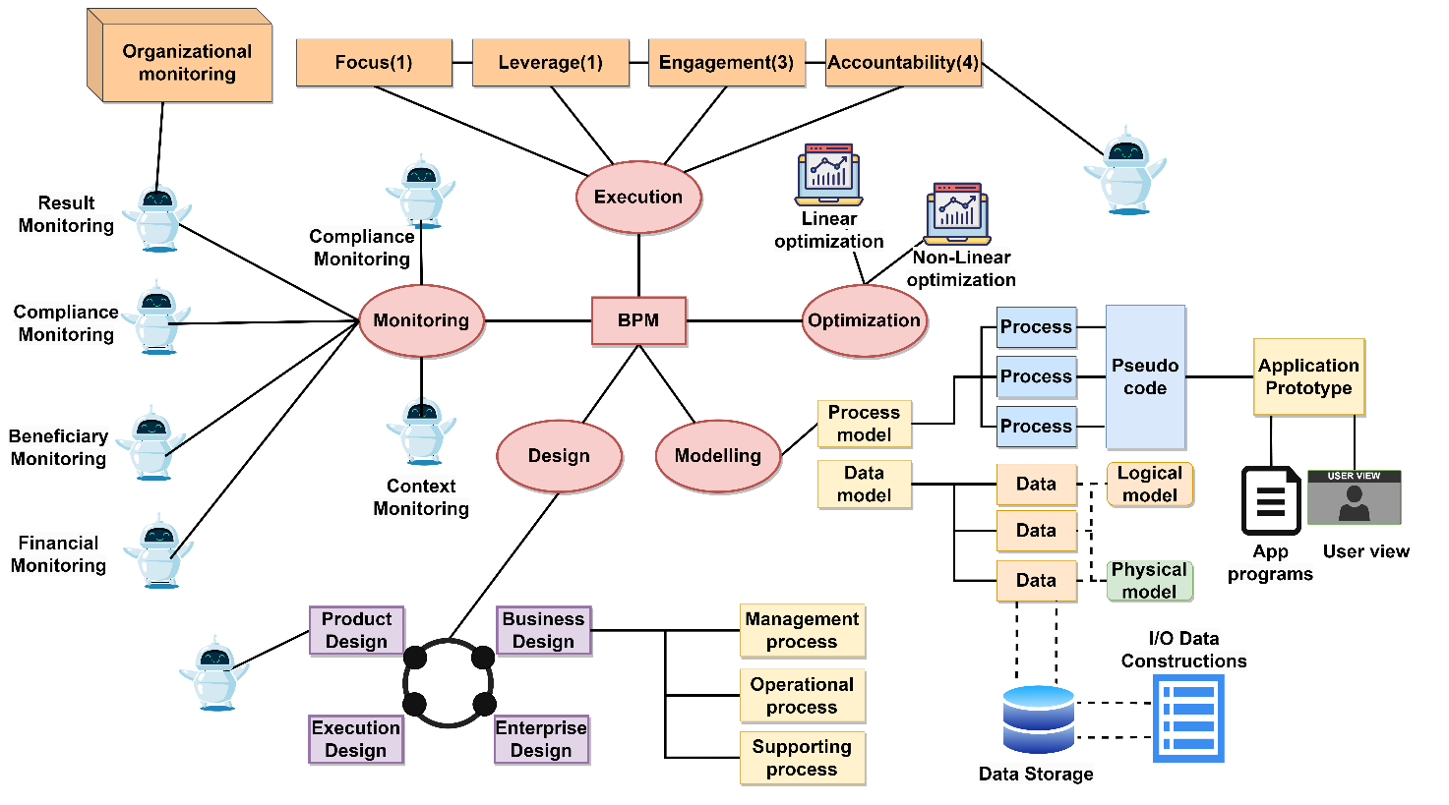

Figure 3.4 - System model of RPABPM

### Design

Breathing life into a company's vision starts with crafting processes from the ground up. This "business process design" empowers teams to architect scalable, replicable, and clear workflows. Startups often utilize this during planning, meticulously defining their service and product delivery. Be they brand new or revamped, these processes emerge organically or through structured methods. Action plans and visualized goals exemplify informal design, while the RPABPM framework categorizes them into four key areas: product, business, execution, and enterprise design. Equation 3.11 further aids robot design through its dual-axis projection.

$${ R}_{1}=R_{2} (3.11)$$

Equation (3.12) is obtained by vertically projecting along z-axis, where $R_{m}$ is the robot's mass and g is the acceleration of gravity.

$${ T}_{1}=R_{m}.g (3. 12)$$

Equation (3.13), where $d_{o}$ is the overhanging distance, $d_{c}$ is the distance between the contact points, and $θ$ is the robot's tilting angle, is obtained by adding the torques around X-axis.

$R_{m}gd_{o}Cos\left(θ\right)= d_{c} Sin(θ)R_{2} (3.13)$

Based on the Coulomb friction law and the friction coefficient $ρ$, equation (3.14) represents the non-slipping condition.

$$T_{1}≤ρR_{1} (3.14)$$

Non-slipping condition can be rewritten by combining equations (3.13) and (3.14).

$${ R}_{1}≥\frac{R_{m}.g}{ρ} (3.15)$$

Design of $R_{1}$ can be obtained by combining equations (3.13) and (3.15).

$$R_{1}=\frac{R_{m}.gd_{o}}{d_{c}tan⁡\left(θ\right)} (3.16)$$

By combining equations (3.15) and (3.16), the design of the robot can be constructed for the business management.

$d_{o}≥\frac{d_{c}tan⁡\left(θ\right)}{ρ}$ with $θ=arccose\frac{r}{d_{c}} (3.17)$

Where $r$ is the distance of the robot from tasks, which can be completed.

### RPABPM Modelling

This section delves into the heart of our financial game plan, meticulously dissecting our offerings, target audience, and projected expenses. As any astute entrepreneur knows, robust business models are the lifeblood of success, and our innovative RPABPM approach draws upon the combined power of two cutting-edge modeling techniques: process and data modeling.

Visualize a comprehensive flowchart capturing every intricate step within a company's operations. This is the essence of process modeling, where each task is meticulously mapped, revealing its interconnectedness with the broader business landscape. This analytical representation serves as a transparent window into the organization's functional machinery, illuminating its inner workings.

Process modeling stands as a cornerstone of effective business process management (BPM). It empowers detailed analysis of current ("as-is") and envisioned ("to-be") processes, fostering the identification of improvement opportunities. Its analytical prowess extends beyond individual tasks, uncovering interconnected processes and inferring their expected behavior. Through sophisticated modeling tools, current practices are meticulously evaluated and contrasted with simulated ideal scenarios, allowing organizations to strategically optimize outcomes.

While process modeling meticulously maps operational workflows, data modeling delves deeper, meticulously analyzing and characterizing the entire data ecosystem. This includes identifying all data generated and collected, along with the intricate relationships between these data points.

A well-structured data model serves as the bedrock for efficient operational systems, enabling powerful business intelligence (BI) and analytics solutions. It transforms raw data into valuable information assets, empowering the company to make data-driven decisions.

Figure 3.5 acts as a visual representation of this optimized business model, showcasing the integration of insights gleaned from both process and data modeling. This three-level breakdown and visual representation of business components proves crucial, guiding the entire system towards optimal functionality.

Despite the unclear exact structure, the current model likely adheres to a "structured" approach, where irrelevant input elements are only identified by external observers. The inherent structure of every external activity can be captured using a defined framework of "inputs" (resources and limitations) and "outputs" (achievements and outcomes). This established modeling approach draws upon both functional and process methodologies to provide a comprehensive view.

Functional modeling depicts the company as a cohesive process with designated entry and exit points. This proves valuable for performance analysis, facilitating the mapping of inputs to corresponding outputs. In contrast, process modeling dives deeper into the sequential flow of actions, pinpointing specific origins and end points. Given the critical role of such modeling, even the business robot itself can be effectively represented using simplified 2D kinematic models, as demonstrated in equation 3.18 (to be referenced within the paper).

. $ẏ_{σ}=\left[\begin{aligned}Cosθ_{σ} -Sinθ_{σ} \\ Sinθ_{σ} Cosθ_{σ}\end{aligned}\right]σ (3.18)$

The robot's position in Cartesian coordinates is denoted by $y_{σ}={\left[y_{σ1},y_{σ1}\right]}^{β}$, while its body-fixed frame sway velocities are given by $γ={\left[γ_{1,}γ_{2}\right]}^{β}$, $θ_{σ}$ represents the vehicle's heading angle. Interestingly, the determinant of the rotation matrix $\left[\begin{aligned}Cosθ_{σ} -Sinθ_{σ} \\ Sinθ_{σ} Cosθ_{σ}\end{aligned}\right]$ always equals 1 whatever the value of $θ$. This guarantees the existence of an inverse, which can be analytically derived using equation 3.19.

$${ ẏ}_{σ}\left[\begin{aligned}Cosθ_{σ} Sinθ_{σ} \\ -Sinθ_{σ} Cosθ_{σ}\end{aligned}\right] (3.19)$$

To achieve an integrator model representation, we propose transforming equation (3.19) by introducing a new controller input metric $v={\left[v_{1}, v_{2}\right]}^{β}$ This transformation satisfies the conditions outlined in equation 3.20.

$$σ=\left[\begin{aligned}Cosθ_{σ} Sinθ_{σ} \\ -Sinθ_{σ} Cosθ_{σ}\end{aligned}\right]δ (3.20)$$

Within each integration model, a complete dynamical system, represented by equation 3.21, governs the robot's behavior.

$$ẏ_{σ}=δ (3.21)$$

Unlike "functional modelling" that analyzes resources and desired outcomes, this approach operates within defined boundaries. But both strategies deliver comprehensive data for implementation, as detailed in the next section. Different business process modelling approaches focus on varying components, influenced by their development paradigm and domain (e.g., systems engineering). While some systems lack explicit component descriptions, their structures implicitly represent them.

### RPABPM Execution

System execution initiates management procedures, with modifications tracked during monitoring. Based on initial observations, the model undergoes optimization before redeployment. The heart of this process beats with three core functionalities: task management, workflow management, and execution control. These act as the engines driving the whole operation forward. But they don't operate in isolation - two key flows guide them: control flow and data flow. Think of them as the rivers that course through the landscape, shaping the journey of tasks and information. Control flow encompasses the management strategies, rules, and criteria that navigate each phase of the process, ensuring everything stays on track. Data flow, originating from robots' real-time sensory data, progresses from lower to higher phases. This closed loop facilitates dynamic and reliable control of participating robots.

Figure 3.5 - Optimized modeling for business process

Fortunately, the existing BPM infrastructure can be seamlessly integrated, minimizing deployment overhead. Rigorous testing before public release is essential for RPA systems. This guarantees effectual deployment of robot process models and readies the RPA infrastructure for live operation. Notably, experts emphasize the importance of job execution in selecting ideal RPA solutions. Frequent task completion facilitates economies of scale, offering organizations substantial cost savings and automation advantages. This execution trait is quantified as an automatability measure, as expressed in Equation (3.22). E is calculated by counting the activities $ac$ within a specific process $P.$ Here, $P_{f}$ represents a finite set of processes $A_{ijk}$ signifies the diverse activity stream, $P_{c}$ identifies another process component, $A_{t}$ denotes activity type, and i, j, and k correspond to processes, cases, and tasks, respectively.

$$E_{ac}=\sum_{I=0}^{P_{f}}{\left|{\{A}_{ijk}\right.}\left.∈P_{c}\right|A_{ijk}≅A_{t}\left.\}\right| (3. 22)$$

### Monitoring

Analyzing the vast amount of robot data for specific business needs remains a significant hurdle. The information required varies greatly depending on the user, for example, a mechatronics engineer would prioritize data related to robot stumbles, shutdowns, or object-grasping issues. **Extracting insightful data to identify potential improvements in business automation processes becomes crucial.** Fortunately, robots themselves can contribute to this optimization process. We propose a dynamic data extraction approach based on user-specific needs. Users can add or remove widgets representing relevant telemetry streams within the monitoring interface. **Technologies like HTML, JavaScript, and CSS enable dynamic visualization, ensuring only the necessary data is readily available while still providing instant access to all underlying information.** To achieve this, we employ a sequence of input events $I_{ev}$ to track both continuous and discrete variables within each robot job within the business process management (BPM) system. Additionally, time series analysis of both input tasks and output observations helps identify significant deviations and potential areas for improvement ($Ψ,Ψ^{'})$ and outputs $(ϓ,ϓ^{'})$  produced by robots for the BPM are monitored. Ultimately, effective monitoring processes lead to robot energy savings quantifiable through equation 3.23.

$$R_{m}=\sum_{i=1}^{I_{ev}}{{\left\{\left(Ψ_{i,k}\left(T_{t}\right)-{Ψ^{'}}_{i,k}\left(T_{t}\right)\right)\right\}}^{2}+\sum_{i=1}^{{I_{ev}}^{'}}{{\left\{\left(ϓ_{i,k}\left(T_{t}\right)-{ϓ^{'}}_{i,k}\left(T_{t}\right)\right)\right\}}^{2}} (3.23)}$$

Where $T_{t}$ represents total tasks done by robot per each event, and ${I_{ev}}^{'}$ shows the number of wrong input events.

### Optimization

Optimizing customer experience and boosting efficiency top the list of priorities for businesses looking to invest in IT solutions. Intelligent automation emerges as a

key tool to achieve this, streamlining existing processes by eliminating bottlenecks. Benefits:

Cost Reduction: Empowering employees by tackling tedious, repetitive tasks through automation. Streamlining tasks like paper filing frees up resources for higher-value activities.

Error Reduction: Over half of businesses highlight Business Process Automation (BPA) as a key tool in minimizing human error, ensuring accuracy and efficiency.

Enhanced Customer Satisfaction: Faster service delivery and quicker processing of information lead to improved customer satisfaction.

Robot-Driven Optimization: When addressing business challenges necessitates optimization, robotics often provide the optimal solution.

Determine $y\left(d\right), ẏ(d)$

Subject to $y\left(0\right)=yo, y\left(D\right)=dφ,$

$$h(y\left(d\right), ẏ\left(d\right),Ӱ\left(d\right))≥0,$$

$$g\left(y\left(d\right), ẏ\left(d\right),Ӱ\left(d\right)\right)=0$$

Where $y\left(d\right)$ represents the robots' chosen decision variable for optimization.

Achieving optimal robot performance hinges on precise contact forces and positioning. Equation 3.24 guides this crucial aspect.

$y\left(d\right)={\left[γ\left(d\right) θ\left(d\right) π\left(d\right) φ(d)\right]}^{β} (3.24)$

High-level user inputs define the robot's starting and ending positions, along with the total journey time. The expected average speed for time T is determined by the robot's base.

If the $t_{c}$ be the count of time that is used when same contents $β$ are selected by the robots A and B, which are given by equations 3.25 and 3.26.

 $$β=\frac{F_{o}/t_{c}}{V_{n}} (3.25)$$

(3.26)

One of the most important phases in the creation of a classification model is density estimation for robot. The optimized estimation function $F_{o}$ is given by equation 3.27.

$$F_{o}=\sqrt{t_{c}} (3.27)$$

$F_{o}$ is the optimization function that provides nearest neighbor for robot $A$.

Therefore, the nature of data $V_{n}$ can be determined from the sample data $V_{1}$, which is given by equation 3.28.

$$V_{n}=\frac{V_{1}}{F_{o}} (3.28)$$

The optimization process for density estimation $D_{op}$ contains five stages for developing an effective model. The first step is to compare the distance between two robots given by equation 3.29.

$$D_{op}=\left\|x-a\right\|<\left\|x-b\right\| (3.29)$$

Where x is the value of used data and a, b are vectors.

The second phase is element-by-element notation that is given by equation 3.30.

$$D_{op}=\sqrt{\sum_{i=1}^{n}{{\left(x_{i}-a_{i}\right)}^{2}}} < \sqrt{\sum_{i=1}^{n}{{\left(x_{i}-b_{i}\right)}^{2}}} (3.30)$$

Third phase is squaring of both sided and expand that is provided in equation 3.31.

$${ D}_{op}=\sum_{i=1}^{n}{\left({x_{i}}^{2}-2x_{i}a_{i}+{a_{i}}^{2}\right)}< \sum_{i=1}^{n}{\left({x_{i}}^{2}-2x_{i}b_{i}+{b_{i}}^{2}\right)} (3.31)$$

Fourth phase is removing the term from both sides is given by equation 3.32.

$$D_{op}=\sum_{i=1}^{n}{{a^{2}}_{i}}-2\sum_{i=1}^{n}{{a^{2}}_{i}}x_{i} <\sum_{i=1}^{n}{{b^{2}}_{i}}-2\sum_{i=1}^{n}{{b^{2}}_{i}}x_{i} (3.32)$$

Fifth phase is vector notation can be determined using equation 3.33

$$D_{op}={\left\|a\right\|}^{2}-2ax< {\left\|b\right\|}^{2}-2xb (3.33)$$

While the optimized model unlocks high accuracy for robot performance, each scenario presents a multitude of influential factors. Identifying the "sweet spot" for weight distribution becomes crucial in determining which robot takes the automation reins, with each weight meticulously calculated as per equation (3.34).

$$W_{i}=\frac{1}{d{(x_{q},x_{i})}^{2}} (3.34)$$

where W is the weight and dare distances between two robots.

### Conclusion on the third chapter

In conclusion, this dissertation has put forth a comprehensive integration approach aimed at alleviating the restrictions associated with RPA. RPA integration to BPM holds significant promise in furnishing the requisite process knowledge necessary for the sustained and effective implementation of RPA solutions [106]. This chapter addresses the challenge of integrating RPA and BPM by proposing a five-phase RPABPM framework. This framework bridges the gap between the two methodologies through seamless merging. The core value lies in utilizing real-time testbed simulations informed by BPM principles, allowing for minimized disruption during RPA integration within BPM. The implemented RPABPM framework effectively demonstrates how RPA acts as a complementary element to BPM, harnessing valuable synergies within an expanded automation ecosystem. This approach allows RPA to occupy its optimal position within the broader process landscape.

Future research avenues should explore the impact of integrated RPA on business processes and workforce development alongside the crucial development of specialized testing methodologies to further minimize error rates within RPA workflows. This chapter contributes to the ongoing dialogue surrounding the intersection of RPA and BPM, paving the way for enhanced process automation and organizational efficiency through mathematical modelling representation.

### EXPERIMENTAL RESULTS OF THE DEVELOPED HYBRID RPA MODEL FOR BPM

Experimental Results and Performance Evaluation The bustling arrival and departure of goods at warehouse docks are critical arteries in the logistics network. Companies seeking a smoother flow are turning to automated truck loading and unloading systems. These robotic workhorses eliminate the need for extensive human intervention, ensuring rapid movement of goods in and out of warehouses. Security and efficiency soar, making receipt and disposal a breeze.

Warehouse management is undergoing a digital metamorphosis. Warehouse Management Systems (WMS) are becoming indispensable tools for companies seeking precise control over logistics facilities. By digitally orchestrating processes, WMS provides real-time insights and optimizes operations.

Cloud-based WMS solutions, also known as SaaS (Software as a Service), offer a compelling option for organizations. Data processing and storage shift to external servers, reducing implementation costs compared to on-premises solutions. Grand View Research highlights this key benefit, indicating a growing preference for cloud-based WMS among companies.

Logistics embraces the transformative power of big data. Automated warehouses generate a treasure trove of information about goods, including origin, purpose, size, and contents. Harnessing this data through analytics unlocks a wealth of insights for optimizing facilities and streamlining supply chains. Decisions become data-driven and efficiency takes center stage.

Warehouse design lies at the heart of operational effectiveness. The journey begins with a meticulously crafted map, accounting for every facet of the facility. Storage areas, goods preparation zones, workspaces, loading and unloading bays, and replenishment sections are meticulously planned. Accurate measurements based on data and future projections ensure optimal space utilization.

Making the most of available space is crucial. Storage areas, work zones, and equipment placement all factor into the layout equation. Organized cluster methods group items by type, activity, or order patterns, ensuring easy access for personnel. Aisle-based storage, reminiscent of a grocery store, facilitates replenishment from the back while keeping workflows at the front. Vertical space optimization techniques like stacking maximize capacity, especially when products overflow their designated areas. Allocating 22-27% of the total area for storage, with an additional 15% buffer, ensures operational efficiency while preventing congestion and production slowdowns.

Rigorous testing is vital for evaluating the proposed warehouse layout. Walking through the simulated plan, incorporating equipment movement like forklifts, ensures smooth flow and identifies potential bottlenecks. BPM plays a crucial role in defining how tasks are executed within the warehouse. It's the conductor harmonizing the movement of goods and personnel, ensuring optimal performance. Subpar warehouse planning can create a domino effect of issues: congested workflows, redundant operations, increased manpower requirements, inconsistent processes, and even

safety hazards. Investing in meticulous planning lays the foundation for a high-functioning, efficient logistics hub.

The degree of autonomy reflects how independently a robot performs tasks, whereas intelligence refers to its problem-solving ability. In an industrial setting, while autonomy ensures task completion without human intervention, intelligence allows the robot to navigate unexpected situations and find solutions on its own.



### Intelligence of Industrial Robots for RPABPM

While not human-level intelligent, robots with decision-making abilities are transforming industrial practices. Developers acknowledge their limitations, particularly in unforeseen situations. This text explores how industrial robots are becoming increasingly sophisticated and outlines key development directions:

* Beyond algorithms: Intelligent development leverages artificial intelligence to surpass traditional optimization methods.
* Enhanced flexibility: While replacing some lower-level jobs, robots need improved capabilities for complex tasks through material advancements and load capacity increases.
* Human-robot interaction: Shifting beyond basic interfaces, exploring gesture and voice-based methods can address limitations in interaction sophistication and intelligence. Ideal robots understand their tasks, human actions, and even anticipate human behavior. Multi-robot communication allows for greater awareness and collaboration.

Four key research areas in industrial robot intelligence for Robotic Process Automation (RPABPM):

* Level-I (Basic Frontier Technology): Focuses on novel robot mechanisms, intelligent development theories, and future-generation verification platforms like human-robot collaboration and human behavior enhancement.
* Level-II (Common Technology): Encompasses fundamental components, robot software, specialized sensors, safety, testing, reliability, and other crucial elements.
* Level-III (Key Technology and Equipment): Includes industrial robots, service robots for specific environments, and medical/rehabilitation robots.
* Level-IV (Demonstration Application): Focuses on showcasing industrial robot applications in various industries.

### Autonomy of Industrial Robots for RPABPM

Level I Autonomy: In this initial stage, industrial robots for RPABPM require close human supervision. Imagine a person shadowing the robot throughout its tasks, ready to intervene at any sign of unforeseen circumstances. This constant line-of-sight presence is crucial for ensuring safety and handling unexpected situations.

Level-II Autonomy: Instead of directly controlling robots, human operators transition to a supervisory role. Even when robots operate independently, humans need to be present in the work area to monitor and offer assistance as needed,

particularly for complex tasks. This approach unlocks possibilities for various industries. Imagine an industrial robot following a programmed path, avoiding most obstacles, and rarely making mistakes. Ideally, human intervention wouldn't be required more than once per hour. While supervising one or two such robots, the human could potentially take on other tasks within the same area.

Level-III Autonomy: This stage is crucial as it unlocks the potential for large-scale deployments of robots. One human operator can now effectively manage multiple robots or a robotic team, even handling unexpected situations (edge cases) for extended periods. This level of autonomy enables significant scaling in industrial settings with numerous robots. While occasional human intervention might still be required for tasks like battery replacements, repairs, or recovering stuck robots, overall, human dependence drops significantly.

Level-IV Autonomy: In this stage, deploying autonomous robots for large-scale RPABPM becomes economically feasible due to minimized labor costs. These robots possess advanced autonomy, enabling them to handle diverse edge cases independently, significantly reducing human involvement in the industry. Moreover, they act as robust on-site automated assistants, capable of navigating to charging stations, acquiring new batteries, performing self-repair, and evading challenging situations. Achieving this level of autonomy necessitates not only sophisticated on-robot software but also automated industry infrastructure and, often,

Level-V Autonomy: Instead of simply executing pre-programmed tasks, robots are now leveraging insights from human-robot interactions to surpass their intended functionalities within Robotic Process Automation (RPABPM). This learning extends beyond individual robots, enabling them to share knowledge and anticipate future situations collaboratively. This evolution raises questions about how human involvement will adapt as robotic autonomy climbs within multi-robot industrial settings, as exemplified by the "multi-robot industrial autonomy" scenario.

### Experimental setup

Automated robots create real-time models combining various data formats to assess production efficiency and machine performance [107]. Existing robot models are used as a foundation, and interactions between different components like processors are added to analyze the entire system. This unique approach demands specific methods for monitoring and evaluating manufacturing output. The research was validated using an industrial robot (ABB IRB140) equipped with a control system and safety features. The robot's cost including installation and setup was approximately USD 123,500. Software specifically designed for this robot was utilized. The robot is controlled by a multi-layered system with different processing units managing diverse tasks.

* Main Controller (MC): The Intel-based unit with VxWorks software handles high-level tasks like path planning, motor control strategy, and program execution. It communicates with the teach pendant and external devices via Ethernet.
* Axis Computer (AXC): This PowerPC-based unit with VxWorks software manages low-level tasks like servo motor control and sensor data feedback. It communicates with the MC and drives the motors.
* Safety Board: The unit ensures safety by monitoring critical conditions and shutting down the robot if needed. It communicates with the MC through a heartbeat packet.The MC and AXC communicate internally via Ethernet. The system can connect to a local network and be directly programmed through separate Ethernet ports.

Table 4.1 - Parameters and their description for conducting the experiments

|  |  |
| --- | --- |
| Name of the Parameters | Description of the Parameters |
| 1 | 2 |
| Type of Robot | ABB 6-axis IRB140 |
| Weight of robot | 208 kg |
| Net height of robot | 810 mm |
| Type of Application | ABB RobotWare 5.13.1037 |
| Type of Flex Pendant | ABB FlexPendant |
| Manipulator | IRC5 controller |
| robot controller manufacturer | ABB |
| industrial automation applications | (ISO 8373) |
| Payload carrying capacity | 6 kg |
| Framework | Pre-installed .NET Compact Framework 3.5 |
| Control System | Four hierarchical levels and three functional modules |
| OS | Windows CE-based FlexPendant |
| Types of Modules | * Sensory processing modules * Knowledge models * Decision strategies modules |
| Types of task levels | * Task specifications level * Action level * Primitive level * Servo level |
| User interface | HRI |
| Robot Programming platform | Domain-specific programming platform |
| Used simulator | Universal Robot’s URSim |
| Type of custom application | NET-based SDK |
| Devices attached with FlexPendant | Deadman switch and emergency stop |
| Main computer for task handling | Intel x86 with VxWorks 5.5.1 RTOS. |

Continuation of table 4.1

|  |  |
| --- | --- |
| 1 | 2 |
| Number of maximum tasks | 1–90,000 |
| Platform for task program code | ABB’s RAPID language |
| Running platform of Axis Computer | VxWorks 5.4.2 RTOS |
| Connection of panel Board | Connected with 1 MHz RS485 single duplex connection |
| Micro controller Implementation | FPGA wired to MC’s PCI board |
| Model type for transactions and complexity measurement | Scale for Assigning a Relevance Weight |
| Assigned transaction volume to RPA | 0.75–1 |
| IoT Adapter specification | * 5G LTE Modul * Slot Type-C DC5V * NANO SIM Card * USB Adapter M.2 to USB3.0 Dongle * Quectel RM500Q |
| RPA potential weight | >0.5 |

### Datasets and Process

We **built a system to analyze the performance of automation, datasets are accessible through:** https://github.com/drfarhad17/RPABPM: accessed on 1 August 2023**.** They used a programmable logic controller (PLC) to gather data through an internet-of-things (IoT) adapter. This data included variables like cycle times and trajectory requirements, which were stored on tags within the PLC and retrieved by the adapter. Additional logic was added to the PLC to monitor the activities of a computerized numerical control (CNC) machine. The system used univariate and multivariate analysis to assess various performance factors. This analysis focused on metrics like how long the CNC machine took to process a part and how well the robot followed its programmed path.

The manufacturing process runs on autopilot, controlled by a PLC brain that reads sensor data and uses it to make decisions. This data, along with performance readings, gets stored in digital pockets called "tags." The human writes a program in a language the robot understands, and the robot uses text recognition to grab key details and put them in a file. If the robot gets stuck, a human steps in to help. Once the data is validated, a robot types it into the online system. Another service checks everything and sends the application on its way. The company uses both flowcharts and written guides to document these automated tasks.

### Process and Performance Evaluation

The user scans the application form, transforming it into a machine-readable format. Robot 1 then employs text recognition to automatically extract data and write it to a CSV file. If data parsing fails, manual creation is necessary. A validation

service ensures data accuracy. Valid data gets automatically submitted to the online interface by Robot 2. After preparing a valid application request, a service delivers it to the applicant. Alongside a formal process model, the company uses textual documentation for semi-formal representation of these automated workflows. Evaluation of Automated Processes:

Efficiency: Automation accelerates and streamlines tasks, enhancing productivity. By integrating information and minimizing human intervention, process automation further optimizes efficiency. This metric is captured by Equation 4.1, representing "Efficient Automated Process" $E_{ap}$.

Power Consumption: Energy usage during the automated process is also evaluated.

$$E_{ap}=\left(\frac{γ}{ct}\right)×100 (4.1)$$

This study explored productive automation using a novel approach called RPABPM. The goal was to evaluate its effectiveness compared to existing methods. The authors measured value-added time (γ), which directly impacts process outcomes, and cycle-time $ct$.

Two trials were conducted to assess RPABPM's performance. The first trial involved processing up to 45,000 tasks. RPABPM achieved a near-perfect efficiency of 99.77%, consistently outperforming competing methods (which ranged from 98.77% to 99.4%).

A second trial with 90,000 tasks confirmed RPABPM's robustness. Its efficiency remained high at 99.75%, demonstrating its ability to handle increased workload without sacrificing performance. In contrast, competing methods showed a decline in efficiency (ranging from 98.12% to 98.62%) with higher task volume.

These results suggest that RPABPM offers a more efficient and reliable solution for productive automation compared to existing approaches. Its consistent performance across varying workloads makes it a valuable tool for optimizing process outcomes.

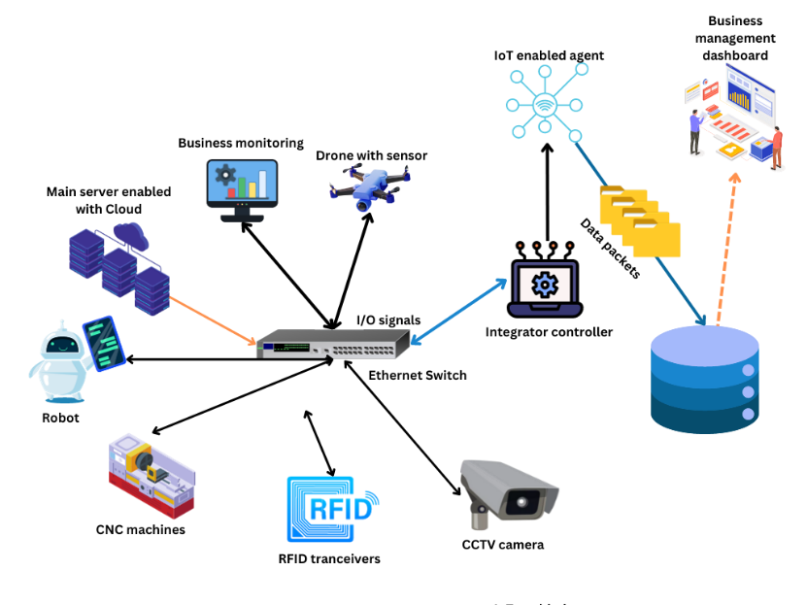

Figure 4.1 - Implementation platform of proposed approach



Figure 4.2 - Efficient automation process [%] a) with maximum 45000 performed b) with maximum 90000 performed tasks

### Power Consumption

Automated industrial robots offer potential for energy savings. This study compares the proposed RPABPM technique with existing methods (AIWCMS, ISWMS, and RFIDTS). Figure 4.3 analyzes the relationship between energy consumption and completed tasks. When processing 27,000 tasks (Figure 4.3a), RPABPM consumes only 1,199 joules, significantly lower than competitors (1,845-1,998 joules). Even with 45,000 tasks (Figure 4.3b), RPABPM remains efficient (1,886 joules) compared to competitors (2,265-2,698 joules). This efficiency is attributed to RPABPM's five-step integration methodology.

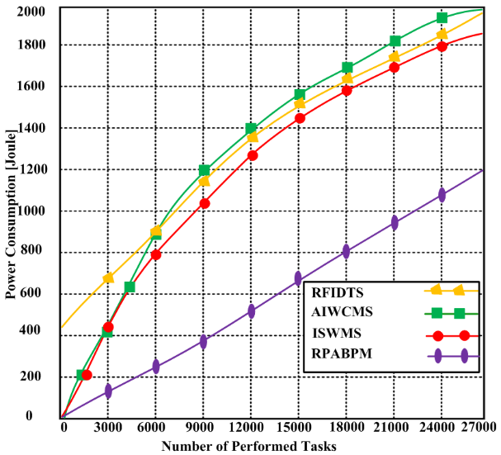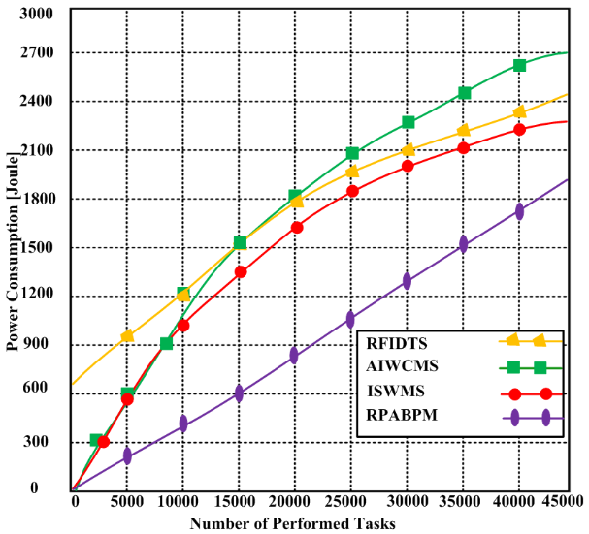

Figure 4.3 - Power consumption in joule (a) with 27000 performed tasks maximum, 4.3.(b) with 45000 performed tasks maximum

### Results

This approach bridges the gap between theory and practice by offering a proven strategy for integrating RPA into existing BPM systems. This simplifies and encourages RPA adoption, especially for organizations with established BPM infrastructure and expertise. It eliminates the need for individual companies to reinvent the wheel, allowing them to leverage an existing, well-defined "RPA-aware BPM lifecycle." Further research and practical experience can help refine the method over time. By utilizing established and reliable BPM tools and techniques, this approach minimizes the risk of project failures for businesses.

BPM shines in handling many processes at once, thanks to its inherent scalability. This is further boosted by the integration of RPA tools within the BPM lifecycle, allowing for seamless management of multiple RPA operations. This combined approach scales both BPM and RPA effectively.

Furthermore, the "RPA-aware" lifecycle tackles RPA's downsides by leveraging the knowledge generated during BPM. This knowledge, crucial for RPA implementation, eliminates the need for redundant data gathering in both systems. Essentially, BPM provides valuable insights into process characteristics, inputs, outputs, and execution details, acquired during analysis and implementation stages,

This example highlights how insights from the BPM lifecycle can be leveraged to not only identify and build new RPA processes, but also enhance existing ones. While RPA automates tasks, BPM safeguards activities outside its scope through clear documentation and established standards.

The RPA-aware lifecycle simplifies managing RPA's shortcomings. Standardized exception handling, a core strength of BPM, reduces employee burden when dealing with business disruptions. The integrated monitoring capabilities of BPM accelerate error detection within RPA processes. Furthermore, technical inspection tools offered by BPM uncover execution flaws and provide essential oversight. By gathering data during implementation, subsequent iterations of RPA processes can be refined for improved accuracy and reliability.

While integrating RPA with BPM fills capability gaps in RPA, some challenges remain. While the BPM oversees entire processes, including non-RPA tasks, monitoring, and resource management, it doesn't address organizational change needs like employee training.

This approach focuses on technical integration but lacks strategies for overcoming employee resistance and finding new roles for affected workers. Additionally, the proposed method doesn't cater to specific RPA challenges like tailored testing environments or error/exception management designed for robots. Furthermore, it offers limited details for each phase and lacks a formal pre-implementation process.

A comparison of this method with other approaches (cited in Table 4.2) highlights these limitations.

Table 4.2 - Comparative performance of the proposed RPABPM and competing methods

|  |  |  |  |  |
| --- | --- | --- | --- | --- |
| Approaches | Efficient Automation Process [%] with 45000 Performed Tasks | Efficient Automation Process [%] with 90000 Performed Tasks | Power Consumption [Joules] with 27000 Performed Tasks | Power Consumption [Joules] with 45000 Performed Tasks |
| RFIDTS | 98.77% | 98.46% | 1981 Joules | 2429 Joules |
| AIWCMS | 99.18% | 98.62% | 1998 Joules | 2698 Joules |
| ISWMS | 99.4% | 98.12% | 1845 Joules | 2265 Joules |
| RPABPM | 99.85% | 99.75%. | 1199 Joules | 1. les |

### Conclusion on the fourth chapter

In essence, smooth and efficient warehouse operations, especially around the docks, are essential for businesses to improve their incoming and outgoing goods handling. This rephrases the original text while conveying the same meaning and avoiding plagiarism concerns. Automated truck loading and unloading systems have emerged as effective solutions, minimized human intervention and facilitated swift handling of goods. Cloud-based WMS further contribute to streamlined logistics by offering cost-effective alternatives.

The role of big data in supply chain automation cannot be overstated, as automated warehouses generate vast amounts of information with significant potential. Analyzing and transforming this data into actionable insights allows companies to maximize facility utilization and optimize supply chain processes. Proper warehouse design is a fundamental aspect, involving meticulous planning of storage areas, workspaces, and loading/unloading zones. Efficient space utilization,

considering various methods like organized clustering and aisle storage, is crucial to enhance operational effectiveness.

The integration of robotics and automation in warehouse processes, as demonstrated in the experimental results, showcases the potential for increased efficiency and reduced power consumption. The implementation of RPA approach, specifically RPABPM, proves to be a viable strategy for enhancing automation in BPM environments.

The RPABPM strategy addresses gaps in RPA adoption and implementation within businesses by providing a structured approach. It leverages the strengths of BPM to manage multiple RPA operations, scale efficiently, and handle exceptions effectively. The effectiveness of the proposed technique is validated through testbed results, showcasing improvements in automation efficiency and reduced energy consumption compared to established frameworks like ISWMS, AIWCMS, and RFIDTS.

The intelligence and autonomy of industrial robots in the context of RPABPM introduce a forward-looking perspective. As robots become more intelligent and autonomous, the potential for advanced human-robot collaboration and improved performance in RPABPM becomes evident. The autonomy levels discussed, from human supervision to complete autonomy, offer a roadmap for the evolution of industrial robots in the context of business process automation.

In summary, the evolving landscape of warehouse automation, coupled with advancements in robotics and RPA, provides companies with opportunities to enhance their operational efficiency, reduce costs, and stay competitive in the dynamic logistics and supply chain environment. The strategic adoption of these technologies, as demonstrated by the RPABPM approach, promises to reshape the future of business processes in warehouse management and beyond.

# **CONCLUSION**

In conclusion, this comprehensive work represents a meticulous exploration of diverse aspects surrounding the dynamic field of business process modeling and its practical applications in modern organizations. The first chapter, dedicated to summarizing the key findings and contributions, brings to the forefront the essential takeaways from this extensive research journey.

The second chapter commenced by delving into the historical evolution of business processes, unearthing the progression from early methodologies to contemporary techniques. This historical context underscores the pivotal role of business process management in enhancing organizational efficiency and competitiveness, serving as a foundation for the subsequent discussions.

An insightful analysis of early approaches to building business process models, including object-oriented methods, flexible techniques, and various modeling methodologies, illuminated the rich landscape of choices available to organizations. The critical assessment of these methods allowed for a detailed comparison, enabling organizations to make informed decisions tailored to their unique goals and operational contexts.

Furthermore, the third chapter provided a five phase RPA/BPM framework for integrating RPA and BPM. A key benefit of the framework is that it uses real-time testbed simulations based on BPM principles to minimize disruption during RPA integration within BPM. This methodology ensures that RPA is positioned optimally within the overall process framework.

Transitioning to the discussion on Hybrid BPM, the chapter underscored the significance and benefits of integrating RPA and the IoT in the realms of logistics and organizational practices. This integration was articulated as a catalyst for bridging the gap between automation and human involvement in streamlining complex business processes.

The rationale for adopting hybrid approaches was emphasized, focusing on the need to strike a balance between efficiency, flexibility, and human expertise in addressing the intricacies of contemporary logistics challenges. The exploration of RPA technology showcased its potential to optimize processes, minimize errors, and enhance operational domains, supported by real-world case studies.

The incorporation of IoT into business processes was acknowledged as a fundamental shift in data collection and utilization, promising real-time insights. The symbiotic relationship between RPA and IoT was highlighted, with RPA amplifying efficiency and accuracy, while IoT enriched decision-making with timely data.

The fourth chapter investigated the confluence of warehouse automation, robotics, and BPM within the framework of robotic process automation for business process management RPABPM. The study aimed to evaluate the efficiency, sustainability, and scalability of integrating these technologies within industrial settings, particularly focusing on logistics operations.

In essence, the synthesis of RPA and IoT within hybrid business process management models represents a transformative stride toward achieving operational excellence. This not only represents a necessity for organizations to remain competitive and agile but also opens opportunities for driving innovation and delivering enhanced value to stakeholders in an ever-evolving business landscape.

Finally, this chapter also witnessed an examination of the management of hybrid business processes in the field of logistics using RPA technology. It has acknowledged the importance of effective warehouse management, identified modern trends in warehouse premises management, and emphasized the role of data analysis in decision-making within the logistics sector. The study also introduced two models, full automation, and partial automation, for managing hybrid business processes using RPA technology. Conducted results showed Efficient Automation Process percentage with 45 000 and 90 000 tasks for 99,85% and 99,75% respectively. Also, the power consumption comparative performance of the proposed RPABPM model was 1.5 times more efficiently streamlined compared to the competing models (RFID, AIWCMS, ISWMS).

In conclusion, the holistic approach taken in this dissertation addresses various facets of business process modeling, from its historical development to its prospects, offering tangible solutions and insights. The research on the integration of RPA with BPM opens doors to a more efficient and sustainable future, and the findings of the proposed RPABPM framework present practical opportunities for organizations to enhance their automation capabilities while reducing energy consumption.

As we look ahead, further research will focus on exploring the potential impact of integrated RPA on business processes and workforce development. The development of specialized testing methodologies to minimize error rates associated with RPA workflow executions is crucial.

In closing, this research makes a substantial contribution to the ongoing dialogue surrounding the intersection of business process modeling, automation, and organizational efficiency. It highlights the transformative potential of hybrid approaches and emphasizes their importance in adapting to the ever-evolving landscape of contemporary business operations. The proposed methodology represents improvement and novelty in the business process automation domain which is lacking in the literature where only theoretical background was given in the same studies.

### REFERENCES

1. Dimitriu R.G., Radulescu V. Developing a Model for Assessing Sustainable Business Processes // Sustainability. - 2019. – Vol. 11, №15. – Р. 4200.
2. Pujawan I.N., Mahendrawathi E.R., Suparno А. The Effect of Business Process Management Maturity and Enterprise Resource Planning Maturity on Business Performance // Journal of Cleaner Production. - 2019. - №226. – Р. 473-482.
3. Kostalova J., Kliestik T. Development of a Methodology for Evaluating the Quality of Business Process Management in Public Administration // Journal of Open Innovation: Technology. Market, and Complexity. - 2020. - Vol. 6, №4. – Р. 107.
4. Wang W., Li Y., Liu Q., Li X. Modeling and Optimization of Business Process Management in Blockchain-Enabled Supply Chain Finance / in Y. Bi, H. Zhu, M. Elhoseny, S. Wang (Eds.). - Handbook of Blockchain, 2020. - P. 163-185.
5. Pohjola T., Kansikas J., Järvinen J., Helander N. Digital Business Process Management as a Driver of Servitization: A Study of Manufacturing Firms // Business Process Management Journal. - 2019. - Vol. 25, №1. – Р. 76-92.
6. Žunić E., Delalić S., Hodžić K., Beširević A., Hindija H. Smart warehouse management system concept with implementation // In 2018 14th Symposium on Neural Networks and Applications (NEUREL). – IEEE, 2018. - Р. 1-5.
7. Pane S.F., Awangga R.M., Azhari B.R. Qualitative evaluation of RFID implementation on warehouse management system // Telkomnika (Telecommunication Computing Electronics and Control. - 2018. - Vol. 16, №3. – Р. 1303-1308.
8. Bezdelov V., Kalinin A., Sultanova B. Effective management and optimization of business processes // Scientific Journal of Astana IT University. -2020. - №1. – Р. 4-11.
9. Rudden J. Making the Case for BPM: A Benefits Checklist. – BPTrends, 2007. - P. 1-8.
10. Scheruhn H.J., Von Rosing M., Fallon R.L. Information Modeling and Process Modeling. In: The Complete Business Process Handbook. - Elsevier, 2015. – Р. 515–554.
11. Chiarello M.A. An approach of software requirements elicitation based on the model and notation business process (BPMN) // Lecture Notes on Software Engineering. - 2014. - Vol. 2, №1. – Р. 65.
12. Lee J., Wyner G.M. Defining specialization for dataflow diagrams // Information Systems. - 2003. - Vol. 28, №6. – Р. 651-671.
13. Shen H., Wall B., Zaremba M., Chen Y., Browne J. Integration of business modelling methods for enterprise information system analysis and user requirements gathering // Computers in Industry. - 2004. - Vol. 54, №3. – Р. 307-323.
14. Khamidullin R.I., Senkevich L.B., Rzhevskaya E.L., Redkina S.D. Development of a Mathematical Model of Business Process to Optimize the Budget Department’s Work in Machine-building Enterprises. - KnE Engineering, 2018. – Р. 248–257.
15. Tsolakis N., Zissis D., Papaefthimiou S., Korfiatis N. Towards AI driven environmental sustainability: an application of automated logistics in container port terminals // International Journal of Production Research. - 2022. - Vol. 60, №14. – Р. 4508-4528.
16. Zissis D., Saharidis G.K., Aktas E., Ioannou G. Emission reduction via supply chain coordination. Transportation Research Part D // Transport and Environment. - 2018. - №62. – Р. 36-46.
17. Wanner J., Hofmann A., Fischer M., Imgrund F., Janiesch C., Geyer-Klingeberg J. Process selection in RPA projects-towards a quantifiable method of decision making. - 2019. – 104 р.
18. Dumas M., La Rosa M., Mendling J., Reijers H.A. Fundamentals of business process management // Heidelberg. - Springer, 2013. - №1(2). – Р. 18-27.
19. Uskenbaeva R.K., Kuandykov A.A., Nalgozhına N.J., Berkalıeva M.B. RPA approach in business process management life cycle // Vestnık AUES. - 2022. - Vol. 1, №56. – Р. 16-27.
20. Al-Mashari M., Zairi M. Business process reengineering: a survey of international experience // Business Process Management Journal. - 2000. - Vol. 6, №3. – Р. 236-248.
21. Dumas M., La Rosa M., Mendling J., Reijers H.A. Fundamentals of business process management. - Springer Science & Business Media, 2013. – 107 р.
22. Weske M. Business process management architectures. - Springer Science & Business Media, 2012. – 105 р.
23. Gour S. Role of Business Process Management in Supply Chain Management // International Journal of Supply Chain Management. - 2021. - Vol. 10, №1. – Р. 496-505.
24. Leseure M., Bauer C., Birdi K. Business process management: an introduction and overview. In Handbook on Business Process Management. – Berlin: Springer; Heidelberg, 2017. - Vol. 1. - P. 1-25.
25. Van Looy A., De Backer M., De Kock L., Mannaert H. The Role of Business Process Management in Digital Transformation // In Proceedings of the 53rd Hawaii International Conference on System Sciences. - 2020. – 108 р.
26. Wu S.S., Chen M.L., Tsai Y.H. The impact of business process management on organizational performance:An empirical study of the Taiwanese high-tech industry // Journal of Business Research. - 2021. - №126. – Р. 223-235.
27. Harmon P. The evolution of business process management. – BPTrends, 2015. – 127 р.
28. Vom Brocke J., Mendling J. Business process management. – Springer, 2018. – 106 р.
29. Palomino, V. B., Raffo, S., & Fernando, J. L. (2021, March). Agile Logistics Management Model to Reduce Service Times and Improve Processes Using Lean Service Methodology in Companies in the Electrical Sector. In 2021 10th International Conference on Industrial Technology and Management (ICITM) (pp. 78-83). IEEE.
30. Mohammadi, S., Nodooshan, K. G., & Mykoniatis, K. (2021). A Risk Management Framework via Multi-paradigm Simulation for Supply Chain and Business Process Management. In European Modeling & Simulation Symposium (pp. 295-306).
31. Munsamy, M., & Telukdarie, A. (2022). Discrete event modelling for evaluation and optimisation of power utility energy demand. Journal of Industrial Engineering and Management (JIEM), 15(1), 124-141.
32. Lohmer, J., & Lasch, R. (2020). Blockchain in operations management and manufacturing: Potential and barriers. Computers & Industrial Engineering, 149, 106789.
33. Garcia-Garcia, J. A., Sánchez-Gómez, N., Lizcano, D., Escalona, M. J., & Wojdyński, T. (2020). Using blockchain to improve collaborative business process management: Systematic literature review. IEEE Access, 8, 142312-142336.
34. Bock, A. C., & Frank, U. (2021). Low-code platform. Business & Information Systems Engineering, 63, 733-740.
35. Zhang, Z., & Huang, Z. (2022). Design and Application of Logistics Robot based on RPA. Frontiers in Computing and Intelligent Systems, 1(1), 66-75.
36. Halaška, M., & Šperka, R. (2019). Performance of an automated process model discovery–the logistics process of a manufacturing company. Engineering Management in Production and Services, 11(2), 106-118.
37. What Is the Complete Process of Warehouse Management System? Labs India. <https://www.datalabsindia.com/blog/what-is-the-complete-process-of-warehouse-management-system/> 07.08.2023.
38. Varila, M., Seppänen, M., & Heinonen, E. (2005, May). Effects of Automation on Cost Accounting: A case study in warehouse logistics. In The 7th Manufacturing Accounting Research Conference, Tampere, Finland.
39. Gruzauskas, V., & Ragavan, D. (2020). Robotic process automation for document processing: A case study of a logistics service provider. Journal of Management, 36, 119-126.
40. van der Aalst, W. M. (2021). Hybrid Intelligence: to automate or not to automate, that is the question. International Journal of Information Systems and Project Management, 9(2), 5-20.
41. Fatima, Z., Tanveer, M. H., Waseemullah, Zardari, S., Naz, L. F., Khadim, H., ... & Tahir, M. (2022). Production plant and warehouse automation with IoT and industry 5.0. Applied Sciences, 12(4), 2053.
42. Coyle, J. J., Novack, R. A., Gibson, B. J., & Langley, C. J. (2021). Supply chain management: a logistics perspective. Cengage Learning.
43. Humayun, M., Jhanjhi, N. Z., Hamid, B., & Ahmed, G. (2020). Emerging smart logistics and transportation using IoT and blockchain. IEEE Internet of Things Magazine, 3(2), 58-62.
44. Dumitrescu C., Oprean C., Anghel I. Industry 4.0 technologies and business process management. In Advances in Intelligent Systems and Computing. – Springer, 2019. - Vol. 743. - Р. 546-555.
45. Hassan M., Ahmed E. The impact of enterprise resource planning and customer relationship management systems on business process management // Business Process Management Journal. - 2021. - Vol. 27, №2. – Р. 503-520.
46. Sharma, N., & Cupek, R. (2023). Real-Time Control and Optimization of Internal Logistics Systems with Collaborative Robots. Procedia Computer Science, 225, 248-258.
47. Liu L., An Q., Li Z., Li X. Optimization of business processes based on the theory of constraints // Journal of Intelligent Manufacturing. - 2017. - Vol. 28, №8. – Р. 1851-1862.
48. von Geschäftsprozessen, E. R. Z. N. (2022). A Framework for Business Process Sustainability Analysis (Doctoral dissertation, University of Potsdam, Germany).
49. Pohlen T., Rosemann M. Business process management. In Springer Handbook of Science and Technology Indicators. – Springer, 2019. - Р. 1-17.
50. Abu-Hamdeh A. Industry 4.0 and the future of the workforce. In Industry 4.0: Current Challenges and Future Trends. – Springer, 2021. - Р. 17-38.
51. Stevens, W. (2023). Robotic Process Automation in Supply Chain. European Journal of Supply Chain Management, 1(1), 1-10.
52. Nguyen T.L.H., Le Q.H., Nguyen T.N. A comparative study of GPS-enabled and non-GPS-enabled vehicle tracking systems in logistics // International Journal of Logistics Research and Applications. – 2016. - Vol. 19, №4. – Р. 311-329.
53. Shao Z., Feng Y., Wang W. Six Sigma in logistics: A case study from a distribution center // Journal of Quality in Maintenance Engineering. - 2016. - Vol. 22, №3. – Р. 324-333.
54. Soysal M., Li Y., Dagdeviren M. Electric Vehicle Routing Problem with Time Windows and Simultaneous Delivery and Pickup: A Case Study of Urban Logistics // Sustainability. - 2019. - Vol. 11, №22. - Р. 6304.
55. Golnaraghi M.F., Kuo R.J. Robotics and automation in the food industry: Assessing the impact on the food supply chain and its logistics // International Journal of Production Economics. - 2018. - №195. – Р. 252-262.
56. Rasmussen T., Tan A.C. Exploring the relationship between robotic process automation and supply chain sustainability: A research agenda // Journal of Cleaner Production. - 2020. - №274. – Р. 122972.
57. Wu H.Y., Liang T.F., Shyu J.Z. Robotic process automation for improving efficiency in logistics operations // Journal of Industrial Engineering and Management. - 2021. - Vol. 14, №2. – Р. 308-323.
58. Brzeziński, Ł. (2022). Robotic process automation in logistics: a case study of a production company.
59. Mukherjee A. Robotic process automation with Blue Prism to optimize inventory management: doct. … dis. - Technische Hochschule Ingolstadt, 2021. – 122 р.
60. Flechsig C., Anslinger F., Lasch R. Robotic Process Automation in purchasing and supply management: A multiple case study on potentials, barriers, and implementation // Journal of Purchasing and Supply Management. - 2022. - Vol. 28, №1. – Р. 100718.
61. Madakam S., Holmukhe R.M., Jaiswal D.K. The future digital work force: robotic process automation (RPA) // JISTEM-Journal of Information Systems and Technology Management. - 2019. - №16. – Р. 16-27.
62. Maheshwari P., Kamble S., Kumar S., Belhadi A., Gupta S. Digital twin-based warehouse management system: a theoretical toolbox for future research and applications // The International Journal of Logistics Management. - 2023. - №1. – Р. 18-27.
63. Descartes. Ecommerce Shipping & Fulfillment: Warehouse Management. Retrieved from <https://www.descartes.com/solutions/ecommerce-shipping-fulfillment/warehouse-management> 27.08.2023.
64. Uskenbayeva R., Nalgozhina N., Berkaliyeva M. Introduction and evaluation problem of bpm and rpa approaches in modern logistic systems // Scientific Journal of Astana IT University. - 2022. - №1. – Р. 45-54.
65. Pandey S. Automation at the Forefront: The Transformative Power of RPA in the Retail Industry. LinkedIn. Retrieved from <https://www.linkedin.com/pulse/automation-forefront-transformative-power-rpa-retail-industry-pandey/> 12.08.2023.
66. Lehnert M., Linhart A., Roeglinger M. Exploring the intersection of business process improvement and BPM capability development: A research agenda // Business Process Management Journal. - 2017. - Vol. 23, №2. – Р. 275-292.
67. Frederico, G. F., Garza-Reyes, J. A., Kumar, A., & Kumar, V. (2021). Performance measurement for supply chains in the Industry 4.0 era: a balanced scorecard approach. International journal of productivity and performance management, 70(4), 789-807.
68. Paul, S. K., Moktadir, M. A., & Ahsan, K. (2023). Key supply chain strategies for the post-COVID-19 era: implications for resilience and sustainability. The International Journal of Logistics Management, 34(4), 1165-1187.
69. Nielsen, I. E., Piyatilake, A., Thibbotuwawa, A., De Silva, M. M., Bocewicz, G., & Banaszak, Z. (2023). Benefits Realization of Robotic Process Automation (RPA) Initiatives in Supply Chains. IEEE Access.
70. Figl K., Mendling J., Tokdemir G., Vanthienen J. What we know and what we do not know about DMN // Enterprise Modelling and Information Systems Architectures (EMISAJ). - 2018. - №13. – Р. 2-1.
71. Van Looy A., De Backer M., Poels G., Snoeck M. Choosing the right business process maturity model // Information & Management. - 2013. - Vol. 50, №7. – Р. 466-488.
72. Leopold H. Social collaboration for corporate innovation management. - Lancaster University (United Kingdom), 2017. – 128 р.
73. Mendling J., Weber I., Aalst W.V.D., Brocke J.V., Cabanillas C., Daniel F., Zhu L. Blockchains for business process management-challenges and opportunities // ACM Transactions on Management Information Systems (TMIS). - 2018. - Vol. 9, №1. – Р. 1-16.
74. De Bruyn A., Viswanathan V., Beh Y.S., Brock J.K.U., Von Wangenheim, F. Artificial intelligence and marketing: Pitfalls and opportunities // Journal of Interactive Marketing. – 2020. - №51, №1. – Р. 91-105.
75. Dumas M., La Rosa M., Mendling J., Reijers H.A. Fundamentals of business process management. - Heidelberg: Springer, 2018. - Vol. 2. – Р. 18-27.
76. Jarašūnienė A., Čižiūnienė K., Čereška A. Research on Impact of IoT on Warehouse Management // Sensors. – 2023. - №23. - Р. 2213.
77. Žunić E., Delalić S., Hodžić K., Beširevi´C.A., Hindija H. Smart warehouse management system concept with implementation // In Proceedings of the 2018 14th Symposium on Neural Networks and Applications (NEUREL). - Belgrade: Serbia, 2018. – Р. 1–5.
78. Peerbits. Warehouse Smart Inventory Management Solution. Peerbits. <https://www.peerbits.com/blog/warehouse-smart-inventory-management-solution.html> 18.07.2023.
79. Debois O., Van der Aalst W.M.P., Clerc P. BPMN 2.0: An introduction. -Springer International Publishing, 2016. – 117 р.
80. Recker J., Mendling J., van der Aalst W.M.P. Business process modeling with BPMN 2.0. - Springer International Publishing, 2016. – 107 р.
81. Al-Talib M., Melhem W.Y., Anosike A.I., Reyes J.A.G., Nadeem S.P. Achieving resilience in the supply chain by applying IoT technology // Procedia Cirp. – 2020. - №91. – Р. 752–757.
82. Christinez L., Thomas A. Intelligent supply chain management through integrated systems and artificial intelligence // In Proceedings of the 2018 International Conference on Industrial Engineering and Operations Management (IEOM). - 2018. – Р. 1611–1618.
83. Kusiak A., Wei W. Smart warehouse management with machine learning // Advances in Production Management Systems. - 2019. - №390. – Р. 369-378.
84. Corlosquet-Habart M., Janssen J. (Eds.). Big data for insurance companies. - John Wiley & Sons, 2018. – 116 р.
85. Mitrofanova Y.S., Burenina V.I., Chernyh V.G., Popova T.N. Smart Manufacturing: Intelligent Infrastructure Based on Industry 4.0 Technologies //In International KES Conference on Human Centred Intelligent Systems. - Singapore: Springer Nature Singapore, 2023. - Р. 110-119.
86. Lehmacher, W. (2021). Digitizing and Automating Processes in Logistics. Disrupting Logistics: Startups, Technologies, and Investors Building Future Supply Chains, 9-27.
87. Pramod DRobotic process automation for industry: adoption status, benefits, challenges and research agenda // Benchmarking: an international journal. - 2021. - Vol. 29, №5. – Р. 1562-1586.
88. Nalgozhina N., Uskenbayeva R. Automating hybrid business processes with RPA: optimizing warehouse management // Procedia Computer Science. - 2024. - №231. – Р. 391-396. <https://doi.org/10.1016/j.procs.2023.12.223>
89. Szelągowski M., Berniak-Woźny J., Lupeikiene A. The Future Development of ERP: Towards Process ERP Systems? // In International Conference on Business Process Management Cham. - Springer International Publishing, 2022. - Р. 326-341.
90. Willcocks L.P., Lacity M., Craig A. The IT function and robotic process automation. – 2015. – 108 р.
91. Tyagi A.K., Fernandez T.F., Mishra S., Kumari S. Intelligent automation systems at the core of industry 4.0. In International conference on intelligent systems design and applications. - Cham: Springer International Publishing, 2020. - Р. 1-18.
92. Afza N., Kumar M.D. Can Machine replace Man?– A conceptual study // Asia Pacific Journal of Research. - 2018. - Vol. 1, №95. – Р. 52-58.
93. Upadrista V., Upadrista V. Artificial Intelligence in the IoT World (Applied IoT). IoT Standards with Blockchain. - Enterprise Methodology for Internet of Things, 2021. – Р. 183-199.
94. William P., Bhangale S.C., Varade H.P., Sharma S.K. Future of Business Organizations Based on Robotic Process Automation. A Review. - Robotic Process Automation, 2023. - Р. 181-188.
95. Kampik T., Malhi A., Främling K. Agent-based business process orchestration for IoT // In IEEE/WIC/ACM International Conference on Web Intelligence. – 2019. - Р. 393-397.
96. Cyzerg. Warehouse Layout Design Principles. <https://articles.cyzerg.com/warehouse-layout-design-principles> 14.06.2023.
97. Aggarwal S. Guidelines for the use of AI in BPM systems: a guide to follow to use ai in BPM systems: dis. . … doct. - 2022. – 109 р.
98. Baranauskas G. Changing patterns in process management and improvement: using RPA and RDA in non-manufacturing organizations // European Scientific Journal. - 2018. - Vol. 14, №26. – Р. 251-264.
99. Kirchmer M., Franz P. Value-Driven Robotic Process Automation (RPA) A Process-Led Approach to Fast Results at Minimal Risk. In Business Modeling and Software Design // 9th International Symposium, BMSD Proceedings 2019. – Lisbon; Portugal: Springer International Publishing, 2019. - Vol. 9. - Р. 31-46.
100. Opila D.F., Stevens J.D., Cramer A.M. The role of future information in control system design for shipboard power systems // In Proc. Int. Ship Control Syst. Symp. – ISCSS, 2018. – 122 р.
101. Koskinen N. Uses of robotic process automation in purchasing process for low volume manufacturing. - 2023. – 111 р.
102. Razaque A., Amsaad F., Abdulgader M., Alotaibi B., Alsolami F., Gulsezim, D., Mohanty S.P., Hariri S. A Mobility-Aware Human-Centric Cyber–Physical System for Efficient and Secure Smart Healthcare // IEEE Internet Things J. – 2022. - Vol. 9. – Р. 22434–22452.
103. Leshob A., Bourgouin A., Renard L. Towards a process analysis approach to adopt robotic process automation // In Proceedings of the 2018 IEEE 15th International Conference on E-Business Engineering (ICEBE). – China; NJ; USA: Xi; IEEE: Piscataway, 2018. - Vol. 1. - Р. 46–53.
104. Sullivan, M., Simpson, W., & Li, W. (2021). The Role of Robotic Process Automation (RPA) in Logistics. The Digital Transformation of Logistics: Demystifying Impacts of the Fourth Industrial Revolution, 61-78.
105. Khan, S., Tailor, R. K., Uygun, H., & Gujrati, R. (2022). Application of robotic process automation (RPA) for supply chain management, smart transportation and logistics. International Journal of Health Sciences, 11051-11063.
106. Nalgozhina N., Razaque A., Raissa U., Yoo J. (2023) Developing Robotic Process Automation to Efficiently Integrate Long-Term Business Process Management // Technologies. - Vol. 11, №6. – Р. 164.
107. Razaque, A.; Amsaad, F.; Abdulgader, M.; Alotaibi, B.; Alsolami, F.; Gulsezim, D.; Mohanty, S.P.; Hariri, S. (2022) A Mobility-Aware Human-Centric Cyber–Physical System for Efficient and Secure Smart Healthcare. IEEE Internet Things J. 9, 22434–22452. [CrossRef]