International Information Technology University

UDC Manuscript Copyright

**MYRZAKERIMOVA ALUA BAUYRZHANKYZY**

**The creation of an automated system for diagnosing diseases of internal organs based on the developed informational mathematical models**

**6D070300 Information Systems**

Thesis for the Degree of

Doctor of philosophy (PhD)

Scientific consultant

Candidate of Physico-Mathematical Sciences

A.K. Khikmetov

Foreign consultant

Doctorof technical sciences,

Professor

Khelvna Iuliia L.

Republic of Kazakhstan

Almaty, 2024

CONTENT

REGULATORY REFERENCES 4

DEFINITIONS 5

ABBREVIATIONS 6

INTRODUCTION 7

1 ANALYSIS OF THE STATE OF PROBLEMS OF CREATION MEDICAL DIAGNOSINGSYSTEMS 15

1.1 Medical information systems 15

1.2 Literature review for medical information systems 17

1.3Analysis of existing systems used in Kazakhstan and Central Asia 21

1.4 SWOT analysis of the diagnosing information systems 24

Summary 28

2 MODELS AND METHODS FOR DISEASE DIAGNOSIS OF INTERNAL ORGANS 29

2.1 Mathematical modeling in diagnosing diseases 29

2.2 Fuzzy set theory 30

2.4Method of the membership function of fuzzy sets 34

2.5 Information Technology in Medicine 36

Summary 39

3 USE OF MATHEMATICAL METHODS FOR FORECASTING DISEASES OF INTERNAL ORGANS IN THE PROPOSED AUTOMATED SYSTEM 40

3.1 Method based on a fuzzy quantitative description of the state of systems for diagnosing the disease toxic goiter and vegetative vascular dystonia 40

3.2 Method based on a fuzzy qualitative description of the state of systems for diagnosing the disease 42

3.3 Method of gradient projection 46

3.4 Method of membership function 49

Summary 57

4 TECHNICAL IMPLEMENTATION OF AUTOMATED DIAGNOSING SYSTEM FOR INTERNAL ORGANS DISEASES 59

4.1 System architecture and the components of the automated system 59

4.2 Components and key terms used in automated system 62

4.3Diagnosing systems development methodology 67

Summary 75

CONCLUSION 76

LITERATURE 79

APPENDIX A 87

APPENDIX B 92

APPENDIX C 93

# REGULATORY REFERENCES

This dissertation uses references to the following standards: «Instructions for the preparation of a dissertation and an abstract", Higher Attestation Commission of the Ministry of Education and Science of the Republic of Kazakhstan dated September 28, 2004 No. 377-3 y.

GOST 7.32-2001. Report on research work. Structure and design rules.

GOST 7.1-2003. Bibliographic record. Bibliographic description. General requirements and rules of compilation.

ST RK 34.014-2002. Information technology. A set of standards for automated systems automated systems. Terms and definitions.

ST RK 34.005-2002. Information Technology. Basic terms and definitions introduced for the first time.

ST RK. 34.015-2002. Information Technology. Set of standards for automated systems. Terms of reference for creating an IP-introduced for the first time.

ST RK 34.027-2006. Information Technologies. Classification of software tools-introduced for the first time.

ST RK 34.014-2002. Information Technology. A set of standards for automated systems. Automated systems. Terms and definitions.

# DEFINITIONS

The following terms are used in this dissertation together with the corresponding definitions:

**An intelligent system** – system with the ability to solve problems that are typically associated with creativity and that focuses on a certain topic area by utilizing stored information.

**Automated system**– artificial intelligence program that simulates the decision-making ability of a human expert

**Clinical Decision Support System (CDSS)** – specialized information technology system designed to assist physicians and healthcare professionals in making decisions, particularly in the area of medical condition diagnosis

**Fuzzy sets**–are sets whose elements have degrees of membership

**Fuzzification** – the process of converting crisp input values into degrees of membership for fuzzy sets.

**Membership Function** – curve that defines how each point in the input space is mapped to a membership value between 0 and 1. It represents the degree to which a particular element belongs to a fuzzy set.

**Knowledge base**–database of domain-specific knowledge that an expert system uses medical knowledge and diagnostic criteria

**Rule-Based System** – system that applies logical rules to a knowledge base to deduce new information, expressed in terms of fuzzy logic.

# ABBREVIATIONS

API – Application Programming Interface

AI – Artificial intelligence

AKI – acute kidney injury

CDSS – Clinical Decision Support System

CKD – chronic kidney disease

DBMS – Database Management System

DS – diagnostic sensitivity

DSp *–* diagnostic specificity

DE diagnostic specificity

HER – Electronic Health Record

HCC(ωi/X*)* – Confidence in the diagnostic hypothesis *ωi* with characteristic(s) *X*

FS – Fuzzy Set

IS – Information Systems

ICT – Information and Communications Technology

IT – Information Technology

MF – Membership Function

MIS – medical information systems

МC(ωi/X) – measure of trust to *ωi* with characteristic(s) *X*

ММ(ωi/X*)* - measure of distrust in a hypothesis *ωi* with characteristic(s)*X*

PL – pyelonephritis

RBES – Rule-Based Expert System

UML – Unified Modeling Language

# INTRODUCTION

**Relevance of research:** The application of information technology has become progressively vital in improving several fields of knowledge. In the field of healthcare, diagnostic procedures are crucial and demand a significant level of competence, considerable background knowledge, and intuitive comprehension from the physician. Efficient and precise diagnosis of a patient's disease greatly aids in choosing the right treatment and improves the chances of patient recovery. The speed and accuracy of a diagnosis are contingent upon a multitude of clinical evidence, with the qualifications and experience of the physician being critical factors. There has been a significant increase in diagnostic capacity in recent years, thanks to developments in modern diagnostic and therapeutic methods. Therefore, it is crucial to establish accurate procedures for overseeing diagnostic processes.

The integration of information technology into medical practice has the potential to greatly improve diagnosis accuracy. By using information technology, it is possible to identify trends and anomalies that may go unnoticed by humans, therefore enhancing the diagnostic process. The digitization of the healthcare system in Kazakhstan is advancing through the Digital Kazakhstan program, making it particularly significant in this context. The program's objective is to enhance healthcare by implementing cutting-edge digital technology.

The relevance of this research is emphasized by the necessity to enhance diagnostic precision and effectiveness by using information technology. This project aims to research and clarify how information technology (IT) can be used to improve diagnostic processes, contributing to better healthcare outcomes.

The "Digital Kazakhstan" initiative is an incredibly important project with the primary objective of enhancing the quality of life for all residents of Kazakhstan by leveraging digital technologies. The program encompasses significant objectives, including expediting the Republic of Kazakhstan's economic progress, enhancing the populace's well-being, and fostering an environment conducive to steering the economy toward an entirely new trajectory—the digital economy of tomorrow.

The advancement of the healthcare sector stands as a primary focus for ensuring sustainable and steady improvement in the overall well-being of the population within the Republic of Kazakhstan. The process of digitalizing the healthcare system in Kazakhstan was initiated in 2005. Over the years, the Ministry's information systems have amassed a substantial 14 terabytes of data. This extensive dataset necessitates the utilization of Big Data technologies and artificial intelligence for effective processing. These technologies enable profound machine analysis of the healthcare system's challenges and requirements, contributing to a comprehensive understanding of its intricacies [1].

In today's world, information technology has found applications in various fields, and one promising area is Medical Science. In this domain, the theory of fuzzy sets offers numerous mathematical approaches for problem description and analysis. Among these, the decision-making problem with fuzzy initial information is of particular significance. In medicine, accurate diagnosis of diverse diseases relies on complex and often ambiguous information, including medical history, clinical data, and laboratory results.

The integration of decision-making principles grounded in fuzzy sets theory has become a vital and relevant concern in the field of medicine. Extensive research has been focused on constructing mathematical models to diagnose different diseases. The objective is to design systems that assist clinicians by providing suitable visual representations during the entire process of diagnosis and therapy [2].

Even in situations when there are uncertainties in the data that is provided, these systems are able to provide assistance to medical practitioners in the process of generating educated decisions by leveraging information technology and fuzzy sets theory. In particular, fuzzy set theory is extremely effective at controlling imprecision and ambiguity, both of which are rather typical in medical data. Fuzzy logic is able to model these ambiguities more effectively than classic binary logic does. This is because symptoms and diagnostic criteria frequently do not have clear-cut bounds. These systems are able to analyze a variety of alternatives and deliver a more sophisticated diagnosis since they incorporate fuzzy sets from the beginning. In this technique, the degree to which distinct symptoms and indications match different illnesses is taken into consideration, which can lead to an improvement in the accuracy of diagnosis.

The ability of information technology to process enormous amounts of data in a short amount of time enables it to offer real-time assistance to medical professionals. This is especially helpful in scenarios that are particularly complicated and need the examination of a number of symptoms and medical histories. The visualizations offered by these technologies provide vital insights, aiding clinicians in accurately diagnosing and arranging appropriate treatments.

The integration of information technology with the theory of fuzzy sets has the potential to revolutionize medical science, leading to more precise diagnoses, personalized treatment plans, and improved patient outcomes. As technology continues to advance, the synergy between these two fields is expected to further enhance healthcare practices and contribute to advancements in medical research and patient care.

This dissertation article outlines the development of a sophisticated knowledge-based system for diagnosing disorders affecting internal organs. It also offers a concise introduction to a medical diagnostic intelligent system and outlines the structure and elements of the system that has been created. The implementation of the automated system presented is dependent on artificial intelligence algorithms and methodologies. This emphasizes the significant capabilities of IT techniques, underscores the wide range of possibilities in the field of IT for researchers, and provides a glimpse of cutting-edge technology. There is a belief that the implementation of IT techniques has the potential to replace a significant portion of occupations typically performed by humans. Nevertheless, based on our intelligent system, we can assert that these technologies have the potential to aid doctors in their work, resulting in a more convenient and secure daily life for us. Given that the discussed system benefits both doctors and patients, it may be concluded that the system does not intend to substitute human doctors, but rather aims to support professionals. Ultimately, the effective application of intelligent knowledge-based system techniques in the medical domain would result in the preservation of numerous lives and the promotion of improved health outcomes for people.

The relevance of the research topic is due to the need to improve the quality and efficiency of medical diagnostics. Consequently, these results in the timely identification of illnesses, accelerated diagnostic processes, and enhanced treatment results, all of which are crucial for healthcare and the enhancement of patients' quality of life.

Therefore, the research topic “Creation of an automated system for diagnosing diseases of internal organs, based on developed information and mathematical models” is relevant and promises to make a significant contribution to the development of modern methods of managing business processes using innovative technologies

**The object of the study** is an automated system for diagnosing diseases of internal organs

**The subject of the research** is information and mathematical methods for diagnosing diseases of internal organs.

**The purpose** of the dissertation work is to ensure high qualitative and quantitative indicators for diagnosing diseases of internal organs through the use of information and mathematical methods and the application of an automated system for diagnosing diseases.

**Objectives of the research:** in order to accomplish the objective of the research, a series of interconnected tasks were established and successfully resolved:

* Analysis of existing information and mathematical methods in the field of medical diagnostics and their applicability for creating an automated system for diagnosing diseases of internal organs
* Creation of a space containing informative characteristics, choice of a suitable mathematical research tool
* Create a synthesis approach that establishes clear criteria for categorizing disease symptoms and evaluating their severity
* Modification of fuzzy models for assessing the belonging of disease symptoms to a diagnosis, based on the use of fuzzy inference rules by L. Zadeh and the theory of confidence by E. Shortliffe
* The process of incorporating advanced tools and software into an integrated automated diagnostic system, followed by its evaluation using authentic clinical data

The research intends to make a substantial contribution to the field of medical science by effectively achieving these objectives. The anticipated automated analytical system is projected to enhance healthcare outcomes by augmenting the precision and efficacy of diagnosing diseases. Moreover, this endeavor holds the capacity to create fresh opportunities for medical investigation and pave the way for enhanced individualized and efficient healthcare in the forthcoming years.

**Scientific novelty.**

The dissertation work obtained the following main scientific results:

* Introduces a technique for creating a space of useful characteristics to classify and assess the intensity of diseases symptoms. This method allows for the consideration of the concealed and imprecise nature of the researched category of human functioning states by using a system of measurable features.
* A method has been developed for synthesizing the decisive rules for classifying and assessing the severity of disease symptoms, based on the use of two-dimensional classification methods and symptom sets, which makes it possible to synthesize appropriate mathematical models that work in conditions of poor formalization of the studied symptoms of patient diseases
* The use of fuzzy models for assessing the belonging of disease symptoms to a diagnosis, based on the use of fuzzy inference rules by L. Zadeh and the theory of confidence by E. Shortleaf, has been further developed

By achieving objectivity, the aim is to minimize subjectivity in disease diagnosis. To achieve this, the application of automated diagnostic systems becomes essential. The development of these systems is crucial to harness the potential of the devised models and ensure their practical implementation.

**Scientific provisions submitted for defense:**

* Creation of a mathematical diagnostic model using the fuzzy set theory approach, which takes into account the fuzzy description of the system's status
* Development of a model that considers both the degree of association between a group of disease symptoms and the overall condition of the system (severity of symptoms)
* the utilization of the mathematical model that was built, which is founded on a fuzzy description of the current state of the system, for the purpose of disease diagnosis and the evaluation of the dependability of the results

**Theoretical and practical significance:** the construction of an automated system for identifying disorders of internal organs was based on the development of information and mathematical models, the resolution of fuzzy rules, algorithms, and the related software. The system can serve as a supplementary tool in conjunction with fundamental laboratory and instrumental studies. The integration of methods from fuzzy set theory was a crucial aspect of this foundation, as it facilitated the utilization of not just numerical values but also linguistic variables. These linguistic variables, often comprising medical initial data, play a significant role in the diagnostic process, contributing to more precise and comprehensive medical assessments. The research work encompassed statistical data concerning nosological classes of diseases prevalent in public health, along with contributions from research institutes and other relevant sources. In the creation of automated diagnostic systems, cutting-edge computer software was employed to harness the power of modern technology and ensure efficient and accurate disease diagnoses. The purpose of the research was to establish automated diagnostic methods that were both useful and dependable. This was accomplished by incorporating a vast amount of statistical data and making use of sophisticated computer software. The implementation of these systems has the potential to bring about major improvements in healthcare practices, to improve medical diagnostics, and to contribute to improved patient outcomes in the field of disease diagnosis.

**The practical value of the study** lies in addressing the significant issue of achieving objective and high-quality disease diagnoses in healthcare, both during the initial examination and within clinical settings. The research offers solutions to this problem by effectively utilizing information that contains linguistic data, such as clinical and anamnestic information.

By incorporating methods from fuzzy set theory and developing advanced mathematical models, the study contributes to more accurate and reliable medical assessments. The automated diagnostic systems based on these models can assist healthcare professionals in making well-informed decisions, minimizing subjectivity, and ensuring a higher standard of diagnosis across various medical scenarios. This practical value extends to improving patient care, streamlining healthcare processes, and enhancing overall healthcare quality.

The development of information-mathematical models for the purpose of illness diagnosis is one of the most significant steps that have been done to address the problem of achieving objective and high-quality medical diagnoses. These models make use of approaches from fuzzy set theory. The ability to efficiently manage linguistic data, which includes clinical and anamnestic information, is provided by these models, which contribute to medical evaluations that are more accurate contribution. A big step forward in the field of medicine is represented by the incorporation of decision-making methods that are founded on fuzzy set theory into conventional medical practice. By leveraging information technology to manage uncertainties and give insightful visualizations, these systems play an essential role in providing support to clinicians throughout the diagnostic and treatment procedures. As a result, they ultimately contribute to the enhancement of the quality of healthcare and the care that is provided to patients.

**Research methods:** the synthesis of medical diagnostic systems, system analysis, modeling, the theory of design for complex information systems, the theory of fuzzy sets, applied mathematical statistics, and expert assessment, will be utilized in order to achieve the goal of addressing the issues and challenges that have been outlined in this study. The Matlab environment, using the Fuzzy logic toolbox package, was used as a modeling tool to create an automated system for diagnosing internal organ diseases.

**Approbation of work**. The main propositions and scientific results of the work were presented and discussed at seminars of the «Information Systems» department at the International University of Information Technologies and International Conferences:

1. The IIER International Conference, Tashkent, Uzbekistan, 8th-9th September, 2019;
2. 6th International Conference on Engineering and MIS 2020, (IITU), Almaty, Kazakhstan, 14-16 September, 2020. The 6th ICEMIS 2020 is cosponsored by UCLan Cyprus and IARES Inc., Canada. ACM International Conference Proceeding Series;
3. The 11th International Conference on Ambient Systems, Networks and Technologies (ANT) April 6-9, 2020, Warsaw, Poland;
4. 7th International Conference on Digital Technologies in Education, Science and Industry, DTESI 2022 October 20-21, Almaty, Kazakhstan;
5. IEEE International Conference on Smart Information Systems and Techonologies held in Astana, Kazakhstan On May 4-6, 2023
6. 14th International Conference on Emerging Ubiquitous Systems and Pervasive Networks / 13th International Conference on Current and Future Trends of Information and Communication Technologies in Healthcare (EUSPN/ICTH November 2023);
7. IEEE International Conference on Smart Information Systems and Techonologies held in Astana, Kazakhstan On May 15-7, 2024
8. IEEE 4th International Conference on Smart Information Systems and Technologies (SIST), 15-17 May, 2024

**Publications:** The main results obtained during the dissertation work have been published in fifteen printed works, including 3 articles in publications recommended by the Committee for Control in the Field of Education and Science of the Ministry of Education and Science of the Republic of Kazakhstan, 1 article in Indonesian Journal of Electrical Engineering and Computer Science (Q3) indexed by Scopus in a high-impact scientific journal with cite score 2.9 and a percentile of 43 (Information Systems), and 11 articles in proceedings of international conferences, of which two scientific articles with a percentile of 68.

The results obtained on the topic of the dissertation are presented in the following publications:

1. Myrzakerimova A.B., Nurmaganbetova М.О., Duisebekova К.S., Diagnostic model development based on Mathematical decision-making method with fuzzy Initial data. Proceedings of The IIER International Conference, Tashkent, Uzbekistan, 8th-9th September, 2019. Publisher: IRAJ
2. Myrzakerimova A.B., Duisebekova К.S., Overview of automated systems for diagnosing diseases of Internal organs. KBTU journal september 2019- 16 volume, 3. – p. 270-276. ISSN 1998-6688
3. Myrzakerimova A.B., Nurmaganbetova М.О., Duisebekova К.S., Use of mathematical methods for forecasting diseases of internal organs in the proposed automated system. Материалы IV международной научно-практической конференции "Информатика и прикладная математика", 25-29 сентябрь 2019, Секция 3. Технологии искусственного интеллекта. Алматы, Казахстан
4. Myrzakerimova A.B., Nurmaganbetova М.О., Duisebekova К.S. Modeling the decision making process for automated system for Diagnosing diseases of internal organs. International scientific journal «Global science and innovations 2019: Central asia» № 2(3). september 2019 ISSN 2664-2271, UDK 004.891.2
5. Myrzakerimova A.B., Nurmaganbetova М.О., Duisebekova К.S., Shaizat М. Forecasting risk of diseases in Kazakhstan with using mapping technique based on 9 years statistics The 11th International Conference on Ambient Systems, Networks and Technologies (ANT) April 6-9, 2020, Warsaw, Poland
6. Myrzakerimova A.B., Nurmaganbetova М.О., Development of an automated expert system for diagnosing diseases of internal organs . Proceedings of the 6th International Conference on Engineering and MIS 2020, (IITU), Almaty, Kazakhstan, 14-16 September, 2020. The 6th ICEMIS 2020 is cosponsored by UCLan Cyprus and IARES Inc., Canada. ACM International Conference Proceeding Series, 2020, 3410759
7. Myrzakerimova A.B., Nurmaganbetova М.О., Applying of the Developed Mathematical Methods and Models for the Diagnosis of Diseases of Internal Organs Using Statistical Data of People of Kazakhstan. 7th International Conference on Digital Technologies in Education, Science and Industry, DTESI 2022 October 20-21, Almaty, Kazakhstan
8. MyrzakerimovaA.B., Kolesnikova K.V., Nurmaganbetova M.O., (2023) development of the structure of an automated system for diagnosing diseases. Scientific Journal of Astana IT University, ISSN (P): 2707-9031 , ISSN (E): 2707-904X,Volume 12, December 2022 DOI: 10.37943/12AVGE4585
9. MyrzakerimovaA.B., Kolesnikova K.V., A mathematical model for an automated system of medical diagnostics. Scientific Journal of Astana IT University. ISSN (P): 2707-9031 ISSN (E): 2707-904X VOLUME 15, SEPTEMBER 2023 DOI: 10.37943/15VKHJ9410
10. K. Kolesnikova, Myrzakerimova A.B., N. Alpysbay, T. Olekh, Transforming Cognitive Maps into Markov Process Models for Software Development Projects. IEEE International Conference on Smart Information Systems and Techonologies held in Astana, Kazakhstan On May 4-6, 2023 Proceedings, , p 318–321
11. MyrzakerimovaA.B., Kolesnikova K.V., Nurmaganbetova M.O., Use of Mathematical Modeling Tools to Support Decision-Making in Medicine. Procedia Computer Science Volume 231, 2024, Pages 335-340 <https://doi.org/10.1016/j.procs.2023.12.213>
12. MyrzakerimovaA.B., Kolesnikova K.V., Khlevna I.L., Nurmaganbetova M.O., Application of mathematical models in the diagnosis of diseases of internal organs. Scientific Journal of Astana IT University. ISSN (P): 2707-9031 ISSN (E): 2707-904X, Volume 17, March 2024, DOI: 10.37943/17ODJA2930
13. MyrzakerimovaA.B., Kolesnikova K.V., Development of mathematical methods for diagnosing kidney diseases using fuzzy set toolsIndonesian Journal of Electrical Engineering and Computer Science, Vol.35, No.1, July 2024, pp. 405~417. ISSN: 2502-4752, DOI: 10.11591/ijeecs.v35.i1.pp405-417
14. MyrzakerimovaA.B.,KhikmetovA.K., Kolesnikova K.V., Comparative effectiveness of models and methods for diagnosing diseases of internal organs. IEEE 4th International Conference on Smart Information Systems and Technologies (SIST), 15-17 May, 2024, Astana, Kazakhstan
15. Myrzakerimova A.B., Khikmetov A.K., Khlevna I.L., Automated systems for diagnosing diseases: a review of existing tools. International journal of information and communication technologies, ISSN 2708–2032 (print), ISSN 2708–2040 (online), Vol. 5. Іs. 2. Number 18 (2024). Рр. 98–119. https://journal.iitu.edu.kz, https://doi.org/10.54309/IJICT.2024.18.2.009

**Main content of the dissertation.**

This work consists of four main chapters. *The first chapter* analyzes the state of the problems of creating medical information systems and substantiates the relevance of the problem. This part formulates the purpose and objectives of the study. A review of the literature on medical expert systems was also conducted, unresolved aspects were highlighted and the theoretical and practical significance of the study was determined.

*Chapter two* focuses on models and techniques to diagnosing diseases of internal organs. It explores mathematical models for an automated medical diagnostic system, the idea of fuzzy sets, and methods based on them*.*

*The third chapter* focuses on the application of mathematical techniques in the proposed automated system for identifying disorders of internal organs. It specifically emphasizes methods that rely on fuzzy description*.*

*Chapter four* provides a comprehensive account of the technological implementation of an automated system designed for the diagnosis of internal organ illnesses. This includes the system architecture, its constituent components, the methodology employed for its development, and the subsequent construction of the system interface*.*

# 1 ANALYSIS OF THE STATE OF PROBLEMS OF CREATION MEDICAL DIAGNOSINGSYSTEMS

The objective of this chapter is to perform a comprehensive review and assessment of automated systems and techniques used for diagnosing disorders affecting internal organs. This analysis will mostly focus on identifying the diverse benefits and drawbacks linked to these methods. Through a detailed evaluation, the chapter aims to elucidate the effectiveness, reliability, and potential limitations of current automated diagnostic technologies.

## 1.1 Medical information systems

The diagnosis of internal organ illnesses is a time-consuming process that requires the systematic and sequential analysis of medical data. Recent advancements in state-of-the-art medical equipment have greatly improved the capacity to non-invasively visualize the inside structures of the human body. These technologies enable the exact detection of anomalies, which enables accurate diagnosis and effective monitoring of disease progression. The non-invasive nature of this diagnostic equipment obviates the necessity for internal sensors, hence diminishing patient discomfort and danger. The extensive data acquired from these imaging techniques offer essential insights, assisting clinicians in making well-informed decisions on diagnosis and treatment strategies [3]. They are designed to provide a list of possible diagnoses based on a patient's symptoms, medical history, and other relevant information. The basic operation of a diagnostic expert system involves capturing information from a patient, such as symptoms and medical history, and using that information to generate a list of potential diagnoses.

This dissertation chapter provides an overview of expert systems, including their history, architecture, knowledge representation. It also discusses the advantages and limitations of expert systems, as well as their applications in different fields. There have been numerous research studies in the field of systems for diagnosing diseases, particularly in the area of medical expert systems and decision support systems.

One study published in the Journal of Medical Internet Research evaluated the effectiveness of a mobile application-based decision support system for the diagnosis and treatment of common childhood illnesses in a low-resource setting [4]. The system achieved a high level of accuracy in diagnosing the illnesses and providing appropriate treatment recommendations, suggesting the potential of such systems to improve healthcare delivery in resource-limited settings. Peter Szolovits (1982) has conducted extensive research on medical decision making, particularly in the area of developing expert systems to aid in clinical decision making [5]. Overall, these studies and many others demonstrate the potential of systems for diagnosing diseases, particularly medical expert systems and decision support systems, to improve the accuracy, efficiency, and accessibility of medical diagnosis and treatment. Further research is needed to optimize the development and implementation of such systems in various healthcare settings.

Medical information systems are commonly recognized as a separate and firmly established area of scientific investigation. It has its own distinct topic matter and field of study, and it plays a vital role in multiple medical fields. This field is a practical combination of medical and technical disciplines that arises from the complex connection between medicine and informatics. In modern healthcare, medical informatics serves as an indispensable framework that integrates multiple components to create a cohesive methodology. The integration of informatics into medicine offers a wide array of tools and strategies designed to enhance the efficiency and accuracy of medical processes. Medical information systems not only aid in the management and analysis of medical data, but also enable the creation of sophisticated diagnostic and treatment systems. This interdisciplinary approach enables the enhancement of healthcare processes, resulting in superior patient care and enhanced healthcare delivery. The classification of medical information systems is a crucial component in the process of digitizing healthcare. Figure 1.1 presents a classification of the main directions of medical information systems.

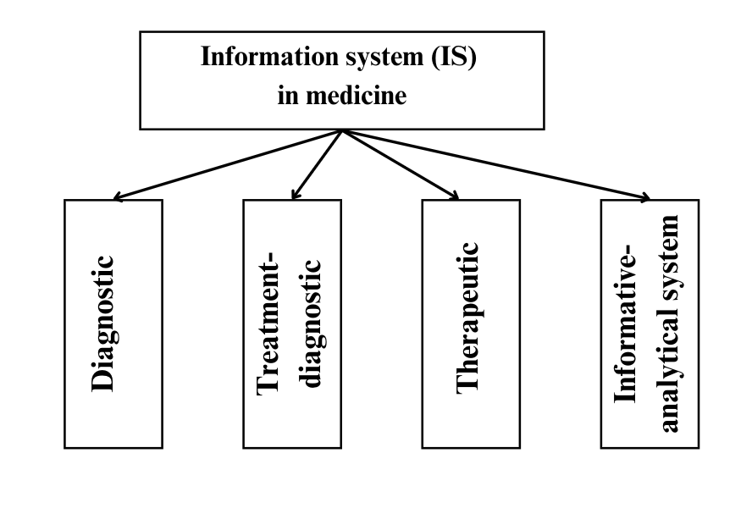

Figure 1.1 - Information systems in medicine.

The proposed categorization classifies the primary domains of information systems (IS) in medicine into diagnostic, therapeutic, treatment-diagnostic, and informative-analytical systems [6].Upon conducting a thorough analysis of software in the field of medicine, it is evident that every aspect of medical information systems necessitates additional enhancements.

The categorization of information systems is structured according to hierarchical principles and aligns with a healthcare system that operates on multiple levels.

Foundational medical information systems are essential tools that assist clinicians from many specializations. Their main goal is to offer computerized assistance to medical professionals. These technologies have the ability to improve the quality of preventative and laboratory-diagnostic operations, especially in situations where there are many patients and a shortage of time among skilled specialists. These systems can be classified into different categories based on the unique aims they intend to achieve [6]:

* Information and reference systems
* Consultative and diagnostic systems
* Automated computer systems

Aiming to streamline the operations of key departments and give information support to physicians during consultations, diagnoses, and urgent decision-making scenarios, the information systems of advising centers are designed to be as efficient as possible. It's challenging to identify a field that remains untouched by the influence of information technology. Key sectors embracing computer technologies include architecture, mechanical engineering, education, banking, and undoubtedly, medicine. In numerous medical investigations, the role of a computer and dedicated software is indispensable. Proficiency in information technology has evolved into a vital competency for healthcare professionals. Indeed, the treatment of many ailments has become reliant on computer utilization, emphasizing the integral role of technology in modern medicine.

Indeed, the medical field significant investments primarily directed towards the development of novel pharmaceuticals, with information technology securing the second spot in terms of investment allocation.

Trying to solve these problems, health care is increasingly turning to information technology. This technology offers avenues for resource management, queue reduction, error elimination, and the provision of contemporary treatment standards to residents in remote towns and villages. Information technology implementation spans all echelons of medical care administration and delivery. The ongoing shift involves the comprehensive automation of specific medical domains, healthcare institutions, and regional healthcare systems. This transition strives to enhance efficiency and accessibility in healthcare services.

## 1.2 Literature review for medical information systems

The ability to make decisions is something that medical expert systems are meant to mimic in order to replicate human experts. For the purpose of providing diagnostic suggestions and treatment recommendations, they incorporate a massive store of medical information, clinical guidelines, and patient data. It has been demonstrated through research that medical expert systems are capable of accurately identifying a wide variety of ailments, such as malignancies, infectious diseases, and cardiovascular diseases. These systems have been shown to enhance diagnostic accuracy, optimize clinical decision-making, and decrease the time required for diagnosis. Nevertheless, there are constraints associated with the utilization of medical expert systems in the diagnosis of diseases. There are several limitations to consider. Firstly, the knowledge base needs to be frequently updated to include new medical advancements. Secondly, if the knowledge base lacks diversity and representation, there is a risk of biased decision-making. Lastly, the system needs to undergo careful validation and verification to ensure its accuracy. Medical expert systems have the ability to improve the accuracy and efficiency of disease diagnosis. Nevertheless, they also present challenges that must be addressed in order to fully harness their capabilities. Expert systems have been created to aid in disease diagnosis since the late 1970s. Figure 1.2 provides a concise timeline of the research conducted on expert systems for disease diagnosis, as indicated by references [7-14].

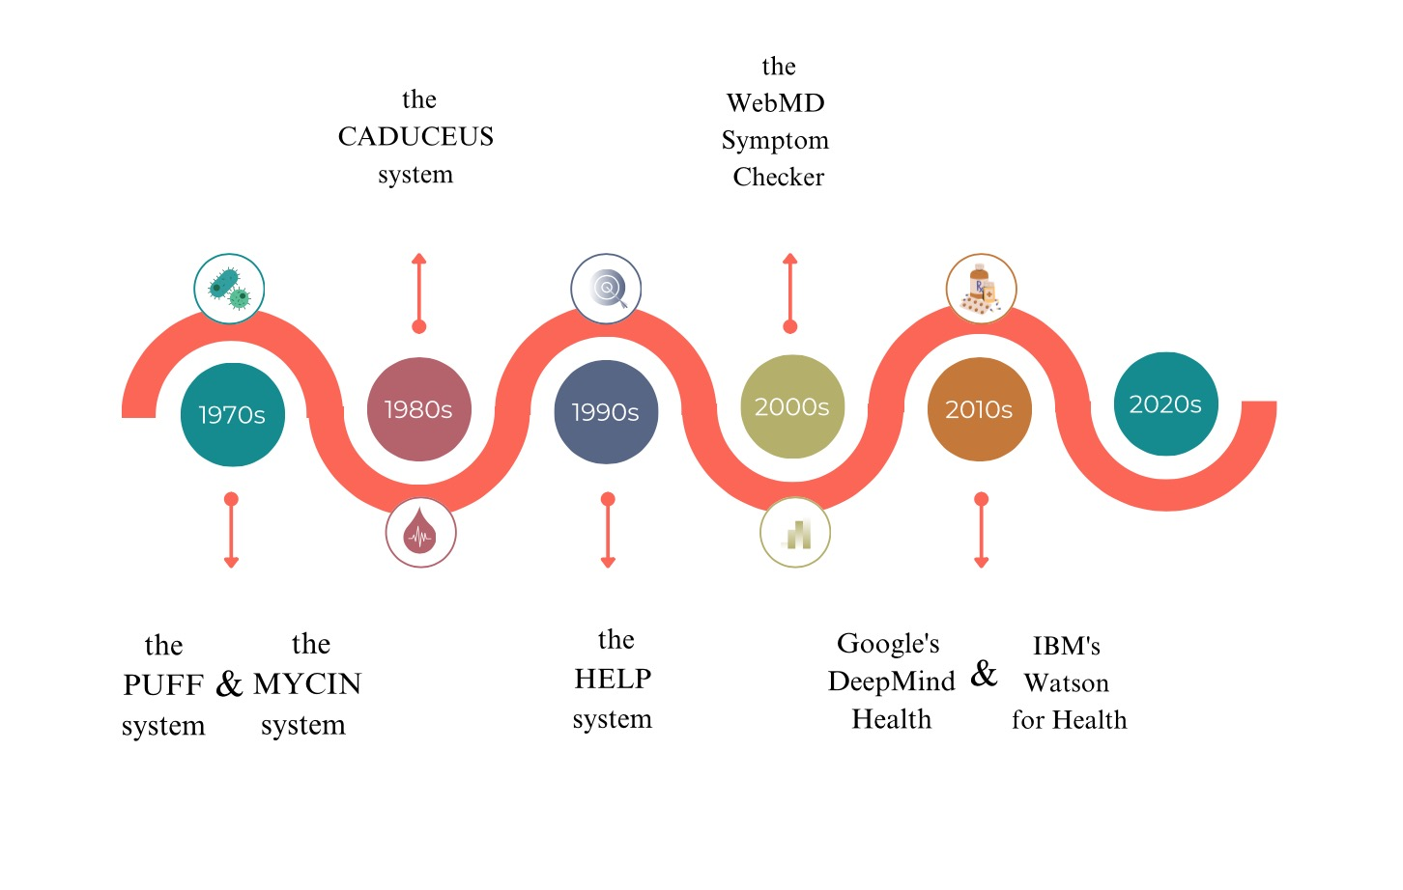

Figure 1.2 - a brief chronology of research in systems for diagnosing

1970s: In the realm of medical diagnostics, the first expert systems were established. These systems included the MYCIN system, which was used to diagnose bacterial infections, and the PUFF system, which was used to diagnose lung disorders [7].

1980s: Expert systems continued to be developed and used in medical diagnosis, with new systems being created for specific diseases and medical specialties. One notable example is the CADUCEUS system for diagnosing and treating blood disorders [8].

1990s: The integration of expert systems with other technologies, including as electronic medical records and decision support systems, had become the primary focus of study in recent years. One notable example is the HELP system, which combined expert system technology with clinical decision support [9].

2000s: With the advent of the internet, research in expert systems for medical diagnosis expanded to include telemedicine and online diagnostic systems. One notable example is the WebMD Symptom Checker, which uses an expert system to assist in diagnosing symptoms and conditions [10].

2010s: There have been significant advancements in artificial intelligence and machine learning, which have led to the development of highly sophisticated expert systems for medical diagnosis. Some examples of these systems include IBM's Watson for Health and Google's DeepMind Health. For the purpose of analyzing huge amounts of medical data and providing assistance in the diagnostic process, these systems make use of machine learning algorithms and natural language processing linguistic processing [11-12].

2020s: Research in expert systems for medical diagnosis continues to advance, with a focus on developing systems that are more accurate, reliable, and user-friendly. There is also growing interest in using expert systems to assist in the diagnosis of rare and complex diseases.

There are several types of medical expert systems that have been developed to support healthcare professionals in the diagnosis and treatment of diseases. Some of the most common types of medical expert systems include [13]:

* Diagnostic Expert Systems: These systems are designed to support the diagnostic process by providing a list of possible diseases based on symptoms and other patient information. They can also provide information on diagnostic tests and treatments.
* Prognostic Expert Systems: These systems are used to predict the likelihood of future outcomes based on patient information and other relevant data. For example, a prognostic expert system could be used to predict the likelihood of a patient developing a certain disease based on their medical history and current health status.
* Therapeutic Expert Systems: The patient's medical history, symptoms and any other pertinent information are taken into consideration by these systems in order to make suggestions regarding the most appropriate treatment for a certain ailment. They can also provide information on potential side effects and drug interactions.
* Clinical Decision Support Systems: These systems provide real-time decision support to healthcare professionals during patient care. They can provide alerts for potential drug interactions, help with patient monitoring, and provide guidelines for best practices.
* Telemedicine Expert Systems: These systems are designed for remote medical consultations and can be used to provide medical advice to patients in remote or underserved areas.
* Health Management Expert Systems: These systems are designed to support patients in managing their own health. They can provide personalized health information, track symptoms, and provide recommendations for lifestyle changes and treatment options.

Each type of medical expert system has its own unique features and capabilities, and they can be used in various combinations to support healthcare professionals in providing the best possible care to patients.

There is a table representation, which is useful tool for diagnosing system analysis, helping to identify and analyze the key components and processes involved in the diagnostic process and to optimize their performance (Appendix A). There are CADUCEUS and DXplain are both diagnostic decision support systems, but CADUCEUS is focused on identifying medication errors, while DXplain is more general and covers a broader range of diagnostic possibilities. Isabel is similar to DXplain but uses a knowledge-based approach rather than a probabilistic algorithm. QMR is a clinical documentation tool and Inferelator is a research tool for identifying gene regulatory networks [14]. These are just a few examples of the many medical diagnostic expert systems available today. Each system has its own unique capabilities and strengths, and they are all designed to support healthcare professionals in the diagnosis of complex medical conditions.

In addition to assisting healthcare professionals Watson for Health can also help patients better understands their health and treatment options. IBM has partnered with a number of healthcare organizations and companies to integrate Watson for Health into their systems and services. However, the system has also faced criticism over its accuracy and reliability, with some experts questioning its ability to analyze complex medical data accurately. IBM has continued to improve and refine Watson for Health and it remains a significant development in the field of healthcare technology [11, p.19].

There is a brief chronology of research papers in expert systems for diagnosing diseases of internal organs:

* 1982: Shortliffe et al. published "MYCIN: A Rule-Based Computer Program for Assisting in the Diagnosis of Infectious Diseases" in the Journal of the American Medical Association, describing the development of MYCIN, an early expert system for diagnosing bacterial infections [15].
* 1987: Buchanan et al. published "Automating Hypertension Diagnosis Using an Expert System" in the Journal of Medical Systems, describing the development of an expert system for diagnosing hypertension [16].
* 1993: Quaglini et al. published "Application of a Bayesian Network to the Differential Diagnosis of Congestive Heart Failure" in the Proceedings of the Annual Symposium on Computer Applications in Medical Care, describing the development of a Bayesian network-based expert system for diagnosing heart failure [17].
* 2002: Hripcsak et al. published "Diagnosis of Chronic Obstructive Pulmonary Disease in an Electronic Medical Record System" in the Proceedings of the American Medical Informatics Association Annual Symposium, describing the development of an expert system for diagnosing chronic obstructive pulmonary disease (COPD) using electronic medical records [18].
* 2009: Razzak et al. published "Expert System for Diagnosis of Renal Disorders using Clinical Data" in the Journal of Medical Systems, describing the development of an expert system for diagnosing kidney disorders [19].
* 2016: Xu et al. published "A Survey on Multiple Chronic Diseases Diagnosis and its Applications Using Data Mining Techniques" in the Journal of Medical Systems, describing the use of data mining techniques for developing expert systems for diagnosing multiple chronic diseases [20].
* 2020: The article "A Hybrid Expert System for the Diagnosis of Coronary Artery Disease" was published in the Journal of Healthcare Engineering by Al-Makhadmeh and colleagues. In this article, the authors describe the construction of a hybrid expert system for diagnosing coronary artery disease that blends rule-based reasoning with case-based reasoning [21].

## 1.3Analysis of existing systems used in Kazakhstan and Central Asia

Medical diagnosing system in Kazakhstan makes use of a wide range of techniques and approaches. These include physical examinations, laboratory testing, imaging investigations, and evaluations of medical histories. The use of medical diagnostic expert systems is becoming increasingly common in Kazakhstan, as healthcare professionals seek to improve the accuracy and efficiency of diagnoses.

Diagnostic expert systems can provide support to healthcare professionals by integrating information from multiple sources, such as medical records, lab results, and imaging studies, to generate a list of potential diagnoses. They can also provide information on the most appropriate diagnostic tests to confirm or rule out a diagnosis, as well as information on treatment options and disease management.

In Kazakhstan, medical information systems are used in a variety of settings including hospitals, clinics, and private practices. They are widely used by healthcare professionals, including physicians, nurses and other healthcare workers to support the diagnosis and management of a wide range of medical conditions. According to decree of the Minister of Health of the Republic of Kazakhstan dated August 6 2021 №80 registered with the Ministry of Justice of the Republic of Kazakhstan on August 10, 2021 № 23926. There is about approval of the minimum requirements for medical information systems in the field of healthcare [22].

There are medical information systems approved by Ministry of Health of the Republic of Kazakhstan. There is a list of systems that used in Kazakhstan [23]. According to that list, there are 31 systems; however it was not possible to find a description of all systems. Therefore, 19 systems described in this research paper. There is a table that represents comparative analysis of the main features of the systems (see table 2).

Table 1.3 - Comparative analysis of the medical information systems

|  |  |  |  |  |  |  |  |
| --- | --- | --- | --- | --- | --- | --- | --- |
| Features  Name | Electronic document management, Cloud storage | Appointment: Online Reception Schedule Management | Maintenance of electronic medical records | Finance Services | Calling a doctor at home | Issuing referrals for tests (анализы) | Diagnosis of diseasesonline |
| «Info-TRACKER» | + |  | + |  |  | + |  |
| «Komek 103» |  |  | + |  | + |  |  |
| e-clinic Sunkar | + |  | + | + |  |  |  |
| InfomedKazakhstan | + | + | + | + |  |  |  |
| KazMedGIS | + | + | + |  | + |  |  |
| IS «БАРС» | + |  |  |  |  |  |  |
| IS «ІnfoDonоr» | + |  | + |  |  | + |  |
| IS «Komek» 112 |  |  |  |  | + |  |  |
| MIS «Авицена» | + |  |  | + |  |  |  |
| KMIS «Damumed» | + | + | + | + |  |  |  |
| MIS MedЕlement | + | + |  | + | + |  |  |
| MIS «Nadezhda» | + | + | + |  | + | + |  |
| MISAKgun | + |  |  | + |  |  |  |
| MIS «NfSoft» | + |  | + | + |  | + |  |
| MIS «Ariadna» | + |  | + | + |  |  |  |
| MIS «Жетысу» | + | + |  |  | + |  |  |
| MIS «Медиалог» | + | + | + | + |  | + |  |
| iMedHub | + |  |  |  |  | + | + |
| PneumoNet | + |  |  |  |  |  | + |
| ExterNET | + |  |  | + |  |  |  |
| MED IS – ERP HOSPITAL | + |  | + |  |  | + |  |
| MIS.SSV.UZ | + | + | + | + |  |  |  |
| Information data management system | + |  | + |  |  |  |  |

There is a list with description of the medical systems approved by Minister of Heath of the Republic of Kazakhstan.

* “Info TRACKER” - is an information system developed for AIDS dispensaries. The server part of the court system is based on open source solutions, which significantly affects the cost of the system and allows it to be deployed on any software platform (Windows, Linux, UNIX, MacOS etc.) [24].
* Komek 103 - ambulance station of Almaty city uses the program that monitors the movement of ambulance vehicles with accuracy, integrates the reception of a call into a single whole, transfers it to the on-board navigator, while ensuring the interaction of all hospitals and polyclinics of the city [25].
* Sunkar - a comprehensive automated information system for automating the activities of a medical and preventive institution. A medical decision support system, electronic medical records of patients, data in digital form from medical research, patient monitoring data from medical equipment, communication tools between staff, and information regarding finances and administration are all included in this system [26].
* Infomed Kazakhstan- system includes electronic health passport, managerial and statistical records of medical activities, medical decision support system, and electronic public medical services. Optimization of expenses of medical organizations, efficient use of resources, updated distribution of the economic effect from electronic document management [27-28].
* KazMedGIS - regional analytical medical system for the West Kazakhstan region. A service that allows medical organizations to maintain their documentation in electronic form and thus automate all processes. You can also make an appointment with a doctor. The system works with Nursultan, Atyrau, West Kazakhstan, Aktobe regions [29].
* BARS - system performs all types of activities of a medical organization from document management, assistance to catering and accounting [30].
* Info DONOR - it is an information system that covers the entire cycle of blood components procurement from a donor to a recipient. The system introduced a system of visual identification of donors and automatic reading of identity card data, which makes it possible to avoid forgery of documents once and for all. The information system determines how to label blood components. Info DONOR will not allow to print a clinical label for components that have not passed all laboratory tests or have unsatisfactory analyzes [31].
* Komek 112– system provides automation of the reception, transmission and processing of calls to the regional emergency services based on a single information system. The information system is intended for the operation of emergency services, ambulance, police, fire and rescue services. The system provides for the functionality of each service for call processing, monitoring of vehicles of field crews [32].
* Avicena - A comprehensive medical information system for automating medical organizations: hospitals, clinics, maternity hospitals, dispensaries, etc. Accounting for medicines and medical devices, Accounting for a treated case, Automation of paid services, etc. Cloud and local solution. The system is cross-platform. We offer a local solution that does not depend on the Internet and external infrastructure. There is integration with the portals of the Ministry of Health [33].
* «Damumed» - this is a quick access to medical organization to make an appointment for users’ and family members, call a doctor at home and view your medical documents. There is service of quick appointment with users’ local doctor, registry function, patient lists and appointment record, various medical preventive measures, fluoroscopy plan, online observation lists, call the doctor to the house [34].
* MedElement– it is a system with a full range of functions for the automation of a clinic, medical center, dentistry, hospital. The cloud system "MedElement" works via the Internet. The system does not require any programs other than a web browser [35].
* Nadezhda - The system allows effectively manage the main processes of a medical institution for the provision of medical care, from the registration of a patient's appeal to the moment of his discharge. Drawing up any automatic reports on the data stored in the system. According to a survey of medical staff, Nadezhda is one of the top three MISs throughout Kazakhstan [36].
* AKGÜN Web - platform for information management system of medical institutions. Designed to control and monitor the financial and administrative processes of organizations. Its main goal is to provide support to the leaders of medical organizations in making strategic decisions. AKGÜN Web MIS has a multilayer open system architecture based on JEE (Java Enterprise Edition) [37].
* «NgSoft» - The system was created for high quality patient care, to improve the financial system of medical institutions by increasing profits and to create a harmonious working environment between all structural units. The program is designed entirely in the integration architecture. The software of the company works in the database "Oracle" used in the field of healthcare [38].
* Ariadna – A modern medical information system of a full cycle includes subsystems of laboratory diagnostics, radiological research, resuscitation and anesthesiology, closely linking their activities with economic, pharmacy and warehouse and personnel subsystems [39].
* Zhetysu - a comprehensive program to automate all stages of treatment, prevention and diagnostic processes in public and private medical organizations [40].
* Medialog (origin МЕДИАЛОГ) - allows for complex automation of a medical institution of any level and scale. Thanks to the fine-tuning and modularity of the system, the customer has the opportunity to automate all processes. Allows trained healthcare IT staff to independently develop and customize user interfaces, business processes, and reporting [41].
* iMedHub - system allows early detection of precancerous and cancerous lesions, thereby preventing the development of morbidity and ultimately reducing mortality [42].
* PneumoNet – system based on artificial intelligence, overworked medical staff will be able to examine patients faster. Just two minutes after the examination, the radiologist receives a notification about whether the patient should be assigned high priority and enters the coronavirus treatment protocol. The system is able to diagnose 14 different types of lung diseases, including pneumonia, as one of the manifestations of the severe course of Covid-19 [43].
* MED IS – ERP HOSPITAL - Designed for comprehensive automation of the activities of medical institutions. Medical data exchange is facilitated through a web services mechanism, employing formats that align with the HL7 international organization's standards for syntactic compatibility [44].
* MIS.SSV.UZ - The primary goal is to automate the procedures of gathering, storing, and utilizing individual-specific information, particularly in the context of recording discharged patients [45].
* Information data management system – medical system used in Kyrgyz Republic, aimed for management medical care among patients. One notable benefit of the systems is the rapid delivery of test results, directly enhancing the quality of patient care. Additionally, data reliability is assured by associating biomaterial with a unique barcode for each patient [46].

According to the official data of the Ministry of Health and the analysis in this dissertation, there is a few example of medical diagnosing expert systems used in Kazakhstan. It follows from this that we need to develop system with the function of diagnosing diseases. The structure of developed diagnosing system described further in chapter 4.

## 1.4 SWOT analysis of the diagnosing information systems

Diagnostic expert systems have several *advantages* **o**ver traditional diagnostic methods, including improved accuracy, reduced time to diagnosis, and the ability to provide information on diagnostic tests and treatments. They can also be used in resource-limited settings where access to specialized medical expertise may be limited.

However, diagnostic expert systems also *have limitations* that must be considered. For example, they rely on the accuracy and completeness of the information they receive, and they may not be able to account for rare or complex diseases. Additionally, they may not always provide a definitive diagnosis, and further tests and assessments may be required to confirm a diagnosis [47]. In spite of these drawbacks, diagnostic expert systems have shown to be an extremely helpful instrument for medical professionals in the process of diagnosing a wide variety of disorders. They have the potential to enhance patient outcomes and reduce the total cost of healthcare by reducing the amount of time and resources necessary for correct diagnoses. This results in time and resource savings.

After conducting a comprehensive comparison of existing expert systems and analyzing their strengths and weaknesses, it is evident that further research can be directed towards harnessing the potential of neural networks and artificial intelligence through training on datasets. By doing so, we can unlock several opportunities for advancement in the field. Some potential research directions include:

* Exploit the capabilities of neural networks to process extensive medical datasets and enhance diagnostic accuracy. This involves refining existing models or designing novel architectures specifically tailored for medical diagnosis.
* Explore the potential of neural networks to deliver personalized treatment recommendations by training them on diverse patient datasets. Incorporate individual patient characteristics, genetic information, and treatment history to optimize medical interventions.
* Enhance the interpretability of neural network models to provide explanations for their predictions. Develop methodologies that can elucidate the contributing factors and decision-making processes of the models, enabling healthcare professionals to better comprehend and trust the generated recommendations.
* Investigate techniques to account for uncertainty and variability in medical datasets. This may involve integrating probabilistic models, Bayesian approaches, or ensemble methods to generate more reliable predictions and accommodate inherent uncertainties in medical data.
* Develop neural network models capable of providing real-time decision support to healthcare professionals. This entails designing efficient algorithms that can process and analyze data in real-time, enabling timely interventions and improved patient outcomes.

Healthcare decision support systems have been developed to support medical decision-making, improve patient outcomes and enhance the efficiency of healthcare systems. They typically use a combination of algorithms, statistical models, and medical knowledge to provide guidance and recommendations to healthcare providers. The use of decision support systems in healthcare is becoming increasingly widespread, as they provide a data-driven and systematic approach to decision-making and help to overcome some of the limitations of traditional methods.

There is a wide variety of diagnostic systems used globally yet only a few examples are specifically adapted for use in Kazakhstan [48]. In order for a diagnostic system to be really efficient, it must be customized to meet the specific requirements and attributes of the community it serves. Hence, it is crucial to establish diagnostic systems that are specifically tailored for the population of Kazakhstan. This modification guarantees that the systems take into consideration the distinct epidemiological, cultural, and socioeconomic characteristics that are widespread in Kazakhstan, thereby improving their precision and efficiency.

Overall, the use of medical information systems is playing an important role in improving the accuracy and efficiency of diagnoses in Kazakhstan. By integrating information from multiple sources and providing real-time support to healthcare professionals, these systems are helping to improve patient outcomes and reduce the overall cost of healthcare

The SWOT analysis serves as a widely employed and accessible analytical approach across various domains. This chapter demonstrates its application in evaluating a medical diagnostic information system. By qualitatively assessing information systems utilized in Central Asia, it has generated several recommendations for prospective research. In the contemporary context, experts unanimously acknowledge the indispensability of acquiring dependable information for the successful diagnosis of diseases. For conducting a SWOT analysis of the diagnostic process, the role of technical information systems is paramount. Identifying strengths and weaknesses, as well as assessing positive and negative aspects, necessitates the effective processing of extensive data. Presented below is the comprehensive analysis (figure 1.3).

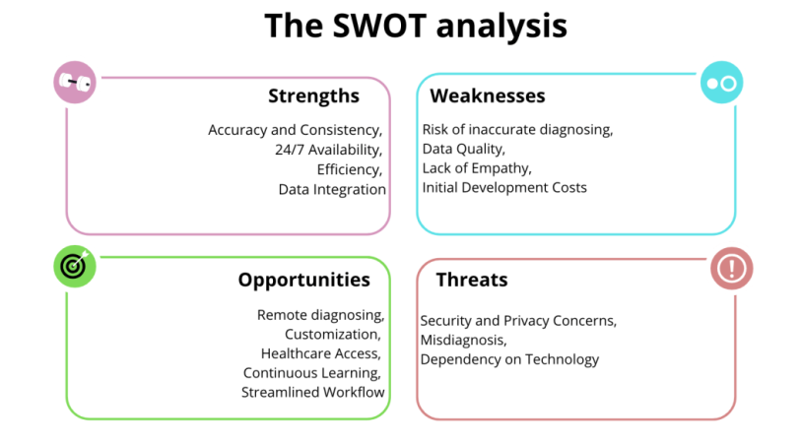

Figure 1.3: SWOT analysis of medical information systems.

Figure 1.3 highlights the various advantages and disadvantages associated with medical information systems. On the positive side, these systems offer several benefits. Expert systems within these frameworks can deliver consistent and precise diagnostic suggestions, thus mitigating the potential for human error. They also operate 24/7, guaranteeing patient access to healthcare information and recommendations at any given time. Furthermore, these systems possess the capacity to swiftly process substantial volumes of medical data, potentially expediting diagnoses and treatment recommendations. Moreover, they can seamlessly integrate with electronic health records (EHRs) and other data sources, thereby enhancing the overall quality of diagnostic information [49].

However, there are notable weaknesses to consider. These systems heavily rely on the knowledge and data upon which they have been trained, which may not encompass the entire spectrum of clinical experiences. The accuracy of their recommendations hinges on the quality and completeness of the data used for their training, highlighting a potential limitation in their performance.

There are opportunities that medical information systems provide: creates an opportunity to assist with remote diagnoses. Such systems can be tailored to specific healthcare specialties, making them more effective in certain domains. They can improve access to healthcare in underserved or remote areas (villages). Moreover, medical systems can continuously learn and improve through machine learning and AI, staying up-to-date with the latest medical knowledge. They can also optimize clinical workflows by assisting healthcare providers with diagnosis and treatment options.

Nevertheless, there are notable threats that must be acknowledged. Storing and processing sensitive patient data can result in security breaches and breaches of privacy. Moreover, if an expert system provides an incorrect diagnosis or recommendation, it can lead to legal and ethical dilemmas. The growing dependency on technology in healthcare presents various challenges that cannot be overlooked, including the potential erosion of healthcare professionals' diagnostic skills and clinical judgment.

In light of this analysis, the article proposes a systematic approach. To mitigate the threats associated with the development and implementation of medical diagnostic systems, several recommendations are suggested:

* Implement robust security measures, such as encryption, secure access controls, and regular security audits, to protect patient data from breaches.
* Make the decision-making process of the expert system transparent and understandable to healthcare professionals and patients.
* Ensure that they can see how and why a particular diagnosis was reached. Establish clear lines of accountability in case of system errors or misdiagnoses.
* Ensure that healthcare practitioners understand how to collaborate with the system effectively.
* Develop risk management strategies, including liability insurance, to address potential legal and financial consequences of system errors.

The literature review highlights the limited availability of sources on medical diagnostic systems used in Kazakhstan and Central Asian countries. The lack of publications in the Scopus database creates difficulties in analyzing existing developments for this region and forming directions for further research in the field of developing expert systems for diagnosing diseases. The information provided by the Ministry of Health of the Republic of Kazakhstan is mainly related to the management systems of medical organizations [23, p.21]. The subject of developing and utilizing diagnostic systems is largely underexplored. To effectively advance such systems, it is imperative to take into account the findings of worldwide scientific research in this field. Crafting medical diagnostic systems holds the potential to not only expedite the diagnostic process for healthcare professionals but also mitigate potential subjectivity in their decision-making. In addition, these diagnostic systems can be utilized for instructional reasons, which will further improve the education of medical students and strengthen their ability to compete in the field. Improving the quality of healthcare in Kazakhstan, as well as the precision and effectiveness of medical decision-making accomplished through the development and implementation of locally tailored diagnostic systems. Implementing this focused strategy will ultimately result in improved patient outcomes and a stronger healthcare system customized to meet the specific requirements of Kazakhstan's citizens.

## Summary

This chapter is devoted to the review and analysis of existing automated systems for the diagnosis of diseases. The chapter aimed to comprehensively analyze the current advancements in this sector to gain a deep understanding of how these systems enhanced the medical diagnostic process. It also emphasized the areas that needed development and identified potential research prospects for the future. Modern medical technology facilitates non-invasive diagnostics, allowing internal organ visualization without internal sensors, displayed on monitors or images. Diagnostic expert systems, computer-based supports, assist healthcare professionals by providing potential diagnoses from patient data, utilizing decision trees and rule-based systems for refined diagnostics. Highlighted research shows their efficacy in varied healthcare settings, advocating for further advancements to optimize their utility.

# 2 MODELS AND METHODS FOR DISEASE DIAGNOSIS OF INTERNAL ORGANS

This chapter investigates the ways in which these strategies enhance the accuracy and efficiency of disease diagnosis by providing structured frameworks for the interpretation of complex medical data. In addition to this, the chapter places an emphasis on the significance of decision support systems and the use of these mathematical techniques to improve the outcomes for patients.

## 2.1 Mathematical modeling in diagnosing diseases

Mathematical techniques have become ever more essential in medical research and diagnostics in recent years. Researchers and medical professionals may now process massive amounts of data with exceptional efficiency and precision because to the application of mathematical models, statistical analysis, and machine learning algorithms [50].

Mathematical models have offered a structure for comprehending intricate biological processes and the mechanisms of diseases. These models facilitate the simulation and prediction of illness progression, hence assisting in the timely identification and diagnosis of different medical problems. Through the usage of statistical analysis, researchers are able to uncover patterns and connections within huge datasets, resulting in greater diagnosis accuracy and improved patient outcomes [51]. One example of the use of mathematical methods in medical diagnosis is the development of diagnostic algorithms. These are logical sequences of steps that medical professionals follow to arrive at a diagnosis based on the patient's symptoms, medical history, and other relevant information. Through the analysis of patient data from the past, these algorithms are able to recognize patterns and correlations that can be used to guide future diagnoses. The field of medical diagnostics has been greatly transformed by machine learning techniques. These algorithms have the capability to examine medical imaging, electronic health records, and other types of medical data in order to identify abnormalities and forecast illness outcomes. The ability of machine learning to learn from data and improve over time makes it an invaluable tool for enhancing diagnostic accuracy and efficiency.

Another approach could involve the use of decision trees or rule-based models, which use a series of if-then statements to arrive at a diagnosis based on the patient's symptoms and medical history. These models can be particularly useful for diagnosing rare or complex conditions where there may not be enough data to train a machine learning algorithm.

Making a diagnosis requires processing a large amount of information, and this can lead to physical and psychological fatigue in doctors. In addition, errors in diagnosis can have serious consequences for patients, including delayed treatment and potential complications.

On the one hand, one approach to addressing these challenges is to use technology to assist doctors in the diagnostic process. For example, automated systems of medical diagnostics can help to process large amounts of patient data and arrive at a diagnosis more quickly and accurately than a human doctor. These systems can also be programmed to identify patterns in patient data that might be difficult for a human doctor to detect.

Another approach is to use decision support tools that help doctors to make more informed decisions based on patient data. These tools can provide recommendations for diagnostic tests or treatments based on the patient's symptoms and medical history, and can help to reduce the risk of errors in diagnosis and treatment. By leveraging technology and providing ongoing training and support for doctors, it is possible to improve the accuracy and efficiency of the diagnostic process and ultimately improve patient outcomes. The integration of mathematical methods into medical research and diagnosis has driven significant progress in understanding and treating diseases. These approaches have enhanced the ability of healthcare professionals to diagnose conditions accurately, develop effective treatments, and provide personalized care. As mathematical techniques continue to evolve, their impact on the medical field is expected to grow, leading to further advancements in healthcare.

## 2.2 Fuzzy set theory

Fuzzy set theory finds its application in various practical problems, such as medical diagnosis of diseases using incomplete and loosely structured databases of diagnostic signs. The range of applied problems where fuzzy set theory is employed is extensive. For instance, it is used in determining research areas, assessing their level and research prospects, and other related considerations [52]. Furthermore, fuzzy set theory is utilized in the development of new oil fields and the construction of comprehensive infrastructure for their transportation, storage, and processing, taking into account multiple factors including social, geological, and economic aspects.

Fuzzy set theory and fuzzy logic serve as generalizations of classical set theory and formal logic. Prominent researchers such as L. Zadeh, E. Mamdani, R. Bellman, and others have contributed significantly to the development of the mathematical framework for fuzzy set theory (referenced in the book: Kofman). Their works have paved the way for advancing our understanding and application of fuzzy sets and fuzzy logic [53].

Fuzzy set theory has undergone three distinct periods since its inception, spanning several decades. The first period, occurring during the 1960s and 1970s, was primarily focused on the development of the theoretical foundations of fuzzy set theory. The second period, spanning the 1970s to the 1980s, witnessed the emergence of practical applications in the management of complex technical systems. During this time, researchers directed their efforts towards constructing expert systems based on fuzzy logic and developing fuzzy controllers. Fuzzy expert systems found applications in diverse fields such as medicine, economics, and other areas, providing decision support. The third period, spanning from the late 1980s to the present, witnessed the expansion of fuzzy expert systems into various fields such as transportation, finance, and analysis and management decision-making. Notably, the development of software packages for constructing expert systems became prominent during this period, with notable contributions from researchers like S.D. Shtovba, A.P. Rotshtein, and others. Furthermore, the theory of fuzzy sets and fuzzy logic continued to advance during this period, with notable researchers such as D. Dubois, A. Prade, M. James, and others making significant contributions to its development [54, 55].

In theoretical terms, the development of fuzzy set theory has evolved from the concepts of fuzzy sets and membership functions to the establishment of fuzzy logic, fuzzy modeling, and control. A significant milestone occurred in the late 1980s when Bartholomew Kosko proved the renowned Fuzzy Approximation Theorem (FAT). This accomplishment marked the beginning of fuzzy logic's global recognition and widespread adoption.

One noteworthy application of fuzzy logic emerged in 1988 when an expert system based on fuzzy rules successfully predicted a stock market crash, demonstrating its potential for forecasting financial indicators. Following this event, fuzzy logic gained significant recognition and acceptance in the fields of business and finance. Fuzzy logic provides a framework to effectively model and analyze such complex data, allowing for more nuanced and flexible decision-making processes. By incorporating fuzzy sets and fuzzy rules, fuzzy logic enables the consideration of degrees of membership and uncertainty, enabling clinicians to better navigate and interpret the complexities of medical databases.

The methods of fuzzy set theory are best suited for humanistic systems []. One of the basic concepts of fuzzy set theory is the universal set and the membership function , where u – universal set element ().The membership function shows the degree of membership of a set А from set U on the set of numbers in the interval [0,1]. For example, the fuzzy concept of “high soy content in blood” can be set  present in the form:



It can be seen that the erythrocyte sedimentation rate = 1mm/h does not apply to the concept of "high", because , and the sets having the corresponding membership functions:



belong to the fuzzy set. Erythrocyte sedimentation rate 25 mm/h и 30 mm/h () belong to the “high”.

For fuzzy sets, the main logical operations are defined. The most basic ones needed for calculations are *intersection* and *union*.

Intersection of two fuzzy sets (**fuzzy "AND"**): A B:



Union of two fuzzy sets (**fuzzy "OR**"): A B:



Thus, the implementation of the operations of intersection and union is carried out - the most common approach in the theory of fuzzy sets.

In order to provide a description of fuzzy sets, linguistic variables are utilized. It is possible for these linguistic variables to take on fuzzy values, which indicates that the linguistic variable functions at a higher level of abstraction than the fuzzy variable that it represents [57]. Each linguistic variable consists from:

* names
* set of terms T (the elements of the base term-set are the names of fuzzy variables
* universal set X
* rules according to which each value of a linguistic variable is associated with a fuzzy subset of the set X

To ensure the reliability of diagnoses, it becomes crucial to encompass all types of diagnostic signs and indicators. This necessitates the development of novel approaches and the creation of new mathematical diagnostic methods. These methods should effectively handle the complexity and uncertainty inherent in medical data, allowing for accurate and comprehensive assessments of patients' conditions.

By employing advanced mathematical techniques, such as fuzzy set theory, machine learning algorithms, and probabilistic models, researchers can work towards enhancing the diagnostic process. These approaches enable the integration and analysis of diverse types of medical data, assisting in the formulation of precise and reliable diagnoses for improved patient care.

For this purpose, researchers have explored the potential of mathematical tools such as probability theory, mathematical statistics, and fuzzy set theory. Given that clinical, anamnestic, and clinical laboratory data often exhibit ambiguity and lack crisp boundaries, the utilization of the mathematical framework provided by fuzzy set theory is particularly suitable. Fuzzy set theory allows for the representation and analysis of uncertain and imprecise information, making it a suitable approach for handling medical data characterized by inherent vagueness and uncertainty. By leveraging fuzzy set theory, medical professionals can effectively model and interpret complex data, leading to more accurate and reliable diagnoses. Information plays such a significant role in the process of decision-making, there has been an increasing demand for modern information systems in the society that we live in today, which is characterized by its advanced technological capabilities. There is currently an issue with information that human society is confronted with as a result of the scientific and technological revolution, which has occurred concurrently with the progression of civilization. In particular, the discipline of medicine necessitates the accumulation of enormous amounts of information in order to fulfill the requirements of professionals. Researchers are diligently working to offer a more objective approach to address pressing medical challenges, particularly in the areas of disease diagnosis and prediction. These efforts aim to utilize information technology and advanced information systems to provide valuable insights and solutions to improve healthcare and contribute to the overall well-being of individuals and society as a whole.

The cybernetic approach to studying medical issues revolves around comprehending the organization of systems, information processing, and purposeful management within the context of healthcare. This methodology embraces novel techniques, including modeling self-regulation mechanisms and feedback loops, all grounded in precise quantitative analysis and mathematical formalization. By doing so, it enables the effective utilization of computers and modern computer technology in medical applications.

By combining medical logics with these mathematical methods, the information-technological approach aims to create powerful and reliable automated diagnostic systems. As technology and medical knowledge advance, these systems have the potential to revolutionize healthcare and improve medical outcomes for patients worldwide.

**2.3 Method based on a fuzzy description**

A mathematical method based on fuzzy sets makes it possible to solve the problem of finding an optimal alternative with a fuzzy description of the state of the system. The choice of alternatives under various conditions is based on an analysis of utilities that allow making an appropriate decision. The use of this method in medicine for diagnosing diseases will correspond to the task of finding an optimal alternative [58]. Let's say we have many alternatives:

А ={A1,A2, ...,Am}

Corresponding diseases belonging to the same nosological class, thhe form of a matrix for possible conditions and various alternatives (disease):

|  |  |  |  |
| --- | --- | --- | --- |
|  | U1 | …. | Uim |
| U = |  | …. |  |
|  | Umi | …. | Umn |

The optimal alternative can be represented as a fuzzy set:

A=

where - degree of membership Ai for fuzzy set A.

If the state of the system is known and defined as Xj which belongs to Х, then the best alternative is defined as the alternative with the highest degree of membership. The diagnosis is established on the basis of a particular collection of symptoms that have been seen, which is analogous to the situation in which the state of the system is characterized by a particular fuzzy set:

X= and

Then best alternative is defined as:



The maximizing set is used in the selection of the optimal alternative based on consideration of the maximum utility of the alternatives:

Umax=supY from Y=S(Ui),

and



Then the maximizing set:

 ,

Set Uio determined based on the intersection of fuzzy sets Uim and Ui:



Finally:



Where A(*) means appropriate diagnosis, which has alternative having the greatest membership value of the set:



Therefore the most probable disease (diagnosis), is the alternative that has the greatest membership value. It is possible to classify medical illnesses through the utilization of fuzzy sets and rules, even in cases when symptoms are not clearly defined or overlap with one another. This assists in the identification of diseases that share symptoms with one another. It is anticipated that the application of fuzzy logic in medical diagnostics will become more widespread as technology continues to evolve. This will result in further improvements to patient outcomes and the effectiveness of healthcare delivery.

## 2.4Method of the membership function of fuzzy sets

There are several main approaches to the membership function. One of them is subjective, based on subjective reasoning of experts. The membership function obtained in this way reflects the experts' own opinions about the degree of uncertainty regarding the considered object (for example, how well the number of heart contractions corresponds to the concept of "normal").

In the diagnostic process, so-called diagnostic tables are utilized. These tables are compiled based on statistical data and represent a compilation of knowledge from specialists in the field pertaining to specific diseases. By employing the assessments provided in the table, we determine the degree of membership of elements to a set through pair wise comparisons [59]. In the process of differential diagnosis, based on the developed diagnostic mathematical model and using decision-making methods in the presence of qualitative uncertainty in the initial data, there arises a need to assess linguistic variables in numerical terms, such as "characteristic" "often" "possible" etc.

As an example, consider comparative qualitative indicators (severe headaches, seizures, nausea, belching, vomiting, etc.) that serve as characteristics for the differential diagnosis of early and late dumping syndrome. They have corresponding qualitative indicators (weights), such as "characteristic" "not characteristic" "often" "rarely" "possible" etc. The task is to determine the degree of expression of these properties, representing the relative membership of elements in the set X.

Let's consider a set (diagnostic features) with "n" elements:

, where *j=(1,n)*.

Fuzzy set *S* of set*Х* is:

, 

- Degree of membership of «*х»* set *S*

Assessment of qualitative indicators: "characteristic" corresponds to obvious superiority, the indicator "often" - significant superiority, and the indicator "possible" - weak superiority, and so on.

Matrix, whereis an indicator of *хi* compared with *xj* from *S.* Let’s take. Matrix eigenvector values ***А*** -represent degrees of membership of elements *х* from set *S* :

, *i=1,n*

To find the comparison vector results ***w*** solve this equation: ***Aw****=****w***, where**- matrix eigen value ***А*** .Deviation**from *n* serves as a measure of the consistency of expert judgments, since equality is always satisfied: ***Aw****=n****w*** [60].

The concept of belonging to a set A becomes ambiguous in fuzzy representation, which allows for partial membership, which is defined as "degree of membership to set A." These instances of partial membership are possible. In addition to digital variables, fuzzy set theory involves the utilization of linguistic variables in order to provide a description of semantic notions. An example of this would be the linguistic variable AD=[blood pressure], which can have values such as BPn=[low blood pressure], BPnd=[normal pressure], and BP=[high blood pressure]. In addition, there are language terms that are used to describe states such as "absence of function," "normal function state," and "excessive function." These expressions are represented by membership functions μH(x), μnorm(x), and μI(x).

Lotfi Zadeh developed a method that includes logical operations over membership functions to create fuzzy logic rules of inference [61]. These rules, resembling an "if-then" structure, are successfully used in medical applications for solving forecasting and medical diagnosis tasks. These rules determine how the system will interpret and process input data to produce relevant output data. Each rule consists of an antecedent (the "if" part) and a consequent (the "then" part). Fuzzy "if-then" rules, also known as fuzzy implications, are formally described as follows:

|  |  |
| --- | --- |
| IF x = A, THEN y=B | ( |

The values A and Β are linguistic fuzzy values, which are defined by the membership functions that correspond to the variables x and y, briefly this implication looks like А → В. For variables x1, x2 this expression is ultimately transformed by aggregating a set of “if-then” rules showed in expression 2:

|  |  |
| --- | --- |
| IFx1 = A1and x2 = A2 and …. and Xn = An, THEN y=B | ( |

Variables x1, x2,... represent feature x of N-dimensional vector. ParametersA1, A2,..., AN and B indicate the corresponding membership coefficients, µA(xi) and µB(y). The iterative formulas developed by E. Shortliff are an additional method for making decisions with limited certainty. These formulas were generated from comprehensive investigations of the rationale behind medical decisions [62]. The fundamental aspect of his logic is the confidence coefficient of the ω hypothesis confidence coefficient HCC(ωi/X) which in general is determined by the disparity between the measurements of trust and distrust about the hypothesis being tested, illustrated by formula 3.

|  |  |
| --- | --- |
| *HCC(ωi/X) = МC(ωi/X)* - *ММ(ωi/X)* | (3) |

*HCC(ωi/X)* - Confidence in the diagnostic hypothesis *ωi* with characteristic(s) *X*,

*МC(ωi/X)* - measure of trust to *ωi* with characteristic(s) *X*

*ММ(ωi/X)* - measure of distrust in a hypothesis *ωi* with characteristic(s)*X*

Indicators of trust and distrust are assessed on a scale from 0 to 1, which reflects the weight of evidence in favor of or against the hypotheses being studied. Confidence coefficient (*HCC(ωi/X)*) on a scale from -1 to +1, where «-1» means false, and «+1» means true. Intermediate values ​​indicate varying degrees of confidence in decisions made. When new evidence (*x*) is received, the measures of trust and distrust (*MС*and *MМ*) are updated according to the following formulas:

|  |  |
| --- | --- |
| *МC(ωi/X, х) = МC(ωi/X) + МC(ωi/х)(1 - МC(ωi/Х))* | (4) |
| *ММ(ωi/X, х) = ММ(ωi/X) + ММ(ωi/х)(1 - ММ(ωi/Х))* | (5) |

## 2.5 Information Technology in Medicine

Acquisition, processing, transformation, transmission, and delivery of information are all aspects that fall under the umbrella of information technology, which spans a vast variety of approaches. When it comes to the subject of medicine, information technology refers to the utilization of computer systems to accomplish a variety of tasks, such as automated control systems, diagnosis, and other related activities [63]. This system also includes a database that keeps important information regarding examinations that have been carried out. As an additional feature, the computer system is equipped with the capability to send and receive accumulated data to and from other users or systems. In addition, the system incorporates specialist software modules that are designed to do activities such as disease detection, prediction, and various other medical studies.

An advanced and all-encompassing automated information system that incorporates a variety of crucial components, the Medical Information System (MIS) is a smart and complete system. When compared to other types of information systems, medical information systems are distinguished by the fact that they are concentrated on the patient and give crucial information about individual patients as well as their medical histories. The burden of ensuring the confidentiality and security of sensitive patient data is enhanced as a result of this requirement placed on developers [64].

Furthermore, the integration of administrative and medical information is the distinctive feature that distinguishes medical information systems from other types of technology. Because of this integration, healthcare procedures are streamlined, which makes it easier to manage medical practices, distribute resources, and make decisions that result in better patient care. When a diagnosis is being made, information flows within the "patient-doctor" system, involving two information circuits [65]:

* "Patient-Doctor-Clinical Examination Plan": The patient provides information to the doctor about their symptoms and medical history. Based on this information, the doctor formulates a clinical examination plan to further investigate the patient's condition.
* "Patient-Doctor-Diagnosis-Treatment Plan": The patient provides additional details, and the doctor conducts the clinical examination. With the examination results, the doctor formulates a diagnosis and develops a treatment plan, which is then communicated back to the patient.

When a computer is involved in the diagnostic process, the information circulation may differ:

* "Doctor-Computer": The doctor interacts with the computer system, inputting the patient's data and receiving diagnostic suggestions or assistance from the computer in making the diagnosis.
* "Patient-Doctor-Computer": The patient provides information to the doctor, who then enters it into the computer system. The computer processes the data and provides the doctor with additional insights or recommendations for diagnosis and treatment.
* "Patient-Computer": The patient directly interacts with a computer system, inputting their symptoms or medical history. The computer may offer some preliminary information or possible diagnoses, which can be shared with the doctor for further analysis and confirmation.

In general, the interaction of doctor, patient, and computer can take place in any combination of these three systems, depending on the specific diagnostic scenario and the level of computer involvement in the process. These interactions have the potential to complement and enhance the diagnostic process, leading to more accurate and efficient medical decision-making.The application of medical information technologies necessitates the establishment of specialized automated diagnostic complexes. The primary objective is to develop robust mathematical models capable of diagnosing and predicting diseases accurately. These models serve as the foundation for creating automated systems that leverage various models and advancements in informatics. Their purpose is to offer valuable assistance to healthcare professionals in making competent and well-informed decisions regarding patient care. By combining mathematical precision with modern informatics, these automated diagnostic complexes have the potential to revolutionize medical practices, improving diagnosis and treatment outcomes for patients.

These systems are able to execute actions such as storing and retrieving clinical data in a quick and efficient manner because of their analytical capabilities and high speed. In clinical laboratories, they are particularly helpful for a variety of purposes, including the interpretation of X-ray pictures, the identification of cell preparations, the processing of cardiograms, and a number of other applications. Clinics are intended to benefit from automated information systems that incorporate hospital administration subsystems, medical history information retrieval subsystems, and other essential components. These systems are supposed to be advantageous. Through the implementation of these technologies, clinics are able to administer patient data in an effective manner and streamline hospital operations. In the end, the incorporation of medical automated information systems gives medical practitioners the ability to provide medical services that are both more comprehensive and more efficient, which ultimately results in improved patient care and outcomes [66].

Medical information systems for physicians play a vital role in enhancing their professional capabilities and facilitating the efficient and swift delivery of medical care. These systems unlock hidden reserves within healthcare that can only be harnessed through information technology. By leveraging these advanced systems, medical care can be significantly improved through enhanced recognition of pathological processes. The integration of information technology enables healthcare professionals to tap into valuable insights and data, leading to more efficient and effective medical care for patients. Deterministic logic involves precise rules and algorithms to arrive at a diagnosis based on specific symptoms and data. The phase interval method considers the temporal aspects of a disease's progression, enabling a more dynamic approach to diagnosis. Information-probabilistic logic, on the other hand, leverages statistical data and probabilities to assess the likelihood of different diagnoses.

By incorporating these different types of medical logic, information technology systems in medical information systems enhance diagnostic capabilities, allowing for more accurate and efficient disease diagnosis and prediction. These advanced systems contribute to improved patient care and better health outcomes. Deterministic logic is a straightforward diagnostic approach that relies on clear and unambiguous signs for making a diagnosis. It does not involve conditional probabilities and can be based on either clinical or functional data. This method is commonly used when the relationship between symptoms and specific diseases is well-established and can be directly inferred.

Logic-information models encompass a range of techniques, such as recognition models, graphs, logical trees, hierarchical schemes, and methods based on Boolean algebra. These diverse models play a crucial role in processing and organizing information within various systems, enabling efficient problem-solving and decision-making processes.

Recognition models aid in identifying patterns and features within data, facilitating the classification and recognition of specific objects or phenomena. Graphs provide a visual representation of relationships between different data points, enhancing data analysis and understanding. Logical trees offer a hierarchical structure for organizing and evaluating information based on logical conditions and branching pathways. Hierarchical schemes further organize data in a nested manner, allowing for efficient data management and retrieval.

## Summary

This chapter explored the application of mathematical modeling methods based on fuzzy descriptions in medical diagnostics. An investigation into the utilization of fuzzy sets' membership function for the purpose of managing uncertainties in medical data and enhancing diagnostic accuracy was carried out. This chapter also included an analysis of the incorporation of these methods into medical information systems, showing the potential of these methods to improve the effectiveness and dependability of healthcare procedures.

# 3 USE OF MATHEMATICAL METHODS FOR FORECASTING DISEASES OF INTERNAL ORGANS IN THE PROPOSED AUTOMATED SYSTEM

There is a large amount of promise in the investigation of methods for decision-making that make use of hazy initial data. One of the most difficult challenges in the world of medicine is resolving diagnostic difficulties that are associated with a wide variety of disorders. This involves processing intricate and frequently ambiguous information, encompassing diverse sets of clinical, historical, laboratory, and other details regarding the patient's condition. Frequently, information originates from individuals and might stand as the sole data source, as seen in cases of clinical and historical data. However, this information tends to be incomplete, subjective, and prone to inaccuracy [67].

Fuzzy set theory methods enable the utilization of linguistic variables, which often constitute the medical input data utilized in the diagnostic process. This approach offers the benefit of considering the intensity of symptoms. Given the dynamic nature of a patient's condition in real-world scenarios, where improvements and deteriorations occur, this versatile mathematical method holds the potential to predict the progression of the illness.

## 3.1 Method based on a fuzzy quantitative description of the state of systems for diagnosing the disease toxic goiter and vegetative vascular dystonia

There is an example of diagnosing of the disease toxic goiter and vegetative vascular dystonia, which belong to the same nosological class. To do this, we use the diagnostic table (Appendix A) compiled on the basis of statistical data taken from Okorokov studies [68]:

Table 3.1: Matrix of diseases (appendix A)

|  |  |  |  |  |  |  |  |  |  |  |  |  |  |  |  |  |
| --- | --- | --- | --- | --- | --- | --- | --- | --- | --- | --- | --- | --- | --- | --- | --- | --- |
| U |  | X1 | X2 | X3 | X4 | X5 | X6 | X7 | X8 | X9 | X10 | X11 | X12 | X13 | X14 | X15 |
| A1 | 2 | 3 | 3 | 4 | 3.5 | 4 | 4 | 4 | 3 | 4 | 0.5 | 2.4 | 2 | 0.3 | 0.2 |
| A2 | 9 | 9 | 8.3 | 6 | 8 | 9.5 | 7 | 7.6 | 7.5 | 4 | 6 | 9.5 | 8.3 | 4.4 | 4.2 |
| A3 | 9 | 8.3 | 4.5 | 0.5 | 7 | 7.6 | 8 | 6 | 4 | 2 | 4 | 5 | 4.2 | 0.7 | 0.2 |

A1 represents the control group, A2 represents diffuse toxic goiter, and ΐ3 represents vegetative vascular dystonia. It is determined that the condition of the system is Xj, J=1,n, and it is characterized by the following symptoms: exhaustion and weakness, irritability, pulse that is greater than beats per minute, poor sleep, shortness of breath, palpitations, discomfort in the heart, sweating, weight loss, increased appetite, arrhythmia, shaking fingers, hot, wet hands, and exothalmia [69,70].

Let the patient have poor sleep, shortness of breath, heart palpitations, pain in the heart area, sweating, weight loss and the patient's condition is given by a set:

X~={0.4/X4, 0.2/X5, 0.5/X6, 0.2/X7, 0.6/X8, 0.7/X9}.

Let us define the fuzzy utilities of alternatives for a given state, and if some element of the domain of definition appears K-times, then the degree of its membership:

 =1+2+...+kи1 +2=1+2-1*2.

Then,

U~1={0.4/4, 0.2/3, 0.5/4, 0.2/4, 0.7/3}={0.9/4, 0.76/3}.

U~2={0.4/6, 0.2/8, 0.5/9, 0.2/7, 0.6/7, 0.7/7}={0.4/6 0.2/8, 0.5/9, 0.9/7}.

U~3={0.4/6, 0.2/7, 0.5/7, 0.2/8, 0.6/6, 0.7/4}={0.4/5, 0.6/7,0.2/8, 0.6/6, 0.7/4}.

Where supY :



Y={4,3}{6,8,9,7} {5,7,8,6,4}={3,4,5,6,7,8,9}.

We define maximizing sets:

U~1m={4:9/4, 3:9/3 = {0.44/4, 0.33/3}

U~2m={0.66/6, 0.88/8, 1.0/9, 0.77/7}

U~3m={0.55/5 0.77/7 0.88/8, 0.66/6, 0.44/4}

Then the optimizing set Аio:

U~10={min/0.44, 0.9/4, min /0.33, 0.76/3}={0.44/4,0.33/3}

U~20={min/0.66,0.4/6, min /0.88, 0.2/8, min/1.0,0.5/9, min(0.77, 0.9)/7}={0.4/6, 0.2/8, 0.5/9, 0.77/7}

U~30={min/0.55, 0.4 / 5,min(10.77,0.6)/7,min(0.88,0.2)/8, min/0.66, 0.6 / 6,min/0.44, 0.7/4}={0.4/5, 0.6/7, 0.2/8,0.6/6, 0.44/4}

Hence the fuzzy set:

(Aio)~Ao

(A1o)=max (0.44, 0.33) = 0.44,

(A2o)=max(0.4, 0.2, 0.5,0.77)=0.77,

(A3o)=max(0.4, 0.6, 0.2, 0.6, 0.44)=0.6

Best alternative is A2:

A(*)=~ (A2o)=0.77 ,

then,it is possible to make a diagnosis: in this condition, the disease is diffuse toxic goiter.

*Comparison and verification of the results obtained by Bayesian mathematical diagnostic methods:* In order to verify the result obtained, we determine the diagnosis according to this symptom complex using the known Bayesian method [71]:

P(Bj /Ski ) = 

where P(Sk) =  ,and the conditional probabilities of the symptom complex (P(Ski/Bj)).

In accordance with the information contained in the diagnostic table (Appendix A), the probability of the disease have been determined. According to the findings, a diffuse toxic goiter is noticed in conjunction with this symptom complex for the patient. Clearly, the diagnoses were identical to one another.

On the other hand, the mathematical approach that is proposed in the dissertation for the purpose of diagnosing a sickness is rather different. Not only does it take into account the degree of belonging (Xk)) of symptoms of diseases, but it also takes into account the state of the system, which is characterized by a fuzzy set:

X~=

(Xk)-symptom severity.

Table 3.2: Results of diagnosing diseaseswithvarious mathematical methods

|  |  |  |  |  |
| --- | --- | --- | --- | --- |
| № | Symptoms | Results of diagnosing | | Diagnosis |
| Proposed  method | Bayesian method |
| 1 | 0.4/X4,0.2/X5,0.5/X6,  0.2/X7,0.6/X8,0.7/X9 | 0.44 | 0.1 | Diffuse toxic goiter |
| 2 | 0.77 | 0.79 |
| 3 | 0.6 | 0.2 |

## 3.2 Method based on a fuzzy qualitative description of the state of systems for diagnosing the disease

A detailed collection of information regarding the patient's medical history, current symptoms, lifestyle, and family medical history is gathered with the assistance of the healthcare provider. This can involve conducting interviews, filling out questionnaires, and looking over previous medical data. A physical examination is carried out by the physician in order to examine and measure vital signs, physical anomalies, and any other symptoms that can be considered noticeable. In order to determine which symptoms are the most severe, the information that was collected is examined. In order to accomplish this, it is necessary to differentiate between primary symptoms, which are directly associated with the hypothesized ailment, and secondary symptoms, which are additional indicators that may either support or complicate the diagnosis. A provisional or preliminary diagnosis is drawn up on the basis of the symptoms that have been detected and the material that has been evaluated. It is necessary to do additional analysis and laboratory testing in order to validate the preliminary diagnosed condition. Among the diagnostic procedures that may be performed are blood tests, imaging scans (such as X-rays, MRIs, and CT scans), biopsies, and other such operations. Because it is able to successfully manage uncertain and imprecise data, fuzzy logic is appropriate for use in medical diagnostics, which frequently lack distinct bounds due to the fact that symptoms and test findings frequently lack clear boundaries. The process of disease diagnosis entails taking a methodical approach to the collection and examination of patient data, determining the presence of important symptoms, and verifying diagnoses through the use of clinical testing. When examined through the lens of cybernetics, diagnostic algorithms offer a logical framework that can be utilized for this procedure. Medical diagnostics are made more accurate and efficient through the use of machine diagnostics, which make use of artificial intelligence, fuzzy logic, and decision support systems. Nevertheless, in order to guarantee the most favorable outcomes for patients, the incorporation of these technologies must be matched with the experience of humans [72].

This paper discusses the mathematical model that was constructed for the goal of diagnosing functional dyspepsia and peptic ulcers based on decision-making with qualitative and probabilistic uncertainty. The model was developed for the aim of determining the severity of the condition. The diagnostic table of usefulness was applied, which is a table in which the data is given in a qualitative manner, including frequently, characteristically, infrequently, possibly, and so on [73]. It is recommended that we create a utility matrix of functional dyspepsia and peptic ulcer by making use of clinical markers for the disorders that have been described (appendix A).

Table 3.2- utility matrix of functional dyspepsia and peptic ulcer

|  |  |  |  |  |  |  |  |  |  |  |  |  |  |  |  |  |
| --- | --- | --- | --- | --- | --- | --- | --- | --- | --- | --- | --- | --- | --- | --- | --- | --- |
|  | X1 | X2 | X3 | X4 | X5 | Х6 | X7 | X8 | X9 | X 10 | X 11 | Х12 | X13 | Х14 | X15 | X16 |
| A1 | NC | R | R | NC | O | C | NC | NC | C | O | NC | NC | NC | C | C | C |
| А2 | C | C | C | C | NC | NC | P | P | O | R | C | P | C | P | R | NC |

When it comes to alternatives, A is: A1 is functional dyspepsia, and A2 is peptic ulcer therapy. Diagnostic signs (linguistic variables) include the following: X1: the daily rhythm of pain; X2: the seasonality of pain; X3: the many-year rhythm of pain; X9: the association of pain with psychological and emotional elements; X10: nausea; X15: data from an X-ray examination and other information.

A table of qualitative indicators, organized according to letter designations: "C" stands for "characteristically," while "NC" for "not characteristically" P stands for "possible"; R is for "rare," and O is for "often." It is possible to define utilities as linguistic variables. Imagine the following as subsets, assuming that the index, which determines the highest possible degree of membership, is determined by a knowledgeable individual:

C={0.5/9; 1.0/10};

O={0.5/7; 1.0/8; };

P={0.5/4; 1.0/5; 0.5/6};

NC={0.5/2;1.0/3;};

R={0.5/2;1.0/1}.

Developing a mathematical model that is based on the use of a variety of approaches to forecast the progression of the disease is the objective of the research that is currently being conducted. If this is the case, then a change in the severity of symptoms ought to be mirrored in the outcome of the disease.

Take, for example, the following symptoms that are associated with a conditional patient: the daily rhythm of pain; the progressive course of the disease; the duration of the disease: more than five years; pain relief after eating; weight loss; the symptom of local palpation soreness; concomitant neurotic manifestations all occur simultaneously. The patient symptom utility matrix can then be expressed from this point forward:

Table 3.3- Matrix of diseases

|  |  |  |  |  |  |  |  |  |
| --- | --- | --- | --- | --- | --- | --- | --- | --- |
| U |  | X1 | X4 | X5 | Х7 | X12 | X13 | X14 |
| A1 | NC | NC | NC | NC | NC | NC | C |
| А2 | C | C | O | P | P | C | P |

The condition of the patient, taking into account the specified severity of symptoms, is described by the following set:



Mathematically, the state of the system is given in the form of a fuzzy set:

Х =  ,

where and  - severity of the symptom k. There was used the mathematical method presented and a given utility matrix for these diseases we find:

U1=

U2=

Convert it into:

U1=

U2=

We substitute the above subsets instead of the quality indicators:

U1=

U2=

and accordingly simplify:



U1=

U2=

We find the maximizing set, with taking into account:

umax=sup Y, where Y=S(U 1)S(U 2) = {2,3,4,5,6,7,8,9,10}; umax=10;

U1m=

Accordingly:

U2m=

Then, we find optimizing sets:

U1=

U2=

Determine the best alternatives:

 ~(А1)=max (0.2,0.3, 0.5)=0.5;  ~(A2)= max (0.4,0.5,0.8, 0.999,)=0.999

А(*)= max (0.5, 0.999) = 0.999(А2).

So, the most likely condition is a peptic ulcer, given the current symptoms and the degree of severity of the symptoms. As was indicated, the objective of our research was to determine the impact that variations in the severity of the sickness had on the final result of the condition. Lastly, we determine the disease that is most likely to be present by reducing the severity of symptoms. This is accomplished by calculating the following: X1 иХ13 (circadian rhythm of pain and a symptom of local palpation tenderness), followed by symptoms X4 and X12, then X5 and X7, and so on. Tables are used to present the findings that were obtained from the calculation of the outcomes of the disease (see table 3.4).

Table 3.4- Results of results of diseases from changes in the degree of expression of symptoms

|  |  |  |  |
| --- | --- | --- | --- |
| № | The condition of the patient | А1 | А2 |
| 1 |  | 0.5 | 0.999 |
| 2 |  | 0.5 | 0.985 |
| 3 |  | 0.5 | 0.8 |
| 4 |  | 0.5 | 0.5 |
| 5 |  | 0.3 | 0.48 |

Figure 3.1: Dependence of the outcome of the disease on time

Based on the findings of the study, it is clear that the severity of symptoms at different phases of the disease has a significant impact on the outcomes of the disease. A decrease in the severity of symptoms that are indicative of the disease peptic ulcer also results in a reduction in the likelihood of developing this disease. There is a dynamic trend, which may be derived through the graphic representation of the reliance of the outcome of the disease on time (fig 3.1).

## 3.3 Method of gradient projection

The gradient projection method operates by iteratively modifying the decision variables in order to optimize an objective function, while adhering to specific restrictions. Within the context of medical diagnosis, this objective function can be used to measure the precision of the diagnosis or the probability of a correct diagnosis based on a particular combination of symptoms and test outcomes. The method guarantees that iteration approaches an optimal solution by projecting the gradient of the objective function onto the feasible region, which is determined by the constraints. This ensures that the limitations and boundaries of the issue are respected [74].

By relying on a systematic optimization approach, the gradient projection method minimizes the influence of subjective judgment and biases in medical diagnosis. This is particularly important in clinical settings where consistent and objective decision-making is crucial.

The mathematical rigor of the gradient projection approach offers a precise framework for assessing diagnostic criteria, guaranteeing that decisions are made using measurable facts rather than subjective interpretation or personal experience.

The integration of the gradient projection method and fuzzy logic can be employed in automated diagnostic systems. These systems have the capability to analyze patient data, such as symptoms, test findings, and medical history, in order to offer precise and unbiased diagnostic suggestions. By incorporating these sophisticated mathematical techniques, medical personnel can guarantee the availability of dependable decision-support tools, thereby improving the overall quality of patient care [75].

Medical diagnostic systems possess a high degree of specialization and are not universally applicable, as they cannot be employed to diagnose all disorders. Conversely, every system is specifically tailored to a certain topic area and employs a distinct technique to provide a diagnosis. The information utilized by these systems is commonly stored in a knowledge base, which can be modified when new information becomes accessible.

Using the gradient projection method in medical diagnostics offers a promising approach to reduce subjectivity and improve objectivity. Incorporating fuzzy logic enables the handling of uncertain and imprecise data, resulting in improved accuracy and reliability of diagnostic models. Implementing this approach is essential for accurate recognition of medical disorders and effective implementation of treatments, hence decreasing the probability of wrong diagnoses.

In order to validate the findings obtained by fuzzy qualitative description, an alternative mathematical technique known as the gradient projection method will be explained in the next section. This method is frequently employed in restricted optimization problems, where the goal is to minimize a function while adhering to specific constraints. The projection guarantees that the algorithm stays within the feasible set [76]. So, the patient’s condition is written in the following set:



where: 0.8; 0.9; 0.8; 0.9; 0.8; 0.9; 0.5 – predetermined degrees of severity of symptoms, and fuzzy usefulness of alternatives for a given condition are taken from the matrix. The patient's condition is presented in the form of the following matrix А:



and

vector

Find:



Same:



((Aio))=max (20,3; 47,4),

Then

A(*)=~ (A2o)=47.4

The best alternative is the disease: peptic ulcer.

We will carry out similar calculations of disease outcomes with a change in the severity of symptoms (see table 3.5).

Table 3.5: Results of the diagnosing with using method of projects of gradients

|  |  |  |  |
| --- | --- | --- | --- |
| № | The condition of the patient | А1 | А2 |
| 1 |  | 20,3 | 47,4 |
| 2 |  | 16,1 | 33,4 |
| 3 |  | 11,9 | 19,4 |
| 4 |  | 7,7 | 10,3 |
| 5 |  | 3,7 | 8,3 |

As a consequence of the findings of the studies, we are able to draw the conclusion that the same pattern is observed. The chance of acquiring peptic ulcer disease diminishes in proportion to the degree to which the intensity of current symptoms is reduced. In a similar vein, we are able to shape a dynamic trend (see figure 3.2).

Figure.3.2 Dependence of the outcome of the disease

Used mathematical diagnostic models, such as the decision-making method with qualitative uncertainty and the gradient projection method, have several advantages over classical methods like the Bayesian approach. One of the most common types of data used in medical diagnostics is qualitative data, which is incorporated into this procedure. This method can make use of clinical signs that are expressed in qualitative terms (for example, mild, moderate, and severe) as an alternative to depending entirely on quantitative measurements. These models can incorporate clinical indicators expressed qualitatively and account for the severity of symptoms, offering a more nuanced and flexible approach to medical diagnostics [77]. Unlike traditional Bayesian methods, which require precise probability distributions, these advanced models can work with qualitative data. This is particularly useful in medical settings where symptoms and clinical indicators are often described in non-quantitative terms.

The ability to take into account the severity of symptoms enables diagnoses that are more accurate and sensitive to the surrounding environment. It is essential to do this in order to uncover the subtleties in patient circumstances that may be missed by statistical methods that are more rigid. The dependability and robustness of these approaches are strengthened by the fact that the findings reached by various mathematical methods, such as the decision-making method with qualitative uncertainty and the gradient projection method, are consistent with one another.

It may be concluded that the incorporation of mathematical models into automated diagnostic systems, such as the decision-making method with qualitative uncertainty and the gradient projection method, is a significant achievement in the field of medical technology. In the end, these technologies contribute to improved healthcare outcomes by improving the diagnostic process, providing assistance for medical personnel, and providing essential tools for teaching.

## 3.4 Method of membership function

There is a fundamental notion in fuzzy logic that is known as the Zadeh membership function approach. This method was named after Lotfi A. Zadeh, the person who established fuzzy set theory. When used to a fuzzy set, it is utilized to indicate the degree of truth or membership of an element within the set. This technique is especially helpful when dealing with information that is uncertain, ambiguous, or imprecise, which places it in a position to be an invaluable instrument in a variety of sectors, including medical diagnostics [78].

A method was designed for the database with the purpose of making an unbiased conclusion regarding the diagnosis of renal disease. This decision is based on self-diagnosis, test results, and other relevant data. The input data values are collected based on the patients' severe condition, following the recognized recommendations for medical care supplied by the Ministry of Health of the Republic of Kazakhstan. There is a list of 52 parameters ***xi***, and the contribution of each parameter to determining the object's belonging to the identified classes has been defined [60, p.37]. There are data that has been taken into account:

1. Patient’s questionnaire data

2. Laboratory analyses of patients

3. Data from instrumental examination: ultrasound examination

4. Pathology (if exists).

The preoperative examination data was converted into a multidimensional vector and organized into a database, with each patient's information represented by 52 features. Every entry concludes with a distinct outcome (output parameter) which indicates whether renal disease is present or not [79]. A retrospective analysis was conducted on the medical records of over 400 patients with different types of pyelonephritis, chronic kidney disease, and acute kidney damage who received treatment at a private clinical hospital in Almaty between 2017 and 2022. The mean age of the patients was 49.3 years, with 57% being male and 43% being female. During the study, corresponding symptoms were assessed, and clinical-laboratory diagnostics of inflammatory processes in the kidneys were conducted. The data presented in Table 3.4.1 is taken from sources and illustrated in short form. Table 1 displays the initial collection of informative features pertaining to risk factors for renal disease, which were obtained through surveys, examinations, and routine research. The elements that contribute to a certain outcome can be categorized into several groups, such as nutritional factors, medical biological factors, laboratory research methodologies, socio-economic factors, occupational factors, and behavioral factors [80].

Table 3.4.1 - Informative features of risk factors for kidney disease

|  |  |  |
| --- | --- | --- |
| Group of factors. | Indicators (risk factors). | Gradation |
|  |  |  |
| Medical biological factors. | Age; chronic urinary tract infection; history of urethral instrumental invasion; history of sexually transmitted infection; chronic disease of the colon, rectum; chronic inflammatory diseases of the female genital organs; phimosis; urolithiasis disease; cancer of the intestine, female genital organs; |  |
| Nutritional factors | consumption of overcooked meat food on the number of days per week; consumption of refined carbohydrates more than 60 grams per day on the number of days per week; excessive consumption of spicy food and coffee on the number of days per week; regularity of intake of fresh vegetables and fruits |  |
| Socio-economic factors. | Level of education; Unsatisfactory housing conditions, lack of hot water, inadequate temperature regime; Low income level; Social status | higher, secondary, below secondary |
| Data about general condition | respiratory movement frequency 16 18 minute, 19-22 per minute, or 23 higher per minute; heart rate; blood pressure level; |  |
| Behavioral factors | Employment; Work in harmful production conditions;  Workers detached from home, shift work, long-haul truck drivers; Outdoor work in unfavorable temperature conditions;  Labor associated with physical or psychological stress; |  |
|  |  |  |

A number of different factors, such as a genetic predisposition, hypertension, diabetes, infections, and autoimmune illnesses, can all contribute to the development of kidney problems. Due to the complexity of the situation, it is impossible to identify a single cause or a group of factors. In addition to overlapping with symptoms of other ailments, kidney diseases can cause a wide range of symptoms in their patients. It is common for patients to experience symptoms such as weariness, edema, changes in urine, and electrolyte abnormalities; however, these symptoms can also be present in other conditions. The changes in kidney function that might occur over time are influenced by a variety of factors, including the adherence to therapy, changes in lifestyle. The dynamic character of the condition makes diagnosis and management more difficult to accomplish. While using a statistical approach, it's important to consider that the data used for research analysis must be statistically precise enough [81]. However, in practical scenarios, the conditions for statistical precision are often not met, especially in medical applications. Problems include the limitation of information for accurately describing an object, the complexity of verifying data reliability, the presence of important but unconfirmed information, overlapping classes without precise formal models, different structures within the same classes, and the fundamentally fuzzy nature of data. To address such problems, Lotfi Zadeh introduced fuzzy sets, an extension of classical set theory, as a tool for fuzzy logic decision-making [61, p.37].

In fuzzy representation, the concept of belonging to a set A becomes ambiguous, allowing for partial membership, defined as "degree of membership to set A." Fuzzy set theory, in addition to digital variables, uses linguistic variables to describe semantic concepts. For example, the linguistic variable AD=[*blood pressure*] can have values such as BP*n* [*low blood pressure*], BP*nd*=[*normal pressure*], and BP=[*high blood pressure*]. Another example includes linguistic expressions describing conditions such as "absence of function," "normal function state," and "excessive function," represented by membership functions ***μH(x), μnorm(x)*** and ***μI(x)***.

Lotfi Zadeh developed a method that includes logical operations over membership functions to create fuzzy logic rules of inference [61, p.37]. These rules, resembling an "if-then" structure, are successfully used in medical applications for solving forecasting and medical diagnosis tasks. These rules determine how the system will interpret and process input data to produce relevant output data. Each rule consists of an antecedent (the "if" part) and a consequent (the "then" part). Fuzzy "if-then" rules, also known as fuzzy implications, are formally described as follows:

|  |  |
| --- | --- |
| IF x = A, THEN y=B | (1) |
|  |  |

Where А and В are linguistic fuzzy values, determined by the corresponding membership functions for variables ***х*** and *у*. Briefly this implication looks like А → В. For variables *x1*, *x2* this expression is ultimately transformed by aggregating a set of “if-then” rules showed in expression 2:

|  |  |
| --- | --- |
| *IFx1 = A1andx2 = A2 and …. and xn = An, THEN y=B* | (2) |
|  |  |

Variables *x1*, *x2*,... represent feature *x*of N-dimensional vector. Parameters*A1, A2,..., AN* and *B* indicate the corresponding membership coefficients, *µA(xi)* and *µB(y)*. Another approach to decision making with incomplete certainty is E. Shortliff's iterative formulas, derived from extensive observations of the logic of medical decisions [29]. The central element of his reasoning is the confidence coefficient of the ω hypothesis confidence coefficient *HCC(ωi/X)* which in general is determined by the discrepancy between the measures of trust and distrust regarding the hypothesis being tested, illustrated by formula 3.

|  |  |
| --- | --- |
| *HCC(ωi/X) = МC(ωi/X)* - *ММ(ωi/X)* | (3) |
|  |  |

*МC(ωi/X)* - measure of trust to *ωi* with characteristic(s) *X*

*ММ(ωi/X)* - measure of distrust in a hypothesis *ωi* with characteristic(s)*X*

*HCC(ωi/X)* - Confidence in the diagnostic hypothesis *ωi* with characteristic(s) *X*

On a scale ranging from 0 to 1, indicators of trust and distrust are evaluated. This scale is used to reflect the balance of evidence that is either in favor of or against the hypotheses that are being investigated. Confidence coefficient (*HCC(ωi/X)*) on a scale from -1 to +1, where «-1» means false, and «+1» means true. Intermediate values ​​indicate varying degrees of confidence in decisions made. When new evidence (*x*) is received, the measures of trust and distrust (*MС*and *MМ*) are updated according to the following formulas:

|  |  |
| --- | --- |
| *МC(ωi/X, х) = МC(ωi/X) + МC(ωi/х)(1 - МC(ωi/Х))* | (4) |
|  |  |
| *ММ(ωi/X, х) = ММ(ωi/X) + ММ(ωi/х)(1 - ММ(ωi/Х))* | (5) |
|  |  |

Sometimes, when solving practical problems, doctors focus only on signs that increase confidence in the hypothesis ***ωi***, and then expressions 4 and 5 transformed into a decisive rule of the form:

|  |  |
| --- | --- |
| *HCCωi(p+1)=HCCωi(p) + HCCωi(Zs) [1 - HCCωi(p)]* | (6) |
|  |  |

Where p is number of iterations of *HCCωi(p), and Zs*- the basic variable, which is based on conclusion. In frequent cases *Zs= хi*

Research works [78,79, p.50-51] proved the effectiveness of joint use of rule of type (6) and membership functions. In order to address the imprecision and ambiguity that are inherent in the diagnosis and management of renal illnesses, fuzzy logic offers a framework that can cope with these issues. It is possible to achieve significant benefits by utilizing decision theory that is founded on fuzzy logic in order to address the complexities and uncertainties associated with kidney illnesses. The incorporation of fuzzy sets, linguistic factors, and rule-based systems allows medical professionals to arrive at more precise diagnoses and develop more individualized treatment programs. It is finally possible to improve patient outcomes in the management of renal disorders by utilizing fuzzy logic because of its adaptable character, which guarantees that decision-making will continue to be dynamic and receptive to new data. Then model (6) transforms into an expression (7):

|  |  |
| --- | --- |
| *HCCωi (p+1)=HCCωi (p) + µωi(xi) [1 - HCCωi (p)]* | (7) |
|  |  |

Using these sets of fuzzy decision rules and the synthesis rules of hybrid fuzzy decision rules proposed in research [78, p50], a set of fuzzy decision rules was developed to solve the problem of diagnosing kidney disease. This process is done using a combined fuzzy model:

|  |  |
| --- | --- |
| *HCCOPC (j+1)= HCCOPC (j)+ HCCOPC (j+1) [1 - HCCOPC (j)]* | (8) |
|  |  |

*HCCOPC*- overall predictive confidence

*HCCOPC (1) = HCClab* for signs characterizing laboratory predisposing factors(*х1,х2,х3,х4*)functions defined *µ1(x1), µ1(x2), µ1(x3), µ1(x4)*

The membership and partial confidence coefficient are given by:

|  |  |
| --- | --- |
| *HCClab (i+1)=HCClab (i) + µωi(xi+1) [1 - HCClab (i)]* | (9) |
|  |  |

Where *HCClab (1) = µω1(x1)*

Similarly for other factors features areх5, х6, х7, х8-x52. Defuzzification of the output is carried out on the basis of the following implications illustrated with expressions 10 and 11:

|  |  |
| --- | --- |
| *IF (HCCωS1>HCCωS2), THEN [pyelonephritis] OTHERWISE [Chronic kidney disease]* | (10) |
| *IF (HCCωK1>HCCωK2), THEN [kidney stone] OTHERWISE [Acute kidney injury]* | (11) |

For the selected classes of diseases, using Delphi technology, belonging function graphs were constructed, shown in figures 4-8.

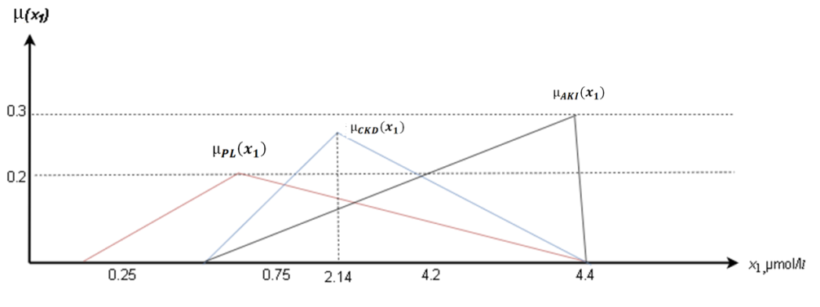

Figure 3.4.1 - Belonging function graph for feature ***x***1

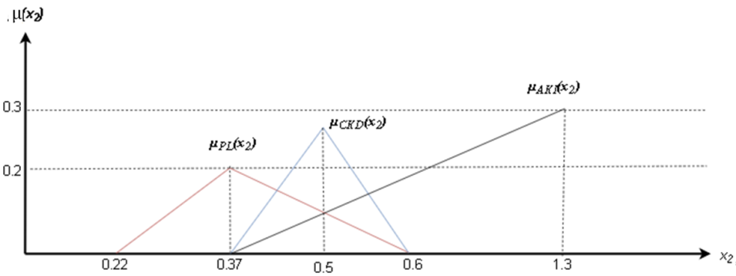

Figure 3.4.2 - Belonging function graph for feature ***x***2

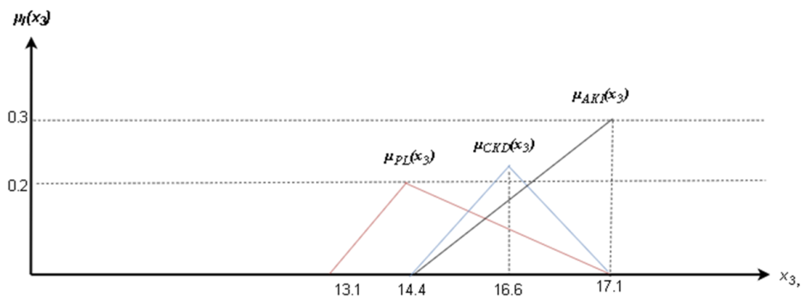

Figure 3.4.3- Belonging function graph for feature ***x***3

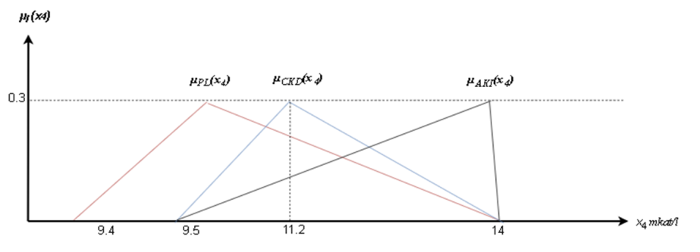

Figure 3.4.4 - Belonging function graph for feature ***x***4

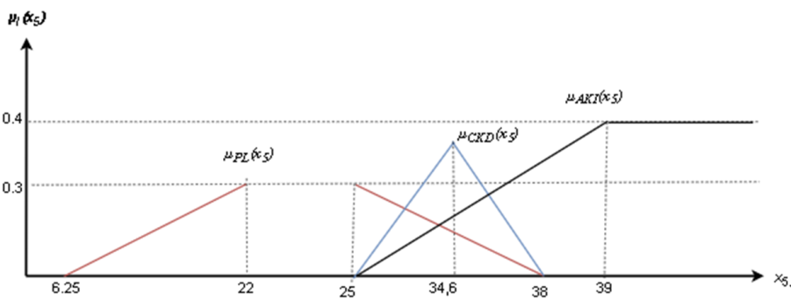

Figure 3.4.5 - Belonging function graph for feature ***x***5

|  |  |
| --- | --- |
|  |  |

Figures 3.4.1-3.4.5 are illustrated function graphs belong to the kidney disease classes (*ωPL*, *ωCKD* and*ωAKI*) with basic variables: *x*1; *x2*; *x3*….*x*5.In the next stage, we obtain the corresponding analytical expressions using Figures 4-8. For example, we provide analytical calculations of membership functions in selected class states based on characteristics *x*1 and *x*2, given by expressions 12-17.Below are the analytical expressions for the membership functions of the classes *ωPL*, *ωCKD* and *ωAKI* based on the levels of bilirubin (factor x1) and urea (factor x2):

|  |  |
| --- | --- |
| $$µ_{PL}\left(x_{1}\right)= \left\{\begin{aligned}0, if x_{1}<0,19 \\ 0,4x_{1}-0,1, if 0,19≤x_{1}<0,78 \\ -0,146x_{1}+0,34 if 0,78≤x_{1}<4,3 \\ 0, if x_{1}>4,3\end{aligned}\right.$$ | (12) |
| $$µ_{CKD}\left(x_{1}\right)= \left\{\begin{aligned}0, if x_{1}<0,32 \\ 0,29x_{1}-0,1, if 0,32≤x_{1}<5,1 \\ 0,3 if x_{1}>5,1\end{aligned}\right.$$ | (13) |
| $$µ_{AKI}\left(x_{1}\right)= \left\{\begin{aligned}0, if x_{1}<0,17 \\ 0,667x_{1}-0,096, if 0,17≤x_{1}<0,36 \\ -0,435x_{1}+0,134 if 0,36≤x_{1}<1,5 \\ 0, if x_{1}>1,5\end{aligned}\right.$$ | (14) |
| $$µ_{PL}\left(x_{2}\right)= \left\{\begin{aligned}0, if x_{2}<16,1 \\ 0,213x_{2}-0,34, if 16,1≤x_{2}<16,4 \\ -2,15x_{2}+1,4 if 16,4≤x_{2}<17,1 \\ 0, if x_{2}>17,1\end{aligned}\right.$$ | (15) |
| $$µ_{CKD}\left(x_{2}\right)= \left\{\begin{aligned}0, if x_{2}<11,3 \\ 0,4x_{2}-0,58, if 11,3≤x_{2}<12,8 \\ -0,065x_{2}+3,4 if 12,8≤x_{2}<13,6 \\ 0,4, if x_{2}>13,6\end{aligned}\right.$$ | (16) |
| $$µ_{AKI}\left(x_{2}\right)= \left\{\begin{aligned}0, if x_{2}<0,22 \\ 0,322x_{2}-0,12, if 0,22≤x_{2}<0,37 \\ -0,082x_{2}+0,4, if 0,37≤x_{2}<0,43 \\ 0,3, if x_{2}>0,43\end{aligned}\right.$$ | (17) |
|  |  |

Functions are described in a similar way for each factor from table 1. Studies indicate that professionals can develop membership functions for individual characteristics but require assistance with fuzzy structures involving multiple dimensions [82].The E. Shortliffe methodology can be an effective tool for making informed decisions. It employs a fuzzy, iterative, and cumulative approach to tackle complex problems. This methodology substitutes the confidence coefficient with the patient's symptoms that belong to specific classes, namely ***ωPL*,*ωCKD***and ***ωAKI***, as demonstrated in equations 18–20. This approach helps to replicate the reasoning behind decision-making and enhances accuracy.

|  |  |
| --- | --- |
| *UFP1PL(q+1)=UFP1PL(q)+µPL(хi+1)[1-UFPPL1(q)]* | (18) |
|  |  |
| *UFP1CKD(q+1)=UFP1CKD(q)+µCKD(хi+1)[1-UFPCKD1(q)]* | (19) |
|  |  |
| *UFP1AKI(q+1)=UFP1AKI(q)+µAKI(хi+1)[1-UFPAKI1(q)]* | (20) |
|  |  |

Where *UFP1PL (*1*)*=*µPL(х*1*);UFP1CKD (*1*)*=*µCKD(х*1*);i*=1*,*2*,*3*;q*=1*,*2*,*3

Final decisive rules for determining confidence in Classes *ωPL*, *ωCKD* and *ωAKI*aggregated by models of the form presented in expression 21-23:

|  |  |
| --- | --- |
| *UFFPL = UFP1PL + UFP2PL + UFP3PL - UFP1PL ×UFP2PL - UFP1PL ×UFP3PL -UFP2PL ×UFP3PL + UFP1PL ×UFP2PL ×UFP3PL* | (21) |
| *UFFCKD = UFP1CKD + UFP2CKD + UFP3CKD -UFP1CKD ×UFP2CKD -UFP1CKD ×UFP3CKD - UFP2CKD ×UFP3CKD + UFP1CKD ×UFP2CKD ×UFP3CKD* | (22) |
| *UFFAKI = UFP1AKI + UFP2AKI + UFP3AKI -UFP1AKI ×UFP2AKI -UFP1AKI ×UFP3AKI - UFP2AKI ×UFP3AKI + UFP1AKI ×UFP2AKI ×UFP3AKI* | (23) |
|  |  |

When the greatest confidence value for the specified classes of patient diseases surpasses the threshold, a decision is made about classification according to class diagnosis *ωPL*, *ωCKD* and *ωAKI*. This decision is made by utilizing expression 24.

|  |  |
| --- | --- |
| *FUPl=max(UFFPL, UFFCKD, UFFAKI*) | (24) |
|  |  |

Where *l = PL, CKD, AKI*

*UPn* was determined by experts during the work of the expert group, as a result of which the value was determined *UPn* = 0,7. If the confidence scores are equal, the diagnosis is determined in favor of a more severe form of the disease class. With *FUPl* ≤ *UPn*a decision is made about the absence of pyelonephritis and acute kidney damage. For all tasks, quality indicators generally accepted in medical practice were calculated: diagnostic sensitivity (*DS*) illustrated with formula 25, diagnostic specificity (*DSp*) showed by formula 26, and diagnostic efficiency (*DE*) illustrated with formula 27.

|  |  |
| --- | --- |
| $$DS= \frac{n_{l}^{+}}{n}$$ | (25) |
|  |  |

Where $n_{l}^{+}$- number of correct “match” of the rule *ωl* for diseases class ***l****=PL, CKD,AKI*

*n –*number of class objects *ωl*

|  |  |
| --- | --- |
|  | (26) |
|  |  |

Where $n_{l}^{-}$ number of “does not match” of the rule *ωl* for diseases class *l=PL, CKD,AKI*

*n –*number of class objects *ωl*

(27)

**Results**

The observation results from applying the decision rules based on the recommendations are displayed below. The table 2 presents the results of activation of the decisive rule for the diagnosis of pyelonephritis, acute kidney injury and chronic kidney disease using informative indicators for calculation using formula 24.

The presented approach's accuracy and precision were evaluated by analyzing the medical records of 150 patients diagnosed with acute kidney injury(AKI), chronic kidney disease (CKD), and pyelonephritis (PL). Table 2 illustrates the distribution of precise and imprecise results. The number of patients in categories PL, CKD and AKI were listed, along with the control group's n0 patient count

Table 3.4.2 - Results of the adequacy of decision rules

|  |  |  |  |
| --- | --- | --- | --- |
| Diseases class | Patients | Results | |
| Match | Does not match |
| *ωPL* | *nPL=150* | 125 | 25 |
|  | *n0=150* | 13 | 137 |
| *ωCKD* | *nCKD=150* | 134 | 16 |
|  | *n0=150* | 9 | 141 |
| *ωAKI* | *nAKI=150* | 140 | 10 |
|  | *n0=150* | 1 | 149 |

*n0* – number of patients

Table 3. Quality of classification of decision rules

|  |  |  |  |
| --- | --- | --- | --- |
| Class | Quality indicators | | |
| *DS* | *DSP* | *DE* |
| *FUPPL* | 0,89 | 0,87 | 0,88 |
| *FUPCKD* | 0,91 | 0,9 | 0,91 |
| *FUPAKI* | 0,81 | 0,84 | 0,83 |

Table 3.4.2 presents the outcomes of assessing the suggested instruments for diagnostic specificity (DS), diagnostic sensitivity (DSp), and diagnostic efficiency (DE).Analysis of table 3 indicates that all metrics are suitable for practical application. Nonetheless, it is important to consider that the quantity of informative attributes within the model has a direct proportional impact on the outcome. This, in turn, influences the time and expense associated with gathering data to address the objectives. The objective focused on crafting hybrid NRPs tailored for distinct problem categories linked to kidney diseases [83]. This involved generating a collection of informative characteristics and intricate markers to accurately depict the health status of patients across different levels of severity. From our perspective, we aim to automate this procedure by implementing a fuzzy hybrid classifier, followed by its subsequent optimization. The derived fuzzy rules will then serve as a training set for the neural network, facilitating a more efficient and precise diagnostic process.

## Summary

Medical information systems enhance the professional capacities of healthcare specialists and facilitate the efficient and swift delivery of medical services.

Machine diagnostics relies on a range of medical logics, including deterministic, phase interval method, information-probabilistic, and more. A mathematical technique has been formulated to address the challenges of diagnosing diverse illnesses by utilizing intricate and frequently vague information. This method involves handling fuzzy initial data to facilitate decision-making.

A method was developed by employing fuzzy system descriptions to diagnose conditions such as toxic goiter and vegetative vascular dystonia.

During the diagnostic process, the use of the proposed mathematical technique that is rooted in fuzzy set theory takes into consideration not only the degree of symptom-disease correlation (which is measured by utility (Xk)), but it also incorporates the state of the system that is described by a fuzzy set. The comparative findings of the study revealed that when employing the Bayes method, the disparity between the most probable state and the nearest value was 98%, while with the proposed method, this difference was only 24%. This indicates that the proposed method aligns more closely with actual observations. The superiority of the developed mathematical diagnostic methods based on fuzzy set theory over other approaches has been demonstrated.

# 4 TECHNICAL IMPLEMENTATION OF AUTOMATED DIAGNOSING SYSTEM FOR INTERNAL ORGANS DISEASES

This chapter focuses on computer-based applications that are utilized to address intricate decision-making difficulties, such as the diagnosis of internal organ illnesses. This study presents an intelligent system designed to address intricate problems in a specific medical field, specifically the diagnosis of disorders affecting internal organs. The provided automated diagnostic system may effectively address numerous issues that often necessitate the expertise of a human professional, such as a doctor. It is derived from the expertise obtained from a physician. Additionally, it has the ability to articulate and analyze finalized diagnoses, and provides certain suggestions. Automated systems served as the forerunners of the present-day artificial intelligence and machine learning systems [84].

## 4.1 System architecture and the components of the automated system

In order to perform the approach described in the dissertation, asystem architecture was created to implement the methodology for automated disease diagnosis. The figure 4.1 illustrates the primary elements of the system and their interconnections. The automated system that has been designed comprises the following components:

*The User Interface (UI)* is the most crucial component of the system. This component receives a user request in a format that may be easily understood and transfers it to the inference engine. Subsequently, it presents the outcomes to the user. Put simply, it is a user interface that facilitates communication between the user and the system. The system is specifically built to facilitate a pleasant and seamless connection between the user, who is a physician, and the system itself. The system incorporates processes for controlling the morphology, syntax, and semantics of incoming requests, transforming them into a format that can be comprehended by a computer. When issuing response information, the reverse operation is carried out - the conclusion is “translated” into a limited natural language that is understandable to the user. Language processor is used for friendly problem oriented-communications between the user and the computer. This communication is best carried out in a natural language and in some cases; it is supplemented by the graphics. The human computer interface or user interface technology allows users to interact with the system [85].

*Inference Engine* - is the brain of the system, which is contains rules to solve a specific problem. It refers the knowledge from the *Knowledge Base*. It selects rules to apply when trying to answer the user's query. Current component works with developed mathematical model, which is presented in papers [72, p.44]. It also helps in subtracting the problem to find the solution. It is also helpful for formulating doctor’s recommendations, deductive machine, inference engine. The interference engine is that part of the program which regains, determines how to apply the knowledge in the knowledge base to the facts and symptoms presented at the user interface. It performs this task which is subsequently used to draw further conclusions. The interference engine is the active component of system. It is the Brain of the automated knowledge based information system. An interference engine is alternatively referred to as the control structure or the rule interpreter. This component is essentially an algorithm that utilizes the knowledge base to accomplish the objective specified by the user, who interacts with the system through the user interface. The technique offers a framework for logical analysis of material in the knowledge base and for drawing conclusions.

*A Knowledge Base* is a centralized collection of factual information. It contains comprehensive information regarding disorders affecting internal organs. It functions as a comprehensive repository of expertise gathered from several specialists in a certain medical domain. Hence, it can be asserted that the efficacy of the automated system is primarily contingent upon the acquisition of exceedingly accurate and precise knowledge. Knowledge-based refers to the codified representation of medical expertise and the measures taken during the diagnosis of internal organ illnesses. This is the most important element of the system since it holds the problem solving knowledge. The knowledge component “fills” the system with knowledge that allows it to solve problems from the problem area itself, with knowledge described in treatment protocols approved by Ministry of Health of the Republic of Kazakhstan. It contains rules, facts and descriptions of diagnosis. The knowledge base is always stored in data. The information in knowledge base is everything that is necessary for understanding, formulating the problem, and then diagnosing diseases. Such knowledge representation deals with the structuring of the information, manipulation of information, and knowledge acquisition. The power of a system tends to be related from all sides of the knowledge in the knowledge base [86]. In case of current study, the database includes a control part, which consists of questioning the patient. As a result, the system generates the most probable disease (diagnosis of the patient) for a given condition. Additionally, the system generates the list of further tests to pass to confirm the diagnosis.

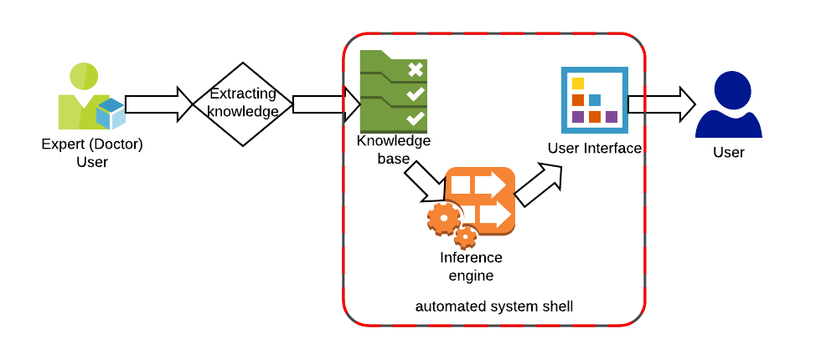

Figure 4.1.1- Automated system architecture

Figure 4.1.1 shows the most important modules that make up a rule-based automated system to diagnosing. The user interacts with the system through a user interface. The knowledge base is replenished by requiring the data and rules from doctor (expert), the process starts by converting the acquired knowledge into rules and injecting it to our system. The user of an automated knowledge-based information system must articulate the specific problems that require understanding in order to generate appropriate answers. The diagram in Figure 4.1 illustrates the design and framework of an automated knowledge-based information system. It depicts the connections between the knowledge base, inference, and user interface components, as determined by various research investigations.

*Diagnosing algorithm:* the diagnostic technique is constantly being improved, new diagnostic techniques appear, and new pathogens open up [87]. Therefore, the number of “diseases” is constantly growing and replenishing. There are two different approaches to building diagnostic algorithms. First, on the basis of the information you have (the results of general clinical laboratory tests) formulate a preliminary diagnosis. And then, comparing the existing symptoms and data of additional research methods with the signs of another a disease occurring with similar symptoms, you either confirm the preliminary diagnosis, or formulate a new diagnose. Figure 4.2 shows graphical representation of simple diagnosing algorithm. Patient usually comes to the physician and doctor takes general clinical anamnesis, and then with presented automated system the more likely disease is going to be detected.

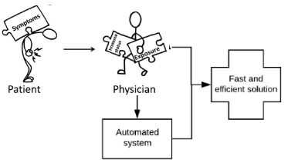

Figure 4.1.2 -Algorithm of diagnosing with using of presented system

An automated system is an interactive and reliable computer-based decision-making system will help to the physician to find fast and efficient solutions [88]. Structured representation of medical activities: To implement the above approach, architecture and a set of programs were developed that implement the method of automated diagnosis of diseases. The main components of the system and the relationship between them are shown in the figure 4.3 below.

Treatment selection

Data analysis

Data processing

Collection of information

Treatment

Figure 4.1.3- Structured representation of medical activities.

The initial phase involves gathering data for a study that a physician undertakes to validate or disprove a theory. During the second step, the system undertakes several tasks with the supplied information, including eliminating unnecessary data, filling in missing information, rectifying errors, and constructing a database. During the third stage, the doctor-researcher examines the facts using several approaches to either validate or disprove the proposed hypothesis. Additionally, a model is constructed. The doctor presents the outcomes of the third phase in practical medicine through the use of formulas, tables, or a list of measures. These resources can then be utilized by other doctors during the fourth phase for differential diagnosis, selecting the most effective treatment approach, or implementing preventive measures. At the fifth stage, therapy and preventive measures are implemented directly. The subsequent cycle commences anew with the gathering of information. Every stage has the potential to be completely or partially mechanized in order to address any medical issue. Medical practitioners have long been using computers and specialized software to carry out scientific research, collect, process, and evaluate information. The worldwide medical community has accumulated significant expertise in converting research discoveries into computer applications. This encompasses the creation of diagnostic systems that utilize neural technologies and principles of fuzzy logic.

## 4.2 Components and key terms used in automated system

The proposed system functions as a program that mimics the behaviors of a doctor during diagnostic, drawing specific conclusions while providing advice and recommendations. The primary distinctions of the system from other software products lie in its utilization of both data and information, as well as its unique mechanism for deducing decisions and generating new knowledge from current ones. The information in our system is given in a format that can be readily processed by a computer. Our approach employs a knowledge processing algorithm rather than a conventional problem-solving algorithm. Hence, the utilization of the knowledge processing algorithm can result in the acquisition of an outcome that was not initially given while addressing a certain challenge. Additionally, the algorithm for processing knowledge is not predetermined and is constructed while addressing the problem using heuristic criteria. Knowledge-based systems contain the rules or heuristics used to solve problems in a certain subject area in a knowledge base. The system is presented with a set of facts that describe a specific circumstance, and it attempts to draw a conclusion from these data using its knowledge base [89]. Generally, automated knowledge based information system requirements can be described and modeled in some UML diagrams like use case, class, and sequence. The proposed model described in this chapter is the systematic model that is generally found in the system. Figure 4.4 is a use case diagram that illustrates the interaction between the user, developer and the system.

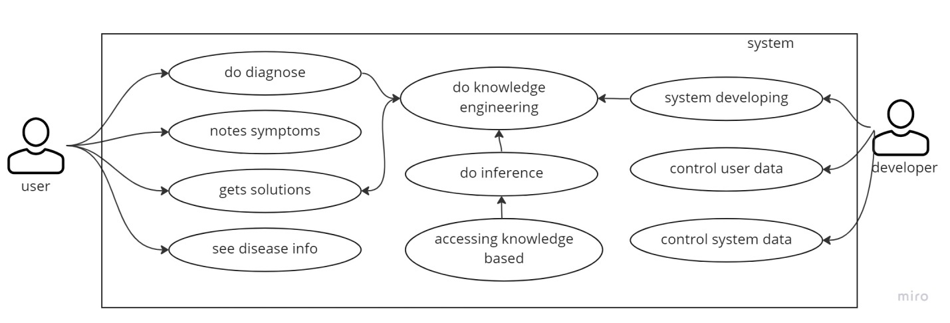

Figure 4.2.1 -Use case diagram of the proposed system

Correct system designing helps developer to easily generate the code and understand user needs. Therefore there are UML diagrams are created and explained. Use case diagram (see fig. 4.4) illustrates is a visual representation of the possible scenarios of using proposed system. It illustrates how a user will perform actions and interact with system. Like, notes symptoms and get result. Also, there are possible actions of the system: do inference or accessing to knowledge base. Developer, presented in diagram above, usually controls user and system data. Use case diagrams can help establish complexity of the system. It does so by specifying which functions become requirements that will make it to the development stage [90]. Use case diagram written in natural language, which helps easily understand the diagram.

The following sequence diagram (see fig. 4.5) displays the relationships between the objects, and describes what those objects do. Diagrams are useful in many stages of system design. In the analysis stage, diagram can help to understand the requirements of the system domain and to identify its components. Illustrate the scenarios or a series of steps performed in the response. During the implementation phase of a system development, diagrams helps to convert the models into code [91]. The system processes the incoming information, as well as responds to user actions. As shown in Figure 4.5 to incoming information systems include all of the symptoms, the answers to the survey questions are recorded in the system. The system is processing the information entered. All the entries are recorded in the respective tables. So, for example, to determine the best diagnosis for the patient should receive questionnaires, and then fill in the data following a pattern. Results will be displayed on the page result.jsp, as well as the table user, the cell result in a system database.

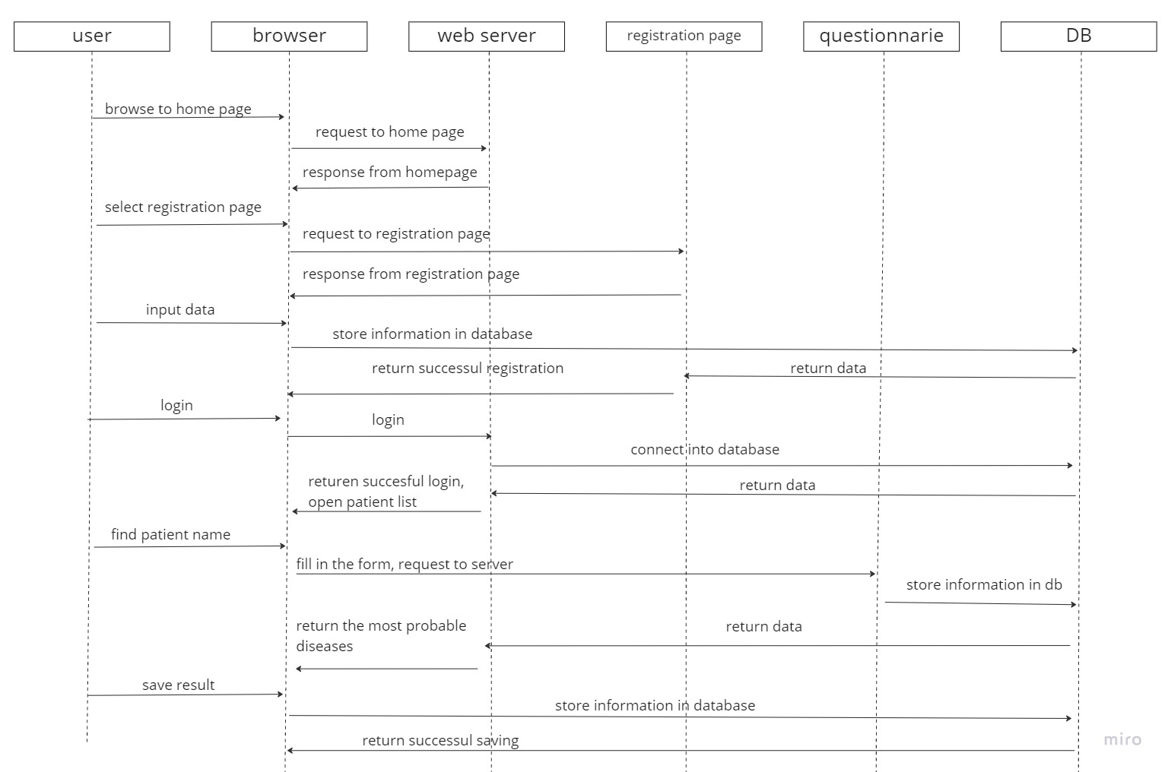

Figure 4.2.2- Sequence diagram of proposed system

After processing the input information system allows the user to get relevant results and other relevant information about specific diagnosis. The project involves the development of a computerized system of information processing. An automated system processes the input data. Input data - is the primary documents (in this case the patient’s symptoms), which enters into the system. Furthermore, data flow diagram shows the way information flows through a process or system [92]. As can be seen in figure 4.6 the data flow diagram consists of several main elements: action, data flow arrow, decision making step. According to proposed system, the system starts with login page.

* New user should follow registration stage, and then go to account page. Login page allows user to access to the system by entering their username and password, after registration. Data saved in database. If the username and password do not match the data in the database, then the page is returned to the registration or indicates an error.
* There is a main page, which allows user to choose the patient from the list (previous patients) or create a new patient.
* Next step is aimed for questionnaire. Then fill all the data in the form to fill in evaluations. The system using the mathematical method defines most probable diagnose, suitable for patient. And prints the list of analysis tests needed to be passed, in order to confirm the diagnosis. Then the user goes out of the system by pressing the logout.

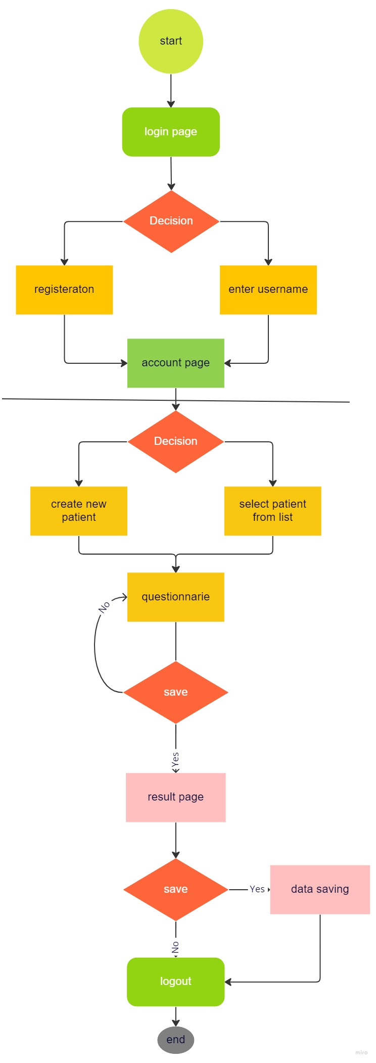

Figure 4.2.3 - data flow diagram for proposed system

To development a medical diagnostic system, we considered the general procedure for making decisions in medicine based on operating with certain knowledge. This knowledge is taken from various fields and can formally be represented as a database, knowledge base, and decision-making rules. The functional scheme of a medical diagnostic system is shown on figure 4.7.

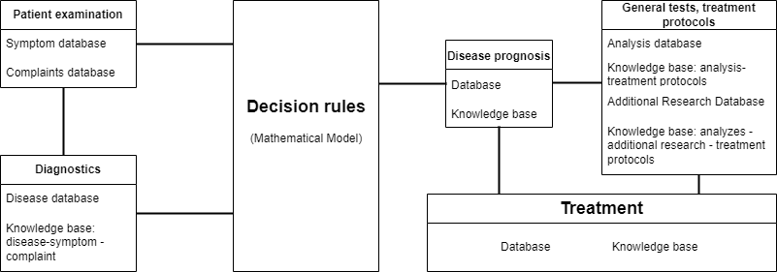

Figure 4.2.4 - Scheme of the functioning of the medical diagnostic system

According to the functional diagram depicted in figure 4.7, the structure and functional blocks of the proposed automated system for diagnosing diseases have been constructed (refer to Fig. 4.8).The core elements of the automated system consist of the Blocks "Management of databases and knowledge bases" and "Decision rules (mathematical model)". The database and knowledge management module enables efficient utilization of data and knowledge by providing separate access to them from the inference engine. Additionally, it allows for the independent utilization of medical data, separate from the data collected during patient interviews. Subsequently, leveraging his profound understanding of medical principles and personal expertise, he proceeds to inquire more extensively about the symptoms linked to a likely ailment, and formulates a definitive assessment. In this case, it is necessary to have knowledge about the overall connections between diseases and symptoms. It is evident that some form of measurement is required to understand the relationship between a disease and its symptoms, as well as the relationship between symptoms and the condition. The "Decision rules (mathematical model)" block enables the simplification of this operation. The system being developed must operate in diagnostic mode, allowing the evaluation of the current condition of the patient based on data contained in the patient's symptom knowledge base.

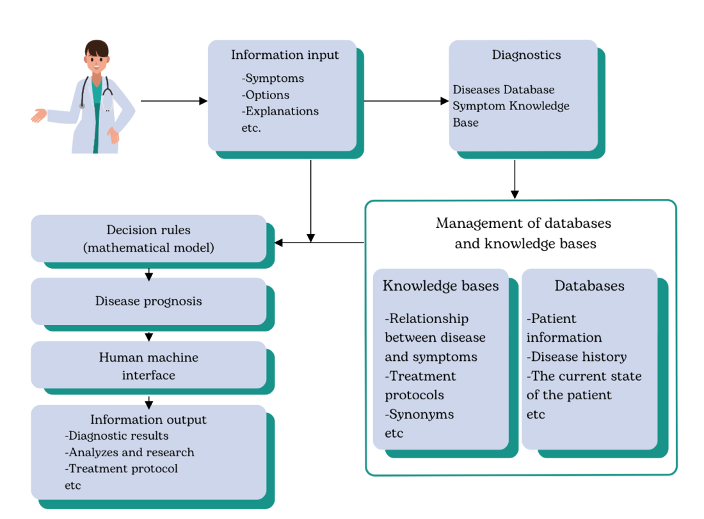

Figure 4.2.5 - The structure of an automated system for diagnosing diseases

The system should incorporate the requisite interface and procedures to accomplish the following tasks:

* Create Linguistic Models: The system should enable the creation of linguistic models representing the patient's health status and a diagnostic model, both of which will be stored in the knowledge base.
* State Determination: It should facilitate the determination of the object's state by analyzing the current parameters affecting the subject under evaluation.
* Resource Adaptation: The system must have the capability to adjust its resources by accumulating knowledge through ongoing work processes.
* Information Output: It should provide a mechanism to present the necessary information in the form of numerical values for the test criterion.

The designed system is intended to expedite the process of diagnosing the condition of the subject under investigation through an automated procedure for knowledge base creation. Furthermore, it aims to enhance the efficiency of diagnostic decision-making.

## 4.3Diagnosing systems development methodology

There are phases of integrating new software system (see fig. 4.9). The strategy and algorithm of implementing new systems is defined below, because it is more major an issue at the beginning. As implementation of estimating software is an IT project, it requires basis phases [93].

In order to ensure that the project management system is effectively implemented, it is essential to specify the sequence of operations that encompass the integration of software in a clear and concise manner. At the same time, it is essential to mention clear objectives and to specify primary, time-limited goals that are urgent. The organizational component is valuable for the project implementation. Before implementation of the project there should have been formed a project management team.

It should be emphasized that the all decisions during the project implementation of the system should be made as promptly as possible. This is because long waiting approvals can significantly tighten the project (or completely destroy it). For the operative project implementation there should be formed a special working group of integration members, which will be directly involved with the implementation process as a whole, to interact and solve issues emerging during the project. Finally, after finishing the integration of software, the supporting team will work on maintenance functionality of the system (If errors occur after implementation or if anything is misunderstood).There have been several implementation methods considered, such as waterfall model; in this particular research the most suitable is a combination of methods, for which a simplified breakdown is presented below. There is a sequence process diagram of integrating this system, which consists of five main phases:

1. Defining requirements phase
2. Modification phase
3. Implementation phase
4. Commissioning phase (testing)
5. Warranty support phase

Below are descriptions of each stage process. Software Development includes defining requirements, modification and implementation. There is an explanation of the process of creating a dynamic and interactive website using a modern technology stack that includes Node.js, React.js, MongoDB, and Express.js. These technologies have gained immense popularity in recent years due to their ability to build scalable, real-time web applications efficiently. Node.js is a runtime environment that allows you to run JavaScript on the server-side. It is known for its non-blocking, event-driven architecture, making it perfect for building high-performance web servers and APIs. React.js is a popular JavaScript library for building user interfaces. It is renowned for its component-based architecture, allowing you to create reusable UI components, which is crucial for developing complex web applications. MongoDB is a NoSQL database that stores data in JSON-like documents. It is highly scalable and suitable for handling large amounts of unstructured or semi-structured data. Express.js is a minimalist web application framework for Node.js. It simplifies the process of building robust, scalable, and maintainable web APIs and applications.

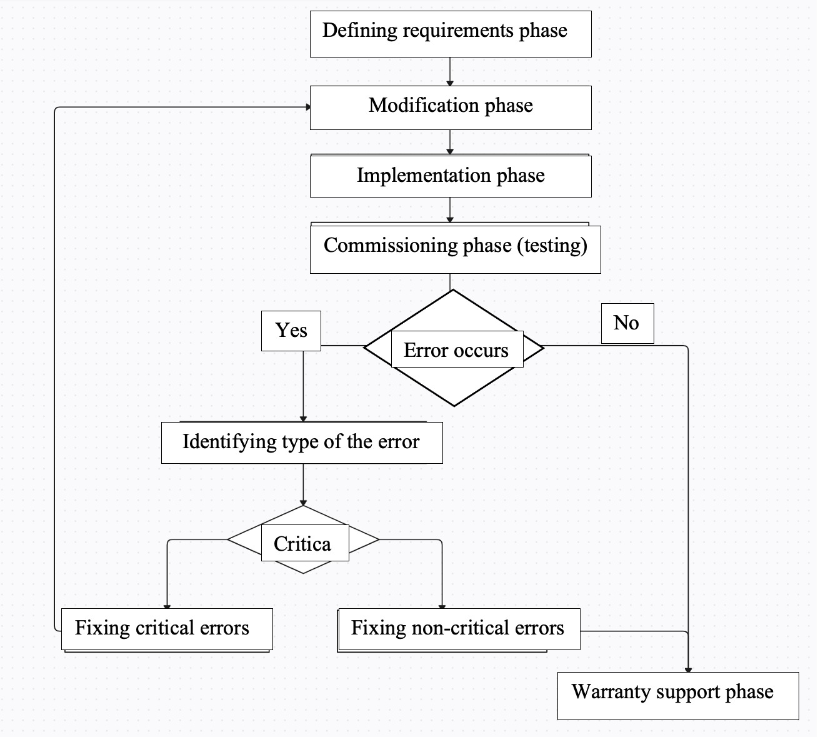

Figure 4.3.1 - Flow diagram - software development phases

Commissioning Phase (Testing): In this phase, the mathematical model is thoroughly tested and validated to ensure it meets its intended objectives and performs reliably.

Warranty Support Phase: After the mathematical model is deployed and operational, it enters the warranty support phase, which involves ongoing maintenance and support. Continuously monitor the model's performance and update it as needed to adapt to changing healthcare conditions. Provide training and support to healthcare professionals using the model. Maintain comprehensive documentation of the model's design, operation, and updates. Gather feedback from users and stakeholders to make iterative improvements to the model.

By following these five phases, the process of diagnosing diseases with mathematical modeling can be systematic, effective, and adaptable to the evolving healthcare landscape. It ensures that mathematical models contribute positively to patient care and medical research.

There is a system workflow description. The system is activated in operational mode to assess the patient's present condition using a collection of symptoms. The diagnostic process relies on models that are constructed within the system's operational mode. The outcome of the diagnostic mode operation is the identification of the current state of the subject, drawing from the patient's health status model and the diagnostic model.

The system operation in diagnostic mode looks like this:

1. The doctor sets a task: enters a working array of information received from the patient
2. The system conducts a verification process to assess the accuracy and completeness of the entered data. Subsequently, it accesses the object model and initiates the state diagnostic procedure by employing the state assessment module.
3. The resulting status is displayed on the screen.
4. If the doctor is not content with the obtained reliability degree value, they have the option to refine the input data by incorporating additional information. Following this, they can recommence the procedure for diagnosing the patient's condition. The operation of the system in diagnostic mode is graphically presented in the figure.

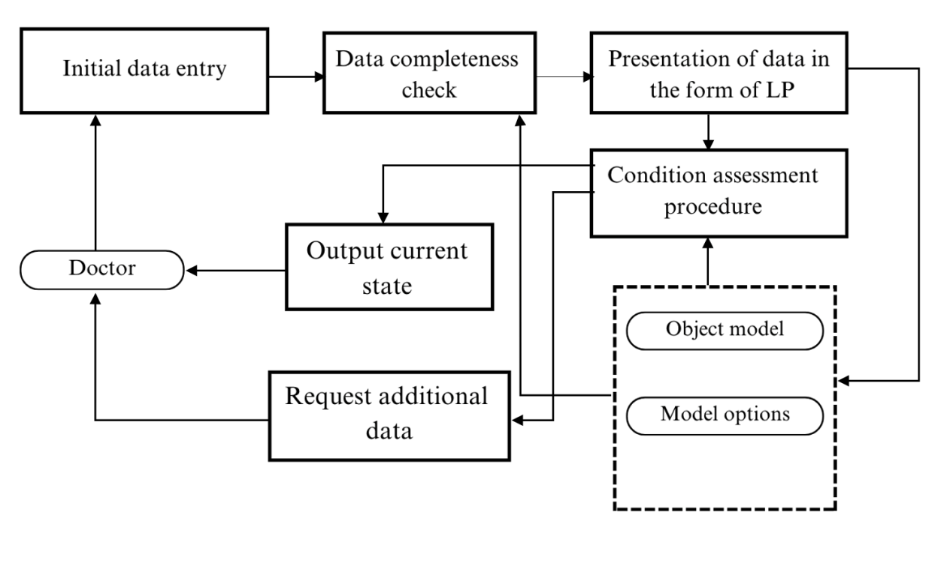

Figure 4.3.2 - Functional scheme of the system

The provided operational mechanism enables the diagnosis of the subject's condition, resulting in time savings during the diagnostic procedure.

**4.4 System interface development**

The fundamental requirements that the system interface in model building mode must adhere to are as follows:

1. The system interface in model building mode should provide the capability to load a database from an external source.
2. Create prototypes to visualize the layout and functionality of the interface, using Figma
3. Present medical information in a clear and understandable manner. Use tables, charts, and visual aids when necessary to convey complex data effectively.

The primary objective of the developed system is to provide intelligent assistance for disease diagnosis, utilizing the established mathematical model. This system aims to enhance the quality of preventive and diagnostic efforts, particularly in scenarios of high-volume service where time is limited. There are two groups of users in the system. Depending on the selected type, the modes of operation available to it change. The distribution of user rights is shown in the table below

Table 4.1: user right in developed system

|  |  |
| --- | --- |
| User | User rights |
| Doctor | Patient registration |
| Recording patient complaints and symptoms. |
| Establishing diagnosis |
| Editing knowledge database |
| Editing and printing reports |
| Administrator | System Administration |
| Adding\correcting data about the disease |
| Knowledge database modification |
| Doctor and patient data management |

There is a «CareMed Assistant» Welcome Page. This site is designed to help physicians quickly and accurately identify their patients' diagnoses. CareMedAssistant is a smart medical assistant that uses advanced technology and artificial intelligence to analyze medical data and provide the best treatment recommendations.

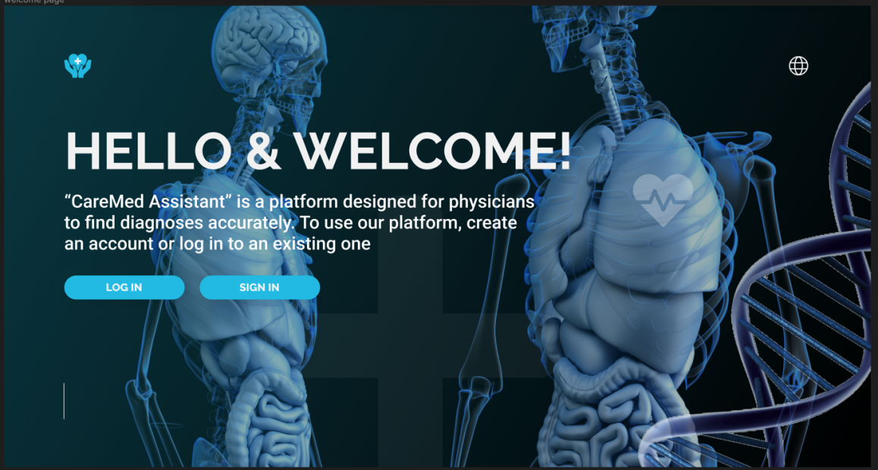

Figure 4.3.3 - « CareMed Assistant» Welcome Page

On the Welcome Page (appendix A), physicians will be greeted with information on how CareMedAssistant can become an indispensable tool in their daily practice. Here we talk about what the site provides and how it can help reduce diagnostic time and improve the accuracy of disease detection. To start working on this platform, you need to register (Fig. 2 in appendix A) or log in to your account (Fig. 4 in appendix A).

The “Sign In Page” (appendix A) allows physicians to log into their CareMedAssistant account. Here they enter their credentials, including special identifiers for data security. Physician authentication ensures privacy and prevents unauthorized access to medical data. The Sign In Page provides an opportunity for new doctors to register on the CareMedAssistant platform and gain access to unique features that help in more accurate and faster identification of patient diagnoses.

Registration process:

1. Doctors enter their name, date and place of birth, e-mail.
2. The doctor chooses a strong password for his account. The password must be complex and strong enough to keep the data secure.
3. After filling in the information, the CareMedDiagnosis system checks the data for correctness and uniqueness. If necessary, the doctor can make adjustments.
4. After successfully filling in the data, a verification code is sent to the specified contact phone number or email address (Fig. 3).
5. The doctor enters the received verification code on the registration page to complete the account registration process.
6. After successful verification of the code, the doctor's account is created on CareMedAssistant, and he gets access to the site's functionality.

Confirmation Page (appendix A): Upon successful registration on the site, physicians are redirected to a Confirmation Page, which notifies them of the completion of the process and confirms that the data entered is correct.

Log In Page: The Sign In Page allows physicians to log into their CareMedAssistant account. Here they enter their credentials, including special identifiers for data security. Physician authentication ensures privacy and prevents unauthorized access to medical data.

Home Page:The Home Page(appendix A) is the hub of CareMedAssistant's activities. Physicians gain access to the site's main functions, such as uploading patient medical data, selecting symptoms, examinations and analyses. This page also displays the current and previous diagnoses of patients, which allows you to track the dynamics and effectiveness of treatment.

The Patient Registration(appendix A) page provides an opportunity for physicians to register new patients on the CareMedAssistant platform. Here, doctors fill in the personal data and medical history of patients, which provides a complete picture of the state of health of patients and more accurately determine the diagnosis.

During patient registration, you input the following information: the patient's complete name, age, contact information, residential address, gender, blood type, and diagnosis. Rest assured all the data you provide is handled with utmost confidentiality and safeguarded by our advanced security system.

Once the data is successfully filled in, the information of each patient is automatically incorporated into a dedicated list (refer to Fig. 7 in appendix A). This feature facilitates efficient organization of data and enables swift access to information pertaining to all patients served by this platform.

The Patient List (appendix A) page offers physicians a user-friendly overview of all patients registered on the CareMedAssistant platform. Here, doctors have the ability to view, add, and manage crucial information about their patients, facilitating seamless tracking of their medical history and test results. This functionality streamlines patient care and enhances the efficiency of healthcare management.

The Test Entry(appendix A) page enables physicians and healthcare professionals to effortlessly upload the results of medical tests conducted on patients. In addition to entering the test outcomes, clinicians can include supplementary comments and interpretations to provide a comprehensive understanding of the findings. This feature ensures comprehensive and detailed documentation, enhancing collaboration among medical practitioners and improving patient care.

The Review Tests (appendix A) page empowers physicians to thoroughly assess and analyze uploaded medical and patient exams. Leveraging advanced artificial intelligence, the CareMedAssistant system processes the data and offers preliminary recommendations for potential diagnoses. This cutting-edge technology aids healthcare professionals in making informed decisions and expediting the diagnostic process, ultimately enhancing the quality of patient care.

The Symptom Review(appendix A) page provides physicians with valuable information about the symptoms reported by patients, enabling them to analyze how these symptoms relate to the provided medical data and test results. This process proves instrumental in narrowing down the range of potential diagnoses and refining the need for further investigations or studies. The feature enhances diagnostic accuracy and aids healthcare professionals in delivering targeted and effective treatment plans.

The Results page (appendix A) presents the conclusive diagnoses and recommendations for each patient, derived from the comprehensive analysis of medical data, test results, and reported symptoms. Physicians have the option to grant patients access to this information through their personal accounts, allowing them to stay informed and engaged in their healthcare journey. This transparent approach fosters better patient-doctor communication and empowers patients to actively participate in their treatment decisions. Key Features of the Results Page:

1. Diagnosis, level of accuracy and description. Within this section of the Results page, physicians are presented with individual diagnoses for each patient. Furthermore, a diagnostic accuracy level is furnished, indicating the clinician's degree of confidence in the accuracy of the diagnosis. The diagnosis description offers comprehensive insights into the patient's condition, encompassing key disease characteristics and its prognosis.
2. Causes and symptoms. In this section, doctors are provided with vital information concerning the underlying causes of the disease, as well as a detailed description of the typical symptoms associated with the diagnosis. This knowledge is crucial in enabling physicians to gain a more accurate understanding of the disease's nature, which in turn facilitates the development of appropriate and effective treatment plans for patients. By comprehending the causes and symptoms, doctors can make informed decisions and provide targeted care, ultimately enhancing the patient's chances of recovery and improved health outcomes.
3. Social communication and interactions. Within this section, physicians are offered valuable guidance on social communication and interaction with patients. They can learn essential skills to foster positive relationships with their patients, ensuring effective and empathetic communication. By understanding how to support patients in coping with stress and addressing their concerns, physicians contribute to improving the overall well-being and health outcomes of their patients. Building strong doctor-patient relationships based on trust and understanding is essential for providing comprehensive and patient-centered care.
4. In the Treatment section, physicians have access to comprehensive information regarding recommended medical procedures, therapies, medications, and other relevant treatments tailored to assist the patient in managing their specific condition. This wealth of knowledge enables physicians to formulate personalized treatment plans that cater to the unique needs and circumstances of each patient. By utilizing this valuable information, healthcare providers can optimize the effectiveness of treatments and ensure the best possible outcomes for their patients' health and well-being.
5. Treatment of other diseases. By considering other medical aspects, physicians can develop a comprehensive approach to treatment. This integrated approach takes into account the interactions between different health issues, allowing doctors to address multiple conditions simultaneously. By managing these concomitant conditions effectively, healthcare providers can improve overall treatment outcomes and enhance the patient's overall well-being.

The Results Page plays a pivotal role in delivering high-quality and comprehensive care. It serves as a critical resource for doctors, offering all the necessary information to make crucial medical decisions and develop personalized approaches for each patient. CareMedAssistant is committed to utilizing this approach to ensure the best possible outcomes for its users and enhance their overall health and well-being. By leveraging the wealth of data and insights provided in the Results Page, healthcare professionals can deliver patient-centered care, tailored to individual needs, and ultimately contribute to improving the overall health and quality of life for their patients.

The admin page (appendix C) is designed exclusively for administrators of the CareMedAssistant platform. Through this page, administrators can access various essential features such as user management, database administration, software updates, and system settings. These functionalities enable administrators to maintain a stable and secure operation of the platform. Additionally, the admin page provides administrators with the necessary tools to monitor the site's functioning, ensuring smooth operations and resolving any potential issues promptly. With this comprehensive control and oversight, administrators can effectively manage the platform, ensuring a seamless experience for users and maintaining the platform's integrity and security.

## Summary

In this chapter, the system's necessary modules, required to facilitate the intended functionality, have been specified. The system's structure has been meticulously developed, and automated system diagrams have been presented for both the model building mode and diagnostic mode. Clear requirements have been articulated for the system's interface, ensuring a user-friendly and efficient interaction. The primary dialog windows for the system in both model building and diagnostic modes have been introduced. Comprehensive testing has been conducted to evaluate the performance of the Modern Disease Diagnostics System. Was covered setting up the development environment, choosing the technology stack, structuring project, and key development steps. Building a web application with these technologies can be challenging, but it offers the flexibility and scalability needed to create modern, dynamic websites.

# CONCLUSION

The dissertation addresses the contemporary scientific and practical challenge of developing an automated system for diagnosing internal organ diseases. This system is built on modern information technologies and examines the theoretical principles of creating information systems using information and mathematical methods. It involves establishing a database of disease symptoms, developing tools to set distinct criteria for categorizing symptoms, and assessing their severity.

The study addressed several objectives, including analyzing current methods, creating a space for informative characteristics, establishing clear criteria for symptom categorization, and modifying fuzzy models for symptom assessment. The study's primary objective was to enhance the quality and quantity of diagnostic measures for internal organ diseases through the strategic integration of computational and mathematical methodologies.

Through the processing of rules that have been defined by specialists and that link observations to diseases, medical diagnostic systems are supposed to duplicate the decision-making process that a physician goes through. In the field of medicine, these systems are the most notable applications of artificial intelligence; nevertheless, they are not ubiquitous and differ greatly in terms of the subject matter they cover, the diagnostic mechanism they use, and the manner by which they store knowledge.

Because of the high level of specialization that medical diagnostic systems possess, they are not universal and cannot be utilized to diagnose all diseases without exception. Instead, each system is tailored to meet the requirements of a particular field of study and employs a distinct method for arriving at a diagnosis. The knowledge that is utilized by these systems is often kept in a knowledge base, which may be updated whenever new information is made accessible.

There are a variety of applications that can cause the algorithms that are utilized by medical diagnostic systems to change. In spite of this, they are typically intended to generate a diagnosis by processing the rules and information that are contained in the knowledge base. There are three types of algorithms: deterministic, logical, and probabilistic. These algorithms may also make use of machine learning techniques in order to increase their accuracy over time. It is for this reason that medical diagnostic systems are an essential application of artificial intelligence in the field of medicine. These systems have the potential to increase the accuracy and efficiency of diagnosis. These machines, on the other hand, are not intended to take the position of human physicians and must be utilized in conjunction with clinical skill and judgment. The following scientific and practical results have been achieved.

1. Contribution to the theoretical foundations of information technology:

1.1 Based on the analysis of existing diagnostic methods and information support systems in medicine, the dissertation aims to solve the scientific and applied problem of creating an automated system for diagnosing diseases of internal organs. This includes developing and using information and mathematical models to improve the accuracy and efficiency of diagnostic processes.

1.2 For the first time, a rule synthesis model has been developed for classifying and assessing the severity of disease symptoms based on two-dimensional classification methods and symptom sets. This allows us to create appropriate mathematical models that weakly formalize disease symptoms.

1.3 Technologies that combine fuzzy logic and big data analysis can improve the process of diagnosing diseases. These tools can analyze complex medical data and provide accurate and reliable diagnostic reports.

1.4 To solve the problem of diagnosing diseases of internal organs, a formalization of the feature space was completed, including the development of an automated system capable of integrating various types of medical data and analyzing those using fuzzy models and confidence theory.

1.5 The structure was justified, and a computer implementation of a system for automating disease diagnosis, including software tools for extracting and analyzing medical data, was carried out.

1.6 Methods for using fuzzy models for assessing disease symptoms have been improved based on the fuzzy inference rules by L.Zadeh and the theory of confidence by E.Shortliffe. This lets you reliably identify diseases and minimize subjectivity in the diagnostic process.

2. Contribution to methods for constructing medical information and diagnostic systems:

2.1 The study shows that fuzzy models can improve the quality of disease diagnosis through accurate analysis and interpretation of medical data.

2.2 In order to assist medical professionals in making decisions and to enhance diagnostic accuracy, the findings provide the foundation for the further development of automated diagnostic systems that may be incorporated into clinical practice.

2.3 At this presentation, both the theoretical and practical foundations for the development of an automated diagnostic system are discussed. These foundations include models and methods for analyzing and interpreting medical data.

2.4 A concept for constructing an automated diagnostic system based on information and mathematical models is proposed. This system would allow you to monitor the patient's condition and provide accurate diagnostic reports.

2.5 Software tools have been developed for automated diagnosis of diseases that can be used in clinical practice to improve the accuracy and efficiency of diagnosis. These tools enable physicians to make more informed decisions and improve the quality of care.

2.6 Information technology has been developed for the purpose of processing medical data, which has made it possible to conduct an all-encompassing evaluation of the patient's state and to arrive at diagnostic findings that are accurate and dependable.

2.7 There has been the development of a software product that utilizes information technology for the purpose of disease diagnosis. This software product has the potential to be beneficial for both medical institutions and individual physicians who require diagnostic tools that are accurate and dependable.

3 Creating prerequisites for further research:

3.1 A system for automated diagnosis of diseases based on information and mathematical models can replace manual diagnosis in clinical practice. With rational organization, it can significantly improve the quality of diagnosis and, therefore, patients' and the health care system's quality of life.

3.2 The proposed information technology for diagnosing diseases can be formalized as a software application for inclusion in other medical information systems, expanding diagnostic capabilities and improving the quality of medical care.

3.3 The developed models for automated disease diagnosis contribute to the development and improvement of medical information technologies, ensuring increased accuracy and efficiency of diagnosis and creating new opportunities for medical research and practice.

# LITERATURE

1. Digital Kazakhstan. State program aimed at digitalization of Kazakhstan. 2018. [Electronic resource] // Available at: <https://digitalkz.kz/o-programme/> [Accessed 25.05.2021].
2. Kumari, P., Sharma, S. Fuzzy based medicine recommendation system // Proceedings of the Third International Conference on Advanced Informatics for Computing Research - ICAICR ’19. 2019. doi:10.1145/3339311.3339346.
3. Buchanan, B. G., & Williams, B. W. A rule-based expert system for medical diagnosis // Computer. 1980. 13(3). С. 31-41.
4. Smith, John, Lee, Mary, Kim, David. Artificial Intelligence for Medical Diagnosis: A Comprehensive Review // Journal of Medical Systems. 2020.
5. Szolovits, P. Artificial Intelligence in Medicine. 1982. Volume 1(1), 1-25.
6. Bellman, R. E., Bellman, R. E., Bellman, R. E. (1983). Mathematical methods in medicine. // Singapore: World scientific.
7. Buchanan, B. G., & Shortliffe, E. H. Rule-Based Expert Systems: The MYCIN Experiments of the Stanford Heuristic Programming Project. Reading, MA: Addison-Wesley, 1984.
8. Pople, H.E. (1982). "Heuristic methods for imposing structure on ill-structured problems: The structuring of medical diagnostics." In Artificial Intelligence in Medicine, pages 119-190
9. Warner, H.R., Olmsted, C.M., & Rutherford, B.D. (1972). "HELP - A Program for Medical Decision Making." Computers and Biomedical Research, 5(1), 65-74.
10. WebMD. (n.d.). "Symptom Checker." Retrieved from https://symptoms.webmd.com/
11. IBM Watson Health. Watson Health. [Electronic resource] // Available at: https://www.ibm.com/watson-health/
12. DeepMind Health. [Electronic resource] // Available at: https://deepmind.com/applied/deepmind-health/about
13. Bhatia, R., & Aggarwal, S. Handbook of research on expert systems for decision support. IGI Global, 2015.
14. Vert, J.P., Maraia, R.J., Eddy, S.R. Inferring Gene Networks from Expressions Profiles with Inferelator // Nature Genetics. 2005. Vol. 37. С. 489-496.
15. Shortliffe, E. H., Buchanan, B. G., Feigenbaum, E. A. MYCIN: A rule-based computer program for assisting in the diagnosis of infectious diseases // Journal of the American Medical Association. 1982. 248(8). С. 971-976. doi: 10.1001/jama.1982.03330080033024.
16. Buchanan, B. G., Shortliffe, E. H., Scott, A. C. Automating hypertension diagnosis using an expert system // Journal of Medical Systems. 1987. 11(5). С. 353-364. doi: 10.1007/BF00995298.
17. Quaglini, S., Rognoni, C., Stefanelli, M., Fassina, G. Application of a Bayesian network to the differential diagnosis of congestive heart failure // Proceedings of the Annual Symposium on Computer Applications in Medical Care. 1993. С. 207-211. PMID: 8130519.
18. Hripcsak, G., Ryan, P. B., Duke, J. D., Shah, N. H., Park, R. W., Huser, V., ... Suchard, M. A. Diagnosis of chronic obstructive pulmonary disease in an electronic medical record system // Proceedings of the AMIA Symposium. 2008. С. 321-325. PMID: 18998918.
19. Razzak, M. I., Naz, S., Zaheer-ul-Haq, Muhammad, F., Aslam, N. Expert system for diagnosis of renal disorders using clinical data // Journal of Medical Systems. 2009. 33(6). С. 435-440. doi: 10.1007/s10916-008-9144-4.
20. Xu, Z., Liu, J., Yin, Y. A survey on multiple chronic diseases diagnosis and its applications using data mining techniques // Journal of Healthcare Engineering. 2016. С. 1-13. doi: 10.1155/2016/9108473.
21. Al-Makhadmeh, Z., Al-Omari, H., Alhasanat, F., Alsmadi, M. A hybrid expert system for the diagnosis of coronary artery disease // Journal of Medical Systems. 2020. 44(5). С. 91. doi: 10.1007/s10916-020-1548-2.
22. Decree of the Minister of Health of the Republic of Kazakhstan dated August 6, №80, about approval of the minimum requirements for medical information systems in the field of healthcare. 2021. [Electronic resource] // Available at: https://adilet.zan.kz/rus/docs/V2100023926
23. List of medical information systems that meet the requirements for work in the OSMS (Compulsory social health insurance) system used in Kazakhstan. 2021. [Electronic resource] // Available at: https://www.gov.kz/memleket/entities/dsm/documents/details/196758?directionId=14999&lang=ru
24. Info TRACKER. [Electronic resource] // Available at: https://kz.bizorg.su/laboratornaya-informatsionnaya-sistema-r/p6246989-sistema-informatsionnaya-info-tracker
25. Komek 103. 2015. [Electronic resource] // Available at: https://polikliniki.kz/ru/catalog/stanciya-skoroy-medicinskoy-pomoschi_270/
26. Synkar. 2019. [Electronic resource] // Available at: https://e-clinic.kz/
27. Infomed Kazakhstan. 2020. [Electronic resource] // Available at: https://www.infomed.com.kz/welcome/
28. Infomed Kazakhstan. [Electronic resource] // Available at: http://www.dgt.kz/
29. KazMedGIS. [Electronic resource] // Available at: https://vcabinet.kz/kazmedinfo.htmlIS
30. BARS. [Electronic resource] // Available at: https://bars.group/health/meditsinskaya-informatsionnaya-sistema2/
31. Info DONOR. [Electronic resource] // Available at: https://kz.bizorg.su/laboratornaya-informatsionnaya-sistema-r/p6246474-sistema-informatsionnaya-info-donor
32. IS Komek 112. [Electronic resource] // Available at: https://www.gov.kz/memleket/entities/mdai/press/article/details/25588?lang=ru
33. MIS Avicena. [Electronic resource] // Available at: https://avicenna.online/
34. Damumed. [Electronic resource] // Available at: https://damumed.kz/#/
35. MIS MedElement. [Electronic resource] // Available at: https://medelement.com/page/avtomatizatsiya_kliniki
36. MIS Nadezhda. [Electronic resource] // Available at: https://xn--80aalaeg9b.kz/%D0%BC%D0%B8%D1%81-%D0%BD%D0%B0%D0%B4%D0%B5%D0%B6%D0%B4%D0%B0/for-poli.html
37. AKGÜN. [Electronic resource] // Available at: https://www.akgunyazilim.com.tr/ru/urunler/akgun-hastane-bilgi-yonetim-sistemleri-hbys
38. NgSoft. [Electronic resource] // Available at: http://www.ngsoft.kz/his/
39. Arianda. [Electronic resource] // Available at: https://reshenie-soft.ru/about-system
40. MIS Zhetysu. [Electronic resource] // Available at: http://cav.kz/catalog/MISZHetysu/MISZHetysu/
41. Medialog. [Electronic resource] // Available at: https://ppt-online.org/973312
42. iMedHub. [Electronic resource] // Available at: https://astanahub.com/ru/article/uchastnik-astana-hub-razrabotal-meditsinskuiu-sistemu-diagnostiki-zabolevanii-legkikh
43. PneumoNet. [Electronic resource] // Available at: https://damu.kz/news/detail.php?ELEMENT_ID=41828
44. Med is – erp hospital. [Electronic resource] // Available at: <https://e.zdrav.mcfr.uz/640420>
45. Mis.ssv.uz. [Electronic resource] // Available at: <https://reestr.uz/ru/projects/1307?type=passport>
46. Information data management system used in Kyrgyz Republic. [Electronic resource] // Available at: <http://foms.kg/ru/blog/159-Novyie-informatsionnyie-sistiemy-vniedriaiutsia-v-orghanizatsii-zdravookhranieniia.html>
47. Kostishyn, S., Tymchyk, S., Vyrozyb, R., Zlepko, A., Pavlov, V. Design features of automated diagnostic systems for family medicine // 2016 13th International Conference on Modern Problems of Radio Engineering, Telecommunications and Computer Science (TCSET), 2016. doi:10.1109/tcset.2016.7452180.
48. Myrzakerimova A.B., Khikmetov A.K., Khlevna I.L., Automated systems for diagnosing diseases: a review of existing tools. International journal of information and communication technologies, ISSN 2708–2032 (print), ISSN 2708–2040 (online), Vol. 5. Іs. 2. Number 18 (2024). Рр. 98–119. https://journal.iitu.edu.kz, <https://doi.org/10.54309/IJICT.2024.18.2.009>
49. Panda, Suryakanta, Mondal, Samrat. An efficient and untraceable authentication protocol for cloud-based healthcare system. Machine Learning for Biometrics, Academic Press, 2022. С. 217-235. ISBN 9780323852098. <https://doi.org/10.1016/B978-0-323-85209-8.00006-7>.
50. Ikram, R. R. R., Ghani, M. K. A., Abdullah, N. An analysis of application of health informatics in Traditional Medicine: A review of four Traditional Medicine Systems. // International Journal of Medical Informatics, 2015, 84(11), 988–996. doi:10.1016/j.ijmedinf.2015.05.00
51. Abd Ghani, M. K., Bali, R. K., Naguib, R. N. G., Marshall, I. M. Electronic health records approaches and challenges: a comparison between Malaysia and four East Asian countries. // International Journal of Electronic Healthcare, 2008, 4(1), 78–104, Available at: <http://www.ncbi.nlm.nih.gov/pubmed/18583297>
52. Klir, G. J., Folger, T. A. Fuzzy sets, fuzzy logic, and fuzzy systems: Selected papers. // Prentice Hall, 1988.
53. Dubois, D., Prade, H. Fuzzy sets and systems: Theory and applications. // Academic Press, 1998.
54. Durkin, J. Expert systems: a view of the field // IEEE Expert. 1996. 11(2), 56–63. doi:10.1109/64.491282
55. Sandell, Hsh, Bourne Jr. Expert systems in medicine - a biomedical-engineering perspective // Critical reviews in biomedical engineering. 1985. Volume 2, pp. 95-129.
56. Myrzakerimova, A. B., Nurmaganbetova, M. O., Nurmaganbetov, D. E. Mathematical model of diagnosis using rules in fuzzy inference. // International Journal of Experimental Education, 2017, №4(part 2), pp. 493-497.
57. Myrzakerimova A.B., Nurmaganbetova М.О., Duisebekova К.S., Diagnostic model development based on Mathematical decision-making method with fuzzy Initial data. Proceedings of The IIER International Conference, Tashkent, Uzbekistan, 8th-9th September, 2019. Publisher: IRAJ
58. Myrzakerimova A.B., Nurmaganbetova М.О., Development of an automated expert system for diagnosing diseases of internal organs . Proceedings of the 6th International Conference on Engineering and MIS 2020, (IITU), Almaty, Kazakhstan, 14-16 September, 2020. The 6th ICEMIS 2020 is cosponsored by UCLan Cyprus and IARES Inc., Canada. ACM International Conference Proceeding Series, 2020, 3410759
59. Myrzakerimova, A. B., Nurmaganbetova, M. O. Information Technology in Medical Research. // III International Conference «Digital Technologies in Science and Industry - 2017», Kazakhstan, Almaty, 19-20 May 2017, pp. 522-524.
60. MyrzakerimovaA.B., Kolesnikova K.V., Development of mathematical methods for diagnosing kidney diseases using fuzzy set tools, Indonesian Journal of Electrical Engineering and Computer Science, Vol.35, No.1, July 2024, pp. 405~417. ISSN: 2502-4752, DOI: 10.11591/ijeecs.v35.i1.pp405-417
61. Zadeh L.A. Advances in Fuzzy Mathematics and Engineering Fuzzy Sets and Fuzzy information-Granulation Theory. Beijing: Beijing Normal University-Press. – 2005. – Pр. 71-78.
62. Shortliffe, E. H. (1976). Computer-Based Medical Consultations: MYCIN. Elsevier.
63. Mardani, A., Hooker, R. E., Ozkul, S., Sun, Y., Nilashi, M., Sabzi, H. Z., & Goh, C. F. (2019). Application of decision making and fuzzy sets theory to evaluate the healthcare and medical problems: A review of three decades of research with recent developments. Expert Systems with Applications, 137, 202-231. <https://doi.org/10.1016/j.eswa.2019.07.002>.
64. Negnevitsky, M. Artificial intelligence. Pearson Education Limited, 2005.
65. Economou, G.P., Sourla, E., Stamatopoulou, K.M., Syrimpeis, V., Sioutas, S., Tsakalidis, A., Tzimas, G. Exploiting expert systems in cardiology: a comparative study // Adv Exp Med Biol. 2015. 820. С. 79-89. doi: 10.1007/978-3-319-09012-2_6. PMID: 25417018.
66. Koteluk, O., Wartecki, A., Mazurek, S., Kołodziejczak, I., Mackiewicz, A. How Do Machines Learn? Artificial Intelligence as a New Era in Medicine // Journal of Personalized Medicine, 2021. 11(1), 32. doi:10.3390/jpm11010032.
67. Zadeh, L. A. (1965). Fuzzy sets. Information and Control, 8(3), 338-353. https://doi.org/10.1016/S0019-9958(65)90241-X
68. Okorokov, A.N. Diagnosis and treatment of internal diseases, 2005. // Published: Medical literature.
69. Myrzakerimova A.B., Nurmaganbetova М.О., Duisebekova К.S., Use of mathematical methods for forecasting diseases of internal organs in the proposed automated system. Materials of the IV International Scientific and Practical Conference "Informatics and Applied Mathematics", 25-29 september 2019, Almaty
70. Myrzakerimova A.B., Nurmaganbetova М.О., Duisebekova К.S. Modeling the decision making process for automated system for Diagnosing diseases of internal organs. International scientific journal «Global science and innovations 2019: Central asia» № 2(3). september 2019 ISSN 2664-2271, UDK 004.891.2
71. Myrzakerimova A.B., Nurmaganbetova М.О., Applying of the Developed Mathematical Methods and Models for the Diagnosis of Diseases of Internal Organs Using Statistical Data of People of Kazakhstan. 7th International Conference on Digital Technologies in Education, Science and Industry, DTESI 2022 October 20-21, Almaty, Kazakhstan
72. MyrzakerimovaA.B., Kolesnikova K.V., Nurmaganbetova M.O., (2023) development of the structure of an automated system for diagnosing diseases. Scientific Journal of Astana IT University, ISSN (P): 2707-9031 , ISSN (E): 2707-904X,Volume 12, December 2022 DOI: 10.37943/12AVGE4585
73. MyrzakerimovaA.B., Kolesnikova K.V., A mathematical model for an automated system of medical diagnostics. Scientific Journal of Astana IT University. ISSN (P): 2707-9031 ISSN (E): 2707-904X VOLUME 15, SEPTEMBER 2023 DOI: 10.37943/15VKHJ9410
74. MyrzakerimovaA.B., Kolesnikova K.V., Nurmaganbetova M.O., Use of Mathematical Modeling Tools to Support Decision-Making in Medicine. Procedia Computer Science Volume 231, 2024, Pages 335-340 <https://doi.org/10.1016/j.procs.2023.12.213>
75. MyrzakerimovaA.B., Kolesnikova K.V., Khlevna I.L., Nurmaganbetova M.O., Application of mathematical models in the diagnosis of diseases of internal organs. Scientific Journal of Astana IT University. ISSN (P): 2707-9031 ISSN (E): 2707-904X, Volume 17, March 2024, DOI: 10.37943/17ODJA2930
76. Fomin, A., Turov, M., Matrosova, E., Tikhomirova, A. Medical Knowledge-Based Decision Support System // Biologically Inspired Cognitive Architectures (BICA) for Young Scientists, 2017. 324–328. doi:10.1007/978-3-319-63940-6_46.
77. Sivaram, M., Mohammed, A. S., Yuvaraj, D., Porkodi, V., Manikandan, V., Yuvaraj, N. Advanced Expert System Using Particle Swarm Optimization Based Adaptive Network Based Fuzzy Inference System to Diagnose the Physical Constitution of Human Body // Communications in Computer and Information Science, 2019. 349–362. doi:10.1007/978-981-13-8300-7_29.
78. Novikov, A.V. (2009). Fuzzy decision-making technique and algorithm for managing the provision of medical care to patients with pyelonephritis (Dissertation, 05.13.01). Kursk, 232 pp.
79. Korenevskiy, N. A., Al-Kasasbeh, R. T., Seregin, S. P., & Siplivyj, G. V. (2021). Mathematical Models of Differential Diagnostics of Serious and Purulent Pyelonephritis in Pregnant Women Based on Fuzzy Logic for Decision-Making. Critical Reviews in Biomedical Engineering, 49(1). DOI: 10.1615/CritRevBiomedEng.2021036519.
80. Ichino Manabu. (2008). Dataset Information: Transcription profiling of rat model of pyelonephritis. Source from: <https://www.omicsdi.org/dataset/arrayexpress-repository/E-GEOD-7087>
81. El Sherbiny, M. M., Abdelhalim, E., Mostafa, H. E.-D., & El-Seddik, M. M. (2023). Classification of chronic kidney disease based on machine learning techniques. The Indonesian Journal of Electrical Engineering and Computer Science (IJEECS). Vol. 32, No. 2, DOI: <http://doi.org/10.11591/ijeecs.v32.i2.pp945-955>
82. Papageorgiou, E. I. (2012). Fuzzy cognitive map software tool for treatment management of uncomplicated urinary tract infection. Computer Methods and Programs in Biomedicine, 105(3), 233-245. https://doi.org/10.1016/j.cmpb.2011.09.006.
83. Khalil, A. M., Zahran, A. M., Basheer, R. A novel diagnosis system for detection of kidney disease by a fuzzy soft decision-making problem. // Jan 2023, Mathematics and Computers in Simulation, 203, pp. 271-305.
84. Rich, E., & Knight, K. Artificial intelligence. McGraw-Hill Inc, 1991.
85. Zhang, W., Zhang, C., Su, J., Huang, P., Zhou, J. Design of Automated Medicine-Liquid Proportioning System Based on Spectral Analysis // 2020 6th International Conference on Control, Automation and Robotics (ICCAR), 2020. doi:10.1109/iccar49639.2020.91080.
86. Ma, Y., Mazumdar, M., Dasgupta, A. How to build and interpret a machine learning model for classification in diagnostic medicine? // Journal of Clinical and Translational Research, 2019. 4(2), 78-88.
87. Chattopadhyay, S. A neuro-fuzzy approach for the diagnosis of depression // Appl. Comput. 2014. Inf. 13(1), 10–18.
88. Kenji Suzuki, Yisong Chen, Springer International Publishing (2018). Artificial Intelligence in Decision Support Systems for Diagnosis in Medical Imaging.
89. Opris, V. N. Building and modeling a sustainable expert system, using UML language. // 4th International Scientific Conference SEA-Conf, 2018, 172.
90. Abdullah, M. S., Paige, R., Kimble, C. Knowledge engineering using the UML profile - Adopting the model-driven architecture for knowledge-based system development. // ICEIS 2006: Proceedings of the Eighth International Conference on Enterprise Information Systems, pp. 74-81.
91. Song, W. G., Wang, D. D., Wang, Y. Y. The intelligent design of modeling using UML for belt conveyor. // ICMH' 2015: Proceedings of the 5th International Conference on Material Handling, pp. 231-237.
92. Kundu, D., Samanta, D., Mall, R. (2013). Automatic code generation from unified modeling language sequence diagrams. // IET Software, 7(1), 12-28.
93. Zhang, Y. F., Gou, L., Tian, Y., Li, T. C. Design and Development of Sharable Clinical Decision Support System Based on a Semantic Web Service Framework, March 2016. // Journal of Medical Systems, DOI:10.1007/s10916-016-0472-y.
94. Jang, J.S. ANFIS: adaptive-network-based fuzzy inference system // IEEE Trans. Syst. Man Cybern. 1993. 23(3), 665–685.
95. Boose, J. H., Gaines, B. R. (1988). Knowledge acquisition tools for expert systems. // London: Academic Press.
96. Batarekh, A., Preece, A., Bennet, A., Grogono, P. (1991). Specifying an expert system. // Expert Systems With Applications, 2(4), 285-303.
97. MyrzakerimovaA.B., KhikmetovA.K., Kolesnikova K.V., Comparative effectiveness of models and methods for diagnosing diseases of internal organs. IEEE 4th International Conference on Smart Information Systems and Technologies (SIST), 15-17 May, 2024, Astana, Kazakhstan
98. Myrzakerimova A.B., Duisebekova К.S., Overview of automated systems for diagnosing diseases of Internal organs. KBTU journal september 2019- 16 volume, 3. – p. 270-276. ISSN 1998-6688
99. Myrzakerimova A.B., Nurmaganbetova М.О., Duisebekova К.S., Shaizat М. Forecasting risk of diseases in Kazakhstan with using mapping technique based on 9 years statistics The 11th International Conference on Ambient Systems, Networks and Technologies (ANT) April 6-9, 2020, Warsaw, Poland
100. K. Kolesnikova, Myrzakerimova A.B., N. Alpysbay, T. Olekh, Transforming Cognitive Maps into Markov Process Models for Software Development Projects. IEEE International Conference on Smart Information Systems and Techonologies held in Astana, Kazakhstan On May 4-6, 2023 Proceedings, , p 318–321
101. Garbe, H., Nunes, M. B., McPherson, M. Intelligent assistance in a problem-solving environment for uml class diagrams using a hybrid expert system. // IADIS International Association Development Information Society, Lisboa, 412-416, Portugal
102. Hoffer, Edward. DXplain: Patterns of Use of a Mature Expert System. 2005. AMIA Annual Symposium proceedings. [Electronic resource] // Available at: https://www.academia.edu/31904983/DXplain_Patterns_of_Use_of_a_Mature_Expert_System.
103. Quaglini, S., Barahona, P., Andreassen, S. (2001). Artificial intelligence in medicine. // Berlin: Springer.
104. Miller, R.A., McNeil, M.A., Challinor, S.M., Masarie, F.E., & Myers, J.D. (1986). "The Internist-1/Quick Medical Reference Project--Status Report." Western Journal of Medicine, 145(6), 816-822
105. Kahn, M. G., W. (2019). An expert system for culture-based infection control surveillance. // [Electronic resource] PubMed Central (PMC). Available at: https://www.ncbi.nlm.nih.gov/pmc/articles/PMC2248498/ [Accessed 17 Apr. 2019]
106. Easy Diagnosis. (2015). [Electronic resource] // Available at: http://easydiagnosis.com/ [Accessed 17 Apr. 2019]
107. Berger, S.A. (2005). GIDEON: A Comprehensive Web-Based Resource for Geographic Medicine. Journal of Travel Medicine, 12(4), 252-253

# APPENDIX A

|  |  |  |
| --- | --- | --- |
| Name | Overview | Features |
| **CADUCEUS** | Developed by the Department of Veterans Affairs, CADUCEUS is a medical diagnostic expert system that helps healthcare professionals diagnose and manage conditions related to the digestive system, such as gastroesophageal reflux disease (GERD) and irritable bowel syndrome (IBS). [101] | This tool is a computer-based system for detecting medication errors in medication order entry and review processes. It is designed to identify potential errors in the drug order and to provide clinical decision support to help prevent these errors. It does this by analyzing patient data, such as allergies and drug interactions, to identify potential medication errors |
| **DXplain** | Developed at Massachusetts General Hospital, DXplain is a medical diagnostic expert system that provides information on over 3,000 medical conditions, including symptoms, diagnosis, and treatment. It is designed to support healthcare professionals in the diagnosis of complex medical conditions. [102] | The diagnostic decision support system is designed to assist doctors in the process of generating a list of potential diagnoses for patients based on the symptoms and other clinical information that they have. It uses a probabilistic algorithm to generate a ranked list of possible diagnoses and provides additional information on each condition |
| **Cardiologist** | The information about the patient can be utilized in the process of evaluating the automated medical system. It is utilized for the diagnosis of cardiovascular disorders, and it establishes the patient's diagnosis based on the symptoms that are entered. Additionally, it suggests a therapy and prevention process [103]. | The system only stores information that is transient; it does not have any memory for long-term patient information. In order to create the expert system known as "Cardiologist," the programming language Pascal and the development environment known as Delphi 7 were selected during the process |
| **QMR** | Developed at the University of Pittsburgh, QMR (Qualitative Medical Reasoning) is a medical diagnostic expert system that uses a combination of probabilistic reasoning and Bayesian networks to support healthcare professionals in the diagnosis of medical conditions [104] | It is a clinical documentation tool that helps clinicians to create comprehensive and accurate electronic medical records. It uses a structured approach to document patient information, including medical history, physical examination findings, and diagnostic test results |
| **Isabel** | Isabel is a web-based diagnostic expert system that provides information on over 6,000 medical conditions. It is designed to assist healthcare professionals in the diagnosis of complex medical conditions, including rare and uncommon conditions [105] | With the use of this clinical decision support system, physicians are able to develop a list of potential diagnoses for their patients based on the symptoms they are experiencing as well as other clinical information. In order to construct a ranked list of possible diagnoses, it employs a knowledge-based approach, and also offers further information about each illness |
| **EasyDiagnosis** | The medical expert system that is accessible online, in which any user can make a diagnosis with a probability that varies from case to case. This system is a free service that is available in the English language. With the assistance of a test, it is possible to determine the diagnosis of the condition or the factors that are contributing to symptoms of illness. When all of the questions have been answered, a diagram will appear in which the possibility of having a specific disease is shown in the form of a probability [106]. | The user will be presented with a window that contains a test after they have accepted the terms of service. In this test, you will first be required to specify your gender and age, and then you will be asked questions. After all of the questions have been answered (the amount of questions vary depending on the disease), a diagram will appear in which the probability of having a specific disease is presented as a percentage |
| **Inferelator** | Inferelator is a medical diagnostic expert system that employs machine learning algorithms to provide assistance to medical professionals in the process of diagnosing difficult medical problems. It is designed to integrate information from multiple sources, including medical records, lab results, and imaging studies, to generate a list of potential diagnoses [14, p.20] | Inferelator is a computational tool that uses machine learning algorithms to identify gene regulatory networks from high-throughput genomic data. It helps researchers to identify the genes and pathways that are involved in various biological processes |
| **MYCIN** | This is a classic example of an early diagnostic expert system. Developed in the 1970s by a team of researchers at Stanford University, MYCIN was designed to assist physicians in diagnosing infectious diseases.[15, p.20] | MYCIN used a rule-based system to analyze patient information and generate a list of possible diagnoses. The system then asked a series of questions to refine the diagnosis and determine the most appropriate course of treatment. MYCIN was designed to provide real-time support to healthcare professionals, and it was one of the first expert systems to be used in a real-world clinical setting. Despite its success, MYCIN was limited by the technology and knowledge available at the time |
| **GIDEON** | Global Infectious Diseases and Epidemiology Networkis a web-based diagnostic expert system that provides information on infectious diseases and their diagnosis[107] | One of the key features of GIDEON is its ability to generate a differential diagnosis based on patient symptoms, medical history, and other relevant information. Additionally, the system is able to supply information regarding diagnostic testing and medical treatment alternatives. allows for the integration of information on more than 2,000 infectious diseases, including information on epidemiology, diagnosis, therapy, and prevention |
| **WebMD** | Symptom Checker is a tool designed to help individuals self-diagnose their medical symptoms. It does this by utilizing a collection of algorithms that are designed to match the symptoms that the user enters with possible medical issues. In addition to providing information on the likely causes of the symptoms, the tool also offers suggestions for the next measures that should be taken, such as consulting a physician or obtaining emergency medical attention [10, p.19] | This is not meant to take the place of a physician's evaluation and diagnosis; rather, it is meant to serve as a starting point for folks to better understand their symptoms and what might be causing them. It is essential to keep in mind that the instrument does not always produce precise results, and that individuals should seek the guidance of a healthcare expert in order to obtain a conclusive diagnosis. |
| **INTERNIST** | An expert system for internal medicine that was developed in the 1980s. It is based on the MYCIN expert system. Uses a knowledge base and a set of rules to diagnose and manage infectious diseases, and provides explanations and recommendations for the management of the disease.[7, p.19] | Was designed to support internists, who are physicians specializing in the diagnosis and treatment of complex medical problems, in their clinical decision-making process. The system was developed with the goal of providing a high level of accuracy and reliability in its diagnoses and recommendations, and was extensively tested and validated in clinical settings |
| **IBM's Watson for Health** | is an artificial intelligence-powered system designed to assist healthcare professionals in making clinical decisions. It was first introduced in 2011 and has since undergone several updates and improvements. Watson for Health uses natural language processing, machine learning, and other advanced technologies to analyze vast amounts of medical data, including electronic health records, medical journals, and clinical trials[11, p.19] | Can analyze a patient's medical history and symptoms to suggest a list of possible diagnoses, along with the likelihood of each diagnosis. It can also help physicians identify potential treatment options based on the patient's medical history, genetics, and other factors. |
| **Google's DeepMind Health** | is a research-based division of Google's artificial intelligence company, DeepMind. It was established in 2016 to apply machine learning and other advanced technologies to healthcare research and development[12, p.19] | One notable initiative of DeepMind Health is the development of a secure data platform for sharing medical data between healthcare organizations. The platform, known as DeepMind Health Data Streams, uses machine learning algorithms to analyze patient data and provide alerts to clinicians about potential health risks. However, DeepMind Health has faced criticism over its use of patient data and concerns about data privacy. In response, the company has established a number of policies and procedures to ensure the responsible use of patient data and the protection of patient privacy |

# APPENDIX B

Table 1 -

|  |  |  |  |  |
| --- | --- | --- | --- | --- |
| **№** | **Diseases**  **Symptoms** | **Control group** | **Diffuse toxic goiter** | **Vegetative Vascular dystonia** |
| 1. | Fatigue,weakness | 0,2 | 0,92 | 0,91 |
| 2. | Irritability | 0,28 | 0,90 | 0,88 |
| 3. | Pulse is greater than bpm. | 0,31 | 0,83 | 0,45 |
| 4. | Bad dream | 0,41 | 0,62 | 0,49 |
| 5. | Dyspnea | 0,35 | 0,82 | 0,69 |
| 6. | Increased heart rate | 0,40 | 0,95 | 0,76 |
| 7. | Heart pain | 0,39 | 0,72 | 0,82 |
| 8. | Sweating | 0,42 | 0,76 | 0,62 |
| 9. | Weight loss | 0,28 | 0,75 | 0,40 |
| 10. | Elevatedappetite | 0,41 | 0,41 | 0,19 |
| 11. | Arrhythmia | 0,05 | 0,29 | 0,39 |
| 12. | Trembling fingers | 0,24 | 0,95 | 0,39 |
| 13. | Hot wet hands | 0,03 | 0,44 | 0,47 |
| 14. | Exophthalmos | 0,03 | 0,83 | 0,42 |

# APPENDIX C

**C.1 « CareMed Assistant» Welcome Page**

This site is designed to help physicians quickly and accurately identify their patients' diagnoses. CareMedAssistant is a smart medical assistant that uses advanced technology and artificial intelligence to analyze medical data and provide the best treatment recommendations.

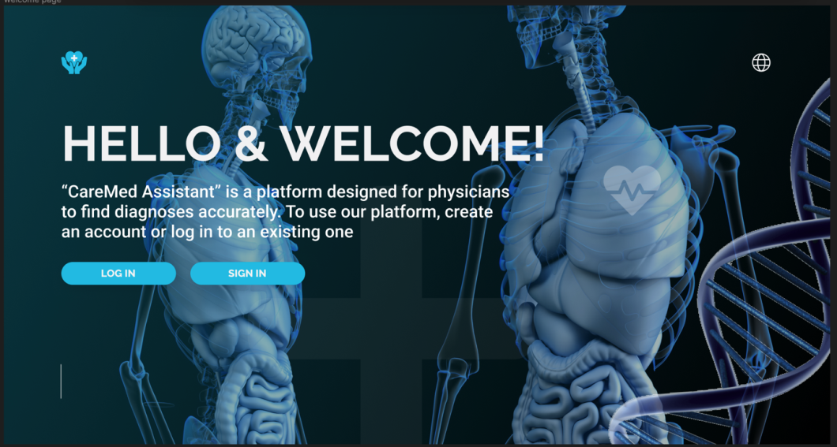

Figure B.1 - **«** CareMed Assistant» Welcome Page

On the Welcome Page, physicians will be greeted with information on how CareMedAssistant can become an indispensable tool in their daily practice. Here we talk about what the site provides and how it can help reduce diagnostic time and improve the accuracy of disease detection.

To start working on this platform, you need to register (Fig. B.2) or log in to your account (Fig. B.4).

**C.2 Sign In Page**

The Sign In Page allows physicians to log into their CareMedAssistant account. Here they enter their credentials, including special identifiers for data security. Physician authentication ensures privacy and prevents unauthorized access to medical data.

Figure B.2 – Sign In Page.

The Sign In Page provides an opportunity for new doctors to register on the CareMedAssistant platform and gain access to unique features that help in more accurate and faster identification of patient diagnoses.

Registration process:

1. Filling in the data: Doctors enter their name, date and place of birth, e-mail.
2. Password creation: The doctor chooses a strong password for his account. The password must be complex and strong enough to keep the data secure.
3. Data confirmation: After filling in the information, the CsreMedDiagnosis system checks the data for correctness and uniqueness. If necessary, the doctor can make adjustments.
4. Sending a verification code: After successfully filling in the data, a verification code is sent to the specified contact phone number or email address (Fig. 3).
5. Account Confirmation: The doctor enters the received verification code on the registration page to complete the account registration process.
6. Successful registration: After successful verification of the code, the doctor's account is created on CareMedAssistant, and he gets access to the site's functionality.

C**.3Confirmation Page**

Figure B.3 – Confirmation Page

Upon successful registration on the site, physicians are redirected to a Confirmation Page, which notifies them of the completion of the process and confirms that the data entered is correct.

C**.4 Log In Page**

Figure 4 – Log In Page

The Sign In Page allows physicians to log into their CareMedAssistant account. Here they enter their credentials, including special identifiers for data security. Physician authentication ensures privacy and prevents unauthorized access to medical data.

**C.5 Home Page**

Figure B.5 - Home Page

The Home Page is the hub of CareMedAssistant's activities. Physicians gain access to the site's main functions, such as uploading patient medical data, selecting symptoms, examinations and analyses. This page also displays the current and previous diagnoses of patients, which allows you to track the dynamics and effectiveness of treatment.

**C6 Patient Registration page**

Figure B.6 – Patient Registration page

The Patient Registration page provides an opportunity for physicians to register new patients on the CareMedAssistant platform. Here, doctors fill in the personal data and medical history of patients, which provides a complete picture of the state of health of patients and more accurately determine the diagnosis.

During patient registration, you input the following information: the patient's complete name, age, contact information, residential address, gender, blood type, and diagnosis. Rest assured, all the data you provide is handled with utmost confidentiality and safeguarded by our advanced security system.

Once the data is successfully filled in, the information of each patient is automatically incorporated into a dedicated list (refer to Fig. 7). This feature facilitates efficient organization of data and enables swift access to information pertaining to all patients served by this platform.

**C.7 List of Patients**

Figure B.7 – List of Patients

The Patient List page offers physicians a user-friendly overview of all patients registered on the CareMedAssistant platform. Here, doctors have the ability to view, add, and manage crucial information about their patients, facilitating seamless tracking of their medical history and test results. This functionality streamlines patient care and enhances the efficiency of healthcare management.

**C.8 Analysis Input (Ввод анализов)**

Figure B.8 – Input of Patient Analyses

The Test Entry page enables physicians and healthcare professionals to effortlessly upload the results of medical tests conducted on patients. In addition to entering the test outcomes, clinicians can include supplementary comments and interpretations to provide a comprehensive understanding of the findings. This feature ensures comprehensive and detailed documentation, enhancing collaboration among medical practitioners and improving patient care.

**C.9 Analysis Check**

The Review Tests page empowers physicians to thoroughly access and analyzes uploaded medical and patient exams. Leveraging advanced artificial intelligence, the CareMedAssistant system processes the data and offers preliminary recommendations for potential diagnoses. This cutting-edge technology aids healthcare professionals in making informed decisions and expediting the diagnostic process, ultimately enhancing the quality of patient care.

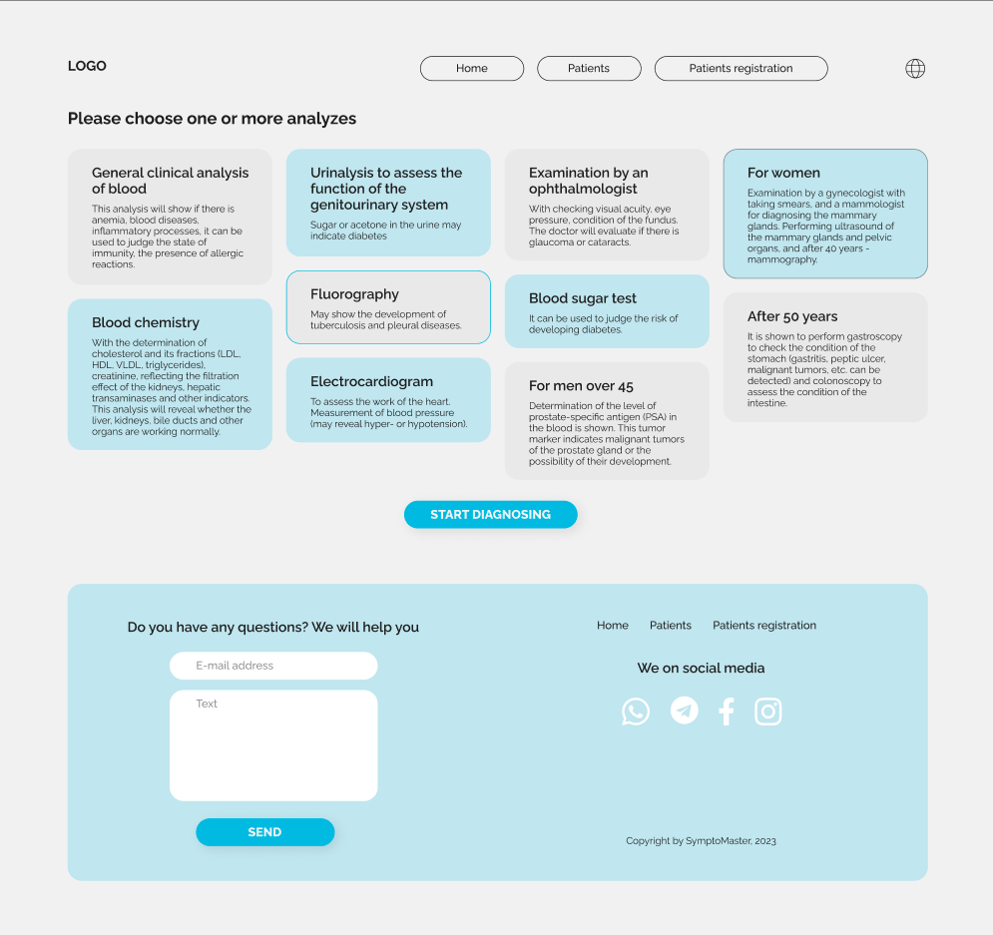

Figure B.9 – Analysis Verification

**C.10 Check Symptoms**

Figure B.10 – Symptom Verification

The Symptom Review page provides physicians with valuable information about the symptoms reported by patients, enabling them to analyze how these symptoms relate to the provided medical data and test results. This process proves instrumental in narrowing down the range of potential diagnoses and refining the need for further investigations or studies. The feature enhances diagnostic accuracy and aids healthcare professionals in delivering targeted and effective treatment plans.

**C.11 Results**

The Results page presents the conclusive diagnoses and recommendations for each patient, derived from the comprehensive analysis of medical data, test results, and reported symptoms. Physicians have the option to grant patients access to this information through their personal accounts, allowing them to stay informed and engaged in their healthcare journey. This transparent approach fosters better patient-doctor communication and empowers patients to actively participate in their treatment decisions.

Figure B.11 – Results

Key Features of the Results Page:

* Diagnosis, level of accuracy and description

Within this section of the Results page, physicians are presented with individual diagnoses for each patient. Furthermore, a diagnostic accuracy level is furnished, indicating the clinician's degree of confidence in the accuracy of the diagnosis. The diagnosis description offers comprehensive insights into the patient's condition, encompassing key disease characteristics and its prognosis.

* Causes and symptoms

In this section, doctors are provided with vital information concerning the underlying causes of the disease, as well as a detailed description of the typical symptoms associated with the diagnosis. This knowledge is crucial in enabling physicians to gain a more accurate understanding of the disease's nature, which in turn facilitates the development of appropriate and effective treatment plans for patients. By comprehending the causes and symptoms, doctors can make informed decisions and provide targeted care, ultimately enhancing the patient's chances of recovery and improved health outcomes.

* Social communication and interactions. What can be done to improve the condition

Within this section, physicians are offered valuable guidance on social communication and interaction with patients. They can learn essential skills to foster positive relationships with their patients, ensuring effective and empathetic communication. By understanding how to support patients in coping with stress and addressing their concerns, physicians contribute to improving the overall well-being and health outcomes of their patients. Building strong doctor-patient relationships based on trust and understanding is essential for providing comprehensive and patient-centered care.

* Treatment

In the Treatment section, physicians have access to comprehensive information regarding recommended medical procedures, therapies, medications, and other relevant treatments tailored to assist the patient in managing their specific condition. This wealth of knowledge enables physicians to formulate personalized treatment plans that cater to the unique needs and circumstances of each patient. By utilizing this valuable information, healthcare providers can optimize the effectiveness of treatments and ensure the best possible outcomes for their patients' health and well-being.

* Treatment of other diseases

In this section, doctors can find information about the treatment of concomitant or comorbid conditions that may impact the patient's primary condition. By considering other medical aspects, physicians can develop a comprehensive approach to treatment. This integrated approach takes into account the interactions between different health issues, allowing doctors to address multiple conditions simultaneously. By managing these concomitant conditions effectively, healthcare providers can improve overall treatment outcomes and enhance the patient's overall well-being.

The Results Page plays a pivotal role in delivering high-quality and comprehensive care. It serves as a critical resource for doctors, offering all the necessary information to make crucial medical decisions and develop personalized approaches for each patient. CareMedAssistant is committed to utilizing this approach to ensure the best possible outcomes for its users and enhance their overall health and well-being. By leveraging the wealth of data and insights provided in the Results Page, healthcare professionals can deliver patient-centered care, tailored to individual needs, and ultimately contribute to improving the overall health and quality of life for their patients.

**C.12 Admin Page**

Figure B.12 – Admin page

The admin page is designed exclusively for administrators of the CareMedAssistant platform. Through this page, administrators can access various essential features such as user management, database administration, software updates, and system settings. These functionalities enable administrators to maintain a stable and secure operation of the platform. Additionally, the admin page provides administrators with the necessary tools to monitor the site's functioning, ensuring smooth operations and resolving any potential issues promptly. With this comprehensive control and oversight, administrators can effectively manage the platform, ensuring a seamless experience for users and maintaining the platform's integrity and security.

**C.13 Program code for the given website**

