L.N. Gumilyov Eurasian National University

UDC 327.83 As a manuscript

MUKASHEVA ZARINA YERENOVNA

Perceptions of the EU agenda for the development of regional cooperation in Central Asia

8D03102 ‒ International Relations

Dissertation for the degree of
doctor of philosophy (PhD)

Scientific adviser
candidate of political sciences,
D. Akhmedyanova

Foreign scientific adviser
PhD,
professor,
Haidar Efe
(Erzincan Binali Yildirim University)

The Republic of Kazakhstan
Astana, 2025
CONTENTS

DESIGNATIONS AND ABBREVIATIONS …..……………………...…… | 3
INTRODUCTION……………………………………………………………. | 4
1 CONCEPTUAL FRAMEWORK OF THE REGIONAL COOPERATION……………………………………………………………... | 16
1.1 Understanding the Promotion of Regional Cooperation and the EU as a Promoter of Regional Cooperation……………………………………..…….. | 16
1.2 Shaping the Local Perceptions: Media Coverage and Attitudes of elites… | 25
2 Perspectives on previous studies AND EVOLUTION OF THE EU-CENTRAL ASIA RELATIONS …………………………………. | 36
2.1 Estimating Previous Studies Assessing the Regional Cooperation in Central Asia, the EU’s Approach to Promote Regional Cooperation in Central Asia, and the Perceptions on the EU’s Role in the Region……………………. | 36
2.2 Regional Dynamics and the EU’s Engagement: Intraregional Relations in Central Asia, Bilateral Ties with the EU, and the EU’s Policy towards Regional Cooperation in the Region.................................................................... | 50
3 KEY FINDINGS OF THE mixed-methods RESEARCH DESIGN……………………………………………………………………….. | 67
3.1 Survey Conducted Among Central Asian Intermediate Elites: Methodology and Results……………….……………………………………... | 67
3.2 Local Media Content Analysis of News Articles: Methodology and Results…………………………………….…………………………………… | 86
CONCLUSION……………………………………………………………….. | 96
REFERENCES……………………………………………………………….. | 103
APPENDIX A ‒ Screenshots of Collected Data on the EU Agenda for the development of Regional Cooperation in Central Asia …………..………….. | 119

DESIGNATIONS AND ABBREVIATIONS

ASEAN | ‒ Association of Southeast Asian Nations
BOMCA | ‒ Border Management Programme in Central Asia
CACO | ‒ Central Asian Cooperation Organization
CAREC | ‒ Central Asia Regional Economic Cooperation
CAWEP | ‒ Central Asia Water Energy Programme
CIS | ‒ Commonwealth of Independent States
CSTO | ‒ Collective Security Treaty Organization
EAEU | ‒ Eurasian Economic Union
EPCA | ‒ Enhanced Partnership and Cooperation Agreement
ERASMUS+ | ‒ Flagship program permitting mobility of students and staff between EU and Central Asian countries
EU | ‒ European Union
FDI | ‒ foreign direct investment
IEA | ‒ Islamic Emirate of Afghanistan
IFCA | ‒ Investment Facility for Central Asia
ILO | ‒ International Labour Organization
MERCOSUR | ‒ Mercado Común del Sur
NAFTA | ‒ North American Free Trade Agreement
OECD | ‒ Organization for Economic Cooperation and Development
PCA | ‒ Partnership and Cooperation Agreement
PTA | ‒ preferential trade agreements
SAARC | ‒ South Asian Association for Regional Cooperation
SADC | ‒ Southern African Development Community
SCO | ‒ Shanghai Cooperation Organization

INTRODUCTION
General characteristics of the dissertation research. The primary characteristic of this dissertation research lies in its examination of the perceptions and responses of Central Asian countries to the European Union’s agenda aimed at fostering regional cooperation among the post-Soviet republics in Central Asia. This research is distinct in its focus on understanding how Central Asian media and elites interpret and engage with the EU's strategic initiatives. It explores the complexities and nuances of Central Asian perspectives, highlighting not only their views on the EU’s objectives but also the underlying regional, cultural, and historical factors that shape their attitudes toward external involvement in regional integration.
Through an in-depth analysis, the research delves into the factors that influence Central Asian perceptions of the EU, including their own geopolitical interests, regional security concerns, and economic priorities. By examining these perceptions, this study provides insights into how the EU’s efforts are received locally, assessing the degree to which the EU’s values of rule-based cooperation, connectivity, and multilateralism align with the goals of Central Asian nations.
Moreover, this dissertation contributes to the broader discourse on international relations and regional integration by offering a critical perspective on the effectiveness of the EU’s regional agenda. It considers whether the EU’s approach resonates with Central Asian aspirations and examines any challenges or reservations that may arise due to competing influences from other global powers, such as Russia and China. This research is thus characterized by its emphasis on local agency and its contribution to a more nuanced understanding of regional cooperation in the context of Central Asia's complex geopolitical landscape.
Relevance. The European Union has gained recognition as a significant advocate for regional cooperation, both in its verbal declarations and financial contributions, on a global scale and in the particular regions [1]. Post-Soviet Central Asia, comprising Kazakhstan, Kyrgyzstan, Tajikistan, Turkmenistan, and Uzbekistan, often referred to as the neighboring region [2], attracts EU involvement owing to its strategic significance, the EU's eastern enlargement efforts, and acknowledgment of the region's substantial energy resources [3, 4]. Despite the geographical separation between Central Asia and Europe, their interconnectedness is indispensable due to their shared interests in economic collaboration, trade, energy resources, and security partnerships. Therefore, one of the EU's goals in the region is to promote closer regional ties to strengthen security in the region and around the EU borders and foment its soft power projection [5]. The European Union (EU) officially initiated its engagement with Central Asia through the 2007 Strategy, which was later significantly updated in 2019 to accommodate the evolving regional dynamics and strategic imperatives [6]. A core objective of this revised strategy is to deepen cooperation among Central Asian nations. The 2019 Strategy underscores the EU's commitment to fostering rule-based collaboration and advancing connectivity both within Central Asia and between Central Asia and Europe, with an emphasis on partnerships and shared benefits, rather than competition or rivalry.
This updated approach aligns with the ongoing Consultative Meetings among Central Asian heads of state, a series initiated in 2018, marking a phase of improving regional relations and cohesion. Against the complex global challenges presented by conflicts in Ukraine, enduring instability in Afghanistan, and sustained unrest in the Middle East, Central Asian governments face an increasing imperative to explore innovative regional security arrangements. In this context, the EU’s regional approach to Central Asia resonates with the geopolitical realities of the region and the stated priorities of Central Asian states to enhance intergovernmental relations, potentially facilitating new or renewed cooperative frameworks [7].
The relevance of this research is underscored by its implications for both the EU and Central Asia. Central Asian voices have played a vital role in shaping the 2019 Strategy, with input from Central Asian experts incorporated into the final text. This inclusion highlights the EU’s acknowledgment of the value of local perspectives in the formation of effective policy [8]. Such an inclusive approach strengthens the EU’s standing in the region and aligns with the aspirations of Central Asian authorities and elites, who regard EU involvement as a catalyst for positively impacting regional integration. The EU’s cooperative approach is anticipated to enhance internal connectivity and bolster the collective developmental capacity of Central Asia [9-11].
Furthermore, the EU’s engagement presents Central Asia with a valuable alternative geopolitical partnership beyond the traditionally dominant influences of Russia and China. This relationship offers Central Asian nations a potential counterbalance, supporting a diversified approach to foreign relations and regional development initiatives [12]. The EU’s role in the region, therefore, represents a broader geopolitical strategy, providing Central Asian nations with pathways to fortify their sovereignty and increase their influence within the global arena. This evolving partnership promises to contribute to regional stability and prosperity by fostering a shared vision of economic growth, security, and resilient governance.
This research holds critical relevance as it elucidates the strategic importance of the EU-Central Asia relationship, the mutual benefits derived from it, and its potential for transformative impact. The EU’s engagement contributes positively to regional development and security and exemplifies a model of cooperative international relations that actively responds to the needs of both parties. This relationship, grounded in mutual respect and shared interests, represents a significant case of effective international cooperation that can guide future developments in regional and global governance.
The degree of scientific elaboration of the problem. In prior scholarly discussions on regional relations in Central Asia, numerous studies have consistently identified enduring challenges in establishing sustainable, multilateral dialogues within the region. This body of research can be categorized into following primary areas:
The first group delves into theoretical perspectives on international cooperation, particularly the debate between neorealism and neoliberalism. Neorealism, as articulated by Waltz [13] and Mearsheimer [14], argues that an anarchic international system limits state cooperation, especially in high-stakes areas such as defense. Neoliberalism, however, holds that cooperation is achievable, with organizations like the WTO facilitating mutual benefits [15]. This theoretical divide frames regional cooperation, providing insight into why Central Asian states often struggle to collaborate effectively.
The EU’s long-standing efforts to promote regionalism globally form the second research group. Neorealist interpretations suggest that regional cooperation bolsters the EU’s security, influence, and economic interests [16], whereas neoliberal views, as outlined by Smith [17] emphasize the EU’s normative power in promoting peace, stability, and growth. The EU’s influence is further shaped by theoretical frameworks like Europeanization, interregionalism, and diffusion mechanisms. These approaches explore how EU norms are promoted abroad through tools such as social learning, incentives, and conditionality [18-20]. The EU also engages in interregionalism, seeking to strengthen relationships with other regions like East Asia, South America, and Africa, offering opportunities for cooperation and influence [21-23]. Despite these efforts, the EU often favors bilateral agreements over multilateral ones, especially when regional groupings are weak, allowing the EU more direct influence [17, p. 30].
Over the years, a substantial body of literature has explored the extent to which the EU embodies various power dimensions, including being a civilian [24], normative [25], responsible [26], ethical [27], and normal [28] power. In its role as an international actor, the EU has consistently strived to project itself as “a force for good” [29], drawing from its unique history and experiences to offer an attractive model for others. Consequently, the discourse surrounding an EU "model" has generated considerable debate among scholars [30-36].
Image theory and role theory, the third research area, provide critical frameworks for understanding state behavior and perception in international relations. Image theory posits that states’ actions are shaped by perceptions rather than objective realities, with media playing a key role in forming these perceptions [37]; [38]. Role theory, as articulated by Holsti [39] and Aggestam [40], suggests that decision-makers’ perceptions of their country’s international role significantly influence foreign policy. These theories are instrumental in analyzing EU-Central Asia relations, where the EU’s image and perceived role influence how Central Asian media and elites view its regional impact.
The fourth research group addresses how the EU’s normative power is perceived by non-EU states. Research highlights diverse perspectives: in aid-dependent regions, the EU is generally seen as a development ally, while in areas like Russia, China, and parts of Africa and Asia, EU norms are viewed with skepticism, often perceived as Eurocentric or neo-colonial [41, 42]. Local identity and historical context, such as Turkey’s apprehension toward the EU, further shape these perceptions [43].
The fifth group of discussions is dedicated to the Central Asian regional challenges in multilateral cooperation. Many scholars including local Central Asian and foreign have explored the intrinsic challenges Central Asia faces in achieving long-term multilateral cooperation, often attributing these difficulties to historical, political, and structural factors specific to the region. Key studies highlight how Central Asian nations, shaped by their post-Soviet legacy, struggle to forge cohesive regional frameworks that facilitate collaborative dialogue. This discourse includes work by Spechler [44], Bohr [45], Kakharov [46], Allison [47], Wagerich [48], Pomfret [49], Kavalski [50], Tolipov [51], Rosset [52], Cornell and Starr [53], Iskakova, Sarsembayev, and Kakenova [54], Patnaik [55], Nogayeva [56], Akhmedyanova [57], Costa Buranelli [58], Mukasheva and Akhmedyanova [59] all of whom document the complexities inherent in fostering regional unity and effective communication mechanisms within Central Asia. It is important to underline the closely related works of Central Asian authors including researchers from Kazakhstan [60-63], Kyrgyzstan [64-66], and Uzbekistan [67].
A substantial portion of the literature examines the influence of external powers on the regional cooperation in Central Asia, such as Russia, China, and the European Union, on Central Asia’s regional dynamics. Scholars argue that these external actors often have conflicting agendas that exacerbate regional divisions and hinder cohesive cooperation efforts. Studies by Zhengyuan and Xu [68], Cornell, Nourzhanov [69], Qoraboyev and Moldashev, Owen [70], Rakhimov, and Krapohl [71] discuss how the competing geopolitical interests of these powers introduce both strategic partnerships and tensions that impact regional cohesion and stability.
Another significant category within this body of work focuses on the EU's specific role and agenda in Central Asia [72-76] also address issues from various perspectives, including economic [77, 78], educational [79, 80], democratic [81-84], and security [85, 86], while examining the EU's role in promoting regionalism and its position within broader geopolitical dynamics involving China and Russia [87-91]. While the EU’s regionalism strategy is often viewed as geopolitically motivated, some scholars suggest that Central Asian elites interpret the EU’s initiatives as an opportunity to learn from successful integration models. Arynov [92] emphasizes how the EU’s engagement is seen by local elites as a pathway to strengthen regional structures, though gaps remain in understanding the alignment between EU priorities and local perceptions [8, р. 1028-1049; 59, р. 1-19; 60, р. 72-82; 61, р. 1183-1203]. Specifically, it is unclear which aspects of the EU’s regional cooperation agenda resonate most strongly with local media and elites.
Despite the existing literature, there is a notable gap in identifying how Central Asian media and intermediate elites perceive the EU’s influence and the specific spheres where they view the EU as effective in promoting regional cooperation. Therefore, the primary research question guiding this study is: In the perceptions of Central Asian media and intermediate elites, which spheres are the most influential for the EU in promoting regional cooperation within the region?
This research aims to address this question by systematically analyzing the areas in which local media and intermediate elites perceive the EU to be most impactful in fostering regional cooperation. By focusing on these perceptions, this study contributes to the existing literature by highlighting the specific domains ‒ such as economic development, security, and governance ‒ where the EU’s presence is most acknowledged and valued in Central Asia. This research thus provides nuanced insights into the alignment between the EU’s regional agenda and local stakeholder expectations, filling an important gap in the study of EU-Central Asia relations.
The aim of the work is to assess how the European Union’s agenda for promoting regional cooperation among post-Soviet republics is perceived by Central Asian media and elites, identifying which aspects are considered most influential and comprehensible, and providing policy recommendations to strengthen the EU’s engagement with Central Asian countries.
To achieve this goal the following research tasks are distinguished:
1. To understand the regional cooperation, promotion of the regional cooperation, as well as the EU as a promoter of regional cooperation.
2. To develop understanding on local perceptions illustrated by media coverage and attitudes of elites.
3. To analyze previous studies assessing regional cooperation in Central Asia, the EU’s approach, and perceptions of the EU’s role.
4. To explore Central Asian intraregional relations, bilateral ties between Central Asia and the EU, and the EU’s policy towards regional cooperation.
5. To present key findings of the mixed-methods research design – survey of intermediate elites and local media content analysis.
Each task can help address different facets of understanding the EU’s influence on regional cooperation in Central Asia, and together they form a comprehensive framework for this research study.
Object of study is the EU’s efforts to promote regional cooperation within Central Asia.
Subject of study is the perceptions of Central Asian media and intermediate elites regarding the EU’s regional cooperation initiatives.
The chronological framework of the study. The research on media analysis covers the period from 2019, marking the adoption of the EU's recent Strategy, to 2022. The online survey of local elites was conducted from June to November 2023.
The research methodology. To address the research question, this study employs a mixed-methods approach, which includes: 1) a quantitative content analysis of news articles from five popular media portals – 24.kg (Kyrgyzstan), Asiaplus.news (Tajikistan), Kun.uz (Uzbekistan), Tengrinews.kz (Kazakhstan), and Turkmenportal.com (Turkmenistan) – covering the period from 2019, the year of the recent Strategy adoption, to 2022; and 2) an online survey of local intermediate elites conducted from June to November 2023.
According to Similarweb, a global company specializing in web analytics, digital performance, and web traffic data aggregation, these media portals are the most widely followed general news sites in their respective countries. Tengrinews.kz, recognized as Kazakhstan's largest information site, ranks among the top 30 news websites in the country. Likewise, Kun.uz, 24.kg, Turkmenportal.com, and Asiaplus.news are highly influential in Uzbekistan, Kyrgyzstan, Turkmenistan, and Tajikistan, respectively, with Asiaplus.news being the most-read source for Tajik users, reaching approximately 30,000 unique daily visitors. These news outlets were selected due to their substantial regional influence and significant user engagement. Positioned at the intersection of information flows between elites and the general public, these media sites are pivotal in shaping international perceptions [93].
The perspectives of intermediate elites are particularly valuable to this study. Unlike the general population, which may have limited awareness of the EU's policies in Central Asia [94], intermediate elites play a crucial role in influencing high-level elite perceptions and policy outcomes, yet their views remain understudied [95]. Understanding their perspectives is essential, as they indirectly impact policy formulation and implementation. The development of regional identity is shaped by political decisions and elite actions, mirroring dynamics observed in other regions inspired by EU models [96].
The study engaged members of the intermediate elite in Central Asia through two main respondent groups. The first group, connected via the Cabar.Asia network (Central Asian Bureau for Analytical Reporting), included experienced regional experts and journalists, fostering analytical expertise and media training across Central Asia. The second group comprised personally known academic experts, diplomats, and journalists. Ethical guidelines by Bell and Bryman [97] were strictly followed, ensuring participant dignity, anonymity, and data confidentiality, with transparency and honesty prioritized throughout the research process.
This approach aims to foster a more balanced and comprehensive understanding across multiple domains, ultimately contributing to more robust regional cooperation.
At the same time, it is important to acknowledge limitations:
Limitation 1 is related to the subjectivity of the two methods. First, there is subjectivity in classifying news for the content analysis technique used. We are aware that there is always a human with prejudices behind the classification process, and therefore the findings are inherently inaccurate. Quantitative analysis software can only assist with the extraction and analysis of data, but it cannot mechanically sort it [98]. Second, the survey questionnaire was designed by someone who perceives the situation from their own point of view, with their own biases and perceptions.
Limitation 2 is the most crucial to note. The survey was conducted among Central Asian intermediate elites, which may not fully represent the diverse perspectives of the entire population in the region. The findings may be limited to the specific group of individuals surveyed. The scarcity of information regarding public opinion in Central Asia is indeed a challenge in conducting comprehensive surveys in the region. As highlighted by Peyrouse [99], there are limited autonomous institutions and resources dedicated to conducting surveys in countries like Turkmenistan and Uzbekistan, while institutions in Kazakhstan, Kyrgyzstan, and Tajikistan face significant challenges.
Furthermore, it is true that the general population in Central Asia may have limited exposure and understanding of international events and foreign policies. As a result, conducting surveys among the wider population may yield responses that are less informed or lack a nuanced understanding of the research topic. Therefore, focusing on intermediate elites, who have a higher level of awareness and knowledge of the research issue, can provide valuable insights into the perceptions and views of a more informed segment of the population.
By targeting intermediate elites, such as diplomats, experts in international relations, and journalists, the survey aims to capture the perspectives of individuals who are actively engaged and knowledgeable in relevant fields. While this approach may not represent the views of the entire population, it offers valuable insights from a specific segment of society that can contribute to our understanding of Central Asian perceptions of the EU’s influence on the regional cooperation within Central Asia.
Furthermore, it is important to acknowledge the potential bias that may arise from conducting the survey within the singular Cabar.Asia network. The selection of respondents from these networks could introduce a certain level of bias in favor of the EU or result in a skewed perspective. As members of this network are likely to have an interest or affiliation with the EU or have a more positive view of its activities, their responses may not fully represent the diverse range of opinions within Central Asian society.
It is important to acknowledge the limitations of any survey conducted within a specific group and to interpret the findings in the context of the targeted sample. Future research can strive to expand the scope and reach of surveys in Central Asia to include a broader cross-section of the population while addressing the challenges associated with limited resources and awareness among the general population.
Limitation 3 emphasizes that content evaluations focus on the perspective of news sources rather than the audience. This means that our research does not investigate how Central Asians perceive the same content, how they interpret meaning within their social groups, and whether they understand the content within the context of national interests, corporate influences, and other factors. Additionally, we do not know if these views translate into a change in attitudes towards the EU.
Furthermore, the media content analysis was conducted solely in the Russian language, which may exclude relevant sources or perspectives in other languages spoken in Central Asia. This could potentially introduce a bias in the analysis. Additionally, the study's analysis was conducted based on data collected between 2019 and 2022. It is important to consider that perceptions and dynamics may have evolved or changed since then, and the study may not capture the most current viewpoints.
Limitation 4 pertains to the exclusion of other sources of information, such as local newspapers, television, radio, and public opinion from social media platforms like Facebook, Instagram, and Telegram channels. It is possible that the research results would have been different if these sources were included in the analysis. Additionally, although social media is gaining popularity in Central Asia, it can be challenging to ascertain the accuracy of the information shared on these platforms. According to Ribeiro [100], many Facebook pages are categorized as news media outlets, but their reliability is questionable. This poses a challenge for media content analysis. Therefore, in this study, we focused on official websites of regional media outlets rather than social media pages. Furthermore, online media sources were used for the study due to the article format and the ease of data collection and sorting.
Limitation 5 highlights the issue of regulated media censorship in Central Asia [101]. Due to political and economic factors, as well as widespread self-censorship, journalism in the region is constrained. As a result, the content presented on news portals may not fully reflect the true reality in Central Asia. It is important to acknowledge that the findings of this research may be influenced by the lack of media coverage on certain events or aspects of occurrences.
Limitation 6 highlights the omission of geopolitics in the research, particularly the involvement of actors other than the EU, such as Russia and China. Central Asia shares close proximity with Russia and China, and the region is a member of various regional organizations like the EAEU, SCO, CSTO, and CIS. Additionally, the research overlooks the different versions of cooperation, such as C5+1, between Central Asia and other countries like the United States, Japan, India, and Korea. These factors can have a complex impact on regionalism processes within Central Asia. It is important to acknowledge that this limitation exists and may have implications for the overall understanding of the EU's influence in the region.
Despite these limitations, this study provides valuable insights into the Central Asian view of the EU's role in promoting regional cooperation and adds to the existing body of research on this topic. Future studies can build upon these findings and address the limitations to further enhance our understanding of Central Asian perceptions and the EU's impact in the region.
The source base of the study. The first group of sources includes foundational European Union documents such as the EU Global Strategy [103], the 2007 EU Strategy for Central Asia, and the renewed 2019 EU Strategy for Central Asia, titled “EU and Central Asia: New Opportunities for a Stronger Partnership”, which were issued specifically targeting the region.
The second group of sources includes the foreign policy concepts of Central Asian countries, where Central Asian states pursue multi-vector foreign policies aimed at balancing international relations, supporting domestic development, and fostering regional cooperation, with specific doctrines including Kazakhstan's leadership goals [104-105], Kyrgyzstan’s pragmatic approach [106-108], Tajikistan’s “open doors” policy [109-111], Turkmenistan’s permanent neutrality [112-114], and Uzbekistan’s economic liberalization and neighborhood stability focus [115, 116].
The third type of documents includes key bilateral agreements between the EU and each Central Asian state, such as Partnership and Cooperation Agreements (PCAs) and Enhanced Partnership and Cooperation Agreements (EPCAs). Tajikistan (2004) [117] and Uzbekistan (1996) [118] have PCAs with the EU, which primarily guide political and economic dialogue, as well as cooperation in areas like trade, investment, energy, and business. Turkmenistan has the lowest level of bilateral relations with the EU and has only signed an interim trade agreement [119]. Kyrgyzstan recently signed an EPCA in 2024, though the agreement has yet to be ratified. Until ratification, the relationship between the two parties continues to be regulated by the PCA from 1995 [120]. Kazakhstan enjoys the most advanced level of relations with the EU, having signed the EPCA in 2015 [121], which provides an enhanced legal foundation for EU-Kazakhstan relations.
The fourth type of sources includes statistical data from platforms such as SimilarWeb.com [122], WorldBank.org [123], Cabar.asia [124], Commission.europa.eu [125], and various EEAS factsheets on the EU’s relations with Central Asia and individual countries within the region [126], including Kazakhstan [127], Kyrgyzstan [128], Tajikistan [129], Turkmenistan [130], and Uzbekistan [131].
The fifth group includes media content in the form of news articles (excluding analytical data and interviews) from local media outlets, such as 24.kg (Kyrgyzstan), Asiaplus.news (Tajikistan), Kun.uz (Uzbekistan), Tengrinews.kz (Kazakhstan), and Turkmenportal.com (Turkmenistan).
Key points to defense.
1. The discourse on the promotion of regional cooperation highlights a complex interplay of theoretical perspectives, such as neorealism and neoliberalism, which define self-interest and normative approaches in the EU’s policy of promoting regionalism abroad.
2. Both elite attitudes and media coverage emerge as critical factors in determining the success of regional cooperation initiatives. While elite perceptions and preferences shape policy direction and the willingness to engage in integration efforts, media representations help mold public understanding and support.
3. Previous studies largely identify lack of regional cohesiveness in Central Asia, while the EU is often viewed as prioritizing geopolitical interests over its normative agenda. The generally positive perception of the EU in Central Asia contrasts with a misunderstanding of its normative approach.
4. Central Asia’s journey toward deeper regional cooperation faces ongoing challenges despite recent positive changes in intraregional relations, the EU’s evolving strategy toward the region, and its bilateral relations with each republic offer a promising framework for fostering stability and regional cooperation in education, energy, and democracy promotion, while also addressing critical regional challenges such as border and security management, drug trafficking prevention, COVID-19 mitigation, environmental concerns, and trade.
5. Central Asian elites express mixed views on the EU’s influence. On the one hand, there is a strong support for EU-led initiatives in environmental, economic, and educational areas; on the other hand, skepticism about the EU’s geopolitical role compared to more dominant actors like Russia and China. The EU is recognized as a facilitator in sectoral areas but faces challenges in being viewed as a significant geopolitical player and normative promoter of democratic values.
The local media covers EU-Central Asia cooperation primarily through bilateral agreements (27% of news stories frame EU-Central Asia relations), with a focus on security, development, and financial assistance, highlighting Tajikistan and Kyrgyzstan more prominently, and portraying the EU’s role in regional cooperation with a generally neutral tone, except for 24.kg which presents a positive view.
Scientific Novelty of the Work. This research contributes novel insights into how the EU’s regional cooperation efforts are perceived in Central Asia, addressing gaps in the literature regarding the effectiveness of EU norm promotion. To talk more specifically we can underline particular points:
1. Focus on Key Areas of Recognition: Based on the media content analysis method the EU’s potential to foster regional cooperation in Central Asia is primarily acknowledged in the areas of security, economic support, and environmental sustainability, as highlighted by local media coverage.
2. Neutral Perceptions in Other Domains: In other areas of EU engagement, such as political or social initiatives, perceptions tend to be more neutral as content analysis results have shown.
3. Local Intermediaries’ Views: Based on the survey method local intermediaries recognize the EU's beneficial role in enhancing cooperation, particularly in the environment, education, and economics.
4. Dependence on Economic and Environmental Initiatives: The EU’s effectiveness in promoting regional cooperation is largely dependent on its emphasis on economic and environmental initiatives, which are positively received by local media and influential elites. This result is based on the comparison of two methods’ findings.
5. Need for Culturally Sensitive Approach: Based on the results of two methodological approaches, the EU should adopt a more culturally sensitive approach that takes into account the region's unique values and needs to address skepticism surrounding its other initiatives.
Theoretical and Practical Significance of the Research. The key findings and conclusions of the thesis provide valuable insights for a wide range of international experts, fostering further exploration of European and Central Asian regional foreign policies. The research holds significant practical relevance, particularly for the training of diplomatic personnel, the teaching of core and specialized courses in International Relations, and the development of textbooks in social sciences and related disciplines. Its insights also contribute to the enhancement of foreign policy frameworks, with certain conclusions directly applicable to the work of Ministry of Foreign Affairs personnel, aiding in more effective policy design and implementation.
The findings emphasize the importance of the EU adopting more targeted approaches to regional cooperation by recognizing the diverse interests and priorities of Central Asian countries. By prioritizing areas of shared concern, such as environmental collaboration and economic assistance, and addressing security challenges in a way that avoids perceptions of interference or neo-colonialism, the EU can strengthen its regional influence. Insights into how the media portrays the EU further help refine diplomatic strategies, enabling more effective engagement with Central Asian countries on issues most relevant to local elites.
Future studies should delve deeper into the reasons for varying levels of media coverage across Central Asian states, particularly in Kazakhstan, to better understand the influence of national political agendas or historical ties on perceptions of the EU. Conducting additional surveys and interviews with Central Asian elites could also provide valuable insights into regional priorities, helping the EU improve its strategies for fostering multilateral cooperation. Furthermore, expanding the scope of media analysis to include online and social media platforms could enrich the understanding of the EU’s image in the region and offer more nuanced perspectives for engagement strategies.
This thesis highlights the interconnectedness of media, diplomacy, and regional priorities in shaping effective foreign policy, offering actionable insights for academics and practitioners alike.
Testing the results of the study. We tested the results of this research in the following recently published scientific journals: Is EU Democracy Promotion Aligned with Local Media Perception in Central Asia? Findings from Content Analysis, published in Political Research Exchange Journal [59, р. 1-19] as well as Evolution of the Bilateral Partnership Between the European Union and Kazakhstan: Results from the Content Analysis of the PCA and EPCA, published in Bulletin of KazNU [132], A New Phase of Regionalism in Central Asia? Content Analysis of Documents and Speeches Following the IV Consultative Meeting of 2022, published in Bulletin of L.N. Gumilyov Eurasian National University [133] and Evolution of The European Union’s Engagement with Central Asia published in Journal of Central Asian Studies [76, р. 7-18].
Furthermore, article “The Normative Power of the European Union: The Case of Central Asia,” December 2021 [134], published in the proceedings of the conference Science and Education held by L.N. Gumilyov Eurasian National University dedicated to the 30th anniversary of Kazakhstan's independence and “The European Union Agenda on Promoting Regional Cooperation in Central Asia”, published in the proceedings of the conference Science and Education held by L.N. Gumilyov Eurasian National University in 2023 [135]. Article based on the outcomes of the conference at the Peoples' Friendship University of Russia (RUDN), focused on the Eurasian Economic Union and integration processes in Eurasia, titled: “The Diffusion of European Union Norms: The Case of the Eurasian Economic Union” [136]. Additionally, during the spring semester on March 16, 2023, an online academic seminar on the topic of the dissertation research was conducted. The seminar was attended by faculty members of the Department of International Relations, as well as master’s and PhD doctoral students [137].
The structure of the dissertation. The dissertation consists of normative references, introduction, three sections, 30 figures, 9 tables, conclusion, list of references - 261 and appendices.

Chapter 1 lays the foundation for understanding the concept of regional cooperation promotion, offering a comprehensive overview of the theoretical framework that underpins this study. It examines the European Union’s (EU) role as a promoter of regionalism beyond its own borders, detailing the mechanisms through which it engages with neighboring regions. Additionally, this chapter delves into the critical role that media and local elites play in shaping perceptions of the EU’s influence, highlighting how these perceptions can vary significantly across different contexts.
Chapter 2 presents an extensive literature review of previous studies focused on the EU as a regionalism promoter. It synthesizes existing research, illuminating key themes and identifying notable gaps in the literature. This section of the chapter pays particular attention to the global perceptions of the EU’s role, with a special emphasis on Central Asia. By exploring local attitudes and understandings, it underscores the necessity of integrating these perspectives into any assessment of the EU's impact and effectiveness in the region. Furthermore, a historical overview of regional integration initiatives in Central Asia is provided, concentrating on the EU's engagement with the region. This second half of the chapter reviews the evolution of the EU’s agenda for promoting regional cooperation, discussing various political, economic, environmental, and normative dialogues. It highlights specific initiatives undertaken by the EU to enhance regional collaboration, illustrating both successes and challenges encountered in these efforts.
Chapter 3 outlines the methodological framework guiding this research and the main findings. It details the content analysis conducted on news articles sourced from five prominent Central Asian news outlets, providing insight into how media narratives reflect and influence public opinion. Additionally, this chapter describes a survey carried out among a select group of Central Asian respondents, including diplomats, international relations experts, and journalists. It elaborates on the data collection process, the research instruments employed, and the methods used for data analysis, ensuring a robust approach to understanding local perspectives. Furthermore, the Chapter 3 presents the primary research findings, engaging in a thorough discussion of the results. By synthesizing findings with existing literature, the research aims to contribute to a deeper understanding of the complexities involved with the process of the EU regionalism promotion in Central Asia.

1 CONCEPTUAL FRAMEWORK OF THE REGIONAL COOPERATION

1.1 Understanding the Promotion of Regional Cooperation and the EU as a Promoter of Regional Cooperation
The ongoing debate between neorealism and neoliberalism has profoundly influenced our understanding of cooperation in international relations, particularly regarding how states navigate their interactions on the global stage. Central to this discourse is the neorealist perspective, which, whether framed through a defensive or offensive lens, asserts that cooperation among states is frequently improbable. When cooperation does occur, it is typically confined to areas of "low politics," such as economic cooperation, while "high politics," particularly concerning national security, tends to resist collaborative efforts [13, р. 1-18; 14, р. 3-300]. Neorealists argue that the anarchic structure of the international system, characterized by a lack of a central authority and the pursuit of self-interest by states, makes sustained cooperation challenging.
For neorealists, the inherent competition among states is underscored by a perpetual security dilemma, where the actions of one state to ensure its own security may inadvertently threaten others. This dynamic often leads to a cycle of mistrust and conflict, inhibiting cooperative ventures. Moreover, neorealists emphasize the role of power distribution in shaping state behavior, suggesting that stronger states may exploit weaker ones, further complicating potential cooperation. The belief that states primarily act in their self-interest casts a long shadow over the possibility of enduring partnerships, particularly in matters of security, where survival is the ultimate concern.
In contrast, neoliberalism presents a more optimistic view of international relations. Neoliberal theorists contend that cooperation is not only feasible but can occur across a diverse range of issues, encompassing those traditionally regarded as high politics [138]. Unlike neorealists, who view conflict as a natural and often inevitable aspect of international politics, neoliberals assert that states can resolve conflicts through mechanisms that promote dialogue and negotiation. They argue that institutions play a critical role in facilitating cooperation, serving as platforms where states can communicate, build trust, and work toward mutual goals.
Neoliberal scholars emphasize the importance of economic interdependence as a key factor fostering cooperation among states [139]. The logic is straightforward: as states become more economically intertwined, the costs of conflict rise, incentivizing them to seek collaborative solutions. International institutions, such as the World Trade Organization (WTO) and regional trade agreements, are seen as vital tools in this process, mitigating the self-interest of states and guiding them toward cooperative outcomes [140]. Neoliberalism thus provides a framework for understanding how shared interests can lead to effective collaboration, even in a competitive international system.
Despite these divergent views, both neorealists and neoliberals acknowledge a fundamental limitation in the international system: the absence of a sovereign authority capable of enforcing binding agreements among states. This lack of a central governing body complicates the dynamics of cooperation, as states must navigate their interactions without the assurance of compliance or enforcement mechanisms.
To further comprehend the intricacies of cooperation, it is crucial to differentiate the concept of regional cooperation from related terms such as regional integration, regionalism, and regionalization. Regional cooperation refers to collaborative policy actions undertaken by a group of countries within a defined geographical area. The overarching aim of such cooperation is to achieve a level of collective welfare that exceeds what individual nations could accomplish independently [141]. This process can take many forms, from economic partnerships to joint security initiatives, illustrating the multifaceted nature of cooperation.
For instance, the Association of Southeast Asian Nations (ASEAN) exemplifies a regional cooperation framework where member states work together on issues ranging from trade to environmental challenges. While some initiatives emphasize fostering economic integration, others prioritize social or political goals, reflecting the diverse motivations behind regional cooperation efforts. This adaptability allows countries to address pressing issues collaboratively while recognizing their unique national interests.
In contrast, regional integration denotes a deeper, more systemic merging of economies within a particular region. This process can occur through market-driven integration, which takes place without formal agreements, or through policy-induced integration that stems from cooperative efforts. The intensity and nature of regional integration can vary widely, with full integration facilitating the free movement of goods, services, and labor among countries involved. This transformation often leads to a reorientation of domestic political loyalties, as political actors begin to prioritize regional interests over national ones [142].
Cooperation itself operates within a landscape characterized by competing interests, necessitating that actors adapt their behaviors to align with the preferences of others [143]. Effective cooperation hinges on shared problems and specific needs that create a framework for collective action [144]. This dynamic assumes the existence of self-governing, self-provisioning communities that engage in consensus-building, fostering an atmosphere conducive to collaboration [145].
Identifying the international and domestic conditions that facilitate effective regional cooperation is a vital area of ongoing research. Factors such as political stability, economic incentives, and cultural ties significantly influence the willingness of countries to engage in cooperative initiatives. For example, the European Union (EU) represents a notable case where regional cooperation has flourished due to shared economic interests, cultural affinities, and political commitments to peace and stability. Understanding these conditions can empower policymakers to design frameworks that promote cooperation across various contexts.
Moreover, distinguishing between regionalization and regionalism is essential for a comprehensive understanding of regional dynamics. Regionalization is primarily a market-driven phenomenon that results from unilateral reforms within individual economies in a region [141, p. 15]. Favorable trade and investment conditions, coupled with geographic and cultural factors, can incentivize multinational enterprises (MNEs) to establish production facilities across multiple countries, leading to the creation of regional production networks characterized by increased specialization and interdependence. This is often exemplified by the "flying geese" model, which describes how production migrates to more cost-effective areas as economies develop [146].
Conversely, regionalism encompasses formal economic cooperation and arrangements among countries aimed at enhancing regional integration. Examples of regionalism include regional trade agreements (RTAs) designed to strengthen economic ties and reduce trade barriers. The North American Free Trade Agreement (NAFTA), now succeeded by the United States-Mexico-Canada Agreement (USMCA), illustrates how regionalism can promote economic integration while reflecting the specific interests of member states. While terms like regional cooperation, integration, regionalization, and regionalism are sometimes used interchangeably, it is critical to recognize their distinct processes and implications [147].
The key concepts that define the depth of regionalism involve cooperation and integration within a given region. "Regionalism can be understood as encompassing a range from cooperation to integration" [148]. While "regional integration" may be used interchangeably with "regionalism," it can refer to both a static situation and a dynamic process depending on context [149]. Importantly, "regional cooperation" and "regional integration" are not synonymous; the former is considered a component of the broader process leading to the latter [150]. Cooperation can occur without the necessity for formal institutions, equal reward distribution, or standardized practices, and may manifest as strictly functional without long-term commitments [151]. In contrast, integration entails a more profound shift wherein governments cede individual decision-making authority in favor of delegating power to supranational bodies.
Muntschick [149, p. 13] asserts that regionalism and regional integration are interchangeable terms, encapsulating a spectrum of multidimensional regional cooperation initiatives defined by territorial parameters and constrained by member states. This perspective aligns with the European Union’s intricate network of international cooperation and institutions, which emphasizes the interconnectedness of regionalism and cooperation [152, 153]. While this approach simplifies the complexities of reality, it allows for the modeling of causal relationships and the illustration of patterns at a higher analytical level [154].
The figure 1 below provides a structured comparison of Old Regionalism, New Regionalism, and Comparative Regionalism, highlighting the evolution of regionalism in response to changing global dynamics. Each category – World Order Context, Links Between Governance Levels, Sectors, Actors and Forms of Organization, Ontology, Epistemology, and Methodology – sheds light on the theoretical and practical shifts across these phases.

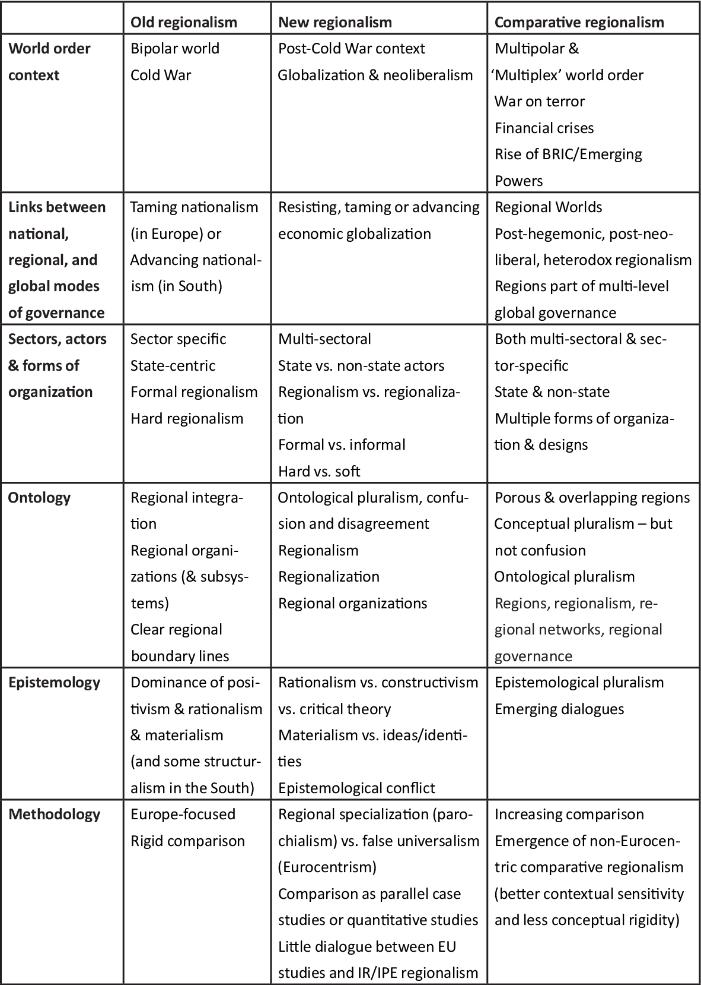

Figure 1 – Old Regionalism, New Regionalism, and Comparative Regionalism

Note ‒ Compiled from source [155]

In this study, we will specifically focus on the promotion of regional cooperation, exploring its mechanisms, benefits, and challenges. Understanding these dynamics is crucial for fostering successful collaboration among nations and enhancing regional welfare. By unpacking the nuances of these terms, we can better appreciate the complexities of international relations and the potential for cooperative initiatives across various regional contexts.
A fundamental question that emerges from this discourse is whether regional cooperation can be externally promoted or facilitated. This research adopts a neorealist framework to analyze the role of external powers in fostering regional cooperation and integration. According to neorealism, the distribution of power in the international system plays a pivotal role in shaping state behavior. External powers can act as catalysts for regional cooperation by encouraging, facilitating, or endorsing multilateralism. Weaker states, particularly when faced with a common threat from a dominant power, often seek cooperation as a strategic response. They may choose to counterbalance stronger states, such as Russia and China, or "bandwagon" with them by aligning themselves with a more powerful coalition in multilateral arrangements [156]. The term “bandwagoning” describes the strategy employed by weaker states that align with stronger powers when they perceive the costs of opposing them as prohibitively high [157].
The influence of external powers in promoting regional cooperation varies significantly based on their interests and engagement strategies within specific regions. Major powers can play pivotal roles in establishing regional structures, either facilitating or obstructing their formation. When a dominant power exerts substantial influence, it often seeks to institutionalize its role as a means of safeguarding its strategic, economic, or political interests [139, р. 3-270]. This process not only aids in forming regional structures but also contributes to the development of a regional identity, enhancing the external power's legitimacy and reducing the costs associated with its dominance [157, р. 118-133]. Regional states may find it advantageous to forge closer economic or security ties with more influential powers, indicating a greater willingness to collaborate [158].
From the perspective of regional states, their interactions with external powers significantly shape the trajectory of regional cooperation. Neorealists assert that when regional states perceive the involvement of an external power as a threat, they often resort to balancing strategies by cooperating with one another across various domains. In this context, an external power can stimulate closer regional cooperation, especially when its presence is perceived as a potential threat [157, р. 118-133]. The extent to which external powers can promote regional cooperation hinges on their strategic interests, local state behaviors, and the interrelations among various regional structures sponsored by these external actors.
One of the such kind of external powers is the European Union (EU). The EU’s long-standing aim to promote regionalism globally continues to be an integral part of its external policies and remains a main objective of the EU’s 2016 Global Strategy [102, р. 3-58]. This strategy underscores the EU’s commitment to fostering a more integrated international system through regional cooperation, recognizing that stability and prosperity in neighboring regions can significantly enhance the EU’s own security and economic interests. Theoretically, this endeavor can be explained by two competing motivations: neorealism and neoliberalism [159].
From a neorealist perspective, regional cooperation enhances the EU's influence relative to other international actors and target countries. Such cooperation often leads to increased trade and the dissemination of EU norms and regulations [160]. By fostering regional alliances, the EU can wield greater leverage in its dealings with countries outside its borders, positioning itself as a critical player in global governance. Moreover, regional cooperation can provide a strategic buffer against potential conflicts that might arise in neighboring areas, thereby protecting the EU's interests and stability.
While the EU's promotion of regional cooperation may enhance the bargaining power of neighboring countries within a grouping, it retains the authority to grant or revoke benefits, which underscores its dominance in these relationships [161]. This conditionality illustrates that the EU’s economic interests are not easily compromised in favor of regional cooperation. The EU’s approach of engaging with neighboring countries through regional groupings allows for time and cost savings. By formulating regional strategies and organizing regional meetings that incorporate bilateral negotiations, the EU can streamline its diplomatic efforts [162]. This efficiency not only facilitates smoother interactions but also amplifies the EU's influence in shaping regional agendas.
From a neoliberal perspective, the EU promotes regional cooperation because it acknowledges, based on its own experiences, that such collaboration fosters peace, stability, and economic development [17, р. 3-325]. The EU perceives regional cooperation as a mechanism for contributing to a more orderly world and facilitating economic growth in neighboring regions [163]. By encouraging economic development and enhancing competitiveness, the EU believes it can foster environments conducive to peace and mutual prosperity [164]. This ethical approach reflects broader EU narratives that emphasize the value of regional integration and the EU's role as a normative power in global affairs.
Over the years, a substantial body of literature has explored the extent to which the EU embodies various power dimensions, including being a civilian [24, р. 32-46], normative [25, р. 235-257], responsible [26, р. 3-236], ethical [27, р. 1-10], and normal [28, р. 1-17] power. In its role as an international actor, the EU has consistently strived to project itself as "a force for good" [29, р. 109-129], drawing from its unique history and experiences to offer an attractive model for others. Consequently, the discourse surrounding an EU "model" has generated considerable debate among scholars [30, р. 109-129; 31; 32, р. 167-189; 33, р. 192-206; 34, р. 333-351; 35, р. 407-425; 36, р. 669-681].
The study of Europeanization beyond the EU can benefit from various theoretical frameworks that have previously been employed to analyze its effects within member states. Schimmelfennig and Sedelmeier [18, р. 3-250] identify two main dimensions of Europeanization: whether it is EU-driven or domestically driven, and whether it operates through the “logic of consequences” (cost-benefit calculations) or the “logic of appropriateness” (social norms). EU influence can manifest through external incentives, such as rewards or sanctions, or through social learning, leading to the adoption of EU norms.
Lavenex and Uçarer [165] outline four modes of EU governance: unilateral policy emulation (adopting EU rules due to perceived superiority), negative externalities (adopting to avoid costs), and conditionality (adapting based on EU requirements that align with domestic interests). This multiplicity of influences illustrates the complex dynamics of how EU norms can be adopted, further complicating the understanding of regional cooperation.
Additionally, Diez, Stetter, and Albert [166] describe four pathways of EU impact on border conflicts, ranging from direct measures, such as incentives, to more indirect effects through integration processes that reshape identities. Bauer, Knill, and Pitschel [167] categorize EU governance modes into compliance (binding rules), competition (market pressures), and communication (information exchange), each affecting domestic change in distinct ways.
Börzel and Risse [19, р. 290-306] propose a typology of diffusion mechanisms, distinguishing between direct influences, such as coercion and persuasion, and indirect influences, like competition and emulation. This framework suggests that the diffusion of EU norms is a complex process influenced by various actors, both governmental and societal. They further elaborate that diffusion processes cannot be measured solely by outcomes; the connections and interactions among actors must also be taken into account to understand the full implications of EU influence.
Lavenex [20, р. 680-699] emphasizes six mechanisms of rule projection, highlighting different structures of interaction and types of power, such as conditionality and competition. These perspectives indicate that Europeanization operates through both direct and indirect pathways and can involve a variety of stakeholders, underscoring the complexity of how EU norms and practices are adopted beyond its borders.
Another valuable approach to analyze the EU's promotion of regionalism abroad is the theoretical framework of interregionalism [160, p. 117-131]. Interregionalism refers to the relationships between regional groups, specifically the interactions between the European Union and regional or subregional organizations, regardless of their degree of institutionalization [21, р. 3-190]. Numerous studies have examined the diverse interregional agreements reached by the EU around the world, illustrating how interregionalism has become a cornerstone of the EU’s foreign policy [155, p. 3-26]. Delcour posits that the increasing relevance of interregionalism is evident in the growing share of regional cooperation that emerged in the late 1980s and 1990s, leading to the formation of groupings and organizations such as MERCOSUR, NAFTA, SAARC, and SADC [20, p. 3-190]. This “new regionalism” corresponds with the global expansion of EU foreign policy initiatives [168].
In this context, the EU sees the development of regional ties as essential to its foreign policy, enhancing its international actorness and overall efficiency [16, p. 117-131]. Empirical studies focusing on specific interregional ties between the EU and various regions ‒ including East Asia [22, p. 59-77], South America [23, p. 2-400], and Africa ‒ highlight the EU’s efforts to project its influence through regional cooperation. As Smith illustrates, the EU’s support for regional cooperation is one of its oldest principles and a fundamental objective in the international arena [160, p. 3-296]. As emphasized by De Lombaerde and Schulz [169], the EU is likely to influence regionalization abroad through its direct and indirect contributions.
Scholarly consensus indicates that the EU played a pivotal role in initiating two significant waves of regionalism since World War II, effectively shaping the contemporary regional landscape [170, 171]. Evidence suggests that norms, institutions, and policies originating in Europe are increasingly being adopted elsewhere [35, p. 407-425; 172, 173]. This trend signifies a shift from traditional intergovernmental cooperation to supranational governance models among regional organizations [174].
Despite the notable influence of EU normative power on regionalism, much of the existing research has focused on whether the EU functions as a normative power regarding its methods, objectives, and rhetoric [175, 176]. This focus stems, in part, from Manners's emphasis on exploring the internal and external dimensions of Europe as a global actor and his comprehensive analysis of normative power’s critical dimensions [177]. Furthermore, empirical analysis of the EU's ideational impact has proven challenging; while criteria for normative power can be established, attributing specific causal effects is complicated by numerous influencing factors.
Lenz [173, p. 211-227] addresses this gap by refining Manners's framework to enhance empirical investigation into the EU's ideational influence on regionalism. He introduces the concept of "ideational diffusion," framing normative power as the EU's capacity to disseminate EU-style norms, institutions, and practices through non-material means. Although Manners acknowledged the significance of diffusion in his earlier work [178, 179], he did not fully develop this concept. Lenz argues that the EU’s influence on regionalism can be understood as an indirect process in which the EU shares its experiences with other regions through socialization and emulation. However, due to varying structural conditions, the outcomes of EU ideational diffusion often yield different or divergent institutional practices across regions. Lenz proposes a choice-oriented approach to empirically examine these claims, focusing on the counterfactual premise that regional political decisions would differ in the absence of the EU's influence.
The EU employs various traditional instruments to promote regional cooperation [159, p. 22]. These instruments include assistance for conflict prevention and crisis management, capacity-building for regional groupings, establishing cooperation agreements, providing economic aid for cross-border projects, and engaging in dialogues across political, economic, environmental, educational, and democratic spheres [159, p. 22]. While conditionality is also employed, its application is somewhat limited. Notably, the EU stands out as a significant donor, offering financial support for regional cooperation programs. Through political dialogues, it aims to create a framework for discussing issues of regional importance [159, p. 23].
However, in contrast to its enlargement processes, the EU does not frequently employ conditionality as a tool when promoting regional cooperation. In cases where regional groupings are weak, the EU often resorts to bilateral agreements, which still seek to encourage cooperation among neighboring countries. This preference for bilateral agreements over multilateral ones is particularly evident in the context of the European Neighborhood Policy (ENP), which heavily leans toward bilateralism. While the EU may rhetorically advocate for regional cooperation, it often opts for bilateral agreements with partner countries rather than involving interested parties in multilateral negotiations and agreements [17, p. 3-326]. This strategy may aim to deepen regional involvement, as highlighted by the EU’s security interests in encouraging Myanmar to cooperate within ASEAN [180]. This underscores the EU's validation of the ASEAN Regional Forum (ARF) framework, promoting multilateral security policy while fostering ASEAN’s responsibilities and Myanmar's multilateral security options [180, p. 84]. The EU's preference for bilateral agreements may also stem from economic or security instability in the ENP regions, a situation that arguably extends to Central Asia.
There is no singular metric to measure the outcomes of the EU’s regionalism support policy. The new waves of regionalism may coincidentally align with the EU's foreign policy trajectory towards other regions [21, p. 3-186]. Furthermore, an intriguing counter-intuitive phenomenon emerges: interregional collaboration with the EU tends to enhance regional cooperation among the EU’s weaker partners, ostensibly to improve their negotiating leverage with the Union [181]. Conversely, we support Hettne and Soderbaum’s [182] argument that interregional cooperation depends significantly on how two regions construct their own regional identities.
In conclusion, the discourse surrounding regional cooperation reveals a multifaceted interplay of theories and dynamics. Neorealism and neoliberalism present contrasting perspectives on the feasibility and scope of cooperation among states, with neorealism emphasizing the challenges posed by power dynamics and security concerns, while neoliberalism highlights the potential for collaboration through shared interests and institutional frameworks. Regional cooperation, distinct from related concepts like regional integration and regionalism, underscores the importance of collaborative policy actions aimed at enhancing collective welfare.
Furthermore, the role of external powers emerges as critical in this context; they can either facilitate or impede cooperation depending on their strategic interests and perceived threats. As regional states navigate these influences, their responses to external power dynamics ‒ whether by balancing or bandwagoning—ultimately shape the trajectory of cooperation within their regions. Understanding these complex interactions is vital for fostering effective regional cooperation, which relies on addressing shared challenges and leveraging mutual benefits in an increasingly interconnected world.
This comprehensive exploration of regional cooperation not only illuminates the theoretical frameworks at play but also underscores the practical implications for policymakers and scholars alike. By navigating the intricate web of interests, behaviors, and external influences, we can better position ourselves to promote sustainable and meaningful collaboration in the realm of international relations.
So, we adhere to the preceding ideas, focusing on identifying tangible evidence of the European agenda for promoting regional cooperation. This exploration, assessed through the lenses of media narratives and perspectives of intermediate elites in Central Asia, aims to determine how these assessments align with neorealist and neoliberal theoretical perspectives. Understanding these dynamics is crucial for comprehending the complexities of the EU's foreign policy and its implications for regional cooperation in an increasingly interconnected world.

1.2 Shaping the Local Perceptions: Media Coverage and Attitudes of elites
The exploration of perceptions in International Relations is deeply rooted in the field’s intellectual history, dating back to the 1950s, when image theory emerged as a foundational framework for analyzing foreign policy. This influential theoretical perspective emphasizes a profound insight: human behavior is shaped not by the objective reality of the world but by the way, individuals perceive and interpret it [37, p. 120]. In essence, actions stem from subjective understandings of reality rather than from its empirical truths.
These subjective interpretations crystallize into what are referred to as "images." These images serve as cognitive constructs that distill beliefs and perceptions about the world into coherent patterns. Specifically, they are defined as "patterns or configurations of coherent beliefs about the character, intentions, motives, and emotions attributed to or associated with the out-group as a whole" [183]. These mental frameworks play a critical role in shaping the dynamics of international interactions, as they influence how states and actors interpret each other's actions, intentions, and roles within the global arena.
Image theory provides a powerful framework for understanding the influence of perceptions in shaping international relations, particularly in contexts where information is incomplete, ambiguous, or deliberately distorted. This theoretical lens proved especially insightful during the Cold War, an era defined by sharp ideological divisions, pervasive secrecy, and mutual suspicion. Scholars such as Silverstein and Flamenbaum [38, p. 51-71] demonstrated the utility of image theory in deciphering the deeply rooted perceptions that governed the strained relationship between the United States and the Soviet Union.
Throughout this period, the United States often constructed and relied upon generalized images of the Soviet Union to navigate its foreign policy decisions. These images, born out of limited access to reliable information about Soviet intentions, were frequently shaped by the narratives propagated through extensive media coverage. The media, in turn, tended to emphasize and amplify critiques of the USSR, fostering and entrenching a potent “enemy image.” This image became a dominant lens through which American policymakers interpreted Soviet actions and intentions. It not only shaped public opinion but also guided strategic decisions, underscoring how perceptions can serve as a surrogate for factual knowledge in environments marked by opacity and mistrust.
This dynamic illustrates the profound implications of image theory: perceptions do not merely reflect reality but actively construct it, influencing the course of international relations in profound and enduring ways.
The development of image theory as a tool for analyzing international perceptions was largely pioneered within the American academic community, with a strong focus on understanding how the United States perceived its Cold War adversary, the Soviet Union. Central to this analysis was the 'enemy image' of the USSR ‒ a perception shaped by deep suspicion and adversarial assumptions. This construct mirrored a broader pattern in global politics, where simplified or biased images often emerge as cognitive shortcuts. These heuristics enabled decision-makers to navigate the inherent uncertainty and complexity of international relations, providing a framework for interpreting the intentions and actions of other states [184].
The relevance of image theory extends far beyond the Cold War. Its conceptual framework continues to offer valuable insights into how states perceive each other and how these perceptions drive their behavior and interactions. At its core, the theory underscores the subjective nature of foreign policy decision-making, revealing that perceptions frequently hold greater sway over state actions than objective realities.
In historical contexts such as the Cold War, image theory illuminated the mechanisms through which adversarial narratives were constructed and sustained. In contemporary geopolitics, it remains a powerful tool for dissecting the complex interplay of perception, belief, and action. By emphasizing the pivotal role of subjective interpretations, the theory provides a nuanced lens for analyzing both enduring rivalries and emerging global challenges, reaffirming its significance in understanding the dynamics of international relations.
Image theory not only deepens our understanding of how perceptions shape interactions between states but also highlights the pressing need to address biases and distortions in global discourse. This recognition is vital for crafting more informed, balanced, and effective foreign policy decisions in a world characterized by growing interconnectedness and interdependence.
With the end of the Cold War, the entrenched 'enemy image' – rooted in animosity and suspicion – began to lose its centrality in explaining the dynamics of the evolving international system. In response, scholars and practitioners developed new and contextually relevant images to analyze the shifting global order [183, p. 782; 185]. This evolution marked a critical adaptation of image theory, ensuring its continued applicability in a world undergoing profound political and security transformations.
The adaptability of image theory was particularly evident in its application to emerging challenges in the post-Cold War era. For example, it provided valuable insights into counterterrorism efforts, helping to unpack how states constructed perceptions of non-state actors and the global fight against [183, p. 787]. Similarly, it was employed to analyze national security policies, offering a nuanced understanding of how perceptions influence strategic decision-making in an increasingly complex geopolitical environment [186].
These applications underscore the enduring relevance and flexibility of image theory. By evolving to address contemporary challenges, it remains a critical framework for interpreting the interplay between perception, belief, and action, offering a vital lens for navigating the complexities of modern international relations.
In the modern era, the media plays an increasingly pivotal role as both a mediator and an influencer of perceptions in international relations. Positioned at the nexus of communication between political elites and the public, the media acts as a powerful agent in constructing and disseminating international images [93, p. 17-32]. By framing and broadcasting information, media-generated images significantly shape how events, policies, and global actors are perceived, influencing both elite decision-making and public opinion.
Empirical evidence underscores the profound impact of media coverage on audience perceptions. For instance, research has shown that mass media serves as a dominant source of economic news, deeply shaping individuals’ perceptions of economic conditions [187-190]. Similarly, experimental studies provide robust evidence of the media’s ability to shape opinions and attitudes across a wide range of issues [191, 192].
This influence is not only broad but also highly targeted. Studies reveal that specific audiences can be effectively influenced through tailored media content, molding their perceptions and attitudes in precise ways [193, 194]. Whether through agenda-setting, framing, or priming, the media operates as a dynamic force in defining the narrative and shaping the lens through which both the public and policymakers interpret international events and relations.
As a result, the media’s role extends beyond information dissemination to actively constructing the reality of global politics, making it a critical actor in the interplay of perception, belief, and action within the international system.
The media’s role as a powerful "image-shaper" is particularly pronounced in the realm of international relations, where the framing of events, actors, and policies can significantly influence both public opinion and policy-making. By crafting compelling narratives and emphasizing specific themes, media outlets actively participate in constructing the images that shape international perceptions. These media-driven images not only influence how states and their actions are interpreted but also guide responses at both the public and governmental levels, underscoring the media’s critical function in the global discourse.
The evolution from Cold War-era adversarial imagery to more nuanced and context-specific representations demonstrates the adaptability of image theory in addressing the complexities of contemporary global dynamics. As international relations grow increasingly multifaceted, this theoretical framework continues to evolve, integrating new variables like the media's pivotal role in shaping perceptions.
In this way, the synergy between image theory and the media highlights the importance of understanding how perceptions are constructed and disseminated in an interconnected world. Together, they provide a robust lens for analyzing the interplay of belief, perception, and action, affirming image theory’s enduring relevance as a tool for unpacking the mechanisms that drive interactions within the international system.
Manheim and Albritton [195] propose two critical dimensions for analyzing a nation’s image in the media: visibility and valence. These dimensions offer a systematic framework to evaluate how media coverage influences the perception of nations and their roles in international relations.
Visibility refers to the degree of media attention a country receives, effectively measuring how frequently a nation is featured in the media. High visibility indicates significant coverage, suggesting the country’s prominence or relevance in ongoing events. Conversely, low visibility suggests minimal media focus, which may limit a nation’s ability to influence public perceptions or global narratives.
Valence, or "value," examines the tone of the coverage, determining whether the portrayal is favorable, unfavorable, or neutral:
1. Positive Valence: Highlights a country's achievements, stability, reliability, or progress. Such narratives emphasize strengths and portray the nation as a dependable and constructive actor.
2. Negative Valence: Focuses on shortcomings, instability, decline, or liabilities, casting a country in an unfavorable light. These portrayals can influence audiences to view the country as weak or unreliable.
3. Neutral Valence: Reflects an impartial presentation of facts without bias, personal opinions, or sensationalism. Neutral coverage strives for objectivity, allowing audiences to interpret the information independently. Neutral reporting avoids partisanship, maintaining a balanced perspective.
Using the visibility and valence framework, this study assesses how EU-Central Asia relations are represented in local media. By analyzing news stories, we aim to determine the extent of coverage (visibility) and evaluate whether the narratives are predominantly positive, neutral, or negative (valence).
This structured approach enables a nuanced understanding of how local media shapes the image of EU-Central Asia relations among their audiences. By categorizing stories based on visibility and valence, we can uncover trends in media portrayal, identify the EU’s perceived strengths and weaknesses, and assess the influence of media narratives on public and elite perceptions in Central Asia.
Ultimately, the visibility and valence framework provides valuable insights into the dynamics of international image construction, offering policymakers and stakeholders a clearer understanding of how media narratives affect the EU's role and reputation in the region.
Another pivotal approach in foreign policy analysis that emphasizes perceptions is role theory, which offers a complementary perspective to image theory. While image theory examines how states are perceived by external actors, role theory – introduced by Holsti [39, p. 233-308] – focuses on how decision-makers perceive their own state and its position, as well as the roles of other states within the international system. These internalized perceptions significantly influence the roles that states adopt or project and, consequently, their foreign policy behavior.
Role theory emphasizes the dynamic interplay between self-perception and external expectations. Decision-makers’ understanding of their own state’s identity, capabilities, and responsibilities helps define its role in international affairs, such as being a mediator, protector, or leader. Simultaneously, the perceived roles of other states – as allies, rivals, or neutral actors – shape interactions and strategies.
This theoretical lens is particularly insightful for analyzing how states navigate their relationships in a complex and evolving international environment. By focusing on the roles states aspire to or are assigned, role theory provides a structured framework for understanding why states pursue certain policies and how these align (or clash) with the expectations of others. When combined with image theory, which focuses on external perceptions, role theory enriches the analysis by linking internal perceptions to broader patterns of interaction and behavior within the global system.
Holsti [39, p. 233-308] developed the concept of National Role Conceptions (NRC) to provide greater clarity to the often ambiguous and loosely used term "roles" in international relations discourse. NRC refers to the roles that decision-makers attribute to their own state, based on their understanding of its character, capabilities, and purpose in the international system. These roles are not simply theoretical constructs; rather, they are derived inductively from the statements, policies, and actions of policymakers themselves, reflecting how decision-makers perceive their state's identity and role in the world [40, p. 3-235].
Krotz [196] offers a more refined definition, describing NRC as the "collectively shared understandings concerning the appropriate role and purpose of one's own state as a social entity in the international arena". This definition highlights the social and collective nature of role construction, emphasizing that national roles are not solely shaped by individual decision-makers but by a broader consensus within the state. This consensus is influenced by both internal factors, such as historical experiences, national identity, and political culture, as well as external factors, including global norms, regional dynamics, and the expectations of other states.
The concept of NRC helps to understand how states define their foreign policy behavior in terms of their perceived roles. For example, a state may see itself as a peacekeeper, a regional leader, or a defender of human rights, and this self-image guides its actions and policies on the global stage. Understanding NRC provides insight into how foreign policy is formulated, as these national roles not only reflect internal understandings but are also shaped by how a state believes it should be viewed in relation to others in the international system.
In addition to defining their own state's role, decision-makers also engage in the process of role prescription ‒ a concept discussed by Tewes [197], Aggestam, and Le Prestre [198]. Role prescription refers to how one state perceives and assigns roles to other states, based on its understanding of their purpose, influence, and position within the international community. This process is crucial for shaping the expectations that one state has of another and for framing how states interact with each other on the global stage.
Role prescription directly impacts diplomatic interactions, as states assess how others fit into the broader international order and adjust their policies accordingly. For example, a state may view another as a strategic ally, a rival, or a neutral actor, and this perception will influence diplomatic strategies, cooperation, or competition. The roles assigned to other states can also affect the formation of alliances and the development of multilateral relationships, as states seek partners whose roles align with their own interests and objectives.
Moreover, role prescription plays a key role in conflict management and the dynamics of international disputes. If one state perceives another as a threat or a destabilizing force, it may take measures to counteract that perceived role, leading to tensions or confrontations. Conversely, if a state views another as a cooperative partner, it may invest in strengthening diplomatic ties and fostering mutual understanding.
Ultimately, role prescription highlights the reciprocal nature of role theory ‒ where states not only define their own roles but also actively shape the roles of others. This dual process of role construction and prescription is fundamental to understanding international relations, as it helps explain how perceptions of roles influence foreign policy behavior, alliances, and interactions between states in the global arena.
Role theory provides valuable insights into foreign policy by explaining how states interpret their position in global affairs and act in accordance with these interpretations. For example:
1. Barnett [1990] and Grossman [200] explored how decision-makers construct roles based on their perceptions of their state’s character, such as viewing their nation as a regional leader, a mediator, or a global advocate for specific norms.
2. The theory also highlights the dynamic interaction between internal role conceptions (how a state sees itself) and external role expectations (how others see that state). Misalignments between these roles can lead to tensions or adjustments in foreign policy.
While image theory emphasizes external perceptions, role theory offers a broader scope by focusing not only on how states are perceived by others but also on their own self-perception within the international system. Together, these frameworks provide a comprehensive understanding of how perceptions shape foreign policy, capturing both the external views of a state and how it defines itself in the global arena.
In the context of role theory, Holsti [39, p. 233-308] underscores the subjective dimension of international relations, highlighting the ways in which a nation's cultural and historical context shapes its role on the world stage [201, 202]. This approach, while emphasizing the importance of perception, does not overlook the material structures that influence state behavior. Just as in image theory, the roles states assume are deeply interconnected with the material world. The crucial question within role theory is how material factors are perceived and mediated by the actors themselves [40, p. 3-236].
Role theory recognizes that the roles assigned to a state can shift depending on the specific issue or context [203], and that these roles can evolve over time as interpretations of their relevance and significance change. Such shifts in role perceptions can be gradual, as older roles lose prominence and significance wanes. However, more rapid transitions in roles occur during periods of revolutionary change or the emergence of new states [204]. These shifts reflect the dynamic nature of international relations and the fluidity of a state's identity and function within the global system.
Role theory has emerged as a versatile and valuable explanatory framework in foreign policy analysis, providing deep insights into the ways in which states and other actors conceptualize and enact their roles within the international system. Its adaptability has allowed scholars to apply it across a range of contexts, shedding light on diverse foreign policy dynamics and behavior.
The utility of role theory in foreign policy analysis has been well-documented in various studies. Walker [205] highlighted its relevance in understanding the frameworks of foreign policy, while Le Prestre [198, p. 3-330] employed the theory to examine the transformations in global politics following the end of the Cold War. Harnisch [206] further explored the role dynamics of states within the broader international system, emphasizing how these roles are negotiated and contested on the global stage. In the post-Cold War context, Chafetz [201, p. 661-687] applied role theory to analyze Russia’s foreign policy transformations, considering the shifting identity and aspirations of the state in a new geopolitical environment. Grossman [200, p. 334-350] took this a step further, investigating Russia’s role adaptations in the mid-1990s, particularly focusing on its evolving identity and positioning in international relations. Additionally, Chafetz et al. [204, p. 727-756] utilized role theory to explore state behavior in the context of nuclear arms non-proliferation, examining how states conceive of their roles within global security frameworks. Catalinac [207] employed role theory to analyze Japan's foreign policy, drawing attention to the role conceptualizations that underpinned its international engagements, especially in terms of its pacifist post-war identity.
Significantly, the applicability of role theory extends beyond major powers and traditional state actors. Sekhri [208] used the framework to explore the roles of developing countries in global politics, highlighting the diverse and evolving roles that these states adopt in response to their unique challenges and opportunities in the international system. Barnett [199, p. 271-295] similarly applied role theory to understand the role conceptions of Arab countries, providing valuable insights into their strategies and positioning within both regional and global contexts.
One of the most compelling extensions of role theory is its application to the European Union (EU), which serves as the focal point of this research. The EU's distinct nature as a supranational entity with a hybrid identity ‒ partly intergovernmental and partly supranational ‒ renders it a particularly intriguing subject for role analysis. This dual character allows the EU to function simultaneously as both a collective actor and a union of states, giving it a complex and evolving role in the international system.
The broad application of role theory across various regions, issues, and actors highlights its versatility and relevance in analyzing the behavior and strategies of diverse entities. By investigating how states and organizations define and conceptualize their roles, and how these perceptions guide their actions, role theory offers a nuanced approach to understanding the complex and often contested dynamics of international relations.
In the case of the EU, role theory provides an invaluable framework for analyzing the union's identity and foreign policy strategies, particularly in regions like Central Asia. Here, the EU seeks to position itself as a facilitator of cooperation and development, striving to balance its normative power and diplomatic influence amidst the geopolitical competition posed by global powers such as Russia and China. Through role theory, one can explore how the EU's evolving role in Central Asia reflects its broader ambitions to promote stability, democracy, and economic development, while navigating the tensions and opportunities presented by its hybrid identity and external perceptions. This lens enables a deeper understanding of how the EU shapes and is shaped by its role in the international arena.
Two prominent foreign policy analysis approaches, image theory and role theory, have significantly enhanced the study of International Relations (IR) by incorporating the dimension of perceptions. Image theory centers on how international actors are perceived by others, making it an invaluable tool for analyzing media representations and their impact on public and elite perceptions. Its continued relevance is especially evident in contemporary contexts where media plays a central role in shaping narratives about international actors, influencing both popular sentiment and elite decision-making.
In contrast, role theory focuses on the self-perception of decision-makers concerning their state's identity and its relationships with other political actors. This theory provides valuable insights into how states conceptualize their roles within the international system and the expectations they have for themselves and others. Role theory highlights the dynamic interplay between internal self-perception and external role expectations, offering a framework to understand how states navigate their identities and responsibilities on the global stage.
Both image theory and role theory are particularly effective for examining the EU's media image and how Central Asian elites perceive its efforts to promote regional cooperation. By applying image theory, researchers can analyze how the EU is portrayed in local media, identifying recurring themes, tones, and patterns that influence public understanding of its role in the region. Such an analysis can reveal how the media shapes and frames the EU's image in the eyes of the Central Asian public. On the other hand, role theory allows for an exploration of how Central Asian elites perceive the EU's role as a facilitator of regional cooperation. This approach enables an investigation of whether these elite perceptions align with or diverge from the EU's self-identified role, providing a deeper understanding of the EU's strategic positioning and influence in the region. Through this dual framework, scholars can gain a comprehensive view of the EU's external identity and the complex factors that shape its foreign policy in Central Asia.
Together, these approaches provide a comprehensive framework for understanding the interplay between media narratives, elite attitudes, and the EU's foreign policy strategies in Central Asia, offering nuanced insights into its influence and effectiveness in fostering regional cooperation.
In this regard, media and elites, are considered crucial for regional cooperation and integration promotion. The media plays a significant role in helping the general public understand the concepts of regional cooperation and integration. It serves as a platform for disseminating information about regional bodies, their functioning, and the benefits they bring to citizens. The media's participation is based on the assumption that spreading concepts about regional cooperation and integration, explaining how regional bodies operate, and highlighting the advantages for citizens would increase regional consciousness among the general public. This, in turn, would contribute to the development of a regional culture. The media is considered a sense-making and dissemination agent of integrationist ideas, aiding in the initiation of integrative tendencies. Furthermore, the media's role in enhancing knowledge of the integration process adds to the acceptance of a regional identity [209].
Elites and interest groups play an indispensable role in promoting regional cooperation and integration. They are not only instrumental in initiating and advancing the integration process but also in securing broad acceptance for expanding the functional scope of cooperative activities. The perspectives and attitudes of elites toward regional cooperation, often referred to as regional allegiance, are fundamental for ensuring the continuity and success of the integration process.
As emphasized by Frisvoll and Rye [10, p. 175-189], politicians, business leaders, and high-ranking bureaucrats possess the ability to reshape societal structures and influence the spatial awareness of communities, thereby impacting the geographical associations tied to regional identity. Their authority enables them to actively direct efforts toward defining and redefining regional narratives, which include elements of territorial unity and shared identity. This aligns with earlier studies, such as Häkli [9, p. 1-81] and Paasi [210], which assert that specific social classes or groups often exert a disproportionate influence in shaping emerging regions and their collective identity.
The creation of a regional identity is inherently a political process. It involves deliberate value-based choices and is not a naturally occurring phenomenon. Instead, it is strategically employed to achieve specific political objectives, which are heavily influenced by the decisions and actions of elite actors [10, p. 175-189]. These choices determine how a region's unity, culture, and shared purpose are conceptualized and communicated, affecting both internal cohesion and external perceptions.
In this study, the term "intermediate elites" refers to individuals who occupy a unique position within the societal hierarchy, bridging the gap between high-ranking decision-makers and the general public. These individuals gain influence through their knowledge, professional experiences, established networks, oral communication skills, and deep understanding of their communities [95, p. 433-450]. Positioned within this intermediary space, they play a critical role in shaping and transmitting perceptions, ideas, and information.
Among the key characteristics and functions of intermediate elites are [92, p. 734-750]:
1. Intermediate elites act as conduits, facilitating the flow of information and communication between top-level elites and the public. They engage in discussions about agendas, contribute to the formulation of future policies, and help implement decisions made by higher-ranking elites.
2. Compared to the general public, intermediate elites possess a higher level of education and specialized knowledge about particular topics. This positions them as opinion-shapers capable of influencing public attitudes and perceptions on critical issues.
3. Intermediate elites actively express their views and opinions through various media channels, leveraging their platforms to amplify their impact on public discourse. Their ability to articulate complex ideas in accessible terms ensures their influence extends beyond their immediate networks to shape broader societal narratives [92, p. 734-750].
The dual function of intermediate elites ‒ as mediators and opinion-shapers ‒ grants them a pivotal role in the policy-making and public perception processes. By engaging with both decision-makers and the general populace, they ensure that high-level policies are informed by grounded community insights while also framing these policies in ways that resonate with and garner support from the public. This dual engagement highlights their importance in understanding and analyzing the interplay of perceptions in areas such as foreign policy, regional cooperation, and societal change.
The European Union actively promotes regional cooperation both as a strategic tool to extend its geopolitical influence and from an idealistic perspective, rooted in its belief that regional collaboration fosters peace, stability, and economic development. This dual approach reflects the EU's commitment to normative values while advancing its strategic interests.
In regions like Central Asia, the role of external powers in shaping regional cooperation is multifaceted and often contentious. Drawing from neorealist theory, external powers may either facilitate or obstruct regional integration depending on their strategic priorities. For instance, weaker states in the region might align with dominant powers to secure protection or resources or alternatively band together to counterbalance those powers, thereby influencing the trajectory and dynamics of regional integration. These interactions highlight the complexities of balancing regional aspirations with external pressures.
To assess regional cooperation effectively, the theories of image and role analysis provide valuable frameworks:
1. Image theory focuses on how media portrayals influence perceptions and subsequently shape foreign relations. It examines the narratives disseminated by the media, which play a crucial role in shaping public opinion and framing international actors.
2. Role theory delves into how decision-makers perceive their state’s identity and responsibilities within the international arena, influencing foreign policy decisions and approaches to regional collaboration.
Both media coverage and elite attitudes emerge as critical factors in determining the success of regional cooperation initiatives. Media representations help mold public understanding and support, while elite perceptions and preferences shape policy direction and the willingness to engage in integration efforts.
This research employs a combined neorealist and neoliberal perspective to explore how the EU’s initiatives to promote regional cooperation are perceived in Central Asia. The neorealist lens helps contextualize the geopolitical strategies and power dynamics influencing cooperation, while the neoliberal approach emphasizes the potential for mutual gains, interdependence, and the EU’s role as a facilitator of economic, environmental, and educational collaboration.
By integrating these perspectives and utilizing the analytical tools of image and role theories, the study aims to provide a comprehensive understanding of the region’s response to the EU’s efforts, offering insights into the broader implications for international cooperation and the EU's positioning as a global actor.

2 Perspectives on previous studies AND EVOLUTION OF THE EU-CENTRAL ASIA RELATIONS

2.1 Estimating Previous Studies Assessing the Regional Cooperation in Central Asia, the EU’s Approach to Promote Regional Cooperation in Central Asia, and the Perceptions on the EU’s Role in the Region
The subject of Central Asian regional relations and regionalism has been extensively studied in both local and foreign research. Central Asian scholars have focused on internal regional issues [46, р. 110-115; 51, р. 629-638; 56, s. 44-65; 57, s. 107-145] while also considering the influence of external actors to some extent [12, p. 1-12; 67, p. 115-129]. On the other hand, Western researchers tend to label Central Asian multilateral regional relations in a pessimistic manner [45, p. 485-501; 47, p. 185-201; 52, p. 245-265; 71, p. 347-365].
Notably, Bohr [45, p. 485-501] addresses the key challenges of regionalism in Central Asia, focusing on how the role of leaders or the personalization of politics in the region have hindered both state-centric "top-down" regionalism and informal regionalist movements "from below." The author consider that despite the rhetoric surrounding regional cooperation, Central Asian states have increasingly found themselves in conflict, facing issues like trade disputes, border conflicts, and disagreements over water and energy resource management. The events of September 11, 2001, and the subsequent establishment of US military bases in the region have reinforced existing patterns of cooperation rather than creating a new regional order. Since the mid-1990s, these developments have revealed significant challenges to regional integration. As the five Central Asian countries seek to leverage the renewed rivalry between Russia and the United States for their strategic and economic gains, the US-Uzbekistan partnership has prompted other Central Asian nations (except Turkmenistan) to counterbalance Uzbekistan's influence by actively engaging in regional initiatives with Russia and, to a lesser extent, China. This shift has moved the center of regionalism from a nominal Tashkent-Astana axis to a more stable Astana-Moscow relationship, which could have implications for the less affluent nations of Tajikistan and Kyrgyzstan. The article explores the main obstacles to regionalism in Central Asia, particularly how the personalist, non-democratic regimes hinder both state-led 'top-down' regionalism and grassroots 'bottom-up' initiatives.
Furthermore, Kakharov [46, p. 110-115] highlights trade and energy as two essential areas of regional relations in Central Asia, considering them crucial for the growth of regionalism in the region.
According to Allison [47, p. 185-201], "the jealous protection of state sovereignty has exacerbated intra-regional rivalries in Central Asia and hindered regionalist initiatives." The shortcomings of regional cooperation among the five Central Asian CIS states are well-documented. However, existing explanations do not adequately clarify why these countries appear enthusiastic about macro-regional frameworks like the Eurasian Economic Community, the Collective Security Treaty Organization, and the Shanghai Cooperation Organization. This article posits that, similar to past attempts at regional self-organization, these larger organizations primarily represent a form of 'virtual regionalism.' Nonetheless, for the Central Asian states, they serve an increasingly significant purpose: 'protective integration.' This manifests as collective political solidarity or 'bandwagoning' with Russia (and China within the SCO) to counter perceived threats to incumbent leaders and their administrations. Consequently, a key motivation for Central Asian leaders' participation in the EAEC, CSTO, and SCO is to bolster domestic regime security and resist external pressures advocating for good governance or democratic reforms. These objectives are often masked by rhetoric that criticizes the imposition of external 'values' and emphasizes national sovereignty, providing little resolution to the existing divisions among Central Asian states.
Additionally, Rossett [52, p. 245-265] suggests that the Central Asian republics had conflicting expectations regarding regionalism, with Uzbekistan viewing it as valuable only if it assumed a leadership role, while the other countries saw regional relations under Uzbek dominance as undesirable, instead preferring to defer to Russia.
The dynamic of Central Asian multilateral relations within the region have been advocated from a sub-regional perspective, with Russia and China being viewed as limiting factors for Central Asian regionalism [71, p. 347-365]. Krapohl calls the failure of regionalism in Central Asia as a perplexing case. While many regions globally have seen an increase in regional organizations since the end of the Cold War, efforts to create lasting regional cooperation among Kazakhstan, Kyrgyzstan, Tajikistan, Turkmenistan, and Uzbekistan have not succeeded. Although some of these countries engage in broader regional entities such as the Eurasian Economic Union (EAEU) and the Shanghai Cooperation Organization (SCO), the Central Asian Cooperation Organization (CACO) was dissolved in 2005. Given the shared cultural, economic, and political characteristics of these nations, this absence of a cohesive regional organization is unexpected. Krapohl [71, p. 351] argues that the failure of regionalism in Central Asia stems more from external economic dependencies and the influence of foreign powers than from internal political issues. In the context of China’s rise, Russia uses the EAEU to maintain its dominant position over the former Soviet states. By participating in the Russian-led EAEU, Kazakhstan reaps significant economic benefits that far exceed any potential advantages of regional cooperation through CACO. As a result, the author concludes Kazakhstan prioritizes its interests in stronger ties with Russia, undermining efforts for regional collaboration with its Central Asian neighbors. Consequently, the Central Asian countries struggle to form a unified bloc in their dealings with external powers like China and Russia.
Both China and Russia have substantial strategic plans for the region, such as the Silk Road Economic Belt (SREB) and the Eurasian Economic Union (EAEU), which call for closer cooperation but also impose constraints on relations within the region [70, p. 457-479]. Additionally, the policy of omnibalance or multivectorism, which involves balancing relations with neighboring Russia and China, Western partners, and among Central Asian states themselves, is seen as a limiting feature that hinders trustful cooperation among the five republics [69, p. 363-380].
On the other hand, Qoraboyev and Moldashev [67, p. 115-129] argue that the Chinese Belt and Road Initiative in Central Asia has the potential to contribute to the strengthening of political, economic, and security cooperation in the region.
Furthermore, Rakhimov [12, p. 1-12] emphasizes that the development of formal multilateral contacts in Central Asia, such as the US-Central Asia (C5+1) format, the Russian CIS, CSTO, EEU, Chinese Silk Road Economic Belt, European Strategy toward Central Asia, as well as Central Asia plus Japan and Central Asia–Republic of Korea, will play a role in shaping future perspectives on regional cooperation. Rakhimov [12, p. 7] insists Central Asia has attracted significant attention from external actors, each pursuing different strategies for security, trade, and cooperation in the region. Russia views Central Asia as within its sphere of influence, maintaining security alliances like the CSTO, while China focuses on economic investment through initiatives like the Belt and Road. The EU and the USA also engage with the region, although they face limitations in influence compared to Russia and China. Japan and South Korea have developed cooperative frameworks, such as “Central Asia plus Japan” and the “Republic of Korea-Central Asia” forum, emphasizing trade, technology, and energy efficiency. Turkey has expanded its influence by uniting Turkic nations through the Council of Cooperation of Turkish-Speaking Countries. India seeks to boost cooperation via trade corridors and energy security, exemplified by the North-South trade corridor.
Furthermore, the author considers multilateral organizations like the Shanghai Cooperation Organization (SCO) also play a vital role, fostering regional cooperation in security and trade, with members including China, Russia, India, and Central Asian states. However, tensions remain, particularly regarding economic dominance by China and a lack of conflict management within the SCO.
According to Rakhimov [12, p. 9] Central Asia's future cooperation efforts will depend on balancing external influences while strengthening regional ties across economic, security, and political spheres. But the author concludes the EU has the most distinct strategy to develop Central Asian region cooperation.
Patnaik A. [55, p. 147-161] insists since the collapse of the Soviet Union, Central Asia has lost the unity it once had. The countries in the region have sought external connections to further their economic and security goals, which has led to a weakening of relations among them and, in some cases, even adversarial dynamics. National leaders' nation-building efforts have marginalized ethnic minorities and strained ties with neighboring states. Consequently, the regional organizations that have emerged are often influenced or initiated by external powers like Russia, China, and the USA. The conflicting interests of these powers have hindered cooperation among Central Asian countries, despite some benefits these organizations provide to their members. However, since 2016, following the election of a new leader in Uzbekistan, a shift has been observed. Enhanced bilateral relations and regional summits offer hope for a new form of regionalism in Central Asia, driven by internal cooperation. The author concludes while this may not replace existing mechanisms or organizations, it fosters intra-regional collaboration and helps protect the region from the geopolitical rivalries of outside powers.
Costa Buranelly [58, p. 1-25] considers the nature of regional relations in Central Asia differs from standard European regionalism theories. Buranelly argues that regionalism in Central Asia is often examined and evaluated based on Western and European benchmarks, which may not be applicable to the context of contemporary Central Asia. Despite previous attempts to establish the Organization of Central Asian Cooperation (OCAC) in the 1990s and 2000s, Buranelli suggests that the dynamics of coexistence and cooperation in Central Asia diverge from traditional regionalism theories. To better understand the Central Asian context, Buranelli introduces the concept of "order" as a framework for analyzing regional dynamics in the area.
According to Buranelli's concept of order, it is characterized as a relatively stable and predictable set of relations that enable the achievement of common goals through the implementation of rules and institutions. This concept does not necessarily require a formal organization or administrative machinery but rather relies on shared habits and practices that are oriented towards the realization of common interests. The idea of order emphasizes the importance of minimalistic and basic principles that promote peaceful coexistence and mutual respect, with the goal of avoiding violence and allowing each party to live and pursue their own interests. Buranelli argues that this concept of order is more applicable and analytically clear in describing the dynamics of regional relations in Central Asia. By embracing this concept, Central Asian countries can find fertile ground for the development of regionalism and the pursuit of common goals.
Cornell and Starr [53] emphasize the significance of deepening regional relations for Central Asia, highlighting that the level of regional cooperation and integration will greatly influence the lives of Central Asians. As citizens of countries with relatively small or moderate populations, Central Asians find themselves surrounded by major global powers. The choices and actions taken in the realm of regionalism will ultimately shape the destiny of their nations, particularly in terms of security and economic opportunities. Central Asians understand that their countries' futures can either be determined by themselves, through regional collaboration and collective decision-making, or by external actors and forces. The degree of regional relations in Central Asia is thus seen as crucial in shaping the prospects and well-being of the region's inhabitants.
The academic discourse on the future format for Central Asian relations presents a range of perspectives. Cornell and Starr [53] suggest that Central Asia should draw lessons from the experiences of regions such as the Nordic countries, South America, and Southeast Asia. Patnaik A. [55, p. 147-161] proposes that the Visegrad Group model, consisting of the Czech Republic, Hungary, Poland, and Slovakia, could serve as a suitable framework for building a platform for Central Asian regional relations to be deepened. These countries share similar economic and geopolitical orientations and are members of both the EU and NATO, paralleling the situation in Central Asia where Kazakhstan and Kyrgyzstan are part of the Eurasian Economic Union (EAEU). Horak [211] supports this view, highlighting that the Visegrad Group operates as a non-institutionalized group that organizes regular meetings among presidents and representatives from government and non-governmental sectors. In contrast, formalized structures found in other regional groups like the Baltic Assembly, the Nordic Council, or ASEAN may be deemed too advanced for Central Asian states at their current stage.
On the other hand, Iskakova, Sarsembayev, and Kakenova [54, p. 152-168] argue that Central Asia is evolving in a manner similar to ASEAN, which successfully united small nations and concentrated their efforts while mitigating pressure from larger powers. However, they caution that Central Asia is still in its early stages, and there is a significant risk of disrupting the existing balance of power if not approached carefully.
These different perspectives reflect the ongoing discussions and exploration of various cooperation models that could best suit the unique characteristics and needs of the Central Asian region. The choice of the cooperation format will depend on factors such as the level of integration desired, the specific goals and interests of the Central Asian states, and the regional dynamics and challenges they face.
As for EU-Central Asian relations, the recent literature pertains to the EU's renewed strategy for Central Asia adopted in 2019 as well as Rezaei and Haghighi [212], Birkeland, Gänzle, and Torjesen [213], Neil and Gänzle [214], Zharmakhanova, Nurdavletova, and Akhmetzhanova and gives an assessment to the EU's shift towards a more pragmatic approach for Central Asia which is guided as much by geopolitics and geoeconomics as it is by EU values.
The relations of two regions are examined from the different prospective including economic, educational, democratic, and security fields. Furthermore, the EU's role in promoting regionalism in Central Asia has been subject to differing interpretations. While Rakhimov [12, p. 1-12] sees the EU as the most suitable external supporter for Central Asian regionalism with a well-structured strategy, Fawn [4, p. 675-697] and Kuszewska-Bohnert [215] suggest that the EU's engagement in the region is driven by geopolitical interests mostly.
Another body of research examines the power dynamics between the EU and Central Asian actors [65, p. 225-250]. This research situates the EU within a broader geopolitical context to promote regionalism, evaluating its position relative to other international players, particularly China and Russia [2, p. 3-265; 84]; 87, p. 606-630; 88, p. 716-743; 89, p. 715-732; 90]. In a broader context, the EU's role is assessed as being less influential to promote regionalism compared to the Chinese Belt and Road Initiative and the Russian-led Eurasian Economic Union, both of which have become significant players in Central Asia [91, p. 3-308].
Additionally, Zhengyuan [68, p. 37-51] investigates the external roles played by the United States and the European Union in shaping regional dynamics in Central Asia. He highlights the US C5+1 format, which brings together the five Central Asian countries and the United States in a collaborative framework aimed at enhancing regional cooperation across multiple areas, including security, economic development, and governance. This initiative seeks to address shared challenges and foster dialogue among the nations involved. In contrast, the European Union's strategy for Central Asia focuses on promoting stability, prosperity, and connectivity in the region through a variety of initiatives and partnerships. The EU aims to bolster economic ties, encourage sustainable development, and enhance political dialogue, recognizing the importance of Central Asia as a crucial link between Europe and Asia. Through these efforts, the EU seeks to support regional integration while respecting the sovereignty of the Central Asian states. Both the US and EU approaches reflect their broader geopolitical interests in the region, as well as their recognition of the strategic significance of Central Asia in the context of global power dynamics. The interplay between these external influences and the internal aspirations of Central Asian countries adds a layer of complexity to the regional cooperation landscape, making it essential for local leaders to navigate these relationships carefully to achieve their goals.
Hanova S. [72, p. 699-713] emphasizes the European Union's ongoing commitment to advocating for the regional consolidation of Central Asia, even in the face of misalignment with local narratives and priorities. The concept of an evolving Central Asian identity stands in stark contrast to the EU’s more established and consolidated regional identity, prompting a critical reevaluation of the value and relevance of regional integration efforts. This is particularly evident in the current geopolitical climate shaped by the Russian-Ukrainian war, which has underscored the complexities and challenges facing regional cooperation. Despite these discrepancies, the EU continues to hold significance as a model of regional integration within Central Asian discourses. Local leaders and scholars often look to the EU’s experiences as a potential framework for enhancing their own regional cooperation and governance. This dynamic highlights a persistent interest in the EU's approach to integration, even as Central Asian nations navigate their unique historical, cultural, and political contexts. As regional identities evolve and external influences shift, the dialogue surrounding integration in Central Asia remains critical, suggesting that there is still potential for constructive partnerships between the EU and Central Asian states.
Andžāns, Gussarova, and Balcer [77] emphasize that the European Union and its member states should not only sustain but also expand their economic engagement with Central Asian countries through carefully tailored initiatives designed to meet the specific needs of the region. They outline several key actions that could enhance this engagement, including the support of small and medium-sized enterprises (SMEs), which play a crucial role in the economic development of Central Asia. Additionally, clarifying trade regulations and raising awareness of existing trade agreements can empower local businesses to navigate international markets more effectively.
Furthermore, the authors advocate for offering technical training and English language courses to improve the skill sets of the workforce, thereby enhancing employability and competitiveness. Promoting good governance practices is also critical, as it can create a more favorable business environment and foster trust in institutions. They stress the importance of aiding agricultural practices to bolster food security and economic resilience, as agriculture remains a significant sector for many Central Asian economies. Improving border management is another essential aspect, as it can facilitate trade flows and reduce delays that often impede cross-border commerce.
Despite the potential benefits of EU market access, Central Asians hold mixed views about engaging with the EU. While the EU is perceived as a large, stable market with high demand for goods and services, various challenges continue to obstruct progress for Central Asian companies. These challenges include high transportation costs, complex regulatory and language barriers, marketing shortcomings, intense competition, tariffs, and persistent domestic corruption. Such obstacles can deter businesses from fully capitalizing on the opportunities presented by EU markets, highlighting the need for comprehensive strategies to address these issues and foster deeper economic ties between the EU and Central Asia.According to Cornell and Starr [53] the EU has the advantage of not being a traditional geopolitical power, which allows it to actively promote regional cooperation. Furthermore, the authors are sure the EU can participate in various international forums to encourage and facilitate meetings among Central Asian states. It may even consider stepping back and allowing these states to engage in meetings without external intervention. While it remains uncertain whether the EU can effectively mediate and resolve differences among Central Asian states, it holds a high level of credibility as a potential facilitator in these efforts.
Fawn R. [4, p. 675-697] evaluates the EU's initiatives directed at fostering regional cooperation among the five Central Asian republics and emphasizes their deficiencies. Fawn's argument centers on the EU's encouragement of regionalism in Central Asia, while pointing out that cooperation among the Central Asian states remains restricted, and the prospects for inter-regionalism between the EU and the unified group of Central Asian states appear even more remote.
Furthermore, Fawn offers an evaluation of the EU's expectations and commitment to regionalism in Central Asia, taking into account three critical factors: the degree of Central Asia's own dedication to regionalism, the extent of the EU's promotion of regionalism, and the degree to which the EU persists in pursuing bilateral relations rather than region-wide engagement. Fawn concludes that when examining the entirety of EU statements, certain ambiguities in the EU's approach on the latter two points become apparent. In addition, in Fawn's perspective, the EU attributes three types of regional identity to Central Asia:
1. Central Asia as a series of bilateral relationships with varying degrees of intensity.
2. Central Asia as a region consisting of the five states, along with largely declaratory region-wide initiatives, which receive more funding than any individual Central Asian state. This sometimes creates the impression of Central Asia as an identifiable, even well-functioning regional unit.
3. Central Asia as a region within two broader contexts: the EU's wider neighborhood and a region that includes Afghanistan.
Kluczewska and Dzhuraev [65, p. 225-250] highlight that many stakeholders favor bilateral relations between the European Union and individual Central Asian states, arguing that this approach is more effective for addressing specific needs and circumstances. Some critics suggest that the EU may overemphasize regional frameworks, potentially overlooking the nuances of these bilateral relationships [65, p. 225-230]. In line with this, Fawn, Kluczewska, and Korneev [216] emphasize that the EU and its member states actively engage in bilateral relations with Central Asian countries, with these interactions often motivated by distinct national interests.
These interests are multifaceted, encompassing both state objectives and non-state factors, particularly those driven by companies involved in energy sectors and other industries. The differing priorities and agendas among EU member states can sometimes create friction, resulting in disruptions to the EU's collective policies and strategies toward Central Asia. Moisé and Sorbello [217] discuss how these divergent interests complicate the EU's ability to present a unified front in its relations with Central Asian nations, further illustrating the intricate dynamics at play in this region. Ultimately, while regional approaches have their merits, the emphasis on bilateral relations may offer more tailored and effective pathways for cooperation and development.
Nevertheless, the European Union's self-proclaimed intentions regarding both region-making and inter-regional relations continue to hold significant weight in shaping dynamics within Central Asia. Previous research has positioned the EU in a complex space, acting as a mediator between those who aspire to emulate its practices and those who actively resist its influence [218]. This nuanced landscape highlights the varying attitudes toward the EU across the five Central Asian states, where differing perspectives on regionalism and engagement with the EU are prevalent [219].
Moreover, the EU itself seems to embody a certain level of uncertainty—perhaps intentionally ‒ regarding how Central Asia fits within broader regional frameworks and policies. This ambiguity can lead to inconsistencies in the EU's approach, making it challenging to define a cohesive strategy for engaging with the region [82, p. 206]. The interplay of these factors underscores the complexity of Central Asia's geopolitical landscape, where the EU's intentions and actions must navigate a myriad of local interests, historical contexts, and external pressures. Consequently, while the EU's aspirations for fostering regional cooperation are evident, their realization may be hindered by these divergent perspectives and the intricate realities on the ground.
According to Peter Jones [79, p. 59-84], a central consideration within the framework of European educational initiatives aimed at Central Asia is the regulatory regional approach. This approach involves the EU's intention to extend its internal policy dynamics into the region, creating a cohesive strategy that integrates Central Asian states into its broader educational framework. The development of educational initiatives, particularly those linked to the Bologna Process, underscores the significance of understanding how these activities form an essential part of the EU's policy agenda. However, while Central Asian countries may formally commit to participating in these initiatives, there is scant evidence to suggest that they are willing to engage more deeply as a cohesive region beyond mere participation.
MacFarlane further argues that the EU's approach to external relations entails viewing regions like Central Asia as containers of shared economic, social, and political characteristics. By integrating these regions into EU processes, the EU aims to foster connections that enhance economic cooperation and political dialogue. This strategy not only emphasizes the importance of establishing an external dimension to the EU’s internal policy development but also reflects a nuanced understanding of how regions can contribute to and benefit from EU policies. The EU's foreign relations strategy is characterized by two key components: the internal perception of what constitutes a political, economic, and social space, and the assessment of how its policy development can effectively contribute to these regions based on a thorough understanding of their unique contexts.
The ensuing section of this discussion will focus on a literature review that examines the perceptions of the EU across various regions, with a particular emphasis on Central Asia. This review will highlight the complexity of the EU's interactions and the varying perceptions held by Central Asian states regarding their relationship with the EU.
The academic investigation into the partnership between the European Union and Central Asia has yielded a rich body of scholarship that explores not only the dynamics of the relationship between these regions but also the EU's engagements with individual Central Asian countries. However, it is important to note that scholarly research in this area has often been compartmentalized, leading to distinct emphases and research approaches that may overlook the interconnectedness of these dynamics. As a result, while valuable insights have been gained, there remains a need for more comprehensive analyses that consider the broader implications of EU-Central Asia relations in a holistic manner. By doing so, researchers can better understand the complexities and challenges inherent in fostering meaningful cooperation and dialogue between the EU and Central Asian states.
The debate on the EU’s perception by the third states still differs and the results are ambiguous. Several studies have focused on the EU's messaging and how it is perceived by external audiences, particularly elites outside the EU, as evidenced by works like Chaban et al. [220], Chaban and Kelly [221], Speyer, Chaban, and Niemann [222], Pardo [223]. The concept of normative power is intrinsically linked to the examination of perceptions, as the EU's capacity to act as a normative power depends on how it is perceived by other actors, as noted by Lucarelli and Fioramonti [41, p. 3-250] and Sicurelli [42, p. 23-38]. These external perceptions provide insights into whether the EU is indeed seen as a "force for good" promoting positive values and shared norms on the global stage. They also shed light on interactions with external actors, contributing to the formation of the EU. According to Larsen's [224] findings, the EU is perceived as a development supporter and international aid provider in states that rely on EU financial donations. However, this "supporter" role is rarely seen as influential in shaping the EU's global stance [225]. Furthermore, there is limited evidence to suggest that the EU is widely perceived as a normative power outside the EU [226, 227]. Lucarelli [226, p. 2-22] also note the lack of widespread recognition of the EU as a normative power exporting universal values of democracy and human rights. Consequently, Larsen [224, p. 896-909] concludes that the EU's economic and integration role is more readily understood than its normative role in promoting democratic values in other regions.
Essentially, Larsen [224, p. 896] identifies three forms of the general absence of images of the EU as a normative power. The first form is that the EU is not recognized as having a distinctive normative status as a "leader," particularly in the Western world (e.g., the USA, Canada, Australia, New Zealand). In these countries, the EU is primarily perceived as a partner rather than a normative leader.
The second form pertains to the equating of normative power with a neo-colonial form of European domination, which is predominantly met with negative attitudes in Africa, Asia, and South America [228]. The third form involves perceiving the EU's promotion of norms as a manifestation of Eurocentrism, distinguishing it from other international actors. Chinese and Russian elites, in particular, hold a negative view of the EU's normative approach to democracy and human rights promotion, regarding it as European interference in internal political affairs [229]. However, Larsen emphasizes the appeal of the European normative agenda in the eastern neighboring countries, such as Ukraine, Azerbaijan, Moldova, and Georgia [224, p. 896].
Cultural lenses are shown to be a significant factor in molding how people view the EU as a normative force. A study conducted in Turkey using focus groups uncovered historical doubts about the EU's normative influence, particularly related to concerns about foreign powers potentially dividing territories, a phenomenon known as the "Sèvres syndrome" [43, p. 612-626]. Furthermore, Chaban and Holland's [230] study stands out as one of the most extensive attempts thus far to assess non-elite viewpoints of the EU. They employed surveys and media analysis to explore how the EU is perceived in various aspects across significant nations. Their results likewise demonstrated that differences in attitudes toward the EU can be accounted for by the local context, including factors like self-perceptions and cultural perspectives.
Ariely, Zahavi and Hasdai-Rippa [231] argue that people's national identity plays a significant role in shaping their perceptions of the EU. It specifically explores this relationship in the context of Israel, distinguishing between national identification and national chauvinism through two surveys. The first study (N=1050) examines the link between national identification/chauvinism and general sympathy for the EU, using the Eurovision Song Contest 2019 as a case study. The second study (N=657) investigates how national identification and national chauvinism relate to perceptions of the EU as a normative power. The findings highlight the role of national identity as a cultural filter shaping these perceptions. Furthermore, Ariely and Zahavi [232] conducted a survey experiment in Israel, revealed that exposure to the "EU as a model" message enhanced the recognition of the EU's normative role. This effect remained consistent even when considering and interacting with various cultural filters, such as political attitudes, which are crucial in shaping perceptions of the EU. Central Asian opinion about the EU's regional role has received limited attention in existing literature. However, a handful of empirical studies offer valuable insights into the EU's image in Central Asia, providing a foundation for examining perceptions in this specific context.
According to Peyrouse [233], who focused on the opinions of Central Asian elites, there is a range of perceptions about the EU's role in the region. The study suggests that Kazakhstan and Kyrgyzstan are more inclined towards Europe and have a greater orientation towards the EU. In contrast, Tajikistan, Turkmenistan, and Uzbekistan are seen as being more distant from Europe. The study also highlights that Russia and China are viewed as more popular partners in Central Asian countries, and Iran holds a special status for Tajikistan. In comparison, Europe and the United States are seen as more distant partners in the region.
It is important to note that these findings represent the perceptions of Central Asian elites and may not capture the views of the general population or provide a comprehensive picture of public opinion. The perception of the EU's role in Central Asia may vary among different segments of society and across different contexts. Studies conducted on the media perception of the EU's role in Kazakhstan provide some insights into how the EU is portrayed in Kazakh newspapers.
In a study by Ospanova, Sadri, and Yelmurzayeva [60, p. 72-81], which involved a quantitative content analysis of Kazakh newspapers, the overall assessment was that the mass media in Kazakhstan develops a slightly positive but contradictory image of the EU. According to the study, the EU is often described as a powerful and significant actor in global affairs. However, due to publications highlighting the EU's economic and social problems, there is also a negative image of the EU as a failing actor. This contradictory information in the Kazakh media allows readers to pick whichever angle of the picture they prefer regarding the EU.
Similarly, Bekenova and Collins [61, p. 1183-1203] conducted a media portrayal analysis of the EU in Kazakhstan in 2019. They found that the EU is viewed as the main trade and investment partner, a leader in alternative energy, a peace-builder, a trustful political negotiator, and a union promoting a culture of tolerance. It is important to note that these studies focus specifically on the media portrayal and perception of the EU in Kazakhstan. They provide insights into how the EU is presented in the media and how it is perceived based on media coverage. However, it is crucial to consider that media portrayals may not always fully reflect the opinions and attitudes of the general population, as individual perspectives can vary.
Zhanibek Arynov [8, p. 1028-1049] has conducted several studies focusing on the perceptions of the EU by intermediate elites [92, p. 734-750] and youth [94, p. 42-54] in Kazakhstan and Kyrgyzstan. These studies provide valuable insights into the perceptions of the EU in Central Asia, and highlight the nuanced understanding of the EU and the varying perspectives on different aspects of the EU's engagement in the region. In Arynov's studies, it is highlighted that intermediate elites in Kazakhstan recognize the EU primarily as an economic partner. The donor image of the EU is prevalent among intermediate elites in Kyrgyzstan [92, p. 734]. This suggests that the perception of the EU varies among different groups and countries in Central Asia. Arynov [92, p. 734] examined the perspectives of local Central Asians regarding the EU's endeavors to foster closer regional ties in Central Asia through insights from intermediate elites. These elites perceive the EU as an opportunity to glean from its effective integration experience. Despite Spaiser's [2, p. 3-266] contentions that while the EU's regionalism is generally appealing, skepticism exists among Central Asians regarding its relevance. However, Kazakhstani and Kyrgyzstani intermediate elites often characterize the EU as an "example," "successful," "unique," "mature," and "breakthrough" in integration [92, p. 735]. The EU's integration model is most frequently referenced in the context of the Eurasian Economic Union (EAEU), rather than a potential Central Asian one [92, p. 734-750].
In terms of awareness and understanding of the EU among Kazakhstani youth, Arynov's research indicates that there is a general understanding of the EU as a successful integration, developed economy, and progressive values [8, p. 1028-1049]. However, there is a lack of awareness and knowledge about the EU and its policies, even among students with specific educational backgrounds. This could be seen as an indicator of the insufficient reach of EU-led initiatives in the region. These findings highlight the need for the EU to enhance its communication and engagement efforts in Central Asia, particularly in promoting its normative agenda and increasing awareness among the youth population. As a consequence, an extensive literature assessment on the Central Asian previous regionalism, the role of external actors in the Central Asian regional cooperation, and the EU’s image in Central Asia, is provided.
Fawn, Kluczewska, and Korneev [217, p. 617-637] provide a concise summary of existing research on EU perceptions of Central Asia and vice versa. They contribute to this literature by demonstrating the relevance of analyzing Central Asia's relations with the EU for the region's studies. Their research draws on insights from Arynov [92, p. 734-750] regarding how local actors perceive themselves in relation to the EU, as well as from Bossuyt and Davletova [234] on the EU's influence on everyday life in the region through reshaping local institutions.
In this chapter, we have examined the intricate landscape of the European Union’s efforts to promote regionalism in Central Asia through a detailed literature review. The analysis highlights the complex interplay between regional cooperation dynamics within Central Asia, the EU's strategic engagement, and the varying perceptions of the EU within the region.
The EU's engagement with Central Asia, particularly its attempts to promote regionalism, presents a multifaceted picture. Historically, the EU has endeavored to support and facilitate regional integration in Central Asia through various strategies and frameworks. However, the effectiveness and impact of these efforts are nuanced and influenced by several factors.
First, it is strategic approaches and limitations of the EU’s foreign policy for Central Asia. Scholars like Fawn [4, p. 675-697] and Kluczewska and Dzhuraev [65, p. 225-250] note that while the EU’s intention to promote regionalism is clear, its approach has faced several challenges. The EU's regional strategy is often perceived as overly ambitious or inconsistent, primarily due to its dual focus on bilateral relationships with individual Central Asian states and the broader regional framework. This dual approach can sometimes undermine its effectiveness in fostering a cohesive regional identity.
Second, the influence of external actors, notably Russia and China, significantly shapes the EU’s regionalism promotion efforts. Russia’s dominance through the Eurasian Economic Union and China’s Belt and Road Initiative impose constraints on Central Asian regionalism and often overshadow EU initiatives. These external forces not only affect the region's political and economic landscape but also influence how Central Asian states perceive and engage with the EU [12, p. 1-12]. Despite the EU’s efforts to offer an alternative model of regional cooperation, its role remains relatively subdued compared to these more dominant external players.
Third, perceptions of the EU within Central Asia vary widely, reflecting the diverse political, economic, and cultural contexts of the region. Central Asian elites and media portray the EU in mixed lights, recognizing its role as an economic partner and model of integration while also highlighting its limitations and distance compared to regional heavyweights like Russia and China [92, p. 734-750]. Studies by Peyrouse [233, p. 2-12] and Arynov [92, p. 734-750] show that while countries like Kazakhstan and Kyrgyzstan are more receptive to European models, others are more skeptical or detached. This discrepancy in perceptions can impact the EU’s ability to effectively promote regionalism and integrate its initiatives into the regional framework.
In conclusion, the complexities of regional relations in Central Asia underscore a multifaceted landscape shaped by both internal dynamics and external influences. Despite the extensive scholarship on the subject, a consensus remains elusive regarding the nature and future of regional cooperation. Central Asian states have struggled to form cohesive partnerships, often resorting to external frameworks dominated by powers such as Russia and China, which complicates genuine regionalism. This reliance on external actors, coupled with historical legacies of rivalry and conflicting interests, has hindered collaborative efforts among the five nations.
Recent developments, particularly the emergence of a new leadership in Uzbekistan, hint at a potential shift towards a more cooperative regional framework. Enhanced bilateral relations and regional summits signal hope for a form of regionalism driven by internal dynamics, which could foster collaboration while mitigating the impact of geopolitical rivalries. However, this evolving landscape must navigate the challenges posed by differing national priorities and the entrenched influences of external powers.
The exploration of alternative models of cooperation, such as learning from the experiences of other regions, presents avenues for future development. Whether Central Asia can successfully leverage its shared interests and cultural ties to create a stable and cooperative environment remains to be seen. Ultimately, the path forward will depend on the willingness of these states to prioritize regional collaboration over external dependencies, ensuring that the voices and interests of Central Asians shape their collective future.
The evolving dynamics between the European Union and Central Asia, as outlined in the recent literature, highlight a complex interplay of geopolitical interests, regional aspirations, and varying local perspectives. The EU's renewed strategy for Central Asia reflects a pragmatic approach that seeks to balance its foundational values with the geopolitical realities of the region, driven by both economic and security concerns. While initiatives aimed at fostering regional cooperation are significant, the multifaceted nature of EU engagement ‒ characterized by both bilateral and regional strategies ‒ reveals the challenges inherent in aligning diverse interests and expectations.
Scholars have pointed out the contrasting perceptions of the EU among Central Asian states, with some viewing it as a potential model for regional integration, while others are wary of its influence. This dichotomy underscores the necessity for the EU to navigate these relationships with sensitivity, recognizing the unique historical and cultural contexts of Central Asia. Furthermore, the influence of competing powers such as China and Russia complicates the EU's role, positioning it within a broader geopolitical landscape that demands strategic adaptability.
As the EU continues to engage with Central Asia, it must also acknowledge the internal aspirations of Central Asian countries, which may not always align with its regional vision. Addressing the challenges that hinder deeper cooperation ‒ such as economic barriers, governance issues, and differing national priorities ‒ will be essential for realizing the potential of EU-Central Asia relations. Ultimately, while the EU's commitment to supporting regional integration is commendable, its success will depend on its ability to foster genuine partnerships that respect the sovereignty and agency of Central Asian states. The ongoing dialogue about integration, identity, and cooperation remains critical, offering pathways for mutual growth and understanding in an increasingly interconnected world.
This subsection highlights the intricate nature of Central Asian regionalism and the multifaceted role of the European Union within this evolving landscape. The EU’s strategic engagement is designed to foster regional cooperation, yet its effectiveness is profoundly shaped by a myriad of factors, including local political dynamics, historical legacies, and the overarching geopolitical context [4, p. 675-697].
As Central Asia navigates its identity amid competing influences from global powers such as Russia and China, the EU must carefully consider how its initiatives align with the aspirations and realities of the Central Asian states. While the EU presents itself as a potential model for regional integration, the varying degrees of commitment and readiness among these states to embrace such frameworks pose significant challenges.
Moreover, the EU's reliance on both bilateral and regional strategies reflects a recognition of the complexity inherent in these relationships. The interplay of national interests, local governance issues, and external pressures complicates the EU's ability to present a unified front and achieve meaningful progress in its objectives.
Therefore, understanding these dynamics is essential for a comprehensive evaluation of the EU's potential and limitations in promoting stability and integration in Central Asia. It is crucial to recognize that any efforts toward fostering cooperation must be grounded in a deep respect for the sovereignty and unique contexts of Central Asian nations. Only by navigating these complexities with sensitivity and strategic foresight can the EU hope to cultivate lasting partnerships that not only advance its interests but also contribute to the sustainable development and resilience of the region as a whole. The dialogue surrounding Central Asian regionalism, EU engagement, and global power dynamics remains vital, underscoring the need for ongoing research and adaptation in this critical geopolitical arena.

2.2 Regional Dynamics and the EU’s Engagement: Intraregional Relations in Central Asia, Bilateral Ties with the EU, and the EU’s Policy towards Regional Cooperation in the Region
At the end of the 19th century, Tsarist Russia established the governor-generalship of Turkestan, and Central Asia was formed as a political entity. During the Soviet period, tight economic and infrastructure linkages created another aspect of regional identity [55, p. 147-161]. Wagerich [48, p. 117-130] insists that the Soviet system encouraged regional interdependence, which he refers to as the "integrate and rule" doctrine. This meant that while these republics had some level of industrialization, their infrastructure and commercial links were largely oriented towards Moscow [49, p. 47-67]. Their role in the Soviet economy was mainly as producers of raw materials such as cotton, minerals, oil, and natural gas [49, p. 47-67]. This form of regional cooperation served the Soviet territorial division well [55, p. 147-161]. However, despite the apparent economic cohesion within the region, the states did not have a history of cooperating with each other independently. Furthermore, there was a late-Soviet movement for the merger of nations called "sliianie narodov," which aimed to unite all Central Asians into a single ethnicity within the USSR, resulting in ambiguous ethnic borders and enclaves [53].
Following the collapse of the Soviet Union, the region faced numerous challenges as the common regional power grid disintegrated. Issues such as the movement of goods and people across borders became difficult, and nationalist discourse took precedence in politics, leading to a shift from interdependence to self-sufficiency [55, p. 147-161]. The newly independent Central Asian states had to navigate internal and external challenges while striving for survival and determining their path, despite experiencing temporary international isolation from both the capitalist and Muslim worlds [235]. These challenges included resource-based and skewed economic development, environmental degradation caused by Soviet projects such as nuclear testing, river diversion leading to the desiccation of the Aral Sea, and intensive crop irrigation [236-239].
According to Pomfret R. [49, p. 47-67], the post-independence reality of the Central Asian states can be accurately described as follows. In the 1990s, Kazakhstan pursued more liberal policies compared to its neighbors, and its oil-driven economy made it the wealthiest and fastest-growing economy in the region. However, Kyrgyzstan faced challenges due to a lack of natural resources, weak transportation infrastructure, and limited institutional development. Tajikistan experienced a violent civil war that lasted until 1997, resulting in the complete disruption of its previous economic framework. Like Kyrgyzstan, Tajikistan is resource-poor and geographically isolated from international markets. Turkmenistan had an even more controlled economy with limited economic freedom, but the government managed to survive due to substantial natural gas revenues. Uzbekistan initially achieved economic success by adopting a gradual reform approach, but it implemented tighter economic regulations after 1996, hindering long-term progress.
In 1993, the Soviet name of the region, "Kazakhstan and the Middle Asian States," was proposed to be changed when the presidents of the independent Republics of Kazakhstan, Kyrgyzstan, Tajikistan, Turkmenistan, and Uzbekistan decided to rename themselves as "Central Asia" [240]. Thus, the term Central Asia was smoothly incorporated into international convention [240, p. 30]. After gaining independence, Central Asian governments have been pursuing their own path towards regionalism. In 1994, Uzbekistan, Kazakhstan, and Kyrgyzstan formed the Central Asian Union (CAU) with the aim of establishing a "single economic zone" for the free movement of money, goods, and labor, as well as implementing shared policies on credit, pricing, taxes, customs, and hard currency [45, p. 485-501]. Tajikistan was later admitted to the CAU in March 1998, while Turkmenistan has consistently declined invitations to join [232, p. 107-124].
In 1998, the Central Asian Union (CAU) was renamed the Central Asian Economic Union (CAEU), and in 2001, it was further renamed the Central Asian Cooperation Organization (CACO). One of the primary objectives of the CACO was to stipulate that if one member state's independence and sovereignty were threatened, the others would provide assistance to prevent the threat [56, s. 44-65]. The CACO existed de jure until 2005, when Russia joined the organization and subsequently orchestrated its merger with pan-Eurasian integration structures [53].
According to Nogayeva [56, s. 44-65], the Central Asian Cooperation Organization (CACO) failed to establish an effective organization for regional economic, trade, and security policy cooperation for several reasons. Firstly, there was a fear among the newly independent countries that economic integration might eventually lead to political unification, which raised concerns and hindered progress. Secondly, competition for regional leadership between Kazakhstan and Uzbekistan, as well as protectionist policies became dominant factors in Central Asian economic relations, further undermining intra-regional trade. Furthermore, Russia's involvement in the process was seen as either rendering the initiative ineffective or limiting its scope through lengthy and unnecessary procedures. On October 7, 2005, President Putin responded to CACO's decision to join the Eurasian Economic Community (EurAsEC) by calling it "the best birthday present" [56, s. 44-65].
Currently, Central Asian countries have varying degrees of participation in regional organizations, including the Eurasian Economic Union (EAEU), Shanghai Cooperation Organization (SCO), Collective Security Treaty Organization (CSTO), and Commonwealth of Independent States (CIS). Kazakhstan and Kyrgyzstan are members of the EAEU, which aims to promote economic integration among its member states. The SCO includes four Central Asian countries (Kazakhstan, Kyrgyzstan, Tajikistan, and Uzbekistan) but does not include Turkmenistan as a full member, although it has observer status. The SCO focuses on security, economic cooperation, and cultural exchanges among its member states. The CSTO is a security bloc that includes Kazakhstan, Kyrgyzstan, and Tajikistan. It aims to enhance collective security and cooperation in defense matters among its member states. The CIS is a post-Soviet organization that includes all five Central Asian countries (Kazakhstan, Kyrgyzstan, Tajikistan, Turkmenistan, and Uzbekistan) along with other former Soviet republics. It promotes cooperation in various areas, including economy, politics, and culture, among its member states. It’s important to note that the level of engagement and participation in these regional organizations can vary among the Central Asian countries, and their relations with neighboring Russia and China play a significant role in shaping their involvement in these organizations.
Today, the debate over greater Central Asian collaboration has become more relevant due to recent improvements in regional partnerships among all five governments, driven by their efforts to undertake political and economic reforms [53]. The prioritization of regional policy by President Shavkat Mirziyoyev of Uzbekistan, who was elected in 2016, has had a particularly positive impact on the rapprochement of countries [55, p. 147-161].
As a result, regular Consultative Meetings of the Heads of Central Asian States have been reestablished, with meetings held in 2018, 2019, 2021, 2022, 2023 and 2024 in Astana (Kazakhstan), Tashkent (Uzbekistan), Avaza (Turkmenistan), Cholpon-Ata (Kyrgyzstan), Dushanbe (Tajikistan) and Astana (Kazakhstan) respectively. Furthermore, following the 2022 Consultative Meeting, several regional cooperation documents were signed, including the Treaty of Friendship, Good Neighborhood, and Cooperation for the Development of Central Asia in the Twenty-First Century, the Roadmap for the Development of Regional Cooperation (2022-2024), the Central Asia Regional Green Agenda Program, and the Concept of Interaction of Central Asian States in Multilateral Formats [241]. The Consultative meeting in 2023 witnessed increased border crossings and the introduction of a visa free regime. As a result of the most recent summit held in Astana in 2024, the five Central Asian republics signed a strategic framework for regional cooperation titled “Central Asia 2040”.
These developments have created favorable conditions for successful and efficient regional dialogue, which may lead to beneficial decisions in resolving regional border, water, energy, and security concerns. The security aspect is particularly crucial in light of the conflict in Ukraine since 2022 and the Taliban assuming control in neighboring Afghanistan in 2021 [242]. Central Asia shares a border with Afghanistan, making it either an enclosed region or a potential gateway for transnational flows of power, people, capital, religions, ideas, or terrorism [243].
There is a growing focus on institutionalizing regional cooperation, particularly in the area of water resources. At the 2021 Consultative Meeting, Kazakhstan's President proposed the formation of a special working group to address water-related issues, aiming for a comprehensive approach and involving key vice ministers from the region [244]. Additionally, the establishment of the International Water and Energy Consortium in Central Asia was advocated, with the goal of aligning the water-related interests of the governments. Efforts to revitalize regional water management institutions, such as the International Fund for Saving the Aral Sea and the 1998 Syr-darya River Agreement, were also proposed [244, p. 2-28]. However, while Tajikistan and Kyrgyzstan are upstream nations, their dependence on gas from Uzbekistan, Turkmenistan, and Kazakhstan limits the extent of the "hydro-hegemony" paradigm [245].
Currently, there is a tendency towards greater openness in addressing controversial regional matters in Central Asia. This is evident in increased border crossings and the implementation of a visa-free system, which has facilitated greater mobility of people, products, and services within the region. The overall foreign trade turnover of Central Asian nations has risen by 54% between 2016 and 2021, reaching $167 billion [246].
Figure 2, cited by Djamalov [246], highlights the case of Uzbekistan and its significant regional role. Being bordered by the other four Central Asian states and located in the heart of Central Asia, Uzbekistan plays a crucial role in regional cooperation. Djamalov emphasizes that intraregional commerce has more than tripled, the number of joint ventures has grown more than fivefold, Central Asian investment has increased from 1.6% to 2.5% of global investment, reaching $34.3 billion in 2021, and mutual investments have quadrupled during the same period [233, p. 2-12]. As a result, the region's total GDP has increased by 20% to $329 billion [246].

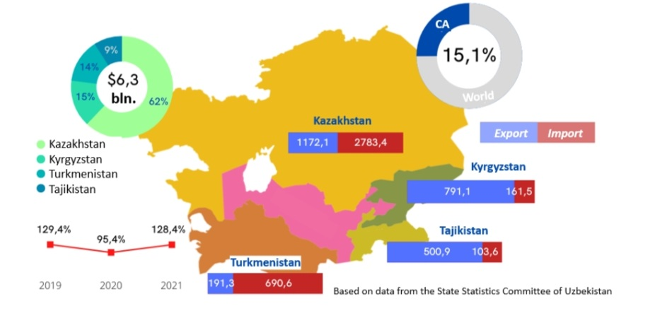
Figure 2 ‒ Trade of Uzbekistan with the countries of Central Asia

Note ‒ Compiled from source [246]

Together with the encouraging dynamics of regional ties, there have been recent significant improvements in border issues between Uzbekistan and Kyrgyzstan. It is worth noting that during President Mirziyoyev's visit to Kyrgyzstan in January 2023, the process of border demarcation between the two countries was completed. However, it should be noted that there is disagreement among the Kyrgyz people regarding the authorities' decision to hand over the Kempir-Abad reservoir to Uzbekistan [246]. Furthermore, during President Mirziyoyev's visit to Tajikistan in 2018, the last section of the Uzbek-Tajik border between the Sughd province and the Sirdaryo viloyati was settled. The two sides resolved the dispute regarding the Farkhad Dam, with the dam being recognized as Uzbek territory while the surrounding area was acknowledged as Tajik [55, p. 147-161].
Despite the positive tendencies Central Asia has a lack of cohesiveness and regionalism. According to Christian Ploberger's analysis, the current state of regional cooperation and integration in Central Asia is hindered by a lack of political will and preparedness among the Central Asian countries to share power and identity [247]. This lack of commitment contributes to a weak regional integration process that is primarily driven by external advocacy rather than local initiatives. Ploberger highlights that despite the growing importance of collaboration and regional integration in Central Asia, the countries in the region have not shown a strong willingness to actively engage in the process. The reluctance to share power and identity within a regional framework hampers the progress of regional cooperation efforts [247, p. 35]. There is a suggestion that external actors may play a significant role in advocating for regional cooperation, but without the active participation and commitment of the Central Asian countries themselves, the potential for meaningful integration remains limited [247, p. 36]. Overall, it is emphasized the need for increased political will and readiness among Central Asian nations to foster stronger regional cooperation and integration in order to address the challenges and realize the potential benefits of a more integrated Central Asia [247, p. 37].
Furthermore, the issue of unresolved border disputes has been a persistent challenge in Central Asia since the post-Soviet era. Over the years, several border sections have been contested, particularly between Kyrgyzstan and Tajikistan, where shared border areas overlap, converge, and occasionally lead to conflicts. The existence of such disputed territories has created situations where the residents do not identify themselves with either country [248]. The existence of border disputes and attempts to redraw borders in Central Asia have hindered regional cooperation and strained relations among the countries. Ethnic riots and conflicts over water sharing further contribute to the animosity and lack of cooperation [248, p. 222]. Recent clashes in April 2021 and September 2022 between Kyrgyzstan and Tajikistan have demonstrated the scale of violence associated with border issues, resulting in casualties, destruction of structures, and tensions between the two countries' armies [249].
The Vorukh enclave with 35, 000 Tajik population, which is part of the Batkent district of Kyrgyzstan and borders the Sughd region of Tajikistan, was a particularly contentious area in the relations between the two republics [249, p. 532]. The unresolved border issues posed challenges to regional cooperation and stability [250]. Recently, Kyrgyzstan and Tajikistan have recently agreed on the delimitation of the previously contested territory.
Furthermore, it is worth noting that Turkmenistan continues to maintain its policy of neutrality and refrains from actively engaging in formal structures of regional integration or increased participation. This stance taken by Turkmenistan may contribute to the overall lack of cohesiveness within the region. While other Central Asian countries are involved in various regional organizations and initiatives, Turkmenistan's reluctance to fully engage in such processes can affect the level of regional cooperation and hinder efforts towards greater integration and cohesion.
Another factor that hampers indigenous regional cooperation in Central Asia is the significant disparity in economic strength among the countries. GDP data highlights this diversity, with Kazakhstan leading the region by a wide margin. Uzbekistan and Turkmenistan follow at a relatively lower level, while Kyrgyzstan and Tajikistan have even lower GDP figures (refer to table 1).

Table 1 ‒ Contemporary Central Asian states

Country | Population | GDP, US$ billion in 2021 | GDP growth in 2021 (%)
Kazakhstan | 19 mln | 197.1 | 4.3
Kyrgyzstan | 6.6 mln | 8.5 | 3.6
Tajikistan | 9.7 mln | 8.7 | 9.2
Turkmenistan | 6.3 mln | 45.2 | 6.3
Uzbekistan | 34.9 mln | 69.2 | 7.4
Note ‒ Compiled from source [123]

Furthermore, the weak economic interlinkage within the Central Asian region is another factor that hampers regional cooperation and integration [247, p. 33]. The countries of Central Asia often find greater incentives in accessing economic markets outside the region rather than focusing on intra-regional trade and cooperation. This lack of strong economic ties and limited intra-regional market attractiveness creates a missing incentive for support from within the region for regional cooperation and integration efforts. As a result, the focus and priority of economic activities tend to be directed towards external markets, diminishing the potential for greater collaboration within Central Asia itself [247, p. 33-45].
Additionally, the Central Asian region shares a close proximity to Afghanistan, with Tajikistan, Turkmenistan, and Uzbekistan having common borders with the country. This geographical proximity presents both opportunities and challenges for the region. On one hand, it could potentially allow for increased transnational flows of power, people, capital, ideas, and religious influences. On the other hand, it also exposes the region to security threats and instability emanating from Afghanistan [243, p. 1-9].
The security aspect is particularly crucial in light of the conflict in Ukraine since 2022 and the Taliban assuming control in neighboring Afghanistan in 2021 [242, p. 3-246]. The potential spillover of security threats and terrorist activities from Afghanistan can have destabilizing effects and pose risks to the stability and security of Central Asian countries. The region must be vigilant in addressing these challenges and developing effective strategies to counter terrorism and prevent the spread of instability across their borders [243, p. 8].
The lack of regional identity and cohesiveness in Central Asia can be attributed to various factors, including disputed border areas, limited economic interdependence, competition for vital resources like water and energy, and security threats [244, p. 2-28]. These challenges have hindered the development of a strong regional identity and cooperation.
To address these issues and promote regional cooperation, it is important to enhance existing positive regional arrangements that deal with crises in a comprehensive manner. This can help foster trust, cooperation, and collective action among Central Asian countries [245, p. 897-915]. Additionally, the region is anticipated to move towards greater unity in the future, as efforts are made to overcome these challenges and promote regional integration [55, p. 147-161].
Central Asia is considered to be the EU's 'neighbor of neighbors' [2, p. 3-266]. Although Central Asia is geographically distant from Europe, the relationship between the two regions is important due to partnerships in various spheres. The EU-Central Asia relations encompass both bilateral and multilateral dialogues, covering political, economic, energy, and other aspects.
The EU's bilateral basis of cooperation with each state of Central Asia governed by Partnership and Cooperation Agreements (PCAs). Tajikistan [117] and Uzbekistan [118] have PCAs with the EU, which primarily guide political and economic dialogue, as well as cooperation in areas such as trade, investment, energy, and business. Turkmenistan has the lowest level of bilateral relations with the EU and has only signed an interim trade agreement [119]. Kyrgyzstan recently signed the EPCA in 2024, but the agreement has yet to be ratified. Until ratification occurs, the relationship between the two parties continues to be regulated by the PCA of 1995 [120].
Kazakhstan enjoys the most advanced level of relations with the EU, as it signed the Enhanced Partnership and Cooperation Agreement in 2015 [121]. The EPCA provides an enhanced legal foundation for EU-Kazakhstan relations, strengthening cooperation and fostering a more favorable regulatory environment in the fields of economy, energy, social issues, and the environment [127]. Negotiations to sign EPCAs with Kyrgyzstan and Uzbekistan were initiated in July 2019 and July 2022, respectively, demonstrating their interest in upgrading their relations with the EU [128; 131]. Tajikistan has also expressed interest in signing a similar agreement to enhance its relations with the EU [129].
These negotiations for new-generation EPCAs with Central Asian states aim to forge a more modern and diversified partnership, going beyond a "trade and aid" agenda. They seek to promote cooperation and regulatory convergence in areas relevant to the ongoing democratic reform processes in the region.
Table 2 provides more details on the status of EU agreements signed with each Central Asian country, as well as the EU's financial support allocated to each republic on a bilateral basis for the period of 2021-2024.

Table 2 ‒ EU agreements with Central Asian countries

Country | PCA | EPCA | Current status | The EU financial support on the bilateral basis for 2021-2024
Kazakhstan | signed in 1995,  in force since 1999 | signed in 2015,  in force since 2019 | EPCA | 9 million euro
Kyrgyzstan | signed in 1995,  in force since 1999 | signed in 2024, waiting for ratification | PCA | 62 million euro
Tajikistan | signed in 2004,  in force since 2010 | Tajik request for negotiations in November 2018, not launched | PCA | 91 million euro
Turkmenistan | Signed in 1998 but not ratified | - | Interim trade agreement pending ratification of PCA | Benefit from the EU regional programs
Uzbekistan | signed in 1996,  in force since 1999 | initialed in 2022 | PCA | 76 million euro
Note ‒ Compiled from source [126; 127; 128; 129; 130; 131]

In 2007, the European Union adopted its Strategy for the Central Asian region, a move prompted by the EU's recognition of the strategic significance of the area in the aftermath of the 9/11 terror attacks and international involvement in neighboring Afghanistan [4, p. 675-697]. In 2019, the EU further developed its regional approach for Central Asia and renewed its strategy. This updated version of the document aimed to deepen political dialogue, enhance economic connectivity, promote sustainable development, and address common challenges [5]. Efforts have been made to support the development of a stable, secure, and prosperous Central Asia while fostering regional cooperation.
The approval of a new Central Asia policy by the European Union in June 2019 marks the beginning of a new chapter in their relationship. What sets this policy apart is the active involvement not only of Europeans but also of Central Asian authorities, academia, businesses, and civil society groups. This inclusive approach ensures that the perspectives and aspirations of all stakeholders are taken into account when shaping the future of EU-Central Asia relations [92, p. 734-750]. Table 3 demonstrates the evolution of the EU's regional approach for Central Asia by comparing the main priorities of two strategies.
Given its robust economic strength, the European Union plays a significant role in the Central Asian region. The EU holds a prominent position as the largest trade partner of Central Asia, accounting for 30% of the region's total trade. In 2016, the EU's trade with Central Asia amounted to €13.8 billion in imports from the region into the EU single market and €8.4 billion in exports from the EU to Central Asia [126]. This trade relationship reflects the mutual economic interests between the EU and Central Asia. The EU provides a substantial market for Central Asian exports, offering opportunities for the region's goods and services to access the EU's vast consumer base (figure 3).

Table 3 ‒ Comparing key priorities in EU Central Asia ‘Strategies’ of 2007 and 2019

European Council 2007 | European Commission 2019
1. Human rights, rule of law,  good governance, and democratization.  2. Youth and education.  3. Economic development .  trade and investment.  4. Energy and transport.  5. Environmental sustainability and water.  6. Combating common threats and challenges.  7. Intercultural dialogue | Resilience:  1) the promotion of democracy, human rights, and the rule of law;  2) the cooperation on border management, migration and mobility as well as addressing commons security challenges;  3) environmental, climate and water resilience.  Prosperity:  1) partnership for economic reform;  2) intra- and inter-regional trade and investment facilitation;  3) sustainable connectivity;  4) youth, education, innovation, and culture.  Working better together  1) partnership with civil societies and parliaments;  2) cooperation for high impact (at a more global level);  3) raising the overall profile of partnership
Note ‒ Compiled from source [74, p. 1342-1360]

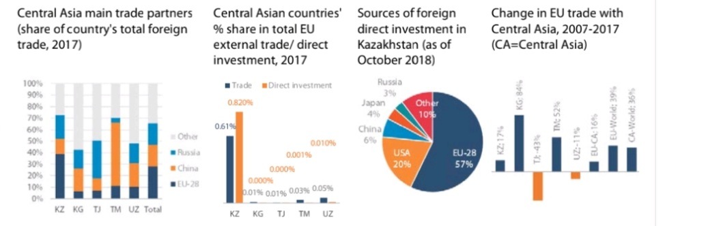

Figure 3 ‒ EU trade and investment in Central Asia

Note ‒ Compiled from source [251]

The EU primarily exports manufactured items to Central Asia, including pharmaceuticals, automobiles, and equipment. On the other hand, imports from the region consist mainly of raw materials and low-value-added manufactured items, such as Kazakh and Turkmen oil and gas, Kyrgyz gold, Tajik aluminum, and Uzbek chemicals and textiles.
In addition to trade, the EU has made significant direct investments in Central Asia. In 2017 alone, the EU's direct investments in the region amounted to €62 billion [251]. These investments are focused on various sectors, including infrastructure, energy, agriculture, and manufacturing, with the aim of promoting economic development and enhancing connectivity within Central Asia.
To support its financial resources in the region, the EU has established the Investment Facility for Central Asia (IFCA). The IFCA combines grants and loans and provides financial support for investments, technical assistance, and risk capital operations. This facility assists Central Asian governments in securing finance by offering loan guarantees or investment grants, thereby reducing the amount of capital they need to raise themselves. Since its establishment in 2010, the IFCA has successfully leveraged development aid. By 2016, €143 million of development aid had leveraged €970 million in loans, further supporting the region's development initiatives [251]. Additionally, the EU supports Central Asian countries' aspirations to integrate into the global economy. The EU has assisted Tajikistan and Kazakhstan in becoming members of the World Trade Organization (WTO) in 2013 and 2015, respectively. Kyrgyzstan joined the WTO in 1998, and the remaining two Central Asian countries are still considering membership [251].
However, the most influential external influences in Central Asia are of Russian and Chinese origin, particularly in the context of energy politics [252]. When it comes to the oil and gas industry, Central Asian governments, such as Kazakhstan and Turkmenistan, often engage directly with Western transnational corporations (TNCs) rather than relying on existing diplomatic networks with the EU or its member states [74, p. 1342-1350]. In practice, such bilateral agreements have proven convenient for Central Asian governments and TNCs, while the 'home nations' of TNCs may only benefit from profit repatriation fees, which can be relatively minor compared to the cash flow benefiting private shareholders [74, p. 1342-1360]. Table 4 demonstrates the participation of European TNCs in the energy fields of Kazakhstan and Turkmenistan.

Table 4 ‒ Participation of European Union foreign companies in Kazakhstan’s and Turkmenistan’s oil and gas fields in 2020

Foreign company | Country of origin | Oil and gas fields
Kazakhstan
Total SA | France | Kashagan
Royal Dutch Shell | UK, the Netherlands | Kashagan; Karachaganak
ENI | Italy | Kashagan; Karachaganak
Turkmenistan
ENI | Italy | Burun
Note ‒ Compiled from source[253, p. 771-772]

When the assistance provided by the EU is combined with the support from individual EU member states, the European Union emerges as the leading donor in the region. From 2014 to 2020, the total budget for EU aid to Central Asia amounted to €1.1 billion. The EU takes a diverse approach to development aid, tailoring its programs to the specific needs of each country in the region [126]. The 2019 Strategy sets the framework for the new programming period from 2021 to 2027. It aims to foster closer interactions within Central Asia and promote interregional relations between the EU and Central Asia.
According to the recent EU Strategy for Central Asia, one of the key cross-cutting priorities for the European Union in the region is to invest in regional cooperation within Central Asia [5]. The strategy emphasizes that 'the EU has a strong interest in seeing Central Asia develop as a region of rules-based cooperation and connectivity rather than of competition and rivalry. The EU is determined to invest in the new opportunities and growing potential for cooperation within and with the region as a whole' [5].
The adoption of the 2019 Strategy for Central Asia aligns with the positive developments and improved relations within Central Asia in 2018. The EU aims to support these processes and recognizes that the advancement of voluntary forms of regional cooperation should be determined by Central Asians themselves and progress at their own pace [5]. The EU's role is to provide support and facilitate dialogue while respecting the agency and priorities of the Central Asian countries.
According to the EEA website's factsheet [126], one of the priorities in the process of regional integration is the pursuit of common rules and the establishment of a more integrated regional market. This entails promoting economic cooperation and trade facilitation among the Central Asian countries.
The factsheet also mentions that regional cooperation in Central Asia encompasses functional and security goals. This includes addressing environmental challenges and terrorism, as well as participating in international efforts to achieve peace in Afghanistan. These areas of cooperation aim to enhance stability and security within the region.
Furthermore, EEAS Factsheet on the EU- Central Asia relations [126] highlights the importance of regional cooperation in Central Asia, both in terms of economic integration and addressing common challenges related to security and sustainability. Figure 43 demonstrates the priority of investing in Central Asian regional cooperation in the 2019 EU Strategy.
The information provided by the EEA website supports the notion that the EU has an agenda of promoting regional cooperation in Central Asia. This aligns with the recent strategy points of the EU's aim to deepen regional ties within the Central Asian countries and encourage region-to-region partnership between the EU and Central Asia European Union Strategy for Central Asia, 2019. Despite the established documentary basis for EU’s regional approach for Central Asia, there is a question: how does the EU practically promote regional cooperation in Central Asia? First, the two regions continue to hold annual meetings and consultations that cover various spheres of interaction. These EU-Central Asia meetings involve representatives at different levels, starting from the High Representative of the European Union and the foreign ministers of the five Central Asian countries, extending down to lower-level local authorities. The tradition of annual meetings at the high levels dates back to the appointment of the EU's first special representative to Central Asia in 2005.

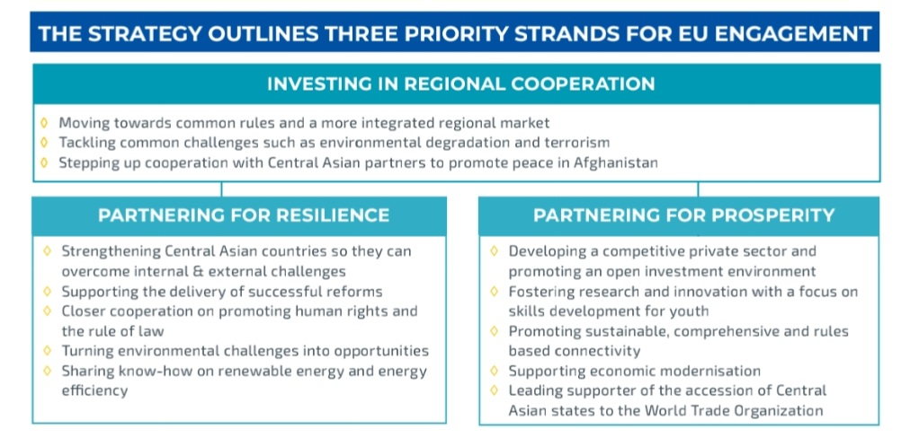

Figure 4 ‒ Explaining three priority directions of the EU’s engagement with Central Asia according to the 2019 Strategy

Note ‒ Compiled from source [126]

The annual meetings serve as an important platform for discussing and advancing cooperation between the EU and Central Asia. They provide an opportunity for dialogue on a wide range of issues, including political, economic, social, and cultural matters. The participation of key representatives from both sides highlights the commitment to maintaining and deepening interregional communication between the EU and Central Asia [126]. In 2022 and 2023, the Central Asian Heads of State and the President of the European Council held their first-ever high-level meetings in Astana and Cholpon-Ata respectively, resulting in the preparation of a further joint roadmap for deepening ties between the EU and Central Asia. The first-ever EU–Central Asia leaders' summit is due to take place in the second half of 2024 in Samarkand, formalising the C5 + EU cooperation at the highest political level, and will be an opportunity to match the EU's political relevance in the region with its status of major donor and investor.
Second, the EU actively contributes to promoting cooperative solutions at the regional level in various areas through EU-funded regional programs and projects for Central Asia. The European programs and projects aimed at the development of Central Asia are considered powerful tools for advancing political, economic, environmental, and normative discourses, ultimately strengthening cooperation within the region and between the EU and Central Asia. These initiatives involve all five Central Asian republics, demonstrating a strong regional scope. According to the table 5, the EU's regional support covers a broad range of areas and engages all Central Asian countries, underscoring the EU's commitment to fostering regional cooperation and development.

Table 5 ‒ General view on the EU’s programs and projects for Central Asia

Field of aid | Programe/Project | Main goals
1 | 2 | 3
Border/Security | BOMCA - Border Management Programme in Central Asia | facilitates the movement of people and goods, promotes the economic development and human rights of border communities, harmonises customs procedures and helps tackle illegal trafficking and organised crime since 2003. Its current 10th phase (BOMCA 10) has started on April 1, 2021 for the period of 54 months with the budget of 21.65 million euro.
Drug traffic prevention | CADAP - Central Asia Drug Action Program | has helped the governments of Central Asia in adopting drug demand reduction strategies, promoting prevention, and strengthening state-provided drug treatment since 2003. Phase 7, with a 6.8 million Euro budget from 2022, will establish comprehensive and evidence-based drug policies and execute quality drug demand reduction approaches among vulnerable populations.
Civil Society | Central Asia Civil Society Forum | since 2019 the annual Forum provides a platform for civil society representatives of the two regions to contribute to the development of the EU-Central Asia partnership. The Forum gathers civil society representatives, researchers, media experts, private sector and government experts to discuss ideas, generate new and innovative proposals and recommendations on how civil society can further contribute and be more involved in the implementation of the EU Central Asia Strategy at the local level through programs and at policy level.
COVID prevention | CACCR- Central Asia COVID-19 Crisis Response | is a 10,3 million euro program co-financed by the EU and the WHO that contributes to mitigating the impact and controlling the COVID-19 pandemic in the region and reinforcing their longer-term health resilience. This Action provides assistance for: a rapid and safe roll-out of vaccines, building long-term resilience of routine immunization systems, building the capacity for the region to achieve universal health coverage through digitalization of health systems.
Education | Erasmus + | a flagship programme permitting mobility of students and staff between EU and Central Asian countries (including Afghanistan). Erasmus+ also funds cooperative capacity-building projects for Central Asian universities, which, among other things, develop curricula for new courses with total budget of €115 million for 2014-2020.
Continuation of the table 5

1 | 2 | 3
Education | DARYA - Dialogue and Action for Resourceful Youth in Central Asia | is program that will support inclusive skills development, relevant to labor market needs, for young women and men in the five Central Asian countries with a 10 million euro budget since 2022 for five years.
Education | Marie Skłodowska-Curie actions | educational mobility in law, economics, business and energy efficiency
Energy | CAWEP - Central Asia Water Energy Programme | promoting energy security, water security, and the water-energy nexus at the national and regional level in Central Asia since 2009, also included Afghanistan in 2018.
Energy | Hydro4U project | promoting innovative and sustainable hydropower solutions to develop unexplored small-scale hydropower potential in Central Asia since 2021.
Energy | SECCA - Sustainable Energy Connectivity for Central Asia | stimulating sustainable energy practices to boost investments in Central Asia for 2022-2026 period with total budget 6.8 million euro. The project activities include capacity development for energy efficiency (EE) and renewable energy (RE) deployment, awareness raising on EE and RE, and improving investment climate for EE and RE projects.
Environment | WECOOP - Water, Environment and Climate Change Cooperation | aims to enhance environment, climate change and water policies in Central Asia through approximation to EU standards and to promote green investments in relevant sectors with the aim of contributing to measurable reductions in man-made pollution, including CO₂ emissions. It was renewed in October 2019 to April 2023
Human rights | EIDHR - European Instrument for Democracy and Human Rights | is an informal grouping of 43 NGOs operating at the EU-level mainly in Brussels with separated budget, created in 2004 ,that aims to promote democracy and human rights and support civil society to become an effective force for political reform in Central Asia.
Rule of Law | Central Asia Rule of Law Initiative | supports legal reforms and the sharing of experience, including how to reform the judiciary or draw up effective legislation including constitutional, administrative, commercial, and criminal law for 2020-2024 programing period with 8 million euro total budget of the EU contribution.
Trade | Ready4Trade | project, launched in 2020, to boost intra-regional and international trade for Central Asia
Note ‒ Author’s elaboration based on EEA Factesheets

According to table 5, recent European Union programs targeting Central Asia have notably emphasized the sectors of education, energy, and democracy promotion. The democracy promotion agenda, encompassing human rights, civil society, rule of law, and good governance [82, p. 3-220], is represented by distinct programs per each sphere, where total for democracy promotion is three programs. In addition, there are three programs per each dedicated to education and economic development, reflecting a balanced focus on these areas. This distribution suggests a prioritization of education and economic growth in the EU-Central Asia regional strategy. Conversely, other critical areas such as border and security management, drug trafficking prevention, COVID-19 mitigation, environmental concerns, and trade are addressed by only one program each.
Third, the EU encourages stable regional dialogue within Central Asia through cooperation with other international organizations. The EU's 2019 strategy highlights the strengthening of cooperation with organizations such as the OSCE (Organization for Security and Cooperation in Europe), the Organization for Economic Cooperation and Development (OECD), and the International Labour Organization (ILO) [4, p. 675-697]. In addition, the EU provides financial assistance to Central Asia through loans from the European Bank for Reconstruction and Development (EBRD) and the European Investment Bank (EIB). These loans have been used to fund initiatives aimed at enhancing infrastructure and promoting sustainable development within the five states [251].
For example, the loans have supported projects to improve municipal water supply and wastewater systems, develop renewable energy sources such as solar and wind farms, stimulate the growth of small and medium-sized enterprises (SMEs), and expand transportation and energy infrastructure in the region [251]. Indeed, the EU's engagement with Central Asia through various forms of dialogue, cooperation, and assistance demonstrates its agenda of regional cooperation promotion for the region. The EU's involvement spans political, economic, environmental, and normative aspects, aiming to foster regional cooperation among Central Asian nations.
The EU's support for regional cooperation within Central Asia aligns with the positive dynamics that have emerged in the region in recent years. Central Asian countries have shown an increasing willingness to engage in regional initiatives, and the EU's regional and interregional measures can further contribute to the deepening of Central Asian regional ties. Through its initiatives, programs, and projects, the EU encourages dialogue and collaboration on a wide range of issues, including trade, security, energy, education, environment, and human rights. By promoting regional cooperation and integration, the EU aims to strengthen the resilience and stability of the region, enhance connectivity, and support the socio-economic development of Central Asian countries.
In conclusion, the evolution of regional cooperation in Central Asia has been marked by both progress and persistent challenges. From the Soviet era's enforced economic interdependence to the post-independence search for self-sufficiency, the region has faced numerous obstacles to establishing a cohesive identity. Although initiatives such as the Central Asian Cooperation Organization (CACO) and the Central Asia 2040 strategic framework demonstrate a desire for increased collaboration, issues such as unresolved border disputes, economic disparities, and security concerns continue to undermine deeper integration. Nevertheless, recent improvements in political dialogue, economic exchanges, and border demarcation efforts provide hope for the future. The region’s geopolitical importance, particularly its proximity to Afghanistan, further underscores the need for robust regional cooperation to address shared challenges in security, water resources, and energy. Ultimately, while the journey towards a more united Central Asia remains ongoing, growing regional engagement and international collaboration present promising avenues for enhanced stability and prosperity.
The relationship between the European Union and Central Asia has evolved significantly over the past decades, marked by increasing engagement in political, economic, and energy sectors. The EU's comprehensive approach, including bilateral and multilateral agreements such as the PCAs and EPCAs, demonstrates its commitment to fostering partnerships in the region. With the EU's role as a major trade partner and investor, Central Asian states benefit from support for economic development, particularly through initiatives like the Investment Facility for Central Asia (IFCA). While Russia and China remain influential in the region, especially in energy politics, the EU's strategic importance continues to grow. The ongoing modernization of agreements and strategies, alongside sustained financial aid, highlights the EU's dedication to promoting stability, connectivity, and sustainable development in Central Asia. The future of EU-Central Asia relations, shaped by mutual interests and evolving partnerships, will likely focus on deeper integration, reform processes, and global economic collaboration.
To summarize, the European Union's commitment to fostering regional cooperation within Central Asia, as articulated in the 2019 EU Strategy for Central Asia, reflects a strategic and supportive approach aimed at enhancing connectivity and stability in the region. By prioritizing regional integration, the EU seeks to build a framework for rules-based cooperation rather than competition, aligning its efforts with the positive momentum observed in Central Asia’s recent developments. Through a variety of channels ‒ ranging from high-level annual meetings and collaborative regional programs to targeted financial support ‒ the EU is playing a pivotal role in promoting dialogue, economic growth, and sustainable development across Central Asia.
The EU's multifaceted engagement includes substantial investments in education, energy, and democracy promotion, as well as addressing critical regional challenges such as environmental issues and security concerns. This approach not only supports the immediate needs of the region but also aims to strengthen its long-term resilience and stability. The EU's strategy underscores its respect for Central Asia’s sovereignty and its role as a facilitator of regional cooperation, rather than a prescriber of solutions.
As the region continues to evolve and embrace greater regional collaboration, the forthcoming high-level meetings and summits, such as the EU-Central Asia regional high-level meeting in October 2022 in Astana and June 2023 in Cholpon-Ata. European Council (EC) President Charles Michel expressed a desire for closer future cooperation with Central Asian countries. Moreover, the expected EU-Central Asia leaders' summit in Samarkand, will serve as significant milestones in formalizing and deepening interregional ties. These developments highlight the EU's ongoing commitment to supporting Central Asia's journey towards greater integration and cooperation, reflecting a shared vision of a more interconnected and resilient regional landscape.
However, while the EU's strategy is commendable for its emphasis on regional cooperation and support for development, it remains somewhat general and broad in scope. The strategy outlines ambitious goals but lacks detailed mechanisms for implementation and specific targets. This generality can dilute the effectiveness of the EU’s interventions, as it may not address the unique challenges and priorities of each Central Asian country with sufficient granularity. Additionally, the broad focus on various sectors, from education to security, may lead to resource allocation that is too dispersed to achieve significant impact in any one area.
Moreover, the EU's approach, though supportive, might not fully account for the complex political and socio-economic realities within Central Asia. The strategy's reliance on high-level meetings and generalized programs may not always translate into practical, on-the-ground solutions that are needed to address the region's diverse and pressing issues. For instance, while promoting democracy and human rights is essential, the implementation of such programs might face challenges due to varying levels of political will and institutional capacity across Central Asian countries [92, p. 734-750].
As the region continues to evolve, the EU will need to refine its strategy to include more specific, actionable objectives and to tailor its support to the nuanced needs of individual countries within Central Asia. This would enhance the effectiveness of its initiatives and better align with the region’s unique context, ultimately contributing to a more robust and sustainable framework for regional cooperation.

3 KEY FINDINGS OF THE mixed-methods RESEARCH DESIGN

3.1 Survey Conducted Among Central Asian Intermediate Elites: Methodology and Results
This study on the Central Asian view of the EU’s role in supporting regional cooperation in and with Central Asia is based on a mixed-methods approach of surveying Central Asian intermediate elites and analyzing local media content, contributes to existing research on Central Asian perceptions of the EU [60, p. 72-81; 92], p. 734-750; 100, p. 2-9].
After conducting an extensive analysis of the historical overview of the European Union-Central Asia ties, we designed an exploratory field research approach that incorporates both a local media content analysis and survey. This mixed-methods research design aims to gain a comprehensive understanding of the Central Asian public opinion regarding the EU's role in promoting regional cooperation in the target region. The use of mixed-methods analysis is considered effective as it allows us to validate findings obtained through both quantitative and qualitative research methods. By employing a combination of approaches, we can gather complete data and develop a deeper understanding of the complex topic under investigation [254].
In the first part, we will present our approach to conducting a local media content analysis. We will outline the criteria for selecting relevant news items related to the European Union's involvement with Central Asia, explain the coding process, and discuss the interpretation of the media content.
The second section of this chapter will describe the survey model we selected for our research. This survey was conducted among Central Asian intermediate elites in 2023. We will provide details on the survey design, sampling techniques, questionnaire development, and data collection procedures.
By employing a mixed-methods approach and addressing methodological considerations, we aim to provide a robust analysis of Central Asian public opinion on the EU's efforts to promote regional cooperation in the region.
Conducting a survey is a commonly used method in social science research to collect data on public behaviors, experiences, needs, and preferences [255].
We opted for an online survey, which is a self-administered questionnaire distributed to respondents via email and WhatsApp messenger. The questionnaire was designed manually by our team and consisted of 23 questions. The analysis of the survey data can incorporate both quantitative and qualitative research approaches, as the questionnaire includes different types of questions, such as yes/no questions, multiple-choice questions, rating scale questions, and open-ended questions.
The questionnaire is divided into three sections. The first section collects basic demographic information about the respondents, including their age, gender, occupational category, and the country they represent. The second section focuses on the EU-Central Asian relations, assessing the EU's engagement with the region and capturing the respondents' attitudes towards it. The final section of the questionnaire explores the support for regional cooperation by the EU in Central Asia and its perceived influence on it.
Furthermore, the survey was conducted using the QuestionStar.ru program. The questionnaire was made accessible to respondents through the following link: https://survey.questionstar.ru/80fa00e1. The program facilitated the distribution of the questionnaire and allowed respondents to easily access and submit their responses using smartphones or computer devices. This streamlined process ensured convenience for the respondents, enabling them to complete the questionnaire at their own preferred time. The questionnaire typically took around 10-15 minutes to complete. The survey was administered to 30 Central Asian intermediate elites, including former and current diplomats, experts in International Relations, and journalists, in 2023.
We identified the members of the intermediate elite through several groups. The first group of respondents who received the survey link consists of experts affiliated with the Cabar.Asia network. Cabar.Asia is the Central Asian Bureau for Analytical Reporting (CABAR), a regional platform that fosters analytical, informational, and educational activities in Central Asia. It brings together experts and journalists from all five Central Asian republics to develop expertise in analytical reporting, deliver training on new media, and provide analytical support for various social processes in the region.
The authors of these materials are highly experienced and renowned experts in Central Asian countries. They include journalists who are recognized for their mastery of the analytical genre, as well as young and talented graduates of educational programs in the field of analytics and analytical journalism. We established contact with them through the networking channels provided by Cabar.Asia. These contacts allowed us to engage with a diverse range of individuals who possess expertise and knowledge in the Central Asian region.
The second group of intermediate elites includes individuals with whom we have established personal contacts. These respondents are academic experts, diplomats, and journalists who we personally know and have identified as valuable contributors to our survey.
During the survey, we were diligent in adhering to basic ethical considerations as outlined by Bryman. We took into account the dignity of research participants, ensuring that we did not cause any discomfort or anxiety during the survey process [97, p. 63-76]. Clear and informative email instructions and recommendations were provided to all survey participants to ensure their understanding of the research and their voluntary participation.
To protect research privacy and maintain confidentiality, we took measures to ensure the anonymity of individuals and the confidentiality of research data. We respected the principles of honesty and transparency, avoiding deception, misrepresentation, and any false reporting of research results. Openness and honesty were maintained throughout the survey process, following the principles of affiliation and reciprocity [97, p. 63-76]. By following these ethical principles, we aimed to conduct the survey with integrity, ensuring the trustworthiness of the research process and results.
Through this survey methodology, our objective is to collect insights and opinions from Central Asian intermediate elites concerning the EU's role in promoting regional cooperation in Central Asia. The questionnaire's design enables a comprehensive analysis of respondents' perspectives, incorporating both quantitative and qualitative aspects. Additionally, we have included a question about respondents' preferences for media sources, including those used in the media content analysis.
We conducted a survey among Central Asian intermediate elites from five Central Asian republics between June and November 2023. The total data collected includes 34 responses, with an distribution of 35% women and 65% men. Specifically, we obtained 15 responses from Kazakhstan, 5 from Kyrgyzstan [256], 8 from Tajikistan, 4 from Uzbekistan, and 2 from Turkmenistan. The majority of respondents are under the age of 35. Figures 5, 6, and 7 illustrate the precise proportion of information about the respondents.

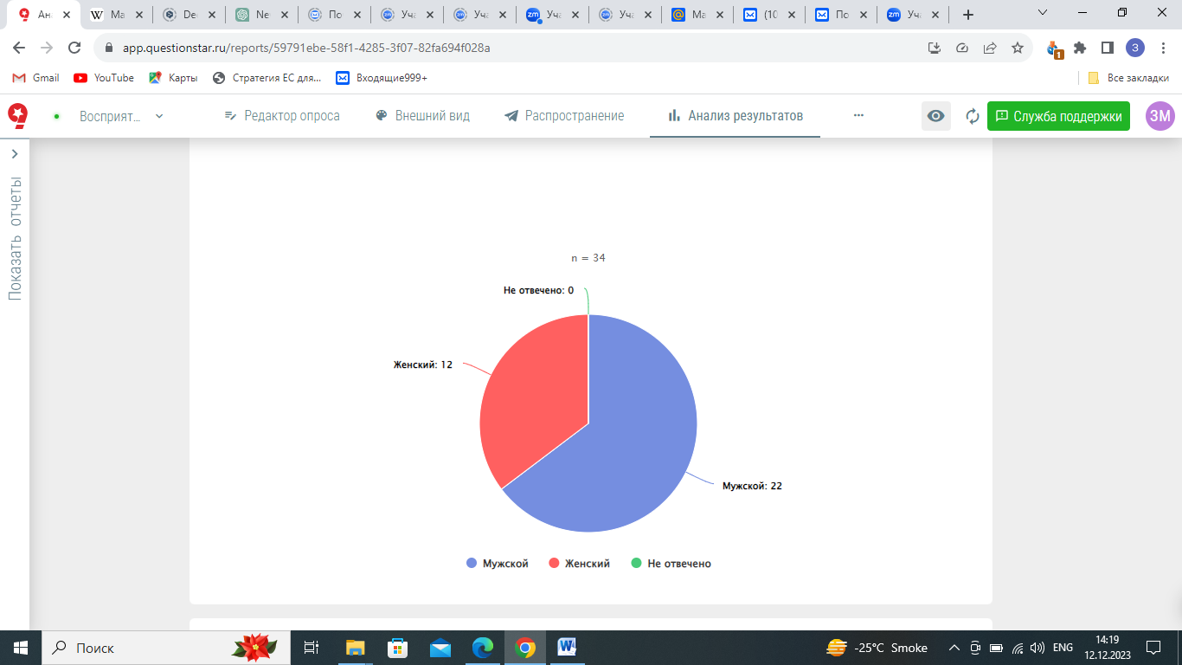

Figure 5 ‒ Gender distribution of the respondents

Note ‒ Author’s elaboration

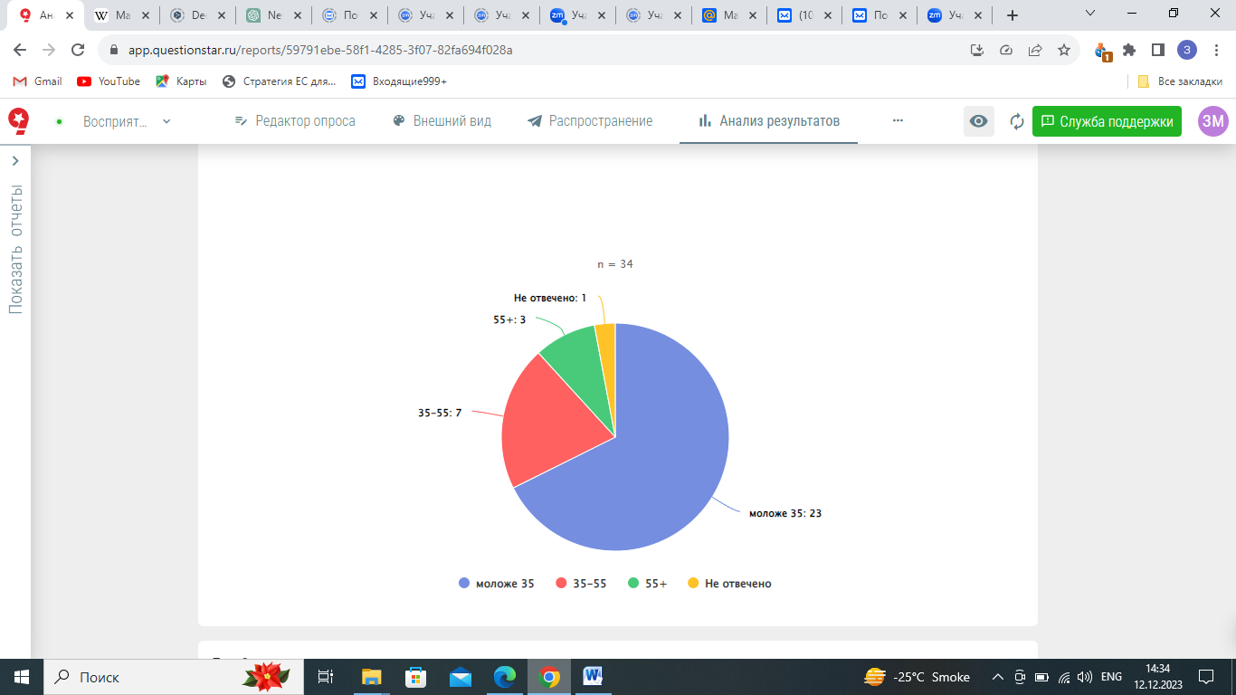

Figure 6 ‒ Age distribution of the respondents

Note ‒ Author’s elaboration

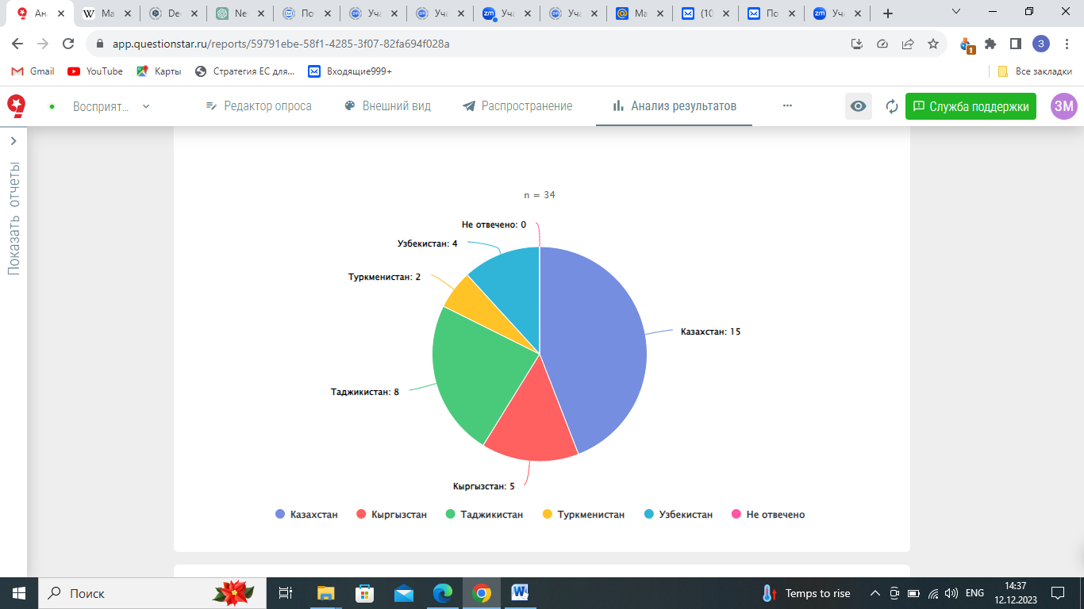

Figure 7 ‒ Country distribution of the respondents

Note ‒ Author’s elaboration

The survey involved the following composition of target groups: experts - 55%, journalists - 8%, government employee - 8%, previously held any of the above positions - 11%, diplomats – 5%. The figure 8 below illustrates the exact composition of the target groups among the respondents.

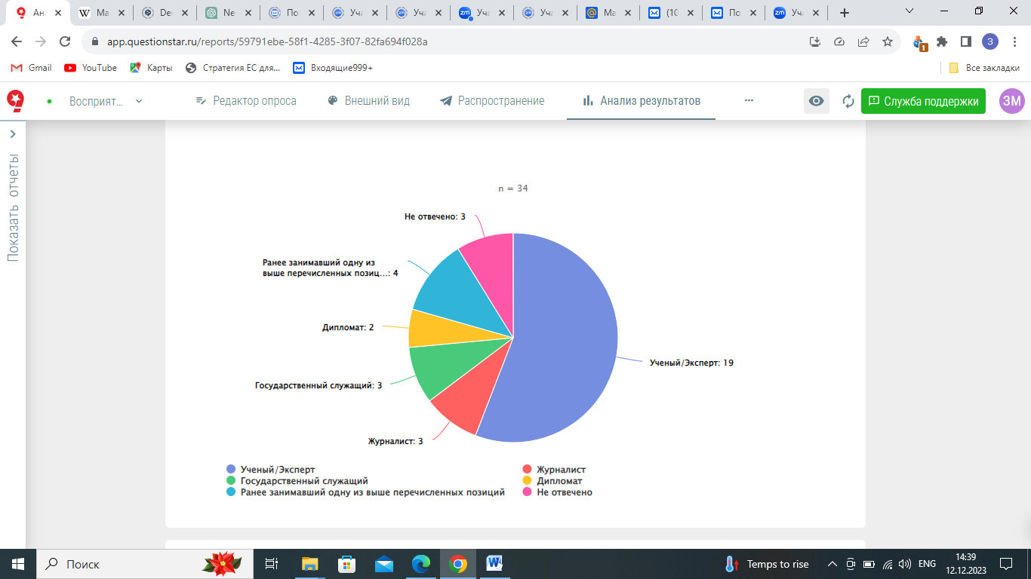

Figures 8 ‒ Target group distribution of the respondents

Note ‒ Author’s elaboration

To investigate the percentage of intermediate elites who engage with the analyzed news outlets, we included a multiple choice question on this topic. The following figure 9 presents the information on the readability of the local outlets.

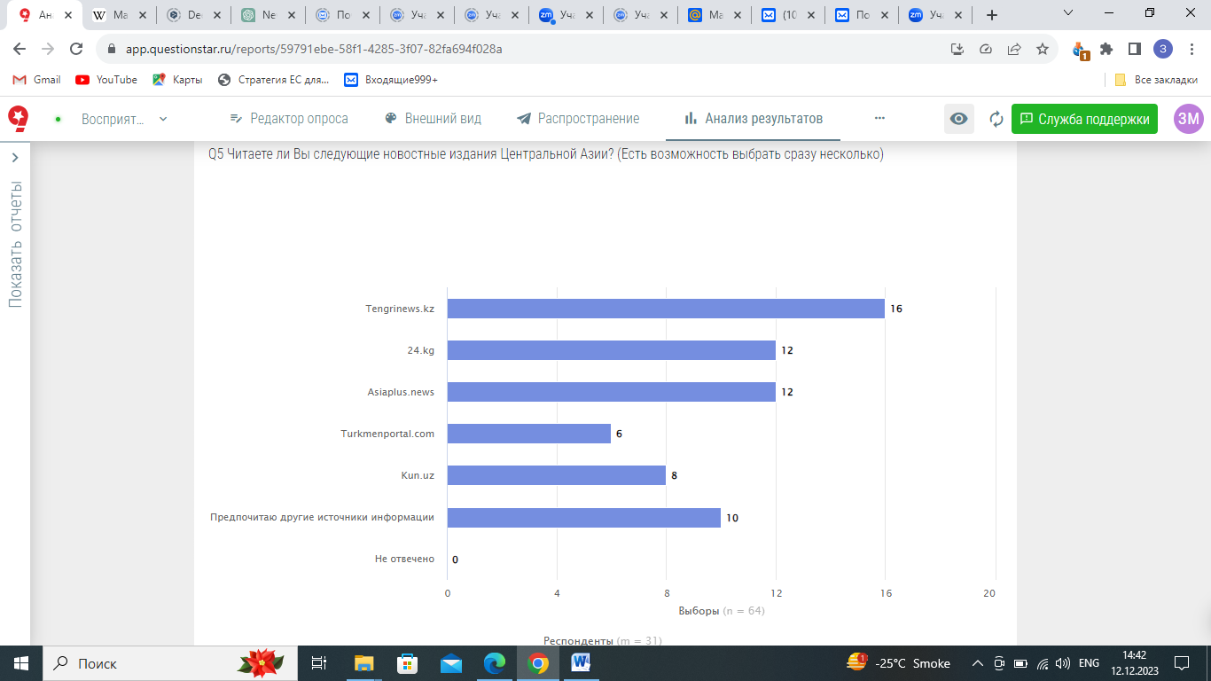
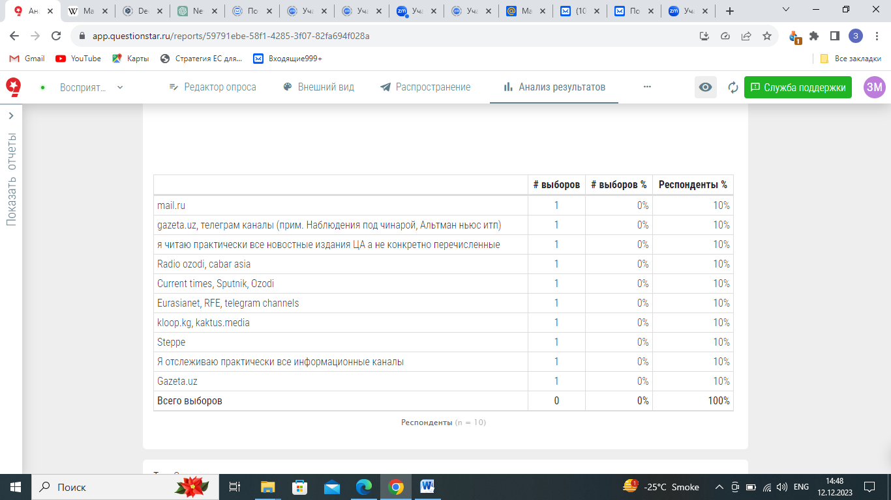

Figure 9 ‒ Readability of the local outlets

Note ‒ Author’s elaboration

We observed the following results: Tengrinews.kz was chosen 16 times, Asiaplusnews.tj and 24.kg have equal 12 number of selections, while Turkmenportal.com and Kun.uz received an 6 and 8 selections respectively. Nine respondents mentioned that prefer other sources of information. Among other mentioned resources are gazeta.uz, cabar.asia, rus.ozodi.org, current time.tv, sputnik.kz, eurasia.net, kloop.kg, kaktus.media. Furthermore, the respondents quite often (chosen 12 times), very often (chosen 6 times), infrequently (chosen 12 times) read news on EU-Central Asia relations, as indicated in figure 10.

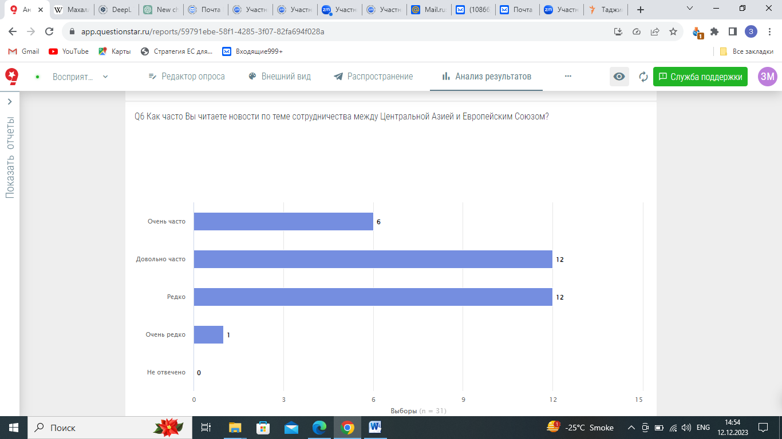

Figure 10 ‒ Readability rate of the local outlets

Note ‒ Author’s elaboration

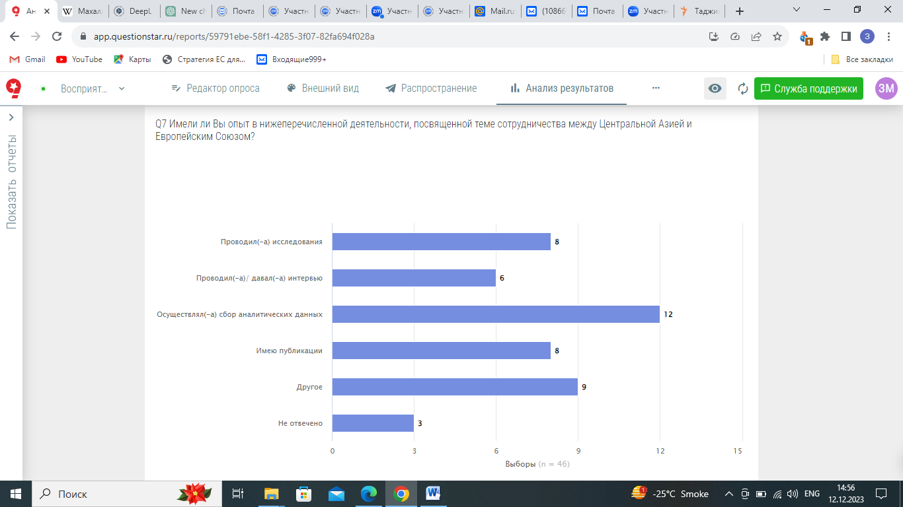
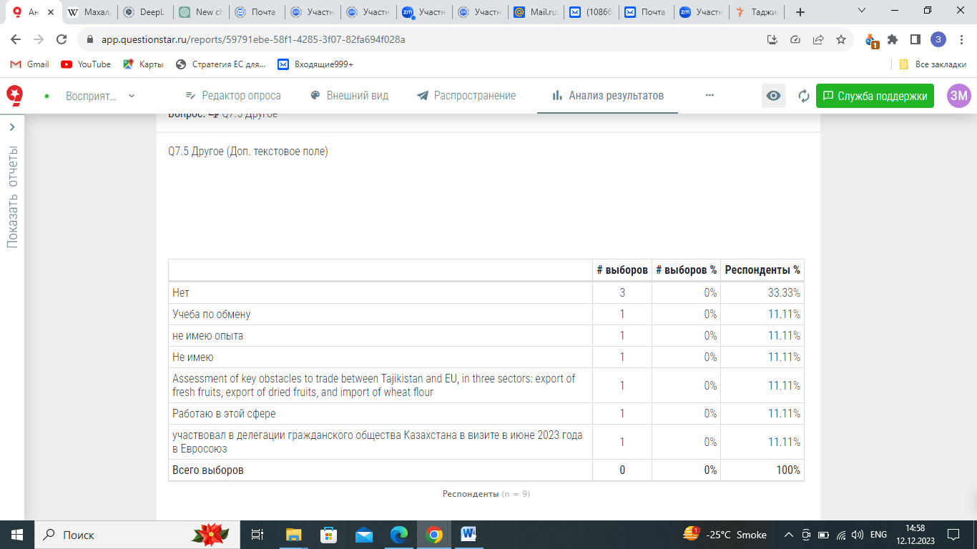

Figure 11 ‒ Respondents’ experience in the EU-Central Asia activities

Note ‒ Author’s elaboration
According to the data from figure 11, we understand that the majority of the respondents participated in an experience related to the EU-Central Asian partnership. Thus, there are 8 respondents who chose the option indicating that they conducted research. Additionally, 6 respondents selected the option indicating that they conducted interviews or were interviewed. Furthermore, 12 respondents chose the option indicating that they collected analytical data. Additionally, 8 respondents selected the option indicating that they have publications on the target topic. Finally, 9 respondents chose the option 'another,' and 3 respondents skipped the question. Below, we present the response records in the 'another' box (figure 11).
Based on the results of figure 4.12, three respondents replied “No”. Furthermore, each respondent is represented by an equal number of records, including those who:
- do not have experience related to the EU-Central Asian partnership;
- assessed key obstacles to trade between Tajikistan and the EU in three sectors: export of fresh fruits, export of dried fruits, and import of wheat flour;
- are working in this field;
- indicated their participation in the visit of the delegation of civil society of Kazakhstan to the EU in June 2023.

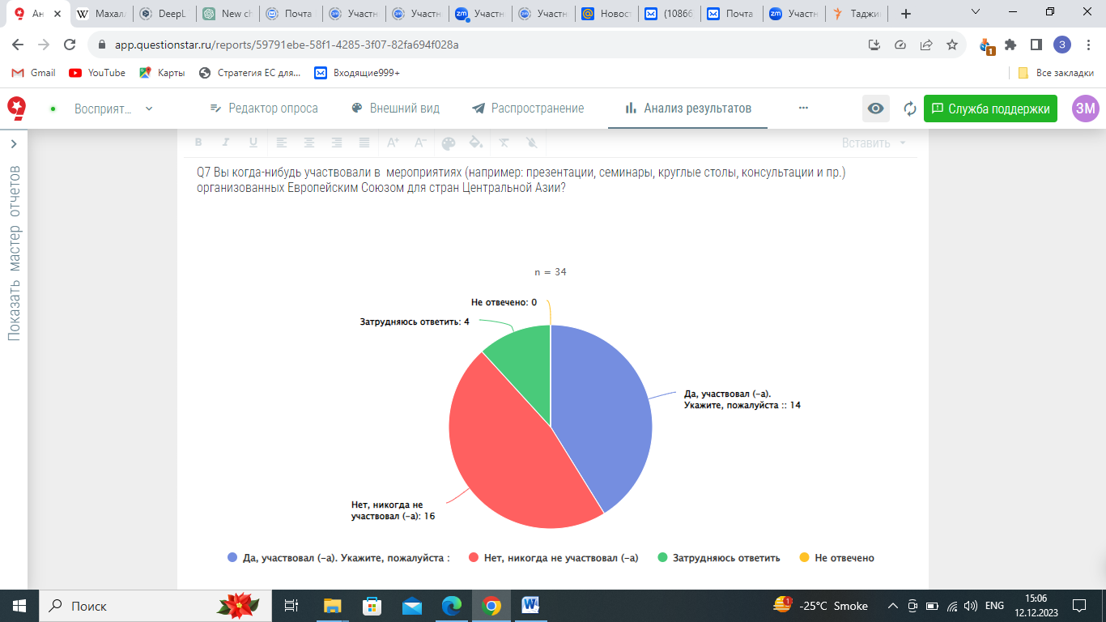
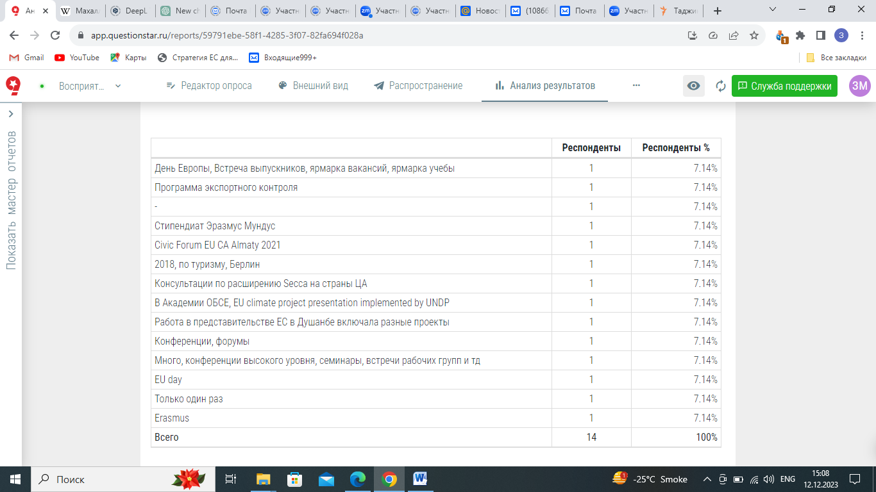

Figure 12 ‒ The percentage of respondents participating in EU-organized events for Central Asia

Note ‒ Author’s elaboration
Figure 4.13 indicates that 41% of the respondents participated in events (e.g., presentations, seminars, round tables, consultations, etc.) organized by the European Union for Central Asian countries. The listed events include the Civic Forum EU-Central Asia held in Almaty in 2021, an event dedicated to tourism held in Berlin in 2018, consultations on including the states of Central Asia in the SECCA program, events in OSCE, EU climate project events by UNDP, EU Day, and other conferences at high levels, seminars, and working groups.
Furthermore, 9 participants were directly involved in European targeted project/program for Central Asian countries, and three of them mentioned Erasmus Mundus and Erasmus+, there are also mentions on SECCA, Youth Council C5+1, ITC study of export-import barriers, SIDA assessment of climate-conflict nexus in Central Asia (figure 13).

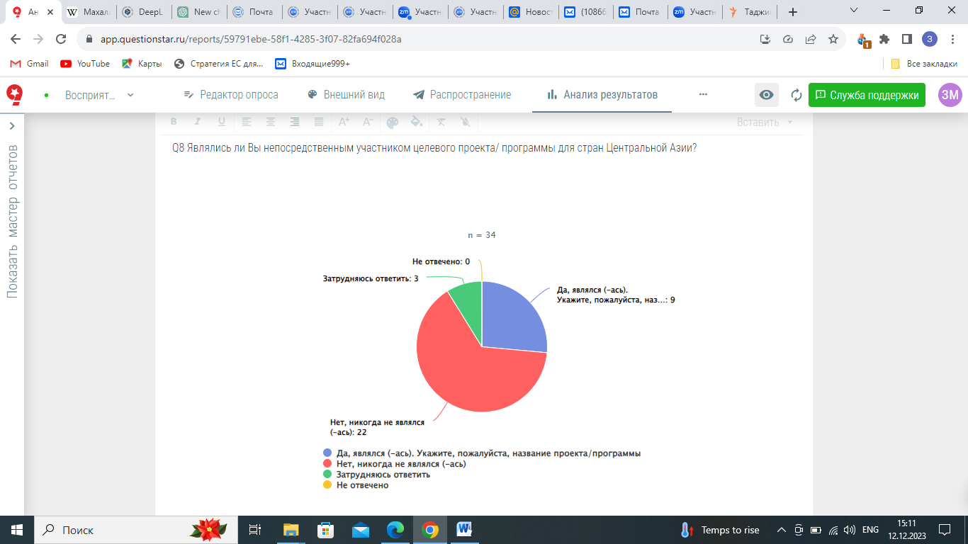
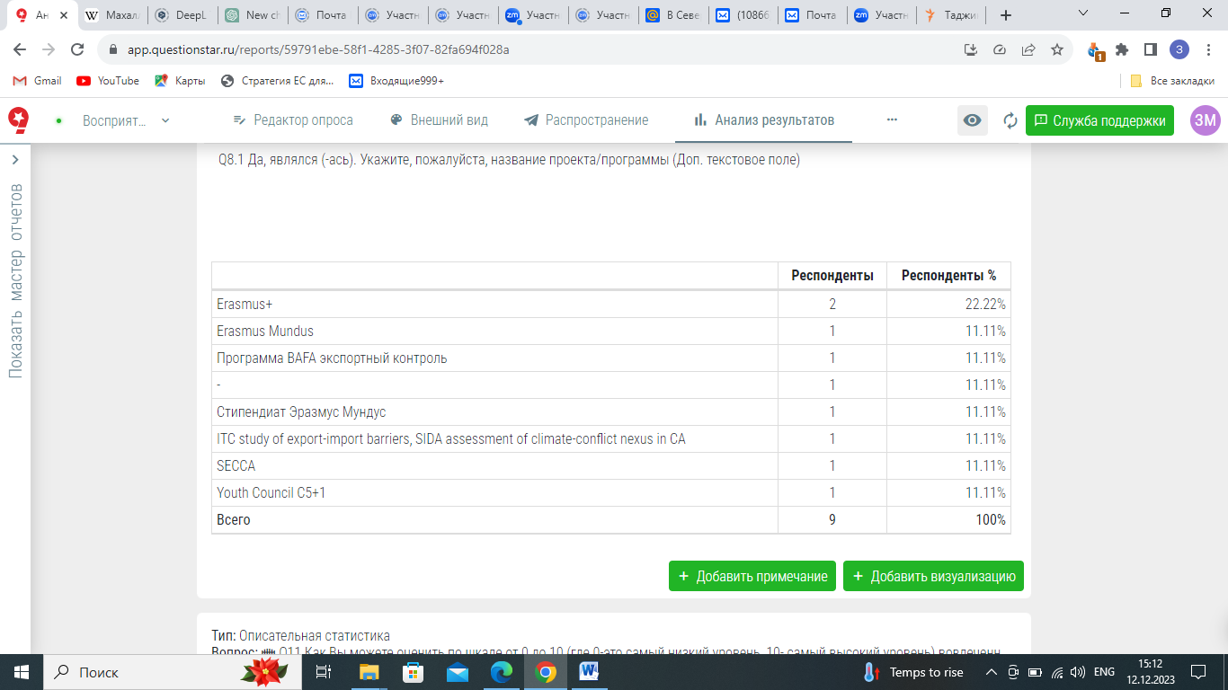

Figure 13 ‒ The amount of participants involved in the EU’s projects/programs for Central Asia

Note ‒ Author’s elaboration

The respondents have rated the involvement of the European Union in the development of Central Asian countries on a scale from 0 to 10, where 0 is the lowest level and 10 is the highest level. According to figure 14, the most frequently chosen answer among intermediate elites for the perception of the EU's involvement with Central Asia is assessed as 6.

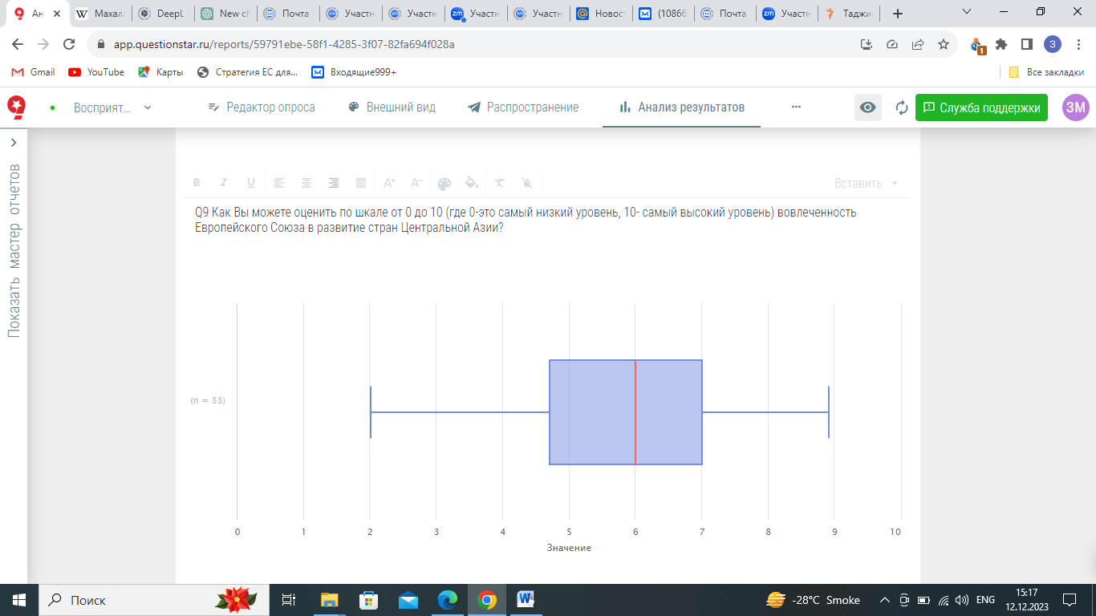

Figure 14 ‒ Local perceptions of EU involvement in Central Asian development

Note ‒ Author’s elaboration

Furthermore, we examined the perception of material assistance provided by the European Union to Central Asian countries. The survey revealed that 26% of participants viewed EU assistance very positively, 44% viewed it positively, 29% viewed it neutrally, and none viewed it negatively (figure 15).

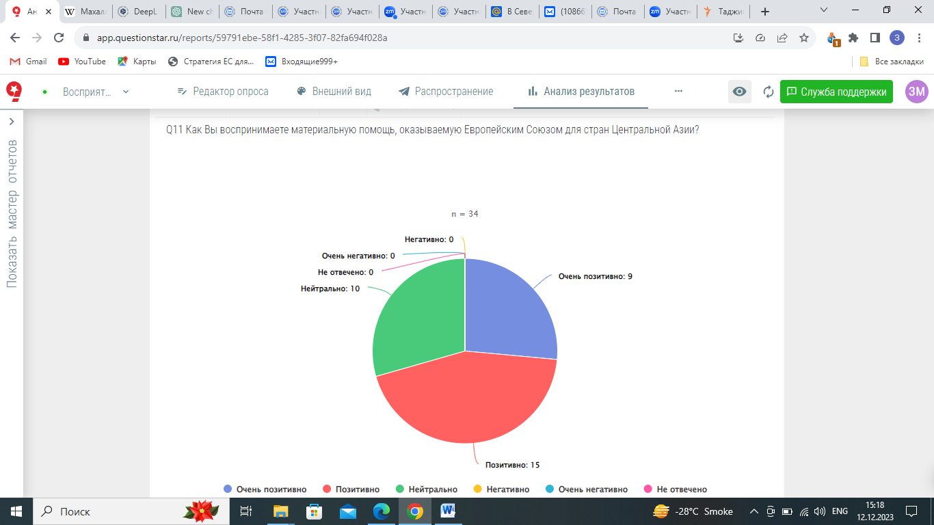

Figure 15 ‒ Local perceptions of EU involvement in Central Asian development

Note ‒ Author’s elaboration

According to figure 15, 50% of the surveyed local intermediate elites perceive EU support to Central Asia as a geopolitical vector of the EU’s foreign policy. This is a perspective that aligns with views of Fawn [4, p. 675-697] and Kuszewska-Bohnert [216, p. 617-637] suggesting that the EU’s actions in Central Asia are primarily driven by geopolitical considerations. This raises the question of whether the EU’s involvement is predominantly influenced by strategic interests rather than genuine regional development concerns.
Another 11% view it as a means to promote stability and security, particularly given Central Asia's proximity to Afghanistan. This view underscores the security dimension of the EU’s involvement. However, Marchi [180, p. 81-97] has noted that similar security-focused strategies have been effectively employed in other contexts, such as Myanmar and ASEAN. This prompts an inquiry into how the success of such strategies might differ across regions and what factors contribute to their varying effectiveness.
Only 11% of respondents considered it an aspect of an equal partnership between the EU and Central Asia. This perspective suggests a more collaborative approach, though it appears to be less prevalent, indicating that the predominant views may lean towards more strategic or unilateral interpretations of the EU’s role. Moreover, 17% of responses link the EU’s support to voluntary aid and neo-colonial ambitions, reflecting concerns similar to those raised by Larsen [224, p. 896-909], who criticized the EU’s normative promotion as neo-colonial in Africa and Asia. This highlights ongoing concerns about whether the EU’s actions are perceived as self-serving or as an imposition on the region.
Additionally, responses categorized under 'another' offer further insights. One respondent suggested that the EU lacks a coherent strategy for its engagement with Central Asian countries, indicating potential inconsistencies or strategic ambiguities in the EU’s approach. Another respondent believed that Central Asia is not a priority within the EU’s foreign policy framework, suggesting that the region may not receive the necessary focus or resources. These varied perspectives provide a nuanced view of the EU’s role in Central Asia. They prompt critical questions about the effectiveness and reception of EU strategies and their implications for future policy development and regional interactions.
Furthermore, two respondents selected the 'another' option. The first one believes that the EU itself lacks a clear direction for this type of cooperation with Central Asian countries. The second one is certain that the region is not a priority direction in the EU’s foreign policy actions.
The responses to whether the European Union can effectively foster close regional cooperation in Central Asia reveal a spectrum of opinions (figure 16). While 11% of respondents are firm in their belief that the EU is absolutely capable of promoting such cooperation, a larger group, 58%, views the EU as generally capable. This suggests a substantial degree of confidence in the EU's potential to influence the region. Conversely, 14% of respondents remain neutral, neither agreeing nor disagreeing with the EU's capability. This neutrality might stem from uncertainty about the EU's role or the complex dynamics at play in Central Asia.

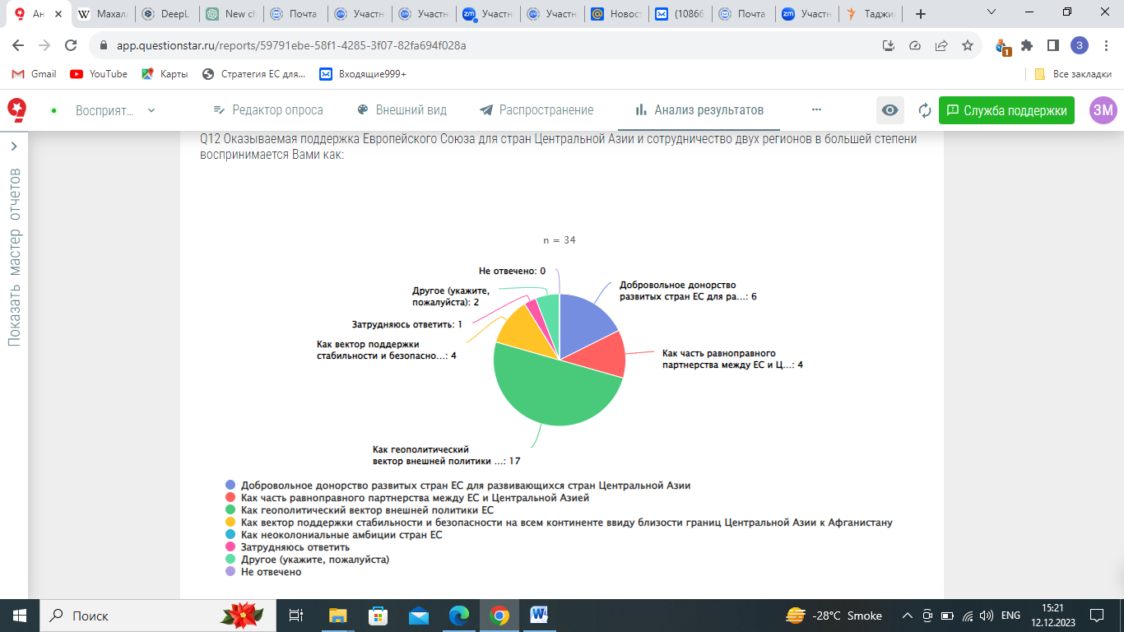
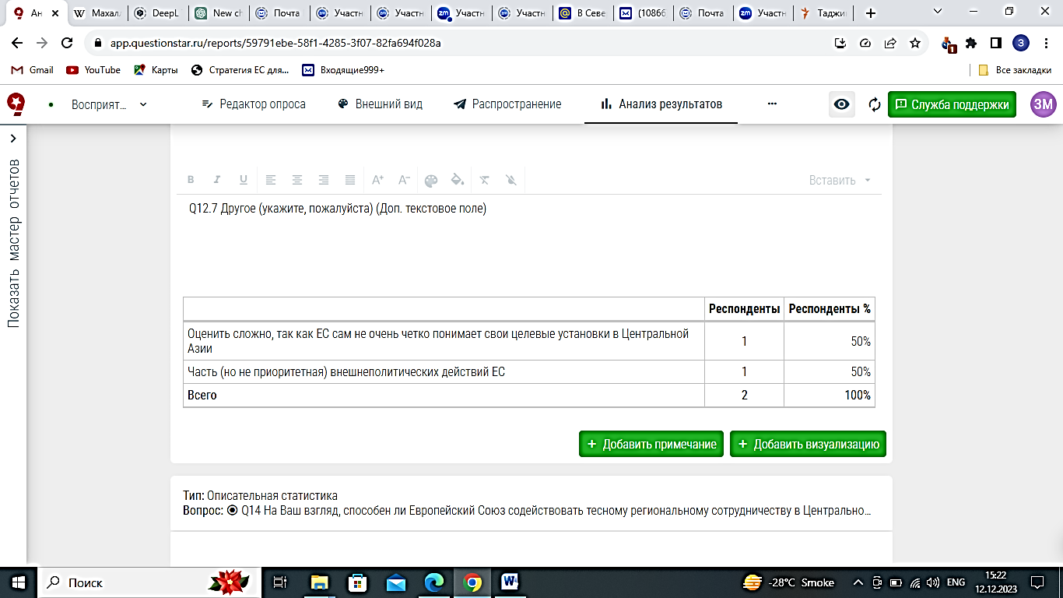

Figure 16 ‒ Local perception of EU support for Central Asia

Note ‒ Author’s elaboration

Interestingly, 5% of respondents are convinced that the EU is absolutely not capable of influencing regional cooperation, attributing this to the belief that such cooperation is an internal process of the region itself. This opinion raises questions about the extent to which external actors, including the EU, can genuinely impact regional dynamics that are deeply rooted in local contexts. Additionally, 8% of respondents selected the 'another' option, indicating that there may be other factors or considerations influencing their views. This group’s responses could suggest alternative perspectives or emphasize nuances not fully captured by the other categories. Overall, these varying opinions reflect an ambiguous stance on the EU’s role (figure 17).

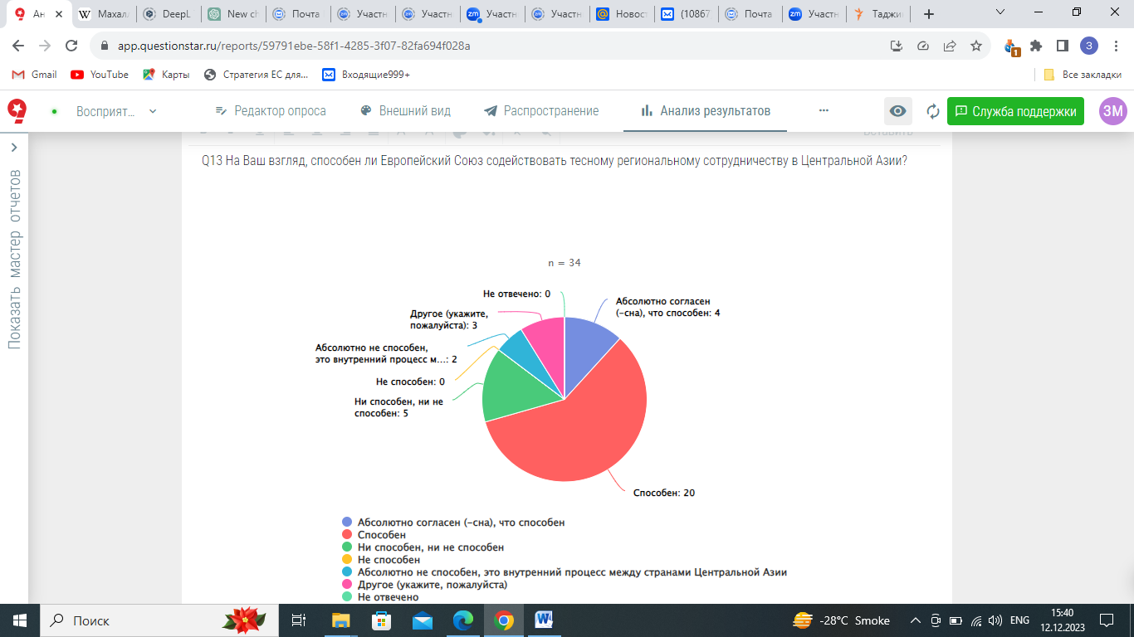
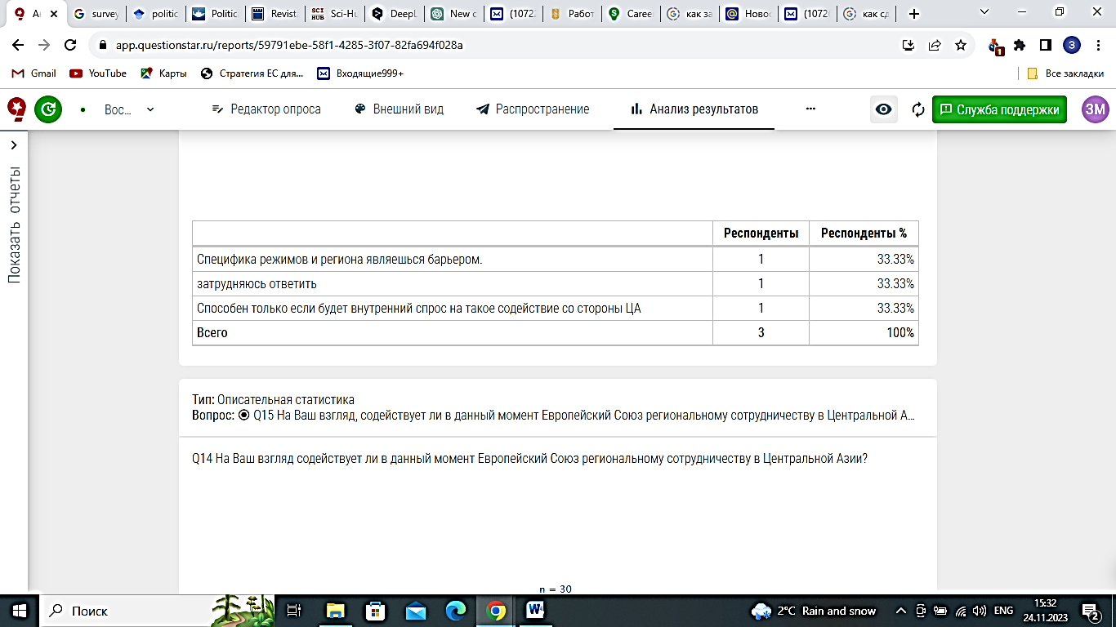

Figure 17 ‒ The perception of the EU’s approach to promote regional cooperation in Central Asia

Note ‒ Author’s elaboration

The perspective that Central Asian regimes represent a significant barrier is among those who chose the 'another' option (figure 17). This viewpoint resonates with Alison's 2008 analysis, which suggests that virtual regionalism and regime security are major factors shaping the political landscape in Central Asia.
On the other hand, there's also a respondent response on the role of internal demand of Central Asia for developing regionalism (figure 18). Arguably, focusing solely on the regimes as a barriers of closer regional cooperation in Central Asia might overlook the importance of internal factors—such as local economic needs and societal impacts ‒ that could be just as influential.
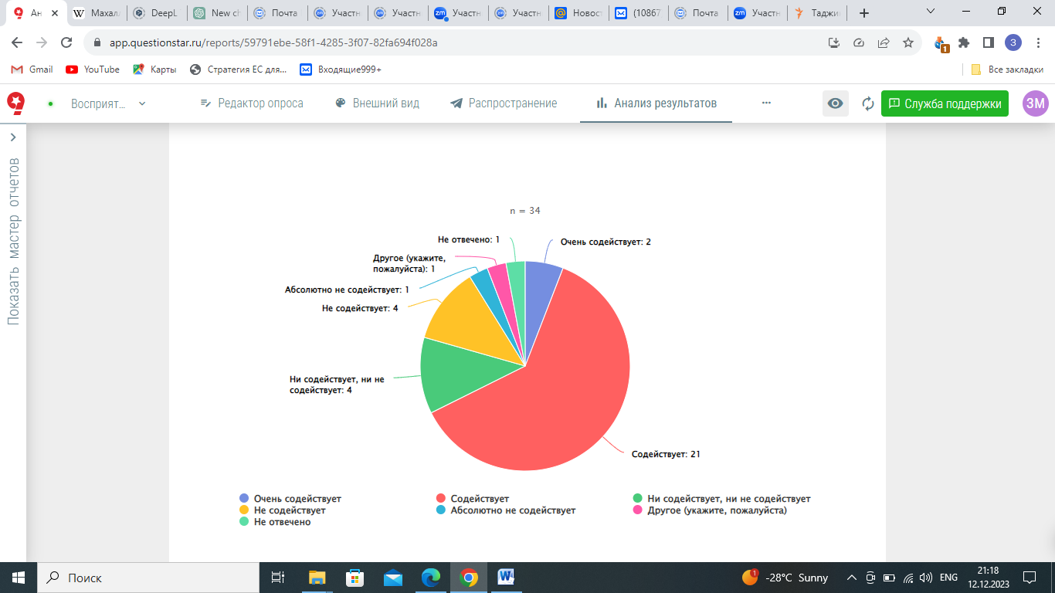
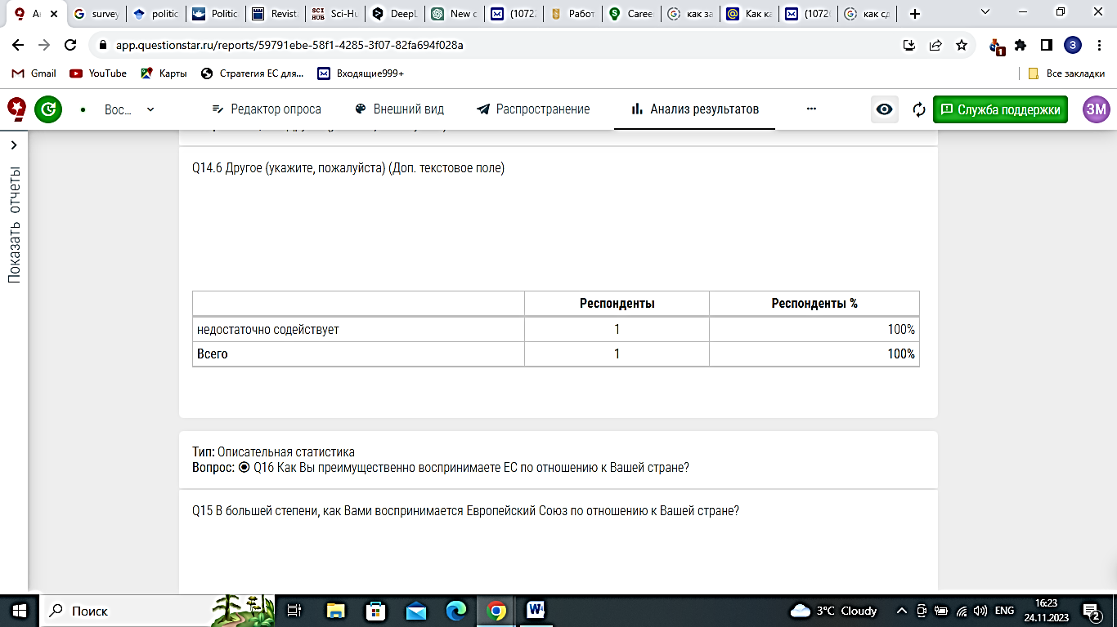

Figure 18 ‒ The perception of the EU’s approach to promote regional cooperation in Central Asia

Note ‒ Author’s elaboration

The perceptions of Central Asian elites regarding the European Union's role in promoting regional cooperation reveal a spectrum of opinions. A majority of respondents, specifically 61% and 5%, are optimistic about the EU's efforts, with the former believing that the EU is actively facilitating regional cooperation and the latter considering its support to be very strong. In contrast, 11% of respondents are neutral, perceiving the EU as neither facilitating nor hindering regional cooperation. Conversely, 11% of respondents hold the view that the EU does not contribute to this process, and 2% are unequivocally convinced that the EU's efforts are detrimental to regional cooperation (see figure 19).
Additionally, one respondent selected the 'other' option, suggesting that the EU's facilitation of regional cooperation is insufficient. This nuanced feedback is consistent with Hanova's [72, p. 699-713] analysis, which underscores the EU's persistent advocacy for regional consolidation in Central Asia despite occasional misalignment with local narratives. The ongoing evolution of Central Asian identity and its divergence from the EU’s more established regional identity complicates the integration process. This dynamic, particularly in the context of geopolitical tensions such as the Russian-Ukrainian conflict, necessitates a reassessment of the value of regional integration. Nonetheless, the EU continues to be perceived as a significant model of regional integration within Central Asian discourses, despite these complexities [72, p. 702].
In exploring how Central Asian elites perceive the EU, it becomes evident that their views are quite varied and reveal underlying attitudes toward the EU's role in the region (figure 19). A significant proportion of respondents ‒ 44% ‒ perceive the EU primarily as an actor with its own interests in Central Asia. This suggests a degree of skepticism or caution among Central Asian elites, reflecting a wariness about the EU's motivations and objectives in the region.

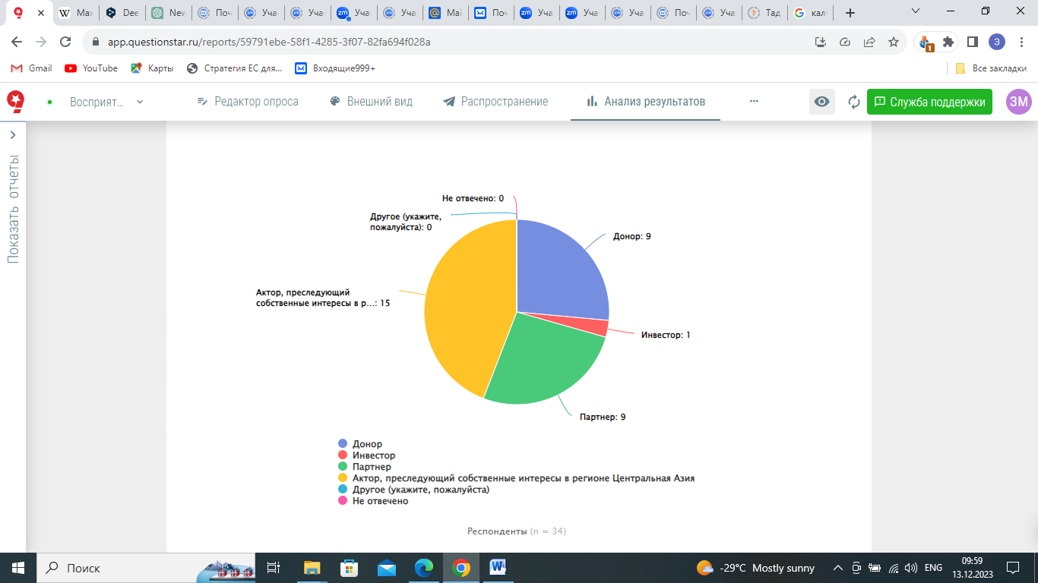

Figure 19 ‒ The predominant perception of the EU in Central Asia

Note ‒ Author’s elaboration

On the other hand, the EU is seen as a donor and a partner by an equal percentage of respondents ‒ 26% each ‒ indicating that there is recognition of the EU's supportive roles in terms of aid and collaborative initiatives. These views align with the arguments put forth by Fawn [4, p. 675-697] and Arynov [92, p. 734-750], who also highlight the EU's multifaceted engagement with Central Asia.
Interestingly, only 2% of respondents view the EU as an investor, which points to a lesser emphasis on the EU's economic involvement compared to its roles as a donor and partner. This distribution of perceptions underscores the complexity of the EU’s image in Central Asia, suggesting that while the EU is acknowledged for its supportive roles, its impact as an economic investor is relatively minimal or less recognized in the region.
To address the question of how significantly the EU can influence integration in Central Asia, we observed a range of opinions from respondents. Specifically, 15% believe the EU will definitely have a positive impact, while 65% think it might have a positive impact, and 20% are skeptical, believing it will not have any effect (figure 20). These findings suggest a generally favorable view of the EU's role in the region, consistent with earlier research which highlights a positive perception of the EU in Central Asia [60, p. 72-81; 61, p. 1183-1203; 92, p. 734-750; 100, p. 2-9]. However, Hanova [72, p. 699-713] presents a nuanced perspective, noting that while the EU persistently advocates for regional consolidation in Central Asia, this stance sometimes diverges from local narratives and priorities. This disparity between broad positive perceptions and the EU's sometimes discordant regional strategies underscores the complexity of its influence on Central Asian integration.

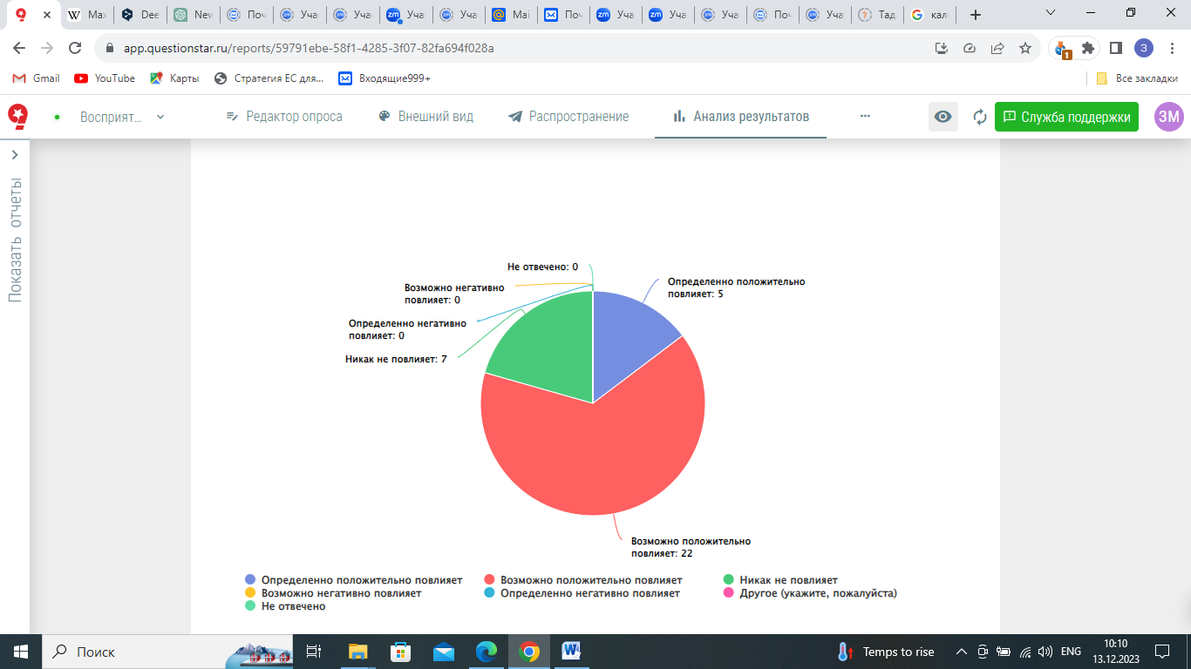

Figure 20 ‒ Local perception on the EU’s influence on integration in Central Asia

Note ‒ Author’s elaboration

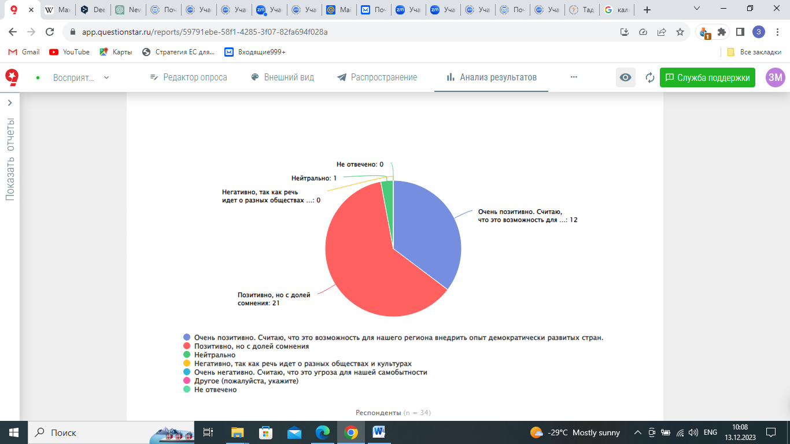

Figure 21 ‒ The perception of EU initiatives to promote democracy, the rule of law, and human rights in Central Asia

Note ‒ Author’s elaboration

Figure 21, furthermore, we examined the perception of EU initiatives aimed at promoting democracy, the rule of law, and human rights in Central Asian countries. The perception is overwhelmingly positive, with 35.2% of respondents viewing it very positively, considering it an opportunity for the region to learn from democratically developed countries. Additionally, 61.7% expressed a positive outlook, albeit with some reservations, while only 3% maintained a neutral stance. Notably, there was no indication of a negative or very negative attitude toward these initiatives.
These results indicate a degree of hesitation in the sensitive area of democracy promotion in Central Asia. This contributes to existing research suggesting that the EU's normative agenda is not entirely comprehensible within the local context [59, p. 1-19; 92, p. 734-750; 257].
We conducted an examination of Central Asian attitudes toward EU environmental initiatives in the region. Our findings reveal that 44% of respondents have a very positive perception, viewing these initiatives as an opportunity to apply successful EU practices. Another 44% also hold a positive view, acknowledging the environmental challenges in Central Asia. Meanwhile, 11.7% of respondents expressed a neutral stance. Notably, there were no negative or very negative opinions, suggesting that the initiatives are not seen as a threat to Central Asia (figure 22).

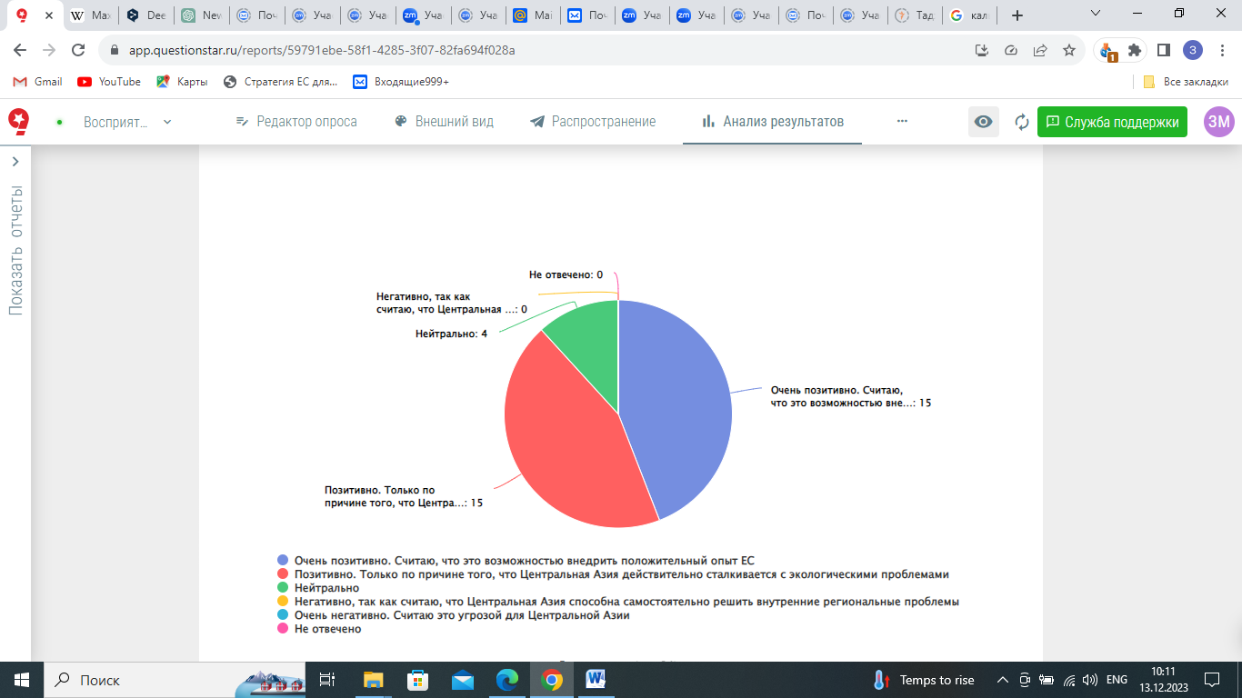

Figure 22 ‒ The perception of EU environmental initiatives in Central Asia

Note ‒ Author’s elaboration

These results, arguably, highlight a willingness among Central Asian intermediate elites to engage in environmental cooperation, indicating a potential for stronger regional collaboration. By promoting regional cooperation, the EU might bolster local capacities to tackle environmental issues and integrate these efforts into its broader framework. This approach could foster a more unified and collaborative strategy for environmental management in Central Asia, thereby strengthening ties between the region and EU member states. Effective sustainable management of environmental issues in Central Asia will likely be achieved through enhanced global and regional cooperation which might be positively influenced by the EU [258].
Additionally, we assessed the perception of EU initiatives aimed at fostering economic prosperity in Central Asia. As depicted in Figure 28, 29.4% of local elites have a very positive view of EU projects contributing to the region's economic recovery. Meanwhile, 64.7% regard these initiatives positively but with some reservations. Only 5.8% maintain a neutral stance, and none view the economic support negatively or very negatively.
These findings suggest that while the majority of Central Asian elites view EU economic initiatives favorably, there remains a notable level of cautious optimism. This cautious perspective may reflect underlying concerns in the EU-Central Asia economic relations such as high transportation costs, regulatory and language barriers, inadequate marketing practices, intense competition, tariffs, and local corruption. Addressing these issues could enhance the effectiveness of EU support and better align it with the needs and expectations of Central Asian countries. The alignment with previous research by Andžāns, Gussarova and Balcer [77] further underscores the attractiveness of the EU market for Central Asians but also highlights the persistent barriers that must be navigated to facilitate deeper economic integration within the region and enclose interregional ties.
We also explored how EU educational initiatives are perceived in Central Asia. The initiatives are viewed very positively by 79.4% of respondents, who see academic exchanges with EU countries as highly beneficial for the region's education system (see figure 23).

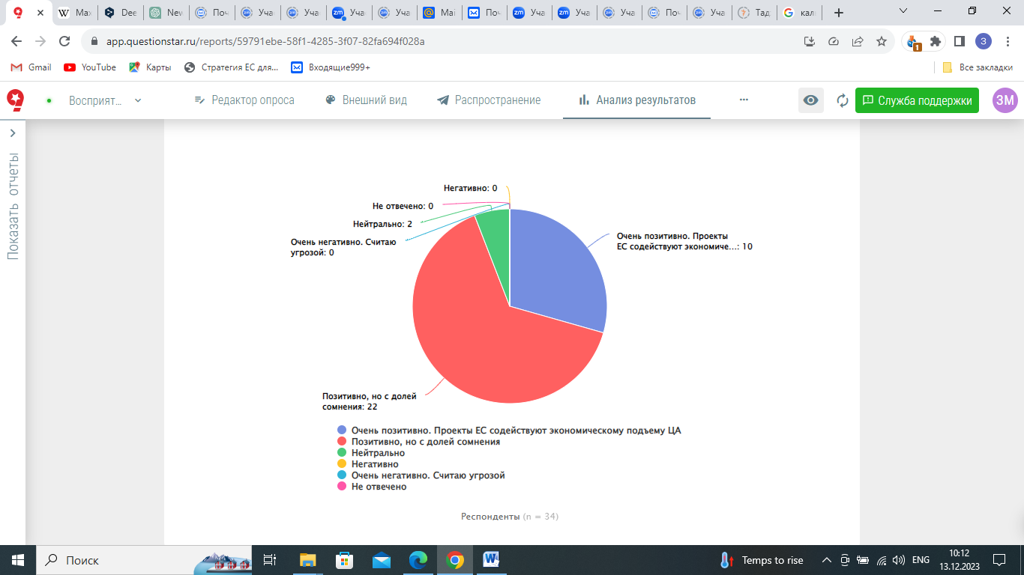

Figure 23 ‒ The elites’ attitude towards EU’s initiatives to promote economic prosperity in Central Asia

Note ‒ Author’s elaboration

Another 20.5% hold a positive view but with some reservations. This suggests that education could serve as a platform for the EU to promote its ideas on regional cooperation in Central Asia, given the positive and comprehensible reception of EU-supported educational efforts in the region. This perspective aligns with Longhurst et al. [80, p. 111-122], who argue that the EU’s higher education strategy for Central Asia aims to enhance regional integration. The strategy encourages local actors to pool their sovereignty by adopting EU-style regulations and aligning national standards with supranational norms [80, p. 111-122].
Some reservations from local elites may echo Jones's [79, p. 59-84] criticism that the EU's educational initiatives in Central Asia expose a disconnect between its regulatory goals and regional realities. Although Central Asian countries participate in EU programs, their commitment remains superficial. The EU’s strategy needs to tackle specific educational issues directly rather than relying solely on high-level diplomacy. The initiatives also suffer from a lack of transparency and local involvement, highlighting broader challenges in achieving effective regional integration (figure 24).

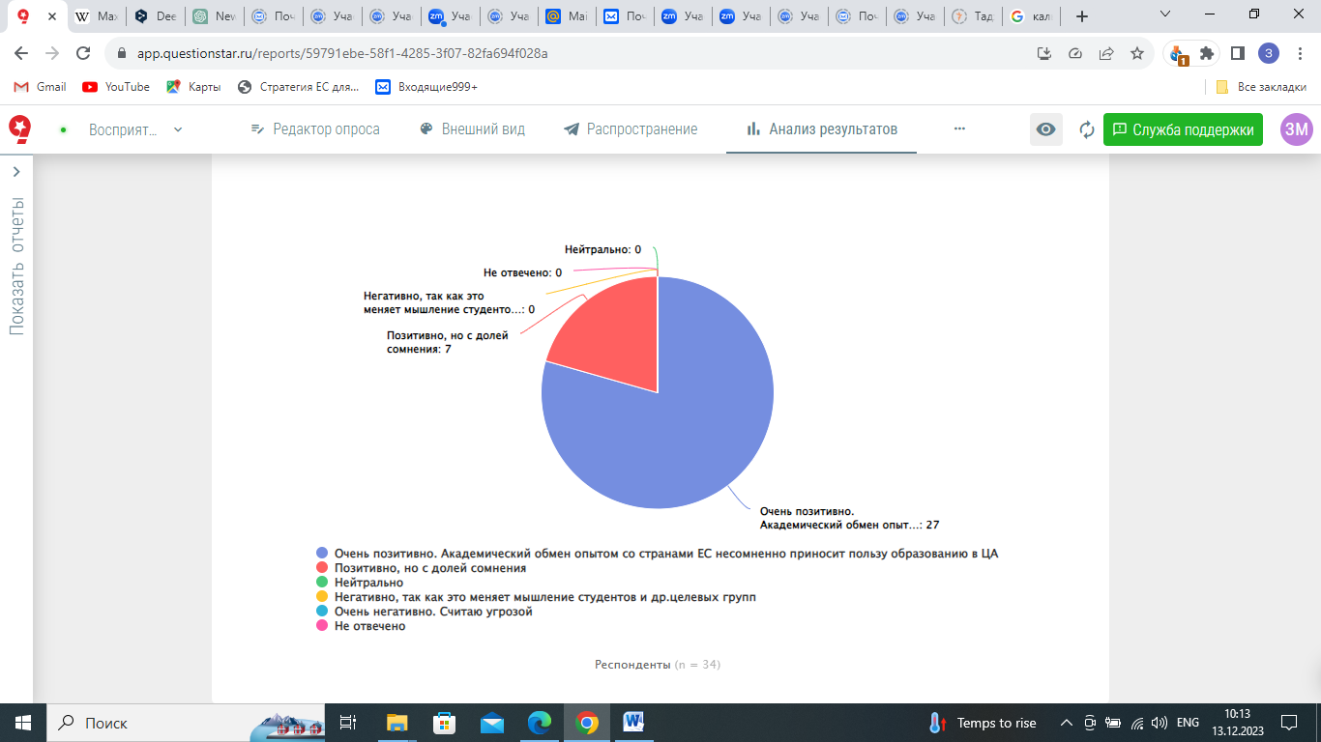

Figure 24 ‒ The elites’ attitudes towards EU’s educational initiatives for Central Asia

Note ‒ Author’s elaboration

Furthermore, EU initiatives aimed at promoting closer regional cooperation among the five Central Asian countries are very positively perceived by 52.9% of the respondents, who consider these initiatives as an opportunity to establish a constructive dialogue between the Central Asian countries for addressing key regional issues. 17,6% have a positive attitude, but with some doubt. 26.4% have a neutral attitude, and 2.9% have a negative perception considering the states of Central Asia are capable to build the constructive dialogue by their own.
The survey on the EU's approach to supporting regional cooperation in Central Asia provides an understanding of the perceptions held by Central Asian elites. The respondents rated the EU's involvement in the development of Central Asian countries, with the most frequently chosen score being 6 of 10. The examination of the EU’s involvement into the Central Asia’s development indicates a generally positive reception, with 26% viewing it very positively and 44% positively. But at the same 58% of the respondents consider time EU is capable to promote regional cooperation, 61% consider the EU is currently facilitating regional cooperation within Central Asia (figure 25) and 65% are sure the EU might positively influence on the integration in Central Asia. The EU's potential positive impact on integration in Central Asia is acknowledged by a majority, but doubts persist. This assumption empirically complements theoretical point of view on that the attitudes of elites towards regional cooperation, referred to as regional allegiance, are crucial for the continuity of the integration process [259]. Fifty percent of respondents perceive the EU's engagement with Central Asia as rooted in a geopolitical approach, while 44% view the EU as an actor driven by its own interests. This observation aligns with Fawn's [4, p. 675-697] perspective.

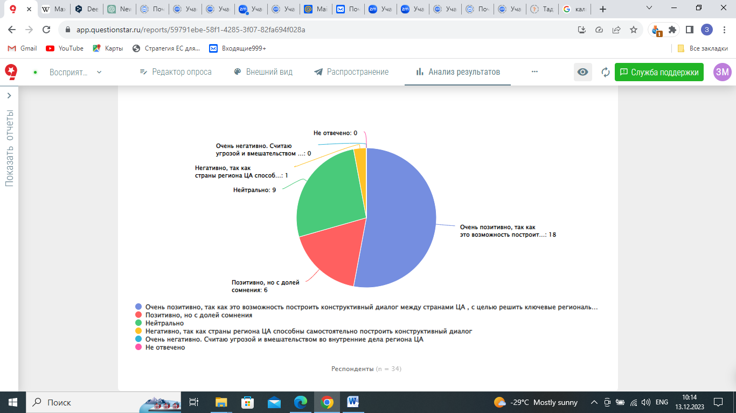

Figure 25 ‒ The elites’ attitudes towards EU’s initiatives to promote closer regional cooperation in Central Asia

Note ‒ Author’s elaboration

In conclusion, our examination of Central Asian attitudes towards the European Union's involvement in the region reveals a nuanced perspective. While 44% of respondents view the EU’s engagement positively, seeing it as an opportunity to apply successful EU practices and address regional environmental challenges, there is a notable perception that the EU’s involvement could be more substantial. The prevalent rating of 6 out of 10 suggests that while the EU's efforts are recognized, there is room for deeper engagement.
The positive views towards EU material assistance and educational initiatives, alongside cautious optimism regarding economic support, indicate a generally favorable reception. However, some skepticism remains, particularly around the EU's motivations, which are often seen through a geopolitical lens or as driven by its own interests. This skepticism is complemented by a belief that regional cooperation is crucial and that the EU’s impact might be limited by local dynamics and internal barriers. Overall, the findings suggest that the EU has significant potential to foster closer regional cooperation and integration in Central Asia, but achieving this will require addressing local concerns, enhancing engagement strategies, and aligning more closely with regional priorities and realities.

3.2 Local Media Content Analysis of News Articles: Methodology and Results
According to Similarweb, a global company specializing in web analytics, digital performance, and web traffic data aggregation, these media portals are the most widely followed general news sites in their respective countries. Tengrinews.kz, recognized as Kazakhstan's largest information site, ranks among the top 30 news websites in the country. Likewise, Kun.uz, 24.kg, Turkmenportal.com, and Asiaplus.news are highly influential in Uzbekistan, Kyrgyzstan, Turkmenistan, and Tajikistan, respectively, with Asiaplus.news being the most-read source for Tajik users, reaching approximately 30,000 unique daily visitors. These news outlets were selected due to their substantial regional influence and significant user engagement.
Notably, all the data for the media content analysis was collected in the Russian language as it remains the lingua franca of the region [259, p. 35-44]. The news articles that centered on EU-Central Asia relations across various spheres of cooperation were converted to PDF format and retrieved from Central Asian websites.
We conducted the news media content analysis in several stages. First, we sorted the collected news articles into categories related to bilateral relations between the EU and each Central Asian state, as well as interregional cooperation between the EU and Central Asia. It's important to note that news articles covering bilateral cooperation between EU member states and individual Central Asian countries, such as Germany-Kazakhstan relations, were not included in the analysis. We then examined word frequency in the entire dataset and within the articles related to region-to-region cooperation to gain insights into priorities in both cases.
The word frequency query has been accomplished by the NVivo software, which is widely recognized and extensively used for academic content analysis [260]. NVivo is a computer-assisted qualitative data analysis software that allows researchers to analyze and manage large amounts of information [260, p. 1280]. It simplifies the research process without compromising the quality of analysis [260, p. 1281]. Furthermore, by using NVivo, we were able to systematically analyze and interpret the content of the news media sources, enabling us to gain valuable insights into the perceptions and representations of the European Union's role in Central Asia. The program presented comprehensive information in the form of a word cloud and a table of the top 20 of the most frequently terms, allowing for a quick understanding of the main priorities.
Second, the NVivo program generated a visualization in the form of a 'word tree' centered around the concept of 'regional cooperation.' This method is a modification of the traditional 'keyword-in-context' approach for information retrieval, effectively illustrating the connections between the identified words in the dataset. It greatly simplifies the process of querying and exploring textual content [261].
Third, the analysis aimed to determine the proportion of articles with positive, neutral, or negative tones within the news stories dedicated to the region-to-region partnership between the EU and Central Asia. Since the research focuses on tracing the EU's regional approach, the NVivo program was used to code the sentiment (positive, neutral, or negative) of the news articles, which were manually sorted.
This subsection focuses on the empirical findings of the study, starting with the media content analysis. This analysis is based on data collected from the five most popular Central Asian news outlets: Tengrinews.kz (Kazakhstan), 24.kg (Kyrgyzstan), Asiaplus.news (Tajikistan), Turkmenportal.com (Turkmenistan), and Kun.uz (Uzbekistan). The media analysis covers the period from 2019 to 2022 and was facilitated by the use of NVivo software. The content analysis provides insights into the portrayal and coverage of the EU and its interactions with Central Asia in the selected news outlets.
Following the media analysis, the chapter presents the results of survey conducted among Central Asian intermediate elites. The survey participants included members of the Cabar.Asia network, academic experts, diplomats, and journalists from Central Asia. The survey data provides insights into the perceptions and opinions of these individuals regarding the EU's role in regional cooperation in Central Asia.
We conducted a content analysis of news coverage on five major news websites: Asiaplus.news, Kun.uz, Tengrinews.kz, Turkmenportal.com, and 24.kg, focusing on the period from 2019 to 2022. The analysis aimed to track the coverage of various aspects of collaboration between the EU and the states of Central Asia in media articles, using key term such as 'European Union'.
In this way, we collected a total of 530 articles, and the table below provides the exact percentage of the collected data (table 6).

Table 6 ‒ Frequency of news articles on the EU-Central Asian cooperation, according to news outlet and year
Year | Tengrinews.kz |  | Outlets  24.kg | Asiaplus.news | Kun.uz | Turkmenportal.com | Total
2022 | 22 | 62 |  | 49 | 13 | 14 | 160
2021 | 13 | 64 |  | 50 | 10 | 3 | 140
2020 | 8 | 30 |  | 45 | 13 | 9 | 105
2019 | 11 | 42 |  | 54 | 8 | 10 | 125
Total | 54 (10.1) | 198(37.3) |  | 198(37.3) | 44 (8.3) | 36(6.7) | 530 (100)
Notes:
1. Percentages in parentheses
2. Author’s elaboration

The largest proportion of news articles was published on 24.kg and Asiaplus.news, with an equal number of 198 news pieces each. Turkmenportal.com had the lowest number of articles published. Kun.uz and Tengrinews.kz published 44 and 54 articles respectively.
The data collection started from the beginning of the 2019, the year of the EU renewed strategy adoption. In 2020, the majority of news articles were related to the Covid-19 pandemic and the EU’s assistance for Central Asia (Appendix A). The 2021 was marked by frequent news coverage of the Tajik-Kyrgyz border conflict in April (Appendix A), the Afghan issues (Appendix A). In 2022, the news topics mostly were dedicated to the events in Kazakhstan in January (Appendix A) and the border conflict between Tajikistan and Kyrgyzstan in September (Appendix A), and the EU-Central Asia summit in Astana (Appendix A). Throughout the analyzed period, information on the EU regional programs and financial assistance (Appendix A) received regular coverage in local media sources. Additionally, media articles about EU - Central Asian joint political, business, cultural events, forums, annual ministerial meetings (Appendix A) and environmental issues (Appendix A) were frequently published during this time.

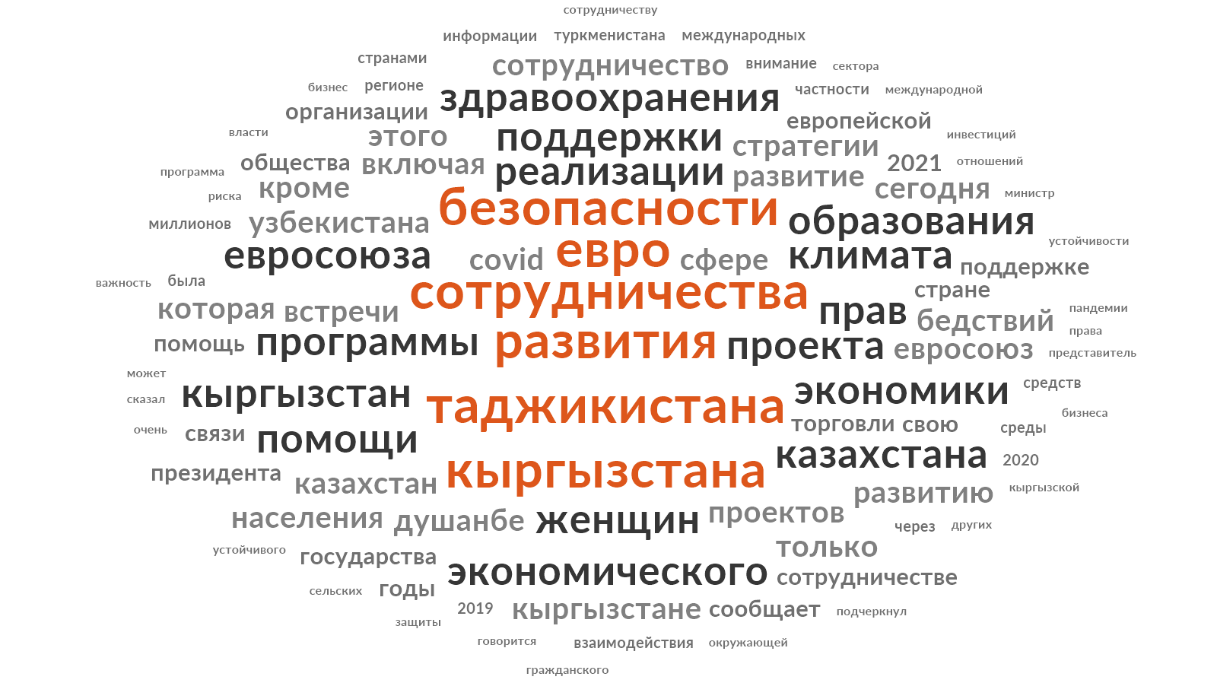

Figure 26 ‒ Media Content Analysis

Notes:
1. Word frequency query results in Russian language
2. Author’s elaboration

Figure 26, which represents a cloud of the most used words in the local news outlets about the EU. Table 7 the most frequently used words are development (529 times), cooperation (470 times), euro (315 times), security (297 times), project (282 times), programs (226 times) The analysis shows that the news articles about the EU had mostly a financial aid perspective, since the words development, euro, project, programs are in the list of the most frequent. Furthermore, the word 'security' ranks among the top 10 most frequently used words, indicating that it is perceived as a priority area in EU-Central Asia relations by the local media. The words 'Tajikistan' and 'Kyrgyzstan' are in the top 5 list, which correlates with the fact that both news outlets, such as Asiaplus.news and 24.kg, covered the largest amount of news articles.

Table 7 ‒ Top 20 frequent words in the news articles of Central Asian media outlets. Translated from Russian

Word | Time of Repetition
Development | 529
Cooperation | 470
Tajikistan | 462
Euro | 315
Kyrgyzstan | 302
Security | 297
Project | 282
Programs | 226
Realization | 224
Women | 203
Support | 175
Economy | 174
Right | 170
Health | 164
Kazakhstan | 163
Climate | 158
Education | 152
COVID | 148
Uzbekistan | 148
Meeting | 140

Note ‒ Author’s elaboration

However, the words, such as 'region' or 'regional cooperation' are not among the most frequently used words. Since our focus is on regional cooperation in Central Asia, influenced by the EU, we have analyzed the number of media articles dedicated to bilateral and multilateral issues.

Table 8 ‒ Number of news articles per year dedicated to the bilateral and multilateral format of cooperation between the EU and states of Central Asia

Year | 24.kg |  | Asiaplus.news |  | Kun.uz |  | Tengrinews.kz |  | Turkmenportal.com
 | bilateral | multilateral | bilateral | multilateral | bilateral | multilateral | bilateral | multilateral | bilateral | multilateral
2019 | 31 | 11 | 39 | 15 | 3 | 5 | 9 | 2 | 7 | 3
2020 | 28 | 2 | 35 | 10 | 9 | 4 | 8 | 0 | 5 | 4
2021 | 40 | 24 | 34 | 16 | 8 | 2 | 9 | 4 | 3 | 0
2022 | 50 | 12 | 37 | 12 | 7 | 6 | 17 | 5 | 9 | 5
Note ‒ Author’s elaboration

According to the data from table 8, there is a higher frequency of coverage on bilateral cooperation between the EU and specific Central Asian republics compared to the multilateral EU-Central Asia dialogue. This suggests that while the news outlets do cover the multilateral format of cooperation between the EU and Central Asia, they tend to give more attention to bilateral relations between the EU and individual Central Asian republics. The proportion of news articles is 388 (73%) dedicated to bilateral cooperation and 142 (27%) dedicated to multilateral cooperation.

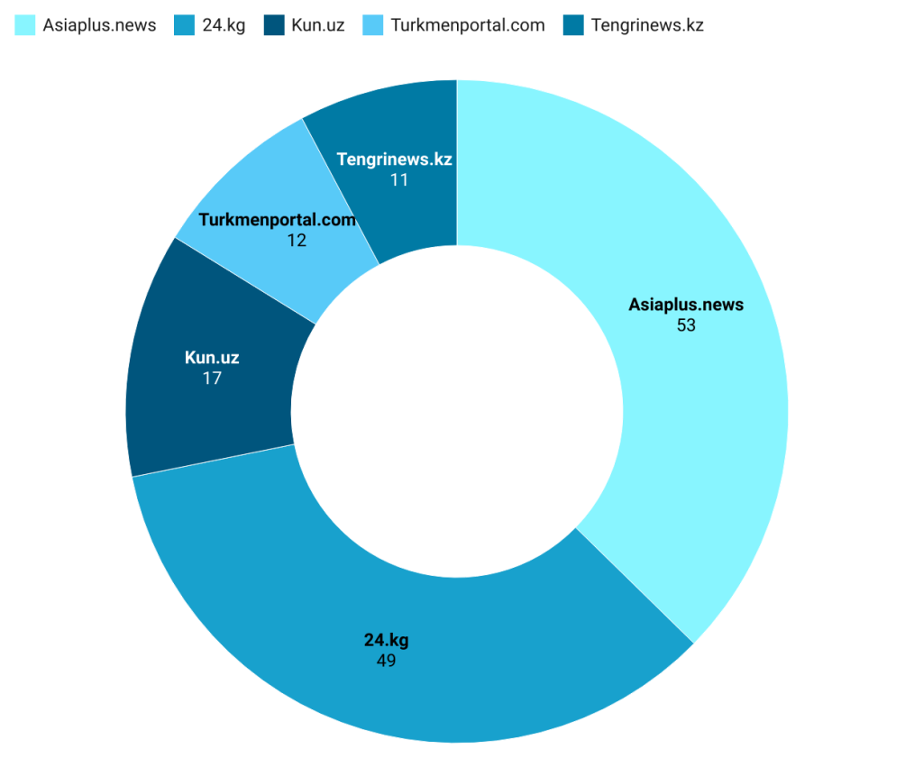

Figure 27 ‒ Media Content Analysis

The percentage of the news articles per the outlet dedicated to the EU-Central Asia region-to-region partnership

Note ‒ Author’s elaboration

According to Figure 27, Asiaplus.news and 24.kg published the highest number of news articles dedicated to the region-to-region partnership between the EU and Central Asia. On the other hand, Tengrinews.kz has shown the lowest number of articles in this regard.
Furthermore, to gain insight into the priority areas in region-to-region cooperation as covered by the local media, we conducted an analysis of the most frequently used words in articles dedicated to multilateral issues.
The analysis of news articles dedicated to the region-to-region partnership between the EU and Central Asia, using word frequency techniques, has revealed the most frequently covered topics. These include security, financial and development aid areas, as well as other significant topics such as the economy, climate, and COVID. The observations made in figure 28 and table 9 provide evidence to support these findings, as the words 'security' (122 times), 'development' (114 times), and 'Euro' (76 times) were repeated frequently.

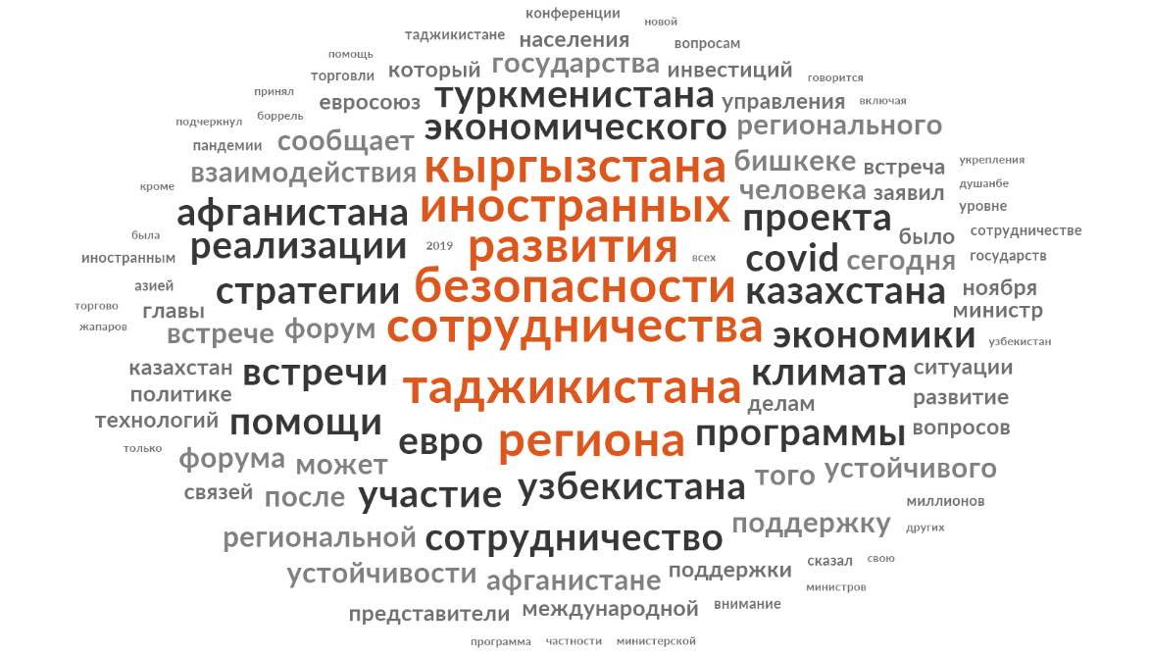

Figure 28 ‒ Media Content Analysis

Notes:
1. Word frequency query results in the news articles dedicated to the EU-Central Asia region-to-region partnership in Russian language
2. Author’s elaboration

Table 9 ‒ Top 20 frequent words in the news articles of Central Asian media outlets dedicated to the EU-Central Asia region-to-region partnership

Word | Time of Repetition
Cooperation | 152
Security | 122
Tajikistan | 119
Development | 114
Region | 104
Foreign | 77
Kyrgyzstan | 77
Euro | 76
Uzbekistan | 72
Programs | 68
Economic | 65
Strategy | 61
Kazakhstan | 60
Climate | 57
COVID | 55
Meetings | 54
Realization | 54
Participation | 54
Afghanistan | 46
Project | 46

Notes:

1. Translated from Russian

2. Author’s elaboration
There are words as ‘cooperation’ (repeated 152 times) and ‘region’ (repeated 104 times), which are the hints, the EU - Central Asia region-to-region partnership is perceived as the top 5 priorities by the media outlets.
Furthermore, the exact match repetition percentage of the term 'regional cooperation' in news articles about EU-Central Asia relations is 23%. It was found in 33 out of 142 articles, with a total of 57 exact references. This indicates that the term 'regional cooperation' is frequently reiterated in articles dedicated to the EU-Central Asia partnership.
Figure 29 is a “regional cooperation” word tree, which is a graphical version of the traditional “keyword-in-context” information-retrieval technique, and enables rapid querying and exploration of bodies of text [261, p. 1221-1227].

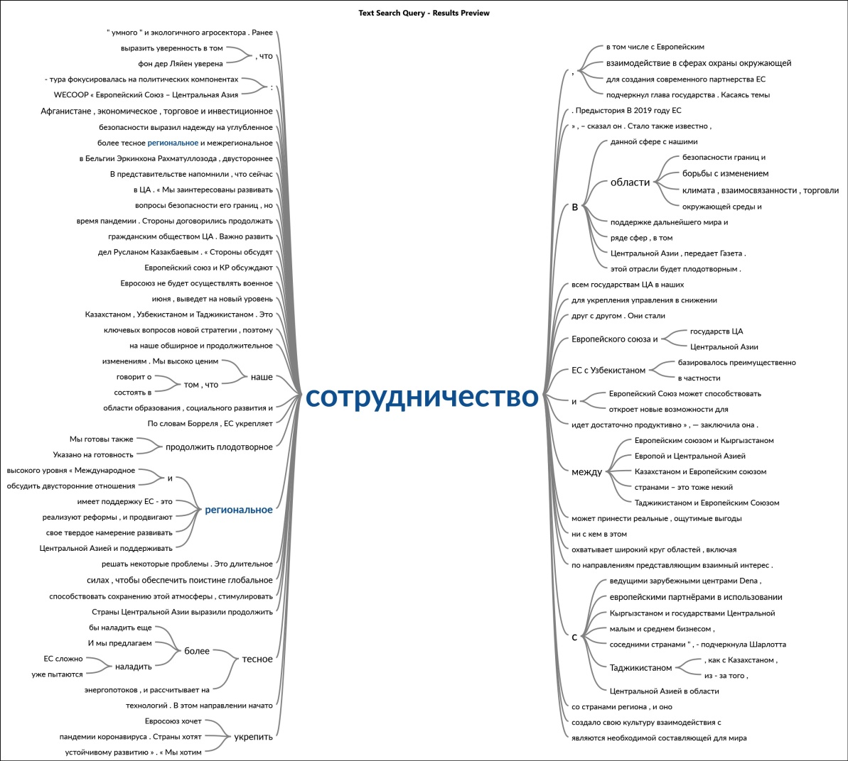

Figure 29 ‒ Word Tree of the ‘regional cooperation’ phrase in Russian language

Note ‒ Author’s elaboration

In general, the figure depicts a clear connection between the term 'regional cooperation' and several matching phrases. On the left side of the figure, there is a direct link between the phrase 'regional cooperation' and phrases such as 'closer regional and interregional cooperation', 'the EU supports regional cooperation' (repeated twice), 'reforms are implemented to promote regional cooperation', and 'there is a strong commitment to develop regional cooperation'. This empirical reflection provides evidence of the Central Asian media outlets covering the relevant and existing EU's agenda of regional cooperation promotion.
Furthermore, based on the indications provided in Figure 8, we observe direct matches between the phrase 'regional cooperation' and phrases such as 'in the environmental fields' (repeated twice), 'in the field of border security', and 'in the field of combating climate change'. This interesting observation contributes to our understanding that the EU promotes regional cooperation with and within Central Asia, particularly in areas such as border security and environmental issues. Additionally, the repeated mentions of 'the environmental fields' and 'border security' indicate that the EU's assistance in those areas through projects like WECOOP and BOMCA is highly appreciated and creates a connection between border security and closer regional cooperation in the perception of Central Asians. However, Figure 5 also reveals limited coverage of the EU's regional assistance programs in other areas and efforts to encourage a strong regional dialogue within Central Asia to address existing water issues and border conflicts.
Regarding the tone of the collected 142 articles about the EU-Central Asia multilateral cooperation, more than half of them (54%) showed a neutral bias. This is due to the high percentage of neutral news published in Asiaplus.news (27%). The 24 kg, Kun.uz, Tengrinews.kz and Turkmenportal.com have shown the results of 9.1, 7.7, 4.2 and 6.3% respectively (figure 30). The new stories were mostly descriptive and did not report either positively nor negatively. Mostly they content general information on the events such as meetings and etc. (Appendix A).

Figure 30 ‒ Positive, neutral and negative tones of the news stories on the EU-Central Asia cooperation in five Central Asian news outlets during 2019-2022

Note ‒ Author’s elaboration

A positive tone was present in 33.8% or 48 news articles. The majority of these articles highlighted the benefits of EU financial aid, foreign investments, news stories about newly launched EU programs, technical assistance provided to Central Asia, and grants offered to the states in the region (Appendix A). The 24.kg outlet perceives the EU-Central Asia partnership positively, as it covers 18% or 26 articles with a positive tone. Kun.uz, Tengrinews.kz, and Turkmenportal.com all have an equal result of 2.1%, indicating a lower proportion of positive coverage. On the other hand, Asiaplus.news published 9.1% of the news stories with a positive tone, demonstrating a relatively higher proportion of positive coverage.
Regarding negative articles about EU-Central Asia relations in the five local outlets, 10% or 15 news stories had this tone. Those articles focused on condemning acts of violence in Almaty in 2022 (Appendix A), border conflicts between Tajikistan and Kyrgyzstan (Appendix A), human rights concerns (Appendix A), geopolitical concerns (Appendix A) and the EU's negative assessment of climate change impacts in Central Asia (Appendix A).
Summarizing the above suggestions based on the quantitative content analysis of the most popular Central Asian outlets, we may give the following assessment of the local perceptions on the EU’s approach on promoting the regional cooperation within Central Asia.
Firstly, it is evident that the topic of region-to-region cooperation is covered by the local media. However, there is a notable emphasis on the bilateral format of cooperation between the EU and specific Central Asian states. Only 27% of the available data is dedicated to EU-Central Asian cooperation, which is less than one-third of the overall coverage. This suggests that the multilateral aspect of the EU as a promoter of regional cooperation within Central Asia may not be prioritized in local news coverage. Furthermore, this assumption finds its theoretical understanding by Smith [141, p. 3-43], who argues the EU often resorts to bilateral agreements in ‘instances where regional groupings are weak’, but still encouraged cooperation between neighboring countries. Smith concludes the prevalence of bilateral agreements over multilateral ones is particularly evident in the context of the European Neighborhood Policy (ENP), which strongly leans toward bilateralism [159, p. 3-294].
Secondly, based on Figure 6, it is evident that Tajikistan and Kyrgyzstan are more prominently featured in the EU-Central Asia region-to-region partnership. This is supported by the fact that Asiaplus.news and 24.kg have published the highest proportion of news stories on the EU-Central Asia relations. On the other hand, Tengrinews.kz has the lowest percentage, indicating that the topic may not be of particular interest for Kazakhstan.
Furthermore, according to the word frequency query, the EU’s regional approach for Central Asian cooperation is mostly perceived as a security, development and financial assistance. This outcome offers partial validation to Smith's [159, p 21] theoretical proposition regarding the European Union's (EU) objectives when promoting regional cooperation in other regions. Smith [159, p. 23] suggests that the EU pursues dual goals, encompassing self-interest and normative aspirations. However, in the context of Central Asia, it becomes evident that the EU's endeavor to foster regional cooperation is predominantly associated with promoting security by the local media. This orientation is more indicative of a pragmatic, materialistic approach rather than a normative one.
In addition, a ‘regional cooperation’ word tree has shown that local news outlets perceive the EU's regional cooperation promotion efforts as closely connected to providing border security assistance and addressing environmental and climate issues in Central Asia. The local media's coverage highlights and emphasizes these aspects, indicating their understanding of the EU's priorities and activities within its regional approach.
According to the tone of the news stories, it can be observed that the local media generally perceives EU-Central Asia regional cooperation in a neutral manner, primarily publishing general information on the EU-Central Asia multilateral dialogue. The neutral tone prevails in four of the news outlets, except for 24.kg, which portrays a positive perception of the EU-Central Asia regional collaboration.
In general, based on the available evidence, we can conclude that the Central Asian outlets perceive the EU's efforts to promote closer regional cooperation within Central Asia ambiguously. Indeed, based on the available information and the coverage in local media, it is challenging to conclude that regional cooperation is widely supported, strengthened, or significantly impacted in Central Asia by the EU. The local media coverage does not provide strong evidence to suggest a substantial impact or widespread support for regional cooperation within the region. But the spheres such as security, economic support and environment have a potential to become a basis for the EU to promote regional cooperation within the region.
Overall, the study employs two types of analysis: local media content analysis and survey responses from Central Asian intermediate elites. These approaches aim to provide a comprehensive understanding of the perceptions held by Central Asians regarding the EU’s agenda of regional cooperation promotion for Central Asia. By combining these two methods, the study seeks to gather insights from the opinions of key individuals within the region as well as analyze the representation and coverage of the EU's role in Central Asian media. Together, these analyses contribute to a deeper understanding of Central Asian perspectives on the EU's role as a regional cooperation promoter in Central Asia.

CONCLUSION

This research attempts to make a contribution to the existing body of knowledge regarding the European Union’s (EU) norm promotion, particularly in the context of Central Asia, where it navigates a critical intersection of regional cooperation, geopolitics, and international relations. By addressing the research question, the study focuses on the specific spheres in which the EU is perceived as most influential in fostering regional cooperation, particularly as identified by local intermediate elites.
Utilizing a mixed-method approach that combines content analysis of media articles from 2019 to 2022 with an online survey conducted among local elites in 2023, this study provides a comprehensive examination of how the EU’s initiatives and efforts are understood, interpreted, and evaluated in Central Asia. This methodological framework allows for a nuanced analysis that captures both qualitative and quantitative insights, thereby enriching the understanding of the EU's role in the region.
Through this exploration, the research not only highlights the perceptions of the EU among local elites but also sheds light on the broader implications of these perceptions for EU policy and engagement strategies. By understanding how the EU's actions are received in Central Asia, the study offers insights into the effectiveness and resonance of its normative agenda, revealing both opportunities and challenges for future cooperation. Ultimately, this research underscores the importance of local perspectives in shaping the dynamics of international relations, emphasizing the need for the EU to adapt its approaches to better align with the realities and aspirations of Central Asian states.
The study is structured around several precise tasks and the mail goal, all of which have been effectively achieved. It delves into how Central Asian media portray the EU's agenda for promoting regional cooperation, identifying key narratives and focal points within this discourse.
In addition, the research includes a survey of local elites, encompassing diplomats, academics, and industry experts, to investigate how these influential figures perceive the EU’s agenda. This study underscores the nuanced and evolving nature of EU-Central Asia relations, highlighting significant insights into how these relationships are framed and perceived within the region. By examining the primary hypotheses and scientific results, a comprehensive understanding of the EU's engagement strategy and its implications for regional cooperation emerges. The research goal and tasks have been achieved, contributing to a detailed and point-by-point exploration of the key dimensions of this relationship.
This research tries to accomplish its primary aim: to assess how the European Union’s agenda for promoting regional cooperation among post-Soviet republics is perceived by Central Asian media and elites. It identified the aspects of the EU’s engagement considered most influential and comprehensible while providing actionable policy recommendations to strengthen the EU's involvement in the region. Each task tries to outline for the study was achieved, contributing to a comprehensive analysis of EU-Central Asia relations. Below is an account of the tasks were addressed:
1. The research thoroughly analyzed the EU’s strategies and initiatives aimed at fostering regional cooperation in Central Asia, emphasizing its focus on security, economic development, environmental cooperation, and educational programs. By investigating both direct and indirect methods, the study provided a theoretical framework for understanding the EU’s role as a promoter of regional cooperation. It highlighted the EU’s efforts to balance bilateral relationships and regional projects.
2. The study reviewed existing literature on regional cooperation within Central Asia, tracing its evolution and identifying how historical, political, and economic factors have shaped the region's cohesion. Previous studies on EU-Central Asia relations were assessed, focusing on the EU’s strategies and contributions to regional cooperation. This provided a contextual understanding of the EU’s role and its perceived limitations. This paper explored Central Asian perceptions of the EU, identifying areas where the EU is respected, such as environmental and educational initiatives, and areas of skepticism, such as its geopolitical and normative influence compared to Russia and China.
3. Challenges to regional cohesiveness, such as differing national priorities, geopolitical influences, and limited regional infrastructure, were critically examined, highlighting opportunities for the EU to address these gaps. The study detailed the EU’s current relationship with individual Central Asian countries, highlighting the alignment of strategic interests and regional policies with the EU’s overarching goals. The EU’s agenda and objectives for promoting regional cooperation were clearly defined and critically examined, revealing areas where its initiatives align with regional needs and where further engagement is necessary.
4. The primary constraints and methods of this research were noted, including challenges related to data availability and accessibility, ensuring a transparent and rigorous methodological approach. A detailed analysis of survey results among intermediate elites provided valuable insights into their perceptions of the EU’s role in promoting regional cooperation and its comparative influence. Local media content was investigated to assess representations of the EU and its policies, providing quantitative and qualitative insights into how the EU is framed in regional narratives.
Together, these tasks formed a comprehensive framework that addressed the various facets of understanding the EU’s influence on regional cooperation in Central Asia. The study bridged gaps in knowledge, clarified perceptions, and provided a holistic assessment of the EU’s engagement in the region.
This research tried to fulfill its objectives but also set the stage for further exploration of how the EU can enhance its role in fostering regional cohesion and addressing shared challenges. By achieving the formulated goal and tasks, the study provides a robust foundation for policy recommendations, ensuring that the EU remains an influential and constructive partner in Central Asia's development and integration.
The following conclusions may be offered:
1. All the theoretical approaches to the promotion of regional cooperation may be divided into two large groups – pragmatic and normative. The same applies to practical implementation of EU’s policy in the region.
2. Elite and public support are significant determinants for the development of cooperation within the region and with outer-regional actors, identification policy priorities, as well as the realization of regional projects and initiatives.
3. The EU’s initiatives in Central Asia are perceived through three primary lenses: security, economic development, and environmental cooperation. While the EU is recognized as a facilitator of regional cooperation in specific areas, it encounters obstacles in asserting itself as a major geopolitical player in Central Asia. The region’s geopolitical landscape, heavily influenced by the presence of Russia and China, limits the EU’s ability to establish itself as a dominant actor. However, the EU’s ability to focus on sectoral initiatives, particularly in the environment, economy, and education, presents opportunities to deepen its engagement and address regional priorities effectively.
4. The duality of the EU’s role in Central Asia is highlighted. On one hand, it is a respected partner in areas where its expertise aligns with regional needs. On the other hand, its broader aspirations to act as a normative power and a significant geopolitical player face significant perception challenges. By refining its strategies, amplifying its successes, and addressing local concerns, the EU can strengthen its role as a valuable partner in fostering regional cooperation and addressing shared challenges.
5. The survey of Central Asian elites also shed light on the mixed perceptions of Central Asian elites regarding the EU’s influence. There is strong support for the EU’s initiatives in specific areas such as environmental management, economic cooperation, and education, where its sectoral expertise is evident. However, its efforts to promote democratic values and act as a normative power face significant challenges in gaining traction within the region.
Local media prominently features the EU’s contributions to the mentioned three areas, particularly its security-related activities, such as border management and countering shared regional challenges. Economic assistance and development projects further enhance the EU’s image as a partner for progress. Environmental issues are another significant domain where the EU’s involvement is well-regarded. The EU's focus on climate change, resource management, and cross-border environmental cooperation resonates with the region’s critical needs, showcasing the EU as a pragmatic and effective actor in these specific sectors.
A content analysis of local media reveals that bilateral relations dominate coverage, while only 27% of stories frame the EU’s role within a regional context. This framing suggests that while the EU actively pursues a regional integration agenda, its narrative does not resonate strongly as a unified regional approach in local media. The bilateral focus reflects the varying national priorities of Central Asian states and highlights a challenge for the EU in positioning itself as a cohesive regional partner.
This study contributes to a deeper understanding of the EU’s engagement in Central Asia, offering a foundation for policymakers to craft strategies that enhance the EU's effectiveness and visibility in the region. Through targeted initiatives and a balanced approach between bilateral and multilateral cooperation, the EU can play a pivotal role in shaping a more cohesive and cooperative Central Asia.
This complex interplay between skepticism and recognition reflects the broader challenges facing the EU as it seeks to enhance its engagement in Central Asia. While the focus on bilateral relations may dominate current perceptions, the potential for collaborative efforts in critical areas remains a significant aspect of the EU’s identity in the region. By capitalizing on this potential, the EU can work towards building stronger, more meaningful partnerships that address both local needs and broader regional aspirations.
However, the research also uncovers several challenges that affect the EU's engagement in Central Asia:
1. Neutral Perceptions of Broader EU Engagement: While certain areas of cooperation, particularly economic development, receive positive recognition, other areas ‒ such as governance reforms and democratization efforts – are met with ambivalence or outright skepticism. This response indicates a disconnect between the EU’s normative agenda and the local realities faced by Central Asian states. Elites and media representatives may perceive these efforts as misaligned with the region’s immediate priorities and pressing challenges, suggesting a need for the EU to better understand and align its initiatives with local contexts.
2. Elite Skepticism and Geopolitical Concerns: The survey reveals a pervasive skepticism regarding the EU's motives, with many respondents interpreting the EU’s regional agenda through a geopolitical lens. Central Asian elites often view the EU’s engagement as part of a broader strategy to extend its influence, potentially at the expense of other powerful actors in the region, particularly Russia and China. This perspective emphasizes the complexity of regional power dynamics and highlights the importance of fostering trust and transparency in the EU's relationships with Central Asian countries. Addressing these geopolitical concerns is crucial for the EU to enhance its credibility and effectiveness in the region.
These challenges underscore the necessity for the EU to adopt a more culturally sensitive and transparent approach in its dealings with Central Asia. By bridging the gap between its normative aspirations and the local context, the EU can better position itself as a genuine partner in the region, facilitating more meaningful and productive engagement that resonates with the priorities and aspirations of Central Asian states.
Based on the research findings, the study proposes several actionable recommendations for the EU to enhance its engagement in Central Asia:
1. Focus on Economic and Environmental Cooperation: The EU should prioritize initiatives that promote economic development and environmental sustainability. These areas resonate positively with local perceptions, providing the EU with a strong foundation for deeper and more impactful engagement in the region. By aligning its efforts with the pressing needs of Central Asian states, the EU can foster goodwill and build stronger partnerships.
2. Culturally Informed Framework: A more nuanced and culturally sensitive approach to cooperation is essential for effective engagement. The EU might be mindful of local contexts, particularly when promoting democratic norms or governance reforms, to counter existing skepticism and foster greater trust among local stakeholders. By understanding the cultural and historical intricacies of the region, the EU can tailor its initiatives to be more relevant and acceptable.
3. Shift towards Multilateral Agreements: While bilateralism has its merits, the EU should actively work towards strengthening multilateral frameworks and regional cooperation mechanisms. By focusing on region-wide initiatives, the EU can facilitate stronger regional ties that align with its normative goals, enhancing collective action and collaboration among Central Asian states.
4. Inclusive Stakeholder Engagement: The EU should broaden its engagement beyond state actors to foster meaningful dialogue with civil society, academia, and business leaders. Such an inclusive approach would ensure that a diverse set of local voices influences EU initiatives, enhancing their relevance and effectiveness. By incorporating multiple perspectives, the EU can create initiatives that truly reflect the needs and aspirations of the region.
5. Longitudinal Studies for Ongoing Assessment: To measure the long-term impact of its engagement, the EU should implement longitudinal studies that track the effectiveness of its initiatives in Central Asia over time. Regular feedback from local stakeholders would allow for ongoing adjustments and improvements to EU strategies, ensuring that they remain aligned with the evolving dynamics of the region.
By adopting these recommendations, the EU can significantly strengthen its role as a constructive partner in Central Asia, fostering regional cooperation that is both meaningful and sustainable. This endeavor requires ongoing research to inform policymakers in both the EU and Central Asia about the intricacies of their relationship.
We may also outline implications for Central Asian countries in case of the EU promotes regional cooperation successfully:
1) opportunities:
Enhanced Central Asian trade through harmonized policies and reduced trade barriers can lead to regional economic growth. As well as it will give a greater access to European markets and investments, bolstering sectors like infrastructure, green energy, and digital transformation.
Growing regional identity reduces over-reliance on traditional powers such as Russia and China by balancing relationships with the EU.
Successful regionalism opens avenues for technological and educational exchanges, fostering innovation and skill development.
Joint initiatives to address transboundary challenges like water management, climate change, and security threats can foster stability and trust.
Enhanced governance practices through EU-supported reforms could lead to improved institutions and reduced corruption.
Regional cooperation can boost the international visibility of Central Asia, enabling the region to collectively negotiate better terms in global platforms.
EU-backed infrastructure projects can enhance connectivity, boosting regional transit potential between Europe and Asia, particularly through the Middle Corridor.
Adoption of EU environmental standards could position Central Asia as a leader in sustainable development within the Eurasian context.
2) risks:
Success in EU-promoted cooperation might be viewed as a challenge to Russian and Chinese influence, potentially resulting in political or economic retaliation.
Risk of being caught in a great-power rivalry, complicating foreign policy and regional strategies.
Unequal benefits from regional cooperation could exacerbate tensions between larger economies like Kazakhstan and smaller, less-developed states like Kyrgyzstan and Tajikistan.
Competition for resources, such as water or EU funding, could heighten intra-regional disputes.
Relying heavily on EU models and aid could lead to reduced local autonomy in policymaking, especially if conditionalities are stringent.
Potential misalignment between EU values and local political systems might lead to friction or resistance.
EU-driven regional initiatives may face resistance due to perceived imposition of Western norms, especially in areas like governance and human rights.
Elite resistance in authoritarian regimes may hinder implementation of regional reforms.
Adoption of EU trade standards and practices may require costly adjustments, especially for smaller economies with less capacity to adapt.
Industries dependent on non-EU markets might face short-term disruptions during the transition.
Uneven EU engagement across the region might create divisions if some countries are perceived as more strategically important or favored by the EU.
By balancing these risks and opportunities, Central Asian states could strategically leverage EU-promoted regional cooperation for sustainable growth while mitigating potential geopolitical and internal challenges.
Further exploration in this field is vital, and potential areas for future research include:
1. Public Perception Studies: Comprehensive surveys and interviews should be conducted across diverse demographics in Central Asia to capture a wide range of public perceptions regarding the EU. Such studies would provide invaluable insights into how the EU’s image and influence compare to those of other external actors, such as Russia and China, thus allowing for a nuanced understanding of regional sentiment.
2. Media Influence: Investigating the role of different media platforms in shaping public opinion about the EU would yield valuable insights into how various media narratives can influence perceptions. A comparative analysis of how the EU is portrayed in different media outlets ‒ both state-controlled and independent ‒ would be particularly beneficial in understanding the dynamics at play.
3. Civil Society Engagement: Researching the role of civil society in promoting awareness of the EU in Central Asia could offer important lessons for enhancing grassroots engagement strategies. This approach would help identify effective methods for building stronger connections between EU initiatives and local communities, ensuring that programs are tailored to the specific needs and concerns of the populace.
4. Geopolitical Dynamics: Comparative studies exploring the influence of Russia, China, and the EU in Central Asia could illuminate the region's geopolitical competition. Understanding how these powers are perceived and how they interact with the EU would aid in crafting more effective foreign policy strategies, enabling the EU to navigate the complexities of regional relations with greater efficacy.
By pursuing these research avenues, stakeholders can deepen their understanding of the multifaceted relationship between the EU and Central Asia, ultimately contributing to more effective policy formulation and implementation.
The research successfully addresses its core objectives, providing a comprehensive analysis of the EU’s role in promoting regional cooperation in Central Asia. It offers a nuanced understanding of local perceptions, revealing both the successes and challenges of EU engagement in this diverse region. The findings underscore that while the EU has made significant strides, it faces notable obstacles, particularly in aligning its normative agenda with local realities.
By highlighting the need for a more culturally sensitive and inclusive approach, the study lays a solid foundation for further research. It presents actionable recommendations for policymakers, emphasizing the importance of fostering multilateral cooperation and engaging a broader range of stakeholders. This approach would not only enhance the EU’s influence in Central Asia but also promote a more collaborative and sustainable future for the region.
Overall, this study tries to fulfill its academic goal and tasks and can serve as an resource for EU policymakers navigating the complexities of Central Asia’s geopolitical landscape. It underscores the necessity of aligning EU initiatives with local priorities, ultimately fostering a more effective and meaningful engagement in the region. By addressing these critical areas, the EU can work towards building stronger ties with Central Asian states, ensuring that its efforts contribute to stability, prosperity, and mutual benefit for all parties involved.

REFERENCES

1 Wetzel A., Orbie J., Bossuyt F. One of what kind? Comparative perspectives on the substance of EU democracy promotion // Cambridge Review of International Affairs. – 2015. – Vol. 28, Issue 1. – P. 21-34.
2 Spaiser O.A. The European Union's influence in Central Asia: Geopolitical Challenges and Responses. – NY.: Lexington Books, 2018. – 270 p.
3 Hoffmann K. The EU in Central Asia: successful good governance promotion? // Third World Quarterly. – 2010. – Vol. 31, Issue 1. – P. 87-103.
4 Fawn R. ‘Not here for geopolitical interests or games’: the EU’s 2019 strategy and the regional and inter-regional competition for Central Asia // Central Asian Survey. – 2022. – Vol. 41, Issue 4. – P. 675-698.
5 The EU and Central Asia: New Opportunities for a Stronger Partnership // URL:https://eur-lex.europa.eu/legal-content/EN/TXT/PDF/?uri=CELEX. 15.05.2024.
6 Korosteleva E., Bossuyt F. The EU and Central Asia: New opportunities or ‘the same old song’? // https://kar.kent.ac.uk/74465/. 15.05.2024.
7 Engvall J. Central Asia Moves Beyond Russia // Current History. – 2023. – Vol. 122, issue 846. – P. 261-267.
8 Arynov Z. ‘Nobody Goes to Another Monastery with Their Own Charter’: The EU’s Promotion of ‘European Values’ as Perceived in Central Asia // Europe-Asia Studies. – 2022. – Vol. 74, Issue 6. – P. 1028-1050.
9 Häkli J. Territoriality and the rise of the modern state // Fennia. – 1994. – Vol. 172, Issue 1. – P. 1-82.
10 Frisvoll S., Rye J.F. Elite discourses of regional identity in a new regionalism development scheme: The case of the ‘Mountain Region’in Norway // Norsk Geografisk Tidsskrift–Norwegian Journal of Geography. – 2009. – Vol. 63, Issue 3. – P. 175-190.
11 Conti N., Marino B., Memoli V. Business Elites and European Integration: Really a Honeymoon Story? // Journal of Common Market Studies. – 2021. – Vol. 59, Issue 6. – P. 1400-1418.
12 Rakhimov M.A. Complex regionalism in Central Asia: Local, regional, and global factors // Cambridge Journal of Eurasian Studies. – 2018. – Vol. 2. – P. 1-13.
13 Coetzee E. No rest for the weary: Competition and emulation in international politics. A Waltzian perspective // Politikon. – 2019. – Vol. 46, Issue 1. – P. 1-19.
14 Mearsheimer J. The Tragedy of Great Power Politics. – NY.: WW Norton, 2001. – 160 р.
15 Keohane R.O. After hegemony: Cooperation and discord in the world political economy. – Princeton, 2005. – 320 р.
16 Söderbaum F., Stålgren P., Van Langenhove L. The EU as a global actor and the dynamics of interregionalism: A comparative analysis // The EU as a global player. – London: Routledge, 2013. – P. 117-132.
17 Smith K.E. European Union foreign policy in a changing world. – Hoboken: John Wiley & Sons, 2008. – 331 р.
18 Schimmelfennig F., Sedelmeier U. The Europeanization of central and eastern Europe. – NY., 2005. – 256 р.
19 Börzel T. A., Risse T. From Europeanization to diffusion // In book: Domestic Politics and Norm Diffusion in International Relations – NY., 2012. – P. 290-307.
20 Lavenex S. EU external governance in'wider Europe' // Journal of European public policy. – 2004. – Vol. 11, Issue 4. – P. 680-700.
21 Delcour L. Shaping the Post-Soviet Space? EU Policies and Approaches to Region-Building. – London: Routledge, 2016. – 194 р.
22 Gilson J. New Interregionalism? The EU and East Asia // In book: The EU as a Global Player. – London: Routledge, 2013. – P. 59-78.
23 Telò M. European Union and New Regionalism: Regional Actors and Global Governance in a Post-hegemonic Era. – Bodmin, 2007. – 406 р.
24 Duchêne F. Europe’s role in world peace // Europe tomorrow: Sixteen Europeans look ahead. – 1972. – Vol. 43. – P. 32-47.
25 Manners I. Normative power Europe: a contradiction in terms? // Journal of common market studies. – 2002. – Vol. 40, Issue 2. – P. 235-258.
26 Mayer H., Vogt H. A Responsible Europe? Ethical foundations of EU external affairs. – London, 2006. – 240 р.
27 Aggestam L. Introduction: ethical power Europe? // International affairs. – 2008. – Vol. 84, Issue 1. – P. 1-11.
28 Pacheco Pardo R. Normal Power Europe: Non-proliferation and the normalization of EU's foreign policy // Journal of European integration. – 2012. – Vol. 34, Issue 1. – P. 1-18.
29 Nicolaïdis K., Howse R. ‘This is my EUtopia...’: Narrative as Power // Journal of common market studies. – 2002. – Vol. 40, Issue 4. – P. 767-792.
30 Acharya A. Regionalism beyond EU-centrism // In book: The Oxford handbook of comparative regionalism. – Oxford, 2016. – P. 109-130.
31 Allison-Reumann L., Murray P. The EU and ASEAN after Brexit // https://eastasiaforum.org/2017/01/03/the-eu-and-asean-after-brexit/. 10.10.2024.
32 Beeson M., Stone D. The European Union model’s influence in Asia after the global financial crisis // European Journal of East Asian Studies. – 2013. – Vol. 12, Issue 2. – P. 167-190.
33 Börzel T. A., Risse T. When Europeanisation meets diffusion: Exploring new territory // In book: From Europeanisation to Diffusion. – London: Routledge, 2020. – P. 192-207.
34 Breslin S., Higgott R. Studying regions: learning from the old, constructing the new // New political economy. – 2000. – Vol. 5, Issue 3. – P. 333-352.
35 Jetschke A. Institutionalizing ASEAN: celebrating Europe through network governance // Cambridge Review of International Affairs. – 2009. – Vol. 22, Issue 3. – P. 407-426.
36 Wong R. Model power or reference point? The EU and the ASEAN Charter // Cambridge review of international affairs. – 2012. – Vol. 25, Issue 4. – P. 669-682.
37 Boulding K.E. National images and international systems // Journal of conflict resolution. – 1959. – Vol. 3, Issue 2. – P. 120-131.
38 Silverstein B., Flamenbaum C. Biases in the perception and cognition of the actions of enemies // Journal of Social Issues. – 1989. – Vol. 45, Issue 2. – P. 51-72.
39 Holsti K.J. National role conceptions in the study of foreign policy // International studies quarterly. – 1970. – Vol. 14, Issue 3. – P. 233-309.
40 Elgström O., Smith M. The European Union's roles in international politics. – London: Taylor & Francis Limited, 2006. – 240 p.
41 Lucarelli S. et al. External perceptions of the European Union as a global actor. – London: Routledge, 2010. – 256 p.
42 Sicurelli D. The EU as a norm promoter through trade. The perceptions of Vietnamese elites // Asia Europe Journal. – 2015. – Vol. 13. – P. 23-39.
43 Aydin‐Düzgit S. Legitimizing Europe in contested settings: Europe as a normative power in Turkey? // Journal of common market studies. – 2018. – Vol. 56, Issue 3. – P. 612-627.
44 Spechler M.C. Regional Cooperation in Central Asia //Problems of Post-Communism. – 2002. – Vol. 49, Issue 6. – P. 42-47.
45 Bohr A. Regionalism in Central Asia: new geopolitics, old regional order // International affairs. – 2004. – Vol. 80, Issue 3. – P. 485-502.
46 Kakharov J. Regional Cooperation in Central Asia as Seen from Uzbekistan // Central Asia and the Caucasus. – 2007. – Vol. 6. – P. 110-116.
47 Allison R. Virtual regionalism, regional structures and regime security in Central Asia //Central Asian Survey. – 2008. – Vol. 27, Issue 2. – P. 185-202.
48 Wegerich K. Passing over the conflict. The Chu Talas basin agreement as a model for Central Asia? // In book: Central Asian Waters. Social, economic, environmental and governance puzzle. – Helsinki, 2008. – P. 117-131.
49 Pomfret R. Regional integration in central Asia // Economic Change and Restructuring. – 2009. – Vol. 42, Issue 1. – P. 47-68.
50 Kavalski E. The new Central Asia: The regional impact of international Actors. – Singapore, 2010. – 346 p.
51 Tolipov F. Micro-geopolitics of central Asia: a Uzbekistan perspective // Strategic Analysis. – 2011. – Vol. 35, Issue 4. – P. 629-639.
52 Rosset D., Svarin D. The Constraints of the past and the Failure of Central Asian Regionalism, 1991–2004 // Region: Regional Studies of Russia, Eastern Europe, and Central Asia. – 2014. – Vol. 3, Issue 2. – P. 245-266.
53 Cornell S.E., Starr S.F. Modernization and regional cooperation in Central Asia: a new Spring // https://www.isdp.eu/publication/modernization. 10.09.2024.
54 Iskakova Z., Sarsembayev M., Kakenova Z. Can Central Asia be integrated as ASEAN? // Opción. – 2018. – Vol. 34, Issue 85. – P. 152-169.
55 Patnaik A. Regionalism and Regional Cooperation in Central Asia // International studies. – 2019. – Vol. 56, Issue 2-3. – P. 147-162.
56 Nogayeva A. Central Asian States’ Security Policies // In book: The Changing Perspectives of Central Asia in the 21 st Century. – Ed. 1 st. – İstanbul, 2020. – S. 44-66.
57 Akhmedyanova D. Central Asian States’ Relations to Each Other (1991-2020) // In book: The Changing Perspectives of Central Asia in the 21 st Century. – Ed. 1 st. – İstanbul, 2020. – S. 107-146.
58 Buranelli F.C. Central Asian regionalism or central Asian order? Some reflections // Central Asian Affairs. – 2021. – Vol. 8, Issue 1. – P. 1-26.
59 Mukasheva Z. et al. Is EU democracy promotion aligned with local media perception in Central Asia? Findings from content analysis // Political Research Exchange. – 2024. – Vol. 6, Issue 1. – P. 1-20.
60 Ospanova B., Sadri H.A., Yelmurzayeva R. Assessing EU perception in Kazakhstan's mass media // Journal of Eurasian Studies. – 2017. – Vol. 8, Issue 1. – P. 72-82.
61 Bekenova K., Collins N. Knowing me, knowing you: Media portrayal of the EU in Kazakhstan // Europe-Asia Studies. – 2019. – Vol. 71, Issue 7. – P. 1183-1204.
62 Laumulin M., Aubakir A. European union and Central Asia: new horizons for enhanced cooperation // Journal of Central Asian Studies. – 2021. – Vol. 81, Issue 1. – P. 35-43.
63 Zharmakhanova Z., Nurdavletova S., Akhmetzhanova L. European Union’s Security policy in regard to Central Asia within the EU strategy for CA // Central Asia & the Caucasus. – 2021. – Vol. 22, Issue 3. – P. 7-14.
64 Arynov Z. Opportunity and Threat Perceptions of the EU in Kazakhstan and Kyrgyzstan // Central Asian Survey. – 2022. – Vol. 41, Issue 4. – P. 734-751.
65 Kluczewska K., Dzhuraev S. The EU and Central Asia: the nuances of an ‘aided’partnership // In book: Managing security threats along the EU’s eastern flanks. – Cham, 2020. – P. 225-251.
66 Dzhuraev S. The EU’s Central Asia policy: no chance for change? // Central Asian Survey. – 2022. – Vol. 41, Issue 4. – P. 639-653.
67 Qoraboyev I., Moldashev K. The Belt and Road Initiative and comprehensive regionalism in central Asia // In book: Rethinking the Silk Road. – Singapore, 2018. – P. 115-130.
68 Zhengyuan X. In the shadow of great powers: a comparative study of various approaches to regionalism in Central Asia // Connections. – 2010. – Vol. 9, Issue 4. – P. 37-52.
69 Nourzhanov K. Omnibalancing in Tajikistan's foreign policy: Security-driven discourses of alignment with Iran // Journal of Balkan and Near Eastern Studies. – 2012. – Vol. 14, Issue 3. – P. 363-381.
70 Owen C. Making friends with neighbors?: Local perceptions of Russia and China in Kyrgyzstan // China Quarterly of International Strategic Studies. – 2018. – Vol. 4, Issue 03. – P. 457-480.
71 Krapohl S., Vasileva-Dienes A. The region that isn't: China, Russia and the failure of regional integration in Central Asia // Asia Europe Journal. – 2020. – Vol. 18, Issue 3. – P. 347-366.
72 Hanova S. The interplay of narratives on regionness, regionhood and regionality: European Union and Central Asia // Central Asian Survey. – 2022. – Vol. 41, Issue 4. – P. 699-714.
73 Pak M. et al. State-run media outlets in Central Asia: external regime legitimation through regional conflict and cooperation framing // Central Asian Survey. – 2020. – Vol. 39, Issue 3. – P. 378-397.
74 Winn N., Gänzle S. Recalibrating EU foreign policy vis-à-vis Central Asia: Towards principled pragmatism and resilience // Geopolitics. – 2023. – Vol. 28, Issue 3. – P. 1342-1361.
75 Zharmakhanova Z., Marcos A.A. New EU strategy for Central Asia: barriers for its successful implementation // Вестник КазНУ. – 2022. – Т. 98, №2. – C. 70-77.
76 Mukasheva Z., Efe H. Evolution of The European Union’s Engagement with Central Asia // Journal of Central Asian Studies. – 2023. – Vol. 89, Issue 1. – P. 7-19.
77 Andžāns M., Gussarova A., Balcer A. No. 11 Economic relations and trade-Analysis of the EU’s comparative advantages and Central Asian interests // https://duepublico2.uni-due.de/receive/duepublico_mods_00048493. 10.08.2024.
78 Andersone L. EU Cooperation Programmes for Central Asia: New Challenges and Responses // Studia Europ. – 2024. – Vol. 28, Issue 1. – P. 247-260.
79 Jones P. Regulatory regionalism and education: The European Union in central Asia // Globalisation, Societies and Education. – 2010. – Vol. 8, Issue 1. – P. 59-85.
80 Longhurst K.A., Nitza-Makowska A., Skiert-Andrzejuk K. International Higher Education as Foreign Policy: Comparing the Strategies of the EU, China, and Russia Towards Central Asia // Polish Political Science Yearbook. – 2022. – Vol. 4, Issue 51. – P. 111-123.
81 Bossuyt F., Kubicek P. Advancing democracy on difficult terrain: EU democracy promotion in Central Asia // European Foreign A ffairs Review. – 2011. – Vol. 16, Issue 5. – P. 639-658.
82 Warkotsch A. The European Union and Central Asia. – London: Routledge, 2011. – 224 p.
83 Axyonova V. The European Union's Democratization Policy for Central Asia: Failed in Success Or Succeeded in Failure?. – Hannover, 2014. – 210 p.
84 Sharshenova A., Crawford G. Undermining Western democracy promotion in Central Asia: China’s countervailing influences, powers and impact // Central Asian Survey. – 2017. – Vol. 36, Issue 4. – P. 453-472.
85 Spaiser O.A. The EU as a security actor in Central Asia: Minor but not marginal // Europe en formation. – 2015. – Vol. 1. – P. 83-105.
86 Plottka J. One Size Fits None: Is there a Regional Approach to Central Asia? // Europe en formation. – 2015. – Vol. 1. – P. 123-139.
87 Bossuyt F. The EU’s and China’s development assistance towards Central Asia: low versus contested impact // Eurasian Geography and Economics. – 2019. – Vol. 59, Issue 5-6. – P. 606-631.
88 Leskina N., Sabzalieva E. Constructing a Eurasian higher education region:“points of correspondence” between Russia’s Eurasian economic union and China’s belt and road initiative in Central Asia // Eurasian Geography and Economics. – 2021. – Vol. 62, Issue 5-6. – P. 716-744.
89 Krivokhizh S., Soboleva E. The EU and China: how do they fit in Central Asia? // Central Asian Survey. – 2022. – Vol. 41, Issue 4. – P. 715-733.
90 Pantucci R. Europe’s Pivot to Central Asia // https://rusi.org. 10.09.2024.
91 Bossuyt F., Dessein B. The European Union, China and Central Asia: global and regional cooperation in a new era. – NY.: Routledge, 2022. – 312 p.
92 Arynov Z. Opportunity and Threat Perceptions of the EU in Kazakhstan and Kyrgyzstan // Central Asian Survey. – 2022. – Vol. 41, Issue 4. – P. 734-751.
93 Elgström O., Chaban N. Studying external perceptions of the EU: Conceptual and methodological approaches // In book: Perceptions of the EU in Eastern Europe and Sub-Saharan Africa: Looking in from the outside. – London, 2015. – P. 17-33.
94 Arynov Z. Hardly visible, highly admired? Youth perceptions of the EU in Kazakhstan // Journal of Eurasian Studies. – 2022. – Vol. 13, Issue 1. – P. 42-55.
95 Chaban N. et al. Images of the EU beyond its Borders: Issue‐Specific and Regional Perceptions of European Union Power and Leadership // Journal of common market studies. – 2013. – Vol. 51, Issue 3. – P. 433-451.
96 Bregu M. The regional cooperation in the Western Balkans and the Open Balkans initiative // Academicus International Scientific Journal. – 2024. – Vol. 15, Issue 29. – P. 191-206.
97 Bell E., Bryman A. The ethics of management research: an exploratory content analysis // British J of management. – 2007. – Vol. 18, Issue 1. – P. 63-77.
98 Crowley C., Harré R., Tagg C. Qualitative research and computing: methodological issues and practices in using QSR NVivo and NUD* IST // International journal of social research methodology. – 2002. – Vol. 5, Issue 3. – P. 193-197.
99 Emerson M. et al. Into EurAsia: Monitoring the EU’s Central Asia Strategy: report of the EUCAM Project. – Madrid, 2010. – 157 p.
100 Ribeiro F. et al. Media bias monitor: Quantifying biases of social media news outlets at large-scale // Proceed. of the internat. AAAI conf. on Web and Social Media. – San Franciso, 2018. – P. 2-10.
101 Kenny T., Gross P. Journalism in Central Asia: A victim of politics, economics, and widespread self-censorship // The International Journal of Press/Politics. – 2008. – Vol. 13, Issue 4. – P. 515-525.
102 Shared vision, common action: A stronger Europe: A global strategy for the European Union’s Foreign and Security Policy / European Union Global Strategy. – NY., 2016. – 60 р.
103 Указ Президента Республики Казахстан. О Концепции внешней политики Республики Казахстан на 2001 года // https://bstudy.net/984278/politika/kontseptsiya_vneshney_politiki_2001. 15.01.2025.
104 Указ Президента Республики Казахстан. О Концепции внешней политики Республики Казахстан на 2014-2020 годы: утв. 21 января 2014 года, №741 (утратил силу) // https://adilet.zan.kz/rus/docs/U1400000741. 15.01.2025.
105 Указ Президента Республики Казахстан. О Концепции внешней политики Республики Казахстан на 2020-2030 годы: утв. 6 марта 2020 года, №280 // URL:https://adilet.zan.kz/rus/docs/U2000000280. 15.01.2025.
106 Концепция внешней политики Республики Кыргызстан (1999) // URL:http://mfa.kg/acts/koncepciya-vneshnei-politiki-kr_kg.html. 15.01.2025.
107 Указ Президента Республики Казахстан. Концепция внешней политики Республики Кыргызстан: утв. 10 января 2007 года, №2 // http://cbd.minjust.gov.kg/act/view/ru-ru/4569?cl=ru-ru. 15.01.2025.
108 Концепция внешней политики Республики Кыргызстан (2019) // http://cbd.minjust.gov.kg/act/view/ru-ru/430045 (дата обращения 15.01.2025)
109 Указ Президента Республики Таджикистан. Концепция внешней политики 2002 года и доктрина «открытых дверей» // https://bstudy.net/984328/politika/kontseptsiya_vneshney_politiki 15.01.2025.
110 Указ Президента Республики Таджикистан. О Концепции внешней политики Республики Таджикистан: утв. 27 января 2015 года, №332 // https://online.zakon.kz/Document/?doc_id=31666891. 15.01.2025.
111 Указ Президента Республики Таджикистан. Об обеспечении реализации единой внешней политики Республики Таджикистан: утв. 3 декабря 2015 года // https://adlia.tj/show_doc.fwx?rgn=125826. 15.01.2025.
112 Концепция внешней политики Республики Туркменистана как нейтрального государства (декабрь 1995 года) // https://base.spinform.ru/show_doc.fwx?rgn=9356. 15.01.2025.
113 Постановление Президента Республики Туркменистан. О Концепции внешнеполитического курса Туркменистана на период 2013-2017 гг.: утв. 10 декабря 2012 года // https://bstudy.net/984351/politika/kontseptsiya. 15.01.2025.
114 Утверждена Концепция внешнеполитического курса Туркменистана на 2017-2023 годы // https://kyrgyzstan.tmembassy.gov.tm/ru/news. 15.01.2025.
115 Закон Республики Узбекистан. Об основных принципах внешнеполитической деятельности Республики Узбекистан: принят 10 сентября 2012 года, №ЗРУ-330 // https://lex.uz/docs/39322. 15.01.2025.
116 Стратегия действий по пяти приоритетным направлениям развития Республики Узбекистан в 2017-2021 годах: прилож. №1 // О Стратегии действий по дальнейшему развитию Республики Узбекистан: утв. Указом Президента Республики Узбекистан от 7 февраля 2017 года, №УП-4947 // https://old.gov.uz/ru/pages/international_relations. 15.01.2025.
117 Partnership and Cooperation Agreement establishing a partnership between the European Communities and their Member States, of the one part, and the Republic of Tajikistan, of the other part // https://eur-lex.europa.eu. 19.02.2024.
118 Partnership and Cooperation Agreement establishing a partnership between the European Communities and their Member States, of the one part, and the Republic of Uzbekistan, of the other part // https://eur-lex.europa.eu/. 19.02.2024.
119 Interim Agreement on trade and trade-related matters between the European Community, the European Coal and Steel Community and the European Atomic Energy Community, of the one part, and Turkmenistan of the other part // https://eur-lex.europa.eu/legal-content. 19.02.2024.
120 Partnership and Cooperation Agreement Establishing a Partnership between the European Communities and Their Member States, of the One Part, and the Kyrgyz Republic, of the other part // https://eur-lex.europa.eu. 19.02.2024.
121 Enhanced Partnership and Cooperation Agreement between the European Union and its Member States, of the one part, and the Republic of Kazakhstan, of the other part // https://eur-lex.europa.eu/legal-content/. 19.02.2024.
122 SimilarWeb.com // https://www.similarweb.com/ru/website/
123 WorldBank // https://www.worldbank.org/
124 Cabar.asia // https://cabar.asia/ru/. 19.02.2024.
125 Official website of European Commission // https://commission. 19.02.2024.
126 EEAS Factsheet on the EU - Central Asia relations // https://www.eeas.europa.eu/sites/default/files/documents/2023. 19.02.2024.
127 EEAS Factsheet on the EU - Kazakhstan relations // https://www.eeas.europa.eu/sites/default/files/documents/EEAS. 19.02.2024.
128 EEAS Factsheet on the EU - Kyrgyz Republic relations // https://www.eeas.europa.eu/sites/default/files/documents/EEAS. 19.02.2024.
129 EEAS Factsheet on the EU - Tajikistan relations // https://www.eeas.europa.eu/sites/default/files/documents/2023/EEAS. 19.02.2024.
130 EEAS Factsheet on the EU - Turkmenistan relations // https://www.eeas.europa.eu/sites/default/files/documents/EEAS. 19.02.2024.
131 EEAS Factsheet on the EU - Uzbekistan relations. 2022 // https://www.eeas.europa.eu/sites/default/files/documents/EEAS. 19.02.2024.
132 Mukasheva Z.Y., Akhmedyanova D.K. Evolution of the Bilateral Partnership between European Union and Kazakhstan: Results from the Content Analysis of Partnership and Cooperation Agreement and Enhanced Partnership and Cooperation Agreement // Вестник КазНУ. – 2023. – Т. 102, №2. – С. 4-12.
133 Мукашева З.Е., Ахмедьянова Д.К. Новый виток регионализма в Центральной Азии? Контент-анализ текстов документов и выступлений президентов по итогам IV консультативной встречи 2022 года // Вестник ЕНУ им. Л.Н. Гумилева. – 2024. – Т. 146, №1. – С. 8-21.
134 Мукашева З.Е. Диффузия норм Европейского союза: миф или реальность // Ǵylym Jáne Bilim – 2021: матер. междунар. науч. конф. студ. и молод. учен. – Астана, 2021. – C. 1889-1892.
135 Мукашева З.Е. Повестка дня европейского союза о развитии регионального сотрудничества в Центральной Азии // Ǵylym Jáne Bilim – 2023: матер. междунар. науч. конф. студ. и молод. учен. – Астана, 2023. – C. 1746-1749.
136 Мукашева З.Е. The Diffusion of European Union Norms: The Case of the Eurasian Economic Union // Современные методы региональных исследований: матер. междунар. конф. – М.: РУДН, 2022. – С. 341-351.
137 Научный Семинар-20230316_101102-Запись собрания.mp4 // https://www.microsoft.com/ru-ru/microsoft-teams. 10.07.2024.
138 Keohane R.O. International institutions and state power: Essays in international relations theory. – NY., 2020. – 270 p.
139 Nye J.S. Power and interdependence: World Politics in Transition. – Boston, 1977. – 273 р.
140 Walt S.M. International relations: One world, many theories // In book: Foreign policy. – Washington, 1998. – P. 29-46.
141 Lamberte M.B. An overview of economic cooperation and integration in Asia // In book: Asian Economic Cooperation and Integration. – Manila, 2005. – P. 3-44.
142 Haas E.B. The Uniting of Europe: Political, Social, and Economic Forces, 1950-1957. – Notre Dame, 2004. – 552 p.
143 Axelrod R., Keohane R.O. Achieving cooperation under anarchy: Strategies and institutions // World politics. – 1985. – Vol. 38, Issue 1. – P. 226-254.
144 Welsh H.A., Willerton J.P. Regional cooperation and the CIS: West European lessons and post-Soviet experience // International Politics. – 1997. – Vol. 34, Issue 1. – P. 33-61.
145 Edwards M. Future positive: International co-operation in the 21st century. – London: Routledge, 2013. – 304 p.
146 Kumar N. Flying Geese Theory and Japanese Foreign Direct // Journal of International Economic Studies. – 2001. – Vol. 15. – P. 179-192.
147 Vasilyan S. et al. The policy of regional cooperation in the south Caucasus. – Centro Argentino de Estudios Internacionales. – Halle, 2007. – P. 1-49.
148 Knecht S. Arctic regionalism in theory and practice: From cooperation to integration? // In book: Arctic yearbook. – Akureyri, 2013. – P. 164-183.
149 Muntschick J. Theorising regionalism and external influence: A situation-structural approach // Mainz Papers on International and European Politics. – 2012. – Vol. 2. – P. 1-29.
150 Lambrechts K., Alden C. Regionalism and Regionalisation // In book: Palgrave Advances in Development Studies. – London, 2005. – P. 288-312.
151 Kubicek P. Regionalism, nationalism and realpolitik in Central Asia // Europe-Asia Studies. – 1997. – Vol. 49, Issue 4. – P. 637-655.
152 Hoffmann S. Reflections on the nation-state in Western Europe today // J. Common Mkt. Stud. – 1982. – Vol. 21. – P. 21-38.
153 Moravcsik A. The choice for Europe: Social purpose and state power from Messina to Maastricht. – London: Routledge, 1998. – 514 p.
154 Keohane R.O. The demand for international regimes // International organization. – 1982. – Vol. 36, Issue 2. – P. 325-355.
155 Söderbaum F. Early, old, new and comparative regionalism: The scholarly development of the field // SSRN Electronic J KFG. – 2015. – Issue 64. – P. 3-27.
156 McKeown T.J. Hegemonic stability theory and 19th century tariff levels in Europe // International organization. – 1983. – Vol. 37, Issue 1. – P. 73-91.
157 MacFarlane S. N. The Caucasus and Central Asia: towards a non-strategy // In book: European Union foreign and security policy. – London: Routledge, 2004. – P. 118-134.
158 Rumley D. The geopolitics of Asia-Pacific regionalism in the 21st century // The Otemon Journal of Australian Studies. – 2005. – Vol. 31. – P. 5-27.
159 Dover R. European Union foreign policy: What it is and What it Does / by Hazel Smith. (Pluto Press, London, 2002) // European Foreign Affairs Review. – 2003. – Vol. 8, Issue 3. – P. 417-418.
160 Söderbaum F., Stålgren P., Van Langenhove L. The EU as a global actor and the dynamics of interregionalism: A comparative analysis // Journal of European Integration. – 2005. – Vol. 27, Issue 3. – P. 365-380.
161 Edwards G., Regelsberger E. Europe's global links: the European Community and inter-regional cooperation. – NY., 1990. – 248 p.
162 Reiterer M. Interregionalism as a new diplomatic tool: the EU and East Asia // Eur. Foreign Aff. Rev. – 2006. – Vol. 11. – P. 223-245.
163 Communication from the Commission to the Council and the European Parliament. Wider Europe ‒ Neighbourhood: A New Framework for Relations with our Eastern and Southern Neighbours. COM(2003) 104 final – 2003 // http://ec.europa.eu/world/enp/pdf/com03_104_en.pdf. 19.02.2024.
164 Resolution on the Commission communication on European Community support for regional economic integration efforts among developing countries (COM(95)0219 C4- 0260/95) // http://eurlex.europa.eu/LexUriServ. 19.02.2024.
165 Lavenex S., Uçarer E.M. The external dimension of Europeanization: The case of immigration policies // Cooperation and conflict. – 2004. – Vol. 39, Issue 4. – P. 417-443.
166 Diez T., Stetter S., Albert M. The European Union and border conflicts: the transformative power of integration // International organization. – 2006. – Vol. 60, Issue 3. – P. 563-593.
167 Bauer M.W., Knill C., Pitschel D. Differential Europeanization in Eastern Europe: the impact of diverse EU regulatory governance patterns // Journal of European Integration. – 2007. – Vol. 29, Issue 4. – P. 405-423.
168 Hettne B., Sunkel O., Inotai A. Globalism and the New Regionalism. – London: Palgrave Macmillan UK, 1999. – Vol. 1. – 209 р.
169 De Lombaerde P. et al. The EU and World Regionalism: the Makability of regions in the 21st century. – London, 2009. – 320 p.
170 Breslin S. et al. New regionalism in the global political economy: theories and cases. – London: Routledge, 2002. – 272 р.
171 Katzenstein P.J. A World of Regions: Asia and Europe in the American Imperium. – London: Cornell University Press, 2005. – 297 р.
172 Alter K.J. The global spread of European style international courts // In book: From Europeanisation to Diffusion. – London: Routledge, 2020. – P. 135-154.
173 Lenz T. EU normative power and regionalism: Ideational diffusion and its limits // Cooperation and Conflict. – 2013. – Vol. 48, Issue 2. – P. 211-228.
174 Marks G., Lenz T., Ceka B. Discovering cooperation: A constructivist theory of regional governance // Procced. internat. Studies Association Annual conf. – San Francisco, 2013. – P. 1-9.
175 Whitman R.G. The neo-normative turn in theorising the EU’s international presence // Cooperation and conflict. – 2013. – Vol. 48, Issue 2. – P. 171-193.
176 Diez T. Normative power as hegemony // Cooperation and conflict. – 2013. – Vol. 48, Issue 2. – P. 194-210.
177 Manners I. The European Union’s normative power: critical perspectives and perspectives on the critical // In book: Normative power Europe: Empirical and theoretical perspectives. – Basingstoke, 2011. – P. 226-247.
178 Diez T., Manners I. Reflecting on Normative Power Europe // In book: A different kind of power?: the EU's role in international politics. – NY., 2014. – S. 55-74.
179 Manners I., Whitman R. The" difference engine': constructing and representing the international identity of the European Union // Journal of European public policy. – 2003. – Vol. 10, Issue 3. – P. 380-404.
180 Marchi L. The EU promotion of security cooperation in the non-European world: the case of ASEAN and Myanmar // Journal of European Integration History. – 2019. – Vol. 25, Issue 1. – P. 81-98.
181 Risse T. The Diffusion of Regionalism, Regional Institutions, Regional Governance // https://ecpr.eu/Events/Event/PaperDetails/26755. 08.05.2024.
182 Hettne B., Söderbaum F. Theorising the rise of regionness // New political economy. – 2000. – Vol. 5, Issue 3. – P. 457-472.
183 Alexander M.G., Brewer M.B., Livingston R.W. Putting stereotype content in context: Image theory and interethnic stereotypes // Personality and Social Psychology Bulletin. – 2005. – Vol. 31, Issue 6. – P. 781-794.
184 Silverstein B. Enemy images: The psychology of US attitudes and cognitions regarding the Soviet Union // American Psychologist. – 1989. – Vol. 44, Issue 6. – P. 903-913.
185 Herrmann R.K., Fischerkeller M.P. Beyond the enemy image and spiral model: cognitive–strategic research after the cold war // International organization. – 1995. – Vol. 49, Issue 3. – P. 415-450.
186 Herrmann R.K., Keller J.W. Beliefs, values, and strategic choice: US leaders’ decisions to engage, contain, and use force in an era of globalization // The Journal of Politics. – 2004. – Vol. 66, Issue 2. – P. 557-580.
187 Mutz D.C. Contextualizing personal experience: The role of mass media // The Journal of Politics. – 1994. – Vol. 56, Issue 3. – P. 689-714.
188 Blood D.J., Phillips P.C.B. Recession headline news, consumer sentiment, the state of the economy and presidential popularity: A time series analysis 1989–1993 // International Journal of Public Opinion Research. – 1995. – Vol. 7, Issue 1. – P. 2-22.
189 Soroka S.N. Good news and bad news: Asymmetric responses to economic information // The journal of Politics. – 2006. – Vol. 68, Issue 2. – P. 372-385.
190 Soroka S.N., Stecula D.A., Wlezien C. It's (change in) the (future) economy, stupid: economic indicators, the media, and public opinion // American Journal of Political Science. – 2015. – Vol. 59, Issue 2. – P. 457-474.
191 Iyengar S. et al. News that matters: Agenda-setting and priming in a television age // In book: News That Matters: Television and American Opinion. – Chicago, 1987. – P. 108-131.
192 Nelson T.E., Clawson R.A., Oxley Z.M. Media framing of a civil liberties conflict and its effect on tolerance // American Political Science Review. – 1997. – Vol. 91, Issue 3. – P. 567-583.
193 Gilens M. Why Americans hate welfare: Race, media, and the politics of antipoverty policy. – Chicago, 2009. – 303 p.
194 Kellstedt P.M. The Mass Media and the Dynamics of American Racial Attitudes. – Cambridge, 2003. – 174 p.
195 Manheim J.B., Albritton R.B. Changing national images: International public relations and media agenda setting // American political science review. – 1983. – Vol. 78, Issue 3. – P. 641-657.
196 Krotz U. National role conceptions and foreign policies: France and Germany compared. – Cambridge, 2002. – 33 p.
197 Tewes H. Between deepening and widening: Role conflict in Germany's enlargement policy // West European Pol. – 1998. – Vol. 21, Issue 2. – P. 117-133.
198 Le Prestre P.G. Role quests in the post-cold war era: foreign policies in transition. – London, 1997. – 336 p.
199 Barnett M. Institutions, roles, and disorder: The case of the Arab states system // International studies quarterly. – 1993. – Vol. 37, Issue 3. – P. 271-296.
200 Grossman M. Role theory and foreign policy change: The transformation of Russian foreign policy in the 1990s // International Politics. – 2005. – Vol. 42. – P. 334-351.
201 Chafetz G. The struggle for a national identity in post-soviet Russia // Political science quarterly. – 1996. – Vol. 111, Issue 4. – P. 661-688.
202 Hudson V.M., Vore C.S. Foreign policy analysis yesterday, today, and tomorrow // Mershon International Studies Review. – 1995. – Vol. 39, Suppl 2. – P. 209-238.
203 Thies C. Role theory and foreign policy // In book: Oxford Research Encyclopedia of International Studies. – NY., 2010. – P. 2-44.
204 Chafetz G., Abramson H., Grillot S. Role theory and foreign policy: Belarussian and Ukrainian compliance with the nuclear nonproliferation regime // Political Psychology. – 1996. – Vol. 17, Issue 4. – P. 727-757.
205 Walker S.G. Role Theory and Foreign Policy Analysis. – Durham, 1987. – 304 p.
206 Harnisch S. Role Theory in International Relations. – Abingdon, 2011. – 326 p.
207 Catalinac A.L. Identity theory and foreign policy: explaining Japan’s responses to the 1991 Gulf War and the 2003 US war in Iraq // Politics & Policy. – 2007. – Vol. 35, Issue 1. – P. 58-100.
208 Sekhri S. The role approach as a theoretical framework for the analysis of foreign policy in third world countries // African Journal of Political Science and International Relations. – 2009. – Vol. 3, Issue 10. – P. 423-432.
209 Schulz M. The EU and World Regionalism: the Makability of regions in the 21st century. – London, 2016. – 320 p.
210 Paasi A. The institutionalization of regions: a theoretical framework for understanding the emergence of regions and the constitution of regional identity // Fennia-International Journal of Geography. – 1986. – Vol. 164, Issue 1. – P. 105-146.
211 Horák S. Central Asia after Astana: From integration to cooperation // https://www.cacianalyst.org/publications/analytical-articles/item/13509. 05.08.2024.
212 Rezaei Z., Haghighi A.M. Evaluation of the European Union’s transformative power in Central Asia // Central Asia and The Caucasus Journal. – 2020. – Vol. 25, Issue 108. – P. 1-32.
213 Birkeland T., Gänzle S., Torjesen S. Towards a ‘normalization’of EU foreign policy? The making of the new Central Asia Strategy // European Foreign Affairs Review. – 2021. – Vol. 36, Issue 3. – P. 377-96.
214 Winn N., Gänzle S. Recalibrating EU foreign policy vis-à-vis Central Asia: Towards principled pragmatism and resilience // Geopolitics. – 2023. – Vol. 28, Issue 3. – P. 1342-1361.
215 Kuszewska-Bohnert A. The policies of the European Union and Russia vis-à-vis Central Asia // In book: Europe-Central Asia Relations: New Connectivity Frameworks. – Singapore, 2023. – P. 33-62.
216 Fawn R., Kluczewska K., Korneev O. EU – Central Asian interactions: perceptions, interests and practices // Central Asian Survey. – 2022. – Vol. 41, Issue 4. – P. 617-638.
217 Moisé G.M., Sorbello P. The EU and European transnational companies in Central Asia: relocating agency in the energy sector // Central Asian Survey. – 2022. – Vol. 41, Issue 4. – P. 770-787.
218 Farrell M. et al. From EU model to external policy? Promoting regional integration in the rest of the world // Making history: European integration and institutional change at fifty. – 2007. – Vol. 8. – P. 299-315.
219 Matveeva A. EU stakes in Central Asia. – Paris, 2006. – Issue 91. – 129 p.
220 Beamer G. Elite Interviews and State Politics Research // State Politics and Policy Quarterly. – 2002. – Vol. 2, Issue 1. – P. 86-96.
221 Chaban N., Kelly S. Tracing the evolution of EU images using a case‐study of Australia and New Zealand // Journal of Common Market Studies. – 2017. – Vol. 55, Issue 4. – P. 691-708.
222 Speyer J., Chaban N., Niemann A. Introduction: Uncertain change and changing uncertainty – the Brexit referendum and the EU in the eyes of the world // In book: Changing Perceptions of the EU at Times of Brexit. – London: Routledge, 2020. – P. 1-24.
223 Pardo S. Normative power Europe meets Israel: perceptions and realities. – Lanham, 2015. – 144 p.
224 Larsen H. The EU as a normative power and the research on external perceptions: The missing link // Journal of Common Market Studies. – 2014. – Vol. 52, Issue 4. – P. 896-910.
225 Lucarelli S. et al. Great powers, conlict areas and emerging markets // External perceptions of the European Union as a global actor. – London: Routledge, 2010. – P. 11-134.
226 Holland M. et al. EU in the Views of Asia-Pacific Elites: Australia, New Zealand and Thailand. – Christchurch, 2005. – Issue 5. – 24 p.
227 Elgström O. Partnership in peril? Images and strategies in EU->ACP economic partnership agreement negotiations // In book: External perceptions of the European Union as a global actor. – London, 2010. – P. 137-149.
228 Olivier G., Fioramonti L. The emerging “global south”: The EU in the eyes of India, Brazil and South Africa // In book: External perceptions of the European Union as a global actor. – London, 2010. – P. 105-119.
229 Morini M. et al. Eastern giants: The EU in the eyes of Russia and China // In book: External perceptions of the European Union as a global actor. – London, 2009. – P. 32-51.
230 Chaban N., Holland M. Introduction. Partners and perceptions // In book: Shaping the EU global strategy: Partners and perceptions. – Cham, 2019. – P. 1-25.
231 Ariely G., Zahavi H., Hasdai-Rippa T. National identity as a cultural filter: External perceptions of the EU in Israel //Journal of European Integration. – 2023. – Vol. 45, Issue 6. – P. 945-962.
232 Ariely G., Zahavi H. Evaluating the impact of the EU’s normative message of the “EU as a model” on external public perceptions: an experimental study in Israel // European Security. – 2024. – Vol. 33, Issue 1. – P. 107-125.
233 Peyrouse S. How does Central Asia view the EU: working paper 18. – Madrid, 2014. – 13 p.
234 Bossuyt F., Davletova N. Communal self-governance as an alternative to neoliberal governance: proposing a post-development approach to EU resilience-building in Central Asia // In book: Resilient Communities of Central Eurasia. – London, 2023. – P. 91-110.
235 Kaser M.C., Mehrotra S. The Central Asian Economies After Independence. – London, 1992. – 50 p.
236 Kandiyoti D. et al. The cotton sector in Central Asia: economic policy and development challenges: proceed. of a conf. held at SOAS. – London, 2005. – 232 p.
237 Sievers E.W. The Post-Soviet Decline of Central Asia: Sustainable Development and Comprehensive Capital. – London: Routledge, 2013. – 264 p.
238 Weinthal E. State making and environmental cooperation: Linking domestic and international politics in Central Asia. – London, 2002. – 274 p.
239 Sally R. States and firms: multinational enterprises in institutional competition. – London: Routledge, 2013. – 272 p.
240 Karabayeva A. Leaders, ideas, and norm diffusion in Central Asia and beyond // Asian J of Comparative Politics. – 2021. – Vol. 6, Issue 1. – P. 25-44.
241 Ibrokhimzoda U.Prospects and Barriers on the way to the (re)institutionalization of Central Asia // https://cabar.asia/en/prospects. 19.02.2024.
242 Saikal A., Nourzhanov K. The Spectre of Afghanistan: Security in Central Asia. – NY., 2021. – 248 p.
243 Reece J. et al. Interventions on the state of sovereignty at the border // Political Geography. – 2017. – Vol. 59, Issue 4. – P. 1-10.
244 Szálkai K. Central Asian Water Cooperation after COVID-19: Could the Impact of the Pandemic Challenge the Achievements of the Recent'Water Thaw'?. – Bishkek, 2022. – 29 p.
245 Mohapatra N.K. Geopolitics of water securitisation in Central Asia // GeoJournal. – 2023. – Vol. 88, Issue 1. – P. 897-916.
246 Djamalov F. Regional Cooperation in Central Asia: Vision from Uzbekistan // https://cabar.asia/en/regional-cooperation-in-central-asia. 10.06.2024.
247 Ploberger C. Central Asia’s challenging prospects for regional cooperation: External advocacy and local inactivity // Asian Social Science. – 2022. – Vol. 18, Issue 6. – P. 33-46.
248 Baizakova Z. Border issues in Central Asia: current conflicts, controversies and compromises // Revista UNISCI. – 2017. – Vol. 45. – P. 221-234.
249 Sullivan C.J. Battle at the Border: An Analysis of the 2021 Kyrgyzstan-Tajikistan Conflict // Asian Affairs. – 2021. – Vol. 52, Issue 3. – P. 529-535.
250 Matveeva A. Divided we fall… or rise? Tajikistan–Kyrgyzstan border dilemma // Cambridge Journal of Eurasian Studies. – 2017. – Vol. 1. – P. 1-20.
251 Russell M. Connectivity in Central Asia: reconnecting the silk road // https://www.europarl.europa.eu/thinktank/en/document/EPRS_BRI. 07.08.2024.
252 Cossa R.A., Marantidou V. Cooperation among BRICS: What Implications for Global Governance? // Procced. for the internat. sympos. on Building Governance Systems and Capabilities of BRICS Countries. – Beijing, 2014. – P. 2-19.
253 Moisé G.M., Sorbello P. The EU and European transnational companies in Central Asia: relocating agency in the energy sector // Central Asian Survey. – 2022. – Vol. 41, Issue 4. – P. 770-787.
254 Bryman A. Social Research Methods. – Oxford, 2016. – 747 p.
255 Couper M.P. New developments in survey data collection //Annual review of sociology. – 2017. – Vol. 43, Issue 1. – P. 121-145.
256 Pierobon C. European Union, civil society and local ownership in Kyrgyzstan: analysing patterns of adaptation, reinterpretation and contestation in the prevention of violent extremism (PVE) // Central Asian Survey. – 2022. – Vol. 41, Issue 4. – P. 752-769.
257 Erdogan H.E. et al. Soil conservation and sustainable development goals (SDGs) achievement in Europe and central Asia: Which role for the European soil partnership? // International Soil and Water Conservation Research. – 2021. – Vol. 9, Issue 3. – P. 360-369.
258 Lakkis R.A. Arab Regional Integration: A Neo-functionalist and Transactionalist Analysis. – Durham, 2003. – 294 p.
259 Brown M., Ibrayeva G. Why study journalism: Motivation of future Kazakh journalists // Farabi Journal of Social Sciences. – 2019. – Vol. 5, Issue 1. – P. 35-45.
260 Hsieh H.F., Shannon S.E. Three approaches to qualitative content analysis // Qualitative health research. – 2005. – Vol. 15, Issue 9. – P. 1277-1288.
261 Wattenberg M., Viégas F. B. The word tree, an interactive visual concordance // IEEE transactions on visualization and computer graphics. – 2008. – Vol. 14, Issue 6. – P. 1221-1228.

APPENDIX A

Screenshots of Collected Data on the EU Agenda for the development of Regional Cooperation in Central Asia

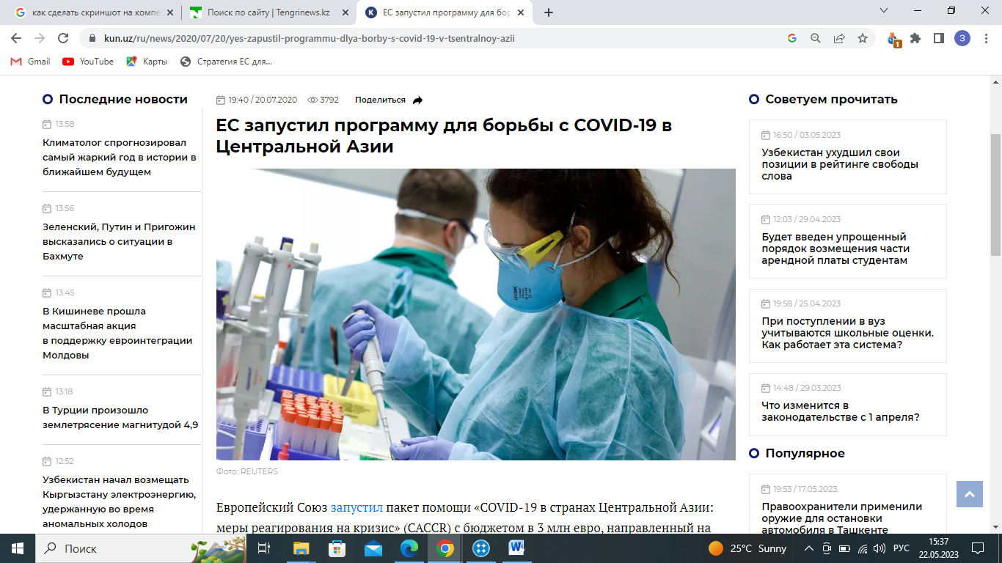

Figure 1 ‒ News articles related to the EU’s assistance for Central Asia during the Covid-19 pandemic

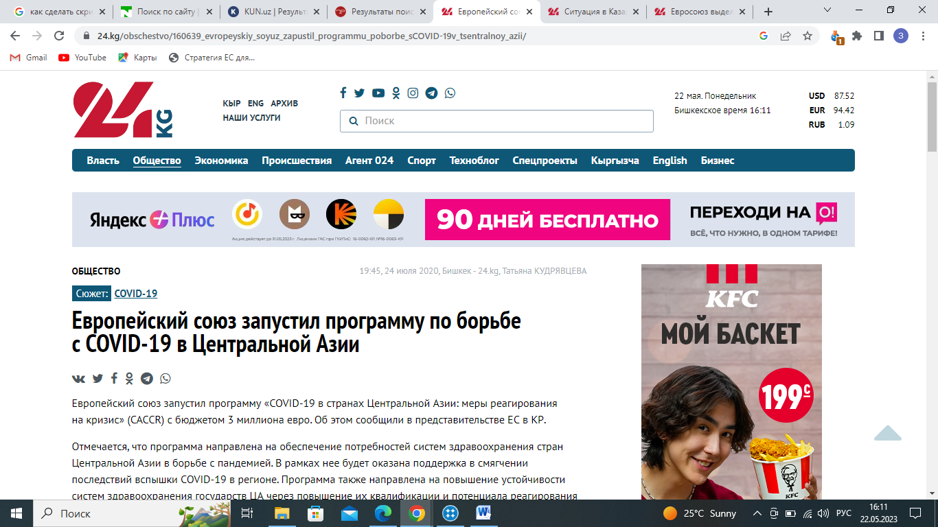

Figure 2 ‒ News coverage of the Tajik-Kyrgyz border conflict in April 2021
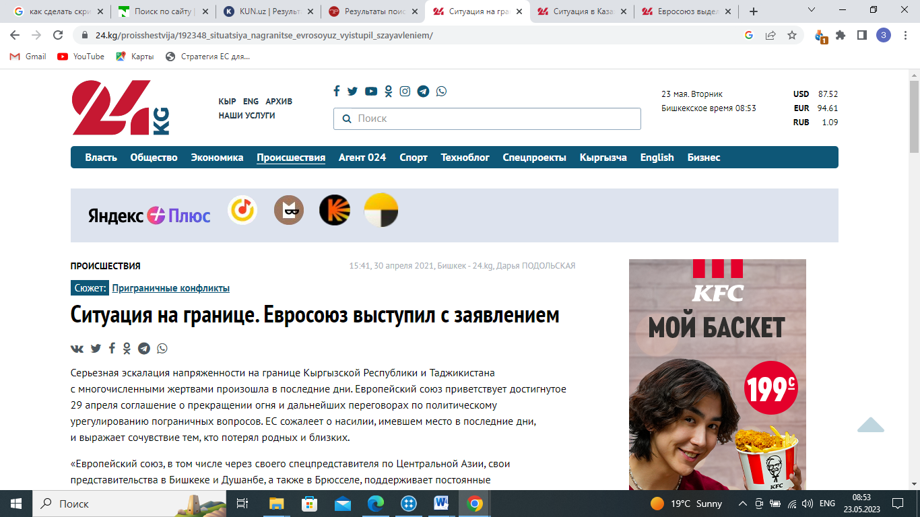

Figure 3 ‒ The Afghan issues

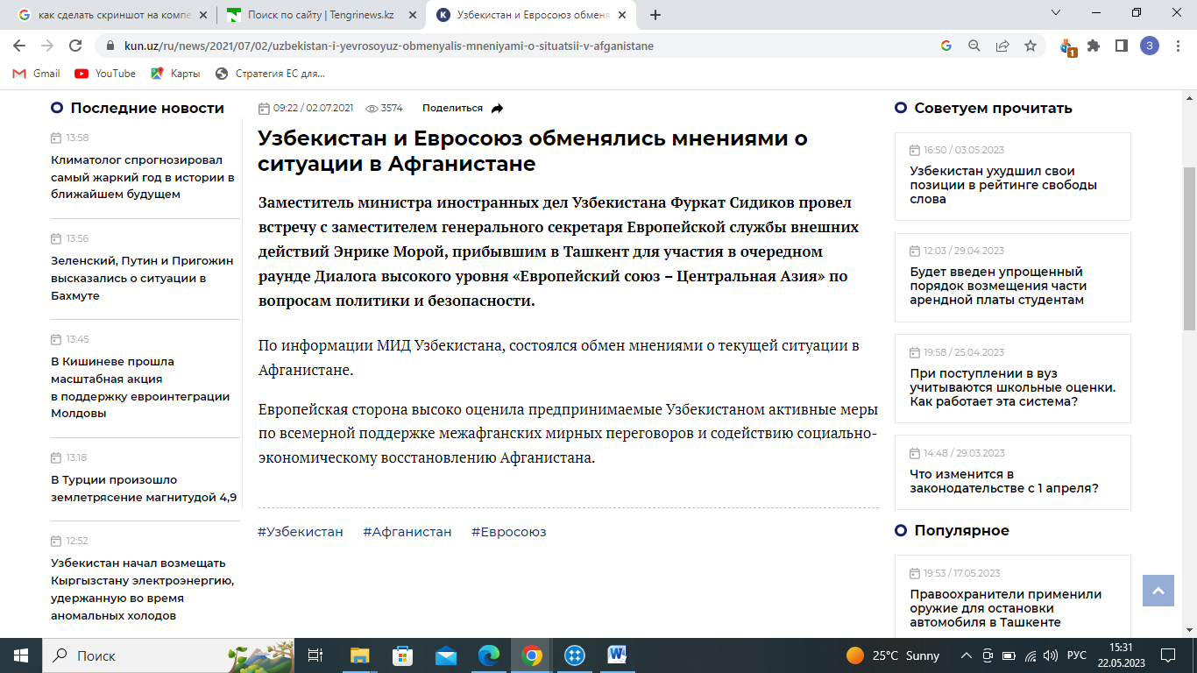

a

Figure 4 ‒ 2022 January news on the events in Kazakhstan, sheet 1
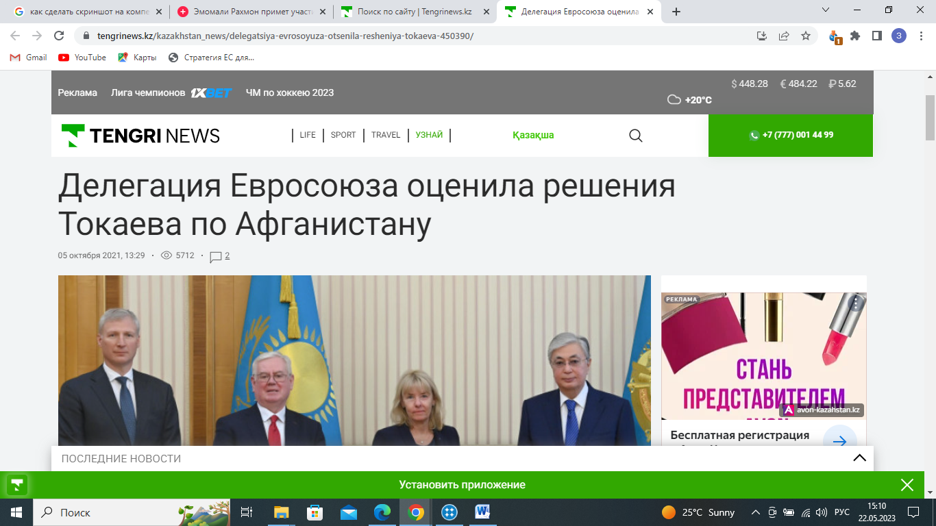

b

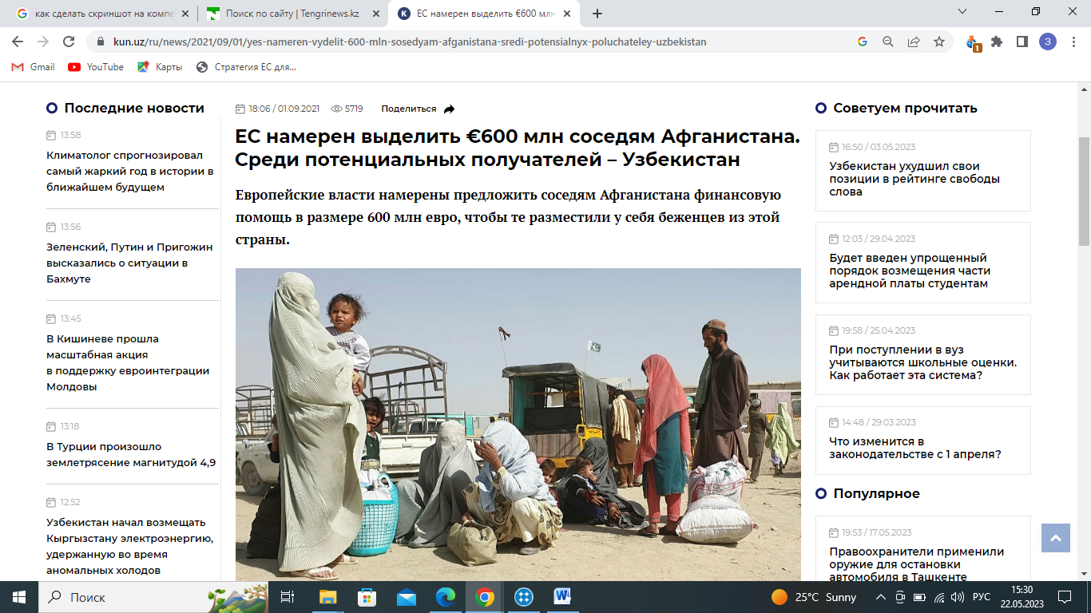

c

Figure 4, sheet 2
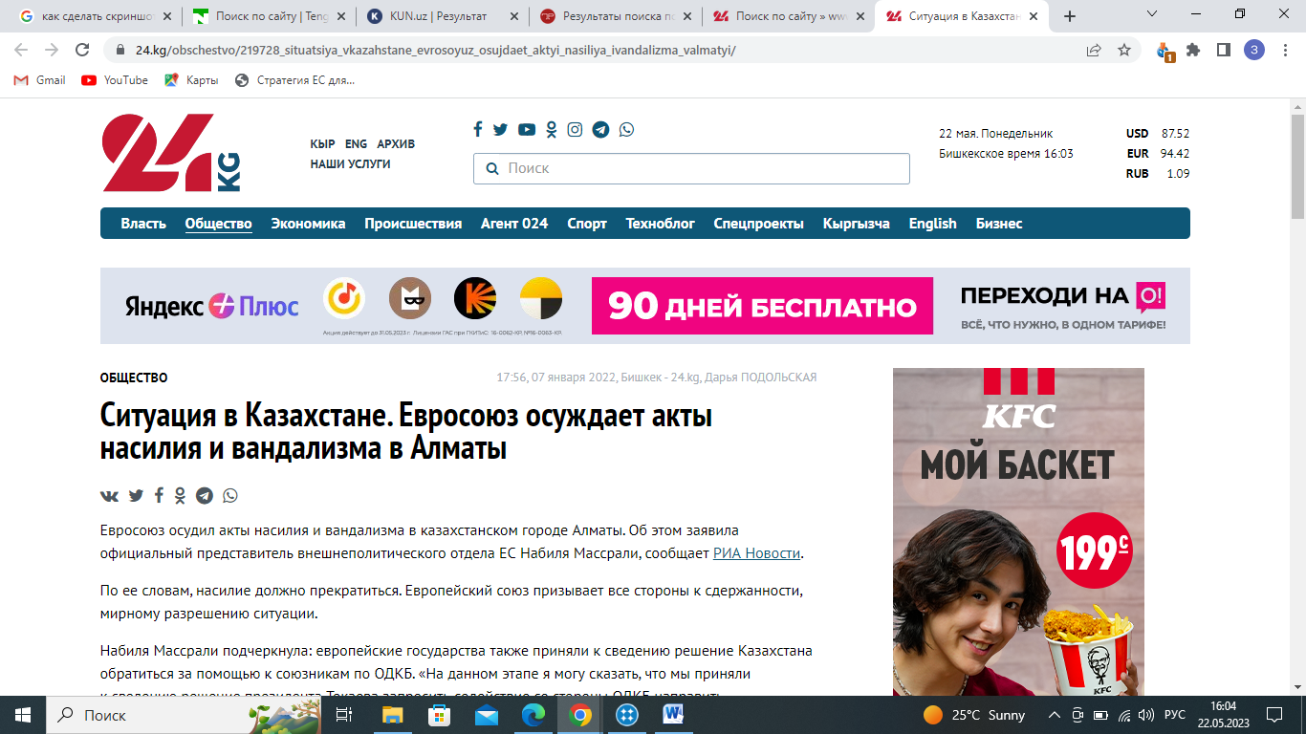

Figure 5 ‒ Border conflict between Tajikistan and Kyrgyzstan in September 2022

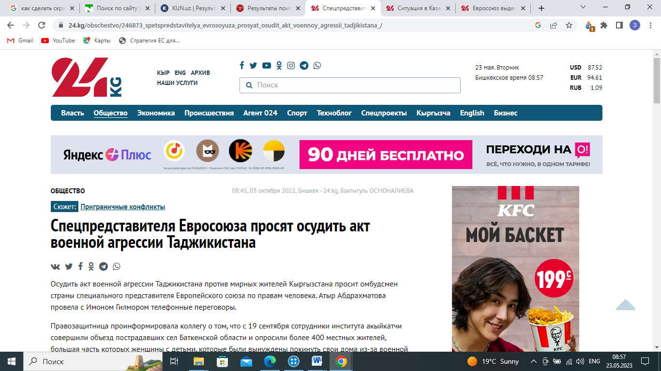

a

Figure 6 – News on the 2022 EU-Central Asia summit in Astana, sheet 1
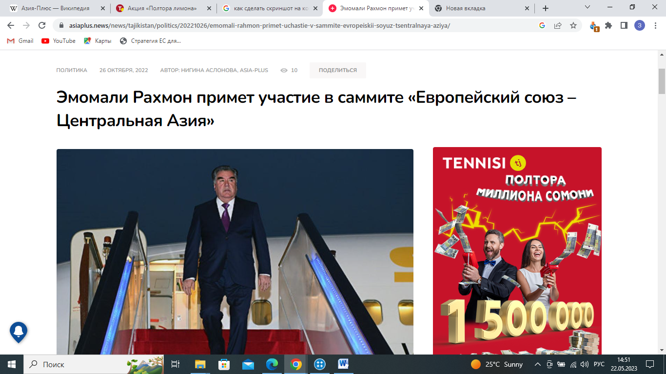
b

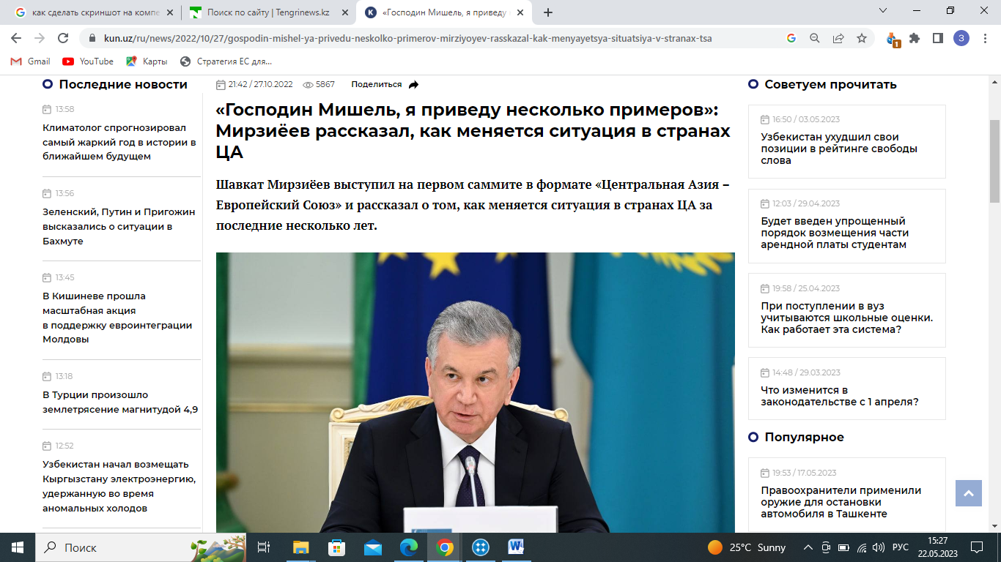

c

Figure 6, sheet 2
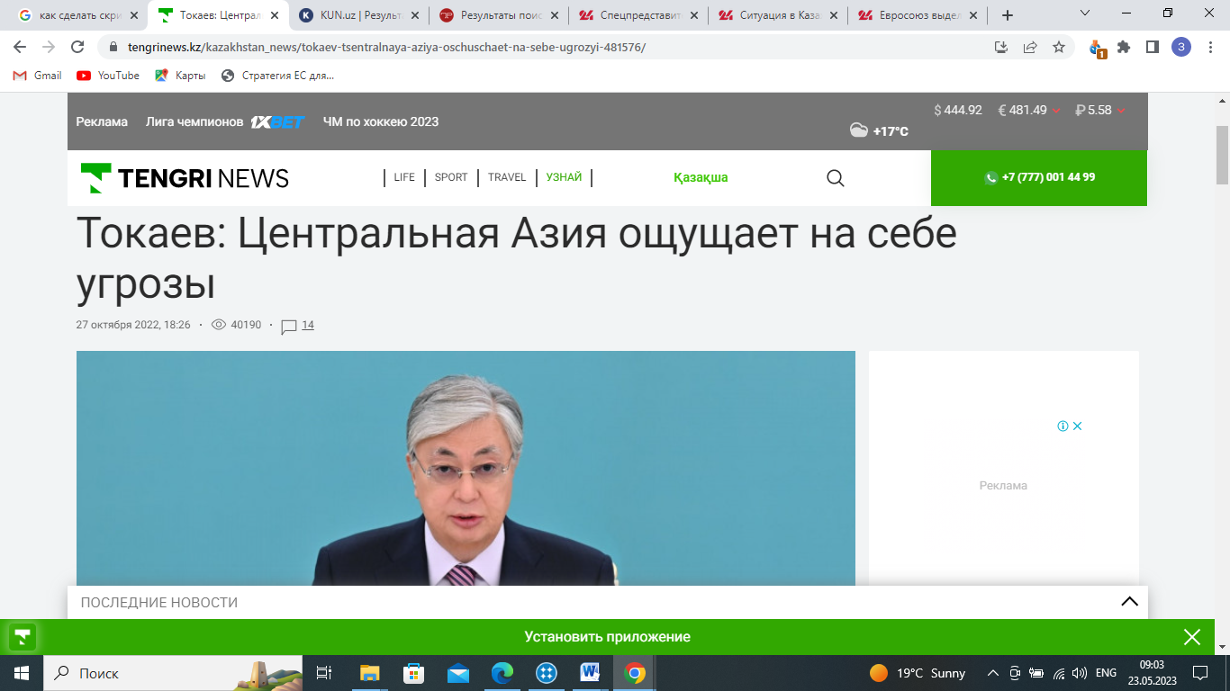

a

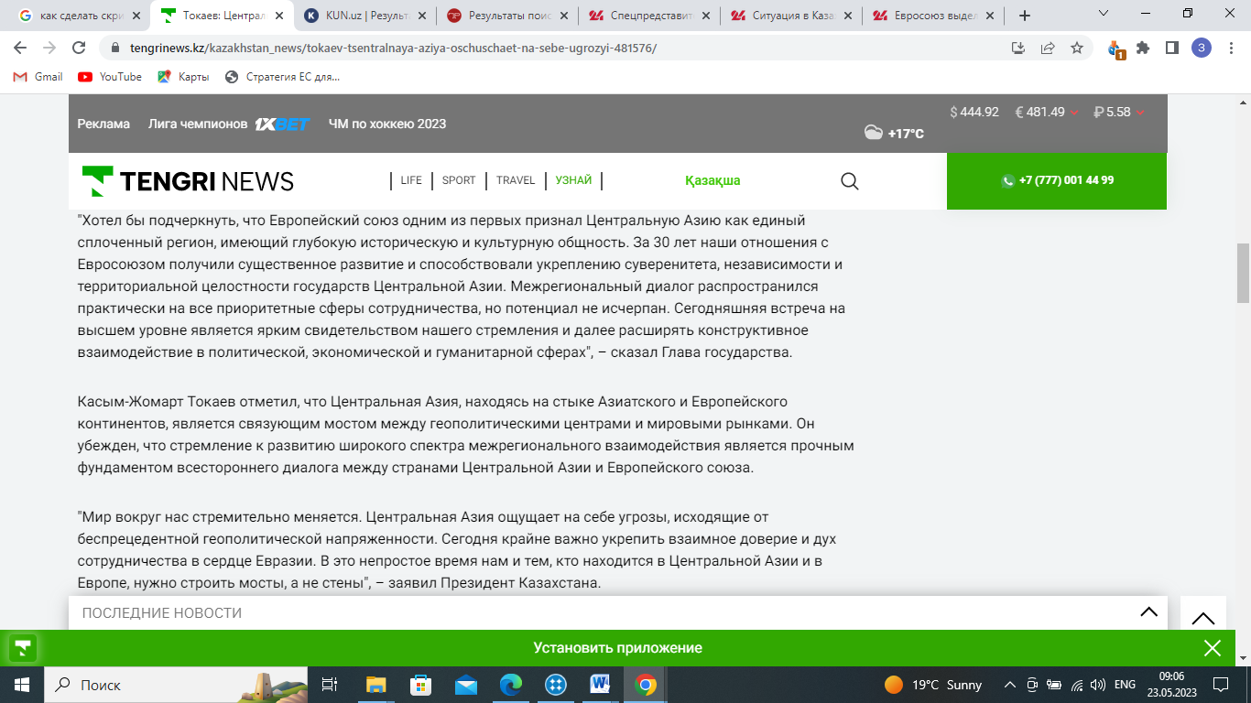

b

Figure 7, sheet 2
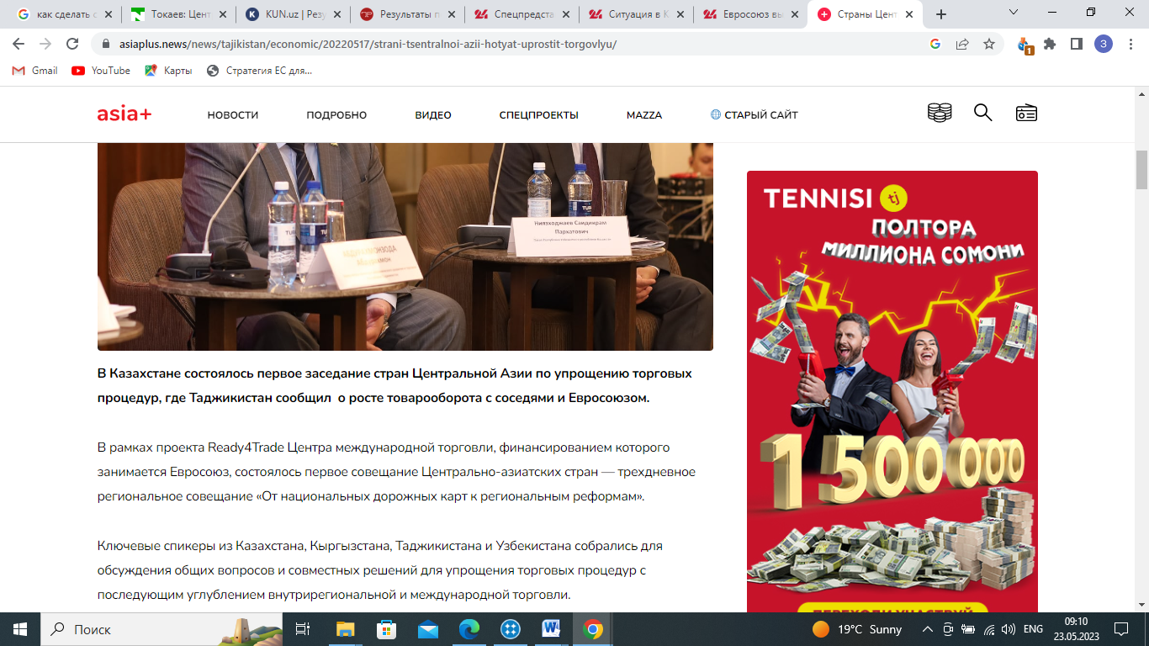

c

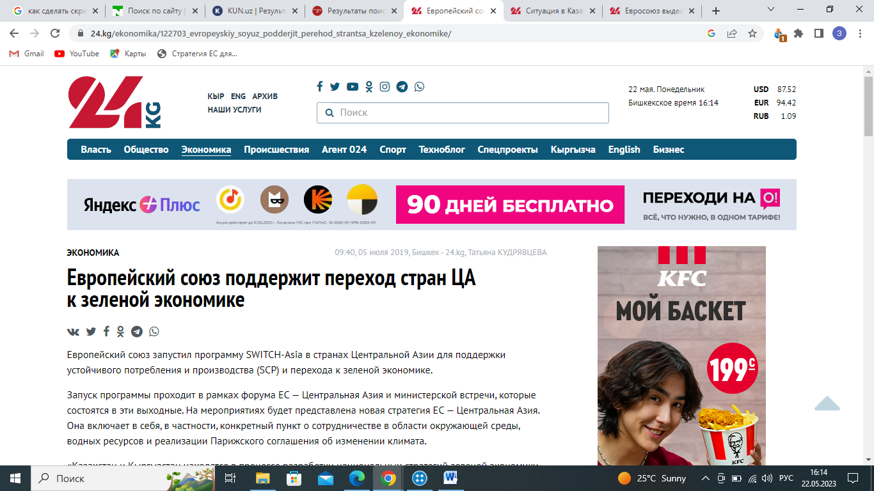

d

Figure 7, sheet 3
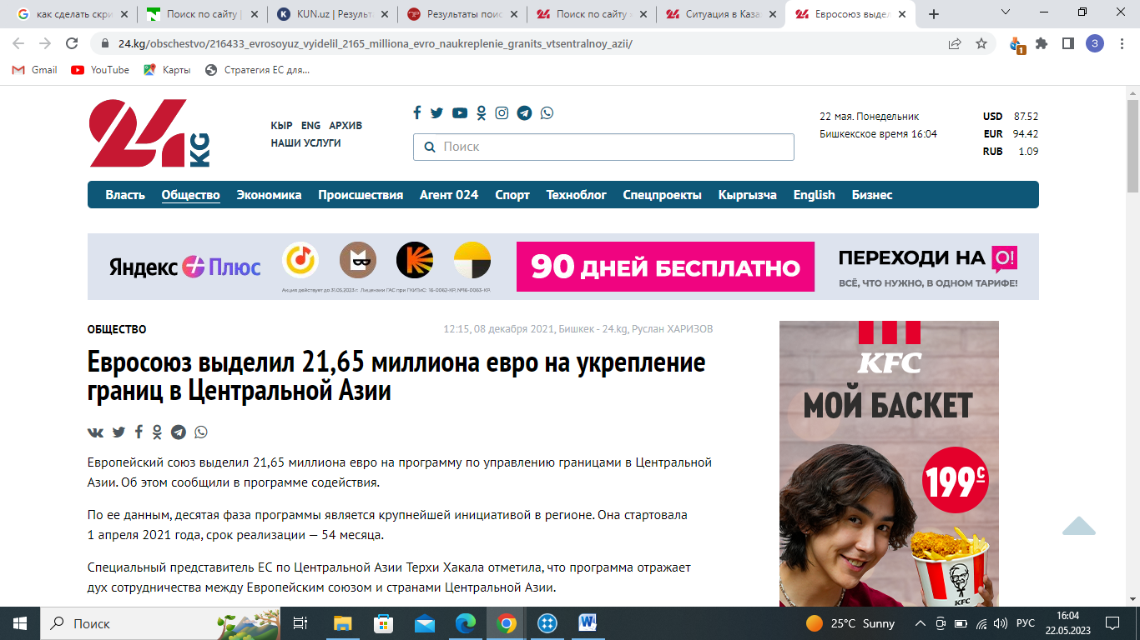

Figure 8 ‒ Media articles about EU- Central Asian joint political, business, cultural events, forums, annual ministerial meetings

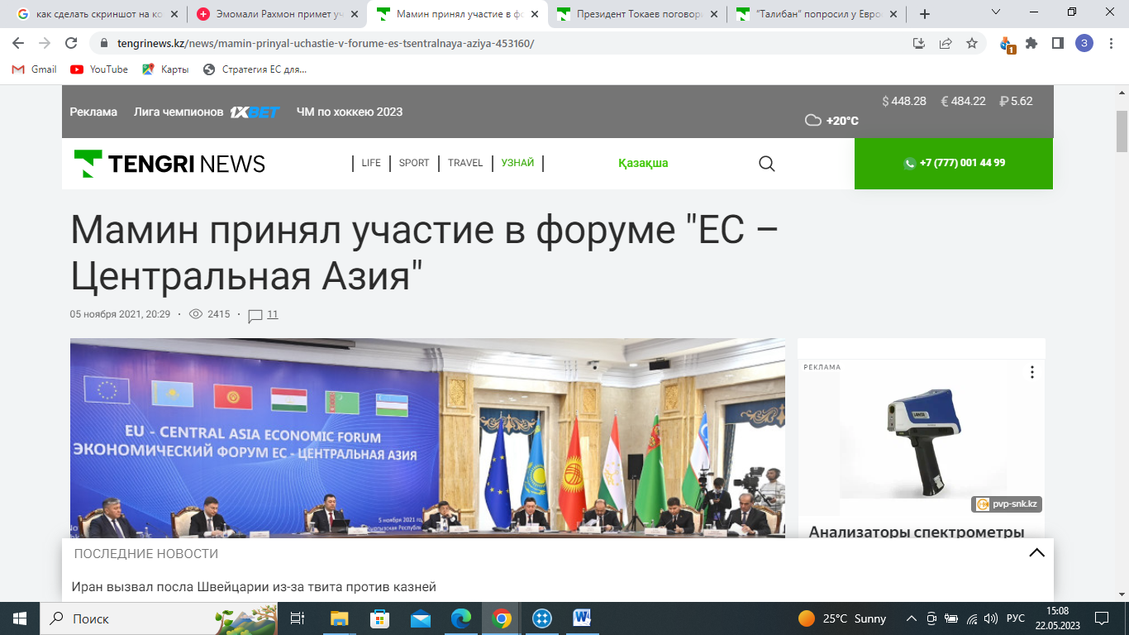
a

Figure 9 ‒ Environmental issues, sheet 1
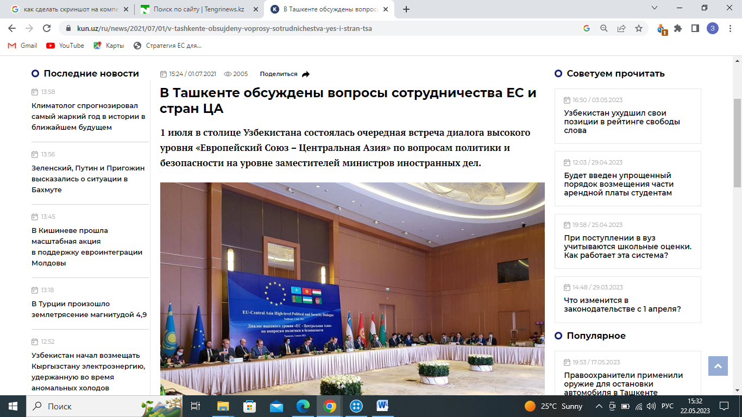

b

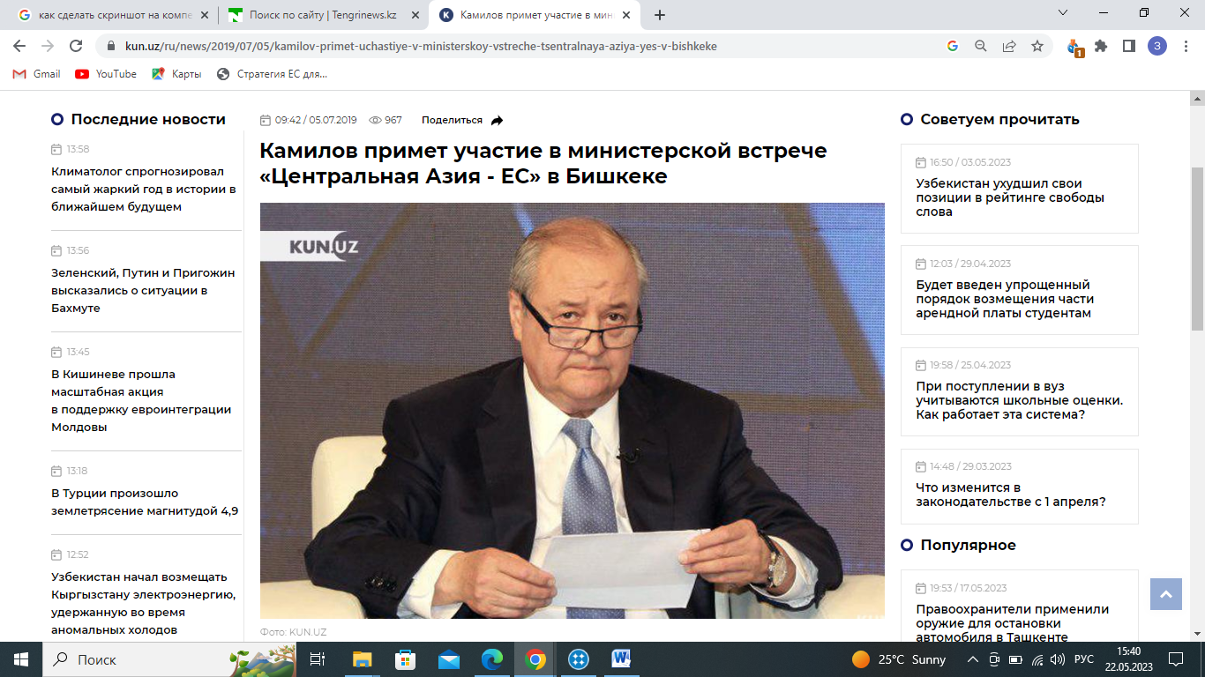

c

Figure 9, sheet 2
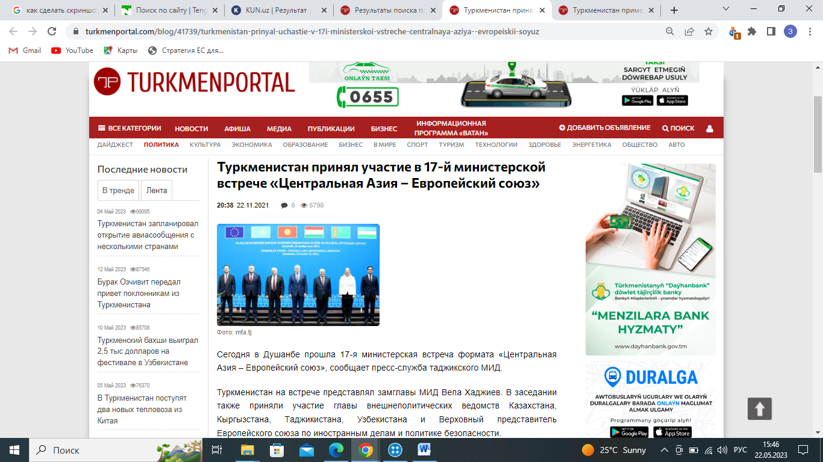

d

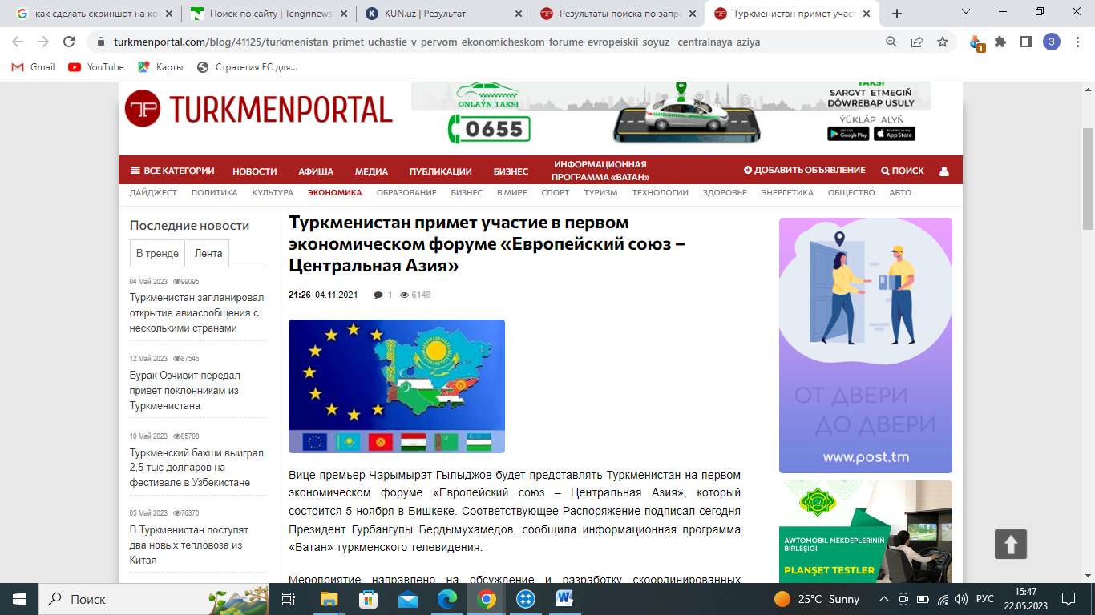

e

Figure 9, sheet 3
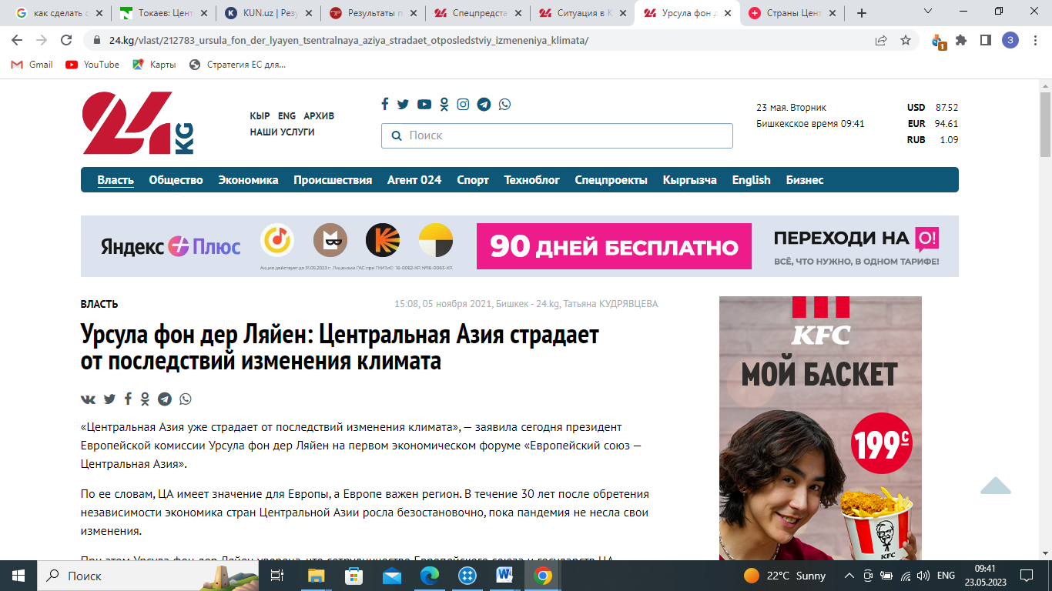

f

Figure 9, sheet 3

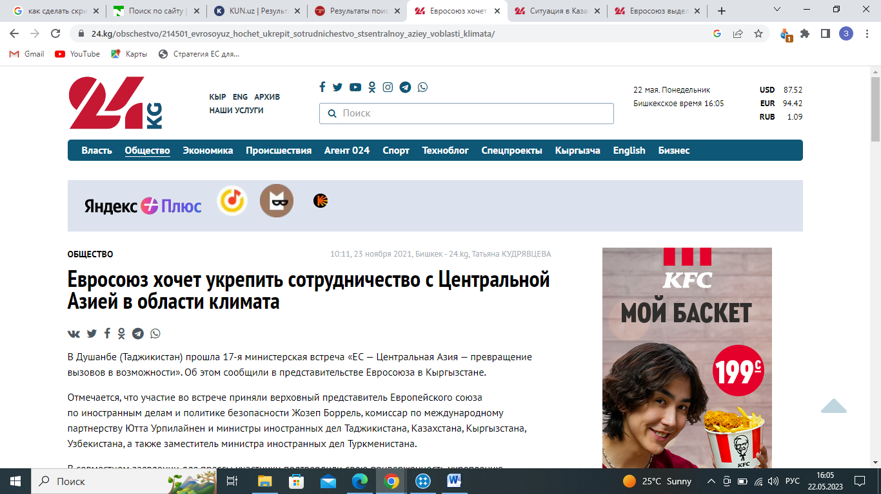

a

Figure 10 ‒ Human Rights, sheet 1

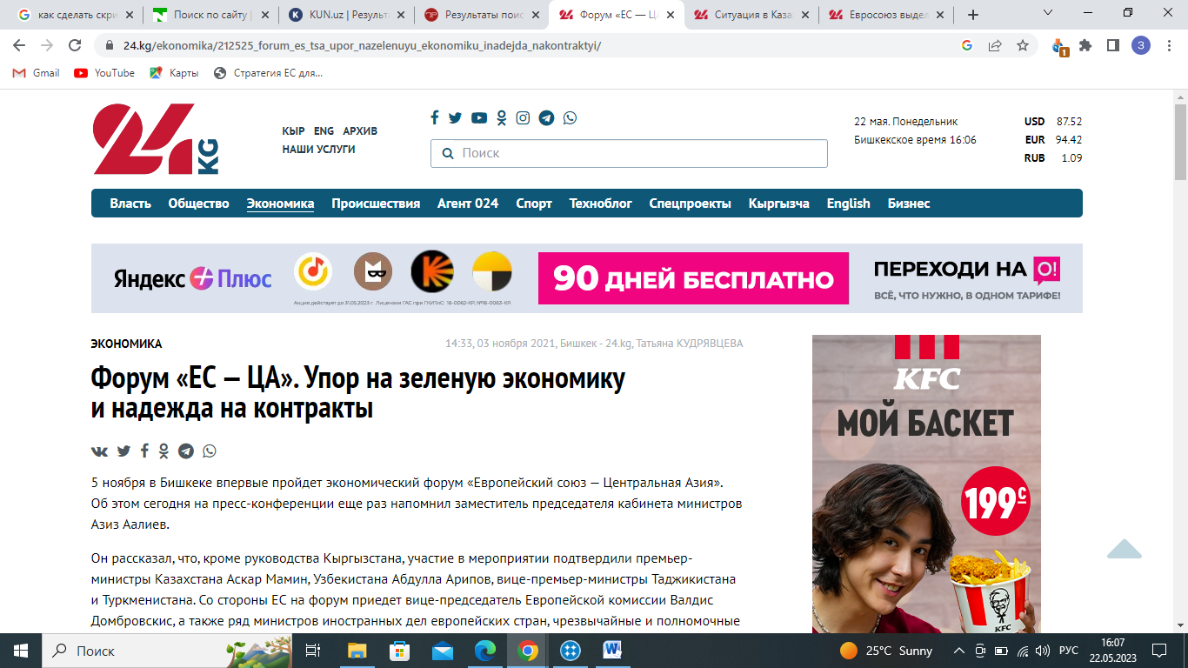

b

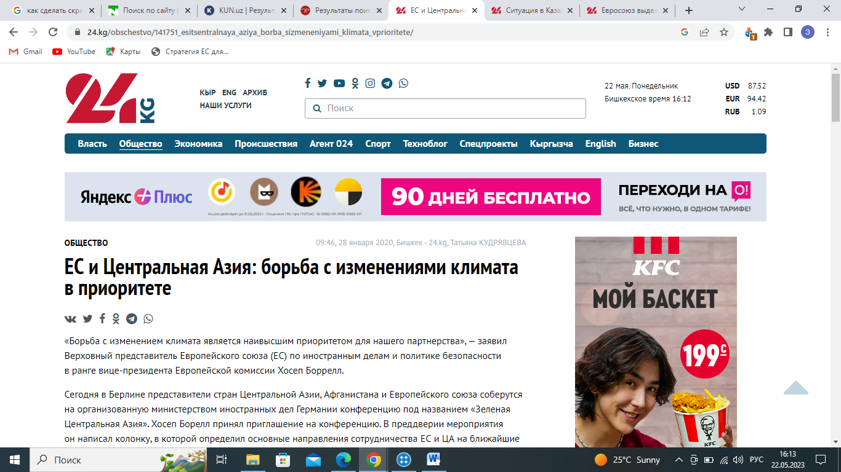
c

Figure 10, sheet 2
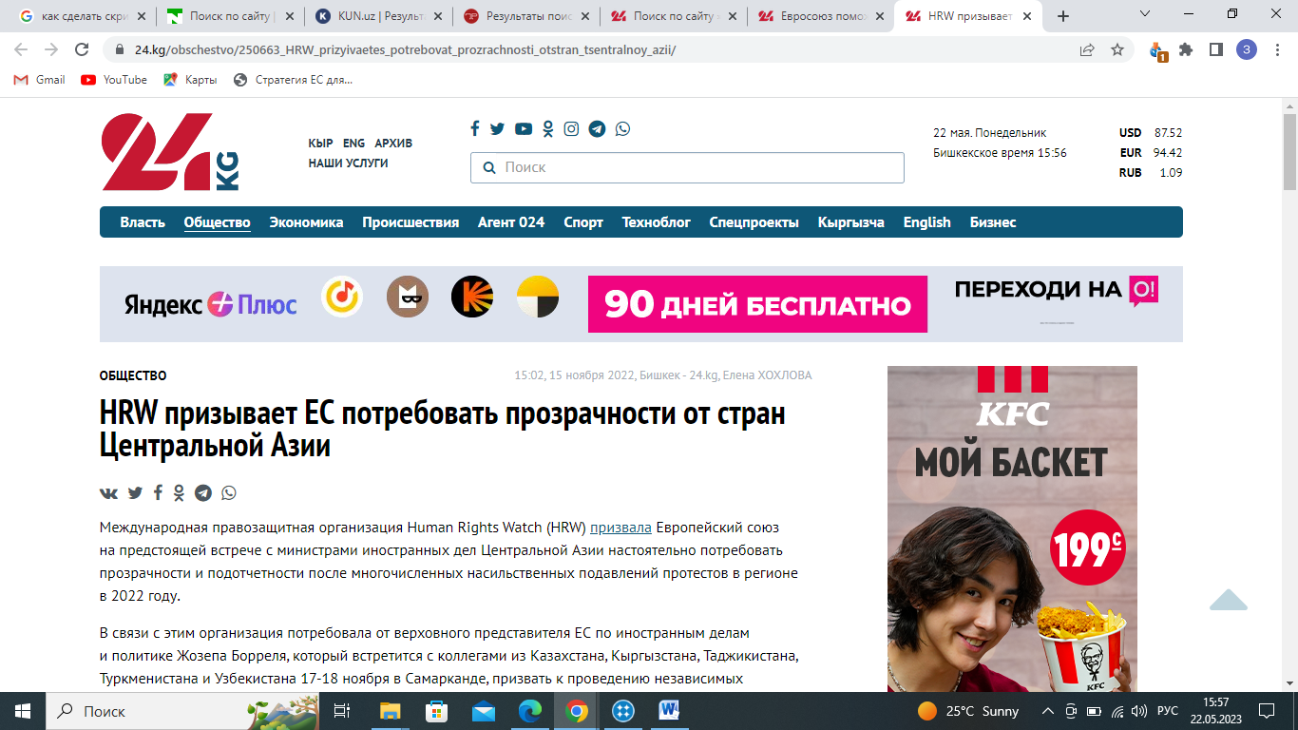

d

Figure 10, sheet 3

