«Л.Н. Гумилев атындағы Еуразия ұлттық университеті» КеАҚ

ӘОЖ 547.829:675.043.84 Қолжазба құқығында

КАНАШЕВА НУРДАНА КАБЫКЕНОВНА

Бициклді бисмочевина негізіндегі макро - және супрамолекулалық жүйелерді синтездеу және зерттеу

8D05306 – Химия

Философия докторы (PhD) дәрежесін алу үшін мақалалар сериясы түрінде ұсынылған диссертация

Ғылыми кеңесші:
химия ғылымдарының докторы,
профессор Еркасов Р.Ш.

Шетелдік ғылыми кеңесші:
химия ғылымдарының докторы,
профессор Бакибаев А.А.

Қазақстан Республикасы,
Астана, 2025
Диссертациялық жұмыс «Л.Н. Гумилев атындағы Еуразия ұлттық университеті» КеАҚ жаратылыстану ғылымдары факультетінің химия кафедрасы зертханасында және Томск мемлекеттік университетінің (Томск қ., РФ) органикалық синтез зертханасында орындалды.

Ғылыми кеңесші | х.ғ.д., химия кафедрасының профессоры  Еркасов Рахметулла Шарапиденович;
Шетелдік кеңесші | Томск мемлекеттік университетінің (Томск қ., РФ) органикалық синтез зертханасының жетекші ғылыми қызметкері, х.ғ.д., профессор  Бакибаев Абдигали Абдиманапович.
Диссертациялық кеңестің ғалым  хатшысы, х.ғ.к., қауым. профессор | Уәли А.С.

«8D05306 – Химия» білім беру бағдарламасы бойынша философия докторы (PhD) дәрежесін алу үшін ұсынылған Канашева Нурдана Кабыкеновнаның «Бициклді бисмочевина негізіндегі макро- және супрамолекулалық жүйелерді синтездеу және зерттеу» тақырыбындағы диссертациялық жұмысына
АҢДАТПА

Диссертациялық зерттеудің жалпы сипаттамасы.
Диссертациялық жұмыс полимерлік қосылыстар үшін прекурсорлар ретінде бициклді бисмочевина (гликолурил) негізіндегі макро- және супрамолекулалық жүйелерді алу шарттарын зерттеуге, сондай-ақ олардың негізінде медициналық мақсаттағы биокомпозиттік материалдарды жасау мүмкіндіктерін зерттеу үшін олардың кейбір практикалық қасиеттерін анықтауға арналған.

Диссертациялық жұмыс докторанттың ҚР Білім және ғылым министрінің 30.04.2020 жылғы №170 Бұйрығымен өзгерістер енгізілген Қазақстан Республикасы Білім және ғылым министрінің 2011 жылғы 31 наурыздағы №127 (нормативтік құқықтық актілерді мемлекеттік тіркеу тізілімінде №6951 болып тіркелген) бұйрығымен бекітілген дәрежелерді беру қағидаларының 5-1 тармақтарына және ҚР Ғылым және жоғары білім министрінің м.а. 09.01.2023 жылғы №7 Бұйрығымен өзгерістер енгізілген ҚР Білім және ғылым министрінің 09.03.2021 жылғы №98 Бұйрығының талаптарына сәйкес жарияланған екі мақала және бір шолу сериясы түрінде ұсынылады.

Зерттеудің өзектілігі.
Қазіргі уақытта гликолурил әртүрлі салаларда, оның ішінде фармацевтикалық препараттар, жарылғыш заттар, арнайы мақсаттағы полимерлерді синтездеуге арналған байланыстырушы агенттер және басқа да практикалық маңызды қосылыстарды өндіруде қолданылады.
Соңғы онжылдықтарда белсенді дамып келе жатқан гликолурил химиясының жаңа бағыты – бірегей бақыланатын қасиеттері бар макроциклді қосылыстарды, соның ішінде кукурбит[n]урилдер, бамбус[n]урилдер, тиара[n]урилдер жасау және олардың негізінде супрамолекулалық жүйелерді құру. Гликолурил негізінде алынған супрамолекулалық қосылыстар органикалық жартылай өткізгіш материалдардың, фармацевтикалық препараттар үшін көмекші қосылыстардың (мысалы, пролонгаторлар мен шығарылуы бақыланатын молекулалық контейнерлер), «молекулалық тану» қасиеттері бар материалдардың және беттік белсенді заттар, бактериалды эндотоксиндер және биогенді аминдер сияқты амфифилді компоненттерді жедел талдауға арналған молекулалық сенсорлардың құрамдас бөліктері ретінде зерттелді.
Айтарлықтай жетістіктерге қарамастан, гликолурил химиясы белсенді дамуын жалғастыруда, өйткені ол зерттеулердің алдыңғы қатарлы саласы болып табылады. Атап айтқанда, оның негізінде макро- және супрамолекулалық жүйелердің болашағы әртүрлі іргелес салалардың заманауи қажеттіліктерін қамтамасыз ету үшін жаңа көкжиектер ашады, мысалы, медициналық мақсаттағы биокомпозиттік материалдарды жасау, жаңа «ақылды» материалдарды әзірлеу және дәрілік заттарды мақсатты түрде жеткізу жүйелерін қалыптастыру. Гликолурилдер химиясының осы даму үрдістерінің жиынтығы бициклді бисмочевина негізіндегі жаңа макро- және супрамолекулалық жүйелерді синтездеуге және зерттеуге бағытталған осы зерттеудің өзектілігін анықтайды.
Зерттеудің мақсаты. Жаңа гликолурилқұрамды макроциклді заттарды алу әдістерін дайындау және олардың физика-химиялық және биологиялық қасиеттерін зерттеу.
Бұл мақсатқа жету келесі міндеттерді шешуді қамтиды:
- Гликолурил негізіндегі макроциклді қосылыстарды синтездеу әдістері және оларды полимерлік қосылыстар үшін прекурсорлар ретінде қолдану туралы қазіргі ғылыми әдебиетті талдау.
- Жаңа антиадгезиялық заттарды жасау үшін гликолурил мен карбоксиметилцеллюлозаның натрий тұзы (Na-КМЦ) негізінде жаңа биокомпозиттік материалдарды алу шарттарын және биоүйлесімділігін зерттеу.
- Оксиэтилидендифосфон қышқылы (ОЭДФ) қатысында жаңа гликолурил-меламин-формальдегидті (ГУМЕФА) полимерді синтездеу және алынған полимердегі метилолды топтар мен бос формальдегид мөлшерін зерттеу.
- Кукурбит[6]урил (CB[6]) және 1,4-бис(2-гидроксиэтил)пиперазин дигидрохлориді (Pipa*2HCl) негізіндегі супрамолекулалық комплекс (CB[6]@Pipa*2HCl) қатысында ГУМЕФА полимерінің алу шарттарын зерттеу.
- ОЭДФ қатысында алынған ГУМЕФА полимерінің гемоүйлесімділігін және антибактериялық белсенділігін бағалау.
Зерттеу нысаны - гликолурил, гликолурил және Na-КМЦ негізіндегі композиттік қабықша материалдары, гликолурил-меламин-формальдегидті полимер, кукурбит[6]урил және 1,4-бис(2-гидроксиэтил)пиперазин дигидрохлориді негізіндегі супрамолекулалық комплекс.
Жұмыстың ғылыми жаңалығы.
- Полимерлерге арналған прекурсорлар ретінде гликолурил негізіндегі макроциклді азотқұрамды қосылыстардың синтез әдістері, қасиеттері және практикалық қолданылуы туралы деректерді жүйелеуге арналған әдеби шолуы алғаш рет жүргізілді.
- Гликолурил мен Na-КМЦ негізіндегі композиттік қабықша материалдары алғаш рет алынып, олардың антиадгезиялық әсерін анықтайтын физика-химиялық және биологиялық қасиеттері зерттелді. Эксперимент нәтижесінде гликолурил және Na-КМЦ негізіндегі композиттік қабықшалардың бетіне макрофагтардың төмен адгезиясы (61±8 (0,01%) және 18±5 (0,05%)) және жоғары антиоксиданттық белсенділігі (10,02$±$0,86 мкмоль тролокс/ г қабықша (0,01%), 21,27$±$0,91 мкмоль тролокс/ г қабықша (0,05%)) анықталды. Бұл нәтижелер коммерциялық Seprafilm үлгісінің көрсеткіштерінен (макрофагтардың адгезиясы: 128±16; антиоксиданттық белсенділік: 2,19±0,32 мкмоль тролокс / г қабықша) ерекшеленеді.
- Гликолурил мен меламиннің (ГУ-МЕ) 1:5 арақатынастағы комплексі алғаш рет синтезделіп, ИҚ- және ЯМР-спектроскопия әдістерімен сипатталды. Оның ГУМЕФА полимеріне поликонденсациялану мүмкіндігі «жасыл» катализатор ретінде ОЭДФ-ті пайдалану арқылы анықталды. Бұл полимердің түзілу механизмі ұсынылып, құрамындағы бос формальдегидтің (1,22–1,34 мас.%) және метилолды топтардың (1,56–0,48 мас.%) мөлшері зерттелді. Сонымен қатар, CB[6]@Pipa*2HCl супрамолекулалық комплексінің ГУМЕФА полимерінің синтезінің тиімді катализаторы екендігі алғаш рет анықталды, ол пластификация уақытын тұз қышқылына қарағанда 58%-ға және ОЭДФ-ке қарағанда 37,5%-ға қысқартады. Оның қолданылуы аз мөлшердегі катализаторды талап ететіндіктен, процестің тиімділігін арттырады және полимерлік химияда мүмкіндіктерді кеңейтеді.
- Әртүрлі катализаторлар (тұз қышқылы және ОЭДФ) көмегімен синтезделген жаңа синтетикалық ГУМЕФА полимерінің гемолитикалық әсері спектрофотометриялық әдіспен, антибактериялық белсенділігі авторлық модификациядағы стандартты диск-диффузиялық әдіспен алғаш рет зерттелді.
Қорғауға ұсынылған диссертацияның негізгі ережелері:
- Реакцияға қабілетті аралық өнімдерді түзу арқылы макроциклді қосылыстарды синтездеуге гликолурилдің туындыларын қолдану ықтималды жоғары функционалдық қасиеттері бар жаңа құрылымдарды алуға мүмкіндік береді. Әдеби деректерді талдау негізінде функционалдық материалдарды әзірлеудің жаңа мүмкіндіктерін ашатын жеткіліксіз зерттелген бағыт ретінде жоғары молекулалық қосылыстар (полимерлер) синтезінде гликолурилді қолдану болашағы негізделді.
- Композиттік қабықша материалын алу шарттары (0,01% және 0,05% ерітінділері; гликолурил мен глиоксальдің мольдік қатынасы – 1:2,5; pH – 2,7–4,0; биологиялық инертті матрица: Na-КМЦ (M.W. 250000, DS = 0,9), Na-КМЦ (M.W. 250000, DS = 1,2) немесе гидроксипропилметилцеллюлоза; жалпы масса – 10,0 г; t – 24 сағат) оның Seprafilm коммерциялық медициналық өнімімен салыстыруға болатын биоүйлесімділікті қамтамасыз етеді.
- ГУМЕФА полимерін алу барысында ОЭДФ әсері тұз қышқылының қатысында алынған полимермен салыстырғанда бос формальдегидтің (спектрофотометриялық және флуориметриялық әдістер) және метилол топтарының (кері йодометриялық әдіс) мөлшерін төмендетуге әкеледі.
- ГУМЕФА полимерінің синтезінде катализатор ретінде ОЭДФ-ті қолдану оның гемолитикалық әсерін төмендетуге (0,1889%) және Escherichia coli-ге қатысты антибактериалдық белсенділікті артыруға (бактериялардың өсуін тежейтін аймақтардың орташа диаметрі 47,8 мм) ықпал етеді. Тұз қышқылы қатысында алынған полимер үшін бұл көрсеткіш төмен (43,7 мм), әрі бұл айырмашылық статистикалық тұрғыдан маңызды (p<0,05).
Жұмыстың практикалық маңыздылығы.
Гликолурил мен Na-КМЦ негізіндегі композиттік қабықша материалдардың алу шарттары мен биоүйлесімділігін зерттеу нәтижелері антиадгезиялық қасиеттері бар қабықша материалының прототипін жасауға негіз бола алады. Дайындалған композиттік қабықша материалдардың құрамы клиникалық хирургияда қажетті отандық тосқауыл типтегі антиадгезиялық заттарды жасауға қолданылуы мүмкін.
Зерттеудің практикалық маңызы – ОЭДФ катализаторы ретінде қолдану ГУМЕФА полимеріндегі бос формальдегидтің мөлшерін төмендетіп, оның қолдану аясын кеңейтеді және формальдегид деңгейін азайту үшін пластификация процесін оңтайландырады. Сонымен қатар, зерттеу барысында алынған үлгілердің жоғары гемоүйлесімділігі мен антибактериалдық белсенділігі олардың биомедицинаның түрлі салаларында қолдануға мүмкіндік береді. Алынған нәтижелер, сондай-ақ, әртүрлі құрамдағы және мақсаттағы шайырларды әзірлеуге мүмкіндіктер ашып, берілген қасиеттері бар жаңа композиттік материалдарды жасауға ықпал етеді.
Автордың диссертациялық зерттеуге қосқан жеке үлесі. Автор зерттеу тақырыбы бойынша белгілі ғылыми деректерді іздеу, талдау және жалпылау, зерттеу жоспарын жасау жұмысын атқарды. Автор барлық химиялық эксперименттерді, соның ішінде өнімдерді алу және тазартуды жүргізді, зерттеудің физика-химиялық талдау нәтижелерін түсіндірді. Ізденуші материалдарды ғылыми журналдарда жариялауға дайындап, оларды ғылыми конференцияларда баяндама ретінде ұсынды.
Жұмысты апробациялау. Диссертацияның негізгі ережелері, қорытындылары мен ғылыми нәтижелері халықаралық конференцияларда баяндалды және талқыланды: «Жаратылыстану ғылымдарының өзекті мәселелері» ХІІ Халықаралық ғылыми-практикалық конференциясы (Петропавл, 2024), «Іргелі ғылымдардың даму перспективалары» ХХ студенттердің, аспиранттардың және жас ғалымдардың халықаралық конференциясы (Томск, 2023), 7th International Scientific Conference «Reviews of Modern Science» (Zurich, Switzerland, 2024), International Scientific Conference «Foundations and Trends in Research» (Copenhagen, Denmark, 2024), International Scientific Conference «European Research Materials» (Amsterdam, Netherlands, 2024).
Жарияланымдар. Диссертациялық зерттеудің негізгі нәтижелері жарияланған 9 жұмыста көрсетілген, оның ішінде Clarivate Analytics (Кларивэйт Аналитикс) компаниясының Journal Citation Reports (Жорнал Цитэйшэн Репортс) деректеріне сәйкес импакт-фактор бойынша бірінші және екінші квартильге кіретін басылымдарда жарияланған 2 мақала және 1 шолу; шетелдік ғылыми басылымда 1 жарияланым, республикалық және халықаралық ғылыми конференциялар материалдарында 5 жұмыс.
Kabieva, S.K.; Zhumanazarova, G.M.; Kanasheva, N.; Bakibaev, A.A.; Panshina, S.Yu.; Malkov, V.S.; Mamaeva, E.A.; Knyazev, A.S. Methods of synthesizing glycoluril-based macrocyclic compounds as precursors for polymeric compounds. Journal of Saudi Chemical Society 2023, 27, 101768. Докторант зерттеу тақырыбы бойынша әдебиеттерді іздеуге, деректерді талдауға және жұмыстың бастапқы нұсқасын дайындауға белсенді қатысты. «Journal of Saudi Chemical Society» журналының 2023 жылғы Impact Factor (Импакт-фактор) 5,9-ға тең, химия, пәнаралық бойынша Q1 квартиліне ие. 2023 жыл үшін CiteScore 8,9-ға тең, жалпы химия бойынша процентиль 83-ке тең.
Kanasheva, N.; Fedorishin, D.A.; Lyapunova, M.V.; Bukterov, M.V.; Kaidash, O.A.; Bakibaev, A.A.; Yerkassov, R.; Mashan, T.; Nesmeyanova, R.; Ivanov, V.V.; Udut, E.V.; Tuguldurova, V.P.; Salina, M.V.; Malkov, V.S. and Knyazev, A.S. The Determination of the Biocompatibility of New Compositional Materials, including Carbamide-Containing Heterocycles of Anti-Adhesion Agents for Abdominal Surgery. Molecules 2024, 29, 851. Ізденуші – бірінші автор. «Molecules» журналының 2023 жылғы Impact Factor (Импакт-фактор) 4,2-ге тең және биохимия мен молекулалық биология, химия, пәнаралық - Q2 квартилі бар. 2023 жыл үшін CiteScore 7,4-ке тең, химия (әртүрлі) бойынша процентиль - 83; органикалық химия бойынша процентиль - 81; физикалық және теориялық химия бойынша процентиль - 80; аналитикалық химия бойынша процентиль - 78; фармацевтика ғылымы бойынша процентиль – 81; есірткіні табу бойынша процентиль - 73; молекулалық медицина бойынша процентилі - 68. Докторант зерттеулер жүргізуге және деректерді талдауға қатысты, графиктер мен кестелер жасады, сондай-ақ қолжазбаны құрылымы, стилі және мазмұндық анықтығын жақсарту үшін өңдеді. Сонымен қатар, Н.К. Канашева мақаланы журнал талаптарына сәйкес рәсімдеумен айналысты.
Kanasheva, N.; Ukhov, A.; Malkov, V.S.; Gubankov, A.; Sergazina, S.; Issabayeva, M.A.; Mashan, T.; Kolpek, A.; Ryskaliyeva, R.; Bakibaev, A. and Yerkassov, R. The Synthesis of a New Glycoluryl–Melamine–Formaldehyde Polymer under the Action of HEDP and the Investigation of the Content of Methylol Groups and Free Formaldehyde. Polymers 2024, 16, 2877. Докторант – бірінші автор. «Polymers» журналының 2023 жылғы Impact Factor (Импакт-фактор) 4,7-ге тең, полимер ғылымы бойынша квартилі Q1 болып табылады. 2023 жыл үшін CiteScore 8,0-ге тең, жалпы химия бойынша процентиль – 81; полимерлер және пластмасслар бойынша процентиль – 80. Н.К. Канашева тәжірибелік деректерді алуға, оларды өңдеуге және нәтижелерін интерпретациялауға, қолжазбаның бастапқы нұсқасын дайындауға, мақаланы рәсімдеу үшін эксперимент бойынша қорытынды жазуға тікелей қатысты. Ізденуші журналға мақаланы жіберумен де айналысты, рецензиялау және жариялау барысында редакциямен байланыста болып, хат жазысуды жүргізді.
Докторант республикалық және халықаралық ғылыми конференцияларда 5 баяндаманың материалдары мен тезистерін рәсімдеу үшін эксперименттік деректерді алуға, нәтижелерді өңдеуге және түсіндіруге тікелей қатысты.
АННОТАЦИЯ
диссертационной работы Канашевой Нурданы Кабыкеновны на тему «Синтез и исследование макро- и супрамолекулярных систем на основе бициклических бисмочевин», представленной на соискание степени доктора философии (PhD) по образовательной программе
«8D05306 – Химия»

Общая характеристика работы.
Диссертационная работа посвящена изучению условий получения макро- и супрамолекулярных систем на основе бициклических бисмочевин (гликолурила) в качестве прекурсоров для полимерных соединений, а также определению их некоторых практических свойств для изучения потенциала создания на их основе биокомпозитных материалов медицинского назначения.
Диссертационная работа представлена в виде серии из двух статей и одного обзора, опубликованных докторантом в соответствии с требованиями пункта 5–1 Правил присуждения степеней, утвержденных приказом Министра образования и науки Республики Казахстан от 31 марта 2011 года №127 (зарегистрирован в Реестре государственной регистрации нормативных правовых актов под №6951), с изменениями, внесенными приказом Министра образования и науки РК от 30.04.2020 №170, и в соответствии с приказом Министра образования и науки РК от 09.03.2021 №98, с изменениями, внесенными и.о. Министра науки и высшего образования РК от 09.01.2023 года №7.
Актуальность работы.
В настоящее время гликолурил используется в различных отраслях, включая производство фармацевтических препаратов, взрывчатых веществ, сшивающих агентов для синтеза полимеров специального назначения и других практически ценных соединений.
В последние десятилетия новой активно развивающейся областью химии гликолурила является создание макроциклических соединений с уникальными контролируемыми свойствами — кукурбит[n]урилов, бамбус[n]урилов, тиара[n]урилов и образование супрамолекулярных систем на их основе. Супрамолекулярные соединения, полученные с использованием гликолурила, изучались как компоненты органических полупроводниковых материалов, вспомогательные соединения для фармацевтических препаратов (например, пролонгаторы и молекулярные контейнеры с контролируемым высвобождением), материалы со свойствами «молекулярного распознавания» и молекулярные сенсоры для экспресс-анализа амфифильных компонентов, таких как поверхностно-активные вещества, бактериальные эндотоксины и биогенные амины, в которых гликолурил используется в качестве строительного блока.
Несмотря на значительный прогресс, химия гликолурила продолжает активно развиваться, поскольку является фронтирной областью исследований. В частности, перспективы макро- и супрамолекулярных систем на его основе открывают новые горизонты для обеспечения современных нужд различных смежных областей, например, разработка биокомпозитных материалов медицинского назначения, создание новых «умных» материалов и формирование систем таргетной доставки лекарственных веществ. Совокупность этих тенденций развития химии гликолурилов определяют актуальность настоящего исследования, направленного на синтез и изучение новых макро- и супрамолекулярных систем на основе бициклических бисмочевин.
Цель диссертационного исследования.
Цель работы – разработка методов получения новых гликолурилсодержащих макроциклических веществ и исследование их физико-химических и биологических свойств.
Задачи:
- Провести анализ современной научной литературы по методам синтеза макроциклических соединений на основе гликолурила и их применению в качестве прекурсоров для полимерных соединений.
- Исследовать условия получения и биосовместимость новых биокомпозитных материалов на основе гликолурила и натриевой соли карбоксиметилцеллюлозы (Na-КМЦ) для разработки новых противоспаечных средств.
- Синтезировать новый гликолурил-меламин-формальдегидный (ГУМЕФА) полимер в присутствии оксиэтилидендифосфоновой кислоты (ОЭДФ) и исследовать содержание метилольных групп и свободного формальдегида в полученном полимере.
- Изучить условия образования полимера ГУМЕФА в присутствии супрамолекулярного комплекса (CB[6]@Pipa*2HCl) на основе кукурбит[6]урила (CB[6]) и дигидрохлорида 1,4-бис(2-гидроксиэтил)пиперазина (Pipa*2HCl).
- Оценить гемосовместимость и антибактериальную активность полимера ГУМЕФА, полученного в присутствии ОЭДФ.
Объекты исследования – гликолурил, композитные пленочные материалы на основе гликолурила и Na-КМЦ, гликолурил-меламин-формальдегидный полимер (ГУМЕФА), супрамолекулярный комплекс на основе кукурбит[6]урила и дигидрохлорида 1,4-бис(2-гидроксиэтил)пиперазина.
Научная новизна работы.
- Впервые проведён обзор методов синтеза, свойств и применения макроциклических азотсодержащих соединений на основе гликолурила в качестве прекурсоров для полимеров.
- Впервые получены композитные пленочные материалы на основе гликолурила и Na-КМЦ, а также исследованы их физико-химические и биологические свойства, определяющие противоспаечное действие. Экспериментально установлено, что композитные пленки на основе гликолурила и Na-КМЦ демонстрируют низкую адгезию макрофагов к поверхности (61±8 при 0,01% и 18±5 при 0,05%) и высокую антиоксидантную активность (10,02±0,86 мкмоль тролокса/г пленки при 0,01% и 21,27±0,91 мкмоль тролокса/г пленки при 0,05%), что превышает показатели коммерческого образца Seprafilm (адгезия макрофагов: 128±16; антиоксидантная активность: 2,19±0,32 мкмоль тролокса/г пленки).
- Впервые синтезирован и охарактеризован комплекс гликолурила и меламина (ГУ-МЕ) в соотношении 1:5, что подтверждено методами ИК- и ЯМР-спектроскопии. Установлена возможность поликонденсации комплекса в ГУМЕФА с использованием ОЭДФ в качестве «зеленого» катализатора. Предложен механизм образования данного полимера, а также исследовано содержание свободного формальдегида (1,22–1,34 мас.%) и метилольных групп (1,56–0,48 мас.%) в его составе. Также впервые установлено, что супрамолекулярный комплекс CB[6]@Pipa*2HCl является эффективным катализатором синтеза полимера ГУМЕФА, сокращая время пластификации по сравнению с соляной кислотой (на 58%) и ОЭДФ (на 37,5%). Его применение требует меньшего количества катализатора, что повышает эффективность процесса и расширяет перспективы в полимерной химии.
- Впервые исследованы гемолитический эффект с использованием спектрофотометрического метода и антибактериальная активность стандартным диско-диффузионным методом в авторской модификации для нового синтетического полимера ГУМЕФА, синтезированного с использованием различных катализаторов: соляной кислоты и ОЭДФ.
Основные положения диссертации, выносимые на защиту.
- Использование производных гликолурила для синтеза макроциклических соединений за счет образования реакционноспособных интермедиатов позволяет получать новые структуры с потенциально высокими функциональными свойствами. На основе анализа литературных данных обоснована перспективность применения гликолурила в синтезе высокомолекулярных соединений (полимеров) как недостаточно изученного направления, открывающего новые возможности для разработки функциональных материалов.
- Условия получения композитного пленочного материала (0,01% и 0,05% растворы; мольное соотношение гликолурила и глиоксаля – 1:2,5; pH – 2,7–4,0; биологически инертная матрица: Na-КМЦ (M.W. 250000, DS = 0,9), Na-КМЦ (M.W. 250000, DS = 1,2) или гидроксипропилметилцеллюлоза; общая масса – 10,0 г; t – 24 часа) обеспечивают биосовместимость материала, сравнимую с коммерческим медицинским изделием Seprafilm.
- Воздействие ОЭДФ при синтезе полимера ГУМЕФА приводит к снижению содержания свободного формальдегида (по спектрофотометрическому и флуориметрическому методам) и метилольных групп (по обратному йодометрическому методу) по сравнению с полимером, полученным в присутствии соляной кислоты.
- Использование ОЭДФ в качестве катализатора при синтезе полимера ГУМЕФА приводит к снижению его гемолитического эффекта (0,1889%) и повышению антибактериальной активности в отношении Escherichia coli: средний диаметр зон подавления роста бактерий составил 47,8 мм. Для полимера, полученного с использованием соляной кислоты, данный показатель оказался ниже (43,7 мм), при этом различия статистически значимы (p < 0,05).
Практическая значимость работы.
Полученные результаты исследований условий синтеза и биосовместимости композитных пленочных материалов на основе гликолурила и Na-КМЦ могут служить основой для разработки прототипа пленочного материала с противоспаечными свойствами. Разработанные составы композитных пленочных материалов могут быть использованы при создании необходимых в клинической хирургии отечественных противоспаечных средств барьерного типа.
Практическая значимость исследования заключается в том, что применение ОЭДФ в роли катализатора снижает содержание свободного формальдегида в полимере ГУМЕФА, что расширяет его области применения и оптимизирует процесс пластификации для снижения уровня формальдегида. Кроме того, образцы, полученные в ходе исследования, благодаря высокой гемосовместимости и антибактериальной активности, могут быть использованы в различных областях биомедицины. Полученные результаты также открывают перспективы для создания смол различного состава и назначения, что способствует разработке новых композитных материалов с заданными свойствами.
Личный вклад автора в диссертационное исследование заключается в поиске, анализе и обобщении известных научных данных по теме исследования, разработке плана исследования. Автором проведены все химические эксперименты, включая выделение и очистку продуктов; интерпретированы результаты физико-химических методов исследования. Соискатель осуществлял подготовку материалов к публикации в научных журналах, представлял их в докладах на научных конференциях.
Апробация работы. Основные положения, выводы и научные результаты диссертации докладывались и обсуждались на международных конференциях: ХII Международная научно-практическая конференция «Актуальные проблемы естественных наук» (Петропавловск, 2024), ХХ Международная конференция студентов, аспирантов и молодых ученых «Перспективы развития фундаментальных наук» (Томск, 2023), 7th International Scientific Conference «Reviews of Modern Science» (Zurich, Switzerland, 2024), International Scientific Conference «Foundations and Trends in Research» (Copenhagen, Denmark, 2024), International Scientific Conference «European Research Materials» (Amsterdam, Netherlands, 2024).
Публикации. Основные результаты диссертационного исследования отражены в 9 опубликованных работах, из них 2 статьи и 1 обзорная статья опубликованы в научных изданиях, входящих в первый и второй квартиль по импакт-фактору согласно данным Journal Citation Reports (Жорнал Цитэйшэн Репортс) компании Clarivate Analytics (Кларивэйт Аналитикс); 1 публикация в зарубежном научном издании; 5 работ в материалах республиканских и международных конференций.
В обзоре Kabieva, S.K.; Zhumanazarova, G.M.; Kanasheva, N.; Bakibaev, A.A.; Panshina, S.Yu.; Malkov, V.S.; Mamaeva, E.A.; Knyazev, A.S. Methods of synthesizing glycoluril-based macrocyclic compounds as precursors for polymeric compounds. Journal of Saudi Chemical Society 2023, 27, 101768. докторант участвовал в поиске литературы по теме исследования, анализе данных и подготовке первоначального варианта работы. Журнал «Journal of Saudi Chemical Society» имеет Impact Factor за 2023 год равный 5,9, и квартиль по химии, мультидисциплинарной – Q1. Имеет CiteScore за 2023 год равный 8,9, процентиль по общей химии – 83.
В статье Kanasheva, N.; Fedorishin, D.A.; Lyapunova, M.V.; Bukterov, M.V.; Kaidash, O.A.; Bakibaev, A.A.; Yerkassov, R.; Mashan, T.; Nesmeyanova, R.; Ivanov, V.V.; et al. The Determination of the Biocompatibility of New Compositional Materials, including Carbamide-Containing Heterocycles of Anti-Adhesion Agents for Abdominal Surgery. Molecules 2024, 29, 851. соискатель является первым автором. Журнал «Molecules» за 2023 год имеет Impact Factor равный 4,2, и квартиль по биохимии и молекулярной биологии, химии, мультидисциплинарной – Q2. Имеет CiteScore за 2023 год равный 7,4, процентиль по химии (разное) – 83; процентиль по органической химии – 81; процентиль по физической и теоретической химии – 80; процентиль по аналитической химии – 78; процентиль по фармацевтической науке – 81; процентиль по открытию наркотиков – 73; процентиль по молекулярной медицине – 68. Докторант участвовал в проведении экспериментов и анализе данных, создавал графики и таблицы, а также редактировал рукопись, улучшая структуру, стиль и ясность изложения. Кроме того, Канашева Н.К. занималась оформлением статьи в соответствии с требованиями журнала.
Докторант является первым автором в статье Kanasheva, N.; Ukhov, A.; Malkov, V.S.; Gubankov, A.; Sergazina, S.; Issabayeva, M.A.; Mashan, T.; Kolpek, A.; Ryskaliyeva, R.; Bakibaev, A.; et al. The Synthesis of a New Glycoluryl–Melamine–Formaldehyde Polymer under the Action of HEDP and the Investigation of the Content of Methylol Groups and Free Formaldehyde. Polymers 2024, 16, 2877. Журнал «Polymers» за 2023 год имеет Impact Factor равный 4,7, и квартиль по полимерной науке – Q1. Имеет за 2023 год CiteScore равный 8,0, процентиль по общей химии – 81; процентиль по полимерам и пластмассам – 80. Канашева Н.К. принимала непосредственное участие в получении экспериментальных данных, обработке и интерпретации экспериментальных результатов, в подготовке первоначального варианта рукописи, в написании выводов по эксперименту для оформления статьи. Соискатель также занимался подачей статьи в журнал, поддерживанием контакта и ведением переписки с редакцией журнала во время рецензирования и публикации статьи.
Докторант принимал активное участие в получении экспериментальных данных, обработке и интерпретации результатов для оформления материалов и тезисов 5 докладов на республиканских и международных научных конференциях.

ABSTRACT
on the dissertation of Kanasheva Nurdana Kabykenovna on the topic “Synthesis and research of macro- and supramolecular systems based on bicyclic bisureas”, submitted for the degree of Doctor of Philosophy (PhD) in the educational program “8D05306 – Chemistry”

General description of the work.
The dissertation focuses on investigating the conditions for obtaining macro- and supramolecular systems based on bicyclic bisureas (glycoluril) as precursors for polymer compounds, as well as assessing their practical properties to explore their potential in developing biocomposite materials for medical applications.
The dissertation is presented as a series of two articles and one review, published by the doctoral student in accordance with paragraph 5-1 of the Rules for Awarding Degrees, approved by Order No. 127 of the Minister of Education and Science of the Republic of Kazakhstan, dated March 31, 2011 (registered in the Register of State Registration of Normative Legal Acts under No. 6951), as amended by Order No. 170 of the Minister of Education and Science of the Republic of Kazakhstan, dated April 30, 2020, and in accordance with the Order of the Minister of Education and Science of the Republic of Kazakhstan, dated March 9, 2021, No. 98, as amended by the Acting Minister of Science and Higher Education of the Republic of Kazakhstan, dated January 9, 2023, No. 7.
The relevance of the work.
Currently, glycoluril is used across various industries, including the production of pharmaceuticals, explosives, linking agents for the synthesis of special-purpose polymers, and other practically valuable compounds.
In recent decades, an emerging and rapidly developing field of glycoluril chemistry has focused on the synthesis of macrocyclic compounds with unique, controllable properties, such as cucurbit[n]urils, bambus[n]urils, and tiara[n]urils, as well as the formation of supramolecular systems based on them. Supramolecular compounds derived from glycoluril have been explored as components of organic semiconductor materials, auxiliary compounds in pharmaceuticals (e.g., prolongators and molecular containers for controlled release), materials with “molecular recognition” properties, and molecular sensors for the rapid detection of amphiphilic components such as surfactants, bacterial endotoxins, and biogenic amines, where glycoluril serves as a structural building block.
Despite considerable progress, the chemistry of glycoluril continues to evolve, remaining at the forefront of scientific research. In particular, the potential of macro- and supramolecular systems based on glycoluril opens up new opportunities to address modern challenges in various related fields, such as the development of biocomposite materials for medical applications, the creation of novel “smart materials”, and the design of targeted drug delivery systems. The convergence of these advancements in glycoluril chemistry underscores the relevance of this study, which focuses on the synthesis and investigation of novel macro- and supramolecular systems based on bicyclic bisureas.

The purpose of the dissertation research.
The purpose of this work is to develop methods for synthesizing novel glycoluril-based macrocyclic compounds and to investigate their physicochemical and biological properties.
Tasks:
      - Analyze modern scientific literature on the synthesis methods of macrocyclic compounds based on glycoluril and their application as precursors for polymeric materials.
      - Investigate the synthesis conditions and biocompatibility of novel biocomposite materials based on glycoluril and sodium carboxymethylcellulose (Na-CMC) for the development of new anti-adhesive agents.
      - Synthesize a new glycoluril-melamine-formaldehyde (GUMEFA) polymer in the presence of hydroxyethylidene diphosphonic acid (HEDP) and examine the content of methylol groups and free formaldehyde in the resulting polymer.
      - Investigate the formation conditions of the GUMEFA polymer in the presence of a supramolecular complex (CB[6]@Pipa*2HCl) composed of cucurbit[6]uril (CB[6]) and 1,4-bis(2-hydroxyethyl)piperazine dihydrochloride (Pipa*2HCl).
      - Assess the hemocompatibility and antibacterial properties of the GUMEFA polymer synthesized with HEDP.
The objects of research are glycoluril, composite film materials based on glycoluril and Na-CMC, glycoluril-melamine-formaldehyde polymer (GUMEFA), supramolecular complex based on cucurbit[6]uril and 1,4-bis(2-hydroxyethyl) piperazine dihydrochloride.
The scientific novelty of the work.
- A comprehensive review of the synthesis methods, properties, and applications of macrocyclic nitrogen-containing compounds based on glycoluril as precursors for polymeric materials has been conducted for the first time.
- Novel composite film materials based on glycoluril and Na-CMC were synthesized, and their physicochemical and biological properties responsible for their anti-adhesion effect were identified. Experimental studies demonstrated that these composite films exhibit low macrophage adhesion to the surface (61±8 at 0.01% and 18±5 at 0.05%) and high antioxidant activity (10.02±0.86 µmol Trolox/g Film at 0.01% and 21.27±0.91 µmol Trolox/g Film at 0.05%), surpassing the commercial Seprafilm sample (macrophage adhesion: 128±16; antioxidant activity: 2.19±0.32 µmol Trolox/g Film).
- A glycoluril-melamine complex (GU-ME) with a 1:5 ratio was synthesized and characterized for the first time, confirmed by IR and NMR spectroscopy. The possibility of its polycondensation into the GUMEFA polymer using HEDP as a "green" catalyst has been established. A mechanism for polymer formation has been proposed, along with an analysis of its composition, including free formaldehyde content (1.22–1.34 wt.%) and methylol group content (1.56–0.48 wt.%). For the first time, it was demonstrated that the supramolecular complex CB[6]@Pipa*2HCl serves as an efficient catalyst for the GUMEFA polymer synthesis, reducing plasticization time by 58% compared to hydrochloric acid and by 37.5% compared to HEDP. Additionally, its lower catalyst consumption enhances process efficiency and broadens potential applications in polymer chemistry.
- For the first time, the hemolytic effect of the newly synthesized polymer GUMEFA was evaluated using the spectrophotometric method, and its antibacterial activity was assessed using the standard disk diffusion method in the author's modified approach. The polymer was synthesized using different catalysts: hydrochloric acid and HEDP.
The main provisions of the dissertation submitted for defense.
- The utilization of glycoluril derivatives in the synthesis of macrocyclic compounds, facilitated by the formation of reactive intermediates, enables the development of new structures with potentially enhanced functional properties. A literature review confirms the promising application of glycoluril in the synthesis of high-molecular-weight compounds (polymers), highlighting it as an underexplored field that offers new opportunities for the design of functional materials.
- The established conditions for obtaining composite film materials (0.01% and 0.05% solutions; molar ratio of glycoluril to glyoxal – 1:2.5; pH – 2.7–4.0; biologically inert matrix: Na-CMC (M.W. 250000, DS = 0.9), Na-CMC (M.W. 250000, DS = 1.2), or hydroxypropylmethylcellulose; total weight – 10.0 g; t – 24 hours) ensure the biocompatibility of the material, comparable to the commercial medical product Seprafilm.
- The influence of HEDP in the synthesis of the GUMEFA polymer results in a reduced content of free formaldehyde (determined by spectrophotometric and fluorometric methods) and methylol groups (analyzed using the reverse iodometric method) compared to the polymer synthesized in the presence of hydrochloric acid.
- The application of HEDP as a catalyst in the synthesis of the GUMEFA polymer reduces its hemolytic effect (0.1889%) and enhances its antibacterial activity against Escherichia coli. The average diameter of bacterial growth inhibition zones was 47.8 mm, while for the polymer synthesized using hydrochloric acid, this indicator was lower (43.7 mm), with the differences being statistically significant (p < 0.05).
The practical significance of the work.
The findings from the studies on the synthesis conditions and biocompatibility of composite film materials based on glycoluril and Na-CMC provide a foundation for developing a prototype film material with anti-adhesion properties. These composite film compositions have potential applications in the creation of domestic barrier-type anti-adhesive agents for clinical surgery.
The practical significance of the study is that using HEDP as a catalyst lowers the free formaldehyde content in the GUMEFA polymer, thereby broadening its potential applications and optimizing the plasticization process to reduce formaldehyde levels. Furthermore, the obtained samples, due to their high hemocompatibility and antibacterial properties, can be applied in various biomedical fields. Overall, the results pave the way for creating resins with diverse compositions and functions, advancing the development of new composite materials with tailored properties.
The author's personal contribution to the dissertation research include the comprehensive search, analysis, and synthesis of established scientific data on the research topic, as well as the development of a detailed research plan. The author independently conducted all chemical experiments, including the isolation and purification of products, and interpreted the results obtained from physicochemical research methods. The applicant prepared materials for publication in scientific journals and presented the findings through reports at scientific conferences.
Approbation of the work. The main provisions, conclusions and scientific results of the dissertation were reported and discussed at international conferences: the XII International Scientific and Practical Conference «Actual Problems of Natural Sciences» (Petropavlovsk, 2024), the ХХ International Conference of Students, Postgraduates and Young Scientists «Prospects for the Development of Fundamental Sciences» (Тomsk, 2023), 7th International Scientific Conference «Reviews of Modern Science» (Zurich, Switzerland, 2024), International Scientific Conference «Foundations and Trends in Research» (Copenhagen, Denmark, 2024), International Scientific Conference «European Research Materials» (Amsterdam, Netherlands, 2024).
Publications. The main results of the dissertation research are reflected in 9 published works, including 2 articles and 1 review in scientific publications included in the first and second quartile of the impact factor according to the Journal Citation Reports of Clarivate Analytics; 1 publication in a foreign scientific publication, 5 works in the materials of the republican and international conferences.
In the review Kabieva, S.K.; Zhumanazarova, G.M.; Kanasheva, N.; Bakibaev, A.A.; Panshina, S.Yu.; Malkov, V.S.; Mamaeva, E.A.; Knyazev, A.S. Methods of synthesizing glycoluril-based macrocyclic compounds as precursors for polymeric compounds. Journal of Saudi Chemical Society 2023, 27, 101768. the doctoral student contributed to the literature search on the research topic, conducted data analysis, and assisted in preparing the initial draft of the work. The journal “Journal of Saudi Chemical Society” has an Impact Factor for 2023 equal to 5.9, and has a quartile in chemistry, multidisciplinary – Q1. For 2023, CiteScore has an equal 8.9, the percentile in general chemistry is 83.
In the article Kanasheva, N.; Fedorishin, D.A.; Lyapunova, M.V.; Bukterov, M.V.; Kaidash, O.A.; Bakibaev, A.A.; Yerkassov, R.; Mashan, T.; Nesmeyanova, R.; Ivanov, V.V.; et al. The Determination of the Biocompatibility of New Compositional Materials, including Carbamide-Containing Heterocycles of Anti-Adhesion Agents for Abdominal Surgery. Molecules 2024, 29, 851. the applicant is the first author. The journal “Molecules” for 2023 has an Impact Factor of 4.2, and the quartile for biochemistry and molecular biology, chemistry, multidisciplinary is Q2. The CiteScore for 2023 is 7.4, the percentile in chemistry (miscellaneous) is 83; the percentile in organic chemistry is 81; the percentile in physical and theoretical chemistry is 80; the percentile in analytical chemistry is 78; the percentile in pharmaceutical science is 81; the percentile in drug discovery is 73; the percentile in molecular medicine is 68. The doctoral student contributed to conducting experiments and analyzing data, generated graphs and tables, and edited the manuscript to enhance its structure, style, and clarity. Additionally, N.K. Kanasheva handled the article's formatting to meet the journal's requirements.
The doctoral student is the first author in the article Kanasheva, N.; Ukhov, A.; Malkov, V.S.; Gubankov, A.; Sergazina, S.; Issabayeva, M.A.; Mashan, T.; Kolpek, A.; Ryskaliyeva, R.; Bakibaev, A.; et al. The Synthesis of a New Glycoluryl–Melamine–Formaldehyde Polymer under the Action of HEDP and the Investigation of the Content of Methylol Groups and Free Formaldehyde. Polymers 2024, 16, 2877 . The journal “Polymers” for 2023 has an Impact Factor of 4.7, and has a quartile in polymer science – Q1. It has a CiteScore of 8.0 for 2023, the percentile in general chemistry - 81; the percentile in polymers and plastics - 80. N.K. Kanasheva was directly involved in obtaining experimental data, processing and interpreting the results, preparing the initial manuscript, and writing the conclusions for the article. The applicant also participated in submitting the article to the journal and maintained communication with the editorial board throughout the review and publication process.
The doctoral student was directly involved in obtaining experimental data, processing and interpreting the results for the preparation of materials and abstracts of 5 reports at national and international scientific conferences.


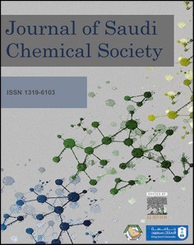
[Short title + Author Name - P&H title] 27 (2023) 101768
Contents lists available at ScienceDirect

Journal of Saudi Chemical Society
journal homepage: www.ksu.edu.sa


Review
Methods of synthesizing glycoluril-based macrocyclic compounds as precursors for polymeric compounds
Saule K. Kabieva ª, Gaziza M. Zhumanazarova ^{a,*}, Nurdana Kanasheva ^{b}, Abdigali A. Bakibaev ^{c},
Svetlana Yu. Panshina ^{d}, Victor S. Malkov ^{c}, Elena A. Mamaeva ^{e}, Alexey S. Knyazev ^{c}
ª Karaganda Industrial University, Temirtau, Kazakhstan
^{b} L.N. Gumilyov Eurasian National University, Astana, Kazakhstan
^{c} National Research Tomsk State University, Tomsk, Russia
^{d} Karagandy University of the name of academician E.A. Buketov, Karaganda, Kazakhstan
^{e} National Research Tomsk Polytechnic University, Tomsk, Russia

A R T I C L E I N F O

Keywords:
Glycoluril Polymers Macrocycles
Tetrahydroxymethylglycoluril Cyclocondensation Propellanes
Supramolecular systems
A B S T R A C T

This review study considers the classification of data on synthesis methods and practically valuable features of glycoluril-based macrocyclic nitrogen-containing compounds as precursors for polymeric compounds. General data about glycoluril and tetra-N-hydroxymethylglycoluril as parental bases for various macrocyclic compounds were considered. Generalized experimental facts about methods for glycoluril direct N-functionalization and its N-hydroxymethyl derivative reactions in macrocycles and polymeric compound synthesis are given.

Introduction

Currently, glycoluril is used for producing pharmaceuticals [1], ex- plosives [2–5], linking agents, special purpose polymers [6] and other valuable compounds.
In recent decades, a new field in glycoluril chemistry that has been actively developing is the creation of macrocyclic compounds with unique controlled properties based on glycoluril and its derivatives - (cucurbit[n]urils, bambus[n]urils, tiara[n]urils, «molecular clips» and the formation of supramolecular systems involving them. Supramolec- ular compounds obtained using glycoluril have been studied as com- ponents of organic semiconductor materials [7], auxiliary compounds for pharmaceuticals, such as prolongators and controlled release mo- lecular containers [8–10], materials with “molecular recognition” properties and molecular sensors for express analysis of amphiphilic components, such as surface-active substances, bacterial endotoxins and biogenic amines [11–15], which use glycoluril 1 as a construction material.
Definite success in researching cucurbit[n]uril and bambus[n]uril properties and synthesis methods is a subject for freestanding general- izations [16–23].
There are a number of generally acceptable methods of glycoluril synthesis [24–26], of which methods based on carbamide reactions with 1,2-dicarbonyl compounds are of practical interest. This synthetic approach allowed us to obtain various glycolurils unsubstituted along nitrogen atoms, glycolurils with cyclic fragments at C(3a)-C(6a) atoms, 1-substituted glycolurils, 1,3,4-trisubstituted glycolurils, and 1,4-di-, 1,6-di-, and 1,3,4,6-tetrasubstituted glycolurils. Another way to pre- pare glycolurils is using 4,5-dihydroxyimidazolidine-2-one (DHI) in- termediates as synthons, followed by glycoluril formation.
A synthetic variety of glycolurils is reached by changing substituents in standard reactions of N-alkylation, N-acylation, N-halogenation, N- nitration, N-nitrosation, N-hydroxyalkylation, etc. [27,28].
Given that the trajectories of glycoluril formation are not exhaustive methods of its synthesis, the success achieved in modifying these methods is defined by the selection of new catalysts and conditions

Peer review under responsibility of King Saud University. Production and hosting by Elsevier.
* Corresponding author.
E-mail addresses: kabieva.s@mail.ru (S.K. Kabieva), gaziza.zhumanazarova@mail.ru (G.M. Zhumanazarova), kanasheva_nur_94@mail.ru (N. Kanasheva), bakibaev@mail.ru (A.A. Bakibaev), janim_svetatusik@mail.ru (S.Yu. Panshina), malkov.tsu@yandex.ru (V.S. Malkov), mamaeva@tpu.ru (E.A. Mamaeva), kas854@mail.ru (A.S. Knyazev).
https://doi.org/10.1016/j.jscs.2023.101768
Received 3 October 2023; Received in revised form 1 November 2023; Accepted 4 November 2023
Available online 8 November 2023
1319-6103/© 2023 The Author(s). Published by Elsevier B.V. on behalf of King Saud University. This is an open access article under the CC BY-NC-ND license (http://creativecommons.org/licenses/by-nc-nd/4.0/).

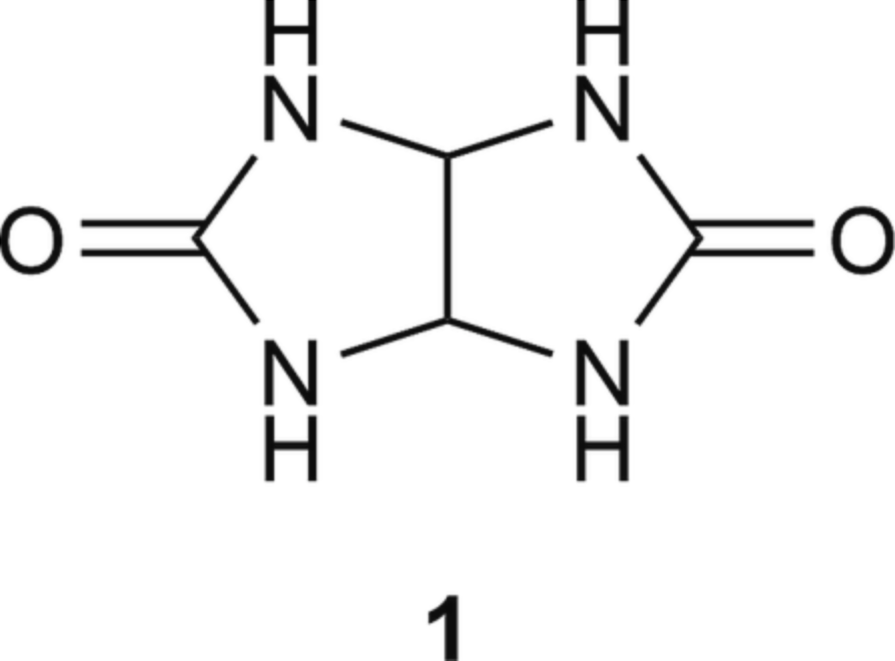
General information about glycoluril

Table 1

Fig. 1.1. Glycoluril molecule.

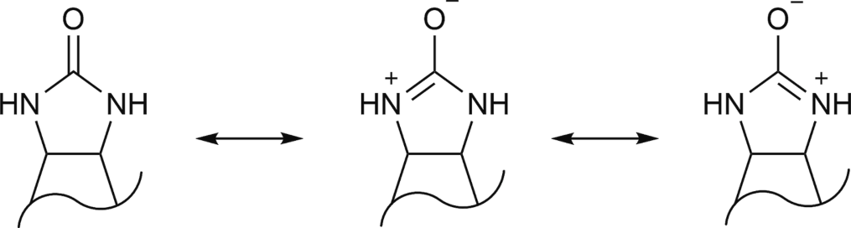
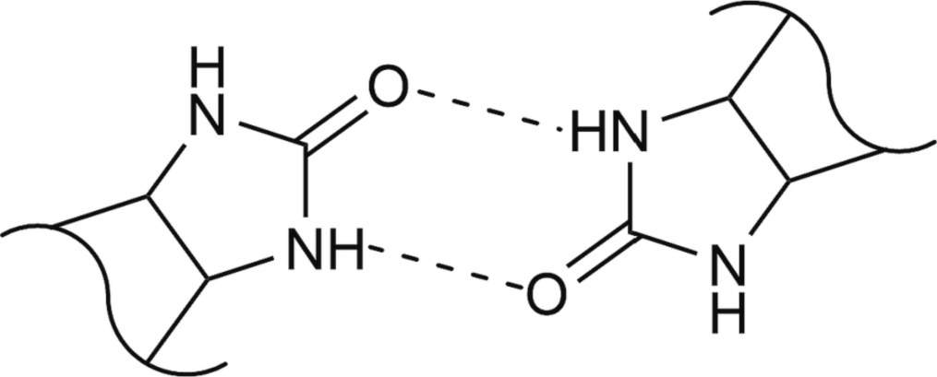
Fig. 1.2. Reaction centers in glycoluril.

Fig. 1.3. Hydrogen bonds in crystalline glycoluril.
Bicyclic carbamides play an important role in heterocyclic com- pound chemistry, specifically 2,4,6,8–tetraazabicyclo[3.3.0. ]octan-3,7- dione (glycoluril 1, tetrahydroimidazo[4,5-d]imidazol-2,5(1H, 3H)- dione) and its compounds (Fig. 1.1). Glycoluril chemistry originated in the second half of the 19th century, when a number of researchers managed to synthesize the original 1, and it was considered to have a bicyclic structure similar to carbamide [35,36].
However, relatively recently, it was found [37] that the molecule of glycoluril 1a is not flat and has a 124.1◦ angle between two imidazoli- dinone fragments, and nitrogen atoms are located equidistantly from
each other. Hydrogen atoms at the methine carbon are cis-oriented, and imidazolidinone cycles are characterized as almost flat but having a minor C = O group deviation from the general plane.
Glycoluril 1 is a polyfunctional compound in which the carbamide
fragment (Fig. 1.2) defines the properties of the 1 molecule, which are caused by the presence of two reaction centers (4 (–NH) donor groups and 2 (C = O) acceptor groups).
Compound 1 has the form of white crystals with a developed system
of strong intermolecular hydrogen bonds (Fig. 1.3), which define the high melting temperature (360 ◦C – with decomposition) and low sol- ubility of glycoluril 1.
A more detailed view of glycoluril structure peculiarities is given in the study [38], which says that glycoluril 1 exists in two polymorphic forms that can crystallize in water simultaneously. The polymorphism effect of glycoluril 1 has a significant influence on its physical–chemical properties, and in the case of reactive ability estimation, this effect is neutralized in solutions due to the equal solvent influence on crystalline structure of 1.
The physical–chemical properties of glycoluril 1 are given in Table 1. Thus, considering the specific limited solubility of glycoluril 1 (Table 1), usual solvents DMSO‑d₆ and D₂O are used most often for
identification via the NMR method.
There are some difficulties in identifying glycoluril 1 as well as other NH-group-containing compounds in D₂O, as the chemical shift of NH groups is often hidden due to deuterium exchange. The 1 molecule is defined more clearly in the ¹H NMR spectra in DMSO‑d₆, where there are 2 chemical shifts in the 5.24 ppm and 7.16 ppm areas, which correspond to protons of CH and NH groups. In the ¹³C NMR (DMSO‑d₆) spectrum, CH-carbons are revealed at 64.6 ppm, and carbonyl carbons (C = O) resonate at 160.3 ppm [39]. The equivalence of carbon and hydrogen atoms in the bicyclic structure definitely suggests glycoluril
space symmetry.
Glycoluril 1 is an active N-nucleophile and significantly deactivated

Physicochemical properties of glycoluril 1.

Parameter Data

Melting point, ◦C 360(decomposes)
Solubility Insoluble in most solvents
Slightly soluble in DMF, DMSO, acetic anhydride, H₂O
IR-spectrum, cm^{—1} 3209 (NH); 1675 (C = O)
¹H NMR (DMSO‑d₆) 5.24 (2H, CH)7.16 (4H, NH)
¹³C NMR (DMSO‑d₆) 160.3 (C = O)64.6
(CH)

allowing the combination of simplicity of the process and efficiency increase [29–32].
The aim of this review is to raise awareness of interesting and practically useful synthesis methods and properties of glycoluril-based macrocyclic nitrogen-containing compounds as precursors for poly- meric compounds and to encourage new research in this promising field.
Separate parts of this generalized research on glycoluril-based polycyclic heterocycles are given in studies [33,34].
p-nucleophile, and the presence of (NH–C = O) bonds with electron-
acceptor carbonyl groups makes it a less reactive base. This explains protonation difficulty and tendency toward breakage of products formed in electrophilic attack of nitrogen atom; besides, weak electrophilic properties of carbonyl group are explained by collectivization of two lone pairs of electrons which compensate electron-acceptor effect of carbonyl group. Glycolurils have a tendency to form complexes due to oxygen and nitrogen atoms, which are the most likely coordination centers for complex formation. However, coordination via nitrogen atoms is generally sterically complicated due to its predominantly py- ramidal structure; moreover, this center has lower electron density than oxygen.
The most frequently used compounds for making glycoluril metal complexes are N-alkylglycolurils, which are potentially polydentate li- gands and can perform either monodentate or bidentate-bridge func- tions with d-metals with binding through C = O groups of carbamide
fragments depending on the metal atom’s coordination number
(Fig. 1.4).
The combination of the abovementioned structural and phys- ical–chemical properties of glycolurils and their polyfunctionality basi- cally define these molecules’ ability to form macrocyclic and polymeric

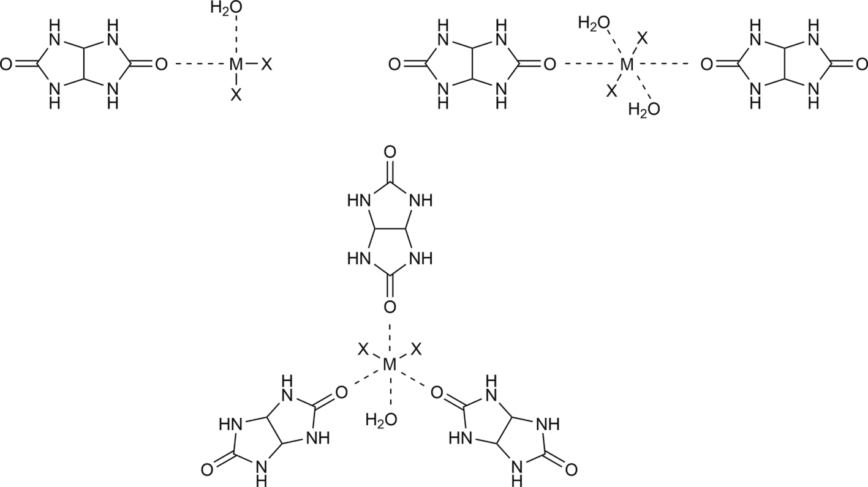

Fig. 1.4. Glycoluril complexes with d-metals.

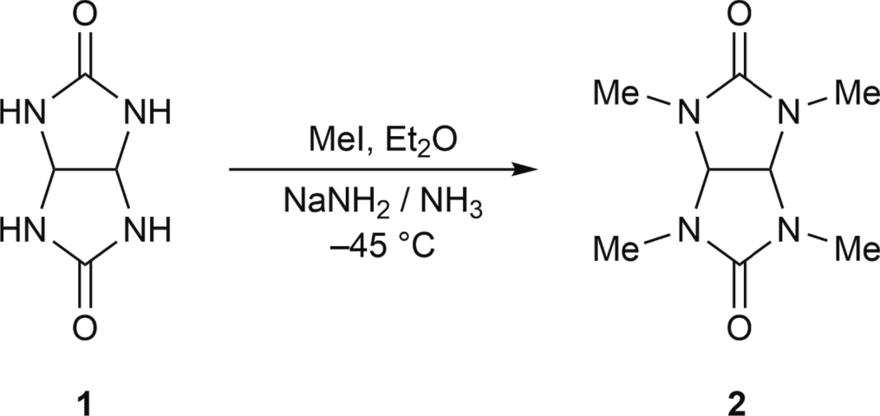

Fig. 2.1. Scheme of glycoluril alkylation.
compounds.

Direct N-functionalization of glycoluril in macrocycle synthesis

By changing the nature of the substituents during N-alkylation of glycoluril 1, it is possible to regulate the biological activity of its tetra-N- substituted compounds [40]. For example, the most frequent methyl- ating agents in tetra-N-methylglycoluril synthesis are dimethyl sulfate
[41] and methyl iodide [42]; generally, alkylation is performed in liquid ammonia under NaNH₂ with alkylhalides (Fig. 2.1).
Although tetra-N-methylglycoluril is a highly chemically and bio- chemically stable compound, a distinctive feature of glycoluril’s N-alkyl derivatives is the tendency toward complex formation with various metals [43–45], which allows us to expect the possibility of new het- eronuclear polycyclic system synthesis.
Studies [46,47] suggest ways of obtaining 2,4,6,8-tetrasubstituted

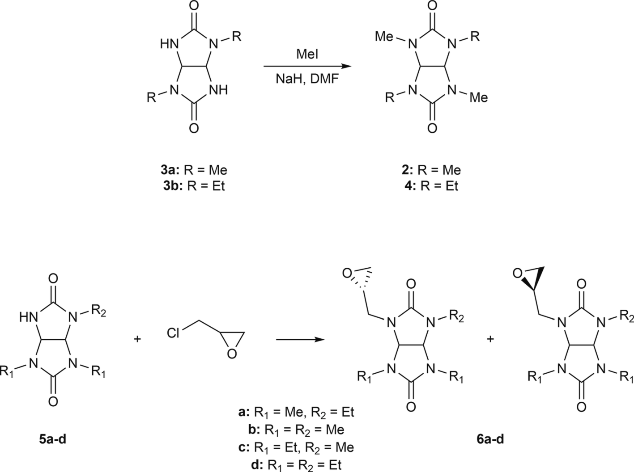

Fig. 2.2. Alkylation of partially substituted glycolurils.

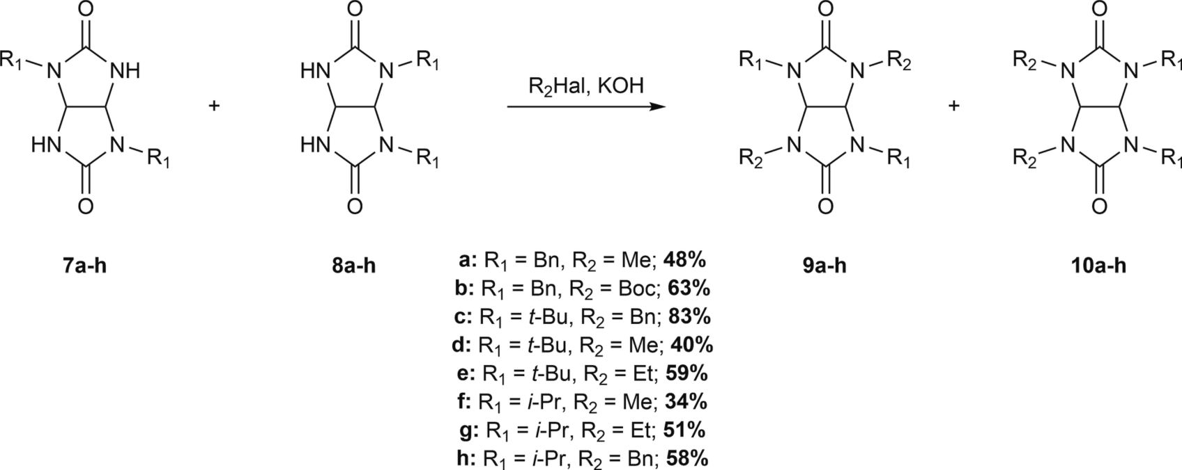

Fig. 2.3. Alkylation of disubstituted glycolurils.
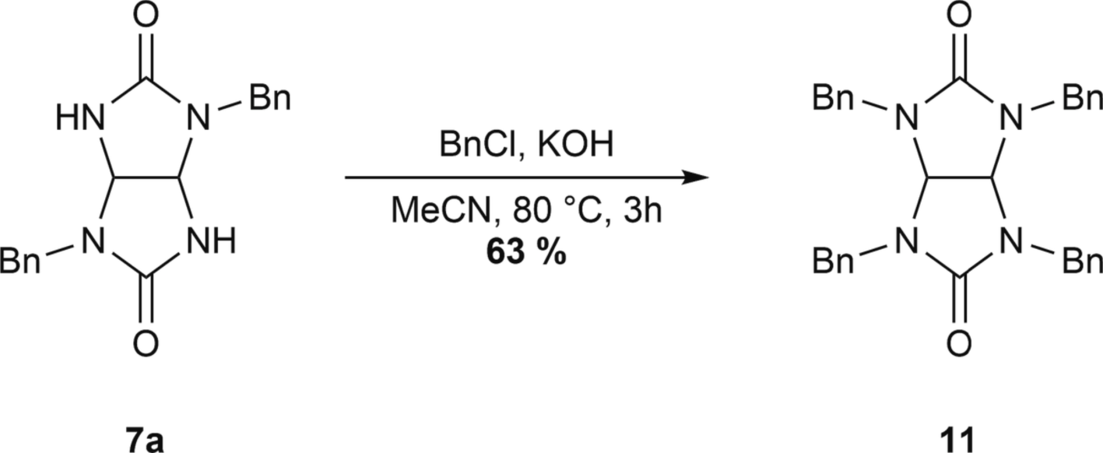

Fig. 2.4. Synthesis of N,N,N,N-tetrabenzylglycoluril.
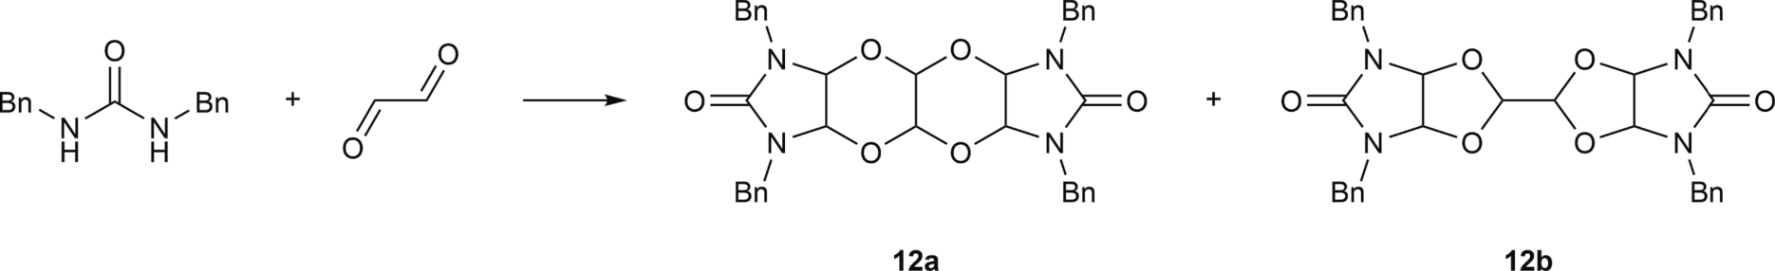

Fig. 2.5. Reaction of dibenzylurea with glyoxal.
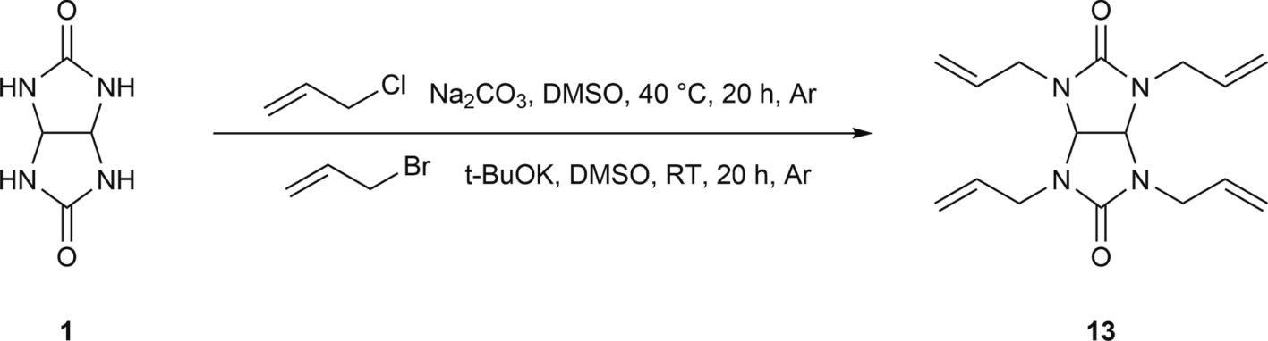

Fig. 2.6. Synthesis of tetraallylglycoluril.

glycolurils through partially substituted glycolurils (Fig. 2.2).
The developed convenient method of tetrasubstituted glycoluril synthesis in an acetonitrile-KOH environment by treating disubstituted glycolurils with alkylating agents (Fig. 2.3) allowed us to expand the line of tetra-N-substituted glycolurils not described in the literature before [48]. Initial disubstituted glycolurils were obtained by monosubstituted carbamide cyclization with glyoxal using methods [49] and are a
mixture of cis- and trans-isomers.
This type of reaction also includes N-benzylation of glycoluril 1, which is interesting due to its use as an effective stabilizer for polymeric materials. Such switching to tetra-N-benzylglycoluril 11 was established during N-benzylation of 2,6-di-N-benzylglycoluril with a target com- pound yield of 63 % [50] by alkylation with benzyl chloride in aceto- nitrile (Fig. 2.4). It was concluded that acetonitrile is the most suitable

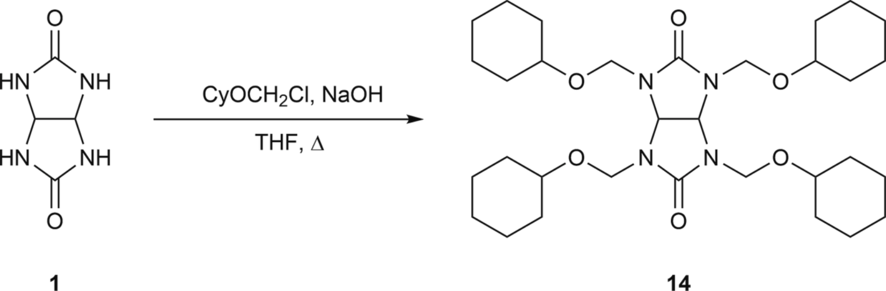

Fig. 2.7. Synthesis of substituted glycoluril that can be used with overcoated photoresist compositions.
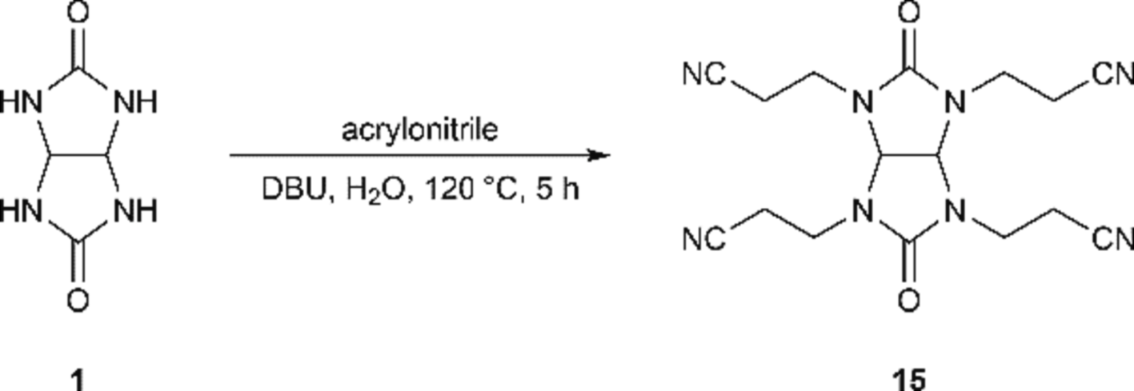

Fig. 2.8. Synthesis of tetra(2-cyanoethyl)glycoluril.
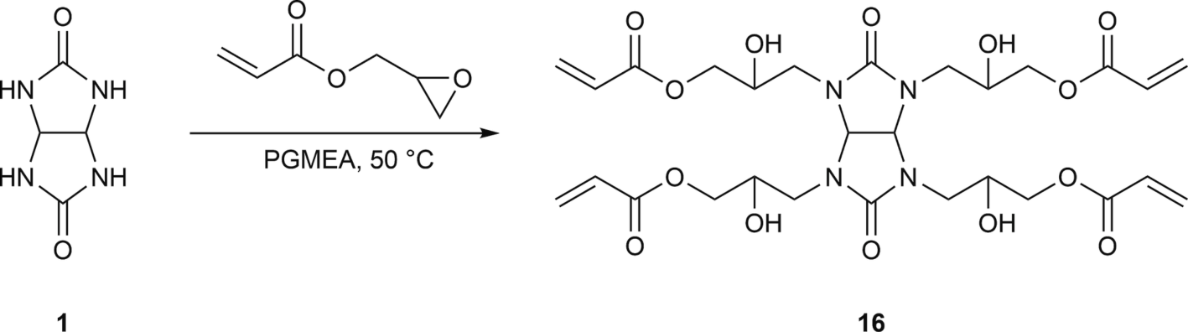

Fig. 2.9. Reaction of glycoluril with glycidylacrylate.
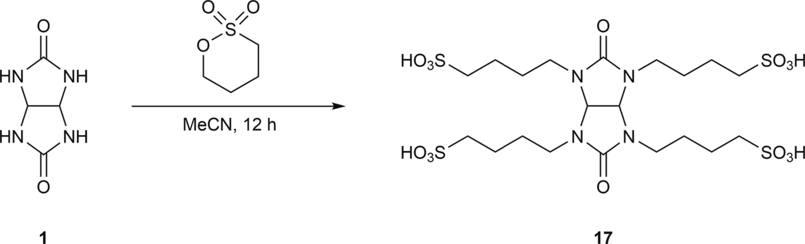

Fig. 2.10. Synthesis of glycoluril tetrakis(butane-1-sulfonic acid).

generic solvent, as its use provided the best experimental results, while DMSO and DMF, similar to direct reaction with glycoluril, did not lead to positive outcomes. It was found that benzyl chloride is better as an alkylating agent, as it provides a higher target product yield than benzyl bromide and is less toxic. This study suggests that the 2,6-dibenzylglyco- luril N-alkylation reaction is currently the only way of obtaining tetra-N- benzylglycoluril.
An alternative way to prepare 2,4,6,8-tetrabenzylglycoluril 11 through condensation of 1,3-dibenzylcarbamide with glyoxal does not provide the desired outcome, as it is accompanied only by the formation
of oxo-compounds 12a–b, as shown in Fig. 2.5.
A similar process was previously observed in the study [51] where an analogue of compound 12a, with the structure of condensed 4 hetero- cycles was synthesized. An analogue of Compound 12b, with a bicyclic structure (dioxolane fragment) with methyl substituents, was described in the study [52], with the structure proven by the XRD method.
The importance of N,N,N,N-tetraallylglycoluril 13 obtained by ally- lation of glycoluril 1 with allylchloride in the presence of sodium car- bonate (Fig. 2.6) is defined by the fact that it is a convenient precursor for obtaining new polymers due to its polyfunctionality. A new

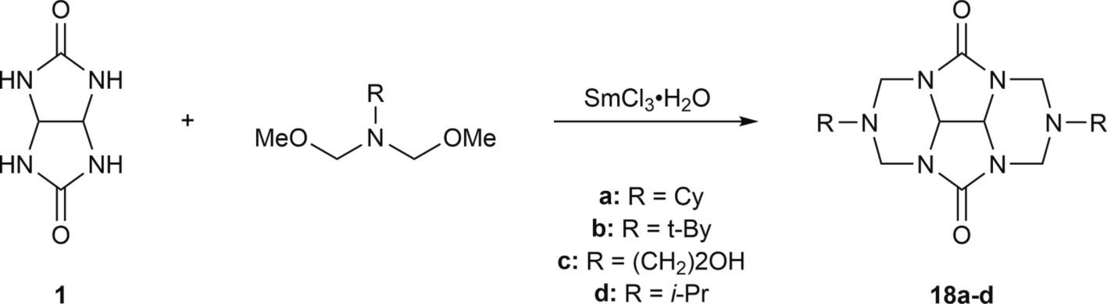

Fig. 2.11. Catalytic cycloamination of glycoluril.
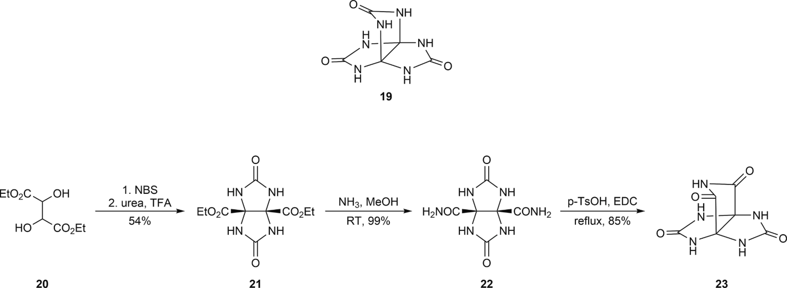

Fig. 2.12. 2,4,6,8,9,11-hexaaza[3.3.3]propellane (19) and synthesis of 2,4,6,8,10-pentaaza[3.3.3]propellane (23).

Table 2
Conditions of 3,7,9,11-tetraoxo-2,4,6,8,10-pentaaza [3.3.3]propellane nitration.

Nitration mixture Data

HNO₃/P₂O₅ 21a, 32 %
HNO₃/CF₃COOH 21a, 61 %
HNO₃/Ac₂O 21a, 38 %
HNO₃/NO₂BF₄ 21b, 53 %
NH₄NO₃/CF₃COOH 21b, 11 %

functional polymer was obtained by copolymerization of 4-vinylpyri- dine and N,N,N,N-tetraallylglycoluril 13 [53], which was obtained by allylation of glycoluril 1 with allylbromide in the presence of potassium tert-butoxide. Tetra-N-allylglycoluril 13 was also used to create orga- nosilane polymers [54].
The results given in the patent [55] are of practical interest, where light-reflecting coating compounds were studied for use in photo- resistors; they contained linking components obtained according to the procedure shown in Fig. 2.7.
Another example of obtaining a promising monomer is the synthesis of tetra(2-cyanoethyl)glycoluril 15 with 61 % yield [56], which was obtained through the interaction of acrylonitrile and glycoluril in a water environment in the presence of diazabicycloundecene (DBU) as a base (Fig. 2.8).
Promising outcomes of polyfunctional polymer precursor synthesis are shown in the patent [57], where glycoluril 1 reacts with glycidyla- crylate in 1-methoxy-2-propanolacetate (PGMEA) at 50 ◦C, giving tet-
rasubstituted glycoluril 16 (Fig. 2.9).
New glycoluril derivatives with sulfonic acid marks are impressive [58], particularly glycoluriltetrakis(butane-1-sulfonic acid) 17 in the shape of nanosized particles (Fig. 2.10). It was proven that this new nanostructured substrate is an effective catalyst for new spiropyrane synthesis through the multicomponent condensation of isatin, naphthalene-1,2-diol or 2,5-dihydroxycyclohex-2,5-dien-1,4-dion and malononitrile (or 1,3-dicarbonyl compound) in boiling water.
Glycoluril 1 cycloamination products were identified using N,N-bis (methoxymethyl)alkaneamines and SmCl₃⋅6H₂O as catalysts (Fig. 2.11).
Reaction products were separated from the formed mixture by column chromatography using silica gel as a sorbent [59].
3,7,10-trioxo-2,4,6,8,9,11-hexaaza[3.3.3]propellane 19 has attrac- ted interest in recent years – a cyclic carbamide derivative consisting of three condensed cycles connected by a common carbon–carbon bond, including a glycoluril fragment. Such [3.3.3]propellanes gained interest in the scientific community, having become the subject of a number of reviews [60,61].
Relatively recently [3.3.3]propellane with five nitrogen atoms in the structure was synthesized through a glycoluril derivative in stage (Fig. 2.12). The main point of this method is that the initial interaction of diethyl-2,3-dihydroxybutanedioate with carbamide in an acidic envi- ronment provides a bicyclization product, which is then tricyclized into [3.3.3]propellane 23 consecutively through intermediate bisamide in the presence of p-toluene sulfonic acid 23 [62].
Based on previously obtained results of the glycoluril diethyl ether nitration model reaction, the authors of [63] implemented such a shift to nitroderivatives of tetraoxopentaaza[3.3.3]propellanes 24a-b (Table 2, Fig. 2.13). During these reactions, di- and trisubstituted nitrocompounds – 2,6-dinitro-3,7,9,11-tetraoxo-2,4,6,8,10-pentaaza[3.3.3]propellane 24a and 2,6,10-trinitro-3,7,9,11-tetraoxo-2,4,6,8,10-pentaaza[3.3.3] propellane 24b – were obtained in yields of 61 % and 53 %, respec- tively. The range of performed research did not allow the synthesis of pentanitrosubstituted propellane. Reactions were performed at room temperature for 10–12 h; then, the reaction mixture was poured on ice and filtered.
Another approach to [3.3.3]propellane was shown in the study [64] – a method of obtaining [3.3.3]hexaazapropellane structure with six NH groups was developed (Fig. 2.14).
In the study [65], uric oxide 25 was used as the initial compound; it was oxidized under Na₂S₂O₈, which caused the formation of 1,5-diami- noglycoluril 26. The following tricyclization stage was performed suc- cessfully using di-tert-butylcarbonate (Boc₂O), forming intermediate product 27 at room temperature. The final stage of protective Boc-group removal led to final product 19 formation. It should be noted that two- stage synthesis can be performed without intermediate formation of 27, and structures 27 and 19 were confirmed by X-ray diffraction analysis. Considering the experimental data, more successful results were

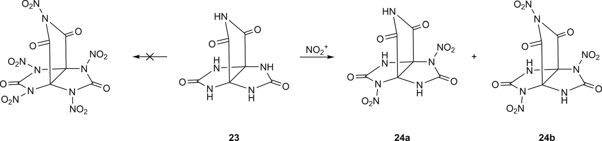

Fig. 2.13. Nitration of 3,7,9,11-tetraoxo-2,4,6,8,10-pentaaza[3.3.3]propellane.
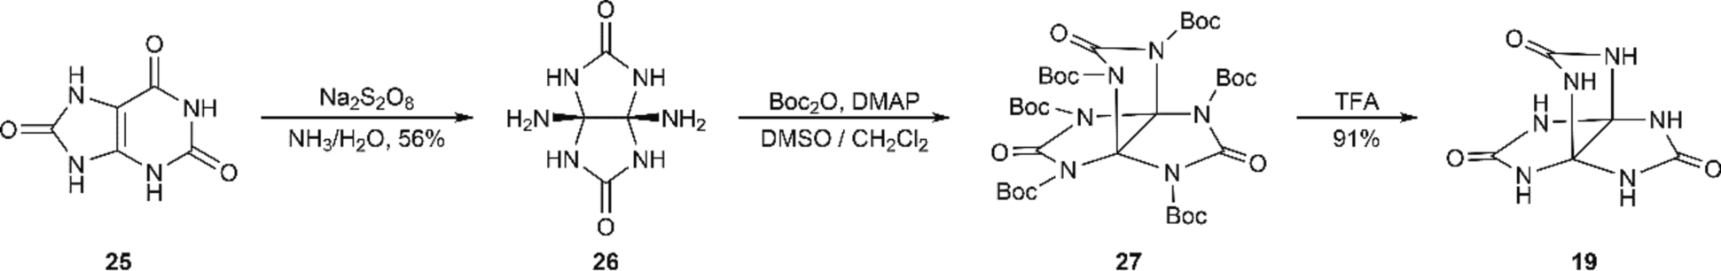

Fig. 2.14. Synthesis of hexaazapropellane 19.
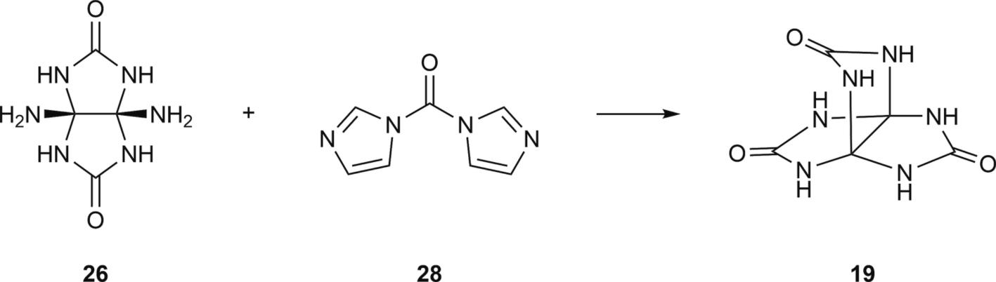

Fig. 2.15. Synthesis of propellane 19 using carbonyldiimidazole.

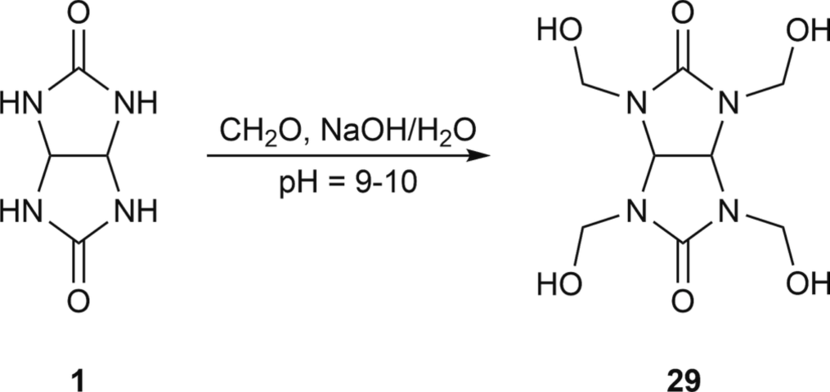

Fig. 3.1. Synthesis of THMGU.
Table 3
Properties of THMGU.

Parameter Data
Melting point, ◦C 135–136
Solubility Insoluble in hydrocarbons, alcohols, ketones, esters Slightly soluble in DMF, DMSO
Soluble in H₂O, acids
IR-spectrum, cm^{—1} 3337 (OH); 1675 (C = O)
¹H NMR (DMSO‑d₆) 5.97 (4H, OH)5.51
(2H, CH)4.70
(2H, CH₂)
¹³C NMR (DMSO‑d₆) 157.48 (C = O)87.03 (CH)65.10
(CH₂)

achieved in the study [66], which shows a one-stage way of obtaining 19 through carbonyldiimidazole 28 at 15–20 ◦C. Final product 19 was separated by acetone descension with a yield of 85 % (Fig. 2.15).
A series of studies [67,68] were aimed at finding ways of function- alizing 3,7,10-trioxo-2,4,6,8,9,11-hexaaza[3.3.3]propellane. During the research, methods for obtaining hexaalkyl derivatives of 3,7,10-trioxo- 2,4,6,8,9,11-hexaaza[3.3.3]propellane (methyl-, ethyl-, propylder- ivatives) and mono- and dinitroderivatives of 3,7,10-trioxo- 2,4,6,8,9,11-hexaaza[3.3.3]propellane were developed. It was found that complete acetylation of 3,7,10-trioxo-2,4,6,8,9,11-hexaaza[3.3.3] propellane proceeds in two stages through the formation and separa- tion of intermediate 2,6-di- and 2,6,9-triacetylsubstituted derivatives of 3,7,10-trioxo-2,4,6,8,9,11-hexaaza[3.3.3]propellane.

N-hydroxymethylglycoluril-based macrocycle synthesis

  - General information about tetra-N-hydroxymethylglycoluril

N-hydroxylalkylderivative glycolurils are traditionally obtained through reaction with aldehydes, of which the most synthetically important is the parent 2,4,6,8-tetrahydroxymethyl-2,4,6,8-tetraazabi- cyclo[3.3.0]octan-3,7-dione (tetra-N-hydroxymethyl glycoluril, THMGU) 29, which is obtained through a typical reaction of glycoluril 1 formylation [24] in an alkaline environment (Fig. 3.1).
Currently, THMGU is widely used as a linking agent for obtaining glycoluril-formaldehyde resins [69] and high-quality thermosetting

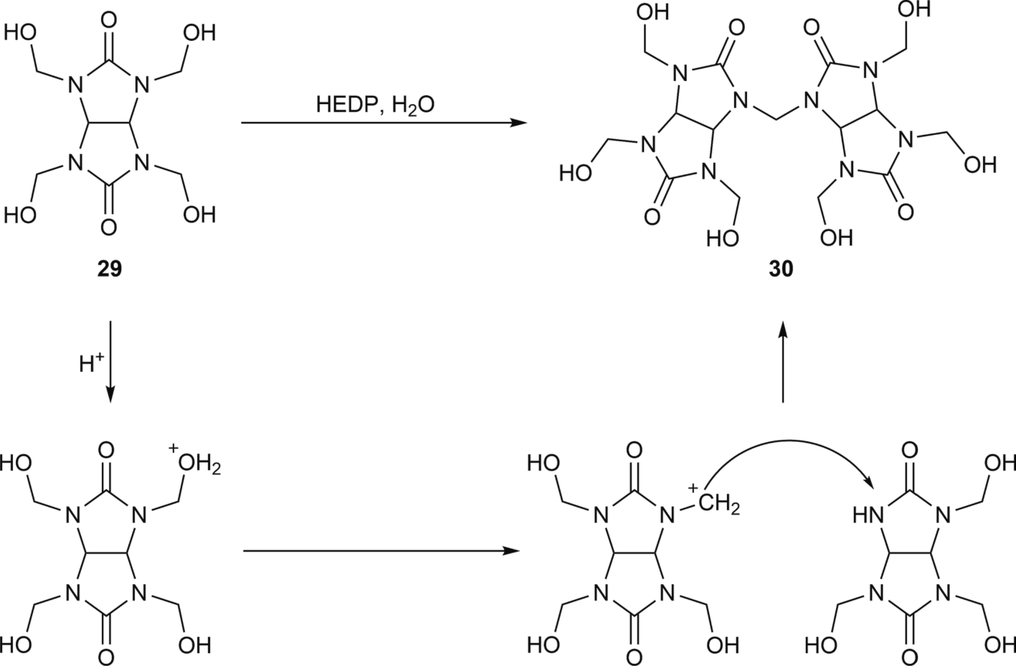

Fig. 3.2. Dimerization of THMGU 29 in the presence of HEDP.
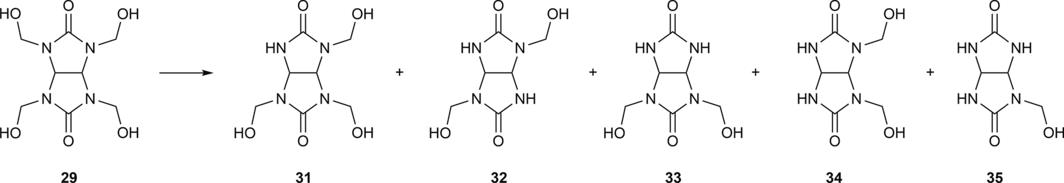

Fig. 3.3. Consecutive elimination of formaldehyde from THMGU 29.

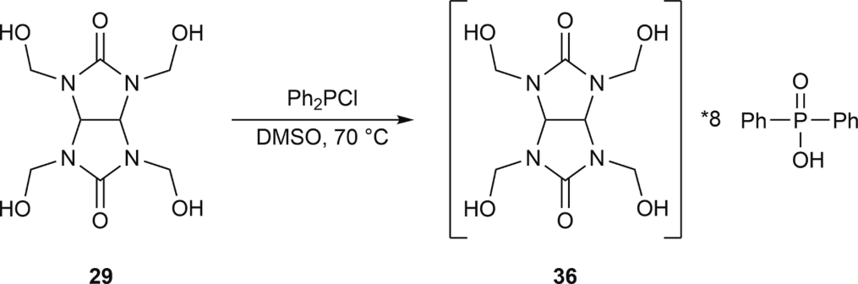

Fig. 3.4. Product of interaction of THMGU 29 with diphenylchlorophosphine.

coatings [70] and for supramolecular object synthesis [71], as well as a bactericidal agent for aqueous compositions [72].
THMGU is widely used as a linking agent in different fields [70,73,74]. For example, it was suggested to use an ethylene–vinyl chloride emulsion containing 4 to 10 mass percent THMGU as a linking agent for filter paper. It is said that paper soaked in this emulsion maintains strength and flexibility even when exposed to hot oil.
The authors of the patent [75] suggested a microencapsulation sys- tem using THMGU for various carboxamide compounds in different in- dustry fields: antipyrenes, pharmaceuticals, cosmetics, etc. The authors give most attention to the agrochemical area.
In [76], THMGU was used as a linking agent for the creation of methylmethacrylate- and acrylamide-based macroporous polymers.
THMGU is a white powder, very soluble in water and DMF and poorly soluble in most other organic solvents (Table 3). When stored with air contact, THMGU tends to detach from formaldehyde, thus gaining a typical yellow color. In water solution at pH = 4–8, THMGU
undergoes demethylolation until reaching equilibrium: approx. 3.6
hydroxymethyl groups per glycoluril molecule with 0.4 parts of free formaldehyde. A pH over 8.8 promotes demethylolation even more. For example, at pH = 11, the amounts of hydroxymethyl groups and free
formaldehyde are approximately equal [77].
After studying properties 29 in the presence of 1-hydroxyethylidene- 1,1-diphosphonic acid (etidronic acid, HEDP), it was found that the substance dimerizes, yielding product 30, and with a longer period of time, there is no further oligomerization (Fig. 3.2). This feature is highly irregular and selective, as using mineral acids leads to the formation of macrooligomerization products [71].
Dimer 30 was also separated in a different experiment with heating to 60 ◦C a water solution of glycoluril 1 with excessive formaldehyde (pH = 3,4) [78].
It should be noted that dimer 30 obtained through condensation is evidence that supramolecule formation in this case is difficult, as hydroxymethyl end groups “block” further condensation processes due to the lack of reaction partners with vacant NH groups. This can explain the fact that with longer reaction times and high temperatures, there are no insoluble residues, proving the formation of macromolecular systems.
The study [79] found that THMGU 29 is unstable and tends toward dehydroxymethylation products. Products of its step-by-step dehydrox- ymethylation (Fig. 3.3) were identified by HPLC and 1D/2D NMR spectroscopy.
The most stable product of hydrolytic destruction is tris(hydrox- ymethyl)glycoluril 31, which can be caused by peculiarities of intra- molecular interaction formation in THMGU 29. Further dehydroxymethylation with the formation of glycoluril di- and mono- derivatives 32–35 (Fig. 3.3) occurs under much harsher conditions.

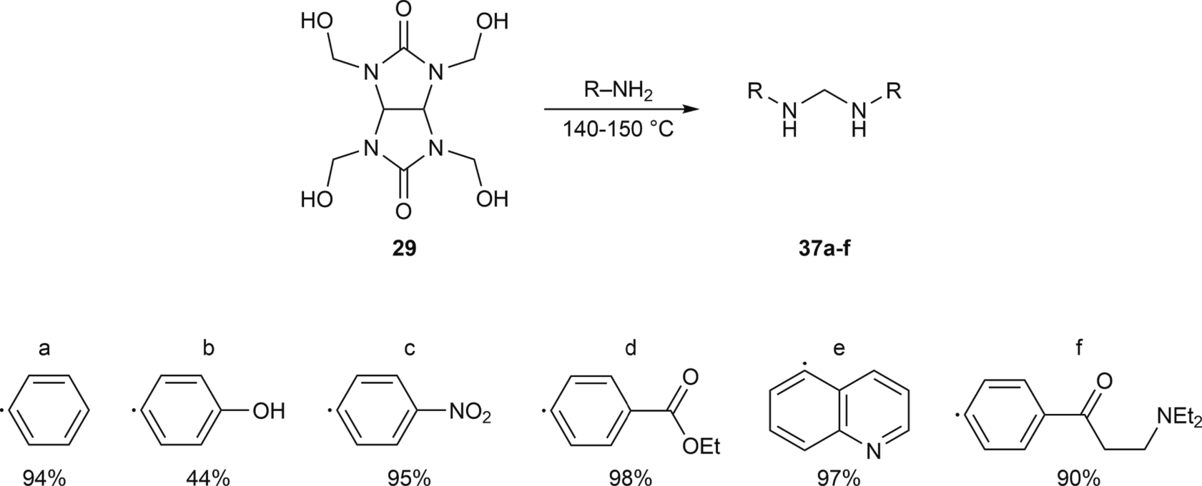

Fig. 3.5. Synthesis of aminals 37a-f from 29.
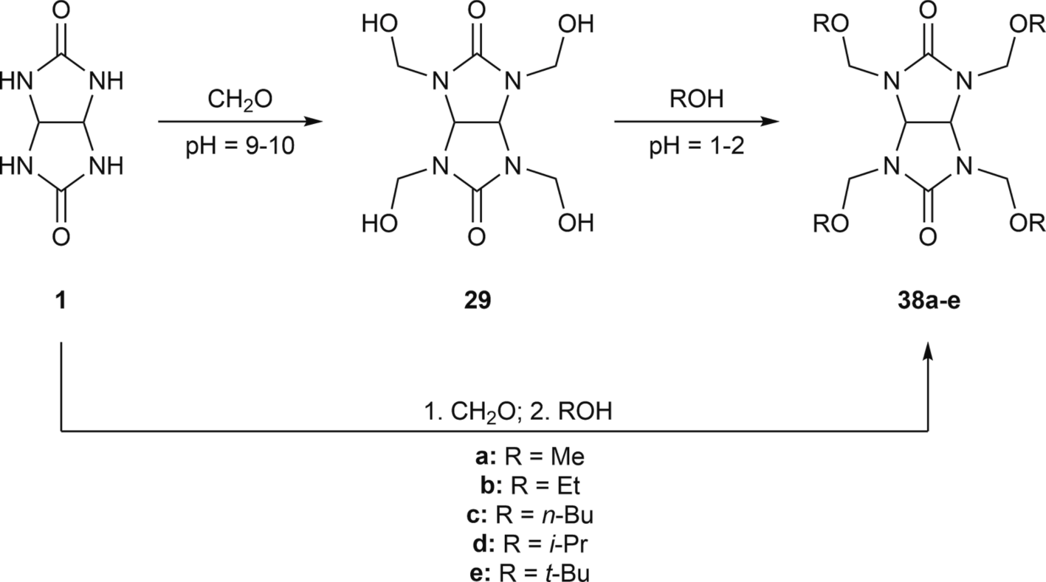

Fig. 3.6. Synthesis of tetra(alkoxymethyl)glycolurils 38a-e.
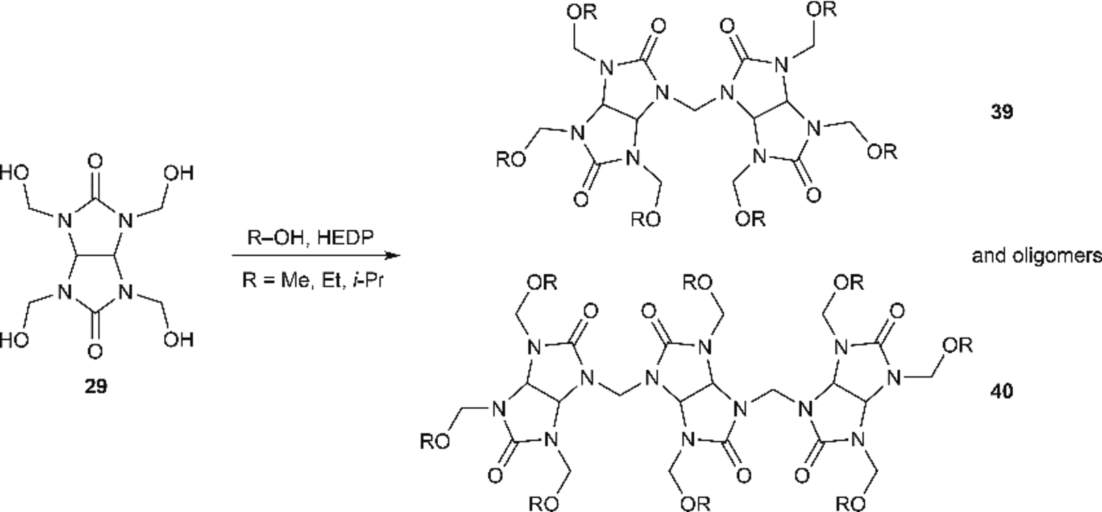

Fig. 3.7. Oligomerization of THMGU 29 under HEDP.

It should be noted that complexes 29 with HEDP were not separated from the reactin mixture. However, in reaction with diphenyl- chlorophosphine 29 gives complex product 36 (Fig. 3.4), which was
obtained in a DMSO environment at room temperature for 3 h [80]. After the reaction, white crystalline sediment dissolved poorly in water and did not dissolving in organic solvents.

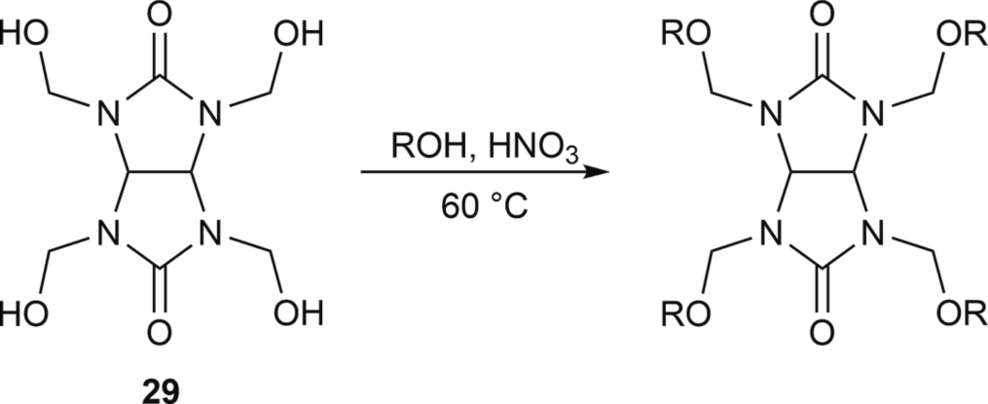

Fig. 3.8. N-alkoxymethylglycoluril synthesis.

It is interesting that considering the tendency for elimination of tetrasubstituted glycoluril 29 formaldehyde, it was suggested to syn- thesize aminals 37a-f (Fig. 3.5) with yields of 44–98 % [81].
Tetra(hydroxymethyl)glycoluril 29 is a polyfunctional alcohol, and a number of ethers are obtained from it in acidic catalysis (HCl, HBr) — tetra(alkoxymethyl)glycolurils 38a-e, which are widely used as
linking agents in obtaining polymers [82]. In addition, there are ex-
amples of obtaining tetraether compounds [83] using 1 as an initial base, skipping the stage of separating 29 (Fig. 3.6).
The same study shows that after replacing mineral acids with HEDP in reactions involving glycoluril 1 as an initial substrate, the latter rearranged into hydantoin. Different results were achieved using THMGU29 – instead of expected ether products 38a-e, the process included formation of oligomeric Compounds 39–40 with terminal arrangement of alkyl groups - derivatives of methyl, ethyl and isopropyl alcohol (Fig. 3.7).
To explain the results of oligomer 39–40 formation, a mechanism assuming intermediate dehydroxymethylation in the water environment of initial substrate 29 was suggested. With longer reaction times, olig- omeric chains increase, as there are poorly soluble residues of unknown structure.
  - Reactions of glycoluril N-hydroxymethyl derivatives

THMGU 29 reacts with alcohols if heated with mineral acids, form- ing respective tetraalkoxymethylglycolurils. The study [84] gives ex- amples of synthesizing ethoxy- and methoxymethylglycolurils, and an extended line of 29 reactions with various alcohols is given in the patent [55]. A typical approach is exposing suspension 29 to the respective
alcohol with nitric acid at 60 ◦C (Fig. 3.8).
Depending on the method of product separation and the alcohol involved in the reaction, either liquid tars or solid substances with high melting temperatures can be formed. Alkoxyglycoluril tars are widely used for surface treatment, and they have a number of advantages over melamine–formaldehyde tars, such as resistance to acid hydrolysis and UV rays [85].
The hydroxylation reaction speed depends directly on the amount of catalyst added. The direct reaction is faster in acidic media, but the reverse reaction speed is much lower in acidic environments. However, after being in an acidic environment for a long time, the glycoluril tet- rahydroxymethyl derivative may condense in the form of a tetracyclic diether [86]. Conversion of N-hydroxymethylglycolurils containing substitutes R₁ and R₂ into respective diethers is possible at room tem- perature. The presence of more volume substitutes increases the cyclo- condensation reaction activation energy due to steric effects: for example, diphenylglycoluril diether can be obtained only in the case of reaction mixture heating (Fig. 3.9).
At low pH (1–2), there is a condensation reaction (Fig. 3.10) with the formation of oligomers connected by methylene bridges [8]. There is no information on the possibility of similar processes in alkaline environments.
Apart from glycoluril-formaldehyde tars, glycoluril alkoxoder- ivatives can also be used in new material creation. For example, tetrakis (methoxymethyl)glycoluril 41 is used as a binding agent in the creation of a three-component negative photoresist from molecular glass [87]. Photoacid is generated by mixture irradiation and catalyzes the linking

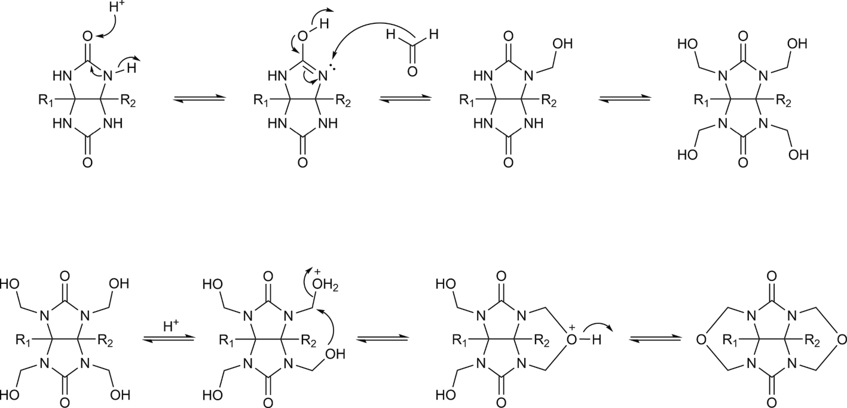

Fig. 3.9. Transformations in the glycoluril-formaldehyde reacting system in an acidic medium.
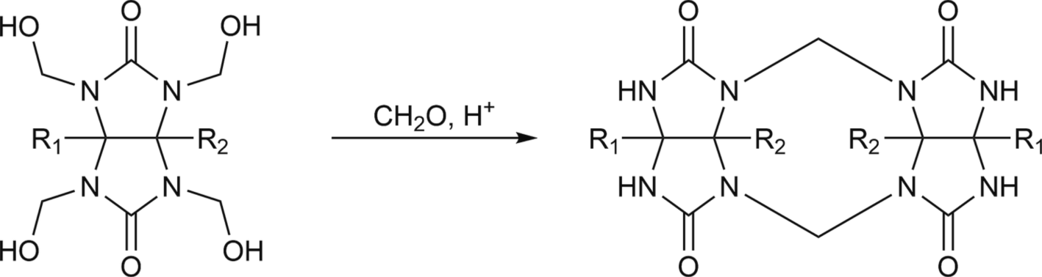

Fig. 3.10. Transformations in the glycoluril-formaldehyde reacting system in strong acidic medium.

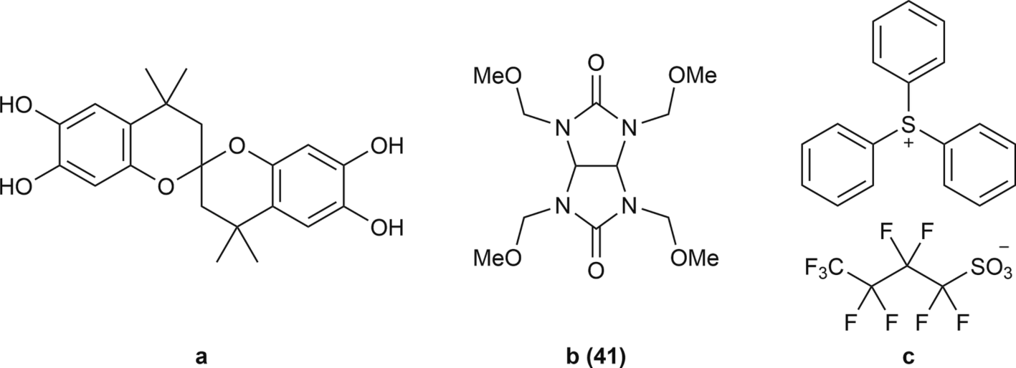

Fig. 3.11. Three-component molecular glass negative photoresist: a – monomer, b – tetrakis(methoxymethyl)glycoluril 41, c – acid catalyst.
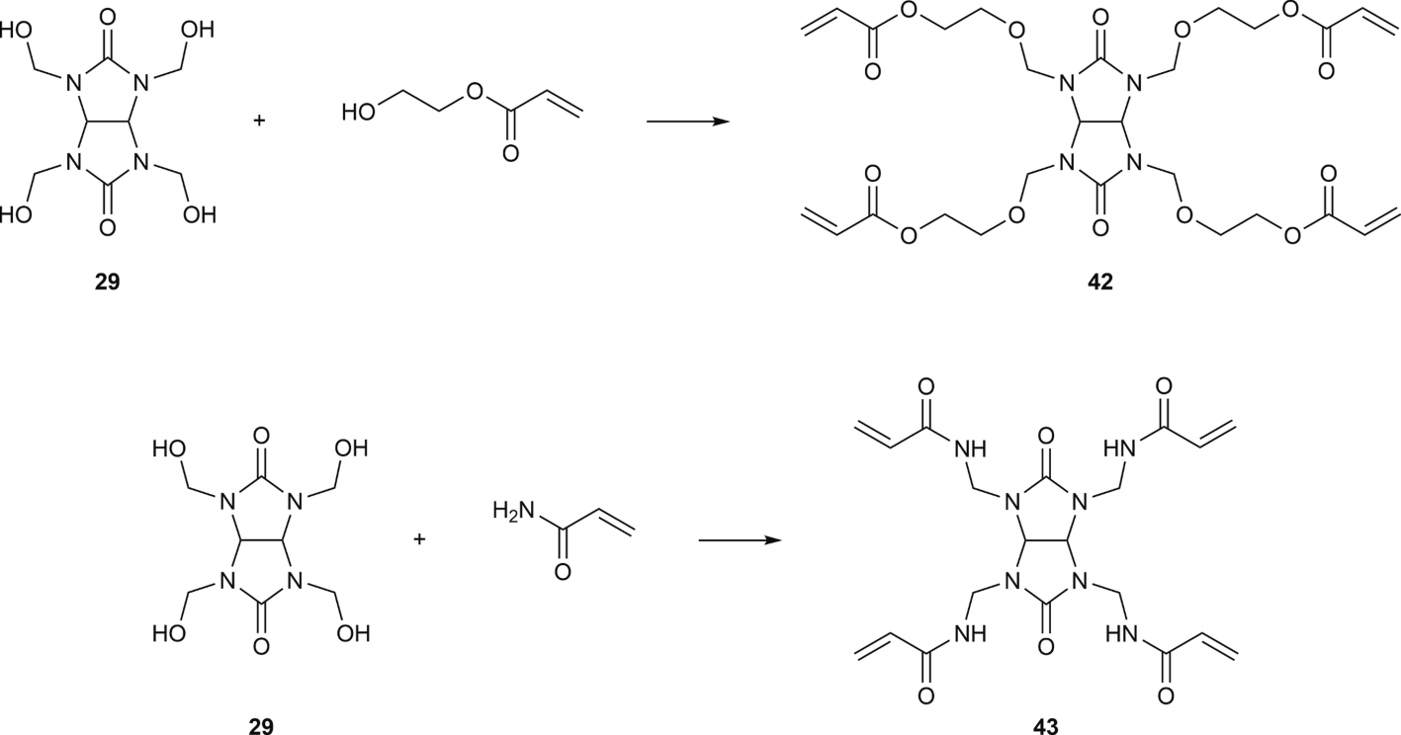

Fig. 3.12. Reaction of THMGU 29 with hydroxyethylacrylate and acrylamide.
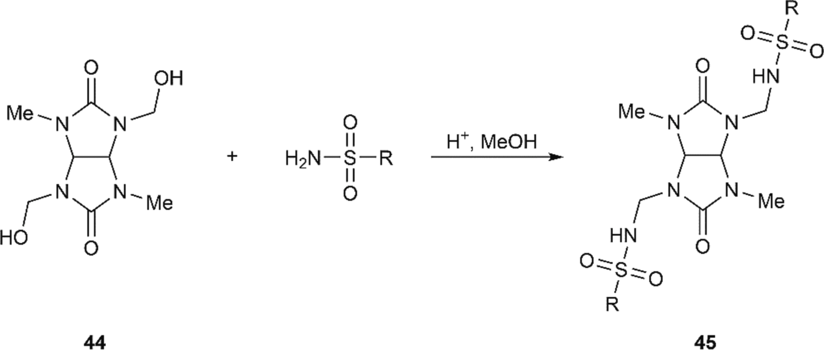

Fig. 3.13. Condensation of glycoluril derivative 44 with sulfonamide.

process between 41 and monomer hydroxylic groups (Fig. 3.11).
When reacting with alcohols containing double bonds, 29 forms aminoplastics with side α,β-unsaturated carbonyl groups. The study [82] described reactions of 29 with hydroxyethylacrylate and acrylamide (Fig. 3.12) with the formation of respective products 42–43.
The most preferred option is when 29 is reacted with a mixture of hydroxyethylacrylate and acrylamide, which leads to stable product formation. It was found that after mixing such products with other aminoplastics with side α,β-unsaturated carbonyl groups and single- stage resins, the conversion rate during cross-linking increased.
Several studies [88–90] have researched reactions of α-ure- idoalkylation of sulfonamides, sulfonamides and N,N’-dialkylsulfamides
using mono-, di- and tetra-N-hydroxymethylglycolurils.
Sulfonamide condensation with glycoluril 44 containing one hydroxymethyl group is shown in Fig. 3.13, with 2-hydroxymethyl- 4,6,8-trimethylglycoluril and benzene sulfonamide. This reaction was completed in 1 h in boiling methanol in the presence of hydrochloric acid. Sulfonamides with 2,6-dihydroxymethylglycoluril 44 in these conditions give 2,6-bis(arylsulfonylaminomethyl)glycolurils 45 with yields of 27–50 %.
Sulfamide condensation with 2,8-bis(hydroxymethyl)glycolurils 34
leads to the formation of tricyclic dioxides (Fig. 3.14).
Condensation of 29 with N,N’-dimethylsulfamide in water and an acidic environment (pH 1) leads to the formation of tetracyclic

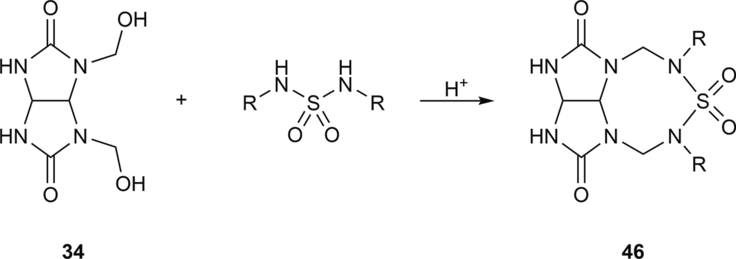

Fig. 3.14. Condensation of 2,8-bis(hydroxymethyl)glycoluril 34 with sulfamides.
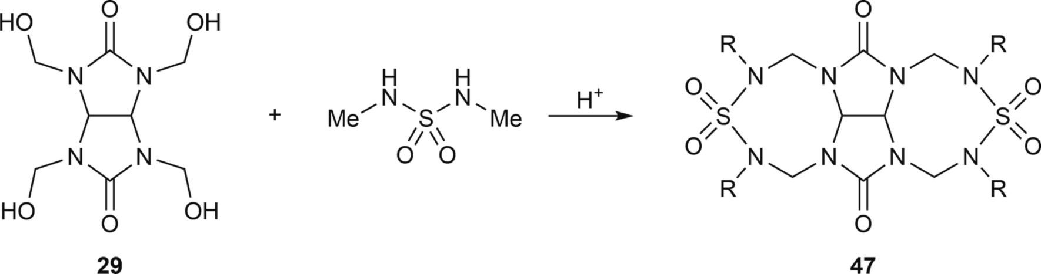

Fig. 3.15. Condensation of THMGU 29 with N,N’-dimethylsulfamide.
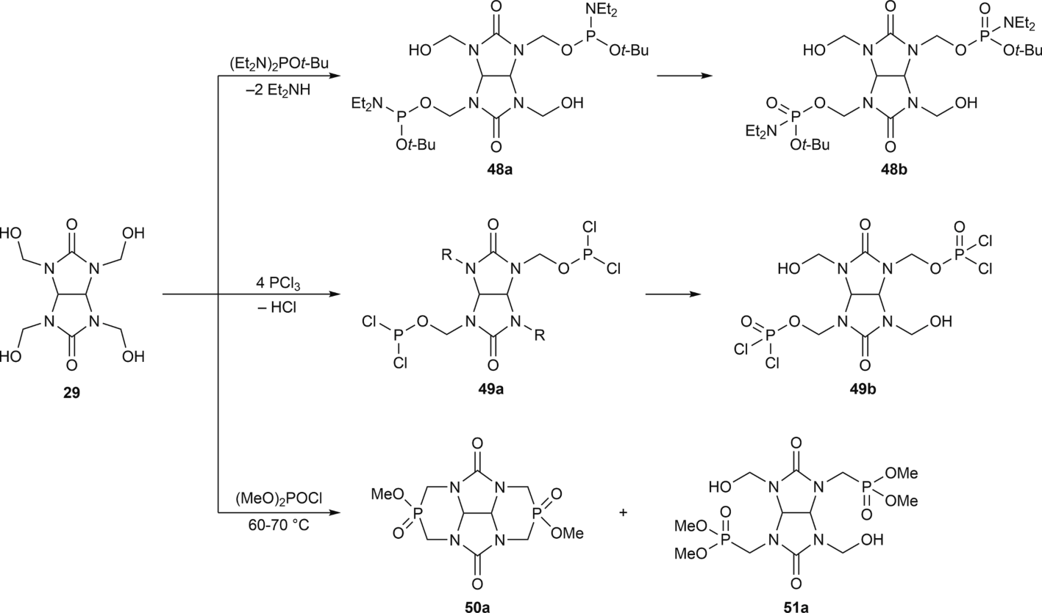

Fig. 3.16. Phosphorylation of THMGU 29.
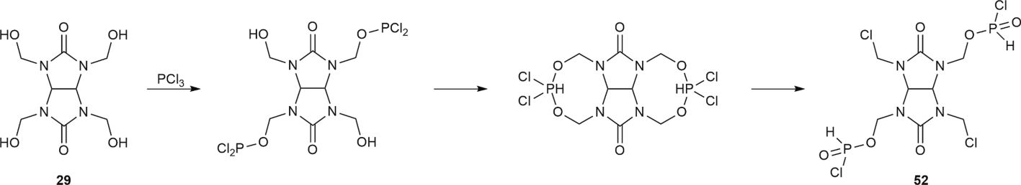

Fig. 3.17. Interaction of THMGU 29 with PCl_{3.}

compounds (Fig. 3.15).
Phosphorylation of tetra(hydroxymethyl)glycoluril 29 with tetrae- thyldiamido-tert-butylphosphite [91] leads to the formation of an oleiferous product – 2,6-di-(N-diethylamidohydroxymethylphosphato)-
2,4,6,8-tetraazobicyclo[3.3.0]octan-3,7-dione 48b through the forma- tion of intermediate Compound 48a (Fig. 3.16). Interaction of 29 with phosphorus trichloride leads to separation of the yellow crystalline substance – 2,6-di-(N-methylchlorophosphato)-4,8-chloromethyl-

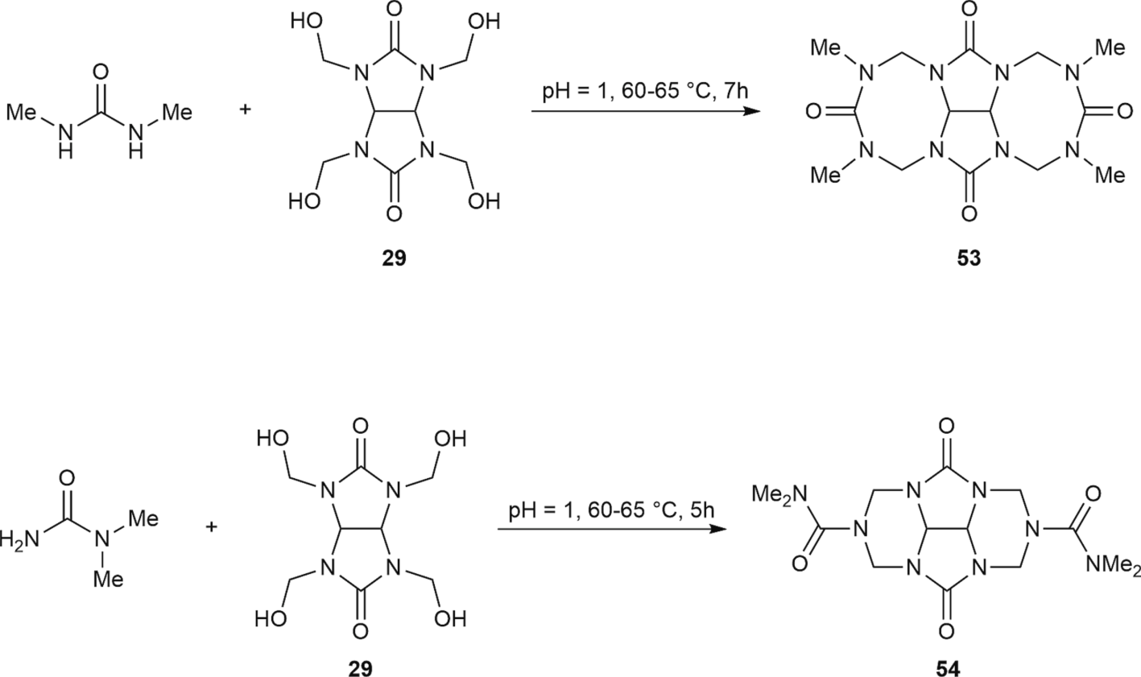

Fig. 3.18. Ureidoalkylation of dimethylureas.
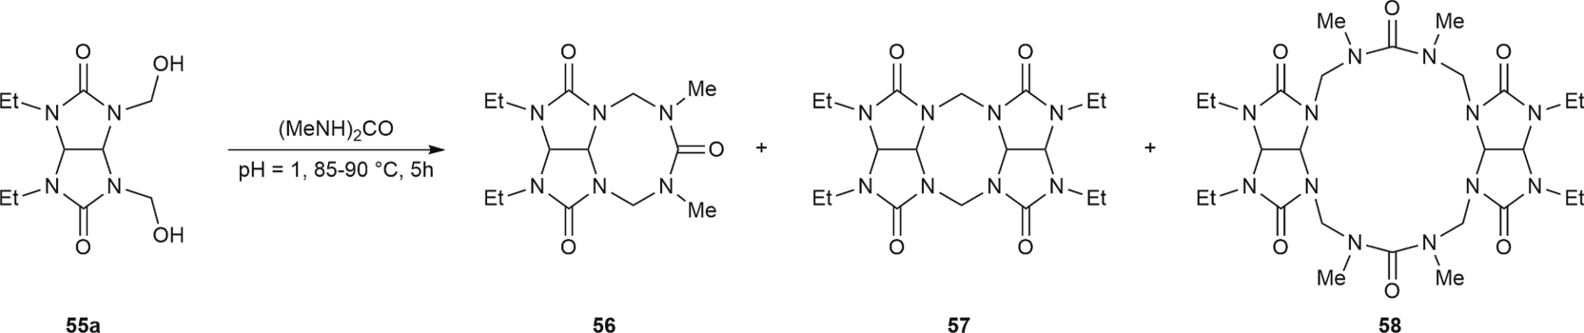

Fig. 3.19. Reaction of glycoluril derivative 55a with 1,3-dimethylurea.
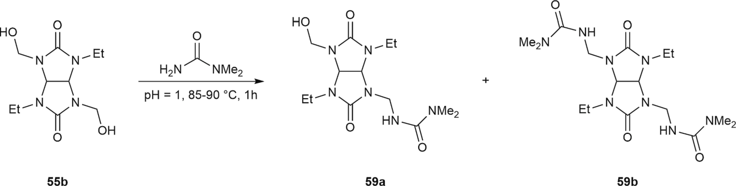

Fig. 3.20. Reaction of glycoluril derivative 55b with 1,1-dimethylurea.
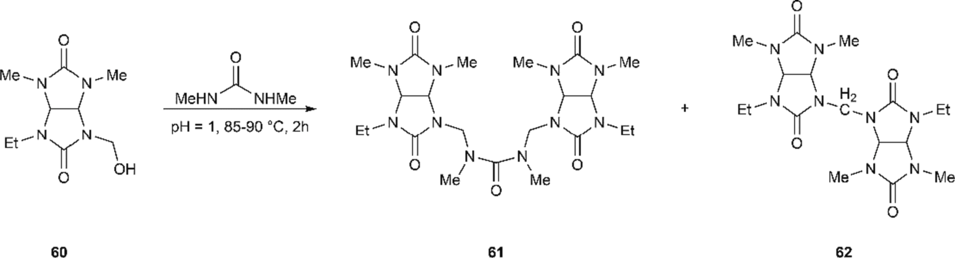

Fig. 3.21. Ureidoalkylation of glycoluril derivative 60.

2,4,6,8-tetraazobicyclo[3.3.0]octan-3,7-dion 49b – product obtained after phosphoric fragment oxidation in Compound 49a to the quinque- valent state. Reaction of 29 in an absolute benzene with two
dimethoxychlorophosphate and pyridine equivalents as hydrogen chloride acceptors led to the formation of mixtures 50a and 50b, and the reaction proceeded with intense heat emission.

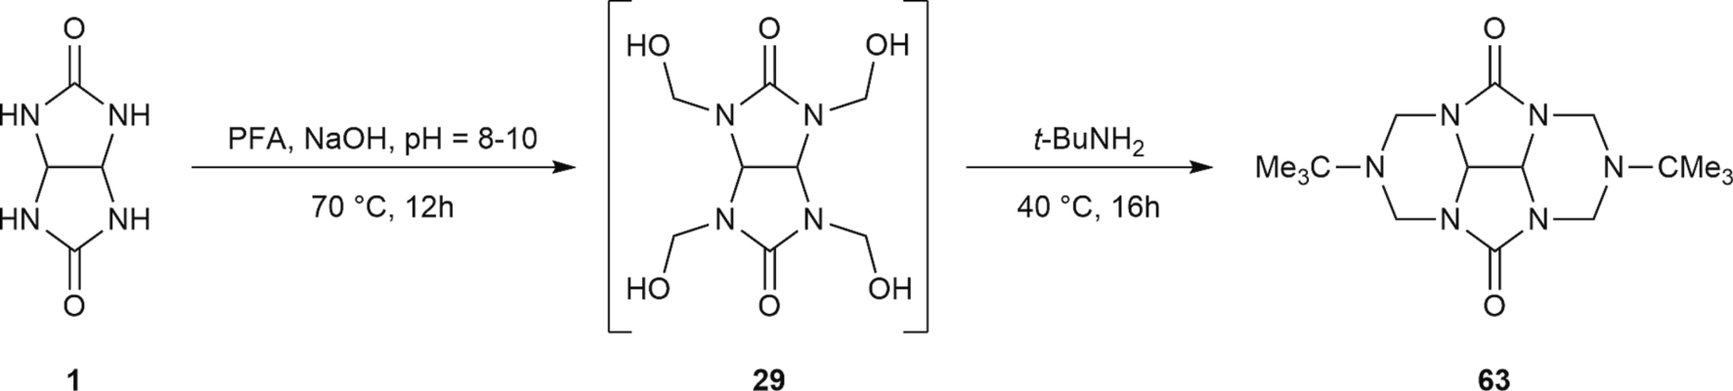
Fig. 3.22. Cycloaminomethylation of glycoluril (PFA = paraformaldehyde).

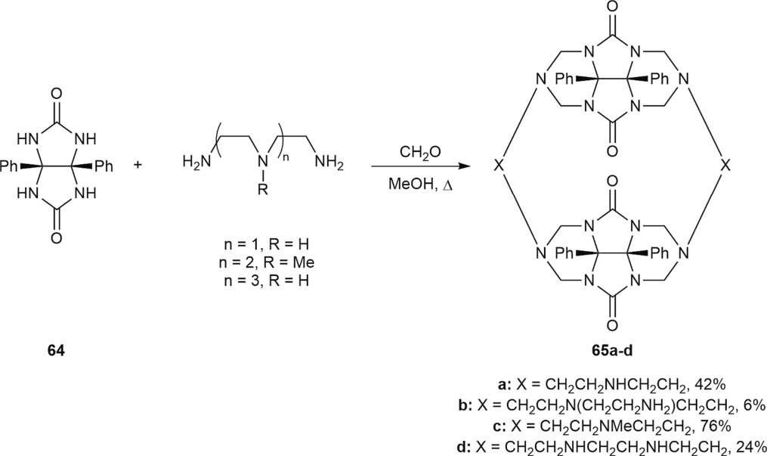

Fig. 3.23. Macrocyclic polyamines based on diphenylglycoluril 64.

Pooled analysis of chemical shifts in NMR spectra ³¹P and ¹³C of bicyclic biscarbamide phosphatives was performed in the study [92]. The phosphorus trichloride effect on 29 leads to a tetracycle containing two eight-membered rings, which then open with the formation of 2,6-di (N-methylchlorophosphato)-4,8-chloromethyl-2,4,6,8-tetraazobicyclo [3.3.0]octan-3,7-dione 52 (Fig. 3.17).
Glycoluril hydroxymethyl derivatives can be used for carbamide α-ureidoalkylation with the formation of bi and polycyclic systems [88]. As with sulfonamides, tetra-N-hydroxymethyl-, 2,8-cis-bis-(hydrox- ymethyl)-, 2,6-trans-bis(hydroxymethyl)- and mono- hydroxymethylglycolurils were used in water solution at pH = 1 for condensation with different carbamides. The impact of temperature and
reaction time on the initial glycoluril conversion rate was also studied. α-Ureidoalkylation of 1,3- and 1,1-dimethylcarbamides using 29 leads to the formation of tetracyclic condensed polyazasystems 53–54
containing four carbamide fragments (Fig. 3.18).
As a result of the reaction of cis-bis-hydroxymethylglycoluril 55a with symmetrical 1,3-dimethylcarbamide, in addition to expected tri- cyclic product 56, two pentacyclic systems 57–58 was also formed (Fig. 3.19).
During the reaction of trans-bis(hydroxymethyl)-glycoluril 55b with 1,1-dimethylcarbamide in an equimolar ratio, there is selective condensation through one of the hydroxymethyl groups (Fig. 3.20) with the formation of only 3 % of the side disubstituted product. Use of stoichiometric ratios of glycoluril 55b and carbamide in the same ratios leads to yields of 10 % through mono-59a and 20 % through disubsti- tuted 59b products.
α-Ureidoalkylation of 1,3-dimethylcarbamides with mono(hydrox-
ymethyl)glycoluril 60 also leads to the formation of two products: ure- idobisglycoluril 61 and 8,8′-methylenebis(6-ethyl-2,4- dimethylglycoluril) 62 (Fig. 3.21).
The glycoluril cycloaminimethylation reaction is of high interest for the synthesis of bioactive tetracyclic compounds. In addition, such compounds are used as light stabilizers, stabilizers in the production of plastics, coatings and organic materials protecting from oxygen and heat.
Glycoluril cycloaminimethylation can be performed in an easier and more efficient way with formaldehyde in the presence of catalytic amounts of NaOH for the formation of tetrakis(hydroxymethyl)glyco- luril and its instant cyclization with an appropriate amine (Fig. 3.22). Such approaches were used in [93] with example of tert-butylamine and with monoethanolamine [94]. These studies state the possibility of using

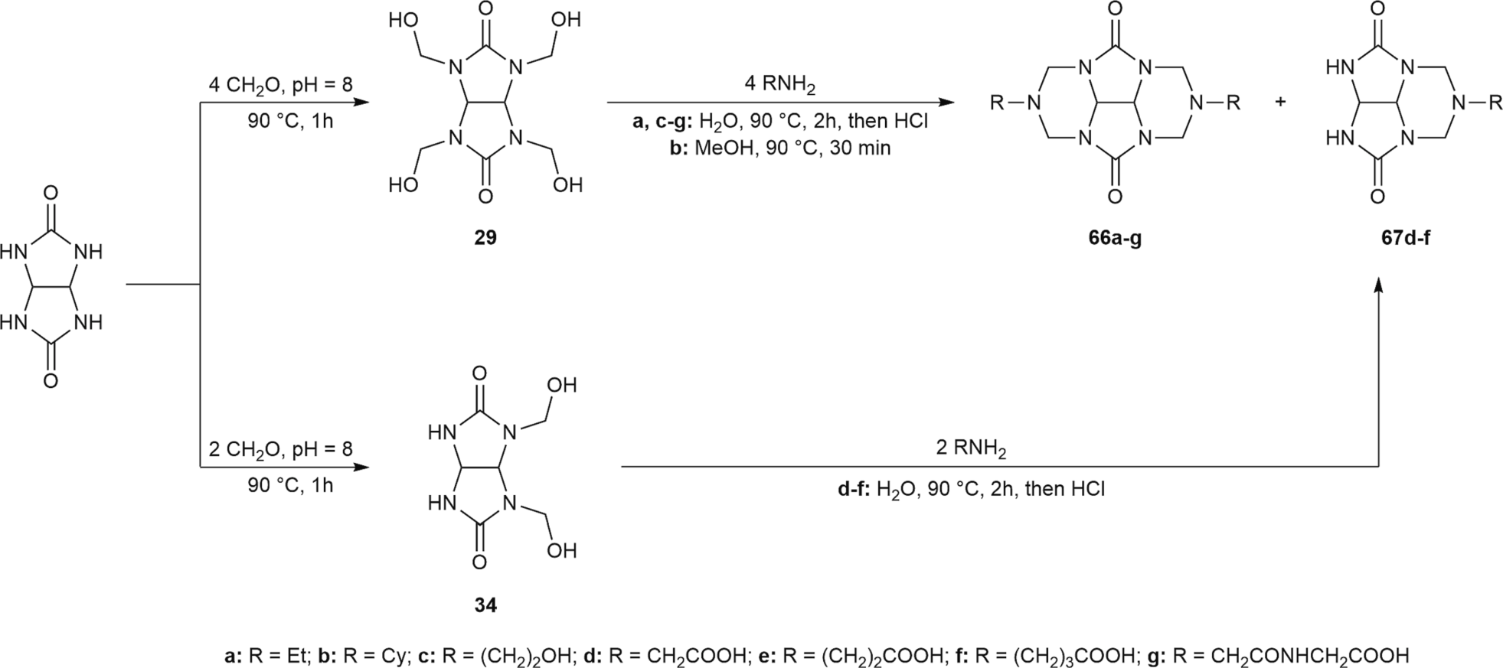

Fig. 3.24. Synthesis of tetracyclic compounds based on THMGU 29.

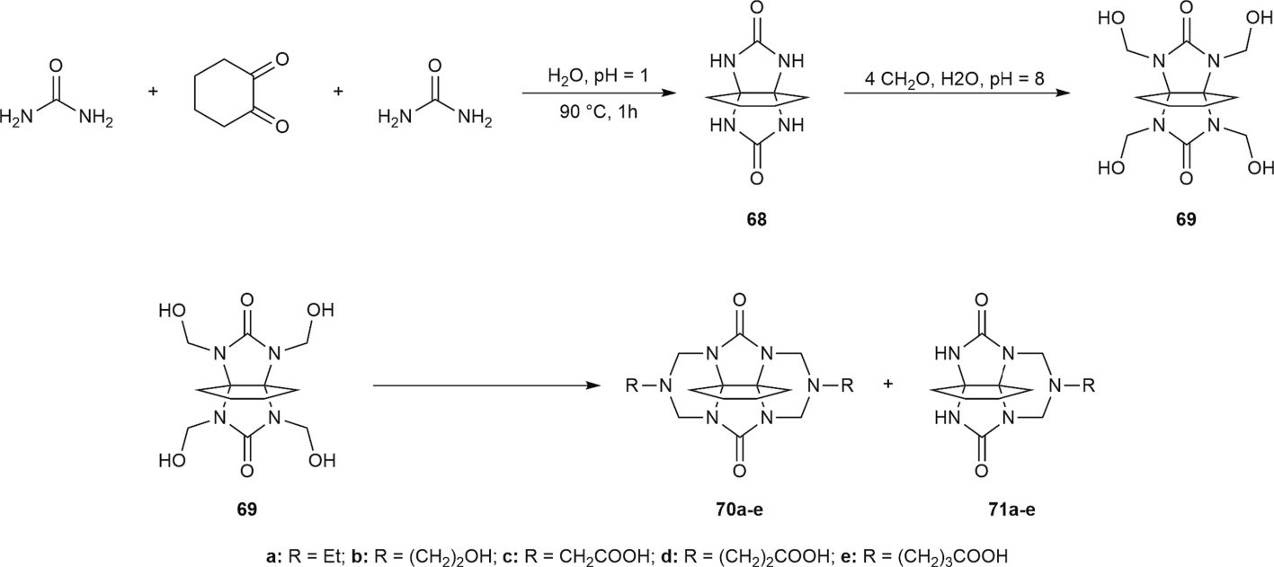

Fig. 3.25. Synthesis of hexacyclic and pentacyclic compounds from urea.
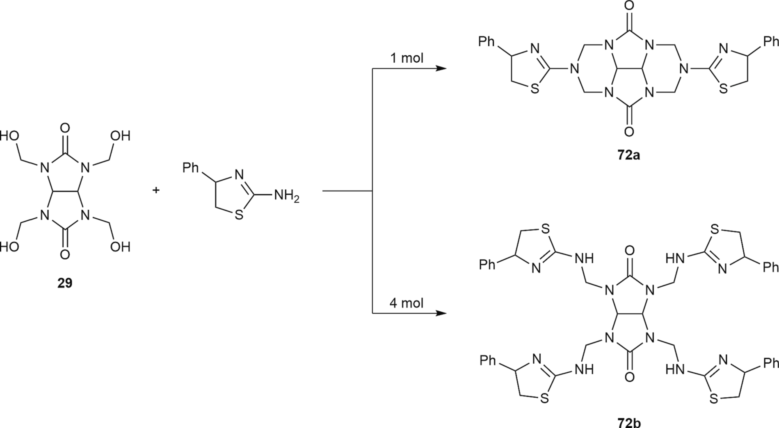

Fig. 3.26. Condensation of THMGU with 2-amino-4-phenylthiazole.

glycoluril for aminogroup protection (as in a strongly alkaline envi- ronment, N-aminomethylated glycoluril derivatives decompose through N-CH₂ bonds).
Glycoluril or its derivative hydroxymethylation with formaldehyde or paraformaldehyde with instant Mannich cyclization is widely used in the synthesis of molecular clips, molecular scaffolds and other polycyclic compounds. For example, new macrocyclic polyamines 65a–d and macrocycles [95] were synthesized by diethylentriamine (and triethy- lentetraamine) condensation with formaldehyde and diphenylglycoluril 64 (Fig. 3.23).
Reactions of glycoluril with aliphatic amines and potassium salt amino acids were studied in detail in [89]. As a result of these reactions, the authors performed the synthesis of optically pure polycycles by the interaction of (S)-α-amino acids with THMGU and 1,5-butano-THMGU. Optimal conditions for THMGU-based tetracycle synthesis were found:
the reaction proceeded for two hours in water at 90 ◦C with a yield of 65–90 % (Fig. 3.24). In some cases, for example, with hexylamine,
methanol is an efficient solvent. In this case, the reaction takes 30 min with 90 % yield. Formed tetracycles always contain impurities of respective tricyclic compounds that can be synthesized when using a
lower ratio of formaldehyde and amino acid to glycoluril. However, N- hydroxymethylglycioluril and amino acid oligomers are formed in side reactions.Fig 3.25.Fig 3.26.
Based on the tetra-N-hydroxymethyl derivative of 1,5-butanoglyco- luril, the authors synthesized hexa- and pentacycles in 43–87 % yield. Ethylamine, monoethanolamine and amino acids in the form of potas- sium salt water solutions were condensed with 1,5-butano-THMGU. Individual hexacycles 70a–e and pentacycles 71b–c were separated by fractional crystallization, and Compounds 71a,d–e failed to separate individually.
Several studies [96,97] researched the reaction of condensation of THMGU 29 with 2-amino-4-phenylthiazole. Depending on the amount of added thiazole, different reaction products can be formed. At an equimolar ratio of initial reagents, tetracycle 72a is formed, and excessive use of thiazole leads to the formation of 72b.
The authors also found that 72b can transform into 72a with an almost quantitative yield, thus suggesting that Compound 72b can be an intermediate in the synthesis of tetracycle 72a. The single-step synthesis of 72a from glycoluril through the Mannich reaction is characterized by low yield.

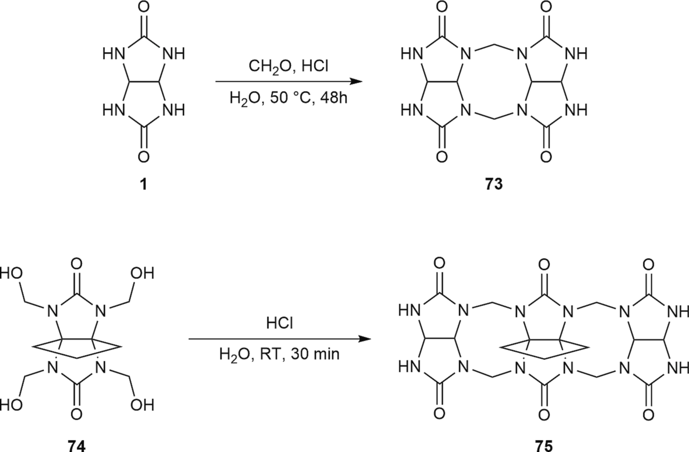

Fig. 3.27. Dimers and trimers of glycoluril derivatives as precursors for the synthesis of macrocyclic compounds.
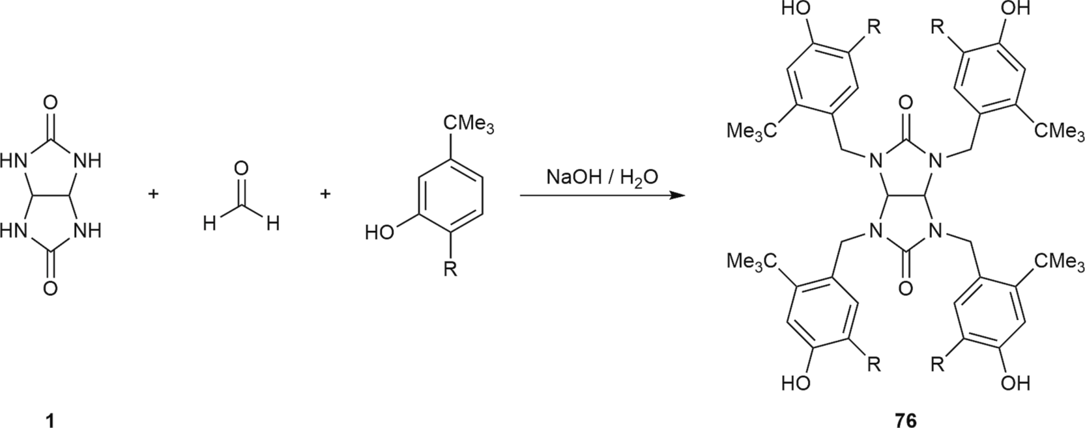

Fig. 3.28. Synthesis of stabilizers based on glycoluril 1.
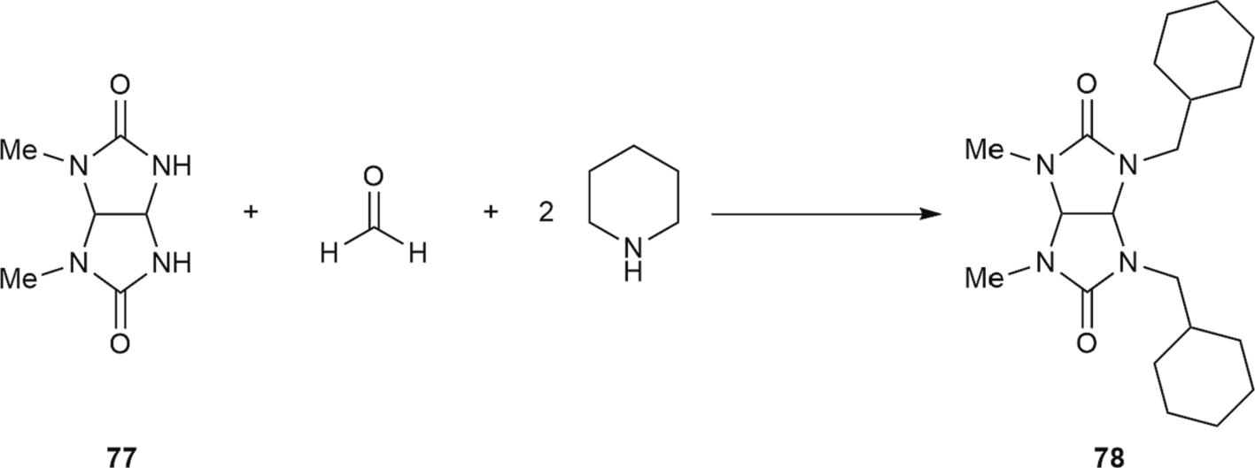

Fig. 3.29. Synthesis of glycoluril derivative 78.

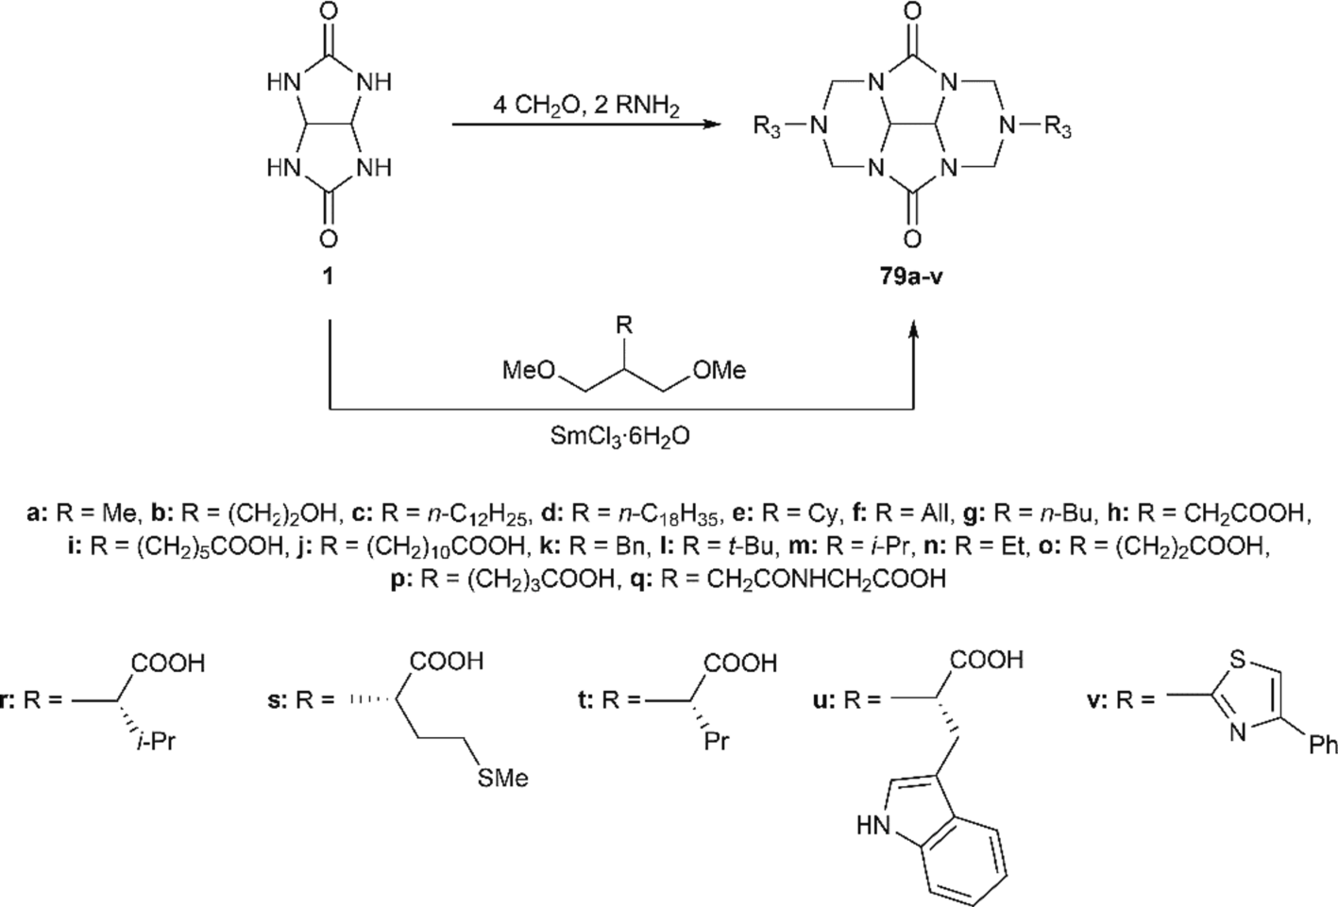

Fig. 3.30. Mannich reaction of glycoluril 1.
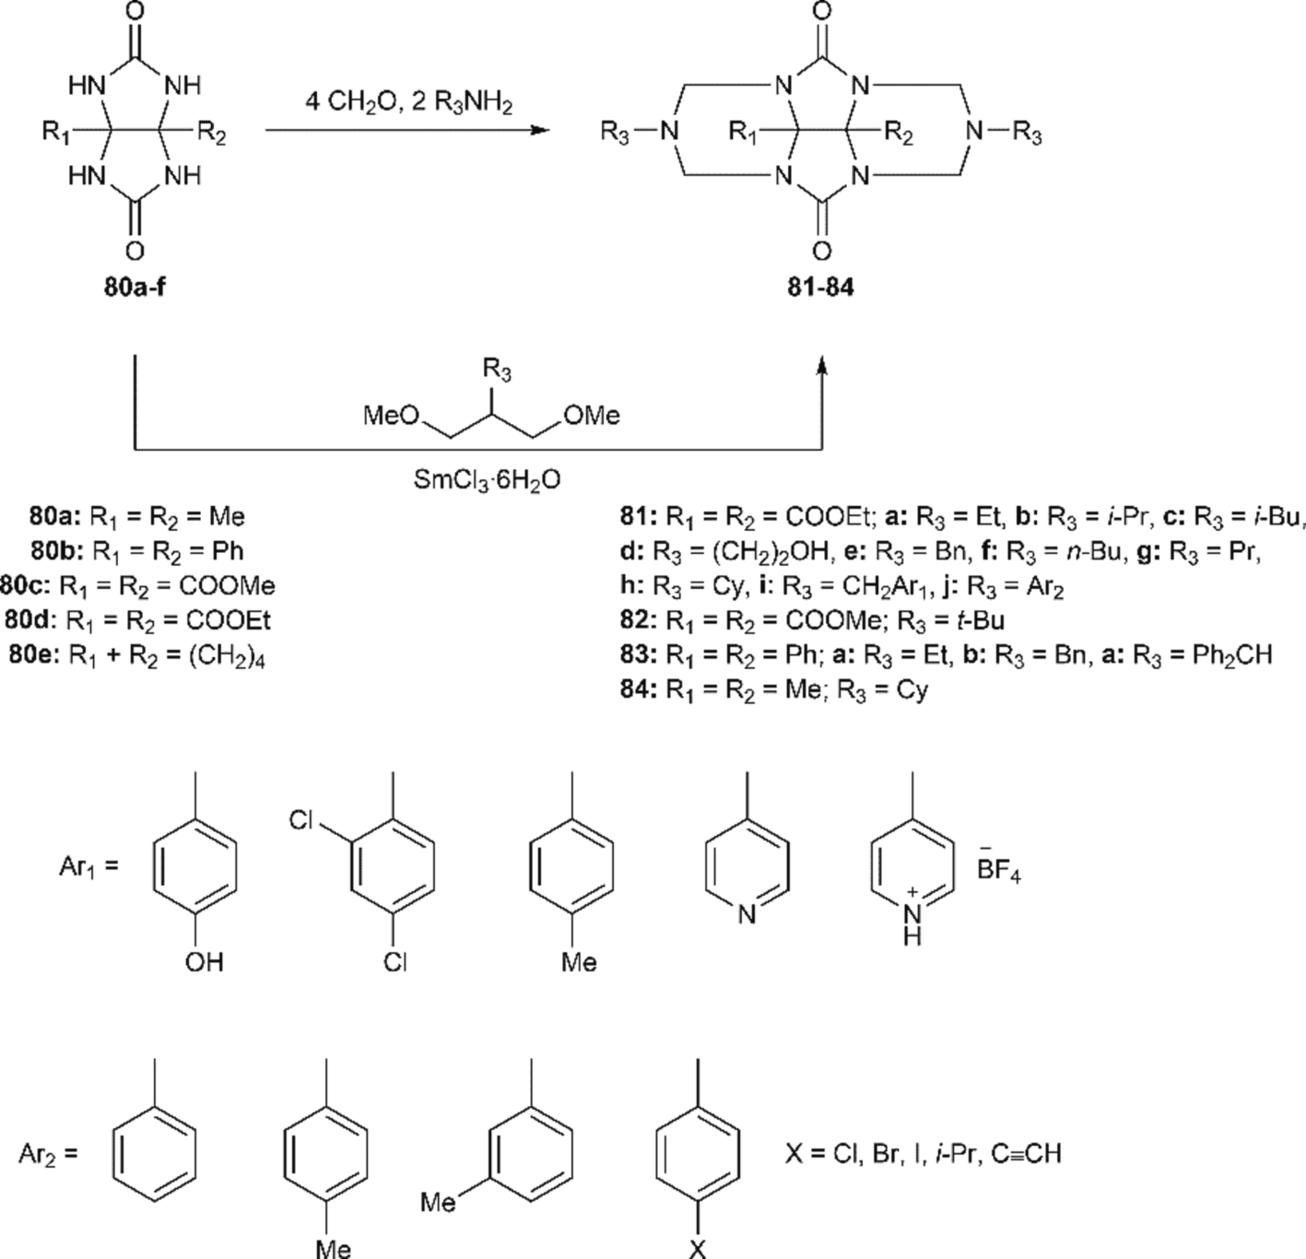

Fig. 3.31. Condensation of glycoluril derivatives 80a–e with amines.

The reaction of glycolurils with formaldehyde became the basis for rapid progress in glycoluril condensed polycyclic derivative chemistry, such as cucurbiturils and bambusurils, which are interesting objects for supramolecular chemistry research [33]. In the case of changing the initial reagent ratio in formaldehyde reactions, dimers 73 and trimers 75
can be obtained (Fig. 3.27) as precursors in cucurbituril synthesis [98,99].Fig 3.28.
Through the Mannich reaction or gradually through intermediate THMGU 29 N-aminomethylated derivatives were synthesized, including tri- and tetracyclic condensed azaheterosystems [100,101].

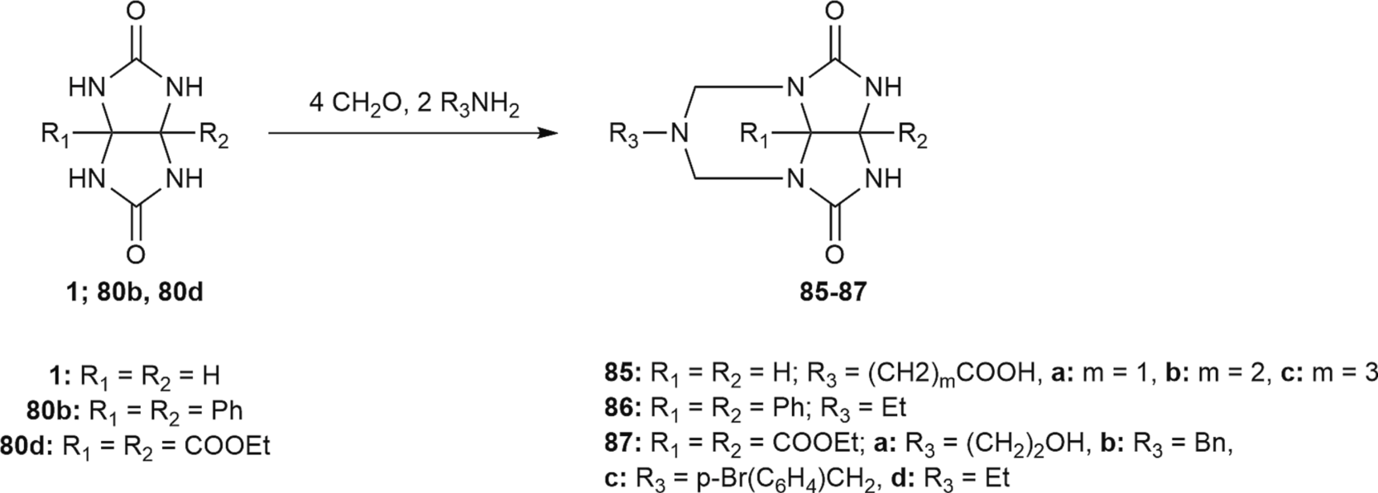

Fig. 3.32. Condensation of glycoluril 1 and its derivatives 80b and 80c with amines.
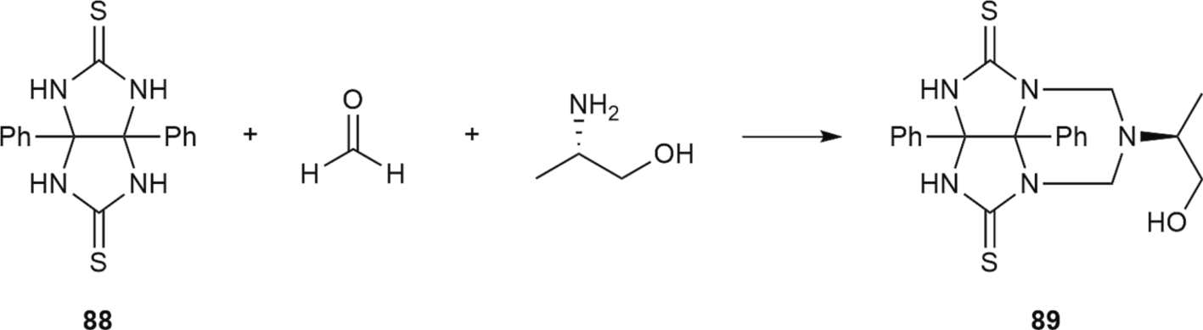

Fig. 3.33. Condensation of 88 with formaldehyde and (S)-2-aminopropan-1-ol.
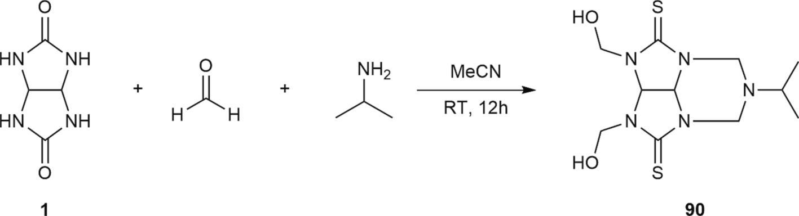

Fig. 3.34. Condensation of glycoluril 1 with formaldehyde and isopropylamine.
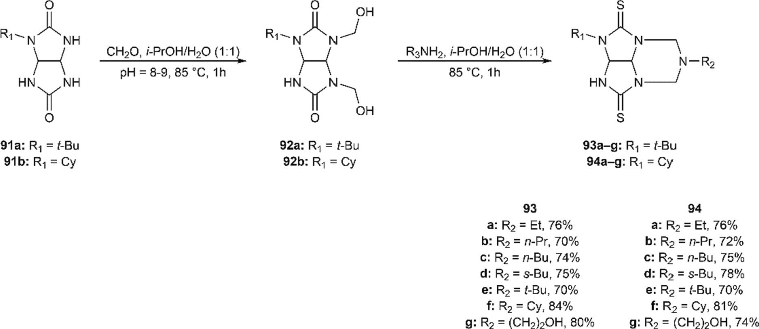

Fig. 3.35. Condensation of glycoluril derivatives with formaldehyde and aliphatic amines.

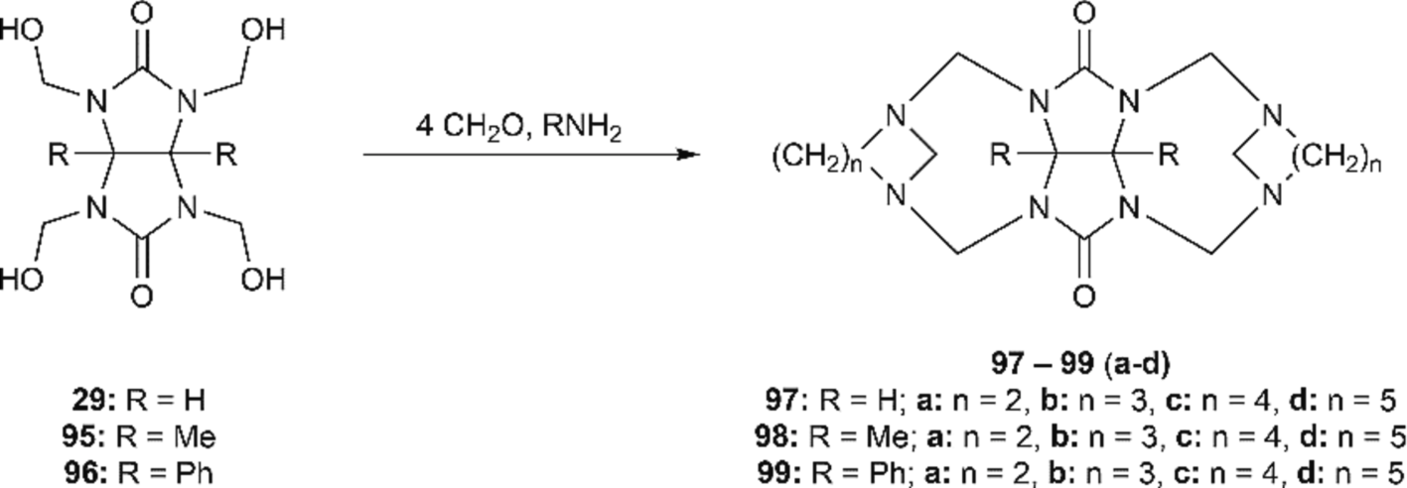

Fig. 4.1. Hexacyclic systems based on THMGU 29 and its derivatives.
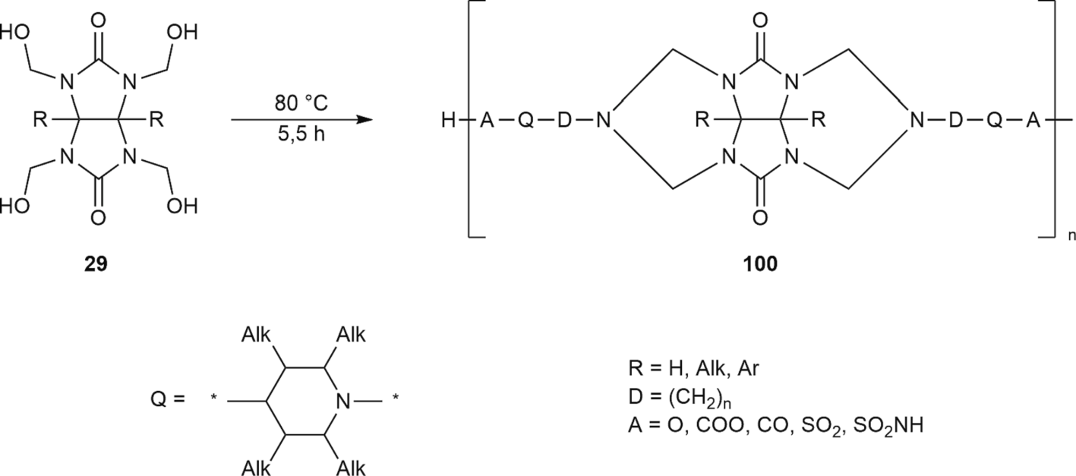

Fig. 4.2. Macrocyclic polymer based on THMGU 29.
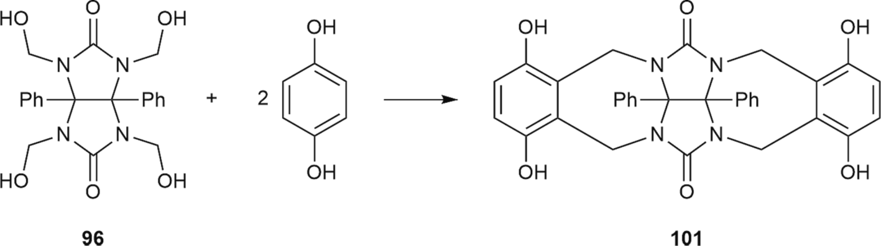

Fig. 4.3. Condensation of glycoluril derivative 96 with hydroquinone.
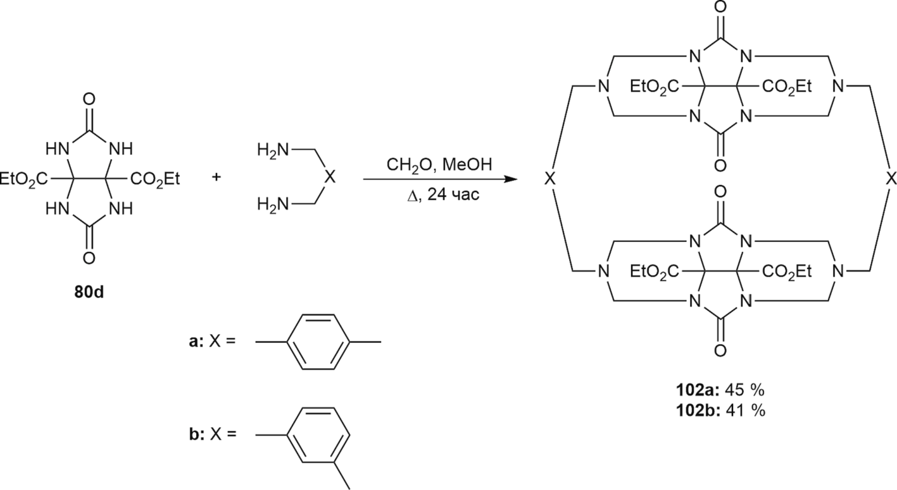

Fig. 4.4. Synthesis of macrocyclic polyamines.

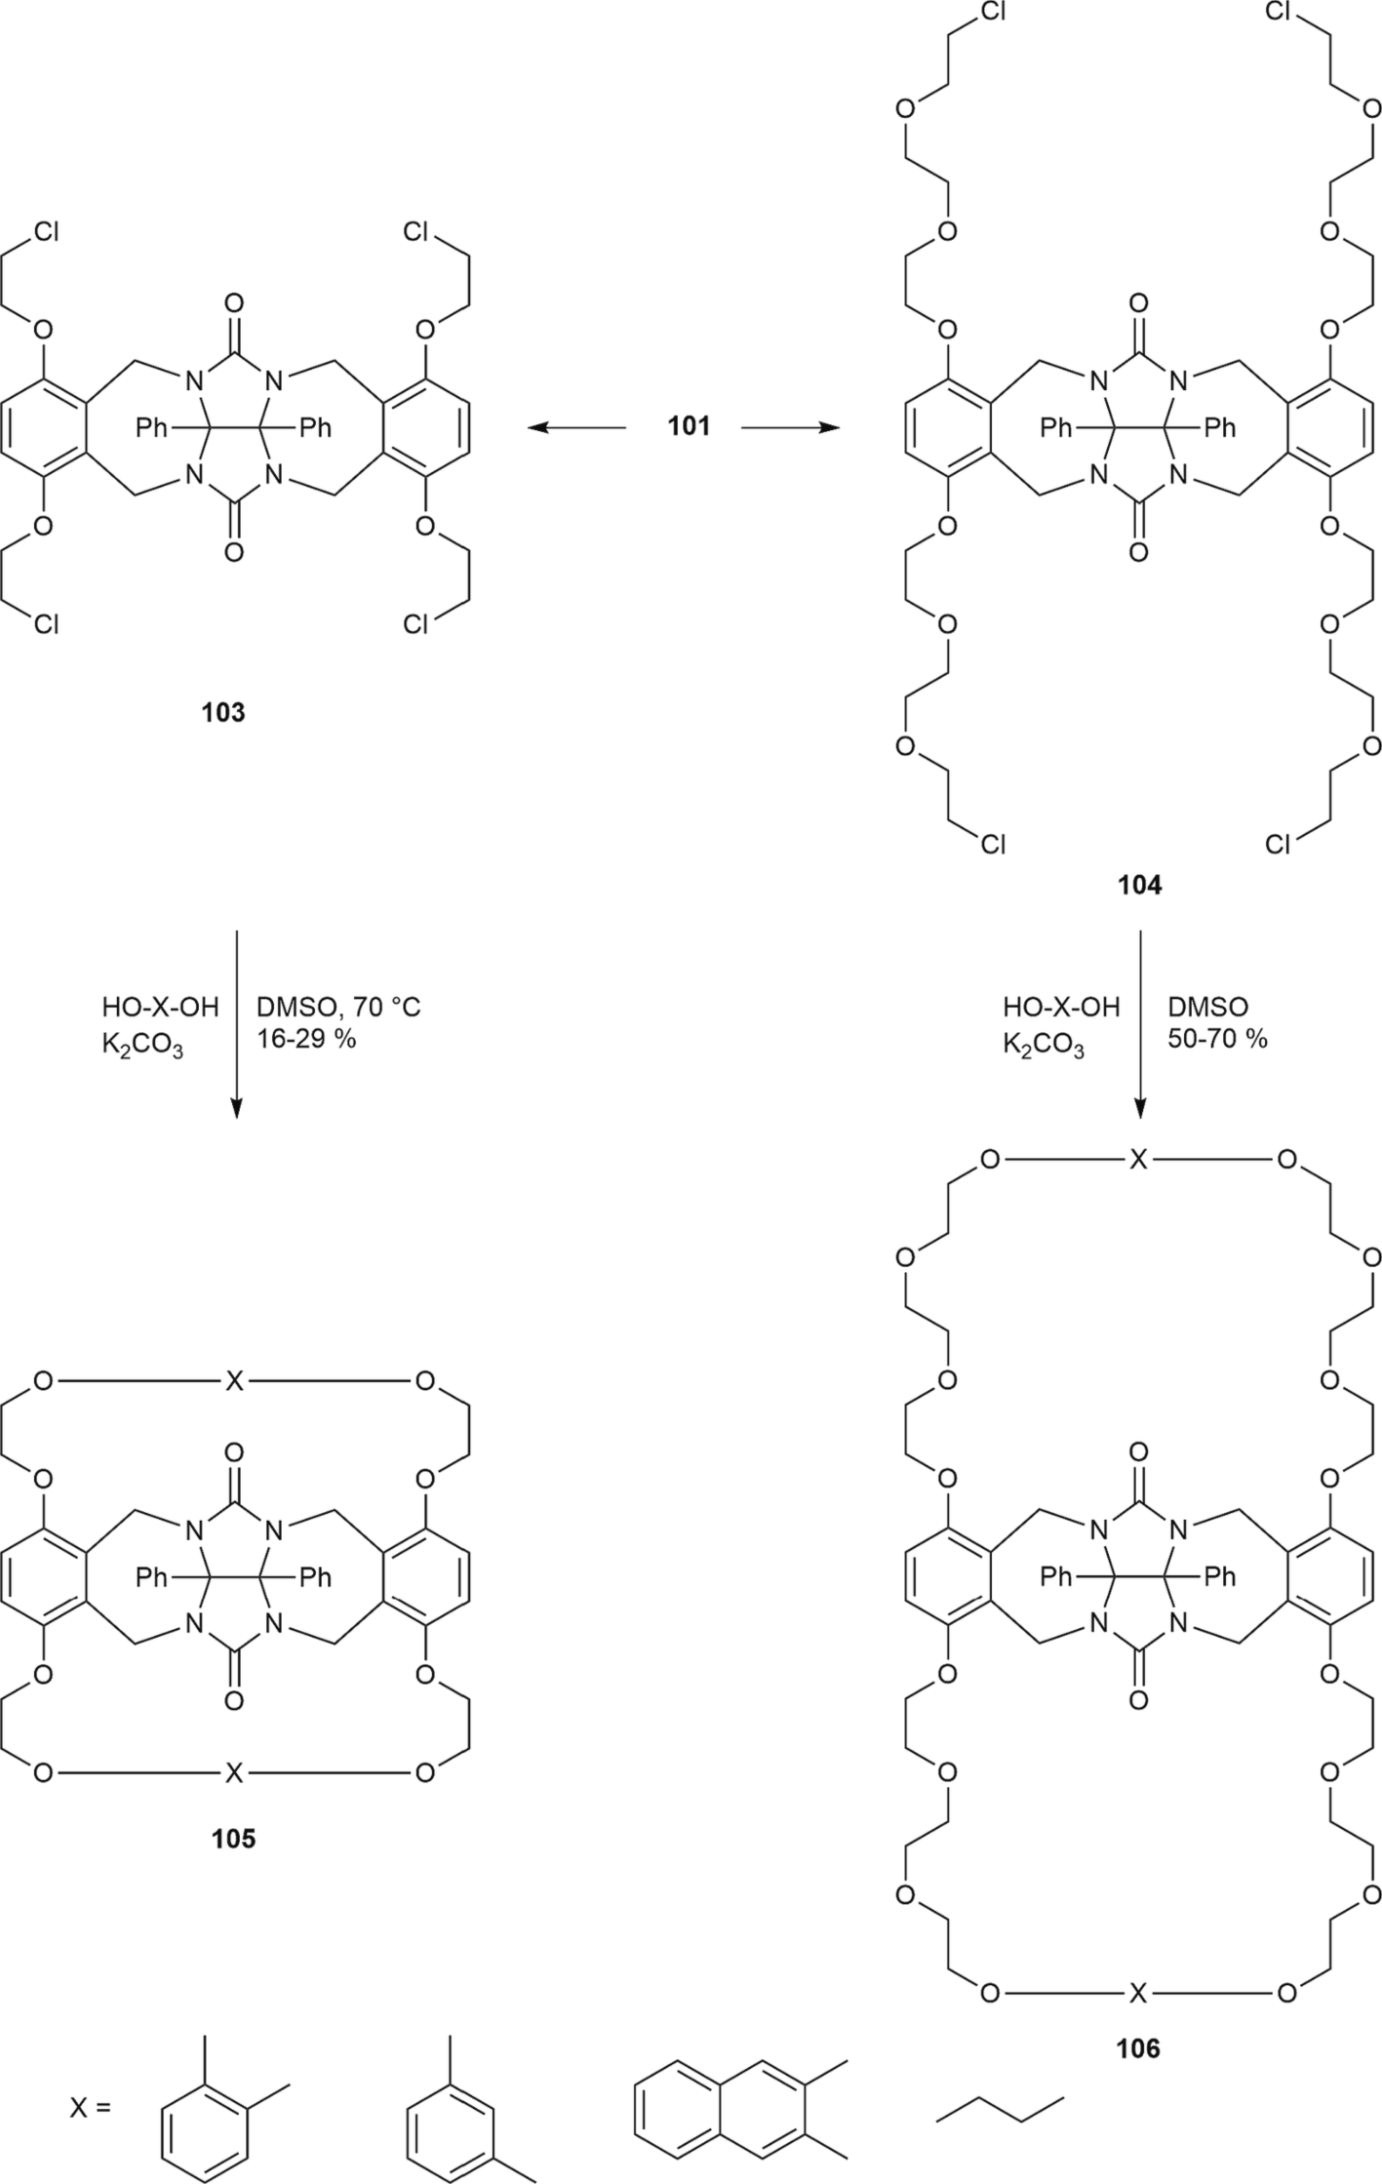

Fig. 4.5. Macrocycles from tetraphenol 101.

Aminomethylated glycolurils in a strongly alkaline environment are decomposed through the N-CH₂ bond with the formation of the initial glycoluril, which is an argument for using named derivatives for ami- nogroup protection.
Compounds of general Formula 76 – effective stabilizers for natural and synthetic polymeric materials – are obtained through the reaction of glycoluril 1 with phenols and formaldehyde [102].
The reaction of 1,6-dimethylglycoluril 77 with piperidine and formaldehyde [103] gives di-N-piperidinemethylglycoluril 78
(Fig. 3.29).
For the synthesis of tetracyclic compounds 79a–v, a three-
component condensation of glycoluril 1 with formaldehyde and amines was used (Fig. 3.30). For example, this approach was used in the synthesis of three tetracyclic Compounds 79a, b, q, and v through gly- coluril 1 interaction with formaldehyde (4 mol) and 2 mol of the respective amine [96,104]. Tetracyclic Compound 79a was synthesized with 33 % yield, but the conditions required for the reaction of glycoluril 1 with formaldehyde and methylamine are not given in this patent. For synthesis of the second tetracyclic Compound 79b, according to this patent data with a yield of 80 %, the reaction mixture was heated for
2.5 h at 80 ◦C. The yield of Compound 79q obtained in formamide was
52 %, and the yield of 79v was 17 % [59].

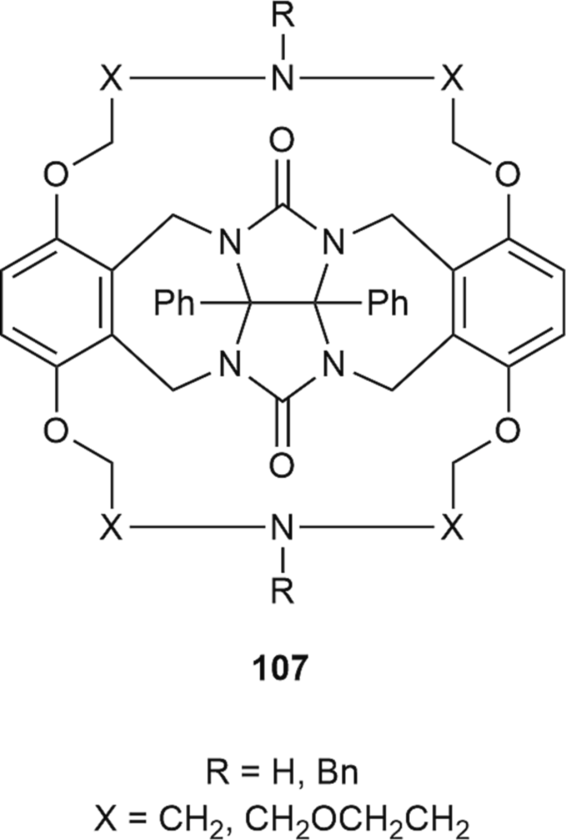

Fig. 4.6. Heterostructure 107.

A new method of synthesizing Compounds 79b, e, l, and m based on glycoluril 1 condensation with N,N-bis(methoxymethyl)alkylamines (R = Cy, i-Pr, t-Bu, (CH₂)₂OH) in a CHCl₃-EtOH environment using
SmCl₃⋅6H₂O as the catalyst was suggested [59]. Desired products were
separated using column chromatography, and the yield of Compounds
79b, e, l, and m was 70–81 %.
Three-component condensation was used mainly for obtaining diethyl-2,6-dialkyl-4,8-dioxo-1,3,5,7-tetrahydro-1H,5H- 2,3a,4a,6,7a,8a-hexaazacyclopenta[def]fluoren-3a 1,4-dicarboxylates 81a–j through condensation of diethyl-2,5-dioxotetrahydroimidazo [4,5-d]imidazol-3a,6a (1H,4H)-dicarboxylate 80d with 37 % formal- dehyde water solution and alkyl-, aryl- or alkylarylamines (Fig. 3.31).
In addition, methods for obtaining Compounds 81a–j were described; according to them, respective amine solutions in MeOH or MeCN were added dropwise to glycoluril and formaldehyde mixtures. In the case of using MeOH, amine solutions were added dropwise for 1 h, and the reaction mixture was boiled under reflux for 9–24 h. The yield of
tetracyclic compounds obtained through this method ranged between 10 and 76 %. To increase tetracyclic compounds 81b–e, acetonitrile was used as a solvent for amines, and the reaction mixture was mixed for 12 h at room temperature. This approach allowed us to obtain tetracy- clic compounds 81b–e and 81 h in 90 % yield. Synthesis of tetracycles 81j was performed in different solvents (MeOH, EtOH, THF, DMF) [95,105–117]. The authors found that the optimal conditions for diethoxycarbonylglycoluril 80d reactions with formaldehyde and aro- matic amines (aniline, p- toluidine, m- toluidine, p-methoxyaniline, p- isopropylaniline, p-chloroaniline, p-bromo-aniline, p-iodoaniline, p- ethynylaniline) are as follows: DMF was used as a solvent, and the re-
action mixture was kept at 120 ◦C for 16 h, where the 81j product yield
was between 24 and 61 %.
When p-nitroaniline and p-aminopyridine were used in similar re- actions, the expected tetracyclic compounds were not obtained. In another study, Compound 81j (R₃ = Ph, p-Tol) was obtained with 70 %
and 60 % yields, respectively, but the only recorded reaction parameter
was its time (12 h).
Dicarboxylate 82 was obtained through condensation of dimethyl- 2,5-dioxotetrahydroimidazo[4,5-d]imidazol-3a,6a(1H,4H)- dicarboxylate 80c, paraformaldehyde and tri-butylamine in acetonitrile at room temperature.
Compound 83a (yield 12 %) was obtained through condensation of 3a,6a-diphenylglycoluril 80b with formaldehyde and ethylamine by boiling the initial substances in MeOH solution [118]. The synthesis of Compounds 83b–c was also performed with 90 % yield in acetonitrile at room temperature [105,119].
Compound 84 was obtained through the reaction of 3a,6a-dimethyl- glycoluril 80a with cyclohexylamine [120].
Synthesis of glycoluril tricyclic derivatives, 2a,2a1-disubstituted 6- alkyltetrahydro-5H-2,3,4a,6,7a-pentaazacyclopenta[cd]-indene-1,4- (2H,3H)-diones 85–87 was obtained through three-component condensation of 3a,6a-disubstituted tetrahydroimidazo[4,5-d] imidazol-2,5-(1H,3H)-diones 1, 80b, 80d with formaldehyde (used in form of solutions in a respective solvent) and amines or amino acid potassium salts (Fig. 3.32) [90,105,111,121–124].
Reactions were performed in solutions of H₂O, MeOH, EtOH and MeCN. Tricyclic compounds 85a–c were obtained with 35–50 % yield by reaction mixture conditioning for 2 h at 90 ◦C. The observed products were formed through oligomerization between N-(hydroxymethyl)-
glycolurils with different rates of hydroxymethylation along nitrogen atoms as well as oligomerization of these compounds with amino acids. Synthesis of Compound 87a (yield 20 %) was performed in aceto- nitrile at room temperature for 12 h. To synthesize Compounds 87b–c, the reaction mixture was boiled under reflux in MeOH. Compound 87d was obtained similarly using EtOH instead of MeOH (reaction time
10–12 hrs.). The yields of products 87b–d were within 45–80 %.
The condensation reaction between 3a,6a-diphenyltetrahydroimi- dazo[4,5-d]imidazol-2,5 (1H, 3H) dithione 88, formaldehyde water solution (37 %) and (S)-2-aminopropane-1-ol afforded tricyclic com- pound 89 (Fig. 3.33), but the yield was not reported [125].
It should be noted that condensation between glycoluril 1, formal- dehyde and isopropylamine in acetonitrile at room temperature (Fig. 3.34) led to the formation of 2,3-bis(hydroxymethyl)-6-

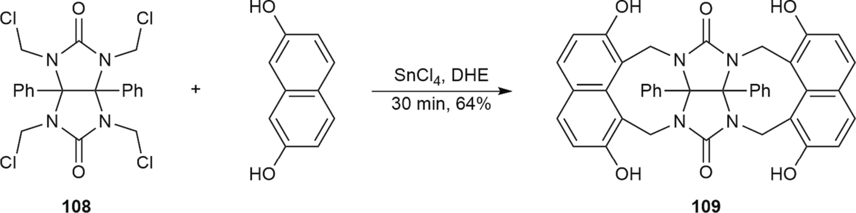

Fig. 4.7. Synthesis of macrocyclic structure 109.

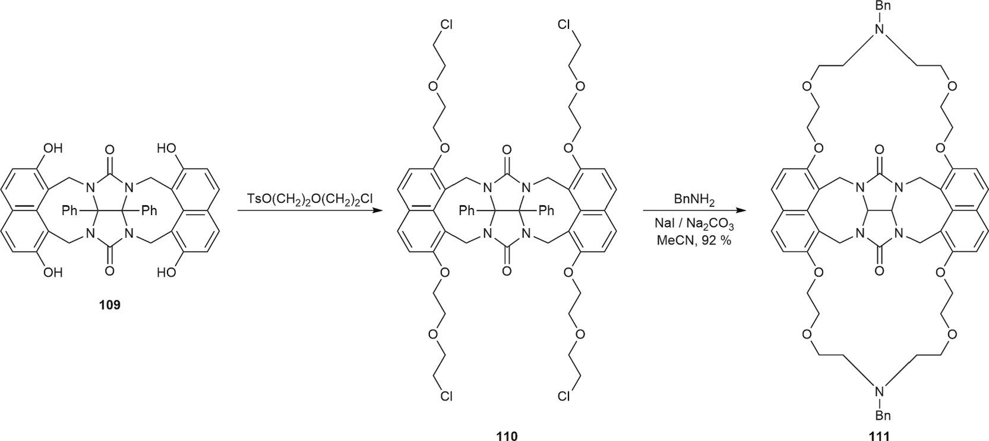

Fig. 4.8. Synthesis of macrocycles 110 and 111.
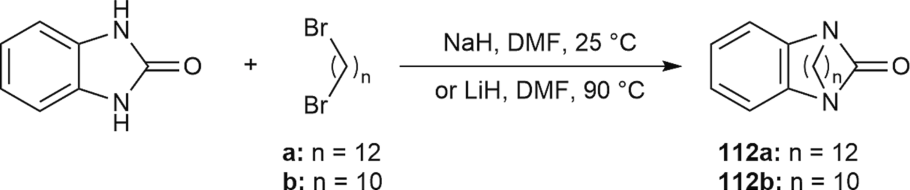

Fig. 4.9. Synthesis of macrocycles 112.
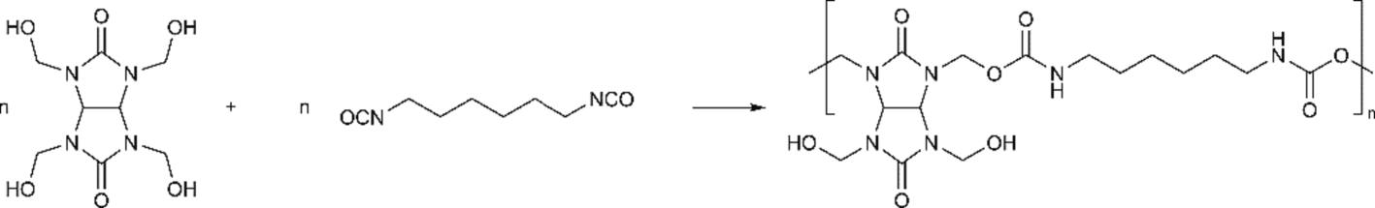

Fig. 4.10. Reaction of THMGU 29 with hexamethylenediisocyanate.
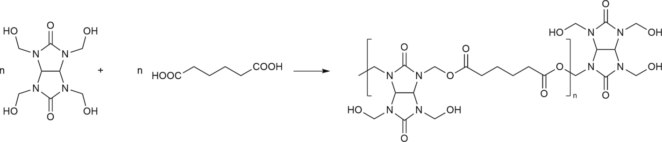

Fig. 4.11. Reaction of THMGU 29 with adipic acid.

isopropylhexahydro-1H-2,3,4a,6,7a-pentaazacyclopenta[cd]indene-1,4 (2H)-dione 90 with 20 % yield [126].
First, one-stage condensation reactions of 1-(tert-butyl)- or 1-cyclo- hexyltetrahydroimidazo[4,5-d]imidazol-2,5-(1H,3H)-diones 91a–b by formaldehyde and aliphatic amines (Fig. 3.35) were performed [127]. As a result, 2-substituted 6-alkyltetrahydro-1H-2,3,4a,6,7a-pentaazacy- clopenta[cd]indene-1,4 (2H,3H)-diones 93–94 with high yields within 70 and 84 % were obtained through the formation of intermediate Compounds 92a–b.

Glycoluril macrocyclic derivative synthesis

Interest in macrocyclic polyamines is caused by the desire to obtain new objects for research in supramolecular chemistry characterized by the ability for self-assembly and molecular recognition.
Boiling tetra-N-hydroxymethylglycoluril 29 or its analogs in aqueous formaldehyde solutions with polymethylenediamines (tetra-N-pentam- ethylenediamines) leads to the formation of hexacyclic heterosystems 95 (Fig. 4.1) with different numbers of CH₂-groups in the side groups (2–5), where yields range between 54 % and 70 % [128].
Heating 29 or its derivatives with piperidine aminoalkyl derivatives gives macrocyclic polymer 100 (Fig. 4.2) with great light-stabilizing properties [94,129].
Condensation of tetra-N-hydroxymethyl-1,5-diphenylglycoluril 96 with hydroquinone (Fig. 4.3) gives polycyclic tetraphenol 101 [130], which forms complexes with hydroquinones [131] and is a semiproduct for the synthesis of new macrocyclic heterosystems [132].
Macrocyclic polyamines 102 were obtained through condensation of 6a-bis(ethoxycarbonyl)glycoluril 80d, formaldehyde (37 % water solu- tion) and aliphatic diamines with boiling under reflux for 24 h in MeOH

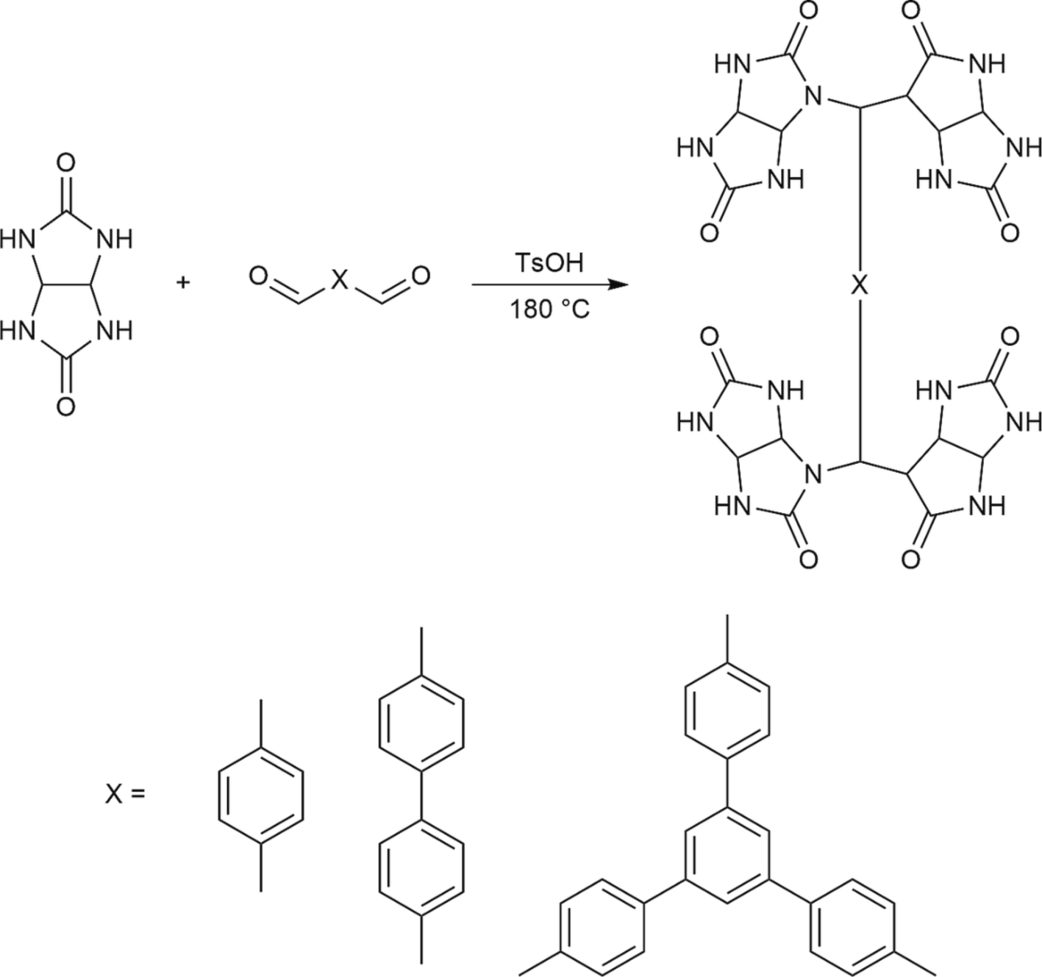

Fig. 4.12. Synthesis of polymers based on glycoluril and aromatic aldehydes.

(Fig. 4.4). The yields of products 102a–b reached 45 and 41 %, respectively [105].
In this way, the interaction of tetraphenol 101 with 1-chloro-2-tosyl- ethane or 1-(2-chloroethoxy)-2-tosylethane synthesizes respective products of tetra-O-alkylation 103–104, which are further cyclized into DMSO in a basic environment in the presence of respective diols or diphenols [132] with the formation of products 105–106 (Fig. 4.5).
Compounds 105 and 106 form complexes with cations and dications
(alkaline metals, NH⁺, RNH⁺, ⁺H N(CH ) NH⁺ (n = 3 9), xylylene- and
groups into the polyether cycle significantly changes the complex- forming properties of coronands [136–141]. Originally, the synthesis of macrocyclic heterocycles 112 with carbamide groups was performed through the interaction of benzimidazol-2-one with α,ω-dibromalkanes
in DMF (Fig. 4.9) in the presence of sodium hydride at 25 ◦C or lithium at 90 ◦C[136].
Generally, references analysis shows that synthetic research aimed at
obtaining condensed tri-, tetra-, poly- and macrocyclic polyamines through combining easily accessible reagents (glycolurils, formaldehyde

4 3 3 2 n 3

phenylenediammonium) with a stoichiometry of 1:1. In the authors’ opinion, the structure of these complexes is similar to a sandwich or a “clamshell”. Strong complex formation with dihydroxybenzols is observed for 107-type heterostructures (Fig. 4.6), which are synthesized through the interaction of compound 103 with respective amines [133]. Compound 107 contains a “gap” formed by a diphenylglycoluril fragment and two O-xylylene rings with an almost parallel orientation. Nitrogen atoms in azacrownether bridges are capable of forming hydrogen bonds with dihydroxybenzol hydroxylic groups. The binding constants of macrocycle 107 with isomeric dihydroxybenzols decrease
in the following order: resorcinol > hydroquinone > catechin.
THMGU 29 under regular chlorinating reagents easily turns into tetra-N-chloromethylglycoluril 108, cyclocondensation of which with 2,7-dihydroxynaphthalene (Fig. 4.7) leads to macrocycle 109 [134].
The result of the interaction of macrocycle 109 with TsO(CH₂)₂O (CH₂)₂Cl in a superbasic environment in an inert atmosphere is tetra-O- alkyl derivative 110, which in turn undergoes cyclocondensation with benzylamine, turning into Compound 111 (Fig. 4.8). Macrocycles 110 and 111 can form stable complexes with nitroaromatic compounds, such as nitrobenzene [135].
Cryptands, unlike crown ethers, are much stronger and more selec- tive complex formers for alkaline metal ions. The most well-known cryptands are typically aminopolyethers, and adding carbamide
and amines or amino acids as well as polyamines) are rather modern studies. Continuous progress in this area is caused by the practical importance of these compounds and their application in supramolecular chemistry research.
As discussed above, data on glycoluril-based polymers of the non“- cucurbituryl” type are scarce in references.
Polyurethane prepolymers were synthesized through the interaction of THMGU 29 with hexamethylenediisocyanate in a mixture of chloro- benzene and o-dichlorobenzene (Fig. 4.10). The average molecular mass of the obtained prepolymers is 1800 [142].
The authors also performed step-by-step polymerization of THMGU with adipic acid (Fig. 4.11). As a result, a mixture of polytetra-N- hydroxymethylglycoluriladipinate oligomers was obtained with an average molecular mass of 2860.Fig. 4.12.
Polyether was added to the reaction with diisocyanate under vacuum to avoid frothing. The obtained polyether urethane is a solid wax-like product with a molecular mass of 4310 that is poorly dissolved in organic solvents.
The creation of porous glycoluril-based materials through the reac- tion of glycoluril with different aldehydes at high temperatures in the presence of an acidic catalyst was reported [143]. A mixture of alde- hyde, glycoluril and p-toluene sulfonic acid was mixed in a test tube and degassed through freezing and thawing cycles. Then, the tube was

frozen at 77 K, vacuumed, heated to 180 ◦C and conditioned at this temperature for 24 h. The obtained polymer was washed with organic solvents and dried under vacuum for 12 h. The authors used tereph-
thaldehyde, 4,4-diphenylcarboxyaldehyde and 1,3,5-tris(4-for- mylphenyl)benzenealdehyde.
Polymers synthesized in this way have developed a specific surface area of up to 1010 m²/g and the ability to absorb gases, which makes them promising materials for gas storage and separation.

Conclusion

In conclusion, it is necessary to turn researchers’ attention to the following points in tracking the synthesis of new glycoluril-based macrocyclic compounds:
Glycoluril is not a perfect model for the biomimetical cycle, first due to its low solubility in most organic solvents, which often leads to very strict conditions for the direct synthesis of desired macrocyclic com- pounds. One of the interesting possibilities for overcoming this obstacle is using other glycoluril derivatives by adding a reagent to the parent glycoluril model or (more efficiently) to its reactive adduct, which generally leads to different interesting unexpected structures.
Glycoluril model design in macrocyclic compound synthesis is mostly based on condensation reactions and is rarely presented by some other reactions.
In addition, based on the created summary, it can be said that the use of glycoluril in the synthesis of high-molecular-weight compounds (polymers) is relatively understudied and has enough unrevealed po- tential for performing a wide range of new research to obtain practically valuable substances.

Declaration of Competing Interest

The authors declare that they have no known competing financial interests or personal relationships that could have appeared to influence the work reported in this paper.

Acknowledgments

In this section, you can acknowledge any support given which is not covered by the author contribution or funding sections. This may include administrative and technical support or donations in kind (e.g., materials used for experiments).

References

- A.V. Valdman, I.V. Zaikonnikova, M.M. Kozlovskaya, I.E. Zimakova, A study of the spectrum of psychotropic action of Mebicar, B. Exp. Biol. Med.-USSR 89 (1980) 621–624, https://doi.org/10.1007/BF00835799.
- H. Rongzu, Y. Desuo, Z. Hongan, G. Shengli, S. Qizhen, Kinetics and mechanism of the exothermic first-stage decomposition reaction for 1,4-dinitro-3,6-bis(tri- nitroethyl) glycoluril, Mater. Adv. 2 (2021) 1821–1871, https://doi.org/ 10.1016/S0040-6031(02)00005-9.
- J. Yinon, S. Bulusu, T. Axenrod, H. Yazdekhasti, Mass spectral fragmentation pathways in some glycoluril-type explosives. A study by collision-induced dissociation and isotope labeling, J. Mass Spectrom. 29 (1994) 625–631, https:// doi.org/10.1002/oms.1210291109.
- Espacenet. Available online: https://worldwide.espacenet.com/patent/search/ family/009123023/publication/US4487938A?q=US4487938 (accessed on 24April2023).
- J. Boileau, M. Carail, E. Wimmer, M. Pierrot, Derives nitres acetyles du glycolurile, Propell. Explos. Pyrot. 10 (1985) 118–120, https://doi.org/10.1002/ prep.19850100407.
- W. Jacobs, D. Foster, S. Sansur, R.G. Lees, Durable glossy, matte and wrinkle finish powder coatings crosslinked with tetramethoxymethyl glycoluril, Prog. Org. Coat. 29 (1996) 127–138, https://doi.org/10.1016/S0300-9440(96)00643-
1.
- Espacenet. Available online:https://worldwide.espacenet.com/patent/search/ family/017523485/publication/US6376157B1?q=US6376157 (accessed on 24April2023).
- D. Ma, G. Hettiarachchi, D. Nguyen, B. Zhang, J.B. Wittenberg, P.Y. Zavalij,
V. Briken, L. Isaacs, Acyclic cucurbit[n]uril molecular containers enhance the
solubility and bioactivity of poorly soluble pharmaceuticals, Nat. Chem. 4 (2012) 503–510, https://doi.org/10.1038/nchem.1326.
- W. Liu, X. Lu, W. Xue, S.K. Samanta, P.Y. Zavalij, Z. Meng, L. Isaacs, Hybrid molecular container based on glycoluril and triptycene: Synthesis, binding properties, and triggered release, Chem.—Eur. J. 24 (2018) 14101–14110, https://doi.org/10.1002/chem.201802981.
- L. Gilberg, B. Zhang, P.Y. Zavalij, V. Sindelar, L. Isaacs, Acyclic cucurbit[n]uril- type molecular containers: influence of glycoluril oligomer length on their function as solubilizing agents, Org. Biomol. Chem. 13 (2015) 4041–4050, https://doi.org/10.1039/C5OB00184F.
- M. Xu, S.P. Kelley, T.E. Glass, A multi-component sensor system for detection of amphiphilic compounds, Angew. Chem. Int. Ed. 130 (2018) 12923–12926, https://doi.org/10.1002/ange.201807221.
- K.M. Park, J. Kim, Y.H. Ko, Y. Ahn, J. Murray, M. Li, S. Annadka, K. Kim, Dye- Cucurbit[n]uril complexes as sensor elements for reliable pattern recognition of biogenic polyamines, B. Chem. Soc. Jpn. 91 (2017) 95–99, https://doi.org/ 10.1246/bcsj.20170302.
- N. She, D. Moncelet, L. Gilberg, X. Lu, V. Sindelar, V. Briken, L. Isaacs, Glycoluril- derived molecular clips are potent and selective receptors for cationic dyes in water, Chem. Eur. J. 22 (2016) 15270–15279, https://doi.org/10.1002/ chem.201601796.
- J.B. Wittenberg, M.G. Costales, P.Y. Zavalij, L. Isaacs, A clipped [3]rotaxane derived from bis-nor-seco-cucurbit[10]uril, Chem. Commun. 47 (2011) 9420–9422, https://doi.org/10.1039/C1CC13358F.
- R. Dhiman, S. Pen, P.K. Chanrakumar, T.J. Frankcombe, A.I. Day, Glycoluril derived cucurbituril analogues and the emergence of the most recent example: Tiarauril, Chem. Commun. 56 (2020) 2529–2537, https://doi.org/10.1039/ C9CC07233K.
- J. Lagona, P. Mukhopadkhyay, S. Chakrabarti, L. Isaacs, The Cucurbit[n]uril family, Angew. Chem. Int. Ed. 44 (2005) 4844–4870, https://doi.org/10.1002/ anie.200460675.
- H. Cong, X.L. Ni, X. Xiao, Y. Hyang, Q.-J. Zhu, S.-F. Xue, S. Tao, L.F. Lindoy, Synthesis and separation of cucurbit[n]urils and their derivatives, Org. Biomol. Chem. 14 (2016) 4335–4364, https://doi.org/10.1039/C6OB00268D.
- K.I. Assaf, W.M. Nau, Cucurbiturils: from synthesis to high-affinity binding and catalysis, Chem. Soc. Rev. 44 (2015) 394–418, https://doi.org/10.1039/ C4CS00273C.
- D. Bardelang, K.A. Udachin, D.M. Leek, J.C. Margeson, G. Chan, C.I. Ratcliffe, J.
A. Ripmeester, Cucurbit[n]urils (n = 5–8): A comprehensive solid state study, Cryst. Growth Des. 11 (2011) 5598–5614, https://doi.org/10.1021/cg201173j.
- A. Day, A.P. Arnold, R.J. Blanch, B. Snushall, Controlling factors in the synthesis of cucurbituril and its homologues, J. Org. Chem. 66 (2001) 8094–8100, https:// doi.org/10.1021/jo015897c.
- Khan, R.; Tuncel, D. Cucurbituril Containing Supramolecular Nanomaterials. In Cucurbituril-based Functional Materials, 1st ed.; Tuncel, D.; Royal Society of Chemistry: Thomas Graham House, Science Park, Milton Road, Cambridge, CB4 0WF, UK; Volume 7, pp. 149–174.https://doi.org/10.1039/9781788015950.
- S.J. Barrow, S. Kasera, M.J. Rowland, J. del Barrio, O.A. Scherman, Cucurbituril- based molecular recognition, Chem. Rev. 115 (2015) 12320–12406, https://doi. org/10.1021/acs.chemrev.5b00341.
- J. Svec, M. Necas, V. Sindelar, Bambus[6]uril, Angew. Chem. Int. Ed. 49 (2010) 2378–2381, https://doi.org/10.1002/anie.201000420.
- H. Petersen, Syntheses of cyclic ureas by α-ureidoalkylation, Synthesis 5 (1973)
243–292, https://doi.org/10.1055/s-1973-22190.
- A.A. Bakibaev, S.N. Vostretsov, A.Y. Yagovkin, Methods of synthesis of nitrogen- containing heterocycles using ureas and related compounds, Russ. Chem. Rev. 67 (1998) 295–314, https://doi.org/10.1070/RC1998v067n04ABEH000295.
- A.N. Kravchenko, V.V. Baranov, G.A. Gazieva, Synthesis of glycolurils and their analogues, Russ. Chem. Rev. 87 (2018) 89–108.
- A.A. Bakibaev, E.A. Mamaeva, V.A. Yanovskiy, A.Y. Yagovkin, E.L. Bystritskiy, Preparative method for the synthesis of heterocyclic compounds based on ureas, Autograph-Press, Tomsk, Russia, 2007, pp. 113–142.
- N.P. Hoang, A.A. Bakibaev, V.S. Malkov, Bis-deacetylation of tetraacetylglycoluryl under action of ureas, Izv. Vyssh. Uchebn. Zaved., Khim. Khim. Tekhnol. 61 (2018) 50–54, https://doi.org/10.6060/ivkkt.20186107.5800 (In Russian).
- A.A. Bakibaev, A. Uhov, V.S. Malkov, S.Y. Panshina, Synthesis of glycolurils and hydantoins by reaction of urea and 1, 2-dicarbonyl compounds using etidronic acid as a “green catalyst”, J. Heterocycl. Chem. 57 (2020) 4262–4270, https:// doi.org/10.1002/jhet.4132.
- G. Micheletti, C. Delpivo, G. Baccolini, A green synthesis of glycoluril derivatives in aqueous solution with recycle of the waste, Green Chem. Lett. Rev. 6 (2012) 135–139, https://doi.org/10.1080/17518253.2012.718803.
- Usha, G.; Karpagalakshmi, K.; Ramalakshmi, S.; Prakash, R.; Lakshminarayanan, P.; Yang, C.; Selvapalam, N. Synthesis of Glycoluril using Urea Phosphate. Russ. J. Org. Chem. 2021, 57, 1988–1992.https://doi.org/10.1134/S1070428
021120149.
- R.S.B. Soares, L.R.R. Souza, M.M. Bertolucci, A. de Oliveira, G.J.F. Demets,
K. Araki, Critical parameters for green glycoluril synthesis, Russ. J. Gen. Chem. 91 (2021) 739–742, https://doi.org/10.1134/S1070363221040253.
- Y.A. Barsegyan, V.V. Baranov, A.N. Kravchenko, Glycolurils in the synthesis of fused polyheterocyclic compounds, Chem. Heterocyc. Compd. 53 (2017)
116–122, https://doi.org/10.1007/s10593-017-2029-5.
- V.Y. Kirsanov, E.B. Rakhimova, Recent advances in the chemistry of saturated annulated nitrogen-containing polycyclic compounds, Int. J. Mol. Sci. 23 (2022) 15484–15505, https://doi.org/10.3390/ijms232415484.

- H. Biltz, Zur Kenntnis der Diureine, Ber. Dtsch. Chem. Ges. 40 (1907) 4806–4816, https://doi.org/10.1002/cber.190704004138.
- C. Bo¨ttinger, Ueber AcetylenharnstoffBer, Dtsch. Chem. Ges. 11 (1878) 1784–1787, https://doi.org/10.1002/cber.187801102151.
- S. Xu, P.K. Gantzel, L.B. Clark, Glycoluril, Acta Crystallogr. Sect. C 50 (1994) 1988–1989, https://doi.org/10.1107/S0108270194006955.
- S.Y. Panshina, O.V. Ponomarenko, A.A. Bakibaev, V.S. Malkov, Analysis of XRD structural parameters of glycoluril and its derivatives, J. Struct. Chem. 61 (2020) 1315–1355, https://doi.org/10.1134/S0022476620090012.
- Panshina, S.; Bakibaev, A.; Ponomarenko, O.; Malkov, V.; Kotelnikov, O.; Tashenov, A. Study of glycoluril and its derivatives by 1H and 13C NMR spectroscopy. B. Karaganda University. Chemistry series. 2020,99, 21–37. https://doi.org/10.31489/2020Ch3/21-37.
- A.V. Valdman, I.V. Zaikonnikova, M.M. Kozlovskaya, Correlation between the stress-protective and vegetotropic actions of Mebicar, a new Soviet tranquilliser, Russ. Pharmacol. Toxicol. 44 (1981) 11–15.
- J. Nematollahi, R. Ketcham, I. Imidazoimidazoles, The reaction of ureas with glyoxal. Tetrahydroimidazo[4,5-d]imidazole-2,5-diones, J. Org. Chem. 28 (1963) 2378–2380, https://doi.org/10.1021/jo01044a055.
- L.I. Suvorova, L.V. Epishina, O.V. Lebedev, L.I. Khmel’nitskii, S.S. Novikov, The chemistry of bicyclic bisureas. 4. Reduction of bicyclic bisureas and their O-alkyl derivatives, Russ. Chem. Bull. 28 (1979) 2108–2111, https://doi.org/10.1007/ BF00947561.
- Netreba, E.E.; Somov, N.V. Crystal Structure of a New Binuclear Complex of Bis (2,4,6,8-Tetramethyl-2,4,6,8-Tetraazabicyclo(3.3.0)Octane -3,7-Dione-O, O′)- diaqua-hexakis(nitrato-O,O′)-Digadolinium(III) Monohydrate.J. Struct. Chem.
2017,58, 838–842.https://doi.org/10.15372/JSC20170432.
- Netreba, E.E.; Sarnit, E.A.; Shabanov, S.V.; Velikozhon, A.A.; Somov, N.V. New Binuclear Bis(2,4,6,8-Tetramethyl-2,4,6,8-Tetraazobicyclo(3.3.0)Octane-3,7- Dione-O,O’)-tetraaqua-hexakis(nitrato-O,O’)-Disamarium(III) Complex: Synthesis and Crystal Structure. Russ. J. Inorg. Chem. 2017,62, 654–658.htt ps://doi.org/10.7868/S0044457X1705018X.
- Netreba, E.E.; Sarnit, E.A.; Shabanov, S.V.; Velikozhon, A.A.; Somov, N.V.Crystal Structure of a New Binuclear Complex Bis(2,4,6,8-Tetramethyl-2,4,6,8-
Tetraazabicyclo(3.3.0)Octane-3,7-Dione-O,O′)-tetraaqua-hexakis(nitrato-O,O′)-
Dieuropium(III). J. Struct. Chem. 2016, 57, 754–759.https://doi.org/10.15372/
JSC20160418.
- A.N. Kravchenko, Y.A. Strelenko, Synthesis of 2,4,6-trialkyl-8-(2,3-epoxypropyl) glycolurils, Mendeleev Commun. 23 (2013) 104–105, https://doi.org/10.1016/j. mencom.2013.03.018.
- D.A. Lenev, K.A. Lyssenko, R.G. Kostyanovsky, The chiral drug Albicar: resolution of its racemate via complexation with BINOL, New J. Chem. (2010).
- A.A. Sinitsyna, S.G. Il’yasov, N-alkylation reaction in the synthesis of tetra- substituted glycolurils, J. Sib. Fed. Univ. Chem. 13 (2020) 40–45, https://doi. org/10.17516/1998-2836-0164.
- Kravchenko, A.N.; Sigachev, A.S.; Maksareva, E.Y.; Gazieva, G.A.; Trunova, N.S.; Lozhkin, B.V.;Pivina, T.S.; Il’in, M.M.; Lyssenko, K.A.; Nelyubina, Yu.V.; Davankov, V.A.; Lebedev, O.V.; Makhova, N.N.; Tartakovsky, V.A. Synthesis of new chiral mono-, di-, tri-, and tetraalkylglycolurils. Russ. Chem. Bull. 2005,54, 691–704. https://doi.org/10.1007/s11172-005-0307-3.
- Sinitsyna, A.A.; Il’yasov, S.G.; Chikina, M.V.; Eltsov, I.V.; Nefedov, A.A.A search for synthetic routes to tetrabenzylglycoluril.Chem. Papers. 2020, 74, 1019–1025. https://doi.org/10.1007/s11696-019-00941-4.
- R.H. Barker, S.L. Vail, G.B. Barcelo, Tetracyclic acetal fromN, N’-dimethylurea and glyoxal, J. Heterocyclic Chem. 3 (1966) 354, https://doi.org/10.1002/ jhet.5570030325.
- Gazieva, G.A.; Kravchenko, A.N.; Lebedev, O.V.; Lyssenko, K.A.; Dekaprilevich, M.O.; Men’shov, V.M.; Makhova, N.N. 3,3’-Bi(6,8-dialkyl-2,4-dioxa-7-thia-6,8- diazabicyclo[3.3.0]octane 7,7-dioxides) as new heterocyclic system derivatives. Mendeleev Commun. 2001, 11, 138–140. https://doi.org/10.1070/ MC2001v011n04ABEH001465.
- B. Chen, F. Li, Z. Huang, T. Lu, G. Yuan, Stability or flexibility: Metal nanoparticles supported over cross-linked functional polymers as catalytic active sites for hydrogenation and carbonylation, Appl. Catal. A-Gen. 481 (2014) 54–63, https://doi.org/10.1016/j.apcata.2014.05.001.
- Espacenet. Available online: https://worldwide.espacenet.com/patent/search/fa mily/054851198/publication/US2016297951A1?q=US2016297951 (accessed on 02May 2023).
- Espacenet. Available online: https://worldwide.espacenet.com/patent/search/fa mily/058097968/publication/US10788751B2?q=US201615253005 (accessed on 02May 2023).
- Espacenet. Available online: https://worldwide.espacenet.com/patent/search
/family/052815645/publication/JP2015057375A?q=JP2015057375 (accessed on 02May 2023).
- Espacenet. Available online: https://worldwide.espacenet.com/patent/search/ family/048905507/publication/US8828644B2?q=US8828644 (accessed on 02May 2023).
- M. Zarei, H. Sepehrmansourie, M. Ali Zolfigol, R. Karamian, S.H.M. Farida, Novel nano-size and crab-like biological-based glycoluril with sulfonic acid tags as a reusable catalyst: its application to the synthesis of new mono- and bis- spiropyrans and their in vitro biological studies, New J. Chem. 42 (2018) 14308–14317, https://doi.org/10.1039/C8NJ02470G.
- R.R. Khairullina, A.R. Geniyatova, E.S. Meshcheryakova, L.M. Khalilov, A.
G. Ibragimov, U.M. Dzhemilev, Catalytic cycloaminomethylation of ureas and thioureas with N, N-bis(methoxymethyl)alkanamines, Russ. J. Org. Chem. 51 (2015) 116–120, https://doi.org/10.1134/S1070428015010200.
- Levin, M.D.; Kaszynski, P.; Michl, J. Bicyclo[1.1.1]pentanes, [n]Staffanes, [1.1.1] Propellanes, and Tricyclo[2.1.0.0^{2,5}]pentanes. Chem. Rev. 2000, 100, 169–234. https://doi.org/10.1021/cr990094z.
- A.M. Dilmaç, E. Spuling, A. de Meijere, S. Bra¨se, Propellanes – From a chemical curiosity to “Explosive” materials and natural products, Angew. Chem. Int. Ed. 56 (2016) 5684–5718, https://doi.org/10.1002/anie.201603951.
- M. Shin, M.H. Kim, T.-H. Ha, J. Jeon, K.-H. Chung, J.S. Kim, Y.G. Kim, Synthesis of novel 2,4,6,8,10-pentaaza[3.3.3]propellane derivatives, Tetrahedron 70 (2014) 1617–1620, https://doi.org/10.1016/j.tet.2014.01.024.
- M. Shin, T.-H. Ha, K.-H. Chung, J.S. Kim, Y.G. Kim, Nitration of 3,7,9,11- Tetraoxo-2,4,6,8,10-pentaaza[3.3.3]propellane, J. Korean Ind. Eng. Chem. 25 (2014) 188–192, https://doi.org/10.14478/ace.2014.1005.
- B. Lee, M. Shin, Y. Seo, M.H. Kim, H.R. Lee, J.S. Kim, K.-H. Chung, D. Yoo, Y.
G. Kim, Synthesis of 2,4,6,8,9,11-hexaaza[3.3.3]propellanes as a new molecular skeleton for explosives, Tetrahedron 74 (2018) 130–134, https://doi.org/ 10.1016/j.tet.2017.11.046.
- H. Qiu, J. Rong, S. Li, W. Tong, T. Zhang, L. Yang, Preparation, crystal structure, thermal decomposition, and DFT calculation of a novel 3D infinite structure coordination polymer [Na2(H2O)4(ITDO)2]n (ITDO = 2H-imidazo-[4,5-e]-as-
1,2,4-triazine-2,7-dihydro-3,6-dione), Zeitschrift Anorganische Allgemeine
Chem. 641 (2014) 424–429, https://doi.org/10.1002/zaac.201400413.
- Espacenet. Available online: https://worldwide.espacenet.com/patent/search/ family/055192609/publication/CN105294703A?q=CN105294703 (accessed on 03May 2023).
- Sinitsyna, A.A.; Il’yasov, S.G. Synthesis of alkyl derivatives of 3,7,10-trioxo- 2,4,6,8,9,11-hexaaza[3.3.3]propellane and evaluation of their biological activity.
B. Karaganda University. Chemistry series. 2021, 101, 19–26. https://doi.org/ 10.31489/2021Ch1/19-26.
- Glukhacheva, V.S.; Il’yasov,S.G.; Shestakova, E.O.; Zhukov, E.E.;Il’yasov, D.S.; Minakova, A.A.; Eltsov,I.V.; Nefedov, A.A.; Genaev, A.M.Synthesis of Nitro- and Acetyl Derivatives of 3,7,10-Trioxo-2,4,6,8,9,11-hexaaza[3.3.3]propellane. Materials.2022, 15, 8320–8338; https://doi.org/10.3390/ma15238320.
- Y. Sohtome, A. Tanatani, Y. Hashimoto, K. Nagasawa, Development of novel chiral urea catalysts for the hetero-Michael reaction, Chem. Pharm. Bull. 52 (2004) 477–480, https://doi.org/10.1248/cpb.52.477.
- Espacenet. Available online: https://worldwide.espacenet.com/patent/search/ family/025297512/publication/US5182328A?q=US5182328 (accessed on 03May 2023).
- M. Stancl, M. Hodan, V. Sindelar, Glycoluril trimers: Selective synthesis and supramolecular properties, Org. Lett. 11 (2009) 4184–4187, https://doi.org/ 10.1021/ol9017886.
- Espacenet. Available online: https://worldwide.espacenet.com/patent/search/fa mily/068342414/publication/CL2009000754A1?q=CL2009000754 (accessed on 03May 2023).
- Espacenet. Available online: https://worldwide.espacenet.com/patent/search/ family/023270981/publication/US4962141A?q=US4962141 (accessed on 03May 2023).
- Espacenet. Available online: https://worldwide.espacenet.com/patent/search/ family/024691804/publication/WO8602921A1?q=WO1986002921 (accessed on 03May 2023).
- Espacenet. Available online: https://worldwide.espacenet.com/patent/search/fa mily/041506534/publication/US2012157315A1?q=US2012157315 (accessed on 03May 2023).
- L. Nikoli´c, D. Skala, V. Nikoli´c, J. Stamenkovi´c, D. Babi´c, S. Ili´c-Stojanovi´c, Methyl methacrylate and acrylamide crosslinked macroporous copolymers,
J. Appl. Polym. Sci. 91 (2004) 387–395, https://doi.org/10.1002/app.13113.
- Wicks, Z.W.; Jones, F.N.; Pappas, S.P.; Wicks, D.A. Organic Coatings: Science and Technology. 3rd ed.; John Wiley & Sons: Publisher 111 River Street, Hoboken, NJ, United States, 2007; pp. 228–229.
- S.Y. Panshina, O.V. Ponomarenko, A.A. Bakibaev, V.S. Malkov, Segregation and identification of oligomers in the synthesis of cucurbiturils, Tomsk State Univ. J. Chem. 16 (2019) 29–38, https://doi.org/10.17223/24135542/16/3.
- S.Y. Panshina, O.V. Ponomarenko, A.A. Bakibaev, V.S. Sidelnikov, D.
A. Kurgachev, V.S. Malkov, A.I. Khlebnikov, A.K. Tashenov, A study of products of tetrakis(hydroxymethyl)glycoluril dehydroxymethylation in aqueous solutions, Russ. Chem. Bull. 70 (2021) 140–147, https://doi.org/10.1007/s11172-021-
3068-8.
- Zhumanov, K.B.; Bakibaev, A.A.; Panshina, S.Yu.; Tsoy, I.G., Matniyazova, G.K. Synthesis and identification of a phosphorylated complex based on tetramethylolglycoluril. Materials of the XIII International Scientific and Practical Conference of Young Scientists «Innovative Development and the Requirement of Science in Modern Kazakhstan». Taraz, Kazakhstan, November 07–08, 2019. Taraz University: Taraz, Kazakhstan, 2019; 63–67.
- S.Y. Panshina, O.V. Ponomarenko, A.A. Bakibaev, V.S. Malkov, Tetrakis (hydroxymethyl)glycoluril in N-methylenation reactions with arylamines, Chem. Heterocycl. Comp. 56 (2020) 112–115, https://doi.org/10.1007/s10593-020-
02633-4.
- Espacenet. Available online: https://worldwide.espacenet.com/patent/search/fa mily/049768844/publication/US10000701B2?q=US10000701 (accessed on 03May 2023).
- Ponomarenko, O.V.; Panshina, S.Yu.; Bakibaev, A.A.; Tashenov, A.K. Synthesis and identification of bicyclic bisurea esters. B. L.N. Gumilyov Eurasian National University. Chemistry. Geography. Ecology Series. 2019, 128, 70–75. https://doi. org/10.32523/2616-6771-2019-128-3-70-75.
- Boudebouz, I.; Arrous, S.; Bakibaev, A.A.; Synthesis and study of some glucoluril derivatives. Proceedings of XIII International Scientific conference of students,

graduate students and young scientists “Prospects of fundamental sciences development”. Tomsk, Russia, April 26–29, 2016. Tomsk Polytechnical University: Tomsk, Russia, 2016; 86–87.
- Espacenet. Available online: https://worldwide.espacenet.com/patent/search/ family/024896139/publication/CA1091236A?q=CA1091236 (accessed on 03May 2023).
- K. Jansen, A. Wego, H.-J. Buschmann, E. Schollmeyer, D. Do¨pp, Glycoluril derivatives as precursors in the preparation of substituted cucurbit[n]urils, Des. Monomers Polym. 6 (2003) 43–55, https://doi.org/10.1163/
156855503321127529.
- D. Yang, S.W. Chang, C.K. Ober, Molecular glass photoresists for advanced lithography, J. Mater. Chem. 16 (2006) 1693–1696, https://doi.org/10.1039/ B514146J.
- G.A. Gazieva, A.N. Kravchenko, N.S. Trunova, N.N. Makhova, Glycolurils in α-ureido-and α-aminoalkylation reactions 1. α-Ureidoalkylation of sulfamides with N-(hydroxymethyl)glycolurils, Russ. Chem. Bull. 56 (2006) 2272–2276, https://doi.org/10.1007/s11172-007-0358-8.
- A.N. Kravchenko, G.A. Gazieva, N.G. Kolotyrkina, N.N. Makhova, Glycolurils in α-ureido- and α-aminoalkylation reactions 2. α-Ureidoalkylation of ureas with N- (hydroxymethyl)glycolurils, Russ. Chem. Bull. 57 (2008) 1760–1764, https://doi. org/10.1007/s11172-008-0233-2.
- A.N. Kravchenko, I.E. Chikunov, K.A. Lyssenko, V.V. Baranov, Glycolurils in
α-ureido- and α-aminoalkylation Reactions. 3. N-(hydroxymethyl)glycolurils in Reactions with Aliphatic Amines and Amino Acids, Chem. Heterocycl. Comp. 50 (2014) 1322–1331, https://doi.org/10.1007/s10593-014-1595-z.
- Salkeeva,L.K.; Taishibekova, Ye.K.; Minaeva, Ye.V.; Sugralina, L.M.; Makin, B.K.; Abaidil’din, T.S.; Omasheva, A.V.; Kumakov, F.E. Synthesis and research of polyfunctional derivatives of glycoluril. B. Karaganda University. Chemistry series. 2016, 84, 14–20.
- Bakibaev, A.A.; Zhumanov, K.B.; Panshina, S.Yu.; Malkov, V.S.; Gorbin, S.I.; Khrebtova, D.V.; Ponomarenko, O.V.; Tsoy, I.G.; Matniyazova, G. K.; Baybazarova, E.A. NMR spectra of phosphorylated carbamide-containing heterocycles: peculiarities of chemical shifts from the valence state of the phosphorus and the size of the cycle. News Academy Sci. Rep. Kazakhstan, Series chemistry and technology. 2019,5, 100–107. https://doi.org/10.32014/201
9.2518-1491.60.
- L.A. Wingard, E.C. Johnson, J.J. Sabatini, Efficient method for the cycloaminomethylation of glycoluril, Tetrahedron Lett. 15 (2016) 1681–1682, https://doi.org/10.1016/j.tetlet.2016.03.013.
- Espacenet. Available online: https://worldwide.espacenet.com/patent/search/ family/006316872/publication/DE3643892A1?q=DE3643892 (accessed on 03May 2023).
- S. Liu, X. Wu, S. Zhang, J. Yao, C. Wu, Facile synthesis of novel macrocyclic polyamines derived from diphenylglycoluril, New J. Chem. 5 (2004) 562–564, https://doi.org/10.1039/B400123K.
- L.K. Salkeeva, A.K. Shibaeva, A.A. Bakibaev, E.K. Taishibekova, E.V. Minaeva, A.
A. Zhortarova, A.K. Salkeeva, New heterocycles based on tetramethylol glycoluril, Russ. J. Gen. Chem. 84 (2014) 338–339, https://doi.org/10.1134/ S1070363214020339.
- E.A. Mamaeva, A.V. Leppa, A.A. Bakibaev, Selective synthesis of a novel glycoluril-based hybrid compound with high application potential, Chem. Heterocycl. Comp. 57 (2021) 700–703, https://doi.org/10.1007/s10593-021- 02970-y.
- Espacenet. Available online: https://worldwide.espacenet.com/patent/search
/family/055747475/publication/WO2016061571A1?q=WO2016%2F61571 (accessed on 03May 2023).
- Espacenet. Available online: https://worldwide.espacenet.com/patent/search
/family/034280524/publication/WO2005026168A1?q=WO2005%2F26168 (accessed on 03May 2023).
- Hellmann, H.; Seegmüller, K. Formaldehyd-Cyanessigester- Kondensationsprodukte. Chem. Ber.1957, 90, 1363–1373. https://doi.org/10.100 2/cber.19570900734.
- Zinner, H.; Fischer, W. Lactons¨aure-ester und Amide der D-Zuckersa¨ure. Chem. Ber.1956, 89, 1503–1507. https://doi.org/10.1002/cber.19560890618.
- Espacenet. Available online: https://worldwide.espacenet.com/patent/search/ family/006316868/publication/DE3643887A1?q=DE3643887 (accessed on 03May 2023).
- Eresko, V.A.; Epishina, L.V.; Lebedev, O.V.; Khmel’nitskii, L.I.; Novikov, S.S.; Povstyanoi, M.V.; Kulik, A.F.The chemistry of bicyclic bisureas 1. Synthesis of 2,4,6,8-tetraazabicyclo[3.3.0]octane-3,7-diones and 2,4,6-8-tetraazabicyclo [3.3.1]nonane-3,7-diones by the reaction of ureas with α- and β-dicarbonyl compounds.B. Acad.Sci. USSR Ch+.1979,28, 1003–1006. https://doi.org
/10.1007/BF00963316.
- Espacenet. Available online: https://worldwide.espacenet.com/patent/search/ family/009144990/publication/FR2291203A1?q=FR2291203 (accessed on 03May 2023).
- Y. Li, Y. Wang, A. Wu, 2,6-Dibenzhydryl-8b,8c-diphenyl-2,3,5,6,8b,8c- hexahydro-2,3a,4a,6,7a,8a-hexaaza-1H,4H-cyclopenta[def]fluorene-4,8-dione, Acta Crystallogr. E 62 (2006) o379–o380, https://doi.org/10.1107/ S1600536805038572.
- Y. Li, Q. Guo, Diethyl-2,6-diisobutyl-4,8-dioxo-2,3,6,7-tetrahydro-
1H,5H–2,3a,4a,6,7a,8a-hexaazacyclopenta[def]fluorene-8b,8c-dicarboxylate, Acta Crystallogr. E 62 (2006) o3463–o3464, https://doi.org/10.1107/ S1600536806027620.
- Y. Li, J. Li, Diethyl-2,6-diisopropyl-4,8-dioxoperhydro-2,3a,4a,6,7a,8a- hexaazacyclopenta[def]fluorene-8b,8c-dicarboxylate, Acta Crystallogr. E 62 (2006) o5144–o5145, https://doi.org/10.1107/S1600536806042644.
- Y. Li, Y. Chen, N. She, A. Wu, Diethyl-2,6-bis-(2-hydroxyethyl)-4,8-dioxo-1,2,5,6- tetrahydrohydro-2,3a,4a,6,7a,8a-hexaazacyclopenta[def]fluorene-8b,8c- dicarboxylate, Acta Crystallogr. E 61 (2005) o3364–o3365, https://doi.org/ 10.1107/S1600536805027625.
- Y. Li, Z. Wang, G. Yin, A. Wu, Diethyl-2,6-dibenzyl-4,8-dioxotetrahydro- 2,3a,4a,6,7a,8a-hexaazacyclopenta[def]fluorene-8b,8c-dicarboxylate, Acta Crystallogr. E 61 (2005) o2187–o2188, https://doi.org/10.1107/ S1600536805018775.
- G. Yin, Y. Chen, B. Zhou, A. Wu, Diethyl-4,8-dioxo-2,6-diphenyl-1,3,5,7- tetrahydro-2,3a,4a,6,7a,8a-hexaazacyclopenta[def]fluorene-8b,8c-dicarboxylate, Acta Crystallogr. E 61 (2005) o2467–o2469, https://doi.org/10.1107/ S1600536805021525.
- G. Yin, Z. Wang, Y. Chen, A. Wu, Y. Pan, Synthesis of novel molecular clips based on diethoxycarbonyl glycoluril, Synlett 1 (2006) 0049–0052, https://doi.org/ 10.1055/s-2005-922761.
- G. Yin, B. Zhou, Y. Chen, A. Wu, N, N′-Bis(N, N-dimethyl-p-toluidine)bis-
(ethoxycarbonyl)glycoluril, Acta Crystallogr. E 61 (2005) o2632–o2634, https://
doi.org/10.1107/S1600536805022725.
- S. Hu, S. Wang, L. Cao, Diethyl-2,6-bis-(4-ethynylphenyl)-4,8-dioxoperhydro- 2,3a,4a,6,7a,8a-hexaazacyclopenta[def]fluorene-8b,8c-dicarboxylate, Acta Crystallogr. E 63 (2007) o4542, https://doi.org/10.1107/S160053680705458X.
- G. Yin, B. Zhou, A. Wu, Diethyl 4,8-dioxo-2,6-di-p-chlorophenyl-1,3,5,7- tetrahydro-2,3a,4a,6,7a,8a-hexaazacyclopenta[def]fluorene-8b,8c-dicarboxylate, Acta Crystallogr. E 61 (2005) o2787, https://doi.org/10.1107/ S1600536805024116.
- G. Yin, B. Zhou, A. Wu, 4,4′-[8b,8c-bis(ethoxycarbonyl)-4,8-dioxo-2,3,5,6-
tetrahydro-1H,4H–2,3a,4a,6,7a,8a-hexaazacyclopenta[def]fluorene-2,6-diyl]
dipyridinium bis-(tetrafluoridoborate), Acta Crystallogr. E 64 (2008) o1689, https://doi.org/10.1107/S1600536808023635.
- H. Guo, N. She, T. Li, Diethyl-2,6-bis-(4-methylbenzyl)-4,8-dioxo-2,3,6,7- tetrahydro-1H,5H–2,3a,4a,6,7a,8a-hexaazacyclopenta[def]fluorene-8b,8c- dicarboxylate, Acta Crystallogr. E 62 (2006) o5596, https://doi.org/10.1107/ S1600536806046927.
- T. Li, B. Zhou, G. Yin, A. Wu, Diethyl-2,6-dicyclohexyl-4,8-dioxo-2,2,3,6,7- tetrahydro-1H,5H–2,3a,4a,6,7a,8a-hexaazacyclopenta[def]fluorene-8b,8c- dicarboxylate, Acta Crystallogr. E 61 (2005) o3368, https://doi.org/10.1107/ S160053680502948X.
- J. Li, Y. Hu, Z. Wang, 2,6-Diethyl-8b,8c-diphenylperhydro-2,3a,4a,6,7a,8a- hexaazacyclopenta[def]fluorene-4,8-dione, Acta Crystallogr. E 63 (2007) o4777, https://doi.org/10.1107/S1600536807058400.
- Y. Li, T. Long, A. Wu, 2,6-Dibenzyl-8b,8c-diphenyl-2,3a,4a,6,7a,8a- hexaazaperhydrocyclopenta[def]fluorene-4,8-dione, Acta Crystallogr. E 61 (2005) o2374, https://doi.org/10.1107/S1600536805020659.
- Espacenet. Available online: https://worldwide.espacenet.com/patent/search/ family/006316869/publication/EP0272588A1?q=EP0272588 (accessed on 03May 2023).
- L. Cao, X. Meng, M. Gao, N. She, A. Wu, Two-dimensional hydrogen-bonded networks in two novel glycoluril derivatives, Acta Crystallogr. C 64 (2008) o69–o72, https://doi.org/10.1107/S0108270107067108.
- Y. Li, J. Li, L. Wen, Diethyl-6-(2-hydroxyethyl)-1,4-dioxo-2,2a,3,4,6,7-hexahydro- 1H,5H–2,3,4a,6,7a-pentaazacyclopenta[cd]indene-2a,7b-dicarboxylate, Acta Crystallogr. E 63 (2007) o287, https://doi.org/10.1107/S1600536806053244.
- L. Cao, Z. Wang, Y. Hu, Diethyl-1,4-dioxo-6-(3-pyridyl)perhydro-2,3,4a,6,7a- pentaazacyclopenta[cd]indene-2a,7b-dicarboxylate 1,2-dichoroethane solvate, Acta Crystallogr. E 63 (2007) o4540, https://doi.org/10.1107/ S1600536807054566.
- L. Cao, Z. Wang, Y. Hu, Diethyl-6-(4-bromophenyl)-1,4-dioxoperhydro- 2,3,4a,6,7a-pentaazacyclopenta[cd]indene-2a,7b-dicarboxylate methanol hemisolvate, Acta Crystallogr. E 63 (2007) o4740, https://doi.org/10.1107/ S1600536807057790.
- Cao, L.; Wang, Z.; Hu, Y. (4R,11R)-9-(1-hydroxypropan-2-yl)-4,11-diphenyl- 1,3,5,7,9-pentaazatricyclo[5.3.1.0^{4,11}]undecane-2,6-dithione. Acta Crystallogr. E. 2011, 67, o2060–o2060. https://doi.org/10.1107/S160053681102736X.
- H. Xi, M. Gao, L. Cao, Y. Li, 2,3-Bis(hydroxymethyl)-6-isopropylperhydro- 2,3,4a,6,7a-pentaazacyclopenta[cd]indene-1,4-dione, Acta Crystallogr. E 63 (2007) o400, https://doi.org/10.1107/S1600536806054882.
- Lozhkin,B.V.;Sigachev,A.S.;Kravchenko,A.N.;Kolotyrkina,N.G.;Makhova,N.N.; Lyssenko,K.A. The first conglomerate in the series of 2,4,6,8,10-pentaazatricyclo [5.3.1.0^{3.11}]undecane-1,5-diones. Mendeleev Commun. 2007, 17, 85–87. https
://doi.org/10.1016/j.mencom.2007.03.010.
- W.L. Mock, T. Manimaran, W.A. Freeeman, R.M. Kuksuk, J.E. Maggio, D.
H. Williams, A novel hexacyclic ring system from glycoluril, J. Org. Chem. 50 (1985) 60–62, https://doi.org/10.1021/jo00201a012.
- Espacenet. Available online: https://worldwide.espacenet.com/patent/search/ family/006316871/publication/DE3643890A1?q=DE3643890 (accessed on 03May 2023).
- J.W.H. Smeets, R.P. Sijbesma, L. van Dalen, A.L. Spek, W.J.J. Smeets, R.J.
M. Nolte, Synthesis and binding properties of basket-shaped hosts, J. Org. Chem. 54 (1989) 3710–3717, https://doi.org/10.1021/jo00276a037.
- R.P. Sijbesma, A.P.M. Кentgens, R.J.M. Nolte, Binding of dihydroxybenzenes in a synthetic molecular clip. Effect of hydrogen bonding and π-stacking, J. Org. Chem. 56 (1991) 3199–3201, https://doi.org/10.1021/jo00010a001.

- Smeets, J.W.H.; Visser, H.C.; Kaats-Richters, V.E.M.; Nolte, R.J.M. Basket-shaped hosts with semi-flexible handles. Recl. Trav. Chim. Pays-B. 1990, 109, 147–153. https://doi.org/10.1002/recl.19901090303.
- R.P. Sijbesma, R.J.M. Nolte, Binding of dihydroxybenzenes in synthetic molecular clefts, J. Org. Chem. 56 (1991) 3122–3124, https://doi.org/10.1021/ jo00009a036.
- R.P. Sijbesma, S.S. Wijmenga, R.J.M. Nolte, A molecular clip that binds aromatic guests by an induced-fit mechanism, J. Am. Chem. Soc. 114 (1992) 9807–9813, https://doi.org/10.1021/ja00051a013.
- R.P. Sijbesma, R.J.M. Nolte, Allosteric effects in a synthetic receptor for alkali metal ions and dinitrobenzene, J. Phys. Org. Chem. 5 (1992) 649–655, https:// doi.org/10.1002/poc.610051006.
- Htay, M.M.; Meth-Cohn, O. N-bridged heterocycles. Part III. A new simple synthesis of 1,3-polymethylenebenzimidazolones, their crown ether analogues and related systems. Tetrahedron Lett. 1976, 17, 1, 79–82. https://doi. org/10.1016/S0040-4039(00)71329-3.
- Meth-Cohn, O.; Smith, D.I. N-bridged heterocycles. Part 5. αω-Bis-(2-
oxobenzimidazolinyl)alkanes and -ethers as selective ligands for group-1 and -2 metals. J. Chem. Soc., Perkin Trans. 1. 1982, 261–270. https://doi.org/10.1039/ P19820000261.
- M.M. Htay, O. Meth-Cohn, N-bridged heterocycles part IV. Metal complex formation with N-bridged heterocycles and two simple ‘yes-no’ tests for complexability of crown ethers and related systems, TetrahedronLett. 17 (6) (1976) 469–472, https://doi.org/10.1016/S0040-4039(00)77885-3.
- L.J. Kaplan, G.R. Weisman, D.-G. Cram, complexation., 17. Design, syntheses, and complexation of macrocycles containing phosphoryl, pyridine oxide, and urea binding sites, J. Org. Chem. 44 (1979) 2226–2233, https://doi.org/10.1021/ jo01327a041.
- D.J. Cram, I.B. Dicker, G.M. Lein, C.B. Knobler, K.N. Trueblood, Hemispherands containing cyclic urea and anisyl units, J. Am. Chem. Soc. 104 (1982) 6827–6828, https://doi.org/10.1021/ja00388a080.
- E. Weber, M. Piel, H.-J. Buschmann, E. Cleve, Synthese und Komplexbildung eines neuen makrocyclischen Liganden mit drei Benzimidazolin-2-on-Einheiten, Ber. 125 (1992) 2483–2485, https://doi.org/10.1002/cber.19921251121.
- Sugralina, L.M.; Rozhkovoy, I.E.; Salkeeva, L.K.; Taishibekova, Ye.K.; Omasheva, A.V.Polyurethanes based on derivatives of bicyclic bisureas, hexamethylenediisocyanate and adipic acid. B. Karaganda University. Chemistry series. 2016,82,18–22. https://doi.org/10.31489/2020Ch3/21-37.
- T. Wang, Y.-C. Zhao, M. Luo, L.-M. Zhang, Y. Cui, C.-S. Zhang, B.-H. Han, Facile one-pot synthesis of glycoluril-based porous organic polymers, Polymer 60 (2015) 26–31, https://doi.org/10.1016/j.polymer.2014.12.072.

molecules

Article
The Determination of the Biocompatibility of New Compositional Materials, including Carbamide-Containing Heterocycles of Anti-Adhesion Agents for Abdominal Surgery
Nurdana Kanasheva 1,*, Dmitry A. Fedorishin 2, Maria V. Lyapunova 2, Mikhail V. Bukterov 3,
Olga A. Kaidash 3, Abdigali A. Bakibaev 2, Rakhmetulla Yerkassov 1, Togzhan Mashan 1, Rimma Nesmeyanova 4,
Vladimir V. Ivanov 3, Elena V. Udut 3, Vera P. Tuguldurova 2, Margarita V. Salina 2, Victor S. Malkov 2
and Alexey S. Knyazev 2

1 Department of Chemistry, L.N. Gumilyov Eurasian National University, Astana 010008, Kazakhstan; erkass@mail.ru (R.Y.); togzhan-mashan@mail.ru (T.M.)
2 Faculty of Chemistry, National Research Tomsk State University, Tomsk 634028, Russia;
strix187@yandex.ru (D.A.F.); lyapunova.mari@mail.ru (M.V.L.); bakibaev@mail.ru (A.A.B.); tuguldurova91@mail.ru (V.P.T.); 89991237185@mail.ru (M.V.S.); malkov.tsu@yandex.ru (V.S.M.); kas854@mail.ru (A.S.K.)
3 Central Research Laboratory, Siberian State Medical University, Tomsk 634050, Russia;
bukterov.mv@ssmu.ru (M.V.B.); kaidash_2011@mail.ru (O.A.K.); ivanovvv1953@gmail.com (V.V.I.); evu8@mail.ru (E.V.U.)
4 Department of Chemistry and Chemical Technologies, Faculty of Natural Sciences, Toraighyrov University,
Pavlodar 140008, Kazakhstan; nesm_r@mail.ru
* Correspondence: kanasheva_nur_94@mail.ru; Tel.: +7-747-2131490


Citation: Kanasheva, N.; Fedorishin, D.A.; Lyapunova, M.V.; Bukterov, M.V.; Kaidash, O.A.; Bakibaev, A.A.; Yerkassov, R.; Mashan, T.; Nesmeyanova, R.; Ivanov, V.V.; et al. The Determination of the Biocompatibility of New Compositional Materials, including Carbamide-Containing Heterocycles of Anti-Adhesion Agents for Abdominal Surgery. Molecules 2024, 29, 851. https://doi.org/10.3390/ molecules29040851
Academic Editor: Nurettin Sahiner Received: 22 December 2023
Revised: 7 February 2024
Accepted: 10 February 2024
Published: 14 February 2024

Copyright: © 2024 by the authors. Licensee MDPI, Basel, Switzerland. This article is an open access article distributed under the terms and conditions of the Creative Commons Attribution (CC BY) license (https:// creativecommons.org/licenses/by/ 4.0/).
Abstract: Due to traumatic injuries, including those from surgical procedures, adhesions occur in over 50% of cases, necessitating exclusive surgical intervention for treatment. However, preventive measures can be implemented during abdominal organ surgeries. These measures involve creating a barrier around internal organs to forestall adhesion formation in the postoperative phase. Yet, the effectiveness of the artificial barrier relies on considerations of its biocompatibility and the avoidance of adverse effects on the body. This study explores the biocompatibility aspects, encompassing hemocompatibility, cytotoxicity, and antibacterial and antioxidant activities, as well as the adhesion of blood serum proteins and macrophages to the surface of new composite film materials. The materials, derived from the sodium salt of carboxymethylcellulose modified by glycoluril and allantoin, were investigated. The research reveals that film materials with a heterocyclic fragment exhibit biocompatibility comparable to commercially used samples in surgery. Notably, film samples developed with glycoluril outperform the effects of commercial samples in certain aspects.

Keywords: anti-adhesion agents; carbamide-containing heterocycles; composite materials; barrier films; biocompatibility; surgery

Introduction
Due to traumatic injuries to internal organs and an increasing number of surgical procedures, the prevalence of abdominal adhesions is on the rise. Adhesions’ development is linked to chronic abdominal pain syndrome, which significantly diminishes patients’ quality of life, impairs reproductive function in women, and can lead to acute adhesive intestinal obstruction. Currently, the exclusive method for treating adhesions involves surgical intervention through mechanical dissection. However, preventive measures can be implemented during abdominal organ surgeries. Over the past decades, a crucial role in preventing abdominal adhesions has been played by a category of specialized prod- ucts known as anti-adhesion barriers [1,2]. These barriers are constructed from reactive, biodegradable materials. An ideal barrier, characterized by high safety and efficacy, should

Molecules 2024, 29, 851. https://doi.org/10.3390/molecules29040851 https://www.mdpi.com/journal/molecules

not induce inflammation or immune responses, persist throughout the critical remesothe- lization phase, remain securely in place without the need for stitches or staples, stay active in the presence of blood, and be fully resorbable. Additionally, it should not impede the healing process, trigger infections, contribute to oncologic processes, or promote the formation of new adhesions. To achieve optimal results, these barrier agents should be administered intraperitoneally either during or at the conclusion of surgery [3].
Barrier agents function primarily by targeting inflammation reduction and exudation in wound areas, temporarily delineating wound surfaces, preventing fibrin accumulation in the abdominal cavity, inhibiting fibroblast proliferation, and providing fermentative pro- tection to tissues against hypoxia damage [4]. The utilization of anti-adhesion barriers has been demonstrated as an etiopathogenetic approach to prevent adhesion formation. These barriers safeguard the wound from mechanical damage and adhesion with neighboring or- gans while also promoting favorable effects on reparative tissue regeneration [5]. Presently, a variety of “barrier type” anti-adhesion agents are available, including those based on icodextrin, polytetrafluoroethylene, hyaluronic acid, polyethylene oxide, and cellulose.
Dextran-70 underwent testing as an anti-inflammatory agent, yielding positive ex- perimental and clinical outcomes in the 1980s. Despite these promising results, practical application revealed reported side effects, including interstitial edema, ascites, and coagu- lopathy. Consequently, the approval for the use of dextran as an anti-inflammatory agent was not granted, leading to its current limited usage [6].
Constructed from polytetrafluoroethylene, a material commonly utilized in vascular grafts known for its low thrombosis factor, the anti-adhesion “barrier” Preclude (Gore- Tex Surgical Membrane, W. L. Gore & Associates, Flagstaff, AZ, USA) was developed. While this product received positive evaluations in a study and was endorsed for gyneco- logic surgeries by The Myomectomy Adhesion Study Group in 1995, it does have certain drawbacks that restrict its application. Primarily, these drawbacks are associated with its hydrophobic nature, leading to inadequate tissue adhesion. Additionally, the material lacks biodegradability. Consequently, this “barrier” necessitates fixation with threads and persists as a foreign body in the abdominal cavity indefinitely, heightening the risk of adhesion and infection development in the extended postoperative period [7].
In clinical studies, both hyaluronidase alone and its compounds with iron and car- boxymethylcellulose (CMC) have demonstrated efficacy. Barriers incorporating hyaluronidase, besides serving as anti-adhesion agents, also exhibit anti-inflammatory effects and enhance the proliferation of mesothelial cells [8,9]. Among hyaluronidase-based agents, the compound with CMC and two anionic polysaccharides, known as Seprafilm (Genzyme Corporation, Cambridge, MA, USA), is more commonly utilized. This bioabsorbable membrane is non- toxic, non-immunogenic, and biocompatible, functioning as a film that covers traumatized surfaces. Although the membrane transforms into a gel within 24–48 h, it remains at the placement site for up to 7 days and completely resorbs by day 28, eliminating the need for stitches. It proves effective even in the presence of blood. Seprafilm has substantially reduced the extent and severity of postoperative adhesions in various experiments and ran- domized clinical trials in gynecology and general surgery. However, its potential to reduce the incidence of adhesive intestinal obstruction remains uncertain [10]. Additionally, its relatively high cost and the modified hyaluronic acid in the drug may pose risks, potentially leading to anastomosis failure and the formation of intra-abdominal abscesses [11].
Oxidized regenerated cellulose, recognized as the Interceed antiadhesion barrier (Ethicon Inc., Somerville, NJ, USA), is a membrane that fully absorbs within a span of 28 days. This drug has been employed in gynecologic surgeries since the late 1980s, and both experimental and clinical applications have indicated a reduction in the frequency and severity of postoperative adhesions. However, its widespread utilization is constrained by diminished efficacy in the presence of blood or excess peritoneal fluid. The necessity for achieving comprehensive hemostasis before employing Interceed is attributed to the deposition of fibrin between tissue fibers [12].

Hence, the independent application of local and general anti-inflammatory agents in the majority of clinical trials has not yielded satisfactory outcomes, and certain drugs have not progressed beyond the experimental study phase [13].
When seeking the “ideal” anti-adhesion agent, it is crucial to consider the biological parameters of the utilized reagents. In our study, during the selection of the composition for the barrier membrane, we investigated compounds that include the urea-containing heterocyclic fragment of allantoin and glycoluril (Figure 1).
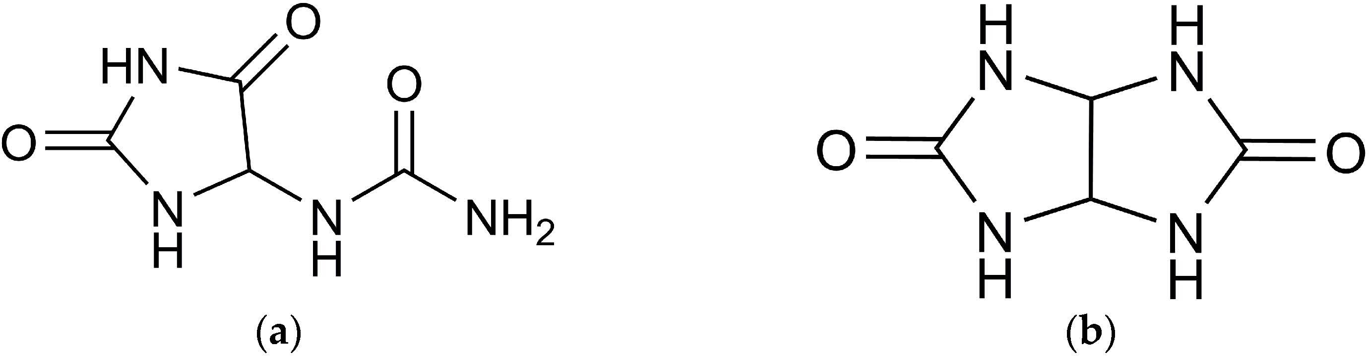
Figure 1. Chemical structures of allantoin (a) and glycoluril (b).

Allantoin (Figure 1a) belongs to the well-established class of azaheterocycles in the imidazolidinone series, specifically hydantoins. The beneficial biological and pharmaco- logical properties of this compound have been extensively discussed in several review articles [14–16]. Allantoin, chemically defined as (2,5-Dioxo-4-imidazolidinyl) urea, is a heterocyclic compound with a five-membered cycle containing a carbamide substituent in the 4th position. Presently, allantoin is a component in over 1300 different cosmetic products [14]. Recognized for its regenerative effects, it aids in the removal of abrasions and scars [17]. When included in creams, it safeguards the skin from sunburn, weathering, and cracking, offering gerontological benefits [18] and restoring normal moisture and elasticity to the skin. Allantoin has the capability to diminish the genotoxic effects of ultraviolet radi- ation [19]. Additionally, research has demonstrated its ability to inhibit various destructive processes induced by reactive oxygen species, thereby exhibiting antioxidant properties.
Glycoluril (Figure 1b), specifically (2,4,6,8-tetraazabicyclo[3.3.0]octane-3,7-dione), serves as the precursor to a class of nitrogen-containing heterocycles known as bicyclic bisureas of the octane series. The distinctive structural framework of these bicyclic bisureas, or glycoluriles, has made them the foundation for the development of valuable substances utilized in various human activities, including disinfectants, drugs [20,21], and polymer sta- bilizers [21]. Notably, glycoluriles have been identified as key components in the construc- tion of polycyclic condensed systems, such as cucurbit[n]urils [22] and bambus[n]urils [23], each exhibiting unique physicochemical properties.
The commonality between allantoin and glycoluril lies in their nature as carbamide- containing heterocycles. Owing to their polyfunctionality and intricate chemical structures, both compounds showcase a broad spectrum of physiological activities and a propensity for polycondensation processes.
Film materials were formulated using these compounds and subsequently studied for cytotoxicity, adhesion to blood proteins, adhesion to macrophages, antibacterial activity, antioxidant activity, and hemocompatibility.

Results
Throughout this investigation, novel composite materials derived from Na-CMC and carbamide-containing heterocycles (allantoin and glycoluril) were synthesized, and their biocompatibility was assessed using the test models described below. The synthesis of allantoin and glycoluril followed previously established methods [24,25], and the procedure for preparing the composite material is detailed in the Section 4 of this study.

  - Evaluation of Hemocompatibility of Composite Film Materials
Through experiments, it was determined that in all samples, when incubating ery- throcyte suspensions from five patients in three measurements with extracts of Seprafilm™ (Genzym Corporation, Cambridge, MA, USA) as the comparison sample (1) and the investi- gated composite film materials based on allantoin (2, 3) and glycoluril (4, 5), the hemolysis value did not exceed 2% (Table 1).

Table 1. The effect of extracts of film samples on erythrocyte hemolysis.

 | Hemolysis, %
Samples № | Erythrocyte | Erythrocyte | Erythrocyte | Erythrocyte | Erythrocyte
 | Suspension №1 | Suspension №2 | Suspension №3 | Suspension №4 | Suspension №5
1. | 0.59 | 0.70 | 0.29 | 0.57 | 0.47
1 2. | 0.38 | 0.20 | 0.87 | 0.43 | 0.49
3. | 0.39 | 0.32 | 0.23 | 0.56 | 0.64
X ± m | 0.45 ± 0.07 | 0.41 ± 0.15 | 0.46 ± 0.20 | 0.52 ± 0.04 | 0.53 ± 0.06
1. | 0.40 | 0.59 | 0.40 | 0.29 | 0.44
2 2. | 0.47 | 0.13 | 0.99 | 0.81 | 0.64
3. | 0.77 | 0.43 | 0.38 | 0.80 | 0.31
X ± m | 0.55 ± 0.11 | 0.38 ± 0.13 | 0.59 ± 0.20 | 0.63 ± 0.17 | 0.46 ± 0.09
1. | 0.66 | 1.04 | 0.70 | 0.41 | 0.66
3 2. | 0.25 | 0.50 | 0.34 | 0.69 | 0.33
3. | 0.67 | 0.45 | 0.35 | 0.46 | 0.57
X ± m | 0.52 ± 0.14 | 0.66 ± 0.19 | 0.46 ± 0.12 | 0.52 ± 0.09 | 0.52 ± 0.09
1. | 0.38 | 0.47 | 0.28 | 0.82 | 0.53
4 2. | 0.40 | 1.22 | 1.17 | 0.46 | 0.37
3. | 0.61 | 0.57 | 0.55 | 0.38 | 0.59
X ± m | 0.46 ± 0.07 | 0.75 ± 0.23 | 0.67 ± 0.26 | 0.55 ± 0.14 | 0.49 ± 0.07
1. | 0.47 | 0.49 | 0.45 | 0.36 | 0.40
5 2. | 0.63 | 0.74 | 0.67 | 0.60 | 0.66
3. | 0.36 | 1.14 | 0.40 | 0.76 | 1.68
X ± m | 0.49 ± 0.08 | 0.79 ± 0.19 | 0.51 ± 0.08 | 0.57 ± 0.12 | 0.91 ± 0.39

Therefore, the experimental film samples exhibit no cytotoxic effects on erythrocytes, and their hemolytic activity is comparable to that of the reference sample Seprafilm™ (1).
Considering the aforementioned information, to identify the factors contributing to the low level of hemolysis and, consequently, the high hemocompatibility of the examined samples, the adsorption of blood plasma proteins on the surface of the studied composite film materials was investigated.
  - Adsorption of Blood Plasma Proteins on the Surface of the Investigated Composite Film Materials
Following the experiments, it was determined that the protein concentrations in donor serum diluted ten times were 7.11 g/L, 6.85 g/L, 5.85 g/L, 6.14 g/L, and 6.83 g/L, respectively. Subsequent to a 2 h incubation of serum at 37 ◦C in wells containing the films under examination, there was a marginal decrease in protein concentration attributed to protein adsorption.
According to the information presented in Table 2, protein adsorption in film (1) was
2.96 ± 0.13%. The protein adsorption for the investigated composite film materials, based on glycoluril- and allantoin-modified sodium salt of carboxymethylcellulose (2–5), was
3.06 ± 0.17% (p = 0.917), 3.29 ± 0.11% (p = 0.117), 3.16 ± 0.11% (p = 0.347), and 3.28 ± 0.17%
(p = 0.117), respectively. These values were not significantly different from the protein adsorption capacity of sample (1).

Table 2. The adsorption of proteins on the surface of the investigated films.
 | Serum №1 | Serum №2 | Serum №3 | Serum №4 | Serum №5
1. | 2.36 | 2.94 | 1.81 | 3.80 | 1.54
1 2. | 4.41 | 2.82 | 2.71 | 3.51 | 3.68
3. | 2.88 | 3.42 | 3.08 | 2.17 | 3.20
X ± m | 2.96 ± 0.13
1. | 1.48 | 3.04 | 1.89 | 4.82 | 4.16
2. | 2.76 | 2.69 | 3.86 | 3.05 | 1.96
2 3. | 4.02 | 3.55 | 2.41 | 3.16 | 3.01
X ± m | 3.06 ± 0.17  p2–1 = 0.917
1. 2.15 |  | 2.47 | 4.08 | 5.60 | 3.71
2. 3.83 |  | 3.42 | 1.74 | 3.55 | 4.38
3 3. 3.37 |  | 4.15 | 3.08 | 1.32 | 2.47
X ± m | 3.29 ± 0.11  p3–1 = 0.117
1. 4.81 |  | 3.10 | 2.93 | 4.33 | 3.14
2. 3.01 |  | 2.63 | 2.22 | 2.73 | 2.21
4 3. 0.83 |  | 4.24 | 5.35 | 2.20 | 3.74
X ± m | 3.16 ± 0.11  p4–1 = 0.347
1. 2.73 |  | 3.07 | 3.00 | 2.45 | 3.74
2. 3.68 |  | 4.02 | 6.05 | 2.98 | 1.54
5 3. 3.16 |  | 0.94 | 1.18 | 5.57 | 5.08

Samples № Adsorption of Proteins, %

X ± m 3.28 ± 0.17
p5–1 = 0.117

As indicated by the information in Table 2, protein adhesion observed in the samples of the investigated composite film materials, based on the sodium salt of carboxymethylcel- lulose modified with glycoluril and allantoin (2–5), is comparable to protein adhesion in the reference sample “Seprafilm” (1).
  - Evaluation of Cytotoxicity
The experiments revealed that incubating the 3T3-L1 normal fibroblast cell line with various concentrations of extracts from the investigated samples of composite film materials, based on allantoin-modified sodium salt of carboxymethylcellulose (2, 3), for 24 h, as well as the reference sample (1), did not result in a noteworthy reduction in cell viability in the neutral red test (Figure 2).
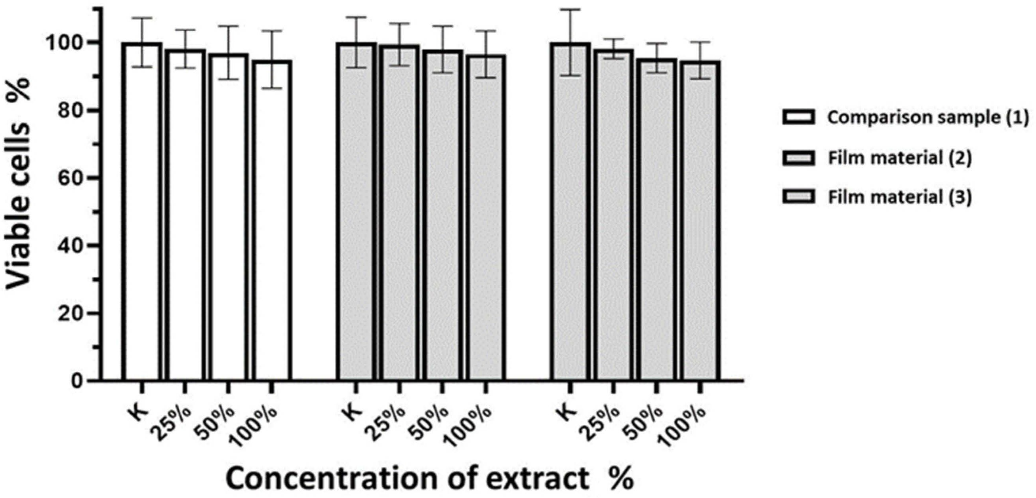
Figure 2. Cell viability of 3T3-L1 normal fibroblast culture (in %) after incubation with different concentrations of extracts of commercial sample of Seprafilm™ membrane and investigated films.

Culturing the 3T3-L1 normal fibroblast cell line with varying extract concentrations from the examined samples of composite film materials, which are based on glycoluril- modified sodium salt of carboxymethylcellulose (4, 5), for 24 h similarly showed no impact on cell viability (Figure 3).
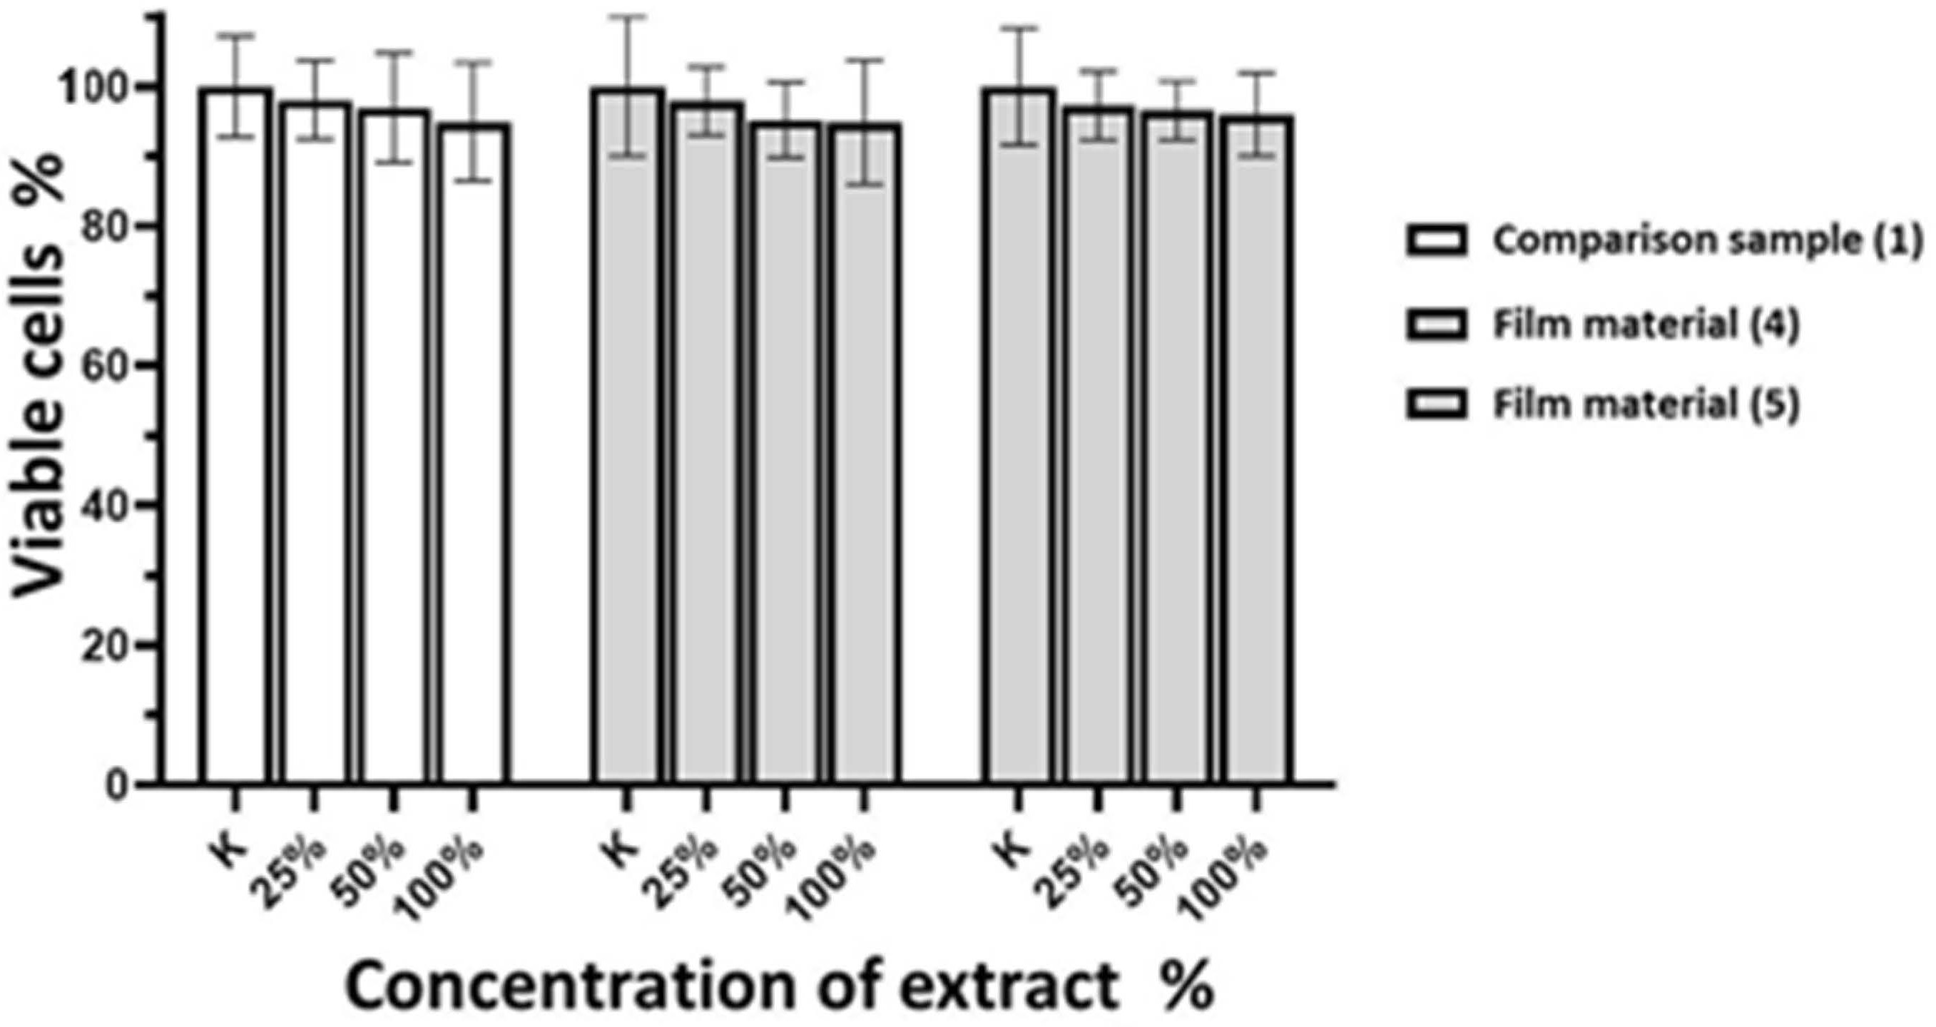
Figure 3. Cell viability of 3T3-L1 normal fibroblast culture (in %) after incubation with different extract concentrations of Seprafilm™ commercial membrane sample and the tested films.
Therefore, extracts from the examined films, as well as extracts from the reference film, do not exhibit a notable cytotoxic effect on the 3T3-L1 fibroblast cell culture.
A comparative examination of the cytotoxicity of the studied composite film samples (2–5) and the reference sample (1) is detailed in Table 3 and Figure 4. The findings suggest that the cytotoxicity of the investigated composite film materials, based on the sodium salt of carboxymethylcellulose modified with glycoluril and allantoin (2–5), is comparable to the cytotoxicity of the commercial sample (1).

Table 3. Cytotoxicity rates of various extract concentrations determined by neutral red assay.

Film Sample | Extract, % | Cell Viability, %, M ± SD | Reliability of Differences
 | 25% | 98.1 ± 5.6
1 | 50% | 96.9 ± 7.8
 | 100% | 93.0 ± 8.6
 | 25% | 99.4 ± 6.2 | p = 0.344
2 | 50% | 97.9 ± 6.9 | p = 0.612
 | 100% | 96.5 ± 6.9 | p = 0.356
 | 25% | 96.9 ± 3.3 | p = 0.450
3 | 50% | 95.4 ± 4.3 | p = 0.220
 | 100% | 94.7 ± 5.4 | p = 0.875
 | 25% | 97.9 ± 4.9 | p = 0.831
4 | 50% | 95.2 ± 5.4 | p = 0.177
 | 100% | 94.9 ± 8.9 | p = 0.982
 | 25% | 97.2 ± 4.9 | p = 0.685
5 | 50% | 95.6 ± 4.2 | p = 0.558
 | 100% | 96.0 ± 5.9 | p = 0.620
Note: p reflects the reliability of differences from the comparison film–commercial sample of Seprafilm™ mem- brane (Genzym Corporation, USA).

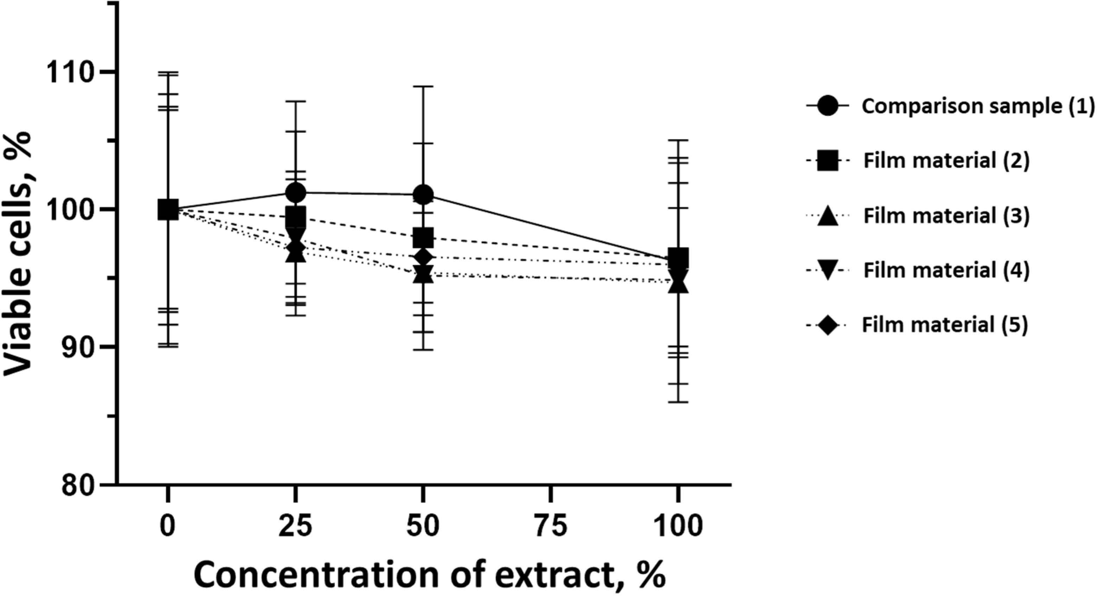

Figure 4. Impact of different extract concentrations of commercial Seprafilm™ membrane sample and tested film samples.
  - Evaluation of Macrophage Adhesion to the Surface of the Tested Samples
Following the investigation of cytotoxicity, the adhesion of macrophages to the surface of the examined samples was explored. In the experiments, it was observed that the number of adhered macrophages from the RAW 264.7 line on the surface of tablet wells without the investigated composite film materials in the microscope’s field of view was 355 ± 36 (Table 4). Upon placing RAW 264.7 cells in the tablet wells with the surface of the comparison sample “Seprafilm”, the number of adhered cells significantly decreased to 128 ± 16 within the microscope’s view field. The adhesion of macrophages on the surface of the composite film materials samples, based on the sodium salt of carboxymethylcellulose modified by allantoin (2, 3), did not differ significantly from the comparison sample “Seprafilm”.

Table 4. Adhesion of macrophages of the RAW 264.7 cell line to the surface of the samples of the tested films.

Film Samples Phalloidin DAPI Merge RAW 264.7 Value

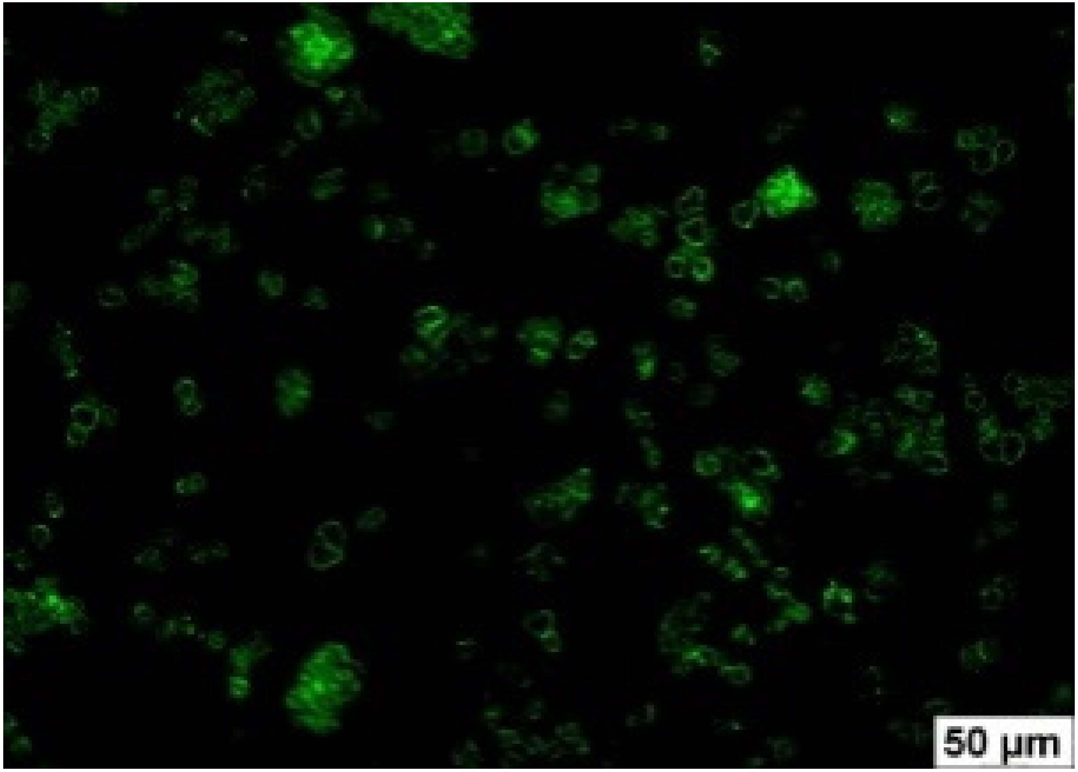
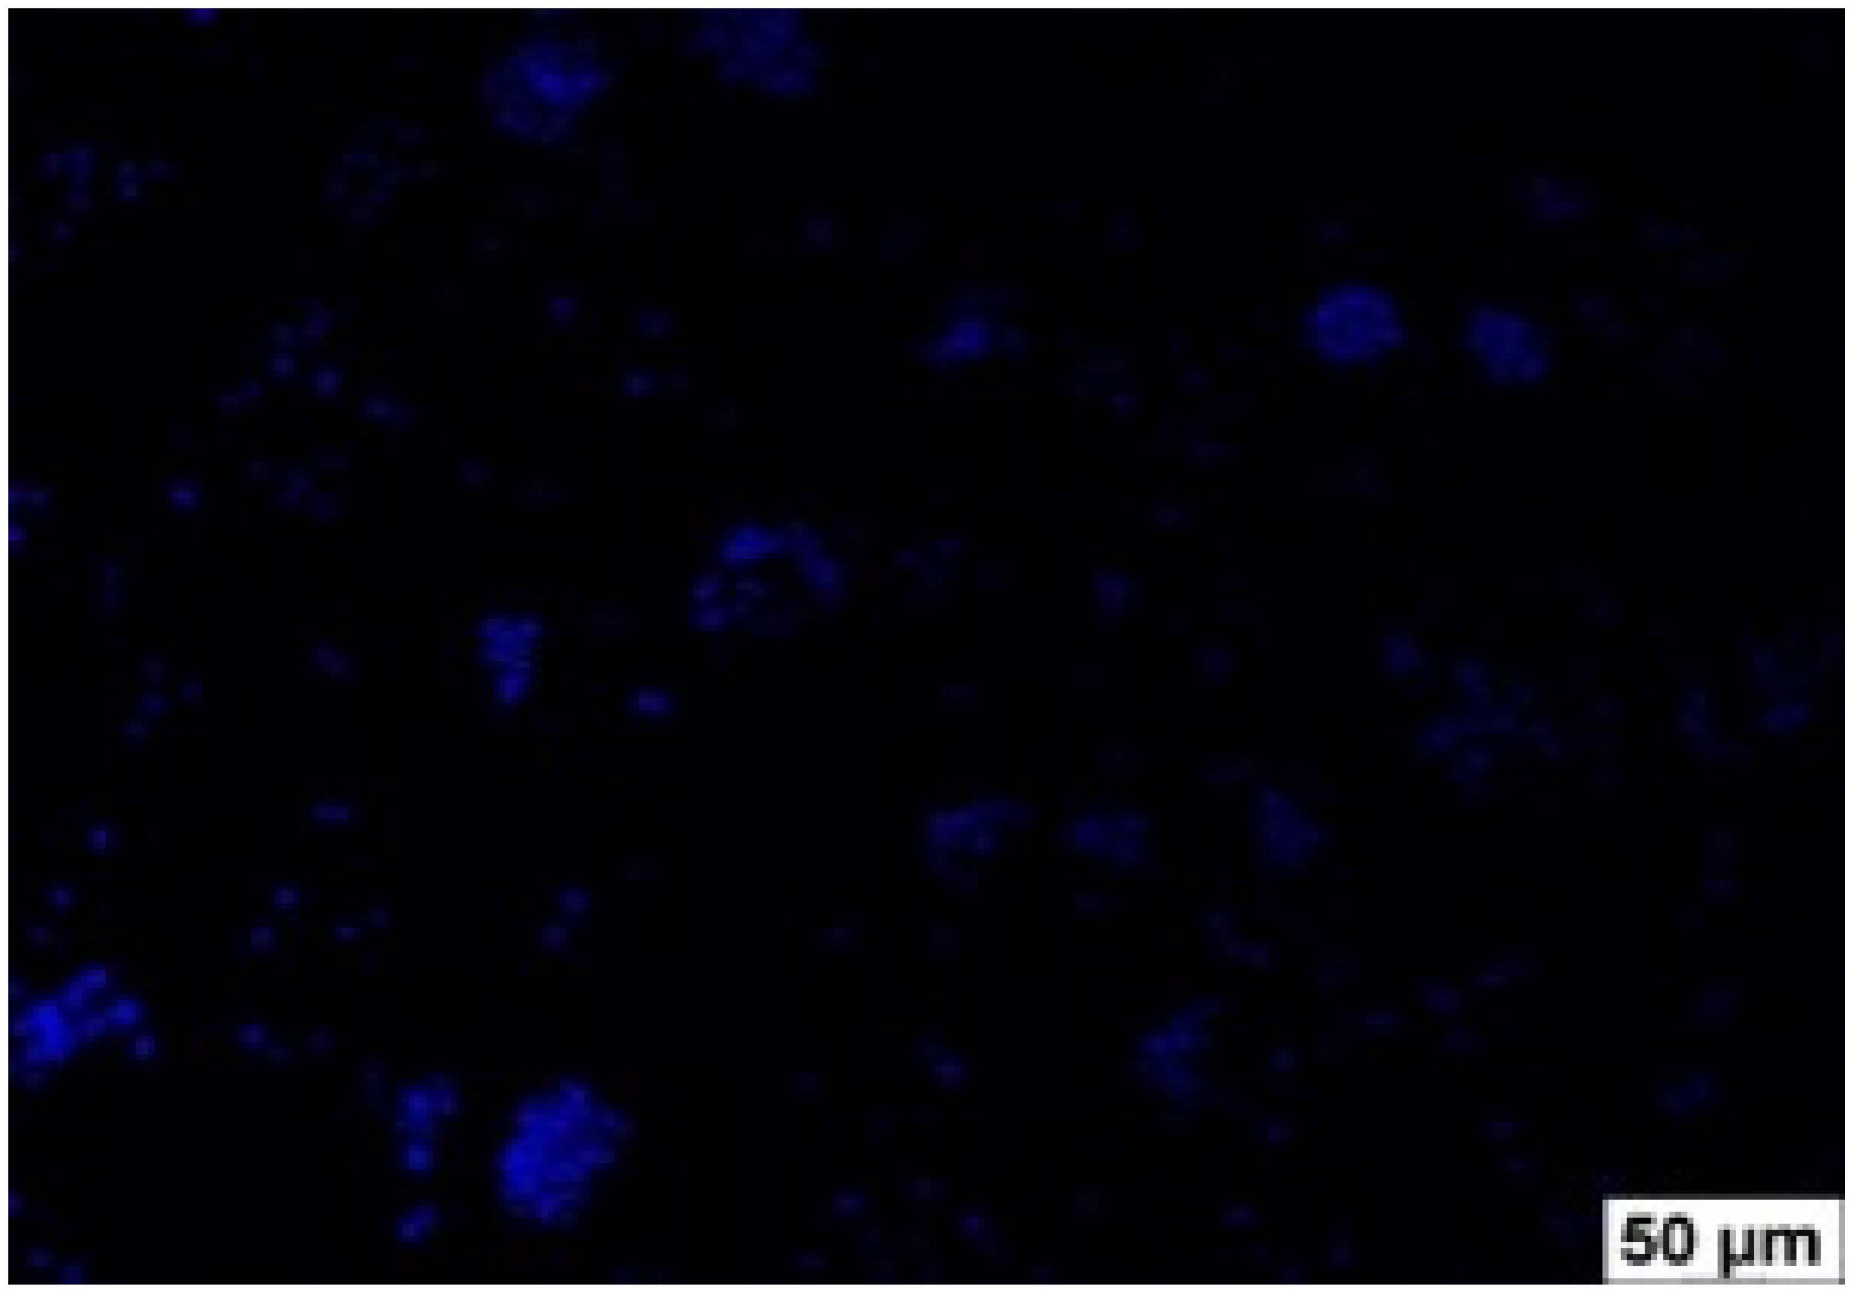
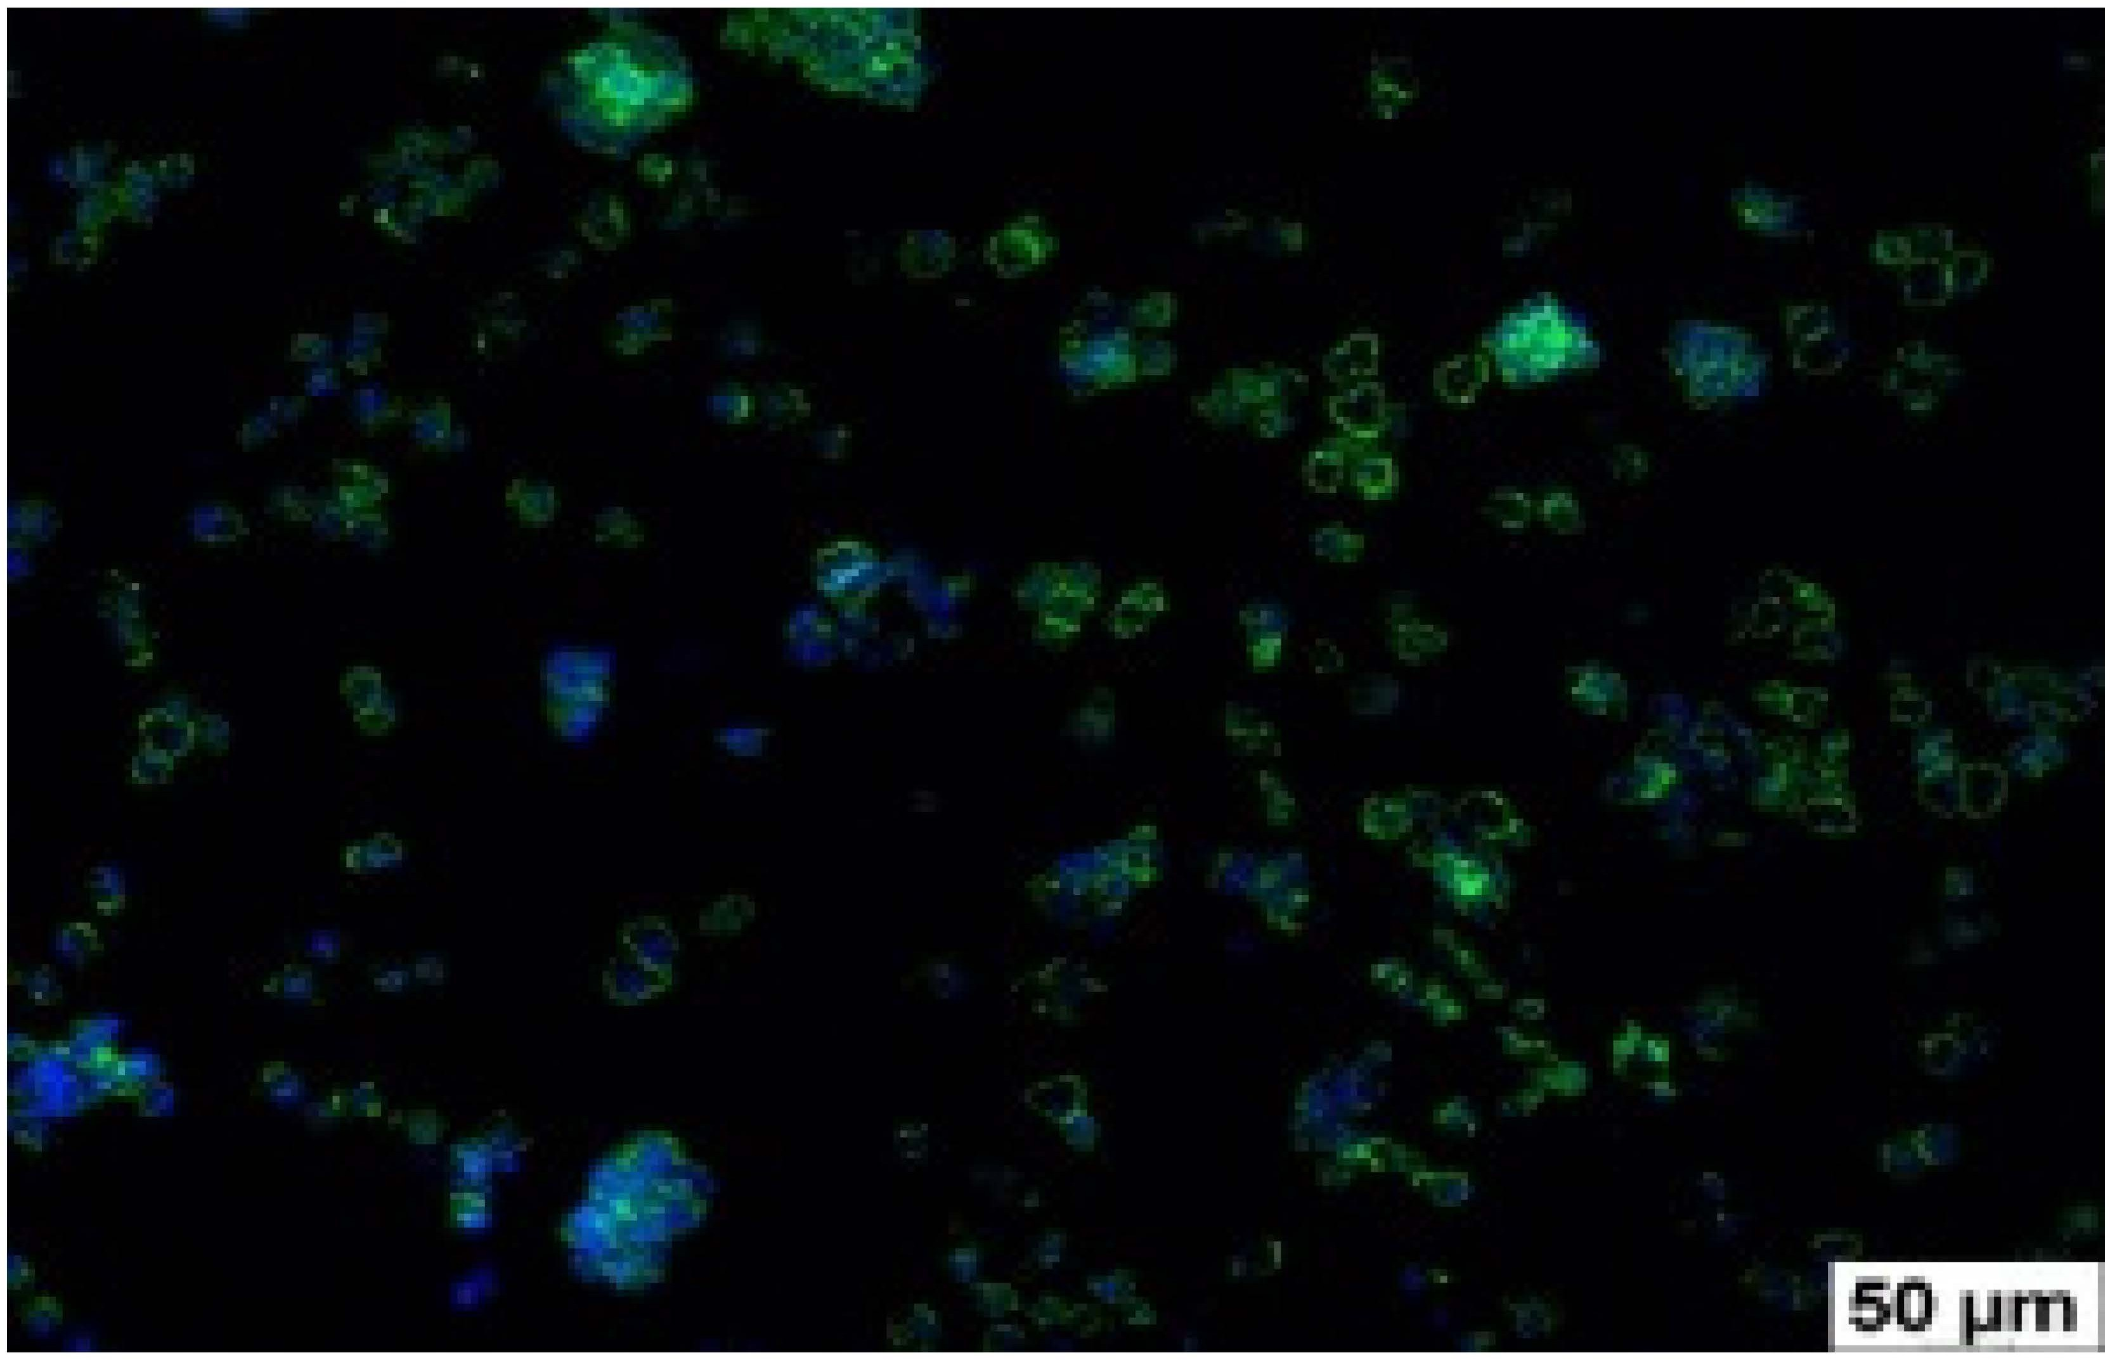
Control (n = 9) 355 ± 36

1
(n = 9)

2
(n = 9)
128 ± 16
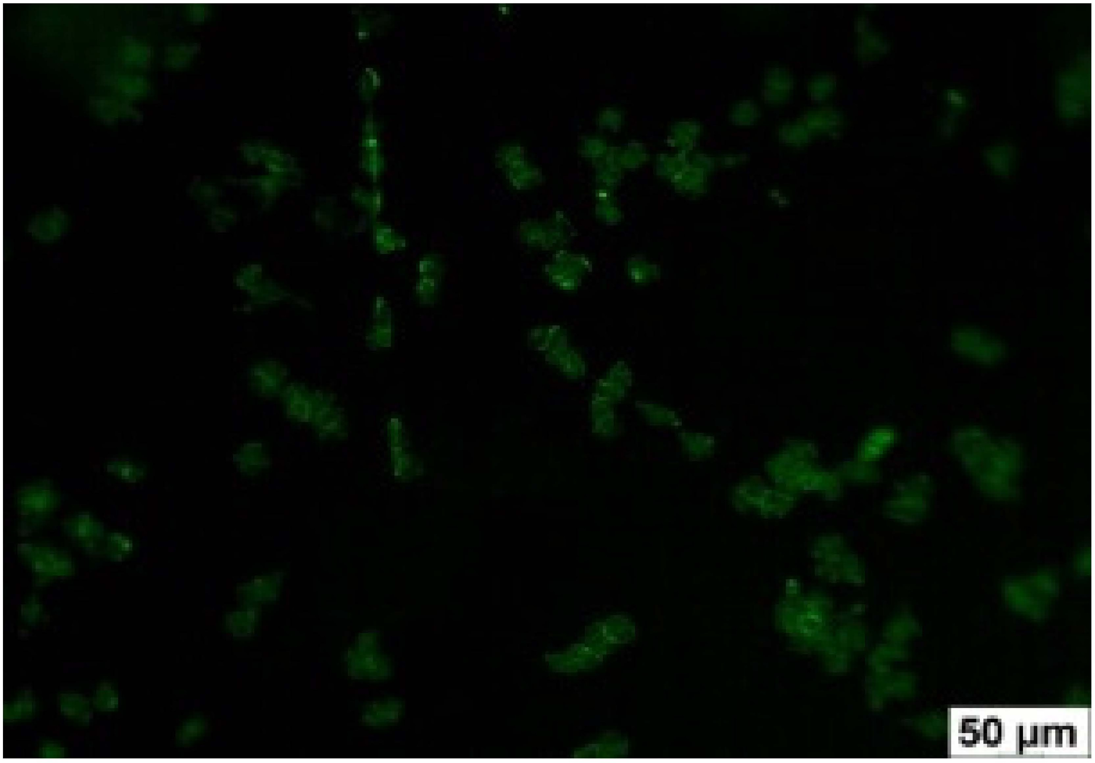
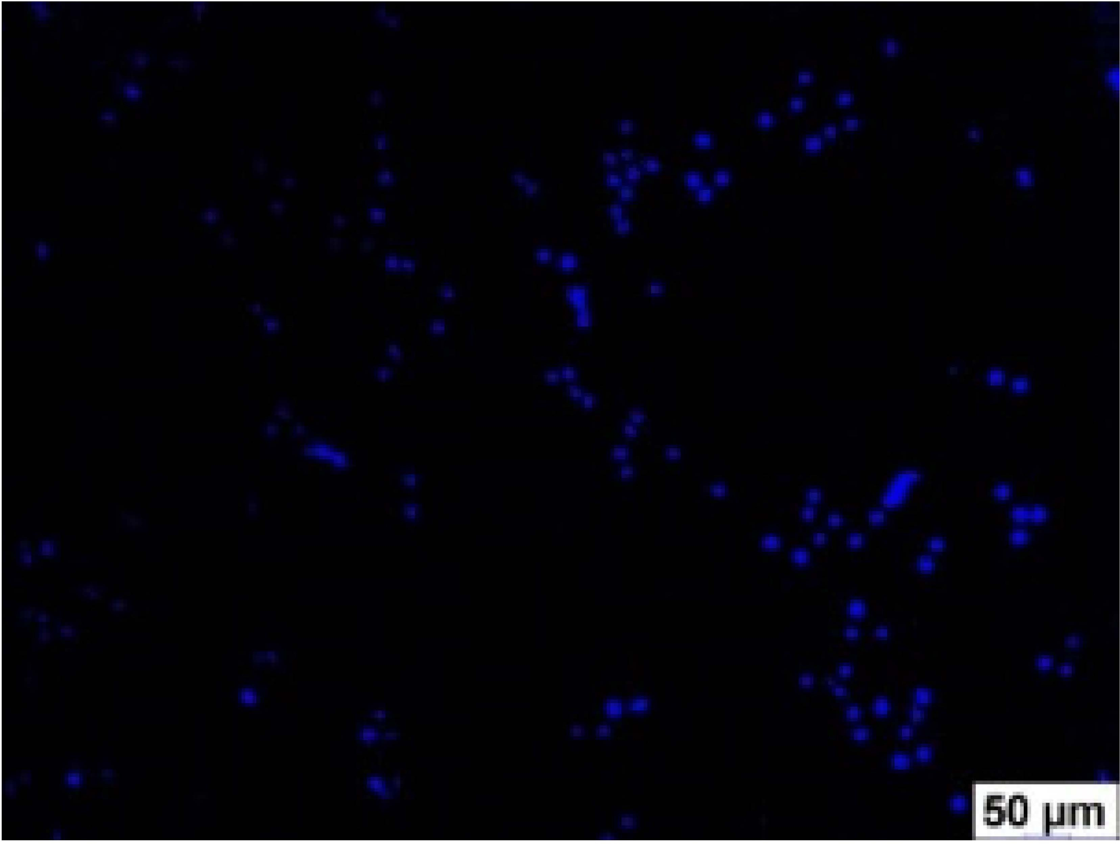
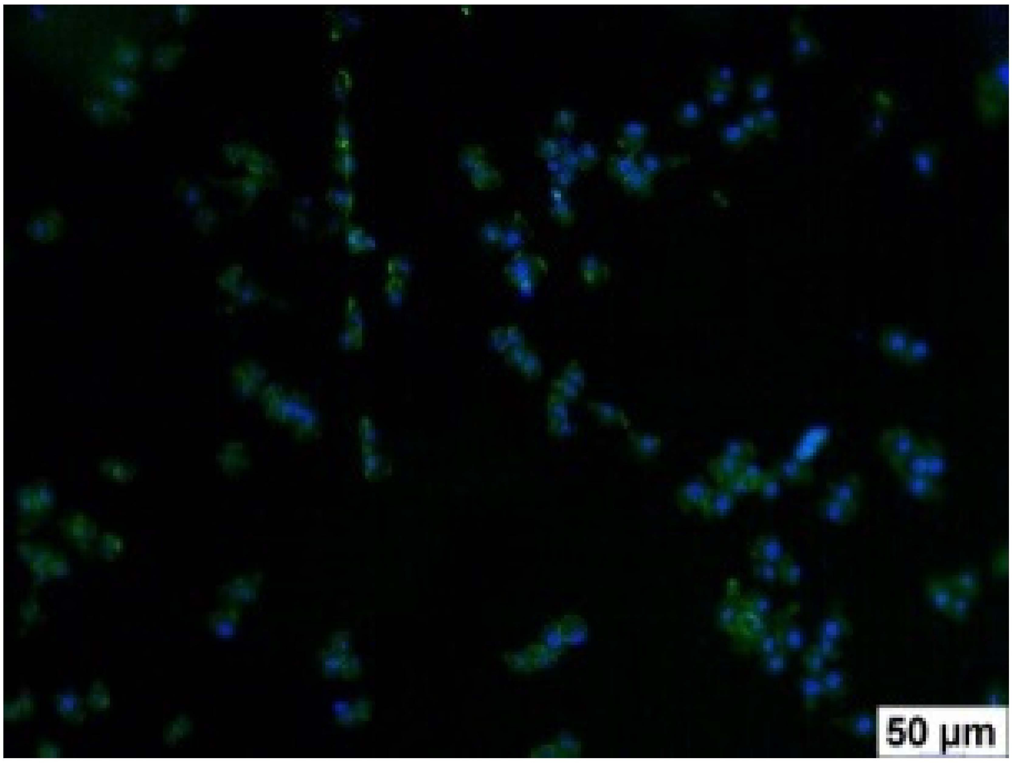
p2–1 < 0.001

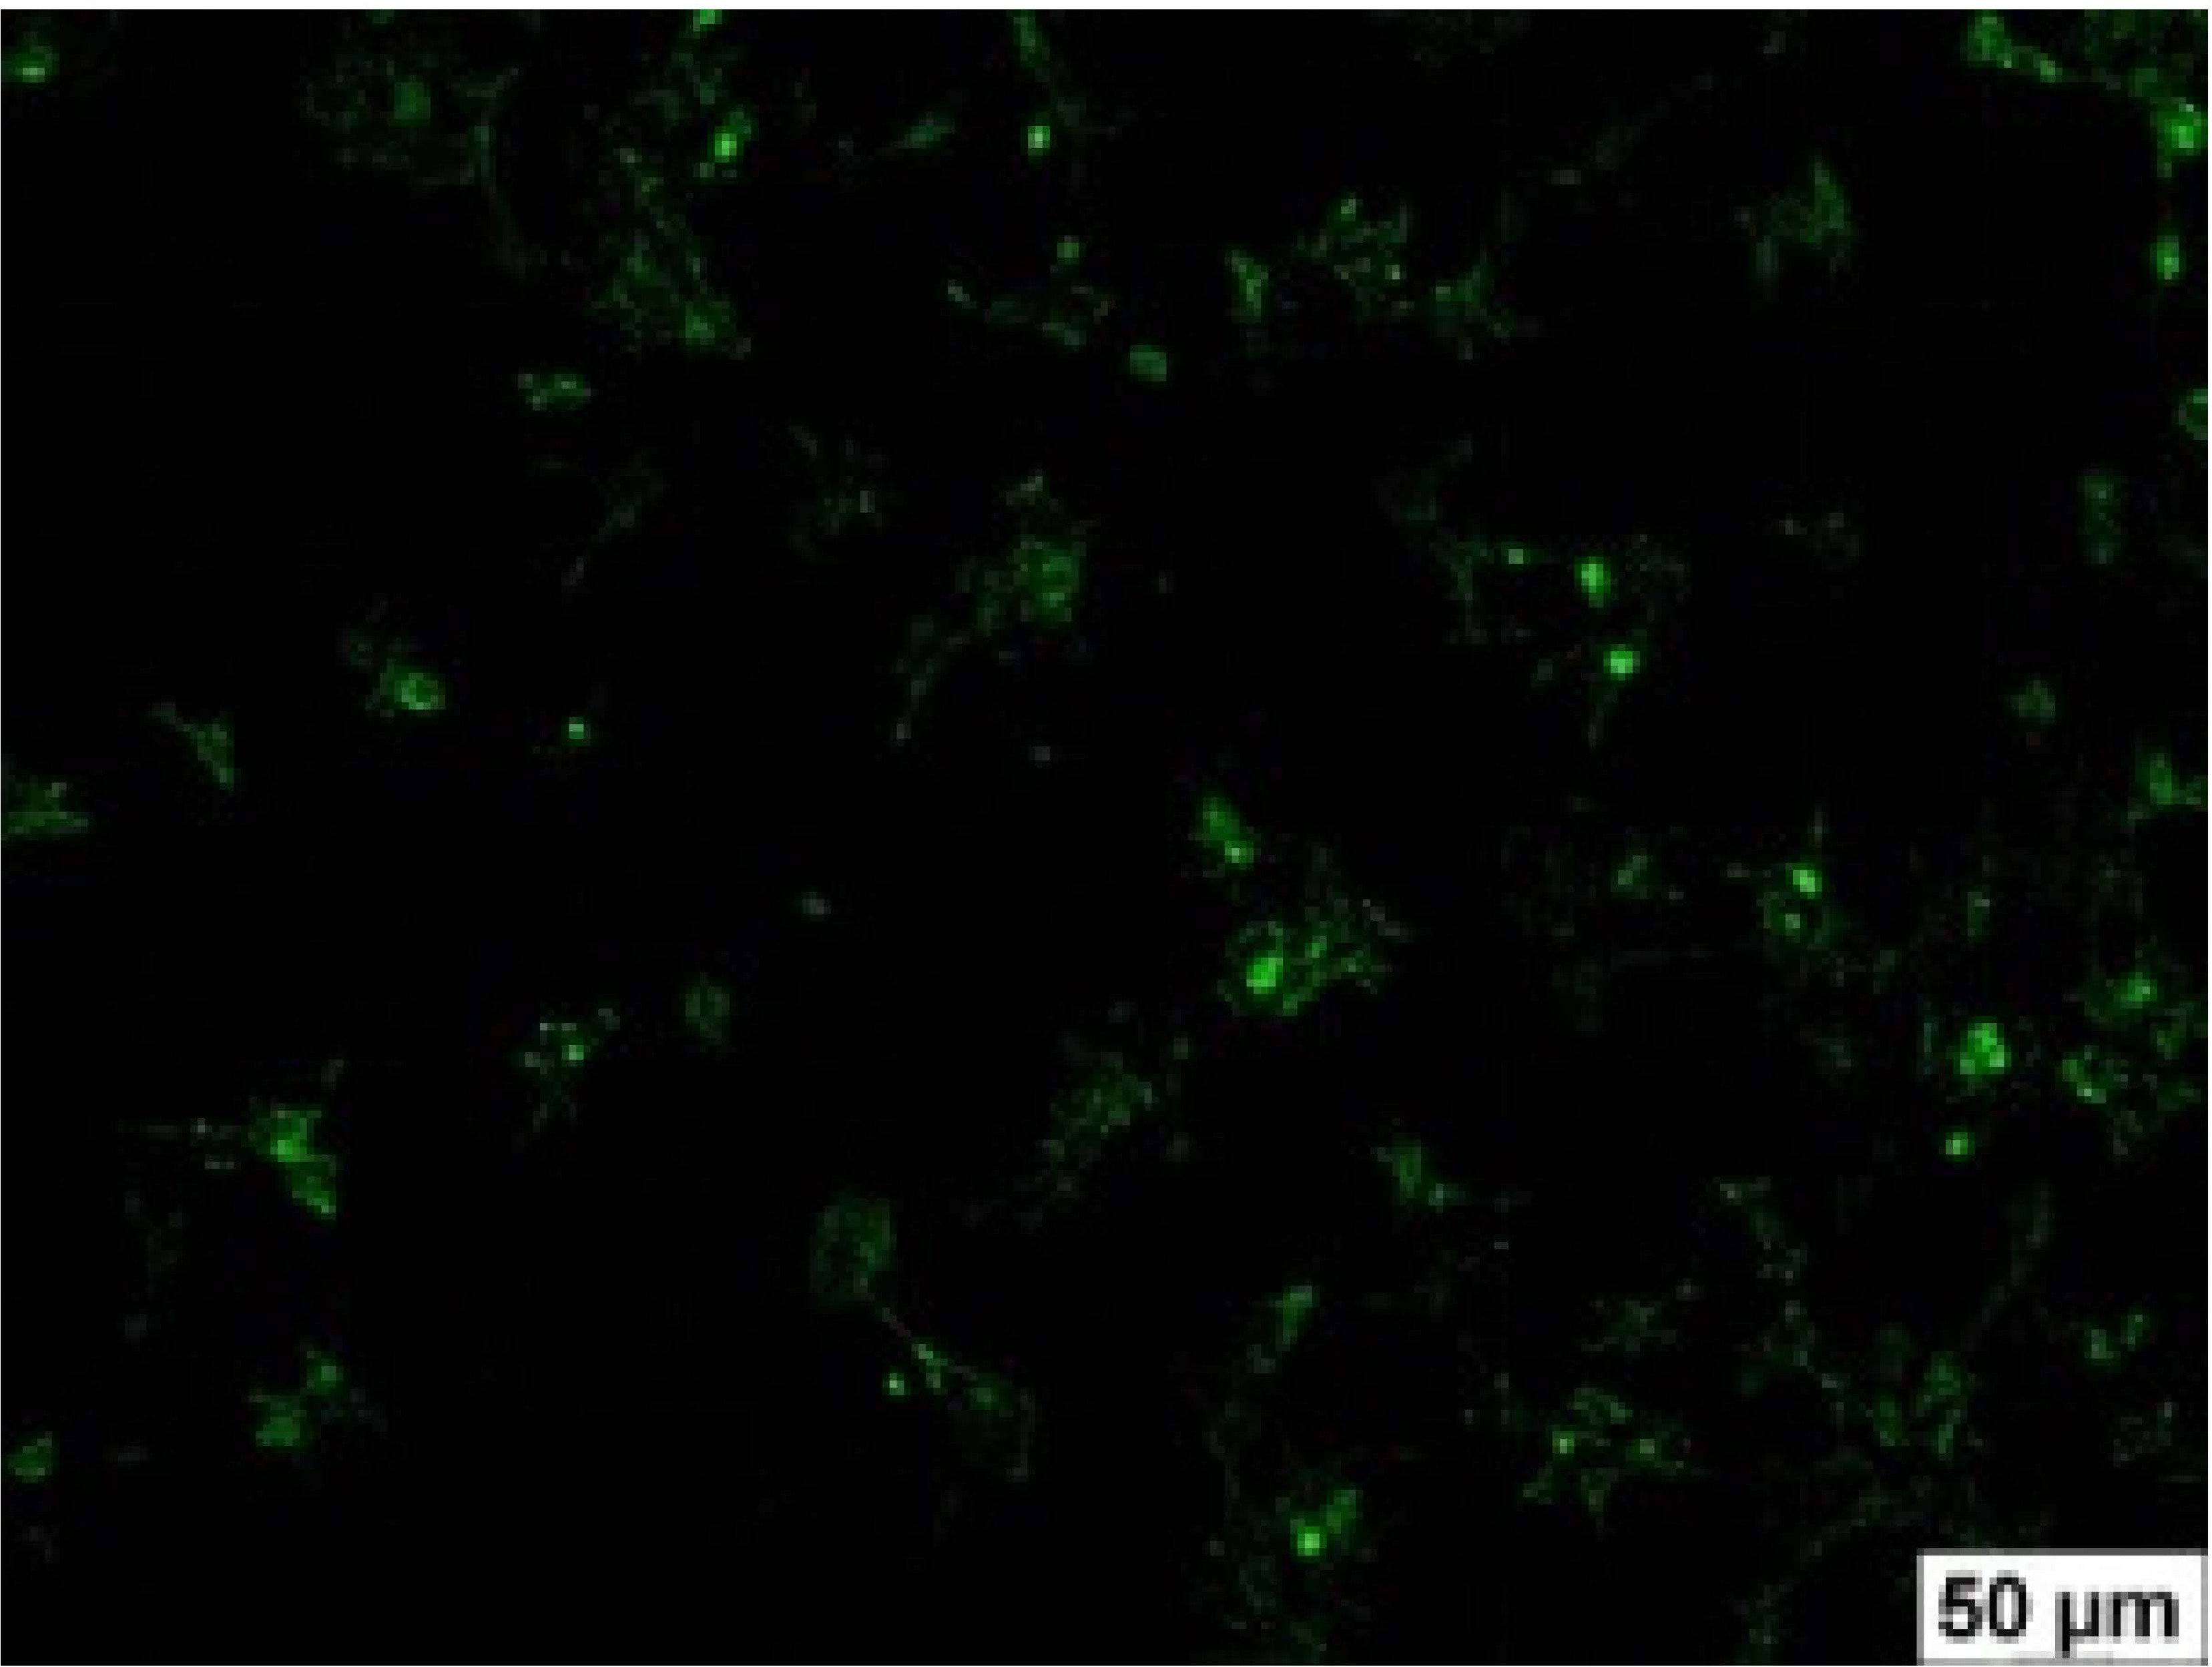
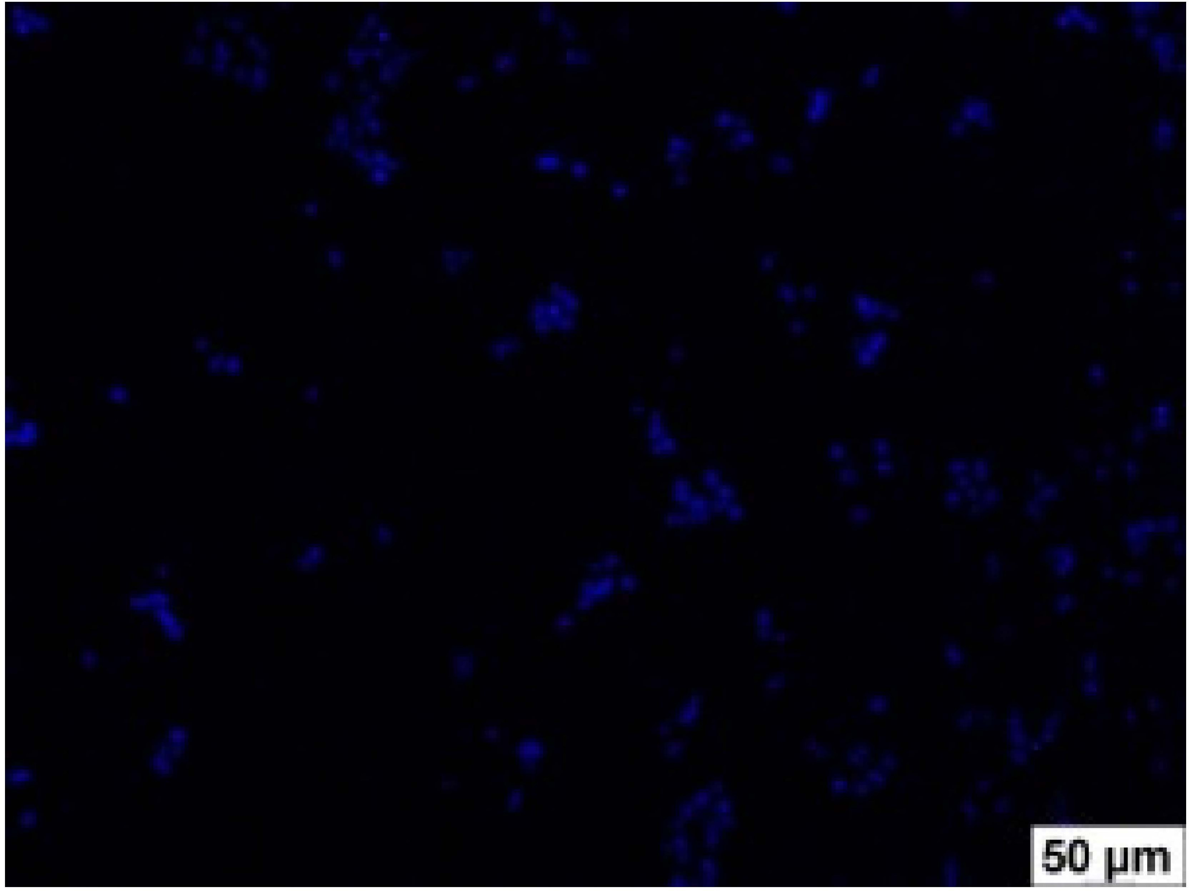
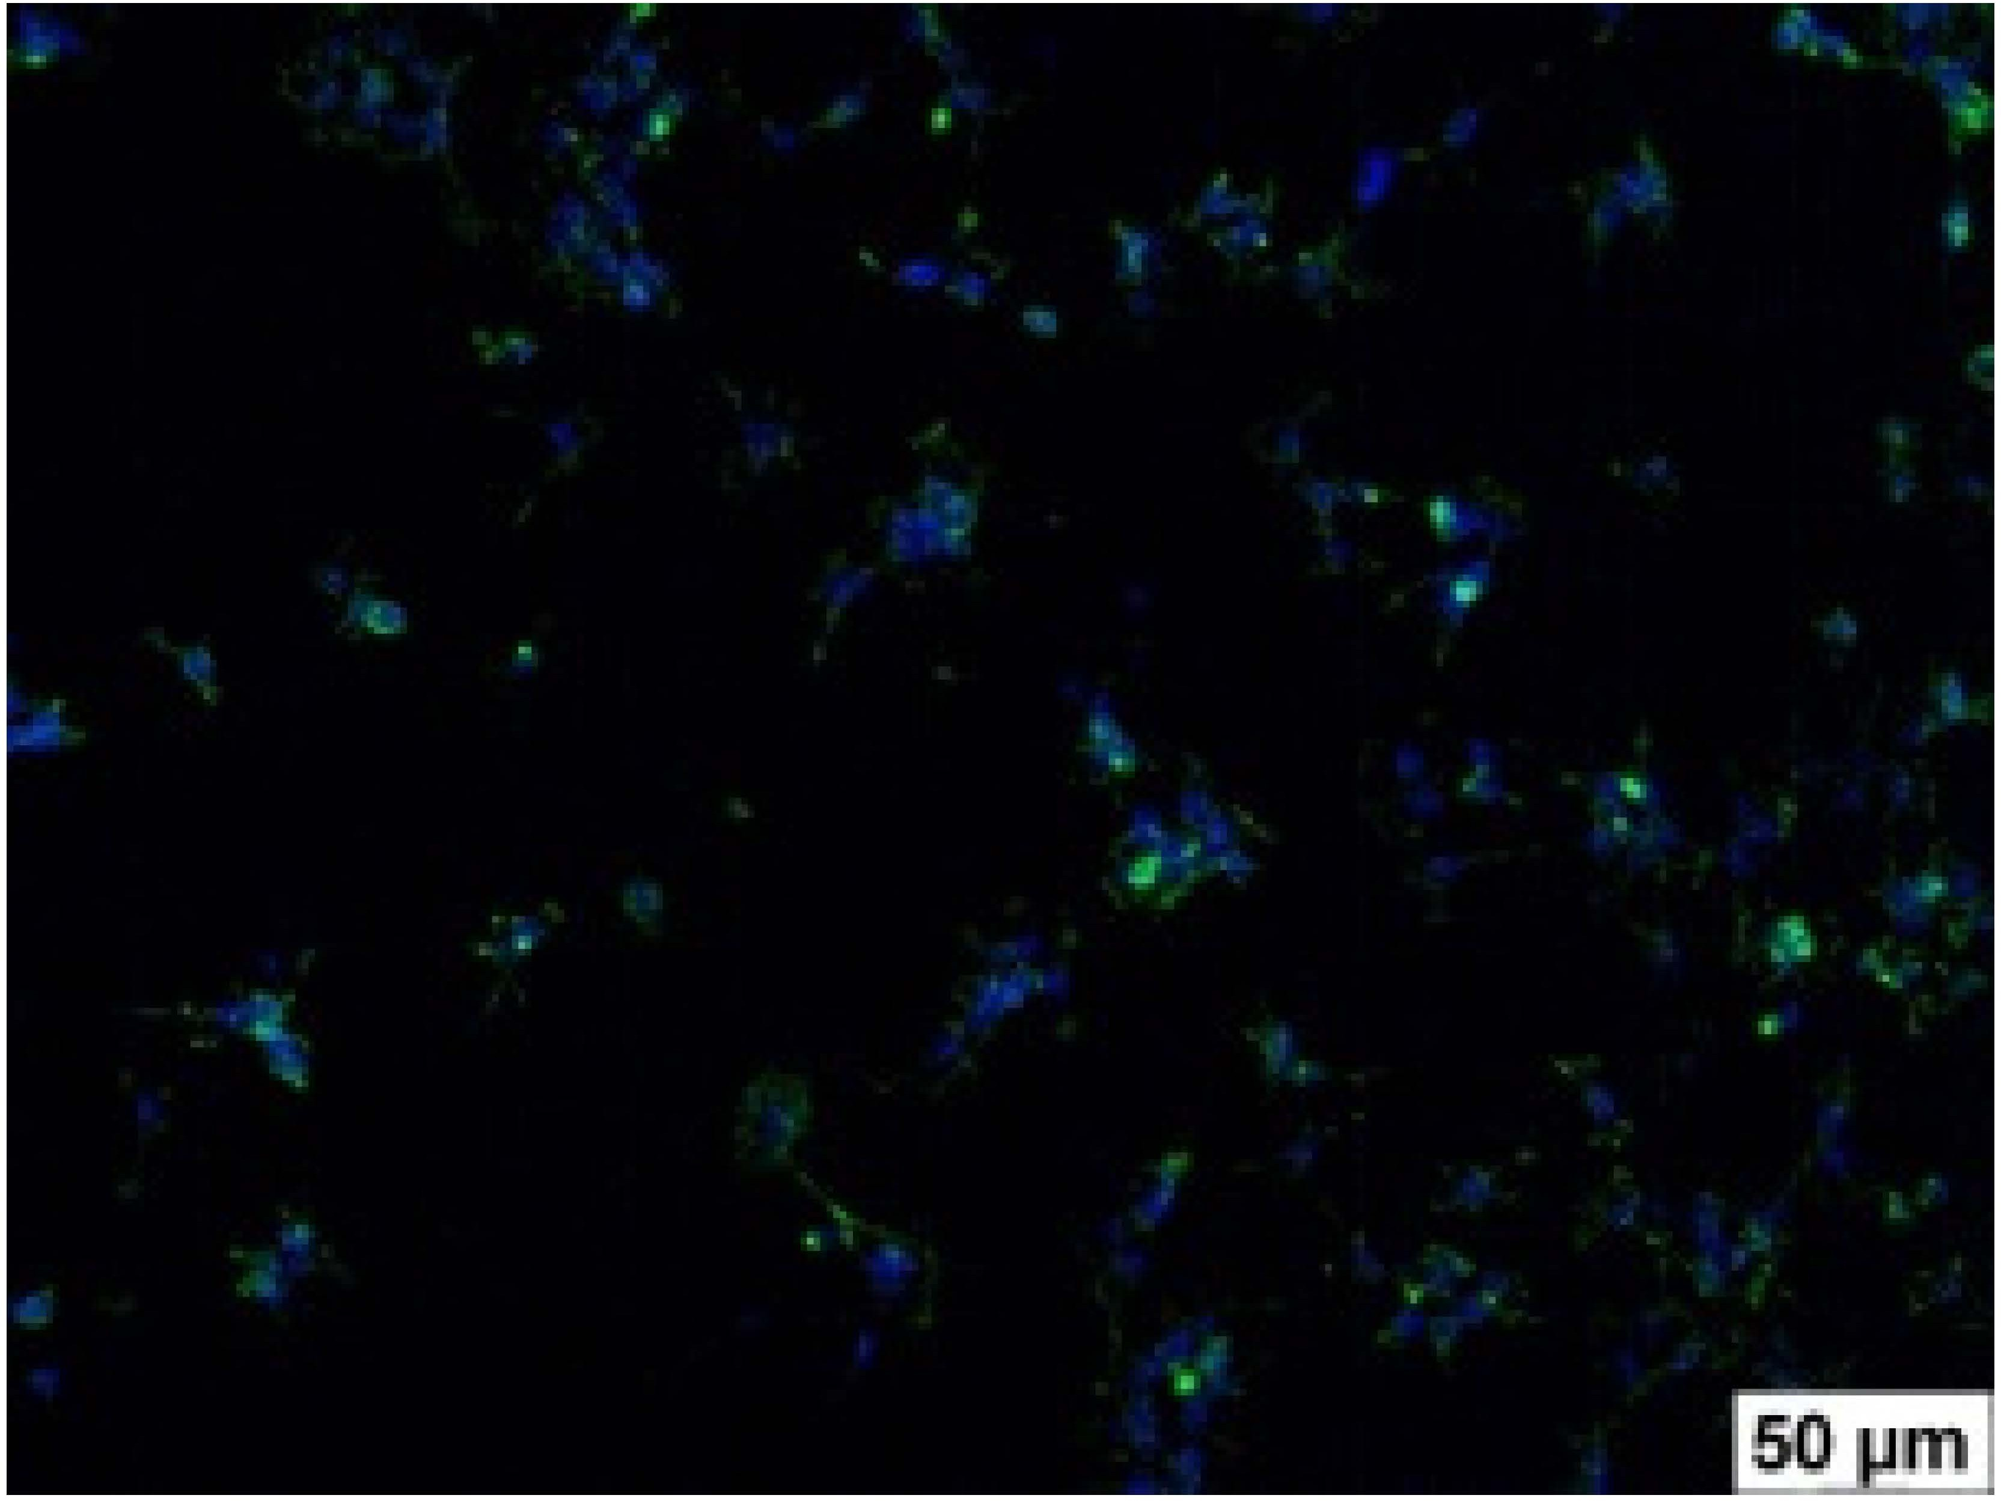
215 ± 31
p3–1 < 0.03
p3–2 = 0.058

Table 4. Cont.

Film Samples Phalloidin DAPI Merge RAW 264.7 Value
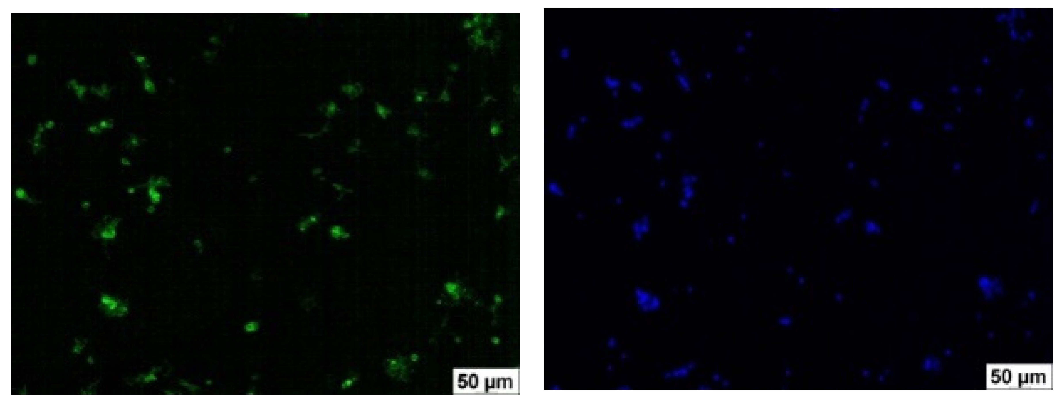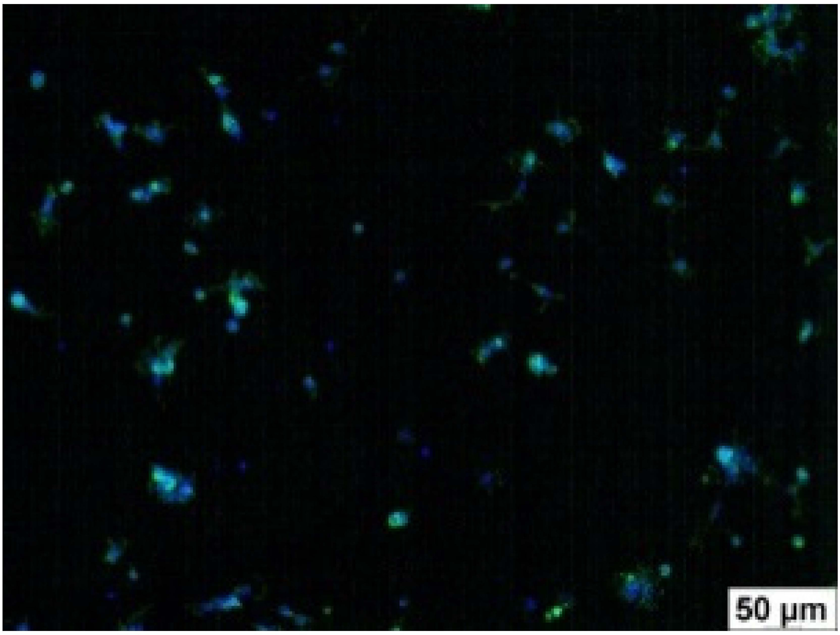
3
(n = 9)
195 ± 29
p4–1 < 0.002
p4–2 = 0.064
p4–3 = 0.757

4
(n = 9)

5
(n = 9)
61 ± 8
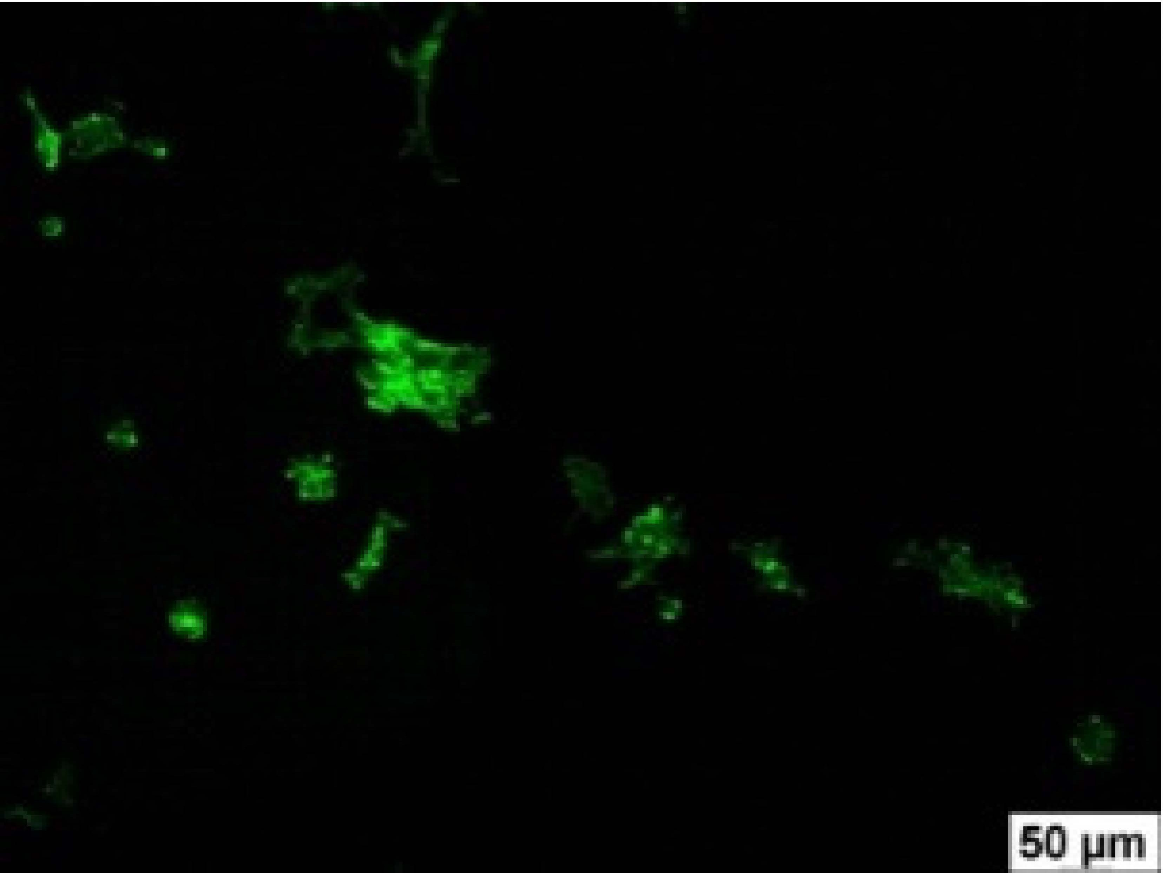
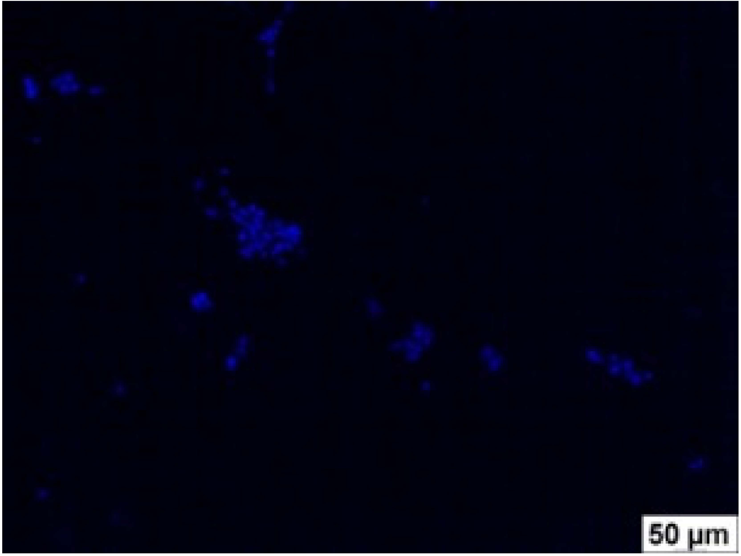
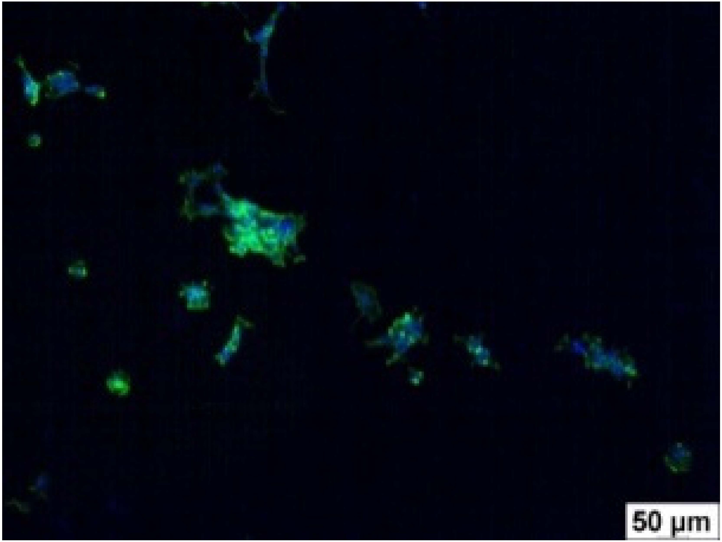
p5–1 < 0.001
p5–2 < 0.005
p5–3 < 0.001

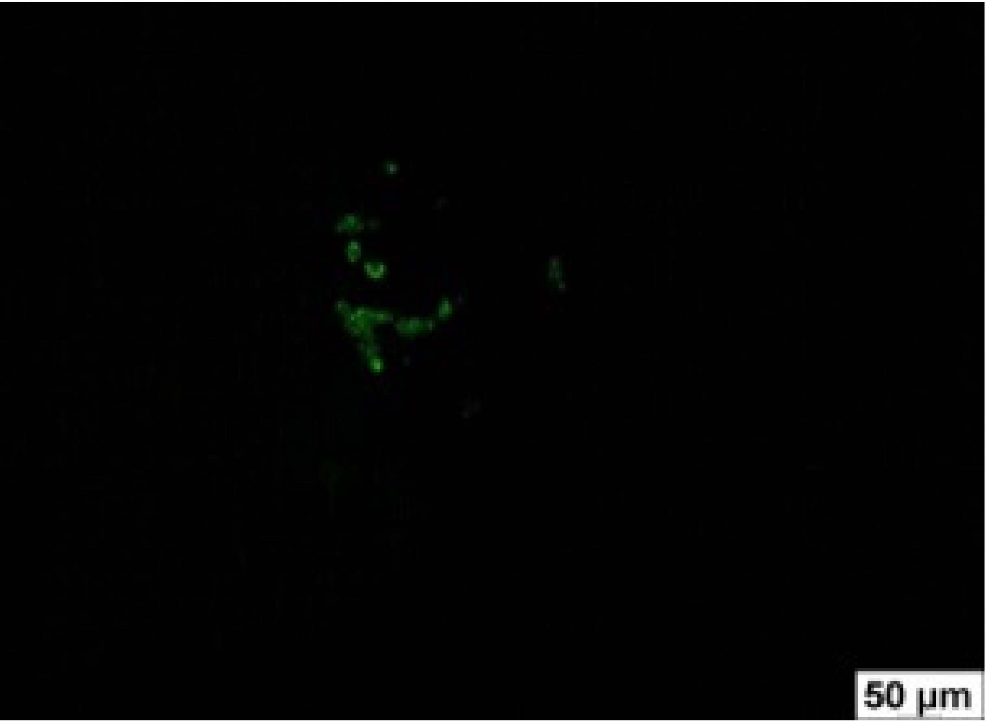
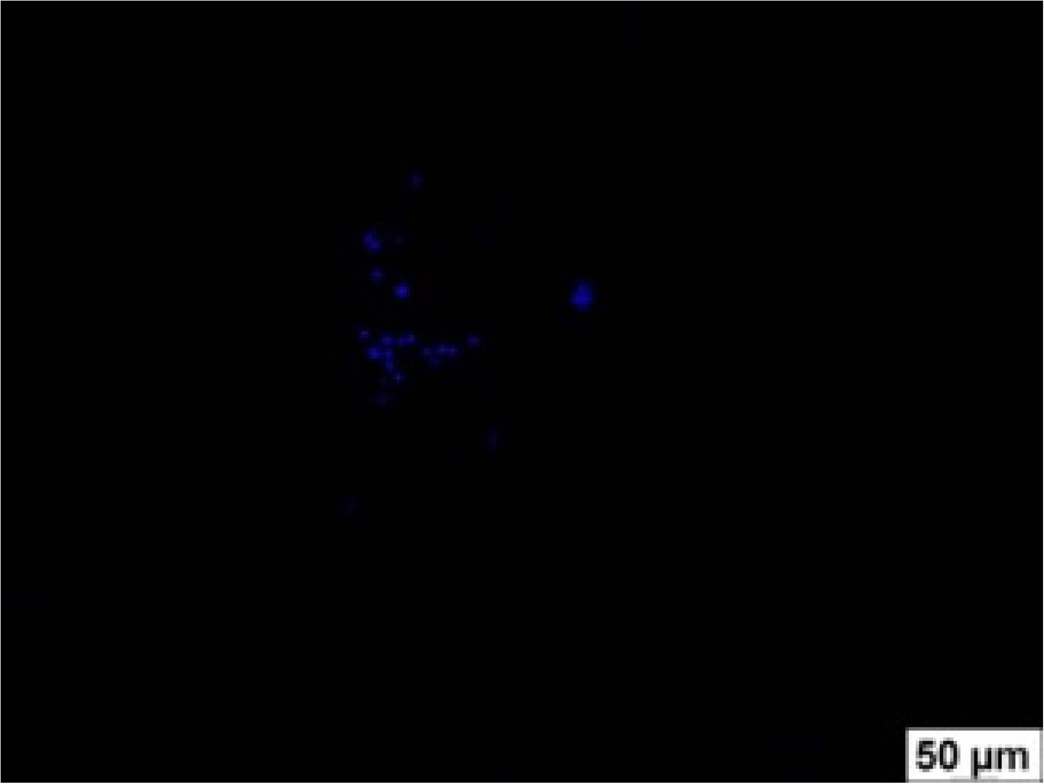
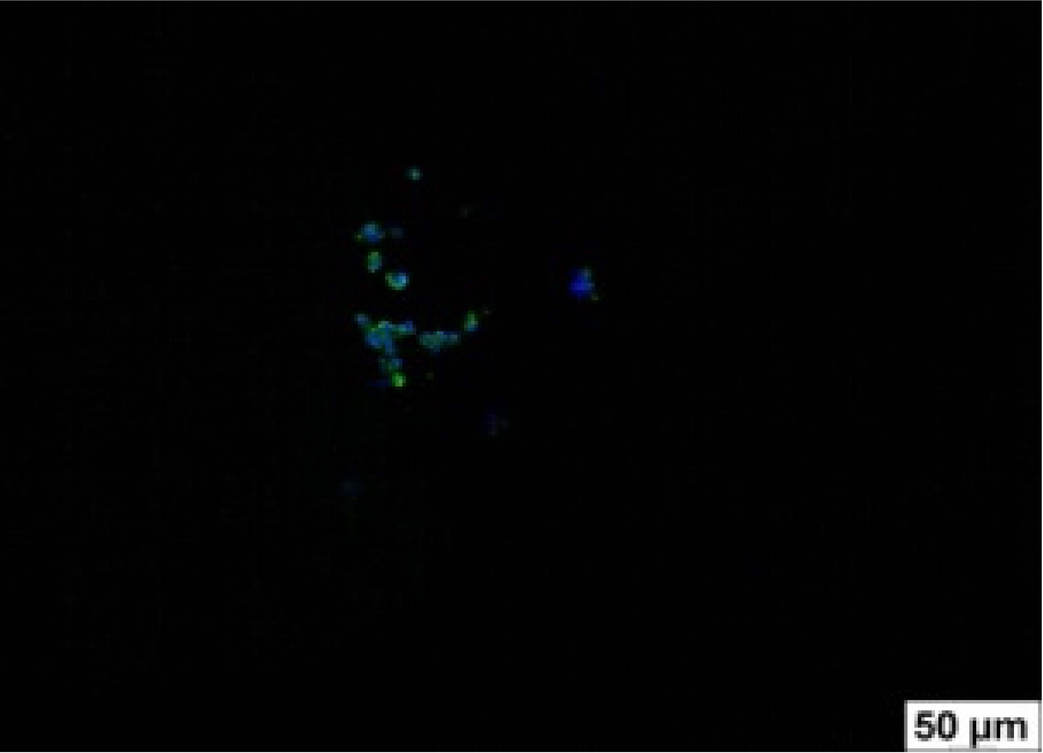
18 ± 5
p6–1 < 0.001
p6–2 < 0.001
p6–4 < 0.001
p6–5 < 0.002

The number of adhered cells in the microscope’s field of view was 215 ± 31 (p = 0.058) and 195 ± 29 (p = 0.064) cells, respectively. In contrast, the ability of macrophages to adhere in the samples of composite film materials based on glycoluril-modified sodium salt of carboxymethylcellulose (4, 5) was significantly lower than in sample (1) and the studied samples (2, 3). The number of adhered cells in the microscope’s field of view was 61 ± 8 and 18 ± 5, respectively.
Consequently, the tested composite film materials samples, which are based on allantoin-modified sodium salt of carboxymethylcellulose (2, 3), exhibit a diminished ability for macrophages from the RAW 264.7 line to adhere, and their adhesion value is comparable to that of sample (1).
The samples of composite film materials, derived from the glycoluril-modified sodium salt of carboxymethylcellulose (4, 5), exhibit notably reduced adhesion of RAW 264.7 line macrophages to the surface compared to both sample (1) and the examined composite film materials based on allantoin-modified sodium salt of carboxymethylcellulose (2, 3).
  - Evaluation of Antibacterial Activity
Following the examination of antibacterial activity, it was observed that the samples from all groups, including the control sample of film (1), did not exhibit any noteworthy activity against the test strains.
  - Evaluation of Antioxidant Activity
In the experiments measuring antioxidant activity, it was determined that the com- mercial sample (1) decreased the concentration of ABTS cation radical in the model system, equivalent to 2.19 ± 0.32 µmol of Trolox (Table 5). The investigated samples of composite film materials, based on the sodium salt of carboxymethylcellulose modified with allantoin (2, 3), exhibited more pronounced antioxidant effects (5.49 ± 0.47 and 9.99 ± 0.51 µmol of Trolox equivalents/g film, respectively). The samples of composite film materials, derived from the glycoluril-modified sodium salt of carboxymethylcellulose (4, 5), demonstrated the highest antioxidant activity (10.02 ± 0.86 and 21.27 ± 0.91 µmol of Trolox equivalents/g film, respectively)

Table 5. Antioxidant activity of film samples expressed in Trolox equivalents.

Film Samples Antioxidant Activity, µmol Trolox/g Film

1 (n = 6) 2.19 ± 0.32
2 (n = 6) 5.49 ± 0.47 (p2–1 < 0.005)

3 (n = 6) 9.99 ± 0.51 (p3–1 < 0.001)
4 (n = 6) 10.02 ± 0.86 (p4–1 < 0.001)

5 (n = 6) 21.27 ± 0.91 (p5–1 < 0.001)

Hence, all experimental film material samples based on Na-CMC modified with gly- coluril and allantoin (2–5) exhibit superior antioxidant activity compared to the membrane sample (1), demonstrating the capability to diminish the level of free radicals in model systems using DPPH and ABTS radicals. The samples of composite film materials based on Na-CMC modified with glycoluril (4, 5) display the most pronounced antioxidant effect.
  - Investigation of the Mechanical Properties of Film Materials
In experiments measuring the mechanical strength of samples, it was established that samples based on the sodium salt of carboxymethylcellulose modified with allantoin (2, 3) and glycoluril (4, 5) have a tensile strength higher than the reference sample “Seprafilm” (Table 6).

Table 6. Mechanical properties of film samples.

Film Samples | Tensile Strength of Films, MPa
1 | 32.02
2 | 47.51
3 | 43.36
4 | 46.40
5 | 40.58

  - Investigation of Water Content in the Obtained Film Materials
The water content of the samples of film materials modified with allantoin (3) and glycoluril (5) was determined to be residual moisture. Samples (3) and (5) did not demon- strate high humidity (0.27% and 0.23%, respectively).

Discussion
In this study, composite film materials based on allantoin and glycoluril were synthe- sized for the first time, and consequently, their beneficial biological properties have not yet been established. To gauge the potential of these biomaterials in medical applications, it is imperative to initially assess their biocompatibility. The convergence of favorable biocompatible traits in the examined material paves the way for the potential development of targeted medical products. The outcomes of the biocompatibility assessment for the developed biomaterials are presented and discussed in the following sections.
  - Evaluation of Hemocompatibility of Composite Film Materials
As indicated in Table 1, the experimental film samples do not exhibit a lytic effect on erythrocytes, and their hemolytic activity is comparable to that of the Seprafilm™ reference sample (1).
Hemolysis refers to the temporary or permanent damage to red blood cells (erythro- cytes), resulting in the diffusion leakage of hemoglobin (Hb) from the cells. Various factors, including mechanical, thermal, chemical, and biological influences, can contribute to red blood cell damage when they come into contact with devices handling blood. Mechanical

hemolysis, for instance, can occur during the flow transport of red blood cells in medical devices such as syringe pumps [26], artificial hearts [27], and heart valves [28]. Prolonged contact and collision between blood cells and the surfaces of foreign devices, particularly barrier films, can lead to erythrocyte damage. When erythrocytes are damaged, hemoglobin is released into the plasma, which, in severe cases, can result in renal failure, anemia, ar- rhythmias, and even death. According to the literature, hemolysis on inert biomaterial surfaces is directly linked to the adsorption of plasma proteins, particularly fibrinogen, onto the material’s blood-contacting surface. The extent of plasma protein adsorption correlates with the degree of hemolysis [29]. Considering these factors, this study focused on investigating the adsorption of blood plasma proteins on the surface of the examined composite film materials.
  - Adsorption of Blood Plasma Proteins on the Surface of the Investigated Composite Film Materials
As indicated by the data in Table 2, the protein adsorption in the reference sample (1) was measured at 2.96 ± 0.13%. The protein adsorption in the investigated composite film materials, which are based on glycoluril- and allantoin-modified sodium salt of car- boxymethylcellulose (2–5), ranged from 3.06 ± 0.17% to 3.28 ± 0.17%, with p-values of
0.917, 0.117, 0.347, and 0.117, respectively. These values were not significantly different from the protein adsorption capacity of the reference sample (1).
The challenge of undesired blood clotting upon contact with implanted materials and devices remains unresolved. This issue arises because healthy vascular endothelium possesses mechanisms that resist thrombosis, while foreign materials lack such protective mechanisms. Instead, biomaterials stimulate blood clotting through the activation of inter- connected processes, including protein adsorption, thrombocyte and leukocyte adhesion, thrombin production, and complement system activation [29]. Simultaneously, heightened adsorption of plasma proteins results in the accumulation of fibrinogen on the surface of the implanted material. Fibrinogen serves as a protein precursor of fibrin, forming the foundation of the clot during hemostasis. Disruption of the balance between fibrin deposition and degradation is a critical factor in adhesion formation [30]. In this context, the quest for biocompatible materials that do not undergo surface adsorption becomes particularly crucial.
  - Cytotoxicity
An additional crucial aspect of biocompatibility involves the in vitro cytotoxicity of materials. The cytotoxicity of the samples was assessed using the 3T3 cell line, which is obtained from mouse fibroblasts. Fibroblasts play a role in secreting collagen proteins, contributing to the maintenance of the structural framework in numerous tissues. Dermal fibroblasts, in particular, are responsible for producing connective tissue and extracellular matrix components that influence epidermal regeneration and facilitate wound healing [31].
Following the experiments, it was observed that the incubation of the normal fibroblast cell line 3T3-L1 with various extract concentrations of the investigated samples of composite film materials based on allantoin-modified sodium salt of carboxymethylcellulose (2, 3) for 24 h, as well as the comparison sample (1), did not result in a significant decrease in cell viability in the neutral red test (Figure 2).
Similarly, incubation of the normal fibroblast cell line 3T3-L1 with different extract concentrations of the examined samples of composite film materials based on glycoluril- modified sodium salt of carboxymethylcellulose (4, 5) for 24 h showed no impact on cell viability (Figure 3).
Therefore, the extracts from the studied films, as well as the extracts from the comparison film, do not exhibit a notable cytotoxic effect against the culture of 3T3-L1 fibroblast cells.
A comparative analysis of the cytotoxicity of the investigated samples of composite film materials (2–5) and the comparison sample, Seprafilm™ membrane (Genzyme Corpo- ration, Cambridge, MA, USA), is presented in Table 3 and Figure 4. The results indicate that

the cytotoxicity of the studied samples of composite film materials, based on the sodium salt of carboxymethylcellulose modified with glycoluril and allantoin (2–5), does not differ from the cytotoxicity of sample (1).
  - Adhesion of Macrophages to the Surface of the Tested Samples
Following the investigation of cytotoxicity, the adhesion of macrophages to the surface of the examined samples was scrutinized. Experimental results revealed that the number of adhered macrophages of the RAW 264.7 line on the surface of tablet wells lacking the investigated composite film materials within the microscope’s field of view was 355 ± 36 (Table 4). Upon placing RAW 264.7 cells in the wells of the tablet on the film surface of the comparison sample “Seprafilm”, the number of adhered cells significantly decreased to 128 ± 16 in the microscope’s field of view. The extent of macrophage adhesion on the surface of the samples of composite film materials based on allantoin-modified sodium salt of carboxymethylcellulose (2, 3) did not differ from sample (1), with the number of adhered cells in the microscope’s field being 215 ± 31 (p = 0.058) and 195 ± 29 (p = 0.064), respectively. The ability to adhere macrophages in the samples of composite film materials based on glycoluril-modified sodium salt of carboxymethylcellulose (4, 5) was significantly lower than in sample (1) and the studied samples (2, 3), with the number of adhered cells in the microscope’s field being 61 ± 8 and 18 ± 5, respectively.
Hence, the samples of the examined composite film materials based on allantoin- modified sodium salt of carboxymethylcellulose (2, 3) exhibit a limited ability to adhere RAW 264.7 macrophages, and their adhesion capability is not inferior to that of sample (1). In the case of samples of composite film materials based on glycoluril-modified sodium salt of carboxymethylcellulose (4, 5), the adhesion of RAW 264.7 macrophages to the surface is significantly lower compared to sample (1) and the investigated composite film materials based on allantoin-modified sodium salt of carboxymethylcellulose (2, 3).
In a well-functioning organism, the innate immune system serves as the initial defense against both external and internal stress signals. The mononuclear phagocyte system, comprising circulating monocytes, resident macrophages, and dendritic cells, assumes a crucial role in inflammation, defense against pathogens, and the direct elimination of foreign agents.
Macrophages are distributed across various tissues in the human body and play a pivotal role in promptly responding to the invasion of foreign pathogens. They constitute a vital component of the innate immune system, actively participating in the initiation and execution of responses within the acquired immune system. Dysfunction of macrophage functions can result in the development of chronic inflammation and autoimmune diseases and contribute to the progression of cancer. Tissue-resident macrophages demonstrate the ability to swiftly adapt to environmental triggers by modulating gene expression [32]. This rapid response, typically observed during inflammation or tissue damage, is referred to as macrophage activation, involving an increased production of cytokines, chemokines, and other inflammatory mediators. This, in turn, facilitates the recruitment of additional macrophages [32].
Macrophages, acknowledged as crucial effector cells within the innate immune system, serve not only as the primary defense against microorganisms but also play a key role in triggering and regulating adaptive immune responses [33]. Consequently, macrophages warrant significant consideration when examining the pathogenetic aspects of diseases characterized by an inflammatory component [32].
One crucial aspect of medical materials is their cytotoxicity and impact on the immune system. According to the literature findings, immune system cells play a pivotal role in adhesion formation. Specifically, macrophages release various factors influencing the healing processes of the peritoneum post-surgery, thereby modulating the inflammatory response across a significant area of the wound surface [30].
It can be inferred that increased macrophage adhesion to implanted material is linked to the activation of the inflammation process resulting from tissue trauma. Consequently,

the higher the macrophage adhesion to the biomaterial surface, the greater the likelihood of inflammatory and, subsequently, adhesion process development. It can also be hypothe- sized that the level of macrophage adhesion to the biomaterial surface serves as an indicator of the material’s toxicity to immune system cells. Higher macrophage adhesion implies higher toxicity and, consequently, an increased probability of adhesion formation. The sub- sequent stage of the research will involve studying the impact of the developed composite biomaterials on macrophage activation and assessing their immunomodulatory properties.
  - Antibacterial Activity
As a result of experiments to study the antibacterial activity of film samples, it was established that there were no zones of inhibition of the growth of test strains around the samples (d = 0). It follows that samples from all groups, including the control film sample (1), did not show any noticeable activity against the test strains. The absence of antibacterial activity suggests that the films are not conducive to the growth of microorgan- isms, indicating that bacteria do not utilize them as a nutrient substrate.
  - Antioxidant Activity
In the examination of antioxidant activity, it was observed that the commercial “Seprafilm” membrane sample reduced the concentration of the ABTS cation radical in the model system, equivalent to 2.19 ± 0.32 µmol of Trolox (Table 5). The investigated composite film materials based on allantoin-modified sodium salt of carboxymethylcellu- lose (2, 3) displayed a more notable antioxidant effect (5.49 ± 0.47 and 9.99 ± 0.51 µmol Trolox equivalents/g film, respectively). Furthermore, samples of composite film materials based on glycoluril-modified sodium salt of carboxymethylcellulose (4, 5) exhibited the highest antioxidant activity (10.02 ± 0.86 and 21.27 ± 0.91 µmol of Trolox equivalents/g film, respectively).
Consequently, all experimental samples of composite film materials based on Na- CMC modified with glycoluril and allantoin (2–5) showcase superior antioxidant activity compared to the “Seprafilm” membrane sample (Genzyme Corporation, Cambridge, MA, USA). They demonstrate the capacity to reduce the level of free radicals in model systems using DFPH and ABTS radicals. The most significant antioxidant activity is observed in samples of composite film materials based on Na-CMC modified with glycoluril (4, 5).
  - Mechanical Properties of Film Materials
In the examination of mechanical strength, it was noted that the studied composite film materials based on allantoin- and glycoluril-modified sodium salts of carboxymethylcellu- lose (2–5) showed higher tensile strength than the commercial sample (1) (Table 6). Further- more, samples of composite film materials based on Na-CMC modified with glycoluril and allantoin (2, 4) exhibited the highest tensile strength (47.51 and 46.40 MPa, respectively).
  - Water Content in the Obtained Film Materials
As a result of experiments to study the water content in the obtained film materials, it was established that composite film materials based on Na-CMC modified with allantoin (3) and glycoluril (5) did not consist of high water content. However, composite film materials based on allantoin-modified sodium salt of carboxymethylcellulose (3) contain more water than composite film materials based on Na-CMC modified with glycoluril (5) (0.27% and 0.23%, respectively).

Materials and Methods
  - Production of Composite Film Materials Based on Carbamide-Containing Heterocycles
    - Production of Allantoin-Based Composite Film Materials (2, 3) Preparation of Allantoin (2,5-Dioxo-4-imidazolidinyl) Urea
A total of 1.80 g of 50% aqueous urea solution, 0.25 mL (0.41 g) of 50% phosphoric acid solution, and 0.02 g of sulfamic acid are placed in a flask equipped with a stirrer and a

reflux condenser. Then, 1.13 mL (1.5 g) of 50% glyoxalic acid solution is added dropwise while stirring at 15 ◦C. The mixture is stirred for 2 h at 95 ◦C; in this case, the formation of white precipitate of allantoin is observed. After cooling, the mixture is filtered, washed with warm water, and dried. The output is (64%) [24,34]. Melting point is 225 ◦C (with decomposition). 1H NMR spectrum (δ, ppm, DMSO-d6): 8.05 (1H, s), 6.94 (1H, d), 5.83 (2H, s), 5.24 (1H, d). 13C NMR spectrum (δ, ppm, DMSO-d6): 173.79 (C=O), 157.70 (C=O),
157.06 (C=O), 62.61 (C-tert.). IR spectrum (cm−1): 3436 (NH₂), 3068 (NH₂), 3192 (NH),
2947 (CH), 1780 (C=O), 1719 (C=O), 1667 (C=O), 1602 (NH₂), 1430 (NH).
Production of a Film Material Containing Allantoin (2)
Adding an aqueous solution of allantoin with a mass fraction of 0.01% to 0.2 g of the film-forming agent Na-CMC M.W. 250,000 (DS = 0.9, Acros Organics, Geel, Belgium) or Na-CMC M.W. 250,000 (DS = 1.2) up to a total mass of 10 g. The resulting solutions are dispensed onto the substrate (10 mL) and air-dried for 24 h.
Production of a Film Material Containing Allantoin (3)
Adding an aqueous solution of allantoin with a mass fraction of 0.05% to 0.2 g of the film-forming agent Na-CMC M.W. 250,000 (DS = 0.9, Acros Organics, Belgium) or Na-CMC
M.W. 250,000 (DS = 1.2) up to a total mass of 10 g. The resulting solutions are dispensed onto the substrate (10 mL) and air-dried for 24 h.
    - Production of Composite Film Materials Based on glycoluril (4, 5) Production of glycoluril (2,4,6,8-tetraazabicyclooctane[3.3.0]octane-3,7-dione)
To an aqueous solution of 6.0 g (0.1 mol) of urea and 7.3 g of 40% aqueous solution of glyoxal (0.05 mol), 20.6 g (0.1 mol) of OEDP is added while stirring. The reaction mixture is heated to 80 ◦C and incubated for one hour. After 10 min, the solution starts to become turbid, and the product precipitates. After 40–50 min, the reaction mixture is cooled, and the precipitate is filtered and washed with water [25]. The substance is a white powder, and the yield is 99%. Temperature of decomposition is more than 360 ◦C. 1H NMR spectrum (δ, ppm, DMSO-d6): 7.17 (s. 4H, NH), 5.24 (s. 2H, CH). 13C NMR spectrum (δ, ppm, DMSO-d6): 161.72 (C=O), 65.05 (CH).
Production of a Film Material Containing Glycoluril (4)
Adding an aqueous solution of glycoluril with a mass fraction of 0.01% to 0.2 g of the film-forming agent Na-CMC M.W. 250,000 (DS = 0.9, Acros Organics, Belgium) or Na-CMC
M.W. 250,000 (DS = 1.2) up to a total mass of 10 g. The resulting solutions are dispensed onto the substrate (10 mL) and air-dried for 24 h.
Production of a Film Material Containing Glycoluril (5)
Adding an aqueous solution of glycolurol with a mass fraction of 0.05% to 0.2 g of the film-forming agent Na-CMC M.W. 250,000 (DS = 0.9, Acros Organics, Belgium) or Na-CMC
M.W. 250,000 (DS = 1.2) until the total mass of the solution reaches 10 g. The resulting solutions are dispensed onto the substrate using a dispenser (10 mL) and air-dried for 24 h.
  - Evaluation of Hemocompatibility of Composite Film Materials
Hemocompatibility of the samples was evaluated by comparing the optical density of the extract suspension with blood to the optical density of blood under conditions of 100% hemolysis [35].
To assess the hemocompatibility of the samples, a set of extracts was created from the examined composite film materials derived from Na-CMC modified with glycoluril and allantoin. Sterilized penicillin vials were filled with 4 mL of sterile physiological solution each. Samples of the investigated composite film materials, along with the Seprafilm™ comparison sample, were positioned in a [1.5 × 1.5] cm area and subjected to incubation in the thermostat at 37 ◦C for 24 h.

Blood was drawn from five healthy donors (5 mL) into vacuum vials containing an anticoagulant (citrate) and was then centrifuged at 900× g for 15 min at 4 ◦C following a 2 h incubation at room temperature. The resulting supernatant was separated, and 8 mL of 0.9% sodium chloride solution was added to the precipitate. After gently shaking and centrifuging at 900× g for 10 min at 4 ◦C, the supernatant was once again separated, and red blood cell washing was repeated two additional times. For the creation of a 10% red cell suspension, 1 mL of red cell mass was combined with 9 mL of 0.9% sodium chloride solution. This resulting erythrocyte suspension was stored at 4 ◦C for no more than 24 h.
Control samples comprised 0.2 mL of erythrocyte suspension mixed with 2 mL of 0.9% sodium chloride solution. For samples with 100% hemolysis, 0.2 mL of erythrocyte suspension was combined with 2 mL of distilled water, resulting in complete destruction of erythrocytes, corresponding to 100% hemolysis. Experimental samples consisted of 0.2 mL
of erythrocyte suspension and 2 mL of previously prepared extracts from the investigated samples. These samples were then placed in a thermostat at 37 ◦C for 1 h. Subsequently, tubes containing experimental samples, control samples, and samples with 100% hemolysis underwent centrifugation using a Hermle Z 383 K centrifuge for 20 min at a speed of 6000 rpm. The resulting supernatant was separated for optical density measurement using
an SF-2000 spectrophotometer (Saint Petersburg, Russia).
The optical density of control samples, consisting of a 10% erythrocyte suspension with 0.9% sodium chloride solution, should not surpass 0.03 optical units. Meanwhile, the optical density of samples indicating 100% hemolysis should range from no less than 0.8 to no more than 1.0 optical units [35].
  - Adhesion Evaluation of Blood Serum Proteins to the Surface of Composite Film Materials
To assess the adhesion of serum proteins, whole anticoagulated blood from a healthy donor was employed. Following a 2 h incubation at room temperature, the blood was centrifuged at 600× g for 15 min at 4 ◦C. The resulting serum was diluted tenfold with 0.9% NaCl, and the protein concentration in each sample was spectrophotometrically measured using the Bradford method with Coomassie G-250 dye [36]. A calibration curve was established using bovine serum albumin (BSA) as a standard.
The investigated composite film materials were positioned in 24-well culture dishes with a surface area of 1.9 cm². Subsequently, 300 µL of 0.9% NaCl was added to the wells and allowed to swell the composite films for 3 min, after which the residual 0.9% NaCl was removed. Following this, tenfold diluted serum was added to each well, and the composite film materials were incubated in a thermostat for 2 h at 37 ◦C. After incubation, serum was withdrawn from the wells, and the concentration of unadsorbed proteins was measured
through a spectrophotometric method.
The percentage of protein adsorbed by the films was calculated by the difference between the total protein content of serum and the amount of unadsorbed proteins after incubation with the films.
  - Evaluation of Cytotoxicity of Composite Film Materials
The cytotoxicity towards fibroblasts was evaluated using the extract method [37]. To assess the cytotoxic activity of the tested samples of composite film materials based on the sodium salt of carboxymethylcellulose modified with glycoluril and allantoin, as well as the comparison sample Seprafilm™, a colorimetric test utilizing the intracellular uptake of the vital dye neutral red was selected [38,39].
Before the experiment, cells of the 3T3-L1 cell line (obtained from FSIS SRC VB “Vector” Rospotrebnadzor) were cultured in complete nutrient medium (DMEM/F-12, 292 mg/L L-glutamine, 50 mg/L gentamicin, 10% FBS) for at least 3 passages.
Briefly, after passaging of cells in 96-well plates at 10,000 per well, the plates were kept in a CO₂ incubator (Sanyo, Tokyo, Japan) for 24 h for cell adhesion and to achieve 80–90% confluence. During this period, extracts of the examined samples were generated as follows: 1.5 × 1.5 cm composite films were positioned under aseptic conditions in a

pre-sterilized penicillin vial containing 4 mL of complete nutrient medium (CNM) and incubated for 24 h at 37 ◦C to produce a 100% extract. The 50% and 25% extracts were derived through successive 2-fold dilutions of the 100% CNM extract.
On the following day, the medium in the cell-containing wells was substituted with extracts from the examined composite film samples (100 µL). Control cells received an equivalent volume of CNM.
After substituting the CNM with extracts in the wells, the plates containing cells were placed in a CO₂ incubator for 24 h. Following incubation, extracts were aspirated from the wells, cells were rinsed once with 200 µL of 1X PBS, and 100 µL of CNM with neutral red (40 µg/mL) was dispensed into each well. The plates were incubated in a thermostat for 2 h at 37 ◦C. Afterward, the incubation medium containing the dye was carefully aspirated, cells were washed once with 200 µL of 1X PBS, and 150 µL of a mixture of 96% ethanol: deionized water: glacial acetic acid (50:49:1) was added to each well to extract the bound dye. The plate was positioned in a Tecan Sunrise microplate spectrophotometer, and the optical density in each well was measured at 540 nm with a reference wavelength of 650 nm.
Cell viability post-incubation with extracts of composite film samples was computed relative to cell viability in the control and expressed as a percentage of viable cells.
Statistical analysis of in vitro experiment data was conducted using GraphPad Prism7 (GraphPad Software, Inc., La Jolla, CA, USA) and SPSS 17.0 (IBM, Armonk, NY, USA) soft- ware packages. Descriptive statistics, including the mean and standard deviation, were com- puted for all data. The normality of distribution was assessed using the Shapiro–Wilks test.
  - Evaluation of Macrophage Adhesion to the Surface of Composite Film Materials
The test films or the Seprafilm comparison sample were positioned in 24-well culture plates, fully covering the bottom surface of each well. DMEM/F-12 medium supplemented with 10% fetal bovine serum and 10 µg/mL gentamicin was introduced into the wells. After allowing the plates to stand for 3 min to facilitate swelling of the composite films, any remaining medium was removed. Subsequently, a suspension of RAW 264.7 macrophages (ATCC, Manassas, VA, USA) in DMEM/F-12 complete nutrient medium was added to the wells, achieving a concentration of 50 × 103 cells per 1 cm2 of the surface of the investigated composite film materials.
The plates were subjected to a 24 h incubation at 37 ◦C in a 5% CO₂ atmosphere.
Following this, non-adherent cells were removed by resuspending the cell suspension. Cells attached to the surface of the composite film materials were subsequently fixed with 2.5% glutaraldehyde for 30 min and stained with fluorescent dyes, specifically Phalloidin- Atto-488 for cytoskeleton staining and DAPI for nucleus staining.
The count of cells adhered to the surface of the composite film materials within the mi- croscope’s field of view was conducted utilizing a Leica DMi8 fluorescence microscope [40]. Three repetitions of experiments were carried out for each composite film sample and the comparison sample “Seprafilm”, with the number of adhered cells in each experiment assessed across three fields of view.
  - Evaluation of Antibacterial Activity of Composite Film Materials
The experiment focused on examining the antibacterial activity of polymer films mod- ified with heterocyclic nitrogen-containing compounds, namely allantoin and glycoluril. These samples served as prototypes for films designed to prevent adhesion. Four groups of polymer film samples (2–5) were investigated during the experiment. For comparison, a film with a similar purpose from industrial production, “Seprafilm” from the USA (1), was used as a positive control.
The evaluation of the antibacterial activity of the samples was conducted through a modified version of the standard disk-diffusion method, where the sample was applied to the surface of a dense agarized medium. The modifying agents from the samples diffused into the medium, leading to the formation of zones indicating the suppression of bacterial growth.

To investigate the impact of the samples on both Gram-positive and Gram-negative microflora, Staphylococcus aureus and Escherichia coli ATCC 25922 (American Type Culture Collection) were employed as the test subjects.
The liquid medium utilized for the cultivation of Escherichia coli, a standard for this test object, was LB medium comprising the following concentrations in g/L: peptone—10; yeast extract—5; and sodium chloride—10. The incubation process took place in a thermostat within 250 mL Erlenmeyer flasks containing 100 mL of LB medium at a temperature of 37 ◦C.
The liquid medium used for the cultivation of Staphylococcus aureus, a standard for this test object, was fish meal hydrolysate bouillon consisting of the following concentrations in g/L: fish meal hydrolysate—8; meat peptone—8; and sodium chloride—4. Incubation occurred in a thermostat within 250 mL Erlenmeyer flasks containing 100 mL of the medium at a temperature of 37 ◦C.
The solid medium used for sowing Staphylococcus aureus, modified by the author, was fish egg meal hydrolysate agar. This medium contained the following concentra- tions in g/L: fish meal hydrolysate—8; meat peptone—8; sodium chloride—4; egg yolk solution—200 mL; and bacteriological agar—1.5–2% of the volume. Incubation took place in a thermostat at 37 ◦C.
The solid medium used for sowing Escherichia coli, following the standard for this test object, was LB medium. This medium contained the following concentrations in g/L: peptone—10; yeast extract—5; sodium chloride—10; and bacteriological agar—1.5–2% of the volume. Incubation occurred in the thermostat at 37 ◦C.
The test strain was uniformly spread on each Petri dish containing 15 mL of a suitable nutrient-rich medium using the lawn method from a pure culture. Subsequently, a sample was positioned at the center of each dish. Following incubation, the diameter of the zone where bacterial growth was inhibited was measured with a precision of 0.1 mm. A larger zone indicated greater antibacterial activity of the sample, and the zone of bacterial growth inhibition was identified as the region where colony growth was completely suppressed.
  - Evaluation of Antioxidant Activity of Composite Film Materials
The determination of the films’ antioxidant activity involved a spectrophotometric assessment based on the reduction in the concentration of the ABTS cation radical in the reaction medium. The reaction mechanism of the model ABTS cation radical encompasses both hydrogen atom recoil and electron transfer [41].
The ABTS radical was generated in the solution through the action of potassium peroxodisulfate. To achieve this, a stock solution of ABTS was prepared by dissolv- ing a (11 ± 0.1) mg suspension of ABTS in 900 µL of distilled water. Simultaneously, a
(20 ± 0.1) mg suspension of potassium peroxodisulfate was dissolved in 1 mL of distilled
water. Subsequently, 100 µL of the potassium peroxodisulfate stock solution was added to 900 µL of the ABTS solution.
To create the working solution, the ABTS cation radical stock solution was diluted in
0.1 M phosphate buffer (pH 7.4) until reaching an optical density of 0.70 ± 0.02 at 734 nm, with an optical path length of 1 cm. It is important to note that the ABTS cation radical working solution is not stable and was freshly prepared before each use.
A 400 µM solution of Trolox, a water-soluble analog of tocopherol, was utilized to create a calibration curve through a series of dilutions. It is worth noting that Trolox
solutions are not stable and were freshly prepared just before usage.
During the construction of the calibration curve, 200 µL of each Trolox solution con- centration was introduced into 1.8 mL of the ABTS radical working solution. After a 40 min incubation, the optical density of the solutions was measured spectrophotometrically at 734 nm. A calibration curve was then generated using the mean values obtained for various Trolox standard concentrations.
To assess antioxidant activity, the examined composite film materials measuring
1.5 × 1.5 cm were submerged in a 2 mL working solution of ABTS cation radical. After a 40 min incubation, the optical density of the solutions was recorded. Antioxidant ac-

tivity was quantified in units of equivalent concentration of the water-soluble analog of tocopherol, Trolox, utilizing a calibration curve.
  - Investigation of the Mechanical Properties of Film Materials
In order to study the mechanical properties of the composite biomaterial samples, an Instron 3347 tensile machine has been used.
After drying the composition, the obtained films were cut into rectangles of 50 mm long and 30 mm wide. The geometric dimensions of the samples were measured to an accuracy of 0.1 mm. Thickness of each sample was measured on three points using a digital micrometer, and its accuracy was 0.01 mm.
  - Investigation of Water Content in the Obtained Film Materials
For the obtained film material samples, the water content was determined according to K. Fisher. The experiment was carried out in accordance with the methodology [42].

Conclusions
This study examined the biocompatibility of the developed composite materials, con- sidering their hemolytic impact, cytotoxicity, and antibacterial and antioxidant activities, as well as the adhesion of blood serum proteins and macrophages to the surface. Comparative analysis revealed that the proposed film materials incorporating allantoin and glycoluril exhibit biocompatible properties comparable to, if not superior to, the commercial reference medical product “Seprafilm”. Notably, a significant experimental finding was the low adhesion of macrophages to the surface of composite film materials based on glycoluril, coupled with their elevated antioxidant activity, surpassing the values observed for the commercial sample “Seprafilm”.
The promising biocompatibility findings of the newly developed composite film materials based on glycoluril suggest a favorable avenue for their practical application in abdominal surgery.

References
Author Contributions: Conceptualization, D.A.F. and M.V.L.; data curation, R.N.; formal analysis, M.V.B., T.M., M.V.S. and V.V.I.; funding acquisition, T.M. and R.N.; investigation, N.K., M.V.B. and V.V.I.; methodology, A.A.B. and R.Y.; project administration, M.V.L., A.A.B. and V.P.T.; resources, E.V.U., V.S.M. and A.S.K.; software, E.V.U. and V.S.M.; supervision, O.A.K., A.A.B. and R.Y.; validation, M.V.B., O.A.K. and R.N.; visualization, N.K. and D.A.F.; writing—original draft preparation, T.M. and V.P.T.; writing—review and editing, N.K., M.V.L. and V.P.T. All authors have read and agreed to the published version of the manuscript.
Funding: This study was supported by the Tomsk State University Development Programme (Priority 2030).
Institutional Review Board Statement: The study was conducted in accordance with the Declaration of Helsinki and approved by the Committee on Bioethics of Research Tomsk State University № 10 dated 20 November 2023, Project identification code-18.
Informed Consent Statement: Informed consent was obtained from all subjects involved in the study.
Data Availability Statement: The data presented in this study are available in this article.
Conflicts of Interest: The authors declare no conflict of interest.

- Samartsev, V.A.; Kuznetsova, M.V.; Gavrilov, V.A.; Kuznetsova, M.P.; Parshakov, A.A. Anticommissural barriers in abdominal surgery: Up-to-date state of problem. Perm. Med. J. 2017, 34, 87–93.
- Nappi, C.; Di Spiezio Sardo, A.; Greco, E.; Guida, M.; Bettocchi, S.; Bifulco, G. Prevention of Adhesions in Gynaecological Endoscopy. Hum. Reprod. Update 2007, 13, 379–394. [CrossRef]
- Lundorff, P.; Donnez, J.; Korell, M.; Audebert, A.J.M.; Block, K.; diZerega, G.S. Clinical Evaluation of a Viscoelastic Gel for Reduction of Adhesions Following Gynaecological Surgery by Laparoscopy in Europe. Hum. Reprod. 2005, 20, 514–520. [CrossRef]

- Snimshchikova, I.A.; Medvedev, A.I.; Antsupova, V.S.; Shmaneva, I.A.; Kruglyj, V.I.; Novikova, E.P.; Molchanova, A.V. Problems pathogenesis and treatments of adhesive formation processes. Acad. Notes Oryol State Univ. Ser. Nat. Tech. Med. Sci. 2008, 2, 211–217.
- Presnov, K.S.; Solomka, Y.A.; Bashankaev, N.A. Prophylaxis adhesion disease in endoscopic gynecological operations. Endosc. Surg. 2001, 3, 68.
- Greene, A.K.; Alwayn, I.P.J.; Nose, V.; Flynn, E.; Sampson, D.; Zurakowski, D.; Folkman, J.; Puder, M. Prevention of Intra- Abdominal Adhesions Using the Antiangiogenic COX-2 Inhibitor Celecoxib. Ann. Surg. 2005, 242, 140–146. [CrossRef]
- diZerega, G.S.; Coad, J.; Donnez, J. Clinical Evaluation of Endometriosis and Differential Response to Surgical Therapy with and without Application of Oxiplex/AP* Adhesion Barrier Gel. Fertil. Steril. 2007, 87, 485–489. [CrossRef] [PubMed]
- Fries, E.; Kaczmarczyk, A. Inter-Alpha-Inhibitor, Hyaluronan and Inflammation. Acta Biochim. Pol. 2003, 50, 735–742. [CrossRef]
[PubMed]
- Šoltés, L.; Mendichi, R.; Kogan, G.; Schiller, J.; Stankovská, M.; Arnhold, J. Degradative Action of Reactive Oxygen Species on Hyaluronan. Biomacromolecules 2006, 7, 659–668. [CrossRef]
- McLeod, R. Does Seprafilm Really Reduce Adhesive Small Bowel Obstructions? Dis. Colon Rectum 2006, 49, 1234, author reply
1235–1236. [CrossRef] [PubMed]
- Beck, D.E.; Cohen, Z.; Fleshman, J.W.; Kaufman, H.S.; van Goor, H.; Wolff, B.G. A Prospective, Randomized, Multicenter, Controlled Study of the Safety of Seprafilm® Adhesion Barrier in Abdominopelvic Surgery of the Intestine. Dis. Colon Rectum 2003, 46, 1310–1319. [CrossRef] [PubMed]
- Farquhar, C.; Vandekerckhove, P.; Watson, A.; Vail, A.; Wiseman, D. Barrier Agents for Preventing Adhesions after Surgery for Subfertility. Cochrane Database Syst. Rev. 2000, 2, CD000475. [CrossRef]
- de la Portilla, F.; Ynfante, I.; Bejarano, D.; Conde, J.; Fernández, A.; Ma Ortega, J.; Carranza, G. Prevention of Peritoneal Adhesions by Intraperitoneal Administration of Vitamin E: An Experimental Study in Rats. Dis. Colon Rectum 2004, 47, 2157–2161. [CrossRef] [PubMed]
- Becker, L.C.; Bergfeld, W.F.; Belsito, D.V.; Klaassen, C.D.; Marks, J.G.; Shank, R.C.; Slaga, T.J.; Snyder, P.W.; Andersen, F.A. Final Report of the Safety Assessment of Allantoin and Its Related Complexes. Int. J. Toxicol. 2010, 29 (Suppl. S3), 84S–97S. [CrossRef] [PubMed]
- Shestopalov, A.V.; Shkurat, T.P.; Mikashinovich, Z.I.; Kryzhanovskaya, I.O.; Bogacheva, M.A.; Lomteva, S.V.; Prokof’ev, V.N.; Gus’kov, E.P. Biological Functions of Allantoin. Biol. Bull. Russ. Acad. Sci. 2006, 33, 437–440. [CrossRef]
- Gus’kov, E.; Prokof’ev, V.; Kletskii, M.; Kornienko, I.; Gapurenko, O.; Olekhnovich, L.; Chistyakov, V.; Shestopalov, A.; Sazykina, M.; Markeev, A.; et al. Allantoin as a Vitamin. Doklady. Biochem. Biophys. 2004, 398, 320–324. [CrossRef]
- Thornfeldt, C. Cosmeceuticals Containing Herbs: Fact, Fiction, and Future. Dermatol. Surg. 2005, 31, 873–881. [CrossRef]
- Xu, B.; Sung, C.; Han, B. Crystal Structure Characterization of Natural Allantoin from Edible Lichen Umbilicaria esculenta. Crystals
2011, 1, 128–135. [CrossRef]
- Sazykina, M.A.; Chistyakov, V.A.; Kolenko, M.A.; Azarin, K.V. Allantoin and Urate as Suppressors of the Genotoxic Effect of 300–400 Nm Ultraviolet Radiation. Russ. J. Genet. Appl. Res. 2011, 1, 119–120. [CrossRef]
- Mashkovsky, M.D. Medicinal Products, 15th ed.; New Wave: Moscow, Russia, 2005; pp. 1–86.
- Prokopov, A.A.; Kostebelov, N.V.; Berlyand, A.S. Excretion of Albicar from the Rat Organism. Pharm. Chem. J. 2002, 36, 170–171. [CrossRef]
- Bakibaev, A.A.; Yagovkin, A.Y.; Vostretsov, S.N. Methods of Synthesis of Nitrogen-Containing Heterocycles Using Ureas and Related Compounds. Russ. Chem. Rev. 1998, 67, 295–314. [CrossRef]
- Havel, V.; Babiak, M.; Sindelar, V. Modulation of Bambusuril Anion Affinity in Water. Chem. A Eur. J. 2017, 23, 8963–8968.
[CrossRef]
- Bakibaev, A.A.; Il’yasov, S.G.; Tatarenko, O.V.; Tuguldurova, V.P.; Zorin, A.O.; Malkov, V.S.; Kasyanova, A.S. Allantoin: Synthesis and chemical properties. Bull. Univ. Karaganda-Chem. 2020, 97, 7–21. [CrossRef]
- Bakibaev, A.A.; Uhov, A.; Malkov, V.S.; Panshina, S.Y. Synthesis of Glycolurils and Hydantoins by Reaction of Urea and 1, 2-Dicarbonyl Compounds Using Etidronic Acid as a “Green Catalyst”. J. Heterocycl. Chem. 2020, 57, 4262–4270. [CrossRef]
- Schumacher, J.T.; Grodrian, A.; Lemke, K.; Römer, R.; Metze, J. System Development for Generating Homogeneous Cell Suspensions and Transporting Them in Microfluidic Components. Eng. Life Sci. 2008, 8, 49–55. [CrossRef]
- Throckmorton, A.L.; Kapadia, J.Y.; Chopski, S.G.; Bhavsar, S.S.; Moskowitz, W.B.; Gullquist, S.D.; Gangemi, J.J.; Haggerty, C.M.; Yoganathan, A.P. Numerical, Hydraulic, and Hemolytic Evaluation of an Intravascular Axial Flow Blood Pump to Mechanically Support Fontan Patients. Ann. Biomed. Eng. 2011, 39, 324–336. [CrossRef]
- Castellini, P.; Pinotti, M.; Scalise, L. Particle Image Velocimetry for Flow Analysis in Longitudinal Planes across a Mechanical Artificial Heart Valve. Artif. Organs 2004, 28, 507–513. [CrossRef] [PubMed]
- Maitz, M.F.; Martins, M.C.L.; Grabow, N.; Matschegewski, C.; Huang, N.; Chaikof, E.L.; Barbosa, M.A.; Werner, C.; Sperling, C. The Blood Compatibility Challenge. Part 4: Surface Modification for Hemocompatible Materials: Passive and Active Approaches to Guide Blood-Material Interactions. Acta Biomater. 2019, 94, 33–43. [CrossRef] [PubMed]
- Attard, J.-A.P.; MacLean, A.R. Adhesive Small Bowel Obstruction: Epidemiology, Biology and Prevention. Can. J. Surg. 2007, 50,
291–300.

- Palomo, J.; Dietrich, D.; Martin, P.; Palmer, G.; Gabay, C. The Interleukin (IL)-1 Cytokine Family—Balance between Agonists and Antagonists in Inflammatory Diseases. Cytokine 2015, 76, 25–37. [CrossRef]
- Martinez, F.O.; Sica, A.; Mantovani, A.; Locati, M. Macrophage Activation and Polarization. Front. Biosci. 2008, 13, 453–461.
[CrossRef] [PubMed]
- Mosser, D.M.; Edwards, J.P. Exploring the Full Spectrum of Macrophage Activation. Nat. Rev. Immunol. 2008, 8, 958–969. [CrossRef] [PubMed]
- Li, J.; Wu, J.; Wen, H.; Zhang, M. A Method for Synthesizing Allantoin by Catalysis of Phosphorous Acid. CN 102010372A, 13 April 2011.
- GOST ISO 10993-4:2020; Medical Products. Biological Evaluation of Medical Devices—Part 4. Selection of Tests for Interactions
with Blood, IDT. Standardinform: Moscow, Russia, 2020.
- Bradford, M.M. A Rapid and Sensitive Method for the Quantitation of Microgram Quantities of Protein Utilizing the Principle of Protein-Dye Binding. Anal. Biochem. 1976, 72, 248–254. [CrossRef] [PubMed]
- GOST ISO 10993-5:1999; Biological Evaluation of Medical Devices—Part 5: Tests for Cytotoxicity: In Vitro Methods. IPK
Publishing House of Standards: Moscow, Russia, 2000.
- Borenfreund, E.; Puerner, J.A. Toxicity Determined in Vitro by Morphological Alterations and Neutral Red Absorption. Toxicol. Lett. 1985, 24, 119–124. [CrossRef]
- Hexig, B.; Nakaoka, R.; Tsuchiya, T. Safety Evaluation of Surgical Materials by Cytotoxicity Testing. J. Artif. Organs 2008, 11, 204–211. [CrossRef]
- Page, J.; Heitz, B.A.; Joubert, J.R.; Keogh, J.P.; Sparer, T.; Saavedra, S.S.; He, W. In Vitro Assessment of Macrophage Attachment and Phenotype on Polymerized Phospholipid Bilayers. J. Biomed. Mater. Res. Part A 2011, 97A, 212–217. [CrossRef]
- Bentayeb, K.; Rubio, C.; Nerín, C. Study of the Antioxidant Mechanisms of Trolox and Eugenol with 2,2′-Azobis(2-
Amidinepropane)Dihydrochloride Using Ultra-High Performance Liquid Chromatography Coupled with Tandem Mass Spectrometry. Analyst 2011, 137, 459–470. [CrossRef]
- Council of Europe. European Pharmacopoeia, 6th ed.; Council of Europe: Strasbourg, France, 2007; 1084p.

Disclaimer/Publisher’s Note: The statements, opinions and data contained in all publications are solely those of the individual author(s) and contributor(s) and not of MDPI and/or the editor(s). MDPI and/or the editor(s) disclaim responsibility for any injury to people or property resulting from any ideas, methods, instructions or products referred to in the content.

polymers

Article
The Synthesis of a New Glycoluryl–Melamine–Formaldehyde Polymer under the Action of HEDP and the Investigation of the Content of Methylol Groups and Free Formaldehyde
Nurdana Kanasheva 1,*, Arthur Ukhov 2, Victor S. Malkov 2, Alexander Gubankov 2, Samal Sergazina 3,
Manar A. Issabayeva 4, Togzhan Mashan 1, Ainagul Kolpek 1, Roza Ryskaliyeva 5, Abdigali Bakibaev 2
and Rakhmetulla Yerkassov 1

1 Department of Chemistry, L.N. Gumilyov Eurasian National University, Astana 010008, Kazakhstan
2 Faculty of Chemistry, National Research Tomsk State University, 634028 Tomsk, Russia
3 Department of Chemistry and Biotechnology, Sh. Ualikhanov University, Kokshetau 020000, Kazakhstan
4 Department of Chemistry and Chemical Technologies, Toraighyrov University, Pavlodar 140008, Kazakhstan
5 Faculty of Chemistry and Chemical Technology, Department of General and Inorganic Chemistry, Al-Farabi Kazakh National University, Almaty 050000, Kazakhstan
* Correspondence: kanasheva_nur_94@mail.ru; Tel.: +7-747-2131490

Citation: Kanasheva, N.; Ukhov, A.; Malkov, V.S.; Gubankov, A.; Sergazina, S.; Issabayeva, M.A.; Mashan, T.; Kolpek, A.; Ryskaliyeva, R.; Bakibaev, A.; et al. The Synthesis of a New Glycoluryl–Melamine–Formaldehyde Polymer under the Action of HEDP and the Investigation of the Content of Methylol Groups and Free Formaldehyde. Polymers 2024, 16, 2877. https://doi.org/10.3390/ polym16202877
Academic Editors: Keon-Soo Jang and Łukasz Klapiszewski
Received: 21 August 2024
Revised: 24 September 2024
Accepted: 9 October 2024
Published: 12 October 2024
Copyright: © 2024 by the authors. Licensee MDPI, Basel, Switzerland. This article is an open access article distributed under the terms and conditions of the Creative Commons Attribution (CC BY) license (https:// creativecommons.org/licenses/by/ 4.0/).
Abstract: This study outlines a method for preparing a complex involving glycoluril and melamine (GU-ME). The structure of the resultant complex was analyzed using IR and NMR spectroscopy. In the subsequent phase, the polymer GUMEFA was derived from the resultant complex, employing hydroxyethylidene diphosphonic acid (HEDP) as a sustainable plasticizer, with a proposed chemical mechanism for its formation. The molecular weight of the resulting GUMEFA was analyzed, and the formation chemistry was proposed. GUMEFA was characterized, and its free formaldehyde and methylol group contents were investigated. It was observed that GUMEFA prepared with HEDP contained approximately 1.15–1.34 wt.% free formaldehyde and 1.56–0.54 wt.% methylol groups. These findings provide valuable insights for developing resins of different compositions and applications, thereby paving the way for producing composite materials with tailored properties.

Keywords: glycoluryl; glycoluryl–melamine–formaldehyde resins; HEDP; free formaldehyde in polymers

Introduction
In practical human applications, the diverse range of polymer substances includes cru- cial resins like phenol–formaldehyde, urea–formaldehyde, and melamine–formaldehyde resins (MFRs). MFRs are utilized both independently and in combination with urea– formaldehyde resin to enhance their strength and fire resistance within cellulose-containing composites. Research is also advancing on amine-containing, phenolic, and isocyanate resins [1]. The latest thermoset adhesives are preferred for their economic benefits, offering versatile properties in their cured state with rapid curing capabilities. Urea–formaldehyde (UF) resins stand out as the most significant adhesives due to their cost-effective raw ma- terials, fast curing times, high dry bond strength, and transparent glue lines. They are predominantly used in manufacturing wood-based materials such as particleboards or medium-density fiberboards [2]. For applications in high-humidity conditions, UF resins are typically modified with more expensive compounds like melamine, phenol, or resorci- nol [2]. The choice of final adhesive composition depends on specific requirements for the wood material, including the desired strength properties, expected resistance to moisture, production costs, and targeted formaldehyde emissions.
In industry, modifications are commonly applied, such as incorporating urea into an aqueous solution or powder form, organic amines, resin scavengers, sulfites, functionalized paraffin waxes, and porous materials like pozzolan and charcoal [3]. Significant reductions

Polymers 2024, 16, 2877. https://doi.org/10.3390/polym16202877 https://www.mdpi.com/journal/polymers

in formaldehyde emissions can be achieved by adding sodium metabisulfite to the resin, introducing a tannin solution into urea–formaldehyde resins, or utilizing different starch derivatives [4,5].
Of particular interest is the direct modification of resin structures to enhance their key characteristics. The literature extensively discusses numerous resins where compounds containing amino groups such as urea (and its derivatives), melamine (and its deriva- tives) are combined with the carbonyl compound formaldehyde [6]. Furthermore, patents detail methods and formulations for urea–formaldehyde resins [7] and urea–melamine– formaldehyde resins [8], which are widely used in manufacturing various composite materials like particleboards, fiberboards, and plywood. Another structural modification option for urea–formaldehyde resins involves glycoluril (GU). There are documented in- stances where glycoluril is utilized during curing as a formaldehyde-binding agent [9,10], suggesting its ability to undergo condensation reactions with formaldehyde. Additionally, a mixture of melamine and glycoluril has been used as a fire retardant in thermoplastics [11]. These combined chemical properties position glycoluril as a promising cross-linking agent in polycondensation reactions involving formaldehyde-containing resins [11].
Glycoluril–melamine–formaldehyde resins are synthesized through the condensation of urea and/or melamine with formaldehyde in a neutral or slightly alkaline environment, followed by thermal and/or acid curing. Initially, the polycondensation reaction produces water-soluble oligomeric products. In the subsequent stage, these oligomeric fragments undergo cross-linking to form a network polymer. This process involves the formation of methylene bridges, resulting from the interaction of methylol groups with the hydrogen atoms of NH groups, and ether bonds between methylol groups, creating a spatially structured polymer [12]. Depending on the reaction conditions, the resulting polymer may have linear, cyclic, or spatial fragments [13].
Uncured resins are viscous liquids that are either yellow or colorless. Once cured, these resins do not melt, dissolve, or soften. However, due to high shrinkage, cured resins often crack [14]. If the reaction temperature is too high or if there is long-term storage, low pH, or prolonged polycondensation reactions, poorly soluble and water-insoluble compounds can form, precipitating as a white sediment. Once precipitation occurs, the reaction ceases. This precipitation is also linked to a decrease in the content of free formaldehyde in the solution due to the Cannizzaro reaction, which leads to the formation of formic acid [15].
A significant drawback of the described resins and materials based on them is their extremely low moisture resistance. Hydrolytic action leads to the destruction of the polymer chains, and the presence of methylene ether bonds results in the release of formaldehyde and other toxic compounds into the environment [16]. Another issue is the fragility of pure MFR, making it unsuitable for use without modifications. Additionally, medium-term storage of the resin presents challenges. These combined disadvantages significantly limit the potential applications of MFR. Despite efforts, it has not been possible to eliminate the internal stresses in the resin caused by shrinkage while simultaneously improving its strength properties. Consequently, resins modified with glycoluril are attracting increasing interest from researchers.
Additionally, the plasticization of melamine–glycoluril–formaldehyde resins is achieved using the Mannich reaction in the presence of strong inorganic and organic acids, such as hydrochloric, sulfuric, and formic acids. This requirement imposes restrictions on the use of such polymers due to the high toxicity and hazards associated with these acids during their emission. Recently, studies have found that 1-hydroxyethylidene diphospho- nic acid (HEDP) serves as an effective "green" catalyst in various chemical processes [17]. For instance, HEDP is a convenient catalyst for forming dihydropyrimidones from car- bonyl compounds with active methylene groups, urea, and aldehydes, both under tradi- tional [18] and microwave synthesis conditions [19], and in the synthesis of glycoluril and its derivatives [20–23]. This makes HEDP an attractive plasticizer for producing resins for various applications.

Materials and Methods
  - Synthesis of Glycoluril–Melamine–Formaldehyde Resin (GUMEFA)
In the initial stage, a glycoluril (LLC, Novokhim, Tomsk Oblast, Russia) and melamine (JSC AMK-group, Barnaul, Russia) complex (GU-ME) was prepared following the method described in [24]. In the subsequent stage, this complex was plasticized with formaldehyde (Scharlab, Barcelona, Spain) in the presence of HEDP (VitaChem, Moscow, Russia).
    - Synthesis of the Glycoluril–Melamine Complex (GU-ME)
In a round-bottom flask, 0.61 g (0.0043 mol) of glycoluril, 2.15 g (0.0171 mol) of melamine, and 55 mL of distilled water were combined and stirred at 90 ◦C for 2.5 to 3 h. The solution was then filtered through a Buchner funnel without prior cooling, and the precipitate was dried to a constant weight. The dried precipitate was used directly for the synthesis of GUMEFA. The product yield was 1.4 g.
    - Synthesis of GUMEFA via Plasticization with Hydrochloric and HEDP Acids
In the subsequent stage, the polymer GUMEFA was synthesized from the GU-ME complex through plasticization, which was catalyzed by varying concentrations of hy- drochloric acid (Sigma Tec, Moscow, Russia) and hydroxyethylidene diphosphonic acid (HEDP) (VitaChem, Russia). To 8.5 mL of a 36.6 % aqueous formaldehyde solution (0.1 mol),
0.3 mL of a 25 % aqueous ammonia solution (0.0044 mol) and 1.4 g of the GU-ME com- plex were added and stirred at 60–65 ◦C until the mixture was homogenized. Then, 3.1 g (0.0246 mol) of melamine was added and stirred until the mixture became homogeneous. After homogenization, the resin was cured using different methods:
      - Method 1: by adding HEDP solution (1 mL of HEDP solution with a concentration of 0.5 g per 1 mL of water), with a plasticization time from 20 h to 24 h [25];
      - Method 2: by adding crystalline HEDP acid (0.5 g of HEDP acid), with a plasticization time from 5 to 10 min [25];
      - Method 3: an experiment conducted without using a plasticizer, serving as a control; with the plasticization period lasting three days.
Additionally, for the control and comparison, a polymer was synthesized using hy- drochloric acid following a well-established method [26]. The following plasticization conditions were selected:
      - Method 4: by adding hydrochloric acid solution (1 mL of 8% diluted solution), with the time for complete plasticization being from 20 h to a day;
      - Method 5: by adding concentrated hydrochloric acid (0.2 mL of 36% concentrated acid), with a plasticization time from 5 to 10 min.
In all cases, the polymer yield was about 5 g.
  - Physicochemical Research Methods
    - IR Spectroscopy
The samples were analyzed using Fourier-transform infrared (FTIR) spectroscopy with a Nicolet 6700 IR spectrometer from Thermo Fisher Scientific (Waltham, MA, USA). Attenuated total internal reflection (ATR) was employed to study the samples in the spectral range of 400 to 4000 cm−1, with a resolution of 4 cm−1. The reflection spectra obtained were then converted into absorption spectra using the Kubelka–Munk transformation.
    - NMR Spectroscopy
The NMR spectra of the synthesized compounds were acquired using a Bruker Avance 400 III HD NMR spectrometer (Billerica, MA, USA), operating at 400 MHz for hydrogen nuclei and 100 MHz for carbon-13 nuclei, in a CDCl₃ solution at 25 ◦C.

    - Melting Temperature
The melting point was measured using an M-560 melting point analyzer (Buchi, Flawil, Switzerland), with a heating rate of 0.1 ◦C/s. The obtained results were compared to the data reported in the literature.
    - Gel Permeation Chromatography
Measuring instruments and equipment: Agilent 1260 liquid chromatograph with a refractometric detector (Agilent Technologies, Santa Clara, CA, USA); software (Agilent ChemStation Rev. B.04.03 16) for GPC analysis result processing, “Agilent GPC Addon Rev.B.01.02”; gel permeation chromatography column PLgel 5 µm MIXED-D 300 × 7.5 mm2; variable-volume single-channel pipette dispenser DPOP-1–100–1000 “Lenpipet-Light”, with a volume range up to 1000 µL.
Reagents and materials: stabilized chloroform for HPLC; polystyrene standards for
calibration, such as Calibration kt or PL2010-0100; chromatographic vials with screw caps. Measurement conditions: detector: refractometric; column: PLgel 5 µm MIXED-D
300 × 7.5 mm2; column temperature: 30 ◦C; isocratic elution; flow rate: 1 mL/min; mobile
phase: chloroform; analysis time: 15 min; sample injection volume: 50 µL.
Sample preparation: a 1.0 mL aliquot of the sample was transferred to a 2 mL vial
for analysis.
    - Determination of Methylol Group Contents
The method involves oxidizing methylol groups and free formaldehyde (“total” formaldehyde) with iodine in an alkaline medium. Subsequently, the excess iodine is titrated with a sodium thiosulfate solution. By subtracting the content of free formaldehyde from the resulting total formaldehyde, the content of methylol groups is determined [27].
A sample of the analyzed GUMEFA, weighing 0.2380 g, was placed in a conical flask and dissolved in 30 mL of distilled water with stirring. To this solution, 25 mL of 0.1 N iodine solution and 10 mL of 1 N potassium hydroxide solution were added. The mixture was stirred and left in a dark place for 15 min, with the flask tightly closed with a stopper. Then, 15 mL of 1 N sulfuric acid solution was added to the flask, mixed, and after 5 min, the contents were titrated with 0.1 N sodium thiosulfate solution. When the solution turned straw yellow, a starch solution was added, and the titration continued until the blue color disappeared. A control experiment was conducted simultaneously in the same manner without the analyzed sample.
The content of methylol groups, x (in %), was calculated using the following Equations (1) and (2):
x = x₁ − x₂ (1)

x = (V₁ − V₂) × 100 × 0.0015 × 100
1
m

(2)

where x₁ is the total content of methylol groups and free formaldehyde in terms of formalde- hyde, which is determined using the iodometric method, %; x₂ is the content of free formaldehyde in the sample, %; V₁ and V₂ are volumes of 0.1 N sodium thiosulfate solution used for the titration of control and working solutions, respectively, mL; 0.0015 is the amount of formaldehyde, 1 mL of which contains exactly 0.1 N sodium thiosulfate solution, g; and m is the sample weight, g.
The test result is determined as the arithmetic mean of the results from two parallel measurements, with a permissible discrepancy not exceeding 3%.
    - Determination of Formaldehyde Content
The concentration of formaldehyde in the polymer was analyzed using two methods. The first method was spectrophotometric, being based on the interaction of formaldehyde with acetylacetone in ammonium acetate, producing a yellow-colored compound [28]. The second method was fluorimetric, which involved the formation of a luminescent

compound when formaldehyde reacted with 1,3-cyclohexanedione in the presence of ammonium ions [28].
Spectrophotometric method: for this method, a PE-5400UF spectrophotometer (EKROSHIM LLC, St. Petersburg, Russia) was used; spectral range: 190–1000 nm; spec- tral slit width: 4 nm; wavelength setting error: no more than ±1 nm; wavelength setting reproducibility: ±0.5 nm; limits of permissible absolute error when measuring spectral coefficients of directional transmittance: no more than ±0.5%T (315–1000 nm) and ± 1.0%T (190–315 nm); measuring range:
- Optical density: from 3.000 to 0.000;
- Directional transmittance: from 0.0 to 100.0%.
Light source: deuterium and halogen lamps.
Preparation of acetylacetone–ammonia reagent: A total of 15 g of ammonium acetate was added to a 100 mL volumetric flask and dissolved in a small amount of distilled water. Then, 0.3 mL of glacial acetic acid and 1 mL of acetylacetone were added. The flask was filled up to the 100 mL mark with distilled water and mixed thoroughly.
Preparation of calibration solutions: Here, 8–9 mL of distilled water was placed into a graduated test tube with a capacity of 25 mL, and the following was added with a graduated pipette, respectively: 0.0; 0.5; 1.0; 1.5; 2.0; 4.0; 6.0; 8.0; and 10.0 mL of a working solution of formaldehyde with a concentration of 1 mg/L; then, 5 mL of acetylacetone–ammonium reagent was poured into each flask, diluted to the mark with distilled water, and mixed. The values f the mass concentrations of formaldehyde in the calibration solutions are as follows, respectively: 0.0; 0.02; 0.04; 0.06; 0.08; 0.16; 0.24; 0.32; and 0.40 mg/L. A calibration solution that does not contain formaldehyde (with a mass concentration of formaldehyde equal to zero) was used as a blank sample.
The solutions were prepared on the day they were to be used. Each prepared calibra- tion solution and a blank sample were placed in a water bath at a temperature of 60–65 ◦C for 10 min. The flasks were then cooled to room temperature, either in a cold water bath or under running cold water. The optical densities of the calibration solutions and the blank sample were measured at a wavelength of 414 ± 20 nm in an optical cuvette with an
absorbing layer thickness of 5 cm, using distilled water as the reference solution. Following this, the formaldehyde content in the polymer was determined.
Polymer modeling conditions: model medium: distilled water; saturation of the aqueous solution: 0.01 g: 200 mL or 0.05 g: 200 mL; temperature of the aqueous solution (60 ± 2) ◦C; exposure time: 1 h.
A total of 8 mL of distilled water was placed into a 25 mL graduated test tube. Using a graduated pipette, the model solution was added in the following volumes: 0.5 mL and
1.0 mL for a polymer mass of 0.05 g and 5.0 mL for a polymer mass of 0.01 g. Next, 5 mL of acetylacetone–ammonium reagent was added to each test tube, which was filled to the 25 mL mark with distilled water and mixed thoroughly. The prepared samples of the ana- lyzed solution and the blank sample were then heated and cooled as previously described.
Processing of measurement results. The mass concentration of formaldehyde in the sample of the analyzed model solution X, mg/L, was calculated using Equation (3):

X = (K × A × V_{C})
V_{S}

(3)

where K is the calibration coefficient. A is the difference between the optical density of the analyzed water sample and the optical density of the blank sample and is measured in units of optical density. V_{C} is the volume of the graduated test tube used to prepare the sample for measurement (in this case, 25 mL), in milliliters. V_{S} is the volume of the sample used for measurements, in milliliters.
The amount of formaldehyde, C, in grams per gram of polymer was calculated using the following Equation (4):

C = X × V_{M}
1000 × m
(4)

where X is the mass concentration of formaldehyde in the sample of the analyzed model solution, mg/L; V_{M} is the volume of the model solution, l; m is the mass of the polymer used to study the solution, g; and 1000 is the conversion factor in g.
Next, Equation (5) was used to calculate a percentage of 1 g of polymer:

C, % = C × 100 %
1

(5)

Fluorimetric method: for this method, a Fluorat-02–2M liquid analyzer (Lumex, St. Petersburg, Russia) was used; spectral range of optical radiation, nm: excitation channel 200–650; transmission channel 200–650; and registration channel 250–650; measurement ranges: mass concentration of phenol in water, mg/L: 0.01–25; sample transmittance, %: 10–90.
Preparation of a solution of 1,3-cyclohexanedione in an ammonia acetate buffer solu- tion: Here, 10 g of ammonium acetate was dissolved in 50–60 mL of distilled water, 2.4 mL of concentrated hydrochloric acid was added, and 10 mg of 1,3-cyclohexanedione was added. Once fully dissolved, the solution was diluted with distilled water to the 100 mL mark in a volumetric flask.
The calibration solutions were prepared in vessels with screw caps (vials). A total of 2 mL of reagent solution was added to each of two containers. Into the first vessel, 3.0 mL of distilled water was added, and into the second vessel, 3.0 mL of a formaldehyde solution with a mass concentration of 0.5 mg/L was added. The vessels were sealed with their screw caps and then placed in a water bath and heated at 100 ◦C for 10 min. The solutions
were cooled by placing the vessels into a glass filled with cold water. The analyzer was then calibrated by measuring the fluorescence signals of the blank sample solution and the formaldehyde solution with a mass concentration of 0.5 mg/L. Calibration was performed during the analysis of each batch of samples.
The determination of formaldehyde in GUMEFA polymer occurred as follows:
Polymer modeling conditions: model medium: distilled water; saturation of aqueous solution: 0.01 g: 200 mL or 0.05 g: 200 mL; temperature of the aqueous solution (60 ± 2) ◦C; exposure time:1 h.
Here, 0.5 or 1.0 mL of the model solution was transferred into vessels with a screw cap (vials), distilled water was added to a volume of 3 mL, and 2 mL of reagent solution was added. Then, we proceeded with the same steps as used for the calibration solutions.
The measurement results were processed by calculating the mass concentration of formaldehyde in the analyzed model solution sample, X (mg/L), using the following Equation (6):
X = C_{meas} × Q (6)
where C_{meas} is the measured mass concentration of formaldehyde in the model solution, mg/L; and Q is the sample dilution factor.

Results and Discussion
In the initial phase of the study, a glycoluril and melamine complex (GU-ME) was synthesized. The composition and structure of the resulting complexes were analyzed using IR and NMR spectroscopy (Figures 1 and 2).
The melting points of these complexes were 325 ◦C and 321 ◦C with decomposition.
Compared to the melting temperatures of glycoluril (>300 ◦C with decomposition) and melamine (345 ◦C with decomposition), the observed temperatures clearly differ, indicating the formation of a complex.
The analysis of the 1H NMR spectrum of the GU-ME complex reveals that the integral intensity ratio of the C-H protons of glycoluril at 5.25 ppm to the N-H protons of melamine at 6.05 ppm is 1:5.
The obtained data are also confirmed by the 13C NMR spectrum of the obtained compound (Figure 2). At 65.06 ppm, C-H signals of glycoluryl, at 161.77 ppm, C=O of glycoluryl, and at 167.9 ppm, signals in the melamine ring are observed.

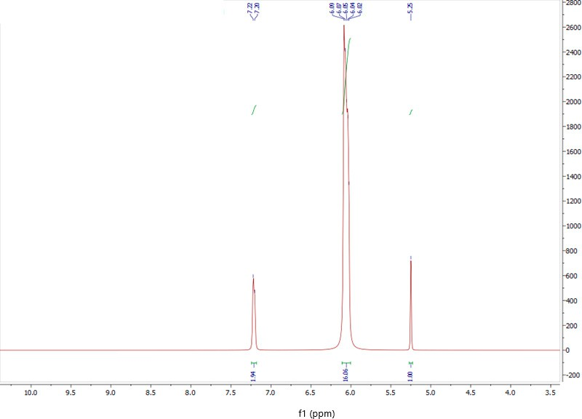
Figure 1. 1H NMR spectrum of the obtained GU-ME complex.
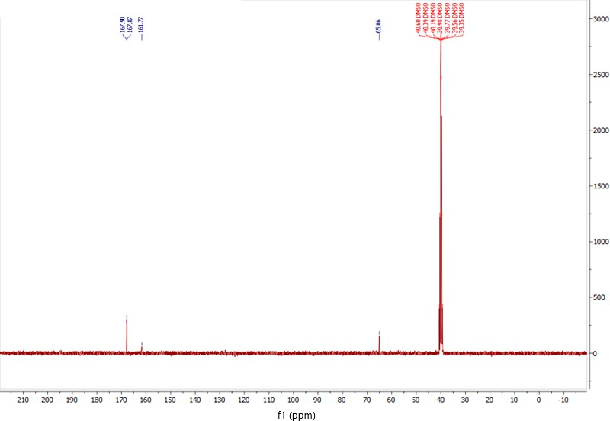
Figure 2. 13C NMR spectrum of the obtained GU-ME complex.
When examining the IR spectrum of the resulting GU-ME complex (Figure 3) and comparing it with the spectra of glycoluril and melamine, specific absorption bands are identified. These bands include those that are characteristic of glycoluril (C-H stretching vibrations at 3071 cm−1, N-H bending vibrations at 1757 cm−1, and C=O stretching vi- brations at 1679 cm−1) and melamine (NH₂ stretching vibrations at 3470 and 3418 cm−1). Additionally, there is a noticeable decrease in the intensity of the absorption bands for the

carbonyl group of glycoluril and the amino groups of melamine, which is likely associated with the formation of the glycoluril–melamine complex.
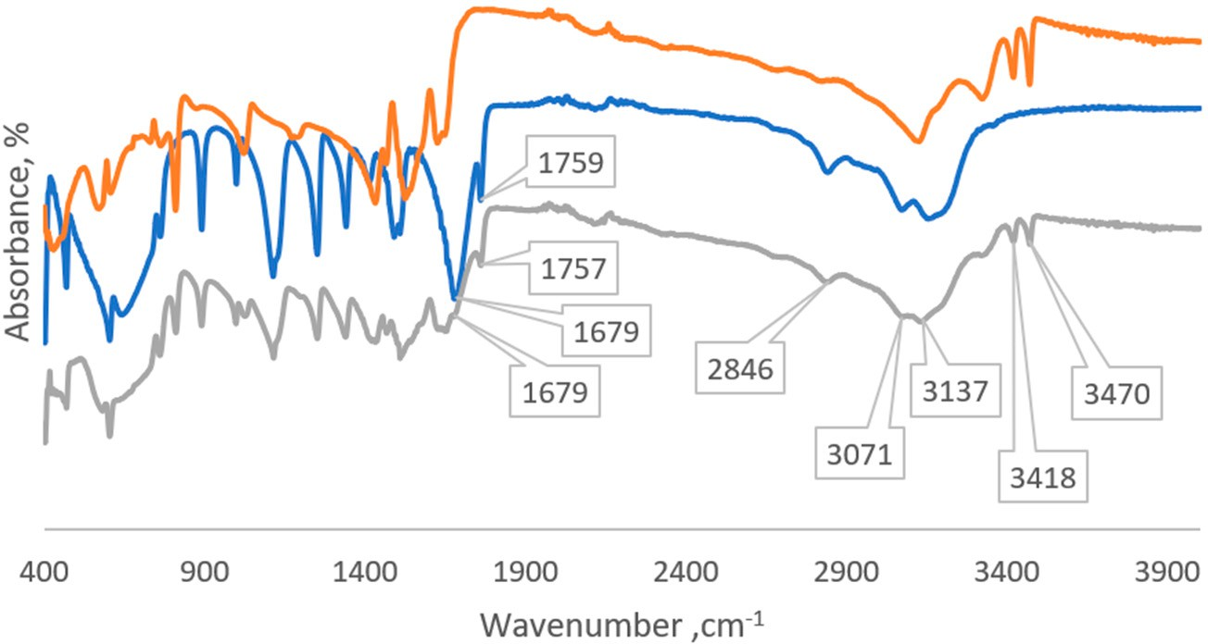
Figure 3. Comparative IR spectra of melamine (orange line), glycoluril (blue line), and GU-ME complex (grey line).
The formation of the GU-ME complex does not follow a stoichiometric process. The combination of the aforementioned facts suggests that melamine molecules coordinate not only with glycoluril but also with each other in a similar manner [24]. Based on this, a scheme for obtaining the GU-ME complex is proposed (Figure 4). These findings are supported by the literature data [24], which include examples of the formation of glycoluril– melamine complexes in varying ratios (1 mole of glycoluril to 2–4 moles of melamine).
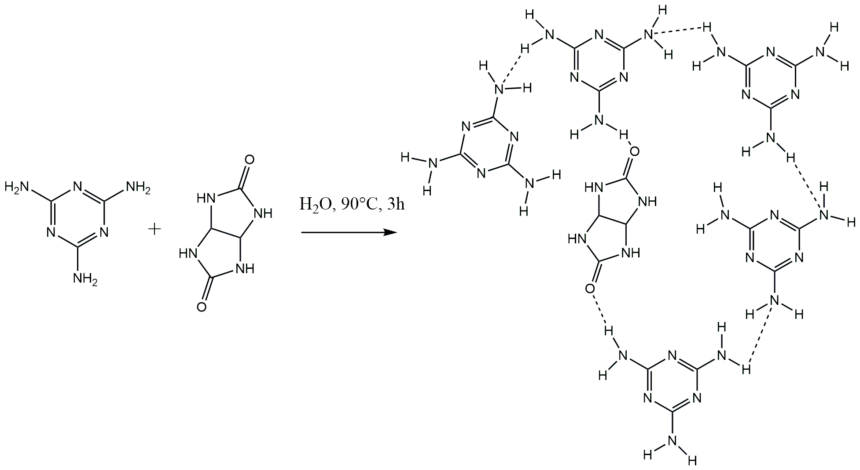
Figure 4. Scheme for synthesizing the GU-ME complex.
In the next phase of the work, the synthesis of the polymer (GUMEFA) from the GU- ME complex was conducted, varying the concentration of the plasticizer or without using a plasticizer. It was found that the concentration of acids plays a key role in the plasticization time of the polymer. For instance, using HEDP and concentrated hydrochloric acid resulted in plasticization within about 5 min, whereas using dilute solutions extended the process up to a day. In the experiment without a plasticizer, complete plasticization of the polymer occurred within three days. The resulting polymer samples were ground in a laboratory

mill to an average particle size of about 150–200 microns. GPC analysis of the resulting GUMEFA was performed to determine the average molecular weight of the polymer. This involved extracting the GUMEFA polymer with chloroform at room temperature. It was determined that the polymer consists of a high-molecular-weight fraction (Figure 5), with an average molecular weight ranging from 3.3 × 104 to 4.4 × 104 g/mol. The obtained polymer product was also tested for degradation at high temperatures. It was found out that GUMEFA does not have thermoplastic properties, and degradation occurs at temperatures of 345–360 ◦C.
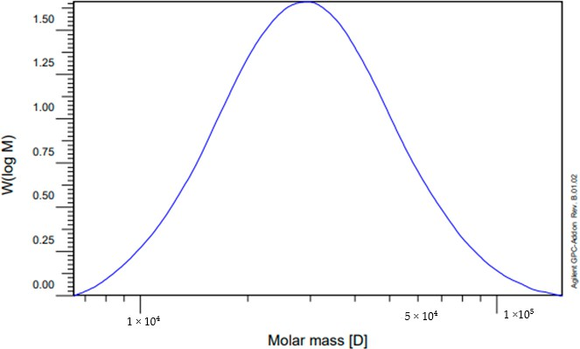
Figure 5. GPC analysis of GUMEFA, high-molecular-weight fraction.
In the IR spectrum of GUMEFA, both glycoluril- and melamine-related fragments are evident. The IR spectrum (crystal, cm−1) shows the following peaks: 3271 (NH stretching vibrations), 2953 (CH₂ stretching vibrations), 1700 (C=O stretching vibrations), 1549 (C=N stretching vibrations), 1488 (C=N stretching vibrations), 1356 (C-N stretching vibrations), 1191 (>NH stretching vibrations), and 812 (NH bending vibrations) (Figure 6).
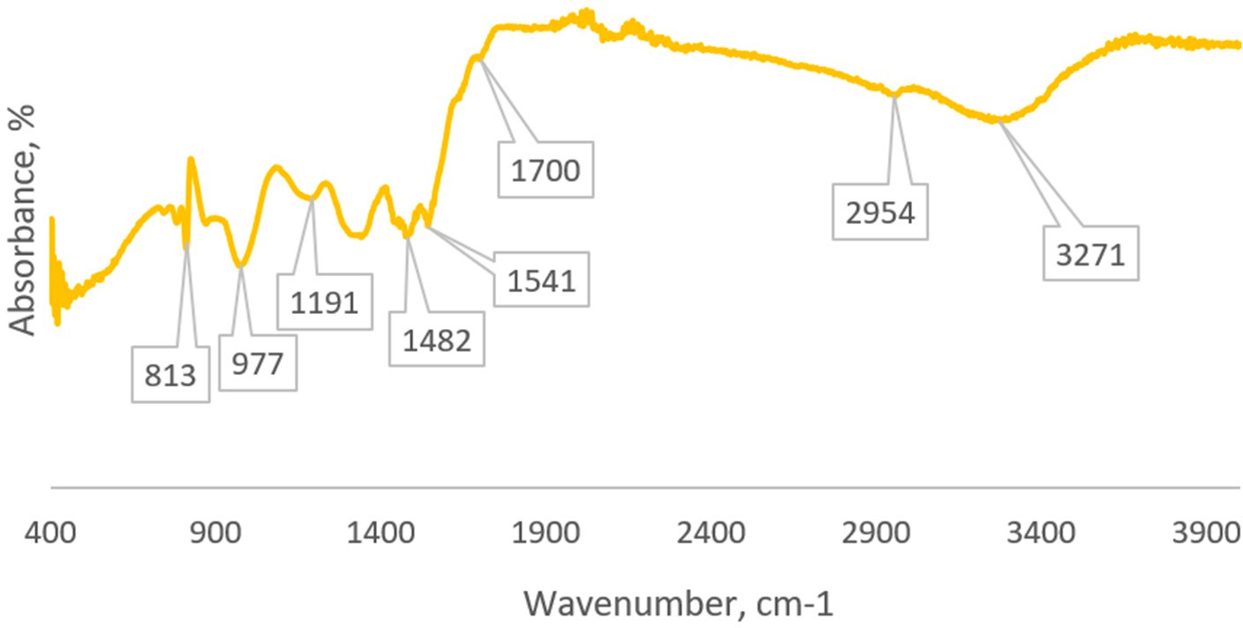
Figure 6. IR spectrum of GUMEFA.
Based on the above information, we propose the following reaction mechanism: When glycoluryl reacts with formaldehyde in the presence of HEDP, methylol groups are formed through the Mannich reaction, as described in [29]. In the subsequent stage, these methylol groups react with melamine to create methylene bridges. Additionally, if the reaction between glycoluryl and melamine does not take place, free methylol groups are gener-

ated in both glycoluryl and melamine (Figure 7, product A), which can later eliminate formaldehyde under environmental conditions [30].
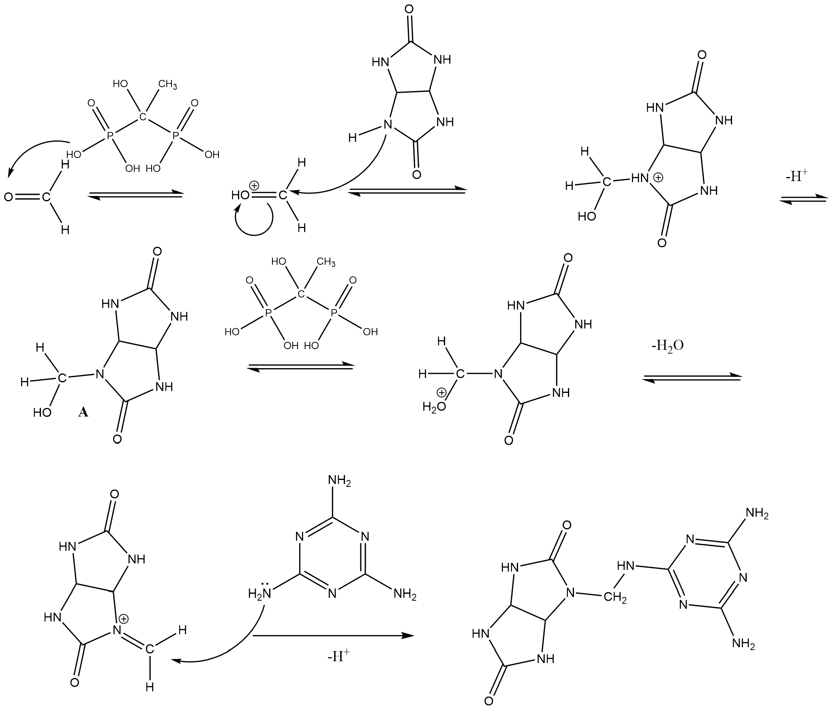

Figure 7. Reaction mechanism for the formation of the GUMEFA polymer under the influence of HEDP.
Additionally, melamine can cross-link with itself through a similar mechanism, re- sulting in a branched melamine–melamine structure (Figure 8). From this, a polymer structure has been proposed (Figure 8). According to the proposed reaction mechanism, methylol groups form in glycoluryl (Figure 6, compound A), which may gradually release formaldehyde over time [21].
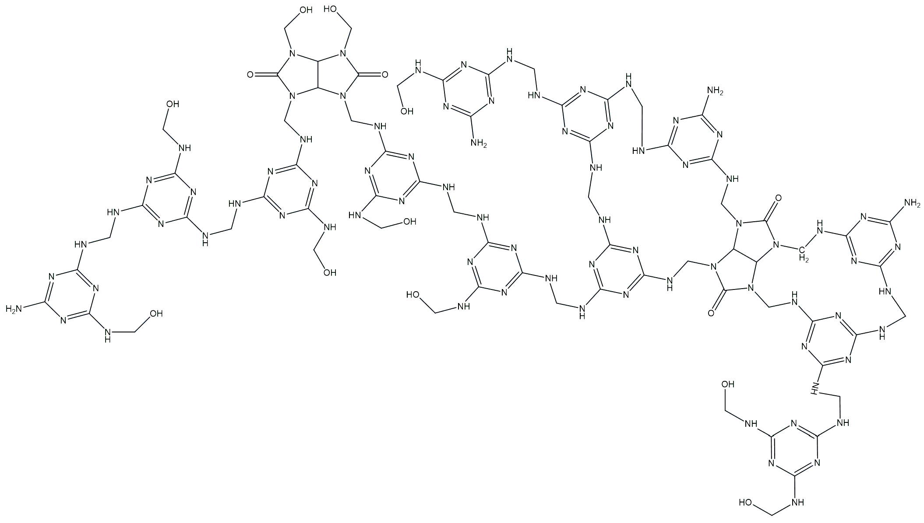
Figure 8. Proposed structure of the resulting GUMEFA.

It is known that glycoluryl readily forms tetramethylolglycoluril [31], and similarly, melamine forms trimethylolmelamine [30]. This results in competitive interactions be- tween melamine and formaldehyde in the reaction mixture (Figure 9). These reactions occur simultaneously and in parallel, leading to the development of a network structure in GUMEFA.
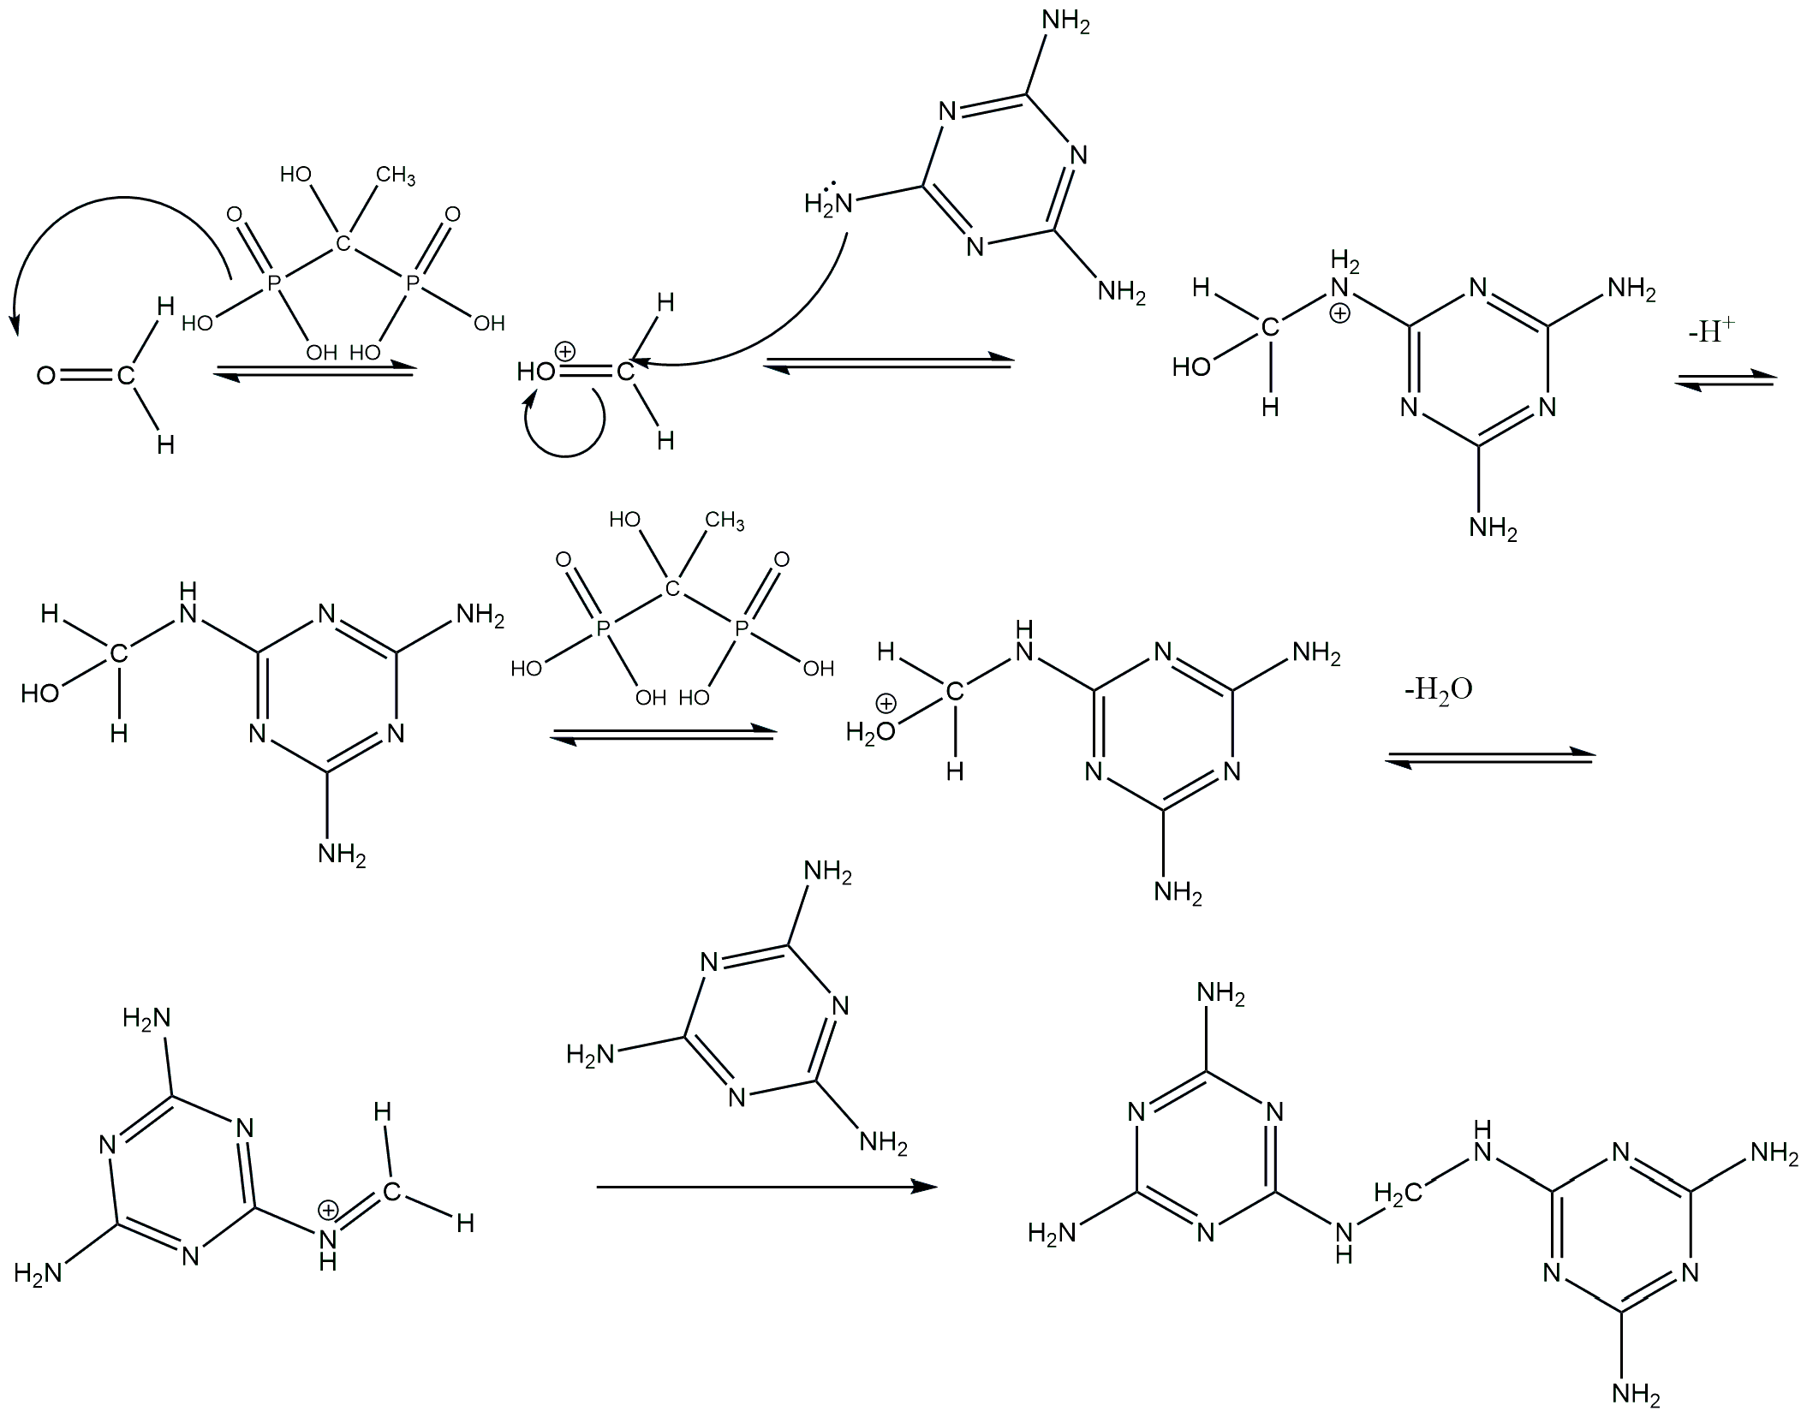
Figure 9. Reaction mechanism for the formation of melamine fragments in the GUMEFA polymer under the influence of HEDP.
Next, the free formaldehyde content in GUMEFA was analyzed using spectrophoto- metric and fluorimetric methods. The study revealed that the highest formaldehyde content was present in the sample produced without a plasticizer. This observation is attributed to the fact that in the absence of a plasticizer, polymerization is prolonged, allowing unbound formaldehyde to remain within the polymer without being incorporated into the structure.
In the analysis of GUMEFA produced with the plasticizer HCl, it was observed that as the acid concentration increases, the amount of free formaldehyde also rises (Table 1) by
0.14 wt.%, according to the spectrophotometric method, and by 0.12 wt.%, according to the fluorimetric method. This is explained by the fact that higher concentrations of HCl accelerate the polymerization rate, causing formaldehyde to be trapped within the polymer structure without being incorporated into it.
In the study of GUMEFA with the plasticizer HEDP, a similar trend was observed: the formaldehyde content in the polymer was higher when using crystalline HEDP compared to its solution. However, the difference between the HEDP solution and crystalline HEDP is minimal, at 0.02 wt.%. This slight variation is attributed to the selective interaction of the plasticizer with glycoluryl in the GU-ME complex.
In the next stage, both the methylol groups and formaldehyde were determined together using reverse iodometric titration. For this experiment, the GUMEFA was ground into a powder and placed in a chemical beaker. Distilled water was then added, and the mixture was maintained at 60 ◦C for one hour. The resulting solution was subsequently
analyzed using reverse iodometric titration. The results of the titration are presented in Table 2.
According to the data in Table 2, the highest content of formaldehyde and methylol groups by weight is found in the polymer where hydrochloric acid was used as the plasti- cizer. This is because HCl is a much stronger acid than HEDP, leading to a rapid reaction of formaldehyde and the formation of methylol groups. The reaction rate varies with the

acid concentration: it is faster with concentrated HCl and slower with diluted HCl. As the reaction with formaldehyde proceeds more quickly, methylol groups form more rapidly (Figure 6, substance A).
Table 1. Formaldehyde content in samples obtained using spectrophotometric (SP) and fluorimetric methods (FL).

Sample | Plasticizer | Method | Xavg, %
Sample 1 | HCl conc. | SP | 1.29
Sample 1 | HCl conc. | FL | 1.40
Sample 2 | HEDP cr. | SP | 1.26
Sample 2 | HEDP cr. | FL | 1.34
Sample 3 | HCl dil. | SP | 1.15
Sample 3 | HCl dil. | FL | 1.28
Sample 4 | HEDP sol. | SP | 1.24
Sample 4 | HEDP sol. | FL | 1.22
Sample 5 | Without plasticizer | SP | 1.53
Sample 5 | Without plasticizer | FL | 1.62

Table 2. Results of determination of methylol groups and formaldehyde using reverse iodometric titration.

Plasticizer | Content of Methylol Groups and Formaldehyde, %
HCl conc. | 24.7
HEDP cr. | 2.9
HCl dil. | 15.5
HEDP sol. | 1.7
Without plasticizer | 2.7

The low levels of formaldehyde along with methylol groups suggest that in the absence of acid, the plasticization process takes significantly longer. The methylol groups formed in this scenario quickly react with melamine to create a network structure. Additionally, the extended plasticization time in the air allows for the desorption of unreacted formaldehyde from the surface of GUMEFA. These observations are supported by the spectrophotometric and fluorimetric measurements of formaldehyde in the polymers (Table 2). The highest formaldehyde content is found in GUMEFA produced without a plasticizer. In contrast, for GUMEFA samples made with HEDP, the formaldehyde content remains almost unchanged and falls within the margin of error (0.02 wt.% with the SF method, Table 2).

Conclusions
In this study, a glycoluryl and melamine complex (GU-ME) at a 1:5 ratio was synthe- sized and characterized using IR and NMR spectroscopy. In the next phase, this complex was polycondensed into the polymer GUMEFA using HEDP as a “green” plasticizer, and its formation chemistry was proposed. The resulting GUMEFA was analyzed for its free formaldehyde and methylol group contents. It was found that GUMEFA produced with HEDP contained lower amounts of free formaldehyde (1.15–1.34 wt.%) and methylol groups (1.56–0.54 wt.%) compared with the resin plasticized with HCl. These results indi- cate that using HEDP as a plasticizer reduces the free formaldehyde levels and broadens the potential applications of the resulting GUMEFA. The study enhances the understanding of the plasticization process for glycoluril–melamine resins and allows for the optimization of the production process to minimize free formaldehyde, thereby increasing the range

of possible applications. Additionally, the findings will assist in developing resins with various compositions and purposes, paving the way for creating composite materials with desired properties.

Author Contributions: Conceptualization, A.U. and A.G.; methodology, A.B. and R.Y.; validation, S.S., M.A.I. and R.Y.; formal analysis, T.M. and A.K.; investigation, N.K.; resources, S.S. and M.A.I.; data curation, T.M. and A.K.; writing—original draft preparation, N.K. and A.U.; writing—review and editing, N.K.; visualization, R.R.; supervision, V.S.M.; funding acquisition, R.R. All authors have read and agreed to the published version of the manuscript.
Funding: This research received no external funding.
Institutional Review Board Statement: Not applicable.
Data Availability Statement: The original contributions presented in this study are included in this article. Further inquiries can be directed to the corresponding authors.
Conflicts of Interest: The authors declare no conflicts of interest.

References
- Hollande, L.; Marcolino, I.D.; Balaguer, P.; Domenek, S.; Gross, R.A.; Allais, F. Preparation of Renewable Epoxy-Amine Resins With Tunable Thermo-Mechanical Properties, Wettability and Degradation Abilities From Lignocellulose- and Plant Oils-Derived Components. Front. Chem. 2019, 7, 159. [CrossRef] [PubMed]
- Solt, P.; Konnerth, J.; Gindl-Altmutter, W.; Kantner, W.; Moser, J.; Mitter, R.; van Herwijnen, H.W.G. Technological Performance of Formaldehyde-Free Adhesive Alternatives for Particleboard Industry. Int. J. Adhes. 2019, 94, 99–131. [CrossRef]
- Réh, R.; Igaz, R.; Krišt’ák, L’.; Ružiak, I.; Gajtanska, M.; Božíková, M.; Kucˇerka, M. Functionality of Beech Bark in Adhesive Mixtures Used in Plywood and Its Effect on the Stability Associated with Material Systems. Materials 2019, 12, 1298. [CrossRef] [PubMed]
- Zhang, H.; Zhang, J.; Song, S.; Wu, G.; Pu, J. Modified Nanocrystalline Cellulose from Two Kinds of Modifiers Used for Improving Formaldehyde Emission and Bonding Strength of Urea-Formaldehyde Resin Adhesive. BioRes 2011, 6, 4430–4438. [CrossRef]
- Kawalerczyk, J.; Siuda, J.; Mirski, R.; Dziurka, D. Hemp Flour as a Formaldehyde Scavenger for Melamine-Urea-Formaldehyde Adhesive in Plywood Production. BioRes 2020, 15, 4052–4064. [CrossRef]
- Brown, D.; Sherdron, G.; Kern, W. A Practical Guide to the Synthesis and Study of Polymer Properties; Chemistry: Moscow,
Russia, 1976.
- Malkov, V.S.; Perminova, D.A.; Knyazeva, S.L. Method of Producing Urea Formaldehyde Resin. RU 2541522C1, 20 February 2015.
- No, B.Y.; Kim, M.G. Syntheses and Properties of Low-Level Melamine-Modified Urea–Melamine–Formaldehyde Resins. J. Appl. Polym. Sci. 2004, 93, 2559–2569. [CrossRef]
- Antunes, A.; Paiva, N.; Ferra, J.; Martins, J.; Carvalho, L.; Barros-Timmons, A.; Magalhães, F.D. Highly Flexible Glycol-Urea- Formaldehyde Resins. Eur. Polym. J. 2018, 105, 167–176. [CrossRef]
- Perminova, D.A.; Malkov, V.S.; Guschin, V.; Eisenreich, N. Influence of Glyoxal on Curing of Urea-Formaldehyde Resins. Int. J. Adhes. Adhes. 2019, 92, 1–6. [CrossRef]
- Yan, S.; Wang, Y. 4(0,0-Diethyl Phosphoryl)Glycoluril Flame Retardant Composition and Application Method Thereof. CN104151795A, 19 November 2014.
- Liu, Y.; Li, S.; Chen, Y.; Li, M.; Chen, Z.; Hu, T.; Shi, L.; Pudukudy, M.; Shan, S.; Zhi, Y. Urea/Amide-Functionalized Melamine- Based Organic Polymers as Efficient Heterogeneous Catalysts for CO₂ Cycloaddition. Chem. Eng. J. 2023, 474, 145918. [CrossRef]
- Lan, P.; Yang, R.; Mao, H.; Cui, J.; Brosse, N. Production of Melamine Formaldehyde Resins Used in Impregnation by Incorporation of Ethylene Glycol and Caprolactam with High Flexibility, Storage Stability, and Low Formaldehyde Content. BioResources 2019, 14, 9916–9927. [CrossRef]
- Dai, F. 10—Understanding Residual Stresses in Thick Polymer Composite Laminates. In Residual Stresses in Composite Materials (Second Edition); Shokrieh, M.M., Ed.; Woodhead Publishing Series in Composites Science and Engineering; Woodhead Publishing: Cambridge, UK, 2021; pp. 313–349. [CrossRef]
- Chrobak, J.; Iłowska, J.; Chrobok, A. Formaldehyde-Free Resins for the Wood-Based Panel Industry: Alternatives to Formaldehyde and Novel Hardeners. Molecules 2022, 27, 4862. [CrossRef] [PubMed]
- Roffael, E. Emission of Formaldehyde from Particle Boards; Ecology: Moscow, Russia, 1991.
- Mohammadi, Z.; Rahsepar, M. The Use of Green Bistorta Officinalis Extract for Effective Inhibition of Corrosion and Scale Formation Problems in Cooling Water System. J. Alloy. Compd. 2019, 770, 669–678. [CrossRef]
- Pansuriya, A.M.; Savant, M.M.; Bhuva, C.V.; Singh, J.; Naliapara, Y.T. One-pot Synthesis of 5-Carboxanilide-Dihydropyrimidinones Using Etidronic Acid. Arkivoc 2009, 7, 79–85. [CrossRef]
- Savant, M.M.; Pansuriya, A.M.; Bhuva, C.V.; Kapuriya, N.P.; Naliapara, Y.T. Etidronic Acid: A New and Efficient Catalyst for the Synthesis of Novel 5-Nitro-3,4-Dihydropyrimidin-2(1H)-Ones. Catal. Lett. 2009, 132, 281–284. [CrossRef]

- Panshina, S.Y.; Bakibaev, A.A.; Gusliakov, A.N.; Malkov, V.S. Synthesis of Cucurbit[6]uril Using 1-Hydroxyethylidene-1,1- Diphosphonic Acid as a “Green Catalyst”. Bull. Univ. Karaganda-Chem. 2022, 4, 5–13. [CrossRef]
- Panshina, S.Y.; Ponomarenko, O.V.; Bakibaev, A.A.; Sidelnikov, V.S.; Kurgachev, D.A.; Malkov, V.S.; Khlebnikov, A.I.; Tashenov,
A.K. A Study of Products of Tetrakis(Hydroxymethyl)Glycoluril Dehydroxymethylation in Aqueous Solutions. Russ. Chem. Bull
2021, 70, 140–147. [CrossRef]
- Bakibaev, A.A.; Uhov, A.; Malkov, V.S.; Yu. Panshina, S. Synthesis of Glycolurils and Hydantoins by Reaction of Urea and 1, 2-Dicarbonyl Compounds Using Etidronic Acid as a “Green Catalyst”. J. Heterocycl. Chem. 2020, 57, 4262–4270. [CrossRef]
- Panshina, S.Y.; Ponomarenko, O.V.; Bakibaev, A.A.; Malkov, V.S. New Synthesis of 2,4,6,8-Tetramethyl-2,4,6,8-Tetraazabicyclo[3.3.0]- Octane-3,7-Dione Using Etidronic Acid as a “Green” Catalyst. Russ. J. Org. Chem. 2020, 56, 2067–2073. [CrossRef]
- Rottmaier, L.; Merten, R. Glycoluril Salts and a Process for the Preparation Thereof. US4433144A, 21 February 1984. Available online: https://patents.google.com/patent/US4433144A/en (accessed on 22 July 2024).
- Bakibaev, A.A.; Ukhov, A.E.; Guslyakov, A.N.; Gubankov, A.A.; Malkov, V.S.; Knyazev, A.S. Polymer Based on Glycoluril and Melamine and Method for its Production. RU 2822105C1, 1 July 2024.
- Parunov, I.V. Aminoplastic Resin. RU 2696859C1, 7 August 2019.
- Kalinina, L.S. Analysis of Condensation Polymers; Chemistry: Moscow, Russia, 1984.
- ISO 16000-3:2022; Part 3: Determination of Formaldehyde and Other Carbonyl Compounds in Indoor and Test Chamber Air-Active Sampling Method. ISO: Geneva, Switzerland, 2023.
- Kabieva, S.K.; Zhumanazarova, G.M.; Kanasheva, N.; Bakibaev, A.A.; Panshina, S.Y.; Malkov, V.S.; Mamaeva, E.A.; Knyazev, A.S. Methods of Synthesizing Glycoluril-Based Macrocyclic Compounds as Precursors for Polymeric Compounds. J. Saudi Chem. Soc. 2023, 27, 101768. [CrossRef]
- Duliban, J.; Galina, H.; Lubczak, J. 1H NMR Study of (Hydroxymethyl)Melamine Rearrangement in DMSO Solutions. Appl.
Spectrosc. 1996, 50, 528–532. [CrossRef]
- Li, X.; Miao, L.; Yang, W.; Zheng, J.; Xiong, Y. Method of Increasing Hydroxymethyl Content of Hexahydroxymethyl Melamine. CN104592138A, 6 May 2015.

Disclaimer/Publisher’s Note: The statements, opinions and data contained in all publications are solely those of the individual author(s) and contributor(s) and not of MDPI and/or the editor(s). MDPI and/or the editor(s) disclaim responsibility for any injury to people or property resulting from any ideas, methods, instructions or products referred to in the content.

