Al-Farabi Kazakh National University

UDC 004.8(043) | as manuscript

IBRAYEVA ARMAN SAYATQYZY

Synthesys of Leg Mechanism and Optimal Design of Walking Robot with Decoupled Motion

8D07117 – Robotic systems

Thesis for the degree of Doctor of Philosophy (PhD)

Local supervisor: Jamalov Nutpulla,
candidate of technical sciences,
assoc. prof.
Foreign supervisor: Sarosh Patel,
PhD, assoc. prof.

Republic of Kazakhstan
Almaty, 2023
CONTENTS

NORMATIVE REFERENCES ……………………………………………… |  | 4
INTRODUCTION ………………………………………………………….. |  | 5
1 | AN EXAMINATION OF RECENT GLOBAL TRENDS IN WALKING ROBOT DEVELOPMENT AND PROSPECTIVE AVENUES FOR ADVANCEMENT ………………………………… | 10
1.1 | Leading teams abroad …………………………………………….. | 10
1.2 | Comparative analysis of the main ideas in the design of walking robots.. | 12
1.3 | Study of trajectory propulsors ……………………………………......... | 16
1.4 | Developments of Kazakh scientists: the most promising areas of research …………………………………………………………………. | 17
 | Conclusions on Section 1 ……………………………………………….. | 19
2 | KINEMATIC SCHEME OF A WALKING ROBOT WITH DECOUPLING OF MOVEMENTS BY DEGREES OF FREEDOM AND SEPARATION OF MOTOR FUNCTIONS ………………….. | 20
2.1 | Decoupling of movements and separation of functions of the walking robot motors. …………………………………………………………… | 20
2.2 | Substantiation of WR structure …………………………………………. | 24
 | Conclusions on the Section 2 …………………………………………… | 29
3 | DEVELOPMENT OF METHODS FOR ANALYSIS, STRUCTURAL-PARAMETRIC SYNTHESIS AND OPTIMAL DESIGN OF LEG MECHANISMS …………………………………. | 31
3.1 | Description of six link leg mechanism structure ……………………. | 32
3.2 | Approximate Synthesis of the Path Generator by Minimizing Directly the Output Accuracy …………………………………………………… | 34
3.2.1 | Analytical Synthesis by four Parameters ……………………………… | 34
3.3 | Testing the results ……………………………………………………… | 37
3.4 | Functionality Study of the Chebyshev Mechanism ……………………. | 41
3.5 | Optimal Leg Design ……………………………………………………. | 46
 | Conclusions on Section 3 ………………………………………………. | 54
4 | OPTIMIZATION OF THE METRIC PARAMETERS OF THE WR …………………………………………………………………….. | 55
4.1 | Derivation of the Isotropy Criterion …………………………………… | 56
4.2 | Study of the Isotropy Conditions ………………………………………. | 65
 | Conclusions on Section 4 ………………………………………………. | 74
5 | AWR PROTOTYPE DESIGN AND EXPERIMENTAL VALIDATION ……………………………………………………..…. | 77
 | Conclusions on Section 5 ………………………………………………. | 88
CONCLUSIONS …………………………………………………………….. |  | 89
LITERATURE ……………………………………………………………….. |  | 90
APPENDIX A – Fragments of Truncated Tables .............................................. |  | 96

NORMATIVE REFERENCES

The following references to standards are used in the thesis:
State Educational Standard of the Republic of Kazakhstan 5.04.034-2011: compulsory state education standard of the Republic of Kazakhstan. Postgraduate education. Doctoral studies. Basic provisions (amendments dated August 23, 2012 No. 1080);
GOST 7.32-2001. Structure and rules for preparing a report on research work.;
GOST 7.1-2003. Bibliographic record. Bibliographic description. General requirements and rules of compilation.

INTRODUCTION

The proven advantages of walking mobility for traversing complex terrain have significantly fueled interest in walking-based movers [1,2]. A walking robot can “step over” obstacles, which further increases its permeability. Thus, the use of a walking method of movement becomes indispensable for working in areas of destruction. In addition to high maneuverability and adaptability—the ability to move the vehicle body smoothly despite uneven terrain—another inherent advantage of walking robots lies in the unique nature of the interaction between their supporting limbs and the load-bearing surface. This includes the capability to traverse areas with weak soil bearing capacity. Unlike a wheels or tracks, the legs of a walking robot experience minimal resistance from the environment when moving, which reduces slipping and often eliminates the wheelspin.
Increased interest in walking robots can be observed in connection with the rapid growth of agricultural robots, since walking robots cause minimal damage to the load-bearing surface. Thanks to their discrete track, as opposed to a continuous one, soil erosion is significantly reduced, and the risk of ravine formation is virtually eliminated, highlighting the positive environmental properties of walking movers. Furthermore, the walking principle of movement minimizes ground pressure, significantly lower than that of tracked or wheeled vehicles [3,4].
As walking robots (WRs) evolve beyond the stage of laboratory models, it comes important to develop new design principles based on the requirements of optimality across various criteria. Main areas of focus include the problem of power consumption and power autonomy, speed and cost-effectiveness of the control systems, optimal technical parameters for control and traffic safety. Effectively addressing these challenges will pave the way for broader applications, enabling efficient movement over rough terrain and the execution of technological tasks in remote, hard-to-reach, or hazardous environments.
The research into walking vehicles, particularly in the context of robotics and automated systems, can be traced back to several key developments and works over the past few decades. One of the earliest examples of a walking vehicle was the "Walking truck" or "Cybernetic Anthropomorphous Machine," developed by General Electric in the 1960s. This quadrupedal machine, designed by Ralph Mosher, was an experimental project funded by the U.S. Army [5]. Another early example was the "Runabout," developed by Ichiro Kato at Waseda University in Japan. This was part of the Waseda Bipedal Humanoid projects, which began in the late 1960s and continued into the 1970s [6]. Research in bipedal robots, which are a subset of walking vehicles, saw significant growth during the 1980s and 1990s. Universities and corporations, particularly in Japan, made notable advancements. Honda's work on prototypes that eventually led to ASIMO (first revealed in 2000) is a prime example [7].
The most famous project of Marc Raibert and his group, the BigDog project [8], was developed as an auxiliary robotic transport for the ground forces and was funded through DARPA. The analysis shows that leading technologically developed countries have made significant progress in the development of military robotic systems capable of conducting combat operations without human intervention with a high degree of autonomy [9]. In the near future, robotic systems for various purposes will confidently take their place in the ground, sea and even space spheres of military operations. The robot is capable of moving over rugged terrain, carrying up to 150 kg of cargo at speeds of up to 7 km/h and overcoming a slope of up to 35 degrees.
Another project of the same company, the four-legged robot Cheetah, capable of reaching speeds of up to 45 km/h, was also developed with financial support from DARPA under the Maximum Mobility and Manipulation program. Cheetah has a flexible "back" that helps achieve high speed of movement.
The Russian “analogue” of a walking robot of this type is the military robot “Lynx” BPMBR400. The developer is the Kovrovsky All-Russian Scientific Research Institute “Signal” (Kovrov, Russia), conducting developments within the framework of R&D Lynx-BP [10] (Katalog nazemnyx). It is planned to produce in various modifications, depending on the functional purpose - reconnaissance equipment, means of destroying explosive devices, a platform for transporting ammunition and ammunition, means of evacuating the dead and wounded from the battlefield, means of reconnaissance of mine-explosive barriers, weapons for fire support of units, delivery of equipment [11-13]. (More detailed specifications from the technical specifications can be found on the website.
However, existing approaches are based on active coordination of motor operation and feature complex hierarchical control system (4 17-19). In addition, engines operate in intensive acceleration and deceleration modes and, leading to unreasonably low efficiency [14, 15]. However, by placing the issues of efficiency, simplicity, and availability of technical means at the forefront, the irrationality of universal designs becomes beyond doubt. The structural solution of most WRs is also rendered irrational due to structural redundancy and multiple static uncertainties. In such systems, the number of active drives often exceeds the number of degrees of freedom. For instance, anthropomorphic WRs, which aim to replicate human bipedal walking and running, utilize a dynamic gait but are quite costly despite achieving remarkable results (e.g., bipedal WRs like the Atlas type [16, 17]. This observation is equally applicable to quadrupedal [18-20] and hexapodal structural schemes, which are characterized by the complexity of their multi-level control systems, significant energy expenditure to support body weight, and the reversible operating modes of engines.
An alternative to “biomorphic” designs is the use of orthogonal propulsion schemes. This separation of engines is important from the point of view of increasing efficiency and simplifying the control system. The weight load from the body falls only on the adaptation motor locking devices. However, the disadvantage of such propulsors is the use of reciprocating drives and the presence of significant lateral loads in translational pairs. The use of rectilinear guide mechanisms makes it possible to achieve kinematic decoupling of movement and separation of engine functions, when the main engine is responsible for the rectilinear translational motion of the body, another group of drives is responsible for adaptation to uneven terrain, and a third group is responsible for turning and maneuvering. Pantograph-type copying mechanisms are considered promising [18; 19] which make it possible to quite simply adjust the height of trajectories and provide a linear transmission ratio between the input and output generalized coordinates. This is how, for example, the walking robot “with adaptive suspension” Adaptive Suspension Vehicle by Professor K. Waldron and others was built. The disadvantages of such designs include significant force effects on the driving parts, the use of translational pairs loaded with lateral load.
Thus, the search for alternatives to traditional principles for designing mobile robots based on a walking platform is an urgent problem. At the same time, most existing walking robots with six (Hexapod) and four (Quadruped) supporting limbs are of the anthropomorphic type and are characterized by a complex multi-level control system, high energy consumption and low rigidity. The use of rectilinear guide mechanisms in the Support-Lochomotion Mechanism (SLM) can significantly improve these indicators, however, it is necessary to optimize the geometric parameters based on the isotropy criterion. Based on the above, the problem of optimal design of a walking vehicle and its propulsion remains relevant from the point of view of minimizing energy consumption and simplifying control (and, as a consequence, increasing the speed of the control system).
- Purpose of the work: development of synthesis methods for WR mechanisms and optimization of the robot parameters based on functional decomposition, which will simplify the control system and enable efficient traversal of rough terrain with minimal energy consumption.
- Object of study: highly traversable walking robot;
- Subject of research: optimal structural-parametric synthesis of the kinematic scheme of a walking robot;
- Research methods: robot design methods, analytical and numerical methods for optimization synthesis of machine mechanics;
- Theoretical and practical significance of the study: optimization of the structural and kinematic parameters of a walking robot, development of a methodology and determination of the optimal structure and parameters of a walking robot;
According to the research plan, the research work consists of several tasks, each of which focused on certain applied and theoretical aspects of the study.
- Review and survey of research in the field of walking robots and analysis of the main types of propulsors
- Synthesis of a walking robot based on functionally independent structural modules.
- Development of synthesis/analysis methods and PC programs.
- Optimization of leg mechanism parameters.
- Development of a mechanism for adaptation to unevenness of the bearing surface
- Study of turning modes and structural-parametric synthesis of turning and maneuvering mechanisms.
- Development of design documentation
- Development and experimental study of a laboratory model of the WR.
- The novelty of the study lies in the development of methods for the synthesis and optimization of structural and metric parameters of the WR based on the functional separation of engines, which allows
- simplify the coordination of the legs and carry out movement with a minimum number of motors, the lowest energy consumption and the use of the simplest possible controls;
- solve the problem of adapting each foot to surface unevenness individually and independently of the main control unit;
- solve the problem of excessive constraints of existing structures and eliminate parasitic loads on actuators associated with multiple static uncertainties;
- eliminate additional energy costs for feet slippage and reducing the reaction in the joints when turning.
The methods of the synthesis of mechanisms with parallel topology and the methods of approximation synthesis of planar linkages were used.
The reliability and validity of the scientific provisions, conclusions and results of the dissertation are confirmed by the correct formulation of the problem and the use of well-known mathematical methods, methods of theoretical mechanics, methods of studying mechanisms and machines, and methods of numerical research and validated on the experimental prototype.
Connection of the dissertation work with other research works. This dissertation work was carried out under the grant scientific project of the Ministry of Education and Science of the Republic of Kazakhstan for 2020-2023 "Optimal design of an adaptive walking robot with an intelligent control system" (Grant No. AP09259589).
Publications. The author wrote 12 works on the topic of the dissertation, including 1 patent of the Republic of Kazakhstan; 5 publications in scientific journals and proceedings of international conferences included in the Scopus database; 5 publications in the proceedings of domestic and foreign scientific international conferences [21-34].
Personal contribution of the author. The main results of the research carried out in dissertations were obtained by the author independently.
The thesis structure and volume. The thesis contains a Title page, Normative References, a Table of Contents, an Introduction, six Main sections, a Conclusion, Bibliography and Appendixes. The total volume of theses is 97 pages, including illustrations and tables. Section 1 analyzes the global trends of the recent years on WRs, and indentifies promising areas of research; Section 2 introduces kinematic scheme of a WR with decoupled motion and separation of motor functions; Section 3 presents developed methods and algorythms of structural-parametric synthesis across multiple criteria, and the obtained optimal design of the leg mechanism. Section 4 presents studies on the turning/maneuring mechanism and optimization of the metric parameters of the WR on the basis of isotropy criterion. In Section 5, presented is the design of the independent adaptation mechanism to unevenness of surfaces. Section 6 describes the design and development of the physical prototype of the (AWR).

Aknowledgements

I would like to extend my deepest gratitude to my father, Sayat Ibrayev, for his unwavering support and invaluable guidance throughout my academic journey. Special acknowledgment is also reserved for my entire family, whose enduring love and steadfast belief in my potential have been fundamental sources of encouragement and inspiration.
Furthermore, I am immensely grateful to my supervisors, Dr. Jamalov Nutpulla and Dr. Sarosh Patel, for their insightful feedback, and constant encouragement. Their mentorship has significantly shaped my research and academic growth.

AN EXAMINATION OF RECENT GLOBAL TRENDS IN WALKING ROBOT DEVELOPMENT AND PROSPECTIVE AVENUES FOR ADVANCEMENT

1.1 Leading teams abroad
The leading groups in the field of research and development of walking robots are [2; 4; 8]: Boston Dynamics (USA), Ghost Robotics (USA, Philadelphia), Case Western Reserve University Robot Laboratory (USA), Massachusetts Institute of Technology, Institute of Mechanical Engineering named after A.A. Blagonravov RAS (Moscow), Volgograd State Technical University, FSPC "Titan-Barricades", JSC Central Design Bureau "Titan" (Russia), Tokyo Institute of Technology (Dept. Of Mechano-Aerospace Engineering, Japan, Laboratory of Professors Shigeo Hiroze and Edward Fukushima, University of Tokyo (Dept. of Mechano-Informatics, group of Professor Noriaki Takasugi), German Research Center for Artificial Intelligence (Germany, Deutsches Forschungszentrum für Künstliche Intelligenz GmbH, Robotics Innovation Center), Information Technology Research Center FZI (Karlsruhe, Germany), Chinese defense company NORINCO, Shanghai Jiao Tong University (China, Shanghai Jiao Tong University), Institute of Technology and Engineering, Changchun, China, University of Cassino (Italy, group of Professor M. Ceccarelli), Italian Institute of Technology (Genoa, Italy, Advanced Robotics Department). Detailed review material is presented in the monographs of Professor Marco Ceccarelli (University of Cassino, Italy) [4], Professor Kenneth Waldron (Ohio State University), G. Gent (Germany), in a number of specialized issues of the international journal “The International Journal of Robotics Research” (Figure 1.1).
The Chinese military company NORINCO has developed its version of BigDog, which they called Da Gou (Mountainous Bionic Quadruped Robot) [20]. As the name suggests, this “robot mule,” like previous analogues, is also bionic, that is, based on the desire to copy biological principles of movement organization and, accordingly, is very expensive. The same applies to other well-known robots of the quadruped and hexapod type, which have a musculoskeletal mechanism of a “universal” type: the Italian four-legged WR of Professor S. Semini HyQ2max-Robot (Italian Institute of Technology, Genoa) [35], the ultra-modern German robot MANTIS (Multi-limbed walking robot for mobile manipulation in unstructured environments) (Mantis, 2019), “Multi-limbed walking robot for mobile manipulation in unstructured environments”, developed by the German Research Center for Artificial Intelligence, Robotics Innovation Center (Germany) [36] Finnish MECANT and Plustech machines for real transport and technological operations weighing more than one ton [37, 38], the German six-legged WR LAURON V, developed by the Research Center for Information Technologies FZI (Karlsruhe, Germany) and others [39, 40, 41].
However, it should be remembered that existing approaches based on active coordination of motor motion use a complex hierarchical control system [42, 43], and the operation of motors in intensive acceleration and deceleration modes causes unreasonably low efficiency [44-47]. Anthropomorphic walking robots that seek to replicate human bipedal walking and running and use a dynamic gait (statically unstable) are extremely expensive [4] (despite the fantastic results demonstrated by bipedal robots such as Atlas (Boston Dynamics) and others [16].
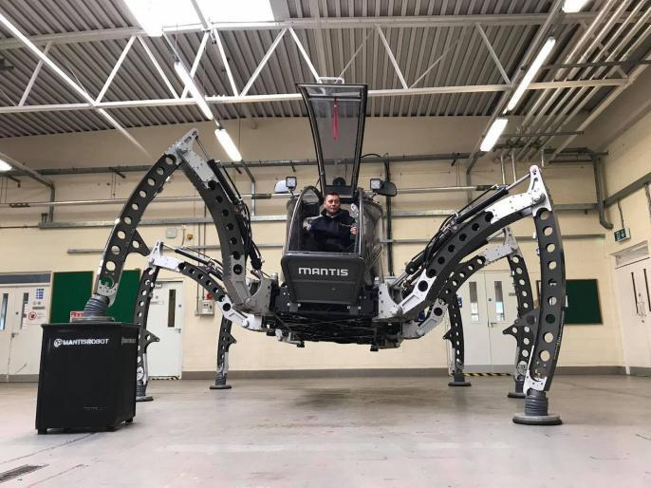
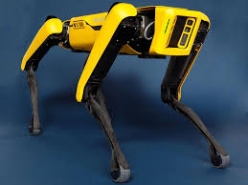
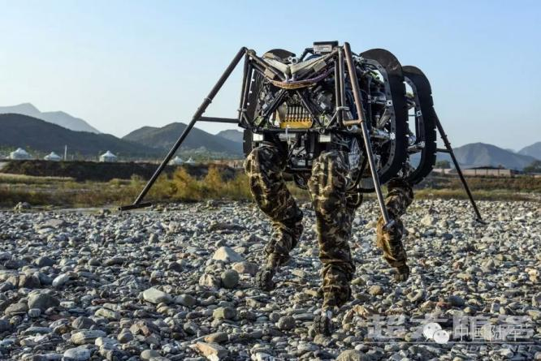
а) b)
c)

a) Spot, Boston Dynamics (USA) (frobotsguide.com); b) – Quadruped robot Da Gou, NORINCO (China) (army-guide.com); c) – Hexapod-robot MANTIS, German Research Center for Artificial Intelligence, Center for Innovation in Robotics (Germany) (laughingsquid.com).

Figure 1.1 – Overview of Advanced Walking Robots

The same largely applies to Quadruped [18;19; 20] and Hexapod [15] structural patterns. Such robots have theoretically unlimited maneuvering capabilities. Therefore, it is most advisable to use them, for example, in destruction zones to move cargo and technological equipment over extremely difficult terrain. However, the complexity of the multi-level control system, high energy consumption to maintain the weight of the hull and reverse operating modes of the engines in such machines impose restrictions on transport speed and payload. The irrationality of the structural solution of most walking robots is also associated with structural redundancy and multiple static uncertainty. The number of active drives in such systems is much greater than the number of degrees of freedom of the system. So, for example, in robots like Hexapod [15] (in which each leg is driven by three actuators), at the “tripod” gaiting, the number of degrees of freedom is six, while the active actuators are 9. (This is taking into account only the “supporting” legs; if all legs are in the support phase, then the number of active drives is 18, and the number of degrees of freedom of the system is 6). As a result, parasitic loads arise in the engines (motors work “against each other”), reactions in the joints increase, foot slipping occurs, etc. Thus, one can observe, on the one hand, the virtuoso abilities of robots in performing complex movements, at the same time, the irrationality of most existing anthropomorphic and biomorphic robot designs from a mechanical point of view.
This state of affairs is explained by the fact that advanced research teams, such as Boston Dynamics and others, pursued the main goal of copying the biological principles of organizing limb movement and demonstrating the “ultimate” capabilities of the robot [42], and the issue of optimal mechanical design remained in the background. The principal outcome of these investigations and comprehensive trials offers a cogent response to the question: to what extent can technical mechanisms execute mobility tasks, and what boundaries exist in the application of bionics principles leveraging modern robotics technologies. However, at this stage, the main trend is the search for alternative concepts to traditional concepts for creating robots, taking into account the requirements of efficiency, simplicity and availability of low-cost technical means [45; 48-51].

1.2 Comparative analysis of the main ideas in the design of walking robots
Modern trends clearly show that it is the rational mechanics of the designed system that largely determines its future operational characteristics, significantly affects the quality of the control system, and allows reducing the cost of the robot. The implementation of the traditional principle, of course, can be justified by the specifics of the functional task being performed. For example, for working in a destruction zone, when the main criterion is a high degree of maneuverability. However, in most cases, the problem can be solved by cheaper, simpler and more reliable means - primarily due to the mechanical part of the robot. Walking robots are not widely used due to the complexity of the propulsion system and low energy efficiency [48; 49; 52,53]. Therefore, one of the main tasks of increasing the operating efficiency of walking robots is to reduce power losses: since for walking robots the power expended to set them in motion, in the general case, is proportional to the cube of the speed, and energy losses, accordingly, to the square. Some methods for solving this problem are also known: by introducing energy recuperators, by abandoning the uniform movement of the center of mass of the robot body while maintaining the average speed, and others.
Therefore, for example, the use of orthogonal-type SLMs makes it possible to achieve kinematic decoupling of movement and separation of engine functions, when the main engine is responsible for the rectilinear translational motion of the body, another group of drives is responsible for adapting to uneven terrain, and the third group is responsible for turning and maneuvering. The implementation of this principle makes it possible to build a significantly cheaper control system, achieve optimal motion characteristics, increase the efficiency of the system and, thus, forms the basis of an alternative principle for designing walking robots in relation to “biomorphic” designs [2; 15; 48; 49; 54].
Providing the required movement characteristics is largely determined by the rational choice of the propulsion system and the corresponding organization of gaits [4; 11 ; 55, 15 ].
Thus, copying or orthogonal propulsors have all the advantages of insectomorphic type propulsors (which are open kinematic chains), at the same time, they have a number of additional advantages. In such propulsors, the main linear translational movement of the machine body is carried out by the main engine, while the weight load from the body is supported exclusively by the engine locking device, thereby achieving what is known as the "gravitational independence" of the main drive for horizontal movement, which leads to elimination of drawbacks of classical designs mentioned above. However, the disadvantage of such propulsors is the use of reciprocating drives, as well as the presence of significant lateral loads in translational pairs. The use of pantograph-type copying mechanisms is considered promising: the advantages of such a scheme are a fairly simple solution for adjusting the height of trajectories, also a linear ratio between the generalized coordinates of the mechanism and the Cartesian coordinates of the reference point. Based on such a mechanism, for example, the legs of the walking robot of the Adaptive Suspension Vehicle (a six-legged model) of the Ohio State University (Figure 1.2), the walking apparatus of Professor Shigeo Hiroze (Tokyo Institute of Technology), etc. are built. However, the disadvantage of such designs are significant force impacts on the driving parts, the use of prismatic pairs loaded with transverse load. Prismatic kinematic pairs can again be eliminated by using using hinged rectilinear guiding mechanisms [4], however, as already indicated, the presence of a similarity coefficient leads to deterioration in positioning accuracy. More preferable, is the approximate Cartesian mechanism proposed by scientists from the IMMash, Ministry of Education and Science of the Republic of Kazakhstan, which is a hinge-lever mechanism (Figure 1.3) (cf. next paragraph).
These factors explain the increased interest in trajectory-type propulsors that provide a given step cycle, and therefore interest in the problems of synthesizing LMSs is being revived [52 ; 56-63]. The significance of the benefits offered by such mechanisms is exemplified by the project of the four-legged robot "The Ghost Minitaur," developed by the Philadelphia startup Ghost Robotics. This project stands out as one of the most successful in terms of maneuverability [64]. Despite the fact that the robot has shown the advantages of the walking method of movement over tracked and wheeled ones, the robot propulsion does not have the ability to adapt to uneven supporting surfaces and therefore does not provide horizontal uniform movement of the body. Thus, the main purpose of the walking mobility is not fulfilled. Therefore, the use of linkages, especially hinged-linkages—generators of rectilinear trajectories (approximate or accurate)—can significantly simplify the leg motion [65-71].

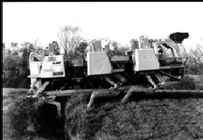
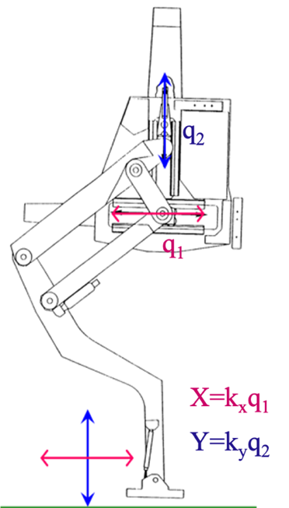

Figure 1.2 – Pantograph Leg Mechanism of Adaptive Suspension Vehicle. Ohio State University, USA, Courtesy of Professor Kenneth Waldron (cyberneticzoo.com)

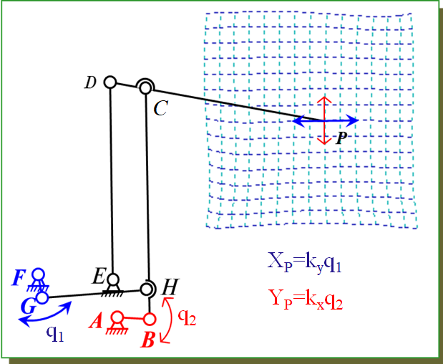

Figure 1.3 – Cartesian 7R robot with the decoupled motion of
end-effector coordinates

Trajectory-type propulsors have advantages over other types of walking propulsors due to lower energy consumption, the absence of motor reversal, a simpler control system, and high speed of movement. The very idea of using rectilinear guiding mechanisms is not new (A.P. Bessonov, N.V. Umnov, K. Hunt, K. Waldron, etc.) (Figure 1.4), however, a number of problems remain unresolved; here we will only point out the main difficulties. Thus, many authors have studied in detail Theo Jansen’s mechanism [48; 65; 66; 68; 69; 70; 71] and attempts have been made to improve its various characteristics from the point of view of use in walking machines. Thus, work [48] describes a method for synthesizing a mechanism based on two criteria, which made it possible to improve the quality and accuracy of reproducing the step cycle of the natural movement of a human leg. Komoda tried to achieve adjustability of the foot trajectory of the Jansen mechanism by changing the position of the fixed axis [50] and also conducted a comparative study of the Chebyshev and Klann mechanisms. Similar studies were also carried out by Nansai, Zang H.B. [52], Wang C.Y. [72] and other researchers, by changing the lengths of binary links, they were able to obtain adaptive mechanisms with two or more degrees of freedom, significantly expanding the possibility of practical use of the prototype - Theo Jansen mechanism. Wang C.Y. created a mathematical model that allows to study the influence of carrier-link lengths on the kinematic and dynamic characteristics of the leg mechanism. However, the range of adjustment of the foot trajectory is quite small compared to the length of the straight section of the trajectory. In the following sections it will be shown that these results can be significantly improved by using approximation synthesis methods: even with the help of simple four-bar linkeges it is possible to achieve a significant range of adaptation.

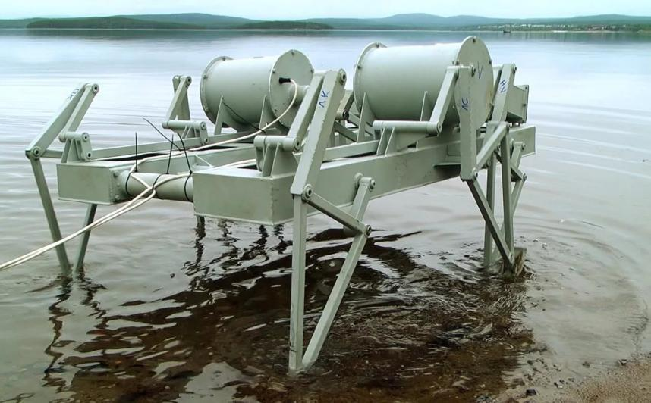

a)
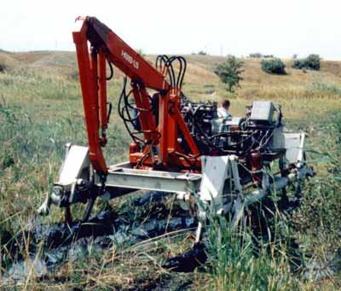
b)
a) Federal Research and Production Center "Titan-Barricades" (based on trajectory-generator), JSC CDB "Titan" (Russia) ; b) Walking machine with a trajectory generator developed by Bauman Moscow State Technical University.

Figure 1.4 – Walking machine with a trajectory generator

1.3 Study of trajectory propulsors
Despite the wide variety of rectilinear guide mechanisms, the requirement for adaptability to uneven terrain makes most of them unsuitable for practical use as propulsors of walking machines. So, the accurate rectilinear-guiding mechanisms of the Poselye-Lipkin and Garth inverters and more complex mechanisms are difficult to adjust. It is possible to implement approximately rectilinear parallel trajectories over a fairly wide range of control on the basis of hinged four-bar linkages (for example, modifications of the Roberts mechanism, etc.). However, all these mechanisms do not ensure the constancy of the analogs of the supporting point velocities along the straight sections of the trajectories over the entire range of variation of the adaptation height (on different rectilinear trajectories, the velocity of the reference point must be the same at the same value of the angular velocity of rotation of the input link). Other hinged four-bar linkages (Watt mechanism and its modifications, Evans mechanisms, related to Watt's mechanism, crane mechanisms, modifications of the Roberts mechanism, etc.) also do not satisfy the mentioned requirements and are two-rockers.
Much attention was paid to crank rectilinear-guiding mechanisms of the "λ-type", but their main disadvantage was that the rectilinear section of the trajectory was internal in relation to the mechanism. Strictly speaking, such mechanisms with an internal transfer region exist and even two solutions are known. However, in the first of them, the crank-and-rocker mechanism, the height of the transfer (non-rectilinear) section is unacceptably low, and the accuracy is poor. Another solution is a double-crank mechanism of the “λ-type”, described by E. Dijksman; however, it less accurately reproduces a straight-line trajectory than crank-and-rocker mechanisms. This is due to the property of the connecting rod curve (in this case, cardioids): any straight line perpendicular to the axis of symmetry of the connecting rod curve intersects it at no more than four points, while in the crank-and-rocker group there are six such intersections. In addition, in these mechanisms, all the joints of the mechanism are inside the trajectory, and the transfer section is characterized by significant accelerations. It should also be noted that in these mechanisms, the possibilities of adjusting the position of the support point on the connecting rod plane are mainly considered, and the possibilities of adjusting any other dimensions are practically not investigated. Also proposed are leg mechanisms based on a fourth-class mechanism with an adjustable crank length, propulsion schemes in the form of gear-and-linkage and six-link guide mechanisms, mechanisms with non-circular gears, various modifications of crank-slider mechanisms, etc. The analysis shows that the biggest challenge is to maintain constant velocities while adjusting the height.
Thus, the question of the capabilities of multi-directional linkage systems from the point of view of their applicability to the propulsors of walking vehicles remains open. The capabilities of the simplest four-bar mechanisms have also not been fully explored.

1.4 Developments of Kazakh scientists: the most promising areas of research
The most significant achievements of Kazakh scientists in the development of walking-type mobile robots should be considered the development of analytical and numerical methods for optimal synthesis of walking robot propulsors, taking into account a set of quality criteria, the main of which are minimizing energy costs when moving over rough terrain and simplifying the control system, increasing speed [73-79; 21; 22; 23; 24; 25; 26; 27; 28; 30]. All the mentioned above shortcomings are eliminated through rational structural synthesis of a walking robot, optimal solutions of the structural and geometric parameters of the robot based on motion decomposition and functional separation of motors.
The problem of synthesizing the SLMs of walking robots was solved in the works of scientists from the IMMash, Ministry of Education and Science of the Republic of Kazakhstan by two methods:
1) by developing methods for approximation synthesis of adjustable mechanisms, allowing to generate rectilinear horizontal trajectories of the foot at different heights relative to the chassis using an adjustable parameter, i.e. introduction of an additional drive for adaptation to unevenness of the supporting surface;
2) by synthesizing LSMs with rectilinear translational movement of the supporting limb, which allows for an unlimited range of adaptation to uneven terrain with obstacles. In this case, the method allows to generate the required step cycle of the foot, taking into account the optimal force transmission.
Optimal synthesis of walking robot propulsors made it possible to develop a control system in which the adaptation system to unevenness of the bearing surface operates independently of the main control unit. This leads to significant unload of the control system, because adaptation of each leg is carried out individually and coordination of their work is not required. As a result of structural optimization, the number of main motors involved in control is minimized, which also has a positive effect on minimizing energy costs for moving over uneven terrain.
Based on the developed methods, a Cartesian pedipulator was developed for the first time, based on the LSM with complete kinematic decoupling of movement in degrees of freedom, when one drive is responsible for the horizontal movement of the foot, and the other for the vertical lifting/lowering. The only existing analogue is the Sylvester pantograph mechanism, first used by Professor K. Waldron in “adaptive-suspension vehicle” (Ohio State University) [80]. However, difficulties arise in manufacturing the translational drive due to large lateral loads on the guides, which result in a limited lifespan for the hydraulic cylinder. The uniqueness of the mechanism proposed by the Kazakh scientists is that it uses only rotational kinematic pairs [76]
Methods have been developed for the synthesis of a lower limb exoskeleton, operating on the principle of gravitational independence of engines, where the primary horizontal movement drive operates with optimal efficiency for moving the body and payload [27; 28] An additional drive for adjusting the height of the foot and adapting to unevenness of the bearing surface is equipped with a locking mechanism that holds the whole weight of the body and payload. Thanks to this, the height drive also consumes minimal power and the exoskeleton as a whole has the plain control system.
Modern trends in the development of automation and robotics make it urgent to develop “modern concepts for the analysis and synthesis of mechanisms, machines and their complexes in relation to solving problems of robotics and biomechanics, mathematical modeling when conducting research in the field of machine mechanics and robotics” (academician K.V. Frolov). Research conducted at the Institute of Mechanics and Engineering (IMMash, Almaty, Kazakhstan) is of significant importance in light of the growing trend of abandoning blind copying of “biological” principles when designing robotic systems and searching for alternative ways to design robots with optimal mechanics of propulsors. A new class of mechanisms for manipulators and robots with closed kinematic chains has been developed, allowing to achieve the most rational combination of mechanical and electronic control components of a robotic system.
The fundamental directions developed by Kazakh scientists correspond to global trends in the field of service robotics and require further development. In contrast to the traditional principle of constructing walking robots of the anthropomorphic and insectomorphic type, using active suspension and characterized by low efficiency, the concept proposed by IMMash scientists is based on the decomposition of the robot’s movement into functional components and separation of the functions of the motors, which makes it possible to obtain optimal structural and metric parameters of the robot.
The IMMash research team proposes to eliminate all shortcomings of biomorphic designs mentioned in above sections (expensiveness, reverse modes of motors, huge number of motors, variability in the structure, redundant constraints leading to increase in reactions in the joints, etc.) primarily through rational design of the mechanical structure of the robot.
The research being carried out is important on a national scale, because for the first time, a Kazakh walking robot will be created for locomotion in rough terrain and areas with weak bearing capacity of the soil. The results open up broad prospects in the development of service and agricultural robotics, in the development of domestic robots for emergency departments when working in destruction zones, for mining and rescue work, in railway track machines, in medical robots, and in mobile robots for military purposes.
According to the International Federation of Robotics (IFR), a steady increase in the ratio of service robots to industrial robots can be observed. This trend in global robotics is important for Kazakhstan with emerging industrial robotics. Kazakhstan is not even represented in the annual IFR ranking of the number of robots used per 10 thousand workers, so in order to at least equal Russia, Kazakhstan needs to have several thousand robots. But at the same time, the Science Fund mainly supports completed developments and technologies that are ready for commercialization; Kazakh scientists do not have to finance these promising developments in the field of robotics.
Based on the above, comprehensive support from the state for key participants in the robotics platform, including increased investment in fundamental and applied research in the field of robotics, adaptation of the best world experience in this industry should be considered a priority for increasing the competitiveness of the Republic of Kazakhstan.

Conclusions on Section 1
Among the various ideas considered for the design of the WR legs, three main types can be identified, each with different advantages. The advantage of WRs of biomorphic and anthropomorphic types is their versatility, i.e., the ability to move in any desired direction and a high degree of maneuverability, making this robot very convenient, for example, in areas of destruction. In this sense, orthogonal-type propellers of walking robots have all the advantages of a universal biological design (Hexapod type or four-legged Quadruped), which also refers to the type of propulsion system with a gravitationally independent suspension. However, the motors perform swinging (reverse) movements, and propellers based on trajectory-generating mechanisms are more preferable in terms of energy consumption for translational movement of the body/hull due to the rotation of the main crank motors with constant angular velocity.

KINEMATIC SCHEME OF A WALKING ROBOT WITH DECOUPLED OF MOVEMENTS BY DEGREES OF FREEDOM AND SEPARATED MOTOR FUNCTIONS

In the preceding section, we examined notable deficiencies inherent in the concept of blindly replicating locomotive mechanisms of biological organisms. An alternative to “insectomorphic” designs is an approach based on the abandonment of universality in favor of optimal motion characteristics and cheapness of control by separating the functions of the motors, when each drive has a specific functional purpose [9; 10; 11; 81, 82]. For example, the use of SLMs of an orthogonal type makes it possible to achieve kinematic decoupling of movement and separation of engine functions, when the main engine is responsible for the rectilinear translational motion of the body, another group of drives is responsible for adapting to uneven terrain, and the third group is for turning and maneuvering. The objective of this section is to show that a rational scheme of the design being developed can significantly simplify the control of the movement of a WR by minimizing the number of motors responsible for turning the robot. A method for turning the WR, carried out by a minimum number of motors, and a kinematically equivalent scheme of the WR are proposed to simplify the study of motion when turning. Results of the section 2 are published in the author’s article [78]

2.1 Decoupling of movements and separation of functions of the walking robot motors
In traditional designs of universal-type walking robots, all drives are simultaneously involved in organizing movement both during rectilinear translational movement of the body, and during rotation/maneuvering and adaptation to unevenness of the load-bearing soil. The work [83] is devoted to the study of the modes of rotation of the WR during the “tripod” gait, when two main gaits are used for turning: circular and rotating. A similar approach for various types of gaits was also used in works of Ryan and Song [84, 85] within the framework of the traditional insectomorphic robot design. However, the irrationality of the structural solution of most WR is associated not only with the complexity of coordination, but also with structural redundancy / static uncertainty, as mentioned in the Section 1 (Figure 2.1). Table 2.1 shows that the majority of standard structures (quadrupeds and hexapods) feature three or four motors per leg, resulting in a total of up to 24 motors.

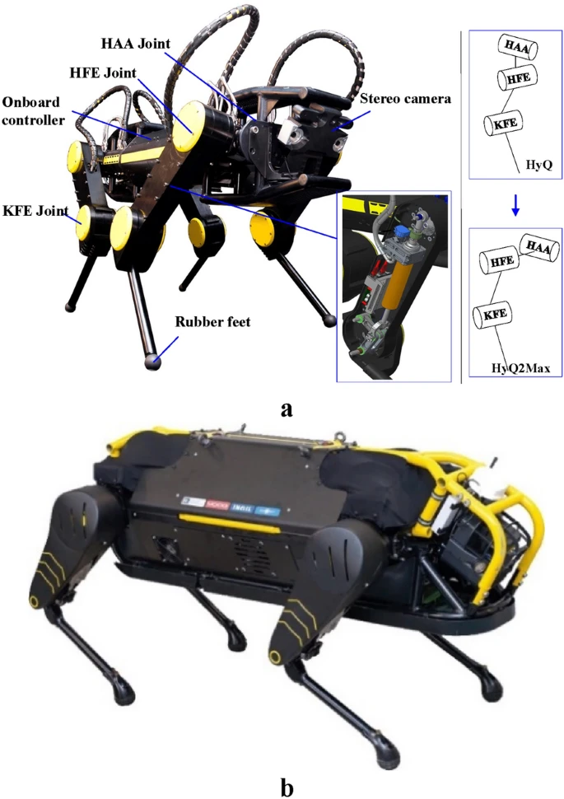

a)

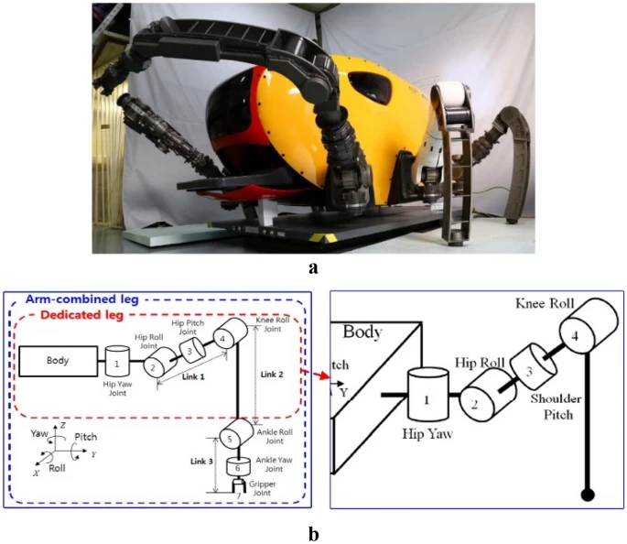

b)

a) quadruped: 3 motors per leg; b) hexapod: 4 motors per leg (He & Gao, 2020).

Figure 2.1 – Structure of classical WR legs

Table 2.1 – Parameters of the most well-known WR (He & Gao, 2020)

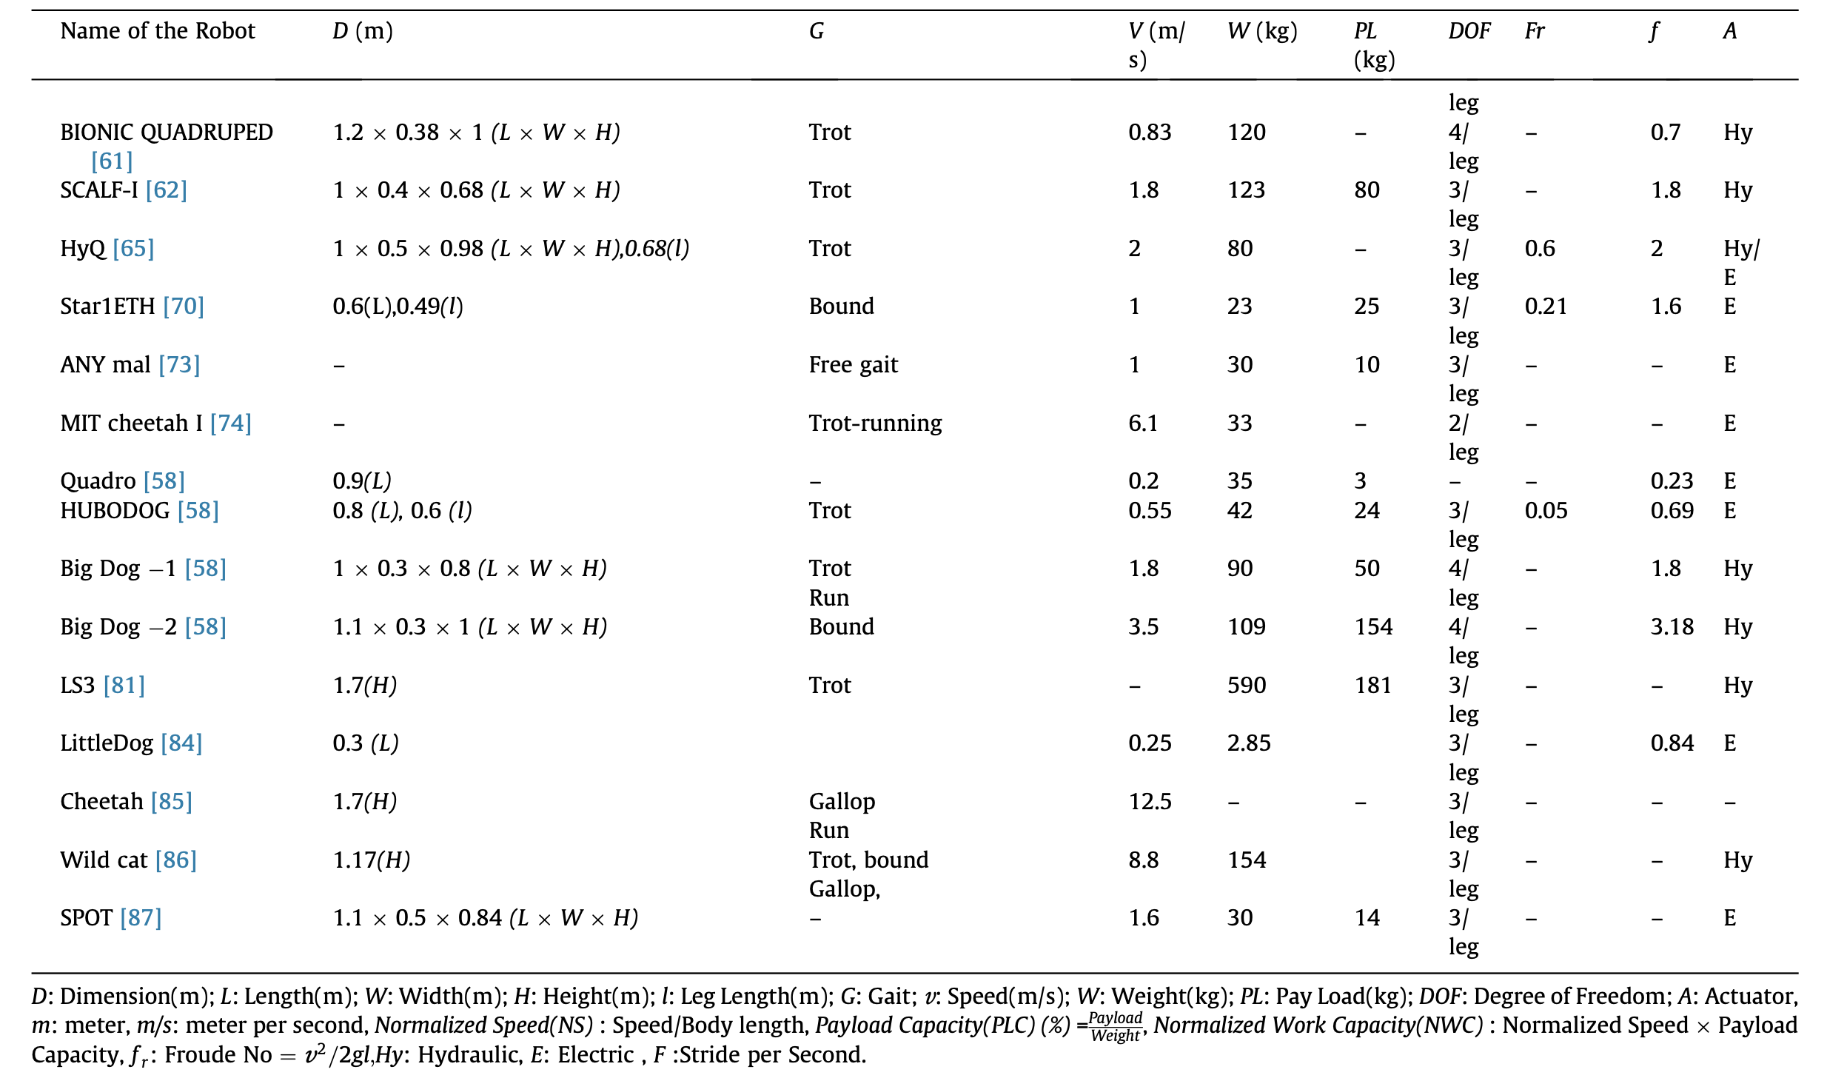

In Figure 2.2a, depicted is an initial prototype developed to demonstrate the capability of providing rectilinear translational motion of the body. An additional linkage EJM was incorporated into the 4-bar mechanism ABCD. As the crank's rotation angle $φ_{AB}$ varies within the limits of $φ_{0}≤φ_{AB}≤φ_{0}+Φ_{sup}$, $Φ_{sup}>π$, where $Φ_{sup}$, defining the "duration" of the support phase (SPh), the connecting rod EM undergoes rectilinear translational motion. Consequently, all points on this linkage trace identical trajectories.
By connecting a vertical pair M to this 5th link, adaptability to uneven surfaces is ensured without compromising the rectilinearity of the body's motion. Figure 2.2b illustrates another leg mechanism of the walking apparatus with an adaptation mechanism. To adjust the height h and enable vertical lifting and lowering of the foot S, an additional straight-line guiding mechanism is affixed to the connecting rod, conventionally represented as a prismatic pair M in Figure 2.2b.
It is noteworthy that if the body moves horizontally at a speed V, then the connecting rod EM, along with the foot, moves relative to the body at a speed $V_{S}=-V$. Consequently, with respect to the fixed coordinate system associated with the load-bearing surface, the connecting rod remains stationary. During strictly vertical lifting and lowering of the foot, the horizontal speed of the foot S relative to the ground remains zero.
To carry out the rotation of the body, we propose to introduce additional joints $O_{i}$, rotating around the vertical axis $O_{i}z_{i}^{'}$ (Figure 2.3a). To simplify the study of the turning modes, an equivalent kinematic scheme of the WR is also presented (Figure 2.4b, 2.4c), where entire SLMs of the robot were modeled as prismatic pairs $P_{i}( i=1, …, 6)$. Actuating the joints $O_{i}$ to turn the robot will again lead to structural redundancy. Thus, turning is carried out due to the difference in velocities of $P_{i}$.

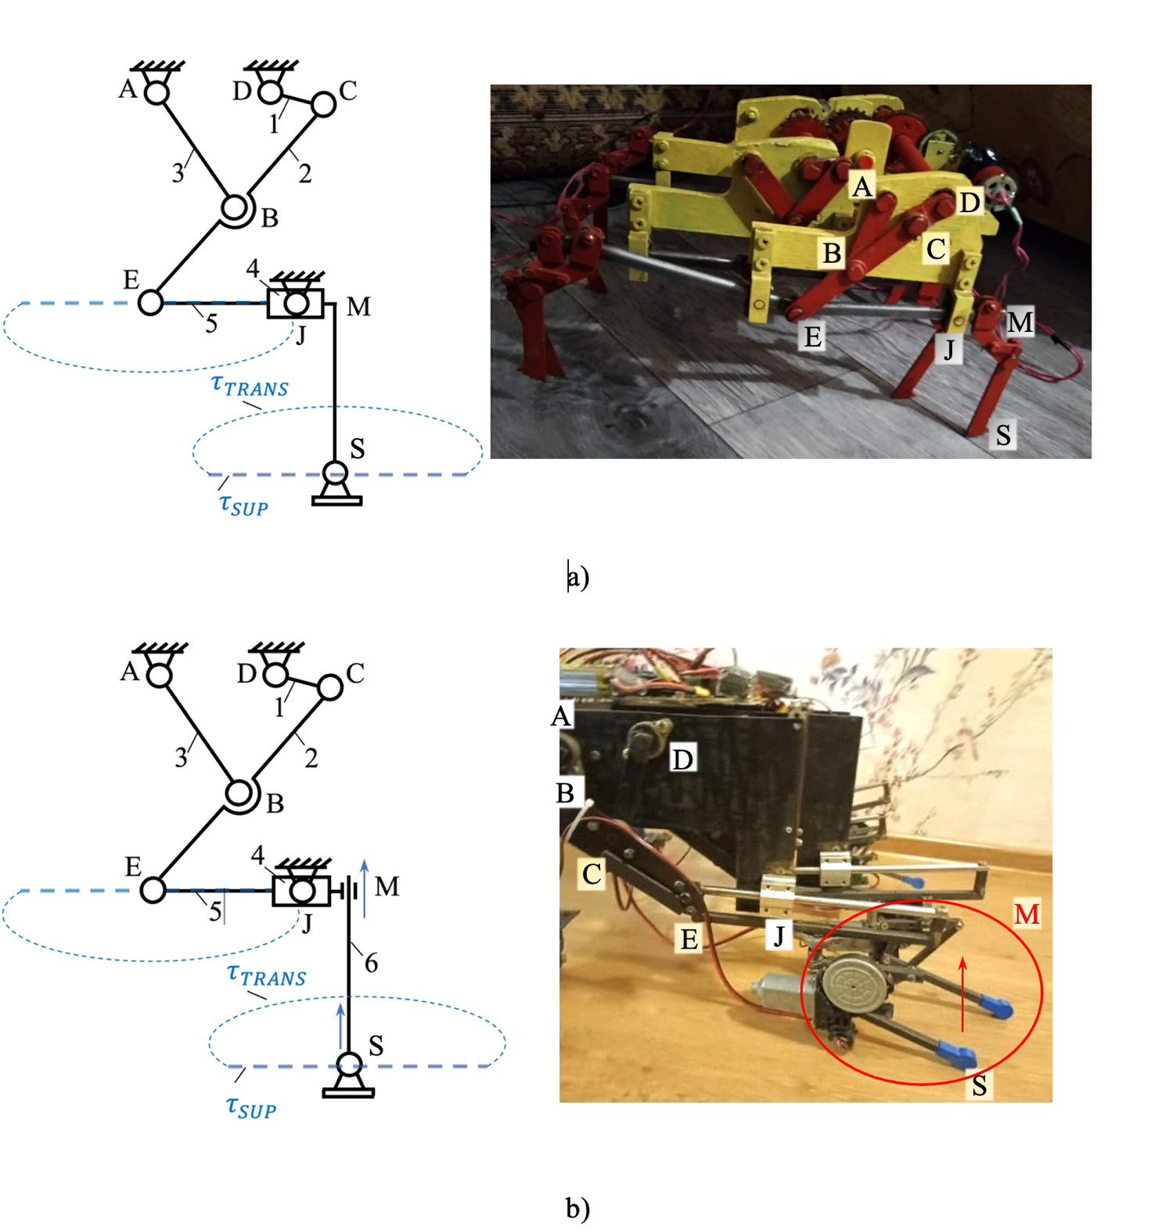

Figure 2.2 – Model of a walking apparatus using a straight-line guide mechanism as a propulsion device

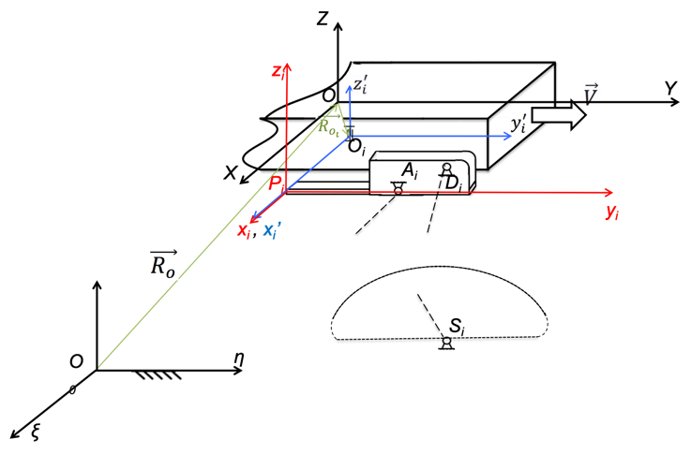
a)

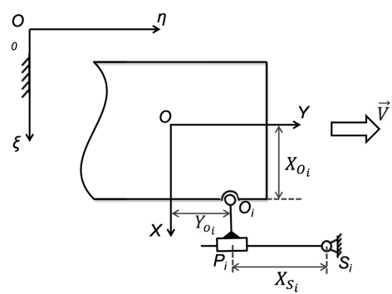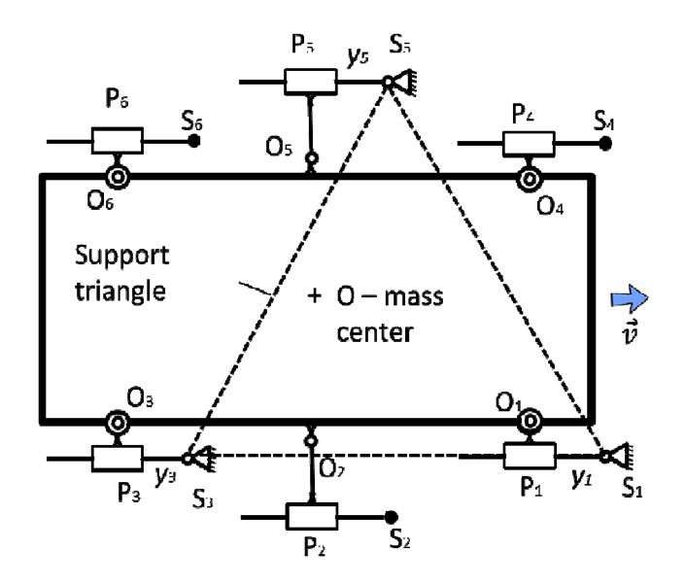
b) c)

Figure 2.3 – WR structural scheme on the plane $Oξη$ with
equivalent 2D kinematics (“tripod” gate) [78]

2.2 Substantiation of WR structure
The kinematic equivalent schemes mentioned above are introduced for the analysis of turning modes, and are presented in a two-dimensional manner. This choice is made because the vertical motion of the legs—adaptation to surface irregularities—does not affect the horizontal motion of the robot, as further expounded in subsequent chapters. Figure 2.4 illustrates the kinematic equivalent scheme in three-dimensional space. Notably, only supporting legs are depicted in the Figure 2.4, as legs in the transference phase do not contribute to the overall motion of the robot. In the subsequent sections, the rationality of the proposed structural configuration will be proven for both planar and spatial schemes.

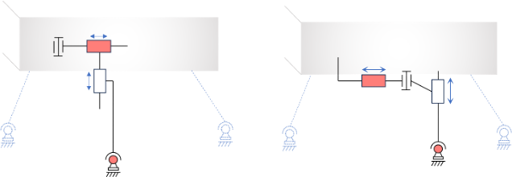

Figure 2.4 – Spatial kinematic equivalent scheme of the WR,
featuring only the supporting legs during “tripod” gate

The equivalent planar mechanism in Figure 2.4c has 3 DoF, since the number of moving links is n = 7, and p₅ = 9, then the number of DoF, W

$W=3n-2p_{5}=21-18=3$,
where $p_{5}$ is the number of kinematic pairs with five constraints.
For spatial scheme:

$p_{5}=3(legs)∙3(per leg);W=6\left(n+1\right)-3p_{3}-5p_{5}=6\left(3∙3+1\right)-3∙3-5∙9=6$ = number of input joints.

Thus, the number of degrees of freedom is equal to the number of active drives, which meets the requirement of rational structural synthesis of the kinematic diagram of the robot. Due to rational mechanics, the problem of redundant connections is eliminated, parasitic loads on motors and deformation of links associated with multiple static indeterminacy are eliminated, and slippage of the robot’s feet is eliminated.
For a modified kinematic scheme presented in Figure 2.6 the same structural formulas are valid.
An experimental prototype shown in Figure 2.2b correspond to the kinematic-equivalent scheme in Figure 2.5a, Figure 2.5b.
Figure 2.7 demonstrates a kinematically equivalent scheme of an eight-legged robot with a regular four-legged gait (at each moment of time, four legs are in the support phase). To obtain a rational structural scheme of the robot in this case, the robot must have a dissected body. To prove this statement, it is necessary to show that the number of DoF of such a system with a regular four-legged gait is equal to the number of active power drives (conventionally shown by arrows), i.e. the number of input joints of all legs in the support phase. Only moving links that ensure movement of the body are considered, i.e. legs in the swing phase are excluded.
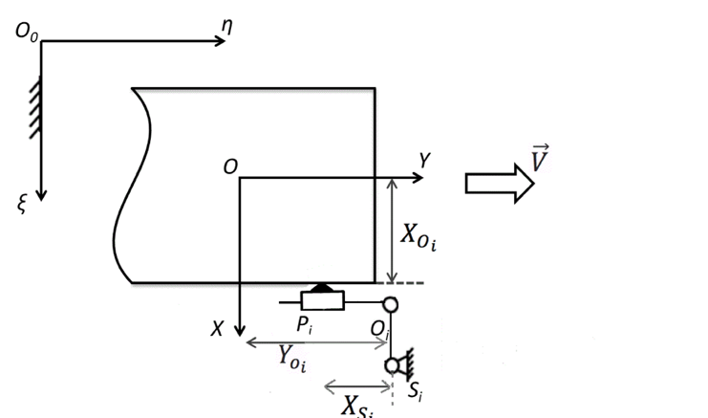
a)

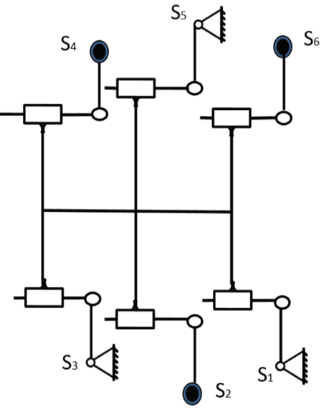

b)

Figure 2.5 – 2D Kinematic-equivalent scheme of the WR with regular “tripod” gate

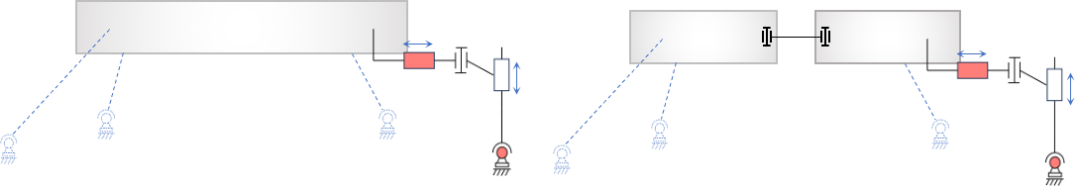
a) b)

a) overconstrained structure; b) “rational” structure.

Figure 2.6 – Kinematic equivalent scheme of the eight-legged WR during regular 4-legged gait

The following structural formula shows “irrationality” of the structure shown in Figure 2.6a:

$p_{5}=4 \left(supporting legs\right)∙3;W=6\left(n+1\right)-3p_{3}-5p_{5}=6\left(4∙3+1\right)-3∙4-5∙12=6≠$number of input links =12

After partition of the robot body:

$p_{5}=4 (supporting legs)∙3+2;W=6\left(n+1\right)-3p_{3}-5p_{5}=6∙15-3∙4-5∙14=8=$number of input links

Thus, the following decomposition of the robot’s movement is proposed:
a) generating rectilinear-forward motion of the robot through the use of a trajectory SLM;
b) the introduction of additional drives to adapt to uneven terrain (so that these drives operate independently and coordination of their work is not required);
c) turning control due to the difference in the angular velocities of the SLM cranks.
Let's introduce the following coordinate systems:
- $O_{0}ξηζ$ – absolute (fixed) coordinate system, rigidly connected to the supporting (bearing) surface, the WR body moves along the $O_{0}η$ axis with a speed $\vec{V}$.
- $OXYZ$ – coordinate system rigidly connected to the WR body.
- $O_{i}x_{i}{'y}_{i}'z_{i}'$ – local coordinate system associated with the i-th leg, the beginning of which $O_{i}$ coincides with the center of the joint $O_{i}$.
- $P_{i}x_{i}y_{i}z_{i}$ – also a local coordinate system, rigidly connected to the leg mechanism with number i; the plane $P_{i}y_{i}z_{i}$ coincides with the plane of the leg mechanism, the axes are parallel to the axes of the coordinate system $O_{i}x_{i}{'y}_{i}'z_{i}'$, the beginning of $P_{i}$is shifted along the axis $x_{i}'$ by a distance $x_{P_{i}}'$.
Let the foot $S_{i}$ be in support, so that $ξ_{S_{i}}=const$, $η_{S_{i}}=const$, $ζ_{S_{i}}=const$. With uniform rotation of the crank $A_{i}B_{i}$with a constant angular velocity $\dot{q_{i}}=\dot{φ_{i}}=ω_{i}=const$, the foot $S_{i}$ moves relative to the coordinate system OXYZ uniformly and rectilinearly with a speed $\vec{V_{S_{i}}}=-\vec{V}$, i.e. parallel to the $P_{i}y_{i}$axis. Neglecting minor deviations, we can assume that the coordinate at the foot $S_{i}$ depends linearly on the generalized coordinate $q_{i}$:

$y_{S_{i}}=y_{S_{i}}^{'}=A_{i}{+B}_{i}q_{i}$, | (2.1)
and the coordinates of X and Z (${ x}_{S_{i}}, z_{S_{i}}$) remain constant:

$${ x}_{S_{i}}=0, x_{S_{i}}^{'}=x_{P_{i}}^{'}=const,$$ | (2.2)
$$z_{S_{i}}=z_{S_{i}}^{'}=-h_{i}$$ | (2.3)
For rectilinear and uniform movement of the body, the cranks $A_{i}B_{i}$ of all legs located in the support must rotate with the same angular velocity $\dot{q_{i}}=ω_{i}=ω$. Then, differentiating expression (2.2), we obtain

${\dot{y}}_{S_{i}}{=V}_{S_{i}}^{y}=B_{i}{\dot{q}}_{i}=B_{i}ω_{i}$, | (2.4)
whence follows

$B_{i}=B=-\frac{V}{ω}=const$, | (2.5)

where $V$ – is the velocity of translational motion of the body: $V_{S_{i}}^{y}=-V$.
Further, for the convenience of studying the rotation of the WR, we will take the coordinates $y_{i}=y_{S_{i}}$ instead of $q_{i}$ as conditional generalized coordinates.
Another important condition is the absence of singular positions when the lines $S_{i}O_{i}$ intersect at one point, or all $S_{i}O_{i}$ are parallel (for supporting legs) (Figure 2.7a, b).
Remark 1. Note that if, when designing the WR, we take all $O_{i}P_{i}$=0, then during the rectilinear translational movement of the WR, the configuration would be in a special position (Figure 2.7c) and when rotating from this position, an ambiguity in the WR configuration would arise.
Remark 2. When designing the WR, it is necessary to take into account that the hinges $O_{i}$ (Figure 2.4) were introduced not as drive ones, but to eliminate redundant connections. Rectilinear translational motion of the body is possible without them, but then the structural diagram will be irrational, since the number of degrees of freedom will be zero ($W=3∙4-2∙6=0$). Rotation of such a mechanism will not be possible.
Remark 3. In the swing phase, the feet S_{i} are raised from the surface and then the hinges O_{i} will be passive (hinges O₂, O₄ and O₆ in Figure 2.7). However, in reality, we only need to return the link $O_{i}P_{i}$ (the plane of the mechanism, see Figure 2.7) to its original (“neutral”) position: to the position where the angle ($\hat{OY, \vec{O_{i}P_{i}}}$), formed by the link $O_{i}P_{i}$ axis ${OY}_{ξ}$ is equal to 90⁰. Thus, in the hinges $O_{i}$ in place of the active drives, it is enough to place a “return link” (for example, springs).
Remark 4. And thus the six-legged WR will have six main active drives working together (instead of twelve in a flat design and eighteen in a Hexapod-type spatial robot). The task of the control system will be to ensure the coordinated operation of these drives, so reducing the number of drives to six leads to a significant simplification of the control system. Note that due to the separation of motor functions, the robot’s movement is controlled independently of the system for adapting to unevenness. The latter includes six more drives, but coordination of their work is not required, because adaptation of each leg is carried out individually.

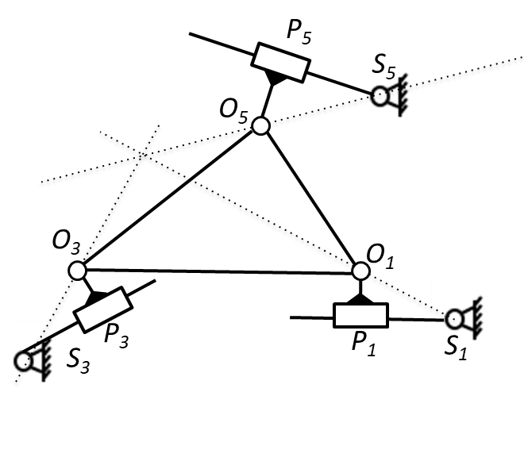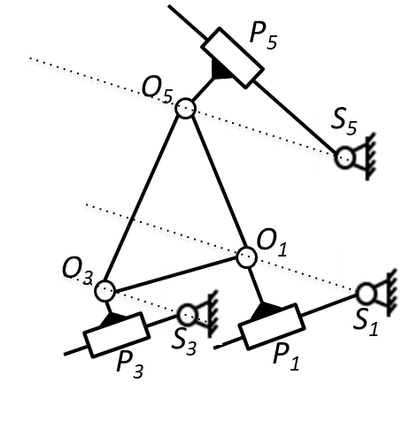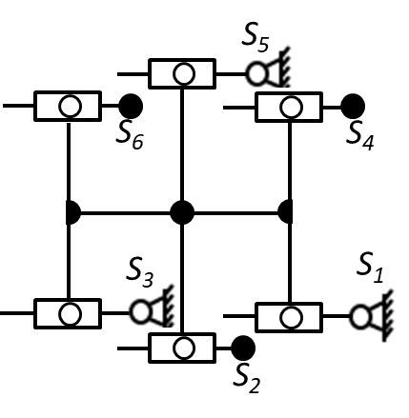
а)
b)
c)

Figure 2.7 – Configurations of WR in singular positions [78]

Conclusions on the Section 2
The application of the principle of separation of drive functions in the rational design of a walking robot is shown. As a result, the robot moves in an optimal mode from a mechanical point of view, with minimal energy consumption and using a simplified control system. Rational structural synthesis of the WR made it possible to eliminate the problem of redundant connections and multiple static uncertainty in the structure of traditional “universal” robots such as Hexapod, and also made it possible to get by with a minimum number of active drives. As a result of structural optimization, the number of main motors has been reduced to six, while the additional six adaptation drives are not involved in the main movement, coordination of their work is not required, because adaptation of each leg is carried out individually (independent of the others). Finally, the use of this approach makes it possible to perform parametric synthesis of WR based on well-known methods of multicriteria synthesis of parallel manipulators (based on such criteria as manipulability, isotropy, etc.).

3 DEVELOPMENT OF METHODS FOR ANALYSIS, STRUCTURAL-PARAMETRIC SYNTHESIS AND OPTIMAL DESIGN OF LEG MECHANISMS

In connection with the increased interest in trajectory type propulsion devices [50; 56; 59, 86, 87, 88, 89] that provide a given step cycle, increases the relevance of the problem of leg mechanism synthesis. In recent years, different approaches have been proposed for the dimensional synthesis of linkage mechanisms of walking robot (WR) leg [11; 12; 49, 90, 91, 92, 93, 87; 70; 59; 89]. For example, [41; 50; 59; 94] are devoted to adjustable trajectory generators synthesis. However, most of the existing methods of synthesis suffer from so-called “branching defect” [95], when one part of the desired motion is generated by one assembly of the mechanism, while another one is reproduced by another one. Moreover, the proposed mechanisms have a poor range of adaptation to irregularities of the supporting surface. It is obvious that the solution of the last problem can be the use of the mechanism with output-link, all points of which generate straight-line trajectory. However, increasing the adaptation range this way leads to another problem: decreased transmission angle [96]. The main reason for drawbacks mentioned is that the “traditional” methods of synthesis are based on the minimization of structural error, implying the compliance to specific geometric constraints, such as circle fitting (matching a circular point on a coupler) etc. Therefore, synthesized mechanism often has unfavorable force transmission or even doesn’t work at all due to the break of the mechanism kinematic chain.
The method of synthesis proposed in this section doesn’t suffer from these disadvantages due to minimizing directly the error of the mechanism output. The results of optimal design of six-link leg-linkage with straight-line and translatory motion of the output point and with unlimited adaptation range on the rough terrain are presented. [77] was proposed another mechanism with a “shin-link”, all points of which performs a rectilinear and translational movement. The optimal step cycle parameter of the leg is attained by maximizing the duration ratio of support and transference phases and, at the same time, the best transmission angle is achieved without loss of accuracy. Increasing the transmission angle (from 12$-15°$ in existing prototypes to 25 [97] ensures higher efficiency and lower power consumption. Some of the results are provided in [29]. Another work [23] is enhanced by changes and extension in analytical synthesis method, complemented with discussions, functionality studies of the lambda mechanism; numerical solutions supplemented on the basis of an improved synthesis method are provided in current work. New prototypes of WR are developed using the synthesized straight-line generator as propellers.

3.1 Description of six link leg mechanism structure
A mechanism structure with translatory motion of the output link EJ is plotted in Figure 3.1. Here the basic straight-line generating mechanism ABCD is the “lambda-type mechanism”, the link 5 (EJ) of the additional kinematic chain 4-5 copies the trajectory of the coupler point E due to the translational motion of this link. Thus, with the additional input link 6 and the input joint M we obtain the adjustable leg mechanism for multiple straight-line generation: now one can easily change the foot height and adjust the foot position on uneven surface. Note that the additional actuator at the joint M is used just to fix the foot position on the output link 5 (to fix link 6 relative to link 5), so the joint M is passive on the support phase of the step cycle.

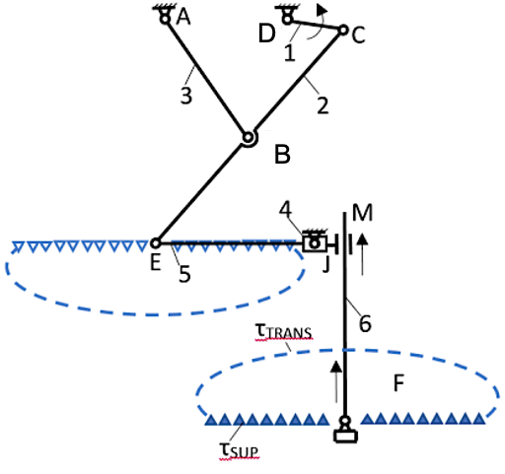

Figure 3.1– Leg linkages with translational output motion based on P. Chebyshev’s “lambda mechanism” [23]

On the support phase $τ_{SUP}$ (that correspond to the crank angle ($φ_{AB})$ change within the range $φ_{0}≤φ_{AB}≤φ_{0}+Φ_{SUP}$, where $φ_{0}$ is a crank angle at the start of the support phase and $φ_{0}+Φ_{SUP}$ – corresponds to the end of the support phase. (Figure 3.3)
- the leg foot F has to trace straight-line with nearly constant velocity relative to the robot chassis while the angular velocity of crank AB is constant (the relation between the input and output velocities has to be nearly linear;
and, for the robot stable motion,
- the duration of the support phase has to be longer than the duration of the transfer phase $τ_{TRANSF}$ (when foot is off ground, that correspond to crank angle $φ_{AB}$ values within the range $φ_{0}+Φ_{SUP}≤φ_{AB}≤φ_{1}$, where $φ_{1}=φ_{0}+360$).
If crank AB angular velocity is constant, then the ratio $ν{=Φ}_{SUP}/Φ_{TRANSF}$ is equal to the duration ratio of two phases. This ratio is referred to as the parameter of step cycle. In classical Chebyshev’s lambda mechanism with $Φ_{SUP}=184, Φ_{TRANSF}=176$ ($Φ_{TRANSF}$ is a magnitude of the angle corresponding to the transfer phase), this ratio υ is equal to 1,045.
The prototype of the legged robot horizontal propulsion mechanism was designed in the Institute of Mechanics and Mechanical Engineering of Kazakhstan Ministry of Sciences (Figure 3.2). For stable motion of the vehicle, two legs should occur alternately in the support/transference phases while the crank angles of these mechanisms are shifted by 184°. To overlap support phases of these two mechanisms, support phase should be longer than transference phase: $Φ_{SUP}>180$ and, thus, the parameter $ν≥1$ should be as greater as possible. However, according to the previous studies (Funabashi, 1987), increasing this parameter leads to poor solutions in terms of both accuracy and transmission angle. A new method of synthesis proposed in the next section does not have these inherent drawbacks due to minimizing the deviation of the output motion from the desired/prescribed one directly, i.e., instead of minimizing the residual error, derived from geometric constraints, such as circle fitting, etc.

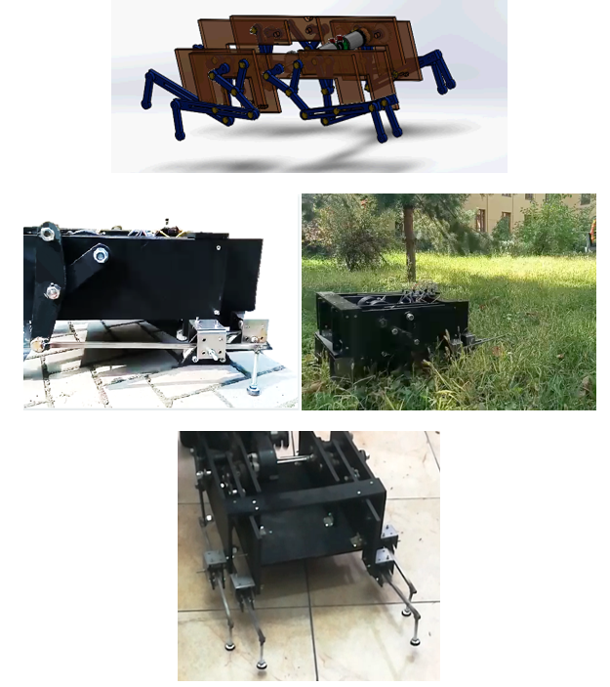
Figure 3.2 – Prototype of the legged robot horizontal propulsion mechanism [23]

3.2 Approximate Synthesis of the Path Generator by Minimizing Directly the Output Accuracy

3.2.1 Analytical Synthesis by Four Parameters
Let us consider a four-bar linkage ABCD that is described by the linkage dimensions $X_{A}=Y_{A}=0, X_{D}, Y_{D}, r_{AB}, l_{BC}, l_{CD}$ (Figure 3.3), where $X_{A}, Y_{A}, X_{D}, Y_{D}$ are the absolute coordinates of the frame pivots A and D relative to the absolute reference frame OXY. The crank angle $φ_{AB}$ is varied within the range $φ_{0}≤φ_{AB}≤φ_{0}+Φ_{SUP}$ as
$$φ_{i}= φ_{0}+Φ_{SUP}k_{i}, where k_{i}=\frac{i-1}{N-1}, i=1, 2, …, N.$$

and for each crank angle $φ_{AB}= φ_{i}$ position analysis is supposed to be carried out; thus, N positions of the coupler BC are supposed to be determined.

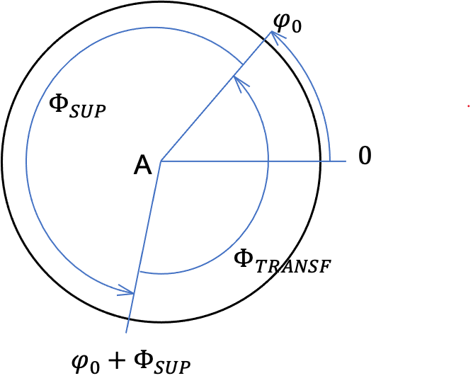

Figure 3.3 – A step cycle of the leg: $φ_{0}$ is a crank angle corresponding to the beginning of the support phase, $φ_{0}+Φ_{SUP}$ – end of the support phase;
$Φ_{TRANSF}$ – corresponds to the transfer phase [23]

If Bxy is the local moveable reference frame fixed on the coupler BC, with the axis Bx lying along the link BC, so we know the coordinates $X_{B_{i}}, Y_{B_{i}}$ of the origin B and inclination angles $β_{i}=β_{BC}$. Now the coupler point (end-effector) E with the local coordinates $x_{E},y_{E}$ relative to Bxy is sought, that most accurately reproduces the trace through N prescribed points $E_{1}^{*}, …, E_{N}^{*}$ with the given absolute coordinates $X_{E_{i}}^{*}, Y_{E_{i}}^{*} (i=1, …, N)$. In Figure 3.4, $\vec{R_{E_{i}}^{*}}$ is a radius-vector of the points on the program trajectory, and $\vec{R_{E_{i}}}$– on real trajectory. If the given (program) trajectory is horizontal,
$\left\{\begin{aligned}X_{E_{i}}^{*}=X^{0}+Lk_{i}, i=1, 2, …, N \\ Y_{E_{i}}^{*}=Y^{0},\end{aligned}\right.$ (3.1)
where $L$ is a length of the given trajectory (straight-line), $X^{0}, Y^{0}$ – absolute coordinates of the point $E_{1}^{*}$.

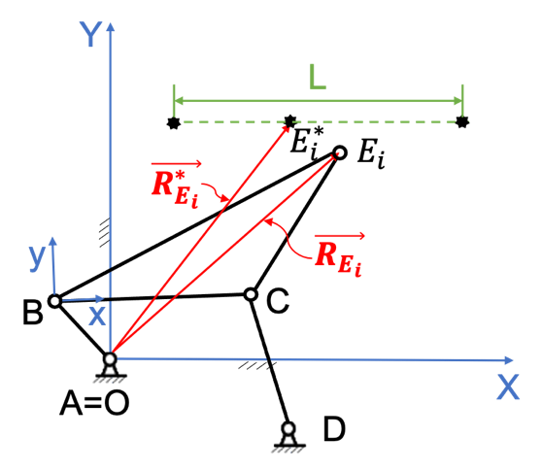
Figure 3.4 – Kinematic scheme of the linkage ABCD: $\vec{R_{E_{i}}^{*}}$ is a radius-vector of the points on the program trajectory, and $\vec{R_{E_{i}}}$– on real trajectory [23]

In general case, if the trajectory is a straight line at angle $α$ with horizontal and with length L, then
$\left\{\begin{aligned}X_{E_{i}}^{*}=X^{0}+L_{X}k_{i}, i=1, 2, …, N \\ Y_{E_{i}}^{*}=Y^{0}+L_{Y}k_{i}\end{aligned}\right.$ (3.2)

where $L_{X}=L\cos{α}, L_{Y}=L\sin{α}$ (Figure 5).

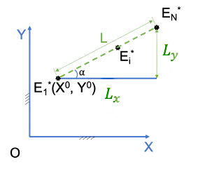
Figure 3.5 – Program (prescribed) trajectory of the coupler point[23]

The absolute coordinates of the points $E_{i}(X_{E_{i}}, Y_{E_{i}}$) of the joint E are given by

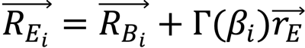

$\left\{\begin{matrix}X_{E_{i}}=X_{B_{i}}+x_{E}cosβ_{i}-y_{E}sinβ_{i} \\ Y_{E_{i}}=Y_{B_{i}}+x_{E}sinβ_{i}+y_{E}cosβ_{i}, \end{matrix}\right.$ (3.3)

where $\vec{R_{B_{i}}}$ is a radius vector of the joint B with absolute coordinates $X_{B_{i}}, Y_{B_{i}}$. $Γ\left(β_{i}\right)$ is a rotation matrix of dimension 2$×$2, $\vec{r_{E_{i}}}$ is a radius-vector of the coupler point (E) on real trajectory relative to Bxy.
The synthesis task consists of satisfying approximately the following conditions:

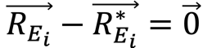 (3.4)

That is

$\left\{\begin{matrix}X_{B_{i}}+x_{E}cosβ_{i}-y_{E}sinβ_{i}=X^{0}+L_{x}k_{i} \\ Y_{B_{i}}+x_{E}sinβ_{i}+y_{E}cosβ_{i}=Y^{0}+L_{y}k_{i}\end{matrix}\right.$ (3.5)

The designing task is formulated as the following minimization problem

$δ=\sum_{i=1}^{N}{δ_{i}^{2}} =>\min_{x_{E},y_{E},X^{0},Y^{0}}{ }$ (3.6)

where $δ$ is a design error – the distance between actual positions $E_{i}$ and the desired ones $E_{i}^{*}$,

$δ_{i}^{2}≡{\left\|E_{i}E_{i}^{*}\right\|}_{2}^{2}={\left(X_{E_{i}}-X^{0}-X_{i}^{*}\right)}^{2}+{\left(Y_{E_{i}}-Y^{0}-Y_{i}^{*}\right)}^{2}$ (3.7)

where $X_{i}^{*}= L_{X}k_{i}, Y_{i}^{*}= L_{Y}k_{i}$, $X^{0},Y^{0}$ are shifting of the prescribed points ($E_{i}$).
If L and $α$ are given, the design parameters are $x_{1}=x_{E},{ x_{2}=y}_{E},x_{3}=X^{0},{ x}_{4}=Y^{0}$ (note that the coordinates of the crank pivot A were specified above to be X_{A}=Y_{A} = 0). From equations (3.2), δ is written as follows

$δ=\sum_{i=1}^{N}{\left\{{(X_{B_{i}}+x_{1}cosβ_{i}-x_{2}sinβ_{i}-X_{i}^{*}-x_{3})}^{2}+{\begin{aligned} \\ (Y_{B_{i}}+x_{1}sinβ_{i}+x_{2}cosβ_{i}-Y_{i}^{*}-x_{4})\end{aligned}}^{2}\right\}}$ (3.8)

Here $X_{B_{i}}{, Y}_{B_{i}}, β_{i}, X_{i}^{*}, Y_{i}^{*}$ are known. The necessary condition of minimum ${∂δ}/{∂x_{j}}=0, j=1,…,4$, yield 4 linear equations with 4 unknowns

$AX=b.$ (3.9)

The matrix A can be written in the form $A=B^{T}B$, where $B^{T}=[C_{1},C_{2},…,C_{N}]$,

$C_{i}=\left[\begin{matrix}cosβ_{i} & -sinβ_{i} \\ sinβ_{i} & cosβ_{i}\end{matrix} \begin{matrix}-1 & 0 \\ 0 & -1\end{matrix}\right]$.

Thus, the matrix A is non-negatively determined and it’s all main minors as well, hence linear equations (3.8) yield single solution. It should be noted that the main advantage of this technique is that there is no branching defect and, moreover, the designer can specify the desired transmission angle.

3.3 Analytical Synthesis by six Parameters
The number of determined analytically variables can be increased by another two if we introduce into the number of variables the parameters $x_{5}=L\cos{α} and x_{6}=L\sin{α}.$ The meaning of these parameters is the rotation and scaling of the mechanism as a whole. But now we have to consider a “normalized mechanism” with a unit length of the axle spacing of the bases (frame) AD = 1 and $X_{A}=Y_{A}=0, X_{D}=1, Y_{D}=0$. Then the minimized approximation function in new variables $x_{1},x_{2},x_{3},{ x}_{4}$, $x_{5},x_{6}$ has the form

$\sum_{i=1}^{N}{\left\{{(X_{B_{i}}+x_{1}cosβ_{i}-x_{2}sinβ_{i}-x_{3}-x_{5}k_{i})}^{2}+ {\begin{aligned} \\ (Y_{B_{i}}+x_{1}sinβ_{i}+x_{2}cosβ_{i}-x_{4}-x_{6}k_{i})\end{aligned}}^{2}\right\}}$ (3.10)
Then, similarly to the previous case, from the necessary minimum condition for the variables $x_{1},…,x_{6}$ we obtain the system of six linear equations of type (8), where

$A=\left[\begin{matrix}E & A_{1} & A_{2} \\ A_{1}^{T} & E & 1/2E \\ A_{2}^{T} & 1/2E & \frac{1}{N}\sum_{i=1}^{N}{k_{i}^{2}}E\end{matrix}\right]$,  $E=\left[\begin{matrix}1 & 0 \\ 0 & 1\end{matrix}\right]$,  $$A_{1}=\left[\begin{matrix}-\frac{1}{N}\sum_{i=1}^{N}{cosβ_{i}} & -\frac{1}{N}\sum_{i=1}^{N}{sinβ_{i}} \\ \frac{1}{N}\sum_{i=1}^{N}{sinβ_{i}} & -\frac{1}{N}\sum_{i=1}^{N}{cosβ_{i}}\end{matrix}\right],$$  $$A_{2}=\left[\begin{matrix}-\frac{1}{N}\sum_{i=1}^{N}{k_{i}\cos{β_{i}}} & -\frac{1}{N}\sum_{i=1}^{N}{k_{i}\sin{β_{i}}} \\ \frac{1}{N}\sum_{i=1}^{N}{k_{i}\sin{β_{i}}} & -\frac{1}{N}\sum_{i=1}^{N}{k_{i}\cos{β_{i}}}\end{matrix}\right]$$  b=[b₁, b₂,…, b₆]^{T}, $b_{1}=-\frac{1}{N}\sum_{i=1}^{N}{(X_{B_{i}}cosβ_{i}+Y_{B_{i}}sinβ_{i})}$,  $b_{2}=\frac{1}{N}\sum_{i=1}^{N}{(X_{B_{i}}sinβ_{i}-Y_{B_{i}}cosβ_{i})}$,  b₃$=\frac{1}{N}\sum_{i=1}^{N}{X_{B_{i}}}$,  b₄$=\frac{1}{N}\sum_{i=1}^{N}{Y_{B_{i}}}$,  b₅ $=\frac{1}{N}\sum_{i=1}^{N}{k_{i}X_{B_{i}}}$,  b₆$=\frac{1}{N}\sum_{i=1}^{N}{k_{i}Y_{B_{i}}}$ | (3.11)

3.3 Testing the results
To test the method proposed in previous sections let us use well known Chebyshev's lambda mechanism (Figure 3.1) with the following link lengths:

$r_{AB}=0.5,$ $l_{BC}=0.625, l_{CD}=0.625$,

frame pivot coordinates:

$X_{A}=0, Y_{A}=0, X_{D}=-0.5,$ $Y_{D}=0$,

initial crank angle $φ_{AB}=90°$.
With these parameters the coupler point E generates approximately horizontal straight-line, specified by points $E_{1}(2, 2)$ and $E_{N}(0, 2)$. The step cycle parameters of this mechanism are $Φ_{SUP}=184, Φ_{TRANSF}=176$, and $ν{=Φ}_{SUP}/Φ_{TRANSF}=1.045$ .
The desired motion is given by N prescribed equidistant points $\left(X_{i},Y_{i}\right), i=1, ... , N$ horizontal straight-line segment of length L=1 determined by

$$Y_{0}^{*}=0, X_{0}^{*}=0, X_{N}^{*}=1,$$

as follows:

$Y_{i}^{*}=Y_{0}^{*}, X_{i}^{*}=X_{0}^{*}+\left(X_{N}^{*}-X_{0}^{*}\right)k_{i}$.
So, the coupler point has to trace equidistant horizontal points $(X_{i}^{*},Y_{i}^{*})$ while the crank angle $φ_{i}$is changed by constant increment ${Δ_{φ}=φ}_{i}-φ_{i-1}=Ф_{SUP}/(N-1)$, thus, the relation between input and output velocities (coupler point horizontal velocity and crank angular velocity) will be nearly linear.
The mechanism synthesis parameters are determined to be:

$$x_{1}=x_{E}=1.23218,$$

$$x_{2}=y_{E}=-0.02180,$$

$$x_{3}=X^{0}=2.04035,$$

$x_{4}=Y^{0}=1.95574$.

Minimum of the Euclidean norm is achieved with these parameters. The real accuracy (maximal error on the output) achieved is

$ε=\max_{i=1,…,N}{\sqrt{{\left\|E_{i}E_{i}^{*}\right\|}_{2}^{2}}}=0.002$,

i.e., 0.2%, trajectory height $Y_{E}^{0}=-0.9827$ (Figure 3.6)
In six-parameter case, desired movement is also given by N finitely distant points $(X_{i}^{*},Y_{i}^{*})$, i =1, …, N, lying on a horizontal segment of length L=1:

$\left\{\begin{matrix}Y_{i}^{*}=Y_{0}^{*}, \\ X_{i}^{*}=X_{0}^{*}+\left(X_{N}^{*}-X_{0}^{*}\right)k_{i}, i=1, 2, …, N.\end{matrix}\right.$ (3.12)

The synthesis parameters found are following:
$r_{AB}=0.24743,$

$$l_{BC}=0.61857,$$

$$l_{CD}=0.61857,$$

$$X_{D}=-0.49479,$$

$$Y_{D}=-0.00768,$$

$$x_{1}=x_{E}=1.23218,$$

$$x_{2}=y_{E}=-0.02180,$$

$$x_{3}=X^{0}=2.04035,$$
$$x_{4}=Y^{0}=1.95574,$$

$$x_{5}=L\cos{α}=– 2.02056 ,$$

$$x_{6}=L\sin{α}=0.03138.$$
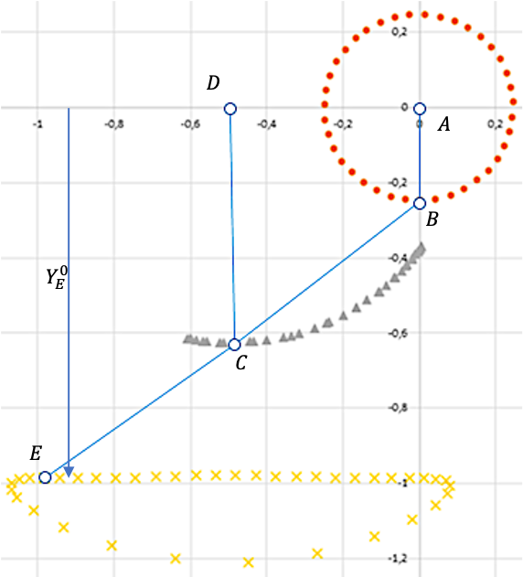
Figure 3.6 – Synthesized mechanism – method test [23]
3.4 Functionality Study of the Chebyshev Mechanism
The variable parameters of the search area were given by

- 0.15 ≤ $r_{AB}$≤ 0.750
- 0.400 ≤ $l_{BC}$≤ 1.200
- 0.400 ≤ $l_{CD}$≤ 1.200

- 15° ≤ $φ_{0}$≤ 150° (initial angle of the crank).
- 190° ≤ $Φ_{SUP}$ ≤ 220°

The mechanism link dimensions are varied by Sobol-Statnikov random LP_{τ}-sequence method [98], for each value of the variable parameters, the parameters $x_{1},x_{2},…, x_{6}$ were determined by analytical synthesis.
For the accuracy ε < 0.015 (1.5% from step length) and the worst value of the pressure angle $μ_{e}$>30° ($μ_{e}=\min\left(μ_{i}, 180-\left|μ_{i}\right|\right), μ_{i}$ is the pressure angle of the mechanism at i-th position, the parameters lie within the boundaries:

- 0.15 ≤ $r_{AB}$ ≤ 0.670

- 0.410 ≤ $l_{BC}$≤ 1.200

- 0.450 ≤ $l_{CD}$≤ 1.200

- 24° ≤ $φ_{0}$ ≤ 113° .

The mechanism with the maximum $Φ_{SUP}$ value and minimum of links constant dimensions $S=Σl_{i}$ is shown in Figure 3.7a. The mechanism with the best accuracy is shown in Fig.7b. The accuracy of all of the obtained mechanisms can be improved by local search.
The mechanisms with the best $μ_{e}$values are shown in Figure 3.7c,d, however, these mechanisms have very huge dimensions: the better the transmission angle, the worse the mechanism dimensions. More compact mechanisms are presented in
Figure 7e-h. Table 3.1 corresponds to the mechanisms shown in Figure 3.7.
The possibility of increasing of the parameter $Φ_{SUP}$ up to 270° was studied. The mechanism with $Φ_{SUP}=270$ is shown in Figure 3.8a. As expected, the larger the angle $Φ_{SUP}$ the worse the accuracy and transmission angle: the mechanism has the accuracy 1.3%, whereas the angle $μ_{e}=12.4$, which is, of course, unacceptable. At the same time, we observe the compact mechanism dimensions. Nevertheless, the compromise solution is shown in Figure 3.8b with $Φ_{SUP}=265$, the accuracy 1.3% and $μ_{e}=19$. Finally, trying to improve transmission angle up to $μ_{e}=25$ leads to compromise solution with further decrease in the value of the $Φ_{SUP}=232$ (see Figure 3.8d), the accuracy is 0.8%. Table 2 represents the parameters of the mechanisms in Figure 3.8.

Table 3.1 – Parameters of the mechanisms in Figure 3.7

LLP_{τ} | $$r_{AB}$$ | BC | CD | $$X_{D}$$ | $$Y_{D}$$ | $$φ_{0}$$ | $$x_{P}$$ | $$y_{P}$$ | $$S_{x}$$ | $$S_{y}$$ | accuracy
4254 | 0,30475 | 0,52602 | 0,68496 | -0,53957 | 0,45021 | 207,38226 | 0,75118 | 0,30410 | 0,68594 | 1,50257 | 0,01017
5958 | 0,27495 | 0,65352 | 0,64086 | -0,65392 | 0,30159 | 240,98711 | 1,06360 | 0,51025 | 0,93311 | 1,78113 | 0,00564
12832 | 0,31933 | 1,25004 | 1,59662 | -1,27288 | 1,53606 | 214,92422 | 1,31896 | 1,07583 | 0,13555 | 1,02718 | 0,00657
9716 | 0,31510 | 0,83516 | 0,94771 | -0,84873 | 0,85434 | 204,87726 | 0,93535 | 0,68031 | 0,36470 | 1,21463 | 0,00983
14418 | 0,32059 | 0,66452 | 0,84780 | -0,67283 | 0,72679 | 208,80739 | 0,78034 | 0,52378 | 0,37129 | 1,26668 | 0,01043
9970 | 0,28325 | 0,66814 | 0,69291 | -0,68768 | 0,48731 | 218,04003 | 0,90721 | 0,57621 | 0,62916 | 1,53021 | 0,00959
4938 | 0,32344 | 0,61929 | 0,87601 | -0,63433 | 0,69395 | 204,79524 | 0,78459 | 0,39617 | 0,40168 | 1,27153 | 0,00929
5158 | 0,28327 | 0,59856 | 0,70411 | -0,61246 | 0,40861 | 219,77593 | 0,90648 | 0,37549 | 0,74094 | 1,59605 | 0,00915

Table 3.2 – Criteria values of the mechanisms in Figure 3.7

LP_{τ} | $$Y_{P}$$ | $μ_{e}$, deg. | $$dφ$$ | $$ΣL$$ | Fig.6
4254 | -0,49956 | 35,4 | 219,7 | 2,5 | a)
5958 | -0,88176 | 40,2 | 190,8 | 3,1 | b)
12832 | -1,09865 | 70,9 | 199,9 | 6,1 | c)
9716 | -0,71626 | 59,4 | 217,1 | 4,0 | d)
14418 | -0,58001 | 50,8 | 207,5 | 3,2 | e)
9970 | -0,74289 | 48,5 | 216,5 | 3,2 | f)
4938 | -0,52557 | 44,8 | 211,5 | 3,0 | g)
5158 | -0,67388 | 39,7 | 215,1 | 2,9 | h)

Table 3.3 – Parameters of the mechanisms in Figure 3.8

LPτ | $$r_{AB}$$ | BC | CD | $$X_{D}$$ | $$Y_{D}$$ | $$φ_{0}$$ | $$x_{P}$$ | $$y_{P}$$ | $$S_{x}$$ | $$S_{y}$$ | accuracy
26239 | 0,22215 | 0,34980 | 0,35020 | -0,29672 | -0,02400 | -118,38177 | 0,70725 | -0,05224 | 2,66504 | 1,38452 | 0,01340
10539 | 0,24757 | 0,38280 | 0,40521 | -0,37030 | 0,09351 | 209,42744 | 0,69700 | 0,09750 | 1,94367 | 1,70734 | 0,01350
16867 | 0,22768 | 0,42761 | 0,43076 | -0,36849 | 0,01137 | 229,38446 | 0,82319 | -0,00133 | 2,34719 | 1,67886 | 0,00755
8277 | 0,24247 | 0,46252 | 0,46239 | -0,43410 | 0,08361 | 229,47388 | 0,86981 | 0,14968 | 1,82675 | 1,81800 | 0,00811

Table 3.4 – Criteria values of the mechanisms in Figure 3.8

LP_{τ} | $$Y_{P}$$ | $μ_{e}$, deg. | $$dφ$$ | $$ΣL$$ | Fig.7
1 | 2 | 3 | 4 | 5 | 6
26239 | -0,47478 | 12,40006 | 269,84407 | 1,40310 | a)
10539 | -0,44707 | 19,36943 | 265,24292 | 1,71184 | b)
16867 | -0,58996 | 18,91090 | 248,18298 | 1,77158 | c)
8277 | -0,63424 | 24,92673 | 232,44507 | 2,06778 | d)

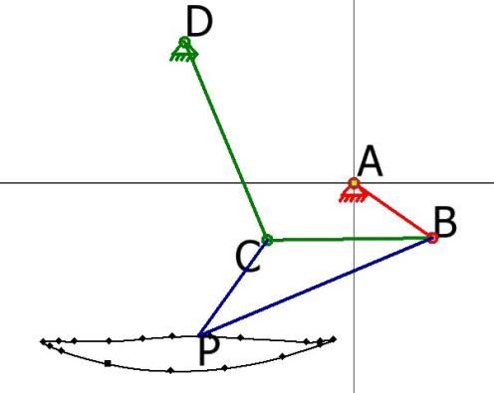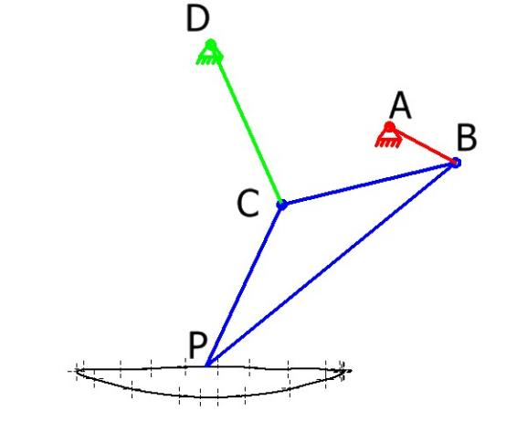
a) b)
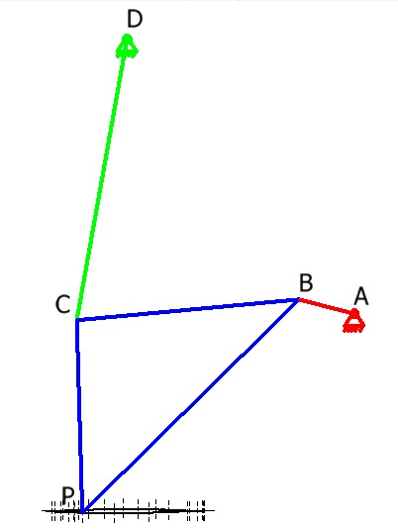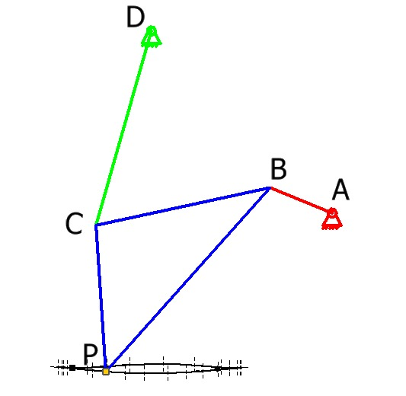
c) d)
Figure 3.7 – Functionality study of the Chebyshev mechanism, sheet 1

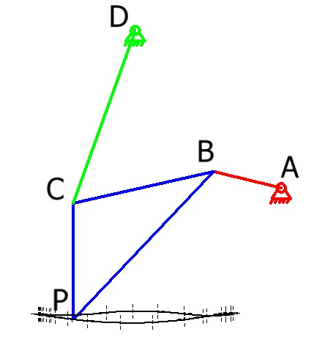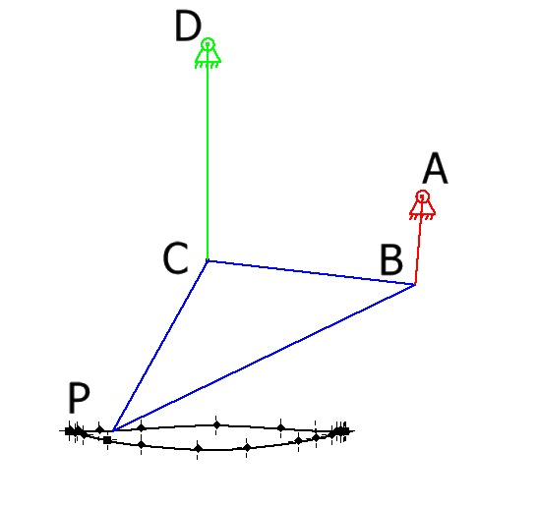

e) f)

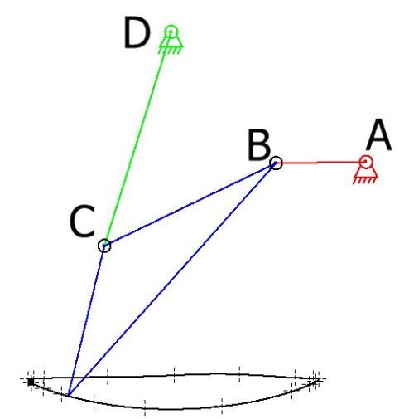
g) h)

Figure 3.7 – sheet 2

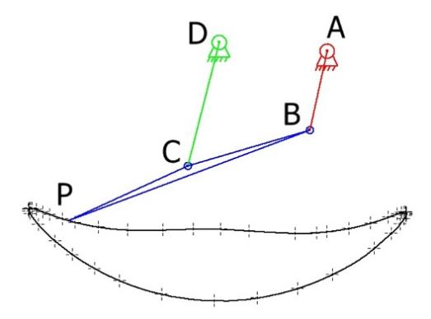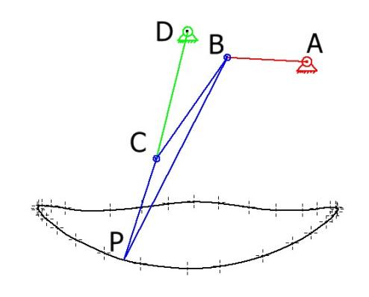
a) b)
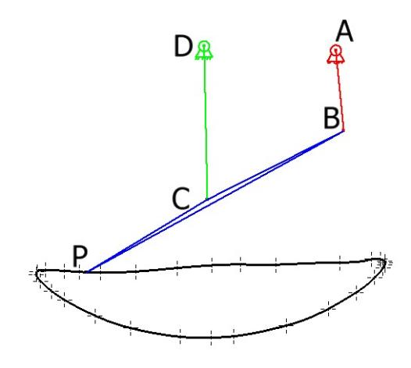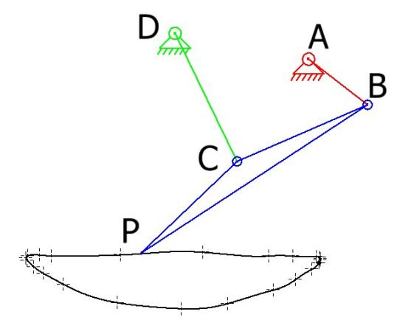
c) d)
Figure 3.8 – Functionality study of the Chebyshev mechanism [23]

3.5 Optimal Leg Design
Each of the solutions discussed above can be improved by the local search in the surrounding area. On the first stage the lengths of normalized mechanism (when $X_{A}=Y_{A}=0, X_{D}=1, Y_{D}=0$) and the value of $Φ_{SUP}$ (which is the third criteria) are varied by Sobol-Statnikov random LP_{τ}-sequence method [97], the boundaries of the search were set:

- $0.150≤r_{AB}≤0.750$,

- $0.400≤l_{BC}≤1.200$,

- $0.400≤l_{CD}≤1.200$,

- $15≤φ_{0}≤150$°,

- $190≤φ_{SUP}≤220$° (the third criterion).

For each value of the mentioned varying parameters we
- obtain the worst value of the pressure angle $μ_{e}=min⁡(\left|μ_{i}\right|, 180-|μ_{i}|)$;
- determine 6 synthesis parameters X$={\left[x_{1}, …, x_{6}\right]}^{T}$ by solving the linear equations (3.10);
- determine the worst deviation – the accuracy of reproduction of the program trajectory (approximation error) $ε=\max_{i=1,…,N}{\sqrt{{\left\|E_{i}E_{i}^{*}\right\|}_{2}^{2}}}$;
- record the results in the Test Table.
The Test Tables are analyzed and truncated 1) by accuracy ($ε<0.015$), 2) by pressure angle ($μ_{e}>18$). Figure 3.9 shows the solutions corresponding to the best accuracy, whereas the solutions with the best pressure angles are shown in Figure 3.10.
On the next stage duration of the support phase is chosen on the basis of previous analyses Ф_{SUP}=220⁰, then the ratio is $ν{=Φ}_{SUP}/Φ_{TRANSF}=1.57$. The ranges of the lengths of the normalized mechanism are now narrowed down to

- $0.175≤r_{AB}≤0.5$,

- $0.410≤l_{BC}≤1.200$,

- $0.530≤l_{CD}≤1.200$,

- $40≤φ_{0}≤100$°

On the next stage duration of the support phase is chosen on the basis of previous analyses Ф_{SUP}=220⁰, then the ratio υ=Ф_{SUP}/Ф_{TRANSF} is υ=1.57. The ranges of the lengths of the normalized mechanism are now narrowed down to
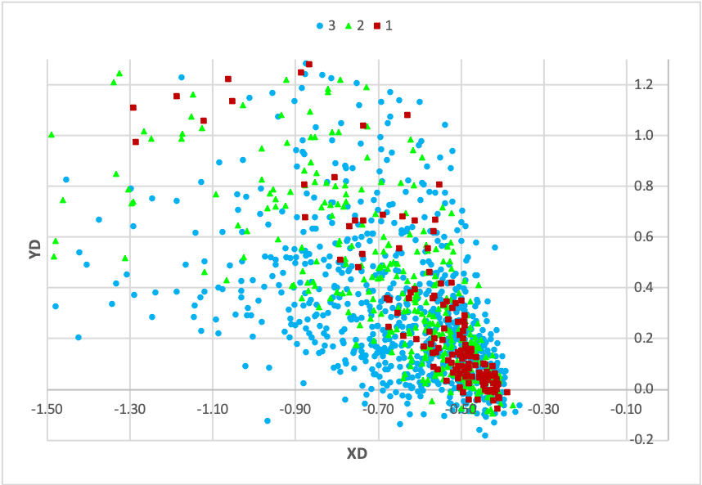

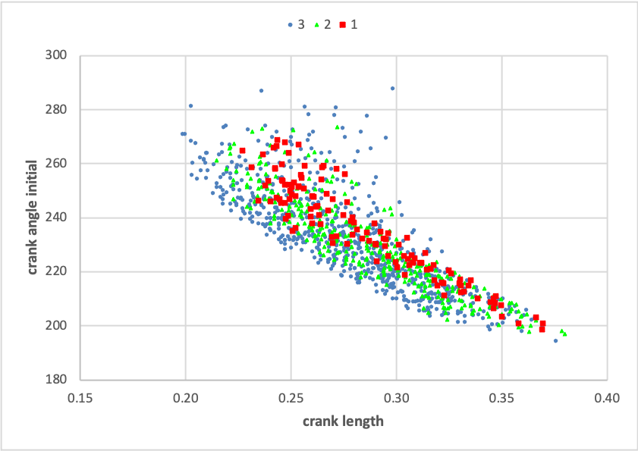

b)
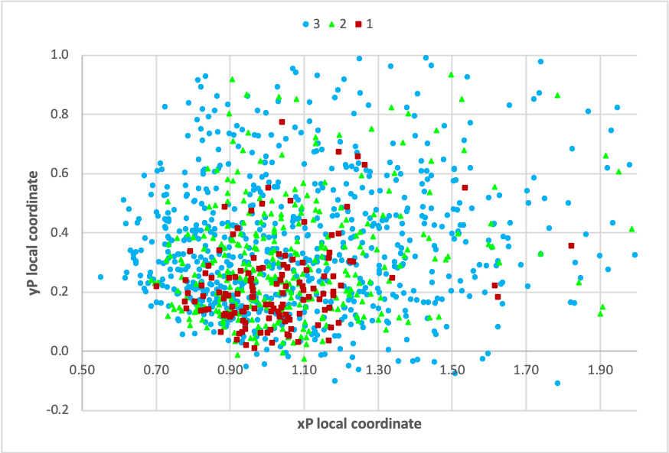

c)

Figure 3.9 – Scatter of solutions with the best accuracy ε (first stage): ‘1’ – ε ≤ 0,0075 (the best accuracy on the truncated (by accuracy) table); ‘2’ – 0,0075 < ε ≤ 0,01; ‘3’ – 0,01 < ε ≤ 0,015 (the worst accuracy on the truncated (by accuracy) table)
    - 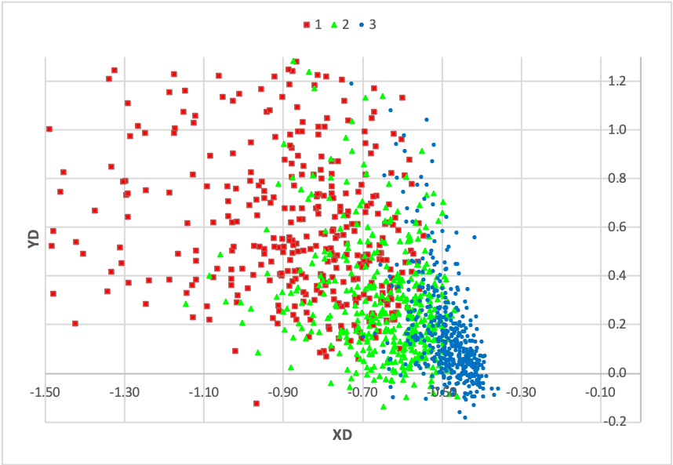
a)
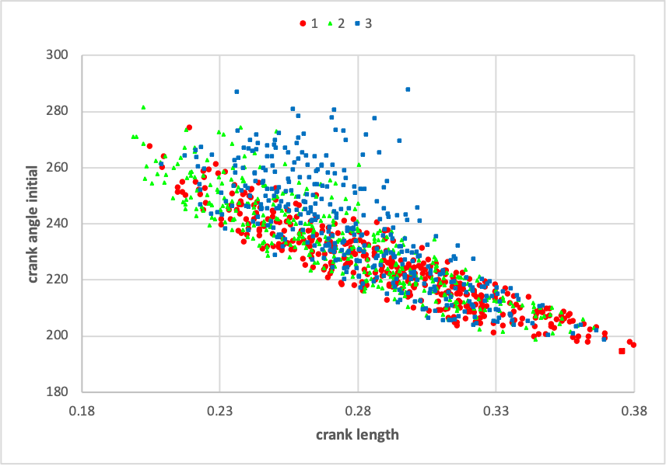
b)
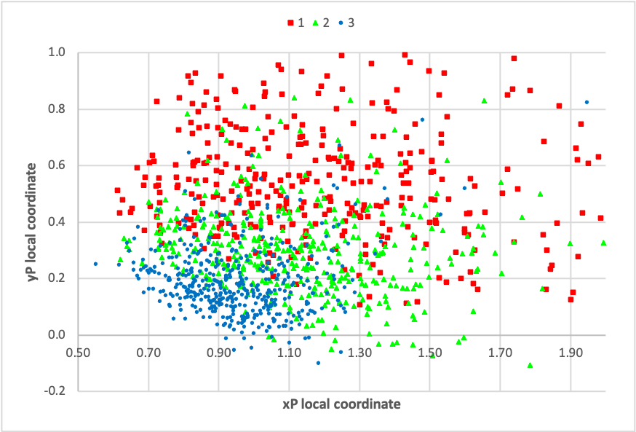
c)
Figure 3.10 – Scatter of solutions with the best motion transfer µ_{e} (first stage):
‘1’ – µ_{e}>40° the best motion transfer on the truncated (by µ_{e}) table;
‘2’ – 30°≤ µ_{e}<40°;‘3’ – 18°≤ µ_{e}<30°

- $0.175≤r_{AB}≤0.5$,

- $0.410≤l_{BC}≤1.200$,

- $0.530≤l_{CD}≤1.200$,

- $40≤φ_{0}≤100$°

On this stage truncated are Test Tables with the accuracy limit ε<0.006 (0.6% of the trajectory length) and the pressure angle µ_{e}>22°. Table 3.3 shows the link sizes with the best accuracy (ordered by increasing approximation error), and Table 3.4 shows the mechanisms with the best motion transfer (ordered by decreasing pressure angle µ_{e}).
The scatter of acceptable solutions under the indicated restrictions (Figure 3.11, 3.12 and Table 3.3, Table 3.4) show that the considering criteria are conflicting: as the accuracy improves, the pressure angle decreases and vice versa. For example, it can be seen from the resulting figures that the best parameter values $X_{D}-Y_{D}$ in terms of accuracy (red dots) lie in the lower right corner (Figure 3.11a), while acceptable solutions $X_{D}-Y_{D}$, corresponding to good pressure angles, lie in the upper left corner (red dots in Figure 3.12a). The best parameter values $r_{AB}-φ_{0}$ in terms of accuracy lie in the upper left corner (red dots in Figure 3.11b), while the best solutions $r_{AB}-φ_{0}$, corresponding to good pressure angles lie in the lower right corner (Figure 3.12b). Finally, the best parameters $x_{E}-y_{E}$ lie at the bottom in terms of accuracy (red dots in Figure 3.11c), and are shifted upward in terms of pressure angle (red dots in Figure 3.12c).

Table 3.5 – The mechanism dimensions with the best accuracy

r_{AB} [m] | l_{BC} [m] | l_{CD} [m] | X_{D} [m] | Y_{D} [m] | , [deg]
0,2335 | 0,4926 | 0,5037 | -0,4243 | 0,0301 | 245
x₁=x_{E} | x₂=y_{E} | x₃=S_{x} | x₄=S_{y}
0,9568 | 0,0271 | 2,0543 | 1,8465 | 0,0049 | 22,2

Working with truncated Test Tables, further we discard solutions with restrictions µ_{e} < 24°. and ε > 0.0057, compromise solutions were found that satisfy all of the considered conflict criteria. The best solutions in terms of accuracy are shown in Table A1 (Appendix 1), in terms of pressure angle – in Table A2 (Appendix 1). As a result of the analysis of these Tables, the first line of Table A2 with the LP_{τ} -sequence number 10995 was chosen as the optimal solution; best pressure angle µ_{e} = 25.1°; however, the loss in accuracy is not significant: the accuracy ε = 0.0057 is very close to the best accuracy ε = 0.0052 obtained from Table A1 (Appendix A).

Table 3.6 – The mechanism dimensions with the best transmission angle

r_{AB} [m] | l_{BC} [m] | l_{CD} [m] | X_{D} [m] | Y_{D} [m] | [deg]
0,2445 | 0,4867 | 0,5002 | -0,4531 | 0,0925 | 238
x₁=x_{E} | x₂=y_{E} | x₃=S_{x} | x₄=S_{y}
0,9230 | 0,1457 | 1,7207 | 1,8693 | 0,0060 | 25,5

Noteworthy are 3 more solutions included in the Top 14 of both Tables A1 and A2: these are solutions with LP_{τ} -sequence numbers 29755, 23207 and 10823.
The final mechanism is shown in Figure 3.13, the mechanism structural scheme corresponds to the scheme in Figure 3.1. Instead of prismatic pair M in Figure 3.1, we used another straight-line generator driven by a servo, that provides a set of infinite vertical-line trajectories which allow the robot to adopt to unevenness of the surface. The study of the adaptation mechanism of the WR is out of scope of this work. As a part of the design work, an operational prototype of the WR was developed
(Figure 3.13) using the synthesized mechanism as a propeller. Directions for the future research include investigation and experimental studies of the adaptation mechanism.

a) b)

c)
Figure 3.11 – Scatter of solutions with best accuracy: ‘‘1’ – ε ≤ 0,0054; ‘2’ – 0,0054 < ε ≤ 0,0057;‘3’ – 0,0057 < ε ≤ 0,006 [23]

a) b)

c)
Figure 3.12 – Scatter of solutions with the best motion transfer: ‘1’ – µ_{e}≥24grad.; ‘2’ – 23,5≤ µ_{e}< 24 (grad) ; ‘3’ – 22≤ µ_{e} <23,5 (grad) [23]

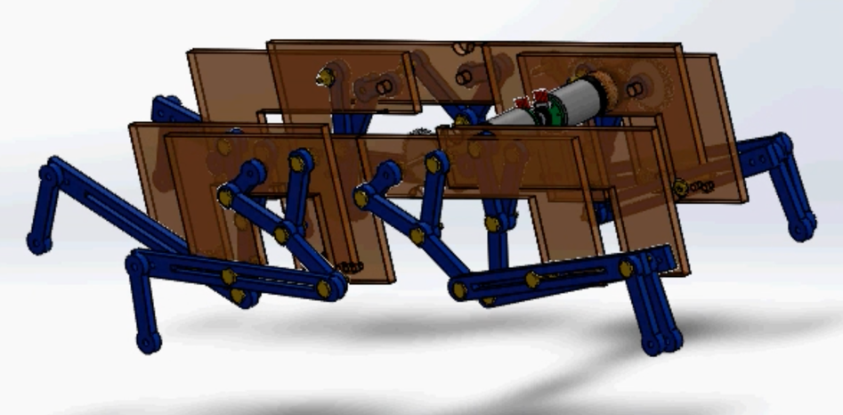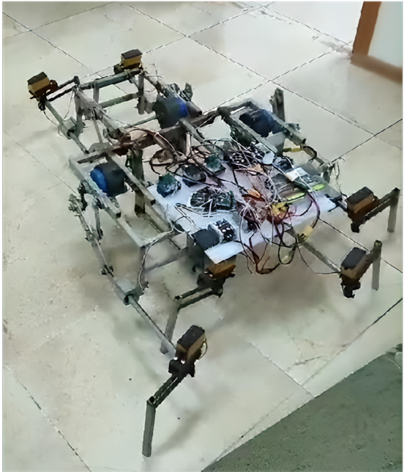
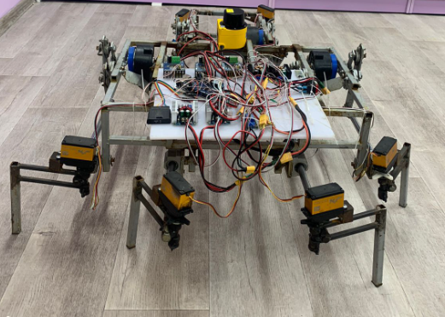
Figure 3.13 – 3D model of the WR and the experimental prototype [23]

Conclusions on Section 3
An optimal design of walking robot leg mechanism is proposed that allows to reduce the power consumption and simplifies the control system of the robot. Unlimited range of foot adaptation to unevenness of a supporting surface is reached due to the use of the “shin-link” that performs rectilinear and translational motion. The analytical synthesis methods based on the least-square approximation are presented that eliminates “the branching defect” that occurs in the most of the existing methods. The method of multicriteria design using Sobol – Statnikov LP-tau sequences allowed to find the mechanism with desired accuracy of the output motion, transmission angle and step cycle parameter. Transmission angle increased from 12$-15°$ in existing prototypes to 25. The step cycle parameter $ν{=Φ}_{SUP}/Φ_{TRANSF}$ of the synthesized mechanism is 1.59, the duration of the support phase is increased up to 221°, whereas the values of these parameters in prototype are $ν=1.045$ and $Φ_{SUP}=184°$ [23].

4 OPTIMIZATION OF THE METRIC PARAMETERS OF THE WR

The principal findings of this section are presented in the author’s work [24]. Various "measures" have been proposed to estimate how far the position of the mechanism is "remote" from the nearest singular position of the second kind. In Mechanisms and Machines Theory, for example, there is the concept of the quality of motion transmission (the closest concept in German literature is "Uebertragungsguete"). In the English-language literature, there are a number of concepts that are close in meaning, such as manipulability, the ability of force and motion transfer, the kinematic performance index, etc.
So, in work [99], as such a measure, the "transfer coefficient" is proposed as the product of the sines of the pressure angles related to the output and input links. Funabashi, H. et al. [100] propose to use the sine of the pressure angle related to the output link, wherein consider the angle formed by the direction of motion of a rotational or spherical kinematic pair on the platform and the direction of the relative motion of this pair around the joint on the input link. Despite the fact that the equality of the named angle to zero is a sufficient condition of singularity, its magnitude is not linear with respect to the force transmission.
Yoshikava T. [101] uses the determinant of the Jacobian matrix as a criterion of manipulability, which transforms the generalized velocities at the input into the generalized velocities at the output object, and the determinant is a measure that reflects the transformation of a unit sphere into an ellipsoid, more precisely, the change in its dimensions along the principal axes. In other words, this measure indicates some integrated value of the velocity that is achieved by the generalized output velocities in different directions. Considering special cases of symmetric planar and spatial manipulators, Duffy, J. [102] also introduced a measure based on the determinant of the Jacobian matrix. It is obvious that these measures are local criteria and depend on the configuration of the manipulator. Tsai, K.Y. in the work [103] introduces a global criterion that is the integral of the square of the determinant (of a matrix that is the product of the Jacobian matrix and its transposition) over the entire working volume of the manipulator.
A clearer interpretation of the transfer criterion was described in the works of Angeles, J. [104], who proposed to consider as the measure the condition number k of the Jacobian matrix, which is equal to the ratio of the largest and smallest eigenvalues. If we consider the ellipsoids of generalized velocities and generalized forces, then the number k reflects the uniformity of the motions and forces transmission. The maximum reciprocal value 1/k over the entire working volume (which varies from zero to one), is called the kinematic conditioning index of the manipulator. In addition to the Chebyshev norm, the root mean square criterion is also introduced as an integral of the Euclidean norm over the entire working volume.
The most complete to date is the method of optimal synthesis of parallel manipulators, proposed by representatives of the German school. In the works of Schoenherr, J. [105] a generalized functional (Guetefunktional) is introduced based on the use of the product of the weighted norm of the Jacobian matrix and the weighted norm of the inverse matrix and a method of optimal synthesis is presented.
The monograph [106] presents the results of researches on developing of synthesis methods and new kinematic schemes of planar manipulators, which are isotropic (in terms of force transfer) in the entire working area.
Consider a robot/manipulator with $W_{q}=n$ d.o.f. and generalized coordinates $\vec{q}={\left[q_{1},q_{2}, …,q_{n}\right]}^{T}$. Assume that the output object also has $W_{x}=n$ d.o.f. Then the singular positions of the manipulator or robot, which are important in the analysis and synthesis of manipulators, are determined by the Jacobian matrix (J): in such positions, its determinant is equal to zero: $\det{J}=0$. In the vicinity of such configurations, there is no unique solution to the direct and inverse kinematics. These positions define the boundaries of the working area of the manipulator (Sefrioui & Gosselin, 1995; Chablat et al., 1999) and are worst in terms of force transfer. The same Jacobian matrix is used in (Ibraev, 2014) to define the best configurations in terms of force and motion transfer:

$J^{T}J=α^{2}E,$ (4.1)
or

$JJ^{T}=α^{2}E.$ (4.2)

The configurations, satisfying (4.1) or (4.2), where E is the identity matrix and $α$ is some real number, are called “isotropic”, which are the furthest configurations from singularity.
In Section 4.2 provided are the brief description of a walking robot (WR) structure and its kinematic-equivalent scheme that simplifies the study of turning modes. The isotropy criterion (4.2) is applied to the quasi-planar WR in Section 4.3 and on its basis, in Section 4.4, the optimal geometrical parameters of the robot were defined. An experimental prototypes of the WR with decoupled motion are presented. The experimental studies of the synthesized turning mechanism will be provided in the future. In this research we considered only one structural scheme of the WR. Future directions include also investigation of different structural schemes. [24]

4.1 Derivation of the Isotropy Criterion
This section is devoted to defining criteria for the WR, which ensure optimal movement of the robot in terms of force/motion transmission. Consider a tripod gait, i.e., a common method, when three legs are in the support, three are in the transfer (lifted up) phase at all times. In the equivalent scheme (Figure 4.1) the first, third and fifth legs are in the support phase (feet $S_{1}, S_{3},S_{5}$), C is the center of mass of the robot body/hull, $O_{0}ξηζ$ is a global coordinate system fixed with the bearing surface, CXY is a coordinate system fixed with the robot body/hull. $O_{i}P_{i}$ $(i=1, 3, 5)$ is a local coordinate system, fixed with a link $O_{i}P_{i}$. The local coordinates of the joint $S_{i}$ in this coordinate system are ${x_{S}}_{i}=a_{i}, {y_{S}}_{i}=q_{i}$, where $q_{i}$ are generalized coordinates, $i=1, 3, 5$.
For each foot $S_{i}$the following vector equation holds:

$\vec{O_{0}S_{i}}=\vec{O_{0}C}+\vec{CO_{i}}+\vec{O_{i}S_{i}}$, $i=1, 3, 5$, (4.3)
or in terms of radius vectors of the joint centers,

$\vec{{R_{S}}_{i}}=\vec{R_{C}}+Γ\left(θ\right)\vec{{r_{O}}_{i}}+Γ\left(θ+α_{i}\right)\vec{{r_{S}}_{i}} ,$ (4.4)

where $Γ\left(θ\right)$ is a rotation matrix:

$Γ\left(θ\right)=\left[\begin{matrix}cos⁡(θ) & -sin⁡(θ) \\ sin⁡(θ) & cos⁡(θ)\end{matrix}\right]$,
and

$$\vec{{R_{S}}_{i}}={\left[{ξ_{S}}_{i},{η_{S}}_{i}\right]}^{T},$$

$\vec{R_{C}}={\left[ξ_{C},η_{C}\right]}^{T},$ $\vec{{r_{O}}_{i}}={\left[{X_{O}}_{i}, {Y_{O}}_{i}\right]}^{T}, \vec{{r_{S}}_{i}}={\left[a_{i}, q_{i}\right]}^{T}$

are the radius-vectors of the mass center C of the body/hull, and the centers of the joints $O_{i}, S_{i}$ in the coordinate systems $O_{0}ξηζ, CXY, O_{i}x_{i}y_{i}z_{i}$ respectively. $θ$is a rotation angle of the robot body/hull with respect to the absolute coordinate system $O_{0}ξηζ$.

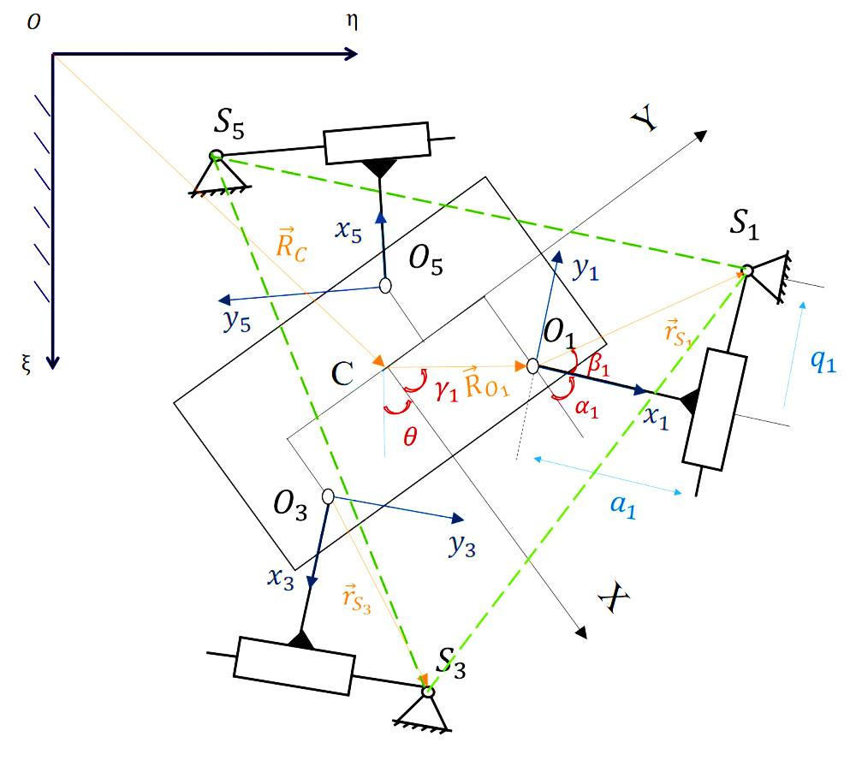
Figure 4.1 – Kinematic-equivalent scheme of the WR with a “tripod”-gate [24]

Differentiation of (4.3) with respect to time gives the following correlation:

$$\vec{0}=\dot{\vec{R_{C}}}+\dot{θ}Γ\left(θ+\frac{π}{2}\right)\vec{{r_{O}}_{i}}+\left(\dot{θ}+{\dot{α}}_{i}\right)Γ\left(θ+α+\frac{π}{2}\right)\vec{{r_{S}}_{i}}+$$

$+Γ\left(θ+α_{i}\right)∙\dot{\vec{{r_{S}}_{i}}},$ (4.5)

since $\frac{d\vec{{R_{S}}_{i}}}{dt}=\vec{0}$.
From (4.5) a Jacobian matrix $J_{q}$ of the system can be found, which is defined as

$$\dot{\vec{x}}=J_{q}\dot{\vec{q}}$$

or

$J_{q}=\frac{d\vec{x}}{d\vec{q}}$ , (4.6)

$\vec{x}={\left[{\vec{R_{C}}}^{T}, L_{θ}θ\right]}^{T}={\left[ξ_{C}, η_{C}, L_{θ}θ\right]}^{T}$ – output coordinates, where $L_{θ}$ – characteristic length, and input coordinates are $\vec{q}={\left[q_{1},q_{3},q_{5}\right]}^{T}$.

To eliminate ${\dot{α}}_{i}$, from the equation (4.5), we multiply the equation from the left by the vector $\vec{{O_{i}S}_{i}}=Γ\left(θ+α_{i}\right)\vec{{r_{S}}_{i}}$. Then since,

$\left(\dot{θ}+{\dot{α}}_{i}\right){\vec{{r_{S}}_{i}}}^{T}∙Γ^{T}\left(θ+α_{i}\right)∙Γ\left(θ+α_{i}+\frac{π}{2}\right)∙\vec{{r_{S}}_{i}}=0$,

the equation (4.5) can be rewritten as follows:
${\vec{{r_{S}}_{i}}}^{T}∙Γ^{T}\left(θ+α_{i}\right)∙\dot{\vec{R_{C}}}+\dot{θ}∙{\vec{{r_{S}}_{i}}}^{T}∙Γ^{T}\left(\frac{π}{2}-α_{i}\right)∙\vec{{r_{O}}_{i}}=$

$=-q_{i}\dot{q_{i}},$ $i=1,3,5.$ (4.7)

Then the Jacobian matrix

$J_{q}=A^{-1}B,$ | (4.8)

where

$A=\left[\begin{matrix}{\vec{{r_{S}}_{1}}}^{T}∙Γ^{T}\left(θ+α_{1}\right) & \frac{1}{L_{θ}}{\vec{{r_{S}}_{1}}}^{T}∙Γ^{T}\left(\frac{π}{2}-α_{1}\right)∙\vec{{r_{O}}_{1}} \\ {\vec{{r_{S}}_{3}}}^{T}∙Γ^{T}\left(θ+α_{3}\right) & \frac{1}{L_{θ}}{\vec{{r_{S}}_{3}}}^{T}∙Γ^{T}\left(\frac{π}{2}-α_{3}\right)∙\vec{{r_{O}}_{3}} \\ {\vec{{r_{S}}_{5}}}^{T}∙Γ^{T}\left(θ+α_{5}\right) & \frac{1}{L_{θ}}{\vec{{r_{S}}_{5}}}^{T}∙Γ^{T}\left(\frac{π}{2}-α_{5}\right)∙\vec{{r_{O}}_{5}}\end{matrix}\right]$,

$$B=-\left[\begin{matrix}q_{1} & 0 & 0 \\ 0 & q_{3} & 0 \\ 0 & 0 & q_{5}\end{matrix}\right].$$

The isotropy condition (1.1) can be transformed to another form [12]:

${\left(J_{q}^{-1}\right)}^{T}∙J_{q}^{-1}=\frac{1}{λ^{2}}E,$ (4.9)

where $E$ is the identity matrix, $\dim{E}=3×3,$ and

$$J_{q}^{-1}=$$

$$\left[\begin{matrix}\frac{1}{q_{1}}{\vec{{r_{S}}_{1}}}^{T}∙Γ^{T}\left(θ+α_{1}\right) & \frac{1}{{q_{1}L}_{θ}}{\vec{{r_{S}}_{1}}}^{T}∙Γ^{T}\left(\frac{π}{2}-α_{1}\right)∙\vec{{r_{O}}_{1}} \\ \frac{1}{q_{3}}{\vec{{r_{S}}_{3}}}^{T}∙Γ^{T}\left(θ+α_{3}\right) & \frac{1}{{q_{3}L}_{θ}}{\vec{{r_{S}}_{3}}}^{T}∙Γ^{T}\left(\frac{π}{2}-α_{3}\right)∙\vec{{r_{O}}_{3}} \\ \frac{1}{q_{5}}{\vec{{r_{S}}_{5}}}^{T}∙Γ^{T}\left(θ+α_{5}\right) & \frac{1}{q_{5}L_{θ}}{\vec{{r_{S}}_{5}}}^{T}∙Γ^{T}\left(\frac{π}{2}-α_{5}\right)∙\vec{{r_{O}}_{5}}\end{matrix}\right] (4.10)$$

The following equation can be derived from (4.10):

$$\frac{1}{q_{i}}{\vec{ r_{S_{i}}}}^{T}∙Γ^{T}\left(θ+α_{i}\right)=$$

$=\frac{1}{q_{i}}\left[\begin{matrix}{\vec{e_{ξ}}}^{T}Γ(θ+α_{i})\vec{{r_{S}}_{i}} & {\vec{e_{η}}}^{T}Γ(θ+α_{i})\vec{{r_{S}}_{i}}\end{matrix}\right]$,

$$\frac{1}{{q_{i}L}_{θ}}{\vec{{r_{S}}_{i}}}^{T}∙Γ^{T}\left(\frac{π}{2}-α_{i}\right)∙\vec{{r_{O}}_{i}}=\frac{1}{{q_{i}L}_{θ}}{\vec{e_{ζ}}}^{T}\left[\vec{{r_{O}}_{i}}×Γ\left(α_{i}\right)\vec{{r_{S}}_{i}}\right],$$

where $\vec{e_{ξ}}, \vec{e_{η}}, \vec{e_{ζ}}$ are the basis vectors of the coordinate system $O_{0}ξηζ$.

Thus,

$J_{q}^{-1}=$ (4.11)

$$-\left[\begin{matrix}\frac{1}{q_{1}}\begin{matrix}{\vec{e_{ξ}}}^{T}Γ\left(θ+α_{1}\right)\vec{{r_{S}}_{1}} & \frac{1}{q_{1}}{\vec{e_{η}}}^{T}Γ\left(θ+α_{1}\right)\vec{{r_{S}}_{1}}\end{matrix} & \frac{1}{{q_{1}L}_{θ}}{\vec{e_{ζ}}}^{T}\left[\vec{{r_{O}}_{1}}×Γ\left(α_{1}\right)\vec{{r_{S}}_{1}}\right] \\ \frac{1}{q_{3}}\begin{matrix}{\vec{e_{ξ}}}^{T}Γ\left(θ+α_{3}\right)\vec{{r_{S}}_{3}} & \frac{1}{q_{3}}{\vec{e_{η}}}^{T}Γ\left(θ+α_{3}\right)\vec{{r_{S}}_{3}}\end{matrix} & \frac{1}{{q_{3}L}_{θ}}{\vec{e_{ζ}}}^{T}\left[\vec{{r_{O}}_{3}}×Γ\left(α_{3}\right)\vec{{r_{S}}_{3}}\right] \\ \frac{1}{q_{5}}\begin{matrix}{\vec{e_{ξ}}}^{T}Γ\left(θ+α_{5}\right)\vec{{r_{S}}_{5}} & \frac{1}{q_{5}}{\vec{e_{η}}}^{T}Γ\left(θ+α_{5}\right)\vec{{r_{S}}_{5}}\end{matrix} & \frac{1}{q_{5}L_{θ}}{\vec{e_{ζ}}}^{T}\left[\vec{{r_{O}}_{5}}×Γ\left(α_{5}\right)\vec{{r_{S}}_{5}}\right]\end{matrix}\right].$$

The isotropy condition can be represented in a more compact form, using the variable $β_{i}$, the angle between the vectors $\vec{O_{i}P_{i}}$ and $\vec{{r_{s}}_{i}}$, i.e. $tgβ_{i}=\frac{q_{i}}{a_{i}}$ (see figure 1). To this end we can obtain

$$\frac{1}{q_{i}}Γ\left(θ+α_{i}\right)\vec{{r_{S}}_{i}}=$$

$$=\frac{r_{S_{i}}}{q_{i}}Γ\left(θ+α_{i}\right)∙\left[\begin{matrix}\cos{β_{i}} \\ \sin{β_{i}}\end{matrix} \right]=\frac{1}{\sin{β_{i}}}\left[\begin{matrix}\cos\left(θ+α_{i}+β_{i}\right) \\ \sin\left(θ+α_{i}+β_{i}\right)\end{matrix} \right],$$

where $r_{S_{i}}=\sqrt{a_{i}^{2}+q_{i}^{2}}$ – magnitude of the vector $\vec{{r_{S}}_{i}}$, and $\cos{β_{i}}=\frac{a_{i}}{r_{S_{i}}}, \sin{β_{i}}=\frac{q_{i}}{r_{S_{i}}}$. Hence,

$$\frac{1}{q_{i}}{\vec{e_{ξ_{i}}}}^{T}∙Γ\left(θ+α_{i}\right)\vec{{r_{S}}_{i}}=\frac{\cos\left(θ+α_{i}+β_{i}\right)}{\sin{β_{i}}};$$

$$\frac{1}{q_{i}}{\vec{e_{η_{i}}}}^{T}∙Γ\left(θ+α_{i}\right)\vec{{r_{S}}_{i}}=\frac{\sin\left(θ+α_{i}+β_{i}\right)}{\sin{β_{i}}};$$

Also, the right column in the expression (4.11) can be simplified as follows:

$$\frac{1}{q_{i}L_{θ}}{\vec{e_{ζ}}}^{T}\left[\vec{{r_{O}}_{i}}×Γ\left(α_{i}\right)\vec{{r_{S}}_{i}}\right]=$$

$$\frac{r_{S_{i}}}{L_{θ}q_{i}}{\vec{e_{ζ}}}^{T}∙\left|\begin{matrix}X_{O_{i}} & Y_{O_{i}} \\ \cos\left(α_{i}+β_{i}\right) & \sin\left(α_{i}+β_{i}\right)\end{matrix}\right|\vec{e_{ζ}}=$$

$$\frac{r_{O_{i}}}{L_{θ}sin{β_{i}}}\sin\left(α_{i}+β_{i}-γ_{i}\right),$$

$r_{O_{i}}$, $γ_{i}$ – polar coordinates of the center of the joint $O_{i}$:

$$r_{O_{i}}=\sqrt{X_{O_{i}}^{2}+Y_{O_{i}}^{2}}, tgγ_{i}=\frac{Y_{O_{i}}}{X_{O_{i}}}.$$

Then the expression (4.11)

$$J_{q}^{-1}=$$

$$\left[\begin{matrix}\begin{matrix}\frac{\cos\left(θ+α_{1}+β_{1}\right)}{\sin{β_{1}}} & \frac{\sin\left(θ+α_{1}+β_{1}\right)}{\sin{β_{1}}}\end{matrix} & \frac{r_{O_{1}}}{L_{θ}sin{β_{1}}}\sin\left(α_{1}+β_{1}-γ_{1}\right) \\ \begin{matrix}\frac{\cos\left(θ+α_{3}+β_{3}\right)}{\sin{β_{3}}} & \frac{\sin\left(θ+α_{3}+β_{3}\right)}{\sin{β_{2}}}\end{matrix} & \frac{r_{O_{3}}}{L_{θ}sin{β_{2}}}\sin\left(α_{3}+β_{3}-γ_{3}\right) \\ \begin{matrix}\frac{\cos\left(θ+α_{5}+β_{5}\right)}{\sin{β_{5}}} & \frac{\sin\left(θ+α_{5}+β_{5}\right)}{\sin{β_{5}}}\end{matrix} & \frac{r_{O_{5}}}{L_{θ}sin{β_{5}}}\sin\left(α_{5}+β_{5}-γ_{5}\right)\end{matrix}\right]. (4.12)$$

Now, from (4.9)
$${\left(J_{q}^{-1}\right)}^{T}∙J_{q}^{-1}=\left[\begin{matrix}j_{11} & j_{12} & j_{13} \\ j_{21} & j_{22} & j_{23} \\ j_{31} & j_{32} & j_{33}\end{matrix}\right]=\frac{1}{λ^{2} }E, (4.13)$$

where
$$j_{11}=\sum_{i=1,3,5}{\frac{\cos^{2}\left(θ+α_{i}+β_{i}\right)}{\sin^{2}{β_{i}}}};$$
$$j_{12}=\sum_{i=1,3,5}{\frac{\sin{2\left(θ+α_{i}+β_{i}\right)}}{2\sin^{2}{β_{i}}}};$$
$$j_{13}=\sum_{i=1,3,5}{\frac{r_{O_{i}}\cos\left(θ+α_{i}+β_{i}\right)\sin\left(α_{i}+β_{i}-γ_{i}\right)}{L_{θ}\sin^{2}{β_{i}}}};$$
$$j_{21}=\sum_{i=1,3,5}{\frac{\sin{2\left(θ+α_{i}+β_{i}\right)}}{2\sin^{2}{β_{i}}}};$$
$$j_{22}=\sum_{i=1,3,5}{\frac{\sin^{2}\left(θ+α_{i}+β_{i}\right)}{\sin^{2}{i}}};$$
$$j_{23}=\sum_{i=1,3,5}{\frac{r_{O_{i}}\sin\left(θ+α_{i}+β_{i}\right)\sin\left(α_{i}+β_{i}-γ_{i}\right)}{L_{θ}\sin^{2}{β_{i}}};}$$
$$j_{31}=\sum_{i=1,3,5}{\frac{r_{O_{i}}\cos\left(θ+α_{i}+β_{i}\right)\sin\left(α_{i}+β_{i}-γ_{i}\right)}{L_{θ}\sin^{2}{β_{i}}}};$$
$$j_{32}=\sum_{i=1,3,5}{\frac{r_{O_{i}}\sin\left(θ+α_{i}+β_{i}\right)\sin\left(α_{i}+β_{i}-γ_{i}\right)}{L_{θ}\sin^{2}{β_{i}}}};$$
$$j_{33}=\sum_{i=1,3,5}{\frac{r_{O_{i}}\sin^{2}\left(α_{i}+β_{i}-γ_{i}\right)}{L_{θ}^{2}\sin^{2}{β_{i}}}}.$$

Therefore, we get 6 isotropy conditions:

$$\sum_{i=1,3,5}{\frac{\cos^{2}\left(θ+α_{i}+β_{i}\right)}{\sin^{2}{β_{i}}}}=\frac{1}{λ^{2} };$$ | (4.14)
$$\sum_{i=1,3,5}{\frac{\sin^{2}\left(θ+α_{i}+β_{i}\right)}{\sin^{2}{β_{i}}}}=\frac{1}{λ^{2} };$$ | (4.15)
$$\sum_{i=1,3,5}{\frac{r_{O_{i}}\sin^{2}\left(α_{i}+β_{i}-γ_{i}\right)}{\sin^{2}{β_{i}}}}=\frac{1}{λ^{2} };$$ | (4.16)
$$\sum_{i=1,3,5}{\frac{\sin{2\left(θ+α_{i}+β_{i}\right)}}{\sin^{2}{β_{i}}}}=0;$$ | (4.17)
$$\sum_{i=1,3,5}{\frac{r_{O_{i}}\cos\left(θ+α_{i}+β_{i}\right)\sin\left(α_{i}+β_{i}-γ_{i}\right)}{\sin^{2}{β_{i}}}}=0;$$ | (4.18)
$$\sum_{i=1,3,5}{\frac{r_{O_{i}}\sin\left(θ+α_{i}+β_{i}\right)\sin\left(α_{i}+β_{i}-γ_{i}\right)}{\sin^{2}{β_{i}}}}=0.$$ | (4.19)
For convenience in the further studies the derived conditions were used in different forms. From (4.13), (4.14)

$$\frac{1}{λ^{2} }=\frac{1}{2}\left(\frac{1}{\sin^{2}{β_{1}}}+\frac{1}{\sin^{2}{β_{3}}}+\frac{1}{\sin^{2}{β_{5}}}\right). (4.20)$$

since,

$$\sum_{i=1,3,5}{\frac{\cos^{2}\left(θ+α_{i}+β_{i}\right)}{\sin^{2}{β_{i}}}}=\sum_{i=1,3,5}{\frac{\sin^{2}\left(θ+α_{i}+β_{i}\right)}{\sin^{2}{β_{i}}} ,} (4.21)$$

$$\sum_{i=1,3,5}{\frac{\cos{2\left(θ+α_{i}+β_{i}\right)}}{\sin^{2}{β_{i}}}}=0 . (4.22)$$

And from (4.15), (4.20)

$$\sum_{i=1,3,5}{\frac{1}{\sin^{2}{β_{i}}}}\left[\begin{matrix}\cos{2\left(θ+α_{i}+β_{i}\right)} \\ \sin{2\left(θ+α_{i}+β_{i}\right)}\end{matrix}\right]=$$
(4.23)

$$=\sum_{i=1,3,5}{\frac{1}{\sin^{2}{β_{i}}}Γ\left(2θ\right)∙\left[\begin{matrix}\cos{2\left(α_{i}+β_{i}\right)} \\ \sin{2\left(α_{i}+β_{i}\right)}\end{matrix}\right]}=\vec{0}$$

Since the last equality holds for any $θ$, the angle $θ$can be eliminated from the conditions (4.12) and (4.13):

$$\frac{\cos{2\left(α_{1}+β_{1}\right)}}{\sin^{2}{β_{1}}}+\frac{\cos{2\left(α_{3}+β_{3}\right)}}{\sin^{2}{β_{3}}}+\frac{\cos{2\left(α_{5}+β_{5}\right)}}{\sin^{2}{β_{5}}}=0 (4.24)$$

$$\frac{\sin{2\left(α_{1}+β_{1}\right)}}{\sin^{2}{β_{1}}}+\frac{\sin{2\left(α_{3}+β_{3}\right)}}{\sin^{2}{β_{3}}}+\frac{\sin{2\left(α_{5}+β_{5}\right)}}{\sin^{2}{β_{5}}}=0 (4.25)$$

Similarly, the rotation angle can be excluded from the equations (4.18), (4.19).
If we denote ${u_{i}=r}_{O_{i}}\sin\left(α_{i}+β_{i}-γ_{i}\right), i=1,3,5$, then the equations (4.16), (4.18), (4.19), taking into account (4.20) will get the following forms:

$$\sum_{i=1,3,5}{\frac{u_{i}^{2}}{\sin^{2}{β_{i}}}}=\frac{L_{θ}^{2}}{2}\sum_{i=1,3,5}{\frac{1}{\sin^{2}{β_{i}}};}$$ | (4.26)
$$\left[\begin{matrix}\sum_{i=1,3,5}{\frac{u_{i}\cos\left(θ+α_{i}+β_{i}\right)}{\sin^{2}{β_{i}}}} \\ \sum_{i=1,3,5}{\frac{u_{i}\sin\left(θ+α_{i}+β_{i}\right)}{\sin^{2}{β_{i}}}}\end{matrix}\right]=$$  $$=\sum_{i=1,3,5}{\frac{u_{i}}{\sin^{2}{β_{i}}}}Γ\left(θ\right)∙\left[\begin{matrix}\cos\left(α_{i}+β_{i}\right) \\ \sin\left(α_{i}+β_{i}\right)\end{matrix}\right]=\vec{0}.$$  $$\sum_{i=1,3,5}{\frac{u_{i}\cos\left(α_{i}+β_{i}\right)}{\sin^{2}{β_{i}}}}=0,$$ | (4.27)
 | (4.28)
$$\sum_{i=1,3,5}{\frac{u_{i}\sin\left(α_{i}+β_{i}\right)}{\sin^{2}{β_{i}}}}=0.$$

And from (4.24), (4.25)

$$\frac{\cos^{2}{2\left(α_{5}+β_{5}\right)}}{\sin^{4}{β_{5}}} =\frac{\cos^{2}{2\left(α_{3}+β_{3}\right)}}{\sin^{4}{β_{3}}}+\frac{\cos^{2}{2\left(α_{1}+β_{1}\right)}}{\sin^{4}{β_{1}}}+$$

$$+2\frac{\cos{2\left(α_{3}+β_{3}\right)}\cos{2\left(α_{1}+β_{1}\right)}}{\sin^{2}{β_{3}}\sin^{2}{β_{1}}} ;$$

$$\frac{\sin^{2}{2\left(α_{5}+β_{5}\right)}}{\sin^{4}{β_{5}}}=\frac{\sin^{2}{2\left(α_{3}+β_{3}\right)}}{\sin^{4}{β_{3}}}+\frac{\sin^{2}{2\left(α_{1}+β_{1}\right)}}{\sin^{4}{β_{1}}}+$$

$$+2\frac{\sin{2\left(α_{3}+β_{3}\right)}\sin{2\left(α_{1}+β_{1}\right)}}{\sin^{2}{β_{3}}\sin^{2}{β_{1}}} .$$

Hence,

$$\frac{1}{\sin^{4}{β_{5}}}=$$

$$=\frac{1}{\sin^{4}{β_{3}}}+\frac{1}{\sin^{4}{β_{1}}}+2\frac{\cos{2(α_{3}+β_{3}-α_{1}-β_{1})}}{\sin^{2}{β_{3}}\sin^{2}{β_{1}}}.$$
(4.29)

$$\cos{2\left(α_{3}+β_{3}-α_{1}-β_{1}\right)=}$$

$$=\frac{\sin^{2}{β_{3}}\sin^{2}{β_{1}}}{2}\left(\frac{1}{\sin^{4}{β_{5}}}-\frac{1}{\sin^{4}{β_{3}}}-\frac{1}{\sin^{4}{β_{1}}}\right).$$

(4.30)

Due to the symmetricity of equations (4.24), (4.25), using the cyclic permutation of indices (1 – 3 – 5 – 1),

$$\cos{2\left(α_{5}+β_{5}-α_{1}-β_{1}\right)}=$$  $$=\frac{\sin^{2}{β_{5}}\sin^{2}{β_{1}}}{2}\left(\frac{1}{\sin^{4}{β_{3}}}-\frac{1}{\sin^{4}{β_{5}}}-\frac{1}{\sin^{4}{β_{1}}}\right) .$$ | (4.31)

4.2 Study of the Isotropy Conditions
4.2.1 Deserve more attention the symmetric solutions. Let’s consider the case $β_{i}=\frac{π}{2}, i=1,3,5$. From (3.18),

$$\frac{1}{λ^{2}}=\frac{3}{2} ,$$ | (4.32)

The following can be derived from (3.12), (3.13):

$$\sin^{2}{α_{1}}+\sin^{2}{α_{3}}+\sin^{2}{α_{5}}=\frac{3}{2};$$ | (4.33)
$$\cos^{2}{α_{1}}+\cos^{2}{α_{3}}+\cos^{2}{α_{5}}=\frac{3}{2}.$$ | (4.34)

And (3.14) gives

$$\sin{2α_{1}}+\sin{2α_{3}}+\sin{2α_{5}}=0.$$ | (4.35)
From (4.2) and (4.3) it follows

$$\cos{2α_{1}}+\cos{2α_{3}}+\cos{2α_{5}}=0.$$ | (4.36)

A simple solution can be found from last formulas:

$$\cos{2\left(α_{3}-α_{1}\right)}=-\frac{1}{2};$$

Analogically, we can get

$$\cos{2\left(α_{i}-α_{j}\right)}=-\frac{1}{2}, i,j=1,3,5, i≠j.$$ | (4.37)

The parameters $r_{O_{i}}, γ_{i}$ can be found using (3.14), (3.16) and (3.17):

$$\sum_{i=1,3,5}{r_{O_{i}}\cos^{2}\left(α_{i}-γ_{i}\right)}=\frac{L_{θ}^{2}}{λ^{2} }$$

Knowing that (see equation (4.1)

$$\sum_{i=1,3,5}{r_{O_{i}}\cos^{2}\left(α_{i}-γ_{i}\right)}=\frac{{3L}_{θ}^{2}}{2 },$$ | (4.38)

we find

$$\sum_{i=1,3,5}{r_{O_{i}}\sin{α_{i}}\cos\left(α_{i}-γ_{i}\right)}=0,$$ | (4.39)

and

$$\sum_{i=1,3,5}{r_{O_{i}}\cos{α_{i}}\cos\left(α_{i}-γ_{i}\right)}=0.$$ | (4.40)

The last equations are also true for $β_{i}=-\frac{π}{2}$.
Denote $r_{O_{i}}\cos\left(α_{i}-γ_{i}\right)=x_{i}$, then

$$\left\{\begin{aligned}x_{1}^{2}+x_{3}^{2}+x_{5}^{2}=\frac{3}{2}L_{θ}^{2} \\ \\ x_{1}\sin{α_{1}+x_{3}\sin{α_{3}+x_{5}\sin{α_{5}}}}=0 \\ \\ x_{1}\cos{α_{1}+x_{3}\cos{α_{3}+x_{5}\cos{α_{5}}}}=0\end{aligned}\right.$$ | (4.41)

According to the Cramer’s rule, the solution of the last two equations:

$$∆=\sin\left(α_{3}-α_{5}\right),$$

$$x_{3}=-\frac{x_{1}\left|\begin{matrix}\sin{α_{1}} & \sin{α_{5}} \\ \cos{α_{1}} & \cos{α_{5}}\end{matrix}\right|}{Δ}=\frac{x_{1}\sin\left(α_{5}-α_{1}\right)}{\sin\left(α_{3}-α_{1}\right)}$$ | (4.42)
$$x_{5}=-\frac{x_{1}\left|\begin{matrix}\sin{α_{3}} & \sin{α_{1}} \\ \cos{α_{3}} & \cos{α_{1}}\end{matrix}\right|}{Δ}=\frac{x_{1}\sin\left(α_{1}-α_{3}\right)}{\sin\left(α_{3}-α_{5}\right)}$$ | (4.43)
Thus,

$$x_{1}^{2}=\frac{L_{θ}^{2}}{2}.$$ | (4.44)
For example, when $L_{θ}=1\frac{m}{rad},$

$$r_{O_{i}}\cos\left(α_{i}-γ_{i}\right)=±\frac{1}{\sqrt{2}} m;$$

Or if $L_{θ}=\sqrt{2}\frac{m}{rad},$

$$r_{O_{i}}\cos\left(α_{i}-γ_{i}\right)=±1 .$$

    - Consider a more general case: $β_{1}=β_{3}=β_{5}$.
Rewrite the equations (3.22), (3.23) as follows:

$${\left(\frac{\cos{x_{1}}}{\sin^{2}{β_{1}}}+\frac{\cos{x_{3}}}{\sin^{2}{β_{3}}}\right)}^{2}={\left(-\frac{\cos{x_{5}}}{\sin^{2}{β_{5}}}\right)}^{2},$$ | (4.45)
$${\left(\frac{\sin{x_{1}}}{\sin^{2}{β_{1}}}+\frac{\sin{x_{3}}}{\sin^{2}{β_{3}}}\right)}^{2}={\left(-\frac{\sin{x_{5}}}{\sin^{2}{β_{5}}}\right)}^{2}.$$ | (4.46)

Then we get

$$\cos\left(x_{1}-x_{5}\right)=$$  $$=\frac{\sin^{2}{β_{5}}\sin^{2}{β_{1}}}{2}\left(\frac{1}{\sin^{4}{β_{3}}}-\frac{1}{\sin^{4}{β_{5}}}-\frac{1}{\sin^{4}{β_{1}}}\right)$$ | (4.47)

And making cyclic permutation (1 – 3 – 5 – 1),

$$\cos\left(x_{1}-x_{5}\right)=$$  $$=\frac{\sin^{2}{β_{5}}\sin^{2}{β_{1}}}{2}\left(\frac{1}{\sin^{4}{β_{3}}}-\frac{1}{\sin^{4}{β_{5}}}-\frac{1}{\sin^{4}{β_{1}}}\right).$$ | (4.48)

The case of equal angles $β_{1}=β_{3}=β_{5}$ will lead to a simple solution, which coincides with (4.6):

$$\left\{\begin{aligned}\cos{2\left(α_{3}-α_{1}\right)}=-\frac{1}{2}, \\ \cos{2\left(α_{5}-α_{1}\right)}=-\frac{1}{2}.\end{aligned}\right.$$ | (4.49)
Hence,

$$\left\{\begin{aligned}α_{3}=α_{1}±\frac{π}{3}+2πn, n=0,1, \\ α_{5}=α_{1}∓\frac{π}{3}+2πk, k=0,1\end{aligned}\right.$$ | (4.50)

This solution gives 8 combinations of ${\{α}_{3}-α_{1},α_{5}-α_{1}\}$, each of which satisfies (3.22) and (3.23):

$$\left\{\frac{π}{3},-\frac{π}{3}\right\};\left\{\frac{π}{3},-\frac{2π}{3}\right\};\left\{-\frac{π}{3},\frac{π}{3}\right\};\left\{-\frac{π}{3},-\frac{2π}{3}\right\};$$  $$\left\{-\frac{2π}{3},-\frac{π}{3}\right\};\left\{-\frac{2π}{3},\frac{2π}{3}\right\};\left\{\frac{2π}{3},\frac{π}{3}\right\};\left\{\frac{2π}{3},-\frac{π}{3}\right\},$$ | (4.51)

Fig.5a illustrates 1-, 2-, 3-, 4-, 5-, 7-th solutions and the Fig.5b represents combinations ${\{α}_{3}-α_{1},α_{5}-α_{1}\}=$ $\left\{-\frac{2π}{3},\frac{2π}{3}\right\}$, and ${\{α}_{3}-α_{1},α_{5}-α_{1}\}=\left\{\frac{2π}{3},-\frac{π}{3}\right\}$.

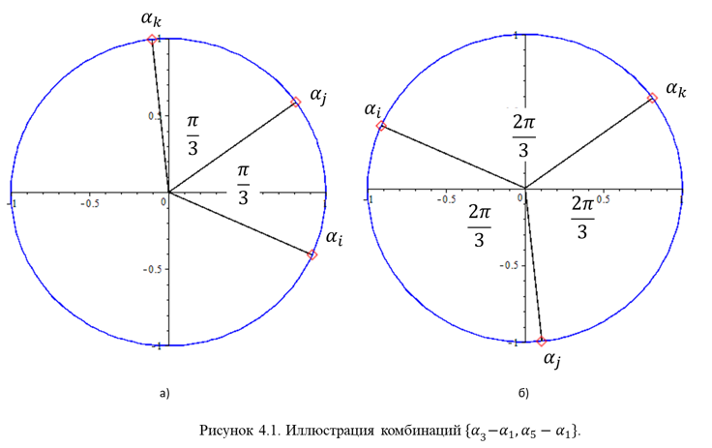

  - b)

Figure 4.2 – Illustration of combinations ${\{α}_{3}-α_{1},α_{5}-α_{1}\}$ [24]

To search for the parameters $β_{i}, r_{O_{i}}$, we set $β_{1}=β_{3}=β_{5}=β$ again. Equation (24) in this case will take the form:

$$\sum_{i=1,2,3}{u_{i}^{2}}=\frac{3L_{θ}^{2}}{2},$$ | (4.52)

where

$$u_{i}=r_{O_{i}}sin\left(α_{i}+β-γ_{i}\right).$$

Equations (3.25) and (3.26) give a system of two linear equations in the unknowns $\{u_{3},u_{5}\}$:
$$\sum_{i=1,3,5}{u_{i}Γ\left(β\right)∙\left[\begin{matrix}\cos\left(α_{i}\right) \\ \sin\left(α_{i}\right)\end{matrix}\right]}=0,$$

from where

$$\sum_{i=1,3,5}{u_{i}\cos\left(α_{i}\right)}=0, i=1,3,5;$$ | (4.53)
$$\sum_{i=1,3,5}{u_{i}\sin\left(α_{i}\right)}=0, i=1,3,5.$$ | (4.54)

Solving the last equations by Cramer’s method with respect to $u_{3}$ and ${ u}_{5}$,

$$u_{3}=u_{1}\frac{\sin\left(α_{1}-α_{5}\right)}{\sin\left(α_{5}-α_{3}\right)},$$  $${ u}_{5}=u_{1}\frac{\sin\left(α_{3}-α_{1}\right)}{sin⁡(α_{5}-α_{3})}.$$ | (4.55)

It is known from (3.18) that

$$\sin^{2}{(α_{i}-α_{j})}=\frac{1-\cos{2\left(α_{i}-α_{j}\right)}}{2}=\frac{3}{4}.$$ | (4.56)

Then the solution of (4.21) is

$$u_{i}=±\frac{L_{θ}}{\sqrt{2}}, i=1,3,5.$$ | (4.57)

or

$$sin\left(α_{i}+β-γ_{i}\right)=±\frac{L_{θ}}{\sqrt{2}r_{O_{i}}}, i=1,3,5.$$ | (4.58)
The equality $u_{1}^{2}=u_{3}^{2}=u_{5}^{2}$ follows from (4.20) and (4.21). The solutions correspond to 8 combinations of $\left\{u_{1},u_{3},u_{5}\right\}$:

$$\left\{\frac{L_{θ}}{\sqrt{2}},\frac{L_{θ}}{\sqrt{2}},\frac{L_{θ}}{\sqrt{2}}\right\}, \left\{\frac{L_{θ}}{\sqrt{2}},\frac{L_{θ}}{\sqrt{2}},-\frac{L_{θ}}{\sqrt{2}}\right\},$$  $$\left\{\frac{L_{θ}}{\sqrt{2}},-\frac{L_{θ}}{\sqrt{2}},\frac{L_{θ}}{\sqrt{2}}\right\},\left\{\frac{L_{θ}}{\sqrt{2}},-\frac{L_{θ}}{\sqrt{2}},-\frac{L_{θ}}{\sqrt{2}}\right\},$$  $$\left\{-\frac{L_{θ}}{\sqrt{2}},\frac{L_{θ}}{\sqrt{2}},\frac{L_{θ}}{\sqrt{2}}\right\}, \left\{-\frac{L_{θ}}{\sqrt{2}},\frac{L_{θ}}{\sqrt{2}},-\frac{L_{θ}}{\sqrt{2}}\right\},$$  $$\left\{-\frac{L_{θ}}{\sqrt{2}},-\frac{L_{θ}}{\sqrt{2}},\frac{L_{θ}}{\sqrt{2}}\right\}, \left\{-\frac{L_{θ}}{\sqrt{2}},-\frac{L_{θ}}{\sqrt{2}},-\frac{L_{θ}}{\sqrt{2}}\right\}$$ | (4.59)

As an example consider the case $u_{1}=u_{3}=u_{5}$, i.e. when

$$sin\left(α_{i}+β-γ_{i}\right)=\frac{L_{θ}}{\sqrt{2}r_{O_{i}}}, i=1,3,5$$

or

$$sin\left(α_{i}+β-γ_{i}\right)=-\frac{L_{θ}}{\sqrt{2}r_{O_{i}}}, i=1,3,5.$$

Only two of eight combinations ${\{α}_{3}-α_{1},α_{5}-α_{1}\}$ satisfy the conditions (4.25), (4.26) in this case:

$$1) α_{3}=α_{1}-\frac{2π}{3}, α_{5}=α_{1}+\frac{2π}{3};$$

$$2) α_{3}=α_{1}+\frac{2π}{3}, α_{5}=α_{1}-\frac{2π}{3}.$$

Fig.6a demonstrate the configurations corresponding to the first, and Fig.6b correspond to the second solutions in symmetric case when

$$r_{O_{1}}=r_{O_{3}}=r_{O_{5}}=±\frac{L_{θ}}{\sqrt{2}\sin\left(α_{1}+β-γ_{1}\right)};$$

$$γ_{3}-γ_{1}=α_{3}-α_{1};$$

$$γ_{5}-γ_{1}=α_{5}-α_{1}.$$

For $γ_{1}=\frac{π}{3},$
- for the first solution, $γ_{3}=γ_{1}-\frac{2π}{3}=-\frac{π}{3};γ_{5}=γ_{1}+\frac{2π}{3}=π.$
- and for the second solution $γ_{3}=γ_{1}+\frac{2π}{3}=π; γ_{5}=γ_{1}-\frac{2π}{3}=-\frac{π}{3}.$
Note that the second configuration can be obtained from the first by swapping leg mechanisms with numbers 3 and 5.
And for $γ_{1}=-\frac{π}{3},$
- the first solution is $γ_{3}=-π; γ_{5}=\frac{π}{3},$
- and the second is $γ_{3}=\frac{π}{3}; γ_{5}=-π$,
i.e. swapped are the legs with numbers 1 and 3.
When choosing $α_{1}, γ_{1}$, it is necessary that $\sin\left(α_{i}+β-γ_{i}\right), i=1,3,5$ have the same signs. In the example above, this follows from condition (4.1):

$α_{1}+β-γ_{1}=α_{3}+β-γ_{3}=α_{5}+β-γ_{5}$.

for the first solution,

$$γ_{3}=γ_{1}-\frac{2π}{3}=-\frac{π}{3}.$$

As can be seen in the Figure 4.3, in the isotropic configuration the lines $P_{i}S_{i}$ form an equilateral triangle. Another advantage is that the center of mass of body C is located in the center of the supporting triangle $∆S_{1}S_{3}S_{5}$, which ensures “equal” movement (the same ability of movement) in all directions and an equal margin of stability.
Remark. There is a disadvantage in these two configurations. Let's call "the main movement" the uniform translational motion of the WR. During the main movement, when the main engines rotate uniformly and the angular speeds $ω_{1},ω_{3}, ω_{5}$reach the nominal value $ω_{nom}$,, the robot operates in an energy-optimal mode. During such a movement, the guides $P_{i}S_{i}$of our model will be parallel (Figure 4.2a). And if $β_{1}=β_{3}=β_{5}$ and $a_{1}=a_{3}=a_{5}$, then the lines $O_{i}S_{i}$ will be parallel, which means that the mechanism is in a singular position. To avoid the singularity, $a_{5}$ can be chosen differently: $a_{5}≠a_{1},a_{5}≠a_{3}$. But a more advantageous solution is the case $β_{3}={β_{1},β}_{5}=-β_{1}$ (Figure 4.2b) or $β_{3}={{-β}_{1},β}_{5}=β_{1}$.
Thus, the expressions are obtained that determine the parameters Р=$γ_{3},γ_{5},α_{3},α_{5}, r_{O_{1}},r_{O_{3}}, r_{O_{5}}$ for given values of Х=$α_{1},γ_{1},β_{1},β_{3}, β_{5},a$. As noted earlier, during the movement of the robot, two conditions must be maintained: the absence of a singularity, as well as the stability of the robot (the center of mass of the WR body should be inside the support triangle). After numerical studies of different solutions of the isotropy equations, for each solution were found the boundary values of the generalized coordinates satisfying both mentioned conditions. The step length of the WR is defined as $L_{0}=\min\left(\left|q_{1}^{*}-q_{1}^{**}\right|,\left|q_{3}^{*}-q_{3}^{**}\right|,\left|q_{5}^{*}-q_{5}^{**}\right|\right)$. The optimal solution corresponds to $L_{0}→max.$ Such a solution is $u_{1}=u_{3}=u_{5}$, ${\{α}_{3}-α_{1},α_{5}-α_{1}\}$= $\left\{-\frac{2π}{3},-\frac{π}{3}\right\}$. E.g., with the given parameters
$β_{0}={β_{1}}_{0}={β_{3}}_{0}= {β_{5}}_{0}=\frac{π}{4}, γ_{1}=\frac{π}{3},a_{1}=10 cm,a_{3}=10 cm,a_{5}=7 cm$,

$$r_{O_{i}}=\frac{L_{θ}}{\sqrt{2}\sin\left(α_{1}+β-γ_{1}\right)}, L_{θ}=0.1 m;$$

the step length can be up to L_{0max}=3.610688817 m. This indicates that the solution ensures a sufficient “remoteness” from singularity and instability.

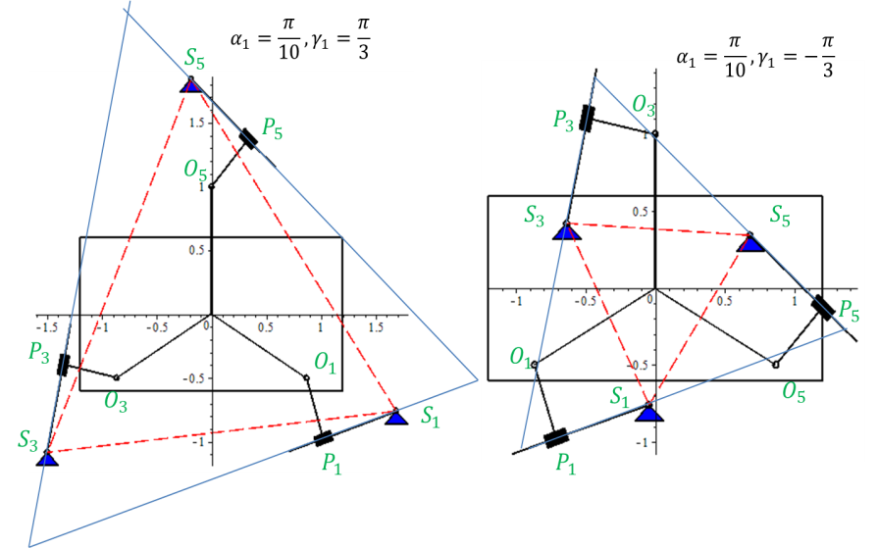
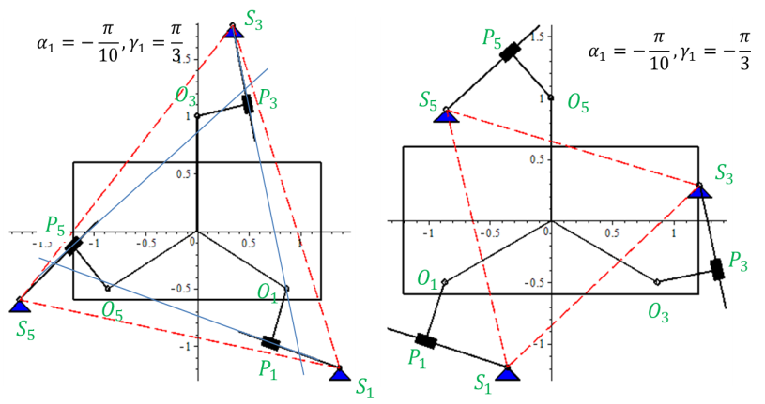
Figure 4.3 – Isotropic configurations [24]
а)
b)

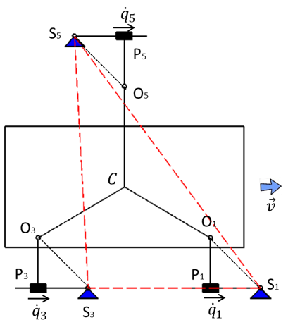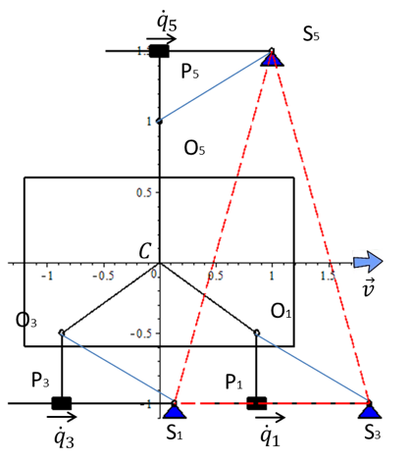

- b)
а) $β_{1}=β_{3}=β_{5}$; b) $β_{1}=β_{3}={-β}_{5}$

Figure 4.4 – Isotropic configurations: $r_{O_{i}}=1, a_{i}=0.5, i=1,3,5.$Configurations at the main movement [24]

Search for more symmetric solutions is provided in (Ibrayeva, 2019) and according to numerical studies was concluded that the above solutions are the furthest from singularity.
Based on the solution of the aforementioned multi-criteria optimization task, an SLM with optimal dimensions has been developed. The solution to the problem and the work with the Test Tables to obtain a compromise solution considering multiple criteria are described in Appendix B.

Conclusions on Section 4
Turning modes of the WR were studied and a parametric synthesis of the turning mechanism has provided. The rotation of the WR is carried out due to the difference in the velocities of the main drives. The method of synthesis of parallel manipulators based on the isotropy criterion is applied for optimization of the WR turning mechanism. The isotropy conditions for robots with orthogonal propulsion are derived. Solutions of isotropy equations are defined. The analysis of the solutions of the isotropy equations was carried out and on their basis the metric parameters of the robot were obtained, which ensure the optimal transmission of forces and motion. One of the symmetric solutions ensures the stability and absence of singularity for the step length limit of 3.6 m, while the characteristic length of the robot is 10 cm.

DESIGN OF ADAPTATION MECHANISM AND EXPERIMENTAL TESTS

5.1 Design Of The Adaptation Mechanism To Uneven Surface
A 3D model of the AWR, developed using the SolidWorks software suite, and a working prototype of the ultimately selected SLM are shown in previous sections. The construction of the prototype showed that in this mechanism, the link EM moves in a straight-line reciprocating motion uniformly with the uniform rotation of the crank.
A mechanism for adaptation to uneven terrain has been developed. The adaptation system was tested on the developed robot prototype (Figure 5.2). The adaptation is performed through the coordination of the main engine, which rotates the crank of the AWR's primary movement, and additional engines responsible for lifting and lowering the foot through the adaptation mechanism (Figure 5.2). During the transfer phase, i.e., at certain crank rotation angles φ_{AB} where $φ_{0}+Φ_{SUP}≤φ_{AB}≤φ_{1}$, where $φ_{1}=φ_{0}+360^{0}$, the adaptation engine raises the foot to the maximum height. At the rotation angle $φ_{1}=φ_{0}+360^{0}$, the leg enters the support phase and the foot begins to lower, and upon contact with the support surface, the foot contact sensor is triggered and sends a signal to the adaptation engine to "lock the engine," i.e., in the support phase, the adaptation engine is locked, ensuring linear motion of the body.

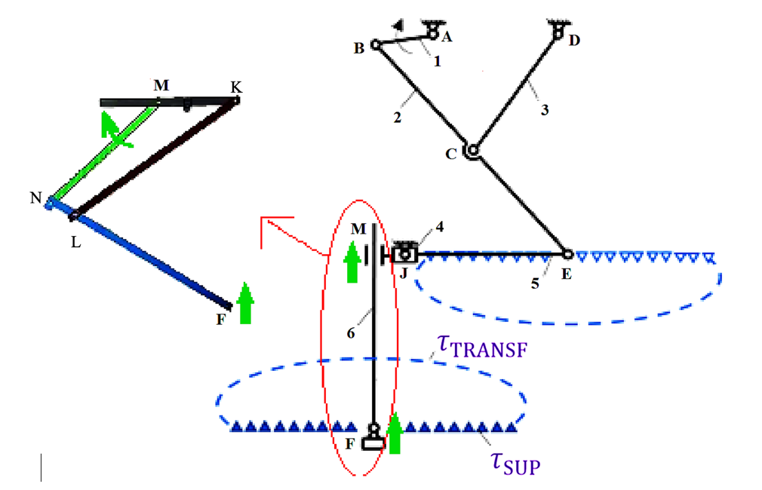

Figure 5.1 – Kinematic Scheme of the SLM of the AWR and the Adaptation Mechanism

The metrical values of the adaptation mechanism normalized (not in meters) by the crank (MN) length are following. MN = 1, KL = 1.37126, NN’ = 0.10591, N’L = 0.36312, LF = 0.63167, MK=0.52718, where N’ is the projection of the point (joint center) N to the line FL.
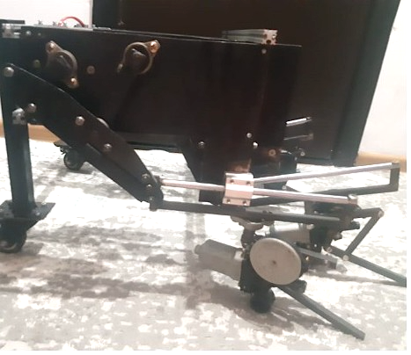
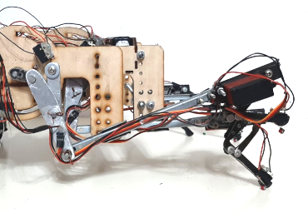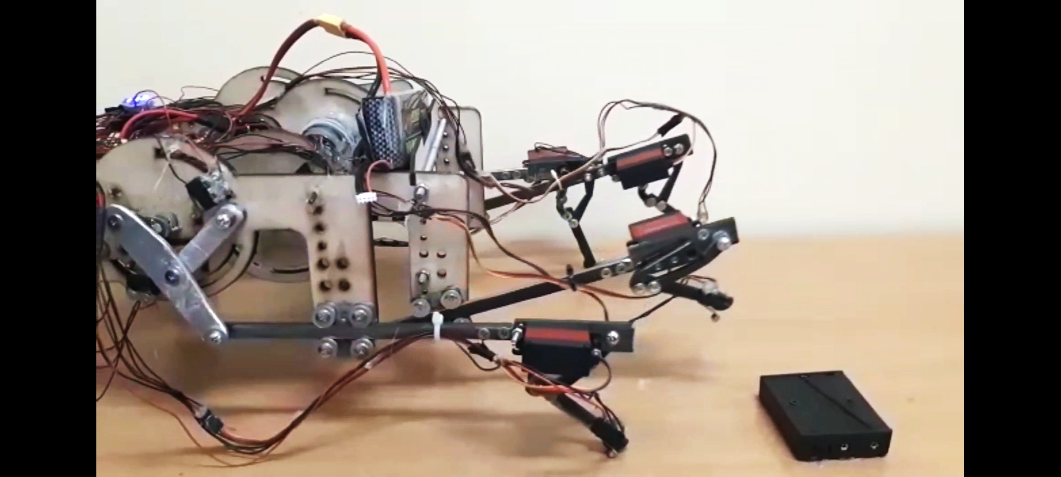

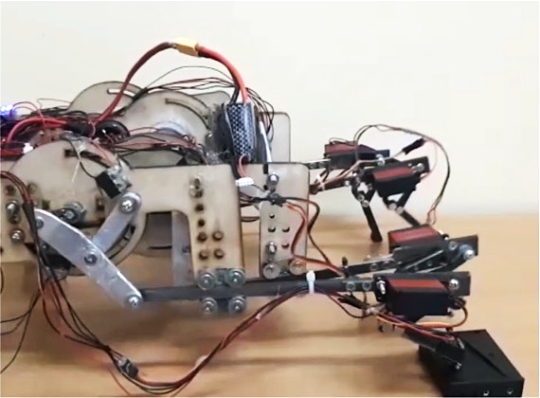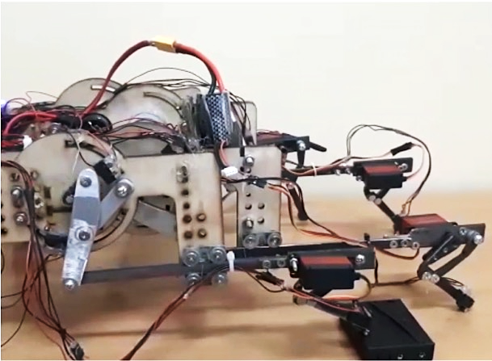

Figure 5.2 – Testing the adaptation mechanism of the WR

5.2 Laboratory Prototype
The aim of this experimental study is to develop a functional prototype of the AWR, with the following objectives:
- To test the effectiveness of implementing the new AWR scheme on a physical robot, especially in terms of forward/backward movement and turning capabilities.
- To evaluate the functionality of the SLM of the AWR.
- To test the robot's control system.
- To identify any shortcomings in the proposed scheme.
- To study the robot's stability during movement: stability is achieved by ensuring the movement of the robot in which the projection of the center of mass constantly lies within the area supported by the robot's feet.
General Description of the Robot: For the purpose of conducting experimental research, three iterations of prototypes were developed, each manufactured with consideration of the shortcomings identified in previous experimental models.
For enhanced stability and safety of movement, an eight-legged design was chosen for the first two prototypes. During movement, four legs are constantly in the support phase while the other four are in the transfer phase, alternating in this pattern. The third stage tested a 'tripod gait' in a six-legged robot. The body and SLM frames of the prototypes were made of aluminum.
Controller. A readily available universal controller—the REV Robotics Control Hub—was used, the advantage of which is that it provides all the necessary interfaces for projects in robotics and mechatronics with multiple programming language options.
The Control Hub is specifically designed to withstand the harsh conditions of various experiments and research, thanks to its protection against electrostatic discharge and reverse polarity. The use of the Android operating system gives the Control Hub flexibility in managing both basic and advanced robots, as well as the ability to be updated on-site as new features are developed.
The Control Hub operates under the control of the Robot Controller application version 5.0 or higher and must be paired with the Driver Station application version 5.0 or higher.
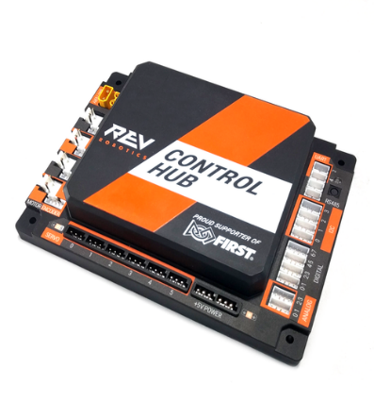

Figure 6.1 - REV Robotics Control Hub [123]

Specifications
- Actuator interfaces
  - Control position and velocity of DC motors
  - Small and easy to control actuators
  - 4 - DC motor ports with built-in encoder ports
  - 6 - Servo motor ports
- Sensor and device interfaces
  - 8 - Digital input/output ports
  - 4 - Analog input ports
  - 4 - Independent I2C ports
  - 1 - Internal 9-axis IMU
- Additional expansion interfaces
  - Additional Expansion Hubs to add more actuator and sensor ports
  - 2 - RS485 ports
- Supported programming languages
  - Blocks
  - OnBot Java
  - Java

Software. The REV Hardware Client—a software designed to make managing REV devices easier for the user—is utilized. This Client automatically detects connected devices, downloads the latest software for those devices, and allows for seamless updating of the devices.
Features:
  - Connect a REV Control Hub via Wi-Fi
  - Pre-download software updates without a connected device
  - Back up and restore user data from Control Hub
  - Install and switch between DS and RC applications on Android Devices
  - Access the Robot Control Console on the Control Hub
  - Auto-update to latest version of the REV Hardware Client
  - Display devices connected via RS485
  - Includes all software less than 1MB in size in the REV Hardware Client installer
  - Adds alternative installers for offline use that bundle all available software, or all software that applies to just FTC or just FRC
Primary motors. For the primary motors, the HD Hex Motor with the UltraPlanetary Gearbox reducer has been selected. The REV UltraPlanetary Gearbox. The REV UltraPlanetary Gearbox (Figure 6.2) is the entry point into using the REV UltraPlanetary System. UltraPlanetary Cartridges allows to support six different final gear reductions ranging from nominally 3:1 to 60:1 ensuring the right amount of torque for the application at hand. A pinion already pressed onto the motor and pre-assembled cartridges for designers to begin testing and iterating on their design.
The UltraPlanetary System is a cartridge based modular gearbox. The UltraPlanetary System includes an input stage and pinion gear that works the REV HD Hex Motor and other 550 class motors. Building on the ability to iterate and adjust designs easily using the REV Building System, the UltraPlanetary System consists of pre-assembled and lubricated cartridges allowing for swapping gear ratios on the fly and with ease. Users can configure a single-stage planetary using one of three different reduction cartridges, build multi-stage gearboxes through stacking individual cartridges together, and choose two different ways for transferring power: either through face mounting directly on the output stage or choosing the length of 5mm hex shaft best suited for the application. It has a variety of options for mounting with four different brackets available for mounting to REV 15mm Extrusion, REV C Channel, or REV U Channel. (REV-41-1608) is pressed on to an HD Hex Motor (REV-41-1291).
Gearbox Specifications
- Module: 0.55
- Pressure Angle: 20°
- Materials: Sintered Steel, Glass Fiber Reinforced PA66 Nylon
- Weight(s):
  - UltraPlanetary w/3 Cartridges and HD Hex Motor, no hardware: 441.5 g (0.973 lbs)
  - UltraPlanetary w/3 Cartridges, no motor and no hardware: 206.5 g (0.456 lbs)
  - UltraPlanetary Output Cartridge: 66.5 g (0.147 lbs)
  - UltraPlanetary Mounting Plate: 33.5 g (0.074 lbs)
  - UltraPlanetary 3:1 Cartridge: 35.5 g (0.078 lbs)
  - UltraPlanetary 4:1 Cartridge: 34.0 g (0.075 lbs)
  - UltraPlanetary 5:1 Cartridge: 36.0 g (0.079 lbs)
HD Hex Motor Specifications - No Cartridges
- Body Diameter: 37mm
- Voltage: 12V DC
- No-Load Current: 400mA
- Stall Current: 8.5A
- Free Speed: 6000 rpm
- Stall Torque: .105 Nm
- Max Output Power: 15W
- Encoder Counts per Revolution
  - at the motor - 28 counts/revolution
Driver. The BTS7960 motor driver was used to control the main motors; it allows control of a single brushed DC motor rated for voltages from 5.5 to 27.5 volts DC up to 43 A. However, as the terminal block installed on the board is not rated for such currents, motors with a consumption current of up to 10 A were used for long-term operation.
Characteristics:
- Motor supply voltage: from 5.5 to 27.5 V DC (outside this range, the driver will enter protection mode).
- Logic supply voltage: 5 V DC.
- Maximum permissible motor current: 43 A (short-term).
- Maximum permissible motor current: 10 A (long-term).
- Maximum PWM frequency on control outputs: 25 kHz.
- Voltage of logic levels on control outputs: 3.3 or 5 V.
Connections:
- "M+" and "M-" - Outputs for connecting the motor.
"M-" Output of the left arm of the H-bridge (chip U3).
"M+" Output of the right arm of the H-bridge (chip U2).
- "S+" and "S-" - Motor power supply.
- "Vcc" and "GND" - Logic power supply.
- "L_IS" - Output state of the left arm of the H-bridge (chip U3).
This output serves as an error flag (if present), or otherwise, it can measure the voltage level proportional to the current flowing through the motor, thus controlling the force of the load applied to the motor.
- "R_IS" - Output state of the right arm of the H-bridge (chip U2).
Similar to "L_IS", this output serves as an error flag or for measuring the voltage level proportional to the current through the motor.
- "L_EN" - Input for enabling the operation of the left arm of the H-bridge (chip U3).
Reset to 0 - disables the "M-" motor output (puts it in a high impedance state).
Set to 1 - enables the "M-" motor output.
- "R_EN" - Input for enabling the operation of the right arm of the H-bridge (chip U2).
Reset to 0 - disables the "M+" motor output (puts it in a high impedance state).
Set to 1 - enables the "M+" motor output.
- "L_PWM" - Input for setting the potential at the output of the left arm of the H-bridge (chip U3).
Reset to 0 - sets the potential at the "M-" output to that of the "S-" output.
Set to 1 - sets the potential at the "M-" output to that of the "S+" output.
The description you've provided is about a motor driver (like the BTS7960) and how to control it using 2 wires. Here's the translation into English:
"Setting the potentials of 'S+' or 'S-' at the output 'M-' is possible only if a 1 is set on the input 'L_EN'.
'R_PWM' - Input for setting the potential at the output of the right arm of the H-bridge (chip U2).
Reset to 0 - sets the output 'M+' to the potential of the output 'S-'.
Setting to 1 - sets the output 'M+' to the potential of the output 'S+'.
Setting the potentials 'S+' or 'S-' at the output 'M+' is possible only if a 1 is set on the input 'R_EN'.
The motor is connected to the 'M+' and 'M-' terminals. The motor supply voltage (5.5 - 27.5 V DC) is applied to the 'S+' and 'S-' terminals. The logic part supply voltage (5 V DC) is applied to the 'Vcc' and 'GND' terminals.
The driver can be controlled by 2, 3, or 4 wires:
2-wire motor driver connection:
The 'L_EN' and 'R_EN' outputs of the driver are connected together and connected to 'Vcc' (do not participate in control).
The 'L_PWM' output is connected to any Arduino pin supporting PWM.
The 'R_PWM' output is connected to any Arduino pin supporting PWM.
2-wire motor driver control:
Forward motion with speed control: 'L_PWM' = 0, 'R_PWM' = PWM (the higher the PWM, the higher the speed).
Forward motion with speed control: 'L_PWM' = PWM, 'R_PWM' = 1 (the higher the PWM, the lower the speed).
Reverse motion with speed control: 'L_PWM' = PWM, 'R_PWM' = 0 (the higher the PWM, the higher the speed).
Reverse motion with speed control: 'L_PWM' = 1, 'R_PWM' = PWM (the higher the PWM, the lower the speed).
Braking: 'L_PWM' = 'R_PWM' = 0 or 1 (maximum braking).
Advantages and disadvantages of the 2-wire control scheme:
The obvious advantage of the scheme is the minimal number of Arduino pins used.
Since 'L_EN' and 'R_EN' are constantly set to 1 (they are connected to 'Vcc'), it means the motor outputs 'M+' and 'M-' do not go into a high impedance state (do not disconnect), therefore, it is possible to brake by speed (reducing speed leads to braking). This fact can also be considered a disadvantage of the scheme, as it does not allow the motor to be freed, with the 'M+' and 'M-' outputs always having the potentials 'S+' and/or 'S-'."
Setting the potentials of 'S+' or 'S-' at the output 'M-' is possible only if a 1 is set on the input 'L_EN'.
- 'R_PWM' - Input for setting the potential at the output of the right arm of the
H-bridge (chip U2).
- Reset to 0 - sets the output 'M+' to the potential of the output 'S-'.
- Setting to 1 - sets the output 'M+' to the potential of the output 'S+'.
- Setting the potentials 'S+' or 'S-' at the output 'M+' is possible only if a 1 is set on the input 'R_EN'.
The motor is connected to the 'M+' and 'M-' terminals. The motor supply voltage (5.5 - 27.5 V DC) is applied to the 'S+' and 'S-' terminals. The logic part supply voltage (5 V DC) is applied to the 'Vcc' and 'GND' terminals.
The driver can be controlled by 2, 3, or 4 wires: 2-wire motor driver connection: The 'L_EN' and 'R_EN' outputs of the driver are connected together and connected to 'Vcc' (do not participate in control). The 'L_PWM' output is connected to any Arduino pin supporting PWM. The 'R_PWM' output is connected to any Arduino pin supporting PWM.
2-wire motor driver control: Forward motion with speed control:
'L_PWM' = 0, 'R_PWM' = PWM (the higher the PWM, the higher the speed).
Forward motion with speed control: 'L_PWM' = PWM, 'R_PWM' = 1 (the higher the PWM, the lower the speed).
Reverse motion with speed control: 'L_PWM' = PWM, 'R_PWM' = 0 (the higher the PWM, the higher the speed).
Reverse motion with speed control: 'L_PWM' = 1, 'R_PWM' = PWM (the higher the PWM, the lower the speed).
Braking: 'L_PWM' = 'R_PWM' = 0 or 1 (maximum braking).
Advantages and disadvantages of the 2-wire control scheme: The obvious advantage of the scheme is the minimal number of Arduino pins used. Since 'L_EN' and 'R_EN' are constantly set to 1 (they are connected to 'Vcc'), it means the motor outputs 'M+' and 'M-' do not go into a high impedance state (do not disconnect), therefore, it is possible to brake by speed (reducing speed leads to braking). This fact can also be considered a disadvantage of the scheme, as it does not allow the motor to be freed, with the 'M+' and 'M-' outputs always having the potentials 'S+' and/or 'S-'.
3-wire motor driver connection:
The 'L_EN' and 'R_EN' outputs of the driver are connected together and connected to any Arduino pin supporting PWM.
The 'L_PWM' output is connected to any Arduino pin.
The 'R_PWM' output is connected to any Arduino pin.
3-wire motor driver control:
Forward motion with speed control: 'L_PWM' = 0, 'R_PWM' = 1, 'EN' = PWM (the higher the PWM, the higher the speed).
Reverse motion with speed control: 'L_PWM' = 1, 'R_PWM' = 0, 'EN' = PWM (the higher the PWM, the higher the speed).
Free rotation: 'L_PWM' and 'R_PWM' do not matter, 'EN' = 0 (motor is electrically disconnected).
Braking: 'L_PWM' = 'R_PWM' = 0 or 1, 'EN' = PWM (the higher the PWM, the stronger the braking).
Advantages and disadvantages of the 3-wire control scheme:
Despite more wires, the control scheme seems simpler: 'L_PWM' and 'R_PWM' control direction, and 'EN' controls speed. If 'L_PWM' and 'R_PWM' have the same logic level, then 'EN' controls braking.
There is the ability to adjust the level of braking using PWM without applying voltage (potential difference) to the motor.
When a logical 0 is applied to the 'EN' input, the motor is electrically disconnected from the circuit. For example, if a device powered by the motor is on a hill and 1 is set on all 'L_PWM', 'R_PWM', and 'EN' inputs, it won't move, but as soon as the level on the 'EN' input is dropped to 0, the motor is freed, and the device will roll down the hill. Another example is saving electricity: after reaching the required speed, drop the level on the 'EN' input to a logical 0, and the device will continue moving by inertia, then set logical 1 on the 'EN' input, accelerate, and drop to 0 again.
A disadvantage of the 3-wire connection scheme is that speed braking is not provided in the scheme.
Power Supply. The motor supply voltage (5.5 - 27.5 V DC) is applied to the 'S+' and 'S-' terminals.
The logic part supply voltage (5 V DC) is applied to the 'Vcc' and 'GND' terminals.
The driver is built on an H-bridge assembled from two half-bridges using BTS7960 chips. These BTS7960 chips support PWM up to 25 kHz (for instance, the Arduino UNO only supports a PWM frequency of 0.5 kHz) and are equipped with protection circuits against short-circuiting, overheating, overvoltage (on the S+ and S- terminal outputs), and voltage drops below 5.5 V (on the S+ and S- terminal outputs). The BTS7960 chips feature an "IS" output, where the voltage changes proportionally to the current flowing through the motor, allowing for the monitoring of motor load. In case of errors, the "IS" output acts as an error detection flag, switching to logical "1". On the board, the "IS" outputs of the chips are connected to GND through a 10 kΩ resistor and are linked to the board's "L_IS" and "R_IS" outputs. A bus driver based on the 74HC244 chip is installed on the driver board, which isolates the logic levels of control signals between the "L_EN", "R_EN", "L_PWM", "R_PWM" inputs and the BTS7960 chip inputs. Thanks to the bus driver, the motor driver can be controlled by both 3.3 V and 5 V logic levels.
In our experimental studies, a three-wire control scheme is used for the motor driver. The Arduino pin numbers are defined in the first three lines of the sketch:
const uint8_t EN = 1; // pin number connected to the driver's L_EN and R_EN inputs.
const uint8_t L_PWM = 2; // pin number connected to the driver's L_PWM input.
const uint8_t R_PWM = 3; // pin number connected to the driver's R_PWM input.
void setup() {
pinMode(EN, OUTPUT); // Configuring the EN pin as an output (driver input)
pinMode(L_PWM, OUTPUT); // Configuring the L_PWM pin as an output (driver input)
pinMode(R_PWM, OUTPUT); // Configuring the R_PWM pin as an output (driver input)
}
void loop() {
// Forward movement at 50% speed:
digitalWrite(L_PWM, LOW); // Set logical 0 on the L_PWM driver input, thus M- output of the driver will be at S- potential
digitalWrite(R_PWM, HIGH); // Set logical 1 on the R_PWM driver input, thus M+ output of the driver will be at S+ potential
analogWrite(EN, 127); // Set 50% PWM on the L_EN and R_EN driver inputs for speed control, adjustable from 0 (0%) to 255 (100%).
delay(2800); // Wait for 2800 ms. PWM and logic levels remain unchanged, hence the motor continues to rotate at the set speed and direction.
// Forward movement at maximum speed:
digitalWrite(L_PWM, LOW); // Set logical 0 on the L_PWM driver input, thus M- output of the driver will be at S- potential
digitalWrite(R_PWM, HIGH); // Set logical 1 on the R_PWM driver input, thus M+ output of the driver will be at S+ potential
analogWrite(EN, 255); // Set 100% PWM on the L_EN and R_EN driver inputs for speed. If the set value is 255, this function can be replaced with digitalWrite(EN, HIGH);
delay(2800); // Wait for 2800 milliseconds. PWM and logic levels remain unchanged, hence the motor continues to rotate at the set speed and direction.
// Free rotation:
digitalWrite(EN, LOW); // Set logical 0 on the L_EN and R_EN driver inputs, thus M+ and M- outputs will transition to high impedance state and the motor will be electrically disconnected.
}
delay(2800); // Wait for 2800 milliseconds. The logic levels at the driver's L_PWM and R_PWM inputs are irrelevant (they can be any value).
// Reverse at 50% speed:
digitalWrite(L_PWM, HIGH); // Set logic level 1 at the driver's L_PWM input, meaning the driver's M- output will be set to the S+ potential.
digitalWrite(R_PWM, LOW ); // Set logic level 0 at the driver's R_PWM input, meaning the driver's M+ output will be set to the S- potential.
analogWrite (EN, 127 ); // Set 50% PWM at the driver's L_EN and R_EN inputs, which controls the speed, adjustable from 0 (0%) to 255 (100%).
delay(2800); // Wait for 2800 milliseconds. The PWM and logic levels will remain unchanged, so the motor will continue rotating at the set speed and direction.
// Reverse at 100% speed:
digitalWrite(L_PWM, HIGH); // Set logic level 1 at the driver's L_PWM input, meaning the driver's M- output will be set to the S+ potential.
digitalWrite(R_PWM, LOW ); // Set logic level 0 at the driver's R_PWM input, meaning the driver's M+ output will be set to the S- potential.
digitalWrite(EN, HIGH); // This function performs the same action as analogWrite(EN, 255);
delay(2800); // Wait for 2800 milliseconds. The logic levels will remain unchanged, so the motor will continue rotating at the set speed and direction.
// Braking with 50% force:
digitalWrite(L_PWM, HIGH); // Set logic level 1, but you can also set logic level 0, the important thing is that the levels at the driver's L_PWM and R_PWM inputs match.
digitalWrite(R_PWM, HIGH); // Set logic level 1, but you can also set logic level 0, the important thing is that the levels at the driver's L_PWM and R_PWM inputs match.
analogWrite (EN, 127 ); // Set 50% PWM at the driver's L_EN and R_EN inputs, which controls the braking force, adjustable from 0 (0%) to 255 (100%).
delay(2800); // Wait for 2800 milliseconds. During this time, the motor will stop.
}[124]
Adaptation mechanism. The mechanism for adapting the suspension response to the irregularities of the supporting surface is controlled using a 16-channel, 12-bit PWM/Servo module based on PCA9685 (see Figure 4). The PCA9685 is a 16-channel, 12-bit controller. The PWM frequency can be adjusted within a range of 40 to 1000 Hz. This PWM controller can be used to control various devices that use a PWM signal as the control signal.
The controller is managed via the I2C bus. This board features two sets of I2C bus connectors on both sides, allowing multiple boards to be connected in series to the bus or to connect other devices to the I2C bus. Most modules have only one group of contacts, sometimes necessitating the use of splitters. This problem is eliminated in this device. On the board, there are jumpers that can be used to set a device address different from the default. Therefore, if 16 channels are not enough, several such boards can be connected in series, setting a unique address for each using the jumpers.

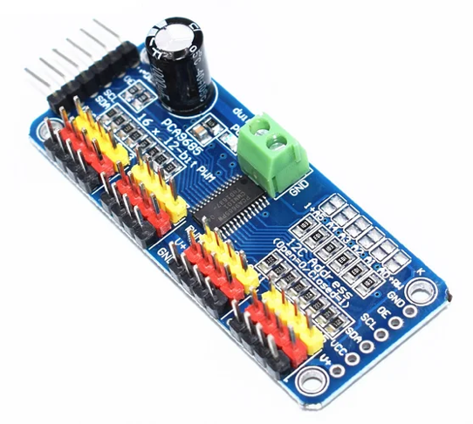

Figure 6.2 - 16-channel, 12-bit controller PCA9685 [125]

ANNIMOS 60 digital servo motors, installed on each leg, are responsible for adjusting the robot's feet, ensuring smooth horizontal movement of the robot's body when traversing rough terrain. This significantly reduces energy consumption due to the absence of vertical movement of the body. The DS5160SSG is known for its high quality, featuring a CNC-machined aluminum middle case for better heat dissipation, and dual ball bearings on the output shaft to reduce friction. It is lightweight, offers high-speed torque, is waterproof, sensitive, has a short response time, operates quietly, and more. The stainless-steel gear provides higher speed and precision, as well as a longer lifespan. It is also powerful, strong, and stable.
Features include:
- High-precision metal gear.
- Durable SS metal gear.
- Dual ball bearing.
- Programmable digital amplifier with Mosft Drive.
- Axial mounting hole on the bottom side.
- Orientation angle: up to 270 degrees.
- Mechanical angle: 360 degrees (plug/output wheel/radio control system, compatible with Futaba JR Hitec).
Speed:
- 0.17 sec/60 degrees at 6V
- 0.15 sec/60 degrees at 7.4V
- 0.13 sec/60 degrees at 8.4V
Torque:
- 58 kg.cm at 6V
- 65 kg.cm at 7.4V
- 70 kg.cm at 8.4V
Operating voltage: 6V-8.4V Connector wire length: 17.7 inches (450 mm) Gear ratio: 279 Pulse width range: 500～2500μs Deadband width: Microseconds Waterproof rating: IP67
The following hardware parts are used:
- 1 piece of digital metal robotic servo motor mounted on the robot's "knee" using the following elements: long aluminum holder, short aluminum holder, round 18T holder, round holder, and screws.
The mechanism for adapting/regulating the height of the feet works in coordination with the linear guide mechanisms, responsible for horizontal movement. During the transition to the swing phase, i.e., at certain crank angles $φ_{AB}$ where $φ_{0}+Φ_{SUP}≤φ_{AB}≤φ_{1}$, and $φ_{1}=φ_{0}+360^{0}$, the adaptation motor raises the foot to its maximum height. At the angle $φ_{1}=φ_{0}+360^{0}$, the leg enters the support phase, and the foot begins to descend. Upon contacting the support surface, the foot contact sensor is triggered, sending a signal to the adaptation motor to "lock," ensuring the motor is fixed during the support phase for straight-line movement of the body. The angular position of the linear guide mechanism's crank is measured by an AS5600 encoder (12-bit), a precision magnetic induction angle measurement sensor module from the brand ENDSTOP, model AS5600 (see Figure 6.3).

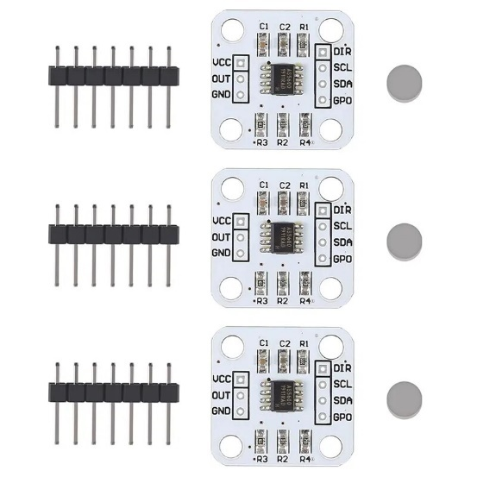

Figure 6.3 - Model AS5600 [126]

The AS5600 encoder, referred to in Figure 6.5, is characterized by the following specifications:
- VCC: 3.3 V
- GND: Power ground
- Output: PWM/Analog voltage output
- DIR: Rotation direction (Grounding increases value clockwise; VCC decreases value clockwise)
- SCL: I2C communication line (Clock)
- SDA: I2C communication line (Data)
- GPO: Mode selection (internal pull-up for programming mode)
The rotation of the hexapod robot's body is achieved through differential speeds of the main motors. When rotating the body of the hexapod robot without translational movement, the maximum rotation angle of the body is 60 degrees. Meanwhile, the rotation angle of the legs in the swing phase around the vertical axis relative to the main direction of the body at that moment is 120, 120, and 60 degrees. It's important to note that when there is translational movement of the body, the rotation angle is not limited.
The robot, weighing 5.7 kg, can move in the main direction on a full charge of a 7A Li-Po battery for 2.5 hours, which is significantly longer than existing experimental models. It should be taken into account that the robot was manufactured under laboratory conditions. Therefore, it is expected that the energy efficiency will be greater when the quality of manufacturing is improved in commercial robot production under factory conditions.
Figure 6.6 illustrates the latest experimental prototype:

Figure 6.4 – Experimental prototype of the WR

Conclusions on Section 5
An adaptation mechanism has been developed to ensure smooth horizontal movement of the robot body by eliminating vertical displacement on uneven surfaces, and has been tested on the physical prototype. As elucidated in previous sections, the adaptation of each leg operates independently from the control of the primary motion of the Walking Robot (WR). Future developments aim to incorporate a locking device within the adaptation system, ensuring that the weight of the WR body is supported by this locking device rather than the motors. This adjustment would allow the adaptation servos to be utilized solely for lifting each individual leg, rather than bearing the entire weight of the robot body, thereby substantially reducing energy usage.
Multiple iterations of experimental laboratory models of the AWR were constructed, testing the functionality of each mechanism of the robot one-by-one. It was demonstrated the complete functionality of the design and affirmed the validity of the primary hypotheses.

CONCLUSIONS

- In this PhD research, an alternative design principle for adaptive walking robots is developed, moving away from the traditional insectomorphic designs in favor of optimizing the robot's operational characteristics in terms of mechanics and control. The optimal synthesis of support and locomotion mechanisms, along with the functional separation of structural modules and their corresponding motors, has led to simplified control systems and minimized energy consumption during movement across uneven terrain.
- Methods for the synthesis have been developed and optimal structural-metric parameters of AWR were determined based on the decomposition of the robot's movement and functional separation of the motors. This allowed:
  - Simplifying the coordination of legs and achieving movement with a minimal number of motors, with the least energy consumption, and using the simplest control system;
  - Solving the problem of adapting each leg to the irregularities of the support surface individually and independently from the main control unit;
- Solving the problem of redundant connections in existing designs and eliminating parasitic loads on the motors associated with multiple static indeterminacies;
- Eliminating additional energy consumption for leg slippage and reducing reactions in leg joints during turns.
- The analytical synthesis method based on the least-square approximation is developed that eliminates “the branching defect” that occurs in the most of the existing methods. Unlimited range of foot adaptation to unevenness of a supporting surface is reached due to the use of the “shin-link” that performs rectilinear and translational motion.
- A method for multicriterial synthesis was developed, and optimal metric parameters of SLM are determined considering the best accuracy, best transmission angle and step cycle parameter. Transmission angle increased from 12$-15°$ in existing prototypes to 25. The step cycle parameter $ν$ of the synthesized mechanism is 1.59, the duration of the support phase is increased up to $Φ_{SUP}=$221°, whereas the values of these parameters in prototype are $ν=1.045$ and $Φ_{SUP}=184°$
- Synthesis method of the WR kinematic chain using the isotropy criterion is created and optimal WR parameters were determined. Optimal WR configurations have been found, which are the farthest from singular positions.
- Prototypes were manufactured, and an experimental laboratory model of AWR was developed, demonstrating the full functionality of the design and the validity of the main hypotheses.

LITERATURE

- Antonov A.V., Vorotnikov S.A. Reshenie zadach kinematiki i dinamiki dlya trexopornogo kolesno-shagayushhego robota. Izvestiya vy`sshix uchebny`x zavedenij.- Mashinostroenie. – 2018. -№3. - 684 р.
- Ignat`ev M.B., Vladimirov S.V., Sapozhnikov V.I., Sergeev M.B. Shagayushhie roboty` – problemy` i perspektivy`. Innovatika i e`kspertiza. – 2016. - №2 (17). – Р. 128 – 137.
- Cherny`shev V.V., Ary`kancev V.V. Shagayushhaya opora transportny`x sredstvpovy`shennoj proxodimosti dlya vodonasy`shhenny`x gruntov. UM 177594 Russian Federation. IPC B62D57/032. - 2018.
- Ceccarelli M. Historical and Modern Perspective of Walking Robots. - 2016.
- Mosher R.S. Exploring the potential of a quadruped //SAE Transactions. – 1969. – С. 836-843.
- Takanishi A., Ishida M., Yamazaki Y., Kato I. The Realization of Dynamic Walking by the Biped Walking Robot WL-10RD // International Conference on Advanced Robotics, 1985. - Р. 459-466.
- Shigemi S., Goswami A., Vadakkepat P. ASIMO and humanoid robot research at Honda // Humanoid robotics: A reference. – 2018. – С. 55-90.
- World Robotics 2017: Industrial Robots & Service Robots // International Federation of Robotics. – 2017. – Р. 245-272.
- Serov V.A., Ustinov S.A., Maksimenko V.I. Onboard control system of special-purpose mobile robots // News of Tula State University. Technical sciences. – 2019. - №1. – P. 32-39.
- Military Robot of VNII Signal. – 2017. – URL: www.vniisignal.ru. 15.09.2021.
- Briskin E.S., Sharonov N.G., Barsov V.S. "About energy-efficient modes of motion of robots with rotary-jamming propulsors." Mechatronics, Automation, Control. – 2018. - № 2. – Р. 100-103.
- Briskin E.S., Sharonov N.G., Serov V.A., Penshin I.S. Controlling the motion of an underwater mobile robot with anchor-rope propulsors // Robotics and Technical Cybernetics. – 2018. - № 2(19). – Р. 39-45.
- Serov V.A., Kovshov, I.V., Ustinov S.A. Tasks of technological robotic walking platforms in the development of underwater (under-ice) mineral deposits // News of SFU "Technical Sciences". – 2017. - No.9 (194). – P. 181-191.
- Briskin E.S., Sharonov N.G. On the control of the movement of mechanical systems with an excess number of control actions // News of the Russian Academy of Sciences. Theory and Control Systems. – 2019. - № 3. – P. 48-54.
- Mantis Hexapod. – 2019. http://www.mantisrobot.com. 25.09.2021.
- Yohei Kakiuchi, Masayuki Kamon, Nobuyasu Shimomura, Sou Yukizaki, Noriaki Takasugi, Shunichi Nozawa, Kei Okada, Masayuki Inaba: Development of life-sized humanoid robot platform with robustness for falling down, long time working and error occurrence // IROS. – 2017. – Р. 689-696.
- Noriaki Takasugi, Kunio Kojima, Shunichi Nozawa, Kei Okada, Masayuki Inaba: 3D walking and skating motion generation using divergent component of motion and gauss pseudospectral method // IROS. – 2017. – Р. 503-510.
- Hu N., Li S., Huang D., Gao F. Modeling and Optimal Control of Rescue Quadruped Robot with High Payload // Mechanism and Machine Science. – 2016. – Р. 521-535.
- Ding L.H. Key Technology Analysis of Big Dog Quadruped Robot // Journal of Mechanical engineering. – 2015. – Vol.51. – Р. 1-23.
- Da Gou. China’s Robot Dog Takes a Walk // Popular Science. – 2017. –Р. 56-71.
- Omarov B., Ibrayev S., Amanov B., Momynkulov Z. Optimal Leg Linkage Design for Horizontal Propel of a Walking Robot Using Non-dominated Sorting Genetic Algorithm // IEEE Access, 2024.
- Ibrayev S., Jamalov N., Ibrayev A., Ualiyev Z., Amanov B. Optimal synthesis of walking robot leg // Mechanics Based Design of Structures and Machines, 2023. - №1.- 21 р.
- Ibrayev S., Rakhmatulina A., Amanov B., Imanbayeva N. Multicriteria Optimization of Lower Limb Exoskeleton Mechanism // Applied Sciences. – 2023. - №13(23). – 12781 р. https://doi.org/10.3390/app132312781.
- Ibrayev S., Jamalov N., Patel S.H. Optimization of the Walking Robot Parameters on the Basis of Isotropy Criteria // IEEE Access. – 2022. - №10. – Р. 113969-113979.
- Rakhmatulina A., Ibrayev S., Imanbayeva N., Tolebayev N. "inematic and kinetostatic analysis of the six-link straight-line generating converting mechanism of the unbalanced sucker rod pumper drive // Eastern-European Journal of Enterprise Technologies. – 2020.- № 6(7). - 108 р. (Scopus, Web of Science)
- Rakhmatulina A., Ibrayev S., Imanbaeva N. Synthesis of the transforming mechanism of the rocking machine // KazNU Bulletin. Mathematics, Mechanics, Computer Science Series. - 2022. - № 116(4). - Р. 46–57.
- Ibrayev S.M., Jamalov N.K., Kamal A., Ibrayev A.S., Abduraimov A.E. Walking mechanism of a vehicle. Patent № 35852, RGNIIS RK, 2021.
- Ibrayev S.M., Sakenova A.M., Karim A.T., Amanov B. Optimal Synthesis Of Upper And Lower Limb Exoskeleton Mechanisms.SIJC “Future Mechanics. - Almaty, 2021. - Р.93 – 103.
- Ibrayev S., Jamalov N., Tuleshov A., Bissembayev K. Walking Robot Leg Design Based on Translatory Straight-Line Generator / In: Venture G., Solis J., Takeda Y., Konno A. (eds) ROMANSY 23 - Robot Design, Dynamics and Control. // ROMANSY 2020. CISM International Centre for Mechanical Sciences (Courses and Lectures). – Springer, Cham. – 2020. - Vol 601.
- Tuleshov A., Ibrayev S., Jomartov A. Development of Robots and Manipulators with Parallel Topology // Machinery Researching. – 2019. - № 2(10). - Р. 10-19.
- Ibrayev S., Jamalov N., Mukhambetkaliyeva G. Optimal structural synthesis of agricultural legged robot with minimal damage on soil / In E3S Web of Conferences EDP Sciences.- 2019. - Vol. 135. – 1027 р.
- Ibrayev S., Jamalov N., Mukhambetkaliyeva G., Aidasheva G. Optimization of the structure and modelling of the turning of legged robot / International Conference Science World of al-Farabi. - Almaty. - 2019.
- Ibraev S.M., Jamalov N.K., Ibraeva A.S., & Mukhambetkaliyeva G.M. "Obosnovanie struktury i modelirovanie povorota shagayushchego apparata s dvizhitelyami ortogonal'nogo tipa / Sbornik tezisov Mezhdunarodnoy nauchno-prakticheskoy konferentsii «Aktual'nye problemy informatiki, mekhaniki i robototekhniki. Tsifrovye tekhnologii v mashinostroenii», - Almaty. - 4-5 oktyabrya 2018. - Р. 83-84.
- Ibrayev S., Ibrayeva A., Ibrayev A. Walking Robot with decoupled motion. Optimal design and synthesis / KAUST Research Conference on Robotics and Autonomy. - KSA.- 2022.
- Semini C., Tsagarakis N.G. Design and Experimental Evaluation of the Hydraulically Actuated Prototype Leg of the HyQ Robot // IEEE/RSJ Int.Conference on Intelligent Robots and Systems (IROS). – 2010. – Р. 352-365.
- Ceccarelli M. Historical and Modern Perspective of Walking Robots. – 2016. www.academia.edu. 24.05.2021.
- Silva Manuel, Tenreiro Machado, José. A Historical Perspective of Legged Robots // Journal of Vibration and Control. – 2007. - №13.- Р. 1447 – 1486. DOI 10.1177/1077546307078276.
- Li
- Kim Sangbae, Wensing Patrick. Design of Dynamic Legged Robots // Foundations and Trends in Robotics. – 2017. – Vol.5. – Р.117-190.
- Chen Gang, Jin Bo, Chen Ying. Tripod gait-based turning gait of a six-legged walking robot // Journal of Mechanical Science and Technology. - 2017. – Vol.31(3). – Р.1401-1411.
- Fernandez Jose de Gea, Mronga Dennis, Günther Martin, Stock Sebastian, Niemann Nils, Wiese Hendrik, Menon Rohit, Kirchner Elsa Andrea, Stiene Stefan. Towards Contextual Robots for Collaborative Manufacturing // Workshop “Human-Robot Cooperation and Collaboration in Manipulation: Advancements and Challenges” at 2018 IEEE/RSJ International Conference on Intelligent Robots and Systems (IROS 2018). – 2018. – Р. 221-228.
- Sharbafi M. A., In Seyfarth A. Bioinspired legged locomotion: Models, concepts, control and applications // Butterworth-Heinemann. – 2017. – Р 114-121.
- Yang Zh., Gu W., Zhang J., Gui L. Force Control Theory and Method of Human Load Carrying Exoskeleton Suit. – Springer. – 2017. – Р. 200- 218.
- Ignatyev M.B., Vladimirov S.V., Sapozhnikov V.I., Sergeev M.B. Walking robots - problems and prospects // Innovatics and Expertise. – 2016. - №2 (17). – Р.128 -137.
- Briskin E.S., Kalinin Y., Maloletov A. On energetically effective modes of walking robot’s movement // CISM International Centre for Mechanical Sciences, Courses and Lectures. – 2019. – Vol.584. – Р.425-432.
- Briskin E.S., Sharonov N.G. On Motion Control of Mechanical Systems with an Excessive Number of Control Actions // International Journal of Computer and Systems Sciences. – 2019. – Vol. 58. – Р.374–381.
- Xu K., Liu H., Xingqiao Zhu X., Song Y. Kinematic analysis of a novel planar six-bar bionic leg // Advances in Mechanism and Machine Science, Proceedings of the 15th IFToMM World Congress on Mechanism and Machine Science. – 2020. - №73. – Р.13-21.
- Miroshkina M.V., Briskin E.S., Smirnaya L.D. On the optimal modes of walking machines movement when moving on uneven ground // Progress of vehicles and systems: Materials of the international scientific-practical conference. – Volgograd: FSTC "Titan–Barricades", 2018. – P. 142-144.
- Komoda K, Wagatsuma H. Energy-efficiency comparisons and multibody dynamics analyses of legged robots with different closed-loop mechanisms // Multibody System Dynamics. -2017. - №40 (2). – Р. 123-153.
- Wang C.Y., Hou J.H. Analysis and Applications of Theo Jansen’s Linkage Mechanism. Theo Jansen’s Linkage Mechanism on Kinetic Architecture // Proceedings of the 23rd CAADRIA Conference. – 2018. – Р.359–368.
- Zang H.B., Shen L.G. Research and Optimization Design of Mechanism for Theo Jansen Bionic Leg // Journal of Mechanical Engineering. – 2017. - №53(15). – Р.101-109.
- Briskin E.S., Kalinin Ya.V., Miroshkina M.V. About energy-efficient modes of movement of mobile robots with orthogonal walking propulsors when overcoming obstacles // News of the Russian Academy of Sciences. Theory and Control Systems. – 2020. - № 2. – P. 75-82.
- Briskin E.S., Kalinin Ya.V., Miroshkina M.V. About energy-efficient modes of movement of mobile robots with orthogonal walking propulsors when overcoming obstacles // News of the Russian Academy of Sciences. Theory and Control Systems. – 2020. - № 2. – P. 75-82.
- Chen Gang, Jin Bo, Chen Ying. Tripod gait-based turning gait of a six-legged walking robot // Journal of Mechanical Science and Technology. - 2017. – Vol.31(3). – Р.1401-1411.
- Wang G., Riaz A., Balachandran B. Computational Studies on Interactions between Robot Leg and Deformable Terrain // The 10th International Conference on Structural Dynamics, EURODYN 2017, Procedia Engineering. – 2017. – Vol.199. – Р.2439–2444.
- Geonea I., Tarnita D., Carbone G., Ceccarelli M. Design and Simulation of a Leg Exoskeleton Linkage for Human Motion Assistance // In New Trends in Medical and Service Robotics. Springer. – 2019. – Р. 93-100.
- Ghassaei Amanda. Design and Synthesis of Six Legged Walking Robot Using Single Degree Of Freedom Linkage // Imperial Journal of Interdisciplinary Research (IJIR). – 2016. -Vol. 2. – Р. 112-125.
- Savin S., Jatsun S., Vorochaeva L. Trajectory generation for a walking in-pipe robot moving through spatially curved pipes // 12th International Scientific-Technical Conference on Electromechanics and Robotics “Zavalishin’s Readings”, MATEC Web of Conferences 113. – 2017. – Р.156-161.
- Selvi Özgün, Samet Yavuz. Design and Dimensional Optimization of a Novel Walking Mechanism with Firefly Algorithm // International Workshop on Computational Kinematics, Springer. – 2017. – Р.188 200.
- Shen Z., Tan T., Allison G., Cui L. A Customized One-Degree-of-Freedom Linkage Based Leg Exoskeleton for Continuous Passive Motion Rehabilitation // Mechanism and Machine Science 68, Advances in Italian Mechanism Science, Springer. – 2019. – Р. 518-526.
- Soh J.S., Mc Carthy J.M. Dimensional Synthesis of Six-Bar Linkage as a Constrained RPR Chain // Int. Journal Mechanism and Machine Theory. – 2015. – Р147-160.
- Veerendrakumar, C.M., Math V.B. Kinematic Synthesis of Planar Adjustable Six-Bar Mechanism for Specified Output // International Journal of Research in Engineering and Technology. – 2016. – Vol. 05 (13). – Р. 2321-7308.
- The Ghost Minitaur: Ghost Q-UGVs are Superior to Wheels and Tracks on Unstructured Terrain. – 2019. -URL: https://www.ghostrobotics.io/.15.09.2021.
- Gao J., Li M., Li Y., Wang B. Singularity Analysis and Dimensional Optimization on a Novel Serial-Parallel Leg Mechanism // 13th Global Congress on Manufacturing and Management. – 2016. - №174. – Р. 45 – 52.
- Geonea I. D., Tarnita D. Design and Evaluation of a New Exoskeleton for Gait Rehabilitation // Mechanism Science. – 2017. - № 8. – Р.307-321.
- Pop F., Lovasz E. C., Pop C. Dimensional synthesis of a leg mechanism // Materials Science & Engineering Conference Series. – 2016. - № 147 (1). – Р. 225-240.
- Selvi Ö., Ceccarelli M. Design and Optimization of a Walking Over-Constrained Mechanism // Proceedings of the 15th IFToMM World Congress on Mechanism and Machine Science. – 2020. – Р. 61-687.
- Shao Y., et. Al. Conceptual design and dimensional synthesis of cam-linkage mechanisms for gait rehabilitation // Mech. Mach. Theory. – 2016. - №104. – Р. 31–42.
- Shen Z., Allison G., Cui L. An integrated type and dimensional synthesis method to design one degree-of-freedom planar linkages with only revolute joints for exoskeletons // J. Mech. Des. – 2018. - №140 (9). – Р. 172-190.
- Tsuge B.Y., Plecnik M.M., McCarthy J.M. Homotopy directed optimization to design a six-bar linkage for a lower limb with a natural ankle trajectory // J. Mech. Robot. – 2016. - №8 (6). – Р.254-269.
- Wang G., Riaz A. Balachandran B. Computational Studies on Interactions between Robot Leg and Deformable Terrain. The 10th International Conference on Structural Dynamics, EURODYN Procedia Engineering. - 2017. - №199. – Р. 2439 –2444.
- Ibraev S.M., Aidashova G.A., Dzhamalov N.K., Ibraev A.S., Mukhambetkalieva G.M. "New adjustable straight-line guiding mechanisms for the drive of the leg of walking robots. Proceedings of the XII All-Russian Congress on Fundamental Problems of Theoretical and Applied Mechanics. – Ufa: Publishing Center of Bashkir State University, 2019. – Vol. 1. – Р. 563-564.
- Ibraev S.M., Aidashova G.A., Dzhamalov N.K., Ibraev A.S., Mukhambetkalieva G.M. "Optimization synthesis of the leg mechanism for a walking machine." Bulletin of the Kazakh-British Technical University. – 2019. - №16 (2). – Р. 102-107.
- Tuleshov A.K., Ibraev S.M., Ibraeva A.S., Dzhomartov A.A. Development of robots and manipulators with parallel topology // Machine Science. – 2020. -№2(10). -P.10-19.
- Tuleshov А. K., Jomartov А. А., Ibrayev S., Jamalov N. K., Halicioglu R. Optimal synthesis of planar linkages // News of the Academy of Sciences of the Republic of Kazakhstan: Series of geology and technical sciences. – 2020. -Vol. 1 (439). – Р. 172-180.
- Ibrayev S.M. Approximate Synthesis of Planar Cartesian Manipulators with Parallel Structures // Int. Journal Machine and Mechanism Theory. – 2002. - №37. – Р. 877-894.
- Ibrayev S., Jomartov A., Tuleshov A., Jamalov N. Synthesis of Four-Bar Linkage with Adjustable Crank Length for Multi-Path Generation // International Journal of Mechanical Engineering and Robotics Research. – 2020. - Vol. 9 (4). – Р.489-495.
- Ibrayev S., Jamalov N., Ibrayeva A., Mukhambetkaliyeva G. Optimal structural synthesis of agricultural legged robot with minimal damage on soil // E3S Web of Conferences. – 2019. - №135. – Р. 21-27.
- Ibrayev S.M., Jamalov N.K., Ibrayeva A.S., Mukhambetkaliyeva G.M. Optimization of the Structure and Modelling of the Turning of Legged Robot // Proc.of the International Conference “Actual Problems of Informatics, Mechanics and Robotics. – 2018. – Р.87-88.
- Song Shin-Min, Waldron Kenneth J. Machines that Walk: The Adaptive Suspension Vehicle. – Cambridge: MIT Press. – 1989. – 226 p.
- Serov V.A., Kovshov, I.V., Ustinov S.A. Tasks of technological robotic walking platforms in the development of underwater (under-ice) mineral deposits // News of SFU "Technical Sciences". – 2017. - N9 (194). – P. 181-191.
- Chernyshev V.V., Arykantsev V.V. Walking support of all-terrain vehicles for water-saturated soils.– Patent No. 177594 Russian Federation, IPC B62D57/032, 2018.
- D. Wettergreen, C. Thorpe, Proc. IEEE/RSJ Int. Conf. Intelligent Robots and Syst., 2,1413 – 1420 (1992)
- A. Ryan, K. Hunt, Trans. ASME: J. of Mechanisms. Transmissions and Automation in Design, 107, 256 – 261 (1985)
- S. Song, V. Vohnout, K. Waldron, G. Kinzel, Mechanisms and Mach. Theory, 19, 17 – 24 (1984)
- Gavrilov, A. E., D. V. Golubev, and A. S. Danshin. 2013. Robotizirovannaya transportnaya platforma s ortogonal’nym shagajushim mekhanizmom. [Robotized Transport Platform with orthogonal legged mechanism]. Reports of Volgograd State Technical University. @ 24(127).
- Kim, H., M. Jung, J. Shin, and T. Seo. 2014. Optimal design of klann-linkage based walking mechanism for amphibious locomotion on water and ground. Journal of Institute of Control, Robotics and Systems 20 (9):936–94.
- Plecnik, M., and J. McCarthy. 2016. Design of stephenson linkages that wide a point along a specified trajectory. In New trends in mechanism and machine science. Netherlands: Springer, 273–280.
- Pop, F., E. Lovasz, C. Pop, et al. 2016. Dimensional synthesis of a leg mechanism. Materials Science & Engineering Conference Series 147 (1):012083.
- Umnov, N. V. 1996. Osobennosti ispol’zovaniya nozhnykh mekhanizmov v netraditsionnykh transportnykh sredstvakh. [Peculiarities of using legged mechanisms in non-traditional vehicles]. In Encyclopedia of machinery, Part 2, Vol. 1, Chapter 11. Moskow: Mashinostroenie Press.
- Xu, K., H. Liu, X. Zhu, and Y. Song. 2019. Kinematic analysis of a novel planar six-bar bionic leg. Advances in Mechanism and Machine Science: Proceedings of the of 15th IFToMM World Congress on Mechanism and Machine Science. p. 13–22.
- Ӧzgun, S., and M. Ceccarelli. 2019. Design and optimization of a walking over-constrained mechanism. Proceedings of 15th IFToMM World Congress on Mechanism and Machine Science, p. 681–687
- Gavrilov, A. E., D. V. Golubev, and A. S. Danshin. 2013. Robotizirovannaya transportnaya platforma s ortogonal’nym shagajushim mekhanizmom. [Robotized Transport Platform with orthogonal legged mechanism]. Reports of Volgograd State Technical University. @ 24(127).
- Funabashi, H. 1987. Adjustable mechanisms with variable crank length. The Theory of Machines and Mechanisms: Proceedings of the 7-th World Congress. September 17–22, 1987. Sevilla, Spain, Vol. 3, pp. 65–68.
- Krishnamurty, S., and D. Turcic. 1988. A general method of determining and eliminating branching in planar multiloop mechanisms. 414–22.
- Ibrayev, S. M. 2014. Approksimacionnyj sintez ploskih rychazhnyh mekhanizmov: Metody i chislennyj analiz. [Approximate synthesis of planar linkages: Methods and numerical analysis]. Almaty, 356 p.
- Artobolevsky, I. I. 1979. Mekhanizmy v sovremennoy tekhnike: Spravochnik. [Mechanisms in modern technology: A reference book]. Moscow: “Nauka”, 2976
- Statnikov, R. B. 1999. Multicriteria design. Optimization and identification. Dortrecht, Boston, London: Kluwer Academic Publishers.
- Kraynev A.F., Glazunov V.A., “New Mechanisms of Relative Manipulation”, Problems of Mechanical Engineering and Reliability of Machines, 1994, N5, pp.106 – 117. (rus.)
- Takeda, Yukio, and Hiroaki Funabashi. "Motion transmissibility of in-parallel actuated manipulators." JSME international journal. Ser. C, Dynamics, control, robotics, design and manufacturing 38.4 (1995): 749-755.
- Takeda, Yukio, Hiroaki Funabashi, and Hironobu Ichimaru. "Development of spatial in-parallel actuated manipulators with six degrees of freedom with high motion transmissibility." JSME International Journal Series C Mechanical Systems, Machine Elements and Manufacturing 40.2 (1997): 299-308.
- Yoshikawa, Tsuneo. "Manipulability of robotic mechanisms." The international journal of Robotics Research 4.2 (1985): 3-9
- Lee, Jaehoon, Joseph Duffy, and Max Keler. "The optimum quality index for the stability of in-parallel planar platform devices." International Design Engineering Technical Conferences and Computers and Information in Engineering Conference. Vol. 97584. American Society of Mechanical Engineers, 1996.
- Tsai, K.Y., Huang, K.D., “The Manipulability and Transmissivity of Manipulators”, Int. J. of Robotics and Automation, 19 (4), 1998, pp.132 – 136.
- Angeles, Jorge, ed. Fundamentals of robotic mechanical systems: theory, methods, and algorithms. New York, NY: Springer New York, 2003.
- Angeles, Jorge, and Carlos S. López-Cajún. "Kinematic isotropy and the conditioning index of serial robotic manipulators." The international journal of Robotics Research 11.6 (1992): 560-571.
- Schoenherr, J., Bemessen, “Bewerten und Optimieren von Parallelstrukturen”. Chemnitzer Parallelstruktur-Seminar, 1998, Tagungsband. – S.85 – 96.
- Schoenherr, J., “Design and Evaluation of Mechanisms Using Static Performance Indices.” Proc. of the Tenth World Congress on TMM, Oulu, 1999. – pp.747 – 753.
- Schoenherr, J., Weidermann, F., “Bewertung und Optimale Auslegung von Bewegungssystemen mit Parallelkinematik.” VDI Berichte 1427, Duesseldorf, VDI-Verlag, 1998. – S.35 – 50.
- Ibraev S.M. Approximation synthesis of lever mechanisms. Methods and numerical implementation: Monograph, Almaty: Economics, 2014, pp.205 – 216. (rus.)
- Sefrioui, Jaouad, and Clément M. Gosselin. "On the quadratic nature of the singularity curves of planar three-degree-of-freedom parallel manipulators." Mechanism and machine theory 30.4 (1995): 533-551.
- Chablat, Damien, Philippe Wenger, and Jorge Angeles. "The Kinematic design of a 3-dof Hybrid Manipulator." Integrated Design and Manufacturing in Mechanical Engineering’98. Springer, Dordrecht, 1999. 225-232.
- D. Wettergreen, C. Thorpe, Proc. IEEE/RSJ Int. Conf. Intelligent Robots and Syst., 2,1413 – 1420 (1992)
- A. Ryan, K. Hunt, Trans. ASME: J. of Mechanisms. Transmissions and Automation in Design, 107, 256 – 261 (1985).
- S. Song, V. Vohnout, K. Waldron, G. Kinzel, Mechanisms and Mach. Theory, 19, 17 – 24 (1984)
- Ibrayev, Sayat, et al. "Optimal structural synthesis of agricultural legged robot with minimal damage on soil." E3S Web of Conferences. Vol. 135. EDP Sciences, 2019.
- R. J. Hijmans and J. van Etten, “Raster: Geographic analysis and modeling with raster data,” R Package Version 2.0-12, Jan. 12, 2012. [Online]. Available: http://CRAN.R-project.org/package=raster
- Teralyzer. Lytera UG, Kirchhain, Germany [Online]. Available: http://www.lytera.de/Terahertz_THz_Spectroscopy.php?id=home, Accessed on: Jun. 5, 2014
- U.S. House. 102nd Congress, 1st Session. (1991, Jan. 11). H. Con. Res. 1, Sense of the Congress on Approval of Military Action. [Online]. Available: LEXIS Library: GENFED File: BILLS
- Musical toothbrush with mirror, by L.M.R. Brooks. (1992, May 19). Patent D 326 189 [Online]. Available: NEXIS Library: LEXPAT File:
- D. B. Payne and J. R. Stern, “Wavelength-switched pas- sively coupled single-mode optical network,” in Proc. IOOC-ECOC, Boston, MA, USA, 1985,
pp. 585–590.
- D. Ebehard and E. Voges, “Digital single sideband detection for interferometric sensors,” presented at the 2nd Int. Conf. Optical Fiber Sensors, Stuttgart, Germany, Jan. 2-5, 1984.
- 123
- https://firsttechchallenge.blogspot.com/2019/06/launching-control-hub-pilot.html
- 124
- https://docs.revrobotics.com/ultraplanetary

- https://arduino-parts.kz/p110427644-kanalnyj-bitnyj-shimservo.html
- https://www.aliexpress.com/item/1005006144589601.html?spm=a2g0o.productlist.main.25.290cZcWUZcWU1H&algo_pvid=f44b7d53-116f-4f64-94f9-d7007512b150&algo_exp_id=f44b7d53-116f-4f64-94f9-d7007512b150-12&pdp_npi=4%40dis%21CHF%215.21%210.90%21%21%2141.33%217.13%21%402103080617174863874651931e9bbf%2112000035961593964%21sea%21CH%210%21AB&curPageLogUid=cQY406MkAsGv&utparam-url=scene%3Asearch%7Cquery_from%3A

APPENDIX A

Fragments of Truncated Tables

Table A1 - Fragments of the truncated Test Table with the best accuracy ε

N | LPT | rAB | BC | CD | XDnew | YDnew | fi_0 | x_BP | y_BP | Sx | Sy | Kcos | Ksin | ε | µ_{e}
1 | 22207 | 0,2335 | 0,4926 | 0,5037 | -0,4243 | 0,0301 | 245 | 0,9568 | 0,0271 | 2,0543 | 1,8465 | -2,3449 | -0,1666 | 0,0049 | 22,2
2 | 23023 | 0,2347 | 0,4889 | 0,4982 | -0,4278 | 0,0382 | 244 | 0,9523 | 0,0514 | 2,0063 | 1,8550 | -2,3193 | -0,2069 | 0,0050 | 22,7
3 | 12127 | 0,2304 | 0,4904 | 0,5025 | -0,4199 | 0,0248 | 248 | 0,9603 | 0,0180 | 2,0699 | 1,8570 | -2,3735 | -0,1404 | 0,0050 | 22,0
4 | 26783 | 0,2277 | 0,4869 | 0,4889 | -0,4160 | 0,0150 | 249 | 0,9683 | 0,0279 | 2,1232 | 1,8539 | -2,4010 | -0,0867 | 0,0051 | 22,3
5 | 9071 | 0,2286 | 0,4950 | 0,5017 | -0,4184 | 0,0149 | 248 | 0,9712 | 0,0085 | 2,1298 | 1,8461 | -2,3869 | -0,0853 | 0,0051 | 22,0
6 | 4639 | 0,2345 | 0,4816 | 0,4910 | -0,4267 | 0,0436 | 246 | 0,9449 | 0,0685 | 1,9668 | 1,8674 | -2,3195 | -0,2367 | 0,0051 | 23,0
7 | 7423 | 0,2389 | 0,4938 | 0,5050 | -0,4324 | 0,0434 | 241 | 0,9475 | 0,0484 | 1,9986 | 1,8363 | -2,2896 | -0,2298 | 0,0051 | 22,6
8 | 25775 | 0,2323 | 0,4912 | 0,5026 | -0,4248 | 0,0317 | 246 | 0,9585 | 0,0332 | 2,0344 | 1,8581 | -2,3408 | -0,1748 | 0,0051 | 22,4
9 | 21983 | 0,2375 | 0,4858 | 0,5050 | -0,4301 | 0,0523 | 244 | 0,9380 | 0,0553 | 1,9282 | 1,8628 | -2,2910 | -0,2786 | 0,0051 | 22,7
10 | 29431 | 0,2340 | 0,4930 | 0,5031 | -0,4294 | 0,0370 | 244 | 0,9582 | 0,0453 | 2,0092 | 1,8566 | -2,3115 | -0,1989 | 0,0052 | 22,8
… | … | … … … … |  |  |  |  |  |  | …
137 | 10995 | 0,2390 | 0,4854 | 0,4946 | -0,4456 | 0,0739 | 242 | 0,9380 | 0,1282 | 1,7979 | 1,8819 | -2,1843 | -0,3622 | 0,0057 | 25,1
… | … | … … … … |  |  |  |  |  |  | …
201 | 4123 | 0,2377 | 0,4811 | 0,4860 | -0,4410 | 0,0677 | 243 | 0,9372 | 0,1300 | 1,8290 | 1,8827 | -2,2153 | -0,3400 | 0,0058 | 24,9
… | … | … … … … |  |  |  |  |  |  | …
278 | 7211 | 0,2454 | 0,4904 | 0,5055 | -0,4532 | 0,0891 | 237 | 0,9263 | 0,1306 | 1,7475 | 1,8603 | -2,1243 | -0,4177 | 0,0059 | 25,1
… | … | … … … … |  |  |  |  |  |  | …

Table A2 - Fragments of the truncated Test Table with the best accuracy ε

N | LPT | rAB | BC | CD | XDnew | YDnew | fi_0 | x_BP | y_BP | Sx | Sy | Kcos | Ksin | ε | µ_{e}
1 | 2675 | 0,2445 | 0,4867 | 0,5002 | -0,4531 | 0,0925 | 238 | 0,9230 | 0,1457 | 1,7207 | 1,8693 | -2,1189 | -0,4327 | 0,0060 | 25,5
2 | 21267 | 0,2423 | 0,4925 | 0,4993 | -0,4534 | 0,0802 | 239 | 0,9388 | 0,1367 | 1,7818 | 1,8664 | -2,1386 | -0,3782 | 0,0060 | 25,4
3 | 27955 | 0,2363 | 0,4841 | 0,4819 | -0,4432 | 0,0632 | 243 | 0,9464 | 0,1391 | 1,8490 | 1,8840 | -2,2115 | -0,3155 | 0,0060 | 25,3
4 | 15107 | 0,2360 | 0,4895 | 0,4966 | -0,4463 | 0,0672 | 243 | 0,9520 | 0,1225 | 1,8200 | 1,8906 | -2,1907 | -0,3299 | 0,0060 | 25,2
5 | 4811 | 0,2360 | 0,4774 | 0,4789 | -0,4396 | 0,0665 | 244 | 0,9378 | 0,1419 | 1,8235 | 1,8925 | -2,2240 | -0,3362 | 0,0060 | 25,2
6 | 26059 | 0,2415 | 0,4820 | 0,4949 | -0,4470 | 0,0846 | 241 | 0,9253 | 0,1390 | 1,7484 | 1,8794 | -2,1598 | -0,4086 | 0,0059 | 25,2
7 | 22667 | 0,2445 | 0,4854 | 0,5063 | -0,4515 | 0,0953 | 239 | 0,9197 | 0,1347 | 1,7031 | 1,8725 | -2,1203 | -0,4477 | 0,0059 | 25,2
8 | 14131 | 0,2447 | 0,4893 | 0,5115 | -0,4535 | 0,0951 | 238 | 0,9241 | 0,1283 | 1,7063 | 1,8702 | -2,1121 | -0,4427 | 0,0059 | 25,1
9 | 7211 | 0,2454 | 0,4904 | 0,5055 | -0,4532 | 0,0891 | 237 | 0,9263 | 0,1306 | 1,7475 | 1,8603 | -2,1243 | -0,4177 | 0,0059 | 25,1
10 | 10995 | 0,2390 | 0,4854 | 0,4946 | -0,4456 | 0,0739 | 242 | 0,9380 | 0,1282 | 1,7979 | 1,8819 | -2,1843 | -0,3622 | 0,0057 | 25,1
11 | 17123 | 0,2414 | 0,4971 | 0,5083 | -0,4530 | 0,0758 | 239 | 0,9464 | 0,1154 | 1,8023 | 1,8663 | -2,1476 | -0,3592 | 0,0060 | 25,0
… | … | … … … … |  |  |  |  |  |  | …
128 | 20759 | 0,2358 | 0,4869 | 0,4941 | -0,4339 | 0,0492 | 244 | 0,9492 | 0,0822 | 1,9381 | 1,8672 | -2,2753 | -0,2580 | 0,0052 | 23,6
… | … | … … … … |  |  |  |  |  |  | …
173 | 12151 | 0,2334 | 0,4846 | 0,4862 | -0,4284 | 0,0384 | 245 | 0,9542 | 0,0769 | 1,9964 | 1,8636 | -2,3154 | -0,2075 | 0,0052 | 23,4
… | … | … … … … |  |  |  |  |  |  | …
244 | 4639 | 0,2345 | 0,4816 | 0,4910 | -0,4267 | 0,0436 | 246 | 0,9449 | 0,0685 | 1,9668 | 1,8674 | -2,3195 | -0,2367 | 0,0051 | 23,0
… | … | … … … … |  |  |  |  |  |  | …

Table A3- Fragments of the truncated Test Table with the best pressure angle µ_{e}

N | LPT | rAB | BC | CD | XDnew | YDnew | fi_0 | x_BP | y_BP | Sx | Sy | Kcos | Ksin | ε | µ_{e}
1 | 2 | 3 | 4 | 5 | 6 | 7 | 8 | 9 | 10 | 11 | 12 | 13 | 14 | 15 | 16
1 | 20759 | 0,2358 | 0,4869 | 0,4941 | -0,4339 | 0,0492 | 244 | 0,9492 | 0,0822 | 1,9381 | 1,8672 | -2,2753 | -0,2580 | 0,0052 | 23,6
2 | 9031 | 0,2350 | 0,4850 | 0,4920 | -0,4342 | 0,0511 | 244 | 0,9491 | 0,0899 | 1,9189 | 1,8760 | -2,2715 | -0,2675 | 0,0053 | 23,9
3 | 20623 | 0,2382 | 0,4900 | 0,4954 | -0,4354 | 0,0484 | 242 | 0,9479 | 0,0786 | 1,9597 | 1,8496 | -2,2685 | -0,2524 | 0,0054 | 23,4
4 | 29755 | 0,2370 | 0,4841 | 0,4914 | -0,4390 | 0,0615 | 243 | 0,9427 | 0,1097 | 1,8639 | 1,8787 | -2,2340 | -0,3132 | 0,0054 | 24,4
5 | 25015 | 0,2374 | 0,4805 | 0,4932 | -0,4338 | 0,0600 | 244 | 0,9354 | 0,0934 | 1,8756 | 1,8754 | -2,2617 | -0,3130 | 0,0054 | 23,7
6 | 26807 | 0,2339 | 0,4830 | 0,4792 | -0,4298 | 0,0393 | 245 | 0,9533 | 0,0935 | 1,9934 | 1,8621 | -2,3072 | -0,2112 | 0,0055 | 23,7

Table A3 (Continued)

1 | 2 | 3 | 4 | 5 | 6 | 7 | 8 | 9 | 10 | 11 | 12 | 13 | 14 | 15 | 16
7 | 6231 | 0,2389 | 0,4828 | 0,4931 | -0,4375 | 0,0633 | 242 | 0,9351 | 0,1027 | 1,8666 | 1,8698 | -2,2392 | -0,3238 | 0,0055 | 24,0
8 | 7327 | 0,2376 | 0,4776 | 0,4832 | -0,4309 | 0,0543 | 244 | 0,9338 | 0,0998 | 1,9164 | 1,8660 | -2,2846 | -0,2881 | 0,0055 | 23,6
9 | 23207 | 0,2388 | 0,4885 | 0,4943 | -0,4397 | 0,0579 | 241 | 0,9442 | 0,0988 | 1,9013 | 1,8607 | -2,2356 | -0,2944 | 0,0055 | 24,0
10 | 8119 | 0,2396 | 0,4883 | 0,4953 | -0,4382 | 0,0567 | 241 | 0,9417 | 0,0915 | 1,9147 | 1,8544 | -2,2444 | -0,2905 | 0,0055 | 23,7
11 | 10823 | 0,2407 | 0,4871 | 0,4978 | -0,4427 | 0,0686 | 241 | 0,9360 | 0,1079 | 1,8441 | 1,8652 | -2,2059 | -0,3419 | 0,0055 | 24,3
12 | 31419 | 0,2319 | 0,4901 | 0,4944 | -0,4317 | 0,0387 | 246 | 0,9636 | 0,0706 | 1,9827 | 1,8737 | -2,2980 | -0,2060 | 0,0056 | 23,6
13 | 24175 | 0,2341 | 0,4746 | 0,4777 | -0,4264 | 0,0464 | 246 | 0,9401 | 0,0969 | 1,9437 | 1,8754 | -2,3178 | -0,2523 | 0,0056 | 23,6
… | … | … … … … |  |  |  |  |  |  | …
27 | 10995 | 0,2390 | 0,4854 | 0,4946 | -0,4456 | 0,0739 | 242 | 0,9380 | 0,1282 | 1,7979 | 1,8819 | -2,1843 | -0,3622 | 0,0057 | 25,1

Table A4 - Truncated Test Table: Best Accuracy Solutions with Pressure Angle Limitation µ_{e}>23.5 deg

N | LPT | rAB | BC | CD | XDnew | YDnew | fi_0 | x_BP | y_BP | Sx | Sy | Kcos | Ksin | accuracy | Transm. angle
1 | 10995 | 0,2390 | 0,4854 | 0,4946 | -0,4456 | 0,0739 | 242 | 0,9380 | 0,1282 | 1,7979 | 1,8819 | -2,1843 | -0,3622 | 0,0057 | 25,1
2 | 4123 | 0,2377 | 0,4811 | 0,4860 | -0,4410 | 0,0677 | 243 | 0,9372 | 0,1300 | 1,8290 | 1,8827 | -2,2153 | -0,3400 | 0,0058 | 24,9
3 | 14027 | 0,2338 | 0,4851 | 0,4887 | -0,4371 | 0,0531 | 245 | 0,9539 | 0,1060 | 1,8972 | 1,8865 | -2,2544 | -0,2736 | 0,0057 | 24,5
4 | 29755 | 0,2370 | 0,4841 | 0,4914 | -0,4390 | 0,0615 | 243 | 0,9427 | 0,1097 | 1,8639 | 1,8787 | -2,2340 | -0,3132 | 0,0054 | 24,4
5 | 21415 | 0,2403 | 0,4815 | 0,4928 | -0,4403 | 0,0712 | 242 | 0,9294 | 0,1162 | 1,8242 | 1,8723 | -2,2132 | -0,3580 | 0,0057 | 24,3
6 | 20071 | 0,2376 | 0,4826 | 0,4833 | -0,4371 | 0,0568 | 242 | 0,9412 | 0,1150 | 1,9008 | 1,8677 | -2,2496 | -0,2922 | 0,0057 | 24,3
7 | 10823 | 0,2407 | 0,4871 | 0,4978 | -0,4427 | 0,0686 | 241 | 0,9360 | 0,1079 | 1,8441 | 1,8652 | -2,2059 | -0,3419 | 0,0055 | 24,3
8 | 31451 | 0,2453 | 0,4971 | 0,5167 | -0,4519 | 0,0808 | 237 | 0,9346 | 0,0979 | 1,7969 | 1,8512 | -2,1444 | -0,3833 | 0,0057 | 24,3
9 | 29659 | 0,2318 | 0,4793 | 0,4822 | -0,4311 | 0,0474 | 247 | 0,9525 | 0,1021 | 1,9199 | 1,8916 | -2,2919 | -0,2519 | 0,0057 | 24,2
10 | 5223 | 0,2415 | 0,4817 | 0,5012 | -0,4413 | 0,0781 | 241 | 0,9242 | 0,1085 | 1,7877 | 1,8739 | -2,1974 | -0,3887 | 0,0057 | 24,2
11 | 28039 | 0,2471 | 0,4918 | 0,5196 | -0,4509 | 0,0918 | 237 | 0,9206 | 0,1011 | 1,7424 | 1,8551 | -2,1294 | -0,4333 | 0,0057 | 24,1
12 | 23879 | 0,2448 | 0,4965 | 0,5110 | -0,4494 | 0,0737 | 237 | 0,9370 | 0,0962 | 1,8381 | 1,8452 | -2,1667 | -0,3551 | 0,0057 | 24,1
13 | 3223 | 0,2351 | 0,4832 | 0,4766 | -0,4330 | 0,0435 | 243 | 0,9513 | 0,1080 | 1,9731 | 1,8611 | -2,2861 | -0,2298 | 0,0057 | 24,1
14 | 23207 | 0,2388 | 0,4885 | 0,4943 | -0,4397 | 0,0579 | 241 | 0,9442 | 0,0988 | 1,9013 | 1,8607 | -2,2356 | -0,2944 | 0,0055 | 24,0
… | … | … … … … |  |  |  |  |  |  | …
22 | 9031 | 0,2350 | 0,4850 | 0,4920 | -0,4342 | 0,0511 | 244 | 0,9491 | 0,0899 | 1,9189 | 1,8760 | -2,2715 | -0,2675 | 0,0053 | 23,9
… | … | … … … … |  |  |  |  |  |  | …
39 | 20759 | 0,2358 | 0,4869 | 0,4941 | -0,4339 | 0,0492 | 244 | 0,9492 | 0,0822 | 1,9381 | 1,8672 | -2,2753 | -0,2580 | 0,0052 | 23,6

