Academy of Public Administration under the President

of the Republic of Kazakhstan

UDC 351:004 Manuscript Copyright

**IBRAYEV SAMAT SABIROVICH**

**The effectiveness of remote work in the public administration system in the context of digitalization**

8D04113 – Public Administration

Dissertation for the degree

of doctor in the profile of the educational program

Scientific advisor

candidate of economic sciences

associate professor

L.I. Kussainova

doctor of economics,

professor

Sh.M. Kantarbayeva

The Republic of Kazakhstan

Astana 2025

**CONTENT**

|  |  |
| --- | --- |
| **REGULATORY REFERENCES**……………………………………………. | 3 |
| **DEFINITIONS**………………………………………………………………... | 4 |
| **DESIGNATIONS AND ABBREVIATIONS**………………………………... | 5 |
| **INTRODUCTION**…………………………………………………………….. | 6 |
| **1 THEORETICAL ASPECTS OF REMOTE WORK IN THE PUBLIC ADMINISTRATION SYSTEM, IN THE CONTEXT OF DIGITALIZATION**…………………………………………………………... | 19 |
| 1.1 Theoretical and methodological approach: Synthesis of New Public Management Theory and Good Governance....................................................... | 19 |
| 1.2 World experience of remote work in the public administration system in the context of digitalization…………………………………………………………. | 25 |
| 1.3 SWOT and PEST analysis of the remote work in the public administration system of the Republic of Kazakhstan, in the context of digitalization………... | 39 |
| **2 ANALYSIS OF THE EFFECTIVENESS OF REMOTE WORK IN THE PUBLIC ADMINISTRATION SYSTEM IN THE REPUBLIC OF KAZAKHSTAN, IN THE CONTEXT OF DIGITALIZATION**………….. | 46 |
| 2.1 Analysis of the remote work in the public administration system in the Republic of Kazakhstan, in the context of digitalization .................................... | 46 |
| 2.2 The impact of distance employment on the environmental situation……… | 58 |
| 2.3 The effectiveness of digitalization in the development of the remote work in the public administration system in the Republic of Kazakhstan…………….… | 61 |
| 2.4 Remote workplace of Public servants…………………………………..…… | 73 |
| **3 ASSESSMENT OF THE POTENTIAL OF REMOTE EMPLOYMENT OF CIVIL SERVANTS IN THE PUBLIC ADMINISTRATION SYSTEM OF THE REPUBLIC OF KAZAKHSTAN, IN THE CONTEXT OF DIGITALIZATION**……………………………..…………………………..… | 79 |
| 3.1 Assessment applications of remote work........................................................ | 79 |
| 3.2 Assessment of the possibility of using a remote work format……………... | 83 |
| 3.3 Calculation of the number of possible participants in the pilot project for testing remote work…………………………………………………………….. | 86 |
| **CONCLUSION**.................................................................................................... | 91 |
| **REFERENCES**………………………………………………………………... | 94 |
| **APPENDIX A** – Application………………………………………………........ | 100 |
| **APPENDIX B** – Letter from Ministry of Digital Development, Innovations and Aerospace Industry of the Republic of Kazakhstan………………………. | 104 |
| **APPENDIX С** – Characteristics of the doctoral student about the internship… | 106 |
| **APPENDIX D** – Conclusion of the Committee on Ethical Examination of Research Academy of Public Administration under the President of the Republic of Kazakhstan, according to the program of the sociological survey..... | 109 |
| **APPENDIX E** – The Act of introducing the results of the dissertation research. | 110 |
|  |  |

**REGULATORY REFERENCES**

References to the following standards are used in this dissertation:

Law of the Republic of Kazakhstan. On the civil service of the Republic of Kazakhstan: adopted November 23, 2015, №416.

The Labor Code of the Republic of Kazakhstan: adopted November 23, 2015, №414-V SAM.

The Law of the Republic of Kazakhstan. On Amendments and Additions to the Labor Code of the Republic of Kazakhstan on improving the legal regulation of remote work: adopted July 1, 2021, №61-VI.

Decree of the President of the Republic of Kazakhstan. On measures to de-bureaucratize the activities of the state apparatus: app. on April 13, 2022, №872.

Rules for the use of remote work, combined remote work, flexible working hours for government employees.

Order of the Chairman of the Agency of the Republic of Kazakhstan for Civil Service Affairs. On approval of the Methodology for the distribution of administrative government positions of Corps "B" by functional blocks: app. on August 11, 2021, №138.

Law of the Republic of Kazakhstan. About state secrets: adopted March 15, 1999, №349-I.

Law of the Republic of Kazakhstan. On mobilization training and mobilization: adopted June 16, 1997, №127-1.

Resolution of the Government of the Republic of Kazakhstan. On the approval of the State Program "Digital Kazakhstan": app. on December 12, 2017, №827.

Order of the Minister of Finance of the Republic of Kazakhstan. On Approval of the Rules for Conducting Internal State Audit and Financial Control: app. on March 19, 2018, №392.

Order of the Minister of Finance of the Republic of Kazakhstan. On approval of the Rules for Public Procurement: app. on December 11, 2015, №648.

Law of the Republic of Kazakhstan. On religious activities and religious associations: adopted October 11, №483-IV.

The Law of the Republic of Kazakhstan. On informatization: adopted November 24, 2015, №418-V-ZRK.

Order of the Minister of Health of the Republic of Kazakhstan. On approval of Sanitary rules «Sanitary and epidemiological requirements for administrative and residential buildings»: app. on June 16, 2022, №KR DSM-52.

# DEFINITIONS

In this dissertation, the following terms are used with appropriate definitions:

**The state policy of the Republic of Kazakhstan** is the purposeful activity of public authorities to solve public problems, achieve and implement generally significant goals for the development of society or its individual spheres.

**The Civil Service of the Republic of Kazakhstan** is the activity of civil servants in state bodies in the performance of official duties aimed at the implementation of the tasks and functions of state power;

**The state administration of the Republic of Kazakhstan** is the administrative activity of public authorities and their officials to implement the developed policy in order to achieve the intended goals, "the transformation of politics into a reality that citizens see every day."

**A civil servant of the Republic of Kazakhstan** is a citizen of the Republic of Kazakhstan who, in accordance with the procedure established by the legislation of the Republic of Kazakhstan, holds a public position in a state body paid from the republican or local budgets or from the funds of the National Bank of the Republic of Kazakhstan and (or) a Special state fund determined by the legislation of the Republic of Kazakhstan on the return of illegally acquired assets to the state and exercises official powers in order to implement tasks and functions of the State;

**Remote work** is a special form of implementation of the labor process outside the employer's location with the use of ICT in the process of work.

**Combined remote work** is the implementation of the labor process by alternating periods of performance of work duties both at the location of the employer and through remote work.

**Digitalization** is the concept of "digitalization" derived from the noun "digit" or the adjective "digital" (digital). In general, this term is due to the introduction of digital technologies, data transmission streams, as well as digital transmitting devices (computers, smartphones, tablets, televisions, smartwatches, etc.) into all spheres of society and the economy.

**The state service of the Republic of Kazakhstan** is one of the forms of realization of individual state functions or their totality, carried out with or without the request of service recipients and aimed at realizing their rights, freedoms and legitimate interests, providing them with appropriate tangible or intangible benefits.

**The electronic document management system** is a system designed for the exchange of electronic documents between the state bodies of the Republic of Kazakhstan and officials of the relevant state body.

**The COVID-19 pandemic** is a public health emergency. Besides ego, this is an economic crisis. A social crisis and a human crisis that is rapidly turning into a human rights crisis.

**DESIGNATIONS AND ABBREVIATIONS**

|  |  |
| --- | --- |
| ILO | ‒ International Labour Organization |
| RK | ‒ The Republic of Kazakhstan |
| RF | ‒ Russian Federation |
| USA | ‒ United States of America |
| LC RK | ‒ The Labor Code of the Republic of Kazakhstan |
| ACSAAC RK | ‒ Agency for Civil Service Affairs of the Republic of Kazakhstan |
| UN | ‒ The United Nations |
| LEB | ‒ Local executive bodies |
| CGA | ‒ Central government agencies |
| RLA | ‒ Regulatory legal acts |
| ICT | – information and communication technologies |
| SWOT | – Analysis of strengths, weaknesses, opportunities and threats |
| PEST | – Analysis of political, economic, social and technological factors |
| MDDDA RK | ‒ Ministry of Digital Development, Innovations and Aerospace Industry of the Republic of Kazakhstan |
| EDMS | ‒ Electronic document management system |
| NIT | ‒ National information technologies». |
| JSC | ‒ Joint stock company |
| SE | ‒ State of emergency |
| MSM | ‒ Mass media |

**INTRODUCTION**

**The relevance of the topic of the dissertation research.** The scientific interest in the research topic is due to the fact that in the modern world, the efficiency of civil servants is largely determined by the optimization and automation of business processes in the public administration system, through the introduction of digital solutions. This relevance is further underscored by the global shift towards digital transformation, where countries are increasingly leveraging technology to enhance governmental operations and service delivery.

Currently, in the Republic of Kazakhstan, in the context of the accelerated development of digitalization, one of the urgent issues in the public administration system is the study of the issue of remote forms of employment using information and communication technologies. As the country strives to modernize its administrative frameworks, the adoption of digital tools and platforms for remote work becomes imperative. This transition not only aims to improve efficiency but also to align with global trends in public sector innovation.

The COVID-19 pandemic has become a definitive catalyst for the active introduction of remote operation both in the public administration system and in general in all spheres of society worldwide. The pandemic highlighted the necessity for adaptable and resilient administrative processes that can function under unprecedented circumstances. Remote work emerged as a viable solution, enabling continuity of operations while ensuring the safety and well-being of employees. This shift has accelerated the exploration and implementation of remote working policies and infrastructure within the public sector.

In turn, the International Labour Organization (ILO) conducts repeated studies in this area, in which it notes the advantages of flexible working hours. Thus, in its study conducted in 2023, the ILO noted that with the help of remote work mode, employees gain control over their work schedule, which allows them to allocate their working time appropriately. The autonomy afforded by flexible working arrangements contributes to higher job satisfaction and better work-life balance, which are crucial factors in employee productivity and retention.

In a recent report analyzing working hours, the flexibility of working hours (including remote work) and their impact on productivity, employee health, and work-life balance, the ILO noted that before the COVID-19 pandemic, about 7.9% of workers around the world regularly performed their work remotely, and in 2023, this figure the indicator increased to 28%. In developed countries, the share of remote workers reached 23%, while in developing countries it was about 13%.

The ILO emphasizes that remote work is most common in the information and communications, financial and insurance sectors, as well as professional, scientific and technical services, where the proportion of remote workers reaches 30% or more. Gender differences also play a role: women are more likely to switch to remote work, especially in areas such as education and healthcare. However, only 10% of countries have developed clear policies or laws governing remote work, underscoring the need for further reforms.

According to Eurofound, almost half of all employees worldwide (41.6%) have access to flexible working hours. Geographically, flexible working hours are most common in Northern Europe (79.4%), as well as remote work (16.4%), and in Bulgaria, almost 60% of employees work a traditional fixed schedule, making the country one of the least flexible in Europe in terms of working hours.

Also, according to the International Social Survey Program (ISSP), workers with the highest level of education and personal income have the greatest access to flexible working hours, then it is used in enterprises and the least in the public sector [1].

At the state level, the spread of remote work can increase overall innovation, especially in industries predisposed to this (for example, the creative economy). At the same time, it is worth noting that in the absence of well-coordinated communication between employees at the remote site and the rest of the team, the team's innovativeness may decrease on the contrary.

The expansion of remote work has the potential to boost total innovation at the state level, particularly in sectors that are already inclined towards it (like the creative economy). However, it's important to remember that if "remote" workers don't coordinate their communication with the rest of the team, the company's creativity might actually decline. Furthermore, the presence of established remote work programmes makes it easier for businesses to respond to crises quickly and efficiently. This was shown even before to the coronavirus pandemic, as evidenced by the organisations' ability to withstand natural disasters like the 2011 Japanese earthquake and the 2010 avian flu epidemic in the US. Even if these plans are rarely utilised in daily life, understanding of the value of having infrastructure and plans for remote work during crises will only increase in the wake of the coronavirus pandemic. Furthermore, compared to workers who solely work from the office, employees who occasionally or regularly work outside the office are more likely to come up with creative ideas and solutions. Research on the implementation of remote work in Belgium and the Netherlands in 2015, for instance, revealed that workers who were "remote" came up with more creative ideas than their colleagues who worked in the office, even if their total productivity stayed the same.

In turn, the Government of the Republic of Kazakhstan is based on international labor standards developed by the ILO and actively implements remote employment. At the same time, one of the main criteria for the effective performance by civil servants of their functional duties working remotely should be not so much their performance of their work activities during a specific period of time, as their high-quality and timely performance of specific tasks, that is, a kind of result of work in the public administration system, in conditions of digitalization, to improve the well-being of the population and in general for the development of the socio-economic situation in the country.

In general, the concept of the effectiveness of the public administration process, organized in a remote format, is determined by the degree to which state bodies achieve high-quality performance of their duties and as a result of improving the welfare of the population in comparison with the material, financial, and intellectual costs to ensure them.

In order to understand the essence of the remote form of work, it is necessary to consider its features. The main feature of the remote form of work is its implementation outside the workplace of a civil servant. Of course, this creates certain organizational and managerial difficulties in the work of civil servants. To exercise the powers of a civil servant, an employee must actively use information and communication technologies.

Moreover, in order to implement this direction, flexible working hours are provided for in the National Development Plan of the country until 2025 "Fair Social Policy", which indicates the transition from the traditional format of work to the development of flexible forms of employment through the introduction of progressive forms of labor relations.

Such an approach aligns with the global trend of remote work, necessitated by the rapid development of digital technologies and catalyzed by events such as the COVID-19 pandemic. The transition to remote work offers various benefits including increased flexibility, reduced commute times, and potentially higher job satisfaction. However, it also brings challenges such as ensuring data security, maintaining communication, and managing remote teams effectively.

For civil servants, remote work requires a rethinking of traditional workflows and performance metrics. Instead of measuring productivity by hours worked, the focus shifts to outcomes and the timely completion of tasks. This results-oriented approach can lead to more efficient use of resources and a clearer alignment of individual roles with organizational goals.

To support this transition, the government must invest in robust ICT infrastructure and provide training to civil servants to enhance their digital competencies. Additionally, policies must be updated to address the nuances of remote work, including guidelines for virtual meetings, digital collaboration, and remote supervision.

The success of remote work in public administration also depends on the establishment of a strong digital culture within government bodies. This includes fostering an environment that encourages continuous learning, collaboration, and innovation. By doing so, the government can ensure that civil servants are well-equipped to navigate the challenges of remote work and continue to deliver high-quality public services.

Ultimately, the shift to remote work in the public administration sector is a significant step towards modernizing the workforce and improving public service delivery. It reflects a broader commitment to leveraging technology to enhance efficiency and better serve the needs of the population. As Kazakhstan continues to implement remote work policies, it will be essential to monitor their impact and make necessary adjustments to ensure they achieve the desired outcomes [2].

Remote work has become increasingly relevant in the civil service sector. This mode of operation allows civil servants to perform their duties outside the traditional office environment, leveraging digital tools and communication technologies. The duration of the working time for civil servants is defined by the norms set forth in the Labor Code of the Republic of Kazakhstan. These norms are tailored to accommodate the unique requirements and conditions of civil service, as specified by the legislation governing civil service. The legislation ensures that despite the flexibility offered by remote work, civil servants still adhere to the standardized working hours and regulations, maintaining productivity and efficiency in public administration [3].

In addition, in the Republic of Kazakhstan, according to the current Concept of the "Hearing State," the government is optimizing business processes through the lens of e-government and the enhancement of information and communication systems to effectively ensure and implement the rights and legitimate interests of citizens. This initiative aims to create a more responsive and inclusive government that listens to and addresses the needs of its citizens.

One significant tool for optimizing and improving business processes in the state apparatus is the introduction of a remote mode of operation within the public administration system. This remote work model not only streamlines processes but also acts as an effective mechanism for reducing bureaucratic inefficiencies within the state apparatus. By minimizing red tape and increasing the flexibility of administrative functions, remote work enhances the overall efficiency and responsiveness of government operations.

Remote work also provides the opportunity to include individuals living in other cities and rural areas in public service. Given the disparities in wages across different regions and the influence of government policies, remote work can either bolster the competitiveness of the civil service or serve as a means of reducing payroll expenses. Additionally, it helps alleviate social tensions related to the lack of affordable and high-quality housing and high mortgage rates. By enabling employees to work from locations with lower living costs, remote work can contribute to a more balanced and equitable distribution of economic opportunities.

Moreover, the expansion of remote employment contributes to solving transportation-related issues and reducing carbon dioxide emissions in major cities. With more people working from home, there is less reliance on commuting, which subsequently decreases traffic congestion and pollution levels. This shift not only benefits the environment but also improves the quality of life for residents by reducing their daily travel time and associated stress.

Remote work allows individuals to choose their living locations based on personal preferences rather than proximity to their workplace. This flexibility can lead to a migration from highly polluted urban centers to cleaner, more sustainable areas. Such a trend could accelerate efforts to reduce pollution levels and support economic stability by fostering the growth of communities in less populated regions.

Furthermore, the adoption of remote work in the civil service supports the inclusion of vulnerable populations, such as people with disabilities and young mothers, into the workforce. This inclusivity addresses mandatory quotas for employing citizens with disabilities and supports national demographic programs aimed at increasing birth rates in Kazakhstan. Additionally, remote employment enables older workers to extend their careers by utilizing their skills and experience from home, which is particularly relevant in the context of the new pension reform that raises the retirement age.

The implementation of remote employment in Kazakhstan's public administration also fosters the development of the digital economy. Government agencies, enterprises, and individuals leverage technology for communication, information exchange, and the provision and receipt of public services. This technological integration ensures that work is performed with high quality and timeliness, adhering to established standards.

Distance employment, as a component of the digital economy, offers prospects for new business models and opportunities for innovation and growth. Scholars often refer to the digital economy as a "platform economy" because interactions between parties occur through internet services or applications (digital platforms) that enhance efficiency and enable novel business models. Examples of such platforms in Kazakhstan's public administration include electronic document management systems like "Documentolog" and online meeting platforms like Zoom.

Despite the relevance of the remote work format, several obstacles hinder its widespread adoption. These include organizational and legal challenges related to supporting remote workers, infrastructural issues like the quality of internet connectivity, and logistical concerns such as the availability of appropriate computer equipment that meets information security standards. Psychological factors also play a role, as employees may struggle with adapting to electronic communication tools, the unfamiliarity of handling routine tasks online, the habit of working in teams, and the difficulty of concentrating in a home environment that may lack a dedicated workspace.

Additionally, the use of remote labor in government agencies remains under-researched, with limited theoretical and practical studies available. This gap is due to the specific nature of legislation governing state bodies and the ambiguous provisions of labor laws concerning remote work. Predicting the long-term consequences of remote labor in government agencies is challenging, as the full impact of this transition is not yet understood.

A limiting factor in the complete transition to remote work is the partial retention of paper-based document management in the public administration system. The readiness of civil servants to adopt remote work is another critical issue. While the transition appears feasible, only a portion of civil servants might choose to work remotely on a permanent basis. Compulsory remote work could lead to the resignation of some employees, highlighting the need for voluntary adoption.

Moreover, the development of remote employment in public administration could lead to the replacement of human labor with digital solutions and innovative technologies. However, certain professions, such as those involving state secrets, information security, and the operation of essential services, cannot be performed remotely. Consequently, a hybrid model of remote work, with employees working remotely for a few days a week, seems more realistic.

To ensure the effective transition of state bodies to remote operation, legal, technical, and psychological support must be provided, particularly in emergency, military, or other crisis situations. Maintaining the efficiency of public administration and the provision of comprehensive public services and obligations to the population is crucial.

In this context, it is essential to analyze the effectiveness of remote work in government agencies, drawing on international experience, and develop proposals for its improvement. This analysis will help identify best practices and strategies to optimize remote work, ensuring that it benefits both the public administration system and the citizens it serves.

**The degree of elaboration of the problem.** In the process of writing this study, the works of English-speaking, Russian and Kazakh scientists were studied.

The beginning of the formation of the scientific concept of distance employment and the practice of its use was laid by American scientists Niles J. ((Nilles Jack M.), Kinsman F. (Kinsman Francis) and Gordon G. (Gordon Gill).

Jack Niles is known as the founder of telecommuting and teleworking. It was he who first introduced these terms into scientific use in 1973. He is a recognized expert on teleworking in Europe and America and the author of several books on the basics of telecommuting, including "Making Telecommuting Outfit" and "Managing Telework" [4].

During the Pandemic, remote employment issues were investigated, Canadian scientists Guillermo Gallacher, Iqbal Hossain in their study, scientists found that 41% of jobs in Canada can be performed remotely, with significant differences in different provinces, cities and industries [5].

In the work of Estonian scientist Ringa Raudla, it is described that, compared with many other European countries, Estonia managed to contain the spread of the new corona virus quite effectively. In his works, the author presented an overview of the measures taken to combat the COVID-19 pandemic, explaining why Estonia was able to successfully contain the epidemic [6].

Chinese scientists Chow, Josephine San Fan, Palamides Demetrious, Marshall Sonia conducted a study aimed at determining the consequences faced by employees who worked remotely during the COVID-19 pandemic [7].

The authors Agota Giedre Raišien e 1, Violeta Rapuano 1, Kristina VarkuleviˇCiut e 1 and Katarína Stachová described in their writings that the virtual way of working is becoming more popular due to its potential for digital savings, it is also a way for an organization to be more flexible and adapt to crises such as global pandemics [8].

In the public sector, the use of remote work was slower. The scale of the sector, the type of activity performed, the need for personal contact with citizens, as well as the mechanistic bureaucracy in the work of many government agencies have created serious obstacles to the development of telework in public administration.

Although authors such as Caller (2012), Dahlstrom (2013) and, more recently, De Vries et al. (2019) have prepared several publications (some theoretical, and others as a result of empirical research) on the role of teleworking in public administration; academic research on this topic is still scarce and they are gradually they appear.

Slovak scientists Juraj Nemec, Maria Murray Sviridonova and Beata Mikusova Merickova conducted research in the Slovak public administration system, where they described the ongoing reforms of the government and public administration, combined with the use of information and communication technologies (ICT), led to the emergence of many innovations in the public sector, including remote work as a form of organizing and performing work outside employers' premises. This structural change in the organization of work is aimed at increasing efficiency, and in some cases, savings [9].

Portuguese authors Cesar Madureira and Belen Rando, in their article "Remote work in public administration in Portugal during the COVID-19 pandemic Advantages, disadvantages, work-life balance and motivation", attempted to characterize remote work in public administration during the COVID-19 pandemic, based on a study aimed at collecting information about the perception of Portuguese civil servants of this phenomenon [10].

Also, in recent years, scientific works by Italian scientists Stefania Capecchi Giustina and Orientale Caputo have been devoted to the issues of remote employment of public administration in foreign science, devoted to the issue of working conditions for employees of the Italian public administration who were engaged in mandatory remote work during the first stages of the COVID-19 pandemic (March–May 2020) [11].

In the work Toleikienė, Rita, Rybnikova, Irma, Juknevičienė, Vita, titled: "Whether and how does the crisis-induced situation change e-leadership in the public sector? Evidence from Lithuanian public administration", describes what problems arise in connection with e-governance in Lithuanian government agencies and how the pandemic has affected e-governance and its consequences for municipal employees [12].

Finnish researchers Lehtonen, Olli, Voutilainen, Olli, Muilu, Toivo in labor, Telecommunications and digitalization opportunities for municipalities describe how high-speed telecommunications have a positive impact on the development of regions and municipalities and vice versa indicate that weak digital infrastructure can lead to digital isolation or digital disruption.

Thus, in Finland, they are studying what the digital gap is between different types of municipalities and how this gap affects remote work [13].

American and Spanish researchers Criado J., Ignacio Herranz, Cristina Villodre, Julián studied informal virtual training of civil servants, as the public sector is currently facing disruptive transformations - many of them related to digitalization, the use of social networks or open innovation and collaboration. In their article, the scientists presented how civil servants use informal learning methods in the environment of digital social innovations. It examines the current experience of informal virtual education in the public sector in the USA and Spain, analyzes their goals and results [14].

Among Russian scientists dealing with the problems of remote forms of employment in the public administration system, the works of Valovaya Yu.I., devoted to the peculiarities of remote work, analysis of the problems of developing remote work in the civil service in the Russian Federation, its practical aspects and measures to solve the main problems associated with its implementation, as well as increasing the prestige of the state civil service by improving the working conditions of public sector employees [15].

Special attention should be paid to the works of Dmitriev M.E., V.B. Krapil, which examines the possibility of using remote work in the civil service and the possibility of switching to it on the example of individual state functions and public services [16].

It should also be noted that M.V. Chudinovsky's work, in his work he presented the result of a study, which concluded that the Russian Federation is taking the first steps in the field of remote employment management, while, for example, a comprehensive state policy has been formed and implemented in the United States since 2010. The effect of which for society and the environment is expressed in increasing the level of public safety, saving energy resources, reducing transport load and environmental pollution [17].

Of particular interest were the works of Kostrova Yu.B. raising the topic of the advantages and features of using information and communication technologies in public administration of the Russian Federation in remote operation [18].

The works of Borisova E. D. concerning the use of electronic document management systems in the public sector of the Russian Federation were also studied [19].

The topic of information security in the organization of remote work of civil servants was devoted to the work of R.G. Baranov. The researcher described the structure of creating a safe workplace for a civil servant at remote work [20].

Unlike their international peers, the works of Kazakhstani scientists who have examined the problems of remote operation in the public administration system and generally in other fields of life are not so widely represented today. Among the scientists, experts, etc. from Kazakhstan who carried out the analysis, one should take note of Mutallap Absattarov's activities about the arrangement of document control and guidelines for remote work in the country's public administration system [21].

The analysis of regulatory laws intended to guarantee digitalization and the advancement of ICTs in Kazakhstan, along with the delivery of public services as a fundamental component of public administration as a crucial component of the public administration system, has been the focus of research on R.T. Dulambayeva's work [22].

The topic of creating conditions for the search for new forms of employment within the country's economy under the influence of new global challenges is devoted to the work of Rakhmetulina Zh.B., which concludes that changes in the conditions of digitalization and automation will lead to the search for new ways and forms of employment in the labor market of Kazakhstan [23].

Significant interest was shown by the study of the works of Bokayev B.N. devoted to the topics of Kazakhstan's experience in implementing distance/online learning during the pandemic and the analysis of the process of adaptation of small and medium-sized businesses to the global economic downturn caused by the COVID-19 epidemic [24].

It should also be noted that the work of A. Olshanskaya is devoted to the topic of the impact of the coronation crisis on the state of the labor market in Kazakhstan as a whole. In this article, the author has largely presented an analysis of the impact of the coronation crisis on the state of the labor force of the population, the sectoral structure of employment, the differentiation of labor incomes, as well as on migration flows in Kazakhstan [25].

Moreover, the works of Ibrayev S., Kusainova L., Kantarbayeva S. deserve attention. devoted to the impact of remote employment on the efficiency of civil servants, the organizational and legal features of remote work in the civil service, as well as the assessment of remote work in the public administration system [26-30].

In addition, it should be noted that the international conference "Remote work of civil servants" was held on May 6, 2020 for the first time. This event was organized by the Agency of the Republic of Kazakhstan for Civil Service Affairs in cooperation with the Astana Hub of Civil Service, the Academy of Public Administration under the President of the Republic of Kazakhstan and Atyrau State University named after H. Dosmukhamedov.

The results of a survey of civil servants of Kazakhstan on the experience of remote work during the quarantine period were presented at the conference. The survey showed that more than half of the respondents surveyed rate the transition to a remote form of work positively, although there are organizational and technical problems. At the same time, 31% noted that technical problems often occur, and 19% reported extremely low Internet quality [31].

Next, it is necessary to note the reports of S. Ibrayev at international conferences in 2021, 2022 on the issues of remote employment in the public administration system in the Republic of Kazakhstan [32, 33].

In general, it is worth noting that the problems of remote employment in the public administration system are in the focus of attention of international organizations such as the UN, the World Bank, the EBRD, etc.

**The purpose of this study** is to analyze and develop strategies to improve the efficiency of remote operation in the public administration system, taking into account the specifics of digitalization, the introduction of information and communication technologies and the optimization of management processes in the context of the rapid development of digital technologies and their impact on the activities of government agencies of the Republic of Kazakhstan.

To achieve the goal, the following **research tasks** were set in the dissertation:

* to study the theory of using the synthesis of New Public Management and Good Governance, the international experience of using remote mode of work in government agencies;
* to conduct a SWOT and PEST analysis of measures of state regulation of distance labor in the public administration system in the Republic of Kazakhstan in the context of digitalization;
* to analyze digitalization in the conditions of remote work in the public administration system of the Republic of Kazakhstan;
* to carry out a functional analysis of the duties of civil servants of the Republic of Kazakhstan and assess the possibility of using a remote work format, with remote employment in the public administration system of the Republic of Kazakhstan, in the context of digitalization;
* to create useful suggestions on how to better organize a Republic of Kazakhstan civil servant’s remote workplace in the context of digitalization.

**The object of the research** is the remote work in the public administration system, in the context of digitalization in the Republic of Kazakhstan.

**The subject of the research** is the effectiveness of remote work in the public administration system, in the context of digitalization in the Republic of Kazakhstan.

**Approbation of the results of research.** As part of the dissertation research, 7 scientific papers were published, including 1 article in the journal included in the SCOPUS database;

4 articles in journals recommended by the Ministry of Science and Higher Education of the Republic of Kazakhstan.

1. Организационно-правовое обеспечение удаленной работы государственных органов Республики Казахстан // Журнал Государственное управление и государственная служба. – 2022. – №1(80).
2. The Impact of Remote working on the Efficiency of Civil servants in Kazakhstan // Central Asian Economic Review – 2023. – Vol. 1, №148.
3. Digitalization of Agro-industrial production in the Republic of Kazakhstan: Risks and ways to overcome them // Problems of AgroMarket. – 2022. – №2.
4. Evalution of remote work in the public administration system of Kazakhstan // Kazakhstan-Spectrum 2023. – 2023. – №4.
5. Remote work as an Innovative Approach in the Public Administration system of the Republic of Kazakhstan // Innovation Journal. – 2022. – №27(3). – Р. 1-21.

Moreover, the main provisions of the dissertation research were reported and discussed at 2 international scientific and practical conferences:

On December 10, 2021, at the Narxoz University, a speech at the International Scientific and Practical Conference «The legal system and Public Administration of Independent Kazakhstan: lessons, challenges and prospects», on the topic: The effectiveness of remote operation in the public administration system in the Republic of Kazakhstan.

In November 2021, a methodological seminar was held within the walls of the Academy of Public Administration under the President of the Republic of Kazakhstan, in the format of debates, at the site of the Economist+ club, on the topic: «The Chamber considers the introduction of a remote mode of operation in the Republic of Kazakhstan justified».

In addition, in April 2022, an interactive seminar was held on the topic: «Motivation in Public Service: Different tools to improve».

In December 13, 2022, at the Narxoz University site, a speech at the International Scientific and Practical Conference «New Kazakhstan: development prospects and challenges of our time», on the topic: Topical issues of remote work in the public administration system of the Republic of Kazakhstan.

In addition, according to the results of scientific work, an act of implementation was received on the proposed measures to improve the efficiency of remote operation in the Akimat of Astana city.

**The structure of the dissertation work.** The volume of the dissertation is 90 pages of typewritten text, including the title page, contents, normative references, definitions, designations and abbreviations, a list of tables and figures, introduction, main part, conclusion, list of sources used, appendices.

**Theoretical and methodological basis**

In the course of the study, theoretical and empirical research methods were applied.

At the first stage of the research, the theoretical and methodological basis of the dissertation research is the analysis of scientific literature on the problems of distance employment in the public administration system, by domestic and foreign authors, including the analysis of documents such as strategic state programs, concepts, NPAs, etc.).

Further, general scientific methods of systematic, comparative and retrospective analysis of the subject of the study were used, materials of international conferences, statistical data on the use of remote forms of employment in the context of the introduction of digital solutions in government agencies abroad and in the Republic of Kazakhstan were also analyzed.

In addition, to identify the advantages and disadvantages, prospects and threats of remote work in the civil service, SWOT and PEST analysis of measures of state regulation of remote employment in the Republic of Kazakhstan in the context of digitalization were conducted.

This analysis allows you to formulate appropriate goals and recommendations in advance to prevent negative scenarios.

Moreover, the analysis of the principles of remote employment in the public administration system of the Republic of Kazakhstan, in the context of digitalization, through the prism of two concepts of public management New Public Management and Good Governance.

At the second stage, to assess the effectiveness of the remote mode of work in government agencies, the results of two sociological surveys (questionnaires) among civil servants of the Republic of Kazakhstan with experience working remotely were used.

It should be noted that the Questionnaire is a universal method of sociological research, which consists in a special appeal to a certain group of people to identify their opinions and views, as well as fixing information about age, level of education, etc. Also, this type of survey is the main method of studying the sphere of human consciousness and is especially important when the area under study is insufficiently documented.

The first survey was attended by *43,646* thousand civil servants of *17* Central State and *17* Local executive bodies of the Republic of Kazakhstan, representing approximately *55%* of civil servants conducted in the period from May to August 2020.

It should be noted that similar surveys were conducted in other countries of the world as part of the Global Civil Service Survey project led by researchers from the World Bank, Stanford University, University College London and the University of Nottingham, etc.

Further, in 2022, specifically within the framework of this research work, a sociological survey was conducted among civil servants in order to assess the effectiveness of civil servants in remote employment in the Republic of Kazakhstan.

This study used data from an online survey using the Google Forms tool, which was attended by *1000* civil servants of the Republic.

The survey consisted of 13 questions, where civil servants could choose one or more answers and add their own comments. The survey was conducted anonymously in Google Forms, the results of which can be viewed here: <https://forms.gle/iTURVq5pBmNGYFNT6>.

At the third stage of the study, to assess the possibility of using remote employment in the public administration system of the Republic of Kazakhstan, in the context of digitalization, a random check of algorithms for the implementation of the powers of civil servants was carried out.

At the same time, the administrative regulations of the state bodies of the Republic of Kazakhstan were used as the main source for such verification. The sample analysis included 12 state functional responsibilities of civil servants of the central and local state bodies of the Republic of Kazakhstan, including 3 functions involving the performance of control functions and 4 public services of four departments operating in the same field.

In addition, to assess the number of civil servants who can work remotely, model (conditional) state bodies of the Republic of Kazakhstan were considered, on the basis of which the calculation of the possibility of saving space during the transition to the workplace subscription system and the calculation of the number of possible participants in the pilot project for the approbation of remote work was made.

The obtained theoretical and practical results of the study can be used in the development and implementation of employment policy by central and local government agencies, as well as in general can be applied in the collective contractual regulation of social and labor relations.

**Scientific novelty and the main results obtained by the author**

The main results of this dissertation research are the following results representing scientific novelty:

1. For the first time, the principles of remote work in the public administration system, in the context of digitalization, are considered through the prism of the scientific concepts of New Public Management and Good Governance.
2. A sociological study was conducted on the effectiveness of distance employment among civil servants of the Republic of Kazakhstan. where the main problems related to the norms of legal regulation of distance employment in the public administration system, the level of digital literacy, digital security, logistical support, psychological and physical condition of civil servants were identified.
3. Proposals have been developed for the development of information security, digital literacy and logistical support, taking into account the forecasting of the need for remote employment in the public administration system.
4. The analysis of the functional responsibilities of civil servants of the Central State Educational Institution and the Ministry of Education and Science of the Republic of Kazakhstan in remote employment, in the context of digitalization, was carried out, as a result, it was revealed that up to 80% of civil servants can work remotely;
5. The calculation of the need for space in government agencies has been carried out when remote operation is introduced in them.

**Key Points to Protect:**

1. Based on the results of the analysis of the development of remote employment processes in the public administration system of the Republic of Kazakhstan, in the context of digitalization, it was found that this process corresponds to the scientific principles of the theories of public administration New Public Management and Good Governance.
2. It has been established that remote work has a positive effect on the physical and psychological state of civil servants. This is because it gives people the opportunity to choose where they want to live. Moreover, eliminating dependence on proximity to work when making this decision means that people can leave cities and regions with high levels of pollution. Of no small importance is the fact that, by introducing a remote mode of work, the civil service provides an opportunity for representatives of the most vulnerable segments of the population (people with disabilities, young mothers, etc.) to take an active part in the work process.
3. To develop digital inequality among civil servants, it is recommended to organize express digital literacy courses at the Academy of Public Administration under the President of the Republic of Kazakhstan and their branches across the country; develop a digital platform for online learning; revise the testing format for admission to the civil service. In addition, it is proposed to modernize the material and technical base of public servants' workplaces for remote work. At the same time, the standard composition of the virtual workplace should be set for each position in the organization, and for all employees who have been transferred to a remote work mode.

4. It has been established that up to 80% of the functional duties of civil servants, both in Central State Bodies (CSB) and Local State Bodies (LSB), can be performed remotely.

5. It is established that the possible release of space will amount to 89.4% of the area or 11,316 sq.m. for the CSB, 88.4% or 10,524 sq.m. for LSB.

**The reliability and validity of the results** of the study lies in the fact that the obtained research results, taking into account domestic and international experience, form the basis for further scientific work in the field of remote work in the public administration system, in the context of digitalization and in providing recommendations for improving the efficiency of remote work in government agencies of the Republic of Kazakhstan, which will positively affect the motivation of public officials employees, will increase their efficiency and effectiveness in the civil service.

**Structure of the Thesis**. The structure is based on the purpose and objectives set out in the research, and consists of an introduction, three chapters, conclusion and list of references.

**1 THEORETICAL ASPECTS OF REMOTE WORK IN THE PUBLIC ADMINISTRATION SYSTEM, IN THE CONTEXT OF DIGITALIZATION**

**1.1 Theoretical and methodological approach: Synthesis of New Public Management Theory and Good Governance**

The theoretical significance of the study lies in highlighting the issue of the effectiveness of remote operation in the public administration system of the Republic of Kazakhstan, in the context of digitalization, possibly from a previously unexplored side, in particular through the prism of two concepts of new Public Management and Good Governance.

Within the framework of the theoretical and methodological approach based on the synthesis of the theory of New Public Management (NPM) and the concept of Good Governance, it is also important to take into account the concept of «remote work», which in the context of public administration can be interpreted as follows:

*Remote work in the field of public administration* is an approach to the organization of work, in which government employees perform their official duties without being physically present at the workplace, but interacting with colleagues and service recipients through virtual workspaces using secure information and communication technology channels, which meets modern requirements of digitalization and optimization of work processes in in the field of public administration.

Since the last quarter of the XX-early XXI centuries is an important milestone on the path of intensive search for optimal models of public administration, which resulted in the implementation of so-called administrative reforms, first in Western countries, and then in other parts of the world.

In addition, it is necessary to try to contribute to the development of these theories, taking into account the Kazakh experience in the system of the state apparatus, or to initiate new developments in this field of scientific approach, also to prove that the conclusions on the introduction of remote employment will be able to optimize the business process in the public administration system of Kazakhstan and complement the existing theoretical and practical experience.

There are many ways leading to effective public administration, and they vary in different regions of the world.

The analysis of issues arising in the public administration system in the Republic of Kazakhstan in the context of digitalization has shown that it is possible to introduce methods of organizing remote employment into the work of public administration, taking into account the theory of New Public Management and the theory of Good Governance.

In more detail, this part of the dissertation examines the issue of the effectiveness of remote employment in the public administration system in the context of digitalization, through the prism of the theories of public administration New Public Management (new public management) and Good Governance (quality management), since from the elements of these models it is possible to form an "ideal model" of public administration in the Republic of Kazakhstan.

This chapter of the dissertation is devoted to the issues of synthesis of the concepts of New Public Management and Good Governance.

In general, the concept of New Public Management is to reduce government spending, improve the efficiency of public functions, improve the quality of public services and strengthen public and business confidence in public authorities [34].

In addition, the essence of New Public Management is to focus on the organizational aspects of public administration, making it more economical, energetic and efficient. These three «E's» are leading to profound changes in the public sector, much of which has turned out to be «market-oriented as a model of good governance» [35].

This is expressed, first of all, in reducing the scale and resources of public administration (delegating a number of state powers to market structures; reducing the cost of the state apparatus by reducing it, reviewing the responsibilities of the state and abandoning some of them.

Also, this model includes the concept (well-being), the idea of which is to improve the well-being of employees, including physical and mental health, as well as financial well-being, which directly affect the involvement of staff, their work efficiency, team spirit and customer orientation of the organization, whether public or private sector.

A concentrated expression of the ideas of New Public Management is the comparison of the state with a boat, in which the government is primarily responsible for developing a development strategy (laying a course, working as a helmsman), and the direct provision of services (rowing) falls on the shoulders of citizens themselves and their associations, businesses. In other words, the state needs to empower society more than to serve it. In this regard, K. Reinhard emphasized that «we are talking about a new division of responsibility between the state and society. The question is what tasks should be performed by the state itself and which can and should be performed by non-state institutions» [36].

Thus, the main message of New Public Management is to model market processes within the public sector and borrow management technologies developed for private companies.

Thus, considering the issue of the effectiveness of remote operation in the public administration system, in the context of digitalization in the Republic of Kazakhstan, it is necessary to note a number of principles that correspond to the concept of New Public Management.

Firstly, the development of remote operation in the public sector of the Republic of Kazakhstan, in the context of digitalization, contributes to the development of the digital ecosystem, improves the quality of the Internet and contributes to an increase in the number of mobile base stations in the country. Thus, the transfer of part of the digital services of the public sector contributes to the development of the IT business and, as a result, obtaining a better result for consumers, represented by the population.

In addition, in the message of the Head of State Kassym-Jomart Tokayev to the people of Kazakhstan dated September 1, 2022, it is indicated that it is necessary to strengthen the personnel reserve, it is important that the civil service become as open as possible to professionals from the private sector [37].

Secondly, the use of digital solutions in the public administration system with remote operation contributes to reducing government spending on renting premises, reducing carbon dioxide emissions into the atmosphere, since employees do not use public and personal transport to get to work and back.

Thirdly, remote work in the public administration system, in the context of digitalization, increases the provision of online public services to the population, contributing to a reduction in the scale and resources of public administration (delegating a number of government powers to market structures, thereby contributing to business development and the transfer of a number of government functions to a specific market environment.

In addition, to date, in the implementation of the President's Address, the Government of the Republic has begun work on administrative reform, which provides for the optimization of the vertical of central departments with the expansion of the powers of local executive bodies, as well as the transfer of state functions to a competitive environment, taking into account the analysis of market readiness.

Also, work is currently actively underway to centralize the support services of government agencies (personnel, financial services, public procurement, etc.), one of the goals of which is to optimize the number of support staff and shift the focus of government agency activities to the implementation of sectoral tasks.

At the same time, the full-fledged effect of centralization largely depends on the quality of de-bureaucratization and digitalization of business processes in the public administration system.

Thus, the main characteristics of the New Public Management concept confirm the effectiveness of the remote mode in the public administration system, in the context of digitalization, this is expressed primarily in reducing public administration, reducing costs for the state apparatus and delegating some government functions to the market environment of the economy.

However, it is not necessary to consider the New Public Management model of public administration as an ideal management concept.

Currently, the international experience of reforming the public sector on market principles has revealed some contradictions of this model.

Some scientists and experts criticize this state management in several ways.

A number of researchers have expressed doubts about the applicability of management methods in the private sector to the public sphere, noting that the state, unlike the market, is focused on satisfying the interests of citizens and the goals of its activities are defined very vaguely (to serve society, preserve law and order, reduce inequality, improve the welfare of citizens, etc.).

In other words, the state should not be a earning, but a servicing system, which is characterized by cooperation and paternalism rather than competition.

It cannot organize the production and sale of public services according to market rules, on the contrary, it must carry values such as fairness, efficiency, democracy and equality.

Pushing public administration into the sphere of market relations leads to the erosion of values among civil servants and the erosion of the essence of public service as an institution of service to society. Private management technologies, in pursuit of financial and economic efficiency of management, relegate the "public mission" of the public service to the background.

The shortcomings of the New Public Management concept in the public administration system provoked the emergence of a new management model in the world, called "Good Governance", the foundation of which is a fundamentally new way of interaction between the state and society - based on the principles of effective cooperation.

This concept was first proposed in 1997 in the documents of the United Nations Development Program. The key values of this model are the rule of law, transparency, accountability, fairness, civic engagement and effectiveness.

The concept of «Good Governance» has become a key paradigm for the development of modern public service. On its basis, the idea of an "Open Government" has arisen and is developing [38].

Good Governance attaches great importance to advancing the computerization of government processes and the transition to fully digital operations. Naturally, this is due to the increase in the scale, quality and quantity of information in the modern world.

In addition, this model aims to maximize the scope of public participation in governance and "ensures that political, social and economic priorities should be based on common consent in such a way that the voices of the poorest and socially vulnerable groups of the population are heard in public decision-making" [39].

Moreover, the specificity of Good Governance is also manifested in the fact that within the framework of this management model, the need to focus on the institutional context of the state in which it is implemented is emphasized. Thus, it seeks to overcome the «illusion of global convergence» [40] of the new state management, which has led far from the most positive results in a number of developing countries. Internal support for reforms, the responsibility of the participants in the process, a developed ownership system, as well as the cultural context and history of the recipient state are factors for the successful integration of Good Governance into the administrative practice of certain states.

Thus, considering the remote mode of work in the public administration system, in the context of digitalization within the framework of the concept of Good Governance, it should be noted that this model increases its effectiveness:

First, the concept of Good Governance creates additional conditions for the development of e-government, thereby improving the quality of public services to the population, and also generally gives rise to the development of digitalization in the public administration system.

Secondly, according to the Good governance model, it becomes possible for people from other regions to participate in the business process of public administration, who can perform their functional duties remotely without leaving their place of residence.

Third, the concept of Good Governance makes it possible for socially vulnerable segments of the population, such as wheelchair users, to work remotely in the public administration system using digital solutions.

Thus, the analysis of the two public administration systems showed that the effectiveness of remote operation in the public administration system, in the context of digitalization within the framework of the New Public Management concept, has a number of positive effects, such as optimization of public spending, decentralization, competition, development of the digital economy and, in general, digital infrastructure in the country. In addition, the New Public Management model, under certain conditions, contributes to the "reprogramming" of the public administration system, destroying "ossified" bureaucratic structures, turning them into more adapted to the economic conjuncture.

However, in turn, the concept of Good Governance represents the development of democratic values in society, transparency, accountability, and citizen participation in public administration processes.

That is, cooperation in which there is no rigid division of responsibilities, but a focus on developing a unified policy with common problems and responsibility for the final results, taking into account a high degree of efficiency, but also political and moral criteria.

In addition, Good Governance involves the use of e-government and digital public administration approaches aimed at using technologies to improve the efficiency of public administration and the availability and quality of public services.

Francis Fukuyama's concept of the bureaucratic apparatus is an important part of his broader theory of state development and institutions. To understand this concept, it is necessary to understand how Fukuyama sees the role of bureaucracy in ensuring the effective functioning of the state and how this idea correlates with specific political systems, for example, the system of public administration in Kazakhstan.

Fukuyama considers bureaucracy as a central element of the functioning of the modern state. In his view, bureaucracy is a professionalized and specialized management system where officials perform their duties based on clear rules and procedures, rather than personal preferences and political commitment. This is important so that government agencies can function efficiently and predictably [41].

Fukuyama's Main Ideas:

1. The effectiveness of the bureaucratic system: Fukuyama argues that a well-organized bureaucracy is essential for creating an efficient and stable state. He emphasizes the importance of institutions that work for the long term rather than for short-term political interests.

2. Independence of the bureaucracy from political interference: The bureaucracy should be independent of political power, so that civil servants can make decisions based on professional knowledge and the interests of long-term stability, rather than on political motives.

3. Transparency and accountability: An important characteristic of an effective bureaucracy is a high level of transparency, accountability and control over the actions of civil servants. This creates trust among citizens and helps to avoid corruption.

4. Quality and professionalism: The key aspect is the availability of qualified and trained professionals in the civil service. The bureaucracy should work on the basis of professional standards, not on the basis of political appointments.

Fukuyama studies the development of bureaucracy in a historical context, from early forms of government in various countries to modern institutions. He identifies several stages:

1. The period before modernization: In pre-industrial societies, bureaucracy was often poorly developed, and states were governed through informal structures, often under the rule of aristocracy or monarchs.

2. Modernization period: In the 19th and 20th centuries, the development of professional state institutions began, which contributed to the modernization of the state. This is also due to the growth of technology, economic development and changes in the social structure.

3. The period of state construction: In today's world, bureaucracy is becoming a necessary tool for ensuring social justice, economic efficiency, and political stability.

Fukuyama also does not miss the problems of the bureaucratic system:

1. Risks of excessive bureaucratization: Too strict or numerous regulations can lead to excessive bureaucratization, which reduces the flexibility and responsiveness of the state.

2. Corruption and politicization of the bureaucracy: If the bureaucracy becomes dependent on political interests, this can lead to corruption, inefficiency, and even loss of public confidence in government institutions.

3. Reforms and institutional changes: Fukuyama emphasizes the need for continuous reform and improvement of bureaucratic institutions to meet the changing conditions and demands of the modern age.

Comparison of Fukuyama's theory with the system of public administration in the Republic of Kazakhstan

To understand how Fukuyama's concept applies to Kazakhstan, it is necessary to consider the key aspects of the state bureaucracy of this country. Advantages of Kazakhstan's bureaucratic system:

1. Centralized power and institutional stability: Kazakhstan has a strong centralized bureaucracy, which ensures the stability of public administration, especially in the post-Soviet period.

2. Professionalization of the civil service: In recent decades, efforts have been made to improve the skills of civil servants, as well as to introduce programs to improve the efficiency of government agencies.

Problems of Kazakhstan's bureaucratic system:

1. Political dependence: In Kazakhstan, the bureaucracy remains quite dependent on political power, which may limit its independence and effectiveness. This dependence can lead to politicization of appointments to high positions, which, in turn, reduces professionalism.

2. Corruption: There is a problem of corruption in the country, which also makes it difficult for the bureaucracy to function effectively. Problems with accountability and transparency often become an obstacle to combating corrupt practices.

3. Inefficiency and excessive bureaucratization: Despite attempts at reform, there are still significant problems with excessive bureaucratic procedures in Kazakhstan, which prevents rapid response to the needs of citizens.

Coincidence with Fukuyama's theory:

1. Fukuyama's theory of professionalism, independence and effectiveness of bureaucracy finds partial application in Kazakhstan. The civil service strives to improve its skills and professionalism, but political dependence and corruption risks remain significant barriers to the full implementation of these principles.

2. At the same time, Kazakhstan is facing problems typical of many developing countries, such as excessive bureaucratization and politicization of bureaucratic processes. These problems negatively affect the effectiveness of the management system, which is also consistent with the risks that Fukuyama warns about [42].

In this regard, it can be concluded that there is no universal approach to public administration and for the effective and efficient functioning of the state apparatus in the face of modern challenges, a multifaceted approach is needed using a synthesis of the basic principles of the theories of New Public Management and Good Governance.

In addition, it should be noted that this study also highlights the importance of continuous learning and adaptation in the field of public administration to meet the changing challenges and needs of society.

Summing up, it can be concluded that the use of synthesis of the principles of the New Public Management and Good Governance concepts increases the efficiency of remote operation in the public administration system of the Republic of Kazakhstan in the conditions of digitalization.

**1.2 World experience of remote work in the public administration system in the context of digitalization**

To review foreign practices, we have selected countries that, according to World Bank experts, have shown the best results in this area over the past 10 years.

According to the results of the study, the percentage of distribution of distance work varies from 2 to 40%, depending on the country and occupation. The USA, United Kingdom, Canada, France, Germany, Estonia, Japan, Singapore and more recently China are among the countries most often using remote forms of employment in general. On average, about 17% of employees in Europe use remote work. In most countries, employees do not perform online work on a regular basis, while most often it is common among managers, managers, administrative workers and sellers.

Men are most often found among remote workers, but women work remotely on a more regular basis, however, the formation of the gender component of remote work is influenced by the foundations and traditions of each particular country [43].

In the 1980s, in a number of European countries (France, Sweden, Switzerland, Great Britain, etc.), at the initiative of municipalities, projects were funded to develop remote work in telecommunications centers. Such projects pursued the following goals: to reduce the loss of time and gasoline costs associated with commuting; to reduce the burden on transport infrastructure; to improve the environmental situation. In addition, they were introduced with the aim of saving office maintenance costs, creating favorable working conditions, improving the quality of working life for employees and, ultimately, increasing labor productivity.

However, not in all cases such centers brought the expected profit and created conditions for labor productivity growth. Nevertheless, the ideas of remote work continued to develop in the 1990s both in America and in the European Union [44].

*United Kingdom.* In the UK, back in the 80s and 90s of the XX century, a course was taken to develop the information and communication component of public services and all public administration technologies. Taking into account the transition of a certain part of civil servants to remote work in the context of these ideas and tasks, the concept of e-government began to develop.

In addition, one of the striking examples is that since April 2003 in the UK, in accordance with the Employment Act 2002, employees with disabled children or children under the age of 6 have been granted the right to require flexible working hours from an employer, up to remote work [45].

Additionally, since 2014, any UK workers who have worked for the company for more than six months are eligible to request approval for a flexible work schedule, which includes remote work and customized start and end dates. The employer retains the right to refuse this request. Thus yet, there has been little actual use of this right. Studies have indicated that companies are hesitant to grant these kinds of requests ‒ and only for highly valued staff members ‒ and that workers themselves are hesitant to alter the nature of their jobs out of concern that it would harm their professional prospects.

However, in the UK, social isolation is often talked about as a disadvantage of remote work, since the workplace, office and organization as a whole are a socially active environment.

In addition, according to the National Public Service Union of Great Britain (UNISON), flexible working hours can be used to improve the working conditions of employees, which allows them to divide, modify or diversify traditional working hours.

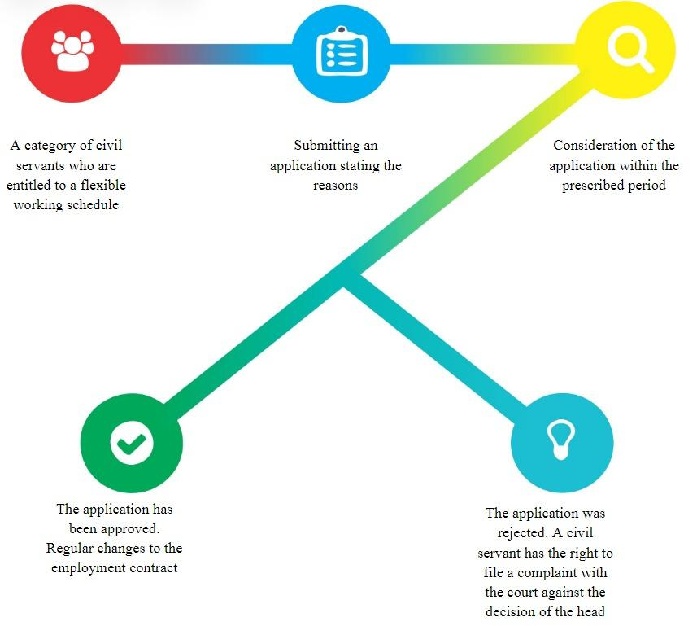

Figure 1 ‒ Implementation of remote work in the UK

Figure 1, the remote work schedule is implemented based on the parameters specified in the diagram:

1. Civil servants who have worked continuously for 26 weeks in the civil service and those who have not applied for flexible working hours in the preceding year are eligible for flexible working hours. Law enforcement personnel are exempt from the provision of flexible working hours.

2. A public servant is entitled to submit a statement to the head once a year detailing appropriate information regarding his beneficial influence on the work process as well as extra justifications, including taking care of a person in need of care or a kid under the age of 18 [46].

3. There is a 12-week window for reviewing applications. The head has the authority to repeatedly amend the employment contract if management approves of the flexible work schedule. A federal servant's pay is also decreased if the necessary number of hours worked falls short of the actual number of hours worked. The employer is free to decline a flexible work schedule and offer the legally mandated justification [47].

The public worker is entitled to file an appeal with the court if he disagrees with the head's decision. However, instances involving requests for flexible work schedules that: - were dismissed by civil servants or rejected by the parties in agreement; - had an expired appeal period (three months from the day the application was filed) are not taken into consideration by the courts. If the employee can demonstrate to the court that he was unable to really make a complaint during this time, the three-month term is reinstated. If a federal servant's complaint is found to be valid, the courts will determine whether to reexamine the application or award compensation, which the employer is required to give the employee [48].

*Canada.* In Canada, remote worker hours are governed by a particular program that gives managers the authority to temporarily or permanently alter an employee's work schedule and workplace. The program stipulates government workers' responsibilities as well as the availability of flexible work schedules. The implementation of a remote worker schedule is done in line with figure 2.

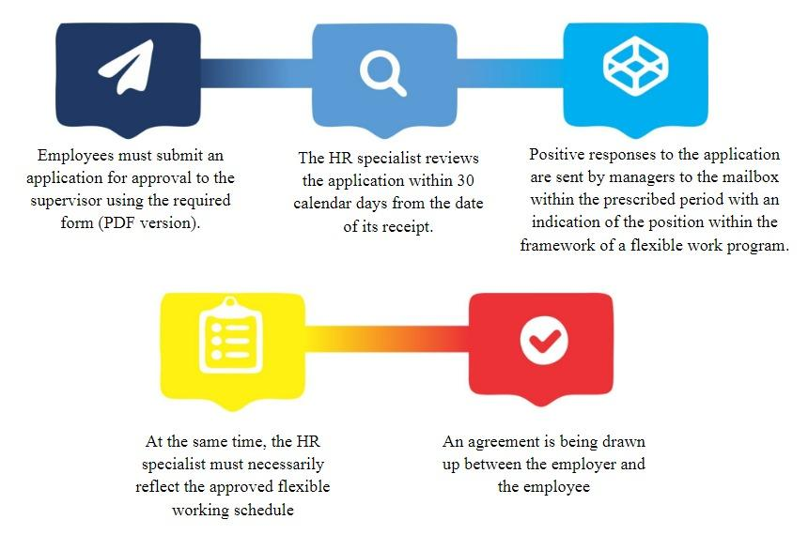

Figure 2 ‒ Remote worker schedule in Canada

All flexible work schedule programmes, government directives, and collective bargaining agreement standards and norms must be complied with by all flexible employment agreements. Until the employee's working arrangements or the flexible working schedule programme change, the flexible working arrangements between the employer and the employee remain in effect. If an employee makes such modifications, they must resubmit a request for approval to the supervisor along with the updated information. in least twice a year, in the middle and end of the year, managers review agreements with their staff.

Managers are expected to continuously assess the state body's operations and the functional duties of staff members. Work that is appropriate will enable timely modifications to the current contract, giving the employee appropriate possibilities for flexible work schedules. The tasks and responsibilities of managers and employees are defined by rules and provisions in the flexible work schedule programme. As a result, regular civil officers are accountable for: amendments include:

‒ submitting an application to a human resources officer for approval of a flexible work schedule;

‒ taking into account alternate options for flexible working hours that align with and positively impact the work of a public authority;

‒ adhering to collective agreement norms, such as: following the approved schedule and keeping information private.

In accordance with the flexible work schedule agreement, managers are accountable for:

‒ promptly reviewing employee applications for a flexible work schedule;

‒ approval of different flexible work arrangements that can address workplace issues or are appropriate for a government agency's aims and duties;

‒ forwarding authorized applications to the flexible work program's designated inbox;

‒ adding a flexible work schedule to an employee's Phoenix compensation plan;

‒ promptly discussing any concerns or modifications pertaining to the flexible work schedule agreement with the staff [49].

*Germany.* Germany has regulations governing remote work schedules.

A resolution dated February 23, 2006, regarding the working hours of Federal Government workers was last modified on February 17, 2020.

The Decree defines remote working hours as times when government officials can, within specific bounds, choose the start and finish of their daily working hours.

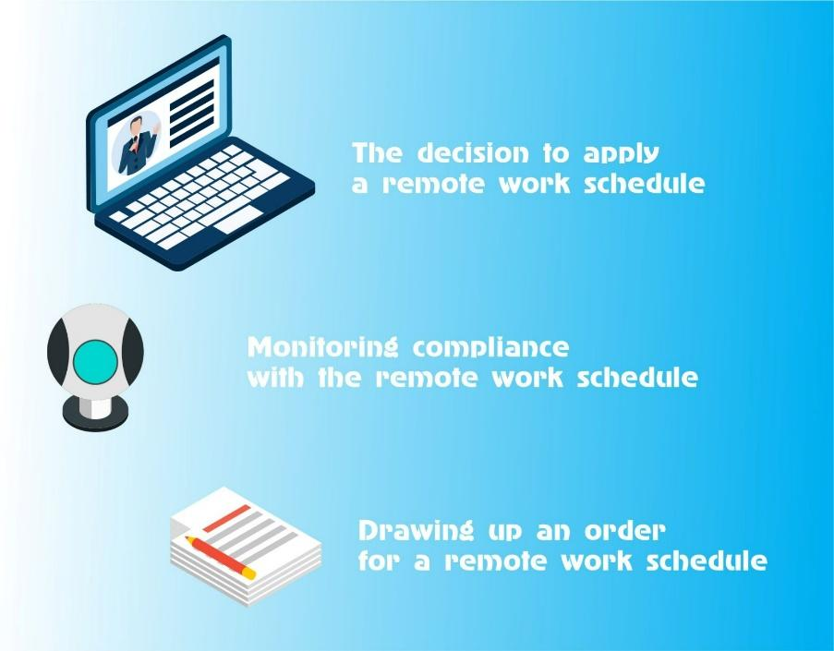

Figure 3 ‒ Remote work schedule in Germany

The Decree states that remote work schedules must comply with figure 3:

1. If it does not conflict with the state body's mission, a higher state body may adopt a flexible work schedule. In addition, in order for employees to carry out their official responsibilities, chiefs of state entities must make sure they show up to work.
2. In the directive about flexible work schedules, it is required to It is necessary to specify the following: main working hours, the circumstances under which flexible working hours may be cancelled, the timetable, and the requirement that all public servants be present at a specific time in order to carry out their tasks are all subject to change. The terms of the main working hours will be decided on an individual basis for part-time employment. Reports of violations of the flexible work schedule policy can be sent to the relevant management.
3. A technical record is used to document government personnel' official presence. There are situations where recording is not allowed. For three months, the record data must be kept on file. No later than six months from the date of recording, the higher state authority may determine whether to preserve or remove the record [50].

On the basis of an application, flexible working hours can be established collaboratively, nevertheless. Employees are often free to choose the start and finish of their own workdays within the given time constraints. Nevertheless, the agreement must take into consideration all of the standards [51].

*Estonia.* The "Electronic Residency" programme was introduced in Estonia in 2014. It allows entrepreneurs to conduct business remotely in the country, providing them with full access to financial services and the ability to process documents electronically. By updating the regulatory framework and introducing wider application digital signatures, for example, these measures essentially remove legal barriers to remote work.

For the efficient administration of state-owned real estate, Riigi Kinnisvara AS, a real estate development and management corporation, was founded in Estonia as well. The Republic of Estonia owns all of the company's shares, and the Ministry of Finance is in charge of them.

In order to boost the availability of public services and save real estate expenses, the government launched a trial project in 2018 before the pandemic to construct public office buildings, including remote workspaces for public sector employees in the districts (Riigi Kinnisvara). Riigi Kinnisvara AS claims that the COVID-19 pandemic has demonstrated the need for an atmosphere at work that is as flexible as feasible and readily adjustable to changes. This implies that an employee of the public sector who has the option to work remotely from anywhere in Estonia or in an office has a fair chance of doing so.

In 10 and 20 years, today's real estate solutions ought to offer a top-notch workplace as well. The national recruiting policy is further supported by a flexible work environment, which allows for the employment of specialists based on their chosen location. According to Riigi Kinnisvara, this entails having a thorough understanding of the client's process and, consequently, producing a high-caliber first design assignment from which designers may produce thoughtful architectural solutions. The goal of the State programme of administrative policy is to guarantee that the proportion of public workers in Tallinn's central office is less than 44.7% (figure 4) [52].

This is because there would also be motivated workers with the required credentials in rural locations. They began employing new personnel in the area where they presently live. It was a political move on the local level, but it was also a chance to employ capable individuals who were unwilling to go to Tallinn.

Government workers now have the chance to work remotely comfortably from a different location for a short period of time. This allows them to evaluate the location and facilities of remote workplaces, as well as their usability and potential future benefits. There are now remote workplaces in seven Estonian cities. This is a trial initiative, and additional offices and workspaces will be added to the many remote workplaces already in existence throughout Estonia, including in upcoming government buildings, if the usage of these spaces becomes commonplace. Every remote workstation has a second monitor, a keyboard, and a fast Internet connection. Remote work is free for employees in the public sector.

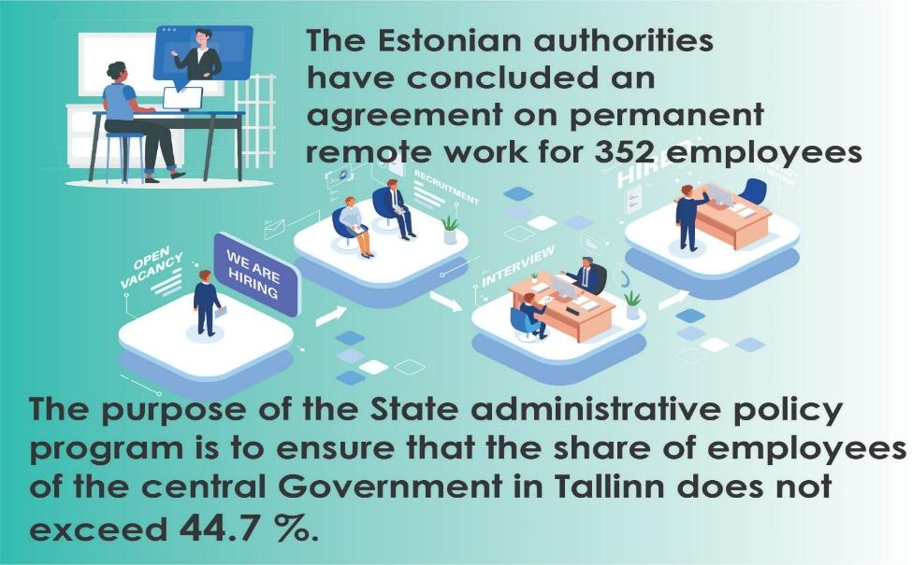

Figure 4 ‒ Estonia's Agreement on Remote Operation

In general, the English-speaking countries are currently the most active in using the remote work format (71% of the relevant vacancies posted on the WWR profile service come from them).

*USA.* Moreover, the absolute leader here is the United States (56.3% of vacancies on WWR). In addition, it should be noted that the issue of the need for detailed regulation of the work of remote workers in the United States was realized back in the 90s of the XX century. against the background of the rapid development of information technology.

Frank Wolf sent more than $2 million in 1998. to organize special teleworking centers in the state of Virginia.

Currently, US legislation encourages the introduction of flexible forms of employment. According to the report on remote work, which is sent annually to Congress, the share of remote workers in the US government is about 20%.

In this regard, the experience of implementing a remote mode of operation in the US public administration system can be considered as more effective for government agencies in Kazakhstan.

Much attention in the United States is paid to the policy of training remote workers. Exemption from training is possible only if the employee has sufficient experience and the necessary competencies. To organize work with remote workers, the position of a manager for the organization of remote work (telework managing officer) has been introduced in each authority. The manager for the organization of remote work belongs to senior managers and reports directly to the head of the state body.

The remote form of employment is considered optimal in the USA in the following cases:

‒ during pregnancy, childbirth, and breast-feeding;

‒ if it is necessary to take care of family members (children, older persons, seriously ill);

‒ in case of adoption of children. The active development of legislation is currently reflected in the Telework Enhancement Act (2010) (figure 5) [53].

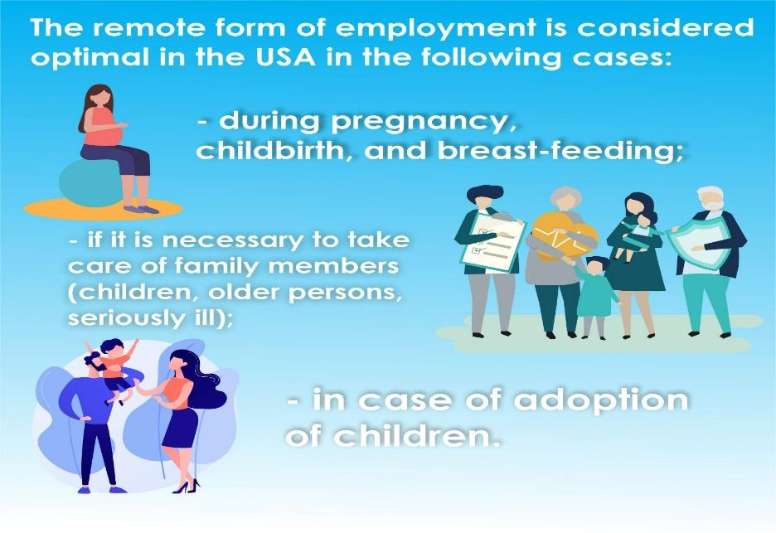

Figure 5 ‒ Cases of employment in remote mode of work in the USA

This law is addressed to the executive authorities of the United States. The main reason for its adoption was the awareness of the advantages that remote employment gives to both employees and employers. U.S. law establishes an equal amount of rights, guarantees and obligations for remote and traditional workers.

Much attention in the United States is paid to the policy of training remote workers. Exemption from training is possible only if the employee has sufficient experience and the necessary competencies.

Every public authority in the United States is obliged to:

‒ develop a policy according to which employees can work remotely;

‒ notify all agency employees of their right to remote employment.

Much attention in the USA is paid to the system of accounting and control in the field of remote employment. Every year, each public authority submits a report that includes the following indicators:

‒ the proportion of jobs that can be transferred to a remote form of employment and the potential number of remote workers;

‒ the actual number of remote workers by age, gender;

‒ management goals in the field of remote employment and the percentage of their achievement;

‒ survey data of remote workers. If the total number of remote workers has changed by more than 10% compared to last year, the public authority must describe the reasons for the positive or negative change.

The report should contain an explanation of what measures are being taken to identify and eliminate barriers to the spread of distance employment. Based on the results of the reports of each department, a general report is generated, which is sent to the US Congress.

This report provides information on all public authorities, as well as summarizes best practices.

Based on the study of the US experience, it can be concluded that government policy in the field of distance employment includes:

‒ development of normative legal acts regulating the rights and duties of remote workers, the specifics of their work;

‒ determination of the powers of state and municipal authorities in the field of remote employment management;

‒ measures to stimulate the creation of remote jobs;

‒ organization of accounting, control and supervision in the field of remote employment.

Analyzing the positive effect of distance employment in the United States and the experience of developed countries, it can be concluded that this approach provides a number of advantages, such as reducing the loss of working time, the possibility of inclusion and stimulating digitalization, which is one of the strategic objectives of public administration, as well as reducing salary costs due to the possibility of attracting employees from other regions and budget savings on used office space.

In addition, it is necessary to evaluate not only the economic efficiency of remote employment, but also the social one. Reducing stress levels, as well as conflict at work and in the family, and improving the health of civil servants can indicate social effectiveness.

As a result of the study, it was concluded that Kazakhstan is taking the first steps in the field of remote employment management, while in the United States, a comprehensive government policy has been formed and implemented since 2010. Despite the differences in economic, political, and cultural contexts, the U.S. experience in implementing information and communication technologies (ICTs) in the public sector is an important guideline for Kazakhstan. The United States has been actively developing e-government and implementing digital solutions to increase the availability and quality of public services for a long time. One of the most striking examples is the use of cloud technologies, digital platforms and integrated information systems that help improve interaction between government agencies and citizens, as well as optimize internal processes in government agencies.

This experience is of significant importance for Kazakhstan, which is also striving for digital transformation and the integration of ICT into the public administration system. In particular, the successful use of digital platforms in the United States to organize remote work and provide public services can serve as a guideline for Kazakhstan. Thus, the US experience, especially in the field of remote work and digital solutions for government agencies, is a valuable resource for adapting and implementing similar models in the context of the Kazakh public administration system. It is important to note that, despite the differences in scale and specifics, many of these technologies and approaches can be adapted to the needs of Kazakhstan, taking into account the specifics of its legal, economic and social environment [17, с. 646-651].

In general, world experience has shown the need to create an independent institute for the development of the labor market to coordinate government agencies, educational institutions and business representatives; the development of human capital from an early age and lifelong learning in accordance with forecast data; wider application of teleworking with the application of labor protection measures.

Considering the civil service in France, it is classified relative to the sphere of management (state, territorial, in the field of medicine). The workplaces of each sphere of management in the civil service are divided into three hierarchical categories, each of which consists of many bodies with different classifications of official powers [54].

The right to exercise their powers under the conditions of remote employment for civil servants and officials of the three above-mentioned public functions was established by the adoption of Law No. 2012-347 "On Access to Official Employment and Improvement of Employment Conditions in the Civil Service, combating discrimination and establishing various provisions related to public service" [55].

The specified normative act has made appropriate amendments to Law No. 83-634 "On the Rights and Duties of Civil Servants", regulating the right of civil service officials to exercise their functions in accordance with the conditions of remote work [56].

*France.* The ongoing process of reforming French legislation on the legal regulation of remote employment was marked by the adoption of a new normative act Decree No. 2016-151 (hereinafter the Decree), which summarized and detailed the conditions for the organization of remote work in the civil service and in the judicial system. According to the provision of article 2 of the Decree, remote work refers to the organization of any form of work when any official functions that could be performed by a civil servant at the employer's premises are performed outside these premises on a regular and voluntary basis using information and communication technologies and communications. Civil servants of medical, territorial, and state public functions can perform their duties under the conditions of remote work from two days a week for a year. The list of activities, conditions for the placement and equipment of the workplace, control and accounting of working hours are attributed to the competence of the relevant ministries, territorial executive bodies, heads of medical institutions in coordination with the National Advisory Committee of the State hospital [57].

It should be noted that only civil servants can perform official functions remotely when their professional powers are not related to such criteria as: 1) personal reception; 2) work with confidential documents; 3) work using software/add-ons that are limited or cannot be used remotely; 4) The work is related to the performance of control functions. The conditions stipulated by the Decree extend the possibility of remote employment in the judiciary to officials who perform their functions not in the jurisdiction, but in the administration [58].

Furthermore, in France, legislation pertaining to enterprises with 50 or less employees were established in 2017. This "right to disconnect" grants employees the freedom to disconnect from work-related applications and devices (phone, mail, etc.) when on vacation or over the weekend. Because this right is not expressly defined, the employer and employee can individually negotiate terms. This provision, which gives employees the option to choose to answer work calls and emails after hours, was introduced to mitigate the hazards associated with "hidden overtime" by incorporating the "right to disconnect" into labour laws (figure 6).

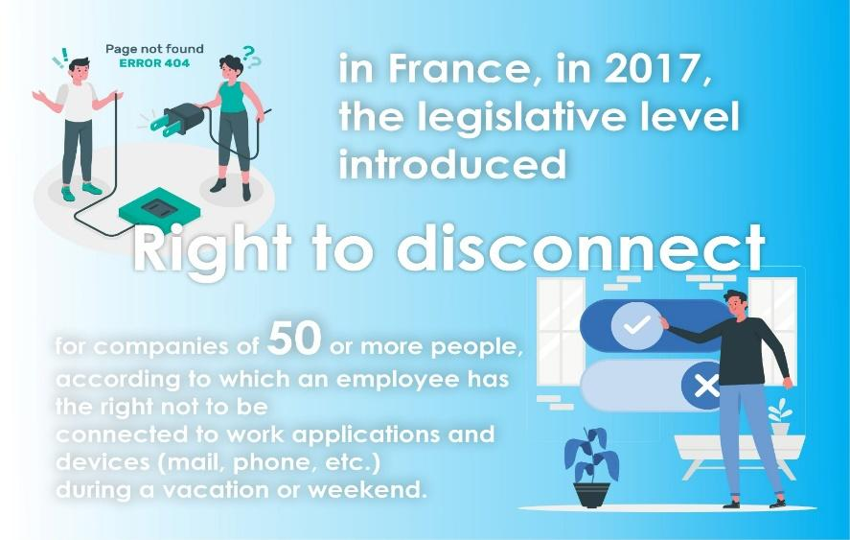

Figure 6 ‒ The Right to Disconnect program in France

The experience of the Republic of France on this issue determines the possibility to increase the effectiveness of remote employment in the civil service in the Republic of Kazakhstan.

*Singapore.* Subsequently, we may examine Singapore's global expertise in providing financial assistance to firms for the development and advancement of ICTs, specifically for government and commercial usage in remote work. For instance, Singapore has been running the Work-Life Grant, a mechanism for supporting flexible working conditions, since 2018. Its goal is to help businesses that provide flexible working conditions ‒ such as adjustable work schedules, workloads, and office/off-office hours ‒ ensure that their staff members have a healthy work-life balance. Two thousand Singapore dollars are allotted for each employee who works on flexible terms (Flexi-Work Arrangement, FWA). The mechanism was expanded in the context of COVID-19. An organization may only have a maximum of 35 of these workers (figure 7).

The qualification criteria for businesses seeking this kind of assistance has been streamlined in light of the epidemic; employees must have been employed on flexible terms for a minimum of one month at the time of application, as opposed to the prior requirement of six months. Furthermore, the Singaporean government's extra budget, which it enacted to assist the economy in the wake of the epidemic, increases funding for small and medium-sized enterprises (SMEs) through the Productivity Solutions Grant. By December 31, 2020, Soil will reimburse up to 80% of the equipment costs required to digitize work processes (previously paid 70% of the cost). Ready-made package solutions are provided to businesses; each comprises the required software and up to three computers.

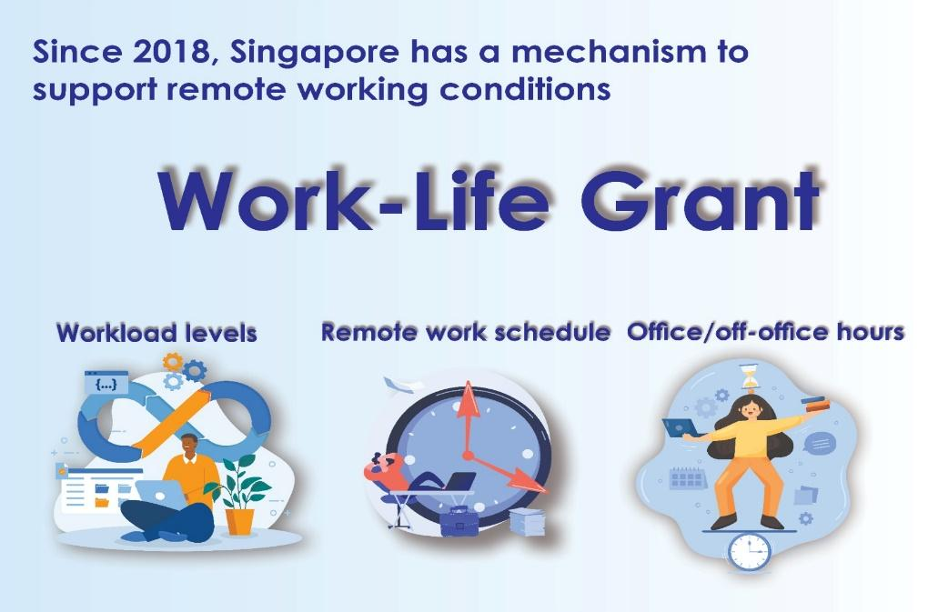

Figure 7 ‒ The "work-life grant" program in Singapore

*China.* After that, you will be exposed to the experience of working remotely in China. Before the Pandemic, business culture and managers' ignorance of the advantages of flexible work meant that there was essentially no demand in China for remote work. China has established a path to offer technical solutions to businesses so they may create remote jobs, particularly for small and medium-sized enterprises (SMEs). Large IT companies like Cisco and Huawei are integrating their gear and software, while internet behemoths Alibaba and Tencent are offering whole C2B solutions. Furthermore, China has subsidized online education for SMEs and made online training platforms freely accessible.

*Japan.* Taking into account Japan's experience in creating remote employment, it should be mentioned that a system of guidelines has been established for the efficient management of employees' remote work under the auspices of the "Association of Employees outside the Office" in Japan. This code is added to the internal charters of many government agencies and commercial businesses. The primary clauses cover particular skills training for employees, requirements for working gear, guidelines for when and how employees can be reached at a "remote location," and methods for assessing employee performance. For instance, the Japanese Ministry of Internal Affairs and Communications started releasing guidelines for putting a remote work paradigm into practice in 2018. In an effort to encourage remote work, the Japanese government has created standards by March 2021 that will enhance employee accident insurance and reinforce legal protection.

When analyzing the global experience of developing remote employment by nation, it's also important to take big international corporations like Google into account. Google, for instance, has a project called ReWork that includes research, best practices, and ideas for creating a flexible work culture in general. The company's website offers the finest advice on how to implement a remote work format to boost productivity, educate employees remotely, create remote managers, evaluate the company's success with remote work, and more.

The examination of global experiences has demonstrated the applicability of remote work in the public sector and its beneficial impact on government agency operations. The Republic of Kazakhstan's public sector may use the remote operation examples from these nations, provided that the following guidelines are followed.

The Republic's efforts to improve engineering communications and roll out high-speed, wide-band Internet access can be categorized as:

‒ allocating funds or attracting investments;

‒ investing in human capital, educating the populace to become proficient in remote work, and training management staff;

‒ funding technology research in fields like virtual reality that encourage the creation of remote work models;

‒ take action to remove legislative barriers that hinder the expansion of remote jobs;

‒ create and put into effect national guidelines for workplace safety and health that take remote work into account (workplace, communication, work and relaxation);

‒ to create or revise national guidelines for data security and protection in remote work environments;

‒ to guarantee the growth of auxiliary infrastructure (such as delivery, child care, and home services).

Overall, this study's findings offer a summary of the key developments in the field of remote work.

Because of the high degree of digitalization and the introduction of IT technologies, the author assumes that employers will continue to support the preference for remote work and that it will become the new standard practice. This is because many government agencies and private businesses worldwide are steadily moving towards remote work. Additionally, the advancement of national economies, the development of regions, and the lessening of socioeconomic inequality globally are facilitated by the preferences of employees regarding remote and remote practices, as well as the willingness of employers to accommodate them. This is all made possible by a high degree of digitization.

In a recent Rengō poll on the right to disconnect, 72.4% of employees said they have received calls about work from supervisors, coworkers, and subordinates outside of regular business hours. Compared to the 64.2% level before the COVID-19 pandemic, this represented an increase of 8.2 percentage points [59].

10.4% said it was "almost every day," 8.0% said it was "4-5 days a week," and 14.3% said it was "2–3 days a week." The frequency varied. Merely 27.6% of the workforce reported that they "have never been contacted" (figure 8a).

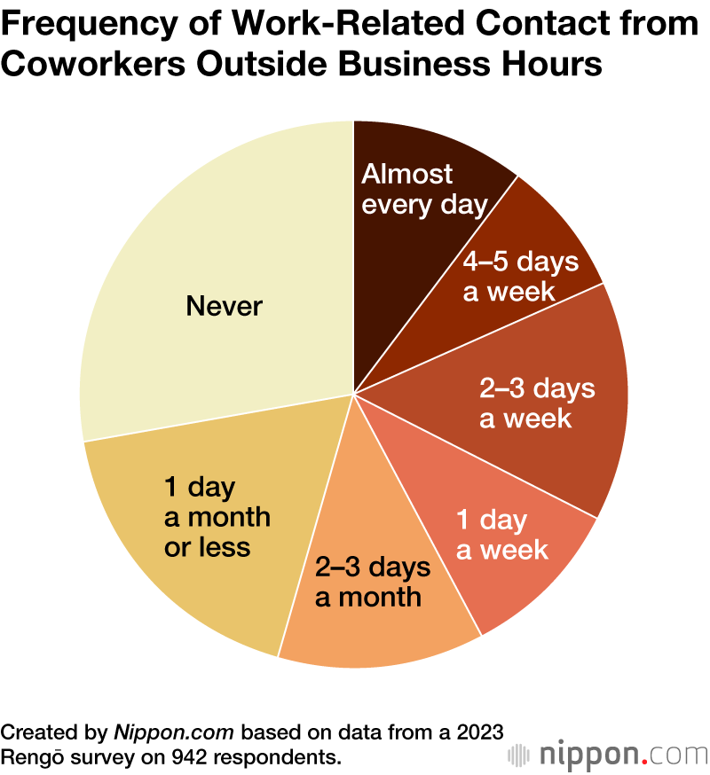

a

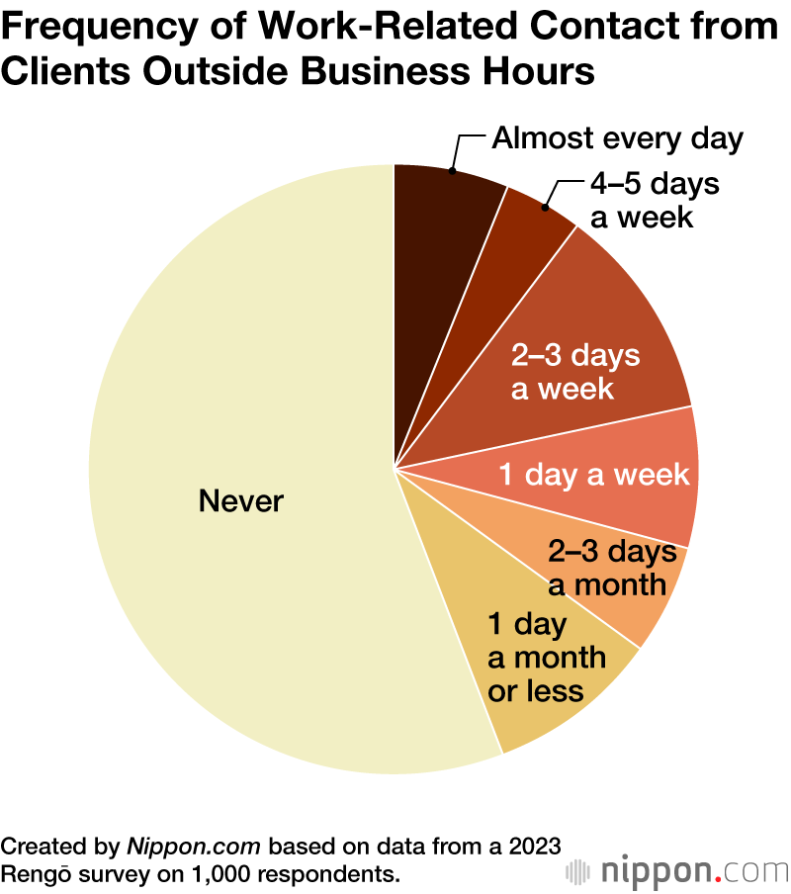

b

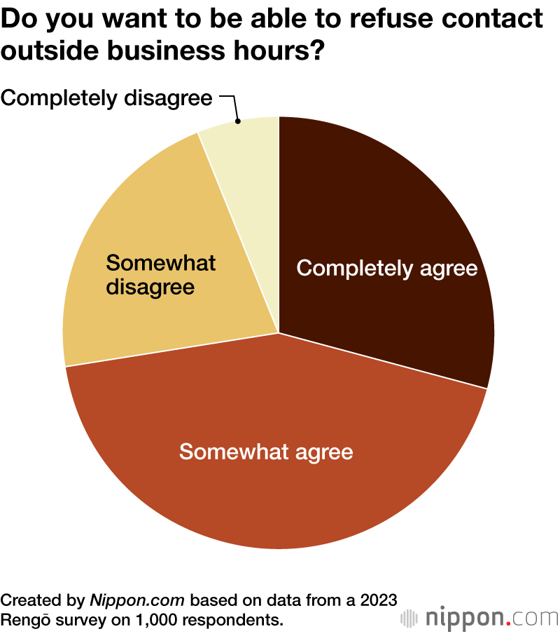

c

a ‒ Part 1; b ‒ Part 2; c ‒ Part 3

Figure 8 ‒ The Rengo 2023 Survey

Construction workers had the highest percentage of people contacted outside of regular business hours (82.7%). This was succeeded by 79.6% in the domains of welfare and medicine, and 78.0% in lodging and dining services.

44.2% more respondents stated that they received calls from clients about work that needed to be done after office hours. This was especially the case for the majority of respondents in the fields of banking and insurance (50.9%) and construction (66.7%) (figure 8b).

The proportion of participants that experience stress in relation to work-related interactions between subordinates, coworkers, and superiors outside of regular business hours was 62.2%. Additionally, 66.7% of respondents to the survey said it was "necessary to limit contact." 19.9% of respondents said there were firm policies prohibiting customer interaction related to employment from occurring after hours, and this number increased to 29.7% in regions where labor unions were present.

When asked whether they "want to be able to refuse contact" when asked about the right to disconnect, which enables workers to decline to respond to work-related correspondence outside of regular business hours or on holidays, 72.6% of respondents said they "completely agree" or "somewhat agree" (figure 8c).

Workers in the banking and insurance sectors made up the largest group of people who desired the ability to reject (81.8%). Construction, with 77.8% of employees, and technology and communications, with 79.8%, were the other two major industries where workers felt this way.

Online responses to the national poll, which was performed in September 2023, were from 1,000 full-time, part-time, and freelance employees in the age range of 18 to 59 [60].

In addition, the study of international experience has shown that the remote mode of work is applicable in the public sector and that it has a positive effect on the work of government agencies. The examples of remote operation of these countries can be applied in the public sector of the Republic of Kazakhstan.

**1.3 SWOT and PEST analysis of the remote work in the public administration system of the Republic of Kazakhstan, in the context of digitalization**

The efficacy of remote operation in the Republic of Kazakhstan's public administration system is examined in this section of the dissertation in the context of digitalization utilizing SWOT and PEST analysis techniques.

The Republic of Kazakhstan's public administration system uses SWOT analysis to evaluate the advantages and disadvantages, possibilities and threats, and prospective benefits and drawbacks of distant employment in the context of digitalization.

The four PEST factors ‒ political, economic, social, and technological ‒ are then separated out for each component.

Conclusions regarding the effectiveness of remote employment in Kazakhstan's public sector within the framework of digitalization are made based on the analysis's findings.

*Strengths*

*Political aspects.*The Republic of Kazakhstan's April 2022 Decree "On measures to de-bureaucratize the activities of the state apparatus" is largely responsible for the positive aspects of the state apparatus's adoption of remote employment. This decree aims to reduce the flow and reporting of documents, increase the independence and personal accountability of state body heads, and improve the effectiveness of the state apparatus's decision-making.

Moreover, the Agency of the Republic of Kazakhstan for Civil Service Affairs adopted in May 2023 the "Rules for the use of remote work, combined remote work, and flexible working hours for civil servants."

The purpose of these rules is to implement a set of measures to improve the civil service in the country, in terms of the possibility of remote work and the regulation of flexible working hours for civil servants, taking into account the specifics of the state apparatus.

*Economic aspects.*Saving budget funds for renting premises and paying for utilities for government agencies, as a result of reducing budget expenditures for servicing the state apparatus.

In addition, the development of the digital economy in the country as a whole, due to the development of digitalization.

*Social aspects.* There are 2 categories here: Competition in the labor market, for employers, a remote work format, this is a large reserve of potential talents (with almost no geographical restrictions), and for potential employees who live in other regions, the opportunity to work in other places without leaving their main place of residence.

Also, the remote work format is an opportunity for people with disabilities to work, for example, people with disabilities who can get the job they want remotely without resorting to excessive workloads.

*Technological aspects.*From a technological perspective, contemporary information and communication technologies are crucial to the public administration system's ability to offer remote employment. One significant application of these technologies is the efficient use of electronic document management systems.

Work to move the state apparatus to contemporary methods of a single, central cloud document management (SDO) is currently happening as part of the Republic of Kazakhstan's de-bureaucratization and digital transformation of the public sector. This technology is unique in that it stores data, files, exchanges information, and stores documents on the servers of the unified information and communication operator JSC "NIT," making it safe and easily accessible.

*Weaknesses*

*Political aspects.*The current labor legislation needs to be finalized, taking into account the principles and features of remote employment in a particular state body, as well as taking into account the online work of each state institution in case of emergencies.

In addition, there are still issues related to the availability of government positions, whose functional duties, according to current job descriptions and legislation, cannot be performed remotely.

It is also necessary to pay special attention to the legislative regulation of digital security in the country's public sector, which will provide a solid security system for data transmission, processing and storage, as well as guarantee the protection of the interests of individuals, businesses and the state.

*Economic aspects.* In order to increase the efficiency of remote employment in the state apparatus, in the context of digitalization, it is necessary to modernize the material and technical base of the workplaces of civil servants in remote work.

At the same time, the standard composition of a remote workplace should be set for each position in the organization, and for all employees who have been transferred to a remote work mode.

*Social aspects.*This section analyzes the degree of digital competence among government employees working remotely. The level of digital literacy among civil servants is at an average level, which in turn affects the effectiveness of remote work in the public administration system.

In this regard, it is advisable to form the skills to create digital content, the skills to form digital cooperation, network etiquette, digital exchange and, in general, professional development of public administration employees within the framework of the public administration process, which should be supported by electronic means.

*Technological aspects.*The main condition for remote employment and effective operation of information and communication technologies in the public administration system is the digital ecosystem (accessibility and quality of the Internet).

However, today in Kazakhstan there is a low quality of the Internet and cellular communication, which in turn affects the efficiency of using electronic document management.

*Potential opportunities*

*Political aspects.* The successful implementation of measures to de-bureaucratize the state apparatus contributes to a significant improvement in the work of the public sector, improving the efficiency of decision-making and improving the quality of interaction with citizens and businesses. With the transition to digital technologies, it becomes possible to introduce domestic online services similar to international platforms such as Zoom, Webex, Microsoft Teams and others. This not only helps to save money on licenses, but also supports the development of the domestic IT sector, creating jobs and new opportunities for innovative startups.

In addition, political employees of central government agencies and administrative employees of Building A will be provided with devices (tablets) with access to key government information systems. This includes:

*Cloud-based document management*, which will reduce the processing and signing time of documents, improving interaction between different levels of government agencies.

*The integrated information system «E-qyzmet»*, which serves as the main tool for providing public services to citizens and businesses in electronic format.

*An online portal of government* agencies that facilitates the exchange of information and coordination of the work of various government agencies, increasing transparency and speeding up processes.

Such equipment will significantly improve the efficiency of civil servants, facilitate access to up-to-date information, and make management processes more flexible and transparent.

*Economic aspects.* Digitalization will allow not only to monetize, but also to increase income. The provision of public services will become economically profitable.

According to preliminary estimates, by 2025, the direct effect of the digitalization of Kazakhstan's economy is estimated at *1.7–2.2 trillion tenge.* These figures represent the added value that is created through the introduction of digital technologies in various sectors of the economy. Value added is the difference between the cost of goods and services produced and the cost of their production, which directly affects GDP growth.

An important aspect of digitalization is *the high level of return on investment.* According to these calculations, by 2025, the estimated return on investment will amount to *4.8–6.4 times* the total investment, including private investment. This means that each tenge invested in digitalization can bring *from 4.8 to 6.4 tenge* to the economy in the form of additional added value. Such a high return rate makes digitalization economically profitable and attractive for both the public and private sectors.

*Potential threats*

*Political aspects.*In recent years, there has been a sharp increase in threats to information security in government information systems.

Along with this, there is a risk that, despite the improvement of legislation to create favorable conditions for civil servants to work remotely, it does not mean an unambiguous increase in the efficiency of remote work of civil servants, since not all government agencies will strictly comply with the developed rules for remote work and generally provide an opportunity for civil servants to work remotely, therefore, not we should expect high results in improving the efficiency of remote operation in the public administration system, in the context of digitalization.

*Economic aspects.*The state program's objectives of going digital might not be met, which would mean that invested public and private capital would be lost. Should circumstances in the civil service remain unchanged and individuals who have been given free training choose for better-paying positions in the private sector, investments in civil servant training and service improvement may also prove to be lost.

*Social aspects.*There is still much to be done, and many more aspects of the impact of the technological era need to be researched and evaluated. Digitalization has already started and has resulted in significant changes in some aspects of public sector employment (such as a certain demand for digital skills and optimization of business processes in the public administration system, job cuts, etc.).

However, it can already be stated that digitalization certainly affects employment issues in the state apparatus.

*Technological aspects.*Kazakhstan has not yet methodically created its own information systems for the public sector; instead, it has been stealing sophisticated digital technology and cybersecurity systems from other nations.

Critical state information and communication infrastructure facilities are vulnerable to attacks at any moment in such a scenario.

There is also a potential threat of espionage and data disclosure.

In terms of remote operation, these are primarily protected digital platforms, in some cases, the digital platforms used by government agencies are not very user-friendly when working remotely, which may cause civil servants to make technical errors in the array of haphazardly posted information, etc.

Speaking about the quality of the Internet, it is necessary to note the insufficient level of coverage and the speed of the Internet network in the whole country, which also affects the effectiveness of remote employment in the public administration system (table 1).

Table 1 – Conclusions and recommendations on SWOT and PEST analysis

|  |  |  |
| --- | --- | --- |
| Factors / Analysis | Conclusions | Recommendations |
| 1 | 2 | 3 |
| PEST-analysis | | |
| The political factor | Conditions are being created in the Republic of Kazakhstan for government agencies to work remotely. In particular, Rules for the use of remote and combined work for civil servants have been developed. This demonstrates government support for the introduction of remote forms of employment. | It is recommended to further improve the regulatory framework to take into account all the nuances and challenges that arise in the process of remote work, especially in emergency situations. |
| The economic factor | The introduction of remote work allows you to save budget funds for renting premises, paying for utilities and transport services for government agencies. As a result, budget expenditures for servicing the state apparatus are being optimized. | Continue to implement digital tools to reduce costs, which will not only save the budget, but also increase the operational efficiency of government agencies. |
| Social factor | The opportunity to work remotely opens up prospects for more flexible employment, including work for people with disabilities. Also, competition in the labor market contributes to the creation of more flexible conditions for working in government agencies without leaving their place of residence. | Take measures to expand opportunities for people with disabilities by introducing flexible work schedules and using affordable technologies for all categories of citizens. |
| The technological factor | As part of the development of information and communication technologies, an electronic document management system has been introduced, which facilitates the effective exchange of documents between government agencies of the Republic of Kazakhstan. | Strengthen support for cloud technologies, as well as develop local data protection solutions, ensuring independence from foreign jurisdictions. |
| SWOT-analysis | | |
| Strengths | 1. The Republic of Kazakhstan has the legal and technical capabilities to implement remote work. Rules and regulations governing remote employment in government agencies have been developed.  2. An electronic document management system has been introduced, which facilitates the exchange of information between government agencies. | To continue using existing legal and technical solutions to expand the practice of remote work and the exchange of electronic documents between government agencies. |
| Continuation of the table 1 | | |
| 1 | 2 | 3 |
| Weaknesses | 1. Despite the availability of a technical base, there is a need to improve interfaces for searching and storing documents in cloud systems.  2. Some government agencies may experience insufficient preparedness for the full transition to remote work, which is associated with insufficient digital competence of employees. | 1. Develop and implement additional measures to improve the cloud document management system, improving interfaces and accessibility for users.  2. Organize regular trainings for government employees to improve their digital literacy and improve the efficiency of using digital platforms. |
| Opportunities | 1. Competition in the labor market and the opportunity to work from anywhere can be an important factor in attracting qualified specialists to government agencies.  2. Remote work helps to save budget funds for rental of premises and utilities, which is an opportunity to optimize budget expenditures.  3. The development of digitalization and the introduction of new technologies will increase labor productivity and efficiency of government agencies. | 1. Introduce more flexible work models, which will attract specialists from different regions and support the employment of people with disabilities.  2. Use remote work opportunities to optimize government spending while maintaining high quality and speed of public services. |
| Threats | 1. Violations in the field of digital security can jeopardize the protection of personal data and state secrets, especially if the data storage servers are located outside Kazakhstan.  2. Risks associated with the potential vulnerability of cloud platforms for data storage and processing, which requires enhanced security measures. | 1. Develop and implement stricter data security measures, including the creation of domestic data centers and legislation aimed at data protection.  2. To increase attention to the legal aspects of data storage and transmission in cloud platforms, as well as to audit the services used in terms of their compliance with local laws |

In this part of the dissertation, the processes and problems of remote operation in the public administration system of the Republic of Kazakhstan, in the context of digitalization, using SWOT and PEST analysis were considered

The analysis led to the following conclusions and allowed us to formulate a number of recommendations in accordance with them.

First, conditions are being created in the Republic of Kazakhstan to varying degrees so that government agencies can have the legal and technical ability to work remotely. In particular, Rules have been developed for the use of remote and combined work for civil servants, etc.

Secondly, as part of the development of information and communication technology, an electronic document management system has been introduced, designed for the exchange of electronic documents between government agencies of the Republic of Kazakhstan.

Third, competition in the labor market, the opportunity to work in other places without leaving the main place of residence, this is an opportunity for people with disabilities to work, etc.

Fourth, saving budget funds for renting premises, paying for utilities for government agencies, as a result, optimizing budget expenditures for servicing the state apparatus.

At the same time, today there are a number of problems directly related to the effectiveness of remote employment in the public administration system of the Republic of Kazakhstan, in the context of digitalization.

In this regard, the following recommendations can be proposed to improve the effectiveness of remote employment:

1. State bodies are recommended to develop local regulations for each state body, taking into account the specifics of the work, fixing the goals, principles of remote employment management and taking into account the occurrence of emergency situations.

2. Further, considering the information and communication technologies of the remote format business process in the public sector, we see that it is necessary to improve the existing cloud document management system in government agencies by improving the interface for searching and storing necessary documents.

3. Strengthen the security of using digital platforms.

To ensure the protection of the interests of people, companies, and the state, the state must give particular attention to the legislative regulation of digital security in the nation's public sector. This will allow for the establishment of a strong security system for data transmission, processing, and storage.

Furthermore, it is imperative that the servers hosting cloud-based data reside in the Republic of Kazakhstan. This is because, in the event of a legal dispute, data centre owners will be bound by the laws of the nation in which their facilities are situated:

‒ to increase the degree of digital competence among civil servants by regularly providing specialized training on the effective use of digital platforms in remote work;

‒ to update the hardware and software in public employees' offices to support remote work. Simultaneously, every job within the company and every person who has been moved to a remote work mode should have the same standard configuration for their virtual workspace.

In general, it is important to understand that successful experience in the field of public administration (in relation to working socio-economic models) can become advanced for other spheres of life in the country.

Since the use of remote activities provides a number of advantages, such as reducing the loss of working time, stimulating digitalization, which is one of the strategic objectives of the state.

**2 ANALYSIS OF THE EFFECTIVENESS OF REMOTE WORK IN THE PUBLIC ADMINISTRATION SYSTEM IN THE REPUBLIC OF KAZAKHSTAN, IN THE CONTEXT OF DIGITALIZATION**

**2.1 Investigation of the effectiveness of remote work in government agencies of the Republic of Kazakhstan against the background of digital transformations**

Working remotely is a unique way to do tasks using ICT while working remotely from the employer's location (article 138) [61]. Employers are required to give their workers access to communication devices and to cover the costs of installation and upkeep. If an employee chooses to use a personal device permanently, they must also reimburse the worker. The employment contract on remote work specifies the amount and method of payment for such compensation. If both parties agree, the employee may be compensated for additional costs incurred while carrying out work for the employer (e.g., water and energy bills).

According to Article 137 of the Labour Code of the Republic of Kazakhstan, "home work" is defined as performing labour at home under one's own initiative, using one's own supplies, equipment, tools, and devices, or having them provided by the employer or acquired at their expense.

Employees are civil servants employed by authorized individuals or government agencies; an access control and management system is a collection of cooperatively operating technical means of control and management (mechanical, electromechanical, electrical, electronic devices, structures, and software) that have technical, informational, and software compatibility and control and control access of individuals staying in government agency buildings.

The authority to appoint and remove employees is vested in an authorized person. In the event that a state of emergency, martial law, emergency declaration, or other restrictive measures, such as quarantine, are imposed by decision of state bodies or their officials, or in other extraordinary circumstances threatening the life or health of employees, the authorized person shall have the right to establish remote work or combined remote work for employees.

The act of an authorized person is required to establish remote work or combined work. This act must include the following details: 1) the reason for the temporary establishment of remote work and/or combined work; 2) a list of employees for whom remote work and/or combined work has been temporarily established; 3) the duration of remote work and/or combined work; and 4) the location of remote work and/or combined work.

When considering remote work or mixed remote work, the nature of the work and the technological skills required for an employee to carry out their official tasks are taken into consideration. The equipment required for the employee to carry out official duties, communication services, informatization facilities compliant with the Republic of Kazakhstan's informatization legislation, and other means are provided by the employer, who also covers the expenses associated with their installation and upkeep.

In accordance with the limitations of the daily working time, a defined accounting of working hours is developed for workers who are involved in remote work or combined remote work.

The head of the state body's structural unit (or, in the event of an absence, the immediate head) and the personnel management service (HR service), or those tasked with the HR service's responsibilities, are in charge of regulating the employee's working hours. If required, the employer's pertinent act may set the procedure for keeping an eye on working hours and the means of contact with the employee. This includes matters pertaining to job performance, information and communication networks, and public communication networks.

With the exception of situations outlined in paragraph 4 of Article 32 of the Law, an employer is not permitted to demand that an employee be accessible after hours.

The employer may call an employee back to work on "for official use" or "secret" documents at his own initiative or at the suggestion of a direct supervisor. In other situations, the employer may also give notice in advance when an employee's presence is required to complete unexpected, urgent, or critical work. Workers are subject to laws pertaining to information security, public service, the Republic of Kazakhstan's Ethical Code of Civil Servants, and limitations on their length of employment in the public sector.

Currently, the Republic of Kazakhstan's government aggressively promotes remote work, including in the civil service, and is built around international labour norms created by the ILO.

The Republic of Kazakhstan's ACSAAC, on the other hand, is the state authority that oversees state agencies' adherence to public service laws and civil servants' official ethics.

It should be mentioned that the COVID 19 pandemic has turned into a strong motivator for the Republic of Kazakhstan's public administration system to actively implement remote operation in 2020.

Therefore, the Government of the Republic of Kazakhstan issued an order covering the entire area of the country in conjunction with the lifting of the emergency rule in March 2020 [62].

There is an online survey that the Republic of Kazakhstan's Civil Service Agency, in collaboration with the World Bank Group, conducted between July and August 2020 among employees of the Central State Authorities and Local Executive Authorities of the Republic of Kazakhstan.

According to the survey, 37% of government servants ‒ especially the senior staff ‒ failed to follow this order, according to the findings of a survey done in the same year 2020.

Consequently, poor Internet quality, a lack of funds to cover personal expenses for government employees for the Internet and utilities, and a lack of sufficient funds to purchase equipment, including computers, laptops, software, and video conferencing services (like Zoom), are cited by 61% of managers as major obstacles to the shift to a remote work format.

Furthermore, among the heads of civil servants, 33% reported that in-person attendance was the primary mode of meeting conduct.

However, 77% of all federal personnel reported that the majority of meetings. At the same time, *53%* of government employees working from home during the Pandemic noted that they were provided with equipment and technical support, as well as *57%* of respondents noted that they received psychological support if necessary.

Based on the results of the survey, it can be concluded that both managers and ordinary employees have a positive attitude towards the introduction of alternative working methods, including flexible schedules and remote work. When asked which of these changes or innovations they would like to maintain or implement after the Pandemic, government officials noted:

1. Flexible working hours *(31%),* remote work or work outside the office using the Internet (*29%*, while half of them stressed that this option is possible if it does not affect wages).

Moreover, most employees believe, answering the question of how management could help civil servants to improve or maintain their level of work during the crisis, they noted the issues of salary increases and continuous improvement of information and communication technologies.

2. Sufficient logistical and software support, taking into account information security when working remotely outside the office.

3. Maximum reduction of paper document flow.

4. An increase in the use of virtual means of communication, however, *66%* of respondents believe that Internet conferences are less productive than face-to-face meetings, while *42%* of them would choose Internet conferences only if absolutely necessary;

5. Simplification of bureaucratic procedures, improvement of adaptation measures to the new work environment, as well as respondents pointed to the need for active implementation in the public administration system of more innovative, optimal and modern methods of conducting business processes, such as Agile, Scrum, Prince 2, etc.

6. Training in remote work skills, namely, on a regular basis to provide specialized online training in productive ways of teamwork, using initiatives such as video conferencing, shared folders in the cloud, shared documents, group messaging systems, task organization platforms.

At the same time, the survey results show that it is extremely important to maintain a high level of engagement and motivation through the use of feedback mechanisms, this provides some psychological support for civil servants while working from home, thereby increasing their effectiveness.

At the same time, the survey showed that it is necessary to stimulate and encourage civil servants to show initiative, dedication and responsibility.

The following is schematic information based on the results of a survey conducted among civil servants of the Republic of Kazakhstan in 2020 (figure 9).



Figure 9 ‒ The results of a survey among civil servants regarding the effectiveness of distance employment until 2020

Further, from March 2020 to July 2021, the state bodies of the Republic of Kazakhstan carried out some work to improve the system of remote work in the context of a pandemic, the result was the adoption of an important document - the Law of the Republic of Kazakhstan dated July 1, 2021 No. 61-VII "On Amendments and Additions to the Labor Code of the Republic of Kazakhstan on issues related to improving the legal regulation of remote work" [63].

The improvements to labour laws regarding the regulation of remote work procedures were mentioned in the changes. Thus, new definitions of mixed remote work and remote work are added to the fundamental ideas of the Code.

Combined remote work is the implementation of the labor process by alternating periods of performance of work duties both at the location of the employer and through remote work. Thus, depending on the nature of the work and the employee's location "in the office", he can be set to a fully remote work mode (he always works "remotely"), or a combined remote work mode (work is performed both "remotely" and at the location of the employer).

It should be noted that earlier the Senate of the Parliament of the Republic of Kazakhstan adopted amendments to the Labor Code of the Republic of Kazakhstan on improving the legal regulation of remote work.

The outcomes of the sociological survey carried out in April 2022 and the second survey carried out by the Republic of Kazakhstan's Civil Service Agency in 2020 are consistent. Of the 1,000 participants in this study, 897 were employed by the government. The data obtained as a result of the survey is presented in the survey protocol (see Appendix A).

Participants between the ages of 18 and 24 made up the least amount of survey respondents, while those between the ages of 25 and 34 made up the greatest (figure 10).

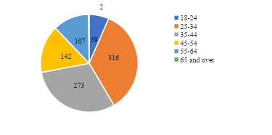

Figure 10 ‒ The age categories of civil servants

337 respondents were female and 560 participants were male out of the 897 civil servants questioned (figure 11). Regarding educational attainment, 789 individuals reported having a bachelor's degree, 60 had a master's degree, and only 48 had completed specialized secondary schooling (figure 12).

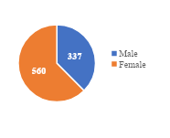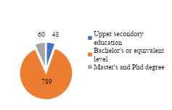

Figure 11 ‒ The gender of the civil servants Figure 12 ‒ The level of education

Figure shows that of the public servants who took part in the poll, 71.4% are employees, 18.4% said they are at a lower level of management, and the remaining 10.2% said they are at the executive or middle level (figure 13).

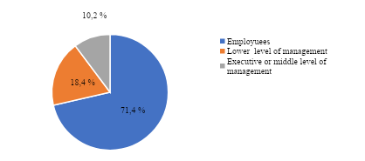

Figure 13 ‒ The level of civil servants

However, the results of a sociological survey conducted already in 2022 among *1000* respondents, where *897* were civil servants, within the framework of the research project "The effectiveness of remote work in the public administration system of the Republic of Kazakhstan, in the context of digitalization", demonstrate that *57%* of respondents replied that the current Labor Code is effective, and all questions are provided; *41%* of respondents stated that the current Labor Code requires improvement even after the amendments to the Labor Code of July 1, 2021, which provide for the possibility of remote work and in a mixed mode of work; only *2%* of respondents said that remote work is ineffective in the civil service (figure 14).

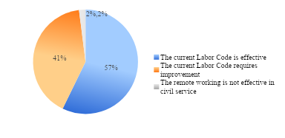

Figure 14 ‒ The effectiveness of the Labor Code in remote work

However, the new Labor Code of the Republic of Kazakhstan does not contain restrictions in concluding agreements on the use of remote work in various spheres of life (be it medicine, life support for infrastructure facilities, law enforcement agencies, etc.). Also, in the field of regulating labor relations, it can be noted that labor legislation contains only the specifics of the implementation of remote work.

Further, in accordance with the first part of Article 138 of the Labor Code of the Republic of Kazakhstan, remote work is considered as one of the forms of the labor process, characterized by its own characteristics and implemented outside the employer's location with the use of information and communication technologies in the process of work [64].

In the second part of Article 138 of the Labor Code, the legislator also regulates the obligation of the employer to provide employees with means of communication, which also bears the corresponding costs of their installation and maintenance. In the opposite case, if the employee uses his own means of communication, the employer pays him appropriate compensation. The rest of the expenses related to electricity and water costs can also be reimbursed by agreement of the parties.

As a result, the Republic's labour policy is moving in a positive direction with the implementation of Article 138 of the Labour Code, which takes into consideration the provisions of certain safeguards for remote workers. However, taking into consideration the existence of set working hours, section 3 of Article 138 of the Labour Code does not fully satisfy the criteria of working in the public service system.

Furthermore, it is important to observe that the laws governing the civil service's operations do not contain any clauses that forbid working remotely. Additionally, there is no information on encouraging remote employment in the statute. Subordinate regulatory legislative statutes governing labour relations in the public service system, in contrast to labour law, more strictly control the public service process.

The lawmaker carefully considers the issues of legislative regulation of remote labour in the public service system, keeping the aforementioned points in mind. It should be highlighted that not all job categories are a good fit for remote work due to the unique requirements of the civil service. However, using a remote work arrangement is not expressly prohibited in the public service system. In this context, it is advised that state agencies' personnel services categorise jobs, paying particular attention to those that fit into the remote work model.

In addition to the aforementioned, it is feasible to include pertinent experts from the civil sector in the framework of the coronavirus pandemic who possess the necessary abilities to carry out support tasks for remote work in government organisations. The aforementioned is a result of the experts' increased involvement in auxiliary tasks that are more closely related to services than in the actual execution of governmental activities.

In accordance with paragraph 6) of Part 1 of Article 1 of the Law of the Republic of Kazakhstan "On Civil Service", civil service is understood as the activity of civil servants in state bodies in the exercise of official powers aimed at implementing the tasks and functions of state power . Thus, this definition of the Law of the Republic of Kazakhstan "On Public Service" needs to be improved. The author raises the question of the need to change the concept of "public service", since it is advisable to understand by it not only official activities aimed solely at the performance of official duties of civil servants, but also employees hired under a contract.

Further, according to the 2022 survey, 59% of respondents stated that remote work in case of emergencies, natural or man-made disasters, epidemiological restrictions, etc. is effective and ensures safety, while 22% of respondents stated that remote work in emergency situations or in conditions of epidemiological difficulties, etc. is partially effective, and 19% of civil servants replied that remote work in a state of emergency, etc., on the contrary, is ineffective.

Thus, taking into account advanced foreign and domestic experience, additional amendments should be made to the Labor Code of the Republic of Kazakhstan to create conditions for work and rest in case of emergency situations. (figure 15).

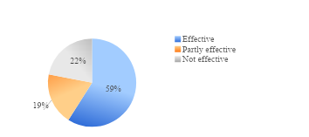

Figure 15 ‒ The effectiveness of remote work during a state of emergency, epidemic restrictions, etc

Note ‒ Compiled from source [65]

It should be noted that in conditions of remote employment, the balance between work and personal life is often disrupted. On the one hand, employees can independently plan their work and rest hours, and on the other hand, they have become "available" to managers almost 24 hours a day.

These conditions not only increase the intensity of work, the amount of work performed, but also impose requirements on such personal qualities of employees as reliability, organization, concentration, etc.

Another negative factor affecting the well-being of employees in remote employment is the limited communication with colleagues, which can lead to a deterioration in their psychological well-being.

The survey's findings indicate that there are some negative psychological effects of working remotely, such as an unbalanced work-life balance, anxiety related to feeling like you don't belong, and misunderstandings of the general state of affairs in an organisation or company; on the other hand, 54% of respondents said that working remotely improves their psychological well-being.

However, 14% of respondents claimed that, on the contrary, their psychological state was getting worse. This could be because psychological issues make it harder for participants to interact emotionally over the internet, disrupt the balance between work and personal life, cause high levels of psycho-emotional stress, lower motivation, exacerbate the already tense psychological situation in isolation, and have an indirect but significant impact on activity outcomes when switching to new forms of work.

However, 32% of government employees stated that their psychological state does not change when they work remotely (figure 16).

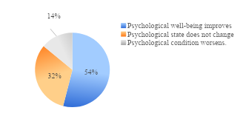

Figure 16 ‒ Psychological state during remote work

Figure 4 shows the physical condition of government employees when working remotely. The data shows that 49% of respondents said their physical condition does not change, while 43% said it is improving. This suggests that people have time for outdoor and sports activities when they are not working from home, and that working remotely is good for your health because it allows you to schedule your work around your own biological rhythm.

Only 8% of respondents stated that their physical condition is deteriorating, stating that, on the contrary, there are problems associated with loss of physical activity or poor workplace organization, non-compliance of working conditions with sanitary and hygienic standards (figure 17).

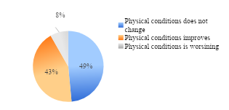

Figure 17 ‒ The physical state of remote work

Having considered the issue of the impact of remote employment on the physical condition of civil servants and Kazakh legislation, it is proposed to amend the norms of the Labor Code of the Republic of Kazakhstan, fixing in its provisions aimed at protecting the rest time and health of persons working remotely.

Further, it should be noted that, taking into account the specifics of the state apparatus, the Agency of the Republic of Kazakhstan for Civil Service Affairs in 2023 approved the "Rules for the use of remote work, combined remote work, flexible working hours for civil servants."

According to these rules, remote work is the implementation of the labor process outside the employer's location with the use of information and communication technologies in the course of work.

Combined remote work is the implementation of the labor process by alternating periods of performance of work duties both at the location of the employer and through remote work.

At the same time, the existing basis for remote activities in the public administration system does not fully answer the question of the real possibility of remote work in terms of the efficiency of using existing electronic document management, since the new standards did not affect the improvement of existing digital platforms and the digital infrastructure in general in the country.

The experience of the developed countries of the world shows that special attention is currently being paid to the introduction of digital infrastructure as part of the process of digital transformation of all sectors of the economy, including the public administration system.

In addition, currently, with the development of information and communication technologies and the availability of the Internet, remote employment has become possible for many categories of the population, including those with health restrictions.

It should be noted that persons with disabilities are a kind of reserve of the labor potential of the population in conditions of a decrease in the number of working–age population and its aging.

In addition, ensuring the employment of persons with disabilities can solve several tasks at once: promotes the integration of persons with disabilities in society; ensures compliance with the provisions of the Convention on the Rights of Persons with Disabilities; improves the standard and quality of life not only of the individual himself, but also of all members of his family; promotes the reproduction of the workforce as a whole, etc.

Currently, in the Republic of Kazakhstan, persons with disabilities work in various sectors: public administration, defense, compulsory social security; education; wholesale and retail trade; healthcare and social services; manufacturing and construction (figure 18).

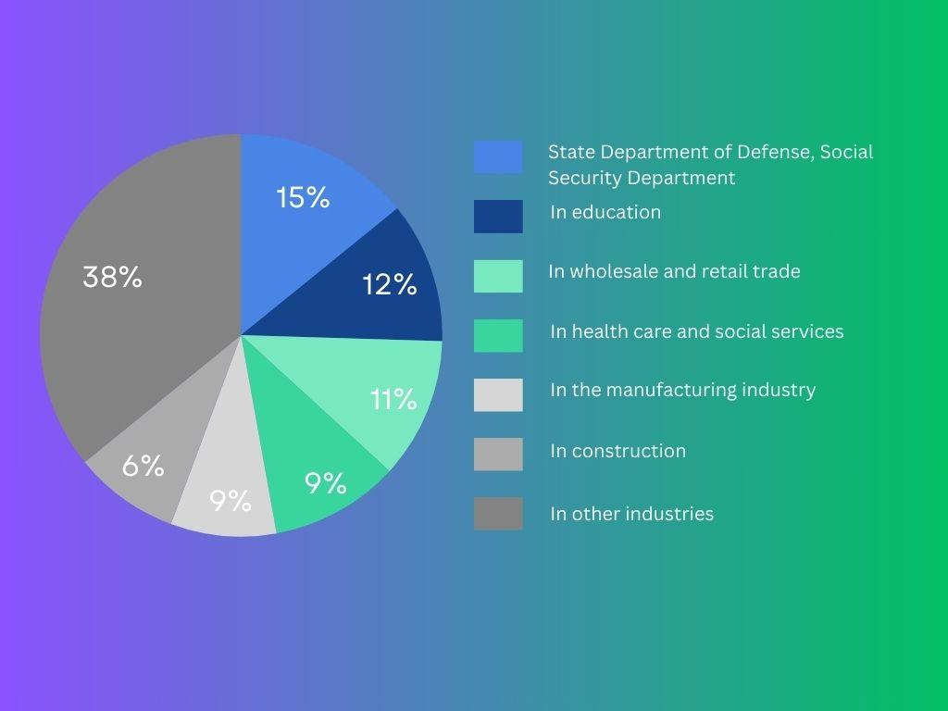

Figure 18 – Employed persons with disabilities by industry

Note ‒ Compiled by the authors based on the source [66]

Based on the data depicted in the picture, we may deduce that a minor portion of the disabled population is employed in the public administration, defence, and mandatory social security systems.

These data explain the insufficient quality and quantity of educational programs in the relevant areas available to persons with disabilities, as well as the low level of competitiveness of persons with disabilities.

There is also a low level of employment in all other industries. It can also be assumed that there will be differences in the employment structure of people with disabilities in urban and rural areas, since government statistics do not allow us to identify the factors of difference.

In addition, the reason for such a low level of economic activity of persons with disabilities in Kazakhstan can be explained by existing barriers. First of all, the presence of structural barriers.

The unavailability of infrastructure seems, at first glance, a minor problem. However, each of them individually poses a big problem for an individual with a disability.

In this regard, the problem of access to social infrastructure for persons with disabilities remains open.

In this regard, remote work is an innovative and effective way to solve the acute problem of unemployment among people with disabilities, thereby its use will have a positive impact on the employment rate of the population as a whole.

In this regard, it seems necessary to return to the discussion of the issue of quotas for places for people with disabilities in government agencies.

Since activity in the public administration system provides citizens with greater confidence in the future, stability and social security, which is so lacking for disabled citizens.

Every year, the Republic of Kazakhstan Agency for Civil Service Affairs assesses the actions of bodies responsible for managing government staff. The normalization of work is one of the evaluation indicators. In turn, federal workers who work remotely and with a flexible schedule are impacted by labor rationing when it comes to overtime. The assessment was based on information regarding the issue of civil personnel (table 2) [67].

Table 2 – Information on the survey

|  |  |  |
| --- | --- | --- |
| Name of the State body | The number of civil servants who  passed the survey | Flexible work schedule indicators ***«****in the remote mode (with a flexible work schedule), I did not have to work overtime»,* % |
| 1 | 2 | 3 |
| *Central state bodies* | | |
| Ministry of Digital Development, Innovation and Aerospace Industry of the Republic of Kazakhstan | 202 | 63,37 |
| Agencies for the Protection and Development of Competition of the Republic of Kazakhstan | 291 | 94,16 |
| Ministry of Health of the Republic of Kazakhstan | 1 942 | 91,92 |
| Ministry of Foreign Affairs of the Republic of Kazakhstan | 320 | 80,31 |
| Ministry of Industry and Infrastructure Development of the Republic of Kazakhstan | 932 | 79,18 |
| Ministry of Information and Public Development of the Republic of Kazakhstan | 155 | 83,87 |
| Ministry of Culture and Sports of the Republic of Kazakhstan | 128 | 78,13 |
| Ministry of Science and Higher Education of the Republic of Kazakhstan | 105 | 75,24 |
| Ministry of National Economy of the Republic of Kazakhstan | 472 | 81,99 |
| Ministry of Education of the Republic of Kazakhstan | 130 | 83,85 |
| Ministry of Agriculture of the Republic of Kazakhstan | 1 726 | 97,51 |
| Ministry of Trade and Integration of the Republic of Kazakhstan | 252 | 90,08 |
| Ministry of Labor and Social Protection of the Population of the Republic of Kazakhstan | 427 | 95,55 |
| Ministry of Finance of the Republic of Kazakhstan | about 5.3 thousand employees | 90,63 |
| Ministry of Energy of the Republic of Kazakhstan | 210 | 87,62 |
| Ministry of Ecology and Natural Resources of the Republic of Kazakhstan | 607 | 83,87 |
| Continuation of the table 2 | | |
| 1 | 2 | 3 |
| Ministry of Justice of the Republic of Kazakhstan | 1 017 | 94,49 |
| *Total 17* | *14 216* | - |
| *Local executive body* | | |
| Akimat of the Abai region | 281 | 97,15 |
| Akimat of Akmola region | 498 | 96,79 |
| Akimat of Aktobe region | 470 | 98,09 |
| Akimat of Almaty region | 363 | 95,32 |
| Akimat of Almaty city | 786 | 95,29 |
| Akimat of Astana city | 682 | 91,2 |
| Akimat of Atyrau region | 348 | 95,7 |
| Akimat of the East Kazakhstan region | 435 | 97,5 |
| Akimat of Zhambyl region | 443 | 96 |
| Akimat of the West Kazakhstan region | 450 | 91,77 |
| Akimat of Karaganda  region | 489 | 96,52 |
| Akimat of Kostanay region | 569 | 99 |
| Akimat of Kyzylorda region | 381 | 97 |
| Akimat of Mangystau region | 358 | 90 |
| Akimat of Pavlodar region | 545 | 97,8 |
| Akimat of the North Kazakhstan region | 453 | 99,6 |
| Akimat of Turkestan region | 499 | 93,8 |
| Akimat of Ulytau region | 177 | 96 |
| Akimat of Shymkent city | 496 | 96,8 |
| *Total 20* | *8 723* | - |
| Note – The table is compiled by the author on the basis of materials collected during practice at the Agency of the Republic of Kazakhstan for Civil Service Affairs | | |

22,939 government servants from central and local administrative bodies took part in the poll, as shown in table 3. Based on the available statistics, over 60% of civil workers from all government agencies responded that they were not required to work overtime when using a remote work schedule.

These numbers demonstrate the efficacy of remote work arrangements in government organizations.

Based on the above, the issues that arise when switching to remote work are very relevant these days and, according to many authors, will be relevant for a long time.

**2.2 The impact of distance employment on the environmental situation**

A theory was presented during the investigation that the installation of quarantine and other restrictive measures during the pandemic or widespread remote employment of the people benefited the environmental condition by reducing pollutant emissions.

As certain organizations reduce their dependence on face-to-face meetings and move to the introduction of remote work methods, the need for air travel, the use of public, official and personal transport decreases sharply.

Examining global experiences, it is worth mentioning that the British DecarboN8 program, which seeks to "decarbonize" transportation, makes a resounding suggestion to "work from home if you can".

They contrasted these numbers with the overall CO2 emissions for 375 local districts after analyzing mobility and public transport data for over 23 million devices between February and June 2020. In comparison to pre-pandemic data, they discovered that commuter emissions had dropped by an average of 30-38%. The largest improvement was noted in May 2020, the fourth month of the quarantine, when emissions decreased by 40-78% [68].

Furthermore, working remotely allows people to live anywhere they desire. People can leave polluted cities and areas when they no longer base their decision on proximity to their place of employment.

Food waste and the use of plastic dinnerware may be drastically decreased by working remotely. Employees who work from home may definitely cut down on the trash produced by the snacks and coffee that are often consumed between nine and five. In fact, the EU's European Environment Agency has already noted this encouraging trend, seeing a decline in sales of food and beverages for on-the-go during the COVID-19 shutdown.

Reducing the use of paper is another environmental benefit of remote work that is worth recognizing. According to a study by the University of Southern Indiana, the average American uses 85 million tons of paper per year, which is about 680 pounds per person [69].

Since, when working remotely, only digital solutions are used. In this way, remote workers can reduce the use of 247 trillion sheets of paper and as a result save up to 16 trillion trees per year.

Thus, remote work has more advantages regarding the ecology of the world.

However, there are results of a study of the reverse effect, including an increase in the number of non-work-related trips and shorter trips. For example, in a California sample of employees who switched jobs during the COVID-19 pandemic, a decrease in vehicle mileage was accompanied by an increase in the average number of trips by 26%. In addition to changes in commuting, potential emissions changes resulting from business travel in mixed environments (e.g. events and conferences) will also be relevant [70].

In addition, the spread of infectious diseases is influenced by a number of factors, which also include geographical ones.

In turn, considering the experience of the Republic of Kazakhstan, it is possible to analyze the impact of remote employment on the environmental situation, using the example of large cities of republican significance Astana and Almaty, being the largest cities in terms of population and area, but having different physical and geographical characteristics, these cities are quite similar in their socio-economic development. Both cities, having no large industrial enterprises within their territorial borders, are among the ten most polluted cities in Kazakhstan, which is facilitated by increased emissions into the atmosphere from motor transport, thermal energy sources and autonomous heat supply. In order to evaluate the environmental conditions before and during the pandemic in the cities of Almaty, where 302 individuals were present, and Astana, where 328 people were present, a sociological survey was taken into consideration.

When examining the average concentrations of various pollutants over a period of months, it becomes evident that nearly all major pollutants experience a decline in values during the Pandemic-related quarantine periods in April, May, and July 2020 in both cities. This period coincides with the prohibition of road transport.

Looking at the average concentrations of pollutants over the course of a month, it is evident that almost all major pollutants have an average concentration decrease during the period of tighter quarantine, which is introduced in April, May, and July 2020 (figure 19). This decrease is linked to the ban on road travel. The relaxing of quarantine and the start of the hot season are responsible for the average concentrations' progressive rise, while the private sector's gasification project and public transit are to blame for the period from October to December's decline.

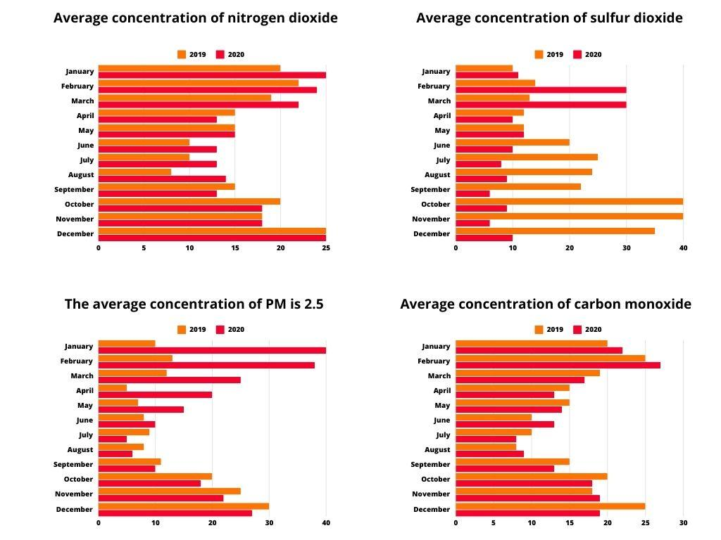

Figure 19 ‒ The average concentration of major pollutants in Astana by month for 2019-2020

Note – Compiled by the authors according to the data of RSE «Kazhydromet»

Even while the amounts of dangerous compounds in the air in Almaty and Astana have decreased, this trend is only sustained while a state of emergency and stricter quarantine are in place. The values rebound to the "doc-shaped" ones in the ensuing months, occasionally surpassing them.

The shift to remote work has resulted in higher energy consumption by city dwellers, which in turn has raised fuel consumption at thermal power plants ‒ the primary producers of pollution in both cities ‒ by inhabitants. The requirement for more frequent furnace heating as a result of people spending more time in private houses is one reason Astana has higher amounts of dangerous compounds.

Emissions were decreased in Almaty by implementing a project for the gasification of specific buildings and public transportation.

In conclusion, at first glance, remote work in Kazakhstan can significantly reduce carbon dioxide emissions, energy consumption, paper use, waste generation and resource consumption, making it a more sustainable and environmentally friendly option compared to traditional office work.

But the research's findings enable us to draw the conclusion that the pandemic's improvements to the environment were just temporary. This can be seen when considering changes in the average concentrations of pollutants in cities in the context of months: a decrease in concentrations of major pollutants

It is observed during the introduction of the state of emergency and tightened quarantine, which occurred from March to April and July 2020, respectively, and in the following months there is a gradual return to "doc-like" values. In this regard, the indicators of remote employment of the population in the Republic of Kazakhstan, including civil servants, are not an explicit criterion for reducing the emission of harmful substances into the environment.

In general, it should be noted that the positive impact on air cleanliness in the cities of Astana and Almaty depends on several factors, such as reducing the use of transport, the use of alternative energy sources, increasing the use of digital devices and, in general, the organization of a waste management system.

**2.3 The effectiveness of digitalization in the development of the remote work in the public administration system in the Republic of Kazakhstan**

The fourth industrial Revolution, manifested in the application of complex, end-to-end, including quantum technologies, the demand for behavioral competencies based on comprehensive erudition and critical thinking, project work and rational decision-making, predetermined the emergence of digitalization, i.e. the digitization of various types of information (text, sound, video), allowing for the rapid processing of large amounts of data, simplify and speed up the work [71].

In general, the concept of "digitalization" is derived from the noun "digit" or the adjective «digital» (digital).

Т Also, this term is due to the introduction of digital technologies, data transmission streams, as well as digital transmitting devices (computers, smartphones, tablets, televisions, smartwatches, etc.) into all spheres of society and the economy.

In addition, digitalization is currently considered not as an independent development of the technological industry, but a platform that provides optimization of production processes, that is, effective management of various resources, that is, optimization of business processes using digital technologies.

However, a review of international experience has shown that the degree of influence of digitalization is uneven and differs from country to country, from sector to sector, depending on the economic structure. As a rule, the more developed the economy, the higher its economic growth due to digitalization [72].

Moreover, despite the fact that digitalization has already led to significant changes in the labor market in many countries, most scientists believe that the main impact of the fourth industrial revolution is still ahead and its level remains uncertain to a fairly high degree [73].

For a unified interpretation of terminology, table 3 lists various definitions of the concepts of «digitization» and «digitalization».

Table 3 – Definitions of the concepts «digitization» and «digitalization»

|  |  |
| --- | --- |
| Authors | Definitions |
| 1 | 2 |
| Gobble M. A. M. | Digitization is a simple process of converting analog information into digital format. Digitalization refers to the use of digitization and digital technologies to create and obtain various values in new ways |
| Rachinger M.,  Rauter R.,  Müller C.,  Vorraber W.,  Schirgi E. | Digitization is the process of converting analog data into digital datasets. Digitalization – exploitation of digital opportunities |
| Cenamor J.,  Sjödin D.R.,  Parida V.,  Eloranta V.,  Turunen T. | Digitization is the prospect of using a digital platform to change the interaction of business models into more digital ones; a combination of autonomous, semi–autonomous and manual operations in multi-channel customer service, integrated marketing or smart manufacturing |
| Yudina T.N. | Digitalization in a narrow sense is the creation of information and digital platforms that allow solving various strategic tasks, and in a broad sense it is a change in the nature of economic or industrial relations, during which the «Internet of Things» and the «Internet of Everything» arise |
| Gauthier C., Bastianutti J., Haggège M., Hasselblatt M., Huikkola T.,  Nickell D.,  Kohtamäki M.,  Helo P. | Digitalization is the conceptualization of the possibilities of digitization and application of the «Internet of Things», which is a system of integrated computer networks and connected physical objects designed for remote data exchange, control and management in an automated mode |
| Gorissen L.,  Vrancken K., Manshoven S.,  Sung T.K. | Digitalization is an activator of new ways of applying digital technologies and the next stage of digitization |
| Clerck J. | Digitalization is the constant introduction of digital technologies in all possible social and human activities |
| Gartner Glossary | Digitalization is the process of transition to a digital business, the use of digital technologies to change the business model and provide new income opportunities and create various values |
| MITSloan Management Review | Digitalization is the innovation of business models and processes that take advantage of digital opportunities |
| Continuation of the table 3 | |
| 1 | 2 |
| Parida V.,  Sjödin D.,  Reim W. | Digitalization is the use of digital technologies to innovate in business models and generate new revenue and opportunities to create various values in industrial ecosystems. |
| Martín‐Peña M.L., Díaz‐ Garrido E., Sánchez‐López J.M. | Digitalization is the use of digital technologies to innovate in business models and generate new revenue and opportunities to create various values in industrial ecosystems. |
| Khalin V.G., Chernova G.V. | Digitalization in a narrow sense is the transformation of information into digital form to reduce costs and create new opportunities, and in a broad sense it is a trend of effective global development and digital transformation of information of wide coverage |
| Zozulya D.M. | Digitalization is a smart socio—cultural and economic reality created through information and communication technologies based on binary code |
| Note – Compiled by the author | |

Most scientists agree that the first step towards a digital society is the digitization of information, the transfer of analog data into electronic digital form, including through the use of various electronic digital platforms. In fact, it automates the process by digitizing data into bits and bytes. The process of digitizing data is often replaced by the name «digitalization». In turn, digitalization is considered the next stage and is interpreted by scientists as using the results of digitization to transition to a digital business, using digital technologies to improve business processes, create new products and increase profits. At the same time, in a narrow sense, three main contexts of the use of the term «digitalization» are noted.

At the same time, in order to study the impact of digitalization on the labor market, the ILO has a Global Commission on the Future of Labor. One of the relevant areas of the commission is to study the impact of digitalization on the possibilities of remote work, the so-called «telework». We believe that the features of the modern digital society, the total lack of time, the high cost of renting office space, heavy car traffic, etc. are quite suitable for the spread of a relatively new type of remote employment.

Due to professional scientific interests, within the framework of this part of the dissertation, the author focuses on the digitalization processes covering the sphere of public administration of the Republic of Kazakhstan and directly on only one aspect of this issue, this is the effectiveness of the use of remote work technologies by civil servants in the public administration system.

First of all, assessing the effectiveness of remote employment in the public administration system in Kazakhstan, we consider it important to assess the digital ecosystem (accessibility and quality of the Internet) in Kazakhstan, since networks are the basis of digitalization, a component that is necessary for access to ICT services.

According to the Bureau of National Statistics of the Agency for Strategic Planning and Reforms of the Republic of Kazakhstan, about 93.3% (the average percentage of people using the Internet aged 16-74 years) of the total population of the Republic of Kazakhstan has access to the Internet [74].

Moreover, it is important to note that this indicator is constantly increasing over time and not only in terms of the number of users, but also the level of traffic. Although there is a significant part of the population that still lacks the means to connect to the Internet.

In general, the overall dynamics shows that phased work is underway to increase the use of fiber and expand the 4G network. Similarly, efforts are focused on preparing platforms and business models to incorporate next-generation technologies such as the deployment of 5G networks.

However, recently there has been a large number of complaints from Kazakhstanis about the poor quality of the Internet and cellular communications in the country [75].

According to the information of the Ministry of Digital Development, Innovation and Aerospace Industry of the Republic of Kazakhstan, the decrease in Internet quality is due to the fact that currently, due to the growth of the digital economy, entertainment content (TikTok, YouTube), the entry of business and public services into the virtual space, that is, the transition of economic activity to a platform model, the pace of Internet use-traffic is growing significantly, since the beginning of the pandemic, this figure has reached 800 petabytes.

It should also be noted that according to the International Telecommunications Union (ITU), last year the number of people using the Internet worldwide exceeded 4.9 billion people. Namely, during this time, the number of Internet users in the country amounted to 90.9%. «Not only is the number of those who use the Internet growing, but also the time during which they access the Internet. These factors are the main reason for the increased load on the communications infrastructure» [76].

At the same time, modern information and communication technologies play a huge and key role in ensuring remote employment in the public administration system of Kazakhstan and one of the important areas of Information and communication technology in the public administration system, and what the author draws attention to in this part of the dissertation is the effective use of electronic document management systems. Since, obviously, without switching to electronic document management, it is pointless to talk about the possibility of remote work of civil servants. The approved data on digital document management and measures to ensure the transition of the state apparatus to a single centralized cloud document management are specified in (Appendix B).

In general, Information and communication technologies in the public sector are understood as a set of methods, business processes and software and hardware that are integrated for the purpose of collecting, processing, storing, distributing, displaying and subsequent use of information in the interests of the state and its residents [77].

In turn, the unified Electronic Document Management system of state bodies (UESED) is an electronic document management system designed for the exchange of electronic documents between state bodies of the Republic of Kazakhstan and officials of the relevant state body.

Currently, as part of the de-bureaucratization and digital transformation of the public sector in the Republic of Kazakhstan, work is actively underway to transition the state apparatus to modern approaches of a unified centralized cloud document management (SDO). The peculiarity of this technology is that information, files, exchange, storage of documents is provided as a "Cloud" and stored on the servers of the unified information and communication operator JSC «NIT», thereby they are accessible and secure from anywhere in the country, for any government agency.

Thus, at the moment, to a large extent, the state bodies of the Republic of Kazakhstan have implemented the project of cloud document management OSDO «Documentolog», which allows using digital solutions to safely optimize the passage of official correspondence between government agencies, with the possibility of working together on one draft document, eliminating duplication of orders, operational formation of analytical reports, as well as the translation of documents marked «or official use» in electronic format.

So, to date, 69 state bodies (28 central, 38 committees, 1 bureau, 2 departments of the Office of the President of the Republic of Kazakhstan), 320 territorial divisions of the GO, 10 local state bodies have already been transferred to cloud document management.

Thus, the number of users connected to cloud document management is over 24,000 users [78].

However, it should be noted that along with the introduction of cloud document management, other electronic document management systems continue to operate in some government agencies of the Republic.

For a more detailed assessment of the effectiveness of the electronic document management system in the public sector of the Republic of Kazakhstan, the author suggests reviewing the results of sociological surveys conducted in 2020 and 2022 among civil servants of the Republic of Kazakhstan.

Thus, according to the result of a 2020 survey among civil servants, comparing the cloud-based document management system OSDO with the unified electronic document management system ESED, 35% of civil servants note that it is more convenient for them to use the cloud-based document management system (OSDO) than the unified electronic document management system (ESED).

However, 30% of civil servants say the opposite, preferring the unified electronic document management system (EDMS) to the cloud document management system (OSDO), explaining this by problems with access to the Internet, as well as the system's user-friendly interface, which complicates the search and storage of necessary documents.

The remaining 35% of civil servants find it difficult to answer, perhaps because they do not use either system (figure 20).

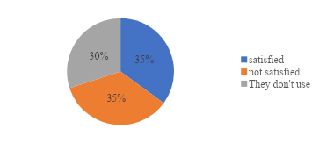

Figure 20 ‒ Comparison of the ESED and the OSDO

In addition, according to the survey results, 65% of respondents noted that the main advantage of the two systems is that they are fast and easy to use, provide high-quality Internet and training in working with electronic document management systems.

Further, analyzing the results of a survey among civil servants from 2022, when asked whether they used official online resources or other social digital platforms when working remotely, 56% of civil servants replied that they used only official resources, 41% said that they used open public sources or messengers to exchange information and perform tasks, and 3% said they used both closed and open platforms (figure 21).

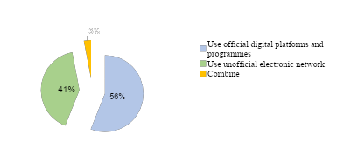

Figure 21 ‒ Use of office digital platforms by civil servants when working remotely

Note ‒ Compiled from source [79]

Also, online work makes its own adjustments to digital inequality. The level of digital skills in the public sector remains insufficient, when this component is essential for government employees in remote work.

Thus, the survey showed that 39% of government officials classified themselves as insecure users whose level of digital literacy is below average or non-existent and performing government duties and functions online is a difficult task for them.

Although, 61% of government employees consider themselves advanced users Figure 22.

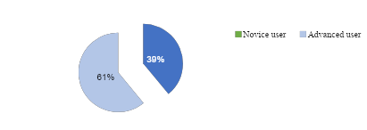

Figure 22‒ Digital literacy of civil servants when working remotely

Further, in general, the logistical equipment used by civil servants to work online is satisfactory. However, not all government agencies can provide their employees with high-quality remote jobs. Thus, 11% indicated a lack of logistical equipment at their workplaces when working remotely, and 44% of respondents stated that their workplace was not properly prepared (figure 23).

Nevertheless, 45% of government employees who participated in the study positively assess their work when working remotely.

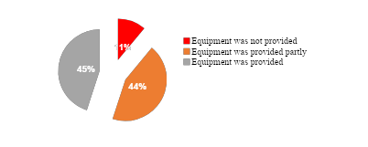

Figure 23 ‒ Material and technical equipment of civil servants when working remotely

The conducted research allows us to conclude that within the framework of the development of information and communication technology, an electronic document management system has been introduced, designed for the exchange of electronic documents between government agencies of the Republic of Kazakhstan.

In addition, within the framework of the e-government concept, various public services are actively provided to the population and other legal entities of the country on the E-gov digital portal.

For example, there is a center in Astana, the purpose of which is to simplify the provision of urban services to organizations of the housing and communal sector. Currently, the Center provides over 140 services.

The convenience of receiving services is confirmed by the increasing demand from residents of Astana for services. So, if during the period June-December 2019, the Department provided 3,701 services, then in 2020 – 69,560 services, in 2021 – 148,586, in 2022 over 173,000 services, from January 1, 2023 to April 24, 2023, the department provided more than 82 thousand services.

At the same time, considering the work of the iKomek center for the provision of housing and communal services to the population in the city, it should be noted that the provision of these services is carried out remotely, on the portal of urban services www.qalaqyzmet.kz and about actively by SMS-questionnaire.

In this regard, there is an elimination of paperwork, an increase in digital literacy of the population and minimizing the interaction of the population with public utilities, which in turn increases the effectiveness of the remote mode of operation of public administration in the context of digitalization.

Moreover, work is underway on an ongoing basis to update the services on the Portal, taking into account the demand for residents of the capital.

At the same time, considering the information and communication technologies of the remote format business process in the public sector, today there are a number of problems directly related to the effectiveness of electronic document management and the organization of a remote workplace for civil servants themselves.

In this regard, the following recommendations can be proposed to improve the effectiveness of distance employment in the public administration system of Kazakhstan:

‒ actively implement and improve the current cloud document management system in government agencies by improving the interface for searching and storing necessary documents.

Also, in addition to electronic document management, implement a centralized platform with task boards that visually display the list of tasks that each employee is working on and the progress of their implementation, which will be an effective tool for monitoring the quality of staff work without excessive (annoying control). For example, using elements of the Trello, Asana and Jira systems.

In addition, to control employees, it is necessary to use technical controls. These may include, for example, the use of video surveillance, recordings of telephone conversations, special computer tracking programs that can save data that is entered from the keyboard, take screenshots, send reports on which sites employees visit, which documents were output to the printer and much, much more.

Such programs not only help to find out what an employee working at a computer spends his working time on, but they are also able to record and prevent the fact that an employee discloses official secrets.

At the same time, it is important to understand that the use of these technical controls must be carried out in strict accordance with the legislation of the Republic of Kazakhstan.

The mechanism for regulating remote work for government agencies in the Republic of Kazakhstan should be fixed in regulatory legal acts regulating labor relations, as well as in specialized acts concerning the organization of work in government agencies.

The main act that regulates labor relations in the Republic of Kazakhstan is the Labor Code of the Republic of Kazakhstan (the Labor Code of the Republic of Kazakhstan), which was adopted on December 28, 2015 and has been consistently updated. This code includes provisions governing various forms of work, including remote work. It contains information about the organization of work, the rights and obligations of employees and employers, including remote work.

To clarify the mechanism for regulating remote work in government institutions, it is necessary to pay attention to the following regulatory legal acts:

1. The Labor Code of the Republic of Kazakhstan regulates general issues of labor relations, including those related to remote work. Specifically for remote work, article 135, which concerns the organization of work using information and communication technologies (remote work), will be important.

2. Resolution of the Government of the Republic of Kazakhstan dated May 15, 2020 No. 321, which establishes the procedure for regulating remote work in an emergency situation and in the context of the COVID-19 pandemic. This decree can be considered a temporary act, but it leaves a mark on the development and implementation of remote work in government agencies.

3. Orders or resolutions of government agencies may also develop additional regulations that specify the procedure for remote work in specific government agencies. For example, ministries can develop methodological recommendations or special documents for use within government structures.

Place in the hierarchy of legislative acts:

1. The Constitution of the Republic of Kazakhstan is the basic law that establishes the principles governing the rights and freedoms of citizens, including the right to work.

2. The Labor Code of the Republic of Kazakhstan is a law regulating labor relations, including remote work.

3. Government and ministerial resolutions regulating specific aspects of remote work in the context of government agencies and institutions.

In addition, to introduce to this digital system the functions of organizing a remote employment monitoring system with the ability to inform employees about problems that arise when performing duties (lack of information, lack of technical capabilities, lack of information from colleagues on the project, etc.). For example, one of such options is to consider the principles of a digital remote access tool for monitoring employee activity for computers (Clever control);

‒ next, make use of digital platforms more secure. To ensure the protection of the interests of people, companies, and the state, the government must give particular attention to the legislative regulation of digital security in the nation's public sector. This will allow for the establishment of a strong security system for data transmission, processing, and storage.

Furthermore, information stored in the cloud must reside on servers that are physically situated in the Republic of Kazakhstan. In the event of a legal dispute, data centre owners who are based outside of our nation will adhere to the laws of the nation in which their facilities are situated;

‒ to improve public servants' level of digital competency by routinely offering specialized training on how to use digital platforms efficiently for remote work.

Because digitalization changes the way that workplaces are conducted, employees must learn new skills in order to perform new tasks. This means that employees must constantly grow professionally, acquire new knowledge throughout their lives, and become proficient in using new software as well as automated and robotic technological processes.

Furthermore, in order to control digitalization in the public administration system, Kazakhstan must make further use of the global experience regarding its effects on the labour market and apply the best international methods;

‒ to update the hardware and software in public employees' offices to support remote work. Simultaneously, every position within the company and every person who has been moved to a remote work mode should have the same standard configuration for their virtual workspace;

‒ create a checklist of the actions that must be taken in order to transition to remote work (refer to figure 24).

|  |
| --- |
| The list of employees moving to remote work has been determined |
| A list of necessary equipment has been compiled for each employee |
| A list of necessary programs has been compiled for each employee |
| A new employment contract has been signed with each employee |
| A wide-range broadcasting channel has been organized for the company's management |
| The list of servers that work in the office on the server is defined |
| Remote access to this list is organized |
| The issue of technical support access to employee workstations has been resolved |
| An infrastructure has been created for file sharing between employees |
| The task control system has been deployed and configured |
| The chat system has been deployed and configured |
| The knowledge base has been deployed and configured |
| All employees have been granted access and accounts have been created in all services |
| Licenses of all working software have been transferred to employees' home workstations |

Figure 24 ‒ Checklist of necessary steps when switching to remote operation.

Note ‒ The table is compiled by the author

The authors then suggest looking at Kazakhstan's experience with the operation of a single life support contact center, or iKOMEK109, in the city of Astana. Up to 90% of resident inquiries can be remotely and operationally resolved by the unified life support contact center, iKOMEK109.

83% of resident requests have been closed since the initial call as of this writing. To optimize ease for the inhabitants, Omni channel conditions have been established, meaning that applicants can utilize various methods to submit their applications and monitor their execution status. Omni channel was initially implemented in the public sector to engage with citizens, but it is primarily employed in the corporate sector to service clients. Currently, there are nine methods available for submitting applications to the iKOMEK109 Unified Contact Centre:

1. *To the short number 1-0-9, free dial-up from mobile and landline numbers.*
2. *Telegram bot.*
3. *Akimat's website аastana.gov.kz.*
4. *Mobile application «iKOMEK109».*
5. *Mobile application «Smart Astana».*
6. *Website aitu.city.*
7. *Facebook.*
8. *109@ikomekastana.kz.*
9. *Instagram.*

The idea is to base the concept on US communities, where all non-emergency matters are handled through the 3-1-1 service. For instance, the 3-1-1 service in the United States is available in 300 US communities and provides assistance on over 4,000 state and federal issues in 25 different languages.

With the creation of the iKomek Centre, all call centers for municipal businesses, healthcare providers, and akimat management have been merged, expanding the range of services available for more than 1,800 issues. This has created a single point of contact for city dwellers.

The skilled staff at the iKomek Centre has been taught to be adaptable so they can advise on any matter pertaining to the city's life support system and work with all utilities.

So the iKomek Center accepted:

* in 2018 – 1,037 thousand requests;
* in 2019 – 1,670 thousand requests;
* in 2020 – 2,197 thousand requests;
* in 2021 – 2,490 thousand requests;
* in 2022 – 2,274 thousand requests;
* since the beginning of 2023 – 730 thousand requests.

Additionally, it should be mentioned that all appeals are handled, registered, and assigned a registration number before being forwarded to public utilities and government bodies to be resolved within the allotted time limit. The Akimat of Astana's resolution No. 17-1178, dated June 26, 2018, adopted the regulations of the Life Support Services Departments, which govern this interaction:

1. Feedback is given in each case based on the outcomes of processing applications with applicants, and a response is given in a variety of ways (return call, photo, video report to a personal page in social networks, etc.).

2. Every day, we get between 7,000 and 29,000 queries. Ninety-nine percent of requests are processed. Every day, 6,000 applications are used in the operations of akimat departments and municipal firms. Over 1,800 services are available, and the operator can respond to inquiries from the very first call:

‒ 16 seconds is the response time to the call;

‒ 10 minutes – reaction time on social media;

‒ 7 days – consideration and provision of a response.

More than 55,000 notifications have been delivered through the iKOMEK109 smartphone application since it was created in January 2019 to alert the city's leadership to significant emergencies and serious situations. The application summarises the work services' sequential actions. Additionally, the mobile application lets you complete the appeal online without having to connect to the akimat employees' fixed workspace. Currently, over 500 workers actively handle citizen appeals using the iKOMEK109 smartphone application. Residents of the capital can access information about scheduled and emergency work, school cancellations, trail closures and openings, and other significant events in the city by downloading the iKOMEK109 mobile application.Considering the effectiveness of creating a Single iKOMEK109 Contact Center, the following characteristics should be noted:

1. All call centers of public utilities and city administrations have been combined under the short number 1-0-9. The problem of «A public utility that cannot be reached» has been solved. You can call 1-0-9 for free from landline and mobile phones 24/7.

2. A convenient service for interacting with public utilities and the akimat is offered to residents: 20% of requests are made using alternative digital services, while 80% of requests are made through call centres.

3. Using BIGDATA technology, a digital platform has been developed for the purpose of systematising concerns in the Rating of systemic problems in the city and analysing citizen comments.

4. In comparison to 2019, there were 21% fewer official appeals made to the district offices, the office, and the akimat administration in 2023.

5. The municipal administration rejected SMS messages concerning events in favour of push notifications through the iKOMEK109 smartphone application, which may have allowed for an annual budgetary savings of 50 million tenge.

6. Of the requests, 83% are resolved "from the first call," while the remaining requests are handled in a week.

It should be mentioned that we are recognized as the best in the CIS each year by international contact center experts at the international Call Centre Awards, which are held in four categories: "The best project for creating a contact center," "The best practice of analytics, customer research and understanding," "The best digital modernization programme and transformation," and "The best analytics, customer research and understanding." On the other hand, not every area in Kazakhstan has the same kind of remote contact center system for life support problems.   
 To improve the efficacy of the nation's public administration system overall and, consequently, raise the standard of living, the authors believe that it is imperative to actively design and execute distant methods of communication between the government and the populace.

The use of remote employment offers several advantages, including promoting the growth of the digital economy, infrastructure, and production, which is in and of itself one of the strategic objectives of the state's development. It should also be emphasized that the state's remote employment management policy contributes to the development of human capital by raising the level of digital literacy among civil servants, who are an integral part of Kazakh society, introducing KPIs for digital vice

Additionally, challenges with digital transformation, such as streamlining company procedures and freeing up staff to bolster analytical and predictive capabilities, will enhance decision-making and reduce ‒ or perhaps eliminate ‒ the danger of corruption. However, in order to effectively administer public administration, new, qualitative approaches are required that are based on the restructuring of public administration activities in accordance with three main trends: political, which focuses on the needs and rights of citizens, economic, which transfers some state functions to business, and managerial, which debureaucratization the state apparatus.

Furthermore, even though remote work has a lot of potential, it cannot be said that the shift can be made as quickly as possible. A lot of issues need to be resolved and the necessary conditions need to be set. The adoption of top-notch electronic document management in the public administration system is the cornerstone that makes the shift to remote work feasible.

**2.4 Remote workplace of Public servants**

In this part of the dissertation, the author considers it necessary to strengthen the attention of the state bodies of the Republic of Kazakhstan to the issue of organizing remote workplaces, since research in this area can become the most important factors for the effective use of civil servants and satisfaction with the working conditions of civil servants themselves.

In general, *a remote workplace* is the organization of the workflow of an employee, department, or the entire government body outside the office by connecting the employee's office device with the work software [80].

One of the important conditions of a remote workplace in the public administration system should be information security and confidentiality.

Also, the remote workplace of a civil servant should be carried out on a single software using certified office applications and digital tools.

Currently, there are basically two main ways to organize a remote workplace: through terminal access and a virtual workplace.

In both cases, the necessary documents and applications are stored on the server, and the employee connects to it through a "thin client". These methods are different:

*Remote Desktop Services (RDS)* ‒ a server or servers on a single OS that employees connect to remotely. Simply put, all employees work simultaneously on one large virtual computer [81].

*Virtual Workplace (VDI)*‒ all employee data is stored centrally, while everyone has their own virtual PC. In this regard, the risk of server disruption by an employee is lower than with terminal access [82].

To organize a remote workplace, the state bodies of the Republic of Kazakhstan should contact the authorized bodies, represented by JSC National Information Technologies, which take over the logistical and technical component.

Professionals will provide a suitable format, as well as install corporate applications and organize the transfer of files to the server.

This format allows you not to deploy your own infrastructure in each government agency separately, but at the same time have the opportunity to enjoy all the advantages of a remote workplace.

In addition, such a solution combines the necessary programs on the server of the state body. As a result, the specialist's computer is not overloaded with heavy software, and the IT department monitors the proper operation of the services.

Also, the system administrator always sees what is happening in the virtual office, what changes are being made by employees and where documents are being moved. In case of suspicious activity, special scripts will block access to the workplace and to the files that are stored there.

The data is stored not on the hard drive, but in data centers that are better protected than conventional personal computers. They have backup systems that ensure smooth operation. At the same time, the data is always available ‒ it is enough to connect to a specialized secure network.

Further, in order for employees to perform their tasks remotely, they need access to special software ‒ for example, a CRM system and a service for working with documents. VDI, a tool for organizing remote workplaces, or RW (remote workplace), helps to provide this access [83].

Typically, corporate programs are stored by the organization on a local or remote server. Office computers are connected to this system: shortcuts to the necessary programs, folders and documents are immediately displayed on their desktops. A virtual workspace is created for a remote employee using VDI: it is also connected to the server, but at the same time, access to software and data can be obtained through a personal computer.

The specialist gets the opportunity to work with programs and makes changes to general documents. This is displayed on the computer screen as normal actions, but all processes take place on a separate virtual platform. Therefore, even if something happens to an employee's computer, it will not affect the safety of the company's data in any way.

At the same time, during the study of remote employment today, in order to neutralize the existing problems in the organization of remote work for employees, in terms of organizing an effective remote workplace for some government employees, it is necessary to highlight a number of recommendations and suggest the use of the following tools for organizing the work of remote workers.

Structuring the working day and communications, using a schedule or a workday scenario, organizing constant communications with colleagues and management, strict time management, deviation from which is impossible for an employee.

For example, the start of the working day at 9.00 is a Zoom video conference, where tasks for the current working day are set and the results of yesterday are summarized.

Organizational and technical support of communications in the company, for which you can use a wide range of technical tools that exist today (Zoom, Skype for business, WebEx, you can use groups in Telegram, etc.).

Delegating tasks to small groups of employees, with a predetermined clear definition of roles in the group, with the mandatory presence of an employee acting as the leader of the project group, which allows you to quickly change the list of tasks and the composition of the group, which in the future will become a flexible project microstructure of the company, control over which is carried out through the group leader, which simplifies the control function of the immediate supervisor.

So, in order to organize task performance monitoring, it is necessary to keep a general schedule in the Calendar: add calls, meetings and other meetings there. To date, there is software from Kickidler, Time Doctor, Hivedesk, ActiveTrak, WorkExaminer, etc. programs that are installed on computers of remote employees, which allows you to control their actions. However, it must be remembered that excessive use of this tool can lead to protest, unwillingness to work and even dismissal of a valuable employee, so the company must make a difficult choice for itself between trusting its employee, expecting results and constant monitoring of their productivity. If an organization gives employees the opportunity to choose the time to solve a task, then such employees change jobs less often and feel more comfortable psycho emotionally, which directly affects their productivity. At the same time, the use of working time monitoring tools can be aimed at the benefit of employees, if, for example, an employee's overload is detected, in this case a decision is made to redefine his workload.

It is also necessary to implement tools for monitoring employee results: it is necessary to use daily allocation and structuring of goals, both for the department and for each individual employee, this will allow you to evaluate the work result by the end of the day and avoid smearing the result in time, since it is always easier for an employee to go stepwise to implement a major task. And here the use of KPI tools can help the manager as much as possible; tools for monitoring working hours, simultaneous control of data protection and monitoring of personnel actions, periodic assessment of employee satisfaction.

In addition, it is necessary at the legislative level to develop rules for transferring civil servants to a remote format of work from the logistical side.

For *example, an office desk* of civil servants engaged in the field of architecture, land relations, construction, design, creation of layouts is preferred "height – adjustable table, standard width (1200-1600 mm), matte table surface".

*To the chair:*

‒ large backrest at the back for the entire length of the back;

‒ the presence of armrests.

*Technical equipment of the workplace:*

* 1. Most employees prefer a desktop computer. Only 19.4% of respondents are comfortable working on a laptop.
  2. 33% prefer one medium monitor, 39% - triple monitor, 52.2% of the surveyed users prefer a keyboard without sound, 22.38% chose the answer "keyboard without sound, but with backlight.
  3. 57% ‒ chose a wireless mouse to work with [84].

*Requirements for artificial lighting.*

1. For 48%, warm lamp light is more preferable.

2. Cold light was preferred for 45%.

3. And only 8% of the respondents do not pay attention to artificial lighting.

4. At the same time, 10% of the respondents need several light sources.

5. The most in ‒ demand equipment is a video camera/hearing headset - 66%.

6. 48% use a printer/scanner/copier.

7. A work phone/graphics tablet requires 22%.

*Document storage.*

8. 57% of employees have documents stored electronically. It is most common among people aged 26-35 years (23%).

9. 33% stores documents in a separate rack/cabinet. Of these, 55% are young people aged 18-25.

11% of the respondents need a safe.

11. 22% ‒ need a desktop case.

*Approximate cost calculation for one workplace*

Let's assume that all expenses are given for one workplace. Let's calculate the total amount for one employee.

*1. Basic equipment costs:*

A laptop: *200,000 KZT (average price).*

Monitor: *60,000 KZT.*

Keyboard and mouse: *15,000 KZT.*

Webcam and microphone: *25,000 KZT.*

Data storage devices: *20,000 KZT.*

*Total (equipment):*

200 000 + 60 000 + 15 000 + 25 000 + 20 000 = 320 000 KZT.

*2. Software:*

Office package: *25,000 KZT per year.*

Antivirus software: *10,000 KZT per year.*

Video conferencing and task software:

10,000 KZT per month (or 120,000 KZT per year)

*Total (BY):*

25 000 + 10 000 + 120 000 = 155 000 KZT per year

*3. Internet and communication:*

Internet: *15,000 KZT per month (or 180,000 KZT per year).*

Mobile service: *7,000 KZT per month (or KZT 84,000 per year).*

*Total (communication and Internet):*

180 000 + 84 000 = 264 000 KZT per year

*4. Furniture:*

Office chair: *50,000 KZT.*

Desktop: *30,000 KZT***.**

*Total (furniture):*

50 000 + 30 000 = 80 000 KZT.

*5. Additional expenses:*

Lighting and organization of the space: *10 000 KZT.*

*The total cost of setting up one workplace (for a year):*

320 000 + 155 000 + 264 000 + 80 000 + 10 000 = 829 000 KZT

Thus, for the organization of one workplace for remote work in the Republic of Kazakhstan, the estimated costs may amount to about *829,000 KZT* in the first year (including the purchase of equipment, furniture and software subscriptions). In the following years, costs will decrease by reducing the cost of equipment and furniture, but the cost of subscriptions and communication services will remain.

*Strengthening the security of digital platforms:*

In recent years, the Republic of Kazakhstan has been actively working to improve the security of digital platforms, which includes both legislative initiatives and technical measures. One of the key initiatives in this area is the implementation of Digital Kazakhstan 2020 and Digital Transformation 2025, which provide for enhanced data protection and improved cybersecurity standards. An example of this is the implementation of national security standards such as *ISO/IEC 27001 and GOST R 57580* to protect personal data and critical infrastructure.

Kazakhstan also operates the Kazakhstan Computer Incident Response Center (KAZCRC), which is responsible for monitoring and preventing cyber attacks at the national level. This includes the development and implementation of a security policy for public and private organizations that must comply with international standards, as well as training and certification of information security specialists.

*Modernizing the interface and improving documentation storage:*

Kazakhstan is actively developing cloud services through initiatives such as «Cloud Technologies for Public Administration» and projects to create national data centers, such as *DataCenter KazTelecom and Astana Data Center.* These centers provide high-level security and reliable data storage. It is important to note that as part of the development of such services, steps are being taken to improve the interfaces for user convenience and to increase the availability of documentation.

It is important to note that Kazakhstan is also actively implementing electronic document management in government institutions, which makes it possible to improve the process of document storage and management. Examples of successful implementations include the *E-gov system and the Electronic Document Archive*, which guarantees the safety of data in electronic form and access to them through user-friendly interfaces.

*Recommendations on management innovation:*

In the field of management and security, innovations can be proposed within the framework of flexible project management (for example, the use of Agile methodology for the development and adaptation of digital services), as well as the introduction of digital risk management tools, which will allow timely response to threats and incidents in the field of security.

The variety of data obtained allows us to conclude that it is necessary to approach the issue of remote workplace equipment systematically and methodically, based primarily on legal requirements, recommendations from occupational safety and health specialists, as well as employee preferences.

In general, the Agency for Civil Service Affairs of the Republic of Kazakhstan needs to develop an algorithm for providing employees with working equipment when organizing a remote workplace, on the basis of which business units will provide employees with effective modern workplaces, taking into account the requirements of legislation, the needs of the organization and the expectations of staff and thereby create favorable working conditions.

Such an algorithm should be based on the employee's questionnaire. Such an algorithm can be fixed in a normative and methodological document and thereby provide a solution to difficult situations, conflicts and problems related to workplace efficiency that arise in the organization.

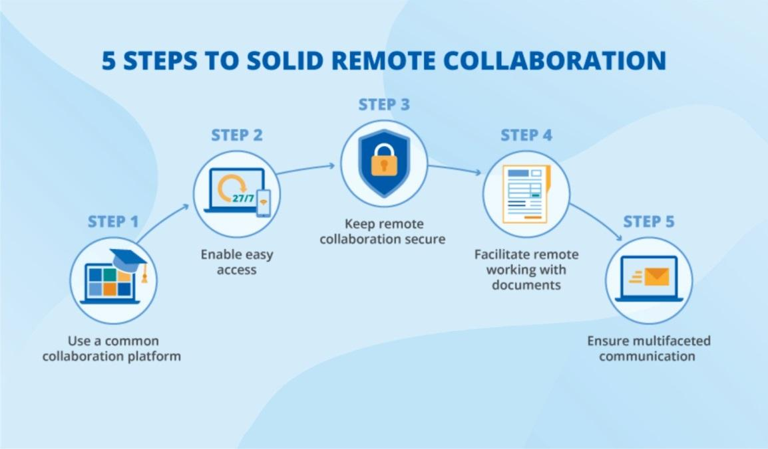

Figure 25 ‒ Diagram of the 5 necessary steps for organizing a remote workplace

Figure 25, is a step-by-step diagram of the necessary steps to organize a remote workplace for a civil servant.

**3** **ASSESSMENT OF THE POTENTIAL OF REMOTE EMPLOYMENT OF CIVIL SERVANTS IN THE PUBLIC ADMINISTRATION SYSTEM OF THE REPUBLIC OF KAZAKHSTAN, IN THE CONTEXT OF DIGITALIZATION**

**3.1 Assessment applications of remote work**

An algorithmic random check of the power implementation methods is recommended in order to assess remote work in the Republic of Kazakhstan's public administration system.

Simultaneously, considering the current standards and guidelines in the public sector, it is suggested that administrative regulations serve as the primary source for this kind of verification, as this approach aligns with the scientific method.

Naturally, not every facet of the task can be examined with their assistance; nonetheless, their insights can help pinpoint the problems that pose the biggest obstacles to working remotely. After examining many facets of public administration, the writers suggest examining the operational authority of state entities by selecting as the foundation [85].

Generally speaking, it should be mentioned that the purpose of this methodology is to address the topic of compensation for civil servants in the political and administrative domains."

The authors also suggest utilizing this methodology to assess the current state of remote work's efficacy in the Republic of Kazakhstan's public administration system.

Therefore, public positions are allocated based on the following functional blocks in line with this methodology:

1) block «A»: This functional block's official powers, as stipulated by the state position, are related to the direct execution of the mission, strategic objectives, and tasks delegated to the state body, as well as the formulation of decisions that support the creation, clarification, and enforcement of state policy;

2) block «B»: The official powers granted by the state position of this functional block are of a facilitating nature in carrying out the mission, strategic objectives, and tasks delegated to the state body, as well as in formulating decisions that aid in the creation, articulation, and execution of state policy. These powers are not directly related to each other;

3) block «C»: This functional block's state position's official powers are not intended to be implemented. Having considered the features and specifics of all 3 functional blocks of administrative civil servants, it is theoretically possible to assess the remote mode of work for some areas of all three blocks, since today their official powers allow them to work remotely, in accordance with current labor legislation and the rules for the application of remote work and combined remote work for civil servants.

However, in order to more clearly determine which powers are really effectively implemented in a remote format, and which are not, then it is necessary to conduct a sample using the example of the Central and Local state bodies of the Republic directly, with an assessment based on the powers established in the Regulations on State Bodies and the division of functions into main and auxiliary with respect to the activities of selected state bodies.

In this regard, further, the sample of authors included 12 state functions, including 3 functions involving the performance of control functions and 4 public services of four departments operating in the same area, these are:

1. The Ministry of Information and Public Development of the Republic of Kazakhstan [86].

2. The Department of Internal Policy of the Akimat of Astana city [85].

3. Department of Religious Affairs of the Akimat of Astana city [87].

4. Department of Social sphere of the akim's office of the "Yesil" district of Astana city [88].

Further, according to the Methodology of the distribution of administrative public positions of the corps «B» by functional blocks, we will theoretically divide the functions of these state bodies into main and auxiliary ones.

This approach will define in more detail the types of functions that can be performed remotely (see table 4).

Table 4 **-** List of main and auxiliary functions

|  |  |
| --- | --- |
| Main functions | Auxiliary functions |
| Forecasting and prevention of unauthorized protests | Organization of work with information constituting state secrets |
| Implementation of interaction and cooperation with youth organizations to strengthen interethnic harmony and tolerance | Mobilization work and information security |
| Media information policy | Registration and issuance of documents that cannot be issued in electronic form |
| Implementation of the formation, development and security of the unified information space. The Republic of Kazakhstan, as well as interdepartmental coordination of activities to ensure the security of the information space | Implementation of internal control, including the implementation of the mission, strategic goals and objectives of the state body |
| Coordination of work with diasporas and interaction with organizations of compatriots, living abroad | Implementation of internal audit |
| Implementation of registration, re-registration of domestic TV and radio channels | Organization and conduct of public procurement |
| Note ‒ The table is compiled by the author | |

Thus, the main functional responsibilities in the elective direction are leadership in the field of information, interaction between the state and civil society, state youth policy, ensuring internal political stability in the camp or region, interfaith, interethnic harmony, and religious activities.

The auxiliary functional responsibilities in this area are those that ensure activity, control, monitoring and are of a supportive nature in the implementation of the mission, strategic goals and tasks assigned to the state body.

Based on the analysis of the activities of all four state bodies, namely, the activities of committees, departments of departments and departments, according to current legislation, it is safe to say that currently only 3 functions cannot be performed remotely, these are:

‒ registration and issuance of documents that cannot be issued in electronic form;

‒ organization of work with information constituting state secrets [89];

‒ mobilization work and information security [90].

Since, firstly, the current Law of the Republic of Kazakhstan on State Secrets and the Instruction on the Protection of State Secrets of the Republic of Kazakhstan does not provide for work with documents by civil servants who have appropriate access to work with documents with stamps and other information of a secret or official nature in a remote format.

Moreover, the work of civil servants with secret documentation is necessarily carried out in a special protected regime on the premises of the authorized state body.

Secondly, according to the Law of the Republic of Kazakhstan On Mobilization Training and Mobilization, remote work is also not provided, outside the regime premises of a state body with documents defining the content, scope, procedure and timing of measures to complete the mobilization task.

In addition, authorized civil servants, according to the law, do not have the right to work with information concerning the reservation of military service personnel to ensure their uninterrupted operation during mobilization, martial law and in wartime in a remote format.

Thirdly, certain functions of state bodies cannot be rendered completely remotely if they include operations requiring personal presence (clarification of legislation concerning the procedure for organizing and holding peaceful assemblies in the Republic of Kazakhstan, issuance of appropriate notifications of permits or postponement of peaceful assemblies, rallies, marches, actions). The output of the result cannot be carried out remotely if the result is not a document or a document of a strictly prescribed form (for example, a certificate of an accredited journalist, a film crew, etc.).

Further, after analyzing the control, audit and other support functions, such as:

‒ implementation of internal control, including over the implementation of the mission, strategic goals and objectives of the state body;

‒ implementation of internal audit [91];

‒ organization and conduct of public procurement [92].

In this case, the analysis showed that the above 3 functions are functions of control, supervision and verification and are carried out, as a rule, in the form of scheduled and unscheduled inspections. The procedure for conducting scheduled and unscheduled inspections is the same, except for the range of issues to be checked, which is not crucial for determining the possibility of remote work. On-site inspections are carried out at the location of the person being checked, that is, they do not depend on where the workplace of the person being checked is located, and, therefore, can also be carried out remotely. The planning of inspections can be carried out remotely, since it is already almost completely carried out in electronic form.

Thus, when switching to electronic document management, there is no obstacle to the performance of control and supervisory functions in the form of conducting documentary checks remotely.

After analyzing the remaining 6 functions [93]:

‒ forecasting and prevention of unauthorized protests;

‒ implementation of interaction and cooperation with youth organizations to strengthen interethnic harmony and tolerance;

‒ media information policy;

‒ implementation of the formation, development and security of the unified information space of the Republic of Kazakhstan, as well as interdepartmental coordination of activities to ensure the security of the information space;

‒ coordination of work with diasporas and interaction with organizations of compatriots living abroad;

‒ registration and re-registration of domestic TV and radio channels;

In this case, there are also no obvious obstacles for civil servants to perform their functional duties in a remote work format, since for the effective performance of the analyzed 6 functions, the main condition is the availability of an electronic document management system.

Further, by analyzing the scope of public services in the field of religious activity. In this case, the provision of 4 public services by the Department of Religious Affairs of Astana is specifically considered [94]:

1. Issuance of a decision on the approval of the location of special stationary premises for the distribution of religious literature and other information materials of religious content, objects of religious purpose.

2. Registration and re-registration of persons engaged in missionary activities.

3. Issuing a decision on the construction of religious buildings (structures), determining their location.

4. Issuing a decision on the conversion (change of functional purpose) of buildings (structures) into religious buildings (structures).

Having studied this business process for the provision of 4 public services in the field of religion, it is safe to say that for this type of authority there are also no fundamental difficulties when switching to remote work, since receiving an application from an individual or legal entity with documents attached, carrying out formal verification (completeness of documents and correctness of their registration), requesting if necessary, information in other executive authorities, decision-making and (or) other actions that make up the meaning of the public service, the output of the result is legally carried out in an online format, by means of the e-government portal E-Gov [95].

Thus, after analyzing the performance of all selected 12 state functions of 4 public services on the example of one sphere of activity, with the exception of 3 functions related to state secrets, mobilization preparation and issuance of documents that cannot be issued in electronic format, it is possible to formulate a hypothesis that regardless of whether the state body is Central or Local, the share of The number of government employees who can do their work remotely is 75%.

By the way, this can be indirectly confirmed by the instruction of the Head of State, to transfer up to 80% of government employees to fully perform their work in a remote format during the Pandemic, while maintaining the same wage system as in the traditional mode of work [96].

**3.2 Assessment of the possibility of using a remote work format**

To assess the number of civil servants who can participate in the pilot project, a model (conditional) state body of the Republic of Kazakhstan was considered.

Its parameters were determined based on the assumption that the central state bodies and local state bodies have uniform principles for the formation of an organizational structure, and the ratio of the number of persons holding certain positions is approximately the same.

This assumption has been tested on open data. Taking into account the results of the verification, the data obtained for the model body can be considered approximate average estimates for real government agencies.

It should also be noted that the calculations were made using the example of a model government agency on the assumption that the internal document flow works efficiently, without failures, but certain elements of the circulation of paper documents are preserved during external contacts.

These estimates are obtained without taking into account the areas occupied by the heads of the executive authority, its structural divisions and territorial bodies.

Thus, based on information from the Agency for Civil Service Affairs of the Republic of Kazakhstan, as of 2023, the actual number of civil servants of Central government agencies amounted to *44 282* people, and in Local executive bodies amounted to *39 681* people [97].

Table 5 **-** Proportion of Remote Work Among CGA and LEB Civil Personnel

|  |  |  |  |  |  |  |  |  |  |
| --- | --- | --- | --- | --- | --- | --- | --- | --- | --- |
| The proportion of CGA and LEB civil personnel who worked remotely | | | | | | | | | |
| Regions | | | | | | | | | |
| city of Almaty | | Akmola region | Karaganda region | | NKZ region | | Abai region | Zhetysu region | Total number |
| 1 | | 1 | 2 | | 2 | | 1 | 1 | 8 |
| Ministries | | | | | | | | | |
| MDDIAI | CEC | MFA | MTI | MNE | MIAI | MTC | MT | ARPC | Total number |
| 2 | 1 | 1 | 1 | 1 | 1 | 19 | 1 | 1 | 63 |
| Note ‒ The table is compiled by the author | | | | | | | | | |

To date, 71 civil servants work remotely: 8 in regions, 63 in ministries.

In addition, considering that in the Republic of Kazakhstan, in 2023 the number of regions and cities of national importance is 20. units, and the number of CSBs is *21* ministries, [98] then the average number of employees in the CSBs is *2 110* people, and in turn in the LSB the average number of employees is *1 985* people.

The following conditions will be met for the model body of the Central State Body:

‒ each head of an independent structural unit in a state body has four deputies and the head of the staff of the state body.

‒ On average, the Central State Body has 17 structural divisions (committees, departments).

The following conditions will be met for the model Local State Body:

‒ each head of an independent structural unit in a state body has three deputies, the head of the staff of the state body and 5 officials holding a political position (for example, akims of districts) and there are approximately 22 structural units (departments).

Taking as a basis the number of departments (directorates) and the number of departments in real various government agencies, we obtain the shares of the corresponding categories of civil servants, which in total are quite stable and average approximately:

*CSB has a total of 2,110 people:*

‒ heads of state bodies and their deputies ‒ 0.28% (6 people);

‒ heads of Departments -0.8% (17 people);

‒ heads of departments, experts and support specialists ‒ 98.9% (2087 people).

*LSB a total of 1,985 units*

‒ heads of state bodies and their deputies -0.55% (11 people);

‒ heads of departments -1.1% (22 people);

‒ heads of departments, specialists and support specialists ‒ 98.4% (1952 people).

Another important parameter is the proportion of work with information constituting state secrets.

As an estimate, we assume that the share of employees who regularly deal with state secrets is conditionally *10%* of the total number of specialists, and the share of each of them's working time accounted for classified materials is *5%.*

In these conditions, some employees cannot switch to remote work, namely:

‒ all units working with state secrets and state secrets, as well as employees providing mobilization training.

The transition to a remote format using cloud technologies requires an integrated approach to security, including compliance with Kazakh legislation, the use of modern security technologies and careful security planning at all levels ‒ from data encryption to incident response procedures. It is important to choose cloud services from Kazakhstani manufacturers that meet security requirements and comply with legislation, as well as implement reliable information control and protection mechanisms. All the data below and the conclusion of the Committee on Ethical Review of Research are presented in (Appendix C, D).

When using cloud services, you should always carefully monitor compliance with security requirements and regularly update the protection system.

Kazakhstan has a number of regulatory legal acts that regulate information security and personal data protection. The most important are:

*The Law of the Republic of Kazakhstan "On Personal Data Protection"* (with amendments and additions) regulates the processing and protection of personal data in Kazakhstan.

*The Law of the Republic of Kazakhstan "On Cybersecurity"* regulates the issues of information security in information systems, protection from cyber threats and incidents.

*Standards and regulations of the National Information Security System* are regulations that establish security requirements in the field of information processing and storage in Kazakhstan.

*Guidelines on security in the field of information technology and data protection* (for example, GOST R 50922-96, ISO/IEC 27001) ‒ international standards and their adaptation in Kazakhstan.

To ensure security when switching to remote work using cloud services, the following aspects should be considered:

*Confidentiality*

All data transferred between a remote employee and the corporate network must be encrypted using reliable protocols (for example, TLS/SSL for data transfer, data encryption on the device).

The system should allow setting access rights depending on the role of employees, ensuring that access to confidential information is minimized.

*Authentication and authorization*

*Multi-factor Authentication (MFA):* Implementation of multi-factor authentication for access to cloud services and important corporate systems.

*Identification and Access Management (IAM) Solutions:* Tools for managing access rights and ensuring the minimum required access level.

*Security of cloud services*

The cloud service provider must comply with international security standards such as ISO 27001, SOC 2, and others. This ensures that customer data is protected in accordance with global best practices.

The legislation of Kazakhstan requires that data concerning citizens of the Republic of Kazakhstan be stored on the territory of the country (for example, as required by the law on personal data). Therefore, it is important to check where the cloud provider's servers are located.

*Incident management*

It is necessary to implement clear procedures for responding to incidents involving data leaks, hacker attacks and other threats.

Constant monitoring of all data transactions, regular audits of security systems and active monitoring of suspicious activities.

There are several Kazakhstani companies that offer cloud services based on security requirements. Examples of such services:

1.*KazCloud* ‒ cloud solutions from *KazTelecom,* offering cloud storage services, computing power and other solutions tailored to local requirements.

2.*Xcloud* ‒ cloud solutions from KT Cloud (Kazakhstan), offering IaaS, PaaS, and SaaS services with the ability to comply with legislative norms and security standards of Kazakhstan.

3. *DataCenter* ‒ companies providing hosting and cloud computing in Kazakhstan that comply with security requirements and legislation.

**3.3 Calculation of the number of possible participants in the pilot project for testing remote work**

Civil servants may be included in the number of participants in the pilot project, with the exception of certain categories.

Let's introduce the following notation:

I ‒ percentage of employees, experts/specialists (without auxiliary specialists).

T ‒ is the proportion of employees working with state secrets.

We will use the indices of *Central State Body* and *Local State Body* in cases where we are talking about values that differ for the *CSB* and *LSB*.

The share of potential participants in the pilot project can be calculated using the formula (1) [99].

K = I * (1–T) (1)

For the Central State Body of the model body, the parameters take the following values:

*I = 0,99; T = 0,1.*

From here

*КCSB=0,89 = 89%*

For the Local State Body, *I = 0.98; T = 0.1,*therefore

*КLSB = 0,88 = 88%*

Thus, *1 878* people can be sent to the CSB for remote operation, and *1 747* people can be sent to the LSB.

*Calculation of the possibility of saving space when switching to a job reservation system*

We will calculate the need for space under the current system (each employee has a workplace) and with the introduction of remote work (on turnout days, civil servants use the system of job registration). At the same time, we will accept the following conditions for the model body:

‒ permanent jobs remain for the heads of independent structural divisions.

The area occupied by one employee is the same for all remaining government employees.

Let's introduce the following notation:

*N* ‒ is the number of employees of the state body.

*S* ‒ is the area per employee (workplaces and other areas directly proportional to the number of employees) and 6 sq.m.

Then the used area *M*before the introduction of remote operation mode will be:

М = S * N (2)

MCSB = 6*2 110= 12 660 sq.m.

MLSB = 6*1 985= 11 910 sq.m.

N2 ‒ the number of employees of the state body without taking into account the heads of the level of structural divisions and the secret.

S **‒** is the area per employee (workplaces and other areas directly proportional to the number of employees) and 6 sq.m [100].

Then the used area of *М2* after the introduction of the remote operation mode will be:

М2 = S * N2 (3)

MCSB = 6*224= 1 344 sq.m.

MLSB = 6*231= 1 386 sq.m.

Thus, the possible release of space for the CSB will amount to 89.4% of the area or 11,316 sq.m.;

for LSB ‒ 88.4% or 10,524 sq.m.

*Analysis of the role of digital platforms in the planning and budgeting process in the public administration system of Kazakhstan*

Planning and budgeting systems are the basis of effective public administration, as they ensure the rational allocation of resources, contribute to the achievement of strategic goals and increase responsibility to citizens. In recent years, Kazakhstan, as well as in other countries, has seen a significant transition to digitalization of government processes against the background of global changes and technological innovations. In particular, this applies to the field of budgeting and planning, where the introduction of digital platforms and technologies contributes to improved management, increased transparency and efficiency of budget spending.

*The role of digitalization in planning and budgeting*

Digitalization of planning and budgeting processes provides significant opportunities to increase efficiency, transparency and flexibility in public finance management. The most important aspects of digitalization in this area can be illustrated through several key platforms and systems:

*1. Electronic budgeting System (e-Budget)*

Kazakhstan has implemented an electronic budgeting system that automates the process of budget preparation, approval and execution. This platform allows you to integrate information about expenses and income, ensuring transparency and reducing the human factor. Budget execution can be monitored in real time, which increases the efficiency of decision-making and reporting. The effectiveness of using this system is to reduce the time and cost of processing budget data.

*2. Open Data Platform*

Open data platforms such as *open.kz,* make information about budget expenditures, public procurement, and other government financial activities accessible to all citizens and stakeholders. This contributes not only to increasing transparency, but also to improving the quality of public oversight, giving citizens the opportunity to participate in discussions on government spending priorities.

*3. The State procurement system (goszakup.gov.kz)*

The public procurement management platform allows you to effectively plan and track the expenditure of funds allocated for procurement. This increases competition among suppliers, reduces corruption risks, and improves control over the use of budget funds in procurement.

*4. Financial Monitoring Systems (IFMIS)*

The use of integrated public finance management systems, such as IFMIS, allows for more efficient budget planning and control at all levels ‒ from central authorities to local ones. These systems provide a high degree of automation, allow for the analysis and forecasting of budget needs and identify opportunities for optimization.

*5. Analytical platforms for forecasting (Data Analytics)*

An important tool for digitalization is the use of analytical platforms such as Power BI, Tableau, as well as domestic solutions that allow you to predict financial flows and analyze the effectiveness of government programs. These platforms facilitate more accurate planning, identify weaknesses, and optimize costs in the long run.

*6. Project Management Systems*

Project management platforms such as Asana and Trello, as well as integrated systems within e-Gov, allow monitoring the implementation of government programs and projects, increasing their transparency and efficiency. Automation of monitoring processes allows timely response to deviations from plans and cost overruns.

*Advantages of digitalization in the planning and budgeting process:*

*1. Increasing transparency and accountability:*Digitalization promotes the availability of information on budget expenditures and program implementation. Open data platforms, electronic reporting and monitoring systems allow citizens and public organizations to monitor the effectiveness of the use of budgetary funds. This reduces the risks of corruption and increases trust in the authorities.

*2. Reducing bureaucratic barriers:* Digital systems can significantly simplify and speed up budget approval, control and monitoring processes. Automation of routine procedures reduces the need for paper documents and physical presence in government agencies, which significantly increases the efficiency of decision-making.

*3. Efficient resource allocation:* Digitalization allows for the integration of different data sources and more accurate analysis. This, in turn, contributes to a more efficient allocation of the budget in accordance with the real needs and strategic priorities of the country.

*4. Forecasting and analytics:* Modern analytical tools make it possible to more accurately predict changes in the economic situation and adapt budget plans accordingly. This improves the ability to manage risks and increases the sustainability of public finances in an unstable environment.

*5. Citizen participation and engagement:* The introduction of digital solutions allows citizens to participate more actively in the planning and budgeting process, providing access to data on expenditures and results of government programs. This helps to improve the interaction between government agencies and society.

Digitalization of planning and budgeting processes in Kazakhstan opens up new opportunities for improving the efficiency of public administration (table 5). Electronic budgeting systems, analytical platforms, open data platforms and other digital tools contribute to improving planning, optimizing the use of budget funds, increasing transparency and citizen engagement. The introduction of these technologies not only simplifies processes, but also makes it possible to quickly respond to changes in the external and internal environment, which is key to effective management of public finances in a modern economy.

In conclusion, it should be mentioned that growing remote work is a possibility as long as mistakes are avoided and positive experience builds up. The percentage of workers who totally or partially transition to remote work may progressively rise if pilot projects are executed successfully. Nevertheless, considering the peculiarities of public administration, each person involved in the pilot project should still have a place of employment, even if the experiment's outcomes don't live up to expectations. Additionally, individuals that operate remotely will frequently make their initial appearance in the authority building.

Table 6‒ Scheme of planning and budgeting in the context of digitalization in government agencies

|  |  |  |
| --- | --- | --- |
| Platform/System | Government agencies using the platform | How the platform is used |
| Electronic budgeting system (e-Budget) | Ministry of Finance of the Republic of Kazakhstan, Treasury of the Republic of Kazakhstan, local executive bodies (city halls) | Automate budget preparation, approval, and execution, monitor budget execution in real time, increase transparency, and reduce data processing costs. |
| Open Data Platform | Ministry of Finance of the Republic of Kazakhstan, Agency for Civil Service Affairs and Anti-Corruption, other government agencies, city halls. | Publication of information on budget expenditures, public procurement, and other financial transactions to ensure transparency, improve public oversight, and citizen engagement. |
| The State procurement system (goszakup.gov.kz ) | Ministry of Finance of the Republic of Kazakhstan, Agency for Regulation of Public Procurement, local executive bodies (city halls) | Planning, management and monitoring of public procurement, increasing competition, reducing corruption risks and controlling budget spending. |
| Financial Monitoring Systems (IFMIS) | Ministry of Finance of the Republic of Kazakhstan, Treasury of the Republic of Kazakhstan, local governments, state institutions | Integration of public finance management, automation of accounting processes, analysis and forecasting of budget needs at all levels of government. |
| Analytical platforms for forecasting (Data Analytics) | Ministry of Finance of the Republic of Kazakhstan, Ministry of Economy of the Republic of Kazakhstan, Agency for Strategic Planning, other government agencies and bodies | Using analytics to predict financial flows, analyze the effectiveness of government programs, identify weaknesses, and optimize budget expenditures. |
| Project Management Systems | Ministries and departments involved in the implementation of government programs and projects (for example, the Ministry of Education and Science, the Ministry of Health, the Ministry of Transport) | Project and program management, monitoring of their implementation, automation of reporting, monitoring compliance with deadlines and budgets, timely response to deviations and overruns. |

However, if more people choose to work remotely and the requirement for this drops to one or two days per week, it is feasible to progressively give up on assigning each employee a permanent workspace on the authority's property. Rather, the job placement system, which is currently in use in many offices of businesses, ought to extend widely. Here, a remote government worker reserves one of the regular positions for himself ahead of time for the period he will be in the office. This may also apply to department heads who are required to remain on the authority's property for two to three days a week on average. For higher-level managers who will work remotely no more than 1-2 days a week, it is advisable to keep permanent jobs.

The effectiveness of the developed recommendations is confirmed by the act on the implementation of the results of the dissertation research (Appendix E).

**CONCLUSION**

The conducted research has shown that the implementation of remote work in the public administration system is one of the significant tools for optimizing and improving business processes within the government apparatus, as well as an effective mechanism for the debureaucratization of its activities.

The analysis of international experience also indicates the high effectiveness of introducing remote work in the public sector. The most notable successes in this area have been achieved in the USA, as well as in European and Asian countries, where the development of remote employment was accompanied by investments in digital infrastructure. Considering national features, these techniques can be tailored to the Republic of Kazakhstan's circumstances and are of great interest.

Moreover, the growth of remote work generally aids in addressing transportation concerns and difficulties pertaining to the mitigation of carbon dioxide emissions into the atmosphere in the nation's major cities.

Remote work also allows for the recruitment of individuals residing in other cities and rural areas of the country into public service. Considering regional differences in wages and depending on government policy, this may become either a means of increasing the competitiveness of public service or a source of payroll savings. Additionally, it helps reduce social tension in society related to the inaccessibility of affordable and quality housing and high mortgage rates.

Furthermore, remote work creates employment opportunities for persons with disabilities.

At the same time, one of the main criteria for the effective performance of functional duties by public servants working remotely should not be the duration of their working time, but rather the quality and timeliness of specific task completion. In other words, the result of their labor activity in the public administration system, under digitalization, aimed at improving the well-being of the population and overall socio-economic development in the country.

Overall, the concept of the effectiveness of public administration organized in a remote format is defined by the degree of achievement in the qualitative performance of public bodies' duties and, as a result, the improvement of population welfare in comparison to the material, financial, and intellectual costs required to achieve this.

The main outcomes of this dissertation research include the following scientifically novel results:

1. For the first time, the principles of remote employment in the public administration system under digitalization have been examined through the lens of the New Public Management (NPM) and Good Governance scientific concepts, which makes it possible to evaluate its impact on public administration.

The NPM concept places a strong emphasis on process optimization, market mechanisms, and cutting back on public administration red tape. The creation of e-government (Egov.kz), the Unified Electronic Document Management System (UEDMS), digital budgeting (e-Budget), and open data (Open Data) are all examples of its implementation in Kazakhstan.

However, the NPM is criticized for excessive use of market mechanisms in public administration, which can lead to a decrease in the quality of public services.

The Good Governance paradigm, which emphasizes accountability, openness, digital inclusion, and citizen participation in government processes, was taken into consideration as a remedy for these flaws.

The synthesis of both concepts leads to the conclusion that applying their principles, adapted to Kazakhstan’s realities, enhances the effectiveness of remote work in the public administration system under digitalization.

1. An analysis of the functional responsibilities of central government and local executive body public servants of Kazakhstan under remote work and digitalization revealed that up to 80% of public servants can work remotely.

The rise of electronic document management, digital platforms for interdepartmental collaboration, and the extensive use of information and communication technology (ICT) are to blame for this.

However, because of the unique nature of activities and work process needs, some functional sectors are still less amenable to digitization. These include:

– Activities of public servants with access to classified information, requiring strict compliance with information security regulations. In remote work settings, there is no guarantee of data protection from unauthorized access, making remote formats unacceptable for these categories.

– Officials responsible for mobilization readiness, emergency response, coordination of emergency services, and the operation of critical infrastructure facilities must be physically accessible to their management and rapid response sites. Their roles require direct presence at decision-making locations.

Based on the conducted analysis, the following recommendations are proposed:

– Develop scientifically grounded criteria for identifying positions suitable for remote work, taking into account the specifics of functional duties.

– Implement a hybrid work model for employees working with physical documents. For example, alternate between in-office and remote days, performing paper-based tasks in the office and analytical/administrative functions remotely.

– Continue the digital transformation of public authorities aimed at minimizing paper document flow and ensuring the legal significance of digital documents.

Thus, the application of remote work in the public administration system has high potential. Optimizing labor resource distribution based on functional analysis of public servants will improve institutional efficiency, minimize administrative costs, and increase employee satisfaction through flexible work processes.

1. A sociological study was conducted on the effectiveness of remote employment among public servants of Kazakhstan. The main problems identified were related to legal regulation of remote work in public administration, the level of digital literacy, digital security, material and technical support, and the psychological and physical condition of public servants.

Accordingly, based on the conducted analysis, the following recommendations can be made to increase the efficiency of remote work in Kazakhstan’s public sector:

– To improve internet quality, efforts should be made to increase the number of mobile communication base stations and develop a digital ecosystem across the country.

– Upgrade the material and technical base of workplaces for public servants working remotely. Each position and employee working remotely must have a standard set of virtual workplace tools.

– Improve the level of digital competence among remote public servants. Digital skills should include content creation, digital collaboration, netiquette, digital sharing, and overall professional development supported by electronic tools within the public administration process.

– Strengthen the security of digital platforms. In this context, the government must pay special attention to legal regulation of digital security in the public sector to establish a reliable data transmission, processing, and storage security system that guarantees the protection of private, business, and governmental interests.

1. A calculation of space requirements for government bodies under the implementation of remote work was conducted.

Quantitative and qualitative methods were used, including analysis of the legal framework, mathematical modeling, and sociological surveys (survey of 43,646 civil servants in 2020 and 1,000 in 2022).

Key research findings:

1. It was found that 89.4% of central government staff (1,878 people) and 88.4% of local executive body staff (1,747 people) can perform their duties remotely. Savings: 89.4% (11,316 sq.m) and 88.4% (10,524 sq.m), respectively.
2. Space optimization can reduce rental expenses by 174.7 million KZT per year and utility costs by 65.5 million KZT. However, IT infrastructure costs (up to 20 million KZT per year) partially offset this effect.
3. Reduced transportation results in lower CO₂ emissions. On average, 0.12 tons of CO₂ per employee per year, totaling 436 tons of CO₂ annually.

Thus, the transition of government agencies to remote work contributes to budget savings, efficient use of office space, and reduced infrastructure load.

In conclusion, at present, the Republic of Kazakhstan is in a position to accumulate global experience in the development of remote work and make a leap in its own progress without repeating the mistakes of other countries.

The theoretical and practical significance of the study, taking into account domestic and international experience, forms the basis for further scientific work in the field of remote work in public administration under digitalization and for providing recommendations to increase the effectiveness of remote work in Kazakhstan’s public sector, which will positively impact public servant motivation, enhance their productivity, and improve performance in public service.

**REFERENCES**

1 Working Time and Work-Life Balance Around the World / International Labour Organization. – Geneva, 2022. – 176 p.

2 Указ Президента Республики Казахстан. Об утверждении Национального плана развития Республики Казахстан до 2025 года и признании утратившими силу некоторых указов Президента Республики Казахстан: утв. 15 февраля 2018 года, №636 // https://adilet.zan.kz/rus/docs/U1800000636. 09.05.2024.

3 Закон Республики Казахстан. О государственной службе Республики Казахстан: принят 23 ноября 2015 года, №416-V ЗРК // https://adilet.zan.kz/rus/docs/Z1500000416. 09.05.2023.

4 Nilles J.M. The Telecommunications-transportation tradeoff: options for tomorrow. – NY, 1976. – 216 p.

5 [Gallacher](https://www.utpjournals.press/author/Gallacher%2C+Guillermo) G., Hossain [I.](https://www.utpjournals.press/author/Hossain%2C+Iqbal) Remote Work and Employment Dynamics under COVID-19: Evidence from Canada // Can Public Policy. – 2020. – Vol. 46, Suppl 1. – P. S44-S54.

6 Raudla R. Estonian response to Covid-19 pandemic: Learning, cooperation, and the advantages of being a small country // Brazilian Journal of Public Administration. – 2021. – Vol. 55, Issue 1. – P. 111-121.

7 Chow J.S.F., Palamidas D., Marshall S. et al. Teleworking from home experiences during the COVID-19 pandemic among public health workers (TelEx COVID-19 study) // BMC Public Health. – 2022. – Vol. 22. – P. 674-1-674-10.

8 Raišien A., Rapuano V. et al. Working from Home ‒ Who Is Happy? A Survey of Lithuania’s Employees during the COVID-19 Quarantine Period // [Sustainability](https://www.mdpi.com/journal/sustainability). – 2020. –Vol. 12, Issue 13. – P. 5332-1-5332-21.

9 Svidroňová M., Meričková B., Nemec J. Telework in Public Sector Organizations // Central European Public Administration Review. – 2016. – Vol. 14, Issue 2-3. – P. 121-137.

10 Madureira C., Rando B. Teleworking in Portuguese publicadministration during theCOVID-19 pandemic Advantages, disadvantages, work-life balance and motivation // Work organization labour & globalization. – 2022. – Vol. 16, Issue 2. – P. 119-139.

11 Capecchi S., Orientale Caputo G. Job satisfaction and teleworking: a study on public administration workers in Italy // Statistica Applicata - Italian Journal of Applied Statistics. – 2022. – Vol. 34, Issue 1. – P. 141-156.

12 Toleikiene R., Rybnikova I., Jukneviciene V. Whether and how does the Crisis-Induced Situation Change e-Leadership in the Public Sector? Evidence from Lithuanian Public Administration // Transylvanian Review of Administrative Sciences: spec. is. – 2020. – P. 149-166.

13 Lehtonen O., Voutilainen O., Toivo M. Telecommunications and digitalization opportunities for municipalities // Terra. – 2023. – Vol. 135, Issue 1. – P. 3-26.

14 Criado J., Herranz C., Villodre J. Informal Virtual Learning in the Public Sector: Educating Public Servants in Digital Social Innovation Environments // In book: The Palgrave Handbook of the Public Servant. – Cham, 2019. – P. 1-18.

15 Выпова Е.И. Особенности удаленного режима работы на государственной службе // Теория и практика эффективности государственного и муниципального управления: сб. науч. ст. – Курск, 2022. – С. 134-139.

16 Дмитриев М.Э., Крапиль В.Б. Оценка потенциала дистанционной занятости государственных служащих // ВТЭ. – 2021. – №1. – С. 35-47

17 Чудиновских М. Государственная политика управления дистанционной занятостью: опыт России и США // Известия Байкальского государственного университета. – 2019. – №29(4). – С. 646-652.

18 Кострова Ю. Особенности использования информационно-коммуникационных технологий в государственном управлении // Научные труды Московского университета им. С.Ю Витте: сб. ст. – М., 2020. – С. 41-52.

19 Борисова Е. Электронный документооборот в государственном секторе России // Исследование инновационного потенциала общества и формирование направлений его стратегического развития: сб. науч. ст. 8-й всеросс. науч.-практ. конф. с междунар. уч. – Курск, 2018. – С. 100-103.

20 Баранов Р. К вопросу информационной безопасности при организации удаленной работы государственных служащих // Роль науки и образования в модернизации и реформировании современного общества: сб. ст. – Екатеринбург, 2021. – С. 45-47.

21 Абсаттаров М. Об организации контроля документов и поручениях в условиях удаленной работы // Государственное управление и государственная служба. – 2021. – №2(77). – С. 16-23..

22 Дуламбаева Р.Т., Жумашева М.Б. Цифровая трансформация: ретроспектива и развитие информационно-коммуникационных технологий в Казахстане // Вестник университета Туран. – 2021. – №3(91). – С. 124-132.

23 Рахметулина З.Б., Урекешова А.Б. и др. Рынок труда в условиях цифровизации // Вестник университета Туран. – 2022. – №4. – С. 130-142.

24 Бокаев Б., Торебекова З., Давлетбаева З. и др. Дистанционное обучение в Казахстане: оценка удовлетворенности родителей качеством образования во время коронавируса // Технологии, педагогика и образование. – 2021. – №30(1). – С. 27-39.

25 Альшанская А. Влияние коронокризиса на состояние рынка труда в Казахстане // Казахстан-Спектр. – 2021. – Т. 98, №2. – С. 71-82.

26 Ибраев С., Кусаинова Л. Организационно-правовое обеспечение дистанционной работы в государственных органах РК // Государственное управление и государственная служба. – 2022. – №1(80). – С. 43-50.

27 Кантарбаева Ш.М., Жанбырбаева А.Н., Ибраев С.С. Цифровизация агропромышленного производства Республики Казахстан: риски и пути их преодоления // Проблемы агрорынка. – 2022. – №2. – С. 38-47.

28 Ibrayev S., Nemec J., Kusainova L. The impact of remote working on the efficiency of civil servants in Kazakhstan // Central Asian Economic Review. – 2023. – Issue 1. – P. 33-47.

29 Ибраев С., Кусаинова Л., Турчекенова T. Оценка дистанционной работы в системе государственного управления Казахстана // Казахстан-Спектр. – 2023. – Т. 108, №4. – С. 100-118.

30 Ibrayev S. Remote Work as an Innovative Approach in the Public Administration System of the Republic of Kazakhstan // The Public Sector Innovation Journal. – 2022. – Vol. 27, Issue 3. – P. 1-1-1-21

31 Международная научно-практическая конференция "Дистанционная работа государственных служащих" // <https://www.astanacivilservicehub.> 10.10.2024.

32 Ибраев С.С. Преимущества, недостатки и перспективы дистанционного режима работы в Казахстане // Правовая система и государственное управление независимого Казахстан: уроки, вызовы и перспективы: сб. матер. междунар. науч.-практ. конф., посв. 30-лет. Независимости Республики Казахстан. – Алматы, 2021. – С. 182-186.

33 International Scientific and Practical Conference «New Kazakhstan: Development Potential and Current Challenges» // https://drive.google.com/file/d/12rv2HDVjvwc3CjoEZy2higUAw. 10.10.2023.

34 Мэннинг Н., Парисон Н. Реформа государственного управления: международный опыт. – М., 2003. – 494 с.

35 Peters G. et al. Introduction: The Role of Public Administration in Governing // In book: Handbook of Public Administration. – London, 2003. – P. 1-10.

36 Райнхард К. Реформирование государственного управления. Концепция активизирующего государства // Государственная служба за рубежом. – 1999. – №6(31). – С. 8-9.

37 Президент Республики Казахстан К.-Ж. Токаев. Справедливое государство. Единая нация. Благополучное общество: послание народу Казахстана // https://adilet.zan.kz/rus/docs/K22002022_2. 09.04.2023.

38 Chapman R.A., Hunt M. Open Government: A Study of the Prospects of Open Government Within the Limitations of the British Political System. – Abingdon, 1987. – 194 p.

39 Governance for Sustainable Human Development / UNDP. Jan., 1997 // <http://gis.emro.who.int/HealthSystemObservatory/Workshops>. 10.10.2024.

40 The Europeanisation of Governance: Comparative Government and Public Administration Revisited // https://scholar.google.ru/scholar?hl=ru&as. 10.10.2024.

41 Fukuyama F. The Origins of Political Order: From Prehuman Times to the French Revolution. – London, 2011. – 631 р.

42 Fukuyama F. Political Order and Political Decay: From the Industrial Revolution to the Globalization of Democracy. – NY., 2014. – 672 p.

43 Messenger J. et al. Working anytime, anywhere: The effects on the world of work. – Luxembourg, 2017. – 80 p.

44 Dondi M., Klier J., Panier F. et al. Defining the skills citizens will need in the future world of work // <https://www.mckinsey.com/industries/public>. 08.09.2024.

45 [Siha S.M.](https://www.emerald.com/insight/search?q=Samia%20M.%20Siha), [Monroe R.W.](https://www.emerald.com/insight/search?q=Richard%20W.%20Monroe) Telecommuting's past and future: a literature review and research agenda // [Business Process Management Journal](https://www.emerald.com/insight/publication/issn/1463-7154). – 2006. – Vol. 12, Issue 4. – P. 455-482.

46 Employment Rights Act 1996 // https://www.legislation.gov. 10.04.2024.

47 Unison the public service union. Flexible working // https://www.unison.org.uk/. 10.04.2024.

48 Employment Rights Act 1996 // https://en.wikipedia.org/wiki. 10.04.2024.

49 Civilian Flexible Work Guidance / Government of Canada // https://www.canada.ca/en/department-national-defence/campaigns. 10.04.2024.

50 Verordnung über die Arbeitszeit der Beamtinnen und Beamten des Bundes (Arbeitszeitverordnung - AZV). Geltung ab 01.03.2006 // buzer.de. 10.04.2024.

51 DDD beamtenbund und tarifunation // https://www.dbb.de. 10.04.2024.

52 Eesti ametiasutustes on püsivalt kaugtööl 35 teenistujat, 19th July // https://www.err.ee/1608661060/eesti-ametiasutustes-on-pusivalt. 20.09.2022.

53 Telework Enhancement Act, 2010 // https://www.telework.gov. 10.10.2024.

54 Fonction publique en France. Le portail de la Fonction publique // https://www.fonction-publique.gouv.fr/ fonction-publique-france. 10.10.2024.

55 Loi n°84-53 du 26 janvier 1984 portant dispositions statutaires rela - tives à la fonction publique territorial // https://www.legifrance.gouv.fr/affich. 10.10.2024.

56 Loi n°83-634 du 13 juillet 1983 portant droits et obligations des fonctionnaires // https://natlex.ilo.org/dyn/natlex2/r/natlex/fe/details?. 10.10.2024.

57 Décret n° 2016-151 du 11 février 2016 relatif aux conditions et modalités de mise en œuvre du télétravail dans la fonction publique et la magistrature // https://www.legifrance.gouv.fr/jorf/id/JORFTEXT000032036983. 10.10.2024.

58 Blanc C. Télétravail des magistrats: qui peut en bénéficier? // <https://www.actualitesdudroit.fr/browse/public/droit-public-general>. 10.10.2024.

59 Your Doorway to Japan // <https://www.nippon.com/en/>. 10.10.2024.

60 Right to Disconnect: Most Japanese Employees Get Contacted Out of Hours // https://www.nippon.com/en/japan-data/h01869/. 10.10.2024.

61 Трудовой кодекс Республики Казахстан: принят 23 ноября 2015 года, №414-V // online.zakon.kz/document/?doc_id=38910832#pos=2064. 10.10.2024.

62 The President of Kazakhstan visited the checkpoint at the entrance to Nur-Sultan // <https://www.akorda.kz/en/events/astana_kazakhstan/visits_to.> 03.12.2022.

63 Закон Республики Казахстан. О внесении изменений и дополнений в Трудовой кодекс Республики Казахстан по вопросам совершенствования правового регулирования дистанционной работы: принят 1 июля 2021 года, №61-VII ЗРК // <https://adilet.zan.kz/rus/docs/Z2100000061/history/>. 10.10.2024.

64 Ibrayev S., Nemec J., Kussainova L. The impact of remote working on the efficiency of civil servants in Kazakhstan // Central Asian Economic Review. – 2023. – Vol. 1. – P. 33-47.

65 Трудовой кодекс Республики Казахстан // https://tkrk.kz/. 10.10.2024.

66 Сокира Т.С., Мышбаева З.Т. Актуальные проблемы занятости лиц с инвалидностью в Республике Казахстан // Central Asian Economic Review. – 2020. – Vol. Issue 5(134). – P. 32-45.

67 Академия государственного управления при Президенте Республики Казахстан // https://elibrary.ru/item.asp?id=48567660. 10.10.2024.

68 Work from home if you can: the carbon impact of reduced commuter journeys in different places in the UK // [https://decarbon8.org.uk/work. 10.10.2024.](https://decarbon8.org.uk/work.%2010.10.2024.)

69 Working from home is revolutionising the UK labour market // https://cepr.org/voxeu/columns/working-home-revolutionising-uk. 10.10.2024.

70 Remote work burnout is growing as pandemic stretches on. Here’s how to manage it // <https://www.cnbc.com/2020/07/28/remote-work-burnout-is.> 10.10.2024.

71 Шваб К. Четвертая промышленная революция. – Женева, 2016. – 229 с.

72 Sabbagh K. et al. Maximizing the impact of digitization // The Global Information Technology Report. – 2012. – Vol. 2012. – P. 121-133.

73 Walwei U. et al. Digitalization and structural labour market problems: The case of Germany: ILO research pap. №17. – Nuremberg, 2016. – 46 p.

74 Doliya polzovatelei seti internet ot obchego chisla naseleniya v vozraste 6-74 let, v razbivke po polu // [https://gender.stat.gov.kz/page/frontend.](https://gender.stat.gov.kz/page/frontend/detail?.) 10.10.2024.

75 Evalution of remote work in the public administration system of Kazakhstan» // Kazakhstan-Spectrum 2023 // №4, 2023.

76 Kazakh PM instructs to develop Kazakhstan as a digital regional hub // <https://el.kz/en/kazakh-pm-instructs-to-develop-kazakhstan-as-a-digital.> 10.10.2024.

77 Мусин: Мы обязаны предоставить людям качественный интернет // <https://www.kt.kz/rus/state/_1377946177.html>. 10.10.2024.

78 Постановление Правительства Республики Казахстан. Об утверждении Правил документирования, управления документацией и использования систем электронного документооборота в государственных и негосударственных организациях: утв. 31 октября 2018 года, №703 // <https://adilet.zan.kz.> 10.10.2024.

79 Единая система электронного документооборота / АО «НИТ» // <https://www.nitec.kz/ru/proekty/edinaya-sistema-elektronnogo.> 10.10.2024.

80 Cakula S., Pratt M. Communication Technologies in a Remote Workplace // Baltic J. Modern Computing. – 2021. – Vol. 9, Issue 2. – P. 210-219.

81 [Что такое терминальный сервер - для чего служит, архитектура, преимущества и недостатки сервера терминалов // https://selectel.ru/](https://selectel.ru/blog/terminal-server/#:~:text=%D0%A2%D0%B5%D1%80%D0%BC%D0%B8%D0%BD%D0%B0%D0%BB%D1%8C%D0%BD%D1%8B%D0%B9%20%D1%81%D0%B5%D1%80%D0%B2%D0%B5%D1%80%20(%D0%A2%D0%A1)%2C%20%D0%B8%D0%BB%D0%B8,%D0%BA%D0%BE%D1%82%D0%BE%D1%80%D0%BE%D0%BC%20%D0%BE%D0%B4%D0%BD%D0%BE%D0%B2%D1%80%D0%B5%D0%BC%). 10.10.2024.

82 VDI: что это, как работает и в чем выгода для бизнеса // <https://cloud.ru/blog/kak-rabotayut-udalennye-rabochie-stoly-vdi>. 10.10.2024.

83 Удалённое рабочее место: что это и как его организовать // <https://360.yandex.ru/blog/articles/kak-organizovat-udalyonnuyu-rabotu.> 10.10.2024.

84 Приказ Председателя Агентства Республики Казахстан по делам государственной службы. Об утверждении Методики по распределению административных государственных должностей корпуса «Б» по функциональным блокам: утв. 11 августа 2021 года, №138 // <https://adilet.zan.kz/rus/docs/V2100023964>. 10.10.2024.

85 Управление внутренней политики города Астаны // [https://www.gov.kz/memleket/entities/astanauvp/about/structure?lang](https://www.gov.kz/memleket/entities/astanauvp/about/structure?lang=ru). 10.10.2024.

86 Министерство информации и общественного развития Республики Казахстан // <https://www.gov.kz/memleket/entities/qogam/about.> 10.10.2024.

87 Управление по делам религии города Астаны // <https://www.gov.kz/memleket/entities/astanaudr/activities/directions?>. 10.10.2024.

88 Аппарат акима района «Есиль» города Астаны // <https://www.gov.kz/memleket/entities/astana-esil?lang=ru>. 10.10.2024.

89 Закон Республики Казахстан. О государственных секретах: принят 15 марта 1999 года, №349-1 // <https://online.zakon.kz/Document/?>. 10.10.2024.

90 Закон Республики Казахстан. О мобилизационной подготовке и мобилизации: принят 16 июня 1997 года, №127-1 // <https://adilet.zan.kz.> 10.10.2024.

91 Приказ Министра финансов Республики Казахстан. Об утверждении Правил проведения внутреннего государственного аудита и финансового контроля: утв. 19 марта 2018 года, №392 // <https://adilet.zan.kz/rus.> 10.10.2024.

92 Приказ Министра финансов Республики Казахстан. Об утверждении правил осуществления государственных закупок: утв. 11 декабря 2015 года, №648 // <https://adilet.zan.kz/rus/docs/V1500012590>. 10.10.2024.

93 Министерство информации и общественного развития Республики Казахстан // [https://www.gov.kz/memleket/entities/qogam/about.](https://www.gov.kz/memleket/entities/qogam/about/structure/1/1?lang=ru) 10.10.2024.

94 О религиозной деятельности и религиозных объединениях // https://adilet.zan.kz/eng/docs/Z1100000483/compare. 10.10.2024.

95 Закон Республики Казахстан. О религиозной деятельности и религиозных объединениях: принят 11 октября 2011 года, №483 // <https://adilet.zan.kz/rus/docs/Z1100000483>. 10.10.2024.

96 Бюро национальной статистики Республики Казахстан // https://stat.gov.kz/ru/. 10.10.2024.

97 Мониторинг состояния кадров государственной службы Республики Казахстан // https://www.gov.kz/memleket/entities/qyzmet/documents. 10.10.2024.

98 Закон Республики Казахстан. Об информатизации: принят 24 ноября 2015 года, №418-V ЗРК // <https://adilet.zan.kz/rus/docs/Z1500000418>. 10.10.2024.

99 О запуске пилотного проекта по проактивному оказанию некоторых государственных услуг социально-трудовой сферы через информационную-аналитическую систему «Smart Data Ukimet» // https://adilet.zan.kz/rus/docs/G23G0000424. 10.10.2024.

100 Приказ Министра здравоохранения Республики Казахстан. Об утверждении Санитарных правил "Санитарно-эпидемиологические требования к административным и жилым зданиям": утв. 16 июня 2022 года, №ҚР ДСМ-52 // [https://adilet.zan.kz/rus/docs/V2200028525#z](https://adilet.zan.kz/rus/docs/V2200028525#z7). 10.10.2024.

**APPENDIX A**

Application

The protocol of the expert survey

*The main purpose of the study* is to determine the effectiveness of remote operation in the public administration system in the Republic of Kazakhstan.

Survey form:

Dear respondent!

We ask you to take the time to participate in the survey of the doctoral research of the doctoral student of the Academy of Public Administration under the President of the Republic of Kazakhstan. The study is aimed at determining the effectiveness of remote operation within the framework of the current legislation of the Republic of Kazakhstan.

The answers are confidential and will be used only for the purpose of summarizing the research data.

*(It will take 3-5 minutes to complete)*

Sincerely,

Ibrayev Samat, PhD student at the Academy of Public Administration

under the President of the Republic of Kazakhstan

Phone: +7-701-244-8883

e-mail: Ibr.sam1984@gmail.com

BY GOING to the next section of the expert survey, YOU CONFIRM that

YOU are familiar with all the terms of the expert survey and that you agree to take this survey.

THANK YOU FOR PARTICIPATING!

*General information:*

1. *Specify your age:*

* 18-24;
* 25-34;
* 35-44;
* 45-54;
* 55-64;
* 65 and older

1. *Specify your gender:\**

* Male;
* Female.

3.*Specify your level of education:*

- general average;

- secondary special education;

- higher education;

- Postgraduate (Master's/postgraduate/doctoral studies).

4.*Specify your main field of activity:\**

- Public service;

- quasi-public sector/civil service;

- employed in the private sector/self-employed;

- other:________________________________.

5.*Specify your job level:\**

- the head of the middle and senior management/ top manager;

- the head of the lower level (head of the department);

- the executive level (specialist, worker, employee).

*The main research questions:*

1. *In your opinion, is the current Labor Code of the Republic of Kazakhstan effective in remote operation? (The current Labor Code of the Republic of Kazakhstan regulates the rights and obligations of the parties in the case of remote operation)* **\***

- the Labor Code is effective, everything is provided for;

- the Labor Code requires improvements.

2. *In your opinion, is remote operation effective in case of force majeure?**(state of emergency, military operations, natural and man-made disasters, epidemiological restrictions, etc.)* **\***

* effective, ensures safety;
* inefficient, makes it difficult to work;
* partially effective.

3. *Evaluate the material and technical equipment of your workplace when working remotely* **\***

* equipped workplace;
* insufficiently equipped workplace;
* there is no workplace.

4. *Evaluate your psychological state when working remotely**(a violation of the balance between the workflow and personal life, the appearance of a feeling of anxiety associated with the loss of a sense of belonging and misunderstanding of the general situation in the organization, company, or vice versa, a feeling of a comfortable working environment, emotional calm when working remotely, etc.)* **\***

* the psychological state is improving;
* the psychological state does not change;
* the psychological state is deteriorating.

5. *Assess the state of your physical health when working remotely**(there is a flexible work schedule for sports, outdoor walks, etc. or vice versa, there are problems associated with loss of physical activity, etc.)* **\***

* physical condition is improving;
* the physical condition does not change;
* the physical condition is deteriorating.

6. *Evaluate your level of digital literacy when working remotely \**

* a confident user;
* average level;
* low level of digital literacy.

7. Do you use closed/service Internet resources or digital platforms when working remotely?*(For example, where user authorization is required to obtain information or perform tasks (corporate document management, corporate portal)***\***

* yes, I use it, there is a service Internet/network resource;
* no, I don't use it, everything is publicly available or I use popular Internet resources;
* other: _________________.

8. *Evaluate the convenience and quality of service digital platforms or resources in remote operation:*

- there is all the necessary information and tools to complete the tasks;

- only part of the work is done through the digital platform *(partially integrated database).*

*Thank you for your answers!*

**APPENDIX B**

Letter from Ministry of Digital Development, Innovations and Aerospace Industry of the Republic of Kazakhstan

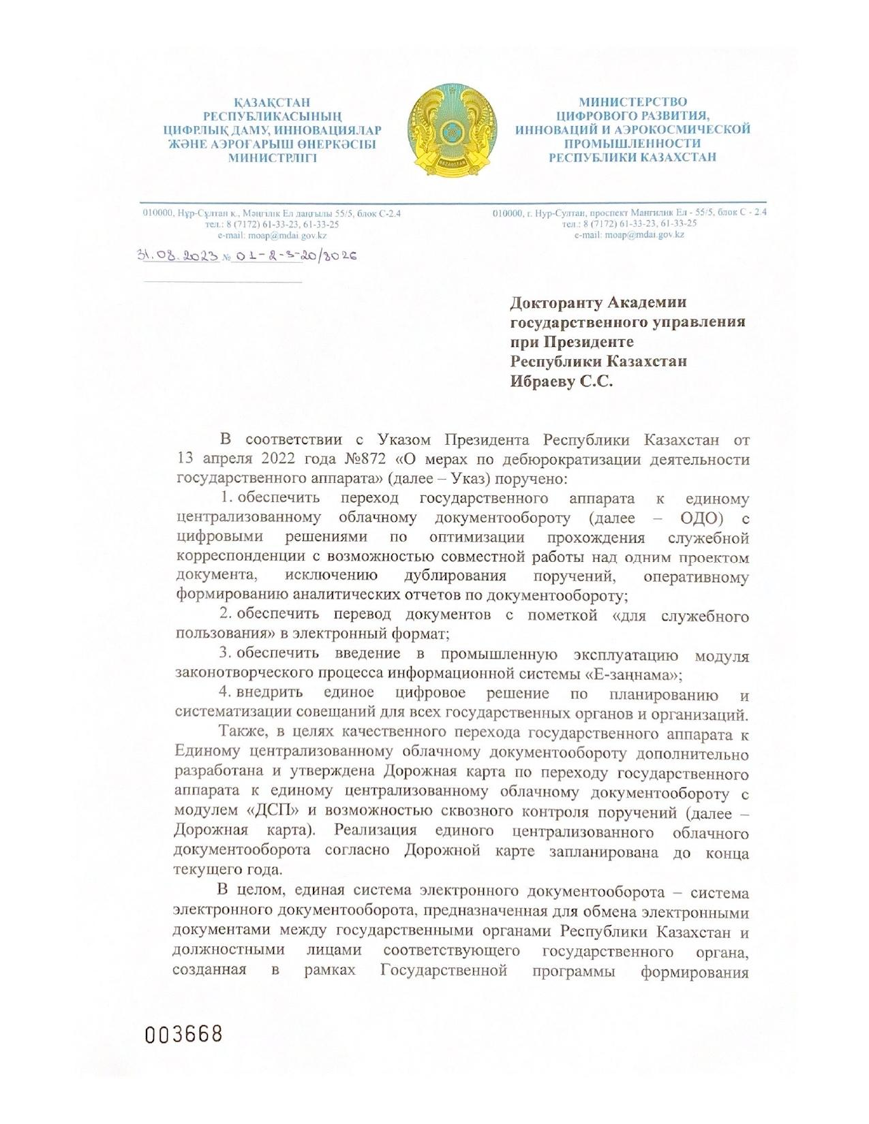

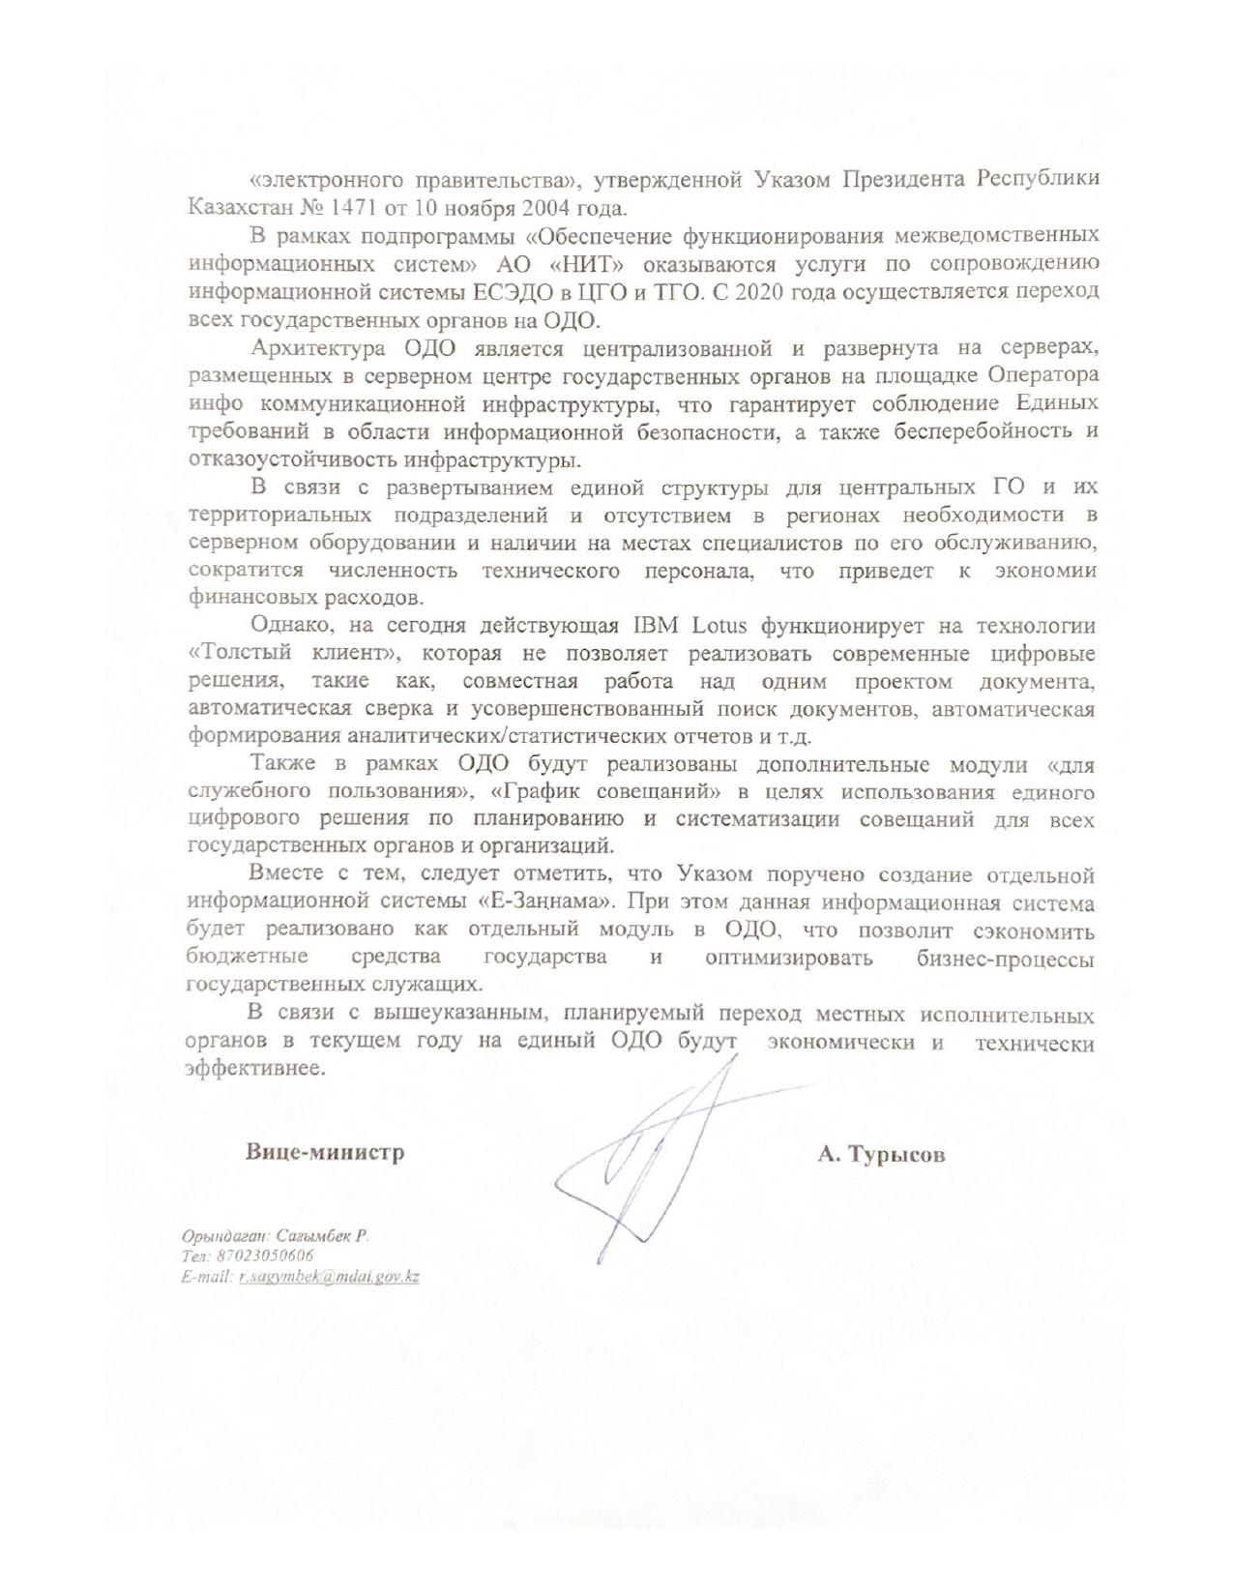

**APPENDIX C**

Characteristics of the doctoral student about the internship

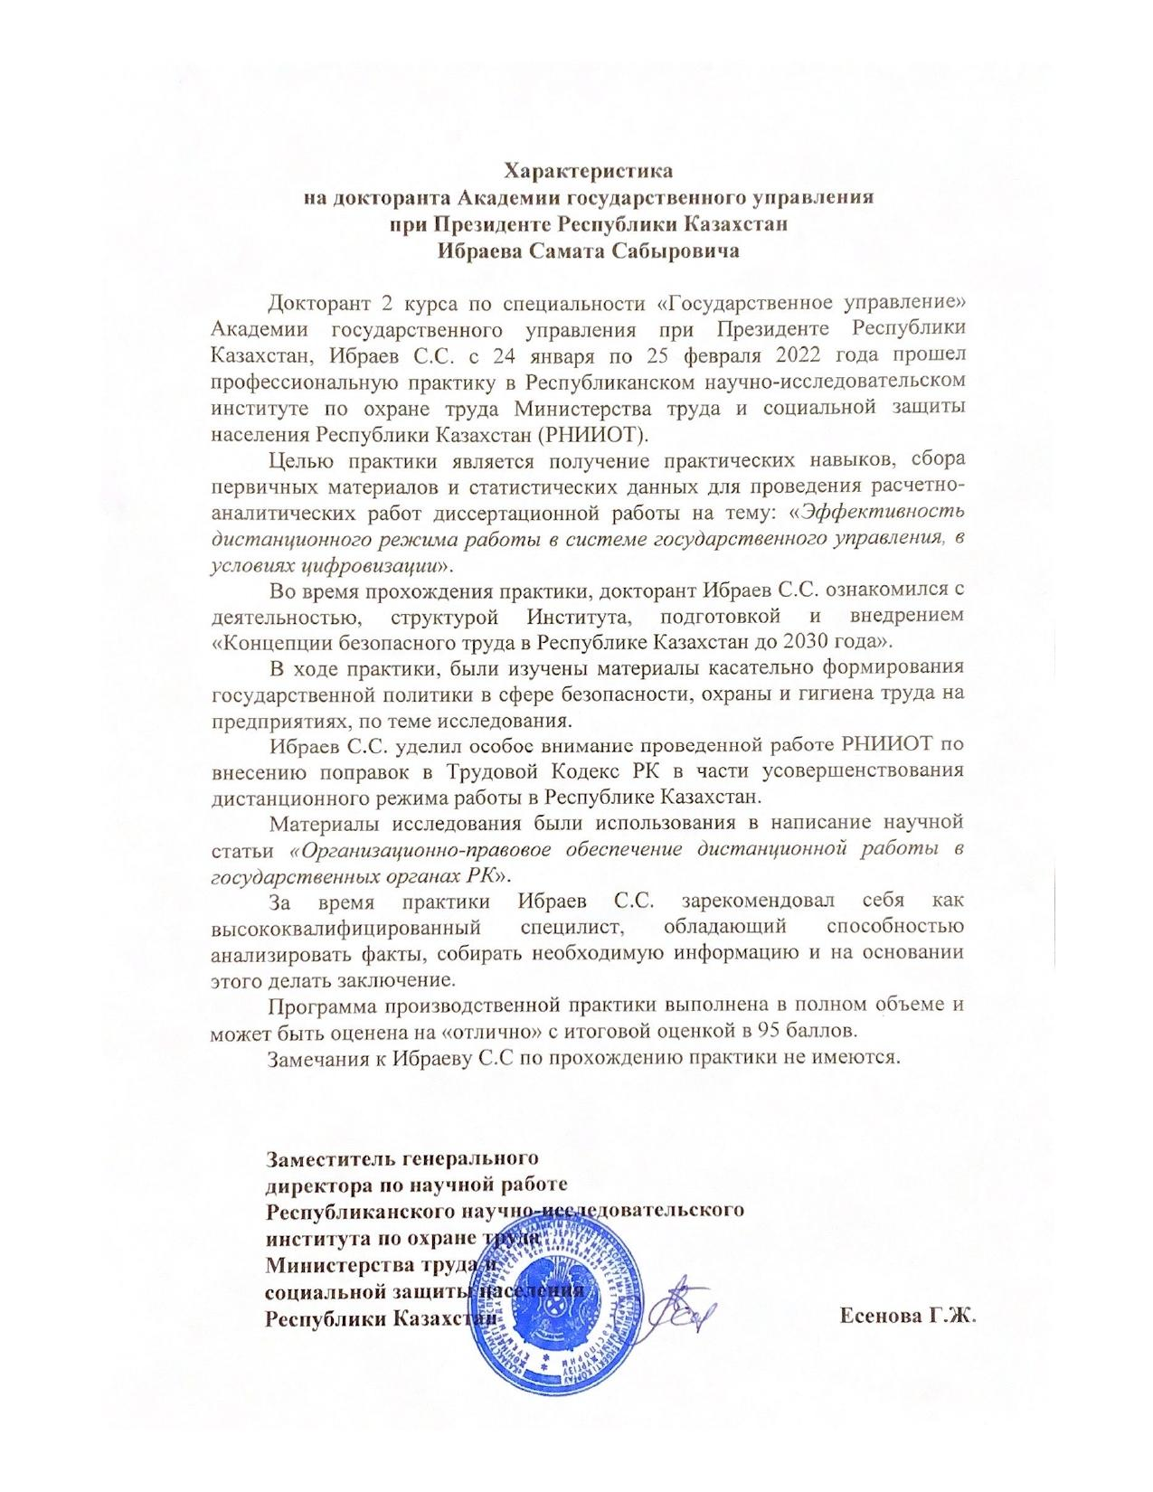

Ministry of Digital Development, Innovations and Aerospace Industry

of the Republic of Kazakhstan

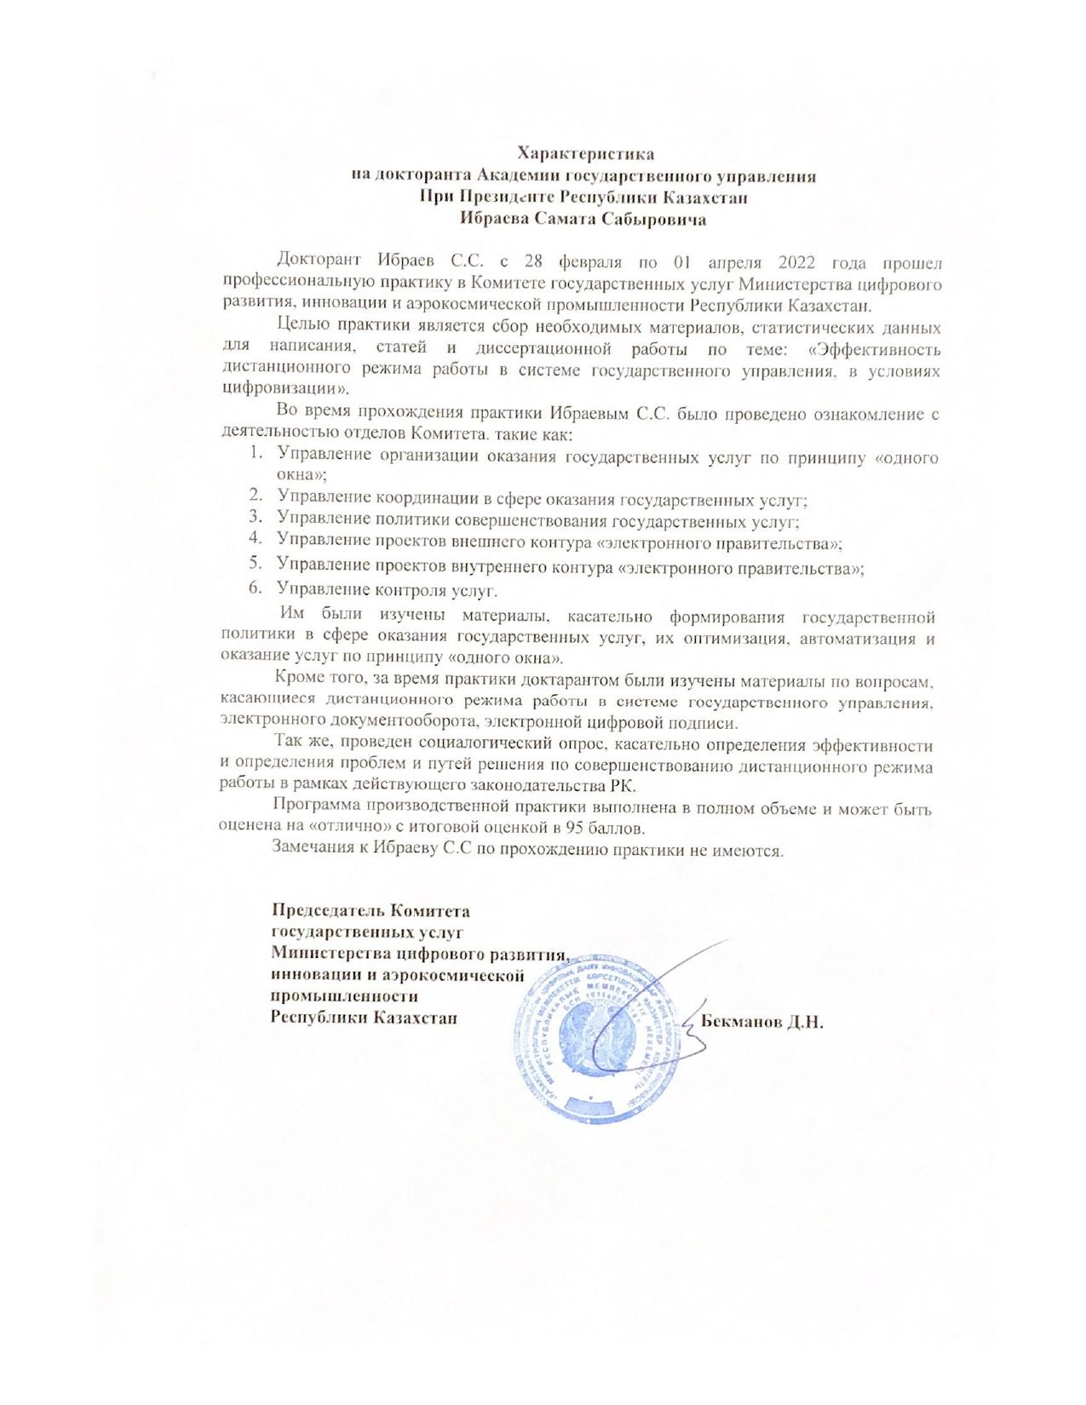

Agency of the Republic of Kazakhstan for Civil Service Affairs

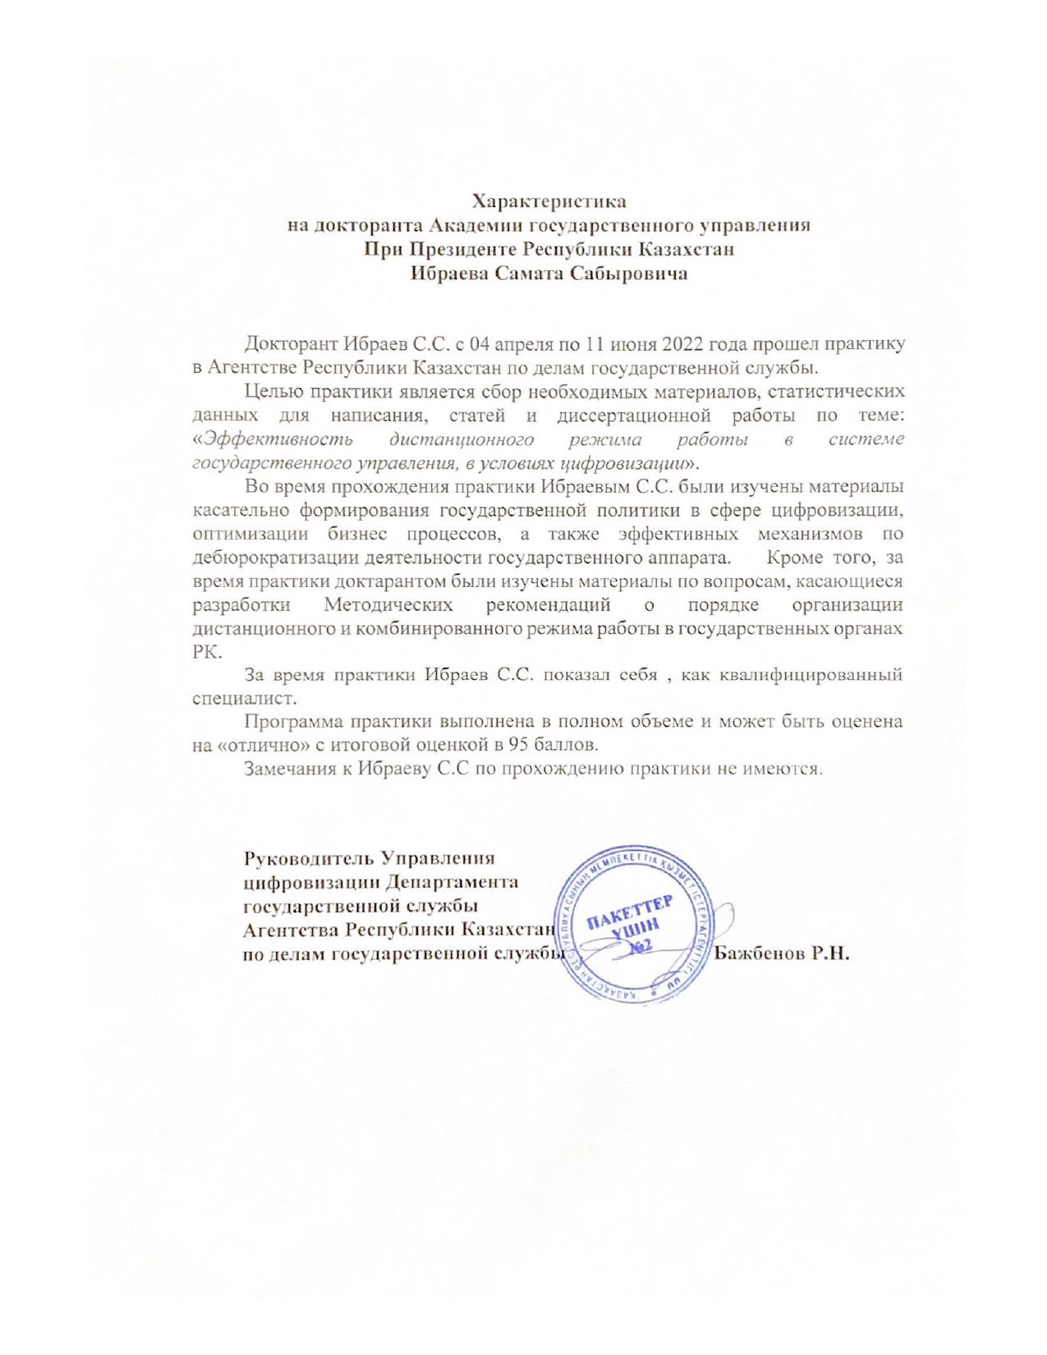

**APPENDIX D**

Table D.1 ‒ Conclusion of the Committee on Ethical Examination of Research Academy of Public Administration under the President of the Republic of Kazakhstan, according to the program of the sociological survey

|  |  |
| --- | --- |
| ФИО докторанта | Ибраев С.С. |
| Специальность (образовательная программа) докторантуры | 6D051000 – Государственное и местное управление |
| Период обучения в докторантуре | С 1 сентября 2020 года по 31 августа 2023 года |
| Тема диссертации | Эффективность дистанционного режима работы в системе государственного управления РК, в условиях цифровизации |
| Данные о научных консультантах - Ф.И.О. (при его наличии), должности и места работы, ученые степени, гражданство | Кусаинова Лариса Ислямовна, к.э.н., профессор АГУ |
| Объекты исследования | Дистанционный режим работы в системе государственного управления РК |
| Нарушения в процессе планирования, оценки, отбора и проведения научных исследований | Нарушения не выявлены. |
| Нарушения в процессе распространения результатов научных исследований | Нарушения не выявлены. |
| Каким образом проводилась защита прав, безопасности и благополучия объектов исследования (в случае наличия объектов живой природы и среды обитания)? | Защита прав, безопасности и благополучия объектов исследования обеспечена посредством соблюдения техники проведения социологического опроса. |

**APPENDIX E**

The Act of introducing the results of the dissertation research

