Ministry of Higher Education and Science of the Republic of Kazakhstan
Al-Farabi Kazakh National University

578.832.1:043.5 As a manuscript

KHAIDAROV SAKEN ZHARKYNOVICH

Study of the antiviral activity of drugs against the SARS-COV-2 virus in vitro

8D05110 Virology

Dissertation for the degree
of Doctor of Philosophy (PhD)
Scientific consultants:
Burashev Yerbol Dosanovich
PhD, Head of the Laboratory "Monitoring of Infectious Diseases" of
Research Institute of Biological Safety Problems
Foreign scientific consultant
Edan Robert Tulman
PhD, Associate Professor,
College of Agriculture, Health and Natural Resources, Departments of Pathobiology and Veterinary Science, University of Connecticut

Republic of Kazakhstan

Almaty 2024
Content
Нормативные ссылки……………………………………………………….....5
Notations and abbreviations…………………………………………………....6
- Introduction……………………………………………………………….…. 7
1.0. Literature review…………………………………………………………….11
1.1. The SARS-CoV-2/human/KAZ/B1.1/2021 strain……………………………....14
1.2. SARS-COV2 and its molecular feature……………………………………….....14
1.3. The retroviruses (Retroviridae) family and their standard features…………..…15
1.4. Structure, genome, and proteins……………………………………………...… 15
1.5. Global COVID-19 spread and clinical consequences…………………………... 16
1.6. Innate Immunity and SARS-COV2……………………………………………..17
1.7. Adaptive immunity and SARS-COV2…………………………………………..18
1.8. Innate immunity – the primary response and cell defence……………………….19
1.9. Vaccination……………………………………………………………………...20
1.10. Immunoglobulins (IgGs, IgA and IgM) ……………………………………….21
1.11. Fc-receptor -associated protective immunity against SARS – COV2………….22
1.12. Modern methods to produce immune modulators against COVID-19 (SARSCOV2) …….....................................................................................................24
1.13. Polyclonal antibodies…………………………………………………………..25
1.13.1. Monoclonal antibodies……………………………………………………….26
1.14. Hybridoma……………………………………………………………………..27
1.14.1. Main steps of Hybridoma technology……………………………………….28
1.14.2. Hemagglutinating virus of Japan (HVJ) or inactivated Sendai virus-fusion….29
1.14.3. Hybridoma: Electrofusion……………………………………………………29
1.15. Functional genome…………………………………………………………......30
1.15.1. Receptor binding protein (RBD)……………………………………………..31
1.16. Drug antiviral activity………………………………………………………….32
1.16.1. Antiviral drugs.................................................................................................33
1.16.2. Effective doses of antiviral effect of Favipiravir, Ribavirin, and Tenofovir for humans (in vivo and for E6 vero cells (in vitro)) ……………………………………..36
1.17. Effective concentrations and potency (EC50, EC90), concertation efficacy of three drugs …………………………………………………………………………...37
1.18. Lethal mutagenesis as a purpose ……………………………………………….38
1.18.1. The lethal mutagenesis of Ribavirin…………………………………………39
1.18.2. The lethal mutagenesis of Favipiravir……………………………………….39
1.18.3. The lethal mutagenesis of Tenofovir………………………………………...40
1.19. Steroids save lives from severe cases of SARS-COV2 infection. Nevertheless, it has its cost – bone infarct development………………………………………………40
1.20. Influenza virus, a comparison with SARS-COV2…………………………….41
1.21. The antigenic shift of Influenza……………………………………………….42
1.22. Influenza antiviral drugs……………………………………………………….43
1.23.M2-ion channel inhibitors……………………………………………………...44
1.24.M2-ion channel inhibitors against COVID19………………………………….45
1.25. Endonuclease inhibitors (Baloxavir)…………………………………………..47
1.26. Endonuclease inhibitor – Baloxavir against COVID-19……………………...47
1.27. Neuraminidase Inhibitors (oseltamivir)……………………………………….47
1.28. Neuraminidase Inhibitors Oseltamivir- against COVID-19…………………..48
- Methods and materials……………………………………………………....50
2.1. The biological samples………………………………………………………….50
  - Viral RNA isolation…………………………………………………………..50
  - Selection and synthesis of primers…………………………………………....51
  - Conducting PCR………………………………………………………………52
  - Gene sequencing……………………………………………………………...52
  - Comparative and phylogenetic analysis of the nucleotide sequence of genes.53
  - Determination of cytotoxicity of drugs for cell culture………………………53
  - Dose - escalation in vitro……………………………………………………...53
  - The vero cells E6……………………………………………………………...54
  - The culture medium…………………………………………………………..54
  - The virus preparation and safety procedures…………………………………54
  - Biosafety Level 2 (BSL-2) ……………………………………………..........54
  - Dose - de-escalation in vitro…………………………………………………..55
  - CCK8 test for cell-viability in 4 drugs of concentration 50µg/ml…………...55
  - Equipment……………………………………………………………………55
  - Materials, reagents, and solutions………………………………………….....56
  - Production of virus fragments by PCR……………………………………….56
3. Results
3.1.1. RT-PCR test results…………………………………………………………...58
3.1.2. Determination of morphological characteristics of viral strains of the SARS-COV-2 virus…………………………………………………………………………60
3.1.3 Study of biological properties of isolated isolates and their subsequent deposition……………………………………………………………………………61
3.1.4. PCR production of fragments of SARS-COV-2 virus genes and sequencing of significant infection genes…………………………………………………………...61
3.2. The rest of the viral genome…………………………………………………….64
3.3.1. Phylogenetic analysis of the SARS-CoV-2 strain/human/KAZ/Britain/2021...66
3.3.2. Phylogenetic analysis of the SARS-CoV-2 strain/human/KAZ/B 1.1/2021…..67
3.3.3. Uploading a genome-wide nucleotide sequence to the GenBank database…...67
3.4.1. Determination of cytotoxicity of drugs for cell culture………………………69
Dexamethasone………………………………………………………………………69
Ribavirin……………………………………………………………………………..70
Tenofovir…………………………………………………………………………….70
Favipiravir…………………………………………………………………………...71
3.4.2. CCK8 test for cell-viability in 4 drugs in concentration of 50µg/ml…………73
3.5.1. Vero E6 cells infection and 72hours incubation, titer production…………….75
3.5.2. Antiviral activity count after drugs adding…………………………………....76
Ribavirin - inhibition assay ………………………………………………………….76
Tenofovir- inhibition assay………………………………………………………...77
Favipiravir- inhibition assay…………………………………………………………77
Dexamethasone- inhibition assay……………………………………………………77
3.5.3. Antivirals recommendation against SARS-COV 2 according to provided results on RdRP-inhibition activity………………………………………………………….79
Discussion……………………………………………………………………………84
Conclusion…………………………………………………………………………...85
Reference…………………………………………………………………………….89
Нормативные ссылки
Настоящие правила составлены на основании следующих нормативных документов:
- Закон Республики Казахстан «О науке» от 18.02.2011 г. № 407-IV ЗРК;
- ГОСО РК 5.04.034–2011: Государственный общеобязательный стандарт образования Республики Казахстан. Послевузовское образование. Докторантура. Основные положения (изменения от 23 августа 2012 г. № 1080);
- Правила присуждения ученых степеней от 31 марта 2011 года № 127;
- межгосударственные стандарты: ГОСТ 7.32–2001 (изменения от 2006 г.). Отчет о научно-исследовательской работе. Структура и правила оформления;
- ГОСТ 7.1–2003. Библиографическая запись. Библиографическое описание. Общие требования и правила составления.

NOTATIONS AND ABBREVIATIONS
SARS-COV 2- severe acute respiratory syndrome-corona virus 2
COVID-19 – Coronavirus disease (December 2019, Wuhan, China)
MERS – Middle East respiratory syndrome (coronavirus)
HIV- Human immunodeficiency viruses
RdRP- RNA-dependent RNA-polymerase
RBD-receptor binding Domain
ACE2 - Angiotensin Converting Enzyme 2 (human)
GP - glycoprotein
Ig-Immunoglobulin
IgA- immunoglobulin subtype A
IgM- immunoglobulin subtype M
IgG- immunoglobulin subtype G
IgE- immunoglobulin subtype E
lg - decimal logarithm
PFU - plaque-forming unit
Vero – the subline of green monkey kidney tissue
cDNA – complimentary deoxy nucleic acid
vRNA - viral ribonucleic acid
mRNA – messenger ribonucleic acid
PCR-Polymerization chain reaction
RT- reverse transcriptase
BP-base pairs
PP-pair primers
ORF – open reading frame
NSP – nonstructural proteins
GP-gene product
NP-nucleotide position
FDA – Food and Drug Administration (federal government, USA)
Fig -X- figures provided by manufacturers ensuring the proper product performance
INTRODUCTION
General description of the research: The dissertation is devoted to the study of the biological and molecular genetic properties of current SARS-CoV2 strains isolated on the territory of the Republic of Kazakhstan using RT-PCR, cell-viability, viral titter production, and COVID-19 express test techniques and appropriate primers to detect NSP12 gene product. An in vitro study of the antiviral activity of drugs against the SARS-COV-2 virus was carried out on the Vero E6 cell culture - green monkey kidney tissue.
Relevance of the research thesis
The pandemic of COVID-19 in 2020 showed the extreme vulnerability of healthcare systems worldwide. First and foremost, the speed and intensity of spreading viral infection was a profound issue due to high viral load rates that most of the population could not withstand. Secondly, hospitalisation issues and neither bed nor drug capacities were sufficient for effective containment. Thirdly, the severe cases of immune response caused significant health damage, predominantly to the lungs, and due to this feature, it was called a severe acute respiratory syndrome. Lastly, the primary objective was to achieve fast and reliable viral infection diagnostics in Kazakhstan and the world.
One of the most significant issues of SARS-COV 2 infection is relatively fast mutation rates and human host adaptation mechanisms through spike protein variations, and the most effective way to hold the population infection intensity is to implement mass vaccination and find effective therapies against it. And, of course, the fundamental understanding of this viral infection's nature will help us minimise the adverse outcomes in combating novel viruses in the future.
The research aims to study the antiviral activity of drugs against the SARS-CoV-2 virus in vitro.
The main tasks of the research to accomplish the purpose are as follows:
- To find the most effective and potent antiviral drug from three candidates, namely Ribavirin, Favipiravir (Fabiflu), and Tenofovir (Tenvir)
- To isolate the SARS-CoV-2/human/KAZ/B1.1/2021 strain and its non-structural protein genome (gene products) and characterise them.
- To confirm the RdRp (RNA-dependent RNA Polymerase) inhibition by antiviral drugs
- To find the cytotoxicity - safe concentration of three antiviral drugs
Research methods: The study employed biomolecular, genetic, cellular-based biotechnological, microbiological, and pharmaceutical processes.
The scientific novelty of the research: Three – stages- long dissertation study of the drug antiviral activity effectiveness against SARS-CoV-2/human/KAZ/B1.1/2021 strain:
- Antiviral drug- cytotoxicity and cell viability assays – optimal drug concentration
- Three tableted antiviral drug efficacy and cytotoxicity comparison and analysis: Favipiravir (T-705), non-generic purine analogue or double nucleoside analogue (intercoperates both Adenine and Guanine); Ribavirin is a broad spectrum, well-established, generic antiviral drug with dual antiviral activities as - 1) Guanosine analogue that phosphorylates intracellularly by adenosine kinase as well as metabolite: Ribavirin or Guanine mono-, di-, and triphosphate. 2) Direct antiviral activity responsible for inhibiting RNA polymerase →chain termination, inhibition of RNA capping activity and lethal mutagenesis of RNA genome. Tenofovir is against DNA-Virus generic and non-toxic, protease-inhibiting medicine (HIV and Hepatitis B), inhibiting viral reverse transcriptase and controlling the viral load, not allowing viral replication to gain pathogenicity.
- The molecular and genetic characterisation of the RdRp (RNA dependent RNA polymerase) gene (NSP12- none structural proteins) and its ‘genetical conservatism.’
- Antiviral activity of three drugs (active agents): Ribavirin, Tenofovir, and Favipiravir on Vero E6 cells line that is both susceptible and permissive for SARS-CoV2 virus – RdRp-inhibition, causing the lethal mutagenesis or fatal error for viral replication with a significantly higher viral load MOI:2 or TID50=10
Subject of study
They are investigating the antiviral-effects activity of medicines against the SARS-CoV type two virus via its genetic and molecular characteristics and evaluating their efficacy. In addition to identifying the cytotoxic concentration of these three antivirals, tenofovir, Fabiflu, and ribavirin, the steroid drug Dexamethasone was also determined.
The work's Theoretical and practical significance is clearly understanding the effectiveness of three disputed antivirals and one hormonal (steroid) drug in vitro. To understand which of these drugs demonstrate not only practical, i.e., clinical effect, but also to set the safety dosage in viral load increasing fighting strategies of SARS-CoV type two viral infection. During the pandemic, Kazakhstan faced multiple and numerous different cases of COVID-19 progressions and complication stages among infected patients with devastating post-corona effects and even lethal outcomes due to a poor understanding of the biological nature of the SARS-COV 2 virus. The primary objective of this dissertation work is to provide a better understanding not only of COVID-19 treatment but also of similar viral infection cases in the future.
The theoretical and practical significance of the research:
To understand the effectiveness of three disputed antivirals and one hormonal (steroid) drug in vitro. To understand which of these drugs demonstrate not only practical, i.e., clinical effect, but also to set the safety dosage in treatment strategies for COVID-19. During the pandemic, Kazakhstan faced multiple and numerous different cases of COVID-19 progressions and complication stages among infected patients with devastating post-corona effects and even lethal outcomes due to a poor understanding of the biological nature of the SARS-COV 2 virus. The objective of this study is to provide a better understanding not only of COVID-19 treatment but also of similar viral infection cases in the future.
The antiviral effects were demonstrated on the Vero E6 cell model. Furthermore, the cytotoxic profiles of all four drugs were evaluated and confirmed. The non-structural protein sites on the viral genome were pointed and quantified, and their biological ‘conservative’ nature was verified in the strain SARS-CoV-2/human/KAZ/B1.1/2021. The main provisions for the defence:
1) Tenvir (Tenofovir) is the most effective antiviral drug among the three selected.
2) It was confirmed that the total SARS-CoV-2/human/KAZ/B1.1/2021 strain –Isolation, as well as its none-structural protein genome (gene products), are Characterization
3) The 100% inhibition of the RdRp (RNA-dependent RNA Polymerase) is detected
4) The cytotoxicity - safe concentration of Tenofovir was found - 50µg/ml or 174µM was set
The relevance of the plan of based scientific works
This work was carried out as a PhD Thesis, ‘Studying the antiviral activity of drugs against the SARS-CoV-2 virus in vitro ’of Khaidarov Saken at Faculty of Biology and Biotechnology, Al-Farabi Kazakh National University, Almaty, Kazakhstan under the professional supervision of Burashev Yerbol who managed my research within the framework of the grant funding project on the topic: AP09058338 “STUDY OF ANTI-VIRAL ACTIVITY OF DRUGS AGAINST SARS-CoV-2 VIRUS IN VITRO AND CONDUCTING MOLECULAR-EPIDEMIOLOGICAL ANALYSIS OF CIRCULATING COVID-19 STRAINS“ under targeted funding for 2021–2023 with the support of the Science Committee of the Ministry of Science and Higher Education of the Republic of Kazakhstan. Special gratitude goes to the Department of Pathobiology and Veterinary Science and Center of Excellence for Vaccine Research, University of Connecticut (UCONN), Storrs, Connecticut, USA, which was in tight collaboration with the Research Institute for Biological Safety Problems (RIBSP), Gvardeyskiy, Kazakhstan and Faculty of Biology and Biotechnology, Al-Farabi Kazakh National University, Almaty, Kazakhstan.

Key research findings and conclusion:
- 1)Tenvir (Tenofovir) is the most effective antiviral drug among the three selected ones; however, it is not the safest. Accurate and proper usage can easily coupe the COVID-19 progression into mild and moderate illness stages.
- 1) Tenvir (Tenofovir) is the most effective antiviral drug among the three selected ones against SARS-CoV-2/human/KAZ/B1.1/2021 strain.
- 2) SARS-CoV-2/human/KAZ/B1.1/2021 strain is fully isolated, and its none-structural protein genome (gene-products) is characterised
- 3) The RdRp (RNA-dependent RNA Polymerase) is almost 100% inhibited
- 4) The cytotoxicity - safe concentration of Tenofovir was found - 50µg/ml or 174µM
The author's contribution to the results described in the dissertation: The author carried out independently the analysis of literature data on the researched problem, the setting of research goals and objectives, the conduct of experimental research, the analysis of the obtained results, statistical processing, and the writing of the dissertation.
Research approbation: the research results and the main principles of the dissertation were presented and discussed at the following international scientific conferences and symposiums:
- Modern scientific technology» (February 9-10, 2023). Stockholm, Sweden, 2023
- 3rd International Conference on Virology, infectious disease COVID-19, October 24-25, 2022, Dubai, UAE
- Proceedings of the 1st International Scientific Conference, 26-27 January 2023, Warsaw, Poland
- II International Forum "Asfen Forum, new generation-2024" on June 6-7, 2024, in Almaty, Kazakhstan
Publications: The main result of the dissertation consists of 9 published works, including two articles in peer-reviewed international scientific journals indexed in the Web of Science or Scopus databases, two articles in the list of the Committee for Control in the Sphere of Education and Science of the Republic of Kazakhstan, and five theses published at international conferences.
Dissertation structure: The dissertation comprises 100 pages of computer text, symbols and abbreviations, an introduction, a literature review, research materials and methods, research results and their discussion, a conclusion, and used literature in the number 146. The work has ten tables, 17 graphs, 16 figures, 1 diagram, one process scheme, 2 PCR charts, two dependence graphs, and one process scheme.

1. LITERATURE REVIEW
Viruses are endo-parasites that strongly depend on the cell host and their replication–transcription–translation machinery. Viruses can infect both domains: the eucaryotic as well as procaryotic organisms (phages). It is tough to classify them as true parasites or pseudo parasites. Viruses have compact genomes enveloped mostly by capsid proteins and can be comprised of either DNA as a genetic material or RNAs, as viruses can encode various types of transcriptase. Coronaviruses are named for their corona-shaped appearance in the electron microscope.
Viruses, are they alive? According to the latest characteristics of life biology, viruses barely satisfy even half of their criteria, like growth and development -viruses do not grow and do not develop in the classical meaning of this word. Only numbers increase – the viral load in a host cell that fatally ends by bursting its membrane and cytosol. Viruses possess neither order because they cannot be characterized as cellular organisms nor energy processing. However, many virions are highly ordered; instead, they use the ‘victim’ replication machinery to reproduce, expressing various enzymes on the eucaryotic ribosomes. Viruses are so heavily dependent on host metabolism that they can survive only inside penetrated host cells. The size also plays a crucial role; most living organisms, even unicellular like bacteria or protists, require space – the biosphere to habitat it; viruses, in sharp contrast, mainly depend on particular hosts and their interactions in the biosphere. The only thing that relates viruses to living is heredity and adaptation capacities according to their features to regulate their gene expression independently. Are they DNA or RNA-type viruses? The viral genome can defend its critical regions of gene expression; these regions are called ORFs, i.e., open reading frames that react as enzyme–bioactive catalysis. The tiny size of viruses allows them not only effectively to infect most organisms but also to develop profound numbers of strategies to regulate the population of bacteria, fungi, plants, etc. Viruses also could not be considered true parasites because, even though they cannot survive on their own, they usually kill their host relatively fast, like Ebola or Marburg virus, and they kill their hosts within several days. This false parasite behaviour is their true weakness – low virulence and the ability to spread. The ideal pandemic viral pandemic scale is when a virus spreads not only fast but also allows a host to spread contamination fluids into the air as long as possible and keeps the so-called patient zero unaware of spreading until it is not too late.
The virus is one of the most primitive life forms biology knows (apart from viroids, they are more primitive): it has only membrane proteins that enable them to penetrate the host cell membrane, nucleocapsid inside which the genetic material appears in either DNA or RNA-form. When the genetic material of a virus is inserted into the cytosol of the victim cell, the viral RNA, for instance, starts to dock on ribosomes and begin to produce immediately so-called reverse-orientated complicated enzymes like RNA driven RNA polymerase-enzyme that interacts with host DNA replication-machinery and starts to reproduce first the genetic material in positive sense direction, the reason why COVID-19 virus, for instance, has a definition as single-stranded RNA positive sense virus (ssRNA⁺). About two-thirds of the SARS-CoV type two virus genome is fully dedicated to enabling, protecting and sustaining the work of RdRP to ensure the viral survival through not only replicating the genetical material but also producing main components of virions like spike protein – the host membrane ‘opener,’ membrane protein -even viruses must have information about host membrane barrier in a cooperative form as Receptor binding domain - Angiotensin-converting enzyme 2 (RBD-ACE 2). The region that occupies 70% of about 30K base pairs (bp) is called ORF1ab (open reading frame), which expresses 16 non-structural proteins, paramount among them are NSP3, NSP5, and NSP12. The NSP5 is located in the ORF1a region, which helps adapt and dock on host ribosomes. The NSP12 is the most significant gene product in the COVID-19 virus and is responsible for RdRP-expression. The rest, for instance, NSP-1-4 and NSP6-11, are responsible for enzymatic activity to promote the work of NSP5 at primary replication proceedings. The NSP13-16 also has significant catalysis features that repeat the classical DNA replication; instead of DNA, it is RNA, and there is no need for leading or lagging strands like during classical eukaryotic DNA replication.
Above all, NSPs are NSP12, the most significant gene product of the viral genome. They encode the most essential enzyme in the primary infection period – the RNA-driven RNA polymerase enzyme. NSP12 is so crucial that NSP13 and NSP11 are fulfilling the catalyst functions to enable NSP12's efficient functioning. Some antiviral drugs like Remdesevir disable RdRP to dock on RNA-subunits and, therefore, stop the viral genome from its replication. Other antiviral drugs cause so-called lethal mutagenesis in RNA metabolism, and viral survival or viral load does not achieve their functions and numbers. RNA-dependent RNA polymerase provides the viral genome with genetic variations through favorable point mutations. The viral survival entirely depends on RdRP, and its importance is paramount. In multiple investigations, in the early 2000s as well as in 2020, in China and the USA, it was confirmed that despite the high mutation potential of the SARS-CoV virus, barely any mutation appears from strain to strain independently of its geographical strain origin and genome region of ORF1ab.
Severe acute respiratory syndrome-associated coronavirus 2 (SARS-CoV type two virus) is a life-threatening respiratory infectious condition caused by SARS-CoV-2, which belongs to the coronavirus family and genus Betacoronavirus—single-stranded positive-sense RNA virus (ssRNA⁺). Variants of the SARS-CoV-2 coronavirus are continually emerging due to this virus's ongoing transmission and evolution worldwide. Since the pandemic was first declared by the World Health Organization (WHO) in March 2020 (1), B.1.17 (alpha), B.1.351 (beta), P.1 (gamma), B.1.617.2 (delta), and B.1.1.529 (omicron) [2–5]. Kazakhstan had the first human infection with coronavirus COVID-19 Registered in March 2020 [6]. According to the Johns Hopkins University database, as of January. In October 2022, the Republic of Kazakhstan had 1,484,400 registered confirmed cases, of which 19,052 died [7].
The coronavirus or SARS-COVID2 belongs to the Coronaviridae family, which are enveloped, positive-sense single-stranded RNA viruses [8]. The SARS-COVID2 consists of a viral genome: fourteen open reading frames (ORFs), two-thirds of which encode sixteen nonstructural proteins (nsp 1–16) that make up the replicase complex [9,10]. The rest encodes the nine accessory proteins (ORF) and four structural proteins: spike (S), envelope (E), membrane (M), and nucleocapsid (N), of which Spike enables the SARS-CoV entry into the cytosol of the target cell [11]. As with any virus of this type, the Spike protein is the most variable, and due to this capacity, the SARS-CoVs can penetrate the various cell membrane types of mammals [9].
There are approximately 30,000 nucleotides in RNA, encoding 11 proteins. Retroviruses have caused much harm over the years, and they're now a significant threat to human well-being. These types of viruses of the family Retroviridae typically carry their genetic material as RNA. Thanks to an enzyme called reverse transcriptase (RT), they could use the host DNA. RT is responsible for copying genetic information from one virus particle to another. The most known viruses of that family are Lentivirus (human immunodeficiency virus (HIV) and SARS-COV2 (COVID-19) [12]. It is essential to mention that virus infections aim to magnify the viral genome and assemble new viral units to invade other surrounding cells and tissues; mainly, such processes are carried out lethally to a cell or even to whole tissue systems like the lungs. Thus, it is tough to classify any viral ‘organism’ as a parasite whose middle-term and long-term survival correlates with the host’s well-being. ‘The side effect’ of viral infections as inflammatory or less obvious clinically distinguishable signs is the integration into the cell genome due to enzymatic activity of viral RNA of various tissue types; this, in the term, causes multiple types of critical mutations in renewable tissues having a sometimes the devastating disease like pneumonia, renal failure or other chronic, irreversible diseases. The negative effect of the global healthcare state on the population exposed to the COVID-19 virus is widespread and is only about to be experienced shortly. So, this type of virus's harm potential is never neutralised completely, and underestimation of its pandemic capacities is the highest priority to avoid by any authority [13-16].
SARS – stays for severe acute respiratory syndrome. Most of those diagnosed with SARS were healthy adults between 25 and 70. Children under the age of 15 have been the victims of a few alleged SARS cases. SARS typically has an incubation period of 2 to 7 days but can last as long as 10. People who have an illness that meets the current WHO case definition for probable and suspected cases of SARS have a case fatality rate of around 3%. Since COVID-19 infection became the subject of the pandemic in 2020, the United Nations considers this virus and related diseases a global problem for healthcare systems worldwide. The consequence of SARS-CoV-2 infection could lead to chronic illnesses, long-term health issues, and sometimes, to some extent, medical and mental impairment, which is why some scientific journals’ scope is fully dedicated to this problem. In many countries, the hospitalisation rates reached critical levels, so many infected ones were forced to stay at home and get treated far from inpatient wards. Pneumonia is a direct and widely spread clinical consequence among COVID-19-positive patients and needs to be separated according to the severity of the illness progress and lung damage surface. The more damage occurred, the less oxygenation gained via lung breath, so many patients with acute lung damage were heavily dependent on artificial lung ventilation apparatus in intensive care. It was crucial to monitor whether the pneumonia patients with COVID-19 infection were regularly assessed for bacterial infection and try to detect bacterial co-infection. The antibiotic treatment strategy would have been implemented if a need occurred to avoid pulmonary collapse [17].
  - The SARS-CoV-2/human/KAZ/B1.1/2021 strain
Strain SARS-CoV-2/ human/KAZ/Britain/2021 consists of 29,815 nucleotides and belongs to lineage B.1.1.7, according to the Pangolin COVID-19 database [18]. The SARS-CoV-2/human/KAZ/B1.1/2021 strain was obtained from the Scientific and Practical Center for Sanitary and Epidemiological Expertise and Monitoring branch of the Republican state enterprise on the right of economic use, National Center for Public Health, Ministry of Health, Republic of Kazakhstan. According to the manufacturer's protocol, nucleic acids were extracted from the test sample using a QIAamp viral RNA mini kit (Qiagen, Germany). Reverse transcription was performed using the SuperScript VILO cDNA synthesis kit (Invitrogen, USA). For amplification to cover the entire genome of the virus, 65 primer pairs were designed using the online Primer-BLAST program (http://www.ncbi.nlm.nih.gov/tools/primer-blast) to generate amplicons ranging in size from 600 to 750 bp and tiled to overlap by about 100 bp. These amplicons were generated by PCR and visualized by 1.2% agarose gel electrophoresis (Sigma, USA). PCR amplicons were purified using the Pure Link PCR purification kit (Thermo Fisher Scientific, USA). Purified amplicons were sequenced using the Sanger dideoxy method using an AB3130xl (Hitachi Applied Biosystems) 16-capillary genetic analyzer autosequencer with the Big Dye Terminator 3.1 cycle sequencing kit (ABI, Foster City, CA, USA). Raw chromatograms were collected using Sequencher version 5 (Gene Codes Corp.) [18].
  - SARS-COV2 and its molecular feature
The viral Spike has an S1/S2 polybasic cleavage site that is proteolytically cleaved by cellular cathepsin L and the transmembrane protease serine 2 (TMPRSS2), and a receptor-binding domain (RBD) that mediates direct contact with a cellular receptor, angiotensin-converting enzyme 2 (ACE2) [8,19,20]. ORF1a and ORF1b are translated into viral replicase proteins as soon as the viral genome is inserted into the cytoplasm of the host and cleaved into individual naps (via the host and viral proteases: PL^{pro}). The RNA-dependent RNA polymerase (nsp12, which is derived from ORF1b) is formed by these [21]. The components of the replicase move the endoplasmic reticulum (ER) into double-membrane vesicles (DMVs) at this location, which makes it easier for the virus to replicate genomic and subgenomic RNAs (sgRNA). The latter is turned into accessory or auxiliary proteins and viral structural proteins, making it easier for the virus to form particles [22,23]. In conclusion, the secondary part of the genome encodes the nine accessory proteins (ORF) that ensure the viral mRNA genome is translated; it is worth mentioning that the replicase for accessory protein production is significantly more significant than the primary one. In addition, the four structural proteins: spike (S), envelope (E), membrane (M), and nucleocapsid (N), of which Spike enables the SARS-CoV entry into the cytosol of target cell [Perlman, S. et al., 2009]. ORF1a and ORF1b are translated into viral replicase proteins as soon as the viral genome is inserted into the cytoplasm of the host and cleaved into individual naps (via the host and viral proteases: PL^{pro}). The RNA-dependent RNA polymerase (nsp12, which is derived from ORF1b) is formed by these [Perlman, S. et al., 2009]. The latter is turned into an accessory or auxiliary protein and viral structural proteins, making it easier for the virus to form particles [Snijder, E.J. et al., 2006; Wu, H.-Y. et al., 2010]. Unlike HIV, which has a complicated capsid structure with sophisticated (negatively charged dNTPs⁻ permeable) pores that are permeable for negatively charged dNTPs, which serve as building blocks for the formation of RNA-host-DNA-hybrid. The SARS-COVs do not possess such protection from hostile enzymes inside the host cells [24]. So, the secondary part of the genome encodes the nine accessory proteins (ORF), making it possible for the viral mRNA genome to go step by step and get translated. Furthermore, the replicase for accessory protein production must be integrated into the host genome to let a virus reproduce itself [21,24].
  - The retroviruses (Retroviridae) family and their standard features
The retrovirus family (Retroviridae) and their standard features Six standard features unite all retroviruses into one group
1. Despite DNA-dependent replication stages, retroviruses contain RNA as genetic material.
2. It is produced by reverse transcription due to the presence of the enzyme reverse transcriptase.
3. Due to the presence of the enzyme reverse transcriptase, it is reproduced by reverse transcription.
4. Integrase randomly moves viral DNA into the cell nucleus and is covalently integrated into the host genome.
5. Retroviruses contain gene sequences such as viral oncogenes and proto-oncogenes, which can quickly transform host cells according to their needs.
6. Human retroviruses can cause immunodeficiency, cancer, and neurological diseases.
  - Structure, genome, and proteins.
The typical structure of retroviruses has a shell shape from spherical to pleomorphic, and they have a diameter of 80-100 nm. Different genera of retroviral virions have different morphologies, but they contain the same virion component, which includes the outer shell, two copies of the genetic material, and viral proteins. The envelope consists of lipids, which are formed from the plasma membrane of the host during budding, and glycoproteins, such as, for example, gp120 and gp41 in the case of HIV [25]. The outer lipid bilayer of the retroviral envelope protects it from the extracellular environment, promotes the penetration and exit of host cells through the endosomal membrane, and allows it to penetrate host cells and merge with their membranes easily - these are three different functions of the retroviral envelope. The retrovirus has a single-component, linear, dimeric ss-RNA (+) genome with a length of 8 to 10 kilobases, a 5' envelope, and a 3' poly-A tail. There are flanks for group-specific genes (gag), pol, pro, and envelope genes (env) between the R sites. The primers U3, R (PBS), and U5 binding sites form 5' long terminal repeats (LTR). In the polypurine tract (PPT), the sections U3 and R form the 3' end. Reverse transcription uses a short repeating sequence at each genome end to ensure proper end-to-end transfer in the growing chain. On the other hand, U5 is a short exception sequence between PBS and R [26]. The 18 bases in PBS correspond to the 3' end of the tRNA primer. An untranslated leader region, the L region, indicates how genomic RNA is packaged. The proteins gag, protease, pol, and env form the retroviral protein. Gag is the main structural protein of the retrovirus, which controls most of the virus assembly processes. Interactions with three Gag subdomains - the matrix (MA), the capsid (CA), and the nucleocapsid (NC) — influence many of these assembly steps. Although gag subdomains are structurally different, their functions overlap during virus assembly [27,28].
  - Global COVID-19 spread and clinical consequences.
According to the WHO dashboard, more than 6.4 million people worldwide died from COVID-19 by August 18, 2022. The omicron strain has been diagnosed in over 590 000 000 people worldwide. A brand-new variant that appeared toward the end of November 2021 is now the most common strain worldwide and has contributed to the ongoing rise in several nations. In several high-income nations, vaccination is significantly reducing the number of cases and hospitalizations, but a lack of universal access to vaccines leaves many populations vulnerable. Even in vaccinated people, there are still questions about how effective and for how long the current vaccines against Omicron and other new SARS-CoV-2 variants are. There is still a need for more efficient COVID-19 treatments as a whole. The CoVID-19 global spreading, as well as the avalanche of research and false information, has shown how important it is to have reliable, easily accessible, and frequently updated living guidelines so that new findings can be understood and clear recommendations for clinical practice can be provided [29].
Apart from the severe acute respiratory syndrome and acute respiratory distress syndrome (ARDS) causing severe health impairment, COVID-19 is also capable of causing post-COVID-19 health conditions like cognitive impairment states. Other neurological and non-neurological deficits, such as fatigue and mental health symptoms, may overlap or cluster with cognitive deficits. In conditions following COVID-19, fatigue or exhaustion manifests as severely depleted systemic energy levels unrelated to activities or exertion and unaffected by usual rest or sleep. The quality of one's life, physical and cognitive function, social participation, and employment are all negatively impacted by fatigue. The core symptoms of depression following COVID-19 include a persistent low mood and sadness for at least two weeks and a markedly diminished interest in enjoyable activities. Depression can also cause problems sleeping, changes in appetite, fatigue, thoughts of self-harm or suicide, and feelings of worthlessness. Anxiety symptoms can include restlessness, racing or uncontrollable thoughts, difficulty concentrating, a sense of dread, difficulty sleeping, a lack of appetite, and irritability [30].
  - Innate Immunity and SARS-COV2
The innate immune system issues are highly complex and deserve a detailed view in a distinct paper. However, within this article, it is essential to include innate immunity to grasp the real pathogenic nature of COVID-19. Innate immunity in humans is the first defence line that helps our body clear and distinguish the viral invasion and respond to it. Human cellular immunity is mainly highly dependent on two types of innate immunity: macrophages, which absorb the pathogen and destroy viruses in themselves, and neutrophils, which can trigger cell death to stop the spread of the virus because one single by SARS-COV 2 infected cell is capable of producing up to 10.000 viral units until it experiences the cellular burst [31].
Limiting viral entrance, translation, replication, and assembly, assisting in detecting and exterminating infected cells, and coordinating and speeding up the development of adaptive immunity are all functions of the responses in an innate immune. Pathogen-associated molecular patterns (PAMPs) are recognized by surface, endosomal, and cytosolic pattern recognition receptors (PRRS), which then cause inflammatory reactions and programmed cell death (neutrophils) to prevent viral infection and encourage clearance [32]. The COVs (coronaviruses) developed innate immune system suppressors thanks to ORFs (ORF3 and 3CL) that are responsible for accessory protein encoding that sustains the viral replication and translation types of machinery and mitigates the antiviral response as an evasion strategy [33]. The cyclic GMP-AMP synthase (cGAS) is a STING (Stimulator of interferon genes) signaling pathway activated by cytoplasmic DNA. cGAS-STING is the protective cascade-driven reaction that significantly limits both DNA and RNA viruses during the active phase of infection [34-37]. The SARS-COV-2 disintegrates the organelles’ unity, and one of its victims is mitochondria. Mitochondria get seriously damaged, and their DNA freely swims in the cytosol, and the cGAS gets activated to fight the invaders’ genome [38]. Finally, mentioning the cellular components of innate immunity against viral infections makes sense. Macrophages, monocytes, dendritic cells, neutrophils, innate lymphoid cells (ILCs), such as natural killer (NK) cells, are capable of resisting virus invasion with the help of PRRs (Pathogen resistance receptors) that detect PAMPs or damage-related molecular patterns (DAMPs) to induce inflammatory pathways and immune responses [39]. To summarize this chapter, SARS-COV-2 or MERS, like other COVs and retroviruses, has an extremely high potential to invade a cell and replicate itself fast and effectively enough to overcome innate immunity and sometimes to escape the B-cell antibody formation. Adaptive immunity also faces high challenges due to the variability of spike proteins, enabling the evolution of new viral strains with novel defensive evasion strategies. The virus is capable of causing severe health and life-threatening conditions to almost all groups of people worldwide. Thanks to accessory proteins, rapid integration into replication and translation cell machinery, and active defense of the positive RNA-original genome, it can make its survival effective in a host cell. The virion rate production is well synchronized by the assembly process, allowing SARS-CoV2 to produce its copies in an average of 10.000 units per eukaryotic cell and achieving high infection rates among human and animal populations. So, we can say that SARS-CoV2 is still a hazardous pathogenic organism whose potential is not fully understood.
  - Adaptive immunity and SARS-COV2
Viruses are capsid–coated, relatively small genomes that carry (mRNA or DNA) ‘nano-living beings’ with ORFs (open reading frames—in the viral genome sequence) when they enter the host cytosol [40].
In medical history, viral infections have often shown a high potential to increase their population in host cells. The virus load speed is critical in the viral spread before the secondary immune response occurs, which can cap any viral threat. The coronaviruses can reproduce copies of up to 10,000 viral particles per infected cell [41].
The occurrence of repetitive, i.e., monotonically repeating, letter sequences is a characteristic that is highly baffling in many genomes of higher organisms and some viruses, the latter to a minimal extent. The human genome of 3.2x10⁹ hereditary letters utilizes under 2% of those letters to store the data of working qualities to the extent we know now. Sequences of letters repeated millions of times make up well over 40% to 50% of the genetic letters housed in our 46 chromosomes. The purpose and significance of these repetitions are unknown to us [42].
However, some theories suggest that the human genome is profoundly designed with a purpose—a defensive way to secure the vital genes or group of genes, to keep them relatively stable against mutations or exposures that cause various mutations that interfere with or even block essential expressions, and maybe also to withstand many viral genome integrations both in replication and translation processes.
The following options were utilized when vaccination options were highly specialized: vaccination with viruses that have been killed (inactivated) and can no longer reproduce or with parts of the viruses. Accidents also occurred during the early stages of vaccine development, primarily because of incomplete inactivation or contaminated vaccines derived from virus-infected cells. One well-known instance is the contamination of an early preparation for the polio vaccine with the rodent tumor virus SV40, a previously unknown simian virus. Fortunately, this accident did not result in any problems: no evidence receiving the contaminated vaccine increased the risk of tumor development [43].
The recombinant virus vaccines produced using genetic engineering technologies are the safest. Since the virus genes whose products are responsible for antibody production are isolated from the virus genome, the proteins of these viral genes are then expressed in bacteria or yeast. The viral proteins synthesized this way are then purified and used as a vaccine. These vaccines are virus-free [44].
  - Innate immunity – the primary response and cell defense.
The immune system consists of specific and unspecific mechanisms that fight viral invasion with various efficiency and time reactions. There are unidentified antiviral compounds in the mucous membranes of the inner surfaces. While some defense cells can kill viruses by phagocytosis (eating), this method isn't very effective without supporting mechanisms. Some viruses, like HIV, can grow in the macrophages that phagocytize them, allowing them to get past this antiviral defense. Generating interferons, or molecules that stop virus replication and spread, is a very intriguing and common defense mechanism. The formation of these proteins occurs far earlier than the development of antiviral antibodies following viral infection. The interferons α, β, γ are currently the most well-known [45].
Interferon | Functions and cells
interferon α | induced mainly in leukocytes by foreign cells, virus-infected cells, tumour cells, or virus envelopes.
interferon β | induced by viruses and foreign nucleic acids in many different body cells.
Interferon γ | formed by T lymphocytes when foreign proteins enter the body.
Table 1 - The interferon types and cells that generate them as unspecified auxiliary virus-fighting agents in humoral immunity. In many antiviral therapy strategies, the artificial interferon α is prescribed with Ribavirin to gain a better antiviral effect within several weeks.
The cellular unspecified immunity consists of macrophages, basophils, and natural killer T-cells.
NKTs and NKs, also known as natural killer T-cells, are a class of leukocytes. White blood cells called leukocytes help the body to fight various infections. Less than 1% of the body's lymphocytes are these uncommon cells. Are T-cells specialized or generalized? The only T-cell subset regarded as non-specific is natural killer T-cells, which facilitate communication between the non-specific and specific immune systems. These cells take direct aim at microbial intruders [43].
Leukocytes called basophils have previously been misinterpreted. Scientists found it challenging to study these cells because of their short lifespans of one or two days. Recent studies show basophils are the only white blood cells expressing histamine congregating in connective tissues. The com-ponent histamine is what causes allergy symptoms to manifest in the body. Basophils could eliminate cancer cells before they threaten the body [42].
The immune system's warning systems and so-called ‘missile defenses’ are macrophages. When they find a pathogen, macrophages raise the alarm by releasing cytokines into the circulatory system. When a cell surrounds and kills another cell or organism, the process is known as phagocytosis [44].
Neutrophils are also innate immune cells with a short life span. They are the first cell type to be drawn to inflammatory areas. They can then change phenotype and produce subpopulations with various cell functions. Additionally, neutrophils can interact with other immune cells directly or indirectly through cytokines and chemokines to modify innate and adaptive immune responses. We still don't fully comprehend these neutrophil subpopulations, but the following instances show that they exist as accurate inflammatory subsets [44].
To summarize, innate immunity is complicated, and humoral immunity is tightly interconnected with the cellular part. Some leukocytes have multiple functions at different levels. Innate immunity can face almost any microbial challenge with various molecular induceable arsenals that sustain integrity and a healthy state.
  - Vaccination
Adaptive immunity consists of both cellular and humoral (antibodies) particles that help neutralize the pathogen in short—and long-term perspectives due to the formation of memory cells. Adaptive immunity requires time to select and expand virus-specific cells from the large variability pools of naïve B cells and T cells for further specification in molecular structures and sequences—priming.
Acute immunity | Humoral | Cell | Cell | Cell
 | Antibody | CD4⁺ T-cells | CD8⁺ T-cells | B-cells
Functions | Identification of epitopes of interest forms cellular memory | Have Helpers and Effectors activities | Kill the infected cells | Production of Antibodies
Table 2 - shows consistent adaptive immunity, with cellular and humoral parts that have adequate functions, high specificity, and efficacy when innate immunity is overwhelmed by infection.
When SARS-COV2 infection proceeds, the viral genome rapidly gets integrated into the host protein and replication machinery, the race with time starts, and the innate immunity must withstand the viral load till the adaptive immunity proliferates and appropriately differentiated to charge already circulating virions and virus seized cells. Innate immunity tries to manage the viral infections on its own by activating the immune response type I and type III interferons that are supposed to delay the intercellular viral infections till the viral load gets the critical values and starts to alarm dendritic cells to call the adaptive immunity to help [43.].
In average situations of SARS-COV2, a so-called ‘simple’ model appears to cause the temporal delay in innate immunity response, which is enough to launch the asymptomatic infection that occurs roughly in 40% percent of сases in COVID-19 infection and T-cells with antibodies form relatively quickly to control viral load and infection rates [44.]. The presence in the bloodstream of COVID-19 patients, the T-cells, and antibodies in sufficient amounts is signaling that the favorable resolution of COVID-19 took place [45.].
In summary, the timely and accurately activated adaptive immunity with humoral and cellular response resolves severe COVID-19 infection and its clinical outcome. Thus, ignoring the importance of innate immunity that charges the first viral invasion with specific delaying responses on viral replication and translation can grant a vital time to withstand rapidly increasing viral load. And thankfully, a significant part of COVID-19 infections run asymptomatic with enough T-cells and secreted by B-cells – Antibodies. So, to ensure such a scenario, innate and adaptive immunity must balance magnitude levels and inpatient time. Ideally, innate immunity holds the primary viral invasion long enough to control the viral load increase with the same immune intensity and provide time for B-cells and T-cells to be released in the bloodstream from the lymph nodes. However, the clinical practices faced relatively ineffective innate immunity, so the viral load got significantly higher than the primary defense could withstand. Still, the adaptive immunity was, on average, capable of clearing the COVID-19 infection. In severe cases, the viral load was not even opposed by innate immunity response, or the reaction was so excessive (The cytokinin shock – an overreaction of macrophages and neutrophils) that it only harmed and benefited the further viral invasion. In dire situations, the timeline of innate immunity overlaps with adaptive and does not stop the exponential growth of virus production, and viral load seriously dominates over the number of antibodies and the T-cells magnitude levels, so their amount is critically low to fight effectively both the intercellular circulation of virions and infected cells as well causing severe health damage or even death.
  - Immunoglobulins (IgGs, IgA and IgM)
The vaccination is a process in which it is tried to cause the immune response as safely as it is only possible and as antigen – the response causing particle could be applied in our case, alive but weakened viruses, viral structural proteins like spike protein, or even based on mRNA (viral genome) vector vaccines, etc. There are always risks to face during the vaccination despite the multiple clinical approval procedures and trials.
Class | Percentage in total | Features and purposes
IgG | ~75% | Found in blood and lymph, active against Bacteria and their metabolites (toxic agents), viruses increase phagocytosis, cross the placenta, and are active in the second response.
IgA | ~15% | Saliva, tears, bronchial, GI, prostatic, and vaginal secretions. It provides local protection on surfaces, has anti-viral potential, Prevents the absorption of antigens from food, and protects against respiratory, GI, and GU infections.
IgM | ~10% | Found in blood and lymph, IgM levels go down during stress. It is the first antibody produced during the primary response and is high in concentration in the initial stage of infection. The level of IgM reduces within one week.
IgE | ~less than 1% | Found in mast cells and neutrophils, it involves an instant hypersensitive response.
IgD | ~less 0.1% | Found in blood and lymph, unknown functions

Table 3 shows the properties and importance of the five main immunoglobulin or antibodies (Ab) classes. GI refers to gastrointestinal Secretions, and GU refers to glucagon secretion.

The B- B-cells and antibodies are the major players of adaptive immunity in the antigen of interest triggered immune response – called seroconversion in the hope of getting vaccinated or so-called memory cells. The primary response or seroconversion leads five days to an increased IgM–-titer. IgG-titters appear first only after 14 days, so the increased IgG demonstrates either the past infection or the vaccination active event [42].
The brightest correlations of seroconversion on IgG illustrated the Spike and Nucleocapsid viral structure protein. A clear tendency was shown that SARS-COV2 was neutralized by receptor binding domain (RBD) with over 90% frequency in COVID-19 cases antibodies [46]. Spike IgG, IgA, and IgM develop simultaneously during the viral infection [47]. The receptor binding domain (RBD) of the Spike protein of SARS-COV2 is the milestone of virus-neutralizing dogma in vaccine and medicine design. To deny such an important aspect of viral defense is not productive. However, the virus neutralization also follows outside the cells thanks to antibodies, and antibodies can kill the infected cells directly [48].
Almost complete COVID-19 neutralizing antibodies run the seroconversion in the Spike range [49]. To this extent, it makes sense to claim that nearly all neutralizing antibodies come from naïve or virgin B-cells, not pre-existing cross-reactive memory B-cells [50]. As a result, the epitopes that are capable of neutralizing the SARS-COVID-2 in the RBD domain, especially those that correspond highly likely to the ACE2 receptor binding footprint (or AACE2–like repertoire, which is mainly found in the lung tissue), strive to be effectively immunogenic and easily detected by antibodies. At the same time, it would be fair to state that the substantial fraction of recovered patients from COVID-19 of antibody titer is considerably low [51]. This means that the most influential period of immunogenic response lasts relatively short, and the secondary response takes time to activate. Thus, the most active period of viral fighting is timely limited. The so-called memory cells are built to stand against repeated infection and viral load exposure until the following B-cell proliferation occurs.
  - Fc-receptor-associated protective immunity against SARS–COV2 (lung tissue)
Many studies showed that humoral responses and neutralizing antibodies alone were insufficient to overcome the COVID-19 viral infection, especially in severe cases or even among deceased patients [52]. Even though there is no direct evidence that Fc-mediated (dependent) effector activity is responsible for effective protective immunity against SARS-COV-2, some studies showed that deceased patients had significantly reduced Fc-dependent antibody effector activity [53].
The variable fragment (Fab), which mediates antigen binding, and the permanent fragment (Fc), which mediates subsequent effector functions by interacting with Fc receptors on cells of (innate) immunity or with C1q, a recognition molecule of the complement system, are two structural sites that make up the antibody. By various immune effector mechanisms such as antibody-dependent cell-mediated cytotoxicity (ADCC) and antibody-dependent cellular phagocytosis, contact with Fc-receptors can cause the death of virus-infected cells (ADCP). Complement-dependent cytotoxicity may result from complement-mediated antibody activation (CDC). Complement activation and Fc-receptor interactions can have various immunomodulatory effects [54].
The Fc domain of antibodies, associated with viral proteins on the surface of virus-infected cells, activates Fc gamma receptors (FCR) on congenital effector cells and induces ADCC. Infected cells die due to this interaction, which releases cytotoxic granules containing perforins and granzymes [55]. Natural killer cells (NK cells), neutrophils, monocytes, and macrophages are some of the innate effector cells that may be involved in ADCC in the laboratory. However, it is believed that NK cells expressing exclusively Fc RIIIA make the most significant contribution to ADCC in vivo. ADCC has been recognized as the most important mechanism of action of therapeutic monoclonal antibodies (MAK) against tumor cells in tumor immunology [56].
The assimilation of virus-antibody complexes or virus-infected cells coated with antibodies by phagocytic cells is called ADCP or opsonophagocytosis. Phagocytic cells such as monocytes, macrophages, neutrophils, eosinophils and dendritic cells (DCS) express Fc RI, FC RIII and FcRI, which can mediate the uptake of immune complexes. The type of cell, stage of development, and degree of FcR expression all affect how effectively effector leukocytes can phagocytose. As a result of ADCP, immune complexes are excreted from the body of an infected host by transport to lysosomes, where they are processed for antigen presentation by molecules of the main histocompatibility complex (MHC) on the cell surface. Certain viruses have used this method to infect phagocytes by evading lysosomal breakdown. However, this mechanism is mainly induced during the bacterial infection, and in the case of viral infections, the ADCP needs to be clarified [57].
The complement system has several parts and uses various paths to activate its effector functions. Complement plays a crucial role in antibody-mediated defense against viral infection, according to studies in complement-deficient mice. Numerous proposed methods have been proposed for this complement-enhanced defense. So, first, the steric hindrance of bound antibodies may increase when complement components are fixed to virus-antibody complexes to enhance the neutralization capacity of antibodies directly [58]. Another potential mechanism is the complement-dependent opsonization of virus-infected cells, which later leads to their absorption by scavenger cells. In an in vivo mouse model, it was additionally shown that complement enhances the response of CD4(+) T cells in the presence of immune serum containing respiratory syncytial virus (RSV) [59-64].
To sum up, complement activation and Fc-receptor interactions can have various immunomodulatory effects on different levels. The Fc domain of antibodies, associated with viral proteins on the surface of virus-infected cells, activates Fc gamma receptors (FCR) on congenital effector cells and induces ADCC. Natural killer cells (NK cells), neutrophils, monocytes, and macrophages are some of the innate effector cells that may be involved in ADCC in the laboratory. Phagocytic cells such as monocytes, macrophages, neutrophils, eosinophils and dendritic cells (DCS) express Fc RI, FC RIII and FcRI, which can mediate the uptake of immune complexes. As a result, ADCP immune complexes are removed from the body of the infected host and transported to lysosomes, where they are processed for antigen presentation by molecules of the main histocompatibility complex (MHC) on the cell surface. Numerous proposed methods have been proposed for this complement-enhanced defense. Another potential mechanism is complement-dependent opsonization of virus-infected cells, which results in phagocyte uptake later.
  - Modern methods to produce immune modulators and SARS-COV2
Viruses are particular ‘microorganisms’ that need to be treated specially, unlike Bacteria, Protista, or even parasite worms. Virus infections are usually swift, aggressive, and highly virulent. The infection proceeds successfully if the virus concentration is high enough; alternatively, the viral load is high enough to cause the infection. That is why HIV, for example, can be pestilent if the infection runs through blood or in utero from mother to child. In other ways, an HIV-positive person does not demonstrate the social threat because the virus load in his fluids, like salvia or sweat, is not sufficient to trigger HIV infection. SARS-COV2, in striking contrast, can infect airborne in a person-person way relatively quickly. This difference demonstrates how complicated viral infection's pathology and biological nature is. To prevent viruses from succeeding, modern scientific ideas should offer new methods to modulate, reinforce, or improve protective immunity against viral invasion. This article considers two sides of the viral nature: how effectively they are fought and how to use them as a drug delivery system. The polyclonal technologies in antibody production have some weighty advantages. First and foremost, it is price; with reasonable and rational immunization with properly prepared antigens, it can produce enough antibodies from blood serum by protein purification methods that were proven over time. The physical techniques are primarily based on photometrical methods such as ELISA or flow cytometry and electrochemical, optical, or piezoelectric immunosensors (biosensors). However, despite the solid advantage, polyclonal antibodies have a low level of sensitivity to antibodies and lower specialization on particular reactions or antigens of interest. Instead, it can react to various reactions and epitopes to some extent. It could be considered as a reasonable upper hand in methodology. Monoclonal antibodies are a powerful tool both in research and clinical approaches as a reliable agent; nonetheless, it is costly to produce highly specified antibodies, as laboratory animals mostly use rabbits for advantageous reasons. For instance, an animal must still be killed to get plasma cells or lymph nodes. Thus, recombination technologies became the main headliner with the help which there is no need to kill the lab animal, by collecting blood samples and getting from the blood centrifugation the PBMC (peripheral blood of mononuclear cells) to isolate the B-cells and their m-RNA. This technology allows us to magnify the production rates of monoclonal antibodies through recombination for yeast, phage, etc. essays. The hybridoma technology offers the immortality potential of adenoma cells to produce almost unlimited rates of monoclonal antibodies in HAT media.

  - Polyclonal antibodies
Polyclonal antibodies or immunoglobulins refer to a mixture of IgG molecules secreted against specific antibodies; each antibody or IgG (IgG2-IgG4) recognizes different epitopes that give IgG additional polyclonal properties:
- Multiple clones of B-white blood cells produce them.
- Heterogeneous antibody population
- Interaction with various epitopes on the same antigen of interest
- Increased likelihood for cross-reactivity for similar antigens
- ‘Lot to lot’ or side-by-side variability
- The expense of production is relatively reasonable.
In the laboratory, when working with living organisms, the production of polyclonal antibodies is the simplest method compared to other, more complex processes, such as the monoclonal approach [65]. Since our work base is and will be based in the future on SARS-COV2 pathogen-derived antigen, there will be no need to worry about adding adjuvants to avoid hypersensitive reactions or responses or the development of tolerability.
The most crucial part of polyclonal antibody production is animal choice; rabbits are the most convenient polyclonal antibody producers in maintaining and producing many antibodies [66]. Polyclonal antibodies can also be arranged against whole microorganisms; their planning has also been detailed utilizing rabbits immunized by peptides such as two parts – bacteriocin and pediocin PA-1 from Pediococcus acidilactici conjugated to the carrier protein keyhole limpet hemocyanin [67] and parts of human chaperonin 10 bound to ovalbumin [68]. Small molecules like organophosphates could also be applied with several additional modifications. However, it could be used only as a fact of appearance, ignoring the cross-linking reaction and minimal specification, and in general, the polyclonal assay could efficiently run either a false positive or false adverse reaction due to its nature – poly epitope reaction still animals in polyclonal antibodies production could be used as specialized inbreeds. For instance, the particular specificity of polyclonal antibodies can be improved when specific pathogen-free (SPF) animals are utilized. The safe framework of SPF creatures is “tabula rasa.” On the other hand, SPF creatures may be inclined to high mortality due to the naivety of their immune framework. Antibodies can be recognized according to the number of B-lymphocyte lines that create them. Polyclonal antibodies are produced from distinctive B-lymphocyte lines as a blend of immunoglobulins. Numerous decontamination strategies have been developed over the past decades to generate crude antibodies (which means they must be humanized for clinical trials or experiments). Since the structures of immunoglobulins are normal proteins, current strategies for protein decontamination are reasonable, too, for the refinement of immunoglobulins. For this case, gel chromatography is one helpful strategy for isolating IgG from the IgM display in polyclonal counteracting agent tests. Precipitation by ammonium sulfate can separate the isotypes of immunoglobulins [69]. Proteins A, G, and L are exceptionally common and commercially provided either free or bound to underpins such as agarose. Antibodies can be essentially filtered by robust stage extraction utilizing, as it were, a framework with the capturing protein A, G, or L [70]. Another appropriate bio-ligand is a counteracting agent, particularly against an entire Ig gather or one course or subclass of immunoglobulins. Compounds arranged by natural blends such as mercaptoethyl pyridine are practical options for naturally determined ligands. To sum up, polyclonal antibodies are primarily produced in vivo, the production time is relatively short (2-3 months), and there is considerable variability if we use a batch-to-batch approach – detect easily and some substances with lower specificity but robust. Finally, cross-reactivity is possible; this probability level depends on the purification level.
    - Monoclonal antibodies
Monoclonal antibodies are a homogeneous population produced by a single clone of plasma B cells. This fact brings a lot of advantages, like predictable reaction response and high specificity on particular epitopes and antigens of interest, which is why monoclonal antibodies are so highly valued in oncological and recombination technology studies. Nothing is so precise as monoclonal IgG, for instance, in detecting and further neutralizing viruses or viral particles in adaptive immunity that also enables the building up of firm long-term protection via consolidation of so-called immune memory cells. The monoclonal antibody is a product of a clone of B lymphocytes. A specific problem is the preparation of recombinant antibodies [70.] accurate genetic manipulation; the producer cell applied could have different origins.
The Monoclonal antibodies, in general, have further characteristics that seriously distinguish them from polyclonal ones:
- The genetic clone of one B-cells
- The primary Nucleotide (mRNA) should and could be isolated from animals' blood (PBMC), lymph nodes, or spleen.
- Antibody population represents a high value of appliance–like identical lots in laboratory working flow.
- Low cross-reactivity
- Clear interaction with an epitope on an antigen
- High price of studies
So, monoclonal antibodies are produced by the same clone plasma B-cell or isolated intact plasma cells from spleen or lymph node tissue. The population of the antibodies (IgG, for instance) is homogeneous. Monoclonal antibodies interact solely with specified epitopes on antigens, allowing them to have very low cross-reactivity and identical lots. Nevertheless, this approach is much more expensive and sophisticated than polyclonal methodology. However, in the case of hybridoma, the production life span is significantly higher than in vivo way and modified (fused) cells, and they can produce pricy monoclonal antibodies for six or more months [71].
  - Hybridoma
Monoclonal antibodies are identical antibodies obtained by hybridized cloning of immortalized B cells derived from the parent cell. Kohler and Milstein used hybridoma technology 1975 to produce monoclonal antibodies [72].
Hybridoma technology is mainly effective in treating cancer precisely and producing antidots, such as anti-snake venom. The antigen is a critical factor for production. Small mammals like mice, rats, and rabbits are the primary model organisms. The bloodstream immunization enables the production of monoclonal B-cells (antibody-secreting cells), and the spleen is the main organ to extract for synthesis/cultivation of plasma cells/B-cells—the main problem of plasma cells/splenocytes/isolated B-cells. Hybridoma innovation allows the production of monoclonal antibodies specific to antigens. In addition, these cell lines can be cryopreserved over a long period. Hybridoma innovation has made it possible to create a variety of monoclonal antibodies specific to a specific antigen. Antigen particles contain chemicals, hormones, and internal and external structures of microbes, infections, and eukaryotic cells. The monoclonal antibodies produced by this strategy are exclusively antibodies obtained from a single parent clone of B cells [73]. Analysts mostly favor hybridoma innovation for monoclonal counteracting agent generation over other methods to preserve a helpful, cost-effective, and boundless generation of monoclonal antibodies [74]. Hybridoma technology is among the most important and widely used methods developed over the years for producing monoclonal antibodies (amplifying individual lymphocytes or culture strategies) [75].
The main idea of hybridoma technology is fusing or hybridizing valuable but not infinite antibody-producing B-cells from the spleen of a mammal with almost immortal myeloma cells, which the term - hybridoma stands for. That allows the profound yield of monoclonal antigen-specific Igs from the limited numbers of cells. The first documented successful practice of artificial gain of monoclonal Igs (immunoglobulins) via fused mRNA synthesizing cells (murine spleen) with myeloma cells was made by Köhler G, Milstein C. in 1975 with the help of HVJ or Sendai-virus. This first successful manipulation was run under the HAT (hypoxanthine-aminopterin-thymidine) selective medium and the phenotypic link between the V and C regions [76]. Interestingly, in this paper [77], a somatic fusion of sensitized B lymphocytes with myeloma cells to generate hybridoma cells secreting mAbs was made by the Sendai virus, giving the reference link to [78], wherein 1965, The hybrid cells from the human and murine cells were successfully derived with Sendai virus or HVJ without knowing that they initiated the first steps of transgenic and monoclonal (in some extent humanized) antibody synthesis era outside the human body.
    - Main steps of Hybridoma technology
Immunization initially involves administering a selected antigen to research center animals, such as rabbits or mice. Within a few weeks, antibodies are produced to activate the division of B cells into B plasma B cells and memory B cells. The living subject dies when sufficient antibodies are formed in the animal serum after weeks of immunization [79].
The isolation of B cells is greatly improved by using a biomaterial such as a spleen, which is removed under aseptic conditions to isolate the B cells. This strategy is carried out using density gradient centrifugation. Antibodies in the blood serum are determined using ELISA or flow cytometry. The serum contains activated B-lymphocytes (which form an antidote). Activated B-lymphocytes connect to myeloma cells at this moment.
For the preparation of myeloma cells, metastatic tumor cells are incubated with 8-azaguanine a few weeks before cell fusion to stimulate the activity of the non-functioning hypoxanthine-guanine phosphoribosyltransferase (HGPRT). Nonfunctional HGPRT can disrupt nucleotide binding on the repair pathway and make metastatic tumor cells sensitive to the HAT environment, which is the preferred strategy in developing hybrid vehicles [80].
Cell fusion is a method in which activated B-lymphocytes combine with thermosensitive malignant tumor cells. This step is carried out naturally by interacting freshly prepared activated B cells with heat-sensitive malignant tumor cells in a fusion-promoting environment. This procedure uses synthetic resin glycol (PEG), which promotes cell fusion by facilitating the fusion of the cell wall of malignant tumor cells with the cell wall of antibody-producing cells, resulting in a cell with more than one nucleus forming a heterokaryon. Another fusion method is electrofusion, in which cells unite under the action of an electric field. This method is more complex than the previous one [80,81].
Hybridoma selection begins in a medium containing PEG, where cells are combined into a unit area to produce somatic cells. However, even the most economical fusion technique can make from one to twenty combined somatic cells. Moreover, every hundredth cell is a viable hybrid cell. Thus, various non-grown cells exist in the medium [72]. In this step, you can select the combined cells from all the non-grown cells. This is often achieved by incubating the cell mixture and subsequent cultivation for 10-14 days in a hat medium (preferred medium). The hat medium contains hypoxanthine-aminopterin-thymidine. Poison-aminopterin in the HAT medium blocks the ability of cells to synthesize nucleotides along the Delaware Novo synthesis pathway. Hypoxanthine and nucleoside allow cells with hypoxanthine-guanine phosphoribosyltransferase (HGPRT) genes to survive through repair pathways. Due to the limited lifespan of B cells that are not fused, the number of B cells decreases within a few days. Ungrown malignant cells die due to a deficiency of cystron - hypoxanthine-guanine phosphoribosyltransferase (HGPRT). The presence of aminopterin blocks their ability to synthesize nucleotides via the Delaware Novo pathway [79]. Consequently, the remaining viable cells in the medium region form hybrid cells. These hybrid cells can grow and divide on the HAT medium since they have to receive HGPRT cistrons from B lymphocytes in a targeted manner, which makes them HGPRT-positive and thus increases in unlimited concentration on the HAT medium. [80]. Further screening needs HAT- somatic cell selection that is transferred to enzyme-linked-immunosorbent serologic assay plates; wherever every well home one somatic cell, this is often achieved victimization the limiting dilution methodology [81]. The genes of the lymph cell lineage gift within the somatic cell cells turn out a selected protein with a selected epitope; this protein is thought of as a “monoclonal protein.”
There is also alternative hybridomas gift in alternative wells manufacturing antibodies specific to a different epitope for identical matter; once the separation and when isolating various hybrids, screening is carried out to select hybrids that identify the necessary antibodies of an associated degree that target specific epitopes. [82].
1.14.2. Hemagglutinating virus of Japan (HVJ) or inactivated Sendai virus-fusion
Japan's hemagglutinating virus was first conducted to cause cell fusion as the basis of cytotechnologies [83]. Hemagglutinating virus particles – virus envelope containing the HN-glycoprotein that enables the clear exhibition of blood cell agglutinating activity were used to fuse the cells of interest. The cells that need to be fused (via virus-agglutinating cells) possess the HVJ receptors on the cell membrane and cause cell fusion efficiently enough to detect the targeted fusion. The protocol [83, p.114-115] shows a relatively simple laboratory setup to ease cell fusion; however, the viral-receptor fusion has many practical drawbacks, the most profound of which is the viral genome interference into fused cells. Therefore, many laboratories prefer to avoid hybridization for research purposes and only use it as a training and teaching technique demonstrating the possibility of cell-to-cell fusion in a biologically driven and systemized way. As discussed earlier, the successful viral cellular entry of the SARS-CoV type two virus is also firmly bound to spike glycoprotein recognition.
    - Hybridoma: Electrofusion
The electrofusion in ‘classical’ hybridoma technology is the most technically sophisticated. It requires skilled operating staff and thoroughly well-tuned equipment during the procedures and after cleaning and rinsing the apparatus [85]. Unlike PEG-mediated cell fusion, E-fusion (Electrofusion) provides faster results, and no 10-14 days incubation period is needed. PEG-driven fusion is still in practice. However, even the handful of commercial kits require 18-21 days until the cycle is over [86,87]. The second point that seriously repels the researchers from using PEG is that the side-product of PEG-cell membrane interaction is the generation of highly cytotoxic H202-build, one of the oxygen reactive species (ORS) both inside the cell and outside that is hard to ignore on experimental results and some fluctuations from one run to another one appears [87]. The E-Fusion, however, does not have such a burden on experiments. First and foremost, E-fusion conducts the electricity (DC (direct current) as well as AC (alternating current)) to align and fuse cells. As mentioned before, the cell membrane, in general, both in plants and animals, is dielectrics; thanks to these properties, versatile capacities could be used, like the AC bringing cells into contact, while the DC-pulses enable the cells to be fused. Moreover, the alternating current preserves compression during the running experiments [85-87].
Considering this advantageous versatility, the E-fusion technique can be included:
• Nuclear transfer
• Embryo manipulation
• Hybridoma production
• Plant protoplast fusion
Interestingly, the first successful PEG-driven cell fusion was -performed on plant protoplasts in 1974 [84]; the electrofusion finds even here its upper hand over PEG, not solely in hybridoma production, respectively. Yet, the most apparent advantages of E-fusion in comparison to PEG is the efficiency of hybridoma production, up to 10 folds, presenting, lower time of production, instead of waiting 10-14 days in selection media alone till only hybrid cells survive (not subcloning included), the e-fusion provides almost 100% fusion rates [87]. Several hours instead of several weeks of experiments conducted in hybridoma production show us the fast solutions and reliable and precise outcomes that could be trusted and reproducible.
  - Functional genome
The SARS-COVID2 consists of a viral genome: fourteen open reading frames (ORFs), two-thirds of which encode sixteen nonstructural proteins (nsp 1–16) that make up the replicase complex [80,81]. The rest encodes the nine accessory proteins (ORF) and four structural proteins: spike (S), envelope (E), membrane (M), and nucleocapsid (N), of which Spike enables the SARS-CoV entry into the cytosol of the target cell [81]. As with any virus of this type, the Spike protein is the most variable, and due to this capacity, the SARS-COVs can penetrate the various cell membrane types of mammals [83-84].
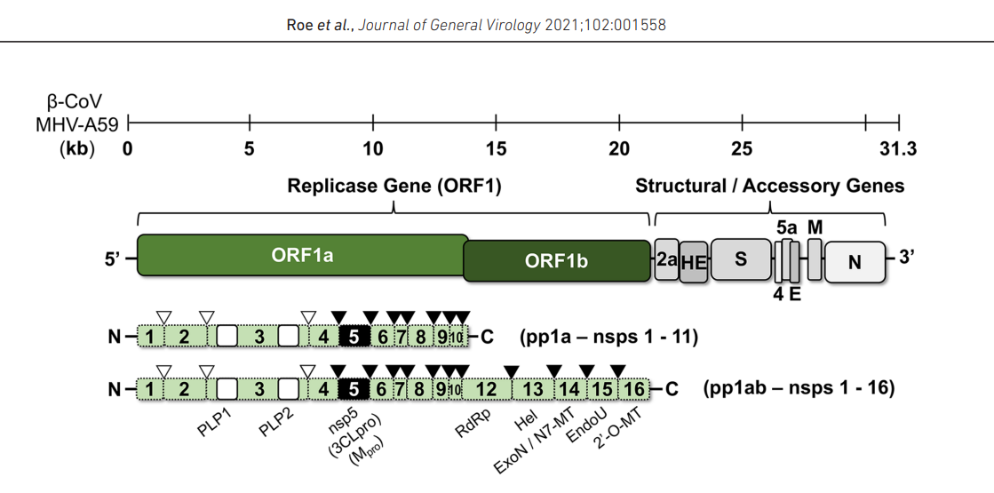
Graph 1 - A schematized viral genome of a beta strain containing about 31,3kB. The polyprotein regions (pp) or so-called opened reading frames (ORFs) are primarily represented in the viral genome for replicase genes serving, the fragments of which are defined as non-structural proteins or NSPs. The most appealing regions to impact are nsp5 and nsp12, which are crucial for viral replication. The structural genes encode for further purposes: spike (S), envelope (E), membrane (M), and nucleocapsid (N), and with auxiliary or accessory proteins among them. Source: [82]. (Roe et al., Journal of General Virology 2021;102:001558 DOI 10.1099/jgv.0.001558)

1.15.1. Receptor binding protein (RBD)
Viral spike protein is glycolyzed*, S1-Domain, ACE-2-recoognition, Furin, S2-Domain, TMPRSS2, cell and viral membrane fusion
The viral infection of SARS-CoV-type two begins with RBD and consists of two subunits, S1 and S2, respectively. They are non-covalently associated subunits. The S1 Subunit binds to ACE-2, and the S2 subunit anchors the S2-protein to the membrane. The S2-subunit possesses the fusion peptide and other molecular machinery needed to mediate membrane fusion upon invasion of a new host cell so the viral genome can enter the cytosol [9]. After contact with the spike protein, Furin cuts off accurately the outer part of the spike protein called the S1 domain, releasing the inner core of the spike protein called the S2 domain, which also gets cut by transmembrane serine protease 2 (TMPRSS2). After these, spike protein unfolds and anchors into the host cell membrane. Thus, the membrane of the virus and the host cell begins to fuse, which allows the viral genome to penetrate the cytosol of the host cell. A ribosome meets the viral RNA and initiates the translation of its genetic code. It results in a long protein chain containing non-structural proteins (nsps). NSPs are capable of cutting the neighboring chains. First, they release short naps, which are capable of grabbing onto a ribosome and occupying it so that the grabbed ribosome can read only the viral RNA and not its host cell messenger RNA (mRNA). From this very beginning phase, we can say that the infected host cell starts to be virus-building factories thanks to control over the cell translation machinery [14-15].
Fusion protein (FP): 1273 aminoacids (mRNA-vaccines) for ACE2-only cleavage with S2’ site is needed to liberate FP and let viral genome entry on host membrane unlike Influenza no pH-mediation.
S2’
SS
SD1/SD1
Graph 2 – The COVID-19 virus is the primary structure of the spike protein. Different domains are displayed in different colours. SS, single sequence; NTD, N-terminal domain; RBD, receptor binding domain; SD1, subdomain 1; SD2, subdomain 2; S1 / S2, protease cleavage site S1 / S2; S2', protease cleavage site S2'; FP, fusion peptide; HR1, heptad repeat 1; CH central helix; CD connection domain; HR2 - heptad repeat 2; TM - Transmembrane domain; CT - cytoplasmic tail. Arrows indicate the place of cleavage by protease. Note: the respiratory cells (lung cells) viral entry activation is mediated by the transmembrane protease serine 2 (TMPRSS2) that cannot be found in Vero kidney cells even though the SARS-CoV type two virus can be easily grown in them.

1.16. Drug antiviral activity.
The COVID-19 pandemic caused enormous global problems for national health care (NHC). The first response to such epidemical spread was how to treat the infected patients to ensure the clinical effect. People around the globe stormed the pharmacies to get paracetamol, which is effective against fever; others claimed anti-flu drugs, hoping to get the therapeutic effects, and some even bought out the antibiotics, considering that it would help too. Covid 19 is a single-stranded positive RNA (+) (ssRNA) coronavirus that attaches to the host cell receptor (ACE2) receptor via spike glycoprotein in a combination of surface protease (TMPRSS2). This virus relies heavily on replicase targets such as RNA–dependent RNA polymerase (RdRp), Helicase, Exonuclease, and Endoribonuclease. None of those mentioned above claimed drugs could handle the fast-increasing viral load and could bring neither therapeutic nor prophylactic (preventive) effects. Since then, scientists worldwide have launched a rally to find the best drug against anti-viral activity with replication-inhibiting features that could ease patients’ infections. Virus infections are complicated to fight without harming the host cells because the viral genome uses the cell host machinery to replicate and assemble into new copies. The viral load is entirely dependent on the assembly rates. For example, in COVID-19, one infected host cell can produce over 10,000 new coronaviruses until the cell bursts.
To understand how effectively to fight and treat the viral infection, we must embrace the viral life cycle of further stages: Attachment to the host (animal) cell receptor. Most animal-specific viruses have an additional lipid membrane called an envelope with protein spikes that serve to attach a target cell in the SARS-COV2 genome by the way they belong to the structural protein’s cohort. Viral entry (endocytosis, fusion). Release of genome (uncoating). Replication of viral genome. Proteins synthesis or processing, assembly. Release of new viruses.
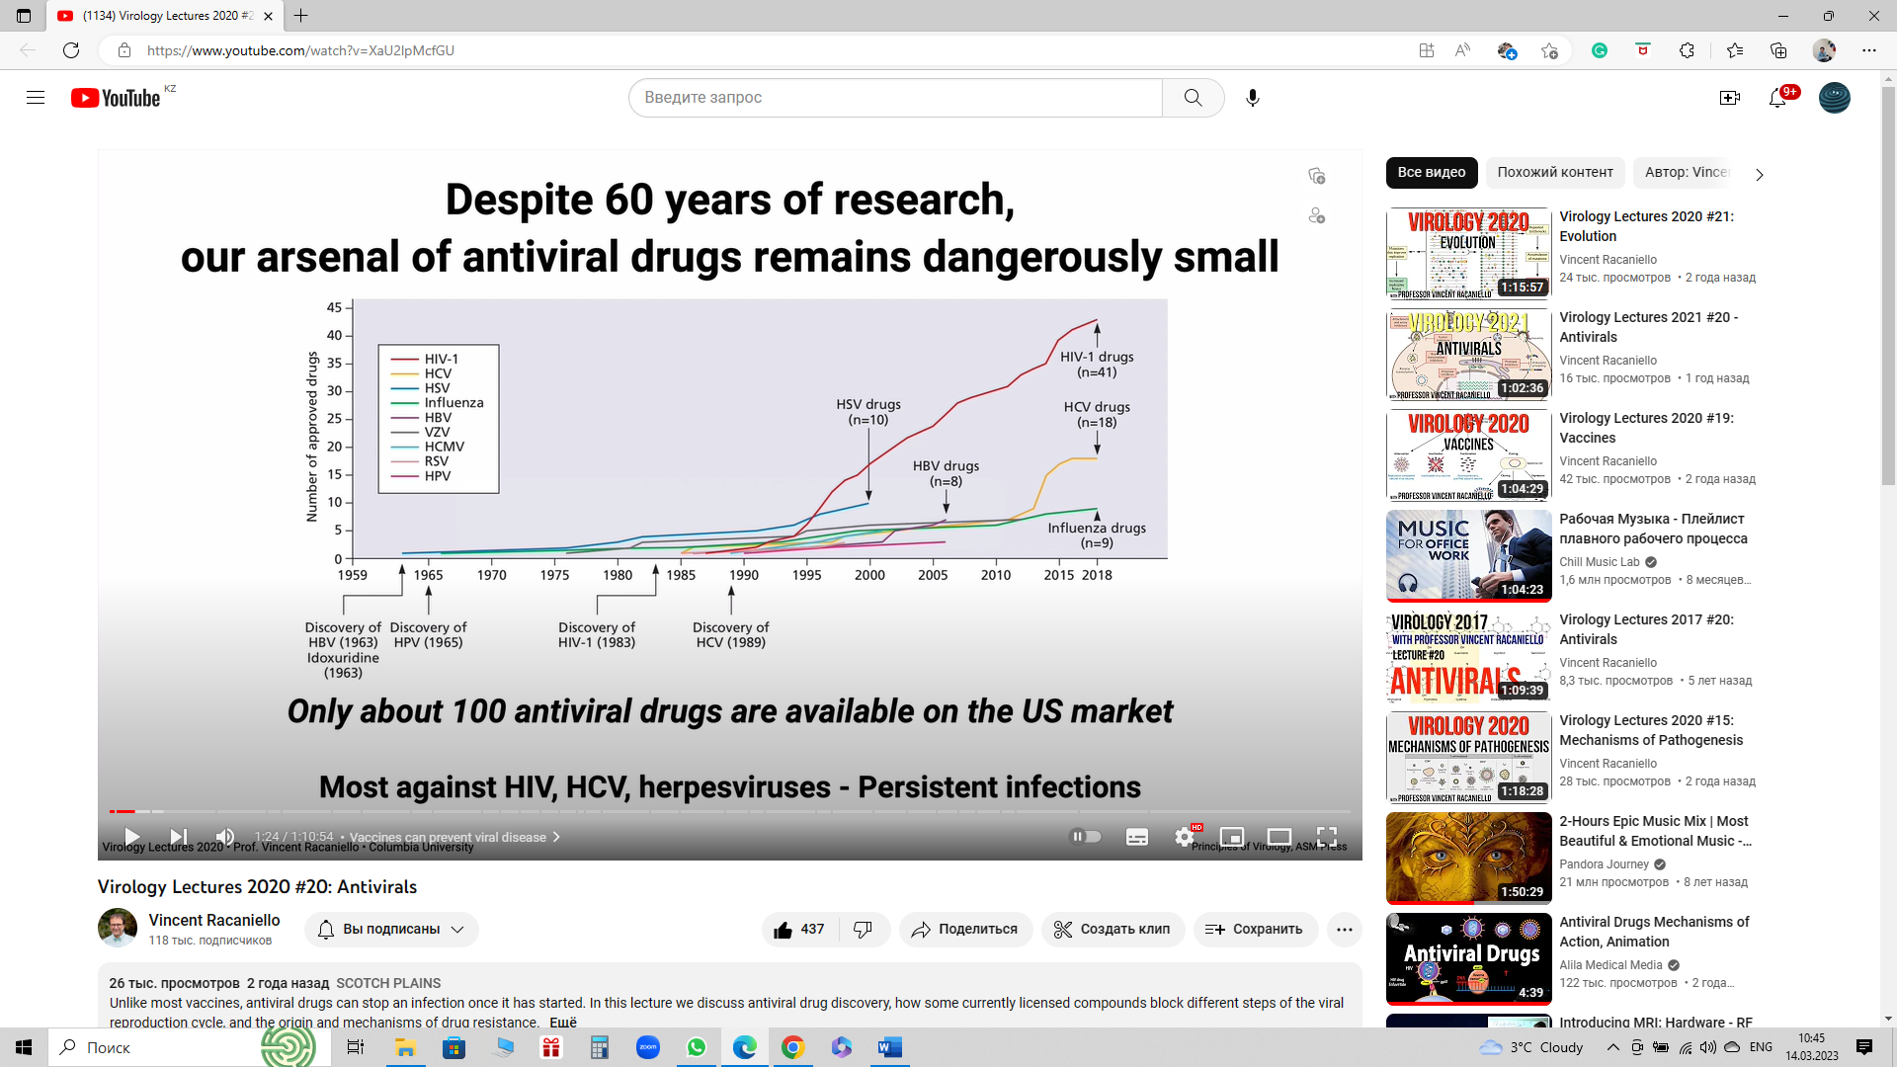
    - Antiviral drugs
Graph 3 - Represents almost 60 years of development of antiviral drugs in the USA since the early 60s in the 20th century; unfortunately, only with virus discoveries the research studies on antiviral drugs take place, allowing viral infection either to spread or adapt to human immunity and genome, causing the pharmacology industry many problems in strategy establishment to fight the viral invasion. Thus, only a few drugs were approved to fight them effectively. To make things worse, pharmacology and science were being aimed only against persistent viral diseases that require long and expensive therapy to drag down the viral load in host cells. Furthermore, viruses are difficult to treat without serious side effects. Source:https://www.cdc.gov/flu/professionals/antivirals/antiviral-use-influenza.htm, https://www.fda.gov/drugs, https://www.drugs.com/drug-class/antiviral-agents.html.

Graph 4 - In the last 60 years of development, most antiviral drugs were designed for long-term infection; only 43 antiviral drugs are against HIV alone. And it has not satisfied the trend for the last several decades. In addition, 75 antiviral drugs are interfering with the viral molecular machinery (proteins) and 13 against host ones. It would probably make more sense if antiviral drugs targeted host proteins because it is harder to get resistance thanks to the host DNA, which generates lower mutation rates. Source:https://www.cdc.gov/flu/professionals/antivirals/antiviral-use-influenza.htm, https://www.fda.gov/drugs, https://www.drugs.com/drug-class/antiviral-agents.html.
We are witnessing so few effective antiviral drugs for some reasons. First and foremost, compounds interfering with virus growth can adversely affect the host cell. This means side effects are common and, in most cases, unacceptable. In addition, every step in the viral reproduction cycle engages host functions.
Secondly, some medically and clinically important viruses cannot be propagated: there is no animal model, and they are too dangerous to work with. These viruses are commonly known as HBV, HPV, smallpox, Ebolavirus, Lassa virus, and Marburg virus.
Thirdly, a compound must block virus replication completely! It must be potent. Antiviral potent drugs cannot afford to block enzyme activity only partially as many standard pharmaceuticals can. Otherwise, we get antiviral drug resistance by mutated strains. And, of course, we should not forget the financial aspect – it is costly.
For many decades, antiviral medicine production has created four main groups. They are 1) Anti-influenza, 2) anti-HIV drugs, 3) Anti-hepatitis, and 4) Anti-herpes.
Favipiravir is pyrazine analog T-705 and a capable inhibitor of influenza viral RNA polymerase [83]. Favipiravir’s metabolite (Favipiravir RTP (ribofuranosyl 5’-triposhpate interacts with viral RNA-dependent polymerase (RdRP). It is assumed that the antiviral effect can be downgraded in the appearance of purine nucleotides ATP and GTP. In addition, this metabolite can be identified as a ‘false’ purine by the viral RdRp [84]. The previous in-vitro studies showed that SARS-COV2 Vero E6 infected cells had a tolerable cytotoxic response, namely half-cytotoxic concentration (CC₅₀) at 400µM and above [85]. Thus, it became clear that Favipiravir could be used at high concentrations as a safe and effective medicine against COVID-19 infection.
Ribavirin is a well-known antiviral drug with clear RNA and DNA replication interfering guanosine analog (Guanine triphosphate (GTP)). The RNA-polymerase is no single target. However, its structure prevents RNA capping during the RNA strand maturing, which is heavily dependent on natural guanosine that keeps RNA from degradation [86]. Some studies showed no significant cytotoxicity in the Vero cells model at 31.3 μg/mL ribavirin concentrations [87]. The clinical experience during the pandemic showed that the patients in worsening cases were given 400mg every 8 hours in addition to methylprednisolone administration to decrease the progressive viral load activity [88]. High specialization of ribavirin drug made doctors pair with either IFN-α2a or IFN-α2b (interferon) to cover the therapeutic threshold and stop viral replication [89]. In 2003, in Canada, ribavirin therapy with a dose of 500mg every 8 hours for 4-6 days long was also combined with a corticosteroid in 40% of SARS patients [90]. So, Ribavirin is a universal antiviral agent that could be taken solely or combined with antiviral compounds like interferon or excessive immune suppressors like corticosteroids in a worsening clinical dynamic.
Tenofovir belongs to both anti-HIV drugs and Antihepatitic drugs, according to the producer’s manual. Tenofovir represents the reverse transcriptase inhibitors, or nucleoside reverse transcriptase inhibitors (NRTIs), which are structural analogs of nucleic acids, adenosine monophosphate, which competitively inhibit the reverse transcription by causing the chain termination after they get involved in viral DNA. This viral DNA incorporation causes so-called ‘lethal mutagenesis.’ Tenofovir is also an antiviral drug against chronic hepatitis B as a nucleotide analog. Tenofovir inhibits the HBV (hepatitis B virus) polymerase by competing with natural substrate in cooperation with growing viral DNA-strand causing, as in HIV (human immune deficit virus) chain termination, subsequently stalls the reverse transcription and synthesis of viral DNA. Tenofovir is another nucleotide analog initially designed to inhibit the HIV (human immunogenicity virus) reverse transcriptase by interfering with the ATP-Polymerization in the growing nucleic acid chain [9,10]. Tenofovir was also assumed to be effective against COVID-19 as it showed the tendency to dock the RNA-dependent RNA-polymerase (RdRP) and silence its activity in replication as well as in transcription and translation of structural and accessory proteins, making virions assembly almost impossible [91]. Tenofovir, which is used in our study for oral administration medicine in the form of disoproxil format (TDF), has many side effects if it is used in high dosages, such as renal toxicity, bone density degradation, etc. [92]. In-vitro studies suggest that at concentrations under 100µM, tenofovir does not inhibit the viral replication in VeroE6 cells at multiple infections in a so-called preventive way when tenofovir was administered one hour before infection and up to 48 hours post-infection. In the discussion of results, researchers came to the idea that tenofovir in ATP-forms requires the activation by host kinase, and any cell type probably has the proper kinase activity to launch the tenofovir antiviral features. Try a study on human airway epithelial cells [93,95].
According to the medicine producer's manual, dexamethasone is a synthetic glucocorticoid (GCS), a methylated derivative of fluoro prednisolone. Provision of anti-inflammatory, anti-allergic, immunosuppressive action, increased sensitivity of beta-adrenergic receptors to endogenous catecholamines. The anti-inflammatory effect is linked to decreased capillary permeability, stabilization of cell membranes (especially lysosomal) and organelle membranes, inhibition of eosinophil and mast cell release of inflammatory mediators, induction of lipocortin formation, and reduction in the number of mast cells that produce hyaluronic acid. It acts on all stages of the inflammatory process: it inhibits the synthesis of prostaglandins (Pg) at the level of arachidonic acid (lipocortin inhibits phospholipase A2, inhibits the liberation of arachidonic acid and inhibits the biosynthesis of endoperoxides, leukotrienes, which contribute to inflammation, allergies, etc.), the synthesis of "pro-inflammatory cytokines" ( interleukin 1, tumor necrosis factor-alpha, etc.); increases the resistance of the cell membrane to the action of various damaging factors. The immunosuppressive effect is brought on by lymphoid tissue involution, inhibition of lymphocyte proliferation (especially T-lymphocyte proliferation), suppression of B-cell migration and interaction between T- and B-lymphocytes, inhibition of cytokine release from lymphocytes and macrophages (interleukin-1, 2; interferon gamma) [94]. And decreased antibody production. The antiallergic effect develops as a result of a decrease in the synthesis and secretion of allergy mediators, inhibition of the release of histamine and other biologically active substances from sensitized mast cells and basophils, a decline in the number of circulating basophils, T- and B-lymphocytes, mast cells; suppression of the development of lymphoid and connective tissue, reducing the sensitivity of effector cells to allergy mediators, inhibition of antibody formation, changes in the body's immune response. It is worth mentioning that 0.5 mg of dexamethasone is equivalent to roughly 3.5 mg of prednisone (or prednisolone), 15 mg of hydrocortisone, or 17.5 mg of cortisone, depending on the degree of glucocorticoid action. According to WHO data, dexamethasone should be used in severe cases of COVID-19, especially if a patient is dependent on live-supporting systems.
    - Effective doses of antiviral effect of Favipiravir, Ribavirin, and Tenofovir for humans (in vivo) for Vero E6 cells (in vitro)
Toxicity is defined as the amount or degree of a substance required to be poisonous. It depends on the amount and concentration involved, frequency of use, interactions of the person receiving the substance of interest, and individual reaction of the person [96].

Graph 5 -Since only Favipiravir, known in the market as Fabiflu, is a specialized medicine against SARS-COV2 infection, its dose is very high. It is designed to be administered within ten days for minor or moderate stages of COVID-19 infection. Unlike Fabiflu, Ribavirin, for instance, was designed to slow down hepatitis C replication for up to 72 weeks, taking a drug twice a day at least. Tenofovir is suggested to be manually taken once a day, with one tablet containing 300mg of tenofovir for an extended period under strict physician prescription and control according to the manufacturers’ manual and publications [83-95].
Effective doses of antiviral effect of Favipiravir, Ribavirin, and Tenofovir for humans (in vitro) Vero E6 cells

Graph 6 -Vero E6 model also shows the toxicity edge for monolayer cells tenofovir and ribavirin could be, and dose control plays a significant role not only in gaining absolute viral RNA/DNA replication silencing but also in minimizing the negative side effect impact on contacting cells and tissues.

  - Effective concentration and potency (EC₅₀, EC₉₀), concertation efficacy of three drugs (Inhibition activity)
Half maximal viable concentration (EC₅₀) may be a degree of the concentration of a medicate, counter-acting agent (e.g., antibodies), or toxicant that actuates a reaction midway (halfway) between the pattern and the most outstanding value after an indicated introduction time, saying it differently, EC₅₀ can be specified as the concentration needed to obtain a 50% drug, antibody or toxicant effect.

(1)

There is a comprehensive run of EC₅₀ (1) values of drugs; they are regularly at any value from nM to mM. Thus, it is frequently more common sense to allude to the logarithmically transformed pEC₅₀ values rather than EC₅₀. The term "potency" refers to the EC₅₀ value. The lower the EC₅₀ value, the lower the drug concentration required to achieve 50% of the maximal effect and the higher the potency. The EC₁₀ and EC₉₀ concentrations induce 10% and 90% maximal responses, respectively.
However, viral replication must be stopped utterly; even 90% of replication silencing or ‘breaking’ is not enough to achieve the therapeutic effect of antiviral medication. Thus, so-called old drugs like ribavirin and tenofovir are designed to be administrated for an extended period and in relatively moderate concentrations to inhibit the viral replication activity in host cells. Ribavirin and tenofovir are the antivirals for long-run drug therapy for primary purposes. Still, the increased concentration for ten days of prescribed therapy like favipiravir can be either a reasonable risk for a cheap and effective alternative or a ‘side-effect disaster’ for a chance to fight COVID-19, for instance, or influenzas. To make things worse, the effective concentrations (EC₁₀, EC₅₀, EC₉₀) measure was heavily criticized in 2003 due to its ‘vagueness’ [97].
To support the idea of the vagueness of this measure methodology, a study for antivirals' effectiveness as individual runs and as a drug combination was made in Japan to show how E₅₀ values span in vitro studies. The difference between minimum and maximum values is, on average, 40 times [98]. Thus, the values of E₁₀ and E₉₀ also demonstrated the wide range of ‘runaway’ values with data infirmity in their integrity.
To sum up, to fight the viral replicase of fast-developing SARS-COV2 (i.e., its intercellular spread), 100% silencing is required, and to gain this, physicians prescribe either high drug doses within ten days on average with a particular drug like T-705 (favipiravir) or a combination of medications like ribavirin with corticosteroids (such as dexamethasone), or even 300mg tenofovir daily up to one week period, yet not at critical phase of COVID-19 infection.
  - Lethal mutagenesis as a purpose

Almost all Nucleoside analogs increase the mutation rates so high that viral replication machinery synthesized in ORF1ab gets disturbed so critically that either the RNA subunits do not attach to RdRP-like Remdesevir does [108-109] or the direct inhibition of RdRP through coping false RNA strands is blocked, just like our discussed purine analogs: Favipiravir, Ribavirin, and Tenofovir [107, 114].
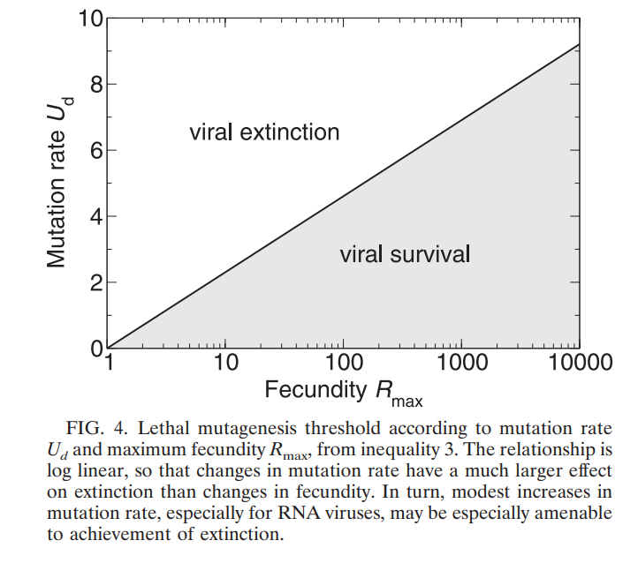
Graph 7 - The lethal mutagenesis characterization for virus existence and since any virus after entrance into the host cytosol consists of genetic information (mRNA), the deadly error rates in replicating itself plays a critical role so that the threshold line between extinction and survival is skinny and as proof-reading-important for viral survival as for pharmacology to target viral replicating machinery in a host cell. [104.] Source: Bull, J. J., Sanjuan, R., & Wilke, C. O. (2007). Theory of Lethal Mutagenesis for Viruses. Journal of Virology, 81(6), 2930–2939. doi:10.1128/jvi.01624-06. pp. 2937
As mRNA -Virus, COVID-19 has two ways to fight against: vaccination and drug intervention. The drug intervention of these antivirals is mostly bound with RdRP- inhibition to reach lethal mutagenesis of viral infection. When the viral genomic RNA (gRNA) ingests itself in the host cell, it has relatively unstable single-stranded positive genomic RNA that requires replicated as soon as possible to be able to replicate new genomic RNA for structural protein synthesis and assembly; furthermore, after replicating itself the ‘original’ genomic RNA craves to build the sub-genomic RNAs (sgRNA) via transcription, these sg-RNAs (with caped mRNA, as in eucaryotic cells) are essential for translation in expressing the structural proteins that go to viral assembly as well as newly replicated RNA. As a result, inhibiting or interfering with the viral replicase represents a serious arsenal in antiviral therapy that allows us to insert mutated gRNA or damaged gRNA into the assembly process, providing so-called extinction by a fatal error in the viral genome during and after replication [99,100,105].
    - The lethal mutagenesis of Ribavirin
As mentioned, ribavirin was invented roughly 40 years ago and showed antiviral efficacy in human and animal lines. As a guanosine analog, it goes to host kinase as ribavirin triphosphate and pairs with cytidine or uridine-triphosphate. It mimics the purine nucleobase, causing severe mutations during replicase and causing lethal mutagenesis as anti-viral therapy, reducing the viral load rates [99-101, 103]. In 2019, a new drug against influenzas had the same RdRP-inhibiting properties as ribavirin, and it showed promising results during the COVID-19 pandemic. Both drugs are nucleoside inhibitors. Unlike ribavirin, molnupirovir is a pyrimidine analog. It is worth mentioning that ribavirin is a much cheaper and more carefully observed drug than molnupirovir, demonstrating similar effectiveness. Nevertheless, during the pandemic crisis in 2003 and 2019, the treatment was combined either with other medications or so-called adjuvants like interferons and corticosteroids to achieve maximum outcomes from treatment, and ribavirin was a classic example of these combination lines with acceptable survival as well as recovery rates among mild and moderate patients with SARS and SARS-COV2 infection. [105, 111-112].
    - The lethal mutagenesis of Favipiravir
Favipiravir is another effective nucleoside -inhibitor with proven wide-spectrum viruses strongly relying on RdRP. In countries like India and Japan, favipiravir showed high rates of clinical effectiveness and relatively low cytotoxicity as well as side-effect potential. Along with ribavirin, it was mainly prescribed for mild or moderate patients with 9-14 days inpatient background. [102,105]. Favipiravir also has a good response on host RNA-dependent replicase kinase that enables favipiravir as an effective lethal mutagenesis causer not only in SARS-CoV2 populations but also against deadly Ebola, commonly known as influenza and terrifying rabies, which makes it asset as antiviral medicine [99-105, 91,110].

    - The lethal mutagenesis of Tenofovir
Tenofovir is the most cytotoxic drug on our antiviral drug list (only 300mg oral administration is allowed daily). It also belongs to the nucleoside inhibitor incorporating RdRP, making viral DNA synthesis unviable and slowing down virulence potential. Initially, it was designed against HIV and Hepatitis B viral invasion [103,105].
  - Steroids save lives in critical and severe cases of SARS-COV2 infection. Nevertheless, it has its cost – bone infarct development in long-term usage.
As it was already mentioned, the immune system in humans is responsible for the ‘overdefensive’ response to the viral invasion, causing massive tissue damage depending on age group, causing severe pneumonia as the ‘final act’ of immunity – the so-called ‘cytokinetic storm’ which probably was the main reason of lethal outcomes during Spanish influenza pandemic after WWI. All three antiviral drugs are clinically prescribed for patients with mild or moderate viral infection, reducing the viral load through lethal mutagenesis and enabling us to achieve viral extinction. In severe cases, doctors mostly take steroids to calm the overreacted immune response that could be lethal if it is not stopped, and here comes corticosteroids in combination with antiviral therapies like with ribavirin already in 2003. The antiviral effect was so highly effective that the WHO (World Health Organization) recommends dexamethasone as an additional and safe medicine to fight COVID-19 infection in mild and moderate patient care [91,106,113].
Before 2019, the steroids’ side effects were studied among many patients with passivated immunity. The bone infarct is mainly caused by the chronic appearance of immune passivation as well as during other health-destructive patterns like alcohol misusage and chronic smoking. The dose risk mostly starts from 500mg of corticosteroids of daily administration for 1-3 months [106]. However, the low doses, up to 100mg daily, showed a low risk, somewhere between 2-3%. The dexamethasone has a 4mg/ml interveinal administration protocol during the COVID-19 treatment, and only a physician decides on the effective dose. WHO recommends using 15-20mg a day in mild stages of infection as an auxiliary therapy option. But what happens with severe cases is still not clear, and everything is highly individual, and intense steroid therapy was inevitable to fight progressing pneumonia and other signs of acute COVID-19 complications [1.8,14,114].
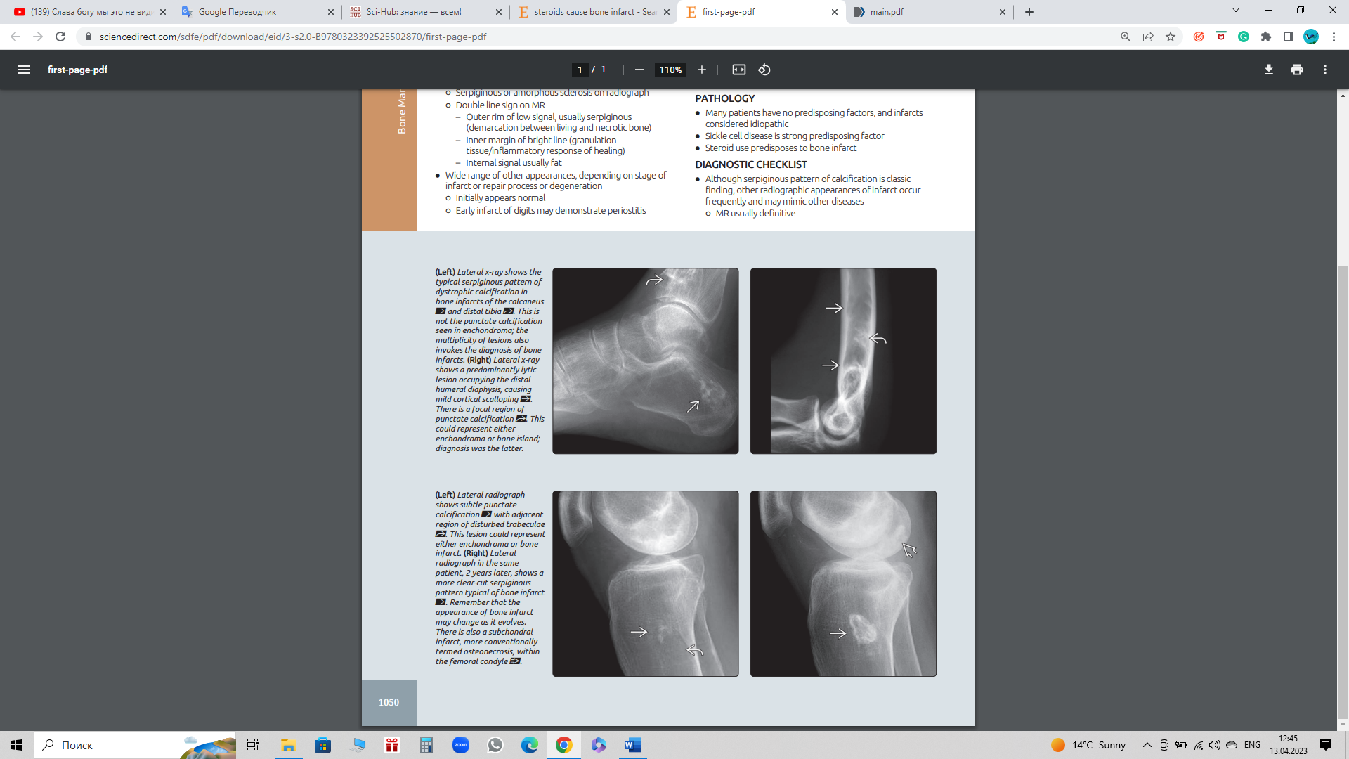
Graph 8 - The bone infarct x-ray image taken from the patient with an immune-passivation medical background. Source: https://www.sciencedirect.com/sdfe/pdf/download/eid/3-s2.0-B9780323392525502870/first-page-pdf
  - Influenza virus, a comparison with SARS-COV2
There are four types of influenza viruses: influenza A, B, C, and D, all of which differ in nucleoproteins and matrix proteins depending on their antigenic differences [115]. Influenza A virus A (IAV) is responsible for respiratory ailments. These unpredictable pathogens threaten human health and animals through continuous evolution, antigenic drift, and shift. The natural reservoir of IAV is aquatic wild birds, from which they can move to another terrestrial host, including terrestrial birds and mammals [116]. Influenza A, B, and C belong to the small virus family Orthomyxoviridae. Corona, the virus family, has a negative RNA segmented genome with continuous and step-by-step activation during the infection period that lasts up to 72h. Still, antiviral management is only effective within the first 48 hours to take the viral replication under the suppressed mode and reduce viral load intensity on innate and adapted immunity. Their primary characterization classification is the subtype of main surface glycoproteins HA- hemagglutinin and NA- neuraminidase. [117-118]. Influenza viruses have a standard terminology, like any widespread virus containing the virus type (A and C, respectively). The species from which it was isolated (if it does not belong to humans, for example, pigs or birds); the place where it was isolated (express PCR is required for identification - diagnosis of influenza infection); isolate number; year of isolation; and only for influenza A virus subtypes HA and NA. It is worth mentioning that by now, only 16 for HA and 9 for NA subtypes (variations) in every season circulating influenza A were found, among which only 3 HA (H1, H2, and H3) and only 2NA (N1 and N2) subtypes (mutated variations) have caused human epidemics, as confirmed by sustained, widespread, human-to-human transmission [119]. Thus, A/Kazakhstan, Almaty/2125/2024 (H3N2)-an example of a viral strain isolated ‘this year’ in Kazakhstan – the strain of profound concern. The same pattern could be seen in SARS-COV2 virus strains, which have multiple and various mutations of the so-called ‘sugar coat’ on Spike protein with the help of the mutated Spike protein strains named Gamma, Delta, Lambda, Mu, Omicron, etc. Since spike proteins enable the SARS-COV2 virus or rather a virion produced from infected host cells like hairy respiratory cells to hide from the innate (unspecified) immune system, spike protein mutations provide various features like higher virulence, more effective and robust vital enzymes and their supporting segments like NSP9 in RNA dependent RNA polymerase. Still, one glycoprotein segment remains unchanged in all variants of concern – the D416G.
Segmentary part of the genome | Segment length in nucleotides | Encoded protein(s) | Protein length in amino acids | Protein function
1 | 2341 | PB2 | 759 | mRNA cap recognition
2 | 2341 | PB1 | 757 | RNA elongation, endonuclease activity.
 |  | PB1-F2 | 87 | Pro-apoptotic activity
3 | 2233 | PA | 716 | protease activity
4 | 1778 | HA | 550 | Surface glycoprotein; major antigen, receptor binding, and fusion activities
5 | 1565 | NP | 498 | RNA binding protein; nuclear import regulation
6 | 1413 | NA | 454 | Surface glycoprotein; sialidase activity, virus release
7 | 1027 | M1 | 252 | Matrix protein; vRNA interaction, RNA nuclear export regulation, viral budding
Infl. B type | -N/A | M2 | 97 | Ion channel: virus uncoating and assembly
8 | 890 | NS1 | 230 | Interferon antagonist protein; regulation of host gene expression
 |  | NS2/NEP | 121 | Nuclear export of RNA
Table 4 - Influenza A/Puerto Rico/8/1934 (H1N1) virus and their encoded proteins: HA- hemagglutinin, NA- neuraminidase, M1 and M2-matrix protein, NS1, NS2 and NEP – non-structural protein, NP-nucleic protein, PB2, PB1, PB1-F2 accessory proteins. Source: N.M. Bouvier, P. Palese. The biology of influenza viruses // Vaccine. -2008.-Vol.265. P. 49–53¹¹⁸.
Overall, the Influenza A virus and SARS-COV2-virus as companions represent a severe threat to immune-compromised individuals and continuous challenges for physicians and pharmacies to find the optimal, effective treatment strategies and minimize, therefore, the post-covid/-influenza effect or period on patients and relatively healthy people. To make things worse, the influenza A virus diagnostics is not as rapid and seriously taken as the SARS-COV2 diagnostics in a cohort of treating doctors or among infected patients. Regarding Influenza A treatment, an infected person must take an anti-influenza drug like oseltamivir as soon as possible, not later than 48 hours after the first sickness signs occurred, to ensure effective and further (resulted) antibiotics treatment. The same applies to COVID-19.
  - Antigenic Shift in Influenza
Most viruses do not change if environmental, mental, and immunity factors do not stress them. So, it is relatively easy for our immune system to recognize them from one year to the next. However, Influenza virus A or B is different. The keys or glycoproteins (HA and NA) on its surface change with each generation, making previously matured Antibodies, mostly IgGs, useless. Each year, the influenza virus changes due to duplication, which ensures viral RNA or genome variability. This process runs gradually, making glycoproteins on the viral surface change, causing a gradual antigenic shift featuring the influenza genome, a so-called step ahead -mutations in antigen-antibody interaction confrontation. Nevertheless, these changes are seasonal effects primarily relying on weakened population immunity, and only relatively minor changes or glycoprotein changes are required to infect/reinfect the target host cell. The more deadly changes appear when inter-species sustained – antigenic shift takes place. Viruses are highly selective invaders; some attach birds’ lung cells only and ignore human lung cells; however, if a bird population is located among other species like mammals and birds- the virus adapts to, for instance, the pigs’ lungs and is capable of invading humans thanks to surface proteins matching or rather multiple matching properties of two glycoproteins (HA and NA). The hybrid set of surface proteins of the avian influenza virus, capable of penetrating both target cells of birds and target cells of pigs, poses a much more severe threat to humans than the "native" influenza virus because of antigenic drift that gets all complete changes or mutation variations of keys (HA and NA) at ones without gradual adaptation period, resulting a rapid and an unhindered spreading of new influenza virus in the host cells experiencing only innate and an unspecified immunity reaction that can lead to severe damage or life-threatening conditions, such as ‘cytokinetic shock’ or overwhelming uncontrolled viral load that also could cause ‘septic shock’ within few days after the incubation period. Moreover, most infected patients died from secondary bacterial infections. The deadliest registered pandemic was caused by this virus in 1918, killing over 400.000 people worldwide. Since antibiotics were not invented, most patients died from secondary bacterial infections that spread when the Influenza virus weakened the innate immune system [120-122, 123].

  - Influenza antiviral drugs

The COVID-19 outbreak revitalized the research interest in antiviral drug studies and accommodating seasonal viral infections like influenza A, B, and SARS (severe acute respiratory syndrome). This is not one specific disease but a whole group with different causative viruses but similar symptoms and course. SARS is usually called a simple cold and is not considered dangerous, especially in adults. However, the virus can cause serious complications, so there is no need to self-medicate. The cause of SARS can be any virus from a large group that includes more than 200 pathogens. These are adenoviruses, rhinoviruses, coronaviruses (several of them of varying degrees of danger), parainfluenza viruses, and other microorganisms.
Thus, it makes sense to talk about so-called Influenza-antiviral drugs. M2-ion channel inhibitors block the M2 channel and thereby restrict the passage of protons (H⁺), which are necessary to trigger the release of viral genes (vRNA) into the host cell: Amantadine and Rimantadine [116]. Another anti-influenza drug class is endonuclease inhibitors. The best-known drug of this kind is Baloxavir, whose direct purpose is to selectively inhibit the cap-dependent endonuclease, a higher-significance enzyme involved in initiating influenza virus mRNA synthesis. The intervention caused by Baloxavir prevents viral gene transcription and, therefore, the viral replication inside the host nucleus and cytoplasm. As we can see, unlike SARS-COV2 -replication, influenza is strongly dependent on cell nucleus-ribosome interactions. The last class of ant-influenza drugs is neuraminidase inhibitors. The active agents of this drug class exert their anti-viral activity by inhibiting the viral neuraminidase enzyme found on the surface of the viral particle. In the absence of intact neuraminidase, the virus loses its ability to cleave sialic acid and ability to escape the cell. Almost the same process has SARS-COV2-virus, which heavily relies on Spike-glycoprotein that also cleaves on surface membrane, but to ACE2-protein, to inter the host cytoplasm and thanks to complicated NSPs interactions and forming DMVs (double membrane vesicle) a safe place to assemble the viral components like newly synthesized genome packed with nucleocapsid protein viral RNA. Thus, unlike the Influenza virus, the SARS-COV2 virus can quickly leave a host cell in a ‘safe’ embedded vesicle form with all the necessary components to start a viral infection. The drugs that belong to neuraminidase inhibitors are Oseltamivir, Peramivir, and Zanamivir.
To sum up, the Anti-Influenza drugs have three classes of antiviral activity: a) M2-ion channel inhibitors, b) endonuclease inhibitors, and c) neuraminidase inhibitors.

1.23. M2-ion channel inhibitors

The antiviral drugs amantadine and rimantadine are M2-ion channel inhibitors, but the new strains of seasonal Influenza A virus started developing drug resistance against these widespread antivirals [124]. Amantadine (adamantane-1-amine) is primarily designed to fight Influenza A virus infection due to its ability to interfere with the viral M2 protein – the ion pore channel, interfering with viral replication in both mRNA synthesis and vRNA [124-126]. Rimantadine (α –methyl-1- adamantane methylamine hydrochloride) is as much an Amantadine's effective and relatively safe M2 inhibitor, primarily designed in the 1980s against spreading influenza A virus infection [127]. Process scheme 1 shows the entire interfering mechanics of the M2-ion channel on the viral membrane. In addition, amantadine has anti-inflammatory features that are already being used against virus infections like Hepatitis C in a combination of Ribavirin and synthesized interferon [126], even though seasonal occurring Influenza A and B virus in western countries like USA started to develop resistance towards M2-Protein inhibition, particularly, against amantadine as well as rimantadine [124]. In Kazakhstan or other post-soviet countries, neither studies nor any data are conducted and collected on any anti-viral resistance tendencies. Still, amantadine and rimantadine are cheap and effective antivirals against flu clinal manifestations (symptoms). They can also be used with decent and inexpensive medication strategies against other viral infections whose replication machinery depends on acidification processes. I may claim that these M2-ion inhibitors would show high efficacy in Kazakh populations due to lower anti-viral drug pressure for a decade at least [128].

1.24. M2-ion channel inhibitors against COVID-19

When SARS-COV2 gained a pandemic scale, physicians and researchers worldwide started to use and study the so-called ‘time-proven’ antiviral drug arsenal, among which amantadine and rimantadine became an attempt to stop viral spreading both within individuals and populations as a therapy strategy.
Since the M2-or Matrix 2 protein is a surface protein, the SARS-COV2 -Spike protein could be inhibited as the M2-surface protein was administered with the help of amantadine. Firstly, amantadine is expected to have an antiviral effect on SARS-COV2-replication by blocking a 5-α-helix channel well known also as the “viroporin channel” in a hydrophobic region of the intramembrane region of COVID-19 [126, 129]. Secondly, some assumptions (hypotheses) showed that amantadine can down-regulate and inhibit the unfunctional state of the expression of cathepsin L (CTSL) and other lysosomal enzymes. These two mechanisms have been proposed as potentially significant in interfering with and hiding the ability of the SARS-CoV2 virus to enter the target cells and the virus replication [130].
Amantadine and rimantadine were studied in vitro on veroe6 cells and showed remarkable results. Both the use of amantadine and rimantadine and the combinations of redeliver + amantadine, redeliver + rimantadine, and only rimantadine inhibited SARS-CoV-2 infection, mainly at the viral level after in vitro infection [131].
To sum up, M2-Ion inhibitors were in active use in Western countries to fight not only seasonal outbreaks of Influenza type A and B viruses but also as an additional treatment against other viral infections like Hepatitis C and, of course, since the emergence of COVID-19, against SARS-COV2 virus too. The viral interior of Influenza A and B and SARS-COV2 are relatively similar; the RNP machinery of replication activation resembles, to some extent, the nucleocapsid protein functions of SARS-COV2-virus that hold together the 30K nucleotides long RNA genome. According to some studies, the M2-ion channel inhibitors are primarily potent against the Influenza A-type and show only partial antiviral effects on the Influenza B-type. Thus, the primary purpose of antivirals remains ineffective; viral replication does tolerate even 90% of damage caused by antivirals, which has often been confirmed since the 1980s.

Early endosomal pH ~6
H⁺/H₃0⁺

Amantadine and Rimantadine blocks the pore of M2-channel preventing vRNA from Acidification

M2-protein
M2-Ion acidification:
At least 2 steps

Late endosomal pH ~5
The viral interior

M2-Protein

M1-Protein
M1-Protein

Acidification weakens electrostatic interaction between M1 and RNP complexes

Viral RNA with 8 segments (type A and B), ~14K Nucleotides and 11 expressed proteins

RNP

Process scheme 1 - The M2-M1-proteins activity to enable viral RNA to be sent into the cell cytosol. The importance of acidification by M2 protein is paramount. The very viral genome replication starts from M2-acidic activation, without which neither infection nor further viral genome implementation makes a little sense. Thus, for many decades M2-inhibitor like amantadine and rimantadine, which block/bind directly to the pores of the M2 protein channel and prevent the replication of the viral genome - while RNP is transported to the target nucleus (lung cells), viral RNA and mRNA-mRNA are produced [125], and then the main proteins of the viral membrane: HA, NA, and M2 are translated from the replicated viral mRNA and carefully inserted into the endoplasmic reticulum (ER). Then, the Golgi trans network (TGN) is transported to the cell surface, and the virus's life cycle is completed.
1.25. Endonuclease inhibitors (Baloxavir)
Baloxavir is a prodrug of Baloxavir marboxil – a source of bioactive Baloxavir acid that inhibits the cap-dependent endonuclease, which is crucial for the synthesis of viral mRNA and then for viral replication [132-136]. The RNA-dependent RNA polymerase in influenza A and B is called the viral ribonucleoprotein complex [137]. These complexes replicate both viral mRNA to produce the necessary proteins and to create a viral genome for virions. The RNA-dependent RNA polymerase of influenza A and B has three unique functional subunits: acid polymerase protein (PA), the main protein of polymerase 1 (PB1), and the main protein of polymerase 2 (PB2) [138]. The protease activity must be triggered quickly and accurately to bind to the 5'-mRNA capsule to begin the replication of the viral mRNA and to translate viral nucleoproteins with its help. Interestingly, the host mRNA mechanism is actively involved; viral RNA has only primers to initiate the replication of viral mRNA, which, in turn, is converted into proteins for further structural purposes. Thus, nucleoside analogs can also have a seriously negative impact on viral genome fitness, causing fatal errors disabling Influenza A and B to replicate the mature RNA, and their combination with Baloxavir represents pharmakinetical and bioactive (di-phosphate as well as tri-phosphate -residues activity) inhibiting interest.
1.26. Endonuclease inhibitor – Baloxavir against COVID-19
Baloxavir is a potent drug against Influenza A and B viruses, showing low levels of cytotoxicity and drug resistance by 2024 [134]. In addition, it is usually prescribed to infants before the age of 12 and shows low side-effect ministrations and, therefore, could be used as a prevention drug against seasonal influenza A and B strains. The prevention makes sense because, generally, antiviral drugs are effective in the first 48 hours as potent drugs to stop the initial viral spread against influenza A and B virus, and Baloxavir is no exception. Furthermore, the antiviral drug administrations must be seriously monitored to avoid persistent drug resistance among viral infection circulation variants yearly [132-138].
Baloxavir and Favipiravir are novel antiviral drugs and the safest ones in invitro and clinical studies. Favipiravir can also inhibit the polymerase essential protein 1 in influenza RdRP-complex [139]. Unlike flu infection, SARS-COV2 has about 7-10 days before antiviral drugs can be potent. The new Fabiflu 400mg tablets, along with Baloxavir 40 and 80mg, subsequently represent an effective combination against seasonal Influenza A and B and the SARS-CoV2 -virus variant of concern, especially for children and people with compromised immunity.
1.27. Neuraminidase Inhibitors (oseltamivir)
Finally, the last group of Influenza antiviral drugs specifies the most fundamental enzyme of Influenza A and B – the neuraminidase located on the surface of viral particles [140]. The inhibition of this enzyme represents paramount importance against the spread of the flu virus, regardless of whether it is influenza A or B type. In sharp contrast to M2-Ion channel inhibitors, the neuraminidase inhibitor (oseltamivir) is potent in stopping viral spreading in Influenza types A and B. The type B virus does not have M2-protein, and drugs like amantadine or rimantadine shows no clinical effect if patients have Influenza B virus infection [141]. The neuraminidase inhibition mechanism takes place in the terminal stage of virion assembly inside the host cell; without the active neuraminidase enzyme, the newly produced virus cannot cleave sialic acid and, therefore, is unable to escape from the infected host cell in the respiratory tract [140]. The oseltamivir is antiviral agent. It is a prodrug whose active metabolite (oseltamivir carboxylate) selectively inhibits neuraminidase of influenza virus types A and B. Neuraminidase is a glycoprotein that catalyzes the cleavage of the bond between terminal sialic acid and sugar, thereby this facilitates the spread of the virus in the respiratory tract (the release of virions from an infected cell and penetration into epithelial cells of the respiratory tract, preventing inactivation of the virus by epithelial mucus). Oseltamivir carboxylate acts outside cells and competitively inhibits viral neuraminidase. It suppresses the growth of the influenza virus in vitro and suppresses the replication of the virus and its pathogenicity in vivo. Reduces the release of influenza A and B viruses from the body [142]. According to the last studies, oseltamivir shows maximum clinical effect within 36 hours in the 48-hour infection period and seriously reduces any symptomatic signs during on-time- treatment [143].
To sum up, oseltamivir 75mg can be used as a prevention medication as much as baloxavir 40mg during the seasonal influenza outbreak, showing relatively low antiviral resistance resilience, baloxavir only 1% and oseltamivir 2%, respectively. Both drugs are safe and effective against Influenza A and B types and can be used among vaccinated and immune-compromised individuals during the so-called flu season.
1.28. Neuraminidase Inhibitors Oseltamivir- against COVID-19
The combination treatment with Oseltamivir-antiviral drug as an additional (complementary) drug with Ribavirin (1200 mg/daily) showed a relatively high positive therapeutical effect in clinical trials in COVID-19-positive patients in mild and severe stages of disease progression that seriously increased the recovery and survival rates among patients [144]. Numerous studies in China during the pandemic showed that three antiviral drugs, remdesivir (nucleoside analog), oseltamivir, and zanamivir (neuraminidase inhibitor too), have high higher molecular binding energies with ACE2-receptor after molecular coupling procedures. Thus, the sialic acid enzyme inactivation activities interfere with the SARS-CoV2 entry by silencing the ACE2-receptor on the host cell membrane [144]. It is also worth mentioning that oseltamivir has the property to regulate the neutrophil immune cell migration and their activation seriously decreasing the chance of developing sepsis and other overreaction -neutrophil-related cell damage during COVID-19 progression both in humans and mice respiratory tract via ROS-production in target cell [144,145].
Overall, the neuraminidase enzyme inhibitor – oseltamivir shows a broad spectrum of antiviral activity, especially during seasonal Influenza A and B outbreaks as prevention therapy and a cellular immune response during mild and severe stages of COVID-19. The oseltamivir carboxylate outside the cell acts as immunoglobulin that seriously jeopardizes the further spreading of the virus without additional immune response and does not mitigate the secondary or active immunity functions. In addition, the antiviral drug – oseltamivir has a relatively low viral resistance percentage, about 2%, and in Kazakhstan, maybe even lower. Generally speaking, all Influenza antivirals make great medication backup strategies for clinicians because the discussed drug types, in most cases, are safe and primarily treat Influenza A and B, whose incubation period or efficacy threshold or anti-viral effective window is potent first 48 hours, whereas SARS-CoV2 has 7-10days to be treated effectively by anti-viral active drugs with various combination options. The SARS-CoV2 treatment combination with oseltamivir can onehandedly substitute the Dexamethasone adjustment in severe cases of COVID-19 dynamics in ICU (intensive care unit) departments.

- Methods and materials

  - The biological samples (bronchial fluids from mid and heavy patients)
They are taken from sick patients (cotton swabs: nasotracheal swabs) during the COVID-19 massive spread of COVID-19 through their consent in favor of scientific research from the Scientific and Practical Center for Sanitary and Epidemiological Expertise and Monitoring, Almaty. Strain: SARS-CoV-2/human/KAZ/B1.1/2021and kept in freezers at -96C⁰.
  - Viral RNA isolation
The mRNA isolation is a crucial method in molecular biology for removing messenger RNA (mRNA) from cells or tissues. This extracted mRNA is frequently utilized for downstream processes, including RNA sequencing, qPCR, and reverse transcription for cDNA synthesis. Because it enables researchers to examine gene expression under specified conditions at a given moment in time, mRNA isolation is significant.
Total RNA is isolated using various techniques: Phenol Chloroform extraction: This traditional method uses Trizol (phenol-chloroform), where RNA is separated from DNA and proteins based on their solubility. The RNA remains in the aqueous phase and is precipitated using isopropanol. Silica-Based Column Purification: Kits are available for fast RNA isolation (e.g., Qiagen RNeasy) using silica membranes that selectively bind RNA in the presence of certain buffer conditions.
Since total RNA includes other forms like rRNA and tRNA, mRNA is typically only 1 - 5 % of total RNA. Two main methods enrich mRNA: Oligo -dT Beads: These beads are coated with oligo (dT) sequences that bind eukaryotic mRNAs' poly - A tail. Non-polyadenylated RNAs (rRNA, tRNA) are washed away, leaving enriched mRNA. Ribosomal RNA Depletion: In cases where poly - A tails are absent (in prokaryotes), specific kits or methods are used to remove rRNAs, enriching the mRNA fraction.
According to the manufacturer's instructions, viral RNA was isolated from virus-containing material (nasotracheal swabs) using the QIAamp Viral RNA Mini Kit, Qiagen: For 50 RNA preps: 50 QIAamp Mini Spin Columns, carrier RNA, Collection Tubes (2 ml), RNase-free buffers.
The QIAamp Viral RNA Mini Kit and QIAamp Viral RNA Mini QIAcube Kit simplify viral RNA purification from cell-free body fluids with fast spin-column, vacuum, or automated procedures. The QIAamp 96 Viral RNA Kit simplifies viral RNA isolation from nasotracheal swabs.
No phenol-chloroform extraction is required. Viral RNA binds specifically to the QIAamp silica membrane while contaminants pass through. PCR inhibitors, such as divalent cations and proteins, are completely removed in two efficient wash steps, leaving pure viral RNA to be eluted in either water or a buffer provided with the kit.
QIAamp RNA technology yields viral RNA from cell-free body fluids ready for RT-PCR and blotting procedures. QIAamp sample preparation technology is fully licensed.
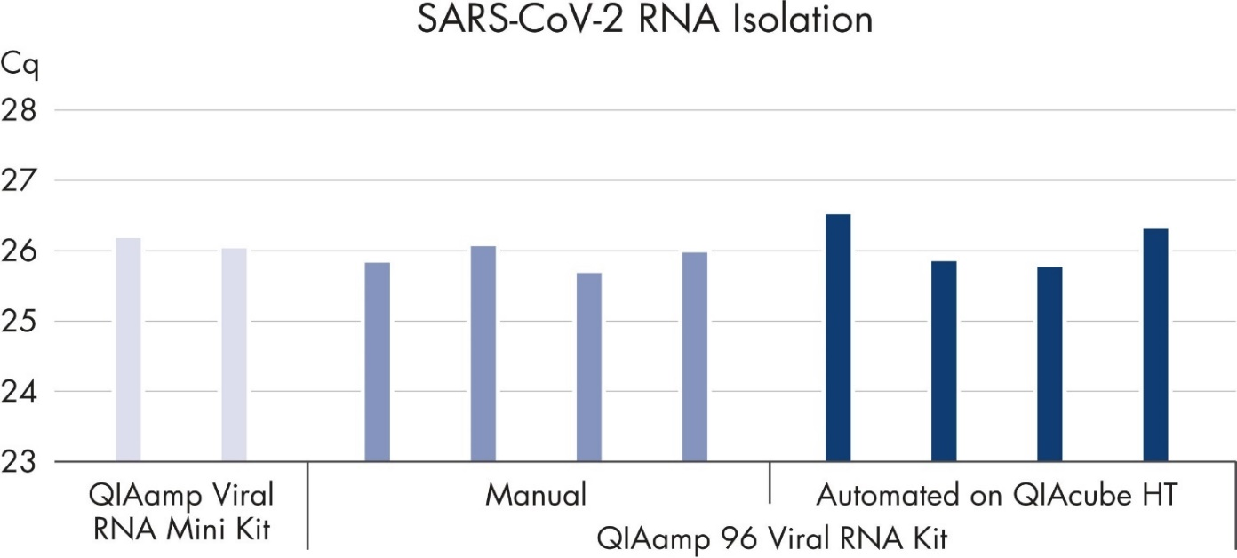Figure X-manufacture’s ensuring of viral RNA Mini Kit efficacy in quantity. Source: https://www.qiagen.com/us/products/diagnostics-and-clinical-research/sample-processing/qiaamp-viral-rna-kits
2.3. Selection and synthesis of primers
The primers were designed with various computer programs, mainly Oligo 6 and Vector NTI Suite 10. The reaction composition and the temperature-time regimes were selected according to the annotation attached to the enzyme and the properties of the primers. The designed primers were synthesized on the H-16 oligonucleotide synthesizer (manufactured in Germany) according to the instructions attached to the device. The elution of synthesized primers from the columns was carried out with a concentrated ammonia solution. The primers were then dried on a rotary evaporator and purified by alcohol precipitation.

2.4. Conducting PCR
A set of superscribed III One-Step RT-PCR with platinum Taq, Invitrogen, was used to perform the PCR. The reaction composition and the temperature-time regimes were selected according to the annotation attached to the enzyme and the properties of the primers. Techne produced specific DNA sites using a GeneAmp PCR 9600 thermal cycler, Applied Biosystems, and TC512. Further detection of amplification products was carried out in the device for horizontal electrophoresis "G-100", manufactured by Pharmacia. For electrophoresis, a 1% solution of agarose in TA was used. The results were visualized and recorded with the "Quantity One" program. "DNA Ladder 1 kb" from Invitrogen was used as a comparative marker for molecular weights.
The SuperScript III One-Step RT-PCR System with Platinum Taq High Fidelity is designed for convenient end-point detection and analysis of RNA molecules by one-step RT-PCR. This one-step formulation allows cDNA synthesis and PCR amplification in a single tube using gene-specific primers and target RNAs from either total RNA or mRNA. It also provides for detecting a wide range of RNA targets (up to 10 kb in length) at variable concentrations (1 pg to 1 μg of total RNA). This system has two major components: SuperScript III RT/Platinum Taq High Fidelity enzyme mix and 2X reaction mix.
2.5. Gene sequencing
The AMPure XP bead-based reagent performs DNA cleanup steps in different genomic applications, such as sequencing, qPCR/ddPCR/PCR, microarrays, and other enzymatic reactions. This reagent utilizes an optimized buffer to selectively bind DNA fragments 100 bp and larger to paramagnetic beads. Excess primers, nucleotides, salts, and enzymes can be removed by simply washing (the detailed protocol is available: https://www.beckman.com/reagents/genomic/cleanup-and-size-selection/pcr/ampure-xp-protocol).
Viral RNA and DNA are isolated using a set of QIAamp virus RNA and triazole reagents according to the manufacturer's instructions. The RNA is eluted with water, two times 40 µl each. Given the fact that the entire genome of the SARS-COV-2 virus includes about 30 thousand nucleotides, a set of primers is used to amplify the whole genome for sequencing. PCR is performed using a set of single-stage RT-PCR elevated III systems. Cleaning of PCR products is carried out using the AMPure kit according to the manufacturer's instructions. The quality of PCR products is checked by electrophoretic analysis. PCR sequencing products were obtained using the BigDye® Terminator v3.1 cyclic sequencing kit. The purification of the sequencing reaction was carried out with the Clean Seq Kit. The sequencing is carried out on 16 capillary sequencers of the genetic analyzer 3130xl (Applied Biosystems / Hitachi). Genomic assembly, genome annotation, comparative genomics, and phylogenetic analysis were performed using the CLC Genomic Workbench 11.0.1 program. Genome-wide sequencing of ILT strains using the new generation NGS sequencing method, the Ion GeneStudio™ sequencer. The S5 system is bundled with the Ion Chef SmartStart system.
2.6. Comparative and phylogenetic analysis of the nucleotide sequence of genes
The available complete genomes of the SARS-COV-2 virus downloaded from the Genbank are used for the full analysis. Phylogenetic trees were created using the maximum similarity method on the CLC Genomics Server 12.0 using the "neighbor Joining" method and the Jukes-Cantor model with gamma distribution 1.0 and 100 replications to assign confidence levels to branches. The MEGA 7.0 application is also used for phylogenetic analysis.
2.7. Determination of cytotoxicity of drugs for cell culture.
Dexamethasone, Ribavirin, Tenvir, and Fabiflu were selected to study antiviral activity against the SARS-CoV-2 virus. Before determining the antiviral activity, a working dose was established that did not cause toxicity to cell culture. Dexamethasone was used in ampoules containing 4 mg/ml in 5 dosages (20, 16, 12, 8, and 4 mg/ml).
2.8. Dose escalation in vitro.
1Х (4мг/мл) DEX. 1мл  10 µM | 2Х в 10 ml  20 µM | 3Х10 ml 30 µM | 4Х10 ml  40 µM | 5Х10 ml  50 µM | Control
1Х 1300 µM (200мг/мл) FAV 1мл | 2Х10ml  2600µM | 3Х10 ml  3900µM | 4Х10 ml  5200 µM | 5Х10 ml  6500 µM | Control
1Х 820 µM (200мг/мл) Ribo. 1мл | 2Х10 ml  820µM | 3Х10 ml  1640µM | 4Х10 ml  2460µM | 5Х10 ml  3280µM | Control
1Х (300/мл) Teno. 1мл 1045µM | 2Х 10 ml  2090µM | 3Х10 ml  3135µM | 4Х10 ml  0 | 5Х10 ml  0 | Control
1day | 1day | 1day | 1day | 1day | 1day
Table 5- The CC-test (cytotoxic test) of 4 drugs in rising stock concentrations and the exposure time with a control for each drug on E6-vero cells (24wells assay). The manufacturer or local distributors deliver the medications in stock concentrations in water-soluble agents.

2.9. The vero cells E6
Vero C1008 [Vero 76, clone E6, Vero E6], from African green monkey kidney, by Sigma Aldrich. Vero cells are derived from an African green monkey's commercial kit of kidney tissue. These are anchorage-dependent cells that have applications in molecular and cell biology research.[106] Vero E6 cells enable high titers of severe acute respiratory syndrome coronavirus (SARS-CoV 2 virus) [107]. Split sub-confluent cultures (70-80%) 1:3 to 1:10, i.e., seeding at 1-3x10,000 cells/cm² using 0.25% trypsin or trypsin/EDTA; 5% CO₂; 37 °C. The Vero cells are 50% susceptible to SARS-CoV type two virus infection and 100% permissive, i.e., can support the viral replication inside. Thus, this type of cell culture is justified to use as an in-vitro model in our thesis work.
  - The culture medium
Dulbecco′s Modified Eagle′s Medium (DMEM) - high glucose, with 4500 mg/L glucose, sodium pyruvate, and sodium bicarbonate, without L-glutamine, liquid, sterile-filtered, suitable for cell culture.
DMEM (D6546) + 2 mM L-Glutamine (G7513) + 10% FBS / FCS (F2442-Fetal Bovine Serum): DMEM with 2% bovine serum and 0,1% (100U/ml) antibiotics (Penicillin-Streptomycin) was prepared.
2.11. The virus preparation and safety procedures
An isolate of the SARS-CoV-2/human/KAZ/B1.1/2021 strain was passaged in Vero E6 cells to establish a high titer stock in all our experiments. Since SARS-CoV-2 is classified as a high-risk pathogen in Kazakhstan, all procedures performed with the virus, including infecting cell lines and their further supervision in the BSL-2 (Biosafety level) class laboratory. All direct manipulation with either viral titers or growth active virus strains in biological tissues is gained from human biomaterials under BSL-3 bio lab conditions by Burashev Yerbol since only he has this type of clearance to work in such strict and protocolized conditions to exclude any containment breach of biohazard materials.
2.12. Biosafety Level 2 (BSL-2)
Biosecurity level 2 (BSL-2) applies to all laboratories working with pathogens associated with human diseases, that is, pathogenic or infectious organisms that pose a moderate health risk. Common examples of pathogens in the BSL-2 laboratory are equine encephalitis viruses, HIV, and staphylococcus aureus (staphylococcal infections).
As mentioned above, BSL-2 labs must maintain the same standard microbial practices as BSL-1 labs and enhanced measures due to the potential risk the microbes pose. Personnel working in biosafety level 2 laboratories are expected to take even more excellent care to prevent injuries, such as cuts and other breakage to the skin, as well as ingestion and mucous membrane exposures.
In addition to the safety protocols established for BSL-1 laboratories, the following safety controls are applied in BSL-2 laboratories:
The use of PPE, including laboratory gowns, gloves, eye protection, and in some cases protective masks
All procedures that may lead to contamination by aerosols or splashes should be carried out in a biosafety workbench.
Infectious material should usually be disinfected with an autoclave before disposal
Self-closing lockable doors
Access to the washbasin and eyewash area
Warning signs of biological hazards.
Access to the biosafety level 2 laboratory is much more limited than the biosafety level 1 laboratory. External personnel or people at increased risk of infection are often not allowed to enter the premises during work [source: Biosafety Levels 1, 2, 3 & 4: What’s the Difference? (consteril.com)]
2.13. Dose-de-escalation in vitro
The 24 wells with vero E6 cells were filled with further drug concentration patterns: Favipiravir concentrations were: 1270µM, 318 µM, 127µM,12,7µM,1,27µM, 0,127µM and control Ribavirin concentrations were: 820µM, 205 µM, 82µM,8,2µM,0,82µM, 0,082µM and control Tenofovir concentrations were: 1050µM, 174µM,10,5µM,1,5µM, 0.105µM and control. Dexamethasone concentrations were 10µM, 20µM,30µM, and control and then were transferred to the 5% CO2 incubator at 370C for 48h. According to the manufacturer's instructions, viral RNA was isolated from virus-containing material using the QIAamp Viral RNA Mini Kit, Qiagen. An isolate of coronavirus infection was used as an object of research.
2.14. CCK8 test for cell-viability in 4 drugs of concentration 50µg/ml
The CD8-Kit-8 (KK-8) enables sensitive colorimetric analyses to determine the viability of cells in the study of cell proliferation and cytotoxicity. The dojo-tetrazole salt, WST-8, soluble in water, is restored in the cells by dehydrogenase activity, forming a yellow formazan dye, soluble in a medium for tissue culture. The amount of the dye formazan, formed due to the activity of dehydrogenases in cells, is directly proportional to the number of living cells. Step 1: Add 10 Pl of Cell Counting Kit-8 to each well in a 96-well microplate. Step 2: Place in a CO2 incubator for 1-4 hours to react. Step 3: Measure the absorbance at 450 nm with a microplate reader.
2.15. Equipment
- oligonucleotide synthesizer H-16, K&Laborgeraete, Germany;
- thermal cycler GeneAmp PCR System 9600, Applied Biosystems;
- thermal cycler TC-512, Techne;
- thermal boards DryBlockHeater, Techne;
- shakers, vortexes Vortex-Genie 2 Shaker, Cole-Parmer;
- automatic micropipettes, Eppendorf;
- apparatus for electrophoresis of nucleic acids G100, Pharmacia;
- gel documenting system “BioRad,” USA;
- microcentrifuge “MiniSpin”, Eppendorf;
- refrigerator – 20 °C;
- a package of application programs for analyzing DNA sequences: DNASYS MAX 1.0, Sequencher, Vector NTI, BioEdit, GENEDOC, and Staden package.
- microplate reader OD (optical density) Plate Verification instrument for Hipo MPP-96, BioSAN
2.16. Materials, reagents, and solutions
- Recombinant Taq DNA Polymerase 5000 unit/mL, SIGMA.
- T4 DNA Ligase;
- ProtoScript® II First Strand cDNA Synthesis Kit;
- RNAZap decontamination solution;
- Super Script IV One-Step RT-PCR System with Platinum Taq DNA Polymerase (Invitrogen, USA) (100 reactions);
- 310 and 31xx Running Buffer, 10X;
- BigDye™ Terminator v3.1 Cycle Sequencing Kit, 100 reactions;
- Reagent for safe staining of agarose gel SYBR Safe DNA gel stain;
- UltraPure™ nuclease-free distilled water;
- Microcentrifuge tubes, 1.5 ml, 500 pcs. pack; Eppendorf;
- Microtubes 0.2 ml with flat cap 1000 pcs/pack Tubes, 0.2 mL, flat cap 1000/pc Eppendorf;
- Microtubes 0.5 ml with flat cap 1000pcs/pack Tubes, 0.5 mL, flat cap 1000/pc Eppendorf.
- Cell Counting Kit -8 [product code: CK04]

2.17. Production of virus fragments by PCR
For two-thirds (~ 70%) of the genome sequencing of SARS-CoV-2 virus variants, the total RNA was successfully isolated from virus-containing material, followed by reverse transcription (cDNA) according to the manufacturer's protocol. Amplicons of the ORF1ab gene of variants of the SARS-CoV type two virus, obtained through classical PCR, were then loaded into a 1.0% agarose gel and documented using the Gel Capture program on a MiniBIS Pro transilluminator device. The PCR report shows the results of PCR using the developed 46 pairs of primers for the ORF1ab gene of variants of the SARS-CoV type two virus.

3. Results
3.1.1. RT-PCR test results
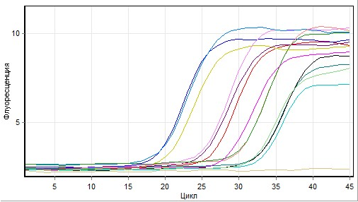
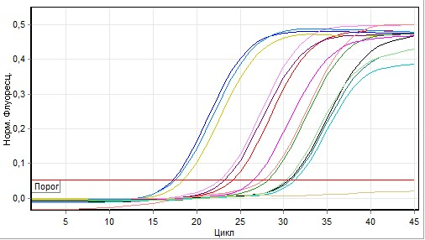
PCR-chart 1 and PCR-chart 2 - The initial data is the fluorescent signal Cycling A. Red and Quantitative data for Cycling A. Red. According to the peaks report, the following samples were taken for further proceedings with subsequent CT (cycle threshold) values: untreated- samples #1-20, -sample #2-21, -sample#3-23, -sample #4 - 24, -sample #5-25, Other samples above 25cycles and lover 20cycles were excluded. Over CT25 is not informative, and the lower CT20 has a viral load that is too high. The same, but treated samples #1-5 (Dexamethasone, Control, Tenofovir, Ribavirin and Favipiravir) were run Real-time – Reverse Transcriptase PCR procedures and showed CT-levels D25, C26.T35, R30, F28) In addition, it shows the stages of the subsequent RT-PCR analysis as an example of sample recognition by CT peaks; a typical RT-PCR analysis comprises a maximum of 40 thermal cycles. The lower the CT value, the higher the amount of viral genetic material in the sample (as an approximate indicator of viral load). The CT values obtained this way are semi-quantitative and make distinguishing between high and low viral loads possible. An increase in the CT value by 3 points approximately corresponds to a 10-fold decrease in viral genetic material.

Название Теста | Тест 2021-03-29 (1)
Начало Теста | 29.03.2021 10:24:30
Тест Закончен | 29.03.2021 12:10:50
Оператор | Нурлан
Замечания | нет
Тест. выполнен программой версии | Rotor-Gene 1.8.17.5
Подпись Теста | Подпись Теста правильна.
Уровень сигнала Green | 5,
Уровень сигнала Orange | 5,
Уровень сигнала Red | 5,
Порог | 0,05139
Исключить циклы до | 1,000
Станд. кривая импортирована | Нет
График станд. (1) | N/A
График станд. (2) | N/A
Начать нормализацию с цикла (Cq) | 11
Корректировка уклона | Нет
Порог Фона (NTC) | 0%
Порог Эффективности Реакции | Отключён
Метод нормализации | Динамич. фон нормализация

Table -6 Quantitative report, information about the test, and Quantitative analysis parameters. The samples were taken from sick patients during the COVID-19 pandemic from the Scientific and Practical Center for Sanitary and Epidemiological Expertise and Monitoring, Almaty. During identification in Real-Time PCR, all samples showed a positive result, where the peak range was from 17 to 30 cycles.
There is no difference between Ct and Cq values. All these values are the same but have different names. Ct is a threshold value cycle, and Cq is a quantification cycle. To standardize the nomenclature of PCR analysis, the MIQE manual (minimal information on the publication of quantitative real-time PCR experiments) recommends using the more general term "quantitative evaluation cycle" (Cq). Real-time PCR usually determines the target sequence's absolute number or compares the target sequence's relative amounts in the samples. Although fluorescent dyes and real-time PCR probes must be sequential, there is significant background fluorescence in most real-time PCR experiments. Therefore, it is essential to bypass this background signal to get meaningful information about your goal. Two values solve this problem in the PCR in real-time, namely the threshold line and the Cq value. A threshold line is a point or detection stage at which the fluorescence intensity in a reaction reaches a value greater than the background level. Before performing the PCR, the software will set a threshold value in your cycler. A line in your graph represents a level more significant than the background fluorescence, which also crosses your reaction curve at the beginning of your exponential phase. The Cq value is the cycle number of the PCR at which the reaction curve of your sample exceeds this threshold line. This value indicates how many cycles it took to detect a fundamental signal in your samples. If the PCR is performed in real-time, a reaction curve will be created, and thus, many Cq values will be generated for each sample. Your cycler's software calculates and displays the Cq value for each of your samples in a graph. The Cq values are inversely proportional to the amount of nucleic acid contained in your sample and correlate with the number of target copies in your sample. Lower Cq values (usually less than 28 cycles) indicate many target sequences. Higher Cq values (more than 38 cycles) mean less of your target nucleic acid. However, high Cq values may also indicate problems with the target or PCR setting.
3.1.2. Determination of morphological characteristics of viral strains of the SARS-COV-2 virus.
To determine and compare morphological characteristics, viral preparations related to various variants of the SARS-COV-2 virus were taken: Wuhan, British, Delta, and Omicron. As a result, it was found that virions are spherical, with a size of 115-125 nanometers in the presence of spikes (surface glycoproteins) with a length of about 10 nanometers. Electron microscopy of the virus is presented below.
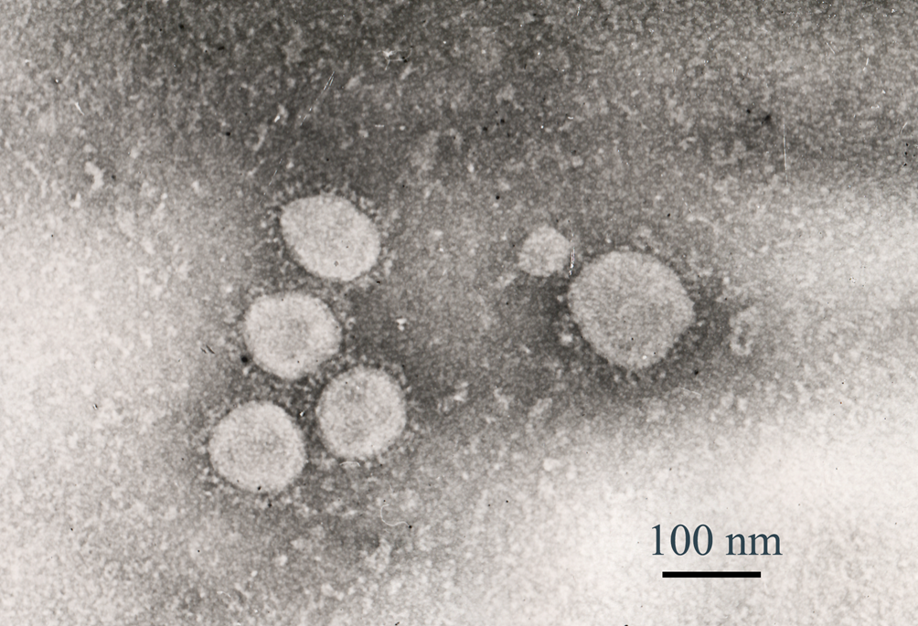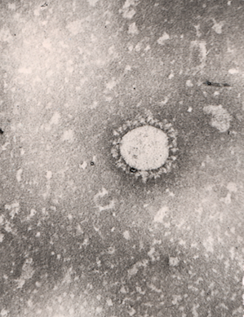
Image 1 - Electron microscopy of the SARS-COV-2 virus. Uv. 120,000, on the microscope Jeol Jem 100 XC (provided by Kozhabergenov N.S.)

3.1.3 Study of biological properties of isolated isolates and their subsequent deposition
Isolates were isolated from the Scientific and Practical Center for Sanitary and Epidemiological Expertise and Monitoring samples.
After studying the biological properties, these isolates were deposited in collections of microorganisms under the following names: SARS-CoV-2 / human / KAZ / B1.1/2021 and SARS-CoV-2 / human / KAZ / Britain / 2021.
Sequencing of significant viral genes. Comparative and phylogenetic analysis of the nucleotide sequence of viral genes.
3.1.4. PCR production of fragments of SARS-COV-2 virus genes and sequencing of significant infection genes
In most cases, the leading indicators of PCR (sensitivity, specificity, product yield, and the possibility of further manipulations with the final product) are determined by how well the specific structures of the primers are selected and developed [45]. Currently, there are several information databases (Ref Seq, GenBank) and many programs (Primer3, Fast PCR, etc.).) for the design of primers depending on the purpose. The search and development of nucleotide sequence primers were manually searched on the NCBI website using the GenBank database. The nucleotide sequence of specific primers was selected based on the reference strain MN908947.3. The specificity of the primers was verified with the NCBI Primer-BLAST Service. The primers were chosen so that each pair of primers overlapped, and their sequence was conservative among all variants of the SARS-CoV-2 virus. As a result, 65 pairs of sequencing primers were selected to develop the complete genome of SARS-CoV-2 virus variants with an overlap of about 100 nucleotide pairs (bp). The estimated amplitude length ranges from 604 to 772 bp.

# | Primer orientation | Sequence (5'->3') | Start | Stop | T C⁰ (primer heat temp | GC% | Product size(bp)
PP 28 | Forward | TGGAACCACCTTGTAGGTTT | 12891 | 12910 | 56.57 | 45.00 | 652
 | Reverse | AGCCCTGTATACGACATCAG | 13542 | 13523 | 56.52 | 50.00
PP 29 | Forward | ACCCTGTGGGTTTTACACTT | 13341 | 13360 | 56.86 | 45.00 | 706
 | Reverse | AACAATACCAGCATTTCGCA | 14046 | 14027 | 56.32 | 40.00
PP 30 | Forward | TACGCCAACTTAGGTGAACG | 13963 | 13982 | 57.93 | 50.00 | 639
 | Reverse | TAGATTACCAGAAGCAGCGT | 14601 | 14582 | 56.36 | 45.00
PP 31 | Forward | CCACTTCAGAGAGCTAGGTG | 14478 | 14497 | 57.04 | 55.00 | 713
 | Reverse | CTCTAGTGGCGGCTATTGAT | 15190 | 15171 | 56.88 | 50.00
PP 32 | Forward | CCAAGTCATCGTCAACAACC | 14913 | 14932 | 57.03 | 50.00 | 644
 | Reverse | CATTAACATTGGCCGTGACA | 15556 | 15537 | 56.71 | 45.00
PP 33 | Forward | GTGTTGTAGCTTGTCACACC | 15372 | 15391 | 56.96 | 50.00 | 659
PP 34 | Forward | ATGTTGGACTGAGACTGACC | 15834 | 15853 | 56.86 | 50.00 | 669
PP35 | Forward | TCCGTATGTTTGCAATGCTC | 16374 | 16393 | 56.80 | 45.00 | 712
Table 7– Sequencing primer parameters, the main gen product of SARS-CoV-2/human/KAZ/B1.1/2021 on ORF1ab here is NSP12 that is responsible for RNA dependent RNA polymerase with 2697bp long as same as Wuhan-Hu-1 strain has 2696 bp [Wuhan-Hu-1 -GenBank MN908947.3].
Note: PP – primer pairs, T – temperature.

Gene:  ORF1ab | Gene product/region | Nucleotide position
5'UTR |  | 106
 |  | 241
Non-structural protein NSP 12 |  | 14120
Non-structural protein NSP 12 |  | 14408
Non-structural protein NSP 12 |  | 14676
Non-structural protein NSP 12 |  | 15017
Non-structural protein NSP12 |  | 15279
Non-structural protein NSP12 |  | 16176
Table 8- RNA dependent RNA polymerase nucleotide positioning of SARS-CoV-2/human/KAZ/B1.1/2021on NSP12, almost the same nucleotide position as Wuhan-Hu-1 strain has: 13442 – 16236 [Wuhan-Hu-1 -GenBank MN908947.3].

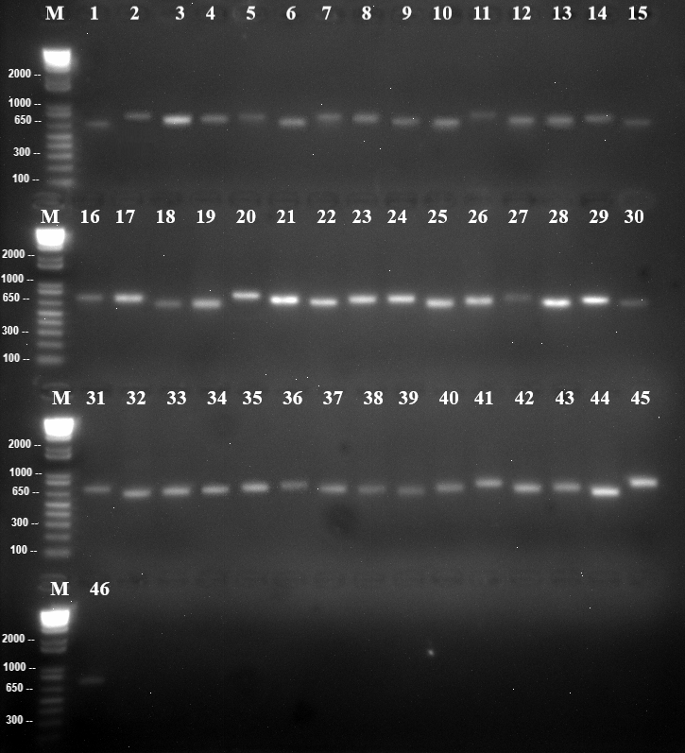
Figure 5—Electropherogram of results of RT-PCR genes of ORF1ab variant B. Virus SARS-CoV-2 As seen from Figure 1, the developed primers make it possible to generate specific PCR products. Electrophoretic analysis yielded products with molecular weights between 604 and 772 bp from the ORF1ab gene. The length of the amplicon corresponds to the size of the synthesized primers.

3.2. The rest of the viral genome
In addition to the 16 NSPs previously shown, 30-32% of the SARS-COV-2 virus genome is occupied by structural proteins: spike-shaped, shell, membrane, and nucleocapsid proteins. These proteins allow the replicated genome to leave the invaded host cell and continue infecting the surrounding cells. The auxiliary proteins ORF 3 -10 are allocated between and among structural proteins closer to the 3’-UTR end.
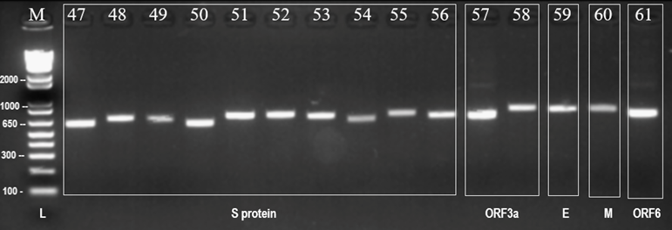
Figure 6 - Electropherogram of the results of RT-PCR genes S, ORF3a, E, M, ORF6, and ORF7a variants of the SARS-CoV-2 virus. The spike-protein product comes directly after NSP13, which enforces the theory of S-protein expression's importance for viral replication processes at the beginning of RdRP activity. The spike protein product consists of 1273bp, the most significant structural protein product, and its nucleotide position barely differs from the original Wuhan strain of 2020. In general, glycolysis spike proteins are the object of vaccine development issues, and their neutralization must be done in extracellular space before penetrating the host cell membrane.

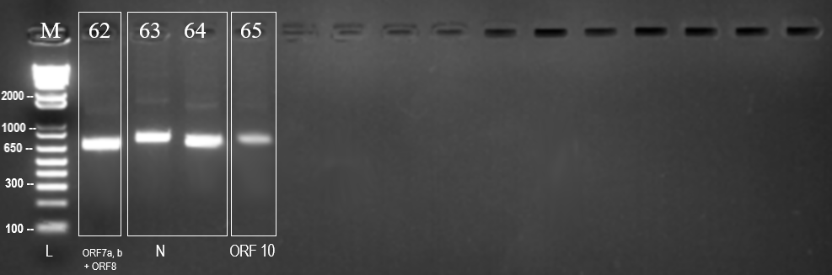
Figure 7- Electropherogram of the results of RT-PCR genes
ORF8, N, and ORF10 variants of the SARS-CoV-2 virus
As a result of the work, putative products of the SARS-CoV-2 virus were obtained using developed sequencing primers.

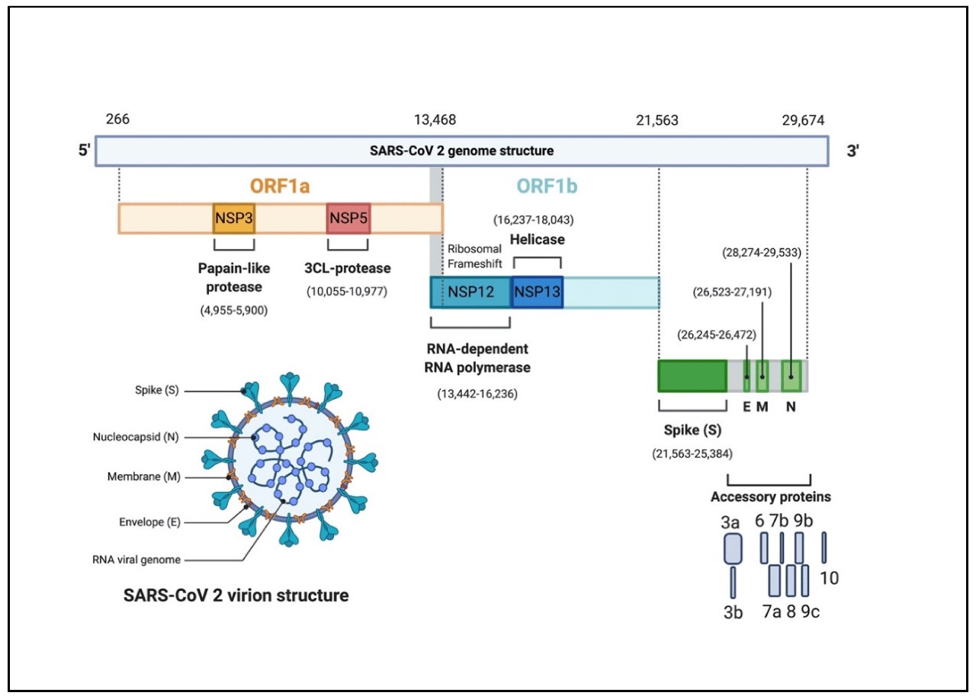
Nucleoside-analog drugs-target
Innate immunity, e.g. Interferon-proteins neutralization and primary ribosome contact
Structural and auxiliary proteins proteins
Diagram 1 – the genome overview of SARS-COV-2, Wuhan- Hu-1 strain, December 2019, from 5’-UTR to 3’-UTR with four main antiviral sites: a) ORF1a (NSP3 and NSP5, for instance) – innate immune system induction – interferon activity-viral replication. b) ORF1b (NSP12 -RNA dependent RNA polymerase and NSP13, for instance) – nucleotide analogs in our case purine analogs- Tenvir (Tenofovir)- RdRP inhibitor –is used primarily against HIV infection before COVID-19 pandemics occurred c) structural proteins, especially, spike protein is main target for vaccination strategies worldwide to induce adaptive immunity-IgGs that neutralize viruses and virions effectively d) the accessory proteins (ORF8a and ORF8ab for instance) help to suppress the host interferon cellular activity during innate immunity encounter, these ORFs are located close and dense to structural proteins, spike protein recognition by naturally and synthetically derived monoclonal antibodies neutralize the accessory proteins activity too [6].
Source: https://doi.org/10.3390/pathogens9050331

3.3.1. Phylogenetic analysis of the SARS-CoV-2 strain/human/KAZ/Britain/2021
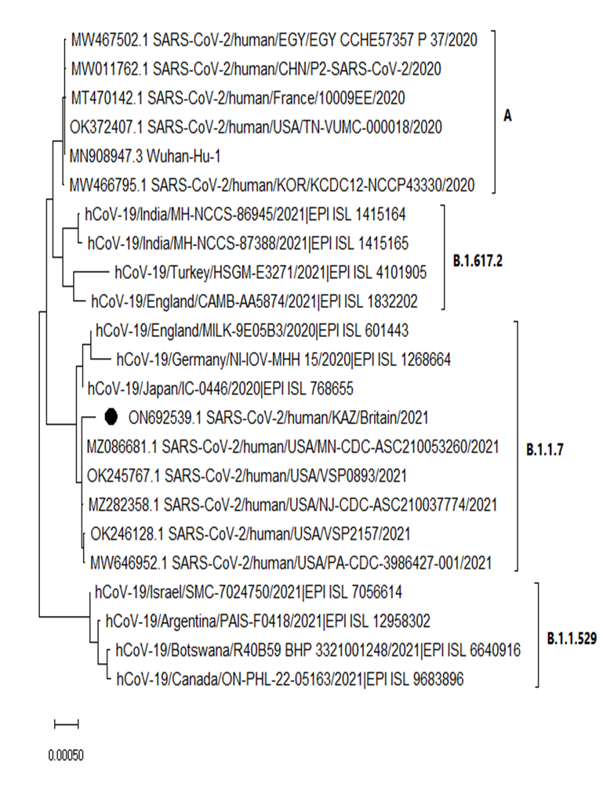
Figure 8 - Phylogenetic analysis of the SARS-CoV-2 strain/human/KAZ/Britain/2021 [17].

3.3.2. Phylogenetic analysis of the SARS-CoV-2 strain/human/KAZ/B 1.1/2021

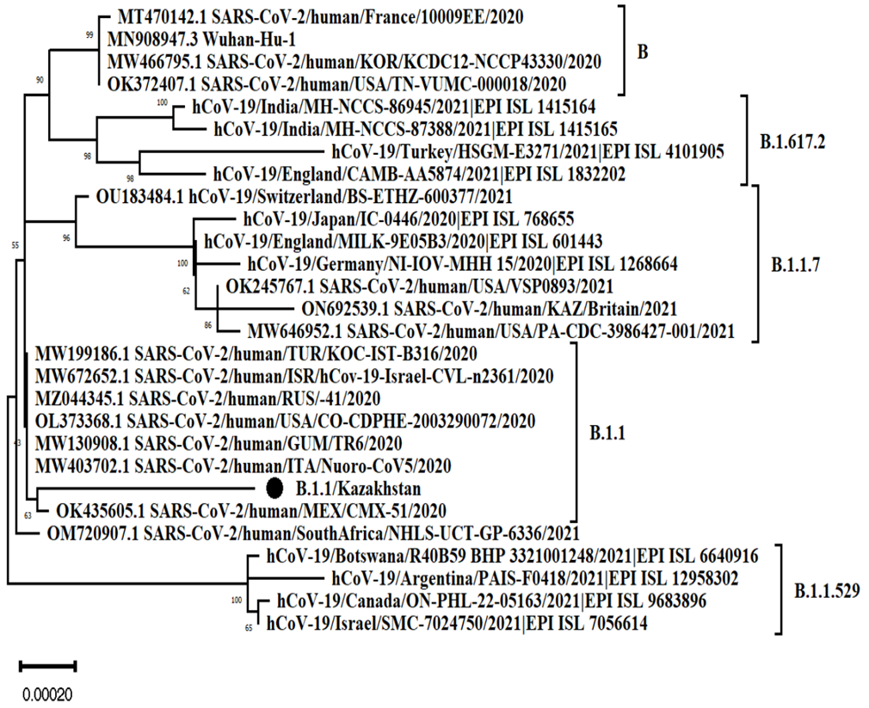
Figure 9- Phylogenetic analysis of the SARS-CoV-2 strain/human/KAZ/B 1.1/2021 [17].

3.3.3. Uploading a genome-wide nucleotide sequence to the GenBank database
The virus data obtained were collected using the program Sequencer V.5.4. The isolated nucleotide sequence of the genome of the virus strain was uploaded to the NCBI database under registration number ON692539.1 dated June 07, 2022, and OP684305.1 dated October 20, 2022. The obtained sequences were analyzed using the Pangolin COVID-19 database (https://pangolin.cog-uk.io), as a result of which it was established that they belong to lines B.1.1.7 and 1.1 (Graph 3 and Graph 4, respectively)

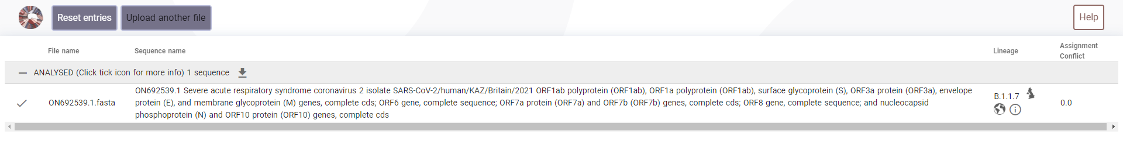
Figure 10 - Identification of the SARS-CoV-2 strain variant/human/KAZ/Britain/2021
according to the Pangolin COVID-19 database
Figure 11- Determination of the SARS-CoV-2 strain variant/human/KAZ/B 1.1/2021
according to the Pangolin COVID-19 database
№ | Variant | Strain | Country | Date | Genome identity% | GenBank
1 | В | SARS-CoV-2 isolate Wuhan-Hu-1 | PRC | 18.03.2020 | Ref. | MN908947.3
2 | В 1.1.7 | SARS-CoV-2/human/KAZ/Britain/2021 | Kazakhstan | 07.06.2022 | 99.80% | ON692539.1
3 | В 1.1 | SARS-CoV-2/human/KAZ/B1.1/2021 | Kazakhstan | 20.10.2022 | 99.82% | OP684305.1
Table 9 - Analysis of the nucleotide sequence of the entire genome of SARS-CoV-2 viruses isolated in the Almaty region in the Republic of Kazakhstan
The analysis of the nucleotide sequence of the whole genome showed that the strains isolated in the Almaty region are 100% similar to SARS CoV-2/human/KAZ/Britain/2021 and SARS-CoV-2/human/KAZ/B1.1/2021 and have 99.80% and 99.82% of the total similarity. identity with the reference strain SARS-CoV-2, the Wuhan-Hu-1 isolate belonging to the B-line (see table4, as well as graph 3 and graph 4)

3.4.1. Determination of cytotoxicity of drugs for cell culture.
Dexamethasone:
Dexamethasone (hormone), Ribavirin (purine analog), Tenvir (purine analog), and Fabiflu (purine analog) were chosen to study the antiviral activity against the SARS-CoV type two virus. Before determining the antiviral activity, a working dose that did not cause toxicity to the cell culture was established. Dexamethasone was used in ampoules containing 4 mg/ml in 5 dosages (20, 16, 12, 8, and 4 mg/ml). The results are presented in Figure 1.
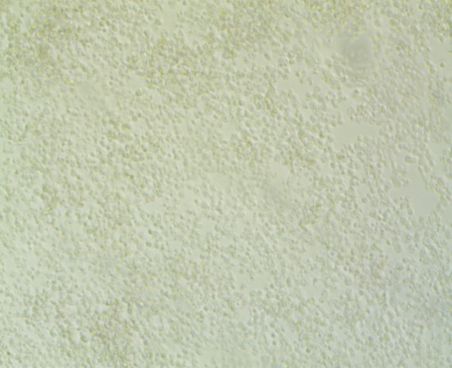  A | 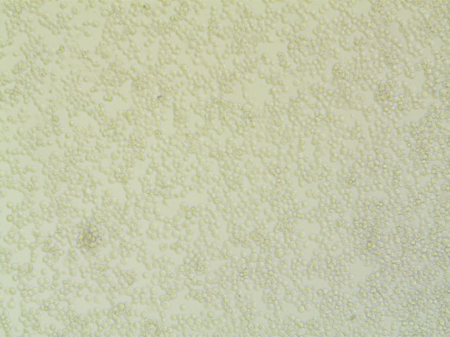  B | 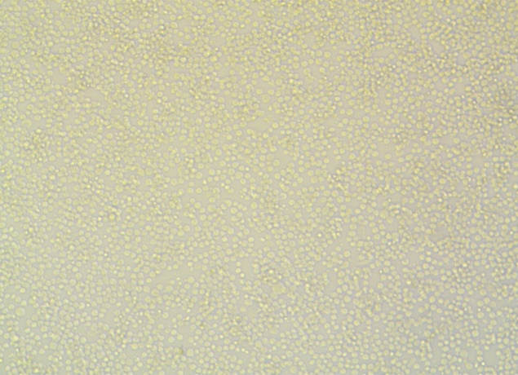  C
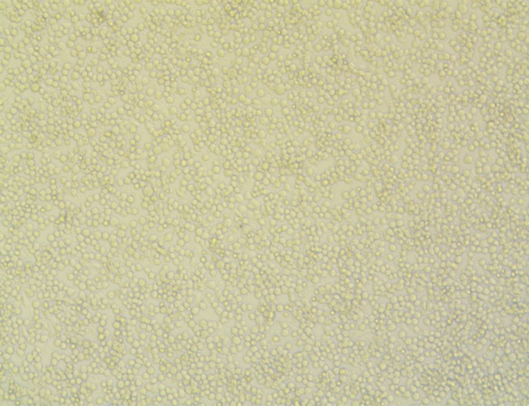  D | 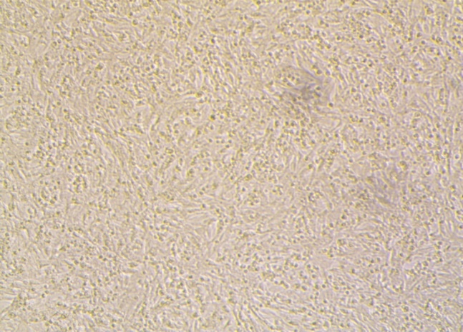  E | 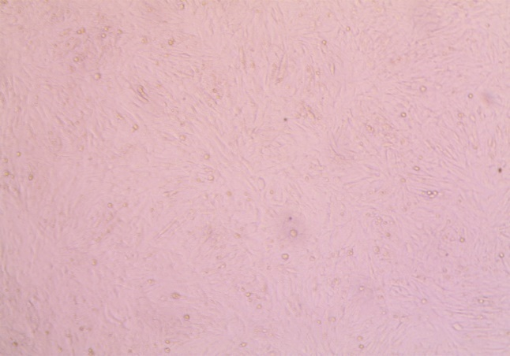  F
Figure 12 - Determination of cytotoxicity of Dexamethasone in Vero cell culture
A – 20 mg/ml, B – 16 mg/ml, C – 12 mg/ml, D – 8 mg/ml, E – 4 mg/ml, F – Vero control.
The higher the concentration, the denser the cell layers stimulated in incubation conditions, mostly indirectly, because dexamethasone only slightly stimulates cellular growth over time.
As in Figure 1 can be seen the cell growth stimulation by Dexamethasone: the mass multiplication of cell monolayers even from stock concentration 4,37ml column A, the mass multiplication of cell monolayers from double stock concentration 8,74ml column B Start of bursting cells from monolayers due to space limitations. Triple stock concentration 13,11ml column C, the moderate bursting of cells from monolayers due to space limitations, from four times stock concentration 17,48ml column D, the acute bursting of cells from monolayers due to space limitations visual evidence of second layer growth, five times stock concentration 21,85ml column E, the complete rupture of tissue integrity of monolayers due to space limitations, the multiple layers formations. It was found that the drug Dexamethasone at a dosage of 4 mg/ml is not toxic to cell culture and will be used to study the inhibition of antiviral activity. Also, with increasing dosage of the drug Dexamethasone, dynamics of cell rounding and swelling are observed.
Ribavirin:
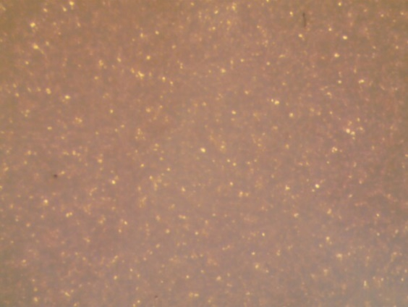  A | 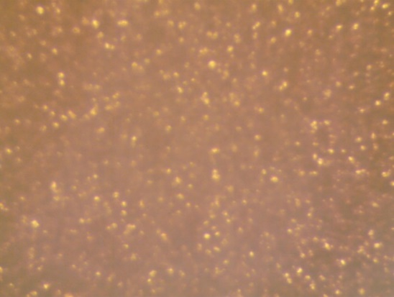  B | 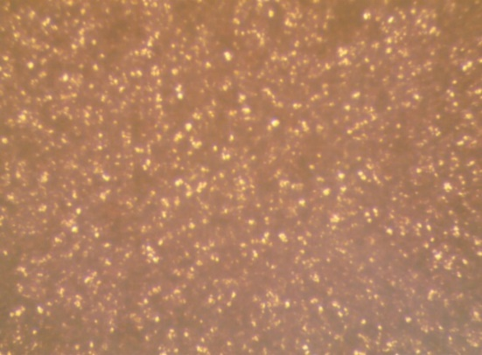  C
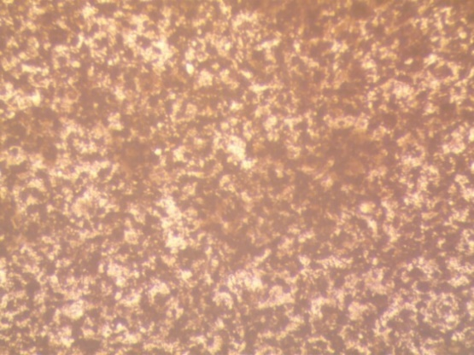  D | 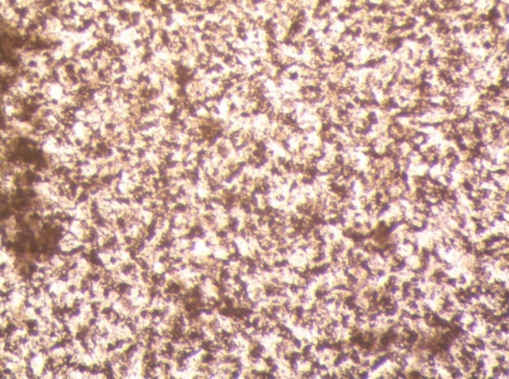  E |   F
Figure 13 - Determination of the cytotoxicity of Ribavirin in Vero cell culture
A – 200 µg, B – 150 µg, C – 100 µg, D – 75 µg, E – 50 µg, F – Vero control.
Ribavirin shows high toxicity rates (cell layers are torn even at minimum concertation) since only a few concentrations are recommended to achieve the therapeutical effect.
The mass destruction of cell monolayers (evident signs of cellular necrosis process) even from stock concentration (200mg) column A and after five times (1000mg) column B. The CCs (cytotoxic concentration) were too high for veroE6 cells to survive during 72h incubation, so starting from the two-fold increase, the wells were practically cell-free and did not differ from the 5-fold increase, see Figure 2.
Tenofovir:
  A |   B
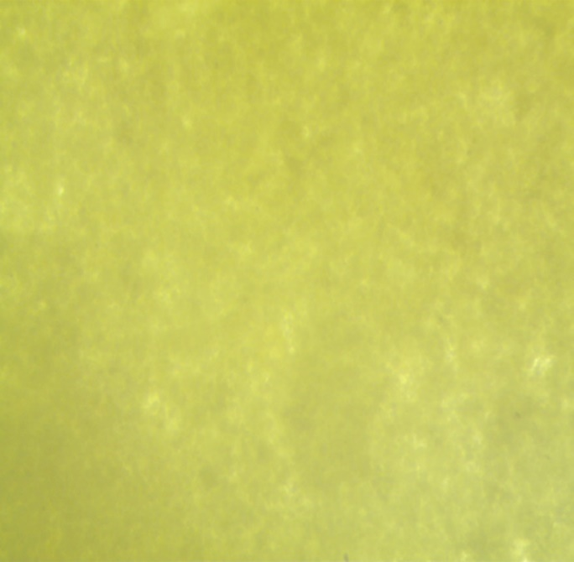  C | 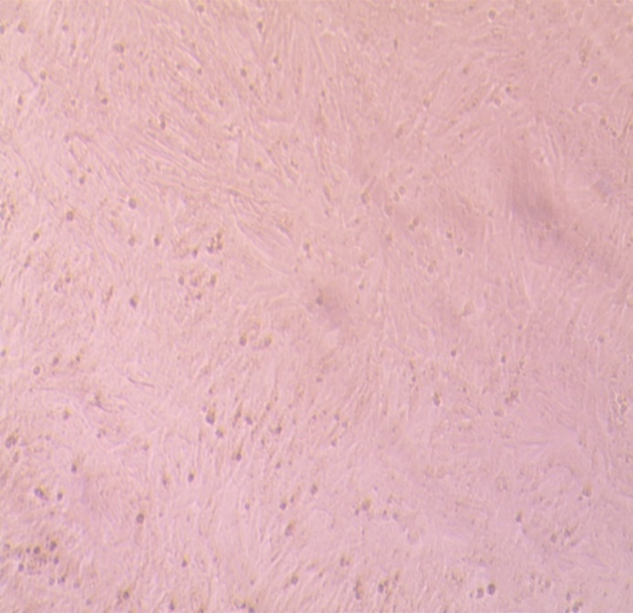  D
Figure 14 - Determination of Tenvir cytotoxicity in Vero cell culture
A – 300 µg, B – 150 gµ, C – 100 µg, D – 50 µg.
Tenvir also shows high toxicity rates (cell layers are torn even at minimum concertation) because only relatively few concentrations are recommended to achieve therapeutical effects.
The destruction of cell monolayers (the appeared cellular necrosis) even from stock concentration (300mg) column A and after three times (900mg) column B. The CCs (cytotoxic concentration) were too high for veroE6 cells to survive during 72h incubation, so starting from 300mg of tenofovir, the wells were practically cell-free, and a 2-fold increase (600mg) did not differ from the 3-fold increase.
The result showed that Tenvir at a dosage of 50 µg is non-toxic to cell culture and will be used to study the inhibition of antiviral activity. Also, with an increase in the dosage of the Tenvir drug, alkalization of the medium and detachment of cells from the surface are observed. The following studies were conducted to determine Fabiflu's cytotoxicity in five dilutions containing 200 mg in 200, 150, 100, 75, and 50 mg dosages. The results are presented in Figure 4.
Fabiflu (Favipiravir):
  А | 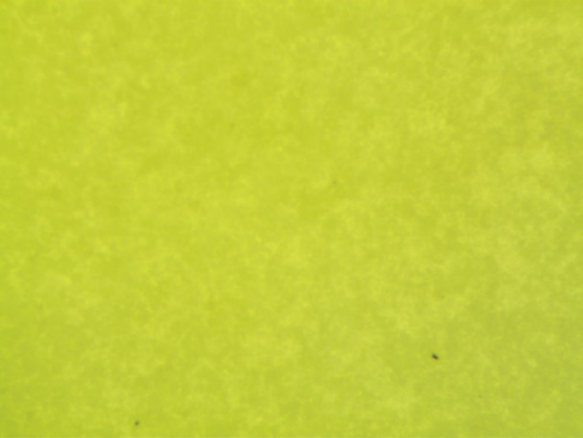  B | 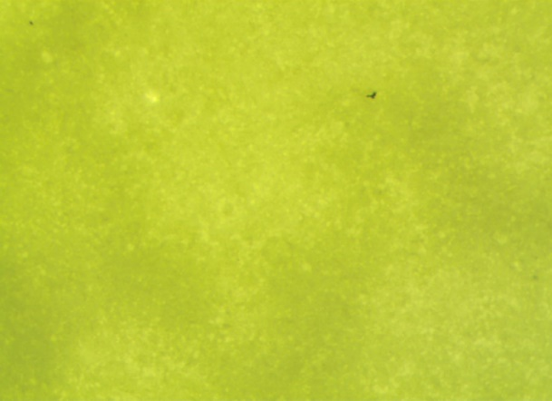  C
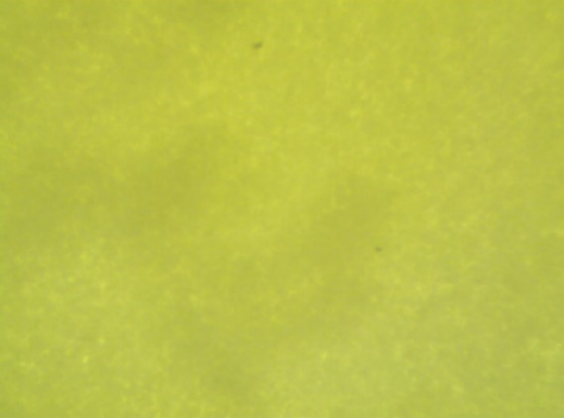  D | 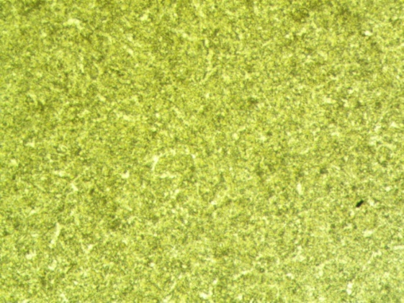  E | 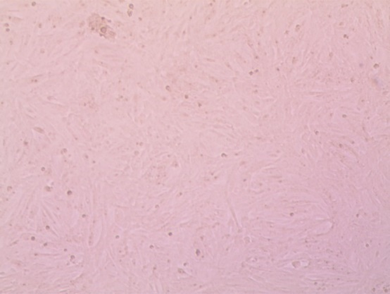  F
Figure 15 - Determination of cytotoxicity of Fabiflu in Vero cell culture
A – 200 µg, B – 150 µg, C – 100 µg, D – 75 µg, E – 50 µg, F – Control Vero.

Next, studies were carried out to determine the cytotoxicity of the drug Fabiflu in five dilutions containing 200 mg in dosages of 200, 150, 100, 75, and 50 mg. The results are presented in Figure 4. The cytotoxic effect increases with rising destruction of cell monolayers even from stock (column A) concentration (200mg) and after2 (column B),3 (column C),4(column D), five times (column A) rises from the stock concentration. The CCs (cytotoxic concentration) were too high for veroE6 cells to survive during 72h incubation, so starting from the two-fold increase, the wells were practically cell-free.
Fabiflu shows high toxicity rates (cell layers are torn at higher concertation); however, at the lowest concentration, the cells were only dyed, and some cellular layers were visually intact, still according to the manufacturer’s manual, to achieve an anti-viral effect, the average concentration must be higher for several times than Tenvir and, especially, Ribavirin. Thus, after exposure, cells fear fewer side effects due to the specified objective of this drug, which was designed to fight viral replication up to 14 days of COVID-19 clinical signs manifestation. Moreover, several administration periods must be held at least thrice daily to get the anti-viral effects. Fabiflu has only a minor impact on COVID-19 virus suppression in these experimental terms.
As a result, it was found that the drug Fabiflu, at a dosage of 50 mg, is non-toxic to cell culture and will be used to study the inhibition of antiviral activity. Also, with an increase in the dosage of the drug Fabiflu, alkalization of the medium and detachment of cells from the surface is observed.

3.4.2. CCK8 test for cell-viability in 4 drugs in concentration of 50µg/ml

Dependence graph 1 – VeroE6 cells survival rates in percentage in the presence of 5 drug concentrations of Ribavirin, Favipiravir, and Tenofovir starting from 50µg/ml to 200 µg/ml. The highest survival rates belong to sample 1.

Dependence graph 2 – VeroE6 cells survival rates in percentage in the presence of 5 drug concentrations of Dexamethasone starting from 50µg/ml to 200 µg/ml. The survival rates are equal from samples 1-5.

3.5.1. Vero E6 cells infection and 72hours incubation, titer production
SARS-CoV 2 infected vero cells incubation

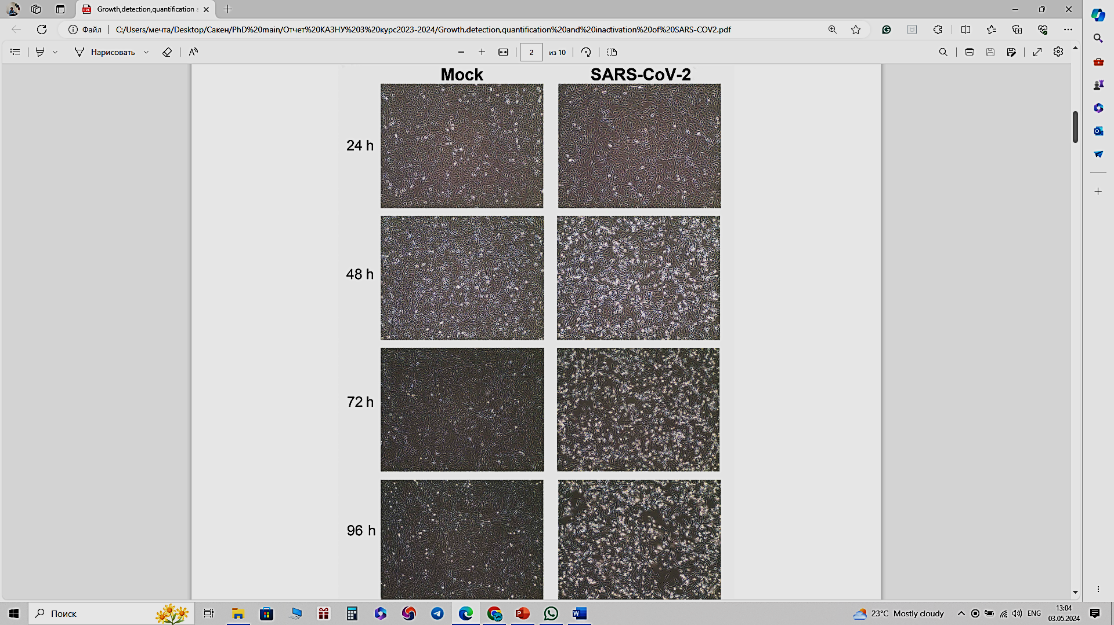
72h
48h
24h
Figure 16 - SARS-CoV-2 causes cytopathic effects on monolayers of Vero E6 cells. Vero-E6 cells were inoculated with SARS-CoV-2 at 10 TCID50 viral titer, or MOI of 2 (200.000,0 virions per 1x10⁵ cells) =MOI of 1 is ten virions for a target cell – counted by express antigen COVID19 test GenSure.

3.5.2. Antiviral activity count after drugs adding
The study of the antiviral activity of the drugs was carried out in a culture of Vero cells infected with the SARS-CoV-2 virus, variant B, based on the coefficient of inhibition of the cytopathic activity of the virus and virus reproduction. After 24 hours of incubation after infection of cells (at a dose of 10 TCID50 -viral titter), when drugs were added in a concentration range of 50 μg/ml, the cytopathic effect of the virus was detected to varying degrees. As a result of a study of the antiviral activity of the drugs Dexamethasone, Ribavirin, Tenvir, and Fabiflu, the inhibition rate was 0%, 80%, 99.31%, and 37.37%, respectively. Tenvir showed the highest degree of inhibition and is one of the most effective drugs for treating viral infections.
Drug | Concentration  µg\ml | Virus accumulation  lg, plaque-forming units (PFU/ml) | Suppression of reproduction  virus, lg | Inhibition coefficient, Percentage %
Dexamethasone | 4  (392,464·mol⁻¹) | 7,20±0,04 | 0 | 0
Ribavirin | 50 (244,206g·mol⁻¹) | 6,40±0,15 | 0,85. EC50=7µM | 80,00. EC90/80(max)=205µM
Tenvir | 50  (287.216 g·mol⁻¹) | 5,03±0,15 | 2,24.EC50=174µM | 99,31.EC90/100(max)=over174µM
Fabiflu (Favipiravir, T-705) | 50  (157.10 g·mol⁻¹) | 6,99±0,05 | 0,22.EC10=1,65µM | 37,37.EC90/100(max)=must be 318 µM
Table 10 - Results of assessing the antiviral activity of drugs against the SARS-CoV-2 virus, variant B, in Vero cell culture, to suppress virus reproduction,
Ribavirin-inhibition assay

Graph 9 - The intact VeroE6 cells seeded in 96-well plates were inoculated with SARS-CoV-2 titer during a 48-hour infection phase, and then 205 µM ribavirin was added. The 205μM concentration and below of Ribavirin -cytotoxic safe concentration; therefore, the tested inhibitor concentration did not affect cell viability (CC-levels) and viral stock dilution 10⁻⁷. The EC max is about 90% inhibition and above, but cell viability decreases with higher drug concentration.
Tenofovir - inhibition assay

Graph 10 - The intact VeroE6 cells seeded in 96-well plates were inoculated with SARS-CoV-2 titer during a 48-hour infection phase, and then 174µM Tenvir (Tenofovir) was added. The 174µM concentration and below of Tenofovir -cytotoxic safe concentration; therefore, the tested inhibitor concentration did not affect cell viability (CC-levels) and viral stock dilution 10⁻⁷. The EC max is almost 100% inhibition, and the cell viability decreases with higher drug concentrations with no higher antiviral effect.
Favipiravir (T-705) - inhibition assay

Graph 11 - The intact VeroE6 cells seeded in 96-well plates were inoculated with SARS-CoV-2 titer during a 48-hour infection phase, and then 318µM Favipiravir was added. The 318µM concentration and below of Favipiravir -cytotoxic safe concentration; therefore, the tested inhibitor concentration did not affect cell viability (CC-levels) and viral stock dilution 10⁻⁷. A relatively high drug concentration reaches the EC 37.37 µM. However, EC10 is relatively low, about 1.65 µM. EC max is predicted to be about 90% inhibition and above. Still, cell viability decreases dramatically since the cells die with EC50 with higher drug concentrations up to 1000 µM.

Dexamethasone- inhibition assay

Graph 12 - The intact VeroE6 cells seeded in 96-well plates were inoculated with SARS-CoV-2 titer during a 48-hour infection phase, and then ten µM Dexamethasone was added. The 10µM concentration and below of Dexamethasone -cytotoxic safe concentration; therefore, the tested inhibitor concentration did not affect cell viability (CC-levels) and viral stock dilution 10⁻⁷. The EC max is almost 0% inhibition; the cell viability does decrease with higher drug concentration with no antiviral effect. After 48h, the Vero cells fused and showed an apparent cytopathic impact due to viral infection progress.
Viral PFU count comparison – the visual/direct antiviral effect of four drugs

Graph 13 - The virus accumulation dynamics in four replica orders on intact VeroE6 cells seeded in 96-well plates after inoculation with SARS-CoV-2 titter during a 48-hour infection phase, with ten µM Dexamethasone-, 318µM Favipiravir- 205 µM ribavirin – and 174µM Tenvir (Tenofovir) -treatment.

Potency and efficacy of four studied drugs

Graph 14—Tenofovir is most effective in inhibition but less potent than Ribavirin and Favipiravir because it starts to work only at relatively high concentrations, whereas Ribavirin has an EC50 at 7µM. In sharp contrast to Tenofovir and even to Ribavirin, Favipiravir has all three effective concentrations, namely EC10, EC50, and ECmax/90. Thus, we can say that favipiravir is the most potent drug, showing the least antiviral effect in our study: the lowest PFU/ml and inhibition coefficient.
3.5.3. Antivirals recommendation against SARS-COV 2 according to provided results on RdRP-inhibition activity
Since the inactive phase of COVID-19 lasts up to 14 days on average, it is essential to control the viral load, which significantly suppresses the ability of the virus to replicate. In addition, we have to take into consideration the side-effect potential of the antivirals, especially those that were initially designed for viral, either long-term or lethal infections like HIV, Ebola, and Hepatitis B and C. As this study demonstrated, the lowest cellular toxicity impact has the Fabiflu (Favipiravir) and the shortest period of oral administration; nevertheless, it showed the weakest potential in inhibiting the RdRP activity. Fabiflu or Favipiravir is the most specified drug against COVID-19 progression. Fabiflu is a drug for mildly to moderately infected adult individuals and helps you recover from the infection. The start dosage is 400mg daily, which could be increased to 1800mg twice on the first day of diagnosis of COVID-19, but not above. This medicine's most common side effects include increased uric acid levels in blood, diarrhea, decreased white blood cell count (neutrophils), and increased liver enzymes. To achieve therapeutic effect, according to the producer’s manual, Fabiflu is taken orally (by mouth), and the recommended dose is 1,800 mg twice on day 1, followed by 800 mg twice daily up to day 14. It means that the highest dose is needed to achieve the maximum effect of stopping the SARS-CoV-2 virus from multiplying. Doing so decreases viral load in the body (graph 8). The producer claims a 100% positive clinical outcome if treatment is diagnosed on time under doctoral supervision. The most significant advantage of Fabiflu (Favipiravir) is the lowest side-effect potential, and the dosage can be allocated according to the individual needs of every patient and the COVID-19 progression. The maximum administration period is 14 days.
Tenvir (graph 9), however, according to the manufacturers’ prescription, must be used only once a day with 300mg Tenofovir. The maximum usage period is only 28 days; neither dosage nor period is included in any extensions. Nevertheless, Tenvir is this study's most effective antiviral drug with optimal cytotoxicity concentration. Thus, even with a limited range of concentration and time scale, Tenvir is highly effective against SARS-COV 2 and can prevent COVID-19 from progressing to pneumonia or other health or life-threatening conditions. Tenvir could be considered a long-term treatment medicine because initially, it was designed to fight the chronic hepatitis B disease and primary HIV infection. The possible side effects in the fight against the SARS-COV 2 viral infection seem to be minimal, and on average, about seven days will be enough to bring COVID-19 under control with Tenvir as the primary drug under strict medical supervision. According to the instruction leaflet, Ribavirin (graph10) is the most dangerous side-effect potential. Still, it is capable of crippling the viral RNA as well as DNA-metabolism and is primarily prescribed against Hepatitis C viral infection with a combination with Interferonα. Ribavirin is the most aggressive purine-analog medicine because, firstly, from the long-term perspective, it might cause Hemolytic anemia, the abnormal breakdown of red blood cells (RBCs), either in the blood vessels (intravascular hemolysis) or elsewhere in the human body (extravascular). Ribavirin showed the lowest antiviral activity among others in this study due to optimal cytotoxically arranged concentration, and this drug concentration could not cause RNA-metabolic collapse. The instruction leaflet (Russian manufacturer) suggests administering Ribavirin 200mg every 8 hours at the beginning and 400mg every 8 hours at the end of the week, respectively. This method is recommended to achieve the maximum concentration (Сmax) in blood plasma to silence the viral reproduction.

Graph 15 - Shows the antiviral data of Tenvir in the in vitro study and the clinical prescription to achieve viral multiplying activity in vivo—Fabiflu medicine dosage recommendation based on this in-vitro study. Green colour shows the safest and the lowest side-effect potential during oral administration. The blue colour demonstrates the moderate data of antiviral effect. Here, we could see not only the shorter period of drug usage but also relatively high antiviral effects like RdRP inhibition coefficient and substantial viral reproduction suppression in decimal logarithm (lg) as well as Virus accumulation lg, PFU/ml. The yellow colour shows the maximum antiviral effect manifested manually, as it could be seen as both the shortest and the most effective intensity with compromised Fabiflu side-effect potential.

Graph 16 - shows Tenvir's antiviral data from the in Vitro study and the clinical prescription for achieving viral multiplying activity in vivo.

Graph 17 - shows Tenvir's antiviral data from an in vitro study and the clinical prescription for achieving viral multiplying activity in vivo.

Graph 18- Fabiflu drug dosage recommendation for all three antiviral drugs based on this in-vitro study; the first leading indicator of our research is the safest drug concentration and the lowest possible side-effect potential during in vitro drug testing. Tenvir in the seven-day usage is our recommendation based on many studies that show already in 3-4 days, the first recovery signs, yet again tenvir was primarily designed against HIV viral infection whose incubation period lasts way longer than SARS-CoV2’s, sometimes decades before turning into AIDS. Ribavirin usage recommendation is based mainly on 3 months of active medication. Since ribavirin was primarily designed to decrease the viral load activity of Hepatitis B or C, the SARS-CoV2 treatment strategy theoretically could be arranged for 7-10 days of medication. Based on studies showing the first recovery signs in 3-4 days, the seven-day usage is our recommendation.

DISCUSSION
General results are positive, and according to a set of goals with all succeeded targets, including provisions that showed a clear structure of this research, we can claim that the ‘Studying the antiviral activity of drugs against the SARS-COV-2 virus in vitro’ was successful. The results of Tenvir show that Tenofovir (T705) showed the highest effectiveness at the provided concentration, which might correlate with the fact that Tenofovir could directly inhibit the NSP3 primary cleavage before the RdRp could be assembled inside DMV. Tenofovir also could have influenced the NP as Remdesevir inhibits Spike protein synthesis [146]. The lower inhibition rates of Ribavirin and Favipiravir could be caused by insufficient drug concentration, which is why running higher concentrations on other cell line models is recommended. The viral load also plays a crucial role in inhibiting capacities; usually, it is used only for MOI 0.5 - virus particles, 5 pathogens per 1 infecting cell. On the contrary, we had MOI 2 – 20 viral particles per 1 infection cell. Nevertheless, Tenvir (Tenofovir – T705) silenced entirely the viral replication. Dexamethasone showed zero antiviral activity; neither concentration escalating nor de-escalating assay did not affect cell survival rates.

CONCLUSION
Studying a drug antiviral activity invitro against SARS-COV 2 is informative. To run this study, the genome sequencing of SARS-COV 2 was necessary, and pointing out the main ORF gene products like NSP12 showed scientific and clinical practicality. The principal value of this dissertational work is that the three main drugs, Tenofovir, Ribavirin, and Favipiravir, are effective against Kazakhstan variants of SARS-CoV2 virus strain; moreover, the single drug exposure on kidney cell culture of these antiviral drugs causing most expectedly the lethal mutagenesis that leads to viral exposure and malfunction of RNA dependent RNA polymerase during viral replication. Because SARS-CoV2 is an RNA virus and RdRP function, inhibiting represents the primary study objective of this dissertational work. Based on the gained date, further conclusions can be made:
- even though all thesis requirements and objectives were fulfilled, we still have to admit that 100% efficacy of any antiviral drug, including those that we conducted and tested in our experiments, must run on lung cell cultures, too, because as it was already mentioned that SARS-COV2 viral infection specifies not only in respiratory cells but also antiviral active drugs must be potent both to cope with the transmembrane protease serine 2 (TMPRSS2), as much as with the receptor-binding domain (RBD) that mediates direct contact with a cellular receptor, angiotensin-converting enzyme 2 (ACE2). The desperate mistakes made during the pandemic in the US by the FDA showed that any drug must be tested thoroughly in at least all spectrums of viral biological properties. The drug hydroxychloroquine is pretty effective in inhibiting endosome acidification in many viruses, showing the hoped results in kidney cell culture against SARS-CoV2 virus growth, ignoring the fact that SARS-CoV2 virus’s primary target is to infect lung or/and respiratory cells, where apart angiotensin-converting enzyme 2 (ACE2) silencing, needed to block the transmembrane protease serine 2 (TMPRSS2) activity as well. Hydroxychloroquine could not have any pharmaceutical impact on SARS-CoV2 viral load progression. It is also worth mentioning that hydroxychloroquine was given to patients with terminal stages of COVID-19, which unfortunately did not help.
- Dexamethasone is a drug without direct antiviral activity (see table 5) in invitro -studies. Dexamethasone is a steroid medicine. Its direct function is to decrease the excessive immune activity in severe complications of COVID-19 (immunity passivation) – pneumonia, and lung collapse. In this study, however, we showed a mild cytotoxicity range on Vero cells even when using high drug dosages. Dexamethasone is recommended to be combined with any antivirals only in severe and terminal stages of COVID-19 progression. Immune-compromised patients (with weak immunity) must avoid using Dexamethasone as a treatment option. In general, the dexamethasone drug exposure nurtured cellular growth, so due to cellular mass increase even at the concentration rate of 10 micro mols, Dexamethasone did have a slight antiviral effect; it highly likely the higher effect would also indirectly suppress the viral spreading/replication thanks to viral load saturation, i.e., the more cells are growing, the more indirect SARS-inhibition takes place.
- Tenvir (Tenofovir) is the most effective antiviral drug among the three selected ones; however, it is not the safest. Accurate and proper usage can quickly stop the progression of COVID-19 in mild and moderate illness stages.
- Fabiflu (Favipiravir) is the least effective antiviral purine-analog among the three. However, it is the safest drug with multiple options of administration dosage and the lowest side-effect potential, causing less cellular damage in vitro and invivo; furthermore, accurate and proper usage can easily cause COVID-19 progression in mild and moderate illness stages. As putative side-effect alleviation and as an anti-viral drug booster recommendation, we can recommend prescribing oseltamivir, 75 mg, once or twice per day for ten days to six weeks.
- Ribavirin is the most toxic and side-effect-inclined antiviral purine analog among the three selected drugs. Still, accurate and proper usage can easily cope with the progression of COVID-19 in mild and moderate illness stages. To get antiviral activity in vitro in this study and keeping cytotoxicity in mind, 205μM was needed to inhibit viral growth, whereas to get the same results, Jones et al. needed to have 100μM but against influenza A virus in combination with other antiviral pharmaceuticals [132].
- Tenvir (Tenofovir) and Ribavirin should be considered as high-risk related medicines and should be administered not longer than a week (7 days long). Otherwise, serious side effects could occur.
- The RNA-dependent RNA polymerase (RdRP) is a highly conservative gene product on ORF1b. Due to proofreading activity, which seldom occurs in RNA viruses, it barely gets mutated in strains of concern.
- The selected purine analogs showed effectiveness against SARS-COV2 replication and RNA metabolism even after 24 h of in vitro exposure in various ranges. Their sound effects are expected to be shown in invivo-arranged doses within at least seven days of administration.
- All gained results demonstrated a clear pattern that drugs like Ribavirin and Favipiravir (T-705) are wide-spectrum antiviral active drugs that should be used in combination with other antivirals and in much higher concentrations than we used in our work to make SARS-CoV2 -clearance effective and avoid systematic viral resistance trends since Ribavirin and Favipiravir have been already used quite often for many years to fight chronic viral infections like Hepatitis C and B virus or poliovirus.
- PCR-drawbacks: PCR does not measure the infectious virus; it measures the nucleic acid, and that is why during the massive outbreak of COVID-19, people without infectious virus disease but PCR positive were falsely held in inpatient departments, causing severe scarcity of beds that others desperately needed. PCR diagnostics gives positive results even after 22days after infection. The infection's SARS-CoV2 RNA is intact and can infect only the first eight days. Still, PCR shows these RNA fragments even after 21 days of the infectious period – a safe state of viral RNA recognition. By measuring the fluorescence of the PCR product, we can have a cycle threshold overview. The CT values (cycle threshold must be 35 or lower to transmit an infection from person to person. The infectivity percentage rates decline by increasing the СT-value by 65; no infectivity exists.
During our viral incubation, the CT value reached 20-25 during virus recovery.

The main objective of this dissertation:
- The drug antiviral activity effectiveness against SARS-COV2 (Kazakhstan strain) - SARS-CoV-2/human/KAZ/B1.1/2021 is confirmed
Assessing the completeness of solving the assigned tasks
The assigned tasks are fully completed.
- The drug cytotoxicity tests on the in-vitro model (VeroE6 cells) are successful and informative
- RdRP -location/region on viral genome in SARS-CoV-2/human/KAZ/B1.1/2021 is confirmed
- The RdRP and RNA-metabolism inhibition is confirmed in a strain of concern
- The antiviral dosage effectiveness was manifested
- The clinical recommendation in antiviral usage is made, including their side-effect development and COVID-19 progression stages
Recommendations for specific use of results
The purine analogs Tenvir (Tenofovir), Ribavirin, and Fabiflu (Favipiravir) are effective against SARS-CoV-2/human/KAZ/B1.1/2021 and highly likely against any strain of concern of SARS-COV2 virus and therefore are recommended for clinical treatment against COVID19 in mild and moderate stages of progression. All four studied drugs could treat COVID-19-infected patients and other pandemic sound outbreaks or seasonal Influenza A and B-like infections within the proper timeline or antiviral effective time window.
The methodological recommendations for optimal parameters of cytotoxicity tests could help conduct similar studies with other antiviral activity structures and combinations, as well as on different cell cultures, like respiratory tract tissue models, as suggested in the concluding part.
Assessment of the scientific level of the work performed
The scientific level of the provided work satisfies international research standards in this scientific field. The work was performed using adequate virological, biochemical, and molecular-genetic methods. The antiviral effects on viral reproduction and its cytotoxicity range were researched.

The main dissertational results and its scientific influence:
- 1) Tenvir (Tenofovir) is the most effective antiviral drug among the three selected ones against SARS-CoV-2/human/KAZ/B1.1/2021 strain.
- 2) SARS-CoV-2/human/KAZ/B1.1/2021 strain is fully isolated, and its none-structural protein genome (gene-products) is characterized
- 3) The RdRp (RNA-dependent RNA Polymerase) is almost 100% inhibited
- 4) The cytotoxicity - safe concentration of Tenofovir was found - 50µg/ml or 174µM
All results and data gained during the research activity were processed and analyzed using PC software, and their interpretation and discussion were performed using in-state and overseas literature, the Internet (open-access sources), legal and accredited portals, and online journal sites.

REFERENCE
- World Health Organization. 2020. Coronavirus disease (COVID-19) weekly epidemiological update and weekly operational update. https://www.who.int/ emergencies/diseases/novel-coronavirus-2019/situation-reports/. Retrieved 15 October 2022.
- Jia Y, Shen G, Nguyen S, Zhang Y, Huang K-S, Ho H-Y, Hor W-S, Yang C-H, Bruning JB, Li C, Wang W-L. Analysis of the mutation dynamics of SARS-CoV-2 reveals the spread history and emergence of RBD mutant with lower ACE2 binding affinity// BioRxiv. - 2020. - Vol.3. - P. 2028-2038. https://www.biorxiv.org/content/10.1101/2020.04.09.034942v2
- Chiara M, Horner DS, Gissi C, Pesole G. Comparative genomics suggests limited variability and similar evolutionary patterns between major clades of SARS-CoV-2.// BioRxiv. - 2020. Vol.4. - P. 102-1035. https://doi.org/10.1101/2020.03.30.016790
- L van Dorp, Acman M, Richard D, Shaw LP, Ford CE, Ormond L, Owen CJ, Pang J, Tan CCS, Boshier FAT, Ortiz AT, Balloux F. Emergence of genomic diversity and recurrent mutations in SARS-CoV-2. //Infect Genet Evol. -2020. - Vol. 83.-P.104-111. https://doi.org/10.1016/j.meegid.2020.104351.
- Walls AC, Park Y-J, Tortorici MA, Wall A, McGuire AT, Veesler D. 2020. Structure, function, and antigenicity of the SARS-CoV-2 spike glycoprotein. Cell 181:281–292.e6. https://doi.org/10.1016/j.cell.2020.02.058.
- Zhugunissov K, Zakarya K, Khairullin B, Orynbayev M, Abduraimov Y, Kassenov M, Sultankulova K, Kerimbayev A, Nurabayev S, Myrzakhmetova B, Nakhanov A, Nurpeisova A, Chervyakova O, Assanzhanova N, Burashev Y, Mambetaliyev M, Azanbekova M, Kopeyev S, Kozhabergenov N, Issabek A, Tuyskanova M, Kutumbetov L. Development of the inactivated QazCovid-in vaccine: protective efficacy of the vaccine in Syrian hamsters. // Front Microbiol. - 2021.-Vol. 12.-P.720-727. https://doi.org/10.3389/fmicb.2021.623171
- Johns Hopkins University. COVID-19 data repository by the Center for Systems Science and Engineering (CSSE). //at Johns Hopkins University. - 2019. https://github.com/CSSEGISandData/COVID-19. Retrieved 15 October 2022.)
- Gorbalenya, A.E. et al. The species severe acute respiratory syndrome-related coronavirus: classifying 2019-nCoV and naming it SARS-CoV-2. // Nat. Microbiol. - 2020. -Vol. 5.-P. 536–544. https://www.nature.com/articles/s41564-020-0695-z
- Lu, R. et al. Genomic characterization and epidemiology of 2019 novel coronavirus: implications for virus origins and receptor binding. //Lancet. -2020.-Vol. 395. - P. 565–574. https://doi.org/10.1016/S0140-6736(20)30251-8
- Zhang YZ, Holmes EC. A Genomic Perspective on the Origin and Emergence of SARS-CoV-2. //Cell. -2020. -Vol. 16.- P. 223-227. https://doi.org/10.1016/j.cell.2020.03.035
- Zhang W, Cao S, Martin JL, Mueller JD, Mansky LM. Morphology and ultrastructure of retrovirus particles. // AIMS Biophys. - 2015. -Vol.2.-P. 343-369. https://doi.org/10.3934/biophy.2015.3.343
- Wyatt R, Sodroski J. The HIV-1 envelope glycoproteins: Fusogens, antigens, and immunogens. // Science. -1998. -Vol. 280.- P.1884-1888.
- Wang, D. et al. Clinical characteristics of 138 hospitalized patients with 2019 novel coronavirus-infected pneumonia in Wuhan, China. // JAMA. - 2020.-Vol.323.-P. 1061–1069. https://doi.org/10.1001/jama.2020.1585
- Li, Q. et al. Early transmission dynamics in Wuhan, China, of novel coronavirus-infected pneumonia. // N. Engl. J. Med.-2020.-Vol. 382.- P. 1199–1207. https://www.nejm.org/doi/full/10.1056/nejmoa2001316
- Chan, J.F.W., et al. A familial cluster of pneumonia associated with the 2019 novel coronavirus indicating person-to-person transmission: a study of a family cluster. // Lancet. – 2020.-Vol. 395.- P. 514–523. https://doi.org/10.1016/S0140-6736(20)30154-9
- Clinical management of COVID-19. // WHO. – 2022. -P. 35- 62.
- Burashev Y. et al. Coding Complete Genome Sequence of the SARS-CoV-2 Virus Strain, Variant B.1.1, Sampled from Kazakhstan. // Microbiology Resource Announcements. -2022.-Vol.12.-N.12. https://journals.asm.org/doi/10.1128/mra.01114-22
- Wu, F. et al. A new coronavirus associated with human respiratory disease in China. // Nature. - 2020. Vol.579. P. 265–269. https://www.nature.com/articles/s41586-020-2008-3
- Hoffmann, M. et al. SARS-CoV-2 cell entry depends on ACE2 and TMPRSS2 and is blocked by a clinically proven protease inhibitor. // Cell. - 2020. -Vol.181.-P. 271–280. https://doi.org/10.1016%2Fj.cell.2020.02.052
- Perlman, S. and Netland, J. Coronaviruses post-SARS: update on replication and pathogenesis. // Nat. Rev. Microbiol. -2009.-Vol. 7. - P. 439–450. https://www.nature.com/articles/nrmicro2147
- Snijder, E.J. et al. Ultrastructure and origin of membrane vesicles associated with the severe acute respiratory syndrome coronavirus replication complex. // J. Virol. -2006.-Vol. 80. -P.5927–5940.doi: 10.1128/JVI.02501-05
- Wu, H.-Y. and Brian, D.A. Subgenomic messenger RNA amplification in coronaviruses. // Proc. Natl. Acad. Sci. U. S. A. -2010.-Vol.107.- P.12257–12262. https://doi.org/10.1073/pnas.1000378107
- Shailendra K. Saxena and Sai V. Chitti. Molecular Biology and Pathogenesis of Retroviruses. // Advances in Molecular Retrovirology. – 2016.- Vol.12.- P. 9-24. doi: 10.5772/62885
- Varmus H. Retroviruses. // Science. -1988.- Vol.240.- P.1427-1435.
- Coffin JM. Structure and classification of retroviruses. // In: Levy, JA. The Retroviridae (First edition). New York: Plenum. - 1992. -ISBN 0-306-44074-1. P. 20.
- Rabson AB, Graves BJ. Synthesis and processing of viral RNA. In: Coffin JM, Hughes SH, Varmus HE, editors. // Retroviruses. Cold Spring Harbor (NY): Cold Spring Harbor Laboratory Press. -1997. - Vol.1.- P.223-236.
- Bharat TA, Davey NE, Ulbrich P, Riches JD, de Marco A, Rumlova M, Sachse C, Ruml T, Briggs JA. Structure of the immature retroviral capsid at 8 Å resolution by cryoelectron microscopy. // Nature. – 2012. Vol. 487.-P. 385-389.
- Clinical management of COVID-19 15th September 2022, WHO p.110
- Clinical management of COVID-19 15th September 2022, WHO p.113-115
- Marilyn J. Roossinck, Viren. // Springer. -2020. Vol.1. -P. 28-32. https://link.springer.com/book/10.1007/978-3-662-61684-0
- Kanneganti, T. D. Intracellular innate immune receptors: life inside the cell. // Immunol. Rev. -2020.-Vol. 297.-P. 5–12. doi: 10.1111/imr.12912. https://pubmed.ncbi.nlm.nih.gov/32856334/
- Rui, Y. et al. Unique and complementary suppression of cGAS–STING and RNA sensing—triggered innate immune responses by SARS-CoV-2. //Nature. -2021.-Vol.12.-P. 1235-1248. https://www.nature.com/articles/s41392-021-00515-5
- Franz, K. M., Neidermyer, W. J., Tan, Y. J., Whelan, S. P. J. & Kagan, J. C. STING-dependent translation inhibition restricts RNA virus replication. // Proc. Natl Acad. Sci. USA. - 2018. – Vol.115. – P.2058–2067.
- Sun, B. et al. Dengue virus activates cGAS through the release of mitochondrial DNA. // Sci. Rep.-2017.-Vol.17. -P. 3594-3600.
- Briard, B., Place, D. E. & Kanneganti, T. D. DNA sensing in the innate immune response. // Physiology. -2020. – Vol. 35.-P. 112–124.
- Sun, L., Wu, J., Du, F., Chen, X. & Chen, Z. J. Cyclic GMP–AMP synthase is a cytosolic DNA sensor that activates the type I interferon pathway. // Science. -2013.-Vol. 339.- P. 786–791.
- Singh, K. K., Chaubey, G., Chen, J. Y. & Suravajhala, P. Decoding SARS-CoV-2 hijacking of host mitochondria in COVID-19 pathogenesis. // Am. J. Physiol. Cell Physiol.-2020. – Vol. 319.- P.258–267.
- Kanneganti, T. D. Intracellular innate immune receptors: life inside the cell. // Immunol. Rev.-2020. Vol. 297. - P. 5–12.
- Walter Dörfer. Viren. // S. Fischer Verlag GmbH.- 2002.-Vol.1.-P. 37-42. ISBN 3-596-15369-7.
- Walter Dörfer. Viren. // S. Fischer Verlag GmbH.- 2002.-Vol.1.-P. 42-49. ISBN 3-596-15369-7.
- Walter Dörfer. Viren. // S. Fischer Verlag GmbH.- 2002.-Vol.1.-P. 49-51. ISBN 3-596-15369-7.
- Walter Dörfer. Viren. // S. Fischer Verlag GmbH.- 2002.-Vol.1.-P. 49-52. ISBN 3-596-15369-7.
- Walter Dörfer. Viren. // S. Fischer Verlag GmbH.- 2002.-Vol.1.-P. 52-53. ISBN 3-596-15369-7.
- Walter Dörfer. Viren. // S. Fischer Verlag GmbH.- 2002.-Vol.1.-P. 54-58. ISBN 3-596-15369-7.
- Walter Dörfer. Viren. // S. Fischer Verlag GmbH.- 2002.-Vol.1.-P. 60-68. ISBN 3-596-15369-7.
- Beyrau, M., Bodkin, J. V., and Nourshargh, S. Neutrophil heterogeneity in health and disease: a revitalized avenue in inflammation and immunity. // Open Biol. -2012.- Vol.2 -P.120-134. doi: 10.1098/rsob.1201349.
- Blanco-Melo, D., Nilsson-Payant, B.E., Liu, W.-C., Uhl, S., Hoagland, D., Møller, R., Jordan, T.X., Oishi, K., Panis, M., Sachs, D., et al. Imbalanced Host Response to SARS-CoV-2 Drives Development of COVID-19. // Cell-2020.-Vol. 181.-P. 1036–1045.
- Oran, D.P., and Topol, E.J. Prevalence of Asymptomatic SARS-CoV-2 Infection: A Narrative Review. // Ann. Intern. Med. -2020. Vol.173. P. 362–367.
- Grifoni, A., Weiskopf, D., Ramirez, S.I., Mateus, J., Dan, J.M., Moderbacher, C.R., Rawlings, S.A., Sutherland, A., Premkumar, L., Jadi, R.S., et al. Targets of T Cell Responses to SARS-CoV-2 Coronavirus in Humans with COVID-19 Disease and Unexposed Individuals. // Cell. -2020.-Vol. 181.-P. 1489–150.
- Piccoli, L., Park, Y.-J., Tortorici, M.A., Czudnochowski, N., Walls, A.C., Beltramello, M., Silacci-Fregni, C., Pinto, D., Rosen, L.E., Bowen, J.E., et al. Mapping Neutralizing and Immunodominant Sites on the SARS-CoV-2 Spike Receptor-Binding Domain by Structure-Guided High-Resolution Serology. // Cell. -2020.-Vol.183. -P. 1024–1042.
- Isho, B., Abe, K.T., Zuo, M., Jamal, A.J., Rathod, B., Wang, J.H., Li, Z., Chao, G., Rojas, O.L., Bang, Y.M., et al. Persistence of serum and saliva antibody responses to SARS-CoV-2 spike antigens in COVID-19 patients. // Sci. Immunol. - 2020.-Vol. 5.- P.5511-5520.
- Lu, L.L., Suscovich, T.J., Fortune, S.M., and Alter, G. Beyond binding: antibody effector functions in infectious diseases. // Nat. Rev. Immunol. - 2018.-Vol. P.18.- 46–61.
- Gudbjartsson, D.F., Norddahl, G.L., Melsted, P., Gunnarsdottir, K., Holm, H., Eythorsson, E., Arnthorsson, A.O., Helgason, D., Bjarnadottir, K., Ingvarsson,R.F., et al. Humoral Immune Response to SARS-CoV-2 in Iceland. //N. Engl. J. Med.-2020.-Vol. 383.- P. 1724–1734.
- Anderson, E.M., Goodwin, E.C., Verma, A., Arevalo, C.P., Bolton, M.J., Weirick, M.E., Gouma, S., McAllister, C.M., Christensen, S.R., Weaver, J., et al. Seasonal human coronavirus antibodies are boosted upon SARS-CoV-2 infection but are not associated with protection. // Med. Rxiv. -2020. - Vol.2.-P.213-223
- Dan, J.M., Mateus, J., Kato, Y., Hastie, K.M., Faliti, C.E., Ramirez, S.I., Frazier, A., Yu, E.D., Grifoni, A., Rawlings, S.A., et al. Immunological memory to SARS-CoV-2 assessed for up to eight months after infection. // Science. - 2021. Vol.3. -P. 406-411.
- Reed Magleby, Lars F Westblade, Alex Trzebucki, Matthew S Simon, Mangala Rajan, Joel Park, Parag Goyal, Monika M Safford, Michael J Satlin. Impact of Severe Acute Respiratory Syndrome Coronavirus 2 Viral Load on Risk of Intubation and Mortality Among Hospitalized Patients with Coronavirus Disease 2019. // Oxford academic. -2021.-Vol.73.-P. 4197–4205. https://doi.org/10.1093/cid/ciaa851
- Zohar, T., Loos, C., Fischinger, S., Atyeo, C., Wang, C., Slein, M.D., Burke, J., Yu, J., Feldman, J., Hauser, B.M., et al. Compromised humoral functional evolution tracks with SARS-CoV-2 mortality. // Cell. -2020.- Vol.183.-P.1508–1519.
- Van Erp, E. A., Luytjes, W., Ferwerda, G., & van Kasteren, P. B. Fc-Mediated Antibody Effector Functions During Respiratory Syncytial Virus Infection and Disease. // Frontiers in Immunology. -2019. Vol. 10. -P.221.
- Smyth MJ, Cretney E, Kelly JM, Westwood JA, Street SE, Yagita H, et al. Activation of NK cell cytotoxicity. // Mol Immunol. -2005.-Vol.42.- P.501-510
- Van Erp, E. A., Luytjes, W., Ferwerda, G., & van Kasteren, P. B. Fc-Mediated Antibody Effector Functions During Respiratory Syncytial Virus Infection and Disease. // Frontiers in Immunology. – 2019. Vol.10.- P. 2-3.
- Van Erp, E. A., Luytjes, W., Ferwerda, G., & van Kasteren, P. B. Fc-Mediated Antibody Effector Functions During Respiratory Syncytial Virus Infection and Disease. // Frontiers in Immunology. – 2019. Vol.10.- P. 4.
- Kaul TN, Welliver RC, Ogra PL. Comparison of fluorescent-antibody, neutralizing-antibody, and complement-enhanced neutralizing-antibody assays for detection of serum antibody to respiratory syncytial virus. // J Clin Microbiol. -1981.-Vol.13. -P. 957-962.
- Kruijsen D, Bakkers MJ, van Uden NO, Viveen MC, van der Sluis TC, Kimpen JL, et al. During respiratory syncytial virus infections, serum antibodies critically affect virus-specific CD4+/CD8+ T cell balance. // J Immunol. -2010.- Vol. 185- P.6489–6498.
- Pohanka M, Pavliš O, Kroča M: ELISA detection of Francisella tularensis using polyclonal and monoclonal antibodies. // Def Sci J. -2008. - Vol.58.-P.698–702.
- Morris TJ, Stanley EF: A simple method for immunocytochemical staining with multiple rabbit polyclonal antibodies. // J Neurosci Methods. -2003.-Vol.127.-P.149–155.
- Martínez JM, Martínez MI, Suárez AM, Hezzanz C, Casaus P, Cintas LM, Rodríguez JM, Hernández PE: Generation of polyclonal antibodies of predetermined specificity against pediocin PA-1. // Appl Environ Microbiol. -1998.- Vol. 64.- P. 4536–4545.
- Somodevilla-Torres MJ, Hillyard NC, Morton H, Alewood D, Halliday JA, Alewood PF, Vesey DA, Walsh MD, Cavanagh AC: Preparation and characterization of polyclonal antibodies against human chaperonin 10. // Cell Stress Chaperones. -2000.- Vol.5. P.14–20.
- Bergmann-Leitner ES, Mease RM, Duncan EH, Khan F, Waitumbi J, Angov E: Evaluation of immunoglobulin purification methods and their impact on quality and yield of antigen-specific antibodies. // Malar J.-2008.-Vol.7.-P.129.
- Pohanka M: Evaluation of immunoglobulin production during tularemia infection in BALB/c mouse model. // Acta Vet Brno. - 2007.-Vol.76.- P.579–584.
- Emanuel PA, Dang J, Gebhardt JS, Aldrich J, Garber EAE, Henrieta K, Stopa P, Valdes JJ, Schultz AD: Recombinant antibodies: a new reagent for biological agent detection. // Biosens Bioelectron. -2000. -Vol.14.- P. 761–770.
- Köhler G, Milstein C: Continuous cultures of fused cells secreting antibody of predefined specificity. // Nature. -1975. -Vol.256.- P. 495–497.
- Shulman M, Wilde CD, Köhler G (1978) A better cell line for making hybridomas secreting specific antibodies. // Nature. – 1978. - Vol. 276.-P.269–270.
- Parray HA, Shukla S, Samal S et al. Hybridoma technology is a versatile method for isolating monoclonal antibodies, its applicability across species, limitations, advancement, and future perspectives. // Int Immunopharmacol. - 2020.-Vol.85.- P.106-139. https://doi.org/10.1016/j.intimp.2020.1066.
- Ghosh S, Wakchaure R (2013) Monoclonal antibodies: a tool in clinical research. J Indian Acad Clin Med 4:9–21. https://doi.org/10.4137/IJCM.S11968.
- Better, M., Chang, C. P., Robinson, R. R., and Horwitz, A. H. Escherichia coli secretion of an active chimeric antibody fragment. // Science. -1988.- Vol. 240.- P. 1041–1043.
- Pirity, M., Hadjantonakis, A.-K., & Nagy, A. Chapter 16 Embryonic Stem Cells, Creating Transgenic Animals. // Methods in Cell Biology. -1998. -Vol.8. - P. 279–293.
- Hogan, B., Beddington, R., Costantini I., and Lacy E. “Manipulating the Mouse Embryo.” Cold Spring Harbor Laboratory Press. //. Cold Spring Harbor., NY. -1994. - Vol.1. – P.112-119.
- Ganguly S, Wakchaure R. Hybridoma technology: a brief review on its diagnostic and clinical significance. // Pharmaceut Biol Eval. - 2020. - Vol.3.- P. 554–555.
- Buck DW, Larrick JW, Raubitschek A, Truitt KE, Senyk G, Wang J, Dyer B. Production of human monoclonal antibodies. In. Kennett RH, Bechtol KB and McKearn TJ (ed) Monoclonal Antibodies and Functional Cell Lines. // Progress and Applications Plenum Press., New York. -1984. – Vol.1. - P. 275-309.
- Saeed AFUH, Awan SA Advances in monoclonal antibodies production and cancer therapy. // MOJ Immunol. - 2020. – Vol. 3. P. 1228-1232. https://doi.org/10.1002/9781119042792.part3
- Parray HA, Shukla S, Samal S et al. Hybridoma technology is a versatile method for the isolation of monoclonal antibodies, its applicability across species, limitations, advancement, and future perspectives. // Int Immunopharmacology. -2020. Vol. -85. -P. 123-132. https://doi.org/10.1016/j.intimp.2020.106639.
- Köhler G, Milstein C. Continuous cultures of fused cells secreting antibody of predefined specificity. // Nature -1975. - Vol. 256. - P. 495–497.
- Harris, h., & watkins, j. F. Hybrid Cells Derived from Mouse and Man: Artificial Heterokaryons of Mammalian Cells from Different Species. Nature. – 1965. Vol. 205. P.640–646. doi:10.1038/205640a0
- Hnasko, R. M., & Stanker, L. H. Hybridoma Technology. // ELISA. -2015. – Vol.28. P.15–28. doi:10.1007/978-1-4939-2742-5_2
- Shirahata S, Katakura Y, Teruya K. Cell hybridization, hybridomas, and human hybridomas. // Methods Cell Biol.- 1998. Vol. 57. -P. 111-145. doi: 10.1016/s0091-679x (08)61575-7. PMID: 9648102.
- Hui, S. W., & Stenger, D. A. Electrofusion of cells: Hybridoma production by electrofusion and polyethylene glycol. // Membrane Fusion Techniques Part A. – 1993. - Vol.1.-P. 212–227. doi:10.1016/0076-6879(93)20084-g
- Lu, R. et al. Genomic characterization and epidemiology of 2019 novel coronavirus: implications for virus origins and receptor binding. // Lancet. - 2020. - Vol. 395. -P. 565–574.
- Zhang, Y.Z. and Holmes, E.C. A genomic perspective on the origin and emergence of SARS-CoV-2. // Cell. - 2020.-Vol. 181.-P. 223–227.
- Roe M.K. et al., Targeting novel structural and functional features of coronavirus protease nsp5 (3CL^{pro}, M^{pro}) in the age of COVID-19 // Journal of General Virology. – 2021. Vol.102. – P. 123-139. https://doi.org/10.1099/jgv.0.001558.
- Joshi S, Parkar J, Ansari A, Vora A, Talwar D and Tiwaskar M. Role of favipiravir in the treatment of COVID-19. // Int J Infect Dis. – 2021. -Vol.102. -P. 501-508.
- Delang L, Abdelnabi R, and Neyts J. Favipiravir as a potential countermeasure against neglected and emerging RNA viruses. // Antiviral Res. – 2018.- Vol. 153.- P. 85-94.
- Wang M, Cao R, Zhang L, Yang X, Liu J and Xu M: Remdesivir and chloroquine effectively inhibit the recently emerged novel coronavirus (2019-nCoV) in-vitro. // Cell Res.- 2020. – Vol.30. - P. 269-71.
- Graci JD, Cameron CE. Mechanisms of action of ribavirin against distinct viruses. // Rev Med Virol. – 2006. – Vol. 16. – P. 37‐48.
- Myung J.1., Kye-Hyung Kim. In vitro antiviral activity of ribavirin against severe fever with thrombocytopenia syndrome virus. // Korean J Intern Med.- 2017.- Vol.32. - P.731–737.
- Lee N, Hui D, Wu A, et al. A major outbreak of severe acute respiratory syndrome in Hong Kong. // N Engl J Med. -2003. Vol.348. – P.1986-1994.
- Falzarano D, de Wit E, Martellaro C, Callison J, Munster VJ, Feldmann H. Inhibition of novel beta coronavirus replication by a combination of interferon‐alpha2b and ribavirin. // Sci Rep. – 2013.- Vol.3. P. 1686.
- Koren G, King S, Knowles S, Phillips E. Ribavirin in the treatment of SARS: A new trick for an old drug? // CMAJ. – 2003.- Vol.168. - P. 1289‐1292.
- Balzarini, J.; Holy, A.; Jindrich, J.; Naesens, L.; Snoeck, R.; Schols, D.; De Clercq, E. Differential antiherpesvirus and antiretrovirus effects of the (S) and (R) enantiomers of acyclic nucleoside phosphonates: Potent and selective in vitro and in vivo antiretrovirus activities of (R)-9 (2phosphonomethoxypropyl)-2,6-diaminopurine. // Antimicrob. Agents Chemother. - 1993. -Vol. 37. - P. 332–338.
- Edited Tsai, C.-C.; Follis, K.E.; Sabo, A.; Beck, T.W.; Grant, R.F.; Bischofberger, N.; Benveniste, R.E.; Black, R. Prevention of SIV Infection in Macaques by (R)-9-(2-Phosphonylmethoxypropyl) adenine. // Science. – 1995. - Vol.270. – P. 1197–1199.
- Elfiky, A.A. Ribavirin, Remdesivir, Sofosbuvir, Galidesivir, and Tenofovir against SARS-CoV-2 RNA dependent RNA polymerase (RdRp): A molecular docking study. // Life Sci.- 2020.- Vol. 253. - P. 117-192.
- Edited Li, G.; Yue, T.; Zhang, P.; Gu, W.; Gao, L.-J.; Tan, L. Drug Discovery of Nucleos(t)ide Antiviral Agents: Dedicated to Prof. Dr. Erik De Clercq on Occasion of His 80th Birthday. // Molecules – 2021. - Vol. 26.-P. 923.
- Choy, K.-T.;Wong, A.Y.-L.; Kaewpreedee, P.; Sia, S.F.; Chen, D.; Hui, K.P.Y.; Chu, D.K.W.; Chan,M.C.W.; Cheung, P.P.-H.; Huang, X.; et al. Remdesivir, lopinavir, emetine, and homoharringtonine inhibit SARS-CoV-2 replication in vitro. // Antivir. Res.- 2020. - Vol. 178. – P. 104-107.
- Rob W. Brooker; Zaal Kikvidze. Importance: an overlooked concept in plant interaction research. // Journal of Ecology. – 2008. Vol. 96. P. 703–708. https://doi.org/10.1111/j.1365-2745.2008.01373.x
- Neubig, Richard R. "International Union of Pharmacology Committee on Receptor Nomenclature and Drug Classification. XXXVIII. Update on Terms and Symbols in Quantitative Pharmacology". // Pharmacological Reviews. – 2003. - Vol. 55. - P. 597–606. doi:10.1124/pr.55.
- Yousuke. А., et.al. Favipiravir (T-705), a broad-spectrum inhibitor of viral RNA polymerase. // Proc. Jpn. Acad., Ser. -2009.- Vol.3.- P.232-239.
- Perales, C., Gallego, I., de Ávila, A. I., Soria, M. E., Gregori, J., Quer, J., & Domingo, E. The increasing impact of lethal mutagenesis of viruses. // Future Medicinal Chemistry. - 2019.- Vol. 11. – P. 123-133.
- Perales, C., Martín, V., & Domingo, E. Lethal mutagenesis of viruses. // Current Opinion in Virology. -2011.-Vol. 1.-P. 419–422. doi: 10.1016/j.coviro.2011.09.001
- Crotty, S., & Andino, R. Implications of high RNA virus mutation rates: lethal mutagenesis and the antiviral drug ribavirin. // Microbes and Infection. -2002.- Vol. 4. - P. 1301–1307. doi:10.1016/s1286-4579(02)00008-4.
- Espy, N., Nagle, E., Pfeffer, B., Garcia, K., Chitty, A. J., Wiley, M. Palacios, G. T-705 induces lethal mutagenesis in Ebola and Marburg populations in macaques. // Antiviral Research. -2019.-Vol.25.- P.123-152.
- McDaniel, Y. Z., Patterson, S. E., & Mansky, L. M. Distinct dual antiviral mechanism that enhances hepatitis B virus mutagenesis and reduces viral DNA synthesis. // Antiviral Research. - 2019.-Vol. 25.-P.130-147.
- Bull, J. J., Sanjuan, R., & Wilke, C. O. Theory of Lethal Mutagenesis for Viruses. // Journal of Virology. -2007.-Vol. 81.- P. 2930–2939.
- Xiaoying XuYuheng ChenXinyu LuWanlin ZhangWenxiu FangLuping YuanXiaoyan Wang. An update on inhibitors targeting RNA-dependent RNA polymerase for COVID-19 treatment: Promises and challenges. // Biochemical pharmacology. -2022. -Vol. 205.- P.1236-1248.
- Christian Powell, Christopher Chang, Stanley M. Naguwa, Gurtej Cheema, M. Eric Gershwin, Steroid-induced osteonecrosis: An analysis of steroid dosing risk. // Autoimmunity Reviews. -2010. - Vol.33. - P.724-743.
- Matthew K. SARS-associated coronavirus replication in cell lines. // Emerg Infect Dis. – 2006. - Vol. 12. - P. 128-33. doi: 10.3201/eid1201.050496.
- Arbeitskreis Blut, Untergruppe Bewertung Blutassoziierter Krankheitserreger. Influenza Virus. // Transfus Med Hemother. - 2009.-Vol.36.-P.32-39. doi: 10.1159/000197314.
- Javanian, Mostafa Barary, Mohammad Ghebrehewet, Sam Koppolu, Veerendra Vasigala, Veneela Krishna Rekha Ebrahimpour, Soheil. A brief review of influenza virus infection //Journal of Medical Virology. – 2021. Vol.-93. P. 4638-4646. https://doi.org/10.1002/jmv.26990
- Peacock, Thomas P., Sheppard, Carol M., Staller, Ecco, Barclay, Wendy S., Host Determinants of Influenza RNA Synthesis// Annual Review of Virology.-2019.-Vol.6.-P. 215-233.https://doi.org/10.1146/annurev-virology-092917-043339
- N.M. Bouvier, P. Palese. The biology of influenza viruses // Vaccine. -2008.-Vol.265. P. 49–53.
- Palese P, Shaw ML. Orthomyxoviridae: the viruses and their replication. In: Knipe DM, Howley PM, editors. // Fields virology. Philadelphia: Lippincott Williams & Wilkins. - 2007.-Vol.2.-P.112-118.
- Barbezange Cyril, Jones Louis, Blanc Hervé, Isakov Ofer, Celniker Gershon, Enouf Vincent, Shomron Noam, Vignuzzi Marco, van der Werf Sylvie. Seasonal Genetic Drift of Human Influenza A Virus Quasispecies Revealed by Deep Sequencing//Frontiers in Microbiology. -2018. -Vol.9.-P. 1123-1137. doi: 10.3389/fmicb.2018.02596.www.frontiersin.org/journals/microbiology/articles/10.3389/fmicb.2018.02596.
- Bedford, T., Riley, S., Barr, I. et al. Global circulation patterns of seasonal influenza viruses vary with antigenic drift. //Nature. -2015.-Vol. 523.-P.217–220 https://doi.org/10.1038/nature14460
- Bano I, Sharif M, Alam S. Genetic drift in the genome of SARS COV-2 and its global health concern. // J Med Virol. -2021.-Vol. 94.-P. 88 -98. https://doi.org/10.1002/jmv.27337.
- Walter Dörfer. Viren. // S. Fischer Verlag GmbH.- 2002.-Vol.1.-P. 70-72. ISBN 3-596-15369-7.
- Wang, J., Wu, Y., Ma, C., Fiorin, G., Wang, J., Pinto, L. H., Lamb, R. A., Klein, M. L., & DeGrado, W. F. Structure and inhibition of the drug-resistant S31N mutant of the M2 ion channel of influenza A virus. //Proceedings of the National Academy of Sciences. - 2013.-Vol. 110.-P. 1315-1320. https://doi.org/10.1073/pnas.1216526110
- K. Martin, A. Helenius. Transport of incoming influenza virus nucleocapsids into the nucleus. // J. Virol. -1991.-Vol. 65.-P. 232–244.
- Jiménez-Jiménez, F.J.; Alonso-Navarro, H.; García-Martín, E.; Agúndez, J.A.G. Anti-Inflammatory Effects of Amantadine and Memantine: Possible Therapeutics for the Treatment of Covid-19? // J. Pers. Med. – 2020.-Vol. 10.P. 217-222. https://doi.org/10.3390/jpm10040217
- Richard Njunge. Rimantadine: A potential drug for COVID-19. // Authorea. -2020.doi:10.22541/au.158506001.13968819.https://www.authorea.com/doi/full/10.22541/au.158506001.13968819.
- Gautam Kumar., Kakade Aditi Sakharam. Tackling Influenza A virus by M2 ion channel blockers: Latest progress and limitations. // European Journal of Medicinal Chemistry. – 2024. - Vol. 267. - P. 116-172. https://doi.org/10.1016/j.ejmech.2024.116172.
- Smieszek, S.P.; Przychodzen, B.P.; Polymeropoulos, M.H. Amantadine disrupts lysosomal gene expression: A hypothesis for COVID19 treatment. // Int. J. Antimicrob. Agents. - 2020.- Vol.2020.- P.104-106. https://doi.org/10.1016/j.ijantimicag.2020.106004.
- Abreu, G.E.A.; Aguilar, M.E.H.; Covarrubias, D.H.; Durán, F.R. Amantadine as a drug to mitigate the effects of COVID-19. // Med. Hypotheses.v-2020.-Vol.140.-P.109-115. https://doi.org/10.1016/j.mehy.2020.109755.
- Zhou, Y.; Gammeltoft, K.A.; Galli, A.; Offersgaard, A.; Fahnøe, U.; Ramirez, S.; Bukh, J.; Gottwein, J.M. Efficacy of Ion-Channel Inhibitors Amantadine, Memantine and Rimantadine for the Treatment of SARS-CoV-2 In Vitro. // Viruses. – 2021.- Vol.13.-P. 2082-2089. https://doi.org/10.3390/v13102082
- Jones JC, Marathe BM, Lerner C, Kreis L, Gasser R, Pascua PNQ, Najera I, Govorkova E A. A Novel Endonuclease Inhibitor Exhibits Broad-Spectrum Anti-Influenza Virus Activity In Vitro. // Antimicrob Agents Chemother. -2016.-Vol. 60.-P. 5504-5514. https://doi.org/10.1128/aac.00888-16.
- Yang T. Baloxavir Marboxil: The First Cap-Dependent Endonuclease Inhibitor for the Treatment of Influenza. //Annals of Pharmacotherapy. -2019.- Vol.53.- P.754-759. doi:10.1177/1060028019826565
- Jiajie Feng, et al. Discovery of a Macrocyclic Influenza Cap-Dependent Endonuclease Inhibitor //J. Med. Chem.-2024.-Vol.67.-P.2570–2583. https://doi.org/10.1021/acs.jmedchem.3c01715
- Yan Lou, Lin Liu, Hangping Yao, Xingjiang Hu, Junwei Su, Kaijin Xu, Rui Luo, Xi Yang, Lingjuan He, Xiaoyang Lu, Qingwei Zhao, Tingbo Liang, Yunqing Qiu, Clinical Outcomes and Plasma Concentrations of Baloxavir Marboxil and Favipiravir in COVID-19 Patients: An Exploratory Randomized, Controlled Trial // European Journal of Pharmaceutical Sciences. – 2021.- Vol.157.- P. 1-7. https://doi.org/10.1016/j.ejps.2020.105631
- Dufrasne F. Baloxavir Marboxil: An Original New Drug against Influenza. // Pharmaceuticals (Basel) - 2021. - Vol.24. - P.28-32. https://doi.org/10.3390/ph15010028.
- Yuan S., Wen L., Zhou J. Inhibitors of Influenza A Virus Polymerase. // ACS Infect. Dis.- 2018.- Vol.4.-P.218–223. https://doi.org/10.1021/acsinfecdis.7b00265
- Ju H., Zhang J., Huang B., Kang D., Huang B., Liu X., Zhan P. Inhibitors of Influenza Virus Polymerase Acidic (PA) Endonuclease: Contemporary Developments and Perspectives. // J. Med. Chem.- 2017.- Vol.60.-P.3533–3551. https://doi.org/10.1021/acs.jmedchem.6b01227
- Hayden, F.G., Shindo, N., Influenza virus polymerase inhibitors in clinical development. // Curr Opin Infect Dis. -2019. -Vol.32.- P.176–186. https://doi.org/10.1097/
- Parra-Rojas, C.; Nguyen, V.K.; Hernandez-Mejia, G.; Hernandez-Vargas, E.A. Neuraminidase Inhibitors in Influenza Treatment and Prevention–Is It Time to Call It a Day? //Viruses. – 2018.- Vol. 10.- P.454-467. https://doi.org/10.3390/v10090454
- Havasi A, Visan S, Cainap C, Cainap SS, Mihaila AA and Pop LA. Influenza A, Influenza B, and SARS-CoV-2 Similarities and Differences – A Focus on Diagnosis. // Front. Microbiol. -2022.-Vol.13. – P. 908-925. doi: 10.3389/fmicb.2022.908525.https://www.frontiersin.org/journals/microbiology/articles/10.3389/fmicb.2022.908525/full
- Dobson, J.; Whitley, R.J.; Pocock, S.; Monto, A.S. Oseltamivir treatment for influenza in adults: A meta-analysis of randomized controlled trials. // Lancet. -2015.- Vol. 385.-P. 1729–1737.
- McClellan, K.; Perry, C.M. Oseltamivir. // Drugs.- 2001.-Vol. 61.-P. 263–283.
- Zendehdel, Mohammad Bidkhori, Mohsen Ansari, Saeidreza Jamalimoghaddamsiyahkali, Azadeh Asoodeh. Efficacy of oseltamivir in the treatment of patients infected with Covid-19. // Annals of Medicine and Surgery. -2022.- Vol.77.-P. 103-110. https://doi.org/10.1016/j.amsu.2022.103679.
- de Oliveira Formiga, R., et al. Neuraminidase is a host-directed approach to regulate neutrophil responses in sepsis and COVID-19. // British Journal of Pharmacology. - 2023.-Vol. 180.-P. 1460-1481. https://doi.org/10.1111/bph.16013
- Huang, J.; Song, W.; Huang, H.; Sun, Q. Pharmacological Therapeutics Targeting RNA-Dependent RNA Polymerase, Proteinase and Spike Protein: From Mechanistic Studies to Clinical Trials for COVID-19. // J. Clin. Med.- 2020.-Vol.9.-P.1131. https://doi.org/10.3390/jcm9041131

