Non-Commercial Joint-Stock Company «Semey Medical University»

UDC 616.132.2-002:616-008.851.852 Manuscript copyright

**GALIMZHANOV AKHMETZHAN MARATOVICH**

**Predicting the risks of hemorrhagic and thrombotic events in patients after percutaneous coronary intervention**

8D10102 - Medicine

Dissertation thesis for the degree of Doctor of Philosophy (PhD)

Scientific consultant (domestic) Sabitov Yersyn, PhD

Scientific consultant (international) Erhan Tenekecioglu, PhD, associate Professor

Scientific consultant (international) Mamas A. Mamas, Professor, MA, DPhil, FRCP, BMBCh

The Republic of Kazakhstan Semey, 2024

*Acute Coronary Syndrome*



The Prognostic Utility of Mean Platelet Volume in Patients With Acute Coronary Syndrome: A Systematic Review With Meta-Analyses

Angiology

2022, Vol. 73(8) 734–743

© The Author(s) 2022 Article reuse guidelines:

[sagepub.com/journals-permissions](https://us.sagepub.com/en-us/journals-permissions) DOI: [10.1177/00033197211070908](https://doi.org/10.1177/00033197211070908)

[journals.sagepub.com/home/ang](https://journals.sagepub.com/home/ang)



Akhmetzhan Galimzhanov, MD1[](https://orcid.org/0000-0002-1605-9512), Erhan Tenekecioglu, MD, PhD2, Farida Rustamova3, Han Naung Tun, MD, PhD4, and Mamas A. Mamas, DPhil, FRCP5

1Department of Cardiology and Interventional Arrhythmology, Semey Medical University, Semey, Kazakhstan

2Department of Cardiology, Bursa Education and Research Hospital Health Sciences University, Bursa, Turkey

3Department of Internal Disease, Asfendiyarov Kazakh National Medical University, Almaty, Kazakhstan

4Larner College of Medicine, University of Vermont, Burlington, VT, USA

5Keele Cardiovascular Research Group Keele University, UK

Corresponding Author:

Akhmetzhan Galimzhanov, Department of Cardiology and Interventional Arrhythmology, Semey Medical University, Abai str,103, Semey 071400, Kazakhstan.

Email: [ahmed.galimzhan@gmail.com](mailto:ahmed.galimzhan@gmail.com)

Abstract

Mean platelet volume (MPV) is a hematological index that is routinely measured in clinical settings. Although many studies have been conducted to investigate the prognostic signiﬁcance of MPV in acute coronary syndromes (ACS), the ﬁndings have been inconsistent. The goal of this study was to systematically review all current evidence on the association between admission MPV and clinical outcomes after ACS. PubMed, Scopus, Web of Science, and other databases were searched. The primary endpoints were major adverse cardiovascular events (MACE) and mortality. We applied a Knapp and Hartung adjustment, prediction interval calculations and permutation tests during pairwise meta-analyses. A one-stage dose–response meta-analysis was also conducted. The meta-analysis consisted of 41 studies with 33443 participants. Mean platelet volume, as a continuous variable, was associated with the risk of long-term mortality (hazard ratio 1.33, 95% CI 1.19–1.48). After conducting permutation tests and calculation of prediction intervals, this association remained signiﬁcant. The results for MACE were nonsigniﬁcant. Linear models were the best ﬁtted models during dose–response meta-analyses, trends for nonlinearity were signiﬁcant for long-term endpoints. Admission MPV was associated with long-term mortality in ACS patients, with nonlinear associations between MPV levels and long-term clinical outcomes.

Keywords

acute coronary syndrome, platelets, mean platelet volume, meta-analysis, mortality, myocardial infarction

Introduction

Despite recent advances in cardiology, acute coronary syn- drome (ACS) continues to have a signiﬁcant impact on global morbidity and mortality.1 Prognostic tools are commonly used in patients with ACS to guide treatments and predict clinical outcomes. Hematological indices are among the most commonly studied laboratory measures in ACS, with the prognostic value of several novel markers including mean platelet volume (MPV) assessed in prior studies in patients with ACS.2 Mean platelet volume is a low-cost, widely available metric that is determined in everyday practice using ordinary auto- mated analyzers.2 Increased MPV indicates a higher number of large platelets with greater prothrombotic activity.3 Being more prevalent in patients with acute thrombotic events, this measure has been found to predict the occurrence of subsequent adverse cardiovascular events in some,4 but not all, studies.5 There have only been a limited number of meta-analyses that have attempted to systematically review the literature and quantify the relationships between MPV and ACS outcomes.4,6 These reviews are limited in that one of them was completed over a decade ago and does not consider more recent studies.4 The second review was limited by synthesizing adjusted with non-adjusted statistics, time-to-event with dichotomized effect estimates, and not exploring dose–response relationships.6 We therefore undertook a systematic review and meta-analysis to examine all recent data on the relationship between admission MPV and the risk of adverse clinical outcomes in patients presenting with ACS.

Materials and Methods

The meta-analysis was conducted in accordance with the Preferred Reporting Items for Systematic Reviews and Meta- Analyses (PRISMA) statement and a Guide to systematic review and meta-analysis of prognostic factor studies.7,8 The protocol was prospectively registered in PROSPERO (CRD42021230058). The main sources for the systematic review were PubMed, Web of Science, Scopus (up to May 24, 2021), and Cochrane Library (up to June 27, 2021). There were no restrictions based on language or dates of potential studies. The *litsearchr* R package and our understanding of the ﬁeld were used to create the search strategy.9 The full strategy was described in the Supplementary Search Strategy.

In order to retrieve relevant publications, Dimensions, BioMed Explorer, international study registries, conference meeting materials, most prominent journal websites, references of included articles, and analogous meta-analyses were also explored. In addition to the standard keyword-based method, co-citation–based search was also applied with a CoCites tool to improve accuracy of the strategy.10 This search is based on ranking potential articles on their co-citation frequency with articles that already met inclusion criteria.10 We contacted authors of original studies to retrieve any missing data. The ﬂow diagram was created using a speciﬁc ShinyApp tool.11

*Study Selection*

The studies that met the following Population–Exposure– Outcome criteria were selected:

1. Population—patients with all types of ACS, that is, myocardial infarction with (STEMI) and without ST-segment elevation, unstable angina. The exclusion criteria were participants under 18 years old, pregnant women, patients with terminal chronic kidney disease, terminal liver disease, and cancer.
2. Exposure—only studies that explored the prognostic value of MPV measured on hospital admission were considered.
3. Outcome—only studies that provided clinical end-points were included.

The main outcomes of the meta-analysis were major adverse cardiovascular events (MACE) and mortality. Secondary endpoints included stroke, recurring myocardial infarction (re-MI), and unplanned revascularization. The Rayyan web app ([http://rayyan.qcri.org](http://rayyan.qcri.org/)) was applied for facilitating screening and selection processes.12 A machine-learning algorithm was used to continuously rate the recordings, and it was regularly updated based on previous decisions.12 All ratings were then checked manually.

*Data Extraction and Risk of Bias Evaluation*

Data was extracted using the Checklist for critical appraisal and data extraction for systematic reviews of prediction modeling studies—prognostic factors (CHARMS-PF).8,13 Data on basic study characteristics, patients, prognostic factors, missing values, statistical analyses, key results, and sample sizes were gathered into a predetermined Excel spreadsheet. Means and standard deviations were calculated using the formula published by the Cochrane group for studies that did not provide overall statistics.14 For studies that reported medians and interquartile ranges, means and standard deviations were estimated with Wan et al’s15 formula.

The risk of bias assessment was conducted using the QUIPS tool (quality in prognostic factor studies).16 The study selection and data extraction was initially performed by 1 reviewer and then discussed by all team members. The risk of bias evaluation was carried out by 1 reviewer, independently checked by a second reviewer, and, ﬁnally, discussed by all reviewers.

*Statistical Analyses*

We conducted random-effects pairwise and dose–response meta-analyses with both maximum and restricted maximum likelihood estimation. Studies with time-to-event and dichotomous estimates were synthesized separately.8 Fur- thermore, papers that presented MPV as a continuous or categorical variable were analyzed separately.8 Also, separate analyses were conducted for different time points of outcomes. Only adjusted statistics were collected for statistical analyses, as recommended.8 To decrease Type I error rate, 95% conﬁdence intervals (CIs) was calculated with Knapp and Hartung adjustment.17-19 For interpretation purposes, we also calculated 95% prediction intervals (PIs).20,21 MPV is considered a signiﬁcant prognostic factor across all cutpoints and suppliers of automated hematological analyzers used in primary research if the interval is fully over 1.20,21 We also conducted multi-level meta-analyses with vendors of hematological systems treated as outer units to account for any potential inconsistencies between hematological analyzers. Furthermore, exact permutation tests were carried out for reducing the probability of type I error.22 Heterogeneity was estimated with chi-squared Q test (*P* <.1 was considered as signiﬁcant) and I2 test (I2 > 50% - substantial heterogeneity).

To reveal potential nonlinear relationships, we performed a one-stage dose–response meta-analysis proposed by Crippa et al.23 The mean values of each MPV study group were set as dose estimates. If these numbers were not reported, the midpoints between the upper and lower borders were considered as dose exposures. The doses for open-ended upper groups were calculated by adding a half of adjacent intervals to the highest categories. The similar approach was applied for open-ended lowest categories. For studies with 1 non-referent group, the midpoints between cutpoints and 2.5 percentiles or 97.5 percentiles were considered as dose exposures for lower and upper categories, respectively. Linear, quadratic, cubic, fractional polynomial, and spline models with maximum likelihood were constructed for model selection based on the Akaike information criterion (AIC) and the Bayesian information criterion (BIC). The Crippa et al. R code was used to select the best ﬁtted fractional polynomials and knots.24

We also conducted publication bias assessment with a trim and ﬁll method, inﬂuential case diagnostics, and leave-one-out sensitivity analyses.25 The certainty of evidence was graded as high, moderate, low, or very low according to the approach proposed by the Grading of Recommendations, Assessment, Development and Evaluation Working Group.26 R language for Statistical Computing (version 4.0.3, Vienna, Austria) with *metafor* and *dosresmeta* R packages were used during statistical analyses.24,25,27

Results

The systematic search revealed 41 eligible studies with 33443 participants.5,28-68 The ﬂow diagram is described in Figure 1. Additional data on search results was provided in [Supplementary](https://journals.sagepub.com./doi/suppl/10.1177/00033197211070908) [Tables 1 and 2](https://journals.sagepub.com./doi/suppl/10.1177/00033197211070908). The identiﬁed studies differ greatly in terms of baseline characteristics ([Supplementary Table 3](https://journals.sagepub.com./doi/suppl/10.1177/00033197211070908)).

The full risk of bias assessment is presented in [Supplementary](https://journals.sagepub.com./doi/suppl/10.1177/00033197211070908) [Table 4](https://journals.sagepub.com./doi/suppl/10.1177/00033197211070908). In short, within the study participation domain, some studies did not clearly specify sampling procedures (eg, consecutive or random); hence, they were labeled as of high risk.30,37,42,43,48,50,64,66 Regarding study attrition, the majority of investigations did not report the percentage of population who dropped out during follow-up.29,32,34-41,43,46,52,54,61,62 Other studies did not attempt to compare lost to follow up patients with those who completed the study.33,45,55,57,58,61,64 Therefore, these publications were classiﬁed as having high or moderate risk of bias. The risk of bias due to prognostic factor measurement was regarded as high in studies that did not describe vendors of hematological analyzers.42,46,66 As preanalytical factors can impact on MPV values, we collected data on used anticoagulants, time between venepuncture and MPV measurement, and resolution of analyzers.69,70 None of the included studies speciﬁed the resolution of the analyzers. Some studies adequately reported the process of complete blood count measurement and had 100% data on MPV values; therefore, we identiﬁed them as with low risk of bias.33,40,41,48,51,52,57,58 Of note, for the majority of studies, cutpoint choice was data-driven. Concerning outcome measurement, only Niu et al.57 claimed blinded assessment of clinical endpoints. Study confounding was also ﬂawed in many investigations since there was no adjustment for traditional risk factors.35,37-40,42,44,46,54-56,61,62,65,66,68 In terms of selectivereporting, 2 studies determined MACE as a study endpoint in the *Methods*, but provided mortality data in the *Results*.39,43 Because to our knowledge, none of the investigations were prospectively registered, selective reporting was difﬁcult to determine. One study mentioned logistic regression in the Methods yet provided hazard ratios (HRs) in the *Results*.39,43 Furthermore, another set of studies applied logistic regression for long-term outcomes, which is not recommended.28,32,49,71



Figure 1. Flow diagram of the meta-analysis. MPV, mean platelet volume; SCAD, stable coronary artery disease.

*Prognostic Signiﬁcance of MPV as a Continuous Variable for Long-Term Mortality With HR as an Effect Estimate*

A total of 7 studies were meta-analyzed, and MPV was signiﬁcantly associated with long-term mortality (HR 1.33, 95% CI 1.19–1.48) (Figure 2). Importantly, this association also remained signiﬁcant when PIs were calculated (1.07–1.64). Permutation tests supported these ﬁndings (HR 1.33; 95% CI 1.22–1.52). The mixed-effects analyses provided similar results (HR 1.34; 95% CI 1.20–1.48) (Figure 2, [Supplementary Figures 1 and 2](https://journals.sagepub.com./doi/suppl/10.1177/00033197211070908)). The association between MPV and long-term mortality was also detected in patients with ACS without ST-segment elevation (NST-ACS) (HR 1.27, 95% CI 1.14–1.41), and percutaneous coronary intervention (PCI) (HR 1.28, 95% CI 1.09–1.50) but not in patients with STEMI (HR 1.35, 95% CI .90–2.04) ([Supplementary Figure 3](https://journals.sagepub.com./doi/suppl/10.1177/00033197211070908)).

The study of Niu et al.63 was inﬂuential on model statistics; however, statistical signiﬁcance remained even following leave-one-out sensitivity analyses [Supplementary Table 5](https://journals.sagepub.com./doi/suppl/10.1177/00033197211070908). The formal statistics and graphical methods for publication bias assessment did not provide evidence on funnel plot asymmetry. The cumulative meta-analysis is provided in the [Supplementary Figure 4](https://journals.sagepub.com./doi/suppl/10.1177/00033197211070908). The grade of evidence was rated as moderate.

*MPV as a Continuous Variable for Long-Term MACE With HR as an Effect Estimate*

Although MPV was associated with MACE (HR 1.21, 95% CI 1.08–1.37), its prognostic value lost signiﬁcance when 95% PIs were estimated (.89–1.66). Permutation tests yielded positive results (HR 1.21, 95% CI 1.10–1.39). Subgroup analyses provided signiﬁcant results for patients with NST-ACS (HR 1.19; 95% CI 1.07–1.31) but not for patients treated with PCI (HR 1.21; 95% CI .99–1.48) ([Supplementary](https://journals.sagepub.com./doi/suppl/10.1177/00033197211070908) [Figures 5-9](https://journals.sagepub.com./doi/suppl/10.1177/00033197211070908)).

Meanwhile, 1 study was detected to be inﬂuential, although similar ﬁndings were recorded following leave-one-out sensitivity analyses ([Supplementary Figure 10](https://journals.sagepub.com./doi/suppl/10.1177/00033197211070908)). Whilst regression tests indicated funnel plot asymmetry, a trim and ﬁll method still provided signiﬁcant results ([Supplementary Figure 11](https://journals.sagepub.com./doi/suppl/10.1177/00033197211070908)). The certainty of evidence was regarded as low.

*MPV as a Categorized Variable for Long-Term Mortality With HR as an Effect Estimate*

The prognostic role of MPV was not detected (HR 2.45, 95% CI .89–6.73). Conducting other analyses was not feasible ([Supplementary Figure 12](https://journals.sagepub.com./doi/suppl/10.1177/00033197211070908)). The quality of evidence was considered as low.

*MPV as a Categorized Variable for Long-Term MACE With HR as an Effect Estimate*

While the traditional meta-analyses and permutation tests demonstrated prognostic value of MPV (HR 2.18, 95% CI 1.27–3.75), 95% PIs were not supportive (.65–7.36). The mixed-effects analyses also showed signiﬁcant results (HR 2.16, 95%CI 1.33–3.5). There were not any outstanding patterns in patients with NST-ACS (HR 1.48, 95% CI 1.18–1.84) and PCI (HR 4.28, 95% CI 1.6–11.46). The cutpoint value explained heterogeneity during univariate



Figure 2. Analyses for long-term mortality with MPV treated as continuous variable, hazard ratio as an effect estimate and the Knapp and Hartung adjustment.

meta-regression based on normal distribution (HR 1.21, 95% CI 1.09–1.35 per-unit increase in cutpoint value), but not on t-distribution ([Supplementary Figures 13-17](https://journals.sagepub.com./doi/suppl/10.1177/00033197211070908)).

The inﬂuential diagnostics detected 1 outlier study, but leave-one-out analyses did not support its impact on overall results [(Supplementary Figure 18 and Table 5](https://journals.sagepub.com./doi/suppl/10.1177/00033197211070908)). Although formal statistics for publication bias were signiﬁcant, their ﬁndings were not conclusive with the trim and ﬁll method ([Supplementary Figure 19](https://journals.sagepub.com./doi/suppl/10.1177/00033197211070908)). The certainty of evidence was qualiﬁed as low.

*Other Analyses for Long-Term Outcomes*

MPVas a linear variable was not associated with the risk of re-MI (HR 1.20, 95% CI .70–2.72). With odds ratios (ORs) as effect estimates, there was a link between MPV as a categorized variable and MACE (OR 2.04, 95% CI 1.14–3.63) and mortality (OR 2.94, 95% CI 1.53–5.63) ([Supplementary](https://journals.sagepub.com./doi/suppl/10.1177/00033197211070908) [Figures 20-22](https://journals.sagepub.com./doi/suppl/10.1177/00033197211070908)). The quality of evidence was rated as low.

*Predictive Value of MPV for One-Month Outcomes*

One femtoliter (ﬂ) increase in MPV value was not associated with mortality (HR 1.31, 95% CI .81–2.13). MPV was not predictive of 1-month MACE (OR 1.85, 95% CI: .12–28.37) and mortality (OR 2.23, 95% CI: .90–5.54) ([Supplementary](https://journals.sagepub.com./doi/suppl/10.1177/00033197211070908) [Figures 23-25](https://journals.sagepub.com./doi/suppl/10.1177/00033197211070908)). The grade of evidence was considered as low.

*Predictive Value of MPV for In-Hospital Outcomes*

As a categorical variable, MPV was associated with the risk of in-hospital mortality (OR 1.72, 95% CI: 1.15–2.56), but results were derived from only 4 studies ([Supplementary](https://journals.sagepub.com./doi/suppl/10.1177/00033197211070908) [Figure 26](https://journals.sagepub.com./doi/suppl/10.1177/00033197211070908)). For in-hospital MACE, the results were inconclusive with signiﬁcant ﬁndings from traditional analyses and permutation tests (OR 1.67, 95%CI: 1.00–2.80), but nonsigniﬁcant ﬁndings from PIs (95% PI .65–4.32). In addition, the results were not consistent in patients with STEMI (OR 1.32, 95% CI .76–2.28) and PCI (OR 1.75, 95% CI .06–52.62). The exploratory univariate meta-regression did not ﬁnd a relationship between cutpoint values and the effect estimate.

One study was found inﬂuential. Leave-one-out analyses altered the signiﬁcance of the main analyses after exclusion of some of the studies ([Supplementary Table 5](https://journals.sagepub.com./doi/suppl/10.1177/00033197211070908)). Publication bias was detected by the regression tests with the trim and ﬁll method providing nonsigniﬁcant results ([Supplementary](https://journals.sagepub.com./doi/suppl/10.1177/00033197211070908) [Figures 27](https://journals.sagepub.com./doi/suppl/10.1177/00033197211070908)–[30](https://journals.sagepub.com./doi/suppl/10.1177/00033197211070908)). The quality of evidence was rated as very low. For other endpoints (stroke, unplanned revascularization), analyses were not conducted given the absence of published data.

*Dose*–*Response Meta-Analyses*

Linear, quadratic, cubic, fractional polynomial, and spline models were constructed. The basic characteristics of the models are provided in [Supplementary Table 6](https://journals.sagepub.com./doi/suppl/10.1177/00033197211070908). For MACE, the best ﬁtted powers for fractional polynomials were 3 and 3. The best knots were determined at 8.49, 10.12, and 10.56. The best ﬁtted model was a linear model with AIC at 13.07 and BIC at 13.23. One ﬂ increment in MPV value was associated with a signiﬁcant increase in the risk of long-term MACE (rate ratio 1.51, 95% CI 1.21–1.88). In addition, a signiﬁcant nonlinear dose–response trend was identiﬁed in the cubic and best ﬁtted spline models (the *P* value for the second spline was .046, z value = 1.996). The latter model reported a gradual increase in the risk of MACE from about 7.5 to 9 ﬂ and, then, a sharp increase from the value of about 9.5 ﬂ (Figure 3).

Concerning long-term mortality, the best ﬁtted powers for fractional polynomials were -2 and 2, meanwhile, the best knots were 8.05, 9.02, and 9.8. The best ﬁtted model was a linear model with AIC at 9.11 and BIC at 9.00. Test for nonlinearity was signiﬁcant for the chosen fractional polynomial model with *P* value at .03 and .02 for the ﬁrst and second polynomials. The risk of mortality seemed to decrease from 7.0 to 8.0 ﬂ and, then, gradually increase ([Supplementary](https://journals.sagepub.com./doi/suppl/10.1177/00033197211070908) [Figure 31](https://journals.sagepub.com./doi/suppl/10.1177/00033197211070908)). However, the CIs for low dose intervals were wide and included no effect estimate.

Discussion

The major ﬁnding of the present meta-analysis is that MPV, as a continuous variable, was associated with long-term mortality in ACS patients. These results were robust after calculating CIs and PIs with Knapp and Hartung adjustment, running permutation tests and leave-one-out analyses. Furthermore, the dose–response meta-analyses suggest that there might be a nonlinear relationship between MPV and the risk of long-term outcomes.

*Comparison With Previous Meta-Analyses*

To the best of our knowledge, only 2 meta-analyses have been undertaken studying the association between MPV and clinical outcomes in patients with ACS.4,6 In general, our ﬁndings are in line with those of earlier studies. The ﬁrst systematic review was conducted over a decade ago and uniﬁed only 3 studies. The authors could not establish if the MPV-mortality link was continuous or categorical based on the evidence.4 The second meta-analysis gathered evidence from 14 studies. The authors combined non-adjusted and adjusted effect estimates from primary studies, which is not robust due to the high potential of confounding bias.8 Furthermore, the meta-analysis aggregated all estimates into a single report, regardless of whether the statistics were HRs or ORs, or whether they were continuous or categorical.8 The interpretation of meta-analysis results using this approach is challenging.

The previous meta-analyses applied a conventional CI estimation based on Wald-type statistics that perform well in a large-sample setting (regarding number of studies).18,19,72 In simulation experiments, Wald-type methods produced highly



Figure 3. Dose–response relationship between mean platelet volume and long-term MACE. (A) Individual prediction curve with conﬁdence intervals for a quadratic model; (B) individual prediction curve with conﬁdence intervals for a cubic model; (C) individual prediction curve with conﬁdence intervals for the best ﬁtted fractional polynomial model with powers *P*(3, 3); (D) individual prediction curve with conﬁdence intervals for the best ﬁtted spline regression model with knots at 8.49, 10.12, and 10.56.

inaccurate results when the number of studies were below 16.73As can be observed, all of our meta-analyses included <10 items; hence, a standard CI calculation should perform worse in these circumstances. Furthermore, if I2 (a measure of heterogeneity) is as high as 90% in a simulated study, the coverage probability of this strategy drops to .65.19 For a meta-analysis of prognostic studies, high heterogeneity could be regarded as a rule rather than exception;8 thus, a Wald-type CI estimation should not be considered as a ﬁrst option.19,72 Real-world data from 689 meta-analyses revealed that 25.1% of signiﬁcant outcomes from traditional analyses were determined to be nonsigniﬁcant after Knapp and Hartung adjustment.72 Given these facts, several authors have recommended Knapp and Hartung adjustment for CI computation as a preferred strategy for meta-analyses.18,19,72

By running permutation tests and calculating PIs, we further attempted to lessen the chance of type I error compared with the prior reviews.20-22

*Implications for Clinical Practice and Further Research*

Risk stratiﬁcation is central to the management of ACS, both in determining who should receive cardiac catheterization, the timings, and antiplatelet/antithrombotic regimes utilized both in type and duration.74 Nevertheless, risk stratiﬁcation is challenging evidenced by the large volume of literature published around novel risk stratiﬁcation tools in ACS. Previous studies such as Roe et al.75 suggested that 10.5% of non-ST-segment elevation MI (NSTEMI) patients did not have any typical risk factors, but they were at a higher risk of dying in the hospital. Similarly, in an analysis of 62 048 patients with a ﬁrst STEMI from using data from the Swedish myocardial infarction registry, 14.9% of patients had no standard modiﬁable cardiovascular risk factors but had a higher rate of in-hospital all-cause mortality.76 Currently, the Global Registry of Acute Coronary Events (GRACE) score is recommended for risk stratiﬁcation of NST-ACS patients.74 However, the discriminative ability of the GRACE score is not absolute45,63 with signiﬁcant work in identifying risk stratiﬁcation tools that can aid decision making. The European society of Cardiology (ESC) has highlighted several gaps in evidence in ACS in its recent guidelines, particularly whether risk stratiﬁcation of NSTE-ACS patients based on multivariable risk prediction models improves clinical outcomes and highlights that no dedicated RCT has evaluated the value of a management strategy based on a risk prediction model.74 Our meta-analysis builds on these recommendations, providing strong evidence for the predictive importance of MPV in determining the risk of long-term death in ACS. It is worth noting that the analyses were adjusted for conventional risk factors and other commonly used risk stratiﬁcation tools. As a result, MPV may be able to assist clinicians in identifying

individuals who are at risk of adverse outcomes despite the absence of established predictors. The independent prognostic role of MPV could also be explained from a physiological point of view. Large platelets were found to be more reactive, contain a higher number of granules with prothrombotic agents and have higher ability for aggregation.3 Recent research has shown that combining the GRACE score with MPV improves its prognostic ability.45,63 Niu et al,63 for example, found that using the MPV allowed them to correctly reclassify 16% of cases. There is also some evidence that MPV may have an impact on therapy selection. In the Huczek et al28 study, only patients with high MPV gained mortality beneﬁts from abciximab administration. However, as highlighted by recent ESC NSTEMI guidelines, whether the use of prognosis tools can improve outcomes in ACS patients should be studied further in large-scale randomized controlled trials.74

In our meta-analysis, there was no signiﬁcant association between MPV and risk of MACE after PI calculation. We assume that inconsistent results were partially due to different endpoint deﬁnitions used in primary studies.77 For example, MACE was deﬁned as a composite of all-cause mortality, non-fatal re-MI, stroke, heart failure, or unplanned revascularization by Niu et al., and as a composite of all-cause mortality or non-fatal MI by Yu et al.52,57 Hence, future studies should focus on non-fatal endpoints with consensus-based deﬁnitions.

Concerning categorical endpoints, the inconsistency of the results might be explained in part by the varying cutpoint values.20 Cutpoints for in-hospital MACE, for example, ranged from 7.5 to 11.3 ﬂ.5,30,31,44,55,60,66,67 We believe that this may support treating MPV as a linear variable. Interestingly, dose–response meta-analyses reported a greater increase in the risk of adverse events for an MPV > 9 ﬂ. Unfortunately, our dose–response analyses were ﬂawed with the fact that the majority of studies reported only 1 non-referent estimate for MPV. Potential nonlinear relationships could be easily revealed if future studies provide at least 2 non-referent statistics for MPV.

*Limitations*

While combining observational studies, our meta-analysis only indicated an association rather than causal link between MPV and clinical endpoints. Whether integration of MPV in risk stratiﬁcation will improve prognosis in ACS patients should be investigated in future randomized controlled studies. Although some studies demonstrated a decrease in MPV after statin therapy,78-80 it has not yet been established whether a reduction in MPV translates into clinical beneﬁts. Unfortunately, none of our analyses were based on >10 studies, therefore, we failed to explore potential reasons for high heterogeneity with meta-regression and subgroup analyses. However, we do not believe that this limitation impacted on main results as we used recommended statistical methods.18,19,71 The primary studies applied different sets of adjustment factors, cutpoints, and vendors of automated analyzers. Regarding this point, calculating PIs facilitates the interpretation of random-effects meta-analyses, with summary estimates being true across all different baseline study characteristics.20,21 In our opinion, there were no signiﬁcant deviations from our prespeciﬁed protocol with exception to addition of advanced statistical techniques to reduce the rate of false-positive results. Also, we did not attempt to extract outcome measures from Kaplan– Meier curves with graph digitizing software, since only adjusted statistics were summarized.

Conclusion

We suggest that admission MPV as a continuous variable could be regarded as a useful marker of long-term mortality in ACS patients. Also, accumulated evidence indicates a potential nonlinear relationship between MPV values and long-term endpoints. Further high-quality studies should focus on the prognostic signiﬁcance of MPV in prediction of other clinical endpoints and exploring dose–response relationships.

Acknowledgments

We thank Jill A. Hayden, DC, PhD, for providing the updated version of QUIPS tool for risk of bias assessment. We would also like to express our gratitude to Alessio Crippa, PhD, for valuable comments that improved the consistency of the manuscript. We also appreciate the contribution of all corresponding authors of primary studies. The research would not have been possible without their assistance and support.

Author Contributions

AG, ET, RF, HNT, and MAM contributed to the conception of the study, collecting the data, statistical analyses, writing and reviewing the manuscript. All authors approved the ﬁnal version for publication.

Declaration of Conﬂicting Interests

The author(s) declared no potential conﬂicts of interest with respect to the research, authorship, and/or publication of this article.

Funding

The author(s) received no ﬁnancial support for the research, au- thorship, and/or publication of this article.

Author Note

The paper was presented orally at International Young Academy of Cardiology E-Congress 2021 held on September 17, 2021-[http://](http://www.kvakkongre.org/en/) [www.kvakkongre.org/en/](http://www.kvakkongre.org/en/).

ORCID iD

Akhmetzhan Galimzhanov [](https://orcid.org/0000-0002-1605-9512) [https://orcid.org/0000-0002-1605-](https://orcid.org/0000-0002-1605-9512) [9512](https://orcid.org/0000-0002-1605-9512)

Supplemental Material

Supplemental material for this article is available online.

References

1. Roth GA, Mensah GA, Johnson CO, et al. Global burden of cardiovascular diseases and risk factors, 1990-2019: update from the GBD 2019 study. J Am Coll Cardiol 2020;76: 2982-3021.
2. Korniluk A, Koper-Lenkiewicz OM, Kamińska J. Mean platelet volume (MPV): new perspectives for an old marker in the course and prognosis of inﬂammatory conditions. Mediators Inﬂamm 2019;2019:9213074.
3. Martin JF, Kristensen SD, Mathur A, Grove EL, Choudry FA. The causal role of megakaryocyte-platelet hyperactivity in acute coronary syndromes. Nat Rev Cardiol 2012;9:658-70.
4. Chu SG, Becker RC, Berger PB, et al. Mean platelet volume as a predictor of cardiovascular risk: a systematic review and meta- analysis. J Thromb Haemostasis 2010;8:148-56.
5. Pabón Osuna P, Nieto Ballesteros F, Moríñigo Muñoz JL, et al. [The effect of the mean platelet volume on the short-term prognosis of acute myocardial infarct]. Rev Española Cardiol 1998;51:816-22.
6. Chen XS, Shao M, Zhang T, et al. Prognostic value of elevated mean platelet volume in acute myocardial infarction: a meta-analysis including 8,945 patients. Int J Clin Exp Med 2019;12: 10151-63.
7. Page MJ, McKenzie JE, Bossuyt PM, et al. The PRISMA 2020 statement: an updated guideline for reporting systematic reviews. BMJ 2021;372:n71.
8. Riley RD, Moons KGM, Snell KIE, et al. A guide to systematic review and meta-analysis of prognostic factor studies. BMJ 2019;364:k4597.
9. Grames EM, Stillman AN, Tingley MW, Elphick CS. An automated approach to identifying search terms for systematic reviews using keyword co-occurrence networks. Meth Ecol Evol 2019;10:1645-54.
10. Janssens ACJW, Gwinn M, Brockman JE, Powell K, Goodman M. Novel citation-based search method for scientiﬁc literature: a validation study. BMC Med Res Methodol 2020;20:25.
11. Haddaway NR, Page MJ, Pritchard CC, McGuinness LA. PRISMA2020: an R package and Shiny app for producing PRISMA 2020-compliant ﬂow diagrams, with interactivity for optimised digital transparency and Open Synthesis. medRxiv 2021.07.14.21260492.
12. Ouzzani M, Hammady H, Fedorowicz Z, Elmagarmid A. Rayyan-a web and mobile app for systematic reviews. Syst Rev 2016;5:210.
13. Moons KG, de Groot JA, Bouwmeester W, et al. Critical appraisal and data extraction for systematic reviews of prediction modelling studies: the CHARMS checklist. PLoS Medicine 2014; 11: e1001744.
14. Higgins J, Li T, Deeks J. Choosing effect measures and computing estimates of effect. In: Cochrane handbook for systematic reviews of interventions version 6.0. 6th ed. Cochrane, [https://training.cochrane.org/handbook/current/chapter-06#section-6-](https://training.cochrane.org/handbook/current/chapter-06#section-6-5-2) [5-2](https://training.cochrane.org/handbook/current/chapter-06#section-6-5-2) (2019, Accessed 20 May 2021).
15. Wan X, Wang W, Liu J, Tong T. Estimating the sample mean and standard deviation from the sample size, median, range and/or interquartile range. BMC Med Res Methodol 2014;14:135.
16. Hayden JA, van der Windt DA, Cartwright JL, Côté P, Bombardier C. Assessing bias in studies of prognostic factors. Ann Intern Med 2013;158:280-6.
17. Hartung J, Knapp G. A reﬁned method for the meta-analysis of controlled clinical trials with binary outcome. Stat Med 2001;20: 3875-89.
18. Veroniki AA, Jackson D, Bender R, et al. Methods to calculate uncertainty in the estimated overall effect size from a random-effects meta-analysis. Res Synth Methods 2019;10:23-43.
19. Langan D, Higgins JPT, Jackson D, et al. A comparison of heterogeneity variance estimators in simulated random-effects meta-analyses. Res Synth Methods 2019;10:83-98.
20. Riley RD, Elia EG, Malin G, Hemming K, Price MP. Multivariate meta-analysis of prognostic factor studies with multiple cut-points and/or methods of measurement. Stat Med 2015;34: 2481-96.
21. Higgins JPT, Thompson SG, Spiegelhalter DJ. A re-evaluation of random-effects meta-analysis. J Roy Stat Soc 2009;172: 137-59.
22. Follmann DA, Proschan MA. Valid inference in random effects meta-analysis. Biometrics 1999;55:732-37.
23. Crippa A, Discacciati A, Bottai M, Spiegelman D, Orsini N. One-stage dose-response meta-analysis for aggregated data. Stat Methods Med Res 2019;28:1579-96.
24. Crippa A, Orsini N. Multivariate dose-response meta-analysis: the dosresmeta R package. J Stat Software 2016;72:1-15.
25. Viechtbauer W. Conducting meta-analyses in R with the metafor Package. J Stat Software 2010; 36: 1-48.
26. Schünemann H, Brozek J, Guyatt G, Oxman A. GRADE handbook for grading quality of evidence and strength of recommendations. Updated October 2013. The GRADE Working Group, 2013, [https://gradepro.org/cite/guidelinedevelopment.](https://gradepro.org/cite/guidelinedevelopment.org/handbook) [org/handbook](https://gradepro.org/cite/guidelinedevelopment.org/handbook).
27. R Core Team. R: A language and environment for statistical computing. R Foundation for Statistical Computing, 2020, [https://www.R-project.org/](https://www.r-project.org/).
28. Huczek Z, Kochman J, Filipiak KJ, et al. Mean platelet volume on admission predicts impaired reperfusion and long-term mortality in acute myocardial infarction treated with primary percutaneous coronary intervention. J Am Coll Cardiol 2005;46: 284-90.
29. Estévez-Loureiro R, Salgado-Fernández J, Marzoa-Rivas R, et al. Mean platelet volume predicts patency of the infarct-related artery before mechanical reperfusion and short-term mortality in patients with ST-segment elevation myocardial infarction undergoing primary percutaneous coronary intervention. Thromb Res 2009;124:536-40.
30. Vakili H, Kowsari R, Namazi MH, et al. Could mean platelet volume predicts impaired reperfusion and in-hospital major adverse cardiovascular event in patients with primary

percutaneous coronary intervention after ST-elevation myocardial in. J Tehran Univ Heart Cent 2009; 1: 17-23.

1. Akpek M, Kaya MG, Uyarel H, et al. The association of serum uric acid levels on coronary ﬂow in patients with STEMI undergoing primary PCI. Atherosclerosis 2011;219:334-41.
2. Goncalves SC, Labinaz M, Le May M, et al. Usefulness of mean platelet volume as a biomarker for long-term outcomes after percutaneous coronary intervention. Am J Cardiol 2011;107: 204-09.
3. Taglieri N, Saia F, Rapezzi C, et al. Prognostic signiﬁcance of mean platelet volume on admission in an unselected cohort of patients with non ST-segment elevation acute coronary syndrome. Thromb Haemostasis 2011;106:132-40.
4. Tekbas E, Kara AF, Ariturk Z, et al. Mean platelet volume in predicting short- and long-term morbidity and mortality in patients with or without ST-segment elevation myocardial infarction. Scand J Clin Lab Investig 2011;71:613-19.
5. Dogan A, Aksoy F, Icli A, et al. Mean platelet volume is associated with culprit lesion severity and cardiac events in acute coronary syndromes without ST elevation. Blood Coagul Fibrinolysis 2012;23:324-30.
6. López-Cuenca AA, Tello-Montoliu A, Roldán V, Pérez-Berbel P, Valdés M, Marín F. Prognostic value of mean platelet volume in patients with non-ST-elevation acute coronary syndrome. Angiology 2012;63:241-4.
7. Vrsalovic M, Pintaric H, Babic Z, et al. Impact of admission anemia, C-reactive protein and mean platelet volume on short term mortality in patients with acute ST-elevation myocardial infarction treated with primary angioplasty. Clin Biochem 2012; 45:1506-9.
8. Choi S-W, Choi D-H, Kim H-W, Ku Y-H, Ha S-I, Park G. Clinical outcome prediction from mean platelet volume in patients undergoing percutaneous coronary intervention in Korean cohort: Implications of more simple and useful test than platelet function testing. Platelets 2014;25:322-27.
9. Akgul O, Uyarel H, Pusuroglu H, et al. Prognostic value of elevated mean platelet volume in patients undergoing primary angioplasty for ST-elevation myocardial infarction. Acta Cardiol 2013;68:307-14.
10. Eisen A, Bental T, Assali A, Kornowski R, Lev EI. Mean platelet volume as a predictor for long-term outcome after percutaneous coronary intervention. J Thromb Thrombolysis 2013;36:469-74.
11. Fabregat-Andrés Ó , Cubillos A, Ferrando-Beltrán M, et al. Mean platelet volume is associated with infarct size and microvascular obstruction estimated by cardiac magnetic resonance in ST segment elevation myocardial infarction. Blood Coagul Fibrinolysis 2013;24:424-7.
12. Bergoli LCC, Castanho ES, Gonçalves SC, et al. Volume plaquetário médio como preditor de desfechos cardiovasculares maiores e ﬂuxo coronariano ﬁnal em pacientes submetidos a` intervenção coronária percutânea primária. Rev Bras Cardiol Invasiva 2014;22:240-4.
13. Lekston A, Hudzik B, Hawranek M, et al. Prognostic signiﬁcance of mean platelet volume in diabetic patients with ST-elevation myocardial infarction. J Diabetes Complicat 2014; 28:652-7.
14. Liu Q, Wang T, Chen R, et al. Mean platelet volume predicts left descending artery occlusion in patients with non-ST-elevation myocardial infarction. Platelets 2014;25:246-51.
15. Wan Z-F, Zhou D, Xue J-H, et al. Combination of mean platelet volume and the GRACE risk score better predicts future cardiovascular events in patients with acute coronary syndrome. Platelets 2014;25:447-51.
16. Ghaffari S, Pourafkari L, Javadzadegan H, Masoumi N, Jafarabadi MA, Nader ND. Mean platelet volume is a predictor of ST resolution following thrombolysis in acute ST elevation myocardial infarction. Thromb Res 2015;136:101-6.
17. Lai H-M, Xu R, Yang Y-N, et al. Association of mean platelet volume with angiographic thrombus burden and short-term mortality in patients with ST-segment elevation myocardial infarction undergoing primary percutaneous coronary intervention. Cathet Cardiovasc Interv 2015;85:724-33.
18. Lai H-M, Chen Q-J, Yang Y-N, et al. Association of mean platelet volume with impaired myocardial reperfusion and short-term mortality in patients with ST-segment elevation myocardial infarction undergoing primary percutaneous coronary intervention. Blood Coagul Fibrinolysis 2016;27:5-12.
19. Ranjith MP, DivyaRaj R, Mathew D, George B, Krishnan MN. Mean platelet volume and cardiovascular outcomes in acute myocardial infarction. Heart Asia 2016;8:16-20.
20. Sun X-p., Li B-y., Li J, Zhu W-w, Hua Q. Impact of mean platelet volume on long-term mortality in chinese patients with st-elevation myocardial infarction. Sci Rep 2016;6:21350.
21. Wasilewski J, Desperak P, Hawranek M, et al. Prognostic implications of mean platelet volume on short- and long-term outcomes among patients with non-ST-segment elevation myocardial infarction treated with percutaneous coronary intervention: a single-center large observational study. Platelets 2016;27:452-8.
22. Yu T, Dong Y, Sun Z, Sun Z. Comparison of prognostic signiﬁcance of mean platelet volume/platelet count with GRACE for long-term prognosis in patients with non-ST-segment elevation myocardial infarction undergoing percutaneous coronary intervention. Int J Cardiol 2017;228:335-40.
23. Gina Y, Sung YJ, Phil CS, et al. Usefulness of serial measurement of the platelet volume indices to predict 30-day mortality in patients with ST segment elevation myocardial infarction. J Korean Soc Emerg Med 2017;28:514-25.
24. Adam AM, Ali MA, Shah AA, et al. Efﬁcacy of hematological and coagulation parameters in the diagnosis and prognosis of patients with acute coronary syndrome. Journal Tehran Heart Center 2018;13:115-25.
25. Machado GP, Araujo GND, Carpes CK, et al. Comparison of neutrophil-to-lymphocyte ratio and mean platelet volume in the prediction of adverse events after primary percutaneous coronary intervention in patients with ST-elevation myocardial infarction. Atherosclerosis 2018;274:212-17.
26. Monteiro Júnior JGM, Torres DOC, Da Silva MCFC, et al. Prognostic value of hematological parameters in patients with

acute myocardial infarction: Intrahospital outcomes. PLoS One 2018; 13: e0194897.

1. Niu X, Liu G, Huo L, et al. Risk stratiﬁcation based on components of the complete blood count in patients with acute coronary syndrome: a classiﬁcation and regression tree analysis. Sci Rep 2018;8:2838.
2. Tian C, Song J, He D, Wu J, Sun Z, Sun Z. Predictive value of mean platelet volume/platelet count for prognosis in acute myocardial infarction. Int Heart J 2018;59:286-92.
3. Chang HY, Hsu LW, Lee CH, et al. Impact of platelet volume on the clinical outcomes of patients with acute coronary syndrome. Acta Cardiol Sin 2019;35:563-70.
4. Garlobo DLN, Dopico RR, Rivero BS, Lombillo CRP, Rodríguez LOC, Gómez OM. Mean platelet volume and possible prognostic value in patients with acute myocardial infarction. Rev Cubana Med Mil 2019;48:696-706.
5. Chirino Navarta D, Monteros A, Trejo G, et al. Mean platelet volume as prognostic marker in patients with acute coronary syndrome. Rev Argent Cardiol 2015;83:292-8.
6. Çanga Y, Emre A, Karatas¸ MB, et al. Mean platelet volume predicts short-term prognosis in young patients with st-segment elevation myocardial infarction. J Cardiovasc Emergencies 2019;5:50-8.
7. Niu X, Yang C, Zhang Y, Zhang H, Yao Y. Mean platelet volume on admission improves risk prediction in patients with acute coronary syndromes. Angiology 2015;66:456-63.
8. Nozari Y, Parsa M, Jalali A, et al. Mean platelet volume and major adverse cardiac events following percutaneous coronary intervention. Arch Iran Med 2019;22:198-203.
9. Şatıroğlu Ö, Durakoğlugil ME, Uydu HA, et al. The relationship between mean platelet volume and in-hospital mortality in geriatric patients with ST segment elevation myocardial infarction who underwent primary percutaneous coronary intervention. Cardiovasc Innov Appl 2019; 4: 135-41.
10. Vogiatzis I, Samaras A, Grigoriadis S, Sdogkos E, Koutsampasopoulos K, Bostanitis I. The mean platelet volume in the prognosis of coronary artery disease severity and risk stratiﬁcation of acute coronary syndromes. Med Arch 2019;73:76.
11. Chen X, Huang Z, Li G. Predictive value of neutrophil-to-lymphocyte ratio combined with mean platelet volume for nosocomial major adverse cardiovascular events in patients with acute STEMI after PCI. Chin Gen Pract 2020;23:1117-26.
12. Chirino Navarta D, Trejo G, Leonardi M, et al. Association between mean platelet volume and resistance to aspirin and P2Y12 receptor inhibitors in elderly patients with acute coronary syndrome. Rev Argent Cardiol 2019;87:258-64.
13. Jagroop IA, Tsiara S, Mikhailidis DP. Mean platelet volume as an indicator of platelet activation: methodological issues. Platelets 2003;14:335-6.
14. Paﬁli K, Penlioglou T, Mikhailidis DP, Papanas N. Mean platelet volume and coronary artery disease. Curr Opin Cardiol 2019;34: 390-8.
15. Tierney JF, Stewart LA, Ghersi D, Burdett S, Sydes MR. Practical methods for incorporating summary time-to-event data into meta-analysis. Trials 2007;8:16.
16. IntHout J, Ioannidis JP, Borm GF. The hartung-knapp-sidik-jonkman method for random effects meta-analysis is straightforward and considerably outperforms the standard DerSimonian-Laird method. BMC Med Res Methodol 2014; 14: 25.
17. Jackson D, Bowden J, Baker R. How does the DerSimonian and Laird procedure for random effects meta-analysis compare with its more efﬁcient but harder to compute counterparts? J Stat Plann Inference 2010;140:961-70.
18. Collet JP, Thiele H, Barbato E, et al. 2020 ESC guidelines for the management of acute coronary syndromes in patients presenting without persistent ST-segment elevation. Eur Heart J 2021;42: 1289-367.
19. Roe MT, Halabi AR, Mehta RH, et al. Documented traditional cardiovascular risk factors and mortality in non-st-segment elevation myocardial infarction. Am Heart J 2007; 153:507-14.
20. Figtree GA, Vernon ST, Hadziosmanovic N, et al. Mortality in STEMI patients without standard modiﬁable risk factors: a sex- disaggregated analysis of swedeheart registry data. Lancet 2021; 397:1085-94.
21. Garcia-Garcia HM, McFadden EP, Farb A, et al. Standardized end point deﬁnitions for coronary intervention trials: the academic research consortium-2 consensus document. Circulation 2018;137:2635-50.
22. Akyüz A, Akkoyun DÇ, Değirmenci H, Oran M. Rosuvastatin decreases mean platelet volume in patients with diabetes mellitus. Angiology 2016;67:116-20.
23. Papanas N, Maltezos E. Rosuvastatin and mean platelet volume in diabetes. Angiology 2016;67:113-5.
24. Lee J-B, Kim G-S, Cho H-N. Statin and ezetimibe combination therapy decreases mean platelet volume compared to statin monotherapy. J Stroke 2017;19:109-10.

**Supplementary Data to the article “The prognostic utility of mean platelet volume in patients with acute coronary syndrome: a systematic review with meta-analyses.”**

**Content**

* 1. Supplementary search strategy.
     + Database: PubMed.
     + Database: Web of Science.
     + Database: Scopus.
     + Database: Cochrane Library.
  2. Supplementary Tables.
     + Supplementary Table 1. Additional sources.
     + Supplementary Table 2. Studies that could be potentially included in the meta-analysis.
     + Supplementary Table 3. Baseline features of the included studies.
     + Supplementary Table 3. Risk of bias assessment of included studies according to QUIPS (quality in prognostic factor studies) tool.
     + Supplementary Table 5. Leave-one out sensitivity analyses.
     + Supplementary Table 6. Model characteristics for dose-response relationship between mean platelet volume (MPV) and long-term mortality and major adverse cardiovascular events (MACE).
  3. Supplementary Figures.
     + Supplementary Figure 1. Analyses for long-term mortality with MPV treated as continuous variable and hazard ratio as an effect estimate and confidence intervals (CIs) estimated with Wald-type statistics.
     + Supplementary Figure 2. Analyses for long-term mortality with MPV treated as continuous variable and hazard ratio as an effect estimate and CIs based on t*-* distribution.
     + Supplementary Figure 3. Subgroup analysis for long-term mortality with MPV treated as continuous variable and hazard ratio as effect estimates.
     + Supplementary Figure 4. Influential case diagnostics for long-term mortality with MPV as a continuous variable and hazard ratio as an effect estimate.
     + Supplementary Figure 5. Additional analyses for long-term mortality with MPV as a continuous variable and hazard ratio as an effect estimate.
     + Supplementary Figure 6. Analyses for long-term MACE with MPV treated as continuous variable and hazard ratio as an effect estimate and the Knapp and Hartung adjustment.
     + Supplementary Figure 7. Analyses for long-term MACE with MPV treated as continuous variable and hazard ratio as an effect estimate and Wald-type CIs.
     + Supplementary Figure 8. Analyses for long-term MACE with MPV treated as continuous variable and hazard ratio as an effect estimate based on t-distribution.
     + Supplementary Figure 9. Subgroup analyses for long-term MACE with MPV treated as continuous variable and hazard ratio as effect estimates.
     + Supplementary Figure 10. Influential case diagnostics for long-term mortality with MPV as a continuous variable and hazard ratio as effect estimates.
     + Supplementary Figure 11. Additional analyses for long-term MACE with MPV as a continuous variable and hazard ratio as an effect estimate.
     + Supplementary Figure 12. Analyses for long-term mortality with MPV treated as categorized variable and hazard ratio as an effect estimate.
     + Supplementary Figure 13. Analyses for long-term MACE with MPV treated as categorized variable and hazard ratio as an effect estimate and the Knapp and Hartung adjustment.
     + Supplementary Figure 14. Analyses for long-term MACE with MPV treated as categorized variable and hazard ratio as an effect estimate and t-distribution based CIs.
     + Supplementary Figure 15. Analyses for long-term MACE with MPV treated as categorized variable and hazard ratio as an effect estimate and Wald-type CIs.
     + Supplementary Figure 16. Subgroup analyses for long-term MACE with MPV treated as categorized variable and hazard ratio as effect estimates.
     + Supplementary Figure 17. Meta-regression analyses with a cut-point value treated as a predictor for long-term MACE and MPV treated as categorized variable and hazard ratio as effect estimates.
     + Supplementary Figure 18. Influential case diagnostics for long-term mortality with MPV as a categorized variable and hazard ratio as an effect estimate.
     + Supplementary Figure 19. Additional analyses for long-term MACE with MPV as a categorical variable and hazard ratio as an effect estimate.
     + Supplementary Figure 20. Analyses for long-term repeated MI with MPV treated as continuous variable and hazard ratio as an effect estimate.
     + Supplementary Figure 21. Analyses for long-term mortality with MPV treated as categorized variable and odds ratio as an effect estimate.
     + Supplementary Figure 22. Analyses for long-term MACE with MPV treated as categorized variable and odds ratio as an effect estimate.
     + Supplementary Figure 23. Analyses for one-month mortality with MPV treated as continuous variable and hazard ratio as an effect estimate.
     + Supplementary Figure 24. Analyses for one-month MACE with MPV treated as categorized variable and odds ratio as an effect estimate.
     + Supplementary Figure 25. Analyses for one-month mortality with MPV treated as categorized variable and odds ratio as an effect estimate.
     + Supplementary Figure 26. Analyses for inhospital mortality with MPV treated as categorized variable and odds ratio as an effect estimate.
     + Supplementary Figure 27. Analyses for in-hospital MACE with MPV treated as categorized variable and odds ratio as an effect estimate.
     + Supplementary Figure 28. Subgroup analyses for in-hospital MACE with MPV treated as categorized variable and odds ratio as effect estimates.
     + Supplementary Figure 29. Influential case diagnostics for in-hospital MACE with MPV as a categorised variable and odds ratio as an effect estimate.
     + Supplementary Figure 30. Additional analyses for in-hospital MACE with MPV as a categorical variable and odds ratio as an effect estimate.
     + Supplementary Figure 31. Dose-response relationship between mean platelet volume and long-term mortality.

**Supplementary search strategy.**

**Database: PubMed.**

**Last search date: 24 May 2021. Number of items: 5230.**

#1 – Patient - (("Acute Coronary Syndrome"[MeSH Terms] OR "Coronary Artery Disease"[MeSH Terms] OR "Myocardial Infarction"[MeSH Terms] OR "Percutaneous Coronary Intervention"[MeSH Terms] OR "ST Elevation Myocardial Infarction"[MeSH Terms] OR "Non-ST Elevated Myocardial Infarction"[MeSH Terms] OR "angioplasty, balloon, coronary"[MeSH Terms] OR "Drug-Eluting Stents"[MeSH Terms] OR "Coronary Thrombosis"[MeSH Terms] OR "angina, unstable"[MeSH Terms] OR "angina pectoris, variant"[MeSH Terms] OR "Myocardial Ischemia"[MeSH Terms] OR "Coronary Care Units"[MeSH Terms] OR "Coronary Stenosis"[MeSH Terms] OR "acute coronary syndrom*"[Title/Abstract] OR "coronary artery diseas*"[Title/Abstract] OR "Myocardial Infarction"[Title/Abstract] OR "ischemic heart diseas*"[Title/Abstract] OR "ischaemic heart diseas*"[Title/Abstract] OR "percutaneous coronary intervention*"[Title/Abstract] OR "primary angioplasty"[Title/Abstract] OR "Drug-Eluting Stents"[Title/Abstract] OR "Drug- Eluted Stents"[Title/Abstract] OR "STEMI"[Title/Abstract] OR "unstable angina"[Title/Abstract] OR "bare metal stent*"[Title/Abstract] OR "myocardial infarction with st"[Title/Abstract] OR "myocardial infarction without st"[Title/Abstract] OR "coronary angioplast*"[Title/Abstract] OR "coronary stent*"[Title/Abstract])

#2 – Exposure - ("Mean Platelet Volume"[MeSH Terms] OR "Blood Platelets"[MeSH Terms] OR "Platelet Count"[MeSH Terms] OR "Blood Cell Count"[MeSH Terms] OR "Thrombocytopenia"[MeSH Terms] OR "Thrombocytosis"[MeSH Terms] OR "Mean Platelet Volume"[Title/Abstract] OR "blood platelet*"[Title/Abstract] OR "platelet count*"[Title/Abstract] OR "platelet volum*"[Title/Abstract] OR "thrombocytopen*"[Title/Abstract] OR "Thrombocytosis"[Title/Abstract] OR "platelet indic*"[Title/Abstract] OR "platelet parameter*"[Title/Abstract] OR "platelet index*"[Title/Abstract] OR "large platelet*"[Title/Abstract] OR "larger platelet*"[Title/Abstract] OR "platelet size"[Title/Abstract] OR "complete blood count*"[Title/Abstract] OR "hematological parameter*"[Title/Abstract] OR "haematological parameter*"[Title/Abstract] OR "hematological marker*"[Title/Abstract] OR "haematological marker*"[Title/Abstract] OR "platelet marker*"[Title/Abstract] OR "hematological indic*"[Title/Abstract] OR "haematological indic*"[Title/Abstract] OR "hematological index*"[Title/Abstract] OR "haematological index*"[Title/Abstract] OR "platelet number*"[Title/Abstract]))

#3 – Outcome - ("Mortality"[MeSH Terms] OR "Hospital Mortality"[MeSH Terms] OR "Prognosis"[MeSH Terms] OR "Biomarkers"[MeSH Terms] OR "Follow-Up Studies"[MeSH Terms] OR "Kaplan-Meier Estimate"[MeSH Terms] OR "Proportional Hazards Models"[MeSH Terms] OR "Odds Ratio"[MeSH Terms] OR "Predictive Value of Tests"[MeSH Terms] OR "Prospective Studies"[MeSH Terms] OR "Cohort Studies"[MeSH Terms] OR "Risk Assessment"[MeSH Terms] OR "Risk Factors"[MeSH Terms] OR "Heart Disease Risk Factors"[MeSH Terms] OR "Cardiometabolic Risk Factors"[MeSH Terms] OR "ROC Curve"[MeSH Terms] OR "Clinical Decision Rules"[MeSH Terms] OR "Survival Analysis"[MeSH Terms] OR "Heart Arrest"[MeSH Terms] OR "Area Under Curve"[MeSH Terms] OR "Cause of Death"[MeSH Terms] OR "coronary thrombosis/prevention and control"[MeSH Terms] OR "Survival Rate"[MeSH Terms] OR "Coronary Restenosis"[MeSH Terms] OR "long-term prognos*"[Title/Abstract] OR "long-term outcom*"[Title/Abstract] OR "long-term surviv*"[Title/Abstract] OR "long-term adverse outcom*"[Title/Abstract] OR "long term

prognos*"[Title/Abstract] OR "long term outcom*"[Title/Abstract] OR "long term adverse outcom*"[Title/Abstract] OR "long term surviv*"[Title/Abstract] OR "short-term prognos*"[Title/Abstract] OR "short-term outcom*"[Title/Abstract] OR "short-term adverse outcom*"[Title/Abstract] OR "short-term surviv*"[Title/Abstract] OR "short term prognos*"[Title/Abstract] OR "short term outcom*"[Title/Abstract] OR "short term adverse outcom*"[Title/Abstract] OR "short term surviv*"[Title/Abstract] OR "cardiovascular outcom*"[Title/Abstract] OR "cardio-vascular outcom*"[Title/Abstract] OR "cardiac outcom*"[Title/Abstract] OR "cerebral outcom*"[Title/Abstract] OR "cerebrovascular outcom*"[Title/Abstract] OR "thrombotic outcom*"[Title/Abstract] OR "ischemic outcom*"[Title/Abstract] OR "ischaemic outcom*"[Title/Abstract] OR "cardiovascular endpoint*"[Title/Abstract] OR "cardiac endpoint*"[Title/Abstract] OR "cerebrovascular endpoint*"[Title/Abstract] OR "thrombotic endpoint*"[Title/Abstract] OR "ischaemic endpoint*"[Title/Abstract] OR "ischemic endpoint*"[Title/Abstract] OR "cardiovascular end point*"[Title/Abstract] OR "cardiac end point*"[Title/Abstract] OR "cerebrovascular endpoint*"[Title/Abstract] OR "cerebrovascular end point*"[Title/Abstract] OR "ischaemic end point*"[Title/Abstract] OR "ischemic end point*"[Title/Abstract] OR "cardiovascular end- point*"[Title/Abstract] OR "cardiac end-point*"[Title/Abstract] OR "cerebrovascular end- point*"[Title/Abstract] OR "ischaemic end-point*"[Title/Abstract] OR "ischemic end- point*"[Title/Abstract] OR "cardiovascular complication*"[Title/Abstract] OR "cardio-vascular complication*"[Title/Abstract] OR "cardiac complication*"[Title/Abstract] OR "cerebral complication*"[Title/Abstract] OR "cerebrovascular complication*"[Title/Abstract] OR "cerebro- vascular complication*"[Title/Abstract] OR "thrombotic complication*"[Title/Abstract] OR "ischaemic complication*"[Title/Abstract] OR "ischemic complication*"[Title/Abstract] OR "adverse cardiac event*"[Title/Abstract] OR "adverse cardiovascular event*"[Title/Abstract] OR "adverse cardio-vascular event*"[Title/Abstract] OR "major adverse cardiovascular event*"[Title/Abstract] OR MACCE[Title/Abstract] OR "cerebral event"[Title/Abstract] OR "cerebrovascular event"[Title/Abstract] OR "reinfarction"[Title/Abstract] OR "re- infarction"[Title/Abstract] OR "Coronary Restenosis"[Title/Abstract] OR "coronary re- stenosis"[Title/Abstract] OR "stent thrombosis"[Title/Abstract] OR "area under curve*"[Title/Abstract] OR "survival analys*"[Title/Abstract] OR "target vessel revascularization"[Title/Abstract] OR "target vessel revascularisation"[Title/Abstract] OR "target lesion revascularization"[Title/Abstract] OR "target lesion revascularisation"[Title/Abstract] OR "kaplan meir curve*"[Title/Abstract] OR "kaplan meir analys*"[Title/Abstract] OR "kaplan meir surviv*"[Title/Abstract] OR "proportional hazard model*"[Title/Abstract] OR "roc curve*"[Title/Abstract] OR "cardiovascular death"[Title/Abstract] OR "cardio-vascular death"[Title/Abstract] OR "cardiac death"[Title/Abstract] OR "cardiovascular risk"[Title/Abstract] OR "cardio-vascular risk"[Title/Abstract] OR "cerebrovascular risk"[Title/Abstract] OR "cerebro- vascular risk"[Title/Abstract] OR "atherothrombotic risk"[Title/Abstract] OR "thrombotic risk"[Title/Abstract] OR "ischemic risk"[Title/Abstract] OR "ischaemic risk"[Title/Abstract] OR "Mortality"[Title/Abstract])

#4 - #1 AND #2 AND #3

**Database: Web of Science. Last search date: 24 May 2021. Number of items: 6535.**

# 1 - TOPIC: ((("myocardial infarct*" OR (myocardial NEAR/0 infarction) ) NEAR/2 "st segment*"))

Databases= WOS, DIIDW, KJD, MEDLINE, RSCI, SCIELO Timespan=All years Search language=Auto

# 2 - TOPIC: (("myocardial infarct*" OR (myocardial NEAR/0 infarction) ) NEAR/2 eleva*) Databases= WOS, DIIDW, KJD, MEDLINE, RSCI, SCIELO Timespan=All years

Search language=Auto

# 3 - TOPIC: (STEMI)

Databases= WOS, DIIDW, KJD, MEDLINE, RSCI, SCIELO Timespan=All years Search language=Auto

# 4 - TOPIC: ("myocardial infarct*" OR (myocardial NEAR/0 infarction) ) Databases= WOS, DIIDW, KJD, MEDLINE, RSCI, SCIELO Timespan=All years Search language=Auto

# 5 - TOPIC: ("acute coronar* syndrom*" OR (acute NEAR/1 coronary NEAR/0 syndrome) ) Databases= WOS, DIIDW, KJD, MEDLINE, RSCI, SCIELO Timespan=All years

Search language=Auto

# 6 - TOPIC: ("coronar* arter* diseas*" OR (coronary NEAR/0 artery NEAR/0 disease) ) Databases= WOS, DIIDW, KJD, MEDLINE, RSCI, SCIELO Timespan=All years

Search language=Auto

# 7 - TOPIC: ("isch$emic* heart diseas*" OR (ischemic NEAR/0 heart NEAR/0 disease) ) Databases= WOS, DIIDW, KJD, MEDLINE, RSCI, SCIELO Timespan=All years

Search language=Auto

# 8 - TOPIC: ("percutan* coronar* intervention*" OR (percutaneous NEAR/0 coronary NEAR/0 intervention) )

Databases= WOS, DIIDW, KJD, MEDLINE, RSCI, SCIELO Timespan=All years Search language=Auto

# 9 - TOPIC: ((Drug-Eluting NEAR/0 Stent) OR "drug-elut* stent*") OR TOPIC: ((*metal* NEAR/0 stent*) OR "bare-metal stent*")

Databases= WOS, DIIDW, KJD, MEDLINE, RSCI, SCIELO Timespan=All years Search language=Auto

# 10 - TOPIC: ((angioplast* NEAR/3 coronar*) OR (coronary NEAR/3 angioplasty) ) Databases= WOS, DIIDW, KJD, MEDLINE, RSCI, SCIELO Timespan=All years Search language=Auto

# 11 - TOPIC: ((stent* NEAR/3 coronar*) OR (coronary NEAR/3 stenting) ) Databases= WOS, DIIDW, KJD, MEDLINE, RSCI, SCIELO Timespan=All years Search language=Auto

# 12 - TOPIC: ("unstable angina" OR (unstable NEAR/0 angina) )

Databases= WOS, DIIDW, KJD, MEDLINE, RSCI, SCIELO Timespan=All years Search language=Auto

# 13 - #12 OR #11 OR #10 OR #9 OR #8 OR #7 OR #6 OR #5 OR #4 OR #3 OR #2 OR #1

Databases= WOS, DIIDW, KJD, MEDLINE, RSCI, SCIELO Timespan=All years Search language=Auto

# 14 - TOPIC: (((platelet* OR thrombocyt*) OR (platelet OR thrombocyte) ) NEAR/2 ((volume OR size OR count* OR number* OR indic* OR parameter* OR index* OR marker*) OR (volume OR size OR count OR number OR indice OR parameter OR index OR marker) ))

Databases= WOS, DIIDW, KJD, MEDLINE, RSCI, SCIELO Timespan=All years Search language=Auto

# 15 - TOPIC: (((h$ematol* OR h$emogram*) OR (hematology OR hemogram OR hematological) ) NEAR/2 ((indic* OR parameter* OR index* OR marker*) OR (indice OR parameter OR index OR marker) ))

Databases= WOS, DIIDW, KJD, MEDLINE, RSCI, SCIELO Timespan=All years Search language=Auto

# 16 - TOPIC: ((blood NEAR/2 platelet) OR (blood NEAR/2 platelet*) ) Databases= WOS, DIIDW, KJD, MEDLINE, RSCI, SCIELO Timespan=All years Search language=Auto

# 17 - TOPIC: ("mean platelet volume" OR (mean NEAR/0 platelet NEAR/0 volume) ) Databases= WOS, DIIDW, KJD, MEDLINE, RSCI, SCIELO Timespan=All years Search language=Auto

# 18 - TOPIC: ((large NEAR/1 platelet) OR (larg* NEAR/1 platelet*) ) Databases= WOS, DIIDW, KJD, MEDLINE, RSCI, SCIELO Timespan=All years Search language=Auto

# 19 - TOPIC: ((complet* blood count*) OR (complete NEAR/1 blood NEAR/1 count) ) Databases= WOS, DIIDW, KJD, MEDLINE, RSCI, SCIELO Timespan=All years

Search language=Auto

# 20 - TOPIC: (thrombocytop* OR thrombocytopenia OR thrombocytosis) Databases= WOS, DIIDW, KJD, MEDLINE, RSCI, SCIELO Timespan=All years Search language=Auto

# 21 - #20 OR #19 OR #18 OR #17 OR #16 OR #15 OR #14

Databases= WOS, DIIDW, KJD, MEDLINE, RSCI, SCIELO Timespan=All years Search language=Auto

# 22 - TOPIC: ((long-term OR short-term ) NEAR/1 ((prognos* OR outcom* OR surviv*) OR (prognosis OR outcome OR survival) ))

Databases= WOS, DIIDW, KJD, MEDLINE, RSCI, SCIELO Timespan=All years Search language=Auto

# 23 - TOPIC: ((cardiovascular OR cardio-vascular OR cardiac OR cerebral OR cerebrovascular OR cerebro-vascular OR atherothromb* OR atherothrombotic OR athero-thromb* OR thromb* OR thrombotic OR isch$emic OR ischemic) NEAR/1 (outcom* OR outcome OR endpoint* OR endpoint OR end-pont* OR end-pont OR complicat* OR complication) )

Databases= WOS, DIIDW, KJD, MEDLINE, RSCI, SCIELO Timespan=All years Search language=Auto

# 24 - TOPIC: (adverse NEAR/1 (cardi* OR cardiac OR cardiovascular OR cardio-vascular) NEAR/1 (cerebr* OR cerebral OR cerebrovascular OR cerebro-vascular) NEAR/1 (event* OR event OR outcome OR outcom* OR endpoint* OR endpoint OR end-pont* OR end-point) ) Databases= WOS, DIIDW, KJD, MEDLINE, RSCI, SCIELO Timespan=All years

Search language=Auto

# 25 - TOPIC: (adverse NEAR/1 (cardi* OR cardiac OR cardiovascular OR cardio-vascular) NEAR/1 (event* OR event OR outcome OR outcom* OR endpoint* OR endpoint OR end-pont* OR end-point) )

Databases= WOS, DIIDW, KJD, MEDLINE, RSCI, SCIELO Timespan=All years Search language=Auto

# 26 - TOPIC: (MACCE)

Databases= WOS, DIIDW, KJD, MEDLINE, RSCI, SCIELO Timespan=All years Search language=Auto

# 27 - TOPIC: ((cardiovascular OR cardio-vascular OR cardiac OR cerebral OR cerebrovascular OR cerebro-vascular OR atherothromb* OR atherothrombotic OR athero-thromb* OR thromb* OR thrombotic OR isch$emic OR ischemic) NEAR/2 risk)

Databases= WOS, DIIDW, KJD, MEDLINE, RSCI, SCIELO Timespan=All years Search language=Auto

# 28 - TOPIC: (mortality)

Databases= WOS, DIIDW, KJD, MEDLINE, RSCI, SCIELO Timespan=All years Search language=Auto

# 29 - TOPIC: ((cardiovascular OR cardio-vascular OR cardiac OR cerebral OR cerebrovascular OR cerebro-vascular OR atherothromb* OR atherothrombotic OR athero-thromb* OR thromb* OR thrombotic OR isch$emic OR ischemic) NEAR/2 death)

Databases= WOS, DIIDW, KJD, MEDLINE, RSCI, SCIELO Timespan=All years Search language=Auto

# 30 - TOPIC: ((proport* OR proportional) NEAR/1 (hazard* OR hazard) NEAR/1 (model* OR model OR analys$s OR analysis) )

Databases= WOS, DIIDW, KJD, MEDLINE, RSCI, SCIELO Timespan=All years Search language=Auto

# 31 - TOPIC: (reinfarction OR re-infarction)

Databases= WOS, DIIDW, KJD, MEDLINE, RSCI, SCIELO Timespan=All years Search language=Auto

# 32 - TOPIC: ((coronar* OR coronary) NEAR/1 (restenos* OR re-stenos* OR restenosis OR re- stenosis) )

Databases= WOS, DIIDW, KJD, MEDLINE, RSCI, SCIELO Timespan=All years Search language=Auto

# 33 - TOPIC: ((stent* OR stent) NEAR/0 (thromb* OR thrombosis) ) Databases= WOS, DIIDW, KJD, MEDLINE, RSCI, SCIELO Timespan=All years Search language=Auto

# 34 - TOPIC: (kaplan-meir NEAR/2 (curve* OR analys$s OR curve OR analysis) ) Databases= WOS, DIIDW, KJD, MEDLINE, RSCI, SCIELO Timespan=All years Search language=Auto

# 35 - TOPIC: ((surviv* OR survival) NEAR/0 (analys$s OR rate* OR analysis OR rate) ) Databases= WOS, DIIDW, KJD, MEDLINE, RSCI, SCIELO Timespan=All years

Search language=Auto

# 36 - TOPIC: ("roc curve*" OR (roc near/0 curve) )

Databases= WOS, DIIDW, KJD, MEDLINE, RSCI, SCIELO Timespan=All years Search language=Auto

# 37 - TOPIC: ("area under curve*" OR (area NEAR/0 under NEAR/0 curve) ) Databases= WOS, DIIDW, KJD, MEDLINE, RSCI, SCIELO Timespan=All years Search language=Auto

# 38 - TOPIC: ((revasculari$ation OR re-vasculari$ation OR revascularization OR re- vascularization) NEAR (("target vessel*" OR "target lesion*") OR (target NEAR (vessel OR lesion) )))

Databases= WOS, DIIDW, KJD, MEDLINE, RSCI, SCIELO Timespan=All years Search language=Auto

# 39 - #38 OR #37 OR #36 OR #35 OR #34 OR #33 OR #32 OR #31 OR #30 OR #29

OR #28 OR #27 OR #26 OR #25 OR #24 OR #23 OR #22

Databases= WOS, DIIDW, KJD, MEDLINE, RSCI, SCIELO Timespan=All years Search language=Auto

# 40 - #39 AND #21 AND #13

Databases= WOS, DIIDW, KJD, MEDLINE, RSCI, SCIELO Timespan=All years Search language=Auto

**Database: Scopus.**

**Last search date: 24 May 2021. Number of items: 4940.**

#1 – Patient: (( TITLE-ABS-KEY ( "myocardial infarction" W/2 "st segment" ) ) OR ( TITLE-

ABS-KEY ( "myocardial infarction" W/2 eleva* ) ) OR ( TITLE-ABS-KEY ( stemi ) ) OR ( TITLE- ABS-KEY ( "myocardial infarction" ) ) OR ( TITLE-ABS-KEY ( "acute coronary syndrome" ) ) OR ( TITLE-ABS-KEY ( "coronary artery disease" ) ) OR ( TITLE-ABS-KEY ( "ischemic heart disease" ) ) OR ( TITLE-ABS-KEY ("ischaemic heart disease" ) ) OR ( TITLE-ABS-KEY

( "Percutaneous Coronary Intervention" ) ) OR ( TITLE-ABS-KEY ( "Drug-Eluting Stents" ) ) OR ( TITLE-ABS-KEY ( "metal stent" ) ) OR ( TITLE-ABS-KEY ( angioplasty W/3 coronary ) ) OR ( TITLE-ABS-KEY ( stent W/3 coronary ) ) OR ( TITLE-ABS-KEY ( "unstable angina" ) ))

#2 – Exposure: (( TITLE-ABS-KEY ( ( platelet OR thrombocyte ) W/2 ( volume OR size OR count OR number OR indice OR parameter OR index OR marker ) ) ) OR ( TITLE-ABS-KEY ( "mean platelet volume" ) ) OR ( TITLE-ABS-KEY ( "blood platelet" ) ) OR ( TITLE-ABS-KEY

( ( hematological OR hemogram OR hematology OR haematological OR haemogram ) W/1 ( indice OR parameter OR index OR marker ) ) ) OR ( TITLE-ABS-KEY ( "large platelet" ) ) OR ( TITLE-

ABS-KEY ( "complete blood count" ) ) OR ( TITLE-ABS-KEY ( complete W/1 blood W/1 count ) ) OR ( TITLE-ABS-KEY ( thrombocytopenia OR thrombocytosis OR thrombocytop*) ))

#3 – Outcome: ((TITLE-ABS-KEY ((long-term OR short-term ) PRE/1 ( prognosis OR outcome OR survival))) OR (TITLE-ABS-KEY ((cardiovascular OR cardio-vascular OR cardiac OR cerebral OR cerebrovascular OR cerebro-vascular OR atherothrombotic OR athero-thrombotic OR atherothromb* OR athero-thromb* OR thrombotic OR thrombo* OR ischemic OR ischaemic) PRE/1 (outcome OR endpoint OR complication OR end-point OR "end point"))) OR (TITLE-ABS- KEY (adverse PRE/1 (cardiac OR cardiovascular OR cardio-vascular) PRE/1 (cerebral OR

cerebrovascular OR cerebro-vascular) PRE/1 (event OR outcome OR endpoint OR end-point OR "end point"))) OR (TITLE-ABS-KEY (adverse PRE/1 (cardiac OR cardiovascular OR cardio- vascular) PRE/1 (event OR outcome OR endpoint OR end-point))) OR (TITLE-ABS-KEY (MACCE)) OR (TITLE-ABS-KEY ((cardiovascular OR cardio-vascular OR cardiac OR cerebral OR cerebrovascular OR cerebro-vascular OR atherothrombotic OR athero-thrombotic OR atherothromb* OR athero-thromb* OR thrombotic OR thrombo* OR ischemic OR ischaemic) W/2 risk)) OR (TITLE-ABS-KEY (mortality)) OR (TITLE-ABS-KEY ((cardiovascular OR cardio- vascular OR cardiac OR cerebral OR cerebrovascular OR cerebro-vascular OR atherothrombotic OR athero-thrombotic OR atherothromb* OR athero-thromb* OR thrombotic OR thrombo* OR ischemic OR ischaemic) W/2 death)) OR (TITLE-ABS-KEY (proportional PRE/1 hazard PRE/1 (model OR analysis))) OR (TITLE-ABS-KEY (reinfarction)) OR (TITLE-ABS-KEY ("coronary restenosis")) OR (TITLE-ABS-KEY (coronary W/1 restenosis)) OR (TITLE-ABS-KEY (coronary W/1 re-stenosis)) OR (TITLE-ABS-KEY ("stent thrombosis")) OR (TITLE-ABS-KEY (stent W/1 thrombosis)) OR (TITLE-ABS-KEY ("kaplan-meir" PRE/2 (curve OR analysis))) OR (TITLE- ABS-KEY (survival PRE/0 (analysis OR rate))) OR (TITLE-ABS-KEY ("roc curve")) OR (TITLE- ABS-KEY ("area under curve")) OR (TITLE-ABS-KEY (revascularization w/2 ("target vessel" OR "target lesion"))))

#4 - #1 AND #2 AND #3

**Database: Cochrane Library. Last search date: 27 June 2021. Number of items: 544.**

#1 MeSH descriptor: [Acute Coronary Syndrome] explode all trees 2102 #2 MeSH descriptor: [Coronary Artery Disease] explode all trees 6696 #3 MeSH descriptor: [Myocardial Infarction] explode all trees 11333

#4 MeSH descriptor: [Percutaneous Coronary Intervention] explode all trees 5706 #5 MeSH descriptor: [ST Elevation Myocardial Infarction] explode all trees 544 #6 MeSH descriptor: [Non-ST Elevated Myocardial Infarction] explode all trees 94 #7 MeSH descriptor: [Angioplasty, Balloon, Coronary] explode all trees 3517

#8 MeSH descriptor: [Drug-Eluting Stents] explode all trees 1467 #9 MeSH descriptor: [Coronary Thrombosis] explode all trees 465 #10 MeSH descriptor: [Angina, Unstable] explode all trees 1138

#11 MeSH descriptor: [Myocardial Ischemia] explode all trees 28851 #12 MeSH descriptor: [Coronary Care Units] explode all trees 145 #13 MeSH descriptor: [Coronary Stenosis] explode all trees 1547 #14 "acute coronary syndrome" 6633

#15 "coronary artery disease" 18600

#16 "Myocardial Infarction" 32430

#17 "ischemic heart disease" 6717

#18 "ischaemic heart disease" 6718

#19 "percutaneous coronary intervention" 10654

#20 "primary angioplasty" 583

#21 "myocardial infarction with st" 104

#22 "myocardial infarction without st" 27

#23 #1 OR #2 OR #3 OR #4 OR #5 OR #6 OR #7 OR #8 OR #9 OR #10 OR #11 OR #12 OR #13

OR #14 OR #15 OR #16 OR #17 OR #18 OR #19 OR #20 OR #21 OR #22 (Word variations have

been searched) 62372

#24 MeSH descriptor: [Mean Platelet Volume] explode all trees 8 #25 MeSH descriptor: [Blood Platelets] explode all trees 1986

#26 MeSH descriptor: [Platelet Count] explode all trees 1264 #27 MeSH descriptor: [Blood Cell Count] explode all trees 7248

#28 MeSH descriptor: [Thrombocytopenia] explode all trees 1300 #29 MeSH descriptor: [Thrombocytosis] explode all trees 110 #30 "Mean Platelet Volume" 157

#31 "blood platelet" 345

#32 "platelet count" 6881

#33 "Thrombocytosis" 313

#34 "platelet parameter" 1

#35 "platelet index" 23

#36 "large platelet" 7

#37 "platelet size" 23

#38 "complete blood count" 1405

#39 "hematological parameter" 15

#40 #24 OR #25 OR #26 OR #27 OR #28 OR #29 OR #30 OR #31 OR #32 OR #33 OR #34 OR

#35 OR #36 OR #37 OR #38 OR #39 16923

#41 MeSH descriptor: [Mortality] explode all trees 13514

#42 MeSH descriptor: [Hospital Mortality] explode all trees 1201 #43 MeSH descriptor: [Prognosis] explode all trees 158287

#44 MeSH descriptor: [Biomarkers] explode all trees 20929

#45 MeSH descriptor: [Follow-Up Studies] explode all trees 60052 #46 MeSH descriptor: [Kaplan-Meier Estimate] explode all trees 5076

#47 MeSH descriptor: [Proportional Hazards Models] explode all trees 5143 #48 MeSH descriptor: [Odds Ratio] explode all trees 2960

#49 MeSH descriptor: [Predictive Value of Tests] explode all trees 7068 #50 MeSH descriptor: [Prospective Studies] explode all trees 93841 #51 MeSH descriptor: [Cohort Studies] explode all trees 151592

#52 MeSH descriptor: [Risk Assessment] explode all trees 9039 #53 MeSH descriptor: [Risk Factors] explode all trees 24961

#54 MeSH descriptor: [Heart Disease Risk Factors] explode all trees 94 #55 MeSH descriptor: [Cardiometabolic Risk Factors] explode all trees 28 #56 MeSH descriptor: [ROC Curve] explode all trees 1110

#57 MeSH descriptor: [Clinical Decision Rules] explode all trees 12 #58 MeSH descriptor: [Survival Analysis] explode all trees 21069 #59 MeSH descriptor: [Heart Arrest] explode all trees 1998

#60 MeSH descriptor: [Area Under Curve] explode all trees 6873 #61 MeSH descriptor: [Cause of Death] explode all trees 1707 #62 MeSH descriptor: [Survival Rate] explode all trees 10114

#63 MeSH descriptor: [Coronary Restenosis] explode all trees 960

#64 (long-term OR short-term ) NEAR/1 (prognosis OR outcome OR surviv*) 9413

#65 (cardiovascular OR cardiac OR cerebral OR cerebrovascular OR atherothrombotic OR thrombotic OR ischemic) NEAR/1 (outcome OR endpoint OR end-pont OR complication) 2493

#66 adverse NEAR/1 (cardi* OR cardiac OR cardiovascular OR cardio-vascular) NEAR/1 (cerebr* OR cerebral OR cerebrovascular OR cerebro-vascular) NEAR/1 (event* OR event OR outcome OR outcom* OR endpoint* OR endpoint OR end-pont* OR end-point) 33

#67 adverse NEAR/1 (cardi* OR cardiac OR cardiovascular OR cardio-vascular) NEAR/1 (event* OR event OR outcome OR outcom* OR endpoint* OR endpoint OR end-pont* OR end- point) 5835

#68 MACCE 487

#69 (cardiovascular OR cardio-vascular OR cardiac OR cerebral OR cerebrovascular OR cerebro- vascular OR atherothromb* OR atherothrombotic OR athero-thromb* OR thromb* OR thrombotic OR ischemic) NEAR/2 risk 27633

#70 (cardiovascular OR cardio-vascular OR cardiac OR cerebral OR cerebrovascular OR cerebro- vascular OR atherothromb* OR atherothrombotic OR athero-thromb* OR thromb* OR thrombotic OR ischemic) NEAR/2 death 9437

#71 revascularization NEAR ("target vessel*" OR "target lesion*") 2906

#72 #41 OR #42 OR #43 OR #44 OR #45 OR #46 OR #47 OR #48 OR #49 OR #50 OR #51 OR

#52 OR #53 OR #54 OR #55 OR #56 OR #57 OR #58 OR #59 OR #60 OR #61 OR #62 OR #63

OR #64 OR #65 OR #66 OR #67 OR #68 OR #69 OR #70 OR #71 320077

#73 #23 AND #40 AND #72 544

**Supplementary Tables.**

**Supplementary Table 1.** Additional sources.

| Name | Last search  date | Search strategy | Number  of results |
| --- | --- | --- | --- |
| Registries | | | |
| ClinicalTrials.gov, <https://clinicaltrials.gov/> | 26/06/2021 | ("Mean Platelet Volume" OR "Platelet Size" OR "Large Platelet" OR "Platelet Volume") AND ("Acute Coronary Syndrome" OR "Myocardial Infarction" OR "Unstable  angina") | 7 |
| The Australian New Zealand Clinical Trials Registry,  <https://www.anzctr.org.au/> | 26/06/2021 | platelet AND “Coronary Artery  disease” | 8 |
| Chinese Clinical Trial Registry, <http://www.chictr.org.cn/abouten.aspx> | 26/06/2021 | “Platelet”; Filter: cohort studies | 18 |
| The European Union Clinical Trials Register, <https://www.clinicaltrialsregister.eu/> | 27/06/2021 | platelet AND "acute coronary  syndrome" | 39 |
| German Clinical Trial Registry, <https://www.drks.de/> | 27/06/2021 | Platelet AND "Acute coronary syndrome" Platelet AND  Myocardial infarction | 79 |
| Japan Primary Registries Network, <https://rctportal.niph.go.jp/> | 27/06/2021 | myocardial  infarction AND platelet | 1 |
| Clinical Research Information Service, Republic  of Korea, | 27/06/2021 | Platelet; Filter:  disease of the | 21 |

| <https://cris.nih.go.kr/cris/> |  | circulatory system |  |
| --- | --- | --- | --- |
| Iranian Registry of Clinical Trials, <https://www.irct.ir/> | 27/06/2021 | (platelet) AND "acute coronary syndrome (platelet) AND  "myocardial infarction" | 29 |
| Peruvian Clinical Trial Registry, <https://ensayosclinicos-repec.ins.gob.pe/en/> | 27/06/2021 | Filter: cardiology “myocardial infarction” “acute coronary  syndrome” | 20 |
| Brazilian Registry of Clinical Trials, <http://www.ensaiosclinicos.gov.br/> | 27/06/2021 | platelet AND myocardial infarction; platelet AND acute coronary syndrome | 8 |
| Clinical Trials Registry-India, <https://ctri.icmr.org.in/> | 27/06/2021 | acute coronary syndrome | 46 |
| International Standard Randomised Controlled Trial Number registry,  <https://www.isrctn.com/> | 27/06/2021 | Platelet  Filter: Circulatory System | 133 |
| Journal websites | | | |
| Taylor and Francis journals, <https://www.tandfonline.com/> | 28/06/2021 | [All: "mean platelet volume"] AND [All: "acute coronary syndrome"] Journals: [Platelets (48)](https://www.tandfonline.com/action/doSearch?field1=AllField&text1=%22mean%2Bplatelet%2Bvolume%22%2BAND%2B%22acute%2Bcoronary%2Bsyndrome%22&Ppub&startPage&SeriesKey=iplt20)  [Acta Cardiologica](https://www.tandfonline.com/action/doSearch?field1=AllField&text1=%22mean%2Bplatelet%2Bvolume%22%2BAND%2B%22acute%2Bcoronary%2Bsyndrome%22&Ppub&startPage&SeriesKey=tacd20) [(5)](https://www.tandfonline.com/action/doSearch?field1=AllField&text1=%22mean%2Bplatelet%2Bvolume%22%2BAND%2B%22acute%2Bcoronary%2Bsyndrome%22&Ppub&startPage&SeriesKey=tacd20)  [Scandinavian](https://www.tandfonline.com/action/doSearch?field1=AllField&text1=%22mean%2Bplatelet%2Bvolume%22%2BAND%2B%22acute%2Bcoronary%2Bsyndrome%22&Ppub&startPage&SeriesKey=icdv20) [Cardiovascular](https://www.tandfonline.com/action/doSearch?field1=AllField&text1=%22mean%2Bplatelet%2Bvolume%22%2BAND%2B%22acute%2Bcoronary%2Bsyndrome%22&Ppub&startPage&SeriesKey=icdv20) [Journal (5)](https://www.tandfonline.com/action/doSearch?field1=AllField&text1=%22mean%2Bplatelet%2Bvolume%22%2BAND%2B%22acute%2Bcoronary%2Bsyndrome%22&Ppub&startPage&SeriesKey=icdv20) [Expert Review of](https://www.tandfonline.com/action/doSearch?field1=AllField&text1=%22mean%2Bplatelet%2Bvolume%22%2BAND%2B%22acute%2Bcoronary%2Bsyndrome%22&Ppub&startPage&SeriesKey=ierr20) [Hematology (4)](https://www.tandfonline.com/action/doSearch?field1=AllField&text1=%22mean%2Bplatelet%2Bvolume%22%2BAND%2B%22acute%2Bcoronary%2Bsyndrome%22&Ppub&startPage&SeriesKey=ierr20) [International](https://www.tandfonline.com/action/doSearch?field1=AllField&text1=%22mean%2Bplatelet%2Bvolume%22%2BAND%2B%22acute%2Bcoronary%2Bsyndrome%22&Ppub&startPage&SeriesKey=ines20) [Journal of](https://www.tandfonline.com/action/doSearch?field1=AllField&text1=%22mean%2Bplatelet%2Bvolume%22%2BAND%2B%22acute%2Bcoronary%2Bsyndrome%22&Ppub&startPage&SeriesKey=ines20) [Neuroscience (3)](https://www.tandfonline.com/action/doSearch?field1=AllField&text1=%22mean%2Bplatelet%2Bvolume%22%2BAND%2B%22acute%2Bcoronary%2Bsyndrome%22&Ppub&startPage&SeriesKey=ines20) [Acta Clinica](https://www.tandfonline.com/action/doSearch?field1=AllField&text1=%22mean%2Bplatelet%2Bvolume%22%2BAND%2B%22acute%2Bcoronary%2Bsyndrome%22&Ppub&startPage&SeriesKey=yacb20) [Belgica (2)](https://www.tandfonline.com/action/doSearch?field1=AllField&text1=%22mean%2Bplatelet%2Bvolume%22%2BAND%2B%22acute%2Bcoronary%2Bsyndrome%22&Ppub&startPage&SeriesKey=yacb20) [Annals of](https://www.tandfonline.com/action/doSearch?field1=AllField&text1=%22mean%2Bplatelet%2Bvolume%22%2BAND%2B%22acute%2Bcoronary%2Bsyndrome%22&Ppub&startPage&SeriesKey=iann20) [Medicine (2)](https://www.tandfonline.com/action/doSearch?field1=AllField&text1=%22mean%2Bplatelet%2Bvolume%22%2BAND%2B%22acute%2Bcoronary%2Bsyndrome%22&Ppub&startPage&SeriesKey=iann20)  [Biomarkers (2)](https://www.tandfonline.com/action/doSearch?field1=AllField&text1=%22mean%2Bplatelet%2Bvolume%22%2BAND%2B%22acute%2Bcoronary%2Bsyndrome%22&Ppub&startPage&SeriesKey=ibmk20) [Expert Opinion on](https://www.tandfonline.com/action/doSearch?field1=AllField&text1=%22mean%2Bplatelet%2Bvolume%22%2BAND%2B%22acute%2Bcoronary%2Bsyndrome%22&Ppub&startPage&SeriesKey=ieop20) [Pharmacotherapy](https://www.tandfonline.com/action/doSearch?field1=AllField&text1=%22mean%2Bplatelet%2Bvolume%22%2BAND%2B%22acute%2Bcoronary%2Bsyndrome%22&Ppub&startPage&SeriesKey=ieop20) [(2)](https://www.tandfonline.com/action/doSearch?field1=AllField&text1=%22mean%2Bplatelet%2Bvolume%22%2BAND%2B%22acute%2Bcoronary%2Bsyndrome%22&Ppub&startPage&SeriesKey=ieop20) | 94 |

|  |  | [Expert Review of](https://www.tandfonline.com/action/doSearch?field1=AllField&text1=%22mean%2Bplatelet%2Bvolume%22%2BAND%2B%22acute%2Bcoronary%2Bsyndrome%22&Ppub&startPage&SeriesKey=ierk20) [Cardiovascular](https://www.tandfonline.com/action/doSearch?field1=AllField&text1=%22mean%2Bplatelet%2Bvolume%22%2BAND%2B%22acute%2Bcoronary%2Bsyndrome%22&Ppub&startPage&SeriesKey=ierk20)  [Therapy (2)](https://www.tandfonline.com/action/doSearch?field1=AllField&text1=%22mean%2Bplatelet%2Bvolume%22%2BAND%2B%22acute%2Bcoronary%2Bsyndrome%22&Ppub&startPage&SeriesKey=ierk20) |  |
| --- | --- | --- | --- |
| Nature journals, <https://www.nature.com/> | 20/06/2021 | "mean platelet volume" AND "acute coronary syndrome" | 24 |
| PLOS ONE journal, <https://journals.plos.org/plosone/> | 28/06/2021 | (title:""mean platelet volume"") AND title:""acute coronary syndrome"" filters: PLOS  ONE | first 100 sorted by relevance |
| Angiology Journal, <https://journals.sagepub.com/> | 28/06/2021 | "mean platelet volume"  Filters: Angiology, Research Article, Cardiology and Cardiovascular Medicine | 87 |
| The American Journal of Cardiology, <https://www.ajconline.org/> | 28/06/2021 | "mean platelet volume"  Filters: Research Article | 33 |
| Atherosclerosis, <https://www.atherosclerosis-journal.com/> | 29/06/2021 | "mean platelet volume"  Filters: Research Article | 43 |
| The International Journal of Cardiology, <https://www.internationaljournalofcardiology.com/> | 29/06/2021 | "mean platelet volume"  Filters: Research Article | 37 |
| Blood Coagulation and Fibrinolysis, <https://journals.lww.com/bloodcoagulation/> | 29/06/2021 | "mean platelet volume" AND "acute coronary syndrome"  Filters: Articles | 20 |
| Journals of American College of Cardiology, [https://www.jacc.org](https://www.jacc.org/) | 29/06/2021 | "mean platelet volume" Filters: Original  Research | 24 |
| Springer journals, <https://link.springer.com/> | 29/06/2021 | acute AND coronary AND syndrome AND "mean platelet volume" Filters: Article, Medicine and  Public Health, Cardiology | 107 |

| Thrombosis Research, [https://www.thrombosisresearch.com](https://www.thrombosisresearch.com/) | 29/06/2021 | "mean platelet volume"  Filters: Research Article | 147 |
| --- | --- | --- | --- |
| Other sources | | | |
| Biomed Explorer, <https://sites.research.google/biomedexplorer/> | 22/06/2021 | “What is the prognostic role of mean platelet volume in acute coronary syndrome?” | 100 |
| Dimensions, <https://app.dimensions.ai/> | 20/06/2021 | Abstract search:   * abstract of Taglieri et al.’s study, * abstract of Osuna et al.’s study. | 1000  -first 500 sorted by relevance  -first 500 sorted by relevance |
| Conferences from the European Society of Cardiology,  <https://esc365.escardio.org/> | 28/06/2021 | "mean platelet volume" Filters: Topic - coronary artery disease, acute coronary  syndromes, acute cardiac care, interventional cardiology and cardiovascular surgery, preventive  cardiology | 26 |
| Transcatheter Cardiovascular Therapeutics web- portal,  <https://www.tctmd.com/see-all/conference> | 28/06/2021 | "mean platelet volume"  Filter: all conferences | 2 |
| CoCites tool, <https://www.cocites.com/> | 20/06/2021 | CoCites plugin for web browsers were used for  PubMed search. | 1294 |

**Supplementary Table 2.** Studies that could be potentially included in the meta-analysis.

| First author,  year | Citation | Reasons for exclusion |
| --- | --- | --- |
| Adam AM, 2018 | Adam AM, Rizvi AH, Haq A, et al. Prognostic value of blood count parameters in patients with acute  coronary syndrome. Indian Heart | It is unknown from the available report whether MPV was treated as a categorical or continuous variable. |

|  | Journal. 2018;70:233-40. |  |
| --- | --- | --- |
| Ayca B, 2015 | Ayça B, Akin F, Çelik Ö, et al. Platelet to lymphocyte ratio as a prognostic marker in primary percutaneous coronary intervention.  Platelets. 2015;26:638-44. | It is unknown from the available report whether MPV was treated as a categorical or continuous variable. |
| Azab B, 2012 | Azab B, Shah N, Akerman M, McGinn JTJ. Value of platelet/lymphocyte ratio as a predictor of all-cause mortality after non-ST-elevation myocardial infarction. J Thromb Thrombolysis.  2012;34:326-34. | It is unknown from the available report whether MPV was treated as a categorical or continuous variable. |
| Bolat I, 2016 | Bolat I, Akgul O, Cakmak HA, et al. The prognostic value of admission mean platelet volume to platelet count ratio in patients with ST- segment elevation myocardial infarction undergoing primary percutaneous coronary intervention.  Kardiol Pol. 2016;74:346-55. | It is unknown from the available report whether MPV was treated as a categorical or continuous variable. |
| Celik T, 2015 | Celik T, Kaya MG, Akpek M, et al. Predictive value of admission platelet volume indices for in- hospital major adverse cardiovascular events in acute ST- segment elevation myocardial infarction. Angiology. 2015;66:155-  62. | It is unknown from the available report whether MPV was treated as a categorical or continuous variable. |
| Cicek G, 2015 | Cicek G, Kundi H, Bozbay M, Yayla C, Uyarel H. The relationship between admission monocyte HDL- C ratio with short-term and long- term mortality among STEMI patients treated with successful primary PCI. Coron Artery Dis.  2016;27:176-84. | It is unknown from the available report whether MPV was treated as a categorical or continuous variable. |
| Delgado JR, | Delgado JR , Gordillo M , Rebaza | The peer-reviewed full-text article was  not found. |

| 2015 | CP , Pereda CM , Espinoza D . Mean platelet volume as a risk factor for death reinfarction and heart failure in acute T segment elevation myocardial infarction. European Heart Journal: Acute Cardiovascular  Care ( 2015 ) 4 ( Suppl 5 ), S123 |  |
| --- | --- | --- |
| Emre AR, 2020 | Emre AR, Yasar KA, Atakan Y, Orhan C, Murathan K. Relationship between White Blood Count to Mean Platelet Volume Ratio and Clinical Outcomes and Severity of Coronary Artery Disease in Patients Undergoing Primary Percutaneous Coronary Intervention. Cardiovasc  Ther. 2020;2020:9625181. | It is unknown from the available report whether MPV was treated as a categorical or continuous variable. |
| Lazareva I, 2019 | Lazareva I, Medvedeva E, Gelis L, Rousskikh I, Shibeka N. Predictors of the risk of recurrent cardiovascular events in patients with unstable angina with conservative treatment strategy.  European Heart Journal ( 2019 ) 40  ( Supplement ), 3415 | The peer-reviewed full-text article was not found. |
| Oncel RC, 2015 | Oncel RC, Ucar M, Karakas MS, et al. Relation of neutrophil-to- lymphocyte ratio with GRACE risk score to in-hospital cardiac events in patients with ST-segment elevated myocardial infarction. Clin Appl  Thromb Hemost. 2015;21:383-88. | It is unknown from the available report whether MPV was treated as a categorical or continuous variable. |
| Pires M, 2020 | Pires M, Goncalves ML, Santos JM, et al. Mean platelet volume in the prediction of in-hospital complications in acute coronary  syndromes. HFA Discoveries 2020. | The peer-reviewed full-text article was not found. |
| Psarakis G, 2021 | Psarakis G, Farmakis I, Zafeiropoulos S, et al. Predictive | The peer-reviewed full-text article was not found. MPV at discharge was  presented. |

|  | role of platelet indices on hospital admission and discharge in the long- term prognosis of acute coronary syndrome: Platelets do count.  European Journal of Preventive  Cardiology. 2021;28(Supplement 1). |  |
| --- | --- | --- |
| Sigirci S, 2021 | Sigirci S, Ser ÖS, Keskin K, Yildiz SS, Gurdal A, Kilickesmez KO. Comparing the Prognostic Value of Hematological Indices in Patients With ST Segment Elevation Myocardial Infarction: “A Head to Head” Analysis. Angiology.  2021;72:348-54. | It is unknown from the available report whether MPV was treated as a categorical or continuous variable. |
| Sun X-P, 2017 | Sun XP, Li J, Zhu WW, et al. Impact of Platelet-to-Lymphocyte Ratio on Clinical Outcomes in Patients With ST-Segment Elevation Myocardial Infarction. Angiology. 2017;68:346-  53. | It is unknown from the available report whether MPV was treated as a categorical or continuous variable. |
| Ulus T, 2018 | Ulus T, Isgandarov K, Yilmaz AS, Vasi I, Moghanchızadeh SH, Mutlu  F. Predictors of new-onset atrial fibrillation in elderly patients with acute coronary syndrome undergoing percutaneous coronary intervention. Aging Clin Exp Res. 2018;30:1475-  82. | It is unknown from the available report whether MPV was treated as a categorical or continuous variable. |
| Yang L, 2018 | Yang L, Wang H, Zhang Y, Han T, Wang W. The Prognostic Value of Lipoprotein-Associated Phospholipase A(2) in the Long- Term Care of Patients With Acute Coronary Syndrome Undergoing Percutaneous Coronary Intervention. Clin Appl Thromb  Hemost. 2018;24:822-27. | It is unknown from the available report whether MPV was treated as a categorical or continuous variable. |

Abbreviations: MPV, mean platelet volume.

**Supplementary Table 3.** Baseline features of the included studies.a

| First author, year | Osu na, 199  8 | Huczek, 2005 | Esteve z- Loureiro,  2009 | Vakili, 2009 | Akpe k, 2011 | Goncalves,2011b | Taglier i, 2011 | Tekbas  , 2011 | Doga n, 2012 | Lopez- Cuenca, 2012 | Vrsalovic, 2012 | Choi, 2013b | Akgu l, 2013 | Eisen, 2013 | Fabreg at- Andre as, 2013 | Bergo li, 2014 |
| --- | --- | --- | --- | --- | --- | --- | --- | --- | --- | --- | --- | --- | --- | --- | --- | --- |
| Country | Spai  n | Polan  d | Spain | Iran | Turke  y | Australia  a | Italy | Turkey | Turke  y | Spain | Croat  ia | Korea | Turke  y | Israel | Spain | Brazil |
| Study design | - | Prospective cohort | Prospective cohort | Retrospective cohort | Prospective cohort | Prospective cohort | Retrospective cohort | Retrospective cohort | Prospective cohort | Prospective cohort | Prospective cohort | Retrospective cohort | Prospective cohort | Retrospective cohort | Retrospective cohort | Prospective cohort |
| Follow- up, months | in- hospital | 6 | 1 | in- hospital | in- hospital | 12 | 12 | 24.2 | 12 | 6 | 1 | 12 | 6 | 48 | 12 | 1 |
| Sample  size, n | 108  2 | 388 | 617 | 203 | 289 | 1102 | 1041 | 429 | 344 | 329 | 543 | 122 | 495 | 4961 | 128 | 168 |
| Diagnosis | STE MI, 100  % | STE MI, 100% | STEM I, 100% | STEM I, 100% | STE MI, 100% | ACS, 100% | NST- ACS, 100% | STEM I 65%; NSTE MI  35% | NST EMI 37%, UA  63% | NST- ACS, 100% | STE MI, 100% | ACS, 100% | STE MI, 100% | ACS, 100% | STEM I, 100% | STE MI, 100% |
| Mean age, yearsc | 68±  13 | 60±1  1.3 | 63±12 | 56±11.  2 | 58±1  2 | 62.8±11.  5 | 76  (67-  82) | 61.9±1  2.4 | 61.9±  7.7 | 67.3±  12.3 | 67.8 | 65.4±1  1.6 | 55.6±  12.4 | 67.1±1  2.5 | 59.5±1  4.1 | 60.7±  12.7 |
| Males,  % | 78 | 72.2 | 81 | 78.8 | 80 | 72.8 | 74.2 | 70.4 | 69.6 | 64 | 63.4 | 66.8 | 80.2 | 75.5 | 80.2 | 66.3 |

| Hypertension, % | 43.5 | 62.6 | 37.5 | 31.5 | 44.7 | 60.2 | 79.7 | 43.4 | 49.1 | 69.4 | 58.4 | 54.8 | 34.3 | 70.5 | 59.2 | 61.3 |
| --- | --- | --- | --- | --- | --- | --- | --- | --- | --- | --- | --- | --- | --- | --- | --- | --- |
| Diabetes mellitus,  % | 19.8 | 16.5 | 17.5 | 22.7 | 28.3 | 27.9 | 25.4 | 52.2 | 34.1 | 40.6 | 27.4 | 32.7 | 20.2 | 38.7 | 37.9 | 15.6 |
| Dyslipidemia, % | 18.9 | 42 | 33.5 | 36.9 | - | 71.5 | 56.7 | 18.9 | 44.1 | 55.7 | 31.1 | 7.7 | - | - | 53 | - |
| Smokin g, % | 55.2 | 55.2 | 35 | 47.8 | 60.6 | 15.9 | 43.5 | 43.4 | 44.9 | 58 | 52.3 | 49 | - | 40.5 | 55.5 | 68.4 |
| Previous MI, % | 36.3 | 20.1 | - | 12.3 | - | 24.7 | 38.5 | 10.5 | - | 17.2 | - | - | 16.6 | - | - | 7.1 |
| Family history of  CAD, % | - | - | 6.5 | - | - | - | 16.3 | 20.7 | 21.1 | - | - | 1.4 | - | - | - | - |
| History of  PCI, % | - | - | - | - | - | - | 23.5 | - | - | 17 | - | - | - | - | - | 9.6 |
| BMI,  kg/m2 | - | - | - | - | 26.1±  2.6 | - | - | - | - | - | 27.8 | - | - | - | - | - |
| Baseline SBP,  mmHg | - | 129.3  ±19.8 | - | 119.7±  27 | - | - | 140  (125-  160) | 124.9±  21.6 | - | - | - | - | 134.8  ±58.5 | - | - | - |
| Glucose, mg/dl | - | - | - | - | 176.5  ±97.1 | - | - | 147.7±  77.7 | - | - | - | - | 168.9  ±83.3 | - | 112.5±  36 | - |
| Cholesterol, mg/dl | - | - | 190.8  ±46 | - | 179.5  ±43 | - | - | - | - | - | - | - | 196.4  ±46.8 | - | 166.2±  50 | - |

| LDL-C,  mg/dl | - | - | 119.8  ±39.1 | - | 117.9  ±32.8 | - | - | - | - | - | - | - | 131.6  ±36.7 | - | 113.9±  36 | - |
| --- | --- | --- | --- | --- | --- | --- | --- | --- | --- | --- | --- | --- | --- | --- | --- | --- |
| HDL-C,  mg/dl | - | - | 47.7±  12,7 | - | 39.0±  113.3 | - | - | - | - | - | - | - | 40.9±  10.3 | - | 37.2± | - |
| Fasting triglycerides,  mg/dl | - | - | - | - | 115.1  ±60.8 | - | - | - | - | - | - | - | 128.3  ±89 | - | - | - |
| Creatinine, mg/dl | - | - | 0.98 | - | - | 1.14±0.7  3 | 1.2  (1.02-  1.52) | 1.16±0  .4 | 1.1 | 0.95  (0.80-  1.13) | 1.25 | 1.2±1.  0 | 0.9±0  .4 | 1.05±0  .7 | 0.9±0.  2 | 1.0±0  .8 |
| WBC,  109/l | - | - | 11.0 | - | 12.3±  4.7 | - | 8.6  (6.9-  10.9) | 11.8±4  .2 | 8.0 | 8.1  (6.7-  9.9) | 10.5 | - | 12.3±  4.2 | - | - | - |
| Hemoglobin, g/l | - | - | - | - | 144.1  ±17.6 | 138.2±1  6.3 | 134  (120-  148) | 13.3±1  .8 | 134.3  ±1.3 | 138±  18 | - | 133±2 | - | 135±1  7 | 137±1  6 | - |
| Platelet  count, 109/l | - | - | 257.5  ±101.  1 | - | 243.7  ±65.8 | 247±74.  1 | 241  (199-  299) | 277.7±  85.3 | 265 | 209  (174-  252) | 246.5 | 252±7  2 | 257±  71.4 | 243.7±  71.1 | 233±6  2 | - |
| MPV, fl | 8.8±  1.03 | 10.0±  0.9 | 8.8 | 9.55±0  .88 | 10.4±  0.9 | 8.7±1.3 | - | 10.4±2 |  | 11  (10.3-  11.8) | - | 8.61±0  .9 | 8.4±1  .1 | 8.55±1  .1 | 9.1±1.  1 | - |
| EF, % | - | - | 57±14 | - | 48.4±  10.6 | - | - | 50.3±9  .4 | 53.4 | - | 53.7 | 58.8±1  1.2 | - | - | 52.1±1  0.8 | - |
| PCI, % | - | 100 | 100 | 100 | 100 | - | 68.4 | - | 61.3 | - | 100 | 100 | 100 | 100 | 100 | 100 |

| Anterior MI, % | - | 43.8 | 41 | 65.1 | - | - | - | - | - | - | 40.7 | - | 44.4 | - | 40.3 | 47.3 |
| --- | --- | --- | --- | --- | --- | --- | --- | --- | --- | --- | --- | --- | --- | --- | --- | --- |
| MVD,  % | - | 22.7 | 48 | - | 51.9 | - | 56.1 | - | 45.6 | - | 51.8 | - | - | 77 | - | - |
| GPI  use, % | - | 52.1 | 61 | 10.9 | 15.6 | - | - | - | - | - | - | - | 33.3 | - | - | 58 |

**(Continued) Supplementary Table 3.** Baseline features of the included studies.a

| First author, year | Leksto n, 2014 | Liu, 2014 | Wan, 2014 | Ghaff ari, 2015 | Lai, 2015 | Navar ta, 2015 | Lai, 2016 | Ranjit h, 2016 | Sun, 2016 | Wasile wski, 2016 | Tongto ng Yu, 2017 | Gina Yu, 2017 | Adam  , 2018 | Mach ado, 2018 | Mont eiro Júnior  ,  2018 | Niu, 2018 |
| --- | --- | --- | --- | --- | --- | --- | --- | --- | --- | --- | --- | --- | --- | --- | --- | --- |
| Country | Poland | China | China | Iran | China | Arge  ntina | China | India | China | Poland | China | China | Pakist  an | Brazil | Brazil | China |
| Study design | Retrospective cohort | Prospective cohort | Prospective cohort | Prospective cohort | Retrospective cohort | Prospective cohort | Prospective cohort | Prospective cohort | Retrospective cohort | Retrospective cohort | Retrospective cohort | Retrospective cohort | Prospective cohort | Prospective cohort | Prospective cohort | Retrospective  cohort |
| Follow- up,  months | 12 | in- hospital | 52 | 6 | 1 | 10.1 | 1 | 12 | 56.9 | 12 | 28 | 1 | 1 | in- hospital | in- hospital | 12 |
| Sample  size, n | 1557 | 190 | 286 | 191 | 649 | 250 | 453 | 1206 | 1836 | 1001 | 887 | 608 | 250 | 625 | 466 | 2693 |

| Diagnosis | STEM I, 100% | NST EMI, 100% | ACS | STE MI, 100% | STEM I, 100% | STE MI, 22%; NST EMI, 26.8  %; UA 51.2 | STE MI, 100% | STE MI, 66.09  ; NST EMI, 33.91  % | STEM I, 100% | NSTE MI, 100% | NSTE MI, 100% | STEM I, 100% | STE MI, 39.6  %; NST EMI, 26.4  %; UA  34 | STE MI, 100% | STE MI,  70; NST EMI, 30% | STEM I, 49.43; NST- ACS, 50.57  % |
| --- | --- | --- | --- | --- | --- | --- | --- | --- | --- | --- | --- | --- | --- | --- | --- | --- |
| Mean age,  yearsc | 61.9±9  .9 | 66.8±  12.7 | 59.4±  12 | 60±1  1 | 59.1±1  1.8 | 74±7 | 56.2±  8.4 | 56±1  1 | 61.1±1  0.6 | 64.7 ±  10.7 | 62.5±1  1.6 | 62.7±1  3.1 | 55.1±  10.7 | 60.7±  12.1 | 64.2±  12.8 | 61.1±1  1.8 |
| Males,  % | 67.6 | 65.8 | 61.2 | 82.2 | 82.3 | 56.4 | 84.5 | 77.4 | 71.3 | 66.6 | 67.3 | 79.1 | 65.2 | 67.5 | 61.6 | 75.8 |
| Hypertension, % | 63.8 | 70 | 41.9 | 37.7 | 45.8 | 81.6 | 41.5 | 34.7 | 57.9 | 65.3 | 60.6 | 49.7 | 70.4 | 59 | 71.9 | 47.4 |
| Diabetes mellitus,  % | 34.6 | 32.1 | 21.3 | 22 | 32.5 | 26 | 25.2 | 30.0 | 27.9 | 30.3 | 35.8 | - | 34 | 23.7 | 37.1 | 20.8 |
| Dyslipidemia, % | - | 17.4 | - | 16.2 | 74 | 58.8 | - | 23.6 | 55.9 | 31.2 | 71 | 13 | - | - | 38.2 | 70.8 |
| Smokin  g, % | - | 36.9 | 46.8 | 40.8 | 30.7 | 26 | 29.8 | 41.3 | - | 21.1 | 48.8 | - | 29.2 | 63.1 | 41.6 | 50.4 |
| Previous MI, % | 28.3 | 12.1 | - | 0 | - | 20.8 | - | - | 7.9 | 34.7 | 9.1 | - | - | 9.0 | - | 10.8 |

| Family history of  CAD, % | - | - | - | 7.9 | - | - | 15.5 | - | - | 24.6 | - | - | 40 | - | 47.2 | - |
| --- | --- | --- | --- | --- | --- | --- | --- | --- | --- | --- | --- | --- | --- | --- | --- | --- |
| History of  PCI, % | - | 11.6 | - | - | - | 18.4 | 4.2 | - | 3.9 | 26.8 | 11 | 11.5 | - | 10.9 | - | - |
| BMI,  kg/m2 | 26±1.9 | - | - | - | 25.8±3  .6 | - | 26±3.  5 | - | - | 28.6±4  .8 | - | - | - | 27.32  ±8.68 | - | 24.1±2  .8 |
| Baseline SBP,  mmHg | - | - | 120.4  ±17.6 | - | 121.3±  20.4 | 146±  29 | 121.1  ±19.7 | - | - | 150.8±  28.7 | 137.3±  23.4 | 127±3  8.8 | 129.4  ±29.4 | - | - | 124.1±  17.4 |
| Glucose, mg/dl | 156.8±  71 | - | 102.7  ±39.6 | 171±  91 | 113.5±  42.3 | - | 100.9  ±31.5 | - | 105.6±  2.3 | 116.4 | - | - | - | - | - | 113.8±  39.2 |
| Cholesterol,  mg/dl | 231.7 | - | 150.2  ±27.6 | - | 183.4±  37.1 | - | 184.6  ±32.8 | 185.5  ±45.4 | 172.2±  2.8 | - | - | - | - | - | - | - |
| LDL-C,  mg/dl | 146.7 | - | 107.4  8±39.  9 | - | 101.2±  33.2 | - | 102.3  ±18.2 | 119.7  ±54.3 | 94.2±1  .6 | - | - | - | - | - | - | 97.7±3  3.7 |
| HDL-C,  mg/dl | 54.1 | - | 33.6±  8 | - | 43.2±2  2.4 | - | 41.3±  8.9 | - | 39.8±0  .8 | - | - | - | - | - | - | - |
| Fasting triglyceride  ides, mg/dl | 123.9 | - | 131.9  ±71.3 | - | 144.3±  80.5 | - | 150.4  ±64.6 | 116.0  ±44.8 | 167.2±  5.8 | - | - | 115.9±  132.3 | - | - | - | - |
| Creatinine, mg/dl | 1.24 | - | - | 1.2±1  .2 | - | 1.0±0  .5 | 1±0.2 | 1.1±0  .4 | 0.85±1  1.2 | 1.05 | 1.04±0  .4 | 1.2±1.  0 | - | - | - | 0.99±0  .2 |

| WBC,  109/l | 11.9±5 | - | - | 12.3±  2.1 | 9.7±2.  8 | 8.85±  3.8 | 10.3±  3.7 | - | 6.6±2 | 9.2 | 7.6±2.  4 | 11.6±4 | 10.5±  3.2 | - | 10.5  (8.4,  12.8) | 7.7±2.  2 |
| --- | --- | --- | --- | --- | --- | --- | --- | --- | --- | --- | --- | --- | --- | --- | --- | --- |
| Hemoglobin, g/l | 144.6±  13.9 | - | - | - | 138±1  3.6 | - | 138.2  ±13.4 | - | 137.7±  16.1 | 136.6±  17.5 | 133±1  7.7 | 143.6±  2 | 124.8  ±1.6 | - | 130±  2 | 147.8±  19.7 |
| Platelet count, 109/l | 207±6  6.9 | 194.8  ±56.3 | - | 242.7  ±56.8 | 211.7±  52.1 | 210±  75 | 220.8  ±65.5 | 238.5  ±65.7 | 223.3±  66.7 | - | 202.3±  56.3 | 246±7  7 | 259.7  ±65.6 | - | 231  (195.  7,  278) | 177.7±  60.2 |
| MPV, fl | 9.7 | 9.5±1  .6 | 11.5±  1.1 | 8.2±1  .8 | 10.5±1  .2 | 10.6±  0.6 | 9.8±0  .9 | 9.2±1  .0 | 11±2.2 | 11±1.1 | 9.4±1.  5 | - | 11.1±  1.4 | 10.7  (10–  11.3) | 10.9±  0.9 | 11.6±1  .3 |
| EF, % | 44.6 | 58.6±  7.6 | 59.7±  13 | - | 50.8±5  .4 | - | 49.6±  6 | 57.5±  10.5 | - | 43.9±1  0 | 57.1±1  0 | 44.6±1  2.2 | 46±1  1.2 | - | - | 55.4±6  .1 |
| PCI, % | - | - | - | 48.7 | 100 | 47.2 | 100 | - | 84.2 | 100 | 100 | - | - | 100 | 48.5 | - |
| Anterior MI, % |  | 23.7 | - | 71.7 | 52.7 | - | 47.2 | - | - | - | - | - | - | 44.8 | - | - |
| MVD,  % | 44.4 | - | - | 47.4 | 71.3 | - | 41.9 | - | - | 68.4 | - | - | 67.6 | - | - | - |
| GPI  use, % | - | - | - | - | 42.7 | - | 43.7 | - | - | 8.7 | 25.5 | - | - | - | - | - |

**(Continued) Supplementary Table 3.** Baseline features of the included studies.**a**

| First author, year | Tian, 2018 | Canga, 2019 | Chang, 2019 | Garlobo  , 2019 | Navarta, 2019 | Nozari, 2019 | Satıroglu, 2019 | Vogiatzis, 2019 | Xinsen, 2020 |
| --- | --- | --- | --- | --- | --- | --- | --- | --- | --- |
| Country | China | Turkey | Taiwan | Cuba | Argentina | Iran | Turkey | Greece | China |

| Study design | Retrospective cohort | Retrospective cohort | Prospective cohort | - | Prospective cohort | Retrospective cohort | Retrospective cohort | Retrospective cohort | Retrospective cohort |
| --- | --- | --- | --- | --- | --- | --- | --- | --- | --- |
| Follow-up,  months | 30 | 1 | 28.8 | in-  hospital | 8.6 | 12 | in-hospital | in-hospital | in-hospital |
| Sample size, n | 1215 | 349 | 1094 | 188 | 195 | 4199 | 194 | 104 | 516 |
| Diagnosis | STEMI, 100% | STEMI, 100% | STEMI, 27.25%; NSTEMI, 44.52%; UA, 28.23% | Acute MI, 100% | STEMI, 20.51%; NST-ACS, 79.49% | NST-ACS, 100% | STEMI , 100% | STEMI, 32.7%; NSTEMI, 29.8%; UA,  37.5% | STEMI, 100% |
| Mean age, yearsc | 61.5±12.4 | 36.4±3.6 | 69±13 | - | 74±7 | 59.9±10.3 | 78.5±4.7 | 64.2±11.1 | 65.4±8.6 |
| Males, % | 73.9 | 90 | 71.1 | 69.7 | 57 | 65.7 | 53 | 76 | 57.6 |
| Hypertension, % | 48.6 | 14 | 68.3 | 80.9 | 80 | 59.8 | 55.2 | - | 61.8 |
| Diabetes mellitus, % | 32.3 | 13.2 | 51.4 | 27.7 | 26.7 | 32.6 | 38.7 | - | 49.6 |
| Dyslipidemia, % | 66 | 12.3 | 53.4 | 4.2 | 56.9 | 68.7 | 44.8 | - | 19.4 |
| Smoking, % | 56.6 | 81.7 | 28.7 | 58.5 | 20.5 | 22.4 | 8.8 | - | 52.7 |
| Previous MI, % | 4.6 | - | - | - | 11.8 | - | - | - | - |
| Family history of CAD, % | - | 14 | - | - | - | 18.1 | - | - |  |
| History of PCI, % | 4 | - | - | - | 11.8 | 15 | - | - | - |

| BMI, kg/m2 | - | - | 25±4 | - | - | 28±4.5 | - | - | - |
| --- | --- | --- | --- | --- | --- | --- | --- | --- | --- |
| Baseline SBP, mmHg | 128±22 | 127.6 ±17.7 | - | - | - | - | - | - | 125.2±19.1 |
| Glucose, mg/dl | - | 128.8 ± 60.4 | - | - | 129.6±36.6 | 103.0 (91.0,  132.0) | 117.3±48.4 | - | 98.2±39.1 |
| Cholesterol,  mg/dl | - | 184.4±51.8 | - | - | - | 173.9 ± 47.1 | 176.5±41.4 | - | 162.21±44.08 |
| LDL-C, mg/dl | - | 114.9± 42.8 | 112±41 | - | - | 102.0 (78.5,  131.0) | 111±35.6 | - | 96.53 |
| HDL-C, mg/dl | - | 34.5 ± 8.5 | - | - | - | 40.9±10.8 | 39.2±9.3 | - | 37.45 |
| Fasting triglycerides,mg/d l | - | 141± 106.0 | - | - | - | 147.0 (106.5,  209.0) | 111.2±50.6 | - | 162.57±106.8  5 |
| Creatinine, mg/dl | 0.96±0.54 | 0.83 ± 0.29 | 2.13±2.5 | - | 1.06±0.6 | 0.9 (0.8, 1.1) | 0.9±0.3 | 1.0±0.3 | 0.83±0.46 |
| WBC, 109/l | 9.5±3.2 | 12.0 ± 3.7 | 10.5± 4.8 | - | 8.3±3.1 | - | 9.9±3.7 | - | - |
| Hemoglobin, g/l | 135.2±17.8 | - | 128±25 | - | - | 140 ± 17 | 131.5±16.9 | - | - |
| Platelet count, 109/l | 203.1±56.3 | 244.3±65.1 | 217±75 | - | 207±45.7 | - | 241±65 | - |  |
| MPV, fl | 9.5±1.6 | 8.0±1.2 | 8.6±1.1 | - | 10.5±0.5 | - | 8.2±1.3 | 10.7±1.2 | 10.7±0.91 |
| EF, % | 54.9±9.4 | 47.4±9.9 | - | - | - | 50.6±9.2 | - | - | 49.8± 9.5 |
| PCI, % | 100 | 100 | - | - | - | 100 | 100 | - | - |

| Anterior MI, % | 50.5 | 57.9 | - | - | - | - | 53.1 | - |  |
| --- | --- | --- | --- | --- | --- | --- | --- | --- | --- |
| MVD, % | - | 29.2 | - | - | - | - | 46.4 | - | - |
| GPI use, % | 46 | 44.7 | - | - | - | - | - | - |  |

Abbreviations: STEMI, ST-elevation myocardial infarction; ACS, acute coronary syndrome; NSTEMI, non-ST-elevation myocardial infarction; NST- ACS, non-ST-elevation acute coronary syndrome; MI, myocardial infarction; CAD, coronary artery disease; PCI, percutaneous coronary intervention; BMI, body mass index; SBP, systolic blood pressure; LDL-C, low-density lipoproteins; HDL-C, high-density lipoproteins; WBC, white blood cells; MPV, mean platelet volume; EF, ejection fraction; MVD, multivessel disease; GPI, glycoprotein inhibitor use.

a The table provides only the features for which the majority of studies reported the data.

b The characteristics for these studies depicted patients who underwent PCI.

C Normally distributed data are presented as mean ± standard deviation, non-normally distributed data are presented as median (interquartile range) or median. Some numbers were calculated indirectly from the published reports

| First author, year | Study Participation | Study Attrition | Prognostic Factor Measurement | Outcome Measurement | Study Confounding | Statistical Analysis  and Reporting |
| --- | --- | --- | --- | --- | --- | --- |
| Osuna, 1998 | L | H | L | M | L | M |
| Huczek, 2005 | L | L | M | L | L | H |
| Vakili, 2009 | H | L | M | M | L | M |
| Estevez-Loureiro,  2009 | L | H | M | L | L | M |
| Akpek, 2011 | M | L | M | M | M | M |
| Goncalves, 2011 | M | H | M | M | L | H |
| Taglieri, 2011 | L | M | L | L | L | M |
| Tekbas, 2011 | L | H | M | L | L | M |
| Dogan, 2012 | L | H | M | M | H | M |
| Lopez-Cuenca,  2012 | M | H | M | M | M | M |
| Vrsalovic, 2012 | H | H | M | L | H | M |
| Akgul, 2013 | L | H | M | L | H | H |
| Choi, 2013 | M | H | M | M | H | M |
| Eisen, 2013 | M | H | L | L | L | M |
| Fabregat Andreas,  2013 | L | H | L | M | L | M |
| Bergoli 2014 | H | L | H | M | H | M |
| Lekston, 2014 | H | H | M | L | M | H |
| Liu, 2014 | L | L | M | M | H | M |
| Wan, 2014 | L | M | M | M | M | M |
| Ghaffari, 2015 | L | H | H | M | H | H |
| Lai, 2015 | L | L | M | L | M | M |
| Navarta, 2015 | L | M | M | M | H | M |
| Ranjith, 2015 | L | L | M | M | L | H |
| Lai, 2016 | H | L | L | L | M | M |
| Sun, 2016 | H | L | M | L | M | M |
| Wasilewski, 2016 | M | L | L | L | M | M |
| Tongtong Yu, 2017 | L | H | L | M | L | M |
| Gina Yu, 2017 | L | H | L | L | H | M |
| Adam, 2018 | L | H | M | L | H | M |
| Garlobo, 2018 | H | H | H | H | M | M |
| Machado, 2018 | L | M | M | M | H | M |
| Monteiro Júnior,  2018 | L | L | M | L | H | M |
| Niu, 2018 | L | M | L | L | L | M |
| Tian, 2018 | L | M | L | M | M | M |
| Canga, 2019 | L | H | M | M | H | M |
| Chang, 2019 | L | L | M | M | L | M |
| Navarta, 2019 | L | H | M | M | H | M |
| Nozari, 2019 | H | M | M | M | M | M |
| Satıroğlu, 2019 | L | L | M | L | H | M |
| Vogiatzis, 2019 | H | L | H | M | H | M |
| Chen Xinsen, 2020 | L | H | H | M | H | M |

Abbreviations: QUIPS, quality in prognostic factor studies; H, high risk of bias; M, moderate risk of bias; L, low risk of bias.

**Supplementary Table 5.** Leave-one out sensitivity analyses.

| Omitting this study -  first author, year | ML estimation | | | REML estimation | | |
| --- | --- | --- | --- | --- | --- | --- |
| Estimate [95% CI] | I2 | tau2 | Estimate [95% CI] | I2 | tau2 |
| MPV as a continuous variable for long-term mortality with HRs as effect estimates | | | | | | |
| Taglieri, 2011 | 1.35 [1.18-1.54] | 72.56 | 0.01 | 1.36 [1.18-1.56] | 79.55 | 0.01 |
| Eisen, 2013 | 1.35 [1.24-1.46] | 0.03 | 0 | 1.37 [1.21-1.54] | 47.83 | 0 |
| Lekston, 2014 | 1.34 [1.15-1.55] | 65.16 | 0.01 | 1.34 [1.16-1.56] | 72.46 | 0.01 |
| Niu , 2015 | 1.29 [1.19-1.39] | 44.62 | 0 | 1.29 [1.19-1.40] | 54.15 | 0 |
| Wasilewski, 2016 | 1.33 [1.16-1.53] | 73.44 | 0.01 | 1.34 [1.16-1.55] | 81.03 | 0.01 |
| Yu, 2017 | 1.34 [1.17-1.55] | 74.07 | 0.01 | 1.35 [1.17-1.56] | 80.84 | 0.01 |
| Tian, 2018 | 1.30 [1.16-1.47] | 60.77 | 0 | 1.31 [1.16-1.49] | 72.87 | 0.01 |
| MPV as a continuous variable for long-term MACE with HRs as effect estimates | | | | | | |
| Taglieri, 2011 | 1.22 [1.06-1.40] | 95.93 | 0.02 | 1.23 [1.07-1.41] | 96.61 | 0.02 |
| Lopez-Cuenca,  2012 | 1.21 [1.06-1.38] | 95.58 | 0.02 | 1.22 [1.06-1.39] | 96.36 | 0.02 |
| Eisen, 2013 | 1.24 [1.08-1.42] | 94.77 | 0.02 | 1.24 [1.08-1.42] | 95.61 | 0.02 |
| Wan, 2014 | 1.23 [1.07-1.42] | 90.97 | 0.02 | 1.24 [1.08-1.42] | 92.35 | 0.02 |
| Wasilewski, 201 | 1.23 [1.07-1.41] | 95.81 | 0.02 | 1.24 [1.08-1.42] | 96.49 | 0.02 |
| Yu, 2017 | 1.21 [1.06-1.38] | 95.58 | 0.02 | 1.21 [1.06-1.39] | 96.38 | 0.02 |
| Tian, 2018 | 1.19 [1.05-1.34] | 94.23 | 0.01 | 1.19 [1.05-1.35] | 95.48 | 0.02 |
| Niu, 2018 | 1.16 [1.06-1.27] | 89.05 | 0.01 | 1.16 [1.07-1.27] | 91.18 | 0.01 |
| Navarta, 2019 | 1.24 [1.10-1.41] | 88.77 | 0.01 | 1.25[1.10-1.41] | 90.77 | 0.02 |
| MPV as a categorized variable for long-term MACE with HRs as effect estimates | | | | | | |
| Taglieri, 2011 | 2.42 [1.28-4.56] | 77.85 | 0.24 | 2.48 [1.30-4.72] | 82.14 | 0.32 |
| Dogan, 2012 | 2.38 [1.25-4.54] | 82.09 | 0.26 | 2.44 [1.26-4.72] | 85.63 | 0.34 |
| Lopez-Cuenca,  2012 | 2.32 [1.21-4.45] | 84.19 | 0.27 | 2.38 [1.22-4.65] | 87.47 | 0.35 |
| Fabregat-Andres,  2013 | 2.11 [1.14-3.92] | 82.41 | 0.22 | 2.17 [1.14-4.10] | 86.41 | 0.30 |
| Choi, 2014 | 2.07 [1.20-3.55] | 80.61 | 0.19 | 2.10 [1.21-3.64] | 84.42 | 0.25 |
| Navarta, 2015 | 1.73 [1.18-2.52] | 51.01 | 0.05 | 1.77 [1.19-2.63] | 61.12 | 0.08 |
| Niu, 2018 | 2.09 [1.09-4.02] | 81.16 | 0.24 | 2.17 [1.11-4.24] | 85.61 | 0.33 |
| Chang, 2019 | 2.44 [1.32-4.51] | 74.46 | 0.22 | 2.50 [1.33-4.68] | 79.51 | 0.29 |
| MPV as a categorized variable for in-hospital MACE with ORs as effect estimates | | | | | | |
| Osuna, 1998 | 1.88 [0.94-3.75] | 87.95 | 0.20 | 2.03 [0.95-4.36] | 92.64 | 0.34 |
| Vakili, 2009 | 1.55 [0.89-2.69] | 81.33 | 0.09 | 1.70 [0.87-3.32] | 90.58 | 0.19 |
| Akpek, 2011 | 1.84 [0.93-3.62] | 89.97 | 0.19 | 2.01 [0.94-4.29] | 94.17 | 0.34 |
| Liu, 2014 | 1.87 [0.93-3.78] | 87.02 | 0.21 | 2.03 [0.93-4.40] | 92.02 | 0.35 |
| Machado, 2018 | 1.60 [1.15-2.21] | 0 | 0 | 1.83 [1.10-3.06] | 58.59 | 0.07 |
| Garlobo, 2019 | 1.50 [1.04-2.17] | 77.68 | 0.07 | 1.53 [1.05-2.24] | 82.10 | 0.09 |
| Vogiatzis, 2019 | 1.56 [0.95-2.55] | 81.68 | 0.08 | 1.61 [0.95-2.75] | 86.71 | 0.12 |
| Chen, 2020 | 1.63 [0.87-3.04] | 85.38 | 0.12 | 1.85 [0.87-3.95] | 93.52 | 0.31 |

Abbreviations: ML, maximum likelihood; REML, restricted maximum likelihood; CI, confidence interval; MPV, mean platelet volume; HR, hazard ratio; MACE, major adverse cardiovascular

**Supplementary Table 6.** Model characteristics for dose-response relationship between MPV and long-term mortality and MACE.

| Model | The best powers or  knots | LogLik | AIC | BIC | p value for the whole model | p value for non-  linearity |
| --- | --- | --- | --- | --- | --- | --- |
| Long-term MACE | | | | | | |
| Linear | - | -4.5374 | 13.0748 | 13.2337 | 0.0002 | - |
| Quadratic | - | -4.5811 | 19.1622 | 20.6751 | 0.0003 | 0.2560 for quadratic  term |
| Cubic | - | -1.6778 | 21.3555 | 24.0788 | <0.00001 | 0.0058 for quadratic term, 0.0037 for  cubic term |
| Fractional polynomial | 3 and 3 | -4.4710 | 18.9420 | 20.4550 | 0.0001 | 0.2403 for the first power, 0.2086 for the second  power |
| Spline regression | 8.49,  10.12,  10.56 | -3.8812 | 17.7624 | 19.2754 | <0.00001 | 0.0460 for the second  spline |
| Long-term mortality | | | | | | |
| Linear | - | -2.5554 | 9.1108 | 9.0026 | <0.00001 | - |
| Quadratic | - | -7.2316 | 24.4632 | 25.4494 | 0.0009 | 0.7787 for the  quadratic term |
| Cubic | - | -6.9570 | 31.9140 | 33.6891 | 0.0022 | 0.3433 for the quadratic term, 0.3042 for  the cubic term |
| Fractional polynomial | -2 and -2 | -6.5409 | 23.0818 | 24.0679 | 0.0002 | 0.0283 for the first power, 0.0220 for  the second power |
| Spline regression | 8.05, 9.02,  9.8 | -6.5534 | 23.1068 | 24.0929 | 0.0004 | 0.1119 for the second  spline |

Abbreviations: MPV, mean platelet volume; MACE, major adverse cardiovascular events, AIC, the Akaike information criterion; BIC, the Bayesian information criterion.

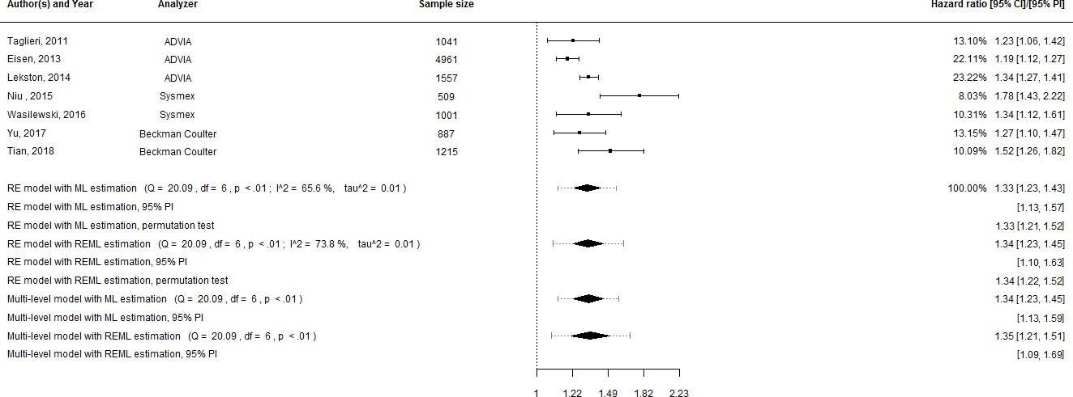

**Supplementary Figures.**

**Supplementary Figure 1.** Analyses for long-term mortality with MPV treated as a continuous variable and hazard ratios as effect estimates and CIs estimated with Wald-type statistics.

Abbreviations: CI, confidence interval; PI, prediction interval; RE, random effects; ML, maximum likelihood; REML, restricted maximum likelihood; MPV, mean platelet volume.

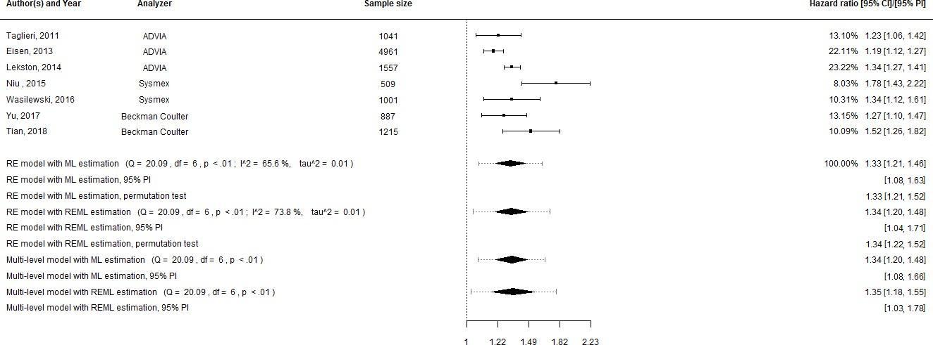

**Supplementary Figure 2.** Analyses for long-term mortality with MPV treated as a continuous variable and hazard ratios as effect estimates and CIs based on t*-*distribution.

Abbreviations: CI, confidence interval; PI, prediction interval; RE, random effects; ML, maximum likelihood; REML, restricted maximum likelihood; MPV, mean platelet volume.

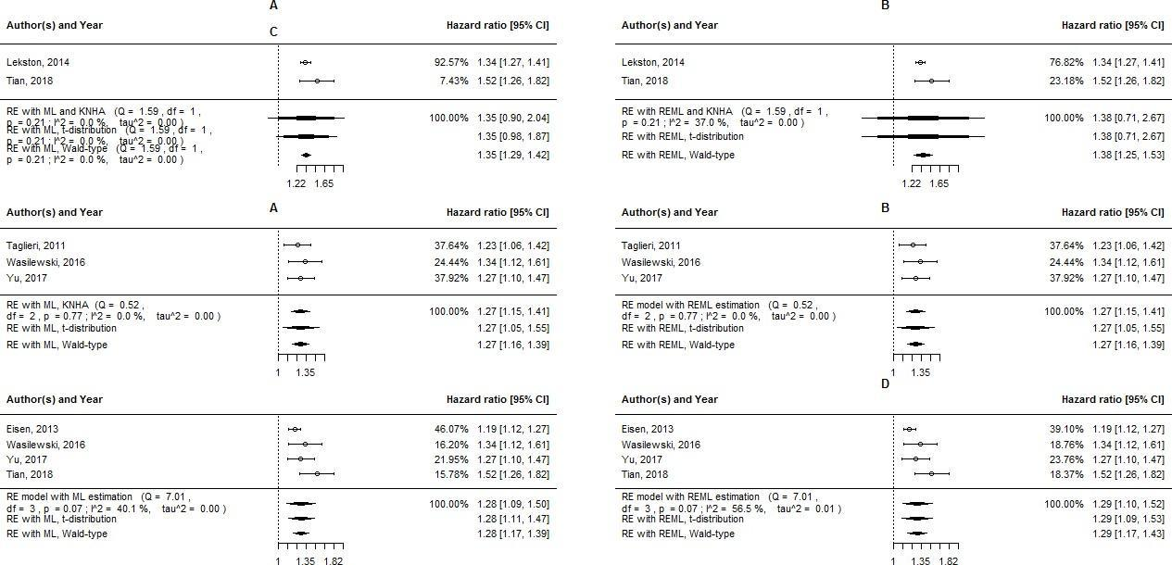

**Supplementary Figure 3.** Subgroup analyses for long-term mortality with MPV treated as a continuous variable and hazard ratios as effect estimates. A and B, subgroup analyses in STEMI patients with ML and REML estimation, respectively; C and D, subgroup analyses in NST-ACS patients with ML and REML estimation, respectively; E and F, subgroup analyses in PCI patients with ML and REML estimation, respectively.

Abbreviations: RE, random effects; ML, maximum likelihood; KNHA, the Knapp and Hartung adjustment; CI, confidence interval; REML, restricted maximum likelihood; MPV, mean platelet volume; STEMI, ST-segment elevation myocardial infarction; NST-ACS, non-ST-segment elevation myocardial infarction; PCI, percutaneous coronary intervention.

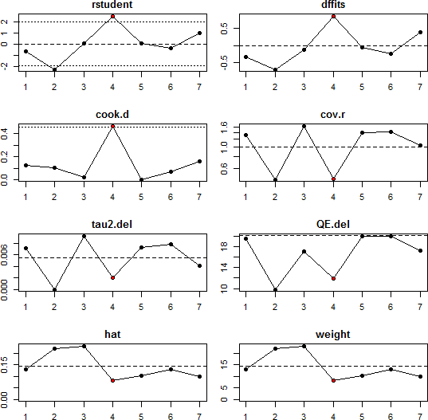

**Supplementary Figure 4.** Influential case diagnostics for long-term mortality with MPV as a a continuous variable and hazard ratios as effect estimates.

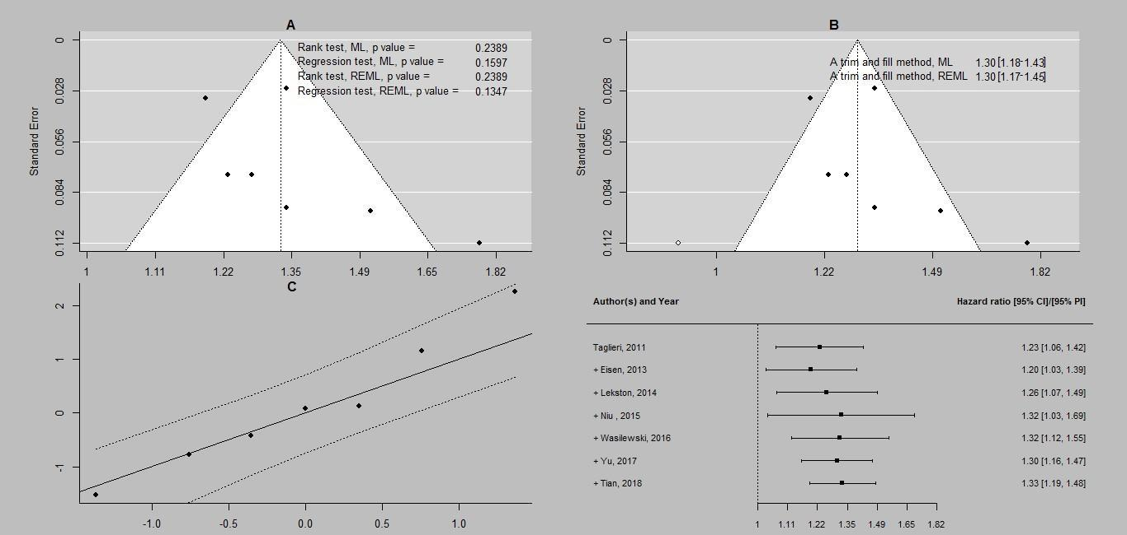

**Supplementary Figure 5.** Additional analyses for long-term mortality with MPV as a continuous variable and hazard ratios as effect estimates. A, funnel plot for ML estimation with rank correlation and regression tests for both ML and REML estimation; B, a trim and fill method for ML estimation with an effect estimate for both ML and REML estimation; C, a Q-Q plot for ML estimation; D, cumulative meta-analysis for ML estimation.

Abbreviations: ML, maximum likelihood; REML, restricted maximum likelihood; CI, confidence interval; PI, prediction interval; MPV, mean platelet volume.

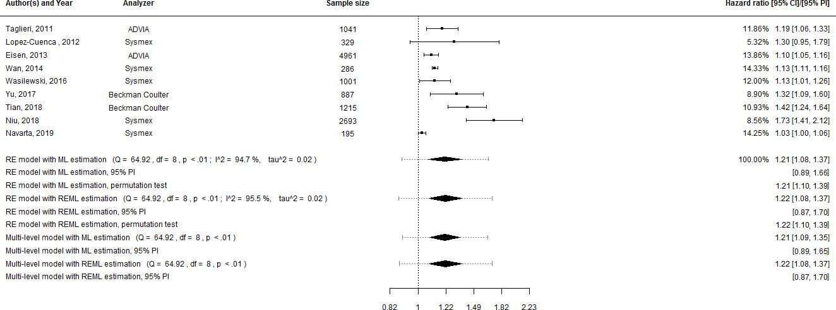

**Supplementary Figure 6.** Analyses for long-term MACE with MPV treated as continuous variable and hazard ratios as effect estimates and the Knapp and Hartung adjustment.

Abbreviations: CI, confidence interval; PI, prediction interval; RE, random effects; ML, maximum likelihood; REML, restricted maximum likelihood; MACE, major adverse cardiovascular events; MPV, mean platelet volume.

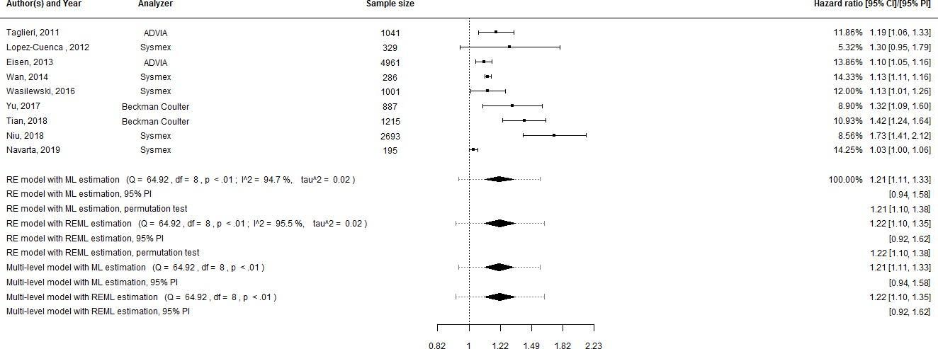

**Supplementary Figure 7.** Analyses for long-term MACE with MPV treated as a continuous variable and hazard ratios as effect estimates and Wald-type CIs

Abbreviations: CI, confidence interval; PI, prediction interval; RE, random effects; ML, maximum likelihood; REML, restricted maximum likelihood; MACE, major adverse cardiovascular events; MPV, mean platelet volume.

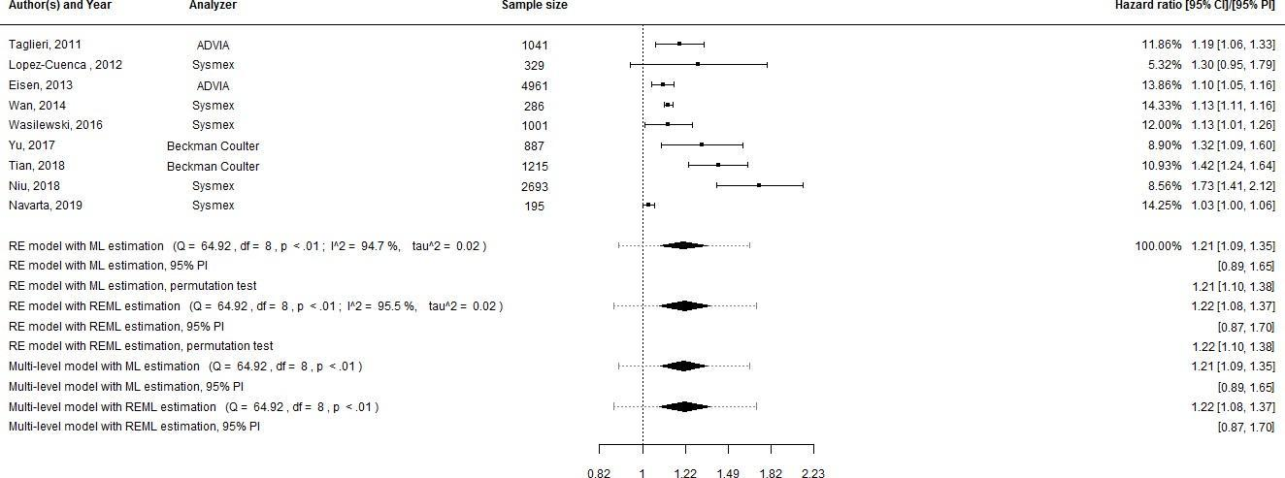

**Supplementary Figure 8.** Analyses for long-term MACE with MPV treated as a continuous variable and hazard ratios as effect estimates based on t-distribution.

Abbreviations: CI, confidence interval; PI, prediction interval; RE, random effects; ML, maximum likelihood; REML, restricted maximum likelihood; MACE, major adverse cardiovascular events; MPV, mean platelet volume.

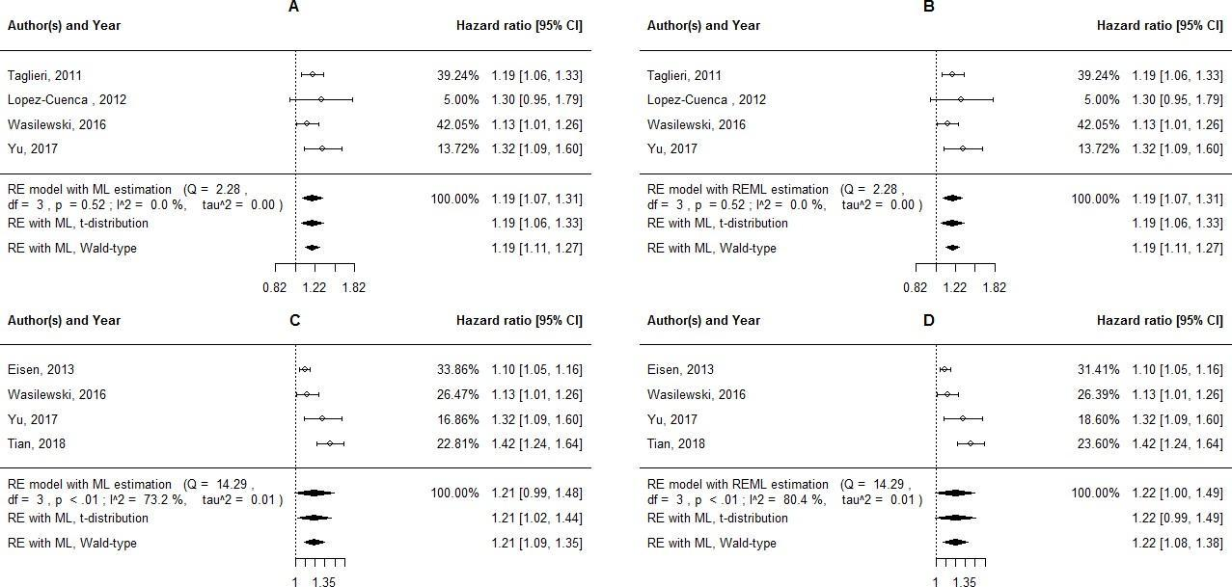

**Supplementary Figure 9.** Subgroup analyses for long-term MACE with MPV treated as a continuous variable and hazard ratios as effect estimates. A and B, subgroup analyses in NST-ACS patients with ML and REML estimation, respectively; C and D, subgroup analyses in PCI patients with ML and REML estimation, respectively.

Abbreviations: RE, random effects; ML, maximum likelihood; CI, confidence interval; REML, restricted maximum likelihood; MACE, major adverse cardiovascular events; MPV, mean platelet volume; NST-ACS, non-ST-segment elevation acute coronary syndrome; PCI, percutaneous coronary intervention.

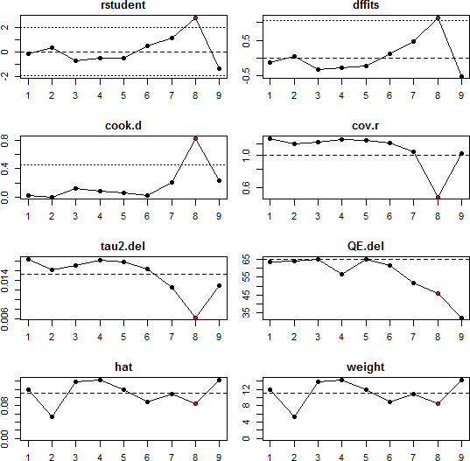

**Supplementary Figure 10.** Influential case diagnostics for long-term mortality with MPV as a continuous variable and hazard ratios as effect estimates.

Abbreviations: MPV, mean platelet volume.

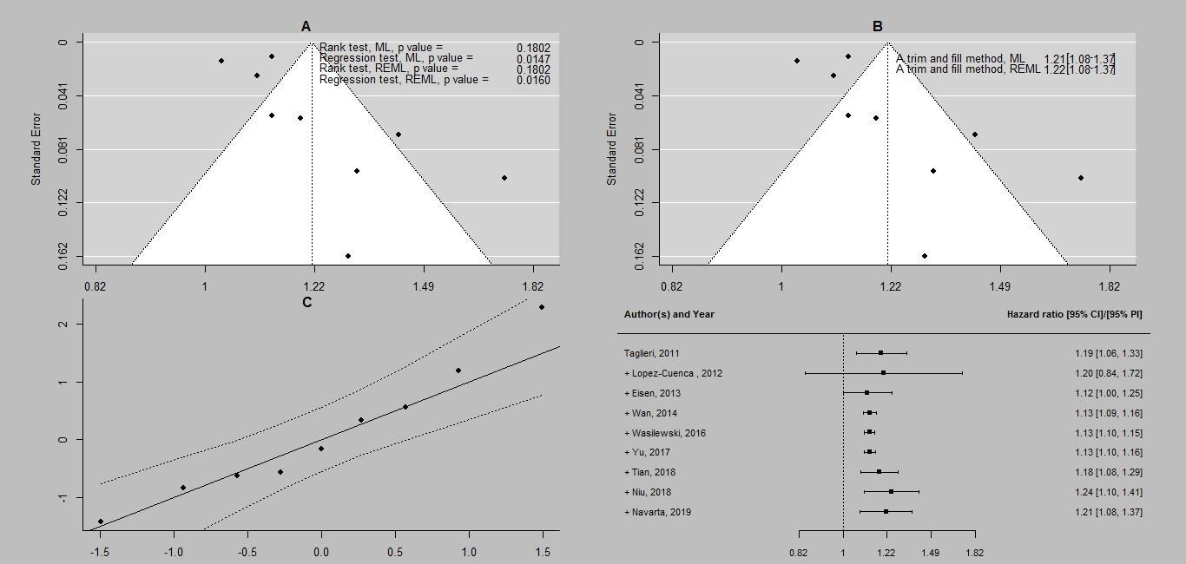

**Supplementary Figure 11.** Additional analyses for long-term MACE with MPV as a continuous variable and hazard ratios as effect estimates. A, funnel plot for ML estimation with rank correlation and regression tests for both ML and REML estimation; B, a trim and fill method for ML estimation with an effect estimate for both ML and REML estimation; C, a Q-Q plot for ML estimation; D, cumulative meta-analysis for ML estimation.

Abbreviations: ML, maximum likelihood; REML, restricted maximum likelihood; CI, confidence interval; PI, prediction interval; MACE, major adverse cardiovascular events; MPV, mean platelet volume.

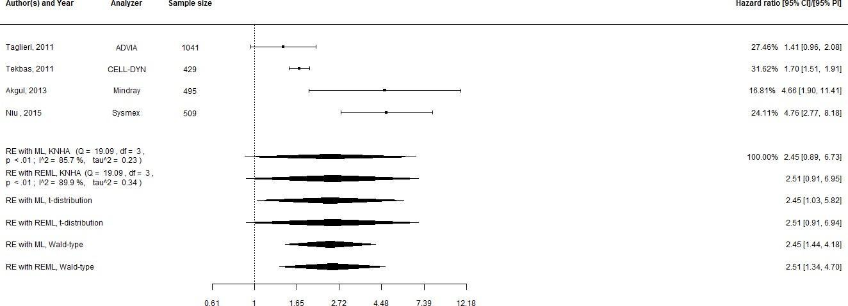

**Supplementary Figure 12.** Analyses for long-term mortality with MPV treated as a categorized variable and hazard ratios as effect estimates.

Abbreviations: CI, confidence interval; RE, random effects; ML, maximum likelihood; KNHA, the Knapp and Hartung adjustment; REML, restricted maximum likelihood; MPV, mean platelet volume.

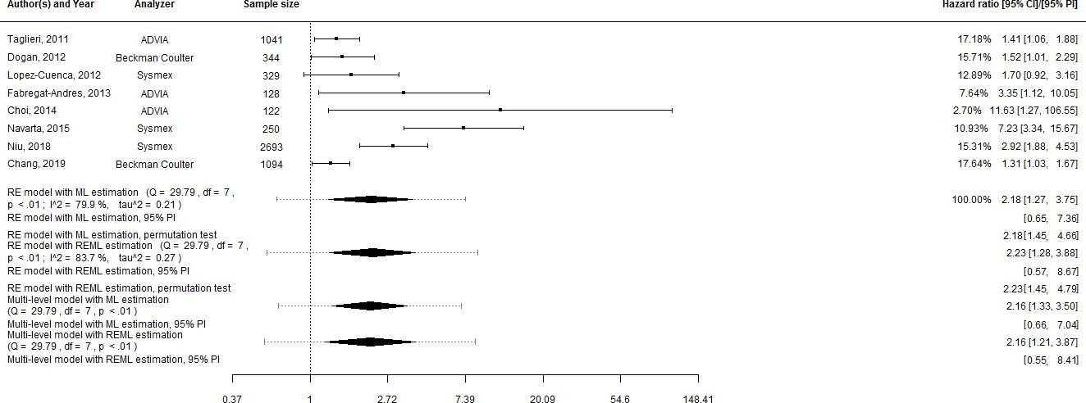

**Supplementary Figure 13.** Analyses for long-term MACE with MPV treated as a categorized variable and hazard ratios as effect estimates and the Knapp and Hartung adjustment.

Abbreviations: CI, confidence interval; RE, random effects; ML, maximum likelihood; REML, restricted maximum likelihood; MACE, major adverse cardiovascular events; MPV, mean platelet volume.

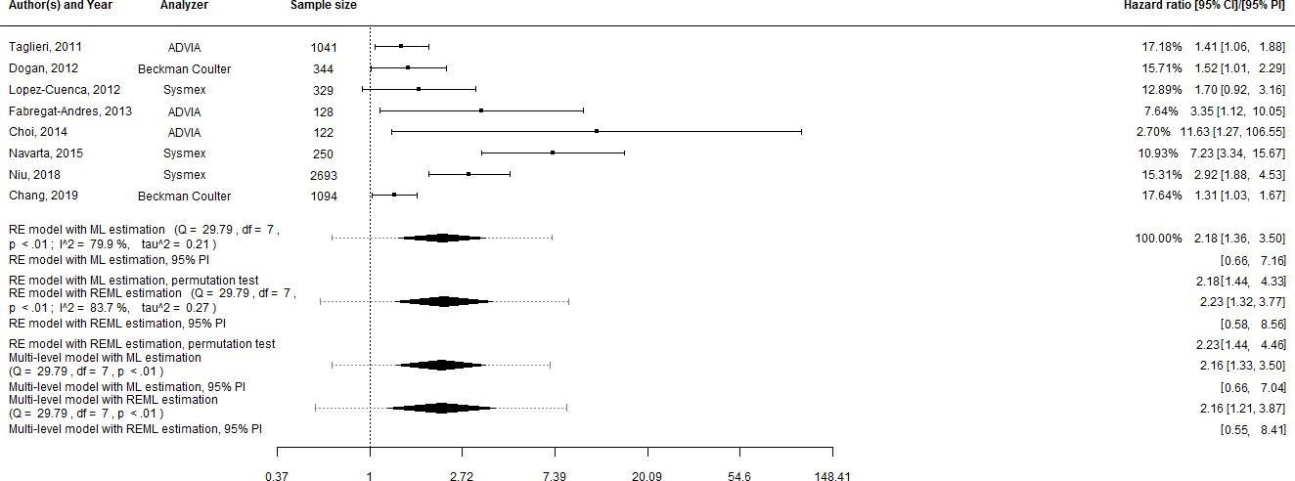

**Supplementary Figure 14.** Analyses for long-term MACE with MPV treated as a categorized variable and hazard ratios as effect estimates and t-distribution based CIs.

Abbreviations: CI, confidence interval; RE, random effects; ML, maximum likelihood; REML, restricted maximum likelihood; MACE, major adverse cardiovascular events; MPV, mean platelet volume.

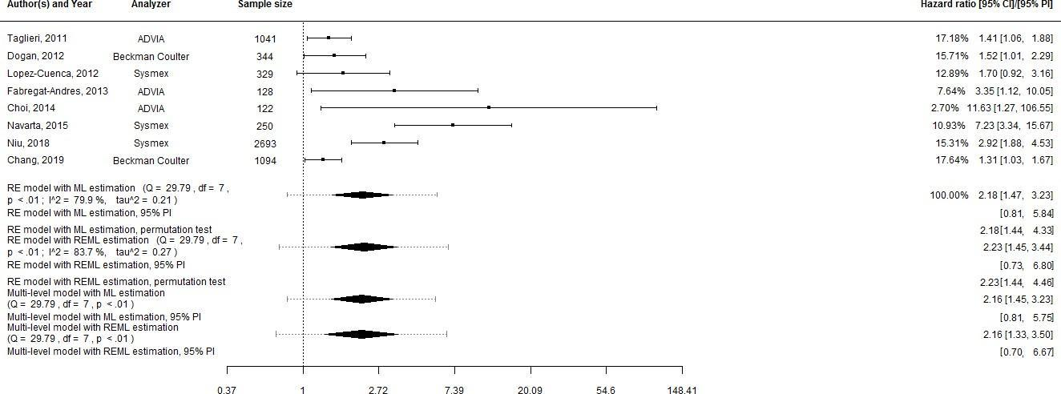

**Supplementary Figure 15.** Analyses for long-term MACE with MPV treated as categorized variable and hazard ratios as effect estimates and Wald-type CIs.

Abbreviations: CI, confidence interval; RE, random effects; ML, maximum likelihood; REML, restricted maximum likelihood; MACE, major adverse cardiovascular events; MPV, mean platelet volume.

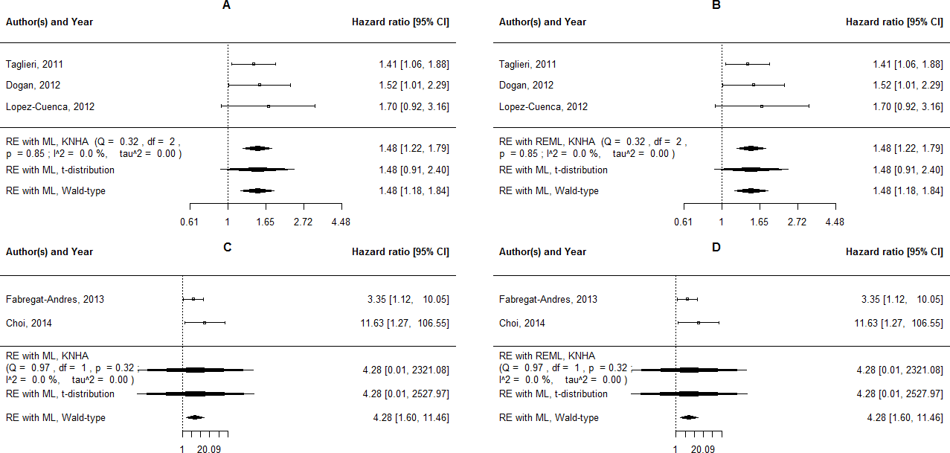

**Supplementary Figure 16.** Subgroup analyses for long-term MACE with MPV treated as a categorized variable and hazard ratios as effect estimates. A and B, subgroup analyses in NST-ACS patients with ML and REML estimation, respectively; C and D, subgroup analyses in PCI patients with ML and REML estimation, respectively.

Abbreviations: RE, random effects; ML, maximum likelihood; KNHA, the Knapp and Hartung adjustment; CI, confidence interval; REML, restricted maximum likelihood; MACE, major adverse cardiovascular events; MPV, mean platelet volume; NST-ACS, non-ST-segment elevation acute coronary syndrome; PCI, percutaneous coronary intervention.

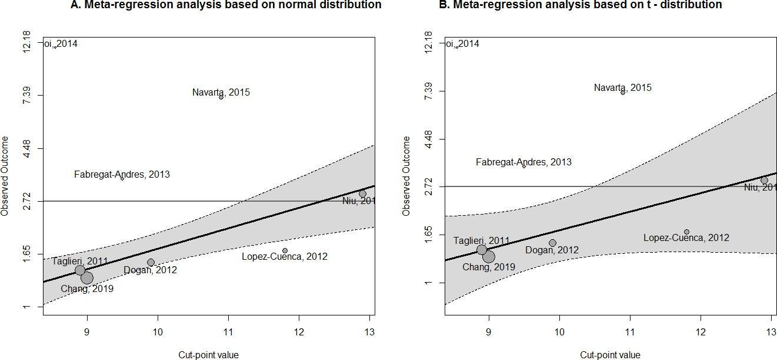

**Supplementary Figure 17.** Meta-regression analyses with a cut-point value treated as a predictor for long-term MACE. MPV was treated as a categorized variable, and hazard ratios were considered as effect estimates.

Abbreviations: MACE, major adverse cardiovascular events; MPV, mean platelet volume.

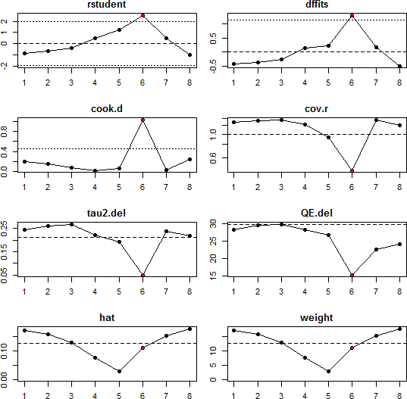

**Supplementary Figure 18.** Influential case diagnostics for long-term mortality with MPV as a categorized variable and hazard ratios as effect estimates**.**

Abbreviations: MPV, mean platelet volume.

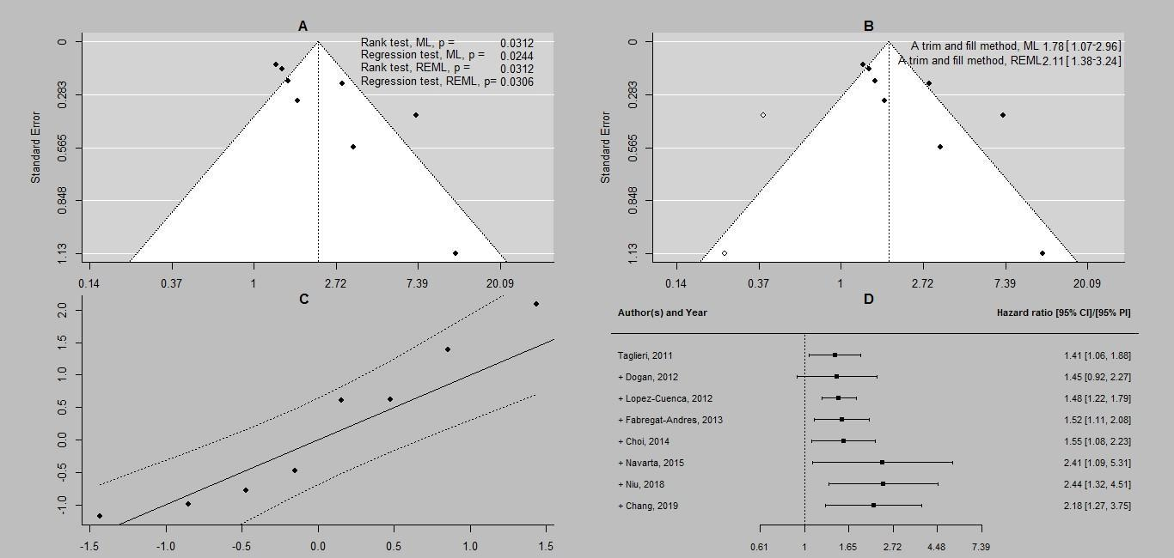

**Supplementary Figure 19.** Additional analyses for long-term MACE with MPV as a categorical variable and hazard ratios as effect estimates. A, funnel plot for ML estimation with rank correlation and regression tests for both ML and REML estimation; B, a trim and fill method for ML estimation with an effect estimate for both ML and REML estimation; C, a Q-Q plot for ML estimation; D, cumulative meta-analysis for ML estimation.

Abbreviations: ML, maximum likelihood; REML, restricted maximum likelihood; CI, confidence interval; PI, prediction interval, MACE, major adverse cardiovascular events; MPV, mean platelet volume.

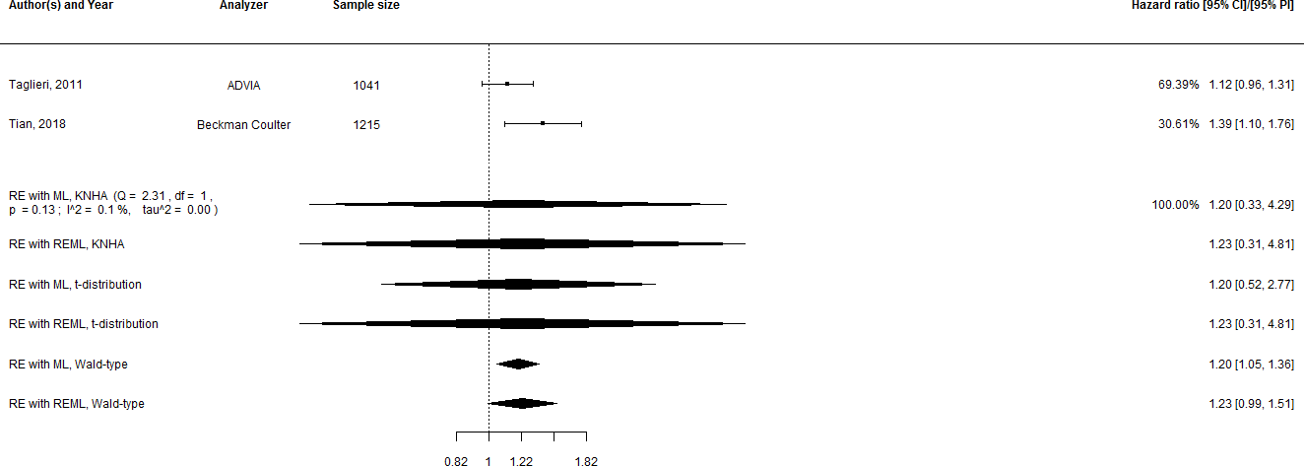

**Supplementary Figure 20.** Analyses for long-term repeated MI with MPV treated as a continuous variable and hazard ratios as effect estimates.

Abbreviations: CI, confidence interval; RE, random effects; ML, maximum likelihood; KNHA, the Knapp and Hartung adjustment; REML, restricted maximum likelihood; MI, myocardial infarction, MPV, mean platelet volume.

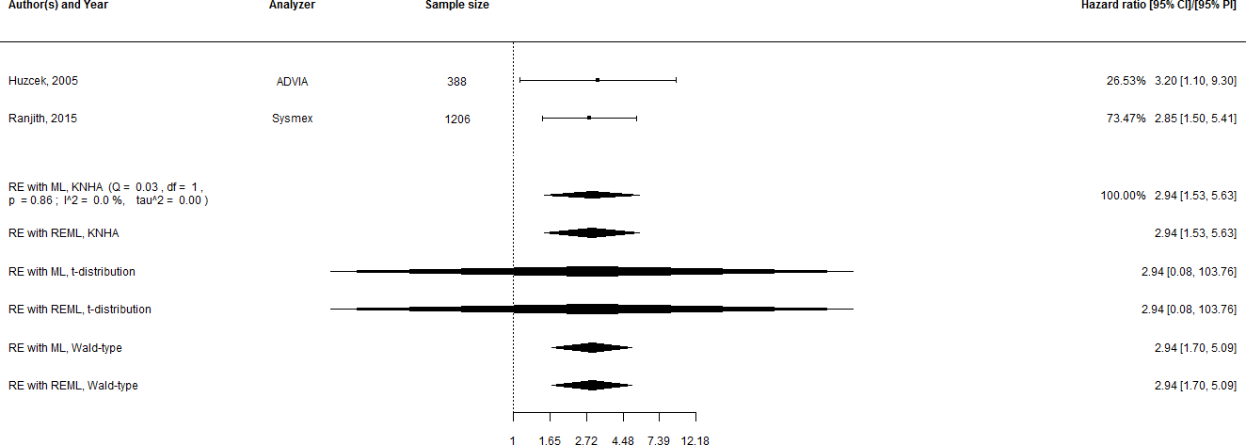

**Supplementary Figure 21.** Analyses for long-term mortality with MPV treated as a categorized variable and odds ratios as effect estimates.

Abbreviations: CI, confidence interval; RE, random effects; ML, maximum likelihood; KNHA, the Knapp and Hartung adjustment; REML, restricted maximum likelihood; MPV, mean platelet volume.

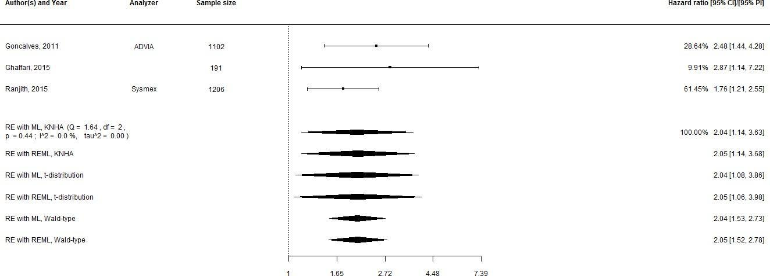

**Supplementary Figure 22.** Analyses for long-term MACE with MPV treated as a categorized variable and odds ratios as effect estimates.

Abbreviations: CI, confidence interval; RE, random effects; ML, maximum likelihood; KNHA, the Knapp and Hartung adjustment; REML, restricted maximum likelihood; MACE, major adverse cardiovascular events; MPV, mean platelet volume.

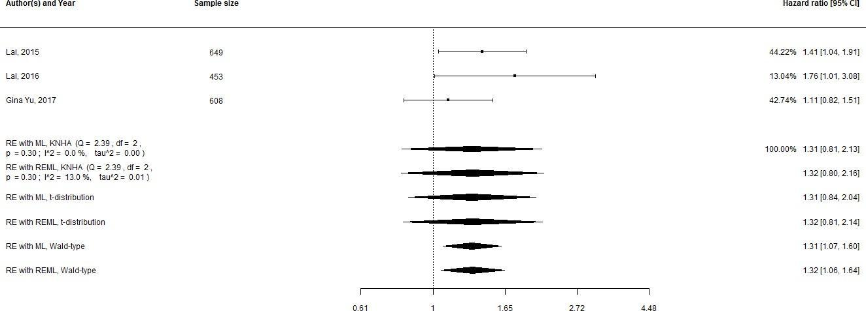

**Supplementary Figure 23.** Analyses for one-month mortality with MPV treated as a continuous variable and hazard ratios as effect estimates.

Abbreviations: CI, confidence interval; RE, random effects; ML, maximum likelihood; KNHA, the Knapp and Hartung adjustment; REML, restricted maximum likelihood; MPV, mean platelet volume.

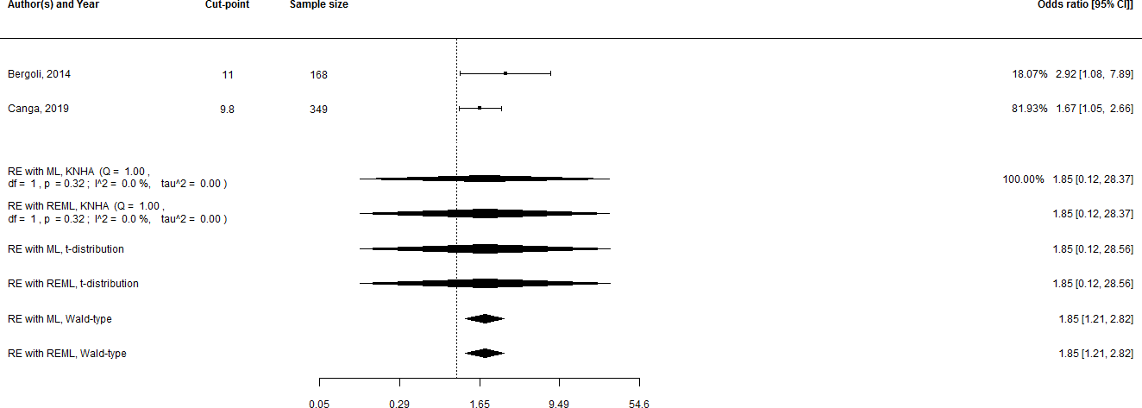

**Supplementary Figure 24.** Analyses for one-month MACE with MPV treated as a categorized variable and odds ratios as effect estimates.

Abbreviations: CI, confidence interval; RE, random effects; ML, maximum likelihood; KNHA, the Knapp and Hartung adjustment; REML, restricted maximum likelihood; MACE, major adverse cardiovascular events; MPV, mean platelet volume.

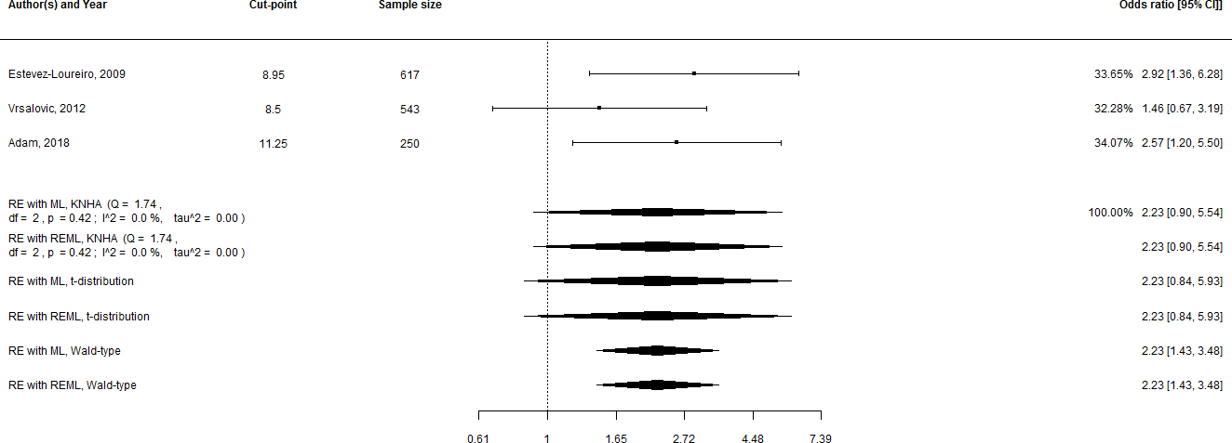

**Supplementary Figure 25.** Analyses for one-month mortality with MPV treated as a categorized variable and odds ratios as effect estimates.

Abbreviations: CI, confidence interval; RE, random effects; ML, maximum likelihood; KNHA, the Knapp and Hartung adjustment; REML, restricted maximum likelihood, MPV, mean platelet volume.

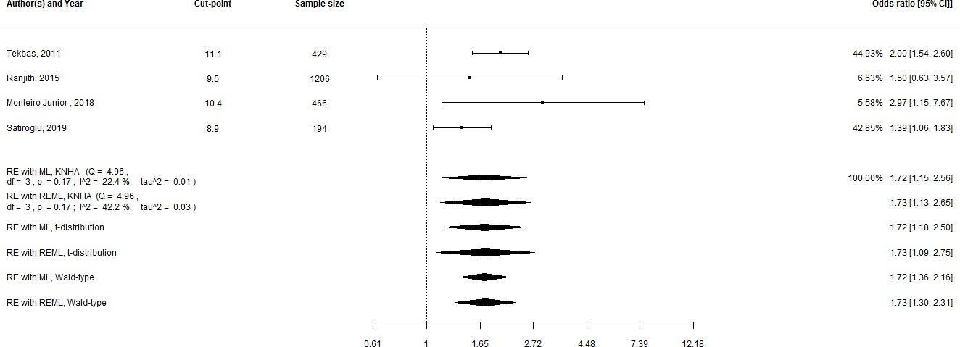

**Supplementary Figure 26.** Analyses for inhospital mortality with MPV treated as a categorized variable and odds ratio as an effect estimate.

Abbreviations: CI, confidence interval; RE, random effects; ML, maximum likelihood; KNHA, the Knapp and Hartung adjustment; REML, restricted maximum likelihood; MPV, mean platelet volume.

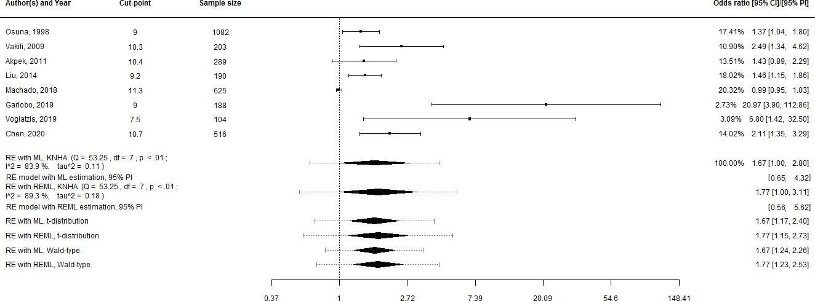

**Supplementary Figure 27.** Analyses for in-hospital MACE with MPV treated as a categorized variable and odds ratios as effect estimates.

Abbreviations: CI, confidence interval; RE, random effects; ML, maximum likelihood; KNHA, the Knapp and Hartung adjustment; REML, restricted maximum likelihood; MACE, major adverse cardiovascular events; MPV, mean platelet volume.

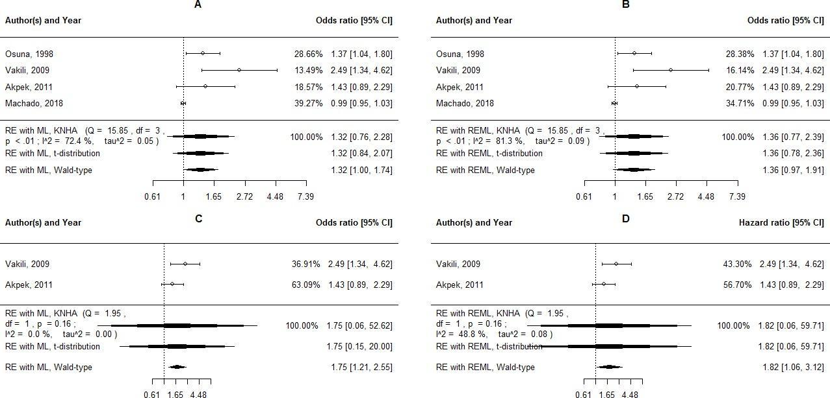

**Supplementary Figure 28.** Subgroup analyses for in-hospital MACE with MPV treated as a categorized variable and odds ratios as effect estimates. A and B, subgroup analyses in STEMI patients with ML and REML estimation, respectively; C and D, subgroup analyses in PCI patients with ML and REML estimation, respectively.

Abbreviations: RE, random effects, ML, maximum likelihood; CI, confidence interval; REML, restricted maximum likelihood; MACE, major adverse cardiovascular events; MPV, mean platelet volume; STEMI, ST-segment elevation myocardial infarction; PCI, percutaneous coronary intervention.

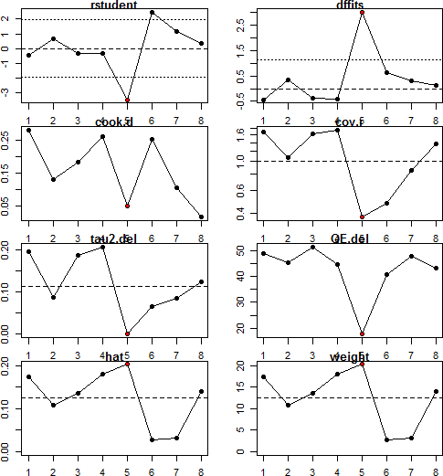

**Supplementary Figure 29.** Influential case diagnostics for in-hospital MACE with MPV as a categorised variable and odds ratios as effect estimates.

Abbreviations: MACE, major adverse cardiovascular events; MPV, mean platelet volume.

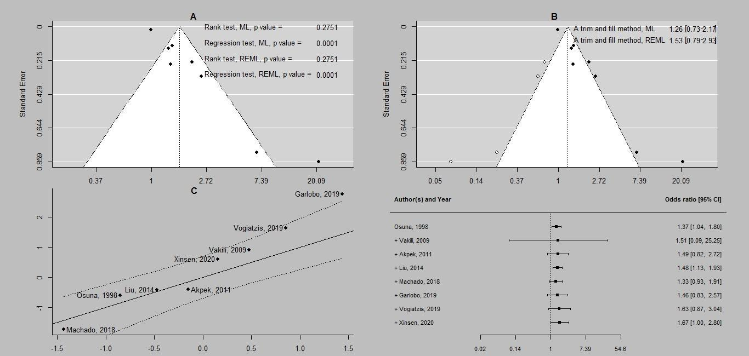

**Supplementary Figure 30.** Additional analyses for in-hospital MACE with MPV as a categorical variable and odds ratios as effect estimates. A, funnel plot for ML estimation with rank correlation and regression tests for both ML and REML estimation; B, a trim and fill method for ML estimation with an effect estimate for both ML and REML estimation; C, a Q-Q plot for ML estimation; D, cumulative meta-analysis for ML estimation.

Abbreviations: ML, maximum likelihood; REML, restricted maximum likelihood; CI, confidence interval; PI, prediction interval; MACE, major adverse cardiovascular events; MPV, mean platelet volume.

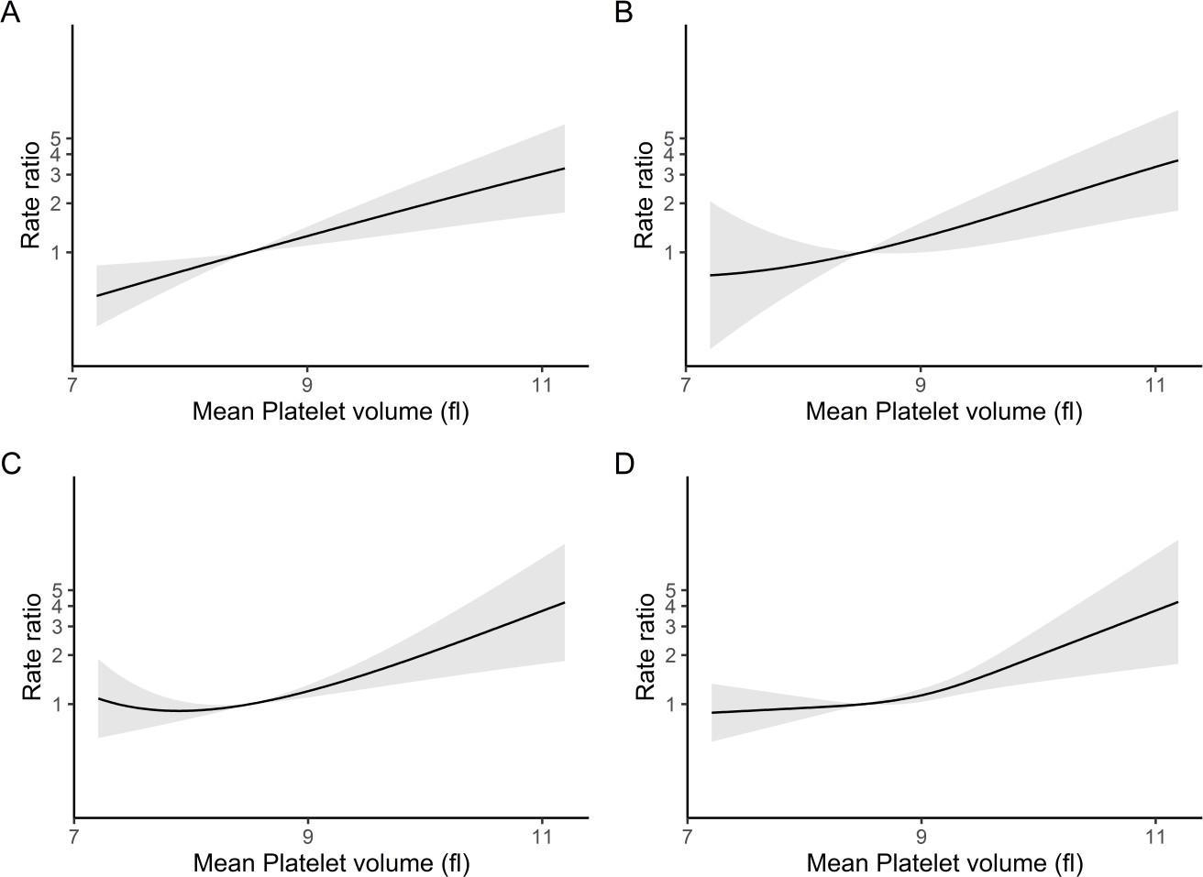

**Supplementary Figure 31.** Dose-response relationship between mean platelet volume and long- term mortality. A, individual prediction curve with confidence intervals for a quadratic model; B – individual prediction curve with confidence intervals for a cubic model; C, individual prediction curve with confidence intervals for the best fitted fractional polynomial model with powers p(-2, - 2); D, individual prediction curve with confidence intervals for the best fitted spline regression model with knots at 8.05, 9.02, 9.8.

* Additional supplemental material is published online only. To view, please visit the journal online [(http://dx.doi.org/10.1136/heartjnl-2022-](http://dx.doi.org/10.1136/heartjnl-2022-320910) [320910).](http://dx.doi.org/10.1136/heartjnl-2022-320910)

1Department of Cardiology and Interventional Arrhythmology, Semey Medical University, Semey, Kazakhstan

2Rentgen-endovascular Laboratory, Semey Medical University, Semey, East Kazakhstan, Kazakhstan 3Department of Cardiology, Bursa Training and Research Hospital, Bursa, Turkey 4Department of Cardiology, Erasmus University Rotterdam, Rotterdam, The Netherlands 5Larner College of Medicine, University of Vermont, Burlington, Vermont, USA 6Cardiovascular Department, King Fahd Armed Forces Hospital, Jeddah, Makkah, Saudi Arabia 7Keele Cardiovascular Research Group, Keele University, Keele, UK



**Correspondence to**

Dr Akhmetzhan Galimzhanov,

Department of Cardiology and Interventional Arrhythmology, Semey Medical University, Semey 575018, Kazakhstan; [ahmed.galimzhan@gmail.com](mailto:ahmed.galimzhan@gmail.com)



Received 1 February 2022

Accepted 11 May 2022 Published Online First 25 May 2022



© Author(s) (or their employer(s)) 2022. No commercial re-use. See rights and permissions. Published by BMJ.

To cite: Galimzhanov A, Sabitov Y, Tenekecioglu E, et al. Heart 2022;108:1792–1799Original research

Baseline platelet count in percutaneous coronary intervention: a dose–response meta-analysis

Akhmetzhan Galimzhanov  ,1 Yersyn Sabitov,2 Erhan Tenekecioglu,3,4 Han Naung Tun,5 Mirvat Alasnag,6 Mamas A Mamas7

### ABSTRACT

**Objectives** The nature of the relationship between baseline platelet count and clinical outcomes following percutaneous coronary intervention (PCI) is unclear. We undertook dose–response and pairwise meta-analyses to better describe the prognostic value of the initial platelet count and clinical endpoints in patients after PCI. **Methods** A search of PubMed, Scopus and Web of Science (up to 9 October 2021) was performed to identify studies that evaluated the association between platelet count and clinical outcomes following PCI. The primary outcomes of interest were all-cause mortality, major adverse cardiovascular events (MACE) and major bleeding. We performed random-effects pairwise and one-stage dose–response meta-analyses by calculating HRs and 95% CIs.

**Results** The meta-analysis included 19 studies with 217 459 patients. We report a J-shaped relationship between baseline thrombocyte counts and all-cause death, MACE and major bleeding at follow-up. The risk of haemorrhagic events exceeded the risk of thrombotic events at low platelet counts (<175×109/L), while a predominant ischaemic risk was observed at high platelet counts (>250×109/L). Pairwise meta-analyses revealed a robust link between initial platelet counts and the risk of postdischarge all-cause mortality, major bleeding (for thrombocytopenia: HR 1.39, 95% CI 1.30 to 1.49; HR 1.51, 95% CI 1.15 to 2.00, respectively) and future death from any cause and MACE (thrombocytosis: HR 1.60, 95% CI 1.29 to 1.98; HR 1.47, 95% CI 1.22 to 1.78, respectively).

**Conclusion** Low platelet counts were associated with the predominant bleeding risk, while high platelet counts were only associated with the ischaemic events.

**PROSPERO registration number** CRD42021283270.



### INTRODUCTION

Percutaneous coronary intervention (PCI) is the most commonly performed revascularisation procedure in patients with coronary artery disease (CAD).1 Although long-term results of PCI have improved, these patients are still at risk of adverse clinical outcomes that include both ischaemic and major bleeding complications.2 Antiplatelet agents are central to the antithrombotic regimes used in PCI, with contemporary regimes using dual antiplatelet therapy consisting of the combination of aspirin and an oral inhibitor of the platelet P2Y12 receptor for adenosine 5′-diphosphate.3 The potency and duration of antiplatelet agent is determined by both clinical characteristics and risk factor profile of the patient as well as the indication for PCI.3

Baseline platelet count is increasingly recognised as an important determinant of both periprocedural and longer term PCI outcomes and has been investigated in a number of prognostic studies previously.4–9 Many of these previous reports have focused on thrombocytopenia that may occur postprocedurally or have characterised thrombocytopenia as a categorical variable without consideration of whether there is gradation of risk by absolute platelet count.5 10 Previous studies have suggested that thrombocytopenia is associated with both an increase in major bleeding and ischaemic events, with no consideration around whether this balance changes across different platelet counts. Furthermore, few studies have investigated the prognostic value of thrombocytosis11–13 with some studies considering platelet count as a linear variable.14 While few studies have attempted to examine non-linear relationships between platelet counts and clinical outcomes,6 12 no dose–response meta-analysis has been conducted yet, and no consideration has been given to quantify net effect on bleeding/ischaemic risk at different platelet



counts. We, therefore, undertook a systematic review and meta- analysis to explore and quantify the relationship across the full continuum of baseline platelet counts and clinical outcomes after PCI.

### MATERIALS AND METHODS

We followed recommendations from the Preferred Reporting Items for Systematic Reviews and Meta-Analyses statement and a guide to systematic review and meta-analysis of prognostic factor studies.15 16 We conducted both a traditional keyword-based and citation-based search. The main databases for the traditional keyword-based strategy were PubMed, Web of Science and Scopus (up to 9 October 2021). Meanwhile, the main tools for the citation-based search were CoCites, Connected Papers and SnowGlobe web-based platforms.17 18 There were no filters based on language or dates of publications. In addition, we searched Dimensions, Microsoft Academics, BioMed Explorer, websites of international conferences, relevant journals and clinical trial registries [(online supplemental appendix).](https://dx.doi.org/10.1136/heartjnl-2022-320910)19 A ShinyApp web tool was employed to create a flow chart.20

#### Screening

The following Population-Exposure-Outcome-based inclusion criteria were used during a screening stage:

1. Population—only studies with patients who underwent PCI were selected. We excluded reports that were dedicated to participants with end-stage kidney, liver disease, cancer; children; or pregnant women.
2. Exposure—only studies that reported baseline platelet counts were considered for inclusion. Publications on acquired thrombocytopenia were removed.
3. Outcome—only studies reporting clinical outcomes were selected. The primary endpoints of the meta-analysis were all-cause mortality, major adverse cardiovascular events (MACE) and major bleeding. We applied definitions used in primary studies. The assigned secondary endpoints were cardiovascular (CV) mortality, myocardial infarction (MI), stroke, unplanned revascularisation, stent thrombosis (ST), all bleeding and minor bleeding. We used the Rayyan web app during the screening process.21

#### Data extraction and risk of bias evaluation

The data extraction was guided with the checklist for critical appraisal and data extraction for systematic reviews of prediction modelling studies—prognostic factors.16 22 We collected data on study design, population, prognostic factor measurement, statistical issues, handling of missing values and results. To calculate unreported overall means and SDs for continuous variables, we used formulae from Wan *et al* and the Cochrane group.23 24

The Quality in Prognostic Factor Studies tool guided our risk of bias assessment.25 The data extraction and risk of bias assessment was performed by two reviewers independently from each other. Any disagreement was discussed within all authors. The Systematic Review Database Repository Plus web portal facilitated collaboration during the data extraction and risk of bias assessment.26

#### Statistical analyses

To investigate the shape of the association between a baseline platelet count and clinical endpoints, we conducted one-stage dose–response meta-analyses for outcomes with at least five available studies.27 If reported, we used mean values of each category of platelet counts as a dose estimate. Otherwise, medians of each category were considered as dose measures. For open- ended highest and lowest categories, half of neighbouring inter- vals were added and subtracted, respectively. For one study, mean doses were calculated directly from the published original data set.28 The study population was divided according to the cut-point used in the study (326.5×109/L), and then mean platelet counts were estimated for each cohort.28 Missing dose values were handled by an R code from Crippa and Orsini. This method defines covariance matrices that enable imputation of missing dose values.29 If not reported, person-time data were calculated by multiplication of the number of patients in each category with median follow-up time. We constructed linear and restricted cubic spline regression models with maximum likelihood estimation. The best locations for knots were derived by a method of Crippa and Orsini.29 The best fitted model was chosen according to Akaike information criterion (AIC). Non-linearity assumption was assessed by testing if the second spline coefficient was equal to zero.30 Taking into account the findings from a large cohort population-based study, we set a platelet count of 250×109/L as a reference point.31 We estimated ischaemic/bleeding risk ratios at different platelet counts by dividing the risk of MACE with the risk of major bleeding. To test the significance of the difference between ischaemic and bleeding risk for different platelet counts, we employed Wald-type test to compare two estimates from independent meta-analyses for MACE and major bleeding.32 The goodness of fit was estimated with an R-squared parameter (0— for no dose–response association, 1—for perfect fitted model) and a visual inspection of the decorrelated residuals. Variance partition coeﬃcients (VPC) at different dose levels were used to quantify between-study heterogeneity.

In addition, pairwise random-effects meta-analyses were performed to compare the prognostic value of thrombocytopenia or thrombocytosis with normal values of a platelet count. For studies with more than two exposure groups, effect estimates were obtained with a method of Hamling *et al*.33 Both maximum and restricted maximum likelihood estimation were applied. Meta-analyses were conducted if at least three studies provided adjusted summary estimates for a particular endpoint. Due to the limited number of primary studies, analyses for a platelet count as a continuous variable were not feasible. To minimise the risk of type I error, 95% CIs were derived with both Wald-type statistics and Knapp and Hartung adjustment.34 As recommended, the Knapp and Hartung adjustment was calculated for analyses with at least five studies.34

The amount of between-study heterogeneity was assessed with χ2 Q test (according to p values) and I2 test. Potential reasons for heterogeneity were investigated with meta-regression analyses if at least 10 studies were available.

We conducted influential case diagnostics to reveal outstanding studies that significantly impact on the model characteristics (fit, covariance structure, heterogeneity) after removing individual studies sequentially.35 Publication bias was tested with rank correlation and regression statistics. An impact of potential missing studies was measured with a trim and fill method. For analyses with positive findings, we performed leave-one-out sensitivity analyses to obtain robust results. Cumulative meta-analyses described time trends of summary estimates. Statistical analyses were computed with R language within metafor and dosresmeta R packages.29 35 We also rated the certainty of obtained results according to guidelines from the Grading of Recommendations, Assessment, Development and Evaluation Working Group.36

Patients or the public were not involved in the design, conduct, reporting or dissemination plans of our study. No

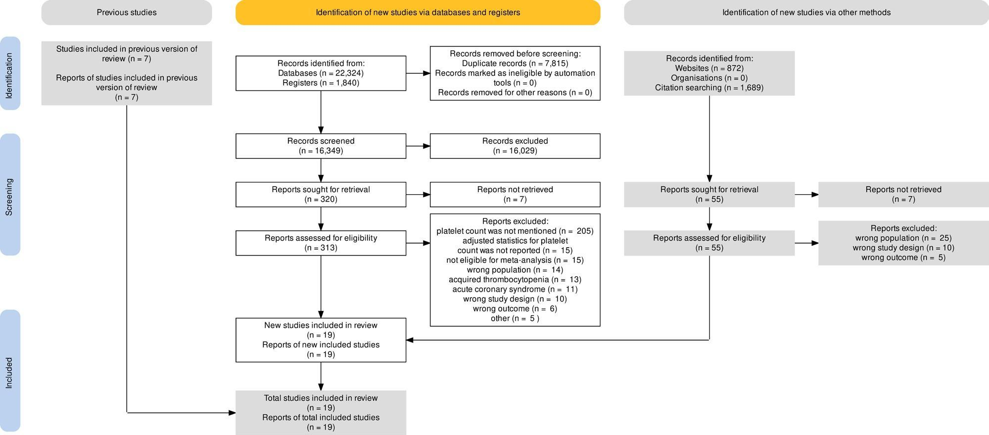

**Figure 1** Flow diagram of the meta-analysis.

ethical approval was needed because we used only published data from the primary studies in which patient informed consent was obtained from the study participants.

### RESULTS

After a comprehensive search, we identified 19 studies with 217 459 participants.4–9 11–13 28 37–45 Figure 1 illustrates the flow diagram of the search strategy used. The number of retrieved studies from additional sources is provided in [online supplemental tables S1 and S2,](https://dx.doi.org/10.1136/heartjnl-2022-320910) and lists potentially relevant studies with reasons of exclusion. The baseline features of the included studies are presented in [online supplemental table S3.](https://dx.doi.org/10.1136/heartjnl-2022-320910) The majority of studies were retrospective. The follow-up duration varied from 11.7 to 60 months. Nine out of 19 studies were conducted in the East-Asian region while 2 were derived from Europe, 5 were derived from North America and 3 were multinational. Mean age of the total population was 65.5±11.7 (ranging from 58.2 to 73.1). The studies varied greatly in the prevalence of hypertension (37.9%–92.7%), diabetes mellitus (13.8%–100%), dyslipidaemia (8.2%–90.6%), chronic kidney disease (3.8%–38.6%), smoking (10.2%–56.6%) and other risk factors. The definitions for MACE used in the included studies are provided in [online supplemental table S3.](https://dx.doi.org/10.1136/heartjnl-2022-320910)

[Online supplemental table S4](https://dx.doi.org/10.1136/heartjnl-2022-320910) describes the risk of bias assessment. Generally, patients from the included studies adequately represent the population of interest. Study attrition bias was rated as moderate in the studies that did not report percentage of lost to follow-up population.4 6–9 11–13 28 40 45 One study reported 14% missing follow-up data without providing any reasons, that is why this study was regarded as of high risk of attrition bias.43 We considered the included studies as low-moderate risk of bias due to prognostic factor measurement since the majority of them had complete data on platelet counts, provided clear definitions and used similar cut-points. In many studies, clinical outcomes were assessed blindly by an independent investigator; therefore, outcome measurement bias was graded as low.4–6 8 11–13 37 39–42 We rated one study as having high risk due to confounding bias since this study did not adjust effect estimates for traditional risk factors.44 One report applied univariate regression analyses on propensity score-matсhed population, which potentially could lead to statistical bias.43

**Dose–response relationships**

A dose–response meta-analysis for postdischarge all-cause mortality included 10 studies with a total population of 106 135 patients (283 520 person-years of follow-up, figure 2A, [online](https://dx.doi.org/10.1136/heartjnl-2022-320910) [supplemental table](https://dx.doi.org/10.1136/heartjnl-2022-320910) S5). The best fitted model was a restricted cubic spline regression with knots located at 75, 125 and 313. Non-linearity assumption was statistically significant (p<0.001). With a platelet count of 250×109/L as a reference value, the risk of all-cause death increased with decreasing platelet counts and became significant from the level of 175×109/L (HR 1.07, 95% CI 1.03 to 1.11). This non-linear inverse relationship continued further with decreasing platelet counts. For values

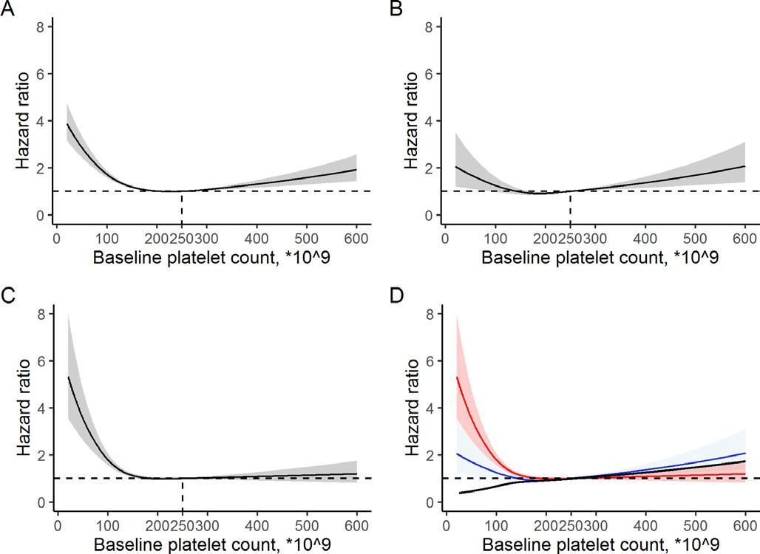

**Figure 2** Dose–response relationships between baseline platelet counts and clinical outcomes. (A) The best fitted restricted cubic spline model for postdischarge all-cause mortality. (B) The best fitted restricted cubic spline model for long-term major adverse cardiovascular events (MACE). (C) The best fitted restricted cubic spline model for long-term major bleeding. (D) The relationship between the risk of MACE and the risk of major bleeding. The red line illustrates the risk for long- term major bleeding, the blue line demonstrates the risk for long-term MACE. The black line represents the ratio of ischaemic/bleeding risks at different platelet counts.

above 250×109/L, the association approximated a linear equation with significant results coming from a level of 275×109/L (HR 1.03, 95% CI 1.01 to 1.05). The model adequately fitted the data with an adjusted R-squared statistics equal to 0.86. The evidence was graded as moderate.

An analysis for long-term MACE included seven studies with 76 903 participants (220 949 person-years of follow-up, figure 2B, [online supplemental table](https://dx.doi.org/10.1136/heartjnl-2022-320910) S5). Departure from linearity was significant (p<0.001). Among all models, a spline regression with knots at 82, 175 and 237 had the highest AIC. For platelet numbers below 250×109/L, the risk of MACE decreased up to the level of 175×109/L, and then increased non-proportionally with statistical significance reaching from a value of 75×109/L (HR 1.46, 95% CI 1.04 to 2.06). Similar to mortality, the risk of MACE increased in an almost linear fashion for platelet count values above 250×109/L. The adjusted R-squared statistics was at 0.36. We rated the grade of evidence as low.

We also found curvilinear inverse association between a baseline platelet count and the risk of major bleeding. This analysis was based on five studies with a total of 83 763 individuals (247 638 person-years, figure 2C, [online supplemental table](https://dx.doi.org/10.1136/heartjnl-2022-320910) S5). The relationship was adequately described with a spline regression model with the best knots located at 79.5, 125 and 236. Non-linear assumption was supported with p<0.001. The risk of major bleeding demonstrated a non-proportional upward trend with decreasing baseline platelet counts. Significant results appeared from a level of 150×109/L (HR 1.13, 95% CI 1.04 to 1.22). Unlike other endpoints, the risk of major bleeding remained stable for baseline platelet counts above 250×109/L. The high adjusted R-squared statistics (0.91) did not imply any lack of fit. The quality of evidence was considered as moderate. A visual inspection of the decorrelated residuals is described in [online supplemental figure S1.](https://dx.doi.org/10.1136/heartjnl-2022-320910)

Figure 2D illustrates how the ratio of ischaemic/bleeding risk varies at different platelet counts. The risk of haemorrhagic events exceeded the risk of thrombotic events at low platelet counts, while a predominant ischaemic risk was observed at high platelet counts. The trend became more prominent for platelet counts below 150×109/L. The difference between the risk of ischaemic and bleeding outcomes was statistically significant across all continuum of thrombocyte counts, except for the range of 175×109/L to 250×109/L [(online supplemental table](https://dx.doi.org/10.1136/heartjnl-2022-320910) [S6).](https://dx.doi.org/10.1136/heartjnl-2022-320910)

For all dose–response analyses, heterogeneity was low with VPC approximating zero. During leave-one-out sensitivity analyses, the shape of relationships did not change significantly with omitting one study after another [(online supplemental figure](https://dx.doi.org/10.1136/heartjnl-2022-320910) S2).

#### Pairwise meta-analyses for thrombocytopenia versus normal values of a platelet count

The majority of the included studies defined thrombocytopenia as a preprocedural platelet count below 150×109/L. Four studies used a cut-point of 100×109/L for patients with thrombocytopenia.38–40 43 For one study, the cut-point choice was based on tertiles of a platelet count.11 An analysis for postdischarge all-cause mortality included 11 studies with a total of 111 305 patients (figure 3A). The association between thrombocytopenia and long-term mortality was significant with an HR of 1.39 (95% CI 1.30 to 1.49). Between-study heterogeneity was low but statistically significant (I2=0%, p=0.03). According to a meta-analysis of eight studies (87 126 patients), thrombocytopenia was not predictive for long-term MACE (HR 1.1, 95% CI 0.97 to 1.25, figure 3B). A meta-analysis of seven studies (92 905 patients) demonstrated a prognostic value of thrombocytopenia in prediction of long-term major bleeding (HR 1.39, 95% CI 1.18 to 1.65, I2=51.5%, p for heterogeneity 0.04, figure 3C). Similarly, a meta-analysis of seven studies (106 496 individuals) found a link between thrombocytopenia and the risk of in-hospital mortality (HR 1.65, 95% CI 1.15 to 2.38, I2=78.6%, p for heterogeneity <0.01, figure 3D). Other estimation methods provided similar results [(online supplemental figure](https://dx.doi.org/10.1136/heartjnl-2022-320910) S3). For

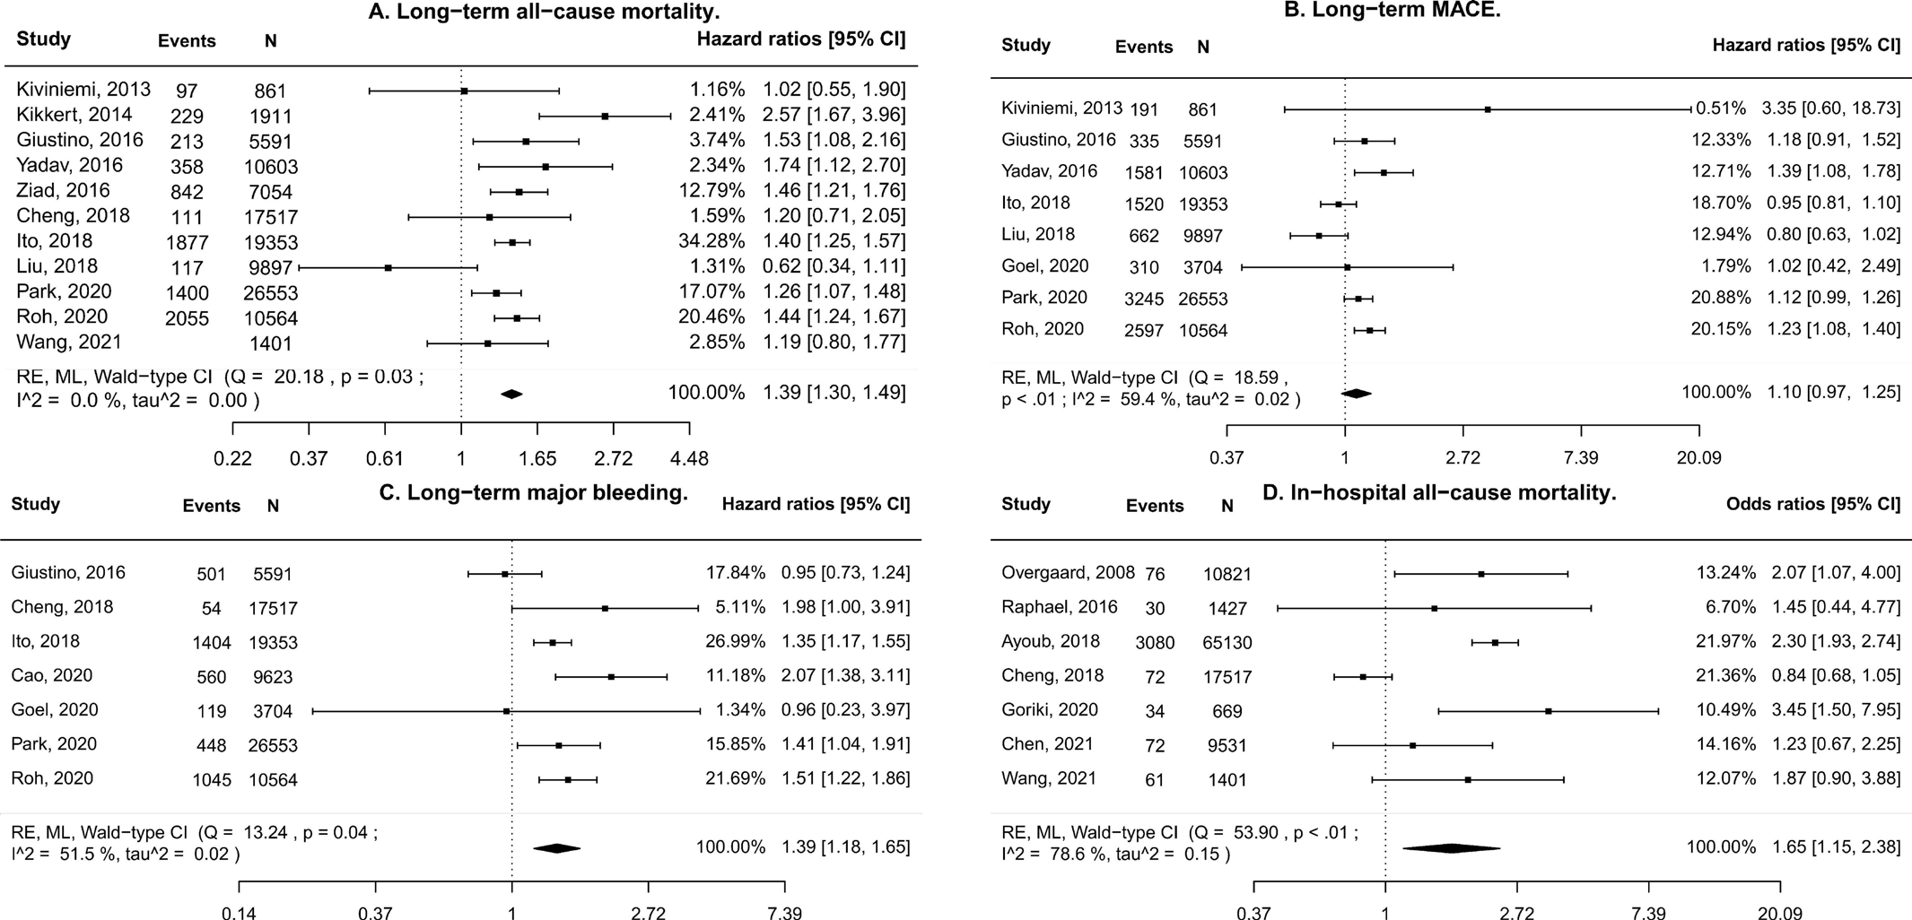

**Figure 3** Pairwise meta-analyses for baseline thrombocytopenia versus normal values of platelet counts. Due to non-availability of the published data, the number of events for the study of Kikkert *et al*41 also included patients with thrombocytosis. MACE, major adverse cardiovascular events; ML, maximum likelihood; RE, random effects.

other endpoints, the results were non-significant or were based on a low number of studies [(online supplemental figure](https://dx.doi.org/10.1136/heartjnl-2022-320910) S4).

Prespecified subgroup analyses were not feasible due to the absence of the required published data. The meta-analysis restricted to only patients with acute MI provides analogous results (HR 1.59, 95% CI 1.27 to 1.99, [online supplemental](https://dx.doi.org/10.1136/heartjnl-2022-320910) [figure](https://dx.doi.org/10.1136/heartjnl-2022-320910) S5). However, whether the prognostic value of baseline platelet counts varies across different clinical groups is unclear as the test for interaction could not be calculated. The meta-regression analyses did not reveal any significant association between the available study-level variables (percentage of patients with MI, acute coronary syndrome, unstable angina, hypertension, diabetes mellitus, dyslipidaemia, smoking, prior MI, mean age and male proportion) and all-cause mortality. The influential case diagnostics regarded the study of Ito *et al*6 as influential for long-term all-cause death and the study of Cheng *et al*13 for in-hospital mortality. However, leave-one-out sensitivity analyses did not alter the results for long-term mortality and major bleeding. After removing one study, the results became non-significant for in-hospital all-cause mortality [(online](https://dx.doi.org/10.1136/heartjnl-2022-320910) [supplemental table](https://dx.doi.org/10.1136/heartjnl-2022-320910) S7). The rank correlation and regression tests for funnel plot asymmetry did not imply any publication bias. Furthermore, trim and fill analyses still supported a prognostic utility of thrombocytopenia for postdischarge all-cause mortality and major bleeding. However, a trim and fill method indicated the presence of publication bias for in-hospital all-cause mortality since the results became non-significant [(online supplemental](https://dx.doi.org/10.1136/heartjnl-2022-320910) [figure](https://dx.doi.org/10.1136/heartjnl-2022-320910) S5). Cumulative meta-analyses are presented in [online](https://dx.doi.org/10.1136/heartjnl-2022-320910) [supplemental figure S6.](https://dx.doi.org/10.1136/heartjnl-2022-320910) The evidence was graded as low quality for in-hospital mortality and moderate quality for postdischarge all-cause mortality and major bleeding.

#### Pairwise meta-analyses for thrombocytosis versus normal values of a platelet count

Definitions for thrombocytosis varied widely from 250×109/L to 450×109/L.11–13 28 41 A meta-analysis of four studies with a total of 33 385 patients revealed a significant association between thrombocytosis and postdischarge all-cause mortality (HR 1.6, 95% CI 1.29 to 1.98, I2=0%, p for heterogeneity=0.37, figure 4A). Also, based on the analysis of three studies (16 038 patients), thrombocytosis predicted the development of long-term MACE (HR 1.47, 95% CI 1.22 to 1.78, I2=0%, p for heterogeneity=0.49, figure 4B). Due to the limited number of studies, other analyses were not feasible.

### DISCUSSION

Our current analysis of 19 studies and with 217 459 participants suggests that the association between preprocedural thrombocyte counts and the risk of postdischarge all-cause mortality and MACE following PCI is J shaped, with a non-linear inverse relationship for low platelet counts (<175×109/L and <75×109/L, respectively) and a linear proportional relationship for high platelet counts (>275×109/L). Our analysis suggests that linear equations used in previous analyses fail to capture the complex relationships between baseline platelet counts and clinical outcomes in patients treated with PCI. The link between initial platelet counts and long-term major bleeding is reverse J shaped, with no significant increase in bleeding risk observed in high baseline platelet counts. Finally, we quantify the overall balance of ischaemic versus bleeding risk varies across different platelet counts, with major bleeding the predominant risk at low platelet counts (<175×109/L), while ischaemic events are more important at high platelet counts (>275×109/L). This differential risk of bleeding versus ischaemic events at different platelet counts may be relevant clinically and may support more personalised antiplatelet regimes in patients with abnormal baseline platelet count, both in terms of potency of antiplatelet type and duration of dual antiplatelet regime.

To the best of our knowledge, this is the first dose–response meta-analysis that has generated evidence on non-linear relationships between preprocedural platelet counts and adverse events after PCI. We also found cut-point levels that better delineate a group of patients at risk. For major bleeding, the risk became statistically significant from a level of 150×109/L. For

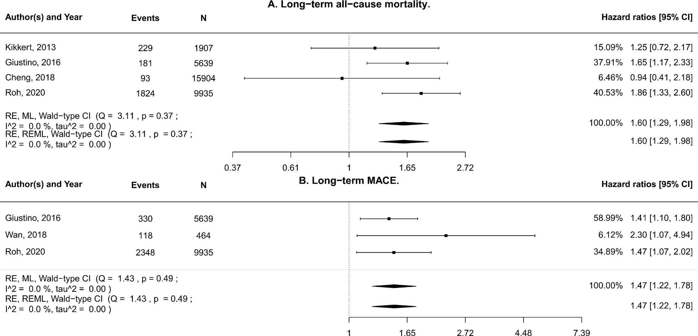

**Figure 4** Pairwise meta-analyses for baseline thrombocytosis versus normal values of platelet counts. MACE, major adverse cardiovascular events; ML, maximum likelihood; RE, random effects; REML, restricted maximum likelihood.

long-term all-cause death and MACE, the best fitted cut-points were located at 175×109/L and 75×109/L, respectively. For high values of platelet numbers, the risk of follow-up mortality and MACE increased in a linear fashion.

In addition, we investigated how the relationship between the ischaemic and bleeding risks varied at different platelet counts. While the risk of haemorrhagic events was greater than thrombotic risk for low platelet counts, patients with high initial platelet counts were at greater risk for ischaemic events. These findings are informative for tailoring both the duration and type of antiplatelet regimen employed at different platelet counts following PCI. Our investigation on the trade-off between ischaemic and bleeding risks suggests that antiplatelet therapy should be guided to minimise bleeding burden in patients with baseline thrombocytopenia. These strategies might include shortening the duration of antiplatelet therapy, selecting clopidogrel as a P2Y12 receptor inhibitor, administration of proton pump inhibitors and avoidance of glycoprotein IIb/IIIa inhibitors.3 For individuals with preprocedural thrombocytosis, our meta-analysis supports the antithrombotic strategies targeted to maximise thrombotic protection. These strategies could be realised as selecting potent P2Y12 receptor inhibitors (ticagrelor, prasugrel) instead of clopidogrel or extending the duration of dual antiplatelet therapy (DAPT).3

The J-shaped relationship between baseline platelet counts and clinical outcomes can be explained from a pathophysiological point of view. Platelets play a pivotal role in both haemostasis and thrombosis. Platelets participate in all stages of haemostasis, including platelet adhesion, activation, aggregation and blood coagulation cascade.46 47 Recent studies have also found that platelets contribute to a ‘protein wave’ of haemostasis that occurs prior to platelet adhesion.46 Baseline thrombocytopenia may be due to chronic conditions, such as immune thrombocytopenia, cancer, leukaemia, liver diseases, anaemia, alcohol abuse and use of some drugs.48 Abnormal platelet counts may relate to underlying comorbidities and any relationship with adverse outcomes may be driven by comorbidities, rather than the platelet count per se. Indeed, several primary studies in our meta-analysis reported a greater burden of comorbid conditions in patients with abnormal platelet counts.4–6 8 12 37 39 43 In order to mitigate the effects of this, we extracted only the effect estimates that were adjusted for these differences in multivariate analyses, although the variables that were adjusted for varied by study. Furthermore, many studies did not provide adequate data on baseline comorbid conditions.7 13 38 40–42 44 45 Therefore, it remains possible that differences in comorbid burden not adjusted for in studies used in the current analysis may in part contribute to our findings.

In patients with baseline high platelet counts, thrombocytosis could be related to primary diseases (essential thrombocythaemia, leukaemia and other haemoproliferative disorders).49 However, more commonly, thrombocytosis is a secondary process related to inflammation, infection, malignancy or stress.49 Therefore, the degree of thrombocytosis could reflect the severity of thromboinflammation. An interplay between platelets and leucocytes is a cornerstone of thromboinflammation.47 Platelets initiate and augment the process of thrombi formation on a ruptured atherosclerotic plaque and mitigate early and late stages of atherosclerosis, predisposing patients to CV events.47 Despite the crucial importance of platelets in haemostasis, thrombosis and thromboinflammation, the prognostic value of elevated platelet counts is not considered in contemporary risk scores.3 10

Previously, one study reported a paradoxical borderline increase in haemorrhagic risk in patients with thrombocytosis calling for additional studies. This phenomenon is described for patients with essential thrombocythaemia and could be explained by functional deficiency of von Willebrand factor.50 Our meta-analysis did not reveal any increase in bleeding events at high platelet counts. It is possible that any small increases in bleeding risk at higher platelet counts were offset by prescription of less potent antiplatelets and shorter duration dual antiplatelet regimes or de-escalation to less potent regimes by operators. Alternatively, the small number of patients with essential thrombocythaemia may mean the study is underpowered to detect small increases in bleeding risk, or such patients present with bleeding events that do not require medical attention.

The primary studies included in the meta-analysis used different definitions for MACE and major bleeding [(online](https://dx.doi.org/10.1136/heartjnl-2022-320910) [supplemental table](https://dx.doi.org/10.1136/heartjnl-2022-320910) S3). For example, MACE was defined as a combination of MI and stroke in a study of Ito *et al*, and as a composite of cardiac death, MI or ST in a study of Giustino *et al*.6 11 There are also differences in how MI was defined, particularly whether hsTn assays were used, or older Tn assays/CK-MB. Therefore, even individual endpoints such as MI would be heterogenous. Measures of significant heterogeneity in some of our reported finding results could be partially related to inconsistency of applied definitions. Also, the lack of consensus in used definitions makes it difficult to speculate on the degree of the association between different components of MACE and baseline platelet counts.

Our systematic review has several limitations. Dose–response meta-analyses were not feasible for long-term MI, ST, stroke and in-hospital mortality due to the limited number of retrieved primary studies. For this reason, we also removed those studies that reported effect estimates for a per-unit increase in platelet counts. Considering a lack of available evidence, we were not able to conduct pairwise meta-analyses for some clinical outcomes. As the primary studies predominantly reported data on major bleeding as a composite endpoint, we did not perform separate statistical analyses for procedural-related bleeding and non-procedural bleeding as these data were not reported. Furthermore, the majority of primary studies were of retrospective design; herein, selection bias could not be excluded. Some missing data did not allow us to perform subgroup analyses for patients with different forms of CAD and diabetes mellitus. Finally, considering predominantly observational design of included studies, we can only postulate an associative rather than causal link between baseline platelet counts and clinical outcomes after PCI. Some of the relationships we describe may be an indirect effect of antiplatelet choice of operators that are based on platelet count at baseline and the perceived bleeding/ ischaemic risk of patients. For example, an increase of thrombotic events in patients with initial thrombocytopenia might be a result of shortening of DAPT duration or administration of less potent P2Y12 inhibitors. Due to limited data, we were unable to investigate the impact of antiplatelet choice/regimes, baseline haemoglobin, creatinine levels, procedural characteristics and other variables on the association between platelet count and clinical outcomes in meta-regression analyses.

### CONCLUSION

Our current analysis of 19 studies and with 217 459 participants suggests that the association between preprocedural thrombocyte counts and the risk of postdischarge all-cause mortality and MACE following PCI is J shaped, with a non-linear inverse relationship for low platelet counts (<175×109/L and <75×109/L, respectively) and a linear proportional relationship for high

platelet counts (>275×109/L). We report a reverse J-shaped relationship between initial platelet counts and long-term major bleeding, with no significant increase in bleeding risk observed in high baseline platelet counts. Our findings suggest that the balance between ischaemic and bleeding events varies according to platelet count. At low platelet counts (<175×109/L), we report that the predominant risk following PCI is major bleeding events, while at higher platelet counts (>275×109/L) the risk is predominantly ischaemic events. This may have implications for antiplatelet regime choice in patients undergoing PCI, particularly when balancing ischaemic versus bleeding risk.

**Twitter** Akhmetzhan Galimzhanov [@AkhmetzhanG](https://twitter.com/AkhmetzhanG)

**Contributors** All authors contributed to the study design and conception, screening, extraction, data preparation, analyses, interpretation of the results and manuscript writing. All authors read and approved the final version of the manuscript. All authors guarantee the accuracy and integrity of the work.

**Funding** The authors have not declared a specific grant for this research from any funding agency in the public, commercial or not-for-profit sectors.

**Competing interests** None declared.

**Patient and public involvement** Patients and/or the public were not involved in the design, or conduct, or reporting, or dissemination plans of this research.

**Patient consent for publication** Not required.

**Provenance and peer review** Not commissioned; externally peer reviewed.

**Data availability statement** All data relevant to the study are included in the article or uploaded as supplementary information.

**Supplemental material** This content has been supplied by the author(s). It has not been vetted by BMJ Publishing Group Limited (BMJ) and may not have been peer-reviewed. Any opinions or recommendations discussed are solely those of the author(s) and are not endorsed by BMJ. BMJ disclaims all liability and responsibility arising from any reliance placed on the content. Where the content includes any translated material, BMJ does not warrant the accuracy and reliability of the translations (including but not limited to local regulations, clinical guidelines, terminology, drug names and drug dosages), and is not responsible for any error and/or omissions arising from translation and adaptation or otherwise.

**ORCID iD**

Akhmetzhan Galimzhanov <http://orcid.org/0000-0002-1605-9512>

### REFERENCES

1. Inohara T, Kohsaka S, Spertus JA, *et al*. Comparative trends in percutaneous coronary intervention in Japan and the United States, 2013 to 2017. [*J Am Coll Cardiol*](http://dx.doi.org/10.1016/j.jacc.2020.07.037)2020;76:1328–40.
2. Brener SJ, Tarantini G, Leon MB, *et al*. Cardiovascular and Noncardiovascular death after percutaneous coronary intervention. [*Circulation*](http://dx.doi.org/10.1161/CIRCINTERVENTIONS.118.006488)2018;11:e006488.
3. Valgimigli M, Bueno H, Byrne RA, *et al*. 2017 ESC focused update on dual antiplatelet therapy in coronary artery disease developed in collaboration with EACTS: the task force for dual antiplatelet therapy in coronary artery disease of the European Society of Cardiology (ESC) and of the European Association for Cardio-Thoracic Surgery (EACTS). [*Eur Heart J*](http://dx.doi.org/10.1093/eurheartj/ehx419)2018;39:213–60.
4. Park S, Ahn J-M, Kim TO, *et al*. Incidence and impact of thrombocytopenia in patients undergoing percutaneous coronary intervention with drug-eluting stents. [*Am J Cardiol*](http://dx.doi.org/10.1016/j.amjcard.2020.07.059)2020;134:55–61.
5. Ali ZA, Qureshi YH, Karimi Galougahi K, *et al*. Effects of baseline and early acquired thrombocytopaenia on long-term mortality in patients undergoing percutaneous coronary intervention with bivalirudin. [*EuroIntervention*](http://dx.doi.org/10.4244/EIJV11I14A314)2016;11:e1627–38.
6. Ito S, Watanabe H, Morimoto T, *et al*. Impact of baseline thrombocytopenia on bleeding and mortality after percutaneous coronary intervention. [*Am J Cardiol*](http://dx.doi.org/10.1016/j.amjcard.2018.02.010)2018;121:1304–14.
7. Liu S, Song C, Zhao Y, *et al*. Impact of baseline thrombocytopenia on the long-term outcome of patients undergoing elective percutaneous coronary intervention: an analysis of 9,897 consecutive patients. [*Catheter Cardiovasc Interv*](http://dx.doi.org/10.1002/ccd.28030)2019;93:764–71.
8. Yadav M, Généreux P, Giustino G, *et al*. Effect of baseline thrombocytopenia on ischemic outcomes in patients with acute coronary syndromes who undergo percutaneous coronary intervention. [*Can J Cardiol*](http://dx.doi.org/10.1016/j.cjca.2015.05.020)2016;32:226–33.
9. Wang L, Su W, Xue J, *et al*. Association of thrombocytopenia and infection in patients with ST-elevation myocardial infarction undergoing percutaneous coronary intervention. [*BMC Cardiovasc Disord*](http://dx.doi.org/10.1186/s12872-021-02210-3)2021;21:404.
10. Ahsan MJ, Lateef N, Latif A, *et al*. A systematic review and meta-analysis of impact of baseline thrombocytopenia on cardiovascular outcomes and mortality in patients undergoing percutaneous coronary intervention. [*Catheter Cardiovasc Interv*](http://dx.doi.org/10.1002/ccd.29405)

2021;97:E778–88.

1. Giustino G, Kirtane AJ, Généreux P, *et al*. Relation between platelet count and platelet reactivity to thrombotic and bleeding risk: from the assessment of dual antiplatelet therapy with drug-eluting stents study. [*Am J Cardiol*](http://dx.doi.org/10.1016/j.amjcard.2016.03.001)2016;117:1703–13.
2. Roh JW, Lim S, Hwang Y, *et al*. Ischemic and bleeding events associated with thrombocytopenia and thrombocytosis after percutaneous coronary intervention in patients with acute myocardial infarction. [*J Clin Med*](http://dx.doi.org/10.3390/jcm9103370)2020;9. doi:10.3390/ jcm9103370. [Epub ahead of print: 21 10 2020].
3. Cheng W-J, Yang S-W, Gao F, *et al*. Association between baseline platelet count and severe adverse outcomes following percutaneous coronary intervention. [*J Geriatr*](http://dx.doi.org/10.11909/j.issn.1671-5411.2018.05.004)[*Cardiol*](http://dx.doi.org/10.11909/j.issn.1671-5411.2018.05.004)2018;15:346–55.
4. Stone SG, Serrao GW, Mehran R, *et al*. Incidence, predictors, and implications of reinfarction after primary percutaneous coronary intervention in ST-segment-elevation myocardial infarction: the Harmonizing outcomes with revascularization and stents in acute myocardial infarction trial. [*Circ Cardiovasc Interv*](http://dx.doi.org/10.1161/CIRCINTERVENTIONS.114.001360)2014;7:543–51.
5. Page MJ, McKenzie JE, Bossuyt PM. The PRISMA 2020 statement: an updated guideline for reporting systematic reviews. [*BMJ*](http://dx.doi.org/10.1136/bmj.n71)2021;372.
6. Riley RD, Moons KGM, Snell KIE, *et al*. A guide to systematic review and meta-analysis of prognostic factor studies. [*BMJ*](http://dx.doi.org/10.1136/bmj.k4597)2019;364:k4597.
7. Janssens ACJW, Gwinn M, Brockman JE, *et al*. Novel citation-based search method for scientific literature: a validation study. [*BMC Med Res Methodol*](http://dx.doi.org/10.1186/s12874-020-0907-5)2020;20:25.
8. McWeeny S, Choe J, Norton E. *SnowGlobe: an iterative search tool for systematic reviews and meta-analyses*, 2021.
9. Hook DW, Porter SJ, Herzog C. Dimensions: building context for search and evaluation. [*Front Res Metr Anal*](http://dx.doi.org/10.3389/frma.2018.00023)2018;3:23.
10. Haddaway N, McGuinness L. *PRISMA2020: R package and ShinyApp for producing PRISMA 2020 compliant flow diagrams (version 0.0.1)*. Zenodo, 2020.
11. Ouzzani M, Hammady H, Fedorowicz Z, *et al*. Rayyan-a web and mobile APP for systematic reviews. [*Syst Rev*](http://dx.doi.org/10.1186/s13643-016-0384-4)2016;5:210.
12. Moons KGM, de Groot JAH, Bouwmeester W, *et al*. Critical appraisal and data extraction for systematic reviews of prediction modelling studies: the charms checklist. [*PLoS Med*](http://dx.doi.org/10.1371/journal.pmed.1001744)2014;11:e1001744.
13. Higgins L, j D. Choosing effect measures and computing estimates of effect. In: *Cochrane Handbook for systematic reviews of interventions version 6.0*. Cochrane, 2019.
14. Wan X, Wang W, Liu J, *et al*. Estimating the sample mean and standard deviation from the sample size, median, range and/or interquartile range. [*BMC Med Res Methodol*](http://dx.doi.org/10.1186/1471-2288-14-135)2014;14:135.
15. Hayden JA, van der Windt DA, Cartwright JL, *et al*. Assessing bias in studies of prognostic factors. [*Ann Intern Med*](http://dx.doi.org/10.7326/0003-4819-158-4-201302190-00009)2013;158:280–6.
16. Galimzhanov A, Sabitov Y, Tenekecioglu E, *et al*. The prognostic value of a baseline platelet count in patients treated with percutaneous coronary intervention: a systematic review and dose-response meta-analysis. Available: [https://srdr.ahrq.gov/](https://srdr.ahrq.gov/projects) [projects](https://srdr.ahrq.gov/projects)
17. Crippa A, Discacciati A, Bottai M, *et al*. One-stage dose-response meta-analysis for aggregated data. [*Stat Methods Med Res*](http://dx.doi.org/10.1177/0962280218773122)2019;28:1579–96.
18. Wan G-X, Xia W-B, Ji L-H, *et al*. Triglyceride to high density lipoprotein cholesterol ratio may serve as a useful predictor of major adverse coronary event in female revascularized ST-elevation myocardial infarction. [*Clin Chim Acta*](http://dx.doi.org/10.1016/j.cca.2018.06.049)2018;485:166–72.
19. Crippa A, Orsini N. Multivariate dose-response meta-analysis: the dosresmeta R package. *J Stat Softw Code Snippets* 2016;72:1–15.
20. Desquilbet L, Mariotti F. Dose-response analyses using restricted cubic spline functions in public health research. [*Stat Med*](http://dx.doi.org/10.1002/sim.3841)2010;29:n/a–1057.
21. Biino G, Santimone I, Minelli C, *et al*. Age- and sex-related variations in platelet count in Italy: a proposal of reference ranges based on 40987 subjects’ data. [*PLoS One*](http://dx.doi.org/10.1371/journal.pone.0054289)2013;8:e54289.
22. Rubio-Aparicio M, López-López JA, Viechtbauer W, *et al*. Testing categorical Moderators in mixed-effects meta-analysis in the presence of heteroscedasticity. [*The*](http://dx.doi.org/10.1080/00220973.2018.1561404)[*Journal of Experimental Education*](http://dx.doi.org/10.1080/00220973.2018.1561404)2020;88:288–310.
23. Hamling J, Lee P, Weitkunat R, *et al*. Facilitating meta-analyses by deriving relative effect and precision estimates for alternative comparisons from a set of estimates presented by exposure level or disease category. [*Stat Med*](http://dx.doi.org/10.1002/sim.3013)2008;27:954–70.
24. Hartung J, Knapp G. A refined method for the meta-analysis of controlled clinical trials with binary outcome. [*Stat Med*](http://dx.doi.org/10.1002/sim.1009)2001;20:3875–89.
25. Viechtbauer W. Conducting Meta-Analyses in *R* with the metafor Package. [*J Stat*](http://dx.doi.org/10.18637/jss.v036.i03)[*Softw*](http://dx.doi.org/10.18637/jss.v036.i03)2010;36:1–48.
26. Schünemann H, Brożek J, Guyatt G, *et al*. *Grade Handbook for grading quality of evidence and strength of recommendations. updated October 2013. The grade Working group*, 2013.
27. Ayoub K, Marji M, Ogunbayo G, *et al*. Impact of Chronic Thrombocytopenia on In- Hospital Outcomes After Percutaneous Coronary Intervention. [*JACC Cardiovasc Interv*](http://dx.doi.org/10.1016/j.jcin.2018.05.033)2018;11:1862–8.
28. Cao D, Mehran R, Dangas G, *et al*. Validation of the academic research Consortium high bleeding risk definition in contemporary PCI patients. [*J Am Coll Cardiol*](http://dx.doi.org/10.1016/j.jacc.2020.03.070)2020;75:2711–22.
29. Chen Z, Liu Z, Li N, *et al*. Impact of thrombocytopenia on in-hospital outcome in patients undergoing percutaneous coronary intervention. [*Cardiovasc Ther*](http://dx.doi.org/10.1155/2021/8836450)2021;2021:1–9.
30. Goel R, Cao D, Chandiramani R, *et al*. Comparative influence of bleeding and ischemic risk factors on diabetic patients undergoing percutaneous coronary intervention with everolimus-eluting stents. [*Catheter Cardiovasc Interv*](http://dx.doi.org/10.1002/ccd.29314)2021;98:1111–9.
31. Kikkert WJ, van Geloven N, van der Laan MH, *et al*. The prognostic value of bleeding academic research consortium (BARC)-defined bleeding complications in ST- segment elevation myocardial infarction: a comparison with the TIMI (Thrombolysis In Myocardial Infarction), GUSTO (Global Utilization of Streptokinase and Tissue Plasminogen Activator for Occluded Coronary Arteries), and ISTH (International Society on Thrombosis and Haemostasis) bleeding classifications. [*J Am Coll Cardiol*](http://dx.doi.org/10.1016/j.jacc.2014.01.069)2014;63:1866–75.
32. Overgaard CB, Ivanov J, Seidelin PH, *et al*. Thrombocytopenia at baseline is a predictor of inhospital mortality in patients undergoing percutaneous coronary intervention. [*Am*](http://dx.doi.org/10.1016/j.ahj.2008.02.003)[*Heart J*](http://dx.doi.org/10.1016/j.ahj.2008.02.003)2008;156:120–4.
33. Raphael CE, Spoon DB, Bell MR, *et al*. Effect of Preprocedural thrombocytopenia on prognosis after percutaneous coronary intervention. [*Mayo Clin Proc*](http://dx.doi.org/10.1016/j.mayocp.2016.05.008)2016;91:1035–44.
34. Goriki Y, Tanaka A, Nishihira K, *et al*. A novel predictive model for in-hospital mortality based on a combination of multiple blood variables in patients with ST-segment-elevation myocardial infarction. [*J Clin Med*](http://dx.doi.org/10.3390/jcm9030852)2020;9. doi:10.3390/jcm9030852. [Epub ahead of print: 20 03 2020].
35. Kiviniemi T, Karjalainen P, Rubboli A, *et al*. Thrombocytopenia in patients with atrial fibrillation on oral anticoagulation undergoing percutaneous coronary intervention. [*Am J Cardiol*](http://dx.doi.org/10.1016/j.amjcard.2013.04.007)2013;112:493–8.
36. Hou Y, Carrim N, Wang Y, *et al*. Platelets in hemostasis and thrombosis: novel mechanisms of fibrinogen-independent platelet aggregation and fibronectin-mediated protein wave of hemostasis. [*J Biomed Res*](http://dx.doi.org/10.7555/JBR.29.20150121)2015;29:437–44.
37. Stark K, Massberg S. Interplay between inflammation and thrombosis in cardiovascular pathology. [*Nat Rev Cardiol*](http://dx.doi.org/10.1038/s41569-021-00552-1)2021;18:666–82.
38. Gauer RL, Braun MM. Thrombocytopenia. [*Am Fam Physician*](http://www.ncbi.nlm.nih.gov/pubmed/22534274)2012;85:612–22.
39. Schafer AI. Thrombocytosis. [*N Engl J Med*](http://dx.doi.org/10.1056/NEJMra035363)2004;350:1211–9.
40. Michiels JJ, Berneman Z, Schroyens W, *et al*. The paradox of platelet activation and impaired function: platelet-von Willebrand factor interactions, and the etiology of thrombotic and hemorrhagic manifestations in essential thrombocythemia and polycythemia vera. [*Semin Thromb Hemost*](http://dx.doi.org/10.1055/s-2006-949664)2006;32:589–604.

[International Journal of Cardiology 374 (2023) 12–19](https://doi.org/10.1016/j.ijcard.2022.12.035)



# Phenotyping for percutaneous coronary intervention and long-term recurrent weighted outcomes

## Akhmetzhan Galimzhanov a,b,*, Yersin Sabitov a, Elif Guclu c, Erhan Tenekecioglu c,d, Mamas A. Mamas b

a *Department of Propedeutics of Internal Disease, Semey Medical University, Semey, Kazakhstan*

b *Keele Cardiovascular Research Group, Keele University, Keele, UK*

c *Department of Cardiology, Bursa Education and Research Hospital, Health Sciences University, Bursa, Turkey*

d *Department of Cardiology, Erasmus MC, Thorax Center, Erasmus University, Rotterdam, the Netherlands*



* Corresponding author at: Department of Propedeutics of Internal Disease, No. 103 Abai Street, Semey Medical University, Semey 071400, Kazakhstan.

*E-mail address:* [ahmed.galimzhan@gmail.com](mailto:ahmed.galimzhan@gmail.com) (A. Galimzhanov).

<https://doi.org/10.1016/j.ijcard.2022.12.035>

Received 21 September 2022; Received in revised form 21 November 2022; Accepted 19 December 2022

Available online 24 December 2022

0167-5273/© 2022 Elsevier B.V. All rights reserved.

A R T I C L E I N F O

*Keywords:*

Cluster analyses Coronary artery disease Machine learning

Percutaneous coronary intervention Prognosis

A B S T R A C T

*Introduction:* Percutaneous coronary interventions (PCI) are often performed in multimorbid patients with heterogeneous characteristics and variable clinical outcomes. We aimed to identify distinct clinical phenotypes utilizing machine learning and explore their relationship with long-term recurrent and weighted outcomes.

*Methods:* This prospective observational cohort study enrolled all-comer PCI patients in 2020-2021. Multiple imputation *k*-means clustering was utilized to detect specific phenotypes. The study endpoints were patient-oriented and device oriented composite endpoints (POCE, DOCE), its individual components, and major bleeding. We applied semiparametric regression models for recurrent and weighted endpoints.

*Results:* The study included a total of 643 patients. We unveiled three phenotype clusters: 1) inflammatory (*n* = 44, with high white blood cell counts, high values of C-reactive protein (CRP) and neutrophil-to-lymphocyte ratio), 2) high erythrocyte sedimentation rate (ESR) (*n* = 204), and 3) non-inflammatory (*n* = 395). For ACS-only population, we four distinct phenotypes (high-CRP, high-ESR, high aspartate-aminotransferase, and normal). For all-comer PCI patients, identified phenotypes had a higher risk of POCE (mean ratio (MR) 1.42 (95% confidence interval (CI) 1.11–1.81) and MR 2.01 (95% CI 1.58–2.56), respectively), DOCE (MR 1.61 (95% CI 1.20–2.16), MR 2.60 (95%CI 1.94–3.48), respectively), and stroke (hazard ratio (HR) 2.86 (95% CI 1.10–7.4), 6.83 (95% CI 2.01–23.2)). Similarly, high-ESR and high-CRP phenotypes of ACS patients were significantly associated with the development of clinical composite outcomes.

*Conclusion:* Machine learning unveiled three distinct phenotype clusters in patients after PCI that were linked with the risk of recurrent and weighted clinical endpoints.

**German Clinical Trial Registry number:** DRKS00020892.



##### Introduction

Percutaneous coronary intervention (PCI) is a cornerstone treatment for patients with coronary artery disease undergoing revascularization [1]. PCI is now performed in a wide range of patients with heterogeneous characteristics and prognosis, who require risk stratification for tailoring treatment [1]. Current stratification tools are limited in their predictive power [2], and there are still patients who do not exhibit traditional risk factors but developed adverse clinical outcomes [3,4].

Unsupervised learning, a type of machine learning, is a data-driven technique that identifies hidden patterns or data clusters without the assistance of a human. We hypothesized that unsupervised machine learning could categorize a heterogeneous population of PCI patients into specific homogeneous groups that may provide distinct clinical trajectories. This classification could be used for enhancement of risk stratification and tailoring treatment.

Furthermore, the current gold standard for statistical analyses is a time-to-the-first-event survival analysis without taking into account a complex recurrent and weighted nature of cardiovascular outcomes [5,6]. It is estimated that about 40–50% of events during follow-up in clinical trials are recurrent [7]. Also, in traditional survival analyses, patients who experienced a non-terminal event and patients who died



first are considered equally, which is not meaningful from a clinical point of view [6]. In this regard, semiparametric proportional rate regression analyses allows researchers to analyze combined outcomes considering the entire follow-up data of the study population in a weighted manner [6]. The crucial advantage of this method is its non-parametric nature that does not require any modelling assumption.

Therefore, we aimed to identify distinct phenotypes among patients who underwent PCI and investigate their association with long-term recurrent weighted clinical endpoints.

##### Methods

* 1. *Study design and ethical consideration*

The research was an investigator-initiated, prospective, observational cohort study. The study population included consecutive all-comer ischemic heart disease patients (myocardial infarction with and without ST segment elevation (STEMI and NSTEMI), unstable angina, stable coronary artery disease) treated with PCI at the at the University Hospital of Semey Medical University and the Hospital of Emergency Care of Semey (Semey, Kazakhstan) from February 2020 to May 2021. The initial diagnosis of myocardial infarction (MI) was set according to the Fourth Universal Definition of MI [8]. Unstable angina and stable coronary artery disease were defined according to the European Society of cardiology guidelines [9,10]. Exclusion criteria included: death during index hospital stay, absence of any complete blood count measurements, end-stage renal disease requiring dialysis, end-stage liver insufficiency, cancer (all stages), haematological proliferative diseases, pregnancy, age <18 years old.

The research was conducted according to the principles from the Declaration of Helsinki. All patients provided written informed consent before enrolment. The research protocol was approved by the Local Ethical Committee of Semey Medical University (G041.19.01.31–2013-2, October 18, 2019). The study was prospectively registered at German Clinical Trials Register with an identifier DRKS00020892.

A standardized extraction form was compiled to collect data from hospital medical records and electronic health record system Damumed. This nationwide database incorporates detailed clinical information presented as a combination of text files of patients’ history, demographic characteristics, physical examination, laboratory test results, findings from coronary angiography reports and instrumental investigations, and data on medication use. As specified by hospital protocols, blood samples for laboratory analyses were collected in standardized tubes with ethylenedinitrilo-dipotassium-tetraacetic acid, and all measurements were performed on automated analysers within 2 h after blood collection.

* 1. *Study endpoints*

The standardized endpoint definitions from the Academic Research Consortium-2 Consensus Document were utilized in this study [11]. The primary outcome was a patient-oriented composite endpoint (POCE) as a combination of all-cause mortality, any stroke, any MI and target vessel revascularization (TVR). The secondary outcomes included a device-oriented composite endpoint (DOCE), stroke, MI, TVR, any emergent readmission related to cardiac reasons, and major bleeding. A DOCE was considered as a combination of cardiovascular death, MI (not related to a non-target artery) and symptomatic TVR. Bleeding Academic Research Consortium defined type 3–5 bleeding was regarded as major bleeding [12]. Stroke was defined as any hospital admissions due to symptoms of neurological deficit accompanying related injuries on neuroimaging and assessed by a neurologist. TVR was set as any repeat revascularizations on a target vessel treated initially at index PCI.

Data for outcome assessment was collected from in-personal meet- ings, telephone interviewing and reviewing the nationwide cloud-based healthcare system Damumed that provides detailed information on outpatient visits and hospital admissions. Outcome adjudication was based on International Classification of Diseases 10th Revision codes combining with treating physicians’ diagnosis who were unaware of study aims. Mortality data was obtained from the National Death Registry.

* 1. *Cluster analyses*

Since our collected data contained missing values, we followed a framework for combining multiple imputation with *k*-means cluster analyses [13]. First, we generated 100 imputed datasets with 45 iterations using *mice* R package [14]. Then, cluster analyses with the *k*-means algorithm were performed on each of these datasets with different numbers of clusters, *k*. The proposed criteria CritCF was applied to detect the optimal number of clusters with the highest values preferred [15]. After identification of the best number of clusters, the backward sequential selection of variables for cluster analyses was performed with CritCF set as an optimization function. The following continuous parameters were incorporated as potential variables for cluster analyses: white blood cell counts (WBC), red blood cell counts (RBC), platelet count, erythrocyte sedimentation rate (ESR), neutrophil-to-lymphocyte ratio (NLR), total blood protein, alanine aminotransferase, aspartate aminotransferase (AST), glucose, сreatinine, potassium, sodium, C-reactive protein (CRP), international normalized ratio, partial thromboplastin time, fibrinogen. The set of variables with the highest CritCF was chosen as a final combination. Further, the cluster model with the selected number of clusters and selected combination of variables was performed in order to assign each subject to a particular phenotype group. Considering distinct characteristics of acute coronary syndrome patients, we also conducted separate cluster analyses for this group. All the above-mentioned steps of cluster analyses were conducted with the *miclust* R package [13].

* 1. *Statistical analysis*

Continuous variables were presented as mean (standard deviation) or median (interquartile range) for normally and non-normally distributed data, respectively. The normality of distributions were determined with a Shapiro-Wilk test. The one-way analysis of variance test and the Kruskal-Wallis Rank Sum Test were applied to reveal any significant differences between clusters in normally and non-normally distributed data, respectively. The categorical parameters were compared with Chi-squared and Fisher exact tests.

POCE and DOCE will be analyzed with semiparametric proportional rate regression analyses proposed by Mao et al. [6] This method takes into account a recurrent and weighted nature of clinical outcomes. The weights were predefined in the protocol according to a Delphi panel of experts as follows: 1.0 for mortality, 0.47 for stroke, 0.38 for MI, and 0.25 for TVR [16]. First, we conducted univariate regression analyses with the following potential predictors: cluster assignment, gender, race, index diagnosis, hypertension, diabetes mellitus, smoking, history of PCI, MI, stroke, coronary artery bypass grafting, peripheral artery disease, high heart rate, systolic and diastolic arterial pressure, atrial fibrillation, low ejection fraction, diseased coronary arteries and their numbers, bifurcation lesions, restenosis, chronic total occlusion, cardiogenic shock, haemodynamic support, stenting, direct stenting, total stent length, drug-eluting stent placement, TIMI grade flow after PCI, arterial access, complications at PCI, access complications, used P2Y12 agent, COVID-19, and noncompliance to treatment. The significant predictors from the univariate analyses were then incorporated into the final multivariate regression analyses.

The Kaplan-Meier curves were constructed to compare survival across phenotype groups. If survival curves crossed each other, we applied Peto test for significance. We also performed Cox proportional hazards analyses to verify robustness of obtained results, when the assumption for hazards proportionality was fulfilled with Schoenfeld’s

test. The stepwise approach was applied to select models with the lowest Akaike information criterion.

In many cases, recurrent events could be correlated with death. For this reason, the assumptions for non-informative censoring are often violated for survival analyses. Joint frailty models allow researchers to investigate recurrent nature of non-composite endpoints and their association with death. Therefore, we applied joint frailty models for stroke, MI, TVR, major bleeding, and emergent readmission with frailtypack R package [17].

Predefined subgroup analyses were conducted according to study population age, race, sex, history of previous coronary revascularization, diabetes mellitus, and clinical presentation. All statistical computations were performed on R version 4.2.1 software (R Foundation for Statistical Computing, Vienna, Austria) [18].

##### Results

The study flow chart is presented in Fig. S1. Among the final study cohort of 643 patients (mean age 63.9 ± 10.4 years, 71.5% males, 66.3% Asians), 34.1% (*n* = 219) were obese, 97.5% (627) had a history of hypertension, 24.6% (158) had a history of diabetes mellitus and 18% (116) were smokers. A total of 25 (3.9%) and 147 (22.9%) had a prior history of coronary artery bypass grafting and PCI, respectively. Table S1-S4 provides the baseline characteristic of the population.

The majority of index PCIs (84.4%) were performed via the transradial approach. The most prevalent indication for PCI was primary PCI (32.2%). A total of 426 (66.3%) had multivessel disease, 42 (6.5%) had a diseased left main coronary artery, 25 (3.9%) had complications at index PCI, 187 (29.1%) were prescribed ticagrelor as a P2Y12-inhibitor during follow-up.

The median follow-up duration was 595.5 [457.5–833.5] days. A total of 147 patients experienced at least one POCE, with 23 (15.6%) of them having 2 events and 2 (1.4%) patients having 3 events (Table 1, Fig. 1, S2). Among them, 70 (10.9% of study population) patients died during the follow-up. There were 102 recurrent events (22 strokes, 57 MIs, 23 TVRs). Regarding readmission for cardiac reasons, a total of 301 patients had at least 1 event, with 35.9% (108 patients) of them having at least 2 events, and 10.1% (31 patients) having at least 4 events (Fig. 1, S3). Two patients were readmitted for emergent cardiac reasons 13 times. A total of 12 patients (1.9%) experienced major bleeding, with 3 of them having 2 hemorrhagic events. For ACS patients, a total of 109 patients experienced at least one POCE, with 20 (15%) of them having 2 events and 2 (2%) patients having 3 events (Fig. S4).

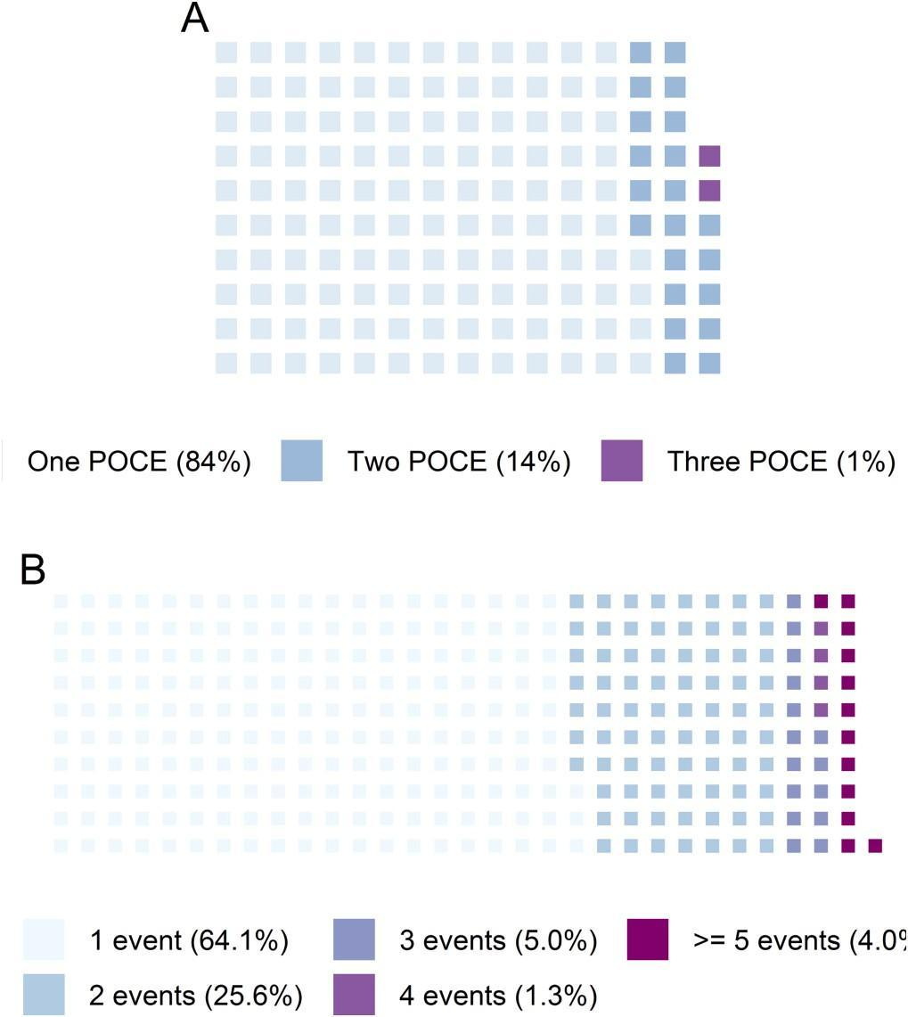

**Fig. 1.** The proportion of events. A, POCE; B, readmission for cardiac reasons. POCE, patient-oriented composite endpoints.

* 1. *Cluster analysis for the all-comer PCI population*
     1. *The baseline characteristics of phenotype groups*

We identified three phenogroups for the overall population (Fig. S5–6). ESR, RBC counts, WBC counts, CRP, and NLR were selected as classification criteria. Three detected phenogroups were defined as inflammatory, non-inflammatory and high-ESR groups.

The inflammatory phenogroup (*n* = 44) was characterized with the highest WBC counts, the highest values of CRP and NLR, a moderate level of ESR, and low RBC counts. The high-ESR phenogroup (*n* = 204) demonstrated the highest values of ESR, lowest level of NLR with other variables being within normal ranges. The third, non-inflammatory, phenogroup was associated with normal values for all cluster-based features. The differences between classification characteristics of three phenotypes could be easily visualized on a parallel coordinate plot (Fig. 2).

It is noteworthy that the differences between clusters went beyond their classification criteria, thus indicating the presence of distinct phenotypes (Table S1–2, Figs. S6–15). The proportion of females was the highest in the high-ESR group (52.5%) with the lowest percentage in the non-inflammatory group (16.5%). The patients in the non-inflammatory group were predominantly Asians compared to other patients (70.6%). The proportion of Caucasians was the highest in the high-ESR group (41.7%). The patients from the high-ESR phenogroup were the oldest (68.14 ± 9.79 years). The body mass index was the lowest in the inflammatory group, and only 18.2% of them were obese. The majority of patients in the inflammatory group were admitted with STEMI (86.4%), while the proportion of individuals with chronic coronary syndrome was the highest in the high-ESR group (18.6%). The high-ESR group exhibited the highest rate of history of diabetes mellitus (30.9%),

| **Table 1**  The outcome data of the study population. |  | | | | | | | | | |
| --- | --- | --- | --- | --- | --- | --- | --- | --- | --- | --- |
|  | Overall |  | Inflammatory group |  | High ESR group |  | Non-inflammatory group |  | *p* value |  |
| n | 643 |  | 44 |  | 204 |  | 395 |  |  |  |
| POCE (%) | 172 (26.7) |  | 22 (50) |  | 62 (30.4) |  | 88 (22.2) |  | <0.001 |  |
| All-cause mortality (%) | 70 (10.9) |  | 17 (38.6) |  | 24 (11.8) |  | 29 (7.3) |  |  |  |
| Stroke (%) | 22 (3.4) |  | 4 (9.1) |  | 10 (4.9) |  | 8 (2.0) |  |  |  |
| Myocardial infarction (%) | 57 (8.9) |  | 0 |  | 20 (9.8) |  | 37 (9.4) |  |  |  |
| Target vessel revascularization (%) | 23 (3.6) |  | 1 (2.3) |  | 8 (3.9) |  | 14 (3.5) |  |  |  |
| DOCE (%) | 112 (17.4) |  | 15 (34.1) |  | 52 (25.5) |  | 45 (11.4) |  | <0.001 |  |
| Readmission (%) | 441(68.6) |  | 27 (61.4) |  | 158 (77.5) |  | 256 (64.8) |  | 0.364 |  |

DOCE, device-oriented composite endpoints; ESR, erythrocyte sedimentation rate; POCE, patient-oriented composite endpoints.

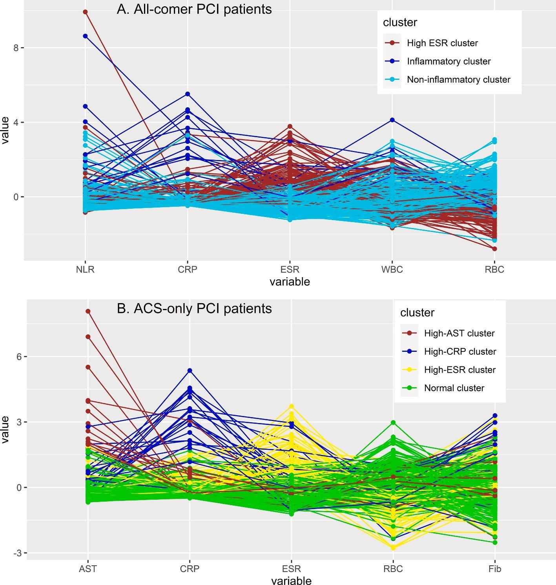

**Fig. 2.** Parallel coordinate plot for visualisation of classification features of the study phenotype groups. ACS, acute coronary syndrome; CRP, C-reactive protein; ESR, erythrocyte sedimentation rate; Fib, fibrinogen; NLR, neutrophil-to-lymphocyte ratio; PCI, percutaneous coronary intervention; RBC, red blood cell counts; WBC, white blood cell counts. (For interpretation of the references to colour in this figure legend, the reader is referred to the web version of this article.)

myocardial infarction (34.3%), peripheral artery disease (4.9%). A total 25% were smokers and 27.3% had atrial fibrillation in the inflammatory group, which were the highest percentages across all phenotypes. Systolic arterial pressure was the lowest (120 mmHg) and heart was the highest (85 beats per min) in the inflammatory group compared to other patients. The level of hemoglobin was low in the high-ESR group (127.00 (116.00–135.00) g/l), while the inflammatory group demonstrated the highest values of platelet count, alanine aminotransferase, aspartate aminotransferase, prothrombin time, international normalized ratio. The level of fibrinogen was high in both the inflammatory group and high-ESR group compared to those in the non-inflammatory group. The proportion of primary PCIs was the highest in the inflammatory phenogroup (72.7%), while elective PCIs were performed most often in the high-ESR group (18.6%). The high-ESR phenotype was associated with the high prevalence of left main coronary artery disease (10.8%) and femoral arterial access (21.1%, Table S2).

* + 1. *Association between phenotype clusters and POCE*

In the multivariate analysis, patients from the high-ESR and inflammatory groups demonstrated a higher risk of POCE with mean ratios (MRs) of 1.42 (95% confidence interval (CI) 1.11–1.81) and 2.01 (95% CI 1.58–2.56), respectively (Table 2, Fig. 3). Other independent predictors were index diagnosis, history of MI, high heart rate, low ejection fraction, arterial access complications, COVID-19, and non-compliance to treatment (Table 2).

These findings were further supported by multivariate Cox analyses with hazard ratios (HRs) for the inflammatory phenotype 2.25 (95% CI 1.29–3.92, Table S3, Fig. S16). The survival plots are presented in Fig. 4.

* + 1. *Association between phenotype clusters and DOCE*

There were significant links between phenotype clusters and recurrent weighted DOCE with MRs 1.61 (95% CI 1.20–2.16) and 2.60 (95% CI 1.94–3.48) for the high-ESR and inflammatory groups, respectively (Table 2, Fig. 3). The risk of DOCE was also associated with index diagnosis, history of MI, high heart rate, and low ejection fraction (Table 2). Due to non-proportionality of hazard functions, the Cox hazards regression analyses were not feasible (Fig. 5).

* + 1. *Association between phenotype clusters and all-cause mortality*

The model derived with stepwise variable selection included the cluster assignment as an independent predictor of all-cause mortality with HR 2.54 (95% CI 1.19–5.41) for the inflammatory vs non-inflammatory phenotypes (Table S3, Fig. S17). Other independent predictors were age, history of MI, heart rate, ejection fraction, and chronic total occlusion. The survival plots are provided in Fig. S18.

* + 1. *Association between phenotype clusters and other endpoints*

Patients with both inflammatory and high-ESR phenotypes were more likely to develop stroke compared with those with the non-inflammatory phenotype with HRs 6.83 (95% CI 2.01–23.2) and 2.86 (95% CI 1.10–7.4), respectively (Table S3, Fig. S19–20). In a joint frailty model, high-ESR and inflammatory clusters remained to be independent

**Table 2**

The results of regression analyses for recurrent weighted composite endpoints.

| Variables | POCE |  | DOCE |  |
| --- | --- | --- | --- | --- |
|  | Univariate  analyses, MR [95% CI] | Multivariate  analyses, MR [95% CI] | Univariate  analyses, MR [95% CI]1 | Multivariate  analyses, MR [95% CI]2 |
| High-ESR vs | 1.75 | 1.42 | 2.08 | 1.61 |
| non- | [1.40–2.20] | [1.11–1.81] | [1.60–2.70] | [1.20–2.16] |
| inflammatory |  |  |  |  |
| cluster |  |  |  |  |
| Inflammatory vs | 3.08 | 2.01 | 4.34 | 2.60 |
| non- | [2.45–3.87] | [1.58–2.56] | [3.35–5.63] | [1.94–3.48] |
| inflammatory |  |  |  |  |
| cluster |  |  |  |  |
| Diagnosis |  |  |  |  |
| NSTEMI vs | 0.82 | 0.83 | 0.72 | 0.76 |
| STEMI | [0.71–0.94] | [0.73–0.96] | [0.60–0.86] | [0.63–0.92] |
| UA vs STEMI | 0.67 | 0.70 | 0.52 | 0.58 |
|  | [0.58–0.77] | [0.61–0.80] | [0.43–0.62] | [0.48–0.70] |
| elective PCI vs | 0.54 | 0.58 | 0.37 | 0.53 |
| STEMI | [0.47–0.63] | [0.51–0.67] | [0.31–0.44] | [0.37–0.44] |
| History of | 1.87 | 1.81 | 1.98 | 2.02 |
| myocardial | [1.36–2.57] | [1.19–2.75] | [1.33–2.94] | [1.30–3.14] |
| infarction |  |  |  |  |
| High heart rate | 3.15 | 2.12 | 3.47 | 2.14 |
|  | [2.23–4.45] | [1.45–3.09] | [2.32–5.18] | [1.33–3.46] |
| Low ejection | 3.03 | 1.83 | 3.35 | 1.90 |
| fraction | [2.16–4.26] | [1.26–2.64] | [2.21–5.07] | [1.20–3.01] |
| Access | 2.34 | 4.14 |  |  |
| complications | [1.01–5.42] | [1.12–15.36] |  |  |
| COVID-19 | 1.85 | 1.63 | 1.69 | 1.53 |
|  | [1.22–2.80] | [1.12–2.38] | [1.05–2.73] | [0.94–2.49] |
| Noncompliance | 2.48 | 5.70 | 2.38 |  |
|  | [1.32–4.66] | [2.14–15.18] | [0.74–7.61] |  |

CI, confidence interval; DOCE, Device-Oriented Composite Endpoints; ESR, erythrocyte sedimentation rate; MR, mean ration; NSTEMI, non-ST-segment elevation myocardial infarction; PCI, percutaneous coronary intervention; POCE, Patient-Oriented Composite Endpoints; STEMI, ST-segment elevation myocardial infarction; TIMI, Thrombolysis in Myocardial Infarction; UA, un- stable angina.

1 Also adjusted for elderly age (>65 years), hypertension, history of PCI, atrial

fibrillation, diseased left main coronary artery, the number of diseased coronary arteries, chronic total occlusion.

2 Also adjusted for elderly age (>65 years), atrial fibrillation, diseased left

main coronary artery, the number of diseased coronary arteries, chronic total occlusion, use of ticagrelor at index PCI.

predictors of stroke with HR 3.19 (95% CI 1.11–9.16) and 9.20 (95% CI 2.43–34.83).

There were no significant relationships between phenotype clustering and MI, TVR, and major bleeding (Table S3). In the joint frailty model, both the high-ESR and inflammatory phenotypes were independent predictors of readmission (HRs 1.29 (95% CI 1.00–1.68), 1.83 (95% CI 1.07–3.12), respectively). The effect estimates for the cluster membership were not significantly different across subgroups (Table S4).

*3.2. Cluster analyses for ACS patients*

*3.2.1. The baseline characteristics of phenotype groups*

We detected four distinct phenotypes among ACS patients. The cluster-defining features for ACS population were ESR, RBC, CRP, fibrinogen, and AST (Fig. S21, 22). We defined four identified phenogroups as normal, high-ESR, high-AST, and high-CRP groups. The high-ESR group was characterized with the highest value of ESR and the lowest level of RBC. The high AST phenotype was associated with the highest value of AST and moderate values for other parameters. The high-CRP group was linked with the highest values for CRP and fibrinogen. For the normal phenotype, cluster-defining characteristics were within normal ranges (Fig. 2).

The revealed phenotypes also had distinct features apart from classification criteria (Table S3,4). The proportion of elderly patients (65.2%) and females (53.9%) were the highest in the high-ESR group. The predominant diagnosis for high-AST and high-CRP groups was STEMI, while the percentages of NSTEMI and UA were higher for normal and high-ESR groups. Meanwhile, diabetes mellitus was the most common in the high-ESR group (34%), the high-AST phenotype was associated with the highest prevalence of smoking (27.6%). The high-ESR group was characterized with the highest frequencies of MI history (36.9%) and peripheral artery disease (3.5%). About 33% of patients in the high-CRP group had atrial fibrillation, which was the highest value among all phenotypes. The platelets count was the highest in the high- ESR group, while hemoglobin level was the lowest in the high-ESR group. The high-CRP group was associated with the highest value for neutrophil-to-lymphocyte ratio, fibrinogen and the lowest level of high-density lipoprotein, sodium and ejection fraction.

*3.2.2. Association between phenotype clusters and clinical endpoints*

The high-CRP group was associated with the development of POCE (MR 2.21 [1.16–4.22]) but not high-ESR and high-AST group. The patients from both high-ESR and high-CRP groups demonstrated higher

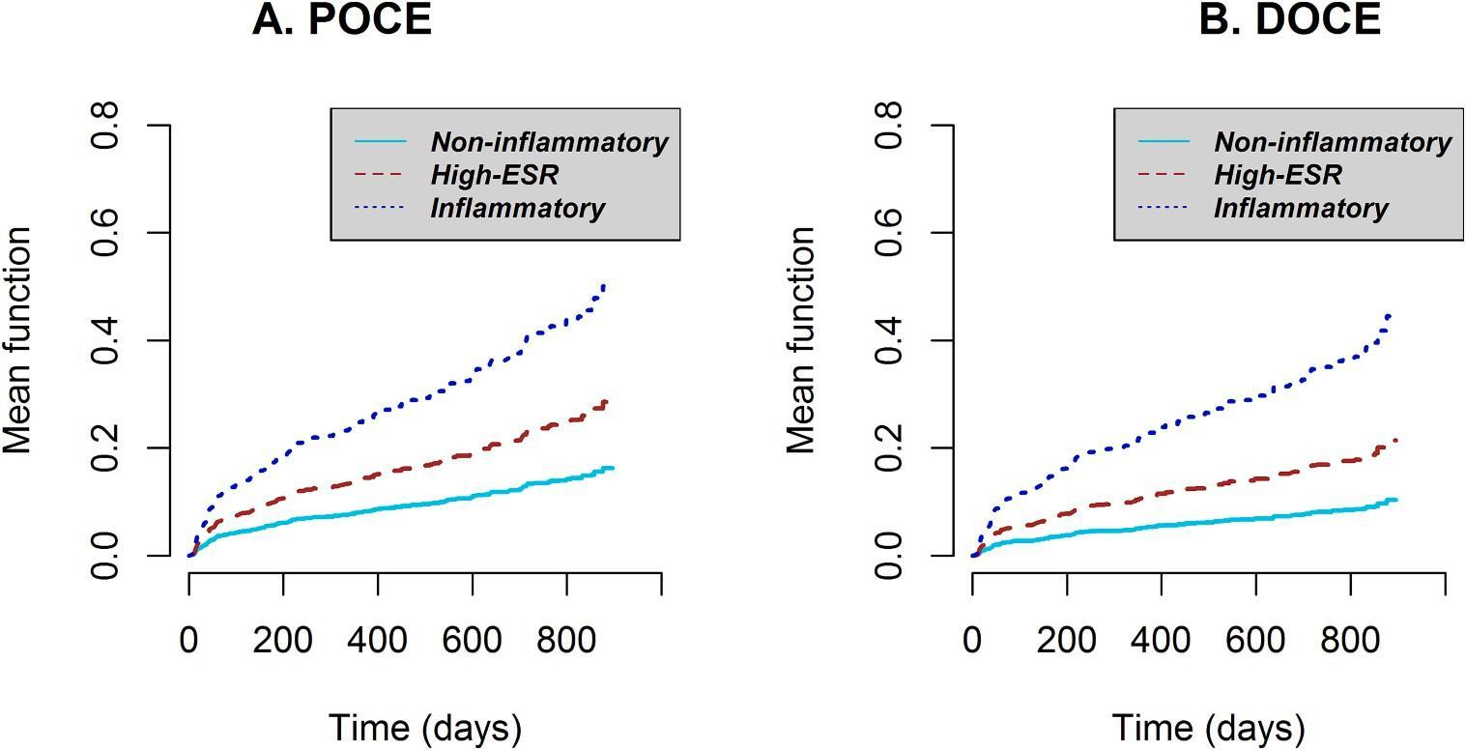

**Fig. 3.** The curves for the estimation of mean function for recurrent weighted composite endpoints. ESR, erythrocyte sedimentation rate; DOCE, device-oriented composite endpoints; POCE, patient-oriented composite endpoints.

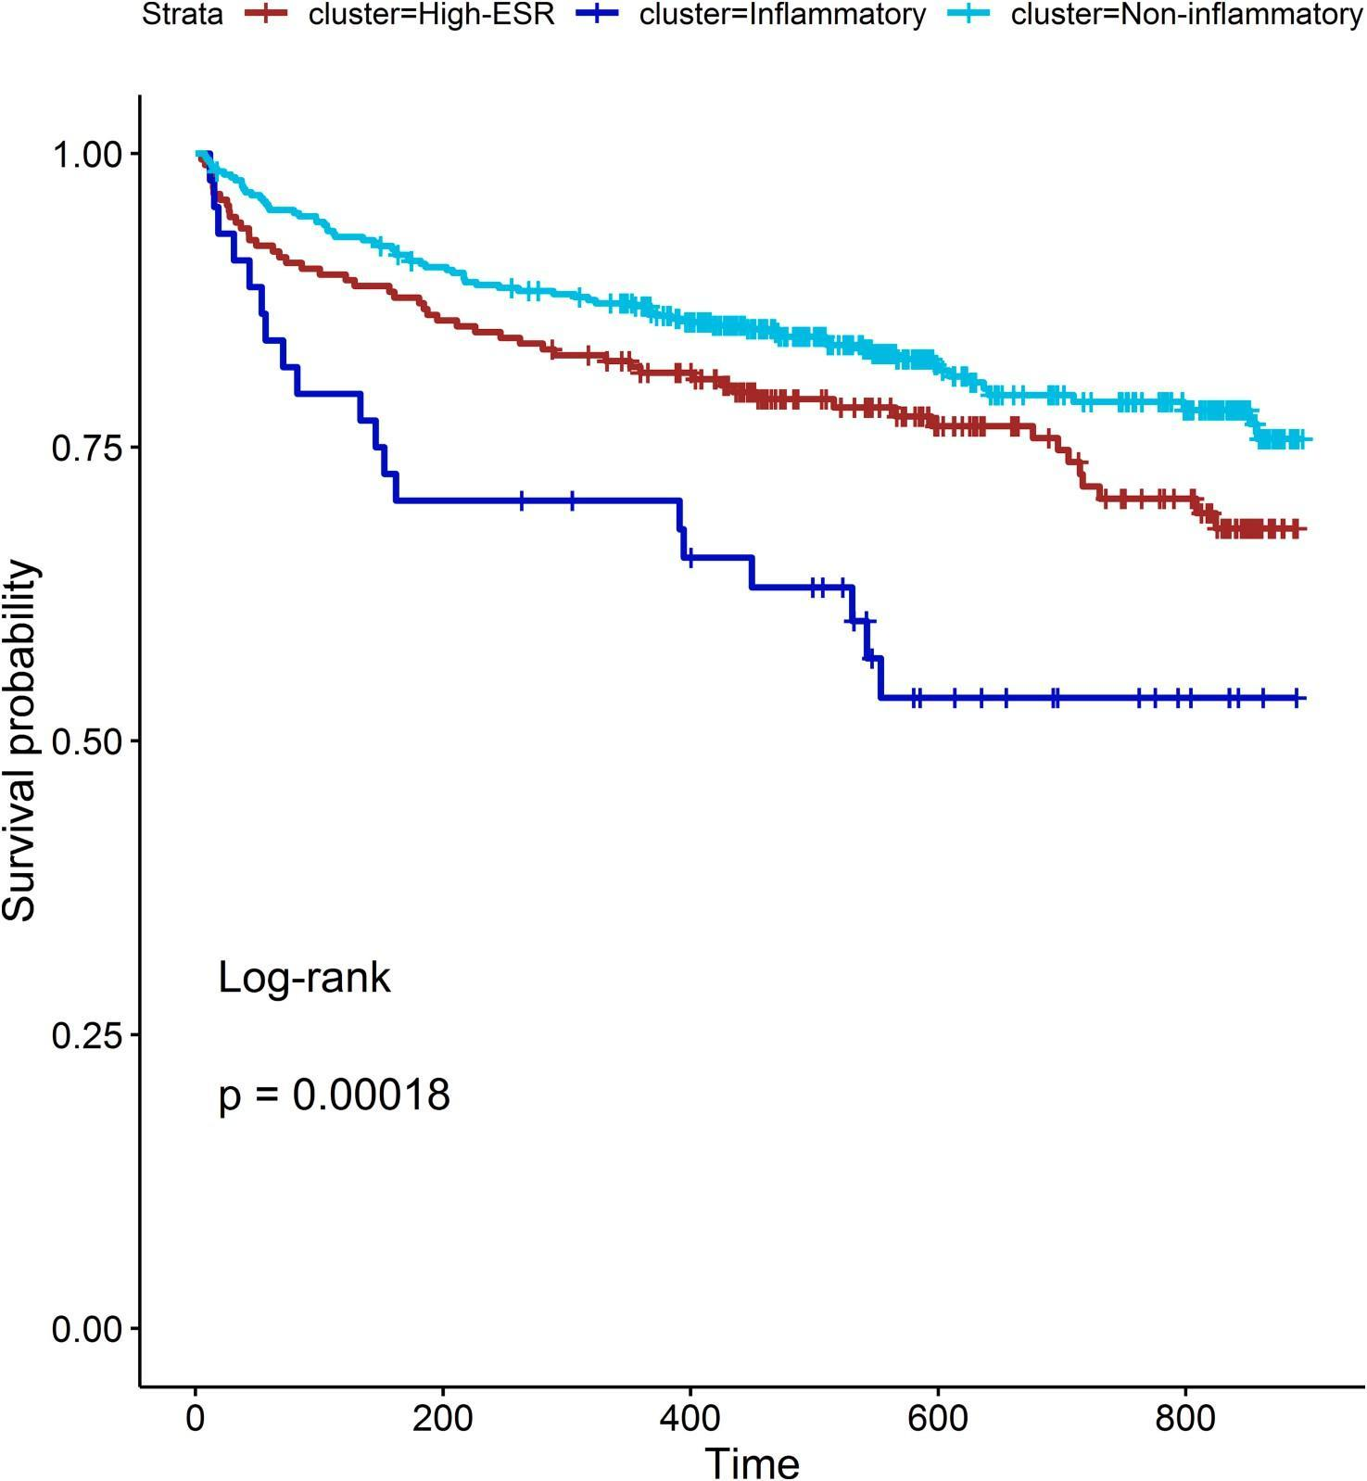

**Fig. 4.** The survival plots for POCE. ESR, erythrocyte sedimentation rate; POCE, patient-oriented composite endpoints.

risk of DOCE (MRs 1.79 [1.07–3.01] and 2.70 [1.47–4.95], respectively, Table 3, Fig. S23). Other potential predictors included history of myocardial infarction, high heart rate and low ejection fraction. Since the survival plots (Fig. S24,25) crossed each other, we did not perform Cox proportional hazards analyses. Peto statistics for the difference between survival curves were significant for both outcomes (*p* < 0.01).

##### Discussion

In this prospective longitudinal cohort study, using machine learning approaches we distinguished three phenotypes in patients after PCI and four phenotypes for ACS subset with specific patterns in demographic, clinical, laboratory, and angiographic characteristics and distinct clinical trajectories. Among 16 potential laboratory parameters, an unsupervised machine learning approach identified 5 most important variables that determined the cluster membership. They were ESR, RBC, WBC, CRP, and NLR for the overall population and ESR, RBC, CRP, fibrinogen, and AST for ACS population. One advantage of unsupervised clustering analyses is that it explores intrinsic relationships between given baseline features of high-dimensional data and defines a limited number of phenotypes with specific patterns [19]. For routine clinical practice, it reduces the amount of data that needs to be processed for risk assessment. For example, there is a large body of evidence supporting the predictive utility of all 16 laboratory markers in PCI patients [20–22]. However, it would be challenging to incorporate all this data into a single risk score with clinical utility. In contrast, our machine-learning based approach provides simple classification based on a handful of routine biomarkers that could easily identify homogeneous phenotypes with specific characteristics and prognosis which could be prospectively evaluated for personalised treatment approaches.

For the overall study population, we defined the detected phenogroups as the inflammatory, high-ESR, and non-inflammatory groups. Patients with the inflammatory and high-ESR phenogroups exhibit a higher risk of cardiovascular events at follow-up. It is noteworthy that outcome data were entirely removed during cluster analyses, therefore, outcomes did not impact on cluster assignment of study participants enabling unsupervised machine learning.

Since ACS represent a heterogeneous subset of patients we conducted separate cluster analyses for this population. For ACS patients, we identified four distinct groups: high-AST, high-ESR, high-CRP, and normal phenotypes. Similalry, the cluster assignment was independently associated with clinical endpoints.

The membership to a particular cluster was an independent predictor of adverse cardiovascular events in multivariate analyses adjusted for index diagnosis. This would suggest that *k*-means cluster analyses unveiled homogeneous subgroups that can not be entirely defined by admission diagnoses. It is further supported by subgroup analyses for ACS patients where a diagnosis at baseline did not alter a significant association between cluster assignment and clinical outcomes. Therefore, our defined phenotypes can reveal vulnerable, higher-risk individuals not captured during traditional risk assessment.

We assume that the detected patterns represented the underlying

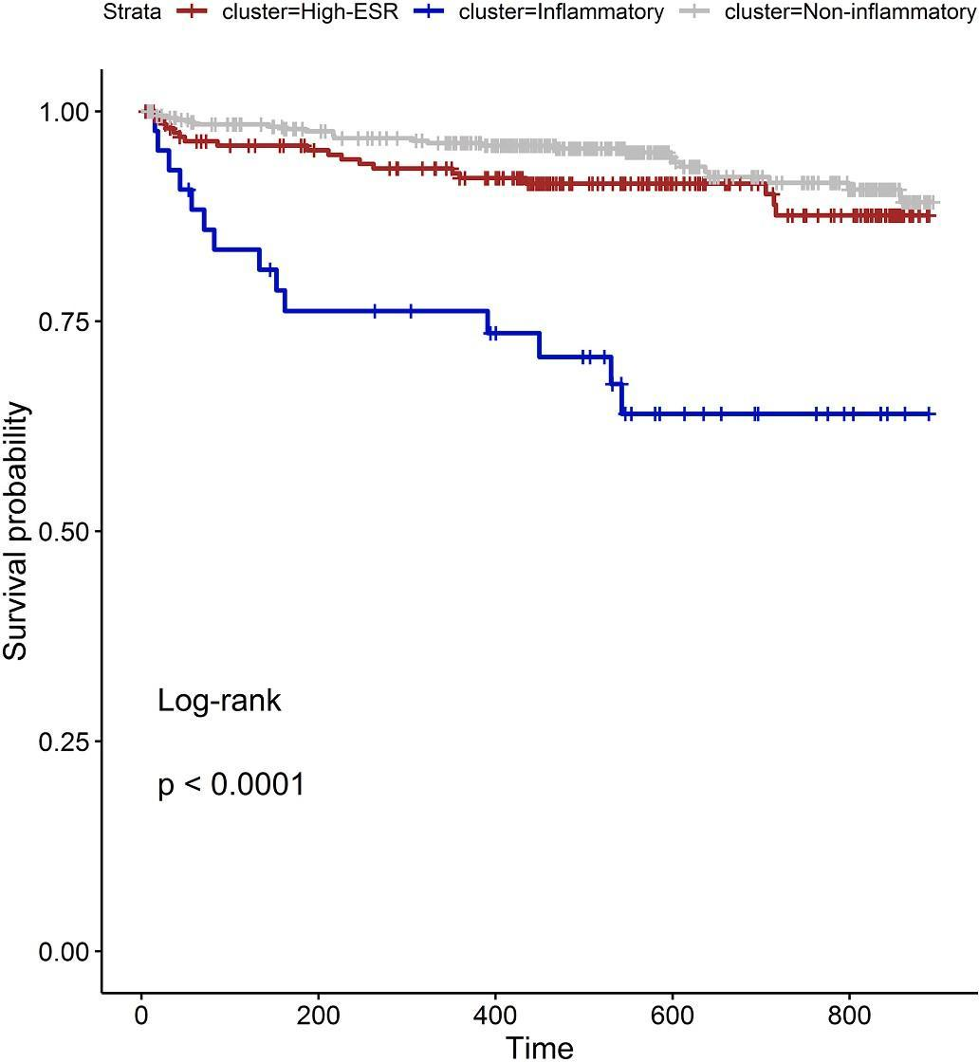

**Fig. 5.** The survival plots for DOCE. ESR, erythrocyte sedimentation rate; DOCE, device-oriented composite endpoints.

pathophysiological type of inflammation. As ESR has a significantly longer lifespan than CRP, ESR is considered as a chronic inflammation biomarker, while CRP is regarded as a marker of acute inflammation [23]. The characteristics of the phenotypes with a high CRP seem to be consequences of acute inflammation with an increase of acute phase biomarkers like WBC, CRP, and neutrophil counts [24]. The presentation of the high-ESR cluster can be explained by systemic chronic inflammation with an increase of ESR and lymphocyte count. There is no specific biomarker indicating chronic inflammation, and previous authors highlighted the need of utilizing advanced research methods for combining a large number of biomarkers into a handful of clusters representing inflammatory activity [24,25]. Regarding this, our data-driven simple classification of heterogeneous all-comer PCI patients provide insights on pathophysiological mechanisms leading to different clinical presentations and clinical trajectories. Our findings further support inflammatory theory of atherosclerosis and could be used for defining specific patient groups for testing tailored anti-inflammatory treatment in future clinical trials [26–28].

The increased risk of cardiovascular events in the inflammatory groups could be attributed to high-degree acute-phase inflammation with leukocyte-mediated myocardial injury [29]. The overactivation of immune pathways is partially responsible not only for cardiomyocyte death and widening the ischemic zone but also for myocardial remodelling and worsening of cardiac function [29]. The patients with inflammatory phenotypes may benefit from the administration of colchicine with proven efficacy in patients after recent MI [27].

The manifestation of the phenotypes with a high ESR might be linked to low-grade systemic chronic inflammation [24]. Chronic inflammation is a key pathological mechanism responsible for initiation, development, maintenance and exacerbation of atherosclerosis, tissue damage via oxidative stress and cytokine storm, chronic activation of sympathetic nervous system and the hypothalamic-pituitary-adrenal axis with release of glucocorticoids and other stress neuromediators, predisposing patients to adverse clinical events [26,30].

A strength of our study is that we considered the recurrent and weighted nature of cardiovascular outcomes during statistical analyses.

**Table 3**

The results of regression analyses for recurrent weighted composite endpoints.

| Variables | POCE |  |  | DOCE |  |  |
| --- | --- | --- | --- | --- | --- | --- |
|  | Univariate analyses, | Multivariate analyses, MR |  | Univariate analyses, MR | Multivariate analyses, MR |
|  | MR [95% | [95% CI]1 |  | [95% CI] | [95% CI]2 |
|  | CI] |  |  |  |  |
| High-ESR vs | 1.59 | 1.29 |  | 2.21 | 1.79 |  |
| normal | [1.08–2.33] | [0.75–2.21] |  | [1.40–3.48] | [1.07–3.01] |  |
| cluster |  |  |  |  |  |  |
| High-CRP vs | 3.07 | 2.21 |  | 3.91 | 2.70 |  |
| normal | [1.94–4.85] | [1.16–4.22] |  | [2.23–6.85] | [1.47–4.95] |  |
| cluster |  |  |  |  |  |  |
| High-AST vs | 1.31 | 1.26 |  | 1.72 | 1.54 |  |
| normal | [0.61–2.82] | [0.56–2.85] |  | [0.71–4.20] | [0.59–4.05] |  |
| cluster |  |  |  |  |  |  |
| Diagnosis |  |  |  |  |  |  |
| NSTEMI vs | 1.02 | 0.93 |  | 0.90 | 0.90 |  |
| STEMI | [0.62–1.69] | [0.53–1.64] |  | [0.450–1.64] | [0.51–1.60] |  |
| UA vs STEMI | 0.72 | 0.75 |  | 0.61 | 0.74 |  |
|  | [0.49–1.05] | [0.49–1.13] |  | [0.38–0.98] | [0.44–1.24] |  |
| History of | 1.97 | 1.81 |  | 2.06 | 1.82 |  |
| myocardial | [1.42–2.74] | [1.14–2.86] |  | [1.38–3.08] | [1.06–3.13] |  |
| infarction |  |  |  |  |  |  |
| High heart rate | 1.02 | 2.03 |  | 3.08 | 2.14 |  |
|  | [0.99–1.04] | [1.34–3.08] |  | [2.06–4.60] | [1.33–3.46] |  |
| Low ejection | 3.18 | 1.83 |  | 3.35 | 1.77 |  |
| fraction | [2.28–4.44] | [1.17–2.86] |  | [2.22–5.04] | [1.07–2.92] |  |
| COVID-19 | 1.70 | 1.63 |  |  |  |  |
|  | [1.14–2.54] | [1.04–2.57] |  |  |  |  |
| Noncompliance | 4.33 | 4.47 |  | 3.50 | 4.42 |  |
|  | [2.44–7.70] | [1.28–15.64] |  | [1.40–8.76] | [0.74–26.43] |  |

CI, confidence interval; DOCE, Device-Oriented Composite Endpoints; ESR, erythrocyte sedimentation rate; MR, mean ration; NSTEMI, non-ST-segment elevation myocardial infarction; PCI, percutaneous coronary intervention; POCE, Patient-Oriented Composite Endpoints; STEMI, ST-segment elevation myocardial infarction; TIMI, Thrombolysis in Myocardial Infarction; UA, un- stable angina.

1 Also adjusted for elderly age (>65 years), hypertension, obesity, history of

PCI and CABG, atrial fibrillation, the number of diseased coronary arteries, and chronic total occlusion.

2 Also adjusted for elderly age (>65 years), atrial fibrillation, diseased left

main coronary artery, the number of diseased coronary arteries, chronic total occlusion, history of PCI and CABG, use of thrombectomia.

We found that about 16% of POCE and 36% of readmissions were recurrent (Fig. 1), therefore, applying time-to-the-first-event analyses could be biassed and underpowered. These findings are in line with the results of previous studies that reported the percentage of recurrent events being up to 40% [5,7]. Furthermore, traditional survival analyses do not incorporate clinical severity of clinical endpoints. As a consequence, death is accounted equally to MI or TVR, which could not represent a real burden of composite cardiovascular outcomes [6,16]. Hence, we argue that statistical techniques representing recurrent and weighted characteristics of study endpoints should be gold standards in future clinical investigations.

Our study has several limitations. They were small sample size, limited number of clinical and laboratory parameters used for cluster analyses, observational design of the study, absence of external validation. Although an unsupervised machine learning approach does not require validation, evaluation of our findings in larger cohorts are needed to explore reliability and generalizability. Also, testing our classification in future randomised controlled trials for tailored anti- inflammatory treatment in PCI patients could further support our results. The limited number of variables imputed into cluster analyses reflects the real-world design of our research, thus, implying a greater chance of implication of our results in routine clinical practice. Finally, despite the small sample size, we managed to identify distinct phenotypes with specific patterns not only in classification criteria but also in demographic, clinical, laboratory, and angiographic features. Finally, the validation of our findings in new settings is crucially important to investigate extrapolation of our approach to wider populations.

##### Conclusion

Using data-driven unsupervised machine learning approach, we unveiled three distinct phenotypes with specific characteristics: inflammatory (with the highest WBC counts, CRP and NLR), high-ESR (with the highest ESR and lowest NLR), and non-inflammatory (with normal-ranged inflammatory biomarkers). Additionally, we identified four specific phenotypes for the ACS population according to the level of routine biomarkers (high-ESR, high-CRP, high-AST and normal groups). The cluster membership was independently associated with the development of POCE and DOCE in both all-comer PCI and ACS-only populations.

##### Funding sources

None.

##### Declaration of Competing Interest

The authors report no relationships that could be construed as a conflict of interest

##### Appendix A. Supplementary data

Supplementary data to this article can be found online at [https://doi.](https://doi.org/10.1016/j.ijcard.2022.12.035) [org/10.1016/j.ijcard.2022.12.035](https://doi.org/10.1016/j.ijcard.2022.12.035).

##### References

1. [F.-J. Neumann, M. Sousa-Uva, A. Ahlsson, et al., 2018 ESC/EACTS guidelines on](http://refhub.elsevier.com/S0167-5273(22)01919-2/rf0005) [myocardial revascularization, Eur. Heart J. 40 (2018) 87–165](http://refhub.elsevier.com/S0167-5273(22)01919-2/rf0005).
2. [M. Valgimigli, H. Bueno, R.A. Byrne, et al., 2017 ESC focused update on dual](http://refhub.elsevier.com/S0167-5273(22)01919-2/rf0010) [antiplatelet therapy in coronary artery disease developed in collaboration with](http://refhub.elsevier.com/S0167-5273(22)01919-2/rf0010) [EACTS: the task force for dual antiplatelet therapy in coronary artery disease of the](http://refhub.elsevier.com/S0167-5273(22)01919-2/rf0010) [European Society of Cardiology (ESC) and of the European Association for Cardio-](http://refhub.elsevier.com/S0167-5273(22)01919-2/rf0010) [Thoracic Surgery (EACTS), Eur. Heart J. 39 (2017) 213–260](http://refhub.elsevier.com/S0167-5273(22)01919-2/rf0010).
3. [G.A. Figtree, S.T. Vernon, N. Hadziosmanovic, et al., Mortality in STEMI patients](http://refhub.elsevier.com/S0167-5273(22)01919-2/rf0015) [without standard modifiable risk factors: a sex-disaggregated analysis of](http://refhub.elsevier.com/S0167-5273(22)01919-2/rf0015) [SWEDEHEART registry data, Lancet Lond. Engl. 397 (2021) 1085–1094](http://refhub.elsevier.com/S0167-5273(22)01919-2/rf0015).
4. [M.T. Roe, A.R. Halabi, R.H. Mehta, et al., Documented traditional cardiovascular](http://refhub.elsevier.com/S0167-5273(22)01919-2/rf0020) [risk factors and mortality in non-ST-segment elevation myocardial infarction, Am.](http://refhub.elsevier.com/S0167-5273(22)01919-2/rf0020) [Heart J. 153 (2007) 507–514](http://refhub.elsevier.com/S0167-5273(22)01919-2/rf0020).
5. [S.D. Anker, J.J.V. McMurray, Time to move on from “time-to-first”: should all](http://refhub.elsevier.com/S0167-5273(22)01919-2/rf0025) [events be included in the analysis of clinical trials? Eur. Heart J. 33 (2012)](http://refhub.elsevier.com/S0167-5273(22)01919-2/rf0025) [2764–2765](http://refhub.elsevier.com/S0167-5273(22)01919-2/rf0025).
6. [L. Mao, D.Y. Lin, Semiparametric regression for the weighted composite endpoint](http://refhub.elsevier.com/S0167-5273(22)01919-2/rf0030) [of recurrent and terminal events, Biostat. Oxf. Engl. 17 (2016) 390–403](http://refhub.elsevier.com/S0167-5273(22)01919-2/rf0030).
7. [A. Vasudevan, J.W. Choi, G.A. Feghali, et al., First and recurrent events after](http://refhub.elsevier.com/S0167-5273(22)01919-2/rf0035) [percutaneous coronary intervention: implications for survival analyses, Scand.](http://refhub.elsevier.com/S0167-5273(22)01919-2/rf0035) [Cardiovasc. J. 53 (2019) 299–304](http://refhub.elsevier.com/S0167-5273(22)01919-2/rf0035).
8. [K. Thygesen, J.S. Alpert, A.S. Jaffe, B.R. Chaitman, J.J. Bax, D.A. Morrow, H.D. White, Fourth universal definition of myocardial infarction (2018), J. Am. Coll.](http://refhub.elsevier.com/S0167-5273(22)01919-2/rf0040) [Cardiol. 72 (2018) 2231–2264](http://refhub.elsevier.com/S0167-5273(22)01919-2/rf0040).
9. [J.-P. Collet, H. Thiele, E. Barbato, et al., 2020 ESC guidelines for the management](http://refhub.elsevier.com/S0167-5273(22)01919-2/rf0045) [of acute coronary syndromes in patients presenting without persistent ST-segment](http://refhub.elsevier.com/S0167-5273(22)01919-2/rf0045) [elevation, Eur. Heart J. 42 (2021) 1289–1367](http://refhub.elsevier.com/S0167-5273(22)01919-2/rf0045).
10. [J. Knuuti, W. Wijns, A. Saraste, et al., 2019 ESC guidelines for the diagnosis and](http://refhub.elsevier.com/S0167-5273(22)01919-2/rf0050) [management of chronic coronary syndromes, Eur. Heart J. 41 (2020) 407–477](http://refhub.elsevier.com/S0167-5273(22)01919-2/rf0050).
11. [H.M. Garcia-Garcia, E.P. McFadden, A. Farb, et al., Standardized end point](http://refhub.elsevier.com/S0167-5273(22)01919-2/rf0055) [definitions for coronary intervention trials: the academic research consortium-2](http://refhub.elsevier.com/S0167-5273(22)01919-2/rf0055) [consensus document, Circulation 137 (2018) 2635–2650](http://refhub.elsevier.com/S0167-5273(22)01919-2/rf0055).
12. [R. Mehran, S.V. Rao, D.L. Bhatt, et al., Standardized bleeding definitions for](http://refhub.elsevier.com/S0167-5273(22)01919-2/rf0060) [cardiovascular clinical trials: a consensus report from the bleeding academic](http://refhub.elsevier.com/S0167-5273(22)01919-2/rf0060) [research consortium, Circulation 123 (2011) 2736–2747](http://refhub.elsevier.com/S0167-5273(22)01919-2/rf0060).
13. [X. Basagaña, J. Barrera-Gómez, M. Benet, J.M. Antó,, J. Garcia-Aymerich, A framework for multiple imputation in cluster analysis, Am. J. Epidemiol. 177](http://refhub.elsevier.com/S0167-5273(22)01919-2/rf0065) [(2013) 718–725](http://refhub.elsevier.com/S0167-5273(22)01919-2/rf0065).
14. [S. van Buuren, K. Groothuis-Oudshoorn, Mice: multivariate imputation by chained](http://refhub.elsevier.com/S0167-5273(22)01919-2/rf0070) [equations in R, J. Stat. Softw. 45 (2011) 1–67](http://refhub.elsevier.com/S0167-5273(22)01919-2/rf0070).
15. [M. Breaban, H. Luchian, A unifying criterion for unsupervised clustering and](http://refhub.elsevier.com/S0167-5273(22)01919-2/rf0075) [feature selection, Pattern Recogn. 44 (2011) 854–865](http://refhub.elsevier.com/S0167-5273(22)01919-2/rf0075).
16. [J.A. Bakal, M.T. Roe, E.M. Ohman, et al., Applying novel methods to assess clinical](http://refhub.elsevier.com/S0167-5273(22)01919-2/rf0080) [outcomes: insights from the TRILOGY ACS trial, Eur. Heart J. 36 (2015) 385–392a](http://refhub.elsevier.com/S0167-5273(22)01919-2/rf0080).
17. [V. Rondeau, S. Mathoulin-Pelissier, H. Jacqmin-Gadda, V. Brouste, P. Soubeyran,](http://refhub.elsevier.com/S0167-5273(22)01919-2/rf0085) [Joint frailty models for recurring events and death using maximum penalized](http://refhub.elsevier.com/S0167-5273(22)01919-2/rf0085) [likelihood estimation: application on cancer events, Biostat. Oxf. Engl. 8 (2007)](http://refhub.elsevier.com/S0167-5273(22)01919-2/rf0085) [708–721](http://refhub.elsevier.com/S0167-5273(22)01919-2/rf0085).
18. [R Core Team, R: A Language and Environment for Statistical Computing, R](http://refhub.elsevier.com/S0167-5273(22)01919-2/rf0090) [Foundation for Statistical Computing, Vienna, Austria, 2022](http://refhub.elsevier.com/S0167-5273(22)01919-2/rf0090).
19. [H. Nouraei, H. Nouraei, S.W. Rabkin, Comparison of unsupervised machine](http://refhub.elsevier.com/S0167-5273(22)01919-2/rf0095) [learning approaches for cluster analysis to define subgroups of heart failure with](http://refhub.elsevier.com/S0167-5273(22)01919-2/rf0095) [preserved ejection fraction with different outcomes, Bioeng. Basel Switz. 9 (2022)](http://refhub.elsevier.com/S0167-5273(22)01919-2/rf0095) [175](http://refhub.elsevier.com/S0167-5273(22)01919-2/rf0095).
20. [B. Shah, U. Baber, S.J. Pocock, et al., White blood cell count and major adverse](http://refhub.elsevier.com/S0167-5273(22)01919-2/rf0100) [cardiovascular events after percutaneous coronary intervention in the](http://refhub.elsevier.com/S0167-5273(22)01919-2/rf0100) [contemporary era: insights from the PARIS study (patterns of non-adherence to](http://refhub.elsevier.com/S0167-5273(22)01919-2/rf0100) [anti-platelet regimens in stented patients registry), Circ. Cardiovasc. Interv. 10](http://refhub.elsevier.com/S0167-5273(22)01919-2/rf0100) [(2017), e004981](http://refhub.elsevier.com/S0167-5273(22)01919-2/rf0100).
21. A. Galimzhanov, Y. Sabitov, E. Tenekecioglu, H.N. Tun, M. Alasnag, M.A. Mamas, Baseline platelet count in percutaneous coronary intervention: a dose–response meta-analysis, Heart (2022);108:1792-1799.
22. [E. Gilardi, P. Iacomini, D. Marsiliani, G. De Marco, M. Covino, Biomarkers in the](http://refhub.elsevier.com/S0167-5273(22)01919-2/rf0110) [prediction and management of acute coronary syndromes: current perspectives,](http://refhub.elsevier.com/S0167-5273(22)01919-2/rf0110) [Res. Rep. Clin. Cardiol. 5 (2014) 21–31](http://refhub.elsevier.com/S0167-5273(22)01919-2/rf0110).
23. [M.K. Litao, D. Kamat, Erythrocyte sedimentation rate and C-reactive protein: how](http://refhub.elsevier.com/S0167-5273(22)01919-2/rf0115) [best to use them in clinical practice, Pediatr. Ann. 43 (10) (2014) 417–420](http://refhub.elsevier.com/S0167-5273(22)01919-2/rf0115).
24. [D. Furman, J. Campisi, E. Verdin, et al., Chronic inflammation in the etiology of](http://refhub.elsevier.com/S0167-5273(22)01919-2/rf0120) [disease across the life span, Nat. Med. 25 (2019) 1822–1832](http://refhub.elsevier.com/S0167-5273(22)01919-2/rf0120).
25. [P.C. Calder, N. Ahluwalia, R. Albers, et al., A consideration of biomarkers to be](http://refhub.elsevier.com/S0167-5273(22)01919-2/rf0125) [used for evaluation of inflammation in human nutritional studies, Br. J. Nutr. 109](http://refhub.elsevier.com/S0167-5273(22)01919-2/rf0125) [(Suppl. 1) (2013) S1–34](http://refhub.elsevier.com/S0167-5273(22)01919-2/rf0125).
26. [A. Alfaddagh, S.S. Martin, T.M. Leucker, et al., Inflammation and cardiovascular](http://refhub.elsevier.com/S0167-5273(22)01919-2/rf0130) [disease: from mechanisms to therapeutics, Am. J. Prev. Cardiol. 4 (2020), 100130](http://refhub.elsevier.com/S0167-5273(22)01919-2/rf0130).
27. [J.-C. Tardif, S. Kouz, D.D. Waters, et al., Efficacy and safety of low-dose colchicine](http://refhub.elsevier.com/S0167-5273(22)01919-2/rf0135) [after myocardial infarction, N. Engl. J. Med. 381 (2019) 2497–2505](http://refhub.elsevier.com/S0167-5273(22)01919-2/rf0135).
28. [P.M. Ridker, B.M. Everett, T. Thuren, et al., Antiinflammatory therapy with](http://refhub.elsevier.com/S0167-5273(22)01919-2/rf0140) [Canakinumab for atherosclerotic disease, N. Engl. J. Med. 377 (2017) 1119–1131](http://refhub.elsevier.com/S0167-5273(22)01919-2/rf0140).
29. [N.G. Frangogiannis, The inflammatory response in myocardial injury, repair, and](http://refhub.elsevier.com/S0167-5273(22)01919-2/rf0145) [remodelling, Nat. Rev. Cardiol. 11 (2014) 255–265](http://refhub.elsevier.com/S0167-5273(22)01919-2/rf0145).
30. [J.M. Bennett, G. Reeves, G.E. Billman, J.P. Sturmberg, Inflammation-nature’s way](http://refhub.elsevier.com/S0167-5273(22)01919-2/rf0150) [to efficiently respond to all types of challenges: implications for understanding and](http://refhub.elsevier.com/S0167-5273(22)01919-2/rf0150) [managing “the epidemic” of chronic diseases, Front. Med. 5 (2018) 316](http://refhub.elsevier.com/S0167-5273(22)01919-2/rf0150).

[International Journal of Cardiology 392 (2023) 131339](https://doi.org/10.1016/j.ijcard.2023.131339)



# Prediction of clinical outcomes after percutaneous coronary intervention: Machine-learning analysis of the National Inpatient Sample

## Akhmetzhan Galimzhanov a,b,*, Andrija Matetic b,c, Erhan Tenekecioglu d,e, Mamas A. Mamas b

a *Department of Propedeutics of Internal Disease, Semey Medical University, Semey, Kazakhstan*

b *Keele Cardiovascular Research Group, Keele University, Keele, UK*

c *Department of Cardiology, University Hospital of Split, Split 21000, Croatia*

d *Department of Cardiology, Bursa Education and Research Hospital, Health Sciences University, Bursa,Turkey*

e *Department of Cardiology, Thoraxcenter, Erasmus MC, Erasmus University, Rotterdam, the Netherlands*



* Corresponding author at: Department of Propedeutics of Internal Disease, No. 103 Abai Street, Semey Medical University, Semey 071400, Kazakhstan.

*E-mail address:* [ahmed.galimzhan@gmail.com](mailto:ahmed.galimzhan@gmail.com) (A. Galimzhanov).

<https://doi.org/10.1016/j.ijcard.2023.131339>

Received 20 March 2023; Received in revised form 8 August 2023; Accepted 3 September 2023

Available online 9 September 2023

0167-5273/© 2023 Elsevier B.V. All rights reserved.

A R T I C L E I N F O

*Keywords:*

Machine learning

Percutaneous coronary intervention Thrombosis

Bleeding Prognosis

Precision medicine

A B S T R A C T

*Background:* This study aimed to develop a multiclass machine-learning (ML) model to predict all-cause mortality, ischemic and hemorrhagic events in unselected hospitalized patients undergoing percutaneous coronary intervention (PCI).

*Methods:* This retrospective study included 1,815,595 unselected weighted hospitalizations undergoing PCI from the National Inpatient Sample (2016–2019). Five most common ML algorithms (logistic regression, support vector machine (SVM), naive Bayes, random forest (RF), and extreme gradient boosting (XGBoost)) were trained and tested with 101 input features. The study endpoints were different combinations of all-cause mortality, ischemic cerebrovascular events (CVE) and major bleeding. An area under the curve (AUC) with 95% confidence interval (95% CI) was selected as a performance metric.

*Results:* The study population was split to a training cohort of 1,186,880 PCI discharges, validation cohort (for calibration) of 296,725 hospitalizations and a test cohort of 331,990 PCI discharges. A total of 98,180 (5.4%) hospital entries included study outcomes. Logistic regression, SVM, naive Bayes, and RF model demonstrated AUCs of 0.83 (95% CI 0.82–0.84), 0.84 (95% CI 0.83–0.86), 0.81 (95% CI 0.80–0.82), and 0.83 (95% CI 0.81–0.84), retrospectively. The XGBoost classifier performed the best with an AUC of 0.86 (95% CI 0.85–0.87) with excellent calibration. We then built a web-based application that provides predictions based on the XGBoost model.

*Conclusion:* We derived the multi-task XGBoost classifier based on 101 features to predict different combinations of all-cause death, ischemic CVE and major bleeding. Such models may be useful in benchmarking and risk prediction using routinely collected administrative data.



##### Introduction

Despite recent advances in percutaneous coronary intervention (PCI) techniques and antithrombotic strategies, patients still experience ischemic and bleeding events following PCI. [1,2] International guidelines on the management of PCI patients strongly recommend implementing personalized clinical decision making while selecting antiplatelet regimes. [3,4] Several point-based scores are now widely available for identification of patients at risk of thrombotic and hemorrhagic events. [5–8] However, based on standard regression statistics, these tools demonstrated modest predictive power (c-statistics ranging from 0.60 to 0.80), included a limited number of classical risk factors and were developed on cohorts of patients with strong exclusion criteria. [9]

Machine learning (ML) is a revived field of data science that has grown in popularity in recent years as a result of the widespread availability of big data, computational power, and specific software solutions. [10,11] ML techniques aim to learn computer algorithms from given data without relying on rule-based programming, whereas statistical methods use predefined mathematical rules to uncover significant relationships between random variables and dependent outcomes. While traditional statistical models require the fulfillment of several assumptions (data distribution, multicollinearity, homoscedasticity, distribution of residuals) to effectively handle uncertainty and tend to



overfit with large high-dimensional datasets, ML algorithms are more flexible with no strong requirements for data uncertainty and demonstrate state-of-the-art performance for big data analyses. [12] With the widespread adoption of electronic health record (EHR) systems in hospital practice and the availability of medical big data, machine learning (ML) can improve precision cardiovascular medicine and the prediction of future adverse events after PCI. [10] Therefore, we set out to create a multiclass ML model based on high-dimensional EHR data that could predict all-cause mortality, ischemic and hemorrhagic events in unselected patients undergoing PCI.

##### Methods

* 1. *Data source*

All data for the study were collected from the National Inpatient Sample (NIS). The NIS was developed under the Healthcare Cost and Utilization Project (HCUP) by the Agency for Healthcare Research and Quality, representing one of the largest registries in the United States. The NIS includes descriptions for about 7 million inpatient hospital stays annually. Since the year of 2012, the NIS represents a 20% stratified sample of all community hospital discharges in the United States. Nationwide estimates can be obtained after applying provided sample weights. Further detailed description of the NIS can be found elsewhere. [13]

* 1. *Study population*

We included all patients aged >18 years who underwent PCI from January 2016 to December 2019. This period was chosen because starting from calendar year 2016 all diagnoses and procedures in the NIS databases were coded using the International Classification of Diseases 10th Edition (ICD-10). Pregnant patients were excluded from the analysis. Having in mind that some ML algorithms are not stable for datasets with missing values, we excluded all entries with any missing data. PCI were defined according to codes provided by the Clinical Classifications Software Refined (CCSR) for procedures (Supplementary Table S1). [14]

* 1. *Feature preprocessing*

Considering the overwhelming number of ICD-10 codes used in the NIS databases, we categorized all these codes in clinically meaningful groups using the CCSR for diagnoses [15] and procedures as well as the Elixhauser Comorbidity Software Refined [16] conditions provided by the AHRQ. This guaranteed a standardized approach in the determination of variables for the trained ML models. Some variables were self-defined by authors since these parameters were not available in the above-mentioned tools (Supplementary Table S2). Some comorbidities defined by the Elixhauser system were excluded since they were repeated in the CCSR tool (Supplementary Table S3). We also removed the variables that were present <150 entries in the training cohort. To prevent data leakage, we have deleted all the ICD-10 codes that were included in the study endpoints (Supplementary Table S3). We also estimated the Charlson Comorbidity Index with the aid of the *comorbidity* R package using Quan et al.'s mapping algorithm. [17,18] The list of all codes used in the feature preprocessing is presented in Supplementary Table S4. We then performed unsupervised feature selection based on supervised algorithms with FRUFS Python library. This new technique removes redundant variables that can be predicted by other features. Finally, we identified 101 (out of 361) most valuable features with the use of this library (Supplementary Table S5). [19]

* 1. *Study outcomes*

Our aim was to develop a multi-task ML model that will provide probabilities for 7 different combinations of individual endpoints in a single-patient: death only, stroke only, bleeding only, death and stroke, death and bleeding, bleeding and stroke; all three outcomes combined. The primary endpoint of the study were all possible combinations of all-cause mortality, acute ischemic cerebrovascular events (CVE) and major bleeding during a hospital stay. All-cause mortality data was originally provided in the NIS databases. Acute ischemic CVE were defined as a combination of any codes in group *CIR020* (“Cerebral Infarction”) pro- vided in the CCSR tool. As the NIS does not contain exact time for any disease development, we did not include myocardial infarction as a study endpoint to prevent inclusion of baseline diagnostic codes in the outcomes. Previous studies found high false-positive rates of ICD-10 codes for major bleeding in administrative databases. [20,21] However, while previous research used a simple approach based only on potential hemorrhage codes, we incorporated bleeding severity in the definition of major bleeding. Generally, we applied the Bleeding Academic Research Consortium (BARC) classification while selecting ICD- 10 codes for major bleeding. [22] The list of used codes are provided in Supplementary Tables S5.

* 1. *Train-test splitting and cross-validation*

The NIS database contains information only on hospital discharges and it does not include any indicators for individual subject identification. Therefore, one person can contribute to several entries in the databases. While splitting the study population to train and test cohorts, hospital discharges from one patient can be placed in both cohorts. This could artificially overestimate performance of any ML models derived from a training dataset. [23,24] In order to prevent this situation, we formed training, stand-alone validation and testing cohorts by randomly separating NIS strata that were created according to census division, region, hospital ownership, location, teaching status, and hospital bed size. Totally, there were 182 stratification units, out of which 19 were randomly marked as the test cohort. This method mitigated the risk of obtaining overoptimistic results on the test dataset.

Moreover, we applied stratified group 5-fold cross-validation for the training dataset while tuning hyperparameters of ML models during grid search. In this type of cross-validation, each strata appears only once in a train or cross-validation cohort reducing the chance of a situation when one subject contributes to both databases. In addition, a stratified nature of this technique guaranteed similar distribution of entries with and without outcomes between formed cohorts during cross-validation.

Since different combinations of death, stroke and major bleeding can be observed during a single hospital stay, we developed ML models to predict multiclass outputs: no outcome, only death, only major bleeding, only stroke, major bleeding and death, stroke and death, major bleeding and stroke, or co-occurrence of major bleeding, stroke, and death. We select an Area Under the Receiver Operating Characteristic Curve (AUC) as a metric to choose the best model. We also considered sample weights during fitting, making derived models more accurate.

* 1. *ML algorithms*

We applied the five most common ML algorithms for classification: logistic regression, support vector machine (SVM), naive Bayes, random forest (RF), and extreme gradient boosting (XGBoost). The stochastic gradient descent for optimization of logistic regression and SVM as an efficient way for large-scale learning were applied. Despite its high- computational and time-demanding nature, deep-learning did not demonstrate any improvement in performance for structured tabular data as compared to tree-based algorithms. [25,26] Considering this, we did not apply deep-learning techniques in our study.

To prevent overfitting, we selected the best combination of hyper- parameters for each ML model during the gridsearch. We then con- ducted calibration of the derived ML models on the separate stand-alone validation cohort. Both an isotonic approach and Platt's method were applied during calibration. [27,28] The performance of these methods

was assessed with calibration curves (reliability diagrams) and expected calibration error (ECE). The assessment was performed with the *net.cal* Python 3 library. [29] The model with the lowest ECE was selected as the best calibrated one. We also apply SHapley Additive exPlanations (SHAP) values to determine contributions of each feature on the prediction in a random sample of entries. [30] We then developed a web-based software based on the best derived ML model using *streamlit* application. The *streamlit* is a powerful tool that helps software designers convert their Python scripts into intuitive web-applications and deploy it.

* 1. *Statistical analysis*

The 2-tailed Student's and chi-square tests were applied to compare continuous and categorical variables, respectively. The weighted statistics for baseline characteristics were obtained using the *Survey* R package. [31] We calculated confidence intervals (CIs) for macro-averaged AUC on 1000 bootstrap replicated using the MultiROC R package. [31,32] We also estimated weighted AUC that takes into account the proportion of true labels for each outcome. All ML algorithms were derived from the Python language using *scikit-learn* and *XGBoost* libraries. [33,34]

##### Results

* 1. *Baseline characteristics*

Out of available 1,934,505 PCI hospitalizations, 118,810 were removed because of missing values, age <18 and pregnancy. We also excluded a total of 100 duplicated entries. Finally, 1,815,595 hospital discharges with PCI remained for the analyses. The study flow chart is described in Fig. 1. The mean age of the study population was 65.4 (95% CI 65.3–65.4). In total, there were 98,180 hospital discharges with study endpoints. Patients with outcomes tend to be older, admitted at weekends. They were more likely to be female and non-white. These patients also had a higher proportion of acute myocardial infarction on admis- sion, ST-segment elevation myocardial infarction, complicated hypertension, chronic rheumatic heart disease, nonrheumatic valve disorders, acute pulmonary embolism, conduction disorders, arrhythmias, heart failure, peripheral vascular disease, sequelae of cerebral infarction, hepatic failure, diabetes mellitus type 2 and with complications, acute and chronic renal failure, chronic obstructive pulmonary disease, autoimmune disease, and cancer. Hospital records without outcomes demonstrated a higher percentage of non-ST-segment elevation myocardial infarction, history of myocardial infarction and PCI, uncomplicated hypertension, obesity, smoking, lipid disorders, and asthma (Table 1).

Out of 98,180 hospital admissions with outcomes, there were 42,820, 27,900 and 17,390 hospitalizations with only death, major bleeding, and ischemic stroke, respectively. Totally, 9300 hospital discharges included ICD-10 codes for different combinations of two study endpoints, and 770 admissions reported death, major bleeding, and ischemic CVE simultaneously (Table 2).

* 1. *Performance of ML algorithms*

All ML algorithms were trained on a sample of 1,186,880 hospitalizations with 5-fold cross-validation with 101 input features. Then, the models were calibrated on the separate validation cohort of 296,725 samples. The discrimination and calibration metrics of the models were calculated on a test cohort of 331,990 entries. For the naive Bayes algorithm, AUC ranged from 0.67 to 0.89 for different endpoints with macro-averaged AUC 0.81 (95% CI 0.80–0.82, Supplementary Fig. S1). The ECEs were 0.05 and 0.01 for the uncalibrated and the best calibrated models, respectively (Supplementary Fig. S2).

The logistic regression reached a macro-averaged AUC of 0.83 (95% CI 0.82–0.84). The AUC for each class of outcomes varied from 0.70 to 0.91. The uncalibrated and calibrated algorithms demonstrated ECEs of 0.26 and 0.003, respectively (Supplementary Figs. S3–4). The calibrated linear SVM classifier showed a macro-averaged AUC of 0.84 (95% CI 0.83–0.86) with an ECEs of 0.01 (Supplementary Fig. S5 and 6).

The best RF classifier demonstrated a macro-averaged AUC of 0.83 (95% CI 0.81–0.84) with individual AUCs varying from 0.708 to 0.91 (Fig. 2) with ECEs of 0.26 and 0.01 for naive and calibrated models, respectively (Supplementary Figs. S7).

Out of all trained models, the XGBoost algorithm showed the best discriminative ability on the test cohort with a macro-averaged AUC of

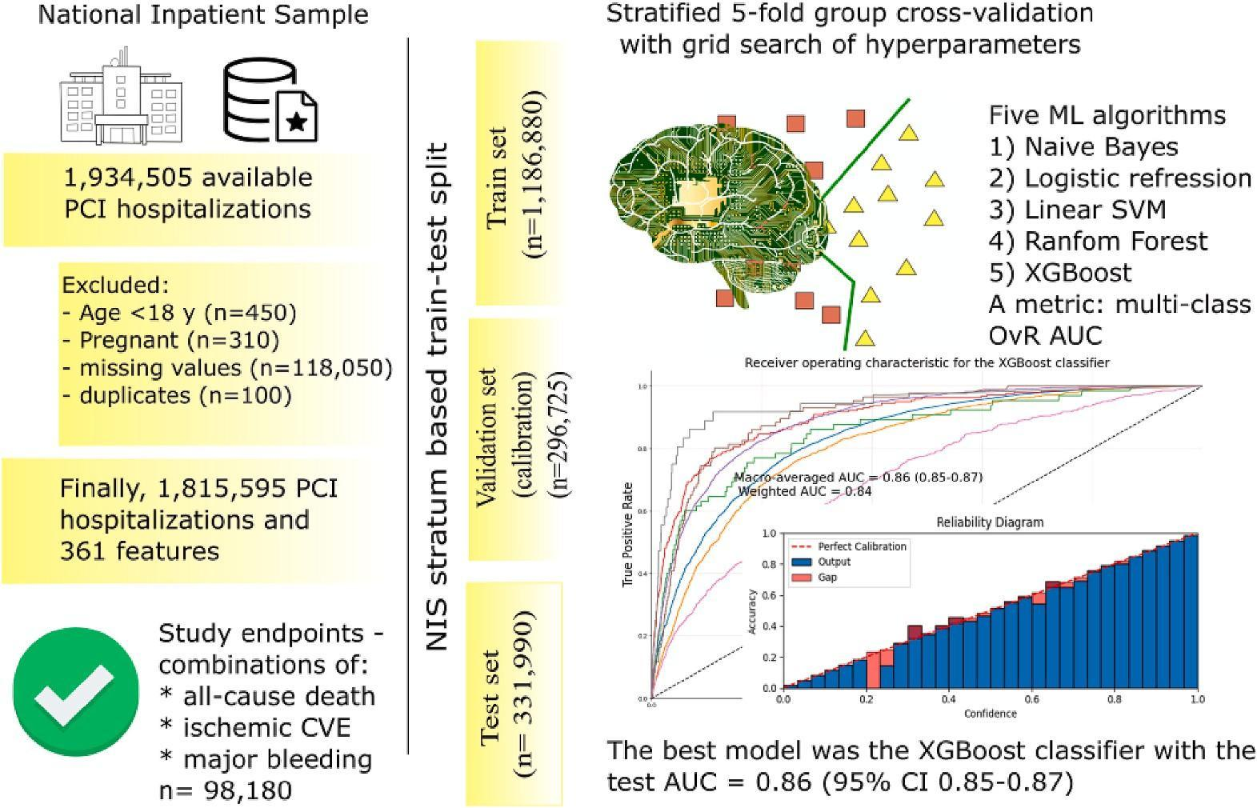

**Fig. 1.** Study flow diagram. CVE, cerebro-vascular events; NIS, the National Inpatient Sample; OvR AUC, one-versus-rest area under the curve; PCI, percutaneous coronary intervention; SVM, support vector machine; XGBoost, extreme gradient boosting.

| **Table 1**  Baseline characteristics of the study population. |  | | | |
| --- | --- | --- | --- | --- |
|  | Total | Without outcomes | With outcomes | *p* value |
| n | 1,815,595 | 1,717,415 | 98,180 |  |
| Age, years | 65.39 (65.35–65.43) | 65.11 (65.07–65.15) | 70.33 (70.16–70.49) | <0.001 |
| Admission at weekend | 432,595 (23.8%) | 407,925 (23.8%) | 24,670 (25.1) | <0.001 |
| Elective admission | 172,250 (9.5%) | 162,285 (9.5%) | 9965 (10.2%) | 0.002 |
| Female | 599,110 (33%) | 559,015 (32.5%) | 40,095 (40.8%) | <0.001 |
| Race |  |  |  | <0.001 |
| White | 1,365,880 (75.2%) | 1,293,365 (75.3%) | 72,515 (73.9%) |  |
| Black | 175,930 (9.7%) | 165,840 (9.7%) | 10,090 (10.3%) |  |
| Hispanic | 150,285 (8.3%) | 142,110 (8.3%) | 8175 (8.3%) |  |
| Asian or Pacific Islander | 50,170 (2.7%) | 46,965 (2.7%) | 3205 (3.2%) |  |
| Native American | 10,180 (0.6%) | 9565 (0.6%) | 615 (0.6%) |  |
| Other | 63,150 (3.5%) | 59,570 (3.5%) | 3580 (3.7%) |  |
| Acute myocardial infarction | 1,313,705 (72.4%) | 1,232,700 (71.8%) | 81,005 (82.5%) | <0.001 |
| ST-segment elevation myocardial infarction | 548,880 (30.2%) | 503,645 (29.3%) | 45,235 (46.1%) | <0.001 |
| Non-ST-segment elevation myocardial infarction | 750,880 (41.4%) | 716,420 (41.7%) | 34,460 (35.1%) | <0.001 |
| Old myocardial infarction | 327,935 (18.1%) | 314,265 (18.3%) | 13,670 (13.9%) | <0.001 |
| History of PCI | 370,480 (20.4%) | 356,275 (20.7%) | 14,205 (14.5%) | <0.001 |
| Long-term use of aspirin | 540,900 (29.8%) | 520,525 (30.3%) | 20,375 (20.8%) | <0.001 |
| Essential hypertension | 886,330 (48.8%) | 857,120 (49.9%) | 29,210 (29.8%) | <0.001 |
| Hypertension with complications and secondary hypertension | 636,350 (35%) | 585,925 (34.1%) | 50,425 (51.4%) | <0.001 |
| Chronic rheumatic heart disease | 60,820 (3.4%) | 56,015 (3.3%) | 4805 (4.9%) | <0.001 |
| Nonrheumatic and unspecified valve disorders | 170,795 (9.4%) | 157,840 (9.2%) | 12,955 (13.2%) | <0.001 |
| Acute pulmonary embolism | 6155 (0.3%) | 4885 (0.3%) | 1270 (1.2%) | <0.001 |
| Conduction disorders | 212,070 (11.7%) | 195,005 (11.4%) | 17,065 (17.4%) | <0.001 |
| Cardiac dysrhythmias | 458,055 (25.2%) | 412,605 (24%) | 45,450 (46.3%) | <0.001 |
| Heart failure | 534,360 (29.4%) | 483,555 (28.2%) | 50,805 (51.7%) | <0.001 |
| Sequela of cerebral infarction and other cerebrovascular disease | 31,315 (1.7%) | 27,695 (1.6%) | 3620 (3.7%) | <0.001 |
| Peripheral and visceral vascular disease | 152,510 (8.4%) | 139,245 (8.1%) | 13,265 (13%) | <0.001 |
| Hepatic failure | 24,830 (1.4%) | 12,860 (0.7%) | 11,970 (12.2%) | <0.001 |
| Liver disease, mild | 50,120 (2.8%) | 45,720 (2.7%) | 4400 (4.5%) | <0.001 |
| Liver disease, moderate to severe | 6670 (0.4%) | 5125 (0.3%) | 1545 (1.4%) | <0.001 |
| Pancreatic disorders (excluding diabetes) | 8265 (0.4%) | 7315 (0.4%) | 950 (0.9%) | <0.001 |
| Diabetes mellitus with complication | 421,115 (23.2%) | 390,125 (22.7%) | 30,990 (31.6%) | <0.001 |
| Diabetes mellitus, Type 2 | 730,310 (40.2%) | 688,645 (40.1%) | 41,665 (42.4%) | <0.001 |
| Obesity | 378,705 (20.9%) | 361,670 (21.1%) | 17,035 (17.4%) | <0.001 |
| Disorders of lipid metabolism | 1,312,890 (72.3%) | 1,257,540 (73.2%) | 55,350 (56.4%) | <0.001 |
| Acute and unspecified renal failure | 279,895 (15.4%) | 233,345 (13.6%) | 46,550 (47.4%) | <0.001 |
| Renal failure, moderate | 237,625 (13.1%) | 218,465 (12.7%) | 19,160 (19.5%) | <0.001 |
| Renal failure, severe | 110,875 (6.1%) | 98,560 (5.7%) | 12,315 (12.5%) | <0.001 |
| Osteoporosis | 26,305 (1.5%) | 24,330 (1.4%) | 1975 (2.0%) | <0.001 |
| Gout | 65,725 (3.6%) | 62,205 (3.6%) | 3520 (3.6%) | 0.79 |
| Asthma | 81,425 (4.5%) | 78,110 (4.6%) | 3315 (3.1%) | <0.001 |
| Chronic obstructive pulmonary disease and bronchiectasis | 288,630 (15.9%) | 269,405 (15.7%) | 19,225 (19.6%) | <0.001 |
| Chronic blood loss anemia | 8210 (0.4%) | 6415 (0.3%) | 1795 (1.6%) | <0.001 |
| Autoimmune conditions | 49,230 (2.7%) | 46,170 (2.7%) | 3060 (3.1%) | <0.001 |
| Hypothyroidism | 204,010 (11.2%) | 191,985 (11.2%) | 12,025 (12.2%) | <0.001 |
| Lymphoma | 7815 (0.4%) | 7100 (0.4%) | 715 (0.7%) | <0.001 |
| Metastatic cancer | 9565 (0.5%) | 8135 (0.4%) | 1430 (1.5%) | <0.001 |
| Solid tumor without metastasis, malignant | 31,640 (1.7%) | 28,165 (1.6%) | 3475 (3.5%) | <0.001 |
| Psychoses | 31,810 (1.8%) | 30,035 (1.8%) | 1775 (1.8%) | 0.56 |
| Smoking | 482,730 (26.6%) | 465,020 (27.1%) | 17,710 (18%) | <0.001 |
| Drug abuse | 39,495 (2.2%) | 37,470 (2.2%) | 2025 (2.1%) | 0.25 |

0.86 (95% CI 0.85–0.87, Fig. 3). The AUC for each class of outcomes ranged from 0.71 to 0.94. Of note, the calibration metrics were also satisfactory with ECEs of 0.003 and 0.002 for uncalibrated and calibrated models, respectively (Figs. 4). The most important features were Elixhauser comorbidity score, moderate renal failure, Charlson comorbidity index, family history of heart diseases, acute renal failure, ST-segment elevation myocardial infarction, dyslipidemia myocarditis and cardiomyopathy, personal/family history of disease, age, and female gender. (Supplementary Fig. S8). Our programming codes are open-source and were published on the [GitHub](https://https//github.com/Akhmetzhan/Prediction_of_clinical_outcomes_after_percutaneous_coronary_intervention_NIS) profile of the first author, making it possible for anyone to develop their own ML model based on NIS datasets.

Using *streamlit*, we built a web-based software facilitating practical implementation of our ML model. After an authorized user input data of the intended patient (age, gender, race, type of admission, a month of admission, discharge quarter, and all ICD10 codes related to the current hospital stay) and click “Predict the risk” button, the web-application provides the estimated risk with 8 possible outputs: the patient has a low risk of in-hospital events, the patient has a high risk of in-hospital death, a high risk of in-hospital major bleeding, a high risk of in-hospital ischemic stroke, a high risk of in-hospital major bleeding and death, a high risk of in-hospital death and ischemic stroke, a high risk of in-hospital ischemic stroke and major bleeding, a high risk of in-hospital death, ischemic stroke and major bleeding (Supplementary video). The Python code for the *streamlit* application is also available on the [GitHub](https://github.com/Akhmetzhan/Prediction_of_clinical_outcomes_after_percutaneous_coronary_intervention_NIS) profile of the first author. Due to the risk of re-identification of the original database and copyright issues, we are not able to release our ML model and web-based software publicly.

##### Discussion

In the current analysis using a large sample of 1,815,595 PCI hospitalizations from a national administrative dataset we show the feasibility in developing a ML model to predict all-cause death, ischemic CVE and major bleeding with a satisfactory discriminatory and calibration performance. With 101 clinical input variables, the best XGBoost

**Table 2**

Baseline characteristics for study population.

|  | Total | Train and validation cohort | Test cohort |
| --- | --- | --- | --- |
| n | 1,815,595 | 1,483,605 | 331,990 |
| Death only | 42,820 | 35,590 (2.4%) | 7230 |
|  | (2.4%) |  | (2.2%) |
| Major bleeding only | 27,900 | 22,260 (1.5%) | 5640 |
|  | (1.5%) |  | (1.7%) |
| Ischemic CVE only | 17,390 | 14,145 (1.0%) | 3245 |
|  | (1.0%) |  | (1.0%) |
| Major bleeding and death | 5780 (0.3%) | 4575 (0.3%) | 1205 |
|  |  |  | (0.4%) |
| Ischemic CVE and death | 2020 (0.1%) | 1590 (0.1%) | 430 (0.1%) |
| Major bleeding and | 1500 | 1175 (<0.1%) | 325 |
| ischemic CVE | (<0.1%) |  | (<0.1%) |
| All three outcomes | 770 (<0.1%) | 590 (<0.1%) | 180 |
|  |  |  | (<0.1%) |
| Total | 98,180 | 79,925 | 18,255 |

Abbreviations: CVE, cerebro-vascular events.

classifier demonstrated an optimal AUC of 0.86 (95% CI 0.85–0.87) which is significantly higher than the performance of many current risk-stratification tools. [35–37]

The current risk scores for in-hospital events aimed to predict only bleeding or ischemic events after PCI. Both the CRUSADE (Can Rapid risk stratification of Unstable angina patients Suppress ADverse outcomes with Early implementation of the ACC/AHA guidelines) and ACTION (the Acute Coronary Treatment and Intervention Outcomes Network Registry-Get With the Guidelines) bleeding score were derived on non-contemporary cohorts of selective MI patients, incorporated a limited set of risk factors and only few comorbidities, demonstrated moderate discrimination (c-statistics of 0.70–0.73). [35,36] The recent studies revealed their poor performance on modern PCI cohorts (with c-statistic from 0.61 to 0.77). [38–40] While being developed on data from all-comer PCI patients enrolled from 2008 to 2011 with exclusion of non-index admissions, the National Cardiovascular Data CathPCI registry score included a broader spectrum of comorbidities but still demonstrated moderate discrimination value (c-statistics of 0.77–0.78). [5]

While the Global Registry of Acute Coronary Events (GRACE) risk score showed high discrimination but poor calibration performance for in-hospital mortality, particularly for PCI patients, other current risk stratification tools performed significantly better in predicting death during hospital stay. [6,7,37] In PCI patients, none of these techniques could predict both ischemic and bleeding in-hospital events. The Dual Antiplatelet Therapy (DAPT) score, on the other hand, assesses both thrombotic and hemorrhagic risk in a single patient, directing the duration of DAPT. [41] A physician, on the other hand, need simultaneous risk assessment for in-hospital events in order to choose an antiplatelet medication, decide on gastro-intestinal protection, or implement other bleeding reduction techniques. In this regard, our ML model is multi-task which means that it could predict all-cause mortality, ischemic and hemorrhagic events as a single output for a given patient. Our ML algorithm can assist a physician to tailor the type and strategy of antithrombotic treatment based on the estimated risk of death, ischemic stroke, major bleeding and their combination. In comparison to current models, our derived model can identify a specific group of individuals who are at high risk of all three outcomes described above. Overall, the created risk-stratification tool may aid clinical decision making in routine hospital settings by categorizing each individual patient into one of eight distinct groups: low-risk, high risk of death only, ischemic CVE only, and major bleeding only, a combination of death and ischemic CVE, death and major bleeding, ischemic CVE and

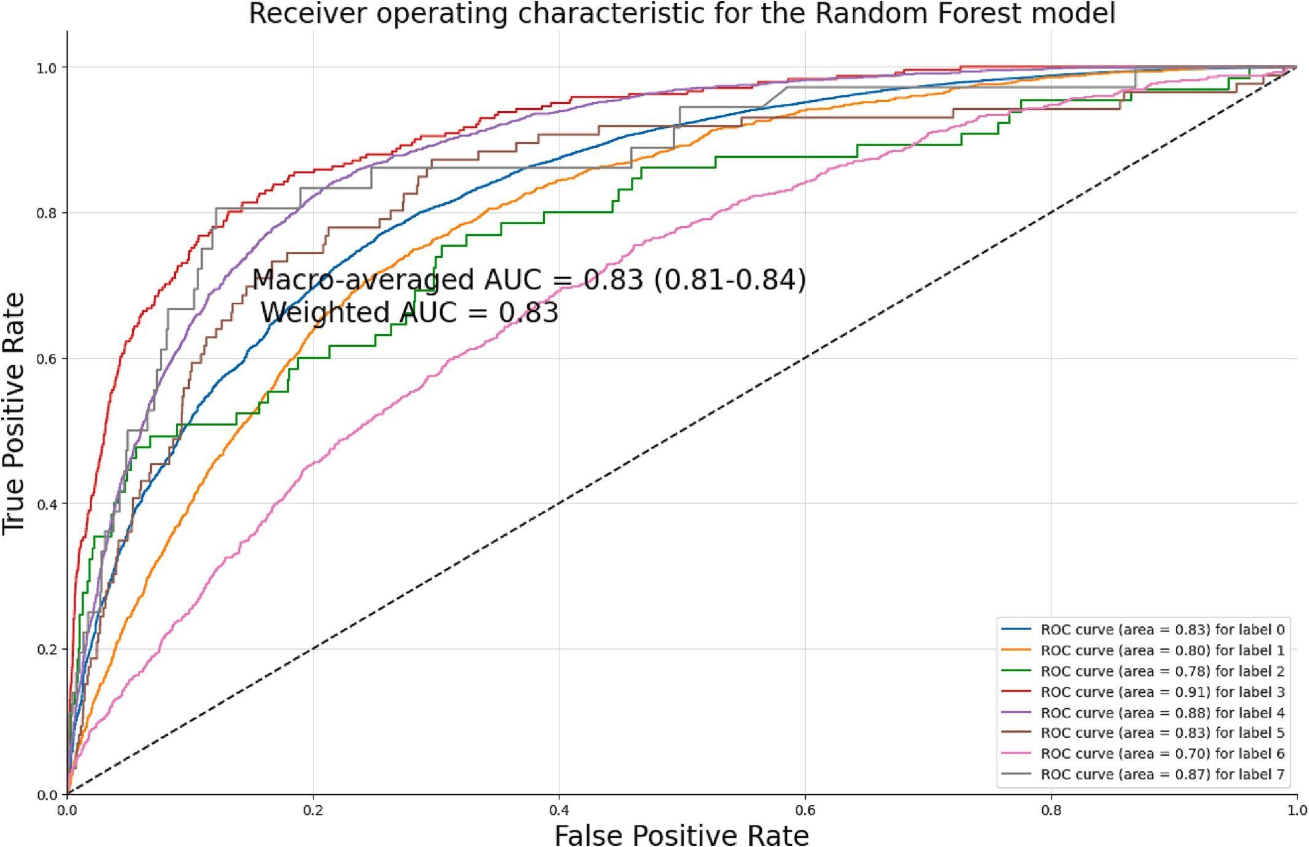

**Fig. 2.** The receiver operating characteristics for the best random forest model. AUC, an area under the curve; ROC, the receiver operating characteristics.

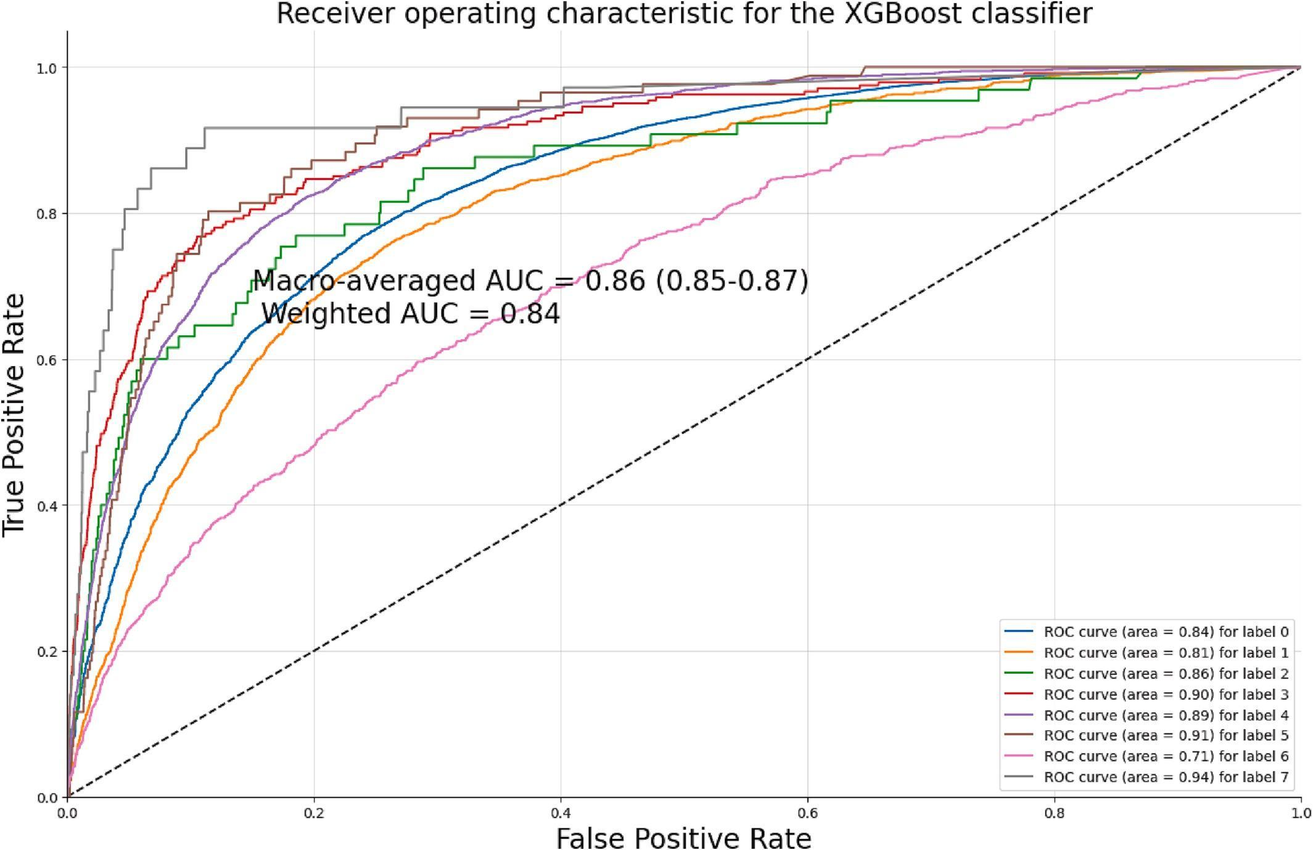

**Fig. 3.** The receiver operating characteristics for the best XGboost model. AUC, an area under the curve; ROC, the receiver operating characteristics; XGBoost, extreme gradient boosting.

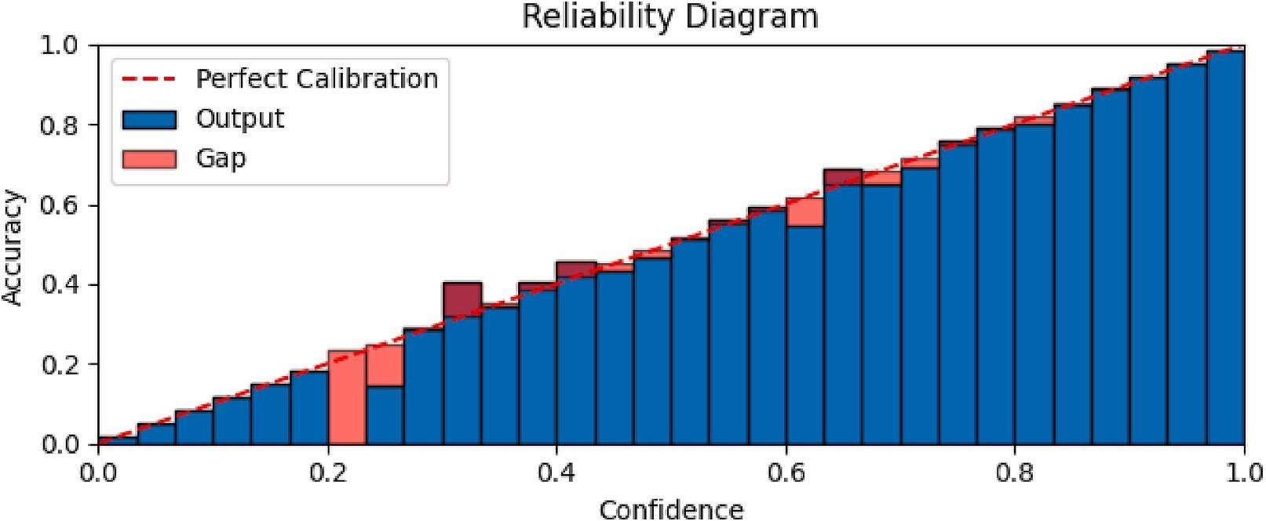

**Fig. 4.** The calibration curve for the best XGboost model. A, for the uncalibrated model; B, for the calibrated model. XGBoost, extreme gradient boosting.

major bleeding, and all three outcomes. We believe that the integration of our model to routine EHRs will not meet significant difficulties and demonstrated this by building a web-based application that needs only baseline patient data and ICD10 codes to provide predictions for in-hospital events.

Based on standard regression techniques, current point-based scores could incorporate only a limited set of classical variables thus leaving out other potential predictors. [9] A recent large meta-analysis demonstrated that prediction tools from Electronic Health Record systems utilize on average 27 variables in a model excluding the vast majority of available information. [42] In this regard, ML algorithms are able to handle all potential features taking into account their complex interrelationship. [12] Moreover, ML does not require any assumption for linearity, normality, and data distribution of input data. [12] Handling these limitations of standard scores, our ML approach provides a better alternative to the current solutions. Of note, the majority of standard prediction scores were developed in randomized controlled trials or observational studies with rigorous exclusion criteria making it difficult to apply in real-world populations. [9] In our study, we developed the ML models in an unselected cohort of PCI patients with few exclusion criteria, thus facilitating its wider clinical application in routine practice.

Whilst our machine learning algorithm may be difficult to apply at the bedside by an individual physician given that the risk score requires complex computational algorithms and contains 101 features, we believe that it may be better placed for use by hospital administrators to benchmark individual operators or centers. Our high-dimensional ML model, which was built on one of the largest electronic healthcare da- tabases in the United States, could be incorporated in a hospital computing system, providing everyday digital assistance to a physician during clinical decision making and also to hospital administrators for benchmarking. The integration of our derived model in the current electronic-health record systems can facilitate automation of risk stratification processes and to help guide antithrombotic regimes, where the type and duration of antiplatelet agents depends on the perceived balance between ischemic and bleeding risk. Furthermore, it allows administrators to benchmarker PCI services offered by the hospital for a number of patient relevant clinically meaningful endpoints. Such inte- grated ML models could be continuously updated and retrained with additional input data even without any human interaction. [43]

Unfortunately, regardless of the high aspirations for artificial intelligence in medicine, there have been obstacles in translating the developed machine learning models from EHRs into real-life clinical applications. [43–45] Only a tiny handful of peer-reviewed publications have really made it to the market and are currently used routinely in some hospitals. [43,45] A recent study found only 21 publications on ML models that were then implemented in healthcare settings. [44,46] According to recent reviews, the large gap between model development and deployment in practice arises not only from flaws in models them- selves, but also from logistical challenges, a lack of multidisciplinary cooperation, a lack of working infrastructure for implementation, privacy and sociocultural issues, and a need for continuous model assessment and financial support. [43,45] Some authors discovered parallels between translational ML and the drug discovery pathway and viewed ML models as a result of the pre-clinical phase that requires further validation in clinical trials. [43] However, we believe that these difficulties should not deter researchers from developing ML models for clinical applications. We have several inspiring examples of successful ML implementations to date. For example, eCart is a ward ML algorithm in use retrospectively developed on EHR data from 5 hospitals to predict death, cardiac arrest, and intensive care transfer. [44,46]

From a scientific perspective, our results could be used to benchmark future studies on the NIS databases. A recent analysis of 445 articles performed on the NIS demonstrated a substantial variation in code selection for case definitions with 8.8% of studies using off-target codes.[47] Also, a total 84% of analyzed studies did not follow required research practices. [47] The use of a common framework for coding and preprocessing data will help to standardize and improve the quality of future research.. For example, the recent study developed a workflow platform for Medical Information Mart for Intensive Care IV Emergency Department database. [48] Similarly to this, our study proposes a pipeline for preprocessing raw NIS datasets into benchmark datasets with standardized variables that then could be trained with the ready-to-use Python code. It means that anyone can use our open-source programming codes to train their own ML model on available databases.

Last but not least, we performed calibration for all models and provided reliability graphs with calibration metrics to detect agreement between the predicted and actual values in the test cohort. A recent systematic review has found that almost 95% of published ML-based prediction models missed calibration data although it is highly recommended by reporting guidelines. [49,50] Despite high discrimination performance, poor calibrated models provide misleading predictions with over- or underestimation of the risks that could be dangerous in healthcare settings. [51] Due to its utmost importance, calibration is considered to be “the Achilles heel of predictive analytics” that prevents real-world application of most ML models. [51] Concerning this, our XGboost model demonstrated optimal performance for both discrimination and calibration facilitating its implementation in real clinical practice.

Several limitations should be considered when interpreting our findings. These limitations are primarily due to the NIS's unique characteristics as a database. First, the NIS data is an example of a record-wise dataset but not subject-wise, which means the sample unit is a single hospitalization rather than an individual subject. [23,24] As a result, one patient may contribute to several entries in the dataset that can be placed in both the training and test cohorts, making test performance appear overly optimistic. To address this issue, we used stratum-based train-test split and group cross-validation, which significantly reduced the possibility of a single subject being placed in multiple cohorts. Second, we did not conduct totally independent external validation. We did, however, employ internal-external validation with train-validation-test splitting depending on NIS strata. [52] Because the NIS stratums are divided based on census division, area, hospital ownership, location, teaching status, and hospital bed size, the baseline characteristics of the study population differ. We anticipate that the resulting diversity and calibration of the models will improve the outcomes of future external validation and ease practical use in the real world. Internal validation that is methodologically robust can then lead to effective performance on unseen data. [52] Nonetheless, we feel that external validation of our data is necessary; however, we agree with many other researchers that such validation should be undertaken by independent authors in order to prevent potential reporting and publication bias. [52] Third, the NIS does not provide an exact time for its ICD-10 codes making it very challenging to distinguish endpoints from baseline comorbidities. We then removed all ICD-10 codes that can be a part of outcomes thus alleviating the risk of data leakage. We could not also include re-infarction, target vessel revascularization and stent thrombosis as an outcome due to absence of diagnosis time. In terms of other outcomes, recent research has indicated that only about 1% of patients with acute ischemic stroke develop MI during their hospital stay, while just 0.3% of patients with acute cerebral bleeding have concomitant MI. It is reasonable to suppose that the fraction of these individuals who underwent PCI is considerably lower given the risk associated with performing PCI in such settings. [53,54] As a result, it is highly unlikely that ICD-10 codes utilized as outcomes were baseline characteristics of the study population. Fourth, the NIS lacks any laboratory or instrumental tests, reducing the number of potential key predictors of adverse outcomes following PCI. Furthermore, we only analyzed structured data, despite the fact that unstructured information (medical images, free texts from medical records) may increase risk prediction even further. However, our model contained a complete set of comorbidities that earlier scores could not sufficiently represent. As a result, our model could be used in future ensemble models. With the widespread availability of EHRs, ensemble ML approaches offer an opportunity to integrate numerous classifiers based on different types of input data and considerably improve predicted accuracy. [55] Finally, as the NIS is an administrative database, any inconsistencies in coding by physicians might impact the reliability and generalization of our findings.

##### Conclusion

After testing five most common ML algorithms on a large sample of 1,815,595 PCI hospitalizations from the NIS database, we derived the multi-task XGBoost classifier based on 101 features to predict different combinations of all-cause death, ischemic CVE and major bleeding with an excellent discriminatory performance compared to this from the previous regression-based scores. Our study highlights the potential benefits of integration of high-dimensional artificial intelligence models in healthcare electronic systems to aid in benchmarking PCI services / operators.

Supplementary data to this article can be found online at [https://doi.](https://doi.org/10.1016/j.ijcard.2023.131339) [org/10.1016/j.ijcard.2023.131339](https://doi.org/10.1016/j.ijcard.2023.131339).

##### Funding

None.

##### CRediT authorship contribution statement

**Akhmetzhan Galimzhanov:** Conceptualization, Methodology, Software, Validation, Formal analysis, Investigation, Data curation, Writing – original draft, Writing – review & editing, Visualization, Su- pervision. **Andrija Matetic:** Conceptualization, Methodology, Resources, Data curation. **Erhan Tenekecioglu:** Conceptualization, Methodology, Writing – review & editing. **Mamas A. Mamas:** Conceptualization, Methodology, Resources, Writing – review & editing, Su- pervision, Project administration.

##### Declaration of Competing Interest

None.

##### Acknowledgments

I, Akhmetzhan, would like to express my deepest gratitude to my mother, Ibraeva Azipa, for devoting her entire life to me, for being my source of inspiration, support, and guidance throughout my life. I believe that this work as well all other my achievements would not be possible without her constant support.

##### References

1. [M. Simonsson, J. Alfredsson, K. Szummer, T. Jernberg, P. Ueda, Association of](http://refhub.elsevier.com/S0167-5273(23)01296-2/rf0005) [ischemic and bleeding events with mortality among patients in Sweden with recent](http://refhub.elsevier.com/S0167-5273(23)01296-2/rf0005) [acute myocardial infarction receiving antithrombotic therapy, JAMA Netw. Open 5](http://refhub.elsevier.com/S0167-5273(23)01296-2/rf0005) [(2022), e2220030](http://refhub.elsevier.com/S0167-5273(23)01296-2/rf0005).
2. [F.-J. Neumann, M. Sousa-Uva, A. Ahlsson, F. Alfonso, A.P. Banning, U. Benedetto,](http://refhub.elsevier.com/S0167-5273(23)01296-2/rf0010) [et al., 2018 ESC/EACTS Guidelines on myocardial revascularization, Eur. Heart J.](http://refhub.elsevier.com/S0167-5273(23)01296-2/rf0010) [40 (2019) 87–165](http://refhub.elsevier.com/S0167-5273(23)01296-2/rf0010).
3. [M. Valgimigli, H. Bueno, R.A. Byrne, J.-P. Collet, F. Costa, A. Jeppsson, et al., 2017](http://refhub.elsevier.com/S0167-5273(23)01296-2/rf0015) [ESC focused update on dual antiplatelet therapy in coronary artery disease](http://refhub.elsevier.com/S0167-5273(23)01296-2/rf0015) [developed in collaboration with EACTS: the task force for dual antiplatelet therapy](http://refhub.elsevier.com/S0167-5273(23)01296-2/rf0015) [in coronary artery disease of the European Society of Cardiology (ESC) and of the](http://refhub.elsevier.com/S0167-5273(23)01296-2/rf0015) [European Association for Cardio-Thoracic Surgery (EACTS), Eur. Heart J. 39](http://refhub.elsevier.com/S0167-5273(23)01296-2/rf0015) [(2018) 213–260](http://refhub.elsevier.com/S0167-5273(23)01296-2/rf0015).
4. [G.N. Levine, E.R. Bates, J.A. Bittl, R.G. Brindis, S.D. Fihn, L.A. Fleisher, et al., 2016](http://refhub.elsevier.com/S0167-5273(23)01296-2/rf0020) [ACC/AHA guideline focused update on duration of dual antiplatelet therapy in](http://refhub.elsevier.com/S0167-5273(23)01296-2/rf0020) [patients with coronary artery disease: a report of the American College of](http://refhub.elsevier.com/S0167-5273(23)01296-2/rf0020) [Cardiology/American Heart Association task force on clinical practice guidelines:](http://refhub.elsevier.com/S0167-5273(23)01296-2/rf0020) [an update of the 2011 ACCF/AHA/SCAI guideline for percutaneous coronary](http://refhub.elsevier.com/S0167-5273(23)01296-2/rf0020) [intervention, 2011 ACCF/AHA guideline for coronary artery bypass graft surgery,](http://refhub.elsevier.com/S0167-5273(23)01296-2/rf0020) [2012 ACC/AHA/ACP/AATS/PCNA/SCAI/STS guideline for the diagnosis and](http://refhub.elsevier.com/S0167-5273(23)01296-2/rf0020) [Management of Patients with Stable Ischemic Heart Disease, 2013 ACCF/AHA](http://refhub.elsevier.com/S0167-5273(23)01296-2/rf0020) [guideline for the management of St-elevation myocardial infarction, 2014 AHA/](http://refhub.elsevier.com/S0167-5273(23)01296-2/rf0020) [ACC guideline for the management of patients with non-ST-elevation acute](http://refhub.elsevier.com/S0167-5273(23)01296-2/rf0020) [coronary syndromes, and 2014 ACC/AHA guideline on perioperative](http://refhub.elsevier.com/S0167-5273(23)01296-2/rf0020) [cardiovascular evaluation and management of patients undergoing noncardiac](http://refhub.elsevier.com/S0167-5273(23)01296-2/rf0020) [surgery, Circulation. 134 (2016) e123–e155](http://refhub.elsevier.com/S0167-5273(23)01296-2/rf0020).
5. [S.V. Rao, L.A. McCoy, J.A. Spertus, R.J. Krone, M. Singh, S. Fitzgerald, et al., An updated bleeding model to predict the risk of post-procedure bleeding among](http://refhub.elsevier.com/S0167-5273(23)01296-2/rf0025) [patients undergoing percutaneous coronary intervention: a report using an](http://refhub.elsevier.com/S0167-5273(23)01296-2/rf0025) [expanded bleeding definition from the National Cardiovascular Data Registry](http://refhub.elsevier.com/S0167-5273(23)01296-2/rf0025) [CathPCI Registry, JACC Cardiovasc. Interv. 6 (2013) 897–904](http://refhub.elsevier.com/S0167-5273(23)01296-2/rf0025).
6. [E.L. Hannan, L.S. Farrell, G. Walford, A.K. Jacobs, P.B. Berger, D.R. Holmes Jr., et](http://refhub.elsevier.com/S0167-5273(23)01296-2/rf0030) [al., The New York state risk score for predicting in-hospital/30-day mortality](http://refhub.elsevier.com/S0167-5273(23)01296-2/rf0030) [following percutaneous coronary intervention, JACC Cardiovasc. Interv. 6 (2013)](http://refhub.elsevier.com/S0167-5273(23)01296-2/rf0030) [614–622](http://refhub.elsevier.com/S0167-5273(23)01296-2/rf0030).
7. [Y.S. Castro-Dominguez, Y. Wang, K.E. Minges, R.L. McNamara, J.A. Spertus, G.J. Dehmer, et al., Predicting in-hospital mortality in patients undergoing](http://refhub.elsevier.com/S0167-5273(23)01296-2/rf0035) [percutaneous coronary intervention, J. Am. Coll. Cardiol. 78 (2021) 216–229](http://refhub.elsevier.com/S0167-5273(23)01296-2/rf0035).
8. [M. Singh, C.S. Rihal, R.J. Lennon, J. Spertus, J.S. Rumsfeld, D.R. Holmes Jr.,](http://refhub.elsevier.com/S0167-5273(23)01296-2/rf0040) [Bedside estimation of risk from percutaneous coronary intervention: the new Mayo](http://refhub.elsevier.com/S0167-5273(23)01296-2/rf0040) [Clinic risk scores, Mayo Clin. Proc. 82 (2007) 701–708](http://refhub.elsevier.com/S0167-5273(23)01296-2/rf0040).
9. [P. Urban, R. Mehran, R. Colleran, D.J. Angiolillo, R.A. Byrne, D. Capodanno, et al.,](http://refhub.elsevier.com/S0167-5273(23)01296-2/rf0045) [Defining high bleeding risk in patients undergoing percutaneous coronary](http://refhub.elsevier.com/S0167-5273(23)01296-2/rf0045) [intervention, Circulation. 140 (2019) 240–261](http://refhub.elsevier.com/S0167-5273(23)01296-2/rf0045).
10. [G. Quer, R. Arnaout, M. Henne, R. Arnaout, Machine learning and the future of](http://refhub.elsevier.com/S0167-5273(23)01296-2/rf0050) [cardiovascular care: JACC state-of-the-art review, J. Am. Coll. Cardiol. 77 (2021)](http://refhub.elsevier.com/S0167-5273(23)01296-2/rf0050) [300–313](http://refhub.elsevier.com/S0167-5273(23)01296-2/rf0050).
11. [K. Seetharam, S. Balla, C. Bianco, J. Cheung, R. Pachulski, D. Asti, et al.,](http://refhub.elsevier.com/S0167-5273(23)01296-2/rf0055) [Applications of machine learning in cardiology, Cardiol Ther. 11 (2022) 355–368](http://refhub.elsevier.com/S0167-5273(23)01296-2/rf0055).
12. [D. Bzdok, N. Altman, M. Krzywinski, Statistics versus machine learning, Nat.](http://refhub.elsevier.com/S0167-5273(23)01296-2/rf0060) [Methods 15 (2018) 233–234](http://refhub.elsevier.com/S0167-5273(23)01296-2/rf0060).
13. HCUP-US NIS Overview [cited 12 Jan 2023]. Available, [https://www.hcup-us.ah](https://www.hcup-us.ahrq.gov/nisoverview.jsp) [rq.gov/nisoverview.jsp](https://www.hcup-us.ahrq.gov/nisoverview.jsp).
14. Clinical Classifications Software Refined (CCSR) for ICD-10-PCS Procedures [cited 12 Jan 2023]. Available, [https://www.hcup-us.ahrq.gov/toolssoftware/ccsr/prccs](https://www.hcup-us.ahrq.gov/toolssoftware/ccsr/prccsr.jsp) [r.jsp](https://www.hcup-us.ahrq.gov/toolssoftware/ccsr/prccsr.jsp).
15. Clinical Classifications Software Refined (CCSR) for ICD-10-CM Diagnoses [cited 12 Jan 2023]. Available, [https://www.hcup-us.ahrq.gov/toolssoftware/ccsr/dxccs](https://www.hcup-us.ahrq.gov/toolssoftware/ccsr/dxccsr.jsp) [r.jsp](https://www.hcup-us.ahrq.gov/toolssoftware/ccsr/dxccsr.jsp).
16. Elixhauser Comorbidity Software Refined for ICD-10-CM [cited 12 Jan 2023]. Available, [https://www.hcup-us.ahrq.gov/toolssoftware/comorbidityicd10/como](https://www.hcup-us.ahrq.gov/toolssoftware/comorbidityicd10/comorbidity_icd10.jsp) [rbidity_icd10.jsp](https://www.hcup-us.ahrq.gov/toolssoftware/comorbidityicd10/comorbidity_icd10.jsp).
17. [H. Quan, V. Sundararajan, P. Halfon, A. Fong, B. Burnand, J.-C. Luthi, et al., Coding](http://refhub.elsevier.com/S0167-5273(23)01296-2/rf0085) [algorithms for defining comorbidities in ICD-9-CM and ICD-10 administrative data,](http://refhub.elsevier.com/S0167-5273(23)01296-2/rf0085) [Med. Care 43 (2005) 1130–1139](http://refhub.elsevier.com/S0167-5273(23)01296-2/rf0085).
18. [A. Gasparini, Comorbidity: an R package for computing comorbidity scores, J Open](http://refhub.elsevier.com/S0167-5273(23)01296-2/rf0090) [Source Softw. 3 (2018) 648](http://refhub.elsevier.com/S0167-5273(23)01296-2/rf0090).
19. GitHub - atif-hassan/FRUFS: An unsupervised feature selection technique using supervised algorithms such as XGBoost, GitHub, 2023 [Internet]. [cited 14 May 2023]. Available, <https://github.com/atif-hassan/FRUFS>.
20. [E. Oger, M.-A. Botrel, C. Juchault, J. Bouget, Sensitivity and specificity of an](http://refhub.elsevier.com/S0167-5273(23)01296-2/rf0100) [algorithm based on medico-administrative data to identify hospitalized patients](http://refhub.elsevier.com/S0167-5273(23)01296-2/rf0100) [with major bleeding presenting to an emergency department, BMC Med. Res.](http://refhub.elsevier.com/S0167-5273(23)01296-2/rf0100) [Methodol. 19 (2019) 194](http://refhub.elsevier.com/S0167-5273(23)01296-2/rf0100).
21. [C. Joos, K. Lawrence, A.E. Jones, S.A. Johnson, D.M. Witt, Accuracy of ICD-10](http://refhub.elsevier.com/S0167-5273(23)01296-2/rf0105) [codes for identifying hospitalizations for acute anticoagulation therapy-related](http://refhub.elsevier.com/S0167-5273(23)01296-2/rf0105) [bleeding events, Thromb. Res. 181 (2019) 71–76](http://refhub.elsevier.com/S0167-5273(23)01296-2/rf0105).
22. [R. Mehran, S.V. Rao, D.L. Bhatt, C.M. Gibson, A. Caixeta, J. Eikelboom, et al.,](http://refhub.elsevier.com/S0167-5273(23)01296-2/rf0110) [Standardized bleeding definitions for cardiovascular clinical trials: a consensus](http://refhub.elsevier.com/S0167-5273(23)01296-2/rf0110) [report from the Bleeding Academic Research Consortium, Circulation. 123 (2011)](http://refhub.elsevier.com/S0167-5273(23)01296-2/rf0110) [2736–2747](http://refhub.elsevier.com/S0167-5273(23)01296-2/rf0110).
23. [S. Saeb, L. Lonini, A. Jayaraman, D.C. Mohr, K.P. Kording, The need to](http://refhub.elsevier.com/S0167-5273(23)01296-2/rf0115) [approximate the use-case in clinical machine learning, Gigascience. 6 (2017) 1–9](http://refhub.elsevier.com/S0167-5273(23)01296-2/rf0115).
24. [I. Tougui, A. Jilbab, J.E. Mhamdi, Impact of the choice of cross-validation](http://refhub.elsevier.com/S0167-5273(23)01296-2/rf0120) [techniques on the results of machine learning-based diagnostic applications,](http://refhub.elsevier.com/S0167-5273(23)01296-2/rf0120) [Healthc Inform Res. 27 (2021) 189–199](http://refhub.elsevier.com/S0167-5273(23)01296-2/rf0120).
25. [R. Shwartz-Ziv, A. Armon, Tabular data: deep learning is not all you need, Inf](http://refhub.elsevier.com/S0167-5273(23)01296-2/rf0125) [Fusion. 81 (2022) 84–90](http://refhub.elsevier.com/S0167-5273(23)01296-2/rf0125).
26. L. Grinsztajn, E. Oyallon, G. Varoquaux, Why do Tree-Based Models Still Outperform Deep Learning on Tabular Data?, 2022, [https://doi.org/10.48550/](https://doi.org/10.48550/ARXIV.2207.08815) [ARXIV.2207.08815](https://doi.org/10.48550/ARXIV.2207.08815).
27. [A.K. Menon, X.J. Jiang, S. Vembu, C. Elkan, L. Ohno-Machado, Predicting accurate](http://refhub.elsevier.com/S0167-5273(23)01296-2/rf0135) [probabilities with a ranking loss, Proc Int Conf Mach Learn. 2012 (2012) 703–710](http://refhub.elsevier.com/S0167-5273(23)01296-2/rf0135).
28. KDE Group, University of Kassel, DMIR Group, University of Würzburg, L3S Research Center, (Germany), H. Probabilistic Outputs for Support Vector Machines and Comparison to Regularized Likelihood Methods [cited 16 Apr 2023]. Available: [https://www.bibsonomy.org/bibtex/2b13a556c2a6c1a3a2a30fe889](https://www.bibsonomy.org/bibtex/2b13a556c2a6c1a3a2a30fe889ea9b738/zeno) [ea9b738/zeno](https://www.bibsonomy.org/bibtex/2b13a556c2a6c1a3a2a30fe889ea9b738/zeno).
29. F. Kuppers, J. Kronenberger, A. Shantia, A. Haselhoff, Multivariate confidence calibration for object detection, in: 2020 IEEE/CVF Conference on Computer Vision and Pattern Recognition Workshops (CVPRW), IEEE, 2020, [https://doi.org/](https://doi.org/10.1109/cvprw50498.2020.00171) [10.1109/cvprw50498.2020.00171](https://doi.org/10.1109/cvprw50498.2020.00171).
30. S. Lundberg, S.-I. Lee, A Unified Approach to Interpreting Model Predictions, 2017, <https://doi.org/10.48550/ARXIV.1705.07874>.
31. [T. Lumley, Analysis of complex survey samples, J. Stat. Softw. 9 (2004) 1–19](http://refhub.elsevier.com/S0167-5273(23)01296-2/rf0155).
32. W. Runmin, W. Jingye, J. Wei, Calculating and Visualizing ROC and PR Curves Across Multi-Class Classifications [cited 13 Jan 2023]. Available: [https://cran.rstu](https://cran.rstudio.com/web/packages/multiROC/multiROC.pdf) [dio.com/web/packages/multiROC/multiROC.pdf](https://cran.rstudio.com/web/packages/multiROC/multiROC.pdf).
33. [F. Pedregosa, G. Varoquaux, A. Gramfort, V. Michel, B. Thirion, O. Grisel, et al.,](http://refhub.elsevier.com/S0167-5273(23)01296-2/rf0165) [Scikit-learn: machine learning in Python, J. Mach. Learn. Res. 12 (2011)](http://refhub.elsevier.com/S0167-5273(23)01296-2/rf0165)

[2825–2830](http://refhub.elsevier.com/S0167-5273(23)01296-2/rf0165).

1. T. Chen, C. Guestrin, XGBoost, in: Proceedings of the 22nd ACM SIGKDD International Conference on Knowledge Discovery and Data Mining, ACM, New York, NY, USA, 2016, <https://doi.org/10.1145/2939672.2939785>.
2. [S. Subherwal, R.G. Bach, A.Y. Chen, B.F. Gage, S.V. Rao, L.K. Newby, et al.,](http://refhub.elsevier.com/S0167-5273(23)01296-2/rf0175) [Baseline risk of major bleeding in non-ST-segment-elevation myocardial infarction:](http://refhub.elsevier.com/S0167-5273(23)01296-2/rf0175) [the CRUSADE (can rapid risk stratification of unstable angina patients suppress](http://refhub.elsevier.com/S0167-5273(23)01296-2/rf0175) [ADverse outcomes with early implementation of the ACC/AHA guidelines)](http://refhub.elsevier.com/S0167-5273(23)01296-2/rf0175) [bleeding score, Circulation. 119 (2009) 1873–1882](http://refhub.elsevier.com/S0167-5273(23)01296-2/rf0175).
3. [R. Mathews, E.D. Peterson, A.Y. Chen, T.Y. Wang, C.T. Chin, G.C. Fonarow, et al.,](http://refhub.elsevier.com/S0167-5273(23)01296-2/rf0180) [In-hospital major bleeding during ST-elevation and non-ST-elevation myocardial](http://refhub.elsevier.com/S0167-5273(23)01296-2/rf0180) [infarction care: derivation and validation of a model from the ACTION registry®-](http://refhub.elsevier.com/S0167-5273(23)01296-2/rf0180) [GWTGTM, Am. J. Cardiol. 107 (2011) 1136–1143](http://refhub.elsevier.com/S0167-5273(23)01296-2/rf0180).
4. [B. Elbarouni, S.G. Goodman, R.T. Yan, R.C. Welsh, J.M. Kornder, J.P. Deyoung, et](http://refhub.elsevier.com/S0167-5273(23)01296-2/rf0185) [al., Validation of the global registry of acute coronary event (GRACE) risk score for](http://refhub.elsevier.com/S0167-5273(23)01296-2/rf0185) [in-hospital mortality in patients with acute coronary syndrome in Canada, Am.](http://refhub.elsevier.com/S0167-5273(23)01296-2/rf0185) [Heart J. 158 (2009) 392–399](http://refhub.elsevier.com/S0167-5273(23)01296-2/rf0185).
5. [D. Bento, N. Marques, P. Azevedo, J. Guedes, J. Bispo, D. Silva, et al., CRUSADE: is](http://refhub.elsevier.com/S0167-5273(23)01296-2/rf0190) [it still a good score to predict bleeding in acute coronary syndrome? Rev. Port.](http://refhub.elsevier.com/S0167-5273(23)01296-2/rf0190) [Cardiol. 37 (2018) 889–897](http://refhub.elsevier.com/S0167-5273(23)01296-2/rf0190).
6. [K. Tscherny, C. Kienbacher, V. Fuhrmann, R. van Tulder, W. Schreiber, H. Herkner,](http://refhub.elsevier.com/S0167-5273(23)01296-2/rf0195) [et al., Risk stratification in acute coronary syndrome: evaluation of the GRACE and CRUSADE scores in the setting of a tertiary care centre, Int. J. Clin. Pract. 74](http://refhub.elsevier.com/S0167-5273(23)01296-2/rf0195) [(2020), e13444](http://refhub.elsevier.com/S0167-5273(23)01296-2/rf0195).
7. [X. Flores-Ríos, D. Couto-Mallo´n, J. Rodríguez-Garrido, M. García-Guimaraes, P. Gargallo-Fern´andez, P. Pin˜o´n-Esteban, et al., Comparison of the performance of](http://refhub.elsevier.com/S0167-5273(23)01296-2/rf0200) [the CRUSADE, ACUITY-HORIZONS, and ACTION bleeding risk scores in STEMI](http://refhub.elsevier.com/S0167-5273(23)01296-2/rf0200) [undergoing primary PCI: insights from a cohort of 1391 patients, Eur. Heart J.](http://refhub.elsevier.com/S0167-5273(23)01296-2/rf0200) [Acute Cardiovasc. Care 2 (2013) 19–26](http://refhub.elsevier.com/S0167-5273(23)01296-2/rf0200).
8. [R.W. Yeh, E.A. Secemsky, D.J. Kereiakes, S.-L.T. Normand, A.H. Gershlick, D. J. Cohen, et al., Development and validation of a prediction rule for benefit and](http://refhub.elsevier.com/S0167-5273(23)01296-2/rf0205) [harm of dual antiplatelet therapy beyond 1 year after percutaneous coronary](http://refhub.elsevier.com/S0167-5273(23)01296-2/rf0205) [intervention, JAMA. 315 (2016) 1735–1749](http://refhub.elsevier.com/S0167-5273(23)01296-2/rf0205).
9. [B.A. Goldstein, A.M. Navar, M.J. Pencina, J.P.A. Ioannidis, Opportunities and](http://refhub.elsevier.com/S0167-5273(23)01296-2/rf0210) [challenges in developing risk prediction models with electronic health records](http://refhub.elsevier.com/S0167-5273(23)01296-2/rf0210) [data: a systematic review, J. Am. Med. Inform. Assoc. 24 (2017) 198–208](http://refhub.elsevier.com/S0167-5273(23)01296-2/rf0210).
10. [S. Harris, T. Bonnici, T. Keen, W. Lilaonitkul, M.J. White, N. Swanepoel, Clinical](http://refhub.elsevier.com/S0167-5273(23)01296-2/rf0215) [deployment environments: five pillars of translational machine learning for health,](http://refhub.elsevier.com/S0167-5273(23)01296-2/rf0215) [Front Digit Health. 4 (2022), 939292](http://refhub.elsevier.com/S0167-5273(23)01296-2/rf0215).
11. M.P. Sendak, J. D’Arcy, S. Kashyap, M. Gao, M. Nichols, K. Corey, et al., A path for translation of machine learning products into healthcare delivery, Euro Med J Innov. (2020), <https://doi.org/10.33590/emjinnov/19-00172>.
12. [C.J. Kelly, A. Karthikesalingam, M. Suleyman, G. Corrado, D. King, Key challenges](http://refhub.elsevier.com/S0167-5273(23)01296-2/rf0225) [for delivering clinical impact with artificial intelligence, BMC Med. 17 (2019) 195](http://refhub.elsevier.com/S0167-5273(23)01296-2/rf0225).
13. [M.M. Churpek, T.C. Yuen, C. Winslow, A.A. Robicsek, D.O. Meltzer, R.D. Gibbons,](http://refhub.elsevier.com/S0167-5273(23)01296-2/rf0230) [et al., Multicenter development and validation of a risk stratification tool for ward](http://refhub.elsevier.com/S0167-5273(23)01296-2/rf0230) [patients, Am. J. Respir. Crit. Care Med. 190 (2014) 649–655](http://refhub.elsevier.com/S0167-5273(23)01296-2/rf0230).
14. [J.W. Ostrominski, J. Amione-Guerra, B. Hernandez, J.E. Michalek, A. Prasad,](http://refhub.elsevier.com/S0167-5273(23)01296-2/rf0235) [Coding variation and adherence to methodological standards in cardiac research](http://refhub.elsevier.com/S0167-5273(23)01296-2/rf0235) [using the National Inpatient Sample, Front Cardiovasc Med. 8 (2021), 713695](http://refhub.elsevier.com/S0167-5273(23)01296-2/rf0235).
15. [F. Xie, J. Zhou, J.W. Lee, M. Tan, S. Li, L.S. Rajnthern, et al., Benchmarking](http://refhub.elsevier.com/S0167-5273(23)01296-2/rf0240) [emergency department prediction models with machine learning and public](http://refhub.elsevier.com/S0167-5273(23)01296-2/rf0240) [electronic health records, Sci Data. 9 (2022) 658](http://refhub.elsevier.com/S0167-5273(23)01296-2/rf0240).
16. [C.L. Andaur Navarro, J.A.A. Damen, M. van Smeden, T. Takada, S.W.J. Nijman, P. Dhiman, et al., Systematic review identifies the design and methodological](http://refhub.elsevier.com/S0167-5273(23)01296-2/rf0245) [conduct of studies on machine learning-based prediction models, J. Clin.](http://refhub.elsevier.com/S0167-5273(23)01296-2/rf0245) [Epidemiol. 154 (2023) 8–22](http://refhub.elsevier.com/S0167-5273(23)01296-2/rf0245).
17. [K.G.M. Moons, D.G. Altman, J.B. Reitsma, J.P.A. Ioannidis, P. Macaskill, E.W. Steyerberg, et al., Transparent reporting of a multivariable prediction model for](http://refhub.elsevier.com/S0167-5273(23)01296-2/rf0250) [individual prognosis or diagnosis (TRIPOD): explanation and elaboration, Ann.](http://refhub.elsevier.com/S0167-5273(23)01296-2/rf0250) [Intern. Med. 162 (2015) W1–73](http://refhub.elsevier.com/S0167-5273(23)01296-2/rf0250).
18. [B. Van Calster, D.J. McLernon, M. van Smeden, L. Wynants, E.W. Steyerberg, Topic](http://refhub.elsevier.com/S0167-5273(23)01296-2/rf0255) [group “evaluating diagnostic tests and prediction models” of the STRATOS](http://refhub.elsevier.com/S0167-5273(23)01296-2/rf0255) [initiative. Calibration: the Achilles heel of predictive analytics, BMC Med. 17](http://refhub.elsevier.com/S0167-5273(23)01296-2/rf0255) [(2019) 230](http://refhub.elsevier.com/S0167-5273(23)01296-2/rf0255).
19. [E.W. Steyerberg, F.E. Harrell, Prediction models need appropriate internal,](http://refhub.elsevier.com/S0167-5273(23)01296-2/rf0260) [internal–external, and external validation, J. Clin. Epidemiol. 69 (2016) 245–247](http://refhub.elsevier.com/S0167-5273(23)01296-2/rf0260).
20. [T. Gattringer, K. Niederkorn, L. Seyfang, T. Seifert-Held, N. Simmet, J. Ferrari, et](http://refhub.elsevier.com/S0167-5273(23)01296-2/rf0265) [al., Myocardial infarction as a complication in acute stroke: results from the](http://refhub.elsevier.com/S0167-5273(23)01296-2/rf0265) [austrian stroke unit registry, Cerebrovasc. Dis. 37 (2014) 147–152](http://refhub.elsevier.com/S0167-5273(23)01296-2/rf0265).
21. [T.A. Pana, A.D. Wood, M.A. Mamas, A.B. Clark, J.H. Bettencourt-Silva, D.J. McLernon, et al., Myocardial infarction after acute ischaemic stroke: incidence,](http://refhub.elsevier.com/S0167-5273(23)01296-2/rf0270) [mortality and risk factors, Acta Neurol. Scand. 140 (2019) 219–228](http://refhub.elsevier.com/S0167-5273(23)01296-2/rf0270).
22. [D. Zhang, C. Yin, J. Zeng, X. Yuan, P. Zhang, Combining structured and](http://refhub.elsevier.com/S0167-5273(23)01296-2/rf0275) [unstructured data for predictive models: a deep learning approach, BMC Med.](http://refhub.elsevier.com/S0167-5273(23)01296-2/rf0275) [Inform. Decis. Mak. 20 (2020) 280](http://refhub.elsevier.com/S0167-5273(23)01296-2/rf0275).