L.N. Gumilyov Eurasian National University

UD 624.156.4 On manuscript rights

BURANBAYEVA AIGERIM MURATOVNA

Artificial Neural Network in Basement Slab Monitoring Using Distributed Fibre Optic Sensor

8D07329 – Civil engineering

Thesis for the Degree of
doctor of Philosophy (PhD)

Scientific supervisor
dr. tech. sc.,
professor
A.Zh. Zhussupbekov

Foreign supervisor
PhD Goh Lyn Dee,
(Universiti Teknologi MARA,
Malaysia)

Republic of Kazakhstan
Astana, 2022

CONTENTS

NORMATIVE REFERENCES ……………………………………………… |  | 4
SYMBOLS AND ABBREVIATIONS……………………………………….. |  | 6
INTRODUCTION…………………………………………………………….. |  | 7
1 | LITERATURE REVIEW…………………………………………… | 11
1.1 | History of structural condition monitoring systems…………………... | 11
1.2 | Distributed fibre sensors………………………………………………. | 18
1.2.1 | Distributed fiber optic strain sensing system (DFOSS)………………. | 19
1.2.2 | Structure of optical fiber……………………………………………… | 19
1.2.3 | Sensing principle……………………………………………………… | 21
1.2.4 | Conversional coefficients…………………………………………….. | 23
1.3 | Strains induced by delayed ettringite formation and alkali-aggregate reaction……………………………………………………………….. | 24
1.4 | The use of strain sensing in monitoring………………………………. | 25
Summary on the section…………………………………………………… |  | 31
2 | METHODOLOGY FOR NUMERICAL ANALYSIS…………….. | 32
2.1 | Methodology for numerical analysis of slab expansion………………. | 32
2.2 | Geometry………………………………………………………………. | 32
2.3 | Constitutive modelling………………………………………………… | 33
2.4 | Analyses……………………………………………………………….. | 35
2.5 | Minimum gauge length to prevent fibre optic fracture……………….. | 36
2.6 | Numerical analyses results…………………………………………….. | 37
2.7 | Required strain resolution for expansion detection…………………… | 42
2.8 | Required strain resolution…………………………………………….. | 43
2.9 | Numerical modeling of concrete raft using Plaxis 3D simulation…….. | 47
Summary on the section ……………………………………………………. |  | 50
3 | EXPERIMENTAL RESEARCH METHODS……………………... | 52
3.1 | Engineering-geological investigation of the construction site………… | 52
3.2 | Fiber optic monitoring system………………………………………… | 56
3.2.1 | Design of distributed fiber optic strain sensing system (DFOSS)…….. | 56
3.2.2 | Gauge length installation-calibration………………………………….. | 56
3.2.3 | Strain resolution……………………………………………………….. | 57
3.2.4 | Grid spacing…………………………………………………………… | 58
3.2.5 | Cable routing…………………………………………………………... | 58
3.2.6 | Optical losses………………………………………………………….. | 63
3.2.7 | Spatial resolution……………………………………………………… | 64
3.2.8 | Analyzer and analyzer room…………………………………………... | 65
3.2.9 | Cable installation……………………………………………………… | 67
3.2.10 | Test preparation……………………………………………………….. | 72
3.2.11 | Site testing……………………………………………………………... | 73
3.3 | Field results……………………………………………………………. | 75
Summary on the section ……………………………………………………….. |  | 78
4 DISCUSSION…………………………………………………………. |  | 80
5 RECOMMENDATIONS…………………………………………...... |  | 84
CONCLUSIONS………………………………………………………………. |  | 85
REFERENCES………………………………………………………………… |  | 86
APPENDIX A – Cable routing locations ……………………………………… |  | 93
APPENDIX B – Distributed fiber optic sensor for civil and geotechnical integrity monitoring……………………………………………………….……. |  | 101
APPENDIX C – Length of Curved cable Transition for steps and ramps…….. |  | 103
APPENDIX D – The obtained data from the temperature field……………….. |  | 109
APPENDIX E – The values of the compression and tension………………….. |  | 111
APPENDIX F – Act of implementation of the monitoring method with fiber optic sensors at the construction site……………………………………………. |  | 115

NORMATIVE REFERENCES

This dissertation uses links to the following standards:
SP RK 1.02-102-2014. Engineering and geological surveys for construction.
SP RK 1.02-105-2014. Engineering surveys for construction. Basic provisions.
SN RK 5.01-02-2013. Foundations of buildings and structures.
SP RK 5.01-102-2013. Foundations of buildings and structures.
SN RK 5.01-03-2013. Pile foundations.
SN RK 2.01-01-2013. Protection of building structures against corrosion.
SP RK 2.03-30-2017. Construction in seismic areas.
GOST 25100-2011. Soils. Classification.
GOST 12248-2010. Soils. Methods for laboratory determination of strength and deformability characteristics.
ST RK 1273-2004. Soils. Method for laboratory determination of grain (granulometric) composition.
ST RK 1291-2004. Soils. Methods for laboratory determination of the filtration coefficient.
ST RK 1550-2006. Soils. Methods for laboratory determination of swelling and shrinkage characteristics.
GOST 20522-2012. Soils. Methods of statistical processing of test results.
SN RK 8.02-05-2002. Collections of estimated norms and prices for construction work.
SN RK 1.03-05-2007. Labor Protection and Safety in Construction.
SN RK 3.02-08-2013. (mod 15.11.18_235-NK) Administrative and domestic buildings.
SN RK 3.02-09-2011. Multifunctional buildings and complexes.
SN RK 1.02-03-2022. The order of development, coordination, approval and composition of project documentation for construction.
SN RK 1.02-01-2016. Standard Design (Order 31-N-K of 12.07.2016).
SN RK 1.03-01-2016. Duration of construction and reserves in the construction of enterprises, buildings and structures. Part 1. (Order 31-N-K dated 12.07.2016).
SN RK 1.03-02-2014. Duration of construction and the reserve in the construction of enterprises, buildings and structures. Part II.
IEC standards. SC86A: Fibers and Cables.
IEC standards. SC86B: Fiber optic interconnecting devices and passive components.
IEC standards. SC86C: Fiber optic systems and active devices.
ITU – R. Radiocommunication sector.
ITU – T. Telecommunication standardization sector.
ITU – D. Telecommunication development sector.
IEC 61300-3-35. Fibre optic connector end face visual inspection.
IEC 60793-1 and -2: Optical fibers (includes several parts).
IEC 60794-1, -2, -3: Optical fiber cables.
G.651. Characteristics of 50/125 μm Multimode graded-index optical fiber.
G.652. Characteristics of single-mode optical fiber and cable.
G.653. Characteristics of single-mode dispersion shifted optical fiber and cable.
G.654. Characteristics of cut – off shifted single-mode optical fiber and cable.
G.655. Characteristics of non-zero dispersion shifted single-mode optical fiber and cable.
G.656. Characteristics of non-zero dispersion shifted fiber for wideband transport.
G.657. Characteristics of a bending loss insensitive single-mode fiber for access networks.
IEC 61350. power meter calibration.
IEC 61746. OTDR calibration.
G.650.1. Definition and test methods for linear, deterministic attributes of single-mode fiber and cable.
G.650.2. Definition and test methods for statistical and non-linear attributes of single-mode fiber and cable.
GOST 19912-2012. Soils. Methods of field tests by static and dynamic sounding. Soils. Field test methods: cone penetration test and dynamic probing.
SP RK 2.04-01-2017. Building Climatology.
SP RK 1.02-105-2014. Engineering surveys for construction.
GOST 25100-2020. Soils. Classification. Soils. Classification.
GOST 9.602-2016. Interstate Standard. Unified system of protection against corrosion and ageing. Underground structures. General requirements for protection against corrosion.
SN RK 8.02-14-2005. Collections of Consolidated Estimate Norms. Rates.

SYMBOLS AND ABBREVIATIONS

SHM | – Structural Health Monitoring
FEM | – finite element model
MEMS | – Micro-electromechanical systems
OW | – optical fibers
BIM | – Building Information Model
ACCL | – Arabtec Consolidated Contractors Limited
DEF | – delayed ettringite formation
AAR | – alkali-aggregate reaction
DFOSS | – distributed fibre optic strain sensing
SiO2 | – silicon dioxide
RI | – refractive index
POFs | – polymer optical fibres
PCS | – polymer clad silica
OTDR | – Optical Time Domain Reflectometry
ADP | – Abu Dhabi plaza

INTRODUCTION

I hereby declare that, except where specific reference is made to the work of others, the contents of this thesis are original and have not been submitted in whole or in part to any other degree or qualification at this or any other university. This dissertation is my own work and contains nothing that is the result of work done in collaboration with others, except as indicated in the text and Acknowledgements. This thesis includes introduction, and main body, which includes 3 chapters, discussion, conclusion, references and appendixes including appendices, bibliography, tables, equations and about 50 figures (total – 115 pages).
The relevance of the study. The safe operation of a building and structure is the main criterion at all stages of construction. To ensure the realization of this task, a System of distributed fiber-optic strain gauge probing of foundations has been developed, which makes it possible:
- to continuously monitor the foundation slab in order to avoid the appearance of cracks in the foundation slab and adverse effects during the operation of the building, and thereby to improve the reliability and safety of the project through the timely identification of critical points of deformation;
- to receive data from sensors and integrate it into the building information modelling system, which in turn makes it possible to process a large amount of data to make correct and quick decisions over the entire life cycle of the object.
The following objectives are defined:
– study of international experience;
– to perform numerical analysis of slab expansion to define the minimum gauge length for the FO cable;
– numerical modeling of concrete raft to determine the vertical and horizontal displacements;
– to design of distributed fiber optic strain sensing system (DFOSS) on the concrete raft surface;
– to substantiate the obtained strains during monitoring with a fiber optic cable.
Scientific novelty:
– scientific-technological support of a new technique for monitoring the foundation slab using fiberoptic sensors at the Abu Dhabi Plaza construction site in Nur-Sultan, Kazakhstan;
– the new concept of integrating BIM models with sensor monitoring to improve the visualization and analysis process of health monitoring, in addition to building operational safety;
- recomendations for minimum gauge length to prevent fibre optic fracture.
The following research methods were used in this study:
- literature review;
- numerical analysis of slab expansion;
- modelling of concrete raft under full load;
- experimental testing on the construction site.

Provisions of the research submitted for the defence of the dissertation:
- as a result of a literature review of foreign experience, it has been established that monitoring using fiber optics is the best solution today to ensure the safe operation of buildings and structures;
– numerical analysis of slab expansion defined the minimum gauge length for the FO cable as 2 m for the high-rise building;
–vertical and horizontal displacements were determined by numerical modeling of concrete raft in Plaxis 3D based on full design gravity load and resulted the differential settlement 24 mm in vertical direction and 1 mm in horizontal direction;
– the distributed fiber optic strain sensing system (DFOSS) on the concrete raft surface was designed which allowed to monitor the stress strain condition of the raft structure and to register cracks in a timely manner;
– monitoring with a fiber optic cable revealed compression strains prevailed in the central part of the building core in the zone of increased load from reinforced concrete load-bearing walls, while the center, north, and east parts of the building have more stable patterns of accumulation of tensile stresses. Local tensile deformations are most focused on the extreme axes, as well as near the joints of the columns;
– сomparative analysis of numerical and field studies of the behaviour of the foundation slab of a high-rise structure.
Approbation. The main results of this research work were presented in the following events:
- At the construction site of project Abu Dhabi Plaza as a result of operational tests the results of which are reflected in this work.
- Implementation of the monitoring method with fiber optic sensors at the construction site (Appendix F).
3. The main results of scientific work were written and published in the international journal published by MDPI - Evaluation of the structural health monitoring results of the applied fiber optic in the pile-raft foundations of a high-rise building. Appl. Sci. 2022, 12(22), 11728; https://doi.org/10.3390/app122211728 and conference materials:
– Tashkent Institute of Architecture and Civil Engineering (TASI) scientific and practical international conference, 21-22 October, 2021. Tashkent, Uzbekistan;
- 20th International Conference on Soil Mechanics and Geotechnical Engineering (ICSMGE 2022), 1-5 May, 2022. Sydney, Australia;
- International Conference on "Innovative Solutions for Geotechnical Problems" in Honour of Prof. Erol Guler, 22-23 June,2022. Istanbul, Turkey.
Publications. The results of this scientific work were published in 8 scientific papers, including: 2 in international publications with a non-zero impact factor in the editions from the Scopus Database, 3 in the publications recommended by the Committee for Quality Assurance in the Sphere of Education and Science of the Ministry of Education and Science of the Republic of Kazakhstan, 3 in the materials of the proceedings of international and national conferences held in Kazakhstan and abroad.

In the editions from the Scopus Database:
- A.M. Buranbayeva, A. Zh. Zhussupbekov and A. R. Omarov. Numerical analysis and geomonitoring of behaviour of foundation of Abu-Dhabi Plaza in Nur-Sultan. Deep Foundations and geotechnical problems of territories (DFGC 2021). Journal of Physics: Conference Series, Volume 1928 (2021) 012033. doi:10.1088/1742-6596/1928/1/012033 (Scopus – 18%);
- Aigerim Buranbayeva, Askar Zhussupbekov, Assel Sarsembayeva and Abdulla Omarov. Evaluation of the structural health monitoring results of the applied fiber optic in the pile-raft foundations of a high-rise building. Applied Science, Volume 12(22), 11728. https://doi.org/10.3390/app122211728 (Scopus – 73%, Web of science – Q2).
In the editions in peer-reviewed scientific journals recommended by the Committee for Quality Assurance in the Sphere of Education and Science of the Ministry of Education and Science of the Republic of Kazakhstan:
- А. Buranbayeva, А.Zh. Zhussupbekov, А. Omarov. Geo-monitoring of basement slab at Abu-Dhabi Plaza in Nur-Sultan City, Kazakhstan. Bulletin of L.N. Gumilyov Eurasian National University. Technical Science and Technology Series, Volume 136, issue 3, 2021 - P.25-32;
- А. Buranbayeva, А. Zhussupbekov, R. Nursafin, K. Badashvili. Design a Building Information Modeling (BIM) project concept in combination with foundation monitoring on the example of the Abu Dhabi Plaza construction project, BULLETIN of L.N. Gumilyov Eurasian National University. Technical Science and Technology Series. Volume 138, issue 1, 2022 – P.23-33;
- А.Buranbayeva, А.Zhussupbekov, Commissioning Test of Distributed fiber-optics sensors during foundation monitoring of the Abu Dhabi Plaza construction project in Nur-Sultan City. BULLETIN of L.N. Gumilyov Eurasian National University. Technical Science and Technology Series. Volume 139, issue 2, 2022 – P. 51-61.
In the proceedings of international and national conferences held in Kazakhstan and abroad:
1. А. Буранбаева, А. Жусупбеков. Эксплуатационные испытания оптического деформационного кабеля с внутренней фиксированной точкой в рамках геомониторинга подвальной плиты проекта Абу-Даби Плаза в городе Нур-Султан (Казахстан). O’zbekiston respublikasi qurilish vazirligi. Toshkent arxitektura qurilishi institute. Ташкент, Узбекистан. УДК: 624.042.7. 2021 - C. 150 – 156;
2. A. Zh. Zhussupbekov, A. Omarov, I. Zhumadilov, A.Buranbayeva. Remediation proposals for damaged subgrade below railway line on soft soils. Proceedings of the 20th International Conference on Soil Mechanics and Geotechnical Engineering– Rahman and Jaksa (Eds). © 2022 Australian Geomechanics Society, Sydney, Australia, ISBN 978-0-9946261-4-1. 2022 – P.5215 – 5218;
3. Aigerim Buranbayeva, Askar Zhussupbekov and Assel Sarsembayeva. A new method of monitoring system of foundation using fiber optic sensors. International Conference on "Innovative Solutions for Geotechnical Problems" in Honour of Prof. Erol Guler. 2022, Istanbul, Turkey, 2022.

Acknowledgements

I wish to express my deepest gratitude to my research supervisor, Professor Askar Zhussupbekov, Doctor of Technical Sciences, who was so kind as to supervise and support me throughout my research. Without his persistent guidance, this scientific work would not have been written in its current form.
I thank Foreign Scientific Advisor Dr. Goh Lyn Dee of Faculty Of Civil Engineering Universiti Teknologi MARA Pulau Pinang, Malaysia, who gave direction and insight to my work.

I would like to express special thanks to Dr. Assel Sarsembaeva and Dr. Abdulla Omarov for their mentoring and direct involvement in writing scientific papers and helping me to understand probing methods and providing valuable feedback during the construction of the spontaneous Brillouin scattering model.

My thanks to Mr. Bun Rin Tee and Smart Sensing Technology SDN (Malaysia) for allowing me to conduct my experiments and access to the facility, for setting up my workplace, and for the great hands-on experience they gave me.

I would like to thank employees of KazNIISA JSC - Head of the Department of Modeling and Calculation of Building Structures of the Center for Information Modeling Ruslan Nursafin and Head of the Department of Methodology of Information Modeling Technology Center for Information Modeling of KazNIISA JSC Konstantin Badashvili, who gave me great guidance during my research and professional assistance in conducting laboratory experiments. They led me to greater understanding of the process of integration of sensor data into the information model.
I would also like to thank all of the staff at the Geotechnical Institute of L.N. Gumilev Eurasian National University for their invaluable help with my scientific experiments and for their friendship during my years of study.
Last, but very important to me, I thank my parents, my husband Nurlan and my sons Mustafa and Khaled for their care and spiritual support in writing this thesis.

1 LITERATURE REVIEW

  - History of structural condition monitoring systems
In recent decades, due to the lack of suitable building sites as well as the complexity of technical specifications, tall buildings have become a frequent phenomenon in metropolitan areas where the economy and population are growing rapidly. Compared to conventional buildings, tall buildings have higher population densities, resulting in greater business conversion and maintenance benefits. In seismically vulnerable areas the safety of such buildings must be known before an earthquake, and all kinds of damage, must be detected in time to make a quick decision. In our regions, because of the difficult soil conditions, high-rise buildings must also be monitored at all times. To meet such needs, high-rise building initiatives are actively carried out to provide a basis for selecting baseline motions, modeling approaches, and performance criteria [1]. Structural Health Monitoring (SHM) systems provide insight into the dynamic performance of buildings. SHM systems are based on data acquisition systems consisting of acceleration sensors and data loggers. Dynamic building characteristics such as modal periods, shapes and damping coefficients can be determined from environmental vibration data records. Given these characteristics, the presence of any damage can be determined and design assumptions can be verified. In addition, the finite element model (FEM) of the building can be updated to reflect the true behavior of the building. The California Seismic Design Guide recommends installing SHM systems on high-rise buildings because these systems make a critical contribution to understanding the dynamic behavior of buildings and enhancing the ability of engineers to detect damage.
SHM systems have been used in civil engineering since the early 1980s. A literature review of SHM systems was first presented by Doebling et al. in 1996, summarizing hundreds of publications through 1995. In his work The interest in the ability to monitor a structure and detect damage at the earliest possible stage is pervasive throughout the civil, mechanical and aerospace engineering communities. Current damage-detection methods are either visual or localized experimental methods such as acoustic or ultrasonic methods, magnet field methods, radiographs, eddy-current methods and thermal field methods. All of these experimental techniques require that the vicinity of the damage is known a priori and that the portion of the structure being inspected is readily accessible. Subjected to these limitations, 2 these experimental methods can detect damage on or near the surface of the structure. The need for additional global damage detection methods that can be applied to complex structures has led to the development of methods that examine changes in the vibration characteristics of the structure [2]. Damage or fault detection, as determined by changes in the dynamic properties or response of structures, is a subject that has received considerable attention in the literature. The basic idea is that modal parameters (notably frequencies, mode shapes, and modal damping) are functions of the physical properties of the structure (mass, damping, and stiffness). Therefore, changes in the physical properties will cause changes in the modal properties. Ideally, a robust damage detection scheme will be able to identify that damage has occurred at a very early stage, locate the damage within the sensor resolution being used, provide some estimate of the severity of the damage, and predict the remaining useful life of the structure.
The effects of damage on a structure can be classified as linear or nonlinear. A linear damage situation is defined as the case when the initially linear-elastic structure remains linear-elastic after damage. The changes in modal properties are a result of changes in the geometry and/or the material properties of the structure, but the structural response can still be modeled using a linear equation of motion. Nonlinear damage is defined as the case when the initially linear-elastic structure behaves in a nonlinear manner after the damage has been introduced. One example of nonlinear damage is the formation of a fatigue crack that subsequently opens and closes under the normal operating vibration environment. Other examples include loose connections that rattle and nonlinear material behavior. A robust damage-detection method will be applicable to both of these general types of damage. The majority of the papers summarized in this review address only the problem of linear damage detection [2, р. 3-25]. They proposed the Classification table for damage identification methods, which is a compendium that classifies various methods of damage identification and model updating in chronological order.
Below is a literature review grouped by the following parameters (table 1, 2, 3, 4, 5, 6). The following is a classification of the literature regarding various methods for damage identification and condition monitoring of structures based on changes in their measured dynamic properties. The methods are categorized according to the type of measured data used or the technique that was used to identify damage from measured data. The table summarizes the characteristics of each method. Abbreviations used in the table are listed at the end of the table:
1. F=Frequencies, M=Mode Shapes, MD=Mode Shape Derivatives (including dynamic strain data), C=Damping, G=Flexibility or Reduced-Rank Stiffness, GD=Flexibility Derivatives, S=Static Data, R=Response Spectra or Frequency Response Function, TD=Time Domain Response/TA=Modal Test/Analysis Correlation (uses analytical model), TT=Undamaged Test/Damaged Test Correlation (uses no analytical model).
2. F=Forward, N=Inverse, T=Neural Network/D=Direct, I=Iterative.
3. (This column is only relevant for inverse or iterative modeling techniques which use some sort of optimization procedure).
4. F=Frequency Change, E=Equation of Motion, P=Parameter Change, R=Parameter Vector (or Matrix) Rank, RF=Response Spectra or Frequency Response Function Change, C=Connectivity, S=Symmetry, D=Positive Definiteness, Z=Sparsity (It should be noted that con- straining connectivity inherently constrains sparsity).
5. I=Indication Only (no spatial information), L=Location of Damage only (no property information), GM=Global Matrix Change, EM=Element Matrix Change, P=Element or Localized Parameter Change/M=Mass, C=Damping, K=Stiffness, H=Hybrid Property (e.g. dynamic impedance), G=Crack Geometry or Location (including composite delamination), V=Environmental or Operational Conditions, N=Response Nonlinearity.

Table 1 - Classification of Damage Identification Methods (Sheet 1 of 6)

Author(s) | Data/ Correlation(a) | Scheme(b) | Criterion/ Constraint(c) | Result/ Property(d)
Lifshitz and Rotem (1969) | F/TA | N / D | E | P / K
Berman and Flannely (1971)  Berman (1979), Berman, et al. (1980), Berman and Wei (1981)  Berman and Nagy (1983) | F, M/TA | N / D | P / E, S | GM / K
Vandiver (1975, 1977) | F / TA | F / D |  | P / M, K
Begg, et al. (1976) | F, R / TA | F / D |  | P / K
Loland and Dodds (1976) | F, M, R / TA | F / D |  | P / M, K, V
Wojnarowski, et al. (1977) | F / TA | F / D |  | P / M, K, V
Adams, et al. (1978) | F / TA | N / D | E | P / K
Baruch (1978, 1982, 1984)  Baruch and Bar Itzhack (1978)  Berman and Nagy (1983) Kabe (1985) Baruch and Zemel (1989) | F, M / TA | N / D | P / E, S | GM / K
Cawley and Adams (1979a, 1979b) | F / TA | F / D |  | P / K
Chen and Garba (1980) | F, M / TA | N / I | P / E | P / M, K
Coppolino and Rubin (1980) | F / TA | F / D |  | P / K
Duggan, et al. (1980) | F / TA | F / D |  | P / K, V
Kenley and Dodds (1980) | F / TA | F / D |  | P / K, M

Table 2 - Classification of Damage Identification Methods (Sheet 2 of 6)

Author(s) | Data/ Correlation(a) | Scheme(b) | Criterion/ Constraint(c) | Result/ Property(d)
1 | 2 | 3 | 4 | 5
Yang, et al. (1980, 1984) | TD / TA | F / D |  | P / K
Crohas and Lepert (1982) | F / TA | F / D |  | P / M, K
Gudmundson (1982) | F / TA | F / D |  | P / G
Nataraja (1983) | F / TA | F / D |  | P / M, K
Whittome and Dodds (1983) | F / TA | F / D |  | P / M, K, V
Berger, et al. (1984, 1989) | F, M / TA | N / I | E / S, D, C
Haug and Choi (1984) | F, M, S / TA | N / D | E / S | P / M, K
West (1984) | M / TT | N / D |  | L
Yuen (1985) | M, MD / TT | F / D |  | P / K
Gysin (1986) | G / TA | N / D | E | L
He and Ewins (1986) | G / TA | N / D | E | L
Afolabi (1987) | R | N / D | RF | L
Lee, et al. (1987) | F / TA | F / D |  | P / G
Wang and Zhang (1987) | R, F / TA | N / D | E | P / K
Chen and Garba (1988a, 1988b) | F, M / TA | N / D | P / E, C, S | P / K
Park, et al. (1988) | G / TA | N / D | E | L
Actis and Dimarogonas (1989) | MD / TA | F / D |  | P / G
Hajela and Soeiro (1989, 1990) | F, M, S / TA | N / D | P / E, S | GM / K
Ladeveze and Reynier (1989) | F, M, S / TA | N / I | E / S, D, C | P / M, K
Norris and Meirovitch (1989) | F, M / TA | N / I | E / S, C | P / M, K
Tracy and Pardoen (1989) | F / TA | F / D |  | P / G
Baruh (1990),  Chou and Wu (1990) | F, M / TA | N / D | E / S, C | P / M, K
Table continuation 2

1 | 2 | 3 | 4 | 5
Ismail, et al. (1990) | F / TA | F / D |  | P / G
Lim (1990, 1991) | F, M / TA | N / I | E / S, D, C | EM / K
Lin (1990, 1994) | G / TA | N / D | E | P / K
Lin and Ewins (1990) | F, M / TA | N / D | E | G / N
McGowan, et al. (1990) | F, M / TA | N / D | P / E, S | GM / K

Table 3 - Classification of Damage Identification Methods (Sheet 3 of 6)

Author(s) | Data/ Correlation(a) | Scheme(b) | Criterion/ Constraint(c) | Result/ Property(d)
Rizos, et al. (1990) | F, M / TA | N / I |  | P / G
Soeiro and Hajela (1990) | F, M / TA | N / I | E / S, D, C | P / K
Stubbs, et al. (1990)  Stubbs and Osegueda (1990a, 1990b) | F / TT | N / D | E | P / K
Bernitsas and Tawekal (1991) | F, M, S / TA | N / I | E / S, D, C | P / M, K
Hearn and Testa (1991) | F, M / TA | N / D | F / E | EM / K
Kudva, et al. (1991) | S / TT | T |  | P / G
Olhoff and Rasmussen (1991) | S / TA | N / D | E / S, C | P / M, K
Pandey, et al. (1991) | MD / TA | N / D | E | L
Piranda, et al. (1991) | F, M, S / TA | N / I | E / S, D, C | P / M, K
Ricles (1991)  Ricles and Kosmatka (1992) | F, M / TA | N / I | E / S, C | P / M, K
Roy, et al. (1991) Girard, et al. (1992) | F, M / TA | N / I | E / S, D, C | P / M, K
Sanayei and Onipede (1991) Sanayei, et al. (1992) | S / TA | N / I | E / S, D, C | P / K
Smith and Beattie (1991a, 1991b,1991c)  Smith (1992) | F, M / TA | N / D, I | P, E / S, Z | GM / K
Chu and Shen (1992) Shen and Chu (1992) | F, R / TA | F / D |  | P / G
Fox (1992) | F, M / TA | F / D |  | P / G
Kam and Lee (1992) | F, M / TA | N / I | E | P / G
Kim, et al. (1992) | M / TT | N / D | E | L
Krawczuk and Ostachowicz (1992) | F / TA | F / D |  | P / G
Law, et al. (1992) | R / TA, TT | N / D | E | P / K
Mayes (1992) | F, M / TA, TT | N / D | E | P / K
Ojalvo (1992) | F, M / TA | N / D | E / S | P / M, K
Osegueda, et al. (1992) | F, M
Richardson and Mannan (1992) | F, M / TA | N / D, I | E | GM / K
Srinivasan and Kot (1992) | F, M / TT | N / D | E | L

Table 4 - Classification of Damage Identification Methods (Sheet 4 of 6)

Author(s) | Data/ Correlation(a) | Scheme(b) | Criterion/ Constraint(c) | Result/ Property(d)
Stubbs, et al. (1992) | MD / TT | N / D | E | P / K
Wu, et al. (1992) | R | T |  | P / K
Zimmerman and Kaouk (1992) | F, M / TA | N / D | E | P / K
Baruh and Ratan (1993) | F, M / TA | N / D | E | L
Elkordy, et al. (1993) | M / TA | T |  | P / K
Hemez (1993)  Doebling, et al. (1993a,1993b)  Alvin (1996) | F, M / TA | N / I | E / C, S | P / M, K
Ju (1993) | R, TD / TA | N / D | E | P / G
Kim and Bartkowicz (1993, 1994)  Kim, et al. (1995a) | F, M / TA | N / D, I | P, E / S, R | P / K
Leath and Zimmerman (1993) | F / TA | T |  | P / K
Lindner, et al. (1993) Lindner and Kirby (1994) | F, M / TA | N / D | P / C, E | P / K, M
Lindner and Goff (1993) | F, M / TA | N / D | E | P / K
Pape (1993) | F / TT | F / D |  | P / G
Penny, et al. (1993) | F / TA | F / D |  | P / K
Peterson, et al. (1993) | G / TT | N / D | E | P / K
Slater and Shelley (1993) | F / TA | N / D | E | P / K
Spillman, et al. (1993) | F, R / TA | T |  | P / K
Springer and Reznicek (1993) | R / TA | F / D |  | P / G
Worden, et al. (1993) | S | T |  | P / G
Aktan, et al. (1994) | G / TT | N / D | E | P / K
Casas (1994) | F, M / TA | N / I | E | L / G
Chance, et al. (1994) | MD / TA | T |  | P / G
Chen and Swamidas (1994) | MD / TA | F / D |  | P / G
Dong, et al. (1994) | F, MD / TT | F / D |  | L
Friswell, et al. (1994) | F / TA | F / D |  | L
Juneja, et al. (1994) | R | F / D |  | P / K

Table 5 - Classification of Damage Identification Methods (Sheet 5 of 6)

Author(s) | Data/ Correlation(a) | Scheme (b) | Criterion/ Constraint(c) | Result/ Property(d)
1 | 2 | 3 | 4 | 5
Kaouk and Zimmerman (1994a, 1994b, 1994c, 1995a)  Zimmerman and Kaouk (1994) Zimmerman, et al. (1995b) | F, M / TA | N / D | R / S, E | GM, EM / M, C, K
Kirkegaard and Rytter (1994) | F / TA | T |  | P / K
Klein, et al. (1994) | F / TT | F / D |  | P / G
Ko, et al. (1994) | M / TT | N / D | E | L
Kondo and Hamamoto (1994) | MD / TA | N / D | E | P / K
Li and Smith (1994) | F, M / TA | N / D, I | P, E / S, Z | P / K
Lim (1994, 1995) | F, M / TA | N / D | E | P / K
Ma and Zheng (1994) | R | N / D |  | L
Table continuation 5

1 | 2 | 3 | 4 | 5
Man, et al. (1994) | F / TA | F / D |  | P / G
Manning (1994) | R | T |  | P / K
Meneghetti and Maggiore (1994) | F / TA | F / D |  | P / K, G
Narkis (1994) | F / TA | N / D |  | P / G
Pandey and Biswas (1994) | G / TT | N / D |  | P / K
Povich and Lim (1994) | R | T |  | P / K
Rhim and Lee (1994) | R | T |  | P / G
Salawu and WIlliams (1994, 1995) | M, MD / TT | N / D | E | L
Saravanos, et al. (1994) | R | F / D |  | P / G
Silva and Gomes (1994) | F / TA | F / D |  | P / G
Stephens and VanLuchene (1994) | R / TA | T |  | P / K
Szewczyk and Hajela (1994) | S | T |  | P / K
Toksoy and Aktan (1994) | G / TA, TT | N / D | E | P / K
Tsou and Shen (1994) | F / TA | T |  | P / K
Zimmerman and Simmermacher (1994, 1995) | F, M, S / TA | N / D | R / S, E | GM, EM / K
Balis Crema and Mastroddi (1995) | R | N / D | E | H
Barai and Pandey (1995) | TD | T |  | P / K
Brincker, et al. (1995a) | F / TA | F / D |  | P / M, K, V

Table 6 - Classification of Damage Identification Methods (to be continued)

Author(s) | Data/ Correlation(a) | Scheme (b) | Criterion/ Constraint(c) | Result/ Property(d)
Brincker, et al. (1995b) | F / TT | N / D | F | L
Ceravolo and De Stefano (1995) | F / TA | T |  | P / K
Choy, et al. (1995) | F / TA | F / I | F / E | P / K
Fritzen, et al. (1995) | TD / TA | F / D |  | P / K
Koh, et al. (1995) | TD / TA | N / I | E | P / K
Lam, et al. (1995) | F, M / TA | F / D |  | P / G
Liang, et al. (1995) | M, C / TA | N / D | E | I
Liu (1995) | F, M / TA | N / D | E / C, S | P / M, K
Mayes (1995) | G / TT, TA | N / D | E | P / K
Nwosu, et al. (1995) | F, MD / TA | F / D |  | P / G
Peterson, et al. (1995) | G / TA | N / D | E / C, S | P / K
Salawu (1995) | F, M / TA | N / D | F / E | P / K
Zhang and Aktan (1995) | GD / TT | N / D | E | P / K
Zimmerman, et al. (1995a) | R / TA | N / D | R / S, E | GM / H
Choudhury and He (1996) | R / TA | N / D | E | L
Dos Santos and Zimmerman (1996b) | F, M / TA | N / D | R, P / E, C, S | P / K
Klenke and Paez (1996) | G | T |  | I
Prime and Shevitz (1996) | M / TT | F / D |  | I / N
Schulz, et al. (1996) | R / TA | N / D | E | P / M, K
Schwarz, et al. (1996) | F | T |  | P / K
Skjaerbaek, et al. (1996) | F / TA | N / I | F / E | GM / K
Straser and Kiremidjian (1996) | TD / TA | N / I | E | N
1. F=Frequencies, M=Mode Shapes, MD=Mode Shape Derivatives (including dynamic strain data), C=Damping, G=Flexibility or Reduced-Rank Stiffness, GD=Flexibility Derivatives, S=Static Data, R=Response Spectra or Frequency Response Function, TD=Time Domain Response/TA=Modal Test/Analysis Correlation (uses analytical model), TT=Undamaged Test/Damaged Test Correlation (uses no analytical model).
2. F=Forward, N=Inverse, T=Neural Network/D=Direct, I=Iterative.
3. (This column is only relevant for inverse or iterative modeling techniques which use some sort of optimization procedure).
F=Frequency Change, E=Equation of Motion, P=Parameter Change, R=Parameter Vector (or Matrix) Rank, RF=Response Spectra or Frequency Response Function Change, C=Connectivity, S=Symmetry, D=Positive Definiteness, Z=Sparsity (It should be noted that con-straining connectivity inherently constrains sparsity).
4. I=Indication Only (no spatial information), L=Location of Damage only (no property information), GM = Global Matrix Change, EM=Element Matrix Change, P=Element or Localized Parameter Change/M=Mass, C=Damping, K=Stiffness, H=Hybrid Property (e.g. dynamic impedance), G=Crack Geometry or Location (including composite delamination), V=Environ-mental or Operational Conditions, N=Response Nonlinearity.
The data collection part of the structural condition monitoring process includes the selection of the types of sensors used, their location, the number of sensors used, and equipment for collecting, storing and transmitting data. One of the most important aspects is the frequency of data collection. There is a large amount of research devoted to the development of new sensors and sensor systems for use in SHM systems. In particular, much more research has emerged on the use of fiber optic sensors [3], MEMS sensors [4], and wireless data acquisition systems [5]. Because data can be measured under a variety of conditions, the ability to normalize data becomes very important to the SHM process. One of the most common procedures is to normalize the measured responses to the measured inputs. The work of Sohn et al. briefly describes the procedure for such normalization when direct measurements of changing input data are not available [6]. When variability in the environment or operating conditions is a concern, it may be necessary to normalize data over time to facilitate comparison of data measured at the same time in the environmental or operating cycle. As an example, Doebling and Farrar measured the temperature difference across the bridge deck in 2-hour increments over a 24-hour cycle and correlated these measurements with changes in the natural frequencies of the bridge [2, р. 3-15]. The goal of data aggregation is to integrate data from multiple sensors to make a more confident fault detection decision than is possible with just one sensor. In many cases, data aggregation is done in a straightforward manner, such as when considering relative information between different sensors to obtain a mode shape.
In studies such as Beck and Jennings [7]; Yun and Shinozuka [8]; Ghanem and Shinozuka [9] the designs were considered as a linear system, and the modal parameters of this system were obtained in the time or frequency domain. SHM has also been used to evaluate seismic performance in terms of interfloor displacement ratio [10, 11].
An operational assessment answers four questions regarding the implementation of a structural condition monitoring system:
1. How is damage determined for a controlled system?
2. What are the conditions, both operational and environmental, under which the system to be monitored operates?
3. What are the limitations on getting data in the operating environment?
4. What are the economic and/or life safety motivations for monitoring?
Cawley [12] not only specifies the type of damage, but also quantifies the extent of damage to be detected in terms of pipe diameter and wall thickness. Staszewski et al. [13] demonstrate that ambient temperature and vibration can affect the performance of piezoelectric sensors used in composite plate testing. Bartelds [14] gives an example of a study that addressed issues of economics and life safety. He argues that the direct costs of preventive inspections and the indirect costs associated with interruption of operation are a strong incentive to develop an SHM system for aircraft. In general, few of the studies reviewed in the papers of the above authors address the operational evaluation portion of the SHM paradigm, as these studies focus on laboratory testing. For such tests, damage is prescribed and there is little or no operational or environmental variability. These studies are carried out as part of scientific research, so little attention is paid to the economic justification and/or justification of the life safety of the monitoring system. However, the mentioned above authors believe that these issues must be considered if SHM is to move from a research topic to useful systems deployed in the field.
In addition, the FEM can be updated to obtain design parameter values by minimizing the difference between the modal parameters obtained from the FEM and experimental data [15, 16]. While vibration data can be used to detect damage, it can also be used to determine actual dynamic performance before damage occurs. It is well known that dynamic responses derived from FEM and vibration data, even for an intact building, show significant differences. The assumptions made for FEM due to building uncertainties are one of the main reasons for these differences, as shown in Brownjohn [17]. However, there are other reasons that cause such differences for tall buildings. Thus, the dynamic behavior of tall buildings is even more unknown than that of conventional buildings. For example, the behavior is dominated by higher modes and the amount of damping is less than that of conventional buildings [18]. The ultimate goal of SHM is to first accurately identify a structure and then predict its future performance, i.e. reliability in operation or catastrophic events such as earthquakes or collapse of a building as a result of a construction error. The current practice of assessing reliability is to construct fragility curves for buildings under multiple inputs so that structural performance can be quantified. The expression of reliability in a quantitative form is the only method for local and central authorities to make decisions and assess the current state of buildings and structures.
With the development of fiber-optic technology over the past 50 years, there has been a huge leap in the production of single-mode and multi-mode optical fibers, which are widely used in information transmission and telecommunications systems [19, 20]. Fiber optic communication is uniquely suited for real-time data connectivity from environmental sensors and equipment to maximize performance while meeting the highest security standards. A major breakthrough has not only been made not only in improving fiber quality and reducing pulse transmission losses of light, but also a significant reduction in its market cost. For example, quartz single-mode optical fiber 9/125 µm (OS2) Corning SMF-28e+® (standard ITU-T G.652.D) costs about USD 9 per kilometer. The cost of semiconductor lasers, which are used as a radiation source, has decreased significantly in recent years. Their noise has been significantly reduced, resulting in less interference in data transmission systems. Today The data transmission over 100 km in telecommunication systems is no problem at all. Fiber-optic sensors for electrical and non-electrical quantities have been developed so far that they are superior to classical systems based on electrical signals. One of the advantages of using optical fibers (OW) as a measuring body is energy passivity and intrinsic safety, since because the light energy transmitted through the fiber is at or below a certain level of power capable of igniting explosive atmospheres. Also, fiber optic cables are not affected by to noise and electromagnetic interference common in various industries [21].

  - Distributed fibre sensors
Engineering design standards are often based on the limitation of deformations and/or stresses developed in a structure. This is important because it is deformation that is a measure of how close the material of construction is to its strength capacity, and therefore indicates the potential degree of damage that has occurred. This is important because it is deformation that is a measure of how close the material of construction is to its strength capacity, and therefore indicates the potential degree of damage that has occurred.
There is a long history of applying reliable monitoring methods to solve civil engineering problems. For example, vibrating wire or metal foil strain gauges are well-known tools for measuring strain at individual points in a structure. They are usually suitable for determining the complete strain profile within structural components such as beams or columns because the strain distribution is a function of the end conditions and the applied load. However, this does not apply to structures that interact with the ground, such as foundations, tunnels and pipelines.
In these cases, soil loads are distributed and it is not possible to fully understand the state of the structure without knowing the full strain profile at the site [22]. Knowledge of the continuous deformation profile helps to locate problems such as deformations, rotations, and unevenly distributed soil and structural force interaction forces due to soil heterogeneity. Such problematic areas can be missed by conventional pinpoint strain measurements [23]. In the mid-2000s, FO distributed strain sensing emerged as a tool to provide continuous strain profiling and therefore improve understanding of civil structures.
1.2.1 Distributed fiber optic strain sensing system (DFOSS)
DFOSS has been employed for measuring the strain in civil engineering structures for over a decade. It is now harnessed worldwide for monitoring a wide range of structures, including tunnels, bridges, piles, dams, embankments and diaphragm walls.
DFOSS relies upon backscattering when lightis transmitted along an optical fibre. One particular component of the backscattered light is produced by Brillouin scattering. At any point along a fibre, the frequency of Brillouin backscattered light depends upon the strain and temperature at that point. Making allowance for the effect of temperature therefore, the strain anywhere along a fibre can be deduced by transmitting pulses of light down the fibre and analysing the frequency of backscattered light.
Compared to the use of isolated strain gauges, DFOSS offers a new paradigm for strain measurement in that (7):
- DFOSS returns the continuous strain profile along a structural element. Strain gauges can provide only discrete pointwise readings and can miss vital strain variations between gauges.
- The backscattering from optical fibres is unaffected by electromagnetic interference.
- The core of optical fibres is made from pure silica which is very stable and inert. The fibres therefore resist corrosion, do not contaminate the local environment and have a design life measured in terms of decades.
- Optical fibres can operate over a much wider range of temperatures than most electronic devices.
- Optical fibres are small and unobtrusive, and hence are easy to integrate into both new and existing structures.
- The complete strain profile can be recovered for a fibre stretching several kilometres, potentially replacing tens of thousands of discrete sensors. The single-cable approach greatly simplifies installation.
- As a result of the ongoing development of DFOSS read-out units, a DFOSS system installed now can benefit from potential enhanced measurement capabilities in the future.
Most analysers require the installation of an additional optical fibre to measure temperature alongside the strain-sensing fibre so that the effect of temperature can be eliminated from the Brillouin frequency shift.

1.2.2 Structure of optical fiber
An optical fibre is a long cylindrical structure that transmits a light signal along its longitudinal axis. As shown in Figure 1, a typical optical fibre consists of a core that carries the light, surrounded by cladding with a lower refractive index and a buffer coating that protects the fragile fibre. The core is usually made of silica glass, which is very pure silicon dioxide (SiO2). It is the smallest and most fragile part of the optical fibre. The transmission of light through the core is due to the core material having a slightly higher refractive index (RI) than the cladding material. This allows the light travelling in the core to be reflected at the core–cladding interface (see section 1.1.2). The change in RI between the core and cladding may either be abrupt, in step-index fibres, or be gradual, in graded-index fibres. Impurities such as germanium or phosphorus are added to the core during manufacturing to increase the refractive index under controlled conditions. Optical fibre cores vary in diameters (figure 1) depending on the application. Common glass fibres core sizes used in telecommunications are 9, 50, and 62.5 μm. The difference between the refractive index of the core and that of the cladding is small and typically around 1%, yet reliably measurable. The RI of the core and cladding is commonly between 1.45 and 1.50.

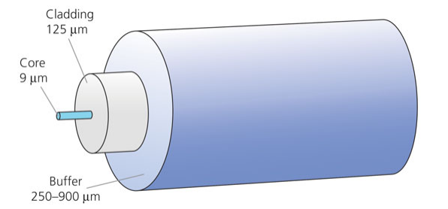

Figure 1 - Structure of a single-mode optical fibre

The cladding surrounding the core is also usually made of glass and the core and cladding are manufactured and fused from the same silicon dioxide but with different levels of impurities to control the RI difference. The cladding diameter is typically 125 μm.
The buffer coating is generally made of ultraviolet-cured acrylate, although polyimide can also be used for added heat and chemical resistance. The coating is purely a protective layer that reinforces the core and cladding and protects them from environmental damage, including moisture. The coating is often coloured so that individual optical fibres can be distinguished from each other. The coating is removed mechanically when splicing the fibre. Its overall diameter is typically 250 μm.
In addition to glass fibres, polymer optical fibres (POFs) are also available (figure 2). The core material is commonly made with poly (methyl methacrylate) (acrylic glass) while the cladding material consists of fluorinated polymers. Alternatively, hard clad silica (HCS) or polymer clad silica (PCS) fibres are made of a glass core and polymer cladding. POFs offer several advantages, such as being cheap, easily manageable owing to their large core and cladding diameter (around 1000 μm), very robust and able to handle large strain of more than 50%. However, POFs have low bandwidths and transmission rates (typically 100 MBits/s) compared to silica fibres (GBits/s), as well as very high attenuation (150 dB/km compared to 0.3 dB/km at 1320 nm in silica), which result in very low transmission distances (around 100 m) and would require high optical power for stimulated Brillouin scattering. In addition, commercial POFs are mostly multimode, and the strong mode dispersion makes Brillouin scattering difficult to excite. There has, nevertheless, been recent progress in encouraging research, and prototypes based on Brillouin scattering in POFs have been developed [24].

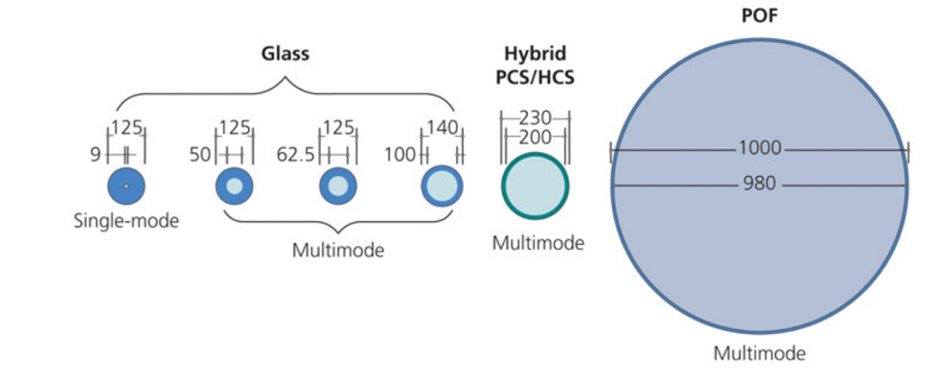

Figure 2 - Comparison of core and cladding diameters of optical fibres

Note – Diameters are in micrometres and drawn to scale

1.2.3 Sensing principle
The basic principle behind the distributed fibre sensor is that cable conditions such as a change of strain and temperature on the cable can influence the properties of the light signal travelling through an optics fibre [29]. Therefore, when light is launched into a sensing cable, the majority of the light travels through the cable, but a small fraction is backscattered and its properties are influenced by the fibre condition (figure 3). The backscattered light includes three types of scattering: Raman scattering, Brillouin scattering, and Rayleigh scattering (figure 4). Raman scattering comes from the interaction of light with the vibrational modes of the molecules in the scattering medium (optical phonons) [25]. Its intensity is temperature dependent and therefore can be used to monitor temperature. The interaction of light with the acoustic wave leads to Brillouin scattering [26]. The centre frequency of the backscattered Brillouin light is dependent on both temperature and strain. The scattering of light from material impurities results in Rayleigh scattering [27]. It does not induce frequency shift, and is the principle behind Optical Time Domain Reflectometry (OTDR).

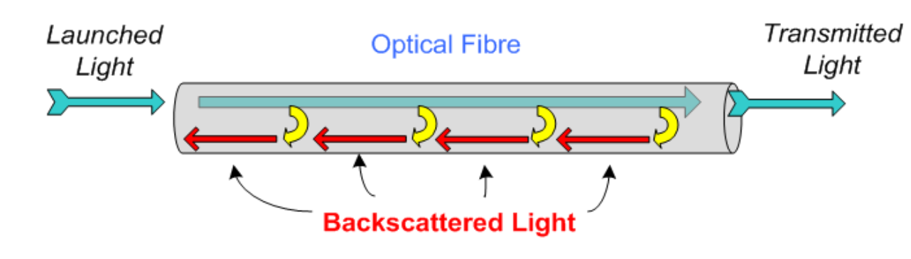

Figure 3 - Principle of backscattered light in an optical fibre
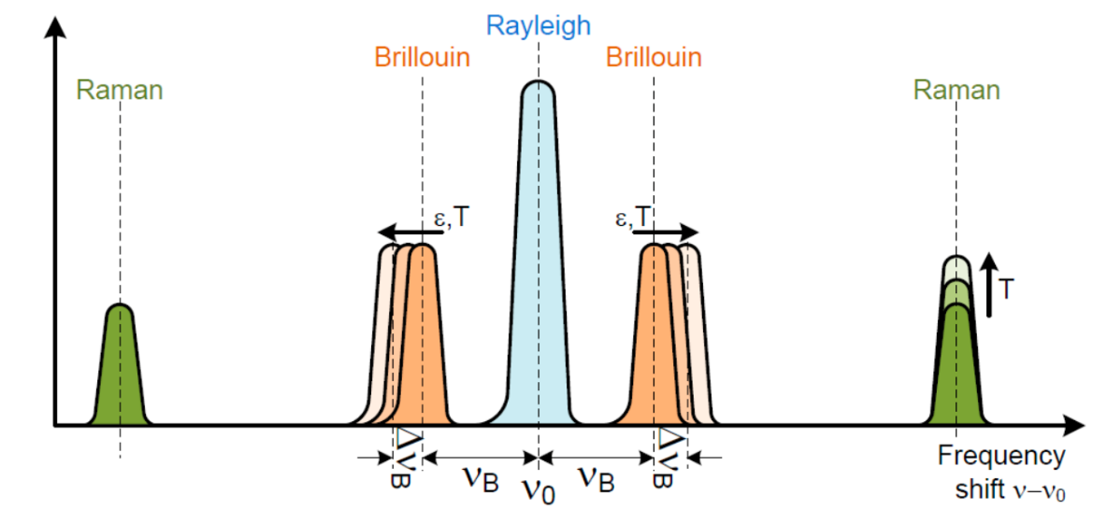

Figure 4 - Raman scattering, Brillouin scattering and Rayleigh scattering

The distributed fibre optics sensing technology discussed in this dissertation uses the phenomena of Brillouin backscattering to monitor strain and temperature. From the microscopic point of view, molecules in an optical fibre tend to stay at a stable separation distance from each other, as the intermolecular movement is a regular periodic fluctuation. This collective excitation of molecules generates acoustic wave. When light goes through an optical fibre, some of the acoustic phonon’s energy is transferred and the backscattered light undergoes a frequency shift. The scattered light that lose energy corresponds to Stokes-type components, and the frequency is down-shifted. On the other hand, anti-Stokes-type components imply a gain in scattered phonon energy with a corresponding up-shift in frequency [28].
The frequency shift of the Brillouin backscattered light is determined by the wave velocity of the acoustic phonon which is dependent on local pressure and the density of the fibre core [29]. The acoustic wave itself firstly induces a change to the local pressure and fibre density, leading to a frequency shift of the Brillouin backscattered light. Then the change of the strain and temperature condition further alters the fibre properties, thus causing an additional Brillouin frequency shift to the backscattered. Changes in strain and temperature can therefore be obtained by calculating the difference between the backscattered Brillouin frequency shift measured at different times.
The fibre’s Brillouin frequency shift is proportional to the local velocity of the acoustic waves. For light with a wavelength r = 1.3 μ m − 1.6 μ m travelling through a standard single mode fibre, the frequency shift of the Brillouin backscattered light (vB) is in the range of 9GHz−13GHz, which is given by [30]:

$v_{B}=\frac{2nv_{a} }{λ}$ (1)

where n is the refractive index of the fibre core;
va is the velocity of sound in glass;
is the free-space wavelength. Because the Brillouin frequency shift increases linearly with the strain and temperature of an optical fibre, equation (2) can be extended into the following form using the temperature and strain conversional coefficients (Cε and CT).

$v_{B}\left(z\right)=v_{B0}\left(z\right)+C_{ε}ε\left(z\right)+C_{T}T(z)$ (2)

where vB(z) is the Brillouin frequency shift at location z;
vB0(z) is the original Brillouin frequency shift;
ε(z) is the strain change;
T(z) is the temperature change.
The location z where Brillouin backscattering happens is determined as a function of time t with known light velocity c0 in a vacuum equation (3).

$z=\frac{c_{0}t}{2n}$ (3)

The distributed strain profile of the fibre can then be reconstructed by resolving the Brillouin backscattered light in both the time and frequency domains. The precision of the location determination depends on the accuracy of the cable distance mapping and cable-lay loss of the fibre [31].

1.2.4 Conversional coefficients
The frequency shift of the backscattered Brillion spectrum is simultaneously sensitive to temperature and strain in the fibre. To distinguish them, a strain sensing cable and a tempera- ture sensing cable are usually placed adjacent to each other for different measurements. The temperature cable consists of a loose buffered fibre to isolate strain effects, and the strain cable contains a tight buffered fibre to efficiently transfer external strain to the fibre inside.
Cε and CT in Eq. 2 are parameters that depend on the properties of the sensing cable. They can be calibrated in the lab by precisely changing the strain and temperature conditions of the sensor and using equation (4), (5). Experimental results indicates that Cε varies in a range of 0.0483MHz/με −0.058MHz/με and CT in a range of 1.17MHz/ °C−1.59MHz/°C, depending on the thermal expansion parameter of the fibre coating material [32].

$C_{ε}=\frac{v_{B}\left(ε\right)-v_{B}(ε_{0})}{ε-ε_{0}}$ (4)

where vB(ε0) is the original Brillouin frequency shift;
vB(ε) is the Brillouin frequency shift after strain change, ε0 is the original strain condition of the cable and ε is the cable’s final strain condition.

$C_{T}=\frac{v_{B}\left(ε\right)-v_{B}}{(T-T_{0})}$ (5)

where vB(T0) is the original Brillouin frequency shift;
vB(T) is the Brillouin frequency shift after temperature change;
T0 is the original temperature condition of the cable;
T is the cable’s final temperature condition.
The conversional coefficients and their accuracies vary with temperature and strain levels. Previous experimental results indicates that CT linearly decreases from 1.113MHz/C to 0.830MHz/C in the range of 22°C-800°C [29, р. 65101]. The measurement accuracy and preci- sion are ±2.6°C and ±5.5°C, respectively. Cε linearly decreases from 0.054MHz/με to 0.042MHz/με in the range of 22°C-700°C [29, р. 65101]. The measurement accuracy and precision are ±45 μ ε and ±76 μ ε, respectively. At 800°C, creep becomes significant, thus reducing the strain sensing precision. During the whole heating–cooling cycles or continuous heating processes, the sensors are stable up to 800°C.

1.3 Strains induced by delayed ettringite formation and alkali-aggregate reaction
The long-term reliability of the distributed optical fibre strain sensing system relies upon the ability of the fibre optic cable to resist fracture when subjected to the greatest expansive strains due to delayed ettringite formation (DEF) and alkali-aggregate reaction (AAR). Presented below are a number of findings from the literature pertaining to the estimation of the maximum expansive strain due to DEF and AAR. It should be noted that unless otherwise mentioned the specimens were formulated in the laboratory and subjected to elevated temperatures to produce significant expansion within a short period.
- DEF expansion is isotropic in stress-free conditions. Restraint in a particular direction reduces the expansion in that direction whilst the expansion in the unrestrained directions is unaffected by the restraint. A maximum ultimate volumetric strain of 2.2% and a maximum ultimate strain in any particular direction of 2.5% was obtained after 600 days at 38°C to accelerate DEF. To promote DEF, 3.1% of sodium sulphate was added to the mixing water. The cement possessed a sulphate content of 3.3%. With a water-cement ratio of 0.55 the sulphate content of the mix excluding aggregate was 3.2% [33].
- A maximum ultimate expansion in any particular direction of 2.4% was observed after 300 days following accelerated DEF using the University of Maryland-Federal Highway Administration (UMD-FHWA) modified Duggan cycle [34].
- Typical ultimate expansive strains of around 3% were obtained when testing the effect of different variables on specimens susceptible to DEF and AAR. The specimens were steam cured for 350 days.
Larger strains of up to 6% were obtained when the proportion of potassium or calcium sulphate was increased from 2.5% to 4.0%. The sulphate content trialled in other laboratory studies is typically around 3% or less and the sulphate contents leading to these larger strains is unusually high [35].
- A maximum ultimate expansive strain of 1.8% was obtained after 350 days following initial heating to 81°C for three days. The cement contained 3.5% aluminate, 4.3% sulphate and 0.8% alkali. With a water- cement ratio of 0.46 the sulphate content of the whole mix was just under 3% [36].
- A maximum ultimate expansive strain of 2.5% was observed after over 500 days at 38°C following initial heating to 80°C for three days. With a cement sulphate content of 3.5% and a water-cement ratio of 0.46 the sulphate content of the mix excluding aggregate was 2.4%. AAR was also induced through using alkali reactive limestone [37].
- A volumetric expansive strain of over 5% was induced by DEF after 270 days and initial heating to 85°C. All other specimens subjected to maximum temperatures below 75°C exhibited volumetric strains of no more than 3%. The cement had a sulphate content of 3.1% and with a water-cement ratio of 0.4 this gave a sulphate content of 2.2% for the mix excluding aggregate [38].
- Ultimate expansive strains of up to 2.8% were induced by DEF after curing at 95°C [39].
In light of the above evidence it can be concluded that the majority of laboratory specimens exhibit expansive strains no greater than 3%. Only in isolated cases have strains up to 6% been observed.
Furthermore, all but one of the above cases were performed with stress-free boundary conditions. Expansive strains resulting from DEF are likely to be significantly reduced when subjected to the restraints of the base slab on site arising from the reinforcement cage, including shear links, the lateral resistance of the piles and the passive pressure imposed by the soil surrounding underhangs.
It is therefore reasonable to set an upper bound value for the ultimate volumetric expansive strain of 3% for the purposes of design.

1.4 The use of strain sensing in monitoring
So, for example, the main idea of the works [40] is related to the use of a G.652 telecommunications optical fiber as a sensitive sensor capable of identifying mechanical effects, and the object can be significant in length of several tens of kilometers. Optical fiber is used as a sensor and as a guide system for transmitting measurement data. The relative simplicity of the system for monitoring defects in reinforced concrete foundation structures using optical fibers of the G.652 standard makes it possible to use it everywhere. To do this, at the initial stage of construction, it is necessary to lay an optical fiber inside the body of the reinforced concrete foundation structure.
The system for monitoring defects and damages of reinforced concrete foundations is based on the use of optical fibers of the G.652 standard. The physical basis for measuring mechanical loads and determining the location of a defect is based on a change in the properties of light or an increase in the level of additional losses passing through the optical fiber under mechanical action on it, and an optical fiber is also capable of capturing various kinds of vibrations in the frequency range from 1 Hz to 1 MHz. In this case, the optical fiber is in a protective silicone shell with a diameter of 1 mm, which cannot reduce the strength of the foundation. Changes in the properties of light are expressed in an increase in additional losses and the appearance of various kinds of scattering (Rayleigh, Brillouin, Romanov). For the convenience of describing the basis of the proposed method for flaw detection of foundations with the help of OF, one can use the classical theory of an optical interferometer. The theoretical basis for the operation of this device is known and is the sum of the addition of two light waves E1 and E2, which manifests itself in a change in the resulting intensity I, which is recorded by the photodetector of the interferometer [41].
On fig. 5 shows the process of changing the properties of light, namely its phase, passing through an optical fiber under external mechanical action on it.

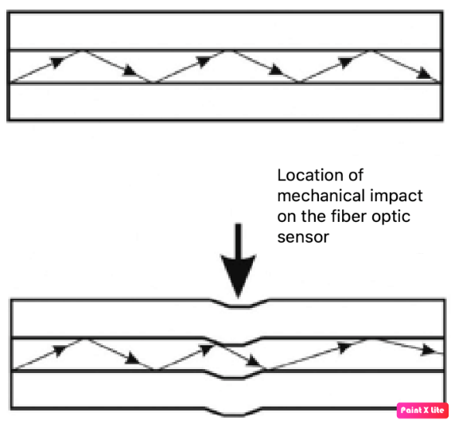

Figure 5 - Change in the properties of light passing through an optical fiber under external mechanical action on it

Under mechanical action, a photoelastic effect arises, which leads to a change in the properties of light, namely its intensity I(t). Accordingly, the refractive indices Δn change. The change in the propagating phase of the light wave Δφ ~ Δn as well as the change in the vector of the electromagnetic field of the wave E affects the polarization. The source generates a coherent light wave that passes through the fiber, the change in its intensity fixes the photodetector. Intensity and tension are related I ~ E2.
Based on the well-known theory of the optical interferometer of the vector of coherent waves, we present a mathematical model of the process:

E1=E01cos(ωt− φ1), (6)

E2=E02cos(ω t−φ2). (7)

When adding waves, we obtain a total vector E = E0cos(ωt – φ) with amplitude

E₀ = $\sqrt{E_{01}^{2}}+E_{02}^{2}+2E_{01}E_{02}\cos\left(∆φ\left(t\right)\right)$ (8)

and phase
φ = arctg ($\frac{E_{01}sinφ_{1}+E_{02}sinφ_{2}}{E_{01}cosφ_{1}+E_{02}cosφ_{2}})$. (9)

In this case, the phase difference will be ∆φ = ∆φн + ∆φ(t), where ∆φн – initial and random phase difference of interfering light waves; ∆φ(t) – the phase difference associated with a change in propagation conditions in the optical fiber under external mechanical action and fiber deformation is a small correction against the background of the first term. The total phase difference is quasi-initial. The maximum interference is reached at ∆φ(t) = ±2πn, where n ∈ z, then cos∆φ + 1 and correspondingly E0 = E01 + E02. In the process of research, it was found that the use of a classical Mach-Zehnder interferometer in its pure form is not acceptable for the system for monitoring defects in building foundations using optical fibers of the G.652 standard, since there are a number of significant drawbacks. For example, the phase difference of interfering light waves ∆φн is random and requires constant adjustment, and changing its parameters is a significant problem in the efficiency of the entire system in real conditions. This circumstance of changing the initial conditions of the phase difference due to temperature changes within 1°C or more can lead to system fading and false triggering, while there was no mechanical impact on the sensor. Based on this, it is necessary to search for and develop more effective systems for monitoring foundation defects based on the effect of photoelasticity of optical fibers, which is less susceptible to fluctuations in the temperature of the environment.
The proposed simplified version of the system for monitoring defects and deformations of reinforced concrete foundation structures using optical fibers of the G.652 standard can be based on the use of a classical Mach–Zehnder interferometer (figure 6). The sensor has three optical fibers. Two fibers are used as sensitive sensors and are located in the body of the building foundation, they supply light created by a semiconductor laser operating in continuous mode, and the third optical fiber (output) serves to further transmit it from the terminal optical module to the system analyzer. In this case, it is also possible to use a multi-year fiber, but the laser must then operate in a pulsed mode. A coherent radiation source (laser) delivers a beam of light through a passive fiber to the initial module (optical splitter). In this module, the radiation is split into two beams, which are fed to two sensitive fibers. At the terminal module, interference of both beams occurs. If both arms of this interferometer are in an unperturbed state, when there are no fiber deformations, then the interference pattern on the terminal module remains unchanged. In this case, the signal transmitted from the terminal module via the output optical fiber to the analyzer does not have a variable component. With deformations or vibrations of the sensor, the optical path difference in the sensitive fibers (that is, in the arms of the interferometer) changes, respectively, the terminal module registers the variable component of the signal, transmitting it to the analyzer. A specific feature of this interference system is that it determines the relative time delay of the recorded signals in both arms of the interferometer.
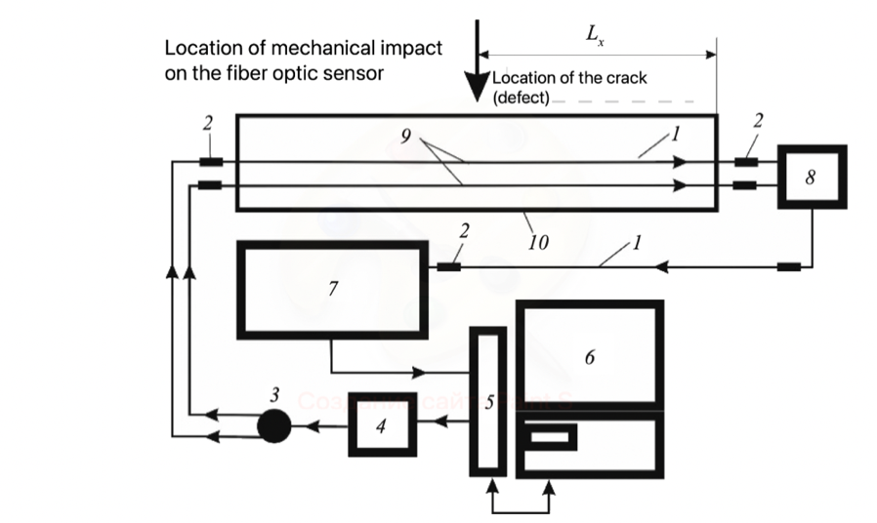

Figure 6 - Method of mechanical impact identification based on optical interferometer

The scheme in figure 6 allows, with high accuracy and linearity of characteristics, to identify mechanical effects on a fiber-optic sensor located in the body of an extended object, for example, a foundation, but does not allow to accurately determine the location of a defect and crack development, there are still a number of problems with various kinds of interference that can lead to measurement error. Experiments have shown that external temperature can affect the accuracy of measurements.
Optical fiber 1 is used as a sensor (see figure 6). Signal pre-processing is carried out in device 7. The sensors are connected to input device 8, from which the light wave enters signal pre-processing device 7 through the return optical fiber. fibers at the site of mechanical action 9 in the body of the beam 10. Under mechanical action, the properties of light passing through the optical fiber change, according to which it is possible to set the numerical value of mechanical stresses or deformations in the body of the beam and set the limit value at which a crack may occur.
Strain is one of the most frequently monitored parameters in civil structural health monitoring (SHM) applications, and strain-based approaches were among the first to be studied and applied in SHM.
There are several reasons why strain plays such an important role in SHM: strain is directly related to stress and deflection, which reflect structural performance, safety, and performance.
Strain field anomalies are often indicators of unusual structural behavior (such as damage or failure). Therefore, the earliest strain gauge concepts were explored in the middle of the 19th century, and the first effective strain gauge appeared in the 19th century, the first effective strain gauge appeared in 1919, and the first practical applications followed in the 1920s.
Today, one hundred years after the first developments, two generations of strain gauges based on electrical and fiber optic principles have firmly reached market maturity and have established themselves as reliable tools used in strain gauge SHM. Along with the development of sensors, the methods of their application also developed: the first generation of discrete sensors was characterized by a small caliber length and provided the basis for local monitoring of the material; The second generation has greatly expanded the applicability and effectiveness of the deformation SHM, providing a long gauge and one-dimensional (1D) distributed sensing, which allows for global monitoring of structure and integrity.
Current research is focused on the third generation of strain gauges for two-dimensional (2D) distributed and quasi-distributed sensing based on new advanced technologies. Modern design and construction of civil structures is based on the criteria of safety and operability prescribed by practical standards. These criteria include allowable stresses and deflections, which are usually predicted during the design phase using structural analysis.
If the point stress or derived stresses (for example, internal forces: normal force, shear force, and bending moment) in a structural member approach or exceed a limit value (for example, the stress approaches or exceeds the structural material strength or compressive normal force, for example, the stress approaches or exceeds the strength of the building material or the compressive normal force approaches or exceeds the crushing capacity), the integrity of the structure may be compromised and its safety compromised. If the deflection of a structural element approaches or exceeds the serviceability limit, the objective function of the structure may be violated. Therefore, the assessment of stresses and deflections in civil structures is an important task of structural health monitoring (SHM).
Exceeding the safety and/or operability limits usually reflects the presence of unusual design behavior (eg, damage or degradation), and therefore an additional important task of the SHM is to characterize such unusual design behavior (i.e., detect, contain, and quantify it). In such tests, damage is prescribed and there is little or no operational or environmental variability.
These studies are carried out within the framework of scientific research, so little attention is paid to the economic justification and justification of life safety. Although we understand that the main goal of any construction project is the safety of operation after construction is completed. Accordingly, we can believe that these issues can be resolved if SHM is to move from a research topic to useful systems deployed in the field, as it was implemented at the Abu Dhabi Plaza site in Nur-Sultan city (Kazakhstan).
High-rise buildings (buildings with a height of more than 75 m) pose new challenges for engineers, especially in the field of calculations and design of above-ground structures, bases and foundations. Therefore, designers of both the above-ground and underground parts of the building are forced to resort to more complex methods of calculation and design. This is especially true for geotechnicians who are involved in the design of foundations for high-rise buildings.
In terms of complexity, problematic design, construction, operation, impact on the environment and people, high-rise buildings can be attributed to buildings of increased danger and complexity. Buildings taller than 75 m require completely different approaches to design. A small number of companies operate in this specific industry: a little over a dozen in the United States and about ten in Europe and Asia (mainly in Japan, Malaysia and Korea) [42].
Kazakhstan also has its own modern experience in the design and construction of buildings with an elevated height of more than 75 m of unique structures, including in Astana the Emerald Quarter (210 m), Northern Lights 1 (180 m), the KTZH Tower (Building of Kazakhstan Railways) (174/156 m), Transport Tower (building of the Ministry of Transport and Communications) (155 m), Khan-Shatyr (150 m) and Esentai Tower in Almaty (168 m).
Abu Dhabi Plaza is a new 5-hectare development in Nursultan (formerly Astana), Kazakhstan, comprising retail, office, residential and hotel buildings. The development incorporates the tallest tower in the Commonwealth of Independent States (CIS) at 310 m high and is designed to be a symbolic and commercially important component of the master plan for the new business centre within the city of Astana.
The total area of “Abu Dhabi Plaza” is about 500 thousand square meters, 206 thousand square meters of ground floors for parking and retail space.
Features of high-rise buildings impose increased requirements on the results of engineering and geotechnical surveys and must solve the following main tasks during their implementation [43, 44]:
– study of the geological structure of a mass of soils of large volumes (up to 60 m in depth and at least 2 more widths of the foundation outside its contour);
– a reliable assessment of the hydrogeological and hydrochemical conditions of both the compressible soil massif and in the excavation zone and the adjacent territory with the establishment of their corrosive aggressiveness, in time;
– determination of deformation and strength properties of dispersed and rocky soils at large ranges of stress changes;
– instrumental observation and monitoring of deformations of the soil massif of the foundation base and the adjacent territory under static impacts.
Abu Dhabi Plaza Residential skyscraper consists of 5 main towers:
1. Block R - offices and residential premises (block RC-1).
2. Block O - office building.
3. Block H - hotel and furnished rooms.
4. Block Y - class "A" offices.
5. Block Z - residential apartments.
In order to monitor and prevent cracks, ACCL engaged Golder to analyze the basement design, who proposed a method involving an internal drainage system that keeps the interior dry while collecting and draining water seeping through the walls and floor. Golder developed a conceptual design for the system consisting of a hollow plate covering the floor [45, 46] and a facade for the walls [47].
However, the need to detect and monitor potential expansion resulting from delayed ettringite formation (DEF) and alkali-aggregate reaction (AAR) in certain areas of the base plate became known. The potential for DEF and AAR formation has been identified in accelerated expansion tests [48] and chemical testing of concrete [49].
The hollow slab prevents visual observation of the slab and access for monitoring. Therefore, Golder developed a conceptual design for a slab monitoring system to detect and monitor DEF- and AAR-related expansion and cracking during basement operation [50]. The core element of the slab monitoring system is the Distributed Fiber Optic Strain Sensing System (DFOSS), which uses a fiber optic cable to monitor deformation developing on the slab surface. This paper presents a detailed design of the DFOSS system.
Almost none of the hundreds of studies summarized in [3, р. 521-528] use any statistical methods to assess whether changes in selected characteristics used to identify damaged systems are statistically significant. The main problem today is that there are no generally applicable sensors for direct monitoring of strain in real conditions. Although there are some variants available, they are limited to very specific applications and cannot be generalized.

Summary on the section
Structural health monitoring (SHM) systems in civil engineering have been developed greatly since 1980s. Strain is one of the most frequently monitored parameters in civil SHM applications, and strain-based approaches were among the first to be studied and applied in SHM. Fiber optic civil engineering sensors have recently become more and more popular. They have the advantages of small size, good resolution and accuracy, as well as excellent ability to transmit a signal over long distances. This is especially true for the construction of high-rise buildings, an example of monitoring of which is presented in this study. The main goal of this work is to integrate data from distributed FO sensors to make a faster and more confident decision when detecting damage than is possible using only one sensor. In many cases, data fusion is performed in a simple manner, such as when relative information between different sensors is examined to obtain a mode shape. In other cases, complex analysis of information from arrays of sensors is carried out, for example, using artificial neural networks. In my work, I propose the concept of integrating data received from sensors with the BIM system of the project, which will allow not only using up-to-date information at any time, but also monitoring for many years.

2 METHODOLOGY FOR NUMERICAL ANALYSIS

2.1 Methodology for numerical analysis of slab expansion
Expansion caused by both delayed ettringite formation (DEF) and alkali-aggregate reaction (AAR) has the potential to induce cracking of the slab. The fibre optic installation should be designed to both detect the formation and development of cracks and withstand the highly-localised strains that are likely to develop across them. According to Section 7.3.4 of Eurocode 2 [51], crack width is governed by the stress in the reinforcement. Numerical analysis was performed to estimate the surface strains and the stress in the top reinforcement induced by DEF- and AAR-induced expansion.
The numerical analysis was executed using PLAXIS 2D 2018.01.
It is acknowledged that factors governing the expansion of the slab are complex and the computational effort necessary to precisely model all scenarios and interactions would be impractical for the purpose of design. The assumptions behind the analyses have been carefully considered to provide an approximate estimate of stresses and strains whilst limiting the computational effort to a feasible amount. The principal simplifications are outlined below and detailed in subsequent sections:
- Axisymmetric geometry and expansion of the slab.
- Simplified boundary conditions for the slab.
- Simplified constitutive model for concrete.
- Assumptions on location and geometry of expanding region.

2.2 Geometry
Expansion adopting the two different slab geometries illustrated in Figure 7 was modelled:
- Geometry G01: Expansion at the centre of a uniform 3.8 m-thick slab spanning the same extent as the Block R raft.
- Geometry G02: Expansion at the centre of an underhang in the above 3.8 m-thick slab which locally increases the thickness to 9.8 m over a square area centred within the raft with a width of 11.6 m.
The thickened width of 11.6 m is taken from Section RD of the foundation drawings [52].
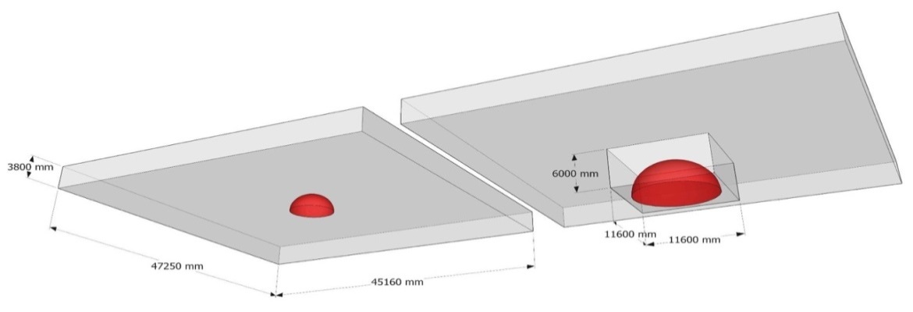

Zone of expansion
G02
G01
UNDERHANG

Figure 7 - Slab geometries represented by axisymmetric analyses
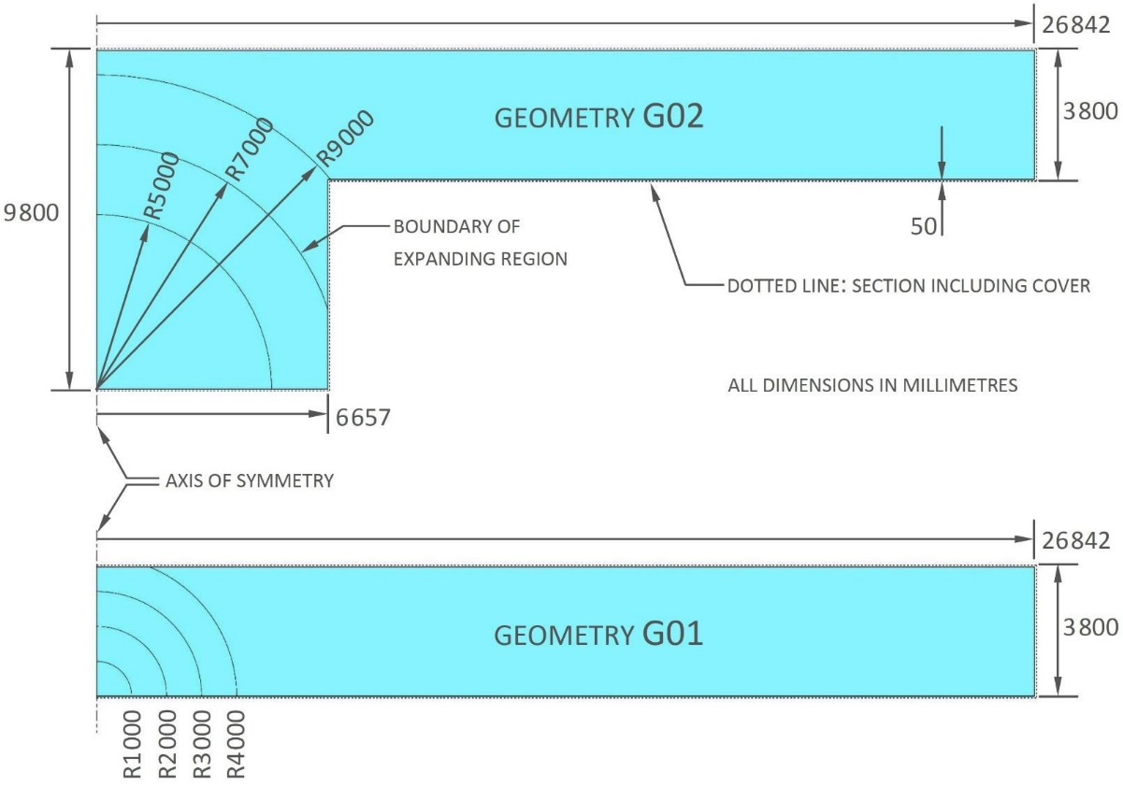

Figure 8 - Axisymmetric sections representing slab geometries

The three-dimensional geometries pictured in figure 7 were converted into the equivalent axisymmetric sections plotted in figure 8. The conversion required the representation of areas which are rectangular in plan as equivalent circular areas. The radii of these circular areas were computed as the average distance of the perimeter of the rectangle from its centre. For a rectangle with sides of length and the equivalent radius 𝑟 is expressed as:

𝑟 =1
r = $\frac{1}{2}\sqrt{a^{2}+b^{2}}+\frac{a^{2}}{2b}\left[ln\sqrt{a^{2}+b^{2}}+b\right]-\left.ln⁡(a)\right]$ (10)

The numerical modelling received from the Arabtec suggests that the cover to the reinforcement is 40 mm [52]; for simplicity the center of action of the reinforcement is assumed to act 50 mm inside the concrete surface. Any concrete outside the boundary formed by the center of action is neglected to simplify the mesh.

2.3 Constitutive modelling
In reality the reinforcement comprises discrete bars; the reinforcement is represented in the axisymmetric models as an equivalent plate element endowed with equivalent smeared values of axial rigidity, flexural rigidity, tensile capacity, bending moment capacity and weight per unit area. The tensile and bending moment capacities are evaluated when the steel becomes fully plastic. The equivalent properties for the modelled reinforcement are outlined in table 2. A Poisson’s ratio of zero is applied to the equivalent plate to reflect the lack of interaction between adjacent bars.

Table 2 - Equivalent properties of plate elements modelling reinforcement

Designation | Bar diameter | Bar spacing | Young’s modulus | Density | Yield strength | Cross-sectional area per metre | Second moment of area per metre | Axial rigidity per metre | Flexural rigidity per metre | Mass per square metre | Weight per square metre | Axial capacity | Fully plastic moment capacity per metre
Designation | d | S | E | ρ | $σ$_{y} | A | I | EA | EI | ρA | w | N_{p} | M_{p}
units of measure  ment | mm | mm | GPa | kg m³ | MPa | $$π\frac{{(1/2d)}^{2}}{s}$$  cm²m⁻¹ | $$π\frac{{(1/2d)}^{2}}{4s}$$  cm⁴m⁻¹ | GN m⁻¹ | MNm^{2m-1} | ρA  kgm⁻² | ρAg  kNm⁻² | $σ$_{yA}  _{MNm}⁻¹ | 1/2 $σ$_{yd}³/s  kNmm⁻¹
T32-100 | 32 | 100 | 205 | 7850 | 450 | 80.4 | 51.5 | 1.65 | 0.106 | 63.1 | 0.619 | 3.70 | 25.1
T40-100 | 40 | 100 | 205 | 7850 | 450 | 125.7 | 125.7 | 2.58 | 0.258 | 98.6 | 0.968 | 5.78 | 49.1

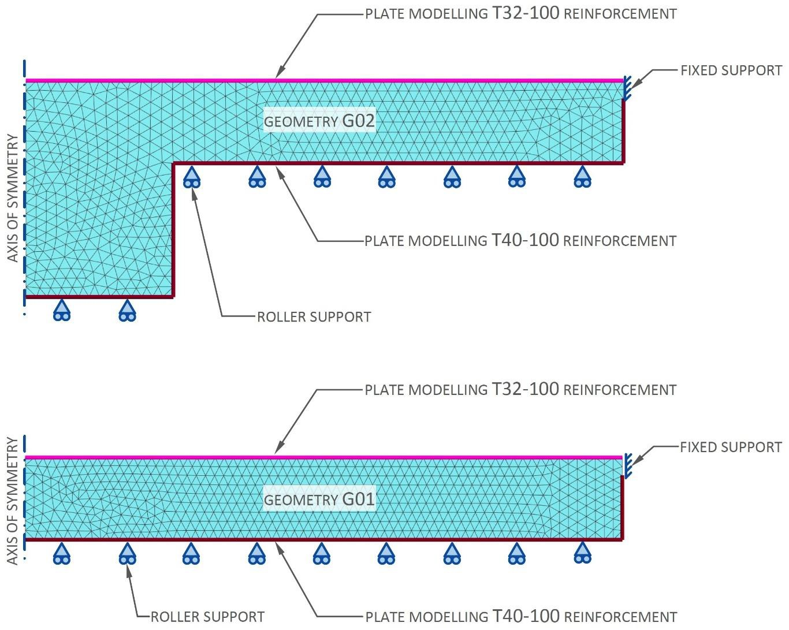

Figure 9 - Meshes for G01R03 and G02R07 illustrating modelling features for the two modelled geometries
The location and type of reinforcement modelled within each geometry is pictured in figure 9 and approximates the reinforcement shown in Section RD of the foundation reinforcement drawings [53].
Figure 9 also illustrates the applied boundary conditions. In reality each pile underlying the slab provides a degree of vertical, horizontal and moment fixity. The vertical fixity is likely to be substantially greater than the horizontal fixity and a roller support boundary condition is applied to the underside of the slab under the assumption that the discrete support provided by each pile can be considered as smeared across the underside of the slab.
The concrete is modelled as a Mohr-Coulomb material endowed with C40 concrete properties in line with Eurocode 2 (1). The modelled concrete properties are tabulated in table 3.

Table 3 - Assumed properties for concrete

Property |  | Value
Mean compressive strength | $$f_{cm}$$ | 48 MPa
Mean tensile strength | $$f_{ctm}$$ | 3.51 MPa
Mean Young’s modulus | $$E_{cm}$$ | 35.2 MPa
Density | $$p_{c}$$ | 2400 kg m⁻³
Poisson’s ratio for cracked concrete | v | 0

A 0.85 m thick slab generally surrounds the 3.8 m raft and the fixity provided by this slab is modelled as a fixed support. The resistance provided by the soil is more akin to a free support than a fixed support and no fixity is applied to model the lateral soil resistance.

2.4 Analyses
In total twelve analyses were performed as specified in table 4. Reinforcement was modelled in seven of these analyses. For five of the seven analyses convergence was unachievable and these particular analyses were re-run with reinforcement omitted in an attempt to obtain an upper bound on concrete surface strain. In each analysis a volumetric strain of 6% was progressively applied.

Table 4 - Parameters differentiating the twelve analyses modelling expansion

Maximum slab thickness | Radius of expanding hemisphere | Reinforcement
M | m | Included | Omitted
3.8 | 1 | G01R01
3.8 | 2 | G01R02 | G01R02N
3.8 | 3 | G01R03 | G01R03N
3.8 | 4 | G01R04 | G01R04N
9.8 | 5 | G01R05 | G02R05N
9.8 | 7 | G01R07 | G02R07N
9.8 | 9 | G01R09

2.5 Minimum gauge length to prevent fibre optic fracture
Continuously adhering a fibre optic cable to a concrete surface enables the cable to potentially indicate strains along its entire length. However, the potential for crack development can threaten the integrity of the fibre. A typical glass fibre has a strain limit of 1.5% [54], yet cracks represent discrete locations of highly localised strain development; indeed, the strain measured across a newly formed crack is theoretically infinite since the initial width of the crack is zero.
To the author’s knowledge, three solutions so far exist to prevent breakage of the fibre:
- Applying continuous adhesion but relying upon the compliance of the cable sheath and adhesive bond to distribute the concentrated strain arising from crack growth across a longer length of fibre. Since cable sheathes are typically thin, this solution is unable to accommodate significant crack development.
- Applying continuous adhesion but designing the adhesive to de-bond beyond a specific shear strain such that the crack displacement is distributed across a longer fibre length [55]. However, de-bonding at precisely the correct strain is crucial — an adhesive bond which is too weak would compromise the spatial resolution whereas a bond which is too strong would risk fracturing the fibre. The widespread implementation of the correct adhesive strength on site would rely upon strict control that is practically only achievable in the laboratory.
- Fixing the fibre optic cable to the concrete surface at discrete intervals thus dividing the cable into gauge lengths and effectively indicating the average strain along each gauge length. This solution has been adopted successfully on site [56] and this case describes the determination of the minimum gauge length necessary to prevent fracture of the fibre.
The resulting radial surface strains and displacements are plotted in figure 10 to figure 17. Comparing figure 14 with 15 reveals that omitting the reinforcement in analysis G02R05N makes only a slight difference to modelled surface strains and displacements. The reinforcement has the effect of slightly reducing surface strain such that omitting the reinforcement leads to a slight overestimation of strains. The analyses omitting reinforcement are therefore conservative with respect to determining the minimum gauge length.
Omitting the reinforcement in analysis G02R05N also results in a concentrated strain located at the epicentre of the expansion. The concentrated strain may be a numerical artefact but in any case it only slightly influences displacements because the strain is highly localised.
Figure 10 to 17 demonstrate that the strain field is typically multimodal in that peaks in strain occur at various radial distances from the epicentre of expansion, not just at the epicentre; indeed in some cases no peak strain is predicted at the epicentre. In analysis G02R07N for instance the peak in surface strain at the epicentre develops at around 1% volumetric expansive strain; then with further expansion, surface strains subsequently develop at a radial distance of approximately 5.5 m from the epicentre.
Finding the minimum gauge length is therefore not a trivial problem and a Visual Basic macro was scripted to search for the minimum gauge length. The macro searches across all secant lines on the surface, not just those intersecting the epicentre of expansion, seeking a minimum gauge length over which the average strain is limited to 1.5% [55]. Displacement rather than strain output is utilised to eliminate errors associated with integrating strains when computing the average strain across candidate gauge lengths.

2.6 Numerical analyses results
The resulting minimum gauge lengths are summarised in table 5. For most cases of volumetric expansion modelled in the analyses the peak surface strain falls below 1.5% and for these cases gauge length is inapplicable; only cases with a peak surface strain exceeding 1.5% are presented in table 2. All minimum gauge lengths straddle the epicentre of expansion as illustrated in figure 10, 11, 12, 13, 14, 15, 16 to figure 17.

Table 5 - Minimum gauge lengths necessary to limit fibre strain to 1.5% for analyses predicting surface strains exceeding 1.5%

Analysis | Input parameters |  |  |  | Minimum gauge length at 1.5% limiting strain  m
Analysis | maximum slab thickness  m | radius of expanding sphere  m | applied volumetric expansive strain, % | reinforcement | Minimum gauge length at 1.5% limiting strain  m
G01R02N | 3.8 | 2 | 2 | No | 0.81
G01R02N | 3.8 | 2 | 3 | No | 1.62
G01R02N | 3.8 | 2 | 4 | No | 2.44
G01R02N | 3.8 | 2 | 5 | No | 3.25
G01R02N | 3.8 | 2 | 6 | No | 3.65
G01R03N | 3.8 | 3 | 4 | No | 4.87
G01R03N | 3.8 | 3 | 5 | No | 6.09
G01R03N | 3.8 | 3 | 6 | No | 7.31
G01R04N | 3.8 | 4 | 4 | No | 6.71
G01R04N | 3.8 | 4 | 5 | No | 8.74
G01R04N | 3.8 | 4 | 6 | No | 9.97

Values for minimum gauge length are summarised in figure 18. The part 1.3 of Chapter 1 concluded that an ultimate volumetric expansive strain of 3% could be assumed as an upper bound value for design. At this level of expansion, adopting a gauge length of 2 m would maintain strains in the fibre below the limiting strain of 1.5%.

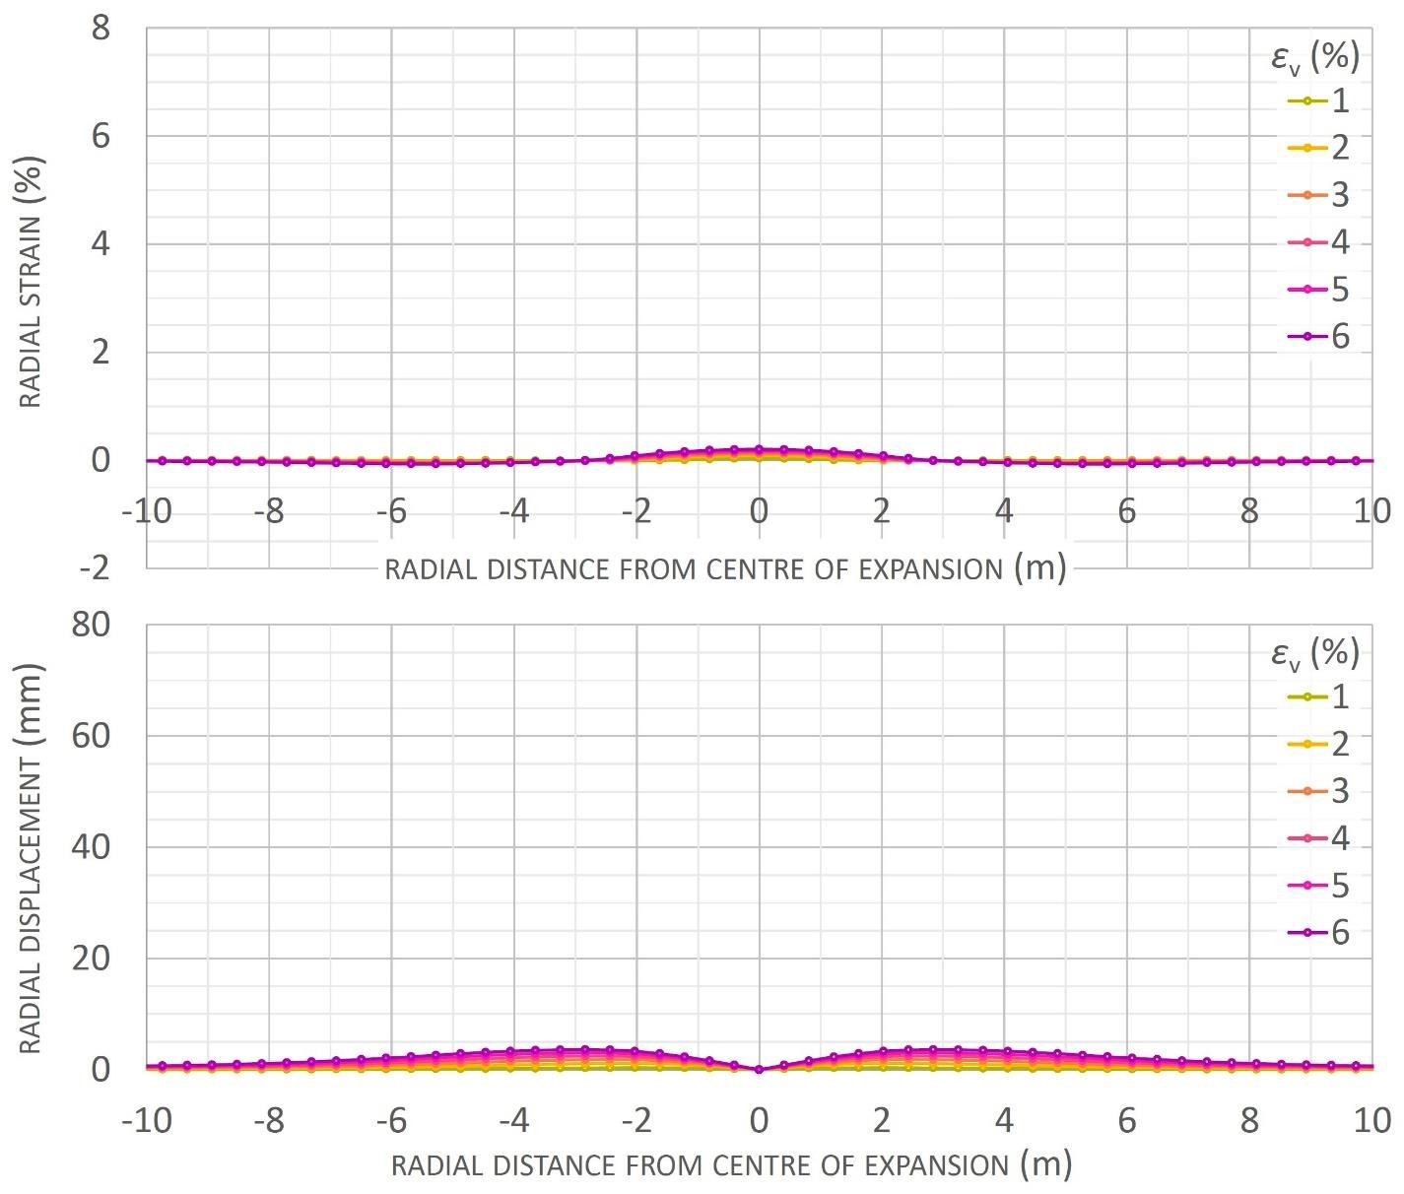

Figure 10 - Strain and displacement profiles for analysis G01R01

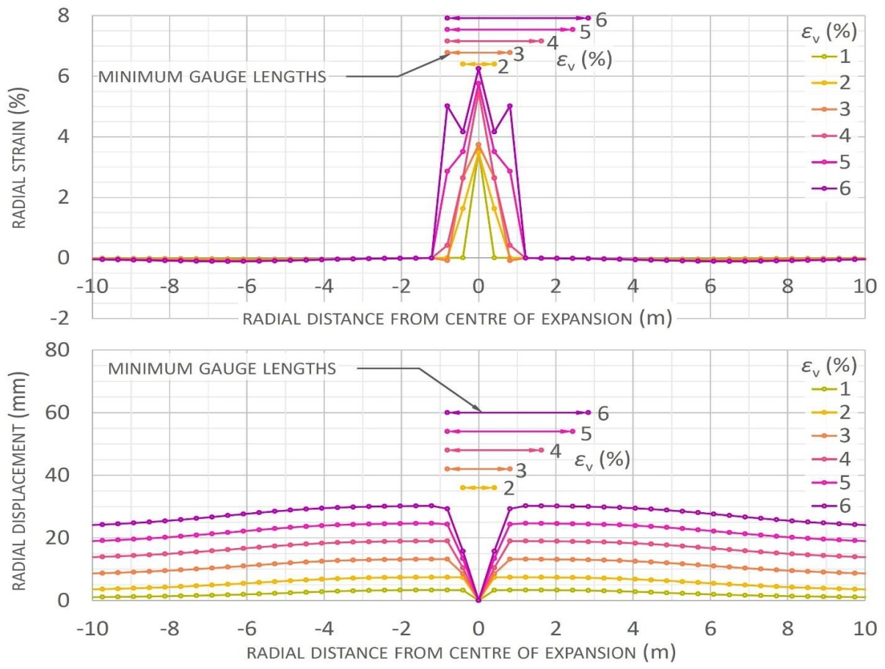

Figure 11 - Strain and displacement profiles for analysis G01R02N
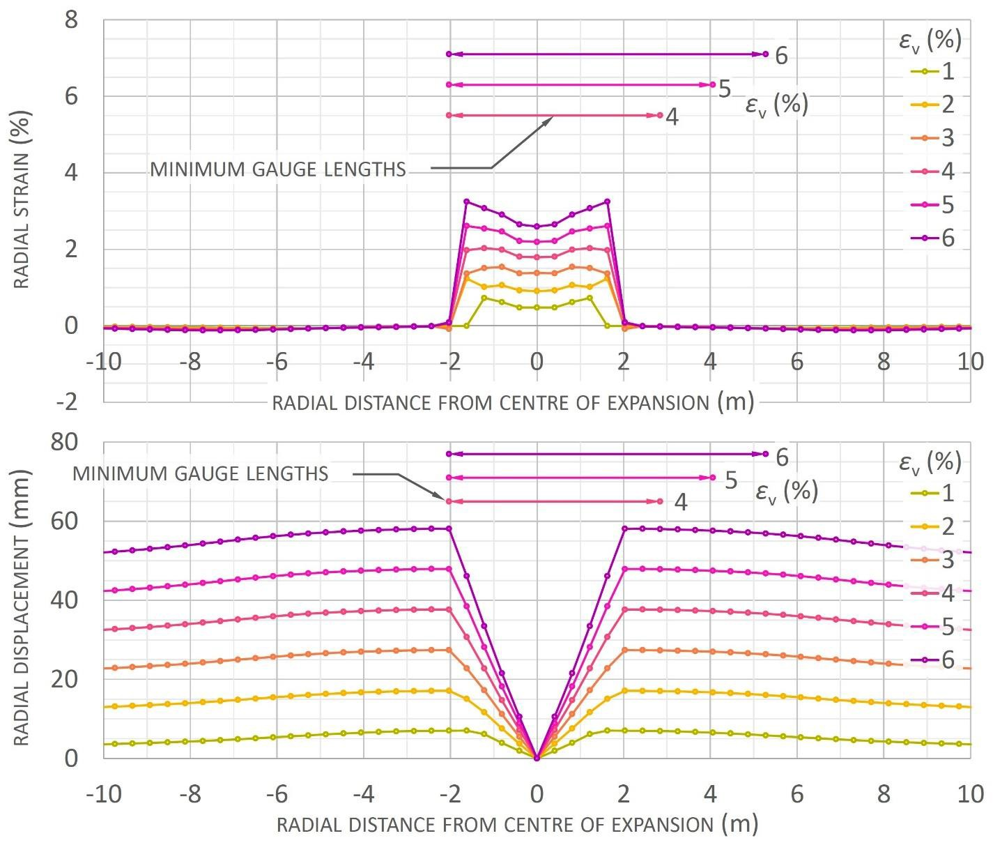

Figure 12 - Strain and displacement profiles for analysis G01R03N

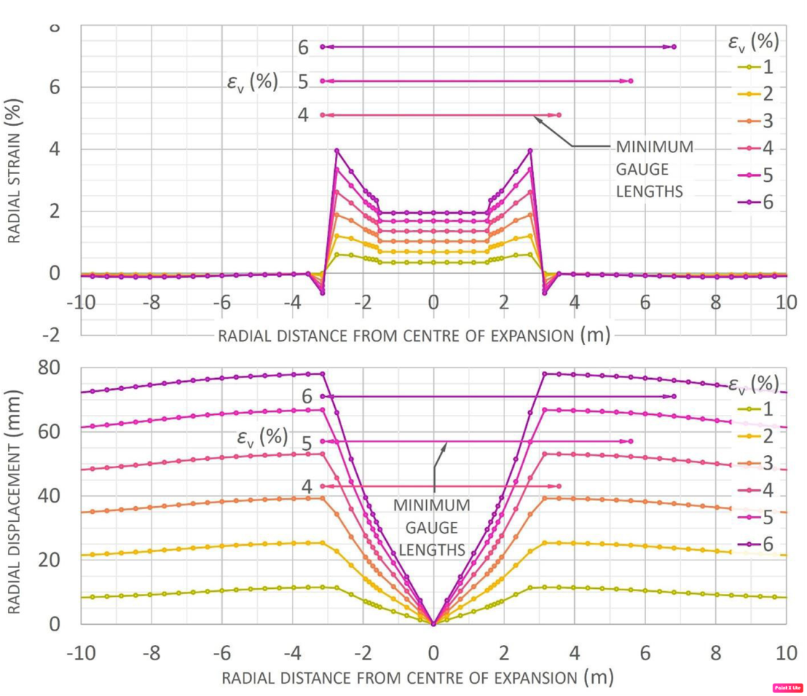

Figure 13 - Strain and displacement profiles for analysis G01R04N
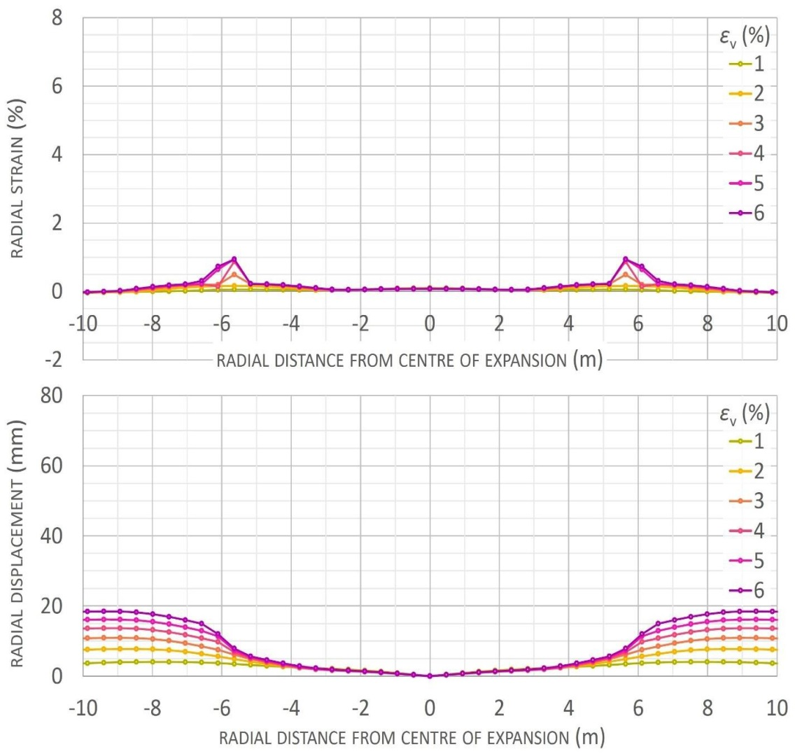

Figure 14 - Strain and displacement profiles for analysis G02R05

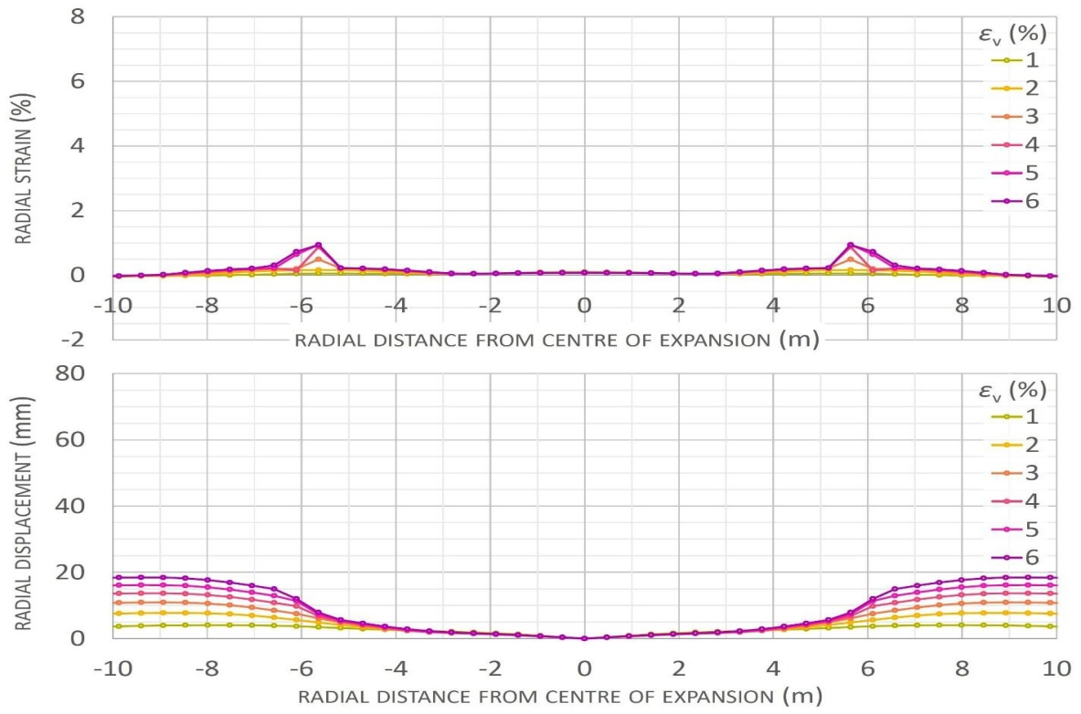

Figure 15 - Strain and displacement profiles for analysis G02R05N
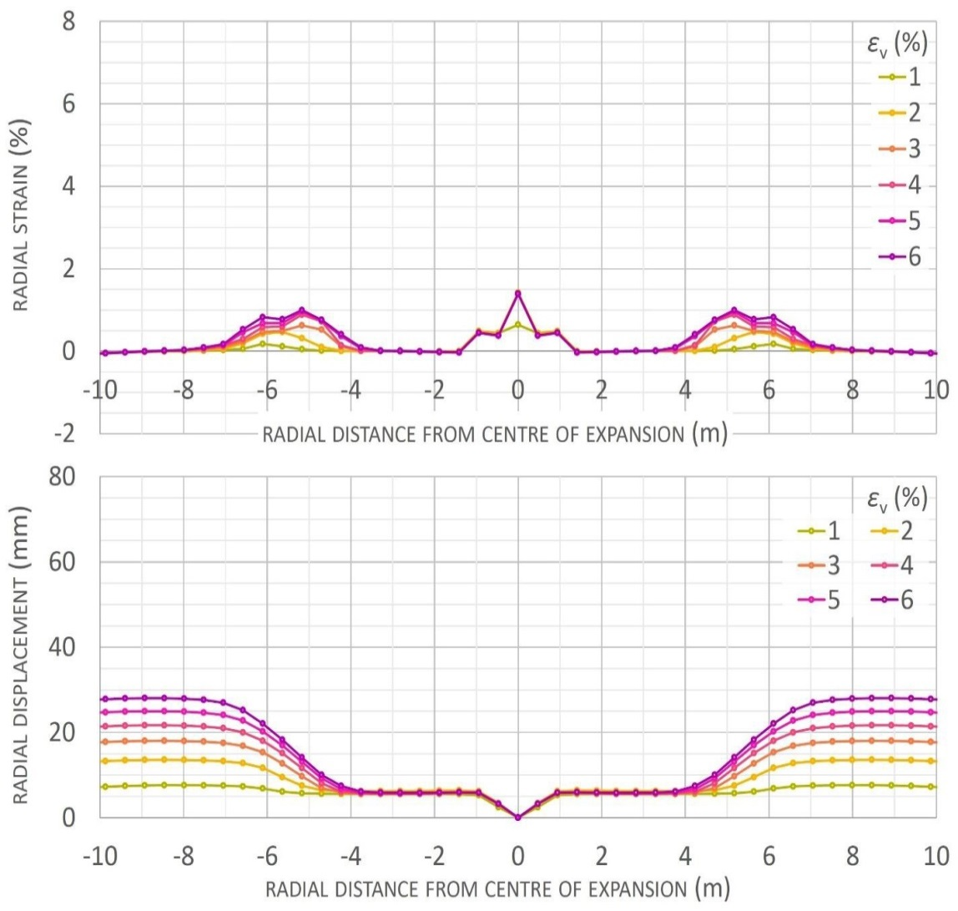

Figure 16 - Strain and displacement profiles for analysis G02R07

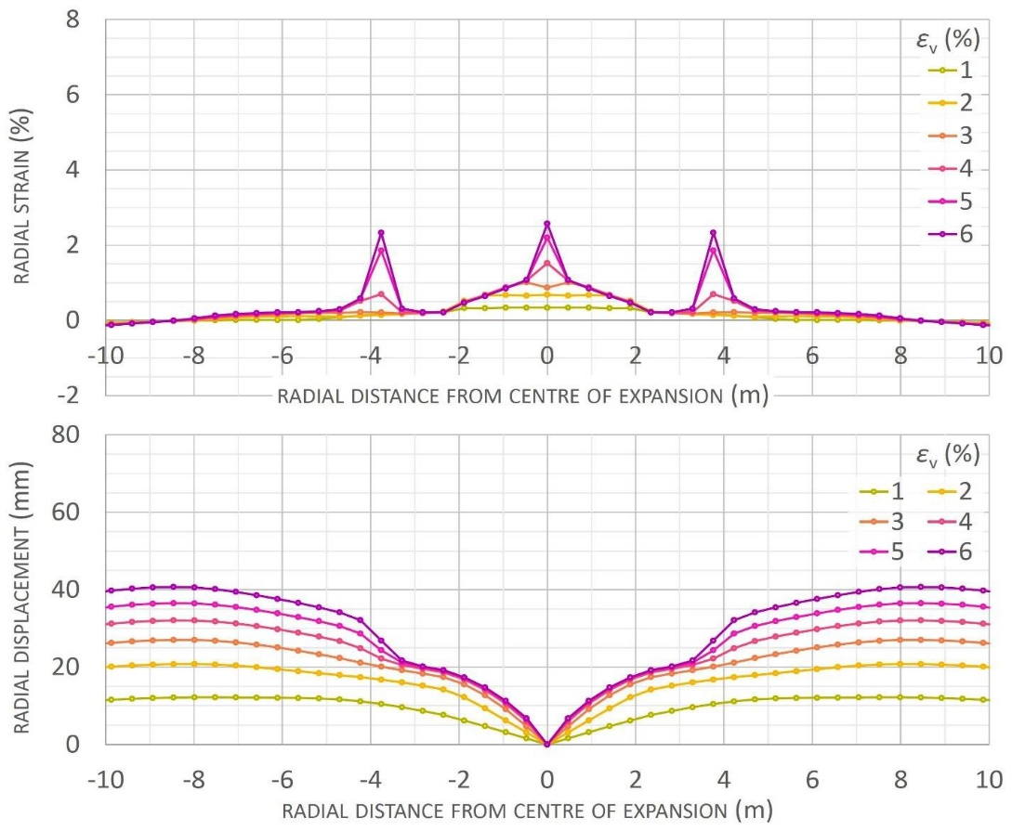

Figure 17 - Strain and displacement profiles for analysis G02R09
2.7 Required strain resolution for expansion detection
DFOSS system must be able to interpret strain to a resolution sufficient to detect expansion events. The report prepared by JKMC specifies a strain level of 0.6 mm m-1 at which the monitoring regime switches from routine surveying to diagnosis and intermediate levels of investigation. The report states that at this strain level, which corresponds to a strain of 0.06%, expansion-related deterioration might be suspected [46].
Numerical analyses were performed to predict surface strains induced by different expansion events within different slab geometries and are described in previous subchapters. In each analysis the expanding region was modelled as a hemisphere expanding according to a ramping volumetric strain.
The surface strain induced by an expansion event is a function of the location, size and shape of the expanding concrete, the degree of expansion and the geometry and boundary conditions of the slab. As a result, the value of volumetric strain corresponding to the detectable surface strain of 0.06% varies between analysis cases.

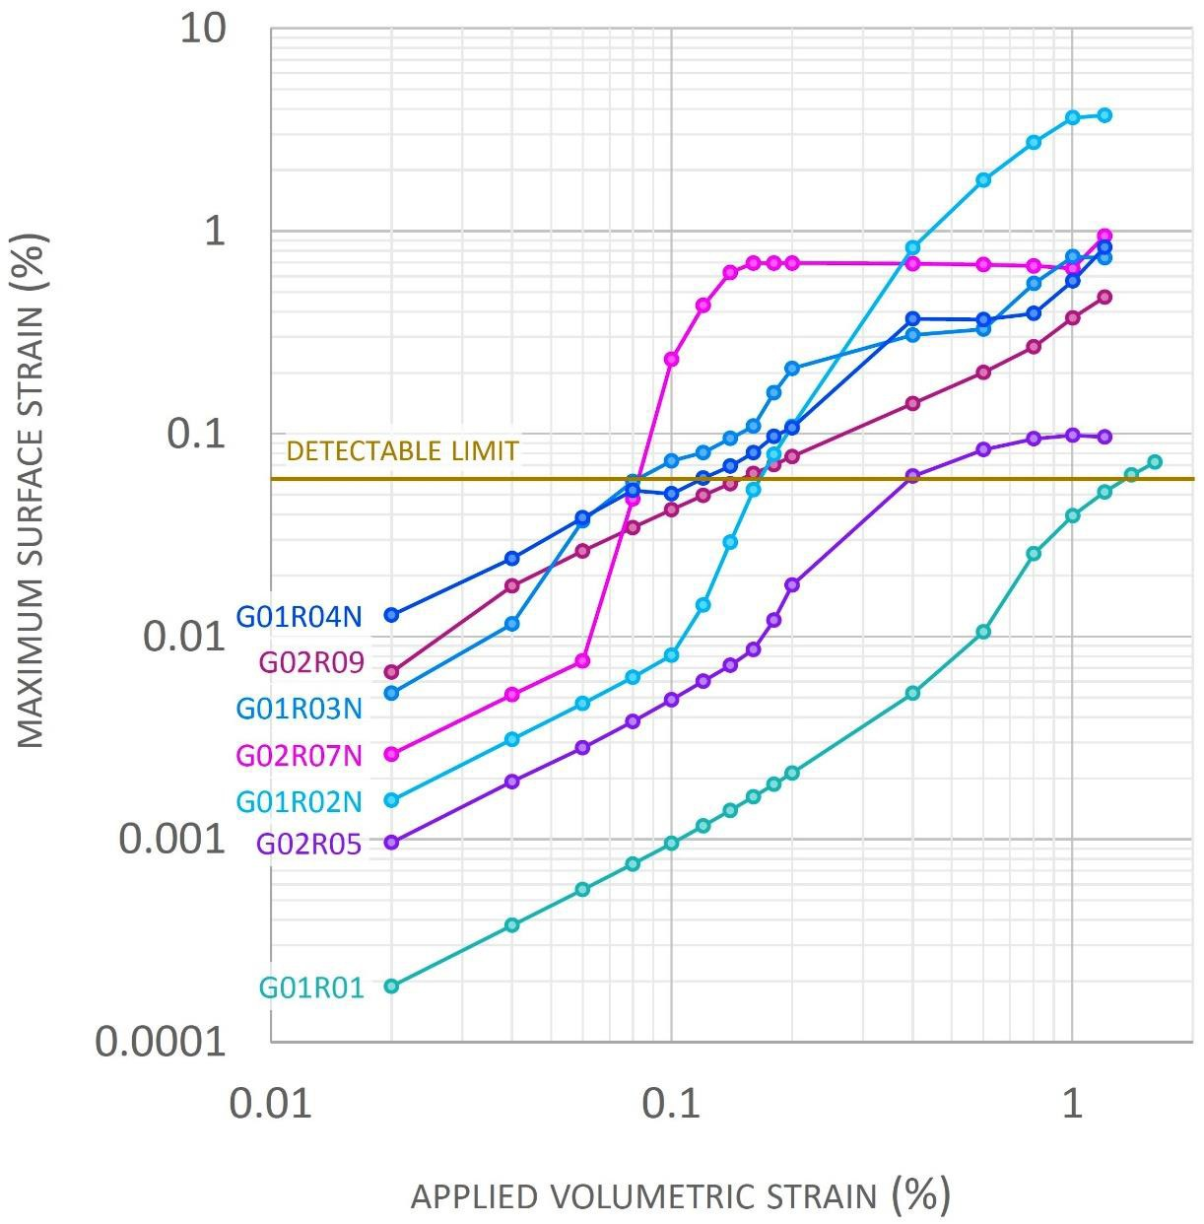

Figure 18 - Relationships between applied volumetric strain and maximum surface strain

The relationship between applied volumetric strain and the consequent maximum surface strain predicted for each analysis case is illustrated in figure 18. The maximum surface strain is plotted because the JKMC report [46] assumes that with the basement slab being exposed, the location of the peak surface strain due to an expansion event would be accessible for measurement; this contrasts with the case where the slab is covered by the cavity drainage system and the location of peak strain might not necessarily coincide with a measurement location. A logarithmic scale has been adopted in figure 18 to more clearly depict the intersection of the applied volumetric strains at the detectable limit of 0.06% surface strain. Since the geometry is axisymmetric, the maximum strain is simply the greatest of the radial and circumferential strains.

Table 6 - Summary of applied volumetric strains and required strain resolutions for various expansion events at the detectable surface strain limit

Analysis name | Maximum slab thickness  m | Radius of expanding hemisphere  m | At detectable limit of 0.06% surface strain …
Analysis name | Maximum slab thickness  m | Radius of expanding hemisphere  m | applied volumetric strain  % | required strain resolution over all considered gauge length and grid spacing με
G01R01 | 3.8 | 1 | 1.360 | 51
G01R02N | 3.8 | 2 | 0.166 | 22
G01R03N | 3.8 | 3 | 0.082 | 35
G01R04N | 3.8 | 4 | 0.119 | 108
G02R05 | 9.8 | 5 | 0.392 | 144
G01R07N | 9.8 | 7 | 0.081 | 35
G02R09 | 9.8 | 9 | 0.150 | 141

The applied volumetric strains at the detectable limit are tabulated in table 6; depending upon the parameters of the expansion event the strains span one and a half orders of magnitude from 0.08% up to 1.4%. The values were evaluated by interpolating between analysis phases; small increments of volumetric strain were applied at each phase to more accurately characterise the relationships depicted in Figure 18.

2.8 Required strain resolution
For each analysis case the predicted displacement field can be referenced to estimate the strain resolution required to detect the modelled expansion event according to the methodology pictured in figure 19. The methodology adopts the following reasoning:
- The expansion event is centred within a grid square delineated by the fibre optic installation. It is assumed that being located at the furthest possible distance from the nearest fibre that the lowest possible maximum strain is induced in the fibre.
- The maximum strain is induced across gauge length 𝐴 in figure 18.
- For small strains the strain in gauge length 𝐴 is given by:

$∈_{AP}=\frac{4u_{p}}{\sqrt{s^{2}+4d^{2}}}$ (11)

where 𝑑 is the gauge length;
𝑠 is the grid spacing;
𝑢_{𝑃} is the radial displacement of point p measured from the epicenter of expansion at 0.

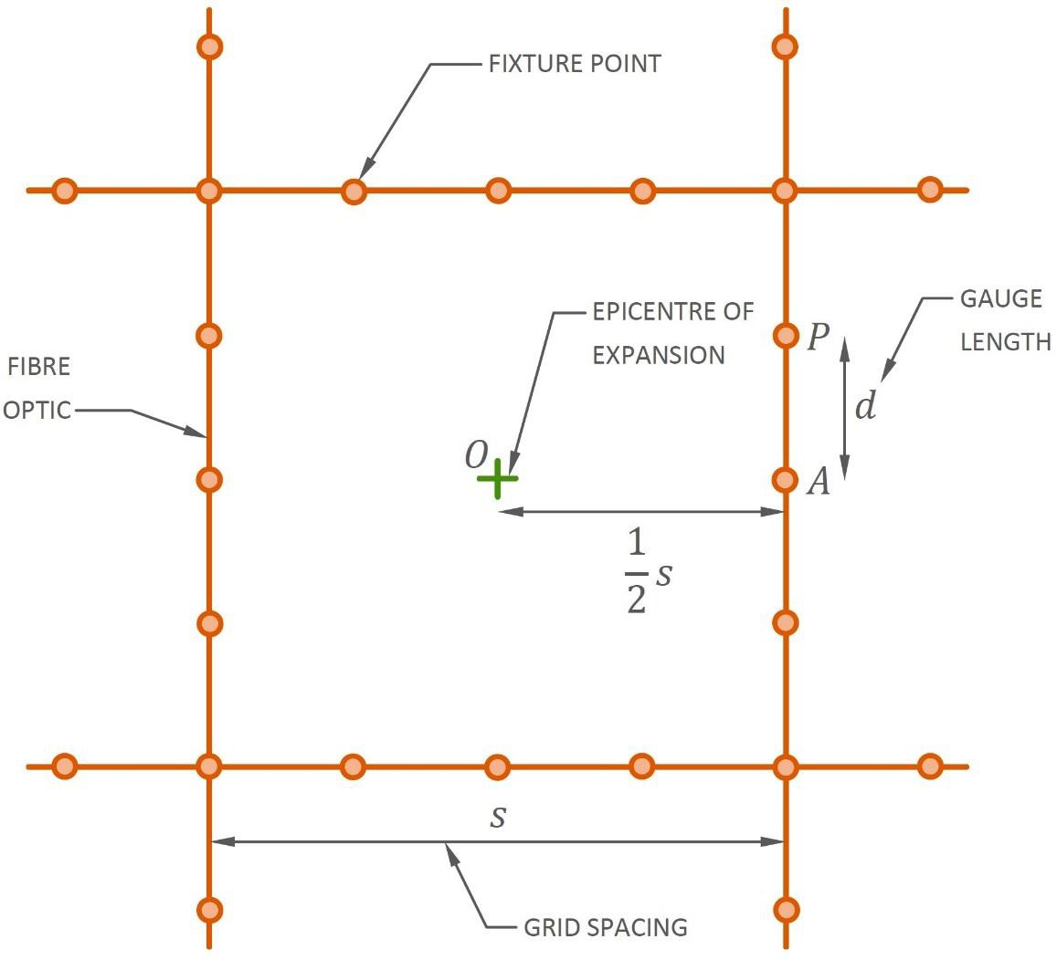

Figure 19 - Geometry assumed for derivation of strain resolution required to detect an expansion event

Values of required strain resolution for each analysis case for a selection of gauge lengths and grid spacings are tabulated in table 7 and plotted as surface plots in figure 20. The following may be observed:
- The strain resolution required to detect an expansion event depends strongly upon the characteristics of the expansion. The most readily detectable events involve expansive regions which are either very small compared with the slab thickness or of a comparable dimension to it. Expansive regions of an intermediate size result in significantly less surface strain and are less readily detectable.
- As the gauge length lengthens the required strain resolution becomes more stringent.
- A wider grid spacing does not necessarily constrain the strain resolution more. The relationship between grid spacing and the required strain resolution is complex and depends upon the distribution of surface strain which might not necessarily decrease monotonically with radial distance from the epicentre of expansion.

Table 7 - Tabulated required strain resolutions for various expansion events, grid spacings and gauge lengths

G01R01 |  | Grid spacing (m)
 |  | 2 | 4 | 6 | 8 | 10 | 12
Gauge length (m) | 2 | 473 | 484 | 340 | 207 | 126 | 80
Gauge length (m) | 4 | 257 | 306 | 245 | 164 | 106 | 70
Gauge length (m) | 6 | 174 | 216 | 183 | 129 | 87 | 60
Gauge length (m) | 8 | 131 | 166 | 144 | 104 | 72 | 51
G01R02N |  | Grid spacing (m)
 |  | 2 | 4 | 6 | 8 | 10 | 12
Gauge length (m) | 2 | 173 | 157 | 113 | 76 | 50 | 34
Gauge length (m) | 4 | 94 | 99 | 81 | 60 | 42 | 30
Gauge length (m) | 6 | 64 | 70 | 61 | 47 | 35 | 26
Gauge length (m) | 8 | 48 | 54 | 48 | 38 | 29 | 22
G01R03N |  | Grid spacing (m)
 |  | 2 | 4 | 6 | 8 | 10 | 12
Gauge length (m) | 2 | 311 | 264 | 184 | 121 | 80 | 55
Gauge length (m) | 4 | 168 | 167 | 133 | 96 | 68 | 48
Gauge length (m) | 6 | 114 | 118 | 99 | 75 | 55 | 41
Gauge length (m) | 8 | 86 | 91 | 78 | 61 | 46 | 35
G01R04N |  | Grid spacing (m)
 |  | 2 | 4 | 6 | 8 | 10 | 12
Gauge length (m) | 2 | 390 | 673 | 620 | 445 | 304 | 207
Gauge length (m) | 4 | 212 | 426 | 447 | 352 | 255 | 182
Gauge length (m) | 6 | 143 | 301 | 333 | 276 | 209 | 155
Gauge length (m) | 8 | 108 | 231 | 262 | 222 | 173 | 131
G02R05N |  | Grid spacing (m)
 |  | 2 | 4 | 6 | 8 | 10 | 12
Gauge length (m) | 2 | 519 | 693 | 647 | 568 | 504 | 449
Gauge length (m) | 4 | 282 | 438 | 466 | 449 | 424 | 394
Gauge length (m) | 6 | 191 | 310 | 348 | 352 | 348 | 335
Gauge length (m) | 8 | 144 | 238 | 273 | 284 | 288 | 284
G02R07N |  | Grid spacing (m)
 |  | 2 | 4 | 6 | 8 | 10 | 12
Gauge length (m) | 2 | 127 | 155 | 158 | 153 | 143 | 130
Gauge length (m) | 4 | 69 | 98 | 114 | 121 | 121 | 114
Gauge length (m) | 6 | 47 | 69 | 85 | 95 | 99 | 97
Gauge length (m) | 8 | 35 | 53 | 67 | 76 | 82 | 82
G02R09 |  | Grid spacing (m)
 |  | 2 | 4 | 6 | 8 | 10 | 12
Gauge length (m) | 2 | 507 | 798 | 903 | 845 | 714 | 597
Gauge length (m) | 4 | 275 | 505 | 651 | 668 | 600 | 524
Gauge length (m) | 6 | 186 | 357 | 485 | 524 | 492 | 445
Gauge length (m) | 8 | 141 | 274 | 381 | 422 | 408 | 378
It follows from the above that a gauge length of 2 m is sufficiently long to avoid fracture of the fibre optic and that this value should be selected for the design. figure 18 cuts a plane through the surface plots of figure 20 at a gauge length value of 2 m and superposes the resulting curves from each case of expansion together. It should be noted that in many cases installing the fibre optic at a closer spacing of 2 m instead of 4 m leads to a more stringent requirement on strain resolution.

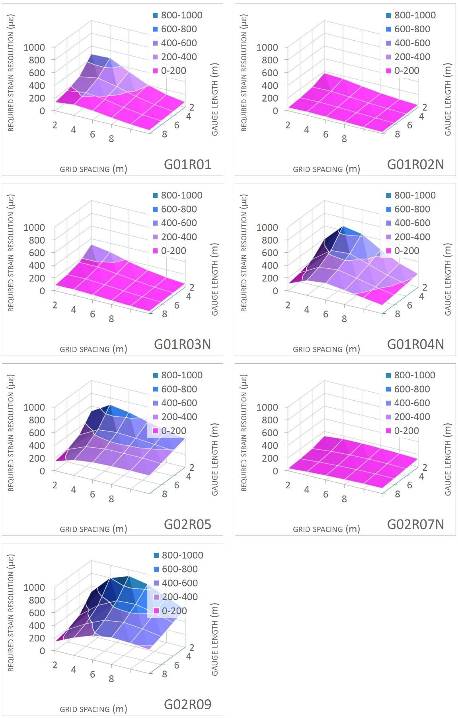

Figure 20 - Surface plots of required strain resolution for various expansion events, grid spacings and gauge length

2.2 Numerical modeling of concrete raft using Plaxis 3D simulation
Numerical modeling for the R block using Plaxis 3D software to determine the horizontal and vertical deformations of the raft was performed. Modeling was designed for the 3.8m thick raft within axes 12 to 19 in Y - direction and axes С to K in X-direction. The analysis of raft deformations was carried out depending on the dead weight load for a single structure in the horizontal plane for vertical deformations, as shown in Figure 21. The loading system on a reinforced concrete square-section raft podium with a side length of 72.9 m. The plan of the horizontal grid is the standard of deformation of the form and is used to estimate the settlement of the column in various places. Settlement for each construction phase is calculated using the vertical reaction at each stage to the vertical reaction at full design load.

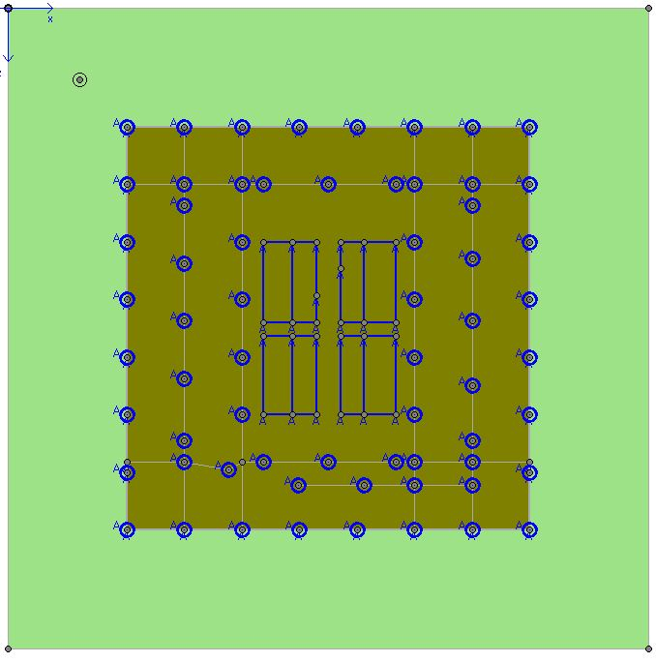

Figure 21 - Loading scheme in numerical modeling

The R block and the basement tile of the common basement are modeled for the change in thickness. Figure 22 and Table 8 show the design contour of the section using the FEM. The load transmitted from the columns at the level of the floor level B4 was represented by a point load (Indicated in the figure with a blue circle), and from the walls of the core of the building as a linearly distributed load along the axis of the walls of the core (indicated as a blue line).

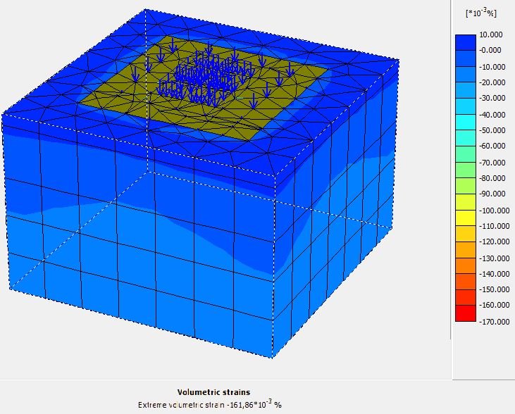

Figure 22 - Volumetric strains obtained with Plaxis 3D modeling

The columns had a different loading area and, accordingly, a different load, and therefore in Figure 23 (b) they have a different size of the arrow designation, depending on the magnitude of the applied load. The mesh was designed by software, total dead and live load was applied at the final stage. The weather conditions were not considered in this simulation. The design parameters were taken from Table 8.

Table 8 – Geotechnical soil parameters for project ADP

Soil | Clay/  Loam | Sand and gravel | Loam and clay | Rock  Debris | Sandstone | Hard  Sandstone
Thickness (m) | 4.0 | 4.5 | 5.5 | 1.5 | 2.0 | Below
Natural unit weight γ (kN/m³) | 18.5 | 19 | 18.5 | 20.5 | 23.5 | 24.0
International Friction Angle ϕ’(º) | 25 | 35 | 26 | 35 | 38 | 38
Cohesion c’ (kN/m²) | 1 | 1 | 30 | 1 | 40 | 50
Modulus of Elasticity E (MPa) | 15 | 25 | 30 | 50 | 65 | 100
Note – Continuation of table [5, р. 450-455]

A raft deformation analysis based on the full design load yields a vertical deformation contour plan as shown in Figure 23 below. Movement units are in meters. The outline plan represents the basic shape of the deformation and is used to estimate settlement at various locations in the core and column. Settlement at each stage of construction is calculated using the ratio of the vertical response at each stage to the vertical response at full design load. Stiffness parameters are set using software Settlement in vertical direction at the raft surface level indicated the maximum displacement at the center of the core and was equal to 38 mm. And the smallest settlement of the column in the circle surrounding the building core was 14 mm at a distance of 26 m from the center of the core. The differential settlement was 24 mm with distance in horizontal plane.

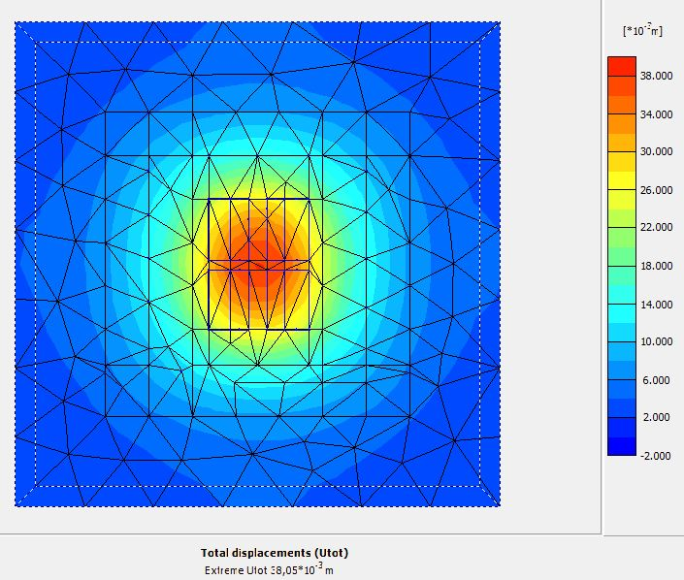
a

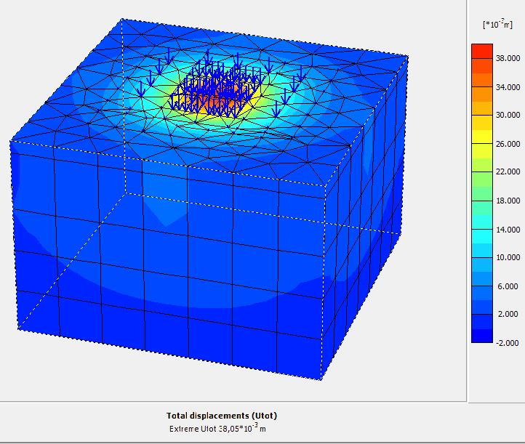
b

a – view of the surface of the raft; b – volumetric model;

Figure 23 - Settlement in vertical Z-direction

Horizontal displacement at the surface level of the raft in block R range from 1 mm to -1 mm in X direction (Figure 24). The sign of displacement alternates from tension to compression and corresponds to 1 mm deformation per 36 m which is half of the building width. The differential settlement between the core walls in the middle and columns by perimeter of block R is 26 mm with distance in horizontal plane is 26.31 m. The values of tensile strain in the horizontal plane are negligible and draw up less than 1 με. The distribution of deformations in X and Y-direction is presented gradually with smooth transitions and does not display point loads from columns.

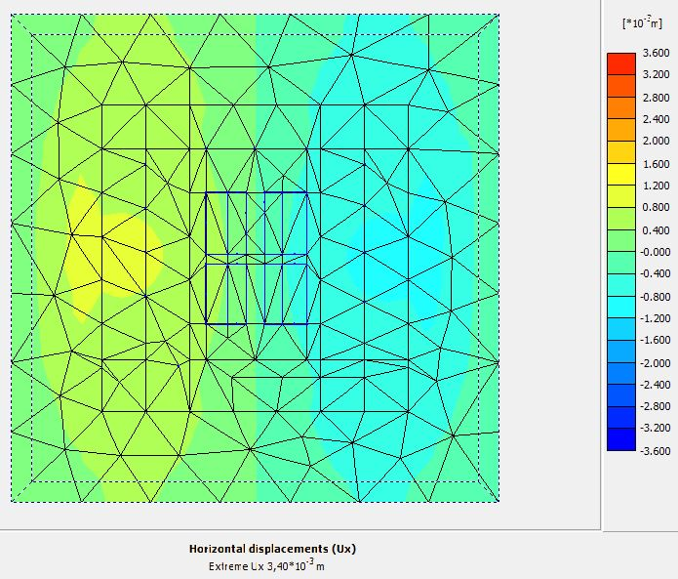
a

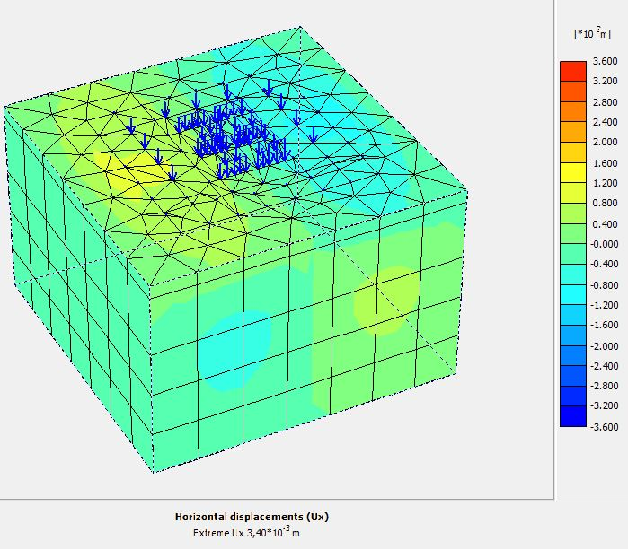
b

a - view of the surface of the raft; b - volumetric model;

Figure 24 - Horizontal displacement in X direction

Thus, according to the results of Plaxis 3D modeling, the largest difference in the vertical displacement was 24 mm and in the horizontal plane 1 mm within a distance from the center of the core up to 30 m. While the relative deformation in the horizontal plane between similar distances is less than 1 με. Such a displacement is negligibly small for consideration in engineering problems in terms of bearing capacity and even in terms of deformations.

Summary on the section
The gauge length is required to prevent fracture of the fibre optic cable and the strain resolution to become more stringent. To do this, the cable is fixed rigidly to the surface with cement mortar. According to the numerical modelling a gauge length of 2 m is sufficiently long to avoid fracture of the fibre optic and that this value should be selected for the design. The most stringent or minimum required strain resolutions across all expansion events is 22 με. In the case of a reinforced raft thickness of 3.8 m according to Table 10 required strain resolutions for various expansion events at the detectable surface strain limit is 51 με. If this limit is exceeded, additional examinations are required for a local diagnostic examination with concrete sampling and testing for strength characteristics as part of the diagnostic survey. According to the FO cable material properties the maximum determined strain is 1.5%. Therefore when a strain above 1000 με (1%) occurs, a basic structural analysis is recommended, above 1500 με (1.5%) a detailed structural analysis is required. Such recommendations of boundary values were adhered to in chapter 3 during experimental studies.
The raft deformation analysis in Plaxis 3D based on full design gravity load resulted the differential settlement 24 mm in vertical direction. The maximum displacement at the raft surface level at the center of the core and was equal to 38 mm. And the smallest settlement of the column in the circle surrounding the building core was 14 mm at a distance of 26 m from the center of the core. Horizontal displacement at the surface level of the raft in block R range from 1 mm to -1 mm in X direction, while the relative deformation in the horizontal plane is negligibly small and is less than 1 με.
The simulation results of DEM represent a general picture of the distribution of settlements in the building plan and do not take into account local effects from the concentrated load from columns and core walls, and also do not detail in the horizontal plane exactly where the points of tensile deformation are located.

3 EXPERIMENTAL RESEARCH METHODS

3.1 Engineering-geological investigation of the construction site
The site of the experiment was in Astana city, in the basement of the tallest building complex in Central Asia - Abu Dhabi Plaza, 320 meters high. Abu Dhabi Plaza is a complex high-rise building with a retail and leisure podium and a hotel cluster at the base that rises to form a series of office and residential towers to the north – a creation of the famous British architect Norman Foster (figure 25).

Figure 25 - Abu Dhabi Plaza Building Complex.

According to SP RK 2.04-01-2017, the number of the area by the weight of the snow cover is III [57].
According to SP RK 2.04-01-2017:
– number of the region according to the average wind speed for the winter period - 5;
– number of the area according to wind pressure – III.
The standard freezing depth according to SP RK 2.04-01-2017 "Construction climatology " is 176 cm (for clay soils) [57].
The average penetration depth "0" into the soil is 193 cm.
It should be borne in mind that in places of open ground or with a low snow cover, both freezing and zero penetration into the depth, with little snow in a harsh winter, can reach 350 cm in loams. The tower’s wind loads fluctuate depending on wind speed, wind direction, and local effects such as swirls. The ambient temperature during the measurement of the tower settlement was recorded to ensure normalization of the results. The measured data had to be collected to minimize the effect of temperature effects throughout the tower, and to limit the effect of localized heating, the effect of solar warm amplification, and the settlement of the sun during the day. Localized temperature control was considered in specific work sites below the working front. Structural elements in unloaded floors opened to the environment were considered at ambient temperature during the collection of these readings. Hydrostatic pressure under the raft foundation was not considered.
All field, laboratory and cameral work were carried out in accordance with the regulatory documents in force on the territory of the Republic of Kazakhstan [58-64]. The field tests included cone penetration test, ground geophysical research using magnetic and electrical methods in the modification of dipole-axial sounding (DAS).
Сone penetration test was performed by TEST-2K equipment according to GOST 19912-2012 [58] to assess the bearing capacity of piles according to SN RK 5.01-03-2013 Pile foundations [65]. For cone penetration testing, a conical tip with a cone base diameter of 35.7 mm and an angle at the cone apex of 60 degrees was used. As rods transmitting pressure to the tip, standard pipes with a diameter of 36 mm were used, the diameter of the friction clutch was 35.7 mm. The length of the friction clutch is 310 mm. The measurement range of soil resistivity to the cone is 1-30 MPa. The range of measurement of soil resistivity along the coupling is 5-200 kPa. The main error of force measurements is no more than 5%. The engineering geological profile of the construction site is presented in figure 26. A detailed description of foundation casting technology during the construction is presented by Zhussupbekov et al. [50]. Ground conditions are presented in table 9 and figure 27 correspond to the conditions of zone 4 of the city of Astana [49].

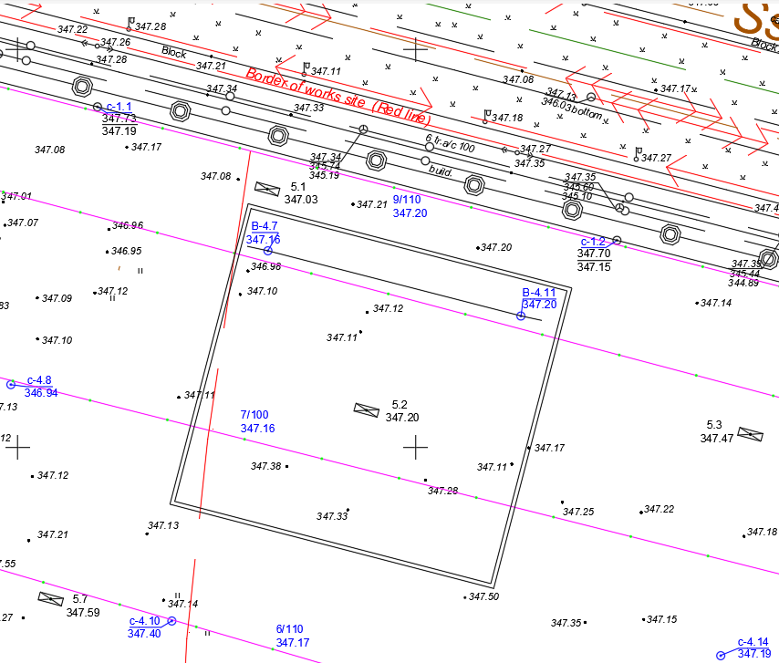

Figure 26 - Topographic survey of the site
Table 9 - Soil properties

Soil type | Thickness, m | Bulk density, kN/m³ | Angle of internal friction φ, kN/m³ | Cohesion C, kN/m³ | Modulus of deformation E_{d}, MPa
Clay / Loam | 4.0 | 18.5 | 25 | 1 | 15
Sand and Gravel | 4.5 | 19 | 35 | 1 | 25
Silty Clay | 2.5 | 18.5 | 26 | 30 | 30
Rock Debris | 2.0 | 20.5 | 35 | 1 | 50
Sandstone | 2.0 | 23.5 | 38 | 40 | 65
Hard sandstone | Below | 24.0 | 38 | 50 | 100

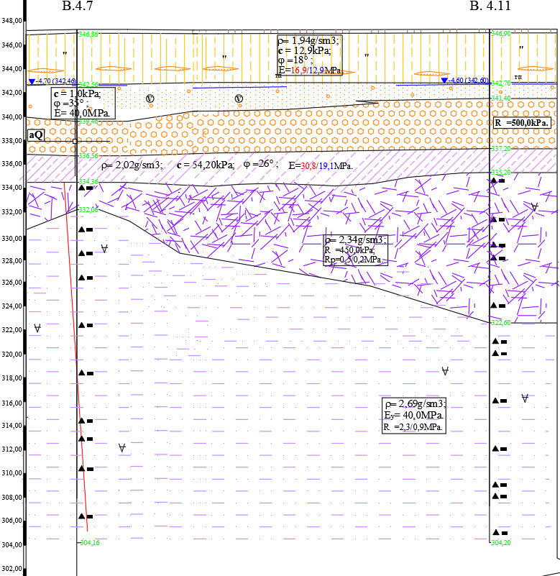

Figure 27 - Engineering-geological profile of the construction site

EGE-2 is represented by alluvial mid-Quaternary modern deposits a(QII-IV) with a thickness of 0.9 to 10.0 m, consisting of sandy clay loam (EGE-2a) with interlayering loamy sands. EGE-3 is located at the depth of 2, 5-8, and 0 m and consists of sands of various sizes (EGE-3a), gravelly sands (EGE-3b) and gravel soils (EGE-3c), belonging to alluvial medium-Quaternary sand and gravel formations a(Q_{II-IV}). The thickness of sands of various sizes varies from 0.4 to 6.3 m, gravelly sands from 0.5 to 6.5 m, gravel soils from 1.0 to 9.2 m. According to the field description, all sand and gravel soils are similar in color, some presence of clayey lenses and differ only in the amount of the determining fraction. All these deposits have a horizontal stratification. EGE-4 eluvial formations of the weathering crust e(C₁) are presented in the form of sandy clay loams and located beneath the sand and gravel alluvial formations at a depth of 6.0–10.0 m. They are mainly presented in the form of gray, greenish-gray and yellowish-gray clays and loams, ferruginous, manganese, with the inclusion of coarse material up to 25%, and in some intervals up to 40%.

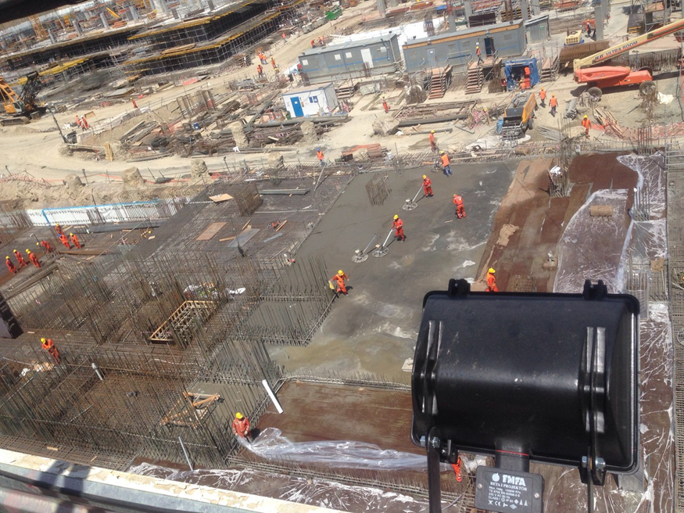

Figure 28 - Construction site

The raft construction process is shown in figure 28, the complex consists of several buildings, where fiber optic cable monitoring was carried out in 3 of them, blocks R, Z, Y. Block R is the tallest building in the complex and is a 75-storey residential building with a 4-storey underground parking at the base. The foundation structure of the building consists of a pile raft including Auger Cast Piles 1,125 m and boring piles with a diameter of 1.2 to 1.5 meters (figure 28). The length of the piles varies depending on the height of blocks from 13 to 25 m from high-strength concrete with an exposure durability of 40 MPa. The raft is built form the C28/35 concrete. The maximum design excavation level for the construction of a raft for block R was 19.30 m. The basement floors consist of 4 levels from B1 to B4 of the lowest.

  - Fiber optic monitoring system

3.2.1 Design of distributed fiber optic strain sensing system (DFOSS)
The proposed DFOSS system comprises a grid of fiber optic cable bonded to the B4 slab linked to an analyzer located in a temperature- and humidity-controlled room at B1 level.
On the B1 level there is an analyzer of the monitoring system for temperature and strain data collected via distributed fiber optic strain sensing system (DFOSS) from B4 level (figure 29). The applied DFOSS system transmit the signal via a grid of fiber optic cable to the B4 raft linked to an analyzer located in a temperature- and humidity-controlled room at B1 level.

Figure 29 - Part plan of cable routing in Block R monitoring area on B4 raft

3.2.2 Gauge length installation-calibration
Fracture of the fiber must be prevented since installing the fiber below the voided slab renders any remediation of the fracture practically unfixable (Appendix A). Fracture at a localized crack in the slab is prevented by fixing the fiber only at discrete points rather than bonding the fiber to the slab continuously along its routing. An unbonded length between two adjacent points of fixture is called a gauge length. Prevention of overstraining relies upon the fiber undergoing the average surface strain of the slab along a gauge length instead of experiencing the maximum localized strain adjacent to a crack [66-74].
A gauge length of two meters was deemed sufficiently long to limit the average strain induced by an expansion event below the allowable strain limit for the fiber. This gauge length was determined as follows:
- Characterizing a collection of expansion events covering the range of conceivable events and performing a numerical analysis for each event to estimate slab surface strains as reported in Chapter 2.
- Reviewing literature on DER- and AAR-induced expansion to establish a design expansive strain resulting from DER and AAR as reported Chapter 1.
- Determining a strain limit based upon the referenced fibre optic cable detailed in (Appendix B).
- Running a search algorithm upon the displacement output from the numerical analyses to find the minimum gauge length required to limit the fibre strain to the determined strain limit as reported in Chapter 2 this thesis.
An alternative to discrete fixing is to bond the fibre continuously along its length but to allow the adhesive bond to yield beyond a predetermined shear stress. However, achieving consistent yielding of the adhesive under site conditions is difficult in practice and risks either inaccurate representation of strain in the case of premature yield or fiber fracture if yield is retarded.

3.2.3 Strain resolution
The degree to which an analyzer can resolve the strain in a fiber is limited by noise and so resolution decreases with measurement distance. Strain resolution may be augmented by improving the signal-to-noise ratio with a more powerful analyzer or by successively taking a large number of measurements and averaging.
The averaging of strain along a gauge length places a more stringent requirement on the strain resolution compared with the case of a continuously bonded fiber. Furthermore, the spacing of the fiber optic grid determines the distance of fibers from an expansion event and influences the required strain resolution [67, 68].
The lowest strain in a gauge length that would be induced by any conceivable expansion event was determined to be 22 με through assuming:
- A two-meter gauge length.
- A variety of grid spacings ranging from two to twelve meters.
- An expansion event centered within a grid square.
- Surface displacements estimated from the numerical analyses reported in Appendix A covering a range of conceivable expansion events.
- A requirement to detect surface strains as low as 0.06%, equivalent to the strain of 0.6 mm m-1 specified in the JKMCL report [46].
Determination of the lowest induced strain is summarized as follows:
- For each expansion event, interpolate the relationship of applied volumetric expansive strain and maximum induced surface strain obtained by numerical analysis to determine the critical value of expansive strain required to induce the lowest detectable strain of 0.06%
- For each expansion event and for a range of gauge lengths and grid spacings evaluate the maximum strain induced across a gauge length by the critical value of expansive strain
When considering expansion events across the entire conceivable range of events the lowest induced strain is 22 με. Although specifications for most analysers state a strain resolution in the order of 2 to 5 με this refers to the condition of uniform strain along the entire fiber. Under non-uniform strain conditions the resolution of typical analyzers increases to around 20 to 30 με which is adequate to detect practically all expansion events considered in this report [47]. Strain resolution is therefore not a governing factor in the DFOSS design.

3.2.4 Grid spacing
With the fiber being a linear sensing element the DFOSS system is unable to monitor strain everywhere across the entire slab surface. Fibers installed closer together would improve the coverage of strain measurement and it would be expected intuitively that the ability of the DFOSS system to detect an expansion event would likewise increase. The analysis presented in Chapter 2 shows that this is not necessarily true due to the particular distributions of surface strain induced by certain expansion events. Indeed, for any grid spacing up to at least twelve meters the strain resolution offered by currently available analysis would be more than sufficient to detect an expansion event anywhere within the grid.
In view of this, the grid spacing is governed by the ability of the DFOSS system to locate an expansion event rather than its ability to detect an event. Following discussion with ACCL a grid spacing of eight meters was selected to offer sufficient ability to locate the region of expansion for the purposes of remediation; this spacing also fits well with the column spacing within the basement which is typically not much wider than eight meters.

3.2.5 Cable routing
The proposed layout for the fiber optic cable on the base slab is illustrated in drawings ADP-CAJ-ST-SD-B-22- B04-00152, -00153 and -00154 with the layouts reproduced in Figure 29 and figure 30 for the reader’s convenience.
In the drawings the bending radii of the cable at turning points is drawn as 600 mm assuming use of the cable specified in Appendix B. If an alternative cable is preferred the bending radius must be at least one-and-a-half times the allowable bending radius specified by the cable manufacturer to allow for installation error.

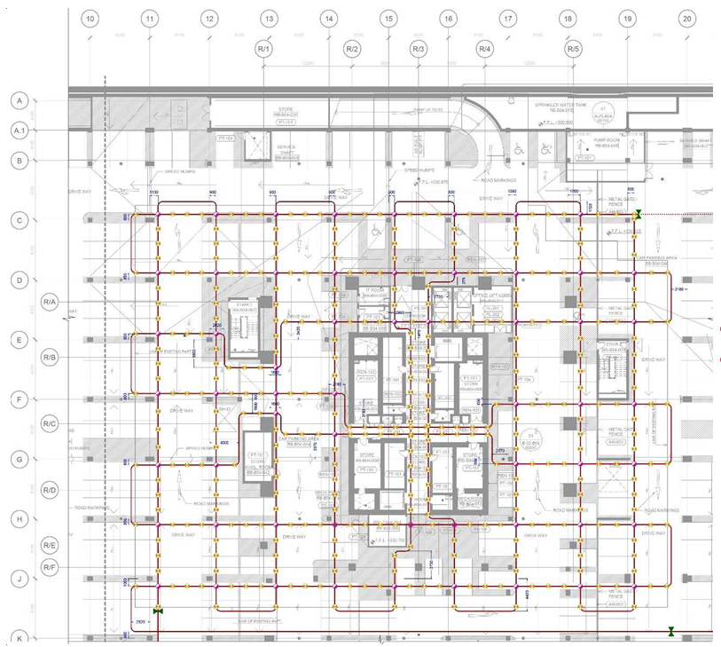

Figure 29 - Part plan of cable routing in Block R monitoring area on B4 slab

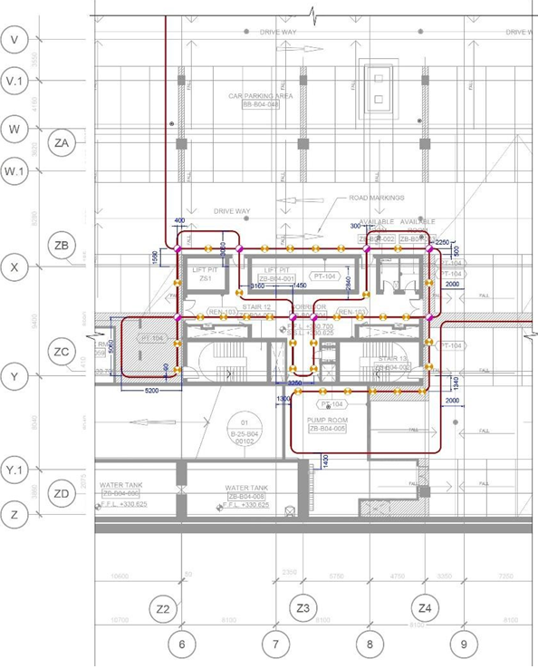
а
а – Block Y monitoring areas on B4 slab

Figure 30 - Part plan of cable routing in Block Y and Block Z monitoring areas on B4 slab, sheet 1
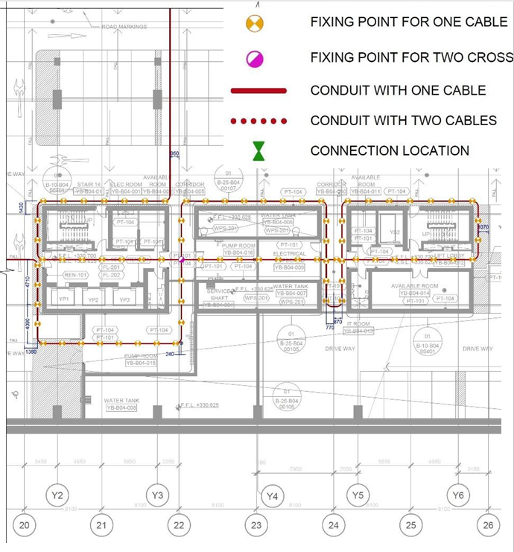
b

b – Block Z monitoring areas on B4 slab

Figure 30, sheet 2

The proposed layout is based upon an eight-meter grid spacing yet there are regions where the spacing is significantly wider than eight meters, particularly around the Block R core located at the center of the Block R raft. Internal walls obstruct straight passage of the cable through the core and to avoid complicated re-entrant routing a wider grid spacing is tolerated within the core. For any point on the slab within the core, the greatest distance between that point and the nearest fiber optic cable is approximately six meters, corresponding to an equivalent grid spacing of 12 m. Figure 18 and table 6 in Chapter 2 demonstrates that for the wider 12-m grid spacing a typical analyzer would possess more than sufficient strain resolution to detect an expansion event within the grid; however the degree to which the event can be located would be diminished within the Block R core. The benefit obtained by augmenting the ability to locate an expansion event is deemed small relative to the additional complexity in routing required to achieve this. The routing generally maintains a half-meter separation between the channel and vertical reinforced concrete elements such as walls and columns.
After Block R, a fiber optic cable was laid in the center of the Block Z building. And then the building Y of the central part, after which it returned to block R but already in the form of a zigzag in the X direction. The cores at Blocks Y and Z are constructed adjacent to ramps connecting to B3 level and the fibre optic cable routing avoids these ramped areas. The routing also avoids penetrating reinforced concrete walls but in places the cable passes beneath blockwork walls. In these places the blocks immediately above the channel will have to be temporarily removed to enable access for both cutting the channel and passing the cable reel through the gap in the wall.
If the gap is too small to pass the reel through an additional cable connection would be required wherever the cable passes beneath a blockwork wall. Where blockwork walls are spaced relatively close together the cable on one side of the walls may be uncoiled from its reel and threaded back along the channel beneath the walls to meet the cable on the other side. Following this methodology only one connection may be necessary where the cable passes beneath a close succession of blockwork.
Each additional connection will significantly increase the total optical loss of the fiber optic circuit and before deciding upon inserting additional connections the specification of the analyzer must be checked to ensure that its optical budget is sufficient to cover the additional optical loss. It is recommended that the reel be passed through the blockwork wall wherever possible and that no additional connections are made.
In the drawings it is assumed that it is possible to pass the cable reel through the blockwork walls and so only four connections are depicted on the B4 slab. Two connections are required at the point where the cables enter and exit the Block R monitoring zone corresponding to the junction of the channel carrying two cables and the channels with one cable. In figure 29 and figure 30 the connections are at the same location and are hence indicated with a single symbol. The other two connections split the cable into reels which are easy to handle during installation. The precise location of the connections is not critical, and adjustment of the locations will be needed if the quality of on-site splicing is unacceptable and connectors need to be used to join cable sections. A summary of cable and reel lengths with estimated weights is presented in table 10; no reel weighs more than around 17 kg assuming the adoption of the cable specified in (Appendix B).

Table 10 - Breakdown of length of cable reels and corresponding sections

Section routing | Direction | Elevation | Section length  m | Reel | Reel length*  m | Reel weigth +
 |  |  |  |  |  | kg
1 | 2 | 3 | 4 | 5 | 6 | 7
Analyzer > B1 ceiling | Vertical |  | 7 | A | 122 | 2.7
B1 ceiling | Horizontal | B1 ceiling | 43 | A | 122 | 2.7
B1 ceiling > B4 floor | Vertical |  | 17 | A | 122 | 2.7
B1-B4 ductwork > Block R | Horizontal | B4 floor | 50 | A | 122 | 2.7
Block R - Y-direction | Horizontal | B4 floor | 568 | B | 596 | 13.1
Block R > Block Z | Horizontal | B4 floor | 193 | C | 706 | 15.5
Block Z | Horizontal | B4 floor | 136 | C | 706 | 15.5
Block R > Block Y | Horizontal | B4 floor | 92 | C | 706 | 15.5
Block Y | Horizontal | B4 floor | 145 | C | 706 | 15.5
Block Y > Block R | Horizontal | B4 floor | 106 | C | 706 | 15.5
Table continuation 10

1 | 2 | 3 | 4 | 5 | 6 | 7
Block R - X-direction | Horizontal | B4 floor | 681 | D | 715 | 15.7
Block R > B1-B4 ductwork | Horizontal | B4 floor | 50 | E | 122 | 2.7
B4 floor > B1 ceiling | Vertical |  | 17 | E | 122 | 2.7
B1 ceiling | Horizontal | B1 ceiling | 43 | E | 122 | 2.7
B1 ceiling > Analyzer | Vertical |  | 7 | E | 122 | 2.7
 |  | Total | 2155 |  | 2261
* – Assumes 5% extra length for minor deviations

A channel accommodating two cables is depicted to run between the Block R monitoring zone and the riser routing the cable between the B1 and B4 levels; one cable routes the light from the analyzer into the monitoring zone whilst the other routes the light back to the analyzer. It is recommended that if possible, the two cables be run side-by-side by doubling the channel width to maintain the cement-mortar cover over the conduit. To facilitate installation, it is also recommended that the two cables first be run vertically between levels B1 and B4 and secured to cable trays before fixing the cables at B1 and B4. Fixing in this order would assist the adjustment of cable length either side of the vertical section.
At certain areas the base slab is thickened by casting additional concrete above the structural floor level and in places steel mesh is cast into the thickened section to prevent surface cracking. To reduce the risk of installing the cable at a curvature exceeding the allowable curvature the elevation of the cable should be maintained in the thickened sections and instead the channel depth adjusted to accommodate the change in slab thickness. Producing the channel at the thickened sections would necessitate cutting through any steel mesh that might be present and additional time and tooling should be provided for this task.
Fixing points within the monitored areas in Blocks R, Y and Z are depicted at intervals of approximately two meters or longer to create gauge lengths. Of the 525 fixing points 450 of them clamp a single cable and the remaining 75 clamp two perpendicular cables. A fixing solution similar to that illustrated in figure 31 may be employed to clamp either one or two cables.

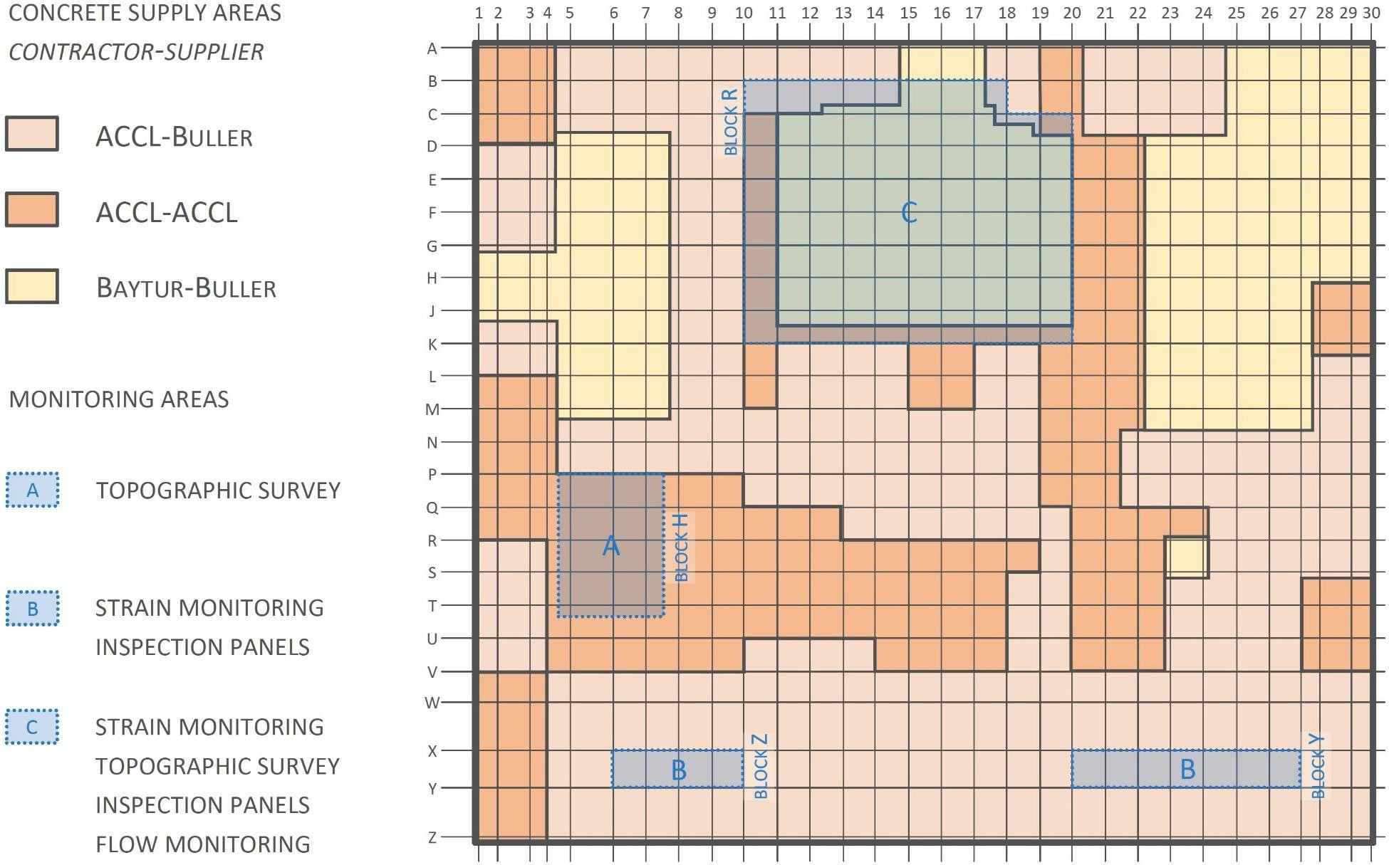

Figure 31 - Plan showing concrete supply areas and required monitoring

At most intersections both cables are clamped but at six particular intersections, namely four at the center of the Block R core and two within the Block Y monitoring area, the intersections are spaced significantly closer than two meters. At these six locations only a single cable is clamped to avoid creating gauge lengths shorter than two metres.

3.2.6 Optical losses
The total length of installed cable is estimated in table 1 to be 2.2 km. The distance range is the maximum distance along the cable from the analyzer where a measurement is required and is equal to 2.04 km. The total optical loss is estimated in table 2 to be 11.0 dB and assumes the following:
- Cable lengths and connectivity as portrayed in figure 32.
- A total fiber length of 4.4 km including both the strain and temperature-measuring fibers running in parallel within the same cable.
- Unit attenuations as suggested in reference [86].
- The use of connectors rather than splices to join two fiber ends on site.
Splicing is the process of fusing two fiber ends together by applying heat at the junction and demands a high level of expertise since the fiber ends must be meticulously prepared and aligned before joining. Conditions within the basement are likely to constrain the quality of splices produced on site; connectors provide an alternative when the quality of on-site splicing is likely to be unacceptable. In this case the connector pigtails can be joined to the fiber ends by splicing in the laboratory before the cable reel is brought to site leading to a quicker and higher-quality installation. Nevertheless, the use of connectors fixes the length of each section of cable and contributes a significant optical loss across each connection.

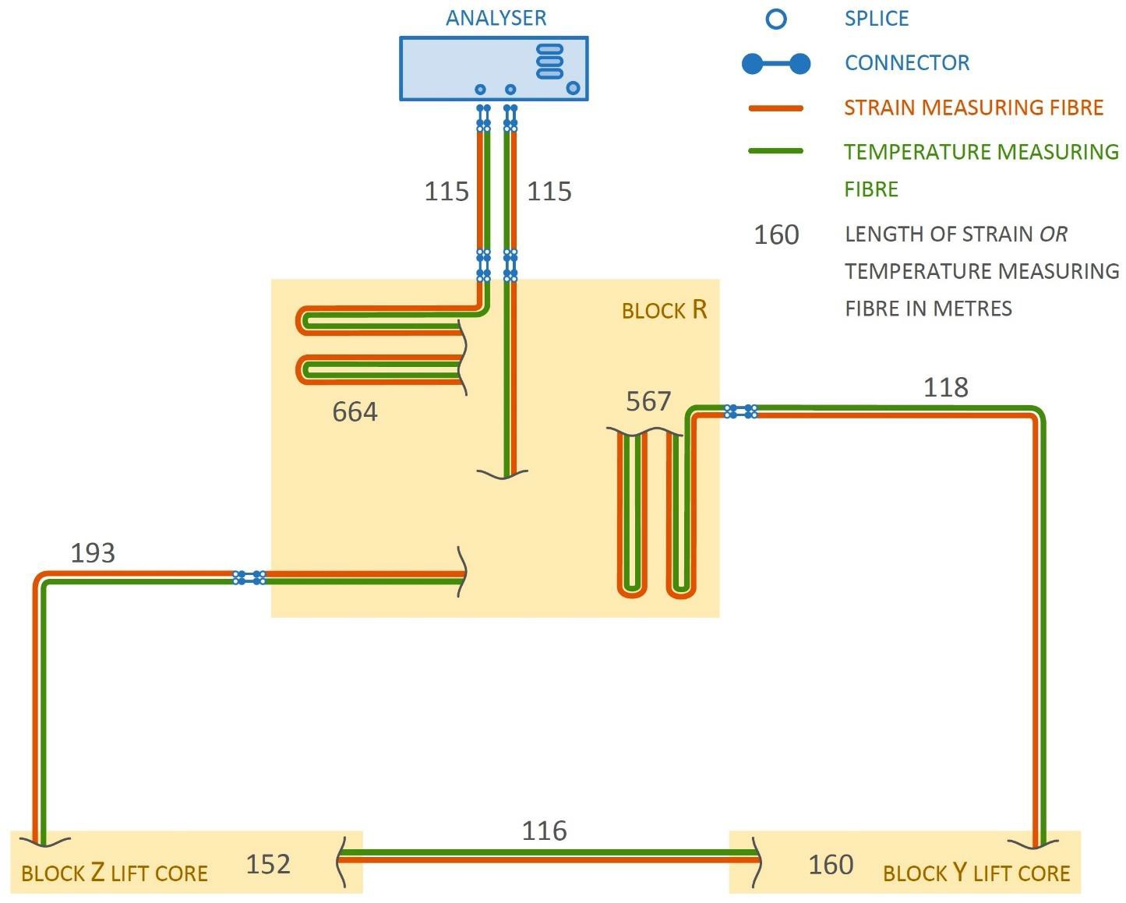

Figure 32 - Schematic diagram of distributed fibre optic strain sensing system

Due to the lower optical loss and flexibility in adjusting the length of cable sections, splicing is preferred over connectors. If the contractor judges that high-quality splicing is unachievable on site then the contractor should use connectors instead and introduce a location where surplus cable can be coiled and stowed; in this case it is suggested that the surplus cable be accommodated in the analyzer room. For the purpose of procuring an analyzer in advance of determining the method for joining fibers, the use of connectors has been assumed to estimate the required optical budget in table 11.

Table 11 - Estimate of total optical loss

Component | Unit attenuation | Quantity | Total loss  dB
Fiber * | 0.5 dB km⁻¹ | 4.4 km | 2.2
Connectors** | 0.4 dB | 12 | 4.8
Splices** | 0.2 dB | 20 | 4.0
Total optical loss |  |  | 11.0
* – Length includes both strain and temperature measuring fibers
** – Includes connectors and splices for both strain and temperature measuring fibers

3.2.7 Spatial resolution
The analyzer measures strain by transmitting pulses of light down the fiber and analyzing the frequency spectrum of the backscattered light. The optical budget of an analyzer may be increased by extending the pulse width measured in nanoseconds, which reduces its attenuation. If the pulse width is too long however, backscattered light from the leading edge of the pulse begins to interfere with backscattered light from the trailing edge of the pulse and the analyzer is unable to differentiate between the two. This places a limit on the minimum distance over which a value of strain can be interpreted by the analyzer. This distance is termed the spatial resolution and may be likened to the width of an averaging window for a sampling point.
A spatial resolution as short as 2 cm is achievable by some analysis on the market but due to the trade-off between optical budget and spatial resolution this comes at the expense of the optical budget which at such a low spatial resolution would be only around 2 dB. To achieve the required optical budget of 11 dB the spatial resolution would typically be no lower than around 0.5 m.
Even though the spatial resolution limits the minimum distance over which a value of strain can be interpreted, the analyzer is still able to take multiple measurements at small intervals along the fiber. The shortest interval between two sampling points is termed the sampling resolution and depends upon the number of measurements made by the analyzer.
Although an analyzer takes a few seconds to take one measurement, analyzers can take up to 220 readings over a period of several minutes to shorten the sampling resolution and improve strain precision. Since for the proposed DFOSS system there is no practical restriction on measurement time, a sampling resolution as low as 5 cm is achievable.
When installing the fiber as gauge lengths the analyzer should be able to return at least one representative strain measurement within each gauge length. The spacing of sampling points is equal to the sampling resolution and can be as low as a few centimeters. However, the strain measurement returned at each sampling point is an average of the strain over a distance equal to the spatial resolution which is around 0.5 m for the required optical budget of the proposed DFOSS system.
Considering a sampling point towards the midpoint of a gauge length, the sum of the spatial resolution and the sampling resolution must be less than the shortest gauge length in the circuit for the analyzer to measure a representative value of strain in the gauge length. Since for the required optical budget the sampling resolution is likely to be at least an order of magnitude lower than the spatial resolution, a spatial resolution shorter than around 1.5 m would be adequate.
Any specification on sampling resolution would arise from the need to detect sharp transitions in strain along the fiber as would be induced by cracking. The use of gauge lengths precludes the detection of exact crack locations and the sampling resolution for readily available analyzers is more than adequate to return at least one measurement within each gauge length.

3.2.8 Analyzer and analyzer room
The analyzer must operate within specified environmental conditions and so must be located inside a room whose temperature and humidity are controlled. The analyzer room will also accommodate the logging system and computer required to interface with the Internet and as such the room must be supplied with uninterrupted electrical power and a high-bandwidth Internet connection and must be sufficiently spacious for two operatives to work comfortably inside. A summary of the analyzer specification is presented in table 12.

Table 12 - Specification for analyzer

Parameter | Value
Spatial resolution | $≤$ 1.5 m
Optical budget | $≥$ 11 dB
Measurement resolution | $≤$ 22με
Distance range | $≥$ 2.09 km
Gauge length | $≥$ 2 m
Measurement range | $≥$ 1.5 %
Measurement interval | $≤$ 3hrs
Operational period | $≥$ 70 yrs
Data acquisition | Remote control and transmission via internet
Note – Optical budget includes both strain and temperature measurements cables configured in a loop

Particular consideration must be given to the routing of the fiber optic cables into the analyzer room from the riser used to route the cables to B4 level. The cables may be routed in channels cut into the B1 slab in a manner similar to the channels in the B4 slab. Running the channels through doorways instead of under walls would remove the need to demolish portions of blockwork wall to enable cable installation. Alternatively, the cables may be routed overhead via cable trays into the analyzer room (figure 33); in this case blockwork at ceiling level will need to be removed for the cable to pass through any walls. Regardless of the routing method it is essential that the allowable curvature of the cable is not exceeded [70-74, 82-84].

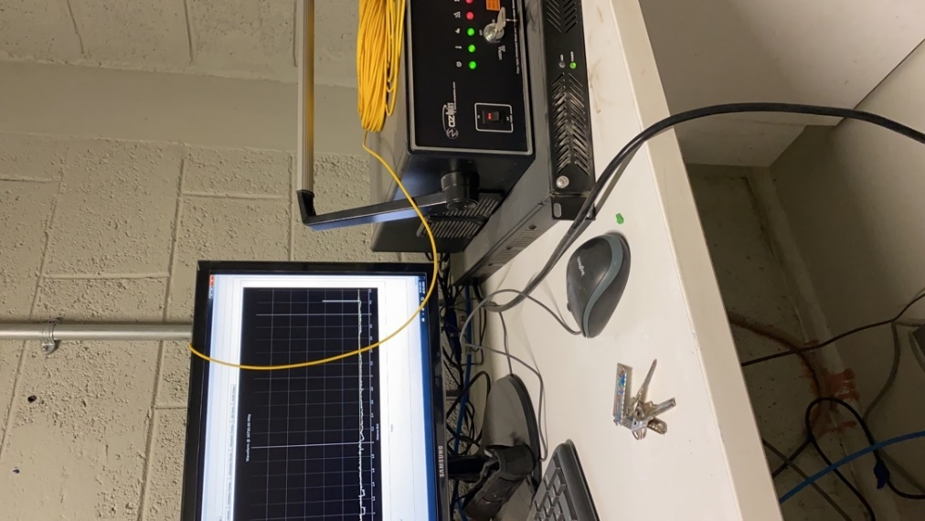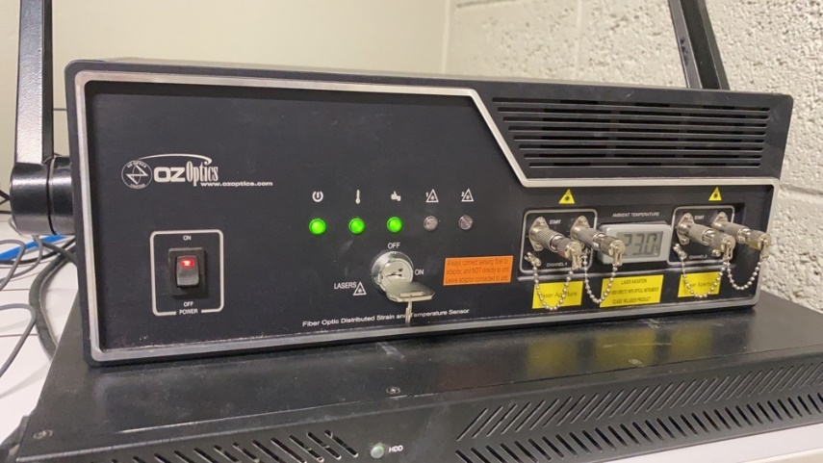

а b

a – the system of typical analyzer; b – signal processor;

Figure 33 - Monitoring room with typical analyzer, sheet 1
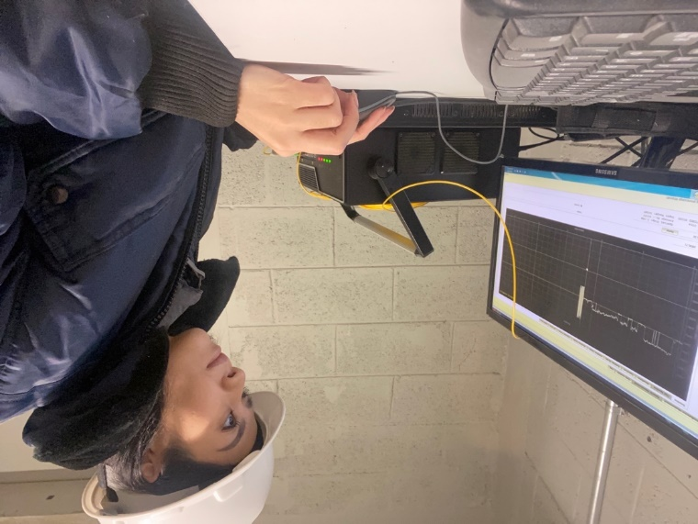

c
c – monitoring of cable routing at construction site;

Figure 33, sheet 2

3.2.9 Cable installation
It is acknowledged that the contractor responsible for installing the fiber is likely to prefer adopting its own installation methodology based upon its own expertise and experience, the conditions on site and the materials and techniques at its disposal. Nonetheless a concept for installing the fiber is presented in figure 34 and figure 35 to assist the contractor in developing its own methodology. Figure 34 presents a method for securing the fiber optic cable to the slab at fixing points whilst figure 35 portrays a method for routing the cable between fixing points.

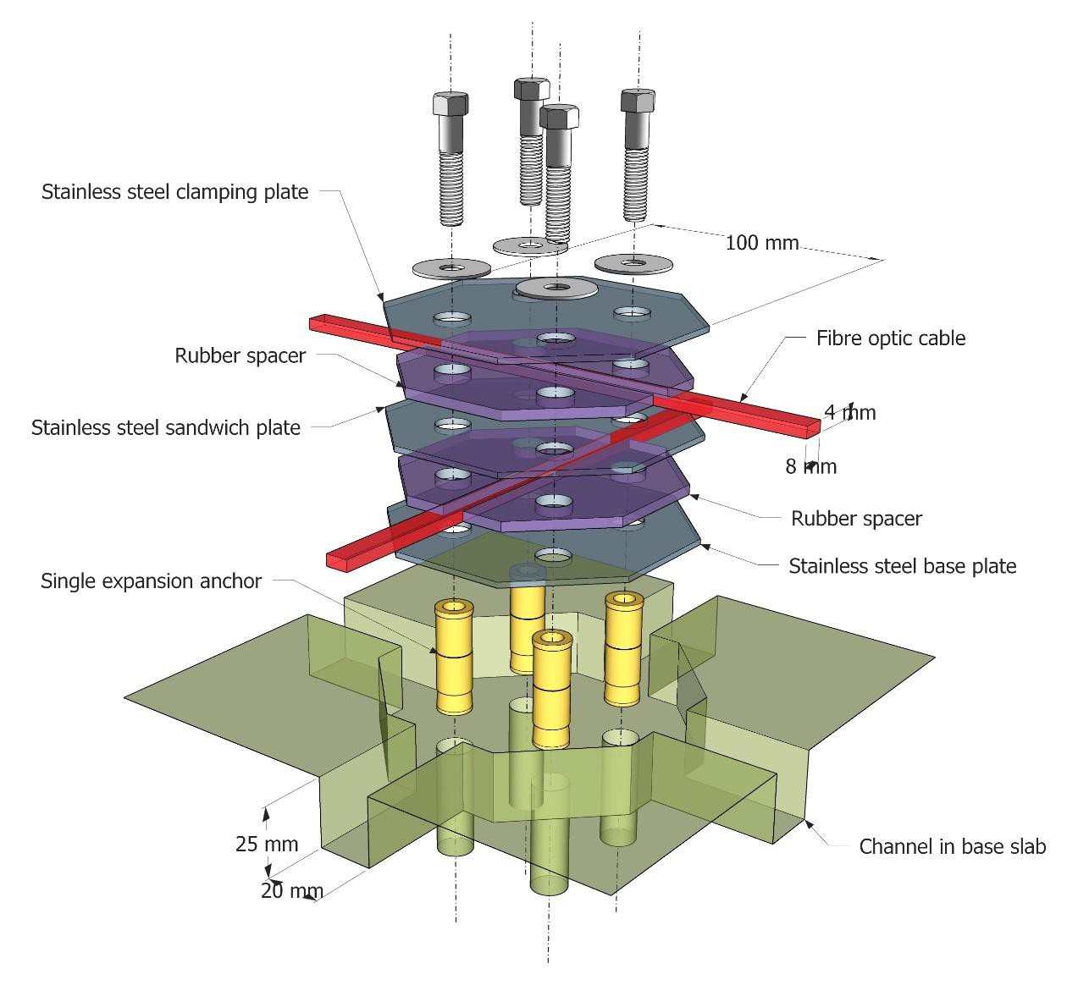
Figure 34 - Cable fixing point (contractor to provide design)

It is emphasized that the contractor is responsible for the final design and procurement of the fiber optic cable installation and the concept presented here is for reference only. Although the contractor is free to choose its own preferred methodology, the installation adopted by the contractor must adhere to the specification outlined in the following sections below.
The fiber optic cable was fixed to the slab at an interval no shorter than two meters along the cable to produce gauge lengths equal to or longer than two meters. This will protect the fiber from fracturing during a design expansion event. Nonetheless, subject to site constraints, the contractor must endeavor to produce gauge lengths as short as possible to maximize the ability of the DFOSS system to locate an expansion event without creating gauge lengths shorter than two meters; for this reason, gauge lengths must be no longer than four meters.
It is important that no gauge length is shorter than two meters and if a shorter gauge length is desired for any reason such as for convenience or due to a desire to more precisely locate an expansion event that this gauge length requirement stands uncompromised – if necessary, it is preferable to omit a potential fixing point for the sake of ensuring the long-term reliability of the DFOSS system [75-82].
Between the fixing points the cable must be unconstrained in its longitudinal direction such that the surrounding slab is free to expand or contract without imparting longitudinal strain to the cable. It is acknowledged that to facilitate infilling and sealing of the channel the contractor may prefer to embed the cable within a compliant filling material inside the channel; if such a material is employed the material must be rheologically similar to a gel such that minimal shear strain is transferred between the cable and the channel. Infilling with grout of any kind is only permitted if a mechanism exists to release the strain transfer between the cable and the surrounding slab. In Figure 34 the flexible conduit shrouding the cable is air-filled so that there is no mechanical connection between the cable and the conduit between fixing points.
Correspondence between chainage points along the as-installed cable and the locations of these points on the slab. Marking or tagging the cable at half-metre or one-metre intervals before installing the cable will provide regular datum points from which to determine the chainage at key locations such as turning points, fixture points and intersections with structural details. Each datum point can also be marked on the surface of the cement mortar infill by casting a small pin directly above the point. The pins may then be surveyed and their locations superposed onto a digital model of the slab. The digital model may then be used to interpret the strain-chainage output from the analyzer in identifying gauge lengths and locating strain anomalies.
Lightly tension the cable between fixing points. A cable which is initially slack would be unable to register tensile strain until the strain is sufficient to take up the slack. Applying an initial tension to the cable also enables it to register compressive strains along gauge lengths. A light tension can be applied to the cable by pulling the cable taut before it is locked down at the fixing points.
It is important that the initial tension in the cable is applied as uniform as possible around the circuit as this will ensure the best possible strain resolution is attained. Along each straight length of cable with multiple fixing points this may be achieved by first applying the tension along the entire length before clamping the cable at each the fixing point; the tension should be maintained around cable bends as well. A tension meter may be used to ensure that a uniform value of tension is applied to all cable lengths.
Enable the crossover of orthogonal cables in the grid at fixture points. This is achieved in figure31 whilst satisfying the remaining requirements for the cable fixture.
Eliminate any interface between the DFOSS system and the internal drainage system. To achieve this the fiber optic cable must be laid within channels cut into the base slab and the channels infilled such that the slab surface after cable installation is smooth and flush with the surrounding slab. The installation must present no impedance to water flow across the surface of the slab. The installation illustrated in Figure 34 and Figure 35 achieves this by recessing the entire cable fixing and routing assembly below the structural floor level of the slab with the remaining void being infilled with grout to the slab surface.

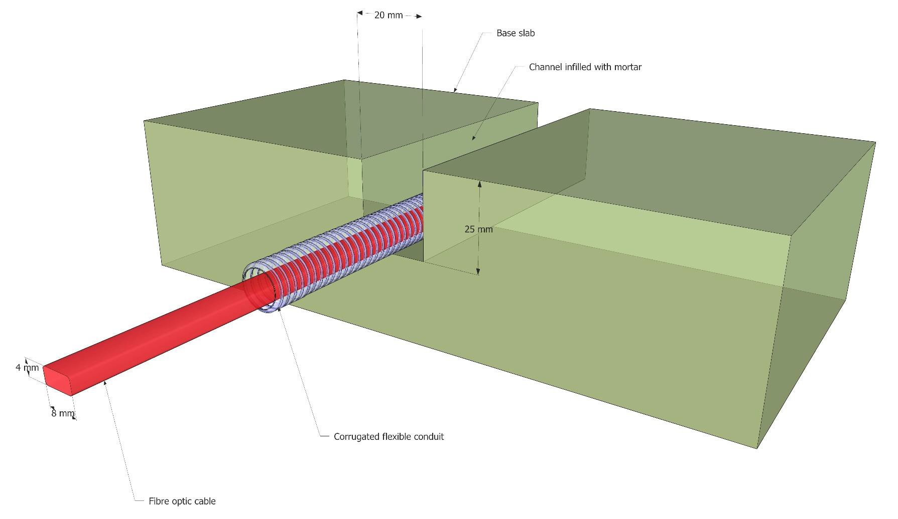

Figure 35 - Suggested design for cable channel between fixing points

Maintain the structural integrity of the basement slab. No part of the cable installation should interfere with the top reinforcement of the slab. The cover to the reinforcement is 40 mm; in figure 34 the 25 mm-deep channels are shallow enough to clear the reinforcement. However, where anchor bolts are employed the drilling depth must be carefully controlled so that the anchors stay clear of the reinforcement. This may be achieved by employing a drill stop during installation and by choosing sufficiently short anchors. The cement mortar intended for filling the recesses in figure 35 and figure 35 restores the reinforcement cover to its original thickness (figure 36).
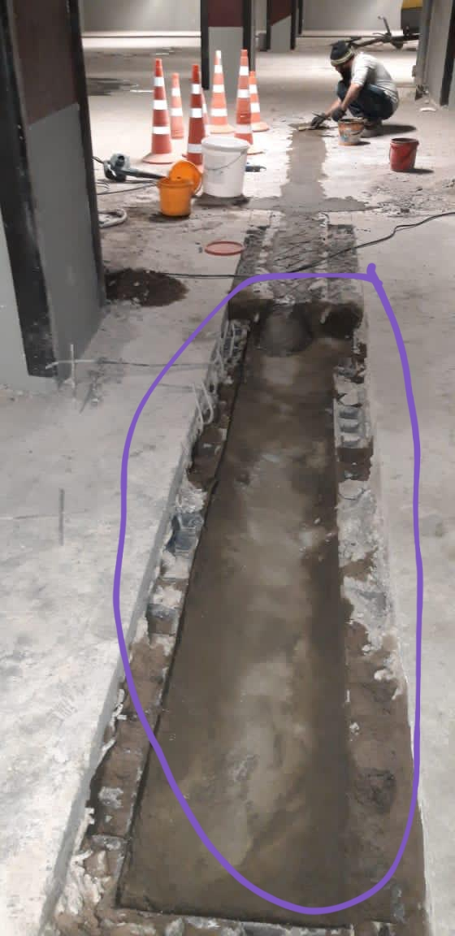

Figure 36 - Cable laying under the cover drain system

The functions of the cable and the internal drainage system must be guaranteed for the 70 year operational life of the basement.
During this period there should be no slippage or creep at the fixing points. This may be achieved by cold forming a grip pattern on clamping surfaces so that the cable sheath is positively engaged with the clamping plates rather than relying solely on friction. The fixture in Figure 34 employs rubber spacers between clamping plates to center the cable within the fixture but also to limit the clamping force that may be applied to the cable; if the contractor decides to use similar spacers the thickness and modulus of the spacers must be carefully determined so that the clamping force is sufficiently high to prevent slippage but low enough not to crush the cable.
The materials chosen to fix and embed the cable must be sufficiently durable to last the 70-year period. In particular the materials used must resist long-term exposure to water which may contain de-icing salts.
In Figure 34 stainless steel is employed because it resists corrosion. Stainless steel is used for clamping plates, bolts and anchors so that corrosion induced by difference in electrode potential is minimized. Stainless steel is to be preferred over galvanized mild steel due to its superior corrosion resistance.
The cable installation must resist bacterial and algal growth which could produce an obnoxious odour and render the basement unusable. In Figure 35 the conduit shrouding the cable along a gauge length is sealed at both ends with an elastomeric sealer with the fixture point infilled with cement mortar to the slab surface. By maintaining a dry cavity within the conduit, the sealer reduces the potential for growth of bacteria and algae.
The curvature of the fiber optic cable needs to be within the allowable limit applicable to the selected cable. Light is transmitted along a glass fiber core by internally reflecting at the boundary between the core and its cladding material. If the cable is bent too much some of the light will escape from the core resulting in transmission losses. The limit on cable curvature ensures that these losses are minimized.
For the cable referenced in Appendix B the minimum allowable bending radius is 400 mm. This value is unique to a particular type of cable and the contractor must ensure that the bending radius applicable to its chosen cable type is maintained above the allowable value at all locations in along the installation including at changes in direction of the cable both horizontally and vertically, at splice locations, along the routing to the analyzer room and within the analyzer room itself.
Particular care must be taken at steps and ramps where in order to accommodate a change in elevation the depth of the cable channel may need to be carefully contoured over a short distance to ensure smooth curvature of the cable. Recommended distances for the curved transition length are derived and presented in Appendix C. In any case it is recommended that a jig in the form of a quadrant with a radius equal to one-and-a-half times the allowable bending radius be used to check that the curvature of the cable is acceptable; the factor of 1.5 accounts for error in cable laying. Care must also be taken:
- At the entry of the cable into the base slab and also its exit. At the entry and exit points there must be sufficient room for the cable to curve vertically upwards from the slab on its way to and from the analyzer room.
- At any turning point of the cable along its routing to the analyzer room as it runs from a vertical surface onto a horizontal surface or vice versa as would occur at wall-ceiling, wall-floor, shaft-ceiling and shaft- floor transitions.
- At the connections of the cable to the analyzer itself. Sufficient room must be allowed in front of the analyzer for the cables to align with the terminals on the analyzer control panel without the curvature of the cables exceeding the allowable limit.
Along the entire cable route from the analyzer terminals to the entry and exit points in the slab the cable should be tied to a rigid support such as a series of cable trays. Turning points may be accommodated by using curved cable trays.
The normal pressure exerted on the cable needs to be less than its specified crushing resistance. Exceeding the crushing resistance would result in kinking of the fiber and loss of signal in a similar manner to when the allowable curvature of the cable is exceeded. The fixture illustrated in Figure 34 attempts to minimize the normal pressure required to clamp the cable by employing large clamping plates and knurling the clamping surfaces with a grip pattern. For the particular fixture adopted by the contractor the contractor must calculate the maximum torque that can be applied to the clamping bolts to maintain the normal pressure within safe limits and stipulate this in the construction drawings.
Crushing of the cable must also be prevented during handling of the cable on site and it is recommended that the cable be stored and transported on cable reels.

3.2.10 Test preparation
The methodology outlined in Table 3 requires five cable reels will be transported to site. The reels must be prepared in a laboratory beforehand. The cable on each reel must be cut to the correct length by either the distance chainage printed on the cable sheath or by spooling the cable onto the reel through a cable length-measuring device consisting of a roller of a known diameter and a counter measuring the number of revolutions of the roller. If connectors are used to terminate the cable sections the connector pigtails must be spliced to the cable ends at this stage. In the laboratory the following tests must be made:
- A mock-up installation was fabricated comprising at least three two-meter gauge lengths created by clamping the cable at four fixing points with the proposed clamping methodology. The mock-up installation must be capable of displacing the fixing points along the cable alignment by a known value so as to apply a known strain to each gauge length. Before clamping, the cable must be pre-tensioned to a tension close to that to be applied on site. Various combinations of strain must then be applied to the gauge lengths while taking readings with the analyzer with the objective of determining the minimum detectable strain between fixing points.
Reference was made to Table 7 of Chapter 2 to establish the detectable range of expansion events corresponding to adopting a gauge length of two meters and a grid spacing of eight meters. If one or more of the expansion events cannot be detected, then the analyzer or its parameters must be adjusted until all expansion events can be detected. In the first instance the number of measurements that are averaged to produce each reading can be increased. If this is ineffective then an analyzer with a lower strain resolution must be used.
The effect of clamping on the cable were investigated including slippage of the cable under prolonged tension and any damage to the fiber caused by clamping. It is acknowledged that the time required for conventional creep testing would be impractical and it is recommended to accelerate the creep either by elevating temperature, applied stress or both, according to international testing standards. A recommended method of carrying out accelerated testing is given in ASTM D6992 - 16 [87].
- After preparation of the cable sections the integrity of the cable in each section and also the quality of the splices made to join the connectors to the cable ends must be tested using optical time domain reflectometry (OTDR) [83]. This technique analyses the backscattered light to identify the location of optical losses along the fiber. Any fiber damage or high-loss splices detected at this stage must be rectified.
- If connectors are used to join the cable sections on site, the optical losses of the entire circuit must be tested in the laboratory before transportation to site. This should be achieved by progressively building up the circuit in stages by connecting successive sections to the first cable section and measuring the location of optical losses at each stage using OTDR and an optical power meter test. As each successive section is added the resulting loss should be compared with the expected loss arising from the additional cable, splices and connectors.
If at this off-site testing stage the total optical loss of the whole circuit exceeds the optical budget of the proposed analyzer then either:
- the analyzer parameters must be adjusted through adopting an analyzer with a higher power or by increasing the pulse width of the proposed analyzer to increase its optical budget albeit with an accompanying penalty on spatial resolution, or;
- the circuit must be redesigned to use fewer connectors through splicing cable sections together on site instead of using connectors or by splitting the circuit into smaller multiple circuits.
During transportation to site and installation on site care must be taken not to damage the connector pigtails or the cable by protecting the cable from concentrated loads and localized bending.
The parties responsible for fabricating, installing and testing the DFOSS system should perform a full health and safety risk assessment which at the least considers:
- Manual handling of cable reels and heavy tools.
- Protection from moving parts and dust inhalation when concrete grinding.
- Cold working temperatures if the basement is unheated at the time of installation.
- Disposal of glass fiber shards arising from cable cutting and splicing.
- Laser hazard to eyes, particularly for laser light outside the visible range.
- Potential exposure to isopropyl alcohol and gel inside loose-tube cables.
- Fusion splicing near flammable or explosive materials.

3.2.11 Site testing
On site the following tests were performed:
- Each cable section must be tested after laying and fixing the cable with OTDR before any channels are infilled with cement mortar, allowing any breakages or localized losses arising from fiber damage to be rectified.
- The cable section must then be tested again following infilling of the channels to ensure that the infilling process had not damaged the cable.
- Once the entire installation is complete the whole circuit must be tested with at least OTDR and preferably with a power meter test to ensure that optical losses of the circuit fall within the optical budget of the analyzer.
- The measurement precision error must be checked. The precision error at any point along the cable is defined as the standard deviation of repeated measurement values [86]. This will indicate the reliability of the measured strain during interpretation of results. The error must be evaluated by performing two tests; in both tests a reading is recorded once every 15 minutes for three days. At each measurement point the standard deviation of the readings is determined and plotted with distance along the cable. In the first test the analyzer is kept continuously on whilst in the second test the analyzer is powered off after each reading. The two different tests are performed because one of the most important factors causing precision error is the thermal shift in the electronic components within the analyzer.
The data gathered from the DFOSS system was interpreted to distinguish between strains induced by DEF- and AAR-related expansion and background causes including:
- vehicle movements;
- diurnal and seasonal temperature fluctuations;
- groundwater level changes;
- soil and structure creep.
The first two years following commissioning of the system will constitute a baseline period to acquire sufficient data to identify the characteristics typical of the above causes. During the baseline period other sources of data apart from the strain data should be referenced to assist in identifying causes of strain development including:
- Time- and location-referenced closed-circuit television footage within the car park to assist identifying strains arising from vehicle parking and movements.
- Temperature data gathered from the DFOSS temperature measurement fibre
- External groundwater level measurements.
- Correlations over specific time periods to assist identifying diurnal and seasonal causes.
- X-Y location of the strain data to assist in spatial correlation of strain phenomena.
During this period no alert system for the purpose of highlighting DEF- and AAR-induced strains should be set- up since the purpose of the baseline period is to characterize strains arising from background causes. If a machine learning algorithm is used to interpret the data, it is recommended that the learning be supervised by having an operative identify strain changes induced by known causes such as vehicle movements and temperature fluctuations.
The broad objectives of the strategy are outlined below; the JKMCL report [46] should be referenced for a complete description. The strategy comprises five progressive stages of survey:
- Baseline.
- Routine.
- Diagnostic.
- Intermediate.
- Extended.
It is intended that the baseline survey would be performed two years after handover of the structure. The baseline survey would establish a benchmark against which subsequent surveys could be compared to detect anomalous changes in the base slab.
The routine surveys are intended every five years and would comprise a non-invasive visual condition survey aimed at detecting effects of expansion. JKMCL define trigger levels for progressing to the diagnostic and intermediate stages. If 0.6 mm m-1 for measured strains or 0.3 mm for change in crack width are exceeded, concrete sampling and testing is specified as part of the diagnostic survey. If strains and displacements remain within the trigger levels after 25 years of routine surveying, monitoring would be ceased.
The intermediate surveys would be implemented every 2.5 years upon exceeding the aforementioned trigger levels. The surveys would involve crack summation: the estimation of strain through the summing of crack displacements.
The extended stage is only invoked once a strain of 1000 με (0.1%) is exceeded, whereupon a basic structural analysis is recommended. This would be developed into a detailed structural analysis upon surpassing 1500 με.
The JKMCL memorandum [47] recommends extension of the monitoring strategy to cover areas of base slab in addition to the Block R raft. JKMCL identifies these areas by reference to the concrete supplier as illustrated in Figure 1 adopting the notation contractor-supplier to differentiate between areas. In essence, the memorandum recommends the following extensions:
- Sampling for the purpose of long-term expansion testing across the entire base slab.
- Extension of strain and crack monitoring to areas with ACCL-Buller concrete which are structurally critical, for instance around lift shafts.
- Extension of topographic surveying to areas with ACCL-ACCL concrete which are structurally critical Figure 31 also superposes the location of proposed monitoring areas:
- area A delineates the structurally critical area where ACCL-ACCL concrete has been cast;
- areas B delineate the structurally critical areas where ACCL-Buller concrete has been cast;
- area C delineates the Block R raft.

3.3 Field results
Emphasis in obtaining the results of the fiber optics was given to high-rise blocks, namely block R, where, as expected, the highest strain values of the fiber optic cable were obtained. $C_{T}$ was found as 1.113MHz/°C, and Cε was equal to 0.054MHz/με. At the time of the measurements, the temperature field distribution was relatively stable and varied within + 4 +8°C over the entire area of the B4 level of block R (figure 37). The location of areas with lower temperatures in the center of the building along the load-bearing walls of the core is explained by the greater thermal conductivity of reinforced concrete structures. Considering the depth of the raft -19 m and the allocation of the block R in the middle of the complex of buildings the ambient temperature did not affect to the results of the FO strain measurements during recording. Considering that the measurements were taken in February 2021, as well as the cold climate of Astana, the data obtained from the temperature field in Figure 38 correspond to the expected results (Appendix D).

Figure 37 - Temperature field distribution in block R

Figure 38 represents a strain fluctuation along the fiber optic cable from 115m to 615m length in Y direction layout under the R block, embedded in B4 level raft. The vertical axis represents the strain in the cable in µɛ: positive values in tension, negative values in compression. The horizontal axis determines the position along the length of the fiber optic. In this case, the location of the cable along the Y axis in the high-rise block basement raft starts from 115 m and the length is 567 м.

Figure 38 - Strain in the Y direction in B4 raft of the 75-storey block R building

Figure 39 shows the results of the strain for fiber optic cable for R block in the back direction, i.e. after bypassing the Z and Y blocks, embedded in the horizontal X direction in the section from 3521m to 4121m. Here the significant compression strains recorded in the middle section from 3675m to 4100m and significant tension strain in the area on the south side of the block R building with less load applied.

Figure 39 - Strain in the X direction in B4 raft of block R

Figure 40 - Fiber optic strain along the cable layout in the block R, level B4

As can be seen in Figure 40, the fiber optic results show alternating strain signs along the length of the fiber optic cable embedded in the raft of the lowest level B4 of block R. Compression deformations prevail in the central part of the building core, in the zone of increased load from reinforced concrete load-bearing walls. Tensile deformations are most focused on the extreme axes, as well as near the joints of the columns. The interpretation of compression zones by values is shown in the figure 41 and tensile zones in figure 42 (Appendix E).

Figure 41 - Zones subjected to compression strains

Figure 42 - Zones subjected to tension strains

Tension zones according to Figure 38 are evenly distributed over values of -20-40 µɛ with a slight predominance on the right (east) side of the building. Individual spots of -40-60 µɛ are occasionally located along the outer contour of the building. While the center, north, and east parts of the building have more stable patterns of accumulation of tensile stresses.

Summary on the section
The fiber optic cable was laid at the base raft under the highest R block. The total length of the cable was 4.4 km including both the strain and temperature-measuring fibers running in parallel within the same cable, of which 664 m in the X direction and 567 in the return Y direction under the R block in particular. The fiber optic cable was attached to the slab at intervals of at least two meters along the length of the cable to achieve calibration lengths equal to or greater than two meters. According to the monitoring results tension zones in block R are evenly distributed over values of -20-40 µɛ with a slight predominance on the right (east) side of the building. Individual spots of -40-60 µɛ were occasionally located along the outer contour of the building. While the center, north, and east parts of the building have more stable patterns of accumulation of tensile stresses. Local tensile deformations are most focused on the extreme axes, as well as near the joints of the columns. Compression deformations prevail in the central part of the building core, in the zone of increased load from reinforced concrete load-bearing walls.

4 DISCUSSION

The simulation with Plaxis 3D represent a general picture of the distribution of settlements and the horizontal displacement in the building plan and do not take into account local effects from the concentrated load from columns and core walls. Numerical modeling results also do not detail in the horizontal plane exactly where the points of dangerous tensile deformation are located. And since concrete does not work well in tension, local tension of concrete is fraught with cracks formation.
The fiber optic cable layout was performed according to the results of the preliminary simulation to cover the areas expected to be the most subsidence, the results of the fiber optic monitoring were aimed at determining areas at risk of cracking in concrete, and not measuring settlement. The main difference from the results of previous simulations and forecasts on various computer programs on this building is that the simulation considered vertical deformations perpendicular to the loading area, depending on the loading of the building and compression characteristics of the soils. While fiber optics transmits the actual stress-strain interaction results along the length of the cable, that is, in the horizontal plane of raft B4, resting directly on the ground and indicating the current state of the structure.
FO observations showed increased relative deformations near the zones of concentrated loads (columns) up to 80 με (0.08 mm per 1m length) in the horizontal plane. Analyzing this in figure 43 single scattered tensile strain points are located in the immediate vicinity of the column and are explained by the tension of the upper part of the raft. Concrete in the places where the column is supported is subjected to compression because of a point load from the upper floors. The top layer of the raft near the column-raft joint is a subject of deflection. And since the optical fiber is located in the upper layers, it undergoes tension in this place. However, in the middle of deflection zone the cable is subjected to compression. Analyzing this in Figure 43 single scattered tensile strain points are located in the immediate vicinity of the column and are explained by the tension of the upper part of the raft.

Figure 43 - Zones subjected to tension strains

In the middle part of the flight, where the spread load applied, the raft plain is evenly compressed and leads the compression strain of the fiber optic cable. Similarly, compressive stress occurs in the immediate area of the building core with the increased load from the core walls. The increased settlement (negative displacement in Z axis) of the R building core with a slight focus on the northern part of the building is also confirmed by the results of computer simulation in the articles by Buranbayeva et al. [88]. While Zhussupbekov et al. [89] presented the results of foundation settlement in computer simulation symmetrically to the contour of the building: maximum in the center with a gradual decrease along the edges.
So according to Zhussupbekov et al. the uneven settlement in the horizontal plane of the raft, between the core walls in the middle and columns by perimeter of block R, was 23-26 mm indicated by the computer simulation. The resulting vertical settlement distribution cannot be verified by the fiber optic method; however, the frequent transition of zones of compressive and tensile stresses obtained using fiber optic monitoring indicates local areas of uneven loading and indicates a high risk of cracks formation in concrete. And the excess of deformations of 600 με or 0.6 mm m⁻¹ requires a local diagnostic examination including surveying with concrete sampling and testing for strength characteristics. At the time of testing, the obtained data do not exceed the allowable values, however, they characterize the general picture of the strain in the raft plane.

Modeling and analysis systems using BIM

All building properties, components, documentation and structural monitoring data are available through the BIM model. The BIM database is easily presented using the IFC standard to pass the exchange step. It is a standard for interpreting building or structure data during construction or maintenance phases and is useful for categorizing data in a BIM model (figure 44). IFC was designed to enable different platforms to integrate building information, i.e. interoperability for collaboration. IFC allows you to standardize the construction process, as it is an open exchange format and is compatible with various applications [90]. Many researchers use BIM in SHM models to explain the advantages and limitations of existing standards.

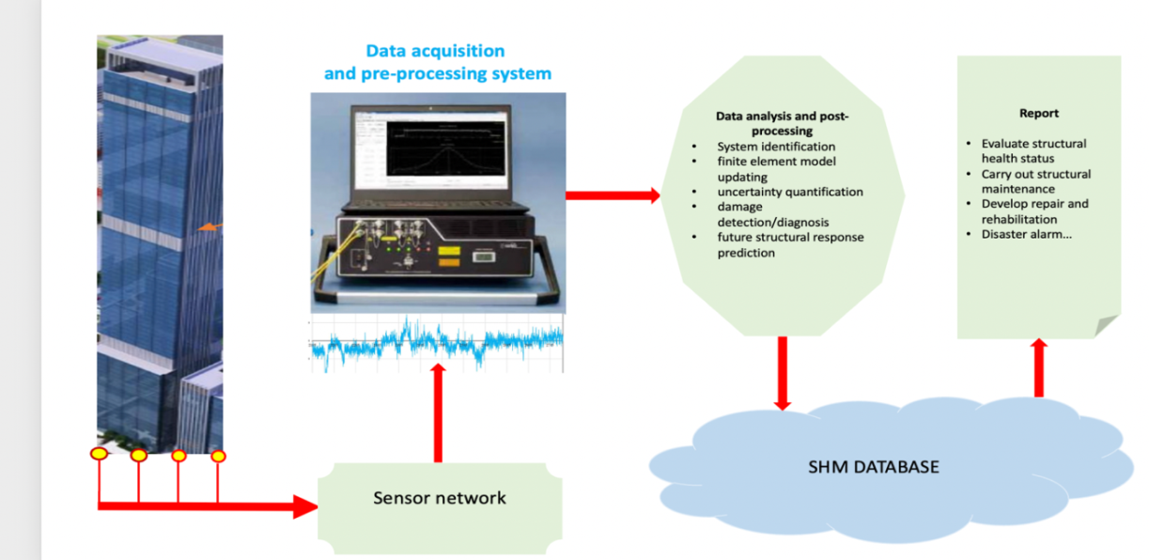

Figure 44 - Integration into the BIM system using the IFC standard

Our challenge is to determine the best format for storing SHM data in a digital database using a BIM system, as this will help improve monitoring efficiency. At the same time, it is necessary to determine which range of data received from sensors will be integrated into the BIM [91-109] system using the IFC standard as a tool for creating a three-dimensional digital model of a real foundation equipped with fiber optic sensors. The software that will transmit data from the recorder to the monitoring room in real time and integrate this data with BIM requirements is the most important aspect of the project.

Of great interest is a plan for future research on integrating BIM models with on-site sensor monitoring to improve the process of visualization and analysis of health monitoring, in addition to the safety of building operation.

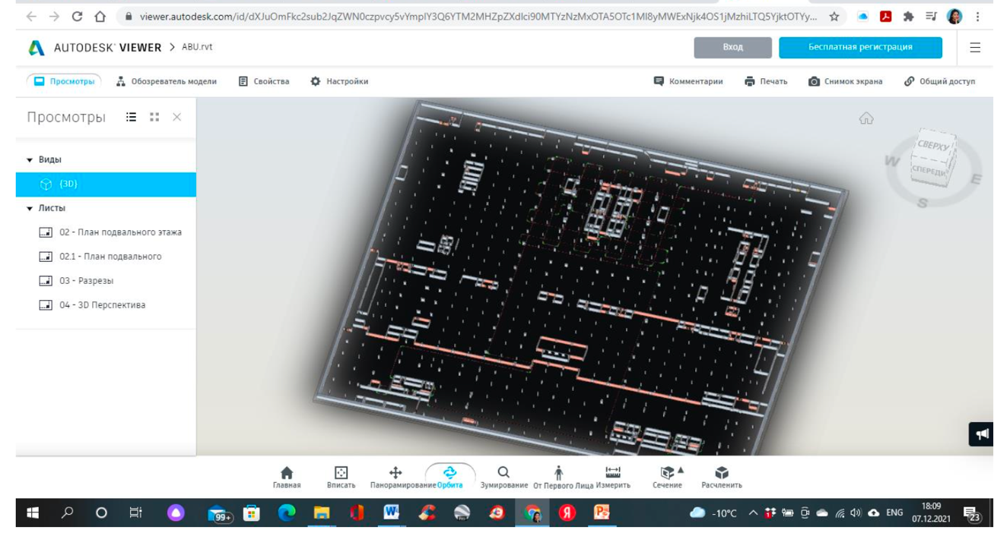

Figure 45 – 3D of the foundation slab and the parking area of the Abu Dhabi Plaza project

In this paper, a foundation slab with an embedded fiber optic sensor was taken as an example to show that the model facilitates data interpretation using a dynamic BIM environment (figure 44). The use of this model will be the result of a study to monitor the condition of the foundation slab and the parking area of the Abu Dhabi Plaza project (figure 45) in the city of Astana and solve various problems that arise during operation. The main goal of this work is to solve such a problem as the dependence of the integrated data in the building information model on the received sensory data over time.

Summary on the section
The gauge length was accepted according to the numerical simulation results presented in Chapter 2 and used in the experimental application of fiber optic monitoring in the base raft. The numerical modelling of the vertical stresses – strain simulation was performed in FLAC 3D and GARP software by Arabtec. The main difference from the results of previous simulations and forecasts on various computer programs on this building is that the simulation considered vertical deformations perpendicular to the loading area, depending on the loading of the building and compression characteristics of the soils. While fiber optics transmits the actual stress-strain interaction results along the length of the cable, that is, in the horizontal plane of raft B4, resting directly on the ground and indicating the current state of the structure. The proposed BIM model allows to cooperate with all ongoing studies in the building and quickly respond to fiber optics cable monitoring readings. This means that it will be possible to notice the cracks in time and provide for the location of the drainage in the basement without damaging the fiber optic cable, etc.
The results of Plaxis 3D numerical modeling where the core of the building reaches the settlement of 38 mm in the raft surface level. The least settled column around the core gains 14 mm of the settlement. So, the differential settlement is 24 mm, and the distance between the core and the least settled column is 20.25 m. With such values of settlement difference, the tensile strain in the horizontal plane in the upper layer of concrete would be less than 1 µε (0.01 mm per 1 m length). However according to SHM, with fiber optic measurement tensile strains with the values varying between −20 to −40 µε, compression from +20 to +40 µε near the walls of the core was registered. Fiber optic cable measures the actual data of the concrete strain exactly in coordinates in the horizontal plane; nevertheless, the pre-simulated modelling shows the most appropriate location for laying the fiber optic cable for further measurement. The simulation shows the overall picture of the settlement of buildings in the plan and omits local effects from the concentrated load of the columns.

5 RECOMMENDATIONS

- Based on the results of the study, we recommend the use of combined strain and temperature sensors, which are designed for distributed monitoring of strain (average strain) and temperature over long distances using BOTDR (Brillouin scattering) technologies.
The recommended DiTeSt SMARTprofile sensor consists of two bonded and two free single-mode optical fibers embedded in a polyethylene thermoplastic profile. The stapled fibers are used for strain monitoring and the free fibers are used for temperature measurement (quantitative if sensor strain is <0.2%, qualitative if sensor strain is >0.2%) and to compensate for temperature effects on the stapled fibers. For redundancy, two fibers are included for strain and temperature monitoring. The advantage of this profile is to provide good mechanical, chemical and temperature resistance. The small size of the profile makes it easy to transport and install the sensor by embedding it in concrete or mortar, gluing or clamping it. The sensor is designed for use in environmental conditions commonly found in civil, geotechnical, and oil and gas applications.
- According to the numerical modelling a gauge length of 2 m is sufficiently long to avoid fracture of the fibre optic and that this value should be selected for the design. The most stringent or minimum required strain resolutions across all expansion events is 22 με. In the case of a reinforced raft thickness of 3.8 m according to Table 10 required strain resolutions for various expansion events at the detectable surface strain limit is 51 με. If this limit is exceeded, additional examinations are required for a local diagnostic examination with concrete sampling and testing for strength characteristics as part of the diagnostic survey. According to the FO cable material properties the maximum determined strain is 1.5%. Therefore when a strain above 1000 με (1%) occurs, a basic structural analysis is recommended, above 1500 με (1.5%) a detailed structural analysis is required. Such recommendations of boundary values were adhered to in chapter 3 during experimental studies.
- Recommended to determine the optimal format of SHM data storage in the digital database using BIM system, as it will help to increase the efficiency of monitoring, further in operation to speed up the decision-making time. All this is achievable if the data obtained from the sensors will be integrated into the BIM system using the IFC standard as a tool for creating a three-dimensional digital model of the real foundation equipped with fiber optic sensors. The data transmitted from the recorder to the monitoring room in real time and integrated with the requirements of BIM, as proposed according to the developed concept will give not only an economic effect, but also become the foundation for the safe operation of the high-rise building.

CONCLUSIONS

As a result of the evaluation of the structural health monitoring data via the applied fiber optic cable, embedded in the raft plane of pile-raft foundations of a high-rise building at the initial stage of its operation, the following conclusions were presented:
1. Fiber optic’s monitoring made it possible to provide actual results of strains in the upper layer of the raft at the lowest level B4 of the high-rise 75-storey block of the Abu Dhabi Plaza building on multilayer soils of Astana city.
2. The compression strains were observed over the entire area of the building with values -20-40 µɛ. A greater values of compression strain, -40-60 µɛ, were registered in the center in the Y direction and along the eastern facade of the block R in the building core with some points up to - 60-80 µɛ.
3. The tension strains are concentrated along the extreme axes of the building, with a predominance in the southern part of the R block, as well as in the immediate vicinity of the columns, in a range of - 20-40 µɛ, with separate spots -40-60 µɛ.
4. Individual patches of tension strains near the columns have been explained by the increased deflection of the raft under the application of a concentrated load (columns).
5. The excess of deformations of 600 με or 0.6 mm m⁻¹ or 0.3 mm for change in crack width are exceeded, requires a local diagnostic examination with concrete sampling and testing for strength characteristics as part of the diagnostic survey.
6. When a strain above 1000 με (1%) occurs, a basic structural analysis is recommended, above 1500 με (1.5%) a detailed structural analysis is required.
7. The results of Plaxis 3D numerical modeling where the core of the building reaches the settlement of 38 mm in the raft surface level. The least settled column around the core gains 14 mm of the settlement. So, the differential settlement is 24 mm, and the distance between the core and the least settled column is 20.25 m. With such values of settlement difference, the tensile strain in the horizontal plane in the upper layer of concrete would be less than 1 µε (0.01 mm per 1 m length).
8. Fiber optic monitoring results at the time of testing did not exceed the permitted values for high-rise building operation; however, they characterized the general picture of the strain in the raft plane and make it possible to determine the initiation of cracks in concrete at an early stage.
9. The proposed BIM model allows to cooperate with all ongoing studies in the building and quickly respond to fiber optics cable monitoring readings. This means that it will be possible to notice the cracks in time and provide for the location of the drainage in the basement without damaging the fiber optic cable, etc.

REFERENCES

- Moehle J.P. The Tall Building Initiative for Alternative Seismic Design // The Structural Design of Tall and Special Buildings. – 2007. – Vol. 16. – P. 559-567.
- Doebling S.W., Farrar C.R., Prime M.B. et al. Damage identification and health monitoring of structural and mechanical systems from changes in their vibration characteristics: A literature review: report. – Los Alamos: National Laboratory, 1996. – 135 p.
- Todd M., Johnson G., Vohra S. Progress Towards Deployment of Bragg Grating-Based Fiber Optic Systems in Structural Monitoring Applications // Procced. European COST F3 conf. on System Identification and Structural Health Monitoring. – Madrid, 2000. – P. 521-530.
- Vandiver T.L. Health Monitoring of US Army Missile Systems // In book: Structural Health Monitoring: Current Status and Perspectives. – Palo Alto, CA: Stanford University, 1997. – P. 191-196.
- Straser E.G., Kiremidjian A.S., Meng T.H. et al. A modular, wireless network platform for monitoring structures // Proceed. of the internat. Modal Analysis conf. – Santa Barbara, CA, 1998. – P. 450-456.
- Sohn H., Farrar C.R., Hemez F.M. et al. A review structural health monitoring literature: 1996-2001: report. – Los Alamos: National Laboratory, 2003. – P. 2-3.
- Beck J.L., Jennings P.C. Structural Identification Using Linear Models and Earthquake Records // Earthquake Engineering and Structural Dynamics. – 1980. – Vol. 8, Issue 2. – P. 145-160.
- Yun Ch.-B., Shinozuka M. 1980, Identification of Nonlinear Structural Dynamic Systems // Journal of Structural Mechanics. – 1980. – Vol. 1980. – Vol. 8, Issue 2. – P. 187-203.
- Ghanem R., Shinozuka M. Structural System Identification // Journal of Engineering Mechanics. – 1995. – Vol. 121, Issue 2. – P. 255-273.
- Naeim F. Performance of 20 Extensively-Instrumented Buildings During the 1994 Northrideg Earthquake // The Structural Design of Tall Buildings. – 1998. – Vol. 7. – P. 179-194.
- Celebi M., Sanli A., Sinclair M. et al. Real-time seismic monitoring needs of a building owner and the solution: A cooperative effort // Earthquake Spectra. – 2004. – Vol. 20, Issue 2. – P. 333-346.
- Cawley P. Long Range Inspection of Structures Using Low Frequency Ultrasound // Structural Damage Assessment Using Advanced Signal Processing Procedures: proceed. Internat. conf. (DAMAS ’97). – Sheffield: Univ. of Sheffield, 1997. – P. 1-17.
- Staszewski W.J., Biemans C., Boller C. et al. Impact Damage Detection in Composite Structures-Recent Advances // In book: Structural Health Monitoring 2000. – Palo Alto, CA: Stanford University, 1999. – P. 754-763.
- Bartelds G. Aircraft Structural Health Monitoring, Prospects for Smart Solutions from a European Viewpoint // In book: Structural Health Monitoring: Current Status and Perspectives. – Palo Alto, CA: Stanford University, 1997. – P. 293-300.
- Skolnik D., Lei Y., Yu E. et al. Identification, Model Updating, and Response Prediction of an Instrumented 15-Story Steel-Frame Building // Earthquake Spectra. – 2006. – Vol. 22, Issue 3. – P. 781-802.
- Moaveni B. et al. Uncertainity and Sensitivity Analysis of Damage Identification Results Obtained Using Finite Element Model Updating // Computer-Aided Civil and Infrastructure Engineering. – 2009. – Vol. 24. – P. 320-334.
- Brownjohn J.M.W., Pan T.C., Deng X.Y. Correlating Dynamic Characteristics from Field Measurements and Numerical Analysis of a High-Rise Building // Earthquake Engineering and Structural Dynamics. – 2000. – Vol. 29. – P. 523-543.
- Smith R., Merello R., Willford M. Intrinsic and Supplementary Damping in Tall Buildings // Structures and Buildings. – 2010. – Vol. 163. – P. 111-118.
- Mekhtiyev A., Bulatbayev F., Neshina Y. et al. The external mechanical effects on the value of additional losses in the telecommunications fiber optic cables under operating conditions // Proceed. of the 6 th internat. conf. on Applied Innovation in IT. – Koethen, 2018. – Р. 123-127.
- Yurchenko A.V., Mekhtiyev A.D., Bulatbaev F.N. et al. Investigation of additional losses in optical fibers under mechanical action // https://iopscience.iop.org/article/10.1088/1757-899X/516/1/012004/pdf. 16.11.2021.
- Yurchenko A.V., Меkhtiyev А.D., Bulatbayev F.N. et al. The Model of a Fiber- Optic Sensor for Monitoring Mechanical Stresses in Mine Working // Russian Journal of Nondestructive Testing. – 2018. – Vol. 54, Issue 7. – Р. 528-533.
- Soga K., Kwan V., Pelecanos L. et al. The role of distributed sensing inunderstanding the engineering performance of geotechnical structures // Procced. 16th European conf. on Soil Mechanics and Geotechnical Engineering. – Edinburgh, 2015. – P. 13-48.
- Soga K. Understanding the realperformance of geotechnical structures using an innovativefibre optic distributed strain measurement technology // Rivista Italiana di Geotechnica. – 2014. – Vol. 4. – P. 7-48.
- Kechavarzi C. Distributed Fibre Optic Strain Sensing For Monitoring Civil Infrastructure: A practical guide. – London, 2016. – 264 p.
- Murayama H., Kageyama K., Naruse H. et al. Ap- plication of fiber-optic distributed sensors to health monitoring for full-scale composite structures // Journal of Intelligent Material Systems and Structures. – 2003. – Vol. 14, Issue 1. – P. 3-13.
- Motil A., Bergman A., Tur M. [INVITED] State of the art of Brillouin fiber-optic distributed sensing // Optics and Laser Technology. – 2016. – Vol. 78. – P. 81-103.
- Lees G.P., Wait P.C., Cole M.J. et al. Advances in optical fiber distributed temperature sensing using the Landau-Placzek ratio // IEEE Photonics Technology Letters. – 1998. – Vol. 10, Issue 1. – P. 126-128.
- Boyd R.W. Nonlinear Optics. – Ed. 3rd. – Amsterdam, 2008. – 640 p.
- Bao Y., Chen G. Temperature-dependent strain and temperature sensitivities of fused silica single mode fiber sensors with pulse pre-pump Brillouin optical time domain analysis // Measurement Science and Technology. – 2016. – Vol. 27, Issue 6. – P. 65101-65111.
- Bao X., Chen L. Recent progress in Brillouin scattering based fiber sensors. Sensors. – 2011. – Vol. 11, Issue 4. – P. 4152-4187.
- Omnisens S.A. Analysis of strain sensor cable models and effective deployments for distributed fiber optical geotechnical monitoring system. ASME 2015 International Pipeline Geotechnical Conference, Bogota, 2015. – 10 р.
- Mohamad H. Temperature and strain sensing techniques using Brillouin optical time domain reflectometry // In book: Smart Sensor Phenomena, Technology, Networks, and Systems Integration. – San Diego, 2012. – P. 1-13.
- Bouzabata H. et al. Effect of restraint on expansion due to delayed ettringite formation // Cement and Concrete Research. – 2012. – Vol. 42, Issue 7. – P. 1024-1031.
- Ceary M.Sh. Characterization of delayed ettringite formation in Maryland bridges: thesis of doc. PhD. – Washington: University of Maryland, 2007. – 304 p.
- Hanehara S., Oyamada T. et al. Reproduction of delayed ettringite formation (DEF) in concrete and relationship between DEF and alkali silica reaction // Proceedings of Fracture Mechanics of Concrete and Concrete Structures – Seoul: Korea Concrete Institute, 2010. – P. 1024-1029.
- Kchakech B. et al. Experimental study of the influence of the temperature and duration of heat treatments at an early age on the risk of concrete expansion associated with delayed ettringite formation // Concreep 10 – Mechanics and Physics of Creep, Shrinkage and Durability of Concrete and Concrete Structures: proceed. of the 10th internat. conf. – Vienna: American Society of Civil Engineers, 2015. – P. 455-465.
- Martin R.P., Renaud J.C., Toutlemonde F. Experimental investigations concerning combined delayed ettringite formation and alkali aggregate reaction // (CONSEC10) Concrete under severe conditions: proceed. of the 6th internat. conf. – Mexico: s.n., 2010. – Р. 1-10.
- Rønne M., Hammer T.A. Delayed ettringite formation (DEF) in structural lightweight aggregate concrete: effect of curing temperature, moisture, and silica fume content // American Society for Testing and Materials. – 1999. – Vol. 21. – Р. 202-211.
- Ramlochan, T. The effect of pozzolans and slag on the expansion of mortars and concrete cured at elevated temperature // Cement and concrete research, volume 34, issue 8, August 2004. – P. 1341-1356.
- Мехтиев А.Д., Юрченко А.В., Нешина Е.Г. и др. Неразрушающий контроль дефектов и повреждений конструкций железобетонных фундаментов при помощи оптических волокон стандарта g.652 // Дефектоскопия. – 2020. – №2. – С. 50-62.
- Калитеевский Н.И. Волновая оптика. – М.: Высшая школа, 1995. – 463 с.
- Поулос Г.Г. Высотные здания и фундаменты глубокого заложения – сложные задачи строительства на Ближнем Востоке // Развитие городов и геотехническое строительство. – 2011. – №1. – С. 1-55.
- Николаев С.В. Безопасность и надежность высотных зданий – это комплекс высокопрофессиональных решений // USTBuilol-2004: инф. сб. – М.: ЦНТСМиО, 2004. – С. 8-18.
- Маклакова Т.Г. Высотные здания. Градостроительные и архитектурно-конструктивные проблемы проектирования. – М.: Ассоциация строительных вузов, 2006. – 160 с.
- Conceptual design for an internal drainage remedial scheme: Report submitted to Arabtec Consolidated Contractors Ltd / Golder Associates. – Hong Kong, 2018. – 50 p.
- Retaining wall drainage and façade remedial scheme: report / Golder Associates. – Hong Kong, 2019. – 20 p.
- Knights J. Abu Dhabi Plaza: Management of potential expansive reactions for WP3 foundation raft slabs. Jon Knights Materials Consulting Limited. s.l. - London, 2015. – 120 p.
- Knights J. Abu Dhabi Plaza: Review and assessment of concrete chemical data for basement slab. – Astana, 2018. – 70 p.
- Conceptual proposal for long-term base slab monitoring / Golder Associates. – Hong Kong, 2019. – 45 р.
- Zhussupbekov A., Alibekova N., Akhazhanov S. et al. Development of a Unified Geotechnical Database and Data Processing on the Example of Nur-Sultan City // Appl. Sci. – 2021. – Vol. 11. – P. 306-1-306-19.
- EN 1992-1-2. Eurocode 2: Design of Concrete Structures - Part 1-2 // https://www.phd.eng.br/wp-content/uploads/2015/12/en.1992.1.2.2004. 03.03.2021.
- Foundation sections and details – Sheet-2. Revision 000 Stage F – construction drawings: construction drawings / Ramboll. – Dubai, 2011. – 20 p.
- Standard notes (Sheet 1): Drawing issued for construction / Arabtec Consolidated Contractors Joint Venture. – Astana, 2014. – 20 р.
- Ramboll. Foundation reinforcement sections and details – Sheet-2. Revision 000 Stage F – construction drawings: Construction drawings. – Dubai, 2011. – 20 р.
- SMARTprofile strain sensing cable / ed. M. Nova. – Manno, 2021. – 12 p.
- Ravet F. et al. Submillimeter Crack Detection With Brillouin-Based Fiber-Optic Sensors // IEEE Sensors Journal. – 2009. – Vol. 9, Issue 11. – P. 1391-1396.
- ГОСТ 19912-2012. Грунты. Методы полевых испытаний статическими динамическим зондированием. – Введ. 2013-12-20. М., 2013. – 24 с.
- СП РК 1.02-105-2014. Инженерные изыскания для строительства. Основные положения. – Введ. 2014-12-29. – Астана, 104 с.
- СН РК 5.01-102-2013. Основания зданий и сооружений. – Введ. 2014-12-29. – Астана, 2015. – 167 с.
- СП РК 1.02-105-2014. Инженерные изыскания для строительства. Основные положения. – Введ. 2014-12-29. – Астана, 104 с.
- ГОСТ 25100-2020. Грунты. Классификация. – Введ. 2021-01-01. – М., 2020. – 41 с.
- ГОСТ 9.602-2016. Единая система защиты от коррозии и старения. Сооружения подземные. Общие требования к защите от коррозии. – Введ. 2017-07-01. – М., 2016. – 93 с.
- СН РК 8.02-14-2005. Сборники укрупненных сметных норм и расценок // https://continent-online.com/Document. 15.04.2021.
- SN RK 5.01-03-2013 Pile foundations. – Publ. 2013. – https://online.zakon.kz/Document/?doc_id=37524597. 20.11.2021
- IEC standards. SC86A: Fibers and Cables // https://www.iec.ch/dyn/ www/f?p=103:30:713774407947745. 20.11.2021.
- IEC standards. SC86B: Fiber optic interconnecting devices and passive components // https://www.iec.ch/dyn/www/f?p. 20.11.2021.
- IEC standards. SC86C: Fiber optic systems and active devices // https://www.iec.ch/dyn/www/f?p. 20.11.2021.
- ITU – R. Radiocommunication sector // https://www.itu.int/en/publications /ITU-R/Pages/default.aspx // 17.01.2022.
- ITU – Working methods for study groups of the ITU Telecommunication Standardization Sector. – Publ. 2019-09.
- ITU – T. SERIES X: data networks and open system communications. Public data networks – Transmission, signalling and switching – Publ. 2011-03..
- IEC 61300-3-35: Fibre optic connector end face visual inspection. – https://www.maytelecom.com.cn/wp-content/uploads/IEC_61300-3-35_Standard.pdf.
- IEC 60793-1 and -2: Optical fibers (includes several parts). – Publ. 2019-05-28.
- IEC 60794-1, -2, -3: Optical fiber cables. – Publ. 2021-09-07.
- G.651: Characteristics of 50/125 μm Multimode graded-index optical fiber. - Publ.20188-11.
- G.652: Characteristics of single-mode optical fiber and cable. – Publ. 2016-11. – P.1-28
- G.653: Characteristics of single-mode dispersion shifted optical fiber and cable. – Publ. 2010-07.
- G.654: Characteristics of cut – off shifted single-mode optical fiber and cable. – Publ. 2020.03.
- G.655: Characteristics of non-zero dispersion shifted single-mode optical fiber and cable. – Publ. 2009-11-26.
- G.656: Characteristics of non-zero dispersion shifted fiber for wideband transport. – Publ. 2010-04-20.
- G.657: Characteristics of a bending loss insensitive single-mode fiber for access networks. – Publ. 2016-04-12.
- IEC 61350: power meter calibration. – Publ. 1995-01-11.
- IEC 61746: OTDR calibration. – Publ. 2011-01-2.
- G.650.1: Definition and test methods for linear, deterministic attributes of single-mode fiber and cable. – Publ. 2020-10.
- G.650.2: Definition and test methods for statistical and non-linear attributes of single-mode fiber and cable. – Publ. 2015-08.11.
Rodenas-Herraiz D. Wireless Sensor Networks for Civil Infrastructure Monitoring: A Best Practice Guide. – Cambridge, 2016. – 210 p.
- ASTM International. Standard test method for accelerated tensile creep and creep-rupture of geosynthetic materials based on time-temperature superposition using the stepped isothermal method. – Publ. 2016-05-15. – West Conshohocken: ASTM International, 2016. – 8 р.
- Buranbayeva A.M., Zhussupbekov A.Zh., Omarov A.R. Numerical analysis and geomonitoring of behaviour of foundation of Abu-Dhabi Plaza in Nur-Sultan // Journal of Physics: Conference Series. – 2021. – Vol. 1928, Issue 1. – P. 012033.
- Zhussupbekov A., Mangushev R., Omarov A. Geotechnical Piling Construction and Testing on Problematical Soil Ground of Kazakhstan and Russia // Lecture Notes in Civil Engineering. – 2021. – Vol. 112. – P. 89-107.
- Buranbayeva А., Zhussupbekov А., Nursafin R., K. Badashvili. Design a Building Information Modeling (BIM) project concept in combination with foundation monitoring on the example of the Abu Dhabi Plaza construction project / BULLETIN of L.N. Gumilyov Eurasian National University. Technical Science and Technology Series. – 2022. – Vol. 138.
- ISO 12006-2 – Information classification in construction. – Publ. 2015-05-01. – Geneva, 2015. – 23р.
- BS EN ISO 13567-1, 13567-2 – CAD overview, codes, and formats used in the construction documentation– Publ. 2017-11-15. – Brussels, 2017. – 17 р.
- BS EN ISO 19650-1. Organization and digitization of information about buildings and civil engineering works, including building information modelling -- Information management using building information modelling: Concepts and principles. – Publ. 2019-01-31. – London, 2019. – 34 р.
- BS EN ISO 19650-2. Organization and digitization of information about buildings and civil engineering works, including building information modelling -Information management using building information modelling: Delivery phase of the assets. – Publ. 2021-02-28. – London, 2021. – 26 р.
- BS EN ISO 19650-3:2020. Organization and digitization of information about buildings and civil engineering works, including building information modelling (BIM). Information management using building information modelling. Operational phase of the assets. – Publ. 2020-08-31. – London, 2020. – 30 р.
- BS EN ISO 19650-4:2022 Organization and digitization of information about buildings and civil engineering works, including building information modelling (BIM). Information management using building information modelling - Information exchange. – Publ. 2022-08 – London, 2022. – 12 р.
- BS EN ISO 19650-5:2020. Organization and digitization of information about buildings and civil engineering works, including building information modelling (BIM). Information management using building information modelling – Part 5: Security-minded approach to information management. – Publ. 2020-08. – London, 2020. – 28 р.
- Приказ Председателя Комитета по делам строительства и жилищно-коммунального хозяйства Министерства по инвестициям и развитию Республики Казахстан. Об утверждении руководящего документа в строительстве Республики Казахстан 1.02-04-2018 "Информационное моделирование в строительстве. Основные положения": утв. 10 декабря 2018 года, №253-нқ // https://adilet.zan.kz/rus/docs/V1800017950. 23.08.2021.
- СП РК 1.02-111-2017. Применение информационного моделирования в проектной организации // https://adilet.zan.kz/rus/docs/W17NB312_11. 23.08.2021.
- СП РК 1.02-112-2018. Жизненный цикл строительных объектов. Часть 1 // https://online.zakon.kz/Document/?doc_id=32643365. 15.03.2022.
- СП РК 1.02-113-2018. Жизненный цикл строительных объектов. Часть 2 // https://online.zakon.kz/Document/?doc_id=35901877. 15.03.2022.
- СП РК 1.02-114-2018. Жизненный цикл строительных объектов. Часть 3 // https://online.zakon.kz/Document/?doc_id=36100670. 15.03.2022.
- СП РК 1.02-115-2018. Правила организации совместного создания информации о строительстве // https://online.zakon.kz/Document. 15.03.2022.
- СП РК 1.02-116-2018. Требования к оформлению проектной документации // https://online.zakon.kz/Document/?doc_id=36475085. 15.03.2022.
- СП РК 1.02-117-2018. Порядок проведения экспертизы информационных моделей // https://online.zakon.kz/Document/?doc_id=36360957. 15.03.2022.
- СП РК. Жизненный цикл строительных объектов. Часть 4. Требования к моделям на стадии строительства // https://online.zakon.kz/ Document/?doc_id=39355511. 23.08.2021.
- СП РК. Жизненный цикл строительных объектов. Часть 5. Требования к моделям на стадии эксплуатации // https://online.zakon.kz/ Document/?doc_id=38578808. 23.08.2021.
- СП РК. Применение информационного моделирования в строительной организации // https://online.zakon.kz/Document/?doc_id=35617794. 23.08.2021.
- СП РК. Применение информационного моделирования в эксплуатирующей организации // https://online.zakon.kz/Document/. 23.08.2021.

APPENDIX A

Cable routing locations

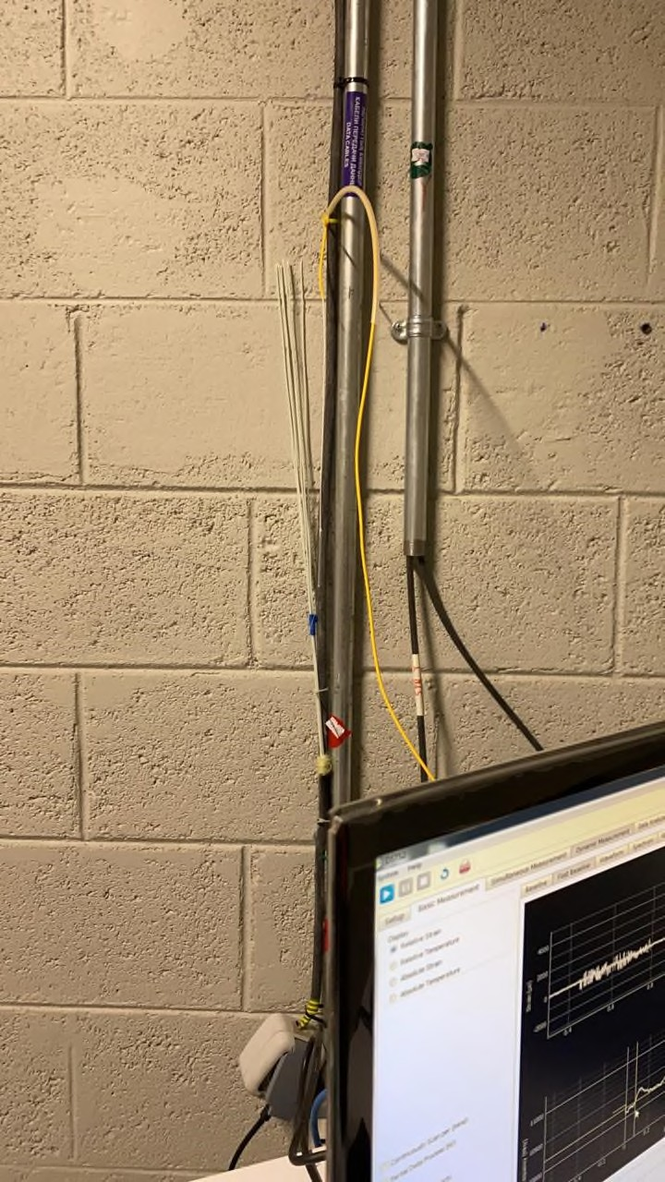

Figure A.1 - Location 1. Monitoring Room

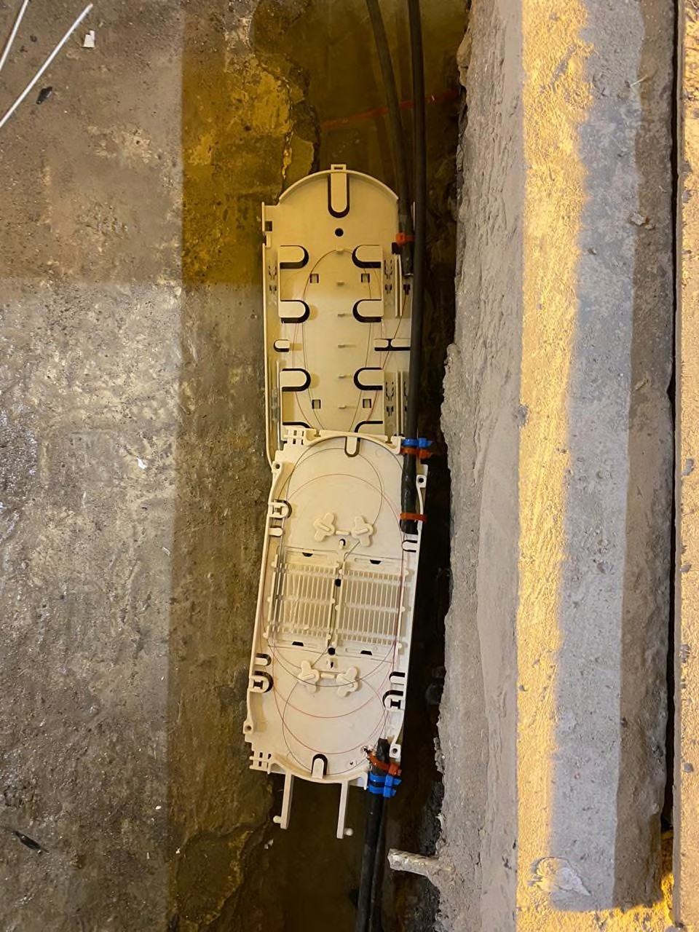

Figure A.2 - Location 2. CH741 & CH2822 (Lead Cable Section)

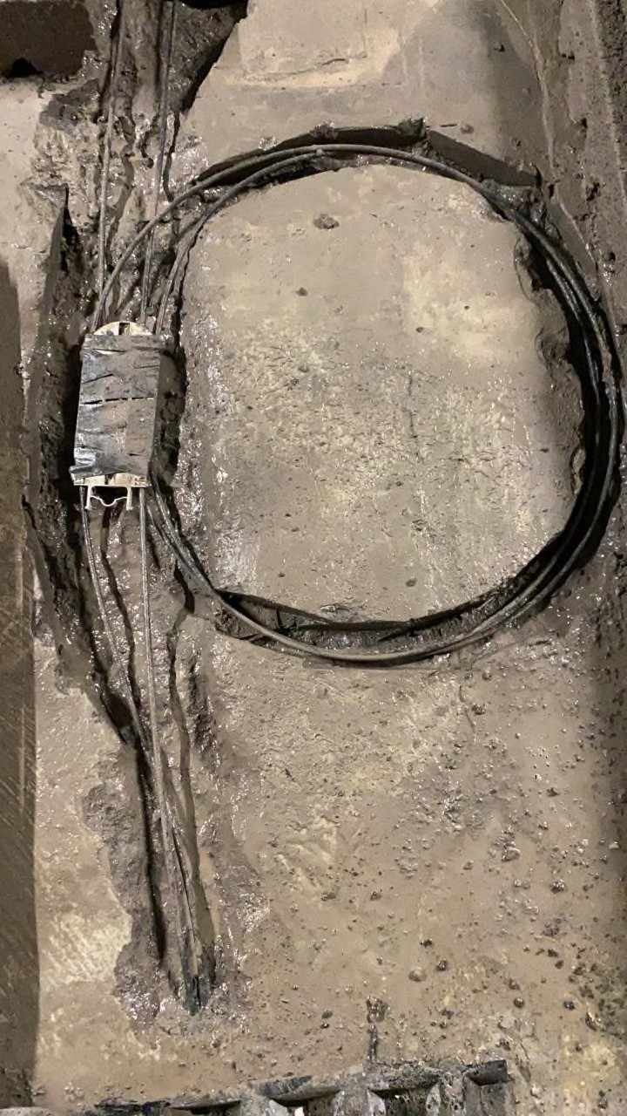

Figure A.3 - Location 2. CH741 & CH2822 (Lead Cable Section)

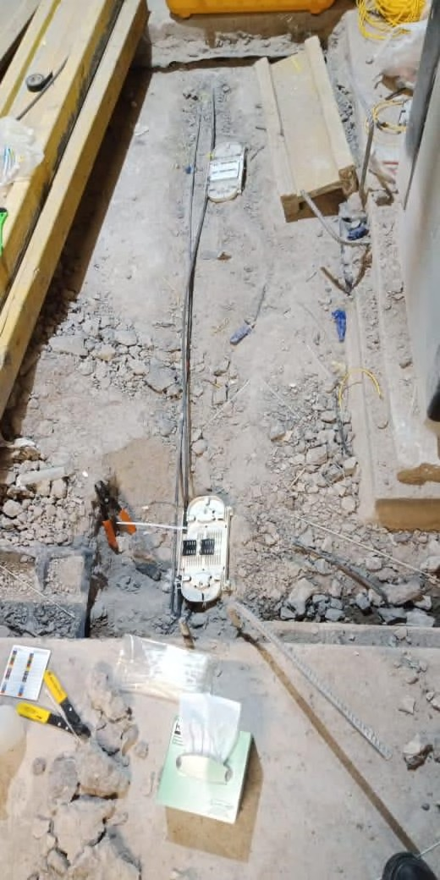

Figure A.4 - Location 3 – CH2655 (Temperature)

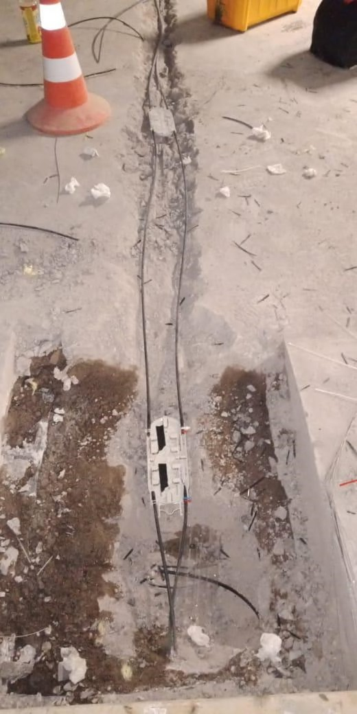

Figure A.5 - Location 4. CH505 (Strain) & CH2589. (Temperature)

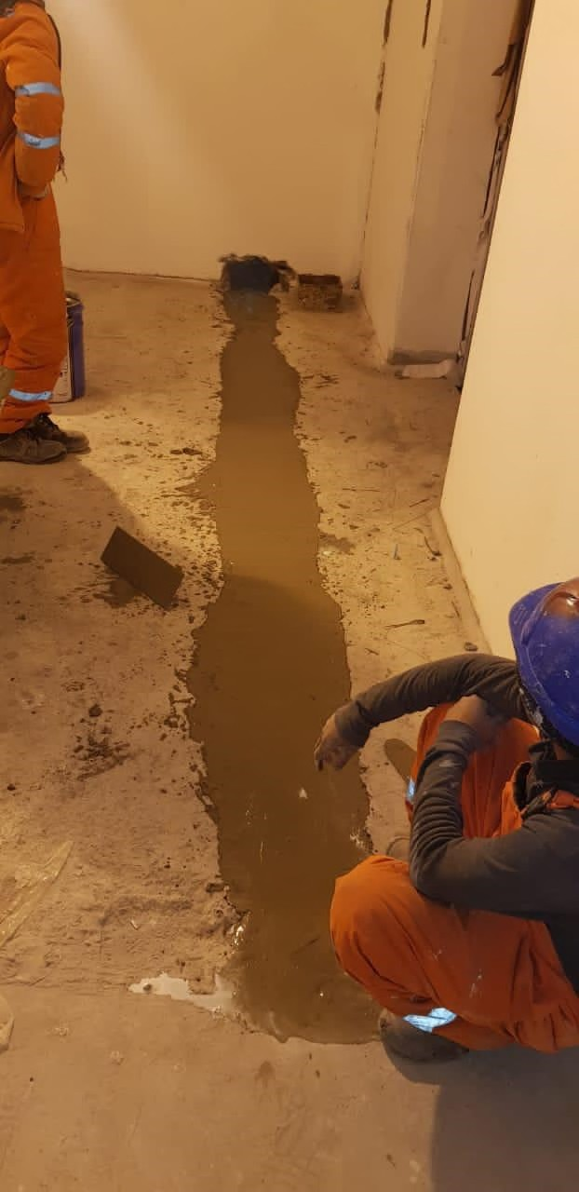

Figure A.6 - Location 5. CH400 (Strain) & CH2484 (Temperature)

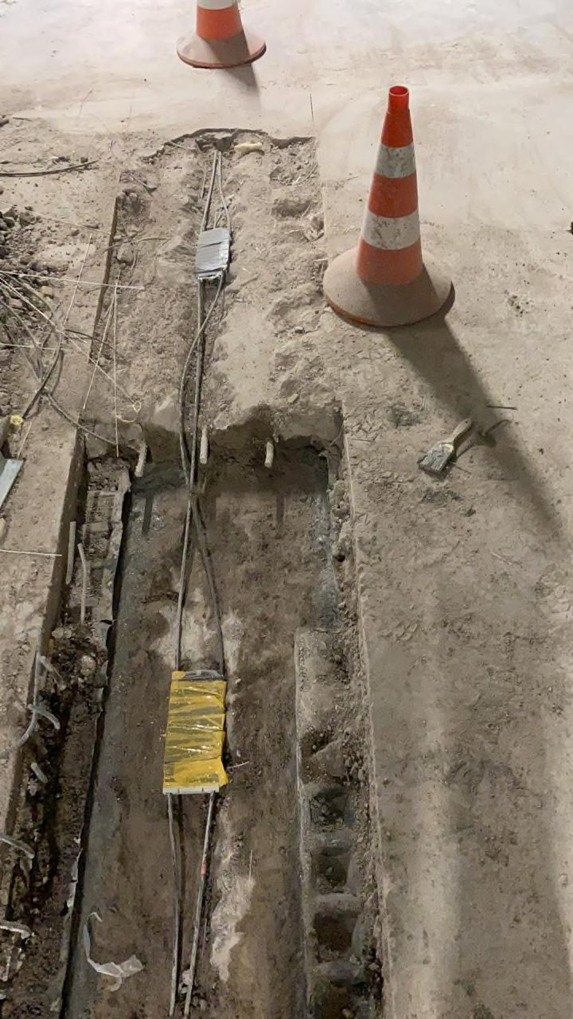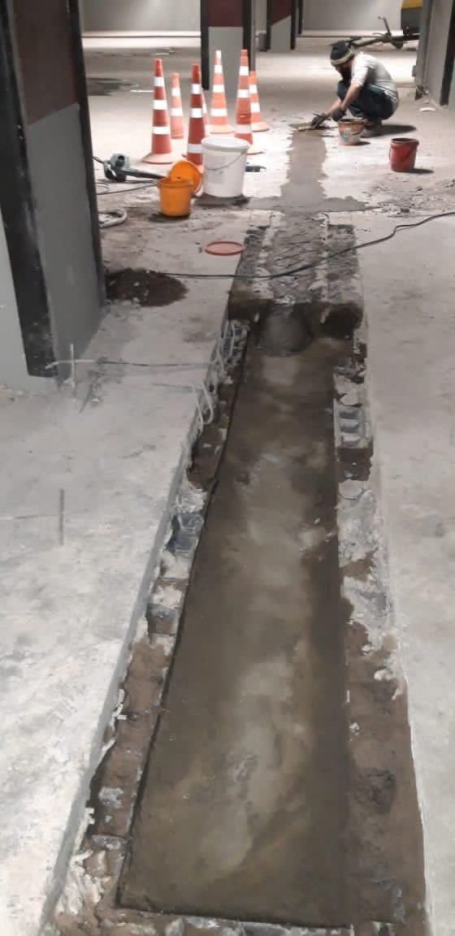

Figure A.7 - Location 6. CH462 (Strain) & CH2545 (Temperature)

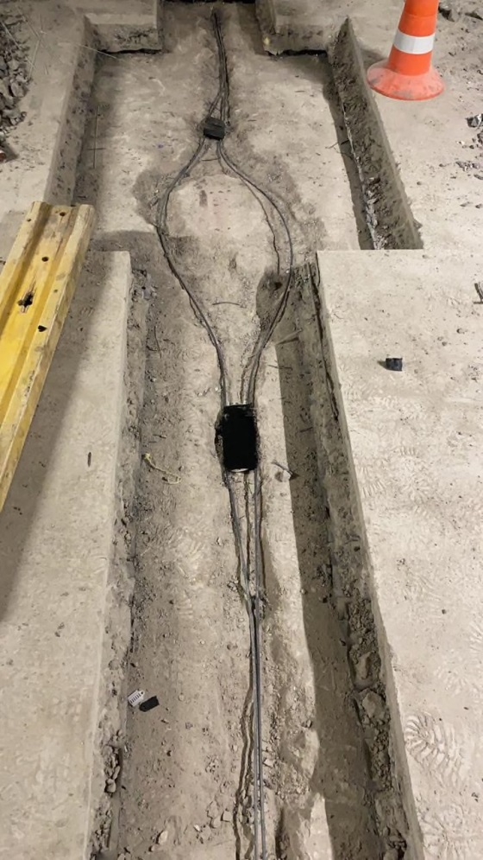
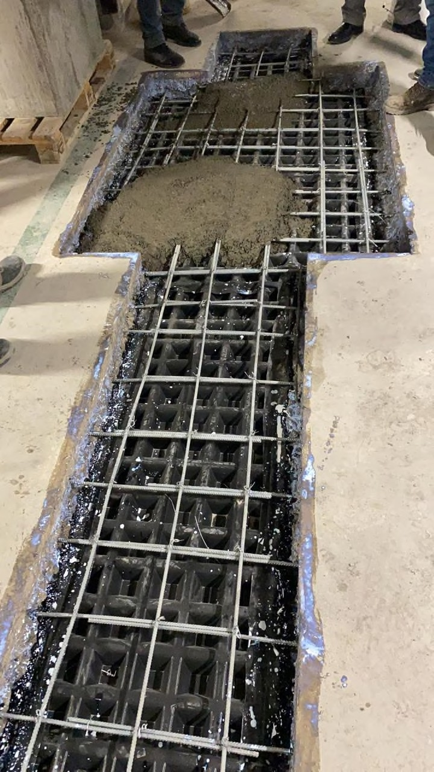

Figure A.8 - Location 7. CH1045 & CH3117 (Lead Cable Section)

APPENDIX B

Distributed fiber optic sensor for civil and geotechnical integrity monitoring
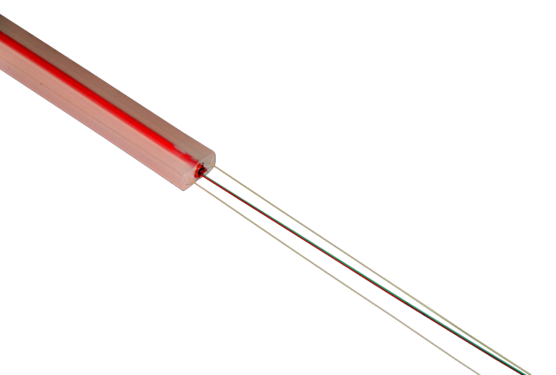

High-accuracy distributed strain and temperature sensing.
Fully redundant configuration. For embedded or surface mounted installation.

Description
Key Features

The DiTeSt SMARTprofile combined strain and temperature sensors are designed for distributed deformation (average strain) and temperature monitoring over long distances, using BOTDR / BOTDA (Brillouin scatter- ing) technologies.

The DiTeSt SMARTprofile sensor consists of two bonded and two free single mode optical fibers embedded in a polyethylene thermoplastic profile. The bonded fibers are used for strain monitoring, while the free fibers are used for temperature measurements (quantitative if sensor deformation <0.2%, qualitative if sensor deformation >0.2%) and to com- pensate temperature effects on the bonded fibers. For redundancy, two fibers are included for both strain and temperature monitoring. The profile itself provides good mechanical, chemical and temperature resistance. The small size of the profile makes the sensor easy to transport and install by embedding in concrete or mortars, gluing or clamping. The SMARTProfile sensor is designed for use in environmental conditions typically found in civil, geotechnical and oil & gas applications. However, this sensor cannot be used in extreme temperature environments, nor in environments with aggressive chemicals. It is not recommended for installation under permanent UV radiation (e.g. sunshine) without an additional cover or aluminum tape protection.

The SMARTprofile sensing cable is delivered on spools with all the nec- essary accessories such termination and connectors (E2000, FC-PC or other).
  - DiTeSt (BOTDA / BOTDR) compatible
  - Multi functional: strain and temperature
  - Robust construction
  - Easy handling
  - Chemically resistant
  - Easy and rapid installation
  - Light weight and small dimensions

Applications

  - Civil infrastructure
  - Tunnel monitoring
  - Settlement and sinkhole detection
  - Concrete crack detection and localization
  - Distributed pipeline strain monitoring

Temperature Range

Operating temperature: -40 °C to +60 °C

Storage temperature: -5 °C to +40 °C

Installation temperature: -5 °C to +50 °C

Pigtails and connectors: -40°C to +60°C

Technical Data

Temperature compensation: through temperature fibers if strain ≤ 0.3 % Calibration: during production
Strain range: -1.5 % to +1.5 %

Maximal length: 800 m / reel, more upon request

Dimensions (W x H): 8.0 mm x 4.0 mm

Weight: 22 ± 0.5 kg/km

Max tensile strain: 1.5 %

Min bending radius: 400 mm (long term)

Hydrostatic pressure: 300 kPa (bar)

Fiber Types

Fiber support (strain): 2 SMF 9 / 125 mm Polymide coated ITU-T G.652.D compliant Fiber support (temperature): 2 SMF 9 / 125 mm Acrylate coated ITU-T G.652.D compliant
≤ 1.2 dB @ 1310 nm - strain
≤ 1 dB @ 1550 nm – strain

Fiber attenuation (cabled @ 20 °C):
≤ 0.4 dB @ 1310 nm - temperature
≤ 0.3 dB @ 1550 nm – temperature

Number of fibers: 2 strain fibers + 2 temperature fibers

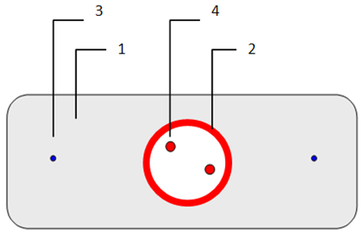

LDPE matrix PVC loose tube
Polymide coated SMF Standard acrylate coated SMF

Accessories and ordering information 11.1030 DiTeSt SMARTProfile Sensor Accessories:
- Cable termination with connectors
- Junction box
- Splice box

APPENDIX C

Length of Curved cable Transition for steps and ramps

Transmission of light along an optical fibre relies upon internal refraction at the interface of the core of the fibre and its cladding. Excessive curvature of the fibre results in light escaping from the core into the surrounding cladding and leads to significant or even total loss of the optical signal. To maintain losses to an acceptable level the fibre optic cable is typically specified with an allowable bending radius 𝑟_{min}.
Steps and ramps in the base slab introduce locations along the fibre alignment where the bending radius approaches zero. At such locations the elevation of the cable must be profiled to ensure that the allowable bending radius is not exceeded.
Depending upon the depth of the cable channel, adjusting the height of the cable within the channel can accommodate a degree of elevation profiling. More substantial profiling can be achieved by varying the channel depth. This appendix recommends minimum lengths of cable over which the elevation must be profiled.

Formulation for steps
For a step the minimum cable length for elevation profiling is derived through considering the geometry illustrated in Figure C.1 where:
- α_{max} is the maximum depth to which the cable may be installed within the channel
- α_{min} is the minimum depth to which the cable may be installed within the channel
- 𝑑₁ is the minimum cable length for elevation profiling along the slab at the foot of the step
- 𝑑₂ is the minimum cable length for elevation profiling along the slab at the top of the step
- ℎ is the step height
In the following equations α is defined as the range of elevation over which the cable depth may be varied within the channel and is equal to α_{max} − α_{min}.
If the step is sufficiently high the length 𝑑₁ is independent of the step height and is dependent only upon α_{𝑐} and 𝑟_{min}. However, if the height of the step is low enough 𝑑₁ is subject to a limit dependent upon the step height according to Equation (1). In Equation 11 a factor 𝑓 is applied to 𝑟_{min} to account for inaccuracies when attempting to install the cable to the minimum bending radius. A factor of 1.5 is recommended and applied in this appendix.

$d1 = min\left(\frac{1}{2}\sqrt{h\left(4fr_{min}-h\right)} ,\sqrt{a_{c}\left(2fr_{min}-a_{c}\right)} \right)$ (1)
The total minimum length for profiling 𝑑₁ ₊ 𝑑₂ is given in Equation (2):

𝑑₁ ₊ 𝑑₂ = $\left\{\frac{2fr_{min}}{\sqrt{h(4fr_{min}-h)}}\right\}$ for h ≥ 2fr_{min.} for h < 2fr_{min.} (2)
The length 𝑑₂ is thus determined by subtracting 𝑑_{1.} from the total length given in Equation (3).
Plots of 𝑑₁ and 𝑑₂ are presented in Figure C.2, C.3, C.4 for α_{𝑐} equal to 0,5 and 10 mm respectively. The case of α_{𝑐} equal to zero corresponds to the channel being insufficiently deep for the cable elevation to vary within the channel; in this case the cable must run at constant elevation along the slab at the foot of the step until it reaches the step itself resulting in 𝑑₁ being equal to zero. For non-zero α the solid line refers to 𝑑₂ and where 𝑑₁ is less than 𝑑₂ the dashed line indicates 𝑑₁.

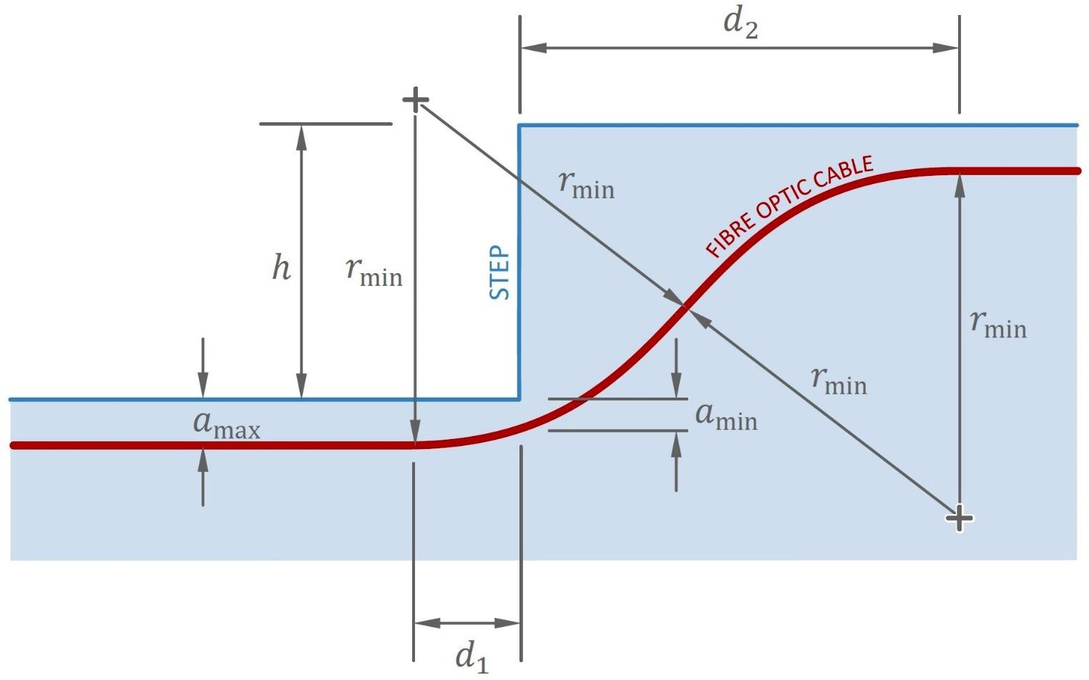

Figure C.1 - Geometry of curved cable transition for a step

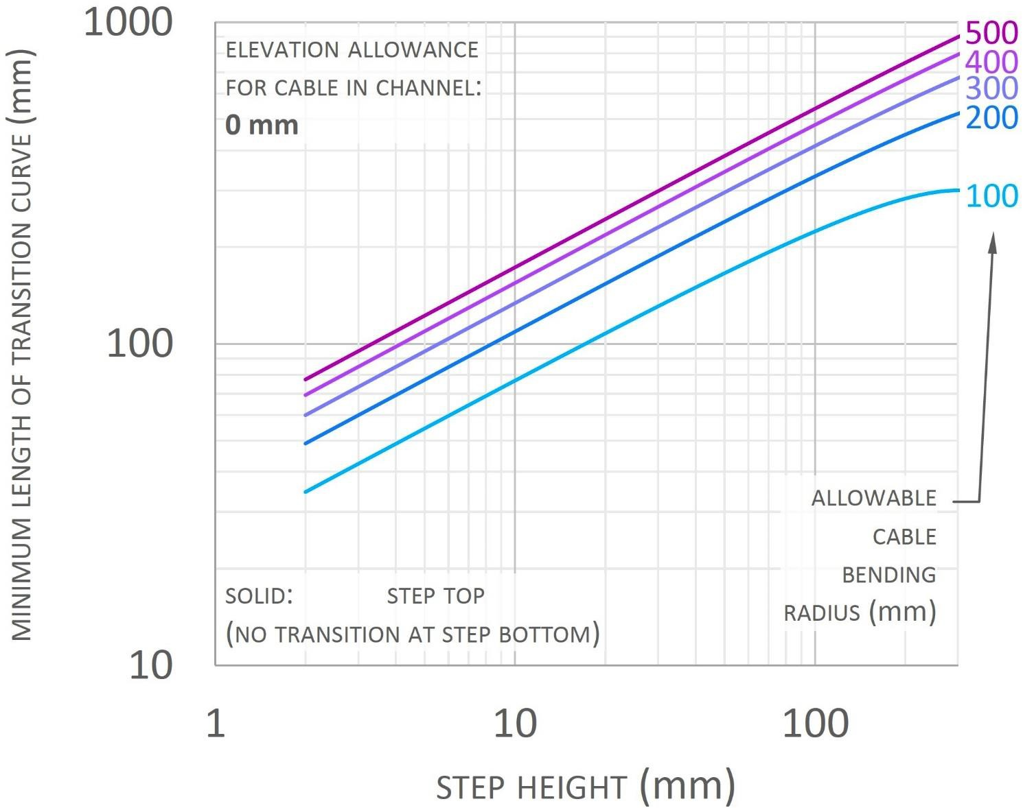

Figure C.2 – Plot of minimum curved cable transition lengths for a step when the elevation allowance of the cable in the channel is zero
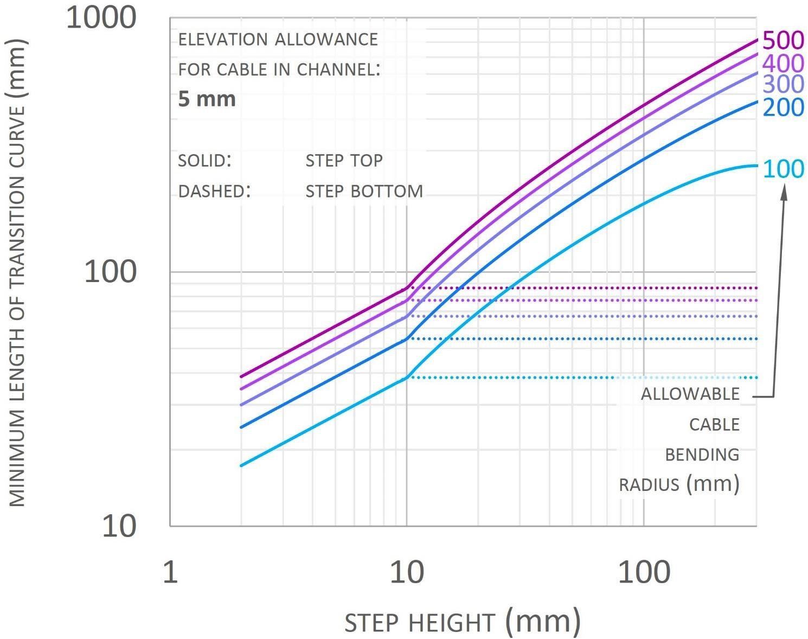

Figure C.3 – Plot of minimum curved cable transition lengths for a step when the elevation allowance of the cable in the channel is 5 mm

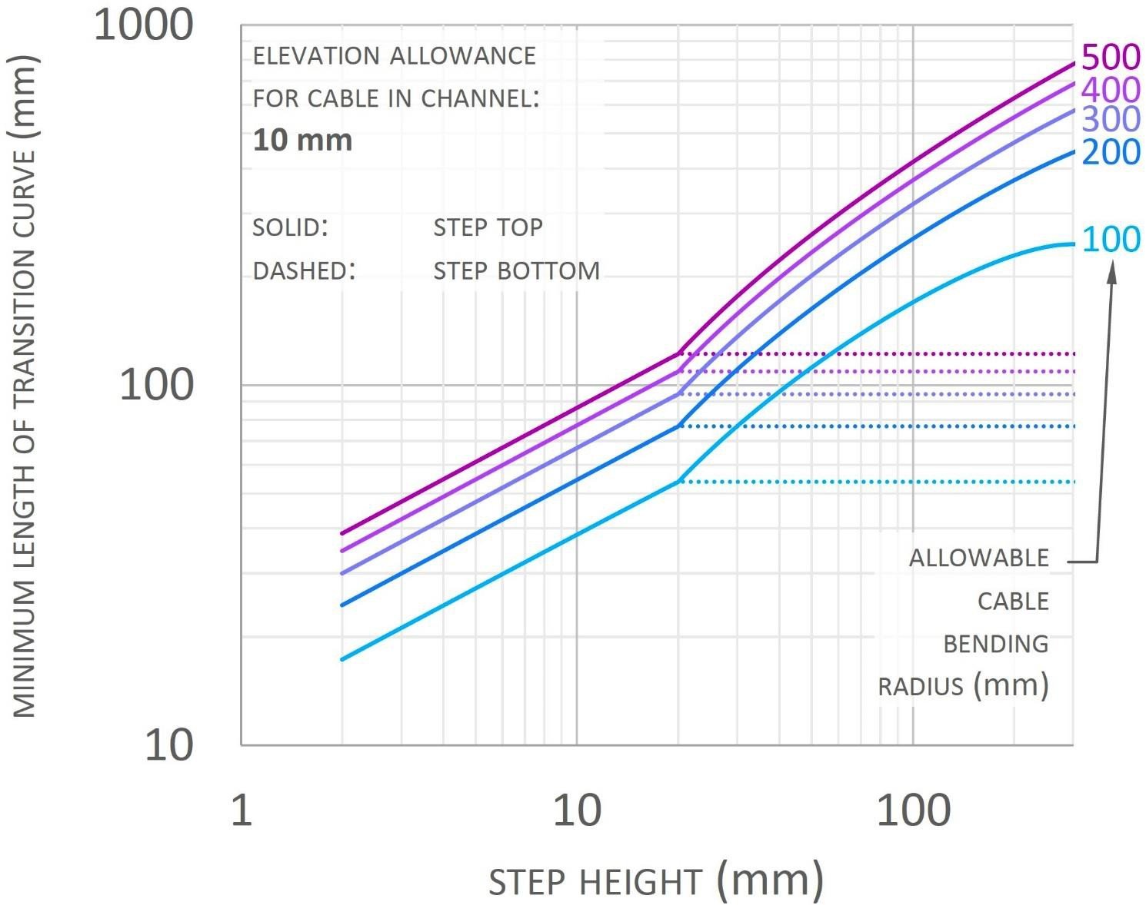

Figure C.4 – Plot of minimum curved cable transition lengths for a step when the elevation allowance of the cable in the channel is 10 mm

Formulation for ramps
For a ramp the geometry is potentially more complex than for a step, as shown in Figure 55. If the gradient of the ramp is sufficiently shallow the cable needs only to curve upwards as the cable ascends the ramp and the curved portion is the sum of the lengths 𝑑₁ and 𝑑₂ as shown in the figure. The length 𝑑₁ is given by Equation (3) where 𝜃 is the ramp angle:

𝑑₁ = $\left\{\frac{fr_{min}sin⁡(\frac{1}{2})}{\sqrt{a_{c}(2fr_{min}-a_{c})}}\right\}$
(3)
for $a_{c}fr_{min}\left(1-\cos\left(\frac{1}{2}\right)\right) for a_{c}<fr_{min}\left(1-\cos\left(\frac{1}{2}\right)\right)$

The length 𝑑₂ is then given by Equation (4):

𝑑₂=$\left\{\frac{d_{1}}{fr_{min}\sin\left(\frac{1}{2}\right)-d_{1}}\right\}$
(4)
for $a_{c}fr_{min}\left(1-\cos\left(\frac{1}{2}\right)\right) for a_{c}<fr_{min}\left(1-\cos\left(\frac{1}{2}\right)\right)$

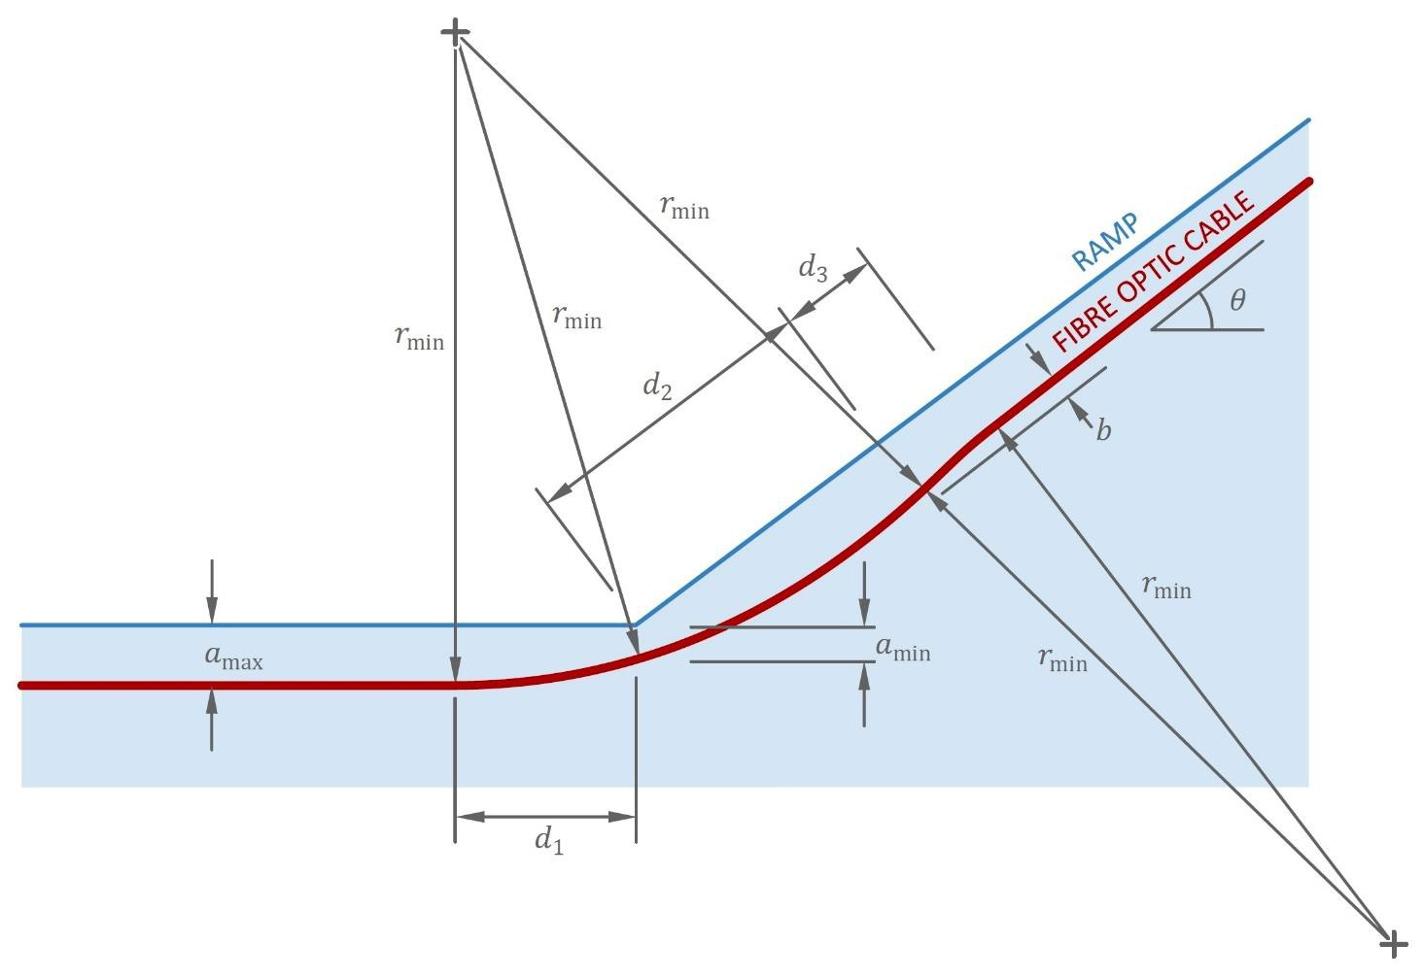
Figure C.5 - Geometry of curved cable transition for a ramp

For steeper ramps the cable initially curves upwards but finally it must curve in the opposite direction for the cable depth to return to its original level in the channel. The oppositely-curving portion is indicated by the length 𝑑₃ in Figure C.5. The length 𝑑₃ is most readily determined by treating the cable as ascending a step of height b as depicted in the figure. The formulation of 𝑑₃ is then analogous to Equation 12 as expressed in Equation (5):
where b is given in Equation (6):

d₃ = $\left\{\frac{0}{\sqrt{b(4fr_{min}-b)}}\right\}$
(5)
for $a_{c}fr_{min}\left(1-\cos\left(\frac{1}{2}\right)\right) for a_{c}<fr_{min}\left(1-\cos\left(\frac{1}{2}\right)\right)$

where b is given in Equation (6):

$b=r_{min}-\sqrt{r_{min}^{2}-d_{2}^{2}}$ (6)

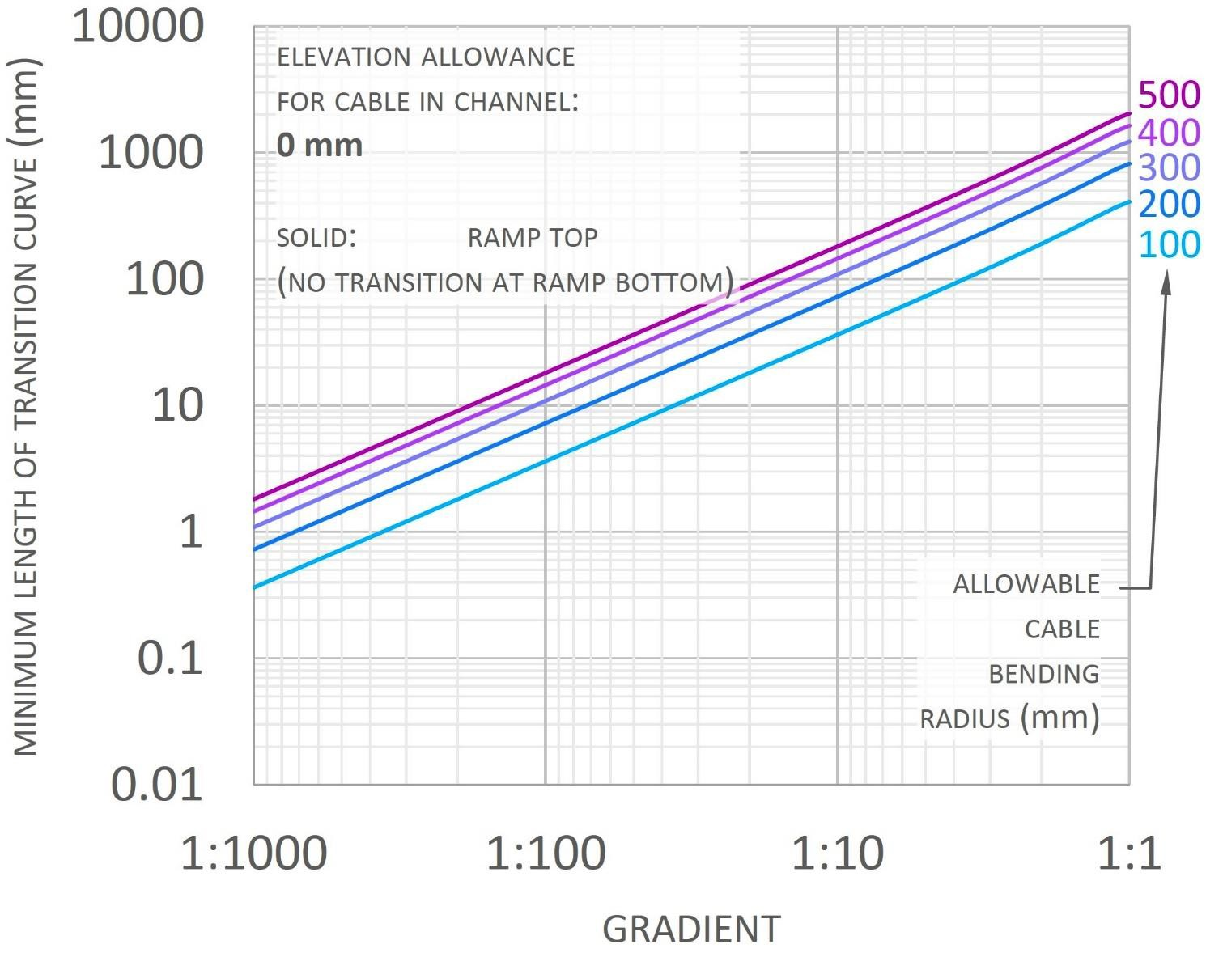

Figure C.6 - Plot of minimum curved cable transition lengths for a ramp when the elevation allowance of the cable in the channel is zero

Plots of 𝑑₁, 𝑑₂ and 𝑑₃ are presented in Figure C.6, C.7, C. 8 for $a_{c}$ equal to 0, 5 and 10 mm respectively. As with the step, for the case of $a_{c}$ equal to zero the entire curved transition must lie within the ramping portion and 𝑑₁ is equal to zero.
The solid lines in the plots indicate the length of the curved transition within the ramping portion, equal to the sum of 𝑑₂ and 𝑑₃. For the plots with non-zero the dashed lines indicate 𝑑₁ where 𝑑₁ ≠ 𝑑₂ + 𝑑₃. The contribution of the oppositely-curving length 𝑑₃ is indicated by the abrupt step in the solid lines plotted in Figure C.7, C.8.
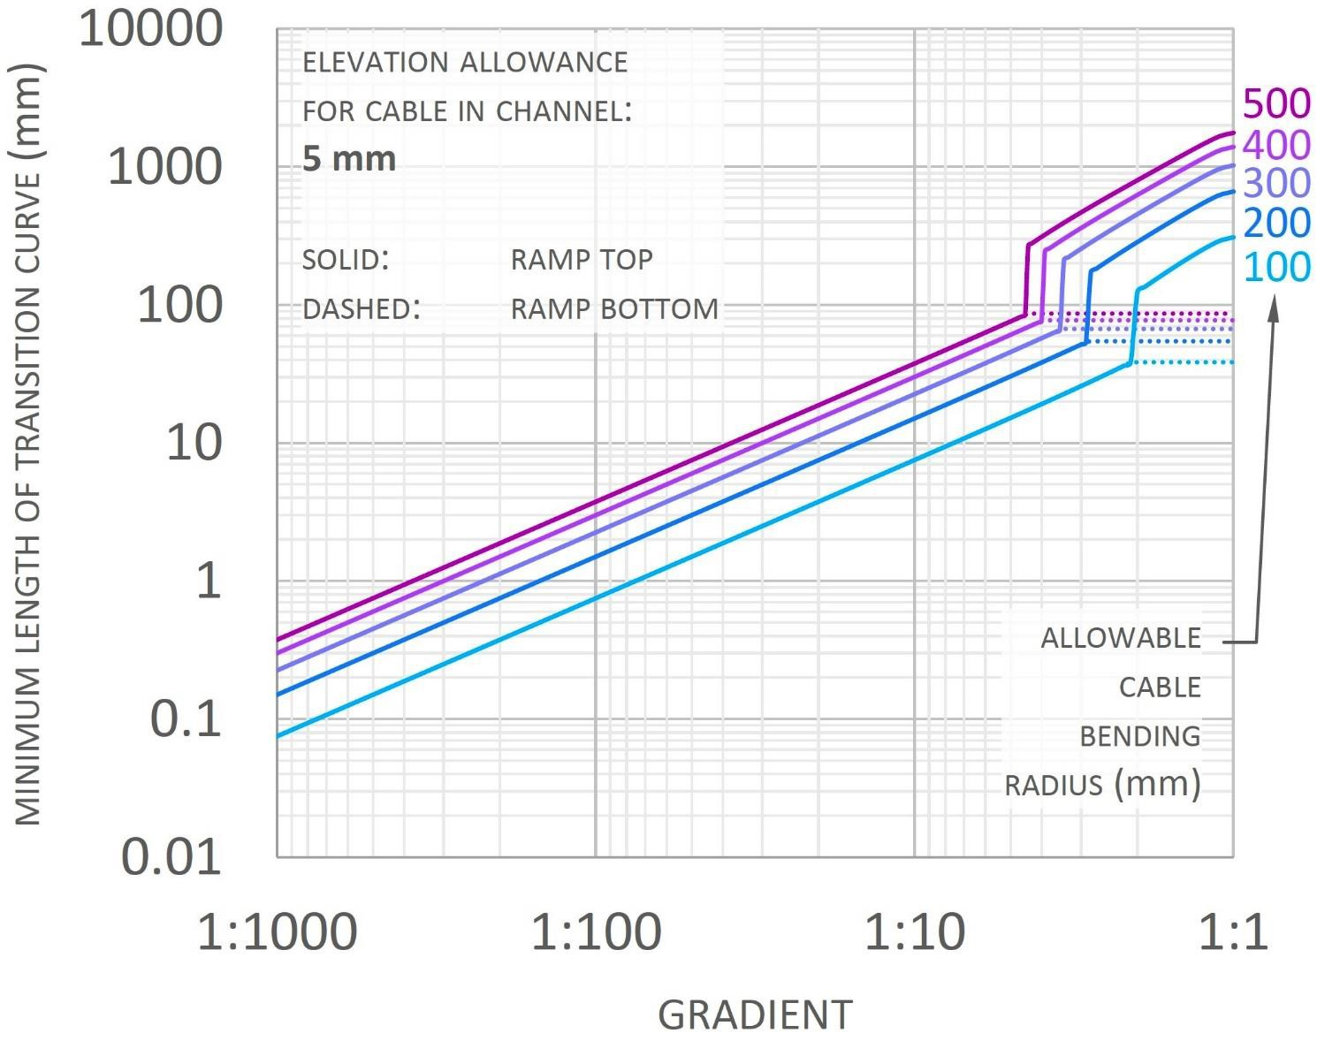

Figure C.7 - Plot of minimum curved cable transition lengths for a ramp when the elevation allowance of the cable in the channel is 5 mm

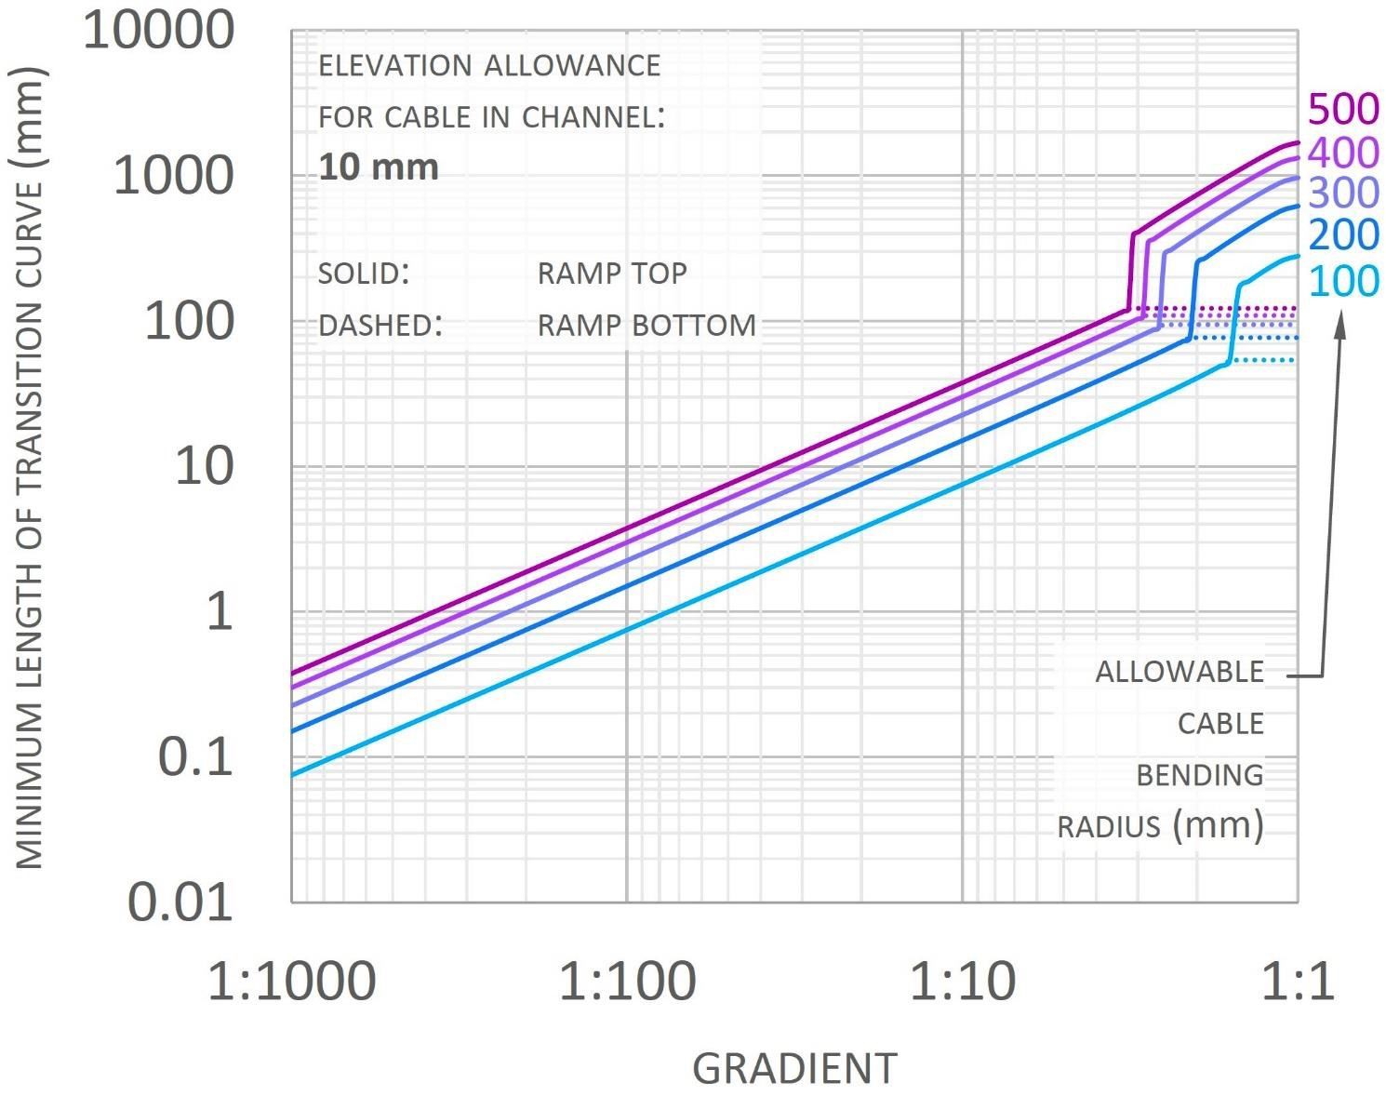

Figure C.8 – Plot of minimum curved cable transition lengths for a ramp when the elevation allowance of the cable in the channel is 10 mm
APPENDIX D

The obtained data from the temperature field

115 + 53,82 + 7,3 + (53,82 + 1,72) + (8,1 + 1,7) + 55,54 + (8,1 – 0,9 +

+ 1,09) + (8,1 + 4,42) + (2,72 + 0,9) + (8,1*3 + 1,47) + 3,6 + (8,1 + 1,72)

+ 8,4 + (1,72 + 8,1 +(8,1 – 1,47)) + (2,98-0,6) + (1,47 + 8,1*3+(8,1-

3,73)) + 2,38 + (3,73 + 4,4) + 8,1 + 55,54 + 7,8 + 55,54 + 8,1 + 55,54 +

(8,1 – 0,23) + 55,54

74,1 = (8,1*8)+2,5+ 0,8+(8,1-2,1)=74,1
6,2
74,1
8,3
74,1
8,3
14,6 = 2,5+8,1+4
7 = 0,8 + (8,1-1,9)
5,7 = 8,1 – 4 + 1,6
2,9 = 8,1 – 1,9 -3,3
28,6 = (8,1- 1,6 +8,1 +8,1+(8,1-2,1)
3,9 = (0,6+3,3)
25,1 = (2,1+8,1+8,1+6+0,8)
8
25,1
3,1
20,1 = (8,1-2,1)+8,1+(8,1-2,1)
4,5 = 3,7+0,8
28,91 = (2,1+8,1+8,1+8,1+2,5)
8,1
13,2 = 8,1+2,5+2,6
4,6 = 3,8+0,8
7,3 = 1,8+(8,1-2,6)

6,6 = 2,4+3,8
53,6 = (8,1-1,8) +8,1*5+0,8+6
6,5
74,1
8
68,12
672,73 m

APPENDIX E

The values of the compression and tension

Table E.1 – R block temp (horizontal)

Tension |  | Compression
3543 | 21 | 3529 | 29
3673 | 27 | 3542 | 26
3676 | 40 | 3546 | 23
3684 | 37 | 3552 | 22
3685 | 43 | 3555 | 23
3688 | 32 | 3557 | 24
3692 | 32 | 3560 | 24
3693 | 36 | 3567 | 27
3696 | 30 | 3571 | 31
3702 | 20 | 3575 | 23
3703 | 27 | 3580 | 26
3708 | 22 | 3585 | 38
3715 | 30 | 3587 | 34
3720 | 36 | 3592 | 33
3723 | 22 | 3598 | 35
3731 | 32 | 3604 | 27
3734 | 27 | 3606 | 43
3744 | 22 | 3609 | 28
3745 | 30 | 3614 | 37
3752 | 30 | 3617 | 50
3764 | 22 | 3622 | 36
3781 | 30 | 3626 | 30
3785 | 33 | 3635 | 44
3798 | 39 | 3640 | 27
3800 | 27 | 3642 | 37
3806 | 29 | 3644 | 30
3810 | 30 | 3653 | 30
3814 | 31 | 3658 | 30
3817 | 27 | 3659 | 33
3820 | 40 | 3666 | 34
3831 | 34 | 3671 | 20
3838 | 27 | 3698 | 26
3842 | 20 | 3704 | 25
3846 | 23 | 3707 | 25
3852 | 28 | 3712 | 27
3866 | 24 | 3738 | 23
3871 | 29 | 3751 | 24
3881 | 21 | 3763 | 23
3890 | 29 | 3788 | 34
3892 | 26 | 3850 | 29
3899 | 21 | 3915 | 26
3902 | 25 | 3932 | 27
3910 | 31 | 3943 | 21
Continuation of table E.1

1 | 2 | 3 | 4
3918 | 36 | 4013 | 29
3926 | 23 | 4056 | 28
3931 | 30 | 4064 | 31
3936 | 25 | 4076 | 23
3945 | 37 | 4089 | 27
3952 | 31 | 4096 | 37
3959 | 27 | 4107 | 44
3968 | 32 | 4110 | 27
3976 | 45 | 4117 | 26
3982 | 52 | 4120 | 30
3990 | 27 | 4124 | 29
3995 | 36 | 4132 | 27
4000 | 26 | 4137 | 35
4007 | 24 | 4144 | 24
4008 | 30 | 4149 | 25
4010 | 35 | 4152 | 47
4015 | 33 | 4154 | 34
4019 | 39 | 4157 | 52
4022 | 37 | 4159 | 38
4031 | 36 | 4170 | 39
4030 | 45 | 4181 | 26
4032 | 24 | 4182 | 35
4040 | 29
4047 | 25
4051 | 27
4060 | 27
4066 | 26
4072 | 23
4087 | 21
4088 | 22
4090 | 47
4095 | 24
4100 | 22
4108 | 38
4118 | 32
4123 | 28
4129 | 29
4137 | 26
4150 | 37
4154 | 45
4162 | 26
4165 | 32

Table E.2 – R block temp (vertical)
Tension |  | Compression
2284 | 21 | 2204 | 25
2295 | 20 | 2212 | 20
2303 | 20 | 2226 | 25
2314 | 32 | 2382 | 24
2332 | 23 | 2395 | 35
2336 | 25 | 2434 | 25
2345 | 20 | 2465 | 22
2349 | 30 | 2476 | 22
2371 | 22 | 2494 | 21
2386 | 24 | 2508 | 24
2391 | 20 | 2516 | 22
2401 | 21 | 2552 | 32
2415 | 26 | 2572 | 27
2429 | 21 | 2604 | 23
2442 | 21 | 2618 | 24
2444 | 25 | 2634 | 29
2475 | 23 | 2716 | 24
2478 | 22 | 2772 | 23
2498 | 20 | 2778 | 22
2513 | 23 | 2787 | 21
2542 | 23
2547 | 25
2551 | 21
2560 | 21
2589 | 21
2600 | 25
2615 | 22
2641 | 20
2649 | 24
2675 | 30
2681 | 31
2683 | 20
2687 | 22
2690 | 28
2694 | 24
2705 | 21
2709 | 27
2714 | 23
2718 | 23
2724 | 32
2732 | 25
2755 | 26
2767 | 25

Table 3 – Strain

Tension |  | Compression
157 | 29 | 132 | 95
163 | 45 | 166 | 132
167 | 28 | 169 | 41
176 | 24 | 187 | 38
203 | 22 | 189 | 47
224 | 29 | 199 | 37
240 | 25 | 208 | 49
248 | 41 | 220 | 35
262 | 35 | 227 | 67
276 | 21 | 229 | 55
288 | 27 | 251 | 27
321 | 22 | 260 | 30
350 | 29 | 279 | 35
381 | 25 | 302 | 36
406 | 30 | 323 | 32
419 | 22 | 328 | 46
432 | 28 | 337 | 32
454 | 28 | 346 | 34
460 | 39 | 349 | 27
466 | 33 | 378 | 32
480 | 27 | 398 | 50
490 | 26 | 415 | 41
500 | 32 | 419 | 28
510 | 25 | 420 | 20
528 | 27 | 430 | 19
607 | 21 | 448 | 33
625 | 36 | 465 | 31
 |  | 468 | 35
 |  | 479 | 28
 |  | 483 | 39
 |  | 493 | 22
 |  | 504 | 27
 |  | 511 | 21
 |  | 526 | 26
 |  | 548 | 24
 |  | 552 | 17
 |  | 568 | 31
 |  | 571 | 26
 |  | 609 | 33

APPENDIX F

Act of implementation of the monitoring method with fiber optic sensors at the construction site


