Karaganda Medical University

UDC 613.6 On manuscript rights

BOLATOVA ZHANERKE ERLANOVNA

ASSESSING ACCESS TO WATER, SANITATION AND HYGIENE IN SCHOOLS

6D110200 – Public health

Thesis is submitted in fulfillment of the requirements for
the degree of Doctor of Philosophy (PhD)

Scientific supervisor:
Candidate of medical sciences,
associate professor Kalishev M.G.

Foreign scientific supervisor:
PhD, professor Hans Orru

The Republic of Kazakhstan
Karaganda, 2023
CONTENT
REGULATORY REFERENCES …………………………………………... |  | 4
DEFINITIONS …………………………………………………………….... |  | 5
SYMBOLS AND ABBREVIATIONS …………………………………….... |  | 7
INTRODUCTION ……………………………………................................... |  | 8
1 | TOWARD HEALTHY LEARNING ENVIRONMENTS: THE SIGNIFICANCE OF WASH IN SCHOOLS (LITERATURE REVIEW) ……………………………………...………………….. | 11
1.1 | The current situation of water supply to the population in Kazakhstan and state water programs: status and prospects ………. | 11
1.1.1 | The present state of water provision to the population in Kazakhstan ………………………………………………………… | 11
1.1.2 | The current status and future prospects of state water programs ….. | 12
1.2 | The significance of water, sanitation and hygiene in schools ………. | 15
1.3 | Navigating health impacts: WASH-related risks…………………… | 22
1.4 | Current state of WASH services in schools ……………………….. | 25
2 | MATERIALS AND METHODS ………………………………… | 28
2.1 | General description of materials and methods of research (research protocol) …………………………………………………………… | 29
2.2 | Description of the study region …………………………………….. | 30
2.3 | Data quality assurance …………………………………………… | 31
2.4 | Ethical consideration ………………………………………………. | 31
2.5 | Description of the third phase studies ……………………………… | 31
2.6 | Sampling …………………………………………………………… | 34
2.7 | Data processing and analysis ………………………………………. | 35
3 | RESULTS …………………………………………………………. | 37
3.1 | The mortality rate attributable to unsafe WASH and morbidity trends in Kazakhstan and Karaganda region ………………………. | 37
3.1.1 | The mortality rate from the lack of safe WASH in KZ and KAR … | 37
3.1.2 | The morbidity trends of water related infectious diseases in KZ and KAR ……………………………………........................................... | 39
3.2 | Assessing to WASH service accessibility at selected schools during the COVID-19 pandemic …………………………………….......... | 45
3.2.1 | Access to drinking water at studied schools ……………………….. | 45
3.2.2 | Access to sanitation at studied schools ……………………………. | 47
3.2.3 | Accessibility of hygiene at studied schools ………………………… | 48
3.3 | Assessing Students’ Satisfaction with WASH Services at Karaganda region during the COVID-19 Pandemic …………………………… | 49
3.3.1 | Sociodemographic characteristics of student participants …………. | 49
3.3.2 | The statistical analysis of student’s satisfaction with WASH services at Karaganda region schools ………………………………………. | 51
3.3.2.1 | Students’ satisfaction with availability and functionality of drinking water at schools …………………………………………………… | 51
3.3.2.2 | Students’ satisfaction with quality of services, operation and maintenance of drinking water at schools………………………….. | 52
3.3.2.3 | Students’ satisfaction with education and practices about drinking water at schools…………………………………………………….. | 54
3.3.2.4 | Students’ satisfaction with functionality and quality of services of sanitation at schools …………………………………….................... | 56
3.3.2.5 | Students’ satisfaction with the privacy and security of sanitation at schools …………………………………….………………………. | 57
3.3.2.6 | Students’ satisfaction with the operation and maintenance of sanitation at schools ……………………………………................... | 58
3.3.2.7 | Students’ satisfaction with education and practices about sanitation at schools ……………………………………................................... | 59
3.3.2.8 | Students’ satisfaction with the availability, functionality of hygiene at schools …………………………………….................................. | 61
3.3.2.9 | Students’ satisfaction with the quality of services of hygiene at schools……………………………………........................................ | 62
3.3.2.10 | Students’ satisfaction with the education and practices about hygiene at schools ……………………………………...................... | 63
3.4. | Factors affecting the hygienic behavior of student ………………… | 65
3.4.1 | Handwashing behavior and its factors: variable definitions ………. | 65
3.4.1.1 | Hand hygiene: group comparison………………………………….. | 66
3.4.2 | Factors associated with Lack of Handwashing skills ……………… | 66
3.4.3 | Factors associated with using handwashing facilities at school …… | 68
3.4.4 | The behavior to drink water at school: group comparison ………… | 69
3.4.5 | Factors associated with the behavior of refusing to drink water at school ………………………………………………………………. | 70
3.4.6 | The behavior to use the school toilet: group comparison …………. | 71
3.4.7 | Factors associated with the behavior of refusing to use the sanitation …………………………………………………………... | 73
4 | WAYS TO IMPROVE ACCESS TO SAFE WASH FACILITIES AND PRACTICES AT SCHOOLS ……………... | 75
4.1 | System approach to WASH ……………………………………....... | 75
4.2 | Promotion of hygiene education ………………………………….. | 77
4.3 | Monitoring and evaluating the progress of the WASH interventions | 79
4.4 | Addressing the Gaps in Sanitary and Epidemiological Requirements for Educational Facilities…………………………………………… | 81
CONCLUSION ……………………………………………………………… |  | 83
PRACTICAL RECOMMENDATIONS …………………………………… |  | 87
REFERENCES ……………………………………........................................ |  | 88
APPENDICES …………………………………….......................................... |  | 98

REGULATORY REFERENCE

The following regulatory references have been used during this work:
Code of the Republic of Kazakhstan "On the Health of the People and the Health Care System" dated July 7, 2020 №360-VI RK;
Water code, as amended and supplemented as of 01.05.2023;
Sectoral program "Drinking Water" for 2002-2010, approved by the Resolution of the Government of the Republic of Kazakhstan dated January 23, 2002 № 93;
Program "Ak Bulak" for 2011-2020, approved by the Resolution of the Government of the Republic of Kazakhstan dated May 24, 2011 № 570;
State program Housing and Communal Development "Nurly Zher" for 2020-2025, approved by the Government of the Republic of Kazakhstan. by the resolution of the Government of the Government of the Republic of Kazakhstan dated December 31, 2019 № 1054;
The national project "Quality Education "Educated Nation", Resolution of the Government of the Republic of Kazakhstan, dated October 12, 2021 №726
Transforming our world: the 2030 Agenda for Sustainable Development, resolution adopted by the General Assembly on 25 September 2015;
UNICEF strategy for water, sanitation and hygiene 2016-2030;
Sanitary Rules "Sanitary and Epidemiological Requirements for Educational Facilities", order of the Minister of Health of the Republic of Kazakhstan from August 5, 2021 № KR DSM-76. Registered with the Ministry of Justice of the Republic of Kazakhstan on August 6, 2021 № 23890;
Law on architectural, town-planning and construction activities in the Republic of Kazakhstan, dated July 16, 2001 № 242;
Construction standards of the Republic of Kazakhstan “Educational institutions”, as amended as of 30.11.2022;
On approval of the national project "Quality education "Educated Nation", resolution of the Government of the Republic of Kazakhstan dated October 12, 2021 № 726.

DEFINITIONS

This thesis involves the following terms with the corresponding definitions:
Basic level of drinking water - on-premises drinking water source from piped water, boreholes or tubewells, protected dug wells; free of fecal and priority chemical contamination; available when required.
Basic level of sanitation – schools with improved toilets, such as flush/pour flush to piped sewer system, septic tank or pit latrine, ventilated improved pit latrine, toilets that are single-sex and functional at the time of the survey.
Basic level of hygiene – at the time of observation, handwashing facilities with available water and detergent were observed.
Water helps the body function by regulating body temperature, protecting delicate tissues, transporting nutrients, and eliminating debris.
Availability and functionality of drinking water encompass both a sufficient quantity of water and efficient service delivery. It raises crucial organizational concerns safeguarded by the theory of sustainability, such as system resilience and safety.
Accessibility of drinking water must be rapid and not too distant, as well as age- and disability-friendly.
Quality of services, operation, and maintenance of drinking water sources to ensure the supply system is functioning properly and that water quality standards are met.
Sanitation is the provision of facilities and services designed to prevent contact with human fluids and faeces.
Availability of toilets - their door is always open, or if they are locked with a key, the key should always be accessible.
The functionality of toilets - the toilets' structure is not damaged, flushing water is available, and the latrine opening is not obstructed.
The privacy of toilets - the stall doors are lockable from the inside, and there are no holes in the structure.
The accessibility of toilets – they are conveniently located near the classrooms. Students can use them during the learning process, including smallest students and those with special needs.
Operation and maintenance of toilets is clean, warm, and comfortable toilets with adequate light, ventilation, toilet paper availability or a clean shower, and adequate disposal facilities.
Hygiene refers to behaviors that can improve hygiene and promote health, such as daily hand-washing, face-washing, soap use, and water bathing.
Hygiene availability - availability of handwashing facilities with soap and water supports proper hand hygiene and is crucial in preventing the spread of infectious diseases.
Hygiene functionality - in order to promote students' hygiene and well-being and prevent the spread of communicable diseases, schools must provide soap-equipped handwashing stations.
Hygiene accessibility - devices are regarded accessible to the youngest students. Children can reach both the water and detergent and can open and close the faucet with minimal effort.
Hygiene quality of services, operation, and maintenance - toilets must be maintained and cleaned multiple times during the school day; otherwise, sanitation and availability of supplies cannot be guaranteed, especially during peak usage periods.
Education and practises - school personnel and teachers may play a crucial role in promoting safe habits among students through instruction and a good example.

SYMBOLS AND ABBREVIATIONS

CDC | – Centers for Disease Control and Prevention
CI | – Confidence Interval
DALY | – Disability-Adjusted Life Years
IPC | – Infection Prevention and Control
JMP | – Joint Monitoring Program
KAR | – Karaganda Region
KZ | – Kazakhstan
LMICs | – Low- and Middle-Income Countries
MDG | – Millennium Development Goals
NED | – National Educational Database
OR | – Odds Ratio
PAF | – Population Attributable Fraction
RR | – Risk Ratio
SDG | – Sustainable Development Goals
UN | – United Nations
UNECE | – United Nations Economic Commission for Europe
UNICEF | – United Nations International Children's Emergency Fund
WASH | – Water, Sanitation and Hygiene
WHO | – World Health Organization
WinS | – Water, Sanitation and Hygiene in Schools

INTRODUCTION
Relevance of the research. Providing safe water and sanitation and hygiene (WASH) practices play a crucial role in determining human well-being, quality of life and dignity. Lack of reliable access to water, sanitation and hygienic conditions remains a significant public health challenge [1]. Improved water and sanitation infrastructure reduces waterborne and other diseases [2]. Even the COVID-19 pandemic emphasized the importance of basic hygiene - regular hand washing [3].
The global community has set measurable Sustainable Development Goals (SDGs). Goal 3 is one of the most important, aimed at improving populations' overall health and well-being, including reducing WASH-related mortality (3.9.2 points). SDG 4 calls for access to quality education, ensuring educational institutions have the necessary facilities, including drinking water and sanitation (4a point). SDG 6 is fully dedicated to ensuring availability and sustainable water supply and sanitation management for all [4].
To assess and monitor compliance with these goals, the World Health Organization (WHO) and the United Nations Economic Commission for Europe (UNECE) have developed the Joint Monitoring Programme (JMP), collecting data on water supply, sanitation and hygiene in different countries [5].
Ensuring access to water and sanitation services in educational institutions becomes an inalienable right of every child to ensure their health and education are in line with the SDGs. To manage these services effectively in our Republic, data on the current situation in school institutions are needed to determine specific measures and their scope. Currently, these data are not available, and the results of previously conducted similar studies are no longer relevant. This becomes an obstacle to the protection of children's rights in the context of educational institutions. This has a negative impact on children's health and school attendance, given the long time students spend in educational institutions [6]. Therefore, schools play an essential role in shaping children's knowledge, attitudes, behavior and health, making them critical institutions for teaching life skills [7].
Research aim was to assess the access to water, sanitation and hygiene in schools to develop recommendations for improving sanitation and hygiene conditions in schools.
The following research objectives were set to achieve the aim of the research:
1. To study the current state and prospects of the development of water, sanitation and hygiene in schools in Kazakhstan and abroad;
2. To analyze the epidemiological situation on acute intestinal infections and viral hepatitis A in Kazakhstan and Karaganda region.
3. To assess the access to WASH and satisfaction of students with WASH services in schools;
4. To identify factors affecting the students' hygienic behavior;
5. To develop recommendations to improve access and satisfaction with WASH services in schools.
The scientific novelty lies in using a comprehensive approach to data collection and analysis of the availability of drinking water, sanitation and hygiene services in schools and assessing pupils' and administration's satisfaction with WASH services. The study includes an analysis of the epidemiological situation in Kazakhstan and Karaganda region related to the spread of infectious diseases potentially dependent on WASH service provision. Factors influencing the hygienic behavior of students in different types of settlements were studied for the first time. Recommendations on improving accessibility to WASH facilities in schools, as well as training programs of courses for schoolchildren that contribute to the formation of hygienic knowledge and skills for the first time.
Theoretical significance of the research. The results of the study of hygienic behavior of school students and the factors influencing it can serve as a theoretical basis for the development of teaching strategies, lay the foundation for the creation of curricula to improve hygiene education, contribute to the development of long-term initiatives that promote sustainable changes in the behavior of school students. Approaches to studying and assessing the quality of water supply and sanitation systems in educational institutions are proposed.
Practical significance of the research. Conclusions and recommendations formulated in the work can be used in the work of educational authorities, school administrations, and school teachers to develop strategies and improve activities aimed at the formation of a safe and healthy learning environment to preserve and promote the health of students, which, in turn, will have a positive impact on the learning process and general well-being of students.
The study's results can raise awareness among parents, school administration, community and students about the importance of WASH in schools. Recommendations on conducting special educational courses can be applied to improve the hygiene literacy of students and the formation of correct hygienic habits and skills among them. In addition, the recommendations on monitoring can be used in the work of school administration and teachers.
The study results are used in educational organisations' activities: specialized lyceum boarding school "Daryn", a secondary school named after Zh. Akbaeva, special lyceum boarding school named after Zhambyl.
The main points to be defended:
- Students in rural schools are insufficiently provided with drinking water, sanitation and hygiene facilities.
- The incidence of acute intestinal infections and viral hepatitis A in Kazakhstan and the Karaganda region for the last 10 years tended to decrease.
3. Urban schools have centralized drinking water supply and sewerage, but hygiene facilities are insufficient.
4. Hygienic behavior of students depends on the extent to which schools provide WASH services, the age of students, and the quality of health education.
Publications. On the subject of the dissertation research published 7 scientific papers, among which 2 articles in journals indexed by bases Scopus (77%, 1-quartile), Web of Science (Clarivate Analytics, IF = 4.61), 1 article in the editions recommended by the Committee for Quality Assurance in the Sphere of Education of the Ministry of Education of the Republic of Kazakhstan. 1 thesis in the collection of foreign conference indexed by Web of Science (Clarivate Analytics, IF=4.4). 3 certificates of state registration of rights to the object of copyright of the Republic of Kazakhstan, 3 acts of introduction of the results of the study in the work of educational organizations were received.
Author's personal contribution. The author's personal contribution lies in the development of theoretical and methodological program of the study, the formation of the goal, objectives of the study, the organization and conduct of the study, direct participation in all stages of research work, statistical processing of data, writing sections of the dissertation, interpretation and discussion of the results, the formulation of the provisions put forward for defense, as well as, conclusions and practical recommendations.
Implementation of the research results. Practical recommendations of the dissertation research are implemented in the practice of schools: specialized lyceum boarding school "Daryn", secondary school named after Zh. Akbaeva, special lyceum boarding school named after Zhambyl.
Scope and structure of the thesis. The dissertation consists of an introduction, literature review, description of materials and methods, results of own research, conclusion, findings, practical recommendations, list of used literature, including 142 literary sources in Kazakh, Russian and English languages.
The dissertation is outlined on 125 pages of typewritten text, illustrated with 16 tables, 28 figures, contains 11 appendices.
- TOWARD HEALTHY LEARNING ENVIRONMENTS: THE SIGNIFICANCE OF WASH IN SCHOOLS (LITERATURE REVIEW)

1.1 The current situation of water supply to the population in Kazakhstan and state water programs: status and prospects
    - The present state of water provision to the population in Kazakhstan
On the Republic of Kazakhstan (RK) territory, there are about 39 thousand rivers and temporary watercourses, of which more than 7 thousand are more than 10 km long. Most rivers belong to the internal closed basins of the Caspian and Aral seas, lakes Balkash, Alakol and Teniz. Only the Ertis River belongs to the basin of the Arctic Ocean. According to Kazakhstan's water legislation, the Caspian Sea, Lake Balkash, Lake Zaisan, the Alakol Lake system, and the Ertiz River are classified as water bodies of special national importance. There are several thousand lakes in Kazakhstan, and most of them are concentrated in the north. The largest ones - Balkash, Zaisan, and Alakol - are in the eastern and south-eastern regions. The increased mineralization of water in many lakes prevents their economic use [8].
In the country for the last 5 years, the volume of annual water consumption in all sectors of the economy is, on average, 25.7 million thousand m³ and 95% of it is due to surface water. Water use: agriculture - more than 60%, industry - more than 20%, 4-5% of total water intake was used annually for domestic needs [8].
The most significant rivers in the Karaganda region are the Sarysu and Nura. In the southeast is the largest lake Balkash. All rivers belong to the undrained basins of Lake Balkash and small lakes, which in summer become very shallow, break up into rifts, saline or completely dry up. Reservoirs have been built to supply water to industrial centres, agricultural areas, and the Yertis-Karaganda Canal. The length of water supply networks in the Karaganda region in 2021 amounted to 7 640.3 km. Table 1 presents data on water supplied to consumers for 2021[8].

Table 1 - The volume of water released to consumers in the Karaganda region [8]

Water supplied to consumers, thousand m³, total | Including
Water supplied to consumers, thousand m³, total | to the public, thousand m³ | for the utility needs of enterprises, thousand m³ | for the production needs of enterprises, thousand m³ | other customers, thousand m³
195 048.10 | 55 832.30 | 7 870.40 | 91 708.60 | 39 636.80

According to the data provided, a total of 195 048.10 thousand m³ of water were supplied to consumers. Of the total water supply, 55 832.30 thousand m³ were allocated for public consumption. This allocation includes water usage by residential households, public amenities, and municipal services. Providing an adequate and reliable water supply to the public is crucial for meeting basic human needs and ensuring public health and sanitation. 91 708.60 thousand m³ of water were supplied to meet the production needs of enterprises. This allocation represents the water industries, and manufacturing units utilized for their production processes. Water-intensive sectors, such as agriculture, food processing, and manufacturing, rely heavily on a consistent and reliable water supply to sustain operations and contribute to economic growth.
The table indicates the varying water needs of different consumer groups. To ensure sustainable water management, it is crucial to implement effective demand management strategies, including water conservation initiatives, leak detection, and efficient irrigation practices. Such measures can help optimize water allocation and ensure equitable distribution among consumers.
Analyzing the distribution of water supplied to consumers provides valuable insights into the allocation of this vital resource. Understanding the needs of different consumer groups and implementing appropriate strategies and infrastructure investments can ensure an equitable and sustainable water supply. By addressing the challenges associated with water distribution, we can strive towards a more resilient and efficient water

1.1.2 The current status and future prospects of state water programs
The Water Code regulates water relations in the RK, and legislative and other normative acts of the RK are issued following it. The Water Code of Kazakhstan is a legislative act regulating relations related to the use and protection of water resources in the country. It was adopted to achieve and maintain environmentally safe and economically optimal levels of water use and protection of water resources to preserve and improve the living conditions of the population and the environment [9].
The water legislation of the RK is based on several principles, such as recognizing the national significance of waters that are essential to the population's existence and well-being; prioritization of providing of potable water in adequate amounts and assured quality to the people; equal and equitable population access to water; comprehensive and rational water use with the mastery of modern technologies that reduce water withdrawal and water's adverse effects; utilizing water elements and protecting them; compensation for unique water use; damages caused by a violation of the nation's water legislation; inevitability of liability for violations of the nation's water laws; accountability and involvement of the public to solve water consumption and protection issues; accessibility of information on the status of the RK's water fund; transboundary consumption of water in accordance with international norms and agreements approved by the RK; design and construction continuity and connectivity of water supply and sewerage; payments for the supply of water and/or wastewater treatment services [9].
By 2025, the Kazakhstani authorities plan to provide 100 percent of the population with quality drinking water. Over the past 30 years, programs have been developed several times to offer people drinking water. Before applying for the first program, 81 cities and 139 settlements out of 86 towns and 174 settlements were covered by centralized water supply systems in the republic. The total length of the water supply network was 23.47 thousand km, and the sewerage was 11.13 thousand km [9].
The level of coverage of centralized water supply services was 6 771 800 people or 79.4% of the urban population, had access to quality drinking water 24 hours a day, and 5 373 500 people, or 63.1%, had access to centralized sewerage systems. At the same time, 537 300 people or 6.3% of the urban population, used water from the yard and public wells, wells and surface springs for drinking and household purposes, as well as imported water. There was a severe problem with the drinking water supply to the rural population living in 7231 settlements. Centralized water supply in rural settlements was solved by constructing local (for one settlement) and group (for a group of settlements) water pipelines. The total length of 79 constructed group water pipelines by the early 90-s reached 17.1 thousand km, and 1276 rural settlements were supplied with them [9].
The first program called "Drinking Water" appeared in 1998. It was designed for the years 2002-2010. The goal was sustainable supply the population with drinking water in the required quantity and of guaranteed quality. According to the Agency of the RK for Construction and Housing and Communal Services, as of January 1, 2011, the provision of the urban population with a centralized water supply was 82%. Under the program, 12 935 kilometers of water pipes and drinking water networks were built, reconstructed and overhauled, and water supply was improved in 3 449 settlements with a combined rural population of over 3.5 million. In 2011, the rural population using imported water decreased by more than six-fold, to 71 100. The condition of water pipelines that do not meet sanitary standards decreased from 336 to 133 units[10].
Thus, according to the Ministry of Agriculture of the RK, as of January 1, 2011, accessibility to centralized water supply in rural areas increased by 13.5% to 42.5%. Despite certain positive results of the Program, the water supply problem for the rural population has persisted. In addition, according to the Ministry of Agriculture of the RK, from the total number of rural areas (RA) – 6 943, 3 592 RA with a population of about 3 million people or 40% of the total rural population are considered as not provided with centralized drinking water supply (problematic). These RAs are grouped into 4 categories, such as using imported water, requiring connection to the group water pipelines, group piped water, with a decentralized system of water supply. 134 rural settlements use imported water, which is 3.7% of the total. 10.7% of rural settlements require connection to group water pipelines (386 SNP). The category of group water pipelines includes 114 rural settlements, which is 3.2% of the total number. 2 958 rural settlements remain with a decentralized water supply system, accounting for 82.4%[11].
The following program is "Ak Bulak" for 2011-2020. The program aims to provide quality drinking water and wastewater services to the population. Achievement of the goal will be determined by comparing and measuring the intermediate results with the following indicators ensuring access to centralized water supply in rural areas 80% of the total number of rural areas, in urban areas - 100%. Program objectives are to introduce a systematic approach in the construction of new water supply and sanitation facilities and the reconstruction of existing ones, the construction and reconstruction of centralized water supply and sanitation systems in urban areas and local systems (septic tanks) in rural settlements [11].
About 12.5 thousand km of water supply networks were built and reconstructed during 2015-2018. This increased the availability of centralized water supply to 90.2% or 16.5 million people. In urban areas, this indicator in 2018 was 94.5% or 10.0 million people; in RAs, it was only 84% or 6.5 million people. Thus, a significant need for water supply issues remains in rural settlements, where about 1.2 million people live in 2 607 RAs without a centralized water supply. At the same time, 1 333 villages are small, with less than 200 inhabitants each, where it is expedient to install local water supply systems. One of the socially - significant issues of safety and comfort of the population is the uninterrupted operation of sewage treatment plants (after this - STP), designed to treat wastewater from large cities and industrial enterprises. Currently, 27 cities in Kazakhstan have no or thoroughly worn-out sewage treatment plants, and 26 towns require modernization and reconstruction. In total, 53 sewage treatment facilities in the country need to be reconstructed and built [12].
The purpose of the latest state program of housing and communal development "Nurly Zher" for 2020-2025 is to improve the affordability and comfort of housing and the development of housing infrastructure. One of the objectives of this program is the rational provision of the population with quality drinking water and wastewater services. The target indicator in the field of water supply of this program is 100% access of the people to water supply services in towns and villages by 2025, and also by 2025 - to reduce the wear and tear of heating, water supply and sewage networks to 47% [12].
To improve the water supply's quality and reduce network depreciation, 36 investment projects are being implemented under the Nurly Zher programme in 2021. At year-end, 234 km of water supply and sewerage networks were built and reconstructed (100.2 km in cities and 133.8 km in villages), which improved access to water supply services in cities to 98.5 % and 91.8% in villages, and reduced the depreciation of water supply networks to 61.7 % and sewage networks to 70.5 %. Quality drinking water is provided to the population primarily through access to the centralized water supply. In 2021, 55 projects worth 46.7 billion tenge were implemented under the State infrastructural development program "Nurly zher" to develop water supply systems in cities from the national budget and the National Fund. For developing water supply systems in villages, 248 projects to 69.5 billion tenge are being implemented from the national budget and the National Fund in 2021. Work on the construction and reconstruction of water supply systems in Kazakhstan continues [12].
In 2021 the country commissioned 5 group water pipelines in Akmola, North Kazakhstan and Karaganda regions. In 2021, the Ministry of Ecology, Geology and Natural Resources of Kazakhstan launched an interactive map of water supply in villages, which contains information on the availability of water supply, financing and need for funds, population, network length, deterioration, etc. 4 680 rural settlements with a population of 7 159 645 people have access to water services, and 1 613 rural settlements (537 018 people) do not have access to water services. The provision of rural settlements with centralized water supply is presented in Figure 1 [8].

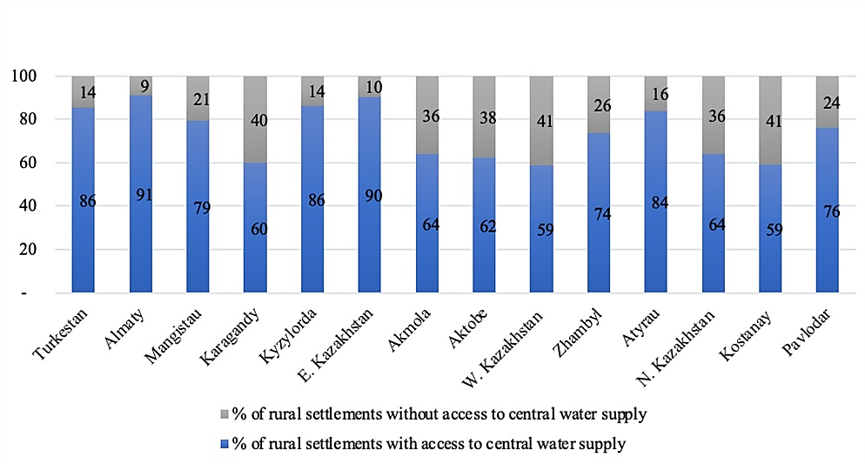

Figure 1 - Provision of rural settlements with centralized water supply [8].

Access to a centralized water supply is crucial for rural settlements to meet their basic needs and improve living conditions. Among the rural settlements in Kostanay, 305 have access to the central water supply, while 212 do not. In West Kazakhstan, 245 have access to the central water supply, while 171 settlements do not. The percentage of rural settlements with and without access to central water supply is similar in these regions; the number of settlements without a central water supply is significant. In Karagandy, 252 rural settlements have access to a central water supply, while 169 lack this facility. This region presents a more significant disparity between settlements with and without central water supply [8].
The availability of central water supply in rural settlements plays a vital role in enhancing the quality of life and promoting sustainable development. While some regions demonstrate relatively high coverage, others still face challenges in providing access to the central water supply. By focusing on infrastructure development, resource allocation, and sustainable water management practices, policymakers can work towards ensuring equitable access to clean and reliable water for all rural communities in Kazakhstan.

1.2 The significance of water, sanitation and hygiene in schools
Since schools significantly impact students' social and health development, studying in this setting is crucial [13]. Because of the high concentration of students and the high frequency with which they interact with each other and the school's resources, the school setting is also an important target for interventions to reduce the spread of infectious diseases. Because of this, interventions for contagious diseases that focus on water, hygiene, and sanitation can be effective in a school setting [14].
Access to clean water and sanitary facilities is fundamental to human survival, social and economic development, and basic human decency. One of the most basic human rights is the availability of clean water for drinking and proper sanitation for all people [15]. Everywhere people live, learn, work, play, recreate, and receive health care, there must be safe, equitable, available, physical, and economic access to water and sanitation services [16].
Additionally, Sanitary Rules "Sanitary and Epidemiological Requirements for Educational Facilities", which Approved by order Minister of Health of the Republic of Kazakhstan dated August 5, 2021, included a number of measures and rules aimed at ensuring the safety and health of students, teaching staff and other employees of educational institutions. And this document states that educational facilities should be provided with safe and quality drinking water in accordance with the established requirements of norming documents. And also, drinking regime shall be organized in schools. A responsible person is appointed for the organization of drinking regime by the order of the head of facilities. Free access of students and students to drinking water during the whole time of their stay at the facilities is provided. Moreover, about the cleanliness of toilets that are cleaned daily with the use of disinfectants. In toilets, floors, door handles, faucet lugs, sinks and toilets are subject to daily disinfection [17].
Furthermore, the national project "Quality Education "Educated Nation" also notes the importance of WASH, indicating the achievement of indicator 5 "Proportion of schools provided with basic sources of drinking water, separate minimum equipped toilets and basic handwashing facilities" to 100% by December 2025 [18].
Quality of life, environmental health, social progress, and economic growth are all improved by access to water, sanitation, and hygiene (WaSH) services, which are the foundation of public health. In 2010, the UN General Assembly passed Resolution 64/292, establishing access to safe drinking water and sanitary facilities as fundamental human rights [19]. The Sustainable Development Goals (SDGs) agreed by 193 Member States at the UN General Assembly in 2015 include two particular targets within Goal 6 for drinking water, sanitation, and hygiene (WaSH) to improve water and sanitation globally significantly [20].
By 2030, ensure that everyone, regardless of where they live or how much money they have, has access to clean water; 6.2 By 2030, ensure that everyone, irrespective of where they live or how much money they have, has access to clean water, sanitation, and hygiene services, and ends open defecation, with a focus on the needs of women and girls and those in vulnerable situations [21]. Goal 4 of the Sustainable Development Agenda states that everyone has the right to a decent education and the chance to continue their education throughout their lives. The indicator of "proportion of schools with access to (e) basic drinking water; (f) single-sex basic sanitation and (g) basic handwashing facilities" is an explicit reference to WASH in Schools in the SDGs, which are part of Target 4. a [22]. There is a strong correlation between students' health knowledge and cleanliness practices at school, and their academic performance [23]. Each SDG works in tandem with the others to determine the best path forward for countries in varying stages of development. One of the responsibilities of WASH is to ensure that all student have access to quality education by providing them with the resources they need and ensuring they are given a fair shot at succeeding in school. For this reason, SDG 4 [24] calls for specific attention to the needs of females and individuals with disabilities by ensuring that they, too, have access to clean water, sanitation, and hygiene at educational institutions [25 - 27].
Moreover, the Kazakhstani National Platform for reporting on Sustainable Development Goals (SDGs) is responsible for monitoring and evaluating the implementation of the 17 SDGs. In order to fulfil this role, the platform publishes open data on SDG statistics. These statistics are provided by the Bureau of National Statistics of the Agency for Strategic Planning and Reforms of the RK, which serves as the central coordinator for SDG reporting [28].
The Joint Monitoring Program for Water Supply, Sanitation, and Hygiene (JMP) is a joint initiative between the World Health Organization (WHO) and the United Nations Children's Fund (UNICEF) that is responsible for global monitoring of the Sustainable Development Goal (SDG) targets related to WASH. Every other year, the JMP updates its estimates for WASH in homes, and every two years, it revises its estimates for WASH in institutions like schools and hospitals. This data update provides national, regional, and worldwide projections for WASH in schools up to 2021 and additional information on school preparation for future pandemics and the provision of disability-inclusive WASH services.
The JMP utilizes service ladders as a benchmarking and comparison tool for WASH in schools across nations (Table 2).

Table 2 - Three ladder levels of WASH [29]

Ladder levels | Water | Sanitation | Hygiene
No service | Schools without available water or they have water from an unimproved water source. Here unimproved water sources do not save from contamination by its construction, such as wells, surface water, and unprotected springs. | Schools without sanitation facilities or they have unimproved toilet facilities. Here unimproved toilet facilities do not provide the separation of human excreta from human contacts, such as pit latrines without a slab or platform, hanging latrines, and bucket latrines; | Schools do not provide handwashing facilities, and there is no water.
Limited | The school's water source is improved; however, the water is unavailable during the observation. The construction of an improved water source protects from contamination, such as a borehole or tubewell, piped water, protected dug well, or spring. | Schools with improved sanitation, where toilets are not separated by gender or unusable at the survey time. Here improved sanitation is the toilet, which hygienically separates contact with human urine and faeces, such as ﬂush/pours ﬂush toilets, ventilated improved pit latrines, composting toilets, and pit latrines with a slab or platform; | Schools have handwashing facilities but without soap. During the survey, water must be available.
Basic | During the survey time, the water is available, and it is from an improved water source. | Schools with improved toilets, where toilets are single-sex and usable at the survey time. Moreover, target 4a of SDG 4 is based on the basic level of WASH services for schools. | The handwashing facilities with available water and soap were found at the time of observation.

The basic level of service is the indicator used for worldwide monitoring of SDG targets for WASH in schools, and these service ladders are meant to track progress towards that level. While the fundamental service indicators are applicable worldwide, they do not account for all the facets of WASH services that contribute to a secure and welcoming school community. In the future, the JMP may also explore reporting on other service levels and provide examples of other relevant indicators in national monitoring systems. New national data on pandemic preparedness and disability-inclusive WASH services in schools, neither of which are included in the current JMP service tiers, are the focus of this paper. For SDG monitoring: a basic drinking water service means schools have access to an improved water source, and water is available; a basic sanitation service means schools have improved sanitation facilities that are single-sex and usable; and a basic hygiene service means schools have a handwashing facility with soap and water available at the time of the survey.
Additionally, WASH Post 2015 indicated that there is higher level than basic one, named safely managed, where basic drinking water source that is on-site, always available, and free of pollution from feces and priority chemicals and basic toilet that where waste can be disposed of safely on-site or cleaned off-site [30].
The SDG WaSH targets will be challenging to achieve. After six years of the SDG period, the world cannot provide all students with access to water, sanitation, and hygiene (WASH) in schools (Figure 2).

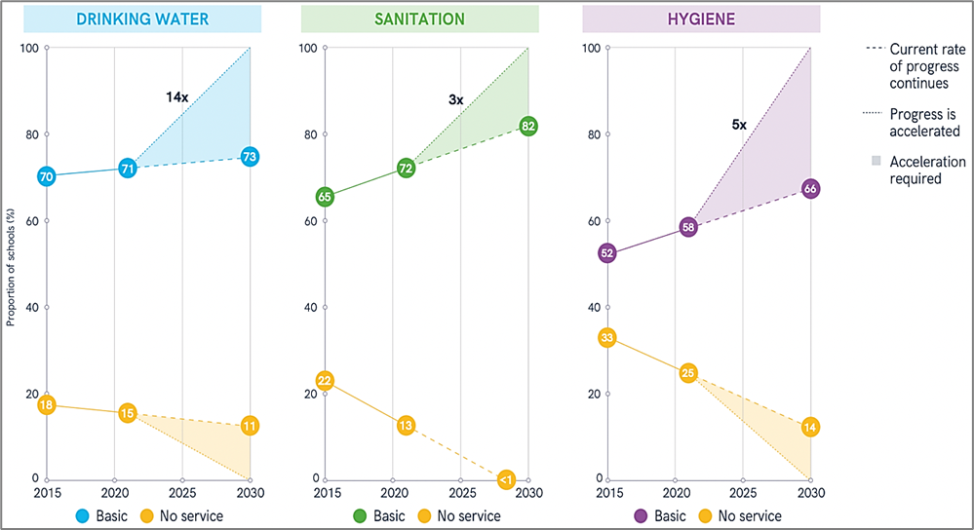

Figure 2 - Global coverage of WASH in schools 2015–2021 and acceleration required to meet targets by 2030 (%) [31]

To reach universal coverage, we need to triple the present rate of advancement in providing safe drinking water, double the improvement in delivering safe sanitation, and multiply the rate of progress in providing safe hygiene services by five. One in four schools will still not have access to safe drinking water in 2030, one in five will not have adequate sanitation, and one in three will not have access to a basic hygiene service if current trends continue. While the percentage of schools without services has steadily declined, more rapid progress is needed to guarantee that all schools have access to clean water and basic sanitation by 2030. One in seven schools will still lack access to basic sanitation facilities in 2030, and one in nine will be without safe drinking water.
High-quality drinking water is crucial to human health and development, so it's no surprise that it's a must for survival [32]. Having access to clean water is a development and health concern on a global, regional, and local scale. Water and sanitation investments have been demonstrated to be economically beneficial in some areas, with savings in healthcare costs and avoided health problems more than offsetting initial outlays. This applies to every water-related investment, from building new pipes to treating water in your house. It has also been proven that initiatives to increase the availability of clean water are more likely to positively impact the lives of people experiencing poverty, whether in urban or rural settings [33]. In 2021, in the world 258 million students had access to an improved water source, but no water was provided at their school, and 288 million students had no access to all [34].
Sanitation is crucial for preserving the environment, fostering economic growth, and improving people's quality of life. Prevention of infectious diseases, lessening antimicrobial resistance, and maintaining mental health and human dignity are just a few health benefits linked to improved sanitation [35]. Aside from its obvious significance, all aspects of sanitation (defined as "physical and affordable access to sanitation, in all spheres of life that is safe, hygienic, secure, socially and culturally acceptable, and that provides privacy and ensures dignity") are considered fundamental human rights [4].
In 2021, 72% of schools had access to basic sanitation services, whether enhanced single-sex facilities were usable at the time of the survey, and 13% had no service (unimproved source or none at all). Sanitary service standards in schools also differed substantially between countries. Estimates for low or basic sanitation services were unavailable for 14 countries because there was insufficient data. Despite recent advancements, the world will only reach 82% coverage by 2030 regarding basic sanitary facilities in schools, leaving over 310 million students without such amenities. Disaggregated data for urban and rural schools is not available for all nations. Only 27 countries submitted estimates for urban school sanitation in 2021, while only 29 had projections for rural school sanitation. Almost everywhere that had disaggregated data, urban schools had better coverage than rural schools. When keeping student healthy and happy for as long as possible, nothing is more important than teaching them good hygiene habits. It keeps kids from missing classes, which improves their academic performance [36].
Around 57% of the world's school-aged population will be enrolled in school in 2021, and national estimates for basic hygiene services in schools were available for 121 nations and 7 of 8 SDG areas. At the time of the survey, 58% of schools provided some form of basic hygiene service (such as handwashing facilities with soap and water), while 17% provided only a restricted service (such as handwashing facilities with water but no soap) and 25% provided no service at all (no facilities or no water at the school). Hygiene promotion, cleaning, disinfection, and solid waste management are all aspects of infection prevention and control (IPC) that need closer attention in schools to better prepare for and respond to pandemics. Current projections show that global coverage will only reach 66% by 2030, leaving almost 590 million school-aged student without access to this fundamental amenity [36].
The importance of hygiene promotion in preventing the spread of infectious diseases has been brought back into the spotlight due to efforts to plan for and respond to a pandemic. Hygiene behavior change initiatives often use several ways to help youngsters adopt healthier routines and routinely practiced skills [36].
A school WASH system should meet criteria, such as availability, functionality, accessibility, privacy, operation and maintenance, education, and practices [37].
Availability and functionality. The WASH facilities’ construction is not broken; service is delivered efficiently [38]. As for toilets, the doors are always opened, or the key should always be available if they are closed by key [39]. The water system must be enough and constant, and adequate sanitary facilities must be accessible at all times [40].
Accessibility. WASH facilities must be easily reached and located not too far away, age-friendly, and disability-friendly [38,39]. Student can use equipment individually with little effort [41]. Sanitation and drinking water infrastructures should be physically accessible to all at all times. The facilities should also be designed with older people, young student, and people with disabilities in mind [40].
Privacy. The toilets must close from the inside and without holes in the facility’s whole construction [39].
Quality of services, operation, and maintenance. WASH equipment works correctly and meets adequate quality requirements [38]. In addition, assurances of cleanliness and availability of supplies, particularly during peak periods of use of WASH facilities, are met [26,42].
Education and practices. School staff and teachers may play an essential role in promoting safe habits among students through teaching and setting a good example [26].
Drinking water performs various essential roles that help the body function, including temperature control, preservation of delicate tissues, transport of nutrients, and waste disposal [37,43]. The water used for drinking, cooking, personal hygiene, cleaning, and laundry is safe for its intended use [44].
Microbiological quality of drinking water. School drinking water should satisfy government standards and adhere to WHO water quality standards [44,45]. In practice, this suggests the water should come from an improved source. Safe drinking water is critical for student's mental and physical well-being. Pipes, protected well or spring, rainwater catchment, bottled water, and water delivered by tanker trucks and small carts are all safe drinking water sources [46]. Unimproved water sources at school do not guarantee well-being and may be dangerous to the student [37].
Acceptability of drinking water. The taste and odor of drinking water must be acceptable to students and staff, or they might not always drink enough or drink water from unprotected sources, which could be dangerous for their well-being. A reliable drinking water source is always available. Water points should be close enough to users and at a suitable height to encourage them to use water as often as necessary. Staff and students, including those with disabilities, have constant access to a reliable drinking water source [47].
Water quantity. There is always enough water for drinking, personal hygiene, food preparation, cleaning, and laundry. Drinking water should be available throughout the school day, and student must be motivated to drink it since even minor dehydration impairs student's concentration and may harm their health in the long run [48].
Sanitation provides facilities and services for preventing contact with human urine and excreta [49]. Flush/pour-flush toilets, ventilated improved pit latrines, composting toilets, and pit latrines with a slab or platform are examples of improved sanitation facilities [50]. Toilets that are adequate, accessible, private, secure, clean, and culturally appropriate should be provided for students and staff. Sufficient toilets are available - Kazakhstani sanitary rules refer to at least one latrine for 20 girls and one latrine for 30 boys [51].
The number of toilets and urinals needed for each school is determined by the number of students and staff [52] and when the students and staff have access to the toilets. If access to toilets is limited to break times, peak demand could be high, especially if all classes have break time during the same time [53]. Separate toilet blocks or areas with solid walls and separate entrances should be provided for boys and girls. Doors should go down to the ground. Separate toilets for staff and student may be needed, especially if there are special toilets for young student [53].
The restrooms should have at least one cubicle that is accessible to adults and kids with disabilities, ideally one for each gender. This entails providing support structures like a handrail, a toilet seat, and level or ramped access to a wide door with enough room inside for a wheelchair user or helper to maneuver [54]. To make toilets convenient and safe, restrooms should ideally be located as close as possible to classrooms and play spaces. Entrances should be placed to allow the most significant amount of privacy when entering and leaving a restroom complex [55].
Toilets should be strategically placed, as well as lit, to reduce the possibility of violence and to guarantee adequate privacy. When not in use, they should be left unlocked to ensure constant accessibility. They should be lockable from the inside (to protect individuals when using them) [53].
Toilets should be constructed and designed to be hygienic to use and prevent the spread of disease. Surfaces that could become dirty ought to be made of a smooth, water-repellent, durable material that can be washed with water and is resistant to cleaning agents. To encourage students and teachers to wash their hands after using the restroom, all toilet designs should have easily accessible handwashing stations [56]. Every time a toilet is dirty and at least once daily, it should be cleaned and all exposed surfaces disinfected.
Hygiene refers to habits that can enhance cleanliness and promote health, such as daily handwashing, face washing, soap, and water bathing [49]. All critical points within the school, particularly the toilets and canteens, have a reliable water point with soap or a suitable alternative. Basic hygiene actions taken by staff and students, particularly handwashing, should not be adversely affected by a lack of water or access to handwashing basins or suitable alternatives [52]. Staff and student's toilets should be near handwashing stations with drainage systems. Water points near the classrooms could be helpful for this [53].
Hygiene education should be a core component of education systems, with regular training sessions to establish knowledge and awareness. Using a wide range of participatory and other learning methods, hygiene education should facilitate student to develop the knowledge, attitudes, and life skills required to adopt and maintain healthy lifestyles, particularly in water, sanitation, and hygiene).
Clear rules and the involvement of staff, students and parents in planning and managing the school environment and WASH facilities should be applied systematically to ensure a healthy school setting and proper use of water supply, sanitation and hygiene services [57].
Handwashing with water and soap is a crucial hygiene behavior that should be encouraged among student. This may involve assisting younger student and supervising older ones to ensure they do it properly and regularly, as well as other hygiene behaviors such as using toilets correctly [58]. Staff and student can easily and quickly practice behaviors that prevent the spread of diseases with the help of facilities and resources[59].

1.3 Navigating health impacts: WASH-related risks
Life, health, well-being, human dignity, and sustainable development depend on access to water and sanitation. The most successful, win-win strategy to stop the spread of infectious diseases is hand hygiene. Basic human rights include having equitable and universal access to safe drinking water and proper sanitation. Student have more possibilities to learn and have improved health and well-being indicators due to WASH improvements in schools. Inadequate water, sanitation, and hygiene (WaSH) are recognized as significant risk factors for diarrhoea [51,52]. It is associated with a wide range of other unfavourable health and social outcomes [62–66], including but not limited to other infectious diseases, low nutritional status, diminished security, and decreased leisure time. About 600 000 student under the age of 5 die from diarrhea each year, making it one of the leading causes of death among student around the world [21].
The importance of water, sanitation, and hygiene (WASH) to public health cannot be overstated. Cholera, typhoid, and hepatitis A are water-related diseases linked to a lack of access to safe water, good sanitation, and adequate hygiene practices [67,68]. According to the most recent review of World Health Organization (WHO) data [69–71], improper WASH practices were responsible for an estimated 829 000 deaths and 49.8 million disability-adjusted life years in 2016. South-East Asian and African low- and middle-income nations had the most incredible mortality rates due to inadequate WASH, at 15.4 and 45.8 per 100 000 people, respectively [72].
Increasing water, sanitation, and hygiene (WASH) provisions in elementary schools can vastly improve students' quality of life and encourage lifelong improvements in personal cleanliness [73]. Improving hygiene and sanitation practices are crucial to reduce the likelihood of an uptick in infectious diseases and boost public health [74,75].
Reduced rates of diarrhoeal disease and other hygiene-related disorders, such as respiratory sickness and soil-transmitted helminths, were seen among students at intervention schools in 78% of the publications that reported disease-related outcomes [13,76,77]. Students in intervention schools were found to have improved their hand-washing with soap or sanitizer [13,78–80], their knowledge of WASH-related diseases, and their hygiene practices in 13 studies that examined these changes [81,82].
Subgroup analyses suggest more significant impacts with water filtration (53%) than with water disinfection (31%), supporting the conclusion that point-of-use water quality improvement interventions are effective in reducing the risk of diarrhea by 40% in children 0-5 years old in communities located in LMICs. Additionally, there is a 27% reduction in the risk of diarrhea when handwashing with soap is encouraged. Insufficient evidence exists to establish that initiatives aimed at improving water supply and facilitating the safe disposal of human waste affect the prevalence of diarrhea in children [83].
Our estimates of the cost of dirty water, poor sanitation, and inadequate hand hygiene are significant: More than 5% of DALYs in 38 countries can be attributed to these factors. The burden related to the cluster of water, sanitation, and hygiene rises when the risk is redefined as unsafe water and unsafe sanitation and when the risk due to a lack of handwashing with soap is also included. Regarding risk reduction, meeting the MDG targets of improved water and sanitation will have little effect on lowering diarrhoea morbidity and death. This has substantial policy consequences. Many of the benefits of water and sanitation can be realized by expanding access to it beyond what is required to meet the Millennium Development Goal for "better water and sanitation" [1]. Thus, the attributable percentages for unsafe water and unsafe sanitation are substantially higher than those for improved water and sanitation, reflecting these findings.
Future water, sanitation, and hygiene monitoring initiatives, such as those that may result from sustainable development goals, should consider the risks associated with varying degrees of access, in our opinion. This strategy, which sets the bar at zero risk, would leave a long way for many nations, including some in the middle-income bracket. This nexus of hazards is essential for all countries, not just the poorest, and the discovery that not washing hands with soap is a worldwide danger in all regions is a reminder of this [84,85]. They can also incorporate hygiene education into the curriculum and reinforce hygiene practices through regular reminders and demonstrations. Furthermore, schools can implement interventions and programs focusing on hand hygiene and environmental disinfection, which can be carried over to the student's homes and influence family behavior [86].
Children's health is negatively impacted by the lack of safe water, sanitation, and hygiene (WaSH) facilities in schools [14]. Children's educational achievements have been shown to suffer when there is a lack of sufficient water, sanitation, and hygiene (WaSH) facilities [79,87], which has been linked to absenteeism and low IQ [88]. Bartlett reviewed the effects of diarrheal disease and poor sanitation on children's IQ, school performance, working memory, and behavioral disorders [89]. Girls are less likely to attend school after they begin menstruating, and this effect may be exacerbated by poor sanitary facilities [90]. However, a more recent literature review showed conflicting results [91].
Providing services (especially for girls who are menstruating) and decreasing the spread of sickness are two ways improved WASH conditions in schools might cut down on student absences [92]. Several studies have found that when students regularly wash their hands with soap at school, they are less likely to get sick [93–96]. One study found a reduction in absence among females (i.e., a 58% drop in the probabilities of absence for girls) [79]. In contrast, several others have documented decreased student absenteeism from 21% to 61% [97]. There was a 35% drop in student absence from baseline after a school-based water and hygiene intervention in Kenyan public primary schools, compared to a 5% rise in absences in nearby schools. As a result of an intensive hand-washing campaign in Egypt, Talaat et al. found a 21% decrease in school absences from all illnesses (e.g., diarrhea, conjunctivitis, influenza); absences caused by influenza-like illness were reduced by 40%, diarrhea by 33%, conjunctivitis by 67%, and laboratory-confirmed influenza by 50% [96].
According to a non-experimental survey evaluation of a comprehensive WASH intervention in schools in Bangladesh, the rate of female student absence dropped by 9-12% (inside and across schools) [98]. The latrines' cleanliness was significantly related to recent student absenteeism in a trial of school-based WASH interventions in Kenya [99]. Researchers in China found that students who participated in either the standard intervention (handwashing program) or the expanded intervention (standard government education plus handwashing program, soap for sinks, and peer hygiene monitors) had 42% fewer absence episodes and 54% fewer days of absence, respectively [95].
Statistically substantial reductions in illness and absenteeism were observed in the intervention groups of the handwashing trial done in China by Bowen et al. [95]. Researchers in Cairo, Egypt, found that absenteeism due to illnesses like diarrhea, conjunctivitis, and laboratory-confirmed cases of influenza decreased significantly after a handwashing and education intervention [96].
Duran-Narucki researched New York City and discovered that kids' academic performance and attendance were correlated with the quality of their schools as measured by numerous factors, including the availability of adequate school sanitation facilities. Students missed more school days and scored lower on standardized tests of arithmetic and English [100].
Girls are less likely to miss school once water and hygiene programs are implemented, as revealed by research by Freeman et al. [79]. Given the high rates of school dropout among young women in many developing nations, this is of special importance [101]. Women's health, economic performance, and educational status are all positively correlated with increased levels of education [102]. To achieve the Sustainable Development Goals of universal education and to promote women's gender equality and empowerment, it is crucial to implement measures that enable women and girls to continue attendance in educational contexts.
Two survey studies in schools in the United Kingdom revealed poor water facilities, including water fountains, potentially leading to inadequate hydration [103,104]. These reports highlight the well-documented adverse effects of dehydration on health, including worse performance on physical and mental tasks and an increased risk of urinary tract infections. When students were given free access to water at school, three intervention studies found a statistically significant increase in water intake[105–107]. The provision of drinking water and teaching in schools in Germany was associated with a 31% reduction in the likelihood of becoming overweight, according to a randomized control trial [107].
Less handwashing was noted at schools where resources were limited [108,109]. According to a 2007 survey conducted in the United States, most college dorms lacked basic necessities such as soap and paper towels. One-third of respondents admitted they didn't wash their hands because they didn't have soap and water [110]. Lopez-Quintero et al. found that Colombian youngsters with access to handwashing supplies were three times more likely to routinely perform these hygiene practices before and after eating and using the restroom. Those who said they washed their hands properly (before meals, after using the restroom) were also 20% less likely to be absent due to illness [108]. This included a reduction in gastrointestinal and respiratory symptoms. The results of these studies suggest a correlation between access to handwashing facilities and increased rates of handwashing among students.
Seventeen schools in Kenya benefited from Blanton et al.'s efforts, which included the installation of handwashing stations, water treatment systems, and teacher training. After implementing the school-based initiatives, they discovered a significant rise in household water purification practices maintained over one year and reported a 26% drop in student absence [111].
Samwel and Gabizon note that students in rural areas of Eastern European countries often avoid going to the bathroom because outdoor facilities are too far away from their schools. Surveyed outdoor toilets also had poor hygiene; several lacked running water, and others had urine-covered floors that froze in the winter [112]. Barnes and Maddocks in the UK and Lundblad et al. in Sweden conducted similar surveys. They found that people avoided using restrooms that they perceived as dirty, smelly, and lacked privacy [113,114].
The correlation between not using the restroom and school crowding was also found. Recess nervousness and a lack of privacy were cited as reasons students didn't use the restroom [54]. Those who avoid going to the bathroom may increase their chances of developing urinary tract infections and other problems related to incontinence.

1.4 Current state of WASH services in schools
The national project "Quality Education "Educated Nation" emphasizes the significance of Water, Sanitation, and Hygiene (WASH), highlighting the target of achieving 100% coverage of indicator 5, which pertains to the proportion of schools equipped with essential drinking water sources, adequately equipped separate toilets, and basic handwashing facilities, by December 2025 [18].
Moreover, according to the "Sanitary and Epidemiological Requirements for Educational Facilities," it is mandated that educational institutions must provide the provision of safe and high-quality drinking water, adhering to the prescribed standards outlined in normative texts [17].
The state program of development of education and science of the RK for 2020 - 2025 considers the task - to provide a safe and comfortable learning environment where to create comfortable conditions for students and students in preschool and secondary education organizations, including the provision of drinking water, sanitation and hygiene. According to 2018 data, 2 535 schools have only above-ground toilets, 1 629 schools have imported water, and 1 093 have no hot water [18].
In 2019, 6 297 (90.3%) public day schools provided students with safe drinking water through stationary drinking fountains/by boiling tap water. 678 (9.7%) schools used imported water in special approved containers and bottled water, meeting quality standards. Brought water is used more often in schools in rural areas (29%) than in cities (5%). Over 4 years, the number of schools without central water supply decreased by 35% (2016 - 975 units); respectively, the number of schools using imported water decreased (2016 – 2 107 units).
According to the national educational database (NED), in 2019, out of 6 975 daytime public schools, 2 297 (33%) had toilets in remote areas of the school grounds (2016 - 40.4%). The share of such schools in rural areas is 41.2% of their total number (2 151 units), and in urban areas - 8.3% (146 units). Only 18% (1 671 units) of schools in the country have warm indoor toilets. In villages, there are only 410 such schools or 7.8% of the total number of schools in the country. In NED, 3 007 schools (including 2 664 in rural areas) were reported to have indoor and outdoor toilets. As a rule, warm toilets in such schools are open for use only in wintertime [115]. In general, Table 3 shows that in the RK, the number of outside toilets was 2297, and 93.6% were located in rural areas of the country.

Table 3 - An outside toilet in daytime public schools in KZ regions, 2019 [115]

№ | Regions | Urban schools, n | Rural schools, n | Total, n
1 | KZ | 146 | 2151 | 2297
2 | Akmola region | - | - | -
3 | Aktobe region | 5 | 133 | 138
4 | Almaty region | 16 | 399 | 415
5 | Atyrau region | - | 37 | 37
6 | West KZ region | 2 | 197 | 199
7 | Zhambyl region | 14 | 251 | 265
8 | Karagandy region | - | 123 | 123
9 | Kostanay region | - | 47 | 47
10 | Kyzylorda region | 14 | 109 | 123
11 | Mangistau region | 1 | 36 | 37
12 | Turkestan region | - | 2 | 2
13 | Pavlodar region | - | 64 | 64
14 | North KZ region | 57 | 483 | 540
15 | East KZ region | 5 | 270 | 275
16 | c. Astana | - | - | -
17 | c. Almaty | 3 | - | 3
18 | c. Shymkent | 29 | - | 29

Only 146 were located in urban areas. It highlights the need to improve sanitation infrastructure in rural regions to ensure access to adequate toilet facilities for the population[115]. The learning environment plays a vital role in the life of every child. The environment helps the child develop, providing developmental and educational functions. International research shows that the learning environment, including the design of the room, the layout of the building, the space, and the environment of early care and education organizations, can influence children's mental development, creative skills, behaviour, and cultural interests, and is a source of their knowledge and social experience. Children are affected by everything that surrounds them, and the environment itself acts as a "third educator" (The Reggio Emilia approach). Thus, the environment should not constrain children's movements but promote physical development, which can increase IQ. Therefore, the physical and developmental environment and infrastructure should meet specific criteria - health-saving, developmental, comfortable, barrier-free, age-appropriate and physiological features of the child. In 2020, 91% of public education day schools had access to centralized drinking water (6 365 schools). The rest 1420 schools have access to imported water; as a rule, about 95% of them are located in rural areas. Only in 3 megapolises (Shymkent city - 3, Astana city - 9, Almaty city - 36) a minimal number of schools with imported water was observed. The number of schools with only above-ground toilets has quadrupled in one year. According to the NED, in 2020, out of 6 957 public day schools, 509 (7.3%) had toilets on school grounds (2019 - 33%). There are 35 such schools in urban areas or 7%, and 474 in rural areas, or 93% of the total. In the academic year 2020-2021, only 43.4% (3017 units) of schools in the country are provided with indoor toilets [116].

- MATERIALS AND METHODS

  - General description of materials and methods of research (research protocol)
The present work is a complex medical and statistical, analytical study, and we conducted the study to develop and implement recommendations to improve access and satisfaction with water, sanitation and hygiene services in schools.
To achieve our goal and objectives, we developed a research program (Table 4).

Table 4 - Research program

Objectives of the study | Objects and scope of research | Research Methods | Research results
The first stage
To study the current state and prospects of the development of water, sanitation and hygiene (WASH) in schools in Kazakhstan and abroad | The source of information is a variety of sources, including national and international databases, government reports, research articles, and relevant publications from international organizations within Kazakhstan and other countries. | empirical and analytical methods | A study of the government regulations, scientific literature on WASH, its impact on the health and education of students, practices of WASH in schools in Kazakhstan was conducted.
The second stage
To analyze the epidemiological situation in Kazakhstan and Karaganda region on acute intestinal infections and viral hepatitis A | Retrospective analysis of secondary data in the depth of 10 years, the annual statistical report “Population health and healthcare organizations’ performance in the RK” was used to derive data about the morbidity. | Analytical, epidemiological and statistical methods | The retrospective analysis of secondary data on the epidemiological situation of diseases, prevalence and trends were provided the over the past ten years.
The third stage
To assess the access to WASH and satisfaction of students with WASH services in schools | To assess the access to WASH was used interview with administration of school, observation and questionnaire for parents. The questionnaire for students to assess the satisfaction was used. | Sociological, observational, analytical and statistical | A questionnaire, observation and interview to assess the access to WASH was conducted. And survey for assessing the satisfaction of students with WASH services in schools was conducted.
The fourth stage
To identify factors affecting to the students’ hygienic behavior | By analyzing the students’ questionnaires results, the study provided the factors that impact the hygienic behavior of student. | Sociological, analytical and statistical | The various factors that influence the hygienic behavior of school students were explored.
The fifth stage
To develop recommendations to improve access and satisfaction with WASH services in schools | Synthesis of the findings contributed to developing and implementing practical recommendations to increase access and satisfaction with WASH services. | Informational-analytical | Practical recommendations are given

In the first stage, the analysis of existing foreign and domestic literature sources was carried out to study the state of the problem. The impact of WASH on students' health and educational outputs in school and understanding how these factors affect well-being and academic performance was considered.
In preparing the literature review, the main databases of evidence-based medicine were searched: Pubmed, Web of Science, Cochrane Database of systematic reviews, and Elsevier, using the keywords “water”, “sanitation” and “hygiene”, “handwashing”, “drinking water”, “toilet use”, “school”, “health”, “well-being”, “academic performance”. Inclusion criteria were: studies mentioning WASH and factors associated with it, the relationship between access and health and academic success, and study design (systematic review, randomized controlled trials, cohort studies, cross-sectional design studies).
Moreover, the key issues, challenges, and opportunities associated with providing WASH facilities and services in schools were identified, as well as highlighted best practices and lessons learned from around the world. Additionally, governmental regulations on WASH in schools and programs to improving water for population were studied.
In the second stage, epidemiological, analytical and statistical studies were done to identify the trends of mortality from unsafe WASH among population and morbidity of WASH-related health issues in KZ and Karaganda region from 2011 to 2021. The annual statistical report “Population Health and healthcare organizations’ Performance in the RK” was used for retrospective secondary data analysis. Moreover, the indicators of mortality from lack of safe water, safe sanitation and hygiene were obtained from the National Platform for reporting on the UN Sustainable Development Goals until 2030, which provides continuously updated information on Kazakhstan's SDG indicators. A linear trend was identified through regression analysis.
In the third phase, a cross-sectional design study was conducted to assess the access to WASH at schools and students’ satisfaction with WASH services. Sociological and statistical research methods were used.
To assess the access to WASH in schools, the survey employed three distinct data gathering methods, namely a questionnaire administered to administrative personnel, a questionnaire distributed to parents, and a method of observation. The foundation for the development of these tools originated from the WHO/UNICEF publication titled "Surveillance of water, sanitation and hygiene in schools"(26). The utilisation of the chosen techniques encompasses all facets of Water, Sanitation, and Hygiene (WASH) and enables us to effectively pursue the research objective. The objective of conducting data cross-checking is to encompass diverse dimensions of WASH services and incorporate several perspectives, hence enabling a more comprehensive examination of potential issues. The validation of the questionnaires was conducted in the study titled "Challenges of Access to Water, Sanitation, and Hygiene (WASH) in Schools in Low- and Middle-Income Countries: A Case Study from Rural Central Kazakhstan."[37].
To assess the students’ satisfaction with WASH services, there was used on-line questionnaire. A questionnaire for students is required to show their views on implementing water, sanitation and hygiene programs in schools and their level of satisfaction with the services available [5].
The fourth stage. The binary logistic regression was done by defining the factors associated with hand hygiene, behavior to drink water at school, the behavior to use the toilet. The model will generate coefficients for each predictor variable, indicating the strength and direction of its association with the response variable. For example, suppose the coefficient for access to clean water is positive and statistically significant. In that case, this suggests that people with better access to clean water are more likely to have a habit of drinking water.
In the fifth stage, to produce recommendations for strengthening the availability of safe drinking water, sanitation and hygiene in schools, the findings of the author's research were summarized and compared with information from the literature.
The final step included the development of conclusions and practical recommendations. Access to and satisfaction with water, sanitation and hygiene in schools were analyzed, and factors influencing hygienic habits in schools were identified. Synthesis of obtained data contributed to developing and implementing practical recommendations for improving access to water, sanitation and hygiene in schools.
Thus, chosen by our methods and methodology of research work, such as sociological, analytical and statistical methods, in our opinion, corresponded to the purposes of the work and promoted reception of the representative information on which basis the received results, synthesis and its analysis allowed to solve set tasks and to make scientifically based conclusions.

  - Description of the study region
The Karaganda region, one of seventeen regions located in the centre of the Eurasian continent, occupies the most elevated part of the Kazakh hills – Saryarka. The climate is sharply continental, characterized by 5.5 months of long cold winter and highly arid, with 3 months of hot summer. Temperature is about -16-17⁰C in winter and 20-21⁰C in summer. On summer days, the temperature can rise to 37 degrees. The coldest month is January. Frosts reach up to 40 degrees (Figure 3).

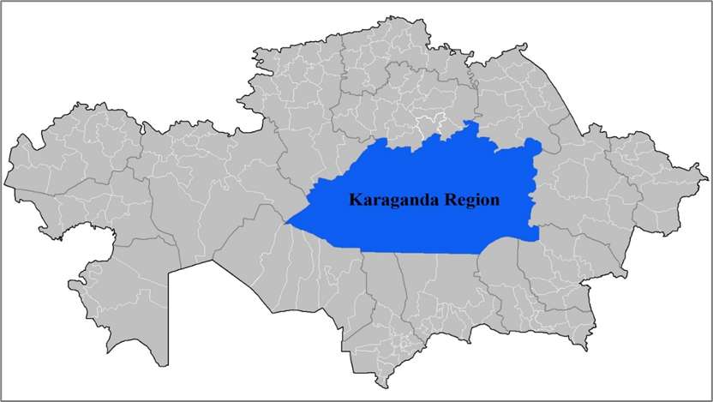
NB - the study was conducted before the division of the region

Figure 3 - The location and borders of the Karaganda region (selected area) on Kazakhstan map (before the 8 June, 2022).
Annual precipitation in the region's north is 250-300 mm; in the south - 150-210 mm; in the low mountainous areas - 300-400 mm. It rains mainly from April to October.
Today, the Karaganda region is one of the industrial regions of Kazakhstan, as it is rich in minerals and raw materials. It occupies 239 045 square km, which contains 8.7 of the whole territory of the Republic. 1134.4 thousand people live in the region, 5.7% of the country’s population [117]. It has 8 rural areas and 8 cities. 504 public schools operate in the Karaganda region. The number of students was about 204 thousand (204,174) in 2020.

  - Data quality assurance
It was conducted in Kazakh and Russian since Kazakh and Russian students’ study in the region's schools. The local educational organization of the Karaganda region approved the questionnaire. Before distributing the electronic questionnaire, this questionnaire was checked for the adequacy of the questions so that the questions do not infringe on students. It was anonymous, and students were aware of free choice to participate in the study. The right of respondents to refuse participation in the survey was respected. The questionnaire aimed to assess satisfaction with the service of WASH in schools and hygienic behavior. The questionnaire included the following aspects of WASH: availability, accessibility, education, functionality, operation and maintenance.
The study was validated in February 2020, before the COVID-19 pandemic, in three schools in three villages in Central Kazakhstan. All tools were translated into the Kazakh language. Questionnaires and interviews were conducted in Russian and Kazakh languages.

  - Ethical consideration
Ethical approval to undertake the study was obtained from the Bioethics Committee (Karaganda Medical University, Karaganda, Kazakhstan, Protocol No.18 of 12.04.2021). The respondents knew participation therein was voluntary and that they could renounce providing any information without reason before conducting the survey. To do this, at the beginning of each questionnaire, had an explanation that participation is voluntary and confidential. Before distributing the electronic questionnaire, this questionnaire was checked for the adequacy of the questions so that the questions do not infringe on students. It was anonymous, and students were aware of free choice to participate in the study. The right of respondents to refuse participation in the survey was respected.

  - Description of the third phase studies
The third phase consists of two studies, assessing access to WASH and assess the satisfaction with WASH services at schools by students (Figure 4).

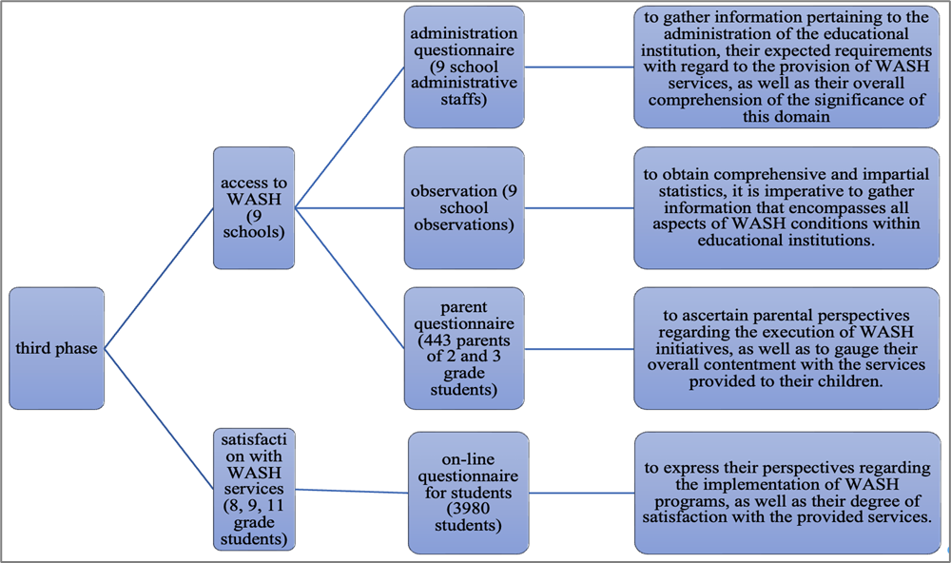

Figure 4 - Types of implemented study.

During the assessing the access to WASH in schools, the primary objective of a questionnaire designed for school administrative personnel is to gather data pertaining to the management of the educational institution, their expectations for the provision of Water, Sanitation, and Hygiene (WASH) services, and their overall comprehension of the significance of this domain [118]. The objective of the survey is to assess individuals' comprehension of the correlation between the provision of water, sanitation, and hygiene services and the establishment of an inclusive and high-quality educational environment [119]. A comprehensive evaluation of the administration's perspective should address the inquiry of the extent to which they prioritize WASH-related matters in educational institutions [41].
In order to assess parental perspectives on the execution of water, sanitation, and hygiene programs in schools, as well as their overall satisfaction with the services provided to their children, it is necessary to administer a questionnaire [118]. An examination of parental reactions should broaden the scope of comprehension regarding the acceptability of WASH facilities and identify other obstacles that must be overcome in order to establish a more conducive educational setting for kids. Observation serves in order to get unbiased and factual data regarding the actual circumstances present in a given context, achieved through purposeful and discerning examinations. The objective of this methodology is to enhance the comprehensiveness of the assessment of water, sanitation, and hygiene conditions in educational institutions by utilizing impartial data. Every component of WASH services possesses an assessment criterion.
A preliminary meeting was scheduled with the school's director and/or administration to provide an explanation of the study's purpose, objectives, and significance. Subsequently, the school administration completed a questionnaire designed for administrative workers, with 15 inquiries encompassing multiple sub-questions and response alternatives. Additionally, the school administration furnished class schedules. Through collaboration with the administration and careful consideration of the schedules, the research team successfully coordinated meetings with the teachers for the purpose of gathering study data. The questionnaires were spread through students the questionnaire and collected by the researchers within a span of one week. A cohort of 450 parents consented to participate in the sessions, during which they were apprised of the study by the researchers and administered questionnaires. Prior to the commencement of the survey, parents were provided with a consent form, which they read and subsequently signed, so acknowledging their understanding of the study's objectives and its significance. The parents who chose not to partake in the study submitted questionnaires that were devoid of any responses. The survey was completed by a total of 443 parents. The researchers were granted permission by all educational institutions to conduct on-site observations, but with certain limitations imposed in accordance with COVID-19 protocols. The observers were granted permission to examine only a single toilet facility at each educational institution. The researcher was accompanied by a school administrator to each lavatory, where the researcher completed an observation sheet with 16 questions.
The data were gathered between mid-October and November 2020, during the COVID-19 outbreak and the following implementation of restrictive measures in Kazakhstan. The study underwent multiple modifications over its course and saw frequent postponements and delays as a result of challenges and national regulations arising from the pandemic [24]. To begin with, the methodology of the study eliminated a survey targeting students due to the prevailing circumstances where a significant number of students across various grade levels were engaged in remote learning. During that period, access to schools was limited, and only kids in grades 1-4 were attending classes on-site with regularity. The participating schools granted permission just for the purpose of conducting observations in a single designated lavatory within their premises. As a result of the constraints imposed by the study, it was imperative to opt for a partial implementation of the WHO/UNICEF tool "Surveillance of WASH in schools" by selecting only specific questions instead of adhering to the complete protocol.
During the assessing the satisfaction with WASH services at schools, analyzing students’ responses should expand the perspective on understanding whether WASH facilities are acceptable and what other challenges lie ahead to create a more comfortable student environment. Random sampling was carried out among students. The survey used a questionnaire to gather data for students. Using the chosen instrument allows us to address the research goal and covers every element of WASH.
It was conducted in Kazakh and Russian since both language students’ study in the region's schools. The local educational organization of the Karaganda region approved the questionnaire. Before distributing the electronic questionnaire, this questionnaire was checked for the adequacy of the questions so that the questions do not infringe on students. It was anonymous, and students were aware of free choice to participate in the study. The right of respondents to refuse participation in the survey was respected. The questionnaire aimed to assess satisfaction with the service of WASH in schools and hygienic behavior. The questionnaire included the following aspects of WASH: availability, accessibility, education, functionality, operation and maintenance.
The cross-sectional study was conducted from April to May 2021 and 2022 in the Karaganda region, Kazakhstan. The electronic and quantitative questionnaire was forwarded to teachers by the school administration and filled in by students. Eligibility criteria for a representative sample of 3980 students included being registered as students of rural and urban schools in Karaganda region. Respondence rate was 88%. 500 student responses were excluded from the final analysis because of grade mismatch and absence of answers. In this stage, there was the satisfaction with access to water, sanitation and hygiene in schools and a comparison among rural and urban schools.

  - Sampling
Random sampling method was used to assess the access to WASH in schools. All Karaganda schools were selected and 9 schools from different districts were randomly selected, where 5 of them were urban schools and 4 were rural and district schools.
A cohort of 450 parents consented to participate in the sessions, during which Researchers provided information about the study and distributed questionnaires. The survey was completed by a total of 443 parents. The surveys were collected by the researchers within a span of one week (Table 5).

Table 5 - Parental sample sizes from various schools
№ | Schools | Settlement type | Sample size, n (%)
1 | school №1 | Urban | 49 (11.1)
2 | school №2 | Urban | 50 (11.3)
3 | school №3 | Urban | 46 (10.4)
4 | school №4 | Urban | 46 (10.4)
5 | school №5 | Urban | 49 (11.1)
6 | school №6 | Urban | 47 (10.6)
7 | school №7 | Urban | 61 (13.8)
8 | school №8 | Rural | 50 (11.3)
9 | school №9 | Rural | 45 (10.2)
10 | Total |  | 443

For on-line questionnaire to assess the satisfaction with WASH services, we carefully selected an appropriate sampling method tailored to the study's objectives to ensure representative sampling. The chosen approach addresses the need to obtain a diverse representation of school students from various locations. By adhering to recognized sampling principles, we aim to minimize bias and increase the likelihood that our findings can be generalized to schools beyond the sample.
In cross-sectional studies, the aim is to estimate the prevalence of unknown parameter(s) from the target population using a random sample. So, an adequate sample size is needed to evaluate the population prevalence with precision. The following simple formula would be used for calculating the adequate sample size in the prevalence study [1];

$n=\frac{z^{2}*p*(1-p)}{\frac{e^{2}}{N}}$, (1)

where you want to estimate a proportion (p) with a specified margin of error (e) and confidence level (z). The formula is iterative because the sample size (n) appears on both sides. Where n is the sample size, z is the z-score corresponding to the desired confidence level (e.g., for a 95% confidence level, Z ≈ 1.96), p = Estimated proportion of the population with the characteristic of interest (if unknown, assume 0.5 for maximum sample size), e is margin of error (expressed as a decimal) N is population size (9-class students – 5874; 11-class students - 2669).
Calculating the sample size:

n = ${1.96}^{2}*0.5*(1-0.5$)/ $\frac{{0.05}^{2}}{8543}$ ≈ 3287.96 (2)

Therefore, a sample size of approximately 3288 students would be needed for the questionnaire to assess access to water sanitation and hygiene at schools in the Karaganda region, considering a 95% confidence level and a margin of error of 5%.

  - Data processing and analysis
The data were analyzed using the IBM SPSS Statistics (Statistical Package for the Social Sciences) version 26.0 for Macintosh. The statistical data analysis was performed, and the study results were used to formulate conclusions and recommendations.
The data collected for this study were processed and analyzed using descriptive frequency analysis. The following section outlines the steps taken to process and analyze the data. After collecting the data, it was organized and cleaned to prepare it for analysis. The data was checked for errors, missing values, and outliers. Any errors or inconsistencies were corrected, and missing values were imputed or removed from the dataset. Outliers were also examined to determine whether they were valid or due to measurement errors. Once the data was cleaned, it was organized into a spreadsheet or database format. Each participant was assigned a unique identification number to maintain confidentiality.
For categorical variables, the data are given as absolute and relative numbers. For qualitative data, the significance of differences in the groups was determined by calculating the Chi-square test (χ2); for quantitative data with a distribution close to the normal statistical significance of differences in the groups was determined by calculating - Student's t-criterion. Descriptive frequency analysis was used to analyze the data collected for this study. This statistical technique was appropriate for describing and analyzing the frequency of occurrence of values in a dataset. A frequency distribution table and graph were created to show the number or percentage of times each value occurred in the dataset. This helped to identify the most common or frequent values in the data. A frequency table presented categorical data. The association between categorical variables was examined using Pearson’s Chi-square test.
Multiple logistic regression was applied to control for possible associated factors and examine the effect variation between identified risk factors. The critical significance level for group differences was set at p<0.05.
In the multivariable analysis, the forward binary logistic regression was used to examine independent factors associated with access to school WASH and hygiene behavior. The measure of association was the odds ratio. 95 CIs to measure the strength of association were used. All statistical tests were two-sided, with a significance level set of p < 0.05. Answer options were provided on yes/no and a 4-point Likert-type scale ranging from 1 (no, never) to 4 (yes, always).
The three outcomes were calculated as binary variables for use in logistic regression. The dependent variable was the student’s poor handwashing behavior, the behavior of refusing to drink water at school and the behavior of refusing to use the sanitation. For each dependent variable, there was code as 1 if the student exhibited the behavior or pattern and 0 if they did not. Logistic regression analyses the relationship between each dependent variable and independent variables. It estimates the probability of each binary outcome (i.e., the probability that a student exhibits the behavior or habit) as a function of the independent variables. It then used this information to identify factors associated with each behavior or pattern and predict the likelihood that a student will exhibit each behavior or habit based on their characteristics and other relevant factors.
- RESULTS

  - The mortality rate attributable to unsafe WASH and morbidity trends in Kazakhstan and Karaganda region
    - The mortality rate from the lack of safe WASH in KZ and KAR
The Sustainable Development Goal 3 highlights the importance of ensuring and promoting the health and well-being of all ages people. The target 3.9 emphasizes environmental health. According to target 3.9, it emphasizes significant reduction the number of deaths and illnesses caused by hazardous chemicals, as well as air, water, and soil pollution and contamination. The data type for this indicator is expressed as a rate, specifically the number of deaths per 100 000 population.
The mortality rate attributable to unsafe WASH is characterized as the annual number of deaths attributable to unsafe WASH divided by the population, per 100 000. Epidemiological studies have demonstrated that exposure to unsafe WASH is directly associated with diarrhoeal diseases, intestinal nematode infections, and other diseases. Poor hand hygiene practices have also been linked to acute respiratory infections. Estimations for SDG 3.9.2 include diarrhoea (ICD-10 codes A00, A01, A03, A04, A06-A09), intestinal nematode infections (ICD-10 codes B76-B77, B79), protein-energy malnutrition (ICD-10 codes E40-E46), and acute respiratory infections (ICD-10 codes H65-H66, J00-J22, P23, and U04).
Comparative risk assessment is used to estimate the proportion of diarrhoea and acute respiratory infections attributable to hazardous WASH. Attributable disease fatalities are calculated by first combining information on the increased (or relative) risk of a disease resulting from exposure with information on the prevalence of exposure as measured by the proportion of the population with exposure to unsafe WASH. This enables the estimation of the 'population attributable fraction' (PAF), which is the proportion of disease in a population that can be attributed to unsafe WASH. When this fraction is applied to the total number of fatalities from diarrhoea or acute respiratory infections, the number of deaths attributable to inadequate WASH is calculated [28].
The use of safe WASH services could have prevented the loss of at least 1.4 million lives and 74 million disability-adjusted life years (DALYs) in 2019 due to diarrhoea, acute respiratory infections (ARIs), malnutrition, and soil-transmitted helminthoses. This accounts for 2.5% of all global deaths and 2.9% of all DALYs.
Over 1 million deaths and 55 million disability-adjusted life years (DALYs) were attributable to diarrheal disease. 69% of the total burden of diarrhoeal disease could be attributed to inadequate WASH. There were 505 000 diarrhoea deaths attributable to unsafe drinking water, 564 000 attributable to unsafe sanitation, and 384 000 attributable to unsafe hand hygiene. The second largest cause of disease burden attributable to WASH was ARIs attributable to inadequate hand hygiene, which was linked to 356 000 deaths and 17 million disability-adjusted life years (DALYs) and accounted for 14% of the total ARIs disease burden.
Kazakhstan belongs to the countries of the European region according to the WHO. The European WHO Region has the lowest percentage of WASH-related deaths 3.6 per 100 000 population, with 33 478 deaths in the region. Regarding to Kazakhstan, WASH-related deaths - 598; mortality rate attributed to WASH - 3.2 per 100 000 population.
The total DALYs (disability-adjusted life years) for the European WHO region is 1 255 524, and the total WASH (water, sanitation, and hygiene)- attributable DALYs in the region is 135 per 100 000.For Kazakhstan, the total number of DALYs from selected diseases related to SDG 3.9.2 is 42 432. The DALY rate attributed to WASH for selected diseases in Kazakhstan is 229 per 100,000 population (120).
According to the MH RK to monitor and review the process of implementation of 17 Sustainable Development Goals (SDGs), The National Platform for reporting on Sustainable Development Goals (SDGs) publishes open data on SDG statistics provided by the Bureau of National Statistics of the Agency for Strategic Planning and Reforms of the RK as the central coordinator of SDG reporting [28].
The Figure 5 shows the mortality from lack of safe water, sanitation, and hygiene in Kazakhstan (KZ), per 100,000 population, for the years 2010 to 2019, for the country as a whole and for urban and rural areas separately.

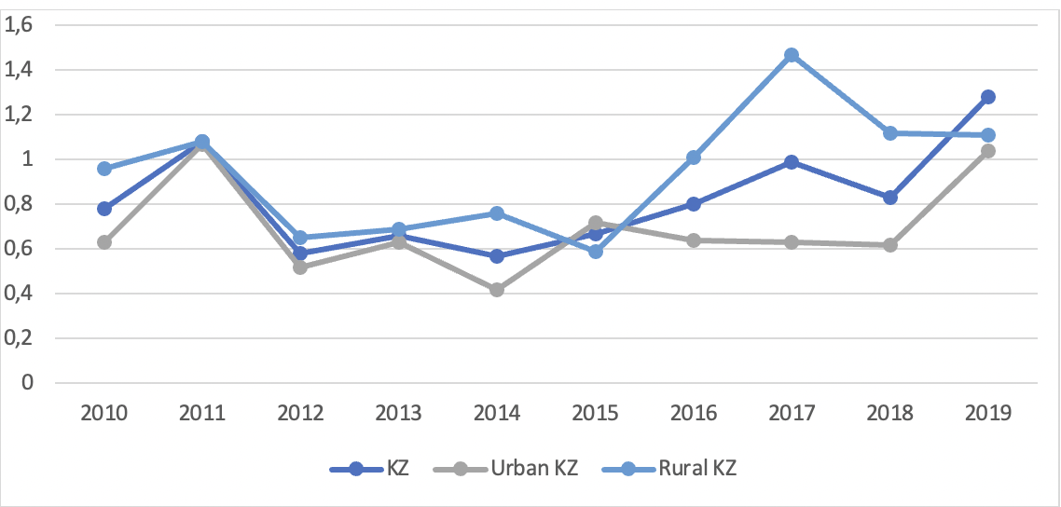

Figure 5 - Mortality from lack of safe WASH, KZ, per 100 000.

In general, mortality rate from lack of safe WASH fluctuated but remained below 1 per 100 000 population during 10 years in KZ. However, the rate increased in 2019 and achieved peak as 1.28 per 100 000. The lowest indicators were 0.58 per 100 000 in 2012 and 2014. Moreover, the mortality rate in rural KZ was higher than in urban areas and average KZ. The highest rate in rural areas was higher than in KZ by 0.19 per 100 000 population, reaching 1.47 per 100,000 population in 2017. As a whole, the mortality rate in urban areas ranged from 0.42 to 1.04 per 100 000 population.
The Figure 6 shows the mortality rate per 100 000 people in Karaganda region (KAR) due to the lack of safe WASH from 2010 till 2019, for both urban and rural areas.
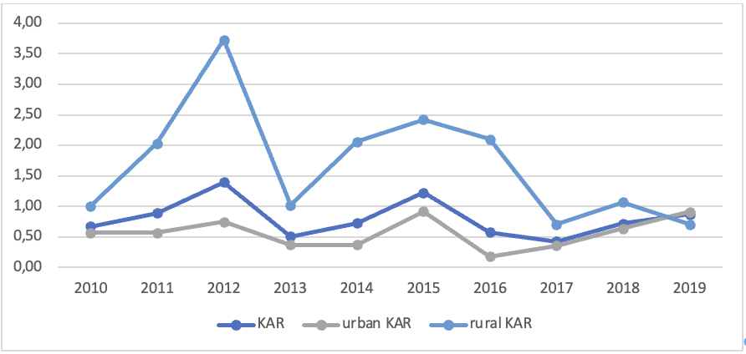

Figure 6 - Mortality from lack of safe WASH, KAR, per 100 000.

Generally, the mortality rate fluctuated over the years but showed an overall decreasing trend. The maximum indicator was 1.40 per 100 000 in 2012. Overall, the peak of the mortality was in rural areas of KAR, with a rate of 3.73 per 100,000 in 2012. In rural KAR, the mortality rate was higher than in urban KAR and showed a more fluctuating pattern. Overall, the data suggests that there has been some improvement in the mortality rate due to lack of safe WASH in KAR over the years, although rural areas still need more attention and intervention to reduce the mortality rate further.
Overall, comparing the data, the indicators of KAR was lower than in KZ, except. In these years, the indicator of KAR was 1.40 and 2.5 times higher, 1.23 and 2 times higher than in KZ. In general mortality rate in rural KAR was significantly higher than in republic mean till 2017, however, since 2017, mortality rates have fallen sharply in the KAR compared to rural areas of KZ. Overall, urban areas in KZ had higher mortality rates than cities in urban KAR.

    - The morbidity trends of water related infectious diseases in KZ and KAR
The availability of clean water is crucial in preventing the spread of disease. Certain diseases, such as cholera, typhoid, dysentery, leptospirosis, tularemia, infectious hepatitis, adenovirus infections, tuberculosis, and helminth infections, are spread through contact with water.
In order to ensure that everyone has access to safe drinking water, sanitary rules called " Sanitary and epidemiological requirements for water sources, places of water intake for domestic and drinking purposes, domestic and drinking water supply and places of cultural and domestic water use and safety of water bodies" outline standards that must be met by centralized water systems.
Infectious morbidity continues to be one of the leading indicators in general the incidence of infectious diseases remains one of the leading indicators of general human pathology and water-related infectious diseases are largely dependent on the nature of water treatment, the condition of water supply and sewerage networks, the quantity and quality of water supplied to the population, as well as a set of indicators of sanitary and hygienic improvement of human settlements.
In general, the trend of infectious diseases over the past ten years is declining year by year. In the structure of infectious diseases for this study were taken incidence of the population of KZ and KAR, having the water factor of transmission for the period 2011-2021, such as typhoid fever, paratyphoid A, B, C, acute intestinal infections, viral hepatitis A and bacterial dysentery.
The maximum rate of typhoid fever for this period showed 4 cases in 2011 in KZ. And 3 of them were in South-Kazakhstan region. The next 3 cases were registered in 2012. In subsequent years, the rate varied, with 1 case reported, mostly were reported in Almaty city and region. In 2019, typhoid fever was detected in Astana city. Moreover, no cases of paratyphoid A, B, C were registered during the period 2010-2020, except for 2017, 1 case in Mangystau region.
Bacterial dysentery is a disease of the group of intestinal infectious diseases, the causative agent of which is the bacterium Shigella. In general, the trend of bacterial dysentery for the period 2011-2021 has been decreasing in both KZ and KAR (Figures 7 and 8). The prevalence of bacterial dysentery among 0-14 years old children was higher than total morbidity and morbidity of 15-18 y.o. children in KZ. The maximum level of bacterial dysentery was in 2012, 27.34 per 100 000 children of 0-14y.o. In KZ, the incidence was declining and sharp rise in 2015, 1.38, 1.52 and 3.78 times more, total rate, morbidity of children 0-14 y.o., and morbidity of children 15-18 y.o., respectively. In 2021, the rate increased to 4.44 and 4.66 times more, total morbidity and 0-14 y.o. children morbidity, respectively (Figure 7).

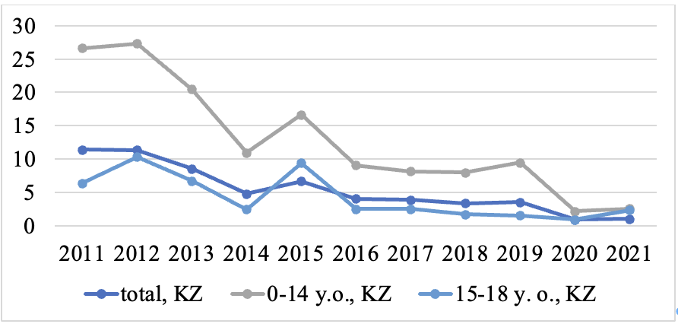

Figure 7 - Bacterial dysentery morbidity, KZ, per 100 000.

The linear regression model for total children morbidity in Kazakhstan y=2098−1.038x indicates a statistically significant negative relationship between the dependent variable bacterial dysentery morbidity and the independent variable year at a significance level of p-value<0.001. For each unit increase in x, the expected mean value of y decreases by approximately 1.038 units. Bacterial dysentery morbidity among 0-14y.o. children showed linear regression y (0-14 y.o.) = 4923 -2.436x (p<0.001), which meant for each unit increase in year, the expected morbidity means decreases by approximately 1.038 units. The linear regression of this morbidity among 15-18y.o. children showed year increases by one unit, the predicted value of morbidity decreases by 0.744 units. It shows negative correlation between y and x, suggesting that as x increases, y tends to decrease.
In KAR, the morbidity trend of bacterial dysentery was also downward and prevalance of morbidity of children aged 0-14 y.o. was higher than total morbidity and morbidity of 15-18 y.o.. From 2011, the rate declined to 0.29 overall and 0.33 among children 0-14 y.o. per 100 000 till 2014. The rates further increased to values of 2.2 and 6.2 among the population and children under 14 years of age in 2016. Since 2017, the trend is downward and in 2021 and the prevelance is equal to 0 (Figure 8).

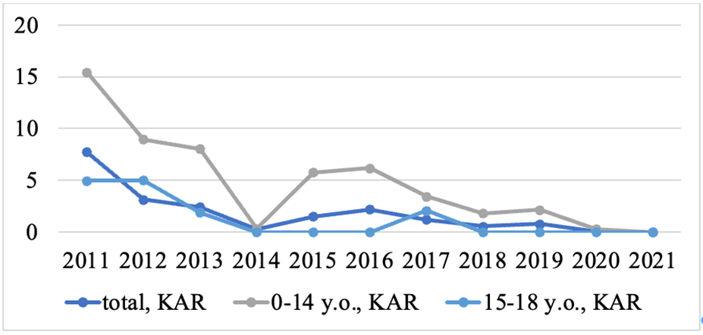

Figure 8 - Bacterial dysentery morbidity, KAR, per 100 000.

The linear regression model for total children morbidity in Karaganda region y=1023-0.507x (p<0.01) indicates a statistically significant negative relationship between the dependent variable bacterial dysentery morbidity and the independent variable year at a significance level of p-value<0.01. For each unit increase in x, the expected mean value of y decreases by approximately 0.507 units. Bacterial dysentery morbidity among 0-14y.o. children showed linear regression y (0-14 y.o.) = 2365 -1.171x (p<0.01), which meant for each unit increase in year, the expected morbidity means decreases by approximately 1.171 units. The linear regression of this morbidity among 15-18y.o. children showed year increases by one unit, the predicted value of morbidity decreases by 0.440 units. It shows negative correlation between y and x, suggesting that as x increases, y tends to decrease.
The next disease is acute intestinal infections, where water is one of the factors of infection and spread. The danger of intestinal infections is caused by drinking, washing dishes, hands, fruits and vegetables in open bodies of water, melted water. Intestinal infections can be caused by drinking water from a well if the well is not properly constructed or used. Overall, the trend of acute intestinal infections was downward and rate of children under 14 years was higher than total and 15-18 y.o (Figure 9). Additionally, there was slightly increase during pandemic years. The indicator raised to 1.7, 1.8 and 4.2 times from 2020 to 2021, total, children under 14 y.o. and 15-18 y.o., respectively.

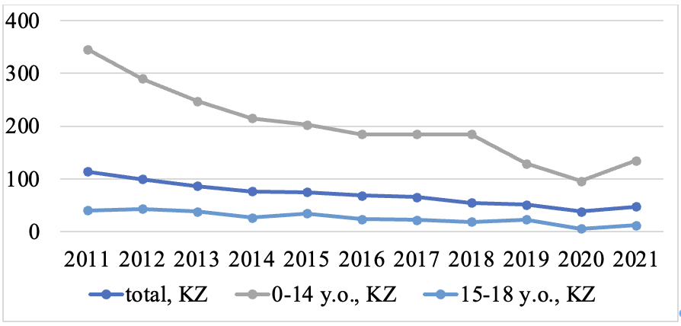

Figure 9 - Acute intestinal infections morbidity, KZ, per 100 000.

The linear regression of acute intestinal infections among total children showed y=13578-6.7x with p-value<0.001 in Kazakhstan. For each unit increase in year, the expected mean value of morbidity decreases by approximately 6.7 units. The morbidity of children among 0-14 y.o. children showed y (0-14y.o.) = 41738-20.604x (p<0.001), where the predicted number of morbidities decrease to 20.604 for each unit year increasing. The linear regression of this morbidity among 15-18y.o. children showed year increases by one unit, the predicted value of morbidity decreases by 3.333 units. It shows negative correlation between y and x, suggesting that as x increases, y tends to decrease.
In general, the trend of acute intestinal infections morbidity in KAR was same as in KZ (Figure 10). While the incidence trend for children under 14 in KZ was slowly declining, in KAR it was more or less stable. And as in KZ, the rates decreased until 2020 and in pandemic years increased by 1.57, 1.78 and 4.17 times by 2021, general morbidity, morbidity among children under 14 years and 15-18 years, respectively.

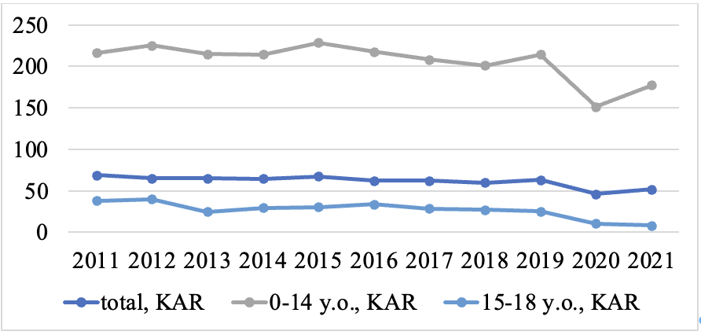

Figure 10 - Acute intestinal infections morbidity, KAR, per 100 000.

Generally, morbidity among children showed y(total)=3375 -1.644x (p<0.01), morbidity among 0-14y.o. children y=10076-4.896x and morbidity among 15-18 y.o. children y= 5030-2.482x in Karaganda region. It showed negative correlation between years and morbidity. The linear regression of this children morbidity showed year increases by one unit, the predicted value of morbidity decreases.
Viral hepatitis A is an infectious disease that can be considered a WASH related disease. It is caused by the hepatitis A virus (HAV) and primarily spreads through the fecal-oral route, often due to contaminated water or food. This disease is closely linked to inadequate access to safe water, poor sanitation facilities, and improper hygiene practices. Contaminated water sources, particularly those contaminated with fecal matter, can serve as a breeding ground for the virus. Additionally, unsanitary conditions, such as lack of proper sanitation infrastructure and poor hygiene practices like inadequate handwashing, contribute to the transmission of HAV.
In general, the trend of viral hepatitis A disease was steadily declining, however, differing from the above-mentioned diseases, the trend of morbidity in 15-8-year-olds was higher than in children under 14 years of age and general morbidity (Figure 11).
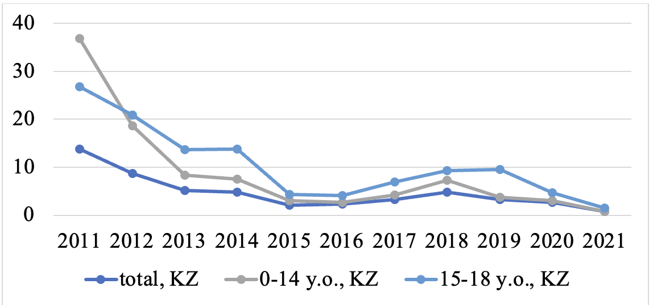

Figure 11 – Viral hepatitis A morbidity, KZ, per 100 000.

The linear regression analysis of morbidity of viral hepatitis y(total)=1724-0.853x, y(0-14y.o.) =4700-2.327x, y(15-18y.o.) =3855-1.907x in Kazakhstan. It showed negative correlation between years and morbidity. The linear regression of this children morbidity showed year increases by one unit, the predicted value of morbidity decreases.
In KAR, the trend was the same as in KZ, but there were three peaks in this area over the period, in 2012, 2014 and 2018 (Figure 12). The first peak was in the morbidity of children 15-18 years of age, with rates of 28.33 per 100,000 population. The next peak was in 2014, 1.4, 1.5 and 2.6 times, total morbidity, morbidity among children under 14 years and 15-18 years. The highest rates were in 2018 in KAR, rising 2.5, 4 and 7.6 times, overall morbidity, morbidity of children under 14 years and 15-18 years, respectively.

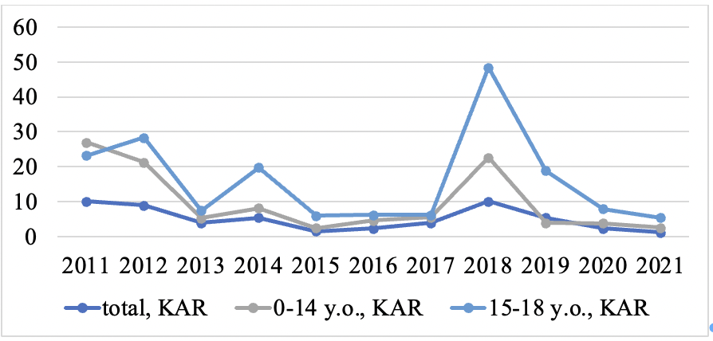

Figure 12 - Viral hepatitis A morbidity, KAR, per 100 000.

Overall, the data indicates a need for continued efforts in improving WASH infrastructure, promoting proper hygiene practices, and enhancing access to safe water sources in order to further reduce water-related diseases and associated morbidity and mortality. It is crucial to focus on both urban and rural areas, with particular attention to vulnerable age group of children.
To sum up, in Kazakhstan and the Karaganda area, the number of cases of bacterial dysentery and acute intestinal infections went down from 2011 to 2021. The rate was highest among children younger than 14 years old. In Kazakhstan, the number of cases of bacterial dysentery dropped to 2.61 per 100,000 children under 14 in 2021. In 2022, there were no reports of bacterial diarrhoea in Karaganda. In Kazakhstan, the number of children under 14 years old with acute intestinal diseases went down to 95.82 per 100,000 in 2020. In Karaganda, the rate went down to 151.31 per 100,000 children under 14 in 2020. In Kazakhstan and the Karaganda area, the older age group of people were most likely to get viral hepatitis. In Kazakhstan, the rate went down to 1.54 per 100,000 15–18-year-olds. The rate of viral hepatitis in Karaganda dropped from 23.18 per 100 000 15–18-year-olds in 2011 to 3.55 per 100 000 15–18-year-olds in 2022. The results show how important it is to have public health policies that are tailored to each age group in order to prevent and control illness. To keep and improve the health of the people in the area, educational campaigns are needed.
These findings emphasize the significance of implementing age-specific public health treatments and policies to prevent and control diseases. Efforts should persist in targeting the reduction of bacterial dysentery and acute intestinal infections, with a particular emphasis on children. Additionally, attention should be given to the developing issues presented by the growing prevalence of viral hepatitis, specifically among the 15–18-year age group. Public health activities and education campaigns are essential for preserving and enhancing the overall health status in the region.

  - Assessing to WASH service accessibility at selected schools during the COVID-19 pandemic
The results were included in the National Center for Public Health's report on the Childhood Obesity Surveillance Initiative study and the baseline assessment of access to water, sanitation and hygiene (WASH) in schools, funded by the World Health Organization and the United Nations Children's Fund (UNICEF).

    - Access to drinking water at studied schools
In three schools, school directors supervised the operation and maintenance of water services, while in six schools, the head teachers or the head of economic affairs were responsible. The school administration questionnaire revealed that the primary source of drinking water in all schools was a building-connected central water supply system. Piped water is safe drinking water delivered straight to the consumer. From the place of collection, it is sent through a pipeline system to the tap customers. Typically, a treatment facility and disinfection are employed to make this water drinkable, and then it is stored in a tank or tanks until it is needed. It goes through several processes before it reaches the user, and it can originate from the earth, a canal, or a more evident source.
From the place of collection, water is transported to the treatment facility via pumping or natural gravity feeding (well, canal, or source). Regular disinfection and cleaning of water taps, water purification was carried out in all schools, and regular inspections of the water supply system to detect irregularities in drinking water supply were noted by seven out of nine schools, where in one questionnaire the answer was omitted and was "no" in carrying out these activities on drinking water supply. Eight of nine administrators responded that the primary source of drinking water was always available during the academic year, and one administrator ignored this question. Seven of nine respondents asserted that students could consume water whenever necessary, including during class. Two respondents did not provide an answer.
The Table 6 reveals that students could obtain free drinking water from faucets or fountains outside the restrooms and from the cafeteria.

Table 6 - The availability of drinking water supply infrastructure

№ | Schools | Faucets or fountains outside the restroom | In the cafeteria for free | Students bring water from home | Students buy water from the canteen or cafeteria
1 | school 1 | Х |  |  | ∼
2 | school 2 | Х
3 | school 3 | ∼ |  | ∼ | ∼
4 | school 4 | Х
5 | school 5 |  | Χ
6 | school 6 |  |  |  | ∼
7 | school 7 | Χ
8 | school 8 | Χ
9 | school 9 | Χ
NB:
1 ∼ - not answered
2 Χ - no
3 - yes

49.2% were parents of males (218 individuals), while 50.8% were parents of girls (225 individuals). About half (48.8%) of parents responded that their child always had access to potable water, primarily (for free) during the entire school day. Very few parents (2.5%) selected the option "rarely," while 13.1% of parents responded negatively. In addition, 7% of respondents indicated that they brought their own water to school, and one parent reported that the cafeteria was closed. During the COVID-19 pandemic, questionnaires from parents were collected in conjunction with provisional restrictions recommending the closure of school cafeterias. Moreover, students may carry water from home or purchase it from the cafeteria or buffet. During the observation phase, water-related information and educational materials were observed in schools.
During the survey time, the water from improved water sources was available in all schools. So, all schools had basic level of water by JMP service ladder level

    - Access to sanitation at studied schools
In every school, students had access to an interior toilet that was connected to a centralized water supply. In addition, one of the schools had a toilet that was not connected to a central sewer (school 1). The number of school toilets ranged between 6 (school 8) to 61 (school 6). The average amount of toilets was 28.89±18.78.
All school restrooms were separated by gender. The maximum quantity of toilets for females was 32 (school 6), while for boys it was 21 (school 6). The minimum number of restrooms for boys and females was three (school 2). In addition, almost all schools had staff restrooms, where the minimum number was 1, and maximum was 9. In addition, just four schools had urinals (school 3, school 6, school 8, and school 9); one of them (school 6) had sixteen urinals. Except for school 2, which is an urban school, all respondents stated that school restrooms provide students with adequate privacy. Almost all administrations stated that students could use the restrooms whenever necessary during the school day, with the exception of urban school 6, where permission was granted at any time, but only upon request during class time. According to the school administration questionnaire, two schools had recently resolved issues with the functionality of their restrooms. The seven remaining organizations had no current issues.
According to the same questionnaire, all institutions had toilets with adequate lighting. Almost all (7/9) school administrations vouched for adequate ventilation. One respondent did not respond, and one school reported inadequate ventilation (urban school 7). According to the data, all school restrooms had heating; school 3 did not respond to this query. Additionally, six of nine institutions reported that toilet paper was always available. One institution provided it most of the time (urban school 4). One institution reported not providing toilet paper (urban school 5). One institution did not reply (urban school 3). All school restrooms were cleaned twice daily, or more frequently as required.
62.3% of parents reported that their children could use the restroom at school whenever they needed to, whereas 16.7% of student used the restroom rarely, only when it was challenging to endure. However, 3.8% of parents reported that their student did not utilize the school's restrooms. A minor percentage of parents (3.6%) needed to be made aware of whether or not their children used the school toilets. In the option of reasons not to use the toilets in the school, some reasons given were such as, there is a strong smell in the toilet, toilets are dirty, no toilet paper, not convenient as there is no toilet seat.
Approximately 80.8% of parents reported that the school's restrooms were located within the building. 2 parents responded that the restroom was located outdoors. However, 1.6% of respondents chose alternative options and provided open-ended responses indicating that their kids only used the toilet at home. In addition, 15.6% of respondents did not respond and 1.6% of parents were unaware of the type of toilet their children used.
The researchers' observations indicated that flushing toilets were available. All toilet cubicles were available for use, doors unlocked. 7 out of 9 schools toilet cubicles are not broken, the toilet opening is not blocked and there is water for flushing, however, in two schools there was a malfunction such as there was no water for flushing.
Doors that could be locked from the inside was found in 5 of the 9 institutions that provided adequate privacy. However, at other institutions, the upper structure of the toilet doors had cracks (urban school 3, school 4, school 7 and rural school 9). All observed school restrooms were all cleaned and provided with sufficient lighting and good ventilation. There were also trash cans in all school restrooms. Toilet paper was available in only 4 surveyed school student toilets.
During the survey time, 4 out of 9 schools had improved sanitation facilities at school, separate for boys and girls and usable (available, functioning and providing privacy). So, these schools have basic level of sanitation by JMP service ladder level. And 5 others were in limited ladder level, because the upper structure of the toilet doors had cracks and in two schools there was a malfunction such as there was no water for flushing.

    - Access to hygiene at studied schools
All school administrators ensured that soap and water for handwashing were always available. Eighty-four percent of parents responded that their child washed their hands with soap before eating in school or after using the restroom. 0.9% of them were unaware of whether or not their children cleaned their hands at school. 13.5% of parents did not respond to the question. A query asked why students do not wash their hands at school. About half of parents (45.8%) did not respond to this question, a quarter (25.5%) indicated they did not know, and 6.8% selected the alternative "other" where they could provide their own free-form responses. The parents indicated that their children disinfected their hands with antiseptic as one of the responses. In addition, 9 percent of respondents reported that no soap or other detergents were available. Some parents (7%) reported having no or limited access to water. Only 3.2% of the parents indicated that their child lacked the desire or ability to wash hands with soap. Lastly, 2.7% of parents reported that their children lacked the opportunity to cleanse their hands.
During the observation, one school did not have the water for washing hands on that moment, and the head of the school answered that it is not frequent situation (rural school 8). Moreover, in urban school 4 school did not have the soap at the moment of observation. Additionally, warm water was available only in five schools, and all of them were urban, despite the fact that the research was conducted in cold autumn. Observed handwashing facilities were clean and drying materials after handwashing were only in four school, despite the fact the pandemic time and when only preventive measure was handwashing hands.
All in all, 16.7% of students only went to the toilet when it was really hard. 3.8% of parents said that their children don't use the school toilet. 3.6% of parents wanted to know more about whether or not their children use the school toilet. 15.6% of those who answered did not say what kind of toilet their children use, and 1.6% of parents did not know. Just 0.9% of parents didn't know if their children washed their hands at school. 13.5% of parents didn't say anything about this. Only 9% of those who answered said they didn't have soap or other cleaning supplies. Some parents (7%) said they didn't have access to water or only had limited access to it. The surveys showed that parents and school officials don't fully understand how important it is to have clean water, toilets, and clothes. Not knowing how important water, sanitation, and hygiene issues are can cause a number of issues, including not having enough centralized control and constant monitoring, not following all sanitation standards completely, and negative effects on health and education.
During the survey time, hand washing facilities with water and soap were available in the 7 schools at the time of the survey. So, these schools had basic level of hygiene. However, in two schools there was not water and soap during the survey, that’s why these schools were in limited ladder level of hygiene by JMP service ladder level.
The study data demonstrates that Karaganda is not a place of significant concern in terms of water access. However, the present evaluation of access to WASH in schools has revealed deficiencies (which have been significantly highlighted by the COVID-19 pandemic) at every phase of the execution of water, sanitation, and hygiene services. Through the examination of questionnaires, it has been determined that parents and administration lack a comprehensive understanding of the significance of this matter. This lack of understanding leads to various issues, such as the absence of centralized control and continuous monitoring, partial non-compliance with sanitary standards, and detrimental effects on both health and education.
The study verified that the complete provision of access to these services within the framework of educational institutions effectively addresses several Sustainable Development Goal (SDG) targets. However, it is insufficient to simply be aware of "what these tasks are" and "why these tasks are necessary". It is crucial to understand the precise method by which these tasks must be resolved. The prompt identification of the practicality of adopting a systematic approach to Water, Sanitation, and Hygiene (WASH) not only aids in the attainment of the objectives outlined in Sustainable Development Goal 4 and Sustainable Development Goal 6, which aim to establish a conducive atmosphere for education and well-being, but also simplifies the process of pinpointing the actual root causes of issues by posing appropriate inquiries. Furthermore, it eradicates instances where ordinary activities are selected inconsistently and without proper consideration, resulting in selections that fail to yield desired outcomes.

  - Assessing Students’ Satisfaction with WASH Services at Karaganda region during the COVID-19 Pandemic
    - Sociodemographic characteristics of student participants
Demographic information for the 3980 student responses included in the final analysis is provided in Table 7.

Table 7 - Socio-demographic characteristics of respondents by gender

Characteristics |  | Male (n=1541)  n (%) | Female (n=2439)  n (%) | Overall (n=3980)  n (%)
Schools | urban | 543(13.6) | 832(20.9) | 1375(34.5)
Schools | rural | 998(25) | 1607(40.4) | 2605(65.5)
Grades | 8 | 292(7.3) | 475(11.9) | 767(19.2)
Grades | 9 | 823(20.7) | 1184(29.7) | 2007(50.4)
Grades | 11 | 426(10.7) | 780(19.6) | 1206(30.3)

Sixty one percent of responding students identified as female (n =2439) and almost thirty nine percent identified as male (n = 1541). One respondent out of three were from urban schools (34.5%, n=1375). Almost every fifth student was student of 5-8 grades (767, 19.2%). Half of the respondents were students of ninth grade (2007, 50.4%), and one student out of three were graduate student of high school (1206, 30.3%). Schoolgirls prevailed in all classes and almost every third respondent out of five were female (Table 7).
The highest percentage of students’ mother occupation were permanent or temporarily unemployed, which consisted of 27.6% (n=1099), housewives were also in this category (Figure 13). Every fourth students’ mother was professional and technical staff, which included professions as, doctor, teacher, lawyer, engineer (968, 24.3%). A less common profession among the mothers of respondents was head or manager of state bodies and institutions, which accounted for 1.1% (n=43). Additionally, student who did not find the profession of the mother in the answer options, chose the option of “others”, and it consisted of 2.4% (n=96) (Table A.1, Appendix A).

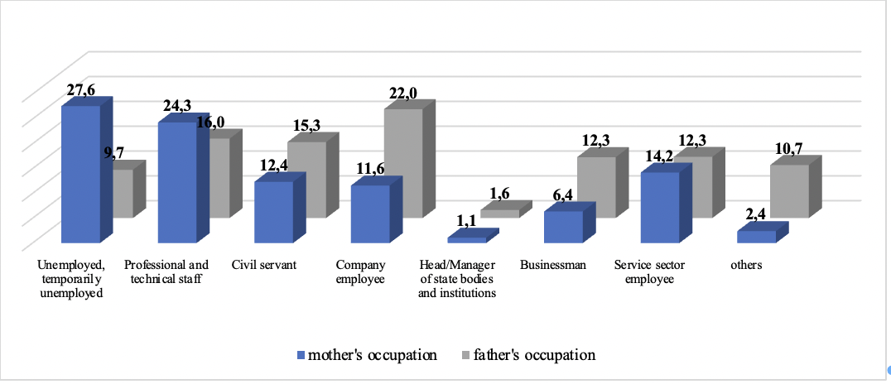

Figure 13 - The profession of students' parents, %.

Every fifth respondent’s father was company employee (n= 874, 22%); 16% of fathers were professional and technical staff (n=637). 65 fathers occupied as head or manager of state bodies and institutions (1.6%). Every tenth respondent’s father was permanent or temporarily unemployed, and consisted of 9.7% (n=388). One out of six fathers were occupied as civil servants (n=610). 489 fathers were businessman and consisted of 12.3%, and the same percentage of respondents’ fathers were service sector employee. 43.3% of mothers had higher education (n= 1724), 33.9% of them had secondary education (n=677) and only 2% of mothers had postgraduate education (n=79) (Figure 14).

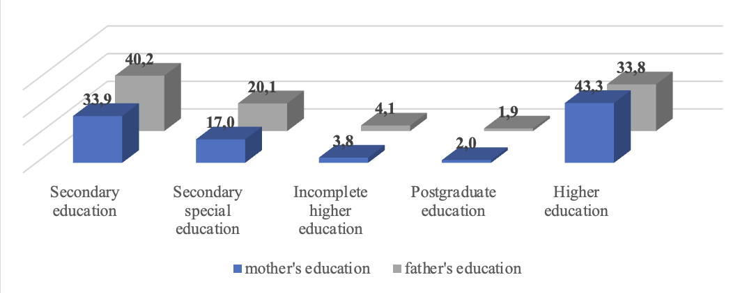

Figure 14 - The education of students’ parents.

Almost half of fathers had secondary education (n=1598, 40.2%), every third father had higher education (n=1345, 33.8%). Additionally, only 1.9% of fathers had postgraduate education (n=76). Every fifth father had secondary special education, which consisted of 20.1% (n=799). 4.1 % of fathers had incomplete higher education (n=162).

    - The statistical analysis of student’s satisfaction with WASH services at Karaganda region schools
      - Students’ satisfaction with availability and functionality of drinking water at schools
55.3% and 22.9% of urban students answered that drinking water was always and almost always available (Table 8). Every fifth urban student answered that water for drinking was rarely and never available. 43% of them answered that they can get drinking water for free. 49.6% of urban students brought the drinking water from home.
Almost half of rural students (58.3%) answered that the drinking water at school was always available, while one-sixth of the students (14.9%) responded that water was almost always available. However, one out of six students answered as rarely and one out of ten students answered as never. Two out of five rural students got water from the faucets in the cafeteria, in the classroom or toilet, from the drinking fountains in the hallway. 35.7% of them take beverage from home.

Table 8 - Prevalence of water availability and functionality

Questions | options | rural school  n (%) | urban school  n (%)
Is water available for drinking at school? | never | 155(11.2) | 165(10.1)
Is water available for drinking at school? | rarely | 213(15.4) | 402(15.4)
Is water available for drinking at school? | almost always | 205(14.9) | 597(22.9)
Is water available for drinking at school? | always | 802(58.3) | 1441(55.3)
I get it for free at school (from the faucets in the cafeteria, in the classroom or toilet, from the drinking fountains in the hallway) | no | 828(60.2) | 1476(56.6)
 | yes | 547(39.7) | 1129(43.3)
I bring it from home | no | 884(64.2) | 1312(50.3)
I bring it from home | yes | 491(35.7) | 1293(49.6)
I buy it at the cafeteria/kiosk/vending machine inside the school | no | 1131(82.3) | 1851(71.1)
 | yes | 244(17.7) | 754(28.9)

Totally, 57.9% of students stated that they didn’t get water for free. Urban students' responses about getting water from the faucets in the cafeteria, in the classroom or toilet, from the drinking fountains in the hallway at school were 3 percent higher than rural students' responses. 28.4% of urban students got free water at school, whereas 13.7% of rural students showed it.
Completely, 44.8% of whole students answered that they take beverage from home. Half of urban students brought water from home, while only one-third of rural students did so and nearly 65% did not bring water. Every third student of urban school bought water at the cafeteria/kiosk/vending machine inside the school. Almost every fifth rural student bought water.
In conclusion, it was said by 57.9% of children that they do not get water for free. 20% of school students in rural areas and 28% of school students in cities agreed that the water at school wasn't suitable to drink.
The study's findings illuminate the difficulties associated with the availability and functionality of drinking water in schools. Although both urban and rural schools encounter challenges in maintaining a steady water supply.

      - Students’ satisfaction with quality of services, operation and maintenance of drinking water at schools
Three out of whole urban school students thought that the water was good for drinking, and it consisted 71.5%. However, 28.5% of urban students assessed it had bad smell, bad taste, bad color, in comparison to 7% of rural students (Table A.2, Appendix A). Totally, every fifth student of rural school and third student of urban school agreed with the statement of not good water for drinking. With the statement of “the drinking water points are too far away” agreed 15-16% of students and 84-85% of them disagreed with it (Figure 15).

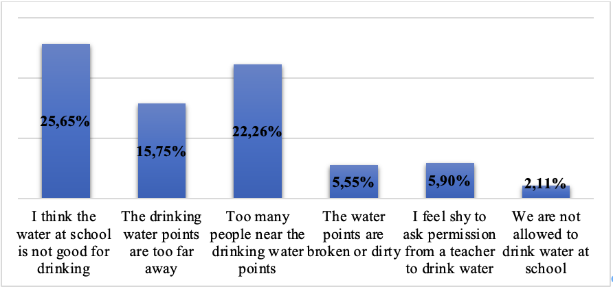

Figure 15 - Water: quality of services, operation and maintenance.

Every fifth rural and fourth urban school students agreed with the statement “too many people near the drinking water points”. 77.7% of whole participants didn’t agree with this statement.
The statement “the water points are broken or dirty” was refuted by almost all students, except 221 students (69 of them rural and 152 of them urban, which consisted 5% and 6%, respectively).
It's natural to feel nervous or shy in certain situations, like asking for permission to drink water from a teacher. However, it's important to remember that staying hydrated is essential for your health and well-being, and most teachers understand this. In spite of this, there is a small percentage of students in schools who are embarrassed to ask teachers for permission to drink water, and this percentage is only 5.9%.
2.1% of students responded that they agreed with the statement “we are not allowed to drink water at school”. However, it's important to note that not being allowed to drink water at school can have negative consequences for students' health and well-being, and it's important to advocate for policies that prioritize students' basic needs.
In conclusion, 24% of school students in cities and 20% of school students in rural areas both worried about how crowded it was near drinking water points. 15% of students at both schools said that the drinking water points were too far away.
The study emphasizes many concerns pertaining to the quality, operation, and maintenance of drinking water services in schools. The results indicate a requirement for enhanced water quality, availability, sanitation, and maintenance at educational establishments to guarantee convenient and secure access to drinking water for students. It is essential to tackle these challenges in order to advance the general health and welfare of children in both rural and urban educational environments.

      - Students’ satisfaction with education and practices about drinking water at schools
A higher percentage of students in urban schools drink water two or more times a day compared to rural schools (39.1% of whole students). However, a considerable number of students (42% of rural students and 41% of urban students) in both rural and urban schools drink water once a day or less, and a significant proportion (19.4% of whole students) report never drinking water at school. It is highlighted the importance of promoting healthy hydration practices and providing access to safe and clean drinking water in schools, especially for those students who are not drinking enough water or not drinking any water at all. Encouraging students to drink water throughout the day can have positive effects on their health, cognitive function, and academic performance (Figure 16).

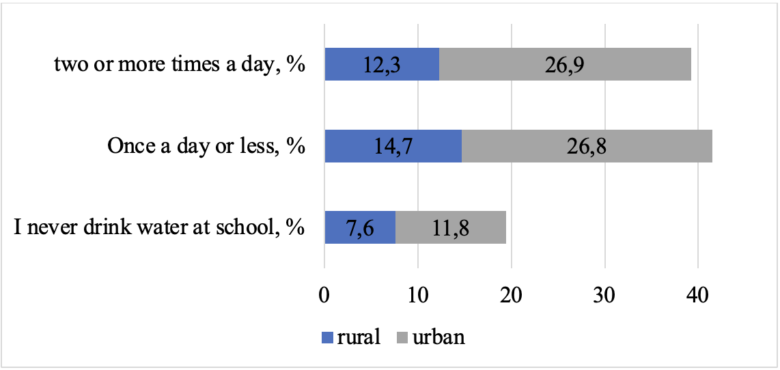

Figure 16 - Think back to the last week you spent at school. Can you remember how often you drank water when you were at school?

Significant number of students in both rural and urban schools are not allowed to drink water during class or can only do so with permission (17.3% of whole students). Moreover, the percentage of this answer among rural school students was higher for 4% than in urban students (Figure 17). However, a higher percentage of urban school students (36% of urban students) report being allowed to drink water always or without asking permission compared to rural school students (26% of rural students). Furthermore, 30.7% of students could drink water with the permission of teacher (27%-urban and 38%-rural students).

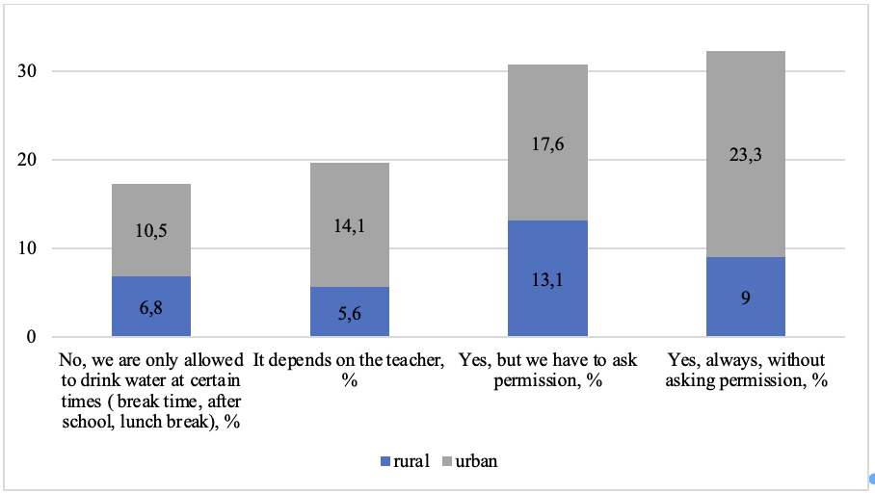

Figure 17 - Can you drink water during class?

Overall, it is important for schools to ensure that students have access to safe and clean drinking water and are allowed to drink water during class as needed. This can help promote healthy hydration practices and support students' overall health and academic performance (Table A.2, Appendix A).
53.8% of whole students answered that they had talking about the importance of the drinking water (53% - urban and 56% - rural students). Nevertheless, 609 students (44.3% of whole sample size) from the rural school and 1 222 students (46.9% of whole sample size) from the urban school answered "no" when asked if their teachers ever talked to them about the importance of drinking water at school (Figure 18).

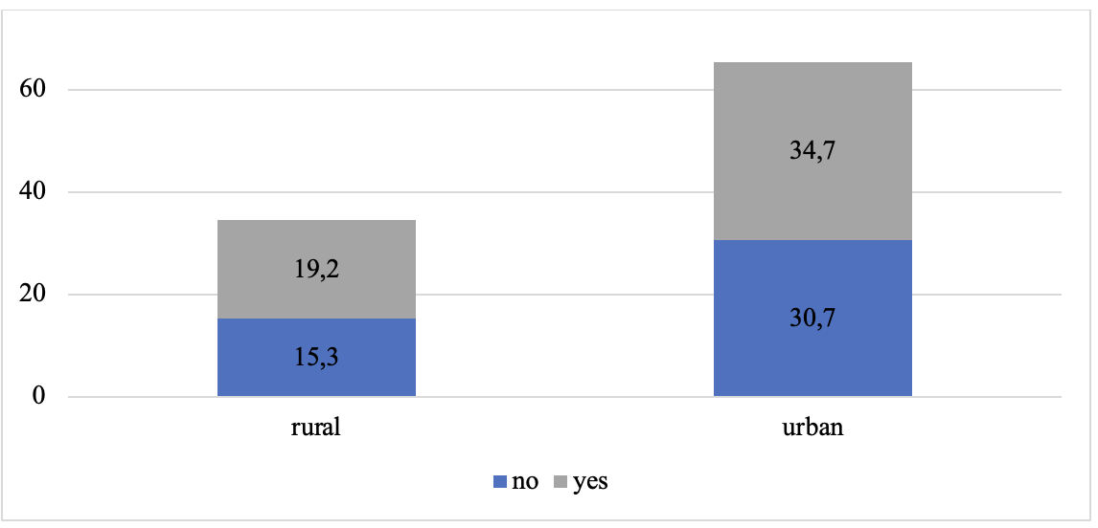

Figure 18 - Did your teachers ever talk to you about the importance of drinking water at school?

In conclusion, 36% of students in rural areas and 41% of students in urban areas drank water at school at least twice a day. But 22% of students in rural areas and 18% of students in urban areas never drank water at school. Moreover, a significant proportion of students in both environments recognize the need of consuming water while at school, underscoring the need to encourage healthy hydration habits and educational campaigns on this matter.

      - Students’ satisfaction with functionality and quality of services of sanitation at schools
Totally, only 6.3% of students assessed as broken toilets, 5% were from total rural students and 7% were from urban school (Figure 19).

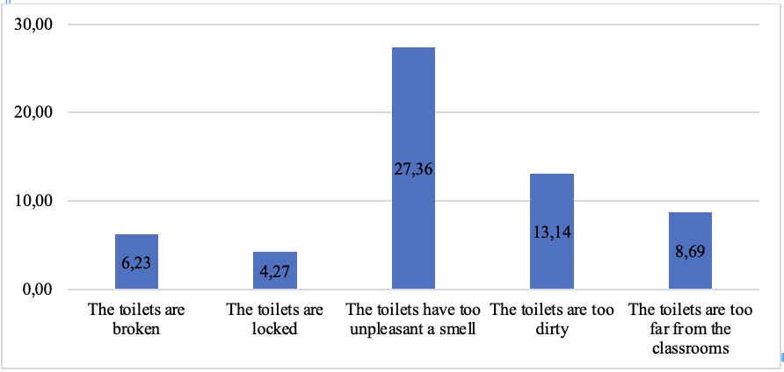

Figure 19 - Sanitation functionality and quality of services.

In general, 4.3% of whole students responded that the toilets were locked, where 5% were from rural sample size and 4% were from urban students (Table A.3, Appendix A).
27.7% of them reported about unpleasant smell in the school toilets, where every fifth student of rural school and every third urban student were agreed with these statements. Moreover, three students out of four (72.4%) disagreed with this statement.
13.2% of students assessed toilets as dirty, where 10% of them were rural students and 15% were from urban students. Nine rural students out of ten and 85% of urban students disagreed with this statement.
About 9% of students answered yes to the question “the toilets are too far from the classrooms”. 18.2% of students complained about long lines in the toilets, where 14% of students were from rural school and every fifth students were from urban schools.
In general, 68 students were complained about the darkness of the toilets, which consists of 1.7% of whole sample size, where 2% were from urban school students.
1 out of four students complained that they could not to close the door of the toilet and 27% of them were urban students, 18% were rural students. Nevertheless, 77.5% of students disagreed with this statement.
Totally, 12.8% of students reported that other students can look inside the cubicles from above or from under the door, through holes in the walls (Figure 20).

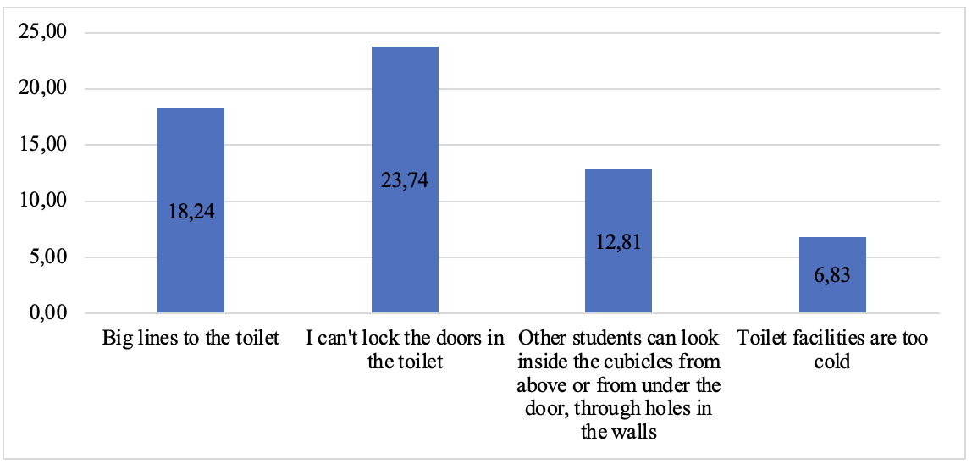

Figure 20 - Sanitation functionality and quality of services.

272 students assessed the toilets as too cold (7% of whole sample size).
Generally, about 22% of students in rural areas and 30% of students in urban areas said that the toilets smelled bad. 10 to 15% of them said the toilets were dirty. Only 9% of both schools said toilets were too far away. 14% of students in cities and 20% of students in rural areas said there were long lines to use toilets. Between 18 and 27% of students said they couldn't lock the toilet door. 7–16% of students said that other students can see into their desks through holes in the walls or from above or below the door. The study's findings emphasize various concerns pertaining to sanitary services in schools, encompassing the state of the facilities, hygiene, availability, seclusion, and convenience. These problems have substantial consequences for the welfare and academic journey of students. It is essential to address these concerns in order to ensure that school sanitary services fulfil the necessary requirements and contribute to a healthy and favorable learning environment.

      - Students’ satisfaction with the privacy and security of sanitation at schools
Based on the data provided, it appears that the vast majority of respondents (97%) answered "yes" to the question of whether the boys' and girls' toilets are separate, while only a small percentage (3%) answered "no" (Table A.3, Appendix A).
It appears that a higher percentage of people in both rural and urban areas see it as a problem if boys' and girls' toilets are not separated. In rural areas, 83% of respondents see it as a problem, while in urban areas, 75% of respondents do. This suggests that having separate toilets for boys and girls is considered important by a majority of people regardless of their location (Figure 21).

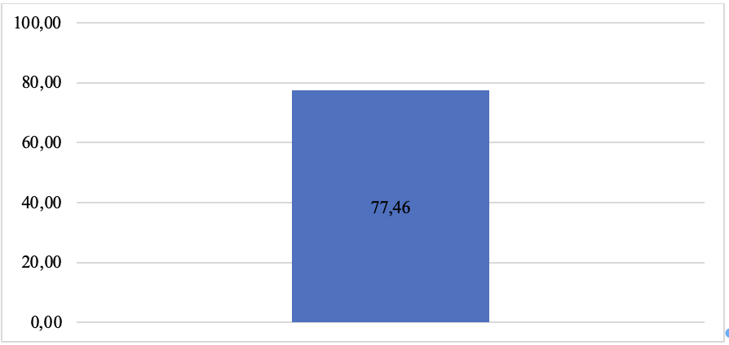

Figure 21 - If the boys’ and girls’ toilets are not separate, is that a problem for you?

Specifically, the data suggest that a higher proportion of people in rural areas (83%) than in urban areas (75%) see it as a problem if boys' and girls' toilets are not separated.
These findings emphasize the significance of establishing separate toilet facilities for male and female students in schools to satisfy their concerns regarding privacy and security. The study results suggests that a significant proportion of students view the lack of this division as a problem, emphasizing the necessity for educational institutions to enhance their policies and infrastructure in order to guarantee the welfare and satisfaction of students.

      - Students’ satisfaction with the operation and maintenance of sanitation at schools
According to the current study, the majority of respondents in both rural and urban areas reported that there is never toilet paper in the toilet stalls. Specifically, 736 respondents in rural areas (54%) and 1474 respondents in urban areas (57%) reported never having toilet paper in the stalls. The next most common response was "rarely," with 279 respondents in rural areas (20%) and 507 respondents in urban areas (19%) reporting this (Figure 22). A smaller percentage of respondents reported "almost always" or "always" having toilet paper in the stalls.

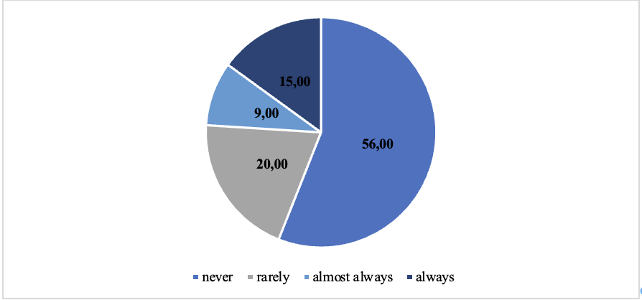

Figure 22 - Think back to today and yesterday. Was there toilet paper in the toilet?
Almost every third student answered that light in the toilet room is always provided (1073 rural students and 1864 urban students). And small percentage of respondents reported “rarely” enough light in the toilet.
In urban areas, a higher percentage of respondents reported that the toilets are "almost always clean" (47%). Conversely, in rural areas, a higher percentage of respondents reported that the toilets are "always clean" (43%) compared to urban areas where the percentage was lower (33%). However, it is also worth noting that a non-negligible proportion of respondents reported that the toilets are "rarely clean" (16% and 17% in rural and urban areas respectively), and a small percentage reported that they are "never clean" (3% in both rural and urban areas). Overall, the majority of respondents in both rural and urban areas reported that the school toilets are clean, but there may be room for improvement in certain areas.
In general, the majority of students (over 75%) in both rural and urban schools reported that the restroom facilities were "not bad" or "good." However, a significant proportion of students in urban schools reported that the facilities were either "terrible" or "pretty bad," compared to only 9% of students in rural schools.
In summary, 54% of students in rural areas and 57% of students in urban areas said that there was never any toilet paper in the school toilets. 22% of students in cities and 17% of students in rural areas said the light appearance happened rarely. Of the students who lived in cities and rural areas, 16% thought toilets were rarely clean. These findings highlight the necessity for enhanced management and maintenance of sanitation facilities in educational institutions. It is crucial to provide students with access to fundamental necessities such as toilet paper, reliable light, and sanitary facilities in order to guarantee their welfare and convenience. Furthermore, it is important to take steps to tackle the disparities and difficulties in both rural and urban educational settings in order to ensure a cleaner and more acceptable sanitation experience for students.

      - Students’ satisfaction with education and practices about sanitation at schools
The appropriate time to use the restroom at school may depend on the specific rules and policies of the school. However, based on the responses provided in the given survey, the majority of students, both in rural and urban areas, believe that they can use the restroom during break time, before or after class, but not during class (every fifth rural student and every fourth urban student). On the other hand, a significant number of students from both areas believe that it's up to the teachers to decide when they can use the restroom (179 rural students and 558 urban students). Finally, a majority of students (60%) from both rural and urban areas feel that they should be allowed to use the restroom when they need to, including during class.
It's important to note that students' health and well-being should be a top priority, and schools should have policies that allow students to use the restroom when they need to. Teachers and school administrators should work to create a supportive and accommodating environment that prioritizes students' health and well-being.
60.4% of students went to the toilet when they need to go, including during class. 18.5% of students responded that it was teacher's discretion. If 45.2% of students discovered a problem in the toilet, they would not talk openly about it with any of the school staff. 35.9% of them usually do this on their own initiative. 58.7% of students had a conversation about toilet hygiene and proper hygienic behavior when using toilets at school.
Majority of students in both rural and urban areas would not talk openly about a problem in the restroom area with school staff. In rural areas, 48% of students responded with "no", while in urban areas, 44% of students responded with "no." However, there is still a significant percentage of students who are willing to report problems in the toilet. In both rural and urban areas, around 1 in 5 students responded with "yes, students are asked to report any problems in the toilet." Additionally, in both rural and urban areas, around 1 in 3 students responded with "yes, students usually do this on their own initiative." Overall, it is important for students to report any problems in the restroom area to school staff so that they can be addressed promptly and properly.
Majority of students in both rural and urban schools have had conversations about toilet hygiene and proper hygienic behavior when using toilets at school. In rural schools, 61% of students responded with "yes" while in urban schools, 57% of students responded with "yes." However, there is still a significant percentage of students who have not had such conversations (Figure 23). In rural schools, 39% of students responded with "no" while in urban schools, 43% of students responded with "no." It is important for schools to educate their students about proper toilet hygiene and behavior to promote good health and prevent the spread of diseases.

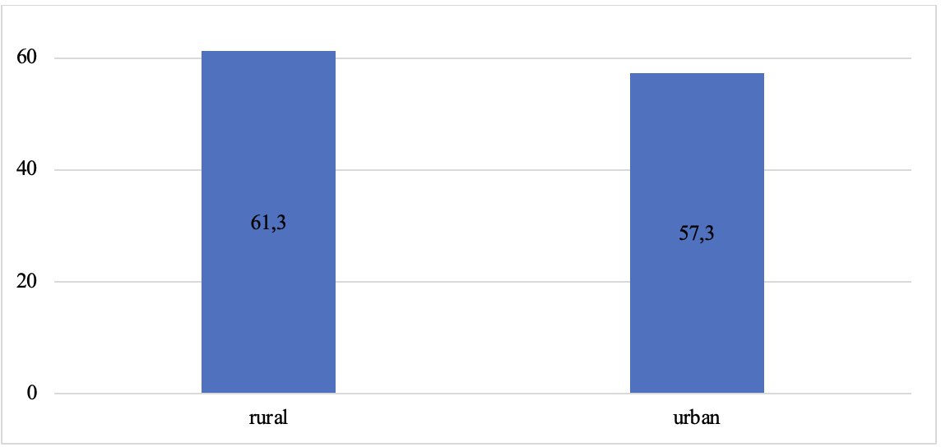
Figure 23 - Having a conversation about toilet hygiene and proper hygienic behavior.

In conclusion, the study's results indicate the significance of attending to students' toilet access preferences, promoting open discussion on toilet issues, and improving hygiene education. These techniques can enhance the comfort and hygiene of students' sanitation experience in both rural and urban school environments.

      - Students’ satisfaction with the availability, functionality of hygiene at schools
Almost each student washed hands always and almost always, when they were at school. Specifically, 90.5% of students in rural areas and 88.1% of students in urban areas reported always washing their hands in school. Only a small percentage of students (3.3% of rural students and 3.8%) reported never or rarely washing their hands while in school, which is a concerning finding from a public health perspective. Hand hygiene is an important practice that can help prevent the spread of germs and diseases, especially in a school setting where students are in close contact with each other (Table A.4, Appendix A).
Every four out of five students of both schools replied that water was always available for handwashing, and each one out of ten students assessed availability of water as almost always. Nevertheless, there were negative answers as rarely and never, where the ratio in rural students (5.1% and 1.6%, respectively) were higher than in urban schools (3.26% and 1.42%, respectively). Moreover, the positive answers were higher in urban schools in comparison with rural schools, and vice versa the proportion of negative answers were higher in rural school students.
Only half of students reported about always availability of soap for handwashing at school (Figure 24). The percentage of “always” answers was higher among rural students, although the percentage of “almost always” was higher to 6.5% in urban schools. Nevertheless, the portion of answers “never” and “rarely” was higher in rural schools.

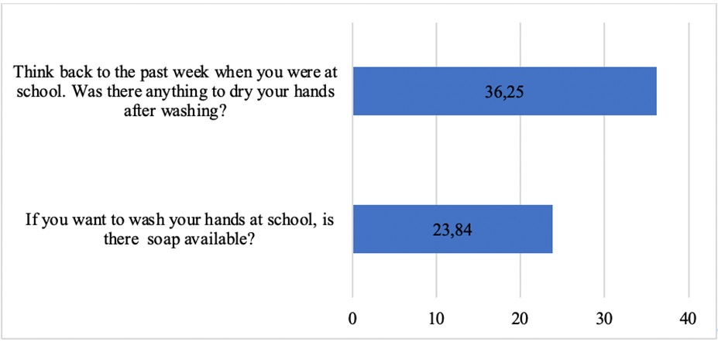

Figure 24 - Availability and functionality of hygiene facilities, %.

Half of students reported about always available drying things after handwashing. Almost always replies were 14.1% in urban school students and less low in rural student answers (12.9%). The percentage of “rarely” and “never” was higher among urban school students. Overall, the negative answers percentage consisted one third of whole answers (36.2%).
Finally, only half of children said they always had access to soap at school for washing their hands. Half of the students said that drying facilities were always available after washing their hands. The study's results indicate that although a significant number of students display good handwashing practices, there is still scope for enhancing the consistent accessibility of soap and hand drying facilities in both rural and urban schools. These findings emphasize the significance of maintaining and improving hygiene infrastructure and practices to establish a cleaner and healthier educational environment for students.

      - Students’ satisfaction with the quality of services of hygiene at schools
A higher percentage of people in urban areas (6.0%) have reported experiencing too long lines to wash their hands compared to people in rural areas (4.3%). However, the overall majority in both rural and urban areas have not experienced long lines to wash their hands, with 95.7% of rural respondents and 94.0% of urban respondents reporting no such experience.
The overwhelming majority of respondents in both rural and urban areas answered "no", indicating that they do not believe hand washing facilities are too far away. Specifically, higher percentage of urban students respondents answered "no". On the other hand, a very small percentage of respondents in both rural and urban areas answered "yes", indicating that they believe hand washing facilities are too far away. Only 2.5% of rural respondents and 1.8% of urban respondents answered "yes".
The vast majority of respondents in both rural and urban areas answered "no", indicating that they do not believe handwashing facilities are broken. Specifically, 96.3% of rural respondents and 95.8% of urban respondents answered "no". A small percentage of respondents in both rural and urban areas answered "yes", indicating that they believe handwashing facilities are broken. Only 3.7% of rural respondents and 4.2% of urban respondents answered "yes".
A majority of respondents in both rural and urban areas answered "no", indicating that they do not believe handwashing facilities look dirty. Specifically, 92.4% of rural respondents and 90.5% of urban respondents answered "no". A small percentage of respondents in both rural and urban areas answered "yes", indicating that they believe handwashing facilities look dirty. 7.6% of rural respondents and 9.5% of urban respondents answered "yes".
Only 5.4% of students assessed the toilets as too long lines to wash your hands. 98% of students reported that hand washing facilities are too far away. 8.8% of students answered that handwashing facilities look dirty.
The findings highlight various areas of concern related to the efficacy and caliber of handwashing facilities in schools, encompassing both rural and urban settings. Students in both environments expressed difficulties concerning extended queues, the accessibility of handwashing facilities, their state, and hygiene. These factors may limit student's capacity to uphold appropriate hygiene protocols, particularly while they are at school. In order to tackle the issues that have been highlighted, schools can examine adopting measures to enhance the availability and state of handwashing amenities, minimize waiting periods, and uphold cleanliness. Furthermore, it is imperative to maintain a strong emphasis on hygiene teaching in school environments, specifically by emphasizing the significance of consistent handwashing for the physical well-being and overall health of kids. Collectively, these strategies can enhance the health and hygiene of the school environment, benefiting students in both rural and urban areas.

      - Students’ satisfaction with the education and practices about hygiene at schools
According to the Centers for Disease Control and Prevention (CDC), it is recommended to wash hands with soap and water for at least 20 seconds to effectively remove dirt, germs, and viruses. Therefore, if both water and soap are available, it is advisable to use both to ensure proper hand hygiene. The majority of people in both rural and urban areas (86.1% and 90.2%, respectively) use water and soap to wash their hands when both are available, which is a positive sign of good hygiene practices. However, a small proportion of people in both rural and urban areas (13.9% and 9.8%, respectively) use only water to wash their hands when both water and soap are available. Proper hand hygiene, including using soap, is essential in preventing the spread of infections and diseases, especially in the midst of a global pandemic. Thus, it is important to continue promoting proper hand washing practices through education and awareness campaigns to ensure that everyone has access to the knowledge and tools needed to maintain good hygiene practices.
The majority of respondents in both rural and urban areas answered "yes", indicating that they have been interviewed about the need to wash their hands at school. Specifically, 71.9% of rural respondents and 73.1% of urban respondents answered "yes". A smaller percentage of respondents in both rural and urban areas answered "no", indicating that they have not been interviewed about the need to wash their hands at school. 28.1% of rural respondents and 26.9% of urban respondents answered "no" (Figure 25).

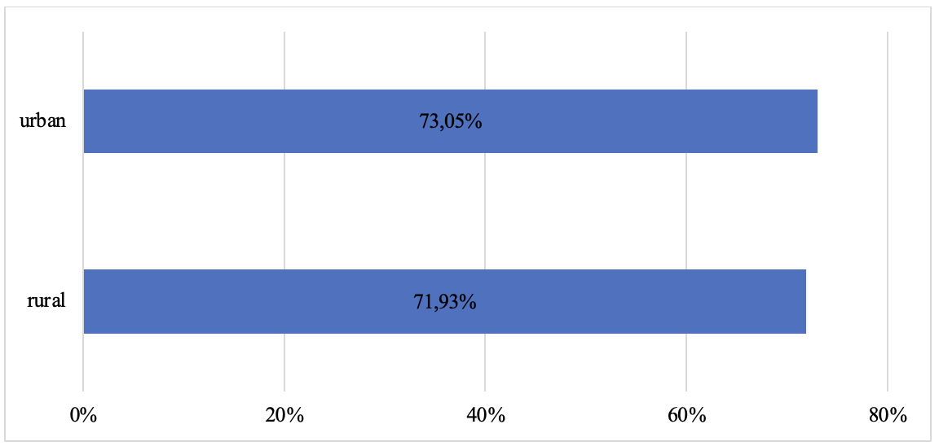

Figure 25 - Having conversations about the necessity of hand washing at school.

There were 1375 respondents in rural areas and 2605 respondents in urban areas. Of these, 56 respondents in rural areas and 84 respondents in urban areas said "no" to the question of whether they know what problems can arise if they don't wash their hands. This represents 4.1% and 3.2% of respondents in rural and urban areas respectively. The vast majority of respondents in both rural and urban areas (95.9% and 96.8% respectively) answered "yes" to the question.
Totally, to the question “When do you usually wash your hands?” in all cases proportion of urban area schools’ participants answered as “yes” more than rural participants (Figure 26). Almost four out of five students in both schools wash their hands when they are dirty.

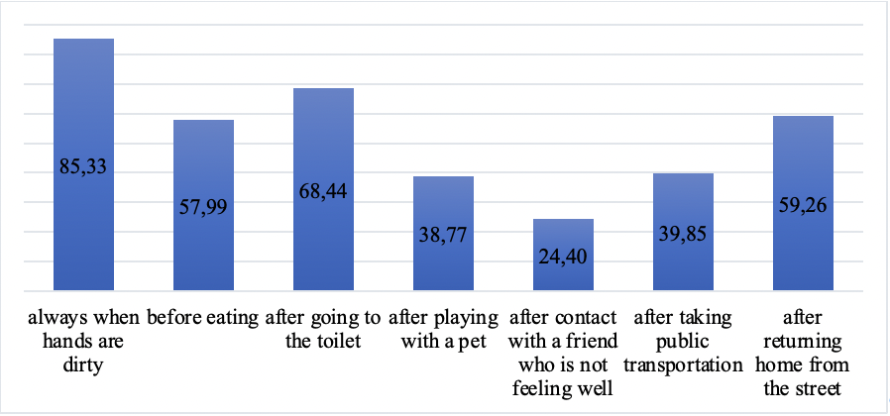

Figure 26 - Washing hand situations.

Regarding hand washing before eating, half of rural students and every third student of urban schools reported about handwashing. Every third rural student and seven out of ten students washed their hands after going to the toilet.
Less than half of rural and urban school students reported about hand hygiene after playing with a pet, 33.8% and 41.4%, respectively.
Despite the fact that, during the pandemic, people talked about the importance of hand washing, especially after contact with someone who was sick, surprisingly only 16.1% of rural students and 28.8% of urban students said yes to hand washing after contact with someone who was not feeling well.
After being in transport, again, only a small percentage of students answered "yes". The percentage of positive answers was 26.1% and 47.1% for rural and urban students, respectively.
Almost half of the rural students answered that they wash their hands after coming home from the street, while more than half of the students answered negatively. Moreover, every third urban student answered positively to this question.
The study's findings indicate that a significant proportion of students follow to proper handwashing practices by using both water and soap when both resources are accessible, a crucial aspect in maintaining optimal hygiene standards. Moreover, the majority of students are aware of the possible issues that can result from disregarding hand hygiene. These findings highlight the favorable hygiene education and practice among students in both rural and urban schools, highlighting the need to continuously promote and strengthen these behaviors to safeguard the health and well-being of student.

3.4 Factors affecting the hygienic behavior of student

3.4.1 Handwashing behavior and its factors: variable definitions

For defining the handwashing habit of students, there were used 9 questions, indicated in the Table 9. If students chose the option “yes” to 7 and more questions, then it was “good” handwashing habit.

Table 9 - Questions for defining handwashing behavior for binary logistics

Questions |  | Male  n (%) | Female,  n (%) | Total,  n (%) | Chi square; p-value
In which of the following scenarios did you wash your hands in the past month?
Always when hands are dirty | no | 265(6.7) | 319(8.0) | 584(14.7) | 12.78; 0.0001
Always when hands are dirty | yes | 1276(32.1) | 2120(53.3) | 3396(85.3) | 12.78; 0.0001
Before dinner | no | 721(18.1) | 951(23.9) | 1672(42) | 23.56; 0.0001
Before dinner | yes | 820(20.6) | 1488(37.4) | 2308(58) | 23.56; 0.0001
After going to the toilet | no | 565(14.2) | 691(17.4) | 1256(31.6) | 30.36; 0.0001
After going to the toilet | yes | 976(24.5) | 1748(43.9) | 2724(68.4) | 30.36; 0.0001
After playing with pet | no | 1012(25.4) | 1425(35.8) | 2437(61.2) | 20.88; 0.0001
After playing with pet | yes | 529(13.3) | 1014(25.5) | 1543(38.8) | 20.88; 0.0001
After contact with a friend who is not feeling well | no | 1194(30.0) | 1815(45.6) | 3009(75.6) | 4.81; 0.028
After contact with a friend who is not feeling well | yes | 347(8.7) | 624(15.7) | 971(24.4) | 4.81; 0.028
After touching the public transport | no | 1015(25.5) | 1379(34.6) | 2394(60.2) | 34.27; 0.0001
After touching the public transport | yes | 526(13.2) | 1060(26.6) | 1586(39.8) | 34.27; 0.0001
After returning home | no | 784(19.7) | 957(24.0) | 1741(43.7) | 51.98; 0.0001
After returning home | yes | 757(19.0) | 1482(37.2) | 2239(56.3) | 51.98; 0.0001
If both water and soap are available, how do you usually wash your hands? | only with water | 232(5.8) | 214(5.4) | 446(11.2) | 37.44; 0.0001
 | with soap and water | 1309(32.9) | 2225(55.9) | 3534(88.8) | 37.44; 0.0001
Do you know what problems can arise if you don't wash your hands? | no | 92(2.3) | 48(1.2) | 140(3.5) | 44.56; 0.0001
 | yes | 1449(36.4) | 2391(60.1) | 3840(96.5) | 44.56; 0.0001

The handwashing behavior part has 9 questions. All questions are presented in Table 9. Each question has 2 answer options (for answers: “no” - 0 point, for “yes” - 1 point; “only with water” – 0, “with soap and water” - 1). All answers were summarized, and answers ranged from 0 to 9. If the student answered 7 and above positive, the handwashing behavior was assessed as “good”. When it was less than 7, considered “poor”.

The results of the survey revealed that 88.8% of students washed their hands with water and soap (n=3534), and 96.5% of them knew the problems connected with poor handwashing behavior (n=3840). 85.3% of students wash their hands when they were dirty (n=3396), and every third out of five students were girls (62.4%; n=2120). Additionally, only 38.8% of students wash their hand after playing with pets (n=1543).

3.4.1.1 Hand hygiene: group comparison
The chi-square test results are shown in Table 10. Hand hygiene was statistically significant for school location (χ² = 81.47, p < 0.01), gender (χ² = 39.22, p < 0.01), grade (χ² = 23.33, p < 0.01), father’s occupation (χ² = 28.00, p < 0.01), mother’s occupation (χ² = 37.90, p < 0.01), mother’s educational background (χ² = 45.91, p < 0.01) and father’s educational background (χ² = 43.52, p < 0.01), handwashing talking at school (χ² = 17.44, p < 0.01).

Table 10 - Comparison of hand hygiene rate (n=3980) among students in different groups

Category | Group | Poor rate of hand hygiene (n; %) | Good rate of hand hygiene (n; %) | Chi square; p-value
schools | Rural | 956(24.0) | 419(10.5) | 81.47; 0.0001
schools | Urban | 1427(35.8) | 1178(29.6) | 81.47; 0.0001
grade | 5-8 | 506(12.7) | 261(6.6) | 23.33; 0.0001
grade | 9 | 1212(30.5) | 795(19.9) | 23.33; 0.0001
grade | 11 | 665(16.7) | 541(13.6) | 23.33; 0.0001
gender | Male | 1017(25.6) | 524(13.2) | 39.22; 0.0001
gender | Female | 1366(34.3) | 1073(26.9) | 39.22; 0.0001
Mother’s occupation | Unemployed, temporarily unemployed | 683(17.2) | 416(10.5) | 37.90; 0.0001
Mother’s occupation | Professional and technical staff | 574(14.4) | 394(9.9) | 37.90; 0.0001
Mother’s occupation | Civil servant | 323(8.1) | 169(4.3) | 37.90; 0.0001
Mother’s occupation | Company employee | 248(6.2) | 214(5.4) | 37.90; 0.0001
Mother’s occupation | Head/Manager of state bodies and institutions | 23(0.6) | 20(0.5) | 37.90; 0.0001
Mother’s occupation | Businesswoman | 126(3.2) | 128(3.2) | 37.90; 0.0001
Mother’s occupation | Service sector employee | 334(8.4) | 232(5.8) | 37.90; 0.0001
Mother’s occupation | others | 72(1.8) | 24(0.6) | 37.90; 0.0001
Father’s occupation | Unemployed, temporarily unemployed | 263(6.6) | 125(3.1) | 28.00; 0.0001
Father’s occupation | Professional and technical staff | 379(9.5) | 258(6.5) | 28.00; 0.0001
Father’s occupation | Civil servant | 376(9.5) | 234(5.9) | 28.00; 0.0001
Father’s occupation | Company employee | 483(12.1) | 391(9.8) | 28.00; 0.0001
Father’s occupation | Head/Manager of state bodies and institutions | 30(0.8) | 35(0.9) | 28.00; 0.0001
Father’s occupation | Businesswoman | 279(7.0) | 210(5.3) | 28.00; 0.0001
Father’s occupation | Service sector employee | 308(7.7) | 183(4.6) | 28.00; 0.0001
Father’s occupation | others | 265(6.7) | 161(4.0) | 28.00; 0.0001
Mother’s education | Secondary education | 894(22.5) | 455(11.4) | 45.91; 0.0001
Mother’s education | Secondary special education | 389(9.8) | 288(7.2) | 45.91; 0.0001
Mother’s education | Incomplete higher education | 95(2.4) | 56(1.4) | 45.91; 0.0001
Mother’s education | Higher education | 949(23.8) | 775(19.5) | 45.91; 0.0001
Mother’s education | Postgraduate education | 56(1.4) | 23(0.6) | 45.91; 0.0001
Father’s education | Secondary education | 1049(26.4) | 549(13.8) | 43.52; 0.0001
Father’s education | Secondary special education | 439(11.0) | 360(9.0) | 43.52; 0.0001
Father’s education | Incomplete higher education | 105(2.6) | 57(1.4) | 43.52; 0.0001
Father’s education | Higher education | 744(18.7) | 601(15.1) | 43.52; 0.0001
Father’s education | Postgraduate education | 46(1.2) | 30(0.8) | 43.52; 0.0001
Talking about handwashing | No | 709(17.8) | 379(9.5) | 17.44; 0.0001
Talking about handwashing | Yes | 1674(42.0) | 1218(30.6) | 17.44; 0.0001

3.4.2 Factors Associated with Lack of Handwashing Skill
In the binary logistic regression, talking about handwashing, school, grade, mothers’ occupation and educational background were significantly associated with lack of handwashing (Table 11). The OR of the absence of talks about importance of the handwashing at school was 1.38 times higher (95%CI=1.18-1.60, p<0.01) compared to talks about it. Students of rural schools had poor handwashing behavior 1.7 times more than students of urban schools (95%CI=1.47-1.96, p<0.01). Eighth grade students 1.5 times more (95% CI =1.26-1.85, p < 0.01) and students of 9-th grade 1.2 times more (95% CI =1.05-1.42, p < 0.01) had poor handwashing compared to the eleventh-grade students.

Table 11 - Binary logistic regression analysis on the influencing factors on the poor hand hygiene (n = 3980)

Variables |  | p-value | OR | OR 95 CI
 |  | p-value | OR | Lower | Upper
School type (ref-urban) | rural | 0.0001 | 1.70 | 1.47 | 1.96
Gender (ref-female) | male | 0.0001 | 1.52 | 1.32 | 1.74
Mother’s occupation (ref-other professions) | Unemployed, temporarily unemployed | 0.039 | 0.59 | 0.36 | 0.97
Mother’s occupation (ref-other professions) | Professional and technical personnel (doctor, teacher, lawyer, engineer) | 0.035 | 0.58 | 0.35 | 0.96
Mother’s occupation (ref-other professions) | Civil servant | 0.190 | 0.70 | 0.41 | 1.18
Mother’s occupation (ref-other professions) | Company employee | 0.016 | 0.52 | 0.31 | 0.88
Mother’s occupation (ref-other professions) | Head/manager of state bodies and institutions | 0.153 | 0.56 | 0.26 | 1.23
Mother’s occupation (ref-other professions) | Entrepreneur | 0.001 | 0.39 | 0.23 | 0.68
Mother’s occupation (ref-other professions) | Service employee | 0.018 | 0.54 | 0.32 | 0.89
Father’s occupation (ref-other professions) | Unemployed, temporarily unemployed | 0.169 | 1.23 | 0.91 | 1.67
Father’s occupation (ref-other professions) | Professional and technical personnel (doctor, teacher, lawyer, engineer) | 0.526 | 1.09 | 0.83 | 1.43
Father’s occupation (ref-other professions) | Civil servant | 0.773 | 0.96 | 0.73 | 1.26
Father’s occupation (ref-other professions) | Company employee | 0.396 | 0.89 | 0.69 | 1.15
Father’s occupation (ref-other professions) | Head/manager of state bodies and institutions | 0.173 | 0.68 | 0.39 | 1.18
Father’s occupation (ref-other professions) | Entrepreneur | 0.908 | 1.01 | 0.76 | 1.35
Father’s occupation (ref-other professions) | Service employee | 0.383 | 1.13 | 0.85 | 1.50
Mother’s education (ref-postgraduate education) | Secondary education | 0.220 | 0.69 | 0.39 | 1.24
Mother’s education (ref-postgraduate education) | Specialized secondary education | 0.073 | 0.58 | 0.32 | 1.05
Mother’s education (ref-postgraduate education) | Incomplete higher education | 0.149 | 0.61 | 0.32 | 1.18
Mother’s education (ref-postgraduate education) | Higher education | 0.017 | 0.50 | 0.28 | 0.88
Father’s education (ref-postgraduate education) | Secondary education | 0.231 | 1.39 | 0.80 | 2.42
Father’s education (ref-postgraduate education) | Specialized secondary education | 0.653 | 1.13 | 0.65 | 1.97
Father’s education (ref-postgraduate education) | Incomplete higher education | 0.188 | 1.52 | 0.81 | 2.87
Father’s education (ref-postgraduate education) | Higher education | 0.575 | 1.16 | 0.67 | 2.00
Grade (ref - 11) | 8 | 0.0001 | 1.53 | 1.26 | 1.85
Grade (ref - 11) | 9 | 0.008 | 1.22 | 1.05 | 1.42
Talking about handwashing (ref-yes) | No | 0.0001 | 1.38 | 1.18 | 1.60

Respondents whose mothers were unemployed or temporarily unemployed had 41% less poor handwashing behavior than other professions of mothers (OR=0.59; 95% CI =0.36-0.97, p < 0.05). Students, whose mothers were professional and technical personnel, such as doctor, teacher, lawyer, engineer had 42% less poor handwashing behavior than other professions of mothers (OR=0.58; 95% CI =0.36-0.97, p < 0.05). Additionally, students, whose mothers were company employee had 48% less poor handwashing in comparison with other professions of mothers (OR=0.52; 95% CI =0.31-0.88, p < 0.01). Respondents, who chose the option “entrepreneur” in mother’s occupation had 61% less poor handwashing behavior than other professions (OR=0.39; 95% CI =0.23-0.68, p < 0.01). Students, whose mothers’ education was high, had 50% less poor handwashing (OR=0.50; 95%CI=0.28-0.88, p<0.01) than students whose mothers had postgraduate education.
The following factors were found to be related to not washing hands: school location (OR of rural school = 1.70), gender (OR of male 1.52), mother's job (OR of unemployed mother = 0.59; OR of professional personnel mother = 0.58; OR of company employee mother = 0.52; OR of entrepreneur mother = 0.39); mother's level of education (OR of higher education = 0.50); and grade (OR of 8th grade = 1.53; OR of 9th grade 1.22). The results of the binary logistic regression analysis offer valuable insights into the determinants that influence handwashing behaviors among students. To develop effective interventions aimed at improving hand hygiene among students and reducing the likelihood of poor handwashing practices, it is crucial to address factors such as rural/urban living, gender, maternal occupation and education, grade level, and the promotion of talks about handwashing.

3.4.3 Factors associated with using handwashing facilities at school
In the binary logistic regression, water and soap availability were significantly associated with the absence of using hygiene facilities for handwashing (Table 12).

Table 12 - Binary logistic regression analysis on the influencing factors of not to wash hand at school (n = 3980)

Variables |  | p-value | OR | OR 95 CI
 |  | p-value | OR | Lower | Upper
Water availability for handwashing (ref-always) | Never | 0.0001 | 0.07 | 0.03 | 0.13
Water availability for handwashing (ref-always) | Rarely | 0.0001 | 0.11 | 0.06 | 0.18
Water availability for handwashing (ref-always) | Almost always | 0.314 | 0.75 | 0.44 | 1.29
Soap availability for handwashing (ref-always) | Never | 0.0001 | 0.29 | 0.14 | 0.58
Soap availability for handwashing (ref-always) | Rarely | 0.002 | 0.38 | 0.20 | 0.69
Soap availability for handwashing (ref-always) | Almost always | 0.0001 | 0.32 | 0.18 | 0.57
Drying facilities for handwashing (ref-always) | Never | 0.309 | 0.77 | 0.46 | 1.27
Drying facilities for handwashing (ref-always) | Rarely | 0.063 | 0.59 | 0.34 | 1.02
Drying facilities for handwashing (ref-always) | Almost always | 0.242 | 0.71 | 0.40 | 1.25

The absence of water availability decreased the using the hygiene facilities at schools to 93% (OR=0.07; 95% CI =0.03-0.13, p < 0.01) in comparison to always availability of water. When students assessed the water availability as rare, the absence of washing hands was to 89% lower (OR=0.11; 95% CI =0.06-0.18, p < 0.01). Moreover, soap availability was affected with decreasing of washing hands at school, answer “never” to 71% (OR=0.29; 95% CI =0.14-0.58, p < 0.01), answer “rarely” to 62% (OR=0.3; 95% CI =0.20-0.69, p < 0.01) in comparison with the answer “always”.
All in all, if students didn't wash their hands at school, it was linked to not having water (OR=0.07) and soap (OR=0.29). The outcomes of a binary logistic regression analysis can offer valuable insights into the factors that affect students' utilisation of hand washing facilities at school. This information is crucial for the development of effective interventions aimed at promoting correct hand hygiene practises and minimising the probability of inadequate handwashing practises. Ensuring a sufficient and reliable stock of soap and drying items, such as paper towels or hand dryers, is essential for promoting efficient handwashing. If students constantly encounter a lack of soap or drying products, it may deter them from practising proper hand hygiene. Schools ought to build dependable distribution networks for these things and closely track their availability to guarantee that kids consistently have access to them.

3.4.4 The behavior to drink water at school: group comparison
The chi-square test results are shown in Table 13. The behavior to drink water was statistically significant for school location (χ² = 18.91, p < 0.01), grade (χ² = 70.47, p < 0.01), availability of drinking water at school (χ² = 36.04, p < 0.01), free access to water in school (χ² = 11.97, p < 0.01).

Table 13. Comparison of behavior to drink water at school among students in different groups (n= 3980)

Category |  | behavior of refusing to drink water (n; %) | drinking behavior (n; %) | Chi square; p-value
School | Rural | 751(18.9) | 624(15.7) | 18.91; 0.0001
School | Urban | 1234(31) | 1371(34.4) | 18.91; 0.0001
Gender | Male | 785(19.7) | 756(19) | 1.14; 0.285
Gender | Female | 1200(30.2) | 1239(31.1) | 1.14; 0.285
Grade | 8 | 282(7.1) | 485(12.2) | 70.47; 0.0001
Grade | 9 | 1095(27.5) | 912(22.9) | 70.47; 0.0001
Grade | 11 | 608(15.3) | 598(15) | 70.47; 0.0001
Does the school have water for drinking? | No, never | 198(5) | 122(3.1) | 36.04; 0.0001
Does the school have water for drinking? | Rarely | 336(8.4) | 279(7) | 36.04; 0.0001
Does the school have water for drinking? | In most cases | 412(10.4) | 390(9.8) | 36.04; 0.0001
Does the school have water for drinking? | Yes, always | 1039(26.1) | 1204(30.3) | 36.04; 0.0001
I get it for free at school | No | 1203(30.2) | 1101(27.7) | 11.97; 0.001
I get it for free at school | Yes | 782(19.6) | 894(22.5) | 11.97; 0.001
I think the water is not good for drinking at school (bad smell, bad taste, unpleasant color) | No | 1399(35.2) | 1560(39.2) | 31.06; 0.0001
 | Yes | 586(14.7) | 435(10.9) | 31.06; 0.0001
drinking water points are too far | No | 1649(41.4) | 1704(42.8) | 4.10; 0.043
drinking water points are too far | Yes | 336(8.4) | 291(7.3) | 4.10; 0.043
There are too many people near the drinking water points | No | 1490(37.4) | 1604(40.3) | 16.38; 0.0001
There are too many people near the drinking water points | Yes | 495(12.4) | 391(9.8) | 16.38; 0.0001
Drinking water points are broken or dirty | No | 1853(46.6) | 1906(47.9) | 9.08; 0.003
Drinking water points are broken or dirty | Yes | 132(3.3) | 89(2.2) | 9.08; 0.003
I'm shy to ask for permission to drink water | No | 1861(46.8) | 1884(47.3) | 0.83; 0.361
I'm shy to ask for permission to drink water | Yes | 124(3.1) | 111(2.8) | 0.83; 0.361
Can you drink water during class? | No, it is only allowed to drink water at certain times | 447(11.2) | 240(6) | 157.02;00001
Can you drink water during class? | It depends on the teacher | 447(11.2) | 337(8.5) | 157.02;00001
Can you drink water during class? | Yes, but you have to ask permission | 608(15.3) | 616(15.5) | 157.02;00001
Can you drink water during class? | Yes, always, without asking permission | 483(12.1) | 802(20.2) | 157.02;00001
Have teachers ever talked about the importance of drinking water? | No | 1024(25.7) | 807(20.3) | 49.67; 0.0001
 | Yes | 961(24.1) | 1188(29.8) | 49.67; 0.0001
Moreover, bad smell, bad taste, unpleasant color of water (χ² = 31.06, p < 0.01) and distant location of drinking water points (χ² = 4.10, p < 0.05), crowdedness near the drinking water points (χ² = 16.38, p < 0.01), breakage of drinking water points (χ² = 9.08, p < 0.01), opportunity to drink water during class (χ² = 157.02, p < 0.01), talks about importance of drinking water (χ² = 49.67, p < 0.01) were statistically significant with the behavior to drink water.

    - Factors associated with the behavior of refusing to drink water at school
In the binary logistic regression, school and grade, availability of drinking water at school, free access to drinking water, bad perception of drinking water, distant location of drinking water points, crowdedness near the drinking water points, to drink water during class, talks about the importance of the drinking water were significantly associated with refusal of drinking water at school (Table 14).

Table 14 - Binary logistic regression analysis on the influencing factors on the behavior of refusing to drink water (n = 3980)

Variables |  | p-value | OR | OR 95 CI
 |  | p-value | OR | Lower | Upper
School (ref-urban) | Rural | 0.0001 | 1.35 | 1.17 | 1.56
Gender (ref - female) | Male | 0.255 | 1.06 | 0.93 | 1.22
Grade (ref-11) | 8 | 0.0001 | 0.54 | 0.45 | 0.66
Grade (ref-11) | 9 | 0.085 | 1.14 | 0.98 | 1.32
Does the school have water for drinking? (ref - yes, always) | No, never | 0.010 | 1.41 | 1.08 | 1.84
Does the school have water for drinking? (ref - yes, always) | Rarely | 0.297 | 1.11 | 0.91 | 1.35
Does the school have water for drinking? (ref - yes, always) | In most cases | 0.539 | 1.05 | 0.88 | 1.25
I get it for free at school (ref - yes) | No | 0.004 | 1.22 | 1.06 | 1.40
I think the water is not good for drinking at school (bad smell, bad taste, unpleasant color) (ref - yes) | No | 0.0001 | 0.67 | 0.57 | 0.78
drinking water points are too far (ref - yes) | No | 0.004 | 0.76 | 0.63 | 0.91
There are too many people near the drinking water points (ref - yes) | No | 0.0001 | 0.65 | 0.56 | 0.77
Drinking water points are broken or dirty (ref - yes) | No | 0.315 | 0.86 | 0.64 | 1.15
I'm shy to ask for permission to drink water (ref - yes) | No | 0.108 | 0.79 | 0.60 | 1.05
Can you drink water during class? (ref - yes, always, without asking permission) | No, it is only allowed to drink water at certain times | 0.0001 | 3.15 | 2.57 | 3.85
 | It depends on the teacher | 0.0001 | 2.13 | 1.76 | 2.57
 | Yes, but you have to ask permission | 0.0001 | 1.87 | 1.58 | 2.21
Talking about the importance of drinking water? (ref-yes) | No | 0.0001 | 1.38 | 1.20 | 1.58

In a rural school drinking water refusal behavior was higher 1.3 times (95%CI=1.17-1.56, p<0.01) than in urban schools. Drinking water refusal behavior was lower to 45% in 8-th grade students (95%CI=0.45-0.66, p<0.01) in comparison with 11-th grade students. The absence of water at school was associated with drinking water refusal behavior, and was 1.4 times higher (95%CI=1.06-1.81, p<0.01) in comparison with the always availability of drinking water at school.
Chargeable water was 1.2 times higher (95%CI=1.38-1.92, p<0.01) associated with drinking water refusal behavior than free water. When students thought that water is good, the drinking water refusal was lower to 33% in comparison to students, who thought that water had bad smell, bad taste, unpleasant color. Students, who assessed that water points were near, showed drinking water refusal to 24% lower in comparison to behavior to drink water at school. Students, who thought that there were less people near to drinking water points, showed 34% lower refusal of drinking water behavior. When the water was allowed at certain times, the drinking water refusal was 3 times higher (95%CI=2.57-3.85, p<0.01) in comparison with to drink water without asking permission. When to drink water was depended on teacher, refusal was 2 times more (95%CI=1.76-2.57, p<0.01) than without asking permission. Moreover, absence of talking about the importance was associated with 1.3 times more (95%CI=1.20-1.58, p<0.01) drinking water refusal behavior.
To sum up, refusing to drink water at school was linked to items like school location (OR of rural school = 1.35), grade (OR of 8-grade = 0.54), not having water for drinking (OR=1.41), having to pay for water (OR=1.22), having a negative view of water (OR=0.67), drinking water points being far away (OR=0.76), drinking water points being crowded (OR=0.65), being able to drink water at certain times (OR=3.15), and talking about how important it is to drink water (OR=1.38). It is crucial to consider the factors that contribute to student refusing to drink water at school in order to encourage the development of healthy hydration habits. Schools should give top priority to guaranteeing the presence and ease of access to potable water, enhancing the public perception of water purity, and tackling concerns with the placement and congestion of water sources. In addition, advocating for education on the significance of water consumption can serve as a potent method to motivate student to maintain proper hydration while at school.

3.4.6 The behavior to use the school toilet: group comparison
The chi-square test results are shown in Table 15. Using the sanitation was statistically significant for school location (χ² = 40.09, p < 0.01), grade (χ² = 21.34, p < 0.01), toilet breakage (χ² = 5.87, p < 0.01), toilet smell (χ² = 75.28, p < 0.01), absence of ability to close the door (χ² = 5.29, p < 0.05) and toilet coldness (χ² = 8.41, p < 0.01), toilet separation (χ² = 10.33, p < 0.01), toilet paper in the toilet cabins (χ² = 11.38, p < 0.01), light in the school toilets (χ² = 51.98, p < 0.01), cleanliness of the school toilets (χ² = 62.98, p < 0.01), thoughts on toilet cubicles (χ² = 95.86, p < 0.01), opportunity to go to toilet during class (χ² = 144.28, p < 0.01), toilet hygiene talks (χ² = 40.87, p < 0.01).

Table 15 - Comparison of behavior to use the sanitation at school among students in different groups (n= 3980)

Category | Group | the behavior of refusing to use the sanitation (n; %) | using the sanitation  (n; %) | Chi square; p-value
School | Rural | 426(10.7) | 949(23.8) | 40.09; 0.0001
School | Urban | 569(14.3) | 2036(51.2) | 40.09; 0.0001
Gender | Male | 387(9.7) | 1154(29) | 0.01; 0.895
Gender | Female | 608(15.3) | 1831(46) | 0.01; 0.895
Grade | 8 | 241(6.1) | 526(13.2) | 21.34 0.001
Grade | 9 | 479(12) | 1528(38.4) | 21.34 0.001
Grade | 11 | 275(6.9) | 931(23.4) | 21.34 0.001
Toilets are broken | No | 917(23) | 2815(70.7) | 5.87; 0.015
Toilets are broken | yes | 78(2) | 170(4.3) | 5.87; 0.015
Toilets are locked | No | 949(23.8) | 2861(71.9) | 0.40; 0.526
Toilets are locked | yes | 46(1.2) | 124(3.1) | 0.40; 0.526
It smells too bad in the toilets | No | 614(15.4) | 2266(56.9) | 75.28; 0.0001
It smells too bad in the toilets | yes | 381(9.6) | 719(18.1) | 75.28; 0.0001
Toilets too far away from classes | No | 894(22.5) | 2740(68.8) | 3.54; 0.06
Toilets too far away from classes | yes | 101(2.5) | 245(6.2) | 3.54; 0.06
Big queues to the toilet and I have to wait | No | 803(20.2) | 2451(61.6) | 0.99; 0.32
Big queues to the toilet and I have to wait | Yes | 192(4.8) | 534(13.4) | 0.99; 0.32
I can't lock the doors of the toilet cubicles | No | 732(18.4) | 2303(57.9) | 5.29; 0.021
I can't lock the doors of the toilet cubicles | Yes | 263(6.6) | 682(17.1) | 5.29; 0.021
Other students may look inside the cubicles from above or under the door, through holes in the walls | No | 851(21.4) | 2619(65.8) | 3.26; 0.071
 | Yes | 144(3.6) | 366(9.2) | 3.26; 0.071
It's too cold in the toilet constructions | No | 907(22.8) | 2801(70.4) | 8.41; 0.004
It's too cold in the toilet constructions | Yes | 88(2.2) | 184(4.6) | 8.41; 0.004
Are there separate toilet rooms for boys and girls? | No | 32(0.8) | 47(1.2) | 10.33; 0.001
Are there separate toilet rooms for boys and girls? | Yes | 963(24.2) | 2938(73.8) | 10.33; 0.001
Think about today and yesterday. Was toilet paper in the toilet cabins? | I can never find toilet paper in the toilets | 586(14.7) | 1624(40.8) | 11.39; 0.01
 | Toilet paper is rarely provided | 190(4.8) | 596(15) | 11.39; 0.01
 | Toilet paper is provided most of the time | 96(2.4) | 273(6.9) | 11.39; 0.01
 | Yes, toilet paper is always provided | 123(3.1) | 492(12.4) | 11.39; 0.01
Is there enough light in the school toilets? | No, never |  |  | 51.98; 0.0001
Is there enough light in the school toilets? | Rarely | 86(2.2) | 140(3.5) | 51.98; 0.0001
Is there enough light in the school toilets? | most of the time | 258(6.5) | 559(14) | 51.98; 0.0001
Is there enough light in the school toilets? | yes, always | 651(16.4) | 2286(57.4) | 51.98; 0.0001
What can you tell me about the cleanliness of the school toilets? | They are never clean | 53(1.3) | 73(1.8) | 62.98; 0.0001
 | They're rarely clean | 207(5.2) | 440(11.1) | 62.98; 0.0001
 | They are clean most of the time | 459(11.5) | 1311(32.9) | 62.98; 0.0001
 | They're always clean | 276(6.9) | 1161(29.2) | 62.98; 0.0001
What do you think about the toilet rooms in your school? | They are horrible, and I try not to use them | 98(2.5) | 129(3.2) | 95.86; 0.0001
What do you think about the toilet rooms in your school? | They're quite bad | 120(3) | 248(6.2) | 95.86; 0.0001
What do you think about the toilet rooms in your school? | They're pretty good | 586(14.7) | 1651(41.5) | 95.86; 0.0001
What do you think about the toilet rooms in your school? | They're good | 191(4.8) | 957(24) | 95.86; 0.0001
If you want to go to the toilet at school, when can you do it? | It depends on the teachers | 311(7.8) | 530(13.3) | 144.28; 0.0001
 | I can go during break time, before or after class, but not during class time | 242(6.1) | 495(12.4) | 144.28; 0.0001
 | When I need to go, including during class | 442(11.1) | 1960(49.2) | 144.28; 0.0001
Have you ever been talked to about toilet hygiene and proper hygienic behavior when using the toilets at school? | No | 497(12.5) | 1147(28.8) | 40.87; 0.0001
 | Yes | 498(12.5) | 1838(46.2) | 40.87; 0.0001
3.4.7 Factors associated with the behavior of refusing to use the sanitation
In the binary logistic regression, school type, grade, unpleasant toilet odor, light in the toilet, perception of the toilet, availability of using the toilet during class, sanitation hygiene talks were significantly associated with the behavior of refusing to use the sanitation at school (Table 16). Rural school students refused to use the toilet 1.8 times more than in urban students (95%CI=1.61-2.22, p<0.01). Students of 8-th grade were associated 1.4 times more with toilet using refusal in comparison to 11-th grade students (95%CI=1.16-1.80, p<0.01).

Table 16 - Binary logistic regression analysis on the influencing factors on the behavior of refusing to use the sanitation (n = 3980)

Variables |  | p-value | OR | OR 95 CI
 |  | p-value | OR | Lower | Upper
School (ref-urban) | Rural | 0.0001 | 1.89 | 1.61 | 2.22
Gender (ref - female) | Male | 0.492 | 0.94 | 0.80 | 1.11
Grade (ref-11) | 8 | 0.001 | 1.45 | 1.16 | 1.80
Grade (ref-11) | 9 | 0.797 | 1.02 | 0.85 | 1.22
Toilets are broken (ref-yes) | no | 0.472 | 0.89 | 0.65 | 1.21
Toilets are locked (ref-yes) | no | 0.325 | 1.21 | 0.82 | 1.76
Toilets are too smelly (ref-yes) | no | 0.0001 | 0.60 | 0.50 | 0.72
Toilets too far away from classes(ref-yes) | no | 0.506 | 0.91 | 0.70 | 1.19
Big queues to the toilet and I have to wait(ref-yes) | no | 0.644 | 0.95 | 0.78 | 1.16
I can't lock the doors of the toilet cubicles(ref-yes) | no | 0.839 | 1.02 | 0.84 | 1.23
Other students may look inside the cubicles from above or under the door, through holes in the walls(ref-yes) | no | 0.386 | 1.11 | 0.87 | 1.41
It's too cold in the toilet constructions(ref-yes) | no | 0.327 | 0.86 | 0.64 | 1.15
Are there separate toilets/toilets/rooms for boys and girls? (ref-yes) | no | 0.314 | 1.28 | 0.78 | 2.11
Think about today and yesterday. Was toilet paper in the toilet cabins? (ref-always) | never | 0.261 | 0.86 | 0.66 | 1.11
 | rarely | 0.563 | 0.92 | 0.69 | 1.22
 | almost always | 0.529 | 1.11 | 0.79 | 1.54
Is there enough light in the school toilets? (ref-always) | rarely | 0.019 | 1.45 | 1.06 | 1.99
Is there enough light in the school toilets? (ref-always) | almost always | 0.045 | 1.21 | 1.00 | 1.47
What can you tell me about the cleanliness of the school toilets? (ref - they're always clean) | they are never clean | 0.711 | 1.09 | 0.68 | 1.74
 | they are rarely clean | 0.626 | 0.93 | 0.71 | 1.22
 | they are almost always clean | 0.560 | 1.06 | 0.86 | 1.30
What do you think about the toilet rooms in your school? (ref- they're good) | they are terrible, and I try not to use them | 0.0001 | 2.72 | 1.82 | 4.07
 | They're pretty bad | 0.0001 | 2.01 | 1.43 | 2.83
 | They're not bad | 0.0001 | 1.68 | 1.35 | 2.09
If you want to go to the toilet at school, when can you do it? (ref- when I need to go, including during class) | It depends on the teachers | 0.0001 | 2.54 | 2.11 | 3.05
 | I can go during break time, before or after class, but not during class time | 0.0001 | 1.82 | 1.49 | 2.23
Have you ever been talked to about toilet hygiene and proper hygienic behavior when using the toilets at school? (ref-yes) | no | 0.004 | 1.27 | 1.08 | 1.49
Students who answered light was rarely in the toilet facilities, refused to use the toilet 1.4 times more (95%CI=1.06-1.99, p<0.01) in comparison to always having the light in the toilets. Students, who assessed the toilet as terrible, they refused the using the toilet 2.7 times more (95%CI=1.82-4.07, p<0.01) than students who assessed them as good. Students who thought that the toilets were pretty bad, they refused to use the toilet 2 times more (95%CI=1.43-2.83, p<0.01) in comparison with students who thought they were good.
Students who perceived the toilet as not bad, refused to use the toilet 1.6 times more (95%CI=1.35-2.09, p<0.01) than students, who assessed toilet as good. Students, who were allowed to use the toilets during the break time, before or after class, refused using the toilet 1.8 times more (95%CI=1.49-2.23, p<0.01) than students, who were allowed to use the toilet during the class. Students, who chose the "it's up to the teacher" option, refused to use the toilet 2.5 times more (95%CI=2.11-3.05, p<0.01) in comparison with students, who were allowed to use the toilet during the class. Students, who did not have talks about sanitation hygiene, refused to use the toilet 1.27 times more (95%CI=1.08-1.49, p<0.01).
Finally, there was a link between students refusing to use the toilet and their school's location (OR = 1.89), grade (OR of 8-grade = 1.45), the lack of an unpleasant smell (OR = 0.60), the light being on only sometimes (OR = 1.45), thinking the toilet was awful (OR = 2.72), having to depend on the teacher to go to the toilet (OR = 2.54), and not talking about toilet hygiene (OR = 1.27). This study results emphasizes the diverse factors that have a substantial impact on students' reluctance to utilize school sanitation facilities. The school type, grade, sanitation hygiene practices, and physical conditions of the bathrooms are crucial factors influencing this behavior. In order to effectively tackle this problem, schools and educational authorities should contemplate adopting measures to enhance the standard and tidiness of sanitation facilities, encourage discussions on hygiene, and customize policies to cater to the distinct requirements of various grade levels and types of schools. By considering these variables, we may incentivize a greater number of students to utilize these important amenities and foster improved cleanliness and hygiene protocols within the school premises.

4 WAYS TO IMPROVE ACCESS TO SAFE WASH FACILITIES AND PRACTICES AT SCHOOLS

  - System approach to WASH
The Sustainable Development Goals (SDGs) and other international development agendas highlight the importance of WASH in educational institutions. Both SDG 4 (Quality Education) and SDG 6 (Clean Water and Sanitation) rely on widespread availability of these basic services. The overall goal of implementing WASH is to create a society where everyone has access to clean water and sanitation and where education is not separated from the health of its students and the communities in which they live. However, the conducted research shows that having the necessary infrastructure is not enough to make the most of this opportunity. Results of the conducted study highlights numerous key areas where improvements are needed, including student satisfaction with the infrastructure, accessibility, maintenance, operation, education and practices.
The significance of providing a suitable and safe atmosphere for students within the field of education cannot be overstated. While schools may have the fundamental infrastructure for Water, Sanitation, and Hygiene (WASH) systems in place, achieving genuine satisfaction and a quality WASH system requires a systematic approach. It's not solely about the physical structures; it's about a holistic consideration of various criteria that collectively contribute to a comprehensive and enhanced WASH service within educational institutions.
The scope of the systematic approach includes various aspects such as functionality, accessibility, privacy, security, quality of services, maintenance, operation, education, and practices. In order to properly increase the WASH service, promote student well-being, and foster a favorable environment for learning and growth, it is imperative to address these complex requirements and effectively organize them inside educational institutions. The systematic approach not only promotes cleanliness but also cultivates a feeling of self-respect and contentment within the student population. This prioritizes the long-term viability of WASH interventions in schools (Figure 27).

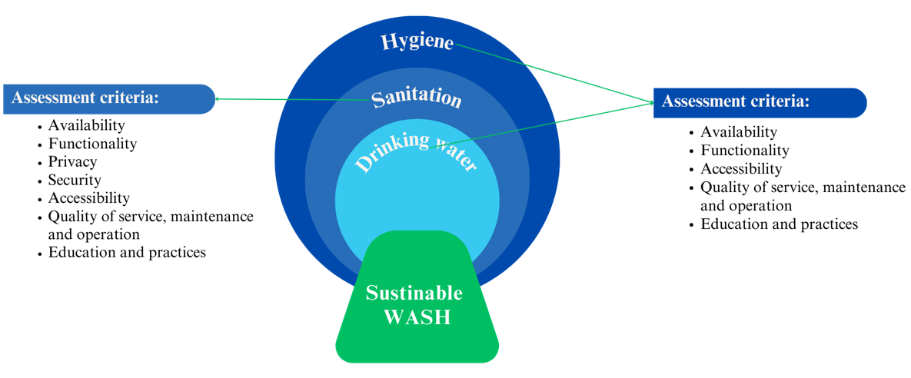

Figure 27. Systematic approach to WASH in schools [56].
Functionality is fundamental to the achievement of a successful WASH system. Although educational institutions may possess the necessary infrastructure, its efficiency and effectiveness are of the crucial importance. Sustained operation, rational resource allocation, and continuous maintenance are critical for guaranteeing the integrity of sanitation facilities, uncontaminated water sources, and consistent availability of essential supplies including clean water and soap.
Addressing issues of equity requires a focus on accessibility. Ensuring equitable access to WASH facilities for all students, regardless of their geographical location and age, is the primary objective. In our study, rural students’ satisfaction with WASH services were lower in comparison to urban ones. It is not merely a matter of equity to acknowledge and alleviate disparities in accessibility; rather, it is an essential stride in the direction of deconstructing the entrenched cycles of inequality.
The quality of services provided by the WASH system is a prerequisite. It is imperative to maintain high criteria at all times, which includes conducting routine water source testing, ensuring that facilities are kept in perfect hygienic condition, and ensuring consistent provision of core resources. Quality assurance is essential for guaranteeing that the WASH system effectively serves its target purpose.
The WASH system's maintenance and operation mechanisms are fundamental to its sustainability. It is imperative that academic establishments have the necessary resources and capacity to efficiently maintain and operate their water and sanitation, hygiene infrastructure.
The integration of hygiene education into the curriculum should be simple, covering topics such as the significance of handwashing, proper sanitation practices, and the broad consequences that these aspects have on individuals' health and well-being. Disseminating effective hygiene practices has a beneficial influence not just on the school community but also on society as a whole. Strengthening educational programs and practices enables students to acquire the knowledge and ability needed to make informed and beneficial choices.
The systems approach places significant emphasis on fostering collaboration and coordination among various stakeholders, integrating interventions, and taking into account contextual factors. To successfully adopt a systems sustainable approach, schools should prioritize the actions (Figure 28).

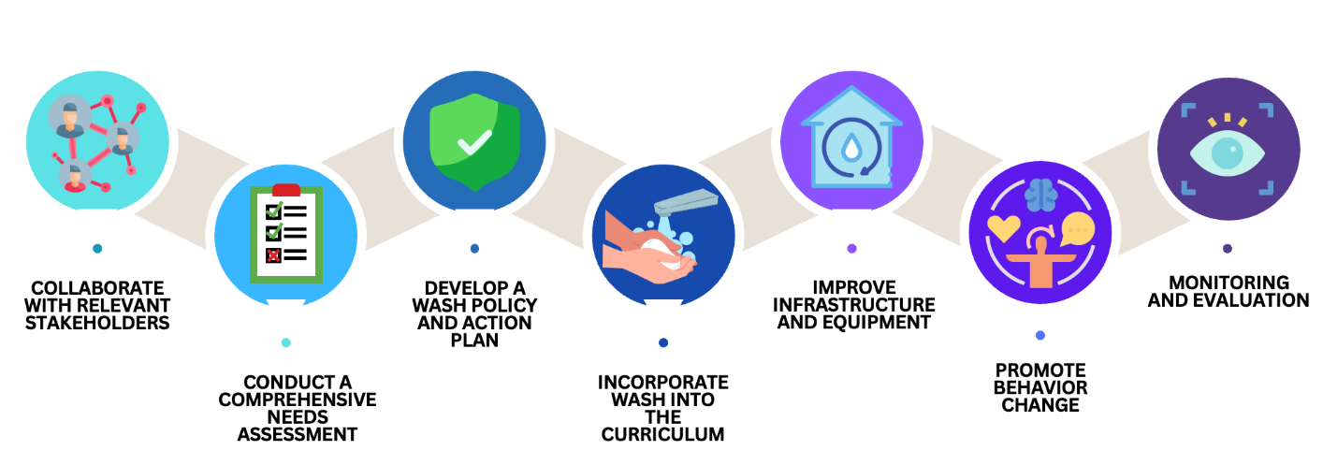

Figure 28. Actions to implement a systems-sustainable approach.
Establishing an integrated water, sanitation and hygiene (WASH) system in educational institutions is a vast and complex task that goes beyond physical infrastructure. An integrated approach is taken, encompassing practice, education, functionality, accessibility, privacy and security, and maintenance and operation. While educational institutions have made progress in these areas, they must consistently and methodically improve.

4.2 Promotion of hygiene education
Regarding to our binary logistic regression, absence of talking about WASH at schools was associated with less refusal behavior to drink water, use sanitation and handwashing. The odds ratio for the lack of discussions regarding the necessity of handwashing at school was 1.38 times higher (95% confidence interval = 1.187-1.604, p < 0.01) compared to discussions about it. Furthermore, the failure to discuss the significance was linked to a 1.3-fold increase (95%CI=1.206-1.585, p<0.01) in the behavior of refusing to drink water. Students who did not get education on sanitation hygiene were 1.27 times more likely to refuse to use the toilet (95%CI=1.081-1.498, p<0.01).
Based on our research, WASH education is essential for fostering not only healthy behaviors but also responsible citizenship in school-aged children. It equips student with the knowledge and skills necessary to protect their health and wellbeing. By introducing student to the concepts of clean water sources, proper sanitation, and effective hygiene practices at a young age, schools set the groundwork for the formation of lifelong habits that protect children from waterborne diseases and promote their physical vitality.
The elective course "Water, Sanitation and Hygiene" was created based on the analysis carried out in the thesis with the aim of developing knowledge and skills related to water, sanitation and hygiene and to develop students' responsible attitude towards the use of resources and maintaining a healthy environment. The Water, Sanitation and Hygiene course is designed to provide a complete understanding of the importance of clean water, good sanitation practices and personal hygiene. Through engaging lessons and related activities, students will acquire a solid foundation of knowledge and skills related to these essential aspects of their daily lives.
In the course, students should learn to understand the need for clean water to sustain life and health and to distinguish between different sources of water and understand their importance in daily life, understand the importance of sanitation rules and regulations in maintaining public health, recognize the importance of hand washing, and other aspects of personal hygiene and learn proper hand washing techniques and follow them in daily life.
This course is assigned to students in grade 5 and is an initiative aimed at building habits of knowledge and skills related to the importance of water, sanitation and hygiene in students from small grades. It promotes the development of a responsible attitude towards health and the environment from an early age. The discipline sets objectives such as recognizing the role of water in sustaining life and health, understanding the importance of water conservation and its impact on the environment; understanding the importance of maintaining cleanliness and hygiene for public health; learning hygiene skills and proper hand washing techniques and their application in daily life.
The first section is entitled "Introduction to Water Supply, Sanitation and Hygiene". In this chapter, students will have a basic knowledge of water supply, sanitation and hygiene, familiarize themselves with the basic concepts and terms in the field, and understand the benefits and importance of proper water supply, sanitation and hygiene for health and well-being. The next chapter "Water Supply" will familiarize students with the concepts and issues related to water quality, understand the importance of clean water for health, and introduce them to the basic methods of water purification. The third chapter "Sanitation" will introduce students to the concept of sanitation, various sanitation conditions and sanitation facilities, and explore the impact of proper sanitation on public health. The purpose of the section "Hygiene promotion" is to develop students' understanding of the importance of hygiene standards, to introduce them to the principles and methods of hygiene promotion, and to develop skills in planning a hygiene promotion program, their hygiene practices and behavioral changes. The last section, Environmental Responsibility, will develop students' understanding of the impact of human activities on water resources and the environment, and encourage them to make responsible decisions regarding the careful use of water, improved sanitation and environmental protection.
The course "Water, sanitation, and hygiene" for schoolchildren should be taught using the activity-based method to help them learn. The way that students are taught is set up so that they are directly involved in the process of learning. Tasks, problem situations, role-playing games, and other engaging activities are part of the lessons so that students can use what they have learned.
Different types of work, like discussions, group projects, research, and building models, will help students think creatively and improve their study skills. Diagrams, illustrations, photos, and films that help students see how ideas and examples in water, sanitation, and hygiene work will help them understand and remember the information better.
Hands-on tasks like checking the quality of the water, making models of sanitation, and using good hygiene habits are all part of the learning process. Learners will be able to use what they've learned and improve their learning through practical activities.
Feedback and self-reflection at the end of each lesson will help them see how much they understand and how far they've come in learning. Students will learn how to think critically and remember what they have learned better if they are encouraged to share their ideas and opinions and ask more questions.
When you connect the study of water, sanitation, and hygiene to other subjects like biology, chemistry, ecology, and geography, it helps students see that these subjects are broad and important in many areas of life.
They will be able to look into specific problems, come up with solutions, and share their ideas by working on projects related to water, sanitation, and hygiene. This will help them become more creative and smart, and it will also help them understand how important water, cleanliness, and hygiene are.
Incorporating WASH education into the school curriculum provides a novel opportunity to nurture responsible citizenship. By introducing the concept of responsible water use and environmental sustainability, schools cultivate young minds that are not only health-conscious but also knowledgeable of their impact on the environment as a whole [121].
Children internalize WASH practices, they naturally extend these principles to their families, peers, and communities, catalyzing an out-of-classroom wave of positive behavior change. They can promote healthful behaviors and practices, which can have a positive effect on the health and well-being of the entire community [122].
WASH education intersects health and education, demonstrating the relationship between health and academic achievement. When children are healthy, they attend school on a more consistent basis, concentrate better in class, and perform at their academic best, creating a cycle of success.
Integrating WASH education across disciplines can be extremely advantageous for students. It can assist them in comprehending the significance of hygiene and its far-reaching consequences. UNICEF, for instance, promotes community-based handwashing through a variety of media and campaigns such as Global Handwashing Day, which reach hundreds of millions of people annually. In addition, they work directly with schools and healthcare facilities to improve access to essential water, sanitation, and handwashing facilities, as well as to develop protocols for preventing and controlling infections [123].
Consistent exposure to WASH education can facilitate behavioral change by increasing awareness and promoting hygiene. A WASH education can also assist students in comprehending the interconnectedness of global issues like climate change, poverty, and public health. Students can gain a better understanding of the influence of climate change on water scarcity and the significance of sustainable water management by learning about responsible water use and conservation.
Concluding, WASH education plays a vital role in preparing students to become responsible global citizens who are able to resolve pressing global challenges and contribute to a more sustainable future.

4.3 Monitoring and evaluating the progress of the WASH interventions
Ensuring access to clean water, sanitation and hygiene are critical to children's health and learning in schools. Research findings show that in order to achieve effective results and improve sanitation in schools, monitoring and evaluation of the implementation of Water, Sanitation and Hygiene (WASH) interventions should be introduced.
Monitoring and assessing the development of WASH services in schools is essential for ensuring the efficacy and sustainability of these interventions. Evaluation demonstrates the effect of WASH interventions on health, education, and well-being in general. It necessitates frequent evaluation of key indicators to effectively target resources and program interventions. National governments and organizations such as UNICEF stress the necessity of monitoring WASH indicators in schools to guarantee adequate coverage and identify problem areas [124].
Also, it aids in identifying disparities in school WASH service access. According to a study results, sociodemographic characteristics, school type, and availability of WASH facilities were associated with disparities in hand hygiene and sanitation practices among students. Students' hand hygiene knowledge and practices are crucial for preventing infections and enhancing overall health. Regular assessments can assist in monitoring hand hygiene practices and identifying areas where behavior modification interventions are required.
In addition, monitoring and evaluation are crucial for determining the sustainability of WASH interventions. Study results have highlighted the significance of WASH facility maintenance and operation in ensuring their long-term functionality.
Various methods can be used to effectively monitor and evaluate school WASH services. Among these are surveys, structured observations, interviews, and the use of indicators and targets [125]. Moreover, the participation of stakeholders such as school administrators, parents, and community members are essential for effective monitoring and evaluation [126].
The evaluation of the students' questionnaire demonstrates its efficacy in obtaining information about students' access to WASH services. Its structured and well-organized format enables a comprehensive comprehension of students' perspectives, which is essential for assessing the functionality and impact of WASH services. This method not only captures vital indicators, but also enables students to communicate their experiences and needs, ensuring that their voices are heard (Appendix E).
Notable is the suggestion to use the interview with school administration as a self-evaluation instrument. This method affords the school administration the chance to reflect on and assess the efficacy of their WASH initiatives. This process of self-evaluation can cultivate a culture of accountability and continuous improvement among the school administration (Appendix B).
The suggestion to monitor handwashing behavior and the condition of WASH infrastructure using observations is remarkable (Appendix D). This method assigns specific responsibilities for sanitation and infrastructure maintenance to designated individuals. This method ensures regular inspections of WASH practices and facility maintenance, thereby promoting a consistent level of sanitation and functionality. In addition, surveillance permits the early detection of problems with school WASH services. Regular monitoring enables the prompt identification of malfunctioning infrastructure, deteriorating water quality, and hygiene violations. By identifying problems in their earliest stages, schools can mitigate potential health risks and prevent minor issues from escalating into significant problems, thereby ensuring the safety of students and employees.
Regular observations of handwashing behavior and facility conditions, student questionnaires, and periodic self-evaluation interviews with school administration create a balanced and dynamic monitoring system.
All of these instruments facilitate the systematic collection of data on various aspects of WASH service delivery. From water availability to the functionality of sanitation facilities, and from hygiene behavior to educational interventions, this instrument incorporates a vast range of indicators. This comprehensive data collection enables a nuanced understanding of the strengths and gaps in WASH infrastructure and practices, providing a holistic perspective that is essential for identifying areas in need of targeted development.
They generate evidence-based, non-numerical data that informs decision-making. The quantitative and qualitative data collected through the process of surveillance serve as the basis for school administrators, policymakers, and other stakeholders to make decisions. The insights provided by the tool enable decision-makers to identify priority areas, allocate resources effectively, and tailor interventions to meet specific requirements, resulting in strategies based on evidence.
Continuous refinement is a hallmark of effective education, and WASH services are no exception. The combination of the three instruments provides a cyclical process of data collection, analysis, and action. This iterative approach facilitates continuous development, ensuring that schools' WASH services evolve over time. They identify areas requiring improvement, schools can implement changes, and monitor the results, fostering an environment of continuous learning and development.

4.4 Addressing the Gaps in Sanitary and Epidemiological Requirements for Educational Facilities
Education institutions have always played a crucial role in the progress of society, nurturing the cognitive advancement and welfare of students. Nevertheless, these establishments serve not just as educational centers but also as settings where students spend a substantial amount of their day, making it crucial to prioritize their well-being and security.
This study found the presence of infrastructure of WASH system, without taking into account criteria. The absence of clear standards as accessibility, privacy, security, quality of services, operation and maintenance for toilets, hygiene facilities, and drinking fountains in schools, highlighting the need for well-defined regulations regarding their design, construction, material, height, and installation. By addressing these gaps, educational institutions can create healthier and safer environments for all stakeholders.
- The existing sanitary rules defining requirements for water supply systems, sanitation and hygienic devices demonstrate vague wording and leave many aspects without proper clarification. Based on the Order of the Minister of Health of the Republic of Kazakhstan from August 5, 2021 № KR MOH-76 "On approval of the Sanitary Rules "Sanitary and epidemiological requirements for educational facilities":requirements for water, sanitation and hygiene in educational institutions, the following additions can be proposed:
- To find the lowest number of water points that should be available for each student. The number of water entry points needed should be based on the number of students (for example, one water fountain for every 100 students). It should include goals for providing drinking water, like putting in several drinking water stations throughout the school, not just in the dining areas, and making sure that students and workers always have access to drinking water during the school day.
- To make sure that compliance with the drinking water regime is part of the plan for internal checks.
- To set up Standard Operating Procedures (SOPs) for maintaining and refilling water stations. Standard Operating Procedures (SOPs) should be used by schools to make sure that water access places are cleaned, sanitized, and maintained in the right way. These SOPs also list the people who are responsible for doing each job. Standard Operating Procedures (SOPs) include how to clean and flush water fountains, large water dispensers, and any other places where people can get water.
- Doing an assessment of the current drinking water surroundings will help find places that might need to be changed.
- To make sure that the toilets and sinks are the right size and height so that young students and students who have trouble moving around can use them easily.
- There should be toilets for both boys and girls on every floor, with rooms that have doors. Toilet walls shouldn't have any holes in them. The toilet door has to close from the inside. Sanitary tools must be usable and free of cracks, chips, and other flaws.
- To put in wheel buckets and toilet paper holders in the bathrooms. There must always be toilet paper provided.
- To set up Standard Operating Procedures (SOPs) for the upkeep and supply of cleaning supplies. Standard Operating Procedures (SOPs) that spell out exact ways to clean, sanitize, and keep sanitation points must be made and followed by educational institutions. In addition, the SOPs list the people who are in charge of carrying out each task. Also, someone should be responsible for refilling trash cans and making sure they are clean and charge with toilet paper.
- To put pedal buckets next to the sinks. Soap, paper towels, or heated towels should be put near the sinks. The hygienic station should always have soap and electronic dryer.
- To come up with standard operating procedures (SOPs) for getting and keeping cleaning supplies. Standard operating procedures (SOPs) should be made and followed by educational centers so that everyone knows how to clean, sanitize, and maintain handwashing stations. On top of that, the SOPs list who is in charge of each task. Additionally, someone should be in charge of replacing hand-washing supplies and checking trash cans on a regular basis.

CONCLUSION

The Sustainable Development Goals (SDGs) prioritise the provision of safe water and sanitation for everyone, along with strengthening the educational environment in schools, involving sufficient availability of drinking water, sanitation, and hygiene facilities. Nevertheless, this study underscores the fact that possessing the essential infrastructure alone is insufficient to transform this difficulty into an opportunity. The study identified substantial deficiencies in key aspects such as availability, maintenance, functionality, education, operations, and student satisfaction with the current infrastructure.
Access to water and sanitation in schools is a global problem. In 2021, 288 million students did not have access to water, 13% of schools did not have access to sanitation, and 25% of schools did not provide hygiene services (no facilities or water in school). Data for Kazakhstan shows that access to water, sanitation and hygiene is unevenly distributed in schools and rural areas still struggle with access to water, sanitation and hygiene. 1420 schools have access to imported water, 95% of which are located in rural areas. Moreover, 474 in-ground toilets were located in rural areas. Currently, there is no unified system of data collection on WASH coverage of schools in Kazakhstan. The data that do exist are often incomplete. At the same time, the national project "Educated Nation" sets an ambitious goal to achieve 100% provision of schools with basic hand washing facilities and toilets by December 2025. These results emphasize the importance of introducing a unified system of data collection on WASH coverage of schools across the country.
The incidence of bacterial dysentery and acute intestinal infections in Kazakhstan and Karaganda region for 2011-2021 decreased. The incidence among children under 14 years of age was the highest. The incidence of bacterial dysentery in Kazakhstan decreased to 2.61 per 100 000 children under 14 in 2021 in comparison to 2011 (26.61 per 100 000 children aged till 14). In Karaganda, no cases of bacterial dysentery were reported in 2021. And the incidence of acute intestinal infections in Kazakhstan decreased to 95.82 per 100 000 children under 14 in 2020 from 2011 (346.05 per 100 000 15-18 y.o. children). And in Karaganda, this incidence decreased to 151.31 per 100 000 children under 14 in 2020 from 216.14 per 100 000 children till 14 y.o. in 2011. The highest incidence of viral hepatitis in Kazakhstan and Karaganda region was observed in older age groups. In Kazakhstan, the rate decreased to 1.54 per 100 000 children 15-18 years old in 2021 from 2011(26.8 per 100 000 children aged 15-18). In Karaganda, the viral hepatitis incidence rate decreased from 23.18 per 100 000 15–18-year-olds in 2011 to 5.55 per 100 000 15–18-year-olds in 2021. The linear regression shows negative correlation between all morbidities and year, suggesting that as year increases, morbidity tends to decrease (except viral hepatitis in Karaganda region).
The results emphasize the importance of age-specific public health policies for disease prevention and control. Educational campaigns are needed to maintain and improve the overall health of the region's population.
In general, in terms of access to water, sanitation and hygiene, Karaganda schools have basic level of WASH. However, the result of conducted surveys in schools revealed shortcomings at all stages of water supply, sanitation and hygiene services provision. 16.7% of children used toilets rarely, only when it was difficult. 3.8% of parents reported that their children do not use school toilets. 0.9% of parents did not know if their children wash their hands at school. 9% of respondents reported not having soap or other detergents. Some parents (7%) reported that they had no or limited access to water. The questionnaires revealed that parents and administrators do not have a full understanding of the importance of water, sanitation and hygiene. Lack of understanding of significance in water, sanitation and hygiene issues leads to various problems such as lack of centralized control and continuous monitoring, partial non-compliance with sanitation standards, detrimental impact on health and education.
57.9% of students stated that they do not receive water free of charge. Every fifth of rural student and 28% of urban school students agreed with the statement the water at school was not good for drinking. Every fifth of rural student and fourth urban school students complained on the crowdedness nearby to the drinking water points. 15% of both school students answered that drinking water points were too far away. 36% of rural and 41% of urban students drank water at school two or more times per day. However, every fifth of rural and urban students never drank water at school. 22% and 30% of rural and urban students answered that there was unpleasant smell in the toilets. Every tenth and sixth students answered that the toilets were dirty. 9 % of both schools stated that toilets were too far. 14 and 20% of rural and urban students complained that there were big lines to the toilet. 18 and 27% of students answered that they could not lock the door of the toilet. 7 and 16% of students answered that other students can look inside the cubicles from above or from under the door, through holes in the walls. 54% and 57% of rural and urban school students answered that there were never toilet papers in the school toilets. 17% of rural and 22% of urban students answered the light presence as rarely. 16% of rural and 17% of urban students assessed the toilets as rarely clean. Just 50% of students indicated consistent access to soap for handwashing at school. 50% of students reported consistent availability of drying facilities after handwashing. The study shows that the availability of necessary infrastructure is not enough to turn the provision of safe water and sanitation for all and improve the ability of schools to offer an effective learning environment, including adequate drinking water, sanitation and hygiene, into an opportunity. The study found gaps in a number of vital aspects such as accessibility, maintenance, operation, training and practice, and student satisfaction with infrastructure. The findings emphasize the importance of not only WASH infrastructure but also consider the aspects of accessibility, maintenance, operation, training and practice, and student satisfaction with infrastructure
By binary logistic regression, on lack of handwashing behavior affected next factors, such as school location, gender, mother’s occupation, mother’s education, grade. On the absence of handwashing behavior at school affected absence of water, and soap at school. On the behavior of refusing to drink water at school was associated with school location, grade, the absence of water for drinking, the chargeable water, the bad perception of water, far distance of drinking points, crowded drinking water points, the allowance to drink water at certain times and talks about the importance of drinking water. The behavior of refusing to use the sanitation at school was associated with school location, grade, the absence of unpleasant smell, the rarely presence of the light, when students assess the toilet as terrible, going to the toilet depends on the teacher, the absence of talking about toilet hygiene. The study highlights the high importance of ensuring equity of access to water, sanitation and hygiene in educational institutions, especially in the context of health and behavioral aspects of learners. The results of the analysis indicate that various aspects such as accessibility, privacy, maintenance, level of cleanliness, and overall functionality are closely related to behaviors related to water drinking, hygiene, and sanitation use in schools. Recommendations were developed from the findings on the assessment of access to WASH services, as well as pupils' satisfaction with these services and factors influencing the development of hygiene skills.
Based on the results of our study, we have drawn the following findings:
- According to the WASH JMP, 13% of the world's schools lack sanitation and 25% lack water and handwashing facilities. In 2021, 288 million children did not have access to drinking water. The 2020 National Report on the Status and Development of the Education System of the RK notes that not all schools have equal access to water, sanitation and hygiene. Access to drinking water, sanitation and hygiene remains difficult in rural areas. Moreover, the national project "Quality Education - Educated Nation" sets the task to create comfortable conditions for students in educational organizations by December 2025, including the provision of drinking water, sanitation and hygiene
- In Karaganda region, the incidence of acute intestinal infections (AII) among children under 14 years old in 2021 decreased to 18% (177.43 per 100,000) compared to 2011 (216.14 per 100,000). The lowest incidence is registered in 2020 - 151.31 per 100,000. In Karaganda region, the incidence of viral hepatitis A (VHA) among children 15-18 years old in 2021 decreased by 4.2 times compared to 2011. Among children under 14 years of age, the average incidence of AII in the Republic decreased 2.5 times (346.05 per 100,000 children in 2011 and 134.96 per 100,000 children in 2021). On average in Kazakhstan, the incidence of VHA among children 15-18 years old for the same period decreased 17.4 times (26.8 in 2011 and 1.54 in 2021).
- According to the JMP hierarchical service ladder, all surveyed schools have a basic level of water supply, five schools have a limited level of sanitation, and two schools have a limited level of hygiene. 57.9% of surveyed school students expressed that there is no free access to drinking water in their schools. 54% of rural school students and 57% of urban school students indicated that that there's no toilet paper in the toilets. Only half of the pupils responded that they always have soap for hand washing at school and can use drying facilities after handwashing.
- The following factors have been found to influence hygiene behavior, particularly the lack of handwashing skills: settlement type (OR of rural school = 1.70), gender (OR of male 1.52) and absence of talks on the importance of hygiene (OR=1.38). Violation drinking water regime at school was linked to incidents like school location (OR of rural school = 1.35), not having water for drinking (OR=1.41), having to pay for water (OR=1.22), having a negative view of water (OR=0.67), drinking water points being far away (OR=0.76), drinking water points being crowded (OR=0.65), being able to drink water at certain times (OR=3.15), and talking about how important it is to drink water (OR=1.38). Students' refusal to use the school toilet was influenced by the school's location (OR = 1.89), the absence of an unpleasant smell (OR = 0.60), the light being on only sometimes (OR = 1.45), thinking toilets were awful (OR = 2.72), going to the toilet depends on the teacher (OR = 2.54), and not talking about toilet hygiene (OR = 1.27).
- Recommendations for improving access to water, sanitation, and hygiene services in schools include conducting a comprehensive needs assessment, developing a policy and action plan, and introducing a WASH elective into the curriculum. A syllabus for the optional course "Water, Sanitation and Hygiene" for secondary general education students has been developed.

PRACTICAL RECOMMENDATIONS

- Implementing a systems approach to water, sanitation and hygiene (WASH) in schools requires comprehensive consideration of all aspects, including functionality, accessibility, privacy, security, quality of service and more. To successfully implement a systemic sustainable approach, schools need to collaborate with stakeholders, conduct a needs assessment, develop a policy and action plan, integrate learning into the curriculum, improve infrastructure, and promote student behavior change.
- To introduce an elective course "Water, Sanitation and Hygiene" to improve hygiene education in schools. The aim of the course is to lay a solid foundation of knowledge about the need for access to safe water and proper sanitation to preserve and promote health and prevent diseases, and to develop the necessary skills of personal and public hygiene. During the course, students should learn to distinguish between different water sources, understand the importance of following sanitary norms and rules in maintaining public health, realize the importance of personal hygiene aspects and learn proper hand washing techniques and observe them in everyday life.
- Monitoring and evaluating progress on water, sanitation and hygiene (WASH) through student questionnaires, observation and school administration surveys. Questionnaires provide feedback and student opinion on WASH services, which helps to improve them and instill a culture of accountability. Observation, in turn, helps to keep sanitation facilities clean and functional, as well as early identification of problems. Utilizing questionnaires with the school administration as a way of self-evaluating the school. In this way, the school administration can evaluate how well their WASH efforts are working. School leadership can create a culture of accountability and continuous improvement through this self-evaluation process. Monitoring and evaluation not only improve access to WASH services but also helps with hygiene practices and ensure the long-term viability of the WASH program.
- To make changes and additions to the Order of the Minister of Health of the Republic of Kazakhstan from August 5, 2021, № KR MOH-76 "On approval of the Sanitary Rules "Sanitary and epidemiological requirements for educational facilities":
- To add Chapter 3, paragraph 30: Determine the minimum number of drinking points for students according to student population, and provide disposable cups.
- To add Chapter 4, paragraph 65: Include monitoring of WASH infrastructure in the internal inspection plan to assess the existing WASH environment to identify areas requiring change.
- To add Chapter 4, paragraph 65: Ensure that standard operating procedures (SOPs) are in place for the maintenance and cleaning of WASH sites and the provision of consumable sanitation supplies.
- To add paragraph 38 of Chapter 5: provide special equipment and sanitary appliances of appropriate size and height to meet the hygienic needs of junior high school students and people with disabilities.
- To add Chapter 8, paragraph 92: Ensure that toilet paper is available at all times in the sanitary facilities.

References

- Wolf J, Prüss-Ustün A, Cumming O, Bartram J, Bonjour S, Cairncross S, et al. Assessing the impact of drinking water and sanitation on diarrhoeal disease in low- and middle-income settings: systematic review and meta-regression // Tropical Medicine & International Health. – 2014. -Vol.19.8.- P.928-942. doi:10.1111/tmi.12331.
- Bekturganov Z, Tussupova K, Berndtsson R, Sharapatova N, Aryngazin K, Zhanasova M. Water Related Health Problems in Central Asia—A Review // Water. - 2016. - Vol 8. - P 219. doi:10.3390/ijerph13111115.
- Alzyood M, Jackson D, Aveyard H, Brooke J. COVID-19 reinforces the importance of handwashing // Journal of Clinical Nursing, – 2020. - V29. -P.15–16. doi: 10.1111/jocn.15313.
- The human rights to safe drinking water and sanitation : resolution / adopted by the Human Rights , - UN, General Assembly, 2016. URL: https://digitallibrary.un.org/record/821067 (cited 2021 Apr 13)
- Progress on Drinking Water, Sanitation and Hygiene: Special focus on inequalities, United Nations Children’s Fund (UNICEF) and World Health Organization, - 2019. - URL: https://www.unicef.org/reports/progress-on-drinking-water-sanitation-and-hygiene-2019 (cited 2021 Apr 13)
- Jasper C, Le TT, Bartram J. Water and sanitation in schools: a systematic review of the health and educational outcomes // International Journal of Environmental Research and Public Health. – 2012. -Vol9(8). - P.2772–87. doi:10.3390/ijerph9082772.
- Huang KY, Cheng S, Theise R. School contexts as social determinants of child health: Current practices and implications for future public health practice // Public Health Reports. – 2013. - Vol128. Suppl 3. - P21–8. doi: 10.1177/00333549131286S304.
- National Report on the State of the Environment and Use of Natural Resources of the Republic of Kazakhstan for 2021, Ministry of Ecology, Geology and Natural Resources of the Republic of Kazakhstan, - 2021 URL: https://www.gov.kz/memleket/entities/ecogeo/documents/details/383692?lang=ru (cited 2021 Oct 21)
- Water Code of the Republic of Kazakhstan from July 9, 2003 № 481-II (with amendments and additions as of 01.05.2023). - Information-legal system of normative legal acts of the Republic of Kazakhstan "Adilet" official site. URL: https://adilet.zan.kz/rus/docs/K030000481_ (cited 2021 Apr 21).
- On sectoral program "Drinking water" for 2002-2010. - Information-legal system of normative legal acts of the Republic of Kazakhstan "Adilet" official site. URL: https://adilet.zan.kz/rus/docs/P020000093_. (cited 2021 Apr 21).
- On approval of the Program "Ak Bulak" for 2011-2020 years - Information-legal system of normative legal acts of the Republic of Kazakhstan "Adilet" official site. URL: https://adilet.zan.kz/rus/docs/P1100000570 (cited 2021 Apr 21).
- On approval of the State Program of Housing and Communal Development "Nurly Zher" for 2020-2025 years - Information-legal system of normative legal acts of the Republic of Kazakhstan "Adilet" official site. URL: https://adilet.zan.kz/rus/docs/P1900001054 (cited 2021 Apr 21).
- Caruso BA, Freeman MC, Garn J V., Dreibelbis R, Saboori S, Muga R, et al. Assessing the impact of a school-based latrine cleaning and handwashing program on pupil absence in Nyanza Province, Kenya: a cluster-randomized trial // Tropical Medicine & International Health,- 2014.-Vol.19(10). – P.1185–97. doi: 10.1111/tmi.12360.
- Jasper C, Le TT, Bartram J. Water and sanitation in schools: A systematic review of the health and educational outcomes // International Journal of Environmental Research and Public Health, -2012. -Vol.9(8). – P.2772–87.
- WHO/Europe Home . URL: https://www.who.int/europe/home?v=welcome (cited 2023 Apr 13).
- The Impact of Mercenary Activities on the Right of Peoples to Self-Determination, UN Office of the High Commissioner for Human Rights (OHCHR), Fact Sheet No. 28, - 2002, - Vol. 28, URL: https://www.refworld.org/docid/479477460.html [cited 27 October 2022]
- On Approval of Sanitary Rules "Sanitary and Epidemiological Requirements to Educational Facilities" - Information-legal system of normative legal acts of the Republic of Kazakhstan "Adilet" official site. URL: https://adilet.zan.kz/rus/docs/V2100023890#z547 (cited 2021 May 7).
- 18. On approval of the State program of development of education and science of the Republic of Kazakhstan for 2020 - 2025 years - Information-legal system of normative legal acts of the Republic of Kazakhstan "Adilet" official site. URL: https://adilet.zan.kz/rus/docs/P1900000988 (cited 2021 May 7).
- Setty K, Cronk R, George S, Anderson D, O’flaherty G, Bartram J. Adapting Translational Research Methods to Water, Sanitation, and Hygiene // International Journal of Environmental Research and Public Health, - 2019. – Vol.16(20). – P. 4049; doi:10.3390/ijerph16204049.
- Transforming our world: the 2030 Agenda for Sustainable Development - 2030, - Resolution adopted by the General Assembly on 25 September 2015, United Nations General Assembly, - 2015. URL: https://www.unfpa.org/resources/transforming-our-world-2030-agenda-sustainable-development. (cited Oct 27, 2021)
- Wolf J, Hunter PR, Freeman MC, Cumming O, Clasen T, Bartram J, et al. Impact of drinking water, sanitation and handwashing with soap on childhood diarrhoeal disease: updated meta-analysis and meta-regression // Tropical Medicine & International Health, - 2018. – Vol. 23(5). – P.508–25. doi:10.1111/tmi.12331.
- Chen X, Ran L, Liu Q, Hu Q, Du X, Tan X. Hand Hygiene, Mask-Wearing Behaviors and Its Associated Factors during the COVID-19 Epidemic: A Cross-Sectional Study among Primary School Students in Wuhan, China // International Journal of Environmental Research and Public Health , - 2020. – Vol. 17.- P. 2893. doi:10.3390/ijerph17082893.
- Bolatova Z, Tussupova K, Toleubekov B, Sukhanberdiyev K, Sharapatova K, Stafström M. Challenges of Access to WASH in Schools in Low- and Middle-Income Countries: Case Study from Rural Central Kazakhstan // I International Journal of Environmental Research and Public Health, - 2021. - Vol.18(18). – P. 9652; doi.org/10.3390/ijerph18189652.
- Chirgwin, Hannah et al. Interventions promoting uptake of water, sanitation and hygiene (WASH) technologies in low- and middle-income countries: An evidence and gap map of effectiveness studies // Campbell systematic reviews , - 2021. - Vol. 17,4. – P. 1194. doi:10.1002/cl2.1194
- Core questions and indicators for monitoring WASH in health care facilities in the Sustainable Development Goals, - World Health Organization& United Nations Children's Fund (‎UNICEF)‎, - (‎2018)‎. URL: https://iris.who.int/handle/10665/275783. (cited 2021 Oct 27).
- Surveillance of water, sanitation and hygiene in schools: a practical tool, World Health Organization. Regional Office for Europe&United Nations Economic Commission for Europe, - ‎2019‎. URL:https://iris.who.int/handle/10665/329394.
- Toleubekov B, Bolatova Z, Stafström M. Assessing Access to WASH in Urban Schools during COVID-19 in Kazakhstan: Case Study of Central Kazakhstan // International Journal of Environmental Research and Public Health, - 2022. - Vol.19(11). – P. 6438. doi: 10.3390/ijerph19116438.
- Indicator 3.9.2 - Deaths from lack of safe water, safe sanitation and hygiene (from lack of safe water, sanitation and hygiene (WASH) services for all) - Sustainable Development Goal Indicators, SDG 17 Goals to transform our world. URL: https://kazstat.github.io/sdg-site-kazstat/ru/3-9-2/
- Strategy for water, sanitation and hygiene 2016-2030 // UNICEF, - 2016. URL: https://www.unicef.org/documents/unicef-strategy-water-sanitation-and-hygiene-2016-2030 (cited 2021 Oct 28).
- WASH Post-2015: Proposed indicators for drinking water, sanitation and hygiene, - WHO/UNICEF, -2015. – P. 1–8. URL: http://www.wssinfo.org/%0Ahttp://www.unwater.org/gemi/en/%0Ahttp://www.wssinfo.org/post-2015-monitoring/ (cited 2021 Oct 28).
- Progress on household drinking-water, sanitation and hygiene 2000-2022: Special focus on gender// WHO/UNICEF Joint Monitoring Programme for Water Supply, Sanitation and Hygiene, - 2022. URL: https://www.unicef.org/reports/progress-on-drinking-water-sanitation-and-hygiene-2019 (cited 2021 Oct 28).
- Khan MH, Nafees M, Muhammad N, Ullah U, Hussain R, Bilal M. Assessment of Drinking Water Sources for Water Quality, Human Health Risks, and Pollution Sources: A Case Study of the District Bajaur, Pakistan // Archives of Environmental Contamination and Toxicology, - 2021 .- Vol.80(1). – P.41–54. doi: 10.1007/s00244-020-00801-3.
- Guidelines for Drinking-water Quality (fourth edition), WHO ,- 2011 Available from: http://www.who.int (cited 2023 Apr 13).
- States of Fragility 2022, OECD, - 2022. URL: https://www.oecd-ilibrary.org/development/states-of-fragility-2022_c7fedf5e-en (cited 2022 Apr 13).
- World Health Organization. Guidelines on sanitation and health, WHO, 2018. URL: https://www.who.int/publications/i/item/9789241514705 (cited 2022 Apr 13).
- Special focus on covid-19 who/unicef joint monitoring programme for water supply, sanitation and hygiene progress on drinking water, sanitation and hygiene in schools, WHO/UNICEF JMP, 2021. URL: https://washdata.org (cited 2023 Apr 13).
- Z Bolatova, B Toleubekov, D Kulov, K Sukhanberdiyev, K Tussupova. Assessment of access to water, sanitation and hygiene in rural schools of Central Kazakhstan //European Journal of Public Health, - 2020. – Vol. 30 (Suppl 5). – P.648.
- The impact of water supply and sanitation interventions on child health: evidence from DHS surveys, - Delhi RBII for IEN, - 2009. URL: http://www.merit.unu.edu/meide/papers/2009/1236570500_RB.pdf (cited 2023 Apr 13).
- Byford T. Water, sanitation and hygiene standards for schools in low-cost settings // International Journal of Environmental Studies, - 2014 . – Vol.30. – P.1–2. doi:10.1080/00207233.2014.913878.
- Poague KIHM, Blanford JI, Anthonj C. Water, Sanitation and Hygiene in Schools in Low- and Middle-Income Countries: A Systematic Review and Implications for the COVID-19 Pandemic // International Journal of Environmental Research and Public Health, - 2022 . – Vol.19(5). P. 3124. doi: 10.3390/ijerph19053124.
- Core questions and indicators for monitoring WASH in Schools in the Sustainable Development Goals. UNICEF, WHO. 2018; URL: http://www.who.int/about/licensing/copyright_form/en/ (cited 2022 Oct 20)
- Grossi BV, Klimschak E, Rechenburg A. The situation of water , sanitation and hygiene in schools in the pan-European region, WHO, 2016. URL: https://iris.who.int/handle/10665/329523?&locale-attribute=de (cited 2022 Oct 20)
- Jéquier E, Constant F. Water as an essential nutrient: The physiological basis of hydration // European Journal of Clinical Nutrition, - 2010. – Vol. 64(2). – P.115–23. doi: 10.1038/ejcn.2009.111.
- John Adams. Water, sanitation and hygiene standards for schools in low-cost settings // WHO, 2009. URL: https://apps.who.int/iris/handle/10665/44159 (cited 2023 Apr 13).
- Guidelines for drinking-water quality, 3rd edition: Volume 1 - Recommendations incorporating the first and second addenda, WHO, 2008. URL: https://iris.who.int/bitstream/handle/10665/204411/9789241547611_eng.pdf?sequence=1(cited 2022 Apr 13).
- Core questions and indicators for monitoring WASH in Schools in the Sustainable Development Goals. United Nations Children’s Fund, World Health Organization. 2016. Available from: http://www.who.int/about/licensing/copyright_form/en/ index.html%0Ahttp://www.who.int/about/licensing/copyright_form/en/ (cited 2022 Apr 13).
- A global overview of national regulations and standards for drinking-water quality, 2nd ed., WHO, 2010. URL: https://www.who.int/publications/i/item/9789240023642 (cited 2022 Apr 13).
- Drinking-water. Available from: https://www.who.int/news-room/fact-sheets/detail/drinking-water (cited 2022 Apr 13).
- Cronk R, Slaymaker T, Bartram J. Monitoring drinking water, sanitation, and hygiene in non-household settings: Priorities for policy and practice // International Journal of Hygiene and Environmental Health, - 2015. – Vol.218(8). – P.694–703. doi.10.1016/j.ijheh.2015.03.003.
- Donde, Oscar Omondi et al. COVID-19 pandemic: Water, sanitation and hygiene (WASH) as a critical control measure remains a major challenge in low-income countries //Water research, - 2021. - Vol. 191. – P. 116793. doi:10.1016/j.watres.2020.116793
- Construction Norms and Rules RK 3.02-25-2004 "General Educational Institutions" (as amended and supplemented as of 09.10.2015). URL: https://online.zakon.kz/Document/?doc_id=30063647&pos=1;-9#pos=1;-9
- School Feeding Handbook // World Food Programme (WFP); United Nations Educational Scientific and Cultural, 1999. URL: https://wfp.tind.io/record/2759 (cited 2022 Apr 13).
- Zomerplaag J, Mooijman A. Child-Friendly Hygiene and Sanitation Facilities in Schools Child-Friendly Hygiene and Sanitation Facilities in Schools: Indispensible to effective hygiene education // International Water and Sanitation Centre, 2005. URL: https://www.oxfamwash.org/communities/children/Child_Friendly%20Hygiene%20and%20Sanitation%20facilities%20in%20Schools.pdf (cited 2022 Apr 13).
- Upadhyay V, Mathai J, Reed PW. Primary school children: Access to toilets. Acta Paediatrica // International Journal of Paediatrics, - 2008. – Vol.97(11). – P.1546–9. doi: 10.1111/j.1651-2227.2008.00969.x.
- R. Franceys, J. Pickford & R. Reed. A guide to the development of on-site sanitation, 1992. P.237. URL: https://apps.who.int/iris/handle/10665/39313 (cited 2023 May 2).
- The World Health Report 1997-conquering suffering, enriching humanity // World Health Forum, - 1997. Vol. 18,3-4 (1997). – P. 248-60. Available from: https://pubmed.ncbi.nlm.nih.gov/9478137/
- Water, Sanitation and Hygiene (WASH) // UNICEF. URL: https://www.unicef.org/wash (cited 2022 May 2).
- Hand Hygiene at Home and in the Community // CDC. URL: https://www.cdc.gov/handwashing/hand-hygiene.html (cited 2023 May 2).
- Infection prevention and control, WHO. URL: https://www.who.int/teams/integrated-health-services/infection-prevention-control (cited 2022 May 2)
- Cairncross S, Hunt C, Boisson S, Bostoen K, Curtis V, Fung ICH, et al. Water, sanitation and hygiene for the prevention of diarrhoea // International Journal of Epidemiology, - 2010. – Vol. 39(SUPPL. 1). – P. 193-205. doi: 10.1093/ije/dyq035.
- Clasen TF, Alexander KT, Sinclair D, Boisson S, Peletz R, Chang HH, et al. Interventions to improve water quality for preventing diarrhoea // Cochrane Database Syst Rev, - 2015. – Vol.10. – P. CD004794. doi:10.1002/14651858.CD004794.pub3
- Dangour AD, Watson L, Cumming O, Boisson S, Che Y, Velleman Y, et al. Interventions to improve water quality and supply, sanitation and hygiene practices, and their effects on the nutritional status of children // Cochrane Database Syst Rev, - 2013 Vol. 8. – P. CD009382. doi: 10.1002/14651858.CD009382.pub2.
- Benova L, Cumming O, Campbell OMR. Systematic review and meta-analysis: association between water and sanitation environment and maternal mortality // Tropical Medicine & International Health , - 2014 . – Vol.19(4). – P.368–87. doi: 10.1111/tmi.12275.
- Bapat M, Agarwal I. Our needs, our priorities; women and men from the slums in Mumbai and Pune talk about their needs for water and sanitation // Environment&Urbanization, - 2003. – Vol. 15(2) doi.101177/095624780301500221.
- Stocks ME, Ogden S, Haddad D, Addiss DG, McGuire C, Freeman MC. Effect of Water, Sanitation, and Hygiene on the Prevention of Trachoma: A Systematic Review and Meta-Analysis // PLoS Med, - 2014. – Vol.11(2). -P. 1001605. doi: 10.1371/journal.pmed.1001605.
- Strunz EC, Addiss DG, Stocks ME, Ogden S, Utzinger J, Freeman MC. Water, Sanitation, Hygiene, and Soil-Transmitted Helminth Infection: A Systematic Review and Meta-Analysis // PLoS Med, - 2014. – Vol.11(3). – P. 1001620. doi: 10.1371/journal.pmed.1001620.
- Water, Sanitation and Health, - WHO, - 2018. Available from: https://www.who.int/southeastasia/activities/water-sanitation-and-health [cited 2022 May 2].
- Stanaway JD, Reiner RC, Blacker BF, Goldberg EM, Khalil IA, Troeger CE, et al. The global burden of typhoid and paratyphoid fevers: a systematic analysis for the Global Burden of Disease Study 2017 // Lancet Infect Dis , - 2019. – Vol. 19(4). – P. 369–81. doi: 10.1016/S1473-3099(18)30685-6.
- The Global Action for Measurement of Adolescent health (GAMA), WHO, 2020. Available from: https://www.who.int/data/maternal-newborn-child-adolescent-ageing/advisory-groups/gama/activities-of-gama (cited 2022 May 2).
- Prüss-Ustün A, Bartram J, Clasen T, Colford JM, Cumming O, Curtis V, et al. Burden of disease from inadequate water, sanitation and hygiene in low- and middle-income settings: A retrospective analysis of data from 145 countries // Tropical Medicine and International Health, - 2014. – Vol.19(8). – P.894–905. doi: 10.1111/tmi.12329
- Prüss-Ustün A, Wolf J, Bartram J, Clasen T, Cumming O, Freeman MC, et al. Burden of disease from inadequate water, sanitation and hygiene for selected adverse health outcomes: An updated analysis with a focus on low- and middle-income countries // International Journal of Environmental Research and Public Health, - 2019. – Vol. 222(5). – P. 765–77. doi: 10.1016/j.ijheh.2019.05.004.
- Kanungo S, Chatterjee P, Saha J, Pan T, Chakrabarty ND, Dutta S. Water, Sanitation, and Hygiene Practices in Urban Slums of Eastern India // Journal of the Infectious Diseases, - 2021. – Vol. 224(Supple 5). – P.S573–83. doi: 10.1093/infdis/jiab354.
- Delea MG, Snyder JS, Belew M, Caruso BA, Garn J V., Sclar GD, et al. Design of a parallel cluster-randomized trial assessing the impact of a demand-side sanitation and hygiene intervention on sustained behavior change and mental well-being in rural and peri-urban Amhara, Ethiopia: Andilaye study protocol // BMC Public Health, - 2019. – Vol.19(1). – P.1–15. doi.org/10.1186/s12889-019-7040-6.
- Thakadu OT, Ngwenya BN, Phaladze NA, Bolaane B. Sanitation and hygiene practices among primary school learners in Ngamiland district, Botswana // Physics and Chemistry of the Earth, Parts A/B/C, - 2018 . – Vol.105. – P.224–30. doi. 10.1016/j.pce.2018.02.006.
- Bah A, Diallo AL, Bah A, Li F. Water, sanitation, and hygiene (WASH) coverage and practices of children from five public primary schools in Guinea // Journal of Water, Sanitation and Hygiene for Development , - 2022, - Vol. 12(7). – P. 555–62. doi.org/10.2166/washdev.2022.078
- Bieri FA, Gray DJ, Williams GM, Raso G, Li YS, Yuan L, et al. Health-education package to prevent worm infections in Chinese schoolchildren // New England Journal of Medicine, - 2013. – Vol.368(17). – P. 1603–12. doi: 10.1056/NEJMoa1204885.
- Trinies V, Garn J V., Chang HH, Freeman MC. The Impact of a School-Based Water, Sanitation, and Hygiene Program on Absenteeism, Diarrhea, and Respiratory Infection: A Matched-Control Trial in Mali // American Journal of Tropical Medicine and Hygiene, - 2016 . -Vol.94(6). – P.1418–25. doi: 10.4269/ajtmh.15-0757.
- Neira M, Prüss-Ustün A, McMahon S, Caruso BA, Obure A, Okumu F, et al. Anal cleansing practices and faecal contamination: A preliminary investigation of behaviours and conditions in schools in rural Nyanza Province, Kenya // Tropical Medicine and International Health, - 2011. – Vol.259(12). – P.1546–9. doi: 10.1111/j.1365-3156.2011.02879.
- Freeman MC, Greene LE, Dreibelbis R, Saboori S, Muga R, Brumback B, et al. Assessing the impact of a school-based water treatment, hygiene and sanitation programme on pupil absence in Nyanza Province, Kenya: a cluster-randomized trial // Tropical Medicine & International Health, - 2012 . – Vol.17(3). – P.380–91. doi: 10.1111/j.1365-3156.2011.02927.
- Caruso, Bethany A et al. Assessing the impact of a school-based latrine cleaning and handwashing program on pupil absence in Nyanza Province, Kenya: a cluster-randomized trial // Tropical medicine & international health : TM & IH, - 2014. - Vol. 19,10. -P. 1185-97. doi:10.1111/tmi.12360
- McMichael C. Water, sanitation and hygiene (WASH) in schools in low-income countries: A review of evidence of impact. International Journal of Environmental Research and Public Health. 2019 Feb 1;16(3).
- Karon AJ, Cronin AA, Cronk R, Hendrawan R. Improving water, sanitation, and hygiene in schools in Indonesia: A cross-sectional assessment on sustaining infrastructural and behavioral interventions// International Journal of Hygiene and Environmental Health, - 2017 . – Vol.220(3). – P.539–50. doi: 10.1016/j.ijheh.2017.02.001.
- Darvesh N, Das JK, Vaivada T, Gaffey MF, Rasanathan K, Bhutta ZA. Water, sanitation and hygiene interventions for acute childhood diarrhea: a systematic review to provide estimates for the Lives Saved Tool// BMC Public Health , - 2017. – Vol.17(Suppl 4). – P. 776. doi: 10.1186/s12889-017-4746-1.
- Forouzanfar MH, Alexander L, Bachman VF, Biryukov S, Brauer M, Casey D, et al. Global, regional, and national comparative risk assessment of 79 behavioural, environmental and occupational, and metabolic risks or clusters of risks in 188 countries, 1990-2013: a systematic analysis for the Global Burden of Disease Study 2013 // Lancet , -2015 . – Vol.386(10010). – P. 2287–323. doi: 10.1016/S0140-6736(15)00128-2.
- Nurhayati R, Wuri S. Personal Hygiene Practices in 5th Grade Elementary School Students // Journal of Health Education, - 2020 . – Vol. 5(2). – P. 94–100. doi:10.15294/JHE.V5I2.30384
- Staniford LJ, Schmidtke KA. A systematic review of hand-hygiene and environmental-disinfection interventions in settings with children // BMC Public Health , - 2020 . – Vol. 20(1). – P. 1–11. doi.org/10.1186/s12889-020-8301-0.
- Alexander KT, Dreibelbis R, Freeman MC, Ojeny B, Rheingans R. Improving service delivery of water, sanitation, and hygiene in primary schools: A cluster-randomized trial in western Kenya // Journal of Water and Health, - 2013. – Vol. 11(3). – P.507–19. doi: 10.2166/wh.2013.213.
- Benton D, Burgess N. The effect of the consumption of water on the memory and attention of children // Appetite , - 2009. Vol. 53(1). – P.143–6. doi: 10.1016/j.appet.2009.05.006.
- Bartlett S. Water, sanitation and urban children: the need to go beyond“improved” provision // Environment & Urbanization, - 2003. – Vol.15 (2). – P.57-70. doi.org/10.1177/095624780301500220.
- Willetts J, MacArthur J, Carrard N. Gender and water, sanitation, and hygiene: Three opportunities to build from recent reporting on global progress, 2000-2022 // PLoS Med, - 2023. – Vol. 20(10). – P.1004297. doi: 10.1371/journal.pmed.1004297.
- Isolde B, Kelly D, Matthew C, Leila J. What impact does the provision of separate toilets for girls at schools have on their primary and secondary school enrolment, attendance and completion? // Systematic review, - 2011.ISBN: 978-1-907345-17-3.
- Pearson J, Mcphedran K. Sanitation has gender, education, disability, economic and environmental implications to those it serves A literature review of the non-health impacts of sanitation// Waterlines, - 2008. - Vol.27 (1). – P.1756–3488. doi: 10.3362/1756-3488.2008.005
- Freeman MC, Clasen T, Brooker SJ, Akoko DO, Rheingans R. The impact of a school-based hygiene, water quality and sanitation intervention on soil-transmitted helminth reinfection: A cluster-randomized trial // American Journal of Tropical Medicine and Hygiene, - 2013. Vol. 89(5). – P.875–83. doi:10.4269/ajtmh.13-0237.
- Trinies V, Garn J V., Chang HH, Freeman MC. The impact of a school-based water, sanitation, and hygiene program on absenteeism, diarrhea, and respiratory infection: A matched-control trial in Mali // American Journal of Tropical Medicine and Hygiene, - 2016. – Vol.94(6). – P.1418–25. doi: 10.4269/ajtmh.15-0757.
- A cluster-randomized controlled trial evaluating the effect of a handwashing-promotion program in Chinese primary schools // American Journal of Tropical Medicine and Hygiene, - 2007. -Vol. 76(6). P.1166-73.
- Talaat M, Afifi S, Dueger E, El-Ashry N, Marfin A, Kandeel A, et al. Effects of Hand Hygiene Campaigns on Incidence of Laboratory-confirmed Influenza and Absenteeism in Schoolchildren, Cairo, Egypt // Emerging Infectious Diseases, - 2011. – Vol. 17(4). – P. 619-625. doi:10.3201/eid1704.101353.
- Hunter PR, Risebro H, Yen M, Lefebvre H, Lo C, Hartemann P, et al. Impact of the Provision of Safe Drinking Water on School Absence Rates in Cambodia: A Quasi-Experimental Study // PLoS One , - 2014 . – Vol.9(3). – P.91847. doi.org/10.1371/journal.pone.0091847.
- Evaluation of the use and maintenance of water supply and sanitation system in primary schools : phase 1 : final report , UNICEF, 1994. URL: https://www.ircwash.org/resources/evaluation-use-and-maintenance-water-supply-and-sanitation-system-primary-schools-phase-1 (cited 2023 May 5).
- Dreibelbis R, Greene LE, Freeman MC, Saboori S, Chase RP, Rheingans R. Water, sanitation, and primary school attendance: A multi-level assessment of determinants of household-reported absence in Kenya // International Journal of Educational Development, - 2013. – Vol.33(5). – P.457–65. doi.org/10.1016/j.ijedudev.2012.07.002.
- Durán-Narucki V. School building condition, school attendance, and academic achievement in New York City public schools: A mediation model // Journal of Environmental Psychology, - 2008 . – Vol.28(3). – P.278–86. doi: 10.1016/j.jenvp.2008.02.008
- Herz BK, Sperling GB, Council on Foreign Relations. What works in girls’ education : evidence and policies from the developing world. - Council on Foreign Relations, 2004. – P.112.
- Farzaneh R., Valentine M.. Empowering Women, Developing Society: Female Education in the Middle East and North Africa // Population reference bureau, - 2003. – Vol.3. – P.1-8.
- Linda H, June R. A study of drinking facilities in schools // Nursing Times, - 2000. – Vol. 96(40). – P.2.
- Hunter ML, Chestnutt IG, Evans SM, Withecombe AC. Fluid for thought: availability of drinks in primary and secondary schools in Cardiff, UK// International Journal of Paediatric Dentistry , - 2004 . – Vol.14(4). – P.267–71. doi: 10.1111/j.1365-263X.2004.00561.x.
- Kaushik A, Mullee MA, Bryant TN, Hill CM. A study of the association between children’s access to drinking water in primary schools and their fluid intake: can water be ‘cool’ in school? // Child: Care, Health and Development, - 2007. - Vol.33(4). – P.409–15. doi:10.1111/j.1365-2214.2006.00721.x
- Loughridge JL, Barratt J. Does the provision of cooled filtered water in secondary school cafeterias increase water drinking and decrease the purchase of soft drinks? // Journal of Human Nutrition, - 2005. – Vol.18(4). – P. 281–6. doi: 10.1111/j.1365-277X.2005.00622.x.
- Muckelbauer R, Libuda L, Clausen K, Toschke AM, Reinehr T, Kersting M. Promotion and provision of drinking water in schools for overweight prevention: randomized, controlled cluster trial //Pediatrics , - 2009 .- Vol.123(4). – P. 661-7. doi: 10.1542/peds.2008-2186.
- Lopez-Quintero C, Freeman P, Neumark Y. Hand washing among school children in Bogotá, Colombia // American Journal of Public Health, - 2009. – Vol.99(1). – P.94–101. doi: 10.2105/AJPH.2007.129759.
- Scott E, Vanick K. A survey of hand hygiene practices on a residential college campus // American Journal of Infection Control, - 2007 . – Vol.35(10). – P.694–6. doi: 10.1016/j.ajic.2007.01.009.
- Lundblad B, Hellström AL. Perceptions of school toilets as a cause for irregular toilet habits among schoolchildren aged 6 to 16 years // Journal of School Health, - 2005. – Vol.75(4). – P.125–8. doi: 10.1111/j.1746-1561.2005.tb06656.x.
- Blanton E, Ombeki S, Oluoch GO, Mwaki A, Wannemuehler K, Quick R. Evaluation of the role of school children in the promotion of point-of-use water treatment and handwashing in schools and households--Nyanza Province, Western Kenya, 2007 // American Journal of Tropical Medicine and Hygiene, - 2010 . – Vol.82(4). – P.664–71. doi: 10.4269/ajtmh.2010.09-0422.
- Samwel M, Gabizon S. Improving school sanitation in a sustainable way for a better health of school children in the EECCA and in the new EU member states // Desalination , - 2009. – Vol. 248(1–3). – P.384–91. dx.doi.org/10.1016/j.desal.2008.05.079.
- Barnes PM, Maddocks A. Standards in school toilets – a questionnaire survey // J Public Health (Bangkok) , - 2002 . – Vol.24(2). – P. 85–7. doi.org/10.1093/pubmed/24.2.85.
- Lundblad B, Hellström AL. Perceptions of school toilets as a cause for irregular toilet habits among schoolchildren aged 6 to 16 years // Journal of School Health, - 2005. – Vol. 75(4). – P.125–8. Available from: doi: 10.1111/j.1746-1561.2005.tb06656.x.
- National report on the state and development of the education system of the republic of kazakhstan by the results of 2019, Ministry of Education and Science of RK, Information and Analytical Center JSC. URL: https://www.gov.kz/memleket/entities/edu/documents/details/141963?lang=ru.
- National report 2020 on the state and development of the system education system of the republic of Kazakhstan, - Ministry of education and science of the republic of Kazakhstan, information and analytical center, -2021. – P. 310. URL: https://iac.kz/wp-content/uploads/2022/01/naczionalnyj-doklad-po-itogam-2020-goda.pdf (cited 2023 Oct 29)
- Strategic Offices of the Republic of Kazakhstan. - URL: https://stat.gov.kz/ (cited 2023 Oct 29).
- Cronk R, Guo A, Fleming L, Bartram J. Factors associated with water quality, sanitation, and hygiene in rural schools in 14 low- and middle-income countries // Science of the Total Environment , - 2021 . – Vol. 761. – P. 144226.doi: 10.1016/j.scitotenv.2020.144226.
- Ferguson T, Roofe CG. SDG 4 in higher education: challenges and opportunities // International Journal of Sustainability in Higher Education, - 2020. – Vol. 21(5). – P.959–75. doi:10.1108/IJSHE-12-2019-0353
- Burden of Disease Attributable to Unsafe Drinking-Water, Sanitation and Hygiene, 2019. - World Health Organization, 2019. URL: https://www.who.int/publications/i/item/9789240075610 (cited 2023 Oct 29)
- Dery F, Bisung E, Dickin S, Dyer M. Understanding empowerment in water, sanitation, and hygiene (WASH): a scoping review // Journal of Water, Sanitation and Hygiene for Development , - 2020 .- Vol.10(1). - P.5–15. doi: 10.2166/washdev.2019.077.
- Hygiene, Better hygiene leads to better health, confidence and overall growth, UNICEF. URL: https://www.unicef.org/wash/hygiene (cited 2023 Oct 24).
- Water, Sanitation and Hygiene (WASH), Safe water, toilets and good hygiene keep children alive and healthy // UNICEF. URL: https://www.unicef.org/wash (cited 2023 Oct 24).
- Jordanova T, Cronk R, Obando W, Medina OZ, Kinoshita R, Bartram J. Water, sanitation, and hygiene in schools in low socio-economic regions in Nicaragua: A cross-sectional survey // International Journal of Environmental Research and Public Health, - 2015. – Vol.12(6). – P.6197–217. doi: 10.3390/ijerph120606197.
- Luis Andres, Kwasi Boateng , Christian Borja-Vega and Evan Thomas. A Review of In-Situ and Remote Sensing Technologies to Monitor Water and Sanitation Interventions // Water, - 2018. – Vol.10(6). – P. 756-769. doi.org/10.3390/w10060756.
- Girmay AM, Weldegebriel MG, Mengesha SD, Serte MG, Weldetinsae A, Alemu ZA, et al. Factors influencing access to basic water, sanitation, and hygiene (WASH) services in schools of Bishoftu Town, Ethiopia: a cross-sectional study // Discover Sustainability , - 2023. – Vol. 4(1). – P.5. doi: 10.1007/s43621-023-00122-0.

APPENDIX A

Table A. 1 - Socio-demographic characteristics of respondents by gender

Characteristics |  | Male (n=1541)  n (%) | Female (n=2439)  n (%) | Overall (n=3980)  n (%)
Mother’s occupation | Unemployed, temporarily unemployed | 416(37.9) | 683(62.1) | 1099(27.6)
Mother’s occupation | Professional and technical staff | 362(37.4) | 606(62.6) | 968(24.3)
Mother’s occupation | Civil servant | 200(40.7) | 292(59.3) | 492(12.4)
Mother’s occupation | Company employee | 196(42.4) | 266(57.6) | 462(11.6)
Mother’s occupation | Head/Manager of state bodies and institutions | 16(37.2) | 27(62.8) | 43(1.1)
Mother’s occupation | Businesswoman | 100(39.4) | 154(60.6) | 254(6.4)
Mother’s occupation | Service sector employee | 204(36) | 362(64) | 566(14.2)
Mother’s occupation | others | 47(49) | 49(51) | 96(2.4)
Father’s occupation | Unemployed, temporarily unemployed | 136(35.1) | 252(64.9) | 388(9.7)
Father’s occupation | Professional and technical staff | 258(40.5) | 379(59.5) | 637(16)
Father’s occupation | Civil servant | 228(37.4) | 382(62.6) | 610(15.3)
Father’s occupation | Company employee | 347(39.7) | 527(60.3) | 874(22)
Father’s occupation | Head/Manager of state bodies and institutions | 29(44.6) | 36(55.4) | 65(1.6)
Father’s occupation | Businessman | 191(39.1) | 298(60.9) | 489(12.3)
Father’s occupation | Service sector employee | 171(34.8) | 320(65.2) | 491(12.3)
Father’s occupation | others | 181(42.5) | 245(57.5) | 426(10.7)
Mother’s education | Secondary education | 506(37.5) | 843(62.5) | 1349(33.9)
Mother’s education | Secondary special education | 237(35) | 440(65) | 677(17)
Mother’s education | Incomplete higher education | 63(41.7) | 88(58.3) | 151(3.8)
Mother’s education | Higher education | 705(40.9) | 1019(59.1) | 1724(43.3)
Mother’s education | Postgraduate education | 30(38) | 49(62) | 79(2)
Father’s education | Secondary education | 621(38.9) | 977(61.1) | 1598(40.2)
Father’s education | Secondary special education | 285(35.7) | 514(64.3) | 799(20.1)
Father’s education | Incomplete higher education | 71(43.8) | 91(56.2) | 162(4.1)
Father’s education | Higher education | 527(39.2) | 818(60.8) | 1345(33.8)
Father’s education | Postgraduate education | 37(48.7) | 39(51.3) | 76(1.9)

Table A.2 - Prevalence of water criteria by school location

Questions | options | rural school  n (%) | urban school  n (%)
Water: availability and functionality
Is water available for drinking at school? | never | 155(11.3) | 165(6.3)
Is water available for drinking at school? | rarely | 213(15.5) | 402(15.4)
Is water available for drinking at school? | almost always | 205(14.9) | 597(22.9)
Is water available for drinking at school? | always | 802(58.3) | 1441(55.3)
I get it for free at school (from the faucets in the cafeteria, in the classroom or toilet, from the drinking fountains in the hallway) | no | 828(60.2) | 1476(56.6)
 | yes | 547(39.7) | 1129(43.3)
I bring it from home | no | 884(64.2) | 1312(50.3)
I bring it from home | yes | 491(35.7) | 1293(49.6)
I buy it at the cafeteria/kiosk/vending machine inside the school | no | 1131(82.2) | 1851(71.0)
 | yes | 244(17.7) | 754(28.9)
Water: quality of services, operation and maintenance
I think the water at school is not good for drinking (bad smell, bad taste, bad color) | no | 1096(79.7) | 1863(71.5)
 | yes | 279(20.3) | 742(28.5)
The drinking water points are too far away | no | 1163(84.5) | 2190(84.0)
The drinking water points are too far away | yes | 212(15.4) | 415(15.93)
Too many people near the drinking water points | no | 1106(80.4) | 1988(76.3)
Too many people near the drinking water points | yes | 269(19.56) | 617(23.7)
The water points are broken or dirty | no | 1306(94.9) | 2453(94.17)
The water points are broken or dirty | yes | 69(5.01) | 152(5.8)
I feel shy to ask permission from a teacher to drink water | no | 1285(93.4) | 2460(94.4)
I feel shy to ask permission from a teacher to drink water | yes | 90(6.5) | 145(5.6)
We are not allowed to drink water at school | no | 1350(98.2) | 2546(97.7)
We are not allowed to drink water at school | yes | 25(1.8) | 59(2.3)
Water: education and practices
Think back to the last week you spent at school. Can you remember how often you drank water when you were at school? | I never drink water at school. | 302(21.9) | 469(18.0)
 | Once a day or less | 584(42.5) | 1067(40.9)
 | two or more times a day | 489(35.6) | 1069(41.04)
Can you drink water during class? | No, we are only allowed to drink water at certain times ( break time, after school, lunch break) | 271(19.71) | 416(15.97)
Can you drink water during class? | It depends on the teacher. | 224(16.29) | 560(21.5)
Can you drink water during class? | Yes, but we have to ask permission. | 523(38.0) | 701(26.9)
Can you drink water during class? | Yes, always, without asking permission. | 357(25.96) | 928(35.6)
Did your teachers ever talk to you about the importance of drinking water at school? | no | 609(44.3) | 1222(46.9)
 | yes | 766(55.7) | 1383(53.1)

Table A.3 - Prevalence of sanitation criteria by school location

Questions | options | rural school  n (%) | urban school  n (%)
Sanitation: functionality and quality of services
The toilets are broken | no | 1309(95.2) | 2423(93.01)
The toilets are broken | yes | 66(4.8) | 182(7)
The toilets are locked | no | 1308(95.1) | 2502(96)
The toilets are locked | yes | 67(4.9) | 103(4)
The toilets have too unpleasant a smell | no | 1066(77.5) | 1814(69.6)
The toilets have too unpleasant a smell | yes | 309(22.5) | 791(30.4)
The toilets are too dirty | no | 1233(89.7) | 2224(85.4)
The toilets are too dirty | yes | 142(10.3) | 381(14.6)
The toilets are too far from the classrooms | no | 1256(91.34) | 2378(91.3)
The toilets are too far from the classrooms | yes | 119(8.7) | 227(8.7)
Big lines to the toilet and I have to wait | no | 1182(86) | 2072(80)
Big lines to the toilet and I have to wait | yes | 193(14) | 533(20)
It's too dark inside the toilets | no | 1365(99.3) | 2547(97.7)
It's too dark inside the toilets | yes | 10(0.7) | 58(2.2)
I can't lock the doors in the bathroom stalls | no | 1130(82.2) | 1905(73.1)
I can't lock the doors in the bathroom stalls | yes | 245(17.8) | 700(26.9)
Other students can look inside the cubicles from above or from under the door, through holes in the walls | no | 1275(92.7) | 2195(84.3)
 | yes | 100(7.3) | 410(15.7)
Toilet facilities are too cold | no | 1284(93.4) | 2424(93.05)
Toilet facilities are too cold | yes | 91(6.6) | 181(6.95)
Sanitation: privacy and security
Are the boys' and girls' toilets separate? | no | 46(3.3) | 33(1.27)
Are the boys' and girls' toilets separate? | yes | 1329(96.65) | 2572(98.7)
If the boys' and girls' toilets are not separate, is that a problem for you?" | no | 233(16.9) | 664(25.5)
 | yes | 1142(83.05) | 1941(74.5)
Sanitation: operation and maintenance
Think back to today and yesterday. Was there toilet paper in the toilet stalls? | never | 736(53.5) | 1474(56.6)
 | rarely | 279(20.3) | 507(19.5)
 | almost always | 114(8.2) | 255(9.8)
 | always | 246(17.9) | 369(14.2)
Is there enough light in the school toilets? | never | - | -
Is there enough light in the school toilets? | rarely | 71(5.2) | 155(5.6)
Is there enough light in the school toilets? | almost always | 231(16.8) | 586(22.5)
Is there enough light in the school toilets? | always | 1073(78.03) | 1864(71.5)
What can you say about the cleanliness of school toilets? | they are never clean | 39(2.8) | 87(3.3)
What can you say about the cleanliness of school toilets? | they are rarely clean | 217(15.8) | 430(16.5)
What can you say about the cleanliness of school toilets? | they are almost always clean | 533(38.8) | 1237(47.5)
What can you say about the cleanliness of school toilets? | they're always clean. | 586(42.6) | 851(32.6)
What do you think of the restroom facilities at your school in general? | they are terrible, and I try not to use them. | 47(3.4) | 180(6.9)
 | They're pretty bad. | 78(5.6) | 290(11.13)
 | They're not bad. | 748(54.4) | 1489(57.2)
 | They're good. | 502(36.5) | 646(24.8)
Sanitation: education and practices
If you feel like going to the toilet at school, when can you do it? | I can go during break, before or after class, but not during class. | 362(26.3) | 479(13.4)
 | It's up to the teachers. | 179(13.0) | 558(21.4)
 | When I need to go, including during class. | 834(60.6) | 1568(60.2)
If you or your classmates discovered a problem in the restroom area, would you talk openly about it with any of the school staff? | no | 655(47.6) | 1142(43.8)
 | Yes, students are asked to report any problems in the toilet. | 217(15,7) | 536(20.6)
 | yes, students usually do this on their own initiative. | 503(36.6) | 927(35.6)
Have you ever had a conversation with you about toilet hygiene and proper hygienic behavior when using toilets at school? | no | 532(38.7) | 1112(42,7)
 | yes | 843(61.3) | 1493(57.3)

Table A.4 - Prevalence of hygiene criteria by school location
Questions | options | rural  school  n (%) | urban school  n (%)
Hygiene: availability, functionality
Do you wash your hands when you are in school? | never | 9(0.6) | 33(1.3)
Do you wash your hands when you are in school? | rarely | 36(2.6) | 66(2.5)
Do you wash your hands when you are in school? | almost always | 85(6.2) | 212(8.1)
Do you wash your hands when you are in school? | always | 1245(90.5) | 2294(88)
If you want to wash your hands in school , is there water available for hand washing? | never | 22(1.6) | 37(1.42)
 | rarely | 70(5.09) | 85(3.26)
 | almost always | 146(10.6) | 325(12.5)
 | always | 1137(82.7) | 2158(82.84)
If you want to wash your hands at school, is there soap available? | never | 125(9.09) | 176(6.76)
 | rarely | 231(16.8) | 41716.01)
 | almost always | 262(19.05) | 668(25.6)
 | always | 757(55.05) | 1344(51.6)
Think back to the past week when you were at school. Was there anything to dry your hands after washing (e.g., towel, disposable paper towels, electric dryer)? | never | 324(23.56) | 621(23.9)
 | rarely | 162(11.78) | 336(12.9)
 | almost always | 178(12.95) | 368(14.3)
 | always | 711(51.71) | 1280(49.14)
Hygiene: functionality and quality of services
Too long lines to wash your hands | no | 1316(95.7) | 2448(94)
Too long lines to wash your hands | yes | 59(4.3) | 157(6)
Hand washing facilities are too far away | no | 1340(97.5) | 2559(98.2)
Hand washing facilities are too far away | yes | 35(2.5) | 46(1.77)
Handwashing facilities are broken | no | 1324(96.3) | 2496(95.8)
Handwashing facilities are broken | yes | 51(3.7) | 109(4.2)
Handwashing facilities look dirty | no | 1271(92.4) | 2357(90.5)
Handwashing facilities look dirty | yes | 104(7.5) | 248(9.5)
Have you ever been interviewed about the need to wash your hands at school? | no | 386(28.0) | 702(27)
 | yes | 989(71.9) | 1903(73)
Hygiene: education and practices
If both water and soap are available, how do you usually wash your hands? | only with water | 191(13.9) | 255(9.8)
 | with water and soap | 1184(86.1) | 2350(90.2)
Do you know what problems can arise if you don't wash your hands? | no | 56(4.07) | 84(3.2)
 | yes | 1319(95.9) | 2521(96.8)
When do you usually wash your hands?
always when hands are dirty | no | 230(16.7) | 354(13.6)
always when hands are dirty | yes | 1145(83.3) | 2251(86.4)
before eating | no | 633(46.0) | 1039(39.9)
before eating | yes | 742(54) | 1566(60.12)
after going to the toilet | no | 514(37.4) | 742(28.5)
after going to the toilet | yes | 861(62.6) | 1863(71.5)
after playing with a pet | no | 910(66.2) | 1527(58.6)
after playing with a pet | yes | 465(33.8) | 1078(41.4)
after contact with a friend who is not feeling well | no | 1153(83.9) | 1856(71.3)
after contact with a friend who is not feeling well | yes | 222(16.2) | 749(28.8)
after taking public transportation | no | 1016(73.9) | 1378(52.9)
after taking public transportation | yes | 359(26.1) | 1227(47.1)
after returning home from the street | no | 745(54.2) | 996(38.2)
after returning home from the street | yes | 630(45.8) | 1609(61.8)

APPENDIX B

ДОСТУП К ВОДЕ И САНИТАРИИ В ШКОЛЕ
(анкета для школы)
(18).Укажите основной источник питьевого водоснабжения в школе (для гигиенических целей, питья, питья после определенной обработки в виде кипячения, иной очистки_________________):
- ☐ Централизованное водоснабжение подведенное к зданию
- ☐ Централизованное водоснабжение во дворе здание (колонка)
- ☐ Общественная колонка вне здания школы
- ☐ Собственная скважина
- ☐ Общественная скважина
- ☐ Собственный колодец
- ☐ Общественный колодец
- ☐ Привозная вода (включая бутилированную воду)
- ☐ Иное____________________________________________
(19) Доступна ли питьевая вода из основного источника в течении всего учебного года?
- ☐ Да, всегда
- ☐ Нет, с периодическими перебоями
- ☐ Нет, с постоянными перебоями
- ☐ Нет, не доступна
(20) Кто является ответственным в школе за функционирование и содержание питьевого водоснабжения, санитарии и обеспечения средствами гигиены?
- ☐ Директор школы
- ☐ Заведующий по хозяйственным вопросам/Завуч школы
- ☐ Преподаватель
- ☐ Особенный член комитета управления школой (член родительского комитета)
- ☐ Иное,укажите____________________________________________
- ☐ Не знаю
(21) Какие меры предпринимает школа по обеспечению питьевым водоснабжением?
1. | Регулярно дезинфицирует/моет пункты воды | ☐ Да ☐ Нет  ☐ Не знаю
2. | Очищает воду | ☐ Да ☐ Нет  ☐ Не знаю
3. | Регулярно проверяет систему водоснабжения для определения нарушений | ☐ Да ☐ Нет  ☐ Не знаю
(22) Когда ученикам разрешается пить воду в школе?
1. ☐ Всегда (когда им нужно, в том числе на уроках)
2. ☐ Только в перерывах
(23) Наличие объектов питьевого водоснабжения (вне туалетов), откуда ученики получают питьевую воду в школе?
1 | Краны или фонтаны вне туалета | ☐ Да ☐ Нет
2 | Краны внутри таулетов | ☐ Да ☐ Нет
3 | В столовой бесплатно | ☐ Да ☐ Нет
4 | Ученики приносят воду из дома | ☐ Да ☐ Нет
5 | Ученики покупают воду в столовой или буфете | ☐ Да ☐ Нет
(24) Школьники имеют доступ к следующим туалетам (отметьте/подчеркните нужное):
- ☐ Туалетная кабинка на улице
- ☐ Туалет в школьном здании, не подсоединенный к централизованной канализации
- ☐ Туалет, в школьном здании, подсоединенный к централизованной канализации
(25) Какое количество унитазов/отверстий для опорожнения в школе? ________________укажите количество
Из них, сколько:
- Для девочек _____________
- Для мальчиков________________
- Для преподавателей_________________________
- Смешанных (для обеих полов)________________________________
- Не знаю
(26) Есть ли в школе писуары?
- ☐ Да
- ☐ Нет
- ☐ Не знаю
Если да, то сколько?______________________
(27) Предоставляют ли туалеты для учеников достаточную степень уединения?
- ☐ Да
- ☐ Нет
- ☐ Не знаю
(28) Определено ли в школе время, когда ученики могут посещать туалет / туалеты?
- ☐ Ученики могут свободно пользоваться туалетами / уборными в любое время в течение учебного дня, тогда, когда они в них нуждаются.
- ☐ В любое время, но во время занятий только по запросу
- ☐ В определенное время только в течение учебного дня (например, в перерывах)
(29) Какие условия имеются в туалетах?
.1 | Освещение | ☐Да, всегда ☐Да, чаще всего ☐Редко ☐Нет, никогда
2 | Вентиляция | ☐Да, всегда ☐Да, чаще всего ☐Редко ☐Нет, никогда
3 | Отопление в холодное время года | ☐Да, всегда ☐Да, чаще всего ☐Редко ☐Нет, никогда
4 | Туалетная бумага или краник для подмывания | ☐Да, всегда ☐Да, чаще всего ☐Редко ☐Нет, никогда
(30) Как часто моются/очищаются туалеты?
1. ☐ Дважды в день или по необходимости
2. ☐ Раз в день
3. ☐ 2-4 раза в неделю
5. ☐ Раз в неделю
6. ☐ Реже чем раз в неделю
(31) Были ли какие-либо проблемы с функциональностью туалетов / уборных для учеников в текущем учебном году?
- ☐ Да, но они были решены
- ☐ Да, и они еще не решены
- ☐ Нет, туалеты / туалеты для учеников работают постоянно
БЛАГОДАРИМ ЗА ЗАПОЛНЕНИЕ ОПРОСНИКА И ПРОСИМ ВЕРНУТЬ ЕГО КООРДИНАТОРУ ПРОЕКТА
APPENDIX C

ГИГИЕНА И САНИТАРИЯ
(анкета для семьи)
- Моет ли ваш ребенок руки с мылом перед приемом пищи и/или после использования туалета в школе?
- ☐ Да, всегда
- ☐ Да, чаще всего
- ☐Редко
- ☐ Нет
- ☐ Не знаю
- Если Ваш ребенок не моет руки с мылом в школе, то, как правило, почему? Укажите наиболее частую причину.
- ☐ Нет времени
- ☐ Отсутствует желание или навык мытья рук с мылом
- ☐ Нет мыла и иных моющих средств
- ☐ Нет воды или доступ ограничен к воде
- ☐ Иное, укажите________________________________
- ☐ Не знаю
- Имеет ли Ваш ребенок доступ к питьевой воде (бесплатно) в течении всего периода пребывания в школе?
- ☐ Да, всегда
- ☐ Да, чаще всего
- ☐ Редко
- ☐ Нет
- ☐ Не знаю
- Ходит ли Ваш ребенок в туалет в школе?
- ☐ Да, всегда по необходимости
- ☐ Да, редко, только когда тяжело терпеть
- ☐ Нет, никогда
- ☐ Не знаю
- Туалет, которым чаще всего пользуется Ваш ребенок, находится:
- ☐ Внутри здания школы
- ☐ На улице
- ☐ Иное, укажите__________________________
- ☐ Не знаю
- Если Ваш ребенок не пользуется туалетом в школе, какова возможная причина? _________________________
БЛАГОДАРИМ ЗА ЗАПОЛНЕНИЕ АНКЕТЫ! ПРОСЬБА ПОЛОЖИТЬ ЗАПОЛНЕННУЮ АНКЕТУ В ПРИЛАГАЕМЫЙ КОНВЕРТ И ЗАПЕЧАТАТЬ ЕГО. ВЫ ИЛИ ВАШ РЕБЕНОК МОЖЕТ ПЕРЕДАТЬ КОНВЕРТ С ЗАПОЛНЕННОЙ АНКЕТОЙ СВОЕМУ УЧИТЕЛЮ

APPENDIX D

ДОСТУП К ВОДЕ, САНИТАРИИ И ГИГИЕНЕ
(наблюдение)
- Имеются ли в помещении/на территории школы информационно просветительские материалы о воде и о гидратации организма?
  - ☐ Да
  - ☐ Нет
Примечание. Необходимо поощрять учащихся к тому, чтобы они пили воду в течение всего дня для обеспечения гидратации организма и улучшения успеваемости, а также благополучия учащихся. Здоровые формы поведения требуют, чтобы их постоянно поощряли. Наглядные напоминания и просветительские материалы в школе могут помочь в поощрении детей к тому, чтобы они пили воду и поддерживали водный баланс в организме.
- Какой тип туалетов/уборных имеется в школе для учащихся?
  - ☐ Туалеты со смывом/промывом вручную
  - ☐ Уборные с выгребной ямой с напольной плитой
  - ☐ Компостирующие туалеты
  - ☐ Уборные с выгребной ямой без напольной плиты
  - ☐ Подвесные уборные
  - ☐ Туалетов или уборных нет
Примечание. Доступ к безопасной санитарии в школах является непременным условием обеспечения хорошего здоровья и общего благополучия учащихся. Отсутствие безопасных санитарно-технических средств и сооружений может приводить к инфекционным болезням, таким как диарея, и к пропускам занятий. Общая информация о типе туалетов/ уборных, которыми пользуются учащиеся, позволяет определить, насколько безопасно используемое средство или сооружение, а также понять разные правила и порядок, необходимые для эксплуатации и
технического обслуживания. Безопасными могут считаться только улучшенные туалеты, которые определяются как обеспечивающие благодаря своей конструкции гигиеничное отделение человеческих экскрементов от соприкосновения с человеком. Такие туалеты могут включать туалеты со смывом/промывом вручную, уборные с выгребной ямой с напольной плитой и компостирующие туалеты.
- Доступна (двери не заперты или в любой момент можно получить ключ) ли кабинка для пользования?
  - ☐ Да
  - ☐ Нет
  - ☐ Неприменимо
Примечание. Очень важна легкость физического доступа к санитарно-техническим сооружениям. В школах должны быть предусмотрены туалеты, находящиеся в пределах физической досягаемости для всех учащихся, включая самых маленьких. Этот вопрос задается для того, чтобы выявить возможные проблемы, связанные с физической доступностью туалетов для самых маленьких детей в школе.
- Исправна (туалет не поломан, отверстие в туалете не забито и имеется вода для смыва или промыва вручную) ли кабинка?
  - ☐ Да
  - ☐ Нет
  - ☐ Неприменимо
Примечание. Очень важна легкость физического доступа к санитарно-техническим сооружениям. В школах должны быть предусмотрены туалеты, находящиеся в пределах физической досягаемости для всех учащихся, включая самых маленьких. Этот вопрос задается для того, чтобы выявить возможные проблемы, связанные с физической доступностью туалетов для самых маленьких детей в школе.
- Обеспечивает ли уединение (имеются закрывающиеся двери, которые запираются изнутри, и в верхнем строении нет больших щелей) кабинка?
  - ☐ Да
  - ☐ Нет
  - ☐ Неприменимо
Примечание. Очень важна легкость физического доступа к санитарно-техническим сооружениям. В школах должны быть предусмотрены туалеты, находящиеся в пределах физической досягаемости для всех учащихся, включая самых маленьких. Этот вопрос задается для того, чтобы выявить возможные проблемы, связанные с физической доступностью туалетов для самых маленьких детей в школе.
- Насколько чистыми в целом является школьное туалетное сооружение для учащихся?
  - ☐ Чистые
  - ☐ Относительно чистые
  - ☐ Не чистые
  - ☐ Неприменимо
Примечание. Исследования документально показывают более высокую распространенность инфекционных, желудочно-кишечных заболеваний, нейрокогнитивных и психологических нарушений там, где учащиеся вынуждены пользоваться не отвечающими требованиям туалетными сооружениями. Часто сообщается о том, что сооружения грязные, неубранные и не соответствуют требованиям гигиены учащихся. Негативное восприятие школьных туалетов из-за их недостаточной чистоты является одной из причин нежелания пользоваться туалетом. Присутствие грязи и/или мусора может указывать на недостаточно частые меры технического обслуживания, такие как уборка и опорожнение урн.
- Достаточно и исправно ли освещение в туалетных сооружениях?
  - ☐ Имеется исправное освещение
  - ☐ Исправное освещение не имеется
  - ☐ Неприменимо
Примечание. Пользованию туалетами может препятствовать недостаточное освещение. Отсутствие исправного освещения в школьных туалетах снижает приемлемость туалетных сооружений и препятствует пользованию ими: это особенно касается учащихся младшего возраста и девочек. Этот вопрос актуален для всех контекстов, но особенно уместен он может быть в странах с продолжительными периодами темного времени в течение учебного дня.
- Имеются ли в туалетных сооружениях признаки достаточной вентиляции?
  - ☐ Да
  - ☐ Нет
  - ☐ Неприменимо
Примечание. Одним из критериев оценки чистоты и вентиляции в санитарно-технических сооружениях является отсутствие сильных запахов. Неприятные запахи могут указывать на то, что школьный туалет не содержится в надлежащем порядке/не убирается или что в нем отсутствует система вентиляции. Неприятный запах является одной из причин, по которым учащиеся считают туалеты неприемлемыми.
- Имеются ли в туалетных кабинках для учащихся средства для очищения анального отверстия?
  - ☐ Да
  - ☐ Нет
  - ☐ Неприменимо
Примечание. В туалете должны быть в наличии приемлемые с точки зрения культурной традиции средства для очищения анального отверстия. Например, это может быть кран/шланг с водой или материалы для вытирания (например, туалетная бумага), а также урна для их удаления, где это требуется.
- Имеются ли в туалетных сооружениях урны для отходов?
  - ☐ Да
  - ☐ Нет
  - ☐ Неприменимо
Примечание. Ненадлежащие методы обращения с твердыми отходами могут создавать не только неприглядный вид помещений и территории школы, но и риск для здоровья учащихся и работников школы. Надлежащее удаление отходов, включая установку урн с крышкой и их регулярное опорожнение, чрезвычайно важно для поддержания туалетных сооружений в чистоте и исправности.
- Имеется ли в приспособлении для мытья рук вода?
  - ☐ Да
  - ☐ Нет
  - ☐ Неприменимо
Примечание. Правильное гигиеническое поведение и действенность пропаганды гигиены в школах могут быть крайне ограничены там, где воды для мытья рук недостаточно или вообще нет. Для того, чтобы учащиеся регулярно и как положено мыли руки и тем самым реально снижали риск инфекционных болезней, постоянно и в любое время должны быть в наличии вода и какое-либо вещество для мытья рук, например, мыло.
- Имеется ли в приспособлении для мытья рук мыло?
  - ☐ Да
  - ☐ Нет
  - ☐ Неприменимо
Примечание. Мытье рук водой с мылом удаляет бактерии с рук намного эффективнее, чем мытье рук только водой.
- Если приспособления для мытья рук неисправны, в чем причины этого?
  - ☐Нет воды
  - ☐Поломан/отсутствует кран
  - ☐Разбитая раковина
☐Засорены сливные отверстия
  - ☐Отсутствует канализация
Примечание. Исправные приспособления для мытья рук дают возможность учащимся регулярно мыть руки водой с мылом и таким образом соблюдать требования гигиены. То, как учащиеся пользуются приспособлениями для мытья рук, а в некоторых случаях пользуются ли ими вообще, может зависеть от физического состояния приспособления. Причины неисправности могут находиться в пределах или за пределами ответственности школы и могут быть связаны с неумелыми действиями при эксплуатации и техническом обслуживании. Информация о конкретных проблемах может указывать на возможную нехватку средств и возможностей или на недостатки в практике использования и определять содержание мер по устранению проблем.
- Подается ли в приспособления для мытья рук горячая/теплая водопроводная вода?
  - ☐ Да
  - ☐ Нет
  - ☐ Неприменимо
Примечание. Полноценно мыть руки можно и без горячей/теплой воды, но наличие горячей/теплой воды может повысить приемлемость мытья рук для учащихся и способствовать укоренению привычки мыть руки, особенно в холодную погоду.
- Чистые ли приспособления для мытья рук?
  - ☐ Да
  - ☐ Нет
  - ☐ Неприменимо
Примечание. Часто сообщается о том, что средства и сооружения WASH в школах грязные, неубранные и не соответствуют нормам гигиены учащихся. Негативное восприятие приспособлений для мытья рук из-за их недостаточной чистоты может быть одной из причин нежелания пользоваться ими, что ведет к возрастанию риска нездорового поведения и передачи болезней
- Какие предоставляются материалы для высушивания рук?
  - ☐ Одноразовые бумажные полотенца
  - ☐ Матерчатые ручные полотенца многоразовые
  - ☐ Персональные полотенца
  - ☐ Сушилка воздушная/электросушилка для рук
  - ☐ Нет
Примечание. Для полноценного предупреждения передачи инфекционных болезней дети после мытья рук должны высушивать их. Если руки не высушены или высушены неправильно (вытираются грязными полотенцами или тряпками), они легко могут снова запачкаться. Как и в случае воды и мыла, учащимся регулярно должны предоставляться гигиеничные материалы для высушивания рук. В зависимости от предоставляемых средств могут требоваться разные процедуры эксплуатации и технического обслуживания. Например, электрические воздушные сушилки больше предрасположены к бактериальному загрязнению и поэтому требуют проведения регулярного технического обслуживания. Матерчатые ручные полотенца многоразового использования не являются гигиеничным средством для высушивания рук.

APPENDIX E

Удовлетворенность услугами воды, санитарии и гигиены
(анкета для учеников)
Уважаемый респондент!
Данный опрос проводится с целью улучшения условий доступа к воде, санитарии и гигиене в средних общеобразовательных учебных учреждениях с целью поддержания инициативы по укреплению здоровья и благосостояния детей. Мы приглашаем Вас к участию в добровольном опросе с гарантией полной анонимности. Ваше мнение представляет для нас особую ценность. По всем интересующим Вас вопросам Вы можете связаться с Болатовой Жанерке Ерлановна/ e-mail: bolatovazhanerke93@gmail.com/ тел: +77015556822

- Номер и название школы: _______________________________________________________
- Укажите, пожалуйста, Ваш пол:
- Женский
- Мужской
- Cколько Вам лет? __________________
- В каком классе Вы учитесь? ______________
- Род занятий мамы:
- Безработная, временно неработающая
- Профессионально-технический персонал (врач, учитель, юрист, инженер)
- Государственная служащая
- Сотрудник компании
- Руководитель/менеджер государственных органов и учреждений
- Предприниматель
- Военнослужащий, работник правоохранительных органов, юстиции
- Работник сферы обслуживания
- Домохозяйка
- Другое
- Род занятий папы:
- Безработный, временно неработающий
- Профессионально-технический персонал (врач, учитель, юрист, инженер)
- Государственный служащий
- Сотрудники компании
- Руководитель/менеджер государственных органов и учреждений
- Предприниматель
- Военнослужащий, работник правоохранительных органов, юстиции
- Работник сферы обслуживания
- Домохозяйка
- Другое
- Образование мамы:
- Среднее образование
- Среднее специальное образование
- Незаконченное высшее образование
- Высшее образование
- Послевузовское образование
- Образование папы:
- Среднее образование
- Среднее специальное образование
- Незаконченное высшее образование
- Высшее образование
- Послевузовское образование
- Пьёте ли Вы воду во время пребывания в школе?
  - Да, всегда
  - В большинстве случаев
  - Редко
  - Нет, никогда.
- Имеется ли в школе вода для питья?
- Да, всегда.
- Большую часть времени
- Редко
- Нет, никогда.
- Если Вы хотите попить воду в школе, где ее получаете? Можете выбрать несколько ответов.
  - получаю её бесплатно в школе (из кранов в столовой, в классе или туалете, из питьевых фонтанчиков в коридоре)
  - приношу из дома
  - покупаю в столовой / киоске / торговом автомате внутри школы
  - покупаю воду за пределами школы
- Могут ли самые младшие школьники в Вашей школе получить питьевую воду самостоятельно, без помощи других?
- Да
- Нет
- Иногда у школьников может быть ограничена подвижность и им для передвижения могут требоваться специальные палки или инвалидная коляска. Могут ли школьники с ограниченной подвижностью в Вашей школе получить питьевую воду без помощи других?
- Да
- Нет
- В нашей школе таких детей нет
- Если Вы не пьете регулярно воду, когда находитесь в школе, в чем причины? Можете выбрать несколько ответов.
  - Нет в наличии воды
  - Я думаю, что вода в школе не годится для питья (плохо пахнет, плохая на вкус, неприятный цвет)
  - точки с питьевой водой находятся слишком далеко
  - возле точек с питьевой водой слишком много народу
  - точки с питьевой водой поломаны или грязные
  - я стесняюсь просить у учителя разрешения попить воды
  - нам не разрешают пить воду в школе
- Вспомните последнюю неделю, проведенную в школе. Вы можете вспомнить, как часто пили воду, когда были в школе?
- Два или более раза в день
- Один раз в день или реже
- Я никогда не пью воду в школе
- Сколько стаканов воды Вы выпиваете в течение школьного дня? _________
- Можете ли Вы пить воду во время занятий?
- Да, всегда, не спрашивая разрешения.
- Да, но нужно спросить разрешения.
- Это зависит от учителя.
- Нет, пить воду разрешается только в определенное время (перерывы, после занятий, обеденный перерыв)
- Ваши учителя когда-нибудь говорили с Вами о важности наличия питьевой воды в школе?
- Да
- Нет
- Вы когда-нибудь ходите в туалет/уборную, когда находитесь в школе?
  - Да, всегда, когда мне нужно.
  - Да, только когда совсем не могу больше терпеть.
  - Нет, никогда.
- Если Вы не пользуетесь туалетом/уборной в школе в любое время, когда понадобится, в чем причины этого. Можете выбрать несколько ответов.
  - Туалеты поломаны
  - Туалеты заперты
  - В туалетах слишком неприятный запах
  - Туалеты слишком грязные
  - Туалеты слишком далеко от классов
  - Нет туалетной бумаги
  - Большие очереди в туалет и мне приходится ждать
  - Внутри туалетов слишком темно
  - Я не могу запирать двери в туалетных кабинках
  - Другие учащиеся могут заглядывать внутрь кабинок сверху или из-под двери, через отверстия в стенах
  - В туалетных сооружениях слишком холодно
- Туалетные помещения/уборные для мальчиков и девочек отдельные?
  - Да
  - Нет
- Если туалеты/уборные для мальчиков и девочек не раздельные, это является проблемой для Вас?
- Да
- Нет
- Можете ли Вы пользоваться туалетом/уборной так, чтобы Вам не причиняли беспокойство другие люди?
- Да, всегда.
- В большинстве случаев
- Редко
- Нет, никогда.
- Случались ли когда-нибудь неприятные происшествия в школьном туалете с Вами? “Плохой опыт” - другие ученики причиняли Вам боль, писали на стенах или говорили что-то плохое про Вас.
- Да
- Нет
- Могут ли самые младшие ученики или ученики небольшого роста в Вашей школе пользоваться туалетом самостоятельно, без помощи других?
- Да
- Нет
- Могут ли школьники с ограниченной подвижностью самостоятельно пользоваться туалетом без дополнительной поддержки?
- Да
- Нет
- В нашей школе нет таких детей
- Вспомни о сегодняшнем и вчерашнем дне. Была ли туалетная бумага в туалетных кабинках?
  - Да, туалетная бумага всегда предоставляется
  - Туалетная бумага предоставляется большую часть времени
  - Туалетная бумага предоставляется редко
  - Я никогда не могу найти туалетную бумагу в туалетах.
- Достаточно ли света в школьных туалетах?
- Да, всегда.
- Большую часть времени
- Редко
- Нет, никогда.
- Что Вы можете сказать о чистоте школьных туалетов?
- Они всегда чистые
- Они чисты почти всегда
- Они редко бывают чистыми
- Они никогда не бывают чистыми
- Что Вы в целом думаете о туалетных помещениях в Вашей школе?
- Они хорошие
- они неплохие
- они довольно плохие
- они ужасные, и я стараюсь не пользоваться ими
- Если Вам захочется пойти в туалет в школе, когда Вы можете это сделать?
- Когда мне будет нужно, в том числе во время занятий
- я могу пойти во время перерыва, до или после занятий, но не во время занятий
- это зависит от учителей
- Если бы Вы или Ваши одноклассники обнаружили какую-либо проблему в зоне туалетов, вы бы стали открыто говорить о ней с кем-либо из работников школы?
- Да, ученики обычно делают это по собственной инициативе.
- Да, учеников просят сообщать о любых проблемах в туалете.
- Нет
- Беседовали ли с Вами когда-нибудь о гигиене туалета и правильном гигиеническом поведении при пользовании туалетами в школе?
- Да
- Нет
- Моете ли Вы руки после посещения туалета, когда находитесь в школе?
- Да, всегда
- Почти всегда
- редко
- никогда
- Если Вы захотите вымыть руки в школе после посещения туалета, есть ли в наличии вода для мытья рук?
- Да, всегда
- Почти всегда
- редко
- никогда
- Если Вы захотите вымыть руки в школе после посещения туалета, есть ли в наличии мыло для мытья рук?
- Да, всегда
- Почти всегда
- редко
- никогда
- Вспомните прошедшую неделю, когда Вы были в школе. Было ли что-нибудь для того, чтобы высушить руки после мытья (например, полотенце, одноразовые бумажные полотенца, электоросушилка)?
- Да, всегда есть что-нибудь для высушивания рук
- да, почти всегда
- редко
- никогда
- Когда Вы, находясь в школе, не моете руки, в чем причины? Можете выбрать несколько ответов
  - Забываю об этом
  - Нет времени на это
  - Не понимаю, зачем нужно мыть руки
  - Нет воды
  - Есть только холодная вода
  - Нет мыла
  - Нечем высушить руки
  - Слишком большие очереди для того, чтобы вымыть руки
  - Приспособления для мытья рук расположены слишком далеко
  - Приспособления для мытья рук сломаны
  - Приспособления для мытья рук выглядят грязными
- В Вашей школе могут быть дети меньше Вас. Могут ли самые младшие или самые маленькие ученики в школе пользоваться приспособлениями для мытья рук без помощи других (к примеру, дотянуться до крана или мыла)?
- Да
- Нет
- Могут ли школьники с ограниченной подвижностью пользоваться приспособлениями для мытья рук без помощи других?
- Да
- Нет
- В нашей школе таких детей нет
- Когда Вы обычно моете руки? Можете выбрать несколько ответов
- Всегда, когда руки грязные
- Перед едой
- После посещения туалета
- После игры с домашним животным
- После контакта с другом, который плохо себя чувствует
- После поездки в общественном транспорте
- После возвращения домой с улицы
- Я не мою руки
- Если имеются в наличии и вода, и мыло, как Вы обычно моете руки?
- Только водой
- водой с мылом
- я не мою руки
- Беседовали ли с Вами когда-нибудь о необходимости мытья рук в школе?
- Да
- Нет
- Знаете ли Вы, какие проблемы могут возникнуть, если не мыть руки?
- Да
- Нет
- Как часто Вы носите маску, выходя на улицу за последний месяц?
- Всегда
- Почти всегда
- Редко
- Никогда
- Какую маску Вы выбирали в прошлом месяце?
- Одноразовая медицинская маска
- Хирургическая маска
- Самодельная маска
- Хлопковая маска
- Другое
- Выбрали ли родители правильный размер маски в соответствии с Вашим размером в прошлом месяце?
- Всегда
- Почти всегда
- Редко
- Родители не могут купить маску для детей
- Как часто Вы меняли маску за последний месяц?
- 2-4 часа
- 1 день
- 2-5 дней
- Больше 5 дней

Дата заполнения _______________Подпись участника _______________
Подпись исследователя _______________________

Благодарим за участие!

APPENDIX F

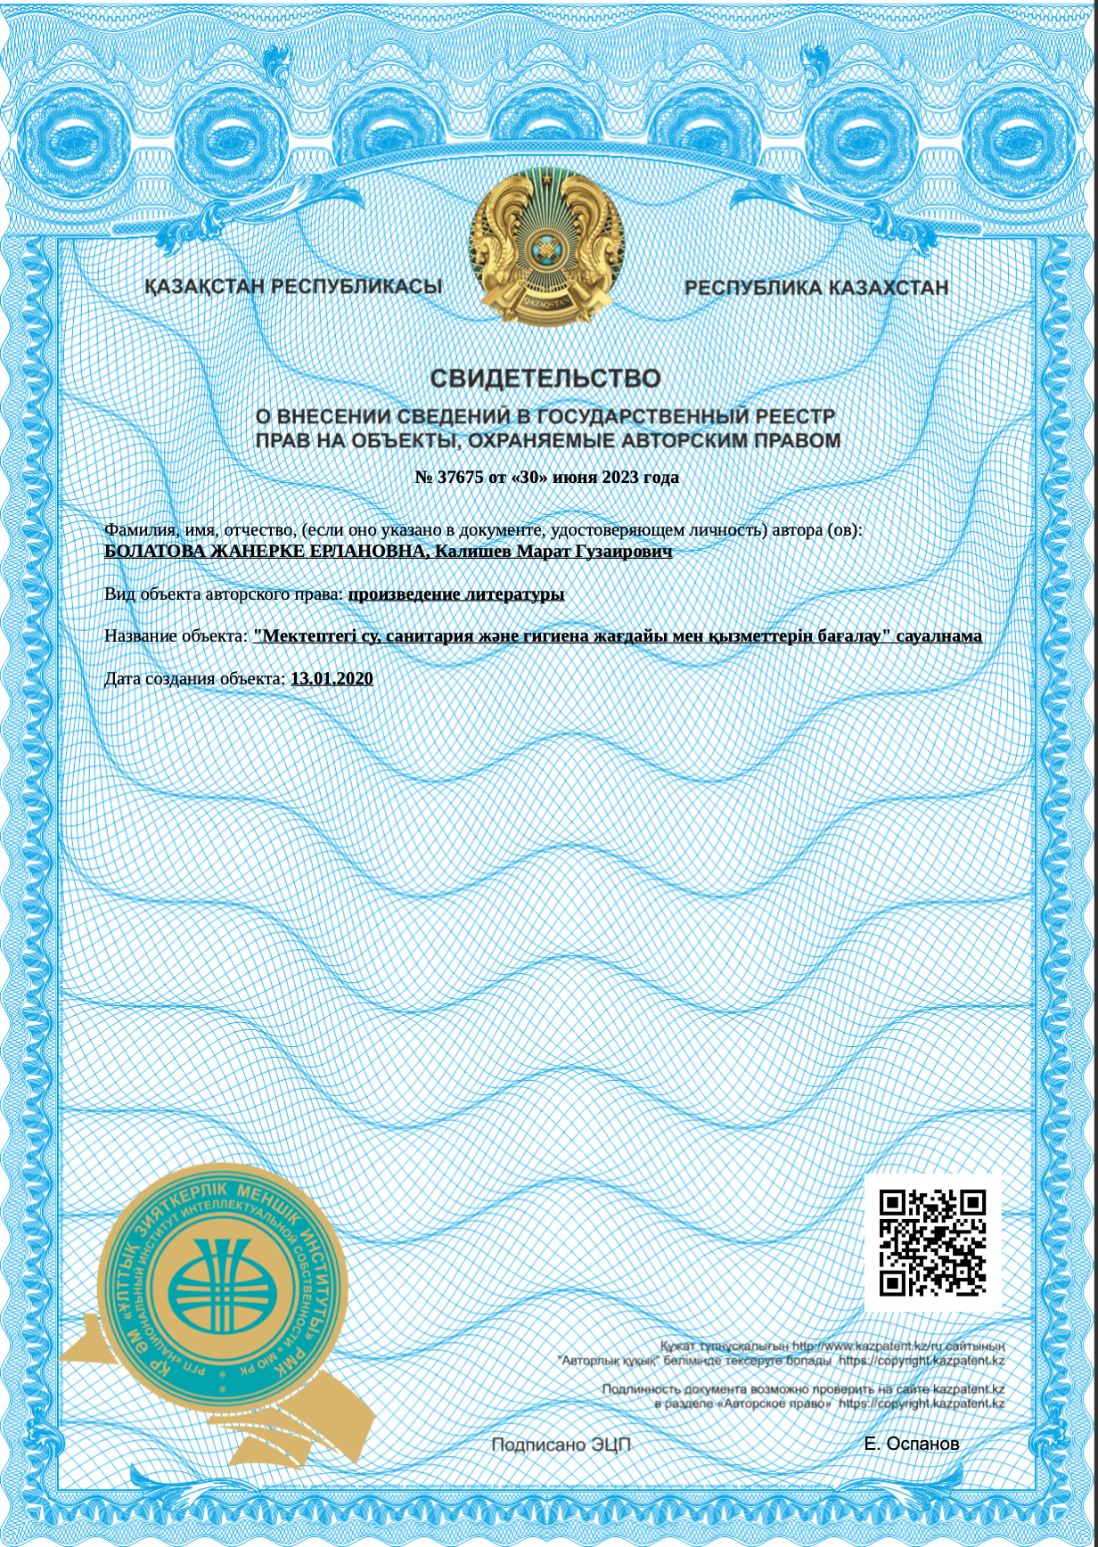

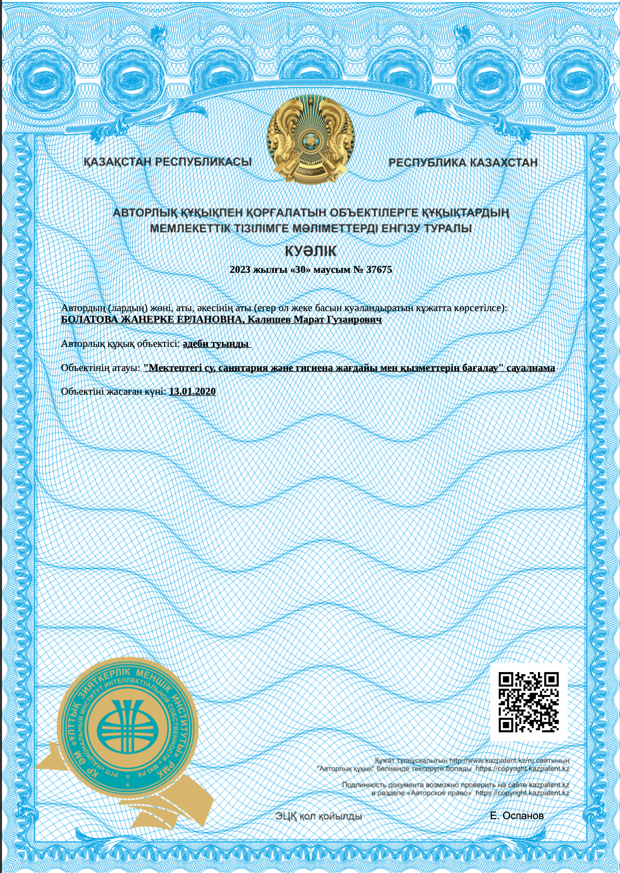

APPENDIX G

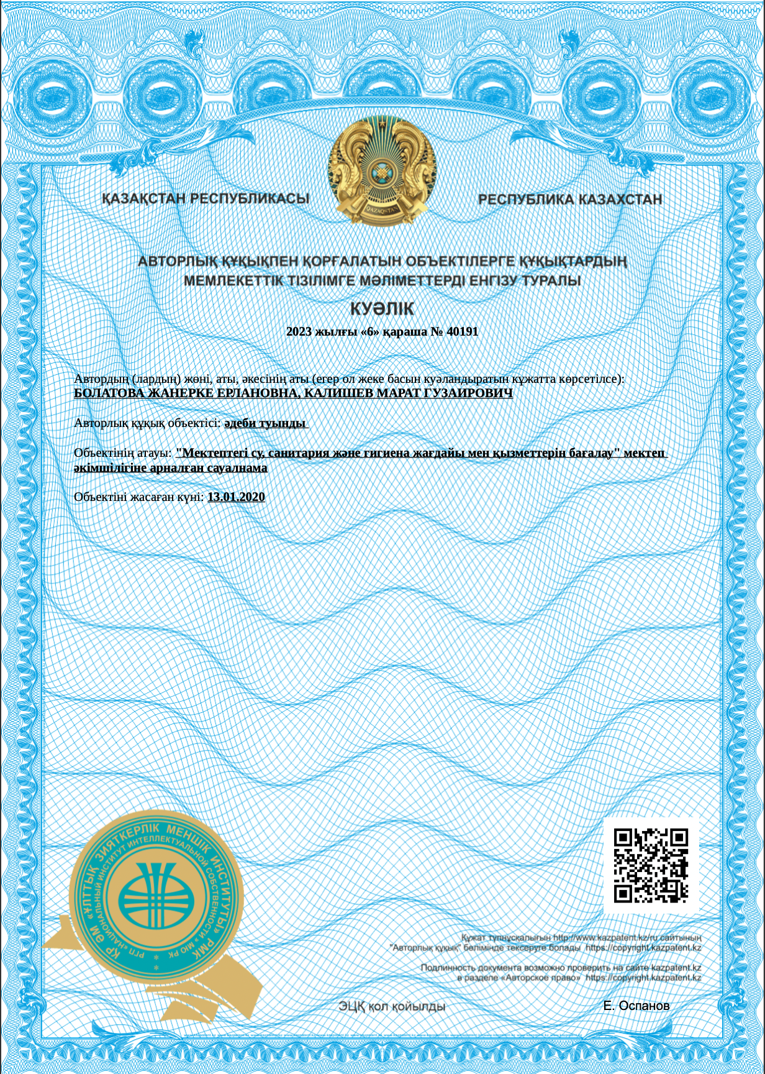

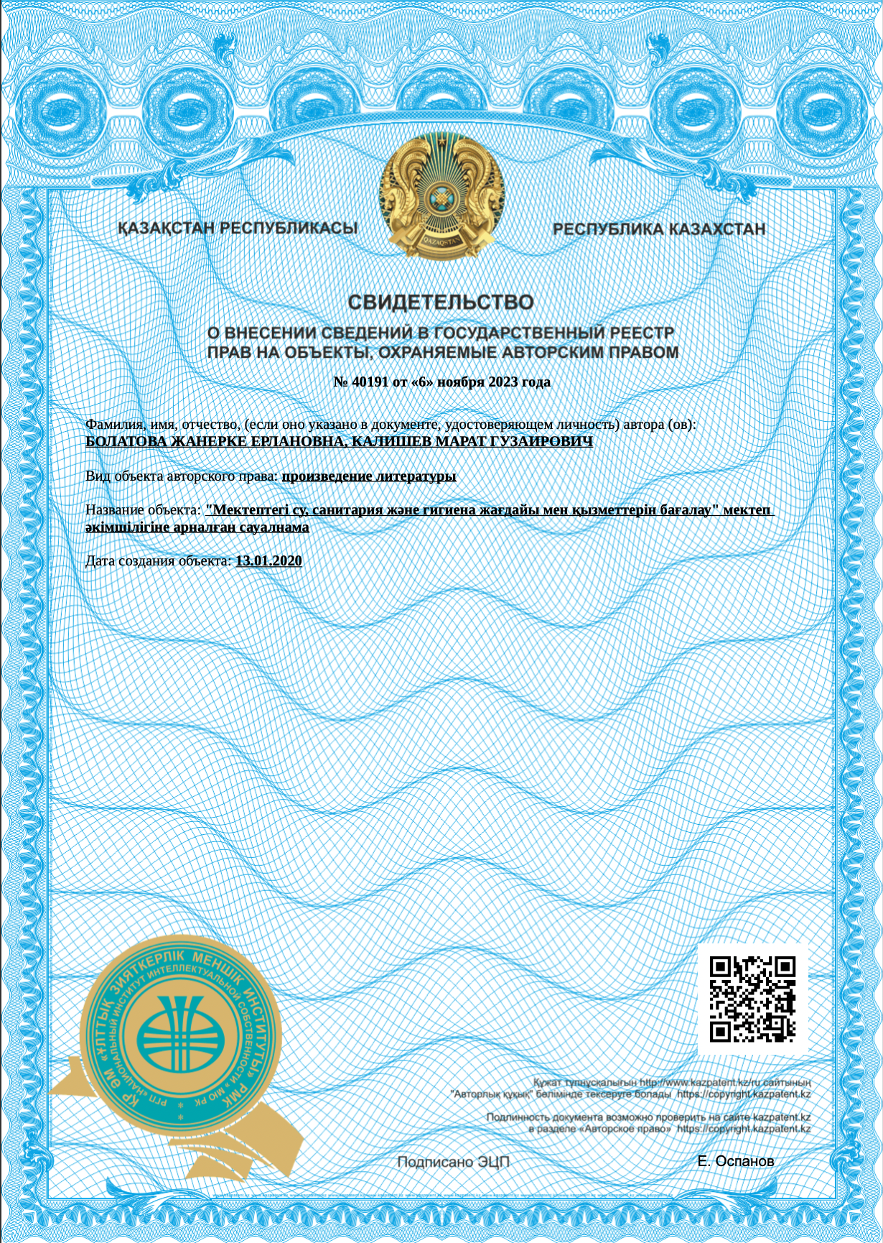

APPENDIX H

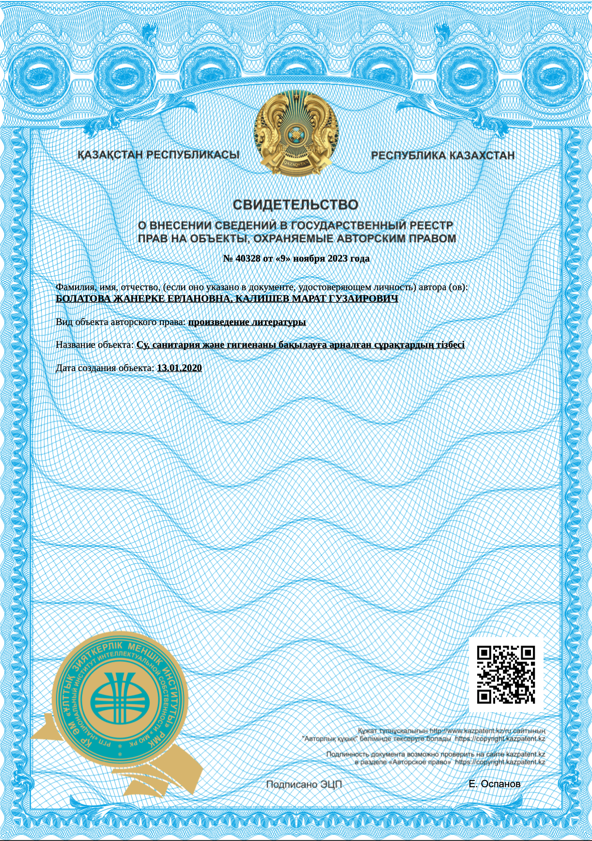

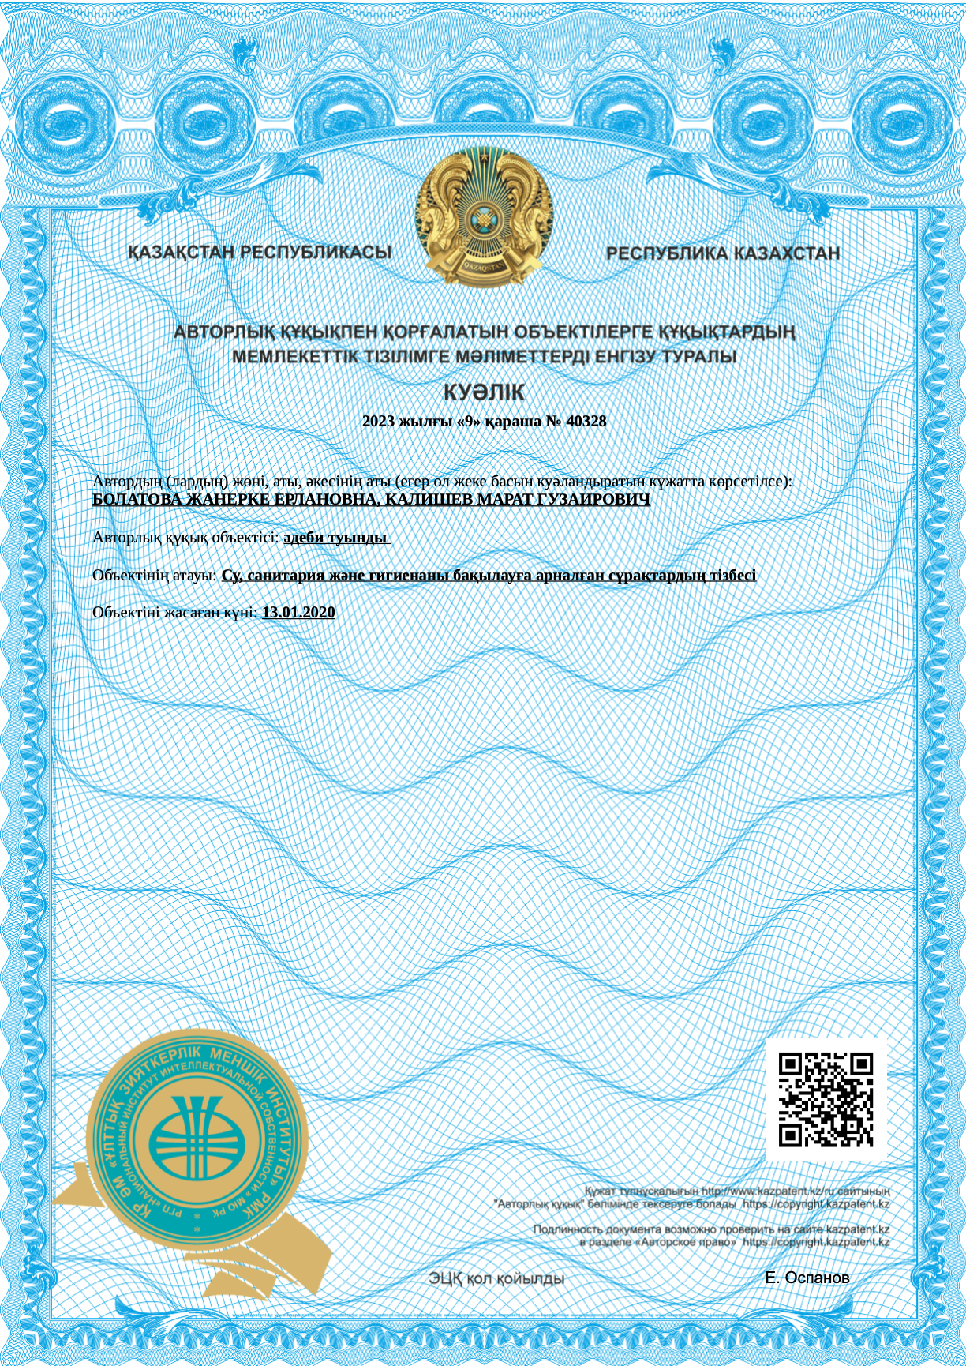
APPENDIX J

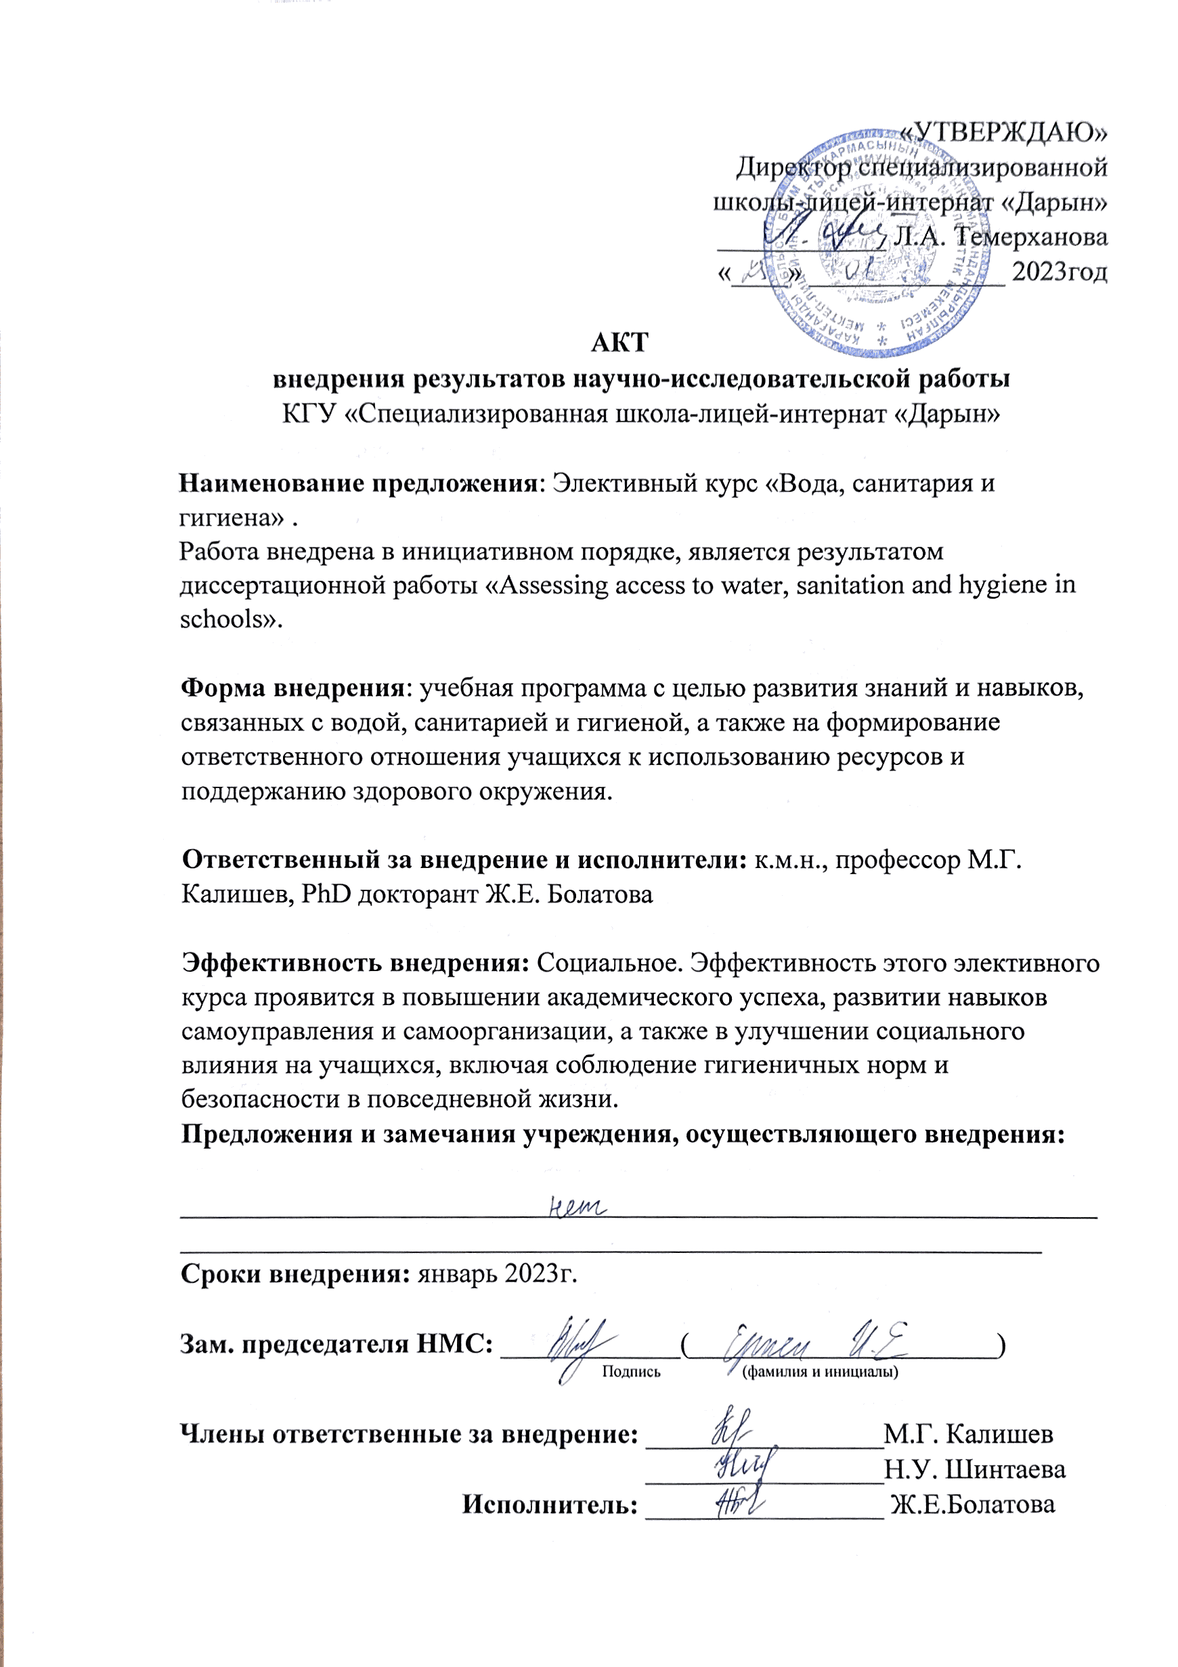
APPENDIX K

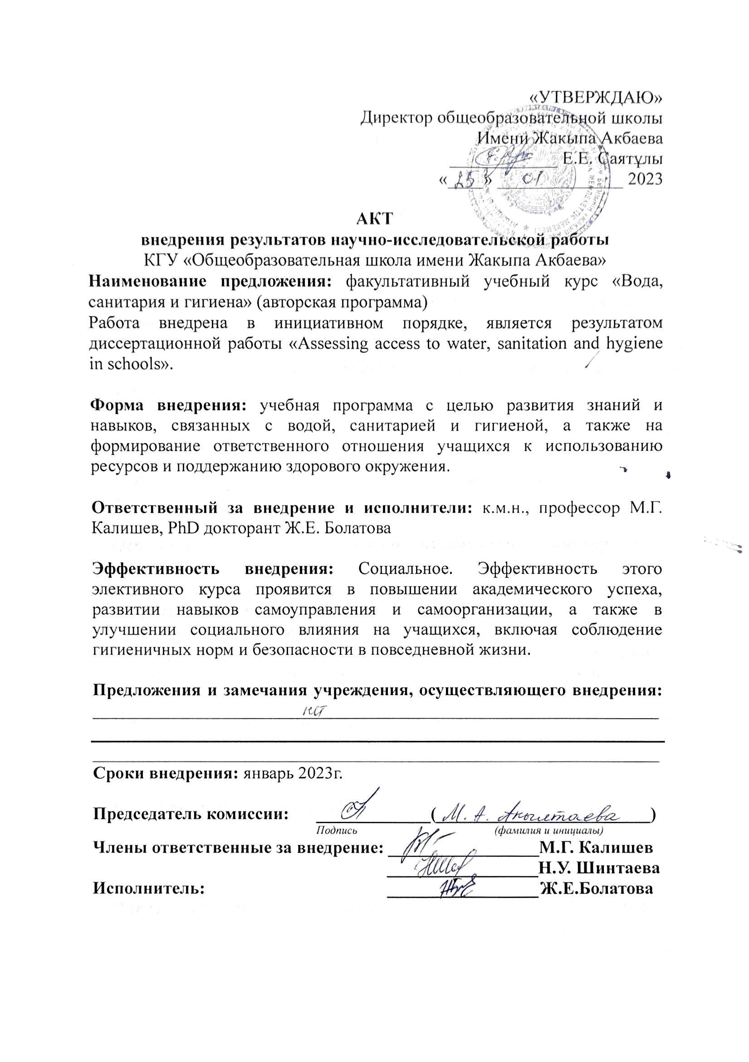
APPENDIX L

