AL FARABI KAZAKH NATIONAL UNIVERSITY

UDC 541.64 On manuscript rights

BEKBASSOV TIMUR MURATOVICH

DEVELOPING POLYMER ADDITIVES FOR REGULATING OIL RHEOLOGICAL PROPERTIES

6D072100 – Chemical technology of organic substances

Dissertation submitted in fulfilment of the requirements for the degree of
Doctor of Philosophy (Ph.D.)

Scientific supervisors:
Doctor of chemical sciences, Professor
Mun Grigoriy Alekseevich

Ph.D., ass. Prof. Dergunov Sergey
University of Connecticut, USA

The Republic of Kazakhstan
Almaty, 2022
TABLE OF CONTENTS

NORMATIVE REFERENCES 3
ACRONYMS AND DEFENITIONS 4
INTRODUCTION 7
1. ANALYTICAL LITERATURE REVIEW 12
1.1 Wax formation in oil transportation 12
1.2 Flow assurance and approaches in petroleum industry 16
1.3 Polymers as pour point depressants 18
1.4 Pour Point and rheology parameters in petroleum industry 21
1.5 EVA based pour point depressants as flow improvers 25
1.6 Synthesis of EVA based polymers using different approaches 31
2 EXPERIMENTAL PART 36
2.1 Reagents and materials. 36
2.2 Pour Point Depressants synthesis 37
2.3 Determination of the mechanism of graft copolymerization on EVA. 38
2.4 Grafted copolymers characterization. 39
2.5 Cold finger test 39
2.6 Pour point measurements. 41
2.7 Rheology measurements 42
2.8 Kinematic viscosity 42
2.9 WAT determination with Differential Scanning Calorimetry 42
3 RESULTS AND DISSCUSION. 43
3.1 Characterization of oil mixture of Kumkol region and all component oils. 44
3.2 Rheological data of each sample 44
3.3. Determination of the mechanism of graft polymerization on EVA. 53
3.4. Preheat effect on the pour point and rheological parameters study 61
3.5. Pour point analysis 69
3.6. Rheological data and the WAT determination 70
3.7. Microscopic Study 71
3.8. Cold finger testing 72
3.9. Studies of stability over time 74
3.10 Proposed production scheme and economic estimation of cost. 75
3.11. Proposed field wax inhibition tests: deposition in the pipeline 76
CONCLUSION 82
REFERENCES 85

NORMATIVE REFERENCES

In this thesis refers to the following standards:
GOST 6.38-90 Unified system of documentation. The system of organizational and administrative documentation. Requirements for documents
GOST 7.1-84 System of standards on information, librarianship and publishing. Bibliographic description of the document. General requirements and rules
GOST 7.9-95 System of standards on information, librarianship and publishing. Summary and abstract. General requirements
GOST 7.1-2003 System of standards on information, librarianship and publishing. Bibliographic record. Abbreviations of words in Russian. General requirements and rules
GOST 7.32-2001 System of standards on information librarianship and publishing. The report on research work. The structure and rules of
GOST 8.417-81 State system for ensuring the uniformity of measurements. Units of physical quantities
GOST R 51069-97 Crude petroleum and petroleum products. Determination of density, relative density and API gravity. Hydrometer method
GOST 11851-85 Oil. Paraffin determination methods
ST RK 1530-2006 Oil. Methods of pour point determination
ASTM D 5853 Standard Test Method for Pour Point of Crude Oils
GOST 33-2000. Petroleum products. Transparent and opaque liquids. Determination of kinematic viscosity and calculation of dynamic viscosity
ASTM D 445 Standard Test Method for Kinematic Viscosity of Transparent and Opaque Liquids (and Calculation of Dynamic Viscosity)
ISO 3219 Plastics - Polymers/resins in the liquid state or as emulsions or dispersions - Determination of viscosity using a rotational viscometer with defined shear rate

ACRONYMS AND DEFENITIONS

DSC – differential scanning calorimetry
EVA – ethylene – vinyl acetate
FI – flow improvers
GC – gas chromatography.
FTIR – Furrier Transform Infra-Red Spectroscopy
IR – infra red
PP – pour point
PPD – pour point depressant
WAT – wax appearance temperature
EB – electron beam

Cold finger test – Specific for oil industry test that simulates cold flow of oil with possible wax deposition on the pipeline wall. Cold rod simulates pipeline walls, whereas oil is being preheated higher than defined WAT to simulate real world situation with warm oil flow within cold pipeline.
Pour point – is the lowest temperature at which the oil is still able to flow under gravity. In foreign standards (ASTM, IP, ISO – used in passports for Texaco products), this is the temperature that is 3°C above the freezing point.
Pour point depressant – Chemical product that, when dosed into the oil, at certain dosage rate (usually 100 – 1000 ppm) can lower oil pour point and enhance its rheological properties in dynamic conditions.
Pigging – pigging is the process of cleaning the pipeline without stopping the transportation process. Special devices that are known as “pigs” are used for these purposes.
Rheology – is a discipline that studies the characteristics of the fluidity and deformation of materials under the influence of applied forces, which are usually measured by a rheometer. Rheological properties can be measured for any material, from liquids such as dilute polymer and surfactant solutions, highly concentrated protein/polysaccharide samples and semi-solid substances such as pastes and creams, to molten or solid polymers and asphalt. Rheological properties can be measured by deformation of a sample using a mechanical rheometer or at the microstructure level using a microcapillary viscometer or an optical method such as microrheology.
Within this work rheological studies have been used to determine low temperature flow properties (dynamic viscosity) of oil sample that is treated with PPD and without it.
Wax appearance temperature – temperature that is characterized with first crystal of paraffin formation from homogeneous oil sample. It can be defined in several ways. Within this work it was defined using differential scanning calorimetry techniques.
Emulsion – is a mixture of two immiscible liquids, one of which is dispersed as droplets in the other. The liquid in an emulsion that is broken into droplets is known as the dispersed or internal phase, whereas the liquid surrounding the droplets is called the continuous or external phase. Emulsions formed in oil producing operations are predominantly water-in-oil.
Spin trapping – is an analytical technique employed in chemistry and biology for the detection and identification of short-lived free radicals through the use of electron paramagnetic resonance (EPR) spectroscopy.
Electron Beam –process that utilizes high energy electrons as its radiation source. The electrons, which are produced by normal electrical current, are accelerated to near the speed of light by means of an accelerator. Electron beam irradiation is a flexible and high-speed process that can be used for: sterilization of single-use medical devices and pharmaceutical, contamination control in packaging, cosmetics, and toiletries, strengthening of polymers due to cross-linking and/or breaking down of polymers.

INTRODUCTION

General characteristics of the work. This thesis is devoted to the creation of new depressant additives based on ethylene-vinyl acetate copolymers, by their radiation-initiated grafting copolymerization with hydrophobic monomers of various nature (butyl acrylate, butyl methacrylate, styrene), as well as the study of their effectiveness in oil treatment in comparison with commercial analogues
A complex of modern research and analysis methods is used in the work: radiation-initiated copolymerization method, gravimetry, differential scanning calorimetry (DSC), polarized light microscopy, rotational viscometry, rheology, cold rod method, electron paramagnetic spectroscopy (EPR), IR-Fourier spectroscopy, determination of yield loss temperature.
he relevance of the problem. The annual increase in the consumption of hydrocarbon raw materials on a global scale naturally leads to an increase in the volume of its transportation. The issues of delivering raw materials to processing facilities are more acute than ever for transporters. An increase in the share of heavy oils in the transported mixtures leads to problems of pumping through main pipelines in the cold season.
This issue is particularly acute in Kazakhstan, where most of the transported oil has a significant proportion of paraffins in its composition, which leads to a high pour point and deterioration of rheological properties with a decrease in temperature.
There are several approaches to solving this problem. In Kazakhstan, the most common are 2: thermal control and chemical method. Thermal control means constant heating of pipeline sections when pumping oil to maintain a stable temperature of transportation. This method is very energy-intensive and requires capital expenditures in the form of heating stations along the oil route and, accordingly, maintenance of these installations. The chemical method of flow control includes the treatment of pumped oil with additives of special functional substances of various nature, so-called depressant additives, capable of improving the rheological properties of oil in low-temperature operation. Currently, industrially produced depressant additives based on ethylene vinyl acetate (EVA) copolymers are most widely used in Kazakhstan. However, these additives do not always show the required efficiency, which decreases with a decrease in their concentration in oil and may also depend on the origin and characteristics of the processed oil. This circumstance determines the relevance of research aimed at expanding the range of available depressor additives, as well as increasing their effectiveness by chemical modification.
The purpose of the thesis research is to develop new highly effective depressant additives based on ethylene-vinyl acetate copolymers, by their radiation-initiated grafting copolymerization with hydrophobic monomers of various nature.

Research objectives:
- systematic study of temperature influence on the rheological properties of oil from the Kumkol group of oilfields, as well as assessment of the effectiveness of the current commercial depressant additive "Randep-5102”.
- development and optimization of the radiation process grafting with hydrophobic monomers of various nature (butyl acrylate, butyl methacrylate, styrene) with ethylene-vinyl acetate copolymers;
- spin trap study of the mechanism and kinetics of radical grafting copolymerization involving ethylene-vinyl acetate copolymers and hydrophobic monomers of ethylene-vinyl acetate copolymers;
- study the effectiveness of the obtained grafted copolymers of ethylene-vinyl acetate copolymers as depressant additives and compare them with the commercial reagents used in a number of parameters;
Research methods: The paper presents the results of testing samples generally recognized in the industry. The properties of the developed depressant additives were investigated by a complex of physicochemical methods: radiation-initiated copolymerization method, gravimetry, differential scanning calorimetry (DSC), polarized light microscopy, rotational viscometry, rheology, cold finger method, electron paramagnetic spectroscopy (EPR), IR-Fourier spectroscopy, determination of pour point temperature.
Objects of research: copolymers of ethylene-vinyl acetate, monomers of butyl acrylate, butyl methacrylate, styrene, a number of oils of the Kumkol region.
Subject of research: radiation grafting copolymerization with ethylene-vinyl acetate copolymers and monomers of various nature (butyl acrylate, butyl methacrylate, styrene), oil rheology, the effect of using new grafted ethylene vinyl acetate copolymers as depressant additives.
The main provisions submitted for protection:
- for a number of oil of the Kumkol region, the use of depressant additives to maintain and regulate rheological properties is more promising compared to the heat treatment method;
- the main contribution to the initiation of grafting copolymerization of hydrophobic monomers with ethylene-vinyl acetate copolymers is made by active centers formed when the hydrogen atom is separated from the copolymer macrochain, while the process of separation of the H atom from the CH groups of vinyl acetate EVA links is realized with the greatest speed;
- grafted EVA copolymers show higher efficiency when used as depressant additives for oil treatment compared to commercially produced analogues;
The main results of the study:
1. The influence of temperature on the rheological properties of oil from the Kumkol group of oilfields has been systematically investigated. The patterns of preheating are determined. It is established that with an increase in heating above the point of formation of paraffin crystals, the rheological properties of oils improve. However, carrying out this process in open containers can lead to losses of light fractions of oil, which in the future will require a higher heating temperature to improve rheological properties. It is shown that for this type of oil, use of the chemical treatment with depressant additives, accompanied by modification of primary paraffin crystals in the volume of oil, is more effective.
2. A number of depressant additives have been developed by radiation grafting of various nature hydrophobic industrially available monomers (butyl acrylate, butyl methacrylate, styrene) on ethylene vinyl-acetate copolymers. During the synthesis of grafted copolymers, a number of experiments were carried out to select the optimal radiation dose. At the same time, 5 variations of the absorbed radiation dose were tested (from 110 to 160 kGy in increments of 10 kGy). It was found that the most optimal radiation dose is equal to 130 kGy.
3. By the EPR method using 2-methyl-2-nitrosopropane as a spin trap, the kinetics and mechanism of grafting copolymerization of monomers to ethylene vinyl acetate copolymers were investigated. It is shown that at the primary stages of the process, active radical centers initiating grafting copolymerization are mainly formed as a result of the separation of an atom from the macro chains of ethylene-vinyl acetate copolymers from primary, secondary and tertiary carbon atoms ( – CH, - CH2 and – CH3). It is established that the process of separation of the H-atom from the tertiary carbon atom is carried out at a higher speed.
4. It has been established that the new depressant additives provide an improvement in the rheological properties of oil at lower dosage rates compared to the commercial analogue – "Randep-5102". A number of dosages comparable in the amount of specific active substance with a commercial analogue were studied. With all comparable dosages of the 3 best reagents obtained in this work, the candidates showed results superior to the commercial analogue. With an increase in dosage rate of new depressant additives, a more pronounced effect of the rheological properties improvement of the treated oil was observed.
5. Using the cold finger method, it was found that the obtained depressant additives have a more pronounced inhibitory effect against paraffins compared to commercial analogues. All tested samples showed a higher level of paraffin inhibition in the finger test, which simulates the movement of oil through a cold pipeline. The inhibition level was consistently above 70% for all tested samples, with the best result being 88%. These indicators can be considered very good by the standards of the industry.
6. It is shown that when oil is treated with newly grafted EVA copolymers, a more stable effect of the rheological parameters improvement of oil over time is achieved compared with the use of commercial additives. In particular, the gEVASt24C sample showed a higher stability of the properties of the processed oil superior to the commercial analogue. This indicates the prospects of using a depressor additive based on gEVASt24C for oil treatment in order to safely operate the pipeline in the cold season.
Substantiation of the novelty and importance of the results obtained.
- For the first time, by the method of radiation-initiated grafted copolymerization, new depressant additives based on ethylene-vinyl acetate copolymers containing grafted macro chains representing a sequence of hydrophobic monomer units of various nature were obtained;
- For the first time, the kinetics and mechanism of grafting copolymerization with the participation of monomers on ethylene vinyl acetate copolymers and hydrophobic monomers have been investigated by the spin trap method using model reactions. It is shown that the formation of active radical centers initiating inoculation copolymerization is carried out as a result of the separation of an atom from the macro chains of ethylene-vinyl acetate copolymers, and in this process the tertiary CH groups of vinyl acetate monomer units of the macro chains of copolymers are most active.
- For the newly grafted EVA copolymers obtained, a high efficiency of their use as depressant additives has been established, namely, when processing oil with it, a stable effect of improving the rheological properties of oil (reducing viscosity) is achieved over time, as well as a well-expressed ability to inhibit the process of paraffinization of oil. It is shown that the new additives obtained have higher efficiency at comparable specific dosages compared to commercial analogues.
Theoretical significance of the results.
The results of the spin trap study of kinetics and the mechanism of grafted copolymerization with the participation of ethylene-vinyl acetate copolymers are a significant contribution to the development of theoretical concepts in radical polymerization processes, data in the study of new depressor additives on the physico-chemical properties of oil can be considered as a scientific contribution to the rheology of oils, as well as to the development of ideas about the mechanism of influence of polymer reagents on the structure and properties of oils.
Practical significance of the results.
According to leading experts, the least energy-intensive and efficient transportation of energy resources and raw materials is one of the fundamental principles of rational production. The use of chemical methods of oil treatment during its low-temperature transportation is the most optimal in the conditions of Kazakhstan. Obtaining highly effective depressant additives at lower dosages to provide more efficient transportation is always in demand. Obtaining them in a rational, waste-free way increases the value of these products, both from the point of view of sustainable production development and economic benefits.
The newly grafted copolymers obtained in the work can be recommended to use as highly effective depressant additives for oil treatment in order to safely operate the pipeline in the cold season.
The results obtained in this work can be considered as a scientific and applied basis for obtaining a number of highly effective depressor additives in a waste-free way.
Approbation of the work. The main results of the thesis were reported and discussed at Problems of theoretical and experimental chemistry conference (Ekaterinburg 2021), international conference “Modern problems of organic substances and materials”(Almaty 2019), International Scientific Conference of Students and Young Scientists «FARABI ALEMI»(2021).
The personal contribution of the author consists in the direct execution of the experimental part of the work, participation in the analysis, generalization and interpretation of the experimental data obtained.
Publications. As a result of research on the topic of the thesis, 10 scientific papers were co-authored, including 2 articles in republican specialized publications recommended by the Committee for Control in the Field of Education and Science of the Ministry of Education and Science of the Republic of Kazakhstan, 1 article in an international scientific journal included in the Scopus database (Journal of Petroleum Science and Engineering), 4 patent 3 of which are utility models and 1 patent for invention, as well as materials and abstracts of 3 presentations at international scientific conferences, symposiums and seminars.
The structure and scope of the thesis. The dissertation work consists of an introduction, 3 main sections, a list of references, 92 titles. The work is presented on 91 pages, contains 43 figures and 27 tables.

ANALYTICAL LITERATURE REVIEW

1.1 Wax formation in oil transportation

Oil transportation is one of the main problems aside from production in the oil industry [1]. The problem of oil flow in the cold season through a pipeline without heating systems is an urgent problem for Kazakhstan and the Kumkol region in particular. Kazakhstan oilfields generally have paraffinic oil that forms deposits and creates rheological problems during transportation [2, 3]. At the same time, when transporting Kazakhstani crude oil through a pipeline over long distances, paraffin precipitation occurs, which can block the pipeline, cause additional pressure drops, which further increases the cost of transportation and in some cases requires large repair costs [4-8].
Wax build up is the complex and very difficult problem for decades in the petroleum industry. Wax precipitation within pipelines at and below the Cloud Point or Wax Appearance Temperature (WAT) can lead to gelling that inhibits flow by causing significant non-Newtonian behavior and increasing effective viscosities as the temperature of a waxy crude oil approaches its Pour Point.
The paraffin crystals grow as the temperature decreases, creating a crystalline net which begins to trap the molecules of liquid hydrocarbon until the oil cannot flow [1–4]. Paraffin deposition is responsible for the reduction in production, in terms of maintenance and removal of deposits already formed, increasing the cost of producing and transporting oil products and mainly, causing a number of handling problems in regions where the service temperatures are or become seasonally very low [5,6].
Oil fields of Central Asia are very diverse in their chemical composition. The content of asphaltenes, paraffin and resins in the form of a solid dispersion phase in these oils can reach 4, 23 and 80% respectively. These oils can be represented as a colloidal system with a coagulation structure. Structural and mechanical properties of individual oils of Central Asia are manifested even in the region of temperature up to 60℃. There are complications in the collection of oil data on the inside of the field reservoirs and transport through the main oil pipelines [7].
There are number of theories of oil pour point. 3 main can be separated. They are listed below
Micellar theory considers a mixture of hydrocarbons as a strongly bound liquid in which a strong association of molecules leads to the formation of micelles [8]. It is believed that the appearance of micelles is possible at temperatures significantly higher than the solidification temperature of a mixture of hydrocarbons. When the temperature decreases, the micelles immobilize a significant part of the hydrocarbons, which leads to a loss of mobility of the system, regardless of the separation of the solid phase from the solution.
Solvation theory asserts the interaction of alkane crystals of normal structure with the surrounding hydrocarbon medium: when the temperature around the emerging alkane crystals decreases due to orientation effects, the liquid phase molecules form a solvate shell. The latter immobilizes part of the dispersion medium, which causes the system to lose mobility.
The theory of crystallization, the simplest in its motivation, proceeds from the fact that the solidification of petroleum products occurs due to the formation of a crystalline phase – when the temperature decreases, solid crystals of normal alkanes are released, which, sticking together, form a spatial grid (framework) linking the liquid phase in the gaps of the pseudo-lattice [8].
The emergence and development of these theories is largely due to the nature and characteristics of those samples of hydrocarbon mixtures that were directly investigated. Currently, most researchers in the study of low-temperature properties of oils use the crystallization theory of solidification of oils and petroleum products.
Paraffin deposits led to blockage of the reservoir during stimulation treatment and prevented low-temperature oil pumping [9]. Pour Point Reduction (PPDS)/Fluidity Improvement (FIS) agents are used as chemical additives in the transportation of crude oil at temperatures below their wax appearance temperature (WAT). The addition of depressant reagents to the oil weakens the bond strength between the individual elements of the crystal structure of paraffins, which leads to a decrease in the pour point and an improvement in the rheological properties of the system.
Wax is not the only component of crude oil. Other components of crude oil, such as asphaltenes, resins, lighter distillates, polar aromatic compounds, etc., should also be considered as important factors in determining the behavior of crude oil. Asphaltenes are very large heterogeneous molecules with condensed aromatic nuclei, which can bind to form colloidal particles, which strongly affect the viscosity of the oil medium and affect the crystallization of wax [10-13].
Several factors affect the deposition of wax. For example, pipe wall temperature (inlet coolant temperature), crude oil composition, crude oil temperature, ambient temperature, flow rate and pressure.
The deposition of wax increases with an increase in the temperature difference between the bulk of the wax solution and the cold surface. Wax deposition will occur only when the surface temperature is lower than both the solution temperature and the cloud point of the solution. The influence of the cold surface of the pipe wall (the temperature of the coolant at the inlet) on the deposition of wax has been studied and described in many papers, where it is considered as one of the main factors affecting the deposition of wax.[27-29] The main conclusion in these papers was that the input the coolant temperature plays an important role in the wax deposition process a decrease in the inlet coolant temperature will lead to an increase in wax deposition, even if the temperature of the crude oil is higher than the wax appearance temperature.
It is also indicated that the composition of crude oil is one of the main factors that significantly affects the deposition of wax and is responsible for reducing the pour point and viscosity. The composition of crude oil consists of a mixture of molecules of various natures: there are light molecules, such as methane, which are responsible for the formation of solid hydrates at high pressure and low temperature, and heavy molecules, such as long linear alkanes and isoparaffins, which tend to change phase at low temperature into the phase of both macro- and microcrystalline impurities. There is also a shift to more polar compounds due to the appearance of aromatic compounds and the presence of heteroatoms (oxygen, sulfur and nitrogen) in the fractions known as resins and asphaltenes [31-34] mentioned in their literature review that the amount of deposited wax is affected by the concentration of paraffin, light ends and nucleating or inhibiting materials in crude oil.
In laminar flow, wax deposition increases with decreasing flow rate. This can be explained by the presence of a large number of particles that settle on the surface. As the flow rate increases to turbulent modes, the deposition of wax decreases due to an increase in shear dispersion. Thus, was deposition gradually decreases as turbulence and flow velocity increase. The shear dispersion prevails in the turbulent flow at all stages. The flow behavior in the current flow is described by the Reynolds number; above 2000 it is often considered turbulent flow. The nature of wax crystals is to stick to the surface of the pipe with good adhesion between them; therefore, increasing the flow rate leads to the destruction of wax crystals into smaller particles, reducing the deposition rate of wax and preventing it by minimizing the adhesion of wax to the pipe wall.
The pressure drops during the extraction of oil from the reservoir to the surface structures. Lighter hydrocarbons in the formation, as a rule, are the first to leave the formation when the pressure drops; consequently, the solubility of wax decreases. The WAT increases with increasing pressure, exceeding the pressure at the bubble point, for a constant composition. This phenomenon implies that an increase in pressure around a single-phase liquid (above the pressure at the bubble point) will aggravate the deposition of wax. Below the bubble point, the situation is different, where the oil has a two-phase composition. The WAT decreases with an increase in pressure to the pressure of the bubble point due to the dissolution of the light hydrocarbon back into the liquid phase.
It is obvious that during deposition, wax crystals adhere to the surface of the pipe; thus, deposition may also depend on the properties of the surface. When paraffin wax is deposited on the surface, it is held in place by adsorption forces. These adsorption forces depend on the free surface energy of both the paraffin and the surface. Deposits do not stick to the metals themselves but are held in place due to the roughness of the surface.[19] There is no direct correlation between wax deposition and surface roughness. However, the adhesive compound on the surface should be proportional to the total contact area and, therefore, related to the roughness of the surface.[36] Wax molecules move towards each other by diffusion and stick to the wall. The rate of adhesion is largely determined by the temperature difference between the wall and the liquid.[26] The inner surfaces of pipes with a low coefficient of friction also prevent deposition, if not deposition, since wax crystals can adhere to the walls of pipes only if they have a sufficiently large coefficient of friction. Adhesion strength of wax samples deposits do not matter much if they do not adhere well to the pipe wall. Field reports show that the adhesive strength of wax deposits is at least equal to their cohesive strength, and they adhere firmly to the pipe wall. However, when applying pure macrocrystalline wax to the wall of a steel pipe in the laboratory, this is not the case. Wax adheres so poorly to steel that it takes a little effort to cause a rough fracture at the steel/wax interface. If you need to find a wax model that can provide reliable testing of removal concepts, this should ensure cohesive destruction of simulated deposits. That is, it should stick well to the pipe wall.[26]
There are number of wax formation in oil theories. Most of them are diffusional ones. Such as thermal and molecular diffusion that are stating about high concentration of wax crystals near the pipeline walls due to lower temperature there. However, all of them are using Flicks law as mathematical estimation of wax flux.
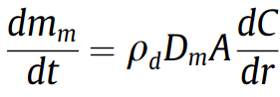
(1)

Here m_{m} is the mass of deposited wax, p_{d} is the density of the solid wax, D_{m} is the diffusion coefﬁcient of liquid wax in oil, A is the surface area over which deposition occurs, C is the concentration of wax in solution (volume fraction), and r is the radial coordinate.
Wax crystallization is a kinetic process, the beginning of which can be described by the classical theory of homogeneous nucleation [14]. Despite the fact that a lot of work has been done on the approach to wax deposition as a thermodynamic problem, modeling based on the kinetics of sediment formation has not been widely studied [15]. Paso sought to eliminate the lack of understanding of crystallization and gelation processes, as well as the assumption that the kinetics of paraffin deposition does not limit the deposition rate, an assumption that may lead to the prediction of wax deposition in cases where a stable gel cannot form. He used model liquids consisting of n-paraffin components dissolved in petroleum mineral oils and applied the theory of homogeneous nucleation and crystallization, as well as differential scanning calorimetry to measure the onset of crystallization and the rate of crystallization.

1.2 Flow assurance and approaches in petroleum industry

As it mentioned before heavy parts of oil are causing main problems with deposition, thus creating plugs, and increasing viscosity of the oil itself. That creates major problems with pumpability and flow assurance of the transporting facilities. Kazakhstan oil is considered to be paraffinic with up to 30% of paraffin content (depending on the region). High molecular weight paraffins, resins and aromatics at low temperature (lower than WAT) will start to create centers of crystallization and will form solid agglomerates, which will deposit from the stream and cause flow assurance problems.
One of the ways to solve flow problem is the heat, for example, on the main pipeline from the Dzhumagaliyev (former Karakoin) pumping station to the south (Pavlodar) is heaters along the pipeline. Heating stations are located along the pipe and help maintain oil temperatures suitable for winter transportation. In addition to heating, pigging is also used for mechanical cleaning to scrape off the deposited wax [16]. However, Kazakhstani oil can be so viscous (for example, Uzen oil) that its pour point can be around + 30 °C [17, 18]. This means that the heaters had to work all year round [4]. These are additional energy expenses for oil transporters [20]. The impact of the thermal history on the yield stress of waxy crude oils has been investigated by some scholars. Chang et al. (2000) and Ghannam et al. (2012) [21] used waxy crude oils and heavy crude oil, respectively, to investigate the influence of the test temperature, cooling rate and isothermal holding time before the yield stress measurement. The authors concluded that the test temperature is the most important factor influencing the rheological properties of waxy crude oils. Their experiments showed that the slower the cooling rate, the larger the wax crystals and their consequent agglomeration and the higher their yield stress. The isothermal holding time before testing was found to have less influence than the temperature or cooling rate. The observation of Chang et al. of higher yield stresses at slower cooling rates was in agreement with Rønningsen's (1992) results [22] obtained on a model pipeline and controlled stress rheometer for different samples of waxy North Sea crudes as well as those of Visintin et al. (2005)[23] from oscillatory tests in a controlled stress rheometer. Venkatesan et al. (2005) investigated [24] the yield stress values at different cooling rates under both static and shear conditions. Their experimental results showed that the yield stress increased with the decreasing cooling rate under static conditions, but it decreased with a decreasing cooling rate under high shear stress. Russell and Chapman (1971) and Cawkwell and Charles (1989) also reported [25] that the yield stress decreased with a decreasing cooling rate. In addition to the measurement temperature and cooling rate, the heating temperature is another crucial thermal factor affecting the flow behavior of waxy crude oils below the WAT [27] (Li and Zhang, 2014; Rønningsen et al., 1991; Zhang and Liu, 2008). Due to their high pour point, waxy crude oils are often heated for transport, and the heating temperature usually varies with the ambient temperature and the flow rate. Therefore, the influence of the heating temperature on the flow properties should be taken into consideration for the flow assurance of waxy crude oil pipelines.
Dilution of oil with lighter one or solvent also can be considered as an option in transporting heavy oil. The main problem is the source of lighter oil if any, and possible asphaltene destabilization. Thus, this kind of interactions must be studied before any mixing will occur.
Another approach with heavy and extra-heavy oil is emulsification [28] with water to decrease viscosity of the liquid and thus lower the load on the pumps and increase oil flow in the pipeline. Emulsions can be divided into 3 types of oil in water (o/w), water in oil (w/o) and oil in water in oil (o/w/o). These can be seen in fig 1. Oil in water is the most effective emulsion type to reduce viscosity of heavy oil. For example, that method is used to transport heavy bitumen oil called Orimulsion is used by Venezuelan Petróleos de Venezuela as the patented technology. It uses surfactant to effectively create o/w type emulsion.
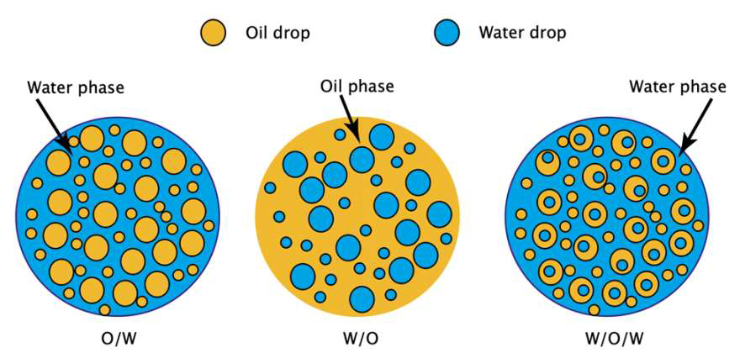

Figure 1 - Emulsions type found in oil industry.

However, that kind of technology can’t be used in Kazakhstan due to low temperature in wintertime and the fact that oil that transported by main pipelines of Kaztransoil is the sales one with the demand of 0.5% water content max. So, there are 2 possible way of oil transportation are left to be used in our conditions.
Heating oil during transportation is not always beneficial in terms of pour point temperature of oil sample. Thus, transporting organization must choose heating temperature carefully. Increasing preheat temperature is not always economically justified due to high energy cost nowadays. So chemical treatment can be used as alternative for heating pipeline along the route.
Typically pour point depressants (PPD) [29] are used to control pour point and wax deposition. Their main components are the polymer compounds that are used to modify wax crystals and prevent them from forming crystal mesh that is then solidify whole oil. (Fig 2.)
As it can be seen on the figure below, PPD polymers are attaching to paraffin crystal that is been separated from homogeneous oil sample and modifies it that all further growth of crystal is impossible.
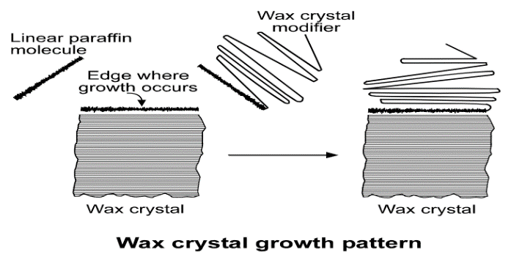
Figure 2 – Schematic mechanism of Wax crystal modification by PPD

1.3 Polymers as pour point depressants

There are many kinds of polymers that are used as PPDs to influence the behavior of the paraffin crystallites formation [30]. To improve the efficiency of the additives, theoretical analyses explain the interactive mechanism, co-crystallization, nucleation, or improved wax solubility [35]. The wax inhibitors are polymeric compounds constituted by a hydrocarbon chain which provides the interaction between the additive and paraffin, and a polar site that is responsible for wax crystals morphology modification necessary to inhibit the aggregation stage. For this reason, such inhibitors are known as wax crystal modifiers.
Most polymeric pour point depressants have 2 main parts of molecule. They are polar and nonpolar parts. Nonpolar parts are long chain of alkyl which interact with wax crystals via absorption, nucleation or co-crystallization. Polar part of that interrupts crystal growth are usually ester, maleic anhydrates or vinyl acetate groups.
Different ideas about the mechanism of action of depressant additives were expressed at different times by authors [37 – 39].
Zhuse T. P. adheres to the point of view that the depressor is adsorbed on the faces of normal alkane crystals, the polar fragments of the depressor molecules are facing the surface of n-alkane crystals, and the nonpolar ones are facing the hydrocarbon medium. This adsorption of the depressor leads to a change in the shape and size of nalkane crystals, which changes the overall structure of the hydrocarbon medium, preventing the formation of a framework and solidification of the petroleum product [40].
Another point of view belongs to Rebinder P.A., which is based on the theory of complexes and consists in the following: a depressor molecule in a hydrocarbon medium connects its polar ends, forming micelles. The hydrocarbon fragments of these mixtures are directed outward into the hydrocarbon medium and bind large amounts of hydrocarbons into solvate shells, which causes a delay in the formation of a spatial grid of crystals of normal alkanes when the temperature decreases. Rebinder P. A. the mechanism of action of depressants was also proposed, which combines both the concept of the absence of additional relevant information and the concept of complexes - everything depends on the initial ratio of the content of n-alkanes and isoalkanes in oil. It is believed that at low concentrations of normal alkanes, the formation of bound complexes of depressor molecules occurs, at high concentrations, the adsorption of the depressor occurs on crystals of normal alkanes. According to the provisions of the crystallization theory, the effect of depressors is considered both superficial and volumetric. The surface effect is that the depressor forms crystallization centers, on the surface of which crystals of n-alkanes are grouped, forming clusters in the form of druzes [39].
When studying the effect of depressants on the structure of paraffin crystals, two main questions were identified: whether the crystallographic cell of n-alkanes changes under the influence of depressants and what is the effect of the latter on the morphology of n-alkane crystals.
The effect of the depressor on the crystallographic lattice of n-alkanes was studied by X-ray examination of crystals of normal alkanes isolated from solutions in separate solvents and from diesel fuels in the presence of 0.1% content of various depressors [41]. It is established that the size of the elementary cells and the type of spatial lattices of n-alkane crystals do not change with the addition of depressors. This suggests that the formation of volumetrically mixed crystals of n-alkanes and a depressor does not occur when exposed to a depressor.
In [42], changes in the morphology of crystals of normal alkanes under the influence of depressants were studied. Based on these data, a diagram of the growth stages and morphological forms of n-alkane crystals under the influence of various doses of depressor was obtained. In the absence of a depressor, the n-alkane crystal is a thin diamond plate. With the introduction of a depressor, the compactness of n-alkane crystals increases, since the growth of crystals in length and width is inhibited. As a result, the surface interaction with n-alkane crystals increases, as the crystal growth in length and width slows down. Due to the surface interaction with crystals of n-alkanes, depressor molecules accumulate on the crystal faces. The subsequent growth of crystals occurs in the corners where the smallest number of depressant molecules that prevent growth are located. With an increase in the concentration of the depressor additive, dendritic growth and further thickening of crystals of normal alkanes, the formation of crystals of normal alkanes, the formation of irregular crystals, tetragonal pyramids and rhombic prisms are achieved.
The development of new additives that can solve or minimize such problems is of great interest to the oil industry worldwide. For example, studies of Malasian oil demonstrated [43] that maleic anhydrate and vinyl acetate-based polymers can significantly decrease viscosity of oil samples. Results were compared with different dilutions with solvents. Results can be seen in table 1 below.

Table 1. Physical properties of treated oil

Type of chemical | Concentration, ppm |  | Temperature, ℃
 |  | 40 | 30 | 20 | 10
EVA | 500 | 4.45 | 5.97 | 13.2 | 43.2
 | 5000 | 3.69 | 4.07 | 5.08 | 11.1
MA | 500 | 10.4 | 19.3 | 20.18 | 50
 | 5000 | 4.4 | 5.8 | 11.71 | 25.54
Cyclohexane | 500 | 11.2 | 19.9 | 23.2 | 55.5
 | 5000 | 4.9 | 6.62 | 7.21 | 23
Toluene | 500 | 13 | 25.5 | 32.1 | 60.2
 | 5000 | 5 | 7 | 6.5 | 29.5
Acetone | 500 | 14.9 | 24.3 | 31 | 65
 | 5000 | 5.4 | 6.74 | 8 | 25
DEA | 500 | 15.1 | 24 | 31.4 | 57.3
 | 5000 | 5.28 | 8.2 | 7.81 | 32.4

It could be noted that EVA copolymer shows best performance in all concentration and temperature range compared to solvent blends. That indicates advantages of chemical treatment of oil with polymeric pour point depressants. They can be used with comparatively low concentrations and show adequate performance in lowering viscosity and pour point of transported oil stream.

1.4 Pour Point and rheology parameters in petroleum industry

The number, size, and shape of wax crystals determines their tendency to increase crude viscosity, network into a gel, and form a deposit. The three most common growth patterns are as follows:
A. Needles — These can network and trap the liquid fraction of the crude.
B. Malcrystals — Poorly shaped crystals that cannot network; they are pumpable.
C. Plates — Plates are pumpable, but it is possible for plates to curl on their edges to form hollow needles that can network.
A fourth type (D) called microcrystalline waxes are found in the residues in refinery stills, but they are not encountered in crude wax deposits or precipitates.

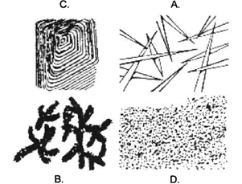

Figure 3 – Common pattern of paraffin crystals growth

Wax crystal modifiers (also called paraffin inhibitors) are usually polymeric materials. These materials are thought to prevent paraffin deposition by co-crystallizing and modifying the wax crystal. They change the shape of the paraffin crystal as it comes out of solution so that it does not form needles, will not network, and will move with the liquid portion of the crude [44].
Wax crystals grow by the addition of individual paraffin molecules to the edge of a crystal nucleus. Wax crystal modifiers have a structure that in part is similar to that of wax. They co-crystallize with the wax by taking the place of a paraffin molecule on the edge of the growing crystal.
The balance of the wax crystal modifier interferes with the proper molecular registration of new paraffin molecules, and growth terminates or occurs in a different direction so that a well-formed needle does not grow. The malcrystals that form cannot network to form deposits and will remain suspended in the crude.
It is important to note that wax crystal modifiers affect the formation of paraffin crystals just as the crystals begin to form, that is, at the cloud point. Wax crystal modifiers can do little to change the cloud point itself. This is not the case with pour point, which can be lowered chemically.
To be effective, wax crystal modifiers must be mixed into the crude oil when the oil is above the cloud point. After paraffin crystals have already formed, adding a wax crystal modifier will have little or no effect.
Pour point depressants are wax crystal modifiers — these names are often used interchangeably. A pour point depressant is defined by its function and not its chemistry. On one crude oil a PPD may work well as a pour point depressant; on another oil it may prevent wax deposition; while on a third crude it may have good functionality for both. PPDs may be applied in crude oils where the pour point of the crude is relatively high. PPDs must be mixed into the oil at a temperature above the cloud point to be effective [45].
Pour point and rheology are very important parameters for oil transportation. Pour point characterizes state when static fluid stops flowing, and rheological parameters shows dynamic changes in the viscosity during oil flow with temperature decrease.
So, pour point is needed to know when oil is kept in the vessels during transportation to know the point at which it still can be poured into other vessels. Rheology on the other hand helps to understand pumpability of the oil during cold season through pipeline. It can predict changes of viscosity and thus help to understand load on the main pumps.
Chemical treatment helps to improve both of those parameters. Lower the load and provide lower temperature vessels transportation without risk of solidifying of oil in those vessels.
Lots of studies are doing to ensure risk free transportation. For example, Iranian crude [46] from 5 different locations were analyzed using different EVA polymers. Parameters of each shown in table 2 below.
Table 2. Crude oil parameters.

Specification | Crude-1 | Crude-2 | Crude-3 | Crude-4 | Crude-5 | Methods
Specific gravity at 15.56/15.56 °C | 0.8503 | 0.8661 | 0.8846 | 0.8944 | 0.9033 | ASTM D-4052
API | 34.9 | 31.9 | 28.5 | 26.7 | 25.1 | ASTM D-4053
Kinematic viscosity at 40 °C C.St. | 7.828 | 10.959 | 12.525 | 14.689 | 15.125 | ASTM D-445
Kinematic viscosity at 100 °C C.St. | 2.751 | 3.852 | 4.656 | 6.136 | 8.698 | ASTM D-446
Pour point (°C) | 26 | 20 | 17 | 14 | 8 | ASTM D-97
Asphaltene content (wt.%) | 0.3 | 1.5 | 2.8 | 4.7 | 7.8 | IP-143
Wax content (wt.%) | 13.1 | 11.2 | 9.7 | 7.4 | 5.2 | BP-237

All of those crudes were treated with different types of EVA copolymers and then parameters of pour point and rheology was measured again. As it can be seen higher the dosage rate, lower the pour point of the crude. Rheological data can be found in table 3. Same regularity can be seen there. Higher the doserate lower the viscosity.

Table 3. Pour point of crudes treated with different EVA copolymers.

Type | Concentration, ppm | EVA80 | EVA20 | EVA40 | EVA32
Crude-1 | 500 | 15 | 19 | 21 | 20
 | 1000 | 5 | 13 | 16 | 14
 | 2000 | - 2 | 9 | 13 | 10
Crude-2 | 500 | 14 | 15 | 16 | 16
 | 1000 | 7 | 8 | 10 | 10
 | 2000 | 1 | 4 | 7 | 6
Crude-3 | 500 | 12 | 9 | 12 | 10
 | 1000 | 7 | 3 | 6 | 5
 | 2000 | 2 | -1 | 3 | 1
Crude-4 | 500 | 9 | 7 | 10 | 7
 | 1000 | 2 | 2 | 6 | -1
 | 2000 | -1 | -1 | 4 | - 4
Crude-5 | 500 | 4 | - 2 | 1 | -1
 | 1000 | 1 | - 4 | -1 | - 6
 | 2000 | - 2 | - 6 | - 2 | -10

Table 4. Viscosity (mPa s) of crude oils at a shear rate of 100 s⁻¹ of crudes treated with different EVA copolymers.

Type | Concentration (EVA80), ppm | 40 °C | 20 °C | 15 °C | 10 °C | 5 °C | Concentration (EVA32), ppm | 40 °C | 20 °C | 15 °C | 10 °C | 5 °C
Crude-1 | 500 | 10 | 39 | 155 | 415 | 760 | 500 | 13 | 44 | 368 | 691 | 992
 | 1000 | 8 | 30 | 120 | 360 | 710 | 1000 | 10 | 38 | 292 | 612 | 874
 | 2000 | 2 | 25 | 98 | 310 | 680 | 2000 | 5 | 34 | 221 | 538 | 842
Crude-2 | 500 | 14 | 42 | 180 | 440 | 780 | 500 | 12 | 42 | 352 | 656 | 910
 | 1000 | 12 | 36 | 140 | 380 | 740 | 1000 | 9 | 36 | 268 | 584 | 855
 | 2000 | 7 | 30 | 110 | 340 | 715 | 2000 | 4 | 30 | 197 | 502 | 810
Crude-3 | 500 | 16 | 45 | 210 | 492 | 810 | 500 | 11 | 40 | 302 | 602 | 895
 | 1000 | 14 | 40 | 180 | 410 | 780 | 1000 | 9 | 32 | 210 | 554 | 802
 | 2000 | 9 | 35 | 150 | 385 | 730 | 2000 | 4 | 24 | 170 | 471 | 780
Crude-4 | 500 | 16 | 47 | 280 | 530 | 865 | 500 | 11 | 38 | 250 | 590 | 820
 | 1000 | 15 | 42 | 225 | 485 | 812 | 1000 | 9 | 32 | 190 | 510 | 780
 | 2000 | 9 | 38 | 186 | 427 | 785 | 2000 | 3 | 24 | 150 | 410 | 720
Crude-5 | 500 | 18 | 52 | 352 | 587 | 912 | 500 | 9 | 38 | 170 | 440 | 750
 | 1000 | 16 | 48 | 286 | 512 | 868 | 1000 | 7 | 32 | 110 | 350 | 710
 | 2000 | 10 | 43 | 227 | 487 | 802 | 2000 | 1 | 25 | 90 | 310 | 683

Other authors [47] tested maleic anhydride based polymers on the samples from number of Kazakhstani oilfields. Table 5 presents the results of tests of the esterified copolymer of maleic anhydride and styrene carried out by the authors of the work on samples of highly paraffin oil fields that differ in their physical and chemical characteristics. Data analysis the table shows the named authors of the article concluded that using the minimum additive concentration the highest depressant activity is observed at the Kumkol oil field. It is shown that, with the introduction of 0.1 wt.% additives in the oil its pour point is reduced by 18.0 °C. Good depressant properties at the same concentration are also found in the oil field Konys and Zhetybay, depression of the flow temperature in both cases is 16.0°C. In addition, it should be noted that the efficiency of the copolymer in reducing the flow loss temperature decreases with increasing content of n-alkanes in the oil. Found that regardless of the conditions of the esterification of the full replacement anhydride groups in the copolymer occurs. To the maximum extent possible of styromal modification is 61%. However, it should be noted that other polymer materials should be studied to show their ability to lower pour point on the given oil.
However, is should be noted that typical dosage rate at of PPD Kazakhstan oilfields is 200 – 500 ppm (0.02 – 0.05 wt. %).

Table 5 – The effectiveness of the depressant action of the modified styrene-maleic anhydride copolymer on various types of oil

Oilfield | Paraffin content, % | Pour point temperature, ⁰С
 |  | Blank sample | Treated oil  (PPD content, wt.%) | Depression value
Kumkol | 16,0 | +12,0 | -6,0 (0,01) | 18,0
Konys | 26,7 | +18,0 | +2,0 (0,01)  +1,5 (0,5) | 16,0  16,5
Bektas | 38,5 | +25,8 | +16,0 (0,01)  +14,0(0,058)  +10,6 (0,093) | 9,8  11,8  15,2
Zhetybay |  | +28,0 | +12,0 (0,01) | 16,0

1.5 EVA based pour point depressants as flow improvers

EVA copolymers are currently the most commonly used polymeric wax and PPD inhibitors in the petroleum industry [48-52], and historically commercial EVA-based PPDs have shown good depression properties on oil from the Kumkol oilfield of Central Kazakhstan [18].
Their structural formula presented at fig 4.
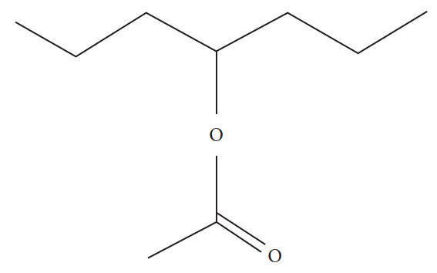
Figure 4 – Structural formula of EVA copolymer.

EVA copolymers with different molecular mass were used as PPDs for a long time now. As it was said before Many polymeric EVA-based PPDs co-crystallized with wax molecules or form a thin layer on the surface of the wax crystals (Figure 2) and prevent the formation of large agglomerates, which in turn improves the flowability of the waxy crude oil at low temperatures.
In this work [53] authors studied. Two mechanisms of n-alkanes crystal growth were identified. EVA can act as nucleation agent or as an inhibitor of crystal growth. Both mechanisms are depending on solvent nature, paraffin chain length and temperature.
Four different compositions were studied. All of them are listed below in table 6.
Table 6. Composition of blends and their cloud points.

 | Solution E1 | Solution E2 | Solution K1 | Solution K2
Composition | 5% C20-C22-C24  in ethylbenzene | 4% paraffin blend in ethylbenzene | 5% C20-C22-C24 in kerosene | 4% paraffin blend in kerosene
Cloud point (◦C)  Cloud point (°C) 500 ppm EVA | -0.5  -1.9 | 4.2  3.6 | -6.9  -7.2 | 1.5  1.1
Afterwards all of the mixtures were cooled down to WAT and crystal size were measured using optical microscopy. Whereas untreated mixtures showed precipitation of needle-shaped large crystals with 5 mm length, treated mixtures showed much smaller crystals with sizes around 6-10 um. Results can be seen in table 7 below and fig 5.

Table 7. Crystal size obtained by optical microscopy.
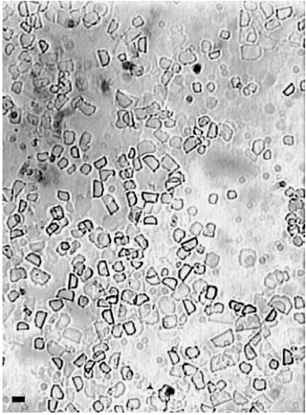
Paraffin solutions | Mean crystal size um) | Standard  deviation um)
E1 + 100 ppm of EVA | 11 | 3
E1 + 250 ppm of EVA | 14 | 3
E1 + 500 ppm of EVA | 8 | 3
E1+1000ppm of EVA | 17 | 8
K2+250ppm of EVA | 7 | 3
K2+500ppm of EVA | 9 | 3
K2+750ppm of EVA | 5 | 2
K2 + 1000 ppm of EVA | 4 | 1

Figure 5 – Paraffin crystals obtained from mixtures with EVA.

Problem of flow improving with chemicals becomes clear when we speak about offshore oil production and transportation via underwater pipeline. It is very difficult to perform pigging or heating underwater pipe. If pig will stuck in that kind of route, that means stop of production for a long period of time, so insurance of stable flow is vital here. Thus, chemical treatment becomes main option to provide risk free production. In this work [54] number of EVA copolymers with different acetate group % were studied to find optimal oil characteristics of sample Albacora field, Campos-Brazil.
10 different EVA copolymers were used in this study. 2 main performance indicators were selected; pour point depression and wax inhibition performance. EVA copolymers used are listed in table 8 below.

Table 8. EVA copolymers used to test out the performance.

Copolymer | Number average molecular weight, Mn (g/mol) | Polydispersity,  PD | Vinyl acetate content (wt %)
EVA 1 | 19300 | 2.8 | 41
EVA 2 | 14100 | 3.6 | 31
EVA3 | 16100 | 4.5 | 28
EVA 4 | 14500 | 3.9 | 28
EVA 5 | 10100 | 4.1 | 28
EVA 6 | 19300 | 4.4 | 28
EVA 7 | 19400 | 3.8 | 28
EVA 8 | 4500 | 2.0 | 36
EVA 9 | 2400 | 2.0 | 31
EVA 10 | 2600 | 2.7 | 30

Pour point was tested after 1000 ppm treatment to test out the performance of samples from Albacora field. Results of that studies are shown below in table 9.

Table 9. Pour point of oil treated with 1000 ppm of different EVA copolymers.

Polymer | Pour point (°C)
— | +4
EVA 1 | <-30
EVA 2 | <-30
EVA3 | <-30
EVA 4 | <-30
EVA 5 | <-30
EVA 6 | <-30
EVA 7 | <-30
EVA 8 | -12
EVA 9 | -4
EVA 10 | -4

Afterwards efficiency of paraffin inhibition was tested using static simulation called cold finger of crude oil with copolymer added. Results are shown below in table 10. As it can be seen EVA with most acetate group % showed better results.

Table 10. Paraffin inhibition oil treated with 1000 ppm of different EVA copolymers.

Copolymer as additive | EVA 1 | EVA 2 | EVA3 | EVA 4 | EVA 5 | EVA 6 | EVA 7
Efficiency of inhibition (%) | 86 | 64 | 14 | 0 | 45 | 2 | -12

EVA based chemicals are used in Kazakhstan. In this study [18] EVA copolymer based chemicals were tested on number of oil samples from different oilfields of Kazakhstan. Geography of samples is presented by Kyzylorda (Central Kazakhstan) region.
Table 11 shows list of oil samples that have been tested and main characteristics of these crude oil.

Table 11. Main characteristics of oil samples from Kyziorda region.

Crude oil | d₄²⁰ ⁽kg/m³⁾ | PP (°C) | Wax (%) | Asphalt. (%) | Resins (%) | Fraction (%)
 |  |  |  |  |  | 200 °C | 300 °C | 350 °C
Kumkol | 810.4 | 12 | 14.4 | 0.1 | 7.6 | 29 | 49 | 59
Akshabulak | 829.7 | 21 | 14.3 | 0.6 | 8.6 | 29 | 48 | 58
Konys-Bektas | 874.4 | 24 | 16.5 | 2.0 | 7.1 | 15 | 33 | 47
Aschysay | 878.2 | 21 | 20.1 | 1.3 | 9.2 | 20 | 39 | 51

Oil samples were treated with 200 ppm of EVA (with 25% of vinyl acetate content) solution in organic solvent. After treatment all main parameters of oil were measured for all oilfield samples. Pour point, wax inhibition rate dynamic viscosity at 2 different temperatures were measured. Results of viscosity measurements, pour point and inhibition rate are shown in tables 12 and 13 below.
As it can be seen EVA copolymers base chemicals are widely used in petroleum industry around the world. Kazakhstan is no exception in that case. EVA based commercial products are used here in oil transporting pipelines from central Kazakhstan to oil refineries and China export pipeline route.

Table 12. Pour point and inhibition rate of EVA for Kyzilorda crude oils.

 | PP (°C) | m (wax), g | Inhibition degree (%)
Akshabulak
Untreated | +21 | 3.6 | 0
Heat treated | +18 | 2.48 | 31.2
EVA | +6 | 1.85 | 48.5
Aschysay
Crude oil | +24 | 4.6 | 0
Heat treated | +21 | 3.28 | 28.6
EVA | +15 | 2.99 | 35.0
Konys-Bektas
Untreated | +24 | 4.2 | 0
Heat treated | +21 | 3.12 | 25.8
EVA | +9 | 2.85 | 32.1
Kumkol
Untreated | +15 | 3.4 | 0
Heat treated | +12 | 2.11 | 37.8
EVA | +9 | 1.95 | 42.5

Table 13. Dynamic viscosity at different temperatures of treated oil from Kyzilorda region.
Waxy crude oil | Treatment | Dynamic viscosity (Pa s)
 |  | 10 °C | 20 °C
Akshabulak | Heat treatment | 1.590 | 0.071
 | EVA | 0.010 | 0.005
Aschysay | Heat treatment | 1.220 | 0.095
 | EVA | 0.557 | 0.041
Konys-Bektas | Heat treatment | 4.24 | 0.084
 | EVA | 0.052 | 0.015
Kumkol | Heat treatment | 0.020 | 0.005
 | EVA | 0.017 | 0.003

1.6 Synthesis of EVA based polymers using different approaches

As the EVA copolymers became more widespread, lots of scientists undertaken the attempts to modify these polymers to obtain more effective chemicals as PPDs. Attempts from mixing it up with different chemicals to create composites, conduct reactions to chain up different functional groups and hydrolyze them to get more effective products.
For example, Guolin Jing [55] described method of obtaining new composite of EVA with SiO₂ nanoparticles to create more effective PPD. To achieve that goal they modified with succinic anhydride and KH550, SiO₂ nanoparticles (30 nm) in ethanol solution (fig 6) with further mixing it with EVA solution in toluene with ultrasonication at 80°C for 3 hours. After that solvent was evaporated and resulting residue represented composite PPD.
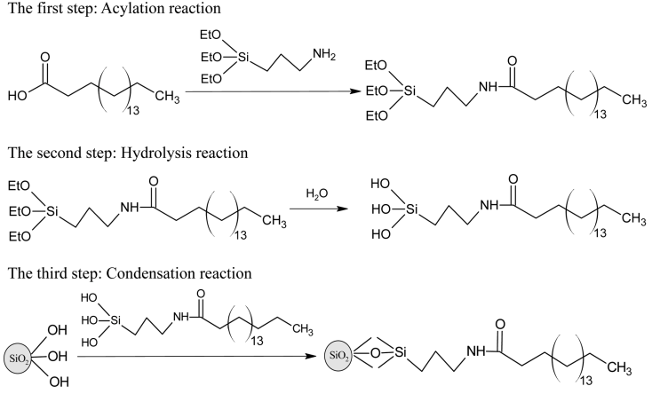

Figure 6 – Modification of SiO₂ nanoparticles.

After that it was tested on crude oil from Daqing oilfield with high wax content (25% wt). EVA with 28 and 38% of vinyl acetate modified with SiO₂ nanoparticles performed better compared to pure EVA copolymers, however EVA with 40 % of vinyl acetate performed comparatively with modified one. Results of pour point presented on figures below.

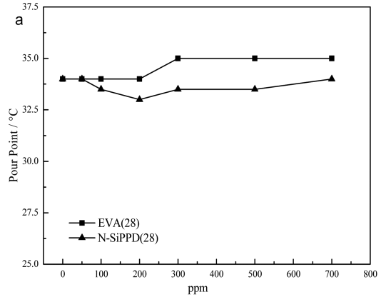
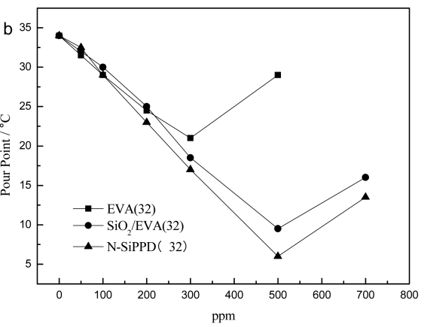
Figure 7 – EVA 28 and EVA 32 pour treated oil compared with modified with SiO₂ nanoparticles.
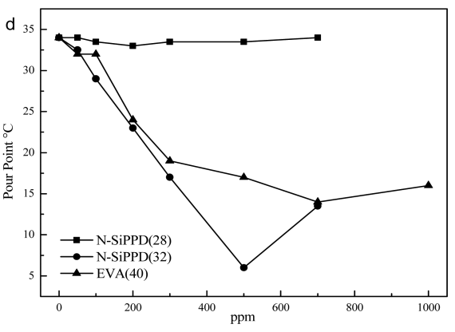
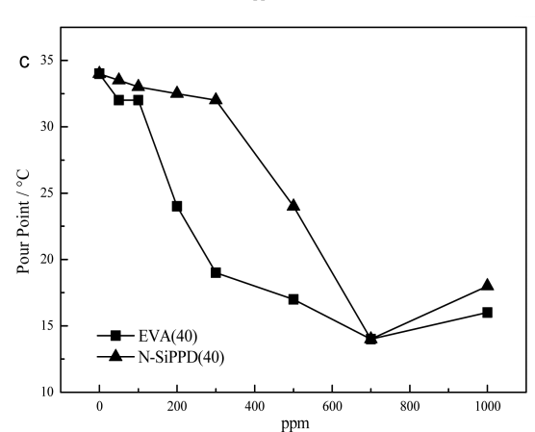

Figure 8 – EVA 40, EVA 28 and EVA 32 pour treated oil compared with modified with SiO₂ nanoparticles.

At another study [56] researchers decided to use locally available gossypol from cottonseed oil production process. It (gossypol) can be obtained from the soapstock of refining process. So basically, it’s a waste that can be converted into valuable product.
EVA-gossypol PPD was obtained by prepared by milling the determined amounts of the starting components in a laboratory ball mill. Then received compounds were used as PPD.
Possible structure of obtained compound shown in figure 9.

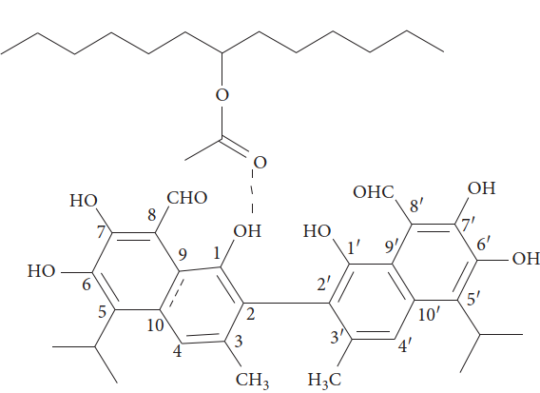

Figure 9 – Possible structure of obtained EVA-gossypol PPD

Crude oil was from Akshabulak field. After treatment with 50-500 ppm of PPD main parameters of oil was measured.
Crude oil parameters are listed in table 14 below.

Table 14. Parameters of crude oil tested with EVA-gossypol PPD

Property | Value
Density at 20°C (g/cm3) | 0.8427
Wax content (wt%) | 17.1
Pour point (°C) | 19
Kinematic viscosity (mm²/s) | 218.46

Pour point measurements are shown in table 15 below.

Table 15. Pour point of oil treated with EVA and modified EVA-gossypol PPD

Additive concentration (ppm) | Pour point depression (°C)  EVAc/CG composition (wt%)
 | EVA | 90:10 | 80:20 | 75:25 | 70:30 | 65:35
50 | 6 | 8 | 8 | 6 | 3 | 1
100 | 9 | 11 | 12 | 9 | 4 | 2
250 | 8 | 10 | 10 | 11 | 5 | 4
500 | 6 | 7 | 7 | 7 | 6 | 4

Another approach [18] was done by group of Kozhabekov S.S and authors. They decided to run alkaline hydrolysis of EVA in alcohol medium. EVA with 25% of vinyl acetate groups was chosen for this study.
EVA in toluene solution was mixed with 1 ml of 2% solution sodium hydroxide in methanol. Reaction was carried out at 80°C and product was precipitated by methanol and dried. Received compound then was used as PPD.
Parameters of oil samples were shown in table 11. Treatment rate was 300 ppm. Results of pour point, dynamic viscosity and paraffin inhibition rate is shown in tables 16 and 17 below.

Table 16. Pour point and inhibition rate of EVA-M for Kyzilorda crude oils.

 | PP (°C) | m (wax), g | Inhibition degree (%)
Akshabulak
Untreated | +21 | 3.6 | 0
Heat treated | +18 | 2.48 | 31.2
EVA-M | 0 | 1.13 | 68.7
Aschysay
Crude oil | +24 | 4.6 | 0
Heat treated | +21 | 3.28 | 28.6
EVA-M | +9 | 2.01 | 56.2
Konys-Bektas
Untreated | +24 | 4.2 | 0
Heat treated | +21 | 3.12 | 25.8
EVA-M | +3 | 1.58 | 62.3
Kumkol
Untreated | +15 | 3.4 | 0
Heat treated | +12 | 2.11 | 37.8
EVA-M | -3 | 0.95 | 72.0

Table 17. Dynamic viscosity at different temperatures of treated oil from Kyzilorda region.

Waxy crude oil | Treatment | Dynamic viscosity (Pa s)
 |  | 10 °C | 20 °C
Akshabulak | Heat treatment | 1.590 | 0.071
 | EVA-M | 0.009 | 0.004
Aschysay | Heat treatment | 1.220 | 0.095
 | EVA-M | 0.069 | 0.027
Konys-Bektas | Heat treatment | 4.24 | 0.084
 | EVA-M | 0.045 | 0.012
Kumkol | Heat treatment | 0.020 | 0.005
 | EVA-M | 0.012 | 0.002

However, in my work it was decided to try our well-known radiation induced non-polar monomers synthesis of modified EVA. The advantage of that process is that after irradiation mixture can be used as is. That excludes purification process and save costs for production, leaving wastes of the process practically to zero.

EXPERIMENTAL PART

2.1 Reagents and materials.

2.1.1 Crude oil. In this study, we used crude oil produced in the Kumkol oilfield of Kazakhstan. The basic physical properties of the oil samples and the corresponding test methods are shown in Table 18. In this blend, KOR and Kuat Amlon Munai oils have the highest pour points with a large amount of heavy hydrocarbon fractions (wax content ~20%). However, their contribution to the overall oil mixture is low. The water cut of marketable oil is usually <0.5%, however, due to weather and storage conditions in all cases shown, it can increase to 1-2%.

Table 18. Physical properties of oil samples that compose Kumkol oil mixture [57].
Oil characteristics | Kazgermunai | PetroKazakhstan Kumkol Resources | Turgai-Petroleum | CNPC – Ai Dan Munai | KOR | Kuat Amlon Munai | Kumkol oil mixture
Pour point,°C | 12 | 9 | 9 | 6 | 21 | 18 | 12
Density at 20 °C (kg/m³) | 813.3 | 810.4 | 810,4 | 813.0 | 878.2 | 824.8 | 818,0
Wax content (wt. %) | 14.3 | 14.4 | 14.4 | 11.6 | 20.1 | 19.5 | 12,6
Resins (wt. %) | 8.6 | 7.6 | 7.6 | 16.3 | 9.2 | 8.0 | 6,02
Kinematic Viscosity at 20 °C, mm²/s | 11.6 | 8.0 | 8.0 | 11.2 | 13.9 (@40°C) | 6.9 (@40°C) | 8.7
Asphaltenes (wt. %) | 0.6 | 0.1 | 0.1 | 0.4 | 1.3 | 0.15 | 0,67
Water cut (vol %) | <0.5 | <0.5 | <0.5 | <0.5 | <0.5 | <0.5 | <0.5
Content of oil in mixture, % | 35.5 | 37.5 | 11.1 | 4.9 | 5.3 | 5.8 | -

2.1.2. Materials. EVA with vinyl acetate co-monomer content from 25% to 40%, butyl acrylate (BA), butyl methacrylate (BMA), styrene (St), 2-methyl-2-nitrosopropane (MNP), Fremy’s salt K₂NO(SO₃)₂, di-tert-butyl peroxalate (DTBP) obtained from Sigma Aldrich. Monomers were purified by passing through a column packed with aluminum oxide shortly before the synthesis. Industrial solvent (the mixture of aliphatic hydrocarbons with aromatic fraction mixed in proportions of 65% and 35% accordingly) and o-xylene as the solvents. All materials obtained from Sigma Aldrich, all chemicals used without further purification.

2.2 Pour Point Depressants synthesis

Solutions of EVA (5 %) in o-xylene or an industrial solvent were mixed with monomers: BMA, BA, and St in various ratios (EVA: monomer = 1: 1; 1: 5; 2: 1). The samples were mixed with constant stirring until complete dissolution at room temperature. The prepared EVA solutions were packaged in ampoules (7 ml) for each ratio and irradiated at a radiation dose from 110 kGy to 160 kGy. The electron accelerator ELU-10 (Institute of Nuclear Physics in Almaty) with an energy range from 2.5 – 4.0 MeV, with a beam current of accelerated electrons up to 40 mA and a maximum power of up to 50 kW was used as a radiation source.
The modification of polymers is confirmed by a number of changes in the physical properties of the mixture after irradiation (physicochemical, mechanical properties, etc.)[92]. The yield of EVA grafted co-polymers (gEVAp) containing BMA, BA and St abbreviated, respectively, as gEVABMA, gEVABA and gEVASt exceeded 95%. All mixtures are described in table 2. Schematic of sample preparation showed in fig. 10.
Each of the synthesized polymers were studied to determine that grafting happened after the EB irradiation. Afterward all polymers that were found to be grafted passed laboratory tests for efficiency.

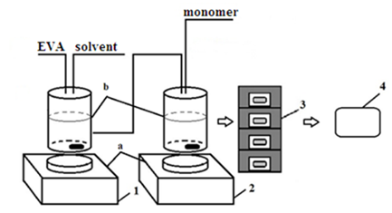

Figure 10 – Scheme of modified samples acquisition. 1. EVA dissolution; 2. Monomer addition; 3. Packaging; 4. Irradiation of mixtures with EB.
Table 19. Synthesized EVA-based graft copolymers.
Name of ratio  Name of  solution | Ratio | EVA:BMA | EVA:BA | EVA:St | EVA  (blank solution)
EVA1¹ in o-xylene | 1:1 | 1 (A-E)⁴ | 10(A-E) | 19(A-E) | 28(A-E)
 | 1:5 | 2(A-E) | 11(A-E) | 20(A-E) | 29(A-E)
 | 2:1 | 3(A-E) | 12(A-E) | 21(A-E) | 30(A-E)
EVA2² in o-xylene | 1:1 | 4(A-E) | 13(A-E) | 22(A-E) | 28(A-E)
 | 1:5 | 5(A-E) | 14(A-E) | 23(A-E) | 29(A-E)
 | 2:1 | 6(A-E) | 15(A-E) | 24(A-E) | 30(A-E)
EVA1 in an industrial solvent³ | 1:1 | 7(A-E) | 16(A-E) | 25(A-E) | 31(A-E)
 | 1:5 | 8(A-E) | 17(A-E) | 26(A-E) | 32(A-E)
 | 2:1 | 9(A-E) | 18(A-E) | 27(A-E) | 33(A-E)
¹EVA1 is a polymer with a vinyl acetate co-monomer content of about 35-40%, ²EVA2 is a polymer with a vinyl acetate comonomer content of about 25-30%, ³Industrial solvent is a mixture of aliphatic hydrocarbons with aromatic fraction mixed in proportions of 65% and 35%, respectively.
⁴The dose of radiation for EVA solutions: A=110 kGy, B=120 kGy, C=130 kGy, D=140 kGy, E=160 kGy

2.3 Determination of the mechanism of graft copolymerization on EVA.

The mechanism of graft copolymerization was investigated by EPR spectroscopy using 2-methyl-2-nitrosopropane (MNP) as a spin trap. All kinetic studies were carried out under green light illumination (light filter ZS-2 with the maximum transmission in the region of 540 nm, in which the MNP solution practically does not absorb), since MNP in solution under irradiation with visible light exhibits the ability to photolysis with the formation of a tert-butyl radical and nitric oxide (two absorption maxima in the optical spectrum of the MNP - in the near-ultraviolet and in the red region) [49]. EPR spectra were recorded on a Bruker ESP 300 EPR spectrometer in sealed glass ampoules. The ampoules with the reaction mixture were evacuated to 0.1 Pa by repeated repetition of the freezing process with liquid nitrogen followed by thawing. Reactions in the presence of MNP were carried out in special ampoules directly in the spectrometer resonator with simultaneous recording of EPR spectrum. The concentration of radicals contained in the sample was calculated using double graphical integration of EPR spectra. If the spectra were complicated by the superposition of lines of several adducts, the calculation was carried out using the shape factor (the ratio of the integral spectrum intensity to the amplitude). The shape factor was determined using a model system that was not complicated by the imposition of other lines. To determine the g-factor and hyperfine splitting constants (α), the spectrum of a dilute aqueous solution of Fremy's salt K₂NO(SO₃)₂ was recorded simultaneously with EPR spectrum of the system [58].

2.4 Grafted copolymers characterization.

To characterize the samples, the polymer solutions after irradiation were kept in a vacuum oven at 140 °C for 24 hours to completely remove the solvent. Fourier-transform infrared spectroscopy (FT-IR). The structure of the synthesized graft copolymers was confirmed by FT-IR (Figures 1S-6S, Thermo Nicolet 380, KBr, cm⁻¹): changes were detected in the fingerprint region of 1200-700 cm⁻¹ on the product spectra compared to the original spectra of the commercial (unmodified) polymers. Peaks above 3000 cm⁻¹ are also indicating the presence of aromatic C-H bonds in gEVASt samples.
Differential Scanning Calorimetry (DSC) of polymer samples was performed on a NETZSCH 214 Polyma Differential Scanning Calorimeter (Figure 7S-8S). All samples were tested by lowering the temperature from 150 to -20 °C with a step of 10 °C/min. The product profiles differ from the starting polymers. One composition: gEVASt24C is an amorphous polymer. The rest have pronounced points of the transition of the aggregate state that is moved to a high temperature which is different from the initial polymers.

2.5 Cold finger test

Cold finger is a hollow cylinder (often used size ∅ 36 mm, working length 90 mm) stainless steel with a hermetically screw-on lid, in which the nozzles for the inlet and outlet of the coolant are welded. Cold finger is connected to the circulation thermostat through the nozzles. Studied sample of the oil is heated to a temperature at which all paraffin crystals dissolve (50-55 °C, generally 5-10 °C above the expected WAT), and poured into the cell - a glass vessel with a capacity of ~200 ml. The magnetic stirrer is located on the bottom of the cell. All construction then is placed into the thermostat, mounted on a magnetic stirrer. The oil temperature in the cell is maintained at 5-10 °C above the expected WAT. Sample of oil in the cell is constantly mixed with a magnetic stirrer. With the help of a circulating thermostat, temperature of the cold finger is set equal to the expected WAT or lower and the cold finger is immersed in a cell with oil for 2-4 hours. After 2-4 hours, the cold finger is removed from the oil and examined. if the temperature of the cold finger was lower or equal to WAT, then paraffins will be deposited on the bottom of the cold finger.
Whenever PPD of paraffin inhibitor is examined, the temperature of the thermostat cell is set at 5-10 °C above the WAT. The oil in the cell is constantly mixed with a magnetic stirrer. Temperature of the cold finger circulation thermostat is set at 25-30 °C below the WAT. Experiment lasts for 4-24 hours.

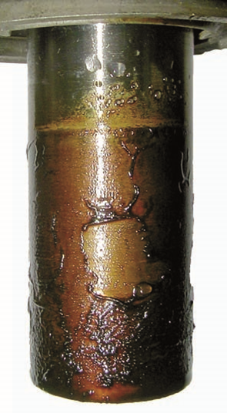

Figure 11 – Cold finger with deposited paraffin

After the experiment, the cold finger is removed from the cell, the temperature of the circulating thermostat is set ~30 °C and the oil is allowed to drain from the cold finger (10-15 min). toluene is washed off paraffin from a cold finger into a pre-weighted porcelain cup, evaporated toluene and weighed with deposit cup. also conduct experiments with oil, which added PPD or paraffin inhibitor. To improve accuracy and reproducibility of experiments in one experiment usually use several (from 2 to 6) cells simultaneously. One of the cells is always a comparison cell (without a reagent), and the rest is filled with oil, which is pre-dosed after heating with PPD or paraffin inhibitor with different concentrations. Concentration of PPD or paraffin inhibitor for the screening is ~1000 mg/l. Performance then is evaluated according to the formula (2):

$z=\frac{m_{oil }-m_{treated}}{m_{oil}}$ (2)

where z – efficiency of inhibition, m_{oil} – mass of deposited paraffin with untreated oil, m_{treated} – mass of deposit with treated oil

2.6 Pour point measurements.

According to ASTM D 5853-09[59], a sample of oil with a volume of ~ 50 ml after preliminary preparation is poured into a special glass flask, cooled under standardized conditions and checked every 3 °C whether the oil retains mobility. the temperature at 3 °C above the one at which the oil in the flask remains stationary for 5 seconds when the flask is brought to a horizontal position is considered as the pour point (PP).

Figure 12 – Schematic draw of cylinder for PP measurements

Standardization of cooling conditions is achieved by stepwise (depending on the oil temperature in the flask) cooling of the flask placed in a steel glass: at an oil temperature equal to or above 45 °C, the glass is placed in a thermostat (or cooling bath) with a temperature of 21 °C, when the oil temperature reaches 30 °C, the glass is transferred to a thermostat with a temperature of 0 °C, at an oil temperature of 9 °C the glass is transferred to a thermostat -18 °C, -9 °C → -33 °C, -24 °C → -51 °C. the size of the flask and glass is also standardized (Fig. 12).

2.7 Rheology measurements

The effective viscosity and shear stress were measured in accordance with ISO 3219 [60], using the Brookfield rotary rheometer model DV-III+. The small sample size adapter and spindle No. 21 were used for 30 sec^{–1} shear rate tests. The preheat temperature was 60 ° C. Rheocalc32 software was used to interpret acquired data.

2.8 Kinematic viscosity

Kinematic viscosity was determined according to GOST 33-2000 and ASTM D 445-96 using capillary viscometers Ballade on viscometric bath "Labovisco TV-2000" [61].

2.9 WAT determination with Differential Scanning Calorimetry

The Wax Appearance Temperature (WAT) of the oil samples with and without PPD was measured on the standard of SY/T 0545-2012 using a NETZSCH 214 Polyma Differential Scanning Calorimeter (DSC) equipped with the Proteus software. The oil sample was preheated to 60 °C prior to analysis, then transferred to a pre-weighed aluminum crucible and sealed. Each DSC test was performed in an air atmosphere with a flow rate of 24 mL/min in the temperature range of 60–0 °С at a rate of 1 °С / min. It was determined that the WAT for commercial Kumkol oil mixture lies in the region of ~38-40 °C.

2.10. Microscopy

To visualize the wax crystals, a Euromex polarizing microscope with a VC301 module was used. Pictures were taken at -3 °C. An oil sample was examined on an LTS 350 temperature-controlled table.

3 RESULTS AND DISSCUSION.

Kumkol oil mixture was selected as study model, because Kumkol-Karakoin-Shymkent is the only major route that is treated with PPD in Kazakhstan. Other major routes such as CPC and Atyrau – Samara are not treated with PPD chemical, instead they are transported using heaters alongside the pipeline.
6 companies are main contributors in kumkol oil mixture. They are: JV Kazgermunai LLP, JSC "PetroKazakhstan Kumkol Resources", “Turgai-Petroleum” JSC, “CNPC - Ai Dan Munai” JSC, “KOR” JSC and JV “Kuat Amlon Munai” LLP.
Oil of all contributors was characterized during study, but main attention was paid for oil mixture. Current scheme of PPD injection is following: all companies are injecting PPD into oil before mixing it at “Kaztransoil” main oil pumping station at Kumkol oilfield. All PPD injection is happening at 55-60℃ before it(oil) gets to main pumping station of “Kaztrasoil”.

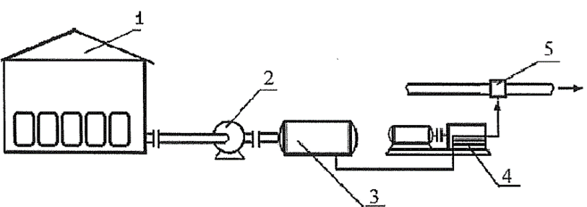

Figure 13 – Schematic drawing of PPD injection

PPD in barrels is preheated in a container (1) (or by means of a heating device) to 25-30° C. After, a filling pump or a barrel pump (2), the supply (dosage) tank (3) is filled with a heated depressant additive. The depressant additive is pumped out of the flow tank and fed by dosing pumps (4) along the pulse lines, then injected into the oil stream (5).
Historically 2 PPDs were applied in the route Kumkol – Karakoin – Shymkent. Russian PPD DMN – 2005 and currently applied Randep – 5102, manufactured in Kazakhstan. Effect of both was studied. Both based on EVA copolymers [62,63].

3.1 Characterization of oil mixture of Kumkol region and all component oils.
Set of analyses were run on each sample of oil. Pour point, Rheological studies, DSC WAT determination and cold finger. DSC and cold finger were run only at oil mixture as it was main object of study, however, pour point and Rheological studies were carried out for all samples.
Pour point analyses of oil samples that compose Kumkol oil mixture are shown in the table 20.

Table 20 – Pour point measurements

Sample name | Kazgermunai | PetroKazakhstan Kumkol Resources | Turgai-Petroleum | CNPC - Ai Dan Munai | KOR | Kuat Amlon Munai | Kumkol oil mixture
Pour point, ℃ | 12 | 9 | 9 | 6 | 21 | 18 | 9

3.2 Rheological data of each sample

Each run was made with following parameters: small sample size adapter and spindle No. 21 were used for 30 sec^{–1} shear rate tests. The preheat temperature was 60 ° C. Rheocalc32 software was used to interpret acquired data. All obtained data plotted on the figures 14-20.
Obtained data perfectly matches with observed pour point values and can be used to describe load on the pumps alongside the main pipeline route. In cold time of the year engineer van predict load on mentioned pumps depending on oil, ground and pipeline temperature. These are the crucial parameters, because depending on the use transporting company can estimate total volume of pumped oil and energy expenses due to load increase.
Rheological parameters are one of the most important and decreasing dynamic viscosity in cold time of the year can greatly help to optimize the transportation. Injecting PPD is one of most effective way of doing so.
WAT is very important parameter of every oil from standpoint of PPD or any other paraffin inhibitor application. It (WAT) characterizes temperature at which first crystal of wax is separated from oil phase into solid phase. Knowing that temperature engenner can easily select best suitable conditions for chemical injection. WAT for Kumkol oil mixture was performed as well. Differential scanning calorimeter Netzsch DSC 214 Polyma, the heating rate of 10°C per minute. The studies were conducted in an inert atmosphere. It was determined that that value lies in the region of ~38-40℃. That information will be used in further studies.
Kinematic viscosity, density and analyses according GOST 11851-85 and ASTM D445 parameters of Kumkol oil mixture were performed too. Results can be seen in the table 21.

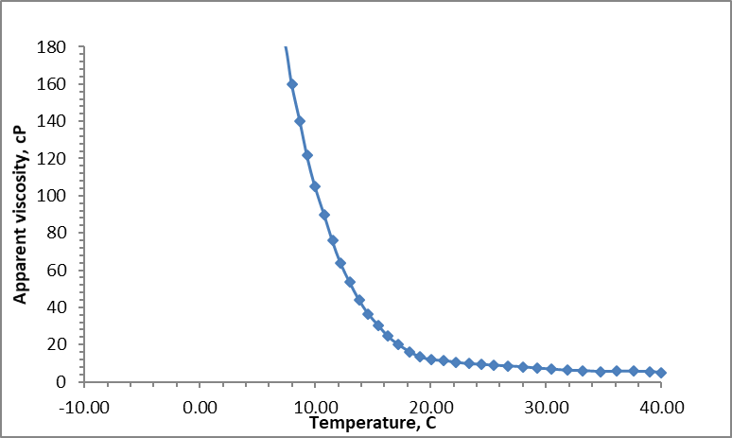

Figure 14 – Apparent viscosity vs temperature of untreated oil sample from Kazgermunai

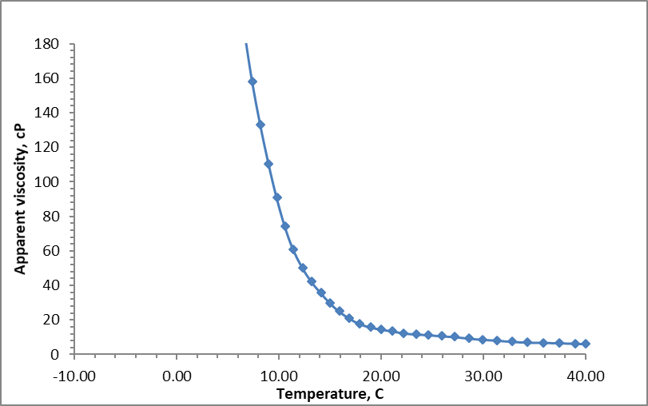

Figure 15 – Apparent viscosity vs temperature of untreated oil sample from PetroKazakhstan Kumkol Resources

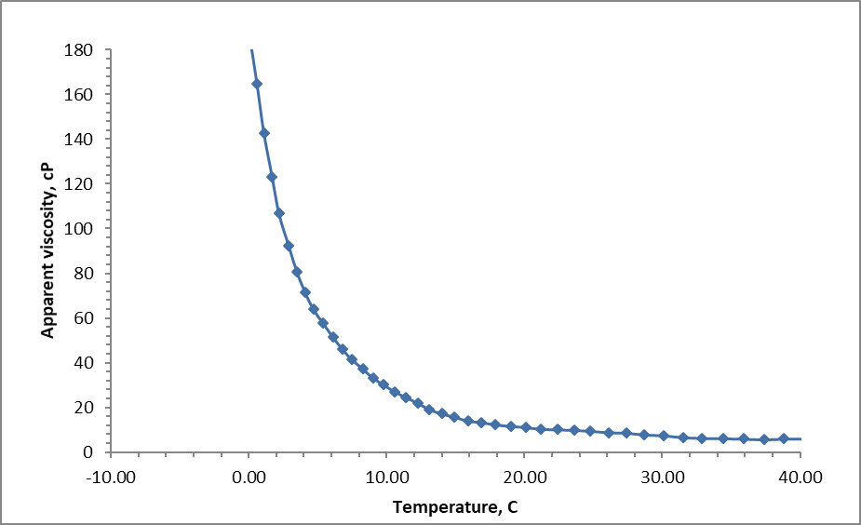

Figure 16 – Apparent viscosity vs temperature of untreated oil sample from Turgai-
Petroleum

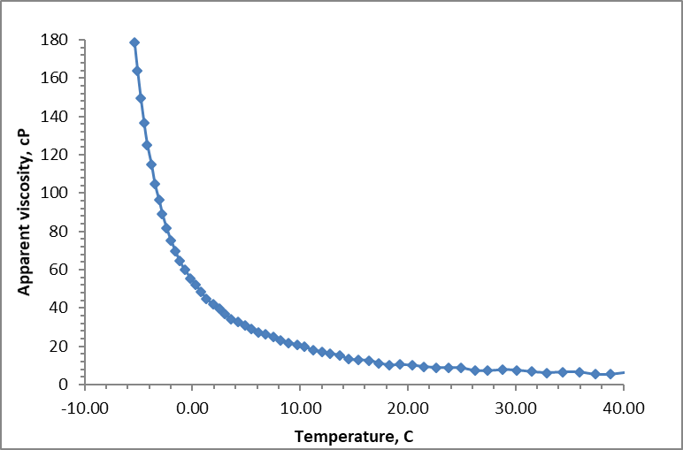

Figure 17 – Apparent viscosity vs temperature of untreated oil sample from CNPC - Ai Dan Munai

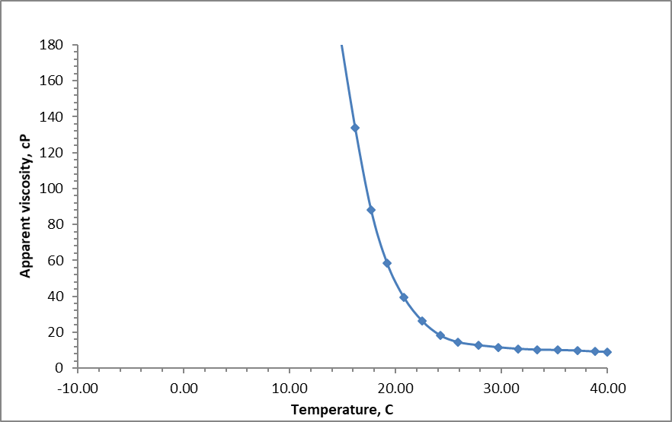

Figure 18 – Apparent viscosity vs temperature of untreated oil sample from KOR

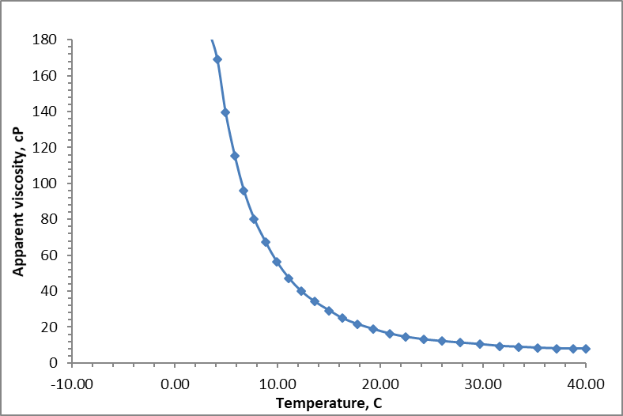

Figure 19 – Apparent viscosity vs temperature of untreated oil sample from KAM

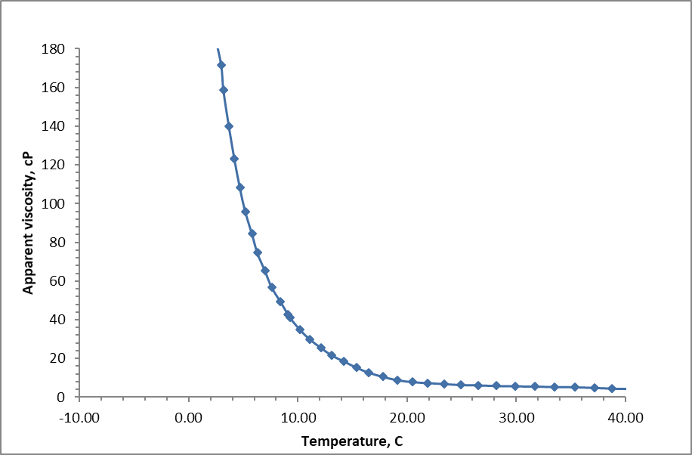

Figure 20 – Apparent viscosity vs temperature of untreated Kumkol mixture

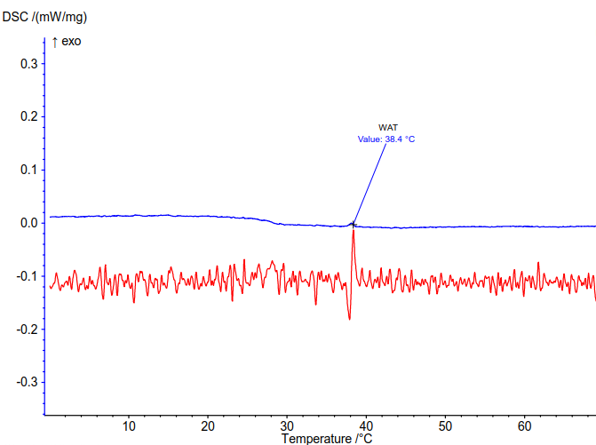

Figure 21 – WAT value for Kumkol oil mixture

Table 21. Density, kinematic viscosity and asphaltenes, paraffins and resins content at Kimkol [64] oil mixture

Oil sample | Density at 20⁰С, kg/m³ | Kinematic viscosity at 20℃, mm/sec² | Asphaltenes% | Paraffins, % | Resins, %
Kumkol oil mixture | 818.0 | 8.771 | 0.67 | 12.6 | 6.02

Composition of Kumkol oil mixture based on the contribution of each company can be represented as shown in table 22.

Table 22. Composition of Kumkol oil mixture based on production of all contributing companies [57]

Company name | Production rate, tons/day | Content of oil in mixture, %
PetroKazakhstan Kumkol Resources | 8450 | 37.5
Kazgermunai | 8000 | 35.5
Kuat Amlon Munai | 1300 | 5.8
CNPC - Ai Dan Munai | 1100 | 4.9
Turgai-Petroleum | 2500 | 11.1
KOR | 1200 | 5.3

3.3. Determination of the mechanism of graft polymerization on EVA.

To study the mechanism of graft copolymerization of hydrophobic monomers onto commercial EVA copolymer, model trapping studies with 2-methyl-2-nitrosopropane (MNP) [65] were performed using a method developed by Mun et al [66]. The mechanism of graft radical copolymerization is realized by the formation of a radical active center on the macromolecule backbone, which initiates the polymerization of the grafted monomer with the formation of side branches. In this work, to determine the nature of the active centers formed on the macromolecule backbones during irradiation with fast electrons, we used model reactions of the interaction of a tert-butoxy radical with an EVA copolymer in a benzene solution. The tert-butoxy radical was obtained by thermolysis of the initiator di-tert-butyl peroxalate (DTBP). Studies carried out by the spin trap method have shown that the formation of radical centers in macromolecules of the EVA copolymer can occur as a result of the abstraction of a hydrogen atom by a tert-butoxy radical from methine (CH), methylene (CH₂), and methyl (CH₃) groups of vinyl acetate units (reactions 1, 2, and 3, Fig. 22). In the presence of a spin trap (MNP), all macromolecules formed as a result of reactions 1–3 are captured by MNP with their attachment to the nitroso group of MNP and the formation of the corresponding stable nitroxyl radicals — adducts a1, a2, a3.
Figure 22 – Scheme of the abstraction of a hydrogen atom from macromolecules of the EVA copolymer and the capture of the resulting macroradicals by a spin trap (MNP).
[DTBP] = 5x10⁻³ mol/l; [MNP] = 3x10⁻² mol/l; [EVA] = 1.5 wt%
Figure 23 – EPR spectrum of MNP adducts with macroradicals formed during the thermal decomposition of the DTBP initiator in a benzene solution of EVA copolymer (20 °C) in the presence of a spin trap.

EPR spectrum of MNP adducts with macroradicals formed during the thermal decomposition of the DTBP initiator in a benzene solution of EVA copolymer in the presence of a spin trap is shown in Figure 23.
In EPR spectrum, an intense triplet (1-3, α_{N} = 15.2 Oe (Oersted) and g = 2.0063) refers to the MNP (a1) adduct with a radical having an unpaired electron on the tertiary carbon atom. Such a radical can be formed only upon the abstraction of a hydrogen atom from the methine group of vinyl acetate groups (reaction 1, Figure 22). A triplet of doublets (4-9, α_{N} = 13.8 Oe, α_{H} = 3.7 Oe, and g = 2.0061) belongs to the MNP (a2) adduct with macroradicals having an unpaired electron on the secondary carbon atom (carbon atom CH -groups). Such a polymer radical can be formed with equal probability upon the abstraction of a hydrogen atom from the methylene groups of vinyl acetate and ethylene units of EVA macromolecules (reaction 2 in Figure 2). The triplet of triplets (10-18, α_{N} = 14.9 Oe, α_{H} = 7.9 Oe, and g = 2.0064) in EPR spectrum shown in Figure 3 refers to MNP (a3) adducts with polymer radicals, having an unpaired electron on the primary carbon atom (on the carbon atom of the CH₂ group). Such a macroradical can be formed only as a result of reaction 3 (Figure 2) of the abstraction of a hydrogen atom from the methyl group of the vinyl acetate units of the EVA copolymer. Along with the spectrum components belonging to MNP adducts with macroradicals of various natures formed upon the abstraction of a hydrogen atom from macromolecules of the EVA copolymer, another triplet is clearly distinguished in EPR spectrum shown in Figure 23 (19-21, α_{N} = 19.3 Oe, and g = 2.0061). This triplet refers to the adduct formed during the direct capture of tert-butoxyl radicals by the MNP spin trap.
The high stability of MNP adducts with macroradicals of various natures formed upon the abstraction of a hydrogen atom from the macromolecules of the EVA copolymer makes it possible to study not only the mechanism of these reactions but also their kinetics. Figure 24 shows the initial linear sections of the kinetic curves of the accumulation of adducts a1, a2 a3. Kinetic analysis of such initial linear sections of the accumulation curves used for estimation of the values of the corresponding kinetic constants [66].

[DTBP] = 5x10⁻³ mol/l; [MNP] = 3x10⁻² mol/l; [EVA] = 1.5 wt%
Figure 24 – Kinetic curves of the accumulation of MNP adducts with macroradicals formed during thermolysis of the DTBP initiator in a benzene solution of EVA copolymer (20 °C) in the presence of an MNP spin trap

It was found that κ1 /κ2 = 11.7, κ1 / κ3 = 3.7 (the values of the kinetic constants increase in the series: κ3 ˂ κ2 ˂ κ1). Consequently, the methine groups (CH) of vinyl acetate units are most active in hydrogen abstraction reactions; methyl groups of vinyl acetate units are 3.7 times less active in hydrogen abstraction reactions than CH groups. The methylene groups of the vinyl acetate and ethylene units of the EVA copolymer exhibit the least activity in the reactions of abstraction of the H-atom.
Thus, the data obtained by the spin trap method show that the main contribution to the initiation of the process of graft polymerization of hydrophobic monomers ST, BMA, and BA onto the EVA copolymer is made by the reactions of hydrogen abstraction from the methine (CH) groups of vinyl acetate units of EVA polymer.
Grafted polymers were studied with FTIR and DSC to determine the changes in the structure and thermal profile.
Solutions of polymers and products were kept in an oven at 140 ° C for a day to completely remove the solvent and then studies were performed. Tablets with KBr were prepared from the dry substances obtained by drying, and then the spectra of the initial polymers and the resulting crosslinking products were taken. The spectra can be seen in the figures below.
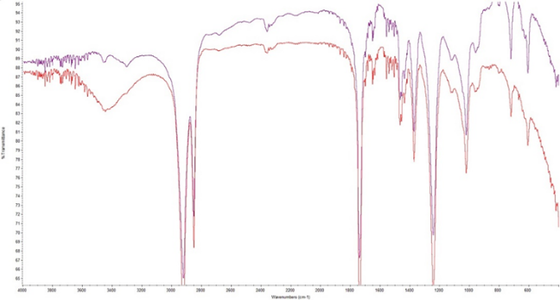

Figure 25 – FTIR spectra of pure EVA1

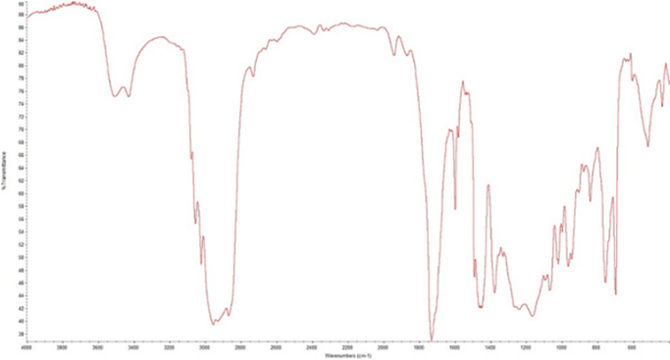
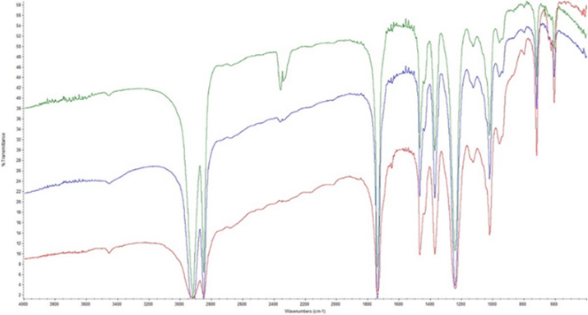
Figure 26 – FTIR spectra of EVABMA7C

Figure 27 – FTIR spectra of pure EVA2

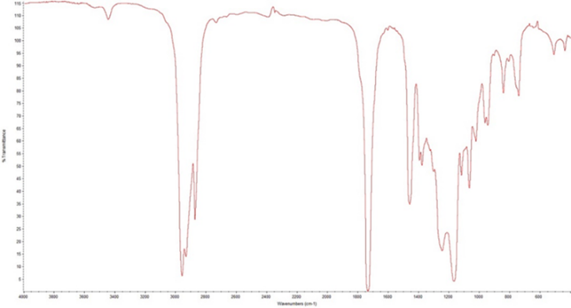

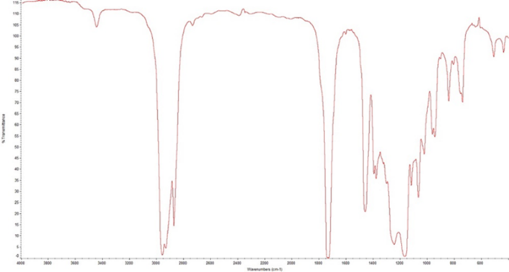
Figure 28 – FTIR spectra of EVABMA6C

Figure 29 – FTIR spectra of EVABA13C

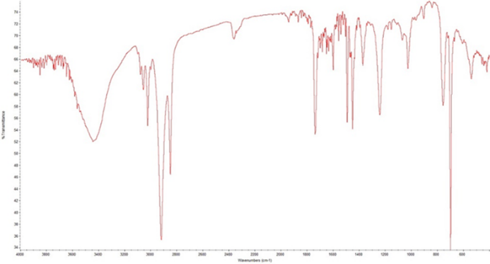
Figure 30 – FTIR spectra of EVASt24C

As can be seen from the spectra, changes in the fingerprint region of 1200 – 700 cm⁻¹ on the product spectra are visible in comparison with the original spectra of the original polymers. Peaks above 3000 cm⁻¹ are also clearly visible in Figure 30, which indicates the presence of aromatic CH bonds.
Studies were also carried out on the DSC 214 Polyma device. All samples were examined by lowering the temperature from 150℃ to -20℃ in increments of 10K/min.
Thermal profiles of the initial polymers and products are shown in Figures 31-32 below.
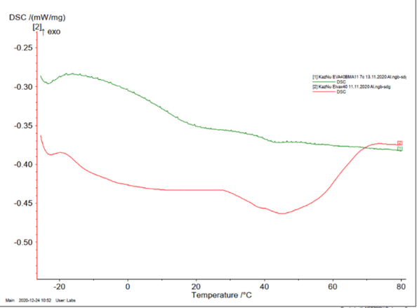

Figure 31 – Thermal profile of pure EVA1(2) and EVABMA7C(1)

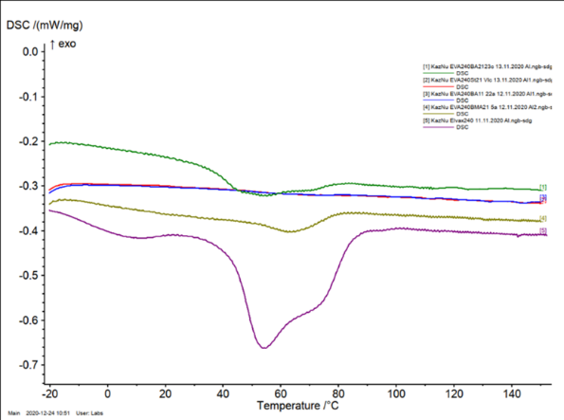

Figure 32 –Thermal profile of pure EVA2(5), EVABMA6C(1), EVABA15C(4), EVASt24C(2,3)

As can be seen, the profiles of the products differ from the original polymers, in the case of EVASt24C an amorphous polymer was obtained. The rest have pronounced transition points of the aggregate state, which differ from the original polymers.

3.4. Preheat effect on the pour point and rheological parameters study

During studies of oil mixture, it was found that varying preheat values can greatly impact on the pour point and rheological parameters. Before getting to discussion, we need to understand paraffin deposition mechanism.
All crude oils contain paraffinic components. The chart below demonstrates how paraffin fits into the scheme of crude oil. Crude oils contain three types of paraffins that are liquid and not likely to cause deposition problems: low molecular weight straight chain, branched chain, and cyclic paraffins.

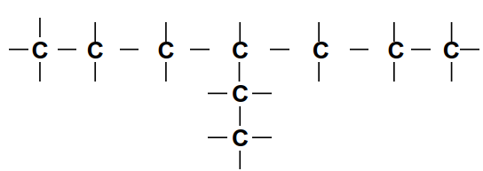
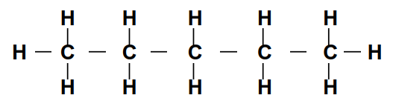

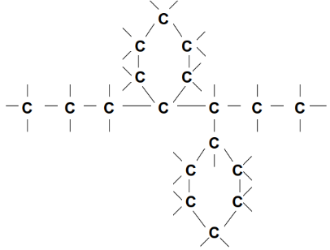

Figure 33 – General view of paraffin structures in crude oil

Straight chain paraffins (or n-alkanes) from C₁₆ up are waxy solids under normal ambient conditions, with solubility decreasing and melting point increasing as carbon numbers increase. Branching can have a major influence on the melting point of paraffin. A n-alkane C₁₆ paraffin will have a cloud point of about 20-25°C. A branched C₁₆ will have a pour point less than -60°C. A cyclic C₁₆ paraffin will have a pour point even lower. Therefore, the paraffins of concern in the oil field are n-alkanes (straight chains) of C₁₆ and higher [67].

Table 23. Typical composition of the oil in fractions of C number

C number | Type | Example
C₁ - C₄ | Natural Gases | Methane, Propane, Butane
C₅ – C₈ | Low Boiling Liquids (40 - 120 C) | Petroleum Ether, Light Naphtha, Gasoline
C₉ - C₁₂ | Higher Boiling Liquids (120 - 210 C) | Kerosene
C₁₃ - C₁₇ | Very High Boiling Liquids (210 - 300 C) | Diesel Fuel
Cl8 - C34 | Non-Volatile Liquids, Long Chain Alkanes | Paraffin, Lubricating Oils
C35+ | Non-Volatile Solids,  Very Long Chain Alkanes, Polycyclic Structures | Asphaltenes, Petroleum Coke, Waxes

Because paraffins are inert and will not react with other components, they retain their physical properties regardless of the chemical mixture of the crude in which they occur. As a consequence, the temperature at which paraffins crystallize is not significantly affected by outside chemical influences.
The physical conditions to which paraffin is exposed determine whether it will crystallize. The physical condition with the greatest influence on paraffin is temperature. If crude becomes cool enough to allow paraffin crystallization, there is nothing that can be done to stop the growth of crystals. The best remedy is to modify the form of the crystal so, when coming out of solution from the crude, they do not cluster and agglomerate and are therefore less likely to deposit on surfaces.
Under normal conditions, most crude oil pipelines operate under a turbulent flow regime. In this type of flow, there is a turbulent core and laminar boundary layer adjacent to the pipe wall [68].
In the turbulent core, temperature, velocity, and wax concentration are independent of radial position. In the laminar boundary layer, there is a high velocity gradient and decrease in temperature towards the pipe wall. The laminar boundary layer controls the wax deposition rate.
Two mechanisms, molecular diffusion and shear dispersion govern the transport of dissolved or precipitated wax from the liquid crude to the pipe wall. Molecular diffusion transports dissolved wax, and shear dispersion transports precipitated wax.
If a pipeline is operating within a laminar flow regime, deposition will increase as the velocity of the oil decreases. Under worst-case conditions, the oil will solidify at the pipeline wall and the pipeline will rapidly become choked with wax [69].
In a pipeline where oil is cooling down, molecular diffusion occurs as soon as the pipe wall temperature reaches the cloud point. There is then a wax concentration gradient between a higher level of dissolved wax in the turbulent core of the oil and the lower level of wax still in solution at the pipe wall. This causes dissolved wax to diffuse towards the pipe wall where it is precipitated.
Pipe wall surfaces are inherently rough, providing nucleation sites for precipitation. The precipitated wax gradually becomes incorporated into an immobile layer.
Deposition only occurs when the oil is being cooled. If the pipe wall temperature is higher than the bulk oil temperature, molecular diffusion can be reversed and waxy residues on the pipe wall can be redissolved into the turbulent core [70].
Wax crystals already present in the flowing crude tend to flow at the mean speed of the crude oil. However, close to the pipe wall, shearing of the liquid causes lateral movement of the particles of wax. This lateral movement is called shear dispersion.
This leads to the transport of precipitated wax from the turbulent core to the pipe wall where it may either deposit directly onto the wall surface or link with wax already deposited by molecular diffusion.
With shear dispersion, there is no tendency for nucleation to occur at the pipe wall surface. This can lead to a less tenacious deposit than would occur by molecular diffusion.
Factors that affect shear dispersion are:
■ Wall shear rate.
■ Quantity of precipitated wax.
■ Shape and size of wax crystals.
Shear dispersion mechanisms only become significant if the precipitated wax content in the turbulent core is high. This only occurs when the bulk oil temperature is well below the cloud point.
Although an increase in shear rate tends to encourage more lateral dispersion of wax particles toward the pipe wall, the increase in shear rate also encourages deposited wax crystals to be stripped off the pipe wall. For any given system, equilibrium is reached where deposition approaches a maximum thickness of deposit, provided conditions remain constant.
It is considered that molecular diffusion is the dominant process at higher temperatures and shear dispersion will dominate at lower temperatures when shorter chain length (or soft) n-alkanes contribute to the deposition process. It is most likely that both mechanisms proceed simultaneously.
Number of analyses were run with different preheat values of Kumkol mixture. Sample of mixture was preheated to 50℃, 60℃, 70℃, 80℃ for 30 minutes before analysis and the pour point and rheological parameters were studied.
It appeared that increasing preheat will improve rheological parameters of oil at lower temperatures and lower the pour point. Results of pour point measurements can be seen in table 24.
Table 24. Pour point values of Kumkol oil mixture at different preheat values

Preheat value, ℃ | 50 | 60 | 70 | 80
Pour point, ℃ | 9 | 3 | 0 | -3
Rheology was dramatically improved too. Figures 33-36 below shows rheological parameters of oil mixture at different preheat.
That fact can give the guidelines for oil transporters and oil producers about optimal preheat temperature before PPD injection and transportation conditions. In the case of PPD absence oil transporting companies can increase temperature at the starting point to an optimal value and enhance rheological properties of oil in low temperature conditions this way.

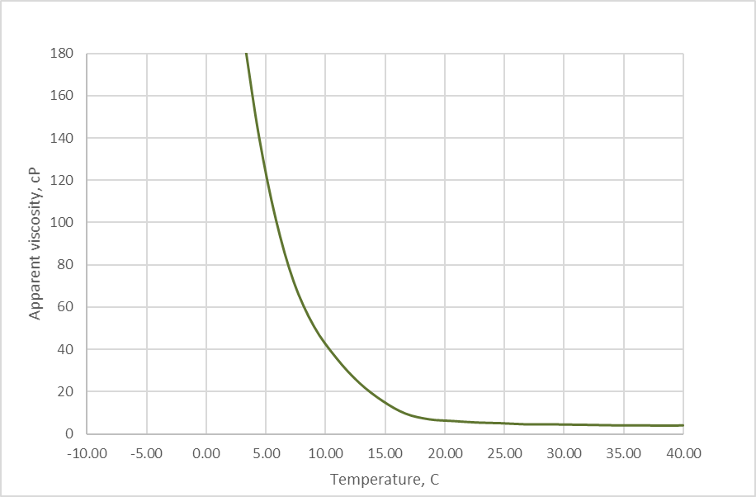

Figure 33 – Apparent viscosity vs temperature of untreated Kumkol mixture at 50℃ preheat

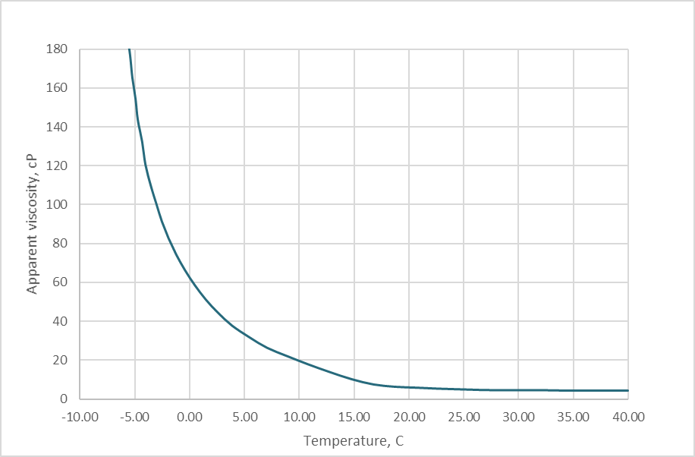

Figure 34 – Apparent viscosity vs temperature of untreated Kumkol mixture at 60℃ preheat

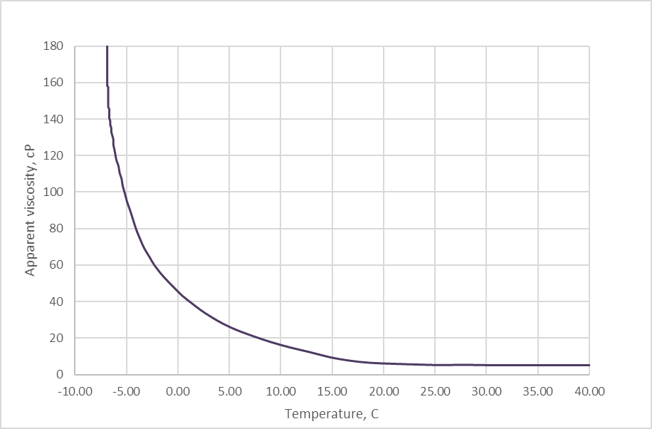

Figure 35 – Apparent viscosity vs temperature of untreated Kumkol mixture at 70℃ preheat
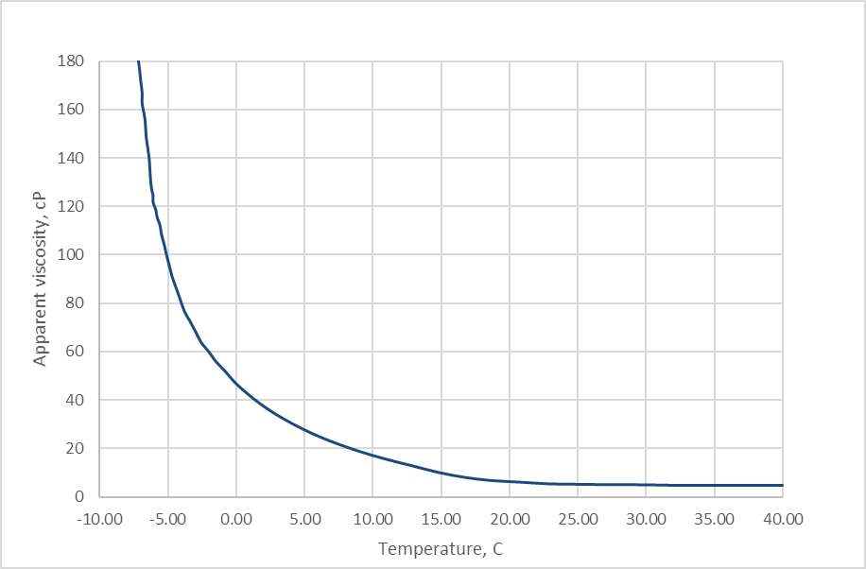

Figure 36 – Apparent viscosity vs temperature of untreated Kumkol mixture at 80℃ preheat

As it can be seen from figures and table all interested parameters are improved. That can be explained from standpoint paraffin deposition theory, mentioned before. Whenever there are crystallization centers in oil, paraffin matrix that then will speed up oil crystallization will build up faster. Increasing oil preheat temperature will melt all heavy fractions that can be presented in oil mixture as crystals, therefor can be considered as crystallization centers.
That information can be useful for oil transportation, if by any reason there is problem with PPD injection. Finding optimal preheat temperature is the other option for improving rheological parameters of oil.
However, it should be noted that preheat is not equal to PPD application due to mechanisms of deposition. When oil is preheated high enough to melt all paraffin crystals, they’ll form again at the same thermodynamic conditions. Whereas PPD physically modifies paraffin crystals and prevent formation of huge agglomerates. Other downside of preheat and cooldown cycles of oil, especially in open vessels, is the light fractions loss in the process, which can potentially lead to even worse consequences, like rheology problems at temperatures with acceptable parameters in the past.

3.5. Pour point analysis

Typical dosage for PPDs in the industry ranges from 500-1000 ppm with some exceptions [71, 72, 73], however in this study we tested all PPDs at a base concentration of 200 ppm as it was compared to an existing commercial product used in Kazakhstan's oil transportation facilities (commercial EVA polymers with a concentration of 200 ppm were used in all tested oils of different sources). Table 4 shows the pour point values when PPD was added at the recommended dosage, compared to an untreated oil blend sample.

Table 25. Pour Points and Depression of Kumkol region oil mixture neat and treated with PPDs.

Sample | Dosage, ppm | Pour point,°C | Depression,°C² | Dry residue, % mass³
Untreated crude oil | - | 12 | -
EVA (Randep-5102 ¹) | 200 | 0 | 12 | 7
gEVABMA7C | 200/400 | -3/-6 | 15/18 | 3
gEVABMA6C | 200/400 | -3/-12 | 15/24 | 4
gEVABA15C | 200/400 | 3/-9 | 9/21 | 3
gEVABA13C | 200/400 | 3/-3 | 9/15 | 3
gEVASt24C | 200/400 | -3/-12 | 15/24 | 4
¹In addition to EVA copolymers, Randep - 5102 consists of a polymer reaction product of formaldehyde with dinonylphenol and nonylphenol for dispersing asphaltenes. ²Depression value is determined as the delta of the Pour Point values of treated and untreated samples of oil. ³Dry residue was calculated based on 200 ppm of PPDs.

As shown in Table 25, the depression temperature and Pour Point of Kumkol oil invariably decreased when treated with PPDs[89-91]. As can be seen from Table 25, the addition of PPDs to Kumkol oil lowers the pour point to -3°C. Moreover, the Pour Point and gel point drop achieved with the gEVAps treatment are greater than with commercial EVA, currently in use. In addition, when recalculating the actual effectiveness of the active part of the PPDs (dry residue), we see that to achieve results similar to the currently used commercial pour point depressant based on EVA (Randep-5102), a lower dosage of the resulting modified polymers is required. Moreover, the doubled dosage of PPDs based on gEVAp showed better performance than the commercial ones based on EVA, with a pure active part corresponding to the amount in the mentioned depressant.

3.6. Rheological data and the WAT determination

The effect of the preheating temperature on the parameters of the rheology of oil samples was preliminary studied. Figure 37A shows the rheological parameters of the oil mixture at different preheats. As can be seen from Figure 37A, as well as Table 24, at a preheating temperature of 60 °C, all the parameters of interest were optimal, and a further increase in the preheating temperature did not significantly improve them, and it was inexpedient from an economic point of view. It also shows that preheating the oil to 60 °C leads to the melting of all heavy fractions that may be present in the oil mixture in the form of crystals. At lower preheating temperatures, crystallization centers present in the oil that have not been completely melted, forms a paraffin matrix, which then accelerates the crystallization of the oil.

Figure 37 – (a) Viscosity of neat crude oil (Kumkol region oil mixture) preheated to various pre-defined temperatures prior to rheology measurements. (b) Apparent viscosity of oil neat and treated with PPDs. Viscosity-temperature changes were measured at a shear rate of 28.16 s⁻¹. In all tests oil was preheated to 60 °C and treated with 200 ppm of PPD.
Figure 37B show the viscosity versus temperature of neat and treated oils. After treatment with PPDs, all curves shifted to a lower temperature region and remained “pumpable” at a much lower temperature compared to the untreated oil sample. As can be seen from Figure 5B, in all cases for all PPDs, the viscosity decreases by about 10 times at low temperatures. In this case, the oil has the best aggregate stability and at low temperatures, it turns into a non-Newtonian liquid. The obtained rheological measurements of the dynamic viscosity showed that all tested gEVAps are well compatible with crude oil, and the data completely coincide with the observed pour point values and can be used to describe the load on pumps on the main pipeline. During the cold season, the engineer can predict the load on these pumps depending on the temperature of the oil, soil and pipelines.

3.7. Microscopic Study

Samples of untreated Kumkol oil mixture and treated were studied with a polarization microscope. Micrographs of paraffin crystals were examined at -3 ° C. Micrographs of Kumkol crude oil (untreated) and oil treated with gEVASt24C are shown in Figures 38a and b, respectively. As can be seen regular, compact, platelet shape wax crystals are formed in the treated oil, and the wax crystals become smaller and more dispersed compared to crystals in the untreated oil, and the results are consistent with previous studies of EVA-based polymers [18, 55, 74-78,88].

Figure 38 – Effect of gEVAp addition on wax crystal morphology in waxy crude oil. (a) Micrographs of wax crystals of Kumkol waxy crude oil, undoped and (b) doped with 200 ppm of gEVASt24C.

3.8. Cold finger testing

The cold finger method [79] (low shear wax deposition test) is used to determine the tendency of oil to deposit and the effectiveness of wax inhibitors on waxy paraffinic oils. A temperature difference is established on the metal surface of the finger and in the oil sample, causing wax deposition. At the completion of the testing period, the cold finger was removed from the oil sample, free oil was allowed to drain off, and then the finger was dipped into cold acetone to wash off residual oil, and dried for 30 minutes. Then the dried cold fingers with the deposit were weighed using an analytical balance; the deposit height was also measured to correct for any differences from finger to finger.
Weights of accumulated deposits were then calculated. The texture of the deposit was noted as either ‘hard’, ‘soft’, ‘sticky’, or ‘impossible to remove’.
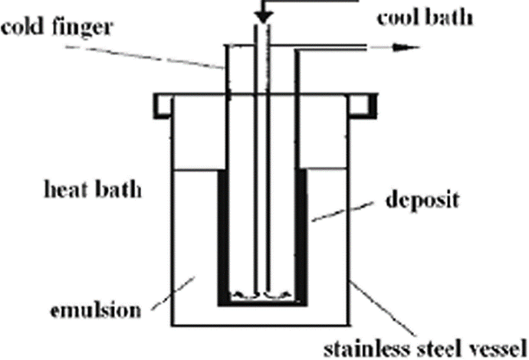
The cold finger deposition tests were performed on neat and treated oil samples. The oil sample was pre-treated first. The bulk oil temperature was chosen to be 50 °C, about 10 °C above the measured WAT temperature. Cold Finger temperature was set at 15 °C, which is about 25 °C below the measured WAT. These conditions allowed us to get 0.360 grams on average in all untreated oil cycles.

Figure 35 – Schematic representation of cold finger cell

After selecting optimal conditions for cold finger test, treated samples of oil were tested under same conditions. Results can be seen in the table 26. Efficiency was calculated according to formula (2).

$z=\frac{m_{oil }-m_{treated}}{m_{oil}}$ (2)

To investigate the effectiveness of this method for Kumkol oils, we tested other cold finger temperatures, so at 25 and 20 degrees, we obtained 0.12 and 0.21 grams of oil deposits on the cold finger surface, respectively. A further decrease in temperature is dangerous due to the approach to the pour point of the oil. In this case, the Cold Finger results may be affected by gelation of the oil along with the paraffins on the Cold Finger, resulting in incorrect results. In these tests, the cold finger simulates the cold walls of the pipeline, and the vessel with heated oil simulates the flow of oil that moves through the pipeline. So, generally speaking, the cold finger test is a pipeline inside out. Figure 36 shows the appearance of the fingers after testing.

Figure 36 – The appearance of cold finger from untreated oil (a) and treated with gEVASt24C (b) and gEVABMA6C (c) at 200 ppm rate.
The test results are presented in Table 26. Thus, in the presence of 200 ppm PPD based on graft copolymers, the paraffin inhibition efficiency for the Kumkol oil mixture reached 70-90%.

Table 26. Results of cold finger test for untreated oil and treated with EVA and gEVAp at 200 ppm dosage level.

Sample | Deposit^{1,} g | Inhibition²,%
Untreated crude oil | 0.360 | 0
EVA (Randep – 5102) | 0.126 | 65
gEVABMA7C | 0.061 | 83
gEVABMA6C | 0.101 | 72
gEVABA15C | 0.076 | 79
gEVABA13C | 0.104 | 71
gEVASt24C | 0.043 | 88
¹ The duration of all experiments was 4 hours. T_{hot}=50 °C, T_{cold}=15 °C. ²Inhibition was calculated using the formula: z = ((m_{oil} – m_{treated})/m_{oil}) x 100

3.9. Studies of stability over time

Finally, one of the important parameters of any PPD for oil transporters is the stability of the effect over time due to the long transportation distance. On the route Kumkol - Karakoin - Shymkent, as a rule, the transportation of oil from the Kumkol field to the Shymkent refinery takes 2-3 weeks. Thus, PPD's ability to reduce viscosity and pour point throughout the entire period is critical. The results of the stability effect for best performed gEVASt24C and commercial EVA (Randep-5102) are shown in Table 6. The main parameter of the study was the pour point. The oil treated with PPD was cooled in the air to room temperature. Then the cooled samples were placed in a cooling unit with a temperature of 6-7 °C, where all subsequent time was kept under the conditions of regular stirring. On the 1st, 3rd, 7th, 14th, 21st, and 28th days after the initial treatment, pour point tests were carried out. gEVAp demonstrated a sufficient depression effect, maintaining + 6°C even on the 28th day, when the typical travel time from Kumkol to Shymkent is about 21 days. This ensures a good flow throughout the cold season without additional oil processing. Results of that study are shown in table 27 below. As it can be seen sample treated with gEVASt24C shows comparable performance to the currently used commercial product Randep-5102.

Table 27. Stability of the pour point of the Kumkol oil mixture treated with gEVASt24C and commercial EVA (Randep-5102) at 200 ppm. Test duration 28 days

Sample | 1st day | 3rd day | 7th day | 14th day | 21st day | 28th day
gEVASt24C | -3 | -3 | 0 | 0 | +3 | +6
EVA (Randep-5102) | 0 | 0 | +3 | +3 | +6 | +6

3.10 Proposed production scheme and economic estimation of cost.

Ideally, it will be good to produce the pour point depressants using EB mounted into the stream of polymer/monomer in the solvent. But we decided to scale the production using existing production facility in Kazakhstan. “RauanNalco” LLP have all needed infrastructure to run this kind of synthesis using initiator of polymerization (polymerization initiator is to be defined). Proposed scheme is listed below.
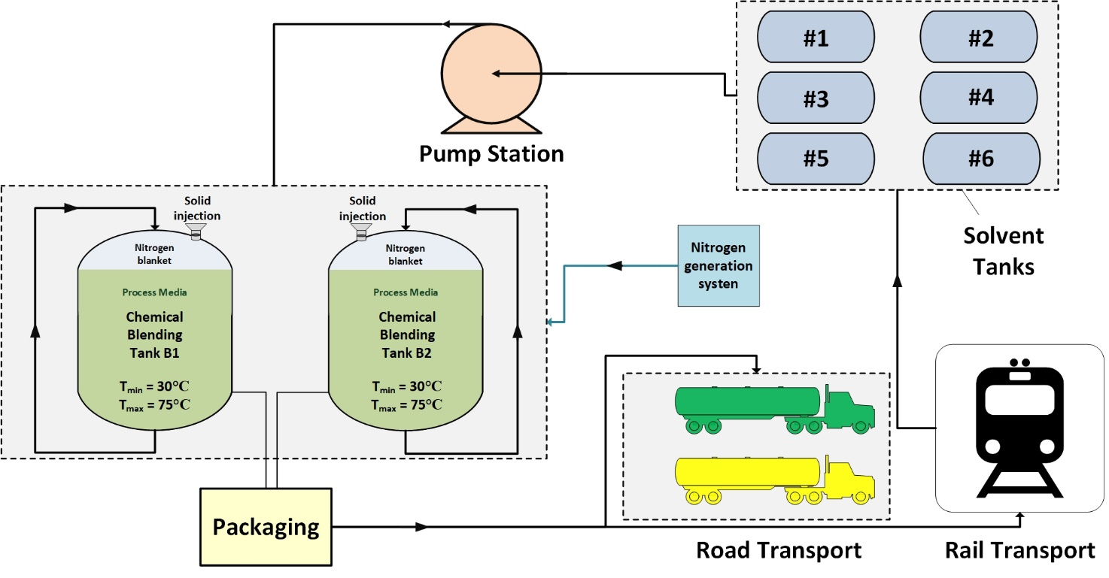
Figure 37 – Proposed scheme of pour point depressant production based on real production facility of “RauanNalco LLP”
As it can be seen in the figure 37 above, production will include 2 reaction blenders, that will be fed by polymer/monomer mixture through solid injection funnel. Solvent will be pumped from solvent tanks at needed ratio (5:95 reactants: solvent), then adding the initiator temperature will be held in the 60°C range. Nitrogen blanket will be used as safety measure to ensure that no evaporation of light fractions of solvent will occur into the production facility. Samples of the reaction mixture will be delivered into the laboratory for inspection of physical parameters, to control grafting process. After process will be completed, reaction mixture will be cooled down to 25-30°C and then packaged into the drums or truck tanks for further transportation to the end customer.
Economical estimation of the final the product cost was made using publicly available prices of the raw materials. EVA copolymer with 28% VA content is listed as 2.35$ per kilogram DDP to Atyrau, Styrene is listed 2.02$ per kilogram DDP to Atyrau and solvent 1.01$ per kilogram DDP to Atyrau plant. All prices are effective for December 2021. So, considering all production costs and packaging into the drums, we can estimate cost of the product roughly 1.7$ per kilogram. That price is not estimating initiator cost, but it should affect the final cost negligibly. So, considering currency rate averaged as 430 Tenge per US dollar, we can estimate product cost as 731 tenge per kilogram. Of course, there will be markups added to generate profit for the company. But considering, that all above numbers were calculated for 10 tons of final product, that will be sufficient to treat 50 000 tons of oil with 200 ppm dose rate, it can give rough idea how much will field trial of the product will cost the company.

3.11. Proposed field wax inhibition tests: deposition in the pipeline

Aside from cold flow transporters are facing deposition problem in during cold time of the year due to lowering temperature of ground, oil and pipeline walls. These conditions will promote deposition of heavy organic substances such as paraffins. There are several ways to deal with such problem. Mechanical and chemical are the most common.
Mechanical way of dealing with deposition is pigging. During the process of oil and gas production, solids can deposit on the internal surfaces of pipelines leading to restricted flow and eventual blocking of the pipeline. These solids may take the form of mineral deposits such as corrosion by-products, scale, or organic deposits such as paraffin and asphaltene. While chemical products, when applied properly, are designed to minimize these deposits, often the most cost-effective route is to combine chemical treatment with a routine pigging program.
In addition to the deposits causing possible restrictions in the flow of production, these deposits can also form corrosion cells in which under-deposit corrosion can occur. To prevent this from happening, a regularly scheduled maintenance program of pigging, or pigging with corrosion inhibitor, is usually required.
Pigging involves sending a semi-hard projectile, usually foam or metal with plastic scraping surfaces, down a pipeline to clean the pipeline. The pig is propelled by gas or production fluids and is introduced at one end of the pipeline and recovered at the other.
Pig launchers are required to introduce the pig into a pressured pipeline. The configuration of the receiver will vary by location, but the typical configurations is as shown below [80].

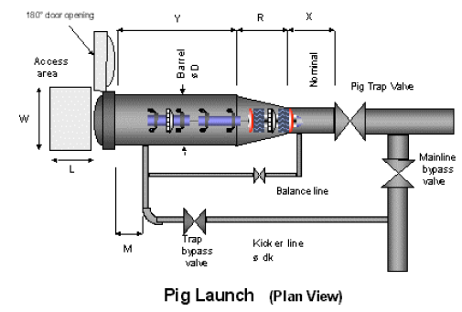

Figure 38 – Pig launch facility. Schematic view

Pig receivers are installed to catch the pigs at the locations where the pig is to be removed. The typical configuration for a pig receiver is shown below.
It can be very beneficial to witness the pig removal process for a pipeline you are treating or are auditing. The volume and type of liquids and solids that come in can be measured and sampled at this time. Operators will not always report this, so it is best to witness and sample the returns.
Pig launching and receiving facilities scheme are presented on the figures 38 and 39 respectively.

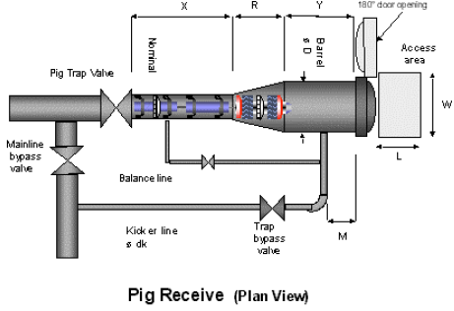

Figure 39 – Pig receiver. Schematic view

That kind of measurements can be recorded to create very useful statistical base for future PPD applications as with that chemical application operator should see gradual solid deposits decrease. Anyway, knowing how much of deposit operator received from the pigging operations can give timely needed diagnostic information.
Usually, these facilities are being installed on bypass lines of pipeline to ensure oil movement even at situations when pig will get stuck in the receiving facility.
These samples can reveal much about what is happening in a pipeline when combined with another audit information [81].
The pigs used to accomplish these tasks can be divided into two categories:
- Utility pigs — Used to perform functions such as cleaning, dewatering, or application of chemicals. There are two basic types of utility pigs, which are used for different purposes (fig 40)
- Cleaning pigs, which are used to remove solid or semi-solid deposits or debris from the pipeline
- Sealing pigs, which are used to provide a good seal in order to sweep liquids from the line, for the application of chemical, or provide a barrier between two dissimilar products within the pipeline
- Gel pigs — Used in conjunction with conventional pigs to optimize pipeline dewatering, cleaning, and drying. (fig. 41)
Utility pigs are most widespread in Kazakhstan and widely been used on main routes of oil transportation. There is one special type of pigs that are used around the globe. They are diagnostic pigs. These kinds of instruments can be equipped with CCD cameras or any other needed electronic equipment and been passed through pipeline can give very useful diagnostic information for operator.
Pigging operation can be applied not only in pipeline but in well too, there are special pigging installations with artificial lift wells in western Kazakhstan at various oilfields in central and western areas.
Figures 40 and 41 shows typical appearance of utility and gel pigs. Utility ones are the most common in Kazakhstan oilfields. They are used across the western and central Kazakhstani fields to clean the pipeline and in the diagnostic purposes. Distance that pigs can travel in the pipeline varies from tens to hundreds of kilometers.
In addition to the cold flow, transporters face the problem of deposition during the cold season due to the decrease in the temperature of the soil, oil, and pipeline walls. These conditions will favor the deposition of paraffins [82]. Figure 42 shows oil pipelines before and after PPD treatment. As seen in Figure 42a, the crude (untreated) oil produced a large amount of thick deposits that clogged the pipes and made transportation difficult. At the same time, after processing the oil with PPD (Figure 42b), the oil remained sufficiently fluid, which required lower transportation costs. PPD was dosed into the commercial oil of the Turgai oil during transportation to the main pumping station Kumkol.

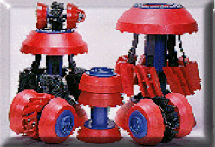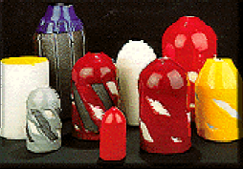

Figure 40 – View of typical utility pigs.

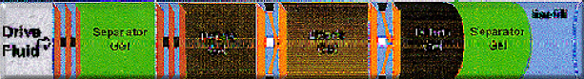

Figure 41 – Schematic view of gel pigging
Figure 42 – Example of wax formation on a production line without PPD (a) and free-flowing oil treated with PPD (b)
After synthesizing enough gEVASt24C we are planning to run field trials on the same pipeline. To run field trials, we will need 600 kg of finish product treat 3000 tons of oil during 1 pass of the pig. Treatment rate will be 200 ppm as incumbent product. The mechanical way of dealing with deposition is pigging. Pigging involves sending a semi-hard projectile, usually foam or metal with plastic scraping surfaces, down a pipeline to clean the pipeline. The pig is propelled by gas or production fluids and is introduced at one end of the pipeline and recovered at the other [83-87].
Depending on the season and outside temperatures the amount of deposit received can vary vastly. It can be as loas as several kilograms and up to hundreds of kilograms in severe winter conditions. Figure 43 (a,b) shows amount receive in the fairly warm conditions of autumn season, so amount of deposit received, as was told above can increase in colder season.
Figure 43 – The resulting pigs from untreated pipelines: (a) taken from the pipeline without PPD treatment, (b) received pig from the pipeline treated with PPD (Randep-5102). The oil pipeline is 14.5 km long and 377 mm in diameter. Temperature gradient 60-25 °C.

CONCLUSION

Carried studies allows us to make following conclusions:
- All contributing to overall Kumkol oil mixture samples of oil were studied for basic rheological parameters and pour point, with lowest +6°C and highest +21°C. It can be concluded that there are KOR and Kuat Amlon Munai oil that have highest pour point with, hypothetically, a lot of heavy fractions of hydrocarbons. However, their contribution in overall oil mixture is not high.
- Experimentally proven that preheat of oil 20-30℃ higher than WAT can enhance rheological parameters of oil and lower pour point. That fact can be used in situations where application of chemicals is impossible by any reason. However, it is worth noting that this process in open containers can lead to the loss of light fractions of oil and subsequently a higher temperature will be required to improve rheological properties.
- Wax Appearance Temperature was determined for Kumkol oil mixture by means of differential scanning calorimetry. It was found to be equal to 38.4°C. That value can be used to optimize PPD injection process, as according to mechanism of PPD crystal modification there is no practical point of injecting PPD lower than wax appearance temperature. So, to optimize and generating more value from chemical application it should be noted that PPD should be injected at temperatures that are higher than WAT.
- EVA based PPDs are effective in the conditions of Kumkol oil mixture transportation in cold weather conditions. Application of PPD on the route Kumkol – Karakoin – Shymkent is justified and effective. Currently applied Randep – 5102 manufactured locally showed good performance. It’s been applied on that route for 7 years now. Its depression rate of overall mixture up to 12℃. From +12℃ pour point of blank oil sample to 0℃ of treated with 200 ppm of Randep-5102.
- Newly synthesized grafted EVA copolymers performed better than available commercial products at comparable dosages. Pour point of overall mixture varied from +3℃ to -12℃ depending on the dose rate. Recalculated to pure active part pour point was lower than 0℃ for all grafted EVA copolymers.
- New polymer depressant additives were obtained by radiation grfating of hydrophobic industrially available monomers of various natures (butyl acrylate, butyl methacrylate, styrene) on ethylene-vinyl acetate copolymers. As a result of varying the radiation dose of the reaction mixture, it was found that the optimal radiation dose is a dose equal to 130 kGy. Using the spin trap method using model reactions, it is shown that at the primary stages of the process, active radical centers initiating grafting copolymerization are formed as a result of the separation of the H atom from the macro chains of ethylene-vinyl acetate copolymers. It is established that the process of separation of the H-atom from the tertiary carbon atom of vinyl acetate monomer units is carried out at the highest speed. Theory of grafting nonpolar monomers into the EVA to increase their oil solubility and performance was confirmed during the work and confirmed with all monomers introduced into the EVA chain.
- Effective dosage, recalculated for dry residue shows that pure active part of PPD using newly synthesized products can be lower than commercially available products. That fact potentially can save up a lot of funds for final users alongside with storage space. Newly synthesized are effectively produced without any wastes due to application of all reaction mixture right after the irradiation. That potentially can be cost saving point of production. All samples were used as is after the irradiation process. Wasteless of synthesis can grant a lot of advantages in terms of sustainability perspective.
Assessment of completeness of the solution of tasks. All tasks that were defined, according to received results, were fully completed. Studies of all locally available PPDs were done and obvious connection between PPD composition and its performance was outlined. Newly synthesized compounds showed better overall performance. EB irradiation showed some advantages in terms of excluding purification process, thus leaving 0 wastes in production.
Whole experimental work was done on modern instruments with use of methods that are recognized throughout the industry.
Recommendations for specific use of results. Received results can be used for future PPD selection process for oil mixtures from central Kazakhstan. Obtained data that characterizes rheology with different preheat is very useful for the routes that are still using heaters to transport the oil and can be used as recommendations for the transporters in situations when PPD is not available.
Assessment of technical and economic efficiency of implementation. Transportation of oil in low temperature conditions via areas that are not equipped with heating facilities, can be complicated with flow problems and wax deposition. Complications like these are being faced on the main pipeline by the route “Kumkol-Karakoin-Shymkent” Pour point depressant is the chemical that should help to overcome these complications during transportation.
Moreover, transportation with use of heaters is becoming more economically inefficient due to rise of price for energy sources from year to year, ecological restrictions for emissions. Gas that is used for heating pipeline could be used to heat homes and social objects. So, use of PPD for oil transportation is one way for save money and protect environment.
Obtained results can create base for future industrial production of more effective copolymer blends synthesis. That blends could be more efficient than currently used products.
Assessment of the scientific level of work. There were many works are done for rheological and transportation studies for Kazakhstan oil. Due to production and oil properties specificity in Kazakhstan, transportation for long distances by the means of pipeline routes was always topic for discussion. This work approached this problem from the point of already used chemicals for transportation as the model to study and starting point for improvement of chemical composition that can be used as PPD to improve rheological properties of transported oil.
Through the work all available and, what is more important, successfully used PPDs were studied. New, more effective copolymers were synthesized, based on assumption about hydrophobic nature of grafted monomers. Main dependences of composition and performance were identified. New copolymers obtained by EB irradiation showed better performance and great potential in the conditions of Kumkol oil mixture transportation.
Determination of optimal preheating conditions for each oil that contributes for overall mixture and applying it can be as momentary help for oil transporters and great help in saving electric power due to high pump loads due to rheology change in low temperature interval.
It can give the guidelines for oil transporters and oil producers about optimal preheat temperature before PPD injection and transportation conditions. In the case of PPD absence oil transporting companies can increase temperature at the starting point to an optimal value and enhance rheological properties of oil in low temperature conditions this way.
For the first time new PPD was obtained by EB grafting of hydrophobic monomers. Resulting compounds, that can be used without further purification, showed better performance, and can be produced with potentially 0 wastes.

REFERENCES

[1] Chala GT, Sulaiman SA, Japper-Jaafar A. Flow start-up and transportation of waxy crude oil in pipelines-A review. Journal of Non-Newtonian Fluid Mechanics 2018;251:69-87.
[2] Zhang F, Ouyang J, Feng X, Zhang H, Xu L. Paraffin Deposition Mechanism and Paraffin Inhibition Technology for High-carbon Paraffin Crude Oil From the Kazakhstan PK Oilfield. Pet Sci Technol 2014;32(4):488-96.
[3] Nadirov KS, Zhantasov MK, Marenov BT, Bimbetova GZ, Orynbasarov AK, Shukhanova ZK, et al. Obtaining High‐Paraffin‐Content Oil Depressants. Chemical Engineering & Technology 2021;44(2):310-7.
[4] Sayakhov BK, Aldyarov TK, Diduh AG, Guzov SY, Sadykova GD, Sigitov VB, et al. Investigation of wax precipitation in pipeline of Pavlodar-Shymkent (in Russian). Oil Gas Journal (Kazakhstan) 2004;4:99-106.
[5] Gluyas JG, Underhill JR. The Staffa Field, Block 3/8b, UK North Sea. Geological Society, London, Memoirs 2003;20(1):327-33.
[6] El-Dalatony M, Jeon B-H, Salama E-S, Eraky M, Kim W, Wang J, et al. Occurrence and Characterization of Paraffin Wax Formed in Developing Wells and Pipelines. Energies 2019;12(6):967.
[7] Huang Z, Lee HS, Senra M, Scott Fogler H. A fundamental model of wax deposition in subsea oil pipelines. AlChE J 2011;57(11):2955-64.
[8] Тертерян Р.А., Башкатова С.Т. - Депрессорные присадки к дизельным топливам. Москва – ЦНИИТЭнефтехим. – 1987, 66с.
[9] K.S. Wang, C.H. Wu, J.L. Creek, P.T. Shuler and V. Tang, J. Pet. Sci. Technol., 21, 2003, 359.
[10] Jun Xu, Huiqin Qian, Shili Xing, Li Li, and Xuhong Guo, Synthesis of Poly(maleic acid alkylamide-co-rolefin-co-styrene) Co-polymers and Their Effect on the Yield Stress and Morphology of Waxy Gels with Asphaltenes, Energy Fuels, 25, 2011, 573–579.
[11] A. Frohlich and B. Rice, Ind. Crops Prod., 21(1), 2005, 25.
[12] M. Ayman Atta, H. I. Al-Shafey and E.A. Ismail, Influence of Ethylene Acrylic Alkyl Ester Copolymer Wax Dispersants on the Rhological Behavior of Egyptian Crude Oil, J Dispersion Science Technology, 32, 2011, 1296-1305.
[13] A H. I. l-Shafey, A.I. Hashem, R. S. Abdel Hameed, E. A. Dawood, Studies on the Influence of Long Chain Acrylic Esters Co-Polymers Grafted With Vinyl Acetate as Flow Improver Additives of Crude Oils, Advances in Applied Science Research, 2 (5), 2011, 476-489.
[14] Paso, K.G., Paraffin Gelation Kinetics (PhD Dissertation). Ann Arbor, Michigan: University of Michigan., 2005.
[15] Merino-Garcia, D., Margarone, M., Correra, S., Kinetics of waxy gel formation from batch experiments. Energy Fuels 21, 1287–1295, 2007.
[16] Li W, Li H, Da H, Hu K, Zhang Y, Teng L. Influence of pour point depressants (PPDs) on wax deposition: A study on wax deposit characteristics and pipeline pigging. Fuel Process Technol 2021;217:106817.
[17] Makhmotov ЕS, Sagitov VB, Ismurzin ОB, Kondratiyev VV, L.Е. B. Physical-chemical and rheological parameters of crude oils of Kazakhstan Republic. Almaty: Zhibek Zoly; 2008.
[18] Kozhabekov SS, Zhubanov AA, Toktarbay Z. Study the rheological properties of waxy oil with modified pour point depressants for the South Turgai oil field in Kazakhstan. Oil Gas Sci Technol – Rev IFP Energies nouvelles 2019;74:28.
[19] Jonathan, Southgate. Wax removal using pipeline pigs, Durham theses, Durham University; 2004.
[20] Rehan M, Nizami A-S, Taylan O, Al-Sasi BO, Demirbas A. Determination of wax content in crude oil. Pet Sci Technol 2016;34(9):799-804.
[21] Ghannam, M.T., Hasan, S.W., Abu-Jdayil, B., Esmail, N., Rheological properties of heavy & light crude oil mixtures for improving flowability. J. Pet. Sci. Eng. 81, 122–128, 2012.
[22] Rønningsen, H.P., Rheological behavior of gelled waxy North Sea crude oils. J. Pet. Sci. Eng. 7 (3), 177–213, 1992.
[23] Visintin, R.F.G., Lapasin, R., Vignati, E., D’Antona, P., Lockhart, T.P., Rheological behavior and structural interpretation of waxy crude oil gels. Langmuir 21 (14), 6240–6249, 2005.
[24] Venkatesan, R., Nagarajan, N.R., Paso, K., Yi, Y.B., Sastry, A.M., Fogler, H.S., The strength of paraffin gels formed under static and flow conditions. Chem. Eng. Sci. 60 (13), 3587–3598, 2005.
[25] Russell, R.J., Chapman, E.D., The pumping of 85 °F pour point Assam (Nahorkatiya) crude oil at 65 °F. J. Inst. Pet. 57 (554), 117–128, 1971.
[26] Singh P, Venkatesan R, Fogler HS, et al. Morphological evolution of thick wax deposits during aging. AIChE. 2001;47(1):6–18.
[27] Zhang, J., Liu, X., Some advances in crude oil rheology and its application. J. Cent. South Univ. 15 (Suppl. 1), S288–S292, 2008.
[28] Rafael Martínez-Palou, María de Lourdes Mosqueira, Beatriz Zapata-Rendón, Elizabeth Mar-Juárez, César Bernal-Huicochea, Juan de la Cruz Clavel-López, Jorge Aburto, Transportation of heavy and extra-heavy crude oil by pipeline: A review, Journal of Petroleum Science and Engineering, Volume 75, Issues 3–4, 2011, Pages 274-282,
[29] Chi Y, Yang J, Sarica C, Daraboina N. A Critical Review of Controlling Paraffin Deposition in Production Lines Using Chemicals. Energy & Fuels 2019;33(4):2797-809.
[30] K.S. Pedersen, J. Energy Fuels, 17(2), 2003, 321.
[31] Merino-Garcia D, Duenas-Diez M, Gomez S, et al. Risk Assessment Methodology for Flow Assurance Challenges: The Sooner You Look at It, the Better, Offshore Technology Conference Paper 22404; 2013.
[32] Zerpa LE, Sloan ED, Koh CA, et al. Hydrate Risk Assessment and Restart Procedure Optimization Offshore Using a Transient Hydrate Prediction Model, Offshore Technology Conference Paper 22406, Brazil; 2011.
[33] Merino-Garcia D, Shaw J, Carrier H, et al. Petrophase 2009 Panel Discussion on Standardization of Petroleum Fractions. Energy and Fuels. 2010;24(4):2175–2177.
[34] Valinejad R, Solaimany Nazar AR. An experimental design approach for investigating the effects of operating factors on the wax deposition in pipelines. Fuel Journal. 2013;106:843–850.
[35] A.A. Hafiz and T.T. Khidr, J. Petrol. Sci. and Engin., 56, 2007, 296.
[36] Patton CC, Casad BM, Paraffin Deposition from Refined Wax Solvent System, SPEJ; 1970. 17 p.
[37] Черножуков Н.И. Технология переработки нефти и газа. Часть 3. Очистка и разделение нефтяного сырья, производство товарных нефтепродуктов, М.: Химия, 1978. — 424 с.
[38] Жузе Т.П. Миграция нефти и газа и фазовые равновесия в углеводородных системах при высоких давлениях, ВИНИТИ, Москва 1969 - 188 с.
[39] Ребиндер П.А. Поверхностные явления в дисперсных системах. Физико-химическая механика. Избранные труды, Москва, Наука, 1979. - 384 с.
[40] Душечкин А.П., Иванов В.И., Тертерян Р.А., Лившиц С.Д. -Разветвленные сополимеры этилена с винилацетатом в качестве депрессорных присадок к дизельным топливам ВНИИ по переработке нефти. - Москва: Деп.в.ЦНИИТЭНЕФТЕХИМ. – 1989, № 143 – 89. – 9с.
[41] H.I. Al-Shafey, R.S. Abdel Hameed, E.A. Ismail, O.E. El Azabawy, Studies of poly ethylene acrylic acid derivatives as pour point depressants of waxy crude oils, Organic Chemistry: An Indian Journal, 10(8), 2014, 308-314.
[42] Энглин Б.А. и др. – Исследование механизма действия присадок. – Гале (ГДР): Докл.2-го международного симпозиума. – 1976, с.392-407.
[43] N. Ridzuan, F. Adam & Z. Yaacob (2016) Evaluation of the inhibitor selection on wax deposition for Malaysian crude oil, Petroleum Science and Technology, 34:4, 366-371,
[44] Grimbergen, Reinier & van Hoof, P.J.C.M. & Meekes, H & Bennema, P. (1998). Morphology of orthorhombic n-paraffin crystals: The influence of multiple connected nets. Journal of Crystal Growth. 191. 846-860.
[45] Тертерян Р.А. Депрессорные присадки к нефтям, топливам и маслам. М.: Химия. 1990. 240с.
[46] Jafari Behbahani, Taraneh & Rahmatollah, Golpasha & Hassan, Akbarnia & Alireza, Dahaghin. (2008). Effect of wax inhibitors on pour point and rheological properties of Iranian waxy crude oil. Fuel Processing Technology - FUEL PROCESS TECHNOL. 89. 973-977. 10.1016/j.fuproc.2008.03.013.
[47] Orazbekuly, Yerbolat & Boiko, Galina & Lubchenko, Nina & Dergunov, Sergey. (2014). Novel high-molecular multifunctional reagent for the improvement of crude oil properties. Fuel Processing Technology. 128. 349–353. 10.1016/j.fuproc.2014.07.039.
[48] Machado ALdC, Lucas EF. Poly(Ethylene-Co-Vinyl Acetate) (Eva) Copolymers as Modifiers of Oil Wax Crystallization. Pet Sci Technol 1999;17(9-10):1029-41.
[49] Ashbaugh HS, Guo X, Schwahn D, Prud'homme RK, Richter D, Fetters LJ. Interaction of Paraffin Wax Gels with Ethylene/Vinyl Acetate Co-polymers. Energy & Fuels 2005;19(1):138-44.
[50] Jafari Ansaroudi HR, Vafaie-Sefti M, Masoudi S, Behbahani TJ, Jafari H. Study of the Morphology of Wax Crystals in the Presence of Ethylene-co-vinyl Acetate Copolymer. Pet Sci Technol 2013;31(6):643-51.
[51] Taraneh JB, Rahmatollah G, Hassan A, Alireza D. Effect of wax inhibitors on pour point and rheological properties of Iranian waxy crude oil. Fuel Process Technol 2008;89(10):973-7.
[52] Yao B, Chen W, Li C, Yang F, Sun G, Wang G, et al. Polar asphaltenes facilitate the flow improving performance of polyethylene-vinyl acetate. Fuel Process Technol 2020;207:106481.
[53] Marie, Emmanuelle & Chevalier, Yves & Eydoux, Franck & Germanaud, Laurent & Flores, Philippe. (2005). Control of n-alkanes crystallization by ethylene-vinyl acetate copolymers. Journal of Colloid and Interface Science. 290. 406-418. 10.1016/j.jcis.2005.04.054.
[54] Machado, André & Lucas, Elizabete. (1999). Poly(ethylene-co-vinyl acetate) (EVA) copolymers as modifiers of oil wax crystallization. Petroleum Science And Technology. 17. 1029-1041. 10.1080/10916469908949763.
[55] Jing, Guolin & Sun, Zhengnan & Tu, Ziyi & Bian, Xudong & Liang, Yu. (2017). Influence of different vinyl acetate content on the properties of EVA/modified nano-SiO2 composite PPD. Energy & Fuels. 31. 10.1021/acs.energyfuels.7b00189.
[56] Marenov, Bekaidar & Nadirov, Kazim & Zhantasov, Manap & Nadirov, Rashid. (2020). Ethylene-Vinyl Acetate Copolymer/Crude Gossypol Compositions as Pour Point Depressants for Waxy Oil. International Journal of Chemical Engineering. 2020. 1-7. 10.1155/2020/4195382.
[57] Махмотов Е.С., Сигитов В.Б., Исмурзин О.Б., Кондратьев В.В., Боранбаева Л.Е. Физико- химические и реологические параметры нефтей Республики Казахстан. Справочник на 3-х языках (казахский, русский и английский).Ч.1 – Алматы: Жибек жолы, 2008. – 629 с.
[58] Yordanov ND. Quantitative EPR spectrometry — “State of the art”. Appl Magn Reson 1994;6(1):241-57.
[59] ASTM D5853 Standard Test Method for Pour Point of Crude Oils
[60] ISO 3219. Plastics. Polymers/resins in the liquid state or as emulsions or dispersions. Determination of viscosity using a rotational viscometer with defined shear rate.
[61] ASTM D 445. Standard Test Method for Kinematic Viscosity of Transparent and Opaque Liquids (and Calculation of Dynamic Viscosity).
[62] Патент РФ 2098459. Присадка к нефтям и нефтепродуктам / Октябрьский Ф.В., Безгина А.М., Шапкина Л.Н., Альтергот В.Э., Габутдинов М.С., Зайцев Н.Ф., Кекишев В.А., Романов Н.В., Хуснуллин М.Г., Черевин В.Ф., Юсупов Н.Х.
[63] Инновационный патент 30239. Депрессорная присадка комплексного действия “Рандеп-5102″ / Беглеров Еркен Абыкаримович, Бекбасов Тимур Муратович, Ажгалиев Бауржан Утепкалиевич
[64] GOST 11851-85. Oil. Paraffin determination methods.
[65] Sato T, Otsu T. Evaluation of relative reactivities of vinyl monomers towards t-butoxy radical by means of spin trapping technique. Polymer 1975;16(5):389-91.
[66] Nurkeeva ZS, Mun GA, Golubev VB. On the activity of monomers and polymers on the basis of vinyl ethers of glycols in radical reactions. Die Makromolekulare Chemie 1992;193(5):1117-22.
[67] Del Carmen García, M. (2000). Crude oil wax crystallization. The effect of heavy n-paraffins and flocculated asphaltenes. Energy and Fuels, 14(5), 1043–1048.
[68] Weingarten, J.S. and Euchner, J.A. 1988. Methods for Predicting Wax Precipitation and Deposition. SPE Prod Eng 3 (1): 121-126. SPE-15654-PA.
[69] Губин В.Е., Скрипников Ю.В. - Параметры структурного потока вязкопластичной жидкости в круглой трубе. Труды ВНИИСПТнефть «Сбор, подготовка и транспорт нефти и нефтепродуктов», вып.11, Уфа, 1973.
[70] Hamouda, A.A. and Davidsen, S. 1995. An Approach for Simulation of Paraffin Deposition in Pipelines as a Function of Flow Characteristics With a Reference to Teesside Oil Pipeline. Presented at the SPE International Symposium on Oilfield Chemistry, San Antonio, Texas, USA, 14-17 February. SPE-28966-MS.
[71] Taraneh JB, Rahmatollah G, Hassan A, Alireza D. Effect of wax inhibitors on pour point and rheological properties of Iranian waxy crude oil. Fuel Process Technol 2008;89(10):973-7.
[72] Wu Y, Ni G, Yang F, Li C, Dong G. Modified Maleic Anhydride Co-polymers as Pour-Point Depressants and Their Effects on Waxy Crude Oil Rheology. Energy & Fuels 2012;26(2):995-1001.
[73] Fang L, Zhang X, Ma J, Zhang B. Investigation into a Pour Point Depressant for Shengli Crude Oil. Industrial & Engineering Chemistry Research 2012;51(36):11605-12.
[74] Ashbaugh HS, Guo X, Schwahn D, Prud'homme RK, Richter D, Fetters LJ. Interaction of Paraffin Wax Gels with Ethylene/Vinyl Acetate Co-polymers. Energy & Fuels 2005;19(1):138-44.
[75] Huang H, Wang W, Peng Z, Ding Y, Li K, Li Q, et al. The influence of nanocomposite pour point depressant on the crystallization of waxy oil. Fuel 2018;221:257-68.
[76] Li N, Mao G, Wu W, Liu Y. Effect evaluation of ethylene vinyl acetate/nano-montmorillonite pour-point depressant on improving the flow properties of model oil. Colloids and Surfaces A: Physicochemical and Engineering Aspects 2018;555:296-303.
[77] Huang H, Wang W, Peng Z, Li K, Gan D, Zhang S, et al. The effect of cooling processes on the yield stress of waxy model oil with nanocomposite pour point depressant. Journal of Petroleum Science and Engineering 2019;175:828-37.
[78] Marie E, Chevalier Y, Eydoux F, Germanaud L, Flores P. Control of n-alkanes crystallization by ethylene-vinyl acetate copolymers. J Colloid Interface Sci 2005;290(2):406-18.
[79] Wu Y, Ni G, Yang F, Li C, Dong G. Modified Maleic Anhydride Co-polymers as Pour-Point Depressants and Their Effects on Waxy Crude Oil Rheology. Energy & Fuels 2012;26(2):995-1001.
[80] Randy L. Roberts (2009) What Do We Really Know About Pipeline Pigging And Cleaning Pipeline & Gas Journal, Vol. 236 No. 8, 2009
[81] Fung, G., Backhaus, W. P., McDaniel, S., & Erdogmus, M. 2006. To Pig or Not to Pig: The Marlin Experience With Stuck Pig. Offshore Technology Conference.
[82] Alnaimat F, Ziauddin M. Wax deposition and prediction in petroleum pipelines. Journal of Petroleum Science and Engineering 2020;184:106385.
[83] Wang Q, Sarica C, Chen TX. An Experimental Study on Mechanics of Wax Removal in Pipeline. Journal of Energy Resources Technology 2005;127(4):302-9.
[84] Sams GW, Zaouk M. Emulsion Resolution in Electrostatic Processes. Energy & Fuels 2000;14(1):31-7.
[85] Li M, Sun M, Lu Y, Zhang J. Experimental Study on the Strength of Original Samples of Wax Deposits from Pipelines in the Field. Energy & Fuels 2017;31(11):11977-86.
[86] Wang Q, Sarica C, Volk M. An Experimental Study on Wax Removal in Pipes With Oil Flow. Journal of Energy Resources Technology 2008;130(4).
[87] Gao X, Huang Q, Zhang X, Li W, Zhang Y, Li R, et al. Estimating Wax Plug Transportation Force in Crude Oil Pipeline Pigging. Energy & Fuels 2020;34(3):3110-20.
[88] Mun, Grigoriy & Bekbassov, Timur & Beksultanov, Zhomart & Yermukhambetova, Bayana & Azhgaliyev, Baurzhan & Azhgaliyev, Naurizbek & Dergunov, Sergey. (2022). Modified graft copolymers based on ethylene vinyl acetate as depressants for waxy crude oil and their effect on the rheological properties of oil. Journal of Petroleum Science and Engineering. 213. 110298. 10.1016/j.petrol.2022.110298.
[89] Bekbassov 2021. Pour point depressant for paraffinic oils. Patent for utility model № 6124 11.02.22.
[90] Bekbassov 2021. Pour point depressant for paraffinic oils. Patent for utility model № 6125 11.02.22.
[91] Bekbassov 2021. Pour point depressant for paraffinic oils. Patent for utility model № 6126 11.02.22.
[92] Bekbassov, Polatkhan, Kenessova, Mun. (2020). Development of radiation modification technology petroleum additives based on ethylene vinyl acetate. KAHAK, 2(69).

