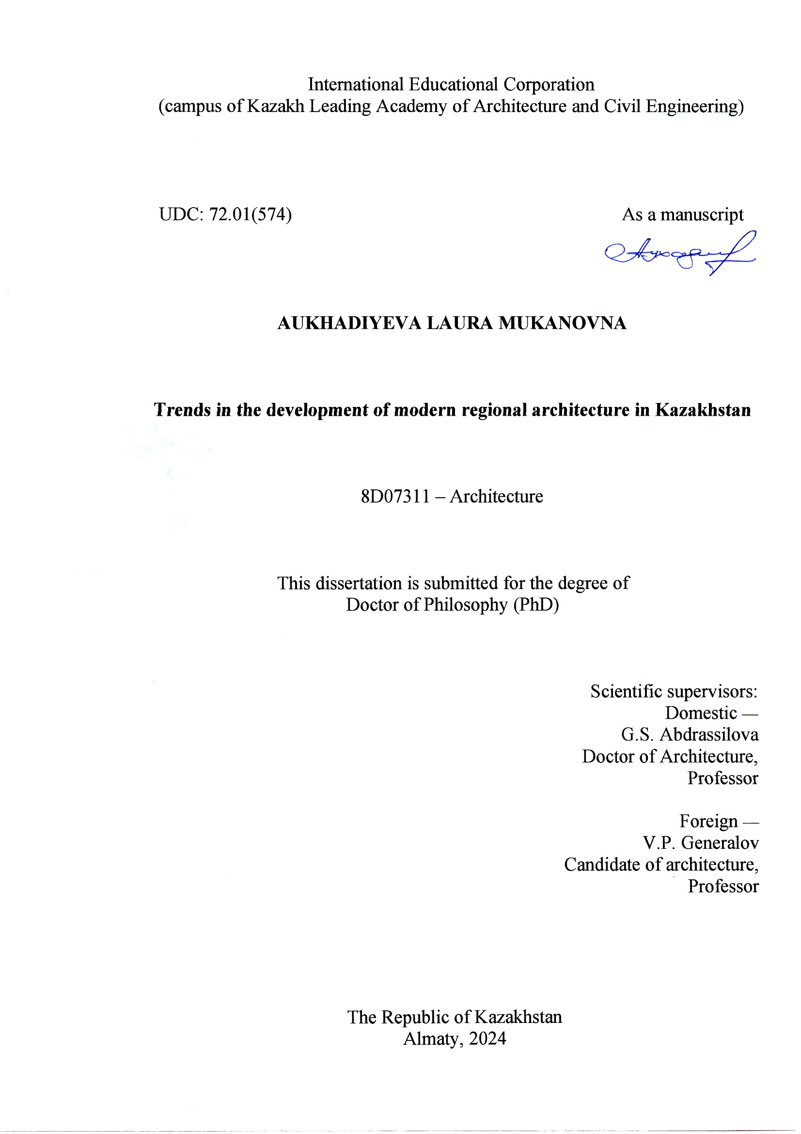

CONTENT

NORMATIVE REFERENCES 4
DEFINITIONS 5
SYMBOLS AND ABBREVIATIONS. 8
INTRODUCTION 9
1 FEATURE OF THE DEVELOPMENT OF WORLD ARCHITECTURE IN THE XX CENTURY, 20
1.1 Development of Western architecture in the twentieth century 20
1.2 Architecture of the Soviet Union 28
1.3 The end of the twentieth century: restructuring of professional thinking in architecture 34
Conclusions to the first chapter 46
2 EVOLUTION OF ARCHITECTURE OF KAZAKHSTAN IN THE XX CENTURY 48
2.1 Architecture of Kazakhstan in the first half of the twentieth century 48
2.2 Development of architecture in Kazakhstan in the second half of the twentieth century 55
2.3 Architectural and artistic features of unique buildings in Almaty in the last quarter of the twentieth century 59
2.4 Architecture of Astana as a stage of transition to global trends 65
Conclusions to the second chapter 71
3 CURRENT ASPECTS OF FORMATION OF MODERN REGIONAL ARCHITECTURE OF KAZAKHSTAN 73
3.1 Traditions and innovations of expression of regionalism in the modern architecture of Kazakhstan 73
3.2 Visualization of identity in architecture through traditional Kazakh ornament 83
3.3 Architecture as one of the primary factors of the identity of a city 87
3.3.1 Natural factors in identity formation 91
3.3.2 Anthropogenic factors in the formation of the identity of a city 92
3.3.3 Results of a sociological survey 94
Conclusions to the third chapter 95
4 TRENDS IN THE DEVELOPMENT OF ARCHITECTURE OF KAZAKHSTAN IN THE XXI CENTURY 97
4.1 Modern local challenges and architecture of Kazakhstan 97
4.2 Architecture of Kazakhstan in the context of global trends in sustainable development 106
4.3 Principles for the formation of regional architecture of Kazakhstan in modern conditions 113
4.4 Priority directions for the development of the regional architecture of Kazakhstan in the 21st century 116
4.4.1 Sustainable development and green architecture 117
4.4.2 Digitalization of the architectural and construction industry 121
4.4.3 Adaptive use and repurposing of buildings 127
4.4.4 Participatory design 129
4.4.5 Formation of architectural identity in modern conditions 134
Conclusions to the fourth chapter 141
CONCLUSION 143
REFERENCES 148
APPENDIX A - Graphic part for the first chapter of the dissertation 182
APPENDIX B - Graphic part for the second chapter of the dissertation 195
APPENDIX C - Graphic part for the third chapter of the dissertation 202
APPENDIX D - Graphic part for the fourth chapter of the dissertation 219
APPENDIX E – Certificate “Approbation of the results of PhD thesis research” 223
APPENDIX F – Act on the implementation of research results in the educational process 224
APPENDIX G – Act on the implementation of research results in the design and production process 226

NORMATIVE REFERENCES

This dissertation uses references to the following standards:
SP RK 2.04-01-2017 Construction climatology;
SN RK 1.02-02-2016 (amended 04.03.20_48-NK) “Engineering surveys for construction. Seismic microzoning. General provisions”;
SN RK 1.04-26-2011 (amend. 25.05.21_70-NK) “Reconstruction, major and current repairs of residential and public buildings”;
SN RK 2.04-21-2004 (amended 06.11.19_178-NK) “Energy consumption and thermal protection of civil buildings”;
SN RK 3.02-38-2013 “Energy-saving buildings”;
SN RK 4.02-101-2012 “Heating, ventilation, and air conditioning”;
SN RK 3.01-01-2013 (amended 05.03.18_45-NK) “Urban planning. Planning and development of urban and rural settlements”;
SN RK 3.01-02-2012 “Planning and development of areas of individual housing construction”;
SN RK 3.02-01-2018 “Residential multi-apartment buildings”;
SN RK 3.02-03-2012 “State social housing”;
SN RK 3.02-07-2014 (amend.27.11.19_194-NK) “Public buildings and structures”;
SN RK 3.02-09-2011 “Multifunctional buildings and complexes”;
SN RK 3.02-20-2011 (amend. 15.11.18_235-NK) “Cultural and entertainment institutions”;
Instructions for preparing a dissertation and abstract, 2004.

DEFINITIONS

In this dissertation, the following terms with corresponding definitions are used:
Adaptation of architecture is the process of changing or modifying an existing architectural structure or environment to meet new conditions, requirements or needs. Arcology (a combination of two words: architecture and ecology; English Arcology) - is an architectural and urban planning concept, a synthesis of architecture and ecology with the aim of creating compact cities and structures that promote environmental safety and efficient use of limited areas.
Additive Manufacturing is a production method based on the sequential deposition or build-up of material with precise process control. It allows the creation of objects layer by layer through 3D printing.
Architectural design software products are specialised programs and applications architects and designers use to create, model, visualise, and analyse architectural projects. These programs simplify the design process, allow you to communicate more effectively with clients and other project stakeholders, and provide more accurate results.
Assimilation is a process in which one ethnic group is deprived of its distinctive features and replaced by the features of another society, such as the mixing of peoples.
Blockchain of building materials is a technology that ensures transparency and reliability of processes in the construction industry through a decentralised database and “smart contracts”. It allows you to avoid unnecessary intermediaries in the chain of processes. It does not allow information to be edited after it has been entered into the blockchain, thereby preventing corruption.
Colour is not just a visual phenomenon but also a reflection of the national worldview, clearly visible in the colour names reflected in phraseological units. Phraseologisms containing colour terms are considered complex nominative constructions that have not only linguistic meaning but also play a role in the knowledge of cultural characteristics.
Composition in architecture involves the distribution and interaction of architectural forms, spatial elements, and interior and exterior details. The primary aim of composition is to create a harmonious and aesthetically pleasing visual effect and evoke an emotional response to the space. Architectural composition employs organisational principles such as balance, contrast, rhythm, proportion, and emphasis.
Critical analysis is the process of systematic and in-depth examination of research materials in order to identify their strengths and weaknesses, evaluate their reliability and significance, and examine their contribution to the relevant field of knowledge. It involves critical thinking, the ability to analyse and interpret information, and the ability to identify bias, logical errors, and flaws in argumentation.
Cultural identity Cultural identity encompasses an individual's recognition of their membership within a particular cultural group, achieved through self-identification with distinct cultural norms. The formation of identity is shaped by the influence of various cultural elements, and when these elements harmonise, the individual gradually or entirely aligns with the cultural stereotypes and values surrounding them.
Digital culture is an understanding of modern information (digital) technologies, their functionality, and the ability to use them competently in work or everyday life.
Digital memory is a concept that describes the phenomenon of storing information in a digital environment. It includes processes and mechanisms for storing, transmitting and processing information in digital format. Digital memory can be both individual and collective, covering both the data of individuals and the collective memory of a society or nation, including events that define national identity.
Digitalisation is the process of converting information or procedures into a digital format. It is often associated with introducing digital systems into various activity areas to improve efficiency.
Gentrification is the reconstruction (revitalisation) of decaying city neighbourhoods through improvement and subsequent attraction of wealthier residents. As a result of gentrification, the average income level of the area's population increases due to the replacement of residents with low incomes by more affluent ones.
Globalisation is a dynamic process of deepening and expanding the relationship between different regions of the world, accompanied by the formation of common political, economic, cultural and value standards. This process is characterised by the integration and unification of the world system while noting the absence of a world state and the existence of a world society without a world government.
Globalism is an ideology aimed at establishing dominance in the world market and economic dominance, built upon the theory of managing the state as an economic enterprise.
Glocalisation is a concept that describes the simultaneous manifestation of universal and individualised trends in modern social, political and economic systems. It is a process of integrating global and regional aspects, involving the transmission of norms, values and behaviours between different levels.
Ornament (from Latin ornamentum - decoration) is a type of decorative design of objects or objects through alternation and combination of different patterns. The ornament is widely used in architecture and embroidery, monumental sculpture and pottery, book graphics and textile production, jewellery and blacksmithing.
Region is the integrity of a place, region, several regions, a country, or several countries that share common characteristics of integrity.
Regional architecture has embraced an approach to design and construction that considers a region’s unique characteristics, such as landscape, climate, cultural traditions, and the needs of its inhabitants. This approach has sought to create a functional and friendly environment that matches the specificity and spirit of the site while maintaining a connection with global architectural trends and standards.
Regionalism is the distinctive feature of a region, characterised by a shared climate, economy, history, lifestyle, religion, language, science, culture, art, and architecture.
Regionality includes the region’s material culture, which exhibits an average level of distinctiveness and reflects unique aspects of lifestyle, daily habits, beliefs, and religious customs. This cultural tapestry includes musical traditions, national competitions, applied arts, and various other forms of cultural expression. It also encompasses decorative home objects, ornamentation, and the distinct manifestation of architectural forms and spaces.
Revitalisation (from the Latin re... - renewal and vita - life, literally: return of life) is the process of recreating and revitalising urban space within the framework of urban planning. The main principle of revitalisation is to reveal new possibilities for old territories and buildings.
Social identity is a collection of personal characteristics defined by an individual’s belonging to various sociocultural groups. In social psychology, identity is expressed through categories of self-awareness related to membership in social groups, such as life paths, religious beliefs, professional activities, etc. These aspects reflect the individual's social status.
Sustainable architecture integrates advanced technologies with ecological principles. The primary objective is to minimise harmful environmental impacts by effectively applying modern materials, rational resource management, and considering structures’ operational characteristics.
Tendency (from Latin tendon - straining, directing) is a direction of development or aspiration inherent in a certain context or event and expressed by logical or artistic means.
The identity of a city centres on the town itself as the subject of study, encompassing its varied attributes, historical development, morphology, structural composition, and vibrancy in social life. The primary emphasis lies on the city's distinctive elements: its architectural heritage, historical context, infrastructure, and related facets.
Tradition in architecture embodies a distillation of cultural heritage passed down through generations. It encompasses design and construction methods and technical solutions tailored to regional characteristics.
Urban identity represents a cognitive connection between the citizens and their specific locality based on collective principles and historical-cultural heritage. It forms a shared sense of identity and strengthens their bond with the city.
Urbanisation is the development of population migration from rural areas to cities driven by job opportunities. The desire for high-quality medical, educational, and social services, along with the advanced urban infrastructure, attracts the younger generation.
Urbanism studies urban planning, viewing the city as a complex and evolving system. It encompasses several dimensions: infrastructural, which examines issues related to urban infrastructure and transport networks, which looks at the city's economy and the management of its development; architectural, which focuses on the city's physical appearance, compositional structure, and design; and sociological, which addresses social issues, the city’s liveability, and citizen engagement in urban planning.

SYMBOLS AND ABBREVIATIONS

BIM – Building information modelling
BREEM - Building Research Establishment Environmental Assessment Method
CIAM – Congrès International d’Architecture Moderne
CPH 2023 - Copenhagen 2023
EAEU – Eurasian Economic Union
ETFE-Ethylene-tetrafluoroethylene copolymer
FGR – Functional urban area
GBS - Green Building Standard
GFRG - Glass Fiber Reinforced Gypsum
GRC - Glass Reinforced Concrete
HQE - Haute Qualité Environnementale
LBC - Living Building Challenge
LEED - Leadership in Energy and Environmental Design
OSA - Association of Modern Architects
PTFE - Polytetrafluoroethylene
RA – Regional architecture
RAP – Detailed Planning Project
RES – Renewable Energy Sources
RK – Republic of Kazakhstan
SA RK - Union of Architects of the Republic of Kazakhstan
SG RK – Union of Urban Planners of the Republic of Kazakhstan
SN - Building codes
SNiP – Construction Norms and Rules
SP - Code of Rules
TIMSO – Technology of information modelling of construction projects
UIA - International Union of Architects
UN – United Nations
UNDP - United Nations Development Program
UNESCO – United Nations Education Scientific and Cultural Organization
WSSD – World Summit on Sustainable Development

INTRODUCTION

Architecture is a crucial element of the history of human civilisation—buildings and structures that provide protection from natural forces and demonstrate culture, technical achievements, and people’s way of life.
At the cusp of the 20th and 21st centuries, the world entered a qualitatively new stage of its development, which world science describes as globalisation, the formation of a post-industrial world, and an information society. Scientists propose various vectors for the continued progress of humanity. In this context, modern architecture has become an important part of civilisational processes in developing natural spaces and, simultaneously, a tool for protecting the natural environment from rash human interventions.
In the 21st century, countries worldwide address common social, economic, and environmental challenges by applying established methods and developing innovative approaches to architectural and urban planning solutions.
At the World Congress of Architects (Copenhagen, 2023), the “Copenhagen Lessons” were formulated—a document that sets out ten principles for rapid and radical change in the built environment to achieve the 17 UN Sustainable Development Goals [1].
It is imperative to recognise that architecture is pivotal in attaining these objectives. Through the design and renovation of buildings, settlements, and urban areas, architecture plays a pivotal role in shaping and transforming the built environment, thereby contributing substantially to the achievement of these objectives.
Kazakhstan is integrated into global architectural processes, playing a pivotal role in implementing international programs designed to address urgent housing issues, preserve historical heritage, combat climate change, and other challenges that the world has recognised as common to every region.
In the context of global challenges, national strategies are becoming key tools for adapting to modern problems and ensuring sustainable development. In 2021, Kazakhstan presented the Kazakhstan 2050 plan, which determines the long-term direction of the country’s development. National projects to achieve the stated strategic goals were developed and implemented as part of this strategy.
However, we are witnessing how some programs aimed at creating comfortable living conditions for citizens, ensuring equal access to basic services, improving housing and communal conditions and stimulating the development of housing construction were not adequately completed. Unfortunately, the work on creating the “Urban Planning Code of the Republic of Kazakhstan”, which was widely discussed in 2023-2024, did not come to a logical conclusion. The developers renamed the Professional community to the “Building Code”.
The cessation of key documents aimed at creating optimal living conditions for the population has raised significant concerns within the professional community. This highlights the urgent need for a scientific analysis of the current situation in the realm of architectural and urban planning solutions in our republic. In conditions of constant change and low performance of some government programs, it is necessary to analyse and evaluate existing strategies, notably within the framework of the regional architecture of Kazakhstan. And it is especially important to work to prevent crisis situations in architecture. This context fits the need to study external (global) and internal (local) factors, as well as forecast directions in the transformation of architecture in Kazakhstan in the future.
Architecture increasingly influences the development of technology, technology, and economics, becoming an element of expressing cities and countries’ identities. These trends in the post-industrial world give architecture, as the sphere of production of material structures, a new scope and new meanings.
In this regard, there is an increasing need to study the patterns of world architecture and, in particular, to understand what place the architecture of Kazakhstan occupies in this system. Only by determining the origins of the current state of architecture in our country can we predict trends in its further development.
The relevance of the research
For a young independent country like Kazakhstan, the risk of the disappearance of regional Kazakh architecture, which is an essential part of national identity, has heightened in the context of globalisation. During this era of global economic, political, cultural, and religious integration and unification, it has become particularly crucial to identify the developmental trends of Kazakhstan’s architecture as part of the Central Asian region, aiming to preserve its uniqueness in a multipolar world. The study, preservation, and development of the diversity of traditions in synthesis with scientific and technological achievements are necessary to improve the living conditions of humanity facing global challenges. In this system of values, one of the main positions is occupied by architecture as the science and practice of shaping the environment for human activity.
In the 21st century, Kazakhstan is faced with an undoubted need for an in-depth study of the evolution of architecture and identifying the main trends in its further improvement. In conditions where globalisation and rapid sociocultural changes actively influence the development of different levels of the spatial environment, it becomes critically important to analyse the state and outline theoretical and practical solutions in the field of formation of the regional architecture of Kazakhstan.
The need to conduct this research work is justified by the need to determine the trajectory of progression of the architecture of our region in the context of modern processes of globalisation and regionalisation. Integration into international architectural processes brings Kazakhstan achievements in the field of new technologies and the introduction of international experience in design and construction. At the same time, preserving unique architectural features and traditions can distinguish Kazakhstan from other countries, which is very important for a state that is in the process of building its own regional identity in a global multicultural environment. Kazakhstan’s modern architecture, which has its roots in the material culture of ancient and medieval nomadic civilisations and evolved from Soviet architecture, is connected to modernism of the second half of the 20th century. By leveraging scientific and technological progress achievements, it reflects the regional characteristics of history and culture and successfully competes in the global context. By joining global architectural movements, Kazakhstan attracts advanced technologies and foreign investments, shaping a new understanding of its own identity.
The dissertation research aims to understand and critically analyse the foundations of the formation and identify trends in the further development of Kazakhstan’s regional architecture. Particular attention is paid to identity, which is considered a key component of regional architecture.
The connection of this work with other research works is that it is logically integrated into the structure of the scientific searches of scientists of Kazakhstan (in particular, those carried out at the Faculty of Architecture of the IEC / KazGASA. For example, with a grant scientific project for 2023-2025 on the topic AP19680138 “Regional identity as a factor in the sustainable development of the architecture of independent Kazakhstan in the context of globalisation”) in order to identify the unique characteristics of the regional architecture of our country and improve it.
Also, the content of the dissertation research is aimed at the implementation of national priorities and government programs: “State program for the development of regions until 2020”, developed as part of the implementation of the “National Development Plan of the Republic of Kazakhstan until 2025” (approved by Decree of the President of the Republic of Kazakhstan dated February 15, 2018 No. 636 ), “Concept of the transition of the Republic of Kazakhstan to sustainable development for 2007-2024” (approved by the Decree of the President of the Republic of Kazakhstan dated November 15, 2006 No. 216) and to solve the problems of current international programs (“Sustainable Development Goals” of the UN, “Copenhagen Lessons” of the International Union of Architects).
The aim of the research is to theoretically substantiate and determine the main trends in the development of modern architecture in Kazakhstan as a response to regional and global challenges, taking into account current trends and highlighting priority directions.
To achieve the stated goal, the following tasks were set:
- to study the historical and theoretical background for the development of world architecture in the twentieth century, including the architecture of Western countries and the Soviet Union;
- to identify the sources of restructuring of professional thinking in world architecture of the late twentieth century;
- to analyse and systematise the process of the genesis of Kazakhstan’s architecture in the twentieth century;
- to determine the architectural and artistic features of the unique buildings of Almaty in the last quarter of the twentieth century as a programmatic stage that characterises a turning point in the formation of modern architecture of Kazakhstan;
- demonstrate, using the example of Astana, the stage of transition of Kazakh architecture to global trends at the end of the twentieth century;
- to identify modern problems of architecture in Kazakhstan based on an analysis of the current state of regional architecture, social needs and preferences of modern society;
- to critically compare traditions and innovations of expression of regionalism in modern architecture of Kazakhstan;
- to substantiate the role of architecture as a basic factor in the formation of regional and cultural identity;
- to determine trends in the development of regional architecture in Kazakhstan in the 21st century in the context of global challenges, taking into account current trends in architecture and highlighting priority areas.
The scientific hypothesis of the research: a critical analysis of the evolution of the architecture of Kazakhstan during the Soviet and post-Soviet periods, identifying the synchronicity of developing global and local trends (integration into international contexts, the use of advanced technologies, adaptation to unique local conditions) will stimulate the development and implementation of sustainable, innovative architectural solutions that can provide the formation in Kazakhstan of a comfortable living environment and humane architecture with a pronounced regional identity.
The object of the research – the architecture of buildings and structures in Kazakhstan, professionally formed as a result of the country’s development process in the 20th and early 21st centuries.
The subject of the research – the origins of the current state of architecture in Kazakhstan, as well as the trends that shape its regional uniqueness and ensure sustainable development in the future.
The boundaries of the research:
- substantive: the focus of the research is aimed at analysing the development of the world context of the architecture of the twentieth century, identifying the place of Kazakhstan in this process and the influence of modern global trends on the development trends of Kazakh architecture;
- chronological: the study covers the period of the 20th - first quarter of the 21st centuries, with selective inclusion of information outside this time;
- geographical: the study examines the processes that took place in the area of Western and Eastern Europe, as well as in the territory of the former USSR, including the modern territory of the Republic of Kazakhstan.
The research methods. The research employed various methods to ensure the comprehensive achievement of its objectives and the resolution of the tasks at hand:
- method of theoretical-empirical analysis (theoretical and experimental study of architecture for a better understanding of phenomena and development processes);
- method of comparative analysis (the study of architectural phenomena through comparison and analysis for a deeper understanding of their relationships);
- iconographic method (analysis and interpretation of artistic meanings of architectural images, decoding symbolism for understanding and meaningful interpretation of regional architectural objects);
- method of logical modelling (description of the development of a predicted object based on identifying a cause-and-effect relationship, the relationship between the individual and the general, the use of general techniques of logic - analysis, synthesis, deduction, induction, inference by analogy, etc.);
- field survey method (data collection, photographic recording, execution of measurement drawings of architectural structures);
- questionnaire method (conducting a survey using a questionnaire in the Survey program);
The theoretical basis of the study. As part of this study, a review of the state and knowledge of modern world and Kazakh architecture was carried out. As a basis for the analysis, the works of both domestic and foreign scientists, as well as legislative documents of government bodies and domestic and international sustainable development programs, were considered.
A large array of studied literature and materials made it possible to identify the main directions in which research was carried out in the area of interest to us:
- the theoretical justification of the ways of development of world architecture and composition of modern architecture of the 20th century is reflected in the works of foreign and domestic researchers (Aalto A. [2], Ambasz E. [3], Ando T. [4], Askarov Sh.D. [5, 6, 7, 8, 9, 10, 11, 12], Barthold V.V. [13], Berkel B. [14], Betsky A. [14], Vuek Ya. [15], Gans D. [16], Giedion S. [17], Glazychev V.L. [18, 19, 20], Howard E. [21], Jacobs J. [22], Jencks C. [23, 24], Doxiadis C. [25], Sitte C. [26], Ikonnikov A.V. [27, 28, 29, 30, 31, 32, 33, 34, 35, 36, 37, 38, 39, 40, 41, 42, 43, 44, 45, 46], Ito T. [47], Yeang K. [48], Candilis G. [49], Kahn L. [50], Kurokawa K. [51], Le Corbusier [52], Lynch K. [53, 54], Maas U. [55], Minervin G.B. [56], Miralles E. [57], Mori T. [58], Muksinov R.M. [59], Pasternak A.L. [60], Perrault D. [61], Peccei A. [62], Piano R. [63], Pinos C. [64], Pearson D. [65], Pollack L. [66], Portoghesi P. [67], Wright F.L. [68], Rappaport A.G. [69, 70, 71, 72, 73], Richards M. [74], Ruskin J. [75], Sullivan L. [76], Söderbaum F. [77, 101], Sorkin M. [78], Speaks M. [79], Tange K. [80], Toynbee J. [81], Frampton K. [82, 83], Height W.L. [84, 85, 86, 87, 88, 89, 90, 91, 92, 93, 94], Khan-Magomedov S.O. [95, 96, 97, 98, 99], Hettne B. [100, 101], Shimko V.T. [102], Steiner R. [103], Tschumi B. [104] et al.);
- scientific-theoretical and practical problems of Soviet architecture are presented in the publications of a large number of scientists of the USSR (Afanasyev K. [105, 106, 107], Astafyeva-Dlugach M. [108, 109, 110, 111, 112, 113], Barthold V.V. [13], Barkhin B.G. [114, 115, 116], Belintseva I.V. [117, 118, 119, 120], Belotserkovsky I.I. [121], Vesnin A.A. [122], Vesnin V.A. [122], Gegello A.I. [123], Ginzburg M.Ya. [122, 124, 125, 126], Glaudinov B.A. [127, 128, 129, 130, 131, 132, 133, 134, 135, 136], Glazychev V.L. [18, 19, 20], Dadashev S.A. [137], Efimov A.V. [138], Yesaulov G.V. [139, 140], Zholtovsky I.V. [1401], Ikonnikov A.V. [27, 28, 29, 30, 31, 32, 33, 34, 35, 36, 37, 38, 39, 40, 41, 42, 43, 44, 45, 46], Kadina I.G. [142], Kapanov A.K. [143, 144], Karpikov A.S. [145, 146, 147, 148], Kosmeridi S.G. [149], Maksimov V.P. [150], Metlenkov N.F. [151], Montakhaev K.D. [152], Muksinov R.M. [153], Nefedov V.A. [154], Omuraliev D.D. [155], Ordabayev A.B. [156], Orelyanskaya O.V. [157], Pasternak A.L. [60], Rabinovich V.I. [158], Rappaport A.G. [69, 70, 71, 72, 73], Rimsha A.N. [159], Rypinskiy N.I. [160], Seidalin M.G. [161], Seidalin R.A. [162], Semyonov V.A. [163], Sukhanov I.S. [164], Tuyakbaeva B.T. [165], Firsanov V.M. [166], Fomin I.I. [167], Height W.L. [84, 85, 86, 87, 88, 89, 90, 91, 92, 93, 94], Khan-Magomedov S.O. [95, 96, 97, 98, 99], Shchusev A.V. [168] et al.);
- the historical aspect of the formation of the architecture of Central Asia and Kazakhstan is most fully explained in the works of the founders of the history of the architecture of the region and their followers (Baipakov K.M. [169, 170, 171, 172, 173], Basenov T.K. [174, 175, 176, 177, 178, 179], Valikhanov Ch.Ch. [180, 181, 182], Weimarn B.V. [183], Glaudinov B.A. [126, 127, 128, 129, 130, 131, 132, 133, 134, 135], Goldstein A.F. [184], Yerzakovich L.B. [201], Manakova N. [191], Margulan A.Kh. [185, 186, 187], Medoev A.G. [188], Mendikulov M.M. [189], Murzaev E. [190], Nielsen V.A. [191], Pugachenkova G.A. [192, 193, 194], Rempel L.I. [194], Savitsky A.P. [195], Starr S.F. [196], as well as pre-Soviet, Soviet, and post-Soviet period researchers (Azhigali S.E. [196], Azimov I.M. [197], Akishev K.A. [198, 199, 200, 201], Alekseev V.P. [202], Askarov A.A. [202], Baipakov K.M. [169, 170, 171, 172, 173], Belousov V.N. [203], Bulgakov S.N. [204], Glaudinov B.A. [126, 127, 128, 129, 130, 131, 132, 133, 134, 135], Zholdasbayev S. [205], Zakhidov P.Sh. [206], Ziyaev A. [207], Ibragimov O. [208], Imankulov Dzh. [209], Kamalov S.K. [210], Kamalova G.M. [211], Kapanov A.K. [143, 144], Karimov U.I. [212], Karpikov A.S. [145, 146, 147, 148], Koshchanov A.K. [210], Levin M.I. [213], Malinovskaya E.G. [214, 215, 216], Melikov E.G. [217], Montakhaev K.Zh. [152], Mukimov R.S. [218], Nazilov D.A. [219], Rakhimova Z. [220], Tatygyulov A.Sh. [221], Turekulova N.T. [222], Turekulov T.N. [222], Tuyakbaeva B.T. [165], Ubbiniyazov Zh.U. [210], Uralov A. [223], Khodjayov T.K. [202], Chebotareva Z. [224], Yusupova M.A. [225] et al.);
- scientific problems of modern architecture and urban planning of Kazakhstan reflected in the works of a large group of scientists (Abdrassilova G.S. [226, 227, 228, 229, 230, 231, 232, 233, 234, 235, 236, 237, 238, 239, 240, 241, 242, 243, 244], Abdrashitova A.M. [245, 246], Abilov A.Zh. [247, 248, 249], Azimov I.M. [191], Auzhanov N.G. [250, 251], Akhmedova A.T. [252], Baimagambetov S.K. [253], Balykbayev B.T. [254, 255], Galimzhanova A.S. [256, 257, 292], Glaudinova M.B. [257, 258, 256, 292], Duisebay E.K. [259], Ibragimova K.T. [260], Ibraev B.A. [261, 262, 263, 264, 265], Isabayev G.A. [266], Iskhodzhanova G.R. [267], Kapanov A.K. [142, 143], Karpikov A. [144, 145, 146, 147], Kisamedin G.M. [268, 269], Kozbagarova N.Zh. [270, 271], Kornilova A.A. [272], Kuzembaev T. [273], Kuspangaliyev B.U. [274], Moyzer F. [275, 276], Nurdubayeva A.R. [277], Ordabayev A.B. [155], Rakhimzhanova L.Sh. [278, 279, 280, 281], Sabitov A.R. [282, 283], Sadvokasova G.K. [284], Samoylov K.I. [285, 257], Sapargaliyev M. [286], Seidalin M.G. [159], Seidalin R.A. [160], Smagulov E.A. [287], Suleimenova S.A. [288], Tazhieva L.I. [289], Truspekova Kh.Kh. [290, 291, 292], Turganbayeva L.R. [293], Tuyakayeva A.K. [294], Chekaeva R.U. [295], Chemisov N.D. [296], Chikanaev A.Sh. [297, 298], Yuzbashev M.M. [105] et al.);
- features of the regional approach in the study of architecture in general, and the architecture of Kazakhstan - in particular, became the subject of research in the works of modern Kazakh authors (Abdrassilova G.S. [226, 227, 228, 229, 230, 231, 232, 233, 234, 235, 236, 237, 238, 239, 240, 241, 242, 243, 244], Abdykarimova Sh.T. [299], Baitenov E.M. [300, 301, 302, 303, 304, 305, 306], Ibraev B.A. [261, 262, 263, 264, 265], Narynov S.Zh. [307] et al.);
- a separate group is represented by studies in which the authors identify new directions of technological, technical, artistic and figurative searches in the architecture of the present and future (Baitenov E.M. [300, 301, 302, 303, 304, 305, 306], Generalov V.P. [308], Generalova S.V. [309], Yesaulov G.V. [138, 139], Isabayev G.A. [266], Lapshina E.G. [310, 311], Narynov S.Zh. [307], Saprykina N.A. [312, 313] et al.).
In the course of studying the materials, the problem of the insufficiency of a comprehensive analysis and assessment of the state of architecture of modern Kazakhstan in the light of the latest international and state programs for sustainable development, implying, among other things, the fight against negative civilisational processes (poverty, homelessness, epidemics, environmental problems, etc.) was identified by improving the material and spatial environment. In the context of the above, it seems necessary to determine the trends in the development of architecture in Kazakhstan in order to ensure its sustainability in shaping the living environment in the face of global and local challenges.
The scientific novelty of the research resides in synthesising specific facets of Kazakhstan’s developmental trajectory, contextualised within the paradigms of both Soviet and post-Soviet eras. This synthesis provides valuable insights into the qualitative transformations occurring within the architectural realm and sheds light on its prospective directions. These changes are enshrined in state documents and urban development policies aimed at enhancing the living environment, as well as broadening perceptions of architecture’s role in shaping regional identity:
- the pathways of transformation of Kazakhstan’s architecture in the late 20th century from Soviet modernism to global trends have been identified;
- the global and local factors shaping the current state of architecture in Kazakhstan have been specified;
- a hierarchy of contemporary issues in Kazakhstan’s architecture has been constructed;
- the features of the identity formation process in modern regional architecture have been identified;
- the idea of visualising symbolic images, reinterpreted in modern architectural forms, as a key construct of regional identity has been substantiated;
- for the first time, current trends in the further development of architecture in Kazakhstan in the context of international and local influences, which constitute the essence of the modern movement towards a sustainable world, have been identified.
This thesis will defend the following theoretical propositions:
- The evolutionary process of Kazakhstan’s architecture in the 20th century, driven by the integration of professional design and construction methods within the socio-economic and political realities of the era and the planned economy of the USSR, fundamentally altered Kazakhstan’s architectural and urban landscape. The increase in the number of cities and rural settlements and the creation of a professional sector based on construction production capacities and design organisations contributed to unprecedented architectural and urban changes across the vast territories of Kazakhstan;
- The transformation of Kazakh architecture in the late 20th century from Soviet modernism to global trends, necessitated by the shift in the state’s socio-economic paradigm from a planned economy to a market economy, followed by economic collapse, required the implementation of modern mechanisms for organising design and construction activities in Kazakhstan. The organisation of international competitions for significant projects during the construction of the new capital, Astana, foreign investments, and the import of innovative technologies facilitated the entry of Kazakh architecture onto the international stage and opened new opportunities for realising creative concepts by Kazakh architects;
- Amidst global changes in all spheres of life, Kazakhstan experiences pressure from both internal and external factors influencing its development, including regional architecture. The research presents a diagram of regional architectural issues in Kazakhstan, constructed on a hierarchy of internal, local and external global factors. This illustrates the interrelationship of existing issues and expands the understanding of their branching from the major problem of “budding”;
- One of the main scientific ideas of the study is the identification of the role of architecture as a fundamental construct in the formation of regional identity, substantiated by natural and anthropogenic factors; enhancing the cultural significance of architecture in creating the international image of the state against the backdrop of modern Kazakh architecture’s integration into international processes;
- In the context of the dramatic shift in architectural development paradigms at the turn of the millennium, amidst the fragmentation of scientific research in the field of architectural theory and the traditions of architectural formation in historical retrospection, and the recognition of the root origins of local architecture, the study proclaims the primacy of a critical approach in using traditions and innovations in modern Kazakh architecture in the context of global integration and regional identification;
- Considering Kazakhstan’s established integration into international political, economic, and cultural processes and, consequently, the infiltration of global issues into Kazakh conditions, the dissertation presents trends in the development of regional architecture in Kazakhstan in the 21st century. This includes local and global challenges (sustainable development, digitisation of the architectural and construction industry, adaptive reuse of buildings, participatory design, and architectural identity) as strategic vectors for local practices to form a humane and comfortable living environment.
The theoretical significance of the research lies in expanding the understanding of the importance of maintaining the connection between contemporary architecture and its previous stages and in identifying developmental vectors amidst global challenges. This significance is evident in the potential for further scientific studies and its application in educational programs. The findings can serve as a foundation for developing new theoretical concepts in regional architecture and can be integrated into the curriculum of the “Architecture” educational program. The research materials have been applied in the educational process and included in lecture and practice materials for the course “Globalization and Regional Issues of Architecture in Kazakhstan” (EP 8D07311–Architecture) during the 2023-2024 academic year.
The practical significance of the research is justified by the necessity of incorporating the best design and construction traditions into architectural practice, adapted to global challenges and local specificities. The dissertation findings will benefit projects related to preserving and reconstructing architectural monuments, conserving cultural heritage, and adapting to contemporary societal needs, thereby enhancing the objects’ functional appeal and economic value. The research materials have been utilised in the experimental design-reconstruction project of the “Three Bogatyrs” residential complex in Almaty in 2024.
The reliability of the main scientific provisions, the formulated conclusions and recommendations presented in the work is justified by the use of a large array of fundamental works on a given topic, the study of design and graphic materials, the use of regulatory documents, methods of computer processing of the results of a sociological survey, publications in peer-reviewed domestic and foreign scientific publications, as well as testing the provisions of this dissertation during in-person presentations at international scientific conferences in Russia, Azerbaijan and Croatia.
Approbation and implementation of scientific research results. The main provisions of the dissertation were presented at international and national scientific conferences:
- 79 All-Russian Scientific and Technical Conference “Traditions and Innovations in Construction and Architecture”. Architecture and urban planning. Samara State Technical University (ASA SamSTU), Samara, Russia, 2021;
- III International Scientific Conference “Modern Problems of Design”, Azerbaijan University of Architecture and Construction (AzUAC), Baku, Azerbaijan, 2021;
- International scientific and practical conference “Problems of creating a comfortable subject-spatial environment of cities. Issues of architecture, construction, design”, dedicated to the memory of Doctor of Technical Sciences. prof. Honorary Builder of Kazakhstan Kusainov A.A. and the 30th anniversary of design education in the Republic of Kazakhstan, Opatija, Croatia, 2022.
The results of the study are reflected in the publications:
- Abdrassilova GS, Aukhadiyeva LM The regional context as a condition for humanisation of architectural and spatial environment // “The construction industry of Kazakhstan in the 21st century: achievements and prospects” is dedicated to the 90th anniversary of academician Parimbetov Berkimbay Parimbetovich. Checkmate​ For Republican scientific-practical conference 09.19-20.2019. – Almaty, 2019. – P.8-13.
- Aukhadiyeva L.M. Identification of the architecture in XXI century “Generation of Legacy Reborn from Innovations” // IOP Conference Series Materials Science and Engineering. IPICSE 2020. – Vol.1030 – P.1-11. DOI:10.1088/1757-899X/1030/1/012056.
- Aukhadiyeva L.M., Abdrassilova G.S. Medieval ornamentation of the mausoleum of Aisha bibi is the identity key of the regional architecture of Kazakhstan in the 21st century // Vestnik KazGASA. - Almaty, 2021. – №2 (80). – P.39-47.
- Aukhadieva L.M., Abdrassilova G.S. The most decorated residential building, as an example of the regional identity of Kazakhstan in the mid-20th century. (Almaty) // Mater. XVII International scientific-practical conf. them. V. Tatlin / under general ed. E.G. Lapshina “Rehabilitation of a city dweller’s living space.” – Penza: PGUAS, 2021. – P.28-34.
- Abdrassilova G.S., Aukhadiyeva L.M., Architecture of the building of the Academy of Sciences of Kazakhstan: romanticization of signs of national culture // Mater. 79 Int. scientific-practical conf. / ed. M.V. Shuvalova, A.A. Pishchuleva, E.A. Akhmedova “Traditions and innovations in construction and architecture.” – Samara: ASA SamSTU, 2021. – P.331-343.
- Abdrassilova GS, Aukhadiyeva LM The role of regional identity in shaping the architecture of the 21st century // International Scientific Journal of Urban Planning and Sustainable Development. No. 26 - Baku, 2021. – P.1-9
- Abdrassilova GS, Aukhadiyeva LM Saken Narynov’s artworks: the symbiosis of architecture and topological experiments // Bulletin KazGASA. Almaty, 2021. – No. 4(82), – P.6-14.
- Aukhadiyeva L.M., Abdrassilova G.S. Creative portrait: architect Spiridon Kosmeridi // Mater. XVIII Int. scientific-practical conf. them. V. Tatlina / under general ed. E.G. Lapshina “Rehabilitation of a city dweller’s living space.” – Penza: PGUAS, 2022. – P.17-22.
- Abdrassilova G.S., Aukhadiyeva L.M., The work of architect Saken Narynov: origins and achievements // Mater. III Int. scientific and practical conference “Modern problems of design” - Baku, 2022. - P.315-328.
- Aukhadiyeva L. M., Karatseyeva T.Y. Architectural images and symbols of the regional identity of modern architecture in Kazakhstan //Innovaciencia, 2022 Vol. 10, Issue 1, P. 1-17 International research and practice conference “Problems of formation of a comfortable object-spatial environment of cities. Issues of architecture, construction, design” September 19-20, 2022 Opatija, Croatia. E-ISSN: 2346-075X. DOI: 10.15649/2346075X.2960
- Aukhadiyeva L.М. Traditional Mashrabia and their Re-inventions for Cooling the Air and Constructing Identity in the Contemporary Architecture of the East // ISVS e-journal, 2023 Vol. 10, Issue 2, P.1-20 https://isvshome.com/pdf/ISVS_10-2/ISVSej_10.2.14_Laura.pdf,
Implementation of research results:
- the provisions of the dissertation were used in the project “Design Code of the City of Almaty” in Appendix No. 5 “Facades” to develop recommendations for the reconstruction of the residential complex “Three Bogatyrs”, located at the address: Almaty City, Dostyk Avenue, 44. Also, the project for the reconstruction of the facade of the residential complex “Three Heroes” used the proposals of the author of the dissertation on the formation of urban identity, taking into account the stylistic characteristics of the modernist architecture of the Soviet period in Almaty (implementation act No. 764 dated 01/05/2024, Appendix G);
- elements of the dissertation research are included in the lecture course in the discipline “Globalization and regional problems of architecture in Kazakhstan” according to EP 8D07311 - “Architecture” in the 2023-2024 academic year (an act of implementation dated 01/08/2024; Appendix F).
The structure and scope of work
The dissertation consists of one volume, which includes a text part (147 pages), consisting of an introduction, four chapters, a conclusion, a bibliographic list (531 sources), as well as appendices on 45 pages (41 author’s graphical-analytical tables, 2 implementation acts, 1 certificate of approbation). The total volume of the dissertation is 226 pages of computer typesetting.

1 FEATURE OF THE DEVELOPMENT OF WORLD ARCHITECTURE IN THE XX CENTURY
The evolution of architectural trends and innovations that characterise this period is being examined to identify the most important trends that determined the modern appearance of the architectural world. Particular attention is paid to the role of the architectural movement in Western countries, as well as to an analysis of the specifics of architectural practice in the Soviet Union. Systematisation of ideas, structuring and visualisation of key changes and dynamics of development made it possible to identify a rethinking of professional architectural paradigms at the end of the 20th century.

  - Development of Western architecture in the twentieth century
Significant political upheavals and complex economic processes characterised the 20th century. During this period, world wars occurred, and socialist ideas spread, which had a profound impact on global development and changed the trajectory of world history. Modernism in architecture, which emerged during this period, was a response to profound social and technological changes in society. The emergence of the modern architectural movement in the West was aimed at abandoning conservative and stylised forms in favour of simplicity, functionality and expressiveness (fig. A.1).
In the second half of the 19th century, architects reflected on the impact of the Industrial Revolution on architecture and sought to create buildings that reflected modern needs and ideals. Famous representatives of this trend (Le Corbusier [52], Siegfried Giedion [17], Walter Gropius [314, 315], Mies van der Rohe [316, 317], Frank Lloyd Wright [318, 319, 320], Louis Henry Sullivan [ 76], Rainer Banham [321], Robert Venturi [322], Charles Jenks [23, 24], Rem Koolhaas [323], Philip Johnson [324], Yo Min Pei [325], Adolf Loos [326] and others) made a significant contribution to the development of new forms and concepts.
Architecture, being not only an art but also a science, is deeply integrated into the socio-economic, political and geopolitical processes that shape regions and states. The emergence of modernism was determined by the desire to reflect the spirit of modernity in architecture, to make it adequate to new social, cultural and technological realities. Modernism in architecture was not only an aesthetic but also a philosophical movement focused on renewal and adaptation to new conditions. The movement became a cultural response to change, influencing people’s lives, their work lives and their perception of the world. The principles of functionalism, minimalism and honesty of materials became fundamental to modernism (fig. A.2).
The foundation of modernist architecture integrates advancements in scientific and technological progress. It is distinguished by a diversity of stylistic explorations and construction concepts. This approach prominently features the use of materials such as glass, steel, and reinforced concrete, which have enabled architects to create new architectural forms and structures. The principle of functionalism, that form should follow function, became a key aspect of this architectural paradigm. Architects strived to create buildings that are not only aesthetically pleasing but also as comfortable and efficient to use as possible. Minimalism allowed a focus on the basic elements of construction and the avoidance of unnecessary decorative details, making buildings more functional and aesthetically pure [327]. An important breakthrough at the end of the 19th century and the beginning of the modern era was Otto Wagner’s book “Modern Architecture” (1896) [328]. The book had a huge influence on architects, just as the critical essays of Georg Brandes and Eugen Wolff's book influenced the literary circles of Central and Northern Europe [329], [ 330]. Wagner used phrases such as “modern life”, “modern man”, “modern view”, and “modern social conditions”, which gave the phrase “modern architecture” specific ideological content. His ideas about functionalism, rationalism and the elimination of “useless” decoration became the basis for subsequent architects such as Hermann Muthesius [331], Henry van de Velde [332], Hendrik P. Berlage [333], Adolf Loos [326] and Walter Gropius [314, 315, 334].
In the 1920s and 1930s, architecture was driven by societal progress and advancements in science and technology. A significant task during this period was restoring European cities and villages destroyed by the First World War. This involved the dual challenge of recreating historical appearances while developing new architectural forms that met contemporary societal needs.
In 1923, Le Corbusier published Vers Une Architecture, which called on architects to abandon outdated traditions and embrace new values appropriate to the modern era. The book proposed principles inspired by the designs of ocean liners, aeroplanes, and automobiles [335].
In 1926, Le Corbusier further developed his ideas by publishing an article in the French magazine L’Esprit Nouveau entitled “The Five Starting Points of Architecture” [336]. The article formulated five principles, which, in his opinion, should become the basis of modern architecture. These include building on supports to create space underneath the building, a roof garden, roof terraces, open floor plans, strip windows, and relieving the load of the façade by creating lightweight walls. However, it is worth noting an interesting fact: long before Le Corbusier formulated his principles, at the beginning of the 20th century, a residential project was created that corresponded to these concepts. This house was designed in 1903. brothers Auguste and Gustave Perret in Paris at 25 bis rue Franklin. The Perret brothers already introduced the basic principles of modern architecture. In the context of the history of architecture, it is important to note the revolutionary moment that was formed thanks to the collaboration of Auguste Perret, an outstanding engineer, and his student Le Corbusier, who later became a famous architect.
Auguste Perret pioneered the introduction of reinforced concrete as the main building material in France at the beginning of the twentieth century. His innovative approach to using reinforced concrete as an architectural means of expression not only set new standards in architectural practice but also stimulated subsequent development and progress in the field [337].
At the turn of the 19th and 20th centuries. The first ideal cities of the industrial era appear. From the point of view of influence on the further development of urban planning, the most important of them were the proposals of the “garden city” by Ebenezer Howard (1902) and the “industrial city” (Ideal Industrial City) by Tony Garnier (1904). Howard, combining the concepts of “city” and “garden,” conveyed to his successors and followers a vision of a happy life among fruit trees, flowers, winding paths and gazebos [15, p.69].
Particularly noteworthy is the project for the restoration of the urban centre of Le Havre, which began in 1947 and was implemented under the leadership of Auguste Perret. This project used a regular building plan based on the principles of rationalised neoclassical architecture. The buildings erected according to this plan reflected the spirit of classical proportions and architectural elements while at the same time combining them with modern technologies and needs [338].
Throughout the historical progression of architectural art, diversity directions and styles have emerged, mirroring the evolution of architectural ideas and concepts. Modernism, a pivotal movement of the 20th century, encompasses an array of schools and trends that have profoundly influenced architects worldwide. Each of these movements brought its own unique ideas, concepts and methods in the search for modern forms and functions of architectural structures. For a more precise structuring of modernism, the following main directions can be distinguished:
- a purely architectural direction includes schools and styles such as the Chicago School, International Style, Functionalism, Constructivism, Brutalism, Metabolism, High-Tech, De Stijl and Futurism [339]. These areas are focused on the rationalisation and functional improvement of architectural forms, the use of new technologies and materials, as well as the creation of universal, functional and aesthetically pure architectural solutions;
- The aesthetic orientation of modernism is represented by movements such as Cubism, Cubo-Futurism, Purism, Abstractionism, Expressionism, New Materiality and Essentialism. These movements emphasise the expressiveness and symbolism of architectural forms, striving for abstract and innovative modes of expression that often go beyond functionality and address deeper philosophical and aesthetic questions;
- totalitarian architecture, including fascist architecture and the Stalinist Empire style, is a reaction to modernist ideas. It strives to create monumental and ideologically loaded structures that reflect the political and social ideals of totalitarian regimes.
However, all these directions had common features:
- clarity and geometric correctness of spatial solutions ensure the logic and rationality of structures, avoiding excessive decorativeness;
- the spatial structure of buildings, characterised by clean lines, proportions and symmetry, creates balanced forms;
- the semantic use of metaphors and signs gives buildings symbolic meaning, shaping cultural and social contexts. An important aspect of modernism is also rhythm and dynamics, which convey a sense of time and movement, emphasising the dynamism of the modern world.
These categories allow us to better understand the relationships between various movements and schools of modernism and the principles of their development. In general, modernism sought to rethink traditional forms and functions, introduce new building technologies and materials, and create architecture that reflected the spirit of the times and the technological advances of the era.
One of the schools that had a significant influence on 20th-century architecture is the Chicago School, whose work is characterised by the use of steel frames, rectangular facades, cubic shapes, impressive heights and decorative elements borrowed from classicism, as well as stone cladding. In the history of architecture, the term “Chicago School” refers to two periods that influenced the development of high-rise construction. The First Chicago School (1880 - 1900) was marked by the introduction of metal frames into construction, which made it possible to create high-rise buildings and effectively use space (architects William Le Baron Jenney, Louis Sullivan and Dankmar Adler, etc.). The Second Chicago School (1940 - 1970) is distinguished by the use of the principles of functionalism and modernism, with an emphasis on simplicity of form and the widespread use of glass and steel (architects Ludwig Mies van der Rohe, Bruce Graham and Fazlur Khan, etc.) [340, 341, 342, 343, 344, 345].
The architectural designs of the Chicago School were distinguished by the use of modern technology and expressive aesthetics, which became a characteristic feature of modernism. Significant buildings of the First Chicago School are the Montauk Block (1882), the Auditorium Building (1889), and the Home Insurance Building (1884). The Second Chicago School includes SR Crown Hall (1956), John Hancock Canter (1969), and Sears Tower (1974) [346].
In Germany, architectural modernism began to spread even before the war, but the country's defeat and its consequences dramatically changed the trajectory of its development. Economic instability and limited resources in the post-war years forced many architects to focus on theorising about the possible reconstruction of society. Bruno Taut’s Alpine Architecture series [347] presented a bold, utopian vision of glass buildings symbolising a return to nature and rising like mountains in rays of light [340].
In this context, the architectural paradigm of expressionism arose, which emerged at the beginning of the 20th century among a number of architects active both in the Netherlands (including Michel de Klerk and Piet Cramer) and in Germany (including G. Poelzig, F. Heger and P. Behrens). Expressionism can be identified in the early works of V. Gropius and even Mies van der Rohe, but for them, this direction was secondary compared to functionalism and rationalist concepts.
The most significant connection with Expressionism was demonstrated by Erich Mendelssohn (1887-1953), whose Einstein Tower (located in Potsdam, Germany, 1920-1924) became the hallmark of this architectural movement. The tower, intended to house an observatory and astrophysics laboratory, looks like a sculpture thanks to the plastic and fluid forms of this solid building [348].
A characteristic feature of the expressionism architectural movement was the introduction of smooth, organic forms. Curves, unconventional angles, variable shapes of windows and doors, and multi-level architectural gables reflect architects’ desire to use imagination and intuition to create buildings that can appeal to both the emotional sphere and the rational mind. An example of this approach is the work of Fritz Höger-Chilehaus in Hamburg, Germany, 1923 [349].
The principle of unity of material in expressionist architecture is manifested in the desire of architects to create buildings consisting primarily of one material. An example of this is the Grundtvigs Kirke, a Lutheran church of the People’s Church of Denmark located in the Bispebjerg district of Copenhagen. Architect Peder Wilhelm Jensen-Klint [350].
The period from the mid-1920s to the mid-1930s in Germany was a time when the principles of functionalism came to the fore. The fundamental features of this period are straightforwardness and rationality in construction. Architects sought to use modern materials such as steel, concrete and glass, and to create flat surfaces and monolithic blocks [351]. In 1923, the founders of the journal Materials for the Creation of Elementary Forms, among whom was Mies van der Rohe, introduced the architecture of new materiality (German: Neue Sachlichkeit, also known as Neues Bauen - new building), which arose in Germany in the 1920s-1930s. x years. In this style, rectilinearity is seen as the dominant architectural principle, differing from the characteristic rounded forms of Expressionism. The principle of straightness is considered rational and economically sound. Its roots can be found in the Dutch De Stijl movement, which had a significant influence on 20th-century architecture [352].
The principle of rationality in the architecture of new materiality introduces the use of modern technologies to achieve optimal architectural results at minimal cost. This approach contrasts with expressionism, where the author’s intuition prevails. In real practice, this is manifested in the transition from abstract fantasies to projects that can be implemented.
In the 1920s, buildings designed by Walter Gropius and Mies van der Rohe, as well as the work of Le Corbusier, established steel, concrete and glass as the main building materials in modernist architecture. Gropius’ projects for the Bauhaus in Dessau were of particular significance, where he showcased the innovative potential of these materials in shaping the form and structure of buildings, notably through the incorporation of cantilevered balconies.
Jacobs Johannes Pieter Oud, who became the chief architect of Rotterdam in 1918, made a major contribution to rational architecture. His style, inspired by the De Stijl school [352], combined expression and rationality. In the Weissenhof residential complex project, the use of flat surfaces emphasised the internal volume and highlighted the boundaries of private apartments in a continuous block.
New technologies and mass industrial production have made it much easier to construct standardised buildings, especially residential buildings, using prefabricated elements. This has made it possible to solve social problems effectively through the application of rational construction principles.
After the First World War, modernists sought to start with a clean slate, ridiculing jewellery as an irrational symbol of the last century [15, p.59]. The shape of buildings was increasingly determined by functional requirements, but the author’s hand as the architect remained noticeable: this was more obvious in the works of expressionism and less in the style of new materiality. The emergence of the International Style was the answer to the question of how, based on function, to create forms that meet modern requirements.
Pluralism was discouraged in the 1920s, and attempts to create an international movement, despite artistic debate, remained temporary. However, they created a belief in the need for a common organization. In this context, the founding of the International Congress of Modern Architecture (CIAM) in 1928 marked the culmination of a process of unifying views in architecture [353]. Everything that followed was just minor nuances and details.
The change of ideologies in architecture from CIAM to “Group X”, covering the period from 1928 to 1968, is an important process in the development of modern architectural thought. CIAM, became a platform for modernists seeking to rationalise and standardise architectural practice in the face of industrialisation and urban growth. In the first decades of its existence, CIAM presented itself as a forum for discussing the principles of functionality, standardisation of residential and urban structures, and a universalist approach to the design of cities and human settlements [83] (fig. A.3).
The architecture of the interwar period evolved from a decorative past to functionally defined forms, reflecting the desire for rationalisation and global unity in design approaches [15, p.167].
In 1932, Henry-Russell Hitchcock and Philip Johnson organised the international exhibition Modern Architecture: International Exhibition [354] at the Museum of Modern Art in New York. The definition of “international style” was intended to emphasise the global formula of the new architectural movement [15, p.167]. The main features of the international style include the desire for dematerialisation and universality of form. Characteristic features were an open layout, open supports and an emphasis on volumetric forms. The exhibition presented works by prominent architects Le Corbusier, Mies van der Rohe, Walter Gropius, and Jacobs Aud, as well as American masters Frank Lloyd Wright and Richard Neutra. All of them were associated with the aesthetics of modernism, although the theoretical and social aspects of their work remained not highlighted. Le Corbusier's work during the purist period of the 1920s played a key role in the formation of the International Style. An example of this is the Villa Savoye in Poissy, France (1928-1931), which was the reincarnation of Le Corbusier’s five principles of architecture, reflecting his search for the ideal home.
The development of the International Style in architecture in the late twentieth century was accompanied by national resistance, leading to varied regional adaptations. In different parts of the world, architects sought to integrate rationalist principles with local traditions and cultural characteristics. In Latin America, for example, Brazilian architects Oscar Niemeyer and Afonso Eduardo Reidy created forms adapted to local conditions, while in Mexico, José Villagran García synthesised modern methods with traditional elements. In Africa and Asia, European architects also adapted the international style to local conditions. In the USA, on the contrary, the international style reached its purest and absolutist form, which sometimes led to internal conflicts and criticism [355].
During the period of the threat of Nazism, many architects emigrated from continental Europe. Among them were Berthold Lubetkin, Walter Gropius, Erich Mendelssohn and Marcel Breuer, who influenced the development of British modernism. After the Bauhaus closed in 1933, Mies van der Rohe moved to Chicago, where he headed the School of Architecture at the Illinois Institute of Technology. The emigration of architects contributed to the spread of modernism beyond Europe and contributed to the formation of corporate modernism in the United States, which was seen as an outgrowth of the International Style and is visible in the work of the architectural firms of Helmuth, Obata and Kassabaum (HOK) and Skidmore, Owings and Merrill (SOM) [356].
The dematerialisation of architecture manifested in the perception of spatial elements through the prism of steel, concrete, and glass led to the creation of fragile building shells. Wide windows and smooth surfaces emphasised the overall effect of dematerialisation, as seen, for example, in Le Corbusier’s Villa Savoye. The open plan principle, one of the key aspects of Le Corbusier’s work, involves the creation of architectural spaces with different functional directions within the overall structure of the building. The spatiotemporal concept represents the interaction and interpenetration of internal and external space and the simultaneity of human perception of this connection. All this together constitutes the basis of modern modernist architecture [17].
The era of modernism, with its emphasis on functional aspects, is an important phase in architectural history, especially in Europe, predominantly in Germany and Scandinavia, from the 1930s to the 1960s. During this period, the social ideology of modernism was especially welcomed in social democratic circles in Sweden and Denmark, and aesthetic aspects became key to the formation of the national identity of Finland, which had just gained independence in 1917.
Projects presented at the 1930 Stockholm Exhibition and designed by Gunnar Asplund introduced an architectural language based on the use of steel and glass into Scandinavian society, facilitating its integration into local traditions. The German Siedlung served as the prototype for the Bellavista complex in Klampenborg, Denmark, which was designed by Arne Jacobsen and completed in 1934 [357].
Functionalism, as one of the radical trends in architecture, sought to subordinate the form of a building to its functional requirements. An early example of this principle is the design of the Radio House in Copenhagen, completed by Wilhelm Lauritzen in 1941. This project focused on the acoustic characteristics of each room, which was an important factor for the radio centre. A characteristic feature of Lauritzen’s approach was the irregular layout, reflecting that the form should correspond to needs rather than to symmetrical standards [340].
After World War II, the principles of functionalism in architecture were embodied in corporate modernism, where steel and glass became the main materials for creating business centres around the world. Functionalism became even more strict and dogmatic. Projects such as the University of Leicester Engineering Building designed by J. Stirling and J. Gowan. A characteristic feature of the functional approach is the irregular layout, which emphasises the principle that the form of a building should correspond solely to its functional needs and not follow symmetrical standards. [340].
The Berlin Philharmonic, designed by Hans Scharoun, is one of the last significant works created within this style. The principle of functionalism, which involves the subordination of form exclusively to the building’s utilitarian requirements, continued the logical line of the modernist paradigm. Radical architectural movements, including functionalism, sometimes suffer from dogmatism, which can result in buildings that lack vitality and creativity. However, the functional approach, applied with skill and in the appropriate context, can produce remarkable, dynamic works [340].
Among the many movements of modernism that spanned the period from the 1910s to the 1970s, essentialism stands out - an expressive architectural style in American architecture. It is characterised by certain features such as spirituality, organicity, the use of historical aspects, as well as a desire for abstraction and monumentality, as well as communal interaction. Unlike the general movement of modernism, which believed that modern architecture should begin with a blank slate, essentialism paid attention to the universal properties of architecture [358].
The works of Frank Lloyd Wright and Louis Kahn shared a common desire for innovation and deep architectural principles. Wright began his career as a student of Louis Sullivan but soon developed his own style, which brought him worldwide recognition. His works, including the famous Prairie Houses, featured open floor plans, paid attention to the natural surroundings, and fit into an overall organic philosophy. Wright also sought to integrate folk art and modern technology into his designs, as reflected, for example, in his Uson House [320].
The work of Louis Kahn [359] is characterised by a desire for individuality and a unique style, as well as a deep understanding of social and cultural contexts. He avoided standard solutions and created designs that were closely related to the functional and symbolic needs of his clients and society as a whole. Both architectural figures used different principles in their work, such as organicity, historicism, communalism, abstraction and monumentality, which reflected their unique vision of architecture and gave them eternal significance in the context of the development of modern architecture.
In Great Britain in the 1950s-1960s, the architectural style of brutalism [360] emerged, which was distinguished by sculptural forms, the use of raw concrete, the creation of complexes of “streets in the sky”, and urbanism in architectural compositions, as well as abstraction and destructiveness in architecture. Brutalism occupies a prominent place among modernist movements, and it is closely associated with the work of Alison and Peter Smithson, who was inspired by the works of Le Corbusier of the post-war period, especially the Habitation Unit in Marseille (France) and the buildings in Chandigarh (India). Their work replaced the smooth white surfaces typical of the 1920s and 1930s with raw concrete. The design for the school in Hunstanton, Norfolk, was inspired by the structure and layout of Mies van der Rohe's Illinois Institute of Technology buildings, but the building and materials were deliberately left unfinished to emphasise the rawness of the surfaces. Influential critic Rainer Banham coined the term “brutalism” and believed that this use of raw materials, characteristic of Smithsonian buildings, was not only an aesthetic statement but also an ethical statement [361].
The decisive moment for the rise of brutalism was the exhibition Tomorrow Begins Today, which took place in 1956 at the Whitechapel Art Gallery in London. Organised by the critic Theo Crosby, it brought together artists, architects, designers and musicians into 12 creative groups, one of which was the Smithsons along with Eduardo Paolozzi and Nigel Henderson. The common goal of these groups was to explore and represent the city as it really was, using elements of popular culture such as outdoor advertising, magazines and everyday objects to add dynamism to their work. A similar approach was expressed, for example, in Richard Hamilton’s collage “So what makes our houses today so different, so attractive?”, which used clippings from style and fashion magazines [362].
Architectural modernism, which originated in the West, has spread to the United States thanks to globalisation. In those years, mass social development in the United States was inspired by the ideas of Le Corbusier, based on simplicity and functionality. The idea of developing and creating residential areas focused on comfort and convenience for residents had its roots back during the Second World War. An example of this approach is the residential area of Vällingby, created in a forest park near Stockholm in the period from 1951 to 1955 with the participation of architects S. Markelius, S. Backström, L. Reinius and others. In the 1950s and 1960s, this project inspired the construction of similar residential areas in various countries, including England, France, Finland, Belgium, Switzerland, and the United States. These regions, which form the “core” of the global system, emphasized not only the functionality of development but also the creation of picturesque and environmentally friendly layouts. Additionally, there was a desire to bring together different social groups.
An analysis of architectural trends in the first and second halves of the 20th century demonstrates shifts in the aesthetic and philosophical approaches of architects (fig. A.4).
The work revealed that modernism in architecture was represented in a variety of directions, and each of them had an influence on the formation of modern architectural practice. In the first half of the 20th century, the prevailing desire was to express industrial progress through architectural forms. However, in the second half of the century, there was a shift in the preferences of architects towards harmony with nature and the cultural context. This change highlights the evolution of architectural thinking and reflects the development of cultural, technological and philosophical understandings in society.

1.2 Architecture of the Soviet Union
After the overthrow of the Great October Revolution, Soviet Russia experienced a period of coordination of socio-economic and political changes. These challenges were reflected in architecture, resulting in the emergence of a new avant-garde movement - constructivism. Constructivism is one of the expressive architectural styles of the 20th century, characterised by the absence of refined decor and the pronounced massiveness of reinforced concrete structures [363]. It is often associated with Soviet modernism, but this style has its own characteristics, in particular, the simplicity and massiveness of forms. In the post-Soviet space and the architecture of Russian cities, one can find many examples of constructivism, among which one can highlight both successful and less successful implementations of this style. Constructivism provokes debate - it is both criticised and defended with equal passion and persuasiveness. However, behind its pure or featureless form, it left behind more than just concrete boxes [364].
The goal of Constructivism was the radical integration of art, industry and technology in order to develop new means of representation that could reflect and disseminate the ideas of the revolution in everyday life. This movement was influential on the basis of theoretical works compiled by the sculptors Naum Gabo and Antoine Pevsner and initially adopted the concepts of abstract geometry represented in the artistic movement of Suprematism, which gained recognition already before the revolution and was most clearly manifested in the work of the group’s leader Kazimir Malevich. Lyubov Popova, Gustav Klutsis and El Lissitzky [365] gradually adopted the innovative ideas of Suprematism and created designs that noted the desire for three-dimensional space.
Constructivism stood out for its revolutionary nature, abstraction, and emphasis on industrial buildings as well as social programs. Architectural forms based on new building types and traditional designs became a symbol of the desire for modernity and progress. The era required new principles in architecture, which began to take shape after the First World War (1914-1918). During the first post-war decade, two leading trends clearly emerged in the architecture of the two worlds - socialist and capitalist: classicising (architectural and artistic) and technologised, corresponding to the principles of technical aesthetics. Developing, each in its own social conditions, these trends seemed unshakably stable, like the visual confrontation that their stylistic features formed at that time. Architecture in the first post-war decade inherited, continued and developed the concepts that emerged in the pre-war period. In the new, changed situation, these concepts turned into a dogmatic doctrine enshrined in strict norms of architectural form-building. The content of the changes experienced at that time was different in different architectural environments, but the overall result was the development of the interconnections of world architecture and the collapse of the stylistic confrontation that formed in the first post-war decade [338].
The architectural concepts formulated by Soviet avant-garde artists in the 1920s, such as V. Shukhov, K. Melnikov, I. Leonidov, K. Lisitsky and M. Ginzburg, had a significant influence on the development of architectural movements throughout the world. Their innovative ideas and experiments became the foundation for many subsequent creative achievements in the field of architecture.
Schools and creative groups, such as Bauhaus (1919-1933) in Dessau and VKHUTEMAS (1920) in Moscow and VKHUTEIN (1922) in Petrograd, affirmed the principles of simplicity, functionality and democratic material. The purpose of creating these educational institutions was to combine artistic, technical and humanitarian education to train specialists capable of working in the new industrial and cultural reality [366].
VKHUTEMAS became a centre where outstanding architects and artists of their time gathered, such as A.V. Shchusev, K.I. Melnikov, A.A. Vesnin, N.A. Ladovsky, and V.F. Stepanova. and Popova L.S. In addition to them, this structure included such prominent representatives as Ginzburg M.Ya., Golosov I.A., Istomin K.N., Lavinsky A.M., Lisitsky L.M., Rodchenko A.M., Tatlin V.E., Shevchenko A.V. and many others. They became not only teachers but also inspirers of a new direction in art and architecture. Training at VKHUTEMAS covered many aspects of artistic and technical creativity, including space, colour, form and design. Interdisciplinary education has cultivated professionals whose expertise and competencies have been extensively applied across diverse domains of art and design, encompassing areas such as propaganda, typography, stage design, photomontage, and architecture.
The influence of VKHUTEMAS and VKHUTEIN spread far beyond their walls. Graduates and teachers of the educational institution actively participated in intellectual discussions and creative experiments, contributing to cultural evolution in the Soviet Union. Projects developed within the framework of VKHUTEMAS, such as the building of the editorial office of the Leningradskaya Pravda newspaper, presented by the Vesnin brothers, became symbols of a new era in architecture and design [367, 368].
VKHUTEMAS and VKHUTEI N not only contributed to the development of Soviet art but also played a key role in the formation of a cultural and intellectual environment that had a profound influence on the further development of art and architecture in the Soviet Union and beyond.
Studying the historical events associated with the associations of architects, OSA (Association of Modern Architects) [369] and ASNOVA (Association of New Architects) [370] allows us to identify similarities and differences in their history, goals, ideology and influence on architecture in the Soviet Union. OSA, founded in 1925 by members of LEF, promoted constructivism and functionalism, supporting the typification and industrialisation of construction using the latest technologies and materials. While ASNOVA, created in 1923 under the leadership of N. Ladovsky, developed a rationalistic approach to architecture, offering an alternative to constructivist concepts. Both organisations influenced the development of architectural practice in the Soviet Union, stimulating the evolution of architectural ideas. Polemics and conflicts between OSA and ASNOVA in the period from 1923 to 1926 indicate a deep ideological struggle that contributed to the development of architectural concepts. Internal disagreements and splits in ASNOVA in 1928, including the creation of the ARU by N. Ladovsky, weakened its influence but did not detract from its historical significance. An analysis of the activities of OSA and ASNOVA reveals not only architectural but also socio-political processes that determined the development of Soviet architecture. Their ideas and achievements left a significant mark on the history of world architecture of the 20th century and continue to inspire modern architects and architectural theorists (fig. A.5).
Diving into the history of architecture of the Soviet period, one cannot fail to note the outstanding project of the tower by Vladimir Tatlin - the embodiment of the ambitious ideas of the new socialist era. Designed in 1919-1920, this colossal steel spiral, 400 meters high, was intended to be placed on the banks of the Neva in Leningrad. It was planned that the tower would become the headquarters of the Third International of the Comintern, symbolising not only the Russian Revolution but also being a “mouthpiece directed to the West” by housing the Comintern administration and radio station. The Tatlin Tower project symbolised art, architecture and industrial design, setting ambitious goals for the architects. However, not only technical difficulties but also the lack of building materials after the 1917 revolution and the Civil War led to the fact that this symbol of the new era remained only on paper, becoming an illustration of the limitations and challenges facing architects during a period of turbulent historical changes [371].
In the 1930s-1950s Soviet history, noticeable transformations took place in the architectural field. Constraints and changes due to political control and ideological demands influenced trends in architecture. Gradually, avant-garde ideas lost their relevance, and there was a transition to more conservative styles that met the requirements of official ideology. Boris Iofan’s design, which won the competition for the construction of the Palace of the Soviets, was a classic stepped tower with a giant statue of Lenin on top [372]. This project symbolises the transition in architecture and art to a pre-revolutionary style, not affected by the influence of constructivism.
The Stalinist Empire style, also known as the triumph style, occupies a prominent place in the history of architecture and monumental art of the Soviet Union from the mid-1930s to the mid-1950s. This period is characterised by a wide variety of architectural eclecticism, including elements of neoclassicism and Soviet interpretations of Art Deco, and is often seen as a strong manifestation of Soviet culture. The architectural thinking of that time attached great importance to the ideological and artistic principle and its visual expression in architectural form. However, classicism was not absolute in the architecture of the socialist countries of the first post-war decade. In the USSR, rational types of large-panel residential buildings were also developed [338].
In the history of Soviet architecture, an important moment was the decree of November 4, 1955, initiated by N.S. Khrushchev on the reduction of excesses in design and construction. This event became the starting point for the era of Soviet modernism, the rejection of Stalinist architecture in favour of industrialisation and the introduction of Western technologies. Cultural policy shaped the doctrine of “national in form, socialist in content,” contributing to the creation of a unique Soviet architectural style [373].
Significant architectural and urban planning projects were executed in the 20th century, including the construction of a series of high-rise buildings in Moscow during the late 1940s and early 1950s. Architects such as V. G. Gelfreikh, A. N. Dushkin, A. G. Mordvinov, L. M. Polyakov, M. V. Posokhin, L. V. Rudnev, D. N. Chechulin, and others worked on projects to enhance the city's skyline with distinct sharp spires, enriching contemporary buildings with metropolitan and national significance.
In Volgograd, the 1945 project led by architects K. S. Alabyan, V. N. Simbirtsev, and others resulted in the creation of new embankments that seamlessly connected the city with the river, unified previously separate urban areas, and established a new city centre. Similarly, in Minsk, city centre redevelopment plans from 1944 to 1946, spearheaded by architect G. V. Zaborsky and colleagues, resulted in the construction of new buildings that transformed the urban core. In Kyiv, the main street Khreshchatyk was designed as an ensemble harmoniously integrated with the area's picturesque topography between 1947 and 1954, under the guidance of architects A. V. Vlasov, A. V. Dobrovolsky, B. I. Priymak, and others.
The projects of that time exhibit characteristic features of architectural thinking based on creating urban ensembles, squares, and infrastructure. Buildings were used to adorn cities, and their city-wide and representative significance was considered more important than their functional purpose. This led to the uniformity of impressive and solemn forms of high-rise buildings in Moscow.
The countries of the socialist camp, formed after the Second World War, developed in the vector of Soviet architecture. Forms and measures associated with order vocabulary and ceremonial phraseology, developed in Soviet architecture, were used to create large administrative ensembles in Poland, the GDR, etc. The architecture of Soviet modernism covered most of the land, including the countries of the socialist camp, which indicates a significant influence on socioeconomic development and the force with which the socialist economy was formed in real practice. An example of such influence is the construction in the centre of Sofia (1949-1953, architects G. Ovcharov, P. Zlatev, etc.) [374]. Marszałk residential area with Constitution Square in Warsaw (1950-1952, architect J. Sigalin and others) [375], the Karl-Marx-Allee highway in Berlin (first stage 1952-1954, architect G. Henzelman and others) [376], complex of the printing plant “Scintea” in Bucharest (1948-1953, architect H. Maicu and others) [377].
Analysis of the evolution of Soviet modernism allows us to understand its formation, development and influence on the architectural environment, as well as the ways of its interpretation by society and professional critics. Mass housing construction, industrialization, the use of new materials and technologies, as well as the integration of Western innovations, despite political restrictions, created a unique architectural style in the USSR. This style not only met functional requirements but also served to promote communist ideals. (fig. A.6).
Late Soviet projects, such as the Lebed residential complex (1967-1973) on Leningradsky Prospekt and the Severnoye Chertanovo residential area (1975-1980), were focused on creating extensive infrastructure, including underground parking, public spaces and various amenities, within one complex such as laundry, dry cleaning, vending machines and medical services. Residential complexes also demonstrated innovative approaches to organizing space, such as functional zoning and closed courtyards without access, which contributed to creating a comfortable and safe living environment. These projects have exemplified the combination of rugged but functional architecture with elements of an innovative approach to the organization of space, making them interesting objects of study and discussion.
Transformations in the interpretation of Soviet modernism occurred at the end of its historical path. It was first subject to devaluation and denial during the late Soviet period and then became the object of increased interest and recognition from researchers and the public in the 21st century. Many buildings and residential areas erected between the 1960s and 1980s in Soviet cities remain undervalued in local cultural interpretation.
In the context of the development of a closed social system, Soviet modernism became a bright, laconic and progressive style, which was often ahead of the technological capabilities of its time. Architectural critic Charles Jencks emphasized that Soviet modernism had simplicity, while at the same time being large-scale and abstract. Soviet architecture featured many bold structures that reflected the ideas of the great Western masters, such as Le Corbusier, Oscar Niemeyer and Ero Saarinen [378].
The architecture of the latter half of the 1950s, with its shift from modernism to Soviet classicism, not only rejected the ideal of stylistic unity that previously unified public and residential buildings through their artistic image but also often made it difficult to identify the functional purpose of buildings based on their appearance.
In the context of the new architectural policy of the Soviet Union in the second half of the 20th century, the exchange of experience and knowledge with foreign partners became important. The participation of Soviet architects in international construction and design programs made it possible to take into account best practices and develop new methods of mass construction, which was of great importance for countries experiencing the post-war crisis.
The main change during the period of Soviet modernism in the architecture of the USSR was the introduction of the concept of microdistricts as the main unit of urban development. These microdistricts included residential areas and socio-cultural infrastructure, which ensured equal living conditions for all citizens in accordance with the ideals of socialism. This approach led to massive housing construction in the country's cities, stimulating the development of the urban environment and improving the quality of life of the population.
These changes focused attention on the fundamental problem of architecture and construction - the creation of housing, which set a democratic orientation and a utilitarian-economic approach to solving this problem. Architecture and construction are aimed primarily at the massive, accelerated construction of large residential areas in the vacant territories of the city outskirts. The enormous scale and rapid pace of work required the industrialisation of the construction industry and the transition to factory production of prefabricated elements from which buildings were assembled on construction sites. Standard design is being introduced into practice, maximising the simplification of the production technology of prefabricated elements and the construction process.
Soviet modernism was not limited to geographical boundaries and developed throughout the Soviet Union. Buildings such as the Ministry of Highways in Tbilisi or the Druzhba sanatorium in Yalta [380] became outstanding examples of architectural creativity of the time. The projects “Ostankino TV Tower”, “Institute of Bioorganic Chemistry”, “Chuvash Opera and Ballet Theater”, “Writers’ Holiday House on the Island of Sevan” [381] are clear examples of the diversity of forms and concepts characteristic of Soviet modernism. Each of these buildings has its own history associated with the era, architects and functional purpose. The study of these examples not only allows us to understand the characteristics of the architectural style but also provides an opportunity to evaluate its significance in the context of modern cultural and historical memory.
The buildings of Soviet architectural modernism reflected aesthetic preferences as well as social and political ideals. Modernist architects sought to create not only beautiful forms, but also to express civic position through architecture. However, often the architectural idea became dominant, leading to the unification of the forms of various types of buildings, which did not always correspond to their functional purpose.
A criticism of Soviet architectural modernism is that after the period of Stalinist “decoration,” the architectural style began to lean towards strict functionality, depriving architects of ample opportunities for creativity. In mass architecture, aesthetic expressiveness gave way to practicality, and style differences became less significant (fig. A.7).

1.3 The end of the twentieth century: restructuring of professional thinking in architecture
At the end of the twentieth century, architecture faced challenges and criticism, which led to the emergence of new trends and styles. Following the era of modernism, which was characterized by universal standards and technological progress, the architectural community began to show a strong need for a more sensory approach to design. In the mid and second half of the 1950s, new ideas began to form in the world, expressed in various directions, such as regionalism, postmodernism, deconstructivism, ecological architecture, emotional rationalism and contextualism, etc. These approaches reflected changing ideas about architecture and its impact on individuals and society.
The period was characterized not only by technological innovation but also by sociocultural transformations, as well as philosophical shifts that influenced the perception and understanding of the role of architecture in society. As Wuek Y. notes, “We look around us with a feeling of embarrassment and, perhaps, guilt. Our environment is distorted by implemented urban planning principles, scarred by incomprehensible and alien architectural forms, and with its depressing appearance, it resembles a cemetery of ideas embodied in concrete and glass” [15 p.8].
Modernist architecture was accused of the evils of industrial civilization, being identified with unfulfilled utopian dreams. These reproaches reflect the deep frustrations of a society that has staged its dreams in material form. Changes in thinking and criticism of modernist architecture have influenced modern architectural practice.
A landmark event that marked the end of the utopias of modernism was the destruction of a residential complex in St. Louis designed by Minoru Yamasaki on July 15, 1972. [381, 382]. Originally meeting the criteria of pure modernism and awarded an American Institute of Architects Award in 1951, the complex was bombed as a hotbed of crime and the cause of the breakdown of social ties. This act symbolized the decline of ideals and emphasized the need for cultural and regional adaptation of architectural standards, marking a restructuring of professional thinking in architecture at the end of the 20th century [15, p.11].
Based on the analysis of the work “The Language of Postmodern Architecture” by Charles Jenks [23], and his contribution to the theory of postmodernism in architecture, we can highlight an approach where Charles Jenks evaluates modernism in architecture as a period with problematic social aspects, especially emphasizing the destruction of the complex “Pruitt-Igoe" in St. Louis as a symbolic failure. He highlights postmodernism as an alternative that can better reflect cultural diversity and introduces new approaches, including using metaphors and symbols to create deep cultural contexts.
The principles of architecture presented by Charles Jencks [24] emphasize the need to take into account the diversity and contextuality of the environment, including historical, sociocultural and natural aspects. It emphasizes the importance of language and symbolism in architecture as a means of communication and expression, which requires consideration of diverse cultural codes. C. Jenks also calls for social and environmental responsibility among architects, supporting the creation of sustainable urban spaces and minimizing environmental impact. Finally, it emphasizes the importance of creativity and innovation in architecture, encouraging critical dialogue with contemporary challenges and the exploration of new ideas through an innovative design approach [383].
C. Jenks formulated important principles that became fundamental to architectural postmodernism (fig. A.8).
These principles emphasize the importance of communication through architectural forms and symbols. They point to the need to take into account the diversity of cultural codes, which helps to create spaces that are understandable and meaningful for different sociocultural groups. The urban, political and environmental context is important for architects as it reminds us of social and environmental responsibility in the design of urban spaces. This highlights the need to create sustainable and socially oriented urban environments that reflect social reality and are in harmony with the environment. They point to the need to maintain a critical dialogue with contemporary challenges and problems through architectural creativity, helping architects explore and implement new ideas and concepts and contributing to public dialogue and solutions to contemporary problems.
The mid-1950s became a period of internal crisis in the architectural world when even prominent architects began to question the dominance of technical aspects in architectural creativity. This time was characterized by a variety of creative approaches, such as the anti-rationalist forms of Le Corbusier, the organic architecture of Bruno Zevi, and the experiments with geometric forms of Frank Lloyd Wright. During this period, new styles and trends also actively developed, such as brutalism, high-tech and expressionism.
The architecture of the last quarter of the 20th century made significant changes in the understanding of functional and typological groups of buildings. Particularly noticeable changes have occurred in the field of public buildings, where the desire for uniqueness and individuality of architectural solutions is actively manifested. In parallel, there is a tendency towards unification and standardization in residential construction, which often leads to the loss of the individual character of buildings in favour of pragmatic considerations.
The built environment faces a conflict between the functional and aesthetic aspects of architecture and urban planning. Solving this conflict requires an integrated approach that takes into account functional needs, as well as cultural, historical and aesthetic aspects. The concept of the urban environment considers the city as a living and organic organism that develops over time and includes various artistic, aesthetic and utilitarian elements.
The last quarter saw the emergence of new architectural oases, which emerged from the fantastic incomes of Asian countries, which reflected relevant urban concepts such as aesthetics and metabolism. On the one hand, there were cities created in accordance with an a priori strict and rational idea, for example, Chandigarh (1951) in India and Brasilia in Brazil.
However, urban life in the second half of the twentieth century demonstrated that ideal concepts do not always correspond to reality, and the urban environment transforms the original theories. This time is also marked by the development of alternative urban settlements, such as Sophia Antipolis (1969) in France, where architecture corresponds to the specifics of life. All these changes highlight the complexity and heterogeneity of architectural development during this period and call for reflection on the role of architecture in creating and transforming urban space in harmony with nature and human needs [338].
Metabolism emerged in Japan in the late 1950s as an alternative to the functionalism that was prevalent in architecture at the time. A critical analysis of the restructuring of professional thinking in architecture includes the study of metabolism and its relationship with postmodernism. Metabolism combined the influence of Le Corbusier, the principles of modularity and monumentality with traditional Japanese approaches. Metabolism viewed buildings and cities as living organisms, resulting in designs with innovative forms and functionality. The metabolic movement in 20th century architecture had a significant impact on global architectural practice. Its features, including the concept of incompleteness and modularity, as well as the influence of traditional Japanese approaches, played a significant role in the formation of the postmodern concept of architecture [323]. Since its first international presentation at the CIAM meeting in 1959, ideas about metabolism have been the subject of study, including research by MIT studio students led by Kenzo Tange [384].
In 1960, at the Tokyo World Design Conference, changes in professional paradigms in architecture were actively discussed, drawing attention to Japanese modernism. A group of young architects, including Kiyonori Kikutake, Kisho Kurokawa and Fumihiko Maki, prepared the publication of the Metabolism manifesto [385]. Their manifesto was a series of four essays entitled: “Ocean City”, “Space City’, “Towards Group Form and “Material and Man”, and also included projects for huge cities floating in the oceans and connected capsule towers that envisaged organic growth. Despite their criticism of traditional forms, they did not completely reject the idea of monumentality, which was expressed, for example, in the building of the Yamanashi Prefectural Communications Centre. In this building, concrete cylinders acting as a load-bearing structure symbolised a combination of adaptation and potential monumentality, representing a new stage in the development of architectural thinking.
Consideration of the role of metabolism in the context of the postmodern concept of architecture allows us to understand its influence on changing professional thinking. Metabolism differs from organic architecture and sustainable technologies because it emphasizes evolution over time and influences on principles of formation. In this context, metabolism becomes part of a wider cultural dialogue between East and West.
An important role in the development of metabolism was played by the architect Kenzo Tange, whose work (projects such as the Hiroshima Peace Memorial Museum) reflected changes in architectural thought [386].
During the 1950s and 1960s, the architectural community increasingly embraced diversity and innovation, moving away from traditional forms in favour of unconventional and experimental designs. The emergence of new directions, such as the use of natural forms, plastic sensuality and architectural expression, indicates a desire for creative self-expression and a rejection of rigid standards.
The professional thinking of architects during this period was changing under the influence of new ideas and challenges, implying that architecture should take into account not only functional needs, but also emotional and artistic aspects. This time was an important phase in the history of architecture, marked by significant changes and experiments that stimulated further development of the profession [338].
It is also worth mentioning the classicist trends in the architecture of capitalist countries and the search for national and regional specifics of architecture in developing countries. Here, problems are solved by both local and visiting craftsmen, leading to an even greater diversity of architectural solutions and interpretations.
After the period of modernism, the architectural community was faced with the need to rethink its approaches to the design of urban spaces. Out of this process, contextualism emerged, actively seeking ways to reconnect with local traditions, systems and environments. This approach has become especially relevant in the context of globalisation when architects strive to preserve cultural identity and environmental sustainability. New Urbanism as an approach to urban planning takes into account local characteristics and traditions, revising universal architectural concepts. Architects create spaces that are not only functional but also have aesthetic value that inspires people. Neo-rationalism represented by the Tendenza group and Aldo Rossi, neo-rationalism offers a new perspective on urban architecture, rethinking classical forms and styles. This approach combines modern construction techniques with respect for historical and cultural contexts [387].
Since its emergence in the 1960s, contextualism has significantly influenced the development of modern architecture, introducing a new approach to design that considers the interaction of buildings with their surroundings, architectural harmony with the natural and cultural context, and consideration of the historical and cultural features of the area. These principles contribute to the creation of unique and significant architectural projects that enrich the cultural heritage of cities and emphasize the functionality and aesthetic value of buildings.
Poetry in architecture is manifested through the harmony of form, context and surrounding landscape. This factor becomes evident in the work of architects who strive to create structures where harmony and expressiveness play a key role. For example, Villa Rotonda, designed by Mario Botta, reflects elements of the local Ticino area and creates a harmonious interaction with the space, demonstrating how abstract forms can be integrated into the natural landscape.
Contextualism also manifests itself in the reinterpretation and visual appeal of historical heritage. The National Museum of Roman Art in Mérida (architect Rafael Moneo 1980–1986) uses concrete walls and arched openings to create a frame that evokes the connection between the past and the present. This example shows how modern architects can reinterpret classical architectural forms and styles, adapting them to modern needs and creating buildings that respect and reflect the historical context [388].
Postmodern architecture actively explores national character and its combination with local conditions. Unlike past decades, when architects solved these problems by combining classical and traditional national forms, today they are turning to the interpretation of the international style. For example, the project of an administrative building in Tbilisi (architect G.V. Chakhavy 1977) demonstrates how rational forms can be harmoniously combined with the surrounding natural landscape, emphasizing the connection with the local environment [389].
In addition, it is worth paying attention to other trends, such as high-tech, structuralism and others, which contribute to the diversity of the architectural landscape of the late twentieth century. The birth of diverse forms and styles demonstrates the enormous potential and possibilities of modern architecture [338].
The high-tech style stands out for its active desire for innovation and the use of advanced technologies in architectural design. This approach emphasizes not only the functionality of buildings, but also their technical aesthetics, which distinguishes it from traditional styles of architecture. The use of high technology in architecture opens up new opportunities to create adaptable and flexible buildings that can effectively respond to changing needs and environmental conditions. High-tech architecture differs from the usual paradigms of architectural thinking, such as the subordination of form to functional requirements, and represents a new stage in the development of the modernist view of the relationship between form and functionality, where the very form of the building can be the goal of design, and not just a means of achieving a certain functionality [390].
The restructuring of professional thinking in architecture associated with the high-tech movement occurred through several key changes and innovations, as seen in famous projects. The integration of advanced technologies, such as the Center Georges Pompidou (architects Renzo Piano and Richard Rogers, 1971–1977) [391], became a prime example of the application of new technologies in architecture. External service pipes and systems brought to the outside demonstrated a new approach to the technical aesthetics of buildings, redefining architectural form and function.
Modularity and flexibility are demonstrated by the conceptual project Plug-in-City (architect Peter Cook 1964), presented at the Archigram exhibition [392]. Architectural thinking has become more dynamic, taking into account the possibility of changing and adding to buildings depending on needs.
The Lloyd’s Building, (architect Richard Rogers, 1978–1986) [393], has become a symbol of high-tech architecture due to its industrial aesthetics and external communications. This changed the idea of what modern buildings should look like and what elements should be on display.
Architects began to view technology not only as tools for creating buildings, but also as important design elements. Forms and materials began to be used more boldly and creatively, and the social significance and adaptability of architectural solutions came to the fore. This approach has contributed to the emergence of innovative and significant architectural objects that reflect the spirit of the times and technological progress. High-tech architecture not only reflects an aesthetic style, but also represents a new paradigm in architectural thinking. It highlights the importance of innovation, flexibility and social relevance in modern architecture, opening up new perspectives for professional development and creativity.
The development of architecture in the United States demonstrates the complex interaction between the diversity of creative concepts and the influence of standards. Despite the significant contributions of American craftsmen and architects from other countries to forming a diversity of architectural ideas, the prevailing absolutist ideas of “new architecture” introduce their characteristics into the architectural community. The euphoria of the possibilities provided by modern technology can create impressive and sensual architectural forms. However, residential buildings often lose their uniqueness and compositional integrity. This raises questions regarding the recognition and expressiveness of buildings in the context of the overall development. Thus, although architects retain their individuality and creativity in their projects, there is a danger that the diversity of architectural forms can be lost in the pursuit of outstanding architectural forms that do not always correspond to the needs and context of society.
Published in 1977, The Language of Postmodern Architecture significantly influenced the development of the theory and practice of architecture, redefining modern approaches to design and interaction with the environment [394, 23].
Modernist architecture, especially during the 1960s and 1970s, came under intense criticism in the context of a general movement against the ideals of enlightenment and progress. The emergence of neoliberal economics and the transition to a “knowledge economy” confronted modernism with problems associated with class liberation and social inequality. French philosopher Jean-François Lyotard became one of the key thinkers who described this condition as “Postmodernism” in his work The Postmodern Condition (1979), emphasizing the rejection of absolute identities and the recognition of relativity and contextuality. However, criticism by J.F. Lyotard and other philosophers may misrepresent the diversity of architectural forms and structures, especially where they reflect unique local contexts. The principle of replacing a single large narrative with many smaller narratives is not always accompanied by meaningful development [395].
Instead, architectural regionalism, which emerged during the modernist period, is a phenomenon with international influence. This approach combines the inventiveness of form, connection with the local climate and landscape, and authenticity and purity of architectural solutions. An example of this approach is the work of Josep Lluis Sert in Spain, who combined modernist principles with traditional building methods and materials [396]. Regional modernism, as a response to globalization and mass migration, allows architects to express local cultural values and unique features through the use of local materials and architectural forms.
The concept of “critical regionalism” has its origins in the writings of Alexander Tzonis and Liane Lefebvre, who first coined the term in 1981 in their seminal text “The Grid and the Pathway” [397]. With some differences in interpretation, theorist Kenneth Frampton makes an important contribution to the development of discourse on the concept in the collection of essays “Towards a Critical Regionalism: Six Points for an Architecture of Resistance” and “Ten Points on an Architecture of Regionalism: A Provisional Polemic” [82]. He presents a broad analysis of the dialectical aspects and oppositions in architectural theory, highlighting the characteristics of critical regionalism architecture and contrasting them with less critical approaches [398]. Kenneth Frampton notes that “critical regionalism” emphasizes the importance of integrating local geographic and cultural features into architecture. This approach involves respecting local traditions and creating architecture that meets the economic, social and political needs of the region [399].
By the mid-twentieth century, internal criticism within CIAM began to mount. Many young architects expressed dissatisfaction with the organization’s universalist approach, which, in their opinion, did not take into account the cultural, climatic and social characteristics of different regions. The characteristics of the locality and cultural context were not given due attention, which limited creative opportunities and led to a standardized living environment that did not take into account the needs of a specific population. An important achievement of Team X was the creation of numerous manifestos, such as the Team 10 Primer [400], which emphasized the importance of dialogue and collective deliberation in architecture. The group became a forum for the exchange of ideas between architects of different nationalities, promoting a more flexible and adaptable approach to design.
CIAM and Team X represent two key stages in the development of modern architecture. While CIAM represented the early ideals of modernism, Team X introduced important adjustments towards more flexible and human-centric design. Their contributions to the theory and practice of architecture remain significant and inspire architects and researchers to this day [401, 402].
The restructuring of professional thinking in the architecture of Latin America under the influence of postmodernism can be traced to the 1970s - 1990s. A deep understanding of the social, political and religious history of the region allowed the creation of buildings that not only served a functional purpose but also reflected local identity and cultural heritage. Luis Barragan’s projects in Mexico, for instance, used colour, light and water to create poetic spaces that convey national characteristics. Climatic conditions and tradition also played an important role in design, as illustrated by the work of Glenn Murcutt in Australia, where architectural designs were adapted to suit local conditions. Despite the uniqueness of Latin American postmodernism, it remains part of a global architectural movement that introduces significant innovations and emphasizes the importance of synthesizing global trends with local traditions.
Postmodernism, as a phenomenon in architecture, reflected the crisis of “new architecture” and expressed a desire to return to classical and folk motifs, but its meaning was ambiguous. It is important to be aware of both its pronounced features and its impact on the architectural environment. Wujek Ya. expressed the need for constant verification of established ideas and truths, noting that this process is disturbing due to its nature. He compared it to trying to keep up with constantly changing fashions, which can lead to us not noticing that we are staying in the same place, performing the same rituals. Wuek Ya. noted that getting out of this cycle is more difficult than it seems since we are enclosed within walls built by our upbringing, habits and automatic reflexes. He emphasized that the appearance of new books, articles and manifestos creates “blinders” that limit our professional consciousness. According to Wujek, making sense of the many words and symbols that have different meanings today than when they were originally announced requires significant time and effort [15].
In the period from the early 1970s to the early 1990s, the new direction of deconstructivism in architecture embodied the basic principles of the destruction of traditional opposites and contradictions characteristic of previous eras. Architects of this movement sought to create multi-layered and metaphorical forms that not only performed functional tasks but also carried deep symbolic meaning. A feature of deconstructivism is the fragmentation of architectural forms, manifested in complex geometric structures and non-standard compositions, which gives the buildings a sculptural quality and a sense of dynamics. Deconstructionists drew inspiration from various fields of art and culture, making their works intertextual and interconnected with different cultural contexts. Smooth curves and unusual shapes became characteristic features of their buildings. Deconstructivism is a means of overcoming traditional opposites and contradictions in architectural thinking, such as order/disorder, function/form, and modernism/postmodernism. The exhibition “Deconstructivist Architecture” (1988) at the Museum of Modern Art in New York, organized by Philip Johnson and Mark Wigley, presented designs by such prominent architects as Peter Eisenman, Frank Gehry, Zaha Hadid, Rem Koolhaas, Daniel Libeskind and Bernard Tschumi. Their work reconsiders established architectural norms and offers a new perspective on space and form.
This exhibition revealed the key characteristics of deconstructivism. Richard Meier’s designs in the 1980s explored the multi-layered citation of Le Corbusier’s villas, creating complex connections between the building's different levels, reflecting a desire for deep symbolism in architecture.
Deconstructionist architects experimented with various aspects of architecture, from layering and metaphor to fragmentation and intertextuality, creating complex and expressive works. Deconstructivism represents a restructuring of professional thinking, offering a new perspective on architecture, where the boundaries between art and functionality, between traditional opposites and modern trends are blurred.
Ecological architecture represents a significant step forward in response to the global challenges facing the modern world. It takes into account the critical importance of using renewable energy sources, sustainable building materials and adapting to local climatic and geographical conditions. This approach goes beyond traditional architecture, striving to create a more sustainable and harmonious world for all living things on the planet. The introduction of environmentally friendly technologies and materials helps reduce harmful impacts on the environment and improve people’s quality of life, which is a key aspect of sustainable development.
Architects who adopt an environmentally conscious approach play an important role in solving global environmental problems by creating more sustainable and harmonious living spaces. This approach goes beyond traditional architecture, striving to create a more sustainable and harmonious world for all living things on the planet. The introduction of environmentally friendly technologies and materials helps reduce harmful impacts on the environment and improve people’s quality of life, which is a key aspect of sustainable development.
Organic architecture is a concept where integrity in a philosophical sense becomes an ideal. An important aspect of this approach is the harmonious relationship of each part with the whole, as well as the whole with the part.
The term “organic architecture” was coined by Frank Lloyd Wright and has deep roots in the principles of his teacher Louis Sullivan. Wright changed the slogan “form follows function” to “form and function are one” [319], emphasizing the importance of integrating these aspects and taking inspiration from nature as an example of harmony. Basic aspects of Wright’s philosophy. Ecological architecture and organic architecture represent important trends in modern architectural practice aimed at creating a sustainable and harmonious world. Both concepts emphasize the importance of harmony between architectural objects and nature, offering innovative solutions to global environmental problems.
An element of ecological and organic architecture in the late 20th century, the “green roof”, also known as the “living roof”, has become a critical component of sustainable construction, providing superior thermal insulation and effective stormwater management, which is especially relevant for improving environmental conditions in urban environments.
Ecological and organic architecture, though distinct, both aim to create sustainable and harmonious environments. Ecological architecture focuses on renewable resources and reducing environmental impact, while organic architecture integrates form and function, inspired by nature. Combining these approaches can lead to architectural solutions that effectively address environmental challenges. (fig. A.9)
A transformation in architectural thinking has been the use of local and sustainable materials. An example of this approach is the restoration workshop of the Weald & Downland Museum in the UK (1970). The project illustrates the use of specially prepared oak wood to create an original structure. The use of such materials not only supports the local economy, but also contributes to the preservation of traditional building technologies [398].
Architects also focus on adapting buildings to local climate and cultural conditions. The Jean-Marie Tjibau Cultural Center in Noumea (architect: Renzo Piano 1991 - 1998) uses elements reminiscent of the conical shape of Kanak buildings, made from local wood. This makes it possible to preserve cultural heritage and create comfortable conditions for local residents [399].
Residential complex “BedZED” (Beddington Zero Energy Development) in London, (architect Bill Dunster 1997-2002), was designed to minimize its carbon footprint. The project includes green roofs to improve insulation and water management. BedZED has become an example of how sustainable building technologies can be successfully applied in the residential sector [403].
The California Academy of Sciences (architect Renzo Piano 1999-2008) demonstrates how green roofs can be integrated into large-scale public buildings. Roofs help improve the environment and provide additional space for local flora and fauna. The California Academy of Sciences has become a prime example of how architectural designs can combine functionality and sustainability [404].
Architects are increasingly using approaches that include social, political and economic aspects, striving to create a harmonious and sustainable world for all inhabitants of the planet. This new thinking requires professionals not only to have technical knowledge but also to have a deep understanding of the environmental and cultural contexts in which they work. An environmentally conscious approach is becoming an integral part of modern architecture, shaping its future and influencing global sustainable development strategies [405].
Since the 1990s, significant changes have occurred in the architectural environment, which have led to the formation of new concepts and directions. Among them, emotional rationalism and contextualism stand out, reflecting profound transformations in architectural thinking related to the challenges of modern society, cultural interactions and environmental issues.
Emotional rationalism is a response to the chaotic and varied nature of modern urban life. Unlike modernism, which sought to bring order and structure to a world of industrialization, emotional rationalism draws inspiration from chaos itself, creating architecture that evokes strong emotional responses and encourages reflection on social, political and economic issues. This approach makes extensive use of modern computer modelling and design technologies to create complex, almost surreal forms.
Rem Koolhaas became the central figure of this movement, rejecting the traditional principles of modernism and proposing new architectural concepts based on the absurdity and incoherence of urban life. His projects, such as the Seattle Central Library (1999-2001) and the concept of enormity, demonstrate innovative solutions that violate conventional ideas about the structure and functionality of buildings and urban space. An example of the Sendai Mediatheque project, architect Toyo Ito demonstrates a multi-program approach in the Sendai Mediatheque project (Sendai Mediatheque 1995-2001), where various functions of the building are carried out in parallel in a continuous flow [406, 407, 408].
At the end of the 20th century, architects increasingly take into account context, harmony with the environment and historical heritage, which leads to the creation of unique, functional and aesthetic projects. This restructuring reflects the architectural community's desire to create more sustainable, harmonious and expressive architectural solutions that respond to the challenges of our time.
For the successful development of the urban environment, it is necessary to strive to create a harmonious combination of functional and aesthetic aspects, taking into account the historical context and the needs of modern society. This requires careful study and analysis of socio-cultural and technological changes, as well as a constant dialogue between architects, urban planners and society at large. In the context of twentieth-century architectural evolution, we see a variety of approaches to urban development, including the creation of cities according to a priori ideal concepts, such as Chandigarh and Brasilia, and organic urban development that adapts plans to the needs of city life. This experience shows that there is no universal solution for the development of the urban environment, and successes are achieved mainly at the local level.
The architectural practice of the 20th century was faced with the challenges of a new era, which required deeper interaction between man and the environment. Important issues become not only technical or aesthetic excellence but also the contribution of architecture to solving global problems such as environmental sustainability and social justice.
An analysis of the architectural phenomenon described by Z. Giedion [17] as “new regionalism” reveals both external signs and essential features of this phenomenon using the example of the works of J. Candilis in Morocco and France in the mid-20th century. Structures created by Team X, at the same time, refer to the historical ksars and residential complexes of Marrakesh and Moulay Idriss while maintaining the principles of modernism. The peculiarity of modernity “dressing” in diverse regional clothes represents the ability not to repeat but to generalize, abstract and breathe new life into diverse and unique cultural traditions. Z. Giedion emphasizes that the “new regionalism” represents the ability to take into account both global and local conditions, while it leaves out the important contributions of modernity. This contribution is especially significant in the creation of a new architecture that preserves the basic principles of modernism but adapts to regional characteristics [409].
The theory of “new regionalism” (New Regionalism Theory), as a theory of interdependence and interaction of regional factors in the context of globalization, was developed only in the 80s of the 20th century by Swedish scientists B. Hettne and F. Soderbaum [101], a theory of modernity without any connection with regionalism was developed by Le Corbusier in the early 30s of the 20th centuries, so it is completely objective that half a century later Art Nouveau “met” with regional architecture.
“New Regionalism” (fig. A.10) and “Critical Regionalism” (fig. A.11) are different approaches to integrating local characteristics into architecture. The former focuses on the external aspects and innovations brought by modernism, while the latter strives for a deep and respectful integration of local traditions and cultural characteristics. Both approaches have their value and can greatly enrich architectural practice, but require careful and deliberate application to ensure that global and local factors interact harmoniously and effectively. Therefore, it was no coincidence that Z. Giedion described “Le Corbusier’s 5 Principles” as a spatio-temporal concept and a springboard for a “new regional” architecture. However, from the point of view of our study, this can be disputed since the phenomenon in question is not simply a new regional architecture. In our opinion, this is a new product of modernism, which can be defined as regional modernism in architecture (fig. A.12).
Regional modernism is not simply an update or imitation of traditional regionalism, formed through the synthesis of advanced science, innovative building materials and structural systems, as well as the wisdom and aesthetics of the regions accumulated by mankind. This phenomenon deserves a new term that most fully reflects the multifaceted image of regional modernism on a global scale.
Regional modernism has the potential for endless development, drawing not only on the achievements of modernism but also on subsequent scientific and artistic discoveries based on regional images. This has already been proven by the modern history of architecture, which increasingly turns to genuine human values from the world treasury of culture, art and architecture of all peoples, countries and regions of ours [410].
The theory of new regionalism, developed by Björn Hettne and Frederik Soderbaum, provides an analytical tool for understanding contemporary trends in regional architecture. The combination of regionalism and regionalisation, as the main components of regionalism, allows for a deeper analysis of the processes of interdependence and interaction that have formed and continue to form regional structures from the middle of the last century to the present day. New regionalism, according to B. Hettne and F. Soderbaum, is a comprehensive, multi-level process of acquiring homogeneity by the regional space in a variety of areas, among which special importance is given to culture, education, architecture, security, economics and politics [101].
Thus, a critical understanding of the heritage of the 20th century, new technologies and a new philosophy of architecture have made it possible to design and build in accordance with modern environmental and cultural challenges, guiding architectural thinking towards the formation of a sustainable urban environment. The discoveries of photovoltaics and other renewable energy sources by scientists (Wilhelm Hallwatsch and Albert Einstein, etc.) in the 20th century became the basis for modern technologies such as solar panels and renewable energy sources. Solar panels, wind turbines and heat pumps are widely used to create environmentally friendly and energy-efficient buildings. These innovations help reduce dependence on traditional energy sources and reduce the carbon footprint [411].
The professional mindset of architects has changed significantly over recent decades, moving away from traditional design methods towards more sustainable and environmentally conscious approaches.
The analysis of various architectural movements in the postmodern era reveals a significant diversity of approaches and concepts that shape contemporary architectural discourse. High-tech architecture emphasises technological innovations and functional aesthetics, while ecological and organic architecture focuses on harmony with nature and sustainable development. Regionalism and contextualism highlight cultural identity and adaptation to local conditions, contributing to creating unique architectural objects. Conversely, deconstructivism and postmodernism play with forms and functions, creating visually and conceptually complex spaces (fig. A13).
Thus, postmodern architecture demonstrates the necessity of integrating new technologies, a profound understanding of cultural context, and a commitment to ecological sustainability, making these elements crucial to architectural thought in the 21st century.
The transformation of professional thinking in architecture reflects profound changes in the perception of the role of architects in modern society. Today’s professionals recognise the need to integrate environmental, social and cultural aspects into their projects, striving to create a sustainable and harmonious world. The evolution in architectural thinking contributes to the development of global sustainable development strategies aimed at improving the quality of life and preserving the environment for future generations. Emotional rationalism and contextualism represent important stages in the development of modern architecture, reflecting the desire of architects to create sustainable and harmonious spaces capable of evoking emotional responses and stimulating public debate. These trends demonstrate the need for the integration of new technologies, a deep understanding of cultural context and a commitment to environmental sustainability, making them key elements of architectural thinking in the 21st century.

Conclusions on the first chapter
- Based on the analysis of 20th-century international architecture conducted in this study, it has been determined that modernism in architecture is represented by a broad spectrum of movements, each of which has significantly influenced contemporary architectural practice. In the first half of the 20th century, architects sought to express industrial progress through new forms that reflected the technological advancements of the time. However, the second half of the century witnessed a substantial shift in architects’ preferences towards harmony with nature and cultural context. This transition not only highlights the evolution of architectural thinking but also reflects profound changes in society's cultural, technological, and philosophical paradigms.
- The research allowed us to establish that the basic principles of modern architecture were formed before their official recognition, changing the paradigm of architectural practice and establishing a new era. Modernism of the 20th century initiated the emergence of new architectural centres and the spread of “Western” ideas to remote regions, significantly influencing peripheral countries' development. This interaction highlights the importance of regional modernism, which, taking into account modern scientific and technological advances, as well as interdisciplinary connections, has contributed to the preservation of cultural identity and the creation of a rich architectural heritage in the context of globalisation.
- The analysis of theoretical research and building design practice during the Soviet Union reveals the distinctive influence of socio-cultural and ideological processes on architectural development. Political and ideological factors played a central role in shaping the architectural paradigm of the Soviet era, where modernism served as an expression of industrial progress. The research demonstrates that the architectural heritage of the Soviet Union represents a complex phenomenon that reflects and shapes the political and cultural values of its time, holding significant importance for understanding the historical context of architectural development.
- A study of the sources and architectural structures of the late 20th century allows us to conclude that there was a restructuring of professional thinking in world architecture, reflecting the complex circumstances and ambitions of the time. Postmodern architecture emerged as a global cultural phenomenon capable of expressing regional identities. By paying attention to a place’s context, history and phenomenology, the architects sought to integrate tradition with modernity, understanding the past as a source of certainty. However, postmodernism was a temporary phenomenon, and starting in the 1980s, architecture began to seek new forms of expression. The inception of computer modelling led to the emergence of new design methods: new technologies heightened the focus on durability and construction efficiency. Trends such as regionalism and ecological architecture grew from the search for local identity.

- THE EVOLUTION OF ARCHITECTURE IN KAZAKHSTAN IN THE 20TH CENTURY
The research demonstrates how the architecture of the Soviet republic was influenced by complex socio-economic and political changes in the country. Significant transformations occurred from the beginning to the end of the century: from traditional forms to innovative architectural solutions symbolising Kazakhstan’s independence. The research highlights key stages and architectural-artistic features of development, as well as the influence of global trends on local practices. The architecture of Kazakhstan in the 20th century reflects these complex socio-economic and political changes.

  - Architecture of Kazakhstan in the First Half of the 20th Century
Kazakhstan is a country located in the centre of Eurasia and has a unique history and culture. The country’s geographical location and natural resources are both its advantages and challenges.
At the beginning of the 20th century, nomadic populations used traditional dwellings such as the “kiiz ui” – wooden structures covered with leather or felt. Research by N. Kharuzin and other scholars emphasises the evolution of construction materials and technologies used in nomadic dwellings. The “kiiz ui” demonstrated adaptation to various natural and climatic conditions. The dwelling served not only for physical protection against natural conditions but also played a role in cultural and religious rites associated with spatial orientation and the symbolism of the structure [277].
In 1854, the Vernenskaya Fortress was built on the site of what is now the city of Almaty. Currently, nine characteristic wooden buildings of the 19th century made from Tien Shan spruce have been preserved. In Verny City, artillery warehouses, a zeikhgaus (armoury), a wing at the hospital, military premises, workshops, and residential buildings were constructed. They have stood the test of time and are unique architectural testimonies of 19th-century military construction in the city. In the early 20th century, the architectural appearance of cities in Kazakhstan reflected the general Russian trends of modernisation and urbanisation [165].
The Ascension Cathedral in Almaty, built in 1907, is an example of wooden architecture with a high degree of seismic resistance. Its ability to withstand strong earthquakes, including the 10-point earthquake in 1911, makes it unique. Also noteworthy are its dimensions: the Ascension Cathedral is one of the largest and tallest wooden structures in the world. The decision to build the cathedral out of wood was influenced by the experience of the devastating earthquake of 1887, which demonstrated the unreliability of stone buildings in the region. Therefore, wooden architecture became a popular choice for construction in seismic conditions. The architectural appearance of the Ascension Cathedral not only reflects technical and structural solutions but also represents the historical and cultural significance of this era. It has become a symbol of faith and resilience and is an important element of Kazakhstan’s architectural heritage in the 20th century [412].
Architectural projects such as the store of the Iskhak Gabdulvaliyev Trading House (1911), the Nikolsky Cathedral (1908), the Zhetysu Hotel (1932), School No. 19 (1936), the 1st Government House (1927-1937), and the “Dom Svyazi” (modern Central Post Office, 1930-1934) are historical and cultural artefacts. They stand out with their unique architecture, reflecting the spirit and time in which they were created. The I. Gabdulvaliyev Trading House is distinguished by expressive architecture characterised by rich decorative elements, such as shaped spires and patterned dome coverings [285].
After the October Revolution of 1917 and the establishment of Soviet power in Kazakhstan, a stage of collectivisation and industrialisation began. After 1926, the construction of the Turkestan-Siberian Railway accelerated the development of the republic's economy.
The transfer of Kazakhstan’s capital from Kyzyl-Orda to Alma-Ata in 1929 was due to several factors, including the need for economic connectivity and the geographical advantages of Alma-Ata, as well as political decisions by the top leadership. This transition became an important stage in the formation of the infrastructure and cultural appearance of Kazakhstan’s future capital [413].
The status of the capital of the Kazakh ASSR led to changes in the development of Alma-Ata, focusing on the construction of important state institutions. The style of the “Soviet Empire” in the 1930s-1940s became an integral feature of the city, emphasising its significance as the centre of the republic.
Urban planning and architecture changed. The development of construction in the southwest direction from the historical centre, the creation of compositional axes on streets connecting state institutions and cultural centres, and the construction of administrative complexes in the constructivist style, such as the Government House and the buildings of the Ministry of Internal Affairs (NKVD), became characteristic of this period.
The history of architectural development in Kazakhstan in the first half of the 20th century is inextricably linked with the activities of the “Kazgosproekt” design institute, which evolved from a small design office to a leading state design institute, later transformed into the ‘KAZGOR” Project Academy.
The establishment of “Kazgosproekt” began with the decree of the Council of People’s Commissars of the Kazakh SSR, On the Streamlining of Construction Affairs, dated September 24, 1930, which set the goal of creating its own design base in the republic. On October 5, 1930, the regional design organisation “Kazgosproekt” was organised, which effectively marked the beginning of Kazakh architecture in the 20th century. Despite the difficulties of the early years, the design office laid the foundations for domestic design work. During this period, significant buildings for the city of Almaty were designed, such as the Club named after F. Dzerzhinsky, the Kurmangazy Conservatory, the Kazgeologoupravlenie, as well as buildings for several ministries and departments, schools, healthcare, cultural, and trade facilities, and residential houses. In 1939, the office was reorganised into the republican design trust “Kazgosproekt”, which unified design organisations throughout the republic and engaged in the design of industrial facilities such as factories, plants, coal mines, and other infrastructure objects.
In the post-war years, which became a period of accelerated development of the country’s national economy, “Kazgosproekt” developed projects for food and local industry enterprises. Rapidly growing cities in Kazakhstan needed schools, universities, hospitals, and, above all, housing [414].
In the second half of the 1930s, the development of architecture in Kazakhstan was marked by an interesting shift towards the use of historical heritage, which led to the monumentalization of Soviet architecture. This shift, however, was due not so much to a deep study of the national architectural heritage as to temporary circumstances and the influence of Soviet policy. Due to the lack of proper study, architects resorted to using classical samples, primarily Russian and Central Asian.
The development of the general plan for Alma-Ata for 400,000 inhabitants, carried out in 1934-1936 by the Moscow architectural-planning workshop No. 1 under the leadership of architects A.I. Repkin and I.S. Gurevich, vividly demonstrates the influence of political and socio-economic factors on the architectural development of the city. At that time, the population of Almaty was only 71,000 people. The general plan provided for the preservation of the rectangular street grid inherited from Verny, which divided the city into blocks of 8-9 hectares. This regular planning grid led to the use of a regional type of residential house with an inner courtyard, characteristic of the southern regions of Central Asia. However, such a layout, typical for the flat terrains of the southern deserts, did not match the picturesque relief of the semi-enclosed intermountain valley of Almaty, located on a slope with a 30% gradient in the south-north direction. This relief required the creation of segmented compositions with height differences to improve air exchange, as semi-enclosed intermountain valleys have weak air exchange. As a result, the city became a hostage to the regular planning system of the 1934-1936 general plan [226].
The Abay Opera and Ballet Theatre, built in 1938-1939, became a vivid example of the “Soviet Empire” style and the continuation of national traditions in the architecture of Kazakhstan. Located in the centre of the city block on Kabanbai Batyr Street, it is oriented along the north-south axis and has a main facade with a portal protruding from the main building. The iwan with a colonnade above the entrance, inspired by the memorial architecture of Kazakhstan, as well as ornamental motifs based on the art of nomadic tribes, give the building a unique appearance.
By 1940, the “Soviet Empire” style, characterised by a combination of classical and national forms, was widespread in architecture. This style is traced in various buildings, such as the regional Philharmonic Hall, the House of Scientists, the House of TurkSib Workers, and other residential complexes, which became important elements of the urban landscape and symbols of the development of architecture in Kazakhstan during the Soviet period [415].
The project of the Palace of Culture in Karaganda, initiated in 1940, became an interesting example of the synthesis of classical architectural forms with regional motifs in the post-war Soviet architecture of Kazakhstan. The use of Kazakh ornamentation in the decoration of facades and interiors emphasised the building’s national identity and contributed to the creation of expressive and functional public buildings in the country after the war.
However, the prolonged construction period and difficult historical conditions affected the preservation of architectural elements. The destruction of sculptures in the 1980s underscores the importance of not only creating but also maintaining and restoring architectural heritage. The project of the Palace of Culture in Karaganda is a symbol of architectural development in post-war Kazakhstan. Nevertheless, despite the project’s symbolic significance, its prolonged construction and subsequent destruction of sculptures highlight the challenges of preserving architectural heritage in the face of change and time [416].
It is important to note that political and social changes significantly influenced architectural decisions and construction pace. The beginning of the Great Patriotic War halted the construction of the Palace of Culture, and only after its end in 1948-1949 was the construction resumed. The architecture of the Palace of Culture clearly reflects the characteristics of the Stalinist Empire style with its aspiration for monumentality and grandeur. The building's facades are adorned with sculptures depicting typical Soviet citizens, symbolising the ideals of that era.
During the Great Patriotic War, Kazakhstan became an important industrial region of the Soviet Union. During the war, due to the evacuation from the central regions of the USSR to Kazakhstan, industrial enterprises were built. In 1943, the construction of the mining and chemical complex in Karatau began, which laid the foundation for the creation of a new city of the same name. In January 1943, the construction of the Aktobe Ferroalloy Plant, the first black metallurgy enterprise in the republic, was completed ahead of schedule. In May 1943, the construction of the Kazakh Metallurgical Plant began near Karaganda. In 1944, the first stage of the Tekeli Lead-Zinc Complex and the Ust-Kamenogorsk Zinc Plant were put into operation [165].
The construction of new industrial centres contributed to the development of settlements, the activation of socio-economic policies, the improvement of construction methods, and the expansion of building typologies.
During wartime, housing construction also continued. In the first three years of the war, 94,580 square meters of housing were built for coal industry workers. This demonstrates the state's efforts to ensure not only industrial production but also to improve the quality of life for workers and engineering and technical personnel [135 p.61].
With the start of the Great Patriotic War, construction work in the cities of Kazakhstan sharply declined. However, due to the evacuation to the republic in the early years of the war, new industrial enterprises and residential areas for workers were rapidly built, often in areas not covered by initial plans. An important step for the development of urban planning in the republic was the decision of the Council of Ministers of the Kazakh SSR in 1945 “On the Preparation of Planning Projects for Regional Centres of the Kazakh SSR”. As a result, from 1945 to 1954, almost all regional centres of the republic were provided with general plans [135 p.62].
For example, the general plans for Shymkent, Petropavlovsk, Pavlodar, Alma-Ata, Akmolinsk, and other cities were approved. A characteristic feature of these plans was that the cities did not expand beyond their existing boundaries; instead, their development occurred through more intensive use of urban territories. The main tasks of the projects were to determine the prospective development of the city, taking into account the natural and climatic features and the location of the city centre, with maximum use of the existing buildings. Alongside these, planning projects were drawn up for many industrial cities such as Temirtau, Balkhash, Rudny, Kentau, and others. However, the lack of qualifications of the designers often led to changes in the plans, necessitating their revision [135 p.64].
Thanks to the coordinated efforts of all the USSR republics, the volume of industrial production in Kazakhstan by 1948 exceeded the pre-war level, and by 1955 it had increased more than four times compared to 1940 [135 p.90]. Kazakhstan experienced intense economic development and a strengthening of the construction industry. Major industrial facilities were put into operation: the Temirtau Metallurgical Plant, the Ust-Kamenogorsk Lead-Zinc Complex, the Sokolov-Sarbai Mining and Processing Complex, the Zhezkazgan Mining and Processing Plant, the Aktobe Plant of Chromium Compounds, and the Karaganda Metallurgical Plant. The oil extraction industry was developing in the western part of Kazakhstan.
The period from the late 1940s was characterized by a rapid rise in construction and the development of urban infrastructure. Particularly important was the relocation of industrial enterprises from the western and central regions of the USSR to Kazakhstan to exploit natural resources. This required a comprehensive approach to urban planning, including terrain analysis and the creation of scientifically substantiated resettlement plans. However, alongside significant achievements, architectural decisions of this period also had shortcomings, such as excessive decoration and insufficient consideration of the actual needs of the cities. Nevertheless, the architectural heritage of this time remains an important element of Kazakhstan’s history, influencing modern architecture and urban planning [135 p.44].
The period from 1936 to 1940 in Kazakhstan’s architecture was a time of change and development, affecting the appearance of cities and various spheres of public life. During this period, significant educational and scientific institutions were built, such as the Main Building of the Alma-Ata Medical Institute (1936) and the building of the Academy of Sciences of the Kazakh SSR (1938), emphasising the high priority given to the development of education and science. The emergence of cultural centres, such as the Conservatory in Alma-Ata and the Library Technical School, reflects the nation's aspiration for cultural and intellectual growth.
The building of the Academy of Sciences in Almaty, created according to the project of the eminent architect Alexey Viktorovich Shchusev (1951-1954), reflects important aspects of Soviet architecture and the regional identity of Kazakhstan. Located at the intersection of Shevchenko, Pushkin, Kurmangazy, and Kunayev streets, the building has become an important architectural landmark of the capital. In 1981, a new wing known as the “House of Scientists” (designed by architects V.Ya. Ekk, M.A. Pavlova, and A.B. Ordabayev) was added to the main building. In 2010, the complex was transformed into the scientific centre “Gylym Ordasy”, which includes museums of nature and archaeology of Kazakhstan, a museum of rare books, a museum of the history of Kazakh science, the Central Scientific Library, and the Satpayev Memorial Museum.
The architectural style of the building combines elements of neoclassicism and traditional Eastern motifs, reflecting the desire to preserve regional cultural identity in the context of Soviet modernization. The central part of the building stands out with rich decor, including an arched portal with bas-reliefs and pilasters adorned with vegetal ornamentation, which gives the building aesthetic expressiveness and historical significance.
The appearance of the building harmoniously fits into the process of romanticizing and stylizing national culture, being an important factor in the formation of the city’s spatial environment and historical context. The ornamental decor, inspired by traditional motifs of Kazakh art, plays a key role in creating the unique artistic appearance of the building.
The project of the Academy of Sciences of Kazakhstan is the combination of elements of Eastern architecture and modern structural solutions. The experience gained by architect A.V. Shchusev during his expeditions and research in the Central Asian region, including the city of Samarkand, significantly influenced the nature of the ornamentation and composition of the building. Studying the use of regional elements in the architecture of the building of the Academy of Sciences of Kazakhstan allows us to see how aesthetic and cultural ideas influence the formation of architectural spaces.
The building of the Academy of Sciences of Kazakhstan is an example of the successful combination of socialist content and national form. This project stands out for its ability to integrate traditional elements of Eastern architecture into a modern context. The ornamental decor, based on Kazakh decorative-applied art, not only harmoniously fits into the overall appearance of the building but also embodies the romantic spirit of Kazakh culture. The Academy of Sciences plays a key role in shaping the architectural environment of the historical centre of Almaty, becoming a symbol of the art and culture of the region. The building of the Academy of Sciences of Kazakhstan is not only an architectural achievement but also an important source for studying and preserving the cultural heritage of the region [417]. The first project by A.V. Shchusev for the Academy of Sciences of the Kazakh SSR was criticized by local architects for the use of a dome and its resemblance to religious architecture. Nevertheless, a building with a central dome would have looked more majestic compared to the implemented project. Interestingly, in 1983, architects boldly used a dome in the Arasan wellness complex. In this project, the dome became an important element of the architectural solution, demonstrating how architectural approaches changed over several decades.
The creation of architectural ensembles, such as the ensemble of the three ministries' buildings in Alma-Ata and the House of Soviets in Karaganda, marked an important stage in the evolution of urban planning. These projects not only improved the visual appearance of the cities but also provided essential administrative and public spaces that contributed to the organisation of urban life.
During this period, there was an active trend towards the typification and standardisation of public buildings, which was particularly evident in the construction of educational and medical institutions. The use of standard designs allowed for faster construction processes and reduced costs, promoting the broader dissemination of such buildings throughout the republic. In the late 1930s, the mass construction of cinemas played a significant role in public life, meeting the demand for accessible leisure and cultural development venues. These cinemas were characterised by a rational approach to design and construction, creating functional public spaces.
The first period of Soviet architecture in Kazakhstan is marked not only by the rationalisation of public building types but also by the introduction of new constructivist solutions, as demonstrated by the Government House of the Kazakh SSR in Almaty. These buildings not only fulfilled their functional roles but also reflected the principles of constructivism, serving as examples of architectural style and cultural ideals of the time [418].
In subsequent decades, the construction of new settlements and cities in Kazakhstan became an example of purposeful urban development driven by industrial needs and social demands. This process included not only the creation of industrial facilities but also the improvement of housing conditions for workers. Such an approach demonstrated the comprehensive and strategically thought-out development of the republic, aimed at meeting both the economic and social needs of the population.
The observed confrontation between modernism and neoclassicism in architecture within the USSR revealed their ideological and cultural contradictions. Modernism, representing a progressive direction in world architecture, faced resistance from the Stalinist elite, who preferred the neoclassical style. The ideological reasons for this resistance were associated with modernism’s connections to bourgeois culture and Joseph Stalin’s preference for monumental neoclassicism. An essential part of Soviet architecture was the preservation and development of national features. This meant that architects combined local and global trends to create a unique architectural heritage [285].
The pavilion of the Kazakh SSR at VDNH (Exhibition of Achievements of the National Economy) is a unique architectural object of the first half of the 20th century, exemplifying the evolution and adaptation of exhibition spaces. Built between 1949 and 1954, the pavilion originally featured architecture inspired by traditional Kazakh structures, with elements reminiscent of mausoleums and expressive national ornaments. It underwent several significant reconstructions, including a reconfiguration in 1964 for the “Metallurgy” exhibition, which led to changes in the interiors and displays. The 2017 reconstruction aimed to restore the pavilion’s historical appearance, including the recreation of original details and national motifs lost during previous modifications. This object stands as a testament to the national cultural heritage and identity of Kazakhstan.
One of the authors of the “Kazakh SSR” pavilion project at VDNH, Tuleu Kulshamanovich Basenov, made a significant contribution to the development of architecture in Kazakhstan and the formation of the national architectural school.
After studying at the Leningrad Institute of Civil Engineers in 1933, he returned to the republic and developed the first general plan for Alma-Ata, as well as numerous urban development and public centre projects. T.K. Basenov is also known for his monumental projects, including the Glory Memorial. In 1961, he founded the architectural faculty at the Kazakh Polytechnic Institute, which in 1980 became a specialized university – the Almaty Architectural and Construction Institute (now the Kazakh Leading Academy of Architecture and Civil Engineering). T.K. Basenov’s scientific works have made a significant contribution to the country’s cultural heritage, as they remain important sources of information to this day [221].
Malbagar Mendikulovich Mendikulov combined practical activities with scientific work, carrying out projects of structures in Alma-Ata and other cities, such as the Palace of Marriage and administrative buildings. He actively participated in the construction of hydraulic structures and residential complexes in Uzbekistan and Kyrgyzstan. M.M. Mendikulov was known as the founder of architectural science in Kazakhstan and the author of monographs, including “The Architecture of the City of Almaty”. He organised scientific expeditions to study the architectural heritage of the region and held positions such as the chief architect of Alma-Ata and Tashkent and director of the Institute of Architecture, Construction, and Building Materials of the Academy of Sciences of Kazakhstan [419].
The first Kazakh architectural scientists, Tuleu Basenov (1909-1985) and Malbagar Mendikulov (1909-1994), made invaluable contributions to the development of Kazakhstan’s architecture. They formed the national architectural school, developed scientific research, and designed significant objects that became the country's cultural heritage.
Overall, this period reflects a distinctive blend of traditional and modernist approaches. The evolution of 20th-century architecture in Kazakhstan, shaped by outstanding architects, demonstrates a profound integration of cultural, political, and technological influences. Foundational contributions by P. V. Gurde, A. P. Zenkov, T. K. Basenov, M. M. Mendikulov, K. A. Kadyrbekovich, N. I. Ripinsky, V. N. Kim, and others established a robust base for architectural practices in Kazakhstan (fig. B.1).
An analysis showed that Kazakhstan’s architecture in the first half of the 20th century was distinguished by a variety of stylistic directions, such as constructivism, simplified classicism, neo-Russian style, national-traditional style, and brick style. These diverse approaches reflected the multitude of cultural and historical influences on the region’s architecture [285].

  - Development of Architecture in Kazakhstan in the Second Half of the 20th Century
The study of Kazakhstan’s architecture in the second half of the 20th century is not only a historical excursion but also a look at the process of forming its own architectural identity. This identity reflects both the socio-economic realities of the time and the unique cultural features of the region.
In 1954-1960, Kazakhstan underwent a period of intensive development of virgin lands, the creation of new agro-industrial centres, and the strengthening of existing cities. The construction of large engineering structures such as canals, reservoirs, and aqueducts began. Examples include the construction of the Nura and Kengir reservoirs, which provided water supply for the agricultural sector and industrial enterprises.
In the 1960s-1980s, new industrial centres actively developed in Kazakhstan - Pavlodar, Ekibastuz, Ermak, and Kostanay, as well as cities associated with the extraction of mineral resources (Balkhash, Ermak, and Ekibastuz) - centres of heavy industry producing copper, ferroalloys, and coal. Simultaneously, infrastructure was designed, including residential complexes and cultural and educational institutions, enhancing the quality of life for the population.
In the second half of the 20th century, Almaty saw extensive mass housing construction, which radically changed the city’s architectural appearance. The serial production of elements for multi-apartment residential buildings became a key tool for expanding the housing stock under the planned economy. During this period, various types of buildings were designed, new materials and structures were introduced, and advanced architectural solutions were applied in mass construction. As a result, new ensembles of public and residential buildings, as well as industrial facilities, appeared in cities and villages [420].
During this period, attitudes towards standard design fluctuated between recognising its necessity and internal rejection due to a sense of its incompatibility with the conceptual frameworks of post-war urban planning. Initially, architectural solutions in Kazakhstan were limited to the application of decoration on building facades; however, over time, new approaches developed — comprehensive volumetric planning and urban planning concepts [285].
Kazakhstan’s specialists are known for developing standard designs for large-panel residential and frame-panel public buildings, as well as an innovative approach to architecture in areas with high seismic activity. In 1956, the Alma-Ata House-Building Factory (ADK) was founded.
During the transition to new technological levels in construction, the Alma-Ata House-Building Plant became an important centre for the modernisation of construction technologies. During this period, new housing construction methods were introduced, significantly improving both the quality and speed of residential building construction. As part of its activities, the plant implemented the design of micro districts, where residential buildings of various heights were created, and all necessary services for residents were provided, such as shops, hairdressers, post offices, schools, clinics, kindergartens, and banks. This approach contributed to the formation of a comfortable urban environment and the satisfaction of the everyday needs of city dwellers.
Serial residential buildings included a variety of architectural solutions, from brick and panel houses to frame structures. Each series had its own characteristics, including considerations for seismic resistance, which was extremely important for regions prone to seismic activity, such as Almaty (fig.B.2). Residential complexes made a significant contribution to the development of urban infrastructure and the social environment. The most common series of residential buildings still make up the majority of the housing stock in the cities of Kazakhstan:
Brick Series:
- Series 275 (1950-1960): These are standard projects of residential buildings with load-bearing brick walls and wooden or reinforced concrete floors. Mainly, buildings of this series had from 2 to 5 floors;
- Series 308 (1950-1960): This was the main standard series for buildings with load-bearing brick walls. They had 4-5 floors and were characterised by good durability and simple structural solutions;
Panel Series:
- Series 1-464-AS (1959-1970): Used for the construction of 4-5 story residential buildings. The structural solutions were based on a cross-wall structure with longitudinal and transverse load-bearing walls combined with vertical joint connections and inter-floor ceilings. Initially, only four-story buildings of this series were erected in the city;
- Series IK3-464-DS (1970-1980): This series was a development of the previous one with improved structural solutions to enhance seismic resistance. This series was intended for the construction of five-story residential buildings and was distinguished by an improved cross-wall scheme and increased rigidity of structures compared to series 1-464-AS;
- Series 69 (1970-1980): Developed for the construction of five-story residential buildings with improved structural solutions. This series used a cross-wall scheme with two internal longitudinal walls, providing updated strength and stability requirements for the buildings;
- Series E-147 (1980-1990): Intended for the construction of eight-story residential buildings. The structural solutions of this series used more modern technologies and improved conditions for seismic resistance, including a cross-wall scheme with two internal longitudinal walls;
- Series 158 (1980-1990): Designed for the construction of nine-story residential buildings. This series employed more modern structural solutions and technologies compared to the previous series. The construction included a cross-wall scheme with two internal longitudinal walls and improved solutions to enhance seismic resistance;
Prefabricated and Monolithic Reinforced Concrete Frame Houses:
- Series 70 (1968) includes four- and five-story buildings (designed by architects A.Naumov and N.Nikonova, and engineers P.Mednikov and Yu.Zolotarenko). This series represents a frame-type construction with brick infill for the exterior walls, combining monolithic reinforced concrete frame construction with traditional building materials; Frame Houses:
- Series VP-1 (1980-1990) includes five-story buildings with a structural solution based on a prefabricated and monolithic reinforced concrete spatial frame. The buildings have a column grid of 3.5×5.4 meters; the frame is made of monolithic reinforced concrete, while the beams are made of prefabricated reinforced concrete;
- Series VT-20 (1980-1990) also includes five-story buildings but with frame structures featuring a column grid of 4.0×6.0 meters. This series uses prefabricated and monolithic reinforced concrete frame structures, where the frame is made of monolithic reinforced concrete, and the beams are made of prefabricated reinforced concrete.
Soviet-era residential buildings played an important role in Kazakhstan, providing the population with mass access to housing amid intense urban growth [230, 135 p.87, 129, 421, 422, 423, 424, 144].
From the late 1950s to the early 1960s, the standard housing design series was actively applied in Kazakhstan, contributing to the rapid development of residential neighbourhoods in major cities. During this period, standard designs were used for the construction of two- and three-story buildings in Almaty, Atyrau, Karaganda, Balkhash, Petropavlovsk, Temirtau, Ust-Kamenogorsk, Tselinograd, and Shymkent. In the 1970s and 1980s, new panel series were introduced in Kazakhstan, which were used in Almaty, Karaganda, Taldykorgan, and Tselinograd for the construction of four-, five-, eight-, and nine-story residential buildings. Standard solutions facilitated the modernisation of urban development and met the housing needs of the population.
By 1965, large-panel housing construction accounted for more than two-thirds of the total volume of housing construction in Alma-Ata. Single-story houses stopped being built after 1962. In the following decades, new residential areas, Orbita, Taugul, Zhetysu, Mamyr, Aksai, Koktem, Sairan, Tastak, Samal, Almagul and Kazakhfilm were created.
Important architectural objects were built that reflected both the aspiration for modernisation and the preservation of national traditions, as vividly demonstrated in the project of the Asem Household Services Center in Almaty (1976, architect S.G. Kosmeridi). One of the distinctive features of the project was the facade grid made of ferrocement, designed in the form of a “panjara” — an eastern sunshade architectural element. This “Openwork Ligature” on the 166-meter front facade not only conveys local colour but also addresses climate control issues, providing protection from low sun rays and creating a sense of depth and spatiality. The Asem Household Services Centre is an example of the successful combination of traditional Eastern motifs with modern architectural technologies. Its design reflects a desire to create functional and aesthetically significant objects that contribute to the architectural development of Almaty in the late Soviet period [425].
In the 1970s, unique objects such as the Lenin Palace (now the Palace of the Republic), the District Officers’ House, the AHBK Palace of Culture, the House of Political Education, and the Kazakhstan Hotel were created in Almaty. The comprehensive development of Lenin Avenue became a significant milestone in architectural development [414].
In 1976, a 12-story experimental residential building was developed on Dostyk Avenue, 53 in Alma-Ata, designed for seismically active areas of the city. The building was designed using monolithic structures erected in sliding formwork. The main focus was on improving seismic resistance by introducing double-layer exterior walls made of heavy concrete and aerated concrete slabs. The floors were made of monolithic reinforced concrete, significantly improving the building’s characteristics in earthquake conditions. This project also proposed an alternative structural solution using monolithic lightweight aggregate concrete for the walls and prefabricated hollow-core slabs, allowing for increased industrialisation of the construction process and reduced construction times [414].
In 1984, a residential building project was presented on Dostyk Avenue, 114 in Alma-Ata, featuring an internal courtyard and a reinforced concrete frame with brick infill. The building was designed for maximum land use efficiency and included six floors with a significant terrain difference. These projects reflected a desire for innovative architectural and construction solutions aimed at improving housing conditions and adapting to the specific conditions of the urban environment [414, 127].
The development of residential architecture in the second half of the 20th century represents a unique cultural and historical phenomenon that can be analysed from various perspectives. It testifies not only to technical progress but also to a desire to create comfortable and safe housing for the population under changing socio-economic conditions.
The collapse of the Soviet Union in 1991 was a historical turning point for Kazakhstan, forcing the country to transform its economy and social policy radically. The transition from a planned economy to a market economy was marked by changes in urban planning and construction, especially in major centres and regional cities.
The aspiration to integrate advanced technologies in construction and urban planning became an integral part of forming the modern architectural appearance of cities aimed at creating a comfortable and safe environment for the population.
Kazakhstan’s architecture has not only functionally adapted to changing conditions but has also become an important element in forming a new urban fabric that reflects the dynamics of sociocultural and economic processes in the country and the region as a whole [226].
Due to its geopolitical position and resource wealth, Kazakhstan has become a part of global transport and energy corridors. This attracts the attention of major world powers and corporations and increases the region’s international influence. Architecture becomes an expression of cultural identity and a tool for demonstrating the state’s level of development [426].
The history of Kazakhstan’s architecture in the second half of the 20th century represents a vivid example of evolution from traditional forms to modern technologies. The mid-20th century was marked by the establishment of modernism when architects actively implemented new technologies and materials, creating functional and aesthetically expressive buildings. The period of postmodernism in the third quarter of the 20th century brought a diversity of styles and approaches, allowing architects to experiment with forms and embody various architectural ideas (fig. B.3).
With the acquisition of independence, Kazakhstan's architecture entered a new stage of development. This stage symbolises the desire to create a modern national image and participate in global architectural trends.

2.3 Architectural and Artistic Features of Unique Buildings in Almaty in the Last Quarter of the 20th Century
The last quarter of the 20th century marked significant changes in the architectural appearance of Almaty, the largest city in Kazakhstan. This period is characterised by active construction and the implementation of new architectural and artistic solutions that reflect unique national features. One of the key characteristics of Almaty’s architecture during this period is the use of new building materials and technologies, including the active use of prefabricated structures, large-panel technologies, and frame systems. These advancements accelerated the construction process and improved its quality. The use of materials such as glass, aluminium, and modern composites contributed to the creation of light and durable structures, as well as improved the thermal and sound insulation properties of buildings. Special attention was paid to designing buildings considering the region’s high seismic activity: special frame systems and damping elements were introduced, significantly enhancing the seismic resistance of buildings.
Almaty, located at the foot of the Zailiysky Alatau mountains in a seismic hazard zone and in a semi-enclosed intermountain valley, faces challenges with air exchange and annual flooding from spring floodwaters in the northern part of the city. These natural features require careful consideration when planning urban development to minimise potential risks and ensure the resilience of urban infrastructure. The mountains not only serve as a magnificent backdrop for urban structures but also influence architectural decisions. Buildings are designed considering the risk of earthquakes and other natural disasters. Examples of such an approach are the high-rise buildings along Dostyk Avenue and Al-Farabi Avenue, which are designed for earthquake resistance.
Studying the architectural and artistic features of Almaty’s unique buildings in the last quarter of the 20th century helps one better understand how architecture developed during this period and appreciate the contribution architects made to preserving and developing the city's cultural heritage.
The Palace of the Republic (architects L. Ukhobotov, Yu. Ratushny, V. Kim, V. Alle, A. Sokolov, O. Balykbayev, T. Yeraliyev, and others) was built in 1970. Located on Abay Avenue, the Palace of the Republic, together with the Kazakhstan Hotel, forms one of the city’s key architectural ensembles. Initially, it was envisioned that its flat roof would seem like an extension of the plain, not obstructing the view of the surroundings and creating the impression of a carpet spread out on the ground. This architectural solution not only gave the building a unique appearance but also harmoniously integrated it into the surrounding landscape, emphasising its subtle connection with the nature and cultural traditions of the region.
The 2010 reconstruction, aimed at increasing the building’s representativeness and modernity, actually led to its degradation as a monument of architecture. The renovation did not consider the historical and cultural significance of the original project, contradicting global standards for the preservation of architectural heritage. The building was distinguished by its monumentality and graceful finish, crowned by an upward-curved roof, which became a hallmark of many public buildings. From a functional point of view, the roof was designed to ensure the building’s stability in a seismically active zone. Inspired by ancient Japanese architecture, where the roofs of pagodas and palaces are always supported by separate pillars, the roof of the Palace of the Republic was also independent of the load-bearing walls. This solution allowed the creation of a large internal space without support, providing layout freedom and diverse use of the interior spaces. The 2010 reconstruction sparked controversy and criticism as the building lost its unique architectural features. Despite this, the original project remains an important stage in the development of Almaty’s architecture, demonstrating the desire to create a unique architectural language that reflects both national traditions and modern architectural ideas. The restoration and preservation of such monuments require a careful approach and respect for their historical and cultural significance [427 p.100].
The architectural and artistic features of the Kazakhstan Hotel (architects L. Ukhobotov, Yu. Ratushny, A. Anchugov, V. Kashtanov), built-in 1973-1978, testify to significant evolution in Soviet architecture and its adaptation to the specific climatic and seismic conditions of Almaty. Creative approaches and unique solutions, such as the innovative building shape adapted to seismic conditions and climate, make this project significant both for Almaty and the entire country. The hotel was constructed in a high 9-point seismic activity zone. For safety, a solid foundation slab was used, deepened by 10 meters. This solution allowed the building not only to withstand seismic impacts but also to avoid serious damage during earthquakes. The hotel has an original shape, resembling a lens or oval in plan. It was built based on the idea of creating an expressive architectural accent in the urban landscape of Almaty. The shape and location of the building were planned to minimise solar insolation and maximise natural ventilation. The hotel facades are decorated with “honeycombs”, creating triangular protrusions – bay windows. These elements are made of anodised aluminium, giving the building a modern and lightweight appearance. However, the use of aluminium sparked disagreements among critics, who pointed out its incompatibility with durability and the cheapness of the approach [428 p.125].
The Medeo sports complex (architects V. Katsev, A. Kainarbayev, and I. Kosogova, engineers S. Matveyev, M. Plokhotnikov, Sh. Chelidze) in Almaty, built from 1967 to 1972, is an outstanding example of Soviet engineering and architecture. Located in the picturesque valley of the Zailiysky Alatau, the complex combines functionality and aesthetic appeal, emphasising the importance of connecting with nature for a city surrounded by mountains. One of the main architectural features of Medeo is its ability to blend into the picturesque landscape of the gorge harmoniously. The architects skillfully used the natural contours of the terrain, avoiding disruptions to the natural balance and creating the impression that the stadium grew out of the ground. This decision reflects not only respect for nature but also a deep understanding of local topography and climatic conditions [427 p.141]. Specially designed refrigeration units and a cold distribution system allow for maintaining ideal ice coverage of 10,500 m² for 8-9 months a year. The innovative base material — self-stressing concrete — ensures the durability and stability of the ice field, with 148 kilometres of cooling pipes laid with incredible precision for that time. This is especially important considering the region’s high seismic activity, where the building must withstand earthquakes up to 9 points.
The integration of various functional zones within a single project created a multifunctional complex capable of meeting the needs of both professional athletes and ordinary visitors. The stands, designed for optimal viewing for spectators, provide convenience and comfort, and their placement around the perimeter of the rink contributes to the efficient distribution of spatial resources.
The tallest stand, the Western Stand, functions as a hotel for athletes and accommodations for honoured guests, providing the necessary infrastructure for hosting major sporting events. The eastern stand, which includes a cinema hall and press centre, serves as a functional core for athletes and coaches, creating conditions for training and preparation. The southern stand, used for equipment storage, complements the functional zoning of the complex, ensuring its full autonomy and readiness for operation.
The artistic design of the northern side of the stadium, where the pavilion with the TV studio and ticket offices is located, stands out for its monumentality and dynamism. Elegant granite staircases and a relief panel depicting competing speed skaters create an expressive composition, highlighting the importance of the sports complex as a centre of the region’s sports life.
The Medeo complex, despite its significant engineering achievements, has its weaknesses. It depends on complex technical equipment and requires constant maintenance and modernisation. Additionally, the high-altitude location and harsh winter conditions create significant costs for maintaining the ice cover, which can be problematic with limited resources.
Nevertheless, the Medeo ice rink and sports complex remain an outstanding example of Soviet architecture and engineering, combining innovation and respect for nature [427 p.142, 429 p.285].
The residential complex “Aul” (architects B. Voronin, L. Andreyeva, M. Dzhakipbayev, V. Vi, E. Rykov), built in Almaty between 1983 and 2002, reveals several key aspects related to its architecture, social impact, and alignment with expectations. The residential complex was designed as an experimental micro-district, representing a compact ensemble of 33 buildings constructed in modular groups. This structure was intended to ensure not only aesthetic diversity but also practical functionality through monolithic construction and multi-level floors (from 9 to 14 floors). The possibility of changing apartment sizes and flexible layouts were proposed as innovations; however, the implementation of these ideas was limited and did not always meet the residents’ expectations. Despite ambitious plans to create a complete infrastructure (schools, clinics, cafes, shops), which were not fully realised, “Aul” became a symbol of changes in urban development and the community. Public opinion was divided: while architectural solutions were inspired by contemporary trends and technologies, issues with execution quality and residents’ convenience remained relevant. The external appearance of the complex, described as a mix of brutal grey structures with unevenly glazed balconies, evokes visual dissatisfaction and comparisons with “favelas”. However, it is worth noting that the idea of creating a living space capable of harmonising with the surrounding environment and providing comfort for residents was present in the architects’ ambitious plans. The “Aul” residential complex embodied both an attempt to modernise urban space and the limitations architects and developers face when implementing such projects. It became an important stage in the history of residential construction in Almaty, but not all of its architectural and social ambitions were achieved. Instead, it became a symbol of its era and a challenge for future generations of architects striving to create comfortable and harmonious urban spaces [427 p.314].
The architectural and artistic features of the Palace of Schoolchildren (architects V. Kim, B. Alibekov, T. Abilda, E. Srednikov, A. Zuyev, Yu. Loktev, designer B. Musurgaliyev, engineer V. Alekseyev, located at 124 Dostyk Avenue) allow it to be considered a unique example of Soviet architecture from the late 1970s to early 1980s, combining elements of modernism, postmodernism, and national symbolism. The architectural features of the Palace of Schoolchildren impress with the unusual shape of the main entrance with a grand staircase and vertical sunshade. The building is organised around a spiral with an aluminium dome, creating a floating effect through narrow horizontal windows. The use of advanced seismic resistance technologies and a variety of materials, such as marble and aluminium, emphasise its expressiveness. In 1985, the project was awarded a certificate of honour by the Supreme Soviet of the Kazakh SSR [428 p.256].
According to the project authors, the building was initially conceived as a space museum, explaining its unusual curves and shape resembling a “galaxy spiral”. This idea, although not fully realised in terms of the museum, is reflected in the facades and layout of the building, creating the impression of a smoothly moving cosmic object. However, such architectural expression, though impressive, has its ambivalent sides. An important aspect is that the stylistic ambiguity of the building - a mix of modernism and postmodernism - does not always harmonise with its functional purpose. The external expressiveness, enhanced by postmodernist elements in the form of various decorative details, arches, columns, and pediments, may seem excessive for a children's educational and cultural centre. It is also important to note that the national symbolism introduced into the building’s architectural appearance (for example, through the use of elements of mausoleums or yurts) has its importance and significance in the context of regional identity [427 p.257].
One of the outstanding examples of architecture in the last quarter of the 20th century is the “Arasan” bathhouse, located at 78 Tolebayeva Street in Almaty, which ideally combines modern technologies with national traditions. The project was supported by D.A. Kunayev, the First Secretary of the Central Committee of the Communist Party of Kazakhstan. For each complex construction project in Alma-Ata, a member of the bureau of the Central Committee of the party was appointed to oversee the progress. K.M. Aukhadiyev, chairman of the Almaty city executive committee, directly managed the construction of the “Arasan” bathhouse. In the city, there were about 40 small one-story bathhouses that did not meet visitors’ requirements. In the 1970s, during a period of intensive construction, the need for a modern bath complex arose. The decision to build a new bathhouse was made in 1977-1978. The Central Committee of the party reviewed the proposal from the Alma-Ata city executive committee, and D.A. Kunayev suggested using regional motifs in the building's architecture. A special group was created to study the best examples of traditional bath complexes, visiting Uzbekistan, Iran, and Saudi Arabia [430 p.76].
The “Arasan” health and wellness complex (architects V. Khvan, M. Ospanov, designers K. Tulebayev, V. Chechelev) was built between 1977 and 1983. The architects created a unique project in the national style, incorporating elements of traditional Kazakh architecture. The domes of “Arasan”, illuminating the halls with pools, create the impression of bright and spacious rooms. The building’s cladding is made of marble and Mangyshlak shell rock. The interior decoration includes ceramic panels, stained glass, and chandeliers made of glass beads, creating a unique atmosphere. The complex became an important social facility that continues to serve people today, demonstrating a harmonious combination of tradition and modernity. In the 2010s, the complex was privatised, retaining its exterior appearance and high level of service [427 p.149].
“Stroll through toda’s Almaty, where the birth of unique structures unfolds with meticulous care, for they are crafted not just for us, but for those yet to come. In the verdant embrace of new parks and squares, the rainbow hues of fountains, and the silver whispers of ditches, you will find the essence familiar to every Kazakhstan. In the gleam of steel and glass of new buildings, the city’s face emerges, reflecting the sparkling peaks of the Zailiysky Alatau”. [428 p.149, 431, 429, 268]
In the 1950s and 1960s, many young architects arrived in Almaty, leading to a true architectural boom. This period was marked by active construction and the emergence of unique objects such as the “Almaty” hotel (1967) and the “Arman” cinema (1968), designed by Nikolai Ripinsky and Ivan Kartasi, standing out with its unusual shape and facade decorated with mosaics. The “Arman” cinema, created by Alexander Korzhempo and Innokenty Slonov, became the first implemented modernist project in the city, laying the foundations for the further development of this architectural direction.
The residential complex “Three Bogatyrs” (architects A. Petrov, A. Petrova, G. Dzhakipova, B. Churlyayev, and N. Chistokletova, designers N. Matvietsa, 1967–1970), at 44 Dostyk Avenue, became a vivid example of rhythmically organized development, creating a dynamic urban environment. The balcony loggias serve as sunshades, and the spaces between the buildings were initially intended as terraces for gardens.
The Kazakh State Circus (architects V. Katsev, A. Kainarbayev, and I. Slonov, 1966–1972), at 50 Abay Avenue, features a unique dome with “diamond” facets and spacious glazed foyers offering views of the city. Its design reflects a blend of national motifs and modern technologies.
The Studio and Apparatus Complex of Kazakh Television (architects A. Korzhempo, N. Ezau, and V. Panin, 1973–1983) is distinguished by its unusual appearance with a “harmonica” of mirrored glass and mukarnas. The building became one of the first examples of postmodernism in Alma-Ata.
The National Library (architects V. Ishchenko and V. Kim, 1970) closing of Abylai Khan Avenue represents an example of concise and functional architecture.
The Palace of Marriage (architects M. Mendikulov and A. Leppik, 1971) attracts attention with its original facade decorated with Kazakh ornamentation.
The architectural and artistic features of Almaty’s buildings from this period reflect a synthesis of national traditions and modern construction technologies. The construction boom of the 1970s and the creation of the city’s master plan in 1978 contributed to the development of transport infrastructure and earthquake-resistant structures. The main objects demonstrated the importance of innovative approaches and the preservation of cultural heritage, which contributed to forming Almaty’s unique architectural appearance.
The study of the architectural and artistic features of unique buildings in Almaty in the last quarter of the 20th century represents an interesting cultural analysis. It allows immersion in the era’s context and reveals important aspects of identity and creative search in architecture.

2.4 The Architecture of Astana as a Transition to Global Trends
The relocation of Kazakhstan’s capitals (Orenburg 1920–1925, Kyzyl-Orda 1925–1929, Almaty 1929–1997, and Astana since 1997) was driven by political, socio-cultural, and economic transformations in the country [432].
Since 1997, when Kazakhstan’s capital was moved from Almaty to Astana (temporarily renamed Nur-Sultan in 2019 and then reverted to Astana in 2022), a new stage in the country’s development began. This period was marked by a drive towards modernisation and economic development, strengthening Kazakhstan's geopolitical positions.
Since gaining independence in 1991, Kazakhstan has been focused on creating new and unique architectural structures to showcase its regional identity. The decision to move the capital city led to a surge in construction, rapidly turning Astana from a small Soviet outpost into a hub for bold architectural experiments, despite the challenging climate.
Local architects have played a significant role in shaping Astana’s architectural landscape, with notable projects such as the “Triumph of Astana” (142 meters) by architects A. Zuyev and N. Boriskin, the “Northern Lights” complex (180 meters) by A. Saumenov, J. Ezau, and Sh. Mataibekov, the “Temir Zholy” Tower (175 meters) by T. Abilda, the “Grand Alatau” complex (144 meters) by Sh. Mataibekov, the House of Ministries by Sh.U. Mataibekov and U.S. Kydyrov, the “Baiterek” Observation Tower by A. Rustembekov and others, the “Shabyt” Palace of Arts by Sh.U. Mataibekov and U.S. Kydyrov, the Museum of the History of Kazakhstan by Vladimir Laptev, the Hazrat Sultan Mosque by Sagyndyk Zhanbolatov, and the Bridge “Atyrau” by Askhat Saudov.
International architects have also made their mark with significant projects, including the Palace of Peace and Reconciliation by Foster + Partners (2004), the Kazakhstan Central Concert Hall by Studio Nicoletti (2004), the Presidential Residence “Ak-Orda” by M. Gualatsi, A. Molteni, and others (2004), the Khan Shatyr Entertainment Center by Foster + Partners (2010), the “Emerald Quarter” by R. Varacali, Zeidler Partnership Architects, and Bazis-A (2011), the UK Pavilion by Asif Khan (2017), the Astana Expo 2017 complex by Adrian Smith + Gordon Gill Architecture (2017), the Palace of Schoolchildren by architect N. Yavein of “Studio 44”, and The Veil Hotel by Marco Casamonti of Archea Associati (2021).
These architectural accomplishments demonstrate Kazakhstan's dedication to establishing a distinct and modern identity that combines local traditions with contemporary design, even in the face of challenging environmental conditions. The creation of modern architectural structures that incorporate regional elements has become part of strategic decisions and efforts to reinforce national identity and build a united, forward-thinking society.
[241].
International competitions brought global players like Norman Foster, Manfredi Nicoletti, Marco Casamonti, SOM, and others to Kazakhstan’s market. Their projects combined local traditions with global architectural trends, contributing to the introduction of new technologies and artistic ideas. Collaboration with world-class specialists not only brought dividends in the form of new construction technologies but also represented an interesting phenomenon — a creative interpretation of regional features in universal solutions [228].
The construction of a new city on the left bank of the Ishim River provided architects with ample space to realise their creative ideas. In this space, like on a canvas, numerous architectural solutions blossomed, each contributing its unique colour to the capital’s appearance. During this period, the search for regional uniqueness intensified, with architects creating projects inspired by the genius loci. These projects, sometimes triumphant, sometimes controversial, reflected the desire to connect the past and the future, tradition and innovation in a unified harmony.
After 1991, during more than thirty years of post-Soviet history, Kazakhstan’s architecture underwent a significant transformation, in which the search for a unique Kazakhstan’s architectural language continues. This process observes the integration of traditional elements, such as domes, arches, kerege, and ornamental motifs, into modern architectural forms, reflecting the desire to merge cultural heritage with new architectural concepts. Comparing the architecture of Soviet and post-Soviet periods in Kazakhstan, several directions of change can be highlighted:
- Economic: The sources of funding for the design and construction industry have changed. The extensive Soviet system of state design institutes has been replaced by private design companies;
- Technological: New foreign technologies and modern finishing materials have been used in construction projects;
- Typological: Instead of typical design, construction based on unique projects has become characteristic in modern conditions;
- Artistic and Imagery: Unlike the classicism and international architecture of the Soviet period, many unique objects in modern Kazakhstan demonstrate avant-garde features [239] (fig. B.5).
The first two decades of the 21st century have been marked by the integration of local and international experiences, reflected in innovative artistic solutions in architectural structures. A key factor in transforming contemporary Kazakh architecture has been the quest for regional identity through avant-garde forms, imparting a unique character to the country's architectural landscape. The formation of the artistic image of buildings reveals a connection with traditional cultural heritage, a characteristic feature of the architecture of the young independent state of Kazakhstan.
The architecture of Astana, particularly the symbolic monument “Bayterek”, illustrates the transition to global trends in architecture, characteristic of the late 20th and early 21st centuries. The monument, rising on the left bank of the Ishim River, with a height of 97 meters, symbolizes the new capital of Kazakhstan and its statehood.
The “Palace of Peace and Reconciliation” (architect N. Foster), the Presidential residence “Ak Orda” (architect K. Montakhayev), and the shopping and entertainment center “Khan Shatyr” (architect N. Foster) are iconic structures of the city and the country.
An analysis of the architecture of the “Khan Shatyr” shopping and entertainment center (architect N. Foster) in Astana reveals a unique combination of innovative approaches and respect for regional culture and traditions. The construction of “Khan Shatyr” took place from 2006 to 2010, and this piece of architecture truly amazes with its unusual appearance and functionality. Its architectural design evokes associations with traditional concepts of nomadic life and the military culture of the people. It is important to note that architect N. Foster was likely aware of the significance of his project for the region. In creating “Khan Shatyr”, he clearly addressed regional historical and cultural aspects, making the building not just an architectural object but a symbol of identity and national dignity.
“Khan Shatyr” uses innovative materials and technologies. Its roof consists of 836 cushions made from ETFE material and tension cables with a diameter of 38 mm, ranging in length from 95 to 140 meters. Each cable weighs about 2.5 tons and is tensioned in pairs every 70 cm. This construction creates a light and open space that adapts to temperature and weather changes. Transparent ETFE films and tension cables provide light permeability and thermal insulation, making the building environmentally efficient.
Considering the climatic features of Astana, where winters are long and snowy with temperatures dropping to -50 °C, and summers often experience strong winds with temperatures rising above +40 °C, creating a comfortable microclimate inside buildings is a complex task.
The pyramidal “Palace of Peace and Reconciliation” in Astana, created by Norman Foster in 2006, is a unique architectural structure. The project is inspired by the symbolism and form of Egyptian pyramids but differs in size and functional purpose. Its triangular shape, reminiscent of a “tumar” — a talisman — symbolises hidden treasures of desires and the aspiration for peace. The creation of the pyramid was made possible by advanced engineering technologies and design solutions that allowed for overcoming the extreme climatic conditions of Northern Kazakhstan. With a height of 62 meters and base dimensions of 62 meters, the total area is 28,000 square meters. The Palace of Peace and Reconciliation is a more compact and modern version of the pyramidal form. It is equipped with a kinetic structural frame capable of adapting to the extreme climatic conditions of Astana. The interior space of the Palace maximises the use of natural lighting, which penetrates through the glass top of the pyramid, creating not only an impressive visual effect but also a unique atmosphere inside the building [233].
The pyramid of the “Palace of Peace and Reconciliation” in Astana has become an integral part of the city’s landscape and a symbol of modern Kazakh culture [269].
In recent decades, global architectural practice has seen an increased influence of global trends on the formation of the appearance of cities and architectural complexes. However, alongside this, there is a growing desire to create architectural images that refer to local historical and cultural traditions. This process is stimulated by both project developers and public opinion, striving to preserve the unique features of their region’s identity.
The facade of the “The Veil” building, designed by Marco Casamonti (Archea Associati) in 2021, features smooth lines reminiscent of natural forms and traditional elements. Innovative materials and technologies, such as Salben glass fibre concrete and corten steel, add texture and unique colour accents that will develop an additional patina over time.
In the architecture of the “Shabyt” creative house in Astana, the architects attempted to create a symbolic structure that would not only meet its functional requirements but also serve as a symbol of modern architecture.
Compositionally, “Shabyt” is a building constructed in the form of two intersecting cones, creating an unusual inner courtyard - a “crater”. This structure symbolises the explosion of a crater, hence the idea of a unique shape and sloping glass walls reminiscent of funnel walls. Inside the building, there are various spaces: administrative blocks, a library, club rooms, a cinema hall, and rooms for sports and dance classes. A feature of the project is its integration into the architectural composition of Astana as an element on the main administrative axis of the city, opposite the “Palace of Independence”.
The “Shabyt” building, despite its unusual shape, became a victim of compromises during construction. Initially, the designers aimed to create a monumental yet light and transparent building that would be perceived as a symbol of modern aesthetics. However, changes made during construction led to the interior not aligning with the original concept and the building itself losing some of its symbolic meaning. Additionally, some architectural details, such as the “sloping line of the two cones’ intersection” and the use of blue glass for external surfaces, emphasise the aspiration to create an innovative and unique visual image. However, even if these details were not successfully realised, they may lose their effectiveness due to insufficient attention to detail and the quality of the interior. Furthermore, the building's construction was transferred to another construction company, which did not always adhere to the initial ideas, highlighting the importance of maintaining unity during the implementation of an architectural project. Thus, the realisation faced a number of difficulties that hindered the full embodiment of the conceived concept [433].
The “Kazakhstan” Concert Hall (architects M. Nicoletti, L. Nicoletti, 2009), located in Astana, is a remarkable example of architectural synthesis, combining modern technologies and global cultural motifs. In the concert hall, the architects implemented the vision of the atmosphere of a Roman square in front of the Pantheon, transferring it to the foyer of the concert hall. The foyer design includes an expressive wall and a spiral staircase, which have strong artistic and symbolic functions. The wall depicts part of a giant musical instrument, handcrafted, whose shape and texture resemble a traditional dombra, symbolising the musical heritage and cultural richness of the region. The hall has a trapezoidal shape with eight concave walls, elements of which resemble light snowflakes and reflect the modern architectural trend of using natural forms to create artistic images rooted in the cultural and aesthetic values of Kazakhstan. The concert hall has become not only an architectural structure for events but also a visual symbol of the region's cultural richness and natural beauty, expressing respect for both history and modernity in its design. [269, 343].
In the article “High-rise Buildings in the Architecture of Astana” by G.S. Abdrasilova, a comprehensive analysis of high-rise construction in Kazakhstan with a focus on Astana is conducted [228]. Both historical aspects and modern achievements in the field of high-rise architecture are considered. Examples of projects (“Emerald Quarter”, “Northern Lights”, “Khan Shatyr”, etc.) that have contributed to the development of high-rise architecture in the capital and made it possible to create modern high-rise buildings in a challenging climate are provided. It is emphasised that high-rise construction in Kazakhstan is mainly concentrated in Astana, while in Almaty, high-rise construction is limited by seismic activity, despite the successful experience of operating the “Kazakhstan” hotel. In Astana, thanks to investments and state programs, more than 20 buildings over 100 meters high have been built. These skyscrapers not only perform their direct functions but also demonstrate the country’s achievements, contributing to its international image and economic development.
The “House of Ministries” complex (architects Sh.U. Mataibekov and U.S. Kydyrov, 2003) is located on the left bank of the Ishim River, opposite the residence of the President of the Republic of Kazakhstan. Initially conceived as an administrative-residential complex, it was later transformed into an administrative building, highlighting the project’s flexibility and adaptability to changing times. The complex surrounds a square in the shape of an amphitheatre and consists of two symmetrical parts separated by Nurzhol Boulevard. The planning solution is dictated by the significance of the complex in the overall urban context of Astana. The golden towers of the complex, 120 meters high, play an important role in forming the architectural image of Nurzhol Boulevard and the entire city. They not only lend monumentality to the building but also symbolise protection and strength, associating with medieval military towers and the minarets of traditional mosques in Central Asia and Kazakhstan. These towers also resemble the national headdress of saukele and the headgear of the “Golden Warrior”, immortalised in the “Independence of Kazakhstan” monument in Almaty.
The “House of Ministries” in Astana is a controversial architectural project that combines ambitious ideas with significant shortcomings. Although the building symbolises the power and ambitions of Kazakhstan’s capital, its architectural solutions often face criticism for a lack of harmony, aggressive visual fields, and lack of comfort. Improving such aspects could make the “House of Ministries” not only a symbol of authority but also a more pleasant and functional space for the city’s residents and visitors [435] (fig.B.6).
Architectural projects in Astana often incorporate elements of Kazakhstan’s national culture. Particularly noticeable is the use of yurt motifs and their components. An example of such an approach is the Palace of Schoolchildren project developed by “Studio 44” under the leadership of Nikita Yavein. The cultural and educational centre, completed in December 2011, embodies the synthesis of suprematism and Kazakh architectural tradition. A distinctive feature of the architectural solution is the use of a central cylindrical element 8 meters high and 156 meters in diameter, analogous to the shanyrak – the eternal symbol of connection with the sky and light in yurts. The disk, dotted with holes of various sizes and zenith lamps, like a starry sky, gently lets in sunlight, bathing everything around in the light. It is not just a source of illumination but the heart of the house, the central atrium that gives a sense of protection and tranquillity. Like the shanyrak, it opens the way to the boundless sky, reminding us of the unity of nature and human dwelling, of eternal harmony and the home hearth. The facade is covered with a metal mesh associated with kerege – traditional structural elements of the yurt. The technical characteristics of the project include a total building area of 61,274 sq.m., a usable area of 34,600 sq.m., the capacity to accommodate up to 10,000 students with two-shift training and a parking lot for 250 cars. The exterior of the complex reflects the internal structure of the building: protruding parallelepipeds emphasise the division of functional zones. The image of the palace is an avant-garde symphony of traditional forms, where modern lines intertwine with cultural patterns of the past, creating a harmony of time and space [436, 275].
The pedestrian bridge “Atyrau” (BI Group, architect A. Saduov) has become a new public space in the capital and an example of the successful application of modern architectural solutions. Specialists from VDS developed a unique concept that includes a decorative metal structure of more than 3,000 elements, forming an openwork shell of the bridge that externally resembles fish scales and creates an effect of light and shadow play on the pedestrian and bicycle path [437]. The “Atyrau” pedestrian bridge, 313.5 meters long and up to 17 meters wide, demonstrates the synthesis of cultural symbolism and innovative architectural solutions.
Built as part of the International Specialized Exhibition “EXPO-2017”, the Museum of Future Energy “Nur Alem” ("Adrian Smith + Gordon Gill Architecture", architect Albert Speer Jr.) is a unique architectural structure in the form of a glass sphere with a diameter of 80 meters and a height of 100 meters. The project symbolises humanity’s transition from fossil fuel sources to renewable technologies, embodying the idea of the “last drop of oil” and the beginning of a new era of ecological innovations. The architectural concept of the sphere includes the use of curved glass panels with high strength, ensuring not only aesthetic appeal but also structural stability. More than 13 thousand tons of metal were used in the construction, surpassing the amount of material used to build the Eiffel Tower [438].
Unlike many modern architectural structures, which often lose their significance after the end of events, “Nur Alem” demonstrates a successful transition from an exhibition pavilion to a multifaceted cultural space. One of the main aspects of “Nur Alem” lies in its adaptation to the function of a permanent scientific and cultural centre. Its shift from a static exhibition pavilion to an active research and educational space is a clear example of how an architectural structure can serve broader public goals. The intensive use of multimedia technologies requires regular technical maintenance and updates, which can create a financial burden. “Nur Alem” represents a significant symbol of technological progress and ecological responsibility, combining innovative technologies with educational initiatives. However, to fully assess its impact on society, it is necessary to delve deeper into its energy efficiency and the effectiveness of its educational programs in the long term [439, 440, 441].
Astana’s architecture represents a unique case of transitioning to global trends while preserving and strengthening national identity. This process not only contributes to the modernisation of the urban environment but also emphasises the importance of preserving cultural heritage in the context of globalisation. The further development of Astana's architecture will depend on the ability to integrate modern trends with the unique historical and cultural features of Kazakhstan, making it a significant object of study and inspiration for other megacities around the world.

Conclusions to the second chapter
- The architecture of Kazakhstan in the first half of the 20th century developed in line with the country’s level of productive forces. At the beginning of the century, settlements were dominated by single-story houses, but over time, buildings became increasingly complex, incorporating multi-story structures and dynamic forms. In the 1930s and early 1940s, a new phase in architecture began, blending constructivist principles with elements of simplified classicism. This synthesis aimed to achieve aesthetic harmony and functionality, reflecting changes in the republic’s social and cultural life. Reconstruction and construction ensued after World War II of 1941-1945, characterised by the unification and standardisation of designs. This process accelerated construction and reduced costs, which was especially important in the post-war period. During this time, new types of public buildings were developed and adapted to local climatic conditions and social needs.
- The second half of the 20th century saw a shift from standard architectural forms to modern, often experimental solutions designed to meet the needs of a rapidly changing society. From the 1950s onwards, mass construction of residential complexes with developed infrastructure began, becoming one of the main factors in shaping the urban environment. The stages of industrialisation, the development of virgin lands, and subsequent urbanisation significantly influenced the architectural landscape of the country. The development and implementation of standard projects, as well as new structural solutions such as earthquake-resistant buildings, illustrate technological achievements within the framework of a planned and socialist economy.
- The research on the architectural and artistic features of unique buildings in Almaty in the last quarter of the 20th century revealed their significant influence on preserving cultural heritage and strengthening regional identity. Almaty’s architecture demonstrated a drive for innovation, the introduction of new materials and technologies, as well as an emphasis on earthquake resistance and the use of national decor. These aspects substantially influenced the city’s architectural appearance. The impact of unique architectural objects built in Almaty in the last two decades of the 20th century played a decisive role in shaping modern approaches in Kazakhstan’s architecture by searching for a new language of form creation.
With the attainment of independence, a new stage of architectural development began, marked by the aspiration to create a national image. Since 1991, when the capital of Kazakhstan was moved from Almaty to Astana, a new era of active implementation of advanced technologies and contemporary architectural solutions began. Astana became an experimental platform for numerous projects developed by Kazakhstan and foreign architects, fostering the emergence of new concepts and innovative approaches in construction. The architecture of high-rise residential and public buildings, such as the "Palace of Peace and Reconciliation" and “Khan Shatyr”, among others, illustrates the successful combination of global architectural trends with regional characteristics, forming regional symbols.

- CURRENT ASPECTS OF FORMATION OF MODERN REGIONAL ARCHITECTURE OF KAZAKHSTAN
It examines how, in the conditions of globalisation and rapid urbanisation, Kazakhstan faces the challenge of preserving and developing its regional identity. Intertwined traditions and innovations can create a unique regional architecture that reflects a rich cultural heritage and meets modern societal needs. Using examples of traditional architecture, respect for historical forms, and the integration of modern technologies allow the formation of architectural spaces that become an integral part of the urban fabric.

3.1 Traditions and innovations of expression of regionalism in modern architecture of Kazakhstan
The late 20th—early 21st centuries in Kazakhstan were a time of significant changes in architecture and urban planning, marked by rapid development and the search for regional identity. With independence in 1991, Kazakhstan began to reflect on its architectural and urban planning policies, which reached a new level with the transfer of the capital from Almaty to Astana in 1997 [241].
In the modern world, architecture is often based on universal principles that may not take into account the characteristics of a particular environment, local traditions and cultural heritage. The population has a need for a material environment that meets the needs of identity: in any society, identification, as a set of self-determination and correlation of oneself with the ideal picture of the world, plays a significant role [233].
The expression of regional identity in architecture is based on identifying basic factors (natural and climatic features of the region, cultural traditions and construction experience of the local population) and transforming them through the prism of universal world standards and new technologies. To solve modern design problems from a continuity point of view, it is always important to remember traditions. Tradition is a mechanism for the transition of the old to the new, which continues to work productively. Traditions are formed on the basis of a set of characteristics that are valuable to the people of a particular region. In architecture, traditions are manifested in the form and details of buildings; their addition occurs by isolating old and forming new regional symbols and images, which are introduced into the mass consciousness [231 p.74].
Unfortunately, still in Kazakh design practice, very often, the formal use of traditional elements (ornament, domes, arches, kereges) replaces a deep awareness of the compositional and spatial patterns of shape-building: insufficient research into both the traditions of shape-making in Kazakh architecture and the possibilities of their modern interpretation hinder the expression of regional characteristics in design practice. Unfortunately, this is happening despite the experience accumulated over the years of the country’s independence in several scientific studies and implemented projects distinguished by a unique regional character.
The creative freedom and professionalism of architects allow us to find the necessary balance of artistic, cultural, structural and technical aspects within the framework of architectural regionalism. Sometimes it is necessary to overcome a simplified, functionalist approach to the formation of a living environment: consider architectural space as a philosophical category, decipher its deep meaning, and introduce symbolic images. In other words, “we need to find a practical and theoretical way out of the difficult historical situation in which architecture finds itself with its symbolism and idealism, which in fact are not “nonsense” at all, but real creative and theoretical problems” [73 p.13].
The best examples of modern architecture in Kazakhstan demonstrate regional features in their design. “There are processes of crystallisation of regional qualities of architecture, which “grow” on the basis of the “philosophy of place” (“Genius loci”), a mentality formed by local traditions, myths, and continuity of generations. Integration into global processes, the organisation of international competitions, and the implementation of projects by world-famous architects in Astana increase the competitiveness of Kazakh architects and contribute to their search for their style, which can only appear in a combination of the regional context and global innovations” [ 242 p.2].
When forming a material structure, the architect can use universal methods of compositional addition of geometric bodies or methods of symbolic expressiveness of elements readable for a specific place. “Meaningfulness can be greatly enhanced by increasing people's ability to perceive and comprehend their environment—a thought that rarely occurs to designers trained to pay attention to things rather than people. You can teach people to pay attention to their environment, to learn more about it, to organise it, to capture the hidden meanings in it”, wrote K. Lynch [53 p.133].
In Soviet architecture, the design took into account the climatic, demographic, and socio-economic conditions of specific areas. However, it did not take into account the history, culture, and worldview of the local population, their psychology, and behaviour patterns. In detail, the environment of settlements in different parts of the huge country was standard, without much difference.
However, in Soviet practice, there were successful examples of integrated environmental design in Kazakhstan’s cities. In 1943-1945. a residential town for oil workers was built in Guryev (Atyrau), during the construction of which local cultural and construction traditions were deeply studied and taken into account (architects Romanovsky I.I., Vasilkovsky S.V., Arefiev A.V.) [216].
Another interesting example is the design of the city of New Uzen (Zhana Ozen) in the 1960-1970s, where the requirements for the formation of an environment for the climatic conditions of desert zones were scientifically developed. During the design process, it was recommended for the city to develop buildings no higher than two floors, using closed O-shaped and semi-closed C-shaped layouts. The courtyard spaces provided seating areas and hydration systems such as pools and fountains. As one of the authors of the project, V. Karamyshev, noted: “Comprehensive protection of housing and settlements ... in desert conditions is possible only with the development and implementation of special architectural and planning measures at each stage of the city’s formation. Violation of one of the principles of comprehensive protection can nullify all efforts” [442 p.27]. Such scientific and practical experience is very valuable in modern conditions, taking into account new historical realities.
Unfortunately, both described regional contextual examples were subject to the destructive effects of socio-economic factors (lack of control over the condition of objects, unreasonable interventions in the layout of buildings, violation of the integrity of the image of buildings, changes in the general appearance, etc.), which later left a negative imprint on the condition of these, undoubtedly - advanced, monuments of Soviet architecture and urban planning.
Under Kazakhstan's independence, new parallels are drawn with historical and cultural factors, and a search is underway to express identity through rethinking the forms of traditional architecture. The main task of identity formation is to isolate old and form new regional symbols and images that are introduced into mass consciousness.
Since 1991, with Kazakhstan attaining the status of an independent state, the quest for regional identity in architecture has become a pivotal aspect of the country's development in the era of globalisation. This process intensified in connection with the transfer of the capital from Almaty to Astana in 1997. The construction of a new capital in an area where there were no visual connections with the old building areas of the Soviet period gave a certain creative freedom to the architects. A large number of original projects were carried out according to the designs of Kazakh architects: the House of Ministries, the development of Main and Round Squares, Water-Green Boulevard, multi-storey residential complexes, museums, office buildings, hotels and shopping and entertainment centres, universities, medical centres and much more [298]. Among them are the residential complexes “Triumph of Astana” (architects Zuev A., Boriskin N.), “Northern Lights” (architects Saumenov A., Ezau Ya., Mataibekov Sh.), “Grand Alatau” (architect Mataibekov Sh.), the administrative tower “Temir Zholy” (architect Abilda T.), the House of Ministries (architect Shokhan Mataibekov), the “Shabyt" Palace of Arts” (architects Mataybekov Sh.U., Kydyrov U.S.), and the “Atyrau” Bridge (architect Askhat Saudov). To design the capita’s facilities, prominent foreign architects were enlisted alongside Kazakh specialists, resulting in projects amalgamating local traditions with global architectural trends.
The projects of foreign architects, paradoxically expressing local symbols in architecture, using innovative design and construction methods, accelerated progressive technological and artistic trends.
The first quarter of the 21st century in our country was marked by a “reformatting” of the language of architecture: the consolidation of local and foreign experience was reflected in the appearance of buildings and structures with new solutions to the artistic image.
Currently, many architectural objects in Kazakhstan demonstrate avant-garde features and are distinguished by their desire for novelty and the creation of a unique product outside of established aesthetic norms. Avant-garde is reflected especially clearly in the architecture of objects that actively respond to cultural and historical changes in society: in the buildings of theatres, museums, memorial and religious buildings, etc., which are elements of the formation of the uniqueness of the architectural environment of cities [239].
An analysis of objects built in the cities of Kazakhstan shows that the modern language of Kazakh architecture articulates a new understanding of regional forms through the understanding of local experience, artistic symbols and progressive technological trends.
Undoubtedly, the formation of architecture is associated with the geographical location of the region, natural and climatic conditions, construction technologies and structural systems. The peculiarity of regional architecture is the interweaving of old traditions and innovations, the organic use of local forms and myths when creating the image of an architectural structure. In modern practice, it is possible to identify several ways of designing modern buildings and structures that generate regional characteristics, emphasizing the connection of the designed object with the context of the place, with the history and traditions of the peoples inhabiting certain territories. All these features are present in a number of buildings that were built in Astana, Almaty and other cities of Kazakhstan in the post-Soviet period, and which are examples of how the “standard” is contrasted with the “non-standard” in architecture.
In the modern architecture of Kazakhstan, the search for techniques and methods of regional shaping becomes particularly acute due to the emergence of a young state seeking to create its own unique image at the international level. The successful formation of regional identity occurs through the organic refraction of traditions and global trends, taking into account the context of the place. It is known that architecture, indifferent to the context, socio-economic , environmental, cultural and historical characteristics and way of life of the population, loses its originality and becomes monotonous and faceless. The widespread use of modern standardised materials and structures creates an anonymous environment, depriving a person of connection with the historical memory of a given territory.
The architecture of the building of the National Museum of the Republic of Kazakhstan (architect V. Laptev), which was opened in 2014 in the capital of Kazakhstan, Astana, uses avant-garde techniques of shaping. The museum building is the largest in Central Asia, with a total area of 62,000 square meters, and has an unusual shape: it consists of seven blocks of a variable number of floors. “Without a doubt, this new National Museum of the Republic of Kazakhstan should rank with such museums as the museums of Bilbao and Dubai,” notes the German architect and researcher of Soviet and post-Soviet architecture F. Meuser [275 p.134]. Incorporates facades embellished with bas-reliefs of national ornaments. This choice transforms the otherwise anonymous surfaces of the contemporary structure into recognisable symbols of traditional heritage. Such decorations serve to immerse societal consciousness in Kazakhstan’s national culture. Numerous instances of this decorative integration, aimed at endowing architecture with national and regional characteristics, are prevalent in Kazakhstan’s architectural landscape. The museum’s architectural and planning design is underpinned by functional zoning of exhibition spaces, which is distinctly articulated in the building's form. This facilitates the efficient movement of visitors in accordance with historical chronology. The museum galleries curate a diverse collection of archaeological, ethnographic, and historical artefacts, showcasing the ancient steppe culture and spiritual heritage of Kazakhstan, including notable works by Saken Narynov. The museum is outfitted with advanced digital exhibition technologies and encompasses supplementary facilities such as a research institute, conference rooms, and media halls, all of which conform to international standards. These enhancements support a comprehensive and interactive exploration of the nation’s history and cultural legacy.
Any nation is intrinsically bound to cherish its historical past and achievements, drawing on this heritage to inform its vision and ambitions for the future. Every manifestation of human culture is invariably linked to the ethnic group, as culture cannot exist independently of human creativity and the intrinsic values of tradition. In the urban planning context, the museum is practically located “on the edge of the steppe” [275 p.134], but is gradually being built into the “fabric” of the city, adjacent to the main square. The museum is compositionally connected with the new centre of the capital, which is an architectural ensemble of modern objects of national significance and cultural value. Astana, the second coldest capital city in the world, is characterised by strong winds, and winter temperatures can drop to -52ºC. Such specific harsh conditions in the north of Kazakhstan require the development of adapted construction methods. One of the common techniques is to protect the architectural environment from snow drifts and prevailing winds using buildings with blank walls [443]. During the construction of the museum building, careful consideration was given to the distinctive characteristics of the local sharply continental climate. The northern façade is designed as an almost entirely solid wall to shield against the prevailing cold winds during winter. Conversely, large stained glass windows face east and southeast to maximise exposure to sunlight and warmth. Compositionally, the museum embodies a dynamic form that symbolises the strength and power of the region.
Foreign architects took an active part in designing new, unique objects in Astana, such as the Palace of Peace and Reconciliation (architect N. Foster), the Palace of Schoolchildren (architect N. Yavein), the cinema and concert hall “Kazakhstan” (architect M. Nicoletti), the shopping and entertainment complex “Khan-Shatyr” (architect N. Foster), and others. These unique buildings and structures can be considered examples of avant-garde architecture, giving a unique look to the young capital of Kazakhstan [298].
An example of a unique expression of the philosophy of Kazakh architecture is the project of the Korkyt-Ata memorial museum. Korkyt (Korkyt-Ata) is a 10th-century Turkic songwriter, born in the steppes along the Syr Darya River, patron of poets and musicians, hero of the epic “Korkyt”. In the history of Turkic culture, Korkyt is presented as a person closely connected with nature and the spiritual world, zhyrau (storyteller), kuyshi (performer of musical works on kobyz and dombra), soothsayer, adviser to the khans, author of sayings passed on by people from mouth to mouth as edifications. The image of Korkyt-Ata, who is revered by all Turkic peoples, is associated with wisdom, nobility and justice. In fiction, his character is often used to express the moral values of people [444].
The image of Korkyt-Ata and his creativity inspired the architect Bek Ibraev to create a unique project. The author used the traditions of Turkic architecture to create a space where architectural elements serve not only functional purposes but are also symbols of cultural heritage and historical values. This approach can contribute to a deeper understanding and perception of the complex as a place filled with historical and cultural meaning [445].
The Korkyt-Ata memorial complex was built in 1980, 18 kilometres from the village of Zhosaly, Karmakshy district, Kyzylorda region, not far from the Korkyt railway crossing. The architecture of the complex, through its compositional organisation, forms and reliefs, creates a unique visual narrative about the life and exploits of Korkyt-Ata [231 p.108]. In 1997, the ensemble was supplemented with an amphitheatre, and a hotel and transferred to the status of a memorial complex; in 2000, construction of the complex was completed, a museum of history and culture of the Korkyt-Ata era and a small administration building was built; in 2014, the museum, amphitheater, stele, and ram statue were reconstructed.
The complex is located in a desert area. To improve the area around the museum, “malta tas” paving was used - made from local stones - sandstone in seven shades. The snow-white complex seems to “float” above a mosaic “carpet” of sandstone [304]. The stylobate (dimensions 74.22x67.18 meters, height 3.9 meters), on which the stele, hilule and amphitheatre are located, is limited by a high concrete wall lined with granite.
All objects of the memorial complex are “strung” on a single compositional axis, which begins with an arched entrance flanked by two compact administrative buildings.
On the same axis as the memorial complex preceding it, there is a hotel and a museum. The museum is a one-story building measuring 15.9x14 meters, L-shaped in plan, and includes 3 exhibition halls. The museum collection contains about 700 exhibits talking about the era in which Korkyt-Ata lived [261].
At the entrance to the complex, along the axis of movement, there is a sculpture “Koitas” - a mythological image that unites two creatures (a Saka griffin and a ram, with wings and legs like a sphinx) in the form of a memorial stone, characteristic of Kazakh architecture [446]. The sculpture, carved from Cordai granite (on a five-level pedestal 220 cm high), is installed on a circular area with a diameter of 36.4 meters. Dimensions of the sculpture: length - 165.5 cm, width - 85 cm, height - 120 cm. The platform directly on which the ram figure is installed has dimensions of 200x90 cm. [447].
The principal edifice of the architectural complex is characterised by a multi-layered composition, segmented into two functionally distinct levels, each contributing to the creation of a unique environment for visitors.
The author conceived the complex's conceptual design, drawing inspiration from the ancient melodies of the kobyz, a musical instrument invented by the 10th-century Kazakh poet Korkyt Ata. This concept emerged as a revelation to modern society in the latter half of the 20th century.
The main structure of the complex comprises two levels: the upper platform, which houses the “Kobyz” stele and the “Baiterek” sculpture—a mythical tree from Kazakh folklore—alongside an amphitheatre referred to as the “Pyramid of Desires” and the lower level, which contains a hall dedicated to the works of Korkyt.
Ethnic identification is an ongoing process in which traditions remain vibrant and dynamic. Traditions are not rigid doctrines; they evolve and are never replicated exactly. They are inherently adaptable and continually influenced by scientific and technological advancements. This perpetual process of social and cultural interaction with society leads to the renewal of traditions, thereby characterising regional development.
The main symbol of the complex is the “Kobyz” stele, which consists of four elements facing in different directions, shaped like a musical instrument kobyz - expanding upward and converging in the shape of a ladle. The height of the stele, made of Cordai stone, is 12.1 meters, and the width is 5.3 meters. In the central hole at the bottom of the connector, there are 40 tubes, which, when the wind blows, produce a sound similar to the sound of a kobyz: the wind blowing here almost constantly plays its intricate melody. Between the trunks of the “kobyz” in the centre of the site, there is a “Baiterek” tree. Visitors to the complex, making their deepest wishes, tie scraps onto the tree and throw coins at its foot.
In the central part of the complex there is an amphitheatre with an area of 536 square meters, with a lower diameter of 6 meters and an upper diameter of 25 meters.
According to the architect Bek Ibraev, the amphitheatre is intended to host festivals for admirers of Korkyt-Ata’s work, competitions in throat singing and the performance of kyuis - instrumental plays. The amphitheatre is not typical of the local cultural tradition; it was built according to Hellenistic architecture, with a round arena in the middle and spectator seats in the shape of a closed circle. This combination of different traditions (global and local) speaks of the breadth of approaches of the author of the project to the interpretation of the figurative and symbolic nature of the memorial complex.
“Pyramid of Desires” (hiluet) is another unusual structure that is part of the complex - an underground prayer house. Anyone who wants to pray makes a ritual gesture: according to established tradition, one should walk around the pyramid three times, and then take off one’s shoes, go down the stairs inside and ask heaven for the fulfillment of one’s cherished desires.
An analysis of this most interesting object of modern architecture in Kazakhstan shows that architectural elements can recreate the symbolism of the local cultural tradition. The Korkyt-Ata memorial complex reflects the image and metaphor of the Turkic epic through composition and architectural form: upward direction, lapidary geometric forms symbolize the sublime spiritual qualities of the prototype.
The Korkyt-Ata memorial complex is a place where there is a “living tradition” and where every visitor can touch the origins of the culture of their people. The complex is a unique structure in which the architectural form and each sculptural composition convey certain meanings and ideas associated with the Turkic epic. Erected in memory of Korkyt, the complex is not only an architectural monument, but also a symbolic message that transmits the deep meanings and values of the Turkic epic tradition to modern times.
The Korkyt-Ata complex demonstrates how architecture can be used to preserve and reinterpret cultural values, as well as recreate images and symbols inherent in traditional cultures.
The architecture of the museum-memorial complex of victims of political repression and totalitarianism “ALZHIR” (Akmola Camp for the Wives of Traitors), which was opened on May 31, 2007 in the Akmol village of the Tselinograd district of the Akmola region on the site of the Akmola branch of Karlag, is distinguished by its pronounced originality. In 1937-1953, 20 thousand women were imprisoned in this camp, 8 thousand of whom were here for more than 10 years. Women of 62 nationalities served their time in the camp, among whom were widely known in the Soviet Union: singer Lidia Ruslanova, actresses Tatyana Okunevskaya, Natalya Sats, famous writer Galina Serebryakova, wives of poets and writers (for example, Gulzhamal Mailina), wives of government officials’ figures (Aziza Ryskulova, Gulyandam Khojanova, Zufnun Nurmakova, Aish Kulumbetova, Fatima Diveeva, Elizaveta Sadvakasova) and others.
The author of the project of the ALZHIR museum and memorial complex is the architect Saken Narynov. The goal of the project is to inform the modern generation about the history of Stalin’s repressions and educate the public, preserve memory, develop museum initiatives and unique evidence of the past by showing its main stages and recreating the atmosphere of a bygone era.
The complex includes the museum building, the “Stalin Carriage” object, the “Arch of Sorrow” monument, sculptural compositions: “Despair and Powerlessness”, “Struggle and Hope”, “Wall of Memory” and memorial plaques installed by embassies accredited in the Republic of Kazakhstan.
The “Arch of Sorrow” monument (height - 18 meters, width - 9 meters) symbolizes the entrance to the sacred territory, where the meeting of two worlds - the living and the dead - takes place. The arch, expressing admiration for the memory of those killed during the years of repression, is made using dark granite and an openwork metal structure, symbolically expressing the hard lot of women (dark, heavy granite), limited in their rights (external metal network).
Modern forms of expression of traditional ideas about religious objects include the architecture of the Mashkhura Zhusup mosque in the city of Pavlodar with a capacity of 1200 people (architect T. Abilda, M. Kabdualiev, 1998). The architectural style of the eight-pointed mosque (48x48m) “is a combination of Central Asian and Ottoman elements. ... the dome is made in the form of a traditional Kazakh yurt, the minarets go back to the traditions of Ottoman mosques, the ornament and colour repeat the religious motifs of Samarkand and Bukhara” [275 p.480]. The total area of the mosque is 7240 m² the height of the minarets is 63 meters, the height of the dome with a crescent is 54 meters, the height of the dome of the men’s prayer hall is 33 meters, and the diameter is 30 meters. The main building and minarets are made of brick, the dome is made of metal structures. The artistic image of the mosque symbolizes a heart open to peace and goodness.
An example of the combination of traditions and innovations is the architecture of one of the oldest settlements in Kazakhstan - the city of Turkestan.
Turkestan was founded more than 1,500 years ago and has always had a special cultural and historical significance for Central Asia and the Turkic world. In 2017, Turkestan was recognized as the cultural and spiritual centre of the Turkic world, becoming a venue for international events, and since June 19, 2018, the city has been the administrative centre of the Turkestan region. In accordance with the changed socio-economic conditions, the city is undergoing a large-scale renovation and expansion of the housing stock, modernization of the general plan, ensuring a comfortable stay and movement in the city.
Within the framework of the planned Soviet economy, Turkestan was a major regional centre of industry, trade, education, culture and tourism: the engineering, textile, clothing, food, and pharmaceutical industries were developed; A special role was assigned to agriculture (livestock breeding, crop growing, cotton growing).
In market conditions, the structure of economic specialization of Turkestan has changed: thanks to the presence of an architectural monument with international status - the mausoleum of Khoja Ahmed Yassawi, tourism - domestic and inbound - has become the leading resource of urban development.
The new administrative status of Turkestan and the strengthening of its international significance require new approaches in the development of architecture and the spatial environment of the city. For this purpose, international competitions were organized, based on the results of which domestic and foreign architects were invited, who are currently implementing a number of projects in Turkestan aimed at developing educational, pilgrimage, and MICE (business) tourism. The problem of architectural renewal of the city is being solved comprehensively: to create a comfortable environment in the hot climate of the region, measures are being taken to improve urban areas.
The location of Turkestan on a territory rich in historical, archaeological, cultural and architectural monuments poses the task of caring for the existing cultural layer, with the help of which an identifiable and expressive image of the city is formed. However, for the full “explosive” development of the region’s economy, it is necessary to attract foreign investment by strengthening the international role of the city of Turkestan and creating conditions for the tourism industry.
The established function of the city of Turkestan as a cultural and spiritual region of the Turkic world requires designers to study the ways of the city’s development in the modern situation, the formation of new regional symbols based on historical elements, and architectural innovations in the traditional appearance of the ancient settlement. New buildings in Turkestan uniquely interpret the traditional architecture of Eastern countries.
A major socio-economic, cultural, and identification experiment is being implemented in the city of Turkestan. The purpose of this experiment is to improve people’s living environments in the face of modern challenges (global economic crisis, global pandemics, the threat of expanding criminalization of destructive religious movements, etc.).
Turkestan is a current image project that demonstrates at the international level Kazakhstan’s achievements in various fields to attract tourists. If there is a certain industrial and agricultural base, tourism can become one of the leading drivers of the economy of the Turkestan region.
Architectural transformations of the material and spatial environment of Turkestan demonstrate new approaches to understanding the sustainable development of the city: the transport system is being improved, the level of improvement of public spaces is increasing, modern methods of landscaping and watering areas are being used, and a comfortable microclimate is being formed. Despite the fact that some new objects show signs of introduced culture, in general, the architecture of modern Turkestan is developing in the direction of searching for a language of regional forms and an expression of local identity.
Emphasizing that the spatial environment of Turkestan has become more comfortable thanks to landscaping, watering, and the desire for identity in architecture, one cannot fail to note the weaknesses in terms of regional specifics.
One of the controversial aspects is the urban planning combination of the legally protected area of the Khoja Ahmed Yassawi mausoleum and new public buildings - a library, restaurant, shopping centre, cinema, etc.: the profane noise of entertainment facilities invades the sacred atmosphere of the medieval monument.
Architectural projects in Turkestan (for example, the Keruen-Saray tourist complex) have attracted attention due to their monumental appearance, which seeks to combine elements of oriental architecture with modern technology. However, some experts have expressed concerns about the harmonious integration of these projects into the historical context [448]. New buildings do not always take into account the authentic architectural features of the region. For example, the Keruen-Saray entertainment complex, with its water elements, may be perceived as an inorganic insertion into the historical landscape, which raises concerns regarding the preservation of the cultural value of the historical heritage of Turkestan.
Critics also point out the need for a deeper analysis of the underlying historical contexts before such projects begin. Insufficient attention to local traditions and architectural styles can lead to a disconnect between new buildings and the unique atmosphere of the historic city, which will negatively affect the overall perception of these sites as part of the world’s cultural heritage.
An emphasis on respect for historical and cultural heritage, as well as innovative approaches in modern architecture, should be a fundamental principle for preserving and strengthening the identity of regional centres. The architecture of individual objects and their complexes, the spatial environment of settlements can be decided by a combination of traditions and modern approaches, and an understanding of local characteristics.
In the examined instances of contemporary architecture, regional identity emerges through a fusion of retained traditional elements and innovative methodologies. The expression of regional characteristics in modern architecture is achieved through diverse design strategies, including the direct simulation of artistic forms (e.g., the ALZHIR Museum and Mashkhur Zhusup Mosque), the utilisation of authentic construction techniques and materials (as seen in the Korkyt-Ata complex), the philosophical engagement with intricate metaphors, and the pragmatic adaptation of new functions that align with local cultural values.
Each of the aforementioned structures embodies the local philosophy and spirit, offering a critically refined interpretation of traditional architectural forms while incorporating contemporary morphological approaches into the regional context. The compositional impact of these buildings typically stems from innovative engineering solutions alongside the evolution of established shaping traditions. In these architectural works, the quest for regional identity is manifested through a creative interpretation of the effects of local natural, climatic, socio-economic, political, cultural, and historical factors on the spatial layout and volumetric design of the edifices.
The study of manifestations of regionalism in modern architecture with an emphasis on the integration of traditional forms and innovative building materials and technologies is particularly relevant in light of global challenges. Innovative building materials and technologies can contribute to a new stage in the development of regional architecture while preserving its cultural and historical identity. The works of famous architects are examples of how historical materials and traditional forms can be the starting point for creating unique architectural solutions [449, 450].
Regionalism in architecture is a complex and multifaceted phenomenon, traditionally associated with opposition to modernization and the preservation of the ethnic and cultural identity of regions [451]. The interaction of tradition and innovation in modern architecture contributes to the creation of unique structures that reflect the cultural identity of the regions and meet modern requirements. Examples of such projects highlight the importance of continued research and innovation in architecture to create symbols of progress and cultural heritage [452].
Modern architectural structures such as Khan Shatyr in Astana clearly demonstrate the trend of integrating the latest technologies into architectural design. Although buildings may not always fit harmoniously into the surrounding landscape, they bring new prominence to their cities, creating an architectural space that speaks an international language of form. Global architecture is penetrating regional contexts, promoting a rethinking of traditional values.
Projects of unique buildings based on a synthesis of traditions and technologies demonstrate the role of regional identity in the formation of the modern architecture of Kazakhstan and the expression of the country’s global image [238] (Fig C.1).

3.2 Visualization of identity in architecture through traditional Kazakh ornament
Humanistic values and ideals, developed over centuries by national cultures, are integrated into various spheres of society, including architecture.
Studying medieval memorial sites in Kazakhstan and Central Asia provides insight into how the structural and decorative elements of historical structures reflect deep cultural and symbolic meanings. The design features and ornamental motifs of the monuments indicate the close connection of architecture with the environment and cultural traditions, creating a unique synergy.
One of the most clearly identifiable features of the architecture of Kazakhstan is the ornament, which was used in architecture in different periods - from antiquity to the present, with varying degrees of intensity, in different interpretations. Our analysis of a number of buildings shows how the “ornamental” tradition developed in the architecture of Kazakhstan, and what parallels arise between ancient and modern methods of decorating buildings. The uniqueness of traditional ornamental design is especially clearly manifested in the architecture of the pearl of Kazakh architecture - the Aisha-Bibi mausoleum [221].
An architectural monument of the period of the Karakhanid state (X - XI centuries) - the Aisha-Bibi mausoleum - is a beautiful example of local architecture, arousing great interest precisely in connection with the ornamental design of the facades. The mausoleum is located in the Zhambyl region, in the village of Aisha-bibi near the city of Taraz [453]. The mausoleum is a cubic structure with a square plan, corner columns and multi-layer walls consisting of facing slabs and terracotta backfill. Ornamental elements such as plant patterns, cosmogonic symbols and zoomorphic motifs give the building a unique visual and symbolic meaning. The main ornamental motifs, “tulip” and “star”, play an important role in shaping the artistic appearance of the monument [306].
The mausoleum has long been of interest to researchers who were amazed by the beauty and grandeur of the structure. The first photograph of the mausoleum was taken by S.M. Dudin during an expedition with V.V. Bartold in 1893. In 1897-1910. research of the monument was carried out by V.A. Kalaur and I.A. Castagne; in 1925, 1938-39 – A.N. Bernshtam, in 1925 - B.P. Denike. In 1943, the study of the monument was continued by a group of graduate students of the USSR Academy of Architecture under the leadership of Yu.S. Yaralov. In 1950, the mausoleum was explored by Kazakh scientists A.Kh. Margulan and M.M. Mendykulov, in 1953 - a group of architects led by T.K. Basenov [268].
In the photograph taken by T.K. Basenov in 1953, only the wall of the western facade with a pointed niche and low columns is visible. At that time, the mausoleum was already in ruins, but even this fragment of the past was a masterpiece of ornamental art (Fig C.2).
The main mystery for the first researchers was the mausoleum’s solid appearance. The scientists were asked to find out what shape the dome could have had: hipped or hemispherical, in the likeness of some structures of approximately that period [234, 454].
Now the reconstructed mausoleum is one of the most popular monuments in Kazakhstan. The ornamentation of the Aisha-Bibi mausoleum has inspired modern architects to use traditional Kazakh ornaments in new architectural projects. One of the striking examples is the Schoolchildren’s Palace in Astana, designed by N. Yavein. In the project, traditional ornaments borrowed from the architecture of the Aisha Bibi mausoleum were adapted for the design of glass facades. This approach indicates the significant influence of traditional ornament on the formation of regional identity in modern practice. In the architecture of the Schoolchildren's Palace, ornamental motifs such as “cake fist” and “zhuldyz” are transformed into modern visual forms, which emphasizes the continuity of traditions and the creation of a unique cultural image. Ornaments, being adapted to new conditions, retain their historical significance and become symbols of regional identity [455].
The architectural heritage of Central Asia provides a striking example of how traditional forms and patterns have evolved in conditions of limited resources and technology, creating unique architectural models. In modern conditions of globalization, preserving cultural identity becomes an important task, which is reflected in the strategies of regional architecture.
In this regard, traditional Kazakh ornamentation plays a special role in the formation of the architectural identity of the 21st century. Contemporary projects show how historical motifs can be adapted to create new architectural forms that preserve cultural traditions.
Traditional Kazakh ornament, as an important element of architectural design, expresses the identity of a nomadic civilization [221, 169, 198, 201, 456]. The specificity of the nomadic way of life is year-round mobility following the migration of animals over considerable distances and the absence of the need to accumulate material values. The values of the nomads included the most necessary things - personal belongings of a person: weapons, everyday clothing of a rider, men's and women’s jewellery, horse equipment, jewellery and other household items decorated with ornaments.
In the traditional culture of Kazakhstan, according to the authoritative expert on the symbolism of Kazakh ornament Uzbekali Dzhanibekov, [457] the basis of ornamental art is the strongest security sign “Koshkar muyiz” - ram horns - this is a symbol of life and prosperity, from the combinations of which the hopes and dreams of defenceless families are woven in the open air from enemies and wild animals. The most ancient images of ram horns were preserved on the ceramics of the Andronovo (2nd millennium BC) and Begazy-Dandybaevskaya (1st millennium BC) cultures of the Scythian-Saka period of the 7th-3rd centuries. BC.)
Kazakh scientist archaeologist K.A. Akishev, describing the Buguly II complex, states: “One of the found pots along the entire body was decorated with a horn-shaped stamp, reminiscent of elements of the Kazakh “horn ornament” - “koshkar muyiz” [458].
Analysis of the petroglyphs of the Tamgaly tract emphasizes their uniqueness as a source of information about the ancient societies of Central Asia, testifying to deep historical connections and symbolism that persists to modern times. It is important to note that the traditional ornament not only decoratively adorns architectural forms, but also conveys the cultural values and identity of the ethnic group [459, 460, 461, 462, 463].
The visualization of identity through ornament demonstrates the deep connection between ancient traditions and modern architectural practices, confirming its role as a symbol of cultural continuity, in which nomadic lifestyle and decorative arts continue to maintain historical and cultural continuity in Kazakh architecture [221].
Ornaments, playing a significant role in the cultural practices of nomadic peoples, have become an integral component of ethnic identity and cultural heritage. Their use not only decorated buildings but also conveyed the traditions, values, and history of nomadic societies through generations. Today, the active use of ornaments in modern professional art emphasises the continuing interest in national cultural elements and their importance in the context of globalisation and cultural diversity [214].
Traditional oriental patterns can be integrated into architecture to express regional identity, as demonstrated by the architectural experiments of A.V. Shchusev at the beginning of the 20th century. Academician A.V. Shchusev had a significant influence on the development of architecture in the 20th century. After completing his studies at the Higher Art School of the Imperial Academy of Arts, he went on a business trip to Western Europe and then took part in an expedition to Central Asia in 1894-1897. This journey marked an important stage in his architectural practice and deeply influenced his future projects.
During the expedition, A.V. Shchusev studied in detail the architectural monuments of Samarkand, including the Gur-e Amir mausoleum and the Bibi-Khanym Mosque. His careful measurements and sketches of historical objects demonstrated his desire for a deep understanding of the architectural traditions of the East (Fig. C.3). The impressions became the basis for his further research and design, aimed at combining traditional forms with modern ideas. In the Soviet Union, Shchusev A.V. became one of the pioneers of the concept of “national in form, socialist in content”, which sought to combine historical heritage with the socialist ideal. One of the striking examples of this concept is his project of the Navoi Opera and Ballet Theatre in Tashkent and the building of the Presidium of the Kazakh Academy of Sciences in Almaty. A.V. Shchusev created a unique architectural expression of Kazakh identity through the integration of traditional oriental ornaments. In the building of the Academy of Sciences, the “koshkar muyiz” ornament, which has become a symbol of life and prosperity, adorns the facade, emphasizing the connection between past and present, tradition and modernity. This approach allows us to consider the Kazakh ornament not just as a decorative element, but as an important symbol of cultural identity and continuity. (Fig. C.4)
“Kazakhs seem to live in a world of patterns and ornaments,” wrote art critic Vladimir Chepelev, emphasizing the importance of ornament as an integral element of Kazakh culture and identity [441 p.34].
The traditional Kazakh ornament entered the “palette” of modern architecture, especially actively in the 1930s–1950s. Ornament was an element of architectural language in the project of the “Residential building for Central Committee workers” (architect A. Leppik), built in Almaty in 1939-1951, in which the ornament was transformed from a simple decoration into a carrier of deep cultural meanings and historical references.
The facade of the “Residential Building for Central Committee Workers” is a complex architectural composition divided into seven sections, each with its own decorative design and visual accents. The façade’s length creates the feeling of a large-scale architectural structure. One of the most striking elements of the facade ornamentation is the use of medallions and capitals with motifs of traditional Kazakh art (Fig. C.5).
The facade of the building demonstrates the principles of composition and dynamics, using the contrast between strictly decorated sections and minimalist areas. These compositional techniques create visual accents and dynamics that direct the viewer’s eye from the main entrance to the building to its flanks while focusing on architectural details and light and shadow effects. The design of false bay windows - loggias, decorated with stalactites, reflects the traditions of Central Asian architecture. These decorative elements are reminiscent of the architectural forms of ancient Central Asian monuments, such as the Gur-Emir Mausoleum and the Bibi-Khanym Mosque, and create the effect of “frozen time” in which traditional forms are intertwined with socialist ideals [465].
In the project “Residential building for Central Committee workers,” light and shadow effects on the facade play an important role in the perception of architectural forms and ornaments. The effects enhance the visual complexity and depth of the facade, creating a distinct architectural experience in which the cultural and architectural identity of the building becomes more pronounced and visible. Ornament is not limited to the function of a decorative element, but becomes the basis for the formation of the regional identity of the building.
Analysing traditional Kazakh ornament and its role in architecture allows us to better understand the evolution of visual art as a tool for forming Kazakhstan’s regional identity. Architectural solutions based on traditional ornaments not only reflected the cultural characteristics of the past but also updated them in the context of the socialist ideology of the last century and modern aesthetic needs.

3.3 Architecture as one of the basic factors of city identity
In the second half of the twentieth century, in the context of political transformations, the topic of identity, presented in different forms - national, political, professional, etc., began to be actively developed in world science. The collapse of the USSR caused similar processes in the former Soviet republics. Although local forms of identity in sociological, cultural, and psychological sciences are discussed quite widely in our country [466, 467, 468, 469, 256, 300], to date, extensive research into the origins of the identity of the country’s cities has not been carried out in the architectural science of Kazakhstan. At the same time, the study and purposeful formation of identity is a condition for creating a recognizable and attractive image of the city and can be not only a humanitarian construct but also become an important economic tool - a source of investment and attracting tourists.
One of the forms of expression of this identity is architecture, which not only shapes the living environment of people, but also transmits to future generations the material signs of the culture of the region.
Dyagileva N.S. in the article “Theoretical aspects of urban identity” gives the following definitions of concepts related to the city and identity:
- “urban identity” - residents’ ideas about themselves as residents of this particular city;
- “city identity” – ideas about the city that describe its essence, specificity, features, similarities and differences with other cities”;
- “identity with the city” is part of a person’s personal identity, when the city is perceived as the context of an individual’s individual biography [470 p.54] (Fig C.6).
Skalkin A.A., summarizing the research of related concepts, deduced the main provisions that the definition of the identity of the urban environment within the framework of architectural science should correspond to: “... focusing on the city, and not on the person, we can consider the phenomena of identity no longer as a property of the human psyche ( as identity was considered earlier), but as a set of material and intangible qualities present in the urban environment and amenable to architectural comprehension: in the form of any physical elements or spatial characteristics. This is how the transfer of the definition of identity from the subjective (considered by the humanities) to the objective (accessible to architectural and artistic theory) is expressed” [471 p.87]. Further, the author formulated the concept of physical identity in relation to the urban environment and architecture: “The architectural identity of a city is a naturally formed integral recognizable set of material and intangible features of the urban environment, focused on internal perception, due to identity with local factors and ideas about the city” [471 p. 87].
The definition given by A.A. Skalkin, in our opinion, most accurately reflects the meaning of the city’s identity, expressed through architecture and urban planning.
We have made an attempt to identify the factors that shape the identity of Almaty, the largest city in Kazakhstan, and to determine the role of architecture in this process.
The problem of identity is a constant companion of turning points in history when a change in the social system occurs. In such difficult periods, there is a need for self-identification of individuals and communities (ethnic, social, professional, religious and other identities, including territorial identity). Interest in studies of territorial identity, which includes city identity, is due to the historical processes of integration of states into global relations.
In the early 1990s, as a result of the collapse of the USSR, the post-Soviet republics, which included Kazakhstan, experienced a painful process of formation of their own identities, which (instead of the national, Soviet one) reflected the signs of the local history and culture of the young independent states. There was a comprehension of the cultural and value dominants of society, which was reflected both in architecture and in the urban environment. This was not a complete break from the Soviet past: based on the rich experience of Soviet architecture and dialogue with other cultures, new features of regional architecture were constructed. Over the past 30 years of independence, in the process of building the new capital, Astana, and updating the appearance of other cities, a new identity of the Republic of Kazakhstan was formed. The modern international image of Kazakhstan is visualized, first of all, through the perception of architecture, reflecting the synthesis of artistic and figurative representations of local and world culture. It was the balance of the universal laws of architecture and local characteristics that became the basis of the modern regional architecture of Kazakhstan [467].
The uniqueness of the city is most clearly demonstrated in the material and spatial environment, which is formed on the basis of various factors - natural, climatic and historical conditions, architectural and cultural traditions of the population, economic resources.
In describing the character of a city, the concepts of “memory of place” and “cultural identity” are often used, which serve to comprehend, modern use, preserve and transmit information about the history and culture of the city to future generations. These concepts are necessary to maintain the uniqueness of the city, which cannot develop in isolation, but is subject to external influences.
All these factors are also characteristic of the cities of modern Kazakhstan, which ranks 9th in the world in terms of territory (2,724,900 km ² ) and is located in the centre of Eurasia, at the crossroads of many trade routes (one of which in ancient times was the Great Silk Road) [472]. The historical heritage of Kazakhstan is represented by a number of major archaeological discoveries that demonstrate the achievements of the ancient inhabitants - nomads and settled populations. Experts have identified ancient cities that are of great importance for the history and culture of the country [473].
In many ways, settlement on the territory of modern Kazakhstan was determined by climate. The climate of Kazakhstan is sharply continental, with cold winters and hot summers. Due to the vastness of the territory, there is a big difference in the climate of different parts of the country: in the northern regions, the climate is harsh and cold, with long winters; in the south, it is softer and warmer, with hot summers and short winters. The country’s topography is characterized by the following indicators: steppes occupy 63%, deserts and semi-deserts account for 25%, mountains cover 10%, and forest steppes, which predominate in the north of the republic, account for 2 % [6]. After the collapse of the USSR and gaining independence in 1991, Kazakhstan was actively involved in global economic, cultural, and environmental processes [474, 475].
Most modern cities in Kazakhstan were formed in the 20th century under the influence of historical, social and economic conditions; many of them have a traditional layout: a rectangular grid of streets and blocks, which was inherited from the Soviet period. As a rule, the most important infrastructure facilities are located in the central part of cities: government agencies, banks, shopping centres, educational, cultural and sports facilities, and residential areas. The areas on the periphery of the city contain both residential areas and industrial enterprises.
One of the developed areas of settlement of Kazakhstan is the Almaty agglomeration and its centre - the city of Almaty, which was the capital of the country in the period from 1929 to 1997. After the capital was moved to Astana in 1997, Almaty remained the financial, scientific, educational, and cultural region of the country.
The geographical location of Almaty contributed to the formation of a special spatial environment and a pronounced identity in the artistic image of architecture. The uniqueness of the situation is determined by the location of the city at the foot of the Trans-Ili Alatau mountains at an altitude of 600 to 1650 meters above sea level. A majestic panorama of mountains with snow-capped peaks frames the city and creates its unique image. The city’s territory is crossed by several mountain rivers. The city is characterized by the use of the suburban area as a recreational location for tourism and various sports activities.
The history of the city goes back more than 2000 years, which is reflected in its architecture. The city began to develop especially actively during the Soviet period of its history, in the 20th century. In the post-Soviet period, since 1991, the city received a new socio-economic impetus: the city’s population increased as a result of internal migration, the urban area increased due to the annexation of suburban areas, and the construction of new residential, retail, sports, office, and educational buildings intensified. A metro, modern transport interchanges, a network of bicycle paths, and pedestrian zones have been built; a mainly accessible environment has been created for people with limited mobility, etc.
The architecture of Almaty inherited elements of styles characteristic of different periods of its development: the forms and elements of buildings made in the Baroque, Art Nouveau, Soviet classics, and other styles were adapted and supplemented with motifs of national art [237, 239, 291]. The city’s modern architecture is influenced by international trends and is comparable to the architecture of European countries.
To design development processes, it is very important to identify and systematize the aspects that shape the city’s identity in the context of globalization. The results of scientific research depend on the representativeness of the methodology and scientific methods. In our study, in order to reveal the topic of the formation of the architectural identity of the city, the following methods were used:
- historical and cultural analysis (study of the history of the region, local cultural characteristics, traditions, customs, lifestyle and social norms that may influence regional architecture);
- field survey method (in Almaty, the main objects erected in the 20th and early 21st centuries were examined, and their characteristic features were determined, reflecting specific periods of the city’s development);
- sociological method (collecting data through the Survio program - conducting online surveys).
A person living in a particular country feels territorial identity - he relates himself to nature, architecture, and culture, which are relays of the symbols of a place, for example, a region. These symbols arise due to territorial meanings that are significant for a person, which are concretized at the level of a city or settlement [453].
The spatial environment, including architectural structures, public spaces, streets, and parks, plays a special role in the formation of a city’s identity when collective and individual memory creates symbolic images, associations, and myths associated with elements of a particular place. K. Norberg-Schultz, within the framework of his concept of “genius loci,” emphasized that the “genius (spirit) of a place” “allows a person to identify himself with the environment” [476 p. 34].
What is the role of architecture in identifying a city? Previous studies have revealed that regional architecture is formed under the influence of various local factors and affects citizens’ self-identification. According to a study conducted by Giuseppe Monterfrate, regional architecture plays an important role in preserving the cultural heritage and sustainable development of the region [477 p. 65].
One of the key aspects of the identity of a modern city is its image. K. Lynch emphasized that the image of the city should be understandable and clearly expressed. According to K. Lynch, mental images of a city are associated with three main aspects - paths, borders and areas. These aspects form the idea of the city as a whole and determine its functional structure. If a city’s image does not reflect the cultural identity of its inhabitants, it can cause disorientation and discontent. On the other hand, cities that have been able to express their cultural identity often become attractive to tourists and investors [54].
As J. Geil notes, the identity of a city is formed through the interaction of its residents with the environment, social institutions and historical heritage of the region [478].
The theory of the regional image of the city by J. Geil (who is the author of the concept of “City for People” for the conditions of Almaty) provides the basis for understanding the identity of Almaty. According to J. Geil, physical, social and cultural features contributed to the formation of the image of Almaty. Preserving and promoting these attributes can help maintain and strengthen the cultural identity of the city and region [478].
the factors that form a city’s identity into “natural, i.e. natural, which mostly relate to stable or sustainable factors (geographical location of the city, climate, landscape, flora, etc.) and artificial, i.e. created in the process of human impact on the urban environment and, as a rule, being stable or changeable (symbols, brands, buildings, bridges, etc.) [476 p.39].
Our research identified the following factors in the formation of the city’s identity:
- natural (climate, terrain, vegetation, wildlife);
- anthropogenic, which, in turn, is divided into two groups: material-spatial (architecture, spatial environment) and cultural-symbolic (images, myths, historical associations).

3.3.1. Natural factors of identity formation.
Natural and climatic conditions are distinguished by a diverse array of aspects that can influence architecture and people’s lives. In terms of geography, residents and guests characterize Almaty as “a green city nestled at the foothills of the mountains”.
The climate of Almaty is temperate continental; air humidity in summer is low, and in winter – high; The average temperature in January is -6°C, and in July +24°C. Precipitation occurs mainly in spring and autumn. The city is situated at an elevation of approximately 800 meters above sea level, which creates conditions for the formation of mountain breezes that reduce the temperature in the city and help cleanse the atmosphere.
For Almaty, one of the key factors is its geological location in a gorge between mountain ranges (at the intersection of two tectonic plates). As a result, seismic activity in the city remains at a high level (up to 9-10 points on the Richter scale). There is also a strong temperature inversion and poor ventilation of the city’s air, especially in winter. Poor ventilation is also associated with factors such as vehicle exhaust gases, industrial emissions, waste burning and heating haze in winter. Unfortunately, seismic hazards and environmental issues are an intrinsic aspect of Almaty’s image.
In recent years, projects to enhance the environmental conditions have been actively developing in Almaty: industrial enterprises are being modernized, and a network of bicycle paths and pedestrian zones has been created, which helps reduce air pollution.
The landscape forms the cornerstone of urban identity. Integral elements that have shaped and continue to influence Almaty’s current urban fabric include its mountains and rivers, which have historically drawn people to settle in the area. In the 19th century, the direction of the streets “north-south” and “west-east” was adopted due to the conditions of the relief: the division of blocks, with the short side facing the mountains, created conditions for the best ventilation of the city. This planning principle was preserved throughout the town’s development in a southwestern direction in the mid-20th century. The characteristic public spaces of the city, which form its unique appearance, are the promenades stretching along the mountain rivers flowing through the city.
The geographical location of Almaty, the diversity of unique natural landscapes, nature reserves in the suburban area, and monuments of nomadic culture play a big role in shaping the city’s identity. These conditions attract a large number of domestic and international tourists to the city. Eco-tourism is becoming one of the promising areas for the advancement of the tourism sector in Kazakhstan. The number of tourists showing interest in the protected areas of Almaty and the region is growing, new forms of organized tourism are being developed: historical and educational, agrotourism, cycling, horseback riding, water tourism, etc. [271].
One of the unique natural elements of Almaty is apple forests. The Sievers apple tree, growing in Kazakhstan, is considered the ancestor of all apples in the world. This fruit originated on the northern side of the Tien Shan Mountains, on the foothill slopes of the Dzungarian and Trans-Ili Alatau, where 40 species of Sivers apple trees grow. The Sievers apple tree is a genetically pure product, which arouses great interest among foreign tourists. Preserved and newly revived apple orchards become the basis of tourist “apple tours” and “apple routes” in the Almaty region [479].
Another endemic, the golden fund of the flora of the region, is wild tulips. Kazakhstan holds a prominent position globally due to its extensive diversity of wild tulip species: 120 species of wild tulips are found on the planet, of which 42 grow in Kazakhstan [480].
Images of mountains, apples and tulips are actively used in the symbolism of city events and are translated in the form of ornaments and decorative architectural elements.

3.3.2. Anthropogenic factors formation of city identity.
A city’s identity is shaped by many factors, including man-made factors including architecture, infrastructure, cultural and social practices, and economic activities, which influence how the city is perceived by its residents and visitors.
Material and spatial elements, such as architecture and the urban environment, are fundamental. Urban planning conditions, encompassing functional zoning, planning principles, and morphological development types, have crafted the city’s spatial structure. The study of the morphological context of the city enabled the identification of the distinctive features of the planning and development of Almaty:
- the vast northern part of the city with houses, mainly of the private sector, and industrial areas (post-initial stage of city development);
- quarterly development of the historical central part of the city with 2-5 storey buildings, with the orientation of the streets “north-south” and “east-west”, including monumental public buildings (formed in the first half of the twentieth century);
- micro districts of the peripheral areas of the southern and western parts of the city, built up with multi-storey panel buildings in the style of Soviet modernism, including a service structure with shopping facilities, schools, kindergartens, clinics (construction was carried out in the second half of the twentieth century).
Currently, the construction of high-rise residential complexes covers all areas of the city; shopping, entertainment and business centres are being built [239]. The functional and planning structure of Almaty is a consequence of the historically established model of the city, as well as the needs of modern society for a comfortable life and economic development.
The master plans of Almaty, developed and implemented in different periods of its history (1855, 1936, 1951, 1963, 1977, 1989, 2002, 2023), reflect the characteristics of historical eras [481, 278, 279].
Modern Almaty includes 8 administrative districts. According to the type of relief, they can be divided into two kinds: southern foothill (Almalinsky, Auezovsky, Medeusky, Bostandyksky, Nauryzbaysky,) and northern plain (Alatau, Zhetysuysky, Turksibsky) (Fig. C.7).
Translators of the unique qualities of the city are of great importance for the expression of identity. Architecture (buildings, memorial forms, parks, squares and streets) is the most striking source of transmitting information about the history, culture, and nature of the region.
The interpretation of the motifs of traditional art and architecture is one of the most important properties of the regional architecture of Kazakhstan. It allows you to determine the identity of the city and establishes a connection between the architecture and culture of the people living in a given territory. Based on the study of art and architectural heritage, analysis of various elements, such as national symbols, decorative and applied arts, as well as traditions of folk architecture (shaping, local building materials), it is possible to develop methods for transforming the urban environment.
The central part of the city is full of unique architectural structures with a strong identity, built at the end of the 19th and throughout the 20th centuries. These buildings reflect the regional image of architecture, including motifs of Kazakh national decor (in the design of residential and public buildings) and associations with traditional memorial architecture (in the elements and forms of public buildings). In the 21st century, urban architecture is advancing in accordance with global trends, distinguished by a synthesis of contemporary design principles, the incorporation of innovative building materials, and the application of state-of-the-art construction techniques.
Identity formation’s cultural and symbolic aspects encompass visual imagery, decorative elements, mythological motifs, and historical associations. The urban environment of Almaty is full of symbolic elements: monuments using allusions to the ancient art of the Scythians (the “Golden Warrior” monument in Almaty), memorials dedicated to historical events; designs based on Kazakh decorative and applied arts: exquisite carvings and geometric patterns on the facades of buildings, murals, cast-iron fences, small forms in parks and squares, etc. These elements reflect history and culture and actively contribute to the representation of the city’s identity.
In addition to the visual signs of local traditions, the public life of the city includes a large number of cultural events: “City Day”, “Apple Festival”, “Fountain Festival”, “Book Festival”, film and music festivals, traditional marathons along the city streets, competitions in the highlands ski resort), etc. Mass city events reproduce the local history and urban myths of Almaty: “city of apples”, “city of fountains”, “green city”, etc. (Fig. C.8).
Identity in architecture can manifest in various forms, from preserving historical tradition to absolute innovation. Unique buildings and structures become symbols of their locations, reflecting scientific and technological progress and cultural heritage. A single outstanding building can define the architectural identity of an entire city, region, or even country, becoming the metaphorical embodiment of its uniqueness and distinctiveness (Fig. C.9).

3.3.3 Results of a sociological survey.
The study of problems of regional identity is relevant for modern architectural science in Kazakhstan. The results of generalization of theoretical research are used as the basis for drawing up normative documentation and practical recommendations when developing projects.
To identify factors in the formation of the identity of the largest city of Kazakhstan - Almaty, we conducted an online sociological survey in 2023, in which 855 people from different cities of Kazakhstan, aged 17 to 60 years, took part, among them: 511 women (59.8 %) and men 344 (40.2%). By occupation among respondents: working – 55.8%; students – 42 %; unemployed - 6.8% [482].
Among the participants, the most active were residents of the largest cities of republican significance with a population of over 1 million people – 79%; respondents from rural areas were less active – 3.2% (Fig. C.10).
The survey participants were asked to rank the factors shaping the identity of the city of Almaty, grouped into the following areas: natural (climate and landscape) and anthropogenic (including architecture, urban environment, cultural symbols and images of the city), as well as assess the influence of socio-economic factors on the formation of the city’s image.
Respondents were able to identify more than one factor with which they attribute the uniqueness of the city. Based on the responses received during the survey, conclusions can be drawn about the preferences of Almaty citizens and guests. It is important that not only city residents but also residents of other populated areas of Kazakhstan participate in the study of Almaty’s identity. That is, we received not only an internal but also an external assessment of the city’s image.
The respondents ranked the priority of factors in the formation of urban identity as follows: 63% of respondents associate Almaty primarily with the natural context (mountains, protected areas, unique landscapes), the anthropogenic material factor (buildings and structures with historical value, historical and cultural landscapes, memorial structures) is important for 52% of respondents, and for 39.5% of people the main characteristic of the city is the anthropogenic intangible factor (traditions, folklore, symbols). Meanwhile, 36.4% of respondents emphasized the role of the functional factor (enterprises, service market, infrastructure) and 23.3% of participants - social conditions (level of education and medicine) in the characterization of the image of Almaty (Fig. C.11).
Based on the results of the survey, it can be concluded that citizens identify the city based on their own perception of environmental features, architecture and symbolic images characteristic of Almaty.
Architecture that respects the landscape and reflects history is an active factor in a city's identity. Architectural forms and styles demonstrate the region’s unique material and symbolic features, as well as the socioeconomic and political context of the time.
Our research allows us to state that the city’s identity is a symbolic resource that forms the population’s image of the urban environment on the basis of symbolic means that are significant to humans and associated with nature, history, and culture of the territory.
The model of city identity is formed in a geographical context, where the ritual of reproducing local identity is carried out through the material and spatial environment (foothill terrain, morphology of historical quarters, architecture of buildings, parks, fountains) and is expressed in stable images (“city at the foot of the mountains”, “city of apples”, “garden city”, “city of fountains”, “cultural capital”, etc.). Translators of urban identity in architecture are decorative elements in the design of buildings (sun protection grilles, balcony railings, ornaments on facades, murals).
The importance of studying the identity of Almaty lies in the fact that this city contains characteristics, by considering which it is possible to determine the vector for studying the identity model of other Kazakh cities, which will undoubtedly be reflected in the transformation of the urban environment, attracting investors and tourists.

Conclusions on the third chapter
- Based on the analysis of buildings, the research establishes that the contemporary state of Kazakhstan’s architecture is a logical continuation of the country’s historical development in the 20th century. The country has managed to preserve and enhance its architectural and urban planning achievements while navigating complex socio-economic and political changes. The analysis of structures built in Kazakh cities reveals that the modern language of Kazakhstan’s architecture articulates a new understanding of regional forms through the reinterpretation of local experiences, artistic-symbolic imagery, and progressive technological trends. The expression of regional identity in architecture is founded on the identification of fundamental factors (natural and climatic features of the region, cultural traditions, and the construction experience of the local population) and their transformation through the lens of universal global standards and new technologies.
- The study of identity expression in architecture showed that one of the most evident techniques is the visualisation through traditional Kazakh ornamentation, which has been used in architecture across different periods and interpretations. The continuity of ornamental design traditions is achieved by incorporating this technique into new structures but in a different compositional and technological interpretation: the ornamentation of facades of the National Museum, the Palace of Schoolchildren in Astana, and other buildings expand the understanding of architectural visualisation in regional conditions.
- To determine the role of architecture in the formation of a city’s identity, the study conducted a sociological survey of more than 800 respondents. Based on the survey results, it was established that architecture is one of the basic factors of a city’s identity, which not only shapes the living environment of people but also transmits to future generations the material signs of the region’s culture. To date, the architectural science of Kazakhstan has not conducted extensive research into the origins of the identity of the country’s cities. At the same time, the study and purposeful formation of identity is a condition for creating a recognisable and attractive image of the city and can be not only a humanitarian construct but also an important economic tool - a source of investment and attracting tourists.
As a result of a survey of respondents, factors shaping the city’s identity were identified:
- natural (climate, landscape, flora, fauna);
- anthropogenic, which, in turn, is divided into two groups: material-spatial (architecture, spatial environment) and cultural-symbolic (images, myths, historical associations).
The study presents an analysis of the identity of Almaty, the largest city in Kazakhstan, and defines the role of architecture in this process:
- the conditions for the formation of the city’s identity are determined, taking into account the influence of natural-climatic, historical, anthropogenic, functional and socio-cultural factors;
- a study of public opinion regarding the perception of the city’s identity was conducted;
- the role of modern architecture as a factor in the formation of Almaty’s identity is revealed.
The importance of conducting such a study is caused by the need to substantiate not only humanitarian but also economic approaches to the functioning of the city.

- Trends in the development of architecture in Kazakhstan in the 21st century
In the 21st century, Kazakhstan is experiencing significant transformations in the field of architecture, being at the crossroads of traditional cultural values and global innovative trends. In light of increasing urbanization, global climate change and economic challenges, the architecture of Kazakhstan strives for a harmonious combination of historical heritage and modern technology.
Architects and urban planners in Kazakhstan are actively working to create sustainable, functional and aesthetically pleasing facilities that not only meet current needs but also lay the foundation for future generations. The introduction of the principles of sustainable development, adaptation to local conditions and the preservation of cultural heritage are important aspects of the development strategy of Kazakhstan’s architecture.

4.1 Modern local calls and architecture
On December 16, 1991, the Constitutional Law “On State Independence of the Republic of Kazakhstan” was adopted, and the young country appeared before the world community as a sovereign state, which is currently a full member of the UN, actively strengthening cooperation with international organisations such as UNESCO, the European Union, IAEA, etc.
Over its more than 30-year journey of independent development, Kazakhstan has achieved notable progress in political and socio-economic realms. This momentum is also evident in the architectural and urban planning sectors, which draw upon the country’s pre-Soviet and Soviet histories.
Examining Kazakhstan’s architectural heritage is crucial for developing a comprehensive understanding of the cultural foundations from which contemporary regional architecture and urban planning evolved.
The current state of architecture in Kazakhstan is a natural continuation of the historical development of the country in the twentieth century. The country managed to preserve and increase its architectural and urban planning achievements, having gone through complex socio-economic and political changes.
One of the main achievements of Kazakhstan during the socialist period is professional urban planning practice, which has been preserved in the post-Soviet period: after the transition from a planned economy to market conditions, instead of state design institutes, design companies led by experienced architects and urban planners began to work in the country. During the years of independence, almost all urban and a significant part of rural settlements developed on the basis of developed master plans. In 2013, the “Basic provisions of the General Scheme for the Organization of the Territory of the Republic of Kazakhstan” [483] were approved, which is intended “to ensure state regulation of the system of settlement and placement of productive forces, establishing the status, purpose and nature of use of territories, taking into account the administrative-territorial structure of the country, coordination interregional and intersectoral state interests in socio-economic and economic development through the implementation of architectural, urban planning and construction activities, ... is the basis for the development of urban planning documentation of the following stages: interregional territorial development schemes, comprehensive urban planning schemes for territories, master plans for settlements” [483].
The general scheme is one of the most important documents that “foresees” the prospects for an integral spatial organisation of the vast territory of the country, developed in accordance with legislation in the field of architectural, urban planning and construction activities, instructive provisions of documents and regulatory legal acts governing environmental, socio-economic issues of the organisation and structure of the country’s territory [483].
However, as in any country, in Kazakhstan there are a number of problems that accompany the development of architecture and require solutions.
The change in socio-economic formations at the turn of the 20th - 21st centuries immediately affected the state of settlements in Kazakhstan: the shutdown of production enterprises (plants, factories) due to the severance of economic ties with other structural elements of the planned Soviet economic system, mass unemployment due to the shutdown of city-forming enterprises in mono- and small towns, rural areas; denationalization property, low-income level of the population - all this contributed to the intensive migration of the economically active population from villages to cities and regions with a more favourable economic situation. The acceleration of the pace of internal migration was supplemented by the outflow of the working-age population to other countries: Germany, Russia, Greece, Poland, the USA, etc.
Uncontrolled internal migration without taking into account the capabilities of the existing labour market has led to “false urbanization” - the chaotic growth of cities and suburban areas due to the influx of low-skilled labour resources into large and large cities, associated with excessive load on social and engineering infrastructure, aggravation of environmental, transport, problems, increased social tension. In the early 1990s, there was a sharp growth in Almaty, Astana, Aktobe, Zhanaozen, Shymkent, Atyrau, Aktau, Taraz, Kyzylorda, Kaskelen and Turkestan [483], the results of which these cities are still experiencing in the form of chaotic development of peripheral areas with low quality of construction, lack of service facilities, healthcare, education, engineering infrastructure, etc.
The “Basic Provisions of the General Scheme for the Organization of the Territory of the Republic of Kazakhstan” provides for the long-term development of cities on the basis of the active development of points of economic growth. In 2014, in the “Regional Development Program until 2020” [484] it was noted that hub cities include Astana, Almaty, Shymkent, Aktobe, which are “first-level” cities and agglomeration, and in the future will become centres of economic activity macro-regions where resources, capital and advanced technologies will be concentrated. Other large cities of macro-regions or cities of the “second level” (regional centres) and “third level” (mono- and small cities) will be connected to hub cities according to the “radial” principle. On the territory of agglomerations, at a distance of 100-200 km from the core of the agglomeration, on the basis of large settlements, it is planned to create counter-magnet cities, which are supposed to be developed as centres of industrial-innovative growth and economic development of the territories [484].
In the “Regional Development Program” approved in 2018, developed as part of the implementation of the Strategic Development Plan of the Republic of Kazakhstan until 2025, it was noted that “ regions based on similar economic, natural and socio-demographic characteristics were grouped into four macroregions - Northern (Akmola, Kostanay, North Kazakhstan regions), Central-Eastern ( East Kazakhstan, Karaganda, Pavlodar regions), South (Almaty, Zhambyl, Kyzylorda, Turkestan regions) and Western (Aktobe, Atyrau, West Kazakhstan, Mangistau regions). Due to socio-economic indicators and special status comparable to macroregions, hub cities – Astana and Almaty – are also distinguished” [485].
Kazakh cities of any level have approximately the same problems: “inefficient public transport, traffic jams and air pollution, high wear and tear of utility networks and low quality of provided public services and, at the same time, the lack of financial instruments for modernization, in addition to the state budget.” engineering infrastructure, insufficient housing construction and the virtual absence of a market for legal rental housing. At the same time, a characteristic feature of housing construction is the predominance of individual development, mainly on the periphery of cities, forming sparsely populated (non-compact) residential areas. In addition, these areas are often not fully provided with public infrastructure, primarily sewerage. In populated areas, there is no established system for recycling industrial and household waste. All this hinders the free movement of labour, the creation of a high-quality urban environment for recreation and other processes” [485].
The adopted state programs provide for implementation in the following areas:
1) development of functional urban areas - large and large cities with their zones of influence, in particular:
– the development of urban infrastructure, including electricity, heating, gas, water supply, sanitation, and waste disposal using modern technologies, is crucial for urban progress;
– the development of business infrastructure (creation of business support hubs in a “one-stop shop”) in mono- and small towns, as well as regional centres.
As part of implementing regional policy, a grouping of mono- and small towns and rural settlements included in the FGR was carried out.
2) development of single-industry towns, small towns and rural settlements (including border ones) that are not part of functional urban areas, in terms of:
– provision of basic government and social services provided for by the legislation of the Republic of Kazakhstan;
– development of key rural settlements as centres for the provision of government, social and commercial services (branches of the State Corporation “Government for Citizens”, local police station, broadband Internet, institutions of general secondary education, medical institutions (medical and obstetric station/outpatient clinic/centre primary health care (or a branch of the central district hospital);
– development of border areas;
3) development of housing and communal services infrastructure” [485].
Currently, urban planning policy in the Republic of Kazakhstan is mainly implemented in line with the adopted programs: cities are developed on the basis of approved master plans, their timely adjustments are carried out, the examination of adopted urban planning decisions is strengthened, design methods are being introduced with the involvement of the population in the discussion of urban planning projects, etc. d.
International trends are reflected in the local practice of urban planning: mechanisms of new institutions - urban planning, master planning, participatory design, etc. - are beginning to work in the country.
Urban planning at all levels - from a general plan to a detailed planning project for a residential group - is a necessary condition for the development of the country. Urban planning is the most important part of the security system of Kazakhstan, a country with a population of 20 million people. (2023, 62nd place in the world), and a territory area of 2,724,902 km² (9th place in the world).
At the next congress of the Union of Architects of Kazakhstan, held in March 2022, ways to solve the problems of the country’s architectural development were discussed: the revival of Urban Planning Councils under the akimats of large cities and regional centres, problems of unauthorized changes to master plans, competitive development of urban areas, protection of architectural heritage, decision-making on the construction of significant objects based on the results of creative competitions, increasing the status of the architect as a creative person. Architects in Kazakhstan face these problems every day while carrying out their professional functions.
Violation of the provisions of the master plan, development principles and construction standards can be seen especially clearly in the example of the largest city in Kazakhstan - Almaty.
Almaty is an earthquake-prone city. The seismic zoning map shows that the city was built with a population of 500 thousand people in mind. Now the city is home to more than 2 million people, but the infrastructure, which has not been radically changed, is experiencing enormous problems: dense development with high-rise buildings that do not meet seismic safety standards, violation of the number of storeys of buildings; redevelopment, demolition of load-bearing walls of buildings without strengthening structures; problems with logistics, overloaded utility networks, a reduction in the share of green public spaces, arbitrary changes by developers to the functional purpose of the construction site, violation of the “red lines”, ignoring the “yellow lines” of development, etc. Architects turn to government bodies and the public with proposals for creating a comfortable environment of settlements at all levels, increasing the status of architects in the current economic system [486].
Problems of “compacting” development. Residential complexes built in the last 20-25 years in Almaty, attracting a large flow of new population, include almost all the problems of the modern urban environment. “Among the shortcomings in the construction of new residential complexes in Almaty, it is necessary to note the high level of building density, low quality of construction and some projects, low requirements of buyers, etc. The issue of insufficient car parking and quality of planning is acute and arrangement of territories ... short-term recreation for residents. There are violations of the rules of insolation and aerodynamics, etc. Due to the high density due to the increased number of storeys, the basic principle of development developed during the Soviet period is often violated - the use of breeze air flows from the mountains to ventilate urban areas. In addition, new residential complexes create unfavourable conditions for residents of existing buildings, from the point of view of interfering with the usual perception of the landscape panorama of the mountains, often completely blocking visual perspectives” [243 p.31].
The population is particularly concerned that dense development in vacant areas, without providing new residential formations with proper social infrastructure, increases the load on existing utility networks. Unfortunately, sometimes the construction of new residential complexes (RCs) does not comply with the approved urban planning regulations, detailed planning projects (DP) of the city of Almaty; During the development of the central part of the city, the demolition of historical buildings takes place and the scale of the historical environment is disrupted.
According to “SP RK 3.01-101-2013 SP RK 3.01-102013 Urban planning. Planning and development of urban and rural settlements” [487] determined the recommended coefficients for building density for various urban functional zones. According to some architectural experts, adjustments to building density standards are required to create a comfortable environment [243].
Amidst the competitive landscape among builders, investors, and developers, new residential projects in Almaty generally align with current standards in functional planning, structural engineering, and aesthetic innovation. Developers are driven to integrate leading-edge architectural solutions. Nevertheless, a concerning trend is observable: as housing quality diminishes, there is a notable decline in the adherence to standards for building density, service provision, infrastructure, and environmental comfort.
Among successful examples in the city of Almaty, experts highlight a number of residential complexes:
“- low-rise residential complexes “Rose Valley”, “Botanical Garden”, “Esentai city”, “Alatau hills” - low building density and rich social infrastructure imply comfortable living; high flexibility and variability of planning solutions depending on the needs of residents;
- The “Legend” residential complex stands out for its attractive design and high-quality construction. Its prime location ensures easy access to essential amenities and attractions, such as schools, institutes, hospitals, the Almaty Circus, the Auezov Drama Theater, the Baluan Sholak Sports Palace, Fantasy World Park, the “Globus” multifunctional centre, and the Wedding Palace. Additionally, the complex offers convenient access to metro stations, which further enhances its appeal. The range of available housing solutions within the complex caters to diverse residential needs and preferences, adding to its desirability;
- The “Apple Town” residential complex showcases a wide variety of well-planned solutions and high-quality construction. It incorporates smart technologies and offers an extensive range of amenities, including retail, household, and sports facilities, all conveniently located near schools, institutes, and a polyclinic. The complex includes both underground and surface parking, providing residents with ample convenience. Additionally, it offers breathtaking views of mountain landscapes and features high-quality landscaping, enhancing its overall appeal and liveability.
- Residential complex “Keremet”- comfort of the courtyard space; good planning solutions and organization of views of the mountain landscape; isolation from the road, accessibility to attractive places in the city - all this allows us to classify them as successful examples, despite a certain lack of car parking [243]. Experts also note the residential complexes “ELEMET”, “RIVIERA”, “ESTET”, “METROPOL”, “AKVAREL”, “JAZZKVARTAL” as positive examples.
Experts include the unsuccessful examples of the residential complexes “Algabas”, “Nurkent”, “Nuria”, “Alma-City”, “Alatau-City”, etc., “which have low-quality architectural planning solutions and construction, inexpressive artistic appearance, lack of insolation, weak social infrastructure, high residential density, insufficient parking spaces. These shortcomings are inherent in the bulk of municipal residential complexes. This causes concern among experts: how will such social “segregation” of architecture affect the physical and mental health of residents of municipal residential complexes? How will the low quality of the architectural and spatial environment affect future generations of citizens?” [243]. That is, the problem of architecture and spatial environment can become the basis for social conflict caused by non-compliance with legislation in the field of urban planning, violation of building rules, low quality of construction work and building materials.
The problem of heritage conservation is another hot topic that can have long-lasting consequences. There are few architectural monuments in the cities and settlements of Kazakhstan: the system of existing permanent settlements was formed mainly at the end of the 18th century, and in the 21st century, there are not a large number of unique structures in the cities of the country. It is all the more important to preserve the existing material evidence of past historical periods - pre-Soviet and Soviet.
Sometimes it is much more economical to build a building than a demolished one. But if we are talking about a building that has cultural value (included in the list of architectural heritage, has high aesthetic qualities, is part of the existing landscape), a new use should be found for it, reconstructing, restoring, changing its function, etc. Such buildings often retain visual features of the original, serving as a “connecting thread” between different eras.
In accordance with Article 10 of the Law of the Republic of Kazakhstan, “On architectural, urban planning and construction activities in the Republic of Kazakhstan”: “The implementation of architectural, urban planning and construction activities must be based on the conditions for the safety of territories and objects recognized in the manner established by law as historical and cultural monuments and protected landscape objects” [488].
The experience of monument reconstruction has many years of roots and deep scientific justification. Methods of restoration and reconstruction of buildings and structures, and the principles of their inclusion in the architectural and spatial environment of cities around the world, are of great interest for study and use in countries such as Kazakhstan, where such experience is not widely practised. “In the context of rapid urban development, which now requires not only the development of vacant peripheral territories for residential complexes but also the qualitative transformation of historically established central areas, the need for rather complex measures to preserve cultural and aesthetic values has become a popular topic of discussion on the pages of both professional publications, and the mass press. The preservation of architectural monuments in the city is primarily a problem for its future. Any monument, be it a separate structure or a vast spatial complex, is a part of the city, entirely dependent on the relationships in its system. The conservation of a monument should therefore be determined by actions aimed both at the monument itself and at the environment that is connected to it physically, functionally and visually. Not only preserving the physical existence of the monument, but also actively involving it in modern life, and finding its place in the system of functions of a living, developing city is our task” [489 p.5].
Architectural monuments can become “magnets” of tourist routes, increase the economic efficiency of the city, and form regional (architectural) and social (civic) identities. The value of architectural monuments in urban development lies in the fact that these historical buildings in the form of a “living tradition” continue to fulfil their purpose - to carry out a certain function (possibly modified) as museums, public centres, educational institutions, visitor centres, etc.
Problems of regional identifiability of objects and the material-spatial environment of settlements in Kazakhstan can also be classified as pressing issues. Settlements play an important role in creating the identity of the architectural and spatial environment, preserving and transmitting cultural heritage, ensuring the inclusion of architectural monuments in the modern context, and expressing the uniqueness of the country through objects of modern architecture.
The inexpressive image of mass architecture of the twentieth century, the low level of quality of construction during the period of the collapse of the planned economy and the transition to a market system are the objective reasons for the existing requests of the population to create architecture that expresses local identity, taking into account advanced global trends. Architecture is a powerful means of strengthening the image of a state both locally and internationally.
In Kazakhstan, the search for regional originality is very relevant: despite the country's architectural and construction achievements in the 21st century, the process of regionalization is slow. Most often, global trends come in a reflected form. In this regard, it is important to constantly analyses foreign and domestic experiences to accelerate metabolism in regional architecture. In the context of forming and developing an independent state, it is also important that identification through architecture is one of the most visual and efficient ways of regional self-identification.
Research devoted to strengthening the identity of the state through regional trends in architecture can speed up processes, both humanitarian (awareness of the cultural roots of the ethnic group) and economic (intensifying tourism, attracting investment) [271, 240, 306].
The absence of a large research institute in the field of architecture and construction is also one burning topic of the current state of architecture in Kazakhstan. The existing two institutes, the Astanagenplan Research Institute and the Almatygenplan Research Institute, are more design organizations than research organizations.
In 1931, the first design institute was created in Almaty (now the KAZGOR Design Academy). The first architects of Kazakhstan were graduates of major universities of the USSR.
The training of its own architectural personnel in Kazakhstan began in 1961 with recruitment at the Kazakh Polytechnic Institute named after. V.I. Lenin of the first group of students, later - established the Faculty of Architecture, which in 1980, alongside the Faculty of Construction and the Faculty of Heat and Gas Supply and Ventilation, was restructured into an autonomous, first specialised university in Kazakhstan - the Alma-Ata Institute of Architecture and Construction (since 1992 known as the Kazakh State Academy of Architecture and Construction, and since 2000, the Kazakh Head Academy of Architecture and Construction). Over its more than 60-year history, the Higher School of Architecture has produced thousands of professional architects. Among them are numerous scientists who received their education at universities and research institutes in Moscow, Leningrad, Kyiv, Tashkent, and other major cities of the USSR and later in Almaty. Scientific research in the field of architecture in Kazakhstan is carried out at universities. This state of affairs does not contribute to the country's sustainable development of architectural and urban planning science: architectural science is still the domain of individual enthusiastic scientists working at universities carrying out their own initiatives or grant projects of the Ministry of Education and Science of the Republic of Kazakhstan. Due to the lack of a state centre for architectural science, many program documents (for example, the “Urban Planning Code of the Republic of Kazakhstan”) do not have the opportunity to be systematically developed by professional architects and introduced into science and practice.
The centuries-old experience of the system of professional architecture in Kazakhstan also requires the preservation of the intellectual heritage of local design organizations and architects. Increasingly, opinions are being expressed about the need to create a large research centre and museum of architecture in Kazakhstan. The professional community of Kazakhstan is concerned that the valuable heritage of architects of the Soviet period is not being properly preserved; many design and graphic materials are irretrievably lost.
“Specialized architecture museums are found in many major world cities. Often, they also perform research functions, serve as a depository for the entire graphic part of architects’ projects, and serve as striking tourist attractions. Such museums are centres for storing the material heritage of architects and are also important cultural organizations. Currently, in the city of Almaty, there is no scientific institute or museum space that would allow the history of architecture and urban planning to be explored and demonstrated to the public. Such a facility will simultaneously provide the opportunity to preserve and study scientific materials and will also attract a large flow of visitors, both tourists and citizens. The organization of such a museum will generally work to popularize Kazakh architecture both within the republic and abroad. In addition, such a space can function as a place for public discussion of modern urban planning and architectural projects” [490].
Participatory design, public discussions as an integral part of population participation in the formation of the architectural and spatial environment of settlements, began to gradually be introduced into Kazakh practice. In 2023, the development and approval of adjustments to the general plan of the city of Almaty took place in the form of open hearings, where both professional experts and groups of interested people participated [491].
In Kazakhstan, public organizations, such as “UrbanForum Almaty” and “Archcode”, are introducing new forms of organizing work with the population, public discussions of projects, citizen orientation in matters of shaping the environment, and the use of participatory design methods [492, 493].
With the acquisition of independence in Kazakhstan, the influence of architectural activity on economic, social, and cultural relations has noticeably increased. However, increasingly, the architectural community expresses concern that the copyrights of architects are not sufficiently protected, responsibility for the quality of decisions made in the field of architecture and urban planning is reduced, and there are insufficient legal conditions to protect the rights of consumers from unprofessional activities in the architectural and urban planning field.
The architectural community, and specialists in the field of architecture and urban planning are united in creative unions - the Union of Architects of the Republic of Kazakhstan (founded in 1937) and the Union of Urban Planners of Kazakhstan (founded in 1998), which organize creative competitions, the annual “Urban Planning Forum”, and participate in legislative activities, express expert assessments on the projects being developed, submitted for discussion to the public commissions “Urban Planning Council” under the akimats of regional centres and large cities. The Union of Architects of the Republic of Kazakhstan (SARK) is a member of the International Union of Architects (UIA) and promotes the participation of Kazakh architects in the global agenda. Membership in the ISA gives the opportunity to architects of our country to participate in the World Congresses of Architecture, where the international community, based on in-depth analysis, interprets current problems of the development of settlements, their material and spatial environment, buildings and structures, and determines trends for the near future.
Analysis of modern problems of architecture and urban planning in Kazakhstan made it possible to identify their main list:
- violations of master plans and road maps;
- development of areas exposed to natural risks and compaction development in large cities, reducing environmental comfort; overloaded infrastructure and utility networks;
- an inexpressive image of architecture,
- lack of mechanisms for involving the population in solving architectural and urban planning problems;
- lack of a national centre for scientific research into the history and theory of architecture;
- reduction of the status of the architect as a creative person, etc.).
These problems hinder the further development of the material and spatial environment, hinder the country’s economic growth, the solution of social and environmental problems, and negatively affect the formation of civil society.
Identification of local architectural problems contributes to the development of new solutions through the prism of global approaches, such as sustainability, digitalization, energy efficiency, participatory design, “green technologies”, identification of regional features of architecture, etc. (Fig.D.1).

4.2 Architecture of Kazakhstan in the context of global trends in sustainable developmen
In the twentieth century, the architecture of Kazakhstan, having become part of the architecture of the USSR, received a powerful impetus for development in accordance with world trends, based on the developed construction industry, and the opening of its own school for training architectural personnel. Despite the socio-economic and political collapse due to the collapse of the USSR, the architectural, urban planning and construction industries of Kazakhstan continue to actively develop in the 21st century.
More than thirty years of post-Soviet history of our country, a quarter of a century of formation and development of the new capital - Astana - in general have significantly changed the architecture and urban planning of Kazakhstan.
Authorized bodies of state power and local self-government regulate architectural and urban planning practice in the manner prescribed by the legislation of the Republic of Kazakhstan [488]. In their activities, state and local authorities set the task of ensuring the sustainable development of territories, improving the environment of settlements - making it safe, functionally organized, and aesthetically attractive.
The efforts of the professional community of architects in Kazakhstan are aimed at solving the problem that has faced architecture for centuries - the formation of the human living environment. However, in the 21st century, this task takes on new forms: humanity faces global challenges, and architecture must flexibly adapt to these conditions.
In September 2015, at its 70th session, the UN General Assembly adopted a new global agenda - “Transforming our world: the 2030 Agenda for Sustainable Development”. The document includes 17 UN Sustainable Development Goals (UN SDGs), which replaced the previous Millennium Development Goals. It should be noted that the newly adopted goals are addressed not only to governments, but also to other participants in the sustainable development process: business, civil society, and all individuals. Thus, the UN proclaims the unity of tasks of all living on our planet, united by the goal of preserving the environment and surviving in the face of new challenges [494].
One of the Goals, Goal No. 11, is called “Ensuring cities and human settlements are inclusive, safe, resilient and environmentally sustainable”: “The world is becoming increasingly urban. Cities and megacities are centers of economic growth, contributing about 60% of global GDP. However, they also account for about 70% of global carbon emissions and more than 60% of resource use. Rapid urbanization leads to an increase in slums, inadequate and congested infrastructure and services (such as waste collection and water and sanitation systems, roads and transport), worsening air pollution and unplanned urban sprawl” [494].
Currently, more than 50% of the world’s population lives in cities, and by 2030 this figure is expected to increase to 60%. SDG 11 warns that “the impact of COVID-19 will be most devastating in poor and densely populated urban areas, especially for the 1 billion people living in informal settlements and slums around the world, where overcrowding also makes it difficult to adhere to recommended measures such as social distancing and self-isolation. Food and Agriculture Organization of the United Nations - FAO and Agriculture Organization, FAO) warned that hunger and mortality could rise significantly in urban areas unless action is taken to ensure access to food for poor and vulnerable residents” [494].
UN-Habitat, the UN organization for housing and urban development, emphasizes that cities are at the forefront of the fight against poverty, the pandemic and its long-term consequences” [494]. “Even though cities account for only 3% of the Earth's land area, they account for up to 80% of energy consumption and 75% of carbon dioxide emissions. Rapid urbanization has negative impacts on freshwater supplies, wastewater treatment systems, habitats and public health systems. In 2016, 90% of city residents breathed air that did not meet WHO safety standards, resulting in 4.2 million deaths. More than half of the urban population breathes air that exceeds WHO standards” [494].
Kazakhstan has ratified many international programs that allow our country to integrate into global systems. In 2006, the “Concept of the transition of the Republic of Kazakhstan to sustainable development for 2006-2024” was presented in Kazakhstan, developed in accordance with the international obligations of the Republic of Kazakhstan, which signed the Program of Action for the transition of the world community to sustainable development - Agenda for the 21st Century [495, 496].
The Concept proclaims, “The main components of sustainable development are political, social, cultural, economic and environmental sustainability. At the same time, one of the main tasks facing the world community in the 21st century is the protection of nature as a universal value that ensures the existence of humanity in a historical context. With the growth of human, technical capabilities, anthropogenic pressure increases, and the risks of degradation of natural systems increase, which not only may turn out to be irreversible but will also lead society to the borders of an ecological crisis” [495].
The Republic of Kazakhstan is a full participant in the world community and fulfils its obligations to fulfil the tasks set in Agenda 21 (Rio de Janeiro, 1992), as well as in the declarations of the Millennium Summit (New York, 2000) and the World Summit on Sustainable Development (Johannesburg, 2002). Since 1998, Kazakhstan has been a member of the UN Commission on Sustainable Development, the “Environment for Europe” and “Environment and Sustainable Development for Asia” processes; Since 2003, Kazakhstan has been participating in the regional Eurasian network of the World Business Council for Sustainable Development. At the national level, the Development Strategy of Kazakhstan until 2030 and other program documents have been adopted.
Kazakhstan is located between Europe and Asia, serving as a link for landscape and ecological systems on the continent. “The size of the territory of Kazakhstan, the diversity of climatic conditions, and the peculiarities of the water balance of the region entail a significant dependence of the situation throughout Eurasia on environmental stability in Kazakhstan” [495].
A secular, socially oriented state, rich natural resources, a fairly high level of the human development index; Mainly high-quality settlement environment are factors that can contribute to the sustainable development of Kazakhstan. At the same time, the country faces threats that government agencies are trying to overcome. Among the negative factors, the most threatening ones are:
- huge territorial resources with a relatively low population density;
- dependence of the country’s economy on the raw materials sector;
- regression of the manufacturing industry in the post-Soviet period;
- low share of high technology use in production [495].
In the implementation of the state strategy “Kazakhstan-2050”, the main goal until 2025 is to achieve a high-quality and sustainable economic recovery, leading to an increase in people’s well-being at the level of the countries of the Organization for Economic Cooperation and Development [497]. In this document, the UN Sustainable Development Goals are declared to be an important guideline: “Quality economic growth should be based on increasing the competitiveness of business and human capital, technological modernization, improving the institutional environment, and minimizing the negative impact of humans on nature” [497].
Kazakhstan is characterized by low population density (on average 6.6 people per sq. km) and an average level of urbanization (55.5% compared
to 74% in Russia, 77% in Malaysia), which increases the cost of infrastructure construction [498 p. 9].
The “Strategic Development Plan of the Republic of Kazakhstan until 2025” states that “regional policy is aimed at the balanced development of regions, stimulating the territorial concentration of labour and financial resources in centres of economic growth, increasing employment and quality of life of the population, regardless of their place of residence” [498 p.9].
It is recommended to form macro-regions at the national level with centres of economic growth in large agglomerations - Astana, Almaty, Shymkent and Aktobe. “At the regional level, regional centres and the cities of Semey and Turkestan, promising mono-(27) and small (41) cities, support villages (314 out of 6,660) and border areas have been identified as growth points. To carry out managed urbanization, special attention is paid to the development of agglomerations in terms of attracting investments, developing innovations, a comfortable urban environment, and managing internal migration. In the development of mono- and small towns, emphasis is placed on taking measures to diversify the economy and support SMEs” [498 p.9].
Such proposals for Kazakhstan were developed taking into account international experience: “Urbanization and migration are increasing on a global scale. The introduction of new technologies and the so-called economies of scale lead to an increase in the volume of intra-country and cross-border migration” [498 p.13].
The importance of providing opportunities when choosing a place of residence, education, and work is significantly increasing: “Within countries, the population is moving to cities. Thus, in 1960, the share of the urban population was only 34%, in 2015 it increased to 54%, and by 2050 it is expected to increase to 70%. At the same time, the greatest population growth until 2030 is expected in megacities and their agglomerations. The number of megacities is expected to grow from 20 in 2012 to 37 in 2025. Cities provide more than 70% of global GDP and a similar share of new job creation. The level of competition for the right to obtain the most in-demand profession is moving from regional to global” [498 p.13].
Against the background of global competition between countries in various aspects, the document emphasizes the importance of strengthening the identity of citizens of Kazakhstan. “...unity and cultural diversity, expressed national identity, tolerance and the ability to adapt to changes, accepting only the best” is one of Kazakhstan’s competitive advantages [498 p.11].
Pointing to positive changes in the implementation of the principles of the “green economy” (Comprehensively addressing the issues of transition to renewable energy and environmental protection aims to achieve a 50% share of alternative and renewable energy use by 2050. It is planned to reduce greenhouse gas emissions by 15% by 2030. Legislative and economic mechanisms have been established to develop renewable energy sources, energy saving, and energy efficiency. Access to centralised water supply has increased from 82% to 88% in cities and from 42.5% to 52.3% in rural areas), the document notes, “problems related to the state of the environment remain unresolved: land degradation, scarcity of water resources, high levels of air pollution in cities, and disposal of household waste” [498 p. 11].
Since the level of development of urbanisation and the urban environment reflects the level of development of the country as a whole and is an important factor for the further socio-economic development of Kazakhstan, it is planned to solve a number of problems:
- regulated urbanization prioritizing medium and small cities; economic development of promising medium and small cities, especially those located within the influence zone of agglomeration centres; implementation of high-tech solutions for urban environment management based on the “Smart City” concept; coordination of the development of promising settlements and areas;
- development of medium and small cities as centres of regional economic development, development of social infrastructure and services, improving the quality of life;
- to avert the depopulation of peripheral areas, strategic measures will be enacted to foster the growth of promising mono- and small towns by encouraging and supporting the execution of private investment projects within these locales;
- large cities will develop in parallel with adjacent settlements, forming so-called functional urban areas FUA (Functional Urban Areas);
- “in all cities of Kazakhstan, the “Smart City” concept will be implemented based on the “reference” standard, taking into account the experience of Astana and other settlements, providing for the use of high-tech solutions for the rational use and management of resources. It is necessary to introduce digital technologies into all spheres of city life, including the management of social, transport, engineering, energy, housing and information infrastructure of the city, the provision of public services, urban planning, and the construction of “smart” buildings. The transition to the “Smart City” concept requires the introduction of national standards for building “smart cities” and the revision of relevant program documents in the field of regional development” [498 p.74].
In July 2023, the next ISA World Congress of Architects was held in Copenhagen (Denmark), in which more than 400 speakers took part in 150 sessions, presenting about 250 scientific reports. The result of the Congress was the adoption of the document “Copenhagen Lessons”, which contains ten principles necessary for the built environment to contribute to the achievement of the UN sustainable development goals [499].
Congress participants expressed the need for change: “The way we act in this direction must be bold - even radical, compared to current practice. In Copenhagen Lessons we present 10 principles for what this means when we design, plan and develop the built environment. The health of the planet and basic human needs are at stake, and we have no time to lose,” said Nathalie Mossin, director of the Institute of Architecture and Technology at the Royal Academy of Arts (Denmark), author of “Guide to Achieving the 17 UN Sustainable Development Goals through Architecture,” which in 2023 she headed the ISA [499].
By articulating “10 Principles for Rapidly and Radically Changing the Built Environment to Achieve the 17 UN Sustainable Development Goals (SDGs),” the Congress demonstrated that architectural solutions already exist to contribute to sustainable communities and improved quality of life.
The built environment is an active part of current problems: it is a major consumer of energy and natural resources and a producer of waste – and it can have a huge impact on both inequality and public health. The construction industry alone accounts for 40% of global CO ₂ emissions and 35% of total waste, which requires urgent action [499].
“Copenhagen Lessons” – “10 principles for rapid and radical change in the built environment” proclaim the following postulates:
1. Dignity and agency for all people are fundamental in architecture, beauty cannot be excluded;
2. People at risk of being left behind must be considered first when we build, plan and develop the built environment;
3. Existing building structures should be reused whenever possible;
4. No new development should erase the green fields.
5. Natural ecosystems and food production must be maintained regardless of built environment.
6. Primary mineral materials should not be used in construction if reuse is possible.
7. No waste should be produced or left during construction.
8. When sourcing materials for construction, local, renewable materials should come first.
9. In everything we build, carbon capture must exceed the carbon footprint.
10. When designing, planning and constructing the built environment, every action must have a positive impact on aquatic ecosystems and clean water supplies.
The Congress once again visibly emphasized the role of architects and urban planners in preserving life on planet Earth. In their speeches, architects from different countries expressed concern that 70% of global carbon dioxide emissions are produced by cities, the built environment plays one of the most important roles in achieving global warming; By 2050, two-thirds of the world's population will live in cities, and the number of urban residents is growing in Asia and Africa.
Representatives of the Federation of Institutes of Korean Architects (FIKA) called on all architects around the world to act together and follow the basic rules of social and ethical practice:
1. Architects strive to protect the environment and improve the quality of life of the people and communities to which we belong;
2. Architects contribute to the betterment of society and comply with all applicable laws and regulations;
3. Architects perform their professional services with integrity regardless of ethnicity, client and user group, religion, disability and gender in relation to social conditions [500].
The Congress demonstrated the increasingly active integration of the younger generation of architects into the development of sustainable development issues. Students and young professionals under the age of 35 made up more than 35% of the total number of participants and contributed to more diverse solutions and increased attention to intergenerational problems.
Students and young architects took part in workshops, the topics of which were aimed at understanding the themes of the Congress:
- Designing for Climate Adaptation: Architecture faces a major challenge in a world affected by climate change. The built environment must adapt to changing weather conditions, higher temperatures and flooding;
- Design to rethink resources: Resources are becoming increasingly scarce, and architects must address this challenge. By using new materials and recycling on a much larger scale, architecture can change its approach to resources.
- Designing for sustainable communities: communities are people, and people create communities. Architects can positively impact the lives of millions and even billions of people by building for the future and creating lasting communities;
- Design for Health: Healthy living is possible in a healthy environment, and architects can help improve public health through careful planning, construction and consideration.
- Design for Inclusion: A sustainable world is a world that has room and consideration for all people. Architects must design with inclusivity in mind and try to understand the needs of the many different people who inhabit the globe.
- Designing partnerships for change: Architects must develop partnerships and work across many different professions and skills to create a sustainable and inclusive future.
Teachers of the Faculty of Architecture of KazGASA have participated in the ISA International Congresses over the years. In 2023, for the first time, a team of KazGASA students took part in the Congress workshop and gained extensive experience and motivation to introduce the principles of sustainable development, first in educational practice, and later in project practice.
Growing international contacts of the architects of our country, the attraction of leading foreign companies for the design and construction of buildings and structures, the introduction of new technologies - all these factors contribute to the rapprochement of the creative and industrial spheres of Kazakhstan with the developed economies of the world.
The modern architecture of Kazakhstan demonstrates both integration into international trends and the development of regional qualities, the desire to express one’s own identity.
Our research allows us to conclude that the modern architecture of Kazakhstan is part of modern world architecture and develops according to general laws, having its own differences and formation features.
The architecture of Kazakhstan in the 21st century faces the same problems that are typical for other countries:
- the formation of a humane urban environment, solving problems of dense development, including social (complementing the previously existing step-by-step system of serving the population) and engineering infrastructure;
- the need to use energy-efficient and environmentally friendly technologies in the construction of buildings and structures;
- development of regional qualities of architecture based on cultural identity;
- preservation of historical material heritage;
- protection of the material environment from natural and anthropogenic risks;
- reuse of previously constructed buildings that are subject to reversible or irreversible changes: rehabilitation and adaptation of buildings of former industrial enterprises, repurposing of vast areas for shopping centres, exhibition pavilions, restaurants, clubs, etc.;
- IT technologies in architecture as a design tool and modeling philosophy;
- introduction of participatory design methods into design practice;
- introduction of rating systems for buildings and structures;
- development of design and construction management [140].
In 2009, a group of Russian scientists led by V.A. Ilyichev and G.V. Esaulov presented the document “Forecast for the development of fundamental research in the field of architecture, urban planning and construction sciences until 2030: abstract presentation”, in which “possible solutions are outlined global environmental and energy problems through the involvement of the architectural and urban planning complex, as well as the main directions of fundamental research in the field of architecture” [501].
Architectural science and higher education are facing a new challenge - adapting to rapidly changing requirements for professional qualifications: “For the first time in its history, the world is forced to prepare specialists for professions that are not yet on the market. Accordingly, the question arises about a new component of education with a shift in emphasis towards the development of universal “skills of the 21st century”: the ability to think critically, handle large amounts of data, work effectively in a team, quickly adapt to changes” [498 p.12]. Along with the digital competencies of architects and urban planners, ethical problems of using artificial intelligence in creative activities are increasingly arising. All these questions accompany the development of architecture and require both studying the current state and determining forecasts.
Any forecast is based on a retrospective analysis of the phenomenon and process. Discussing the difficulties of analysing the present, J. Wujek reasonably noted: “We lack a perspective from which we could evaluate the events of our time in the same way as we do when we study and evaluate the achievements of architecture of antiquity, the Middle Ages or the Renaissance. The artistic phenomena of those times have already been described and classified in detail. The analysis of our time... is aggravated by our own experience, ... as well as by available and not time-tested sources of information. The closer to our time, the higher the probability of error, the more the writer risks that it will not stand the test of time” [15 p.278].
It is all the more important, in our opinion, not only to study the current state, but also to outline the vectors for the development of the regional architecture of Kazakhstan within a foreseeable time frame.

4.3 Principles for the formation of regional architecture of Kazakhstan in modern conditions
The development of regional architectural architecture in Kazakhstan is a complex process that is closely related to geopolitical, social and cultural changes in the Central Asian region. The process requires taking into account the specific challenges and opportunities faced by countries in the region, including Kazakhstan, Uzbekistan, Tajikistan, Turkmenistan and Kyrgyzstan. An important aspect is the transition from local to global architectural trends, which allows regions to integrate into the world community and take their rightful place in the global architectural arena.
The administrative-territorial division of Kazakhstan also influences its development. The country consists of 20 administrative-territorial units, including 17 regions and 3 cities of republican significance. In total, the country has 89 cities, 29 towns and 6293 villages, which reflects the diversity and geographical vastness of Kazakhstan [502].
Kazakhstan has vast mineral reserves, including oil, coal, uranium and other rare metals, making it an important player in the global resource market. However, this resource potential also creates significant environmental challenges. The use of resources must be balanced with the preservation of the country's unique nature, which includes diverse ecosystems from deserts to mountains and reservoirs. [503, 504].
As of May 1, 2024, the population of Kazakhstan was 20,118,478 people. Of the total population, 62.3% are urban, while 37.7% are rural. Among the largest cities in the country, the largest population is in Almaty - 2,253,502 people, Astana - 1,440,821 people and Shymkent - 1,226,931 people [505]. An analysis of the population dynamics of Almaty shows significant growth over several decades.
In 1981, the population of the city of Almaty reached 1,000,000 people, and by 1999 it increased to 1,129,400 people. As of May 1, 2024, the population was 2,249,400, representing an average annual increase of about 44,800 over the past 25 years. However, rapid population growth is accompanied by serious environmental problems. Densification of buildings and development of mountainous areas lead to depletion of the ecosystem, disappearance of open spaces and deterioration of air exchange. Almaty is one of the top three most environmentally polluted cities in Kazakhstan, which negatively affects the health of residents, causing respiratory diseases. In January 2021, Kazakhstan took second place in the world ranking of countries with the worst air quality, behind only India [506, 507].
In the context of rapid urban growth and growing environmental challenges, activities to transform the natural anthropogenic environment require strict adherence to certain principles. The same applies to architecture and urban planning.
For the high-quality implementation of the latest design and construction methods, we have developed a number of principles:
- the principle of environmental safety;
- the principle of permanent scientific and technical modernization of the architectural and construction industry;
- the principle of revitalization of architectural structures;
- the principle of socialization of architecture;
- the principle of a critical approach;
In modern architectural design, the principle of sustainability serves as the basis for creating harmonious and functional urban spaces that take into account both current needs and long-term environmental consequences. Environmental sustainability is not a fashion trend, but a necessity dictated by modern conditions, requiring the integration of energy efficient technologies, the use of renewable energy sources and the choice of environmentally friendly materials. This principle covers all stages of the architectural process - from design to operation - and includes measures such as green roofs and facades, adherence to the Zero Waste concept, as well as obtaining green certificates, which contribute to the sustainable development of urban areas and respect for natural resources. Research confirms that the application of the principles of ecological architecture and an organic approach is a promising direction to help create sustainable and harmonious spaces for future generations.
The principle of permanent scientific and technical modernization in the architectural and construction industry is based on the constant introduction of new technologies and methods to maintain the relevance and competitiveness of projects, which includes digitalization, integration of BIM technologies, development of innovative building materials and smart building management systems. In an environment of rapid technological progress, this principle involves regularly updating design and construction tools, improving the energy efficiency and sustainability of buildings, as well as creating smart control systems and anticipating new solutions. The introduction of advanced technologies contributes to the achievement of high standards of architectural design and construction production, as evidenced by successful examples of digital modelling, the development of new structures and materials, and the integration of smart control systems to improve the quality and efficiency of urban infrastructure.
The principle of revitalization of architectural structures is based on the concept of reuse of buildings, aimed at preserving material heritage, restoration and reconstruction of architectural objects in order to effectively adapt them to modern requirements and functions. This principle includes a whole range of methodological approaches, such as the restoration of historical facades, the reconstruction of internal spaces taking into account new functions and the integration of modern technologies to improve the operational efficiency of buildings. Revitalization involves not only the restoration of the architectural and cultural significance of historical objects, but also their adaptation to modern conditions, which helps to extend their life cycle and improve the urban environment. In Kazakhstan, as in other countries, successful examples of the application of the principle of revitalization demonstrate that an integrated approach, including methods of historical preservation, reuse and the introduction of innovative solutions, contributes to the sustainable development of urban infrastructure and improves the quality of life in cities.
The principle of socialisation of architecture is based on the creation of architectural solutions that contribute to solving social problems of society, and also involve people in active participation in these processes. Architecture not only solves problems associated with the formation of the urban environment, but also plays an important role in social integration, creating public spaces that stimulate interaction and communication between different groups of the population. With increasing urbanization and changing social realities, architectural projects must take into account the needs and interests of various population groups, creating active and harmonious urban communities. The principle of socialization also includes taking into account ethnic and cultural diversity: architectural solutions should reflect the cultural characteristics and traditions of ethnic groups, ensuring convenience and accessibility for all residents.
The principle of a critical approach in architecture is to find a balance between historical traditions and modern innovations in the context of globalization and regional identification. This principle implies that architectural designs must take into account both the heritage of the past and new technological advances. In the 20th century, architecture often contrasted traditional values with modern innovation, but in our time, it is necessary to look for ways to combine old and new ideas. A critical approach suggests that architects must consciously integrate cultural traditions and local characteristics into contemporary practice. This means that architectural solutions must take into account both global trends and the unique characteristics of a particular region, contributing to the creation of sustainable and culturally significant architectural objects that become symbols of innovation and support regional identit (Fig.D.2)
In the context of globalization, when the world is becoming more and more united and homogeneous, preserving the architectural identity of Kazakhstan becomes especially important. Architecture must combine historical motifs with the latest technology, creating unique and sustainable architectural solutions that support cultural diversity and historical continuity.

4.4 Priority directions for the development of regional architecture of Kazakhstan in the 21st century
In the “Strategic Plan for the Development of the Republic of Kazakhstan until 2025”, which incorporates an analysis of international practices, a forecast is outlined for the evolution of Kazakhstan’s settlement system: “The spatial development of Kazakhstan will aim to increase economic and demographic density and improve internal connectivity via 'economic corridors. The “managed urbanisation” policy will involve proactive measures (following the 'people to infrastructure' principle) to accommodate the significant migration of rural populations into urban centres. To achieve this, strategies will include integrated land management and transport planning, investments in social and engineering infrastructure to cater to the needs of both the population and businesses and the expansion of 'green zones’ through the implementation of green technologies” [508 p.62].
The spatial development policy of Kazakhstan is based on:
- the concept of managed urbanisation involves utilising “growth points” such as urban agglomerations, large cities (primarily regional centres), single-industry towns with populations exceeding 50,000, small towns near major cities, and those situated in border regions, as well as supporting rural settlements.
- the formation of “economic corridors”, which, together with “growth points”, form the supporting frame (settlement system) of the country and a single internal economic space;
- unlocking the industrial potential of the country’s regions - northern, southern and south-eastern;
- reformatting the nature of industry in the western, central and central-eastern regions of the country - from a resource orientation to a processing one [508 p.62].
Undoubtedly, a strategically planned urban development policy will help improve the living environment and material space of settlements in Kazakhstan.
Modern architecture is constantly evolving, influenced by a wide range of factors. Like centuries ago, the main criteria for building design remain the requirements to take into account natural and climatic factors, technical and technological achievements, the socio-economic situation, and the cultural and historical context. Architecture, with its inertial properties, consolidates regional characteristics and shapes the unique identity of a region.
But the last quarter of the 20th century and the first quarter of the 21st century confronted humanity with new challenges: globalization, environmental problems, man-made and man-made disasters, and military conflicts. Architecture as a science and practice of shaping the living environment is dependent on changes occurring in society, economics, culture, and politics. Despite the fact that design and construction activities are carried out systematically and on schedule, it is difficult to predict specific trends in the development of architecture.
Indicated in subsection 4.1. problems of the current state of architecture in Kazakhstan allow us to consider options for solving current problems in several directions.

4.4.1 Sustainability and green architecture
The state programs of the Republic of Kazakhstan proclaim: “policy in the field of green economy and environmental protection is focused on improving the quality of natural resources, developing alternative energy sources, adapting to climate change, as well as decarbonization and increasing the energy efficiency of the economy. The main result will be an increase in the quality of life of the population, environmental safety, reduction of environmental risks and environmental deficits, sustainable development and increased competitiveness [498 p.118-119].
From 2015 to 2024, UNDP, in partnership with the Ministry of Industry and Construction of the Republic of Kazakhstan and with financial support from the Global Environment Facility, implemented an energy efficiency project in various regions of Kazakhstan. “The housing and communal services sector is one of the most energy-intensive sectors of the economy of the Republic of Kazakhstan, accounting for 34 percent. According to UNDP, the need for investment to improve energy efficiency in this sector is 2.7 billion US dollars, and for the modernization of multi-apartment residential buildings - 5-10 billion dollars, with about 60,000 of more than 300,000 multi-apartment buildings requiring energy efficiency improvements” [510].
In the cities of the Republic of Kazakhstan, the basis of the multi-apartment housing stock is made up of buildings built in 1960–1990. Therefore, the support, restoration and reconstruction of the old housing stock is an important aspect of the sustainable development of these settlements. After the energy and manufacturing sectors, the residential sector is the third largest consumer of heat and electricity and consumes about 11 percent of the electrical energy and 40 percent of the thermal energy supplied.
Experts note that “more than half of greenhouse gas emissions in the heat and electricity supply sector of the housing stock in Kazakhstan comes from space heating. ... about 60,000 apartment buildings have thermal characteristics that do not meet modern requirements and require energy-efficient modernization [510].
The United Nations Development Program (UNDP) in Kazakhstan has presented an effective model for financing energy-efficient modernization in pilot multi-apartment residential buildings. Five multi-apartment residential buildings located between Pushkin and Zhubanova streets in Astana, which were built back in 1964, were selected for the pilot project [510].
During the modernization, the walls of the houses and inner panel seams were insulated, gutters and ebbs were restored, and entrance doors and balcony structures were replaced. “In the entrances, the old lighting fixtures were completely replaced with LED lighting, the heating system, hot and cold-water supply were modernized with the replacement of pipelines, and automated heating points (ATS) were installed. Funding for the model was provided from several sources, including funds from apartment owners” [510].
In the implementation of reconstruction projects, which are carried out without eviction, explanatory work among residents of apartment buildings, which is carried out by experts together with representatives of the akimat before the implementation of the pilot project, is especially important. The active participation of residents plays a crucial role in the renovation and improvement of properties.
Another pilot project to improve the energy efficiency of multi-apartment residential buildings was tested in Temirtau. “A number of measures were carried out: insulation of the roof, seams, basement ceiling, replacement of windows and entrance areas, installation of an automated heating unit (ATS), balancing, insulation of the pipeline, as well as replacement of lighting fixtures. Some of the activities were implemented by attracting businesses that invested in modernization (ATP, lighting), and the investments of apartment owners were returned due to cost savings under the energy service contract model” [510].
The project made it possible to develop mechanisms and tools for financial support: subsidies to compensate for part of the principal amount of the loan for small and medium-sized businesses and co-financing for housing modernization, based on raising funds from various sources, including apartment owners. Experiments conducted in the cities of Astana and Temirtau made it possible to attract business investment and guaranteed a return of funds to apartment owners through savings on utility bills through energy service contracts.
The project was also aimed at improving legislation and promoting the creation of a green financing market in the field of energy efficiency and energy saving in Kazakhstan.
“The results of the project show that the introduction of energy efficiency technologies can significantly reduce energy consumption and reduce greenhouse gas emissions. These technologies include: improving street and indoor lighting systems, modernizing boiler and heating systems using automated heating units, insulating buildings, updating ventilation systems, as well as installing solar panels, collectors, heat pumps and biomass boilers. These technologies, due to their simplicity and speed of implementation, are actively used in various sectors, including housing and communal services, trade, warehousing, transport and agriculture” [509].
As a result of 50 implemented projects, the total volume of reduced and prevented greenhouse gas emissions amounted to 1,108,652 tons of CO ₂ over the life cycle of the projects. The UNDP project contributed to improving the quality of life and creating a healthier and more sustainable environment for 311,799 people, including 148,928 women, 129,953 men and 32,918 children [509].
The state policy of the Republic of Kazakhstan on the introduction of energy efficiency not only at the stage of operation of buildings, but also during the design and construction process is aimed at increasing the sustainability of buildings and structures, the level of living environment comfort, reducing greenhouse gas emissions, improving the environmental situation, and generally improving the quality-of-life population of the country.
The national vision for sustainable development, biodiversity, green economy and ecosystems for Kazakhstan includes an economy with a high level of quality of life for the population, careful and rational use of natural resources for the benefit of present and future generations and in accordance with the country’s international environmental obligations.
The following can be identified as the main environmental problems of Kazakhstan: industrial, radioactive, bacteriological, chemical pollution of air and soil; shortage of water resources; land degradation (wind, water); natural emergencies; desertification, accumulation of industrial and household waste.
One of the generally recognized factors of pressure on the natural environment is the material and spatial environment of settlements. It is recognized internationally that sustainable development can be enhanced by green technologies in architecture and construction.
Buildings built using green technologies allow owners to save up to 90% on utilities and increase business margins. However, in Kazakhstan there are very few environmentally friendly buildings, in the full sense of the word.
The 6-storey eco-office of the Uchet group of companies in Almaty at the intersection of Zharokov and Zhambyl streets was built in 2017. Based on the calculation of insolation in the building, on the sunny side, small balconies shade the windows of the lower floor, individual seven-layer energy-saving wall panels and three-layer glass units with spraying were used in the construction, solar panels, a rainwater collection system and gas heating were installed . Instead of hot water supply, the water is heated by solar panels. Due to the use of energy-efficient materials, half the gas per square meter is consumed than in similar premises. Collecting rainwater saves drinking water; open aquariums humidify the air and collect paper dust [511].
Global Development Company manages three green buildings: Talan Towers in Nur-Sultan, Park View Office Tower and PRIME Business Park in Almaty. The company's experience shows that the impact of temperature, acoustics, lighting, air quality and other parameters on operating efficiency can be measured objectively. Air pollution indoors, during the construction of which savings were made on materials, due to the release of chemicals from paint and carpeting, can be two to five times higher than outside, and this increases the number of sick days by 5% [512].
It is known that heating, ventilation and air conditioning systems are the largest consumers of electricity in a building. This is especially noticeable in the northern regions. Experts believe that the costs of operating these systems, with a competent approach to design, can be reduced by 60–80% compared to standard solutions.
The most effective ways to save energy, according to engineering companies, include:
- recovery – reuse of heat to heat the supply air;
- inverter compressors for air cooling: they maintain the temperature at the desired level without changes (VRV);
- free-cooling – a system that cools banquet halls and other premises using colder outside air;
- multi-chamber-stained glass glazing with spraying, which prevents heat transfer, reducing the load on heating and air conditioning systems;
- automated plumbing fixtures and household appliances with low water consumption, as well as wastewater treatment, rainwater collection and use, save water.
Ventilation with recovery, depending on the efficiency of the recuperators, can save up to 90% of energy resources. Free-cooling and the use of inverters provide about 70–75% savings. According to VRV, 100% efficiency - heat is taken from the air. An inverter air conditioner consumes 0.5 kW and produces 2.5 kW of cold per hour [513].
Kazakh developers do not actively invest in “green” projects due to higher prices for environmentally friendly building materials compared to traditional ones. The World Green Building Council estimates that investor costs could increase by 10–20% compared to conventional buildings.
Another reason is the fairly high cost of certification. Experts estimate that the registration fee for LEED and BREEAM certification organizations amounts to several thousand dollars, depending on the scale of the project.
However, having a certificate is not necessary: you can confirm the level of “green” of a building at any time. But if green principles are not initially followed during design and construction, certification of the constructed building will require significant resources to replace engineering equipment and facade materials. The payback on such investment’s averages from eight to two decades, experts say.
At the end of 2020, Knight Frank calculated that more than 120 thousand buildings in the world were certified according to green standards. The leaders are Abu Dhabi (22.4 thousand buildings), Chicago (4.4 thousand) and London (3 thousand)
The leaders of “green” certification in Kazakhstan, as well as throughout the world, are the British BREEAM and the American LEED. These construction assessment techniques date back to the 1990s and are aimed primarily at reducing pressure on the environment.
American WELL and FitWel certificates appeared in the 2010s. These methods evaluate how constructed buildings affect people's well-being. For example, they not only require developers to ensure that, for example, every office area has daylight falling at a certain angle, but they also dictate what food should be served in buildings (for example, food should be free of trans fats and high in sugar) [513].
Unfortunately, in Kazakhstan the number of projects with BREEAM or LEED certificates still does not reach two dozen.
As a rule, these are business centres aimed at foreign tenants, whose corporate standards require renting “green” offices.
In Kazakhstan, there was an attempt to develop its own “green” certificate on the eve of EXPO 2017: market participants united in the non-profit organization KazGBC, which became part of the global World Green Building Council (WorldGBC). With the support of international experts, KazGBC has developed a domestic environmental assessment system “Omir” (“Life”). According to it, by 2020 they planned to certify 200 buildings and train a thousand specialists in green building. But only four buildings managed to receive pilot domestic certificates by 2021 - Park View Office Tower, Green Tower, MEGA Silk Way and Ergodom. The project was later stopped due to insufficient funding.
Examples of certified green buildings are:
- in Almaty and Almaty region: business centres Park View Office Tower, Esentai Tower, PRIME Business Park, BNC Plaza, industrial complex of the German company WILO, Central Asian Institute of Environmental Research;
- in Astana: Talan Towers and Q2 business centres, the office of the American company Mars, Astana AIFC, several buildings of the Green Quarter complex on the EXPO territory, MEGA Silk Way and Abu Dhabi Plaza shopping centres, the UAE embassy and consulate.
In the European Union and the United States, the engine of green progress is the high cost of electricity and government policy. Many governments require developers to certify buildings to minimum standards and provide cheap financing for green projects.
In Kazakhstan, the relatively low cost of energy and the absence of legal requirements allow investors and designers not to think about constructing energy-efficient buildings. The transition to eco-standards should become economically attractive for investors, and this cannot be done without government assistance. Both new incentive programs and legislative adjustments in terms of the interaction of existing ones are needed.
According to experts, if a program is adopted so that all municipal buildings are energy efficient at least at a minimum level, this will already give impetus to the development of green technologies in the country. In the meantime, two-thirds of municipal projects are built as cheaply as possible, contractors are forced to remove technological solutions from their projects. According to market participants, if the Kazakh authorities begin to actively stimulate green projects now, the country will see results in 10–15 years [513].

4.4.2 Digitalization of the architectural and construction industry
The concept of the digital economy is becoming increasingly widespread in the world, which also influences the development of architecture. Based on an analysis of design practice, the use of digital technologies in architecture can be divided into two groups: software products as a design tool and digital technologies as elements of the structural, technical, functional, form-building characteristics of buildings and structures [244].
In 2018, the main points of the comprehensive program “Digital Kazakhstan” were identified in Kazakhstan to solve urban planning and city regulatory problems: “Modern technologies provide effective solutions to the problems of a fast-growing metropolis. It is necessary to comprehensively implement management of the urban environment based on the Smart City concept and the development of the competencies of people moving to the city. The world has come to understand that it is cities that compete for investors. They choose not a country, but a city in which it is comfortable to live and work. Therefore, based on the experience of Astana, it is necessary to form a “reference” Smart City standard and begin to disseminate best practices and exchange experience between the cities of Kazakhstan” [514].
The “Digital Kazakhstan” program specifies what needs to be done to successfully navigate and adapt to the new world – the world of the Fourth Industrial Revolution in the digital economy. Experts define the digital economy as an economy where “a certain cyber-physical system acts as a production complex, a production system that creates products and services, ensuring the life and comfort of people and the population” [515].
The idea of a digital economy appeared in the last years of the twentieth century when the development of technology made it possible to carry out more and more not only commercial but also other operations online (distance learning, medical consultations, online design, etc.).
Now, it is difficult to imagine design work without software products, which are widely used not only in architectural design but also in all related technical fields (calculation and design of buildings and structures, engineering systems, etc.).
Architectural design tools widely used in virtual tools include, for example:
- AUTOCAD - two-three-dimensional computer-aided design and drawing system developed by Autodesk;
- Rhinoceros - commercial 3D NURBS modelling software developed by Robert McNeel & Associates;
- REVIT - a software package that implements the principle of building information modelling; designed for architects and structural and engineering systems designers.
All elements of virtual design are integrated into modern systems, for example, BIM.
BIM (Building Information Modelling) - information modelling of buildings - an approach to the construction, equipment, maintenance and repair of a building, which involves the collection and integrated processing during the design process of all architectural, design, technological, economic and other information about the building with all its interrelations and dependencies, when the building and everything that is related to it is considered as a single object [516].
Virtual architectural tools develop the forms and elements of buildings and structures, which are realised in reality as a result of construction and later operation.
Projects of modern buildings and complexes in the digital economy, as a rule, include elements of innovative technologies such as Smart House and Smart City.
Smart concept House (Smart House) includes a well-organized internal space and the presence of a system for controlling life processes.
The Smart House system can integrate various subsystems:
- the “Lighting” subsystem regulates the light intensity taking into account the time of day, sunset/sunrise, indoor and outdoor lighting, human movement and presence;
- the “Climate” subsystem is controlled based on data from temperature and humidity sensors inside and outside the premises using heating systems, air conditioning, exhaust fans and external air supplies, floor heating systems, air humidifiers and other devices;
- the “Security” subsystem includes visual control of an object at a distance, a video surveillance system, simulation of presence inside and outside the home, warning of intrusion into the premises, protection against fire, water and gas leaks;
- “Curtains” subsystem: blinds, gates, awnings are controlled both using push-button switches and automatically, using information about illumination and temperature;
- “Watering the plants” water can be automatically delivered to designated sprayers based on a specified schedule.
- “The “Pool” system ensures the preservation of the optimal microclimate within the aquarium environment;
- “Comfort” involves ensuring the safety of housing both internally and externally, automating and monitoring all processes, providing remote and stationary control over all home systems and centralising home automation management through a unified control interface.
A substantial focus on “smart development” facilitates the creation of a “smart city.” A smart city is an urban planning entity with advanced architecture, innovative construction techniques, and a highly comfortable spatial environment.
The notion of the ‘smart city’ in its contemporary sense emerged in the early 1990s, as it became evident that the future lay within the development of the IT sector. A ‘smart city’ is a comprehensive system integrating various information and communication technologies alongside the Internet of Things (IoT) to manage urban assets. These urban assets encompass local information systems, including schools, libraries, transportation networks, hospitals, power plants, water supply and waste management systems, law enforcement agencies, and other public services.
In recent years, cities’ momentum towards adopting smart systems has notably intensified. Aspiring smart cities are actively enhancing their smart components, reducing expenditures, and increasing the use of renewable energy sources.
In Kazakhstan, the idea of digitalisation is also being introduced into architecture and urban planning. Until recently, architectural design was based on realistic visualisations: sketches, models, and drawings were created by hand. In the digital era, architectural design is transitioning to a virtual environment, where digital technologies facilitate the production of architectural products. Using the terms ‘digital architecture’ and ‘digital city’ may soon become appropriate.
In our opinion, digital architecture is based on new methods of processing, storing, and transmitting data and digital computer technologies. At the same time, the mind of a human architect remains a generator and a prerequisite for architectural creativity [244].
Since 2008, the Government of Kazakhstan has been working on the digitalisation of public services. In 2022, Kazakhstan took 22nd place in the UN e-government ranking with the highest EGDI (e-government development index) values in the CIS. The development of public services is facilitated by high Internet and cellular coverage of the country. Of the 6,406 settlements in Kazakhstan, 4,974 (77% are connected to broadband mobile Internet). 2,928 settlements are connected to the 4G network, 2,046 are provided with 3G technology. By 2027, it is planned that 75% of the capital and every city of republican significance, 60% of regional centres will be provided with a 5 G network [517].
In 2019, the “Reference Standard for Smart Cities of the Republic of Kazakhstan” was developed and approved, which contains recommendations and establishes unified approaches to building smart cities using information and communication technologies [517].
The “National Development Plan of the Republic of Kazakhstan until 2025” states that “Digital technologies will be introduced into the spheres of city life, including education, transport, housing and communal services, healthcare, security, social sphere, city management, construction, business development, tourism and ecology” [508 p.66].
Since 2023, requirements for the mandatory use of BIM in the design of technologically complex objects and digitalization of the public sector of construction services have come into force in Kazakhstan [518].
The result of BIM design, as a rule, is a 3D model of the future object, linked to a database that stores information about all the individual elements of the future building. If you change the parameters of one element, all related indicators will automatically change [519].
The use of information modelling helps improve design results and optimize the development process itself. BIM technologies offer a number of possibilities:
- automatic change of properties of the entire object after changes in one element;
- automation of drawings and reports;
- calculation of economic benefits from construction, forecasting the timing of each stage, analysis of changes in the object during operation;
- collaboration of different specialists with one model, without data transfer and time spent on additional communication.
“Thanks to these properties of BIM, the number of routine repetitive tasks for designers is reduced, the risk of errors when transferring into separate documents and transferring data to other departments and equipment is eliminated, the accuracy of calculations and forecasts is improved, and the preparation of project documentation is accelerated. As a result, due to the time required to eliminate errors, refine and redo documentation, the overall design time is reduced. Also, the use of BIM technologies simplifies the transfer of a project to another company, if such a need arises, because developers use uniform information modelling standards” [519].
The level of digital transformation in Kazakhstan continues to grow. “Digitalization in the construction industry is one of the priority areas, and steps are being actively taken at the state level to transfer construction in Kazakhstan to “digital rails” [518].
In Kazakhstan, digitalisation in the construction industry is being implemented at the state level, including the entire life cycle of real estate - from design to online monitoring of the progress of construction and operation of buildings. “The construction industry of the Republic of Kazakhstan has achieved significant achievements in the launch of geographic information systems. However, many aspects of the introduction of digital in the construction of the Republic of Kazakhstan are still far from ideal,” experts say [518].
The transition of the construction industry to BIM was proclaimed in Kazakhstan in 2015, and seven years of preparatory work began, adapting legislation to the introduction of building information modelling (which in the Republic of Kazakhstan was called TIMSO - technology for information modelling of construction projects). In 2016-2019, an action plan was approved, a road map, a unified system of classification and coding of information, a package of standards and regulations for the use of BIM technologies were developed, taking into account international practice. In January 2023, requirements for the mandatory use of BIM when designing technologically complex objects came into force: many participants in the construction market have already restructured their business processes in anticipation of the introduction of information technologies. First of all, this list includes 24 names of objects, such as high-rise multifunctional multi-storey complexes and residential buildings, for which it is necessary to develop special design solutions, as well as clinics, schools, kindergartens of certain parameters. It is expected that as a result of the implementation of pilot projects, from 2025 the transition to TIMSO will become mandatory for technically complex facilities. For the purpose of collecting and storing data relating to TIMSO objects, the “State Bank of Information Models” was created.
However, despite the efforts of the government and the transition of some large architectural firms and construction companies to the use of information modelling (for example, BI Group, KAZGOR), it can be stated that the readiness of grassroots structures to implement BIM in Kazakhstan is at a low level.
According to a survey conducted in February 2024, 48% of companies use 3D modelling, 12% plan to use it, but at the same time, 40% of companies are not yet ready to use the information model. Among the main software used in Kazakhstan to create 3D models are AutoCAD, ArchiCAD, Autodesk Revit, Autodesk 3ds Max, KOMPAS-3D, ABC. Half of the leading companies in the Republic of Kazakhstan have declared their readiness to switch to an information system, and 70% of companies have the appropriate equipment for working with a 3D model [520].
Among the problems hindering the implementation of TIMSO, experts name:
- the need for significant investments in technology, software and employee training. Small companies are not ready to bear the costs of implementing information modelling;
- lack of government orders for projects using TIMSO. Companies that have switched to creating 3D models have invested significant resources in the digitalization of the industry, but do not receive government support;
- shortage of BIM managers and specialists to work correctly with information models. Only 46% of companies provided training to their employees; other market participants do not make such training a priority;
- lack of understanding by customers of the benefits of BIM, lack of motivation, since the majority of objects under construction do not fall into the category of high-rise or complex;
- lack of practices in the field of project management [520].
Focus on the implementation of information modelling helps to ensure high-quality planning of the development of the territory of the Republic of Kazakhstan and the creation of infrastructure, work with up-to-date data and make decisions based on them.
A great achievement of Kazakhstan is the electronic services introduced in the construction industry:
- “Unified geoportal of infrastructure data of the state urban planning cadastre” (EGID GGK) - provides a unified system for collecting, processing, registering, storing and providing information about all real estate objects of surface and underground infrastructure. In 2024 In the city cadastre system, more than 63% are digitized. Data on utility networks, digital master plans, road maps, data on the road network, landscaping, urban development analytics, and more have been collected.
EGID GGK is in the process of constantly updating data and will become a digital twin of the built-up territory of the country, that is, it will clearly display visual information. Through the city cadastre system, open information about connections to engineering infrastructure facilities is provided. Work is also underway to assign a unique number to objects. This will ensure the issuance of the APP, approval of the preliminary design in the system in accordance with the general plans and RAP with the exception of the human factor, carry out end-to-end verification of documents for compliance with the intended purpose, and ensure monitoring and tracking at all stages, starting from project development. Everything will be reflected in simple everyday things: for example, homeowners will be able to see what defects there were during construction and will be able to understand the components of the home.
- “E-PSD” is a system designed for interaction between the customer and expert organizations based on the “single window” principle. Contains data on aggregated estimates, technical and economic indicators, opinions of expert organizations, standard projects.
- e-QURYLYS is a tool for increasing quality control and transparency of construction in the country. Designed to automate construction at all stages, provides monitoring of work. The system contains reports of technical and architectural supervision, records the implementation of planned and actual work, stages of the act of acceptance of the facility into operation, and collects reports of technical supervision throughout the republic in electronic form. Entering engineering and technical data into the register takes only one day. The system has had a positive effect, and the functions will be expanded further. All construction documentation of the Republic of Kazakhstan will be optimized and transferred to the 3D-4D level.
- e-SHANYRAQ – a system for increasing the transparency and efficiency of the activities of housing stock and housing and communal services entities. Its goal is to collect data, increase transparency and efficiency of actions in the field of housing stock and housing and communal services. While the system is at the initial stage, it already contains technical passports of multi-apartment residential buildings. The main task is to collect data not manually, but automatically and quickly, to ensure certification of the Moscow Railway by at least 90%.
- Online platform for building materials material.kz – brings together manufacturers of building materials in Kazakhstan with their potential customers, construction companies and other market participants. The platform allows domestic manufacturers of building materials to create their own showcase with prices. Construction companies can get direct access to Kazakh building materials without the cost of searching for manufacturers.
- Tokenization of the real estate market and blockchain. Tokenization will make it possible to verify the legality of purchase and sale transactions, provide insurance for all risks, and attract investment in rental housing. An integrated approach will make it possible to digitize the rental housing market, which also needs monitoring and reforming institutions, to create modern real estate funds and attract investments.
- Internet of Things (IoT) – all kinds of sensors for control and monitoring, cloud services, Big data are actively used. For example, one of the tools used is computer vision [520].
During the COVID -19 pandemic, in conditions of limited direct contacts between people, in Kazakhstan, as well as throughout the world, new standards for business automation and remote access to services have been formed. All this has a positive effect on the further development of the country’s economy. By 2025, the government of Kazakhstan aims to be among the top 20 in the UN E-Government Development Index, among the top 50 in the B 2 C E-Commerce Index (Business to Consumers) and among the top 40 countries in the Information and Communication Technologies Development Index [517].
In 2018, government programs noted a trend towards creating artificial intelligence: “Digital services contribute to the growth of the sharing economy, which is built on convenient and low-cost solutions within digital communities. The big data sector is experiencing unprecedented growth. Meanwhile, along with the opportunities, the development of big data raises the question of its safe collection and storage and the consequences of its excess in the life of society. One of the newest technologies in the field of working with data is the development and implementation of machine learning (self-learning systems) and neural networks, which are the first step towards the creation of artificial intelligence” [498 p.14]. Nowadays, just a few years after this declaration, ChatGPT is being used not only by students but also by schoolchildren to create architectural sketches with artificial intelligence (Fig.D.3).

4.4.3 Adaptive use and repurposing of buildings
A huge number of buildings built over previous decades make up the material balance of the settlements. Despite their physical stability, they become obsolete and do not correspond to modern functions and the demands of society. Sometimes it is more economical to demolish a building and build a new one instead. But for environmental reasons, the demolition of all old buildings is impossible: it is more expedient to adapt them to new conditions, integrate them into a new urban context, convert these buildings for new purposes, preserving their historical value, but at the same time meeting the modern needs of the population.
Adapting existing buildings to contemporary requirements is becoming increasingly prevalent. Vacant and unused structures undergo extensive renovations, optimisation, and frequent repurposing. For instance, increasingly old industrial buildings are being converted to new functions—museums and exhibitions, offices, residential, etc.
Measures to adapt structures to new functions help improve the urban environment, “revitalise” peripheral areas, and create new compositional accents. Thus, empty buildings (often in prestigious areas of the city) are saved from destruction and oblivion, are included in new city communications, and play new roles in the spatial environment of settlements.
Repurposing of buildings can be carried out in different forms: renovation, which preserves the dimensions and appearance of the building; expansion (extension, superstructure), when the planning solution and design characteristics of the object change; transformation - making significant changes both to the planning structure, structural design, and the general artistic image of buildings, but preserving fragments of the building and visual connections with the historical prototype.
The results of building adaptation as a complex process can be characterized by the following results:
- cultural and historical - preservation of valuable material heritage - architectural monuments, allows you to form the identity of the environment;
- economic - saving material resources and extending the service life of existing buildings reduces financial costs, allows you to invest in the tourism sector, using adapted objects as “magnets” of attraction for city guests;
- environmental – reuse of old buildings reduces pollution of the environment with construction waste and does not critically increase the carbon footprint.
Adaptation of buildings is carried out in close connection with the existing urban planning situation, in accordance with the development of the residential and public environment of the facility. Adaptation measures contain a large amount of pre-design research and must comply with current regulatory documents to ensure the strength of existing structures and building materials, fire, seismic, environmental safety, accessibility for all categories of citizens, etc.
Understanding of architectural adaptation is rapidly expanding in the context of innovative technologies when buildings and structures are integrated into the structure of interactive systems. This is no longer just an adaptation, repurposing existing buildings. Adaptive architecture, also known as responsive architecture, refers to architectural structures that exhibit the capacity to alter their characteristics in response to changes in operational conditions. The term "adaptive architecture" was first introduced in the late 1960s, when spatial design challenges began to be addressed through the principles of cybernetics. This concept was pioneered by American computer scientist Nicholas Negroponte, who, influenced by architect Moshe Safdie, perceived architecture as an intersection of computing technologies and spatial design. Negroponte envisioned that this integration would lead to more efficient and rational operation of architectural entities. During that era, Negroponte and his collaborators developed robotic systems capable of constructing structures such as residential habitats [521].
Adaptive architecture involves the inclusion of interactive systems in the main elements of the volume, the close integration of related areas - the theory of energy efficiency of buildings and the dynamics of architectural objects: “by incorporating response technologies into the load-bearing frame of the building, architects are able to link the form of the building directly with changes in the environment. This allows us to reconsider the traditional principles of creating architectural objects and their further operation” [522].
The modern understanding of the adaptability of architecture not just in the form of adaptation to new functions, but a deep awareness of the potential of such buildings, the structure of which is permeated with interactive technologies, is demonstrated by the HYPERCUBE project - a building built in the Skolkovo innovation centre in 2012 according to the design of the architect Boris Bernasconi [523].
HYPERCUBE is a new generation architecture programmed to respond to consumer needs in accordance with the requirements of the time: a concrete frame (exoskeleton) allows you to renew the façade, which, like the interior space, can be transformed. Overall, the building can change its function due to the versatility of the spaces. The author of the project notes that “this is an open platform for communications, it is universal, it is an opportunity to transform over time... The building fully meets all the requirements for energy efficiency, modern methods of communication, interaction, etc.” [524].
Adaptive structures force us to reconsider the traditional principles of creating architectural objects and their further operation. “In general, modern architecture is designed in such a way that it has parts, each of which becomes obsolete in different ways. There are media technologies - for example, acoustics, lighting - they become obsolete within fifteen years; computers can be replaced after five years. Facades need to be changed after 30–40 years, if we talk about technology: technologies simply appear that make facades more efficient. [The building] will stand for sixty to a hundred years, nothing will happen to it ... Modern architecture should be more interactive from the point of view of life-cycle cost. The most stable thing in this building, relatively speaking, is the reinforced concrete skeleton. Here it is, and you can add different technologies to it. They can change, but it will remain stable”, says the author of HYPERCUBE B. Bernasconi [525].

    - Participatory Design
One of the effective means of modern design is the participation of the population in the discussion, adjustment and development of new projects. The participation of citizens is provided in various forms: sociological surveys, meetings of designers with citizens, interaction of volunteer organizations with residents, etc.
The UN and its bodies related to problems in the field of urban planning, environmental protection and cultural heritage (HABITAT, EEC, UNESCO, etc.) constantly pursue a policy of enhancing public participation.
“The beginning of “population participation” (UN term) as a movement was laid at the World Conference on Human Settlements in Vancouver in 1976, which defined in its decisions the role of settlements, urban planning and architecture in human life. All subsequent sessions of HABITAT in their decisions called on the public to fully and directly participate in shaping their living environment, and governments to create the most favourable conditions for such participation. In design and planning, experts identify 2 options for cooperation with the population and their public organizations:
- collection, analysis and use of public opinion when discussing design decisions;
- direct participation of residents of the city, district in planning, management and design” [231 p.113].
“... in Kazakhstan there is still no system for analysing public opinion in the field of architecture and urban planning. And as a consequence - insufficient attention to the problem of population participation in solving urban planning problems. At the same time, world experience proves that this area of relations requires a legislative basis and can provide a huge economic and social effect. Abroad, there are many laws regulating the rights and responsibilities of citizens taking part in the formation of the architectural and spatial environment,” G.S. Abdrassilova noted in her publications almost a quarter of a century ago [231 p.113].
Currently, in Kazakhstan, such forms of taking into account opinions as questionnaires and meetings with residents are becoming increasingly widespread to identify the population’s preferences on current issues of urban life.
A sociological study conducted in September 2022-March 2023 by the Almatygenplan Research Institute involved 13,368 city residents who represented all administrative districts of Almaty [526]. As a result of the survey, adjustments were made to the “General Plan of the City of Almaty until 2040.” In this way, a scientific basis is created for studying and taking into account public opinion, and new approaches are being formed in architectural and urban planning activities [527, 528].
The opinion of Almaty urbanists regarding the adoption of urban planning documents in 2023 (master plan until 2024, master plan for the development of the transport framework, detailed planning plans (RPP) for urban areas) was expressed by the chairman of the Urban public movement Forum Adil Nurmakov: “A year ago, a few days ago, residents were gathered in Almatygenplan and told what scenario our city would develop according to. What happened can hardly be called a full-fledged discussion” [529 p.11]. Nurmakov A. notes the imperfection of the methods of work of professionals with the population, the lack of qualified dialogue “due to differences in competencies,” since designers and consumers “speak different languages” [529 p. 11].
OD Urban Forum contributes to the development of participatory design by organizing seminars and business games in Kazakhstan with the participation of both adults and children.
The participatory design methodology was used by the author of this dissertation research when developing a project for the reconstruction of the facade of the “Three Bogatyrs” residential complex, organized by the Almatygenplan Research Institute in 2024. Students from two universities - KazGASA and AlmaU - under the guidance of mentors, conducted a pre-design study of the facility and developed a project proposal. In modern design practice in Almaty, this event stands out for its uniqueness, since it not only provided an opportunity to become familiar with research methods, but also created a platform for the active exchange of ideas and experience in the field of architectural design.
Currently, urgent reconstruction measures are of particular importance, since the Three Bogatyrs residential complex has become one of the symbols of the city and plays an important role in shaping its architectural appearance. The reconstruction of the Three Heroes building is a long-term project initiated in 2019 [530, 531].
Considering the status of this building as one of the symbols of the city, the project was tasked with using an integrated approach to changing its appearance and structure. Facade reconstruction is a detailed process - from drawing up the project to completing installation work, which includes changing the basic parameters of the building, replacing structures and restoring architectural elements.
The residential complex “Three Bogatyrs”, located at 44 Dostyk Avenue, in Almaty, is part of the complex development ensemble of Dostyk Avenue. This unique residential building was built in 1971 according to the design of Almaty architects (A. Petrov, A. Petrova, G. Dzhakipova, B. Churlyaev, N. Chistokletova; designer N. Matviets). Tower-type houses served as vertical accents and set the compositional rhythm of the prospect. Lenin (now Dostyk Avenue). Designed in the style of Soviet modernism, characteristic of the 20th century, the Three Bogatyrya residential complex represents an attempt by the architects to create something completely new, functional and original in form, abandoning the Soviet classics.
The object rises on a common stylobate, consisting of two floors, on which three 12-story towers are located. These towers are interconnected by a metal frame, providing high earthquake resistance. At the junction points, through open terraces were previously installed, which were later withdrawn from public use and privatized. This fact also provoked the loss of the original appearance of the building.
The focus of the project was on taking into account the opinions of residents of the Three Bogatyrya residential complex: as part of the study, a survey of residents was conducted to identify their preferences regarding the future appearance of the building. This stage of research is an integral part of the sociocultural aspect of reconstruction.
The opinions identified during the survey became the foundation for the work and significantly improved the understanding of the expectations and needs of residents. At the first stage of the study, conducted by the Q-Lab department of the Almatygenplan Research Institute using a detailed questionnaire, it turned out that almost all residents of the complex (95.5%) support the idea of reconstruction.
Within the framework of Q-Lab, the most daring reconstruction ideas were born. Residents, delegates, architects, urbanists and designers, students of KazGASA and AlmaU spoke about the possibility of using creative concepts: glazing three towers, adding murals to some planes, creating a public space on the roof, etc.
The main objective of the project was to replace the balcony structures while preserving the lattice decorative elements of the corner balconies. This will provide renewal and functional improvement while maintaining the characteristic details that highlight the architectural style. The renovation project seeks to preserve and restore these characteristic features.
The reconstruction of the facade involves the installation of modern technological structures, such as illumination and dynamic light transformations. These innovative elements give the building a contemporary look and provide opportunities for energy efficiency and visual impact. The project for the reconstruction of the facades of the Three Bogatyrya residential complex is a comprehensive approach to updating the architectural appearance while preserving historical features and integrating modern technologies.
The proposal to create public areas inside a multi-storey building, taking into account a favourable ecosystem and communication between neighbours, is promising. Creating clubrooms, play areas, libraries or mini-parks on empty floors can encourage interaction among residents, helping to build community and improve the overall atmosphere of the building.
In general, the results of the analysis and development of the reconstruction project for the Three Bogatyry residential complex in Almaty demonstrate the value of participatory design as one of the components of an integrated and balanced approach in the context of the relationship between designers and consumers.
International communities of architects and UN commissions predict trends that can shape architecture in the near and long term. In the first quarter of the 21st century, several trends emerged on the forefront of world architecture. It is obvious that in the 21st century the architecture of Kazakhstan, which is developing synchronously with world architecture, but with the inclusion of local features, has all the prerequisites for the development of these same trends.
In turn, these general directions can be divided into many components that reflect the complexity of the problems of the long-term development of processes and phenomena in the modern architecture of Kazakhstan.
In generalized terms, development trends in the regional architecture of Kazakhstan may continue to shape this area in the future along several vectors, which, in turn, branch into a number of constituent components:
- design and construction of buildings that are environmentally friendly and use resources efficiently (sustainable architecture, green building, energy efficiency, use of renewable energy sources, recycling construction waste, reducing carbon footprint);
- digitalization of design (computer programs as a design tool and as a source of creative concepts, computer generation of forms, implementation of BIM, “smart houses” and “smart cities”, “Internet of things”, artificial intelligence, 3 D modelling, 3 D printing of buildings, computer simulations – in silico);
- adaptive use of buildings (preservation of material heritage - restoration, reconstruction, radical restructuring, addition of new infrastructure; functional reorientation of buildings, creation of an exoskeleton, universal spaces; use of biomimetics - evolutionary methods of effective adaptation of living organisms to the environment);
- participatory design (cooperation of professionals with the local community, business, administrative bodies; ensuring accessibility of the environment for all categories of the population).
- expression of the regional identity of the country through the design and construction of unique buildings that reflect local specifics and include global technological innovations (individual signature of the architect, creative thinking, new morphology of architecture, geo-urbanism and geo-landscape design) (Fig.D.4);
Architecture has encapsulated the entirety of human civilisational experience, reflecting both the genius of the architect’s creative vision and a nexus of interrelated domains - engineering, socio-economic factors, technological advancements, and historical-cultural contexts. It has embodied these aspects throughout history and continues to reflect them in contemporary practice.
“Architecture depends on the era, it is not a fashion, but it is not eternal - it is part of the era”, wrote Mies van der Rohe in 1961 [510]. The material space of the living environment, buildings and structures reflect the level of human development in certain periods. And no matter what the trends in the development of architecture will be, how mechanized and digitized the design and construction process will be, the concept of any object is based on an idea generated by the genius of a person - an Architect, whose living thinking cannot be replaced by any software or artificial intelligence. Because only the endless possibilities of human intelligence can create humane architecture and living environment for homo sapiens and the living world around him.
In these conditions, the words of the brilliant architect, one of the leaders of twentieth-century architecture, Ludwig Mies van der Rohe, do not lose their relevance: “The new era is a fact: it exists regardless of whether we like it or not. However, it is no better or worse than any other era. Let us not attach excessive importance to mechanization and standardisation. We recognize as a fact the changing economic and social condition. All these conditions develop in their own way - blindly and fatally. Only one thing is decisive: what position we ourselves will take in the face of the current circumstances. Spiritual values are of decisive importance. For every era - including the new era - the truly important task is to call the spirit into existence” [317].
Comparison and analysis of factors for the implementation of state policy in the field of architecture and architectural activity; professional activities to create a comfortable living environment; the results of intellectual creativity, expressed in implemented projects of buildings, structures, complexes that have social and cultural value; integration into international programs for sustainable development, the architectural community’s commitment to the principles of humanity and professional ethics make it possible to determine the trends in the development of architecture in Kazakhstan in the foreseeable future.
Architecture as a philosophy of organizing existence has no boundaries and limits: “In a few years, the new generation will introduce new symbols of future modernity into the arsenal of architectural means, and, as always, a huge group of heirs will consider this as a new fashion. In total, both of them will create common evidence of their time and will prepare the ground for the next subsequent changes” [15 p.280].
J. Wujek emphasizes the value of constant critical attention to current processes and phenomena, when “Everything flows ... you cannot enter the same river twice, ... everything changes and transforms in time. For us, it poses the question of whether we can sail limply along the river of Time on ships built from our imagination, carried by its rapid current between the narrow crevices created by the myths and utopias of our predecessors, or whether we must make exhausting attempts to direct the current into another, wider channel” [15 p.280-281].
We have attempted to highlight the history of architecture's evolution in our country in the Soviet and post-Soviet periods, aiming to identify its trajectory during a time when mankind’s life is rapidly transforming and the laws of development are unpredictably changing.
The study has determined that architectural trends in Kazakhstan in the 21st century have aligned with global sustainability predictions. These trends have been characterised by improvements in energy efficiency, ‘environmental solutions, green’ architecture, the adaptation of existing structures, the use of digital technologies, and participatory design. Although technical innovations have influenced development, one must acknowledge the profound impact of the architect's creative genius in shaping human environments. Time has changed, new methods and design tools have been introduced, and artificial intelligence has advanced, but nothing has replaced human intelligence in the complex process of creating a humane spatial environment.
“Architecture is the will of an era transferred into space. Until this simple truth is understood and accepted, the new architecture will not cease to be hesitant and experimental. Until then, it will remain a chaos of uncontrollable forces. The question of the nature of architecture is of decisive importance. It is necessary to understand that every architecture is connected with its time and that it can manifest itself only in the implementation of the vital tasks of its era and in the conditions of its era. It has always been this way” [317].

    - Formation of architectural identity in modern conditions
Contemporary architecture has been revitalised with innovative building types and structures, imparting fresh significance to them. Imbuing them with new meanings: cultural aspects are highlighted, and the symbolic importance of architectural forms is enhanced. Innovative solutions in contemporary architecture intensify the perception of forms, granting architectural objects a special status as “new symbols” within the urban landscape. Architecture transcends geographical boundaries, integrating cultural traditions while incorporating new metaphors alongside the traditional lexicon. This new architectural language sets it apart from previous historical periods. However, it is crucial to establish specific developmental guidelines for contemporary architecture. Among these, one of the most pressing creative challenges in the context of globalisation is regional identification and exploring strategies and methodologies to articulate local distinctiveness [232].
Despite significant architectural and construction advancements in Kazakhstan in the 21st century, regionalisation progresses slowly, with global trends often arriving in an altered form. For Kazakhstan, architectural identity should embody a national idea. This does not imply a lack of development. Rather, it pertains to creating recognisable symbols and styles distinct from the contemporary modernist context. In this regard, it is crucial to continuously analyse both international and domestic experiences to expedite the evolution of regional architecture. In an emerging and developing independent state, architectural identification is one of the most visible and immediate means of regional self-identification [238].
Identity formation involves identifying and creating regional symbols and images that are deeply rooted in the collective consciousness. In architecture, this process allows for creative expression and has been shaped over time by historical heritage and collective memory. This is especially significant for countries like Kazakhstan, which gained independence at the end of the 20th century. History, material monuments, oral folklore, and applied art influence regional characteristics. Individual contributions are reflected in monumental art, as well as the architecture of religious, residential, and public buildings, fortifications, and industrial structures. These architectural monuments serve as a testament to the community's history, culture, language, and customs.
Architecture has always been profoundly influenced by a region’s geography, natural and climatic conditions, terrain, construction technologies, and structural systems. The unique character of regional architecture emerges from the blend of traditional methods and innovative techniques, coupled with the seamless incorporation of local practices in crafting architectural forms. Modern architectural practice has embraced various design strategies that accentuate regional features and emphasise the relationship between the built environment and its contextual setting, including the historical and cultural traditions of the local community. This synthesis of features is evident in several structures examined within this research.
A prominent illustration of how modern architecture can convey spiritual and cultural values through artistic expressions, imagery, and metaphorical elements is the oeuvre of B. Ibraev, S. Narynov, and other contemporary Kazakh architects.
A review of notable projects within the architectural profession underscores a growing prominence of regional characteristics in modern Kazakh architecture. This transition reflects the nation’s natural and climatic conditions and cultural heritage, fostering a unique sense of place. By broadening the creative scope of architects and including contributors from diverse cultural backgrounds in the design process, the evolution of regional architecture has been significantly energised. This approach not only rejuvenates and enhances local traditions but also integrates novel perspectives [232].
Not only in the historical centres of Kazakhstan (Turkestan, Taraz, etc.) but also in other cities, the restoration of human-scale morphology of spaces and the preservation of their semantic values can have both a socio-cultural and significant economic effect, helping to attract tourists - local and foreign.
The cultural meaning of space is more fully perceived in a comfortable environment: the improvement of the areas adjacent to the mausoleum of Khoja Ahmed Yassawi in Turkestan has further elevated this monument, allowing visitors to enjoy the architecture in a beautiful environment. Of course, the reconstruction of historical objects and the construction of new ones have increased the economic status of the city, attracting tourists much more than before.
The architecture of independent Kazakhstan is integrated into the global creative process, but strives to preserve regional identity. At the same time, a comprehensive solution to the problems of developing the environment is necessary - the unity of the architectural design of buildings and space elements that carry regional cultural meanings.
G.S. Abdrassilova and E.T. Danibekova’s research juxtaposes large public buildings from the Soviet era with post-Soviet structures of similar functions, elucidating the architectural evolution in Kazakhstan's cities. Their analysis unveils distinct architectural languages across these periods. Soviet-era architecture, deeply politicized, emphasized a grandiose, uniform aesthetic in public buildings characterized by standardised techniques and elements. In contrast, post-Soviet designs have exhibited a broader range of styles. Unique Soviet-era constructions occasionally incorporated national motifs — such as pylons, domes, ornamental grilles, stained glass, and stylised stalactites — serving as “replicas” of regional construction traditions. [239].
The research revealed that socio-economic and cultural-historical shifts acted as catalysts for the transformation of Kazakh architecture at the turn of the 20th and 21st centuries. A comparison of Kazakhstan’s architecture during the Soviet and post-Soviet eras highlights significant changes in this domain, driven by economic and technological innovations, which resulted in typological and artistic metamorphoses:
- economic changes occurred as a result of a change in the socio-economic foundations of the state;
- technological innovations became possible thanks to the inclusion of Kazakhstan in international processes, the construction of a new capital of the country;
- typological transformations are associated with changes in the structure of demand and supply for various services, growth in the material and financial capabilities of the population;
- artistic and figurative transformations are associated with the self-identification of citizens in an independent state and creative searches for means of expressing regional characteristics in architecture. Almost all large modern objects use unique ways to express their regional affiliation through marking features (graphic, plastic or three-dimensional decorative elements, forms of buildings) as allusions to local architecture” [239 p.74-75].
G.S. Abdrasilova notes: “In the context of global trends, the architectural reaction, stimulated by processes of self-identification, can manifest itself in different forms:
- the first situation is the creation of artistic images in the form of historical tradition: the use of attributive features of local architecture;
- the second situation is the creation of architectural objects as new phenomena, previously uncharacteristic for a given city or country” [227].
The first situation – attributive practice – is used quite widely and is easily “deciphered” by the consumer. An example of this practice is the largest multifunctional tourist complex in Central Asia, Keruen-Saray, with an area of 20.5 hectares, commissioned in 2021 in the city of Turkestan (Kazakhstan). The Turkestan reconstruction project harmoniously transformed the area around a unique architectural masterpiece - the Mausoleum of Khoja Akhmet Yassawi (XIV century), which is included in the UNESCO World Heritage List. The mausoleum is the dominant feature of the urban environment of Turkestan, on which all planning axes are oriented, and dictates the scale and style of the artistic image to the new architecture [240].
“Keruen-shed”, which includes a hotel, restaurants, souvenir shops, a modern cinema, walking areas, canals, is integrated into the existing urban development and reproduces the attributes of the architecture of a 1500-year-old city at a new technological level. The artistic image of the buildings of the complex gives rise to allusions to ancient eastern cities: domes, arched openings, openwork “panjara”, ocher shades of the walls. The buildings of the complex are connected to each other by a network of canals. In such examples, we observe the manifestation of a straightforward, “attributive” identity in familiar images and details” [227].
“In the second situation, regionalism in the content and form of architecture manifests itself indirectly through symbolisation and metaphors referring to local culture and traditions. Creative searches are receiving a new impetus, architects are working to identify the origins of intangible and material culture and their interpretation in modern forms,” clarifies G.S. Abdrassilova [227].
“Restructuring the environment is an idea that is attractive because it covers almost everything: internal feeling and external form, the connection between science, art and ethics, the individual’s relationship to the local community and the global community of people, the interconnection and development of the world of people and the world of all living things” [73 p.233]. Previous experience in designing an environment based on common sociocultural motives and common values today must be complemented by creating an environment that meets the real needs, behaviour, and perceptions of consumers and will give people a sense of belonging to a community of residents with strong traditions and cultural values.
The migration of architectural ideas in the context of globalisation contributes to the “adaptation” of the language of the local cultural context to the “visualisation methods” of innovative technologies. A new trend is the creation in different parts of the world of unique objects with architecture that was previously uncharacteristic for a given country: regional identity has been expressed through architectural structures, where the artistic image has been linked not to national elements but to symbols—either visual, such as new interpretations of decoration, or spiritual, such as legends and myths. etc.
In this case, architectural identity is declared at the highest technological level, being a driver of innovative processes in the country's economy. In architecture, the reaction to such processes manifests itself in the form of a new “language” of shape formation, representative images of buildings and structures:
- artistic images in architecture appear in the form of historical tradition: they use attributive features of local architecture;
- architectural objects are created as new phenomena that form the modern image of a city or country through innovative forms [238].
An example of the fact that foreign architects cannot always accurately interpret local sources is the project of the Central Concert Hall (CCH) “Kazakhstan”, built in 2010 in Astana according to the design of the famous Italian architect Manfredi Nicoletti. According to the architect, the artistic image of the CDC was inspired by such a natural phenomenon as the “desert rose.” Despite the fact that almost 44% of the territory of Kazakhstan is occupied by deserts, they differ from the Sahara deserts, where “desert roses” are common - mineral aggregates formed by characteristic lenticular crystals (rosettes) resembling rose petals. This type of gypsum crystallises in the desert sands after precipitation and takes on bizarre shapes. Tulips, poppies, and other steppe and desert plants are endemic to Kazakhstan but not “roses.” Paying tribute to the uniqueness and quality of technological solutions of the Kazakhstan concert hall, F. Meuser notes that its artistic image was not identified in accordance with the local context, and “... ordinary residents of the capital” gave the building the offensive nickname “cabbage” [275 p.120].
Further improvement of architecture is based not only on external features but also on a qualitative change in approaches to the design and construction of residential and public buildings, taking into account modern technologies.
New construction will require improving the quality of building construction, their environmental friendliness and energy efficiency, “which will stimulate the use of new approaches in building design and development planning, construction methods and modern materials, as well as for equipping newly built and existing houses and infrastructure with intelligent control systems. Regulatory and technical documents in the construction field will be updated on an ongoing basis, considering global experience. This will improve the comfort of housing for the population and reduce the costs of consuming electricity, heat and water” [498 p.118].
The foremost instances of modern architecture in Kazakhstan eloquently capture the region’s essence and character, offering a sophisticated reinterpretation of traditional architectural elements while integrating contemporary morphological techniques into the “local theme”. Despite being anchored in classical design principles, these unique architectural forms utilise cutting-edge engineering and design advancements. This architectural approach embodies a pursuit of regional identity by skilfully adapting to local climatic conditions, political dynamics, socio-economic factors, and cultural and historical contexts. These influences collectively mould these structures’ spatial and volumetric design, demonstrating a deep synthesis of tradition and modernity.
This approach, combining local identity with global design and technological innovation, will allow the architecture of Kazakhstan to be integrated into the international space.
The mutual integration of economies and cultures leads to the fact that the role of regional identity in the development of modern architecture is expressed not only in ensuring the continuity of traditions of design, but also in the formation in the international arena of the image of a state based on scientific and technological progress.
Architecture plays an important role in visual images, which are a kind of “icons” of citizens’ self-identification. Even though globalization has penetrated all spheres of life, most people around the world have continued to identify themselves not with the planet or a continent, but with the country, region, or locality where they have been born and live. Architectural identity is visualized through morphology - a system built on the patterns of formation of structural elements and their combinations as a stable set of relationships.
Architectural shaping is the process of forming an architectural object, taking into account utilitarian, structural, technical and aesthetic properties. At the same time, the focus is on the problems of organizing an architectural object as a work of art [73 p.167]. The process of shaping has been influenced by various factors: climatic conditions, people’s lifestyles, materials and their processing methods, construction technology, and the cultural traditions of the population. That is, “shape-forming factors include both material and mental phenomena: in the organisation of material morphology - through technological, engineering and technical principles and in the formation of the information-emotional impact of an architectural object and its artistic image - through the reflection of many mental phenomena and on the basis of artistic semantics” [231 p.86].
Formation does not appear “out of nowhere”; it synthesises “typical features inherent in socially significant objects of its time”, and at the same time searches for a new, individual image. “Characteristic features of the environment, figurative, regional and national features of architecture set the basis for the creation of the typical, while many characteristic factors in the formation of material morphology and specific features of the place contribute to the achievement of individuality. Those and other groups of characteristics are historically transformed into each other” [73 p.254].
Form is inherently shaped by both environmental and cultural contexts. Regarding the form of an architectural structure, A. Ikonnikov observed that “form acts both as a material embodiment of information that is essential for the practical activities and spiritual life of people and as a bearer of aesthetic value and ideological and artistic content of works of architecture” [41 p. 12].
The level of development of architecture has always depended on the level of construction technology. But “in the twentieth century, technology transformed from a means of construction into a source of metaphors for architectural form. This was facilitated by technical progress, rationalisation of thinking, exaltation of tangible objectivity and practical expediency, and denial of the subjective and irrational. This position gave preference to novelty as opposed to continuity of traditions” [231 p.91].
In the conditions of a particular region, the form of architectural structures from generation to generation conveys information of ideological and artistic content. This cultural “memory” is no less important than the utilitarian functions of architecture, contributing to the practical orientation of people, the formation of their psychological attitudes, and the education of the individual.
Speaking about the importance of the concept of “formation” for architectural activity, B. Balykbaev emphasizes that architecture, unlike other types of art, is initially associated with the creation of real objects that provide living conditions for people. In the process of shaping, it is difficult to correlate the various properties of an architectural object, “making it convenient, comfortable, strong, durable, technologically advanced for construction, economical and, finally, turning it into a work of art. The central theoretical problem of shaping is the relationship between the utilitarian-practical and artistic-imaginative principles” [255 p. 31]. The factors of place and time are the “feeding mechanism”, the organizing principle for building a harmonious living environment, the key to preserving nature. The search for a modern architectural form … presupposes perfect knowledge of the cultural traditions of the region” [255 p.33-34].
As the researchers note, “the informational and aesthetic component of Kazakh architecture is most strongly embodied in the images of memorial architecture, which in its forms accumulated the experience of nomadic civilization and gives researchers the opportunity to evaluate the originality of the plastic solutions of architectural monuments, to study their cultural and symbolic purpose” [231 p.97].
The process of formation in the architecture of Kazakhstan has undergone an evolutionary development from the most ancient to modern high-tech types of buildings and structures. Over the course of three thousand years of development of the region, certain forms were a running theme in architecture: dome, arch, lattice. “And at present, the traditional ideas of the local population are reflected in architectural forms, complemented by new combinations, developing and changing in accordance with modern requirements of culture and technology” [231 p.112].
Based on the position that architectonics forms structures that do not relate to sensory reality, but are scientific designs and models, in the process of research, based on compositional exercises performed by students under the guidance of G. Abdrassilova, using artificial intelligence, we developed variants of characteristic forms: frontal (lattice, bas-relief), volumetric (dome), spatial (arch system).
In the 21st century, shaping has undoubtedly become one of the main trends in the development of regional architecture in Kazakhstan.
One of the most important roles in this complex process is played by the architect as a professional “source” of new ideas and concepts implemented within the boundaries of general development trends. In our study, we do not delve into the problems of architectural creativity: the role of the creative personality in modern architecture is a separate large topic that is being studied by scientists from different countries. In our work, we pay tribute to the creative genius of all the architects of the world, and, in particular, Kazakh architects, who make a tremendous contribution to the formation of the identity of our country through the architecture of independent Kazakhstan.
Global architecture penetrates the regional system and contributes to the understanding of traditional values and the expression of regional identity. The process of interpenetration of the global and the local in architecture cannot be stopped. But there is an opportunity to maintain a balance between “local characteristics” and “introduced innovations”. And for this it is necessary to understand the relationship between incentives (as a motivating reason) and reactions (as a response) in the formation of modern architecture [227].
Conclusions on the fourth chapter
- The Influence on the Development of Contemporary Kazakh Architecture: The formation of modern architecture in Kazakhstan is significantly influenced by internal (local) challenges that have emerged as a result of socio-economic, environmental, and technological upheavals over recent decades. The independence gained in 1991 marked the starting point for substantial transformations in the architectural and urban planning sector, reflected in the development of master plans and territorial development schemes. However, these achievements are accompanied by serious issues such as uncontrolled internal migration, overloaded infrastructure, a shortage of quality housing, and threats to architectural heritage. Addressing these problems requires a comprehensive approach, including the development of research institutions, strengthening legal protections for architects, and active public participation in urban planning processes. The architectural community in Kazakhstan must continue integrating advanced global practices, such as sustainable development, digitalisation, and energy efficiency, to create a comfortable urban environment.
- Under present conditions, Kazakhstan’s significant achievements in sustainable development and “green” architecture are evident. These achievements, as evidenced by national strategies and international partnership projects, are a result of the country's global engagement. Government policies focused on decarbonisation and enhancing energy efficiency have substantially improved the quality of life for the population, reduced environmental risks, and fostered sustainable economic growth. Programs implemented in cooperation with international organisations, such as the United Nations Development Programme (UNDP), have proven effective in introducing energy-efficient technologies and modernising the housing sector.
Kazakhstan’s integration into global economic and political processes has exposed the country to various global challenges, including cultural, environmental, and technological issues. Environmental challenges, such as climate change, air and water pollution, and land degradation, necessitate implementing robust environmental protection measures and transitioning to sustainable management practices. Economic diversification is essential to mitigate the vulnerabilities of a commodity-dependent economy to global price fluctuations. Technological modernisation, including digitalisation and the development of “smart” cities, is crucial for enhancing economic competitiveness. Social inequality and the impacts of the COVID-19 pandemic have underscored the importance of equal access to education, healthcare, and social services. Addressing these multifaceted issues requires coordinated efforts from the state, the professional community, and civil society to create a sustainable and comfortable architectural - spatial environment that meets contemporary demands and societal needs.
- Principles for Regional Architectural Development: The analysis reveals that the development of regional architecture in Kazakhstan under contemporary conditions requires adherence to principles such as environmental safety, continuous scientific and technological modernisation, revitalisation of architectural structures, socialisation of architecture, and a critical approach. These principles ensure sustainable and harmonious development, combining historical traditions with the latest global trends. Implementing energy-efficient technologies, using renewable energy sources and environmentally friendly materials, and active public involvement in design processes contribute to creating unique architectural solutions that support cultural diversity and historical continuity, ensuring a high quality of life for the population.
- Through analysing contemporary and local theoretical and practical frameworks, we have delineated key trajectories for the evolution of regional architecture in Kazakhstan in the 21st century. These trajectories address regional challenges while integrating global trends. The main vectors are:
- Sustainable development and green architecture
- Digitalization of the architectural and construction industry
- Adaptive use and repurposing of buildings
- Participatory design with community involvement;
- Formation of architectural identity in modern conditions.

CONCLUSION

In the 21st century, architecture, within the context of a post-industrial world, emerges as a key driver of national development, shaping the physical spaces of settlements and people's living environment. The interaction between contemporary architecture, technology, and techniques, alongside their investment and humanitarian potential, has increasingly influenced the development of the economy, social sphere, environmental concepts, and the expression of city and country identities. This evolution presents new tasks and challenges for architecture as a field responsible for the production of material structures.
Given this, there is a growing need to study the architecture of Kazakhstan and, specifically, to understand the trajectory of its future development.
As a result of the research on the topic “Trends in the Development of Contemporary Regional Architecture in Kazakhstan”, the following conclusions can be drawn:
- Kazakhstan’s architecture, which originated in the material culture of ancient and medieval nomadic civilisations and evolved from Soviet architecture of the 20th century, has managed to preserve and enhance its architectural and urban achievements in the 21st century. Despite undergoing complex socio-economic and political changes, it has actively engaged with contemporary global movements. By integrating into global architectural processes, Kazakhstan contributes to international efforts to address pressing housing issues, preserve historical heritage, and combat climate change — challenges recognised worldwide as common to all countries.
- The resolution of the objectives outlined in the dissertation has made it possible to identify the origins of the current state of Kazakhstan’s architecture and determine the priority trends for its development in the foreseeable future:
- by examining the historical and theoretical underpinnings of global architectural development in the 20th century, including Soviet architecture, the sources of the transformation in professional thinking have been identified — from the universality of modernism to the uniqueness of regionalism;
- an analysis and systematisation of the evolutionary process of Kazakhstan’s architecture in the 20th century have been conducted. This revealed the role of historical periods in shaping architectural distinctiveness: before the 1950s, characterised by principles “national in form and international in spirit”; the last quarter of the 20th century, highlighting the architectural and artistic features of unique buildings in Almaty as a pivotal stage marking the transition in modern architecture; and the independence period from the late 20th century to the present, marked by the transition of Kazakh architecture from Soviet modernism to global trends;
- the global and local factors shaping the state of Kazakhstan’s architecture have been specified;
- the process of identity formation in contemporary regional architecture has been studied. Through a survey of professionals and consumers, the role of architecture as a fundamental factor in the formation of regional identity has been substantiated;
- the concept of visualising symbolic images, reinterpreted in contemporary forms, has been presented as a key construct of regional identity;
- the potential for mutual integration of traditions and innovations in contemporary Kazakh architecture has been critically examined;
- the current trends for further developing Kazakhstan’s architecture have been identified as part of the emerging global system for creating a sustainable living environment actively transformed by human activity.
3. As a result of the dissertation research, the theoretical principles put forward for defence were proven:
- The process of architectural evolution in Kazakhstan during the 20th century, marked by integrating professional design and construction methods into the country's practice under the era’s socio-economic and political conditions, fundamentally transformed Kazakhstan's architectural and urban planning landscape. The rapid increase in the number of cities and rural settlements and the creation of a professional sector based on construction capacities and design organisations contributed to unprecedented architectural and urban planning changes across vast territories of Kazakhstan. In the 20th century, as part of the USSR’s architectural framework, Kazakhstan received a powerful impetus for development in line with global trends, supported by a developed construction industry and the establishment of its own school for training architectural personnel. The study generalises certain aspects of Kazakhstan's development within the Soviet and post-Soviet coordinates, reflecting qualitative changes in architecture and its development prospects. These changes are documented in state policies and urban planning strategies aimed at improving living conditions and expanding the understanding of architecture’s role in shaping the regional identity of the population;
- The transformation of Kazakhstan’s architecture in the late 20th century from Soviet modernism to global trends, driven by the shift in the state’s socio-economic paradigm – from a planned system to a market economy, followed by an economic collapse – necessitated the implementation of modern mechanisms for the functioning of the design and construction industry in Kazakhstan. The construction of the new capital, Astana, the active implementation of foreign projects in our country, foreign investments, and the import of innovative technologies opened new opportunities for realising creative concepts by foreign and Kazakhstan architects. Despite the socio-economic and political collapse following the dissolution of the USSR, Kazakhstan’s architectural, urban planning, and construction sectors continue to develop positively in the 21st century. Our research concludes that contemporary Kazakhstani architecture, emerging from Soviet architecture, has become part of the global architectural landscape and develops according to common laws, with its distinctive features and formation characteristics;
- Kazakhstan faces pressures from both internal and external factors affecting development, including regional architecture. The study presents a diagramm of regional architectural problems in Kazakhstan, built on a hierarchy of internal, local and external global factors, illustrating the interconnection of existing issues. Contemporary architectural and urban planning problems in Kazakhstan (violations of master plans and detailed plans; construction in areas prone to natural risks; densification in major cities reducing environmental comfort; overloaded infrastructure and utility networks; uninspiring building designs; environmental issues; construction quality concerns, etc.) hinder further development of the material and spatial environment. This hindrance, in turn, impedes the country's economic growth and the resolution of social and environmental issues and negatively affects the formation of civil society. Identifying local architectural problems helps develop new solutions through global approaches such as sustainability, digitalisation, energy efficiency, participatory design, “green technologies”, and regional architectural identity etc. Global architecture penetrates regional systems and contributes to the understanding of traditional values and the expression of regional identity. The mutual penetration of the global and local in architecture is inevitable. However, it is possible to balance local characteristics and introduce innovations;
- One of the main scientific ideas of the research is identifying the role of architecture as a fundamental construct in forming regional identity, justified by natural and anthropogenic factors, increasing the cultural significance of architecture in creating the state’s image amidst the integration of contemporary Kazakhstan’s architecture into international processes. Undoubtedly, one of the important architectural trends of the 21st century will be the expression of regional identity through the design and construction of unique buildings reflecting local specifics while incorporating global technological innovations. Architectural identity is visualised through morphology—a system built on the laws of forming structural elements and their combinations as stable relationships. In the context of a specific region, the form of architectural structures transmits information on ideological and artistic content from generation to generation. This cultural “memory” is as important as the utilitarian functions of architecture, contributing to people's practical orientation, the formation of their psychological attitudes, and personal development;
- In the context of the paradigm shift in architectural development at the turn of the millennium, amidst fragmented scientific research in the theory and traditions of architecture in historical retrospect and the understanding of the roots of local architecture, the study proclaims the supremacy of the principle critical approach in using traditions and innovations in contemporary Kazakhstan’s architecture under global integration and regional identification. In the 20th century, technology transitioned from a construction tool to a source of metaphors for architectural form. This was facilitated by technological progress, rationalisation of thinking, the elevation of tangible objectivity and practical expediency, and the rejection of the subjective and irrational. This stance favoured novelty over the continuity of traditions. With the expansion of digital attributes in architectural creativity, the novelty of design concepts requires an even finer understanding of the interplay between traditions and innovations.
- The main outcome of the dissertation is the substantiation of a new approach to studying the architecture of modern Kazakhstan, not merely as a phenomenon of form-making but as a comprehensive process that considers the country’s established integration into international political, economic, and cultural connections. Consequently, this approach considers the penetration of global issues into Kazakhstani conditions. Based on this approach, the dissertation develops trends for regional architecture in Kazakhstan in the 21st century, considering the country’s established integration into international political, economic, and cultural connections and, consequently, the penetration of global issues into Kazakhstani conditions. Taking into account the current integration of Kazakhstan into international political and economic, the dissertation examined cultural processes, thereby highlighting the incorporation of global issues within the context of Kazakhstan trends in the development of regional architecture of Kazakhstan in the 21st century in the context of local and global challenges. The study concluded that the development trends in Kazakhstan’s regional architecture are likely to influence its future trajectory through several key vectors, each of which subdivides into various constituent components:
-creating and erecting structures prioritising environmental sustainability and resource efficiency encompasses several key practices. These include recycling construction debris, minimising carbon emissions, promoting green buildings, and implementing sustainable architectural principles. Additionally, it involves enhancing energy efficiency and incorporating renewable energy sources;
- digitalisation of design (computer programs as a design tool and as a source of creative concepts, computer generation of forms, implementation of BIM, “smart houses” and “smart cities”, “Internet of things”, artificial intelligence, 3 D modelling, 3 D printing of buildings, computer simulations – in silico);
- adaptive reuse of buildings focuses on conserving material heritage through extensive restructuring, reconstruction, restoration, and integration of modern infrastructure. This process involves the functional repurposing of structures, the development of exoskeletons, and the creation of versatile spaces. Additionally, it incorporates biomimetics, drawing on the evolutionary strategies of living organisms for efficient environmental adaptation;
- participatory design (the partnership of professionals with local communities, businesses, and administrative entities, guaranteeing environmental accessibility for all demographic groups);
- expression of the regional identity of the country through the design and construction of unique buildings that reflect local specifics and include global technological innovations (individual signature of the architect, creative thinking, new morphology of architecture, geo-urbanism and geo-landscape design).
- Thus, through the consistent resolution of the set tasks, the research goal was achieved: the work theoretically substantiates and identifies the main trends in the development of modern architecture in Kazakhstan as a response to regional and global challenges, considering current trends and priority directions in the long term.
Based on the above, it can be stated that the scientific research hypothesis was confirmed: the dissertation, through a critical analysis of the evolution of Kazakhstan’s architecture during the Soviet and post-Soviet periods and the identification of synchronous global and local trends (such as integration into international contexts and the use of advanced technologies adapted to unique local conditions), demonstrates that the synergy of these factors will contribute to the development and implementation of sustainable, innovative architectural solutions. These solutions are capable of ensuring the formation of a comfortable living environment and humane architecture with a pronounced regional identity in Kazakhstan.

REFERENCES

- Copenhagen lessons 10 Principles to build on https://uia2023cph.org/wp-content/uploads/2023/10/COPENHAGEN-LESSONS-POSTER_rev-29.08.23.pdf, 29.08.2023.
- Aalto A. Architecture and Humanism // A.Aalto: compilation, introduction, commentary and bibliography. A.N Gozak, -M.: Ed. “Progress”, 1978. -50 p.
- Architecture, New York: A Prestigious New Accolade for Emilio Ambasz https://www.greenroofs.com/2023/04/27/architecture-new-york-a-prestigious-new-accolade-for-emilio-ambasz/, 14.05.2023.
- Philip Jodidio, Ando. Complete Works 1975–Today. 40th Anniversary Edition, TASCHEN, 2020.- 512 р.
- 5. Askarov Sh.D. From portals to regularities. Evolution of "national architecture". // Architecture and Construction of Uzbekistan. -1982. -№11.- P.7-13.
- 6. Askarov Sh.D. The problem of the history of architecture of the Central Asian region - a province of two metropolises // Problems of the history of architecture: Theses of reports of the All-Union Scientific Conf. Suzdal, 1991, Moscow: VNIITAG, 1990.- P.89-91.
- Askarov Sh.D. Region-space-city. M.: Stroyizdat, 1988. -200 p.
- Askarov Sh.D. Regional distinctiveness of Central Asian cities: (Problems, concepts, spatial regularities): doctoral dissertation, Tashkent, 1989. - 321 p.
- Askarov Sh.D. Symbols that we choose // Architecture and Construction of Uzbekistan. -1982. №6.- P. 12.
- Askarov Sh.D. Central Asian constructivism // Architecture and Construction of Uzbekistan. -1975. №2.- P.20-25.
- Askarov Sh.D. Formation of socialist architecture in Central Asia in 1920-early 1930s: Dissertation of Candidate of Architecture. Tashkent, 1975.- 271 p.
- Askarov Sh.D. Metamorphoses of regionalism // Architecture of the West-4: Modernism and Postmodernism. Critique of Concepts / Central Research Institute of Theory and History of Architecture. Stroyizdat - M., 1986. - P.67-71.
- Bartold V. V. Islam. Culture of Islamism. M.: YURAIT, 2018.
- Ben van Berkel, Aaron Betsky, Lidewij Edelkoort, Neal Leach, Robert Somol, Mark Wigley, Daniel Birnbaum и Greg Lynn. UN Studio UNFOLD. Ben van Berkel & Caroline Bos, 2002. – 144 р.
- Wujek, J. Myths and Utopias of Architecture of the XX century / J. Wujek; transl. from pol. by M.V. Predtechensky; ed. by V.L. Glazychev. M.V. Predtechensky; ed. by V.L. Glazychev. - Moscow: Stroyizdat, 1990. - 286 p.: il.
- Deborah Gans, Beyond Temporary: Prototypes for Resilient Communities https://www.researchgate.net/publication/326133600, 04.02.2020.
- Giedion, S. (1967), Space, Time and Architecture, 5th ed.Cambridge, Mass.: Harvard University Press. – 455 р.
- Glazychev V.L. City without borders // M.: Publishing House “Territory of the Future”, 2011 - 400 p.
- Glazychev V.L. Innovation in architecture as a tradition // Architecture (NRB). -1983. №14.- С.28-30.
- Glazychev V.L. Evolution of creativity in architecture. M.: Stroyizdat, 1986.- 496 p.
- Howard E. Cities of the future / Translated from English by A.Y.Blokh. - [Reprint of the 1911 edition]. - M: Sakura, 1992. - 208 p.
- Jacobs J. The decline of America. The Middle Ages lie ahead. - Moscow: Europe, 2007. - 257 p.
- Jencks, Charles. The Language of Post-Modern Architecture. New York: Rizzoli, 1991. – 204 р.
- Jencks, Charles, Kropf, Karl. Theories and Manifestoes of Contemporary Architecture. Chichester, West Sussex: Academy Editions, 1997. – 312 р.
- K.A. Doxiadis and the Concept of Human Settlements: Innovating Urban Dynamics https://www.re-thinkingthefuture.com/articles/k-a-doxiadis-and-the-concept-of-human-settlements/, 25.04.2024.
- Zitte K. Artistic foundations of urban planning / Transl. from German. Ya.A.Krastinsh. - Moscow: Stroyizdat, 1993. - 256 p.
- Ikonnikov A. V. Architecture of the XX century. Utopias and reality. Volume II. Moscow: Progress-Tradition, 2002. - 669 p.
- Ikonnikov A.V. Architecture and History. M.: ARHITECTURA, 1993.-252 p.
- Ikonnikov A.V. Architecture and Utopias // Architecture of the World: Proceedings of the Conference “West-East: Ancient Tradition in Architecture”. Vol. З. / VNIITAG. - M.: Arkhitektura, 1994. - p.166-171.
- Ikonnikov A.V. Humanistic orientation of Soviet architecture. Moscow: Znanie, 1980. - 48 p.
- Ikonnikov A.V. Historism in architecture. M: Stroyizdat, 1997. - 558 p.
- Ikonnikov A.V. Historism in Soviet architecture // Architecture of the USSR. -1990. №3.- P.20-27.
- Ikonnikov A.V. Diversity in Unity. Problems of the formation of schools of Soviet architecture of 70 - 80-s // Architecture of the USSR. -1986. -№1. P.28-35.
- Ikonnikov A.V. About Russian in Russian architecture // Architecture and Construction of Russia. -1992. №2.- P.8-11.
- Ikonnikov A.V. Basic aesthetic problems of the city: Dissertation of Doctor of Architecture. JL, 1964.- 490 p.
- Ikonnikov A.V. Soviet architecture reality and utopias // Images of the history of domestic architecture of the newest time. - M.: RAASN, 1996. P.194-223.
- Ikonnikov A.V. Modern architecture of Central Asia and national traditions // Theses of reports to the UNESCO International Conf. on the social development of Central Asian countries of XIX- XX centuries. Moscow: Nauka, 1972.-P. 182-186.
- Ikonnikov A. Clash of urban cultures (modern cities of Central Asia) // Architecture of the World: Proceedings of the Conference “West-East: Interaction of Traditions in Architecture”. Vol.2, VNIITAG. M.: ARCHITECTURE 1993.- P.127-131.
- Ikonnikov A.V. Utopia and power in architecture between the two world wars // Architecture in the history of Russian culture. Issue. 4. Power and Creativity. M: Era, 1999. - P.32-40.
- Ikonnikov A.V. Formation of national schools in modern architecture of capitalist countries // Soviet Architecture. M., 1962.- P.99-110.
- Ikonnikov A.V. Function, form, image in architecture. M.: Stroyizdat, 1986.-288 p.
- Ikonnikov A.V. Artistic language of architecture. Moscow: Art, 1985.- 175 p.
- Ikonnikov A.V. Aesthetic problems of mass housing construction. L.: Publishing house of literature on construction, 1966.- 160 p.
- Ikonnikov A.V., Stepanov G.P. Towards a New Style. Moscow: Painter of the RSFSR, 1962.-71 p.
- Ikonnikov A.V., Stepanov G.P. Aesthetics of the socialist city. Moscow: Publishing House of the Academy of Arts of the USSR, 1963. - 287 p.
- Ikonnikov A.V., Khan-Magomedov S.O., Shaikhet A.A. Soviet architecture of yesterday, today, and tomorrow. Moscow: Znanie, 1967. - 47 p.
- Toyo Ito & Associates, Architects Deutscher Architektur Verlag 2020. – Р. 120.
- Ken Yeang T.R. Hamzah & Yeang Books Nippan, Images 1999. – Р. 256.
- Kandilis J. To become an architect / Transl. from Fr. J. S. Rosenbaum. - Moscow: Stroyizdat, 1979. - 272 с.
- Monografías de Arqutiectura y Vivienda. Louis I. Kahn. Arquitectura Viva Febrero. - 2001. – 107 р.
- Kurokawa K. Each One a Hero: The Philosophy of Symbiosis / transl. from Jap. Tokyo: Kodansha International Ltd., 1997. – 543 р.
- Le Corbusier. Journey to the East // Stroyizdat-M., 1991. - 120 p.
- Lynch K. Perfect form in urban planning. - M.: Stroyizdat, 1986. - 262p.
- Lynch, K. The Image of the City. Cambridge, MA: MIT Press. 1960. – Р.194.
- Neo-Renaissance motifs in the buildings of V. A. Shreter and V. F. Maas in Minsk at the end of the XIX century / Astashenok L. S. // Architecture: collection of scientific papers / Ministry of Education of the Republic of Belarus / Belarusian National Technical University. Faculty of Architecture. - 2014. - Issue. 7. - С. 5-11.
- Minervin G. B. Fundamentals of equipment design for residential and public buildings: (Principles of equipment shaping, its key types and characteristics): Training manual / Moscow Architectural Institute. - М., 1985. - 107 p.
- Javier Fernandez Contreras. The Miralles Projection: Thinking and Representation in the Architecture of Enric Miralles. Applied Research + Design Publishing, 2020. – 220 р.
- Toshiko Mori: Shattering Expectations in Architecture https://thegrandtourist.net/toshiko-mori-shattering-expectations-in-architecture/, 26.09.2023.
- Muksinov R.M. Architecture of rural dwelling houses of the Kyrgyz SSR: Author’s thesis for the degree of Candidate of Architecture: (18.00.02). - L., 1980. - 27 p.
- Pasternak A. L. Urbanism // Modern Architecture. 1926. № 1. - P. 4-7.
- Dominique Perrault. Dominique Perrault, architect. Includes bibliographical references, 1999. – 381 р.
- Peccei A. One hundred pages for the future: Reflections of the president of the Club of Rome. N.Y.: Pergamon Press, 1981. – 191 р. (Russ. ed.: Peccei, A. Arkhitektory mira. Zapiski Rimskogo kluba. Moscow: Algoritm, 2020. 224 p.).
- Piano R., Architecture and Technology, in “Architectural Association Quarterly”, settembre 1970, – Р. 32-43.
- Daniela Colafranceschi. Carme Pinós: Architecture Artifice Press 2016 – 264 р.
- Thomas Erl. Service-Oriented Architecture: Analysis and Design for Services and Microservices (The Pearson Service Technology Series from Thomas Erl) Pearson; 2nd edition, 2016. – 413 р.
- Pollack L., - https://www.histouring.com/en/historical-figure/leopoldo-pollack/, 28.08.2022.
- Silvia Micheli Paolo Portoghesi: Architecture between History, Politics and Media (Bloomsbury Studies in Modern Architecture) Bloomsbury Visual Arts; 1st edition, 2023. – 217 р.
- Wright F. L. The Disappearing City. Transl. from Engl. Moscow: Strelka Press, 2018. – 180 р.
- Rapoport T.B. Specificity of dwelling architecture in the territories with hot climate in the south of the USSR: (Compositional and typological aspects of the problem): Abstract of the thesis of doctoral architecture. Moscow, 1980. 40 p.
- Rappaport A.G. Toward an Understanding of Architectural Form: Dissertation of Doctor of Art History. М., 2002. -141 p.
- Rappaport A. Space for People. Thoughts Out Loud on New Square Ensembles. // Architecture (Annex to ‘Stroitelnaya gazeta’). -1986. №24(638). - P.6.
- Rappaport AH. Formation of theoretical concepts in modern architectural design: Abstract of dissertation of candidate of architecture. М., 1976. - 17 p.
- Rappoport A.G., Somov G.Y. Form in architecture. Problems of theory and methodology // Stroyizdat -M., 1990. - 344 p.
- J. M. Richards. An introduction to modern architecture. — Revised edition. — Baltimore, Maryland: Penguin Books, 1962. — 185 р.
- Ruskin J. The Seven Lamps of Architecture: with illustrations, drawn by the author. — Sixth edition. — Sunnyside, Orpington, Kent, 1889. – 223 р.
- Sullivan Louis H. The Tall Office Building Artistically Considered // Lippincott`s Magazine. 1896. № 57. P. 403–409.
- Fredrik Söderbaum. Rethinking Regionalism (Rethinking World Politics, 21). Springer; 1st ed. 2016 edition, 2015. – 272 р.
- Michael Sorkin. 250 Things an Architect Should Know. – Princeton Architectural Press, 2021. – 144 р.
- Michael Speaks. Winka Dubbeldam, architect: Subcortical sites: con-tex-ture, – 010 Uitgeverij, 1996. – 59 р.
- Tange K Architecture and urban planning // Stroyizdat -M., 1978. - 248 p.
- Toynbee, A.J.: The comprehension of history. sb./ A.J.Toynbee. - M.: Iris-Press, 2008.- 640 p.
- Frampton K. Towards a Critical Regionalism: Six points for an architecture of resistance // Anti-Aesthetic. Essays on Postmodern Culture. Seattle: Bay Press, 1983.
- Frampton K. Modern Architecture. A critical look at the history of development. / Translated from English by E.A.Dubchenko; Edited by V.L.Khait. -M.: Stroyizdat, 1990. - 535 p.
- Khait, V.L. On architecture, its history and problems: a collection of scientific articles / V.L. Khait; Russian Academy of Architecture and Building Sciences, Research Institute of Theory of Architecture and Urbanism. - Moscow: Unitorial Urss, 2003. - 456 p.
- Khait V.L. Architecture of the XX century and the problem of authority // Architecture in the history of Russian culture. Issue. 4. Power and creativity. -M.: Era, 1999.- P.7-16.
- Khait V.L. Architectural and town-planning ideal and its development and change // Architecture in the history of Russian culture. Issue. 3. Desirable and Factual. - Moscow: Editorial UrsS, 2001. -P.6-13.
- Khait V.L. Identification of national features is one of the factors of humanization of the environment // Technical Aesthetics. -1982. - №12. – P. 10.
- Khait V.L. Identification of national features is one of the factors of humanization of the environment // Technical Aesthetics. -1982. - №12. – P. 10.
- Khait V.L. Cultural interaction and the problem of globalization of architectural history. // Architecture of the World: Proceedings of the Conference “West-East: Interaction of Traditions in Architecture”. Vol.2, VNIITAG. M.: ARCHITECTURA, 1993. - P.162-164.
- Khait VL. National distinctiveness in the modern architecture of capitalist countries. The search and contradictions // Architecture of the USSR. 1974. - №10. - P.50-53.
- Khait VL. Domestic architecture in the world architectural process of the XX century. Images of the history of domestic architecture of the newest time. M.: RAASN, 1996. - P.408-426.
- Khait VL. Problems of critical experience assimilation of capitalist countries in Soviet architecture // Methodological problems of the development of Soviet architecture: Collection of scientific works, Moscow: Central Research Institute of Urban Planning, Central Research Institute of Architecture, 1984. - P.77-84.
- Khait VL. Regional architecture and globalization of the general history of architecture // Problems of History of Architecture: Theses of reports of the All-Union scientific conference Suzdal, 1991. MOSCOW: VNIITAG, 1990. - P.40-41.
- Khait VL. Symbolism of the capital city and the programs of new capitals. // Architecture in the history of Russian culture. Issue. 2. Capital City. MOSCOW: URSS, 1998. - P.18-25.
- Khan-Magomedov S.O. Architecture of the Soviet Avant-Garde: In 2-books: Book 1: Problems of Formation. Masters and Currents. Moscow: Stroyizdat, 1996. - 709 p.
- Khan-Magomedov S.O. Architecture of the Soviet Avant-Garde: In 2 books: Book 2: Social Problems. Moscow: Stroyizdat, 2001. - 712 p.
- Khan-Magomedov S.O. Power creative process, creative hierarchy and copyright // Architecture in the history of Russian culture. Issue. 4. Power and Creativity. - M.: Era, 1999. - p17-23.
- Khan-Magomedov S.O. National and international in modern architecture. // International and national in art; Edited by Kaidalov O.N. M.: Nauka, 1979.- P.200-274.
- Khan-Magomedov S. О. Suprematism and Architecture (Problems of Formation). М.: Arkhitektura-S, 2007. 520 p. 23. Khan-Magomedov S. О. Constructivism. The Concept of Formation. М. Stroyizdat, 2003. - 576 p.
- B. Hettne. Sustainable Development in a Globalized World: Studies in
Development, Security and Culture Palgrave Macmillan; First Edition, 2007. – 334 р.
- Hettne, B. and Söderbaum, F. Theorising the Rise of Regionness, – New Political Economy, 2000. – №5(3). – Р. 457–472.
- Shimko, V.T. Architectural and design projecting. Fundamentals of theory (‘environmental approach’): textbook / V.T. Shimko. - 2nd edition, add.& revised. - Moscow: Arkhitektura-S, 2009. - 408 p.
- Steiner Rudolf. Architecture as a Synthesis of the Arts. New York: Rudolf Steiner Press, 1999.
- Tschumi Bernard. Architecture and Disjunction. – The MIT Press; Third printing, 1996. – 278 р.
- Afanasiev V. N. N., Yuzbashev M. M. Time Rows Analysis and Forecasting. М., 2001. - 231 p.
- From the history of Soviet architecture 1917-1925: documents and materials / edited by K. N. Afanasyev. - Moscow: Publishing House of the Academy of Sciences of the USSR, 1963. - 251 p.
- Afanasyev K.N. A.V. Shusev. Moscow: Stroyizdat, 1978.-191 p.
- Astafieva-Dlugach M.I. In search of national architecture // The Year of Architecture. M., 1987.- P. 241-243.
- Astafieva-Dlugach M. Regional schools of architecture. // Arkhitektura (Supplement to ‘Stroitelnaya gazeta’). -1984. №11(573). - p.1,2.
- Astafieva-Dlugach M.I. Traditions and avant-garde in Soviet architecture // History images of domestic architecture of the newest time. -M.: RAASN, 1996.- P.40-50.
- Astafieva ML Problem formation of the theory and history of Soviet architecture 1917-1954: (Experience of historiographical research): Dissertation of Doctor of Architecture. Moscow, 1990, - 349 p.
- Astafieva-Dlugach ML, Yaralov Y.S. Identity and national features in Soviet architecture. M: Znanie, 1976.- 48 p.
- Astafieva-Dlugach M. I. Accounts of Moscow architecture / Astafieva-Dlugach M. I. - M.: Stroyizdat, 1997. - 191 p.
- Barkhin, B.G. Methodology of architectural design. educational and methodical manual for architects. / B.G. Barkhin. - 2nd ed. - M.: Stroyizdat, 2002.- 230 p.
- Barkhin M.G. Architecture and the city. Problems of development of the Soviet architecture. Moscow: Nauka, 1979.- 224 p.
- Barkhin M.G. Architecture and Man. Problems of town-planning of the future. M.: Nauka, 1979.- 240 p.
- Belintseva, I.V. Architecture of East Prussia in the Kaliningrad region: problems of comprehension and preservation / I.V. Belintseva // Historical expertise. - 2016.- №3.- P. 123-144
- Belintseva I.V. Ensemble of the All-Union Agricultural Exhibition in the context of the history of the Soviet architecture of the 1930s: Dissertation of Candidate of Art History. Moscow, 1989. 254 p.
- Belintseva I.V. Architecture of the pavilions of the All-Union Agricultural Exhibition of 1939 and the problem of heritage development. // Problems of the history of Soviet architecture. Moscow: Central Research Institute of Urban Planning, 1980.- P.91-100.
- Belintseva I.V. National theme in the architecture of the pavilions of the All-Union Exhibition of Economic Achievements of 1939 in Moscow. // Problems of the history of Soviet architecture. -M.,1983.- P.81-89.
- Baragin, D.D., Belotserkovsky, I.I. Alma-Ata. Moscow: State Publishing House of Architecture and Urban Development, 1950. 60 p.
- Vesnin A.A., M.G.Ginzburg. ‘Modern Architecture’ 1926 № 01-06, collective authorship of the Main Directorate of Scientific Institutions (GLAVNAUKA). - Moscow: Gosizdat. 1926.
- Gegello A. I. Smolny: history of the architectural ensemble - L.: Gosstroyizdat, 1958. - 104 p.
- Ginzburg M.Ya. Government House in Alma-Ata (K ASSR) // Modern Architecture. -1928. №3.- P. 75-77.
- Ginzburg ML. National architecture of the peoples of the USSR // Modern Architecture. 1926. - №5-6.- P.113-114.
- Ginzburg M.Ya. Style and epoch // state publishing house - M., 1924. - 239 p.
- Glaudinov B. Architecture of Soviet Kazakhstan // Stroyizdat-M., 1974. - 133 p.
- Glaudinov B. History of architecture of Kazakhstan Almaty: KazGASA, 1999.-295 p.
- Glaudinov B.A. Main aspects of architectural and urban planning of urban environment modernization in the conditions of a large city - Glaudinov B - Bulletin of the National Engineering Academy of the Republic of Kazakhstan, 2013. No.1.- P. 117-121.
- Glaudinov B. Features of development of architecture of Kazakhstan for 50 years. // Architecture of the USSR. -1970. №8.- P.44-49.
- Glaudinov B. Reflection of the idea of strengthening the centralized state power in the memorial architecture of Kazakhstan in XVI-XVH centuries // Kumbez. 2000. - №6.- P.12-13.
- Glaudinov B. Continuity in the development of architecture of Kazakhstan. // Kumbez. -1998. №2.- P.24-25.
- Glaudinov B. Ways of development of architecture of Kazakhstan from ancient times to the beginning of XX century: Dissertation of Doctor of Architecture. -Almaty, 1999.
- Glaudinov B. Ways of development of the Soviet architecture of Kazakhstan 1920-1970: Dissertation of Candidate of Architecture. Moscow, 1970.- 221p.
- Glaudinov B.A. Development of architecture of Kazakhstan // Aleiron LLP -Almaty, 2019. - 371 p.
- Glaudinov B.A., Seydalin M.G., Karpykov A.S. Architecture of Soviet Kazakhstan. // Stroyizdat -M., 1987. - 319 p.
- Architectural monuments of Baku / S. A. Dadashev, M. A. Useinov. - Moscow: Direct-Media, 2014. - 81 p.
- Efimov D. D., Fakhrutdinova I. A. Medium approach in the regional architecture of Soviet modernism 1970-1980 in the design of the Exhibition Hall of the Union of Artists of the TASSR in Kazan // Izvestiya KGASU. 2017. № 4 (42). P. 59-67.
- Esaulov G.V. Interpretation of the forms of regional heritage in the work of architects of the South Russia at the turn of XX-XXI centuries // 2000 - the year of the Republic of Adygea in the South Branch of RAASN. - Maikop: YURO RAASN, 2000. - P. 23-26.
- Esaulov G.V. Modern problems and trends in architecture // Housing Construction, 2013, No.11. - P.20-26.
- Ivan Vladislavovich Zholtovsky (1867-1959). Projects and constructions: [Album]. Introductory article and selection of illustrations. G. D. Oschepkov; editor V. A. Vinograd; art. Е. Е. Lansere. Moscow, State Publishing House of literature on construction and architecture, 1955. - 160 p.
- Kadina I.G. Architecture of Soviet agricultural exhibitions based on the example of the All-Union Agricultural Exhibition of 1923 and the All-Union Agricultural Exhibition of 1939; Dissertation of Candidate of Architecture. Moscow, 1952. 226 p.
- Kalanov A.K., Baimagambetov S.K. Almaty. Architecture and town-planning. Almaty: Publishing house. ‘DIDAR’, 1998.- 352 p.
- Kalanov A.K., Baimagambetov S.K. Almaty. Architecture and town-planning (second book). Almaty: ‘DIDAR’, 2000.-176 p.
- Karpykov A.S. Ensemble in the development of cities of Kazakhstan in 1940-1950 // Ways to improve the efficiency of capital construction: Interuniversity collection of scientific works Alma-Ata: KazPTI, 1990.- P.62-65.
- Karpykov A.S. Architecture of Soviet Kazakhstan 1930-1950-'s: Dissertation of the Candidate of Arts Karpykov A.S. Certain features of the architecture of Kazakhstan in the 40 50s // Architecture and Construction, vol.5. - Alma-Ata: KazPTI, 1976.- P.126-129. Alma-Ata, 1985.- 162 p.
- Karpykov A.S. Residential quarter in the structure of the city of 40-50-s of XX century. // Architecture and Construction, v.5. - Alma-Ata: KazPTI, 1976. - P.122-125.
- Karpykov A.S., Kakorin V.D. Architecture of unique public buildings of Soviet Kazakhstan in 40-50s. // Architecture, building constructions and engineering equipment of buildings and constructions: Interuniversity collection of scientific works, Alma-Ata: KazPTI, 1980. - P.8-12.
- Kosmeridi S.G. Formation of a network and types of buildings of household service of the population of the Kazakh SSR// dissertation of the candidate of architecture in the form of scientific report Kiev, - 1987. -53 p.
- Maksimov V.P. Formation of architecture of public-trade centers of urban significance in conditions of sharply continental climate: (Based on the example of large cities of Northern Kazakhstan): Dissertation of Candidate of Architecture. Moscow, 1990.- 181 p.
- Metlenkov N.F. Nature of innovativeness of architectural education / N.F. Metlenkov, E.V. Koneva // Innovations in architectural education: collection of materials of the international scientific and methodological conference. - Baku: AzASU Publishing House, 2014. - P.179-182.
- Montakhaev K. Akmola. // Kumbez. -1997. № 1.- P.2-5.
- Muksinov R.M., Sadygalieva D.S. Architecture of the dwelling of mountainous Kyrgyzstan (Traditions and modernity). - B., 2014. - 128 p.
- Nefedov, V.A. Landscape design and environmental sustainability / V.A. Nefedov - St. Petersburg: Polygraphist. - 2002. - 295 p.
- Omuraliev D.D. Problems of studying nomadic cities / D.D. Omuraliev, U.J. Iskenderov //Vestnik KUSTU. Vol. No. 4 (58). Bishkek, 2017 P. 41-47.
- Ordabaev A.B. History of Architecture of Almaty. 1.6 Postmodernism Outgrowth in kitsch: Architecture of Independence, ARHCODE ALMATY. [Electronic resource]. Access mode: https://archcode.kz/journal/view?category=article&sefname=istoria-arhitekturygoroda-almaty/ , 29.08.2020.
- Orelskaya O.V. Modern Foreign Architecture Academy. Moscow. 2006. - 272 p.
- Artistic problems of architecture / V. I. Rabinovich. - Moscow: Znanie, 1972. – 31p.
- Rimsha A.N. Urban development in hot climate conditions. - M.: Stroyizdat, 1979. - 312 p.
- Ripinsky N.I., architect. Creative autobiography. // Kumbez. 2001. - №2(11). - P.2-9.
- Seydalin M.G., Churlyaev B.A. Questions of architectural composition in the city building of Alma-Ata. // Architecture and Construction. Issue 5. Alma-Ata: KazPTI, 1976.- P.99-103.
- Seydalin R.A. Types of rural hospitals in the conditions of the Tselinny Krai: Dissertation of Candidate of Architecture. Alma-Ata, 1963. - 206 p.
- Semenov A. V. Furniture design in the USSR: design and production (1920-1980s). - St. Petersburg, 2019.
- I. S. Sukhanov. The Sun’s radiant energy and architecture. (Based on the example of Central Asia). - Publishing house ‘Fan’ Tashkent, 1978.
- Tuyakbaeva B. T. Almaty: ancient, medieval, colonial, and Soviet stages of urbanisation. // World Discovery- Alma-Ata, 2008. - 245p.
- V. M. Firsanov. Architecture of civil buildings in hot climate conditions. - Moscow ‘High School’, 1982.
- Levinson E.A., Fomin I.I. Architecture and construction of the Leningrad Soviet dwelling house. Publishing house of the Academy of Architecture of the USSR. - Moscow. 1940. – P.8 -19
- Shchusev A.V. National form in architecture // Architecture of the USSR, № 12, 1940. - P.53-57.
- Baipakov K.M. Sak and Uysun settlements on the territory of Zhetysu and Almaty. - Almaty: Institute of Archaeology named after A.H. Margulan. A.H. Margulan, 2008. - 172 p.
- Baipakov K.M. Medieval urban culture of South Kazakhstan and Semirechye. Alma-Ata: Nauka, 1986.- 256 p.
- Baipakov K.M. Unique architectural complex Akyrtash. // Kumbez. -1997. №2. - P.28-33.
- Baipakov K.M., Erzakovich L.B. Ancient cities of Kazakhstan. Alma-Ata: Nauka, 1971-211 p.
- Baipakov K.M., Shardenova Z.Zh., Peregudova S.Y. Early medieval architecture of Semirechye and Southern Kazakhstan on the Great Silk Road. Almaty: Gylym, 2001. - 238 p.
- Basenov T.K. Architecture of Soviet Kazakhstan during 30 years. // Izvestiya AN KazSSR, №62. Architectural series. Issue 1, 1948. Alma-Ata, 1948. - P. 3-12.
- Basenov T.K. Architectural monuments in the area of Sam. Alma-Ata: Publishing House of the Academy of Sciences of the Kazakh SSR, 1947.- 49 p.
- Basenov T.K. Ahmad Yasawi Memorial Complex. Alma-Ata: Kazakhstan, 1972.- 100 p.
- Basenov T.K. Ornament of Kazakhstan in architecture. Alma-Ata: Publishing house of the Academy of Sciences of the Kazakh SSR, 1957.-98 p.
- Basenov T.K. Cities portraits of Kazakhstan. Alma-Ata, 1967.-52 p.
- Basenov T.K., Gershberg V.Sh., Greben V.B., Melikov E.G., Mendikulov M.M., Smolensky A.N., Tatigulov A.Sh. Urban Planning of Kazakhstan. Alma-Ata: Kazakhstan, 1973.- 180 p.
- Valikhanov Ch.Ch.: Selected Works. - M.: Nauka, 1986, 415 p.
- Valikhanov Sh. Architecture of our ancestors // Decorative Art of the USSR. -1980. №8.- P.5-8.
- Valikhanov Sh.I. Symphony of stone (book on architectural monuments of Kazakhstan). Alma-Ata: Zhazushy, 1965. (*in Kazakh)
- B.V. Weimarn. Architectural and decorative art of Uzbekistan. State Architectural Publishing House. Moscow-1948.
- Goldstein A.F. Architecture. https://www.koob.ru/goldshtein_a_f/, 14.05.2020.
- Margulan A.H. From the history of cities and building art of Ancient Kazakhstan // Publishing House of the Academy of Sciences of the Kazakh SSR-Alma-Ata, 1950. - 122 p.
- Margulan A.H. Kazakh yurt and its decoration. M.: Nauka, 1964.- 12 p..
- Margulan A.H., Basenov T.K., Mendikulov M.M. Architecture of Kazakhstan. Alma-Ata: Kazgosizdat, 1959.- 259 p.
- Medoev A. G. Rock engravings. Sary-Arka, Mangyshlak. Part 1// Zhalyn- Alma-Ata, 1979. - 172 p.
- Mendikulov M.M. Architecture of the city of Alma-Ata // Publishing House of the Academy of Sciences of the Kazakh SSR - Alma-Ata, 1953. - 95p.
- Murzaev E. M. Turkic geographical names. - Moscow: Oriental Literature. 1996. - 28p.
- Nielsen V.A., Manakova V.N. Architectural decoration of monuments of Uzbekistan. Edited by Doctor of Architecture, Professor V. I. Pilyavskiy. Stroyizdat. Leningrad, 1974.
- Pugachenkova G. A. Architectural heritage of Temur. Main editorial office of encyclopedias. Tashkent, 1996.
- Pugachenkova G. A., Rempel L. I. Outstanding architectural monuments of Uzbekistan. Gosizdat. Tashkent, 1958.
- Savitsky Y.Y. Russian classical heritage and Soviet architecture. Moscow: Gosstroyizdat, 1953.- 84 p.
- Starr S. F.: The Lost Enlightenment: the Golden Age of Central Asia from the Arab conquest to the time of Tamerlane, Alpina Publishers 2016, - 574 p.
- Azhigali S. Architectural monuments of the Atyrau region. // Kumbez. -2000-2001. № 9-10. - P.40-45.
- Azimov I. Architectural monuments of the Fergana Valley // Uzbekistan-Tashkent, 1982.-72 p.
- Akishev K.A. Archaeological monuments of Kazakhstan. - Alma-Ata: Nauka, 1978. - 214 p.
- Akishev A.K. Art and mythology of the Sakas. Alma-Ata: Nauka, 1984. - 176 p.
- Akishev K.A., Baipakov K.M., Erzakovich L.B. Dwelling of late medieval Otrar (XVI-XVIII cc.). // Dwelling of the peoples of Central Asia and Kazakhstan. / Edited by E.E.Nerazik, A.N.Zhilina. -M.: Nauka, 1982.- P.121-136.
- Akishev K.A., Kushaev G.A. Ancient culture of the Sakas and Wusun of the Ili River valley. - Alma-Ata: 1963. - 320 p.
- Alekseev V.P., Askarov A.A., Hodzhayov T.K. Historical Anthropology of Central Asia. (Paleolithic - Age of Antiquity) Edited by Corresponding Member of the USSR Academy of Sciences M.G. Bongard-Levin. Publishing house ‘Fan’ Tashkent, 1990.
- Belousov V.N. Modern architecture of Yugoslavia. - Stroyizdat, 1986. - 208 p.
- Bulgakov, S.N. New technologies of system solution of critical problems of cities / S.N. Bulgakov // Izvestiya Vuzov. St-vo. 1998. №3. -P.5-8.
- Zholdasbaev S.J. Types of Kazakh sedentary settlements according to the data of archeological research of Southern and Central Kazakhstan (XV- XIX cc.). // The past of Kazakhstan according to archeological sources. - Alma-Ata, 1976.- P.46-58.
- Zakhidov P. Sh. Master of Architecture. Life and creativity of the People's Architect of the USSR Abdulla Babakhanov. (in Uzbek language) Tashkent, 1977.
- Ziyaev A. Tashkent’s Bazaars. Past and present. Historical and architectural sketch. Tashkent, 2008.
- Ibragimov O. Sufi traditions in the art of 15th-17th century Maverannahr (architecture, miniature, music)—Tashkent: San’at, 2010. - 207 p.
- Imankulov, J. J. Monumental architecture of Kyrgyzstan X-XII centuries: abstract of dissertation of candidate of architecture: 18.00.01. - Bishkek, 2000. - 23 p.
- Kamalov S. K. K., Ubbiniyazov J. U., Koshchanov A. K. From the history of relations between the Karakalpaks and other peoples of Central Asia and Kazakhstan in the XVII - early XX centuries (Sketch of political, economic and cultural relations) Publishing house ‘Fan’ Tashkent, 1988.
- Kamalova G.M. Adressing the issue of construction of the Orenburg-Tashkent railroad 1901-1905 // Social and historical and cultural aspects of architecture and urban planning of Kazakhstan: Interuniversity collection of scientific works. Almaty: KazGASA. 1994.- P.18-24.
- Karimov U. I. Literary and historical sources and main tendencies of Tajik literature of the 16th century. [[Microform]]: Dissertation of Doctor of Philological Sciences: Approved 26.08.88: (10.01.03). - Dushanbe, 1987. - 461p.
- Doroshenko E. One of the authors of the Aktau city project Mikhail Levin celebrates his 90th anniversary. https://tumba.kz/zhizn-regiona/11-zhizn-regiona/32606-Odin_iz_avtorov_proekta_goroda_Aktau_Mikhail_Levin_otmechaet_svoe_90_letie.html, 09.07.2020.
- Malinovskaya E.G. Historical and cultural heritage of the “national style” architecture of Kazakhstan // Culture and Civilization. 2016. Vol. 6. No. 6A. p. 360-374.
- Malinovskaya E.G. National distinctiveness of the architecture of Kazakhstan in the late 30s // Architecture and Construction of Uzbekistan. -1989.-№11. - P.29-31.
- Malinovskaya E.G. Revitalization project of the oil workers’ town in Guriev. Explanatory note. // Monument of modern architecture. - Almaty: ARK Gallery, 2017. - P.289-341.
- Melikov E. G. Cities are not built, but created: stages of the architectural and planning development of the city of Karaganda / E. G. Melikov. - Karaganda: Polygraphy, 1997.- 67 p.
- Mukimov R.S. Architecture of Northern Tajikistan in the early XX century: (Genesis, evolution, mutual influences and typological features): Dissertation of Doctor of Architecture. - М., 1991. - 477 p.
- Nazilov D.A. Architecture of mountainous regions of Central Asia from the Middle Ages to the beginning of XX century: Dissertation of Doctor of Architecture. Tashkent, 1991. -366 p.
- Rakhimova, Z. Internationalization of the Soviet way of life as a factor of the convergence of national cultures of the peoples of the USSR: (09.00.01): ( Based on the materials of the UzSSR): Author’s abstract of the dissertation for the degree of Candidate of Philosophical Sciences / Academy of Sciences of the UzSSR, Institute of Philosophy and Law named after I. M. Muminov. - Tashkent, 1988. - 21 p.
- Tatigulov, A.Sh., Eraliev, T.E., Tatigulov, A.A., Isa, G.I., Nuserova, D.Y. Architect Toleu Basenov // T.1: anniversary issue. - Basbakan- Almaty, 2009- 412 p.
- Turekulov T., Turekulova N. Almaty Holy Ascension Cathedral. Milestones of history. // Kumbez. -1997. №2. - P.20-27.
- Uralov A. Civil architecture of medieval Central Asia (public buildings and structures): Abstract of dissertation of doctor of architectural sciences. Tashkent, 1998. - 54 p.
- Z. Chebotareva. Neighborhoods under the blazing sun. Publishing house “Uzbekistan” Tashkent, 1985.
- Yusupova M.A. Bukhara school of architecture of XV-XVH centuries: (Features and dynamics of development): Author's abstract of dissertation of doctor of architecture. -M., 2000.- 58 p.
- Abdrasilova, G. S. Architecture of the building of the Academy of Sciences of Kazakhstan: romanticization of the signs of national culture / G. S. Abdrasilova, L. M. Aukhadieva // Traditions and innovations in construction and architecture. Architecture and urban planning: collection of articles of the 79th All-Russian Scientific and Technical Conference, Samara, April 18-22, 2022. - Samara: Samara State Technical University, 2022. -P. 331-343.
- Abdrassilova, Architectural heritage of Karabakh and Eastern Zangezur. Problems of restoration, protection and reuse. International scientific and practical conference. Baku, 18.04.2022 http://dx.doi.org/10.58225/sw.si.2022.1.163-169]
- Abdrassilova G.S. High-rise buildings in the architecture of Astana // Housing Construction. 2017. №6. URL: https://cyberleninka.ru/article/n/vysotnye-zdaniya-v-arhitekture-astany, 03.04.2022.
- Abdrassilova G. House with a small tower. // Exclusive-design. 2000. -№2(2). - P.28-30.
- Abdrasilova G. Mass series residential buildings in the architecture of the Soviet period of Almaty. Traditions and innovations in construction and architecture. Architecture and town-planning, Samara, 2023, - P. 468-482.
- Abdrassilova G.S. Fundamentals of regional architecture of Kazakhstan: Monograph. - Almaty, 2015. - 265 p.
- Abdrassilova G. The potential of Architecture in the formation of regional identity: from stimulus to reaction/ Architectural heritage of Karabakh and Eastern Zangezur. Problems of restoration, protection and reuse. International scientific and practical conference. Baku, 18.04.2022. http://dx.doi.org/10.58225/sw.si.2022.1. P.163-169
- Abdrassilova G.S. Regional factors in the modern architecture of Kazakhstan // Rehabilitation of the citizen's living space. Mat. XIII International Scientific and Practical Conference named after Tatlin. - Penza, 2017. - p.7-11.
- Abdrassilova G.S. Trends of development of regional architecture and urban planning of Kazakhstan. dissertation of Doctor of Architecture. - Almaty, 2010. -280 p.
- Abdrassilova G.S. Traditions and local features of town-planning regulation of regional habitat in Kazakhstan: ( Based on the example of Atyrau region): Abstract of the dissertation. of Candidate of Architecture. Almaty, 2002. - 26 p.
- Abdrassilova G.S. Traditions of formation of architectural and spatial environment in the context of regional cultures // World outlook and methodological problems of modern science and education. Collection of scientific works. Almaty, 2000. - P.65-68.
- Abdrassilova, G. & Aukhadiyeva, L. (2022). Architecture of the Kazakhstan Academy of Sciences Building: Romanticization of National Culture Symbols. In Traditions and Innovations in Construction and Architecture. Architecture and Urban Planning: Proceedings of the 79th All-Russian Scientific and Technical Conference P.331-343. https://www.elibrary.ru/iwwopf
- G.S. Abdrassilova, L.M. Aukhadiyeva. The role of regional identity in shaping the architecture of the 21st century// International Scientific Journal of Urban Planning and Sustainable Development. №26 - Baku, 2021, P.1-9 ISSN:1811-6582
- Abdrassilova, G., & Danibekova, E. (2021). The transformation of modern architecture in Kazakhstan: from Soviet “internationalism” to a post-Soviet understanding of regional identity. SPATIUM, (46), P.73-80. https://doi.10.2298/SPAT2146073A
- Gulnara S. Abdrassilova, Elvira T. Murzagaliyeva, Sabina Kuc. Mausoleum of Khoja Akhmed Yassawi as the element of regional identity formation in modern architecture of Kazakhstan. Periodicals of Engineering and Natural Sciences Vol. 9, No. 1, January 2021, P.127-138. ISSN 2303-4521DOI: http://dx.doi.org/10.21533/pen.v9i1.1783
- Abdrassilova, G. S., Kozbagarova, N. Zh., Tuyakaeva, A. K.(2018). Architecture of high-rise buildings as a brand of themodern Kazakhstan. In D. Safarik, Y. Tabunschikov, V. Murgul(Eds.), High-Rise Construction 2017 (HRC 2017) - ConferenceProceedings. Russia: E3S Web Conferences, P. 1-11. https://doi.org/10.1051/e3sconf/20183301009
- Abdrassilova G.S., Murzagalieva E.T. Implementation of projects of foreign architects in Kazakhstan: in search of regional identity // URBANIZM, Number 22, 2017. Baku, Azerbaijan. - P.1-11.
- G. S. Abdrassilova, A. K. Tuyakaeva. Features of architecture of modern residential complexes of Almaty city. Rehabilitation of the citizen's living space: Mater. XIX International Scientific and Practical Conference named after V. Tatlin / edited by E.G. Lapshina. - Penza: PGUAS, 2023. - P. 31-36.
- Abdrassilova G.S., Umnyakova N.P., Kakimzhanov B. Digitalization of economy and digital environment of modern architecture // Biosphere compatibility: man, region, technology. Scientific and Technical Journal, No. 1(25), 2019 (January-March). - P.3-13.
- Abdrashitova A. M. Formation of the museum space of the city: museum at the service of society: a monograph / M. A. Abdrashitova, A. Y. Tikhonova. - Ulyanovsk: I.N. Ulyanov UlGPU, 2020. - 118 p. - Book from the collection of I.N. Ulyanov Ulyanovsk State Pedagogical University - Art History.
- Abdrashitova A.M. Construction norms and rules of the Republic of Kazakhstan B.2.2-1-96 "Planning and development of areas of individual housing construction". https://online.zakon.kz/Document/?doc_id=30002332&show_di=1, 22.03.2020.
- Abilov A. Ecological roots of urban planning. // №2(11). Kumbez-Almaty, 2001. - P.76-77.
- Abilov A. Zh. Urban Planning and Sustainable Development of Settlements in Kazakhstan. Almaty: KazGASA, 2002. -150 p.
- Abilov A. Zh. Principles of organization of a network of institutions and design of centers of short-term rest: (Based on the example of southern mountainous areas of the Kazakh SSR): Diss. of Cand. of Architecture. Kiev, 1976.-164 p.
- Auzhanov N. Planning structure of Almaty and Almaty group system of settlements (AGSNM) [Electronic resource].URL: https://www.ecopolis.kz/planirovochnaya-struktura-almaty-i-almatinskoj-gruppovoj-sistemy-naselennyx-mest-agsnm/ (date of reference: 09.09.2021).
- Auzhanov N.G. Formation of architectural and planning structure of industrial cities in group system of settlement: ( Based on the example of Karaganda region): Diss. of Cand. of Architecture. D., 1982. - 187 p.
- Akhmedova A.T. Architectural and planning features of rural homestead dwelling in the conditions of southern regions of the Kazakh SSR: ( Based on the example of Alma-Ata and Taldy-Kurgan regions): Diss. of Candidate of Architecture. M., 1988.- 204 p.
- Baimagambetov S. K. K., Kapanov A. K. Almaty: architecture and urban development. - Almaty: DIDAR Publishing Co., 1998. - 352 p.
- Balykbaev B.T. Interrelation of functional and artistic beginning in the architecture of Alma-Ata in the 80s. // dissertation of Candidate of Architecture. - М., 1993. - 138 p.
- Balykbaev B.T. Laws of Form Composition in Architecture // Preservation and Development of Historical and Cultural Environment in Natural and Urban Conditions of Modern Central Asia. - Almaty: Print-S, 2004. - P.31-34.
- Galimzhanova, A. S., Glaudinova, M. B., Truspekova, Kh. Kh., Karzhaubaeva, S. K., & Galimzhanov, S. E. (2020). Identity in the Modern Architecture of Kazakhstan’s Mosques: Ijtihad Principle. International Journal of Engineering Research and Technology. – №13(5). – Р. 923-928.
- M.B. Glaudinova, B. Glaudinov, A.S. Galimzhanova, Amandykova D.A., Samoilov K.I., Priemets O.N 2 History of the Kazakhstan Architecture: educational manual // KazGASA -Almaty, 2019. -160 p.
- Glaudinova M.B. Regional peculiarities of the architecture of mosques in Central Asia in the XIX beginning of the XX century: ( Based on the example of mosques in Kazakhstan and East Turkestan): Diss. of Candidate of Architecture. -Almaty, 2002.- 160 p.
- Duysebay E.K. Modern principles of architectural design of public buildings and structures (adaptable to the dynamics of social changes). Almaty: KazGASA, 2002. - 121 p.
- Ibragimova K. Formation of architectural and planning structure of the city centre of large cities of the south-east USSR: (Based on the example of Alma-Ata): Diss. of Candidate of Architecture. JI., 1983. - 286 p.
- Ibrayev B.A., Iskhodzhanova G.R. Revival of mythology: Korkyt-ata - Zaratushtra // Proceedings of the International Scientific and Practical Conference (April 21-24, 2009). - Bishkek: Kyrgyz-Russian Slavic University, 2009. -P.33-40.
- Ibrayev B.A. Towards the genesis of the forms of domed mausoleums of Western Kazakhstan. // AN. “Stroyizdat”-M., 1981. - Coll. 29. - P. 171 - 178.
- Ibrayev B. Cosmogonic representations of our ancestors. // Decorative Art of the USSR. -1980. №9. - P. 40-44.
- Ibrayev B.A. Certain issues concerning the composition of mausoleum domes of Western Kazakhstan // Architecture and Construction. Issue 5. Alma-Ata: KazPTI, 1976.- P.117-122.
- Ibrayev B. Post-socialism, or the legacy of legacy. // Architecture, Construction, Design. -2002. № 3/4 (27/28). - P.10-12.
- Isabaev G.A.- Stylistic peculiarities of the architecture of Kazakhstan in the second half of the XIX-early XX centuries // Abstract of Cand. of Architecture. - Novosibirsk, 1992. - 24 p.
- Iskhodzhanova G.R. Architecture of earthquake-resistant multi-storey buildings for large cities of Central Asia: Dissertation of Candidate of Architecture. -M., 1984.- 151 p.
- Kisamedin G.M. Architecture of unique buildings. Part 1. //Almaty, 2011. – 213p.
- Kisamedin G.M. Architecture of unique buildings. Part 2. //Almaty, 2014. – 271p.
- Kozbagarova N.J. Small garden - Almaty, 2010. - 16 p.
- Kozbagarova N., Abdrassilova G., Tuyakayeva A. Problems and prospects of the territorial development of the tourism system in the Almaty region. Innovaciencia 2022. – №10 (1). – Р. 1-9. https://revistas.udes.edu.co/innovaciencia/article/view/2962
- Kornilova A.A. Formation of the system of cultural and domestic service in rural residential and industrial complexes of Northern Kazakhstan: Dissertation of Candidate of Architecture. М., 1979. - 172 p.
- Kuzembaev T. TATLIN Mono № 8 AM Totan Kuzembaev. Moscow: TATLIN, 2007. - 200 p.
- Kuspangaliev B.U. Development of architecture of urban dwelling of Kazakhstan in XX century: Abstract of dissertation of doctor of architecture. Bishkek, 2000.- 52 p.
- Moizer F. Astana. Architectural Guide, Astana: Foliant, 2017. - 520 p.
- Moiser F. Housing Construction in the USSR, 1955 - 1985. Architecture during Khrushchev’s and Brezhnev's era / translated by D. Khmelnitsky and D. Zadorin. - Berlin: DOM publisher, 2020. - 312 p.
- Nurdubaeva A.R.-Kiiz Uy: the structure of spatiality. // dissertation of candidate of architecture. - Moscow, 1997- 163 p.
- Rakhimzhanova L.Sh. Urban development of nomadic nobility in the steppes of central Asia in the Middle Ages // Concorde. 2023. №4. URL: https://cyberleninka.ru/article/n/gradostroitelstvo-kochevoy-znati-v-stepyah-tsentralnoy-azii-v-srednie-veka (date of reference: 01.07.2023).
- Rakhimzhanova L.Sh. The role of aquatories in the spatial organization of urban environment of arid zone: Dissertation of Candidate of Architecture. -M., 1983.- 143 p.
- Rakhimzhanova L.Sh. Saka pointed headdresses in Europe // Concorde. 2018. №4. URL: https://cyberleninka.ru/article/n/sakskie-ostrokonechnye-golovnye-ubory-v-evrope (date of reference: 01.07.2023).
- Rakhimzhanova L.Sh, Kainbayeva Zh.S., Pazlyshanova Zh.N. Union of circle and square in architecture - union of heaven and earth union of nomadic and agricultural cultures. // QazBSQA Bulletin. Architecture and design. - Almaty, 2023. – №2 (88).
- Sabitov A.R. Spatial models in the architecture of Kazakhstan // Author's abstract of diss. of doc. of architecture:18.00.01 - Almaty, 2007. - 47 p.
- Sabitov A.R., Bakhmutov Y.I., Bukteeva E.V., Turganbaeva L.R. Imaginary architectural spaces // Complex- Almaty, 2000.- 300 p.
- Sadvokasova G.K., Reshetnev M.I., Project of detailed planning of urban-type settlement. MU Almaty, 1996. - 27 p.
- Samoilov K.I. Architecture of Kazakhstan of the XX century (development of architectural and artistic forms) / K.I. Samoilov; Russian Academy of Architecture and Construction Sciences, NIITAG; Ministry of Science and Education of the Republic of Kazakhstan, KazGASA. - Moscow; Almaty: “M-ARi"”, 2004. - 930 p.
- Sapargaliev M.K.. The network and types of public buildings and constructions of small villages and seasonally inhabited points of collective and state farms: ( Based on the example of the KazSSR): Cand. architecture. М., 1988. - 178 p.
- Smagulov E. Mausoleum at the bottom of the sea. // Kumbez. 2002. - № 4. - P. 50-52.
- Suleimenova S A. Historical planning structures of the cities of South Kazakhstan: Dissertation of Candidate of Architecture. М., 1992. - 210 p.
- Tazhieva L.I. Architectural-planning structure of industrial cities in natural-climatic conditions of the Kazakh SSR: Dissertation of Candidate of Architecture. М., 1965. - 163 p.
- Truspekova H. “Almaty Architecture and Issues of Identity”. Central Asian Journal of Art Studies, т. 1, № 3, 2019.
- Truspekova Kh. Kh., Sharipova D.S. Architecture of Post-Soviet Kazakhstan: Key Stylistic References in Public Facilities. – Civil Engineering and Architecture, Vol. 10, No. 7, pp. 3185 - 3197, 2022.
- Truspekova Kh.H., Galimzhanova A.S., Glaudinova M.B. National identity and architecture of Nur-Sultan [Electronic resource]. URL: https://doi.org/10.18510/hssr.2019.7542/ (date of reference: 15.09. 2021).
- Turganbaeva L.R. Formation of sacral architecture of ancient Turks: Abstract of Cand. of Architecture. Almaty, 2003. - 24 p.
- Tuyakaeva A.K. - Ecological and urban planning features of urban reconstruction in the conditions of technical risk// Abstract of Cand. of Architecture. - Almaty, 2009. – 17p.
- Chekaeva R.U. Bukhara Oasis Architecture in the XVI XIX centuries: Dissertation of Candidate of Architecture. - L., 1978.-182 p.
- Chemisov N.D. Architectural organisation of production environment of agroindustrial enterprises of South Kazakhstan: Dissertation of Candidate of Architecture. Chimkent, 1983.- 164 p.
- Chikanaev A.Sh. Architectural formation of industrial and residential complexes of animal husbandry in the desert and semi-desert zones: ( Based on the example of the Kazakh SSR): Cand. of Architecture. -M., 1978.- 142 p..
- Chikanayev A.SH. Astana: arkhitekturnaya simfoniya Velikoy Stepi. - Astana: Delovoy mir, 2008. - 270 р.
- Abdykarimova Sh.T. Analysis of the formation of the traditional dwelling of nomadic peoples of Central Asia // QazBSQAHabarshysy. Architecture and design. - 2021. - №2 (80). https://doi.org/10.51488/1680-080X/2021.2-12
- Baitenov E.M. Kazakh mausoleums. Competition and form compromise. // World view-methodological problems of modern science and education: Interuniversity collection of scientific works, dedicated to the 20th anniversary of KazGASA. Part P. Almaty: KazGASA, 2000.- P.79-83.
- Baitenov E.M. Kazakh one-chamber mausoleums. Compositional preferences. // Bulletin of the Kazakh State Architecture and Construction Academy, 2001, №1(2). Almaty: KazGASA, 2001.- P.10-15.
- Baitenov E.M. Mausoleums in the vicinity of Lny-Kurgan. // Bulletin of the Kazakh State Architecture and Construction Academy, 2001, №1(2). Almaty: KazGASA, 2001.- P.16-25.
- Baitenov E.M. Memorial architecture of the lower reaches of Syr-Darya: (XVIII - beginning of XX cc.): Dissertation of Candidate of Architecture. Alma-Ata, 1988.- 176 p.
- Baitenov E. Korkyt-ata Memorial Complex // Code of Monuments of History and Culture of the Republic of Kazakhstan. Kyzylorda region. - Almaty: Aruna, 2007. - 376 p.
- Baitenov E.M. On relations of memorial architecture of Kazakhstan with the architecture of Central Asia. // Architecture and Construction of Uzbekistan. -1989. - №11. - P. 31-32.
- Baytenov E. M., Tuyakaeva A. K., Abdrasilova G. S. Medieval mausoleums of Kazakhstan: Genesis, architectural features, major centres //Frontiers of Architectural Research. – March 2019. –Volume 8, Issue 1. – P. 80-93.
- Narynov S.J. Major patterns of development of dwellings of nomads of Central Asia and Kazakhstan. // Issues of study and protection of cultural monuments of Kazakhstan: Abstracts and reports of the scientific-theoretical conference. Conference. - Alma-Ata, 1980. - P.170-173.
- Generalov V.P. Architectural features of formation of residential complexes for cattle breeders of Kazakhstan: Dissertation of Candidate of Architecture. JL, 1982.- 303 p.
- Generalova, S.V. Planning and urban-ecological principles of landscape formation of large cities on large rivers: abstract of Cand. of Architecture. / S.V. Generalova. L., 1982. - 25p.
- Lapshina E. G. Architectural space as a dynamic system: dis. of Cand. of Architecture. / Lapshina E. G, 2016. - 382p.
- Lapshina E.G. Formula of new architecture is Dynamic of space // Vestnik MGSU. – 2012. - №1. – Р. 17-21.
- Saprykina N.A. Architectural form: statics and dynamics. - Moscow: Stroyizdat, 1995.
- Saprykina N.A. Historical precedents of using the principles of dynamic adaptation of architectural objects. // Proceedings of higher educational institutions: "Construction". 2002. - №6. - P.96-101.
- Gropius V. The New Architecture and the Bauhaus. – The MIT Press, 1965.
- Gropius W. Borders of Architecture / Translated by A.S. Pinsker, V.R. Aronov, V.G. Kalish; Composition, scientific editing and a foreword by V.I. Tasalov. - Moscow: Art Publishing House, 1971. - 287 p.
- 11 facts about Ludwig Mies van der Rohe. https://www.interior.ru/design/3135-11-faktov-o-lyudvige-mise-van-der-roe.html , 03.04.2024.
- Mies van der Rohe L. Working Theses. A new era. https://opentextnn.ru/old/man/index.html@id=3412 , 03.04.2024.
- Frank Lloyd Wright. The Future of Architecture. Horizon Press, New York, 1953, – Р.248.
- Dahlin K.Ch.. The Aesthetics of Frank Lloyd Wright’s Organic Architecture: Hegel, Japanese Art, and Modernism. – Theses and Dissertations. – 1983.
- The 20th-century Architecture of Frank Lloyd Wright. Nomination to the World Heritage List by the United States of America (2016) Revised 2019. https://franklloydwright.org/wp-content/uploads/2018/12/The-20th-Century-Architecture-of-Frank-Lloyd-Wright-2019_reduced.pdf , 19.11.2022.
- Banham R. The New Brutalism: Ethic or Aesthetic? Architectural Press, London, 1966, – 199 р.
- Venturi R. Learning from Las Vegas. The Forgotten Symbolism of Architectural Form. Ad Marginem, 2023. – 208р.
- Koolhaas R., Hans-Ulrich O. Project Japan: Metabolism Talks.... – Paperback, illustrated edition. Los Angeles: Taschen America Llc, 2011. – 719 р.
- Johnson Ph. Philip Johnson. New York, Simon and Schuster, 1972. – 130 р.
- Jodidio Ph., Strong A., I.M. Pei: Complete Works. Rizzoli International Publications, Inc, 2008. – 368 р.
- Ralf B. Adolf Loos: works and projects. – Rizzoli International Publications, 2007. – 302 р.
- Modernism in architecture https://www.architecture.com/explore-architecture/modernism, 15.12.2024.
- Wagner O. Modern architecture. - Vienna: A. Schroll 1896. - 101 p.
- Brandes G. Essays. - Lindhardt & Ringhof, 2019. – 437 р.
- Wolf E. Im Innern Chinas: Meine Wanderungen. - Leipzig, Stuttgart: Deutsche Verlags-Anstalt, 1901. – 298 р.
- Muthesius H. Style-Architecture and Building-Art: Transformations of Architecture in the Nineteenth Century and its Present Condition. – Santa Monica, CA: Getty Center for the History of Art and the Humanities, 1994. –129 р.
- Kuenzli K.M. Henry Van de Velde: Designing Modernism. Yale University Press, 2019. – 228 р.
- Berlage H. P.: Thoughts on Style, — Santa Monica: The Getty Center, 1996. — 348 р.
- Mcleod, M. Modernism. In Forty Ways To Think About Architecture. Oxford, UK: Oxford University Press, 2016. – Р. 198-238.
- Сollection de «l’esprit nouveau». Vers une architecture. https://www.mondotheque.be/wiki/images/d/d4/Corbusier_vers_une_architecture.pdf , 23.03.2021.
- L’ESPRIT NOUVEAU №20. http://arti.sba.uniroma3.it/esprit/pdf/EspritNouveau-FT_20.pdf, 23.03.2021.
- Examples of concrete structural elements in early 20th century buildings in Wrocław (Poland) - Case studies. https://www.researchgate.net/publication/266736071_Examples_of_concrete_structural_elements_in_early_20th_century_buildings_in_Wroclaw_Poland_-_Case_studies, 21.03.2021.
- Polevoy V.M. Twentieth century. Fine Art and Architecture of Countries and Peoples of the World. - Moscow: Soviet Artist, 1989. - 456 p., ill.
- Koch W. Encyclopedia of architectural styles: a classic work on European architecture from antiquity to modernity / Wilfried Koch; translated from German. L.I. Knysh. - M.: ZAO “BMM”, 2006. - 528p.
- Visual Dictionary of Architectural Styles / translated by A. Litvinov. - SP.: Peter, 2015. -224 p. ill.
- Architectural styles: a visual guide. https://archive.org/details/ArchitecturalStylesAVisualGuide/page/n153/mode/2up, 05.03.2023.
- Origin of the Chicago school of architecture. https://www.researchgate.net/publication/354073710_ORIGIN_OF_THE_CHICAGO_SCHOOL_OF_ARCHITECTURE, 05.03.2023.
- The Electronic Encyclopedia of Chicago. https://web.archive.org/web/20211008014940/http://www.encyclopedia.chicagohistory.org/, 05.03.2023.
- Architecture: The First Chicago School. https://encyclopedia.chicagohistory.org/pages/62.html, 05.03.2023.
- Architecture: The Second Chicago School. https://web.archive.org/web/20211010093459/http://www.encyclopedia.chicagohistory.org/pages/64.html, 05.03.2023
- Merwood J. The Mechanization of Cladding: The Reliance Building and Narratives of Modern Architecture. – Grey Room 2001. – №4. – Р.52–69.
- Bruno Taut and the First World War By Deborah Ascher Barnstone. https://www.athensjournals.gr/history/2015-1-2-1-Barnstone.pdf , 05.03.2023.
- De La Warr Pavilion - Auditorium Environmental Enhancements. https://planweb01.rother.gov.uk/OcellaWeb/viewDocument?file=dv_pl_files%5CRR_2013_2481_L%5C131127-Listed+Building+Consent+Application_Rev0_small.pdf&module=pl, 05.03.2023.
- Architecture nineteenth and twentieth centuries by Henry-Russell Hitchcock. https://www.gutenberg.org/cache/epub/70079/pg70079-images.html . 27.03.2024.
- Habitable wall as a design strategy for enclave housing. А proposal for an urban residential architecture by Hing Man Chan. https://core.ac.uk/download/pdf/4432537.pdf , 08.11.2023.
- Material for Elemental Form-Creation. https://monoskop.org/images/7/75/G_Material_zur_elementaren_Gestaltung_1_Jul_1923_2010_EN.pdf , 11.11.2023.
- van Faassen, S., Hein, C. M., & Panigyrakis, P. I. (Eds.). Dutch connections: Essays on international relationships in architectural history in honour of Herman van Bergeijk. // Delft University of Technology, 2020. – P.23.
- Mumford E. CIAM and its outcomes, Urban Planning, Volume 4, Issue 3, 2019. – Р. 291–298.
- Las diez maquetas de la Modern Architecture Exhibition, 1932. https://www.researchgate.net/publication/324021809_Las_diez_maquetas_de_la_Modern_Architecture_Exhibition_1932 , 17.09.2023.
- Guillén Mauro F. Modernism without Modernity: The Rise of Modernist Architecture in Mexico, Brazil, and Argentina, 1890-1940 // Latin American Research Review. - 2004. - Vol. 39, № 2. - Р. 6-34.
- Engineering the Future of Renewable Energy. https://www.som.com/, 05.12.2023.
- Arne Jacobsen. From Scandinavian Design. https://arnejacobsen.com/, 14.01.2024.
- Borden G.P. New Essentialism: Material Architecture. — San Rafael, CA: Oro Editions, 2018. — 452 р.
- The LOUIS I KAHN archive. https://usmodernist.org/DBR/DBR-1991-21.pdf, 10.12.2022.
- Clement Alexander. Brutalism: Post-War British Architecture. — Ramsbury, UK: The Crowood Press, 2011. —160 р.
- Alison and Peter Smithson. A Brutalist story involving the house, the city and the everyday. https://www.academia.edu/16823360/Alison_and_Peter_Smithson._A_Brutalist_story_involving_the_house_the_city_and_the_everyday, 09.09.2020.
- The History of Exhibitions: Beyond the Ideology of the White Cube. https://img.macba.cat/public/uploads/20091019/This_is_Tomorrow_eng.pdf, 12.06.2020.
- Seits, I. Architectures of life-building in the twentieth century: Russia, Germany, Sweden: Södertörn Doctoral Dissertations. – Södertörn University, 2018. – 160 р.
- The House-Ship on Tulskaya (House of Atomic Workers), Bolshaya Tulskaya, 2. https://vladimirtan.livejournal.com/1016021.html, 12.05.2022.
- Bowlt, John E. Russian Art of the Avant-Garde. — New York: The Viking Press, 1976. — 360 р.
- Propedeutics as a technology of form. From the experience towards the theory of structure of form. https://www.academia.edu/40720294/Propedeutics_as_a_technology_of_form_From_the_experience_towards_the_theory_of_structure_of_form, 30.06.2022.
- Works of the Faculty of Architecture of the Higher Art and Technical Workshops. https://monoskop.org/images/3/3d/Arkhitektura_Raboty_arkhitekturnogo_fakulteta_Vkhutemasa_1920-1927.pdf , 02.02.2022.
- Architecture of Baku of Constructivism Era: 1920-1930s of the XX century. https://anl.az/el/Download/2017/03/Ar2013-2455.pdf , 08.02.2022.
- Ginzburg Moisei. Style and Epoch. https://monoskop.org/images/e/eb/Ginzburg_Moisei_Style_and_Epoch.pdf, 08.03.2021.
- Lissitzky El, Ladovsky N.A. (editor). ASNOVA. Proceedings of the Association of New Architects. - Moscow: Tipography “Higher Art and Technical Workshops”, 1926. - 8 p.
- Vladimir Tatlin: Form/Faktura. https://monoskop.org/images/a/a0/Rowell_Margit_1978_Vladimir_Tatlin_Form_Faktura.pdf, 21.03.2021.
- Sushkevich I.G. Architecture of the Palace of Soviets: Materials of the V Plenum of the Board of the Union of Soviet Architects of the USSR. - Moscow: Publishing House of the Academy of Architecture of the USSR, 1939. - 112 p.: ill.
- Gorlov V.N., Artemov S.N. Khrushchev's "thaw" and de-Stalinization of architecture in the 1950s // Locus: people, society, cultures, meanings. 2022. Т. 13. № 2. P. 44-59.
- Spassova-Dikova, J., Tasheva, S., Levy, C., & Genova, I. I. Bulgarian 20 the century in arts and culture. – Institute of Art Studies – Bulgarian Academy of Sciences, 2019.
- Lipska, D. Before the Old Town in Warsaw Was Rebuilt. https://www.academia.edu/40487946/Before_the_Old_Town_in_Warsaw_Was_Rebuilt, 23.06.2020.
- Socialist Realism and Socialist Modernism. World Heritage Proposals from Central and Eastern Europe. https://openarchive.icomos.org/id/eprint/2910/1/K046-58.pdf, 03.06.2021.
- Idiceanu-Mathe D., Carjan R. Architecture for the New Man in the 1950’s in Romania: First Glimpse of Communism Build Environment. – Procedia Engineering, 2016. – 161 р.
- Belogolovsky V., Novikov F. A. Soviet Modernism. 1955-1985. Ekaterinburg: Tatlin, 2010. - 232 p.
- Druzhba Boarding House in Kurpaty. https://p2beep.livejournal.com/40184.html, 15.04.2021.
- Amanauz Hotel – “bee honeycomb” in the Caucasus Mountains. https://www.architime.ru/specarch/kostomarov/amanauz.htm#1.jpg, 12.05.2021.
- Salomon, David L. Divided Responsibilities: Minoru Yamasaki, Architectural Authorship, and the World Trade Center. – Grey Room 7, 2002. – Р.86–95.
- Major MD. ‘Excavating’ Pruitt-Igoe using space syntax. Architectural Research Quarterly, 2021. – №25(1). – Р.55-68.
- Charles Jencks and the historiography of Post-Modernism. https://www.tandfonline.com/doi/full/10.1080/13602360902867434, 13.02.2020.
- Lin, Zhongjie. Kenzo Tange and the Metabolist Movement: Urban Utopias of Modern Japan. – 1st Edition. London: Routledge, 2010. – Р.288.
- Schalk, M. The Architecture of Metabolism // Inventing a Culture of Resilience. – 2014. – №3. – Р. 279–297.
- Allam Alkazei & Kosuke Matsubara. The role of reconstruction planning and shop owners’ contribution in the post-war transformation and revival of vitality in Hiroshima Hondōri Shōtengai. Journal of Asian Architecture and Building Engineering. – 2023. – №22(2). – Р. 425-451.
- Rossi, A. The Architecture of the City. — Milan: Il Saggiatore, 2018. — 253 р.
- David Langdon. AD Classics: National Museum of Roman Art / Rafael Moneo. https://www.archdaily.com/625552/ad-classics-national-museum-of-roman-art-rafael-moneo, 25.04.2022.
- A portrait of Georgia’s Soviet architecture. https://thespaces.com/soviet-architecture-georgia/, 21.10.2022.
- AD Classics: The Plug-In City / Peter Cook, Archigram. https://www.archdaily.com/399329/ad-classics-the-plug-in-city-peter-cook-archigram, 23.02.2020.
- Proto, F. The Pompidou Centre: The hidden kernel of dematerialization // The Journal of Architecture. – 2005.– №10(5). – Р.573-589.
- Beslioglu, B. The Critical Approach of ‘Plug’ in Re-Conceptualisation of Architectural Program // VLC arquitectura. – 2014. – Vol. 1(1). – Р.59-76.
- Allinson K., Thornton V. Guide to London’s Contemporary Architecture. – London: Publisher Not Specified, 1994. – 144р.
- Charles Jencks. https://www.charlesjencks.com/, 03.06.2020.
- Jean François Lyotard. https://plato.stanford.edu/entries/lyotard/, 03.06.2020.
- The Writings of Josep Lluís Sert, edited by Eric Mumford. New Haven: Yale University Press; Cambridge, MA: Harvard Graduate School of Design, 2015. – 184 р.
- Lefaivre L., Tzonis A. Critical regionalism architecture and identity in a globalized world. – Munich; London: Prestel, 2003. – 159 р.
- Frampton К. Towards a Critical Regionalism Six Points for an Architecture of Resistance. https://modernindenver.com/wp-content/uploads/2015/08/Frampton.pdf, 23.03.2021.
- Critical Regionalism. Ed. S, Amourgis. Critical Regionalism: The. Pomona Meeting Proceedings. – California State Polytechnic University, 1991. – 336 р.
- TEAM 10 PRIMER 1953-62. https://www.jstor.org/stable/43616184, 21.09.2022.
- CIAM Collection. Harvard Library. https://hollisarchives.lib.harvard.edu/repositories/7/resources/719/collection_organization, 15.02.2020.
- Pedret, A. Team 10: An Archival History. - New York: Routledge, 1st edition, October 10, 2013. – 272 р.
- Cherry C, Hopfe C., MacGillivray B., Pidgeon N. Media Discourses of Low Carbon Housing: The Marginalisation of Social and Behavioural Dimensions Within the British Broadsheet Press. // Public Understanding of Science. – 2015. – №24 (3). – Р.302–310.
- Efficient Building Design. https://www.calacademy.org/efficient-building-design, 06.06.2021.
- Bart Janssens. Design Support for Sustainable Building. https://www.researchgate.net/profile/Bart-Janssens-4/publication/311650469_Design_Support_for_Sustainable_Building_-_Guiding-into-action_tools_tailored_to_architect-designers/links/5852673008ae95fd8e1d42e0/Design-Support-for-Sustainable-Building-Guiding-into-action-tools-tailored-to-architect-designers.pdf, 20.01.2020.
- Witte R. (editor). Toyo Ito: Sendai Mediatheque (Case Series). – London: Prestel Pub, 2002. – 120 р.
- Seattle Central Library. https://www.spl.org/hours-and-locations/central-library, 13.10.2022.
- Megan Sveiven. “AD Classics: Sendai Mediatheque / Toyo Ito & Associates”. https://www.archdaily.com/118627/ad-classics-sendai-mediatheque-toyo-ito , 06.06.2023.
- Candilis, G. Becoming an Architect / Georges Candilis; translated by J. S. Rozenbaum. - Moscow: Stroyizdat, 1979. – 272 р.
- Alexander N., Moran J. (eds.). Title of the Book. Edinburgh. – Edinburgh University Press, 1st edition, October 14, 2013. – 248 р.
- Maka, A. Solar Energy and Its Role in Sustainable Development. // Journal of Renewable Energy. – 2022. – №14(3). – Р.345-360.
- Reasons why the Ascension Cathedral survived the 1911 earthquake. https://archcode.kz/lecture/view?slug=pocemu-voznesenskij-kafedralnyj-sobor-ustoal-pri-zemletrasenii-1911-goda, 23.03.2024.
- How the capital was transferred from Kzyl-Orda to Alma-Ata. https://vlast.kz/istorija/30916-kak-perenosili-stolicu-iz-kzyl-ordy-v-alma-atu.html, 07.03.2021.
- KAZGOR. Projects.-Almaty: Publishing house “Basbagan”, 2019 - 368p.
- Inside. Kazakh National Opera and Ballet Theatre is named after Abay. https://vlast.kz/inside/25931-vnutri-gatob-im-abaa.html, 16.11.2022.
- Lengthy construction and complicated fate of Karaganda Miners' Palace of Culture. https://ekaraganda.kz/?mod=news_read&id=114214, 18.05.2021.
- L.M. Aukhadiyeva. The most decorated residential house as a sample of regional identity of Kazakhstan in the mid-XX century (Almaty) //Rehabilitation of the citizen's living space: mater. XVII International Scientific and Practical Conf. named after V. Tatlin / edited by E.G. Lapshina. - Penza: PGUAS, 2021. - p.28-54.
- The First Government House of the KazSSR. https://vlast.kz/gorod/12530-pervyj-dom-pravitelstva-kazssr.html, 14.02.2021.
- Mendikulova G.M. Founder of architectural school and science of Kazakhstan M.M. Mendikulov - architect, teacher, scientist and warrior. (documents and memoirs). // KazGASA-Almaty, 2009 - 95 p.
- 60-80 years of the Soviet period (period of developed socialism and stagnation). https://kazarch.kz/60-80- , 20.04.2023.
- Micro-districts. https://vlast.kz/gorod/18589-mikrorajony.html, 03.10.2020.
- Almaty panel buildings were famous for their resilience to earthquakes. Is it time to demolish them. https://informburo.kz/stati/almatinskie-panelki-slavilis-svoei-seismostoikostyu-pora-li-ix-snosit, 25.03.2023.
- The first E-147 series house.. https://archcode.kz/objects/view?id=85, 23.03.2023.
- Final Report. Study on Earthquake Risk Management in Almaty City, Republic of Kazakhstan. Project Final Report. Volume XI Compendium of Materials for Project Component Reports. September, 2009. RSE “KazNIISSA”, Almaty, 2009. - 110 p.
- Aukhadiyeva L.M., Abdrassilova G.S. Creative portrait: architect Spiridon Kosmeridi // XVIII International Scientific and Practical Conference named after V.Tatlin. V.Tatlin. Rehabilitation of the citizen's living space. - Penza: PSU Publishing House, 2022. - P. 17-22.
- Stephen Frederick Starr. http://loveread.ec/read_book.php?id=62213&p=1, 19.02.2021.
- Bronovitskaya A., Malinin N.: Alma-Ata: Architecture of Soviet Modernism 1955-1991. - Garage ed. 2018. – 352p.
- Auezov E.K., Chulakova N.P. Almaty. Architectural chronicles. - Almaty: KMK “Museum of the History of Almaty”, 2010. - 190 p.
- Corpus of historical and cultural monuments of Almaty // Editor-in-Chief B.G. Ayagan, Authors of articles and sections: “Monuments of archaeology” M.M. Nurpeisov; “Modern architecture” E.N. Malinovskaya-Ryuntu, historical and architectural section “Verny” V.N. Proskurin – “Kazakh Encyclopedia” - Almaty, 2006.- 360 p.
- Aukhadiyev K., Alma-Ata was not instantly built // Almaty: Agency “Citrus”, 2018. – 130 p.
- Kozybaev M.K. Kazakh Soviet Encyclopedia. - Alma-Ata: Main editorial office of the Kazakh Soviet Encyclopedia, 1983. - 607 p.
- About Kazakhstan. https://www.gov.kz/article/19305?lang=ru, 15.05.2023.
- What is happening to the 'Shabyt' Palace of Creativity in Astana. https://tengrinews.kz/kazakhstan_news/chto-proishodit-s-dvortsom-tvorchestva-shabyit-v-astane-508480/, 26.10.2023.
- Chekaev F. M. “Architecture of Astana XX1 century”. Architecture, construction and transport: Problems and prospects of development // Materials of the Republican scientific-practical conference - ENU, Astana, May 5-6, 2010. - p. 70-74.
- Tear it down immediately: Architects about the capital’s unfavourable buildings. https://www.the-village-kz.com/village/city/architecture/3049-we-love-astana-buuuut, 20.06.2020.
- Aukhadiyeva L. M., Abdrassilova G. S. Medieval ornamentation of the mausoleum of Aisha Bibi is the identity key of the regional architecture of Kazakhstan in the 21st century // Bulletin of Kazakh Leading Academy of Architecture and Construction. 2021. Vol. 2, № 80. P. 39–47.
- Design and construction of pedestrian bridges. https://city.vds.group/projects/bridge-over-esil-river/, 22.03.2022.
- "Nur Alem" is a miracle of the proper shape! https://dzen.ru/a/XWUwwG9fbwCvkpG9, 06.06.2020.
- Nur-Alem Energy Museum. https://ekois.net/muzej-energii-nur-alem/, 20.11.2019.
- Nur-Alem Museum of Energy of the Future. https://www.myd.kz/our-locations/nur-alem, 23.05.2020.
- Nur-Alem Museum of Energy of the Future. https://www.skyway.kz/places/nur-alem-future-energy-museum/, 26.06.2020.
- Karamyshev V. The city is being built in the desert. - Alma-Ata: Kazakhstan, 1975. - 120 p.
- Murzagalieva E.T., Abdrassilova G.S. Influence of natural and climatic conditions on the formation of architecture in the conditions of Kazakhstan. // Bulletin of KazGASA. - 2018. - №3 (69). - P. 73-78.
- Auezov M.O., Sobolev L.S. Epic and folklore of the Kazakh people // Thoughts of different years. Following the literary paths. - Alma-Ata: Kazgoslitizdat, 1961. - 544 p.
- Bektibayev R. Scientist who believed in God // Po Syr, 2002. Valikhanov Ch.Ch. Collected Works / Edited by Academician A.H. Margulan. - Alma-Ata: Kazakh Soviet Encyclopedia, 1961. - Vol. 1. - 777 p.
- Gabitov T., Abishev A. Korkyt-ata “Cheese spruce’ Kyzylorda region: Encyclopedia / Editor-in-chief. B.G. Zhalost. - Almaty: Kazakh Encyclopedia, 2005. - 321 p.
- Korkyt-Ata Memorial Complex. https://chrontime.com/object-memorialnyiy-kompleks-korkyt-ata, 23.02.2021.
- “The holiest place is the place where you were born” - Yerlan Espenbetov, Galymzhan Aliaskarov. Part 1. https://www.youtube.com/watch?v=DiaNHPFu-Gc, 03.03.2024.
- The Pritzker Architecture Prize. Sir Norman Foster. // The Hyatt Foundation. – 1999.
- Pritzker Prize Laureates. https://www.pritzkerprize.com/laureates, 27.06.2023.
- Vasilkova E.A. The concept of “region” and modern trends in the development of regionalism // Bulletin of Taganrog Institute of Management and Economics. - 2018. - № 2. - p. 54.
- Laura Aukhadiyeva. Identification of the architecture in XXI century «Generation of Legacy Reborn from Innovations» // IOP Conference Series: Materials Science and Engineering. – Uzbekistan, Tashkent, 2020. – Vol.1030. DOI 10.1088/1757-899X/1030/1/012056
- L.M. Aukhadiyeva, G.S. Abdrassilova, Medieval ornamentation of the mausoleum of ‘Aisha Bibi’is the identity key of the regional architecture of Kazakhstan in the 21st century // KazGASABulletin. Science Magazine. – 2021. – No2 (80). https://doi.org/10.51488/1680-080X/2021.2-20
- Tuyakbayev K.K. Aisha Bibi: problems and solutions // Museum of Kazakhstan. – 2005. – №2. – P. 25-30.
- The Palace of Schoolchildren in Nur-Sultan city. http://afos.edu.kz/index.php, 10.09.2021.
- Shaikemelev M.S. Kazakh identity. Monograph / Edited by Z.K. Shaukenova. - Almaty: Institute of Philosophy, Political Science and Religious Studies Committee of Science of the Ministry of Science and Higher Education of the Republic of Kazakhstan, 2013. - 272 p.
- Signs and meanings of Kazakh ornaments. https://www.caa-network.org/archives/15372, 11.12.2020.
- Karabaspakova K.M. Zhetysu and South Kazakhstan in the Bronze Age. - Almaty, 2011. - 220 p.
- Beisenov A.Z., Maryashev A.N. Petroglyphs of the Early Iron Age in Zhetysu. - Almaty: Institute of Archaeology named after A.H. Margulan, 2014. A.H. Margulan, 2014. - 156 p.
- Maryashev A.N., Goryachev A.A., Potapov S.A. Ancient settlements and burial grounds of the Eshkiolmes Ridge // History and Archaeology of Semirechye. Collection of articles and publications. - 2017. - Issue No. 5. - p. 91.
- Zheleznyakov B.A., Rogozhinsky A.E. Materials for the excursion: “Petroglyphs of the Turkic time in Tamgaly (Tanbaly)” // Izvestia Kazakh Academy of Sciences. Series of social sciences. - 2011. - №3. - p. 196-203.
- Toleubaev A.T Tamgaly, Zhetysu, petroglyphs, archaeology// ZHETYSU Electronic scientific journal “edu.e-history. kHz”. - 2020. - No. 3(23) July-September.
- Rogozhinsky A.E. Pictorial series of Bronze Age petroglyphs of Tamgaly sanctuary // History and Archaeology of Semirechye. - 2001. - № 2. -. p 7- 44.
- Klodt E.A. (artist), Chepelev V. (intro. art. and notes to the table) - Kazakh folk ornament. Moscow: State Publishing House "Art", 1939. Album. - 34 p.
- Aukhadiyeva L.M., Abdrassilova G.S., The most decorated residential house as a sample of regional identity of Kazakhstan in the middle of XX century (Almaty) // Rehabilitation of the citizen's living space. XVII International Scientific and Practical Conference named after V.Tatlin, Penza. V. Tatlin, Penza. - 2021. - P. 28-34.
- Erikson, E.H. Identity: Youth and Crisis. – W. W. Norton & Company, 1994.
- Shaikemelev M.S. KAZAKH IDENTITY. Monograph / Edited by Z.K. Shaukenova. Almaty: Institute of Philosophy, Political Science and Religious Studies KN MES RK, 2013. - 272 p.
- Burkhanov A. Kazakhstan’s National Identity-Building Policy: Soviet Legacy, State Efforts and Societal Reactions. – Cornell International Law Journal Online. – 2017. – Vol. 50. No. 1.
- Kolbachayeva J.Y. Regional, national and confessional factors of formation of national identity of Kazakhstan // Post-Soviet Issues. – 2019. – №6(4). – Р.398-408. (In Russ.) https://doi.org/10.24975/2313-8920-2019-6-4-398-408
- N.S. Dyagileva. Theoretical aspects of urban identity // Branding of small and medium-sized cities of Russia: experience, problems, prospects. - Ekaterinburg, UrFU, 2013. – P. 54-59. https://elar.urfu.ru/bitstream/10995/22420/1/geobrand-2013-12.pdf
- Skalkin A.A. Architectural identity of the city: concept and methodology of research // Architecture and Modern Information Technologies. - 2018. - №2(43). - P. 87-97 [Electronic resource]. - Access mode: http://marhi.ru/AMIT/2018/2kvart18/05_skalkin/index.php
- Central Intelligence Agency. (n.d.). Kazakhstan. The World Factbook. https://www.cia.gov/the-world-factbook/countries/kazakhstan/, 22.01.2022.
- Krupnov, E.I. and Koshelenko, G.A. Princely Burial of the Hellenistic Period in the Mezmay Burial-Ground (North-Western Caucasus). // Ancient Civilizations from Scythia to Siberia. – 2012. – №18(2). – Р.279–337. Available at: https://doi.org/10.1163/15700577-12341236
- UNFCCC. Kazakhstan’s Eighth National Communication on Climate Change. https://unfccc.int/sites/default/files/resource/8NC_Kazakhstan_2022v1.0.pdf, 04.03.2022.
- National Bureau of Statistics of the Republic of Kazakhstan. (2023). Demography. Statistical Committee of the Republic of Kazakhstan. https://new.stat.gov.kz/ru/industries/social-statistics/demography/, 17. 11.2023.
- Fedotova N.G. Formation of urban identity: factor and institutional aspects // Journal of Sociology and Social Anthropology, 2017. - №20(3). - p.32-49.
- Norberg-Schulz, C. Genius loci: towards a phenomenology of architecture. – New York: Rizzoli, 1980. – 213 р.
- Gehl, J., & Rogers, L. R. Cities for People. – Island Press, 2013.
- Shadmanova, L., Sitpayeva, G., Mukanova, G. & Friesen, N. (2019). Molecular-genetic analysis of Malus sieversii– comparison of Dzungarian populations in situ and ex situ. // Turczaninowia, 2019. – №22(2). – Р.187-198.
- Aibarshyn Akhmetkali (2023). Blooming Beauty: Forgotten Facts About Kazakhstan’s Rich Tulip Heritage Availabl. https://astanatimes.com/2023/04/blooming-beauty-forgotten-facts-about-kazakhstans-rich-tulip-heritage/, 07.02.2020.
- Vukolov V.N., Berkimbaev T.B. Approach to the development of ecological tourism in specially protected natural areas on the basis of system analysis. // Bulletin of “Turan” University, 2023. – №4. –Р.321-333. (In Russ.) https://doi.org/10.46914/1562-2959-2023-1-4-321-333
- https://www.survio.com/p/1XrXbB3S
- On approval of the Basic Provisions of the General Scheme of Organization of the Territory of the Republic of Kazakhstan. https://adilet.zan.kz/rus/docs/P1300001434#:~:text=, 04.12.2020.
- The program in edition of the resolution of the Government of RK dated 30.07.2016 No. 449. https://adilet.zan.kz/rus/docs/P1400000728#z9, 05.12.2019.
- Resolution of the Government of the Republic of Kazakhstan dated November 16, 2018 No. 767. https://adilet.zan.kz/rus/docs/P1800000767, 04.12.2019.
- VLASOVA ALEKSANDRA. How specialists see the further architectural development of Kazakhstan March 30, 2022. https://kazpravda.kz/n/kakim-vidyat-dalneyshee-arhitekturnoe-razvitie-kazahstana-spetsialisty/, 28.06.2022.
- Code of Rules of the Republic of Kazakhstan 3.01-101-2013*. Urban planning. Planning and building of urban and rural settlements. Almaty, KazNIISA JSC. Nur-Sultan, Committee for Construction and Housing and Communal Services of the Ministry of Industry and Infrastructural Development of the Republic of Kazakhstan, 2019
- On architectural, town-planning and construction activities in the Republic of Kazakhstan. https://adilet.zan.kz/rus/docs/Z010000242_, 23.02.2020.
- Architectural Monuments in the Structure of the USSR Cities. Edited by A.V.Ikonnikov and N.F.Gulyanitsky. -M.: Stroyizdat, 1978. -208 p.
- Alexei Goldstein. The need for a Museum of Architecture in Almaty is long overdue https://urbanexpert.kz/article/architecture/v-almati-davno-nazrela-neobhodimost-sozdaniya-muzeya-arhitekturi-36, 13.04.2024.
- Public discussions of the General Plan of Almaty city for 2040 started in Almaty. https://www.gov.kz/memleket/entities/almaty/press/news/details/494620?lang=ru, 16.03.2023.
- Participatory Design: Finding Better Solutions from the Bottom Up. https://urbanforum.kz/henry_sanoff, 03.11.2022.
- Research Project on Preservation of Architectural Identity of Almaty City. https://archcode.kz/, 20.06.2021.
- Goal 11: Open, safe, resilient and sustainable cities and human settlements. https://www.un.org/sustainabledevelopment/ru/cities/, 23.05.2022.
- On the draft Decree of the President of the Republic of Kazakhstan "On the Concept of Transition of the Republic of Kazakhstan to Sustainable Development for 2006-2024". https://adilet.zan.kz/rus/docs/P060000981_, 20.02.2020.
- On the Concept of Transition of the Republic of Kazakhstan to Sustainable Development for the years 2007 - 2024. https://adilet.zan.kz/rus/docs/U060000216_, 20.02.2020.
- Strategies and programs. https://www.akorda.kz/ru/official_documents/strategies_and_programs, 25.02.2020.
- Strategic Development Plan of the Republic of Kazakhstan until 2025.
https://primeminister.kz/ru/documents/gosprograms/stratplan-2025, 24.04.2020.
- Building renovation: making the best out of the old. https://courier.unesco.org/ru/articles/rekonstrukciya-zdaniy-sdelat-iz-starogo-luchshee, 25.06.2021.
- SOUTH KOREA: FEDERATION OF INSTITUTES OF KOREAN ARCHITECTS (FIKA). https://www.uia-architectes.org/en/member/south-korea-federation-of-institutes-of-korean-architects-fika/, 06.07.2022.
- Development Forecast of Fundamental Research in the Field of Architecture, Urban Planning and Building Sciences up to 2030: Abstract ( authored jointly by V. A. Ilyichev, G. V. Esaulov et al.).. http://www.taby27.ru/lib/prognoz-fundamentalnyx-issledovanij-arxitektura- refer.html, 23.05.2022.
- Regional statistics of the Republic of Kazakhstan. https://stat.gov.kz/ru/region/, 05.02.2024.
- On the demographic situation during January-March 2024. https://stat.gov.kz/ru/news/o-demograficheskoy-situatsii-za-yanvar-mart-2024-goda/, 27.05.2024.
- From the beginning of 2024 population decrease is noted in half of the regions of Kazakhstan. https://vlast.kz/novosti/59561-v-polovine-regionov-kazahstana-s-nacala-2024-goda-otmecaetsa-sokrasenie-naselenia.html, 17.03.2024.
- BUREAU OF NATIONAL STATISTICS. https://stat.gov.kz/, 30.05.2024.
- Kazakhstan has taken the second place in the world ranking of countries with the worst air quality. https://kaztag.kz/ru/news/kazakhstan-zanyal-vtoroe-mesto-v-mirovom-reytinge-stran-s-naikhudshim-kachestvom-vozdukha, 20.01.2022.
- Almaty Air Pollution Data File. https://airkaz.org/, 05.05.2024.
- National Development Plan of the Republic of Kazakhstan until 2025. https://www.gov.kz/memleket/entities/aspr/documents/details/200083?directionId=15190&lang=ru&ysclid=l74v4rv7qw325325284, 07.03.2024.
- UNDP presented the results of a nine-year project. https://www.undp.org/ru/kazakhstan/press-releases/bolshe-300000-lyudey-v-kazakhstane-teper-zhivut-i-rabotayut-v-bolee-komfortnykh-usloviyakh, 19.04.24
- An efficient financing model has been introduced in the capital for modernization of apartment buildings. https://www.undp.org/ru/kazakhstan/press-releases/effektivnuyu-model-finansirovaniya-dlya-modernizacii-mnogokvartirnykh-zhilykh-domov-vnedrili-v-stolice , 14.04.2024
- The best eco-office in Almaty and Kazakhstan. http://esgrs.org/?p=26066, 24.05.2023.
- GLOBAL DEVELOPMENT. https://gdc.kz/ru/, 23.05.2024.
- when “green” construction will sprout in Kazakhstan...https://kazgbc.kz/articles/kogda-v-kazaxstane-prorastet-zelenoe-stroitelstvo, 20.04.2024.
- N. Nazarbayev. Message to the people of Kazakhstan on January 10, 2018 "New opportunities for development in the conditions of the fourth industrial revolution". http://www.akorda.kz/ru/addresses/addresses_of_president/poslanie-prezidenta-respubliki-kazahstan-n-nazarbaeva-narodu-kazahstana-10-yanvarya-2018-g, 18.03.2024.
- Digital economy - new business opportunities. http://kak-bog.ru/cifrovaya-ekonomika-novye-vozmozhnosti-dlya-biznesa , 16.01.2024.
- Building information modeling. https://www.autodesk.com/solutions/aec/bim, 14.09.2022.
- Digital Kazakhstan. https://egov.kz/cms/ru/digital-kazakhstan, 09.02.2022.
- Digitalization of construction in Kazakhstan 2023: switching to BIM. https://www.planradar.com/ru/cifrovizaciya-stroitelstva-kazahstana-perekhodim-na-bim/#:~:text=, 12.05.2023.
- BIM design in “ENECA”. https://eneca.kz/uslugi/bim/bim-proektirovanie-v-eneka, 20.03.2022.
- Construction Digitalization of Kazakhstan 2023: Switching to BIM / https://cadsystems.kz/tpost/ef8hjse751-tsifrovizatsiya-stroitelstva-kazahstana, 23.02.2024
- Nicholas Negroponte: A 30-year history of the future. https://ideanomics.ru/lectures/14006 , 27.11.2023.
- Fox M. Interactive Architecture: Adaptive World. – New York: Princeton Architectural Press; Reprint edition, 2016. – 176 p.
- Hypercube creator. https://sk.ru/news/b/press/archive/2013/09/04/sozdatel-giperkuba.aspx, 05.12.2023.
- Hypercube. http://bernaskoni.com/projects/hypercubebuilding#slide22609, 19.01.2024.
- “The Goal Is to Create an Immortal Building”: In Conversation with Boris Bernaskoni. https://www.archdaily.com/930066/the-goal-is-to-create-an-immortal-building-in-conversation-with-boris-bernaskoni, 20.01.2024.
- Creating a creative space and building a community. https://almatycreative.timepad.ru/event/2260583/, 19.12.2023.
- Invisible master plan. https://vlast.kz/gorod/53732-nevidimyj-genplan.html?ysclid=lyfua4yei6788186847, 23.11.2023.
- On the General Plan of Almaty city (including principal points). https://adilet.zan.kz/rus/docs/P2300000349, 12.10.2023.
- Nurmakov A. We have reached a critical point. Vremya newspaper. https://time.kz/articles/ugol/2024/02/28/my-dostigli-kriticheskoj-tochki?ysclid=lyfuiyoen928370637, 29.02.2024.
- Three heroes. https://citystudy.tilda.ws/threeheroes, 31.10.2023.
- I live in the “Three Bogatyrs”. https://www.the-village-kz.com/village/city/where/6919-ya-zhivu-v-treh-bogatyryah, 20.10.2021.

APPENDIX A
Graphic part of the first chapter of the thesis

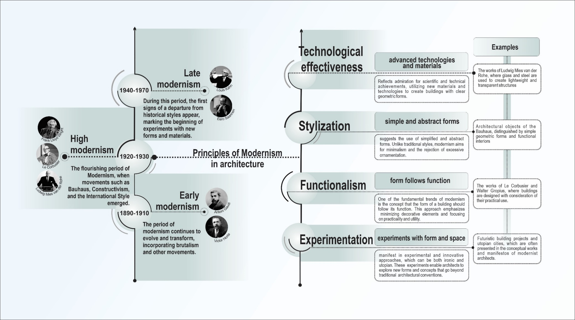
Figure А.1 – Principles of Modernism in Architecture.

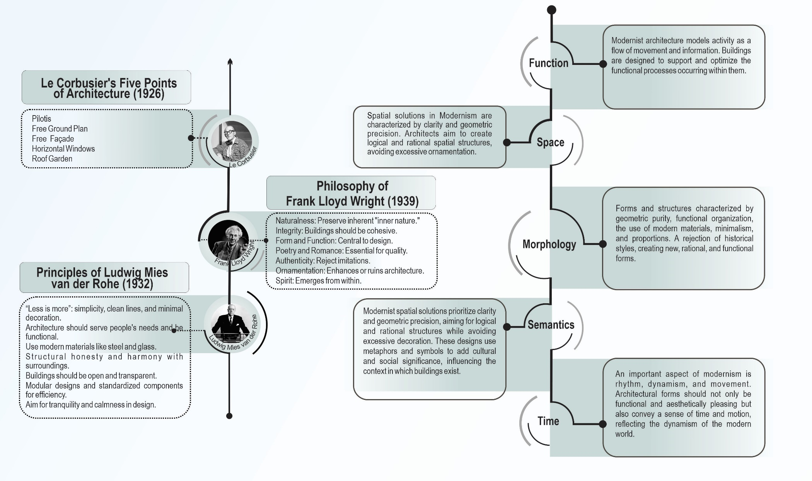
Figure А.2 – Form-generating elements of Modernism.
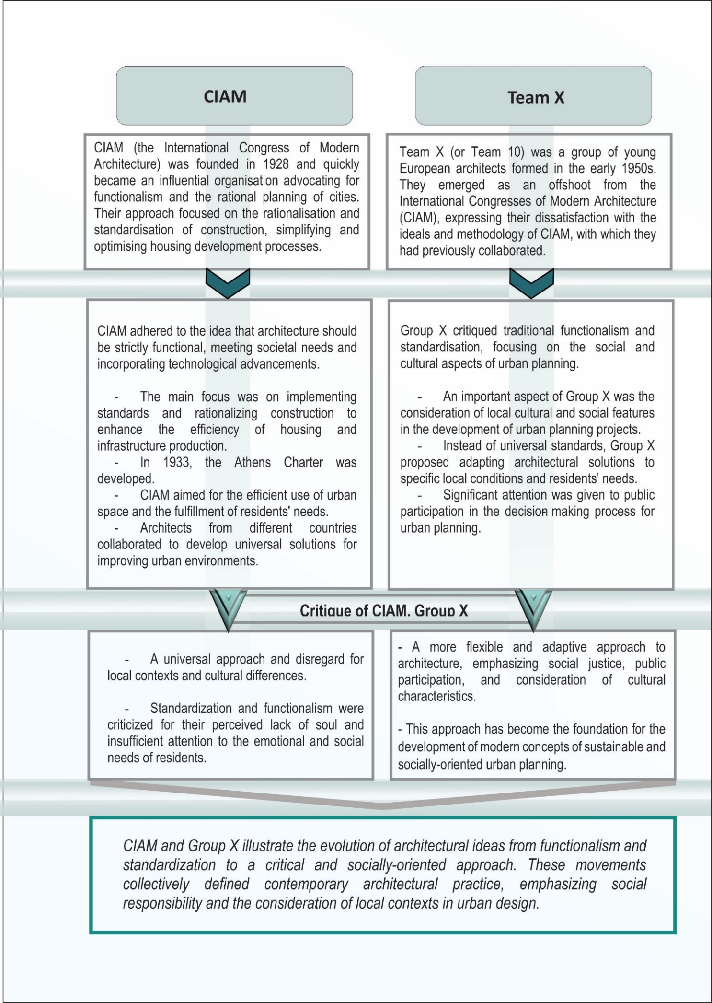
Figure А.3 - Analysis of the activities of CIAM and Team X
(according to K. Frampton).

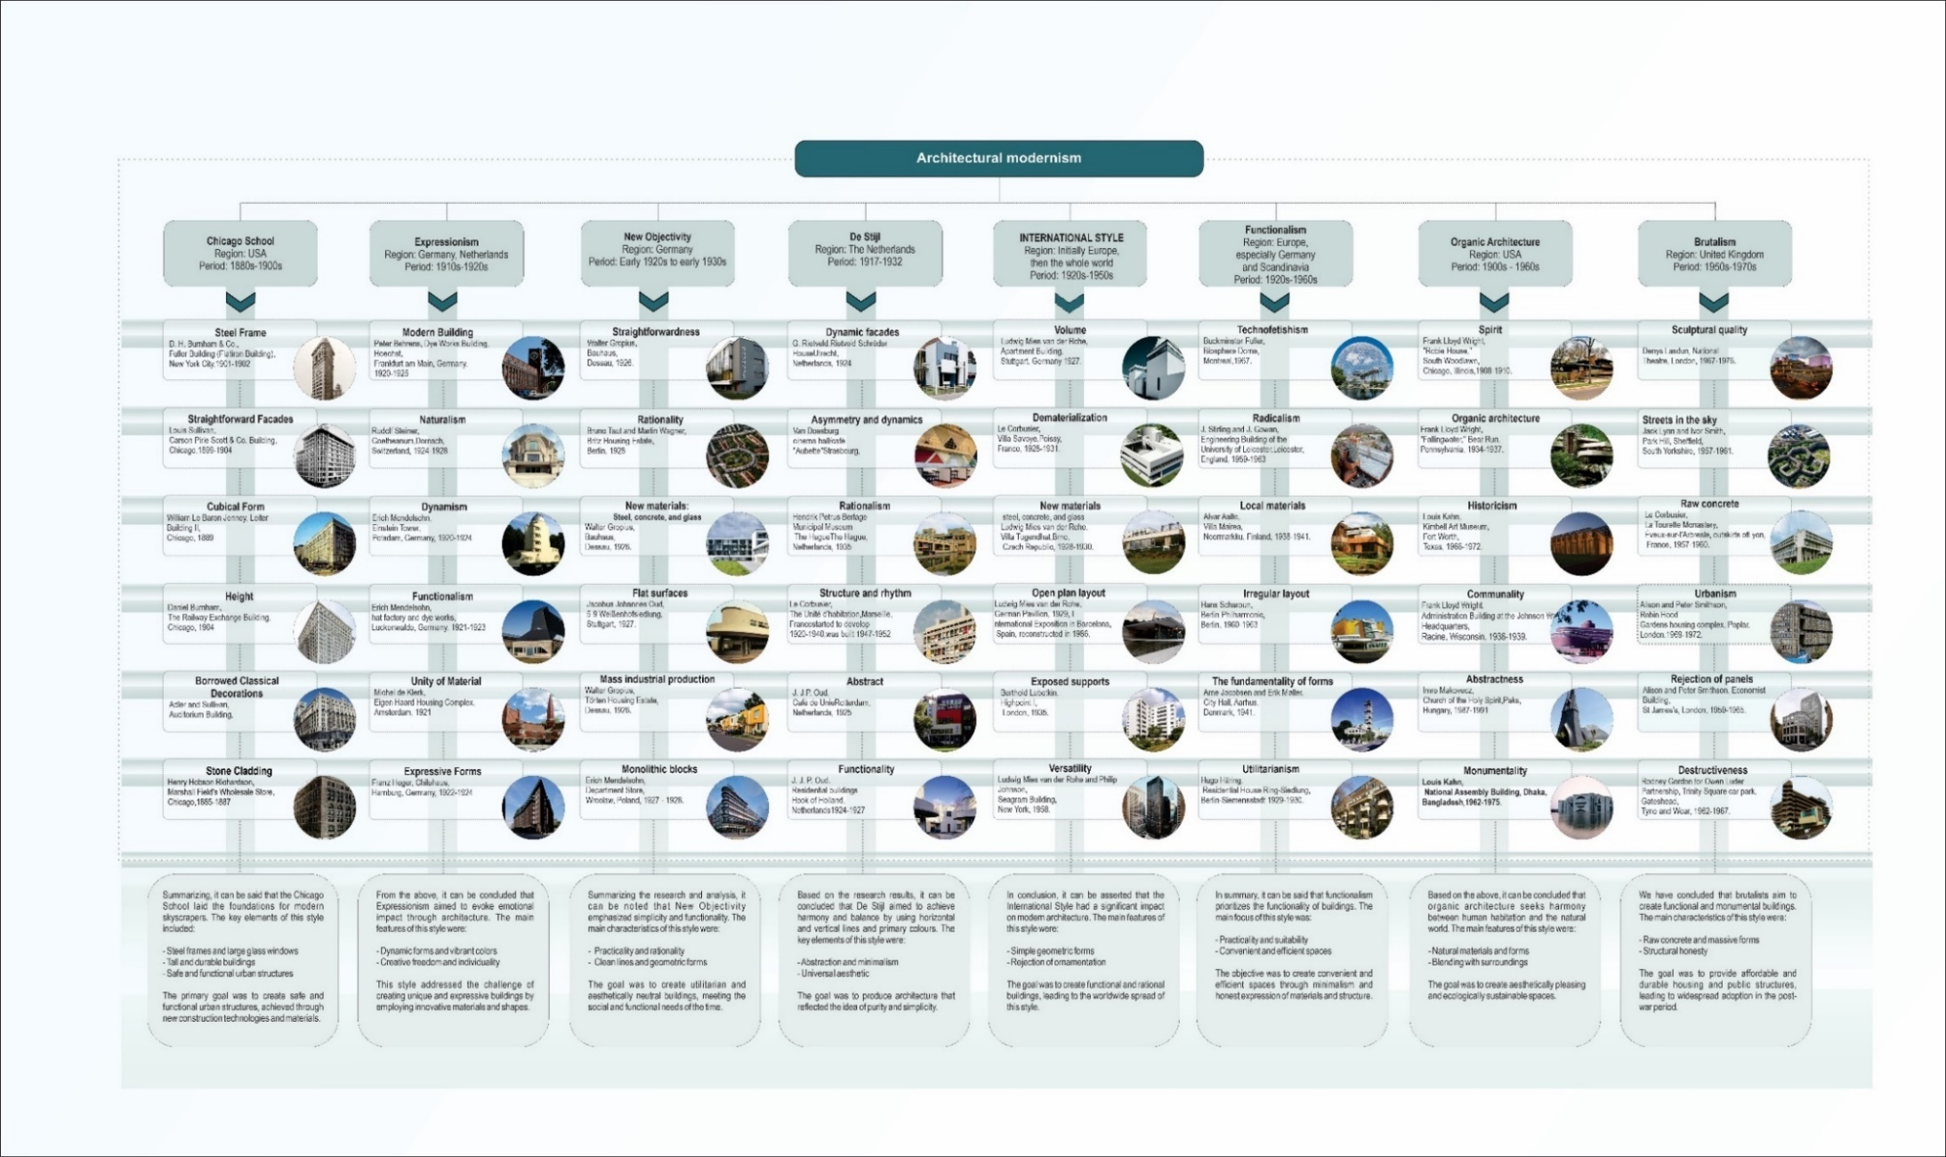
Figure А.4 – Analysis of Architectural Modernism.

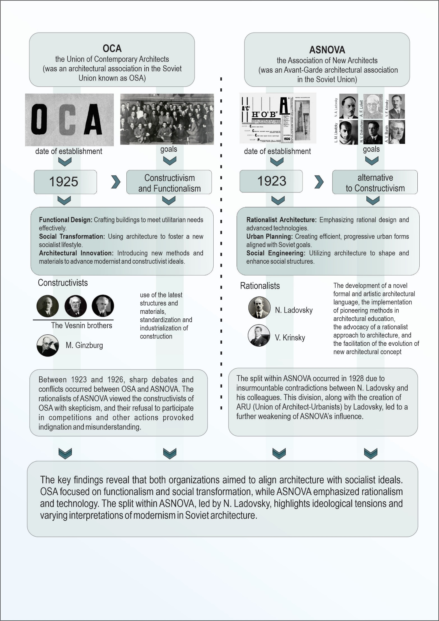
Figure А.5 – Ideologies of OSA and ASNOVA.

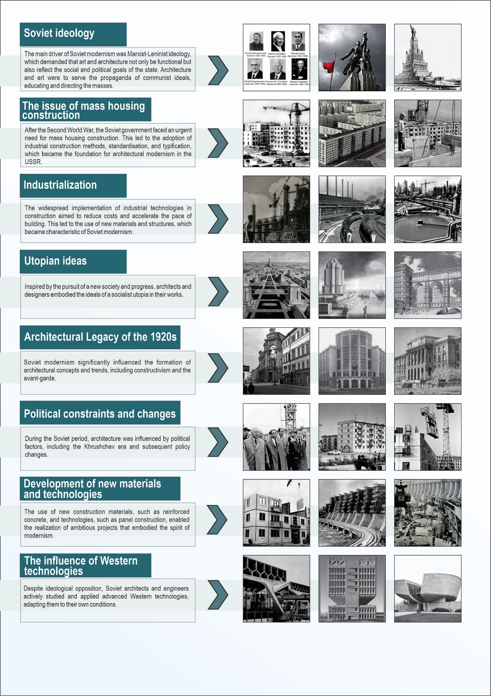Figure А.6 – Factors Shaping Soviet Architecture.

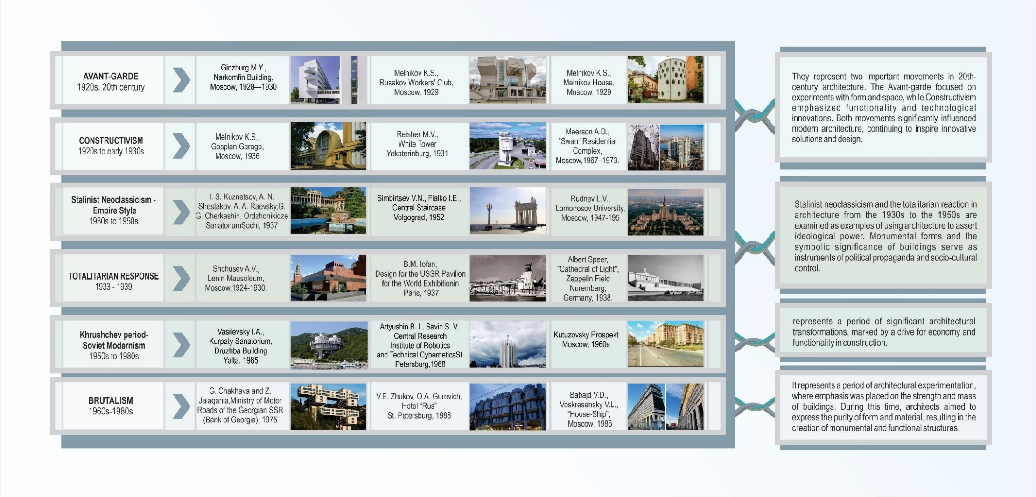
Figure А.7 – Analysis of Soviet Architectural Modernism.

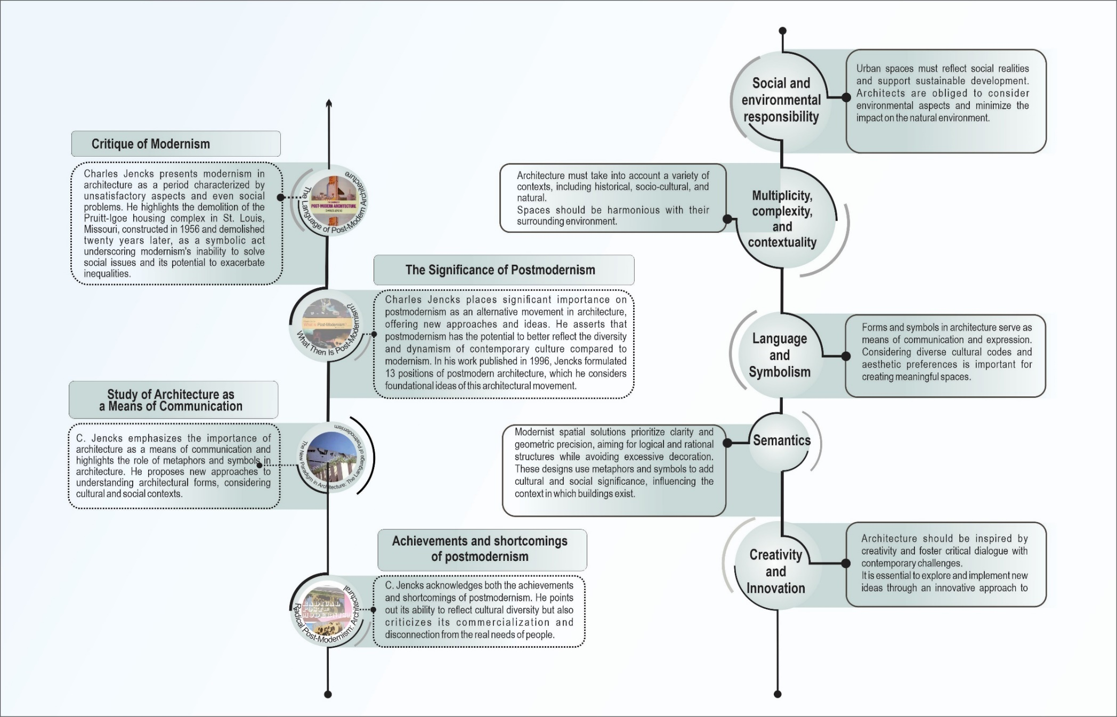
Figure А.8 – A critical analysis of architecture (according to C. Jencks).

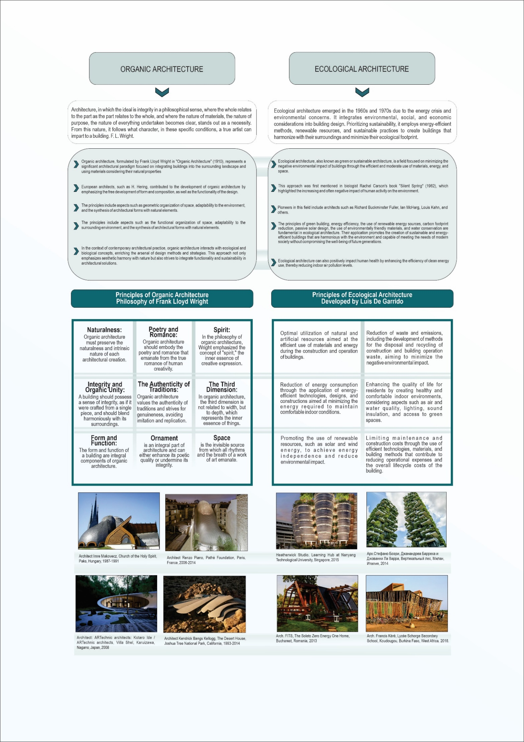
Figure А.9 – Principles of Organic and Ecological Architecture.

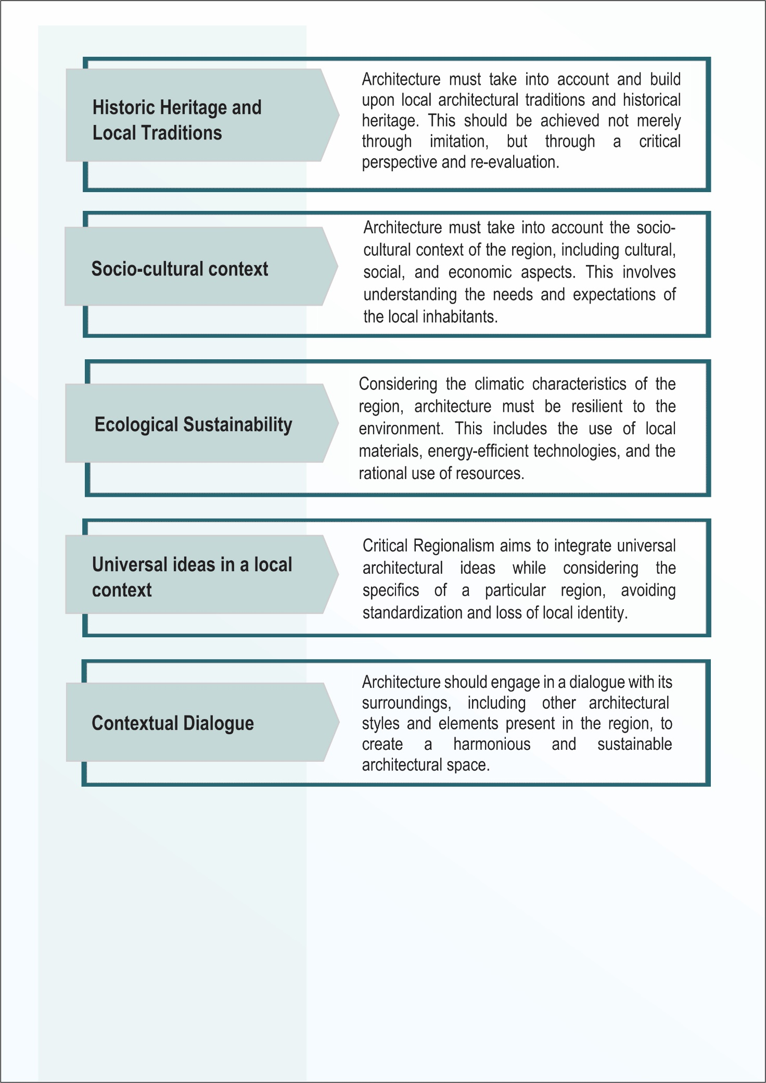
Figure А.10 – The Key Principles of Critical Regionalism (by K. Frampton).

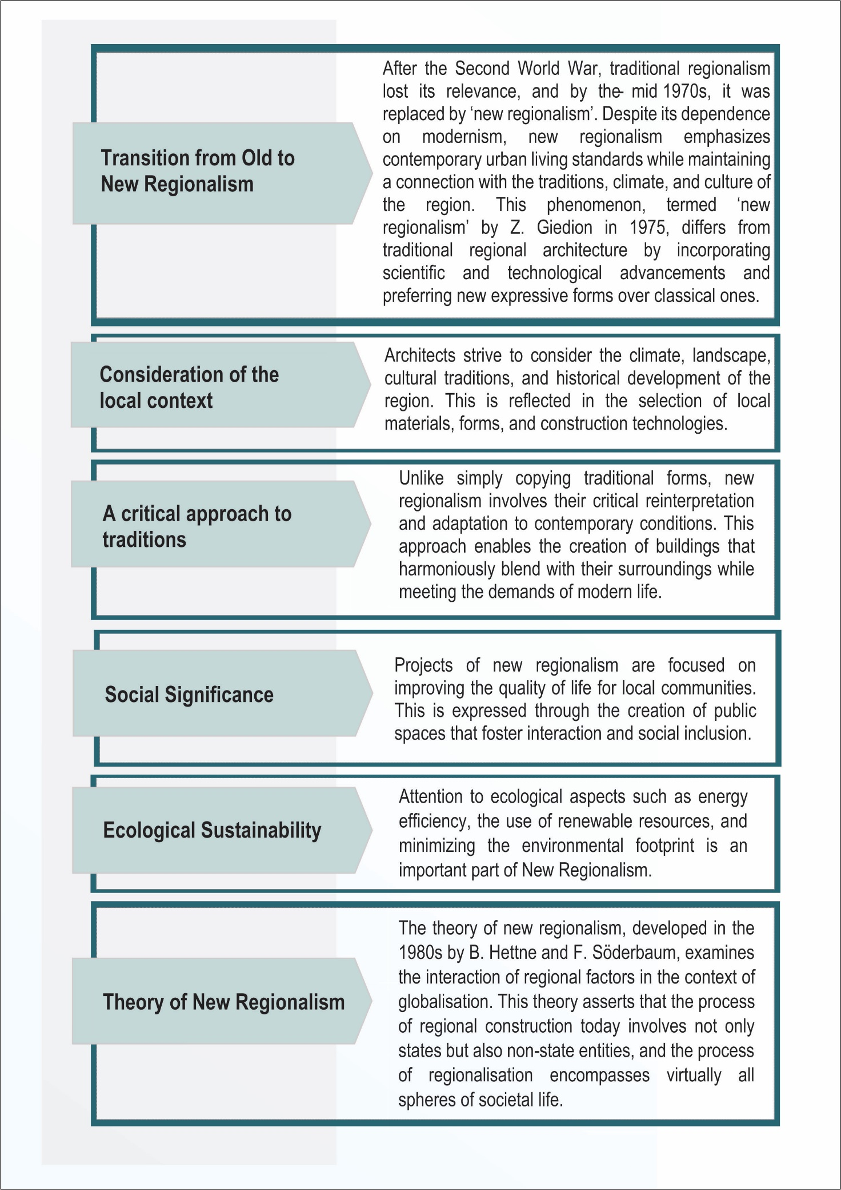
Figure А.11 – Key Principles of New Regionalism (according to K. Frampton).

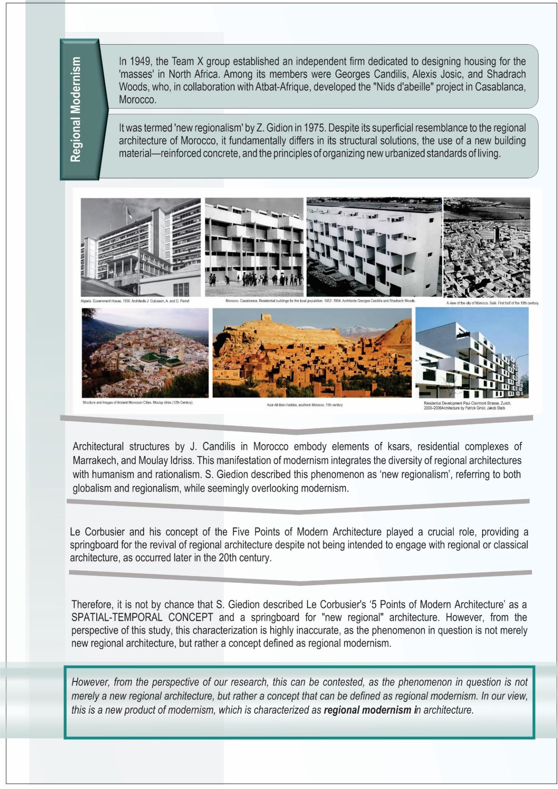
Figure А.12 – Regional Modernism: start of the movement.

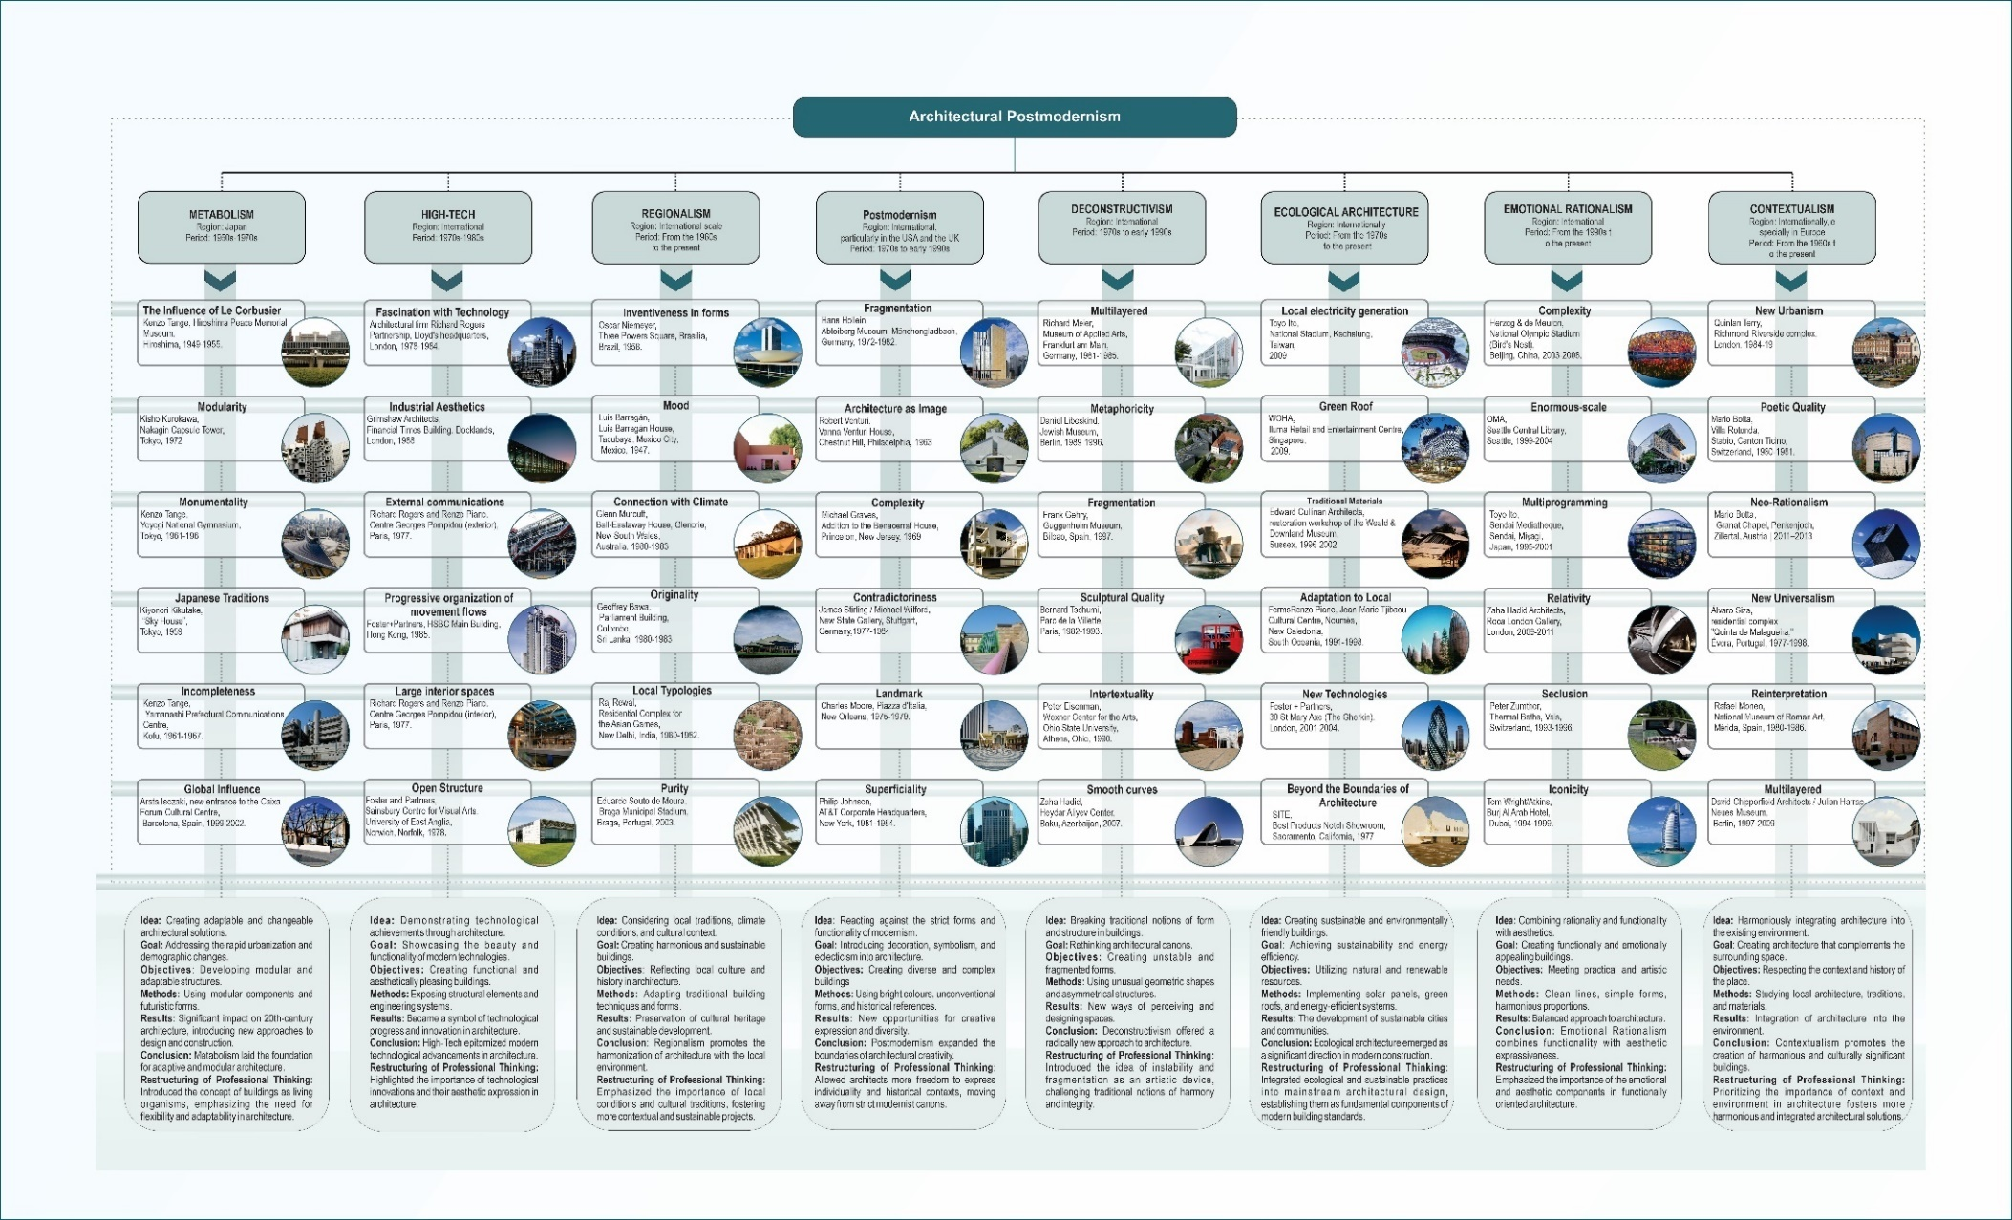
Figure А.13 – Analysis of Architectural Postmodernism.

APPENDIX B
Graphic part of the first chapter of the thesis
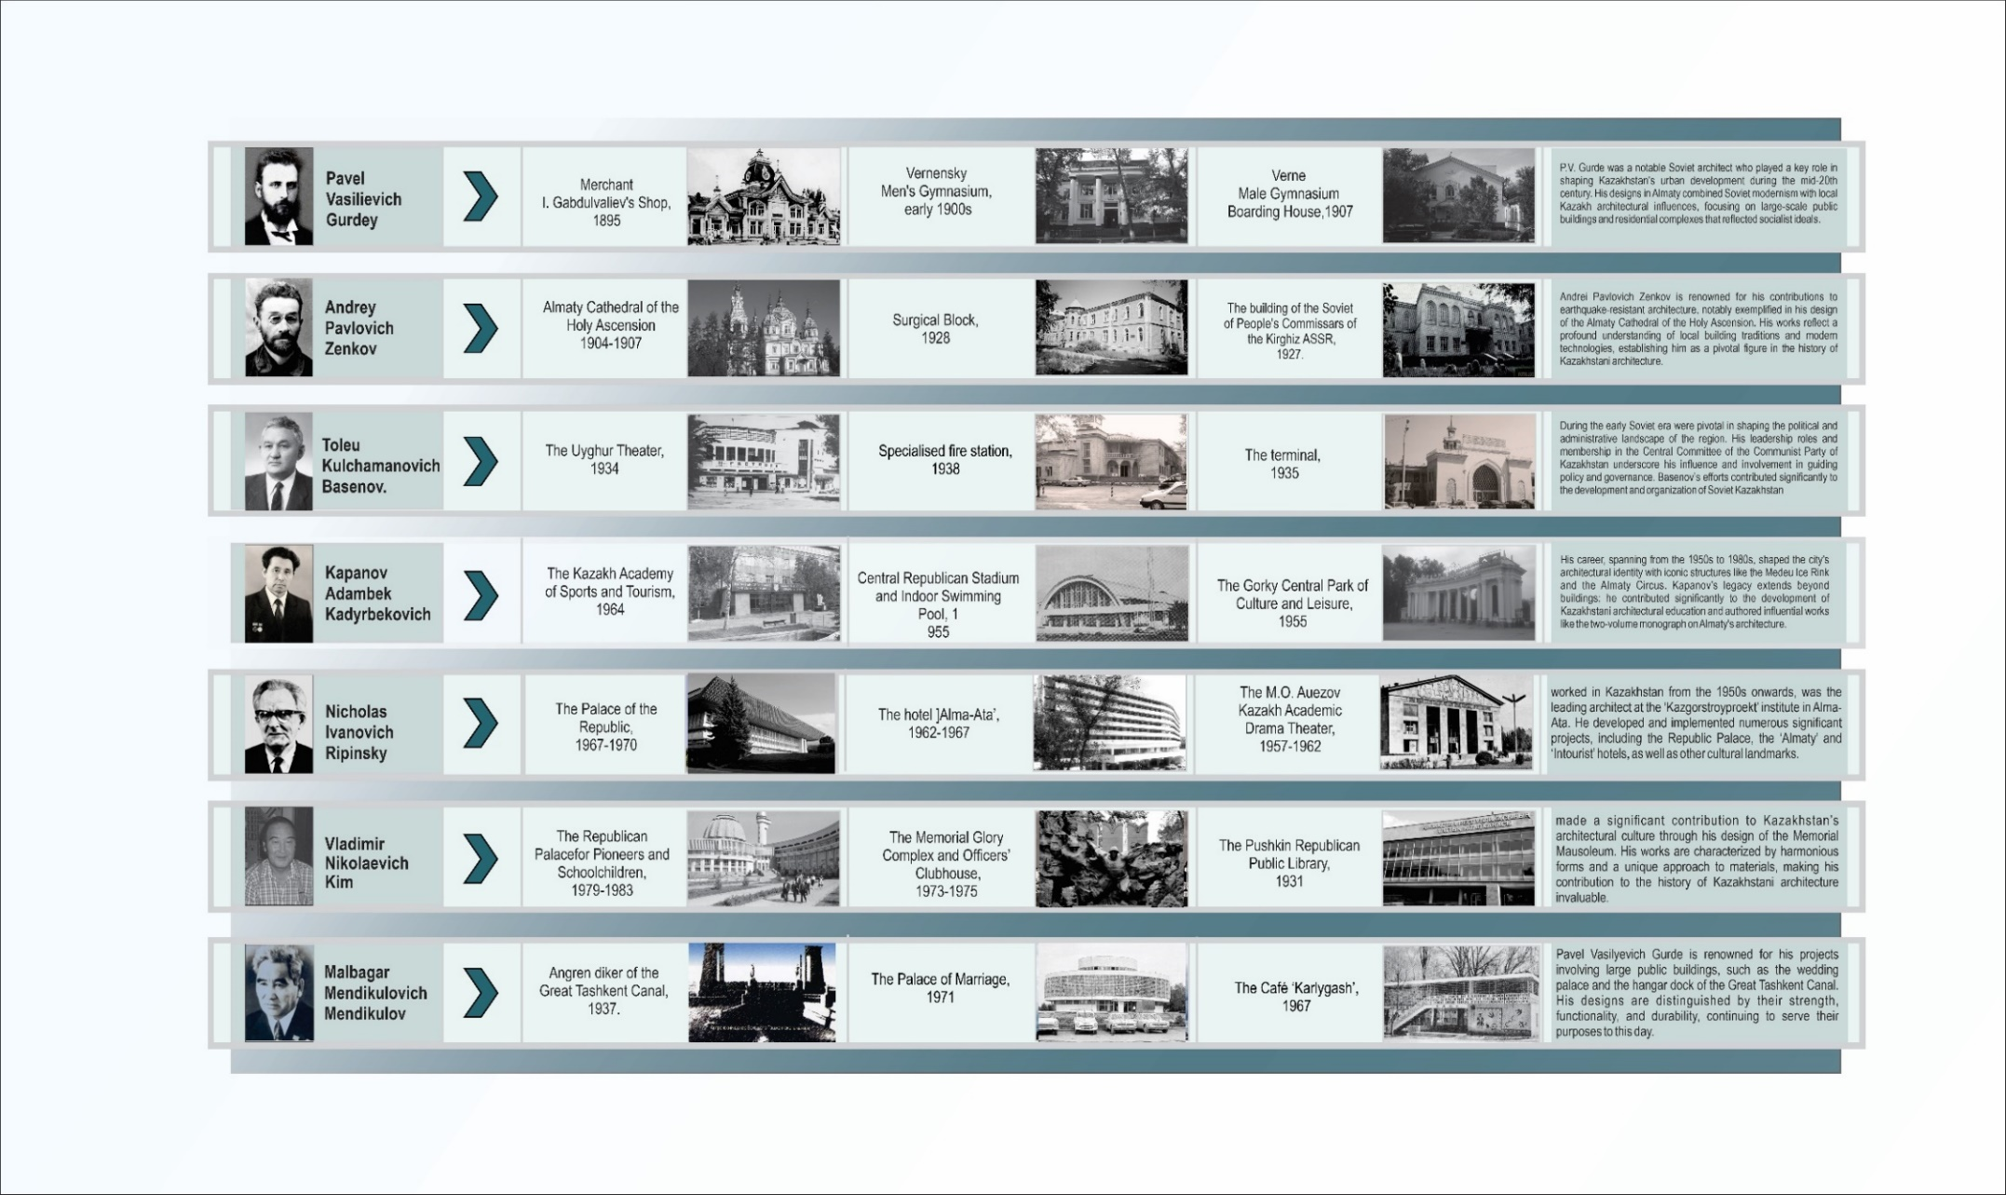
Figure B. 1 – Architecture of Kazakhstan in the first half of the 20th century.

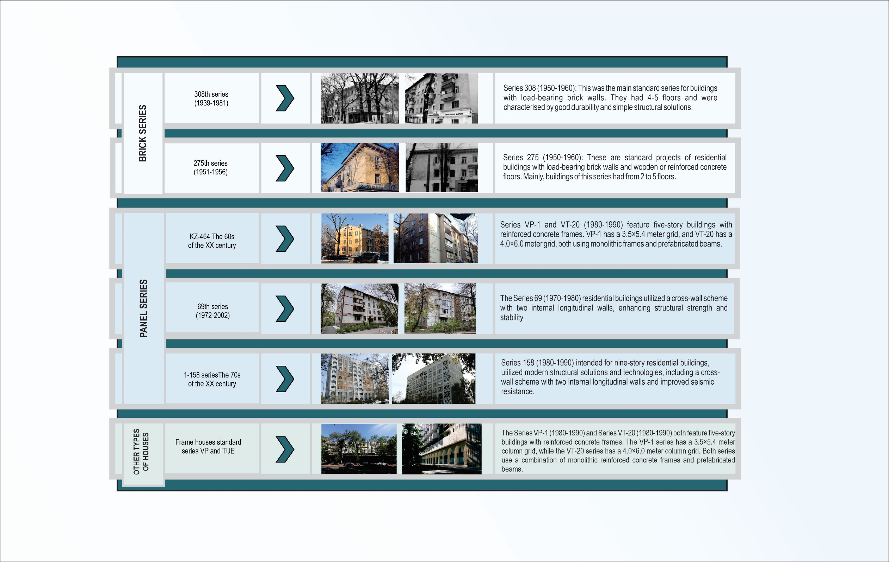
Figure B.2 – Typical residential houses in Almaty.

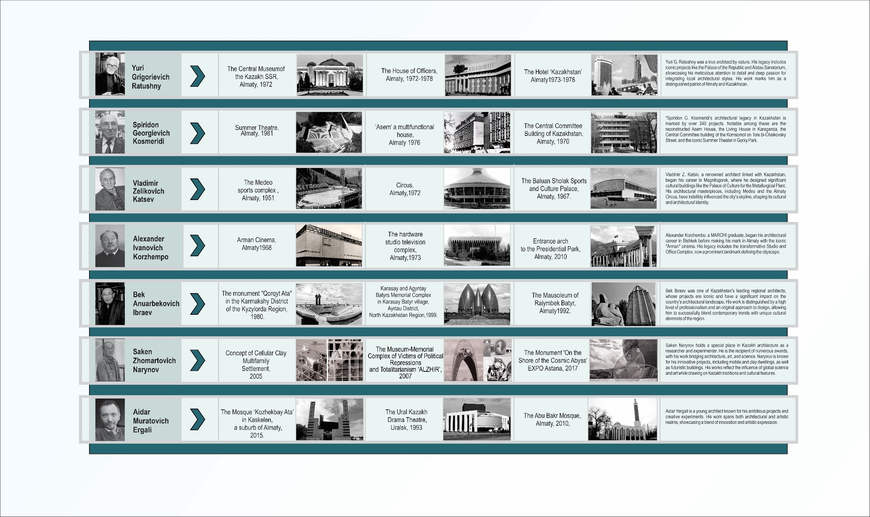
Figure B. 3 – Architecture of Kazakhstan at the end of the 20th century.

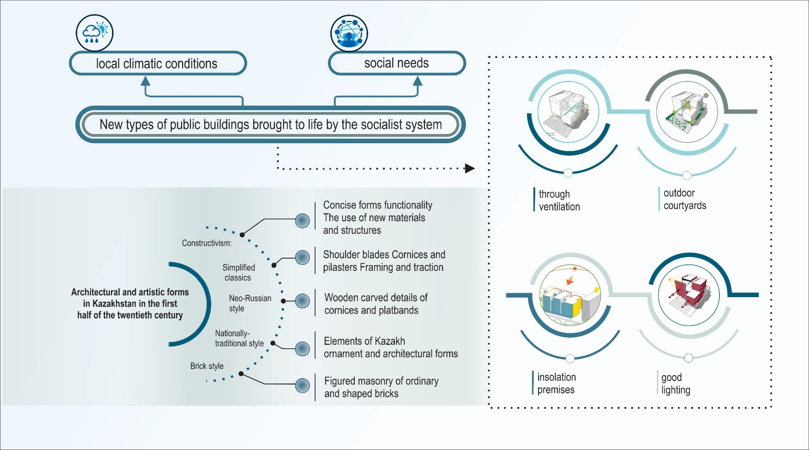
Figure B.4 – Architectural and artistic forms in Kazakhstan in the first
half of the twentieth century (according to K.Samoilov).

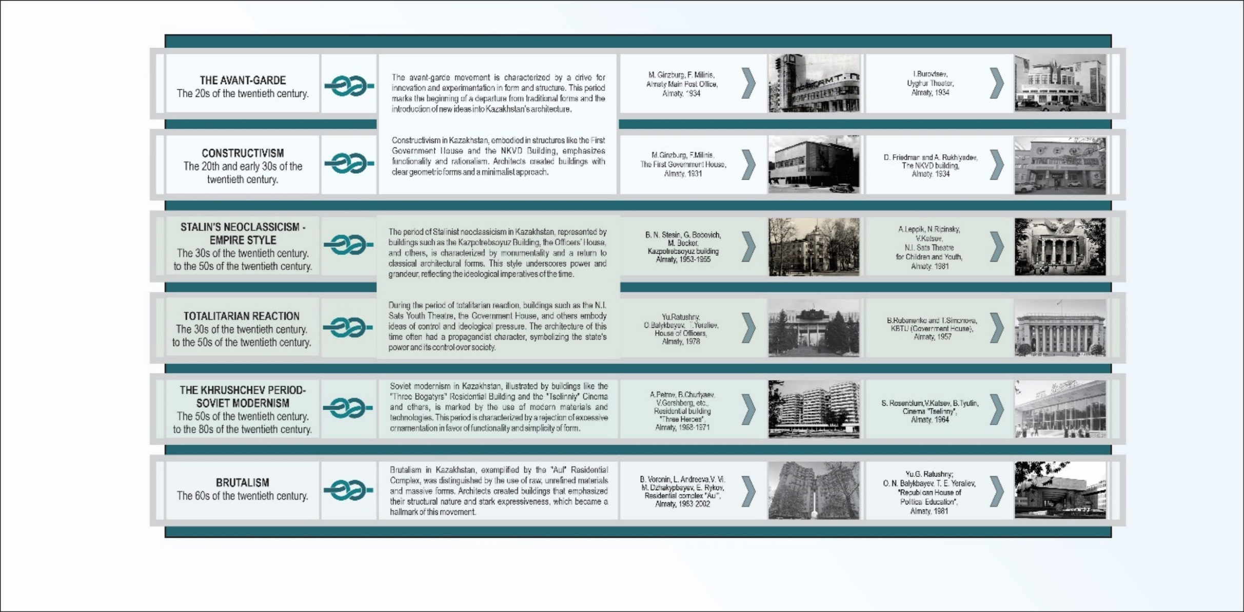
Figure B.5 – Soviet Modernism in the Architecture of Kazakhstan.

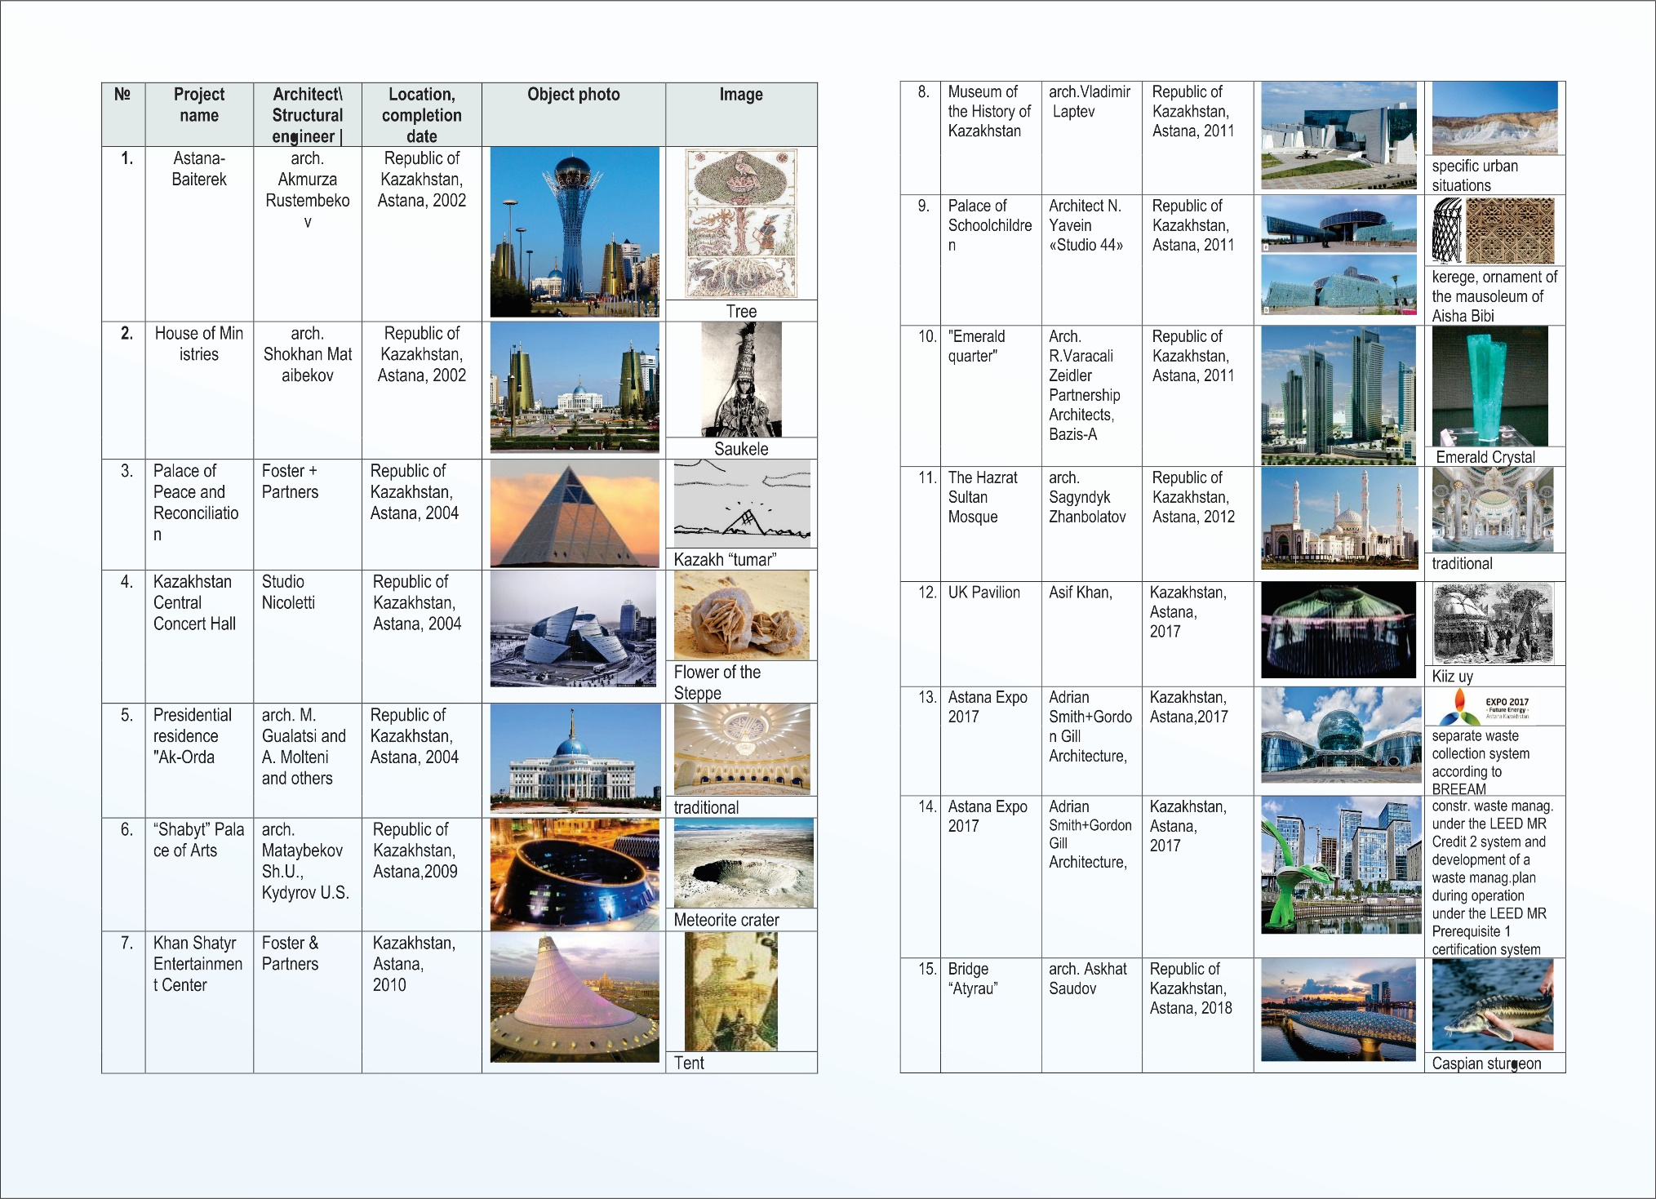
Figure B.6 – The architecture of Astana and its imagery.
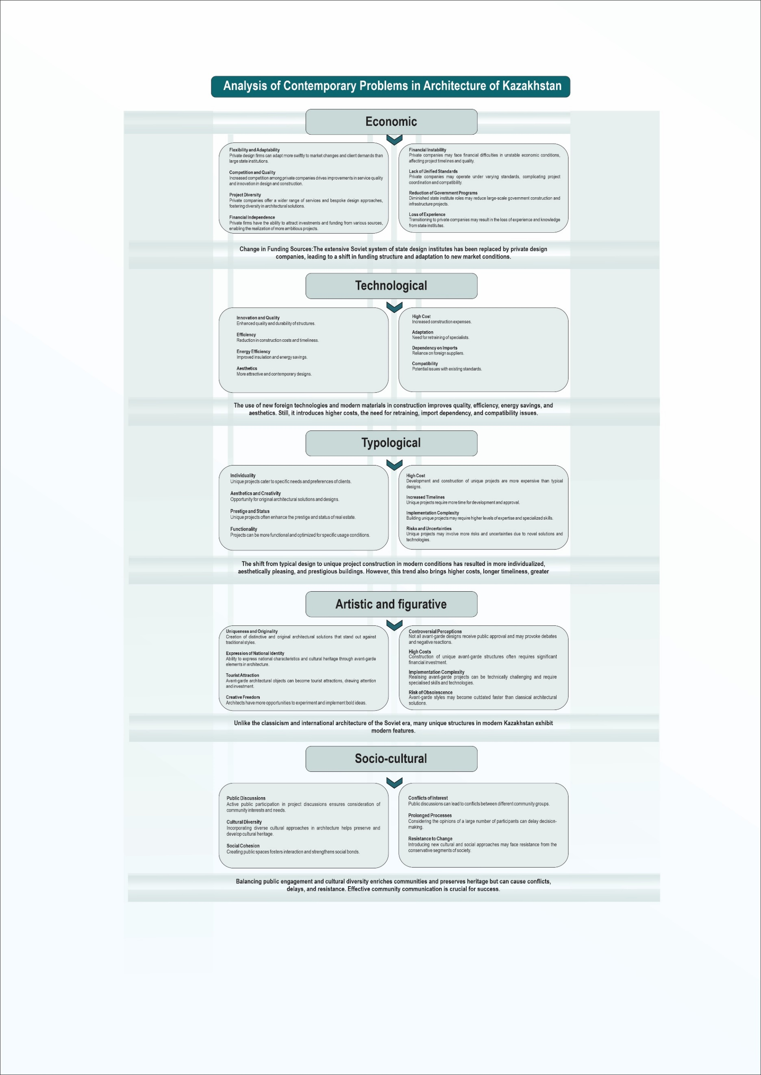
Figure B.7 – Factors Transforming Kazakh Architecture in the Late 20th Century

APPENDIX C
Graphic part of the first chapter of the thesis
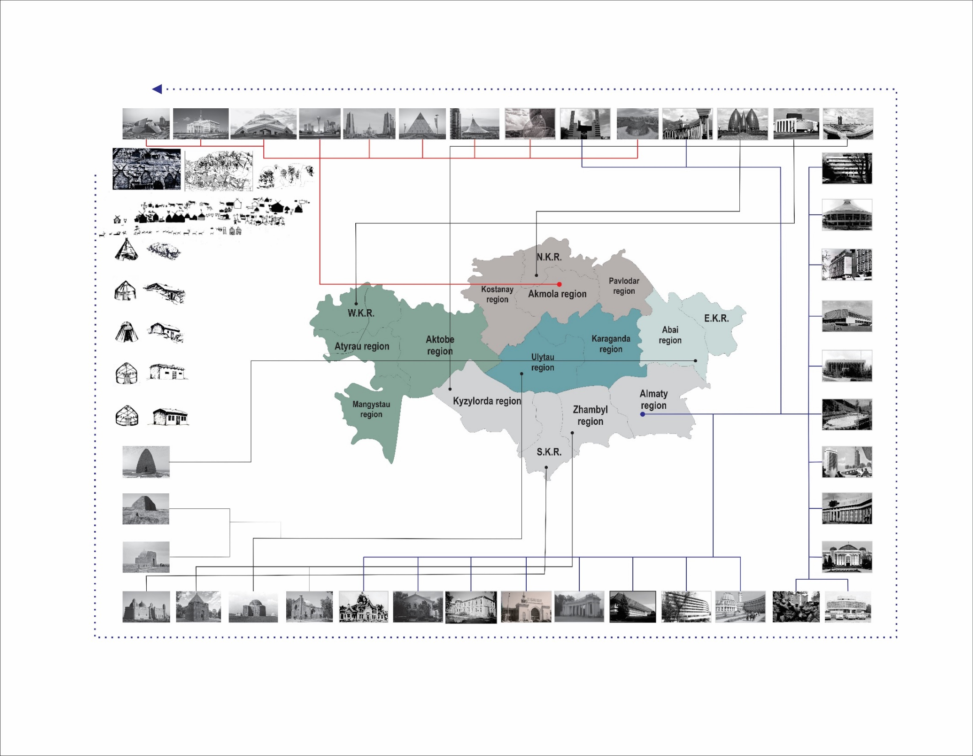
Figure C.1–Kazakhstan’s Architecture: Past and Present

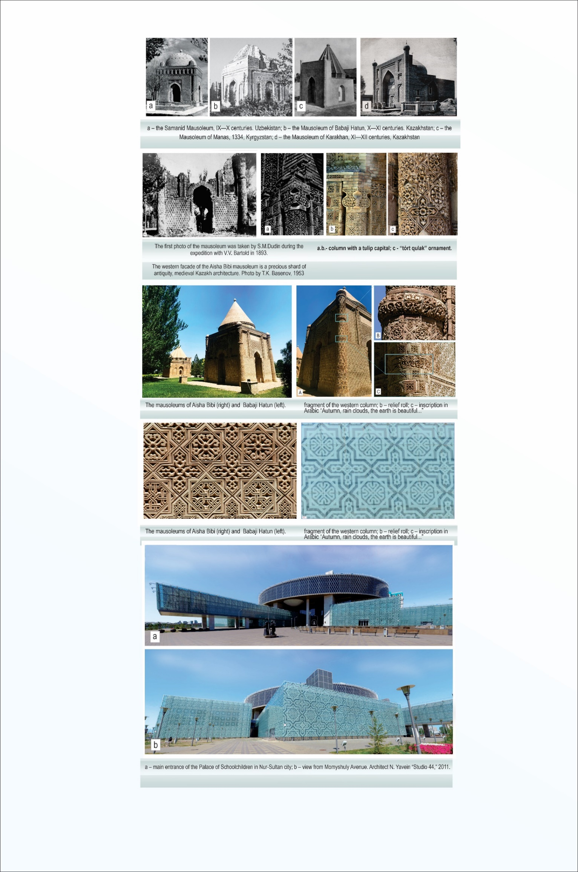
Figure C.2 – Traditions and innovations in the architecture of Kazakhstan.

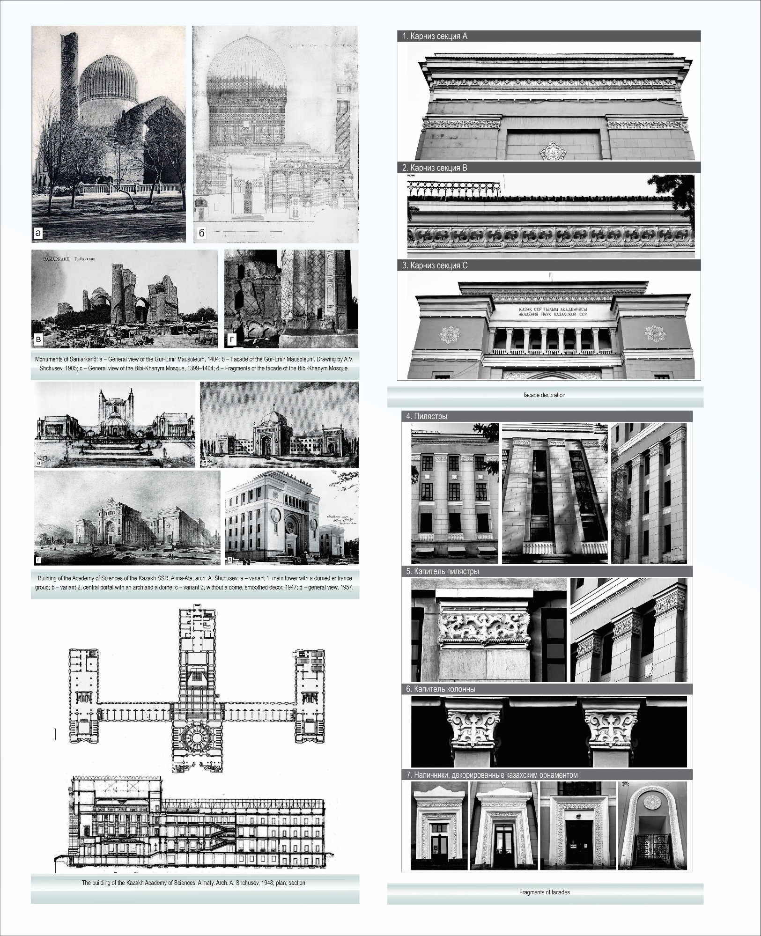
Figure C.3 – The building of the Kazakh Academy of Sciences. Almaty. Arch. A. Shchusev, 1948;

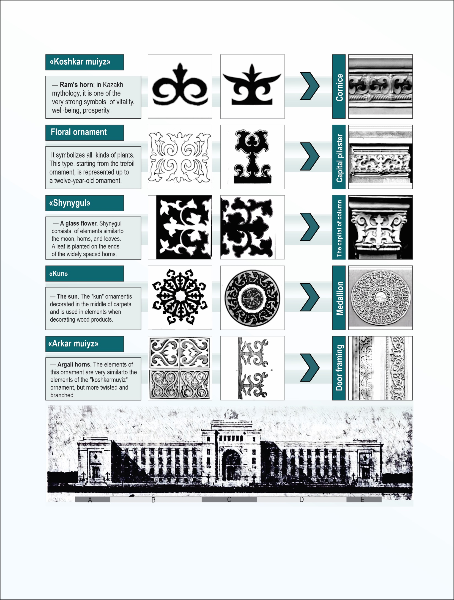

Figure C.4 – Studies of National Ornamentation in the Architecture of Kazakhstan Using the Example of the Academy of Sciences of the Kazakh SS.

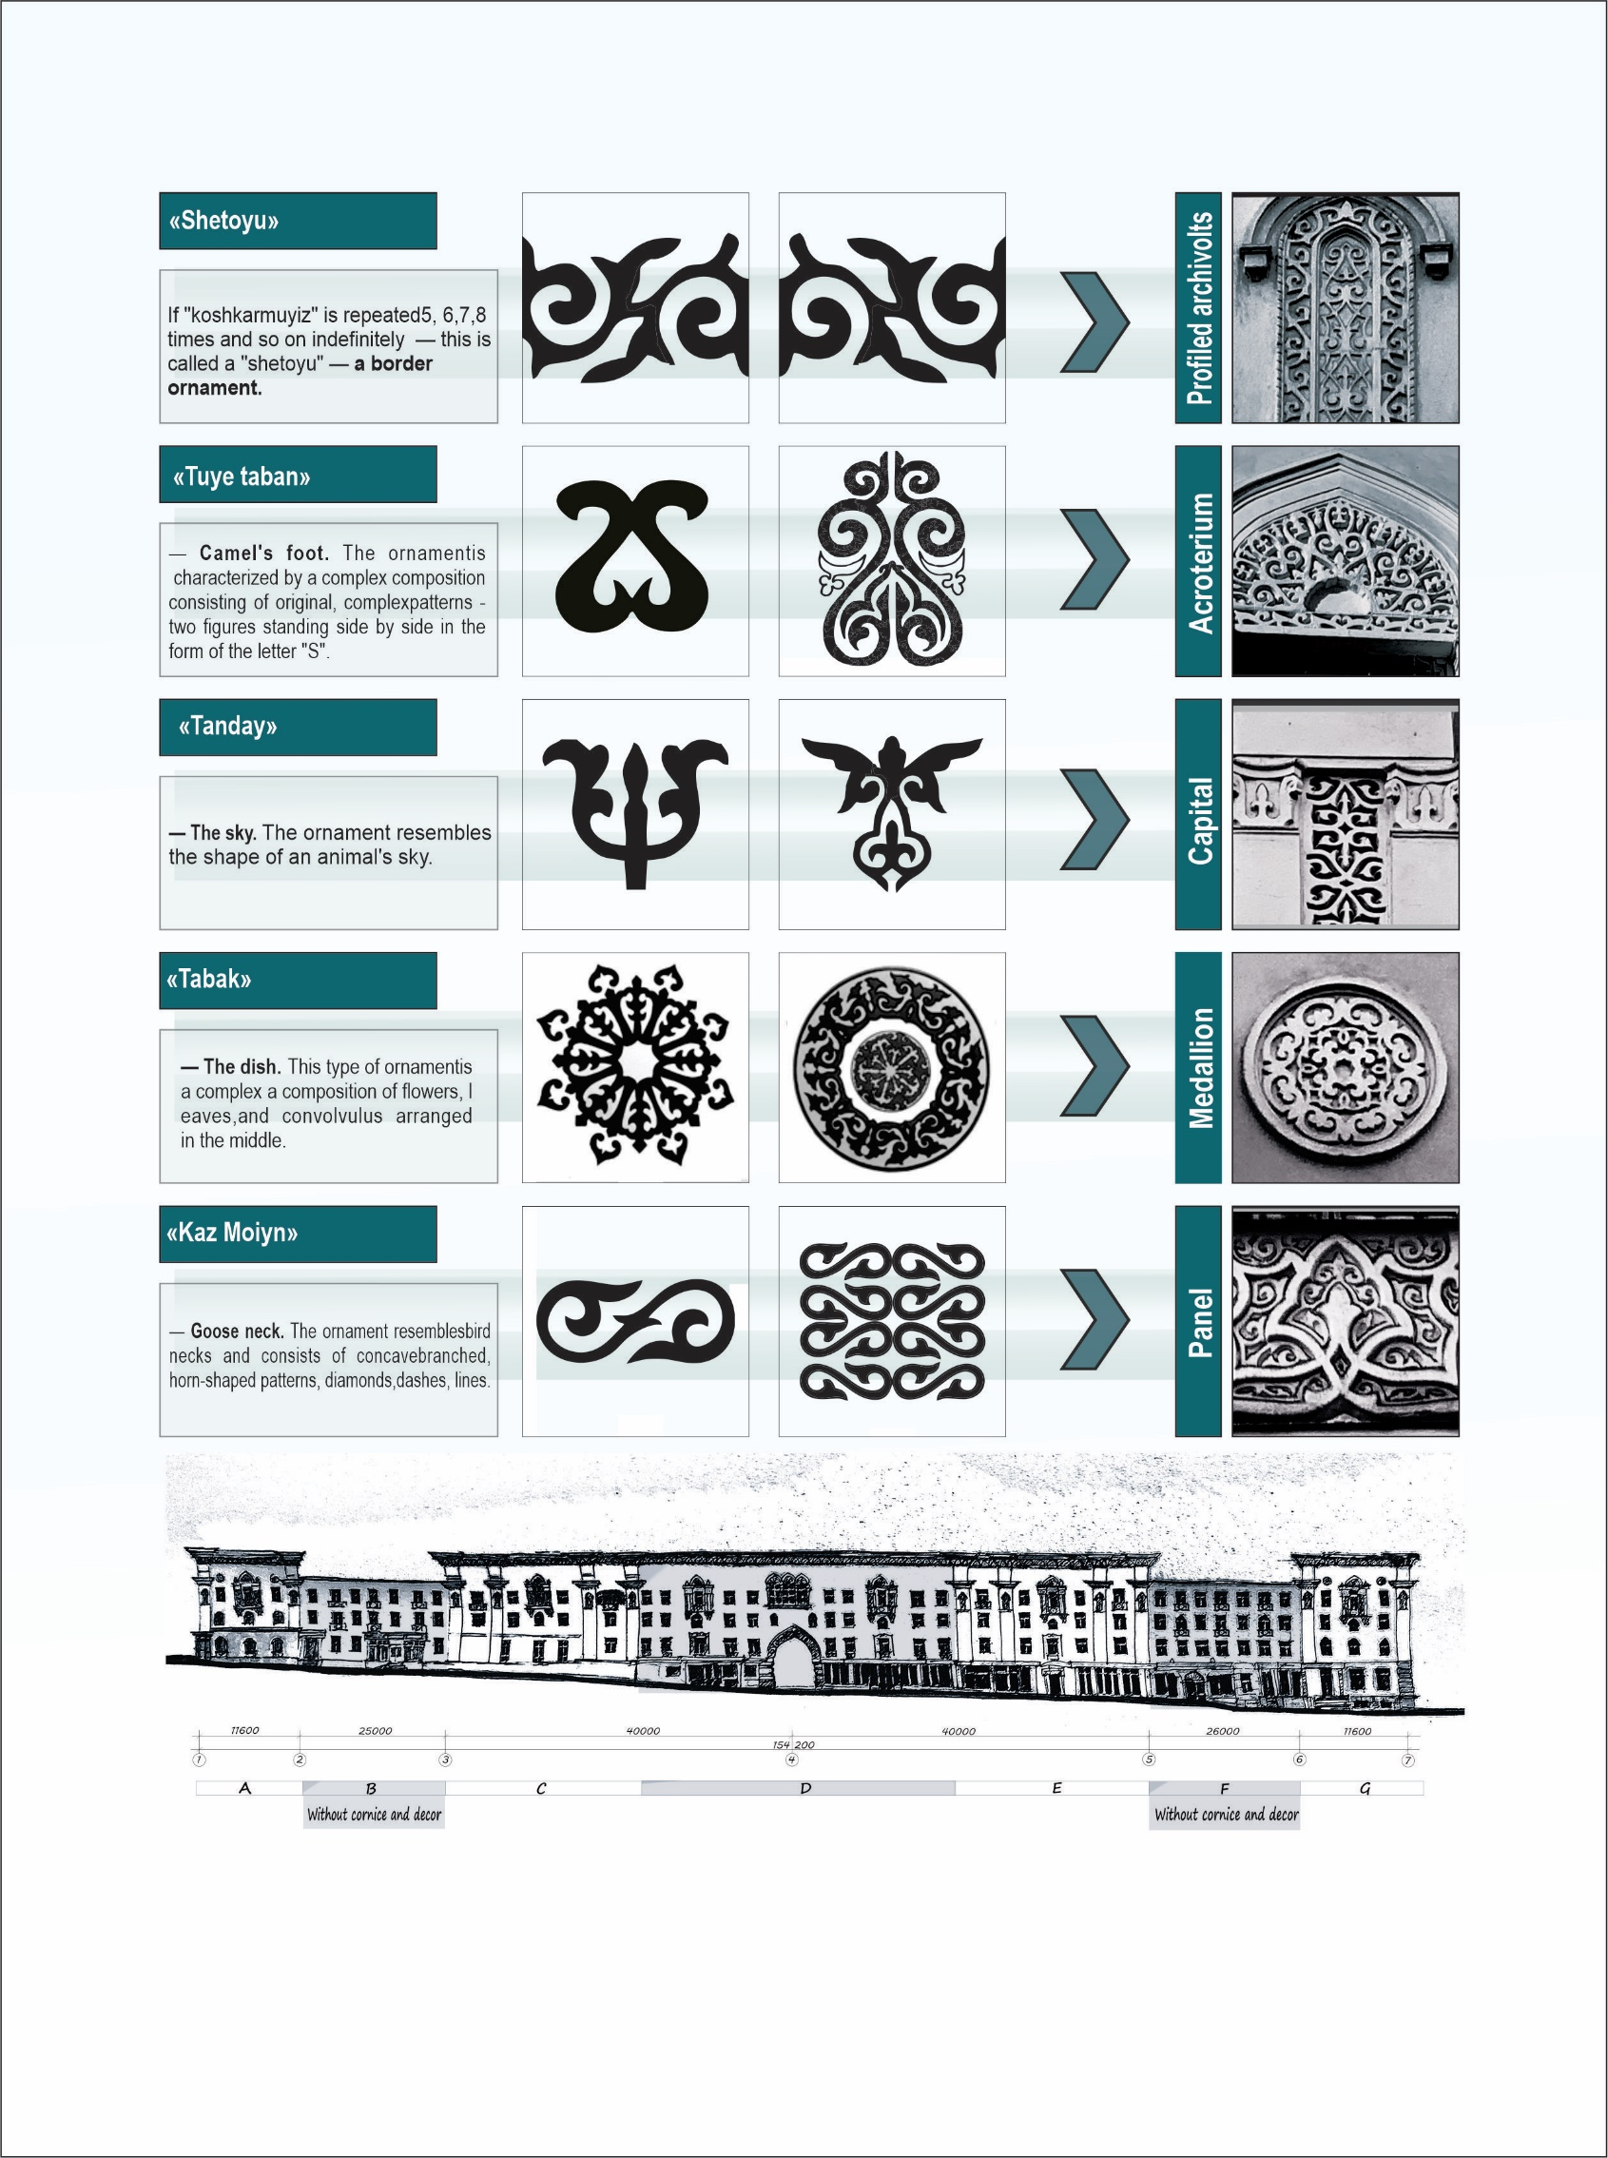
Figure C.5 – Research on National Ornamentation in the Architecture of Kazakhstan: The Example of the “Residential Building for Central Committee Workers”.

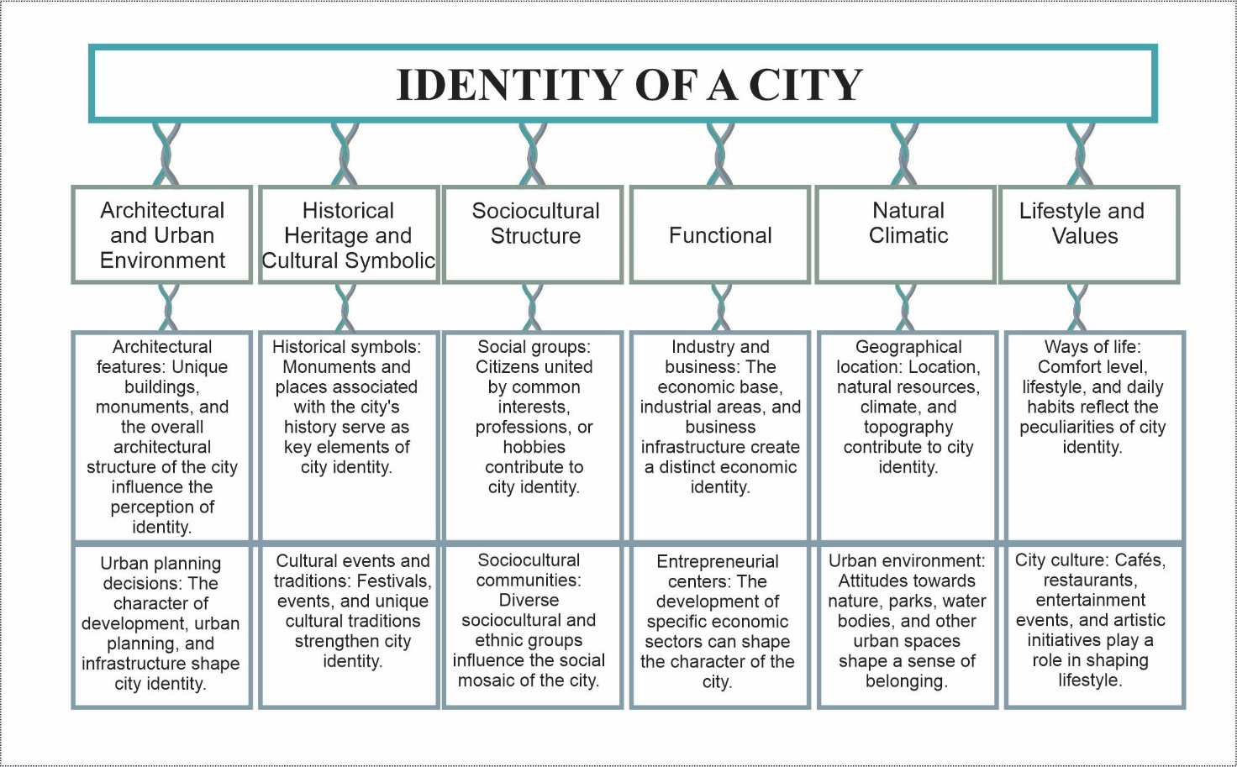

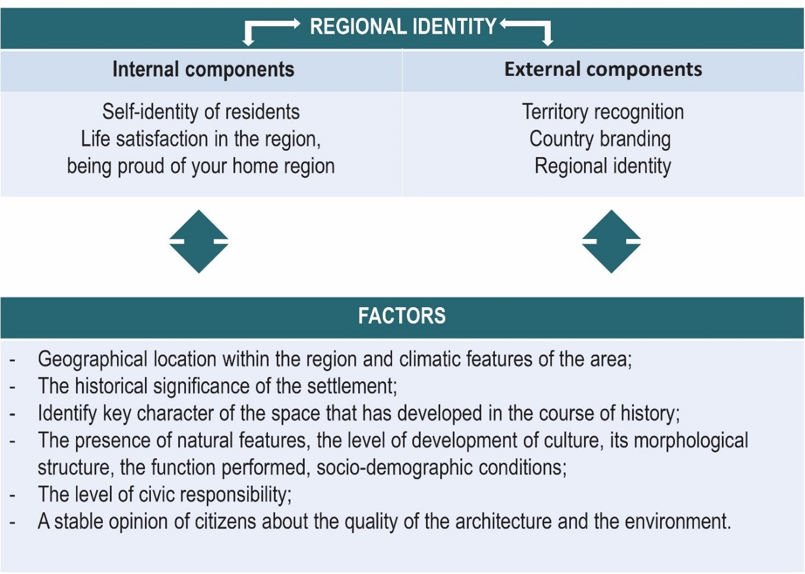
Figure C.6 – Identity of a city and Regional identity.

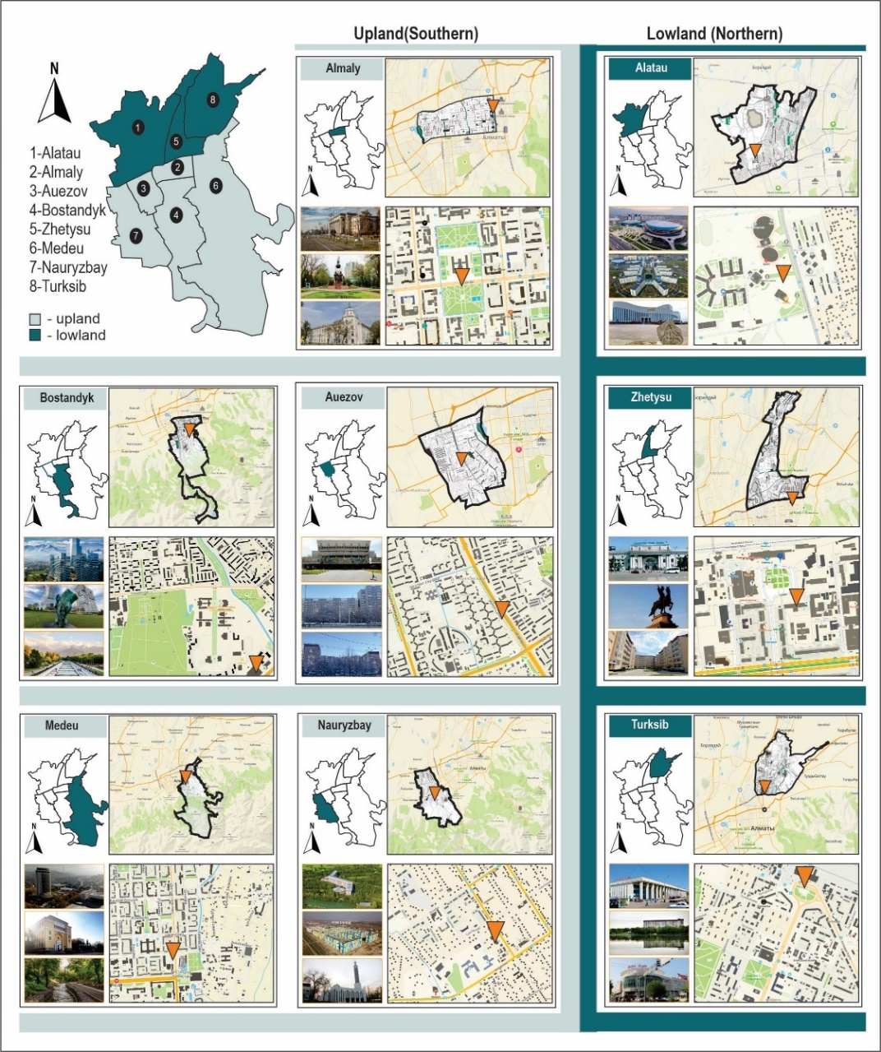
Figure C.7 – Analysis of the City of Almaty.
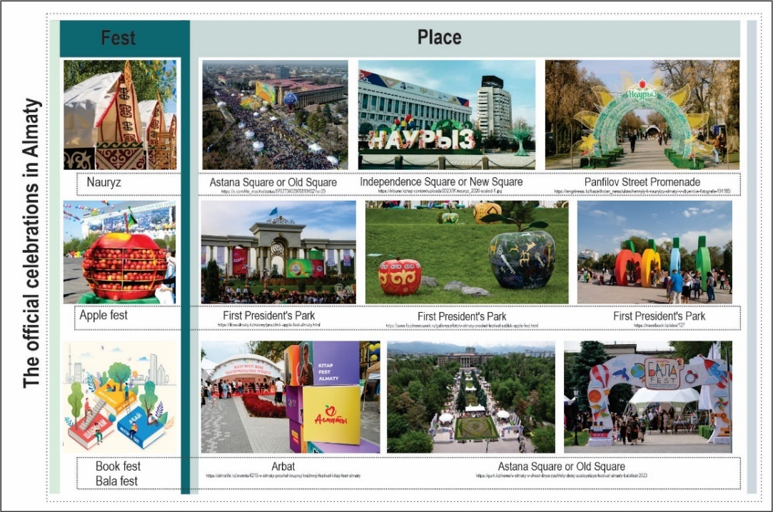
Figure C.8 – The visual signs of local traditions.
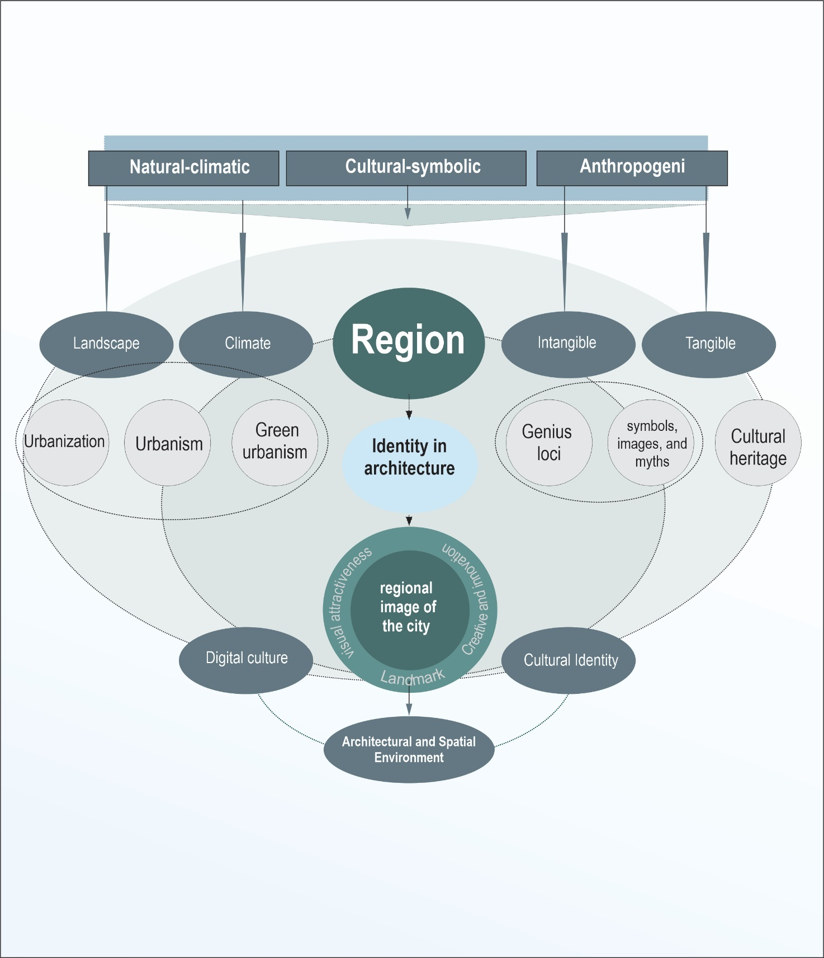
Figure C.9 – Architecture and urban identity.

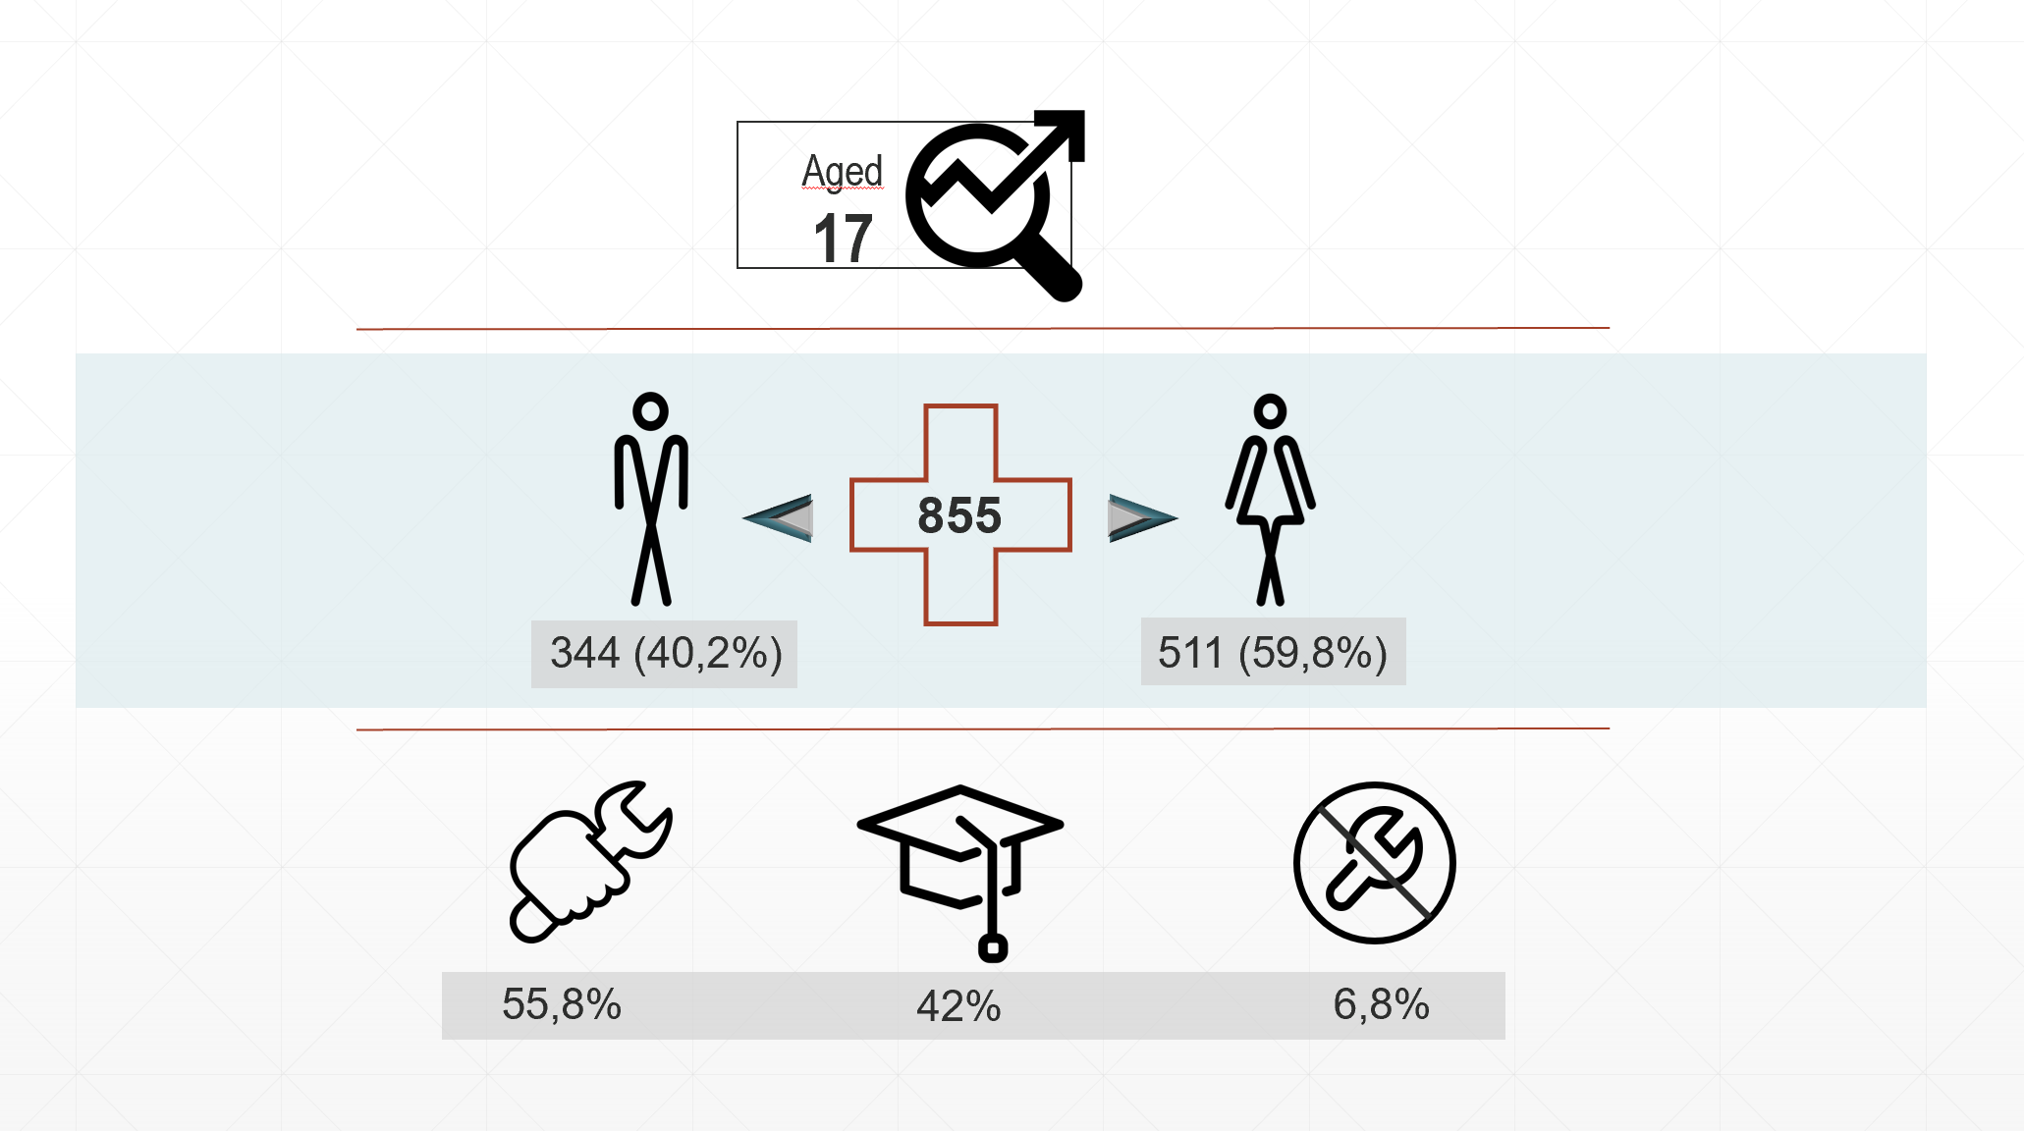

variants | answers | fraction
The megapolis city of republican significance(population over 1 million people) | 676 | 79 %
Large city of regional significance(population from 250 thousand to 1 million people) | 73 | 8.5%
Small city of regional significance(population from 100 thousand to 250 thousand people) | 41 | 4.8%
Big town of areal significance(population from 50 thousand to 100 thousand people) | 29 | 3.4%
Small town of areal significance(population from 10 thousand to 50 thousand people) | 27 | 3.2%
Rural settlement | 27 | 3.2%
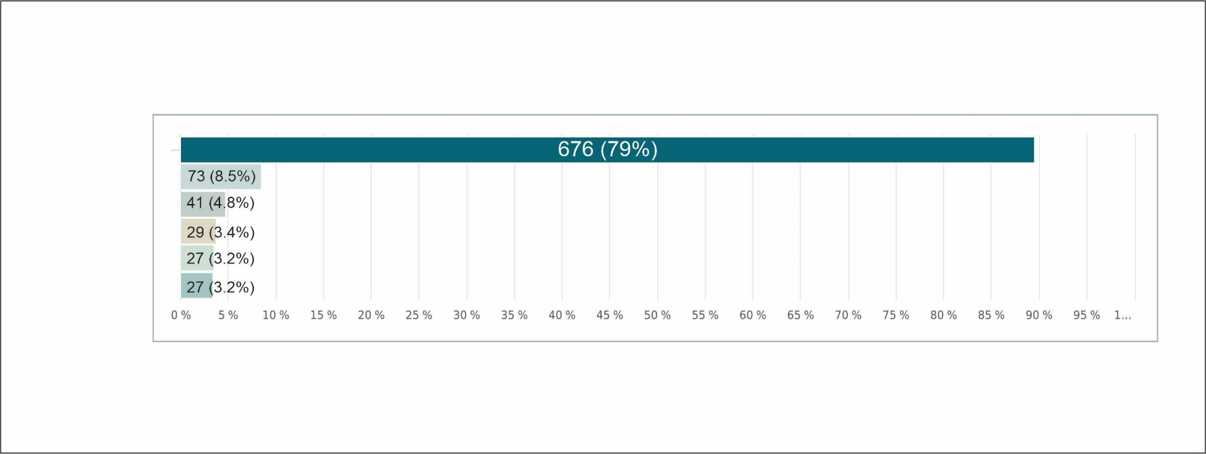
Figure C.10– Data from Sociological Survey

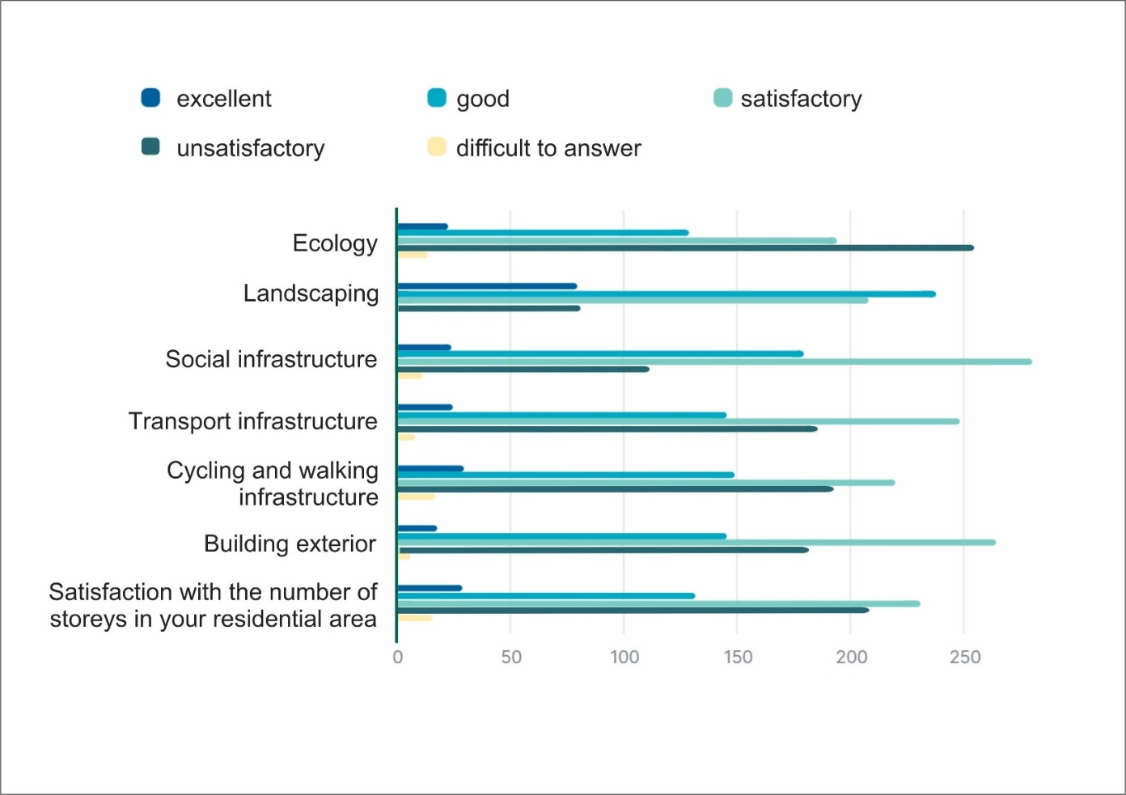
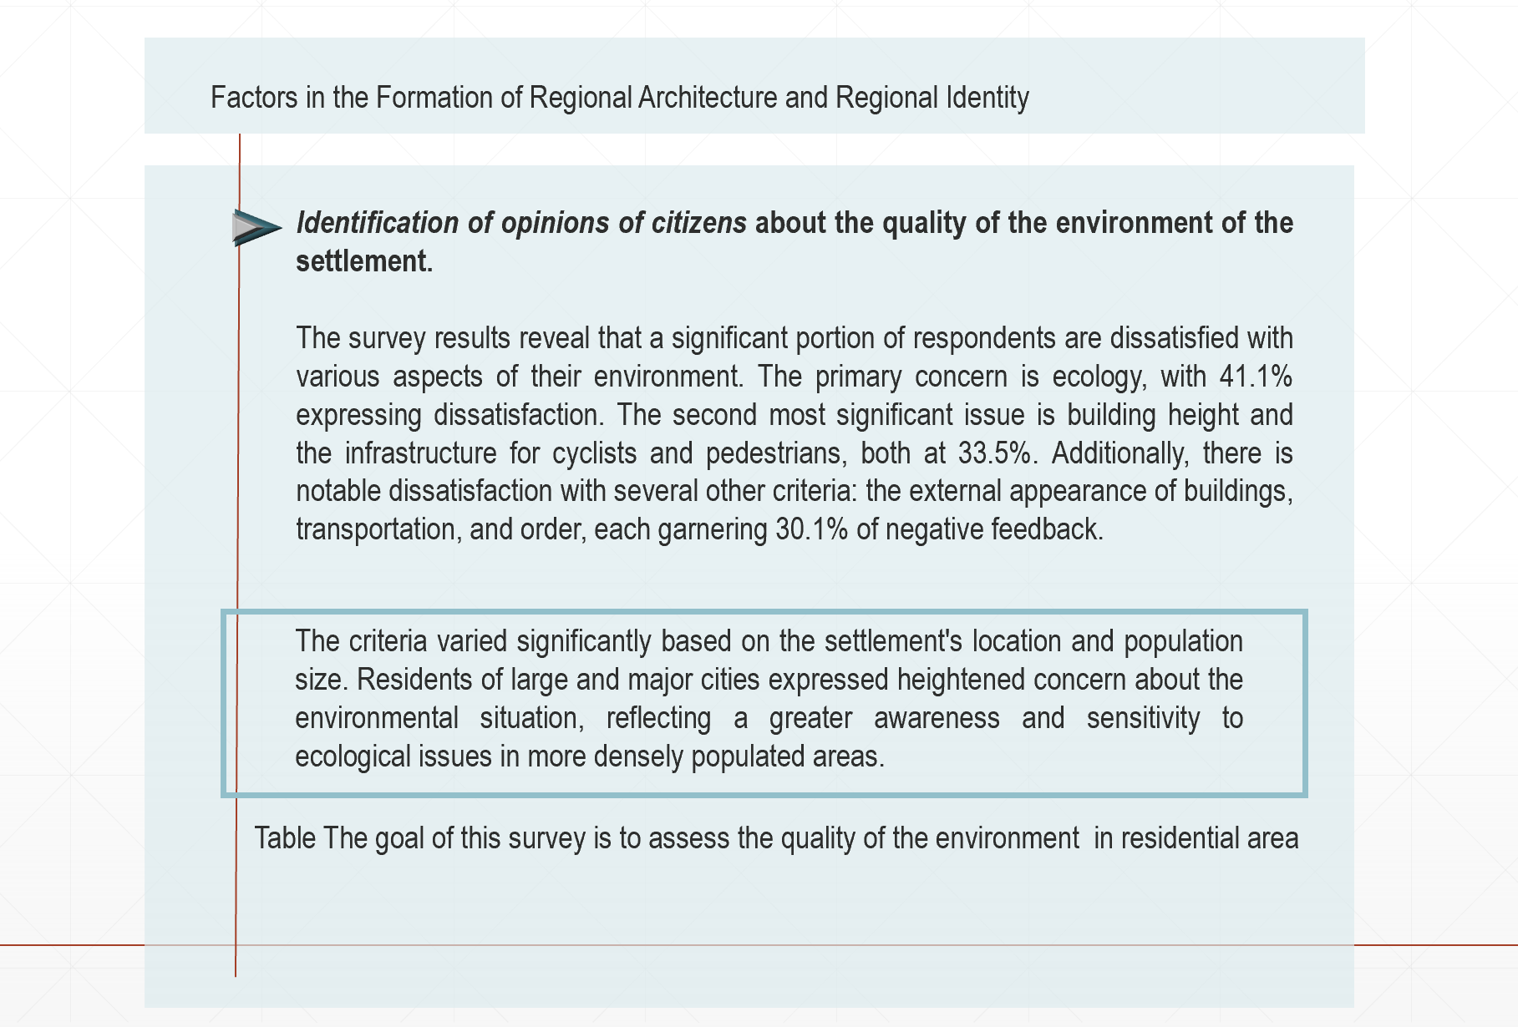
Figure C.11 – Data from Sociological Survey.
Identification of opinions of citizens about the quality of the environment of the settlement.

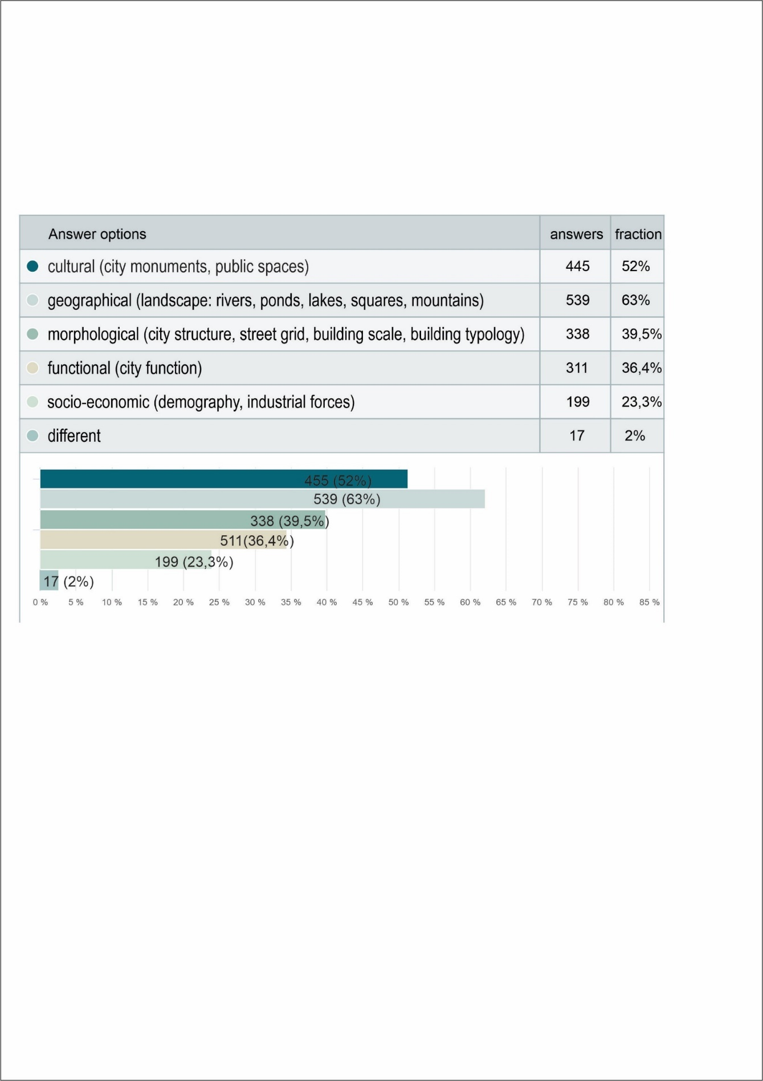
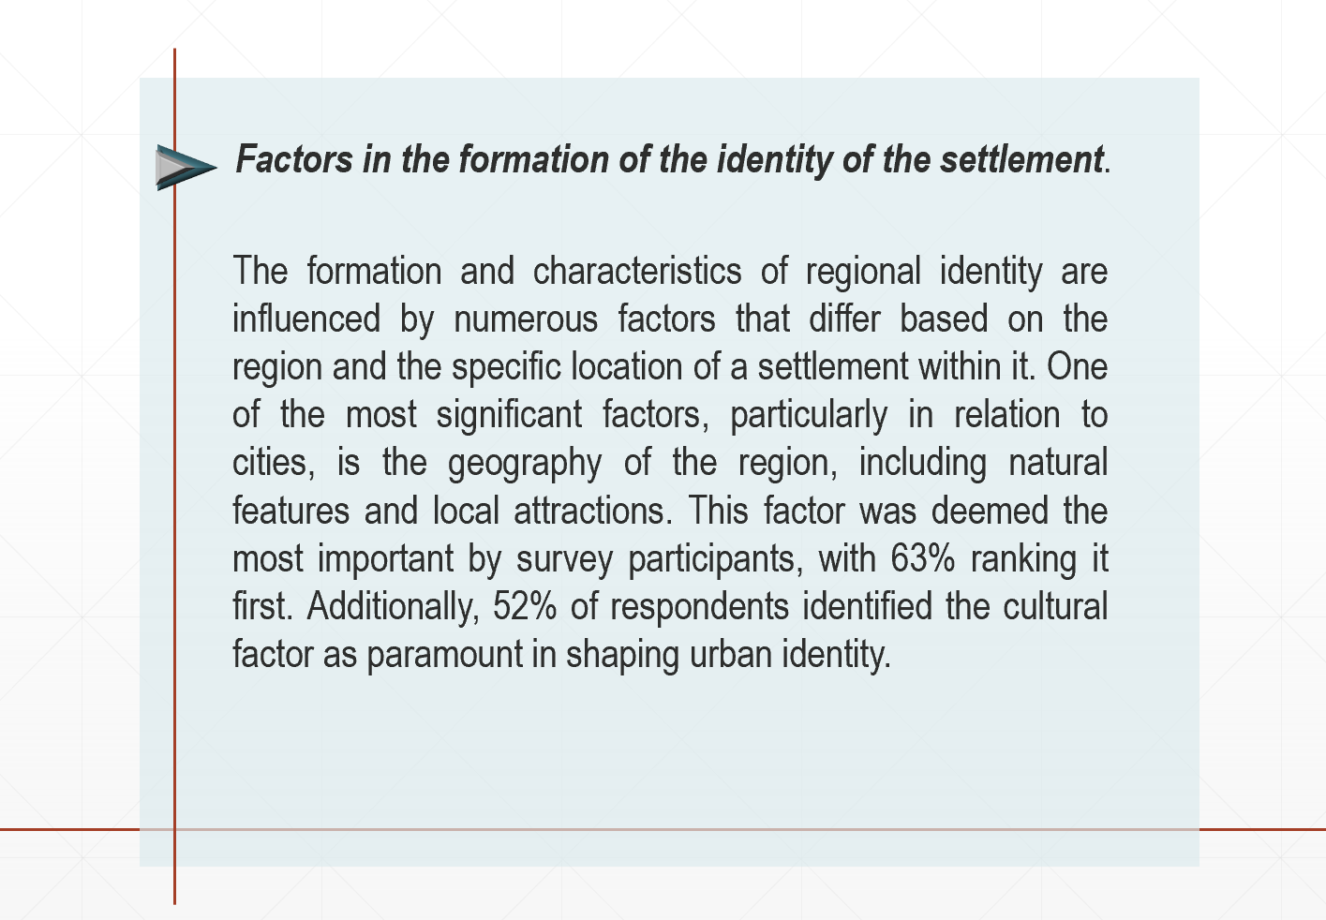

Figure C.12 – Data from Sociological Survey.
Factors in the formation of the identity of the settlement.

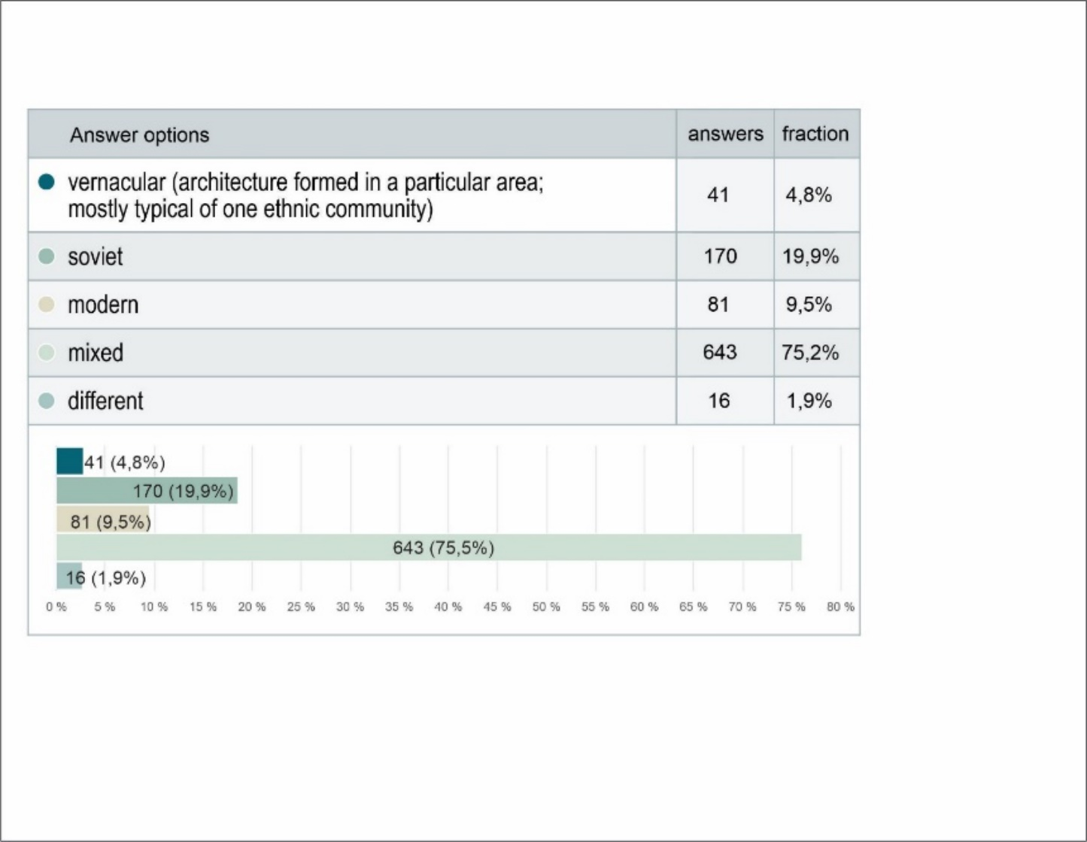
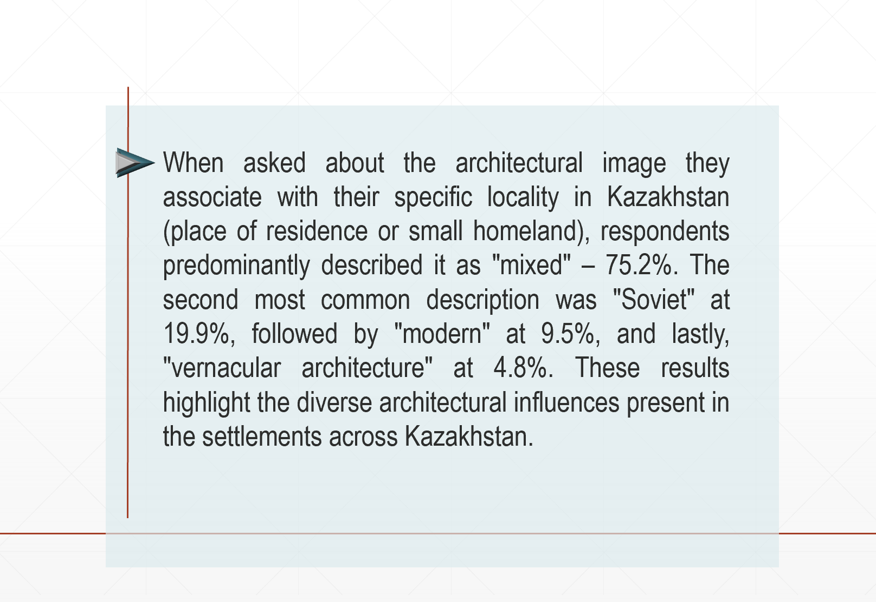

Figure C.13– Data from Sociological Survey.
Describing an architectural image of a place.
а

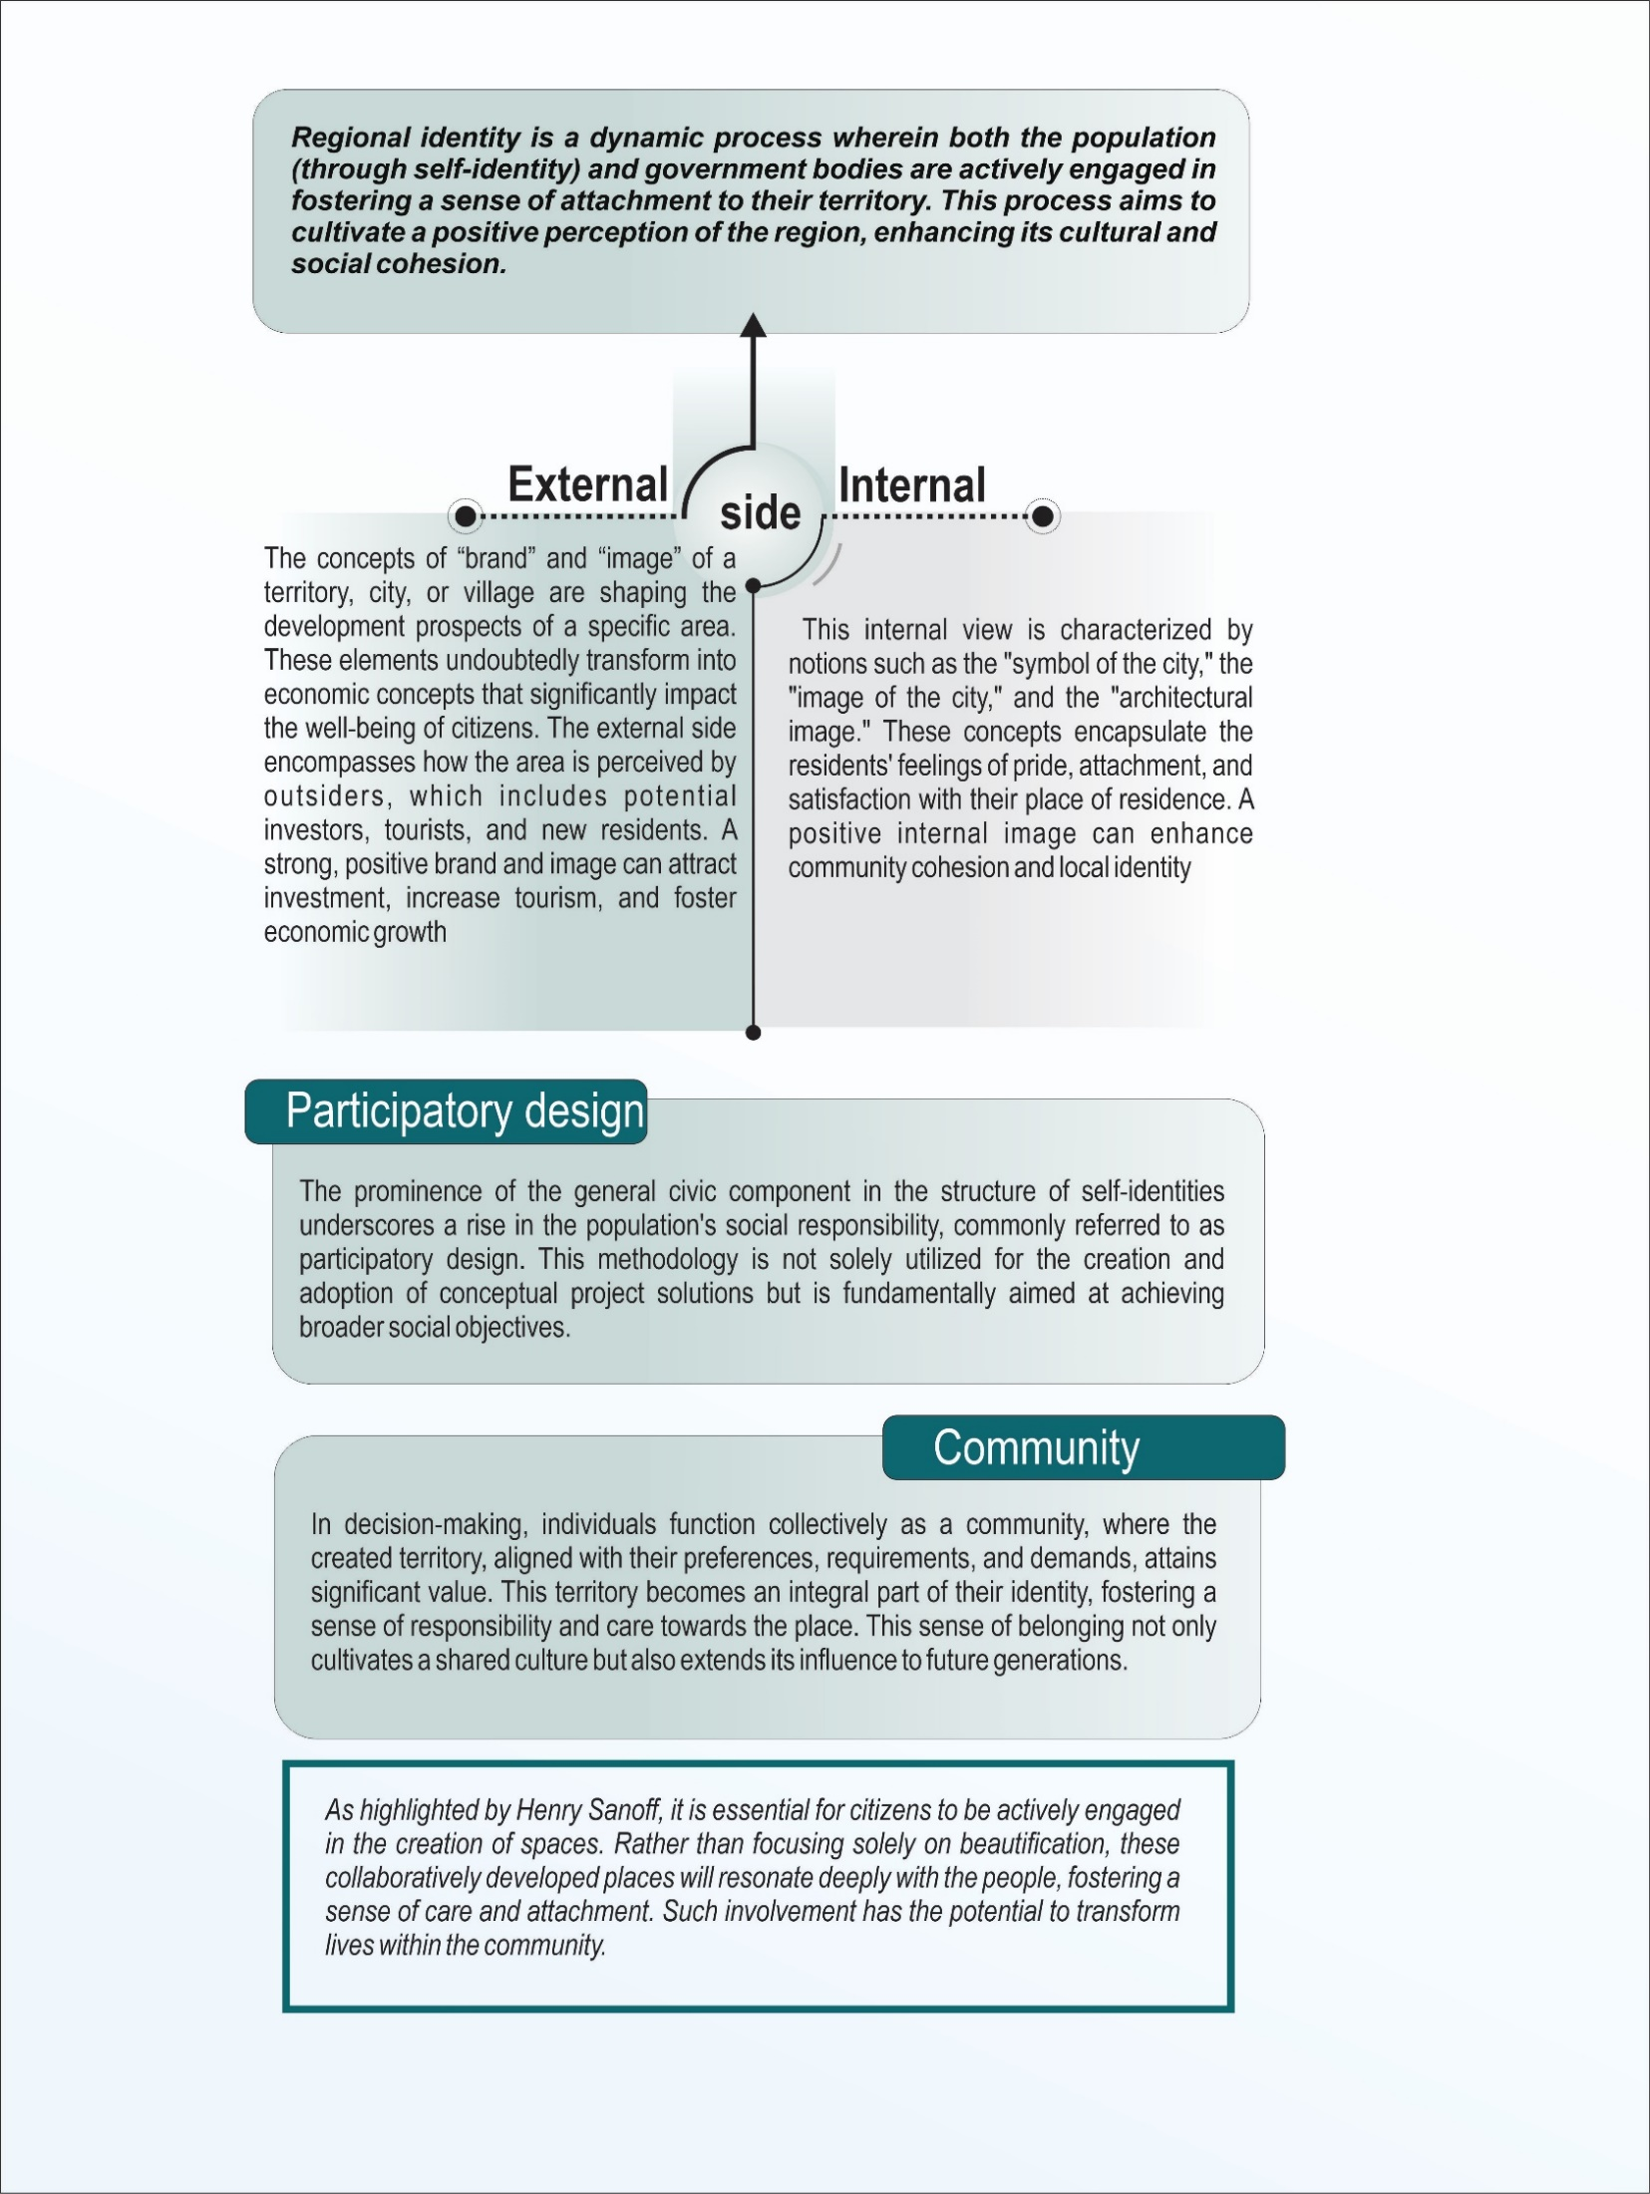
Figure C.14 – Results from Sociological Survey.

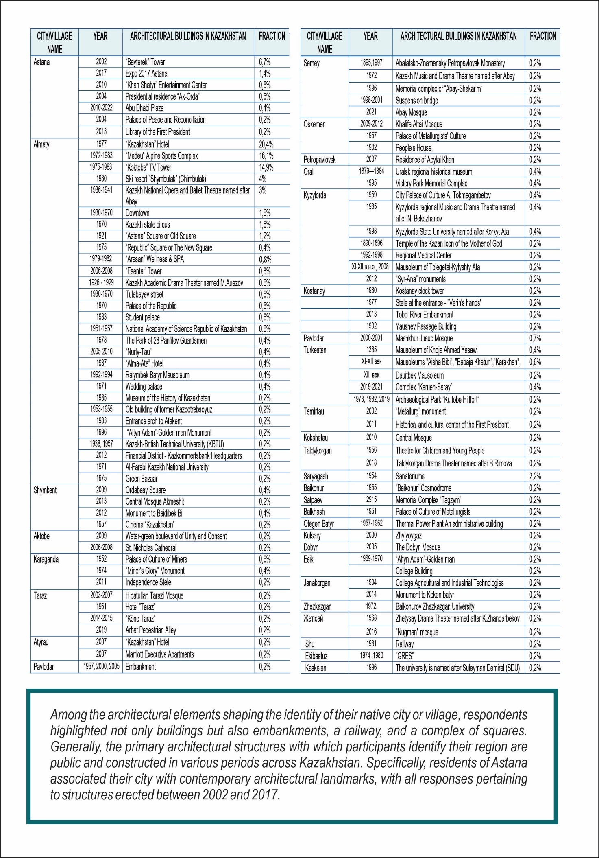
Figure C.15 – Results from Sociological Survey.
An architectural object that forms the identity of their native city/village.
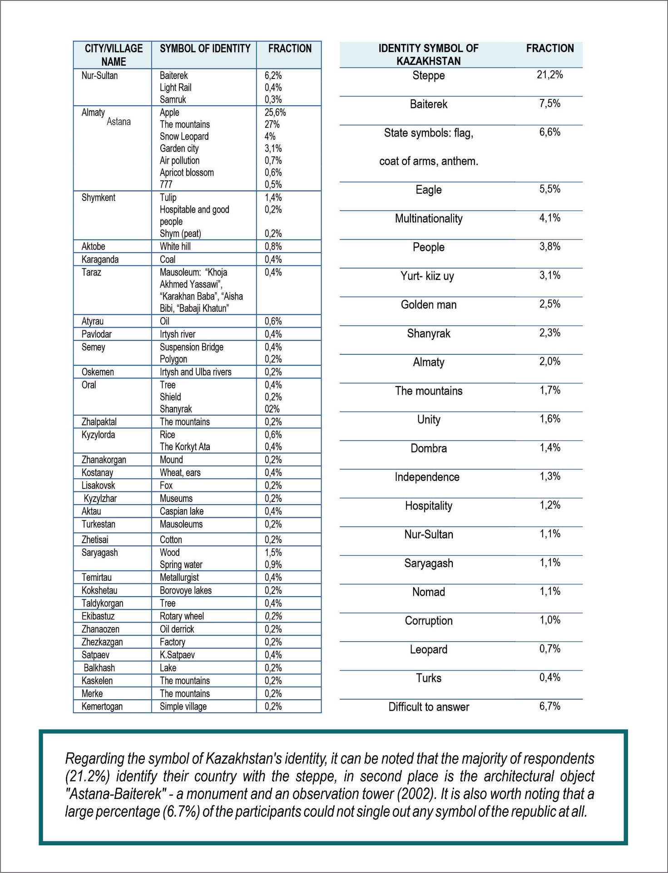
Figure C.16 – Results from Sociological Survey.
An architectural object that forms the identity of their native city/village.

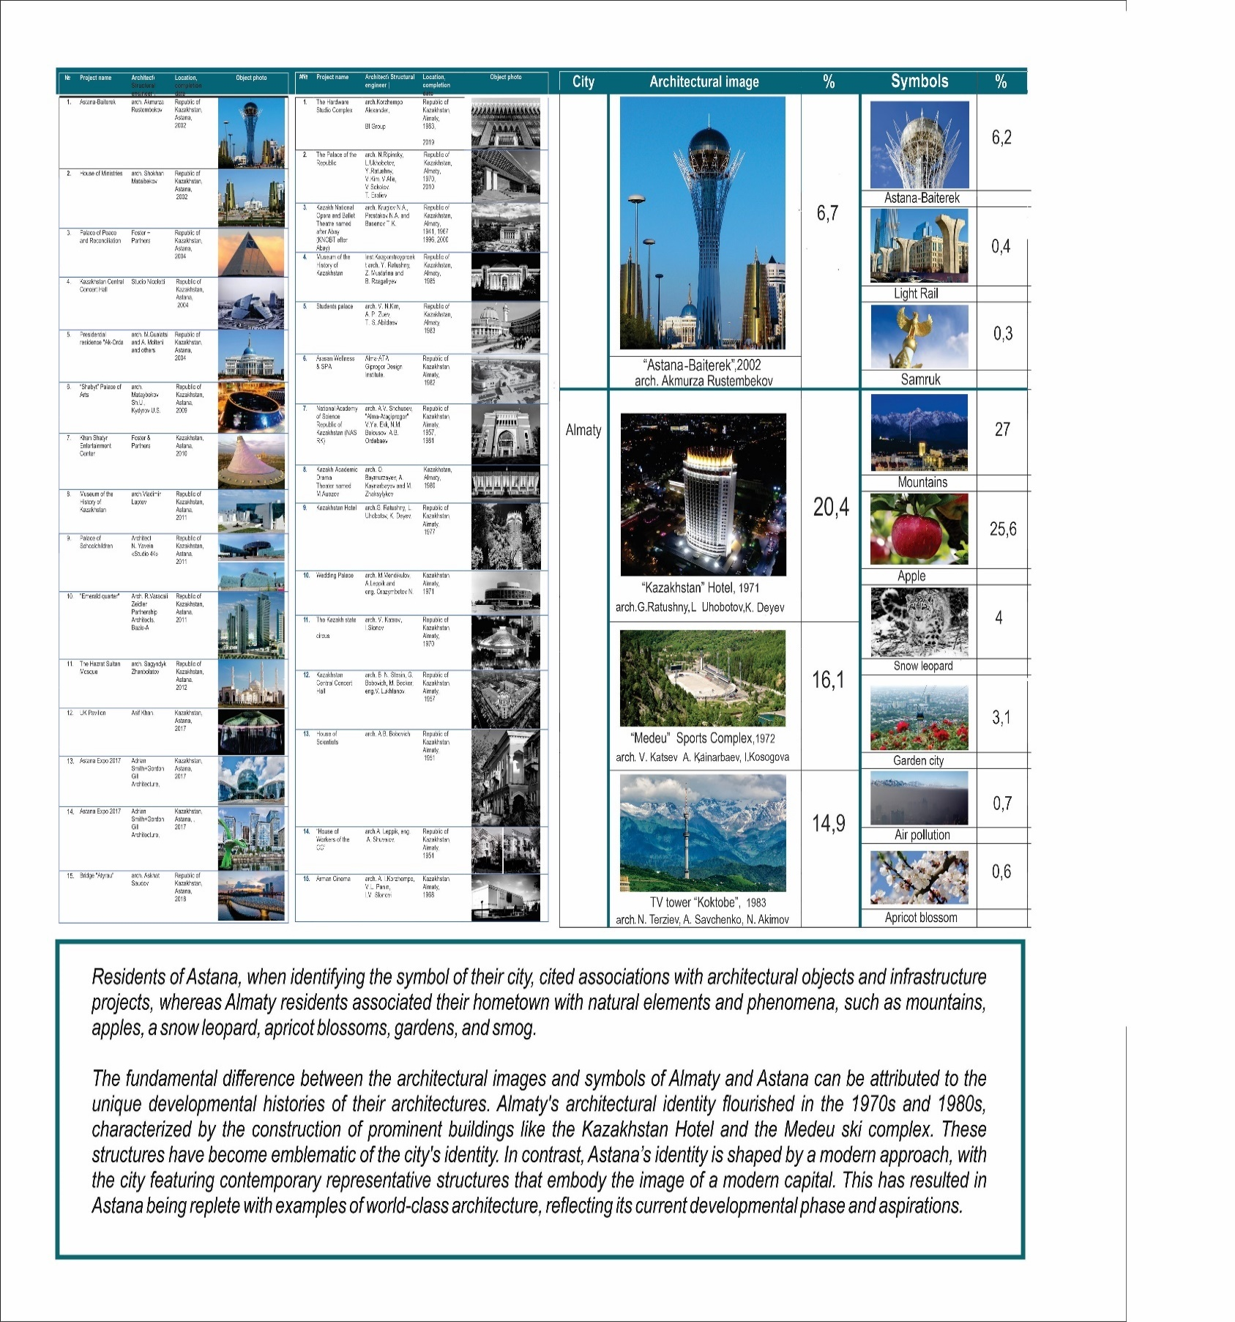
Figure C.17 – Results from Sociological Survey.
An architectural object that forms the identity of their native city/village

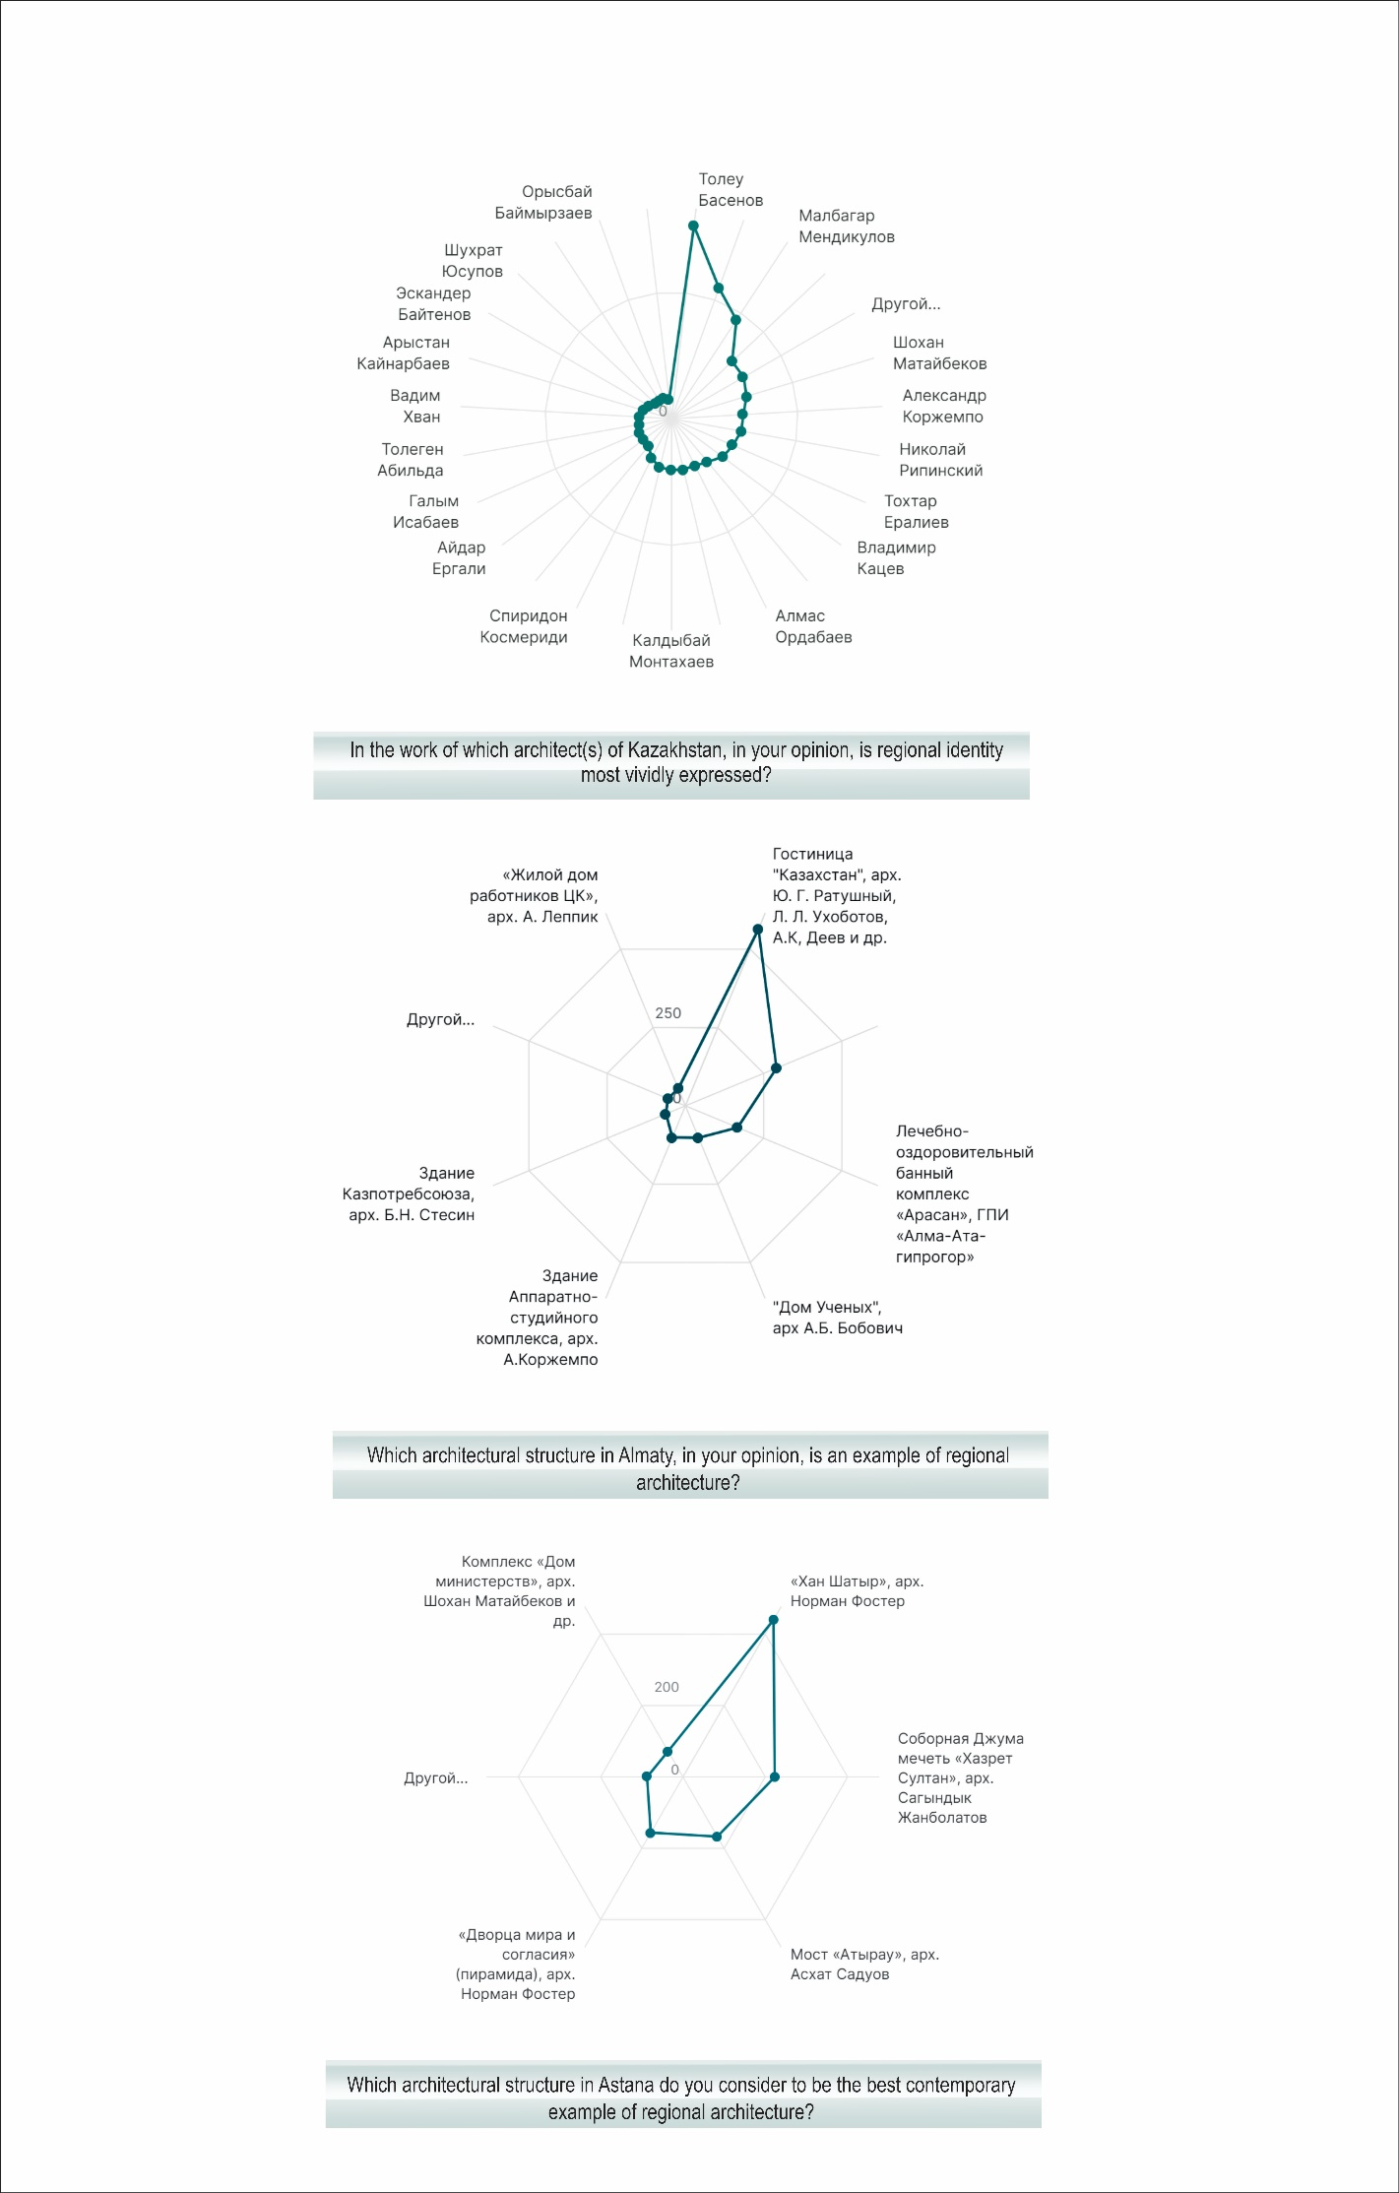
Figure C.18– Data from Sociological Survey.

APPENDIX D
Graphic part of the first chapter of the thesis
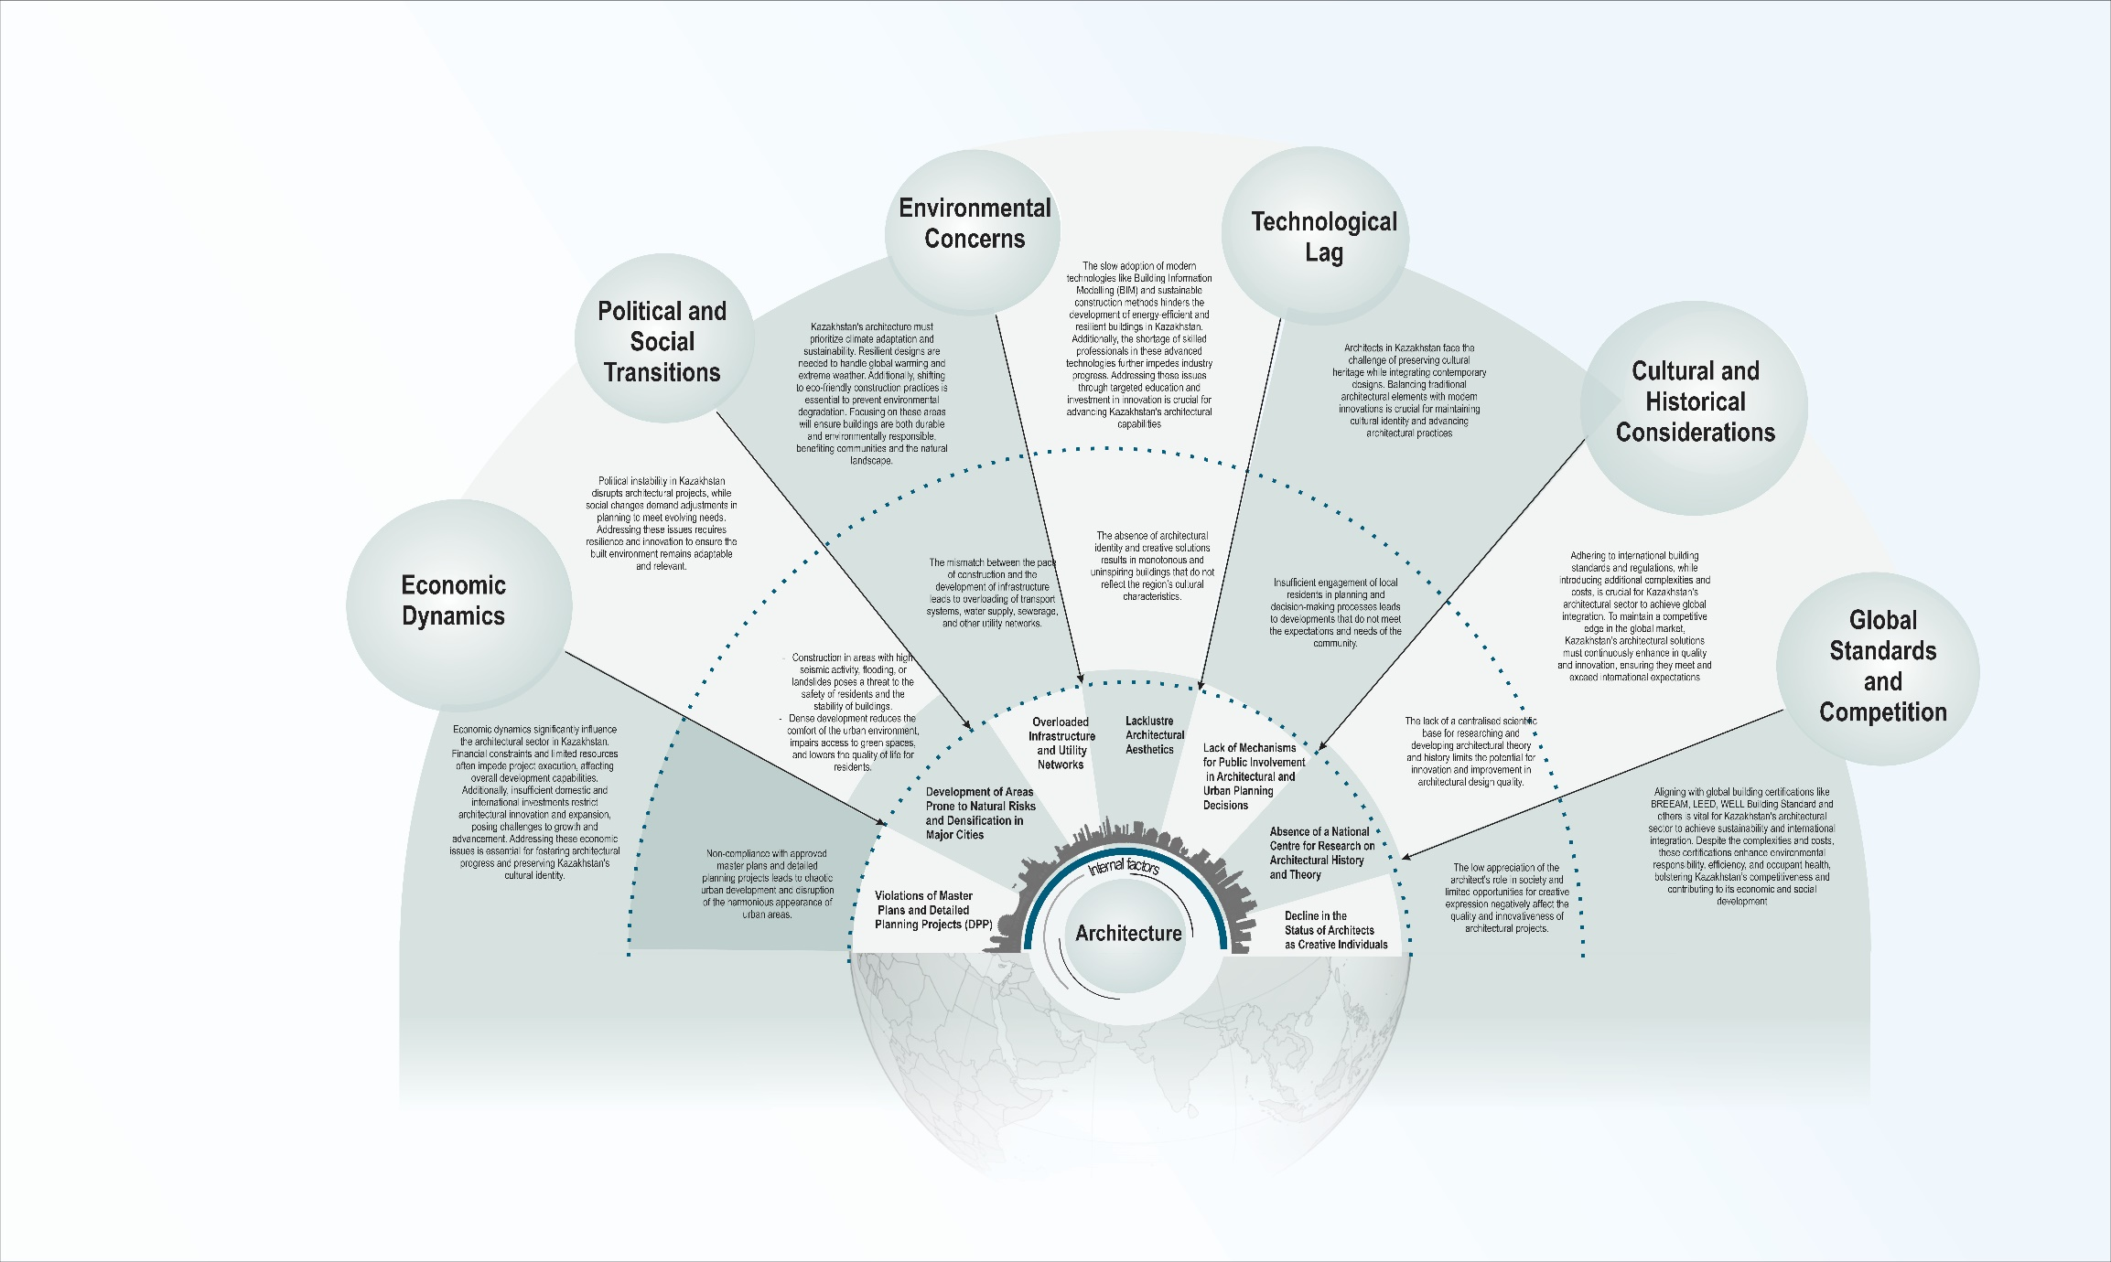
Figure D.1 - The Impact of Local and Global Issues on Kazakhstan's Architecture.

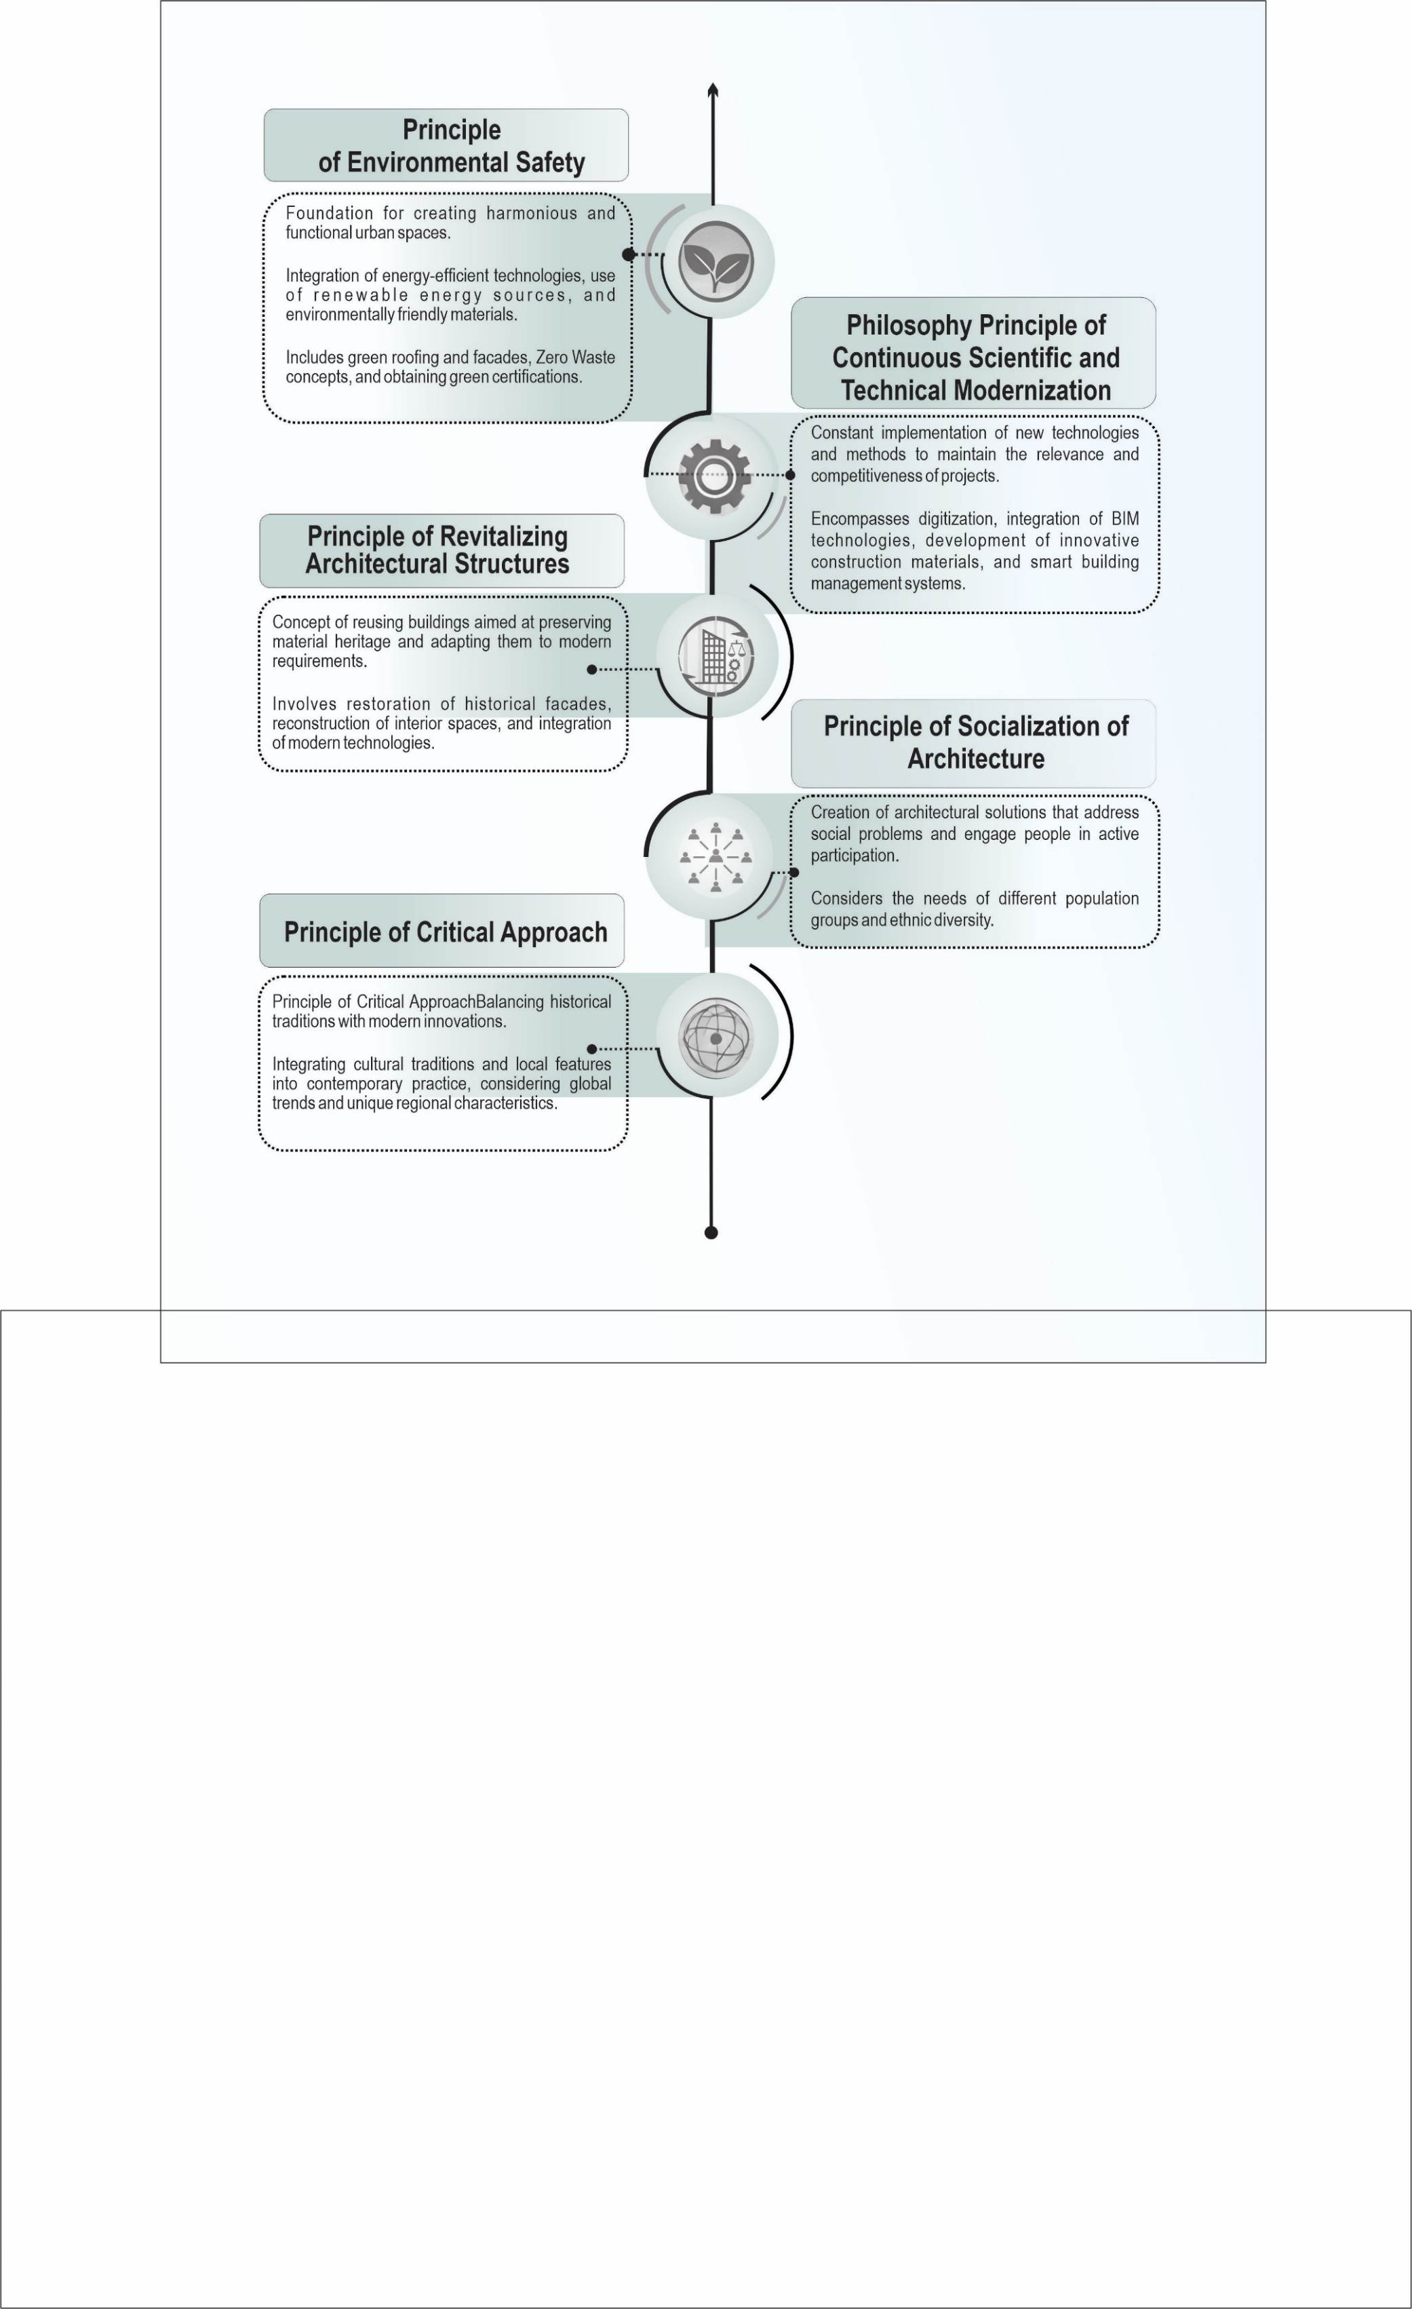
Figure D.2– Principles of forming regional architecture in Kazakhstan under contemporary conditions.

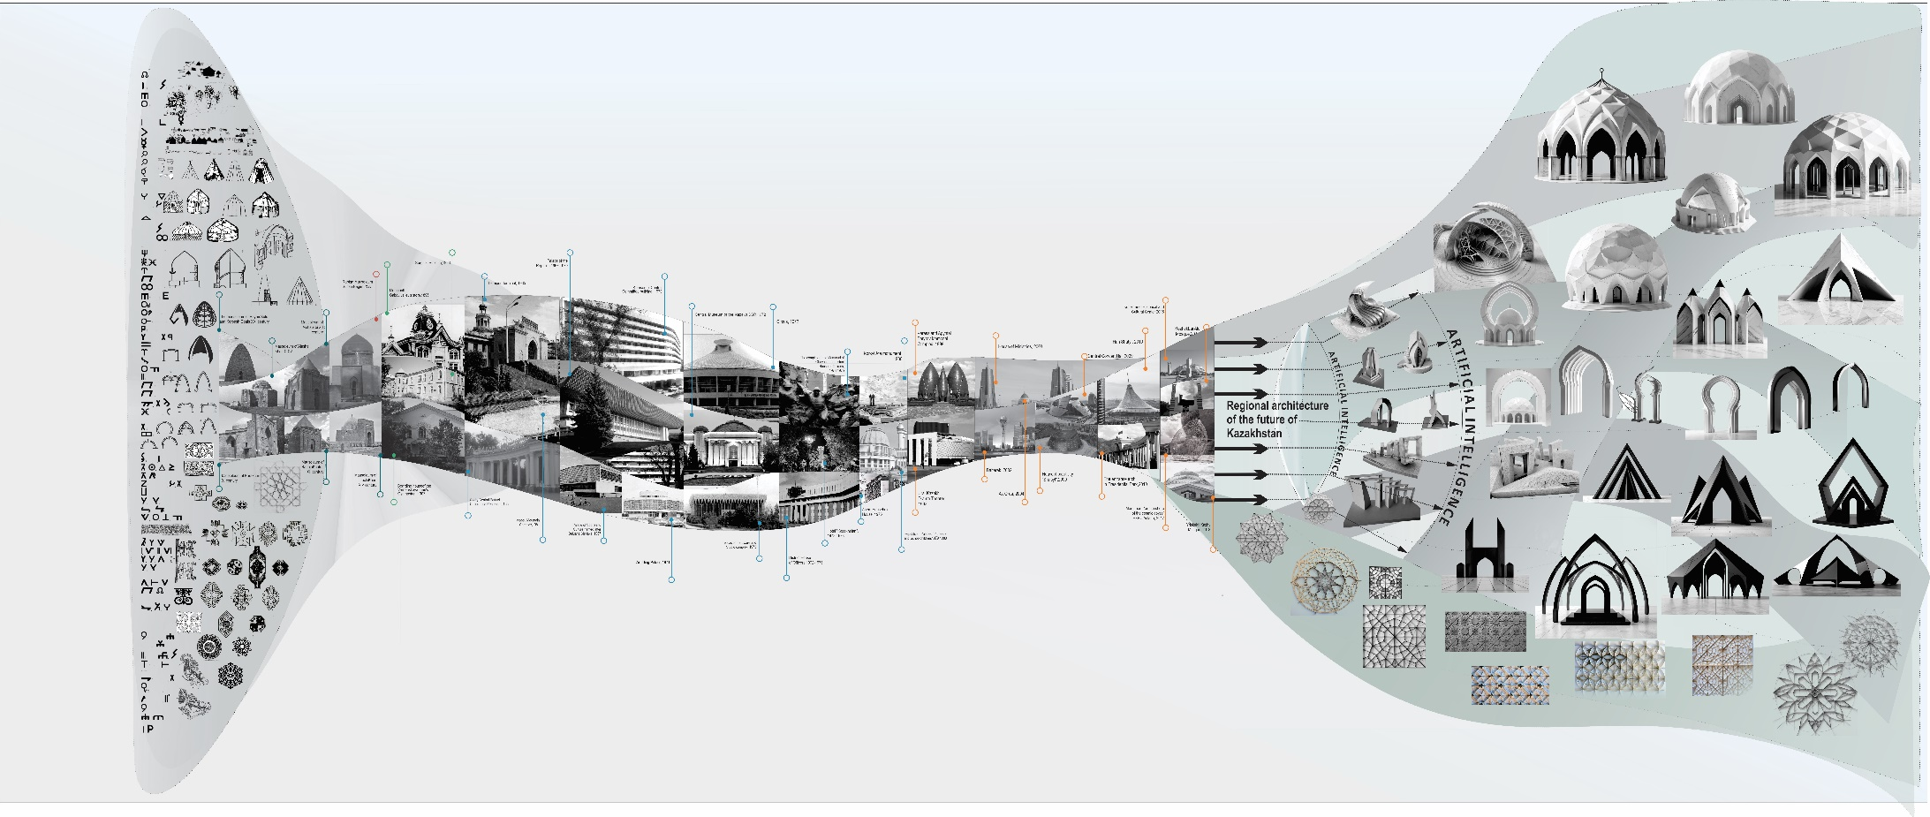
Figure D.3 – Waves of Architecture in Kazakhstan

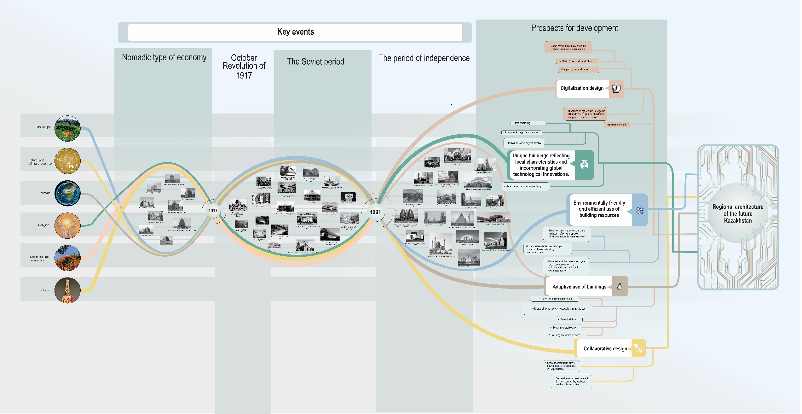
Figure D.4 – The “Tree” of Priority Directions for the Development of Architecture in Kazakhstan in the 21st Century.

APPENDIX E
Certificate “Approbation of the results of PhD thesis research”.

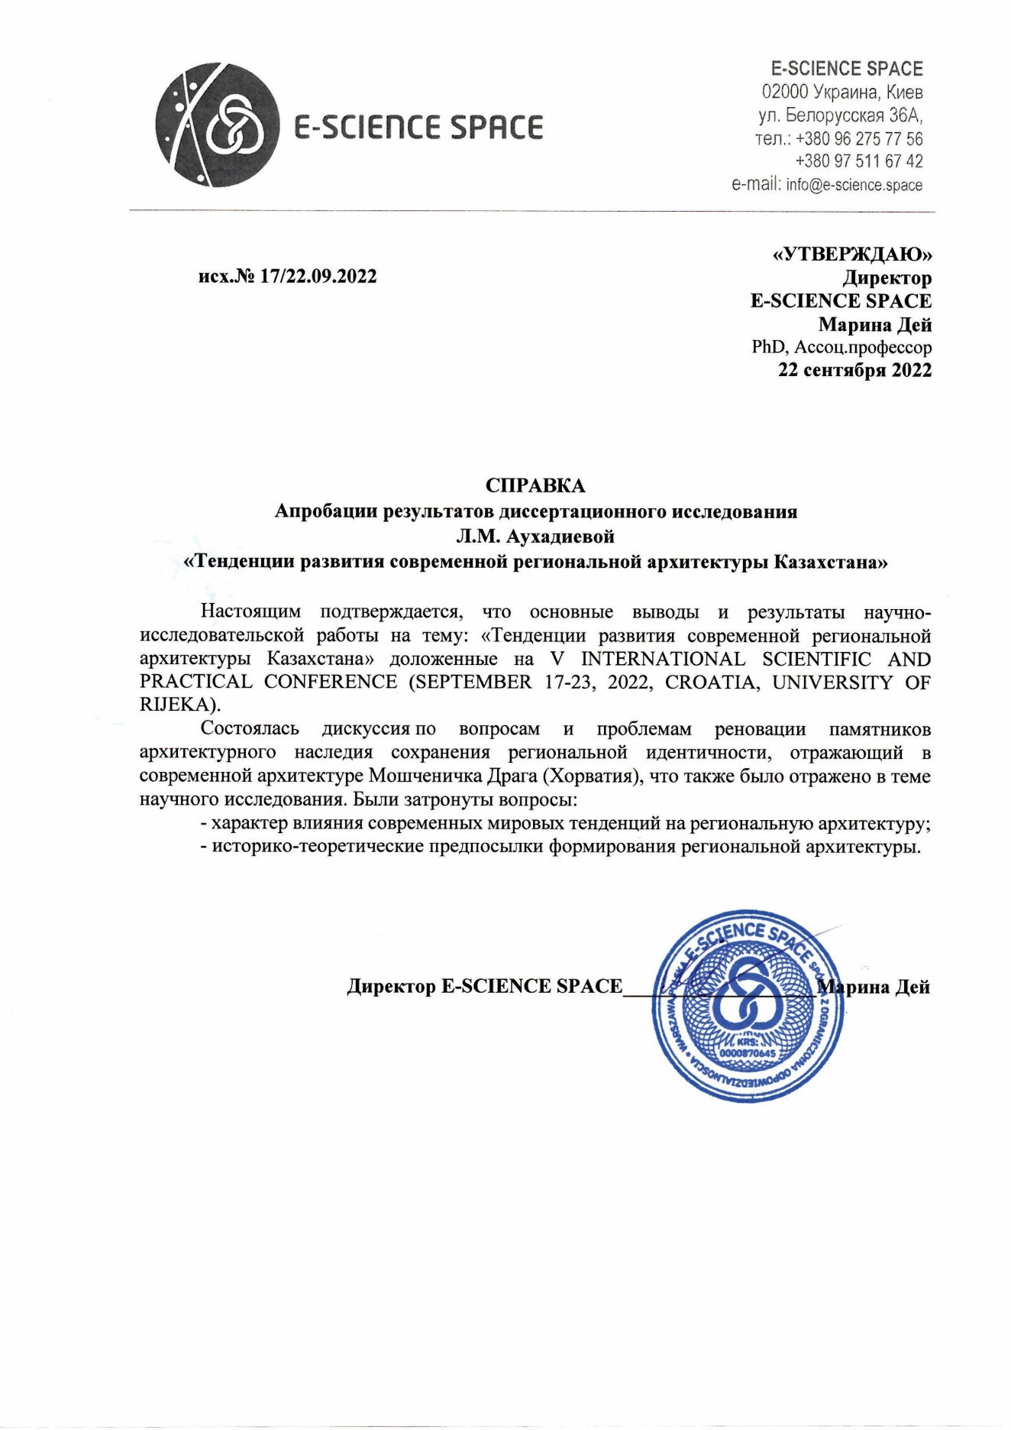

APPENDIX F
Act on the implementation of research results in the educational process
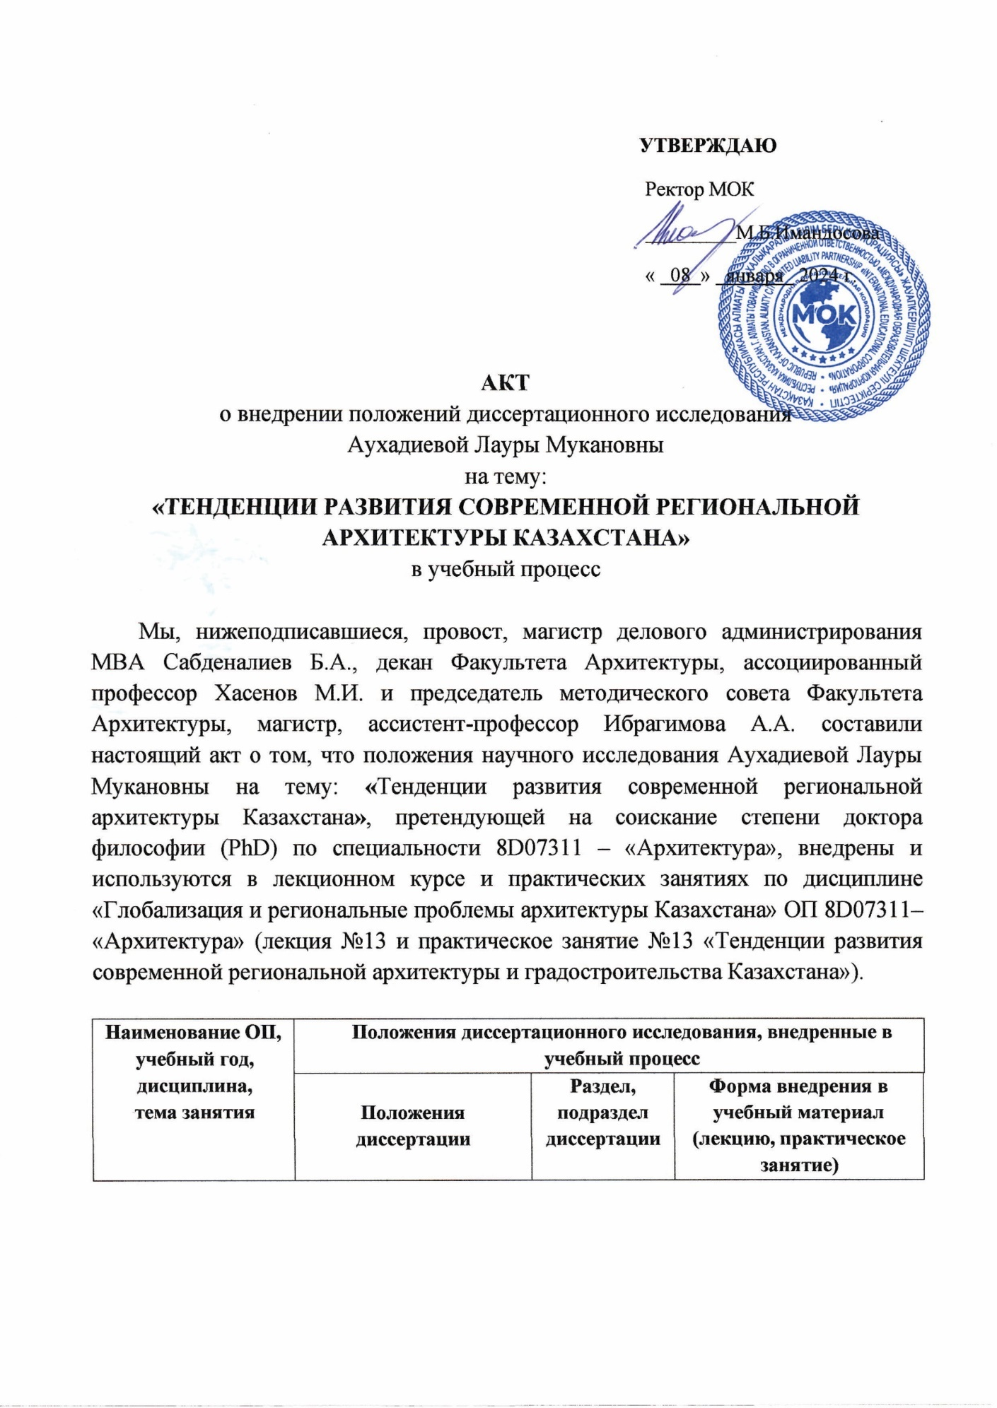
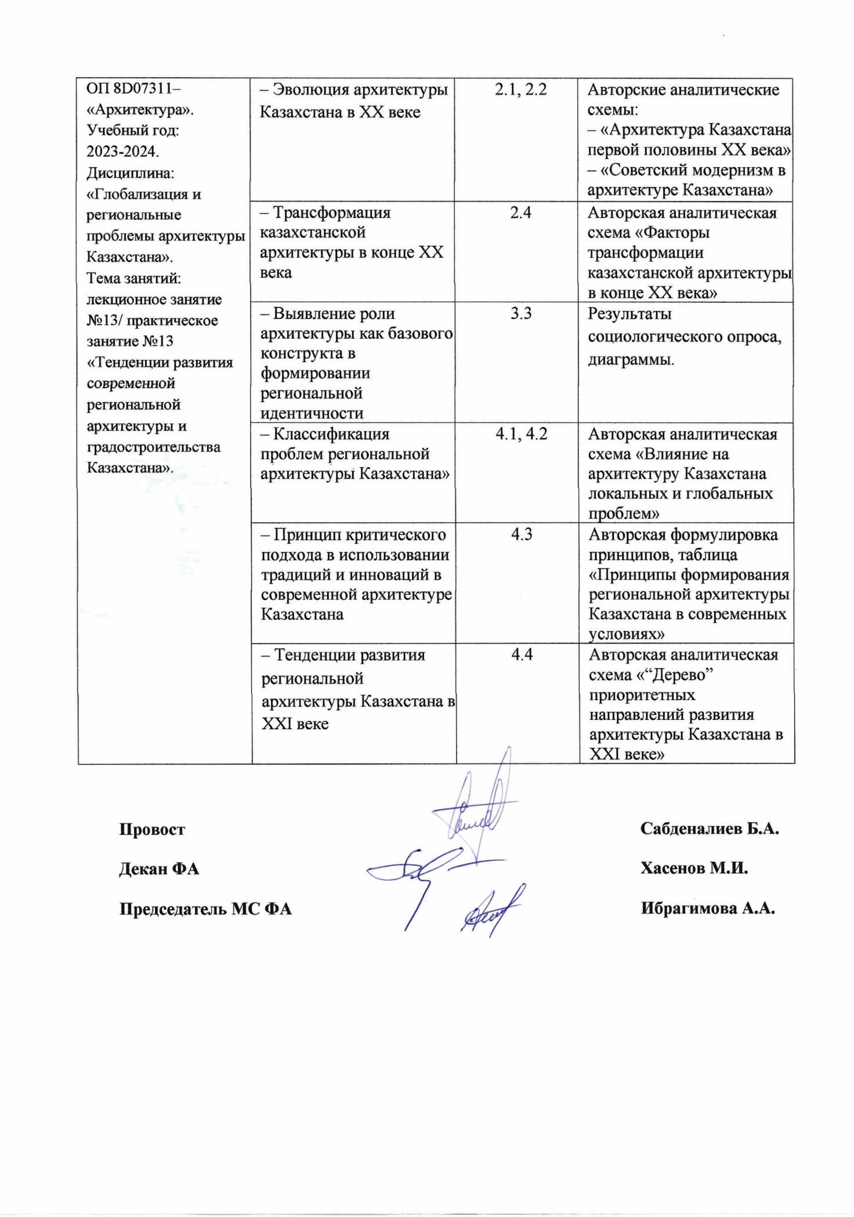

APPENDIX G
Act on the implementation of research results in the design and production process

