al-Farabi Kazakh National University

UDC 547,61 On manuscript rights

Amankulova Dinara Yerkinovna

Development of a method for the non-catalytic synthesis of meta-aryloxy phenols from 1,3-сyclohexanedione

8D07105 Chemical Technology of Organic Substances

Dissertation submitted in partial fulfillment of the requirements for the degree of Doctor of Philosophy (Ph.D.)

Scientific supervisors:
Candidate of Chemical Sciences, Associate Professor,
M.D. Dyusebaeva

Ph.D., DSc, Professor,
DLJ Clive

Republic of Kazakhstan
Almaty, 2023
Contents
SYMBOLS AND ABBREVIATIONS 4
INTRODUCTION 5
1 LITERATURE REVIEW 9
1.1 meta-Aryloxy phenols. Characterization and applications 9
1.2 Synthesis of meta-aryloxy phenols 9
1.2.1 The Nucleophilic Aromatic Substitution Reaction between Aryl Halides and Resorcinol 11
1.2.2 Sonogashira Coupling: A Copper-Catalyzed Method for Biaryl Synthesis 20
1.2.3 Synthesis of meta-(aryloxy)phenols using Grignard Reagents 22
1.2.4 Hydrolysis of Diazonium Salts Using a Two-Phase System 23
1.2.5 Synthesis of meta-aryloxy phenols by demethylation of meta-methoxy phenols 24
1.3 Synthesis of phenol derivatives from cycloxenanone 25
1.3.1 Transition-Metal based Dehydrogenative Aromatization of Cyclohexanones 26
1.3.2 Metal-free dehydrogenative aromatization of cyclohexanones 32
2 RESULTS AND DISCUSSION 37
2.1 Synthesis of 3-Chlorocyclohex-2-en-1-one (2) 40
2.2 Synthesis of 3-(aryloxy)cyclohex-2-en-1-one (3) 43
2.2.1 3-(Phenoxy)cyclohex-2-en-1-one (3a) 48
2.2.2 3-(4-Iodophenoxy)cyclohex-2-en-1-one (3b) 49
2.2.3 3-(4-Chlorophenoxy)cyclohex-2-en-1-one (3c) 50
2.2.4 3-(2,6-Dimethoxyphenoxy)cyclohex-2-en-1-one (3d) 51
2.2.5 3-(2-tert-Butylphenoxy)cyclohex-2-en-1-one (3e) 53
2.2.6 3-(4-tert-Butylphenoxy)cyclohex-2-en-1-one (3f) 55
2.2.7 Methyl 4-[(3-oxocyclohex-1-en-1-yl)oxy]benzoate (3g) 56
2.2.8 3-{4-[(3-Oxocyclohex-1-en-1-yl)oxy]phenoxy}cyclohex-2-ene-1-one (3h) 57
2.3 Synthesis of 2-bromo-3-(aryloxy)cyclohex-2-en-1-one (4) 59
2.4 Synthesis of meta-aryloxy phenols (5) 67
2.4.1 3-(Phenoxy)phenol (5a) 72
2.4.2 3-(4-Iodophenoxy)phenol (5b) 74
2.4.3 3-(4-Chloropenoxy)phenol (5c) 76
2.4.4 3-(2,6-Dimethoxyphenoxy)phenol (5d) 78
2.4.5 3-(2-tert-Butylphenoxy)phenol (5e) 79
2.4.6 3-(4-tert-Butylphenoxy)phenol (5f) 81
2.4.7 Methyl 4-(3-hydroxyphenoxy)benzoate (5g) 82
2.4.8 3-[4-(3-hydroxyphenoxy)phenoxy]phenol (5h) 84
2.5 Technological schemes for developed methods 86
2.5.1 Technological schemes for obtaining compounds 3 86
2.5.2 Material balance of 3-aryloxy-cyclohex-2-ene-1-one (3) synthesis 86
2.5.3 Technological schemes for obtaining compounds 4 88
2.5.4 Material balance of (4) synthesis 90
2.5.5 Technological schemes for obtaining compounds 5 90
2.5.6 Material balance of compound (5) synthesis 92
3 EXPERIMENTAL SECTION 93
CONCLUSION 103
REFERENCES 105
APPENDIX A 116

SYMBOLS AND ABBREVIATIONS

¹³C NMR – Carbon-13 nuclear magnetic resonance
¹H NMR – Proton nuclear magnetic resonance
CPME – Cyclopentyl methyl ether
DBN – 1,5-Diazabicyclo[4.3.0]non-5-ene
DBU– 1,8-Diazabicyclo[5.4.0]undec-7-ene
DCM – Dichloromethane
DIAD – Diisopropyl-azodicarboxylate
DIPEA – N,N-Diisopropylethylamine
DMA – N,N-dimethylacetamide
DMF – Dimethyl formamide
DMG*HCl – N,N-3,3-dimethylglycine hydrochloride
DMS – Dimethyl sulfide
DMSO – Dimethylsulfoxide
DP – Desired product
EPC*HCl – N-ethylcarbodiimide hydrochloride
h – hour
HMPA – Hexamethylphosphoramide
HOBt – Hydroxybenzotriazole
IR – Infrared spectroscopy
LG – Leaving group
LiHMDS – Lithium bis(trimethylsilyl)amide
NBS – N-Bromosuccinimide
NMP – N-Methyl pyrrolidone
PCC – Pyridinium chlorochromate
rt – Room Temperature
TFA – Trifluoroacetic acid
THF – Tetrahydrofuran
Wt% – Percentage by weight

INTRODUCTION
General description of work. The focus of this project is to develop a method for the non-catalytic synthesis of meta-(aryloxy)phenols from 1,3-cyclohexanedione. The goal is on establishing a simple and efficient process for producing meta-substituted phenols using readily available starting materials.
Relevance of the research topic. Meta-(aryloxy)phenols have been widely studied for their efficient and versatile chemical properties. They serve as useful synthetic intermediates for the synthesis of natural and biologically active compounds such as pharmaceuticals, agrochemicals, and dyes. Additionally, meta-(aryloxy)phenols exhibit exceptional antioxidant, antimicrobial, and anti-inflammatory activities, which make them potential candidates for a broad range of industrial and medicinal applications.
Moreover, the meta-substituted nature of these phenols further enhances their efficiency by conferring unique steric and electronic properties that can be optimized for specific applications. This attribute enables the development of highly selective and efficient catalysts, ligands, and chiral auxiliaries that are employed in numerous chemical processes, including asymmetric synthesis, cross-coupling reactions, and polymerization.
The synthesis of meta-(aryloxy)phenols has been a long-standing challenge in organic chemistry due to the complex nature of the reaction and the difficulties associated with achieving high yields and selectivity. Traditional synthetic methods involve the use of transition metal catalysts, which can be expensive and often require rigorous reaction conditions that can lead to undesired byproducts and low yields. Additionally, the use of transition metals can pose environmental concerns, and the presence of metal residues in the final product may limit their applications in various industries, including pharmaceuticals and materials science.
Furthermore, the steric and electronic properties of meta-substituted phenols are highly dependent on the specific substituents present, which can make the synthesis of these compounds even more difficult. Achieving precise control over the position and nature of the substituents can be difficult, and small changes in reaction conditions can lead to significant changes in product distribution and properties.
Despite these challenges, the development of efficient and practical methods for the synthesis of meta-(aryloxy)phenols is of great importance due to their diverse range of applications, including their use as synthetic intermediates and in medicinal and industrial applications. As such, continued efforts are being made to develop more efficient and environmentally friendly methods for their synthesis, which will allow for their wider use in various fields of chemistry.
The degree of development of the problem. The current state of research on the synthesis of meta-(aryloxy)phenols has shown significant progress. While various methods have been developed to synthesize these compounds, the non-catalytic approach is of particular interest due to its potential for industrial-scale production and reduced cost. Recent studies have focused on optimizing reaction conditions and improving yields, as well as exploring the versatility of the resulting compounds in various applications.
Despite the progress made in the field, there is still room for further development of efficient and practical methods for the non-catalytic synthesis of meta-(aryloxy)phenols. Future research may focus on the use of alternative reaction conditions and reagents to improve yields and selectivity, as well as the development of new synthetic routes to access more complex and diverse structures.
The purpose of the dissertation research. The objective of the present dissertation research is to develop an efficient and novel method for the synthesis of meta-(aryloxy)phenols from 1,3-cyclohexanedione.
To accomplish this goal, the following tasks were undertaken:
- formation of 3-chlorocyclohex-2-en-1-one from cyclohexan-1,3-dione by utilizing the Vilsmeier reagent;
- conduction of research on the conditions of obtaining 3-(aryloxy)cyclohex-2-en-1-one by nucleophilic substitution reaction;
- introduction of a directing group by C(2) bromination of 3-(aryloxy)cyclohex-2-en-1-one;
- conduction of research on the conditions of synthesis of meta-(aryloxy)phenols by oxidative aromatization;
- structure analysis of synthesized compounds through various techniques such as IR spectroscopy, mass spectrometry, and NMR spectroscopy;
- representation technological schemes for the developed methods for the synthesis of intermediate and final compounds and calculate the material balance of production.
The main provisions of the dissertation submitted for defense:
- A novel approach for synthesizing meta-(aryloxy)phenols via cyclohexane-1,3-dione has been devised, comprising a four-step synthesis protocol. The method has yielded eight meta-(aryloxy)phenols in high quantities, with an average yield of 66% for all eight compounds.
- The method avoids the need for operations to bypass the ortho-, para- directing effect of oxygen, resulting in a simplified and streamlined synthesis process. The required 1,3-functional group relationship is inherent in the readily available cyclohexane-1,3-dione starting material, allowing for easy access to the desired meta-(aryloxy)phenols.
- The synthesis method does not entail the use of heavy metals or ligands, rendering it a more ecologically sound and safer substitute to conventional techniques.
The objects of study in this dissertation research are cyclohexane-1,3-dione and its derivatives, as well as various reagents and conditions for the synthesis of meta-(aryloxy)phenols.
The subject of the study is the development of a new and efficient method for the synthesis of meta-(aryloxy)phenols from cyclohexane-1,3-dione.
Research methods - mass spectrometry, IR spectroscopy, ¹Н, ¹³С NMR spectroscopy.
The scientific novelty of the work.
- A new and efficient method for the non-catalytic synthesis of meta-aryloxyphenols from 1,3-cyclohexanedione in four steps. All steps don’trequired high temperature and don’t involve any heavy metals or ligandswere developed.
- The method has been successfully utilized to synthesize eight distinct meta-aryloxy phenols, four of which have not been previously documented in the literature. Additionally, the method has yielded 16 intermediate products, 14 of which have not been previously reported in literature.
- The chemical structures of newly synthesized compounds have been characterized for the first time using a combination of analytical techniques.
Theoretical and practical significance. The theoretical significance of the developed method lies in the discovery of a new and efficient approach for the synthesis of meta-(aryloxy)phenols from 1,3-cyclohexanedione. This approach offers a unique alternative to the conventional methods that involve the use of heavy metals or ligands and require additional steps to bypass the ortho-, para- directing effect of oxygen.
The practical significance of this method lies in its potential for industrial applications, as it offers a cost-effective and environmentally friendly approach to the synthesis of meta-(aryloxy)phenols. These compounds have a wide range of applications in various fields, including pharmaceuticals, agrochemicals, and dyes, as well as in the development of highly selective and efficient catalysts, ligands, and chiral auxiliaries used in various chemical processes. The developed method can also be used as a platform for the synthesis of novel meta-substituted phenolic compounds with tailored steric and electronic properties, which can be optimized for specific industrial and medicinal applications.
Compliance with priority areas of science development or government programs. The dissertation was carried out aligning with the priorities of scientific development, as approved by the Higher Scientific and Technical Commission under the Government of the Republic of Kazakhstan. Specifically, it pertained to scientific research in the field of natural sciences.
The author's personal contribution. The author made a significant contribution to the development and implementation of experiments, the solution of theoretical and practical problems, and the interpretation of the results. She collaborated with researchers in the Dr. Clive group laboratory at the University of Alberta.
She also played a key role in the preparation and writing of a review article published in the journal "Molecules". Furthermore, the author synthesized 24 out of the 51 compounds discussed in an article published in the journal "Tetrahedron".
Approbation of work. Main provisions and results of the dissertation presented and discussed at the international conference: the «Фараби Әлемі – 2023» conference for students and young scientists in 2023.
Publications. During the course of the research conducted for this dissertation, three scientific papers were published. Including the article in the Q2-ranked journal Tetrahedron (with a 60% percentile) and another article in the Q2-ranked journal Molecules (with an 83% percentile). Additionally, the findings of this research have been presented and discussed in international conference, such as the «Фараби Әлемі – 2023» conference for students and young scientists in 2023.
The structure and scope of the dissertation. The dissertation is presented as 115 pages of typewritten text and includes abbreviations, an introduction, a literature review, a discussion of results, an experimental part, conclusions and a list of sources used from 128 items, and an appendix for 50 pages. The dissertation work contains 75 schemes, 5 figures and 25 tables.

1 LITERATURE REVIEW
Phenols are widely distributed in nature and are useful in synthetic organic chemistry for the construction of natural products, bioactive compounds, fine chemicals, and functional materials [1-4].
Conventional strategies for the synthesis of substituted phenols involve functionalizations and transformations of functional groups around the periphery of an existing aromatic ring [5-9]. These methods usually provide direct routes to ortho- and para-substituted phenols, but the regiospecific synthesis of meta-substituted phenols can be difficult due to the dependence of regioselectivity on the electronic effects of aromatic ring substituents [10-13].
Consequently, alternative approaches such as oxidative aromatization of non-aromatic precursors have been developed. Recent advances in metal-catalyzed oxidative aromatization of cyclohexenones to phenols have been made, although related metal-free approaches have been limited by issues such as the over-oxidation of products [14-16]. To overcome this, indirect protocols were used, such as: pre-installation of protect groups at sensitive positions of phenols or the use of pre-oxidized substrates obtained by elimination aromatization [17-28]. Therefore, it would be highly beneficial to develop a direct protocol for the regiospecific and facile synthesis of meta-substituted phenols without metal promoters, while avoiding overoxidation.

meta-Aryloxy phenols. Characterization and applications
meta-(Aryloxy)phenols are a class of compounds that have gained significant interest in recent years due to their unique properties and potential applications in a variety of fields. These compounds are characterized by a phenolic group with an attached aryl group linked through an oxygen atom.
meta-(Aryloxy)phenol derivatives possess a diverse range of properties and potential applications [29]. They have been investigated for their antioxidant and anti-inflammatory activities, which makes them potential candidates for the development of pharmaceuticals and nutraceuticals [30,31]. They have also been studied for their antibacterial, antifungal, and antiviral properties, making them promising agents for the development of antimicrobial agents [32-34]. Additionally, the optical properties of meta-(aryloxy)phenols have been explored, demonstrating their potential utility in the development of materials for optoelectronics and photonics [35,36].
Overall, meta-(aryloxy)phenols are a versatile class of compounds with unique properties and promising potential applications. Further research into their synthesis, characterization, and potential applications is expected to continue in the coming years.

Synthesis of meta-aryloxy phenols
The synthesis of meta-(phenoxy)phenol has been of interest for its potential applications in various fields, including medicinal chemistry and materials science [29]. This compound has been shown to exhibit antibacterial and antifungal properties, and has been investigated as a potential agent for the treatment of bacterial infections. In addition, meta-(phenoxy)phenol has been used as a building block for the synthesis of other compounds, such as the herbicide mecoprop and the fungicide triflumizole [37,38].
The synthesis of m -aryloxy phenol can be achieved through a variety of methods, including the reaction of phenol with an aryl halide in the presence of a strong base, known as the Ullmann reaction. Another method involves the reaction of 3-bromophenol with phenylmagnesium bromide in the presence of a catalyst, such as copper (I) iodide.
The first diphenyl compound to be synthesized was biphenyl, which was accomplished by the German chemist Carl Gräbe in 1866. Gräbe utilized a method involving the oxidation of a mixture of two molecules of toluene with potassium permanganate [39]. However, the general method for diphenyl compound synthesis, known as the Ullmann reaction, was first reported by Fritz Ullmann in 1901(scheme 1.1). This reaction method has since been widely used for the synthesis of various diphenyl compounds.

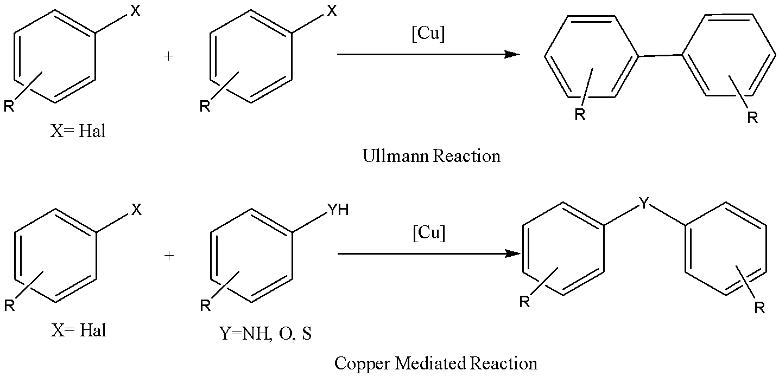
Scheme 1.1 – Schematic representation of the Ullmann and the copper-mediated reaction

In the initial Ullmann reaction protocol, equimolar amounts of copper salts were employed at elevated reaction temperatures (equal to or greater than 200°C) and prolonged reaction times. However, contemporary adaptations of the Ullmann reaction have concentrated on the use of copper-mediated reactions (either stoichiometric or catalytic) between aryl halides and other reagents, such as amines, phenols, or thiophenols, to produce aryl-amine, -ether, or -thioether compounds, respectively [40-42].
Despite the broadened range of reactions that can be classified as Ullmann reactions, the term is primarily used to refer to the copper-catalyzed synthesis of biaryls from aryl halides. This protocol has been widely adopted due to its high efficiency and versatility in constructing complex biaryl compounds [43,44].
Since then, other methods for the synthesis of meta-(phenoxy)phenol have been reported, including the reaction of phenol with 3-chlorobenzyl chloride in the presence of a base, and the reaction of 3-iodophenol with phenylboronic acid in the presence of a palladium catalyst.
Overall, the synthesis of 3-(phenoxy)phenol has contributed to the development of new materials and compounds with potential applications in various fields. Its antibacterial and antifungal properties make it a promising compound for the development of new drugs and agricultural chemicals. The Ullmann reaction continues to be a crucial tool in modern organic synthesis and has played a significant role in the development of numerous natural products, pharmaceuticals, and materials.
Recent developments in the synthesis of meta-(aryloxy)phenols have focused on employing advanced techniques and methodologies for the efficient construction of this class of compounds. One notable advancement involves the utilization of palladium-catalyzed cross-coupling reactions between aryl halides and phenols, which allows for the synthesis of a diverse range of meta-(aryloxy)phenols with high selectivity and efficiency.
Other approaches include the use of copper-catalyzed arylation reactions and transition metal-free methods, which have proven to be effective in constructing meta-(aryloxy)phenols in good yields and wild broad substrate scope. Additionally, the application of microwave-assisted and flow chemistry techniques has facilitated the rapid and streamlined synthesis of meta-(aryloxy)phenols. The following text describes the recent advances in the synthesis of meta-(aryloxy)phenols [29].

1.2.1 The Nucleophilic Aromatic Substitution Reaction between Aryl Halides and Resorcinol
The nucleophilic aromatic substitution mechanism is involved in the reaction between aryl halides and 1,3-dihydroxybenzene (resorcinol). Under basic conditions, resorcinol is deprotonated and acts as a nucleophile on the aromatic ring of the aryl halide. This generates an intermediate species where the nucleophile attacks the ring, leading to the substitution of the halide group. The intermediate species contains an oxide anion, formed due to the loss of a proton. Finally, the reaction yields an aryloxy phenol as the product, which can be obtained in good yield with appropriate reaction conditions [45]. The following text will highlight some recent research studies that have been conducted.
Vagin and colleagues conducted a study in 2010 that described the synthesis of 5-(3-hydroxyphenoxy)-2-nitroanilin from 5-chloro-2-nitroaniline and resorcinol(scheme 1.2). The reaction was performed by heating the reaction mixture containing sodium hydride as a strong base and DMF as a solvent, under an argon atmosphere at 125°C for 24 h. Following this, they utilized a hydrogenation reaction with a Pd/C catalyst to obtain 4-(3-hydroxyphenoxy)-1,2-benzyldiamine as the final product. [46].

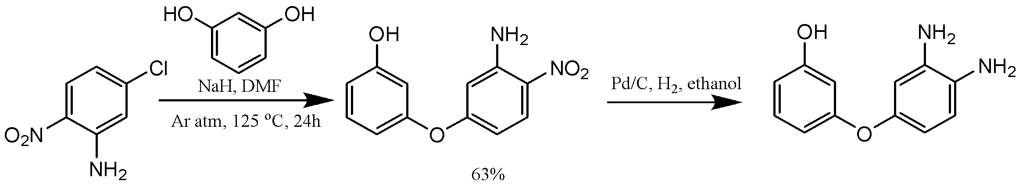
Scheme 1.2 – Hydrogenation reaction of 3-(3-amino-4-nitrophenoxy) phenol

Wang and his research team in 2015 created a self-promoted hydroxy-containing phthalonitrile system, which included 1,3-bis(3,4-dicyanophenoxy)benzene (BDB) and (4-hydroxyphenoxy)phthalonitrile (HPPH) through a one-pot nucleophilic displacement reaction by removing a nitro-substituent from 4-nitrophthalonitrile using a suitable reagent with resorcinol. They used potassium carbonate as a base, and DMSO as a solvent. The reaction goes in 40 ⁰C(scheme 1.3) [47].

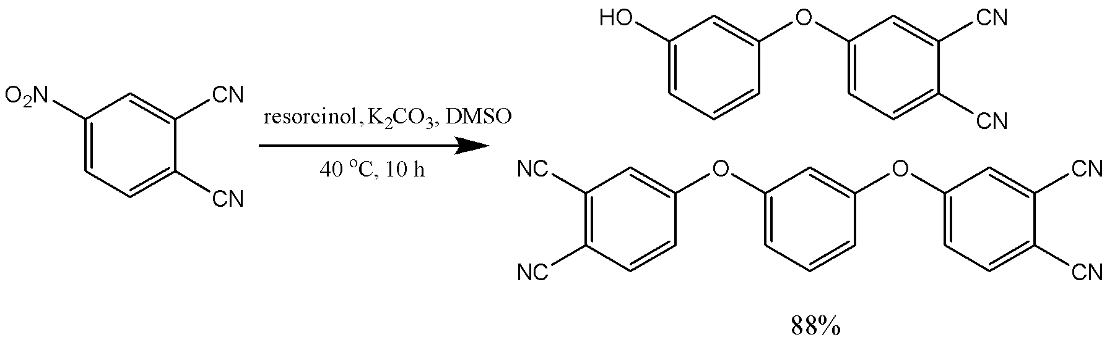
Scheme 1.3 – Synthesis of (4-hydroxyphenoxy)phthalonitrile and 1,3-bis(3,4-dicyanophenoxy) benzene

Bollini and colleagues published a study in 2011 that demonstrated the synthesis of 4-(3-hydroxyphenoxy)-3-[(tetrahydro-2H-pyran-2-yl)oxy]benzonitrile and 3-(benzyloxy)-4-(3-hydroxyphenoxy)benzonitrile from 3-hydroxy-4-fluorobenzonitrile using a two-step process(scheme 1.4) [48].
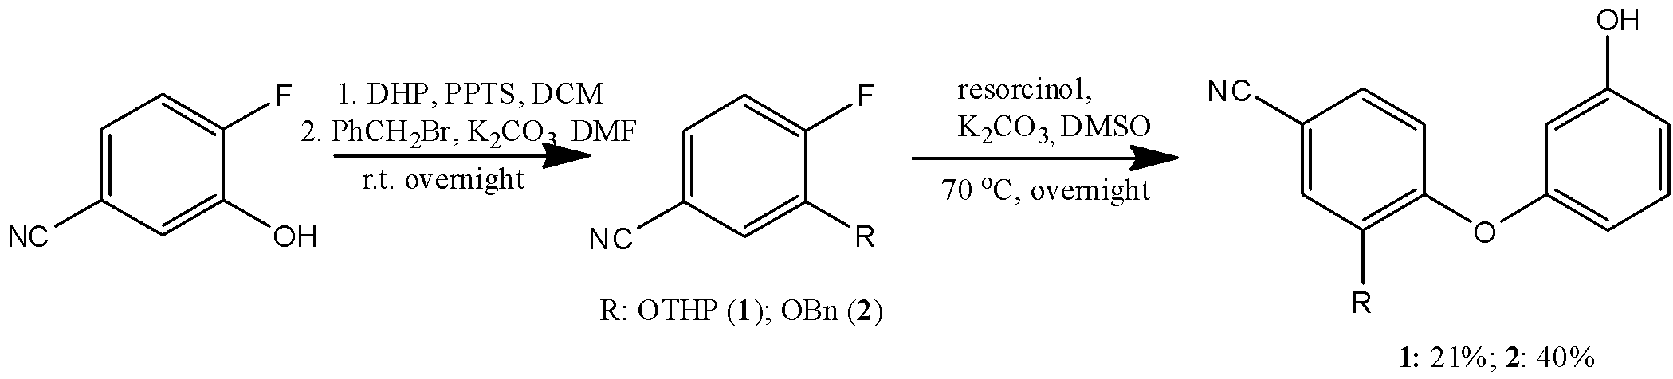
Scheme 1.4 – Synthesis of aryloxy phenols based on 3-aryloxy-4-fluorobenzonitrile and resorcinol

In the second step they used resorcinol, potassium carbonate as a base, and DMSO as a solvent. The reaction goes in 70 ºC, overnight. The yields of the synthesis were 21% and 40%.
In 2011, a team led by Xia introduced a new category of benzoxaborole β-lactamase inhibitors via a three-step synthesis process. The initial step involved substituting 2-bromo-4-fluorobenzaldehyde with phenol to form an ether using nucleophilic substitution. Next, they utilized palladium-mediated boronylation on the ether to generate an aldehyde. Finally, the aldehyde was reduced with NaBH₄ and underwent acid-catalyzed cyclization to produce the final product, known as the (3-hydroxyphenoxy)benzoxaborole(scheme 1.5) [49,50].

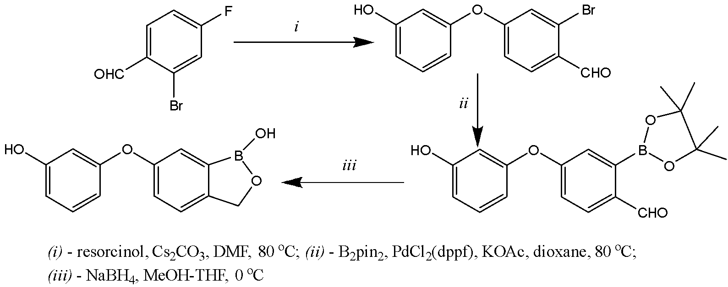
Scheme 1.5 – Synthesis of the (3-hydroxyphenoxy)benzoxaborole

Kobayashi and his team accomplished the synthesis of 5-chloro-4-[4-chloro-2-fluoro-5-(3-hydroxyphenoxy)phenyl]-1,2-tetramethylene-4-pyrazolin-3-one in 2016 (scheme 1.6), using a seven-step process starting from 2,5-difluoro-4-bromonitrobenzene.

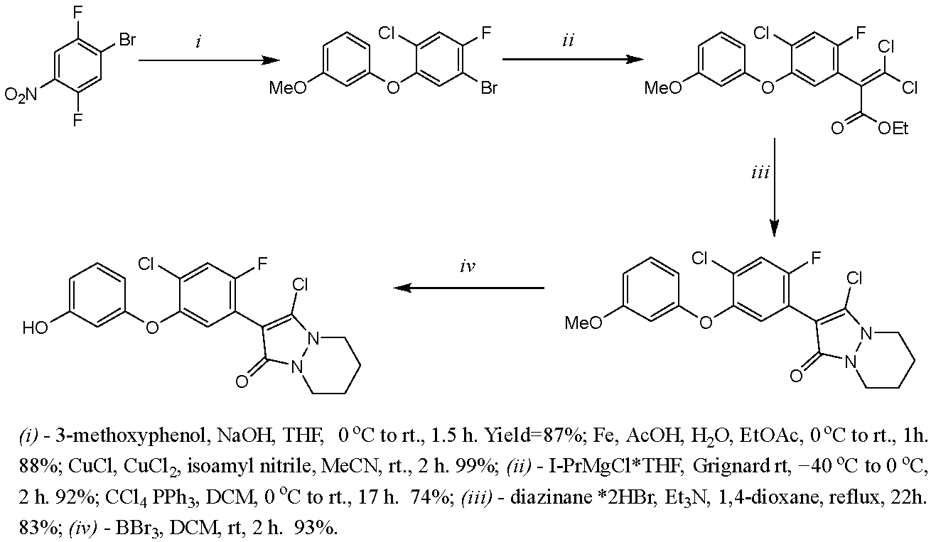

Scheme 1.6 – Synthesis of a polycyclic pyrazolinone derivative containing an aryloxy phenol fragment

Their methodology entailed an electrophilic aromatic substitution reaction between 2,5-difluoro-4-bromonitrobenzene and 3-methoxyphenol, resulting in the formation of an ether. The final step involved the removal of a methyl group utilizing boron tribromide as a demethylation agent, yielding the desired 5-chloro-4-[4-chloro-2-fluoro-5-(3-hydroxyphenoxy-phenyl]-1,2-tetramethylene-4- pyrazolin-3-one [51].
In 2018, Kazuia and colleagues achieved synthesis of 4-(3-hydroxyphenoxy) benzamine from para-fluoronitrobenzene and resorcinol (scheme 1.7). The reaction was carried out at a temperature of 50°C for 3 h, utilizing sodium hydroxide and DMSO as reagents. The final product was obtained by hydrogenation using a Pd/C catalyst in methanol under a hydrogen atmosphere for 2 h [52].

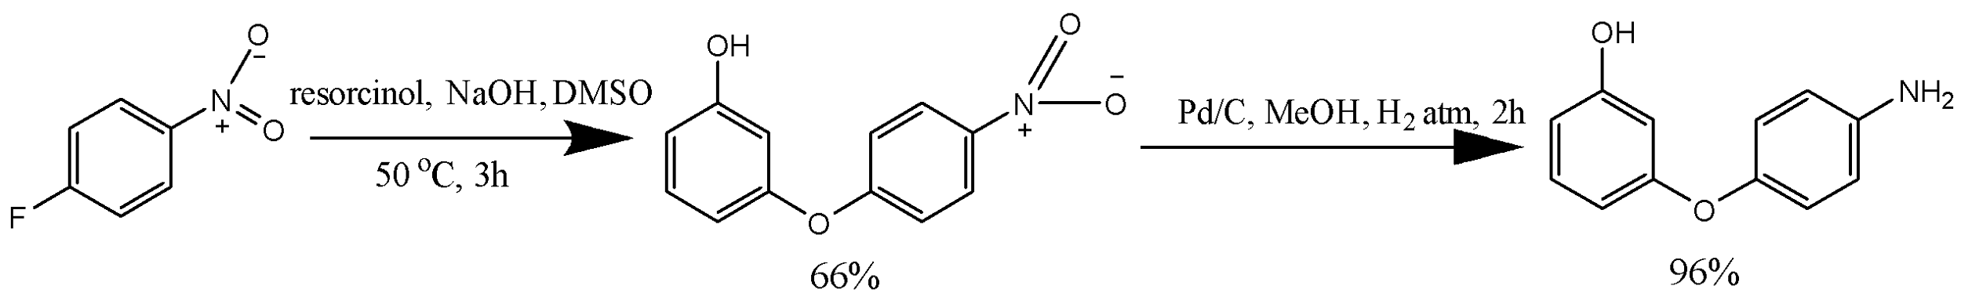

Scheme 1.7 – Synthesis of 4-(3-hydroxyphenoxy) benzamine

Frączk and his team reported the synthesis of 2-(3-hydroxyphenoxy)-5-chlorobenzonitrile in two steps in 2018(scheme 1.8). The first step involved the reaction of 5-chloro-3-fluorobenzonitrile with 3-methoxyphenol using NMP and potassium carbonate as reagents. In the second step, demethylation was performed using BBr₃ in DCM. The final product was 5-chloro-2-(3-hydroxyphenoxy)benzonitrile [53].

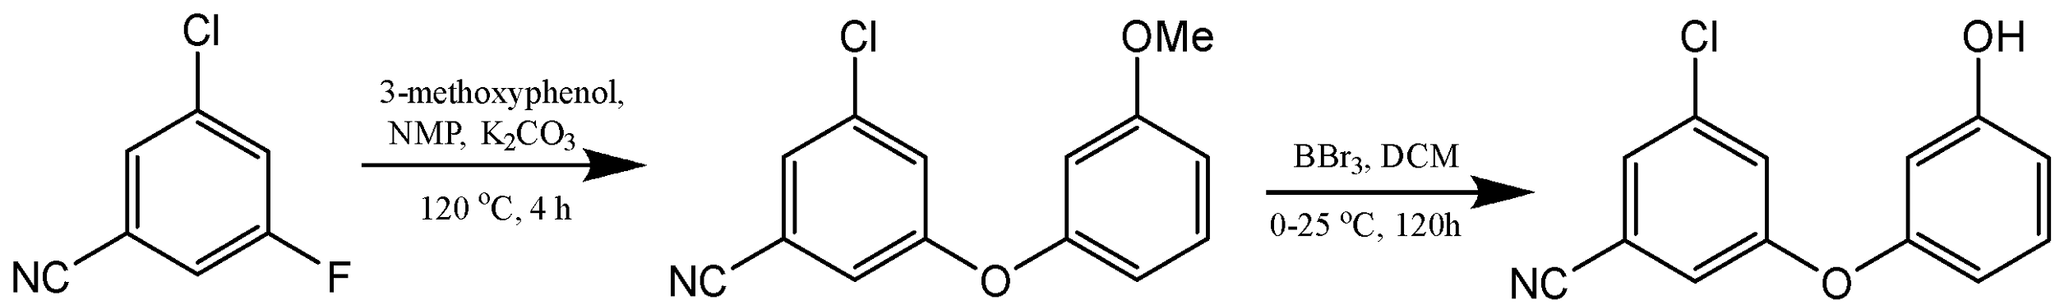

Scheme 1.8 – Synthesis of 5-chloro-2-(3-hydroxyphenoxy)benzonitrile

In 2022, Zhong and his team developed a synthesis approach for producing 3-[2-chloro-4-(trifluoromethyl)phenoxy]phenol(scheme 1.9). The synthesis was achieved through the displacement of 3-chloro-4-fluorobenzotrifluoride with resorcinol, requiring a high temperature of 130°C and an inert atmosphere for a 24-h reaction time. The desired product was 3-[2-chloro-4-(trifluoromethyl)phenoxy]phenol with 99% yield [54].

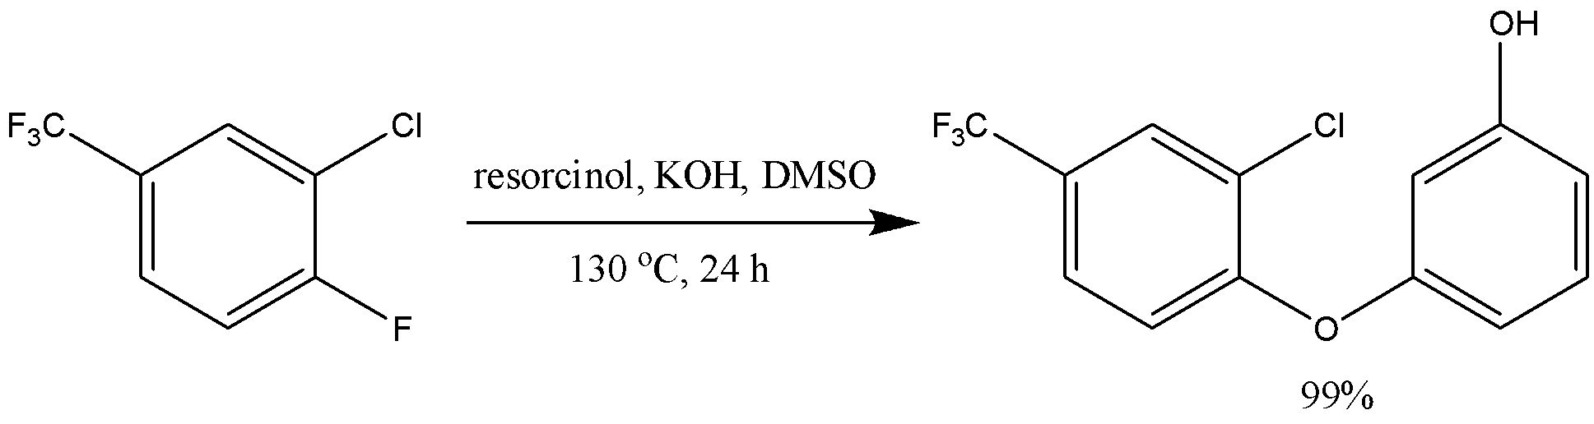

Scheme 1.9 – Synthesis of 3-(2-chloro-4-(trifluoromethyl)phenoxy) phenol

The use of a catalyst in the nucleophilic aromatic substitution reaction between an aryl halide and resorcinol has been extensively studied. The choice of a suitable catalyst depends on the reaction conditions and the desired outcome. Transition metal catalysts like palladium and copper have been shown to be effective in catalyzing this reaction, leading to an increase in reaction rate and/or improved regioselectivity. However, the use of a catalyst may also bring about practical disadvantages, such as higher cost and the need for specific handling and disposal procedures. Copper chloride (CuCl) has been found to be an effective catalyst in the reaction between an aryl halide and resorcinol, resulting in an enhancement in reaction rate and/or regioselectivity [55-58].
In 2010, Silverman and his team developed a two-step procedure for synthesizing meta-(aryloxy)phenols. They first carried out Ullmann couplings of meta-(methoxy)phenol with iodobenzene derivatives using Cs₂CO₃ and a small amount of CuBr as a catalyst to produce the intermediate compound. Next, they cleaved the methyl ethers using BBr₃, resulting in meta-(aryloxy)phenols in high yields(scheme 1.10) [59].
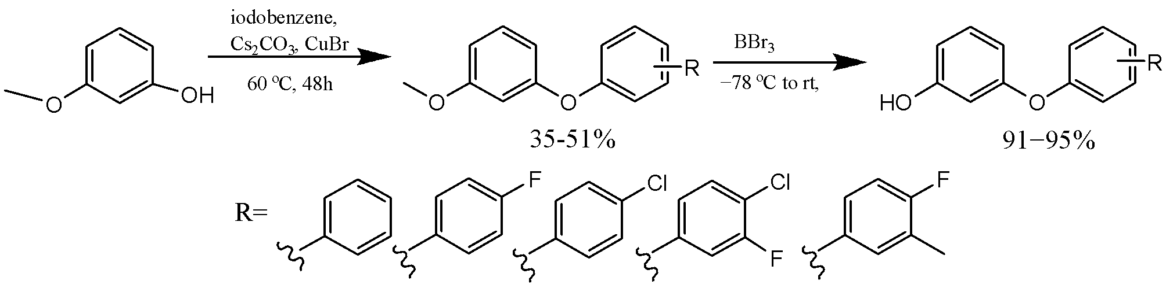

Scheme 1.10 – Synthesis of meta-(methoxy)phenol with iodobenzene derivatives using Cs₂CO₃ and a small amount of CuBr as a catalyst

In 2010, Sapkota and colleagues reported on a two-step copper catalyst-based synthesis of 8 meta-(aryloxy)phenols from methoxyphenols and 2-bromonitrobenzene or 2,4-dibromonitrobenzene. The yields of the final compounds varied between 6-44% (scheme 1.11) [60].
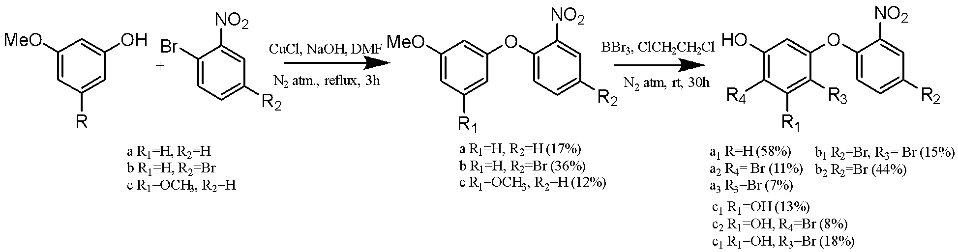
Scheme 1.11 – Two-stage synthesis of new meta-aryloxy phenols based on a copper catalyst

Bouey and her team synthesized 3-(para-tolyloxy)phenol from 3-iodoanisole and para-methylphenol through a two-step process in 2010(scheme 1.12). The first step involved utilizing copper iodide, N,N-dimethylglycine hydrochloride, and cesium carbonate to carry out etherification. In the second step, boron tribromide was used as a demethylation agent, with DCM serving as a solvent [61].

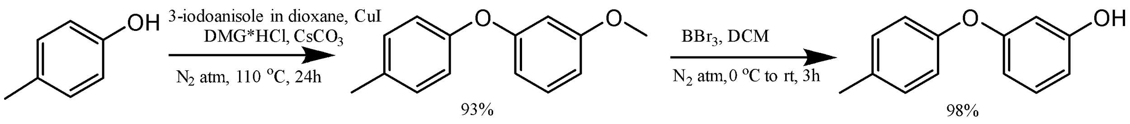

Scheme 1.12 – Synthesis of 3-(para-tolyloxy)phenol based
on copper iodide as a catalyst

In a study published by Lee and colleagues, an Ullmann coupling reaction was employed for the synthesis of 3-(4-bromophenoxy)phenol, a derivative of meta-substituted phenol(scheme 1.13). The reaction was conducted in DMSO and utilized copper iodide, potassium carbonate, and L-proline as catalysts [62].

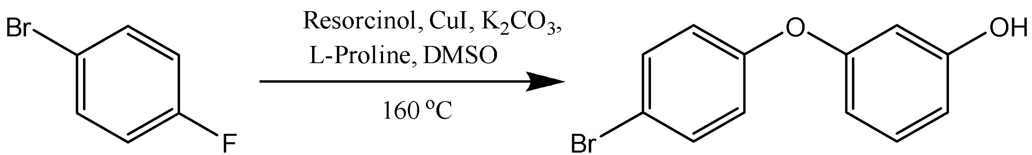

Scheme 1.13 – Synthesis of 3-(4-bromophenoxy)phenol

In 2012, Li and colleagues reported a two-step synthesis of bisphenol monomers using a copper catalyst(scheme 1.14). The starting materials were 4,4’-dibromo biphenyl and 3-methoxyphenol, and the reaction proceeded via an intermediate methoxy-terminated four-ring monomer.

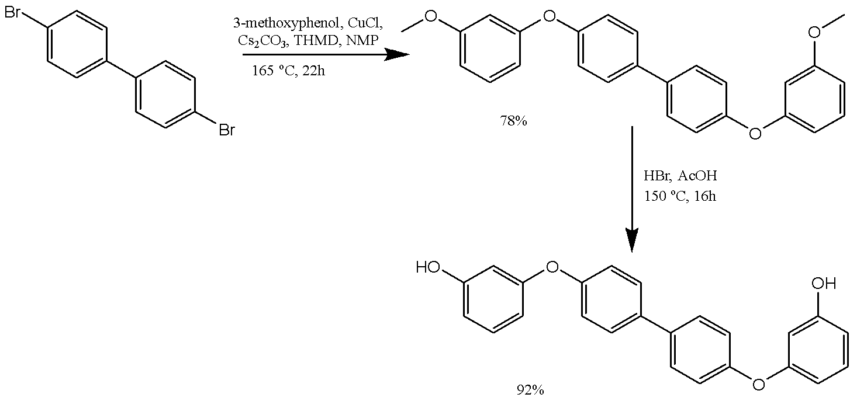
Scheme 1.14 – Synthesis of bisphenol using a copper catalyst

The first step, which involved an Ullmann coupling reaction, using CuCl, Cs₂CO_{3,} 2,2,6,6-tetramethyl-3,5-heptanedione (THMD) and N-methyl pyrrolidone (NMP), was conducted at a high temperature of 165°C. The second step, which involved hydrolysis of the intermediate, was carried out at 150°C using hydrobromic acid in acetic acid to produce the final product [63].
The paper [64] presents a modified method for synthesizing 1,3-di(3-hydroxyphenoxy)benzene, which involves two stages. The first stage involves the use of various activated meta-cresols with protected hydroxy groups and compounds containing leaving groups (LG) in the meta position in the presence of a catalyst such as copper (I) chloride, to produce 1,3-diaryl-substituted heterocycles. The second stage involves the interaction of these compounds with an acid catalyst to produce 1,3-di(3-hydroxyphenoxy)benzene(scheme 1.15). This method is a modification of a process previously published by L. Wang [65].

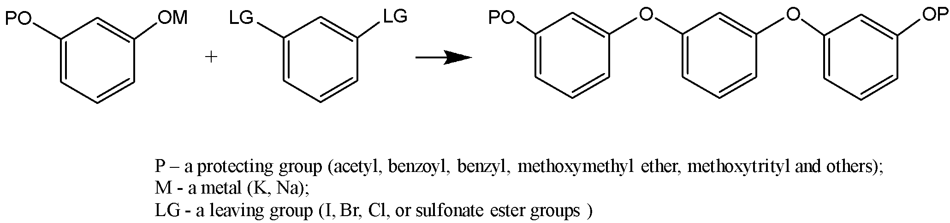

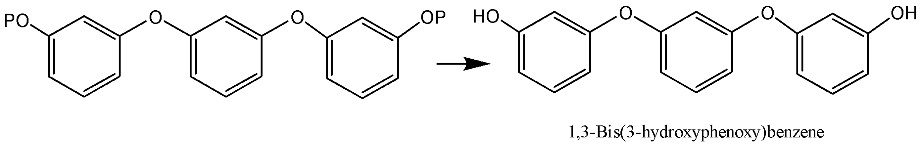

Scheme 1.15 – Synthesis of 1,3-di(3-hydroxyphenoxy)benzene

In 2013, a report was published by Bartholomeus et.al. detailing the synthesis of 3-(3,5-dimethoxyphenoxy)phenol through the application of the Ullmann-type coupling reaction(scheme 1.16). The synthesis process entailed mixing 1-bromo-3,5-dimethoxybenzene with resorcinol, in the presence of a copper iodide catalyst, N,N-dimethylglycine hydrochloride, cesium carbonate, and DMF as the solvent [66].

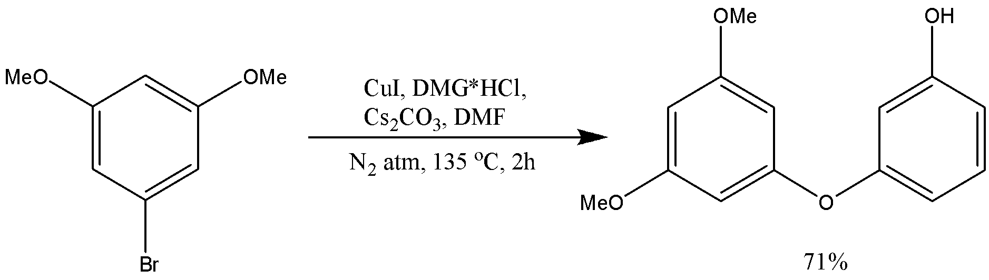

Scheme 1.16 – Synthesis of 3-(3,5-dimethoxyphenoxy)phenol

A methodology for the synthesis of 3-(para-substituted aryloxy) phenols via Ullmann coupling reaction was published by Gim and coworkers in 2015 (scheme 1.17). The process involved the amalgamation of resorcinol and aryl iodides with CuI with picolinic acid serving as catalyst. They used potassium phosphate as a base and dimethyl sulfoxide as a solvent for the synthesis. The reaction goes at 90ºC overnight [67].
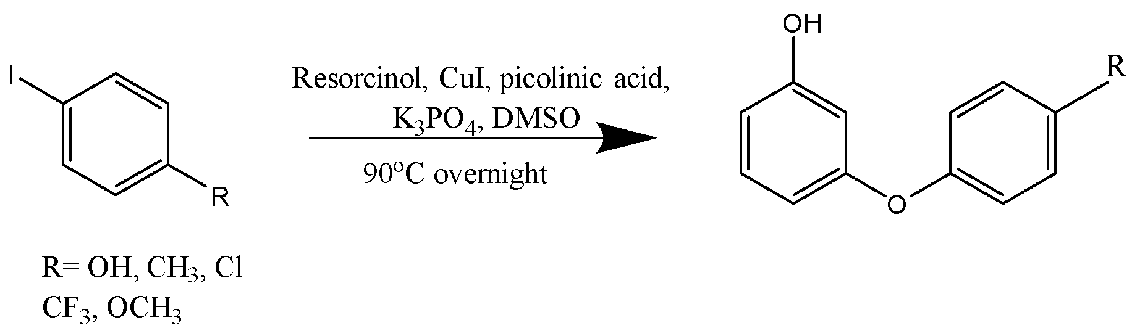

Scheme 1.17 – Synthesis of 3-(para-substituted aryloxy) phenols using
CuI and picolinic acid as catalyst

In 2016, Yang and colleagues presented a 4-step approach for the synthesis of 3-(3,5-dichloro-4-hydroxyphenoxy)phenol from 4-iodophenol(scheme 1.18). The synthesis involved an Ullmann reaction catalyzed by copper, with 3-methoxyphenol serving as a co-reagent, followed by demethylation with HBr in acetic acid. All steps necessitated an inert atmosphere and exhibited high yields. Furthermore, the same process was employed by Hu et.al to synthesize 3-(3,5-dichloro-4-hydroxyphenoxy)-4-chlorophenol, as described in 2016 [68,69].

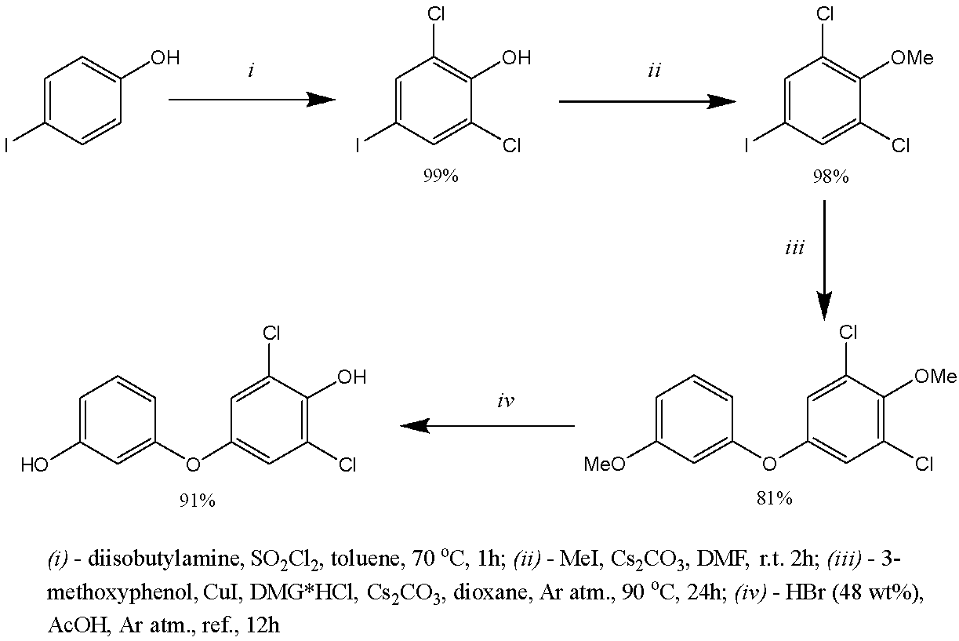
and
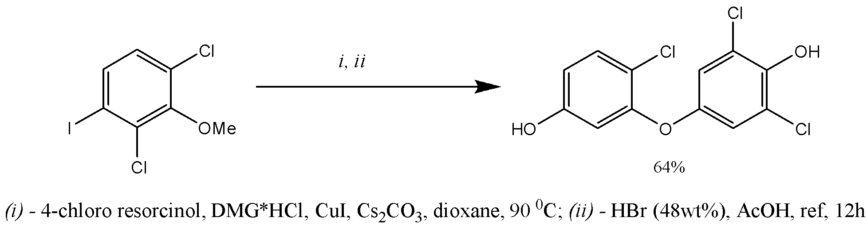
Scheme 1.18 – Synthesis of 3-(3,5-dichloro-4-hydroxyphenoxy)-phenol and 3-(3,5-dichloro-4-hydroxyphenoxy)-4-chlorophenol

Bai and coworkers reported a 2-step method for synthesizing 3-(3,5-diiodo-4-hydroxyphenoxy)phenol and 4-chloro-3-(3,5-diiodo-4-hydroxyphenoxy)phenol from 2,4,6-triiodophenol, utilizing specific reagents. The ultimate stage of the process entailed using boron tribromide in DCM as a demethylation agent(scheme 1.19), as published in 2017 [70].

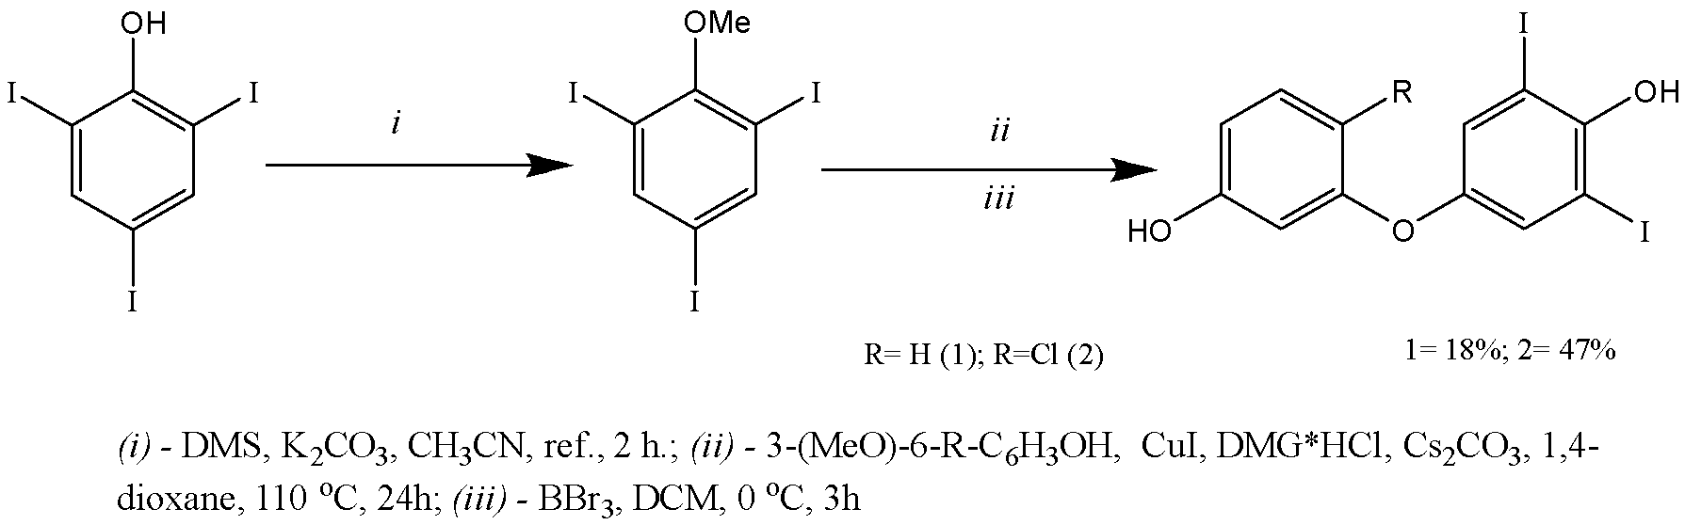

Scheme 1.19 – Synthesis of 3-(3,5-diiodo-4-hydroxyphenoxy)phenol and
3-(3,5-diiodo-4-hydroxyphenoxy)-4-chlorophenol

As per the 2010 patent by Breitenburcher et al. [71], the desired compounds were synthesized by treating the appropriate starting material with a CuI solution, in the presence of resorcinol, N,N-dimethylglycine HCl, and cesium carbonate in N,N-dimethylacetamide (DMA) (scheme 1.20).
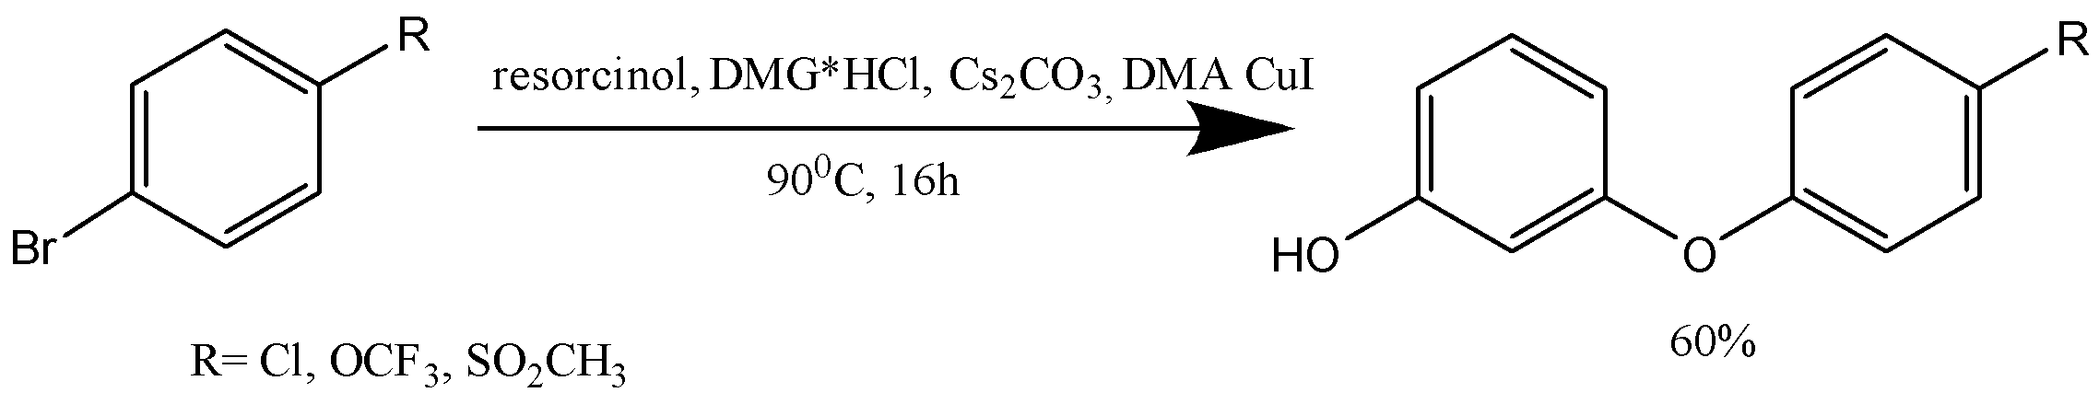
Scheme 1.20 – Synthesis of 3-(para-substituted aryloxy) phenols using CuI and DMG*HCl as catalysts

1.2.2 Sonogashira Coupling: A Copper-Catalyzed Method for Biaryl Synthesis
Over the past three decades, transition metal catalyzed reactions have become a versatile tool in organic chemistry due to their ability to easily form carbon-carbon bonds, making them useful in the synthesis of many pharmaceuticals and agrochemicals. These reactions have many desirable features such as mild reaction conditions, high efficiency, and good functional group tolerance. In 1975 [72-74], the Pd-catalyzed cross-coupling reactions between sp²-C halides and terminal alkynes was independently reported by Heck, Cassar, and Sonogashira. Heck and Cassar utilized Pd catalysts for coupling between sp²-C halide and terminal alkyne, while Sonogashira used a combination of Pd and Cu catalysts [75,76]. The Sonogashira-Hagihara reaction involves the cross-coupling reaction between an aryl halide (Cl, Br, I, OTf) and a terminal acetylene in the presence of catalytic amounts of a Pd complex, CuI salt, and a base to form an aryl acetylene. Typically, a combination of 1-10 mol% of Pd(PPh₃)₂Cl₂ or Pd(PPh₃)₄ and CuI is used as the catalyst system. However, due to the high cost of Pd, the use of the Sonogashira reaction in large scale production is restricted, and therefore, alternative catalyst systems are being actively researched [77]. As a result, replacing Pd with cheaper, more abundant, and less toxic Cu has become an area of active research.
The Sonogashira coupling reaction is a type of cross-coupling reaction that utilizes a copper catalyst and a strong base to facilitate the interaction between aryl boronic acids and phenols. Copper (II) acetate [Cu(OAc)₂] is commonly used as the copper catalyst, while potassium carbonate (K₂CO₃) serves as the base. The reaction mechanism involves the formation of a copper-phenol complex, which then reacts with the aryl boronic acid to generate an intermediate. This intermediate undergoes transmetallation to produce the final biaryl product. Due to its versatility and high efficiency, the Sonogashira coupling reaction is widely used in the synthesis of various compounds, including pharmaceuticals and agrochemicals [78,79].
The Sonogashira coupling reaction is known for its tolerance of various functional groups and can be performed under mild conditions. It has been utilized in the synthesis of a range of biaryl compounds, including natural products, such as strychnine, and bioactive molecules, such as anticancer agents. Despite its many benefits, the Sonogashira coupling reaction is not without limitations. For example, the reaction can be sensitive to steric hindrance, and the use of aryl chlorides or fluorides may require harsher reaction conditions or longer reaction times. Additionally, the use of toxic solvents, such as DMF or DMSO, may be required for certain substrates. Nevertheless, the Sonogashira coupling reaction remains an important tool for the formation of C-C bonds in organic synthesis.
In 2015, Bryan et al. summarized research efforts aimed at creating of the new carbon-heteroatom bonds using organoboron reagents through copper acetate-mediated reactions under ultrasound irradiation. The Chan-Evans-Lam reaction was modified by including of ultrasound irradiation to achieve O-arylation of phenols, N-arylation of anilines and indoles, and S-arylation of thiols. The use of ultrasound irradiation was found to drastically reduce reaction times from 72 h to 4 h, while also increasing product yields by an average of 20%. Scheme 1.21 illustrates the reaction [80].
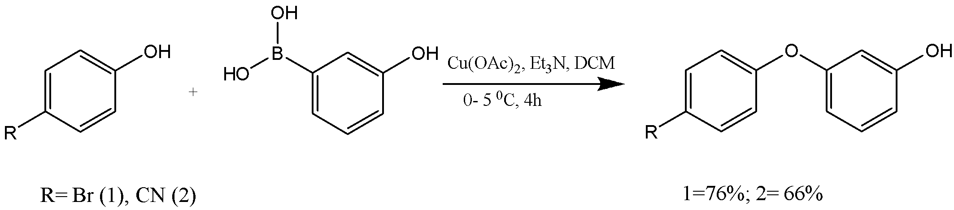

Scheme 1.21 – Synthesis of new aryloxy phenols by the Sonogashira reaction

A method for producing new diaryl ether phenolic compounds has been described by scientists at the University of Pisa. These compounds are composed of two peripheral phenolic rings with hydroxyl groups in the meta- and/or para-positions, which are linked by a central 1,3-disubstituted phenyl ring. The synthesis of these compounds involves four stages, as outlined in scheme 1.22.
Initially, commercially available 3-bromophenol is subjected to a cross-coupling reaction under bis(triphenylphosphine)palladium catalyzed Suzuki conditions with 3- or (4-methoxyphenyl)boronic acid to obtain diaryl derivatives - specifically, 3- and 4-(phenoxy)anisole with a quantitative yield (99% yield) in stage 1 of the synthesis process. The catalyst used for this reaction is a mixture of palladium acetate Pd(OAc)₂ and triphenylphosphine (PPh₃) in ethanol and toluene at rt in an inert gas environment.
Subsequently, the intermediates obtained in the first stage are subjected to a C-O bond interaction with 3- and 4-bromanisole in the presence of appropriate catalysts during heating, resulting in a ligand-free Ullmann-type reaction that forms 3- and 4-methoxy substituted derivatives of diaryl ether in stages 2 and 3 of the synthesis process. All the methoxy-substituted derivatives are then subjected to a common final synthetic step, which involves a BBr₃-promoted removal of the methoxy groups to obtain the desired diaryl ether phenolic compounds(stage 4 in scheme 1.22). The use of this dealkylating agent provides good yields of the target products (yield 71-95%) [81].

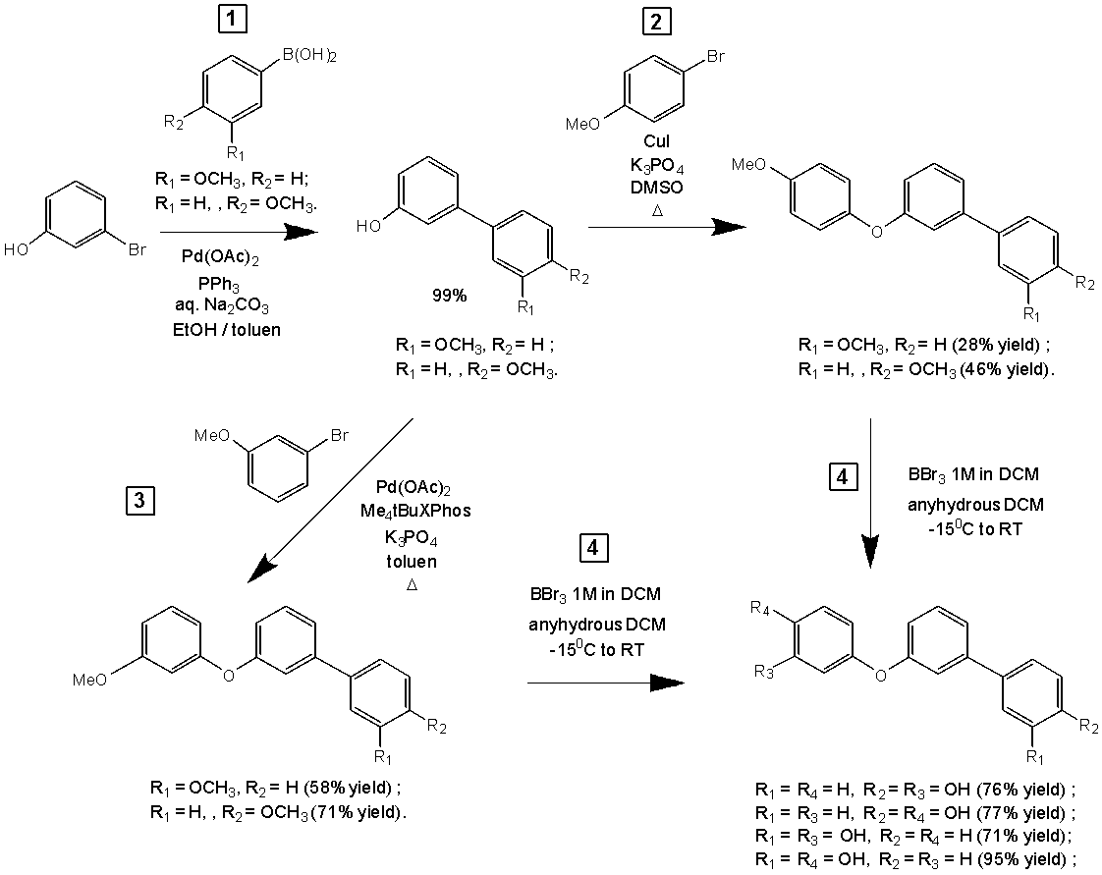

Scheme 1.22 – Synthesis of new diaryl ether phenolic compounds

1.2.3 Synthesis of meta-(aryloxy)phenols using Grignard Reagents
In addition to their utility in the synthesis of aryloxy phenols, Grignard reagents have many other applications in organic chemistry. They can be used to synthesize a wide range of organic compounds, including alcohols, ethers, amines, and carboxylic acids, through reaction with various carbonyl compounds, halides, and other functional groups. They can also be used in cross-coupling reactions with other organic compounds, such as aryl halides, to form carbon-carbon bonds.
Grignard reagents have also been used in the synthesis of natural products and pharmaceuticals, as well as in the production of polymers and materials. They have played a critical role in the development of modern synthetic organic chemistry and continue to be an important tool for chemists in both academia and industry.
However, it is important to note that Grignard reagents can be highly reactive and potentially dangerous, especially when handled improperly. They can react violently with water and air, and can cause severe burns and other injuries. Proper safety precautions, such as appropriate protective equipment and storage conditions, must be taken when working with Grignard reagents [82].
In 2012, a team of researchers led by Chandrakala Pidathala employed 4-(3-methoxyphenoxy)benzaldehyde in a Grignard reaction, which yielded an intermediate alcohol(scheme 1.23). Subsequently, the alcohol was oxidized with PCC to produce 1-[4-(3-methoxyphenoxy)phenyl]propane-1-one, in a yield of 89%. Further, BBr₃ was utilized to eliminate the O-methyl group from the ketone, leading to the formation of 1-[4-(3-hydroxyphenoxy)phenyl]propane-1-one with a yield of 62% [83].

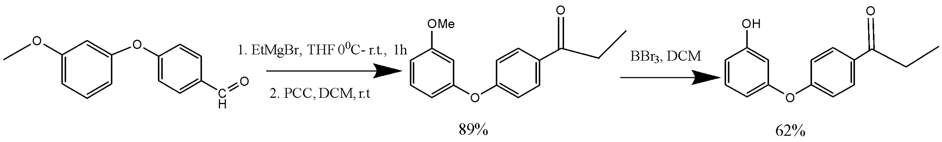

Scheme 1.23 – Synthesis of 1-[4-(3-hydroxyphenoxy)phenyl]propan-1-one

In a study conducted by Gao and colleagues, 3-(4-fluorophenoxy)phenol was synthesized from arylmetals via hydroxylation using N-benzyloxaziridine. The reaction took place at rt for 2 h. The researchers showed that N−H and N−alkyl oxaziridines, which are derived from economical terpenoid scaffolds, can act as effective primary aminating and hydroxylating reagents. This method allows for the direct production of primary arylamines and phenols from readily available aryl metals without the need for transition metal catalysts and under mild reaction conditions(scheme 1.24) [84].

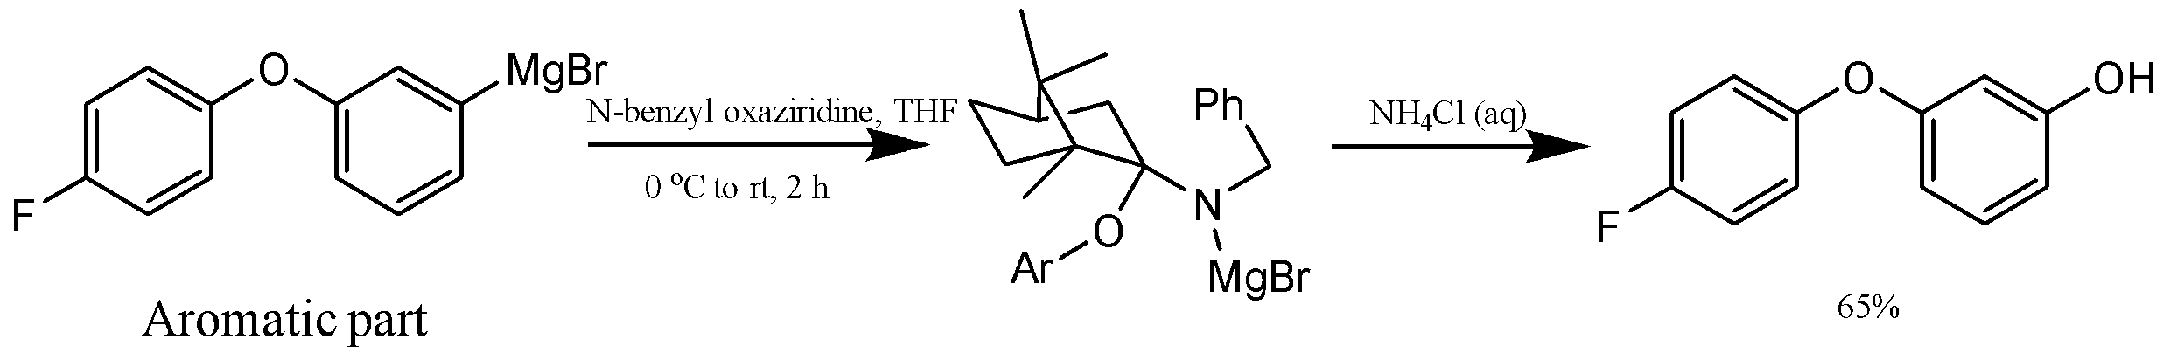

Scheme 1.24 – Synthesis of 3-(4-fluorophenoxy)phenol

1.2.4 Hydrolysis of Diazonium Salts Using a Two-Phase System
The synthesis of 3-(aryloxy)phenols through the hydrolysis of diazonium salts, derived from 3-(4-nitrophenoxy)aniline, was investigated with the goal of developing a safe, simple, low-cost, and high-yielding synthetic method [85]. However, the traditional textbook reactions were not practical and industrially feasible due to the formation of large amounts of tar during the reaction, making experimental manipulation difficult. To overcome this challenge, a two-phase system comprising an organic solvent and water was proposed. After extensive experimentation with various two-phase systems, the use of a mixture of cyclopentyl methyl ether (CPME) and water was found to be surprisingly effective.
In 2015, Taniguchi and colleagues reported a successful method for synthesizing 3-(phenoxy)phenol and 3-(4-nitrophenoxy)phenol(scheme 1.25). The process involved hydrolyzing intermediate diazonium salts derived from anilines using a two-phase system consisting of CPME and water. This approach resulted in high yields of the desired compounds, overcoming the challenge of forming large amounts of tar during the reaction and facilitating suitable experimental manipulation. This study represents the first example of using a two-phase system for the hydrolysis of diazonium salts [86].

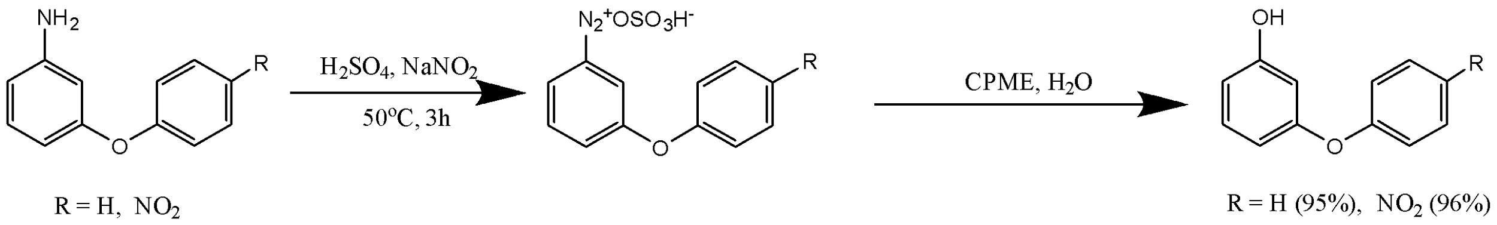

Scheme 1.25 – Synthesis of meta-aryloxy phenols

1.2.5 Synthesis of meta-aryloxy phenols by demethylation of meta-methoxy phenols
Demethylation is a process that involves the removal of a methyl group from a molecule. An example of this reaction is the conversion of meta-methoxy phenols to meta-aryloxy phenols. Demethylation can be achieved through various methods, such as chemical and catalytic approaches. Chemical methods involve the use of strong acids like sulfuric acid, hydrochloric acid, or nitric acid, which convert the methoxy group into the desired meta-aryloxy phenol [87].
In contrast, catalytic demethylation methods utilize transition metal catalysts like copper or palladium, and can occur through different mechanisms such as hydrogenation, transfer hydrogenation, or C-H bond activation. For instance, the use of the Bronsted acid - hydrogen bromide and boron tribromide (BBr₃) as a Lewis acid catalysts is a valuable approach for synthesizing meta-aryloxy phenols. These acids can coordinate with electron-rich sites in organic compounds, which enhances the efficiency of the demethylation reaction of meta-methoxy phenols to meta-aryloxy phenols [88,89].
Kormos and his team synthesized 4-(3-hydroxyphenoxy)benzoic acid from 4-(3-methoxyphenoxy)benzoic acid by refluxing with 48% hydrogen bromide in acetic acid(scheme 1.26). They then synthesized N-(1S)-1-{[(3S)-4-(3-hydroxyphenyl)-3-methylpiperazin-1-yl]methyl}-2-methylpropyl-4-(3-hydroxyphenoxy)benzamide by condensing 4-(3-hydroxyphenoxy)benzoic acid with piperazine using N-ethylcarbodiimide·hydrochloride (EDC·HCl) and a catalytic amount of hydroxybenzotriazole (HOBt) [90].

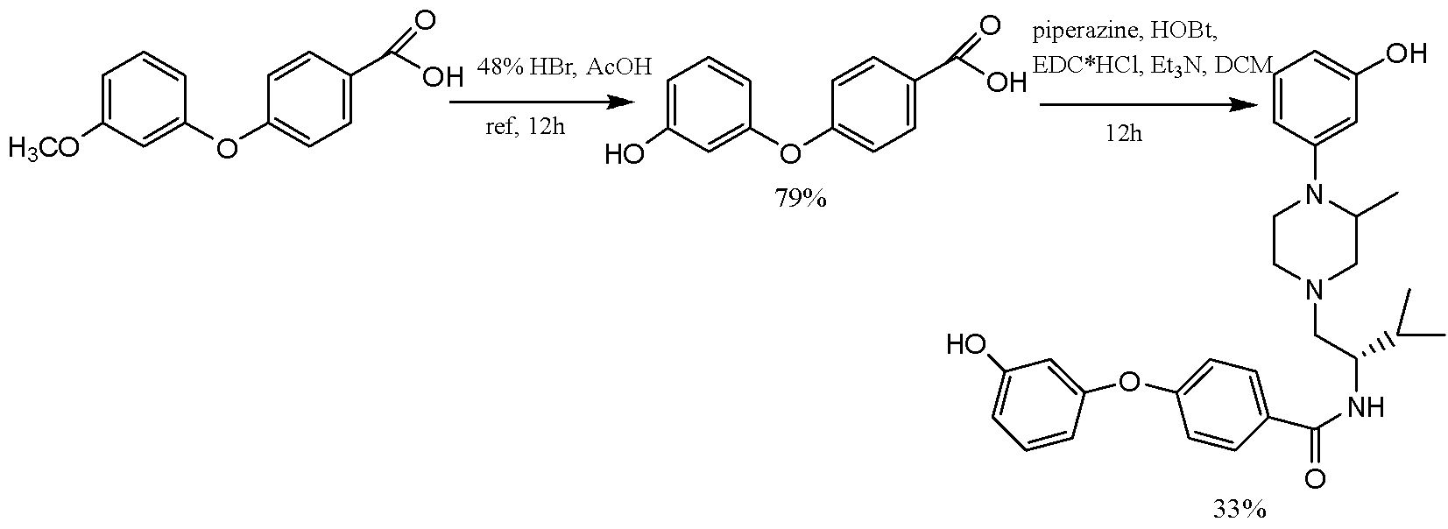

Scheme 1.26 – Synthesis of 4-(3-hydroxyphenoxy)benzoic acid and its
derivative with piperazine amine

In 2022, Yamamoto's group reported the synthesis of N-(2-(3-hydroxyphenoxy)-4-nitrophenyl)methanesulfonamide(scheme 1.27) by demethylating the corresponding methoxy derivatives using BBr₃ as a dealkylating agent [91].

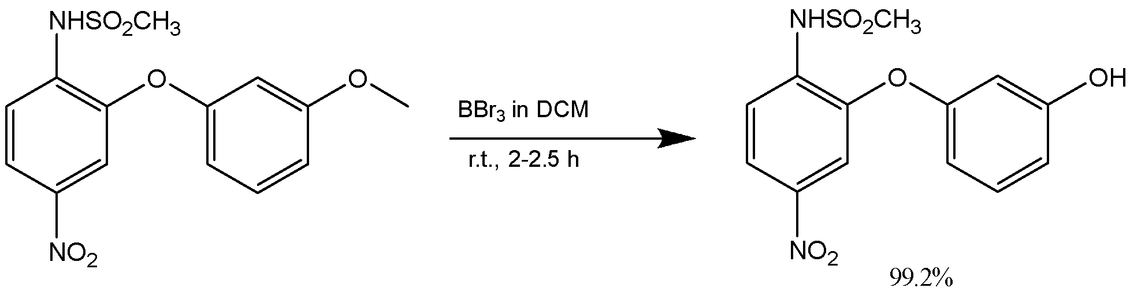

Scheme 1.27 – Synthesis of N-(2-(3-hydroxyphenoxy)-4-nitrophenyl)methanesulfonamide

In 2009, Yang [92] synthesized 3,3'-oxydiphenol by reacting 3-methoxyphenol with 3-bromanisole in the presence of a Cu-catalyst, followed by cleavage of the methyl groups with HBr in acetic acid.

Synthesis of phenol derivatives from cycloxenanone
Phenols are important building blocks for a variety of industrial chemicals, including pharmaceuticals and polymers. As previously described, the synthesis of phenols with specific patterns of functional groups around the aromatic ring is a significant challenge in organic chemistry. Traditional methods for introducing these functional groups, such as nucleophilic aromatic substitution reactions, are limited in their ability to produce ortho- and para-substituted derivatives due to strong electronic directing effects.
The process of aerobic dehydrogenation of substituted cyclohexanones to phenols involves the conversion of a substituted cyclohexanone molecule into a phenol molecule via a sequence of chemical reactions. The reaction is facilitated by a palladium catalyst, which is used to activate the C-H bonds of the cyclohexanone, leading to β-hydride elimination and the formation of a dienone intermediate. The dienone intermediate undergoes tautomerization to form the final phenol product.
One of the major benefits of this reaction is that it can be carried out under aerobic conditions, meaning that oxygen can be used as the oxidant. As a result, the reaction is catalytic in palladium, and water is the only by-product. The reaction is particularly useful for the synthesis of a broad range of substituted phenols, including those with meta-substitution patterns, and it can be used in conjunction with other chemical reactions that provide access to substituted cyclohexanone precursors. This makes it a versatile and valuable method for the synthesis of phenols [93].

1.3.1 Transition-Metal based Dehydrogenative Aromatization of Cyclohexanones
The palladium-catalyzed aerobic dehydrogenation of substituted cyclohexanones to phenols is a chemical reaction that involves the conversion of a substituted cyclohexanone to a phenol molecule using a palladium catalyst. This reaction is a versatile method for the synthesis of substituted phenols that are important precursors for a range of industrial chemicals, including pharmaceuticals and polymers [94].
In this reaction, the palladium catalyst activates the C-H bond of the cyclohexanone molecule, followed by β-hydride elimination that leads to the formation of a dienone intermediate. The dienone intermediate then undergoes tautomerization to form the final phenol product. This reaction has the advantage of being carried out under aerobic conditions, where oxygen from the air serves as the oxidant, making water the only by-product and the reaction catalytic in palladium [95].
Based on recent progress in palladium-catalyzed aerobic oxidation reactions, it has been suggested that various phenol derivatives, even those with meta substitution, can be produced by dehydrogenating cyclohexanones through a sequential process involving Pd-mediated C-H activation and β-hydride elimination, followed by tautomerization of the resulting dienone product(scheme 1.28). This method is particularly attractive because Pd^{II}-hydride intermediates formed in this mechanism can be oxidized by molecular oxygen, leading to a catalytic process in Pd with water as the only by-product [96].

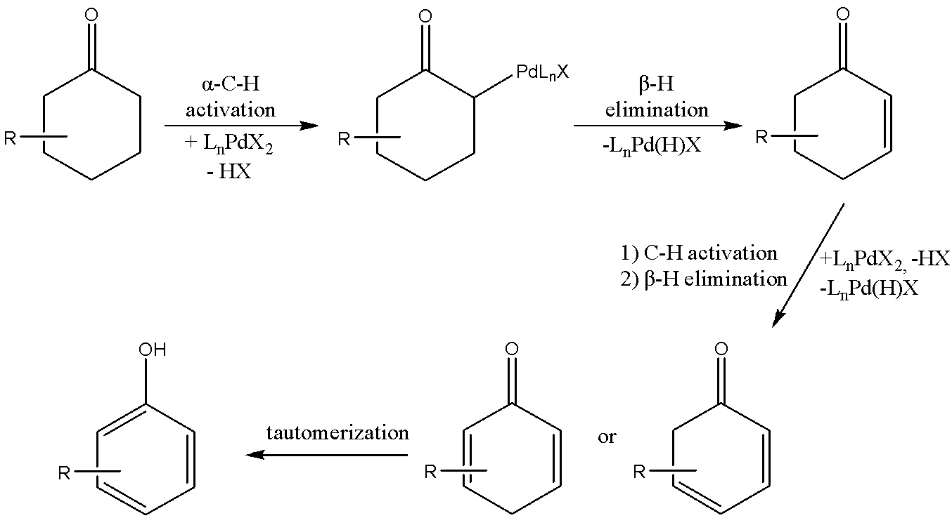

Scheme 1.28 – Stepwise sequence for Pd-mediated dehydrogenation of cyclohexanone

The availability of various chemical reactions that provide access to substituted cyclohexanones, including enolate arylation and alkylation methods, conjugate addition to cyclohexenones, Robinson annulation, and Diels-Alder reactions (as depicted in scheme 1.29), suggests that successful catalysts for this type of reaction could have broad applications [97].

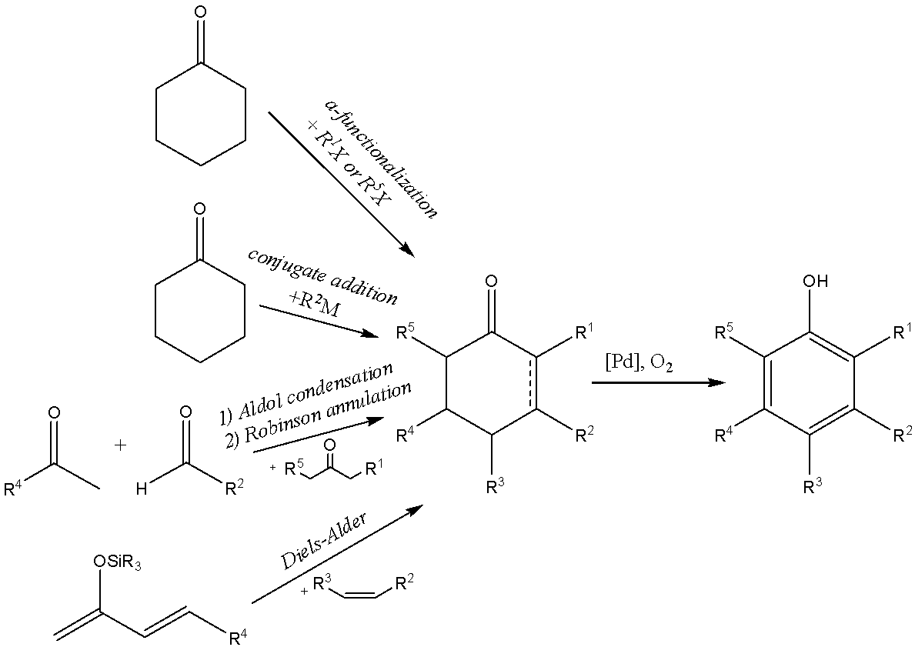

Scheme 1.29 – Representative synthetic methods that afford facile access to substitute cyclohexanone derivatives

Enolate arylation and alkylation are versatile methods for synthesizing substituted cyclohexanones. In these reactions, an aryl or alkyl group is introduced onto a carbonyl compound, such as cyclohexanone, via an enolate intermediate, which is generated in the presence of a strong base. This intermediate then undergoes an electrophilic aromatic substitution reaction with an aryl or alkyl halide, yielding the desired substituted cyclohexanone product.
Conjugate addition to cyclohexenones is another effective method for preparing substituted cyclohexanones. In this reaction, a nucleophile is added to a cyclohexenone derivative in the presence of a base, leading to the formation of a new carbon-carbon bond and the desired substituted cyclohexanone product.
Robinson annulation, a type of reaction that involves the condensation of an α,β-unsaturated ketone with a carbonyl compound in the presence of a base, is a powerful method for producing substituted cyclohexanones that contain a six-membered ring.
The Diels-Alder reaction is a versatile cycloaddition reaction that can be used to synthesize a range of cyclohexanone derivatives with different substituent groups attached. This reaction involves the reaction of a diene with a dienophile to form a cyclic compound.
The availability of these various chemical reactions suggests that the development of efficient catalysts for these reactions could have wide-ranging applications. Catalysts can enhance both reaction rates and selectivity, without being consumed in the process. Thus, effective catalysts for these reactions could lead to more efficient and cost-effective methods for synthesizing a broad range of substituted cyclohexanones with diverse chemical properties, which could have important implications for fields such as chemistry, pharmaceuticals, and materials science.
In 2011, the Stahl group reported the first successful synthesis of phenols from cyclohexanones in high yields and under conditions that are tolerant of various functional groups(scheme 1.30).
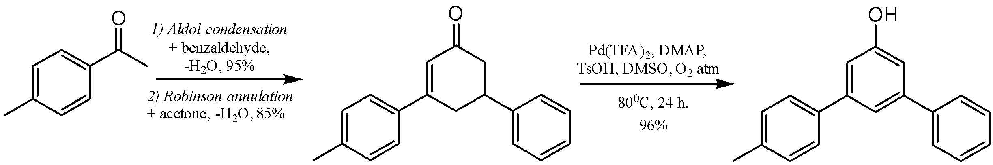

Scheme 1.30 – Synthesis of 3,5-diarylphenol by palladium-catalyzed aerobic dehydrogenation

The process involved using Pd(TFA)₂ as a catalyst in combination with 2-(N,N-dimethylamino)pyridine as a ligand and TsOH as a co-catalyst in the presence of oxygen. By utilizing this methodology, the Stahl group was able to produce a range of 3,5-disubstituted phenols from the corresponding cyclohexanones, with yields ranging from good to excellent. This breakthrough represents a significant advance in the production of meta-functionalized phenols [19,98]. One of them is the 3,5-diarylcyclohexenone which was obtained readily from very inexpensive starting materials, such as 4-methylacetophenone, benzaldehyde, and acetone, via sequential aldol condensation and Robinson annulation. Pd-catalyzed dehydrogenation of intermediate afforded final three-ring compound in excellent yield.
The Stahl group has made further progress in this area by developing a Pd-based catalyst system that enables the conjugate addition of a range of aryl boronic acids to cyclohexenones, followed by dehydrogenative aromatization to produce meta-functionalized phenols [99]. This efficient one-pot procedure employs [Pd(CH₃CN)₄](BF₄)₂ as the catalyst and bidentate bipyridine ligand in DMSO with molecular sieves at 80°C, under an atmosphere of O₂(scheme 1.31).

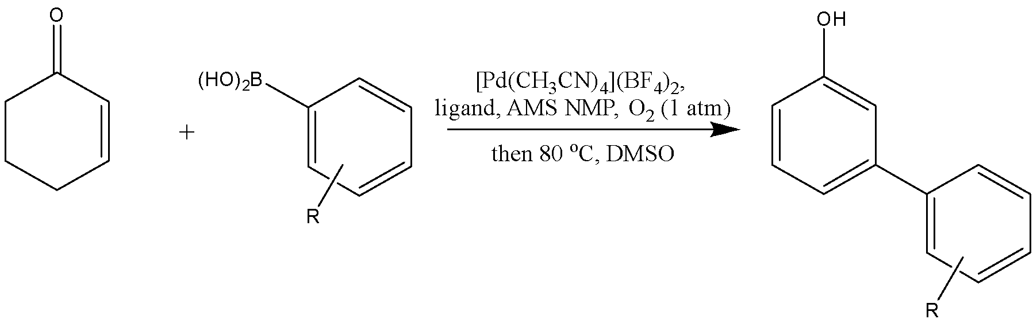
Entry | R | Time (h) | Yield (%) | Entry | R | Time (h) | Yield (%)
1 | para-Me | 32 | 91 | 10 | para-CF₃ | 32 | 40
2 | para-tert-Bu | 36 | 85 | 11 | para-CN | 36 | 35
3 | para- MeO | 32 | 80 | 12 | para-H | 32 | 75
4 | para- Cl | 32 | 68 | 13 | meta-MeO | 36 | 47
5 | para- Br | 32 | 41 | 14 | meta-Me | 36 | 76
6 | para-F | 32 | 87 | 15 | meta-NO₂ | 36 | 42
7 | para-OH | 32 | 64 | 16 | meta-CF₃ | 32 | 60
8 | para-Ph | 36 | 63 | 17 | ortho-Me | 36 | 58
9 | para-COOMe | 32 | 74 | 18 | ortho-F | 36 | 66

Scheme 1.31 – Synthesis of meta-functionalized phenols using Pd-based catalysts

In 2015, the Liu group discovered that palladium on carbon (10 mol%) in the presence of potassium carbonate (20 mol%) in DMA at 150 °C could transform various cyclohexanones/cyclohexenones to their corresponding phenols without the need for external oxidants, instead utilizing a direct H₂ release mechanism [22,100]. Scheme 1.32 presents relevant examples, demonstrating that a wide range of substituted cyclohexenones can be dehydrogenated to yield the corresponding phenols in high isolated yields.
Moreover, the present dehydrogenation method effectively converts various 3-substituted cyclohexanones into their corresponding phenols, which may be useful in the synthesis of meta-fragment substituted phenol derivatives. Interestingly, the catalytic system smoothly converts sulfur-, nitrogen-, and oxygen-containing compounds into their corresponding phenols in high yields. This highlights the versatility of the catalytic system.
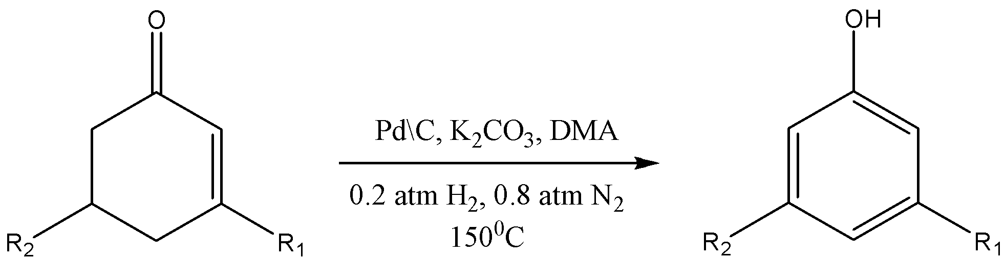
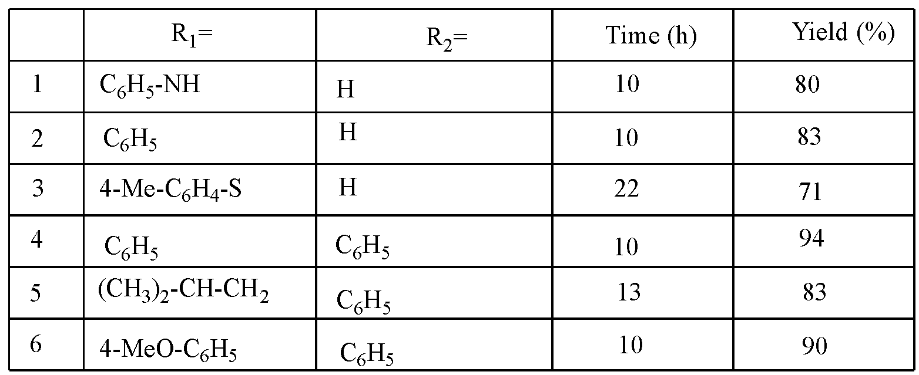

Scheme 1.32 – The synthesis of phenol derivatives by dehydrogenation of substituted cyclohexanones and 2-cyclohexenones

Various copper-mediated oxidative aromatization methods have been developed to produce phenols. The first such method was reported by Kikushima and Nishina in 2013, who utilized CuBr (5 mol%) and concentrated HBr (aq., 20 mol%) under an O₂ atmosphere to efficiently aromatize cyclohexenones(scheme 1.33). When excess HBr is present, this method can also produce brominated phenols with substitution governed by S_{E}Ar selectivity[101]. The resulting reaction system demonstrated exceptional efficiency in generating diverse phenols, all under simple and affordable conditions.

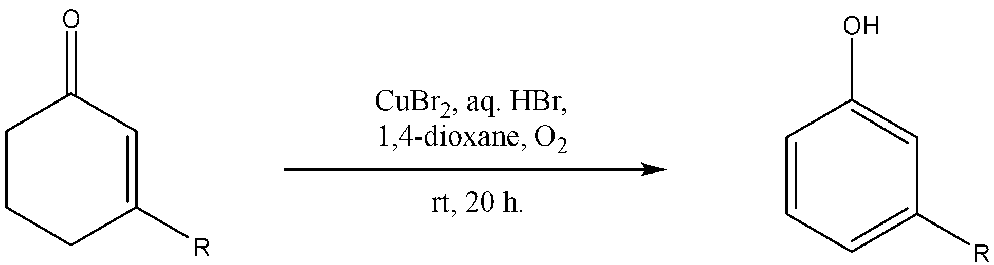
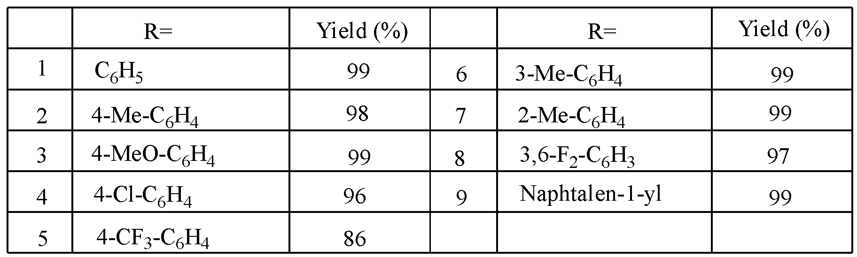

Scheme 1.33 – The transformation of 2-cyclohexen-1-ones into phenols via copper-catalyzed oxidative aromatization
The Liu group reported similar conditions in 2014 [102], using Cu(OAc)₂ (4 mol%) and LiBr (0,5 equivalents) in a 2:1 mixture of acetonitrile/trifluoroacetic acid at 80°C to prepare phenols from cyclohexenones with moderate to excellent yields (scheme 1.34). Again, this method can produce brominated phenols with S_{E}Ar selectivity when excess LiBr is present.

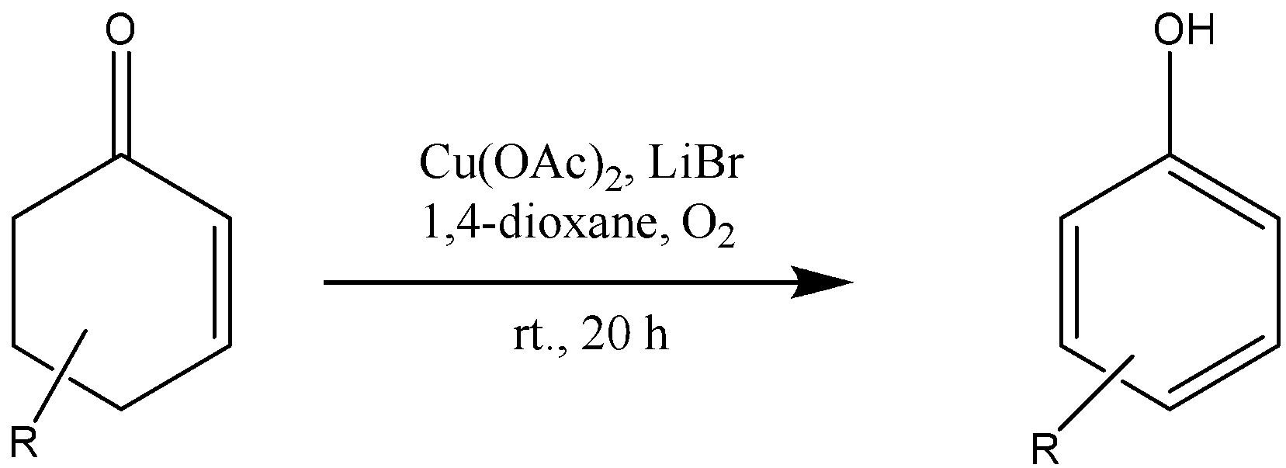
Entry | R | Yield (%) | Entry | R | Yield (%)
1 | 3,5-(C₆H₅)₂ | 65 | 5 | 3-Ph-4-(COOMe)-5-5-C₆H₄-n-Bu-p | 60
2 | 3-Me-4-(COOMe)-5-Ph | 58 | 6 | 3-Me | 46
3 | 3-Me-4-(COOMe)-5-C₆H₄-NO₂-p | 68 | 7 | 2-Me-5-i-Pr | 97
4 | 3,5-diMe-4-(COOMe) | 70 | 8 | 3-Me-4-(COOMe)-5-(C₄H₃S) | 79
Scheme 1.34 – The copper-mediated methods for the synthesis of phenols

In 2017 [103], Wang and Orellana reported a one-pot procedure to convert 3-chlorohexenones to their corresponding 3-arylphenols using palladium-catalyzed Suzuki-Miyaura cross-coupling with aryl/heteroaryl boronic acids, followed by oxidative rearomatization using a CuCl₂ catalyst in the presence of HCl and O₂ as an oxidant(scheme 1.35).

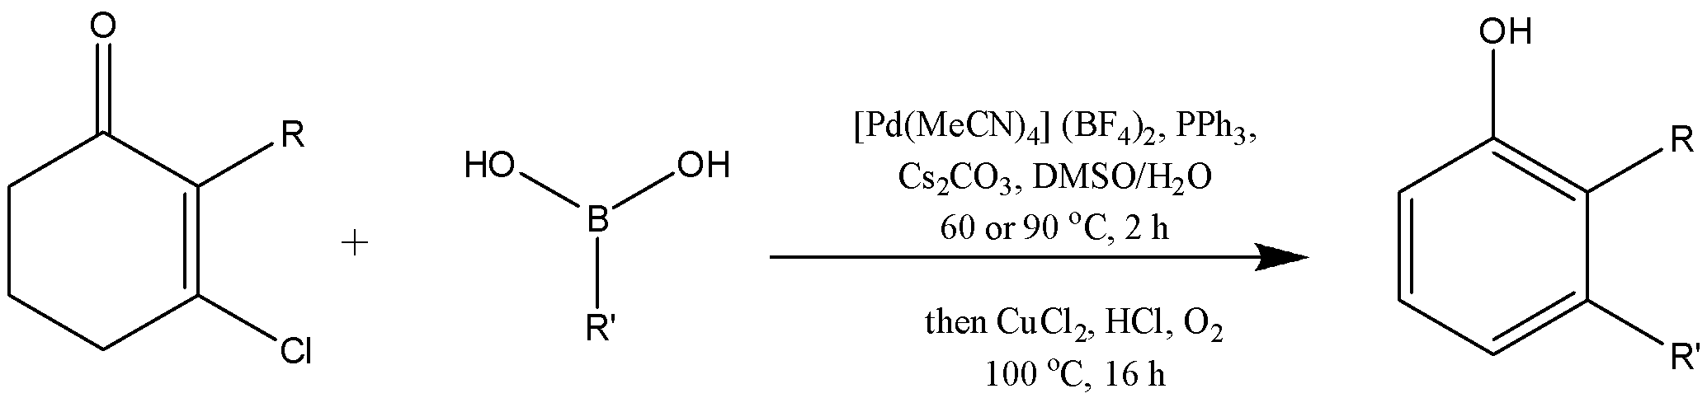

Entry | R | R’ | Yield (%) | Entry | R | R’ | Yield (%)
1 | H | 4-(COMe)-C₆H₄ | 80 | 11 | Me | Ph | 70
2 | H | 4-(SO₂Me)-C₆H₄ | 75 | 12 | Me | 3,5-(MeO)- C₆H₃ | 54
3 | H | 3,5-(MeO)- C₆H₃ | 79 | 13 | Et | Ph | 48
4 | H | 2-Me- C₆H₄ | 81 | 14 | Bn | Ph | 66
5 | H | 2,6-(Me)₂- C₆H₃ | 63 | 15 | Bn | 4-(COMe)-C₆H₄ | 62
6 | H | 4-(C₂H₃)- C₆H₄ | 40 | 16 | Me | C₆H₄-C₂HS | 39
7 | H | C₆H₅-C₂H₂ | 65 | 17 | Me | 2-Me- C₆H₄ | 57
8 | H | C₆H₄-C₂HS | 63 | 18 | Me | 2,6-(Me)₂- C₆H₃ | 52
9 | H | C₆H₄-C₂HO | 57 | 19 | Me | 5-(SOOMe)C₅H₄N | 51
10 | H | Ph | 88 | 20 | Bn | 5-(SOOMe)C₅H₄N | 52

Scheme 1.35 – Synthesis of 3-arylphenols using palladium-catalyzed Suzuki-Miyaura cross-coupling with aryl/heteroaryl boronic acids
This method provides another approach to producing meta-substituted phenols, but is similarly limited to aryl/heteroaryl substituents in the meta-position.

1.3.2 Metal-free dehydrogenative aromatization of cyclohexanones
In 2018, the Jiao group introduced a unique approach for the metal-free dehydrogenative oxidation of cyclohexanones using iodine, which could produce either catechol or phenol depending on the substrate and conditions [104]. By treating various cyclohexanones with an I₂ catalyst in DMSO at 80°C under an air atmosphere, yields of catechol or phenol ranging from 25% to 91% were achieved(scheme 1.36). The proposed mechanism involves the I₂ catalyst trapping of the enol-tautomer of the cyclohexenone, generating the α-iodinated product that can undergo E2 elimination to give the cyclohexenone or Kornblum oxidation to produce the diketone. The E2 elimination product can undergo a second iodination/elimination process to generate a cyclohexadieneone, which can readily tautomerize to the aromatic phenol product. The diketone, on the other hand, can undergo subsequent iodination and elimination, followed by tautomerization to produce the catechol.
Highly substituted cyclohexanones have been observed to preferentially yield phenol rather than catechol due to the transition state energies involved in the initial elimination/Kornblum oxidation step. This is consistent with the conversion of cyclohexenones to the corresponding phenol, rather than catechol, when heated with I₂ and DMSO. The Jiao group demonstrated that a variety of cyclohexenones could be converted to the corresponding phenol using this methodology with yields ranging from 61-95% in 22 examples [105].
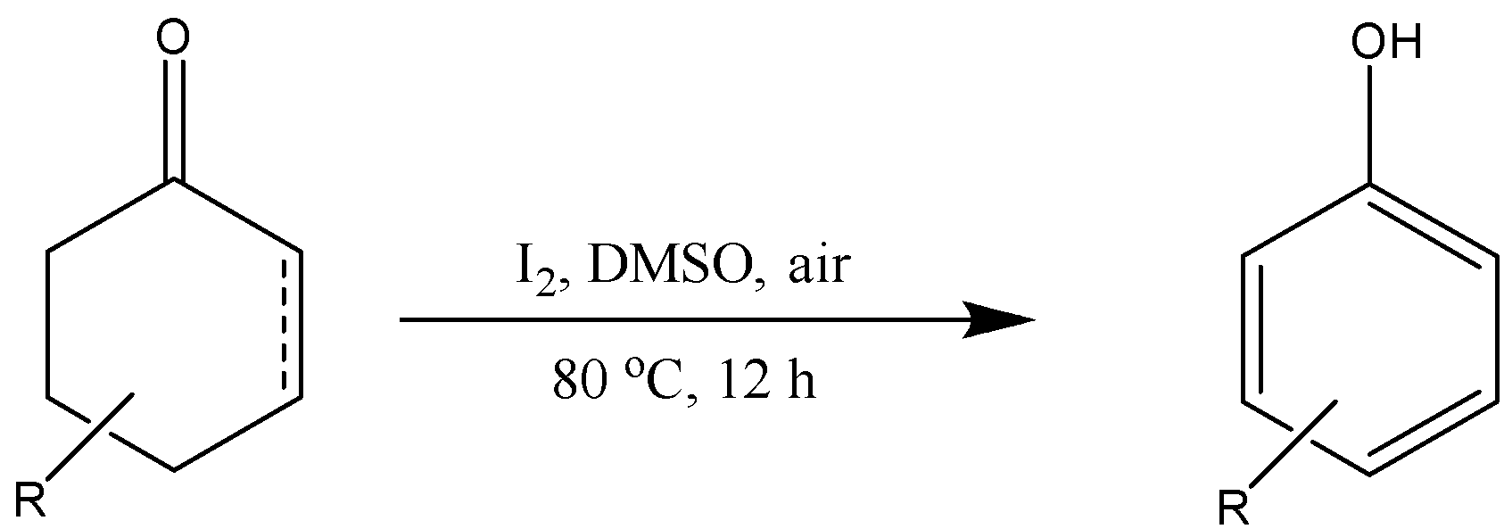

Entry | R | Yield (%) | Entry | R | Yield (%)
1 | 3-Me | 61 | 5 | 3-Me-4-(COOMe) | 73
2 | 2-Me-5-i-Pr | 77 | 6 | 3-Me-4-(COOMe)-5- C₄H₃S | 73
3 | 3-5-(Ph)₂ | 87 | 7 | 3-Et-4-(COOMe)-5- C₅H₄N-6-Me | 78
4 | 3-Ph-5-C₄H₃S | 95

Scheme 1.36 – Synthesis of phenols by treating cyclohexanones with an I₂ catalyst

These results are supported by the Luo group's separate publication, which found that I₂ could effectively catalyze aromative oxidation of cyclohexenones in DMSO at 60 °C [106]. Since cyclohexenones can be readily functionalized at the 3-position through conjugate addition, this strategy allows for the production of various meta-functionalized phenols. These methodologies provide an interesting strategy to access these functional groups, particularly with regard to producing meta-functionalized phenols, and represent one of the first metal-free dehydrogenative oxidations of cyclohexanones to catechols/phenols [107].
Mohr and colleagues developed a three-step synthesis of 3-[(6-methylhept-1-en-3-yl)oxy]phenol and 4-bromo-3-[(6-methylhept-1-en-3-yl)oxy]phenol from cyclohexan-1,3-dione in 2020 [108]. The first step involved a direct acid-catalyzed condensation between cyclohexadione and 2° allylic alcohol, resulting in a low yield of 23% on a 1 mmol scale, which decreased to 14% on a larger scale (5 mmol) (scheme 1.37).
To improve the yield, the Mitsunobu displacement process was utilized, which reversed the polarity of the coupling. The solution of diketone and alcohol in THF treated with a DIAD/PPh₃ mixture yielded the desired vinylogous ester in an improved yield of 58%, which was maintained on a larger scale. The vinylogous ester was then used in the key oxidative aromatization/bromination reaction using the established protocol (LiHMDS, HMPA, para-TsBr), which resulted in a yield of 61% for the desired γ-brominated arene product via a putative γ,γ-dibromoenone. Additionally, 3-[(6-methylhept-1-en-3-yl)oxy]phenol was obtained in a yield of 23%.

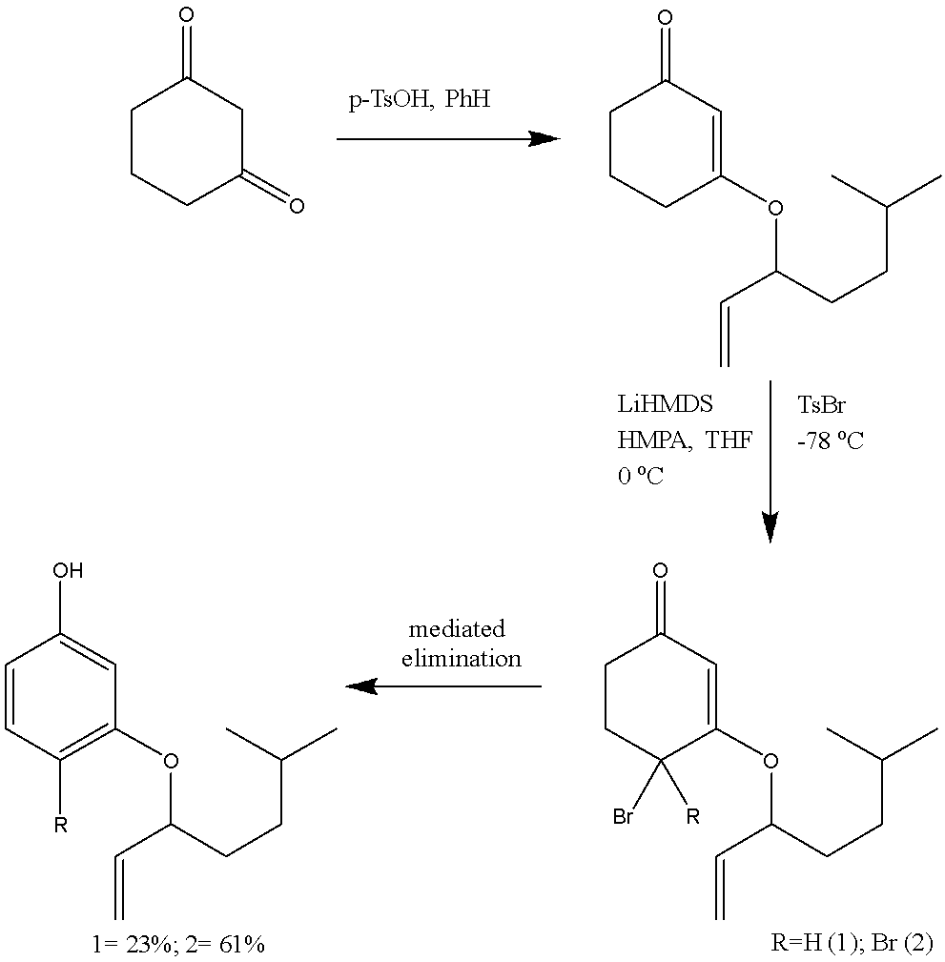

Scheme 1.37 – Synthesis of 3-[(6-methylhept-1-en-3-yl)oxy]phenol and 4-bromo-3-[(6-methylhept-1-en-3-yl)oxy]phenol
Clive discovered in 2016 that functionalized cyclohexenones could be obtained by adding Grignard or other organometallic reagents to 2-halocyclohex-2-en-1-ones, which could then be transformed to the corresponding phenol by treatment with DBU (scheme 1.38) [109].

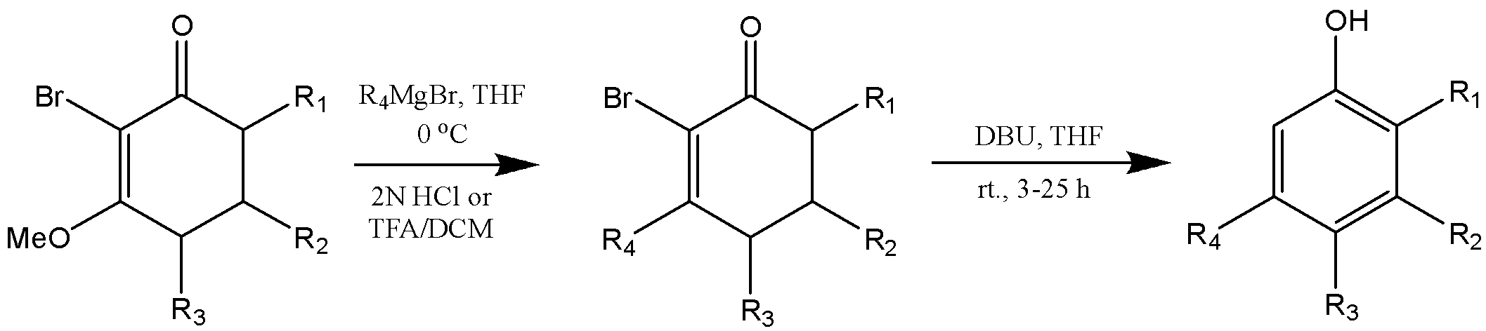

Entry | R₁ | R₂ | R₃ | R₄ | Yield (%) | Entry | R₁ | R₂ | R₃ | R₄ | Yield (%)
1 | H | Me | H | Me | 81 | 9 | H | Me | H | 3,5-(CF₃)₂-Ph | 90
2 | H | Me | H | c-Pr | 84 | 10 | H | Me | H | 4-IPh | 96
3 | H | Me | H | C₂H₃ | 75 | 11 | H | Me | H | naphtalen-1-yl | 84
4 | H | Me | H | Ph-C₂ | 85 | 12 | H | Me | H | furan-1-yl | 89
5 | H | Me | H | Me₃Si-C₂ | 55 | 13 | H | Me | H | thiophen-1-yl | 98
6 | H | Me | H | Ph | 87 | 14 | H | Ph | H | Ph | 93
7 | H | Me | H | 2-MeO-Ph | 91 | 15 | H | Me | F | Me | 87
8 | F | Me | F | 3,5-(CF₃)₂-Ph | 81 | 16 | F | Me | F | 2-MeO-Ph | 85

Scheme 1.38 – Synthesis o f meta-substituted phenols using Grignard reagents

Clive developed a similar methodology in 2018 for the formation of meta-arylsulfanyl and meta-(alkylsulfanyl)phenols from brominated cyclohexane-1,3-diones, which expanded the types of substituents that can be tolerated at the meta-position to include heteroatoms(scheme 1.39). 3-(Tosyloxy)cyclohex-2-en-1-ones, which can be easily synthesized from cyclohexan-1,3-diones, can be converted to 3-(arylsulfanyl)- or 3-(alkylsulfanyl)cyclohex-2-en-1-ones by reacting with thiols in the presence of K₂CO₃ at rt. The resulting products can be brominated at C-2 using NBS in MeCN, and treatment with DBU in MeCN produces the corresponding 3-(arylsulfanyl)- or 3-(alkylsulfanyl)phenols. This reaction sequence occurs under mild conditions and does not require the use of heavy metals [110].
In 2021, Clive’s group reported a synthesis of meta-aminophenols from cyclohexane-1,3-dione [111]. Cyclohexane-1,3-dione can be easily converted into 3-aminocyclohex-2-en-1-ones that have two substituents on the nitrogen atom, which are either both aryl or alkyl units, or one of each type(scheme 1.40). These compounds can be chlorinated at C⁽²⁾ using the crystalline reagent BnNMe₃·ICl₂, and the resulting chloro enaminones undergo aromatization at rt on treatment with DBU in MeCN. The average yield for the chlorination was 83% (12 examples), while the average yield for the aromatization was 73%.
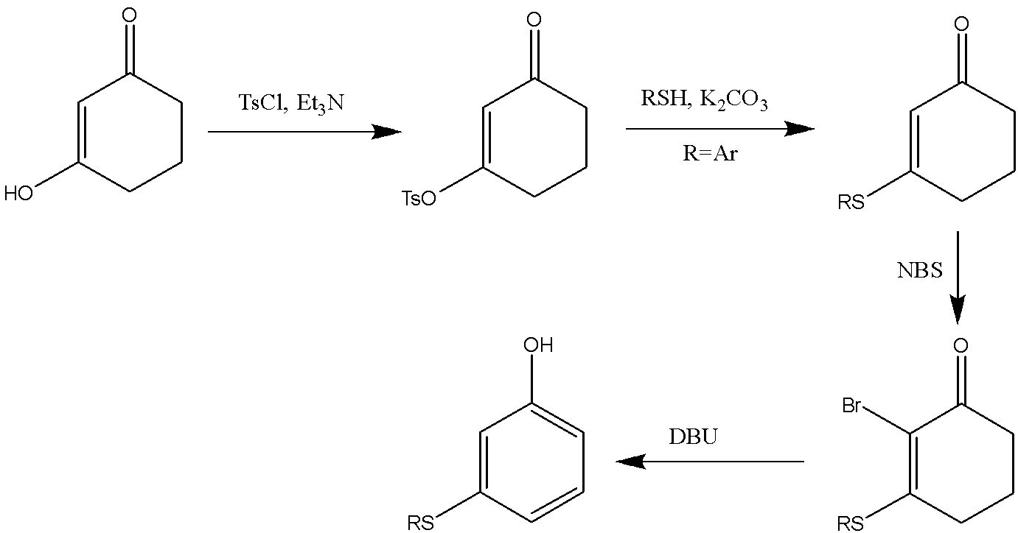

Entry | R | Yield (%) | Entry | R | Yield (%)
1 | Ph | 89 | 6 | 2-MeC₆H₄ | 78
2 | 4-FC₆H₄ | 60 | 7 | 2-(MeO₂C)C6H4 | 72
3 | 4-MeOC₆H₄ | 86 | 8 | Bn | 65
4 | 4-BrC₆H₄ | 79 | 9 | tert-Bu | 25
5 | 4-MeC₆H₄ | 75 | 10

Scheme 1.39 – Synthesis of meta-Sulfanylphenols

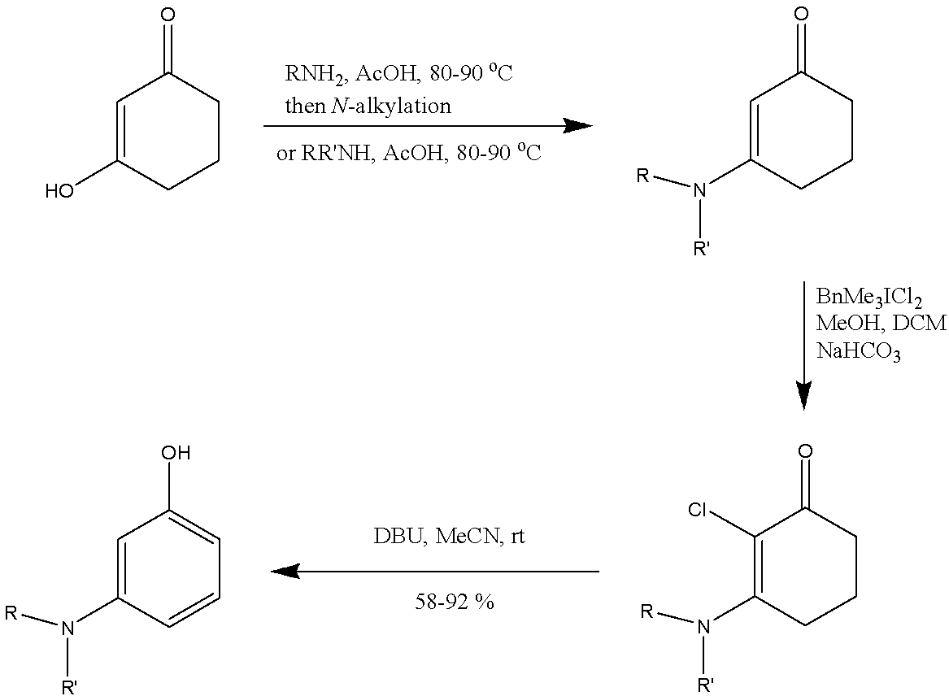

Entry | R | R’ | Yield | Entry | R | R’ | Yield
1 | Me | Ph | 82 | 7 | Me | 4-BrC₆H₄ | 74
2 | Me | 4-MeC₆H₄ | 75 | 8 | Pmb | 4-BrC₆H₄ | 84
3 | Pmb | 4-MeC₆H₄ | 73 | 9 | Ph | Ph | 79
4 | Bn | 4-BrC₆H₄ | 92 | 10 | Me | Bn | 59
5 | Bn | 2-MeC₆H₄ | 72 | 11 | Bn | Bn | 72
6 | Bn | 4-NCC₆H₄ | 62

Scheme 1.40 – Synthesis of 3-aminophenols from cyclohexane-1,3-diones
Oxidative aromatization is an effective method for producing meta-functionalized phenols because 3-substituted cyclohexenones can be easily synthesized through conjugate addition. It is important to note that cyclohexanones/cyclohexenones are derived from aromatic precursors, which are either partially reduced phenols or products of cyclohexane oxidation (which is a product of benzene reduction) [112]. The production of phenols using this strategy illustrates how essential functionalization steps can occur via non-aromatic phenol precursors before undergoing rearomatization and phenol formation.
In conclusion, the literature review has provided a comprehensive understanding of the synthesis methods and potential applications of meta-aryloxy phenols. The reviewed studies have shed light on various approaches, including nucleophilic aromatic substitution reactions, Sonogashira coupling, Grignard reagent utilization, hydrolysis of diazonium salts, and demethylation of meta-methoxyphenols. Additionally, the synthesis of phenol derivatives from cycloxenanone has been explored, focusing on transition-metal based and metal-free dehydrogenative aromatization methods. This knowledge serves as a solid foundation for the subsequent experimental part, where we will implement and expand upon these synthesis strategies to develop a non-catalytic method for the synthesis of meta-aryloxy phenols from 1,3-cyclohexanedione.

2 RESULTS AND DISCUSSION
Chapter 1.2 outlines common strategies to prepare meta-aryloxy phenols, and chapter 1.3 describes synthesis of phenol meta-substituted derivatives by aerobic dehydrogenation of substituted cyclohexenones. From this survey, we identified a deficiency in the number of reactions that could provide meta-substituted derivatives. In this chapter, we will discuss our efforts to address this challenge through the development of a preparation of meta-(aryloxy)phenols from 3-chlorocyclohex-2-en-1-one in three steps [113].
Our approach for the preparation of meta-(aryloxy)phenols has been successfully implemented and offers a gentle alternative to the classical Ullmann reaction, as illustrated in Scheme 2.1. This development presents a universal method for synthesizing meta-aryloxy phenols from cost-effective and easily obtainable starting materials. The procedure involves a series of steps, which are described in detail in (scheme 2.1), including the synthesis of starting material (I), 3-chlorocyclohex-2-en-1-one (2) from cyclohexane-1,3-dione (1), the nucleophilic substitution reaction of 3-chlorocyclohex-2-en-1-one (2) with phenol derivatives (II), bromination (III) of 3-(aryloxy)cyclohex-2-en-1-ones (3), and finally, the aromatization step of 2-bromo-3-aryloxy-cyclohex-2-en-1-one (4) (IV) to obtain meta-aryloxy phenols (5). The synthesized compounds are outlined in figures 2.1 and 2.2.
Overall, our proposed methodology offers a practical and efficient pathway to access meta-(aryloxy)phenols, which have numerous applications in various fields.

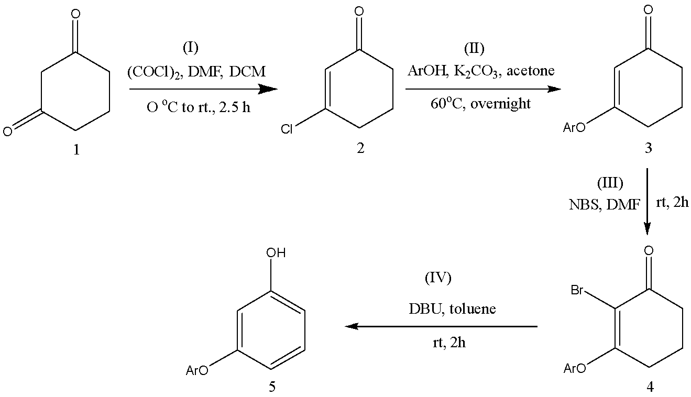
Scheme 2.1 – Synthesis of meta-(aryloxy)phenols

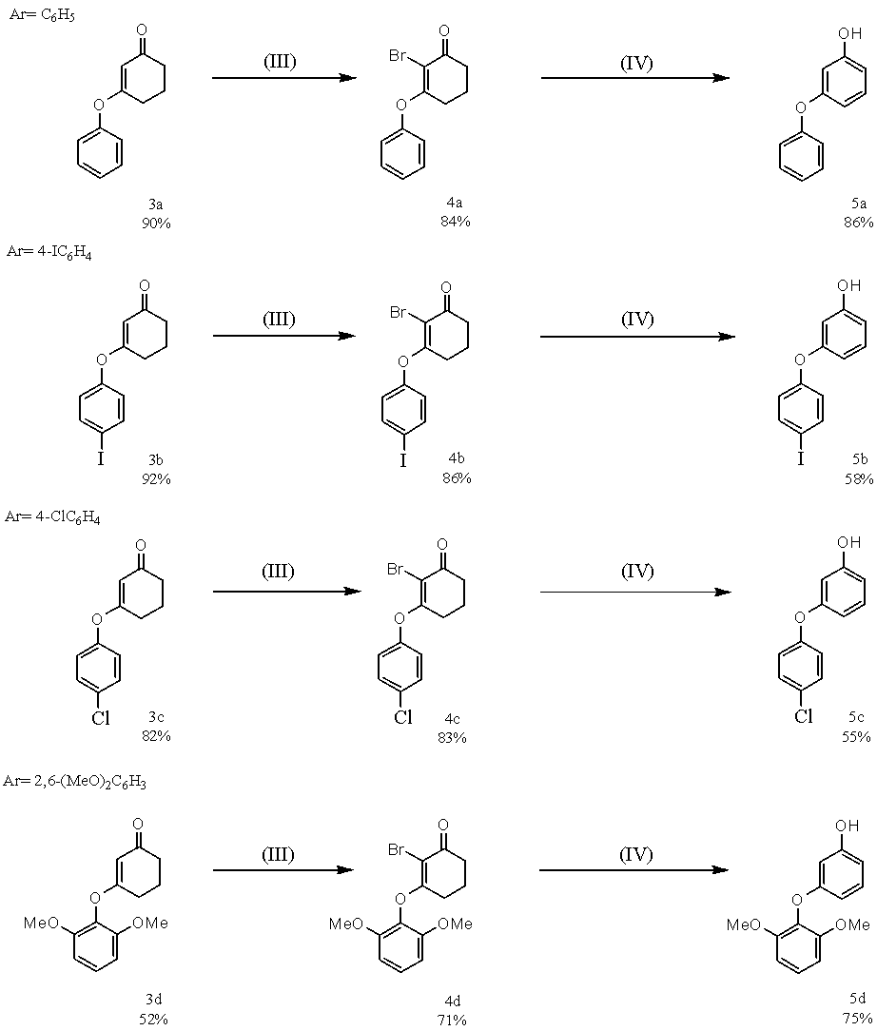
Figure 2.1 – Synthesized compounds (a-d)
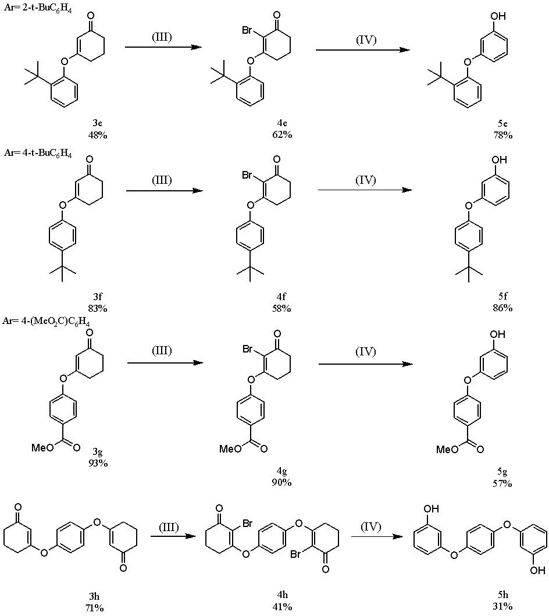

Figure 2.2 – Synthesized compounds (e-h)

2.1 Synthesis of 3-Chlorocyclohex-2-en-1-one (2)
3-Chlorocyclohex-2-en-1-one (2) is a chemical compound that serves as an important intermediate in various organic syntheses. It is typically prepared from 1,3-cyclohexandione by replacing one of its carbonyl groups with a chlorine atom via a substitution reaction(scheme 2.2).

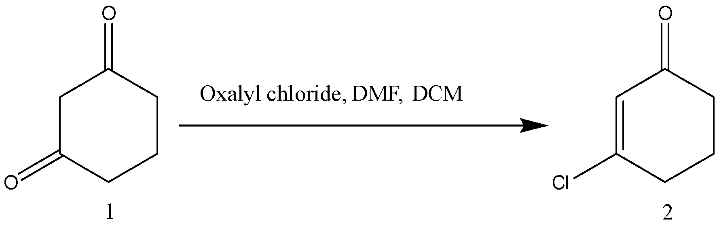

Scheme 2.2 – Synthesis of 3-chlorocyclohex-2-en-1-one

This compound contains a cyclohexene ring with a chloro group and a carbonyl group at the 1,3 positions. The presence of the chlorine atom in 3-chlorocyclohex-2-en-1-one makes it a versatile building block in organic synthesis, as it can undergo various reactions, including nucleophilic substitution, reduction, and addition reactions. 3- Chlorocyclohex-2-en-1-one has numerous applications in the synthesis of various organic compounds, including pharmaceuticals, agrochemicals, and materials.
3-Chlorocyclohex-2-en-1-one was used as an intermediate for the preparation of meta-aryloxy phenols first time because of its unique structural characteristics. The replacement of the chlorine atom with an aryloxy group leads to the formation of 3-(aryloxy)cyclohex-2-en-1-ones, which are then further transformed into meta-aryloxy phenols via an aromatization reaction. Moreover, the use of 3-chlorocyclohex-2-en-1-one as an intermediate in the synthesis of meta-aryloxy phenols allows for the preparation of a wide range of derivatives with various substituents, which makes it a versatile building block for the synthesis of organic compounds with diverse applications.
The formation of 3-chlorocyclohex-2-en-1-one (2) from 1,3-cyclohexandione (1) using oxalyl chloride and DMF in DCM proceeds through a multi-step mechanism [114].
Firstly, oxalyl chloride (COCl)₂ is activated by dimethylformamide (DMF) to form a Vilsmeier reagent(scheme 2.3).
Oxalyl chloride reacts with DMF first, and the DMF is catalytic, meaning that it only needs a substoichiometric amount of it. The mechanism of oxalyl chloride plus DMF overall loses CO₂ and CO and then forms an intermediate, Vilsmeier reagent, that reacts with the 1,3-cyclohexandione to form the 3-chlorocyclohex-2-en-1-one.

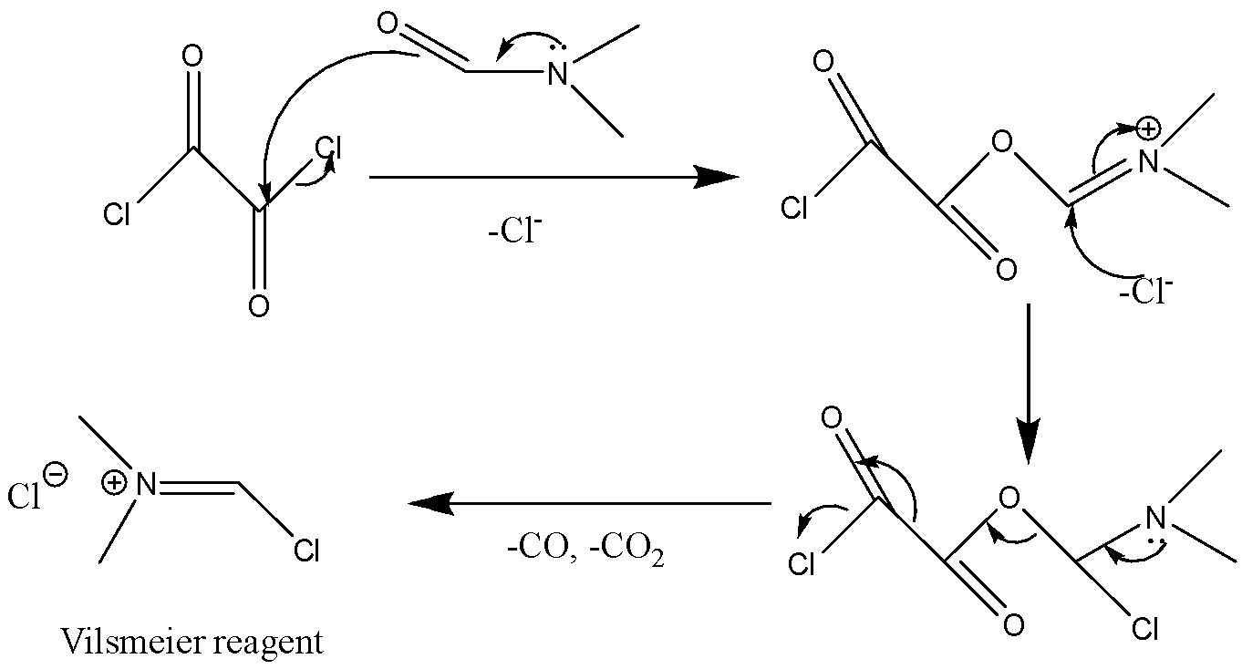
Scheme 2.3 – Mechanism of activation of oxalyl chloride by DMF

The resonance structure depicted in scheme 2.3 involves the transfer of the lone pair of electrons from nitrogen to oxygen of DMF, resulting in the formation of a charge-separated species which contained oxalyl chloride. This process entails the rupture of the pi bond and the formation of a new bond with carbon, while simultaneously breaking the σ bond to chlorine. Subsequently, the resulting species undergoes a collapse reaction, leading to the elimination of chlorine as chloride. The negatively charged chlorine species then attacks the carbon, leading to the formation of a neutral intermediate. This intermediate subsequently undergoes an elimination reaction initiated at the nitrogen center, leading to the rupture of bonds and an alpha elimination process that typically yields CO₂ and CO gases. Finally, the reaction generates an intermediate, which takes the form of a chloride salt.
The Vilsmeier reagent is a well-known and versatile reagent in synthetic organic chemistry that is typically utilized for the formylation of various organic compounds. This reagent, named after its discoverer, the German chemist Anton Vilsmeier, was first reported in 1927. The Vilsmeier reagent comprises a mixture of N,N-dimethylformamide (DMF) and phosphorus oxychloride (POCl₃), which readily reacts with a diverse range of organic compounds to form α-formylated derivatives [115].
In addition to its widespread use in formylation reactions, the Vilsmeier reagent has also been recognized as a valuable reagent for the activation of substrates for halogenation and cyclization reactions. The reagent activates the substrate towards nucleophilic attack by forming an electrophilic intermediate, which can subsequently undergo halogenation or cyclization depending on the nature of the substrate.
Firstly, the protonation of the lone pair of the carbonyl group on 1,3-cyclohexanedione by a hydrogen ion generates the enol tautomer, as shown in scheme 2.4.
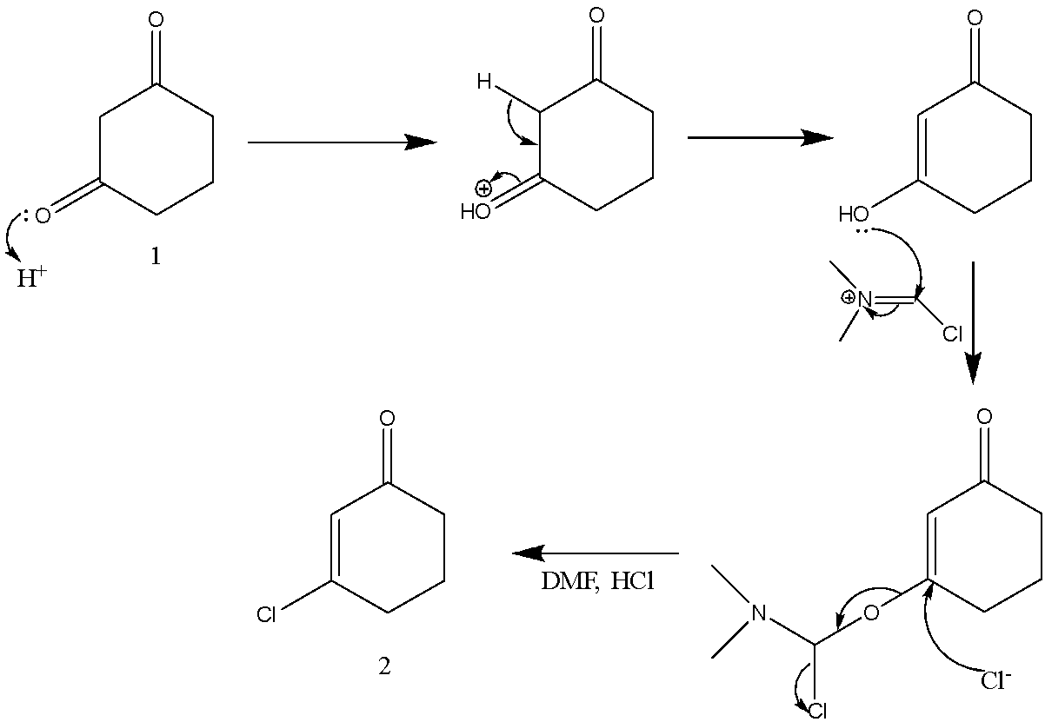

Scheme 2.4 – The reaction mechanism for the formation of
3-chlorocyclohex-2-en-1-one

Upon reacting with the Vilsmeier reagent, 3-hydroxycyclohex-2-en-1-one produces 3-chlorocyclohex-2-en-1-one, which regenerates DMF and forms HCl. During this process, the oxygen atom of the hydroxyl group attacks the carbon of the Vilsmeier reagent, and the electrons from the pi bond are placed onto the nitrogen. Furthermore, the chloride ion attacks the β carbon. Subsequently, a β elimination takes place, breaking the C-O bond and forming 3-chlorocyclohex-2-en-1-one. This species then decomposes to eliminate the chloride ion. An acid-base reaction is then conducted, restoring the lone pair onto the nitrogen and regenerating DMF, while also producing HCl.
The use of oxalyl chloride and DMF in DCM provides mild reaction conditions and high yields, making this method suitable for large-scale synthesis.
The reaction product (2) is a yellow oil. Yield 83%. Spectroscopic data of 3-chlorocyclohex-2-en-1-one (2) was consistent with literature [116].
The FTIR (CH₂Cl₂, cast film) spectrum of compound (2) contains absorption bands of stretching vibrations of the (C-H) bond at 3200, cm⁻¹, methylene (-CH₂-) groups at 2955, 2927 cm⁻¹, carbonyl (C=O) group at 1717 cm⁻¹, (C=C) bond at 1680 cm⁻¹, and (C-Cl) bond at 1605 cm⁻¹.
¹H NMR spectrum of 3-chlorocyclohex-2-en-1-one (figure A1 in an appendix A), (CDCl₃, 500 MHz). The first signal appears as a triplet at δ 6,22 with a coupling constant (t, J = 1,5 Hz, 1 H), indicating the presence of a hydrogen atom next to a carbon atom bearing a double bond. The second signal is a triplet of doublets at δ 2,68 (td, J = 6,1, 1,5 Hz, 2 H), indicating the presence of two hydrogen atoms attached to a carbon atom next to the chlorine atom. Signals appear as a multiplet and pentet δ 2,43-2,40 and 2,08, respectively, indicating the presence of two hydrogen atoms adjacent to the carbonyl group of the cyclohexene ring.
The ¹³C{¹H} NMR (CDCl₃, 125 MHz) spectrum of 3-chlorocyclohex-2-en-1-one (figure A2 in an appendix A) shows six signals at the following chemical shifts: a signal appears at 196,8 ppm (singlet) indicating carbonyl carbon; the signal at 158,7 ppm (singlet) is assigned to the carbon adjacent to the chlorine atom; the signal at 128,5 ppm (doublet) corresponds to the carbon in the conjugated double bond; the triplets at 36,3, 33,9 and 22,2 ppm correspond to the three remaining carbons in the cyclohexane ring.
Mass- spectrum of 3-chlorocyclohex-2-en-1-one, exact mass (EI) m/z calcd for C₆H₇³⁵ClO (M⁺) 130,0854, found 130,01844.

2.2 Synthesis of 3-(aryloxy)cyclohex-2-en-1-one (3)
The nucleophilic substitution reaction of phenol derivatives with 3-chlorocyclohex-2-en-1-one (2) under refluxing acetone conditions in the presence of potassium carbonate (K₂CO₃) represents an efficient method for the synthesis of meta substituted cyclohex-2-en-1-ones (3) (scheme 2.5).
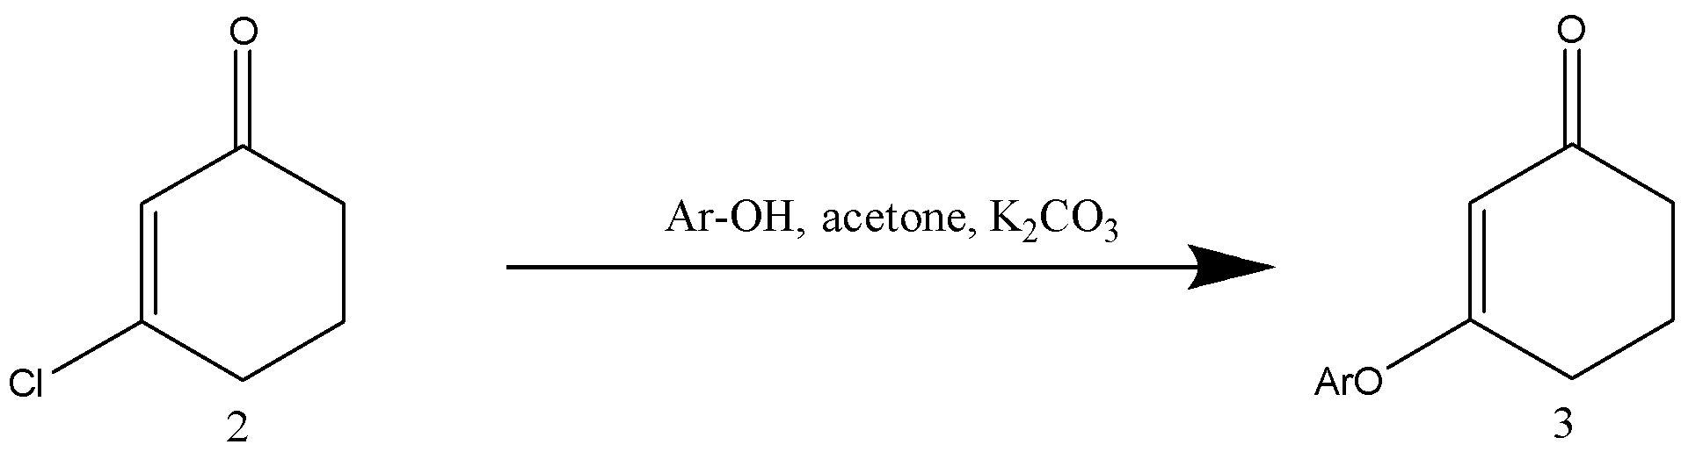
Scheme 2.5 – The nucleophilic substitution reaction of
3-chlorocyclohex-2-en-1-one

The reaction mechanism, which was investigated by Dr. Clive’s group at the University of Alberta, can be summarized as follows(scheme 2.6): The potassium carbonate in the presence of acetone deprotonates the phenol derivatives to form the aryloxide ion. This acts as a nucleophile and attacks the electrophilic β carbon of 3-chlorocyclohex-2-en-1-one, resulting in the formation of a new carbon-oxygen bond, and forming an enolate (1). The enolate then ketonizes with expulsion of chloride (2).
This strategy provides a versatile and practical means for the construction of substituted cyclohexenones from readily available starting materials. The use of refluxing acetone as a solvent provides favorable reaction conditions, allowing for the generation of the expected substitution products.

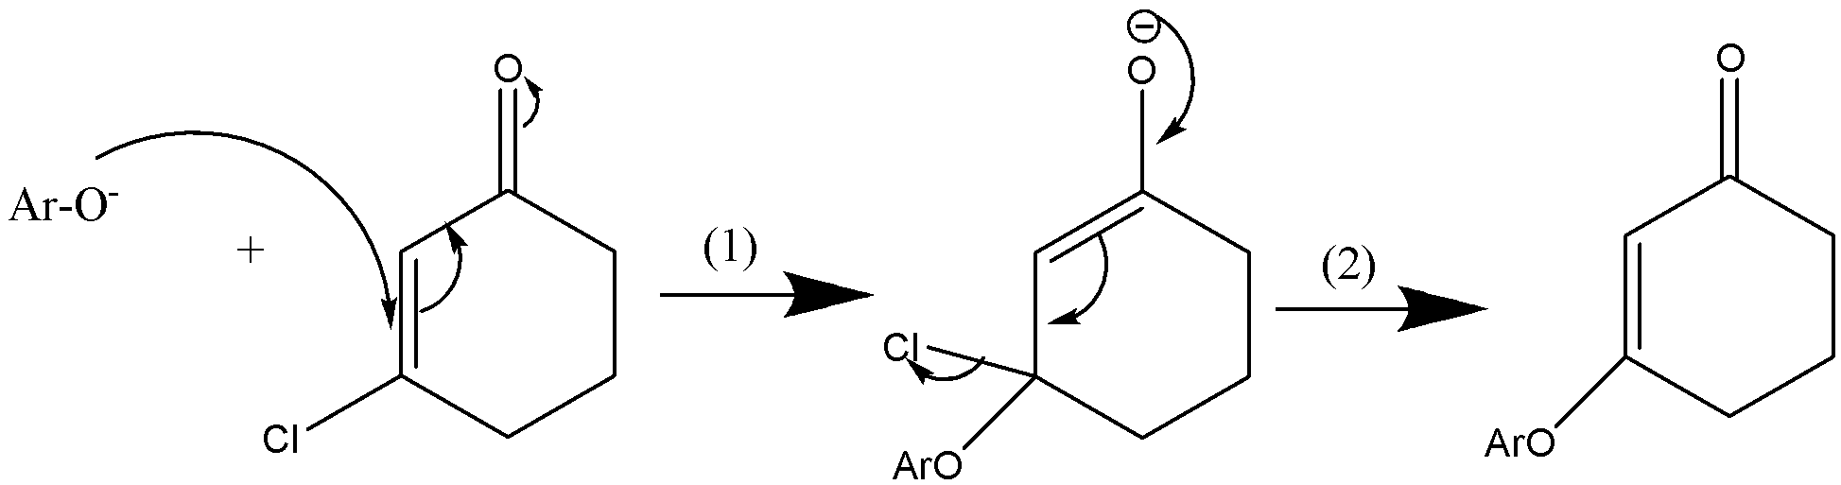

Scheme 2.6 – The reaction mechanism for the formation of
3-aryloxy cyclohex-2-en-1-one

Average yield 76% for 8 examples(table 2.1).

Table 2.1 – Synthesized 3-aryloxy cyclohex-2-en-1-ones

 | Name of compound | Solvent | Conditions | Yield (%) | State | Melting point (ºC)
3a | 3-phenoxy cyclohex-2-en-1-one | acetone | 60 ⁰C, 20 h | 90% | pale yellow oil | -
3b | 3-(4-Iodophenoxy) cyclohex-2-en-1-one* | acetone | 60 ⁰C, 20 h | 92% | oil which slowly crystallized | 69–75
3c | 3-(4-chlorophenoxy) cyclohex-2-en-1-one* | acetone | 60 ⁰C, 18 h | 82% | white solid | 72–75
3d | 3-(2,6-dimethoxy phenoxy)cyclohex-2-en-1-one* | DMF | 100 ⁰C, 24 h | 52% | white solid | 76–78
3e | 3-(2-tert-butylphenoxy)  cyclohex-2-en-1-one | DMF | 100 ⁰C, 24 h | 48% | yellowish oil | -
3f | 3-(4-tert-butylphenoxy)  cyclohex-2-en-1-one* | acetone | 60 ⁰C, 43 h | 83% | white solid | 92–96
3g | methyl 4-[(3-oxocyclohex-1-en-1-yl)oxy]benzoate* | acetone | 60 ⁰C, 18 h | 93% | white solid | 100–104
3h | 3-{4-[(3-Oxo cyclohex-1-en-1-yl) oxy]phenoxy}cyclo hex-2-ene-1-one* | acetone | 60 ⁰C, 43 h | 71% | light orange powder | 209–212

*- compounds have not been previously described in the literature
With 2,6-dimethoxyphenol the yield was only 23% even in refluxing butan-2-one but use of DMF at 100 °C raised the yield to 52%. The completion of the reaction was checked by TLC. The other hindered phenol we examined, 2-t-butylphenol, gave a yield of 21% in refluxing acetone and this result was also improved (48%) by using DMF at 100 °C. Mass, FTIR, ¹H-NMR, ¹³C{¹H} NMR spectroscopic data for compounds 3a-3h are shown in the tables 2.2‒2.5

Table 2.2 – Mass spectrum data for compounds 3a-3h
 | Ionization technique | Formula | Calculated | Found
3a | Electron Ionization | C₁₁H₁₂O₂ (M⁺) | 188,08372 | 188,08356
3b | Electrospray Ionization | C₁₂H₁₂IO₂ (M+H)⁺ | 313,9876 | 313,9878
3c | Electrospray Ionization | C₁₂H₁₁³⁵ClO₂ (M⁺) | 222,0448 | 222,0445
3d | Electron Ionization | C₁₄H₁₆O₄ (M)⁺ | 248,10486 | 248,10488
3e | Electron Ionization | C₁₆H₂₀O₂ (M⁺) | 244,14633 | 244,13634
3f | Electron Ionization | C₁₆H₂₀O₂ (M⁺) | 244,1463 | 244,1461
3g | Electrospray Ionization | C₁₄H₁₅O₄ (M+H)⁺ | 247,09650 | 247,0967
3h | Electrospray Ionization | C₁₈H₁₉O₄ (M+H)⁺ | 299,1278 | 298,1280

Table 2.3 – IR data for compounds 3a-3h
Compound | Wave numbers of absorption bands, ν, cm-1
Compound | C-H of aromatic ring | C-H₂ of aliphatic chain | C=O of ketone group | C=C double bond of cyclohexenone ring | C=C in a aromatic ring | C-C in a aromatic ring | Note
3a | 3065 | 2951, 2894, 2873 | 1661 | 1617 | 1587 | 1488 | -
3b | - | 2949 | 1666 | 1611 | 1653 | 1479 | -
3c | - | - | 1655 | 1614 | 1486 | 1374 | -
3d | - | - | 1651 | 1619 | 1585 | 1482 | -
3e | - | 2957 | 1663 | 1617 | 1599 | 1372 | -
3f | - | 2962 | 1669 | 1616 | 1656 | 1508 | -
3g | - | - | 1668 | 1620 | 1656 | 1598 | 1724 (C=O)
3h | 3099, 3069 | 2940, 2892, 2870 | 1662 | 1614 | - | 1489 | -
Table 2.4 – ¹H-NMR data for compounds 3a-3h
Compound | Chemical shift, ⌠, ppm
Compound | CH (aromatic protons) | C=CH | CH₂ | CH₃
3a | 7,42–7,39 (m, 2H), 7,29–7,24 (m, 1H) 7,06–7,04 (m, 2H) | 5,14 (s, 1H) | 2,65 (t, 2H), 2,41–2,38 (m, 2H) 2,08 (p, 2H) | -
3b | 7,70 (d, 2 H), 6,80 (d, 2 H) | 5,11 (s,1H) | 2,63 (t, 2 H), 2,37 (t, 2 H), 2,08 (p, 2 H) | -
3c | 7,37–7,35 (m, 2 H), 6,99–6,96 (m, 2 H) | 5,10 (s, 1H) | 2,64 (t, 2 H), 2,37 (t, 2 H), 2,07 (p, 2 H) | -
3d | 7,12 (t, 1 H), 6,60 (d, 2 H) | 5,08 (s, 1H) | 2,70 (t, 2 H), 2,37 (t, 2 H), 2,08 (p, 2 H) | 3,80 (s, 6H)
3e | 7,39 (dd, 1 H), 7,18–7,13 (m, 2 H), 6,91 (dd, 1 H) | 5,21 (s, 1H) | 2,67 (t, 2 H), 2,39 (t, 2 H), 2,09 (p, 2 H) | 1,32 (s, 9H)
Extension of table 2.4
3f | 7,39–7,37 (m, 2 H), 6,95–6,93 (m, 2 H) | 5,12 (s, 1H) | 2,65 (t, 2 H), 2,37 (t, 2 H), 2,08 (p, 2 H) | 1,32 (s, 9H)
3g | 8,10 (d, 2 H), 7,12 (d, 2 H) | 5,16 (s, 1H) | 2,67 (t, 2 H), 2,41 (t, 2 H), 2,11 (p, 2 H) | 3,95 (s, 3H)
3h | 7,08 (s, 4H) | 5,15 (s, 2H) | 2,67 (t, 4 H), 2,40 (t, 4 H), 2,11 (p, 4 H) | -
Table 2.5 – ¹³C{¹H} NMR data for compounds 3a-3h
Compound | Chemical shift, ⌠, ppm |  |  |  |  |  |  | Note
Compound | C=O | C-O  Aromatic | C-O | =CH | -CH Aromatic carbons | -CH₂ | -CH₃ | -
3a | 199,6 (s) | 178,3 (s) | 152,7 (s) | 130,0 (d) | 126,1 (d), 121,4 (d), 106,1 (d) | 36,7 (t), 28,6 (t), 21,2 (t) | - | -
3b | 199,3 (s) | 177,7 (s) | 152,6 (s) | 139,1 (d) | 123,6 (d), 106,3 (d) | 36,6 (t), 28,4 (t), 21,1 (t) | - | 90,0 (s) C-I
3c | 199,3 (s) | 177,8 (s) | 151,2 (s) | 130,2 (d) | 122,8 (d), 106,2 (d) | 36,6 (t), 28,5 (t), 21,2 (t) | - | 131,6 (s)  C-Cl
3d | 200,2 (s) | 177,8 (s) | 152,3 (s) | 130,2 (d) | 126,5 (d), 105,1 (d), 104,8 (d) | 36,7 (t), 28,0 (t), 21,3 (t) | 56,1 (q) | -
3e | 199,5 (s) | 177,9 (s) | 151,3 (s) | 127,8 (d) | 127,2 (d), 125,8 (d), 123,0 (d) 106,7 (d) | 36,6 (t), 28,9 (t), 21,2 (t) | 30,3 (q) | 141,5 (s) C-tert-Bu,  34,6 (s) C-(CH₃)₃,
3f | 199,9 (s) | 178,7 (s) | 150,4 (s) | 126,9 (d) | 120,8 (d) 106,0 (d) | 36,7 (t), 28,6 (t), 21,3 (t) | 31,5 (q) | 149,2 (s) C-tert-Bu,  34,6 (s) C-(CH₃)₃,
3g | 199,3 (s) | 177,2 (s) | 156,4 (s) | 131,8 (d) | 121,4 (d) 106,7 (d) | 36,6 (t), 28,4 (t), 21,1 (t) | 52,3 (q) | 166,1 (s) C=O ester, 128,0 (s) C-(CO₂Me),
3h | 199,4 (s) | 177,9 (s) | 150,2 (s) | 122,9 (d) | 106,2 (d) | 36,6 (t), 28,4 (t), 21,1 (t) | - | -

2.2.1 3-(Phenoxy)cyclohex-2-en-1-one (3a)
3-(Phenoxy)cyclohex-2-en-1-one (3a) is a known organic compound that belongs to the class of cyclic ketones. That is primarily used as an intermediate in the synthesis of other organic compounds. It can be used to produce a variety of derivatives, including pharmaceuticals, agrochemicals, and fragrances.
3-(Phenoxy)cyclohex-2-en-1-one (3a) was synthesized by previously described general process(scheme 2.5) to prepare 3-(aryloxy)cyclohex-2-en-1-one using 1 equivalent of phenol as a reagent(scheme 2.7).

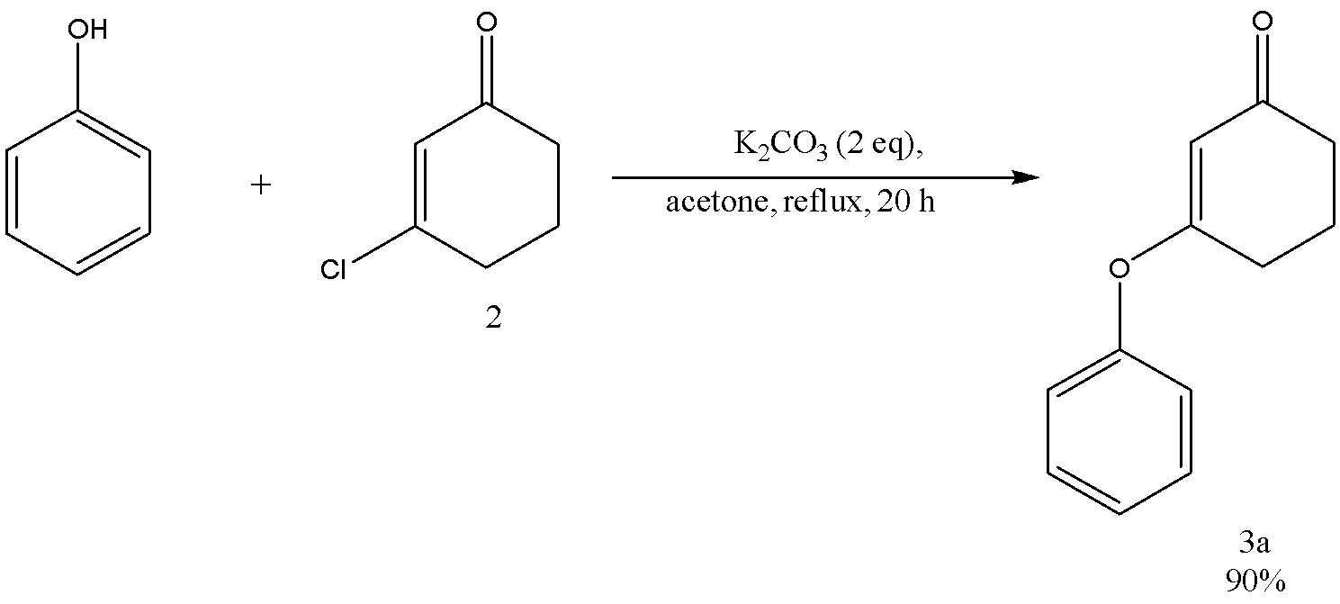

Scheme 2.7 – Synthesis of 3-(phenoxy)cyclohex-2-en-1-one

The reaction product (3a) is a pale yellow oil that crystallized in the fridge to form a white solid. Yield 90%. Physico-chemical data of 3-(phenoxy)cyclohex-2-en-1-one (3a) was consistent with literature [117].
The FTIR (CH₂Cl₂, cast film) spectrum of 3-(phenoxy)cyclohex-2-en-1-one (3a) contains absorption bands of stretching vibrations (C-H) of the aromatic ring in the phenoxy group at 3065 cm⁻¹, (C-H) of the aliphatic chain in the cyclohexene ring at 2951, 2894, 2873 cm⁻¹, (C=O) of the ketone functional group in the molecule at 1661 cm⁻¹, the (C=C) of the double bond in the cyclohexene ring at 1617 cm⁻¹, the (C=C) of the double bond in the phenyl ring at 1587 cm⁻¹, and the (C-C) bending vibration of the phenyl ring at 1488 cm⁻¹.
¹H NMR spectrum of 3-(phenoxy)cyclohex-2-en-1-one (3a) (figure A3), (CDCl₃, 500 MHz) shows the following peaks: the signals appear as multiplets at δ 7,42–7,39 (m, 2H), δ 7,29–7,24 (m, 1H) and 7,06–7,04 (m, 2H) are assigned to the aromatic protons in the phenoxy group; the signal appears as a singlet at δ 5,14 (s, 1H) is assigned to the proton on the double bond in the cyclohexene ring; the signals appear as multiplets at δ 2,65 (t, J = 6,3 Hz, 2H), δ 2,41–2,38 (m, 2H) and δ 2,08 (pentet, J = 6,5 Hz, 2H) are assigned to the methylene protons in the aliphatic chain of the cyclohexene ring.
¹³C{¹H} NMR spectrum of 3-(phenoxy)cyclohex-2-en-1-one (3a) (figure A4) (CDCl₃, 125 MHz) shows signals at the following chemical shifts: The signal appears at 199,6 ppm (singlet) indicating carbonyl carbon; the signal appears at 178,3 ppm (singlet) indicating aromatic carbon attached to oxygen; the signal at 152,7 ppm (singlet) is assigned to the carbon adjacent to the oxygen atom; the signal at 130,0 ppm (doublet) corresponds to the carbon in the conjugated double bond; the doublets appear at 126,1, 121,4 and 106,1 correspond to the aromatic carbons; the triplets at 36,7, 28,6 and 21,2 ppm correspond to the three remaining carbons in the cyclohexane ring.

2.2.2 3-(4-Iodophenoxy)cyclohex-2-en-1-one (3b)
3-(4-Iodophenoxy)cyclohex-2-en-1-one (3b) is a compound that previously was not described in a literature.
The compound 3-(4-iodophenoxy)cyclohex-2-en-1-one (3b) has been successfully synthesized through a previously described general process involving the preparation of 3-(aryloxy)cyclohex-2-en-1-one (3)(scheme 2.5). This synthetic route utilizes 3-chlorocyclohex-2-en-1-one (2), 1 equivalent of 4-iodophenol and 2 equivalents of potassium carbonate in acetone to obtain the desired compound 3-(4-iodophenoxy)cyclohex-2-en-1-one (3b), as demonstrated in scheme 2.8.

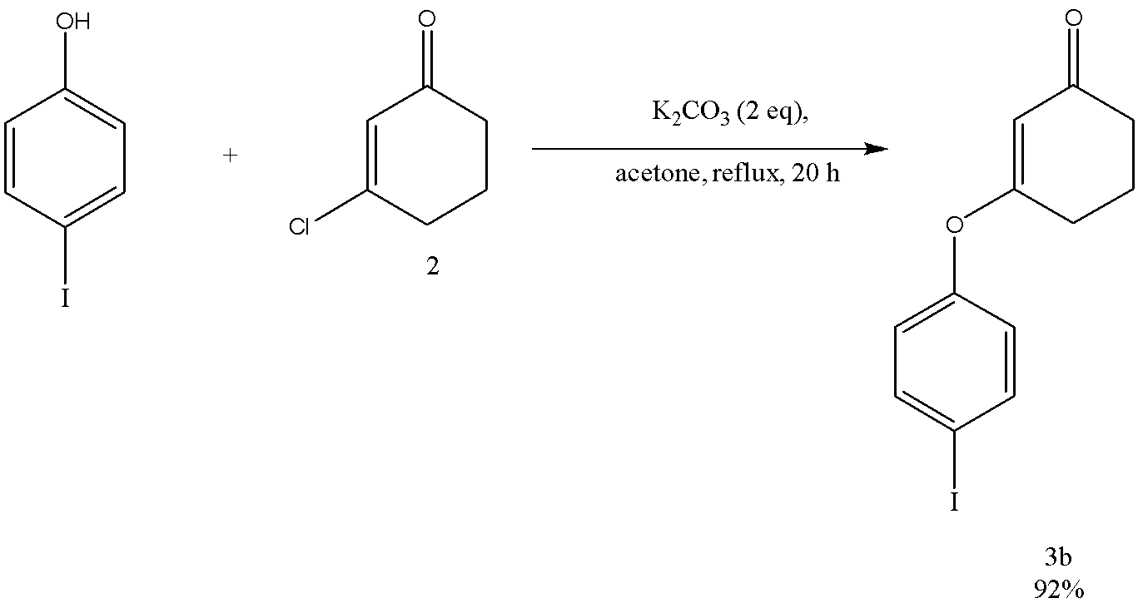

Scheme 2.8 – Synthesis of 3-(4-iodophenoxy)cyclohex-2-en-1-one

The reaction product (3b) was as an oil which slowly crystallized: mp 69–75 °C. Yield 92%. The identification of the structure of 3-(4-iodophenoxy)cyclohex-2-en-1-one (3b) was accomplished through the use of IR, ¹HNMR, ¹³CNMR, and mass spectroscopy.
The FTIR (CH₂Cl₂, cast film) spectrum of 3-(4-iodophenoxy)cyclohex-2-en-1-one (3b) contains absorption bands of stretching vibrations (C-H) of the aliphatic chain in the cyclohexene ring at 2949 cm⁻¹, (C=O) of the ketone functional group in the molecule at 1666 cm⁻¹, the (C=C) of the double bond in the phenyl ring at 1653 cm⁻¹,the (C=C) of the double bond in the cyclohexene ring at 1611 cm⁻¹, and the (C-C) bending vibration of the phenyl ring at 1479 cm⁻¹.
¹H NMR spectrum of 3-(4-iodophenoxy)cyclohex-2-en-1-one (3b) (figure A5), (CDCl₃, 500 MHz) shows the following peaks: the signals appear as doublets at δ 7,70 (d, J = 9 Hz, 2 H), 6,80 (d, J = 9 Hz, 2 H) are assigned to the aromatic protons in the 4-iodophenoxy group; the signal appears as a singlet at δ 5,11 (s, 1H) is assigned to the proton on the double bond in the cyclohexene ring; the signals appear as triplets and pentet at δ 2,63 (t, J = 7 Hz, 2 H), 2,37 (t, J = 7 Hz, 2 H), 2,08 (pentet, J = 6,5 Hz, 2 H) are assigned to the methylene protons in the aliphatic chain of the cyclohexene ring.
¹³C{¹H} NMR spectrum of 3-(4-iodophenoxy)cyclohex-2-en-1-one (3b) (figure A6) (CDCl₃, 125 MHz) shows signals at the following chemical shifts: The signal appears at 199,3 ppm (singlet) indicating carbonyl carbon; the signal appears at 177,7 ppm (singlet) indicating aromatic carbon attached to oxygen atom; the signal at 152,6 ppm (singlet) is assigned to the carbon adjacent to the oxygen atom; the signal at 139,1 ppm (doublet) corresponds to the carbon in the conjugated double bond; the doublets appear at 123,6, 106,3 correspond to the aromatic carbons; the signal at 90,0 ppm (singlet) is assigned to the aromatic carbon adjacent to the iodine atom; the triplets at 36,6, 28,4 and 21,1 ppm correspond to the three remaining carbons in the cyclohexane ring.

2.2.3 3-(4-Chlorophenoxy)cyclohex-2-en-1-one (3c)
3-(4-Chlorophenoxy)cyclohex-2-en-1-one (3c) is a compound that previously was not described in a literature.
The compound 3-(4-chlorophenoxy)cyclohex-2-en-1-one (3c) has been successfully synthesized through a previously described general process (scheme 2.5) utilizing 4-chlorophenolas a reagent(scheme 2.9).

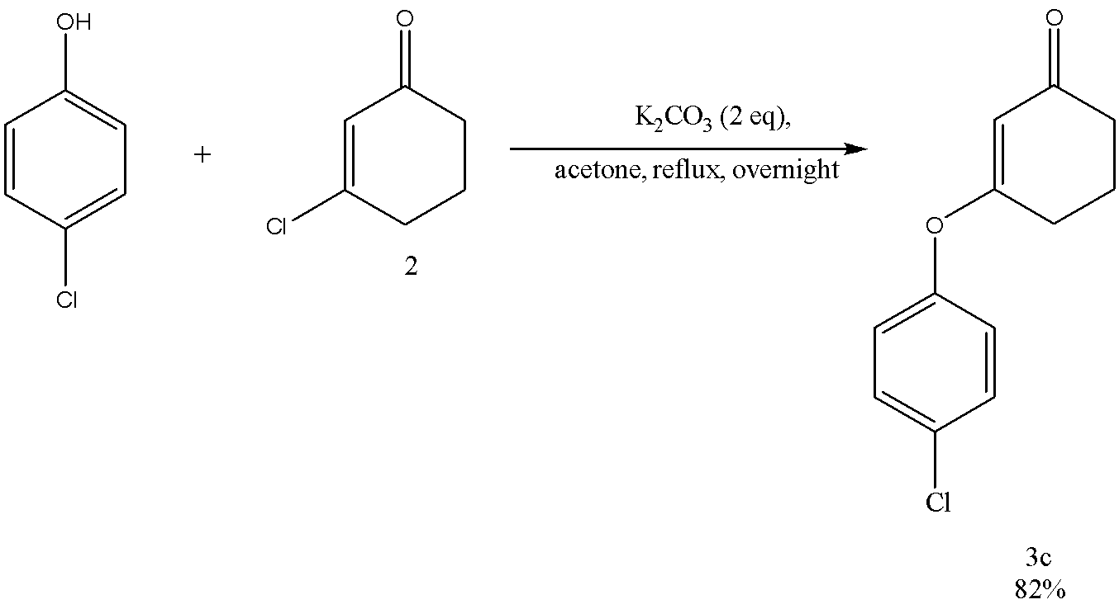

Scheme 2.9 – Synthesis of 3-(4-chlorophenoxy)cyclohex-2-en-1-one
The reaction product (3c) as a white solid: mp 72–75 °C. Yield 82%. The identification of the structure of 3-(4-chlorophenoxy)cyclohex-2-en-1-one (3c) was accomplished through the use of IR, ¹HNMR, ¹³CNMR and mass spectroscopy.
The FTIR (CH₂Cl₂, cast film) spectrum of 3-(4-chlorophenoxy)cyclohex-2-en-1-one (3c) contains absorption bands of stretching vibrations (C=O) of the ketone functional group in the molecule at 1655 cm⁻¹,the (C=C) of the double bond in the cyclohexene ring at 1614 cm⁻¹, the (C=C) bending vibration of the phenyl ring at 1486 cm⁻¹, and the (C-C) of the double bond in the phenyl ring at 1374 cm⁻¹.
¹H NMR spectrum of 3-(4-chlorophenoxy)cyclohex-2-en-1-one (3c) (figure A7), (CDCl₃, 500 MHz) shows the following peaks: the signals appear as doublets at δ 7,37–7,35 (m, 2 H), 6,99–6,96 (m, 2 H) are assigned to the aromatic protons in the 4-chlorophenoxy group; the signal appears as a singlet at δ 5,10 (s, 1H) is assigned to the proton on the double bond in the cyclohexene ring; the signals appear as triplets and pentet at δ 2,64 (t, J = 6,5 Hz, 2 H), 2,37 (t, J = 6,5 Hz, 2 H), 2,07 (pentet, J = 6,5 Hz, 2 H) are assigned to the methylene protons in the aliphatic chain of the cyclohexene ring.
¹³C{¹H} NMR spectrum of 3-(4-chlorophenoxy)cyclohex-2-en-1-one (3c) (figure A8) (CDCl₃, 125 MHz) shows signals at the following chemical shifts: the signal appears at 199,3 ppm (singlet) indicating carbonyl carbon; the signal appears at 177,8 ppm (singlet) indicating aromatic carbon attached to oxygen atom; the signal at 151,2 ppm (singlet) is assigned to the carbon adjacent to the oxygen atom; the signal at 131,6 ppm (singlet) is assigned to the aromatic carbon adjacent to the chlorine atom; the signal at 130,2 ppm (doublet) corresponds to the carbon in the conjugated double bond; the doublets which appear at 122,8 and 106,2 correspond to the aromatic carbons; the triplets at 36,6, 28,5 and 21,2 ppm correspond to the three remaining carbons in the cyclohexane ring.

2.2.4 3-(2,6-Dimethoxyphenoxy)cyclohex-2-en-1-one (3d)
3-(2,6-Dimethoxyphenoxy)cyclohex-2-en-1-one (3d) is a compound that previously was not described in the literature.
The compound 3-(2,6-dimethoxyphenoxy)cyclohex-2-en-1-one (3d) has been synthesized through a general method(scheme 2.5) by using 1 equivalent of 2,6-dimethoxyphenol as a reagent and DMF as a solvent(scheme 2.10).
Our initial attempt at synthesizing 3-(2,6-dimethoxyphenoxy)cyclohex-2-en-1-one (3d) involved a universal approach. However, we encountered a low yield of product when using acetone as a solvent. To improve the yield, we tried using solvents with higher boiling points, such as butanone and DMF(table 2.6).
We first attempted to heat the reaction mixture with acetone at 55°C for 41 h, resulting in a pure product yield of only 5%. Increasing the refluxing temperature to 60°C for 47 h slightly improved the yield to 7%. Refluxing with butanone at 75°C for 66 h led to a more substantial yield of 23% pure product. Finally, when we utilized DMF at 100°C for 24 h, the yield increased significantly to 52%. Using DMF helps to increase the yield and decrease the reaction time.

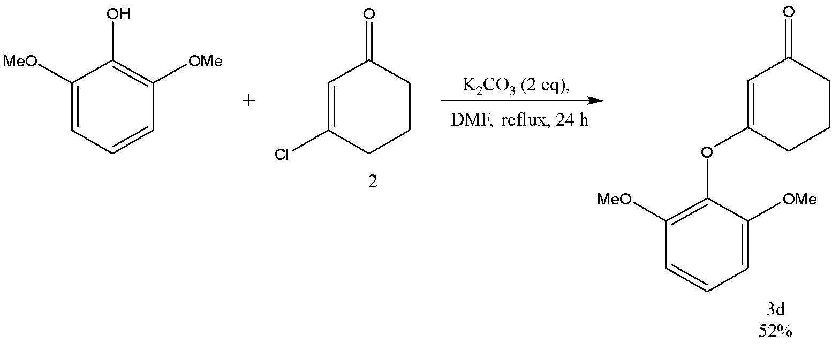

Scheme 2.10 – Synthesis of 3-(2,6-dimethoxyphenoxy)cyclohex-2-en-1-one

Table 2.6 – Yield of 3-(2,6-dimethoxyphenoxy)cyclohex-2-en-1-one (3d) with different solvents and refluxing temperatures

Solvent | Temperature (⁰C) | Time (h) | Yield (%)
Acetone | 55 | 41 | 5
Acetone | 60 | 47 | 7
Butanone | 75 | 66 | 23
DMF | 100 | 24 | 52

The reaction product (3d) is a white solid: mp 76–78 °C. Yield 52%. The identification of the structure of 3-(2,6-dimethoxyphenoxy)cyclohex-2-en-1-one (3d) was accomplished through the use of IR, ¹HNMR, ¹³CNMR, and mass spectroscopy.
The FTIR (CH₂Cl₂, cast film) spectrum of 3-(2,6-dimethoxyphenoxy)cyclohex-2-en-1-one (3d) contains absorption bands of stretching vibrations (C=O) of the ketone functional group in the molecule at 1651 cm⁻¹, the (C=C) of the double bond in the cyclohexene ring at 1619 cm⁻¹, the (C=C) of the double bond in the phenyl ring at 1585 cm⁻¹; and the (C-C) bending vibration of the phenyl ring at 1482 cm⁻¹.
¹H NMR spectrum of 3-(2,6-dimethoxyphenoxy)cyclohex-2-en-1-one (3d) (figure A9), (CDCl₃, 500 MHz) shows the following peaks: the signals appear as a triplet and doublet at δ 7,12 (t, J = 8,5 Hz, 1 H), 6,60 (d, J = 8,5 Hz, 2 H) are assigned to the aromatic protons in the 2,6-dimethoxyphenoxy group; the signal, that appears as a singlet at δ 5,08 (s, 1H) is assigned to the proton on the double bond in the cyclohexene ring; a signal appears as a singlet at δ 3,80 (s, 6H) indicating six protons of the two methyl oxy groups; the signals that appear as triplets and pentet at δ 2,70 (t, J = 6,5 Hz, 2 H), 2,37 (t, J = 6,5 Hz, 2 H), 2,08 (pentet, J = 6,5 Hz, 2 H) are assigned to the methylene protons in the aliphatic chain of the cyclohexene ring.
¹³C{¹H} NMR spectrum of 3-(2,6-dimethoxyphenoxy)cyclohex-2-en-1-one (3d) (figure A10) (CDCl₃, 125 MHz) shows signals at the following chemical shifts: the signal that appears at 200,2 ppm (singlet) indicating carbonyl carbon; the signal that appears at 177,8 ppm (singlet) indicating aromatic carbon attached to oxygen atom; the signal at 152,3 ppm (singlet) is assigned to the carbon adjacent to the oxygen atom; the signal at 130,2 ppm (doublet) corresponds to the carbon in the conjugated double bond; the doublets that appear at 126,5, 105,1 and 104,8 correspond to the aromatic carbons; the signal at 56,1 ppm (quartet) is assigned to the carbons of methoxy groups adjacent to the three protons; the triplets at 36,7, 28,0 and 21,3 ppm correspond to the three remaining carbons in the cyclohexane ring.

2.2.5 3-(2-tert-Butylphenoxy)cyclohex-2-en-1-one (3e)
3-(2-tert-Butylphenoxy)cyclohex-2-en-1-one (3e) is a compound that previously was not described in the literature.
The compound 3-(2-tert-butylphenoxy)cyclohex-2-en-1-one (3e) has been successfully synthesized through a previously described process involving the preparation of 3-(aryloxy)cyclohex-2-en-1-one utilizing 2-tert-butylphenol as a reagent. This synthetic route, as depicted in scheme 2.5, has been employed and modified to obtain the desired compound 3-(2-tert-butylphenoxy)cyclohex-2-en-1-one, as demonstrated in scheme 2.11.

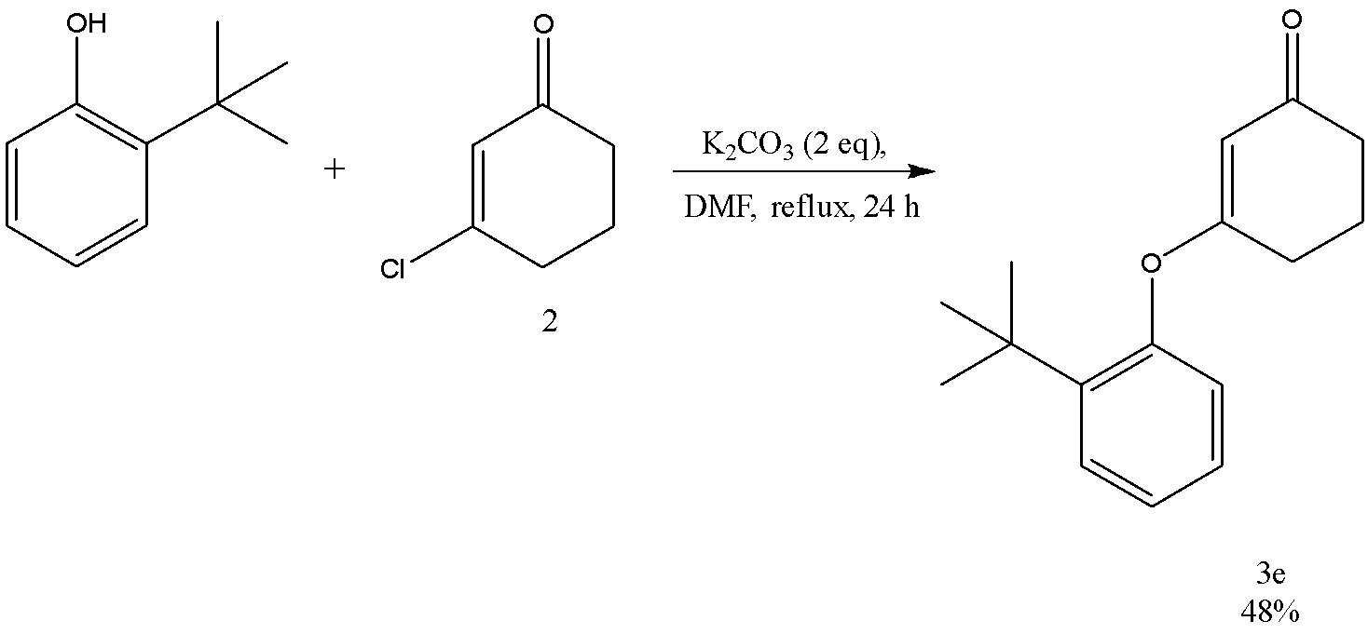

Scheme 2.11 – Synthesis of 3-(2-tert-butylphenoxy)cyclohex-2-en-1-one
Our initial attempt at synthesizing 3-(2-tert-butylphenoxy)cyclohex-2-en-1-one (3e) involved a universal approach. However, we obtained a low yield of product when using acetone as a solvent. To improve the yield, we tried using solvents with higher boiling points, such as butanone and DMF (table 2.7). We first attempted to reflux the reaction mixture with acetone at 60 °C for 43 h, resulting in a pure product yield of only 21%. Refluxing with butanone at 75°C for 116 h led to losing product. Finally, when we utilized DMF at 100°C reaction was completed by TLC in 24 h, and the yield increased significantly to 48%.
The reaction product (3e) is a yellowish oil. Yield 48%. The identification of the structure of 3-(2-tert-butylphenoxy)cyclohex-2-en-1-one (3e) was accomplished through the use of IR, ¹HNMR, ¹³CNMR and mass spectroscopy.

Table 2.7 – Yield of 3-(2-tert-butylphenoxy)cyclohex-2-en-1-one (3e) with different solvents and refluxing temperatures

Solvent | Temperature (⁰C) | Time (h) | Yield (%)
Acetone | 60 | 43 | 21
Butanone | 75 | 116 | -
DMF | 100 | 24 | 48

The FTIR (CH₂Cl₂, cast film) spectrum of 3-(2-tert-butylphenoxy)cyclohex-2-en-1-one (3e) contains absorption bands of stretching vibrations methylene (-CH₂-) groups in the 2957 cm⁻¹; (C=O) of the ketone functional group in the molecule at 1663 cm⁻¹; the (C=C) of the double bond in the cyclohexene ring at 1617 cm⁻¹; the (C=C) of the double bond in the phenyl ring at 1599 cm⁻¹; and the (C-C) bending vibration of the phenyl ring at 1372 cm⁻¹.
¹H NMR spectrum of 3-(2-tert-butylphenoxy)cyclohex-2-en-1-one (3e) (figure A11), (CDCl₃, 600 MHz) shows the following peaks: the signals that appear at δ 7,39 (dd, J = 7,8, 1,8 Hz, 1 H), 7,18–7,13 (m, 2 H), 6,91 (dd, J = 7,8, 1,8 Hz, 1 H) are assigned to the aromatic protons in the 2-tert-butylphenoxy group; the signal that appears as a singlet at δ 5,21 (s, 1H) is assigned to the proton on the double bond in the cyclohexene ring; the signals that appear as triplets and pentet at δ 2,67 (t, J = 6 Hz, 2 H), 2,39 (t, J = 6 Hz, 2 H), 2,09 (pentet, J = 6 Hz, 2 H) are assigned to the methylene protons in the aliphatic chain of the cyclohexene ring; the signal that appears as a singlet at δ 1,32 (s, 9H) indicating nine protons of the tert-butyl group.
¹³C{¹H} NMR spectrum of 3-(2-tert-butylphenoxy)cyclohex-2-en-1-one (3e) (figure A12) (CDCl₃, 125 MHz) shows signals at the following chemical shifts: the signal that appears at 199,5 ppm (singlet) indicates carbonyl carbon; the signal that appears at 177,9 ppm (singlet) indicating aromatic carbon attached to oxygen atom; the signal at 151,3 ppm (singlet) is assigned to the carbon adjacent to the oxygen atom; the signal that appears as a singlet at 141,5 ppm (singlet) is assigned to the aromatic carbon attached to tert-butyl group; the signal at 127,8 ppm (doublet) corresponds to the carbon in the conjugated double bond; the doublets appear at 127,2, 125,8, 123,0 and 106,7 correspond to the aromatic carbons; the signal at 34,6 ppm (singlet) is assigned to the carbon of tert-butyl group adjacent to the three methyl groups and aromatic ring; the signal that appears as a quartet at 30,3 ppm is assigned to the carbons of methyl groups in tert-butyl group; the triplets at 36,6, 28,9 and 21,2 ppm correspond to the three remaining carbons in the cyclohexane ring.

2.2.6 3-(4-tert-Butylphenoxy)cyclohex-2-en-1-one (3f)
The compound 3-(4-tert-Butylphenoxy)cyclohex-2-en-1-one (3f) has not been reported in the literature and hence, remains uncharacterized. The compound 3-(4-tert-butylphenoxy)cyclohex-2-en-1-one (3f) has been successfully synthesized through a previously described process involving the preparation of 3-(aryloxy)cyclohex-2-en-1-one from 3-chlorocyclohex-2-en-1-one(scheme 2.5) utilizing 4-tert-butylphenol as a reagent(scheme 2.12).

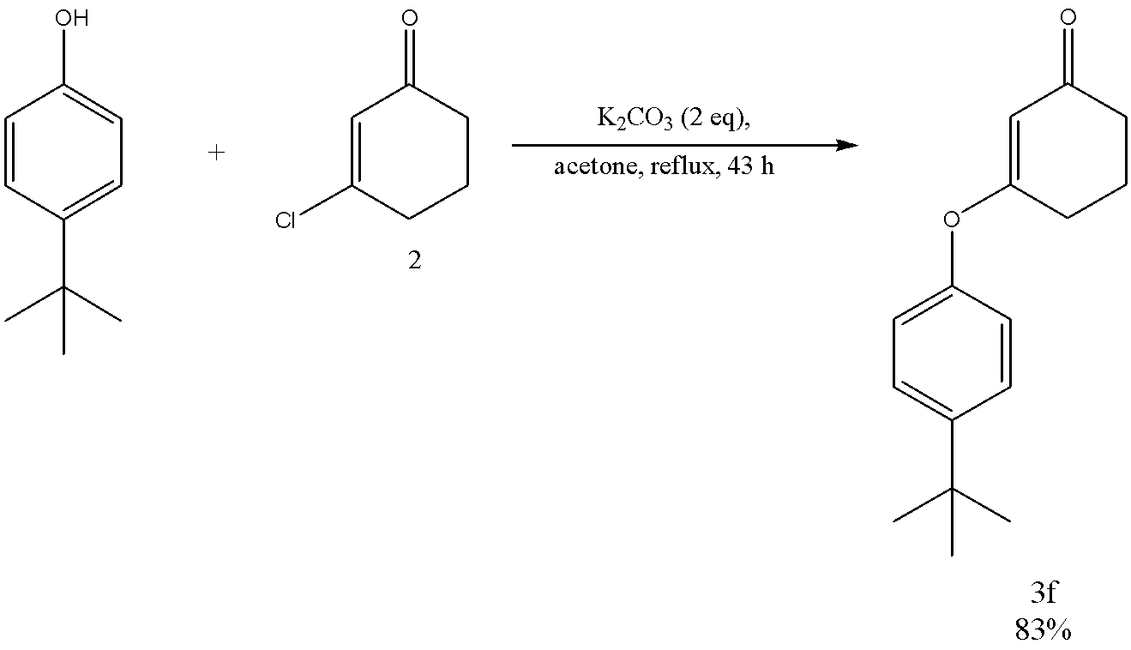

Scheme 2.12 – Synthesis of 3-(4-tert-butylphenoxy)cyclohex-2-en-1-one

The reaction product (3f) is a white solid: mp 92–96 °C. Yield 83%. The identification of the structure of 3-(4-tert-butylphenoxy)cyclohex-2-en-1-one (3f) was accomplished through the use of IR, ¹HNMR, ¹³CNMR and mass spectroscopy.
The FTIR (CH₂Cl₂, cast film) spectrum of 3-(4-tert-butylphenoxy)cyclohex-2-en-1-one (3f) contains absorption bands of stretching vibrations of methylene (-CH₂-) groups at 2962 cm⁻¹; (C=O) of the ketone functional group in the molecule at 1669 cm⁻¹; the (C=C) bending vibration of the phenyl ring at 1656 cm⁻¹; the (C=C) of the double bond in the cyclohexene ring at 1616 cm⁻¹; and the (C-C) of the bond the phenyl ring at 1508 cm⁻¹;
¹H NMR spectrum of 3-(4-tert-butylphenoxy)cyclohex-2-en-1-one (3f) (figure A13), (CDCl₃, 500 MHz) shows the following peaks: the signals that appear at δ 7,39–7,37 (m, 2 H), 6,95–6,93 (m, 2 H) are assigned to the aromatic protons in the 4-tert-butylphenoxy group; the signal that appears as a singlet at δ 5,12 (s, 1H) is assigned to the proton on the double bond in the cyclohexene ring; the signals that appear as triplets and pentet at δ 2,65 (t, J = 7 Hz, 2 H), 2,37 (t, J = 7 Hz, 2 H), 2,08 (pentet, J = 7,0 Hz, 2 H) are assigned to the methylene protons in the aliphatic chain of the cyclohexene ring; the signal that appears as singlet at δ 1,32 (s, 9H) indicates nine protons of the tert-butyl group.
¹³C{¹H} NMR spectrum of 3-(4-tert-butylphenoxy)cyclohex-2-en-1-one (3f) (figure A14) (CDCl₃, 125 MHz) shows signals at the following chemical shifts: the signal that appears at 199,9 ppm (singlet) indicating carbonyl carbon; the signal that appears at 178,7 ppm (singlet) indicates aromatic carbon attached to oxygen atom; the signal at 150,4 ppm (singlet) is assigned to the carbon adjacent to the oxygen atom; the signal that appears as a singlet at 149,2 ppm (singlet) is assigned to the aromatic carbon attached to tert-butyl group; the signal at 126,9 ppm (doublet) corresponds to the carbon in the conjugated double bond; the doublets that appear at 120,8, 106,0 correspond to the aromatic carbons; the signal at 34,6 ppm (singlet) is assigned to the carbon of tert-butyl group adjacent to the three methyl groups and aromatic ring; the signal that appears as a quartet at 31,5 ppm is assigned to the carbons of methyl groups in tert-butyl group; the triplets at 36,7, 28,6 and 21,3 ppm correspond to the three remaining carbons in the cyclohexane ring.

2.2.7 Methyl 4-[(3-oxocyclohex-1-en-1-yl)oxy]benzoate (3g)
Methyl 4-[(3-oxocyclohex-1-en-1-yl)oxy]benzoate (3g) is a compound that previously was not described in a literature.
Methyl 4-[(3-oxocyclohex-1-en-1-yl)oxy]benzoate (3g) has been synthesized successfully by means of a previously described approach(scheme 2.5), which involves the use of methyl 4-hydroxybenzoate phenol derivatives as a reagent (scheme 2.13) for the preparation of 3 methyl 4-[(3-oxocyclohex-1-en-1-yl)oxy]benzoate (3g).

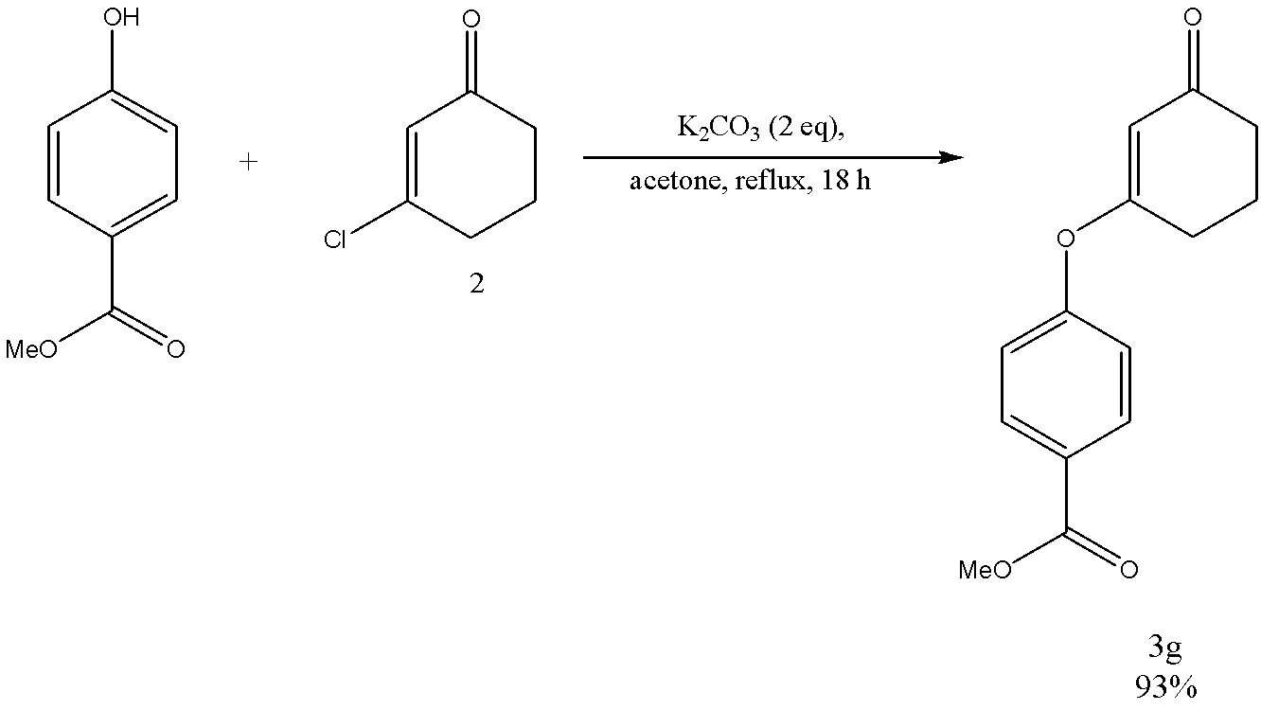

Scheme 2.13 – Synthesis of methyl 4-[(3-oxocyclohex-1-en-1-yl)oxy]benzoate
The reaction product (3g) is a white solid: mp 100–104 °C. Yield 93%. The identification of the structure of methyl 4-[(3-oxocyclohex-1-en-1-yl)oxy]benzoate (3g) was accomplished through the use of IR, ¹HNMR, ¹³CNMR and mass spectroscopy.
The FTIR (CH₂Cl₂, cast film) spectrum of methyl 4-[(3-oxocyclohex-1-en-1-yl)oxy]benzoate (3g) contains absorption bands of stretching vibrations (C=O) of the ester functional group in the molecule at 1724 cm⁻¹; (C=O) of the ketone functional group in the molecule at 1668 cm⁻1; the (C=C) bending vibration of the phenyl ring at 1656 cm⁻¹; the (C=C) of the double bond in the cyclohexene ring at 1620 cm⁻¹; and the (C-C) of the bond in the phenyl ring at 1598 cm⁻¹.
¹H NMR spectrum of methyl 4-[(3-oxocyclohex-1-en-1-yl)oxy]benzoate (3g) (figure A15), (CDCl₃, 400 MHz) shows the following peaks: the signals that appear at δ 8,10 (d, J = 9 Hz, 2 H), 7,12 (d, J = 9 Hz, 2 H) are assigned to the aromatic protons; the signal that appears as a singlet at δ 5,16 (s, 1H) is assigned to the proton on the double bond in the cyclohexene ring; the signal that appears as a singlet at δ 3,95 (s, 3H) indicating three protons of the methyl group; the signals that appear as triplets and pentet at δ 2,67 (t, J = 6,6 Hz, 2 H), 2,41 (t, J = 6,6 Hz, 2 H), 2,11 (pentet, J = 6,6 Hz, 2 H) are assigned to the methylene protons in the aliphatic chain of the cyclohexene ring.
¹³C{¹H} NMR spectrum of methyl 4-[(3-oxocyclohex-1-en-1-yl)oxy]benzoate (3g) (figure A16) (CDCl₃, 125 MHz) shows signals at the following chemical shifts: the signal that appears at 199,3 ppm (singlet) indicates the carbonyl carbon; the signal that appears at 177,2 ppm (singlet) indicates the aromatic carbon attached to oxygen atom; the signal that appears as a singlet at 166,1 ppm indicates carbon of methyl ester; the signal at 156,4 ppm (singlet) is assigned to the carbon adjacent to the oxygen atom; the signal at 131,8 ppm (doublet) corresponds to the carbon in the conjugated double bond; the signal that appear as a singlet at 128,0 ppm (singlet) is assigned to the aromatic carbon attached to (MeO₂C-) group; the doublets that appear at 121,4, 106,7 correspond to the aromatic carbons; the signal at 52,3 ppm (quartet) is assigned to the carbon of methyl group; the triplets at 36,6, 28,4 and 21,13 ppm correspond to the three remaining carbons in the cyclohexane ring.

2.2.8 3-{4-[(3-Oxocyclohex-1-en-1-yl)oxy]phenoxy}cyclohex-2-ene-1-one (3h)
The compound 3-{4-[(3-oxocyclohex-1-en-1-yl)oxy]phenoxy}cyclohex-2-ene-1-one (3h) has not been previously reported in the literature. 3-{4-[(3-Oxocyclohex-1-en-1-yl)oxy]phenoxy}cyclohex-2-ene-1-one (3h) has been synthesized through a previously described process involving the preparation of 3-(aryloxy)cyclohex-2-en-1-one utilizing hydroquinone as a reagent (scheme 2.14). However, when using 1 equivalent of 3-chlorocyclohex-2-en-1-one (2), 1 equivalent of hydroquinone and 2 equivalent of potassium carbonate in refluxing acetone for 41 h we got 69% of 3-(4-hydroxyphenoxy)cyclohex-2-en-1-one (3i) and 13% of 3-{4-[(3-oxocyclohex-1-en-1-yl)oxy]phenoxy}cyclohex-2-ene-1-one (3h) (table 2.8).

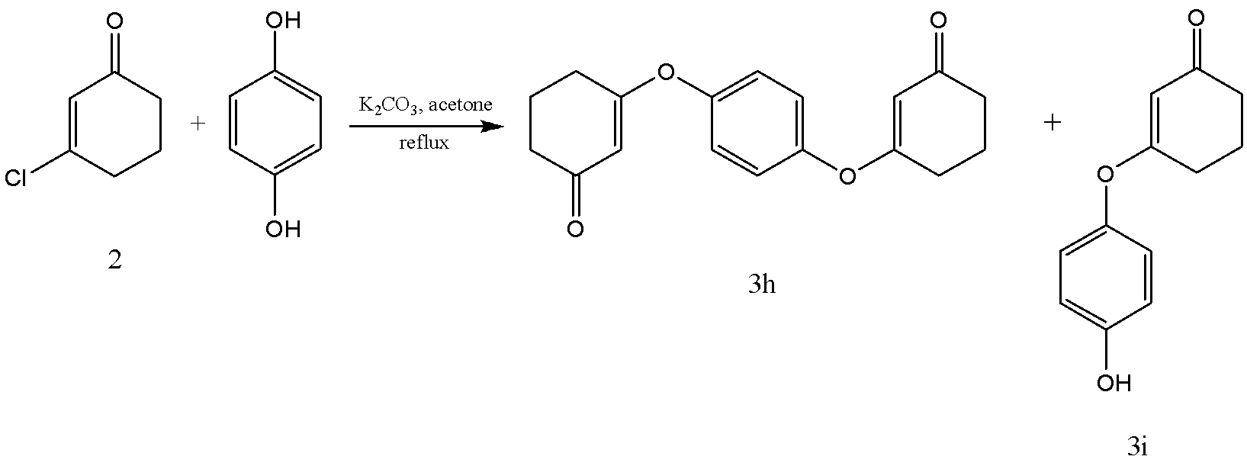

Scheme 2.14 – The synthesis of
3-{4-[(3-Oxocyclohex-1-en-1-yl)oxy]phenoxy}cyclohex-2-ene-1-one (3h) and
3-(4-hydroxyphenoxy)cyclohex-2-en-1-one (3i)

We can not continue synthesis with 3-(4-hydroxyphenoxy)cyclohex-2-en-1-one (3i) because of the ability of the hydroxyl group to react with bromine in the next step. Therefore, we worked on increasing the yield of 3-{4-[(3-oxocyclohex-1-en-1-yl)oxy]phenoxy}cyclohex-2-ene-1-one (3h).
Using 2 equivalent of 3-chlorocyclohex-2-en-1-one (2), 1 equivalent of hydroquinone and 2 equivalents of potassium carbonate in refluxing acetone for 41 h gave us 21% of pure 3-{4-[(3-oxocyclohex-1-en-1-yl)oxy]phenoxy}cyclohex-2-ene-1-one (3h) (table 2.8).
Finally, increasing the amount of potassium carbonate to 4 equivalents, and refluxing in acetone for 43 h gave us 71% of pure 3-{4-[(3-oxocyclohex-1-en-1-yl)oxy]phenoxy}cyclohex-2-ene-1-one (3h).

Table 2.8 – Comparing different amounts of reagents to get 3h
Reagents, equivalent |  |  |  | Yield, %
3-chloro cyclohex-2-en-1-one (2) | Hydroquinone | K₂CO₃ | Reaction conditions | 3-(4-hydroxyphenoxy) cyclohex-2-en-1-one (3i) | 3-{4-[(3-oxocyclohex-1-en-1-yl)oxy]phenoxy} cyclohex-2-ene-1-one (3h)
1 | 1 | 2 | Ref, 41h | 69 | 13
2 | 1 | 2 | Ref, 41h | - | 21
2 | 1 | 4 | Ref, 43 h | - | 71

The yield of the reaction can be improved by increasing the concentration of the mild base potassium carbonate (K₂CO₃) used to facilitate the nucleophilic attack of hydroquinone on 3-chlorocyclohex-2-en-1-one (2). An increasing K₂CO₃ from 2 to 4 equivalents leads to higher base concentration, which improves the efficiency of deprotonation of hydroquinone and makes the nucleophilic attack more efficient, resulting in a higher yield of the desired product. Additionally, higher base concentration minimizes side reactions and increases the reaction rate, leading to a faster formation of the product. The longer reaction time observed with 4 equivalents of K₂CO₃ is compensated by the significant increase in the yield.
The reaction product (3h) is a light orange powder: mp 209–212 °C. Yield 71%. The identification of the structure of 3-{4-[(3-oxocyclohex-1-en-1-yl)oxy]phenoxy}cyclohex-2-ene-1-one (3h) was accomplished through the use of IR, ¹HNMR, ¹³CNMR and mass spectroscopy.
The FTIR (CH₂Cl₂, cast film) spectrum of 3-{4-[(3-oxocyclohex-1-en-1-yl)oxy]phenoxy}cyclohex-2-ene-1-one (3h) contains absorption bands (C-H) of the aromatic ring in the phenoxy groups at 3099, 3069 cm⁻¹, (C-H) of the aliphatic chain in the cyclohexene ring at 2940, 2892, 2870 cm⁻¹; (C=O) of the ketone functional group in the molecule at 1662 cm⁻1; the (C=C) of the double bond in the cyclohexene ring at 1614 cm⁻¹; and the (C-C) of the bond in the phenyl ring at 1489 cm⁻¹.
¹H NMR spectrum of 3-{4-[(3-oxocyclohex-1-en-1-yl)oxy]phenoxy}cyclohex-2-ene-1-one (3h) (figure A17), (CDCl₃, 500 MHz) shows the following peaks: the signal that appears as a singlet at δ 7,08 (s, 4 H) is assigned to the aromatic protons; the signal that appears as a singlet at δ 5,15 (s, 2H) is assigned to the protons on the double bond in the cyclohexene rings; the signals that appear as triplets and pentet at δ 2,67 (t, J = 6 Hz, 4 H), 2,40 (t, J = 7,2 Hz, 4 H), 2,11 (pentet, J = 6,6 Hz, 4 H) are assigned to the methylene protons in the aliphatic chain of the cyclohexene ring.
¹³C{¹H} NMR spectrum of 3-{4-[(3-oxocyclohex-1-en-1-yl)oxy]phenoxy}cyclohex-2-ene-1-one (3h) (figure A18) (CDCl₃, 125 MHz) shows signals at the following chemical shifts: the signal that appears at 199,4 ppm (singlet) indicates carbonyl carbon; the signal that appears at 177,9 ppm (singlet) indicates aromatic carbon attached to oxygen atom; the signal at 150,2 ppm (singlet) is assigned to the carbon adjacent to the oxygen atom; the signal at 122,9 ppm (doublet) corresponds to the carbon in the conjugated double bond; the doublet that appears at 106,2 corresponds to the aromatic carbons; the triplets at 36,6, 28,4 and 21,1 ppm correspond to the three remaining carbons in the cyclohexane ring.

2.3 Synthesis of 2-bromo-3-(aryloxy)cyclohex-2-en-1-one (4)
The introduction of a bromine atom, on the second carbon of a 3-(aryloxy)cyclohex-2-en-1-one (3) prior to the aromatization reaction is a commonly employed strategy. The bromine atom serves as an effective leaving group during the aromatization reaction.
To the best of my knowledge, in 1953 Nazarov [118] reported the first synthesis of 2-bromo-1,3-cyclohexanedione by brominating 1,3-cyclohexanedione using bromine in water, resulting in a yield of 60%. Additionally, Nazarov observed that 2-bromo-1,3-cyclohexanedione exhibited a higher degree of selectivity in reaction with organomagnesium compounds compared to 1,3-cyclohexanedione.
In 1987, Shepherd [119] described a method for synthesizing 2-bromo-3-methoxycyclohex-2-en-1-one from 3-methoxycyclohex-2-en-1-one using N-bromo-succinimide (NBS) in dichloromethane (DCM). Shepherd noted that the conversion of the resulting bromo enone to the corresponding phenol was difficult to achieve using aqueous conditions, but was easily accomplished under anhydrous conditions with acid catalysis, leading to a clean conversion.
This approach improves the selectivity of the reaction and streamlines the purification process. Therefore, the addition of bromine represents a crucial step in the synthetic pathway for the aromatization of 3-(aryloxy)cyclohex-2-en-1-one.
In our research, we synthesized 2-bromo-3-(aryloxy)cyclohex-2-en-1-one (4) from 3-(aryloxy)cyclohex-2-en-1-one (3) using NBS in DMF(scheme 2.15).
The mechanism for the synthesis of 2-bromo-3-(aryloxy)cyclohex-2-en-1-one (4) from 3-(aryloxy)cyclohex-2-en-1-one (3) using NBS in DMF, which was investigated by Dr. Clive’s group at University of Alberta, may occur by the following mechanism (scheme 2.16).
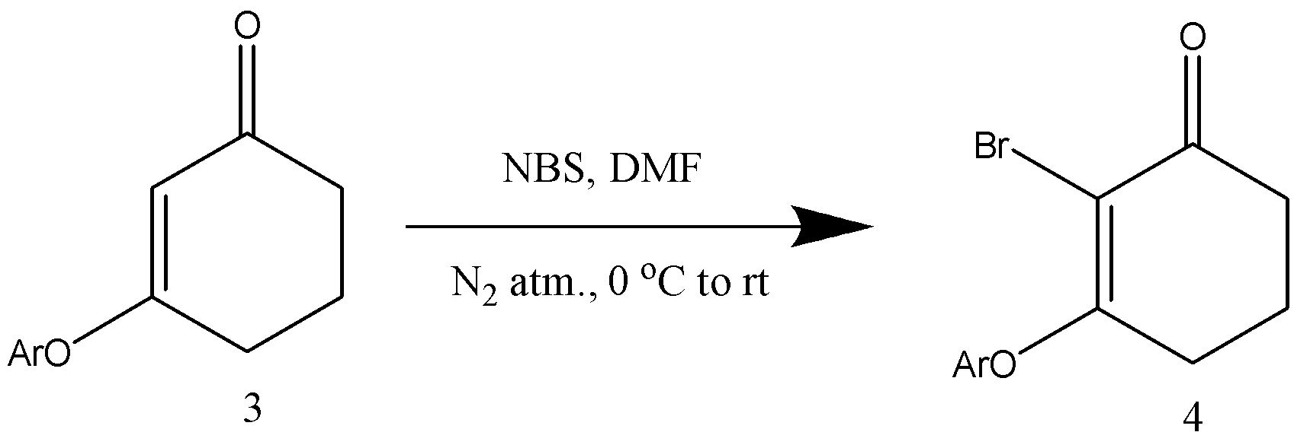
Scheme 2.15 – The synthesis of 2-bromo-3-(aryloxy)cyclohex-2-en-1-one

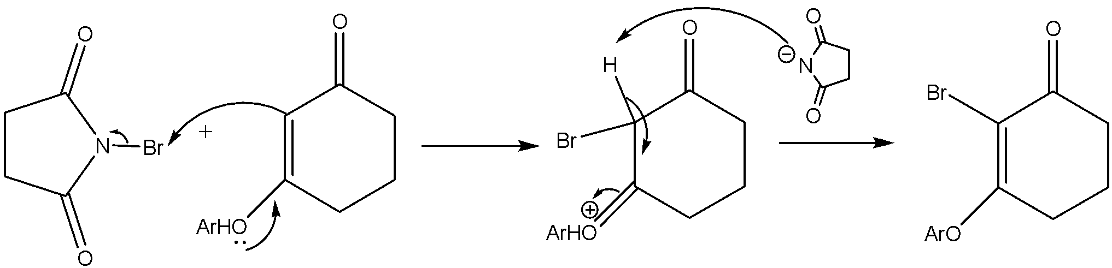

Scheme 2.16 – The mechanism for the synthesis of
2-bromo-3-aryloxy-cyclohex-2-en-1-one

The transfer of the lone pair of electrons from the oxygen of the aryloxy group of 3-(aryloxy)cyclohex-2-en-1-one (3) to the third carbon results in the breaking of the pi bond between the second and third carbons of the cyclohex-2-en-1-one ring and the formation of a new bond between the bromine atom from NBS and the second carbon.
The negatively charged succinimide ion, generated during the reaction, deprotonates the second carbon of the cyclohex-2-en-1-one ring. Subsequently, a pi bond forms between the second and third carbon atoms, causing the pi bond between the oxygen atom and the third carbon atom to break. This sequence of events leads to the formation of 2-bromo-3-(aryloxy)cyclohex-2-en-1-one (4), the desired product.
Initially, the bromination of 3-(aryloxy)cyclohex-2-en-1-ones (3) at C(2) proved to be challenging, until the discovery that NBS in DMF at 0 °C, followed by warming to rt, gave the required 2-bromo derivatives efficiently. Freshly recrystallized NBS from water was used as a matter of routine, and protection from light was necessary for clean halogenation. The amount of NBS needed to be controlled, with the best results obtained using just 1,1 equiv of the reagent, and DMF as the solvent was found to be important. Using a greater proportion of NBS led to the formation of polybromo compounds.
Before DMF was identified as the best solvent for bromination, other solvents and halogenating agents were examined, but none of them was satisfactory. Attempts to make the desired compounds through substitution reactions were also unsuccessful.
Average yield is 72% for 8 examples (table 2.9).

Table 2.9 – Synthesized 2-bromo-3-(aryloxy)cyclohex-2-en-1-ones

 | Name of compound | Time (h) | Yield (%) | State | Melting point (ºC)
4a | 2-bromo-3-(phenoxy)cyclohex-2-en-1-one | 21 | 84 | white solid | -
4b | 2-bromo-3-(4-iodophenoxy)  cyclohex-2-en-1-one* | 24 | 86 | white solid | 157–159
4c | 2-bromo-3-(4-chlorophenoxy)  cyclohex-2-en-1-one* | 18 | 83 | white solid | 149–150
4d | 2-bromo-3-(2,6-dimethoxyphenoxy)  cyclohex-2-en-1-one* | 2 | 71 | white solid | 122–124
4e | 2-bromo-3-(2-tert-butylphenoxy) cyclohex-2-en-1-one* | 18 | 62 | white solid | 103–106
4f | 2-bromo-3-(4-tert-butylphenoxy) cyclohex-2-en-1-one* | 2 | 58 | white solid | 145
4g | methyl 4-[(2-bromo-3-oxocyclohex-1-en-1-yl)oxy]benzoate* | 3,5 | 90 | white solid | 122–125
4h | 2-bromo-3-{4-[(2-bromo-3-oxocyclohex-1-en-1-yl)oxy] phenoxy}cyclohex-2-ene-1-one* | 44 | 41 | violet solid | -

*- compounds have not been previously described in literature
2-Bromo-3-(phenoxy)cyclohex-2-en-1-one (4a) is a known compound, that previously was described by Harrowven et al., in 2007 [120]. They synthesized 2-bromo-3-(phenoxy)cyclohex-2-en-1-one (4a) from 3-(phenoxy)cyclohex-2-en-1-one (3a) using NBS in 1,2-dichloroethane (DCE). The reaction goes at 0 ºC to RT, by stirring for 40 h. Yield of the DP is 74%. Other 7 compounds were not previously described in the literature.
The physical and chemical data for compounds 4a-4h were presented, including mass spectrum (table 2.10), IR (table 2.11), ¹H NMR (table 2.12), and ¹³C{¹H} NMR (table 2.13) analyses. The spectrometers set for these analyses are listed in Appendix A. Further explanations of each data set for the corresponding compound are provided in their respective sections.

Table 2.10 – Mass spectrum data for compounds 4a-4h
 | Ionization technique | Formula | Calculated | Found
4a | Electron Ionization | C₁₂H₁₁⁷⁹BrO₂ (M⁺) | 265,99423 | 265,99355
4b | Electron Ionization | C₁₂H₁₀O₂⁸¹BrI (M⁺) | 393,8880 | 393,8889
4c | Electron Ionization | C₁₂H₁₀⁸¹Br³⁵ClO₂ (M⁺) | 301,9532 | 301,9533
4d | Electrospray Ionization | C₁₄H₁₆⁷⁹BrO₄ (M+H)⁺ | 327,0226 | 327,0220
4e | Electrospray Ionization | C₁₆H₂₀⁷⁹BrO₂ (M+H)⁺ | 322,0568 | 323,0639
4f | Electron Ionization | C₁₆H₁₉⁷⁹BrO₂ (M⁺) | 322,0569 | 322,0567
4g | Electron Ionization | C₁₄H₁₃⁷⁹BrO₄ (M⁺) | 323,999730 | 325,99964
4h | Electrospray Ionization | C₁₈H₁₇⁷⁹Br₂NaO₄ (M+Na)⁺ | 476,9308 | 476,9304

Table 2.11 – IR data for compounds 4a-4h
Compound | Wave numbers of absorption bands, ν, cm-1
Compound | C-H of aromatic ring | C-H₂ of aliphatic chain | C=O of ketone group | C=C double bond of cyclohexenone ring | C=C in an aromatic ring | C-C in an aromatic ring | C-Br | Note
4a | 3063 | 2954 | 1673 | 1608 | 1581 | 1489 | 1455 | -
4b | - | 2953 | 1666 | - | 1655 | 1479 | 1569 | -
4c | - | - | 1673 | 1607 | - | - | 1580 | -
4d | - | - | 1670 | 1599 | 1482 | 1494 | 1580 | -
4e | - | 2957 | 1674 | - | 1485 | 1597 | 1570 | -
4f | 3065 | - | 1665 | - | - | - | 1570 | -
4g | - | - | 1680 | - | 1503 | 1593 | - | 1721 (C=O ester)
4h | - | - | 1655 | 1500 | - | 1417 | 1589 | -

Table 2.12 – ¹H-NMR data for compounds 4a-4h
Compound | Chemical shift, ⌠, ppm
Compound | CH (aromatic protons) | CH₂ | CH₃
4a | 7,45–7,41 (m, 2H), 7,30–7,29 (m, 1H) 7,10–7,08 (m, 2H) | 2,64-2,61 (m, 2H), 2,44 (t, 2H) 2,02 (p, 2H) | -
4b | 7,71 (d, 2 H), 6,82 (d, 2 H) | 2,60 (t, 2 H), 2,44 (t, 2 H), 2,01 (p, 2 H) | -
4c | 7,39–7,36 (m, 2 H), 7,02 – 7,00 (m, 2 H) | 2,61 (t, 2 H), 2,44 (t, 2 H), 2,02 (p, 2 H) | -
4d | 7,15 (t, 1 H), 6,63 (d, 2 H) | 2,57 (t, 2 H), 2,34 (t, 2 H), 1,96 (p, 2 H) | 3,85 (s, 6H)
4e | 7,44 (dd, 1 H), 7,24–7,17 (m, 2 H), 6,82 (dd, 1 H) | 2,62 (t, 2 H), 2,44 (t, 2 H), 1,98 (p, 2 H) | 1,40 (s, 9H)
4f | 7,41–7,39 (m, 2 H), 6,99–6,97 (m, 2 H) | 2,60 (t, 2 H), 2,45 (t, 2 H), 2,00 (p, 2 H) | 1,33 (s, 9H)
4g | 8,10 (d, 2 H), 7,10 (d, 2 H) | 2,64 (t, 2 H), 2,52 (t, 2 H), 2,07 (p, 2 H) | 3,96 (s, 3H)
4h | 7,13 (s, 4H) | 2,65 (t, 4 H), 2,49 (t, 4 H), 2,05 (p, 4 H) | -
Table 2.13 – ¹³C{¹H} NMR data for compounds 4a-4h
Compound | Chemical shift, ⌠, ppm |  |  |  |  |  |  | Note
Compound | C=O | C-O  Aromatic carbon | C-O | =C-Br | -CH Aromatic carbons | -CH₂ | -CH₃ | -
4a | 191,2 (s) | 170,8 (s) | 152,8 (s) | 129,6 (s) | 125,5 (d), 120,3 (d), 106,1 (d) | 36,7 (t), 28,5 (t), 20,4 (t) | - | -
4b | 191,5 (s) | 170,3 (s) | 153,1 (s) | 107,5 (s) | 139,1 (d), 122,6 (d) | 37,1 (t), 28,9 (t), 20,8 (t) | - | 89,5 (s) C-I
4c | 191,5 (s) | 170,5 (s) | 151,7 (s) | 107,3 (s) | 130,1 (d), 121,9 (d) | 37,1 (t), 28,9 (t), 20,8 (t) | - | 131,3 (s)  C-Cl
4d | 191,9 (s) | 173,3 (s) | 152,7 (s) | 131,0 (s) | 126,6 (d), 105,3 (d) | 37,1 (t), 27,5 (t), 20,6 (t) | 56,4 (q) | -
4e | 191,6 (s) | 171,4 (s) | 151,7 (s) | 106,48 (s) | 127,9 (d), 127,2 (d), 125,8 (d) 121,7 (d) | 37,3 (t), 29,6 (t), 21,1 (t) | 30,3 (q) | 141,6 (s) C-tert-Bu,  34,8 (s) C-(CH₃)₃,
4f | 191,7 (s) | 171,6 (s) | 150,8 (s) | 106,0 (s) | 126,9 (d) 120,2 (d) | 37,2 (t), 29,0 (t), 20,8 (t) | 31,4 (q) | 149,1 (s) C-tert-Bu,  34,6 (s) C-(CH₃)₃,
4g | 191,4 (s) | 169,8 (s) | 156,9 (s) | - | 131,8 (d) 119,7 (d) | 37,1 (t), 29,1 (t), 20,7 (t) | 52,3 (q) | 166,0 (s) C=O ester, 127,4 (s) C-(CO₂Me),
4h | 199,4 (s) | 177,9 (s) | 150,2 (s) | 122,9 (d) | 106,2 (d) | 36,6 (t), 28,4 (t), 21,1 (t) | - | -

In the FTIR spectra of compounds (4) several shifts in absorption bands are observed comparing with compounds (3). These shifts are associated with the (C-H) stretching vibrations of both the aromatic ring and aliphatic chain, the (C=O) vibration of the ketone group, the (C=C) vibrations of the double bonds in the cyclohexene and phenyl rings, and the (C-C) bending vibration of the phenyl ring. The observed shifts and the introduction of a new absorption band in the FTIR spectrum are a result of changes in the molecular structure of the compounds due to the substitution of a hydrogen atom with a bromine atom in compounds (4).
Bromine is significantly heavier than hydrogen, which directly influences the vibrational frequencies of the involved bonds and thereby alters the absorption bands. The presence of a bromine atom introduces a new vibrational mode, the (C-Br) bending vibration, which adds a new absorption band to the FTIR spectrum of (4) not seen in (3). Finally, the bromine atom, due to its size and electron-withdrawing nature, could impact the molecular environment surrounding the existing functional groups, further contributing to the shifts in the absorption bands. This can even induce a change in the (C-C) bending vibration of the phenyl ring.
In contrasting the ¹H NMR spectra of compounds (3a-3h) and (4a-4h) (figures in appendix A), distinct shifts and changes in signal distribution become evident.
The aromatic and aliphatic protons in (4) exhibit signals which display a shift when compared to the signals of (3). Additionally, the ¹H NMR spectrum of compounds 4 lacks the singlet at between δ 5,08-5,21 that is present in compounds 3, attributed to the proton on the double bond in the cyclohexene ring.
The observed variances are primarily attributable to modifications in the molecular structure and the proximate electronic environment of the protons.
- Chemical shift changes: These shifts result from the impact of the electron distribution around the protons. The addition of a bromine atom in (4), a much more electronegative element than hydrogen, alters the electron density surrounding nearby protons. This change can lead to a different shielding effect and thus affect the chemical shift of these protons.
- Influence of the bromine atom: Bromine, due to its larger size and different magnetic properties compared to hydrogen, can influence the magnetic field experienced by nearby protons, which can result in shifts in their peaks.
- Absence of the singlet: The disappearance of the singlet corresponding to the proton on the double bond in the cyclohexene ring in (4), compared to its presence in (3), could be due to the bromine substitution, affecting the electronic structure and consequently the chemical environment of this proton.
Analyzing the ¹³C{¹H} NMR spectra of compounds (3a-3h) and (4a-4h), certain shifts are discernible, likely arising from the substitution of a bromine atom in (4).
Carbonyl Carbon: A downfield shift from around 199,2-200,2 ppm (in 3) to 191,2-191,9 ppm (in 4) is noted. This change might be due to the influence of the bromine atom, known for its higher electronegativity compared to hydrogen, which can alter the electronic environment around the carbonyl carbon, reducing its chemical shift.
Aromatic Carbon Attached to Oxygen: The downfield shift is probably a consequence of the bromine substitution as well, altering the electron distribution around the carbon atom connected to the oxygen.
Carbon Adjacent to the Oxygen Atom: A slight upfield shift is seen. Although minor, this alteration may also be due to the effect of the bromine atom in 4, which influences the electron distribution around this carbon atom.
Carbon in the Conjugated Double Bond: A downfield shift suggests changes in the electronic environment due to the introduction of the bromine atom.

2.4 Synthesis of meta-aryloxy phenols (5)
In the first chapter, we delineated contemporary progress in the synthesis of meta-aryloxy phenols, encompassing a series of reactions such as nucleophilic substitution between aryl halides and resorcinol, Sonogashira coupling, demethylation processes, and the employment of Grignard reagents for the generation of meta-aryloxy phenols. Moreover, we examined the advancements in the production of meta-substituted phenols derived from meta-substituted cyclohex-2-en-1-ones via oxidative aromatization techniques.
In the course of our investigation, we successfully synthesized meta-aryloxy phenols (5) by employing 2-bromo-3-(aryloxy)cyclohex-2-en-1-one (4) as a starting material and utilizing 1,8-diazabicyclo[5.4.0]undec-7-ene (DBU) in a toluene solvent(scheme 2.25). The reaction was conducted under ambient atmospheric conditions and at rt, typically requiring a duration of approximately two h to complete.

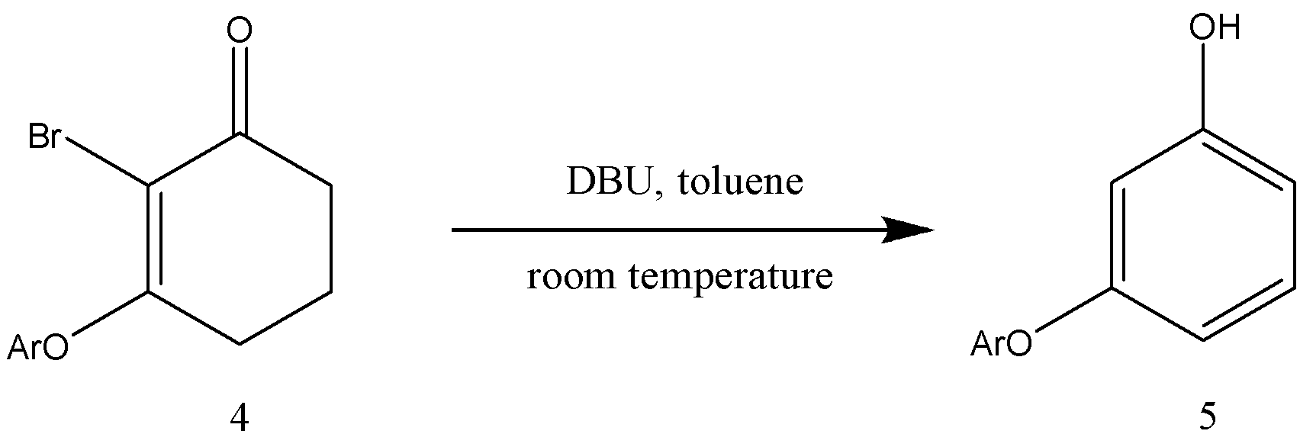

Scheme 2.25 – Synthesis of meta-aryloxy phenols

The reaction mechanism(scheme 2.26) for the synthesis of meta-aryloxy phenols (5) from 2-bromo-3-(aryloxy)cyclohex-2-en-1-one (4) using 1,8-diazabicyclo[5.4.0]undec-7-ene (DBU) in a toluene solvent can be elucidated as follows [113].
DBU, a strong organic base, deprotonates forth carbon in compound 4 which leads to a resonance-stabilized enolate anion (1). The enolate anion undergoes an intramolecular elimination (E2) reaction (2), facilitated by the electron-rich oxygen atom and positively charged protonated DBU (DBUH⁺). This results in the protonation at C-2.

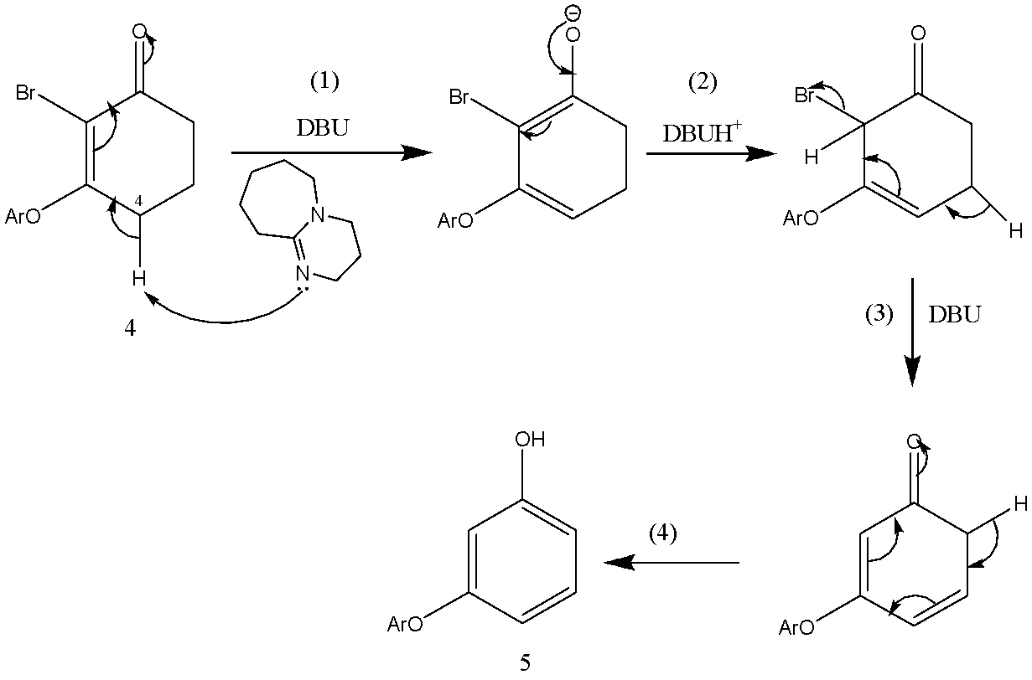

Scheme 2.26 – The mechanism for the synthesis of meta-aryloxy phenols

The second equivalent of the DBU deprotonates (C5) carbon on the cyclic compound (3), that leads to forming a new double bond in (C4) and transferring of the pi bond from (C3) to (C2), and a bromide ion is released as a leaving group. The resulting intermediate undergoes keto-enol tautomerization (4) to form the final meta-aryloxy phenol (5) product. The average yield is 66% for 8 compounds(table 2.14).

Table 2.14 – Synthesized meta-aryloxy phenols

 | Name of compound | Time (h) | Yield (%) | State | Melting point (ºC)
5a | 3-(phenoxy)phenol | 19 | 86 | oil | -
5b | 3-(4-iodophenoxy)phenol* | 30 | 58 | oil | -
5c | 3-(4-chlorophenoxy)phenol | 18 | 55 | oil | -
5d | 3-(2,6-dimethoxyphenoxy) phenol* | 72 | 75 | oil | -
5e | 3-(2-tert-butylphenoxy)phenol* | 72 | 78 | oil | -
5f | 3-(4-tert-butylphenoxy)phenol | 22 | 86 | solid | 122–125
5g | methyl 4-[(2-bromo-3oxocyclohex-1-en-1yl)oxy]benzoate* | 18 | 57 | colorless gel | -
5h | 3-[4-(3-hydroxyphenoxy) phenoxy]phenol | 42 | 31 | colorless solid | 115–118

*- compounds have not been previously described in the literature
We chose to let the aromatization reactions proceed for 24 h or longer without strict time constraints. However, we observed through TLC monitoring that the aromatization of the 2,6-dimethoxy compound (4d) and the 2-tert-butyl compound (4e) occurred at a slower rate. It is possible that in these instances, the aromatic substituents obstruct the base's access to the C(4) hydrogens in compounds 4d and 4e.
With compounds containing an electron-withdrawing group, for which we employed 4-iodophenol, 4-chlorophenol and methyl 4-hydroxybenzoate, as the original phenol. Once again, chloride displacement (2→ 3b, 3c,3g) and bromination (3b, 3c, 3g→4b, 4c, 4g) proceeded efficiently; however, treating with DBU in MeCN resulted in the formation of both the desired product (5b, 5c, 5g) and approximately of 4-iodophenol, 4-chlorophenol and methyl 4-hydroxybenzoate (determined by ¹H NMR), which was not present in the starting bromides (4b, 4c, 4g). In other instances, the degree of initial nucleophile expulsion must have been minimal, allowing the desired meta-(aryloxy)phenol to be isolated in a respectable yield (averaging 66% for 8 examples) using flash chromatography. In all cases, the final aromatized product retained only the substituents present in the starting 3-(aryloxy)enone.
The physical and chemical data for compounds 5a-5h were presented, including mass (table 2.15) IR (table 2.16), ¹H NMR (table 2.17), and ¹³C{¹H} NMR (table 2.18) analyses. The spectrometers used for these analyses were listed in Appendix A. Further explanations of each data for the corresponding compound are provided in their respective sections.

Table 2.15 – Mass spectrum data for compounds 4a-4h
 | Ionization technique | Formula | Calculated | Found
5a | Electrospray Ionization | C₁₂H₉O₂ (M–H)– | 185,0608 | 185,0606
5b | Electrospray Ionization | C₁₂H₈IO₂ (M–H)– | 310,9574 | 310,9571
5c | Electrospray Ionization | C₁₂H₈³⁵ClO₂ (M–H)– | 219,0218 | 219,0216
5d | Electrospray Ionization | C₁₄H₁₃O₄ (M–H)– | 245,0819 | 245,0818
5e | Electrospray Ionization | C₁₆H₁₇O₂ (M–H)– | 241,1234 | 241,1238
5f | Electrospray Ionization | C₁₆H₁₇O₂ (M–H)– | 241,1234 | 241,1232
5g | Electrospray Ionization | C₁₄H₁₁O₄ (M–H)– | 243,06630 | 243,06630
5h | Electrospray Ionization | C₁₈H₁₄O₄ (M–H)– | 293,0819 | 293,0821

Table 2.16 – IR data for compounds 5a-5h
Compound | Wave numbers of absorption bands, ν, cm-1
Compound | C-H of aromatic ring | C-OH | C=C in an aromatic ring | C-C in an aromatic ring | Note
5a | 3065, 2927 | 2411 | 1590 | 1488 | -
5b | 3396 | 1581 | 1600 | 1478 | -
5c | 3407 | 1588 | 1600 | 1484 | -
5d | 3450 | - | 1601 | 1481 | -
5e | 3392 | - | 1596 | 1484 | -
5f | 3411, 2959 | 1592 | 1610 | 1498 | -
5g | 3392 | 1697 | 1598 | - | 1719 (C=O ester)
5h | 3394 | 1599 | 1494 | 1276, 1137 | -
Table 2.17 – ¹H-NMR data for compounds 5a-5h
Compound | Chemical shift, ⌠, ppm
Compound | CH (aromatic protons) | OH | CH₃
5a | 7,36–7,32 (m, 2H), 7,17 (t, 1H) 7,14–7,10 (m, 1H), 7,05 – 7,02 (m, 2H), 6,59 – 6,55 (m, 2H), 6,49 (t, 1H) | 4,76 (s, 1H) | -
5b | 7,62 (d, 2 H), 7,18 (t, 1 H), 6,79 (d, 2 H), 6,60–6,55 (m, 2 H), 6,49 (t, 1 H) | 4,83 (s, 1H) | -
5c | 7,31–7,26 (m, 2 H), 7,18 (t, 1 H), 6,98–6,94 (m, 2 H), 6,60–6,55 (m, 2 H), 6,49 (t, 1 H) | 4,81 (s, 1H) | -
5d | 7,14 (t, 1 H), 7,09 (t, 1 H), 6,66 (d, 2 H), 6,45–6,44 (m, 2 H), 6,35 (t, 1 H) | 4,61 (s, 1H) | 3,79 (s, 6H)
5e | 7,40 (dd, 1 H), 7,18–7,14 (m, 2 H), 7,07 (td, 1 H), 6,87 (dd, 1 H), 6,57–6,53 (m, 2 H), 6,46 (t, 1 H) | 4,73 (s, 1H) | 1,41 (s, 9H)
5f | 7,36–7,35 (m, 2 H), 7,16 (t, 1 H), 6,97–6,95 (m, 2 H), 6,59–6,53 (m, 2 H), 6,47 (t, 1 H) | 4,74 (s, 1H) | 1,33 (s, 9H)
Extension of the table 2.17
5g | 8,02 (d, 2 H), 7,25 (t, 1 H), 7,03 (d, 2 H), 6,70–6,63 (m, 2 H), 6,58 (t, 1 H) | 5,17 (s, 1H) | 3,93 (s, 3H)
5h | 7,20 (t, 2 H), 7,04 (s, 4 H), 6,61–6,57 (m, 4 H), 6,50 (t, 2 H) | 4,96 (br s, 2 H) | -
Table 2.18 – ¹³C{¹H} NMR data for compounds 5a-5h
Compound | Chemical shift, ⌠, ppm |  |  |  | Note
Compound | C-OH | C-O  Aromatic carbon | -CH Aromatic carbons | -CH₃ | -
5a | 158,8 (s) | 156,8 (s), 156,77 (s) | 130,5 (d), 129,8 (d), 123,6 (d), 119,4 (d), 111,1 (d), 110,0 (d), 106,0 (d) | - | -
5b | 158,0 (s) | 157,0 (s), 156,9 (s) | 138,7 (d), 130,6 (d), 121,3 (d), 111,2 (d), 110,7 (d), 106,3 (d) | - | 86,3 (s) C-I
5c | 158,3 (s) | 156,9 (s), 155,5 (s) | 130,6 (d), 129,8 (d), 120,5 (d), 111,0 (d), 110,6 (d) and 106,1 (d) | - | 128,6 (s)  C-Cl
5d | 159,9 (s) | 156,6 (s), 153,6 (s) | 130,0 (d), 125,6 (d), 108,6 (d), 107,6 (d), 105,5 (d), 102,3 (d) | 56,3 (q) | -
5e | 159,3 (s) | 156,8 (s), 155,4 (s) | 130,4 (d), 127,3 (d), 127,2 (d), 123,6 (d), 120,7 (d), 111,0 (d), 109,6 (d), 105,8 (d) | 30,2 (q) | 141,2 (s) C-tert-Bu
5f | 159,2 (s) | 156,7 (s), 154,2 (s) | 130,3 (d), 126,6 (d), 119,0 (d), 110,8 (d), 109,8 (d), 105,6 (d) | 31,5 (q) | 146,6 (s) C-tert-Bu,  34,4 (s) C-(CH₃)₃,
5g | 167,1 (s) | 161,6 (s), 157,3 (s) | 131,7 (d), 130,7 (d), 117,6 (d), 112,0 (d), 111,7(d), 107,4 (d) | 52,2 (q) | 156,8 (s) C=O ester, 124,4 (s) C-(CO₂Me),
5h | 159,3 (s) | 157,0 (s), 152,4 (s) | 130,4 (d), 121,0 (d), 110,4 (d), 110,0 (d), 105,3 (d) | - | -

2.4.1 3-(Phenoxy)phenol (5a)
3-(Phenoxy)phenol have gained considerable attention due to their diverse applications and properties. They serve as valuable intermediates in the synthesis of various organic compounds, including dyes, pharmaceuticals, and agrochemicals. Additionally, they exhibit a wide range of biological activities, such as antioxidant, antimicrobial, and anti-inflammatory properties, which contribute to their potential use in medicinal chemistry [121].
To the best of my knowledge, the initial synthesis of 3-(phenoxy)phenol can be traced back to the work of Armstrong et al. in 1983 [87]. In their research, they successfully synthesized 3-(methoxy)diphenyl ether in a 29% yield through the reaction of phenol and 3-bromoanisole. Subsequently, the resulting compound was subjected to a demethylation process employing boron tribromide as the reagent, which afforded the desired meta-(phenoxy)phenol in an appreciable yield of 83%.
In this research, we synthesized 3-(phenoxy)phenol (5a) from 2-bromo-3-(phenoxy)cyclohex-2-en-1-one (4a) using 3 equivalent of DBU and toluene as a solvent(scheme 2.27).

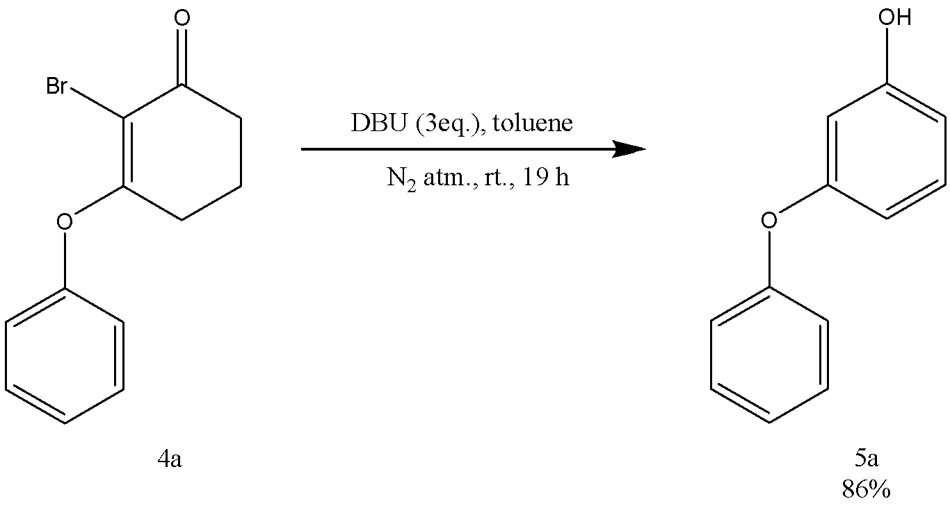

Scheme 2.27 – Synthesis of 3-(phenoxy)phenol

In an effort to synthesize 3-(phenoxy)phenol, we explored various bases and solvents, as detailed in table 2.19. Experiments were conducted with DBU in solvents such as acetonitrile (MeCN), toluene, ethanol, and dimethyl sulfoxide (DMSO) under both rt and reflux conditions. A refluxed reaction using 1,5-diazabicyclo[4.3.0]non-5-ene (DBN) in MeCN for 48 h yielded 43% of the desired product (DP) with impurities present.

Table 2.19 – Comparing of used solvents and bases in synthesis of 3-(phenoxy)phenol

 | Base | Solvent | Temperature (ºC) | Time (h) | Yield (%)
1 | DBU | MeCN | 85 | 48 | 53
1 | DBU | MeCN | rt | 48 | No result
1 | DBU | Toluene | 85 | 48 | 69
1 | DBU | Toluene | rt | 19 | 86
1 | DBU | EtOH | 80 | 48 | 54
1 | DBU | EtOH | rt | 48 | No result
1 | DBU | DMSO | 80 | 70 | 43
1 | DBU | DMSO | 90 | 44 | 55
1 | DBU | DMSO | rt | 48 | No result
2 | DBN | MeCN | 80 | 48 | 43, not pure
2 | DBN | MeCN | rt | 48 | No result
3 | NaOAc | EtOH | rt | 48 | No result
3 | NaOAc | EtOH | 80 | 48 | 36
3 | NaOAc | EtOH | 80 | 74 | 57
4 | DIPEA | MeCN | 80 | 68 | 46
4 | DIPEA | MeCN | rt | 48 | No result
5 | PhONa | MeCN | rt | 45 | 38
5 | PhONa | DMF | rt | 48 | 28, not pure
5 | PhONa | THF | rt | 40 | 66
6 | PhONa and DBU | MeCN | rt | 48 | 40, not pure

When employing sodium acetate in ethanol, we initially observed no significant changes on thin-layer chromatography (TLC) after two days at rt. However, following two days of reflux, a 36% yield of DP was obtained, which increased to 57% after three days of reflux. Utilizing sodium carbonate under reflux for two days resulted in a 30% yield of DP.
A reaction involving N,N-diisopropylethylamine (DIPEA) in MeCN under reflux for 68 h produced a 46% yield of DP. We also experimented with sodium phenoxide alone in MeCN, DMF, and tetrahydrofuran (THF) under reflux for approximately 40 h. These reactions led to 38%, 28%, and 66% yields of purified DP, respectively. Lastly, the combination of DBU and sodium phenoxide in MeCN yielded a 40% mixture of DP and phenol.
The reaction product (5a) as an oil. Yield 86%. The physicochemical properties of the synthesized 3-(phenoxy)phenol were found to be consistent with previously reported literature data [87].
The FTIR (CH₂Cl₂, cast film) spectrum of 3-(phenoxy)phenol (5a) contains absorption bands of stretching vibrations (C-H) of the aromatic ring in the phenoxy group at 3065, 2927 cm⁻¹, the (C-O) of the hydroxyl group at 2411 cm⁻¹, the (C=C) of the double bond in the phenyl ring at 1590 cm⁻¹, and the (C-C) bending vibration of the phenyl ring at 1488 cm⁻¹.
¹H NMR spectrum of 3-(phenoxy)phenol (5a) (figure A35), (CDCl₃, 500 MHz) shows the following peaks: the signals that appear as multiplets and triplets at δ 7,36–7,32 (m, 2 H), 7,17 (t, J = 8,2 Hz, 1 H), 7,14–7,10 (m, 1 H), 7,05–7,02 (m, 2 H), 6,59–6,55 (m, 2 H), 6,49 (t, J = 2,3 Hz, 1 H) are assigned to the aromatic protons of the two phenoxy groups; the signal that appears as a singlet at δ 4,76 (s, 1 H of -OH) assigned to the hydroxylic proton.
¹³C{¹H} NMR spectrum of 3-(phenoxy)phenol (5a) (figure A36) (CDCl₃, 125 MHz) shows signals at the following chemical shifts: The signal that appears at 158,80 as a singlet indicates a carbon attached to the hydroxyl group; the signals that appear at 156,8, 156,77 ppm (singlet) indicates aromatic carbons attached to the oxygen atom; the doublets that appear at 130,5 (d), 129,8 (d), 123,6 (d), 119,4 (d), 111,1 (d), 110,0 (d) and 106,0 (d) correspond to the aromatic carbons;

2.4.2 3-(4-Iodophenoxy)phenol (5b)
3-(4-Iodophenoxy)phenol (5b) is a compound that previously was not described in the literature. The existence of iodine in compound 5b offers potential for additional transformations involving transition metals. Although iodides are compatible with copper-mediated Ullmann reactions [122] it is improbable that they would be well-suited for palladium-mediated variations [123,124] of the Ullmann reaction.
In this research work, we synthesized 3-(4-iodophenoxy)phenol (5b) from 2-bromo-3-(4-iodophenoxy)cyclohex-2-en-1-one (4b) by general synthetic method (scheme 2.25) using 3 equivalent of DBU and toluene(scheme 2.28).

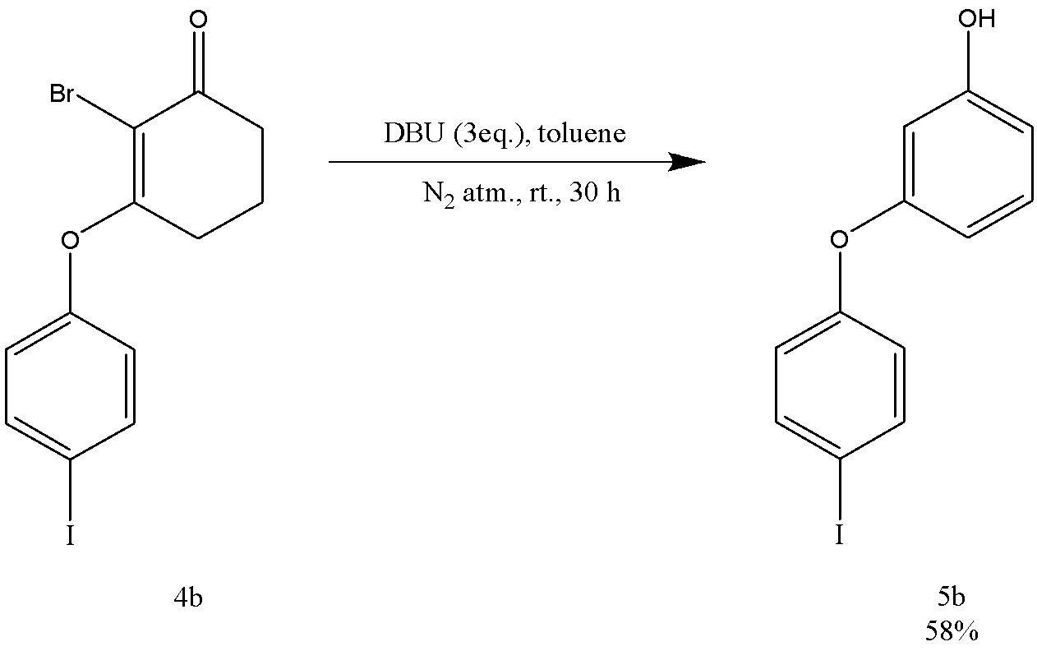
Scheme 2.28 – Synthesis of 3-(4-iodophenoxy)phenol

Reaction is done at rt for 30 h. In this case, we recognized expulsion of 4-iodophenol during the aromatization, which we could not separate by chromatography. Resulting compound contains 8 mol% of 4-iodophenol (¹H NMR). To remove the 4-iodophenol we used a Kugelrohr distillation (0.25 mmHg, oven temperature 110 °C) afforded 5b (58%).
We investigated the impact of solvent choice on the aromatization process by examining the formation of compound 5b. We assessed DMF, DMSO, THF and toluene at rt. Toluene was determined to yield the most favorable outcome, as it minimized the production of unwanted by products(table 2.20).

Table 2.20 – Comparing of used solvents and bases in synthesis of 3-(4-iodophenoxy)phenol

 | Solvent | Temperature (ºC) | Time (h) | Yield (%)  Not pure
1 | MeCN | 80 | 24 | 70
2 | MeCN, Ac₂O | 80 | 48 | 75
3 | MeCN | rt | 42 | 63
4 | DMSO | rt | 23 | 48
5 | Toluene | rt | 2 | 86

With compounds containing an electron-withdrawing group, for which we employed 4-iodophenol, 4-chlorophenol and methyl 4-hydroxybenzoate, as the original phenol, treating with DBU in MeCN resulted in the formation of both the desired product (5b, 5c, 5g) and approximately of 4-iodophenol, 4-chlorophenol and methyl 4-hydroxybenzoate (determined by ¹H NMR), which was not present in the starting bromides (4b, 4c, 4g).
In the current experiments, a competing reaction is observed. Theoretically, the release of the initial phenol (ArOH) might transpire through an addition-elimination mechanism, as outlined in scheme 2.29.

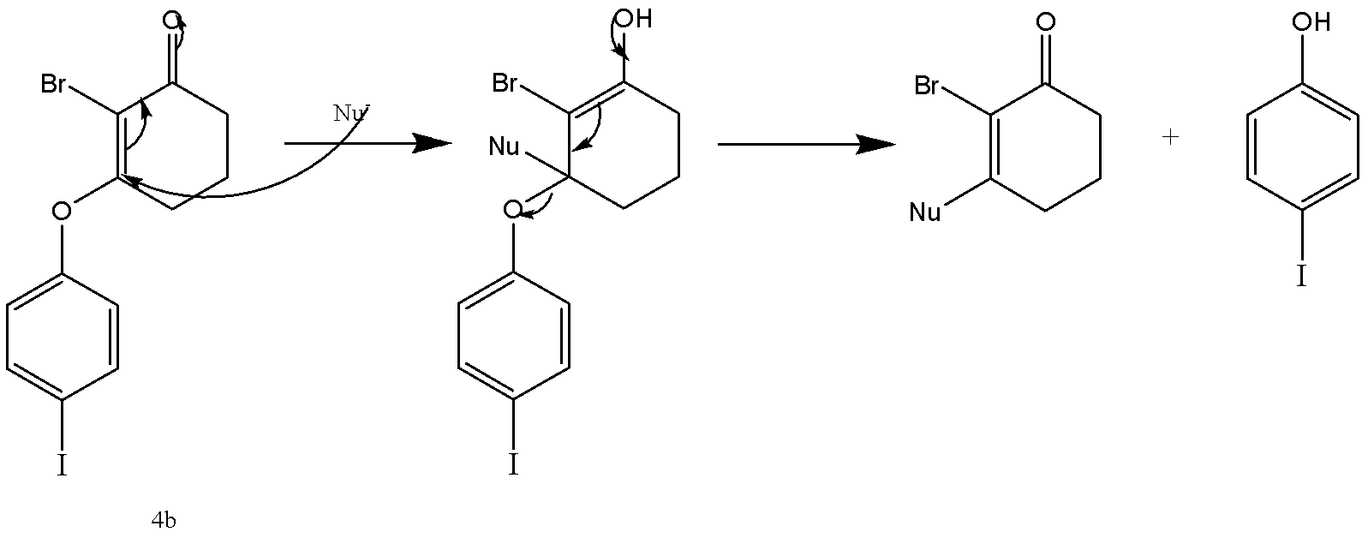
Scheme 2.29 – Expulsion of 4-iodophenol
The reaction product (5b) as an oil. Yield 58%. The identification of the structure of 3-(4-iodophenoxy)phenol (5b) was accomplished through the use of IR, ¹HNMR, ¹³CNMR and mass spectroscopy.
The FTIR (CH₂Cl₂, cast film) spectrum of 3-(4-iodophenoxy)phenol (5b) contains absorption bands of stretching vibrations (C-H) of the aromatic ring in the phenoxy group at 3396 cm⁻¹, the (C-O) of the hydroxyl group at 1581 cm⁻¹, the (C=C) of the double bond in the phenyl ring at 1600 cm⁻¹, and the (C=C) bending vibration of the phenyl ring at 1478 cm⁻¹.
¹H NMR spectrum of 3-(4-iodophenoxy)phenol (5b) (figure A37), (CDCl₃, 500 MHz) shows the following peaks: the signals that appear at δ 7,62 (d, J = 4,5 Hz, 2 H), 7,18 (t, J = 8 Hz, 1 H), 6,79 (d, J = 4,5 Hz, 2 H), 6,60–6,55 (m, 2 H), 6,49 (t, J = 2,5 Hz, 1 H), are assigned to the aromatic protons in the two phenoxy groups; the signal that appears as a singlet at δ 4,83 (s, 1 H of -OH) assigned to the hydroxylic proton.
¹³C{¹H} NMR spectrum of 3-(4-iodophenoxy)phenol (5b) (figure A38) (CDCl₃, 125 MHz) shows signals at the following chemical shifts: The signal that appears at 158,0 as a singlet indicates a carbon attached to the hydroxyl group; the signals that appear at 157,0 and 156,9 ppm (singlet) indicate aromatic carbons attached to the oxygen atom; the doublets that appear at 138,7 (d), 130,6 (d), 121,3 (d), 111,2 (d), 110,7 (d), 106,3 (d) correspond to the aromatic carbons; the singlet that appears at 86,3 (s) indicates the aromatic carbon attached to the iodine atom.

2.4.3 3-(4-Chloropenoxy)phenol (5c)
The 3-(4-chlorophenoxy)phenol (5c) demonstrates distinct characteristics stemming from the coexistence of both phenol and chlorophenoxy functional groups, thereby rendering it potentially advantageous for diverse applications.
As a derivative of phenol, 3-(4-chlorophenoxy)phenol (5c) could exhibit antioxidant properties, attributable to the hydroxyl group within the phenol moiety. Phenolic compounds are recognized for their capacity to donate hydrogen atoms or electrons to neutralize free radicals, consequently safeguarding cells from oxidative harm.
The incorporation of the 4-chlorophenoxy group in the compound imparts lipophilic attributes, which may influence its solubility and reactivity in assorted solvents. This characteristic could also affect its potential utility in agricultural or pharmaceutical contexts, such as functioning as a precursor for the synthesis of more intricate molecules or serving as an intermediate in the formulation of biologically active compounds.
The previous methods of the synthesis of 3-(4-chlorophenoxy)phenol (5c) were described in chapter 1. In this research work, we synthesized 3-(4-chlorophenoxy)phenol (5c) from 2-bromo-3-(4-chlorophenoxy)cyclohex-2-en-1-one (4c) using 3 equivalent of DBU in toluene(scheme 2.30). Reaction is done at rt overnight open to the atmosphere. Resulting the purification by column we got 78% of DP with impurity, which was distilled (Kugelrohr, 0.2 mmHg, oven temperature 110 °C) to afford 5c (55%) containing a small amount of an aromatic impurity.

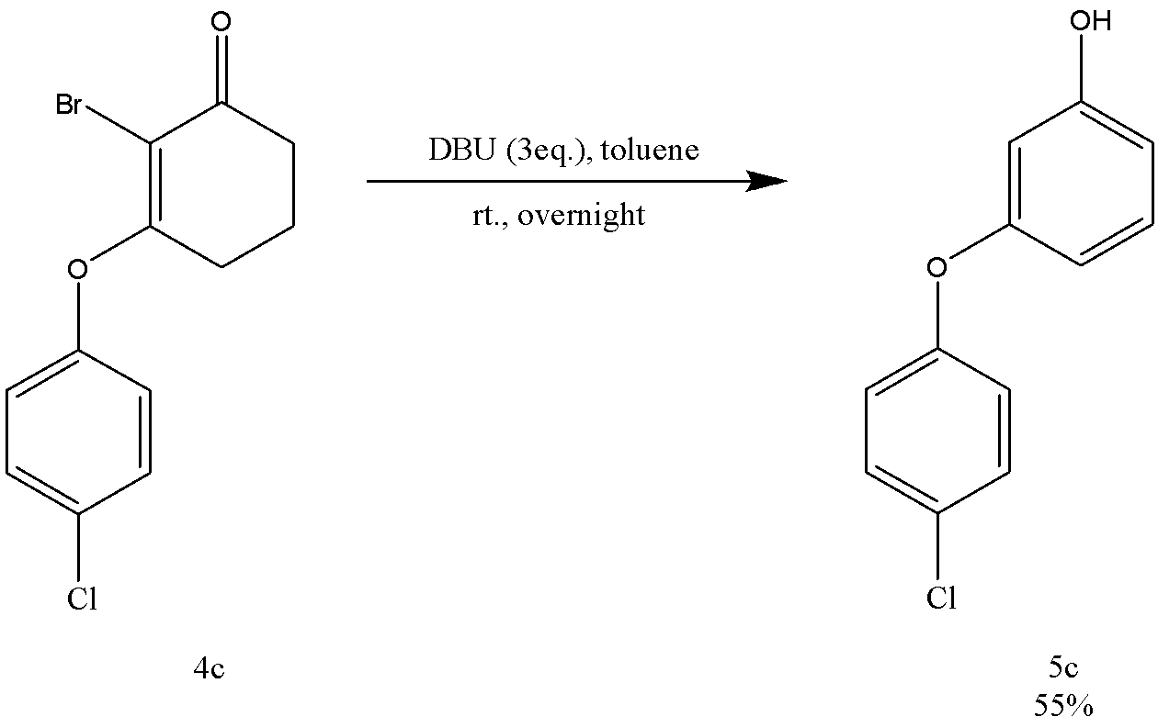

Scheme 2.30 – Synthesis of 3-(4-chlorophenoxy)phenol

Before toluene was determined as a best solvent, we tried MeCN, THF, DMSO, DMF, but reactions with all solvents gave DP with different amount of impurity (table 2.21).

Table 2.21 – Comparing of used solvents in synthesis of 3-(4-chlorophenoxy)phenol

 | Solvent | Temperature (ºC) | Time (h) | Yield (%)  Not pure
1 | MeCN | rt | 41 | 73
2 | THF | rt | 27 | 70
3 | DMSO | rt | 23 | 43
4 | DMSO | 90 | 40 | 58
5 | DMF | rt | 24 | 47
6 | Toluene | 90 | 41 | 77
7 | Toluene | rt | 18 | 78

The physicochemical properties of the synthesized 3-(4-chlorophenoxy)phenol (5c) were found to be consistent with previously reported literature data [59].
The FTIR (CH₂Cl₂, cast film) spectrum of 3-(4-chlorophenoxy)phenol (5c) contains absorption bands of stretching vibrations (C-H) of the aromatic ring in the phenoxy group at 3407 cm⁻¹, the (C=C) of the double bond in the phenyl ring at 1600 cm⁻¹, the (C-O) of the hydroxyl group at 1588 cm⁻¹, and the (C-C) bending vibration of the phenyl ring at 1484 cm⁻¹.
¹H NMR spectrum of 3-(4-chlorophenoxy)phenol (5c) (figure A39), (CDCl₃, 600 MHz) shows the following peaks: the signals that appear at δ 7,31–7,26 (m, 2 H), 7,18 (t, J = 8 Hz, 1 H), 6,98–6,94 (m, 2 H), 6,60–6,55 (m, 2 H), 6,49 (t, J = 2,5 Hz, 1 H) are assigned to the aromatic protons in the two phenoxy groups; the signal that appears as a singlet at δ 4,81 (s, 1 H of -OH) assigned to the hydroxylic proton.
¹³C{¹H} NMR spectrum of 3-(4-chlorophenoxy)phenol (5c) (figure A40) (CDCl₃, 125 MHz) shows signals at the following chemical shifts: The signal that appears at 158,3 as a singlet indicates a carbon attached to the hydroxyl group; the signals that appear at 156,9 and 155,5 ppm (singlet) indicate aromatic carbons attached to the oxygen atom; the doublets that appear at 130,6 (d), 129,8 (d), 120,5 (d), 111,0 (d), 110,6 (d) and 106,1 (d) correspond to the aromatic carbons; the singlet that appears at 128,6 (s) indicates an aromatic carbon attached to the chlorine atom.

2.4.4 3-(2,6-Dimethoxyphenoxy)phenol (5d)
3-(2,6-Dimethoxyphenoxy)phenol (5d) has not been previously reported in the literature.
The compound (5d) was synthesized from 2-bromo-3-(2,6-dimethoxyphenoxy) cyclohex-2-en-1-one (4d) through the previously described general method(scheme 2.25) using 3 eq. of DBU and toluene at rt for 72 h(scheme 2.31).

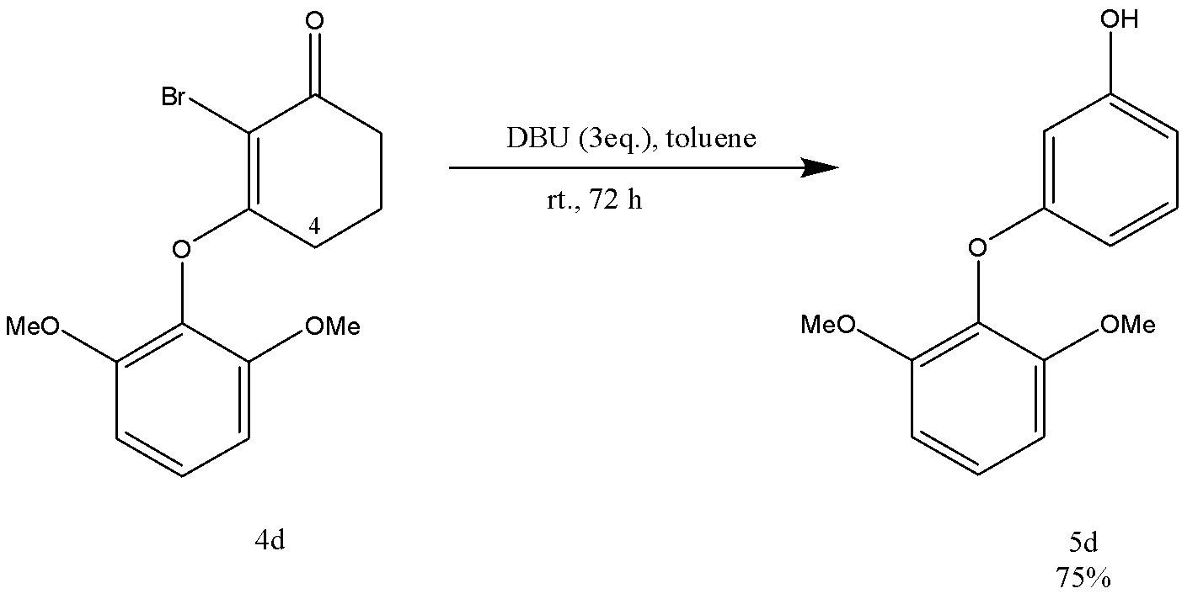

Scheme 2.31 – Synthesis of 3-(2,6-dimethoxyphenoxy)phenol
Although we permitted the aromatization reactions to proceed for an arbitrary duration of 24 h or longer, we observed through thin-layer chromatography (TLC) monitoring that the aromatization of 2,6-dimethoxy compound 4d exhibited a slower pace. It is conceivable that, in these instances, the aromatic substituents obstruct the access of the base to the C(4) hydrogens in compound 4d.
The reaction product (5d) as an oil. Yield 75%. The identification of the structure of 3-(2,6-dimethoxyphenoxy)phenol (5d) was accomplished through the use of IR, ¹HNMR, ¹³CNMR and mass spectroscopy.
The FTIR (CH₂Cl₂, cast film) spectrum of 3-(2,6-dimethoxyphenoxy)phenol (5d) contains absorption bands of stretching vibrations (C-H) of the aromatic ring in the phenoxy group at 3450 cm⁻¹, the (C=C) of the double bond in the phenyl ring at 1601 cm⁻¹, and the (C-C) bending vibration of the phenyl ring at 1481 cm⁻¹.
¹H NMR spectrum of 3-(2,6-dimethoxyphenoxy)phenol (5d) (figure A41), (CDCl₃, 500 MHz) shows the following peaks: the signals that appear at δ 7,14 (t, J = 8,5 Hz, 1 H), 7,09 (t, J = 8 Hz, 1 H), 6,66 (d, J = 8,5, 2 H), 6,45–6,44 (m, 2 H), 6,35 (t, J = 2 Hz, 1 H) are assigned to the aromatic protons in the two phenoxy groups; the signal that appears as a broad singlet at δ 4,61 (s, 1 H of -OH) assigned to the hydroxylic proton; the singlet that appears at 3,79 (s, 6H) indicates the six protons of the methyloxy groups.
¹³C{¹H} NMR spectrum of 3-(2,6-dimethoxyphenoxy)phenol (5d) (figure A42) (CDCl₃, 125 MHz) shows signals at the following chemical shifts: The signal that appears at 159,9 as a singlet indicates a carbon attached to the hydroxyl group; the signals that appear at 156,6, 153,6 ppm (singlet) indicates aromatic carbons attached to the oxygen atom; the doublets that appear at 130,0 (d), 125,6 (d), 108,6 (d), 107,6 (d), 105,5 (d), 102,3 (d) correspond to the aromatic carbons; the quartet that appears at 56,3 (q) indicates the carbons of the methyl groups.

2.4.5 3-(2-tert-Butylphenoxy)phenol (5e)
3-(2-tert-Butylphenoxy)phenol (5e) has not been previously reported in the literature.
The compound (5e) was synthesized from 2-bromo-3-(2-tert-butylphenoxy)cyclohex-2-en-1-one (4e) through the previously described general method(scheme 2.25) using 3 equivalent of DBU and toluene in a rt for 72 h(scheme 2.32).
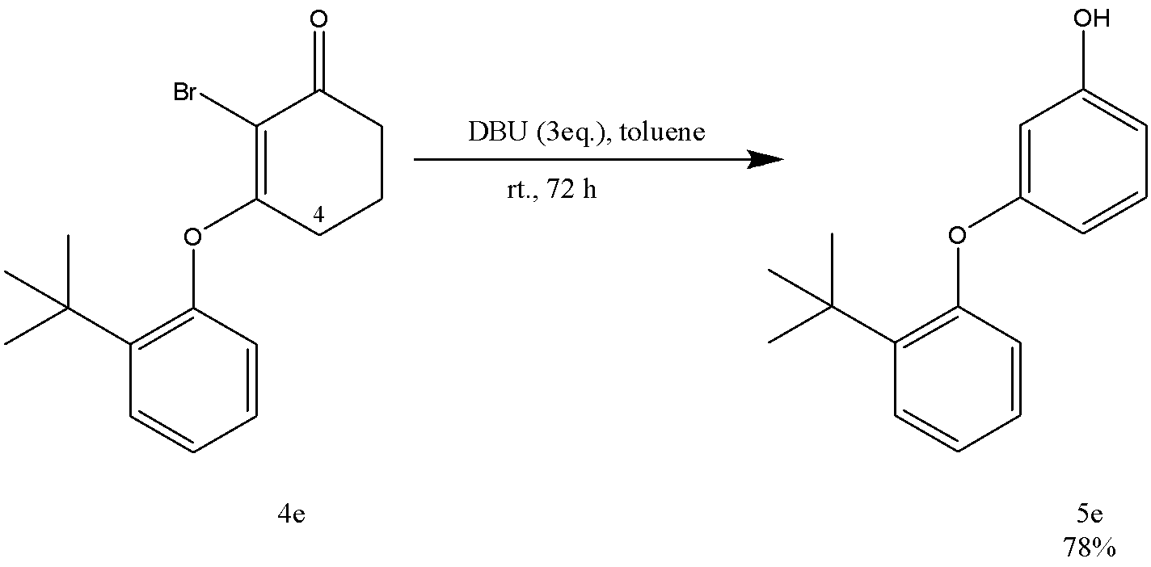

Scheme 2.32 – Synthesis of 3-(2-tert-butylphenoxy)phenol

The reaction requires a longer duration as a previous synthesis of 3-(2,6-dimethoxyphenoxy)phenol (5d) because of the aromatic substituents obstruct the access of the base to the C(4) hydrogens in compound 4e.
The reaction product (5e) as an oil. Yield 78%. The identification of the structure of 3-(2-tert-butylphenoxy)phenol (5e) was accomplished through the use of IR, ¹HNMR, ¹³CNMR and mass spectroscopy.
The FTIR (CH₂Cl₂, cast film) spectrum of 3-(2-tert-butylphenoxy)phenol (5e) contains absorption bands of stretching vibrations (C-H) of the aromatic ring in the phenoxy group at 3392 cm⁻¹, the (C=C) of the double bond in the phenyl ring at 1596 cm⁻¹, and the (C=C) bending vibration of the phenyl ring at 1484 cm⁻¹.
¹H NMR spectrum of 3-(2-tert-butylphenoxy)phenol (5e) (figure A43), (CDCl₃, 600 MHz) shows the following peaks: the signals that appear at δ 7,40 (dd, J = 7,8, 1,2, 1 H), 7,18–7,14 (m, 2 H), 7,07 (td, J = 7,8, 1,2, 1 H), 6,87 (dd, J = 7,8, 1,2, 1 H), 6,57–6,53 (m, 2 H), 6,46 (t, J = 2,4, 1 H) are assigned to the aromatic protons in the two phenoxy groups; the signal that appears as a broad singlet at δ 4,73 (s, 1 H of -OH) assigned to the hydroxylic proton; the singlet that appears at 1,41 (s, 9H) indicates the nine protons of the tert-butyl group.
¹³C{¹H} NMR spectrum of 3-(2-tert-butylphenoxy)phenol (5e) (figure A44) (CDCl₃, 125 MHz) shows signals at the following chemical shifts: The signal that appears at 159,3 as a singlet indicates a carbon attached to the hydroxyl group; the signals that appear at 156,8 and 155,4 ppm (singlet) indicate aromatic carbons attached to the oxygen atom; the singlet that appears at 141,2 ppm indicates an aromatic carbon attached to the tert-butyl group; the doublets that appear at 130,4 (d), 127,3 (d), 127,2 (d), 123,6 (d), 120,7 (d), 111,0 (d), 109,6 (d) and 105,8 (d) correspond to the aromatic carbons; the quartet appears at 30,2 (q) indicates the carbons of the methyl groups in tert-butyl.

2.4.6 3-(4-tert-Butylphenoxy)phenol (5f)
3-(4-tert-Butylphenoxy)phenol is an organic compound with the molecular formula C₁₆H₂₀O₂. It consists of a phenol moiety connected to a 4-tert-butylphenoxy group. The presence of both the phenol and the tert-butylphenoxy functional groups lends this compound unique properties, which could make it valuable for various applications.
The compound (5f) was synthesized from 2-bromo-3-(4-tert-butylphenoxy)cyclohex-2-en-1-one (4f) through the previously described general method(scheme 2.25) using 3 equivalent of DBU and toluene in a rt for 22 h(scheme 2.33).

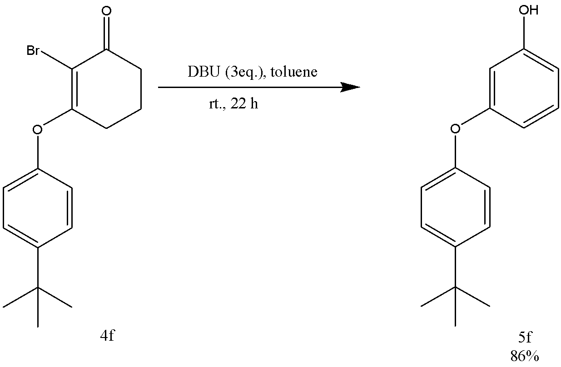

Scheme 2.33 – Synthesis of 3-(4-tert-butylphenoxy)phenol

The reaction product (5f) as a white solid: mp 122–125 °C. Yield 86%. The physicochemical properties of the synthesized 3-(4-tert-butylphenoxy)phenol (5f) were found to be consistent with previously reported literature data [125].
The FTIR (CH₂Cl₂, cast film) spectrum of 3-(4-tert-butylphenoxy)phenol (5f) contains absorption bands of stretching vibrations (C-H) of the aromatic ring in the phenoxy group at 3411, 2959 cm⁻¹, the (C=C) of the double bond in the phenyl ring at 1610 cm⁻¹, the (C-OH) carbon attached to the hydroxyl group the phenyl ring at 1592 cm⁻¹, and the (C=C) bending vibration of the phenyl ring at 1498 cm⁻¹.
¹H NMR spectrum of 3-(4-tert-butylphenoxy)phenol (5f) (figure a45), (CDCl₃, 500 MHz) shows the following peaks: the signals that appear at δ 7,36–7,35 (m, 2 H), 7,16 (t, J = 8 Hz, 1 H), 6,97–6,95 (m, 2 H), 6,59–6,53 (m, 2 H), 6,47 (t, J = 2,0, 1 H) are assigned to the aromatic protons in the two phenoxy groups; the signal that appears as a broad singlet at δ 4,74 (s, 1 H of -OH) assigned to the hydroxylic proton; the singlet that appears at 1,33 (s, 9H) indicates the nine protons of the tert-butyl group.
¹³C{¹H} NMR spectrum of 3-(4-tert-butylphenoxy)phenol (5f) (figure a46) (CDCl₃, 125 MHz) shows signals at the following chemical shifts: The signal that appears at 159,2 as a singlet indicates a carbon attached to the hydroxyl group; the signals appear at 156,7 and 154,2 ppm (singlet) indicate aromatic carbons attached to the oxygen atom; the singlet that appears at 146,6 ppm indicates the aromatic carbon attached to the tert-butyl group; the doublets that appear at 130,3 (d), 126,6 (d), 119,0 (d), 110,8 (d), 109,8 (d), 105,6 (d) correspond to the aromatic carbons; the singlet that appears at 34,4 ppm indicates a central carbon of the tert-butyl group attached to the three methyl groups; the quartet that appears at 31,5 (q) indicates the carbons of the methyl groups in tert-butyl.

2.4.7 Methyl 4-(3-hydroxyphenoxy)benzoate (5g)
Methyl 4-(3-hydroxyphenoxy)benzoate (5g) has not been previously reported in the literature.
The compound (5g) was synthesized from methyl 4-[(2-bromo-3-oxocyclohex-1-en-1-yl)oxy]benzoate (4g) through the previously described general method (scheme 2.25) using 3 equivalent of DBU and toluene in a rt for 18 h(scheme 2.34).

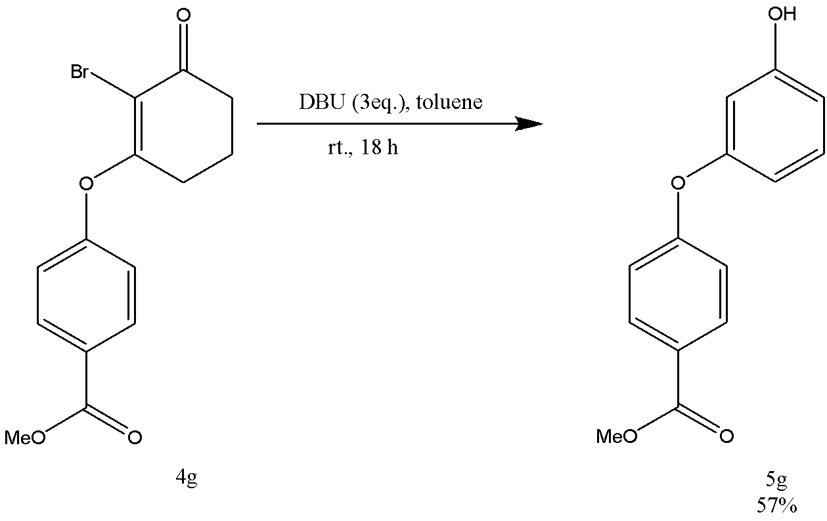
Scheme 2.34 – Synthesis of methyl 4-[(2-bromo-3-oxocyclohex-1-en-1-yl)oxy]benzoate

After purification by flash chromatography of the residue over silica gel (2 ´ 15 cm), using 20% EtOAc-hexane, gave 5g (89% as an oil which contained some impurities (¹H NMR). The material was subjected twice to Kugelrohr distillation under vacuum (0.5 mmHg, oven temp 120–140 °C) to afford 5g (57%) as a colorless gel.
In order to obtain pure 5g, prior to attempting Kugelrohr distillation, we explored the use of methyl 4-hydroxybenzoate sodium salt as a base, both independently and in combination with 1,8-diazabicyclo[5.4.0]undec-7-ene (DBU). We also tested various solvents, including acetonitrile (MeCN), dimethylformamide (DMF), and tetrahydrofuran (THF), as documented in table 2.22.

Table 2.22 – Comparing of used solvents and bases in synthesis of methyl 4-[(2-bromo-3-oxocyclohex-1-en-1-yl)oxy]benzoate

 | Base | Solvent | Temperature (ºC) | Time (h) | Yield (%)  Not pure
1 | methyl 4-hydroxybenzoate sodium salt | MeCN | rt | 43 | More than 100
1 | methyl 4-hydroxybenzoate sodium salt | DMF | rt | 71 | 81
1 | methyl 4-hydroxybenzoate sodium salt | THF | 65 | 42 | Not pure
2 | methyl 4-hydroxybenzoate sodium salt, DBU | MeCN | 80 | 46 | Not pure
3 | DBU | toluene | rt | 2 | 73
3 | DBU | toluene | rt | 18 | 89
4 | dried DBU | toluene | rt | 26 | 90

We have also used azeotropically dried DBU with 4g, as opposed to using the purchased commercial material directly, but this made no difference to the extent of phenol expulsion.
The identification of the structure of methyl 4-[(2-bromo-3-oxocyclohex-1-en-1-yl)oxy]benzoate (5g) was accomplished through the use of IR, ¹HNMR, ¹³CNMR and mass spectroscopy.
The FTIR (CH₂Cl₂, cast film) spectrum of methyl 4-[(2-bromo-3-oxocyclohex-1-en-1-yl)oxy]benzoate (5g) contains absorption bands of stretching vibrations (C-H) of the aromatic ring in the phenoxy group at 3392 cm⁻¹, the (C=O) of the ester functional group in the molecule at 1719, the hydroxyl group attached to phenyl ring at 1697 cm⁻¹; and the (C=C) of the double bond in the phenyl ring at 1598 cm⁻¹.
¹H NMR spectrum of methyl 4-[(2-bromo-3-oxocyclohex-1-en-1-yl)oxy]benzoate (5g) (figure A47), (CDCl₃, 500 MHz) shows the following peaks: the signals that appear at δ 8,02 (d, J = 8,4 Hz, 2 H), 7,25 (t, J = 8,4 Hz, 1 H), 7,03 (d, J = 9 Hz, 2 H), 6,70–6,63 (m, 2 H), 6,58 (t, J = 2,5 Hz, 1 H) are assigned to the aromatic protons in the two phenoxy groups; the signal that appears as a broad singlet at δ 5,17 (br s, 1 H) assigned to the hydroxylic proton; the singlet that appears at 3,93 (s, 3 H) indicates the three protons of the methyl group.
¹³C{¹H} NMR spectrum of methyl 4-[(2-bromo-3-oxocyclohex-1-en-1-yl)oxy]benzoate (5g) (figure A48) (CDCl₃, 125 MHz) shows signals at the following chemical shifts: The signal that appears at 167,1 as a singlet indicates a carbon attached to the hydroxyl group; the signals that appear at 161,6, 157,3 ppm (singlet) indicating aromatic carbons attached to the oxygen atom; the singlet that appears at 156,8 ppm indicates the carbon of the ester group; the doublets that appear at 131,7 (d), 130,7 (d), 117,6 (d), 112,0 (d), 111,7(d) and 107,4 (d) correspond to the aromatic carbons; the singlet that appears at 124,4 (s) indicates the aromatic carbon attached to the (MeO₂C-) group; the quartet that appears at 52,2 (q) indicates the carbons of the methyl group.

2.4.8 3-[4-(3-hydroxyphenoxy)phenoxy]phenol (5h)
3-[4-(3-Hydroxyphenoxy)phenoxy]phenol is an organic compound with the molecular formula C₁₈H₁₄O₄. It is comprised of a phenol moiety connected to a 4-(3-hydroxyphenoxy)phenoxy group. The compound's structure is characterized by the presence of both phenol and hydroxyphenoxy functional groups, which confer unique properties that may be applicable in various fields.
The compound (5h) was synthesized from 2-bromo-3-{4-[(2-bromo-3-oxocyclohex-1-en-1-yl)oxy]phenoxy} cyclohex-2-ene-1-one (4h) through the previously described general method(scheme 2.25) using 6 equivalent of DBU and toluene in a rt for 42 h(scheme 2.35).

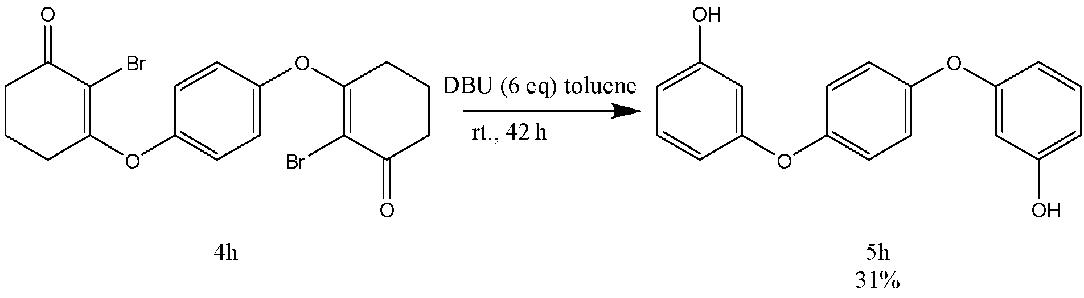
Scheme 2.35 – Synthesis of 3-[4-(3-hydroxyphenoxy)phenoxy]phenol

The reaction product (5h) as a solid which contained some aromatic impurities (¹H NMR): mp 115–118 °C. Yield 31%. The physicochemical properties of the synthesized 3-[4-(3-hydroxyphenoxy)phenoxy]phenol (5h) were found to be consistent with previously reported literature data [126].
The FTIR (CH₂Cl₂, cast film) spectrum of 3-[4-(3-hydroxyphenoxy)phenoxy]phenol (5h) contains absorption bands of stretching vibrations (C-H) of the aromatic ring in the phenoxy group at 3394 cm⁻¹, the (C-OH) of the hydroxyl group attached to the phenyl ring at 1599 cm⁻¹, the (C=C) of the double bond in the phenyl ring at 1494 cm⁻¹, and the (C-C) bending vibration of the phenyl ring at 1276, 1137 cm⁻¹.
¹H NMR spectrum of 3-[4-(3-hydroxyphenoxy)phenoxy]phenol (5h) (figure A49), (CDCl₃, 500 MHz) shows the following peaks: the signals that appear at δ 7,20 (t, J = 7,97 Hz, 2 H), 7,04 (s, 4 H), 6,61–6,57 (m, 4 H), 6,50 (t, J = 1,8 Hz, 2 H) are assigned to the aromatic protons in the two phenoxy groups; the signal that appears as a broad singlet at δ 4,96 (br s, 2 H) assigned to the hydroxylic protons.
¹³C{¹H} NMR spectrum of 3-[4-(3-hydroxyphenoxy)phenoxy]phenol (5h) (figure A50) (CDCl₃, 125 MHz) shows signals at the following chemical shifts: The signal that appears at 159,3 as a singlet indicates a carbon attached to the hydroxyl group; the signals that appear at 157,0, 152,4 ppm (singlet) indicates aromatic carbons attached to the oxygen atom; the doublets that appear at 130,4 (d), 121,0 (d), 110,4 (d), 110,0 (d), 105,3 (d) correspond to the aromatic carbons.

2.5 Technological schemes for developed methods

2.5.1 Technological schemes for obtaining compounds 3
The synthesis of 3-aryloxy-cyclohex-2-ene-1-one (3) is accomplished through a refluxing process of 3-chloro-cyclohex-2-ene-1-one (2) with phenol derivatives and potassium carbonate in acetone. The technological process is depicted in figure 2.3.
First, a mixture of acetone, 3-chloro-cyclohex-2-ene-1-one (2), phenol derivatives, and potassium carbonate is supplied in a ratio of 1:1:2 to reactor {1} equipped with a stirrer. The reaction mass is then heated to 65 ⁰С and stirred until completion.
After completion, the reaction mass is transferred to celite filter {2} where filtration is carried out with dichloromethane (DCM). The filtrate is then dried using anhydrous magnesium sulfate and evaporated {3}. The evaporated DCM is distilled and returned to the filter for reuse.
The residue from the evaporator {3} is passed through a filtration column containing silica gel {4}, where it is cleaned with an ethyl acetate-hexane mixture. The resulting filtrate is evaporated {5} to obtain the desired product in a pure form.
In case of 3-(2,6-dimethoxyphenoxy)cyclohex-2-en-1-one (3d) and 3-(2-tert-butylphenoxy)cyclohex-2-en-1-one (3e), DMF was used as a solvent, and refluxing went ar 100 ºC.
To obtain 3-{4-[(3-Oxocyclohex-1-en-1-yl)oxy]phenoxy} cyclohex-2-ene-1-one (3h) a ratio of entered 3-chloro-cyclohex-2-ene-1-one (2), hydroquinone, and potassium carbonate was changed to 2:1:4.

2.5.2 Material balance of 3-aryloxy-cyclohex-2-ene-1-one (3) synthesis
To evaluate the proposed production processes, calculation of the material balance for obtaining 3-aryloxy-cyclohex-2-ene-1-one (3) was calculated for 3-phenoxy-cyclohex-2-ene-1-one (3a).
To obtain ketone (3a) according to the proposed technological scheme used the reaction of interaction of 3-chlorocyclohex-2ene-1-one (2), phenol in the presence of potassium carbonate in acetone. The material balance is calculated for 100 kg of starting material - 3-chlorocyclohex-2enne-1-one (2).
Material balance equation: G1=G2+G3, where G1 is the mass of the initial substances, G2 is the mass of the finished product, G3 is the mass of material losses [127,138].
Yield of DP: ŋ= $\frac{m pract}{m teor }$×100
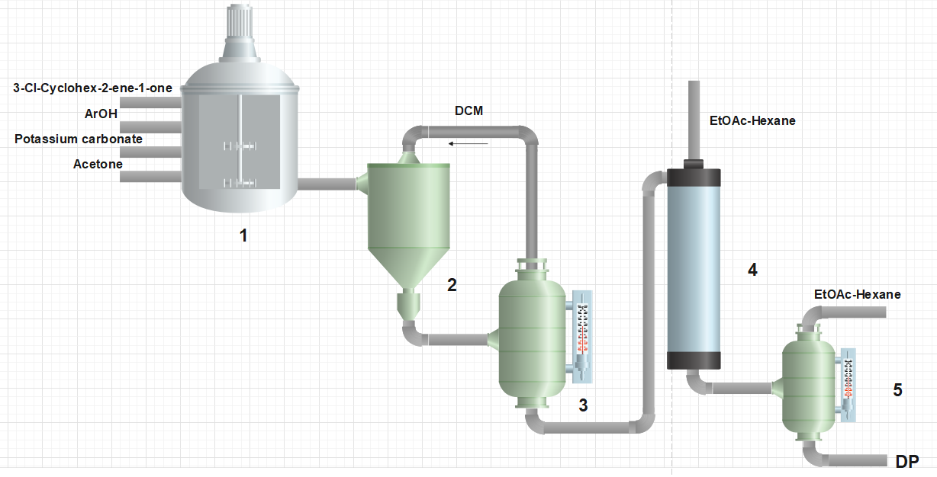
- Reactor; 2 – filter; 3,5 – evaporators, 4 - filtration column

Figure 2.3 – The technological process for obtaining compounds 3
In the synthesis of 3a yield of DP was 90% or 2,01g. The loss of the original compounds will be 100%-90%=10%
The recirculating solvent is acetone.
Calculations on the material balance of the technological process ketone (3a) production is presented in table 2.23.

Table 2.23 – Material balance of production of 3-phenoxy-cyclohex-2-ene-1-one (3a)

Incoming (kg) |  | Consumption (kg)
3-chloro-cyclohex-2-ene-1-one (2) | 100 | Product:  3-phenoxy-cyclohex-2-ene-1-one (3a) | 129,74
Phenol | 72,08 | SM loses | 14,42
K₂CO₃ | 212,18 | KCl | 57,10
Acetone | 452,60 | Recirculate | 407,34
 |  | Solvent loses | 45,26
 |  | K₂CO₃ | 159,26
 |  | CO₂ | 16,85
 |  | Water | 6,90
Total | 836,86 | Total | 836,86

2.5.3 Technological schemes for obtaining compounds 4
The synthesis of 2-bromo-(3-aryloxy)cyclohex-2-ene-1-one (4) is accomplished by brominating process of 3-aryloxy-cyclohex-2-ene-1-one (3) with NBS in dry DMF in inert atmosphere at rt (figure 2.4).
Before adding compounds, DMF was distilled in distillatory column {1} and NBS was crystalized from water {2}. A mixture of dry DMF, 3-aryloxy-cyclohex-2-ene-1-one (3) and NBS is supplied in a ratio of 1:1.1 to reactor {3} equipped with a stirrer. The reaction mass is then stirred in nitrogen atmosphere at rt until completion.
After completion, saturated sodium carbonate and water were added to the mixture and organic layer was separated from aquatic layer by using DCM as a rinse {4}. Residue of the reaction was dried and evaporated from DCM in the evaporator {5}. Evaporated DCM was cleaned for reuse. The residue from the evaporator {5} is passed through a filtration column containing silica gel {6}, where it is cleaned with an ethyl acetate-hexane mixture. The resulting filtrate is evaporated {7} to obtain the desired product in a pure form.

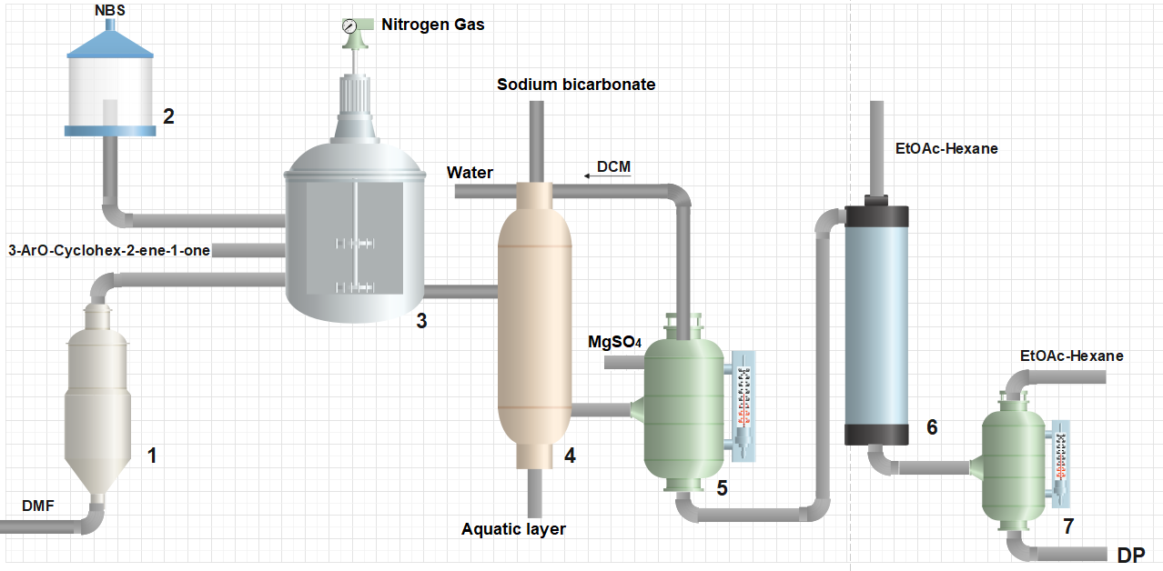
1 – distillator; 2 - crystallizer; 3 - reactor; 4 – separator; 5,7 – evaporators, 6 - filtration column

Figure 2.4 – The technological process for obtaining compounds 4

2.5.4 Material balance of (4) synthesis
To evaluate the proposed production processes, calculation of the material balance for obtaining 2-bromo-(3-aryloxy)cyclohex-2-ene-1-one (4) was calculated for 2-bromo-(3-phenoxy)cyclohex-2-ene-1-one (4a).
To obtain (4a) according to the proposed technological scheme used the reaction of interaction of 3-phenoxy-cyclohex-2ene-1-one (3a) with NBS in DMF. The material balance is calculated for 100 kg of starting material (3a).
Material balance equation: G1=G2+G3, where G1 is the mass of the initial substances, G2 is the mass of the finished product, G3 is the mass of material losses.
Yield of DP: ŋ= $\frac{m pract}{m teor }$×100%
In the synthesis of 4a yield of DP was 84% or 128.7 mg. The loss of the original compounds will be 100%-84%=16%
The recirculating solvent is DMF.
Calculations on the material balance of the technological process (4a) production is presented in table 2.24.

Table 2.24 – Material balance of production of 2-bromo-(3-phenoxy)cyclohex-2-ene-1-one (4a)

Incoming (kg) |  | Consumption (kg)
3-phenoxy-cyclohex-2-ene-1-one (3a) | 100 | Product:  2-bromo-(3-phenoxy)cyclohex-2-ene-1-one (4a) | 119,21
NBS | 104,02 | SM loses | 22,71
DMF | 189,6 | Succinimide | 52,65
 |  | Recirculate | 160,6
 |  | Solvent loses | 29
 |  | NBS | 9,45
Total | 393,62 | Total | 393,62

2.5.5 Technological schemes for obtaining compounds 5
The synthesis of meta-aryloxy phenol (5) is accomplished by aromatization process of 2-bromo-(3-aryloxy)cyclohex-2-ene-1-one (4) with DBU in dry toluene in inert atmosphere at rt. The technological process is depicted in figure 2.5.
Before adding compounds, toluene was distilled in distillatory column {1}. To the dry toluene 2-bromo-(3-aryloxy)cyclohex-2-ene-1-one (4) and DBU is supplied in a ratio of 1:3 to reactor {3} equipped with a stirrer.
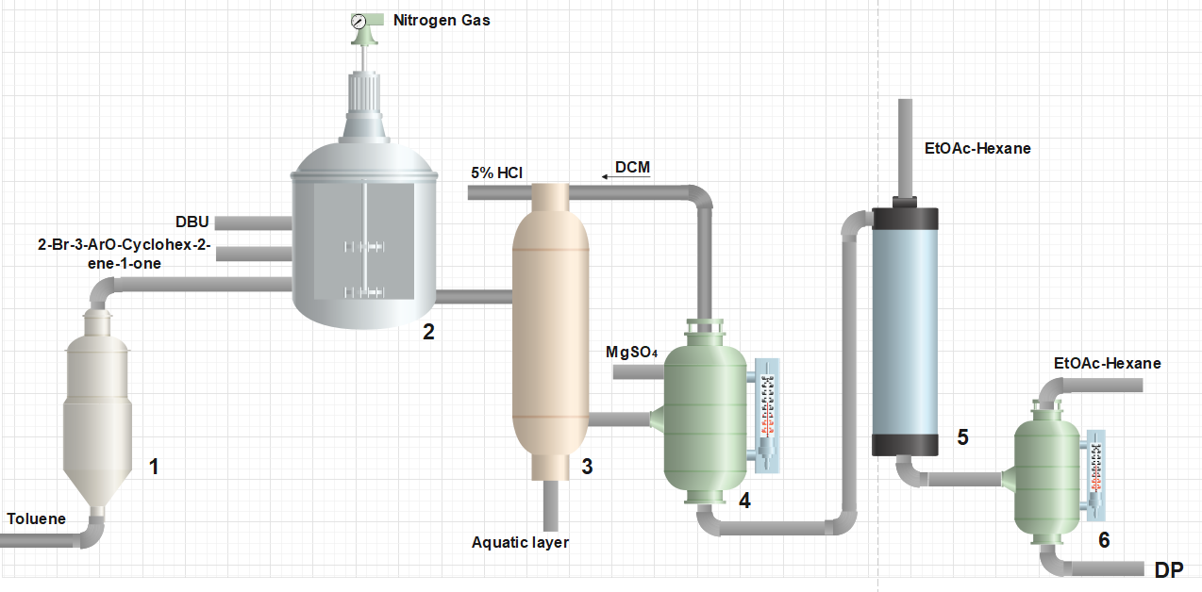

1 – distillator; 2 - reactor; 3 – separator; 4,6 – evaporators, 5 - filtration column

Figure 2.5 – The technological process for obtaining compounds 5
The reaction mass is then stirred in nitrogen atmosphere at rt until completion.
After completion, 5% aqueous hydrogen chloride was added to the mixture and organic layer was separated from aquatic layer by using DCM as a rinse {3}. Residue of the reaction was dried and evaporated from DCM in the evaporator {4}. Evaporated DCM was cleaned for reuse. The residue from the evaporator {4} is passed through a filtration column containing silica gel {5}, where it is cleaned with an ethyl acetate-hexane mixture. The resulting filtrate is evaporated {6} to obtain the desired product in a pure form.

2.5.6 Material balance of compound (5) synthesis
To evaluate the proposed production processes, calculation of the material balance for obtaining meta-aryloxy phenol (5) was calculated for 3-(phenoxy)phenol (5a). To obtain (5a) according to the proposed technological scheme used the reaction of interaction of (4a) with DBU in toluene. The material balance is calculated for 100 kg of starting material (4a).
In the synthesis of 5a yield of DP was 86% or 175,0 mg. The loss of the original compounds will be 100%-86%=14%
The recirculating solvent is a toluene.
Calculations on the material balance of the technological process (5a) production is presented in table 2.25.

Table 2.25 – Material balance of production of 3-(phenoxy)phenol (5a)

Incoming (kg) |  | Consumption (kg)
2-bromo-(3-phenoxy)cyclohex-2-ene-1-one (4a) | 100 | Product: 3-(phenoxy)phenol (5a) | 59,95
DBU | 170,98 | SM loses | 9,76
Toluene | 173,40 | HBr | 30,29
 |  | Recirculate | 156,90
 |  | Solvent loses | 16,50
 |  | DBU | 170,98
Total | 444,38 | Total | 444,38

EXPERIMENTAL SECTION

- Solvents used for chromatography were distilled before use.
- Commercial thin layer chromatography plates (silica gel, Merck 60F-254) were used.
- Silica gel for flash chromatography was Merck type 60 (230−400 mesh).
- Dry solvents were prepared under an inert atmosphere (N₂) and transferred by syringe or cannula.
- Anhydrous K₂CO₃ was stored in an oven.
- In step gradient chromatography ca 100-mL portions were used with 10% increases of the more polar component.
- NBS was freshly recrystallized from water and dried under oil pump vacuum. The brominations were done under an inert atmosphere (N₂).
- The symbols s, d, t, and q used for ¹³C{¹H} NMR spectra indicate zero, one, two, or three attached hydrogens, respectively, the assignments being made from APT spectra.
- Solutions were evaporated under water pump vacuum, and the residue was then kept under oil pump vacuum.
- High resolution electrospray mass spectrometric analyses were done with an orthogonal time-of-flight analyzer, and electron ionization mass spectra were measured with a double-focusing sector mass spectrometer.

3-Chlorocyclohex-2-en-1-one (2). (COCl)₂ (4,8 mL, 55 mmol) was added from a sidearm addition funnel over 30 min to a stirred and cooled (0 °C) solution of cyclohexane-1,3-dione (5,01 g, 44,7 mmol) in bench CH₂Cl₂ (111 mL) containing bench DMF (4,6 mL, 59,4 mmol) (HCl evolution). After the addition the ice bath was removed and stirring was continued for 2,5 h. Water (120 mL) was added and the mixture was extracted with Et₂O (3 ⋅ 100 mL). The combined organic extracts were dried (MgSO₄) and evaporated. Flash chromatography of the residue over silica gel (4 ⋅ 15 cm), using 20% EtOAc-hexane, gave 2 (4,865 g, 83%) as a yellow oil: FTIR (CH₂Cl₂, cast film) 3200, 2955, 2927, 1717, 1680, 1605 cm^{–1}; ¹H NMR (CDCl₃, 500 MHz) δ 6,22 (t, J = 1,5 Hz, 1 H), 2,68 (td, J = 6,1, 1,5 Hz, 2 H), 2,43–2,40 (m, 2 H), 2,08 (pentet, J = 6,3 Hz, 2 H); ¹³C{¹H} NMR (CDCl₃, 125 MHz) δ 196,8 (s), 158,7 (s), 128,5 (d), 36,3 (t), 33,9 (t), 22,2 (t); exact mass (EI) m/z calcd for C₆H₇³⁵ClO (M⁺) 130,0854, found 130,01844.

3-(Phenoxy)cyclohex-2-en-1-one (3a). Phenol (1,02 g, 10,8 mmol) was added to a solution of 3-chlorocyclohex-2-en-1-one (1,56 g, 11,9 mmol) in reagent grade acetone (9 mL). Anhydrous K₂CO₃ (3,08 g, 22,3 mmol) was tipped into the solution and the mixture was stirred and refluxed for 20 h open to the atmosphere. The reaction mixture was allowed to cool to rt and filtered through a sintered disc funnel containing a pad of Celite, using CH₂Cl₂ as a rinse. Evaporation of the filtrate and flash chromatography of the residue over silica gel (2,5 ⋅ 15 cm), using successive portions of EtOAc-hexane from 25% EtOAc to 50% EtOAc, gave 3a (2,01 g, 90%) as a pale yellow oil that crystallized in the fridge to form a white solid: FTIR (CH₂Cl₂, cast film) 3065, 2951, 2894, 2873, 1661, 1617, 1587, 1488 cm^{–1}; ¹H NMR (CDCl₃, 500 MHz) δ 7,42–7,39 (m, 2 H), 7,29–7,24 (m, 1 H), 7,06–7,04 (m, 2 H), 5,14 (s, 1 H), 2,65 (t, J = 6,3 Hz, 2 H), 2,41–2,38 (m, 2 H), 2,08 (pentet, J = 6,5 Hz, 2 H); ¹³C{¹H} NMR (CDCl₃, 125 MHz) δ 199,6 (s), 178,3 (s), 152,7 (s), 130,0 (d), 126,1 (d), 121,4 (d), 106,1 (d), 36,7 (t), 28,6 (t), 21,2 (t); exact mass (EI) m/z calcd for C₁₁H₁₂O₂ (M⁺) 188,08372, found 188,08356.

3-(4-Iodophenoxy)cyclohex-2-en-1-one (3b). 4-Iodophenol (200 mg, 0,913 mmol) was added to a solution of 3-chlorocyclohex-2-en-1-one (131 mg, 1,0 mmol) in reagent grade acetone (12 mL). K₂CO₃ (272 mg, 1,97 mmol) was tipped into the solution and the mixture was stirred and refluxed for 20 h open to the atmosphere (no protection from light). The reaction mixture was allowed to cool to rt and filtered through a sintered disc funnel containing a pad (2 thick ⋅ 3 cm wide) of Celite, using CH₂Cl₂ as a rinse. Evaporation of the filtrate and flash chromatography of the residue over silica gel (2 ⋅ 20 cm), using 40% EtOAc-hexane, gave 3b (274 mg, 92%) as an oil which slowly crystallized: mp 69–75 °C; FTIR (CH₂Cl₂, cast film) 2949, 1666, 1653, 1611, 1479 cm^{–1}; ¹H NMR (CDCl₃, 500 MHz) δ 7,70 (d, J = 9 Hz, 2 H), 6,80 (d, J = 9 Hz, 2 H), 5,11 (s, 1 H), 2,63 (t, J = 7 Hz, 2 H), 2,37 (t, J = 7 Hz, 2 H), 2,08 (pentet, J = 6,5 Hz, 2 H); ¹³C{¹H} (CDCl₃, 125 MHz) δ 199,3 (s), 177,7 (s), 152,6 (s), 139,1 (d), 123,6 (d), 106,3 (d), 90,0 (s), 36,6 (t), 28,4 (t), 21,1 (t); exact mass (ESI) m/z calcd for C₁₂H₁₂IO₂ (M+H)⁺ 313,9876, found 313,9878.

3-(4-Chlorophenoxy)cyclohex-2-en-1-one (3c). 4-Chlorophenol (149 mg, 1,14 mmol) was added to a solution of 3-chlorocyclohex-2-en-1-one (100 mg, 0,80 mmol) in reagent grade acetone (2 mL). Anhydrous K₂CO₃ (200 mg, 1,45 mmol) was tipped into the solution and the mixture was stirred and refluxed overnight open to the atmosphere. The reaction mixture was allowed to cool to rt and filtered through a sintered disc funnel containing a pad of Celite, using CH₂Cl₂ as a rinse. Evaporation of the filtrate and flash chromatography of the residue over silica gel (2 ⋅ 15 cm), using 30% EtOAc-hexane, gave 3c (200 mg, 82%) as a white solid: mp 72–75 °C; FTIR (CH₂Cl₂, cast film) 1655, 1614, 1486, 1374 cm^{–1}; ¹H NMR (CDCl₃, 500 MHz) δ 7,37–7,35 (m, 2 H), 6,99–6,96 (m, 2 H), 5,10 (s, 3 H), 2,64 (t, J = 6,5 Hz, 2 H), 2,37 (t, J = 6,5 Hz, 2 H), 2,07 (pentet, J = 6,5 Hz, 2 H); ¹³C{¹H}(CDCl₃, 175 MHz) δ 199,3 (s), 177,8 (s), 151,2 (s), 131,6 (s), 130,2 (d), 122,8 (d), 106,2 (d), 36,6 (t), 28,5 (t), 21,2 (t); exact mass (ESI) m/z calcd for C₁₂H₁₁³⁵ClO₂ (M⁺) 222,0448, found 222,0445.

3-(2,6-Dimethoxyphenoxy)cyclohex-2-en-1-one (3d). 2,6-Dimethoxyphenol (50 mg, 0,40 mmol) was added to a solution of 3-chlorocyclohex-2-en-1-one (60 mg, 0,45 mmol) in dry DMF (3 mL). K₂CO₃ (110 mg, 0,80 mmol) was tipped into the solution and the mixture was stirred and heated at 100 °C for 24 h open to the atmosphere. The reaction mixture was allowed to cool to rt and filtered through a sintered disc funnel containing a pad of Celite, using CH₂Cl₂ as a rinse. Evaporation of the filtrate and flash chromatography of the residue over silica gel (1 ⋅ 15 cm), using 20% EtOAc-CH₂Cl₂ gave 3d (52 mg, 52%) as a white solid: mp 76–78 °C; FTIR (CH₂Cl₂, cast film) 1651, 1619, 1585, 1482 cm^{–1}; ¹H NMR (CDCl₃, 500 MHz) δ 7,12 (t, J = 8,5 Hz, 1 H), 6,60 (d, J = 8,5 Hz, 2 H), 5,08 (s, 1 H), 3,80 (s, 6 H), 2,70 (t, J = 6,5 Hz, 2 H), 2,37 (t, J = 6,5 Hz, 2 H), 2,08 (pentet, J = 6,5 Hz, 2 H); ¹³C{¹H} NMR (CDCl₃, 125 MHz) δ 200,2 (s), 177,8 (s), 152,3 (s), 130,2 (s), 126,5 (d), 105,1 (d), 104,8 (d), 56,1 (q), 36,7 (t), 28,0 (t), 21,3 (t); (EI) m/z calcd for C₁₄H₁₆O₄ (M)⁺ 248,10486, found 248,10488.

3-(2-tert-Butylphenoxy)cyclohex-2-en-1-one (3e). 2-tert-Butylphenol (95 mg, 0,63 mmol) was added to a solution of 3-chlorocyclohex-2-en-1-one (100 mg, 0,76 mmol) in dry DMF (6 mL). K₂CO₃ (140 mg, 1,0 mmol) was tipped into the solution and the mixture was stirred and heated at 100 °C for 24 h open to the atmosphere. The reaction mixture was allowed to cool to rt and filtered through a sintered disc funnel containing a pad of Celite, using CH₂Cl₂ as a rinse. Evaporation of the filtrate under water pump vacuum and then under oil pump vacuum followed by flash chromatography of the residue over silica gel (2 ⋅ 15 cm), using 30% EtOAc-hexane, gave 3e (52 mg, 48%) as a yellowish oil: FTIR (CH₂Cl₂, cast film) 2957, 1663, 1617, 1599, 1372 cm^{–1}; ¹H NMR (CDCl₃, 600 MHz) δ 7,39 (dd, J = 7,8, 1,8 Hz, 1 H), 7,18–7,13 (m, 2 H), 6,91 (dd, J = 7,8, 1,8 Hz, 1 H), 5,21 (s, 1 H), 2,67 (t, J = 6 Hz, 2 H), 2,39 (t, J = 6 Hz, 2 H), 2,09 (pentet, J = 6 Hz, 2 H), 1,32 (s, 9 H); ¹³C{¹H} NMR (CDCl₃, 125 MHz) δ 199,5 (s), 177,9 (s), 151,3 (s), 141,5 (s), 127,8 (d), 127,2 (d), 125,8 (d), 123,0 (d), 106,7 (d), 36,6 (t), 34,6 (s), 30,3 (q), 28,9 (t), 21,2 (t); (EI) m/z calcd for C₁₆H₂₀O₂ (M⁺) 244,14633, found 244,13634.

3-(4-tert-Butylphenoxy)cyclohex-2-en-1-one (3f). 4-tert-Butylphenol (159 mg, 1,10 mmol) was added to a solution of 3-chlorocyclohex-2-en-1-one (171 mg, 1,32 mmol) in reagent grade acetone (6 mL). K₂CO₃ (292 mg, 2,11 mmol) was tipped into the solution and the mixture was stirred and refluxed for 43 h open to the atmosphere. The reaction mixture was allowed to cool to rt and filtered through a sintered disc funnel containing a pad of Celite, using CH₂Cl₂ as a rinse. Evaporation of the filtrate and flash chromatography of the residue over silica gel (2 ⋅ 15 cm), using 30% EtOAc-hexane, gave 3f (225 mg, 83%) as a white solid: mp 92–96 °C; FTIR (CH₂Cl₂, cast film) 2962, 1669, 1656, 1616 1508 cm^{–1}; ¹H NMR (CDCl₃, 500 MHz) δ 7,39–7,37 (m, 2 H), 6,95–6,93 (m, 2 H), 5,12 (s, 1 H), 2,65 (t, J = 7 Hz, 2 H), 2,37 (t, J = 7 Hz, 2 H), 2.08 (pentet, J = 7,0 Hz, 2 H), 1,32 (s, 9 H); ¹³C{¹H} NMR (CDCl₃, 125 MHz) δ 199,9 (s), 178,7 (s), 150,4 (s), 149,2 (s), 126,9 (d), 120,8 (d), 106,0 (d), 36,7 (t), 34,6 (s), 31,5 (q), 28,6 (t), 21,3 (t); exact mass (EI) m/z calcd for C₁₆H₂₀O₂ (M⁺) 244,1463, found 244,1461.

Methyl 4-[(3-oxocyclohex-1-en-1-yl)oxy]benzoate (3g). Methyl 4-hydroxybenzoate (739,9 mg, 4,863 mmol) was tipped into a solution of 3-chlorocyclohex-2-en-1-one (685,0 mg, 5,246 mmol) in reagent grade acetone (13 mL). K₂CO₃ (1,50 g, 10,9 mmol) was tipped into the solution and the mixture was stirred and refluxed for 18 h open to the atmosphere. The reaction mixture was allowed to cool to rt, diluted with water (50 mL) and extracted with CH₂Cl₂ (3 ⋅ 20 mL). The combined organic extracts were dried (MgSO₄) and evaporated. Flash chromatography of the residue over silica gel (2,5 ⋅ 15 cm), using successive portions of EtOAc-hexane from 20% EtOAc to 50% EtOAc, gave 3g (1,121 g, 93%) as a white solid: mp 100–104 °C; FTIR (CH₂Cl₂, cast film) 1724, 1668, 1620, 1598 cm^{–1}; ¹H NMR (CDCl₃, 400 MHz) δ 8,10 (d, J = 9 Hz, 2 H), 7,12 (d, J = 9 Hz, 2 H), 5,16 (s, 1 H), 3,95 (s, 3 H), 2,67 (t, J = 6,6 Hz, 2 H), 2,41 (t, J = 6,6 Hz, 2 H), 2,11 (pentet, J = 6,6 Hz, 2 H); ¹³C{¹H} NMR (CDCl₃, 125 MHz) δ 199,3 (s), 177,2 (s), 166,1 (s), 156,4 (s), 131,8 (d), 128,0 (s), 121,4 (d), 106,7 (d), 52,3 (q), 36,6 (t), 28,4 (t), 21,13 (t); (ESI) m/z calcd for C₁₄H₁₅O₄ (M+H)⁺ 247,09650, found 247,0967.

3-{4-[(3-Oxocyclohex-1-en-1-yl)oxy]phenoxy}cyclohex-2-ene-1-one (3h). Hydro-quinone (474,4 mg, 4,31 mmol) was tipped into a solution of 3-chlorocyclohex-2-en-1-one (1,12 g, 8,61 mmol) in dry acetone (15 mL). K₂CO₃ (2,38 g, 17,25 mmol) was tipped into the solution and the mixture was stirred and heated at 60 °C for 43 h open to the atmosphere (no protection from light). The reaction mixture was allowed to cool to rt and filtered through a pad of Celite (3 ⋅ 2 cm high), using CH₂Cl₂ as a rinse and the filtrate was evaporated. Flash chromatography of the residue over silica gel (2.5 ⋅ 15 cm), using 30% EtOAc-hexane (50 mL), 40% EtOAc-hexane (100 ml), 50% EtOAc-hexane (200 mL), 60% EtOAc-hexane (200 mL), 70% EtOAc-hexane (100 mL), 80% EtOAc-hexane (100 mL), gave 3h (912,5 mg, 71%) as a light orange powder: mp 209–212 °C; FTIR (CH₂Cl₂, cast film) 3099, 3069, 2940, 2892, 2870, 1662, 1614, 1489 cm^{–1}; ¹H NMR (CDCl₃, 500 MHz) δ 7,08 (s, 4 H), 5,15 (s, 2 H), 2,67 (t, J = 6 Hz, 4 H), 2,40 (t, J = 7,2 Hz, 4 H), 2,11 (pentet, J = 6,6 Hz, 4 H); ¹³C{¹H} (CDCl₃, 125 MHz) δ 199,4 (s), 177,9 (s), 150,2 (s), 122,9 (d), 106,2 (d), 36,6 (t), 28,4 (t), 21,1 (t); exact mass (ESI) m/z calcd for C₁₈H₁₉O₄ (M+H)⁺ 299,1278 found 298,1280.

2-Bromo-3-(phenoxy)cyclohex-2-en-1-one (4a). NBS (113,6 mg, 0,6383 mmol) was tipped into a stirred and cooled (0 °C) solution of 3a (108,0 mg, 0,574 mmol) in dry DMF (2 mL) (protection from light, N₂ atmosphere). After 15 min the ice bath was removed and stirring was continued for 21 h. The reaction mixture was diluted with saturated aqueous NaHCO₃ (4 mL), followed by water (25 mL). The mixture was extracted with CH₂Cl₂ (3 ⋅ 10 mL) and the combined organic extracts were dried (MgSO₄) and evaporated. Flash chromatography of the residue over silica gel (2 ⋅ 15 cm), using successive portions of EtOAc-hexane from 10% EtOAc to 30% EtOAc, gave 4a (128,7 mg, 84%) as a white solid: FTIR (CH₂Cl₂, cast film) 3063, 2954, 1673, 1608, 1581, 1489, 1455 cm^{–1}; ¹H NMR (CDCl₃, 400 MHz) δ 7,45–7,41 (m, 2 H), 7,30–7,29 (m, 1 H), 7,10–7,08 (m, 2 H), 2,64–2,61 (m, 2 H), 2,44 (t, J = 6,2 Hz, 2 H), 2,02 (pentet, J = 6,5 Hz, 2 H); ¹³C{¹H} NMR (CDCl₃, 100 MHz) δ 191,2 (s), 170,8 (s), 152,8 (s), 129,6 (d), 125,5 (d), 120,3 (d), 106,1 (d), 36,7 (t), 28,5 (t), 20,4 (t); exact mass (EI) m/z calcd for C₁₂H₁₁⁷⁹BrO₂ (M⁺) 265,99423, found 265,99355.

2-Bromo-3-(4-iodophenoxy)cyclohex-2-en-1-one (4b). NBS (139 mg, 0,781 mmol) was tipped into a stirred and cooled (0 °C) solution of 3b (212 mg, 0,675 mmol) in dry DMF (10 mL) (protection from light, N₂ atmosphere). After 15 min the ice bath was removed and stirring was continued for 24 h. The reaction mixture was diluted with saturated aqueous NaHCO₃ (8 mL) and then water (100 mL). The mixture was extracted with CH₂Cl₂ (3 ⋅ 30 mL) and the combined organic extracts were washed with water (2 ⋅ 70 mL), dried (MgSO₄) and evaporated. Flash chromatography of the residue over silica gel (2 ⋅ 15 cm), using 15% EtOAc-hexane, gave 4b (224 mg, 86%) as a white solid: 157–159 °C; FTIR (CH₂Cl₂, cast film) 2953, 1666, 1655, 1569, 1479 cm^{–1}; ¹H NMR (CDCl₃, 400 MHz) δ 7,71 (d, J = 5,5 Hz, 2 H), 6,82 (d, J = 5,5 Hz, 2 H), 2,60 (t, J = 9 Hz, 2 H), 2,44 (t, J = 8 Hz, 2 H), 2,01 (pentet, J = 8 Hz, 2 H); ¹³C{¹H} (CDCl₃, 175 MHz) δ 191,5 (s), 170,3 (s), 153,1 (s), 139,1 (d), 122,6 (d), 107,5 (s) 89,5 (s), 37,1 (t), 28,9 (t), 20,8 (t), ; exact mass (EI) m/z C₁₂H₁₀O₂⁸¹BrI (M⁺) 393,8880, found 393,8889.

2-Bromo-3-(4-Chlorophenoxy)cyclohex-2-en-1-one (4c). NBS (100 mg, 0,60 mmol) was tipped into a stirred and cooled (0 °C) solution of 3c (114 mg, 0,52 mmol) in dry DMF (2 mL) (protection from light, N₂ atmosphere). The ice bath was left in place but not recharged and stirring was continued overnight. The reaction mixture was diluted with saturated aqueous NaHCO₃ (4 mL). The turbid mixture was extracted with CH₂Cl₂ (3 ⋅ 10 mL) and the combined organic extracts were washed with brine (2 ⋅ 10 mL), dried (MgSO₄) and evaporated. Flash chromatography of the residue over silica gel (2 ⋅ 15 cm), using 30% EtOAc-hexane, gave 4c (130 mg, 83%) as a white solid: mp 149–150 °C; FTIR (CH₂Cl₂, cast film) 1673, 1607, 1580 cm^{–1}; ¹H NMR (CDCl₃, 400 MHz) δ 7,39–7,36 (m, 2 H), 7,02–7,00 (m, 2 H), 2,61 (t, J = 8,5 Hz, 2 H), 2,44 (t, J = 8 Hz, 2 H), 2,02 (pentet J = 8 Hz, 2 H); ¹³C{¹H}(CDCl₃, 175 MHz) δ 191,5 (s), 170,5 (s), 151,7 (s) 131,3 (s), 130,1 (d), 121,9 (d), 107,3 (s), 37,1 (t), 28,9 (t), 20,8 (t); exact mass (EI) m/z calcd for C₁₂H₁₀⁸¹Br³⁵ClO₂ (M⁺) 301,9532, found 301,9533.

2-Bromo-3-(2,6-dimethoxyphenoxy)cyclohex-2-en-1-one (4d). NBS (22 mg, 0,12 mmol) was tipped into a stirred and cooled (0 °C) solution of 3d (27 mg, 0,11 mmol) in dry DMF (1 mL) (protection from light, N₂ atmosphere). After 15 min the ice bath was removed and stirring was continued for 2 h. The reaction mixture was diluted with saturated aqueous NaHCO₃ (3 mL). The turbid mixture was extracted with CH₂Cl₂ (3 ⋅ 6 mL) and the combined organic extracts were washed with water (1 ⋅ 9 mL), dried (MgSO₄) and evaporated. Flash chromatography of the residue over silica gel (1 ⋅ 15 cm), using 40% EtOAc-hexane, gave 4d (25 mg, 71%) as a white solid: mp 122–124 °C; FTIR (CH₂Cl₂, cast film) 1670, 1599, 1580, 1494, 1482 cm^{–1}; ¹H NMR (CDCl₃, 500 MHz) δ 7,15 (t, J = 8,5 Hz, 1 H), 6,63 (t, J = 8,5 Hz, 2 H), 3,85 (s, 6 H), 2,57 (t, J = 6,5 Hz, 2 H), 2,34 (t, J = 6 Hz, 2 H), 1,96 (pentet, J = 6,5 Hz, 2 H); ¹³C{¹H} NMR (CDCl₃, 125 MHz) δ 191,9 (s), 173,3 (s), 152,7 (s), 131,0 (s), 126,6 (d), 105,3 (d), 103,6 (s), 56,4 (q), 37,1 (t), 27,50 (t), 20,6 (t); (ESI) m/z C₁₄H₁₆⁷⁹BrO₄ (M+H)⁺ 327,0226, found 327,0220.

2-Bromo-3-(2-tert-butylphenoxy)cyclohex-2-en-1-one (4e). NBS (35 mg, 0,20 mmol) was tipped into a stirred and cooled (0 °C) solution of 3e (45 mg, 0,14 mmol) in dry DMF (1 mL) (protection from light, N₂ atmosphere). After 15 min the ice bath was removed and stirring was continued overnight. The reaction mixture was diluted with saturated aqueous NaHCO₃ (5 mL). The turbid mixture was extracted with CH₂Cl₂ (3 ⋅ 10 mL) and the combined organic extracts were washed with water (1 ⋅ 10 mL), dried (MgSO₄) and evaporated. Flash chromatography of the residue over silica gel (1 ⋅ 15 cm), using 25% EtOAc-hexane, gave 4e (40 mg, 62%) as a white solid: mp 103–106 °C; FTIR (CH₂Cl₂, cast film) 2957, 1674, 1597,1570, 1485 cm^{–1}; ¹H NMR (CDCl₃, 600 MHz) δ 7,44 (dd, J = 7,8, 1,8 Hz, 1 H), 7,24–7,17 (m, 2 H), 6,82 (dd, J = 7,8, 1,2 Hz, 1 H), 2,62 (t, J = 6,6 Hz, 2 H), 2,44 (s, 2 H), 1,98 (pentet, J = 6 Hz, 2 H), 1,40 (s, 9 H); ¹³C{¹H} NMR (CDCl₃, 125 MHz) δ 191,6 (s), 171,4 (s), 151,7 (s), 141,6 (s), 127,9 (d), 127,2 (d), 125,8 (d), 121,7 (d), 106,48 (s), 37,3 (t), 34,8 (s), 30,1 (q), 29,6 (t), 21,1 (t); (ESI) m/z calcd for C₁₆H₂₀⁷⁹BrO₂ (M+H)⁺ 322,0568, found 323,0639.

2-Bromo-3-(4-tert-butylphenoxy)cyclohex-2-en-1-one (4f). NBS (160 mg, 0,90 mmol) was tipped into a stirred and cooled (0 °C) solution of 3f (200 mg, 0,80 mmol) in dry DMF (2 mL) (protection from light, N₂ atmosphere). After 15 min the ice bath was removed and stirring was continued for 2 h. The reaction mixture was diluted with saturated aqueous NaHCO₃ (10 mL). The turbid mixture was extracted with CH₂Cl₂ (3 ⋅ 20 mL) and the combined organic extracts were washed with water (1 ⋅ 40 mL), dried (MgSO₄) and evaporated. Flash chromatography of the residue over silica gel (2 ⋅ 15 cm), using 20% EtOAc-hexane, gave 4f (150 mg, 58%) as a white solid: mp 145 °C; FTIR (CH₂Cl₂, cast film) 3056, 1665, 1580 cm^{–1}; ¹H NMR (CDCl₃, 500 MHz) δ 7,41–7,39 (m, 2 H), 6,99–6,97 (m, 2 H), 2,60 (t, J = 6,5 Hz, 2 H), 2,45 (t, J = 6 Hz, 2 H), 2,00 (pentet, J = 6,5 Hz, 2 H), 1,33 (s, 9 H); ¹³C{¹H} NMR (CDCl₃, 125 MHz) δ 191,7 (s), 171,6 (s), 150,8 (s), 149,1 (s), 126,9 (d), 120,2 (d), 106,0 (s), 37,2 (t), 34,6 (s), 31,4 (t), 29,0 (t), 20,8 (t); exact mass (EI) m/z calcd for C₁₆H₁₉⁷⁹BrO₂ (M⁺) 322,0569, found 322,0567.

Methyl 4-[(2-bromo-3-oxocyclohex-1-en-1-yl)oxy]benzoate (4g). NBS (303,3 mg, 1,363 mmol) was tipped into a stirred and cooled (0 °C) solution of 3g (242,5 mg, 1,232 mmol) in dry DMF (3 mL) (protection from light, N₂ atmosphere). After 40 min the ice bath was removed and stirring was continued for 3,5 h. The reaction mixture was diluted with saturated aqueous NaHCO₃ (5 mL) and water (50 mL). The mixture was extracted with CH₂Cl₂ (3 ⋅ 20 mL) and the combined organic extracts were washed with 6:1 water:brine (70 mL), dried (MgSO₄) and evaporated. Flash chromatography of the residue over silica gel (2,5 ⋅ 15 cm), using successive portions of EtOAc-hexane from 30% EtOAc to 40% EtOAc, gave 4g (361,7 mg, 90%) as a white solid: mp 122–125 °C; FTIR (CH₂Cl₂, cast film) 1721, 1680, 1593, 1503 cm^{–1}; ¹H NMR (CDCl₃, 500 MHz) δ 8,10 (d, J = 8,4 Hz, 2 H), 7,10 (d, J = 8,4 Hz, 2 H), 3,96 (s, 3 H), 2,64 (t, J = 6 Hz, 2 H), 2,52 (t, J = 6 Hz, 2 H), 2,07 (pentet, J = 6 Hz, 2 H); ¹³C{¹H} NMR (CDCl₃, 125 MHz) δ 191,4 (s), 169,8 (s), 166,0 (s), 156,9 (s), 131,8 (d), 127,4 (s), 119,7 (d), 108,8 (s), 52,3 (q), 37,1 (t), 29,1 (t), 20,7 (t); (EI) m/z calcd for C₁₄H₁₃⁷⁹BrO₄ (M⁺) 323,999730, found 325,99964.

2-Bromo-3-{4-[(2-bromo-3-oxocyclohex-1-en-1-yl)oxy]phenoxy}cyclohex-2-ene-1-one (4h). NBS (350,9 mg, 1,97 mmol) was tipped into a stirred and cooled (0 °C) solution of 3h (243,3 mg, 0,82 mmol) in dry DMF (2,5 mL) (protection from light). The ice bath was removed 5 min after the addition and stirring was continued for 44 h. The reaction mixture was diluted with saturated aqueous NaHCO₃ (8 mL) and water (100 mL). The mixture was extracted with CH₂Cl₂ (3 ⋅ 30 mL) and the combined organic extracts were washed with water (1 ⋅ 70 mL), dried (MgSO₄) and evaporated. Flash chromatography of the residue over silica gel (2 ⋅ 15 cm), using 5% EtOAc-hexane, gave 4h (150,9 mg, 41%) as a violet solid: FTIR (solid) 1655, 1589, 1500, 1417 cm^{–1}; ¹H NMR (CDCl₃, 500 MHz) δ 7,13 (s, 4 H), 2,65 (t, J = 6 Hz, 4 H), 2,49 (t, J = 6 Hz, 4 H), 2,05 (pentet, J = 6,5 Hz, 4 H); ¹³C{¹H} (CDCl₃, 125 MHz) δ 191,4 (s), 170,3 (s), 150,6 (s), 122,0 (d), 107,5 (s), 37,1 (t), 28,9 (t), 20,8 (t); exact mass (ESI) m/z calcd for C₁₈H₁₇⁷⁹Br₂NaO₄ (M+Na)⁺ 476,9308 found 476,9304.

3-(Phenoxy)phenol (5a). DBU (0,50 mL, 3,4 mmol) was added at a fast dropwise rate to a stirred solution of 4a (290,6 mg, 1,088 mmol) in PhMe (6 mL) and stirring at rt was continued for 19 h (N₂ atmosphere). The mixture was diluted with 5%w/w hydrochloric acid (10 mL) and stirring was continued for 15 min. More 5%w/w hydrochloric acid (10 mL) was added and the mixture was extracted with CH₂Cl₂ (3 ⋅ 12 mL). The combined organic extracts were dried (MgSO₄) and evaporated. Flash chromatography of the residue over silica gel (2,5 ⋅ 15 cm), using 25% EtOAc-hexane, gave 5a (175,0 mg, 86%) as an oil: FTIR (CH₂Cl₂, cast film) 3415 (br), 3065, 2927, 2411, 1590, 1488 cm^{–1}; ¹H NMR (CDCl₃, 500 MHz) δ 7,36–7,32 (m, 2 H), 7,17 (t, J = 8,2 Hz, 1 H), 7,14–7,10 (m, 1 H), 7,05–7,02 (m, 2 H), 6,59–6,55 (m, 2 H), 6,49 (t, J = 2,3 Hz, 1 H), 4,76 (s, 1 H of -OH); ¹³C{¹H} NMR (CDCl₃, 125 MHz) δ 158,80 (s), 156,77 (s), 156,8 (s), 130,5 (d), 129,8 (d), 123,6 (d), 119,4 (d), 111,1 (d), 110,0 (d), 106,0 (d); exact mass (ESI) m/z calcd for C₁₂H₉O₂ (M–H)– 185,0608, found 185,0606.

3-(4-Iodophenoxy)phenol (5b). DBU (31 mg, 0,203 mmol) was added at a fast dropwise rate to a stirred solution of 4b (19 mg, 0,048 mmol) in PhMe (11 mL) and stirring at rt was continued for 30 h. The mixture was diluted with 5%w/w hydrochloric acid (30 mL) and stirred for 30 min. More 5%w/w hydrochloric acid (75 mL) was added and the mixture was extracted with CH₂Cl₂ (3 ⋅ 50 mL). The combined organic extracts were dried (MgSO₄) and evaporated. Flash chromatography of the residue over silica gel (2 ⋅ 15 cm), using 15% EtOAc-hexane, gave 5b containing 8 mol% of 4-iodophenol (¹H NMR). Kugelrohr distillation (0,25 mmHg, oven temperature 110 °C) afforded 5b (9 mg, 58%) as an oil: FTIR (CH₂Cl₂, cast film) 3396, 1600, 1581, 1478 cm^{–1}; ¹H NMR (CDCl₃, 500 MHz) δ 7,62 (d, J = 4,5 Hz, 2 H), 7,18 (t, J = 8 Hz, 1 H), 6,79 (d, J = 4,5 Hz, 2 H), 6,60–6,55 (m, 2 H), 6,49 (t, J = 2,5 Hz, 1 H), 4,83 (s, 1 H); ¹³C{¹H} NMR (CDCl₃, 125 MHz) δ 158,0 (s), 157,0 (s), 156,9 (s), 138,7 (d), 130,6 (d), 121,3 (d), 111,2 (d), 110,7 (d), 106,3 (d), 86,3 (s); exact mass (ESI) m/z calcd for C₁₂H₈IO₂ (M–H)– 310,9574, found 310,9571.

3-(4-Chlorophenoxy)phenol (5c). DBU (120 mg, 0,79 mmol) was injected rapidly into a stirred solution of 4c (203 mg, 0,70 mmol) in dry PhMe (6 mL) and stirring at rt was continued overnight open to the atmosphere. The mixture was diluted with 5%w/w hydrochloric acid (11 mL) and stirring was continued for 30 min. More 5%w/w hydrochloric acid (27 mL) was added and the mixture was extracted with CH₂Cl₂ (3 ⋅ 16 mL). The combined organic extracts were dried (MgSO₄) and evaporated. Flash chromatography of the residue over silica gel (2 ⋅ 15 cm), using 10% EtOAc-hexane, gave material which was distilled (Kugelrohr, 0,2 mmHg, oven temperature 110 °C) to afford 5c (83 mg, 55%) containing a small amount of an aromatic impurity. FTIR (CH₂Cl₂, cast film) 3407, 1600, 1588, 1484 cm^{–1}; ¹H NMR (CDCl₃, 600 MHz) δ 7,31–7,26 (m, 2 H), 7,18 (t, J = 8 Hz, 1 H), 6,98–6,94 (m, 2 H), 6,60–6,55 (m, 2 H), 6,49 (t, J = 2,5 Hz, 1 H), 4,81 (s, 1 H); ¹³C{¹H}NMR (CDCl₃, 125 MHz) δ 158,3 (s), 156,9 (s), 155,5 (s), 130,6 (d), 129,8 (d), 128,6 (s), 120,5 (d), 111,0 (d), 110,6 (d), 106,1 (d); exact mass (ESI) m/z calcd for C₁₂H₈³⁵ClO₂ (M–H)– 219,0218, found 219,0216.

3-(2,6-Dimethoxyphenoxy)phenol (5d). DBU (35 mg, 0,20 mmol) was injected rapidly into a stirred solution of 4d (22 mg, 0,07 mmol) in dry PhMe (1,5 mL) and stirring at rt was continued for 72 h open to the atmosphere. The mixture was diluted with 5%w/w hydrochloric acid (1,5 mL) and stirring was continued for 30 min. More 5%w/w hydrochloric acid (6 mL) was added and the mixture was extracted with CH₂Cl₂ (3 ⋅ 6 mL). The combined organic extracts were dried (MgSO₄) and evaporated. Flash chromatography of the residue over silica gel (1 ⋅ 15 cm), using 40% EtOAc-hexane, gave 5d (12 mg, 75%) as an oil: FTIR (CH₂Cl₂, cast film) 3450, 1601, 1481 cm^{–1}; ¹H NMR (CDCl₃, 500 MHz) δ 7,14 (t, J = 8,5 Hz, 1 H), 7,09 (t, J = 8 Hz, 1 H), 6,66 (d, J = 8,5, 2 H), 6,45–6,44 (m, 2 H), 6,35 (t, J = 2 Hz, 1 H), 4,61 (br s, 1 H), 3,79 (s, 6 H); ¹³C{¹H} NMR (CDCl₃, 125 MHz) δ 159,9 (s), 156,6 (s), 153,6 (s), 130,0 (d), 125,6 (d), 108,6 (d), 107,6 (d), 105,5 (d), 102,3 (d), 56,3 (q); (ESI) m/z calcd for C₁₄H₁₃O₄ (M–H)– 245,0819, found 245,0818.

3-(2-tert-Butylphenoxy)phenol (5e). DBU (30 mg, 0,20 mmol) was injected rapidly into a stirred solution of 4e (35 mg, 0,14 mmol) in dry PhMe (2 mL) and stirring at rt was continued for 72 h open to the atmosphere. The mixture was diluted with 5%w/w hydrochloric acid (2 mL) and stirring was continued for 30 min. More 5%w/w hydrochloric acid (9 mL) was added and the mixture was extracted with CH₂Cl₂ (3 ⋅ 10 mL). The combined organic extracts were dried (MgSO₄) and evaporated. Flash chromatography of the residue over silica gel (1 ⋅ 15 cm), using 20% EtOAc-hexane, gave 5e (26 mg, 78%) as an oil: FTIR (CH₂Cl₂, cast film) 3392, 1596, 1484 cm^{–1}; ¹H NMR (CDCl₃, 600 MHz) δ 7,40 (dd, J = 7,8, 1,2, 1 H), 7,18–7,14 (m, 2 H), 7,07 (td, J = 7,8, 1,2, 1 H), 6,87 (dd, J = 7,8, 1,2, 1 H), 6,57–6,53 (m, 2 H), 6,46 (t, J = 2,4, 1 H), 4,73 (s, 1 H), 1,41 (s, 9 H); ¹³C{¹H} NMR (CDCl₃, 125 MHz) δ 159,3 (s), 156,8 (s), 155,4 (s), 141,2 (s), 130,4 (d), 127,3 (d), 127,2 (d), 123,6 (d), 120,7 (d), 111,0 (d), 109,6 (d), 105,8 (d), 34,8 (s), 30,2 (q); (ESI) m/z calcd for C₁₆H₁₇O₂ (M–H)– 241,1234, found 241,1238.

3-(4-tert-Butylphenoxy)phenol (5f). DBU (78 mg, 0.51 mmol) was injected rapidly into a stirred solution of 4f (50 mg, 0,15 mmol) in dry PhMe (2 mL) and stirring at rt was continued for 22 h open to the atmosphere. The mixture was diluted with 5%w/w hydrochloric acid (3 mL) and stirring was continued for 30 min. More 5%w/w hydrochloric acid was added and the mixture was extracted with CH₂Cl₂ (3 ⋅ 20 mL). The combined organic extracts were dried (MgSO₄) and evaporated. Flash chromatography of the residue over silica gel (1 ⋅ 15 cm), using 20% EtOAc-hexane, gave 5f (31 mg, 86%) as a white solid: mp 122–125 °C; FTIR (CH₂Cl₂, cast film) 3411, 2959, 1610, 1592, 1498 cm^{–1}; ¹H NMR (CDCl₃, 500 MHz) δ 7,36–7,35 (m, 2 H), 7,16 (t, J = 8 Hz, 1 H), 6,97–6,95 (m, 2 H), 6,59–6,53 (m, 2 H), 6,47 (t, J = 2,0, 1 H), 4,74 (s, 1 H), 1,33 (s, 9 H); ¹³C{¹H} NMR (CDCl₃, 125 MHz) δ 159,2 (s), 156,7 (s), 154,2 (s), 146,6 (s), 130,3 (d), 126,6 (d), 119,0 (d), 110,8 (d), 109,8 (d), 105,6 (d), 34,4 (s), 31,5 (q); exact mass (ESI) m/z calcd for C₁₆H₁₇O₂ (M–H)– 241,1234, found 241,1232.

Methyl 4-(3-hydroxyphenoxy)benzoate (5g). DBU (120,6 mg, 0,79 mmol) was injected rapidly into a stirred solution of 4g (72,1 mg, 0,22 mmol) in dry PhMe (4 mL) and stirring at rt was continued for 18 h open to the atmosphere. The mixture was diluted with 5%w/w hydrochloric acid (3 mL) and stirring was continued for 10 min. More 5%w/w hydrochloric acid (20 mL) was added and the mixture was extracted with CH₂Cl₂ (3 ⋅ 20 mL). The combined organic extracts were dried (MgSO₄) and evaporated. Flash chromatography of the residue over silica gel (2 ⋅ 15 cm), using 20% EtOAc-hexane, gave 5g (48.2 mg as an oil which contained some impurities (¹H NMR). The material was subjected twice to Kugelrohr distillation under vacuum (0.5 mmHg, oven temp 120–140 °C) to afford 5g (31 mg, 57%) as a colorless gel: FTIR (CH₂Cl₂, cast film) 3392, 1719, 1697, 1598 cm^{–1}; ¹H NMR (CDCl₃, 500 MHz) δ 8,02 (d, J = 8,4 Hz, 2 H), 7,25 (t, J = 8,4 Hz, 1 H), 7,03 (d, J = 9 Hz, 2 H), 6,70–6,63 (m, 2 H), 6,58 (t, J = 2,5 Hz, 1 H), 5,17 (br s, 1 H), 3,93 (s, 3 H); ¹³C{¹H} NMR (CDCl₃, 125 MHz) δ 167,1 (s), 161,6 (s), 157,3 (s), 156,8 (s), 131,7 (d), 130,7 (d), 124,4 (s), 117,6 (d), 112,0 (d), 111,7(d), 107,4 (d), 52,2 (q); (ESI) m/z calcd for C₁₄H₁₁O₄ (M–H)– 243,06630, found 243,06630.

3-[4-(3-hydroxyphenoxy)phenoxy]phenol (5h). DBU (81,8 mg, 0,54 mmol) in PhMe (2 mL) was added rapidly to a stirred solution of 4h (38,2 mg, 0,084 mmol) in PhMe (1 mL) and stirring was continued for 42 h at rt. The mixture was diluted with 5%w/w hydrochloric acid (3 mL) and stirred for 30 min. More 5%w/w hydrochloric acid (20 mL) was added and the mixture was extracted with CH₂Cl₂ (3 ⋅ 20 mL). The combined organic extracts were dried (MgSO₄) and evaporated. Flash chromatography of the residue over silica gel (1 ⋅ 15 cm), using 50-mL portions of EtOAc-hexane mixtures from 5% EtOAc to 40% EtOAc, gave 5h (7,6 mg, 31%) as a solid which contained some aromatic impurities (¹H NMR): mp 115–118 °C; FTIR (CH₂Cl₂, cast film) 3394, 1599, 1494, 1276, 1137 cm^{–1}; ¹H NMR (CDCl₃, 500 MHz) δ 7,20 (t, J = 7,97 Hz, 2 H), 7,04 (s, 4 H), 6,61–6,57 (m, 4 H), 6,50 (t, J = 1,8 Hz, 2 H), 4,96 (br s, 2 H); ¹³C{¹H} (CDCl₃, 125 MHz) δ 159,3 (s), 157,0 (s), 152,4 (s), 130,4 (d), 121,0 (d), 110,4 (d), 110,0 (d), 105,3 (d); exact mass (ESI) m/z calcd for C₁₈H₁₃Br₂O₄ (M–H)– 293,0819, found 293,0821.

CONCLUSION
According to the results of the dissertation research, the following conclusions are made:
- 3-Chloro-cyclohex-2-en-1-one has been synthesized from cyclohexan-1,3-dione by utilizing Vilsmeier reagent.
- Systematic investigations were conducted to study the conditions for synthesizing 3-(aryloxy)cyclohex-2-en-1-one via nucleophilic substitution reaction. These studies aimed to systematically identify and optimize the reaction conditions for efficient and reliable synthesis of the target compound. 8 Compounds were synthesized by developed approach with average yield 76%; 7 of them have not been previously described in the literature.
- Bromination reaction of 3-(aryloxy)cyclohex-2-en-1-one at position C(2) was performed for further directional aromatization to exclude the synthesis of para- and ortho- substituted phenols. 8 Compounds were synthesized by developed approach with average yield 72%; 7 of them have not been previously described in the literature.
- A novel synthetic approach was developed for the synthesis of meta-aryloxy phenols via aromatization reaction. Through systematic experimentation, DBU was identified as an effective base for aromatizing 2-bromo-3-(aryloxy)cyclohex-2-en-1-one to achieve the desired meta-aryloxy phenols. 8 Final compounds were synthesized by developed approach with average yield 66%; 4 of them have not been previously described in the literature.
- The chemical structures of the synthesized compounds were confirmed using multiple analytical techniques, including infrared spectroscopy (IR), mass spectrometry (MS), and nuclear magnetic resonance (NMR) spectroscopy.
- Technological schemes detailing the developed methods for synthesizing intermediate and final compounds were presented. Additionally, material balances of production were calculated to assess the efficiency of the synthesis processes.
Assessment of the results of the work. The goals and objectives set in the dissertation work were completely achieved. Developed an efficient and novel non-catalytic method for the synthesis of meta-aryloxy phenols from 1,3-cyclohexanedione. The research conducted on the conditions for the synthesis of 3-(aryloxy)cyclohex-2-en-1-one by nucleophilic substitution reaction, the introduction of a directing group by C(2) bromination of 3-(aryloxy)cyclohex-2-en-1-one, and the synthesis of meta-aryloxy phenols by aromatization resulted in the development of new and efficient methods for the synthesis of intermediates and final compounds. The structural characterization of the synthesized compounds using various analytical techniques and the presentation of technological schemes for the synthesis processes and material balances of production further demonstrate the completeness of the solution of the tasks outlined in the dissertation work.
Recommendations and inputs for specific uses results of the study. The developed method for synthesizing meta-aryloxy phenols from cyclohexane-1,3-dione holds significant potential for diverse industrial applications. The compounds produced could serve as valuable precursors for the production of various organic compounds, including pharmaceuticals and agrochemicals.
Furthermore, the absence of heavy metals or ligands in the synthesis process renders this method a more environmentally sustainable and less hazardous alternative to conventional approaches. As such, this method could be adopted by industries to reduce the environmental impact of their chemical production processes.
Finally, the low-temperature operation of the method is conducive to decreased energy consumption and associated cost reductions, rendering it an attractive option for industries seeking to minimize their operational expenses. Overall, the results of this study demonstrate the promising potential of the developed method for synthesizing meta-aryloxy phenols, with potential benefits for both the environment and cost-effectiveness in industrial applications.
Assessment of the scientific level and economic efficiency of the work. The results obtained from this study exhibit a high level of both scientific rigor and practical applicability. The synthesized compounds have the potential to serve as the foundation for the synthesis and modification of various organic compounds, including pharmaceuticals and agrochemicals. Furthermore, the scientific caliber of this work has been assessed against the foremost accomplishments in this field, as evidenced by its publication in esteemed international scientific journals, including one article in the Q2-ranked journal Tetrahedron (with a 60% percentile) and another article in the Q2-ranked journal Molecules (with an 83% percentile). Additionally, the findings of this research have been presented and discussed in international conference, such as the «Фараби Әлемі – 2023» conference for students and young scientists in 2023.

REFERENCES
- Mishra B.B., Tiwari, V.K. Natural products: an evolving role in future drug discovery // European journal of medicinal chemistry - 2011. –Vol. 46, No. 10. P.4769-4807.
- Sun W., Li G., Hong L., Wang, R. Asymmetric dearomatization of phenols // Organic & Biomolecular Chemistry – 2016. –Vol. 14, No.7. P.2164-2176.
- Broadley K.J., Burnell E., Davies R.H., Lee A.T., Snee S., Thomas E.J. The synthesis of a series of adenosine A 3 receptor agonists // Organic & biomolecular chemistry - 2016. –Vol. 14, No. 15 P.3765-3781.
- The Chemistry of Phenols / Ross L., Barclay C. et al.; Edited by Z. Rappoport // John Wiley & Sons, Ltd – 2004. P.1-199.
- Bedford R.B., Coles S.J., Hursthouse M.B., Limmert M.E. The catalytic intermolecular orthoarylation of phenols // Angew. Chem. - 2003. - Vol. 115. P.152-156.
- Ciana C.L., Phipps R.J., Brandt J.R., Meyer F.-M., Gaunt M.J. Highly para-selective copper(II)-catalyzed direct arylation of aniline and phenol derivatives // Angew. Chem. Int. Ed. - 2011. - Vol. 50. P.458.
- Lee D.H., Kwon K.H., Yi C.S. Dehydrative C–H alkylation and alkenylation of phenols with alcohols: Expedient synthesis for substituted phenols and benzofurans // Journal of the American Chemical Society - 2012. - Vol. 134, No. 17. P.7325-7328.
- Fukuzumi S., Ohkubo K. One‐Step Selective Hydroxylation of Benzene to Phenol // Asian Journal of Organic Chemistry - 2015. - Vol. 4, No. 9. P.836-845.
- Krylov I.B., Vil V.A., Terent’ev A.O. Cross-dehydrogenative coupling for the intermolecular C–O bond formation // Beilstein journal of organic chemistry - 2015. - Vol. 11, No. 1. P.92-146.
- Maleczka R.E., Shi F., Holmes D., Smith M.R. C− H activation/borylation/oxidation: a one-pot unified route to meta-substituted phenols bearing ortho-/para-directing groups // Journal of the American Chemical Society - 2003. - Vol. 125, No. 26. P.7792-7793.
- Phipps R.J., Gaunt M.J. A meta-selective copper-catalyzed C–H bond arylation // Science - 2009. - Vol. 323, No. 5921. P.1593-1597.
- Leow D., Li G., Mei T.S., Yu J.Q. Activation of remote meta-C–H bonds assisted by an end-on template // Nature - 2012. - Vol. 486, No. 7404. P.518-522.
- Staudt M., Cetin A., Bunch L. Transition Metal‐Free Synthesis of meta‐Bromo‐and meta‐Trifluoromethylanilines from Cyclopentanones by a Cascade Reaction // Chemistry European Journal - 2022. - Vol. 28, No. 10. P.2021.
- Lau S.Y. Concise and protective group-free syntheses of (±)-hamigeran B and (±)-4-bromohamigeran B // Organic Letters - 2011. - Vol. 13, No. 2. P.347-349.
- Humne V.T., Naykode M.S., Ghom M.H., Lokhande P.D. Total synthesis of diverse oxygenated carbazoles by modified aromatization using molecular iodine // Tetrahedron Letters - 2016. - Vol. 57, No. 6. P.688-691.
- Joshi P.R., Nanubolu J.B., Menon R.S. Oxygenative and Dehydrogenative [3+ 3] Benzannulation Reactions of α, β-Unsaturated Aldehydes and γ-Phosphonyl Crotonates Mediated by Air: Regioselective Synthesis of 4-Hydroxybiaryl-2-carboxylates // Organic Letters - 2016. - Vol. 18, No. 4. P.752-755.
- Moriuchi T., Kikushima K., Kajikawa T., Hirao T. Vanadium-catalyzed oxidative aromatization of 2-cyclohexenones under molecular oxygen // Tetrahedron Letters - 2009. - Vol. 50, No. 52. P.7385-7387.
- Marshall J. L., Lehnherr D., Lindner B. D., Tykwinski R. R. Reductive Aromatization/Dearomatization and Elimination Reactions to Access Conjugated Polycyclic Hydrocarbons, Heteroacenes, and Cumulenes // ChemPlusChem – 2017. –Vol. 82, N. 7. P.967-1001.
- Izawa Y., Pun D., Stahl S.S. Palladium-catalyzed aerobic dehydrogenation of substituted cyclohexanones to phenols // Science - 2011. - Vol. 333, No. 6039. P.209-213.
- Imahori T., Tokuda T., Taguchi T., Takahata H. An alternative approach to para-C–H arylation of phenol: palladium-catalyzed tandem γ-arylation/aromatization of 2-cyclohexen-1-one derivatives // Organic Letters - 2012. - Vol. 14, No. 4. P.1172-1175.
- Pun D., Diao T., Stahl S.S. Aerobic dehydrogenation of cyclohexanone to phenol catalyzed by Pd (TFA) 2/2-dimethylaminopyridine: Evidence for the role of Pd nanoparticles // Journal of the American Chemical Society - 2013. - Vol. 135, No. 22. P.8213-8221.
- Zhang J., Jiang Q., Yang D., Zhao X., Dong Y., Liu R. Reaction-activated palladium catalyst for dehydrogenation of substituted cyclohexanones to phenols and H 2 without oxidants and hydrogen acceptors // Chemical Science - 2015. - Vol. 6, No. 8. P.4674-4680.
- Zhang Z., Hashiguchi T., Ishida T., Hamasaki A., Honma T., Ohashi H., Yokoyama T., Tokunaga M. Aerobic oxidation of cyclohexanones to phenols and aryl ethers over supported Pd catalysts // Organic Chemistry Frontiers - 2015. - Vol. 2, No. 6. P.654-660.
- Theobald D.W. Bromo-derivatives of dimethyl 4-oxo-trans-2, 6-diphenylcyclohexane-1, 1-dicarboxylate and their dehydrobromination // Journal of the Chemical Society, Perkin Transactions 1 - 1982. P.101-105.
- Laugraud S., Guingant A., d'Angelo J. Synthesis of (±) 11-deoxydaunomycinone and 4-demethoxy analogue by sequential Diels-Alder cycloadditions // Tetrahedron Letters - 1989. - Vol. 30, No. 1. P.83-86.
- Hegde S.G., Kassim A.M., Kennedy A.I. Aromatization reactions of 2-cyclohexenones and 1, 3-cyclohexadien-1-amines with iodine/sodium alkoxide // Tetrahedron - 2001. - Vol. 57, No. 9. P.1689-1698
- Rao H.S.P., Senthilkumar S.P. Domino Michael− Aldol Reactions on 1, 4-Diarylbut-2-ene-1, 4-diones with Methyl Acetoacetate Furnish Methyl 2-Aroyl-4-hydroxy-6-oxo-4-arylcyclohexane-1-carbox-ylate Derivatives // The Journal of Organic Chemistry - 2004. - Vol. 69, No. 7. P.2591-2594.
- Sharma, A., Pandey, J., Tripathi, R.P. An efficient regioselective synthesis of functionalized biphenyls via sequential reactions of aromatic aldehydes and β-keto esters or ketones // Tetrahedron Letters - 2009. - Vol. 50, No. 16. P.1812-1816.
- Amankulova, D., Berganayeva, G., Kudaibergenova, B., Zhetpisbay, D., Sharipova, A., Dyusebaeva, M. Recent Advances in the Synthesis and Applications of m-Aryloxy Phenols // Molecules - 2023. - Vol. 28, No. 6. P.2657.
- Carroll, F.I., Carlezon Jr, W.A. Development of κ Opioid Receptor Antagonists // J. Med. Chem. - 2013. - Vol. 56. P.2178-2195.
- Puls, K., Olivé-Marti, A.L., Pach, S., Pinter, B., Erli, F., Wolber, G., Spetea, M. In Vitro, In Vivo and In Silico Characterization of a Novel Kappa-Opioid Receptor Antagonist // Pharmaceuticals - 2022. - Vol. 15. P.680.
- Pauwels, R. New Non-Nucleoside Reverse Transcriptase Inhibitors (NNRTIs) in Development for the Treatment of HIV Infections // Curr. Opin. Pharmacol. - 2004. - Vol. 4. P.437-446.
- Frey, K.M., Gray, W.T., Spasov, K.A., Bollini, M., Gallardo‐Macias, R., Jorgensen, W.L., Anderson, K.S. Structure-Based Evaluation of C5 Derivatives in the Catechol Diether Series Targeting HIV-1 Reverse Transcriptase // Chem. Biol. Drug Des. - 2014. - Vol. 83. P.541-549.
- Huang, B., Chen, W., Zhao, T., Li, Z., Jiang, X., Ginex, T., Vilchez, D., Luque, F.J., Kang, D., Gao, P., Zhang, J. Exploiting the Tolerant Region I of the Non-Nucleoside Reverse Transcriptase Inhibitor (NNRTI) Binding Pocket: Discovery of Potent Diarylpyrimidine-Typed HIV-1 NNRTIs against Wild-Type and E138K Mutant Virus with Significantly Improved Water Solubility and Favorable Safety Profiles // J. Med. Chem. - 2019. - Vol. 62. P.2083-2098.
- Kalinowski J, Fattori V, Cocchi M, Williams JG. Light-emitting devices based on organometallic platinum complexes as emitters // Coordination Chemistry Reviews – 2011. –Vol. 255. N. 21-22. P.2401-2425.
- Xiao L., Chen Z., Qu B., Luo J., Kong S., Gong Q., Kido J. Recent Progresses on Materials for Electrophosphorescent Organic Light-Emitting Devices // Advanced Materials - 2011. - Vol. 23. P.926-952.
- Amporndanai K., Pinthong N., O'Neill P.M., Hong W.D., Amewu R.K., Pidathala C., Berry N.G., Leung S.C., Ward S.A., Biagini G.A. et al. Targeting the Ubiquinol-Reduction (Qi) Site of the Mitochondrial Cytochrome bc1 Complex for the Development of Next Generation Quinolone Antimalarials // Biology - 2022. - Vol. 11. P.1109.
- Chen P., Shi M., Niu M., Zhang Y., Wang R., Xu J., Wang, Y. Effects of HPPD Inhibitor Herbicides on Soybean Root Exudates: A Combination Study of Multispectral Technique and 2D-COS Analysis // Spectrochim. Acta Part A Mol. Biomol. Spectrosc. - 2023. - Vol. 289. P.122241.
- Gräbe C. Berichtigung in Betreff des Carbazolins // Justus Liebigs Annalen der Chemie - 1873. - Vol. 170, No. 1‐2. P.88-88.
- Ullmann F. Ueber eine neue Bildungsweise von Diphenylaminderivaten // Berichte der deutschen chemischen Gesellschaft - 1903. - Vol. 36. P.2382-2384.
- Ullmann, F. Ueber eine neue Darstellungsweise von Phenyläthersalicylsäure // Berichte der deutschen chemischen Gesellschaft - 1904. - Vol. 37. P.853.
- Marcoux, J.F.; Doye, S.; Buchwald, S.L. A General Copper-Catalyzed Synthesis of Diaryl Ethers // J. Am. Chem. Soc. - 1997. - Vol. 119. P.10539-10540.
- Hassan, J.; Sévignon, M.; Gozzi, C.; Schulz, E.; Lemaire, M. Aryl-aryl Bond Formation One Century after the Discovery of the Ullmann Reaction // Chem. Rev. - 2002. - Vol. 102. P.1359-1470.
- Metal-Catalyzed Cross-Coupling Reactions / Diederich, F.; Stang, P.J. (Eds.) / John Wiley & Sons: Hoboken, NJ, USA, 2008. – P. 10-16.
- Lindley J. Copper Assisted Nucleophilic Substitution of Aryl Halogen // Tetrahedron - 1984. - Vol. 40, No. 9. P.1433-1456.
- Vagin S.I., Reichardt R., Klaus S., Rieger B. Conformationally flexible dimeric salphen complexes for bifunctional catalysis // J. Am. Chem. Soc. - 2010. - Vol. 132. P.14367-14369.
- Wang J., Hu J., Zeng K., Yang G. Preparation of self-promoted hydroxy-containing phthalonitrile resins by an in situ reaction // RSC Adv. - 2015. - Vol. 5. P.105038-105046.
- Bollini M., Domaoal R.A., Thakur V.V., Gallardo-Macias R., Spasov K.A., Anderson K.S., Jorgensen W.L. Computationally-guided optimization of a docking hit to yield catechol diethers as potent anti-HIV agents // J. Med. Chem. - 2011. - Vol. 54. P.8582-8591.
- Xia Y., Cao K., Zhou Y., Alley M.R.K., Rock F., Mohan M., Meewan M., Baker S.J., Lux S., Ding C.Z. et al. Synthesis and SAR of novel benzoxaboroles as a new class of β-lactamase inhibitors // Bioorg. Med. Chem. Lett. - 2011. - Vol. 21. P.2533-2536.
- Xiao Y.C., Chen X.P., Deng J., Yan Y.H., Zhu K.R., Li G., Yu J.L., Brem J., Chen F., Schofield C.J., Li G.B. Design and Enantioselective Synthesis of 3-(α-Acrylic Acid) Benzoxaboroles to Combat Carbapenemase Resistance // Chem. Commun. - 2021. - Vol. 57. P.7709-7712.
- Pat. U.S. 9,580,444. Polycyclic pyrazolinone derivative and herbicide comprising same as effective component thereof. / Kobayashi O., Niikura N., Inoue T., Mizuta S., Takatsuna R., Hirai K., Shirouzu K.; publ. 2017.
- Kazui Y., Fujii S., Yamada A., Ishigami-Yuasa M., Kagechika H., Tanatani A. Structure-activity relationship of novel (benzoylaminophenoxy) phenol derivatives as anti-prostate cancer agents // Bioorganic & Medicinal Chemistry. - 2018. - Vol. 26. P. 5118-5127.
- Frączek T., Kamiński R., Krakowiak A., Naessens E., Verhasselt B., Paneth P. Diaryl ethers with carboxymethoxyphenacyl motif as potent HIV-1 reverse transcriptase inhibitors with improved solubility // J. Enzyme Inhib. Med. Chem. - 2018. - Vol. 33. P. 9-16.
- Zhong Y.L., Ji Y., Wang H., Wang X., Gauthier Jr D.R. Highly Enantioselective Rhodium-Catalyzed Transfer Hydrogenation of Tetrasubstituted Olefins: Application toward the Synthesis of GPR40 Agonist MK-2305 // Organic Letters. - 2022. - Vol. 24. P. 3254-3258.
- Joseph P.J.A., Priyadarshini S. Copper-Mediated C–X Functionalization of Aryl Halides // Org. Process Res. Dev. - 2017. - Vol. 21. P. 1889-1924.
- Sperotto E., van Klink G.P.M., van Koten G., de Vries J.G. The Mechanism of the Modified Ullmann Reaction // Dalton Trans. - 2010. - Vol. 39. P. 10338-10351.
- Lin H., Sun D. Recent synthetic developments and applications of the Ullmann reaction. A review // Organic preparations and procedures international. - 2013. - Vol. 45. P. 341-394.
- Khan F., Dlugosch M., Liu X., Banwell M.G. The Palladium-Catalyzed Ullmann Cross-Coupling Reaction: A Modern Variant on a Time-Honored Process // Acc. Chem. Res. - 2018. - Vol. 51. P. 1784-1795.
- Xue F., Huang J., Ji H., Fang J., Li H., Martásek P., Roman L.J., Poulos T.L., Silverman R.B. Structure-based design, synthesis, and biological evaluation of lipophilic-tailed monocationic inhibitors of neuronal nitric oxide synthase // Bioorganic & medicinal chemistry. - 2010. - Vol. 18. P. 6526-6537.
- Sapkota K., Lee E.Y., Yang J.H., Kwon Y.J., Choi J.W., Na Y.H. 4-Hydroxy-2'-nitrodiphenyl ether analogues as novel tyrosinase inhibitors // Bull. Korean Chem. Soc. - 2010. - Vol. 31. P. 1319-1325.
- Pat. US2010/0004159 A1. Substituted imidazolone derivatives, preparations and uses / Bouey E., Masson Ch., Bertrand K. publ. 2010.
- Pat. Lee, J.; Kim, S.; Ko, S.; Kim, H.; Shin, S.; Ahn, E.; Lee, E.; Lee, H.; Jeon, M.; Han, J. Organometallic compound and organic light-emitting device including the same. Current Patent Assignee: SAMSUNG ELECTRONICS CO.,LTD.; Samsung Display (in: Samsung). 2021, US2021/36228, 0381-0383.
- Li X.F., Paoloni F.P., Weiber E.A., Jiang Z.H., Jannasch, P. Fully aromatic ionomers with precisely sequenced sulfonated moieties for enhanced proton conductivity // Macromolecules. - 2012. - Vol. 45. P. 1447-1459.
- Pat. WO 2018/018070 AI. Epoxy resin. / Varley R. J., Dao N. B., Tian W. W., Christensen S., Tucker S. publ. 2018.
- Wang L., Xi H., Sun X., Shen Y., Yang Y., Pan Y., Hu H. Synthesis of Functionalized p-Phenylene Oxide Oligomers // Synth. Commun. - 2000. - Vol. 30. P. 227-234.
- Bartholomäus R., Dommershausen F., Thiele M., Karanjule N.S., Harms K., Koert U. Total synthesis of the postulated structure of fulicineroside // Chem. Eur. J. - 2013. - Vol. 19. P. 7423-7436.
- Gim H.J., Li H., Jeong J.H., Lee S.J., Sung M.K., Song M.Y., Park B.H., Oh S.J. Ryu, J.H., Jeon R. Design, synthesis, and biological evaluation of a series of alkoxy-3-indolylacetic acids as peroxisome proliferator-activated receptor γ/δ agonists // Bioorganic & Medicinal Chemistry. - 2015. - Vol. 23. P. 3322-3336.
- Pat. 20160312033A1. Diarylether-based fluorogenic probes for detection of hypochlorous acid or hydroxyl radical. / Yang D., Hu J., Wong N., Bai X. publ. 27 October 2016.
- Hu J.J., Wong N.K., Lu M.Y., Chen X., Ye S., Zhao A.Q., Gao P., Kao R.Y.T., Shen J., Yang D. HKOCl-3: a fluorescent hypochlorous acid probe for live-cell and in vivo imaging and quantitative application in flow cytometry and a 96-well microplate assay // Chem. Sci. - 2016. - Vol. 7. P. 2094-2099.
- Bai X., Huang Y., Lu M., Yang D. HKOH-1: A highly sensitive and selective fluorescent probe for detecting endogenous hydroxyl radicals in living cells // Angew. Chem. Int. Ed. - 2017. - Vol. 56. P. 12893-12897.
- Pat. WO 2010/141809 A1. Aryl-substituted heterocyclic urea modulators of fatty acid amide hydrolase. / Breitenbucher G.J., Tichenor M.S., Merit J.E., Hawryluk N.A., Chambers A.L., Keith J.M. publ. 2020.
- Dieck A.H., Heck F.R. Palladium catalyzed synthesis of aryl, heterocyclic and vinylic acetylene derivatives // Journal of Organometallic Chemistry. - 1975. - Vol. 93(2). P. 259-263.
- Cassar L. Synthesis of aryl-and vinyl-substituted acetylene derivatives by the use of nickel and palladium complexes // Journal of Organometallic Chemistry. - 1975. - Vol. 93(2). P. 253-257.
- Sonogashira K., Tohda Y., Hagihara N. A convenient synthesis of acetylenes: catalytic substitutions of acetylenic hydrogen with bromoalkenes, iodoarenes and bromopyridines // Tetrahedron letters. - 1975. - Vol. 16(50). P. 4467-4470.
- Sonogashira K. Development of Pd–Cu catalyzed cross-coupling of terminal acetylenes with sp2-carbon halides // Journal of organometallic chemistry. - 2002. - Vol. 653(1-2). P. 46-49.
- Thomas A.M., Sujatha A., Anilkumar G. Recent advances and perspectives in copper-catalyzed Sonogashira coupling reactions // Rsc Advances. - 2014. - Vol. 4(42). P. 21688-21698.
- Astruc D., Ornelas C., Ruiz J. Organometallic Dendrimers: Design, Redox Properties and Catalytic Functions // In Complexity in Chemistry and Beyond: Interplay Theory and Experiment: New and Old Aspects of Complexity in Modern Research. - 2012. P. 133-149. Springer Netherlands.
- Roy D., Uozumi Y. Recent Advances in Palladium‐Catalyzed Cross‐Coupling Reactions at ppm to ppb Molar Catalyst Loadings // Advanced Synthesis & Catalysis. - 2018. - Vol. 360(4). P. 602-625.
- Min H., Palani T., Park K., Hwang J., Lee S. Copper-Catalyzed Direct Synthesis of Diaryl 1, 2-Diketones from Aryl Iodides and Propiolic Acids // The Journal of Organic Chemistry. - 2014. - Vol. 79. P. 6279-6285.
- Musolino J.B., Kabalka W.G. Copper mediated formation of carbon-heteroatom bonds using organoboron reagents and ultrasound // Heterocycles: an international journal for reviews and communications in heterocyclic chemistry - 2015. - Vol. 90, No. 1. P.271-297.
- Pat. WO 2019/162911. New activators of SIRT1 enzyme for the treatment of cardiovascular and cardiometabolic pathologies. / Calderone V., Minutolo F., Tuccinardi T., Testai L., Granchi C., Martelli A., Citi V., De Lorenzo C.V., Lenzi G., Leo F., Malloggi G. publ. 2019.
- Mann F.G., Stewart, F.H. The Action of Magnesium and of Grignard Reagents on Certain Benzyl Ethers. Part I. The Action of Magnesium on o-, m-, and p-Alkoxy-and-phenoxy-methylbenzyl Chlorides // Journal of the Chemical Society (Resumed) - 1954. P.2826-2832.
- Pidathala C., Amewu R., Pacorel B., Nixon G.L., Gibbons P., Hong W.D., Leung S.C., Berry N.G., Sharma R., Stocks P.A., et al. Identification, design and biological evaluation of bisaryl quinolones targeting Plasmodium falciparum type II NADH: quinone oxidoreductase (PfNDH2) // Journal of medicinal chemistry - 2012. - Vol. 55. P.1831-1843.
- Gao H., Zhou Z., Kwon D.H., Coombs J., Jones S., Behnke N.E., Ess D.H., Kürti L. Rapid heteroatom transfer to arylmetals utilizing multifunctional reagent scaffolds // Nature chemistry - 2017. - Vol. 9. P.681-688.
- Hashem M.M. Synthesis of heterocyclic steroids containing vicinal methoxyl (and hydroxyl) groups in the a ring and related model systems--possible potentiators of drug activity in cancer chemotherapy // Oklahoma State University - 1975.
- Taniguchi T., Imoto M., Takeda M., Nakai T., Mihara M., Iwai T., Ito T., Mizuno T., Nomoto A., Ogawa A. Hydrolysis of Diazonium Salts Using a Two‐Phase System (CPME and Water) // Heteroatom Chemistry - 2015. - Vol. 26. P.411-416.
- Armstrong D.R., Cameron C., Nonhebel D.C., Perkins P.G. Oxidative Coupling of Phenols. Part 6. A Study of the Role of Spin Density Factors on the Product Composition in the Oxidations of 3,5-Dimethylphenol and Phenol // J. Chem. Soc. Perkin Trans - 1983. - Vol. 5. P.563-568.
- Bradsher C.K., Brown F.C., Porter H.K. Synthesis and Fungistatic Activity of Some 3-Hydroxybiphenyl Derivatives // J. Am. Chem. Soc. - 1954. - Vol. 76. P.2357-2362.
- Moorthy J.N., Venkatakrishnan P., Samanta S., Kumar D.K. Photochromism of Arylchromenes: Remarkable Modification of Absorption Properties and Lifetimes of o-Quinonoid Intermediates // Org. Lett. - 2007. - Vol. 9. P.919-922.
- Kormos C.M., Jin C., Cueva J.P., Runyon S.P., Thomas J.B., Brieaddy L.E., Mascarella S.W., Navarro H.A., Gilmour B.P., Carroll F.I. Discovery of N-{4-[(3-hydroxyphenyl)-3-methylpiperazin-1-yl] methyl-2-methylpropyl}-4-phenoxybenzamide analogues as selective kappa opioid receptor antagonists // J. Med. Chem. - 2013. - Vol. 56. P.4551-4567.
- Yamamoto Y., Tago T., Toyohara J., Saito Y., Yamamoto F. Radiosynthesis and in Vivo and ex Vivo Evaluation of Isomeric [11C] methoxy Analogs of Nimesulide as Brain Cyclooxygenase-2-Targeted Imaging Agents // Biological and Pharmaceutical Bulletin - 2022. - Vol. 45. P.94-103.
- Yang F., Zhao J., Li Y., Zhang S., Shao Y., Shao H., Ma T., Gong C. Synthesis and Properties of Novel Organosoluble Polyimides Derived from Bis [3-(4-Amino-2-trifluoromethylphenoxy)phenyl] Ether // Eur. Polym. J. - 2009. - Vol. 45. P.2053-2059.
- Stahl S.S. Palladium oxidase catalysis: selective oxidation of organic chemicals by direct dioxygen‐coupled turnover // Angewandte Chemie International Edition - 2004. - Vol. 43, No. 26. P.3400-3420.
- Gligorich K.M., Sigman M.S. Recent advancements and challenges of palladium II-catalyzed oxidation reactions with molecular oxygen as the sole oxidant // Chemical communications - 2009. - No. 26. P.3854-3867.
- Chen X., Engle K.M., Wang D.H., Yu J.Q. Palladium (II)‐catalyzed C H activation/C C cross‐coupling reactions: versatility and practicality // Angewandte Chemie International Edition - 2009. - Vol. 48, No. 28. P.5094-5115.
- Konnick M.M., Stahl S.S. Reaction of molecular oxygen with a PdII-hydride to produce a PdII-hydroperoxide: experimental evidence for an HX-reductive-elimination pathway // Journal of the American Chemical Society - 2008. - Vol. 130, No. 17. P.5753-5762.
- Denney M.C., Smythe N.A., Cetto K.L., Kemp R.A., Goldberg K.I. Insertion of molecular oxygen into a palladium (II) hydride bond // Journal of the American Chemical Society - 2006. - Vol. 128, No. 8. P.2508-2509.
- Liu L., Corma A. Metal catalysts for heterogeneous catalysis: from single atoms to nanoclusters and nanoparticles // Chemical reviews - 2018. - Vol. 118, No. 10. P.4981-5079.
- Izawa Y., Zheng C., Stahl S.S. Aerobic Oxidative Heck/Dehydrogenation Reactions of Cyclohexenones: Efficient Access to meta‐Substituted Phenols // Angewandte Chemie - 2013. - Vol. 125, No. 13. P.3760-3763.
- Qiu Z., Li C.J. Transformations of less-activated phenols and phenol derivatives via C–O cleavage // Chemical Reviews - 2020. - Vol. 120, No. 18. P.10454-10515.
- Kikushima, K. and Nishina, Y., 2013. Copper-catalyzed oxidative aromatization of 2-cyclohexen-1-ones to phenols in the presence of catalytic hydrogen bromide under molecular oxygen. RSC advances, 3(43), pp.20150-20156.
- Tong H.C., Reddy K.R., Liu S.T. Copper (II)‐Catalyzed Aromatization Followed by Bromination of Cyclohexenones Leading to Phenols and Bromophenols // European Journal of Organic Chemistry - 2014. - No. 15. P.3256-3261.
- Wang Z., Orellana A. Convenient Access to meta‐Substituted Phenols by Palladium‐Catalyzed Suzuki–Miyaura Cross‐Coupling and Oxidation // Chemistry–A European Journal - 2017. - Vol. 23, No. 47. P.11445-11449.
- Liu X., Chen J., Ma T. Catalytic dehydrogenative aromatization of cyclohexanones and cyclohexenones // Organic & Biomolecular Chemistry - 2018. - Vol. 16, No. 45. P.8662-8676.
- Liang Y.F., Song S., Ai L., Li X., Jiao N. A highly efficient metal-free approach to meta-and multiple-substituted phenols via a simple oxidation of cyclohexenones // Green Chemistry - 2016. - Vol. 18, No. 24. P.6462-6467.
- Wang S.K., Chen M.T., Zhao D.Y., You X., Luo Q.L. Iodine‐Catalyzed Oxidative Aromatization: A Metal‐Free Concise Approach to meta‐Substituted Phenols from Cyclohex‐2‐enones // Advanced Synthesis & Catalysis - 2016. - Vol. 358, No. 24. P.4093-4099.
- Kotnis A.S. A convenient, practical synthesis of substituted resorcinols: Synthesis of DB-2073 and olivetol // Tetrahedron letters - 1991. - Vol. 32, No. 29. P.3441-3444.
- Grabovyi G.A., Bhatti A., Mohr J.T. Total Synthesis of Benzofuran-Based Aspergillusene B via Halogenative Aromatization of Enones // Organic Letters - 2020. - Vol. 22, No. 11. P.4196-4200.
- Yu G., Clive D.L. Formation of meta-Substituted Phenols by Transition Metal-Free Aromatization: Use of 2-Bromocyclohex-2-en-1-ones // The Journal of Organic Chemistry - 2016. - Vol. 81, No. 18. P.8470-8484.
- Do Van Thanh N., Patra S., Clive, D.L. Formation of meta-arylsulfanyl-and meta-(alkylsulfanyl) phenols from cyclohexane-1, 3-diones // Tetrahedron - 2018. - Vol. 74, No. 32. P.4343-4350.
- Szymor-Pietrzak D., Khan M.N., Pagès A., Kumar A., Depner N., Clive D.L. Formation of 3-Aminophenols from Cyclohexane-1, 3-diones // The Journal of Organic Chemistry - 2020. - Vol. 86, No. 1. P.619-631.
- Fiege H., Voges H.W., Hamamoto T., Umemura S., Iwata T., Miki H., Fujita Y., Buysch H.J., Garbe D. Paulus W. Phenol Derivatives // In Ullmann's Encyclopedia of Industrial Chemistry; Wiley-VCH, Ed.; Wiley-VCH: Weinheim, Germany, 2011. - Vol. 7. P. 49.
- Duvvuru B., Amankulova D., Gauden S., Haffemayer T., Clive D.L. A mild alternative to the classical Ullmann coupling for preparation of 3-aryloxy phenols // Tetrahedron - 2023. - Vol. 133. P.133264.
- Mewshaw R.E. Vilsmeier Reagents: Preparation of β-Halo-α,β-Unsaturated Ketones // Tetrahedron Lett. - 1989. - Vol. 30. P.3753-3756.
- Vilsmeier A., Haack A. Über die Einwirkung von Halogenphosphor auf Alkyl‐formanilide. Eine neue Methode zur Darstellung sekundärer und tertiärer p‐Alkylamino‐benzaldehyde // Ber. Dtsch. Chem. Ges. (A and B Series) - 1927. - Vol. 60, No. 1. P.119-122.
- Ruscoe R.E., Fazakerley N.J., Huang H., Flitsch S. and Procter D.J. Copper‐Catalyzed Double Additions and Radical Cyclization Cascades in the Re‐Engineering of the Antibacterial Pleuromutilin // Chemistry–A European Journal - 2016. - Vol. 22, No. 1. P.116-119.
- McCoubrey A. α-Methylbenzylamines. Part I. 3-cyclo Hexyloxy-4-methoxy-α-methylbenzylamines // J. Chem. Soc. - 1951. P.2931-2935.
- Nazarov I.N., Zav'ialov S.I. Reaction of organomagnesium compounds with 2-bromo-1,3-cyclohexanedione // Russ Chem Bull - 1958. - Vol. 7. P.186–189.
- Stepherd R.G., White A.C. 2-Bromo-3-methoxycyclohex-2-enone. a New Reagent for the a-Arylation of Lactams // J. Chem. Soc. Perkin Trans. I - 1987. P.2153-2155.
- Harrowven D.C., Pascoe D.D., Guy I.L. Thermally induced cyclobutenone rearrangements and domino reactions // Angewandte Chemie International Edition - 2007. - Vol. 46, No. 3. P.425-428.
- Michałowicz J. and Duda W. Phenols - Sources and Toxicity // Polish Journal of Environmental Studies - 2007. - Vol. 16, No. 3.
- Sawyer J.S. Recent advances in diaryl ether synthesis // Tetrahedron - 2000. - Vol. 56, No. 29. P.5045-5065.
- Aranyos A., Old D.W., Kiyomori A., Wolfe J.P., Sadighi J.P., Buchwald S.L. Novel electron-rich bulky phosphine ligands facilitate the palladium-catalyzed preparation of diaryl ethers // Journal of the American Chemical Society - 1999. - Vol. 121, No. 18. P.4369-4378.
- Mann G., Hartwig J.F., Incarvito C., Rheingold A.L. Palladium-catalyzed CO coupling involving unactivated aryl halides. Sterically induced reductive elimination to form the CO bond in diaryl ethers // Journal of the American Chemical Society - 1999. - Vol. 121, No. 13.
- Pat. EP 0 743 064 A1. Leukotriene antagonists for use in the treatment or prevention of alzheimer’s disease / Douglas L., Herbert J. Pub. November 20 1996.
- Pat. US 3,219,670. Glycidyl ethers of poly(hydroxyl-phenoxy) aromatic compounds / Smith C.M. Pub. November 23, 1965.
- Yang Y., Yan P., Zhou W., Ou J.Q., Wu, X. Material balance equation of overmature organic-rich gas shale // Appl Ecol Env Res - 2018. - Vol. 16. P.425-440.
- Rahmati N., Rasaei M.R. Scaling of Gas-Oil Gravity Drainage Mechanism in Fractured Reservoirs Employing the Extended Material Balance Equation // Journal of Porous Media - 2019. - Vol. 22, No. 11.

APPENDIX A
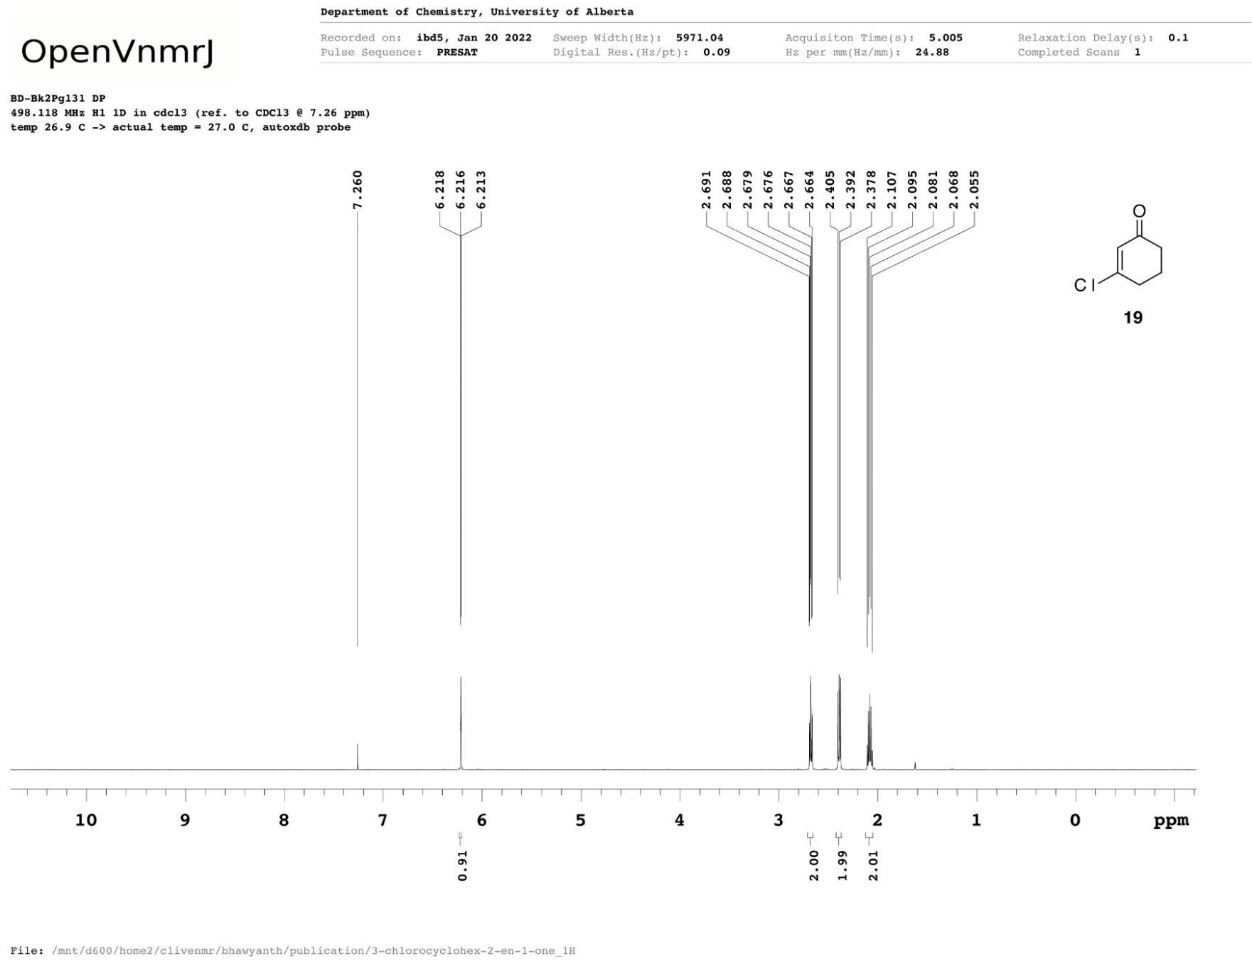
2
Figure A1 ¹H NMR spectrum of 3-chlorocyclohex-2-en-1-one (2).
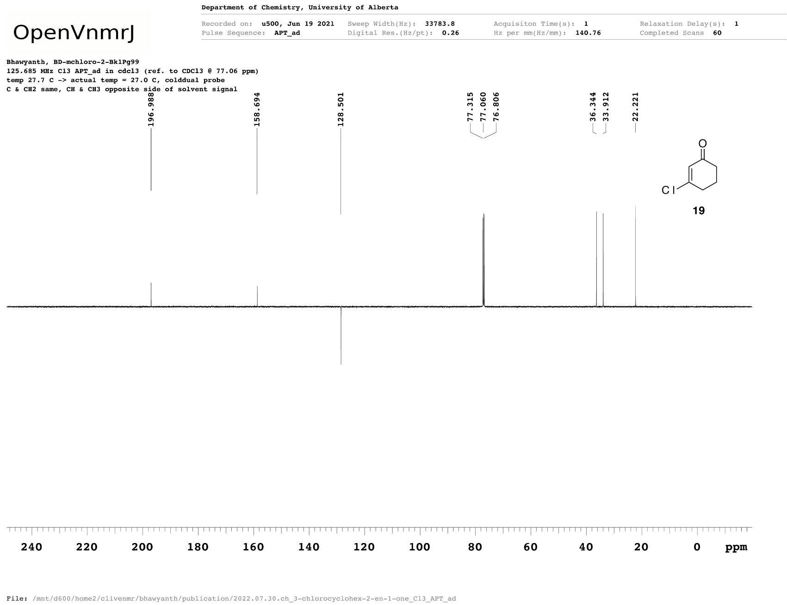
2
Figure A2 ¹³C{¹H} NMR spectrum of 3-chlorocyclohex-2-en-1-one (2).
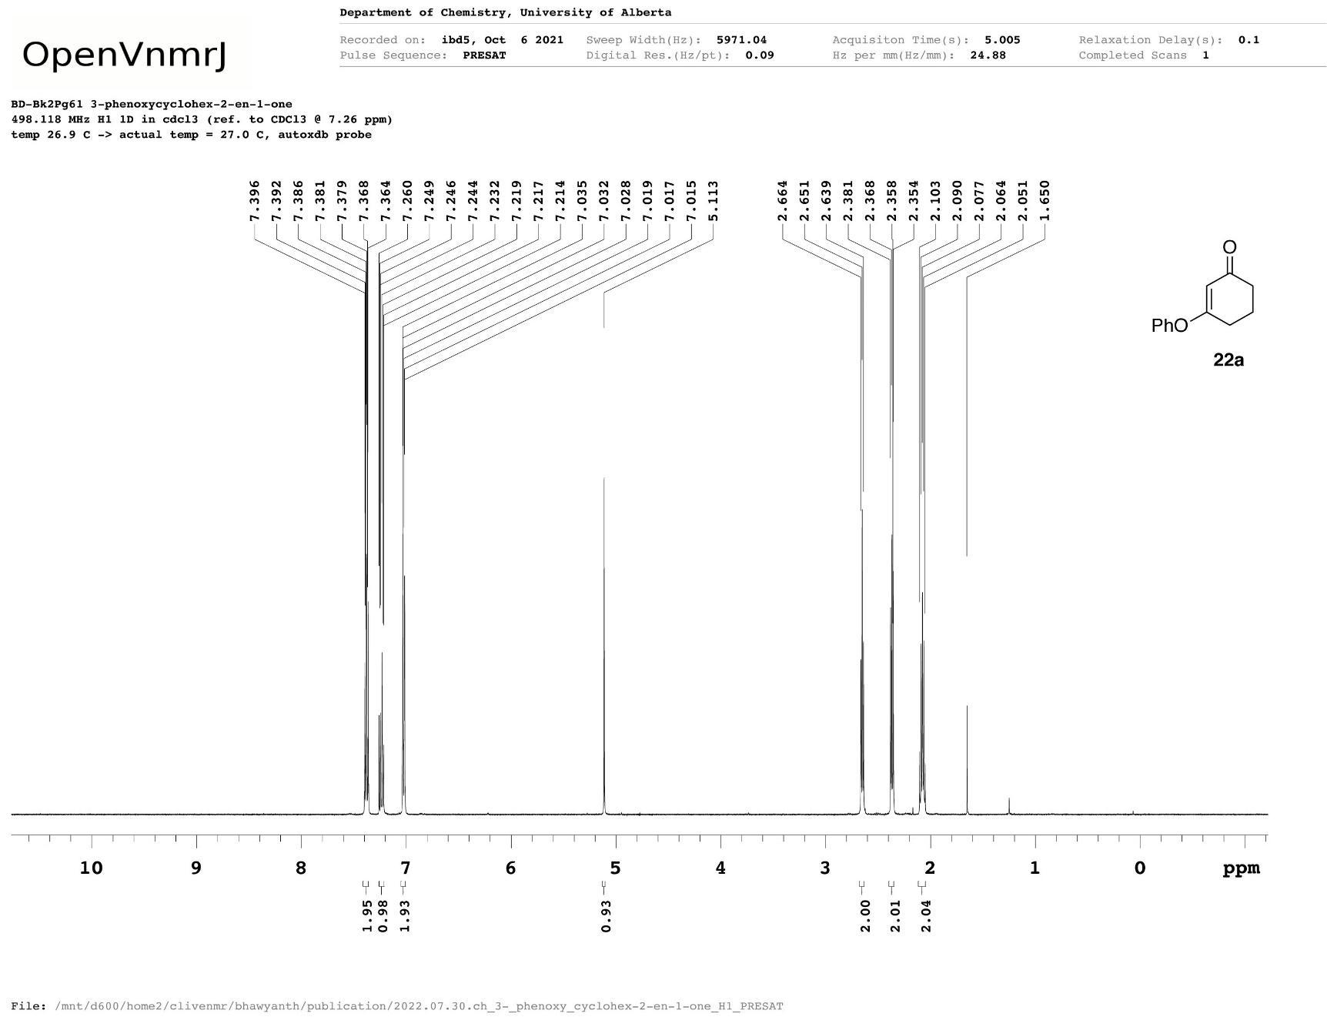
3a
Figure A3 ¹H NMR spectrum of 3-(phenoxy)cyclohex-2-en-1-one (3a)
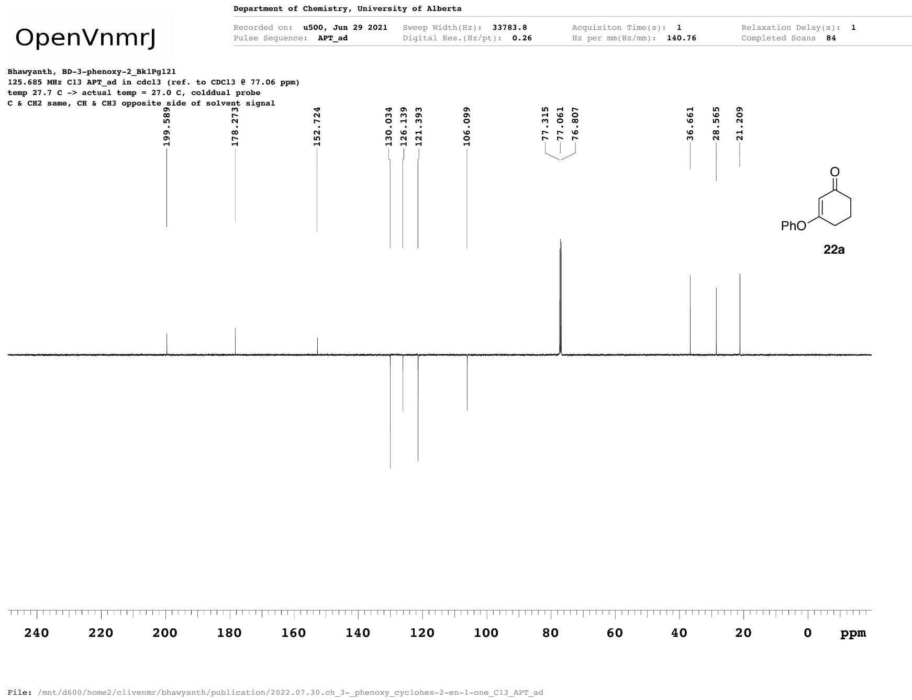
3a
Figure A4 ¹³C{¹H} NMR spectrum of 3-(phenoxy)cyclohex-2-en-1-one (3a).
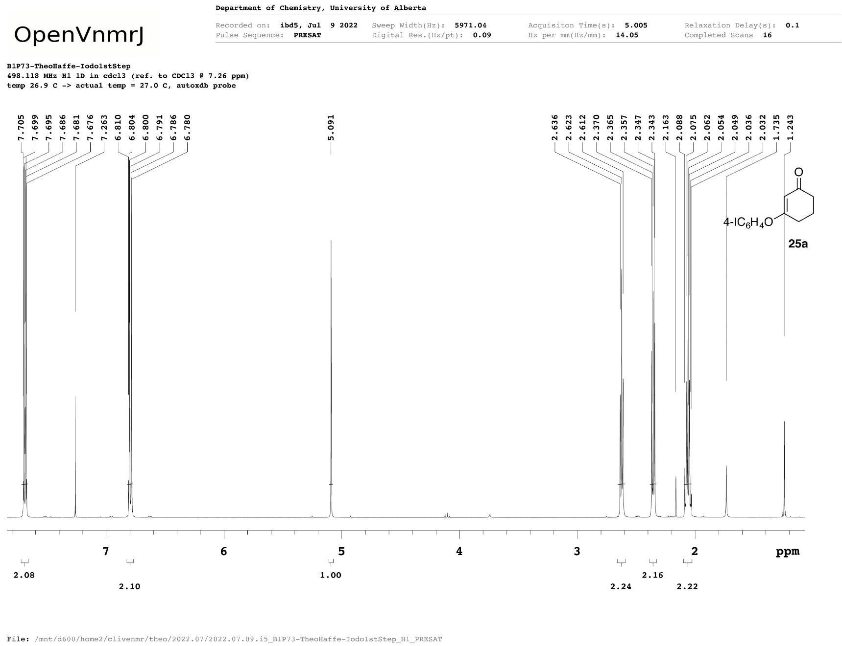
3b
Figure A5 ¹H NMR spectrum of 3-(4-iodophenoxy)cyclohex-2-en-1-one (3b).
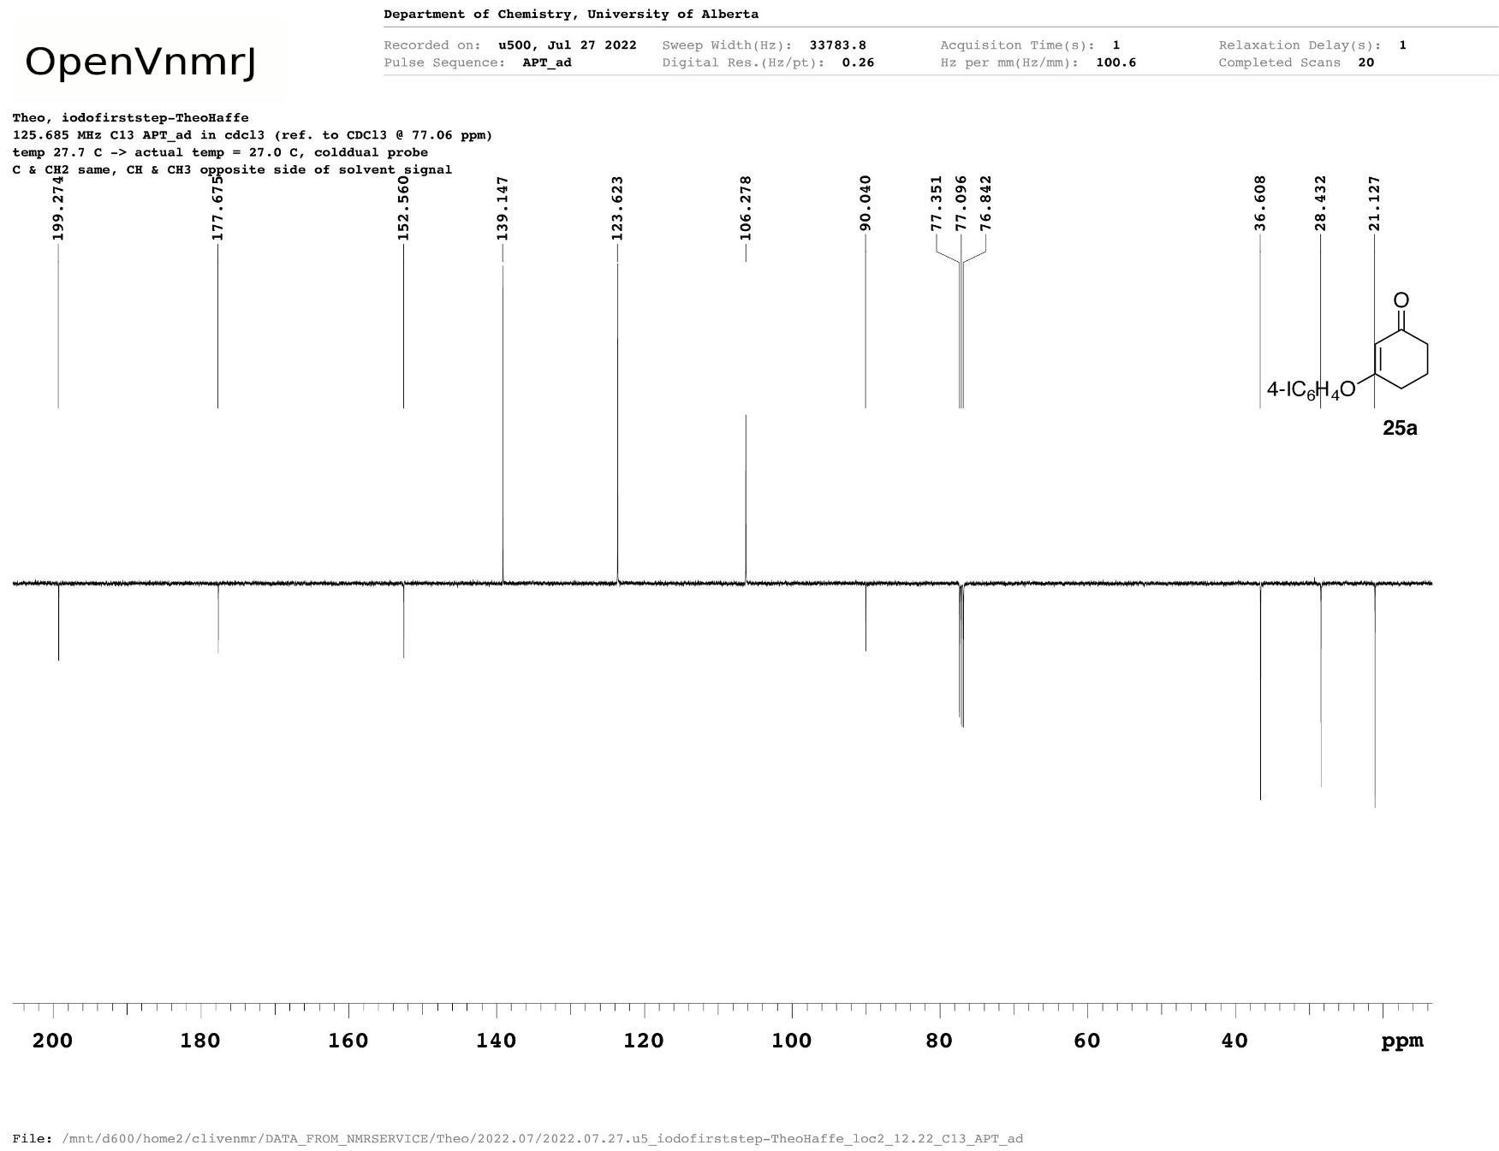
3b
Figure A6 ¹³C{¹H} NMR spectrum of 3-(4-iodophenoxy)cyclohex-2-en-1-one (3b).
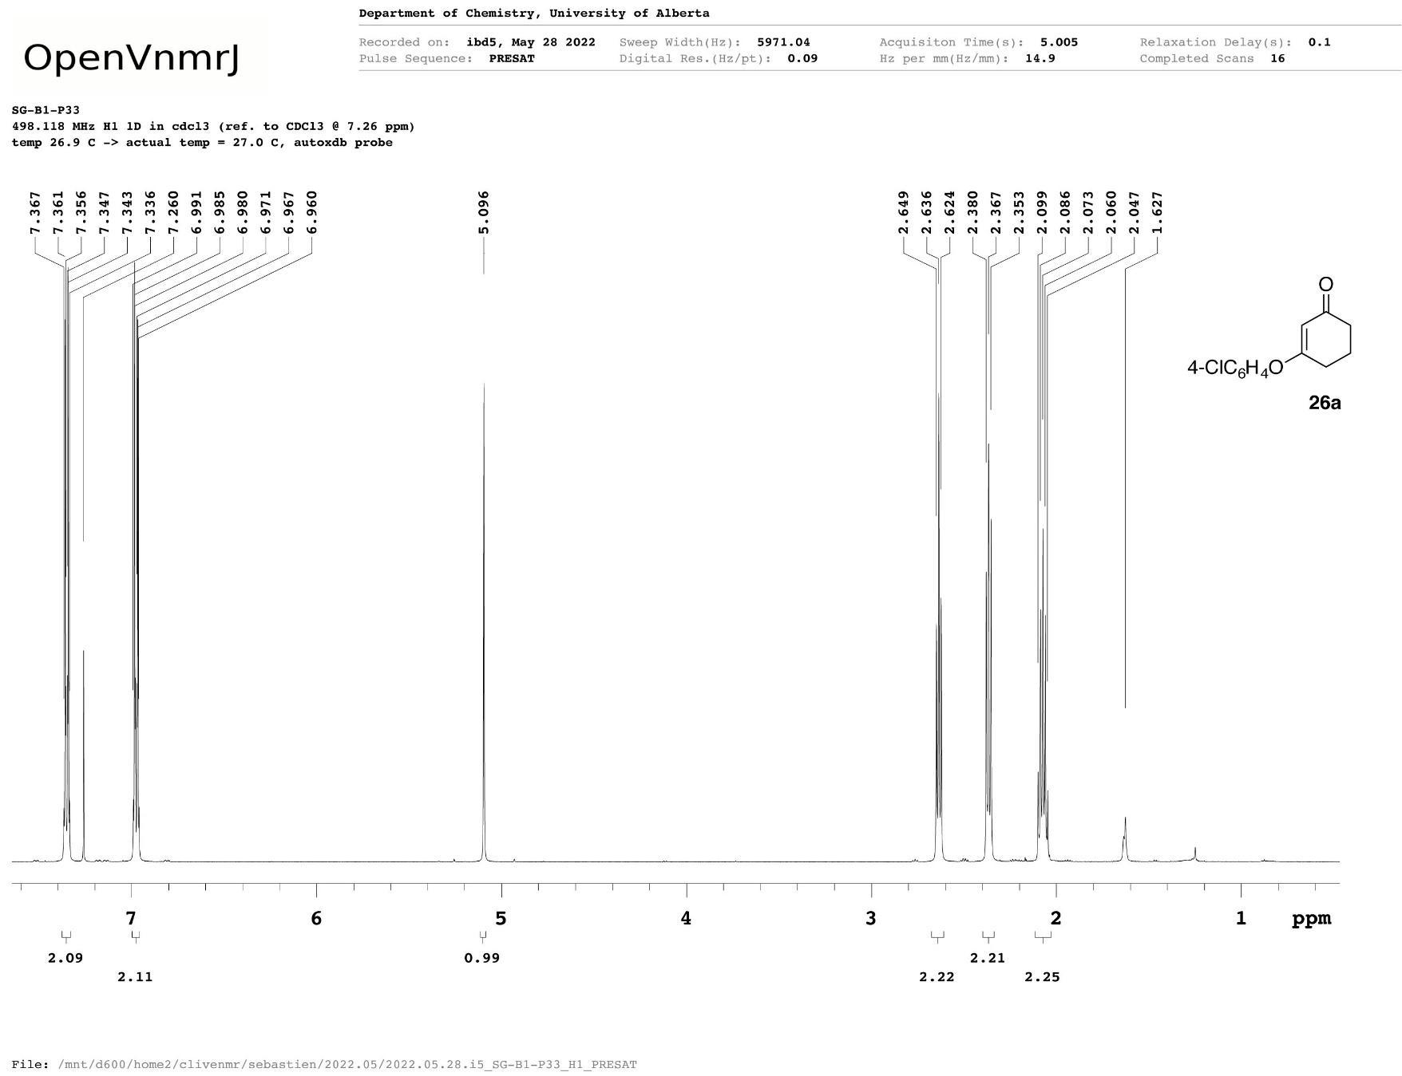
3c
Figure A7 ¹H NMR spectrum of 3-(4-chlorophenoxy)cyclohex-2-en-1-one (3c).
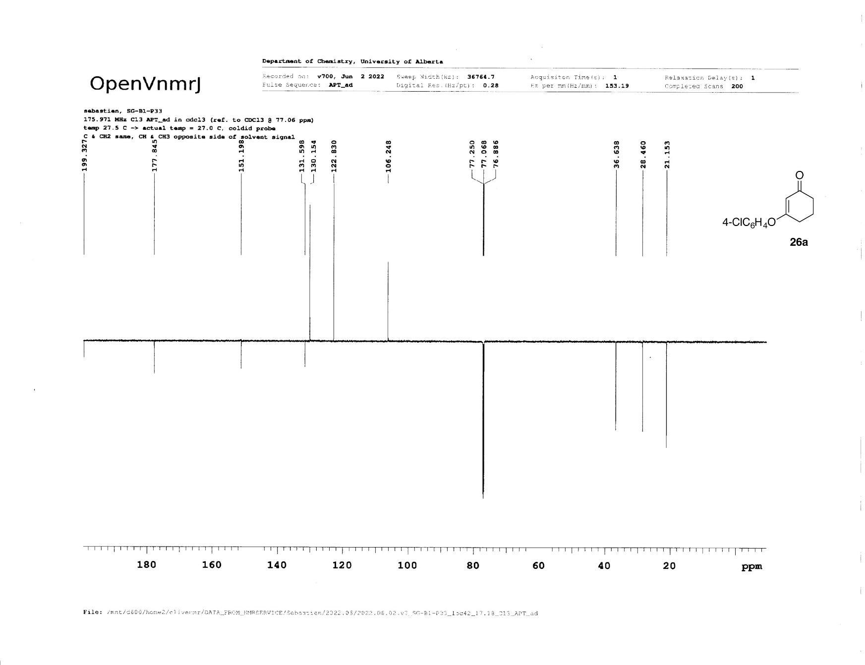
3c
Figure A8 ¹³C{¹H} NMR spectrum of 3-(4-chlorophenoxy)cyclohex-2-en-1-one (3c).
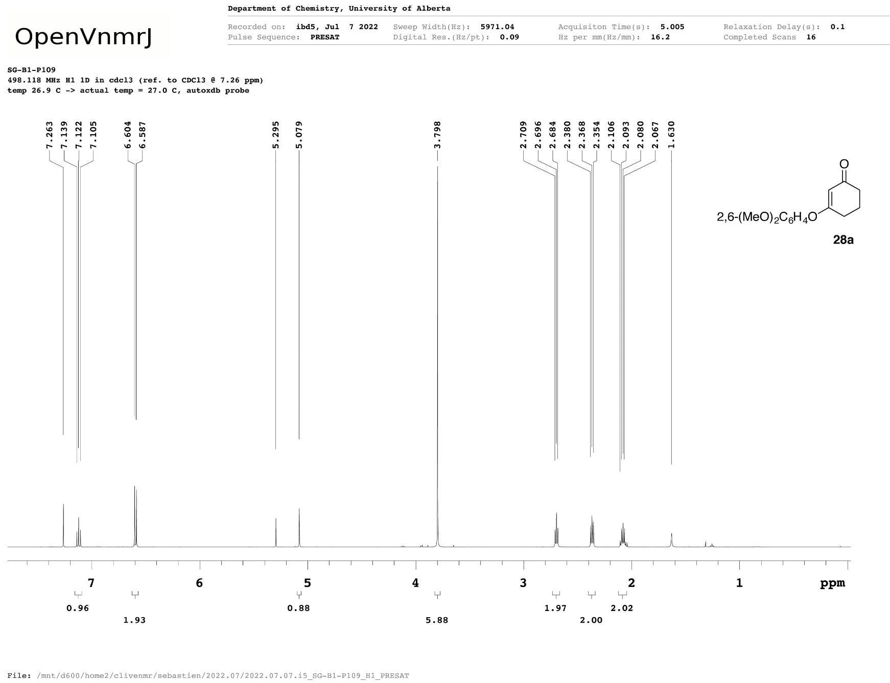
3d
Figure A9 ¹H NMR spectrum of 3-(2,6-dimethoxyphenoxy)cyclohex-2-en-1-one (3d).
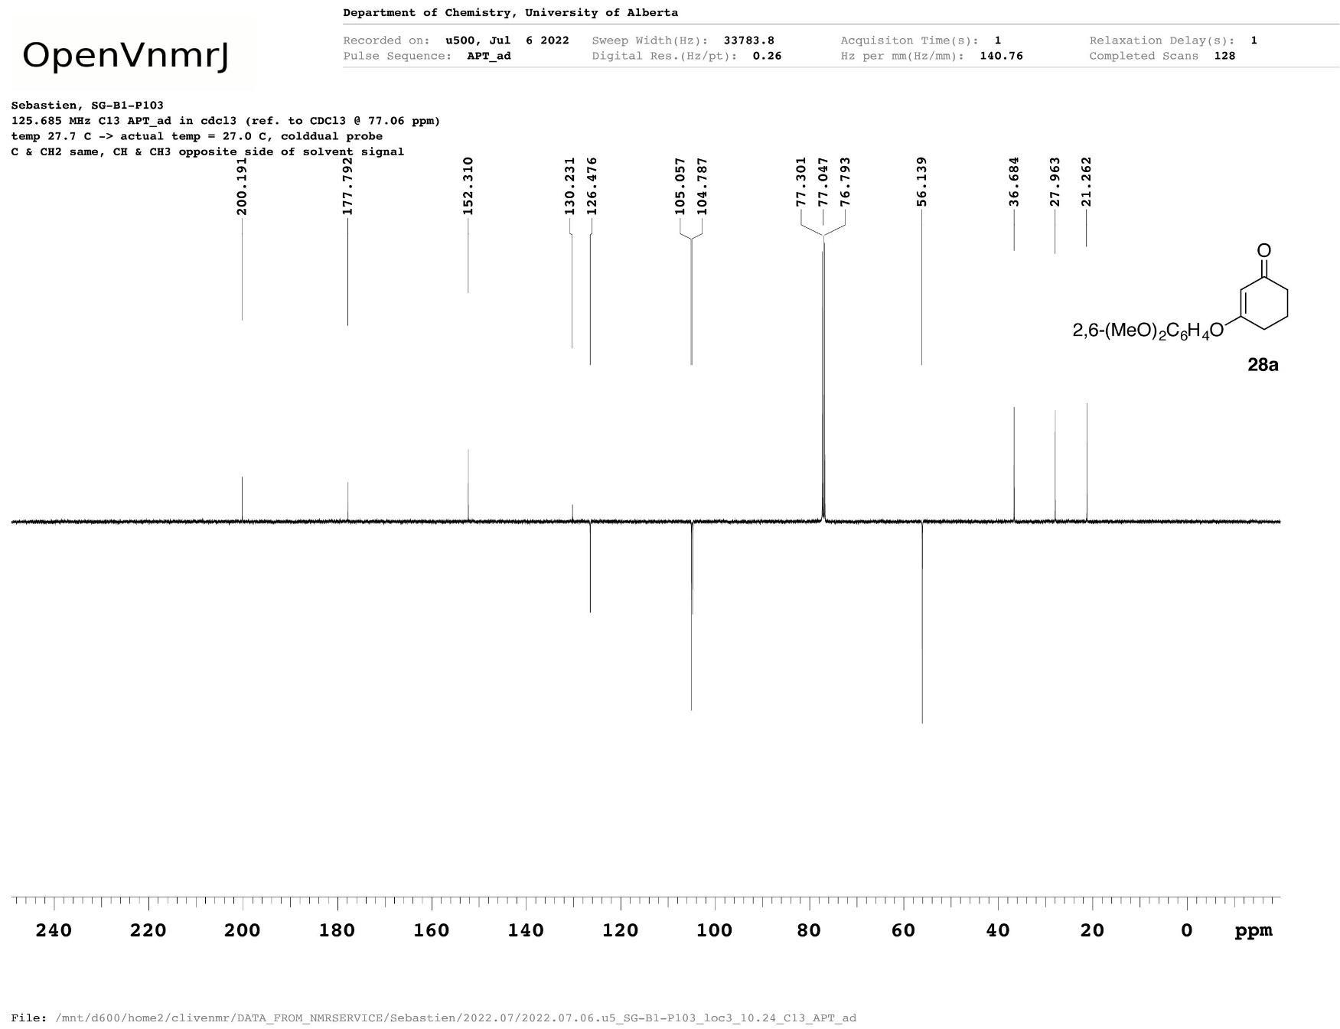
3d
Figure A10 ¹³C{¹H} NMR spectrum of 3-(2,6-dimethoxyphenoxy)cyclohex-2-en-1-one (3d).
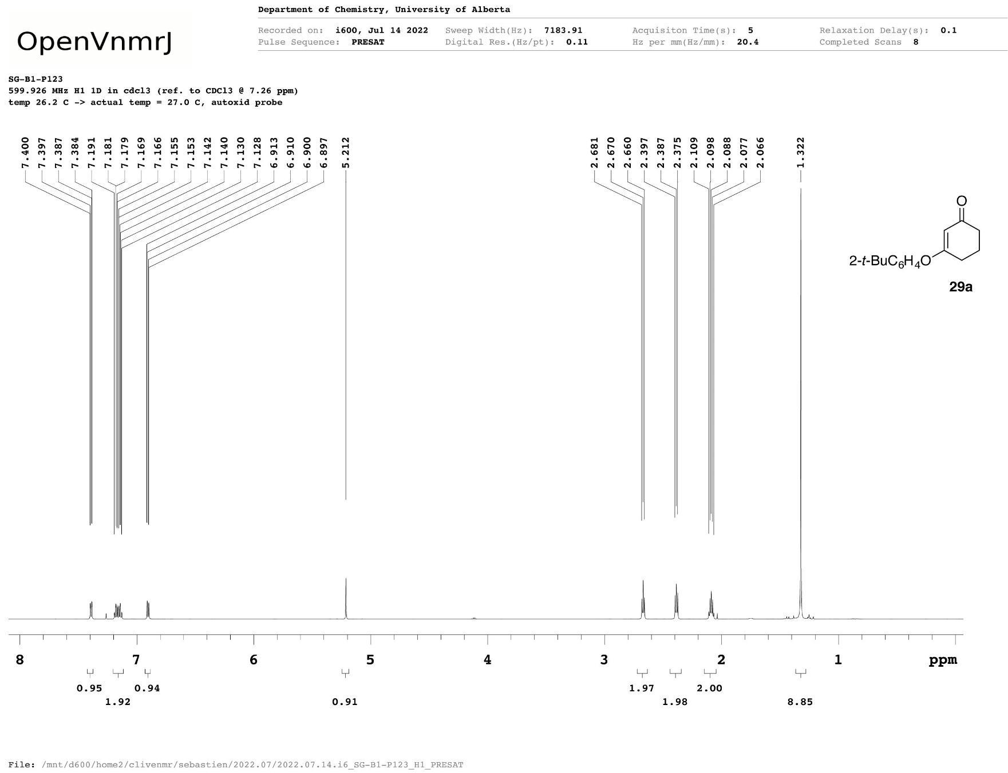
3e
Figure A11 ¹H NMR spectrum of 3-(2-tert-butylphenoxy)cyclohex-2-en-1-one (3e).
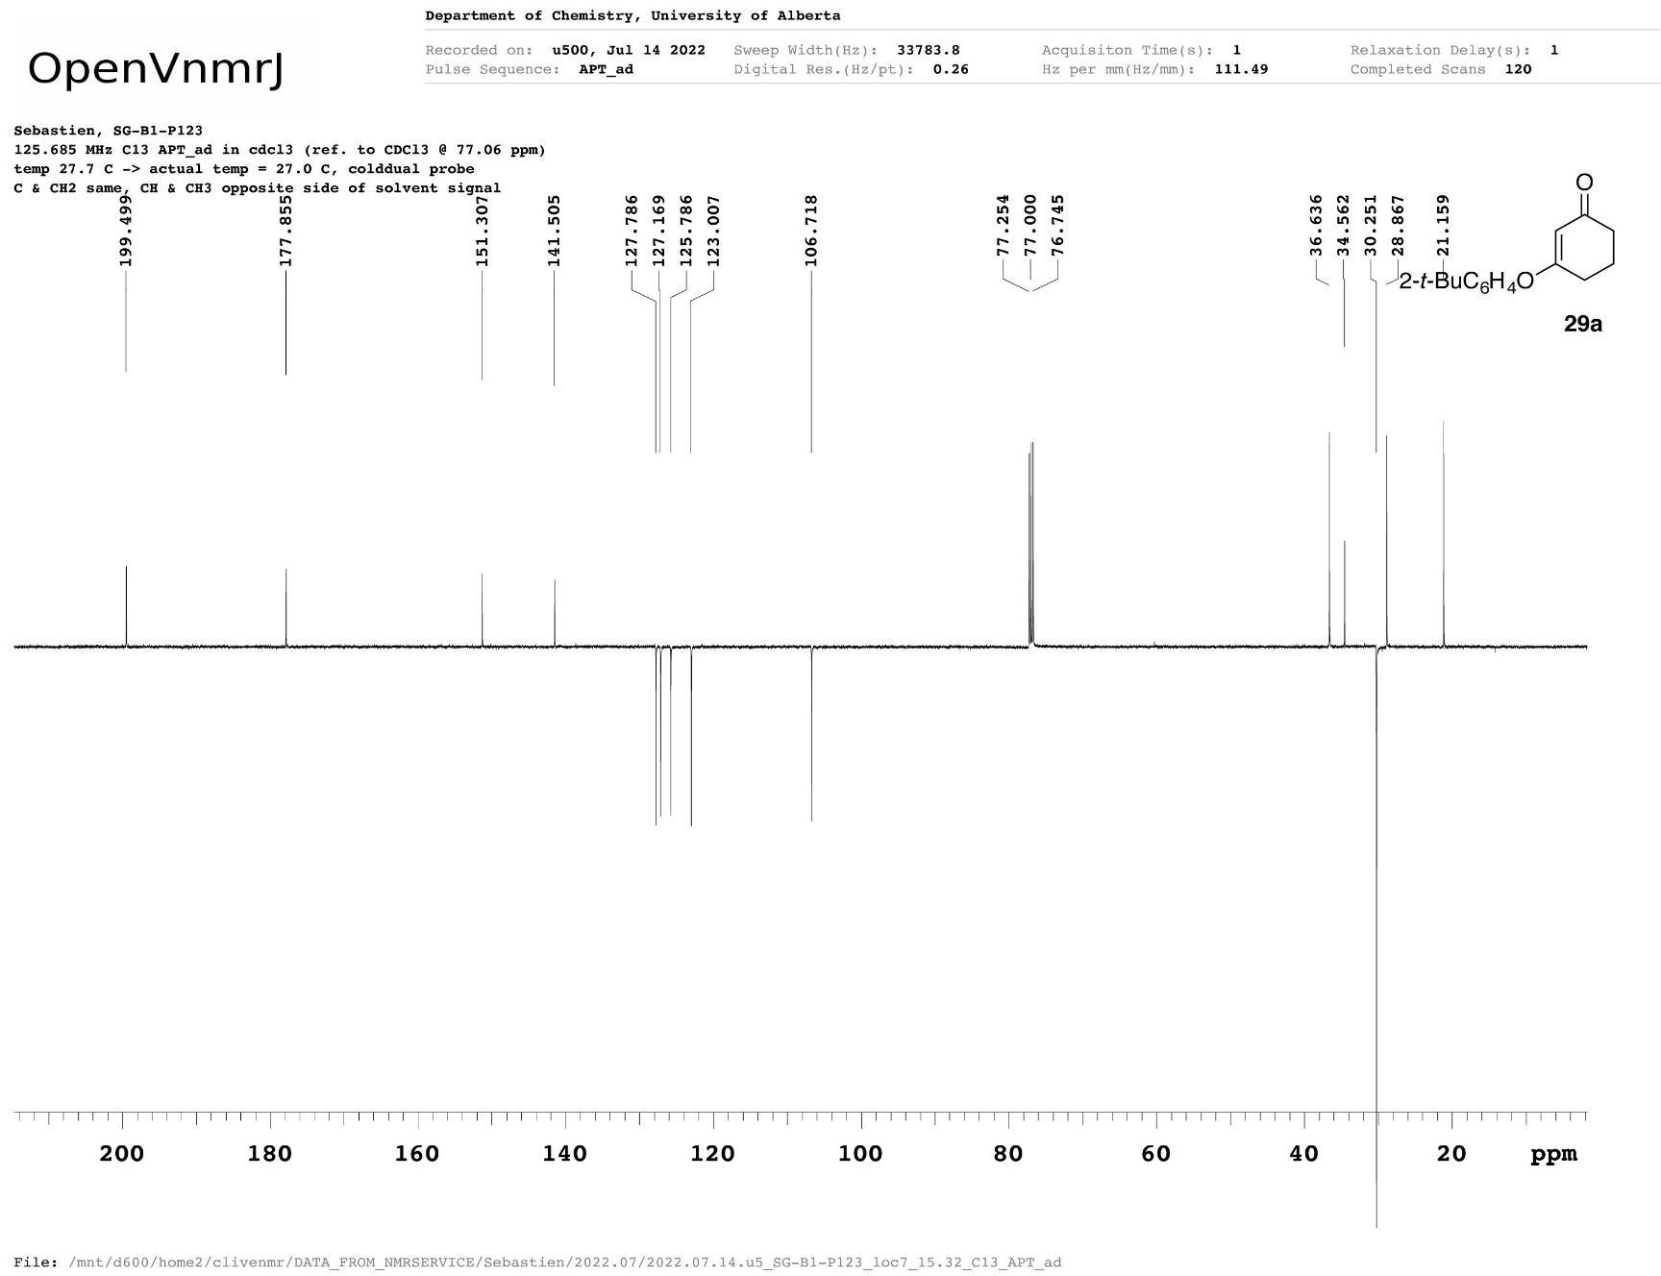
3e
Figure A12 ¹³C{¹H} NMR spectrum of 3-(2-tert-butylphenoxy)cyclohex-2-en-1-one (3e).
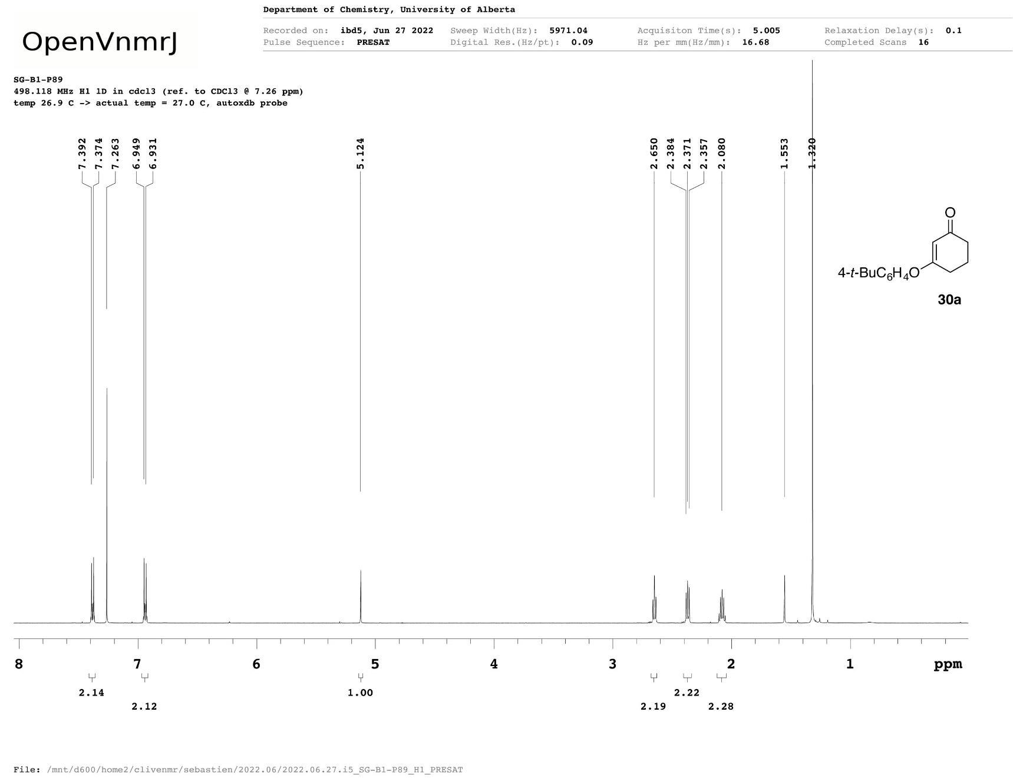
3f
Figure A13 ¹H NMR spectrum of 3-(4-tert-butylphenoxy)cyclohex-2-en-1-one (3f).
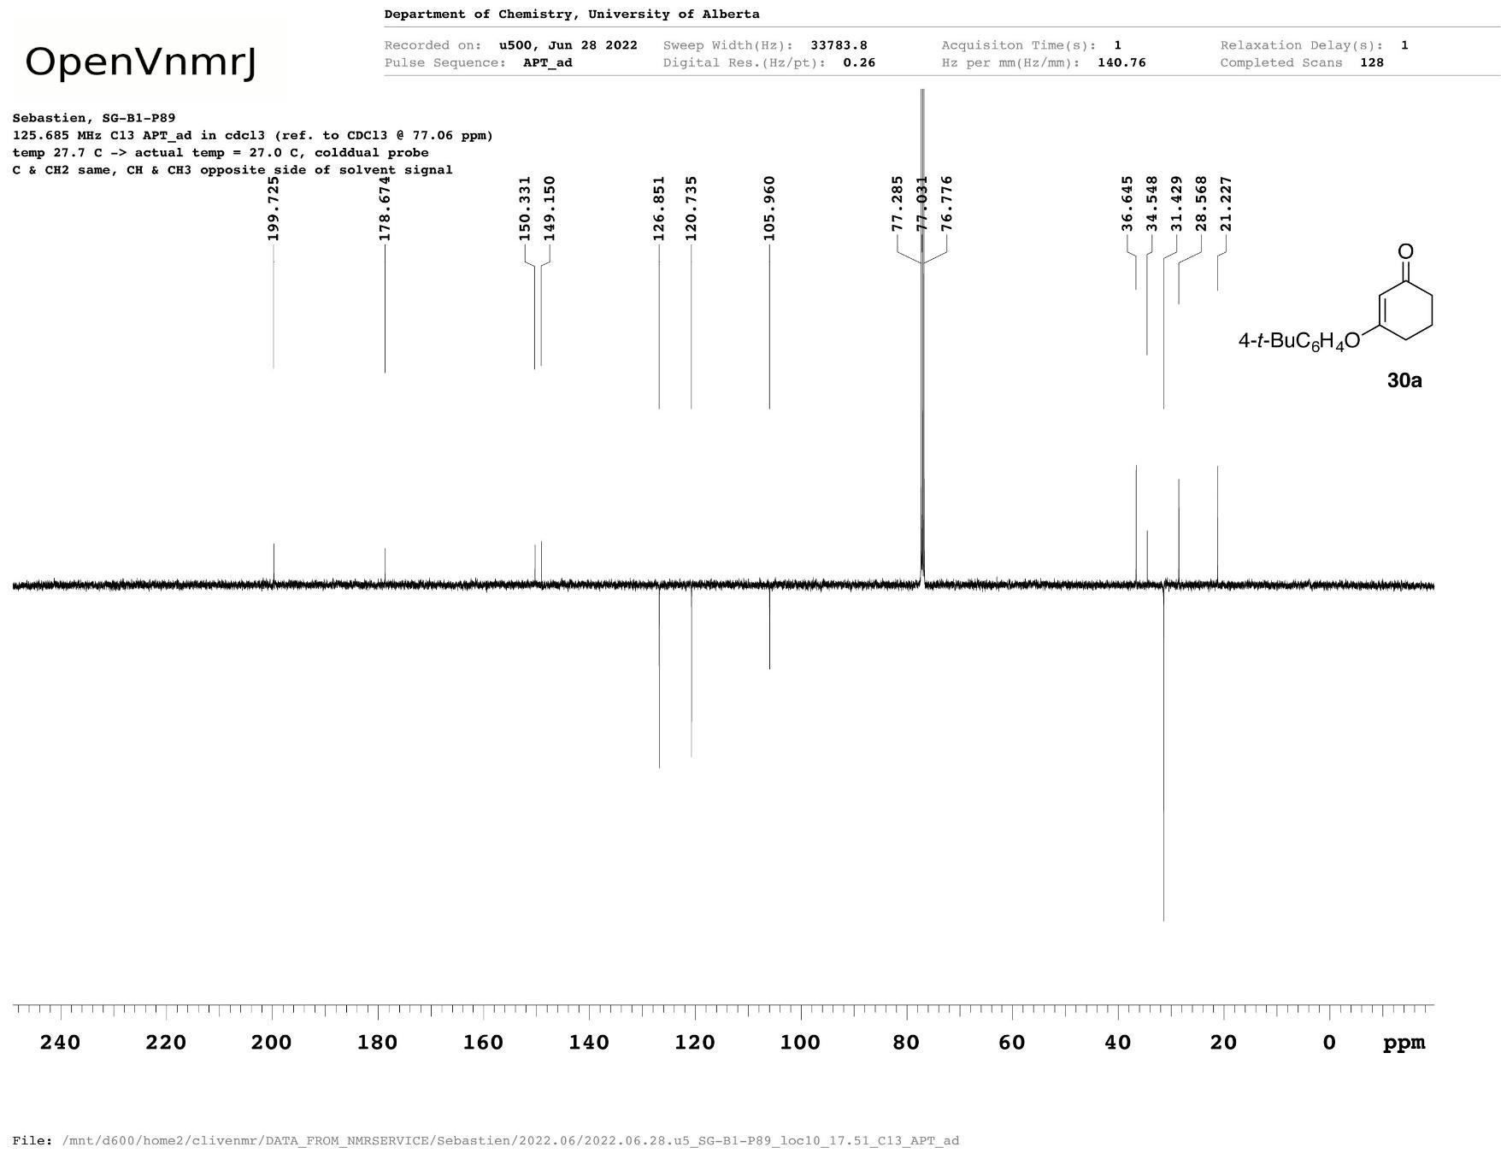
3f
Figure A14 ¹³C{¹H} NMR spectrum of 3-(4-tert-butylphenoxy)cyclohex-2-en-1-one (3f).
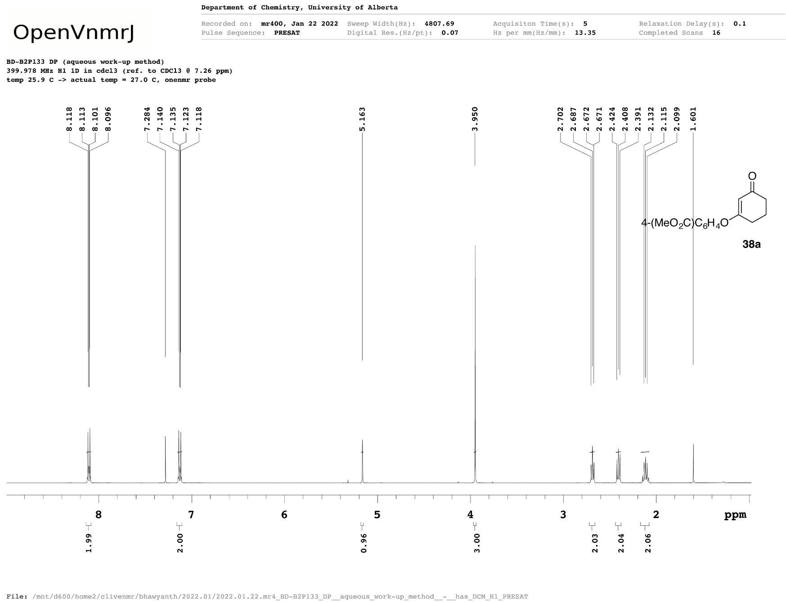
3g
Figure A15 ¹H NMR spectrum of methyl 4-[(3-oxocyclohex-1-en-1-yl)oxy]benzoate (3g).
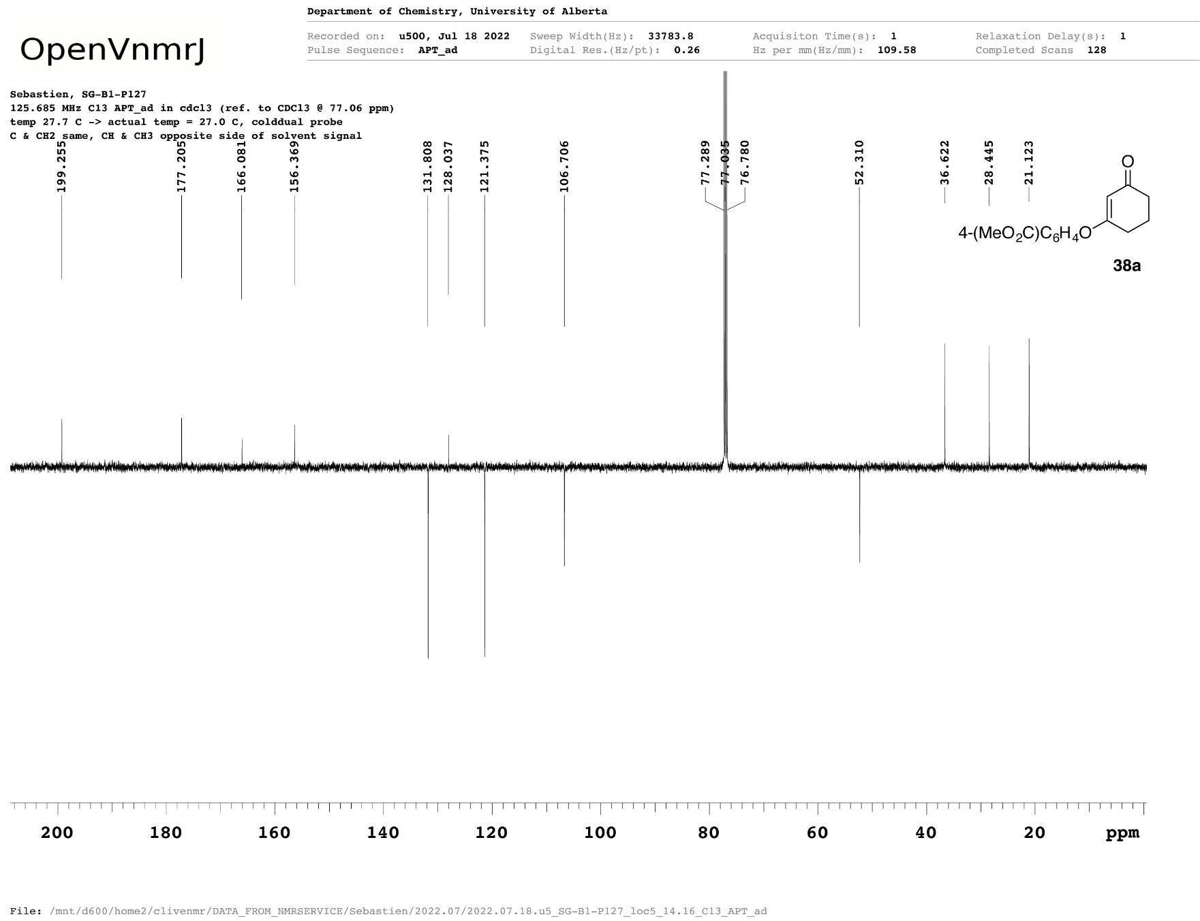
3g
Figure A16 ¹³C{¹H} NMR spectrum of methyl 4-[(3-oxocyclohex-1-en-1-yl)oxy]benzoate (3g).
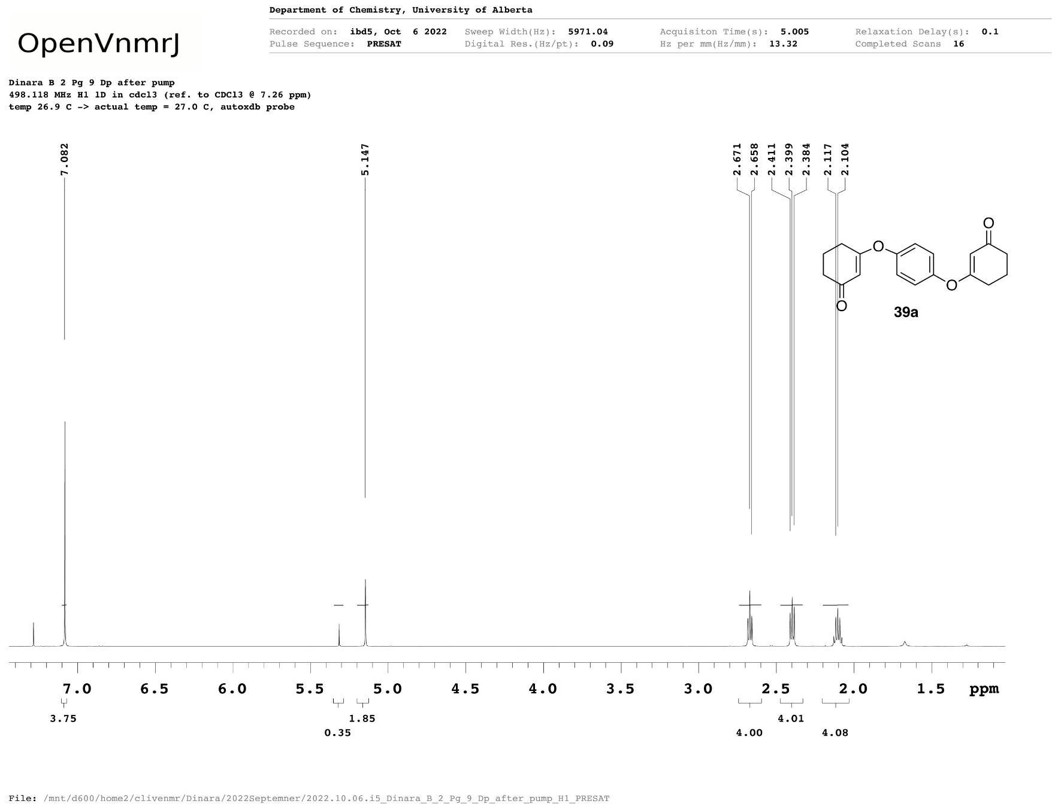
3h
Figure A17 ¹H NMR spectrum of 3-{4-[(3-oxocyclohex-1-en-1-yl)oxy]phenoxy}cyclohex-2-ene-1-one (3h).
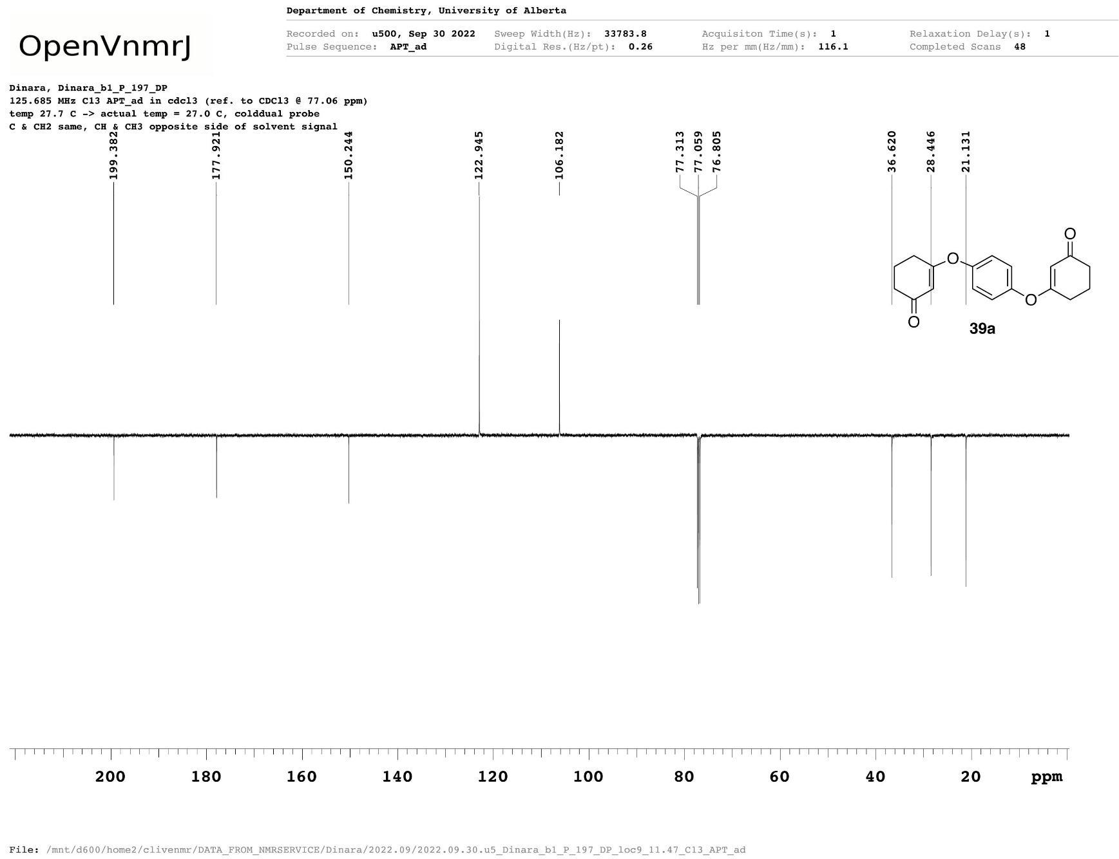
3h
Figure A18 ¹³C{¹H} NMR spectrum of 3-{4-[(3-oxocyclohex-1-en-1-yl)oxy]phenoxy}cyclohex-2-ene-1-one (3h).
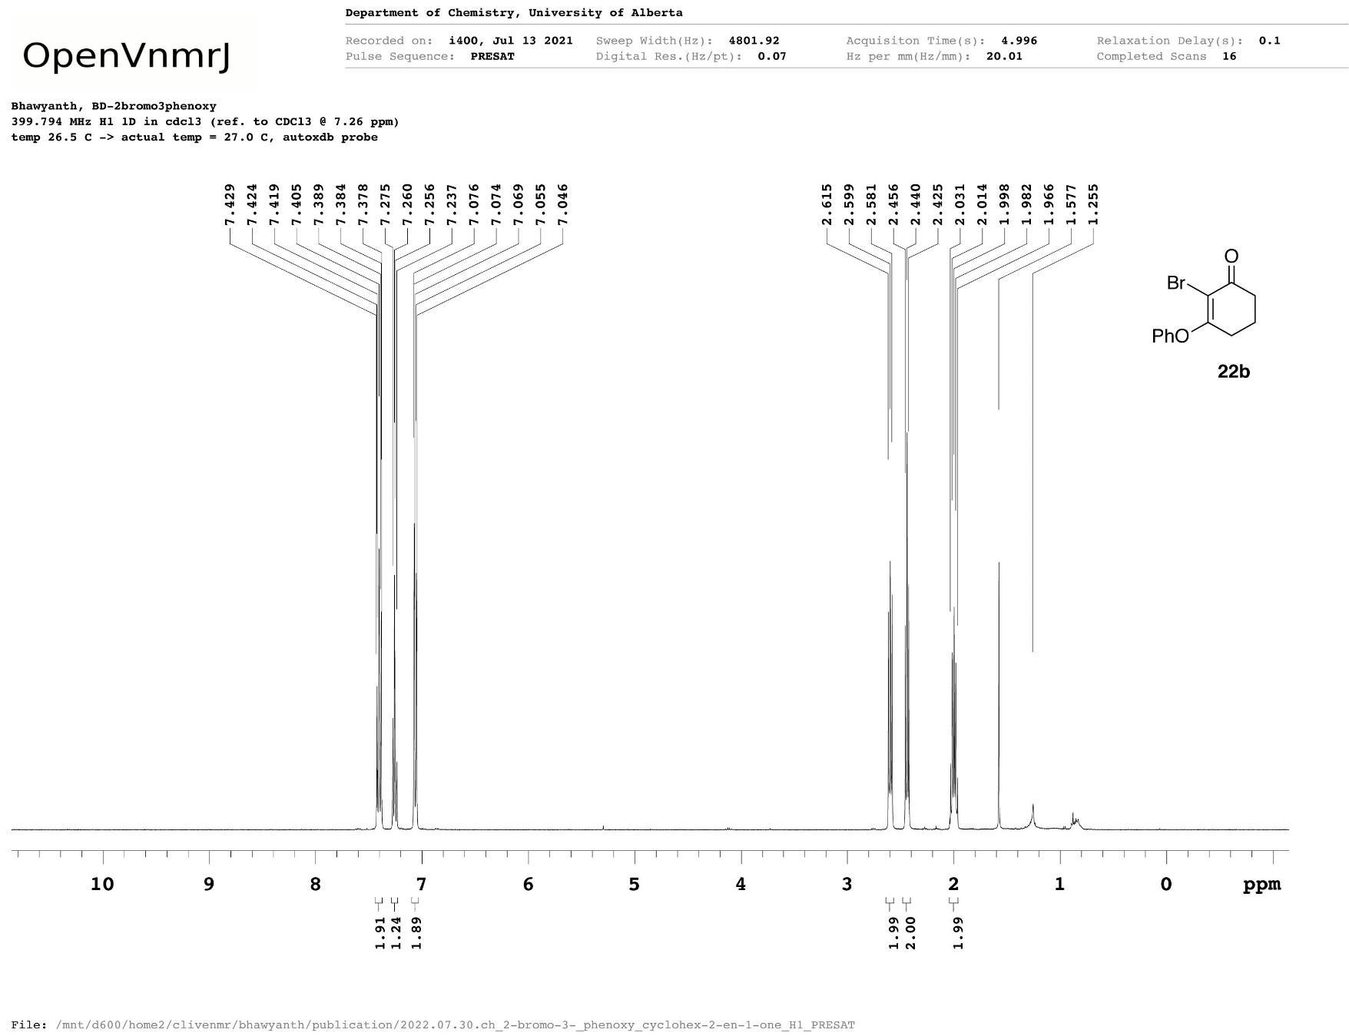
4a
Figure A19 ¹H NMR spectrum of 2-bromo-3-(phenoxy)cyclohex-2-en-1-one (4a).
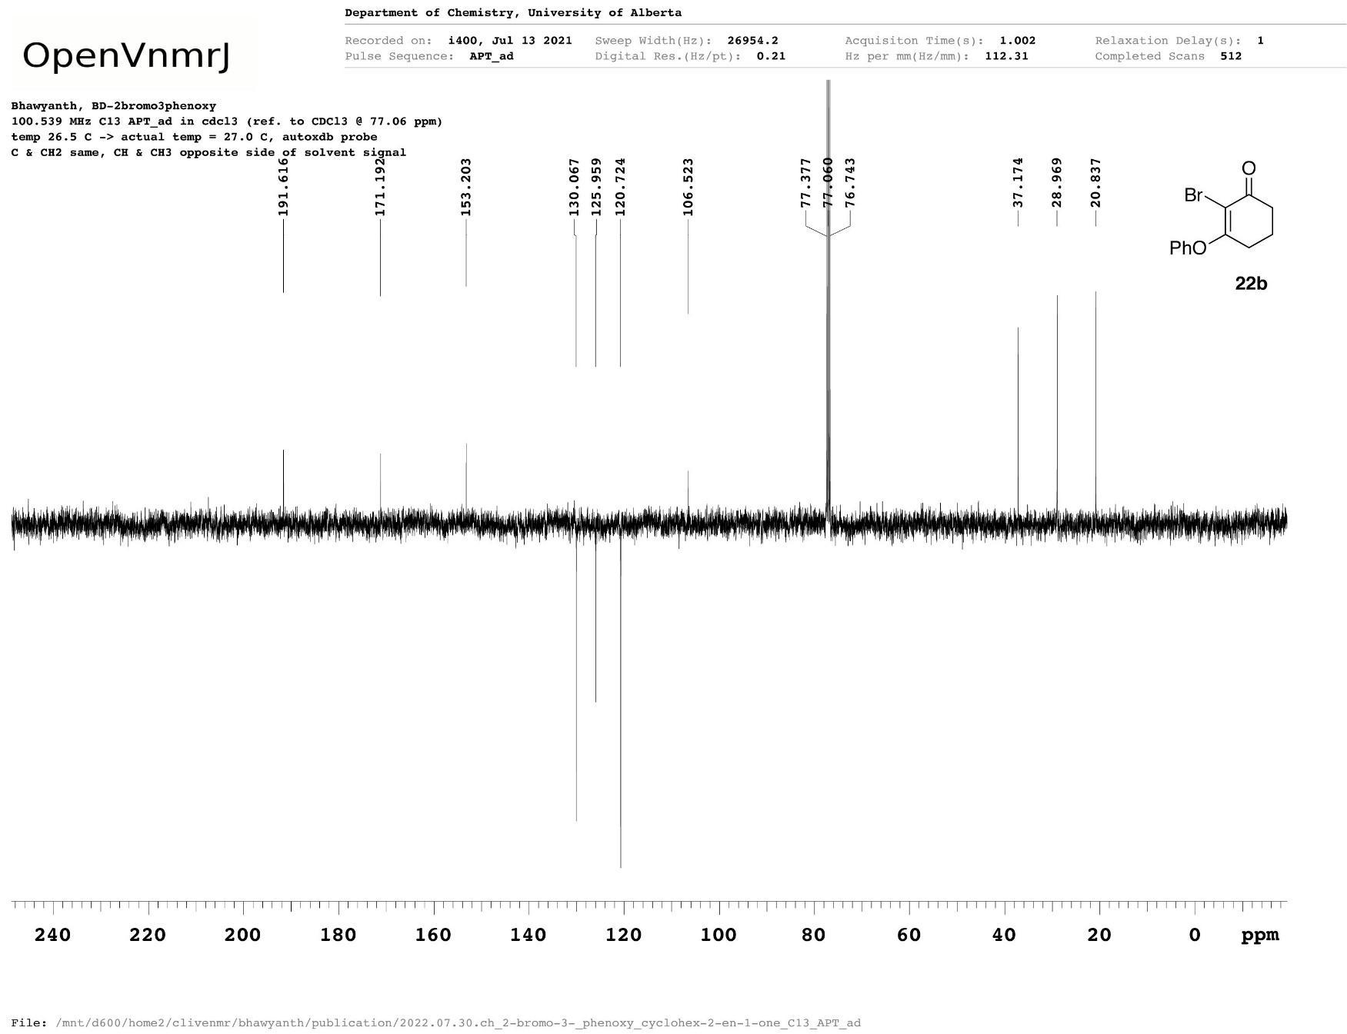
4a
Figure A20 ¹³C{¹H} NMR spectrum of 2-bromo-3-(phenoxy)cyclohex-2-en-1-one (4a).
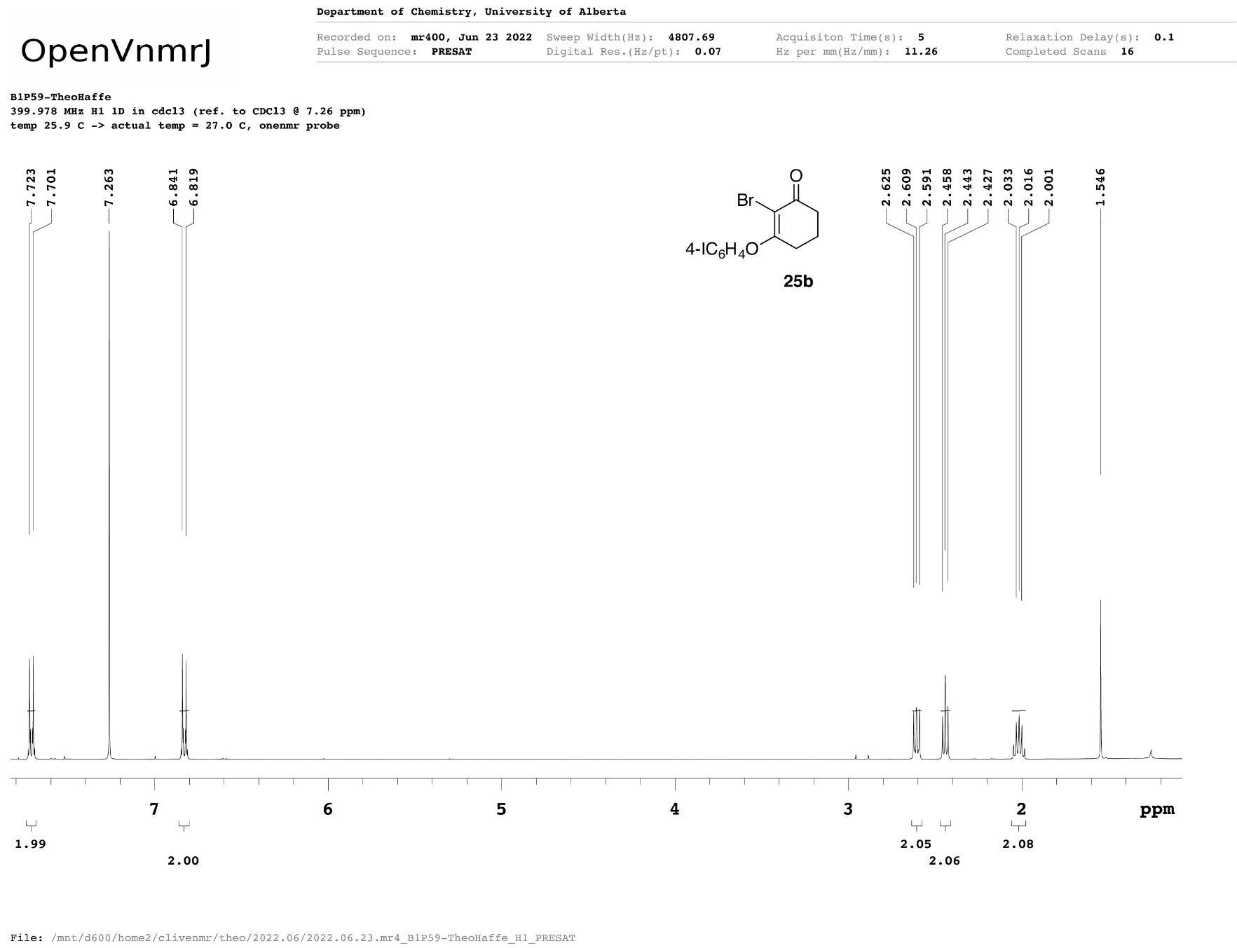
4b
Figure A21 ¹H NMR spectrum of 2-bromo-3-(4-iodophenoxy)cyclohex-2-en-1-one (4b).
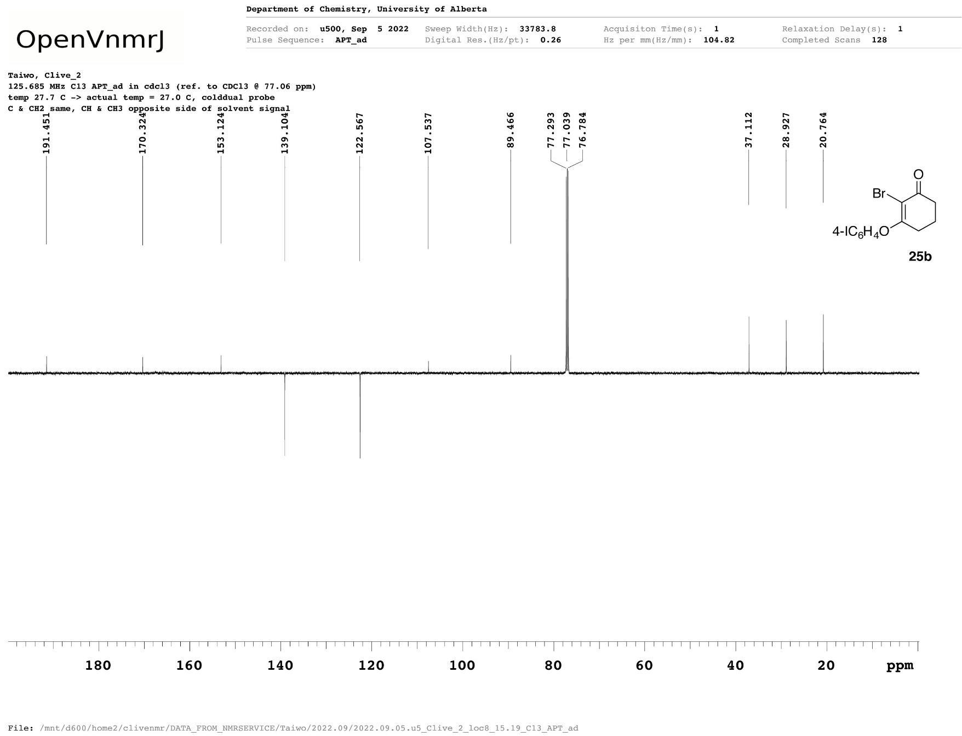
4b
Figure A22 ¹³C{¹H} NMR spectrum of 2-bromo-3-(4-iodophenoxy)cyclohex-2-en-1-one (4b).
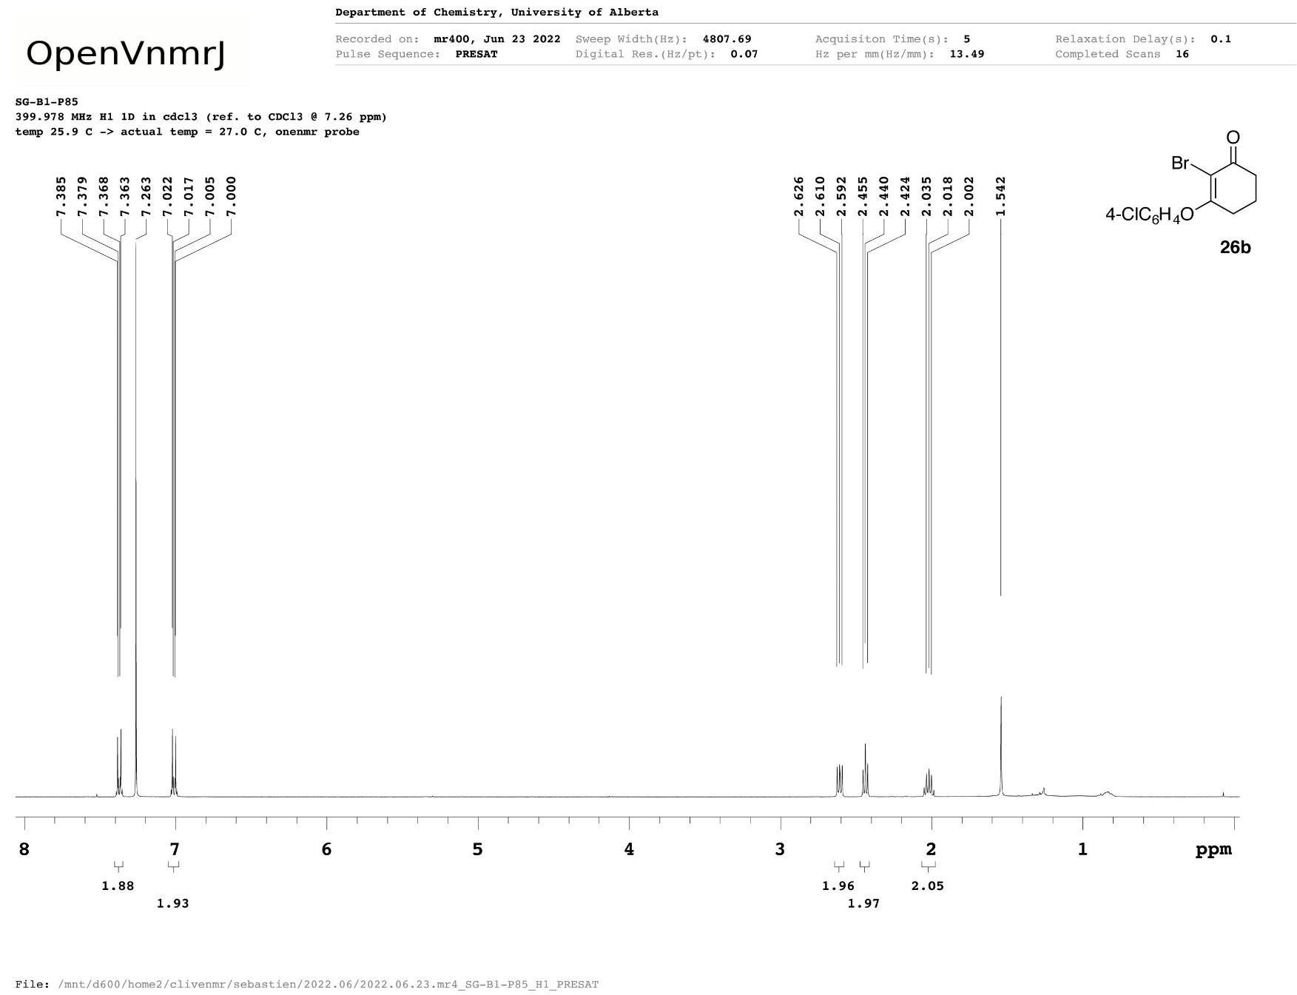
4c
Figure A23 ¹H NMR spectrum of 2-bromo-3-(4-chlorophenoxy)cyclohex-2-en-1-one (4c).
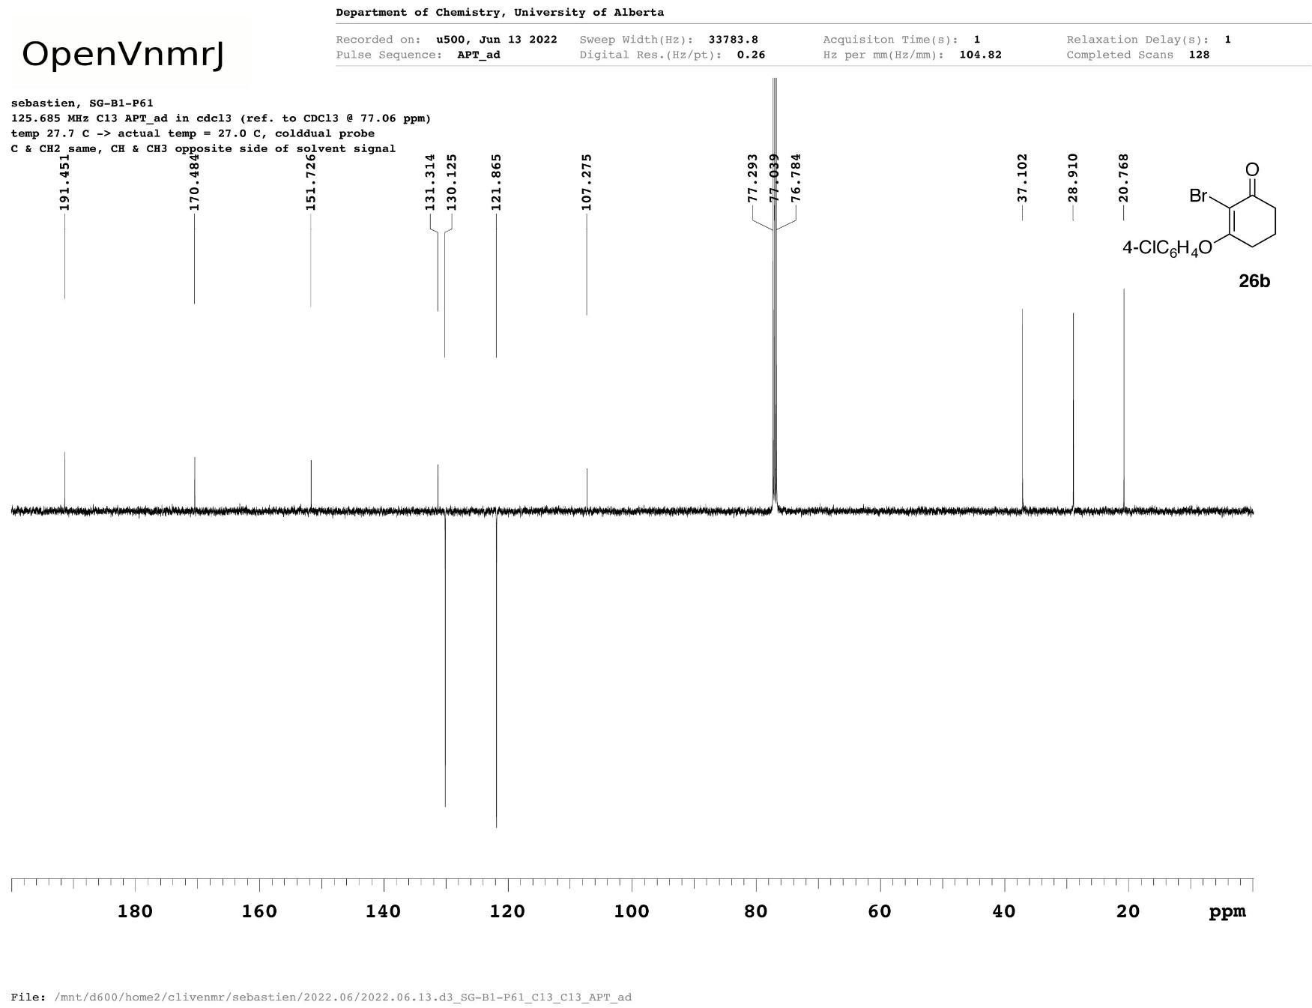
4c
Figure A24 ¹³C{¹H} NMR spectrum of 2-bromo-3-(4-chlorophenoxy)cyclohex-2-en-1-one (4c).
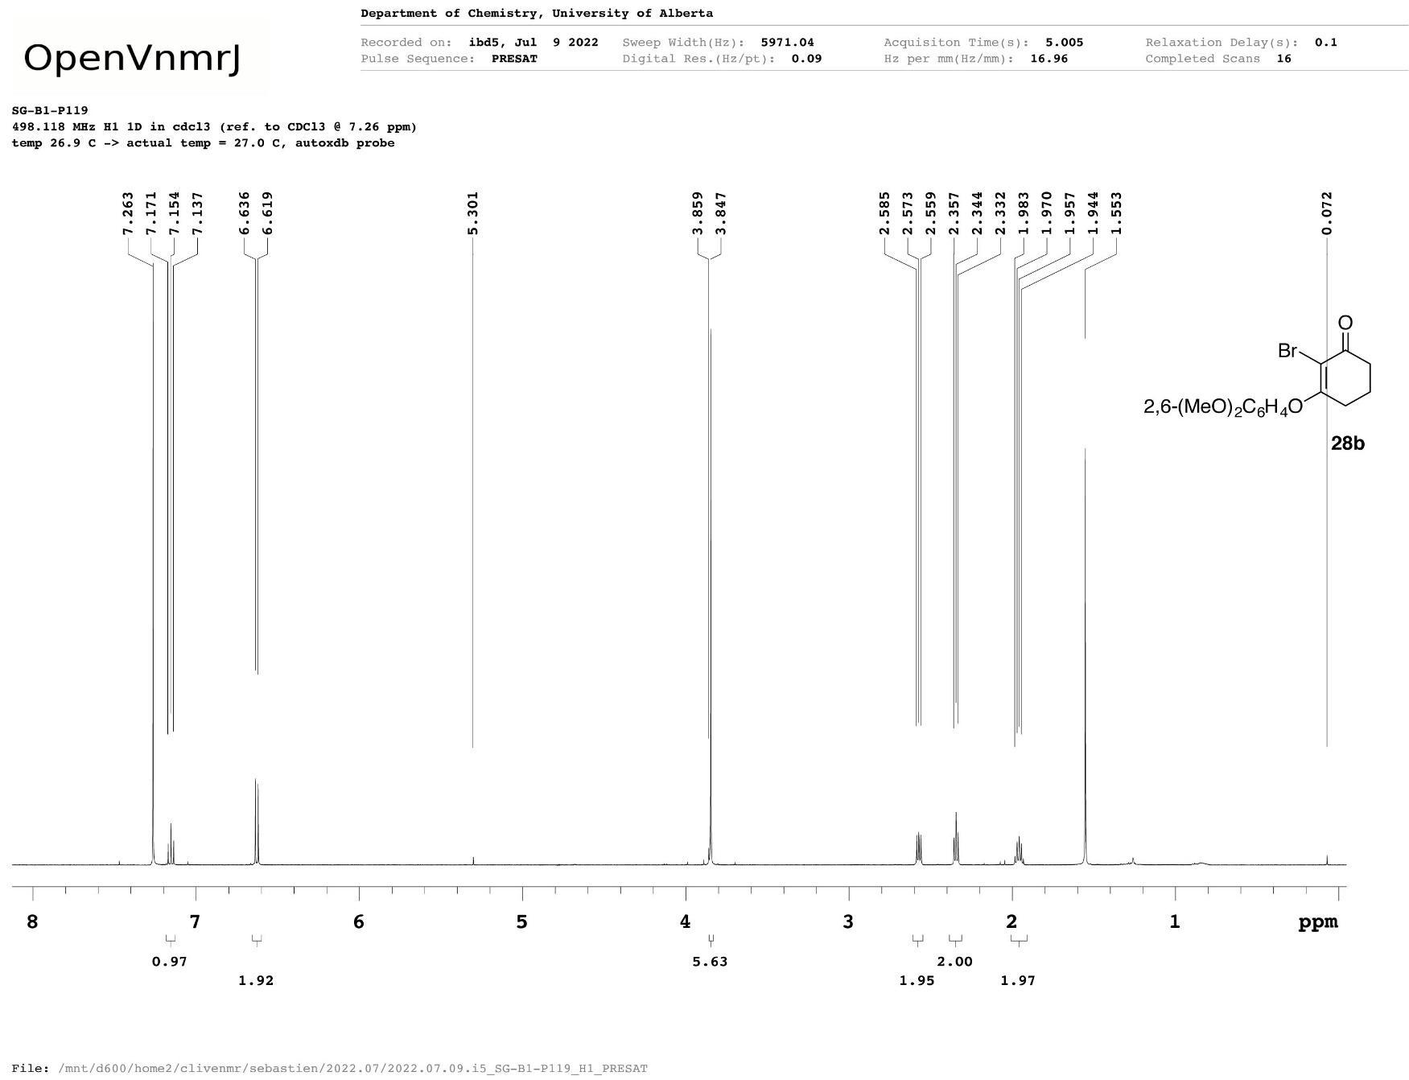
4d
Figure A25 ¹H NMR spectrum of 2-bromo-3-(2,6-dimethoxyphenoxy)cyclohex-2-en-1-one (4d).
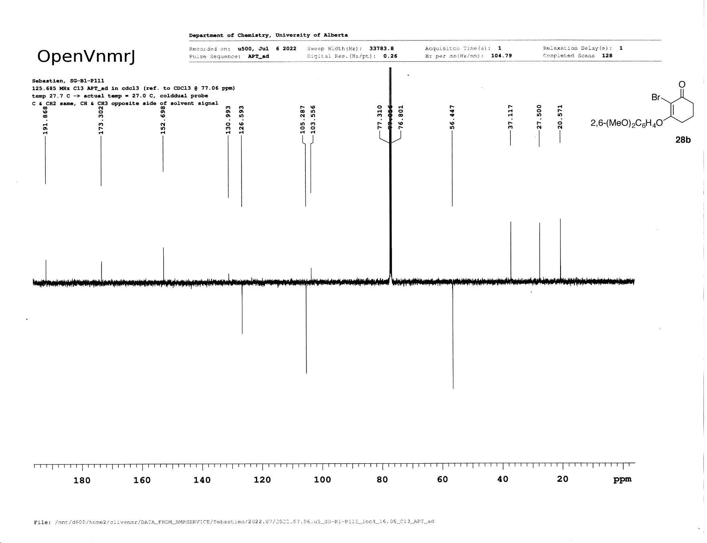
4d
Figure A26 ¹³C{¹H} NMR spectrum of 2-bromo-3-(2,6-dimethoxyphenoxy)cyclohex-2-en-1-one (4d).
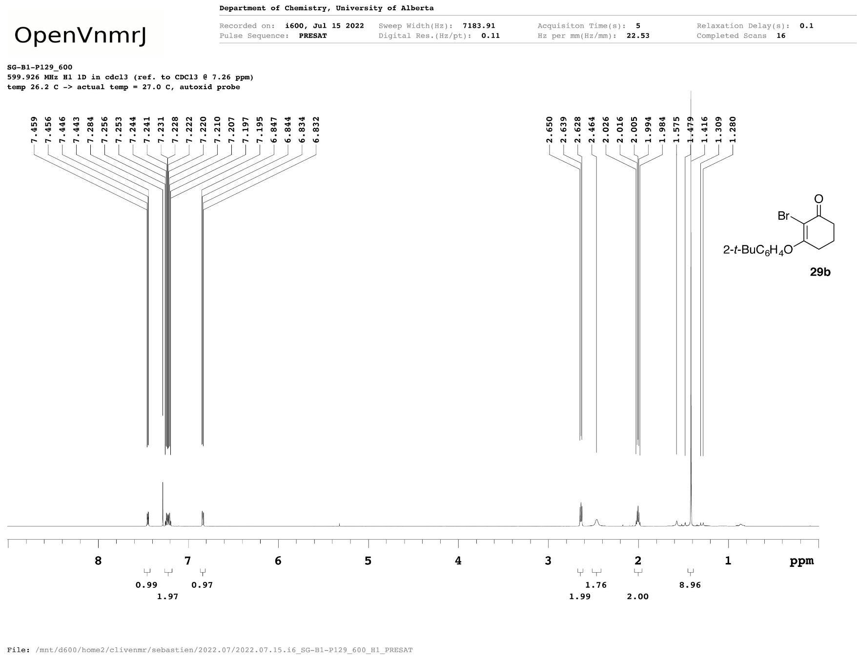
4e
Figure A27 ¹H NMR spectrum of 2-bromo-3-(2-tert-butylphenoxy)cyclohex-2-en-1-one (4e).
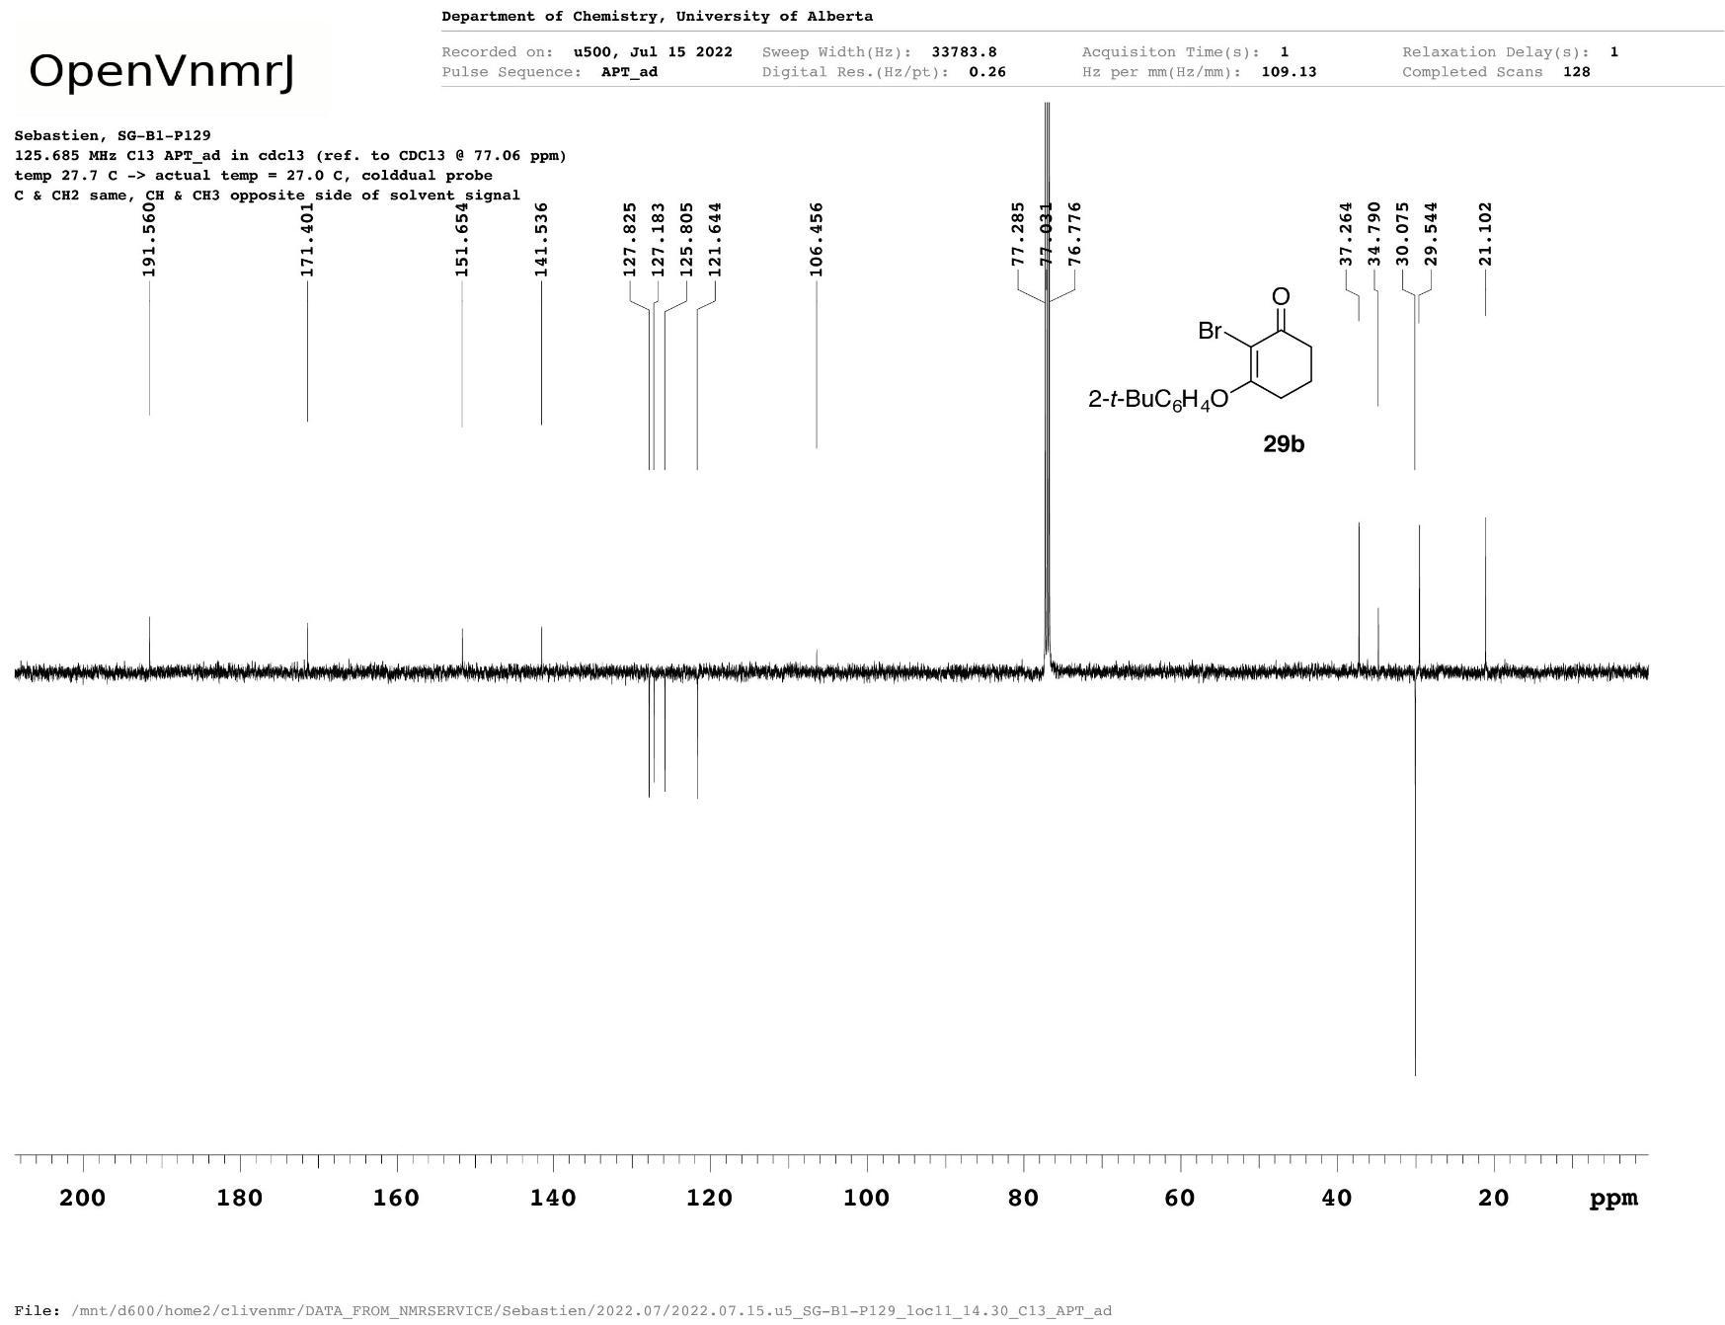
4e
Figure A28 ¹³C{¹H} NMR spectrum of 2-bromo-3-(2-tert-butylphenoxy)cyclohex-2-en-1-one (4e).
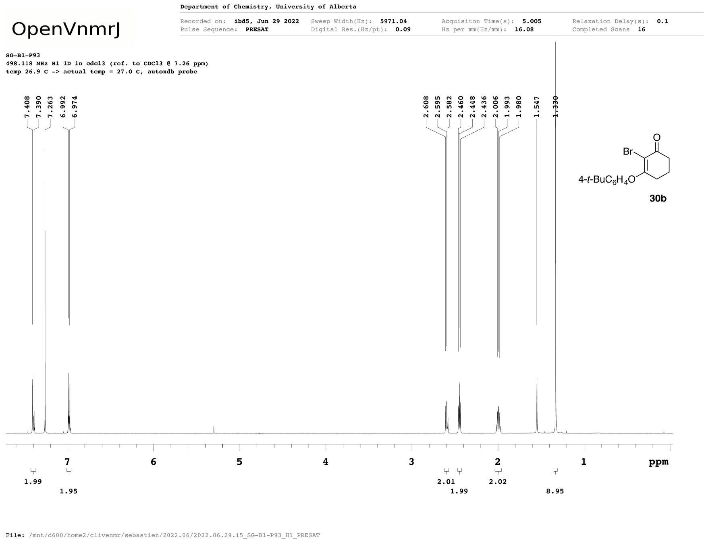
4f
Figure A29 ¹H NMR spectrum of 2-bromo-3-(4-tert-butylphenoxy)cyclohex-2-en-1-one (4f).
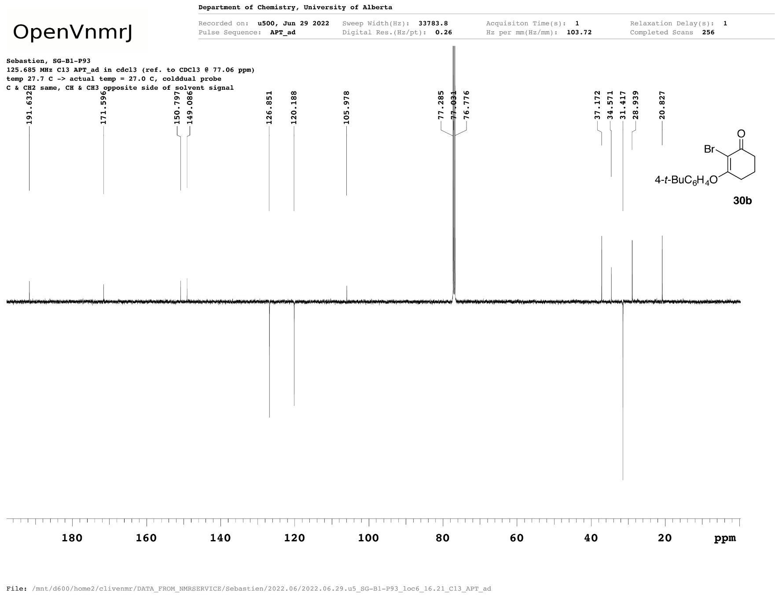
4f
Figure A30 ¹³C{¹H} NMR spectrum of 2-bromo-3-(4-tert-butylphenoxy)cyclohex-2-en-1-one (4f).
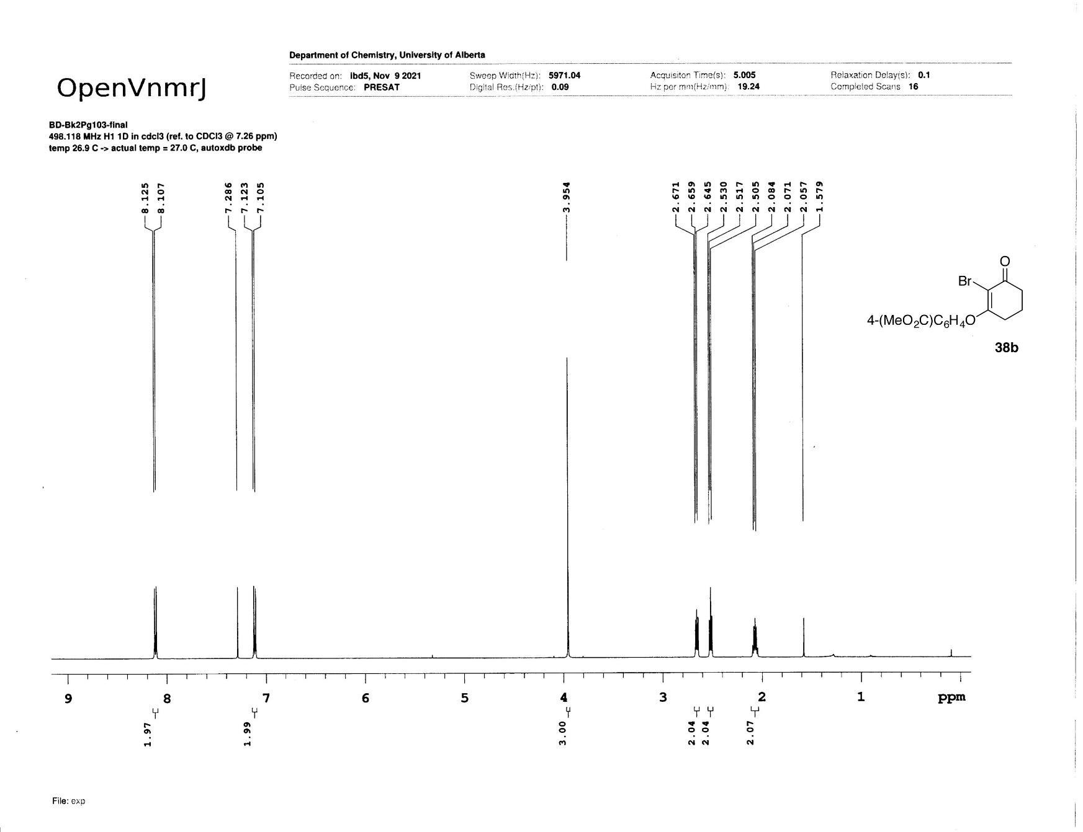
4g
Figure A31 ¹H NMR spectrum of methyl 4-[(2-bromo-3-oxocyclohex-1-en-1-yl)oxy]benzoate (4g).
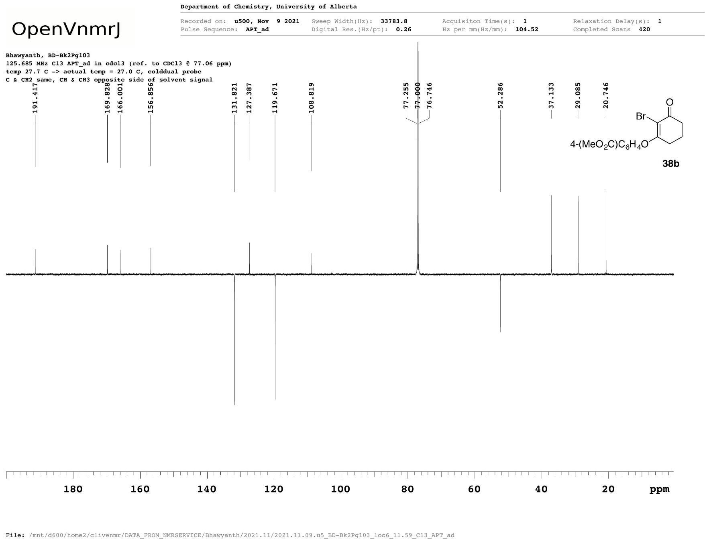
4g
Figure A32 ¹³C{¹H} NMR spectrum of methyl 4-[(2-bromo-3-oxocyclohex-1-en-1-yl)oxy]benzoate (4g).
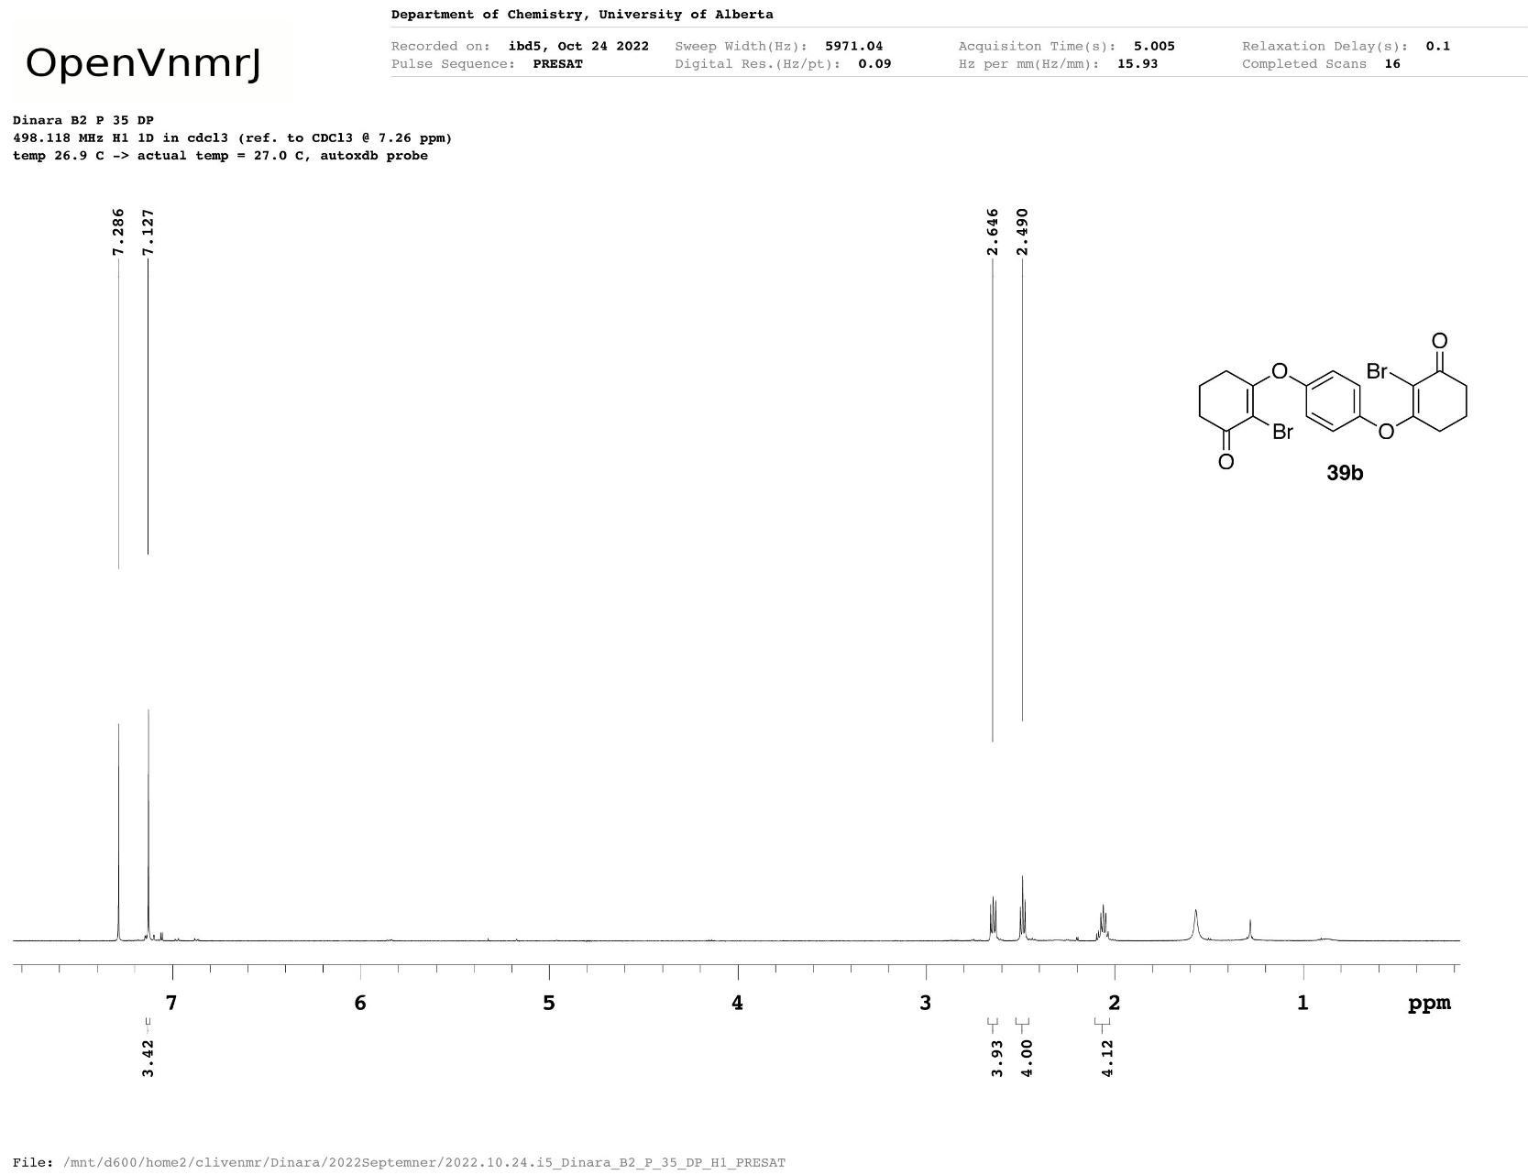
4h
Figure A33 ¹H NMR spectrum of 2-bromo-3-{4-[(2-bromo-3-oxocyclohex-1-en-1-yl)oxy]phenoxy} cyclohex-2-ene-1-one.
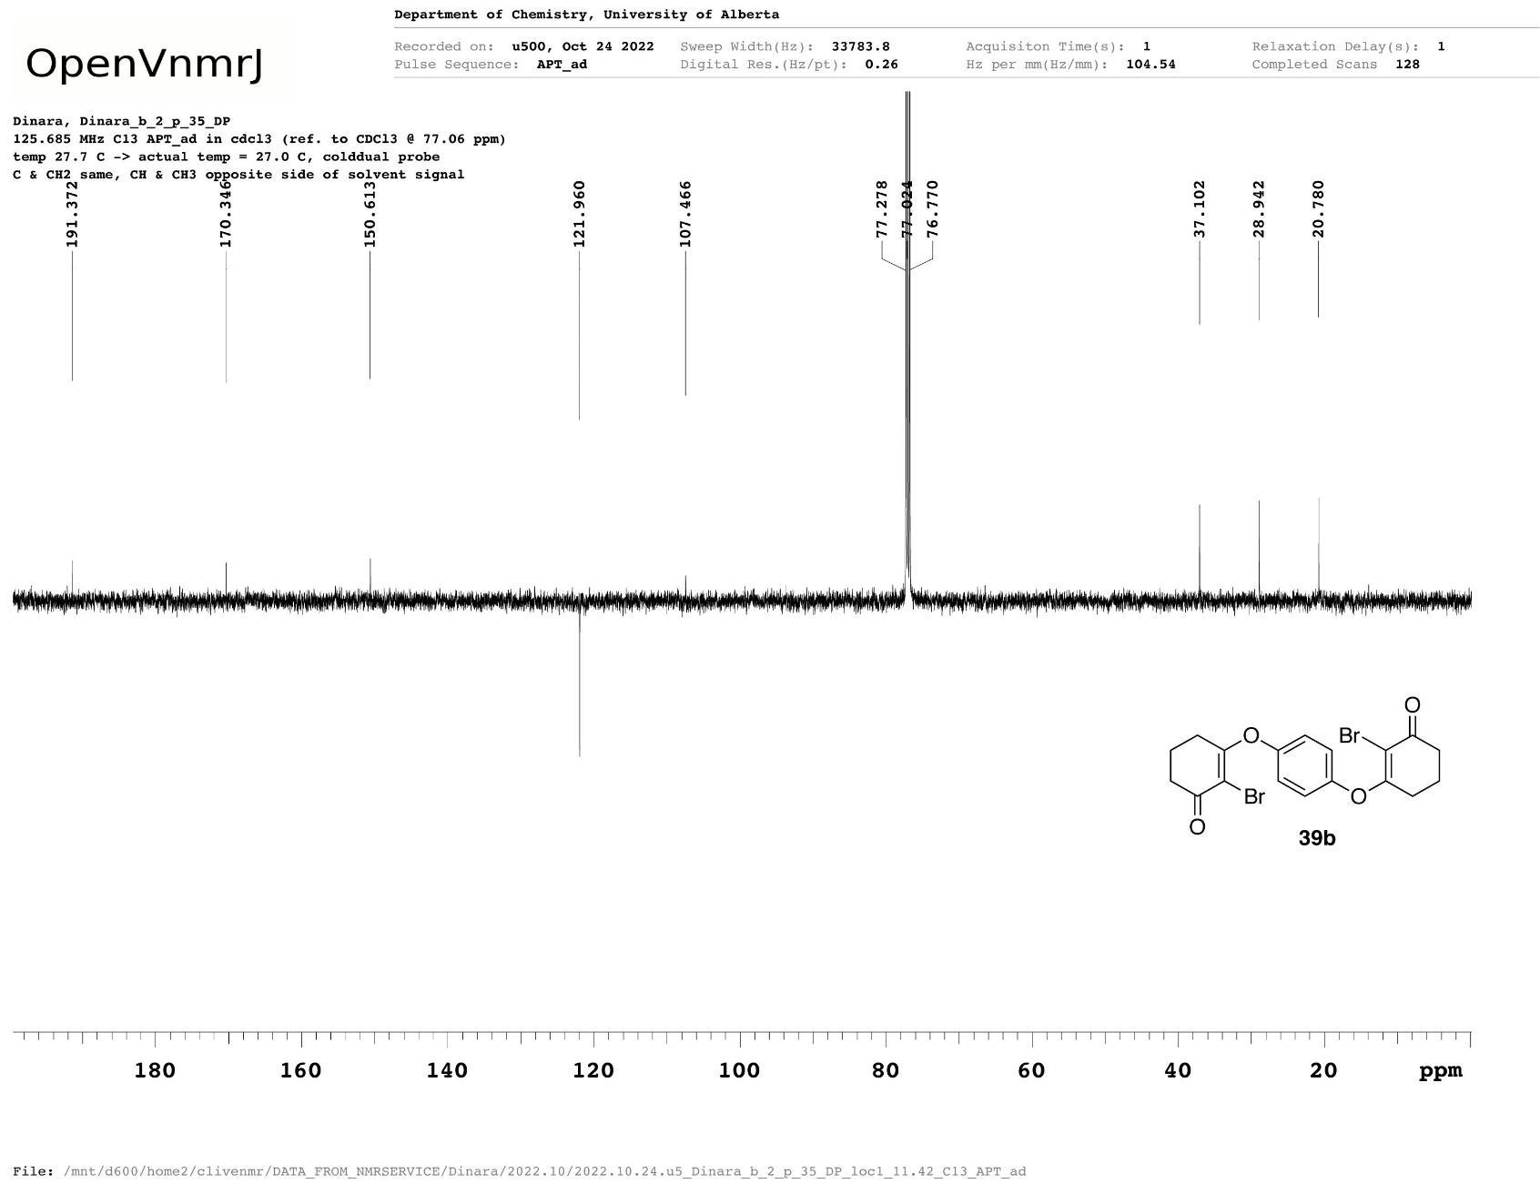
4h
Figure A34 ¹³C{¹H} NMR spectrum of 2-bromo-3-{4-[(2-bromo-3-oxocyclohex-1-en-1-yl)oxy]phenoxy} cyclohex-2-ene-1-one (4h).
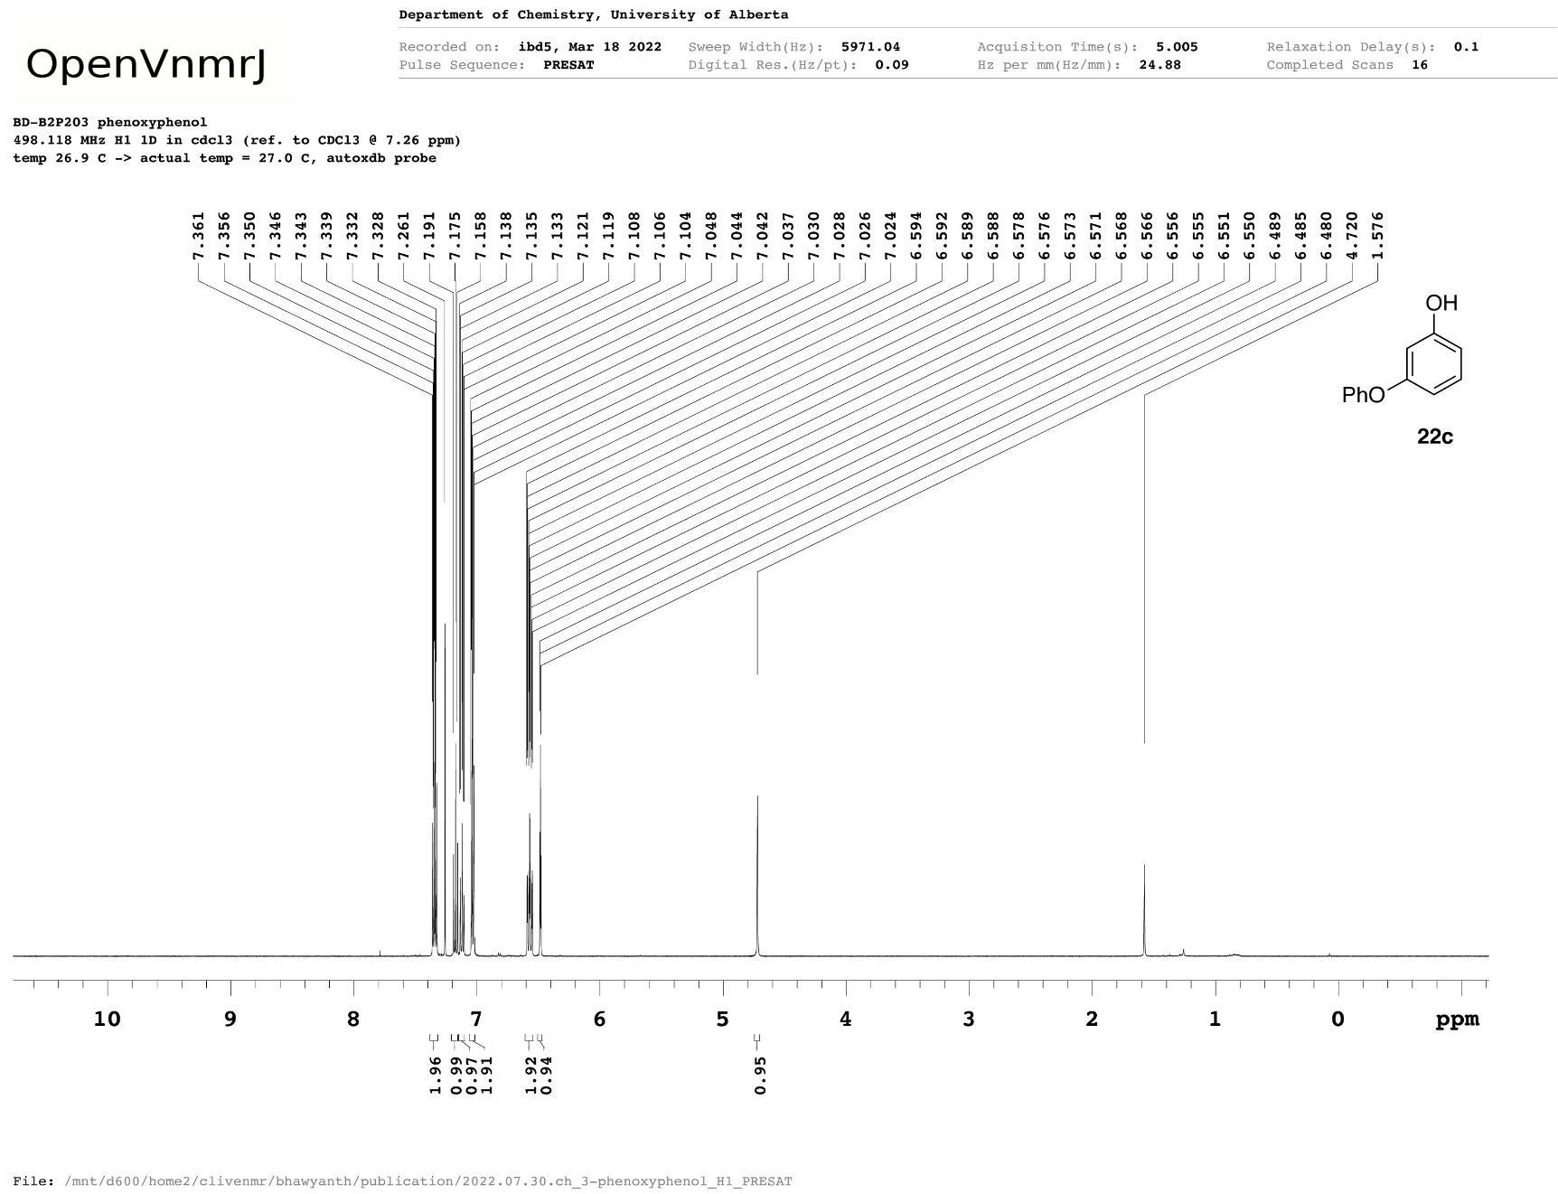
5a
Figure A35 ¹H NMR spectrum of meta-(phenoxy)phenol (5a).
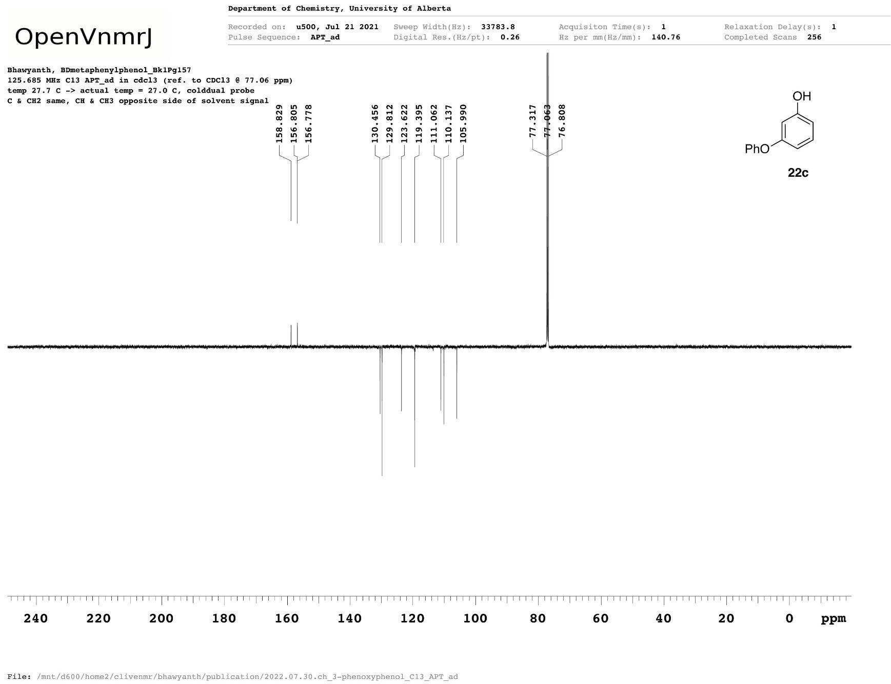
5a
Figure A36 ¹³C{¹H} NMR spectrum of meta-(phenoxy)phenol (5a).
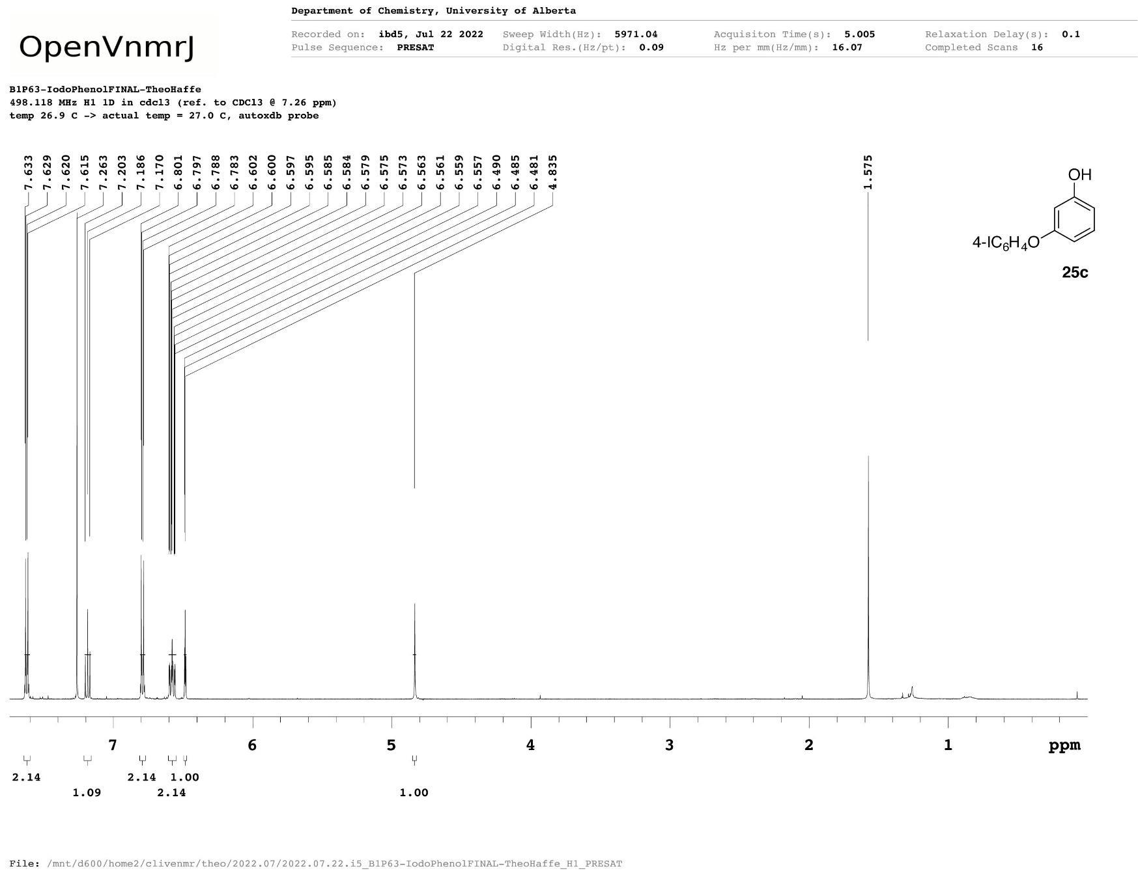
5b
Figure A37 ¹H NMR spectrum of 3-(4-iodophenoxy)phenol (5b).
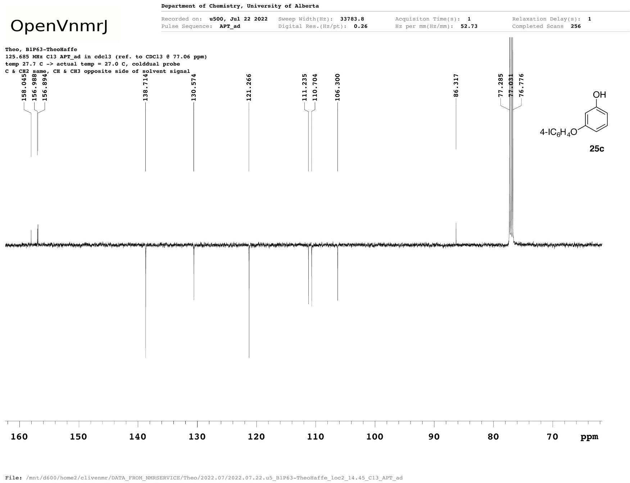
5b
Figure A38 ¹³C{¹H} NMR spectrum of 3-(4-iodophenoxy)phenol (5b).
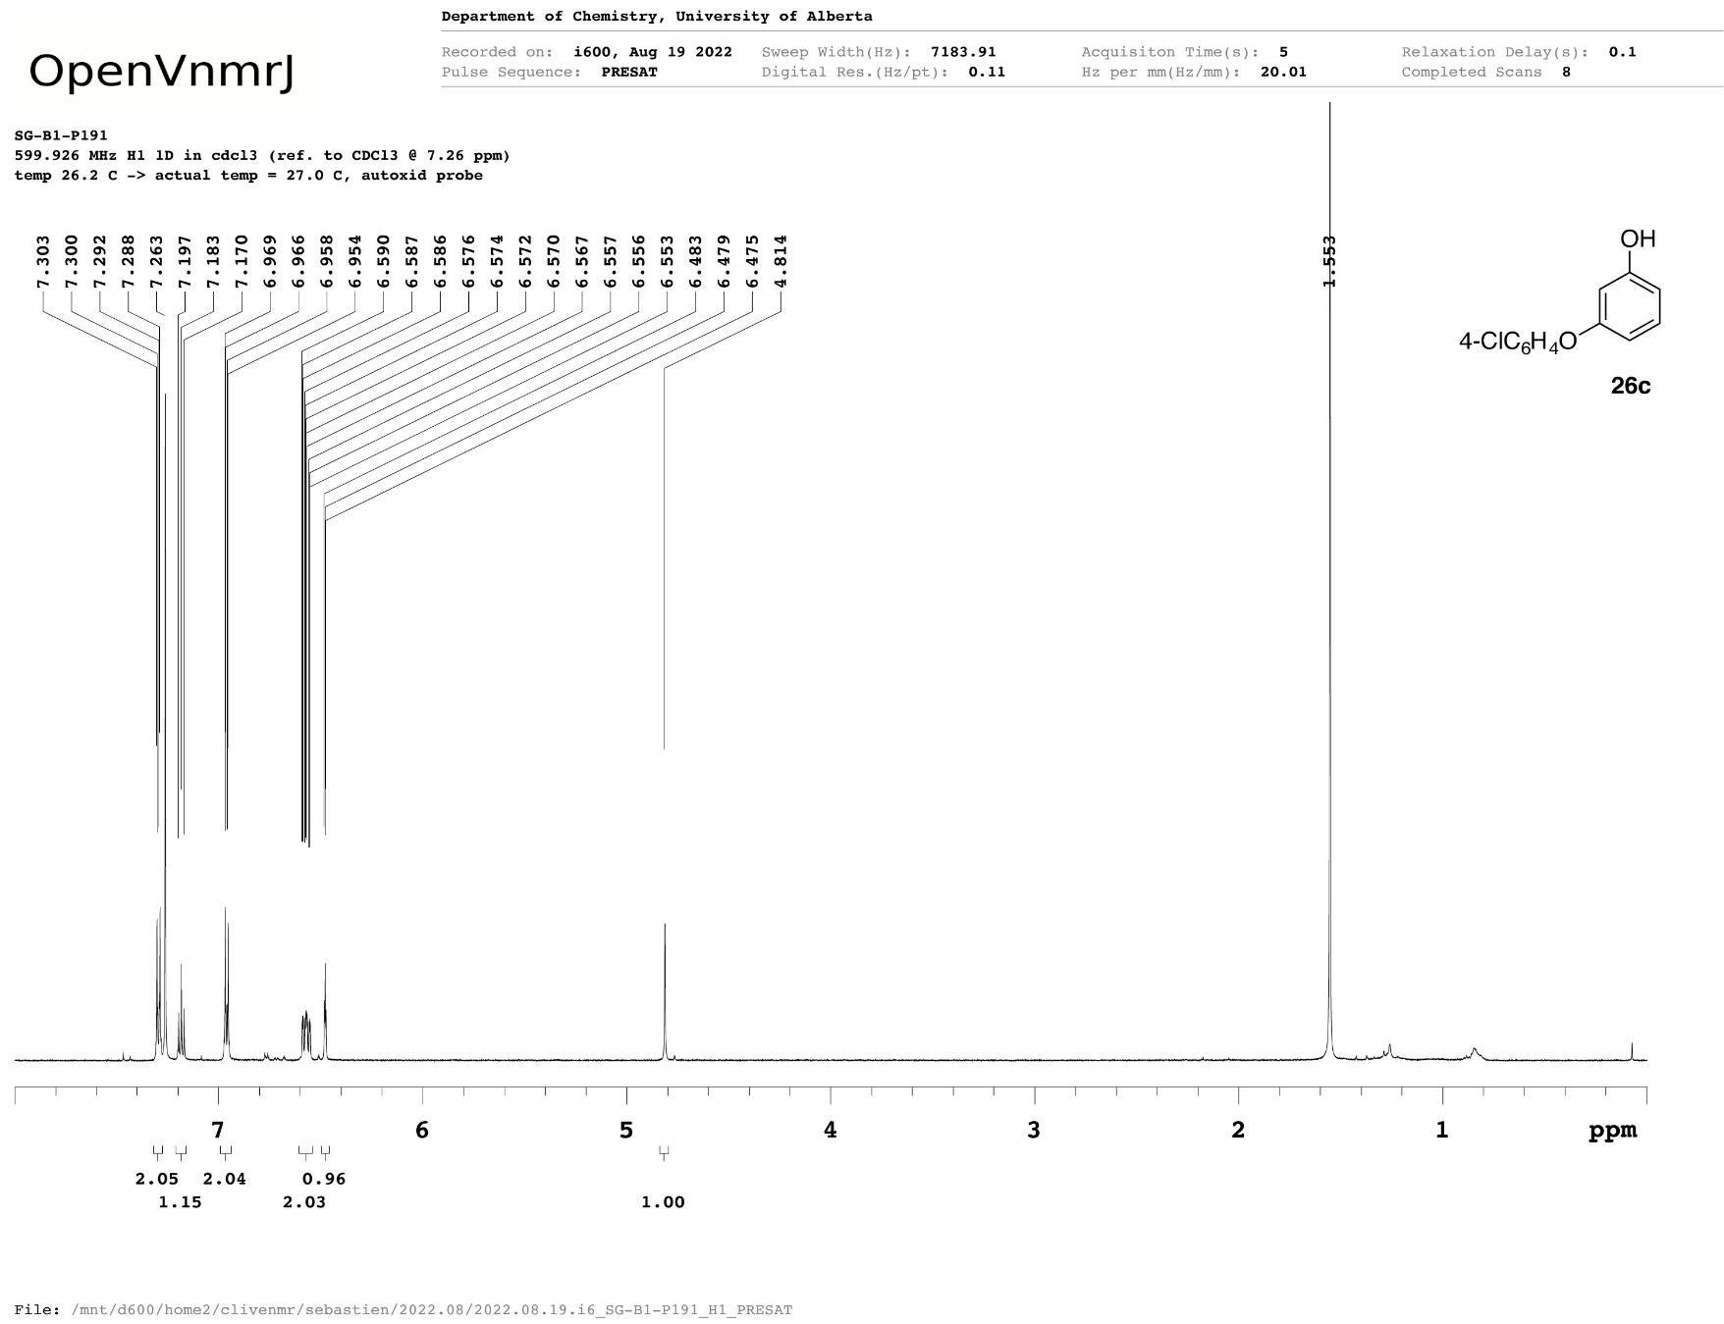
5c
Figure A39 ¹H NMR spectrum of 3-(4-chlorophenoxy)phenol (5c).
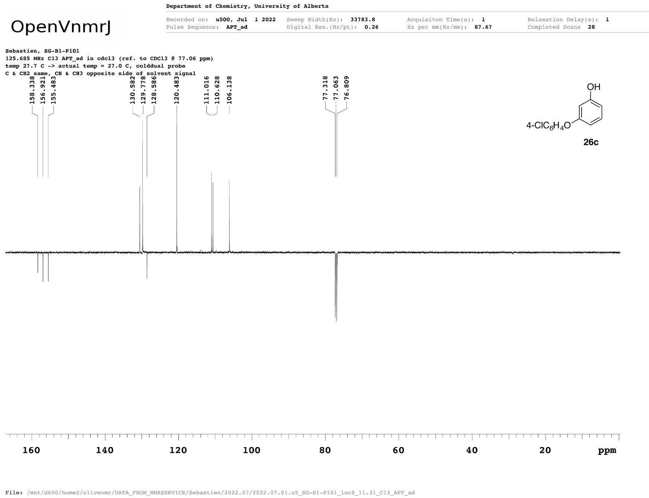
5c
Figure A40 ¹³C{¹H} NMR spectrum of 3-(4-chlorophenoxy)phenol (5c).
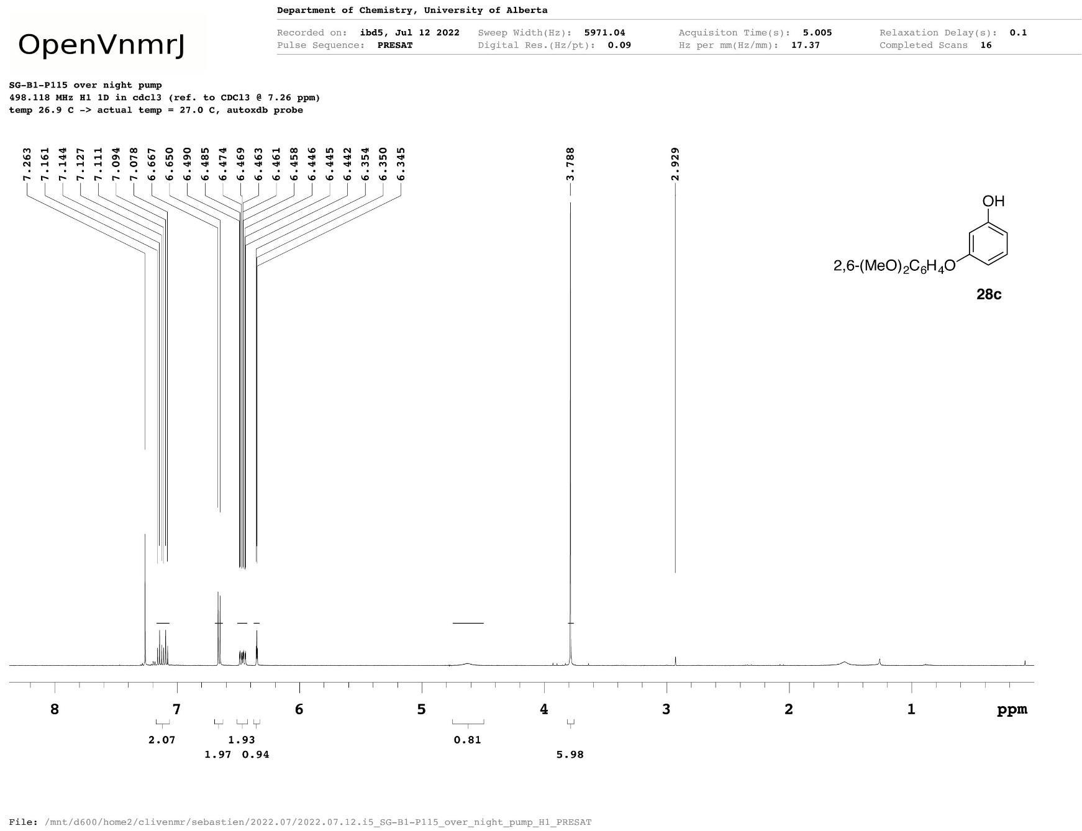
5d
Figure A41 ¹H NMR spectrum of 3-(2,6-dimethoxyphenoxy)phenol (5d).
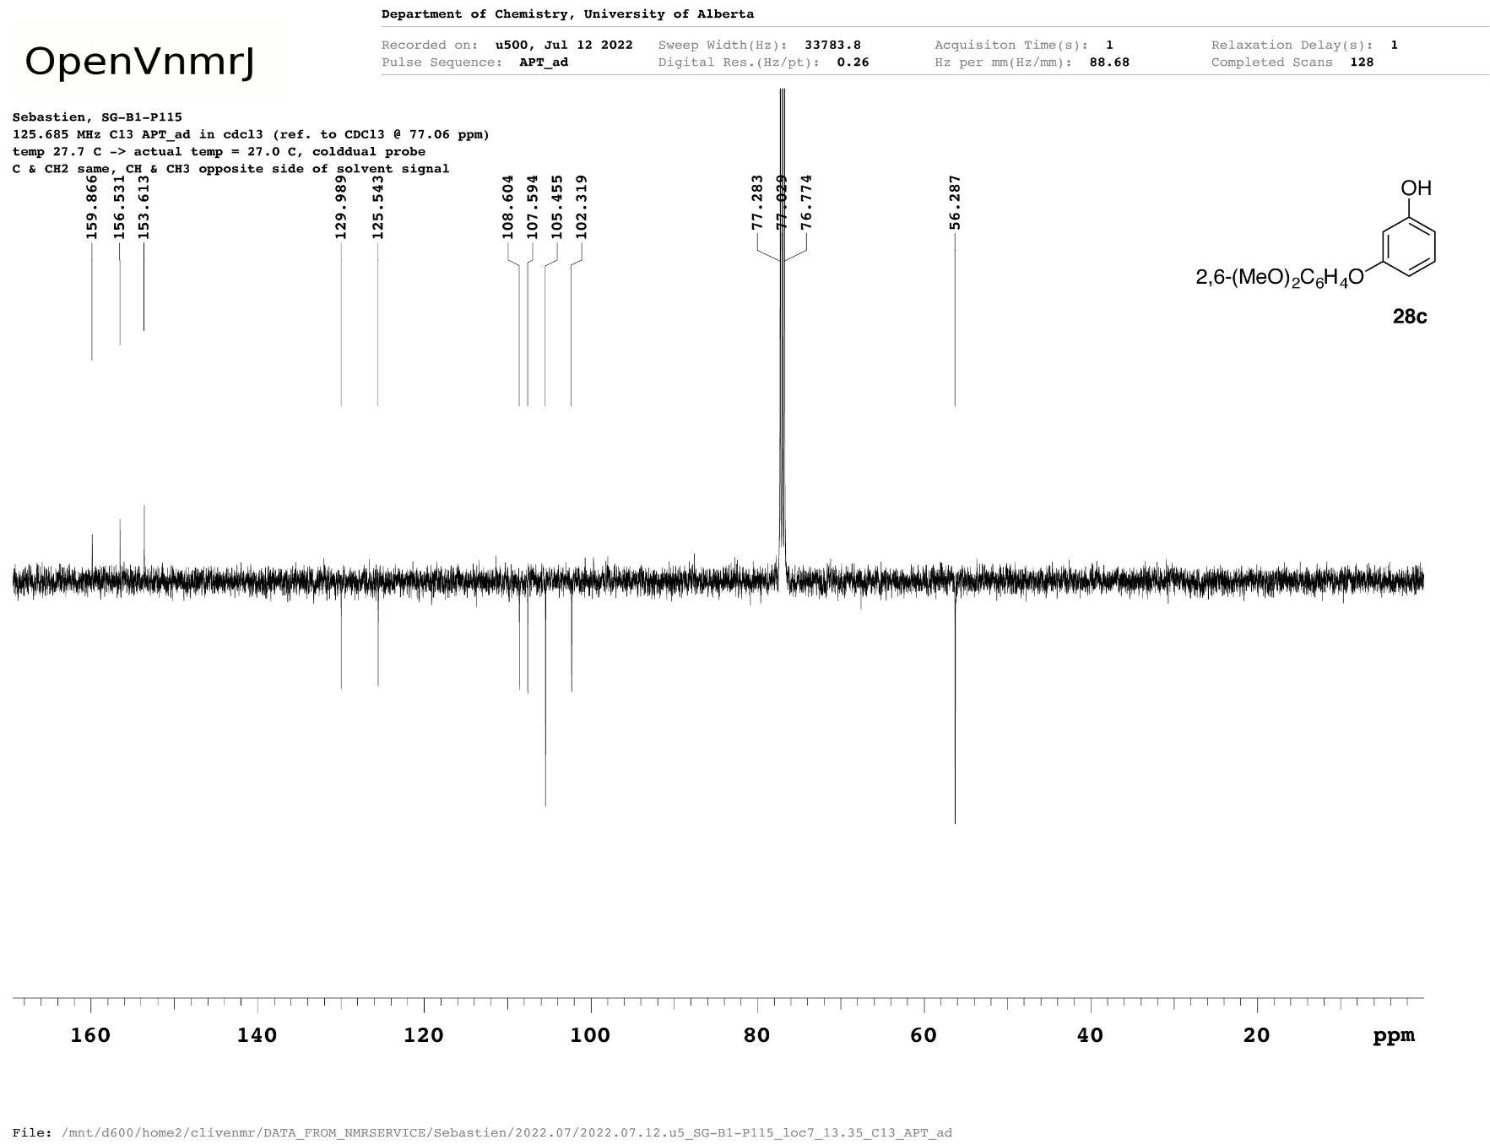
5d
Figure A42 ¹³C{¹H} NMR spectrum of 3-(2,6-dimethoxyphenoxy)phenol (5d).
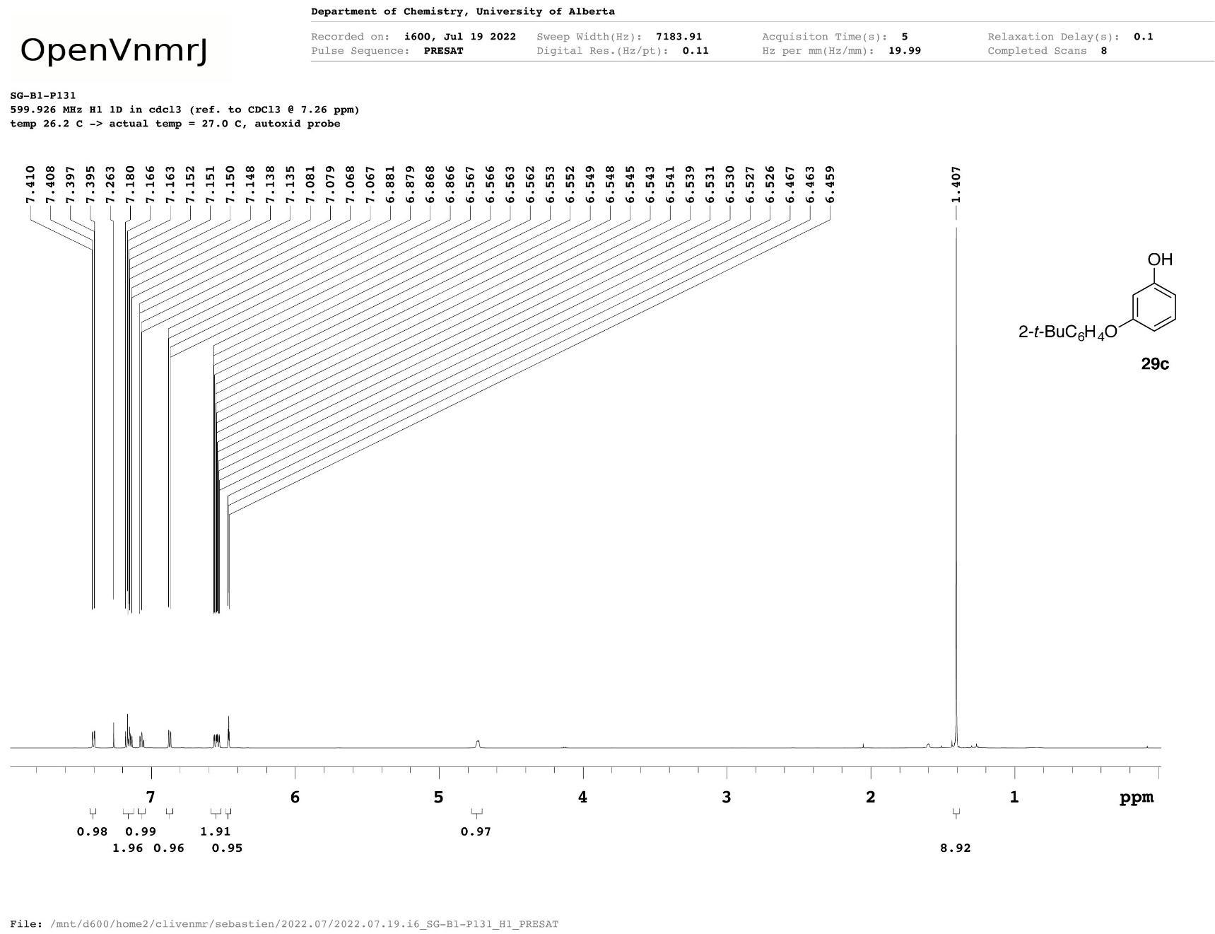
5e
Figure A43 ¹H NMR spectrum of 3-(2-tert-butylphenoxy)phenol (5e).
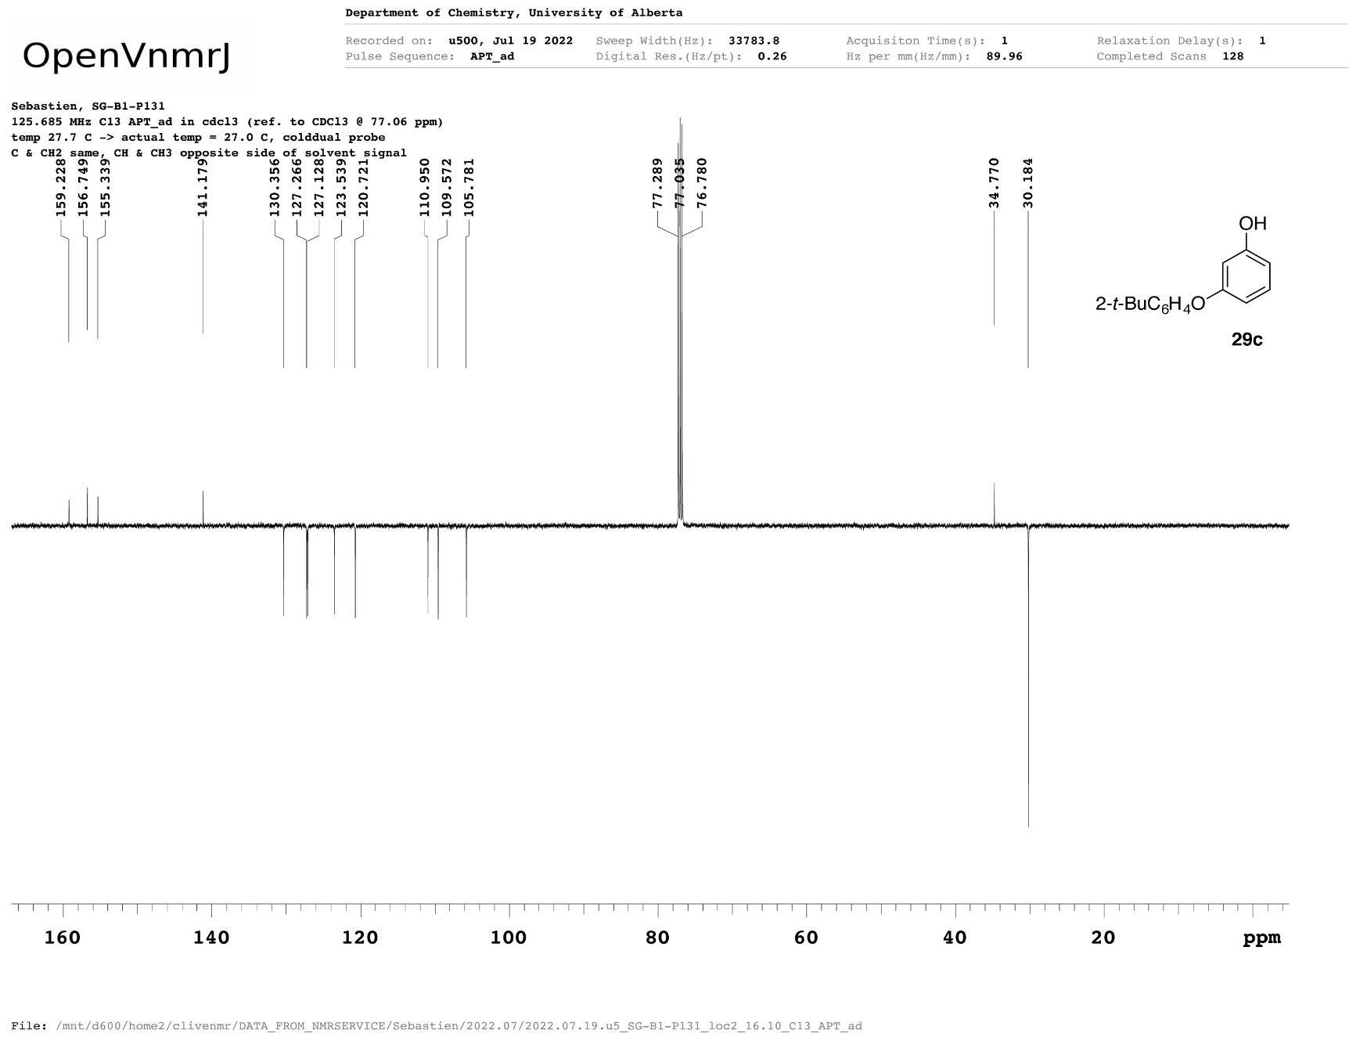
5e
Figure A44 ¹³C{¹H} NMR spectrum of 3-(2-tert-butylphenoxy)phenol (5e).
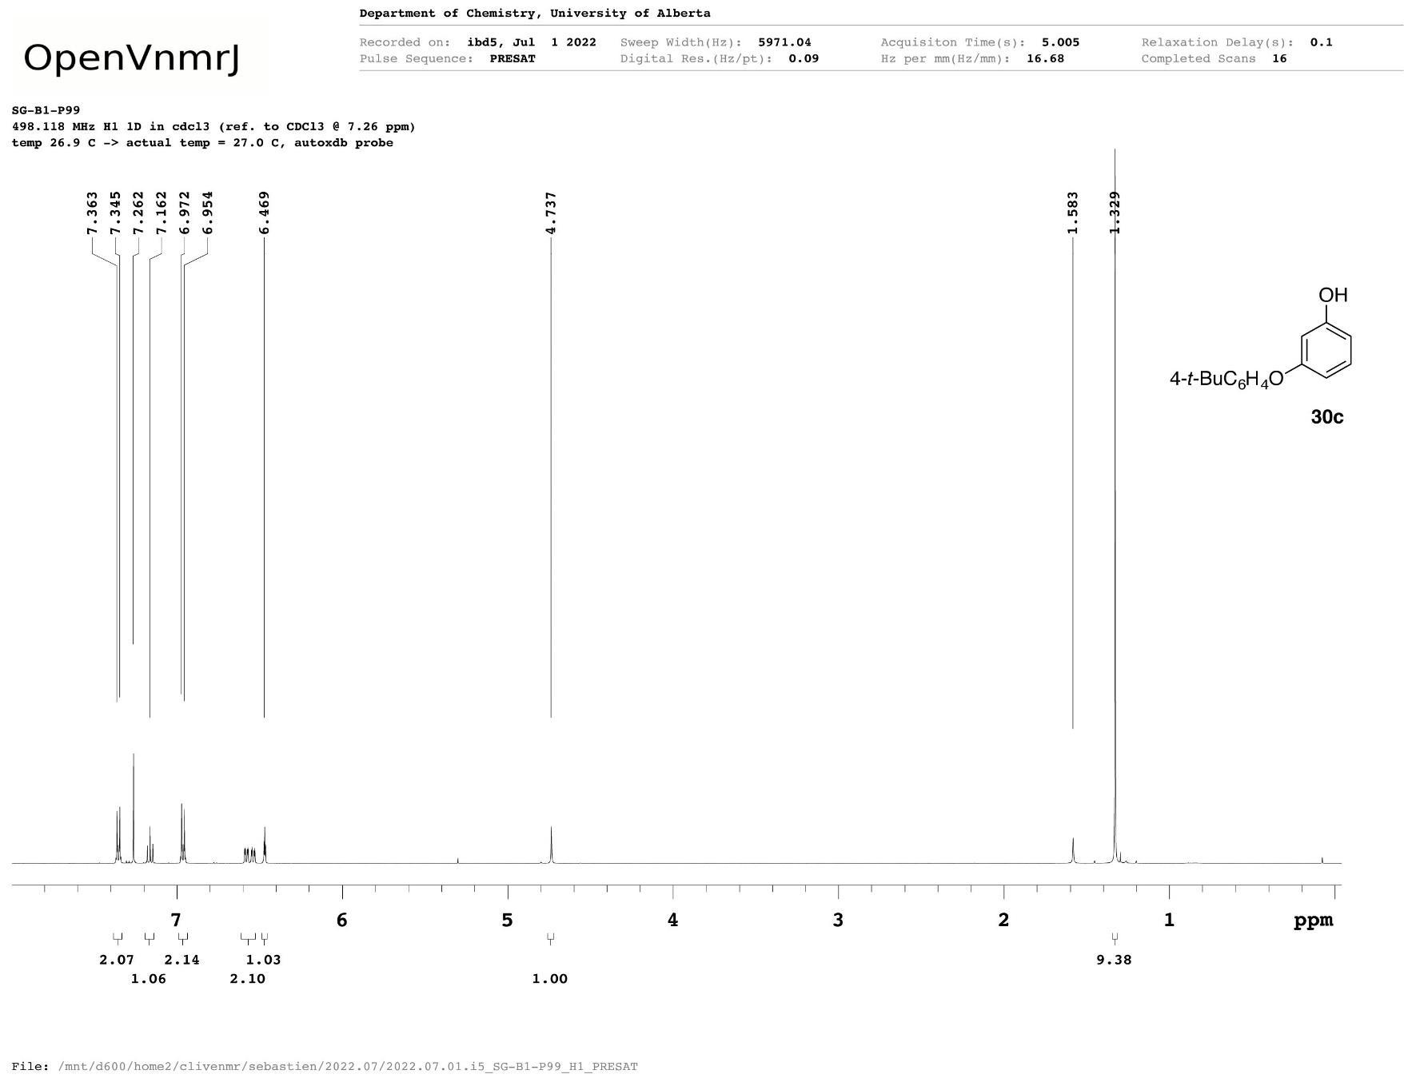
5f
Figure A45 ¹H NMR spectrum of 3-(4-tert-butylphenoxy)phenol (5f).
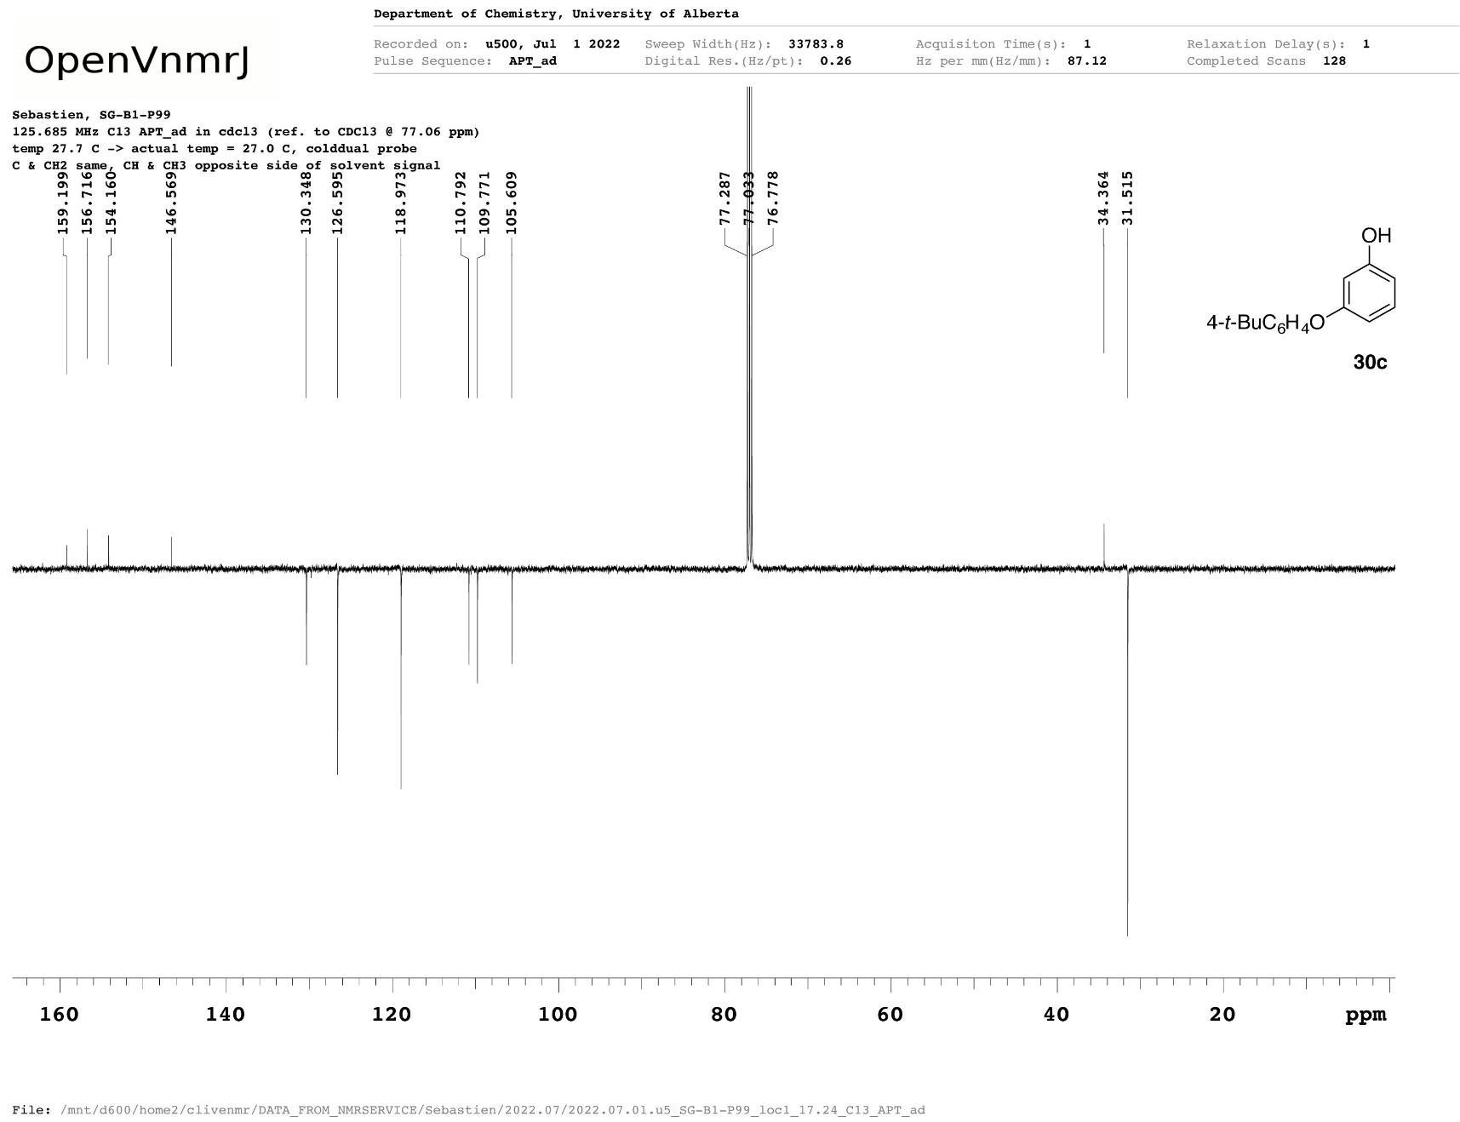
5f
Figure A46 ¹³C{¹H} NMR spectrum of 3-(4-tert-butylphenoxy)phenol (5f).
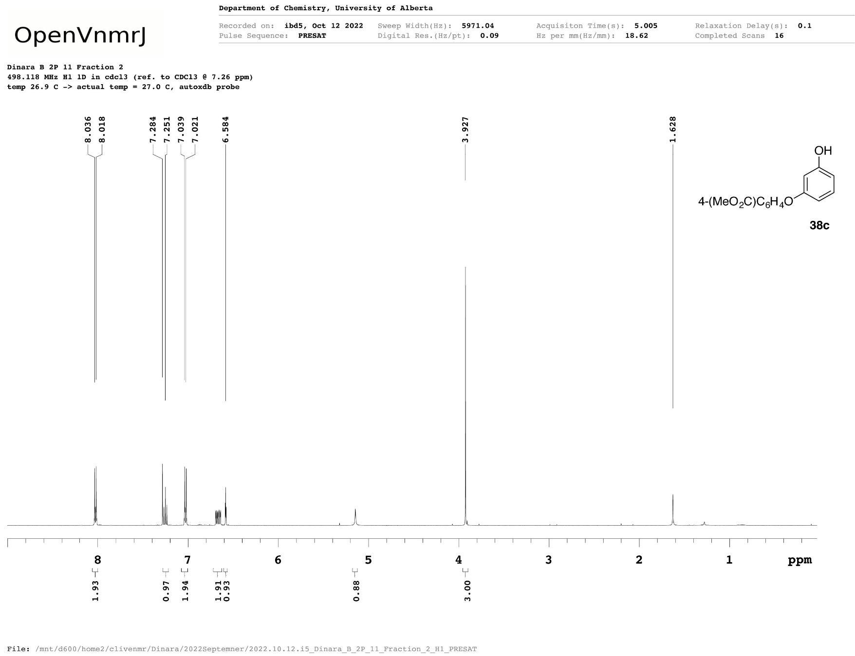
5g
Figure A47 ¹H NMR spectrum of methyl 4-[(2-bromo-3-oxocyclohex-1-en-1-yl)oxy]benzoate (5g).
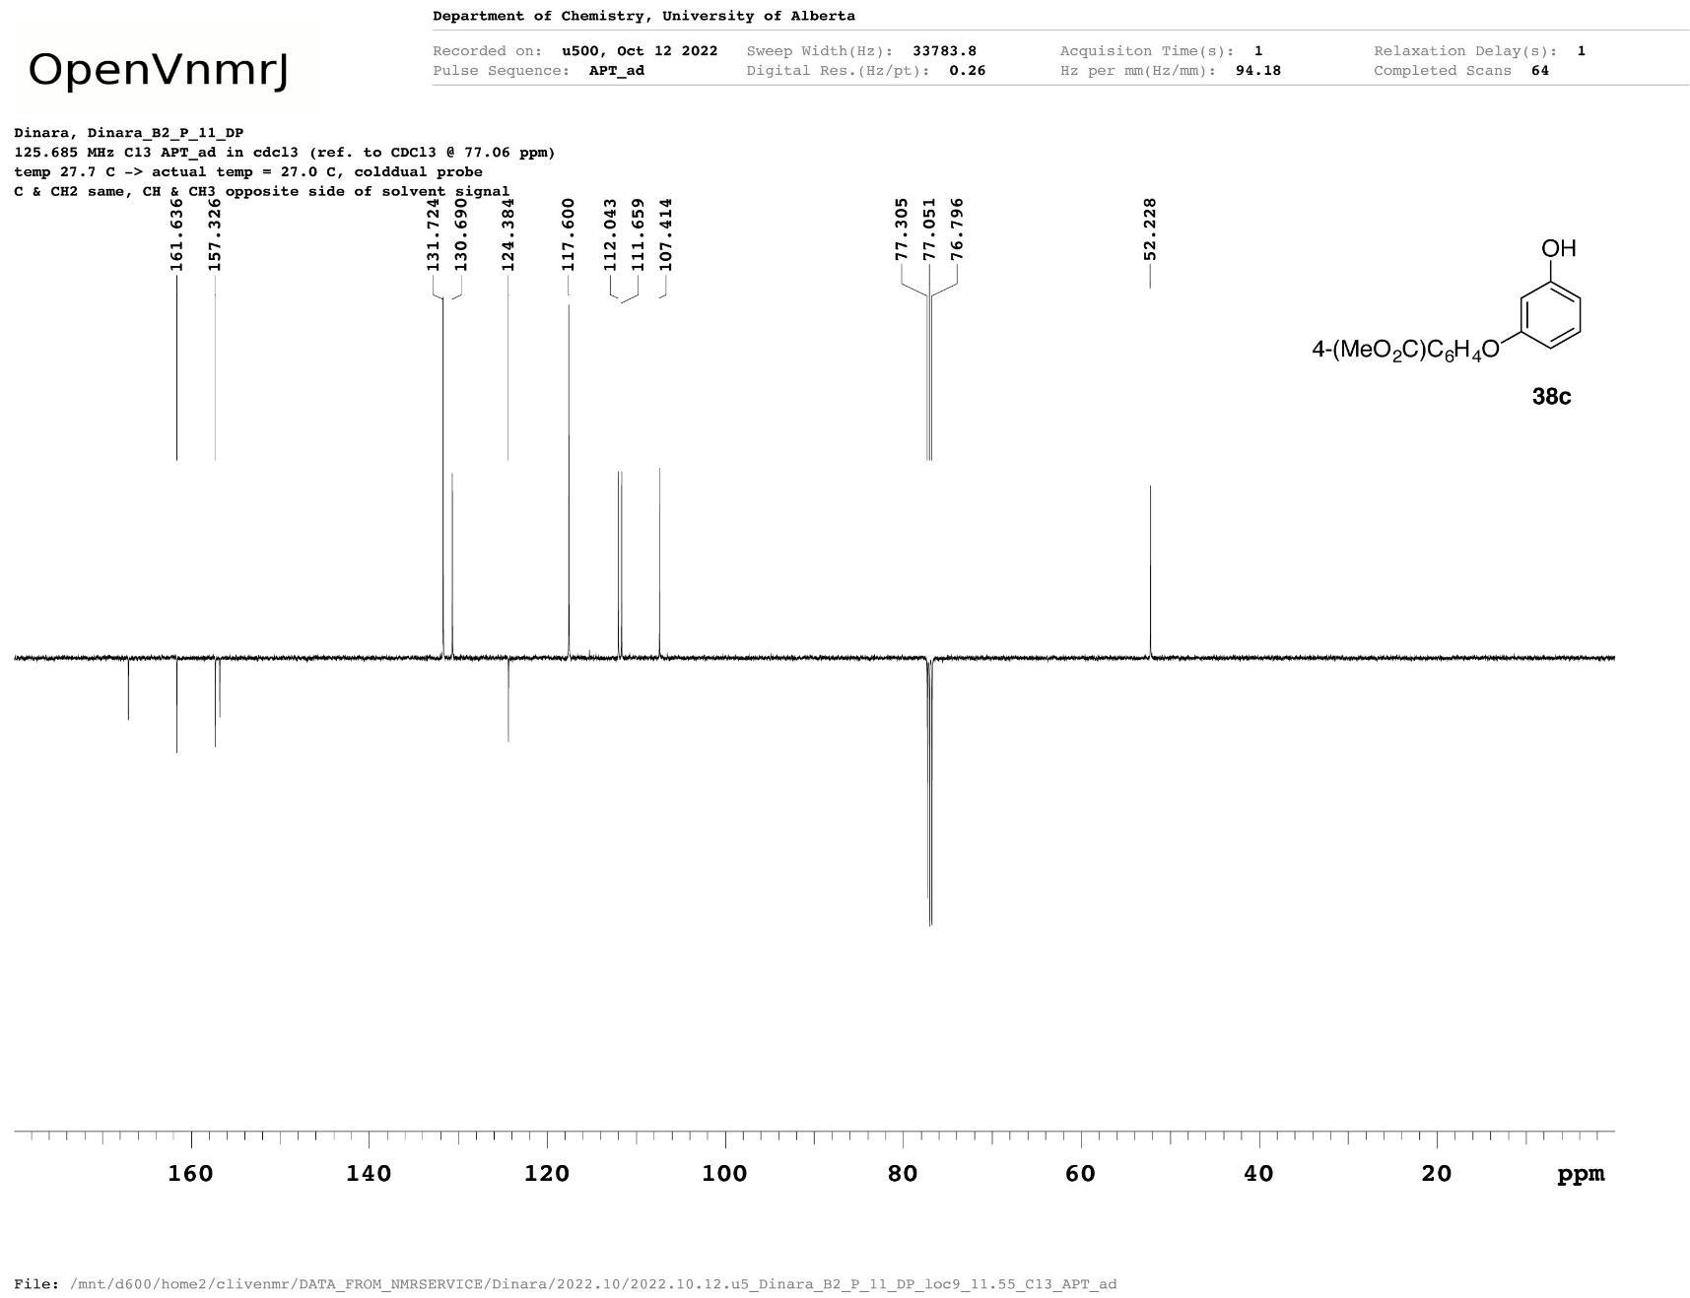
5g
Figure A48 ¹³C{¹H} NMR spectrum of methyl 4-[(2-bromo-3-oxocyclohex-1-en-1-yl)oxy]benzoate (5g).
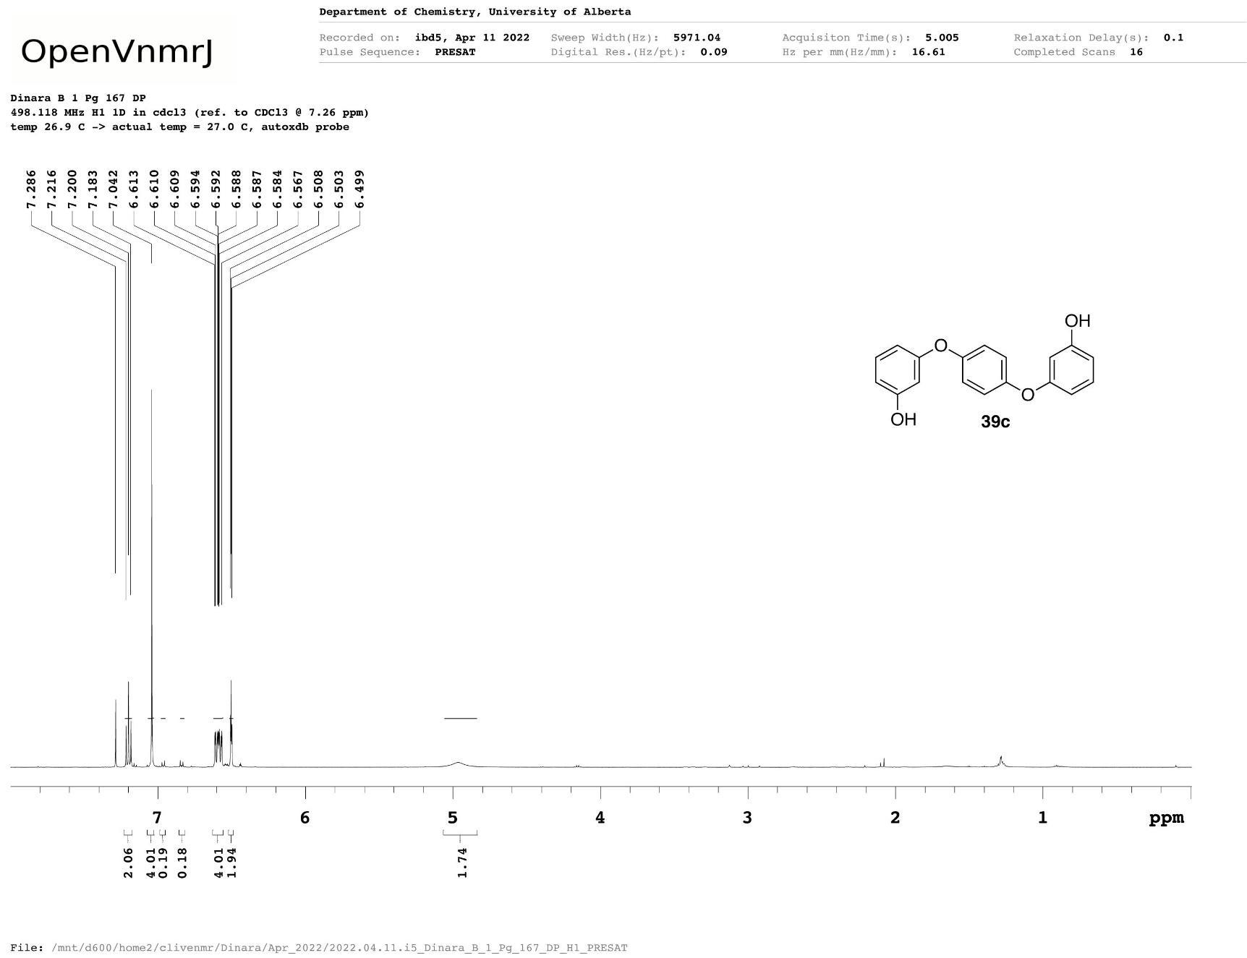
5h
Figure A49 ¹H NMR spectrum of 3-[4-(3-hydroxyphenoxy)phenoxy]phenol (5h).
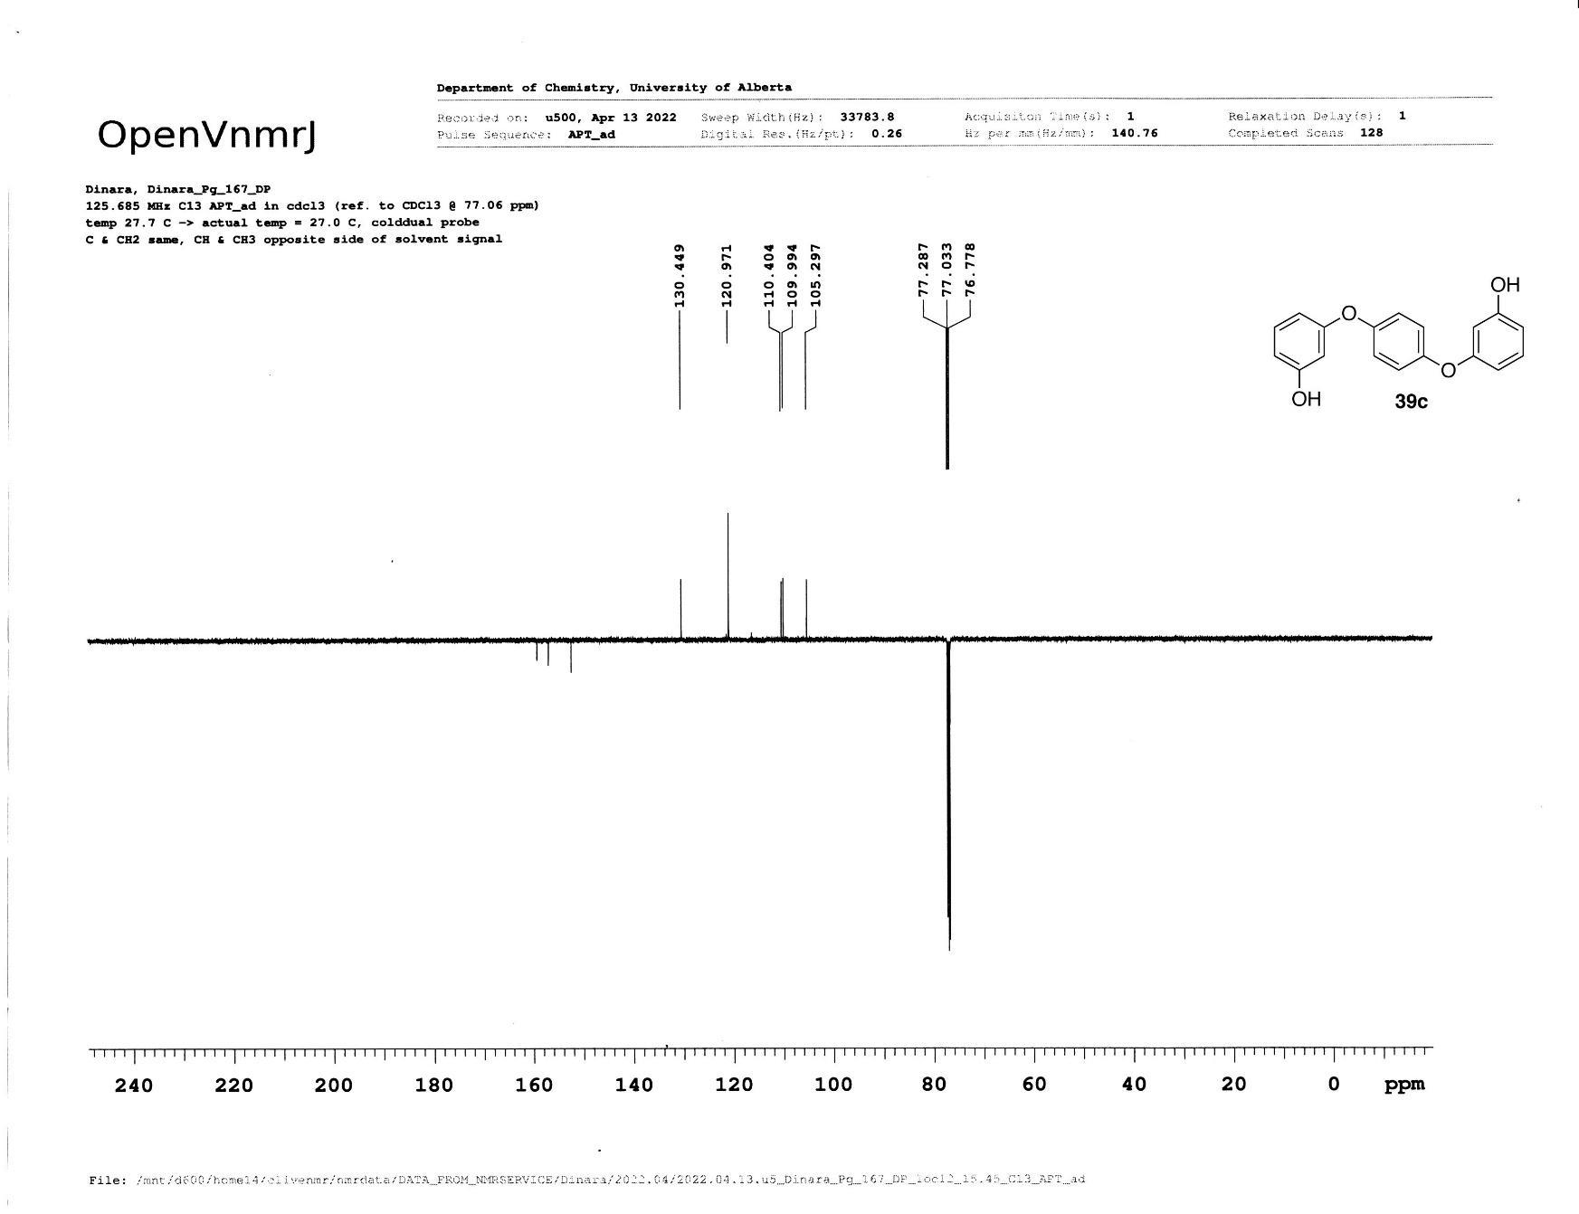
5h
Figure A50 ¹³C{¹H} NMR spectrum of 3-[4-(3-hydroxyphenoxy)phenoxy]phenol (5h)

