JSС «INTERNATIONAL INFORMATION TECHNOLOGY UNIVERSITY»

UDC: 004.89 on manuscript right

ALTAYEVA AIGERIM BAKATAKALIEVNA

MODELS AND METHODS OF DEVELOPING A SMART ENERGY SYSTEM BASED ON MULTI-AGENT TECHNOLOGIES

THESIS

Presented for the Degree of Doctor of Science in Information System
(Degree code 6D070300) Department of Information System

Supervisor:
Doctor of Technical Sciences,
Professor Uskenbayeva R.K.

External supervisor:
Phd, Professor Azizah Suliman

The Republic of Kazakhstan
Almaty, 2021

CONTENT

REGULATORY REFERENCES………………………………………………  LIST OF ABBREVIATIONS…………………………………………………..  INTRODUCTION……………………………………………………………  1 MULTIAGENT TECNOLOGIES……………………………………. |  | 5
 |  | 6
 |  | 8
 |  | 12
1.1 | Development the Smart Energy System Based on Multiagent Solutions for Managing Energy Consumption and Building Comfort…………….. | 12
1.2 | Terminology and Agent Properties……………………………………… | 13
1.3 | Multi-agent systems development tools. FIPA Specifications………….. | 14
1.4 | Multi-Agent System Architecture………………………………………. | 15
2 COMFORTABLE MICROCLIMATES………..……………………. |  | 16
2.1 | Energy saving potential in residential, public and administrative buildings………………………………………………………………… | 16
2.2 | Methods for evaluating the effectiveness of energy-saving measures….. | 17
2.3 | The relevance of the problem of ensuring a comfortable temperature….. | 17
2.4 | The relevance of the comfort humidity problem………………………... | 18
2.5 | The relevance of air quality issues……………………………………… | 19
2.6 | Activities to ensure an optimum and acceptable microclimate…………. | 22
2.7 | Temperature and air velocity, humidity………………………………… | 22
3 INTERNATIONAL STANDARDS FOR COMFORTABLE  MICROCLIMATE IN BUILDING………..…………………………. |  | 27
3.1 | Standards for air quality………………………………………………… | 27
3.2 | CEN Building Ventilation Standards…………………………………… | 28
3.3 | Methods for calculating ventilation needs……………………………… | 28
3.3.1 | Regulatory Approach…………………………………………………… | 28
3.4 | Ashree Standards……………………………………………………….. | 29
3.5 | European standards……………………………………………………… | 31
3.6 | Comparative analysis……………………………………………………. | 32
4 MULTI-AGENT-BASED SMART GRID (MASG) SYSTEM  IMPLEMENTATION FOR BUILDING ENERGY  MANAGEMENT………………………………………………………. |  | 35
4.1 | Agent based systems…………………………………………………….. | 35
4.2 | Architecture of the System………………………………………………. | 36
4.3 | State Switch Agent………………………………………………………. | 39
4.4 | Central Coordinator Agent………………………………………………. | 40
4.4.1 | Negotiation among Agent……………………………………………….. | 40
4.4.2 | Optimization Problem…………………………………………………… | 41
4.5 | Local Climate Controllers……………………………………………….. | 44
4.5.1 | Local Temperature Controllers………………………………………….. | 45
4.5.2 | Local Humidity Controller………………………………………………. | 48
4.5.3 | Local Air Quality Controller…………………………………………….. | 49
4.5.4 | Local Power Management Agent………………………………………... | 49
4.6 | Load Agent……………………………………………………………… | 49
5 MAINTAINING INDOOR ENVIRONMENT MICROCLIMATE  BASED ON FUZZY LOGIC MODEL………………………………... |  | 50
5.1 | Maintaining Indoor Environment Microclimate based on Fuzzy Logic Model…………………………………………………………………… | 50
5.2 | Fuzzy Logic Based Control Process……………………………………. | 54
5.3 | Solving the fuzzification problem……………………………………… | 55
5.4 | System for monitoring the microclimate in the room based on the  use of Fuzzy Logic……………………………………………………… | 56
5.5 | Calculation of Comfort Microclimate parameters for all comfort  Levels…………………………………………………………………… | 57
6 MAINTAINING INDOOR MICROCLIMATE CONTROL BASED  ON PID………………………………………………………………….. |  | 60
6.1 | Mathematical Model…………………………………………………….. | 60
6.1.1 | Mathematical Model of the Indoor Air Temperature……………………. | 60
6.1.2 | Mathematical Model for Calculating Humidity………………………….. | 62
6.1.3 | Dynamic control valve model………………………………………….. | 62
6.1.4 | Mathematical model of temperature and humidity control………………. | 63
6.2 | Design of PID controller…………………………………………………. | 63
6.3 | Fuzzy Block Design……………………………………………………… | 63
6.4 | Design of Adaptive Neuro-PID Controller for Humidity………………... | 70
6.5 | RBF Network Structure………………………………………………….. | 70
6.6 | Control Methodology…………………………………………………….. | 71
6.7 | The RBFNN-PID controller……………………………………………... | 73
7 EXPERIMENT RESULTS AND DISCUSSION…………..………… |  | 76
7.1 | Results.......................................................................................................... | 76
7.2 | Simulation Results………………………………………………………. | 76
7.3 | Case Study of PID Controller…………………………………………… | 81
7.3.1 | Simulation of fuzzy-PID Controller…………………………………….. | 81
7.3.2 | Simulation Tests of RBFNN-PID Control………………………………. | 84
7.4 | Experiment Results……………………………………………………… | 86
7.4.1 | Temperature Control……………………………………………………. | 86
7.4.2 | Relative Humidity………………………………………………………. | 90
CONCLUSION……………………………………………………………........  ReFERENCES………………………………………………………………...  APPENDIX A - Implementation act…………………………………………….. |  | 94
 |  | 96
 |  | 106

REGULATORY REFERENCES

This dissertation uses references to the following standards:
State educational standard of the Republic of Kazakhstan 5.04.034. – 2011 "State mandatory standard of education of the Republic of Kazakhstan. Postgraduate education. Doctoral studies". The main arrangements had been made approved by the minister of education and science of the Republic of Kazakhstan. June 17, 2011 No. 261. Astana, 2011.
Instructions for the design of dissertations and abstracts, Ministry of education and science of the Republic of Kazakhstan, Higher Levels of Attestation committee, Almaty, 2004.
Place 7.1-2003. bibliographic records.
MS 7.32-2001-report on research work. Structure and rules of registration.
ST RK ISO 14001-2006-Environmental Management Systems. Requirements and instructions for use.
ST RK 1.48-2005-system of State technical regulation of the Republic of Kazakhstan. Procedure for making changes to the standards.

LIST OF ABBREVIATIONS

ANN | Artificail Neural Network
AI | Artificial Intelligence
NN | Neural Network
BPNN | Back Propagation Neural Network
RBFNN | Radial Based Function Neural Network
RBNN | Radial Based Neural Network
MAS | MultiAgent System
BEMS | Building Energy Management System
CEuS | California Commercial End-use Survey
IAQP | Indoor Air Quality
NVP | Natural Ventilation
ITCM | Individual Thermal Comfort Model
MaSG | Multi-agent-based Smart Grid
CL | Comfort Level
AP | Agent Platform
OOP | Object-Oriented Programming
BDI | Belief-Desire-Intention
AMS | Agent Management System
ACL | Agent Communaication Language
LC | Least Constrained
AIDs | Agent Identifiers
ACC | Agent Communication Channel
AMP | Agent Meeting Place
RMA | Remote Management Agent
CORBA | Common Object Request Broker Architecture
OMG | Object Management Group
ITCM | Individual Thermal Comfort Model
ANFIS | Adaptive System of Neuro-Fuzzy Inference
FL | Fuzzy Logic
LPD | Large Positive Deviation
APD | Average Positive Deviation
SPD | Small Positive Deviation
Z | Zero Deviation
SND | Small Negative Deviation
AND | Average Negative Deviation
LND | Large Negative Deviation
PEM | Prediction Error Methods
SISO | Single Input Single Output
MIMO | Multiple Input Multiple Output
DBS | Discomfortable Building Syndrome
MTS | Message Transport Service
DF | Directory Facilitator
FAL | Fuels and Lubricants;
NG | Natural Gas
VAV | Variable Air Flow Ventilation

INTRODUCTION

Relevance of the research topic. Energy conservation and energy efficiency are an important component in energy security. Currently, more than a third of the final energy consumption is accounted for by the housing and communal complex and the service sector. The increase in energy consumption due to an increase in the population and an increase in the number of people working in the non-production sector, this trend will continue. in the quality of life of people. Considering the structure of energy consumption by non-production facilities and the cost of various types of energy resources, as well as the tightening of standards in the field of thermal protection of buildings, the most common and investment-attractive energy-saving measures are measures aimed at reducing the consumption of thermal energy. Sealing buildings with natural ventilation leads to a decrease in the air exchange of the premises, which worsens the microclimate and reduces the human performance. Prolonged exposure to unfavorable factors of the indoor environment on the human body can negatively affect his health. Therefore, the development of a new method for assessing the effectiveness of energy-saving measures, taking into account both the economic indicators of the energy-saving project and the comfort of the microclimate in residential, public and administrative buildings, is an urgent task.
The beginning of the development of specialized expert systems and artificial neural networks was the appeal of the electric power industry to the field of artificial intelligence.
In modern conditions, for the functioning and management of electric power systems, it is necessary to create a calculation model for large-dimensional schemes based on state assessment methods. Such schemes are not fully observable, data distortion, poor synchronization and, as a consequence, the adoption of incorrect decisions formed in the grounds of the calculation model are possible. The next step in this direction was Hybrid technology based on technology: Grid systems, multi-agent technologies and neural networks. From the transition to intelligent networks (Smart Grid) is expected to flow information following the flow of energy. This stream needs to be processed, interpreted and adequate actions taken. There is a need to develop new methods and software for assessing conditions that will eliminate these problems. One of the most promising approaches to the development of such kind of software systems is the multi-agent approach, where the system is modeled by a variety of interacting intelligent agents for solving problems.
Object of study. Energy saving and microclimate in non-production buildings.
Subject of study. Heat transfer processes during microclimate formation in non-production buildings.
The purpose of the thesis. Building a system based on multi-agent technology and neural networks to increase a comfortable environment.
Research objectives. To achieve the goal of the research, the following tasks solved:
- Analysis of methods for assessing effectiveness, microclimate, and method
of mathematical calculation of heat transfer processes in rooms, taking into account temperature, humidity, and air quality are all factors to consider. A mathematical model of heat exchange in buildings with natural ventilation has been developed to predict microclimate parameters.
- The architecture of an energy efficiency monitoring system and parameters
was proposed with the participation of Grid and Agent systems for managing grid, energy and HVAC.
- Agents were set that allow you to build a system based on Grid and MAS
technologies:
- State switch agent- used to select Grid
- Central Coordinator Agent - to communicate with other agents.
- Load Agent- to control various equipment from the external environment.
- Local Power Management Agent- for managing and monitoring energy
consumption
- Mathematical and software based on multi-agent in the context of technologies
of the proposed architecture.
- Performed experimental studies, debugging the developed testing and
verified.
Scientific novelty:
- Obtained data on the influence of energy-saving mechanisms on air exchange
and mathematical model of a comfortable microclimate and a SmartGrid model with the participation of multi-agent technologies have been created.
- Based on the mathematical model, the dependence of the comfort level on
standard energy-saving mechanisms aimed at reducing heat energy consumption due
to building insulation has been obtained and a comprehensive comfort criterion has
been proposed that takes into account the combined effects of HVAC parameters.
- Experimentally obtained data on the influence of energy-saving mechanisms
on air exchange and microclimate parameters
- A method for controlling temperature, humidity and air quality has been
developed.
Defense Provisions:
- The energy efficiency system built in the framework of Multi-agent, Neural
and Grid technologies to solve the problem of improving the comfortable environment in residential buildings
- A mathematical model of a comfortable microclimate in buildings with natural
ventilation for predicting microclimate parameters, taking into account the composition of the indoor air.
- Temperature, humidity, and air quality control methods were investigated.
Testing the results of research and publication
The following are the major features of the dissertation study that were presented and discussed:
1. Raissa Uskenbayeva, Aigerim Altayeva (2019), Converged citizen service IOT platform reference model for smart cities //Journal of Theoretical and Applied Information Technology 15th May 2019. Vol.97. No 9, pp 2540-2550.// IP=0.63, percentile 36%, quartile Q4;
2. Aigerim Altayeva, Batyrkhan OMAROV (2018), Design of a multiagent-based smart microgrid system for building energy and comfort management// Turkish Journal of Electrical Engineering & Computer Sciences. 2018, 26(5), стр. 2714–2725. // IP=1.12, percentile 49%, quartile Q3;
3. Raissa Uskenbayeva, Faryda Gusmanova, Gluyssya Abdulkarimova, Saule Berkimbaeva, Kuralay Dalbekova, Azizah Suiman, Akzhunis Zhanseitova, Aliya Amreyeva (2021), Indoor Air Quality Control Using Backpropagated Neural Networks // Computers, Materials and Continua// Vol.70, No.2, 2022, pp.3837-3853, doi:10.32604/cmc.2022.020491// IP=3.772, percentile 80%, quartile Q;
4. Altayeva, A., Omarov, B., Turganbayeva, A., Abdulkarimova, G. Gusmanova,
F., Sarbasova, A., Omarov, N. (2018, November). Agent Based Modeling of
Smart Grid in Smart Cities // In International Conference on Electronic Governance and
Open Society: Challenges in Eurasia (pp. 3-13). Springer, Cham;
- Altayeva A.B., Baisholanova K., Tukenova L., Abduraimova B., Nurtas
Marat, Baishemirov Z., Yessenbek 5. S., Omarov B.S. (2021), Towards Smart Building: Exploring of Indoor Microclimate Comfort Level Thermal Processes//Lecture Notes in Computer Science (including subseries Lecture Notes in Artificial Intelligence and Lecture Notes in Bioinformatics) , 2021, 12608 LNCS, pp. 59–67;
- Altayeva Aigerim, Raissa Uskenbayeva, Azizah Suliman(2020), Applying

Neuro-Fuzzy Model in Indoor Comfort Microclimate Control//2020 8th International Conference on Information Technology and Multimedia, ICIMU 2020this link is disabled, 2020, pp. 177–182;
- Altayeva Aigerim, Bakhytzhan Omarov, Akhan Demeuov, Adilbay Tastanov,
Zhakipbek Kassymbekov, Arman Koishybayev (2020), Fuzzy Controller for Indoor Air Quality Control: A Sport Complex Case Study // International Conference on Advanced Informatics for Computing Research ICAICR 2020: Advanced Informatics for Computing Research, Communications in Computer and Information Science 2021, 1393 pp 53-61;
- Altayeva Aigerim, Uskenbayeva Raissa (2019), Intelligent Microclimate Control
in Smart Building // Bulletin of Satbayev University. Series "Technical Sciences", No. 1 (131) 2019, pp.105-110;
- Altayeva Aigerim, Uskenbayeva Raissa, Omarov Batyrkhan (2019), Энергияға
Арналған Айқын Емес Логикаға Негізделген Контроллерді Жобалау //Bulletin of Satbayev University. Series "Technical Sciences", No. 1 (131) 2019, pp.110-117;
- Altayeva A., R. Uskenbayeva, A. Suliman (2020). Microclimate Control
Techniques Based Intelligent Agents) // Bulletin of Satbayev University. Series "Technical Sciences “, No 1 (137) 2020, pp.223-229;
- Altayeva A., R. Uskenbayeva (2019), Mathematical Model of Multi-Zoned
Power and Comfort Management in Residential Buildings // Bulletin of S. Toraighyrov PSU. Series “Energy", No. 1, 2019, pp.438-446;
- Altayeva A., R. Uskenbayeva (2019), Fuzzy Logic Based Controller for
Maintaining Comfort Temperature with Minimizing Energy// Bulletin of D. Serikbayev EKSTU. Series "Technical Sciences and Technologies", No. 4 (ISSN 1561-4212) 2019, pp.181-186;
- Altayeva Aigerim (2018), Multi-Agent Based Microclimate Control in
Residential Buildings // Internet conference, Satbayev University, https://doi.org/10.31643/2018.051 22 November 2018;
- Altayeva A., Uskenbayeva R. (2019), Agent based intelligent decision-making
system for energy consumption // Proceedings of The Iv International Scientific And Practical Conference "Global Science And Innovations 2019: Central Asia", Astana - 2019, pp 198-200;
- Altayeva A., Kuandykov A.(2021), Models and Methods on Developing
Smary Energy Based on MultiAgent Technologies// Implementation Act 20.08.2021.
The dissertation was discussed at scientific seminars organized by the Department of Information Systems of the International University of Information Technologies. The main results obtained during the dissertation were published in 14 publications, of which 5 articles were published in publications recommended by the Committee for Monitoring in Education and Science of the Ministry of Education and Science of Kazakhstan; 4 articles are published in International Conference’s indexed by the Scopus database, 3 of these publications have non-zero impact factors and published in journals: Journal of Theoretical and Applied Information Technologies: IP=0.63, percentile 36%, quartile Q4; TURKISH Journal OF ELECTRICAL ENGINEERING AND COMPUTER SCIENCES : IP=1.12, percentile 49%, quartile Q3; Computers, Materials & Continua: IP=3.772, percentile 80%, quartile Q1; 2 articles published in collections of international scientific and practical conferences (Kazakhstan), also 1 copyright certificate for intellectual property.
The structure and scope of work.
The dissertation consists of an introduction, 7 chapters and conclusion. Full volume of the dissertation: 107 pages, 61 Figures, 9 Tables. The list of references consists of 127.

1 MULTIAGENT TECNOLOGIES

1.1 Development the Smart Energy System Based on Multiagent Solutions for Managing Energy Consumption and Building Comfort
The quality of life of people directly depends on the environment in which they live. In particular, housing plays a big role in this case, let's take a simple room environment. More than half of a person's life, i.e., 75-80%, takes place in indoor conditions. Life comes, lives, works, comes, goes, studies, gets an education, goes to kindergarten [1], goes to school, visits a doctor, etc. As a result, it's critical that the circumstances within the area, such as the state of the surroundings, heating rate, moisture, and pollution levels, signal that the climatic and environmental conditions are unsuitable for a person. This is precisely the goal of the construction plan. That is, while reducing power consumption, producing a pleasant environment for a human in interior circumstances, considering temperature, humidity, and air quality. It's critical to remember create and have a comfortable environment for a person, because the quality of all actions will increase, which will have a great impact on health. Taking into account all this above-mentioned problem, the architecture of the MultiAgent System is constructed [2].
In this research, we suggest using an iterative method fuzzy - based to examine one of the most effective approaches to regulate heating/air conditioning in the living area that may enhance the energy consumption of preserving a particular climatic environment as a whole [3].
The temperature inside the room depends on which side the air flow comes from. The direction of air flow varies depending on the location of the units. The vertical or horizontal position of the heater and cooler can increase or decrease the quantity of airflow [4]. In addition, the opening and shutting of windows, the thickness of the walls, and other factors should be considered. Owing to the presence of wide opportunities of forecasting the outdoor weather, the developed system is able to control the heating system's output power or cooling devices, which reduces energy costs, and in general, the response time [5].
The data on the of the temperature in the room, its change over time (dynamics) enables the developed system to detect convective flows in space (e.g., drafts) and their sources. Because of this learning process, the control system can develop a series of management rules (sets of parameters of the environment) for different situations [6].
Agents are mostly direct objects and have also emerged as a result of the development of OOP. An artificial agent may be thought of as a meta-object with a degree of subjectivity, i.e., it has the ability to control, create, and destroy other things. In object-oriented programming, an agent is an active artificial object that is considerably more sophisticated than conventional objects. It may accomplish the job via manipulating things, controlling them, or altering their status [7,8].
Many agents interact and interact independently with each other, creating multi-agents. Multiagents jointly solve large-scale situations by communicating with each other.
Their future status are inextricably linked with the reproduction of the following basic properties present in a diverse range of real-world processes [9].
The usage of multi-agent technologies is a logical method for the development of distributed systems applications in this sense, we refer to both physically dispersed systems and distributed computers, such as those categorized as P2P or B2B. A logical method to distributed technology deployment is to distribute agents (independent thinking processes) across different computing devices / processors, which can significantly increase the performance of application systems [10]. The interaction of agents creates interaction between them. Their relationship with each other creates the following situations:
1. Instead of looking for a solution to better situations, that is, instead of finding an easy solution, it tries to subordinate the system to a certain point;
2. He can subordinate himself to a certain order [11];
3. The use of randomization (randomly probabilistic way of choosing decisions) in coordination mechanisms for resolving conflicts;
4. Execution of instinctive regulation, the goal of this is to make the application actively follow external influences, that is, to instill in him wants as intents (purposes) that are compatible with the environment's needs [12].

1.2 Terminology and Agent Properties
This issue of whether software application must be classified as an agent and sub platform is now a hot topic of debate. The reality that academics throughout this subject are frightened explains there is so much demand in this topic. That the words "intelligent agent" and "multi-agent system" would become mainstream, similar to how the term "intelligent system" became popular. This topic was addressed at many FIPA (Federation of Intelligent Physical Agents) seminars, an international organization founded in the summer of 1996 with the goal of advancing multi-agent system concepts in the area of practical applications [12]. Information and physical aspects may be found in an agent. The absence of a clear definition of the agent's environment, as well as the occurrence of a huge set of traits connected with it, as well as the availability of a broad range of instances of agents, suggest that agents are a very widespread technique that integrates many distinct disciplines [13].
It is customary to distinguish between two definitions of an intelligent agent - “weak” and “strong” [14].
A weak agent can act as a program;
In addition to the characteristics previously mentioned, a strong definition of an agent implies a number of others. The primary one is the existence of at least some subset of the so-called "mental characteristics," also known as intensional notions, in the agent [15].
Most academics working on agent theory and architecture believe that at least a subset of mental characteristics, such as knowledge, beliefs, and objectives, must be included in the agent model.
Applied advances in this field are evolving at their own pace, with just a few, mostly at the prototype level, attempting to actualize the concept of an agent with a subset of mental characteristics [16].
In one of the most comprehensive textbooks on artificial intelligence [17], the following classification of agents:
1. Only a completely visible environment allows agents to behave successfully.
2. Reflex agents that are based on models. This kind of agent carries a model of the presently unobservable portion of the environment inside itself, such as the history of the agent's past perceptions and actions. Such agents may operate in an environment that is only partly visible;
3. Agents have a specific purpose, and they are focused on it and act on it;
4. Utility-based agents [18]. Whenever these agents are in action, they optimize the utility, allowing you to rank the potential situations during which the agent could occur per their relevance.
5. Agents that study. This kind of agent may operate in originally unfamiliar settings and progressively gather data on the most successful behavioural traits.

1.3 Multi-agent systems development tools. FIPA Specifications
The principles [19] whereby agent communities need appear, operate, and regulate are defined in these standards. They present an agent platform (AP) architecture in which agents collaborate. In this method, seen in Figure 1.1:
- Multi agent control processes are implemented by an agent that handles various agent Grants [20].
- Agents enroll such products in this domain, and DF (Directory Facilitator) provides the location of the agents that entered it by the provider's name.
- Message Transport Service (MTS) - delivers communications among agents on the same platform and among platforms [21]. Agent Communication Language is also important (ACL). Interfaces simply describe the word's semantics, not how messages are sent. The transmitter and receivers' locations, a predicate that defines the kind of telecommunications act, textual information and metadata (language, decoding), and many elements that govern the conversation of agents make up an ACL transaction.
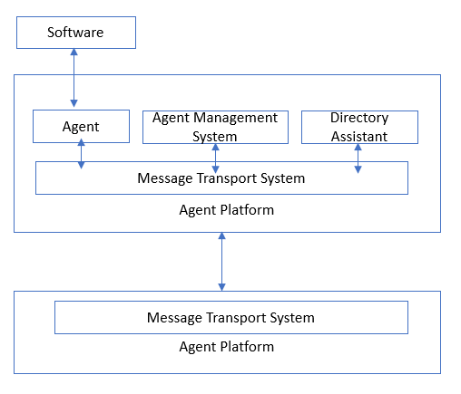

Figure 1.1 - The design of the agent system and how it interacts with other systems

1.4 Multi-Agent System Architecture
Since the system of phagents and agents is closely connected to one another, It is required to implement the architecture of agents and create a program that will study the system, when studying the architecture of a system, it is important to think about the following two situations: the architecture of common agents and their interaction with each other [22]. The architecture of agents and their interaction with each other depends on what their mathematical model will be, as well as a slew of additional variables It is reasonable to assume that there are as many architectures as there are agents and multi-agent systems that exist and/or are being developed. You may, however, select distinctive alternatives that reflect the fundamental principles of design process and are regarded as hopeful by experts. A deeper summary of buildings is built as a categorization with a short description of it, perhaps multiple instances for the same kind of building [23].

2 COMFORTABLE MICROCLIMATES

2.1 Energy saving potential in residential, public and administrative buildings
The analysis of the energy consumption structure of residential, public and
administrative buildings [24,25] shows that the majority of the resulting energyresources account for thermal energy (Figure 2.1)

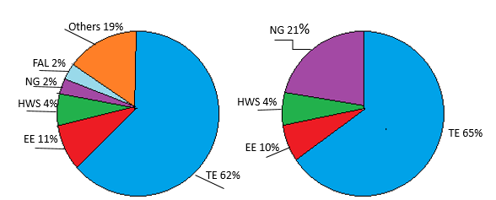

Figure 2.1 - The energy consumption structure. (a - public and administrative buildings; b - residential buildings; FAL - fuels and lubricants; NG - natural gas; HWS - hot water supply; EE - electricity; TE - thermal energy)

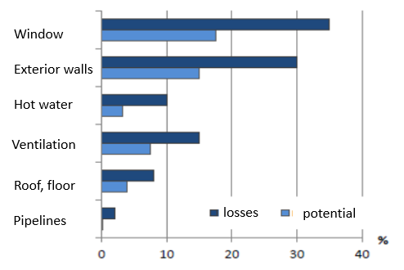

Figure 2.2– Thermal energy distribution in buildings and energy conservation potential

The relevance of the joint solution of the problems of ensuring comfortable environmental conditions for people and energy conservation is confirmed by the inclusion in the list of priority measures of measures to automatically regulate the heat load of buildings depending on the temperature of the indoor air [30]. The distribution of thermal energy is shown in Figure 2.2 [26].

2.2 Methods for evaluating the effectiveness of energy-saving measures
An urgent problem is the efficient use of energy in order to save energy [27]. Comparative characteristics measures are given in the Table 2-1

Table 2.1 - Energy saving methods

Method | Advantages of the method | Disadvantages of the method
Conducting field | Allows you to identify the effectiveness of specific activities for specific objects | Significant time and cost
Energy determination in mathematical modeling | High accuracy of predicting results | A large amount of input data for creating a model and the complexity of creating a model
Analysis of energy use results | Visibility | Integrated methods
The use of data on the effectiveness of energy-saving solutions established by firms - manufacturers of energy-efficient equipment | Availability | Low reliability of the information provided
Express methods | Minimum time costs | Method of integrations that do not take into account exceptions

2.3 The relevance of the problem of ensuring a comfortable temperature
During the functioning of a building, HVAC systems are the primary energy users. Energy efficiency is one of the state's top objectives, and it's at the core of housing and community reforms aimed at improving people's quality of life [28]. Improvements to HVAC systems and their operating modes may save building energy expenditures by 30-60%.
The most common and effective areas of increasing the efficiency of using fuel and energy resources include the introduction of regulatory documents governing relations in the energy sector and the development of energy-efficient transmission systems via the use of energy-saving measures [29]. Currently, more than a third of the final energy consumption is accounted for by the housing and communal complex and the service sector. Considering the structure of energy consumption by non-production facilities and the cost of various types of energy resources, as well as toughening the standards in the field of thermal protection of buildings, the most common and attractive investment saving energy measures are measures of thermal energy, among which the various types of building sealing measures are preferred (overlay thermal insulation on the external enclosing surfaces; replacement of window and door blocks with blocks with higher heat transfer resistance and lower air permeability coefficient) [30]. These measures, of course, lead to savings in thermal energy in physical and monetary terms, however, this reduces the comfort of the indoor climate. Sealing buildings with natural ventilation leads to a decrease in the air exchange of the premises, which worsens the microclimate and reduces the human performance. Prolonged exposure to unfavorable factors of the indoor environment on the human body can negatively affect his health. Therefore, the development of a new method taking into account both the economic indicators and the comfort of the microclimate in the premises of non-production (residential, public and administrative) buildings, is an urgent task [31].
The conclusion of energy-saving measures in the building’s energy supply systems is currently based on an analysis of the economic performance of the project. At the same time, projects related to building microclimate formation systems. The impact of the energy-saving method on the characteristics of the indoor spaces is not taken into consideration by systems [32].

2.4 The relevance of the comfort humidity problem
Humidity is one of the most significant atmospheric factors, which determines how comfortable a person feels [33]. Also, in recent years, among students, a high percentage of colds, and low humidity causes rapid evaporation and drying of the mucous membrane of the nose, larynx, lungs, which leads to colds and other diseases. High humidity also causes some negative phenomena in the human body, for example, the body's heat exchange with the environment is disrupted, which leads to overheating of the body. From the analysis of environmental factors, it follows that many of them (temperature, humidity, pressure) are physical quantities and concepts, which determines the importance of physical knowledge to solve environmental problems [34]. The detrimental effect on wildlife of unusual weather conditions: especially in early frosts, sudden changes in temperature, degrees, etc. This research work reveals the concepts of relative and absolute humidity, dew point; natural and anthropogenic factors affecting the climate (Figure 2.3)
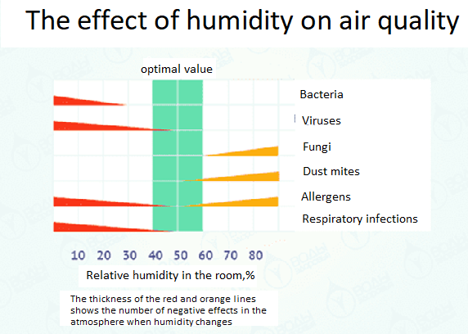
Figure 2.3 - The effect of humidity on air quality
The norm of air humidity in the apartment is a relative value. It can significantly affect all living things in the room (people, animals, plants), as well as the state of furniture, coatings, household appliances [35,36]. The average norm is a value from 40 to 60%. More specifically, from 30 to 60% in the summer and from 30 to 45% in the winter. Allowable maximum, respectively - 65% and 60%. Of particular importance is the humidity regime for those rooms where children or people with respiratory diseases [37]. There are also norms for interior items, various plants: for furniture and household appliances - 40-60%, for books on shelves - from 30% to 65%, for different types of plants - from 40% to 95%.

2.5 The relevance of air quality issues
The findings of international evidence on the effects of heating, ventilation, and air conditioning high efficiency on lighting temperature and humidity comfort and the correlation of the weather pattern with well-being and human achievement demonstrate that establishing a pleasant microclimate with the aim of preserving people's health and productivity is a top priority [38]. "One million buildings in the United States have poor indoor air quality, resulting in reduced worker productivity, and the sum of these losses surpasses $60 billion per year," according to study done by the National Institute for Home Safety and Health in 2002 [39]. More than half of the problems with indoor air quality are related to a lack of integrity in the design of ventilation and air conditioning systems [40]. (Table 2.3). Studies by Harvard scientists [41] showed that the high quality of air in the rooms where mental activity is carried out positively affects people's ability to think, remember and understand. Scientists observed 24 volunteers who worked under different conditions in terms of air quality (different levels of carbon dioxide and other pollution). Simultaneously, it was discovered that the subjects were 61% better at completing test tasks when they were in a room with a low level of air pollution [42]. If the amount of carbon dioxide in the air in the room room was further reduced, the results were more than twice as good (Table 2.3).

Table 2.3 - Measures of the "poor structure" syndrome's effect on human health and economic difficulties

Implications of the "poor structure" phenomenon manifesting |  | In European standards, annual financial failure is attributed to "poor indoor air quality." | Factors that have been taken into consideration in the calculations
The frequency of allergic reactions has risen dramatically. |  | 1.18 billion | All allergic disorders cost 30% of the total cost (600,000 employees in an office environment)
Sick time is arrived. |  | 0.8 million | Because to “bad” indoor air, 15% of workers were absent.
The number of people working is decreasing. |  | 0.2 million | The number of workers in the office has been decreased by 10%. A total of 170 million individuals were impacted, with half of them being unwell as a consequence of "unhealthy" air.
Viruses and other communicable diseases | 84 million
As a consequence of radon gas exposure, cancer may develop. |  | 34 million | 450 cases per year, the cost of one case is 75,000 euros

Learning on the effect of air quality on human performance were also conducted in Denmark and then repeated in Sweden [43]. The research results showed that the productivity of office employees in a room with good air quality is higher, and they had fewer errors (Figure 2.4, 2.5)

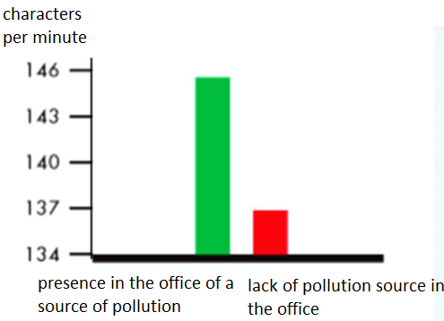

Figure 2.4 - The impact of indoor air pollution on labor productivity (number of computer characters typed)
Regulatory papers provide requirements for maintaining the necessary air quality in the workplace [44]. However, when assessing the microclimate comfort, this indicator is not always taken into account, since measuring the content of carbon dioxide in the room air requires additional measuring equipment. For example, State standard 30494 “Residential and public buildings [44]. The microclimate parameters in the rooms [45] suggests providing the required air quality with the necessary amount of air exchange in the rooms.
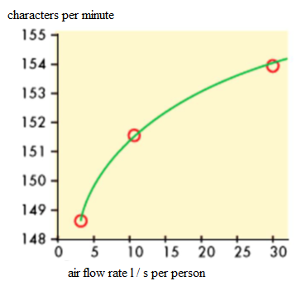
Figure 2.5 - The effect of air consumption on labor productivity

However, determining the actual air exchange of the premises is a labor-intensive procedure that requires special, bulky equipment. Therefore, as a rule, design values ​​are taken as the actual air exchange of the rooms [46]. The most common energy-saving measures for non-production buildings are currently “sealing” measures (replacing window blocks with energy-saving glass packages, insulating walls and doors). These decisions during the operation of buildings change the air exchange, therefore, the use of its design values ​​in assessing the effectiveness of energy-saving measures is unacceptable [47].

2.6 Activities to ensure an optimum and acceptable microclimate
The normalized microclimate parameters are: air temperature of the working area, air velocity, humidity, infrared radiation, thermal load of the medium. The THC index is an empirical integral indicator (expressed in ° C), reflecting the combined effect of air temperature, its speed, humidity and thermal radiation on the heat exchange of a person with the environment. Thus, measures to ensure the optimal and permissible microclimate will concern four of its main parameters: air temperature of the working area, air velocity, humidity, infrared radiation. It is essential to consider the combined impact of microclimate characteristics and associated variables while planning activities [48]. It consists of the following elements:
  - high temperature in combination with high speed of air movement providef
thermal comfort;
  - low temperature and high speed of air movement cause a feeling of cold;
  - high physical activity and low temperature contribute to thermal comfort;
  - high physical activity and a large amount of radiated heat create a feeling of
heat.
A microclimate-friendly environment is ideal for work. Simultaneously, in addition to increasing work efficiency, the likelihood of errors leading to serious consequences or an accident decrease [49].

  - Temperature and air velocity, humidity
The following measures are used to normalize the microclimate of industrial facilities. Installation of heating systems in buildings and premises. The following are
examples of heating systems:
а) Radiators and convectors
Cast iron radiators or convectors made of iron are used in advection heating systems or quasi materials are often utilized as heating equipment. Air travels and around thermostat from below and in front, rises when heated, passes along the radiator, and emerges hot from above, at a noticeable speed [50]. Convectors differ from radiators in that they have a much smaller heating surface and are installed in the ceiling. bottom portion of the particular casing required to produce the "chimney" effect, arrange airflow past the heating surface, and then circulate warm air throughout the room. The size and location of the air intake holes, as well as the technique of blasting the heating surface, determine the convector casing's properties (Figure 2.6)

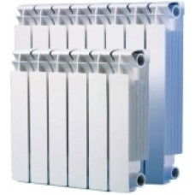
Figure 2.6 - Radiators

b) Fan-heated systems
Convection cooling tube heaters, which are often used in industrial settings and through which room temperature air is forced at a high speed by a fan, are another kind of heating system. Because the heat transfer from the hot surface is more intense in a forced convection system than in a typical heating efficiency of a convector or radiator is much higher than that of other systems. Fan heaters are often shaped like a unit placed near the ceiling in the heated room's center. The shutters on the heater's fan casing enable you to alter the direction of heated air flow in the room, allowing for greater air mixing and preventing the development of undesirable stagnant zones with a temperature differential [51]. Instead of direct air heating, in the channels of air heating systems, tubular heaters with a developed heating surface are sometimes used. The effectiveness of a fan heater is based upon a number of variables, including its placement in the room and the air flow directions at the intake and output (Figure 2.7)

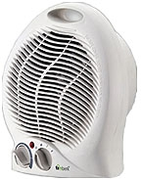

Figure 2.7 – Heaters with a Fan

c) Heating of the air
This phrase refers to heating systems in which hot air is supplied to heated rooms via specialized architectural channels. If the room air is returned for re-heating, the system is called recirculation; otherwise, the system is called ventilation if no air return is supplied and only heated outside air enters the room [52]. The latter method is only utilized in places where recirculation of air is not an option. Natural or forced air heating is available. Because air movement in natural circulation systems is caused by differences in temperature and air density, a key need in duct design is the absence of significant friction losses in order to achieve the required air circulation intensity. Outside electricity is used to produce the necessary pulse intensity in pressured flow. The issue of blending air is eased in forced flow system since the wind flow speed is considerably faster; nevertheless, the pipes and distributing grilles provide a tinny sound [53].

d) Radiant heating systems
Radiant heating is a kind of heating that works on the basis of thermal radiation. to generate heat. Due to the focused radiation to the bottom zone of the room and the passage of heat to directly heated surfaces rather than air, there is no need to increase the unit's capacity depending on the room's height in radiant heating installations. The lack of warm air stasis in the roof region aids in reducing heat loss and creating more pleasant settings in the space [54]. Furthermore, in rooms heated by radiant heating systems, the air temperature may be somewhat fewer than conventionally predicted, but the temperature of the sides and appliances is greater, giving people in the room a level of satisfaction.

e) Heaters with cables

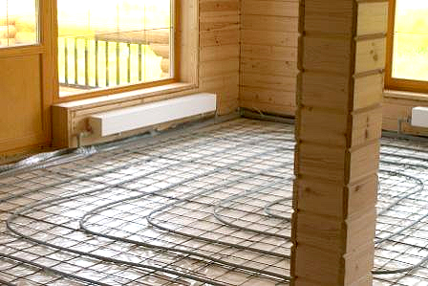

Figure 2.8 - Cable heating systems

- Heating (heating) cables and heating textiles are the two types. Various issues
related with sustaining temperatures, heating, and generally pro may be solved efficiently and cheaply using cable heating (Figure 2.8). Cable heaters are often used to create "warm" floors and to solve non-standard heating issues. Installation of stationary and mobile heating points [55].
- System of ventilation and air conditioning implementation. In buildings, air
conditioning is usually provided by one of two kinds of split systems: standard (board, ground, module), which are physically attached in each room, and channel, which need a pipe to provide chilled air to the facilities [56].
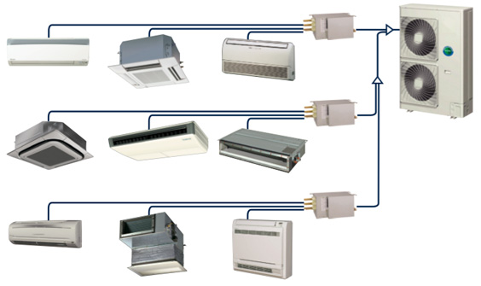
Figure 2.9 – Cooling and heating systems

- Sun block devices are installed on the structure's facades (excluding the north).
Curtains, blinds, peaks, and umbrellas are examples of these. They're more effective if they're on the exterior of the building (outside) [56]. Glasses are also a good way to shield yourself from the sun (Figure 2.9).
- Humidifiers should be used [57].
- Jobs involving air showers an air shower provides cold, fresh air to the
workplace in the form of a fan-created air stream. Jet sources that are both stationary and mobile in the form of moveable fans may be utilized. The jet may be fed from above, below, on the side, or via a fan.
The following are examples of organizational and technological measures:
- interactive machine arrangement that is logical. The major heat generators
are positioned immediately underneath the aeration light, along the building's exterior walls, and in a row so that heat fluxes do not overlap at workstations;
- Maintain and manage your work from afar (protection by "distance");
- Use of sensible technical process equipment (e.g., replacing hot metal
Processing with cold metal processing, replacing flame heating with induction, etc.);
- organizational measures include steps to safeguard “time” (creation of an\
optimum mode of work and relaxation for employees);
- use of heat shields;
- use of water curtains, which is a fine dispersion of dust; To keep employees'
average shift thermal stress at an acceptable level, the entire length of their activity in a heating microclimate during a work shift should not exceed 7, 5, 3, and 1 hour, respectively, depending on the harmfulness of the working circumstances;
- the employment of different kinds of thermal insulation materials to insulate
equipment [58].
We can conclude about the microclimate, which is necessary for human thermal self-action. In addition, the microclimate is determined by the need to develop physiologically sound parameters of temperature, humidity and air humidity, which should take into account various production processes, a variety of technological processes, and labor intensity [59].
When developing energy-saving measures, one should be based on their realism and attainability. The basis for assessing the acceptability of certain activities are economic and economic calculations. In this regard, we can distinguish a certain gradation of energy-saving measures by their availability. Organizational and explanatory. Such events are a necessary step in the development of any energy saving programs. These include establishing responsibility for resource overruns, introducing energy metering, controlling the rationality of resource spending, etc. Reduced energy consumption ranges from 5% to 50%. In this case, the activities should be carried out only for technical and technological events, therefore, the analysis of the level of energy consumption, undistorted influence is not reliable enough [60].

- INTERNATIONAL STANDARDS FOR COMFORTABLE
MICROCLIMATE IN THE BUILDING

3.1 Standards for air quality
Air quality (IAQ) is one of the most major economic and sanitary-hygienic aspects of a person's surroundings. Its parameters determine the quality of employment, health, and productivity. As a result, every construction project aiming at improving air quality should be guided by a regulatory framework based on extensive study and experience. The quality of the surrounding (outdoor) air in cities of industrialized nations has considerably improved during the last several decades. Indoor air quality decreased over the same time period. This is due in part to large-scale energy-saving efforts, and in part to the fact that high energy costs drive individuals to seal their homes and decrease ventilation rates, resulting in a record low rate of air interchange in many households [61].
Today, the acceptable quality of the internal air is mainly determined by the specified rate of air exchange or the external supply air flow. The measurement in watts, which serves as the basis for a comfortable microclimate, that is, the term "thermal comfort" means "fulfilling the criteria." The popularization of energy efficiency from among general public frequently drives to the construction of extremely impermeable structures. This number shows that the air coming at it from the outside need the appropriate quantity of ventilation. The electricity demand, displayed as a portion, is becoming an increasingly larger part the proportion of total energy usage of buildings due to a decrease in heat exchange with outside air through energy transfer thanks to greater criteria for the energy consumption, defined as the percentage, is becoming an extremely large part of the total energy utilization [62].
With the increased density of affected window openings in new buildings and increased thermal protection, a strong emphasis is now placed on establishing optimal air exchange in residential and industrial buildings to meet energy-saving requirements, create a pleasant temperate climate, and ensure sanitary and hygienic conditions. Institutions such as the International Organization for Standardization (ISO), the American Society of Heating, Refrigeration, and Air-Conditioning Engineers (ASHRAE), and the International Council for Research in Heating, Refrigeration, and Air-Conditioning (ICRAF) work on a worldwide scale, Practical Study, and Construction Documentation (CIBC), the European Committee for Standardization (CEN), and the National union of the European Association for Heating, Ventilation, and Air-Conditioning Engineers (Federation of the European Association for Heating, Ventilation, and Air Conditioning Engineers (These documents define the requirements and methods for achieving domestic environmental quality when constructing airconditioning structures, after attempting to put airconditioning structures into operation, while in ventilation and air system operation, and for monitoring ventilation and air system operation [63].

3.2 CEN Building Ventilation Standards
The execution of this Directive's provisions by EU Member States is an important factor of these nations' compliance with the Kyoto Protocol's commitments. Energy efficiency in the building sector is a priority in the EU Action Plan for Energy Efficiency "Realizing the Potential," which was approved in October 2006. The EPBD Directive's requirements, which include laws for determining energy consumption in a building, rules and requirements for devices in single constructed and put into procedure houses, precepts of energy certified of buildings, and criteria to check air quality, play an important role. Many standards be further established in order to put the EPBD Directive's provisions into reality.
The general principle of building ventilation standards shown in the Figure 3.1

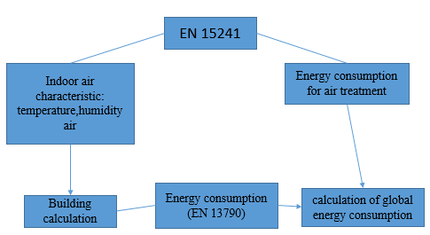

Figure 3.1 - Fundamental principles for the use of EN 15241, taking into account the EN 13790
Specific rules and design requirements for ventilation systems are set out in the EN 13799 standard. This standard offer design guidelines, and its applications [64].

3.3 Methods for calculating ventilation needs
Persons and internal sources of construction emissions are taken into consideration in new guidelines for establishing structural heating and cooling needs, such as ASHRAE 62.1 and EN 15251. The suggested criteria are all concerned with health and comfort [65].

3.3.1 Regulatory Approach
For the normative method, the minimal energy consumption required by a person and the minimum air consumption per square meter. The sum of these two integers equals the total. Air consumption per person should account for pollution caused by other people (smells and other biological emissions), and air consumption per room area should account for carbon emissions from a home, equipment, HVAC system, or other sources. The equation calculates the required external air flow for the surrounding air of the spaces or regions in question, i.e., the air flow into the surrounding air (V_{bz}):

V_{bz} = R_{p}P_{z} + R_{a}A_{z}, (3.1)

where A_{z} – denotes the room's area;
P_{z}– the number of individuals per square meter;
R_{p}– outdoor air emission per individual is needed;
R_{a}– Outside flow of air every square area is required.
At the very least, ventilation should have been enough to absorb biological fluids from users. The estimated amount of air consumption is adequate for individuals entering the room [66]. The question of whether this should always be the case is up for debate. According to the evaluation, one level three ventilation is adequate to offer consumers with acceptable observed air quality (people become accustomed to air quality for at least 15 minutes), i.e., 2.5 l / s per person instead of 7 l / s per person for category II. Ventilation settings for adaptable individuals are defined by ASHRAE 62.1. When considering health risks, simple addition is permissible only for the same chemical components.
For ventilation efficiency the air flow rate at the supply diffusers is calculated by
the formula:
V = V_{bz}/ε_{v}, (3.2)

where V_{bz} – airflow;
ε_{v} – ventilation efficiency.

3.4 Ashree Standards
Several current national and international standards for indoor air quality relate to ASHRAE standards, despite the fact that these standards are not legally enforceable [67]. That's because, across foreign countries, the United States has had the most success, taking into consideration the practice of countries like Denmark, Finland, and Germany in establishing standards for the quality of indoor air in their facilities. The United States established the regulation "Ventilation and Acceptable Air Quality" after completing its own in-depth research. Every three years, this standard is revised. The most recent modification was completed in 2019 (Figure 3.2).
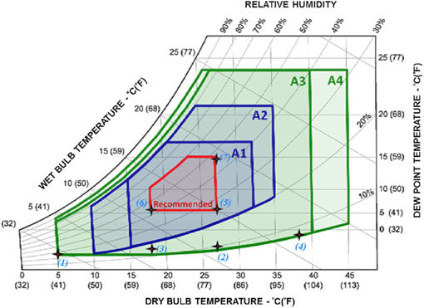

Figure 3.2 - The fact that ASHRAE is located in the house according to international standards.
The objective of the standard remains the same: to identify the minimal air flow rates and to specify methods that guarantee acceptable indoor air quality in order to avoid negative health impacts [68].
To date, the standard for determining the minimum supply air flow rate adheres to three alternative procedures: methods for determining the rate of air exchange (VRP), natural ventilation (NVP) and indoor air quality (IAQP) [69].
– VRP — provides a method for decreasing pollutants in indoor air that is indirect. It includes topics such as proper air supply and disposal device location, air exchange rate adjustment based on usage, HVAC system component isolation, and refrigerant subcooling, among others [70]:
– IAQP — air purification offers a direct solution by lowering and controlling pollutant concentrations;
- Air purification offers a direct treatment by lowering and controlling pollutant
levels;
– NVP — guarantees that natural (passive) ventilation intake sizes are maintained to a minimum on the outside. While the VRP focuses on maintaining acceptable air quality, the IAQP aims to reduce HVAC system operating costs while maintaining a healthy environment. Because it is necessary to provide a mechanical system when the natural system is insufficient or inappropriate, NVP should be utilized in combination with either VRP or IAQP in most situations [71].
ASHRAE Standard 55 [70] is the standard that specifies the minimum criteria for indoor microclimate. It establishes reliability statistics of environmental factors in order to provide users with indoor thermal. It was first published in 1966 and has been updated on a regular basis since 2004.
The ASHRAE standard provides overall thermal sensitivity. This allows you to analytically determine and interpret thermal comfort by calculating the predicted average rating (PMV), the predicted percentage of dissatisfied indicator (PPD) and criteria for comfort that are acceptable for both overall thermal comfort and local discomfort. The advantage of the ASHRAE standard is that it takes into account the dynamic change in the ventilation modes of residential and public buildings. This is realized by a variable air flow (VAV) ventilation system by adjusting the amount of fresh air supplied above the bare minimum, as well as by altering the real scenario, which is decided by the number of people in the ventilated place.

3.5 European standards
CEN develops European Standards (EN) for the design of structures, buildings, and building goods based on ISO and IEC worldwide standards. They are mainly intended to meet the EPBD Directive's criteria [72]. The execution of the provisions of this Directive by European Union Member States is a vital part of their compliance with the Kyoto Protocol's commitments. A separate technical council for certification, CEN / TC 156, was formed to create EN in the area of building ventilation, and it produced normative document CR 1752 and standard EN 13779. EN 15251 is another another European guideline. Unlike the EN 13779 guideline, which governs the requirements for air conditioning and ventilation systems, the EN 15251 guideline controls the inside environment [73]. The term "indoor microclimate" appears many times in the EPBD directive's language. To begin with, energy-saving measures should not be adopted at the expense of person's welfare and convenience. Moreover, in addition to the original amount of energy consumption and the energy certificate, it is suggested that each building include assessed microclimate characteristics and indications of climatic comfort. In this respect, a list of indoor microclimate parameters to be utilized in the based on the energy consumption, building design, and surveillance of workplace conditions is required (Figure 3.3)
The following are the main aspects of the EN 15251 guidelines:
- establishing the microclimate of the grounds, influencing building energy efficiency, and a guide to determining the source data for calculating the energy efficiency of structure system architectures and their architecture;
- a discussion of the techniques for evaluating the interior microclimate over time using mathematical methods or field measurements;
- the creation of metrics for displaying and monitoring the microenvironment of structural members;
- mostly used in civil (residential and public) structures where the necessary climate is defined by the number of people present [74].

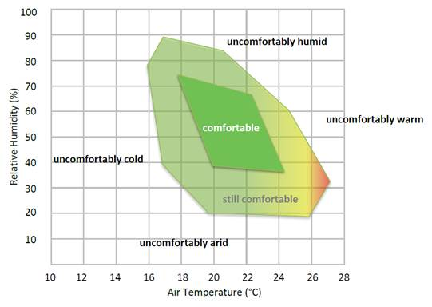

Figure 3.3 - International European standard for indoor comfort.

3.6 Comparative analysis
All of the proposed standards for determining ventilation requirements in buildings relate to the comfort and health of users [75]. In new foreign standards, including ASHRAE and EN, to determine the supply air supply, based on the number of people who were in the house according to the specified norm and the size of the room. Since there are no major additional sources of pollution in domestic and public facilities except carbon dioxide, the guidelines determine the required amount of ventilation per person based on CO2 emissions. Carbon dioxide equivalents are produced by other hazardous gas emissions in rooms. Carbon dioxide in this instance, concentrations were employed as a measure of air quality (Table 3.1)
Table 3.1 - The necessary values of the indoor microclimate parameters

Parameter | ASHRAE Standards | European standards
Cold temperature | 20–24 °С | 19–25 °С
Temperature during the warm season | 23–26 °С | 22–27 °С
Humidity relative | 30–65 % | 20–70 %
Air velocity | ≤ 0.25 m / s | 0.15–0.3 m / s
CO2 levels that are acceptable | No more than 700 parts per million above ambient air | 350–800 ppm
Flow of air supply | 9–36 m3 / h per person + 1.1–3.2 m3 / h per m2 or 2.4–37.1 m3 / h per m2 ** | 14.4–52.9 m3 / h per person + 1.1–7.2 m3 / h per m2 ***
The minimum value determined by the norm for 1 person or per 1 m2 of the room (if it does not provide for a constant presence of people) or according to methodologies derived from the circumstances for heat and moisture assimilation and the mass of hazardous or highly flammable substances released, having taken the greatest of the amounts;
The sum of the fixed (based on consumption per 1 m2 of premises) and variable (based on
consumption per 1 person) indicators or, for a set number of consumers, an unaltered value is used to calculate the outside air consumption in the room.
The house's consumption of outside air is assumed to be adequate for dispersing person's
biological emissions as well as the high toxicity produced by the structure and its engineering systems.

The fact that ASHRAE criteria are founded on adjusted people (those who have been exposed to air quality for at least 15 minutes), whereas European guidelines are based on non-adapted individuals [76,77], is one of the major causes for the differences between ASHRAE and EN standards. Increased air exchange improves comfort, but it also raises energy expenditures for processing and transporting external supply air, as well as complicating ventilation and air distribution systems [78]. Unlike ASHRAE 62.1, EN 15251 does not concentrate on air cleansing. The technique for calculating supply air flow in both categories is built on the current formula:
.$V_{bz}=R_{p}* P_{z}+R_{a}*A_{z}$(3.3)
where $R_{p}$ — air supply per person needed, м³/h;
$P_{z}$ — the amount of persons per square meter;
$R_{a}$ — required supply air flow per unit area, м³/h;
$A_{z}$ — floor area, м²

At the moment, we have certain standards for calculating Air costs, but they are not yet ready. The fact that ASHRAE criteria are founded on adjusted people (those who have been exposed to air quality for at least 15 minutes), whereas European guidelines are based on non-adapted individuals [78], is one of the major causes for the differences between ASHRAE and EN standards. Increased air interchange improves comfort, but it also raises energy expenditures for preparing and transporting outside supply air, as well as complicating ventilation and air distribution systems. Unlike ASHRAE 62.1, EN 15251 does not concentrate on air cleansing [79].
The distinction is that customer impressions cannot be totalled in a linear fashion., so when doubling sources, the number of unsatisfied users should not necessarily double. This situation is correct only when the main criterion of general non-existence, the criteria for the room are correct [80]. If we look at the problem of health in relation to a person as a whole, release from multiple sources may impact numerous organs, thus ventilation of one chemical will also result in a dilution of the amount. of another. In most cases, comfort requirements (regarding odors) require maximum values ​​for minimum ventilation levels.

4 MULTI-AGENT-BASED SMART GRID (MASG) SYSTEM IMPLEMENTATION FOR BUILDING ENERGY MANAGEMENT

4.1 Agent based systems
Today, there are problems with the management of man-made objects. Uses nonlinear functions in the management of such objects. Because natural disasters, such as various accidents, man-made disasters, can disrupt the functioning of the TB system. Therefore, it is extremely necessary to manage with the help of new technologies in order to avoid various dangers. One of these new technologies is a management system based on intelligent agents [81]. Basically, the relevance of the work is determined by the complexity of this particular management approach.
The Figure 4.1 shows the control method using the multi-agent method. Management through a traditional centralized system is carried out through the management of a central agent. There is no centralized system for managing a large number of agents. Each agent has its own independent role, there is a program that can control itself, obeying only the system agent to which they belong.
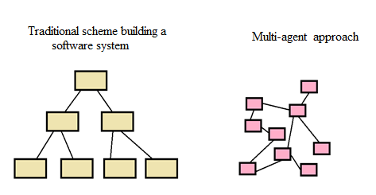
Figure 4.1 - The scheme of building a multi-agent and traditional system

In Figure 4.2 Agent model for building a traditional system. The input zone is the part of the multi-agent system that receives information from outside,the output zone is the place that responds to the outside[82]. A decision-making region is a known decision-making body that processes and analyzes the information received by the center and preserves the information of its own and the environment.
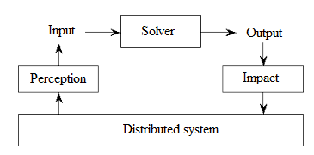

Figure 4.2 - Agent model for building a traditional system

The electric power sector may be one of the first applications of this technology in the near future. Performance and consistency of transmitted electricity; development of renewable energy sources; the problem of judicious use of resources required for electric energy generation; the problem of urbanization, industry, and isolated places; technological advances and digitization of all electricity production and transmission methods; obtaining maximum efficiency [83].
An agent in the energy industry may be defined as any item that is part of the power system, such as a power line, transformers, generators, or a consumer. The advent of such innovation, in which each item has its own management agent, would enable the creation of a centralized personality system that is adaptable, accessible, and controllable in real time.

4.2 Architecture of the System
The smart grid opens up a lot of new opportunities and, at the same time, new challenges to be solved, such as a higher level of complexity. Overcoming these problems is crucial to maximizing the effective realization of the promises of the smart grid. Energy management is believed to be one of main research topics of intelligent networks, mainly owing to high stochasticity, new generation, storage and use of assets. How can these assets be utilized effectively, while simultaneously achieving their design objectives by maintaining grid stability, providing financial effectiveness and customer satisfaction?
Our research focuses on the creation of intelligent Grid using MultiAgent technologies [84].
Multi-agent technology can be used as a basis for the building's power usage and comfort control system. This technology allows one to divide a complex task into simple subtasks that can be solved with the help of agents [85].
In general, the design of a MultiAgent control system broken down into three stages (Figure 4.3). In our case, the algorithms of each agent can be used to adapt the system and save energy.

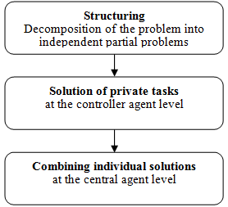

Figure 4.3 - Stages of designing a multi-agent control system

The multi-agent modeling method allows one to model complex systems by focusing on one actor, the so-called agent. Each agent is a virtual pedestrian with prescribed physiological properties, such as gender or body weight, as well as specific routing goals. Following their plans, these agents are actually exposed to various climatic conditions, similar to real pedestrians. The influence of these climatic conditions on individual thermal comfort is constantly monitored by a simple transitional two-node model of the human thermal control system: the individual thermal comfort model (ITCM). A multi-agent intelligent grid system for modeling and analyzing pedestrian traffic and thermal comfort in complex building environments has been developed. The modeling system integrates, in addition to other modules, a model of bio-meteorological thermal comfort.
Modern management technology ensures more reliability system, which introduces the concept of the smart grid. The Smart grid concept guarantees reliability and quality. The increase in energy demand leads to a complication of the system and requires its generation [86]. As a result, centralizing network management is challenging. Intelligent control system technology provides a distributed solution for building management technology, with a secure and reliable operation network to deal with various deployment scenarios. Intelligent BEMS is its application. EMS in a commercial building is aimed at improving the environment within the building [87].
Multi-agent technology is successfully used in various fields. The main element in a multi-agent system is the agent, which can be software or a physical object. Agents can work independently, i.e., without human intervention. They can converse with one another they can record and react to changes in the environment. All agents carry out negotiations with each other [90]. Here, we consider the multi-agent-based management system for an integrated building and microgrid system [88]. Figure 4.4 our proposed multi-agent energy management system

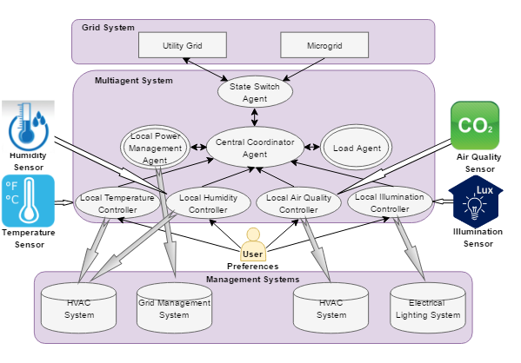
Figure 4.4 - MultiAgent management system architecture proposed by US

At this time, all empirical models of electricity demand were combined by creating four variables (four comfort parameters), since everyone's comfort is unique, it's assessed by the citizenry's % satisfaction level in terms of unpleasantness, calculated using the difference between the sensor's values obtained and the user-defined values. In the next sections, each type of agent will be described and their working principles will be explained [89].

4.3 State Switch Agent

In a Multi-agent system, the switch agent is located on the first level and receives data from the central agent about the energy consumed. The AGENT switch receives power from the power grid. If there is enough energy, then the excess energy it returns it back to the grid, which can be stored in batteries [90].

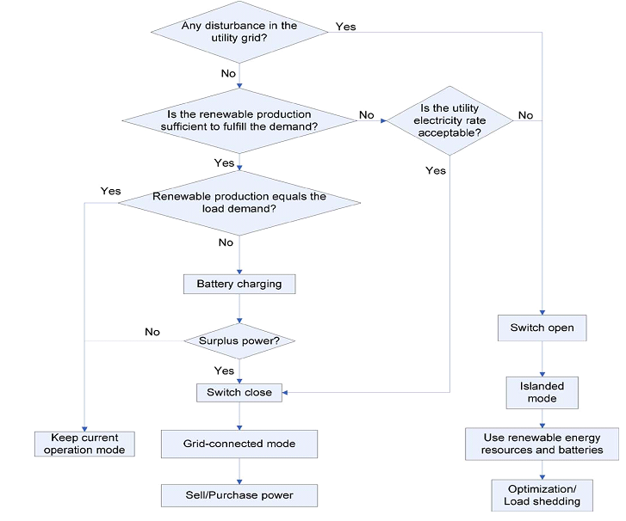

Figure 4.5 – Procedure for the choice of operation modes

There are two types of techniques for the complete integrated building and microgrid system: grid connection mode and isolated mode. The state switch agent interacts with the central coordinator agent to identify the device's condition for joining and removing the microgrid from the power system [91]. The process for choosing a certain operating mode in various situations is shown in Figure 4.5. The microgrid will really be isolated from the mains supply if there is any damage to the electricity system or if the rate of power usage is not suitable to customers. In certain situations, the switch will be flipped on, and suitable optimization or mitigation methods will be implemented to optimize comfortability utilizing alternative fuels; else, the microgrid would be linked to the power grid. Nonetheless, the facility will always use the green energy that is offered first. The tanks will be charged if there is extra energy from solar and wind power. Excess energy will be mainly sold to the energy grid if there is any remaining [92]. Additionally, if there is not enough renewable energy from the “microgrid” and the rate of electricity consumption is acceptable, the power supply will be procured to meet the overall load of the building.

4.4 Central Coordinator Agent

The central coordinating agent, which is located at the second level, is one of the key elements in the management system. It interacts with all agents based on external data (information about weather conditions) and user preferences for thermal, visual comfort and air quality, as well as on data on electrical loads of the building. It also receives information from agents of wind turbines and solar photovoltaics from a battery charge agent. In addition, it determines the quantity of energy and the energy needed to cover it and manages it accordingly [93].

For the central coordinator-agent, the main task is to coordinate the distribution of electricity and maximum convenience for customers.

4.4.1 Negotiation among Agents
Agents communicate with each other to share excess energy. Relationships
are initiated by loading agents, the loading agent draws energy sources from other agents, and other agents initiate Energy Exchange through their own rules [94]. How much energy is needed and how much is needed is shown in order in another shown in Figure 4.6

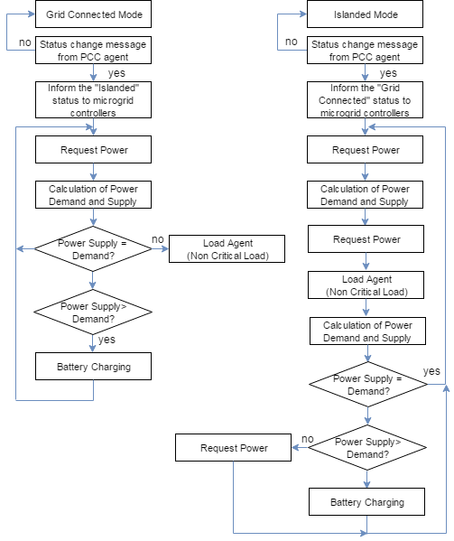

Figure 4.6 - Negotiation among agents

4.4.2 Optimization Problem

The multi-agent coordinating system includes the central coordinator agent and the auxiliary coordinator agents for each comfort parameter. The central coordinator agent is able to coordinate all auxiliary coordinator agents [95]. This allows, preferences of inhabitants and coordinates by applying the optimization algorithm. The whole scheme of the system optimization is illustrated in Figure 4.7

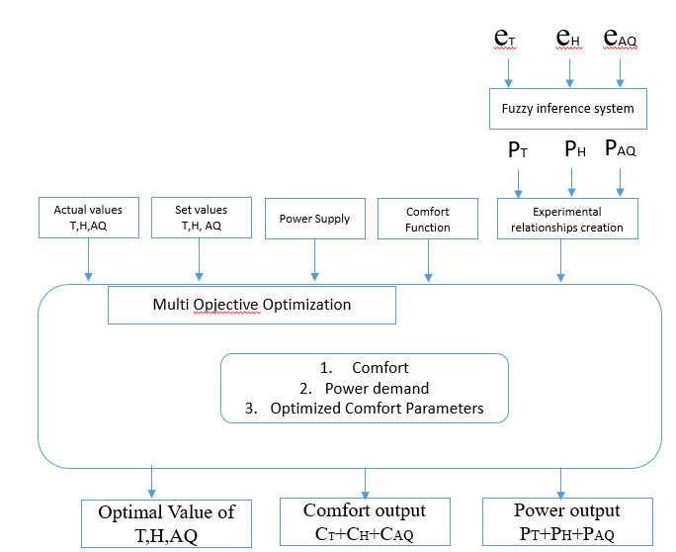

Figure 4.7 - Optimization system

Building inhabitants can determine their comfort range according to their preferences, which is represented by [C_{min}, C_{max}], where "C" means the desired comfort parameter. In this research, the selected comfort parameters are temperature, humidity and air quality [93,94,101]. Users are allowed to set specific requirements for comfort. This means that the optimizer will achieve the desired comfort, unlike its best features, ensuring that all indoor and outdoor information meets their needs. The control of the building's energy and comfort is through various subordinate systems, first of all, four comfort parameters were taken into account: thermal, visual, humidity and air quality. These comfort indicators correspond to the temperature of thermal comfort, artificial lighting for visual comfort, relative humidity level in the indoor environment, and CO2 in the air for comfortable comfort [96].

Fuzzy controllers are used to overcome nonlinear functions in the control system, which allows you to calculate maximum comfort with minimal energy use for each paramete. The developed functions of a multi-agent system for a comfortable environment are determined by the control parameters of temperature, humidity, air quality and are transmitted through sensors.

We will determine the terms “overall comfort index,” “comfort index,” “comfort level,” and their relation as seen via the lens of a mathematical model. Mathematical model is written as follows:

$$CI=OWA\left(δ_{T},δ_{H},δ_{A}\right)=\sum_{i=1}^{n}{ω_{i}b_{i}}$$ | (4.1)

where OWA is an ordered weighted average, $δ_{T},δ_{H},δ_{A}$are, respectively, aggregate comfort levels of temperature, humidity and air quality, $b_{i}$ is j-th largest value of three cumulative parameters $\left[δ_{T},δ_{H},δ_{A}\right]$and $ω_{i}$ are weights corresponding indices of comfort, where $ω_{i}∈\left[0,1\right]$such that $\sum_{i=1}^{n}{ω_{i}=1}$.

Customer centered model of comfort is expressed as the following formula:

$$b_{i}=1-discomfort_{i}$$ | (4.2)

Next formula is described customer centered model of discomfort function:

$$\left\{\begin{aligned}&discomfort_{i}={\left(\frac{N_{actual}-N_{set}}{N_{set}}\right)}^{2} \\ &N_{actual}=T,H,A\end{aligned}\right.$$ | (4.3)

where$N_{actual}$ is actual value of a comfort parameter; T – temperature comfort parameter; H – humidity comfort parameter; A – air quality comfort parameter.

By applying discomfort function in (4.2) to (4.3), we get

$$b_{i}=1-{\left(\frac{N_{actual}-N_{set}}{N_{set}}\right)}^{2}$$ | (4.4)

Taking into consideration that difference of actual and setpoint value gives an error (4.5) is expressed as:
$$b_{i}=1-{\left(\frac{e_{i}}{N_{set}}\right)}^{2}$$ | (4.5)

By substituting (10) into formula (6) we get comfort equation:
$$ComfortLevel=\sum_{i=1}^{n}{w_{i}\left(1-{\left(\frac{e_{i}}{{N_{i}}_{set}}\right)}^{2}\right)}$$ | (4.6)

where${ w}_{i}$ is a user-defined weighting factor that indicates the importance of the comfort factors? In our study, we took and considered temperature, humidity, and air quality as the main weight factors that affect the overall comfort index [97]. Therefore, our resulting formula for comfort level will be as following:

$$ComfortLevel=w_{T}\left(1-{\left(\frac{e_{T}}{T_{set}}\right)}^{2}\right)+w_{H}\left(1-{\left(\frac{e_{H}}{H_{set}}\right)}^{2}\right)+w_{A}\left(1-{\left(\frac{e_{A}}{A_{set}}\right)}^{2}\right)$$ | (4.7)

All weight coefficients are within [0,1] and their total sum is equal to 1.

One of the primary objectives of the system is to provide the most pleasant circumstances for those who are in the room, as illustrated below. This is written as follows:

$$Discomfort=1-Comfort= \\ 1-w_{T}\left(1-{\left(\frac{x_{1}-T_{set}}{T_{set}}\right)}^{2}\right)+w_{H}\left(1-{\left(\frac{x_{2}-H_{set}}{H_{set}}\right)}^{2}\right)+w_{A}\left(1-{\left(\frac{x_{3}-A_{set}}{A_{set}}\right)}^{2}\right)$$ | (4.8)

We minimize the energy used in the following function:

$$E_{total}=E_{T}(x_{1})+E_{H}(x_{2})+E_{A}(x_{3})$$ | (4.9)
Initial indoor temperature, humidity, and values used to improve air quality.

4.5 Local Climate Controllers
To control the indoor microclimate, the logic controllers of temperature, humidity and air quality are important [97,98]. Since they are the microclimate's most important characteristics. Three controller agents take data from the external environment and compare this data for the necessary energy to create a microclimate. The organization of local controllers is shown in Figure 4.8

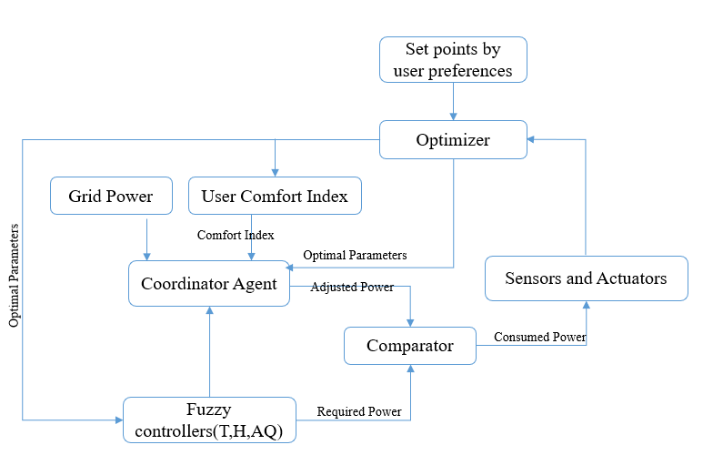

Figure 4.8 - Local controller-agents

4.5.1 Local Temperature Controller
Determine the linguistic fuzzy variables$e$, $Δe$ membership functions$μ\left(e\right)$ and$μ\left(Δe\right)$. We construct two membership functions for a temperature difference (е) (Figure 4.10a); in the second, it is the rate of temperature change $\left(Δe\right)$ (Figure 4.10b). For the first function, the temperature range is −6 to 6 °C; for the second, it is −6 to 6 °С /min. For$μ\left(e\right)$and$μ\left(Δe\right)$, (Figure 4.9) the identifiers have the form: «Large Positive Deviation» (LPD), «Average Positive Deviation» (APD), «Small Positive Deviation» (SPD), «Zero Deviation» (Z), «Small Negative Deviation» (SND), «Average Negative Deviation» (AND), «Large Negative Deviation» (LND).
Depending on the value of parameters in the system, the combined value of functions is determined by a special program.

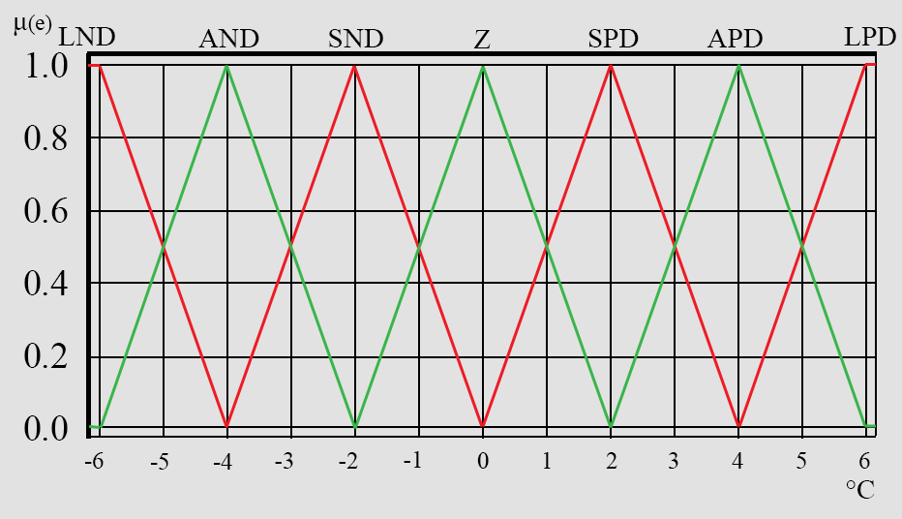

Figure 4.9 - Fuzzy controller design and optimization algorithm

In the following picture (Figure 4.10a) the operation of heating and cooling μ(p) in the application of functions in the system is shown. Fuzzy variables have the identifiers: «Strong Cooling» (СЗ), «Average Cooling» (С2), «Slight Cooling» (С1), «Without Changes» (NO), «Heating 1» (H1) and «Heating 2» (Н2).
Basically, the speed of the air fan depends on the following rule$μ\left(fs\right)$ is computed (Figure 4.10b). There are values in fuzzy variables that come to the fan speed: «high» (Fast), «normal» (Med), «low» (Low), «zero» (Z).
The membership function at the output (Figure 4.10) shows the processing rule, which sums up the response signal to generate an output command. The function chosen in this study supplies the output consisting of two heating levels (HI, H2), three cooling levels (C1, C2, C3) and the norm level (NO).

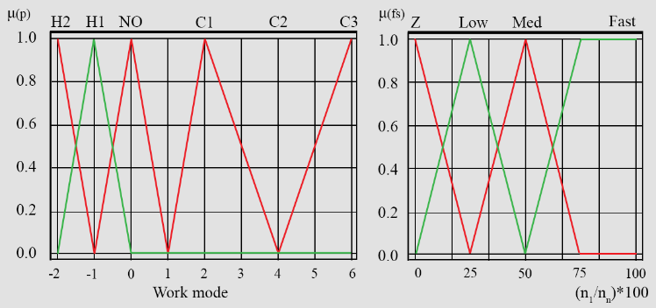
a) b)
Figure 4.10 - The output parameters for the linguistic membership function

For example, many alternative degrees of extra heating or cooling with a value higher than H2 and H1 values greater than C2 and C1 values are conceivable to conceive.

Table 4.1 - Temperature and Humidity control based on fuzzy rules.

Rate of temperature change |  | Temperature difference (e)
Rate of temperature change |  | LND | AND | SND |  | Z | SPD | APD |  | LPD
Rate of temperature change | LND | C3 | C3 | C2 |  | C1 | NO | NO |  | H1
Rate of temperature change | LND | Fast | Fast | Med |  | Slow | Z | Z |  | Med
Rate of temperature change | AND | C3 | C2 | C2 |  | C1 | NO | NO |  | H1
Rate of temperature change | AND | Fast | Med | Med |  | Slow | Z | Z |  | Med
Rate of temperature change | SND | C3 | C2 | C1 |  | C1 | NO | NO |  | H1
Rate of temperature change | SND | Fast | Med | Slow |  | Slow | Z | Z |  | Med
Rate of temperature change | Z | C2 | C1 | C1 |  | NO | NO | H1 |  | H1
Rate of temperature change | Z | Med | Slow | Slow |  | Z | Z | Med |  | Med
Rate of temperature change | SPD | C1 | C1 | NO |  | NO | H1 | H1 |  | H2
Rate of temperature change | SPD | Slow | Slow | Z |  | Z | Med | Med |  | Fast
Rate of temperature change | APD | C1 | C1 | NO |  | NO | H1 | H2 |  | H2
Rate of temperature change | APD | Slow | Slow | Z |  | Z | Med | Fast |  | Fast
Rate of temperature change | LPD | C1 | C1 | NO |  | NO | H2 | H2 |  | H2
Rate of temperature change | LPD | Slow | Slow | Z |  | Z | Fast | Fast |  | Fast
e |  |  |  |  | + very cold |  |  |  | conditioner
 |  |  |  |  | - very hot
$$Δe$$ |  |  |  |  | + heat consumption |  |  |  | ventilator
 |  |  |  |  | - cold consumption (heat output)

Table 4.1 shows that the control signal is determined by the amount of heating or cooling based on the data [2, 1,0, 1,2, 3...]. In the Table 4.1 of fuzzy rules, it is mentioned how the input and output are connected. Each entry is associated with a fuzzy rule.
The controller's output is the amount of electricity required to keep the temperature at a certain level. A negative number indicates that the heating system is operational, whereas a positive number indicates that the cooling system is operational.

4.5.2 Local Humidity Controller
To determine the humidity in the interior, we use a fuzzy PD design. The fuzzy humidity controller shown in Figure 4.11. Shows very dry, dry, normal, wet, and very wet variables in the control. Power consumption varies with each mode [101].

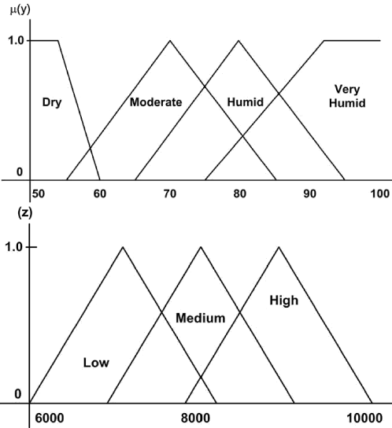
Figure 4.11- Fuzzy Controller for Humidity Control

4.5.3 Local Air Quality Controller
The local air quality detection agent controls the concentration of CO2. Most of the pollutants in the room are CO and other gases from tobacco smoke, volatile organic mixtures of detergents, disinfectants, paints, adhesives, pollutants from copiers, etc.
The best way to reduce pollutants is to introduce fresh air, but this requires a certain rule, since fresh air needs to be heated or cooled, depending on the weather conditions outside. This is thought to be owing to the fact that other contaminants' concentrations follow similar patterns, which may or may not be true in certain instances [102].

4.5.4 Local Power Management Agent
The role of the agent that controls the total power used in the system is to adapt it to the available energy resources in energy consumption, taking into account the person's comfort indicator. This will limit the use of energy sources that require additional funds. The Energy Management agent used in the overall system controls energy consumption (Figure 4.4).

4.6 Load Agent
The boot agent manages all other equipment that is not connected to the three main agents that determine the comfort factor in the system. It also controls additional power sources that are turned on when there is not enough electricity in the system. Allows people to turn the load on and off [103].

5 MAINTAINING INDOOR ENVIRONMENT MICROCLIMATE BASED ON FUZZY LOGIC MODEL

5.1 Maintaining Indoor Environment Microclimate based on Fuzzy Logic Model. The central control of the system in our study takes the following parameters: ambient temperature, atmospheric pressure in the surrounding surroundings, and temperature indicators everywhere in the room where we are sitting. Based on this data, the control unit creates a two-dimensional matrix: deviation matrix of current temperature and the given temperature values in the room, as shown in the following matrix:

$\begin{matrix}ΔT_{1,1} & ΔT_{1,2} & ... & ΔT_{1,n-1} & ΔT_{1,n} \\ ΔT_{2,1} & ΔT_{2,2} & ... & ΔT_{2,n-1} & ΔT_{2,n} \\ ... & ... & ... & ... & ... \\ ΔT_{m-1,1} & ΔT_{m-1,2} & ... & ΔT_{m-1,n-1} & ΔT_{m-1,n} \\ ΔT_{m,1} & ΔT_{m,2} & ... & ΔT_{m,n-1} & ΔT_{m,n}\end{matrix}$ (5.1)

Matrix field values of temperature variations in the room from setpoint
The heat flux in the room may be calculated using the matrix of changes in temperature of the field values in the room from a set of data. Based on the information collected, it is possible to determine that the origin of heating/cooling is in the maximum/minimal temperature, accordingly. In order to train systems and predict its future state as a whole, it is essential to determine the time. to build a matrix of changes in the speed of temperature of different points in the room. Subsequently, the control unit can influence the climate by regulating the output of the heating device (heater) or the cooling unit (air conditioning) [104]. Velocity matrix of changes in the temperature at each point of indoor space, as shown in the following matrix.

$$\begin{matrix}T_{{dT}/{dt} 1,1} & ΔT_{{dT}/{dt} 1,2} & ... & ΔT_{{dT}/{dt} 1,n-1} & ΔT_{{dT}/{dt} 1,n} \\ ΔT_{{dT}/{dt} 2,1} & ΔT_{{dT}/{dt} 2,2} & ... & ΔT_{{dT}/{dt} 2,n-1} & ΔT_{{dT}/{dt} 2,n} \\ ... & ... & ... & ... & ... \\ ΔT_{{dT}/{dt} m-1,1} & ΔT_{{dT}/{dt} m-1,2} & ... & ΔT_{{dT}/{dt} m-1,n-1} & ΔT_{{dT}/{dt} m-1,n} \\ ΔT_{{dT}/{dt} m,1} & ΔT_{{dT}/{dt} m,2} & ... & ΔT_{{dT}/{dt} m,n-1} & ΔT_{{dT}/{dt} m,n}\end{matrix}$$
(5.2)

Matrix of velocity changes in the temperature of the field values in the room.
Next one shows the temperature linguistic variables:

$ΔT=\left|T_{current}-T_{desired}\right|$ (5.3)

$T_{current}$ s the existing room temperature, whereas $T_{desired}$ denotes the intended temperature of the building [105].
Figure 5.1 shows temperature changes inside the room provided to the system.

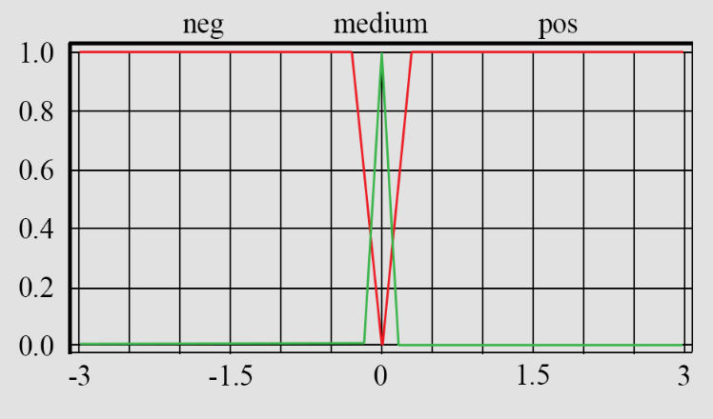

Figure 5.1 - Temperature changes inside the room provided to the system

The matrix in the system (Figure 5.2) simultaneously arranges the changes in temperature value, respectively putting temperature. The temperature difference value can be positive or negative [104-106].
The following Figure 5.2 shows the value of the rate of change of the temperature difference at a specific point in the room.

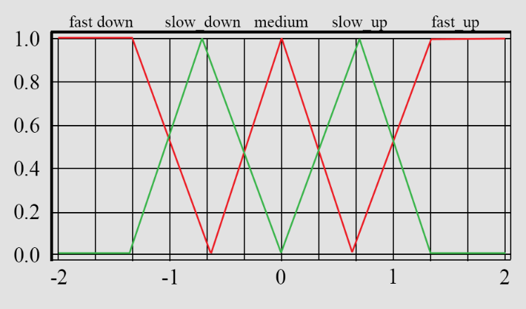

Figure 5.2 - The measurement of the temperature differential speed of increase at a particular location in the area

The temperature range between both the system to analyze in the surrounding surroundings and the presence of a specific section of the room is defined by the following data set:
$T_{{dT}/{dt}}=\frac{T_{2}-T_{1}}{t_{2}-t_{1}}$ (5.4)

Here, T₁ and T₂ are the temperatures of the first- and last-time intervals in the system, respectively, while t1 and t2 are the temperature values between the initial and final times [106].
The language parameters comprise five terms: fast drop, slow slide, neutrality, slow increase, and rapid increase, in recognition of the critical significance of the control object's response periods to external stimuli in the permitting structure.
The third important factor is the distance between the heating/cooling equipment and the coldest/hottest part of the space (Figure 5.3). A variable is a set Unit based on a vector. the final coordinates are the coldest and hottest points in the room:

$S=\left|\overset{→}{OA}\right|=\sqrt{OA_{x}^{2}+OA_{y}^{2}+OA_{z}^{2}}$ (5.5)

Here, $OA_{x},OA_{y},OA_{z}$ are coordinates of the vector along the x, y, and z-axis, respectively. Linguistic values of the expression, the largest, average and shortest distance [107].

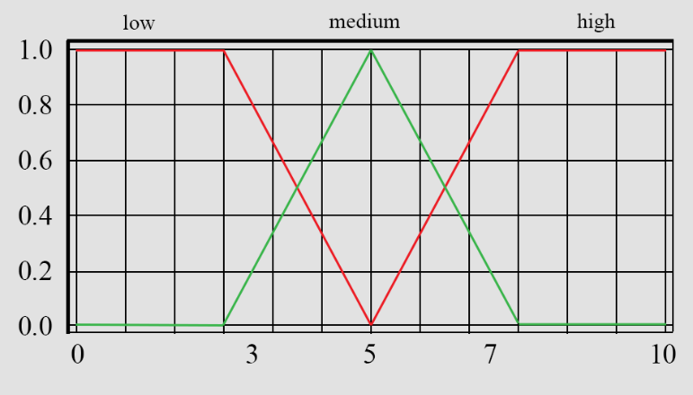

Figure 5.3 - Range between the building's cooling and heating equipment and the building's coldest and hottest spots

The higher center technique of defasification is mostly used to defasify heating and cooling equipment in the space. The three-dimensional fuzzy for heating is shown in Figure 5.4. The three-dimensional fuzzy for condition is shown in Figure 5.5.

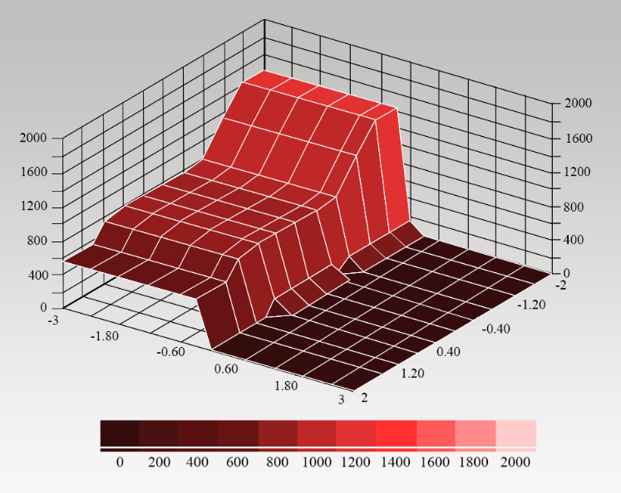

Figure 5.4 - Demonstration of fuzzy heating logic in a three-dimensional system

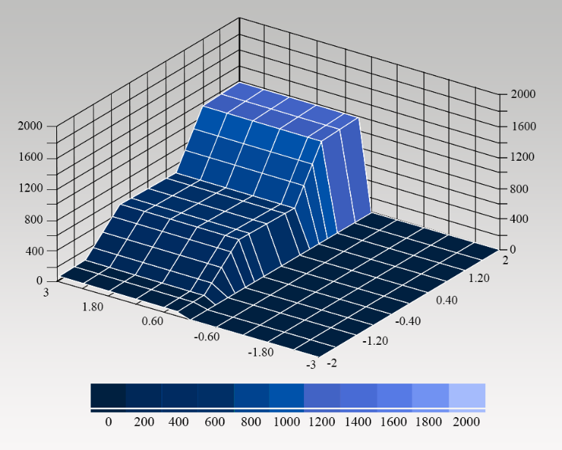

Figure 5.5 - Demonstration of fuzzy condition logic in a three-dimensional system

5.2 Fuzzy Logic Based Control Process
Currently, intelligent systems are used in many places. The advantage of such systems is that they can control the system without a human saw and perform several operations independently [108]. The following intelligent systems can cover the following areas.
Intelligent systems are capable of solving heuristic problems without human involvement. Many different computational and expert inequalities are based on systems, neural structures, and inequalities with fuzzy logic. The more realistic the experience of experts in solving problems, the fairer the solution will be [109].
When trying to decide from a broad logical standpoint, it is utilized as the foundation for constructing a control system to decide the direction of a fuzzy logic-based fuzzy control system. Figure 5.6 depicts the fuzzy control view of a system.

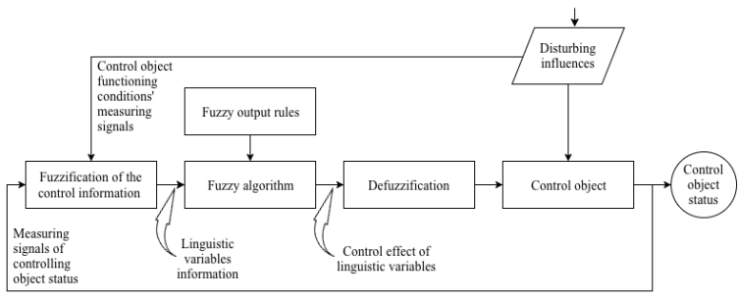

Figure 5.6 - Structure of the fuzzy control

When designing a fuzzy management system, it is necessary to solve the following situations and give an answer to the problem:
- Controlling the data is considered in fuzzy logic is a job that is completed in stages;
- The main work of the expert is the formation of rules of Fuzzy Logic as well as the creation of its algorithms;
- The main goal of the event defasification system is to find the impact of physical control on the system, which is a phenomenon that defines from the perspective of fuzzy logic organization [110].
The issues raised above are linked to the necessity to research and create suitable mathematical models for managing a building's pleasant microclimate.

5.3 Solving the fuzzification problem
Today, traditional automated object models are used in the calculation management of many problems and complex technological processes. But in many cases, this is not a successful response [111]. Due to the increasing complexity of the structure of objects and their role, the use of classical management methods becomes more complex. To the comfort of a person in the system in question the device is designed for: The system for this calculation determines the room's temperature and influences its selection of the appropriate mode.

5.4 System for monitoring the microclimate in the room based on the use
of Fuzzy Logic
The high quality of the microclimate is very important for those who are concentrated in the room. Various harmful substances, air pollution, untimely ventilation of the room, and other conditions worsen the quality of the interior. Therefore, the state of the microclimate is the main key to a healthy life [112].

Figure 5.7 - Fuzzy controller design and optimization algorithm

The work of the controller at the base of a nonlinear function is a cyclical process that reaches a certain degree only after repeated actions. The working procedure of the interior climate control system algorithm is shown in Figure 5.7. It should be remembered that after replacing the microprocessor, the air conditioner will need to endure a 3-minute break in order to regulate the pressure in the compressor chamber [115]. The time delay between switching off and on is governed by the manufacturer and is necessary for the maintenance of the air conditioner. After turning off the air conditioner, in addition to the management status, the time remaining for the normalization of the compressor pressure is also displayed. The operating principle of a fuzzy controller model is presented in Figure 5.7. The temperature inside the building via the feedback is subtracted from the set temperature. The final error and its derivative are transmitted to the multiplexer and then to a fuzzy controller [116].
To calculate the required power for the system, you need to calculate the data. To enter, we need errors and the error difference to calculate the data [113].

5.5 Calculation of Comfort Microclimate parameters for all comfort levels
Earlier we said that expressions (hereinafter referred to as terms) are used to describe the linguistic data of the comfortable temperature setting: "comfortable", "hot", "very hot", "cold», etc. Studies are carried out to characterize language factors for temperature control. For all comfortability, we compute the characteristics of a pleasant microclimate. Studies were conducted out throughout the year, in both the cold and warm seasons [105-107]. A cold day is defined as an ordinary outdoor temperature of 0 °C or below. A per day outdoor temperature over 0 °C characterizes the warm season of the year the values of cold and warm medium temperatures are processed empirically, since it fully reflects the required parameters for each time interval.

Table 5.1 - Temperature control based on fuzzy rules.

 | Cold season |  |  | Warm season
term | min, t, °C | max, t, °C | avg, t, °C | min, t, °C | max, t, °C | avg, t, °C
cold | 14.89 | 16.71 | 15.80 | 15.13 | 17.53 | 16.33
cool | 15.16 | 19.01 | 17.09 | 15.37 | 21.84 | 18.61
comfortable | 16.87 | 24.28 | 20.57 | 20.16 | 26.12 | 23.14
hot | 21.76 | 28.26 | 25.01 | 22.92 | 30.24 | 26.58
very hot | 27.40 | 30.90 | 29.15 | 29.02 | 32.18 | 30.60

Each temperature value corresponds to its own data, and, of course, the range of values of a certain period is considered, the maximum value which is the mean temp during a long time of cold and heat [117].
As a result, Table 5.1 was constructed using the scaling method [118]. As a result, in cold weather, we get the following values:
— "Cold" = A₁; this value is determined in the range from 0 to 1; in the range of 14.89°C=a₁, where M(a) = 0, to 16.71°C = b1, where M(b) = 0. Inside the interval [a_{l}; b_{l}], the point C₁ is highlighted, which indicates indisputable membership values of x = c, where M(c)=1. Thus, the teachings in the cold season fuzzy set A₁ take the following form:

$Δe=\frac{e\left(t_{1}\right)-e\left(t_{2}\right)}{t_{1}-t_{2}}$ (5.6)

where, $a_{1}^{i}$, i=1…6 is a value that belongs to [a₁; b₁].
The input data in the fuzzification stage, which is controlled using fuzzy logic, works as follows: the signal transmission by the phasing function changes, while the spent data passes through defasification, as a result, the system data is transmitted to the cooling system or to the heating valve in which the power will change, hence the accessory function [119]. It is feasible to construct a membership function M(y) of the valve closing, giving thermal linguistic output analog value from 0 to 10V, since the radiator is proportional to the three-way valve's throughput performance. At the maximum value of 10V, the three-way valve is fully open, and when the output value is 0V, the valve is completely closed:
— the three-way valve and U1 are fully opened –$μ_{1}\left(y\right)$, when $c_{1}=(-10)V$
— the three-way valve and U1 are slightly opened — $μ_{2}\left(y\right)$, when $c_{2}=(-7.3)V$
— the valve U1 is half open — $μ_{3}\left(y\right)$, when $c_{3}=(-5)V$
— the three-way valve and U1 is slightly closed – $μ_{4}\left(y\right)$, when $c_{4}=(-2.7)V$
— the three-way valve and U1, U2 are fully closed – $μ_{5}\left(y\right)$, when $c_{5}=0V$
— slowly open the three-way valve U2 – $μ_{6}\left(y\right)$, when $c_{6}=5V$
— quickly open the three-way valve U2 — $μ_{7}\left(y\right)$, when $c_{7}=10V$
The characteristic values of the fuzzy inference system offer thermal comfort in the environment, which is in contrast to the actuators' control signal, and U1 and U2. The actuators' manufacturing technique, as represented by a three-way valve for heating U1 and a three-way valve for cooling components, are diametrically opposed, is denoted by the opposite value [120]. The valves shut when there is no control signal. $μ_{5}\left(y\right)=0$ a linguistic variable. exerts simultaneous effect on both valves, resulting in a decrease in the inertia of the cooling or heating transitional process. Warming up the space in conjunction with the more thorough control.
The result of the impact of the membership function M(x) of the output value of
the parameter M(y) "performance heater" can be described as a set of rules, as follows:
Rule 1: You can open the three-way valve and U1 if it is very cold;
Rule 2: You can slightly open the three-way valve and U1, if the cold is medium
Rule 3: If it is cool, then the half-open the valve U1;
Rule 4: If it is comfortable, then slightly close three-way valve and U1;
Rule 5: close the three-way valve completely, U1 and U2, if it is warm;
Rule 6: You can slightly open the U2 three-way valve if it is hot;
Rule 7: Quickly open the U2 three-way valve if it is very hot;
Summing up, we came to the conclusion that the degree of belonging of all the previous rules is determined as follows:
$R_{μ_{1}\left(x\right)→μ_{1}\left(y\right)}=\min\left\{μ_{1}\left(x\right),μ_{1}\left(y\right)\right\}$ (5.7)

Fuzzy rule: the full opening of the three-way valve, if it is very cold, is determined by the following matrix:

$\begin{matrix}x,V/{y,^{o}C} & -10 & -9.27 & -9 & -8.7 & -7.94 \\ 15.8 & 1 & 0.75 & 0.5 & 0.25 & 0.01 \\ 16.5 & 0.75 & 0.75 & 0.5 & 0.25 & 0.01 \\ 16.29 & 0.5 & 0.5 & 0.5 & 0.25 & 0.01 \\ 16.43 & 0.25 & 0.15 & 0.25 & 0.25 & 0.01 \\ 16.71 & 0.01 & 0.01 & 0.01 & 0.01 & 0.01\end{matrix}$ (5.8)

By using the method of center of gravity, we obtain:

$Z=\frac{(-10)*1+(-9.27)*0.75+(-9)*0.5+(-8.7)*0.25+(-7.94)*0.01}{1+0.75+0.5+0.25+0.01}=-9.5$ (5.9)

The example showed temperature data with one variable, respectively, so to effectively support a comfortable environment inside the building, it is necessary to consider all possible conditions with all comfort parameters [119]. By analyzing the criteria for the comfort of the microclimate inside the building, it will be possible to create optimal conditions for a comfortable environment for a person with less energy resources.

6 MAINTAINING INDOOR MICROCLIMATE CONTROL BASED ON PID

6.1 Mathematical Model

Mathematical models of interior temperature, humidity, and indoor air quality are created in this part, which contains an HVAC system with heating and cooling units, humidifiers, and air conditioning systems. Figure 6.1 depicts our laboratory setup, which was utilized for both the testing and the mathematical model's evolution The room's measurements were 6x4x2.5m (length, width, and height, respectively). Because the outside air is chilly and dry, heaters and humidifiers are required to create a pleasant interior microclimate.

Figure 6.1 - The HVAC system regulates the temperature and humidity of the interior air.

6.1.1 Mathematical Model of the Indoor Air Temperature
The starting temperature, the temperature of the external field, and the size of the chamber all affect the temperature within the area, the heater, and the wall thickness, the loss of heat, and many other parameters. Therefore, the temperature inside the room can be recorded as follows:

$$ρ_{a}V_{indoor}C_{p}\frac{dT_{indoor}(τ)}{dτ} \\ =a_{p}F_{p}\left(t\right)-U_{w}S_{w}\left[T_{indoor}\left(τ\right)-T_{outdoor}\left(τ\right)\right]$$ | (6.1)

Heat transfer of the room wall U_{w}, is calculated as [3, 91–94]:

$$U_{w}=\frac{1}{\left(\frac{1}{h_{A}}+\frac{d_{w}}{K_{b}}+\frac{1}{h_{B}}\right)}$$ | (6.2)
In these cases, heat is transferred from both sides of the wall. conditions, i.e. from all sides, $h_{A}=h_{B}=h_{air}$. Then, $U_{w}$ calculate in this way:

$$U_{w}=\frac{1}{\left(\frac{2}{h_{air}}+\frac{d_{w}}{K_{b}}\right)}$$ | (6.3)

Using the Laplace equation, we simplify the calculation:

$$\left[\frac{ρ_{a}V_{indoor}C_{p}}{U_{W}S_{W}}s+1\right]⋅T_{indoor}\left(s\right)=\frac{a_{P}}{U_{W}S_{W}}F_{P}\left(s\right)+T_{outdoor}\left(s\right)$$ | (6.4)

Assume that $T_{outdoor}=0$, then (6) calculate in this way:

$$G_{11}=\frac{T_{p}\left(s\right)}{F_{p}\left(s\right)}=\frac{k_{tp}e^{-q_{tp}s}}{t_{tp}s+1}$$ | (6.5)
where, $t_{tp}=\frac{ρ_{air}C_{p}V_{indoor}}{U_{W}A_{W}}$ and $k_{tp}=\frac{a_{p}}{U_{W}A_{W}}$

Temperature and humidity vary depending on each other:

$$G_{12}=\frac{T_{q}\left(s\right)}{F_{q}\left(s\right)}=\frac{k_{tq}e^{-q_{tq}s}}{t_{tq}s+1}$$ | (6.6)

where, $t_{tq}=\frac{V_{indoor}}{f_{a}}$, $k_{tq}=\frac{a_{q}a_{t}}{f_{a}r_{a}E_{p}}$

6.1.2 Mathematical Model for Calculating Humidity
The humidity of the air within the space, including indoor and outdoor humidity, as well as the room's size, are all factors to consider, the characteristics of the wall, and many other parameters are affected:

$$r_{a}V_{indoor}E_{p}\frac{dH_{q}(τ)}{dτ}=a_{q}F_{q}\left(t\right)-r_{a}f_{a}E_{p}\left[H_{q}-H_{outdoor}\right]$$ | (6.7)

Using the Laplace equation, $H_{outdoor}=0$ we get (37):

$$G_{22}=\frac{h_{q}\left(s\right)}{F_{q}\left(s\right)}=\frac{k_{hq}e^{-q_{hq}s}}{t_{hq}s+1}$$ | (6.8)
where, $t_{hq}=\frac{V_{indoor}}{f_{a}}$, and $k_{hq}=\frac{a_{q}}{f_{a}r_{a}E_{p}}$.

The humidity inside the room is affected by heating devices. So, we get the following equation:

$$G_{21}=\frac{H_{p}\left(s\right)}{F_{p}\left(s\right)}=\frac{k_{hp}e^{-q_{hp}s}}{t_{hp}s+1}$$ | (6.9)
where, $t_{hp}=\frac{r_{a}C_{p}V_{indoor}}{U_{W}A_{W}}$, and $k_{hq}=\frac{a_{p}a_{h}}{U_{W}A_{W}}$.

6.1.3 Dynamic control valve model
The flow rate in the valve is a linear function. From it we get the following equation (Equation 6.10):

$$\left\{\begin{aligned}&G_{vt}=\frac{F_{p}\left(s\right)}{I_{t}\left(s\right)}=\frac{k_{vt}e^{-q_{vt}s}}{t_{vt}s+1} \\ &G_{vh}=\frac{F_{q}\left(s\right)}{I_{h}\left(s\right)}=\frac{k_{vh}e^{-q_{vh}s}}{t_{vh}s+1}\end{aligned}\right.$$ | (6.10)

6.1.4. Mathematical model of temperature and humidity control
When controlling the temperature and humidity inside the room, we consider a model that takes into account the presence of two input and two output information, taking into account their interaction. Let's describe the control model as shown in the following matrix:

$$\left[\begin{aligned}&T \\ &H\end{aligned}\right]=\left[\begin{matrix}G_{vt}G_{11} & G_{vh}G_{12} \\ G_{vt}G_{21} & G_{vh}G_{22}\end{matrix}\right]\left[\begin{aligned}&Q_{heater} \\ &Q_{humid}\end{aligned}\right]$$ | (6.11)

Our study was conducted out at Gachon University's laboratory. The description of the laboratory was as follows: length - 6 m, width-3 m, height-3 m; wall material-brick and thickness-0.3 m; average room temperature is 22ºC.
So, we came to the following conclusion, $V_{i}=24m^{3}$, $A_{w}=36m^{2}$, $d_{w}=0.3m$, $f_{a}=0.015m^{3}/s$. From [91, 97] we receive values as follows: $E_{p}=2538kJ/kg$, $C_{p}=1005J/kg^{o}C$, $K_{b}=0.6W/m^{o}C$, $ρ_{a}=1.2kg/m^{3}$, $h_{a}=10W/m^{o}C$. And then we can calculate: Uw=1.43, ktp=0.019, $τ_{tp}$=562.24, ktq=1600, We assume: $α_{t}$=0.4, $α_{h}$=0.3, $θ_{tp}$=5.6, $θ_{tq}$=6.4, $θ_{hp}=1.7$, $θ_{hq}=16$, $k_{vt}=22$, $τ_{vt}=1.5$, $θ_{vt}=0.6$, $k_{vh}=23.75$, $τ_{vh}=2.5$, $θ_{vh}=1.2$.

6.2 Design of PID controller

In related works, we considered modern approaches and technologies used to

control indoor comfort levels. Additionally, problems, limitations of current strategies, challenges, and future perspectives in providing comfort microclimate were discussed. In our research, in order to provide a comfortable microclimate, three controllers are considered: Temperature, Humidity and Air Quality control. By controlling these parameters, a comfortable microclimate can be achieved. In this work, in order to control indoor environmental comfort control, and moving air speed, a fuzzy logic-based intelligent PID controller has been designed. PID controller is based on data storage, and incorrect selection will lead to a deterioration in the control performance. Therefore, to ensure high-level control, and adjust PID control parameters, intelligent control is applied.

6.3 Fuzzy Block Design.

The parameters of the PID controller are regulated by a function based on explicit logic, k_{p}, k_{i}, and k_{d}, e and ec are online by controlling fuzzy logic based on time changes as shown in Figure 6.2 [120].

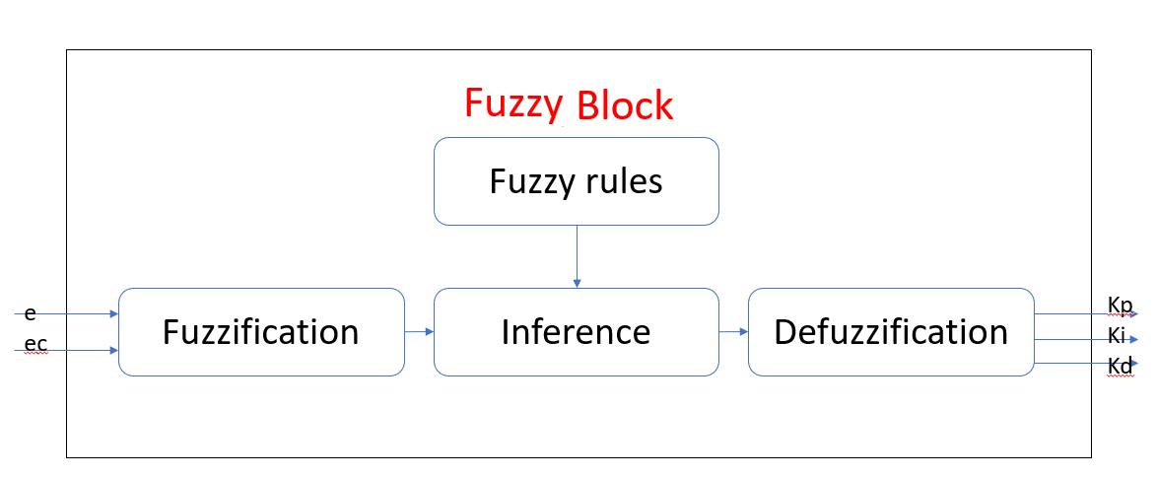
Figure 6.2 - Flowchart of fuzzy block

Table 6.1 - Effects of adjustment kp, ki and kd

Parameter | Rise time | Overshoot | Setting time | Steady state error | Stability
Increase kp | Decrease | Small Increase | Increase | Decrease | Deteriorate
Increase ki | Small Decrease | Increase | Increase | Large Decrease | Deteriorate
Increase kd | Small Decrease | Decrease | Decrease | Small Change | Improve

Demonstrate the PID parameters' self-configuration and the ambiguous connection between e and ec (Table - 6.1).

The fuzzy based PID controller's rules are listed in Tables 6.2-6.4. For the rule basis, the fuzzy variables are e, ec, kp, ki, and kd, with the following form: «Negative Big» (NB), «Negative Medium» (NM), «Negative Small» (NS), «Zero» (ZO), «Positive Small» (PS), «Positive Medium» (PM), «Positive Big» (PB) (PB).

Table 6.2- Base of kp fuzzy rules

$Δk_{p}$ ec,e | NB | NM | NS | ZO | PS | PM | PB
NB | PB | PB | PM | PM | PS | ZO | ZO
NM | PB | PB | PM | PS | PS | ZO | NS
NS | PM | PM | PM | PS | ZO | NS | NS
ZO | PM | PM | PS | ZO | NS | NM | NM
PS | PS | PS | ZO | NS | NS | NM | NM
PM | PS | ZO | NX | NM | NM | NM | NB
PB | ZO | ZO | NM | NM | NM | NB | NB

Table 6.3 - Base of ki fuzzy fule

$Δk_{I}$ ec  e | NB | NM | NS | ZO | PS | PM | PB
NB | NB | NB | NM | NM | NS | ZO | ZO
NM | NB | NB | NM | NS | NS | ZO | ZO
NS | NB | NM | NS | NS | ZO | PS | PS
ZO | NM | NM | NS | ZO | PS | PM | PM
PS | NM | ND | ZO | PS | PS | PM | PB
PM | ZO | ZO | PS | PS | PM | PB | PB
PB | ZO | ZO | PS | PM | PM | PB | PB

Table 6.4 - Base of kd fuzzy fule

$Δk_{D}$ ec  e | NB | NM | NS | ZO | PS | PM | PB
NB | PS | NS | NB | NB | NB | NM | PS
NM | PS | NS | NB | NM | NM | NS | ZO
NS | ZO | NS | NM | NM | NS | NS | ZO
ZO | ZO | NS | NS | NS | NS | NS | ZO
PS | ZO | ZO | ZO | ZO | ZO | ZO | ZO
PM | PB | NS | PS | PS | PS | PS | PB
PB | PB | PM | PM | PM | PS | PS | PB

The membership functions for e, ec, ∆𝑘_{𝑝}, ∆𝑘_{𝑖}, and ∆𝑘_{𝑑} are shown in Figures 6.3 – 6.7.

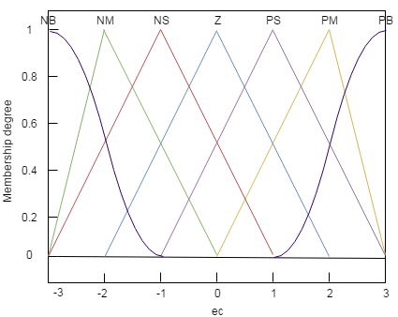

Figure 6.3 - The system error membership function

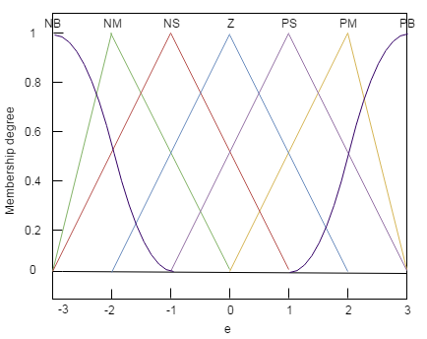
Figure 6.4 - The system error changing rate membership function

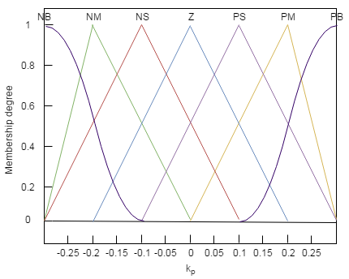
Figure 6.5 - The purpose of membership of k_{p}

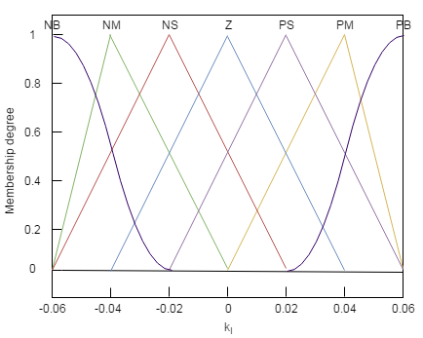
Figure 6.6 - The purpose of membership of k_{i}

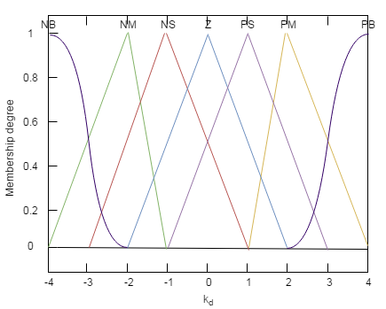
Figure 6.7 - The purpose of membership of k_{d}

A membership value (on degree of membership) between 0 and 1 [100] is mapped to a membership function.The physical domain [100] of e and ec is {-3, -2, -1, 0, 1, 2, 3, }; the physical domain of ∆𝑘_{𝑝} is {-0.3, -0.2, -0.1, 0, 0.1, 0.2, 0.3}; the physical domain of ∆𝑘_{𝑖} is {-0.06, -0.04, -0.02, 0, 0.02, 0.04, 0.06}, and that of ∆𝑘_{𝑑} is {-4, -3, -2, -1, 0, 1, 2, 3, 4}.
We can get the ∆𝑘_{𝑝}, ∆𝑘_{𝑖}, and ∆𝑘_{𝑑} values. Then, k_{p}, k_{i}, and k_{d} calculates as shown below
$$k_{p}\left(k+1\right)=f_{kp}\left(e,ec\right)=k_{p}^{'}\left(k\right)+Δk_{p}\left(k\right)$$ | (6.12)
$$k_{i}\left(k+1\right)=f_{ki}\left(e,ec\right)=k_{i}^{'}\left(k\right)+Δk_{i}\left(k\right)$$ | (6.13)
$$\left(k+1\right)=f_{kd}\left(e,ec\right)=k_{d}^{'}\left(k\right)+Δk_{d}\left(k\right)$$ | (6.14)

In our case, the values k_{p}, k_{i}, and k_{d} values are required for the system can be obtained by using FLC (Figure 6.8):

Figure 6.8- Shows the fuzzy-PID controller's flow Chart

- At the selection stage, we gather control data using measurement equipment;
- Next, we compute the system error and its rate of change;
- Finally, we fuzzify e and ec using the membership function, as indicated in the
function;
- We receive fuzzy data of Δk_{p}, Δk_{i}, and Δk_{d} Tables 6.1-6.4 show the results;
- Defuzzification of Δk_{p}, Δk_{i}, and Δk_{d} while using the membership functions
shown in Figures 6.3- 6.7;
- Determine k_{p}, k_{i}, and k_{d};
- k_{p}, k_{i}, and k_{d} сomes with a PID controller to adjust the temperature in the room

6.4 Design of Adaptive Neuro-PID Controller for Humidity.

Regardless of the fact that the fuzzy PID controller is used to determine the environment within the room, temperature, humidity, and IAQ all have distinct physical properties and characteristics. As a result, in order to improve the quality of life the interior environment, further exploration and development of a new indoor humidity management method is required.
Difficulties in controlling humidity in the absence of housing: time delay; personal preferences; the influence of temperature.

Consequently, fast reaction, minimal overrun, excellent flexibility, and an The temperature is detected using a sophisticated algorithm to determine whether it is hot or chilly, or warm are all criteria for the proposed controller [121]. This chapter summarizes to regulate the room temperature, a radial basis function NN-based intelligent PID controller (RBF) was developed. This study uses computational model and Python to analyse the quality of the RBFNN-PID (radial basis function neural network PID) controller Indoors, an intelligent PID controller based on RBF neural networks is available. RH adjustment.We will demonstrate our method via computer simulation and experimentation in the research results section after a brief explanation.

6.5 RBF Network Structure.

The NN of RBFs contains, in the simplest form, three layers: a normal input layer that performs the distribution of sample data for the first layer of weights; a layer of hidden neurons with a radially symmetric activation function, each jth of which is designed to store a separate reference vector in the form of a weight vector w_{j} (h); and an output layer. The Gauss function is used by latent directional neurons. their result is inversely proportional to the distance.

Figure 6.9 - Architecture of RBF network

RBF networks have a number of advantages (Figure 6.9). Firstly, they are an arbitrary linear function that eliminates the number of layers during development; secondly, the parameters of the linear combination in the output layer can be fully optimized using well-known linear optimization methods that work quickly. Therefore, the RBF network is trained quickly by using the OP algorithm (back propagation). Each hidden node implements a radial activation function that consists of local nodes of perception nodes, and each input node relates to an element of the input vector$I∈R^{n}$ he formula determines the Gaussian activation function for RBF networks:

$$h_{j}=\exp\left(\frac{\left\|I-c_{j}\right\|}{2δ_{j}}\right) j=1,2,...,M$$ | (6.15)

where, $I=\left[I_{1}\right]$ I = [I₁, I₂,...,I_{N} ] is the feature vector in the input, M is the number of nodes that are concealed, Cj = [c_{j1}, c_{j2},...,c_{jN} ] is the The center parameter of the N-dimensional j-th hidden node. The Euclidean norm is denoted by the symbol σ_{j} which is the parameter with a positive central width.

6.6 Control Methodology.

In an interior setting, Figure 6.10 depicts an RBFNN-based intelligent PID control method for RH. The RBFNN-PID controller is made up of two parts: a PID controller for RH control and an RBF NN for PID parameters regulation: k_{p}, k_{i}, and k_{d}.

Figure 6.10 - A PID controller based on RBFNN.
The following is a typical digital incremental PID control algorithm:

$$u\left(k\right)=u\left(k-1\right)+k_{p}\left(e\left(k\right)-e\left(k-1\right)\right)+k_{i}e\left(k\right)+k_{d}\left(e\left(k\right)-2e\left(k-1\right)+e\left(k-2\right)\right)$$ | (6.16)

where k denotes a step in the iterative process, k_{p}, k_{i},and k_{d}are the proportional, integrals and derivative terms of a PID controller[122]. The RBF network uses Jacobian information to set the parameters of a traditional PID controller. The following are the equivalent equations:

The following is a definition of the error signal:

$$u\left(k\right)=u\left(k-1\right)+k_{p}\left(e\left(k\right)-e\left(k-1\right)\right)+k_{i}e\left(k\right)$$  $$+k_{d}\left(e\left(k\right)-2e\left(k-1\right)+e\left(k-2\right)\right)$$ | (6.17)
$$e\left(k\right)=r\left(k\right)-y\left(k\right)$$ | (6.18)

The neuro-PID has three inputs:

$$xc_{1}\left(k\right)=e\left(k\right)-e\left(k-1\right)$$ | (6.19)
$$xc_{2}\left(k\right)=e\left(k\right)$$ | (6.20)

$$xc_{3}\left(k\right)=e\left(k\right)-2e\left(k-1\right)+e\left(k-2\right)$$ | (6.21)

As follows, the control signal is updated:

$$u\left(k\right)=u\left(k-1\right)+Δu\left(k\right)$$ | (6.22)

where,$Δu\left(k\right)$ is equation is used to compute:

$$Δu\left(k\right)=k_{p}xc_{1}+k_{i}xc_{2}+k_{d}xc_{3}$$ | (6.23)

The energy function E(k) is defined as:

$$E\left(k\right)=\frac{1}{2}e{\left(k\right)}^{2}$$ | (6.24)

and the parameters of PID are updated as:

$$k_{p}\left(k\right)=k_{p}\left(k-1\right)+Δk_{p}\left(k\right)$$ | (6.25)
$$k_{i}\left(k\right)=k_{i}\left(k-1\right)+Δk_{i}\left(k\right)$$ | (6.26)
$$k_{d}\left(k\right)=k_{d}\left(k-1\right)+Δk_{d}\left(k\right)$$ | (6.27)

Thus, using the negative-gradient technique, the corresponding$Δk_{p}\left(k\right)$, $Δk_{i}\left(k\right)$, and $Δk_{d}\left(k\right)$ are are modified as follows:

$$Δk_{p}\left(k\right)=-η_{p}\frac{∂E}{∂k_{p}}=-η_{p}\frac{∂E}{∂y}\frac{∂y}{∂u}\frac{∂u}{∂k_{p}}=η_{p}e\left(k\right)\frac{∂y}{∂u}xc_{1}$$ | (6.28)
$$Δk_{i}\left(k\right)=-η_{i}\frac{∂E}{∂k_{i}}=-η_{i}\frac{∂E}{∂y}\frac{∂y}{∂u}\frac{∂u}{∂k_{i}}=η_{i}e\left(k\right)\frac{∂y}{∂u}xc_{2}$$ | (6.29)
$$Δk_{d}\left(k\right)=-η_{d}\frac{∂E}{∂k_{d}}=-η_{d}\frac{∂E}{∂y}\frac{∂y}{∂u}\frac{∂u}{∂k_{d}}=η_{d}e\left(k\right)\frac{∂y}{∂u}xc_{1}$$ | (6.30)

where, $η_{p}$, $η_{i}$, and $η_{d}$ re the proportional, integral, and derivative terms' learning rate parameters, respectively, and ∂y·∂u is the controlled plant's Jacobian information, which can be obtained via RBF network identification as follows:

$$\frac{∂y\left(k\right)}{∂u\left(k\right)}≈\frac{∂y_{m}\left(k\right)}{∂u\left(k\right)}=\sum_{j=1}^{M}{w_{j}h_{j}\frac{c_{ji}-u\left(k\right)}{δ_{j}^{2}}}$$ | (6.31)

6.7 The RBFNN-PID controller.

Figure 6.11 presents the RBF network identification structure, where, u(k) and y(k) represent identifier's input and output, and the RBF network's outputv is y_{m}(k)

Figure 6.11 - RBF network identification structure

The RBFNN-PID control system can be shown as shown in Figure 6.12:

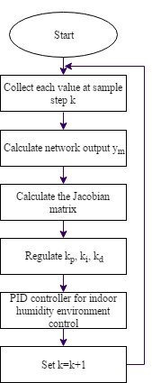

Figure 6.12 - RBFNN-PID controller flow chart
- At the sampling stage, we collect each value of k;
- identifier's input and output, and the RBF network's output,$y_{m}$ ;
- To use the calculations, we obtain the Jacobian matrix;
- we setup the PID controller's parameters;
- and the controller transmits a signal to the temperature sensor, humidity, and
air quality equipment, and since the interior environment may vary, the procedure will restart;
- Set k=k+1.
Energy efficiency in buildings is an urgent task to which much attention is paid all over the world. That's why we proposed fuzzy-PID controller to ensure comfortable indoor environment. To get high accuracy in controlling the comfort parameters, mathematical model of each parameter is explored, after that decoupling strategy for comfort parameters are considered [123]. By applying the developed mathematical model, the proposed PID controller was designated. To get quick reaction of the PID controller and high accuracy, neural network algorithms (RBFNN and backpropagation algorithms) are applied.
7 EXPERIMENT RESULTS AND DISCUSSION

7. 1 Results

After conducting an experiment, we considered the typically used mode. During the experiments, we will measure the power required for the normal mode and the system, and then consider the possibility of providing the microset with electricity [123]. Features of creating a comfortable microclimate in a room of various ranges the characteristics of paremeters include: the air quality in this range is from 400 to 8800 parts per million, the range of power sources that create a comfortable microclimate in the room, i.e., the interval that we justified by the international standards and recommendations of ISO/FDIS 7730.

For the optimisation problem, we utilized neural networks as a tool. Temperature, humidity, and air quality, which are the basis of indoor satisfaction, were assessed for the neural network's basic settings. Elements of the internal atmosphere the bare minimum of data and speed we took the value $\left\{19.5^{∘}C;40\%;800ppm\right\}$ as a vector, and the maximum data and speed of indoor microclimate parameters we took the value $\left\{26^{∘}C;60\%;1100ppm\right\}$ as a vector.

7.2. Simulation Results

The result of experimental work on the data shown in Figure 7.1 is a study that took place during the first hour (from 00:00 to 23:59). The research work is shown by comparing the values of our heating system and the usual heating system. A line marked with green dots indicates the value of temperature changes in a normal system. And the line indicated by the blue dots is a value that reflects the value of the temperature change when using the system, we represent. Esperimentation work began on January 16, 2018, when the outdoor temperature measurement was from -11 ° C to -6 ° C at night and from -6 ° C to +3° C during the day. And tankability was carried out in external conditions, i.e. when the night time changed from 34% to 67% and during the day from 17% to 45%. With considering the quantity of energy we need, we consume typical normal power, gives us a lot of excess energy and creates an unfavorable environment for us. Under the influence of this, we open windows, doors, and lose some energy. The system is depicted in Figure 7.1 proposed by us in which the temperature ranges from 21°C to 26°C, which shows a comfortable temperature level in the room, in which the cost of additional energy at a minimum converges. The Figure 7.1 shows that the traditional system goes far beyond the comfort limits when the temperature changes.
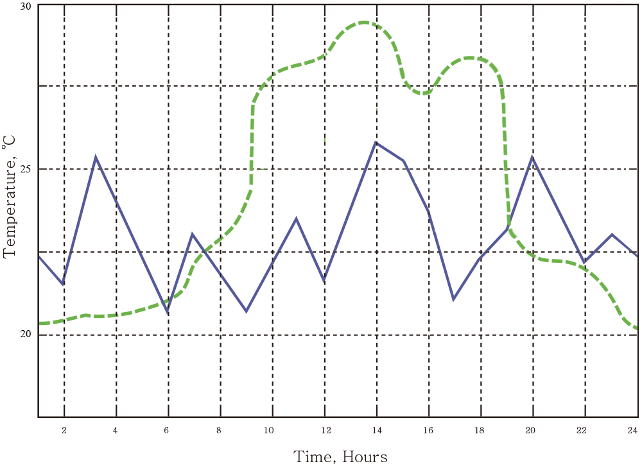

Figure 7.1 - Сomparative scheme of room temperature settings

(Green line: traditional temperature change; Blue line: temperature changes based on our proposed system)

When we use our system based on multi-agent technologies to humidify a room, the relative humidity varies from 30% to 40% (Figure 7.2), which shows a coincidence with the standard system (Figure 7.2). By contrast, it can be shown that the relative humidity of a traditional conventional system gives the result of a poor, low humidity level (from 14% to 28%), since the humidity level is not taken into account in the system, it can be easily adjusted using local humidifiers.
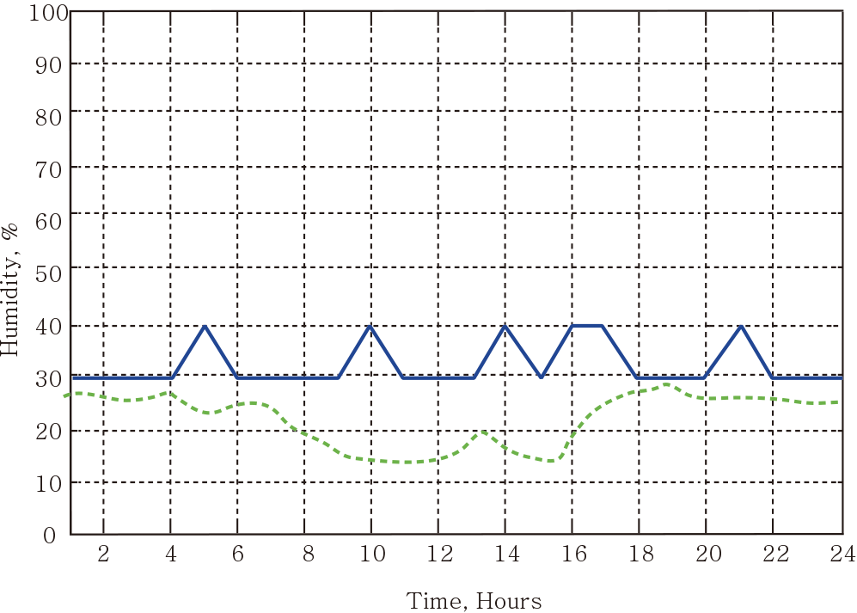

Figure 7.2 - Сomparative scheme of room humidity settings

(Green line: traditional humidity change; Blue line: humidity changes based on our proposed system)

It is for this reason that the humidity during Operation does not show more than 20%. This does not correspond to the description of the comfort environment. The combination of different external conditions and different environmental conditions reduces the humidity in the room, that is, the air quality changes, as shown in the Figure 7.3. The combination of different external conditions and different environmental conditions reduces the humidity in the room, that is, the air quality changes, as shown in the Figure 7.3. As a result, while the air-conditioned room is empty, no CO2 is produced. Of course, there is no CO2 in a room when no one is present. Around the same time, the quantity of CO2 in the room is the same as outside air, and as the work starts and the room fills with people, the volume of CO2 in the room rises. When the amount of CO2 inside the room reaches a given level, the fan turns on and delivers fresh air to the room, keeping the CO2 at a normal level. Thus, as experiments have shown, there is no need to connect the proposed system to each other. It automatically turns on and off. The controller turns on and off based on certain signals in the proposed system, i.e., based on the algorithm [125], it decides when to turn on the fan. As shown in Figure 7.3, when using an ordinary system, we see a high level of CO2, which is much higher than the required level of CO2 during operation, that is, excess energy is consumed, as the number of people inside the room increases and the room is filled. When you open and close windows and doors, the temperature inside the room decreases, which leads to a large difference between the comfort climate in the room and energy consumption, creating an imbalance. At the time of using the proposed system based on the study, the level of CO2 concentration ranged from 820 to 1040 parts per million, which corresponds to indoor air quality.

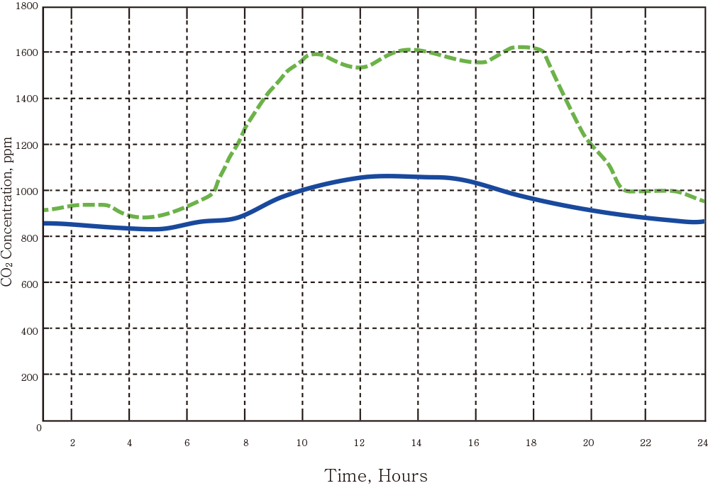

Figure 7.3 - Сomparative scheme of room air quality settings

(Green line: air quality set points; Blue line: air quality set points using our approach)

Figure 7.4 shows a comparison of the comfort parameters in the room with the usual conditions and solutions to the conditions of the system proposed by us. The variables' values across the room throughout the room, using the value, have reached the highest level of comfort level without any Figure 7.5 shows the total energy consumption used in the system (energy consumption from 9.00 in the morning to 18.00 in the evening) [124]. In the system at the heart of our system, we have saved a lot of energy. According to the proposed system, we observed a decrease in energy consumption from 00: 00 to 07:00, and all climate control devices switched to energy saving mode.
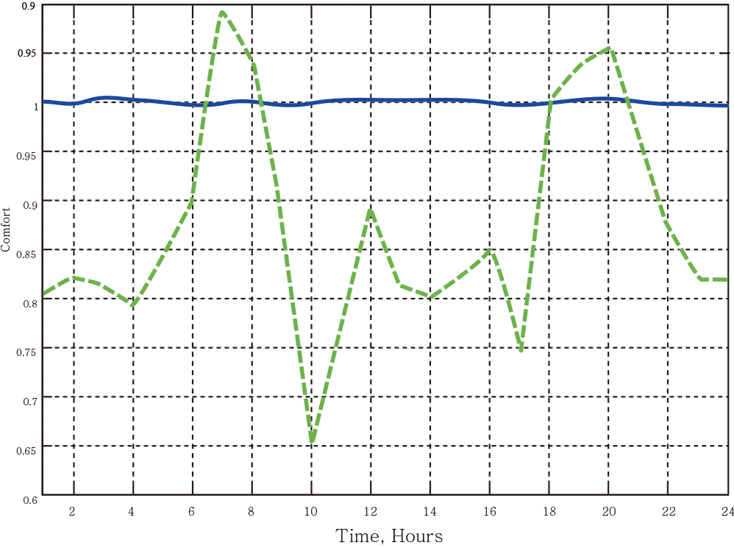

Figure 7.4 - Comparison of parameters of the overall comfort level.

(Green line: comfort level set points comfort level set points; Blue line: comfort level set points using our approach)

Figure 7.5 shows the total energy consumption used in the system (energy consumption from 9 in the morning to 18 in the evening). In the system at the heart of our system, we have saved a lot of energy. According to the proposed system, we observed a decrease in energy consumption from 00: 00 to 07:00, and all climate control devices switched to energy saving mode. The maximum amount of energy used is between 8:00 and 10:00, because when the operating time starts, all temperature control devices are activated [121,122]. During the lunch period from 12:00 to 13: 00, the amount of energy consumption decreases dramatically, as this is the time of the lunch break, during which the ventilation facilities are switched to energy-saving mode. In the afternoon, energy consumption stabilized, and after 18:00 in the evening, energy consumption decreased. In general, after the introduction of the proposed system, we reduced energy consumption by 30%. Smart installations have achieved a high level of internal comfort by reducing the use of eenergy. At the same time, it shows the effectiveness of the algorithm developed by introducing multi-agent and fuzzy proportional functions based on NN [125].

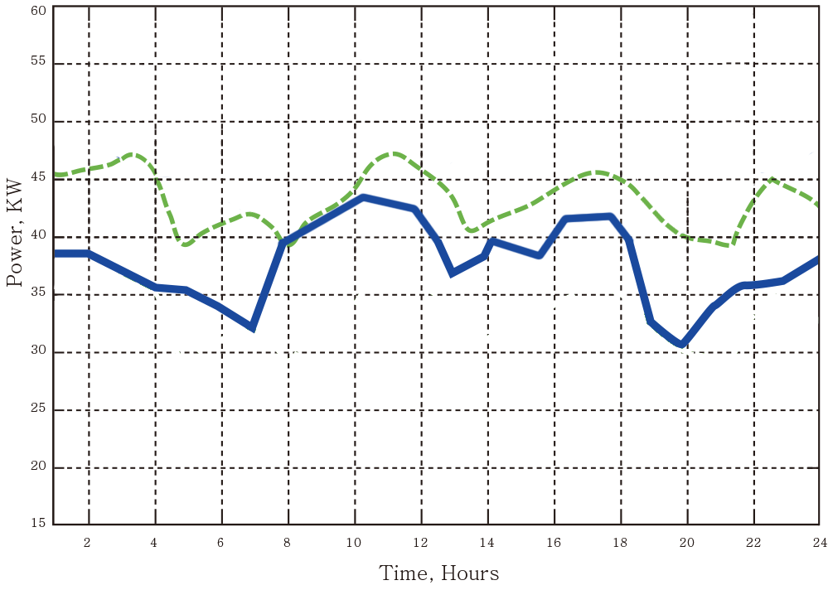

Figure 7.5 - Comparison of total power consumption

(Green line: traditional power consumption; Blue line: power consumption using our approach)

7.3 Case Study of PID Controller

It is essential to correctly monitor the interior temperature, internal humidity, and IAQ in order to accomplish the objective of providing a pleasant indoor environment. In our case, three controllers were offered: fuzzy-PID controller (air temperature and humidity control), a RBFNN-based PID controller (humidity control), and BPNN-based PID controller (for air quality control). In the simulation results subsection, we introduce the simulation performance of the proposed controllers, that was conducted using the Python language.

7.3.1 Simulation of fuzzy-PID Controller

In the result of this part of the study, we model the value of an fuzzy PID regulator that regulates the temperature value. Let us assume that the initial room temperature is inconvenient and requires regulation. After determining and setting the desired temperature, the controller starts working to set the desired room temperature. When analyzing a procedure, the signal is used to make a comparison of controller properties to the data given as input to the internal signal. Consider that the difference in temperature between the interior and outside environments is 5 degrees Celsius. As a consequence, the signal step r(k)=5 is entered at time t=0. Figure 7.6 displays the developed model of the temperature control system's recommended result. The regulator, as can be seen in the image, reacts quickly to the incoming signal with a high rise rate, thanks to the time constant =0.033 s and the settling time ts=0.092 s. And, as for the response of the fast monitoring speed, there is no overload. When 0 the constant error management process is completed[126]. This is because the control speed in the proposed system has excellent response performance, avoids overload, and demonstrates the accuracy and stability of control.

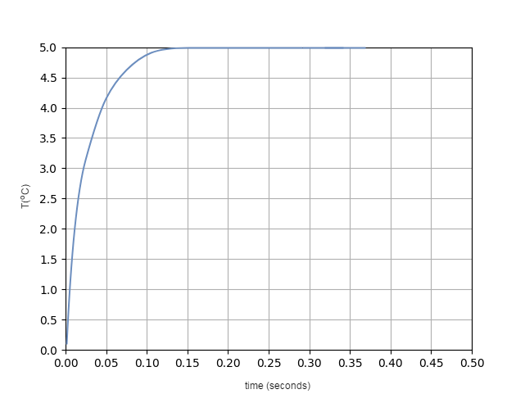

Figure 7.6 - The system output is responsible for step-by-step input

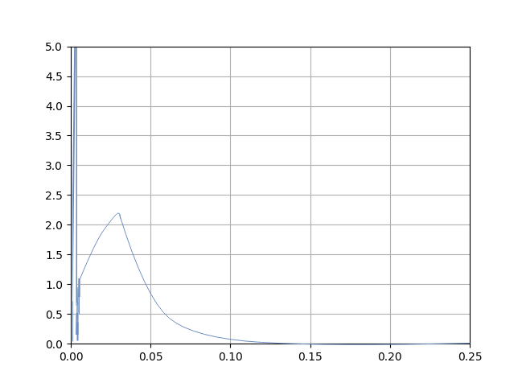

Figure 7.7 - PID output in response to step input

Figure 7.6 shows the temperature changes in the system output, based on outputs from the controllers and systems[126]. As soon as the control process begins, to guarantee that the system's output moves quickly, the PID controller's outcome, approximately equal to the present value, is used while preventing misses. Since the system is in steady state, the steady-state error is 0 and the PID output is set to 0. Figure 7.7 shows the PID response signal. As seen in Figure 7.6 the controller's command is defined, computed with the output, and sent to the device to change the temperature of the air in the room. Figure 7.8 illustrates automatic configuration process of the k_{p}, k_{i}, and k_{d} parameters. Consequently, at t=0, k_{p}=0.3, k_{i}=0, and k_{d}=2 To guarantee that the system output setting is maintained, the PID parameters are changed, and the values change according to the fuzzy logic control rules. In the end, the value of the PID parameters changed to k_{p}=0.31, k_{i}=0, and k_{d}=1.31, and the computer's output was stable. Based on the aforementioned findings, we may conclude that fuzzy PID control can modify the PID controller's parameters to improve control the outcome[127].

7.3.2 Simulation Tests of RBFNN-PID Control

To maintain a suitable humidity level, and to keep it stabile in a room, as well as to eliminate the inconvenience of humidity control, the RBFNN PID controller was developed. The RBFNN controller structure comprises two parts: a conventional PID controller that is responsible for controlling the air temperature, and a RBF for setting the parameters of the PID controller which correspond to the current parameters of the internal environment[123]. For example, suppose that the initial humidity in the room was uncomfortable, and it was necessary to control the humidity. In this case, first, a set value of relative humidity is set, and our controller starts to work, to reach the target humidity level. The maximum learning rate (η=0.25) and the pulse rate after several tests are established. As a result, the best management effectiveness is established. Figure 7.8 shows the results of modeling the yield at a time when the internal and external humidity is 50%. As demonstrated in the simulation, the controller gives a quick response, and there are no omissions. The control process error is close to zero. This means, the suggested controller is efficient and has a quick reaction time, without interruptions, and with high correctness of control and stability. Figure 7.9 shows that the response of the PID controller to the step input signal calculates a control command with an output to set the relative humidity change, or save the state.

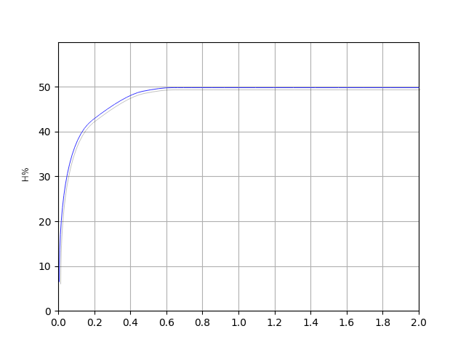

Figure 7.8 - Simulation of RBFNN controller output of the system in response to a step input

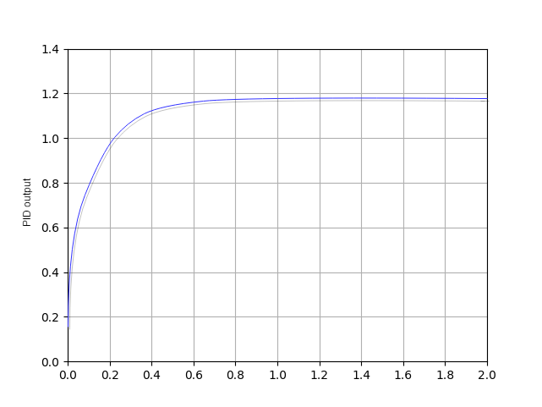

Figure 7.9 - Simulation of RBFNN controller reaction of the PID output to a step input

Figure 7.10 shows the process of automatic adjustment of the PID controller parameters, when the control process started at values k_{p}=0.03, ki=0.01, and k_{e}=1. They were changed in accordance with the RBFNN control. As a result of the simulation in Figure 7.8, it is shown that, based on RBFNN, it is feasible to change the PID settings automatically for kp, k_{i}, and k_{d}, until the PID controller's optimal value is reached parameters is reached. As a result, the system will start working steadily. In our case, the system reached a steady state, with the values k_{p}=0.03, k_{i}=0.05, and k_{d}=1.01 for the PID controller.
Figure 7.10 - The process of configuring PID parameters

7.4 Experiment Results

The research experiments of the newly developed fuzzy-PID regulator for IAQ improvement, including temperature, humidity, monitoring, are described in this section[122-124]. The features of the RBFNN-PID controller and the BPNN-PID controller are compared here.

7.4.1 Temperature Control

Experimental work was carried out from December 2018 to May 2019. At a low outdoor temperature, the chamber should be warmed up. Thus, during temperature tests:
- The Environmental camera is used to simulate the air conditioning area;
- the thermocouple unit was used to measure room temperature;
- the heating unit is used to supply air heated to a certain temperature in the
room through a tube to the room;
- the working power of the heater is regulated by a fuzzy Pi controller;
- 9:00 to 18:00 are is chosen as the working hours (when the office is open).
To simulate controllers, the following rules are introduced:
- The room temperature varies depending on the outdoor temperature and,
doors and windows are opened and closed.

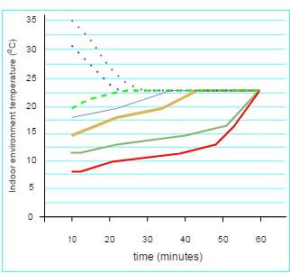

Figure 7.11 - Room temperature measurement

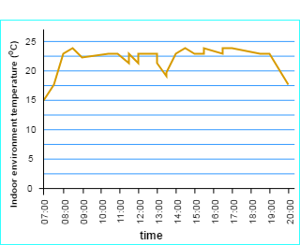

Figure 7.12 - Monitoring of room temperature in December-2018
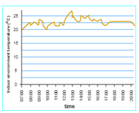

Figure 7.13 - Monitoring of room temperature in May-2019

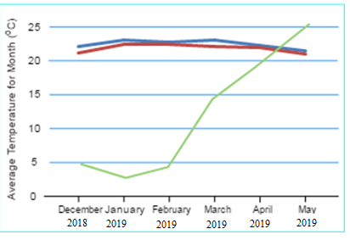

Figure 7.14 - Average monthly temperature inside and outside the room during the experimental period
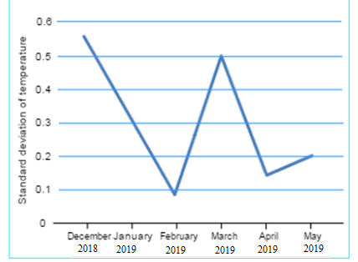

Figure 7.15 - Standard variation of indoor temperature over a month

Figure 7.11 shows the process of configuring PID parameters. To bring the monitored zone to a given point from different values of the initial temperature. Eventually, it took the controller less than sixty minutes to reach a room temperature of up to 21° C, which corresponds to 80% bandwidth satisfaction in To bring the area we are considering from different initial temperature values to a given point. Ultimately, it took the controller no more than sixty minutes to reach room temperature of 21°C, which corresponds to 55% throughput according to ASHRAE 2010-80 in any case (open and closed spaces are not always taken into account in our experiments, as this is not possible)[126]. The PID controller is not clear everywhere, the heater starts working and starts working at 8:00, in our experiments it is an hour before the start of working hours. Accordance with ASHRAE 55-2010 under all conditions (open and closed rooms are not always considered in our experiments, as this is unlikely to happen). Everywhere the statement that the PID controller is fuzzy The claim that the PID controller is hazy begins functioning and operates the heater at 8:00 is false; in our tests, it starts working one hour earlier.

Figure 7.12 shows the results of temperature changes for a single day on the premises, January 17, 2017.

Figure 7.13 demonstrates the indoor air temperature that observed in May 2019, when average outdoor temperature was 25 ºC in daytime, and 11.5 ºC at night.

Figure 7.14 illustrates the result for the 6-month experiment for indoor- and outdoor-temperatures. The green line is the monthly average outdoor temperature, the blue line the average temperature using the proposed system, and the red line the average temperature when the proposed system kept steady state. Suppose that the average room temperature in a stationary state lies between 20.6–21.1°C. The lowest monthly temperature in the room was measured in December of this year hroughout that month, the computer was put through its paces. Under conditions of opening or closing the window for relatively long periods. The normal interior temperature is influenced by the temperature outdoor. The continuous inaccuracy of the procedure is not substantial, based on the research's findings. We can see that the fuzzy PID controller's suggested temperature controller provides excellent control properties[127].

Another feature, the standard deviation of the observed temperature, is computed in Figure 7.15, for examining the proposed temperature controller by the amount of data collected. According to the established mode, the average monthly standard deviation of the room temperature is shown Figure 7.15 shows an example of this. The greatest standard deviation of room temperature was recorded in December 2018, since the device was put to the test during that month under circumstances when the opening was opened for a long period of time or on a regular basis, lowering the room temperature[125]. Higher standard deviations arise from this, since the standard deviation shows the amount of variance or dispersion from the mean. The findings of monthly standard deviations were obtained as a consequence. Their values were modest, indicating that the monitored data on interior temperature obtained in the trials was often near to the average and distributed across a narrow range of values. According to the findings of the tests, a fuzzy PID temperature controller provides excellent control. properties and stability characteristics, and it also adapts well to indoor temperature control, while a comfortable internal temperature can be provided in the conditioned air zone, which is also controlled as suggested controller[124].

7.4.2. Relative Humidity.

Using the Control method as a foundation, fuzzy logic controls the RH in the room. The properties and characteristics of the controller of internal humidity are regulated by the results of the study, this section outlines a series of tests that were put out. From December 2018 to May 2019, the tests were conducted on a test site, while the external environment is dry and the indoor climate requires humidification. Therefore, a number of experiments were carried out to determine the moisture content of the room:
  - The relative humidity in the room is measured using a humidity sensor;
- The humidifier is a DC voltage that may be converted to humidity relative;
- The humidifier's capacity is regulated by the control measure;
- the normal value of temperature and humidity in the area is between 30– 60%
according to ASHRAE studies;
- this survey's set point of household humidity is 55 %. As a consequence, the
room's humidity is maintained around 50 and 60 %, and the workers' working hours (when the office is open) are set from 9:00 a.m. to 18:00 p.m. The next work was done
to replicate any circumstances that occurred in the actual use of our device in real
structures:
- The interior is well sealed (windows and door are closed);
- Violations were introduced into the internal environment, were doors
and windows were constantly
- opened, then closed.

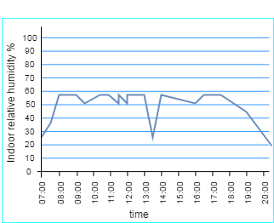

Figure 7.16 - Indoor RH monitored in January, 2019

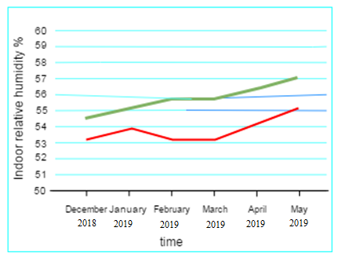

Figure 7.17 - Average monthly relative humidity during the working period;

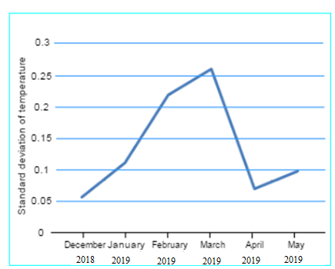

Figure 7.18 - Stand deviation of indoor relative humidity

Figure 7.16 shows the RH changes for one day in the room, January 17, 2019. The initial RH is about 20%, the humidity level in the room rises quickly above 30%, and then adjusts to the set value. During working hours, from 9:00 to 18:00, relative humidity in the premises is maintained between 50–60%.

Figure 7.17 shows the monthly average relative humidity levels in the room from December 2018 to May 2019. As shown in the figure, the red line denotes the average monthly RH during the monitored working hours from 8:30 to 18:00, when the proposed system was applied, and they range from 53–54%.

To study the temperature proposed by the regulator, it is computed the standard deviation of the observed RH level, in addition to the average amount of data collected in Figure 7.18 shows the average monthly standard deviations of the internal RH level in a stationary state. The air temperature is going greatest standard error was obtained in March 2019, when the controller was tested with doors and windows being opened, then closed. Since the standard deviation indicates how much variation or variance exists from the mean, violations occur more frequently within the grounds, resulting in a larger standard error. The following are the results of the monthly median deviations: as a result, the adjusted RH in the area recorded in the tests is often very approximately normal, with a limited set of options. The results of the tests show that the RFBNN-PID sensor is reliable. Regulator possesses good properties and control characteristics of stability, as well as adaptability for regulating indoor humidity that can be provided in the conditioned air zone by controlling the proposed controller.

CONCLUSION

This dissertation work was devoted to the creation of a comfortable microclimate using multi-agent technologies to ensure a comfortable microclimate inside the building. Models and methods for the development of Intelligent Energy based on multi-Agent technology with the use of adapted neural networks were considered. The literature review carried out in the work shows that the problem is relevant, since energy saving and energy efficiency are important components in the heat power industry. In this regard, the dissertation work solved the problems of developing new approaches to assessing the comfort of the microclimate to reduce energy consumption while maintaining occupants within private, commercial, and governmental facilities, and reducing the amount of energy consumed.
The current techniques for evaluating the microclimate's comfort do not take into consideration the special risks inherent in non-industrial premises, as a result of which it can lead to a violation of favorable conditions for people inside. In this regard, in the proposed work, methods have created that consider the effect of energy-saving initiatives on the environment microclimate, as a result of which it will not have a negative impact on people. One of the most suitable methods in the development of such a system is a multi-agent approach using adapted neural networks, in which a large number of interacting intelligent agents are modeled.
During the research, a qualitative review of the existing analogues of the system was conducted, among which the best ones were selected and analyzed to ensure a comfortable indoor microclimate. The paper investigated a mathematical model of thermal processes, interior microclimate factors that influence change, and the maintenance of a pleasant microclimate within the structure, as a consequence of which a mathematical model of thermal processes was developed. Furthermore, it was investigated how to control heating, ventilation, and air conditioning systems while taking temperature and humidity into consideration. in the room and outdoors, and the issue of maintaining a constant comfortable temperature and humidity was also considered.
Thus, experiments conducted in laboratory conditions, analysis of the data obtained and testing showed that the multi-agent system of control and management of electricity proposed in this work based on mathematical models and methods using adapted neural networks is a necessary tool for creating comfortable conditions for people who are indoors and will make a great contribution to improving the country's economy in the future.
The following results were obtained in the dissertation:
1. A mathematical model of a comfortable microclimate of the Smart Grid model was developed with the participation of multi-agent technologies;
2. The architecture of a multi-agent system for monitoring and managing electricity was proposed;
3. Neural network models were adapted to ensure a comfortable microclimate inside the building;
4. Based on the developed mathematical modeling, it was found that the level of comfort of the microclimate depends on standard energy-saving mechanisms;
5. Data on the influence of energy-saving mechanisms on air exchange and microclimate parameters inside the building were obtained experimentally.
Theoretical explanations and practical investigations substantiate the study findings' dependability.
The license of copyright law confirms the economic eﬀectiveness labor outcomes.

REFERENCES

- Földváry, V., Bukovianska, H.P., Petráš, D. Analysis of Energy Performance
and Indoor Climate Conditions of the Slovak Housing Stock Before and After its
Renovation // 6th International Building Physics Conference, IBPC 2015Energy
Procedia, Volume 78, November 2015. - pp 2184-2189.
- Omarov, B., Altayeva, A., Suleimenov, Z., Cho. Y.I, Omarov B., // Design of fuzzy logic-based controller for energy efficient operation in smart buildings // First IEEE International Conference on Robotic Computing, April 2017. - pp. 346–351, doi:10.1109/IRC.2017.26.
- Omarov, B., Altayeva, A., Cho, Y.I. Smart Building Climate Control Considering Indoor and Outdoor Parameters. In: Saeed K., Homenda W. // Chaki R. (eds) Computer Information Systems and Industrial Management (CISIM -2071) Lecture Notes in Computer Science, vol 10244. Springer, Cham.
- Yu, T., Lin, C.: An intelligent wireless sensing and control system to improve indoor air quality: monitoring, prediction, and preaction // International Journal of Distributed Sensor Networks - 2015. Volume: 11 issues: 8, Open Access.
- Abraham, S., Li, X.; A Cost-Effective Wireless Sensor Network System for Indoor Air Quality Monitoring Applications // Procedia Computer Science, 2014. - pp 165–171.
- Omarov, B., Suliman, A., and Kushibar, K. Face recognition using artificial neural networks in parallel architecture // Journal of Theoretical and Applied Information Technology 91 (2): pp 238-248. Open Access.
- M Razmara, M Maasoumy, M Shahbakhti, Optimal exergy control of building HVAC system// Applied energy 2015, https://doi.org/10.1016/j.apenergy.2015.07.051.
- American Society of Heating, Refrigerating and Air-Conditioning Engineers, Inc. ASHRAE standard 34 designation and safety classification of refrigerants // https://www.ashrae.org/technical-resources/standards-and-guidelines, 2013.
- Kevin Mets; Matthias Strobbe; Tom Verschueren; Thomas Roelens; Filip De Turck; Chris Develder, Distributed multi-agent algorithm for residential energy management in smart grids // IEEE Network Operations and Management Symposium, 2012, https://doi.org /10.1109/NOMS.2012.6211928.
- J Yu, A Zhao, M Zhou, optimizing multi-chiller dispatch in HVAC system using equilibrium optimization algorithm //Energy Reports, 2021, https://doi.org/10.1016/j.egyr.2021.09.012.
- Z Li, D Loveday, P Demian, Nudging and usage of thermal comfort-related
systems // Energy and Buildings, https://doi.org/10.1016/j.enbuild.2021.111480.
- M Razmara, M Maasoumy, M Shahbakhti, Optimal exergy control of building
HVAC system // Applied energy, 2015,https://doi.org/10.1016/j.apenergy.2015.07.051

- Luis Hernandez; Carlos Baladron; Javier M. Aguiar; Belen Carro; Antonio Sanchez-Esguevillas; Jaime Lloret; A multi-agent system architecture for smart grid management and forecasting of energy demand in virtual power plants //IEEE Communications Magazine (January 2013, Volume: 51, Issue: 1).
- M Choi, K Cho, JY Hwang, LW Park, Design and implementation of IoT-based HVAC system for future zero energy building // 2017 IEEE International Conference, DOI: 10.1109/PERCOMW.2017.7917631
- Z Zhou, L Feng, S Zhang, C Wang, G Chen, T Du, Y Li, The operational performance of “net zero energy building // Applied energy, 2016, https://doi.org/10.1016/j.apenergy.2016.05.093
- J Rehrl, M Horn, Temperature control for HVAC systems based on exact linearization and model predictive control //IEEE International Conference, 2011 - ieeexplore.ieee.org., DOI: 10.1109/CCA.2011.6044437
- A Afram, F Janabi-Sharifi, AS Fung, K Raahemifar, Artificial neural network (ANN) based model predictive control (MPC) and optimization of HVAC systems: A state of the art review and case study of a residential HVAC system, 2017 //https://doi.org/10.1016/j.enbuild.2017.02.012;
- F Allgöwer, A Zheng , Nonlinear model predictive control // 2012 - books.google.com., Vol. 35, No. 3, 299-315.
- Chun-xia Dou, Da-wei Hao, Bao Jin, Wei-qian Wang, Na An, Multi-agent-system-based decentralized coordinated control for large power systems, 2014 //https://doi.org/10.1016/j.ijepes.2014.01.012.
- Diane J. CookMichael YoungbloodSajal K. Das, Multi-agent Approach to Controlling a Smart Environment // Part of the Lecture Notes in Computer Science book series, Designing Smart Homes, volume 4008, pp 165-182.
- Khodakarami, J.,an dNasrollahi, N. Thermal comfort in hospitals—a literature review // Renewable and Sustainable Energy Reviews 2012. - pp 4071–4079.
- Ormandy, D., and Ezratty, V. Health and thermal comfort: from WHO guidance to housing strategies // Energy Policy 2012. - pp 116–21.
- Chen, A., and Chang, V.W.C. Human health and thermal comfort of office workers in Singapore // Building and Environment 2012. - pp 172–178.
- Leyten, J.L, Kurvers, S.R., and Raue, A.K. Temperature, thermal sensation and workers’ performance in air-conditioned and free-running environments // Architectural Science Review 2013. - pp 14–21, http://dx.doi.org/10.1080/00038628. 2012.745391.
- Shein, W.W., Y. Tan, and A.O. Lim. PID controller for temperature control with multiple actuators in cyber-physical home system // In 15th International conference on network-based information systems. 2012, DOI: 10.1109/NBiS.2012.118.
- Daogui Tang; Xinping Yan; Yupeng Yuan; Kai Wang; Liqiang Qiu, Multi-agent Based Power and Energy Management System for Hybrid Ships // International Conference on Renewable Energy Research and Applications (ICRERA) 2015, DOI: 10.1109/ICRERA.2015.7418441.
- Dounis, A.I. and C. Caraiscos, Advanced control systems engineering for energy and comfort management in a building environment-A review // Renewable and Sustainable Energy Reviews, 2009. - pp 1246-1261
- D.W.U. Perera, C. F. Pfeiffer, N.O Skeie. Control of temperature and energy consumption in buildings - A review // International journal of energy and environment. Volume 5, Issue 4, 2014. – pp 471-484.
- Mirinejad, H., et al., Control Techniques in Heating, Ventilating and Air Conditioning (HVAC) Systems // Journal of computer science, 2008. - pp. 777-783.
- Robin Roche; Benjamin Blunier; Abdellatif Miraoui; Vincent Hilaire; Abder Koukam, Multi-agent systems for grid energy management: A short review // IECON 2010 - 36th Annual Conference on IEEE Industrial Electronics Society, DOI: 10.1109/IECON.2010.5675295.
- Afram, A. and F. Janabi-Sharifi, Theory and applications of HVAC control systems – A review of model predictive control (MPC) // Building and Environment, 2014. - pp 343-355.
- Prívara, S., et al., Model predictive control of a building heating system: The first experience //Energy and Buildings, 2011. - pp 564-572.
- Bao-Cang, D., Modern predictive control, Boca Raton 2010. – pp 286 // DOI https://doi.org/10.1201/9781315222585.
- Vasak, M., Starcic, A. and Martincevic, A. Model predictive control of heating and cooling in a family house // Proceedings of the 34th International Convention MIPRO, 29 July 2011.
- D.W.U. Perera, C. F. Pfeiffer, N.-O Skeie. Control of temperature and energy consumption in buildings - A review // International journal of energy and 7environment, Volume 5, Issue 4, 2014. - pp.471-484.
- Li, S., S. Ren, and X. Wang. HVAC room temperature prediction control based on neural network model // In 5th Conference on Measuring Technology and Mechatronics Automation. 2013, DOI: 10.1109/ICMTMA.2013.151.
- Mohammad Mohammadi, Developing a Framework for Distributed and Multi-agent Management of Future Sustainable Energy Systems // Advances in Intelligent Systems and Computing book series , AISC, volume 1004, pp. 192-196.
- EL Bourakadi, Dounia, Yahyaouy, Ali, Boumhidi, Jaouad, Multi-agent system based sequential energy management strategy for Micro-Grid using optimal weighted regularized extreme learning machine and decision tree // Intelligent Decision Technologies, vol. 13, no. 4, 2019 pp. - 479-494.
- A. Sujil, Jatin Verma & Rajesh Kumar, Multi agent system: concepts, platforms and applications in power systems //Artificial Intelligence Review volume 49, 2018. - pp.153–182.
- Lixing, D., et al. Support vector regression and ant colony optimization for HVAC cooling load prediction // In International Symposium on Computer, Communication, Control and Automation. 2010, DOI: 10.1109/3CA.2010.5533861.
- Mesfer Alrizq; Elise de Doncker; Alvis Fong, Changing Energy Consumption Patterns Based on Multi-Agent Human Behavior Modeling for Analyzing the Effects of Feedback Techniques //2019 IEEE Power and Energy Conference at Illinois (PECI), DOI: 10.1109/PECI.2019.8698779.
- Ferkl, L. and JSiroky, J. Ceiling radiant cooling: Comparison of armax and subspace identication modelling methods // Building and Environment, 2010. - pp 205-212.
- Privara, S., et al. Modeling and identification of a large multi-zone office building // In Control Applications (CCA), 2011 IEEE International Conference on. 2011, DOI: 10.1109/CCA.2011.6044402.
- Wu, S. and J.-Q. Sun, A physics-based linear parametric model of room temperature in office buildings // Building and Environment, 2012. - pp 1-9.
- Mustafaraj, G., Chen, J., and GLowry, G. Development of room temperature and relative humidity linear parametric models for an open office using BMS data. // Energy and Buildings, 2010. - pp 348-356.
- Prívara, S., et al., Building modeling as a crucial part for building predictive control // Energy and Buildings, 2013. - pp 8-22.
- Prívara, S., et al., Building modeling: Selection of the most appropriate model for predictive control // Energy and Buildings, 2012. - pp 341-350.
- Landau, L., et al., Adaptive control // Springer, London 2011. - pp. 457-464.
- Khadijah M. HangaYevgeniyaKovalchuk, Machine learning and multi-agent systems in oil and gas industry applications: A survey // https://doi.org/10.1016/j.cosrev.2019.08.002.
- Wen, J.T., et al. Building temperature control with adaptive feedforward // In Decision and Control (CDC), IEEE 52nd Annual Conference on. 2013, DOI: 10.1109/CDC.2013.6760646.
- Muhammad Waseem Khan, Jie Wang Meiling, Ma Linyun Xiong, Penghan Li, Fei Wu,Optimal energy management and control aspects of distributed microgrid using multi-agent systems // https://doi.org/10.1016/j.scs.2018.11.009.
- Chaudhry, S.I., and Das, M. Adaptive control of indoor temperature in a building using a desirable reference temperature profile // In Circuits and Systems (MWSCAS), IEEE 56th International Midwest Symposium 2013, DOI: 10.1109/MWSCAS.2013.6674899.
- D.W.U. Perera, C. F. Pfeiffer, N.-O Skeie, Control of temperature and energy consumption in buildings - A review // International Journal of Energy And Environment, Volume 5, Issue 4, 2014. - pp.471-484.
- Hongli, L., et al. A novel adaptive energy-effcient controller for the HVAC systems // In Control and Decision Conference (CCDC). 2012, DOI: 10.1109/CCDC.2012.6244225.
- Leephakpreeda, T. Implementation of adaptive indoor comfort temperature control via embedded system for air-conditioning unit // Journal of Mechanical Science and Technology, 2012. - pp 259-268.
- Mohammad Hasanuzzaman Shawon; S. M. Muyeen; Arindam Ghosh; Syed Mofizul Islam; Murilo S. Baptista, Multi-Agent Systems in ICT Enabled Smart Grid: A Status Update on Technology Framework and Applications // Multi-Agent Systems in ICT Enabled Smart Grid: A Status Update on Technology Framework and Applications, DOI: 10.1109/ACCESS.2019.2929577.
- Becerra, V.M., Optimal control, in Scholarpedia // 2008, https://doi.org/10.3390/en11030495.
- Wang, S., and Ma, Z Supervisory and Optimal Control of Building HVAC Systems: A Review // HVAC&R Research, 2008. - pp 3-32.
- Burns, J.A., and Cliff, E.M. On optimal thermal control of an idealized room including hard limits on zone-temperature and a max-control cost term // In Decision and Control (CDC), IEEE 52nd Annual Conference on. 2013, https://doi.org/10.3390/en11030495
- Syed Redwan Md Hassan; Nazmul Hasan; Mohammad Ali Siddique; K.M Solaiman Fahim; Rummana Rahman; Lamia Iftekhar, Incorporating Multi-Agent Systems Technology in Power and Energy Systems of Bangladesh: A Feasibility Study // 2nd International Conference on Robotics, Electrical and Signal Processing Techniques (ICREST) 2021, DOI: 10.1109/ICREST51555.2021.9331205
- Enrique Kremers, Jose Gonzalez de Durana, Oscar Barambones, Multi-agent modeling for the simulation of a simple smart microgrid 2013 // https://doi.org/10.1016/j.enconman.2013.07.050.
- Rui, Y., and Lingfeng, W. Optimal control strategy for HVAC system in building energy management // in Transmission and Distribution Conference and Exposition (T&D), 2012 IEEE PES, DOI: 10.1109/TDC.2012.6281687.
- Berthou, T., et al. Optimal control for building heating: An elementary school case study // Proceedings of BS2013: 13th Conference of International Building Performance Simulation Association, Chambéry, France, August 26-28.
- Mirinejad, H., Welch, K.C., andSpicer, L. A review of intelligent control techniques in HVAC systems // in Energytech, IEEE 2012, DOI: 10.1109/EnergyTech.2012.6304679.
- Mirinejad, H., et al., Control Techniques in Heating, Ventilating and Air Conditioning (HVAC) Systems 1 // Journal of computer science, 2008. - pp 777-783.
- Dounis, A.I., and Caraiscos, C Advanced control systems engineering for energy and comfort management in a building environment-A review // Renewable and Sustainable Energy Reviews, 2009. - pp 1246-1261.
- Song, Y., Wu, S., and Yan, Y.Y. Control strategies for indoor environment quality and energy efficiency—a review // International Journal of Low-Carbon Technologies, Volume 10, Issue 3, September 2015, Pages 305–312, https://doi.org/10.1093/ijlct/ctt051.
- Moon, J.W., et al., Comparative study of artificial intelligence-based building thermal control methods – Application of fuzzy, adaptive neuro-fuzzy inference system, and artificial neural network // Applied Thermal Engineering, 2011. - pp 2422-2429.
- Amin Shokri Gazafroudi; Tiago Pinto; Francisco Prieto-Castrillo; Javier Prieto; Juan Manuel Corchado; Aria Jozi, Organization-based multi-Agent structure of the Smart Home Electricity System // IEEE Congress on Evolutionary Computation (CEC) 2017, DOI: 10.1109/CEC.2017.7969458.
- Shahnawaz Ahmed, S., et al., Fuzzy logic-based energy saving technique for a central air conditioning system // Energy, 2007. - pp 1222-1234.
- Renzhi Lua, Yi-ChangLi, Yuting Lic, Junui Jiang, Yuemin Dingd, Multi-agent deep reinforcement learning based demand response for discrete manufacturing systems energy management 2020 // https://doi.org/10.1016/j.apenergy.2020.115473.
- Alireza Heidari, Mehdi Moradi, Ahmad Hajinezhad, Optimization of Micro-Grid Electricity Market Based on Multi Agent Modeling Approach // International Journal of Energy Optimization and Engineering (IJEOE) 2018, DOI: 10.4018/IJEOE.2018070101,).
- Homod, R.Z., et al., Gradient auto-tuned Takagi–Sugeno Fuzzy Forward control of a HVAC system using predicted mean vote index // Energy and Buildings, 2012. - pp 254-267.
- Kristl, Ž., et al., Fuzzy control system for thermal and visual comfort in building // Renewable Energy, 2008. - pp 694-702.
- DongLiangaShenfangYuanb, Structural health monitoring system based on
multi-agent coordination and fusion for large structure // Advances in Engineering
Software, Volume 86, August 2015, pp 1-12.
- Paris, B., et al., Hybrid PID-fuzzy control scheme for managing energy resources in buildings // Applied Soft Computing, 2011. - pp 5068-5080.
- Kumar, R., Aggarwal, R.K., and Sharma, J.D. Energy analysis of a building using artificial neural network: A review // Energy and Buildings, 2013. 65(0): pp 352-358.
- Moon, J.W., Yoon, S-H., and Kim, S. Development of an artificial neural network model based thermal control logic for double skin envelopes in winter. // Building and Environment, 2013. - pp 149-159.
- Shaun Howell, Yacine Rezgui Jean-Laurent Hippolyte Bejay Jayan Haijiang
Li, Towards the next generation of smart grids: Semantic and holonic // Renewable and
Sustainable Energy Reviews, Volume 77, September 2017. – pp 193-214.
80 Liang, J. and Du, R. Design of intelligent comfort control system with human
learning and minimum power control strategies // Energy Conversion and Management,
2008. - pp 517- 528.
81 Moon, J.W., et al., Determining optimum control of double skin envelope for
indoor thermal environment based on artificial neural network // Energy and Buildings,
2014. - pp 175-183.
- Castilla, M., et al., Neural network and polynomial approximated thermal
comfort models for HVAC systems // Building and Environment, 2013. - pp 107-115.
- Marvuglia, A., Messineo, A., and Nicolosi, G. Coupling a neural network temperature predictor and a fuzzy logic controller to perform thermal comfort regulation in an office building // Building and Environment, 2014. - pp 287-299.
- Soyguder, S., and Alli, H. An expert system for the humidity and temperature control in HVAC systems using ANFIS and optimization with Fuzzy Modeling Approach // Energy and Buildings, 2009. - pp 814-822.
- Pal, A.K. and Mudi, R. Self-tuning fuzzy PI controller and its application to HVAC systems // International journal of computational cognition (http://www.ijcc.us), March 2008, vol. 6, no. 1.
- Bai, J., and Zhang, X. A new adaptive PI controller and its application in HVAC systems // Energy Conversion and Management, 2007. - pp 1043-1054.
- Paris, B., et al., Heating control schemes for energy management in buildings // Energy and Buildings, 2010. - pp 1908-1917.
- Moon, J.W., and Kim, J-J. ANN-based thermal control models for residential buildings. // Building and Environment, 2010. - pp 1612-1625.
- Moon, J.W. Performance of ANN-based predictive and adaptive thermal-control methods for disturbances in and around residential buildings // Building and Environment, 2012. - pp 15-26.
- Zhu Wanga, Lingfeng Wanga, Anastasios I.Dounisb, Rui Yang, Multi-agent
control system with information fusion-based comfort model for smart buildings //
Applied Energy, Volume 99, November 2012. - pp 247-254.
- Taleghani, M., Tenpierik, M., and Kurvers, S. A review into thermal comfort in buildings // Renewable and Sustainable Energy Reviews, 2013. - pp 01-215.
- Wolkoff, P. Indoor air pollutants in office environments: Assessment of comfort, health, and performance // International Journal of Hygiene and Environmental Health 216, 2013. - pp 371-394.
- Mien, T.L. Design of Fuzzy-PI Decoupling Controller for the Temperature and Humidity Process in HVAC System // International Journal of Engineering Research & Technology (IJERT), January 2016, Vol. 5 Issue 01.
- Amjad Anvari-Moghaddama, Ashkan Rahimi-Kianb Maryam,
S. MirianbJosep M. Guerrero, A multi-agent-based energy management solution for
integrated buildings and microgrid system // Applied Energy, Volume 203, 1 October
2017. - pp 41-56.
- Vitor N. Coelhoabc, MiriWeiss, Cohend Igor, M. Coelhoea, Nian Liuf
, Frederico Gadelha Guimarães, Multi-agent systems applied for energy systems
integration: State-of-the-art applications and trends in microgrids //Applied Energy,
Volume 187, 1 February 2017. - pp 820-832.
- Soyguder, S., and Alli; H. An expert system for the humidity and temperature control in HVAC systems using ANFIS and optimization with Fuzzy Modeling Approach // Energy and Buildings 41, 2009. - pp 814–822.
- Zheng Ma 1ORCID, Mette Jessen Schultz 2ORCID,Kristoffer Christensen 3,Magnus Værbak 3,Yves Demazeau 4ORCID andBo Nørregaard Jørgensen, The Application of Ontologies in Multi-Agent Systems in the Energy Sector: A Scoping Review // Energies 2019; https://doi.org/10.3390/en12163200.
- Bharat Menon Radhakrishnan Dipti Srinivasan, A multi-agent based distributed energy management scheme for smart grid applications //https://doi.org/10.1016/j.energy.2016.02.117.
- Soyguder, S., Karakose, M., and Alli, H. Design and simulation of self-tuning PID-type fuzzy adaptive control for an expert HVAC system // Expert Systems with Applications, 2009. - pp. 4566-4573.
- Michal Pěchouček & Vladimír Mařík , Industrial deployment of multi-agent technologies: review and selected case studies //Autonomous Agents and Multi-Agent Systems volume 17, 2008. - pp. 397–431.
- Song, Y., Wu, S., and Yan, Y. Development of Self-Tuning Intelligent PID Controller Based on 115 for Indoor Air Quality Control // International Journal of Emerging Technology and Advanced Engineering, 2013. - pp. 283-290.
- Fotis D. Kanellos, Real-Time Control Based on Multi-Agent Systems for the Operation of Large Ports as Prosumer Microgrids // DOI: 10.1109/ACCESS.2017.2706091.
- Alfonso González-Briones, Fernando De La Prieta,Mohd Saberi Mohamad , Sigeru Omatu 4 andJuan M. Corchado , Multi-Agent Systems Applications in Energy Optimization Problems: A State-of-the-Art Review, Energies 2018, // https://doi.org/10.3390/en11081928.
- Vijay Pratap Singh; Nand Kishor; Paulson Samuel, Distributed Multi-Agent System-Based Load Frequency Control for Multi-Area Power System in Smart Grid // IEEE Transactions on Industrial Electronics, Volume: 64, Issue: 6, June 2017.
- Peng Zhao; Siddharth Suryanarayanan; Marcelo Godoy Simoes, An Energy Management System for Building Structures Using a Multi-Agent Decision-Making Control Methodology // DOI: 10.1109/TIA.2012.2229682.
- Danila Parygin; Nikita Nikitsky; Valery Kamaev; Anna Matokhina; Alexey Finogeev; Anton Finogeev, Multi-agent approach to distributed processing big sensor data based on fog computing model for the monitoring of the urban infrastructure systems // International Conference System Modeling & Advancement in Research Trends 2016 (SMART), DOI: 10.1109/SYSMART.2016.7894540.
- Wang, J.,Zhang, C.Jing, Y., and An, D.Study of Neural Network PID Control in Variable-frequency Air-conditioning System // IEEE International Conference on Control and Automation, Guangzhou, 2007. - pp 317-322. doi: 10.1109/ICCA.2007.4376371.
- Yu.N. Bulatov; A. V. Kryukov, A multi-agent control system of
distributed generation plants // International Conference on Industrial Engineering,
Applications and Manufacturing (ICIEAM) 2017,
DOI: 10.1109/ICIEAM.2017.8076128.
- Peng Zhao; Siddharth Suryanarayanan; Marcelo Godoy Simoes, An Energy Management System for Building Structures Using a Multi-Agent Decision-Making Control Methodology, // IEEE Transactions on Industry Applications, Volume: 49, Issue: 1, Jan.-Feb. 2013.
- Omarov, B., Altayeva, A., Suleimenov, Z., Cho. Y.I.: Application of multi-agent control systems in energy-efficient intelligent building // In: 2017 Joint 17th World Congress of International Fuzzy Systems Association and 9th International Conference on Soft Computing and Intelligent Systems, June 2017, DOI: 10.1109/IFSA-SCIS.2017.8023299
- Gartner. Top Strategic Predictions for 2016 and Beyond: The Future Is a Digital Thing // https://www.gartner.com.
114. Peng Zhao; Siddharth Suryanarayanan; Marcelo Godoy Simoes, An Energy Management System for Building Structures Using a Multi-Agent Decision-Making Control Methodology, // IEEE Transactions on Industry Applications,Volume: 49, Issue: 1, Jan.-Feb. 2013.
115 Gorodetsky V., Karsaev O., Samoylov V., Konushy V. Support for Analysis, Design and Implementation Stages with MASDK // LNCS 5, 2009. - pp. 272–287.
116 Arun Sukumaran Nair, Tareq Hossen, Mitch Campion, Daisy Flora Selvaraj, Neena Goveas, Naima Kaabouch & Prakash Ranganathan, Multi-Agent Systems for Resource Allocation and Scheduling in a Smart Grid // Article number: 15 (2018), Springer 29 October 2018, Open Access.
117 Renuka Kamdar, Priyanka Paliwal and Yogendra Kumar, A State of Art Review on Various Aspects of Multi-Agent System // https://doi.org/10.1142/S0218126618300064.
118 Qingquan Sun 1,Weihong Yu 2,Nikolai Kochurov 1,Qi Hao 1, Fei Hu 1, A Multi-Agent-Based Intelligent Sensor and Actuator Network Design for Smart House and Home Automation //https://doi.org/10.3390/jsan203055.
119 Renuka Kamdar, Priyanka Paliwal and Yogendra Kumar, A State of Art Review on Various Aspects of Multi-Agent System // Journal of Circuits, Systems and ComputersVol. 27, No. 11, 2018.
120 Bellifemine F., Caire G., Greenwood D. Developing multi-agent systems with JADE // London: Wiley, 2007. - 336 p.
121 Multi-agent systems for power engineering applications - Part I: Concepts, approaches, and technical challenges / S.D.J. McArthur, E. M. Davidson, V. M. Catterson, e.a. // IEEE Transactions on Power Systems, Vol. 22, No.4, 2007. - p. 1743-1752.
122 Multiagent systems // http://www.aiportal.ru/articles/multiagentsystems/multiagentsystems.html.
123 Multimethod Simulation Software, AnyLogic. Available at: http://www.anylogic.ru/features.
124 Q Guo, M Zhang, A novel approach for multi-agent-based intelligent manufacturing system // Information Sciences, 2009, https://doi.org/10.1016/j.ins.2009.05.009.
125 http: //www.fipa.org/specs/fipa00001/SC00001L.html.
126 JAVA Agent DEvelopment Framework. Jade. 2015. Available at: http://jade.tilab.com //accessed: 02 September 2014.
127 GH Merabet, M Essaaidi, H Talei, Applications of multi-agent systems in smart grids: A survey //International Conference on Multimedia Computing and Systems (ICMCS), 2014. - pp14-16, DOI: 10.1109/ICMCS.2014.6911384.

APPENDIX A – Certificate of the entering information into the state register of rights
to object protected by copyright

